|  |
| --- |
| **3 May 2013** |

|  |
| --- |
| AusPAR Attachment 2 |
| Extract from the Clinical Evaluation Report forInfluenza virus haemagglutinin inactivated split influenza vaccine |
| Proprietary Product Name: Fluarix Tetra |
| Sponsor: GlaxoSmithKline Australia Pty Ltd |

About the Therapeutic Goods Administration (TGA)

* The Therapeutic Goods Administration (TGA) is part of the Australian Government Department of Health and is responsible for regulating medicines and medical devices.
* The TGA administers the *Therapeutic Goods Act 1989* (the Act), applying a risk management approach designed to ensure therapeutic goods supplied in Australia meet acceptable standards of quality, safety and efficacy (performance), when necessary.
* The work of the TGA is based on applying scientific and clinical expertise to decision-making, to ensure that the benefits to consumers outweigh any risks associated with the use of medicines and medical devices.
* The TGA relies on the public, healthcare professionals and industry to report problems with medicines or medical devices. TGA investigates reports received by it to determine any necessary regulatory action.
* To report a problem with a medicine or medical device, please see the information on the TGA website <<http://www.tga.gov.au>>.

About the Extract from the Clinical Evaluation Report

* This document provides a more detailed evaluation of the clinical findings, extracted from the Clinical Evaluation Report (CER) prepared by the TGA. This extract does not include sections from the CER regarding product documentation or post market activities.
* The words [Information redacted], where they appear in this document, indicate that confidential information has been deleted.
* For the most recent Product Information (PI), please refer to the TGA website <<http://www.tga.gov.au/hp/information-medicines-pi.htm>>.

Copyright

© Commonwealth of Australia 2014  
This work is copyright. You may reproduce the whole or part of this work in unaltered form for your own personal use or, if you are part of an organisation, for internal use within your organisation, but only if you or your organisation do not use the reproduction for any commercial purpose and retain this copyright notice and all disclaimer notices as part of that reproduction. Apart from rights to use as permitted by the *Copyright Act 1968* or allowed by this copyright notice, all other rights are reserved and you are not allowed to reproduce the whole or any part of this work in any way (electronic or otherwise) without first being given specific written permission from the Commonwealth to do so. Requests and inquiries concerning reproduction and rights are to be sent to the TGA Copyright Officer, Therapeutic Goods Administration, PO Box 100, Woden ACT 2606 or emailed to <[tga.copyright@tga.gov.au](mailto:tga.copyright@tga.gov.au)>.

Contents

List of abbreviations 5

1. Clinical rationale 6

2. Contents of the clinical dossier 7

2.1. Scope of the clinical dossier 7

2.2. Paediatric data 7

2.3. Good clinical practice (GCP) 7

3. Pharmacokinetics 7

4. Pharmacodynamics 8

5. Dosage selection for the pivotal studies 8

6. Clinical efficacy 8

6.1. Clinical Immunogenicity 8

6.2. Efficacy 25

7. Clinical safety 49

7.1. Introduction 49

7.2. Adult studies D-QIV-008 and D-QIV-001 51

7.3. Paediatric studies D-QIV-003 and D-QIV-002 53

8. First Round Summary and Discussion 55

8.1. Adult efficacy 57

8.2. Adult Safety 58

8.3. Paediatric Immunogenicity 58

8.4. Paediatric Safety 60

8.5. First Round Risk Benefit Assessment 62

9. First round recommendation regarding authorisation 62

10. Clinical questions 62

11. Second round evaluation of clinical data submitted in response to questions 62

11.1. Question 1 (D-QIV-008) 62

11.2. Question 2 (D-QIV-008) 63

11.3. Question 3 (Fluarix-US-006) 63

11.4. Question 4 (Fluarix-US-006) 64

11.5. Question 5 (Fluarix-US-006) 65

11.6. Question 6 (D-QIV-003) 66

11.7. Question 7 (D-QIV-002) 67

11.8. Question 8 (D-QIV-002) 67

11.9. Question 9 (D-QIV-002) 67

11.10. Question 10 (D-QIV-002) 68

11.11. Question 11 (D-QIV-003 and D-QIV-002) 69

11.12. Question 12 (All D-QIV studies) 69

## List of abbreviations

| Abbreviation | Meaning |
| --- | --- |
| ANCOVA | Analysis of co variance |
| ATP | According to protocol |
| CBER | Center for Biologics Evaluation and Research |
| CDC | Center for Disease Control and Prevention USA |
| CHMP | Committee for Medicinal Products for Human Use |
| CI | Confidence interval |
| D-QIV | GSK’s candidate quadrivalent influenza vaccine |
| ECDC | European Centre for Disease Control and Prevention |
| GMT | Geometric mean Titre |
| HI | Haemagglutination Index |
| LL | Lower limit |
| MGI | Mean Geometric Increase |
| RT-PCR | Reverse transcriptase-polymerase chain reaction |
| SAE | Serious adverse event |
| SCF | Sero conversion factor |
| SCR | Seroconversion rate |
| SPR | Seroprotection rate |
| TIV | Trivalent inactivated influenza vaccine |
| WHO | World Health Organization |

## Clinical rationale

GlaxoSmithKline’s (GSK’s) development of the quadrivalent vaccine is based on their rationale as follows:

Influenza B causes outbreaks every 2 to 4 years, which are accountable for a substantial number of hospitalisations and deaths. Surveillance in the United States since 1976 showed that the overall rate of infection due to influenza B was greater than due to Influenza A subcategory H1N1 (A/H1N1), and that influenza B was second in rank after influenza A subcategory H3N2 (A/H3N2) in terms of lethality.[1] From 1990 to 1999, 16% of the influenza-associated deaths in the overall population in the US (8,349) were due to influenza B. Eighty-six percent of these influenza B deaths occurred in individuals ≥ 65 years of age, where they represent 16% of all influenza-related deaths. Although influenza B mortality is prominent in the elderly, paediatric deaths due to influenza B also occur and account for 46% of all influenza-related deaths in children below the age of 5 years.1

From the late 1970’s, influenza B viruses have diverged into two genetically distinct phylogenetic lineages on the basis of their haemagglutinin. Since the mid 1980’s the two lineages represented by the B/Victoria/2/87 and B/Yamagata/16/88 strains have been co-circulating in varying proportions in different years and countries.1,[2],[3] As only a single B strain is included in the currently licensed trivalent seasonal influenza vaccines, each season there is a risk of disparity between the strain recommended for inclusion in the trivalent influenza vaccines and the dominant circulating B strain, which may vary geographically. High rates of influenza B mismatch have been reported in studies conducted in different regions and countries worldwide as summarised in Table 1.

The available evidence supports some cross-reactivity between the two B lineages, with variable levels across studies. However trivalent influenza vaccine efficacy against influenza B due to the non-vaccine lineage is less than against influenza B due to the vaccine lineage or vaccine-matched influenza A strains. In unprimed children, there is evidence of low or almost non-existing cross-reactivity of antibodies between the two B lineages.[4],[5]

Table 1. Examples of high Influenza B lineage mismatches in recent years

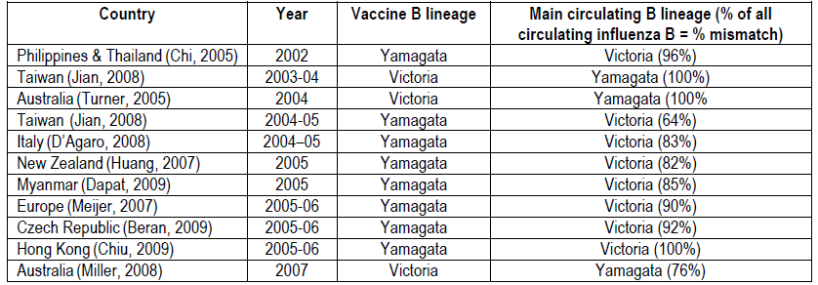

## Contents of the clinical dossier

### Scope of the clinical dossier

Five studies were presented in support of the application.

Two pivotal, Phase III studies, Studies D-QIV-008 and D-QIV-003, evaluated the candidate D-QIV vaccine in adults from 18 years of age and children from 3 years of age respectively. Both studies included two comparator groups, one receiving the seasonal trivalent influenza vaccine Fluarix, the other a similar trivalent vaccine containing a strain of the B lineage not included in the seasonal vaccine.

Two supportive studies, Studies D-QIV-001 (Phase I/II) and D-QIV-002 (Phase II), evaluated the candidate vaccine in adults from 18 years and children from 18 months of age. These studies included a control group that received the seasonally recommended trivalent influenza vaccine.

A further study, Fluarix-US-006 (Phase IV) evaluated the efficacy, safety and immunogenicity of Fluarix trivalent vaccine versus placebo control in an adult population.

### Paediatric data

Paediatric data were submitted with Studies D-QIV-003 and D-QIV-002.

### Good clinical practice (GCP)

GSK asserts that all studies were conducted in accordance with GSK standard operating procedures, which comply with the principles of Good Clinical Practice (GCP), the Declaration of Helsinki, the US Code of Federal Regulations, and local rules and regulations. The studies were conducted with the approval of an Ethics Committee or Institutional Review Board. Written informed consent was obtained from all participants, or parents or legal guardians, prior to the performance of any study-specific procedures.

The study designs took into account the FDA “Guidance for Industry Clinical Data Needed to Support the Licensure of Seasonal Inactivated Influenza Vaccines” (CBER, 2007)[6]; and the European Union (EU) “Guideline on Clinical Evaluation of New Vaccines” (EMEA/CHMP/VWP/164653/2005; EMEA, 2006)[7], “Guideline on Similar Biological Medicinal Products” (CHMP/437/04; CHMP, 2005)[8] and “Note for Guidance on Harmonization of Requirements for Influenza Vaccines” (CPMP/BWP/214/96; CPMP, 2005)[9]. All central and local clinical trial activities were governed by the International Conference on Harmonization, Good Clinical Practice guidelines. All members of staff working on clinical trials were appropriately qualified and trained in GCP and GSK procedures.

## Pharmacokinetics

Not applicable.

## Pharmacodynamics

Not applicable.

## Dosage selection for the pivotal studies

Not applicable.

## Clinical efficacy

### Clinical Immunogenicity

#### Introduction

Immunogenicity was assessed by measurement of haemagglutination inhibiting (HI) antibodies using the method described by the WHO Collaborating Centre for influenza, Centers for Disease Control, Atlanta, USA (1991). Titres of HI antibodies were measured before vaccination and 28 days post vaccination in paediatric studies (D-QIV-002 and D-QIV-003)and before vaccination and 21 days post vaccination in adult studies (D-QIV-001 and D-QIV-008).

In each of the studies the following definitions applied:

* Seropositivity (SPR) was defined as HI antibody titre ≥ 1:10.
* Seroconversion rate (SCR) was defined as the percentage of individuals who had either a pre-vaccination titre < 1:10 and a post vaccination titre ≥ 1:40 or pre-vaccination titre ≥1:10 and at least a 4 fold increase in post vaccination titre.
* Seroprotection rate (SPR) was defined as the percentage of individuals with a serum HI titre ≥1:40.
* Seroconversion factor (SCF) or mean geometric increase (MGI) was defined as the fold increase in serum HI GMT post vaccination compared to Day 0.

The geometric mean HI titre (GMT) calculations in each of the studies were performed by taking the anti-log of the mean of the log10 titre transformations. Antibody titres below the cut-off of the assay were given an arbitrary value of half the cut-off for the purpose of GMT calculation.

The primary analysis of immunogenicity in each study was based on the according-to-protocol (ATP) cohort for analysis of immunogenicity. This cohort included those participants who met all eligibility criteria, who complied with the protocol procedures, with no elimination criteria assigned for whom data concerning immunogenicity endpoint measures against at least one study vaccine antigen were available. A secondary analysis based on the Total Vaccinated cohort (TVC) for analysis of immunogenicity was to be performed in all studies if the ATP cohort for analysis of immunogenicity excluded more than 5% of the vaccinated individuals. The TVC included vaccinated individuals with data concerning immunogenicity endpoint measures available. Analysis was based on the vaccine received.

With regard to missing data in each study, the following applied:

* Missing or non-evaluable immunogenicity measurements were not replaced and were excluded.
* Missing or non-evaluable solicited symptoms measurements were not replaced. The analysis of the solicited symptoms based on the Total Vaccinated cohort included only participants/doses with documented safety data.
* For the analysis of unsolicited adverse events and concomitant medications, individuals who did not report an event were considered as being without an event.

In all studies, “D-QIV” referred to the candidate quadrivalent vaccine, TIV-1 referred to the registered trivalent vaccine, Fluarix, which contained one of the strains included in the quadrivalent vaccine. TIV-2 referred to a trivalent vaccine with a B strain lineage differing from that of the registered trivalent vaccine but contained in the quadrivalent vaccine.

##### Guidelines for licensure of trivalent vaccines

Levels of HI antibody titres post vaccination have not been correlated with protection from influenza illness but have been used as a measure of vaccine activity. The immunological criteria defined in the Note for Guidance on Harmonization of Requirements for Influenza Vaccines” (CPMP/BWP/214/96; CPMP, 2005)9 are applicable to adults. In the absence of specific criteria for children, data were assessed using the existing criteria for 18-60 year-old adults. These guidelines, which have been adopted in Australia, were summarised in a table.[10]

The United States Food and Drug Administration and the European Medicine Agency recommendations for immunogenicity parameters for licensure (CBER, 2007; CPMP, 1997) were also described.[11]

#### Adult studies

Inclusion/exclusion criteria were similar for the adult studies and are summarised below.

##### Inclusion criteria

* Healthy individuals or those with chronic well-controlled disease
* Females of non-childbearing potential defined as being post-menopausal or having tubal ligation, hysterectomy or ovariectomy. Females of childbearing potential could be enrolled in the study if the individual had practiced adequate contraception for 30 days prior to vaccination, had a negative pregnancy test on the day of vaccination and had agreed to continue adequate contraception for the entire treatment period and for 2 months after completion of the vaccination series.

##### Exclusion criteria

* Use of any investigational or non-registered drug or vaccine other than the study vaccines within 30 days preceding the dose of study vaccine, or planned use during the study period.
* Administration for more than a total of 14 days of immunosuppressant or other immune-modifying drugs within six months prior to the first vaccine dose. For corticosteroids, this meant prednisone ≥ 20 mg/day, or equivalent. Inhaled and topical steroids were allowed.
* Administration of an influenza vaccine during the 6 months preceding entry into the study.
* Planned administration/administration of a vaccine not foreseen by the study protocol within 30 days before vaccination and up to Visit 2.
* Any contra-indication to intramuscular (IM) administration of the influenza vaccines.
* History of hypersensitivity/anaphylaxis to a previous dose of influenza vaccine, history of any reaction or hypersensitivity likely to be exacerbated by any component of the vaccines including latex.
* Any administration of a long-acting immune-modifying drug within 3 months before study start or planned administration during the study period
* Any confirmed or suspected immunosuppressive or immunodeficiency condition, based on medical history and physical examination.
* Acute disease and/or fever at the time of enrolment. Fever was defined as temperature ≥ 37.5°C on oral or axillary measurement. Individuals with a minor illness such as mild diarrhoea, mild upper respiratory infection without fever could be enrolled at the discretion of the investigator
* Acute or chronic, clinically significant pulmonary, cardiovascular, hepatic or renal functional abnormality as determined by physical examination or laboratory screening tests.
* History of Guillain-Barre syndrome (GBS).
* Administration of immunoglobulin and/or any blood products within the 3 months before the first dose of study vaccine or planned administration during the study period.
* Pregnant or lactating female.
* History of chronic alcohol consumption and/or drug abuse.
* Any condition which, in the opinion of the investigator, prevented the individual from participating in the study.

In each study the randomisation of supplies was performed by GSK Biologicals using a program developed by GSK Biologicals for use in SAS® (Cary, NC, USA). The vaccine doses were distributed to the study centres, respecting the randomisation block size. The treatment allocation at the investigator site was performed using a central randomisation system on internet (SBIR).

##### Pivotal adult study FLU-D-QIV-008

Study FLU-D-QIV-008, (D-QIV-008) was a Phase III, partially-blind, controlled, multi-centre, multinational, parallel group study to evaluate immunogenicity, safety and reactogenicity of the quadrivalent influenza candidate vaccine in adults 18 years of age or older. The study was conducted between 4 October 2010 and 6 June 2011 by 43 investigators in six countries: Germany, Romania, Spain, Korea, Taiwan and the US.

###### Co-primary objectives

* To assess the lot-to lot consistency of three lots of the quadrivalent influenza vaccine D-QIV, in terms of HI antibody GMTs. Lot- to lot consistency was demonstrated if, for each vaccine strain, the limits of the two-sided 95% confidence interval for the largest geometric mean ratio among the three lots were between 0.67 and 1.5.
* To assess the immunological non-inferiority in terms of HI antibody GMTs and seroconversion rates of D-QIV compared to trivalent influenza vaccine TIV-1 (Fluarix) and TIV-2 vaccine for the three strains that were included in each of the two trivalent vaccines. Non-inferiority in terms of GMTs was demonstrated if the upper limit of the two-sided 95% confidence interval (CI) for the ratio of GMT of TIV-1 vaccine or TIV-2 vaccine over D-QIV did not exceed 1.5 for each strain Non-inferiority in terms of seroconversion rates was demonstrated if the upper limit of the two-sided asymptotic standardised 95% CI for the difference in the SCR (TIV-1 or TIV-2 vaccine minus D-QIV did not exceed 10% for each strain included in the TIV-1 and TIV-2 vaccines.
* To assess the immunological superiority in terms of GMTs and SCRs of the D-QIV vaccine compared to the two trivalent vaccines for the B strain that was not included in each vaccine. Immunologic superiority of the unique B strain the D-QIV vaccine was demonstrated if the lower limit of the two-sided 95% CI on the GMT ratio was greater than one and the lower limit of the two-sided 95% CI for the difference in SCR was greater than zero.

###### Secondary objectives

* To describe the immunogenicity of D-QIV vaccine, TIV-1 (Fluarix) vaccine and TIV-2 vaccine in terms of GMTs and seroprotection rate at Days 0 and 21, and seroconversion rate and mean geometric increase (MGI) at Day 21 overall and in each age stratum.
* To assess the reactogenicity and safety of D-QIV, TIV-1 and TIV-2 vaccines overall and in each age stratum in terms of the following:
  + Solicited local symptoms during the 7 day post vaccination follow-up.
  + Solicited general symptoms during the 7 day post vaccination follow-up.
  + Unsolicited symptoms during the 21 day post vaccination follow-up period.
  + Serious adverse events (SAEs), adverse events (AEs) with medically attended visit (MAV) and potential immune mediated diseases (pIMDs) during the entire study period.

###### Design

Participants were randomised 5:5:5:5:3 into groups as follows:

* D-QIV-1: 1000 participants receiving D-QIV from lot 1
* D-QIV-2: 1000 participants receiving D-QIV from lot 2
* D-QIV-3: 1000 participants receiving D-QIV from lot 3
* TIV-1: 1000 participants receiving TIV-1 - control
* TIV-2: 600 participants receiving TIV-2 - control

The immunogenicity sub-cohorts included the first 600 participants enrolled in each treatment group taking into account the age stratification and the minimisation factors.

The sample size of 3000 participants in the D-QIV groups was determined by the safety cohort needed to allow detection of rare events occurring at a rate of 0.01%. The sample size in the immunogenicity sub-cohort of 570 evaluable individuals for each group was calculated in order to reach the global power for primary objective analysis of at least 90%.

Study duration was approximately 6 months for those vaccinated with D-QIV or TIV-1 and 28 days for those vaccinated with TIV-2 in order that they may be vaccinated with the seasonal vaccine before the commencement of influenza season.

###### Study and reference vaccines

Vaccines were presented as single doses in glass pre-filled syringes with contents as summarised in Table 2. The dose of 0.5 mL was injected intramuscularly into the deltoid region of the non-dominant arm on Day 0.

Table 2. D-QIV-008 study and reference vaccines. Table continued on next page.

| D-QIV | TIV-1 | TIV-2 |
| --- | --- | --- |
| Quadrivalent, split virion, inactivated influenza vaccine | Trivalent, split virion, inactivated influenza vaccine | Trivalent, split virion, inactivated influenza vaccine |
| Candidate vaccine  15 µg haemagglutinin (HA) of each strain; 60 µg HA in total | Commercial TIV-1 (Fluarix) for the season 2010/2011  15 µg HA of each strain; 45 µg HA in total | Manufactured using same process as that of TIV-1.  15 µg HA of each; 45 µg HA in total): |
| Lot numbers:  DFLBA008A - D-QIV-1 group,  DFLBA009A - D-QIV-2 group  DFLBA010A - D-QIV-3 group. | Lot number:  AFLUVA521A | Lot number:  DFLUA039A |
| A/California/7/2009 (H1N1) | A/California/7/2009 (H1N1) | A/California/7/2009 (H1N1) |
| A/Victoria/210/2009 (H3N2) | A/Victoria/210/2009 (H3N2) | A/Victoria/210/2009 (H3N2) |
| B/Brisbane/60/2008 (Victoria lineage) | B/Brisbane/60/2008 (Victoria lineage) |  |
| B/Brisbane/3/2007 (Yamagata lineage) |  | B/Brisbane/3/2007 (Yamagata lineage) |
| Excipient: polysorbate 80 (Tween 80), octoxynol 10 (Triton X-100), α-tocopheryl hydrogen succinate, sodium chloride, magnesium chloride hexahydrate, disodium hydrogen phosphate dodecahydrate, potassium dihydrogen phosphate, potassium chloride, water for injection. (These excipients are as for the formulation proposed for registration) | Excipients: polysorbate 80 (tween 80), octoxynol 10 (Triton X-100), -tocopheryl hydrogen succinate, sodium chloride, magnesium chloride hexahydrate, disodium hydrogen phosphate dodecahydrate, potassium dihydrogen phosphate, potassium chloride and water for injection. | Excipient: polysorbate 80 (tween 80), octoxynol 10 (Triton X-100), alpha-tocopheryl hydrogen succinate, sodium chloride, magnesium chloride hexahydrate, disodium hydrogen phosphate dodecahydrate, potassium dihydrogen phosphate, potassium chloride and water for injection. |

###### Randomisation and treatment allocation

The treatment numbers were allocated by dose. Within age strata 18 - 64 years and ≥ 65 years, the randomisation algorithm used a minimisation procedure accounting for centre and influenza vaccination history for the 2009-2010 influenza season. Minimisation factors had equal weight in the algorithm.

###### Blinding

The D-QIV group and TIV-1 group were double-blind throughout the study. Treatment of the TIV-2 group was open as participants needed to be identified so that appropriate vaccination could be undertaken subsequently; however, the laboratory in charge of testing was blinded to the treatment and codes were used to link the individual and study (without any link to the treatment attributed to the individual) to each sample.

###### Blood samples and antibody determination

Blood was sampled on Days 0 and 21. The antibody assays are summarised in Table 3.

Table 3. D-QIV-008 Humoral Immunity (Antibody determination)

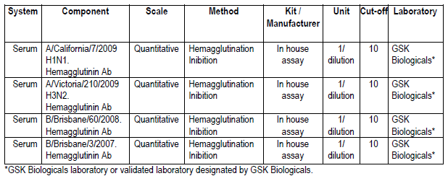

###### Statistics

The following analyses were performed for each vaccine strain:

* The adjusted GMTs were estimated using an Analysis of Covariance (ANCOVA) model fitted on log10 transformed post vaccination HI titre including treatment as fixed effect and baseline as covariate.
* GMT ratios (with two-sided 95% CI) related to the comparisons of interest were computed.
* The SCR of each vaccine, the SCR difference and the two sided 95% CI of the SCR differences were computed after fitting a logistic regression on the seroconversion response, including the vaccine group as fixed effect and the pre-vaccination concentration as covariate.
* The assumption that the treatment effect did not depend on the pre-vaccination serological level was checked by ANCOVA and logistic regression models and additional analyses were to be performed in case of evidence of interaction.

Safety, reactogenicity and demographics were subjected to descriptive statistical analysis.

###### Protocol amendments

Amendment 1 (23 July 2010) was relevant to Korea and Taiwan, where the legal age of majority is 20 years. Local regulations required the informed consent be signed by the individual’s parent(s) or legal guardian for study participants younger than 20 years.

Amendment 2 (19 October 2010): As a precautionary measure, the Paul Erhlich Institute recommended exclusion of individuals with any history of GBS from this current study. Individuals already enrolled in this study with history of GBS were to be followed for safety and immunogenicity as per protocol.

Evaluator comment: These changes would not have affected the primary analyses.

###### Other changes

The protocol stated that temperatures ≥ 39.0°C /102.2°F were scored as Grade 3 fever; however, in the statistical analysis, temperatures > 39.0°C /102.2°F were scored as Grade 3.

Additional age stratified descriptive immunogenicity analyses for 18 - 74 years and > 75years and for 18 - 60 years and > 60 years were presented in this report, although they were not planned per protocol.

Evaluator comment: The changed criteria for reporting of Grade 3 fever had the potential to reduce numbers reported to have had Grade 3 fever. The additional age stratification did not alter assessment of the study.

###### Results

In total, 4656 individuals were vaccinated in this study: 3036 in the D-QIV groups, 1010 in the TIV-1 group and 610 in the TIV-2 group. From the 3036 individuals vaccinated in the D-QIV group, 1012 were vaccinated in the D-QIV-1 group, 1013 in the D-QIV-2 group and 1011 in the D-QIV-3 group.

In total, 4597 individuals completed the study and 57 individuals were withdrawn. Thirteen individuals withdrew from the study because of serious adverse events (SAEs) and one for non serious AE.

Eighteen individuals (13 in the D-QIV group, 2 in the TIV-1 group and 3 in the TIV-2 group) were eliminated from the ATP cohort for safety due to administration of vaccine(s) forbidden in the protocol, randomisation failure or study vaccine dose not administered according to protocol.

Eighty-two participants (52 in the D-QIV group, 17 in the TIV-1 group and 13 in the TIV-2 group) were eliminated from the ATP cohort for analysis of immunogenicity due to protocol violation on inclusion or exclusion criteria, administration of any medication forbidden by the protocol, non compliance with blood sampling schedule or essential serological data missing.

###### Demographic characteristic

Demographic characteristics appeared evenly spread across groups. Participants ranged in age from 18 years to 92 years. The mean age was 57.9 years in the D-QIV group overall and 58.1 years in, both TIV-1 and TIV- 2 groups. In total, 56.6% of participants were female and 43.4% were male. The population was predominantly White-Caucasian (68.5%) or Asian (26.3%). In each group, about 80% of participants received at least one seasonal influenza vaccine in a preceding season. Approximately 70% of each group received the 2009-2010 seasonal influenza vaccine.

###### Immunogenicity results

Less than 5% of participants were excluded from the ATP cohort. The criteria for lot-to-lot consistency were met (for D-QIV-1/D-QIV-2). The limits of the two-sided 95% CI for the largest GMT ratios among the 3 lots of D-QIV were (stated to be) between 0.67 and 1.5 for the four strains (Table 4). The result for D-QIV-3 could not be located.[12]

Table 4. D-QIV-008: Adjusted GMT ratios of HI antibody at day 21 for the maximum difference between two lots of D-QIV for Flu A/CAL/7/09 H1N1, Flu A/Vic/210/09 H3N2, B/Bri/60/08 Victoria and B/Bri/3/07 Yamagata

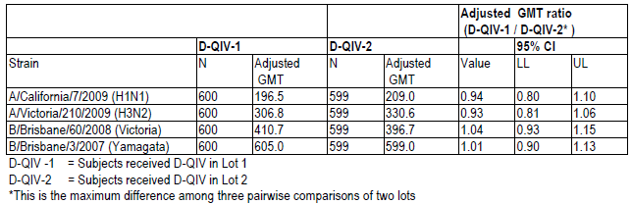

Criteria for non-inferiority of D-QIV versus TIV in terms of adjusted GMT ratio and seroconversion rate difference were met for all strains shared with the trivalent vaccines.

* The upper limit of the two sided 95% CI for the adjusted GMT ratio of TIV (pooled TIV-1 and TIV-2) over D-QIV was 1.18 for A/California (H1N1) and 1.07 for A/Victoria (H3N2), which did not exceed the pre specified limit of 1.5. (Table 5).
* The upper limit of the two sided 95% CI for the adjusted GMT ratio of TIV-1 over D-QIV for the B/Victoria strain was 1.07. (Table 6).
* The upper limit of the two sided 95% CI for the adjusted GMT ratio of TIV-2 over D-QIV for the B/Yamagata strain was 1.07. (Table 7).
* The upper limit of the two-sided 95% CI for the difference in SCR of TIV (pooled TIV-1 and TIV-2) minus D-QIV was 4.11% and -0.30% for A/California (H1N1), A/Victoria (H3N2) respectively, which did not exceed the specified limit of 10%. (Table 8).
* The upper limit of the two-sided 95% CI for the difference in SCR of TIV-1 minus D-QIV for the B/Victoria strain was 1.83%. (Table 9).
* The upper limit of the two-sided 95% CI for the difference in SCR of TIV-2 minus D-QIV for the B/Yamagata strain was 2.01%. (Table 10).

Table 5. D-QIV-008 GMT ratio for H1N1 and H3N2 (ATP cohort for immunogenicity)

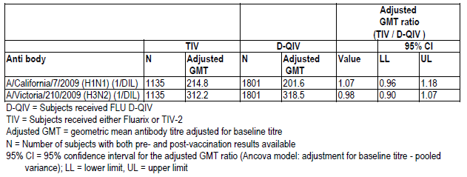

Table 6. D-QIV-008 Adjusted GMT ratio at Day 21 for B/Victoria lineage (ATP cohort for immunogenicity)

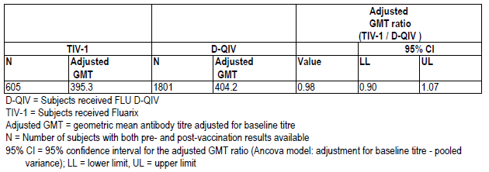

Table 7. D-QIV-008 Adjusted GMT ratio at Day 21 for B/Yamagata lineage (ATP cohort for immunogenicity)

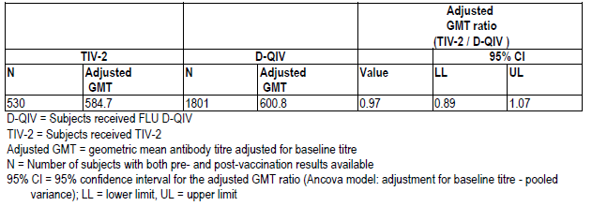

Table 8. D-QIV-008 Seroconversion rate difference for H1N1 and H3N2 (ATP cohort for immunogenicity)

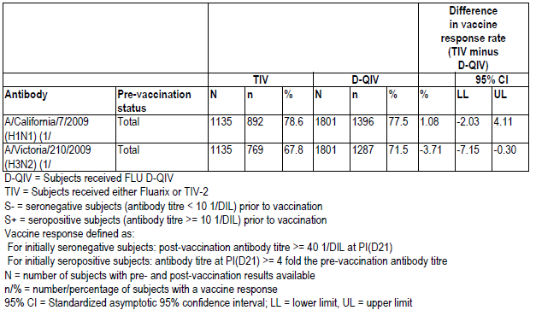

Table 9. D-QIV-008 Seroconversion rate difference for B/Victoria lineage strain (ATP cohort for immunogenicity)

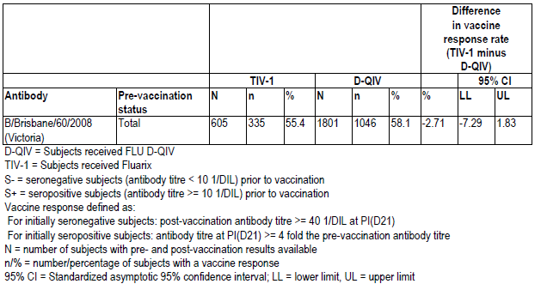

Table 10. D-QIV-008 Seroconversion difference for B/Yamagata lineage) strain (ATP cohort for immunogenicity)

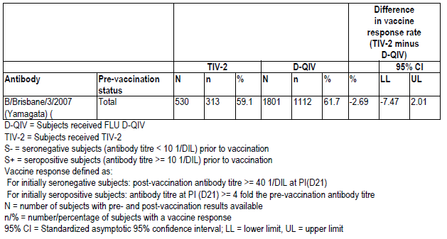

Criteria for superiority of D-QIV versus TIVs in terms of adjusted GMT ratio and SCR difference were met for both B-strains not in the respective TIVs.

* The lower limit of the two sided 95% CI for the adjusted GMT ratio of D-QIV/TIV-2 for the B/Victoria strain was 1.42 l. (Table 11).
* The lower limit of the two sided 95% CI for the adjusted GMT ratio of D-QIV over TIV-1 for the B/Yamagata strain was 1.41. (Table 12).
* The lower limit of the two-sided 95% CI for the difference in SCR of D-QIV minus TIV-2 for the B/Victoria strain was 5.70%, which is greater than the predefined 0%. (Table 13).
* The lower limit of the two-sided 95% CI for the difference in SCR of D-QIV minus TIV-1 for the B/Yamagata strain was 11.54%. (Table 14).

Table 11. D-QIV-008 Adjusted GMT ratio for the B/Victoria lineage (ATP cohort for immunogenicity)

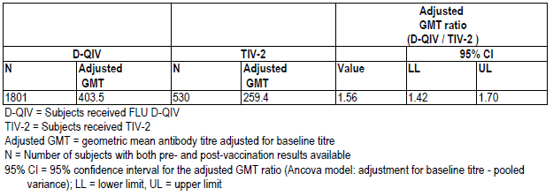

Table 12. D-QIV-008 Adjusted GMT ratio for the B/Brisbane/Yamagata lineage (ATP cohort for immunogenicity)

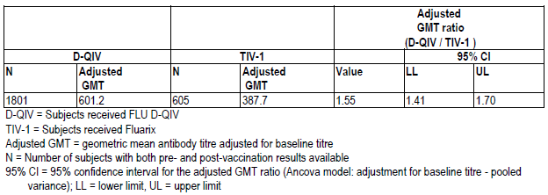

Table 13. D-QIV-008 Difference in SCR for B/Victoria lineage (ATP cohort for immunogenicity)

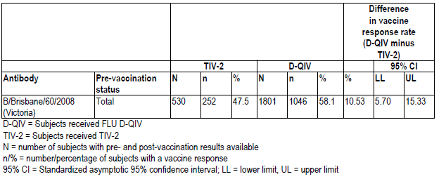

Table 14. D-QIV-008 Difference in SCR for B/Brisbane/Yamagata lineage (ATP cohort for immunogenicity)

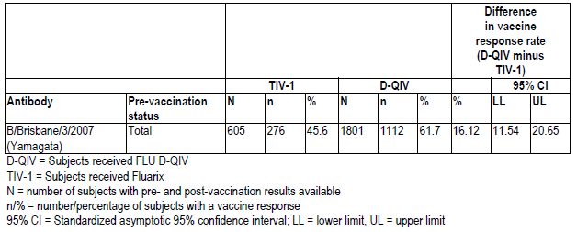

###### Descriptive analyses

GMTs post vaccination

* A/California/7/2009 (H1N1): 201 for D-QIV, 218 for TIV-1 and 213 for TIV-2.
* A/Victoria/210/2009 (H3N2): 315 for D-QIV, 298 for TIV-1 and 340 for TIV-2.
* B/Brisbane/60/2008 (Victoria lineage): 405 for D-QIV, 394 for TIV-1 and 259 for TIV-2 (TIV-2 did not contain B/Victoria lineage).
* B/Brisbane/3/07 (Yamagata lineage): 602 for D-QIV, 583 for TIV-2 and 387 for TIV-1 (TIV-1 did not contain B/Yamagata lineage).

Seropositivity rates baseline and post vaccination respectively

* A/California/7/2009 (H1N1): D-QIV: 53.7%; 96.1%; TIV-1: 58.2%; 96.4%, TIV-2: 54.9%; 96.3%
* A/Victoria/210/2009 (H3N2): D-QIV: 78.6%; 98.6%, TIV-1: 80.7%; 97.7%, TIV-1: 80.2% post 98.9%
* B/Brisbane/60/2008 (Victoria lineage): D-QIV: 86.5%; 99.2%, TIV-1: 84.5%; 98.8%, TIV-2; 85.3%; 97.0%
* B/Brisbane/3/2007 (Yamagata lineage): D-QIV: 86.3%; 99.2%, TIV-1: 86.8%; 98.2%, TIV-2; 86.2%; 99.8%

Seroconversion rates

* A/California/7/2009 (H1N1): 78% for D-QIV, 77% for TIV-1 and 80% for TIV-2.
* A/Victoria/210/2009 (H3N2): 72% for D-QIV, 66% for TIV-1 and 70% for TIV-2.
* B/Brisbane/60/2008 (Victoria lineage): 58% for D-QIV, 56% for TIV-1 and 48% for TIV-2.
* B/Brisbane/3/2007 (Yamagata lineage): 62% for D-QIV, 59% for TIV-2 and 46% for TIV-1.

Seroprotection rates post vaccination

* A/California/7/2009 (H1N1): 91% for D-QIV, 92% for TIV-1 and 93% for TIV-2.
* A/Victoria/210/2009 (H3N2): 97% for D-QIV, 96% for TIV-1 and 97% for TIV-2.
* B/Brisbane/60/2008 (Victoria lineage): 99% for D-QIV, 99% for TIV-1 and 96% for TIV-2.
* B/Brisbane/3/2007 (Yamagata lineage): 99% for D-QIV, 100% for TIV-2 and 98% for TIV-1.

Mean geometric increases

* A/California/7/2009 (H1N1): 14 for D-QIV, 14 for TIV-1 and 15 for TIV-2.
* A/Victoria/210/2009 (H3N2): 9 for D-QIV, 8 for TIV-1 and 10 for TIV-2.
* B/Brisbane/60/2008 (Victoria lineage): 5 for D-QIV, 5 for TIV-1 and 4 for TIV-2.
* B/Brisbane/3/2007 (Yamagata lineage): 6 for D-QIV, 6 for TIV-2 and 4 for TIV-1.

Results by age strata 18 to 60 years and > 61 years were summarised in 4 tables in the submission.

###### Conclusion

The objectives of the study have been metalthough results for the lot-to-lot consistency of lot 3 remain to be seen.[13] Seroconversion rates seroprotection rates and mean geometric increases met CPMP/BWP/214/96 Harmonisation of Requirements for Influenza (trivalent) Vaccines guidelines for adults 18 to 60 years.9

##### Supportive adult study FLU-D-QIV-001

Study FLU-D-QIV-001, (D-QIV-001) was a Phase I/II dose finding single blind, controlled study in adults aged 18 to 60 years to evaluate vaccine immunogenicity, safety and reactogenicity . The study was conducted in one centre in the Czech Republic between 14 July 2008 and 28 January 2009.

###### Co-primary objectives

* To assess non-inferiority of HI antibody GMTs of D-QIV versus TIV for the 3 recommended strains.
* To assess non-inferiority of HI GMTs of the adjuvanted low dose quadrivalent influenza vaccine (LD-D-QIVa) versus the adjuvanted low dose trivalent influenza vaccine (LD-TIVa) for the 3 recommended strains.
* To assess superiority of HI GMTs of D-QIV versus TIV in terms of B/Jiangsu/10/2003 strain not included in the trivalent influenza vaccine.
* To assess superiority of HI GMTs of LD-D-QIVa versus LD-TIVa in terms of B/Jiangsu/10/2003 strain not included in the adjuvanted low dose trivalent influenza vaccine.

Objectives were met if the lower limit of the 95%CI for GMT ratios were > 0.67 for non-inferiority and > 1 for superiority.

###### Secondary objectives:

* To assess the non-inferiority of GMT of LD-D-QIVa versus Study vaccine D-QIV.
* To assess HI antibody titres response induced by the study vaccines 21 days after vaccination.
* To assess safety and reactogenicity of study vaccines with follow-up of solicited symptoms for seven days, unsolicited adverse events for 21 days, serious adverse events, medically significant conditions [MSCs] and autoimmune diseases [AIDs] throughout the entire study period.

###### Design

Participants were randomised (1:1:1:1) to four parallel groups of 105 participants aged 18 to 60 years. The randomisation algorithm used a minimisation procedure accounting for centre and age (18-49 years versus 50-60 years in a 3:1 ratio).

###### Study and reference vaccines

Study and reference vaccines are summarised in Table 15: The 0.5 mL dose was administered intramuscularly into the deltoid region of the non-dominant arm on Day 0.

Table 15. D-QIV-001 Formulation of study and reference vaccines.

|  |  |  |  |  |
| --- | --- | --- | --- | --- |
| Strains/Vaccines | QIV | A* | B* | TIV (reference vaccine) |
| A/Solomon Islands/3/2006 (H1N1) | 15 µg | 5 µg | 5 µg | 15 µg |
| A/Wisconsin/67/2005(H3N2) | 15 µg | 5 µg | 5 µg | 15 µg |
| B/Malaysia/2506/2004 | 15 µg | 5 µg | 5 µg | 15 µg |
| B/Jiangsu/10/2003 | 15 µg | 5 µg | - | - |
| Adjuvant system (AS03) | - | 62.5 µL | 62.5 µL | - |
| Lot number | DFLAA007A | DFLAA008A | DFLAA006A | DFLAA005A |
| Expiry date | 26-08-2008 | 28-08-2008 | 27-08-2008 | 31-01-2009 |

*A and B=exploratory alternative formulations

Vaccine groups were as follows. This evaluation focuses on results for the full strength, unadjuvanted vaccines.

* QIV Group received quadrivalent vaccine
* LD-QIVa Group received [information redacted][14]
* LD-TIVa Group: received [information redacted]14
* TIV Group: received the seasonal trivalent influenza vaccine

Three visits were planned. Vaccination was undertaken at Visit 1 Day 0. Blood was sampled on Days 0 and 21. Safety follow-up was at Day 180.

###### Statistical methods

Analysis of safety and of demographic characteristics was descriptive. Frequentist and Baysian methodologies were applied.

###### Protocol amendment

One protocol amendment dated 16 June 2008 extended the observation after vaccination to 60 minutes.

###### Other changes

Initially, GMT ratios were to be computed with 90% CI but by a default value in the statistical program, 95% CI were computed.

Evaluator comment: the protocol amendment and other change would not have compromised the results.

Additional reactogenicity analyses were performed applying the rules of grading previously used at GSK Biologicals with maximum intensity of local injection site symptoms of redness and swelling and maximum intensity of fever respectively scored as shown in Table 16.

Table 16. Grading used for reactogenicity analyses

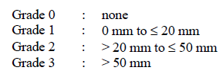

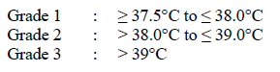

###### Results

Participant flow

* Planned and enrolled: 420 participants (105 per group)
* Completed Day 21: 419 participants (105 in D-QIV, LD-TIVa and TIV Groups, 104 in the LD-D-QIVa Group)
* Safety: Total vaccinated cohort 420 participants (105 per group)
* Immunogenicity: ATP cohort for immunogenicity on Day 21: 417 individuals (104 in the D-QIV,
* [information redacted][15] 105 in the TIV Group)
* Two participants who were non-compliant with the blood sampling schedule and one with essential serological data missing were excluded from the ATP cohort for immunogenicity.

###### Demographic characteristics

The groups’ demographics were comparable with respect to age and racial distribution. Participants aged 18 to 59 years were enrolled; the mean age was 37.6 years. The overall male-female distribution was 40.0% versus 60.0%. The study population was almost exclusively of White-Caucasian/European heritage. There were slightly more females in the LD-D-QIVa and LD-TIVa Groups (both 63.5%) compared to the D-QIV and TIV Groups (57.7% and 55.2%, respectively).

###### Immunogenicity results

Non-inferiority was demonstrated for the 3 strains contained in TIV; the lower limit of the GMT ratio 95% CI was greater than 0.67. Superiority was demonstrated for the B/Jiangsu strain not contained in the TIV; the lower limit of the 95% CI was > 1. (Table 17).

Table 17. D-QIV-001 Adjusted GMT ratios for aD-QIV and TIV (ATP cohort for immunogenicity)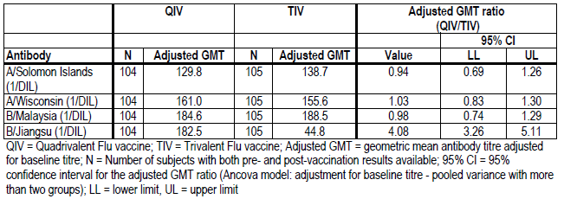

HI antibody assessment

The GMTs and seropositivity rates are summarised Figure 1.

* Prevaccination HI GMTs were similar for each strain in all four vaccine groups;
* Post vaccination GMTs and SPRs increased from baseline in all groups compared for each strain;
* Post vaccination GMTs in all groups ranged from 130.0 to 160.4 against the A/Solomon Islands strain, from 156.3 to 197.9 for HI antibodies against the A/Wisconsin strain and from 187.0 to 213.0 against the B/Malaysia strain;
* Post vaccination, the HI GMTs against the B/Jiangsu strain were between 43.4 and 179.1. The GMT induced by the D-QIV was 4.1-fold higher than that induced by the TIV.

Figure 1. D-QIV-001 HI GMTs with 95% CI Days 0 and 21 (ATP cohort for immunogenicity)

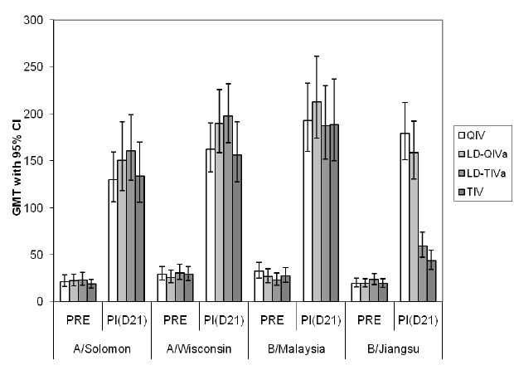

###### Seroconversion factors

For the A/Solomon Islands, A/Wisconsin and B/Malaysia strains in all groups, the SCF on Day 21 exceeded the Committee for Proprietary Medicinal Products (CPMP) threshold of > 2.5 for adults aged 18 to 60 years. The SCF for the B/Jiangsu strain was 9 for the D-QIV Group versus 2.3 for the TIV groups (Figure 2).

Figure 2. D-QIV-001 Seroconversion factors with 95% CI on Day 21 (ATP cohort for immunogenicity)

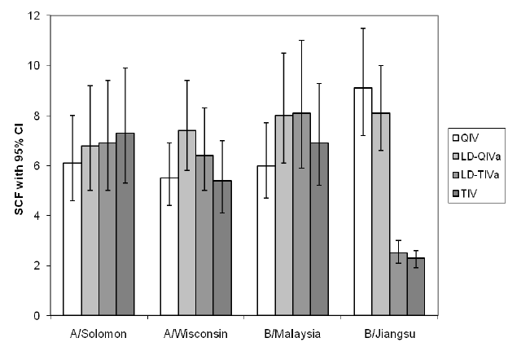

Seroconversion rate

The SCRs for the A/Solomon Islands, A/Wisconsin and B/Malaysia strains were greater than the 40% threshold recommended by the CPMP for adults aged 18 to 60 years for all groups. For B/Jiangsu the D-QIV group the SCR was 76% versus 19% for the TIV group (Figure 3).

Figure 3. D-QIV-001 Seroconversion rate for HI with 95% CI on Day 21 (ATP cohort for immunogenicity)

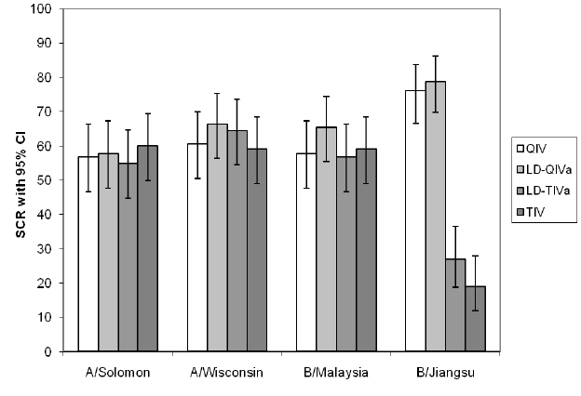

Seroprotection rates

* Baseline SPRs were 35.2% to 42.3% for A/Solomon Islands, 46.2% to 55.2% for A/Wisconsin, 31.7% to 43.3% for B/Jiangsu and 42.3% to 51.0% for B/Malaysia.
* Post vaccination SPRs were greater than the 70% threshold recommended by the CPMP guidelines for the A/Solomon Islands, A/Wisconsin and B/Malaysia.
* For the D-QIV Group, the SPR for B/Jiangsu post vaccination was 98.1 versus 63.8% for the TIV Group (Figure 4).

Figure 4. D-QIV-001 Seroprotection rates for HI antibodies on Days 0 and 21 (ATP cohort for immunogenicity)

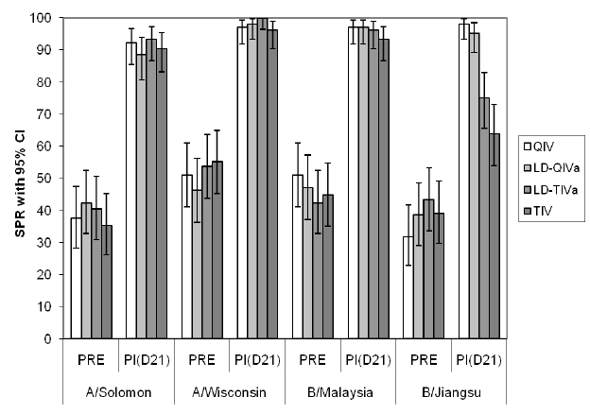

###### Neutralising antibody against B/Malaysia and B/Jiangsu strains

* Pre-vaccination GMTs in all groups were 54.9 to 63.2 for B/Malaysia; 27.3 to 38.0 for B/Jiangsu. Post vaccination, the GMTs for D-QIV were 4.1 fold higher than for TIV.
* The seroconversion rate against B/Jiangsu for D-QIV was 62.0% and for TIV 5.9%. The SCR against the B/Malaysia strain for D-QIV was 34% and for TIV, 43%.
* Post vaccination the proportions with neutralising antibodies of ≥ 1:40 B/Jiangsu were: for D-QIV 90% and for TIV 49%; for B/Malaysia the proportions were D-QIV 80.8% TIV 98%.

### Efficacy

#### Supportive adult study Fluarix-US-006

Fluarix-US-006 was a Phase IV, placebo controlled, double-blind, trial including healthy male and female adults aged 18 to 64 years, conducted during the 2006/2007 northern hemisphere season at one centre in the Czech Republic and fourteen centres in Finland. Participants were randomised 1:1:1 to three parallel groups with planned enrolment of 2,544 per group to received Fluarix lot 1, Fluarix lot 2 or placebo. A subset of 504 participants (168 participants for each lot of Fluarix and 168 for placebo) were enrolled for safety/reactogenicity and immunogenicity evaluation.

The primary objective was to demonstrate the efficacy of Fluarix in the prevention of culture confirmed influenza A and/or B cases with vaccine antigenically matched strains compared to placebo. The primary objective was met if the lower limit of the 95% confidence interval for the vaccine efficacy against culture-confirmed influenza A and/or B, for vaccine antigenically matched strains, was above 35%.

Participants received one 0.5 mL dose, of the study vaccine, Fluarix or the normal saline placebo at Day 0.[16] The immunogenicity subsets of participants were scheduled two visits, Days 0 and 21 at which times blood samples were collected.

Passive surveillance for influenza-like illness (ILI) was performed from the day of vaccination until the end of flu season. Active surveillance for ILI was conducted by the investigator approximately bi-weekly starting from 2 weeks after vaccination until the end of the flu season. There was a 14 day follow-up period for each ILI episode during which a diary card was used by participants to record ILI symptoms, antiviral/antimicrobial therapy and use of antipyretic. Other variables recorded were absenteeism from school/work, medically attended visits and hospitalisations due to ILI. In summary:

* Influenza like illness was defined as at least one systemic symptom [fever (oral temp ≥ 37.8°C)] and/or myalgia and at least one respiratory symptom.
* The first day of an ILI episode was defined as the first day with one systemic symptom and one respiratory symptom.
* The last day of an ILI episode was defined as the last day with fever, myalgia, cough or sore throat.
* A new ILI episode was only to be taken into account after the complete resolution of the previous one. Between two ILI episodes, there had to be at least 7 days free of any symptoms.

A swab of both nares and a throat swab were collected at the onset of the ILI for influenza virus culture and identification, classification of influenza A and/or B virus isolates by serological typing and testing for influenza A and/or B by RT-PCR. Pneumonia was confirmed by chest x‑ray.

A study staff member collected nasal/throat swab specimens preferably between 24 hours and 5 days after the onset of the ILI and preferably before antimicrobial/influenza antiviral therapy commenced. If such therapy had been started, the samples were collected and the therapy recorded. Specimens were placed into one container of M4RT virus transport medium and stored at the site at minus 70ºC until shipment for influenza virus culture in Madin Darby Canine kidney (MDCK) and Rhesus Monkey Kidney (RMK) cells. Frozen aliquots of the specimen swabs were used for identification of vaccine matching isolates.

Methods for identification of isolates include fluorescent antibody staining and haemadsorption. The method of testing for Influenza A and B virus including by subtype was by quantitative Reverse transcription polymerase chain reaction (RT-PCR).

#### Treatment allocation

A minimisation procedure with equal weight accounted for country, age (< 50 years and 50 to 65 years) and previous influenza vaccination. At randomisation, SBIR determined which participants were included in the immunogenicity subsets. Half the subset groups were to be from each participating country and a maximum of one third were to have history of influenza vaccination in the previous season.

#### Statistics

Based on an attack rate of 2% and assuming a VE of 70%, with one-sided test, alpha = 2.5%, the number of participants calculated to demonstrate the lower limit of the 95th CI of > 35% with ≥ 90% power, was 7218: Fluarix groups (N = 4812) and placebo (N = 2406)). Allowing for 5% not evaluable, the target was set at approximately 7632.

Fluarix data from lots 1 and 2 were pooled for all statistical analyses except for estimating vaccine efficacy by vaccine lot administered. The analysis of immunogenicity for the humoral immune response in terms of HI antibodies against each of the three vaccine influenza strains were calculated with 95% confidence intervals, for each treatment group accordingly:

* The attack rates in each treatment group using the Fisher’s Exact test, and VE against culture-confirmed influenza A and/or B, for vaccine antigenically matched strains.
* Attack rates using the Fisher’s Exact test, and VE against culture-confirmed influenza for vaccine antigenically matched strains stratified by influenza virus type.
* Vaccine efficacy against culture-confirmed influenza A and/or B for vaccine antigenically matched strains in terms of incidence rates, taking the participant follow-up periods into account.

The primary analysis was based on the TVC for analysis of efficacy. A secondary analysis was performed on the ATP cohorts for analysis of efficacy. The total vaccinated cohort included all vaccinated individuals. The total vaccinated cohort subset included all participants with at least one vaccine administration documented and for whom unsolicited symptoms were collected. The total vaccinated cohort subset for analysis of immunogenicity included vaccinated participants tested for immunogenicity and for whom data concerning immunogenicity endpoint measures were available. The total vaccinated cohort analysis was performed per treatment actually administered.

#### Results

##### Disposition of participants

A total of 7,652 individuals were randomised and vaccinated. Of these 3,996 (52%) were enrolled in the Czech Republic and 3,656 (48%) in Finland.

Withdrawals accounted for 2.4% of the Fluarix group and 2.2%: for placebo. Most withdrawals were due to loss to follow-up. No withdrawal was due to an adverse event.

The study was conducted according to the protocol with the following exceptions.

* Four patients with symptoms of a second ILI occurring without the full 7 day interval free of all symptoms were included in the analysis because they presented with a combination of new symptoms meeting the protocol definition for ILI that were considered clinically significant. Samples from two in the placebo group were negative. One patient from the Fluarix group tested negative and one positive. The investigators considered that inclusion of these results was conservative because it would not have influenced the estimates in favour of Fluarix.
* One patient in the placebo group with systemic symptoms but without respiratory symptoms was excluded in order to maintain a homogenous ILI definition.
* The number of participants enrolled by the end of the season in the subset for immunogenicity was less than planned (460 versus 504).
* One participant in the Fluarix group was aged 66 years.
* There were 9 samples (Fluarix N = 7, placebo N = 2) collected later than 5 days after the onset of ILI. There were 2 ILI episodes in which swabs were not taken and two episodes in which swabs were lost.

The cohort for the primary analysis of reactogenicity included 460 participants of whom 95.4% were also included in the ATP cohort for immunogenicity. The majority of exclusions were due to non compliance with blood sampling (15). The randomisation ratio (2:1 Fluarix: placebo) was considered maintained in the ATP cohort as the percentage of exclusions was similar in both Fluarix 14, (4.6%) and placebo 7, (4.5%) groups.

##### Demographic characteristics

Demographics of the Fluarix and placebo groups were comparable for the total vaccinated cohort and the total vaccinated cohort subset. The mean ages for the two groups in the TVC were 40.0 and 39.7 years, the majority of participants were White Caucasian (99.9%); and female (60%). Similar distribution was noted for the subset.

##### Primary analysis

ILI was reported by 654 (12.8%) in the Fluarix group and 398 (15.6%) in the placebo group. The total number of ILI episodes was 746 in the Fluarix group and 459 in the placebo group. Culture confirmed influenza A and/or B was reported for 63 (1.2%) of Fluarix participants and 82 (3.2%) of the placebo group. The majority were influenza A H3N2 with most matching the vaccine strain. Of 145 virus isolates recovered, 141 isolates were antigenically characterised (4 could not be typed) and 123 isolates were antigenically matched strains; of these, all 123 isolates were due to influenza A (H3N2) (Table 18).

Table 18. Fluarix-US-006: Distribution of culture-confirmed influenza (Total Vaccinated Cohort)

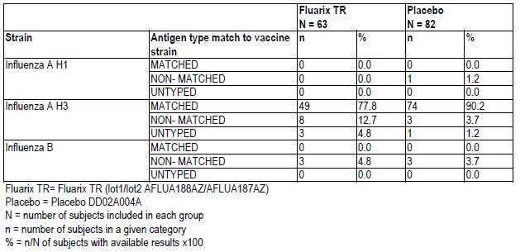

Table 19 summarises the attack rates and vaccine efficacy for culture confirmed influenza A and/or B cases, for vaccine antigenically matched strains. The lower attack rate in the Fluarix group resulted in vaccine efficacy estimate of 66.9%. As the lower limit of the confidence interval for the vaccine efficacy (51.9%) was above 35%, the primary objective of the study was met.

Table 19. Fluarix-US-006: Attack rates and VE against culture confirmed strain matched influenza A and/or B

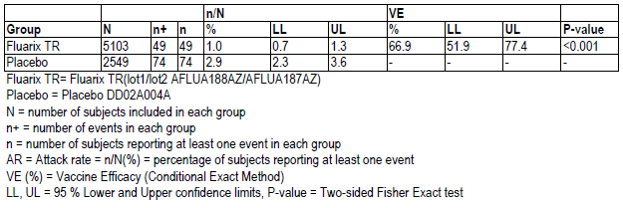

##### Secondary analyses

Vaccine efficacy of 61.6% against culture confirmed influenza A and/or B cases, for any influenza strain was demonstrated, providing evidence that the vaccine offered similar protection against H3N2 virus strains either antigenically matched or drifted compared to the vaccine strain.

Vaccine efficacy was 54.7% against any strain of influenza A and/or B confirmed by culture or RT-PCR. Vaccine efficacy was 17.9% against ILI. Vaccine efficacy was not demonstrated against pneumonia or pneumonia related to influenza, both of which were rare outcomes.

For culture-confirmed cases of influenza:

* The mean duration of fever was 3.4 days for Fluarix and 3.3 days for placebo.
* The majority of participants (77.6 % for Fluarix and 82.4% for placebo) reported absenteeism from work/school with a mean duration of 5.8 days for Fluarix and 5.3 days for placebo.
* Medical visits were attended by 51.0 % for Fluarix group and 47.3% for placebo group
* The duration of culture-confirmed influenza episodes were similar for both Fluarix and placebo groups with an overall mean duration of 12 days for both vaccine matching and any strain episodes.

##### Immunogenicity

###### Geometric mean titres

Prior to vaccination the GMTs were similar in both groups. Vaccination with Fluarix induced an increase in GMTs for all three strains while in the placebo group no increase in GMTs was observed (Table 20).

Table 20. Fluarix-US-006 Geometric mean titres for HI antibodies titre (ATP cohort for immunogenicity)

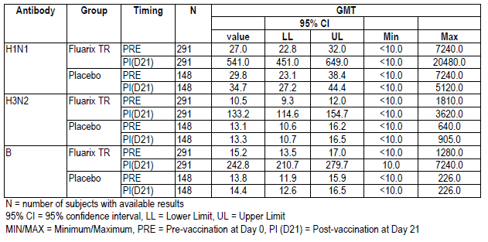

###### Seroconversion rates

In the placebo group a maximum of 2 participants (1.4%) seroconverted to any of the three strains at Day 21. The seroconversion rates at Day 21 in the Fluarix group met the CPMP acceptance criteria for the annual influenza vaccines as the lower limits of the 95% confidence intervals for all three vaccine strains (68.4% to 80.6%) were above 40% (Table 21).

###### Seroconversion factors

The seroconversion factors at Day 21 following Fluarix vaccination met the CPMP acceptance criterion for the annual influenza vaccines as the post vaccination/pre-vaccination geometric mean ratios for the three strains (12.6 - 20) exceeded 2.5 (Table 22).

###### Seroprotection rates

Prior to vaccination there were a higher percentage of participants with HI titres of ≥ 40 for H1N1 (36.8% to 39.9%) than for H3N2 (17.2% to 24.3%) or B (19.9% to 14.9%). Vaccination with Fluarix induced increases of 60% to 76% in seroprotective rates for all three strains. Following administration of placebo, seroprotective rates increased by 4.7% (7 individuals) for H1N1 and by 0.6% (1 individual) for B while for H3N2 the rate decreased by 0.7% (1 individual). The seroprotection rates at Day 21 following Fluarix vaccination met the CPMP acceptance criteria for the annual influenza vaccines as the lower limits of the 95% confidence intervals for the three strains (82.5% to 95.1%) exceeded 70% (Table 23).

Table 21. Fluarix-US-006 Seroconversion rates for HI antibodies titre (ATP cohort for immunogenicity)

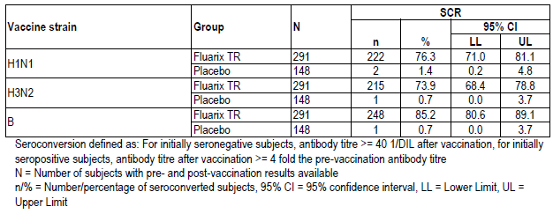

Table 22. Fluarix-US-006 Seroconversion factors for HI antibodies titre (ATP cohort for immunogenicity)

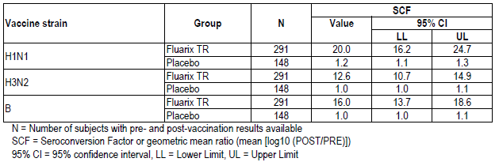

Table 23. Fluarix-US-006 Seroprotection rates for HI antibodies titre (ATP cohort for immunogenicity)

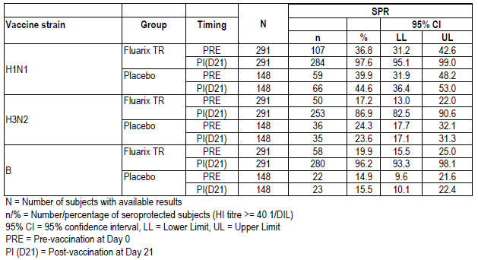

Evaluator comment: For the H3N2 and B type the GMTs in Study 008 were higher than the (adjusted) GMTs in Fluarix-US-006: approximately 310 versus 133 and approx 600 versus 243 respectively. In Study 006, all cases of B-type influenza were non-matching; however, 77.8% of the 19 cases of influenza A H3 in the Fluarix groups were vaccine matching. In Study 008, the (adjusted) GMTs for H1N1 were lower than in 006, about 200 versus 541.

#### Paediatric studies

##### Pivotal paediatric Study FLU D-QIV-003

Study FLU-D-QIV-003 (D-QIV-003) was a Phase III, randomised, controlled, multi-country, multi-centre study with four parallel groups, evaluating immunogenicity, reactogenicity and safety of the quadrivalent influenza vaccine compared to GSK’s trivalent vaccines in children aged 3 to 17 years, and describing the safety and immunogenicity of the quadrivalent influenza vaccine in children aged 6 to 35 months. The study was conducted between October 2010 and June 2011 by 55 principal investigators in five countries, the Czech Republic, France, Germany, the Philippines and the USA.

###### Objectives

The primary objective was to evaluate the immunological non-inferiority of D-QIV versus TIV-1 (Fluarix containing B/Brisbane/60/2008, Victoria-lineage, strain ) and TIV-2 Containing B/Brisbane/3/2007, Yamagata-lineage, strain in terms of GMT and SCR in children 3 to 17 years, 28 days after completion of the vaccination series (Day 28 for primed individuals, Day 56 for unprimed participants).

Non-inferiority was to be concluded if, for the three strains contained in each TIV formulation, the upper limit of the two-sided 95% confidence interval of the GMG ratio (TIV-1 [Fluarix]/D-QIV, and TIV-2/D-QIV) did not exceed 1.5 and the upper limit of the two-sided 95% CI for the difference in SCR (TIV-1 minus D-QIV and TIV-2 minus D-QIV) did not exceed 10% for the three strains contained in each TIV formulation.

Secondary objectives:

* To evaluate the immunological superiority in terms of GMTs and SCRs of D-QIV versus TIV-1 (Fluarix) and TIV-2 in children 3 to 17 years, 28 days after completion of the immunisation series, that is, at 28 days (primed participants) or 56 days (unprimed participants) for the B strain not contained in each TIV formulation. Immunologic superiority of the additional B strain in D-QIV was demonstrated if the lower limit of the two-sided 95% CI on GMT ratio (D-QIV/TIV-1[Fluarix] and D-QIV/TIV-2) was greater than 1 and the difference in SCR (D-QIV - TIV-1 [Fluarix] and D-QIV - TIV-2) was greater than 0%.
* To describe the immunogenicity in terms of GMT, seroprotection rate, seroconversion rate and mean geometric increase (MGI) of D-QIV, TIV-1 and TIV-2 for all participants.
* To evaluate the safety and reactogenicity of D-QIV, TIV-1 and TIV-2 in the 3 to 17 years age category and to evaluate the safety and reactogenicity of D-QIV for the 6 to 35 months age group with regard to solicited local and general events for 7 days post vaccination, unsolicited adverse events for 28 days post vaccination and serious adverse events for the entire study period.

###### Design

Participants aged 3 to 17 years were randomised into 3 groups of 900, giving calculated power to show non-inferiority of greater than 90%. For the three groups aged 3 to 17 the study was conducted in a double blind manner. Immunogenicity for children aged 6 to 35 was not directly relevant to the proposed Indication and was not evaluated for this clinical evaluation report.

For non-US countries, children between 6 months and 17 years were eligible, and for the US, children between 3 and 17 years. The participants were to be in stable health. Written informed consent from the parent/s or legal representative was required, plus written informed assent if required by local regulations.

Contents of the vaccines are summarised in Table 24. The dose of 0.5 mL was administered intramuscularly into the deltoid region of the arm. Primed individuals received one dose on Day 0. Unprimed children received doses on Days 0 and 28. For study purposes, children ≥ 9 years were considered primed. Unprimed children, defined as those who had not received any influenza A (H1N1) 2009 monovalent vaccine in the previous season and had not had laboratory confirmed H1N1 infection, or who had not previously received any seasonal influenza immunisation or had received only one dose of influenza vaccine for the first time in the previous influenza season.

Table 24. D-QIV-003 Study and reference vaccines

|  |  |  |
| --- | --- | --- |
| D-QIV | TIV-1 | TIV-2 |
| Candidate vaccine  15 µg haemagglutinin (HA) of each strain | Commercial TIV-1 (Fluarix) for the season 2010/2011  15 μg HA of each strain | Manufactured using same process as that of TIV-1  15 μg HA of each strain |
| Lot DFLBA0087A | Lot AFLUVA521A | Lot DFLUA039A |
| A/California/7/2009 (H1N1) strain | A/California/7/2009 (H1N1) strain | A/California/7/2009 (H1N1) strain |
| A/Victoria/210/2009 (H3N2) strain | A/Victoria/210/2009 (H3N2) strain | A/Victoria/210/2009 (H3N2) strain |
| B/Brisbane/60/2008 (Victoria-lineage) strain | B/Brisbane/60/2008 (Victoria-lineage) strain. |  |
| B/Brisbane/3/2007 (Yamagata-lineage) strain |  | B/Brisbane/3/2007 (Yamagata-lineage) strain |

###### Randomisation and treatment allocation

Treatment allocation at the investigator site was performed using a central randomisation system (SBIR). Within each age stratum (3 to 8 years old and 9 to 17 years old) the randomisation algorithm used a minimisation procedure accounting for country, centre, previous H1N1 vaccination and priming status. Minimisation factors had equal weight in algorithm. The enrolment was performed to ensure 2:1 distribution of the population across the two age strata.

The microneutralisation subset consisted of 200 children: 50 unprimed and 50 primed participants in each study group, being the first 50 participants from each of the following categories: D-QIV primed; D-QIV unprimed; TIV-1 primed; TIV-1 unprimed.

###### Blood sampling and antibody determination

For HI antibodies, the methods were as for D-QIV-008. For primed participants < 9 years and for all participants from 9 to 17 years, a blood sample was collected at Days 0 and 28. For unprimed participants < 9 years samples were collected at Days 0 and 56.

###### Results

* Enrolled: Total 2741: D-QIV: 915, Fluarix: 914 and TIV-2: 912
* Vaccinated: Total 2738: D-QIV: 915, Fluarix: 912 and TIV-2: 911
* Withdrawn: 81 in total: D-QIV: 24, Fluarix: 32, TIV-2: 25

One participant in each of the D-QIV and Fluarix groups discontinued for serious adverse event, and one in the Fluarix group discontinued for non-serious adverse event.

The ATP cohort for immunogenicity totalled 2411 children, 791 in the D-QIV group, 819 in the Fluarix group and 801 in the TIV-2 group. Exclusion was mainly for non-compliance with blood sampling schedule and essential serological data missing.

###### Demographic characteristics

Demographics were evenly spread across the three groups in the ATP cohort for immunogenicity. The mean age at the first vaccination was 7.9 to 8 years. The percentage of females was 47.7% to 49.8%. The population included White Caucasians 55.2% to 56.5%, South East Asians 25.3% to 26.3% and African Americans 12.7% to 13.2%. Demographics were also similar across groups by age strata for the total vaccinated cohort. History of influenza vaccination was similar between groups.

###### Immunogenicity results

Results are summarised in Tables 25-30 below.

The primary analysis of immunogenicity was performed on the ATP immunogenicity cohort. Non-inferiority of D-QIV versus Fluarix and TIV-2 was demonstrated for GMT ratios.

* The upper limit (UL) of the two-sided 95% CI for the GMT ratio of TIV (pooling Fluarix and TIV-2) over D-QIV was 1.15 for A/California/7/2009 (H1N1) strain and 1.05 for A/Victoria/210/2009 (H3N2) strain, (that is, not exceeding 1.5)
* The UL of two-sided 95% CI for the GMT ratio for Fluarix over D-QIV for B/Brisbane/60/2008 (Victoria lineage) strain was 1.09
* The UL of two-sided 95% CI for the GMT ratio for TIV-2 over D-QIV for B/Brisbane/3/2007 (Yamagata lineage) strain was 1.18

Non-inferiority of D-QIV versus Fluarix and TIV-2 was also demonstrated for the difference in SCR results.

* The UL of the two-sided 95% CI for the difference in SCR of TIV (pooling Fluarix and TIV-2) minus D-QIV was 1.86% for A/California/7/2009 (H1N1) strain and 2.86% for A/Victoria/210/2009 (H3N2) strain ((not exceeding 10%)
* The UL of two-sided 95% CI for the difference in SCR for Fluarix minus D-QIV for B/Brisbane/60/2008 (Victoria lineage) strain was 2.98%
* The UL of two-sided 95% CI for the difference in SCR for TIV-2 minus D-QIV for B/Brisbane/3/2007 (Yamagata lineage) strain was 2.65%

As the percentage of vaccinated individuals with serological results excluded from the ATP cohort exceeded 5%, analysis based on the TVC was performed with results in keeping with those for the ATP cohort for immunogenicity.

Table 25. D-QIV-003 GMT ratios TIV/D-QIV for A/California, A/Victoria (ATP cohort for immunogenicity)

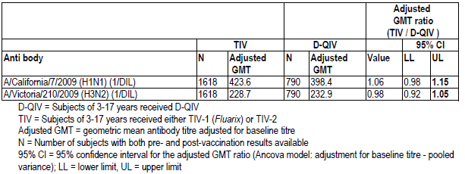

Table 26. D-QIV-003 GMT ratios Fluarix/D-QIV for B/Victoria (ATP cohort for immunogenicity)

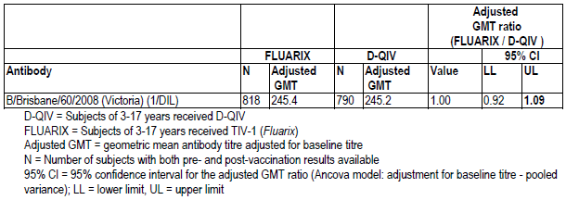

Table 27. D-QIV-003 GMT ratioTIV-2/D-QIV for B/Yamagata (ATP cohort for immunogenicity)

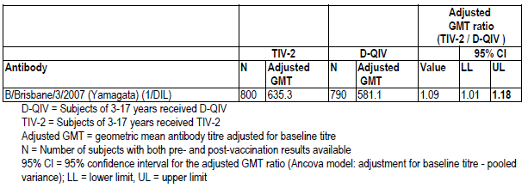

Table 28. D-QIV-003 TIV minus D-QIV SCR for A/California, A/Victoria (ATP cohort for immunogenicity)

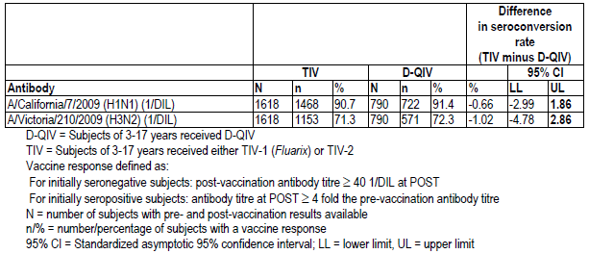

Table 29. D-QIV-003 Fluarix minus D-QIV SCR for B/Victoria (ATP cohort for immunogenicity)

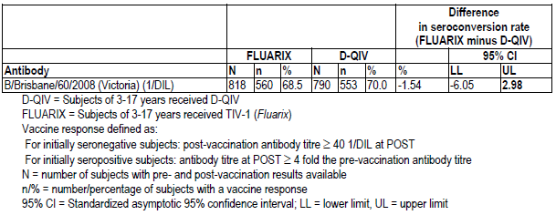

Table 30. D-QIV-003 TIV-2 minus D-QIV SCR for B-Yamagata (ATP cohort for immunogenicity)

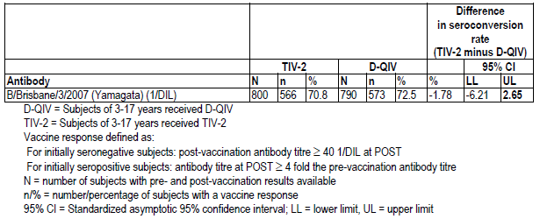

###### Secondary objectives

For the vaccine B strain not included in the TIV vaccines, superiority of D-QIV versus the two TIV vaccines was demonstrated in protocol defined terms. (Tables 31-34).

* The lower limit (LL) of the two-sided 95% CI for the GMT ratio for D-QIV over Fluarix for B/Brisbane/3/2007 (Yamagata lineage) strain was 2.36 (that is, greater than 1)
* The LL of the two-sided 95% CI for the GMT ratio of D-QIV over TIV-2 for B/Brisbane/60/2008 (Victoria lineage) strain was 2.63
* The LL of the two-sided 95% CI for the difference in SCR for D-QIV over Fluarix for B/Brisbane/3/2007 (Yamagata lineage) strain was 30.87% (that is, greater than zero)
* The LL of the two-sided 95% CI for the difference in SCR of D-QIV over TIV- 2 for B/Brisbane/60/2008 (Victoria lineage) strain was 35.78%

Table 31. D-QIV-003 GMT ratio D-QIV/Fluarix for B/Yamagata strain (ATP cohort for immunogenicity)

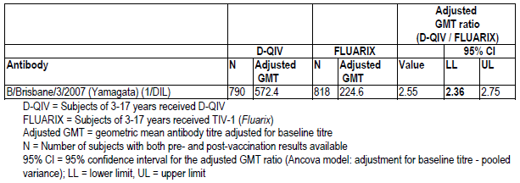

Table 32. D-QIV-003 GMT ratio D-QIV/TIV-2 for B-Victoria strain (ATP cohort for immunogenicity)

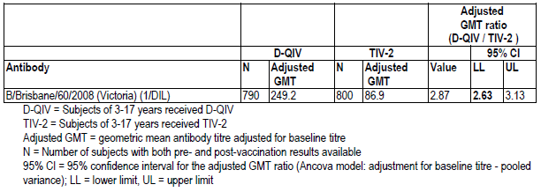

Table 33. D-QIV-003D-QIV minus Fluarix SCRs for B/Yamagata strain (ATP cohort for immunogenicity)

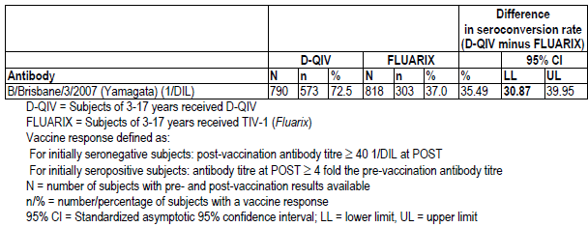

Table 34. D-QIV-3 D-QIV minus TIV-2 SCRs for B/Victoria strain (ATP cohort for immunogenicity)

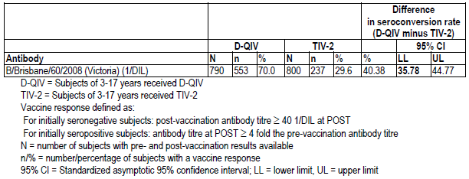

###### Seropositivity rates

Seropositivity rates following vaccination were 99.4% in each group for the four strains. GMTs post vaccination were as follows:

* A/California/7/2009 (H1N1): D-QIV: 386, Fluarix: 433: TIV-2: 422.
* A/Victoria/210/2009 (H3N2): D-QIV: 229, Fluarix 227 TIV-2: 234.
* B/Victoria lineage):D-QIV: 244, Fluarix: 246 for Fluarix and TIV-2: 88 (TIV-2 did not contain B/Victoria).
* B/Yamagata lineage): D-QIV: 570, Fluarix: 643, TIV-2: 225 for Fluarix. (TIV-1 did not contain B/Yamagata)

###### Seroconversion rates

Seroconversion rates are summarised in Table 35 and Figure 5 below.

* A/California/7/2009 (H1N1): D-QIV: 91.4%, Fluarix: 89.9%: TIV-2: 91.6%.
* A/Victoria/210/2009 (H3N2): D-QIV: 72.3%, Fluarix 70.7% TIV-2: 71.9%.
* B/Brisbane/60/2008 (Victoria lineage):D-QIV: 70.0%, Fluarix: 68.5%for Fluarix andTIV-2: 29.6%.
* B/Brisbane/3/2007 (Yamagata lineage): D-QIV: 72.5%, Fluarix: 37.0%, TIV-2: 70.8% for Fluarix. TIV-1.

Table 35. D-QIV-003 Seroconversion rate for HI antibody titres at Day 28 or 56 (ATP cohort for immunogenicity)

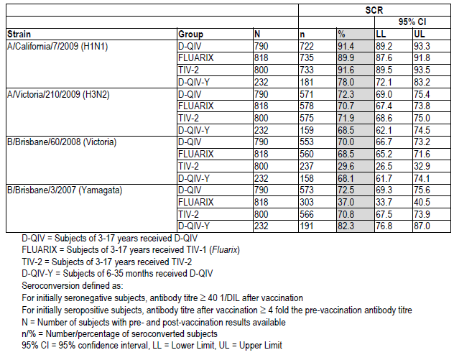

Figure 5. D-QIV-003 SCR for HI antibodies with 95% CIs at Day 28 or 56 (ATP cohort for immunogenicity)

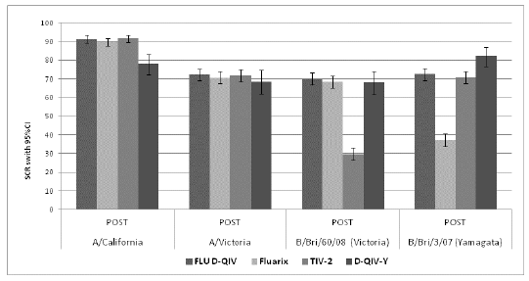

###### Seroprotection rates

Percentages of participants with HI titre ≥ 40 are summarised in Figure 6:

* A/California/7/2009 (H1N1): 97% for the three groups.
* A/Victoria/210/2009 (H3N2): 98% for D-QIV, 98% for Fluarix and 97% for TIV-2.
* B/Brisbane/60/2008 (Victoria lineage): 97% for D-QIV, 97% for Fluarix and 78% for TIV-2.
* B/Brisbane/3/2007 (Yamagata lineage): 99% for D-QIV, 100% for TIV-2 and 94% for Fluarix.

Figure 6. D-QIV-003 SPR titre ≥ 40 with 95% CIs at Day 0 and Day 28 or 56 (ATP cohort for immunogenicity)

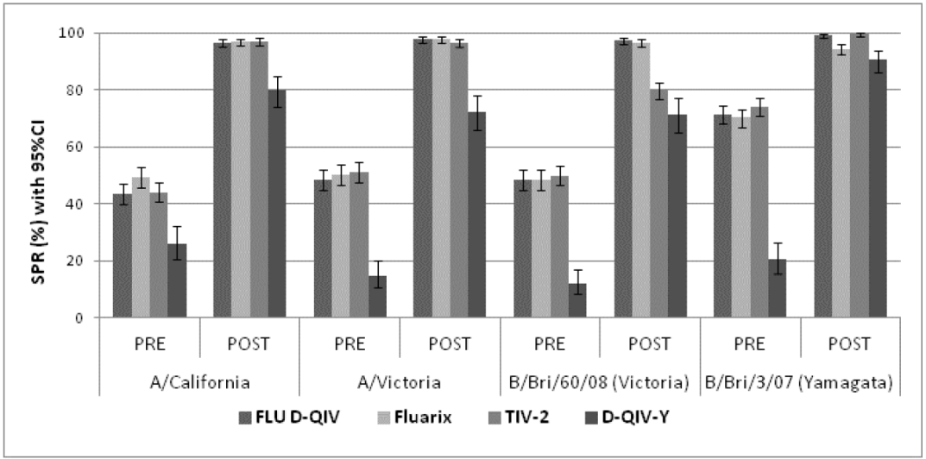

###### Mean geometric increase

Mean geometric increases are summarised in Figure 7.

* A/California/7/2009 (H1N1): 18 for D-QIV, 17 for Fluarix and 19 for TIV-2.
* A/Victoria/210/2009 (H3N2): 8 for D-QIV, 7 for Fluarix and 8 for TIV-2.
* B/Brisbane/60/2008 (Victoria lineage): 8 for D-QIV, 8 for Fluarix and 3 for TIV-2.
* B/Brisbane/3/2007 (Yamagata lineage): 7 for D-QIV, 8 for TIV-2 and 3 for Fluarix.

Figure 7. D-QIV-3 Mean geometric increase for HI antibodies with 95% CIs at Day 28 or Day 56 (ATP cohort for immunogenicity)

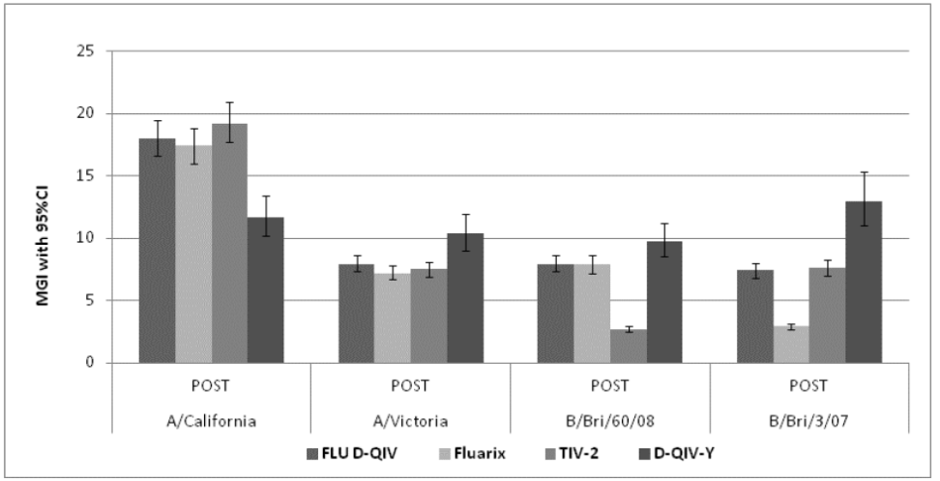

Evaluator comment: Immunogenicity results of this study support registration.

##### Supportive Paediatric Study FLU-D-QIV-002

FLU-D-QIV-002 (D-QIV-002), conducted in two centres in Mexico between October 2009 and May 2010, was a phase II, multicentre, randomised study evaluating immunogenicity, reactogenicity and safety of D-QIV compared with the Fluarix, in children 18 to 47 months of age.

##### Study design

###### Primary objective

To assess non-inferiority of D-QIV versus TIV in terms of HI GMTs for the three recommended seasonal strains, 28 days after the last vaccination in primed and unprimed children. Non-inferiority was determined if the upper limit of the two-sided 95% CI on the GMT ratio (Fluarix/D-QIV) of adjusted HI GMTs was < 2 at Day 28 for primed children and Day 56 for unprimed children. (Note: delta greater than in other studies)

###### Secondary objectives

* To assess superiority of D-QIV compared to TIV for the B strain not included in the trivalent vaccine. Superiority was determined if the upper limit of the two-sided 95% CI on the GMT ratio (Fluarix/D-QIV) was greater than 1.
* To assess the humoral immune response in each vaccine group.
* To assess the safety and reactogenicity of the study vaccines with 7 day follow-up of solicited adverse events, 28 day follow-up of unsolicited adverse events and for 6 months for adverse events of specific interest and serious adverse events.

###### Design

The study design is illustrated in Figure 8. The plan to enrol 300 children per group was calculated to provide 80% power to determine non-inferiority. Randomisation was 1:2:1:2 with 100 children in each primed group and 200 in the unprimed groups. Children between 18 to 47 months of age at the time of first vaccination were eligible for inclusion. By study definition, unprimed children had not been vaccinated with 2 doses of influenza vaccine in the previous season. Primed children received 2 doses of Fluarix 0.5 mL in GSK Biologicals’ study Fluarix-US-007 the preceding season.

Figure 8. D-QIV-002 Overall study design – Description

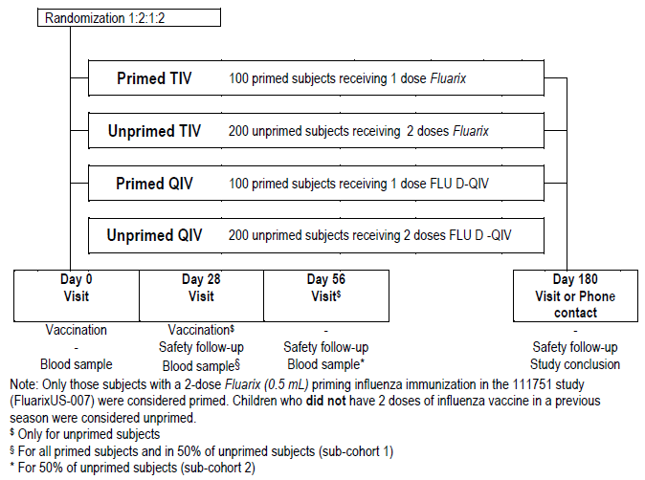

###### Study and reference vaccines

Vaccine formulations are shown in Table 36. Doses were administered intramuscularly into the deltoid region of the right arm.

Table 36. D-QIV-002 Vaccines, formulation, lot numbers and allocation

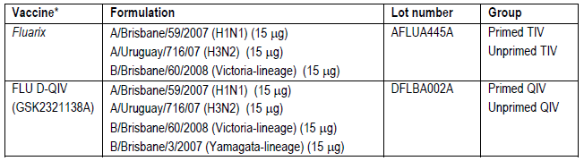

###### Blood samples and antibody determination

All participants had blood drawn on Day 0. All primed and half of the unprimed participants had a second blood sampled at Day 28 after the first vaccination, and half of the unprimed participants had a second blood sampled at Day 56 after the second vaccine dose (Table 37).

Table 37. D-QIV-002 Biological samples

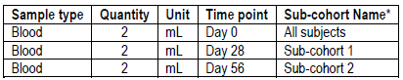

Antibody determination was done by GSK Biologicals’ laboratory as for the other submitted studies.

###### Definition of cohorts

The Total Vaccinated Cohort included all who received at least one dose of vaccine. The TVC for analysis of immunogenicity included vaccinated participants for whom data were available.

The ATP cohorts included all participants who met all eligibility criteria, who complied with the protocol procedures, with no elimination criteria assigned during the study and, for immunogenicity sub-cohorts, immunogenicity data were available. Two ATP immunogenicity cohorts for analysis were defined:

* The ATP immunogenicity cohort for comparisons 28 days after *last* vaccination.
* The ATP immunogenicity cohort for comparisons 28 days after *first* vaccination.

In addition, 2 immunogenicity sub-cohorts were defined, based on the blood sample schedule (Table 38).

* Sub-cohort 1 included participants having the second blood sample at Day 28.
* Sub-cohort 2 included participants having the second blood sample at Day 56.

Table 38. D-QIV-002 Sub-cohorts

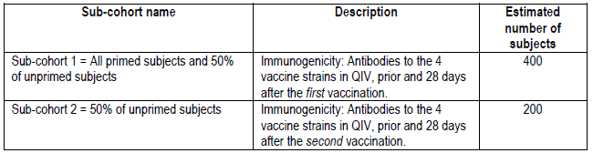

The ATP immunogenicity cohort for comparisons 28 days after last vaccination included children who had received a complete vaccine treatment: 1 dose at Day 0 for primed individuals and 2 doses (at Day 0 and at Day 28) for unprimed individuals (Table 39).

Table 39. D-QIV-002 ATP immunogenicity cohorts for comparisons 28 days after last vaccination

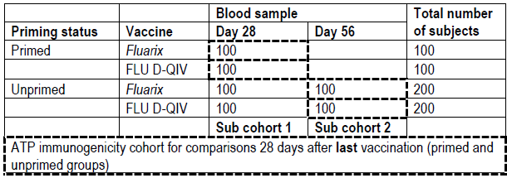

The ATP cohort for immunogenicity for comparisons 28 days after the first vaccination included all participants from sub-cohort 1 (Table 40).

Table 40. D-QIV-002 ATP immunogenicity cohort for comparisons 28 days after first vaccination

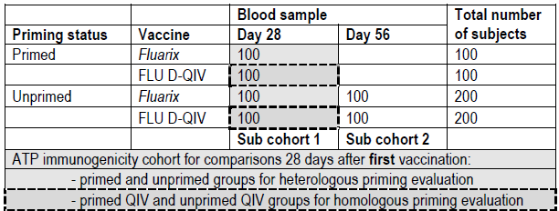

###### Changes to the conduct of the study:

According to the protocol, the study was to be double-blind. However, the presentation of the syringes containing the two vaccines was different. The difference in appearance was considered minor. The participants’ legal guardians remained blinded. The study staff and the local GSK team remained blinded. Therefore, according to the investigators the study was still considered to be double-blind.

Evaluator comment: The design and the reporting of this study were found to be confusing. The reason for complicated cohorts and sub-cohorts was not apparent and was not explained.[17]There was insufficient information provided to be sure that blinding was not compromised; a potential problem more likely to impact the safety/reactogenicity component of the study than the immunogenicity component. Only a proportion of participants in this study were in the age group relevant to the application for registration and they were not separately reported.

###### Results

Disposition

In total, 599 participants were enrolled

* D-QIV group: 298 participants, 95 in the primed group and 203 in the unprimed group.
* TIV group: 301 participants, 97 in the primed group and 204 in the unprimed group.

The numbers vaccinated, completed and those withdrawn with reason for withdrawal are summarised in Table 41. Overall, 584 participants completed the study and 15 withdrew.

Table 41. D-QIV-002 Disposition to Day 180l (Total vaccinated cohort)

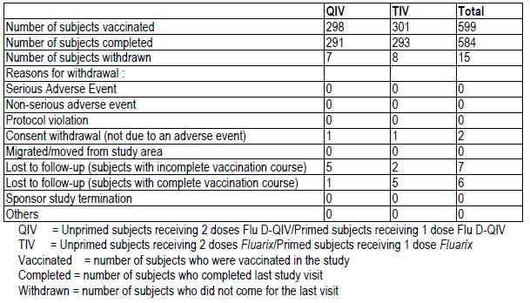

Three children were administered vaccines forbidden in the protocol, 1 in QIV and one in TIV groups. Eleven children had essential serological data missing, 7 in the QIV group and 4 in the TIV group and were excluded from the ATP population.

Demographic characteristics

The mean age was 31.4 months in the D-QIV group and 31.6 months in TIV groups. The population was predominantly American Hispanic or Latino (99.8%). Females accounted for 47.6% of the study population.

Primary objective analysis

Non-inferiority was demonstrated for the three recommended seasonal strains. The UL of the two sided 95% CI on GMT ratio (Fluarix vaccine over D-QIV vaccine) did not exceed 2 for each vaccine strain included in the Fluarix vaccine 28 days after the last vaccination (Table 42).

Table 42. D-QIV-002 D-QIV versus TIV Day 28 after last vaccination (ATP cohort for immunogenicity)

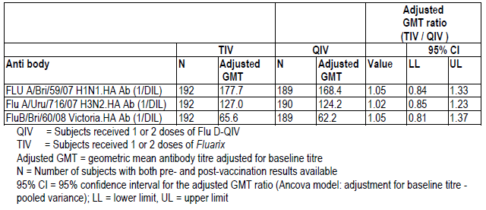

Evaluator comment: Although this study protocol specified a larger delta (2) than that chosen for the other studies (1.5), had the delta of 1.5 been applied, non-inferiority would still have been demonstrated.

Secondary analyses

Superiority was demonstrated for the B strain not included in the TIV vaccine. The LL of the two sided 95% CI on GMT ratio (D-QIV vaccine/Fluarix vaccine) was greater than 1 (Table 43).

Table 43. D-QIV-002 Adjusted GMT ratio Day 28 after last vaccination for the B strain not included in TIV (ATP cohort for immunogenicity)

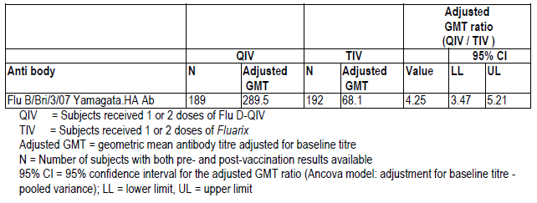

Humoral response

Results measured at Day 0 and 28 days after last vaccination are summarised below. Baseline seropositivity and GMT results were similar for QIV and TIV primed and for QIV and TIV unprimed, and rates were higher for the primed than the unprimed in both groups, particularly so for the B-Yamagata strain. Increase in seropositivity rates and GMTs after vaccination was noted in each group, primed and unprimed. In general, the unprimed group had higher seropositivity rates and GMTs after two doses than the primed children did after the one dose.

Seropositivity results

| Baseline | 28 days after last vaccination |
| --- | --- |
| **A/H1N1 strain** | |
| D-QIV primed: 61.7%; unprimed: 39.5%  TIV primed: 56.8%; unprimed: 35.9% | D-QIV primed: 88.3%; unprimed: 100%  TIV primed: 91.6%; unprimed 100.0% |
| **A/H3N2 strain** | |
| D-QIV primed: 63.8%; unprimed 44.3%  TIV primed 62.1%; unprimed: 41.6% | D-QIV primed: 93.6%; unprimed 100%  TIV primed: 91.6%: unprimed 100.0% |
| **B-Victoria strain** | |
| D-QIV primed: 27.7%; unprimed: 15.8%  TIV primed 29.5%; unprimed 21.2% | D-QIV primed 66.0%; unprimed 98.0%  TIV primed: 69.5% ; unprimed; 95.9% |
| **B-Yamagata strain** | |
| D-QIV primed: 77.7%; unprimed 23.9%  TIV primed 84.2%; unprimed 28.8% | D-QIV primed: 98.9%; unprimed 99.0%  TIV primed: 98.9%; unprimed 71.4% |

Evaluator comment: Baseline seropositivity was higher for A/H1N1, A/H3N2 and B-Yamagata in the primed groups than in the unprimed groups including for all B-Victoria baseline results. Seropositivity increased to between 95.9% and 99% for all groups except the TIV unprimed group but even in that group there was an increase from 28.8% to 71.4%. The evaluator was unable to find details of the priming vaccine but it is considered likely that B-Yamagata was a constituent of that vaccine[18] The TIV vaccine used in this study included a B-Victoria strain and it appears that there may be some cross reactivity to this antigen resulting in increased seropositivity for B-Yamagata or there may have been B-Yamagata circulating in community. However, there is no discussion included in Module 5, just a one sentence conclusion.

GMT results

|  |  |
| --- | --- |
| Baseline GMTs | 28 days after last vaccination |
| **A/H1N1 strain** | |
| D-QIV primed 40.3; unprimed 14.7  TIV primed 36.5; unprimed 12.8 | D-QIV primed 117.0, unprimed 253.1  TIV primed 124.4, unprimed 249.0 |
| **A/H3N2 strain** | |
| D-QIV primed 22.8; unprimed 17.7  TIV primed 21.7, unprimed 17.9 | D-QIV primed 85.2; unprimed 249.0  TIV primed 83.0; unprimed 202.1 |
| **B-Victoria strain** | |
| D-QIV primed 8.9; unprimed 7.8  TIV primed 9.7; unprimed 8.7 | D-QIV primed 38.7; unprimed 97.2  TIV primed 44.0; unprimed 99.6 |
| **B-Yamagata strain** | |
| D-QIV primed 29.3 unprimed 9.1  TIV primed 37.7; unprimed 9.9 | D-QIV primed 243.6; unprimed 311.1  TIV primed 127.2, unprimed 42.2 |

Evaluator comment: For the A/H1N1 and A/H3N32 antigens, the baseline GMTs for the unprimed group were lower than for the primed group and GMTs rose post vaccination, more so in the unprimed groups that received two vaccinations.

The priming vaccine is presumed to have contained B-Yamagata strain.18 B-Victoria strain GMTs were low for all primed and unprimed groups. GMTs rose after vaccination with B-Victoria strain containing D-QIV vaccine, more so with for the unprimed participants. However, GMT responses were not particularly high for any group.

The baseline B-Yamagata strain GMTs for unprimed participants were lower than for primed as would be expected if primed with B-Yamagata. When vaccinated with B-Yamagata, the levels rose for the D-QIV group. When vaccinated only with the B-Victoria strain, levels also rose for both the primed and unprimed groups, more so for the primed group and the GMTs were at least as high as for the post vaccination B-Victoria strain GMTs.

Seroconversion rates

A/H1N1 strain

* D-QIV primed 31.9%l TIV primed 41.1%
* D-QIV unprimed 85.3%; TIV unprimed 91.8%.

Evaluator comment: SCRs met the CPMP criteria for adults between 18 and 60 years of > 40% for the primed individuals vaccinated with TIV and for both unprimed groups. The result for primed individuals vaccinated with D-QIV met the criterion of > 30% for adults over 60 years. The results for unprimed participants were more than twice those for primed participants suggesting that the primed as well as the unprimed children may benefit from a two dose regimen.

A/H3N2 strain

* D-QIV primed 51.1%’ TIV primed 48.4% groups,
* D-QIV unprimed 82.3%; TIV unprimed 77.3%

Evaluator comment: SCRs met the CPMP criterion for adults 18 to 60 years. Seroconversion rates were greater for unprimed participants.

B-Victoria strain

* D-QIV primed 48.9%; TIV primed 44.2%
* D-QIV unprimed 81.1%; TIV unprimed 87.6

Evaluator comment: SCRs met the CPMP criterion for adults 18 to 60 years and were highest for the unprimed children.

B-Yamagata strain

* D-QIV primed 87.2%; TIV primed 42.1%
* D-QIV unprimed 94.7%; TIV unprimed 43.3%

Evaluator comment: For the B-Yamagata strain, SCRs met the CPMP criterion for adults 18 to 60 years. The result was better for the D-QIV vaccinated group but still passed the CPMP recommendation for participants in the TIV group who were not vaccinated with B-Yamagata strain.

Seroconversion factors

The results for fold increases in serum anti-HI GMT 28 days after last vaccination and the SCFs by priming status were presented in two tables. The results met CPMP criterion of > 2.5 for adults 18 to 60 years of age. The fold rises were considerably higher for unprimed children versus primed.

A/H1N1 strain

* D-QIV primed 2.9; TIV primed 3.4
* D-QIV unprimed 19.8 and TIV unprimed 19.2

A/H3N2 strain

* D-QIV primed 3.7; TIV primed 3.8
* D-QIV unprimed 11.1; TIV unprimed 10.3

B-Victoria strain

* D-QIV primed 4.4; TIV primed 4.5
* D-QIV unprimed 11.3; TIV unprimed 12.1

Evaluator comment: For these B-Victoria results, if the priming vaccine was B-Yamagata, then “primed” participants were in essence all participants were unprimed for this strain. The fold rises were considerably higher for those participants unprimed by study definition, who received two doses of B-Victoria containing vaccine.

B-Yamagata strain

* D-QIV primed 8.3; TIV primed 3.4
* D-QIV unprimed 35.1; TIV unprimed 3.7

Evaluator comment: For the primed participants the priming was (probably) with B-Yamagata. Those receiving the trivalent vaccine were not vaccinated with B-Yamagata for this study while those vaccinated with the quadrivalent vaccine were. While the unprimed QIV group had a substantial fold rise and the primed group had a good response, the TIV primed and unprimed groups both had fold rises that met the CPMP criterion for adults 18 to 60 years, in response to a vaccine that did not contain B-Yamagata strain.

Seroprotection rates

The results for seroprotection rates overall and by priming status were presented in two tables. The CPMP SPR guideline for adults 18 to 60 years is > 70% and for adults > 60 years > 60%.

A/H1N1 strain

Baseline

* D-QIV primed 51.1% and TIV primed 47.4%
* D-QIV unprimed 30.5% and TIV unprimed 27.3%

*Post vaccination:* Results were consistent with the CPMP recommendation for adults 18 to 60 years

* D-QIV primed 77.7% and TIV primed 82.1%
* D-QIV unprimed 96.0% and TIV unprimed 95.9%

A/H3N2 strain

Baseliner

* D-QIV primed 41.5% and TIV primed 37.9%
* D-QIV unprimed 38.5% and TIV unprimed 35.5%

*Post vaccinations:* Results were consistent with the CPMP recommendation for adults 18 to 60 years

* D-QIV primed 79.8% and TIV primed 84.2%
* D-QIV unprimed 97.0% and TIV unprimed 95.9%

B-Victoria strain

Baseline

* D-QIV primed 17.0% and TIV primed 21.1%
* D-QIV unprimed13.2% and TIV unprimed 17.7%

*Post vaccination:* The results were consistent with CPMP guidelines for adults 18 to 60 years except for the primed groups in which the results failed to meet the guideline for adults > 60 years.

* D-QIV primed 53.2% and TIV primed 54.7%
* D-QIV unprimed 85.7% and TIV unprimed 89.8%

Evaluator comment: these results also support the contention[19] that the “primed” children in this age group may have benefited from a two dose regimen in order to achieve an adequate SPR response.

B-Yamagata strain

Baseline

* D-QIV primed 59.6% and TIV primed 65.3%
* D-QIV unprimed 19.7% and TIV unprimed 20.2%

Post vaccinations

* D-QIV primed 96.8% and TIV primed 94.7%
* D-QIV unprimed 99.0% and TIV unprimed 60.2%

Post vaccination, the CPMP guideline for adults 18 to 60 years were met for all but the TIV unprimed group. In the TIV group, after vaccination with B-Victoria the B-Yamagata SPR reached the guideline for adults > 60 years. It is interesting to see such good responses for both primed and unprimed children, to a vaccine which did not contain the B-Yamagata strain.

## Clinical safety

### Introduction

In total, 4,228 individuals were exposed to at least one dose of D-QIV vaccine in Phase III studies: 3,036 adults 18 years of age and older and 1,192 children from 6 months to 17 years of age; 915 of whom were in the 3 to 17 years age group. In the paediatric studies, safety data are available from 534 children who received one dose and 956 children who received two doses. In addition safety data from 298 children and 105 adults from the two supportive studies contributed to the total safety database.

Adult participants ranged in age from 18 to 92 years in Study D-QIV-008 and 18 to 59 years in Study D-QIV-001. The study populations were of predominantly White-Caucasian/European heritage (71%), followed by East Asian heritage (24%).

Paediatric participants enrolled in supportive Study D-QIV-002 range in age from 18 to 47 months. In pivotal Study D-QIV-003, the age range of individuals enrolled was 6 months to 17 years. In each study, the demographic characteristics were similar for the D-QIV and comparator groups.

#### Method of evaluation of safety and reactogenicity

Adverse events were solicited during the first 7 days post vaccination (Day 0 to 6). Local and general adverse events solicited in each specific age strata are listed in Table 44 below. Unsolicited adverse events were collected for 21 days (Day 0 - Day 20) in adult studies D-QIV-008 and D-QIV-001, or within 28 days (Day 0 – Day 27) following each vaccination in paediatric Studies D-QIV-003 and D-QIV-002. The intensity grading used for local injection site redness or swelling is summarised in Table 45 below and fever is shown in Table 46. Other adverse events were rated for intensity according to a standard scale (Table 47-48).

In the pivotal paediatric Study D-QIV-003, enhanced surveillance was undertaken for 48 hours post vaccination, for fever ≥ 39°C and febrile convulsions occurring in individuals younger than 5 years of age. An internal Safety Review Committee reviewed the reports on a weekly basis in real time.

Table 44. Solicited local adverse events and solicited general adverse events

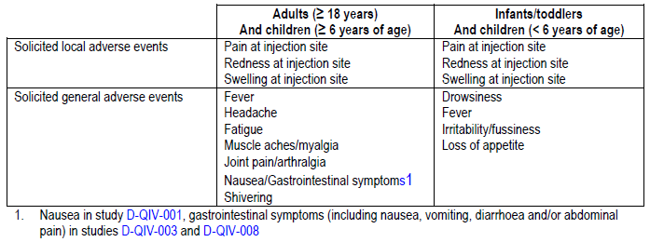

Table 45. Intensity scores used for local injection site redness and swelling

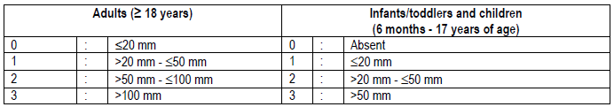

Table 46. Intensity scores used for fever

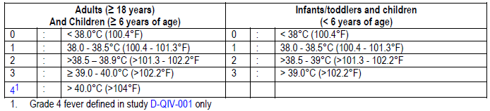

Table 47. Intensity scale for solicited symptoms; adults ≤ 18 years of age - children ≥ 6 years of age

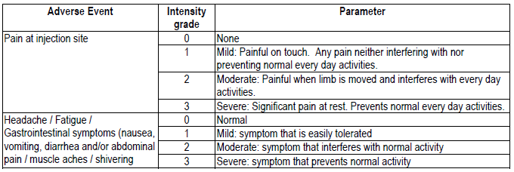

Table 48. Intensity scale for solicited symptoms in infants/toddlers and children < 6 years of age

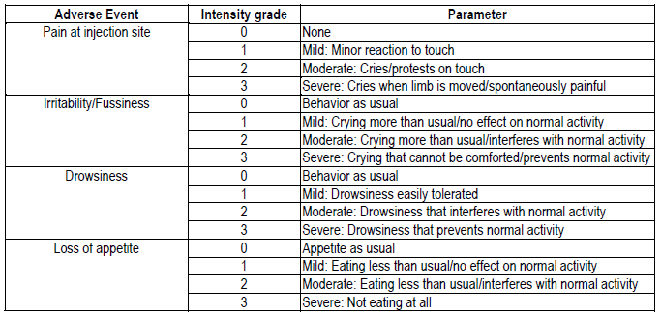

Adverse events (AEs) of specific interest (AESIs) and potential Immune-Mediated Diseases (pIMDs), including autoimmune diseases and other immune mediated inflammatory disorders and/or neurologic disorders which may or may not have an autoimmune aetiology were to be reported up to study end, whether or not they were considered related to vaccination. Investigator judgment was exercised in deciding whether other disorders/diseases not mentioned above might have autoimmune origin.

All solicited injection site reactions were considered by definition to be causally related to vaccination. Causality of all other adverse events was assessed by the investigator as follows:

NO: The AE is not causally related to administration of the study vaccine(s). There are other, more likely causes and administration of the study vaccine(s) is not suspected to have contributed to the AE.

YES: There is a reasonable possibility that the vaccine(s) contributed to the AE.

The primary analysis of safety and reactogenicity was performed on the Total Vaccinated Cohort including all individuals with at least one vaccine administration documented.

### Adult studies D-QIV-008 and D-QIV-001

#### Solicited adverse events

The incidences of solicited local AEs were similar following vaccination with D-QIV and Fluarix except for injection site pain in supportive Study D-QIV-001 (including 105 participants). In this study pain was more common in the D-QIV group (72.4%) than in the Fluarix group (49.5%). The difference in injection site pain observed in Study D-QIV- 001 was not confirmed in Study D-QIV-008, in which 3015 individuals received the D-QIV study vaccine. In this study, pain at the injection site was reported by a similar percentage of individuals in the D-QIV group (36.4%) and the Fluarix and TIV-2 groups (36.8% and 31.3% respectively). In Study D-QIV-008, grade 3 pain was reported by 0.5%-1.2% of participants. Redness and swelling were reported by 1.3% to 2.1% of individuals, with only one case of grade 3 injection site redness reported.

In both adult studies, fatigue, myalgia and headache were the most common solicited general symptoms. For fatigue and headache, incidences were higher in supportive Study D-QIV-001 than in the pivotal Study D-QIV-008, particularly so for fatigue. Examining each study separately, the incidences of events were similar for the vaccine groups. For D-QIV-008; myalgia: D QIV 16.4%, TIV-1 19.4% and TIV-2 16.1%; fatigue: D-QIV15.8%, TIV-1 18.4% and TIV-2 14.8% and headache: D-QIV 15.9%, TIV-1 16.4% and TIV-2 13.2%. For D-QIV-001: myalgia: D-QIV 16.2% TIV 14.3%, fatigue: D-QIV 31.4%, TIV 32.4% and headache: 23.8%, TIV 24.8%. Grade 3 solicited general events were reported by a maximum of 2.9% of participants, the maximum being for headache in the D-QIV group in supportive Study D-QIV-001.

Lower reactogenicity was seen in pivotal Study D-QIV-008 participants aged ≥ 65 years. Pain was reported by 50.9% of those vaccinated with D-QIV-008 aged 18 to 64 years and 21.7% of those ≥ 65 years. Grade 2 pain was reported by 0.8% of those < 65 years and 0.2% of those ≥ 65 years. The incidences were similar to those for Fluarix and TIV-2.

#### Unsolicited adverse events

In Study D-QIV-008, the proportions reporting at least one unsolicited AE within 21 days in the D-QIV, Fluarix and TIV-2 groups were 12.5%, 13.7% and 15.1% respectively. In supportive Study D-QIV- 001, at least one unsolicited adverse event was reported within 21 days by 6.7% of D-QIV and 10.5% of Fluarix participants. The most frequently reported AEs were nasopharyngitis, cough and oropharyngeal pain in Study D-QIV-008 and pharyngitis and headache in Study D-QIV-001 all reported at incidences lower than 2.0% in each vaccine group. The most common vaccine-related unsolicited events were injection site haematoma and oropharyngeal pain in Study D-QIV-008, reported in 0.2-0.5% of individuals. Grade 3 AEs after D-QIV vaccination were reported by 1.3% of individuals in Study D-QIV-008 and none in D-QIV-001.

#### Serious adverse events

SAEs were recorded for 180 days post vaccination, except for adults in the TIV-2 group in Study D-QIV-008 who were followed up until Day 21.

In the pivotal adult study, D-QIV-008, a total of 97/4600 participants (2.1%) reported a total of 127 SAEs. Up to Day 20, 16 (0.5%) in the D-QIV group, 6 (0.6%) in the TIV-1 group and one (0.2%) in the TIV-2 group reported at least one SAE. During the entire study period, 70 (2.3%) in the D-QIV group reported at least one SAE, 26 (2.6%) in the Fluarix group and 1 (0.2%) in the TIV-2 group. In Study D-QIV-001, one SAE was reported during the 180 day follow-up period. None of the SAEs reported in the two adult studies were considered related to vaccination. No SAE occurred within 7 days post vaccination.

In Study D-QIV-008 enrolling adults 18 to 92 years, 12 participants died during the entire study period: 9 (0.3%) in the D-QIV group, 3 (0.3%) in the Fluarix group and none in the TIV-2 group. All but one fatal event occurred beyond the 21 day post vaccination period. No death was considered vaccine related. There were no fatal events reported up to Day 180 in Study D-QIV-001.

#### Treatment discontinuations

In the pivotal adult Study D-QIV-008, 14 participants discontinued due to adverse events; none considered related to vaccination: one with rectal carcinoma (D-QIV); one with sinusitis (TIV-2) and 12 participants died. No AEs leading to the premature discontinuation were reported in Study D-QIV-001.

#### Potential immune mediated diseases

In Study D-QIV-008, one case of multiple sclerosis and one of facial paralysis were reported, both non-serious and both occurring after 3 months, neither being considered vaccine related.

#### Pregnancy

There were 6 pregnancies reported during the entire study period in the adult studies (5 cases in Study D-QIV-008 and 1 case in Study D-QIV- 001). Four of the pregnancies led to delivery of a live infant (D-QIV-008) and one participant underwent elective abortion (Study D-QIV- 008). One pregnancy was ongoing at the time of reporting (D-QIV-008).

#### Concomitant medication

In pivotal adult Study D-QIV-008, antipyretics were taken by 6.3%, 6.0% and 6.4% of participants in the D-QIV, Fluarix and TIV-2 groups, respectively. Two individuals, both in the D-QIV group (0.1%), took prophylactic antipyretics. The use of any antipyretics was lower in participants age > 64years old than in those aged 18 to 64 years.

In supportive adult Study D-QIV-001, the incidence of any medication use during the 21 day post vaccination period was within the same range for both study vaccine groups; D-QIV (8.6%) and (10.5%). Antipyretics were taken during this period by 5 individuals (4.8%) in the D-QIV group and 8 (7.6%) in the Fluarix group. None of the participants took prophylactic antipyretics.

#### Intrinsic factor – gender

In adult Study D-QIV-008, incidences of the most frequently reported solicited local AE pain were consistently higher in females than in males, across the 3 vaccine groups. Also for the most common solicited general AEs (fatigue, headache and muscle aches), incidence rates were generally higher in females than in males.

### Paediatric studies D-QIV-003 and D-QIV-002

Data are presented as the percentage of individuals who experienced a symptom during the full vaccination course, whether one or two doses were administered, and by incidence per dose.

#### Solicited adverse events

The incidences of all solicited symptoms local and general were similar following vaccination with D-QIV and trivalent comparators. No new safety signal was detected. The most common solicited local AE was injection site pain in both studies, reported by approximately 40%-50% of participants across all studies groups. Grade 3 pain was reported by 0.2%-2.3% of participants. Redness and swelling were less common and were reported at similar rates across the vaccine groups in both studies. In children aged 6 to 35 months who received D-QIV vaccine in Study D-QIV-003, pain tended to be reported by fewer participants (30.5%) than in children aged 3 to 17 years, while a trend to more reports of redness (28.4%) was observed.

Evaluator comment: reporting of pain by children aged 6 to 35 months was probably limited by developmental language ability.

The incidences of solicited general adverse events were similar across all study groups in Study D-QIV-003, regardless of severity and causal relationship. For children aged < 6 years (3 to 5 years in D-QIV-003, 18 to 47 months in D-QIV-002), loss of appetite, irritability and drowsiness were reported for D-QIV vaccinated children for 20.3% to 30.7% of participants in both studies. Fever was recorded in 17.2% and 25.3% of D-QIV groups in studies D-QIV-003 and D-QIV-002, respectively.

Incidences of solicited general AEs, including fever, in children aged 6 to 35 months who received D-QIV vaccine in Study D-QIV-003, were within the same range as in children aged 18 to 47 months in Study D-QIV-002 but were generally higher than in children aged 3 to 17 years in D-QIV-003. Grade 3 fever reports followed 3.9% of doses for 6.5% of individuals aged 6 to 35 months.

In children aged 6 to 17 years from Study D-QIV-003, the most frequently reported solicited general symptoms were fatigue, muscle aches and headache, all reported with frequencies ranging from 16.9% to 21.2% across groups.

In children aged 3-17 years, fever (defined as oral or axillary temperature ≥ 37.5°C) was reported for 10.8% of children in the D-QIV group, compared to 12.3% in the Fluarix group and 9.4% in the TIV-2 group. The incidence of fever > 38°C was 4.6% in the D-QIV group, 4.9% in the Fluarix group and 3.5% in the TIV-2 group. Grade 3 fever defined as temperature > 39°C was reported in 1.8% of individuals in the D-QIV group, 1.1% in the Fluarix group and 0.8% in the TIV-2 group.

In those participants who received two doses, there was no evidence of an increased incidence of solicited AEs following administration of a second dose compared to the first dose. Grade 3 solicited events were reported following ≤ 1.6% of doses across vaccine groups from both studies.

Incidences of solicited general AEs, including fever, in children aged 6 to 35 months who received D-QIV vaccine in pivotal Study D-QIV-003, were within the same range as in children aged 18 to 47 months in supportive Study D-QIV-002 but were generally higher than in older children aged 3 to 17 years in D-QIV-003. In line with previous findings from clinical studies with influenza vaccines, the incidence of fever (>37.5°C) tended to be higher in younger individuals. Grade 3 fever reports followed 3.9% of doses in 6.5% of individuals in the D-QIV-Y group aged 6 to 35 months.

#### Unsolicited adverse events

In pivotal Study D-QIV-003, the proportions of children aged 3 to 17 years reporting at least one unsolicited AE within 28 days after vaccination in the D-QIV, Fluarix and TIV- 2 groups were 31.0%, 33.4% and 33.8% respectively. In supportive Study D-QIV-002, at least one unsolicited adverse event was reported within 28 days by 38.9% and 39.2% of D-QIV and Fluarix recipients, respectively. The most common unsolicited AE was nasopharyngitis, reported by 5.4% to 7.0% of participants in Study D-QIV-003 and 24.2% to 22.9% in Study D-QIV-002. For children aged 6 to 35 months who received D-QIV vaccine in Study D-QIV-003, the overall incidence of unsolicited AEs was higher (60.3%) than in the older study groups, with the most frequent AEs being nasopharyngitis reported for 13.4% of participants.

Severe (Grade 3) AEs were reported for D-QIV; for 2.2% (3 to 17 years), 3.4% (18 to 47 months) and 7.2% (6 to 35 months). In both paediatric studies, no differences between D-QIV and comparators were observed.

For children 3 to 17 years of age, unsolicited AEs assessed as causally related to vaccination were reported for 2.2% of individuals in the D-QIV group, 2.1% in the Fluarix group and 2.5% in the TIV-2 group. Grade 3 AEs considered related to vaccination were reported by 1 individual in the D-QIV group (vomiting) and 3 individuals in the TIV-2 group (abdominal pain, vomiting, rhinorrhoea).

Higher incidences of any unsolicited AEs within the 28 day post vaccination period were seen in the 3 to 8 years stratum than the 9 to 17 years stratum (16.1% to 20.3% for 9-17 years stratum versus 39.0% to 41.4% for 3-8 years group).

#### Serious adverse events and deaths

None of the SAEs reported in the paediatric studies were considered related to study vaccination. In pivotal Study D-QIV-003, a total of 30/3015 (1.0%) reported a total of 45 SAEs during the entire study period. Within 28 days after vaccination, at least one SAE was reported by one individual (0.1%) each in the D-QIV group, Fluarix group and TIV-2 group and by 7 individuals (2.5%) in the younger D-QIV group aged 6 to 35 months. During the entire study period, SAEs were reported by 8 (0.9%) in the D-QIV group, 6 (0.7%) in the Fluarix group, 7 (0.8%) in the TIV-2 group and 9 (3.2%) in the D-QIV-Y group aged 6 to 35 months. In supportive Study D-QIV-002, no SAE was reported within 28 days of vaccination. During the entire study period, 2 SAEs were reported (one of bronchopneumonia and one of urticarial reaction)l neither considered related.

In paediatric Study D-QIV-003, one 3 year old boy in the Fluarix group died after a road traffic accident. There were no deaths reported in Study D-QIV-002.

#### Treatment discontinuations

In the pivotal paediatric Study D-QIV-003, 3 discontinued the study because of an AEs, none of which were considered related to vaccination: One participant in the Fluarix group died; one in the D-QIV group had non-fatal bacterial gastroenteritis; one in the Fluarix group had non-serious viral pneumonia. There were no discontinuations because of AE in supportive Study D-QIV-002.

#### Potential immune mediated diseases

In the pivotal paediatric Study D-QIV-003, one case of non-serious Bell’s palsy and one serious case of type 1 diabetes mellitus were reported but neither were considered vaccine related.

#### Febrile convulsions

In Study D-QIV-003, two cases of febrile convulsions were reported for two individuals from the D-QIV-Y group aged 6 to 35 months. Both cases were reported as SAEs, neither was reported within the 2 days post vaccination enhanced surveillance period and neither was considered related to vaccination: A 35 month old boy experienced a febrile convulsion during a viral infection 16 days after the first dose of vaccine. A 14 month-old boy experienced a febrile convulsion along with viral otitis media 98 days after the second dose. In Study D-QIV-002, a 37 month old child the D-QIV group experienced febrile convulsions 11 days after the first dose of vaccine.

#### Pregnancy

One paediatric study patient reported a pregnancy and subsequent elective termination.

#### Concomitant medication

In pivotal paediatric Study D-QIV-003, use of concomitant medication by 3 to 17 years olds during the 28 day post vaccination period was similar for D-QIV (32.3%), Fluarix (30.4%) and TIV-2 (33.8%). The use of antipyretic medication did not increase after the second dose. After Dose 1, prophylactic antipyretic medication was used by 2 (0.2%) in D-QIV group, 3 (0.3%) in Fluarix group, and 3 (0.3%) inTIV-2 group. After the second dose, 1 person in each of the Fluarix and TIV-2 groups took prophylactic medication.

In supportive paediatric Study D-QIV-002, the incidence of concomitant medication taken during the 28 day post vaccination period was similar in the D-QIV (38.9%) and in the Fluarix (38.5%) group. Overall, 24.8% of participants in the D-QIV and 28.6% in the Fluarix group were taking antipyretic medication. The use of antipyretic medication was no higher after the second dose. One child from the Fluarix group took prophylactic antipyretic medication after Dose 1.

#### Intrinsic factor - gender

In paediatric Study D-QIV-003, there was a trend for slightly higher incidences of pain of any intensity in females compared to males across all study groups. No consistent gender differences were noted for local AEs redness and swelling. In children < 6 years of age, no consistent gender difference in solicited general AEs was observed. For children > 6 years of age there was a trend for higher incidences of headache in females than in males, in the 3 vaccine groups.

## First round summary and discussion

GlaxoSmithKline Australia Pty Ltd (GSK) has applied to register the new chemical entity, Fluarix Tetra, an inactivated split influenza vaccine suspension for injection, 0.5mL pre-filled syringe, which includes the two recommended A strains, the recommended B strain, and a second B strain of the complementary B lineage. The intended use is from 3 years of age, based on official recommendations and dosed as for the trivalent vaccine. In essence the rationale is that, while annual influenza vaccination is the most effective method of prevention of influenza to date, the current influenza vaccination schedule includes only one of the two influenza B phylogenetic lineages with resultant risk of mismatch with the dominant circulating B strain, potentially reducing efficacy.

In support of the application, one pivotal adult and one pivotal paediatric study were submitted, along with 2 supporting adult studies and one supporting paediatric study.

Pivotal adult study FLU- D-QIV-008 was conducted in Germany, Romania, Spain, Korea, Taiwan and the US between October 2010 and June 2011. It was a Phase III, partially-blind, controlled, parallel group study to evaluate immunogenicity, safety and reactogenicity of D-QIV vaccine in adults 18 years of age and over, who were either healthy or had chronic well-controlled disease.

Participants were randomised into 5 groups, 5:5:5:5:3. Three groups of 1012 were vaccinated with three different lots of the candidate D-QIV vaccine; 1010 participants were vaccinated with Fluarix including the B/Victoria and 610 with TIV-2 vaccine which was identical to Fluarix except for inclusion of the B/Yamagata. Demographics were evenly spread. Participants ranged in age from 18 to 92 years. Over two thirds were White-Caucasian and approximately a quarter was East Asian. Withdrawal rate was less than 2%.

Co-primary objectives were to assess:

1. Lot-to lot consistency of HI antibody GMTs of three lots of the quadrivalent influenza vaccine D-QIV.
2. Non-inferiority in terms of HI antibody GMTs and seroconversion rates of D-QIV compared to trivalent influenza vaccine TIV-1 (Brisbane) and TIV-2 (Yamagata) vaccine for the three strains that were included in each of the two trivalent vaccines.
3. Superiority in terms of GMTs and SCRs of the D-QIV vaccine compared to the two trivalent vaccines for the B strain that was not included in each vaccine.

Lot-to-lot constancy was shown for Lots 1 and 2. Non-inferiority criteria for HI antibody GMTs and seroconversion rates were met for all vaccine strains shared with the trivalent vaccines. Criteria for superiority of D-QIV to TIVs for the B-strains not included in the trivalent vaccines were met.

Secondary objectives were to describe the immunogenicity in terms of GMTs and seroprotection rate at Days 0 and 21, seroconversion rate and mean geometric increase at Day 21 and to assess reactogenicity and safety.

Baseline seropositivity rates were similar across vaccination groups. The lowest seropositivity rate was for the H1N1 component of the vaccine (53.7% to 58.2%). For H3N2, the rates were approximately 80%, for B virus Victoria lineage rates were approximately 85% and for the Yamagata lineage approximately 86%. For each strain and each vaccine, seroconversion rates, seroprotection rates and fold increases met the CPMP/BWP/214/96 Harmonisation of Requirements for Influenza Vaccines9 guidelines for adults 18 to 60 years of age.

Evaluator comment: This study was well designed and reported and the immunogenicity results generally support the opinion that the quadrivalent vaccine is sufficiently immunogenic to recommend registration for use in adults from 18 years of age. The 2 issues requiring clarification (see List of Questions) considered satisfactorily addressed in the sponsor’s response to TGA’s consolidated request for information.

Supportive adult study FLU-D-QIV-001 conducted in one centre in the Czech Republic between July 2008 and January 2009, was a Phase I/II dose finding single blind, controlled study in adults years to evaluate the immunogenicity, safety and reactogenicity of the quadrivalent influenza candidate vaccine.

Participants aged 19 to 59 years were randomised 1:1:1:1 to four groups of 105 participants. The groups were vaccinated with D-QIV or Fluarix or with a low dose adjuvanted quadrivalent or trivalent vaccine. The quadrivalent vaccine included B/Malaysia/2506/2004 and B/Jiangsu/10/2003. The seasonal vaccine included the B/Malaysia strain. Participants were almost exclusively White-Caucasian. Only one participant withdrew from the study and two were excluded from the ATP analyses.

Co-primary objectives relevant to the appraisal of D-QIV were assessment of non-inferiority of HI GMTs of D-QIV versus Fluarix for the three seasonal strains, and superiority of HI GMT of D-QIV versus Fluarix for the B/Jiangsu/10/2003 strain not included in Fluarix. Criteria for non-inferiority were met for the three strains included in the seasonal trivalent vaccine. Superiority in protocol defined terms was shown for strain not included in Fluarix.

Secondary objectives included assessment of humeral immune responses. Baseline seropositivity rates were similar for all vaccine groups and were relatively high: approximately 60% for A/Solomon/H1N1, approximately 80% for A/Wisconsin/H3N2, between 75% 82% for D-QIV and TIV respectively for B/Malaysia and approximately 70% for B/Jiangsu. For D-QIV, seroconversion rates, seroprotection rates and fold increases met CPMP guidelines for adults 18 to 60 years. The guidelines were met for Fluarix for the three antigens included.

Evaluator comment: The study was well conducted and reported. The results support the opinion that the quadrivalent vaccine is sufficiently immunogenic to recommend registration for the age group included in the study. The GMT results did not suggest interference.

### Adult efficacy

Supportive adult efficacy study Fluarix-US-006was conducted during the influenza season 2006/2007 at one centre in the Czech Republic and fourteen centres in Finland. It was a Phase IV, placebo controlled double-blind trial including healthy adults aged 18-64 years. A total of 7652 participants were randomised 1:1:1 to receive Fluarix lot 1, Fluarix lot 2 or placebo (normal saline). The study population was almost exclusively White Caucasian, 60% were female. The withdrawal rate was less than 3%.

The primary objective was to demonstrate efficacy of Fluarix in the prevention of culture confirmed influenza A and/or B cases for vaccine antigenically matched strains compared to the placebo group. The primary objective was met if the lower limit of the 95% confidence interval for the vaccine efficacy against culture-confirmed influenza A and/or B, for vaccine antigenically matched strains, was above 35%.

Active surveillance for influenza like illness was conducted by the investigator approximately bi-weekly during the study period starting from 2 weeks after vaccination until the end of the influenza season. There was a 14 day follow-up period for each ILI episode. Influenza like illness was defined as at least one systemic symptom, fever (oral temp ≥ 37.8°C) and/or myalgia and at least one respiratory symptom.

The first day of an ILI episode was defined as the first day with one systemic symptom and one respiratory symptom. The last day of an ILI episode was defined as the last day either with fever, myalgia, cough or sore throat. A new ILI episode was only to be taken into account after the complete resolution of the previous one. Between two ILI episodes, there had to be at least 7 days free of any symptoms. A swab of both nares and a throat swab were collected at the onset of the ILI for influenza virus culture and identification, classification of influenza A and/or B virus isolates as “vaccine matching” or not, by serological typing and testing for influenza A and/or B by RT-PCR. A diagnosis of pneumonia was confirmed by chest x-ray.

The study found that the lower attack rate in the Fluarix group resulted in vaccine efficacy estimate of 66.9%. The primary objective was met; the lower limit of the confidence interval for the vaccine efficacy (51.9%) was above 35%.

Evaluator comment: Results of this study supports efficacy of vaccination with Fluarix. There were a number of participants who were not swabbed in the protocol defined 5 day interval, or who were not swabbed or had swabs lost. In addition, it is unclear how long after the onset of symptoms or influenza infection that swabs were likely to be remain positive. Questions relating to these comments were addressed by the applicant and the sponsor’s responses were accepted.

### Adult safety

A total of 3,036 adults were exposed to at least one dose of D-QIV vaccine in Study D-QIV-008 and 105 adults in Study D-QIV-001. No new or unexpected safety signal was detected. In general, in the pivotal study, safety in the D-QIV vaccinated groups mirrored that of the TIV vaccinated groups.

The incidences of solicited AEs were generally similar following vaccination with D-QIV and Fluarix except for injection site pain in supportive Study D-QIV-001, where pain was more common in the D-QIV group (72.4%) than in the Fluarix group (49.5%). In Study D-QIV-008, pain at the injection site was reported by a similar percentage of individuals in the D-QIV group (36.4%) and the TIV-1 and TIV-2 groups (36.8% and 31.3% respectively). In Study D-QIV-008, Grade 3 pain was reported in 0.5%-1.2% of individuals across the 3 vaccine groups. Redness and swelling were reported by 1.3% to 2.1% of individuals. The applicant considers that the smaller number of participants in D-QIV-001 may have biased the results for pain. The evaluator notes that Study D-QIV-001 was not double blind.

In both adult studies, fatigue, myalgia and headache were the most common solicited general symptoms. Incidences of fatigue and headache were higher in supportive Study D-QIV-001 than in the large pivotal Study D-QIV-008, particularly so for fatigue. Examining each study separately, the incidences of events were similar for included vaccine groups. For D-QIV-008 results were; myalgia: D QIV 16.4%, TIV-1 19.4% and TIV-2 16.1%; fatigue: D-QIV15.8%, TIV-1 18.4% and TIV-2 14.8% and headache: D-QIV 15.9%, TIV-1 16.4% and TIV-2 13.2%. For D-QIV-001 results were: myalgia: D-QIV 16.2% TIV 14.3%, fatigue: D-QIV 31.4%, TIV 32.4% and headache: 23.8%, TIV 24.8%. Grade 3 solicited general events were reported by a maximum of 2.9% of participants, the maximum being for headache in the D-QIV group in supportive Study D-QIV-001.

Lower reactogenicity was seen in participants aged ≥ 65 years in Study D-QIV-008 compared with those aged 18 to 64 years.

The most frequently reported unsolicited AEs were nasopharyngitis, cough and oropharyngeal pain in Study D-QIV-008 and pharyngitis and headache in Study D-QIV-001, all reported at incidences lower than 2.0% in each vaccine group. Few unsolicited AEs were considered vaccine-related, the most common being injection site haematoma and oropharyngeal pain in Study D-QIV-008, reported in 0.2-0.5% of individuals. Severe (Grade 3) AEs after D-QIV vaccination were reported by 1.3% of individuals in Study D-QIV-008 and none in D-QIV-001.

There were no deaths, serious adverse events discontinuations or potential immune mediated diseases considered related to study vaccine.

Evaluator comment: The safety and reactogenicity of D-QIV was found to be similar to that of Fluarix and therefore there appears no safety reason not to recommend registration for adults from 18 years of age.

### Paediatric immunogenicity

Pivotal paediatric study FLU-D-QIV-003 was conducted between October 2010 and June 2011 in the Czech Republic, France, Germany, Philippines and the USA. It was a Phase III, randomised, controlled, multi-country, multi-centre study with four parallel groups. A total of 2741 participants aged 3 to 17 years were randomised 1:1:1 to receive D-QIV, TIV-1 (Fluarix, with B/Victoria) or TIV-2 (with B/Yamagata). \

Primed participants were vaccinated with one intramuscular injection on Day 0. By protocol definition, primed participants had received at least one dose of an influenza A (H1N1) 2009 monovalent vaccine in the previous season or had laboratory confirmed H1N1 infection *and* had received two doses of seasonal influenza immunization separated by at least one month during last season or had received at least one dose prior to last season. \

Two IM injections at Day 0 and Day 28 were given to unprimed participants. By protocol definition, these children had not received any influenza A (H1N1) 2009 monovalent vaccine in the last season or did not have laboratory confirmed H1N1 infection *or* had not previously received any seasonal influenza immunisation in the past or received only one dose of influenza vaccine for the first time in the last influenza season.

Demographics were similar across the three groups. The population included White Caucasians approximately 56%, South East Asians approximately 26% and African Americans approximately 13%. Over 5% were eliminated from the ATP immunogenicity population; therefore, analyses were conducted on the ATP and the TVC populations.

A fourth group, D-QIV-Y, aged 6 to 35 was also included in the study. Immunogenicity results for this group were not evaluated for this clinical evaluation report (CER); however the group was examined for safety.

The following objectives were based on results from participants 3 to 17 years of age. The primary objective was to evaluate immunological non-inferiority of D-QIV versus TIV-1 containing B/Victoria lineage and TIV-2 containing B/Yamagata lineage, in terms of GMT and SCR 28 days after completion of the vaccination series (Day 28 for primed individuals, Day 56 for unprimed participants). Evaluation of immunological superiority in terms of GMTs and SCR, of D-QIV versus TIV-1 and TIV-2 for the B strain not contained in each TIV formulation was a secondary objective. Other secondary objectives were to describe the immunogenicity in terms of GMTs, seroprotection rate, seroconversion rate and mean geometric increase and to assess reactogenicity, and safety.

The primary objectives were met. Non-inferiority of D-QIV versus Fluarix and TIV-2 and D-QIV versus TIV-2 for the common antigens was demonstrated. Superiority of D-QIV versus the two TIV vaccines was demonstrated for the B strain not included in the TIV vaccines.

Baseline seropositivity rates were between 63.5% and 68.9% for A (H1N1), between 76.1% and 79.4% for A (H3N2), approximately 75% for B (Victoria) and 92% for B (Yamagata). GMTs rose post vaccination for all antigens but more so for antigens contained in the vaccines.

Seroprotection rates post vaccination were high and met the CPMP criteria for adults 18 to 60 years for all antigens included in the vaccines and for B/Brisbane not contained in the TIV-2 vaccine. Seroprotection rate for the B/Yamagata strain not contained in TIV-2 met the criterion for adults over 60 years of age. Mean fold changes met the CPMP criterion for adults 18 to 60 years for all antigens, irrespective of inclusion in a particular vaccine; however, fold rises were considerably higher for antigens included in the vaccines.

Evaluator comment: Results of this well conducted, well reported study support the opinion that immunogenicity is sufficient to recommend registration.

Supportive paediatric study FLU-D-QIV-002 conducted between October 2009 and May 2010 in two centres in Mexico, was a Phase II, double-blind, multicentre, randomised study evaluating immunogenicity, reactogenicity and safety of D-QIV compared with the Fluarix, in children 18 to 47 months of age.

In all, 599 children were randomised 1:2:1:2 into four groups with approximately 100 children in each of the D-QIV and TIV primed group and 200 in each of the D-QIV and TIV unprimed groups. By study definition, unprimed children had not been vaccinated with 2 doses of influenza vaccine in the previous season and received two doses of vaccine in the study. Primed children had previously received 2 doses of Fluarix 0.5 mL in the GSK Biologicals’ Study Fluarix-US-007 the preceding season and were vaccinated with one dose in Study D-QIV-002. The B virus lineage of the priming vaccine could not be determined and thus was inferred from results.

The primary objective was to assess non-inferiority of D-QIV for the three recommended seasonal strains. Assessment ofsuperiority of D-QIV compared to TIV for the B strain not included in the trivalent vaccine was a secondary objective. The primary object was met for the three recommended seasonal strains according to the protocol. Superiority was demonstrated for the B strain not included in the TIV vaccine.

Humeral immune response was assessed as a secondary objective. Baseline seropositivity results were higher for the primed participants than for the non-primed, even for the B strain not included in the priming vaccine; however, seropositivity result for the B strain not included in the priming vaccine for both primed and unprimed children was considerably lower than for other strains.

Seroconversion rates for A/H1N1 met the CPMP criterion for adults 18 to 60 years except for primed participants in the D-QIV group which met the criterion for adults over 60 years of age. For A/H3N2 and B/Victoria, the criterion was met for all groups. For B/Yamagata, the result was better for D-QIV but still passed the CPMP criterion for participants in the TIV group who were not vaccinated with the B/Yamagata strain. Fold increases met the CPMP criterion for adults 18 to 60 years for all antigens and were higher in the unprimed than the primed participants.

Seroprotection rates for B/Victoria met the CPMP criterion for adults 18 to 60 years for both unprimed groups but both primed groups failed to reach criteria both for adults 18 to 60 years and over 60 years of age. For the B/Yamagata strain, results met the CPMP criterion for adults 18 to 60 years for all but the TIV unprimed group which met the criterion for adults over 60 years.

Evaluator comment: There are questions to be answered before final conclusions are made; see *List of Questions*. The study design and reporting complicated interpretation of results. Although the children in this study were generally younger than those for whom the indication is proposed, there was a proportion between 36 and 47 months of age, relevant to this application. These children were not separately analysed. The results overall, suggest that a young child previously vaccinated with a trivalent vaccine, may benefit from two doses at first vaccination with the quadrivalent vaccine.

### Paediatric safety

In total, 1192 children from 6 months to 17 years of age were exposed to at least one dose of D-QIV vaccine in the Phase III D-QIV-003 study; 915 of whom were in the 3 to 17 years age group. Safety data were available for 534 children who received one dose and 956 children who received two doses of the D-QIV vaccine. An additional 298 children from the supportive Study D-QIV-002 contributed safety information.

The most common solicited local AE was injection site pain reported by approximately 40% to 50% of participants across all studies groups. Grade 3 pain was reported by 0.2% to 2.3%. Redness and swelling were less common and were reported at similar rates across the vaccine groups in both studies. Pain tended to be reported by fewer participants aged 6 to 35 months (30.5%) than in children aged 3 to 17 years, possibly related to developmental language ability, while a trend to more reports of redness (28.4%) was observed in the youngest group.

In children aged 6 to 17 years from Study D-QIV-003, the most frequently reported solicited general symptoms were fatigue, muscle aches and headache, all reported with frequencies ranging from 16.9% to 21.2% across groups.

The incidences of solicited general adverse events were similar across all study groups in pivotal Study D-QIV-003, regardless of severity and causal relationship. For children aged < 6 years (3 to 5 years in D-QIV-003, 18 to 47 months in D-QIV-002), loss of appetite, irritability and drowsiness were reported for 20.3% to 30.7% of the D-QIV vaccinated children in both studies. Fever was recorded for 17.2% and 25.3% of D-QIV participants in Studies D-QIV-003 and D-QIV-002, respectively.

In general, the incidences of all local and general solicited symptoms were similar following vaccination with D-QIV and the trivalent comparators. The incidences of solicited general AEs, including fever, in children aged 6 to 35 months who received D-QIV vaccine in Study D-QIV-003, were within the same range as in children aged 18 to 47 months in Study D-QIV-002 but were generally higher than in children aged 3 to 17 years in D-QIV-003. Grade 3 fever reports followed 3.9% of doses in 6.5% of individuals in the youngest age ranges.

In Study D-QIV-003 for children aged 3 to 17 years, fever (defined as rectal temperature ≥ 38°C, oral or axillary temperature ≥ 37.5°C) was reported for 10.8% of individuals in the D-QIV group, compared to 12.3% in the Fluarix group and 9.4% in the TIV-2 group. The incidence of fever >38°C was 4.6% in the D-QIV group, 4.9% in the Fluarix group and 3.5% in the TIV-2 group. Grade 3 fever defined as > 39°C was reported in 1.8% of individuals in the D-QIV group, 1.1% in the Fluarix group and 0.8% in the TIV-2 group.

Febrile convulsions were considered events of specific interest in pivotal Study D-QIV-003. Two cases of febrile convulsion were reported, both from the D-QIV-Y group. Both cases were reported as SAEs, neither was reported within the 2 days post vaccination enhanced surveillance period and neither was considered related to vaccination: In Study D-QIV-002, one case of febrile convulsion was reported in the D-QIV group and was not considered related to vaccination.

In those participants who received two doses, there was no evidence of an increased incidence of solicited AEs following administration of a second dose compared to the first dose. Grade 3 solicited events were reported following ≤ 1.6% of doses across vaccine groups from both studies.

Few unsolicited AEs were considered vaccine-related (≤ 2.3% after D-QIV vaccination). Severe (Grade 3) unsolicited AEs were reported for D-QIV; 2.2% (3 to 17 years), 3.4% (18 to 47 months) and 7.2% (6 to 35 months). In both paediatric studies no differences between D-QIV and comparators were observed.

No serious adverse event was considered vaccine related. In Study D-QIV-003, 3 individuals discontinued the study because of an unrelated SAE or AE. One individual in the Fluarix group died due to a road traffic accident; one in the D-QIV group was withdrawn due to non-fatal bacterial gastroenteritis; one in the Fluarix group was withdrawn due to non-serious viral pneumonia.

Two potential immune mediated diseases were reported in Study D-QIV-003, one case of non-serious Bell’s palsy and one serious case of type 1 diabetes mellitus were reported. Neither was considered vaccine related.

Evaluator comment: The safety and reactogenicity of D-QIV was found to be similar to that of Fluarix and therefore there appears no safety reason not to recommend registration for children from 3 years of age.

### First round risk benefit assessment

The safety of the quadrivalent vaccine studied in the age groups proposed for registration appears similar to that of the registered trivalent vaccines used in the studies.

Immunogenicity of the quadrivalent vaccine has been demonstrated in the populations studied.

Efficacy of the quadrivalent vaccine has not been determined.

## First round recommendation regarding authorisation

The risk benefit balance was determined to be on the side of benefit. Registration of the vaccine was recommended.

The applicant’s response to comments on the proposed Product Information was accepted with one exception. In the Dosage and Administration section of the amended draft Product Information, the diagrams have been deleted. This is not recommended. The sponsor was asked to please reinstate the diagram.

## Clinical questions

The clinical questions raised by the evaluator are discussed below together with the sponsor’s responses and the evaluator’s comments on the sponsor’s responses.

## Second round evaluation of clinical data submitted in response to questions

### Question 1 (D-QIV-008)

Please provide the lot-to-lot consistency results for all three lots in Study D-QIV-008.

#### Sponsor’s response:

Table 49. Study D-QIV-008: adjusted GMT ratios of HI antibody at Day 21 for the all pairwise comparisons between two lots of D-QIV for the 4 strains contained in the D-QIV vaccine

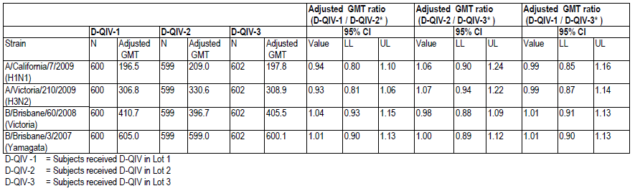

#### Evaluator comment

The response is accepted. All comparisons were between 0.67 and 1.5 for the four strains.

### Question 2 (D-QIV-008)

Please compare and discuss the GMT, seroconversion, seroprotection and fold increase results for participants aged 18 to 60 versus those > 60 years of age.

In Module 5 Clinical Study Report (CSR) there was no discussion of the results for participants stratified by age. Of particular interest is the comparison between those ≤ 60 years versus those > 60 years.

While for both age categories, the seroconversion rate, seroprotection rate and fold changes were commensurate with those recommended by CPMP for acceptance of seasonal vaccines and confidence intervals were tight, it was noted that the trivalent vaccines each passed the criteria even for the antigen not included.

In addition, in relation to GMTs responses, those of D-QIV were less than for either TIV-1 or TIV-2 for A/California, and A/Victoria, and in both instances, the A antigen GMTs for those > 60 years were considerably less than for those ≤ 60 years and quite a deal less than for the responses to the B antigens, especially for B-Yamagata including for TIV-1. Does this suggest the possibility of a degree of interference with antibody response to the A antigens?

#### Sponsor’s response

Discussion of the results was provided as requested. The response was considered to be acceptable.

Regarding A antigen responses, GMT point estimates in the D-QIV group are each time within the 95%CI limits of the respective GMTs in the TIV groups. Hence, the results do not allow to conclude that the response to the A strains is lower with D-QIV than with TIV and these slight differences in the point estimate do not suggest a possible interference of DQIV on the response to A antigens.

When comparing A antigen responses to those against the B antigens it is observed that GMTs responses to the A antigens are lower than GMTs of antibodies against the B antigens. However, this is mainly due to the particularly high responses to the B antigens in this study, an observation that was made in other studies performed during the same season 2010-2011; as further discussed below. Both Yamagata and Victoria B strains had been circulating in preceding influenza seasons and a very high proportion of subjects (approximately 85%) in Study D-QIV-008 were seropositive to the two B strains before vaccination.

#### Evaluator comment

Response accepted.

### Question 3 (Fluarix-US-006)

It was noted that the H3N2 the GMTs in Study 008 were higher than in Fluarix-US-006, approximately 310 versus 133. In Study Fluarix-US-006, although the primary objective was met, 77.8% of the 19 cases of influenza A H3 were vaccine matching. Were the GMTs of those with vaccine matching influenza examined?

#### Sponsor’s response

The absolute figures for GMTs obtained in study Fluarix –US-006 against H3N2 were indeed lower than those observed in Study D-QIV-008, acknowledging that these were different studies, conducted with different vaccine compositions, in different seasons and in different populations.

As the efficacy results have been mainly driven by the VE against H3N2 in that study, as pointed out by the assessor, this could support the reassuring fact that VE observed in that study represents a worst case situation, leading to lower VE than could be anticipated with higher titres. This has however to be balanced with two elements: on one hand, it can be expected that, depending on the strain, the correlation between HI titres and protection might not be strictly linear. Also, individual immunological responses can vary widely around the calculated GMTs, as evidenced by the maximum (3620) and minimum (>10) HI values observed against H3N2.

Blood samples to assess the immune response were taken from a subset of 460 subjects (6% of total enrolled cohort). Among these, only 3 subjects (all in the placebo group) had culture confirmed influenza due to H3N2, precluding any analysis.

#### Evaluator comment

Response accepted.

### Question 4 (Fluarix-US-006)

How long is influenza virus excreted in amounts measurable by the study methods?

#### Sponsor’s response

Published data have shown that titres of infectious influenza virus peak during the first 24 to 72 h of illness .. and decline within several days, with titres usually low or undetectable by Day 5. (Bell et al Emerg Inf Dis 2006).[20]

In Study Fluarix-US-006, the number of positive samples (by RT-PCR and culture) were stratified per time period between ILI onset and sample (nasal/throat swabs) collection (Figure 9.9). Among the 1151 ILI cases sampled, 9 were taken after 5 days. Eight were negative by both methods and one was not processed. These 9 cases were not included in the analysis shown in Figure 9 below. For both assays, the maximum percentage of collected swabs that tested positive was recorded on the day of onset of ILI symptoms (that is, Day 0, 29% for RT-PCR and 18% for culture).

Thereafter, the percentage of RT-PCR positive samples remained relatively constant (17 to 21%) while the percentage of culture positive samples decreased progressively from 15% on Day 1 to 0% on Day 5, indicating that RT-PCR was more likely to detect viral shedding later after clinical onset. With both methods, most of the cases were diagnosed on Day 1.

Figure 9. Numbers of RT-PCR and culture positive samples stratified by time period between onset of ILI and collection of sample

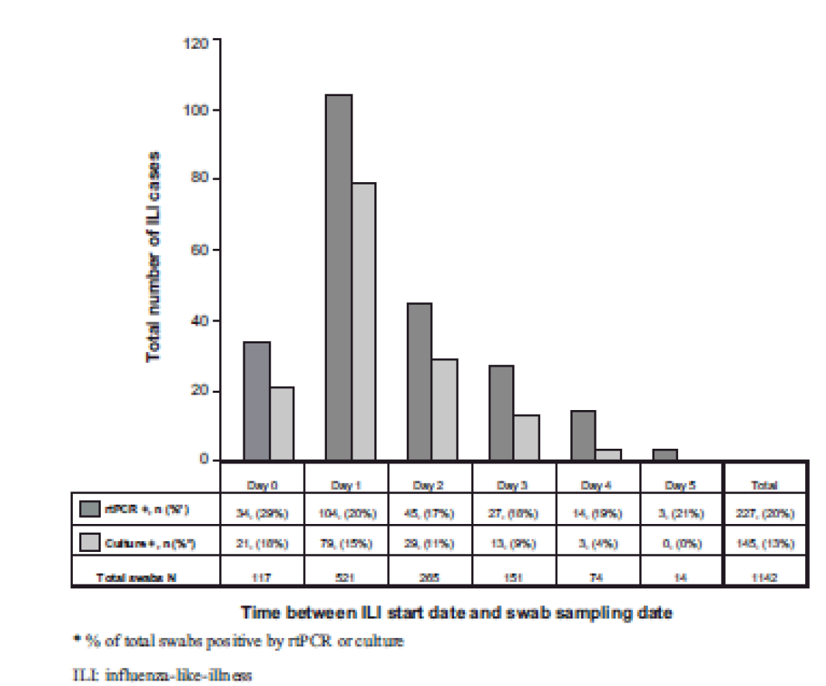

#### Evaluator comment

Difficulty in diagnosis of influenza illness with increasing length of time between onset and sampling complicates the interpretation of the study results. However, it is acknowledged that this study involved complicated organisation while addressing an important question.

Note: the blurring of Figure 9 is unavoidable due to the blurring of the image in the response document.

### Question 5 (Fluarix-US-006)

Would the applicant please comment on whether the collection of samples later than 5 days for 7 of the Fluarix group and 2 of the placebo group, had the potential to bias results in favour of Fluarix? In addition, would the applicant specify in which group(s) the swabs were either not taken or were lost?

#### Sponsor’s response

All 9 samples collected later than 5 days in both Fluarix and placebo groups were negative. To check for potential bias, the sponsor tabulated the Vaccine Efficacy as an exploratory analysis, assuming that all the swabs collected after 5 days may have been positive, which represents the worst case for Fluarix efficacy estimates. Table 50 below shows the computations of VE based on the attack rates including the cases taken outside of the 5 day window (assuming all were positive), assuming the event outcome was Bionomial distribution. The point estimate for VE is 63% (48.2% to 73.8%), still meeting the criteria for evaluation, that is, LL for 95% CI > 35%.

Table 50. Computations of VE based on the attack rates including the cases taken outside of the 5 day window.

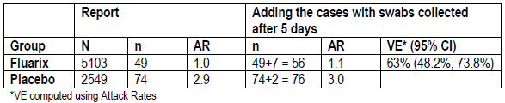

The number of subjects with samples either not taken or lost is presented per group in the table below.

Table 51. Number of samples not taken or lost.

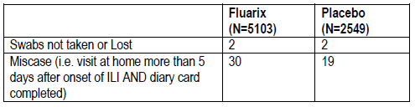

#### Evaluator comment

Response accepted.

### Question 6 (D-QIV-003)

Study D-QIV-003 Supplement Table 132 (reproduced below as Table 52) had as a footnote “Site 82400 excluded”. Please explain the exclusion of the site.

Table 52. D-QIV-003 Non-inferiority of D-QIV versus TIV-2 in terms of seroconversion rate (difference in seroconversion rate) at Day 28 after the last vaccination for B-Yamagata strain (Total vaccinated cohort)

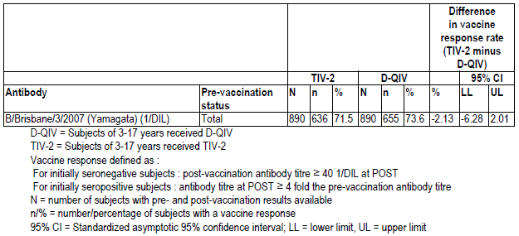

Site 82400 excluded

#### Sponsor’s response

Supplement Table 132 includes all subjects from all centres: the “site 82400 excluded” note is actually not a footnote but a title applicable to Supplement Table 133. The sponsor apologised for the confusing layout.

In Study D-QIV-003, site 82400 in the US was audited and as quality issues were found, the Company decided to also analyse the primary objective of the study excluding the 69 subjects of this site. Though the number of subjects from this centre represented less than 5% (that is, 2.3%) and no difference was expected to be seen, the primary objectives (non-inferiority objectives) were analysed excluding this center for the Total Vaccinated Cohort. Data including and excluding those subjects from the total vaccinated cohort are thus presented in the report:

* The non-inferiority of D-QIV versus TIV-1 (Fluarix) and TIV-2 in children 3 to 17 years old, at 28 days after last vaccination, was presented in Supplement 127 to Supplement 132.
* The non-inferiority of D-QIV versus TIV-1 (Fluarix) and TIV-2 in children 3 to 17 years old, at 28 days after last vaccination excluding the site 82400 was presented in Supplement 133 to Supplement 138.

Excluding site 82400 from the total vaccinated cohort did not affect the outcome of the non-inferiority analysis in the total vaccinated cohort.

#### Evaluator comment

Response accepted.

### Question 7 (D-QIV-002)

Please provide details of the B strain lineage contained in the priming vaccine.

#### Sponsor’s response

Table 53. Strain composition of vaccine formulation used in study Fluarix-US- 007

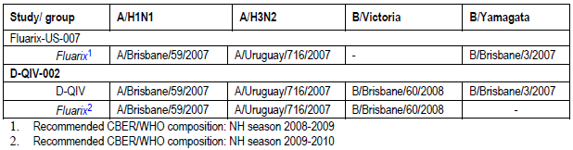

#### Evaluator co**m**ment

Response accepted.

### Question 8 (D-QIV-002)

Please explain the reason for inclusion of cohorts and sub-cohorts, a design feature which was found difficult to evaluate, particularly when reconciling text with table headings.

#### Sponsor’s response

The reason to create the sub-cohorts was to get only two blood samples in the independent cohort of unprimed children instead of three, that is, the first one on Day 0 and the second one either after Dose 1 or after Dose 2, yet to explore the immune responses after the first and the second dose.

#### Evaluator comment

The response was accepted. Reporting of cohorts, sub-cohorts and populations for analysis was confusing unlike any other study submitted in this dossier.

### Question 9 (D-QIV-002)

It appears that there may be some cross reactivity between the 2 B-lineages in primed and unprimed children, or there may have been B-Yamagata circulating in community. Please discuss the findings as the sponsor has previously stated that in unprimed children there is evidence of low or almost non-existing cross-reactivity of antibodies between the two B lineages.

#### Sponsor’s response

The sponsor acknowledged that some level of cross-reactivity is indeed observed between the two B lineages, both in children and in adults. This was observed in Study DQIV- 002 as well as in Studies D-QIV-003 and D-QIV-008.

Results obtained in this suggests that the level of cross-reactivity may increase with age, in line with the hypothesis that cross-reactivity is impacted by previous exposure.

#### Evaluator comment

Response accepted.

### Question 10 (D-QIV-002)

SCRs met the CPMP criteria for adults between 18 and 60 years of > 40% for the primed individuals vaccinated with TIV and for both unprimed groups. The result for primed individuals vaccinated with D-QIV met the criterion of > 30% for adults over 60 years. The SCR and SPR results for unprimed participants are considered to suggest that the primed as well as the unprimed, very young children may benefit from a two dose regimen. Please comment.

#### Sponsor’s response

* Dosage was based on that recommended for inactivated influenza vaccines
* The company acknowledged the somewhat lower immune responses after one dose of vaccine in primed children.
* Primed children had received a vaccine that prevented natural infection whereas unprimed children may have had natural exposure/infection.
* The study was not powered to compare responses of primed versus unprimed children.
* The study population was younger than the lower age limit sought for the Fluarix Tetra indication.
* Responses in primed versus unprimed very young children may vary according to antigens to which they have been exposed.
* A field study would be impossible to validate due to inherent nature of flu vaccines with varying composition each year.

#### Evaluator comment

The question raised a hypothesis and it was agreed that this could not be tested in D-QIV-002. The hypothesis will become more relevant if the company wishes to register the vaccine for younger children in the future.

### Question 11 (D-QIV-003 and D-QIV-002)

Regarding the paediatric studies, in reporting of temperature, and in particular in grading of fever, it is unclear whether there was adjustment for method of recording fever. In both studies according to the protocol, fever was defined as: rectal temperature ≥ 38°C/axillary temperature ≥ 37.5°C /oral temperature ≥ 37.5°C. The grading shown in the table below does not account for the method of measurement. Was adjustment made for method of measurement in analysis of fever?

Table 54. Studies D-QIV-001, D-QIV-002, D-QIV-003 and D-QIV-008: Intensity scores used for fever



#### Sponsor’s response

The sponsor confirmed that for paediatric studies, an adjustment for temperature measurement was done according to the recording route, that is, Grade 1 fever is either ≥ 38°C by rectal route or ≥ 37.5°C by any other route. Other grades are systematically defined with 0.5°C increment for rectal route.

In the D-QIV 002 study, all temperature measurements (which were recorded and their route known) were done using the axillary route.

In the D-QIV 003 study, approximately 20% of the subjects recorded their temperature using the rectal route while the rest of the subjects measured using the oral, axillary or tympanic route.

#### Evaluators comment

With respect to D-QIV-002 the response was accepted.

With respect to D-QIV-003, in the absence of confirmation that all measurements were recorded with their route known, it was considered that the potential may have been present to underreport the incidence of fever if correction could not be made when route of measurement was unknown.

### Question 12 (All D-QIV studies)

Were the disposable needle and syringe used in each of the D-QIV studies the same as that proposed for use with the registered product? If so, were there any accidents reported when the prefilled syringe was being prepared for injection?

#### Sponsor’s response

The presentation used in all D-QIV clinical studies was the plastic rigid tip cap (PRTC), a pre-filled syringe without fixed needle. No incidents or accidents were reported upon the use of this device.

#### Evaluator comment

The response above was accepted.

1. Thompson WW, Shay DK, Weintraub E at al. Mortality associated with influenza and respiratory sincytial virus in the United States. JAMA 2003;289:179-186
2. Shaw MW, Xu X, Li Y et al. Reappearance and global spread of variants of Influenza B/Victoria/2/87 lineage viruses in the 2000-2001 and 2001-2002 seasons. Virology 2002;303:1-8;
3. Belshe RB. The need for quadrivalent vaccine against seasonal influenza. Vaccine. 2010 Sep 7;28 Suppl 4:D45-53
4. Levandowski RA, Regnery HL, Staton E, Burgess GB, Michael S. Williams MS, Groothuis JR. Antibody Responses to Influenza B Viruses in immunologically unprimed children. Pediatrics 1991; 88 (5): 1031-6.
5. Englund JA, Walter EB., Gbadebo A., Monto AS., Zhu Y, Neuzil KM. Immunization with trivalent inactivated influenza vaccine in partially immunized toddlers. Pediatrics. 2006;118:579-585.
6. Guidance for Industry: Clinical Data Needed to Support the Licensure of Seasonal Inactivated Influenza Vaccines <http://www.fda.gov/BiologicsBloodVaccines/GuidanceComplianceRegulatoryInformation/Guidances/Vaccines/ucm074794.htm>
7. EMEA/CHMP/VWP/164653/2005 Guideline on clinical evaluation of new vaccines
8. CHMP/437/04 Guideline on similar biological medicinal products
9. CPMP/BWP/214/96 Note for guidance on harmonisation of requirements for influenza vaccines
10. Summary of CPMP/BWP/214/96 Harmonisation of Requirements for Influenza Vaccines

    |  |
    | --- |
    | The tolerance and efficacy of the vaccine shall be evaluated separately in two groups of at least 50 healthy volunteers, aged between 18 - 60, and over 60 years of age. For the latter group it is important that the prior vaccination status be known.  At least one of the assessments should meet these requirements. |
    | Sera should be assayed for anti-HA antibody against prototype strains by haemagglutinin inhibition or single radial haemolysis tests. A (HI) titre is considered protective if ≥ 40.  Seroconversion is defined in terms of HI. For individuals with a pre-vaccination titre < 10 (1/dil), a post-vaccination titre ≥ 40 (1/dil) represents seroconversion  For individuals with a pre-vaccination titre ≥ 10 (1/dil) a ≥ 4 fold increase from pre to post-vaccination titre represents a significant rise in antibody titre. |
    | Guideline requirements for adults 18 – 60 years  1. The rate of seroconversions or significant increase in anti-HI antibody titre should be > 40%  2. Mean geometric increase between day 0 and Day 21: > 2.5 |
    | 3. The proportion of individuals achieving an HI titre ≥ 40 should be > 70%. |
    | Requirements for adults over 60 years  1. The rate of seroconversion or significant increase in anti-HI antibody titre: > 30%  2. Mean geometric increase between day 0 and day 21 should be >2  3. The proportion of individuals achieving an HI titre ≥ 40 or SRH titre ≥ 25mm2 should be > 60%. |

   
11. Acceptability criteria for HI response set by CBER and CPMP

    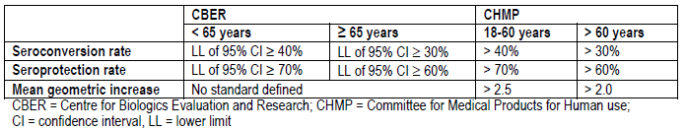
12. Sponsor comment:” The sponsor addressed these points in their Response to Questions (see “Section 11. Second round evaluation of clinical data submitted in response to questions” below).”
13. Sponsor comment:”The sponsor addressed these points in their Response to Questions (see “Section 11. Second round evaluation of clinical data submitted in response to questions” below)
14. Sponsor comment: “an exploratory alternative formulation”.
15. Sponsor comment:”Two exploratory alternative formulations”
16. Fluarix-US-006 Vaccines, formulation, lot numbers and allocation

    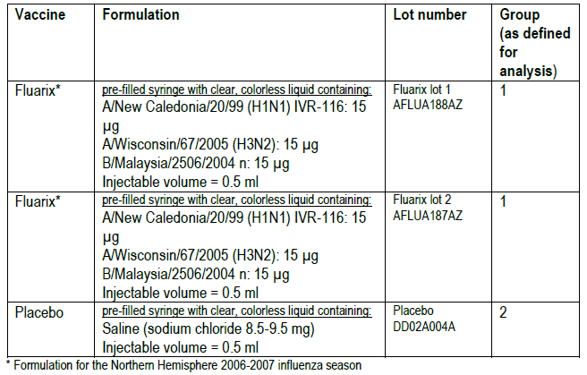
17. Sponsor comment: This was further explained by the sponsor in their Response Questions (see “Section 11. Second round evaluation of clinical data submitted in response to questions” below)
18. Sponsor comment: This was further explained by the sponsor in their Response Questions (see “Section 11. Second round evaluation of clinical data submitted in response to questions” Question 7 below)
19. Sponsor comment:” This is not a GSK hypothesis and the data do not support such a statement.”
20. Bell DM et al; (2006).Non-pharmaceutical interventions for pandemic influenza, international measures. *Emerg Infect Dis* 12:81-7