|  |
| --- |
| **March 2022** |

|  |
| --- |
| Australian Public Assessment Report for Influenza virus haemagglutinin |
| Proprietary Product Name: Influvac Tetra |
| Sponsor: Viatris Pty Ltd |

About the Therapeutic Goods Administration (TGA)

* The Therapeutic Goods Administration (TGA) is part of the Australian Government Department of Health and is responsible for regulating medicines and medical devices.
* The TGA administers the *Therapeutic Goods Act 1989* (the Act), applying a risk management approach designed to ensure therapeutic goods supplied in Australia meet acceptable standards of quality, safety and efficacy (performance) when necessary.
* The work of the TGA is based on applying scientific and clinical expertise to decision-making, to ensure that the benefits to consumers outweigh any risks associated with the use of medicines and medical devices.
* The TGA relies on the public, healthcare professionals and industry to report problems with medicines or medical devices. TGA investigates reports received by it to determine any necessary regulatory action.
* To report a problem with a medicine or medical device, please see the information on the TGA website <<https://www.tga.gov.au>>.

About AusPARs

* An Australian Public Assessment Report (AusPAR) provides information about the evaluation of a prescription medicine and the considerations that led the TGA to approve or not approve a prescription medicine submission.
* AusPARs are prepared and published by the TGA.
* An AusPAR is prepared for submissions that relate to new chemical entities, generic medicines, major variations and extensions of indications.
* An AusPAR is a static document; it provides information that relates to a submission at a particular point in time.
* A new AusPAR will be developed to reflect changes to indications and/or major variations to a prescription medicine subject to evaluation by the TGA.

Copyright

© Commonwealth of Australia 2022  
This work is copyright. You may reproduce the whole or part of this work in unaltered form for your own personal use or, if you are part of an organisation, for internal use within your organisation, but only if you or your organisation do not use the reproduction for any commercial purpose and retain this copyright notice and all disclaimer notices as part of that reproduction. Apart from rights to use as permitted by the *Copyright Act 1968* or allowed by this copyright notice, all other rights are reserved and you are not allowed to reproduce the whole or any part of this work in any way (electronic or otherwise) without first being given specific written permission from the Commonwealth to do so. Requests and inquiries concerning reproduction and rights are to be sent to the TGA Copyright Officer, Therapeutic Goods Administration, PO Box 100, Woden ACT 2606 or emailed to <[tga.copyright@tga.gov.au](mailto:tga.copyright@tga.gov.au)>.

Contents

List of abbreviations 4

I. Introduction to product submission 6

Submission details 6

Product background 7

Regulatory status 9

Product Information 9

II. Registration timeline 9

III. Submission overview and risk/benefit assessment 10

Quality 11

Nonclinical 11

Clinical 11

Risk management plan 24

Risk-benefit analysis 25

Outcome 29

Attachment 1. Product Information 30

## List of abbreviations

|  |  |
| --- | --- |
| Abbreviation | Meaning |
| ACV | Advisory Committee on Vaccines |
| AE | Adverse event |
| AESI | Adverse event of special interest |
| ARTG | Australian Register of Therapeutic Goods |
| ASA | Australian specific annex |
| CHMP | Committee for Medicinal Products for Human Use (European Union) |
| CI | Confidence interval |
| CPMP | Committee for Human Medicinal Products (European Union) |
| DLP | Data lock point |
| EMA | European Medicines Agency (European Union) |
| EU | European Union |
| GMT | Geometric mean titre |
| GVP | Good Pharmacovigilance Practices |
| HI | Haemagglutination inhibition |
| ICH | International Council for Harmonisation |
| MAAE | Medically attended adverse event |
| NIV | Non-influenza vaccine |
| PI | Product Information |
| QIV | Quadrivalent influenza vaccine |
| RMP | Risk management plan |
| PSUR | Periodic safety update report |
| RT-PCR | Reverse transcription polymerase chain reaction |
| SAE | Serious adverse event |
| TEAE | Treatment emergent adverse event |
| VE | Vaccine efficacy |

## I. Introduction to product submission

### Submission details

|  |  |
| --- | --- |
| *Type of submission:* | Extension of indications |
| *Product name:* | Influvac Tetra |
| *Active ingredient:* | Influenza virus haemagglutinin |
| *Decision*: | Approved |
| *Date of decision:* | 15 September 2021 |
| *Date of entry onto ARTG:* | 28 September 2021 |
| *ARTG numbers:* | 292237, 292238 and 281035 |
| *Black Triangle Scheme:[1]* | No |
| *Sponsor’s name and address:* | Viatris Pty Ltd (formerly Mylan Health Pty Ltd)  Level 1, 30 the Bond, 30 to 34 Hickson Road  Millers Point NSW 2000 |
| *Dose form:* | Suspension |
| *Strength:* | 60 µg haemagglutinin/0.5 mL  (containing 15 µg haemagglutinin per each of the following viral strains:   * A/Victoria/2570/2019 (H1N1) pdm09-like strain * A/Hong Kong/2671/2019 (H3N2)-like strain * B/Washington/02/2019‑like strain (B/Victoria lineage) * B/Phuket/3073/2013-like strain (B/Yamagata lineage)) |
| *Container:* | Prefilled syringe |
| *Pack sizes:* | 1 and 10 |
| *Approved therapeutic use:* | *For the prevention of influenza caused by influenza virus, types A and B.*  *For full details regarding recommendations for influenza vaccination, please refer to the relevant National Immunisation Guidelines.*  *Influvac Tetra is indicated in adults and children from 6 months of age and older.* |
| *Routes of administration:* | Intramuscular and subcutaneous |
| *Dosage:* | *Adults and children 6 months of age and older*  0.5 mL dose is recommended for adults and children 6 months of age and older.  For children less than 9 years of age who have not previously been vaccinated, a second dose of 0.5 mL should be given after an interval of at least 4 weeks.  The Australian Immunisation Handbook recommends that preterm infants should receive influenza vaccine every year, starting from 6 months of age and have a second dose at least 4 weeks later. Clinical trial data for Influvac Tetra from Study INFQ3003 were from infants aged 6 to 35 months (pre‑term status is not known).  *Children less than 6 months of age*  The safety and efficacy of Influvac Tetra has not been established.  Influvac Tetra should be administered in autumn before the beginning of the influenza season or as required by the epidemiological situation. Vaccination should be repeated every year.  For further information regarding dosage, refer to the Product Information. |
| *Pregnancy category:* | B2  Drugs which have been taken by only a limited number of pregnant women and women of childbearing age, without an increase in the frequency of malformation or other direct or indirect harmful effects on the human fetus having been observed.  Studies in animals are inadequate or may be lacking, but available data show no evidence of an increased occurrence of fetal damage.  The use of any medicine during pregnancy requires careful consideration of both risks and benefits by the treating health professional. This must not be used as the sole basis of decision making in the use of medicines during pregnancy. The TGA does not provide advice on the use of medicines in pregnancy for specific cases. More information is available from obstetric drug information services in your State or Territory. |

### Product background

This AusPAR describes the application by Viatris Pty Ltd (the sponsor) to register Influvac Tetra (influenza virus haemagglutinin) 60 µg/0.5 mL, suspension for the following proposed extension of indications:

*For the prevention of influenza caused by influenza virus, types A and B.*

*For full details regarding recommendations for influenza vaccination, please refer to the relevant National Immunisation Guidelines.*

*Influvac Tetra is indicated in adults and children from 6 months of age and older.*

Influenza is a seasonal infectious disease caused by respiratory ribonucleic acid orthomixoviruses, occurring in epidemics during the winter. It typically presents with fever, cough, fatigue, sore throat, headache, myalgia and rigors, although severity is variable. The disease is usually self-limiting in healthy adults, but can cause considerable morbidity and mortality in infants, the elderly and people with comorbidities or immunocompromise.

In Australia in 2019, there were almost 300,000 notifications of laboratory confirmed influenza to the National Notifiable Diseases Surveillance System, with 812 deaths reported as of 6 October 2019.[2] Notification rates were highest in children aged between 5 and 9 years of age (2,618 notifications per 100,000) followed by children aged between zero and 4 years old (2,180 notifications per 100,000). There were substantially fewer seasonal influenza cases in 2020, with 21,235 notifications as of 15 November 2020;[3], in association with the COVID-19 pandemic (for example, social distancing measures, altered health seeking behaviours).

Most human disease is caused by influenza virus types A and B. Frequent genetic mutations change the protein structure of the virus (antigenic shift and drift), enabling repeated outbreaks due to evasion of immune recognition.

Management of influenza cases is generally supportive, although antiviral treatments such as oseltamivir (indicated in children aged one year and older) are available, with some evidence that they attenuate symptoms if given early in disease, and reduce the risk of infection when used as post-exposure prophylaxis in contacts of confirmed cases.

The mainstay of the public health approach to the management of influenza is prevention through vaccination. Annual influenza vaccination is recommended for all Australians aged ≥ 6 months,[4] and is funded in children aged 6 months to 5 years, and in certain high risk groups.[5]

The strain composition of vaccines is adapted each year based on the recommendations of the World Health Organization and the Australian Influenza Vaccine Committee. The degree to which the strains included in the vaccine match the predominant circulating strains in any given season will have a bearing on the vaccine effectiveness.

Fluarix Tetra,[6] FluQuadri;[7] and Vaxigrip Tetra;[8] are quadrivalent influenza vaccines (QIVs) on the Australian Register of Therapeutic Goods (ARTG) that are indicated in children 6 months of age and older.

Influvac Tetra provides active immunisation against influenza A and B viruses and contain influenza virus haemagglutinin from four influenza virus strains including an A/(H1N1) strain and an A/(H3N2) strain, a B/Victoria strain and a B/Yamagata strain. It is manufactured according to the same process as trivalent influenza vaccine Influvac, induces humoral antibodies against the haemagglutinins. These antibodies neutralise influenza viruses with matching antigens which has entered the body during infection.

### Regulatory status

The product received initial registration on the Australian Register of Therapeutic Goods (ARTG) on 2 November 2017 for the below indication:

*For the prevention of influenza caused by influenza virus, types A and B. For full details regarding recommendations for influenza vaccination, please refer to the relevant National Immunisation Guidelines. Influvac Tetra is indicated in adults (18 years of age and older).*

At the time the TGA considered this application, a similar application had been approved in the European Union (EU) on 22 April 2021. Similar applications were under consideration in Canada (submitted on 30 November 2020) and New Zealand (submitted on 16 October 2020).

Table : International regulatory status

|  |  |  |  |
| --- | --- | --- | --- |
| Region | Submission date | Status | Approved indications |
| European Union | 29 October 2020 | Approved on 22 April 2021 | *Prophylaxis of influenza, especially those who run an increased risk of associated complications.*  *Influvac sub-unit Tetra is indicated in adults and children from 6 months of age.*  *The use of Influvac sub-unit Tetra should be based on official recommendations.* |
| Canada | 30 November 2020 | Under consideration | Under consideration |
| New Zealand | 16 October 2020 | Under consideration | Under consideration |

### Product Information

The Product Information (PI) approved with the submission which is described in this AusPAR can be found as Attachment 1. For the most recent PI, please refer to the TGA website at <<https://www.tga.gov.au/product-information-pi>>.

## II. Registration timeline

The following table captures the key steps and dates for this application and which are detailed and discussed in this AusPAR.

Table : Timeline for Submission PM-2020-04870-1-2

|  |  |
| --- | --- |
| Description | Date |
| Submission dossier accepted and first round evaluation commenced | 2 November 2020 |
| First round evaluation completed | 31 March 2021 |
| Sponsor provides responses on questions raised in first round evaluation | 29 April 2021 |
| Second round evaluation completed | 15 June 2021 |
| Delegate’s Overall benefit-risk assessment and request for Advisory Committee advice | 7 July 2021 |
| Sponsor’s pre-Advisory Committee response | 21 July 2021 |
| Advisory Committee meeting | 30 July 2021 |
| Registration decision (Outcome) | 15 September 2021 |
| Completion of administrative activities and registration on the ARTG | 28 September 2021 |
| Number of working days from submission dossier acceptance to registration decision* | 196 |

*Statutory timeframe for standard applications is 255 working days

## III. Submission overview and risk/benefit assessment

The submission was summarised in the following Delegate’s overview and recommendations.

Relevant guidelines or guidance documents referred to by the Delegate are listed below:

* Department of Health, Australian Immunisation Handbook, Influenza (Flu), last updated on 30 November 2021.
* European Medicines Agency (EMA), Committee for Medicinal Products for Human Use (CHMP), Guideline on Influenza Vaccines, EMA/CHMP/VWP/457259/2014, 21 July 2016.
* European Medicines Agency (EMA), Committee for Human Medicinal Products (CPMP), International Council for Harmonisation (ICH) E11(R1) Guideline on Clinical Investigation of Medicinal Products in the Pediatric Population, EMA/CPMP/ICH/2711/1999, 1 September 2017.

### Quality

There was no requirement for a quality evaluation in a submission of this type.

### Nonclinical

There was no requirement for a nonclinical evaluation in a submission of this type.

### Clinical

The clinical development program for paediatric population (6 to 35 months age group) consisted of Study INFQ3003, a Phase III efficacy, safety and immunogenicity study (as per the EMA guidance).[9]

#### Pharmacology

Clinical immunogenicity was assessed as a secondary endpoint in Study INFQ3003, which is discussed in the efficacy section, below.

#### Efficacy

##### Study INFQ3003

This study was conducted at 56 centres across Europe and Asia, from 1 September 2017 to 31 January 2020 and included subjects aged 6 to 35 months.

The study included 2 cohorts (Cohort 1 and Cohort 2) and was conducted over 3 influenza seasons (Northern hemisphere 2017/2018, Northern hemisphere 2018/2019, and Southern hemisphere 2019). A revaccination with QIV was conducted in the second influenza season for subjects of Cohort 1 vaccinated with QIV in the first year, in order to assess the persistence of the immune response to QIV and to assess the immunogenicity and safety following revaccination.

The study therapy included two 0.5 mL doses of QIV given intramuscularly, approximately 28 to 33 days apart (Visits 1 and 2), and they contain approximately 15 μg haemagglutinin of each of the viral strains recommended for the Northern hemisphere season 2017/2018 for Cohort 1, and for Northern hemisphere season 2018/2019 or Southern hemisphere season 2019 for Cohort 2.

Cohort 1 was revaccinated with a single dose of Northern hemisphere season 2018/2019 at Visit 4.

The comparator group was administered with two 0.5 mL doses of a non-influenza vaccine (NIV) given intramuscularly, approximately 28 to 33 days apart. Depending on their age, subjects were to receive either pneumococcal conjugate vaccine or meningococcal group C conjugate vaccine if 6 to 11 months of age, or either hepatitis A, tick borne encephalitis, or varicella vaccine if 12 to 35 months of age at the time of the first vaccination on Day 1.

Eligible participants were randomly assigned (using an interactive voice, computer and remote response system) to vaccination with QIV or a NIV in a 1:1 ratio, respectively.

The primary objective was to demonstrate, in subjects aged 6 to 35 months, the absolute vaccine efficacy (VE) of QIV in the prevention of symptomatic influenza infection due to any circulating seasonal influenza strain compared with NIVs. Primary efficacy endpoint was first occurrence of reverse transcription polymerase chain reaction (RT-PCR) confirmed influenza A and/or B illness of any severity due to any circulating seasonal influenza strain occurring between 28 days following the second vaccine administration and the end of the influenza surveillance period (which was 6 to 8 months following Visit 1).

The secondary objectives of this study were as follows:

* to demonstrate in subjects aged 6 to 35 months, the absolute efficacy of QIV in the prevention of symptomatic influenza infection of antigenically matching influenza strains compared with NIVs.
* to describe the immunogenicity of each of the strains in QIV with respect to haemagglutination inhibition in all subjects and virus neutralisation and neuraminidase inhibition antibody titres in randomised population subsets.
* to describe cell mediated immunity for a subset of subjects at preselected sites.
* to describe Year 2 baseline and postvaccination immunogenicity for each of the strains in QIV with respect to hemagglutination inhibition in all subjects and neuraminidase inhibition and virus neutralisation in random population subsets of subjects exposed to QIV in Year 1 and who were to receive revaccination.
* to evaluate the occurrence of all-cause mortality, hospitalisation, influenza like illnesses, all-cause pneumonia, and otitis media in the QIV group compared with the NIV group.
* to explore potential immunological correlates of protection based on determined hemagglutination inhibition antibody titres and RT-PCR outcomes.
* to evaluate healthcare utilisation and health economic outcomes.

Figure : Study INFQ3003 Subject disposition

Figure 1: Study INFQ3003 Subject disposition

A total of 2007 subjects provided informed consent and were screened for eligibility. Of these, all were randomly allocated to study vaccine, which 1009 were in quadrivalent influenza vaccine group and 998 in the non-influenza vaccine group.

Of the quadrivalent influenza vaccine group, 986 subjects completed primary immunisation period, and 23 subjects prematurely terminated the study during the primary immunisation period. 334 subjects who completed primary immunisation period have been revaccinated and all of them have completed the treatment during the revaccination immunisation period.
Of the non-influenza vaccine group, 975 subjects completed primary immunisation period, and 23 subjects prematurely terminated the study during the primary immunisation period.

N = number of subjects; NIV = non-influenza vaccine; QIV = quadrivalent influenza vaccine.

Overall, 46 (2.3%) subjects prematurely terminated the study during the primary immunisation period.

A total of 2,007 subjects provided informed consent and were screened for eligibility. Of these, subjects, all were randomly allocated to study vaccine. All Subjects vaccinated included 1,005 to QIV and 995 to NIV and immunogenicity group included 932 subjects to QIV and 910 to NIV.

###### Baseline data

Demographics were similar between the two groups, with a balanced proportion of subjects in each age category. The most common medical history reported at Baseline was infections and infestations, reported for 222 subjects overall (115 (11.4%) and 107 (10.7%) subjects in the QIV and NIV groups, respectively. 70.9% subjects reported concomitant medication use, most commonly paracetamol (351 (34.8%) and 371 (37.2%) subjects in the QIV and NIV groups, respectively).

Table : Study INFQ3003 Demographics (randomised subjects)

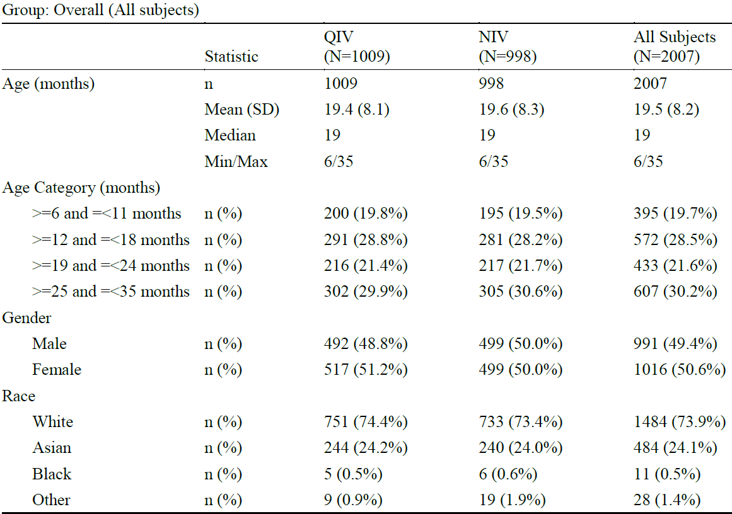

Max = maximum; Min = minimum; N = total number of subjects; n = number of subjects; NIV = non-influenza vaccine; QIV = quadrivalent influenza vaccine; SD = standard deviation.

Percentages are based on the number of subjects in the all subjects randomised sample.

Age (months) is calculated relative to screening.

###### Results for the primary efficacy outcome

The incidence of RT-PCR confirmed influenza due to any circulating seasonal influenza strain was lower in the QIV group compared with the NIV group (71 cases versus 135).

In subjects who received both doses of vaccine, there were 59 influenza cases in the QIV group versus 117 in the NIV group. Absolute vaccine efficacy was estimated as 0.54 (95% confidence interval (CI): 0.37, 0.66).

Table : Study INFQ3003 Incidence of reverse transcription polymerase chain reaction confirmed influenza (full analysis set)

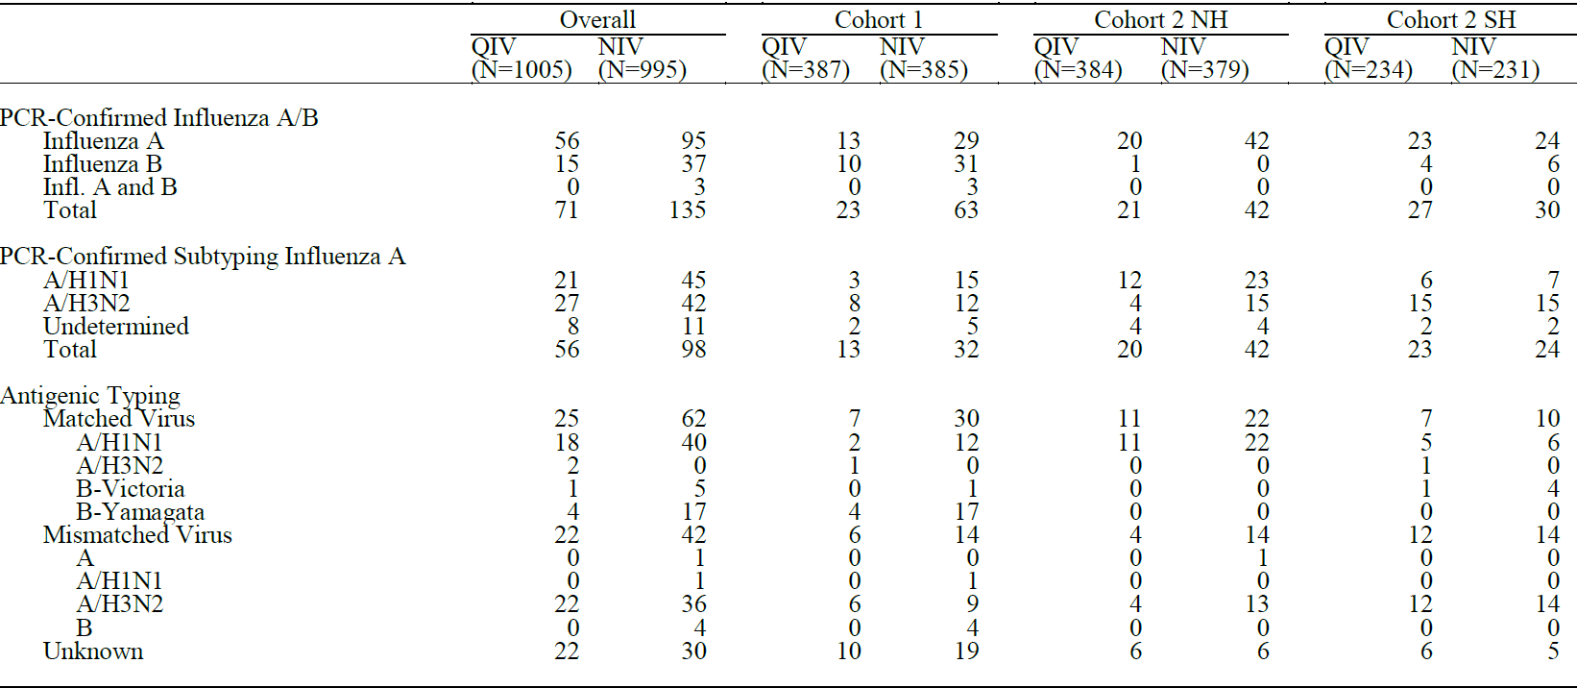

N = total number of subjects; NH = Northern hemisphere; NIV = non-influenza vaccine; PCR = polymerase chain reaction; QIV = quadrivalent influenza vaccine; SH = Southern hemisphere.

Antigenic typing result unknown is defined as antigenic typing not done because virus concentration too low, or no matching strain and typing not done for at least one other strain.

Excluding nasal swabs collected in the revaccination period.

Subjects are counted more than once if they have more than one positive PCR result.

Table : Study INFQ3003 Absolute vaccine efficacy (full analysis set)

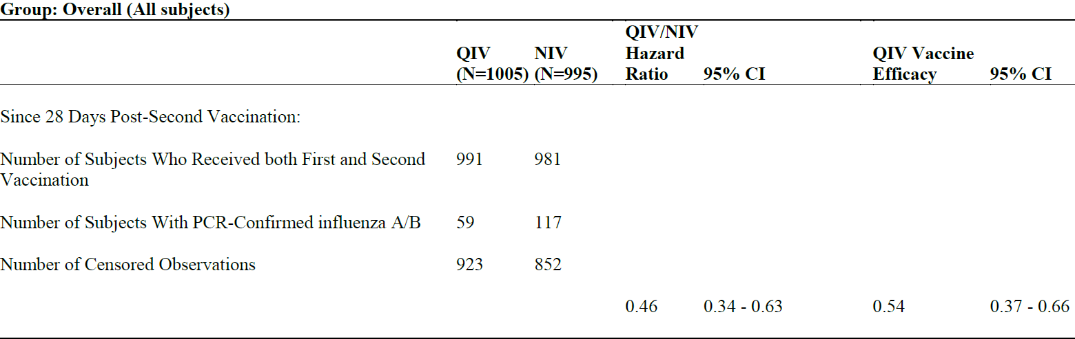

CI = confidence interval; N = total number of subjects; NIV = non-influenza vaccine; PCR = polymerase chain reaction; QIV = quadrivalent influenza vaccine.

Hazard ratio is obtained from a Cox proportional hazards model with time to first occurrence of reverse transcription (RT)-PCR confirmed influenza A and/or B illness of any severity due to any circulating seasonal influenza strain occurring between 28 days following the second vaccine administration and the end of the primary immunization influenza surveillance period. The time to first occurrence is measured from Day 28 after the second study vaccination. The model contains age group (6 to 11 months, 12 to 18 months, 19 to 24 months, 25 to 35 months and 6 to 24 months), country and vaccine group (QIV or NIV) as factors.

Vaccine efficacy is derived as 1 - hazard ratio.

Analysis excludes subjects who did not receive the second vaccination, those who dropped out or withdrew before 28 days after the second vaccination, and those with first occurrence of RT-PCR confirmed influenza between the first vaccination and 28 days after the second vaccination.

For the age subgroups, absolute vaccine efficacy of QIV compared with NIV was demonstrated among all age groups evaluated, with the exception of subjects aged 6 to 11 months (vaccine efficacy (VE): 0.21; 95% CI: -0.70, 0.64) (see Table 6 below). For all other age groups, the efficacy of QIV ranged from 0.50 to 0.73.

The efficacy of QIV among subjects aged 6 to 24 months (VE: 0.55; 95% CI: 0.33, 0.69) was comparable with subjects aged 25 to 35 months (VE: 0.52; 95% CI: 0.18, 0.72).

The overall influenza attack rates were 6.67 % for QIV and 13.07 % for NIV.

Table : Study INFQ3003 Absolute vaccine efficacy of quadrivalent influenza vaccine (6 to 11 months age group)

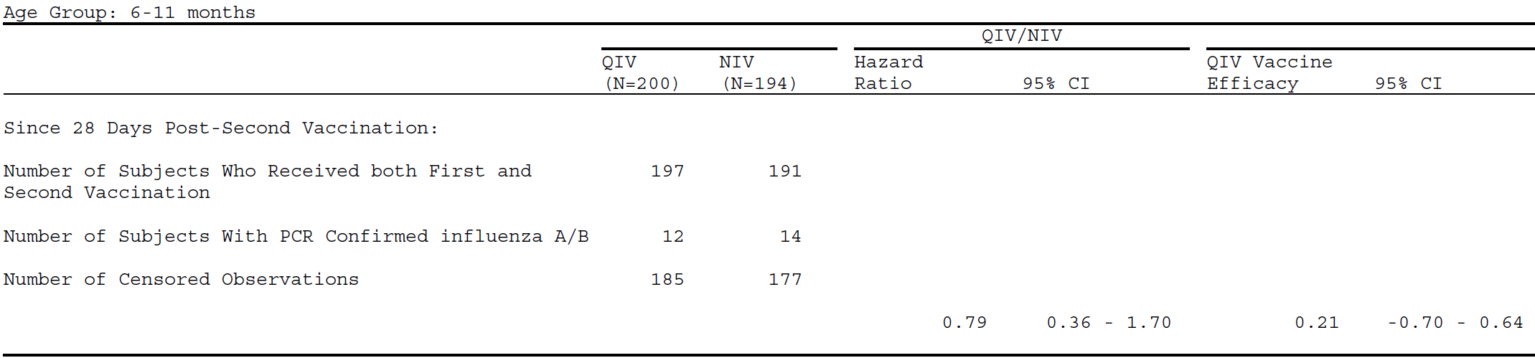

CI = confidence interval; N = total number of subjects; NIV = non-influenza vaccine; PCR = polymerase chain reaction; QIV = quadrivalent influenza vaccine.

Hazard ratio is obtained from a Cox Proportional Hazards model with time to first occurrence of reverse transcription (RT)-PCR confirmed influenza A and/or B illness of any severity due to any circulating seasonal influenza strain occurring between 28 days following the second vaccine administration and the end of the primary immunization influenza surveillance period. The time to first occurrence is measured from Day 28 after the second study vaccination. The model contains age group (6 to 11 months, 12 to 18 months, 19 to 24 months, 25 to 35 months and 6 to 24 months), country and vaccine group (QIV or NIV) as factors.

Vaccine efficacy is derived as 1 - hazard ratio.

Analysis excludes subjects who did not receive the second vaccination, those who dropped out or withdrew before 28 days after the second vaccination, and those with first occurrence of RT-PCR confirmed influenza between the first vaccination and 28 days after the second vaccination.

Efficacy of the vaccine was sustained over the follow-up period.

Figure : Study INFQ3003 Kaplan-Meier plot of time since 28 days post-second vaccination to reverse transcription polymerase chain reaction confirmed influenza A or B viral infection (full analysis set)

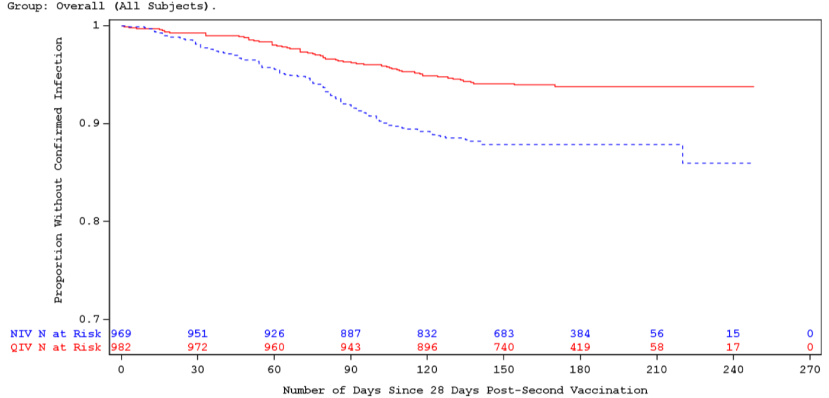

N = number of subjects; NIV = non-influenza vaccine; QIV = quadrivalent influenza vaccine.

###### Secondary efficacy outcome (includes immunogenicity)

The incidence of RT-PCR confirmed influenza due to antigenically matching influenza strains was lower in the QIV group compared with the NIV group, with 19 versus 56 cases (VE: 0.68; 95% CI: 0.45, 0.81).

Geometric mean haemagglutination inhibition titres increased from pre‑vaccination (Day 1) to post‑vaccination (Visit 3) for all strains in the QIV group compared with minimal increases in the NIV group. In the QIV group, geometric mean fold increases varied between 7.7 and 67.1 for the A‑strains, and between 1.8 and 5.4 for the B‑strains across the cohorts evaluated. In the NIV group, geometric mean fold increases were low across all strains.

Seroconversion rates based on haemagglutination inhibition titres were higher in the QIV group (> 65% for the A‑strains and between 16.9% and 65.2% for the B‑strains) than in the NIV group, irrespective of cohort. Seroconversion was defined as becoming seropositive (titre ≥ 10) if seronegative (titre < 10) at enrolment, or (at least) a 4‑fold rise in titre if seropositive (titre ≥ 10) at enrolment.

Table : Study INFQ3003 Haemagglutination titre results by strain and cohort (immunogenicity subset)

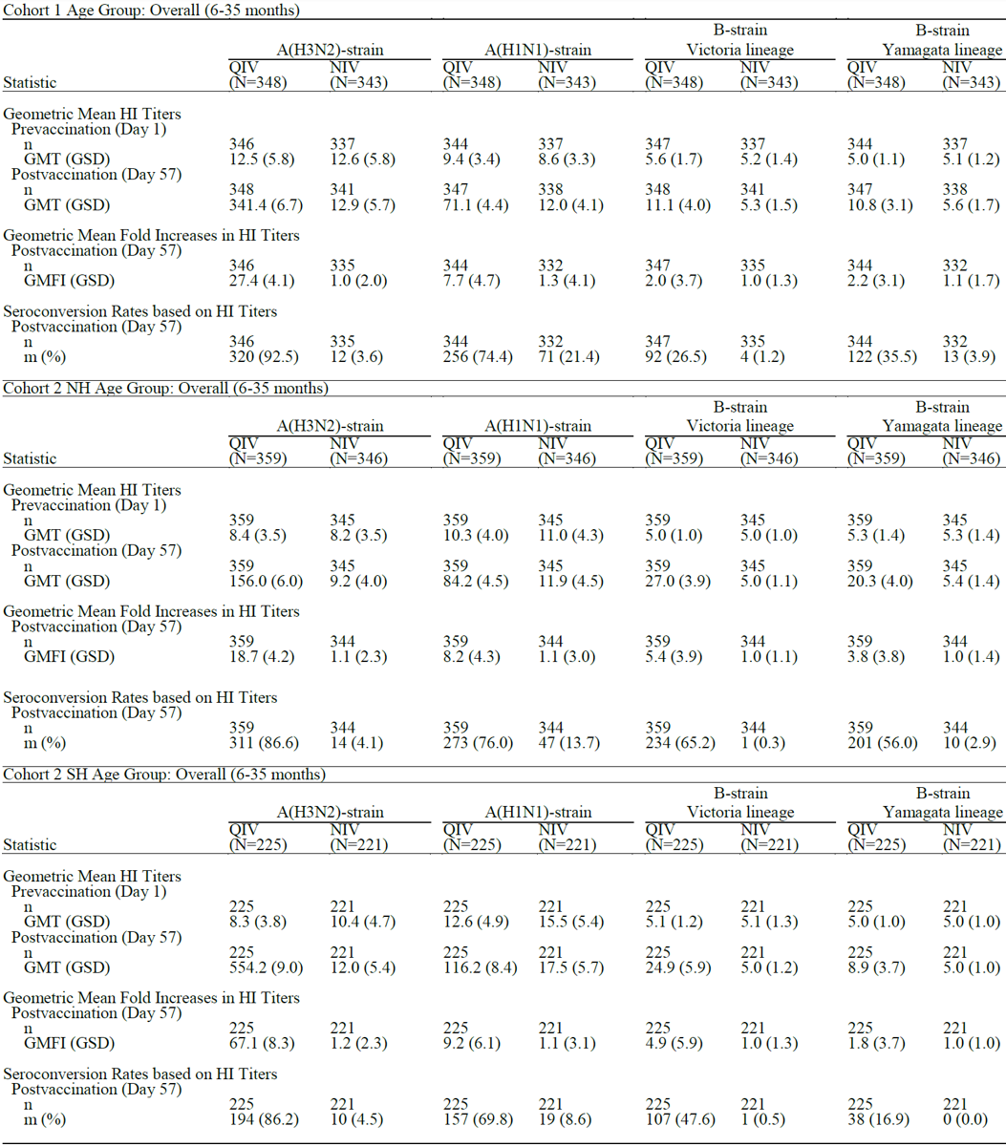

GMFI = geometric mean fold increase; GMT = geometric mean titre; GSD = geometric standard deviation; HI = haemagglutination inhibition; m = number of seroconverted subjects; N = total number of subjects; n = number of subjects with non-missing data; NH = Northern hemisphere; NIV = non-influenza vaccine; QIV = quadrivalent influenza vaccine; SH = Southern hemisphere.

For seroconversion rates, percentages are calculated based on the number of subjects with non-missing data.

There appeared to be a general trend towards hemagglutination inhibition geometric mean titres (GMTs) increasing with age, being generally lowest in the 6 to 11 months old subgroup compared with the overall population in each cohort.

Virus neutralisation and neuraminidase inhibition GMTs increased at Visit 3 for all strains.

Table : Study INFQ3003 Virus neutralisation titre results by strain (immunogenicity subset)

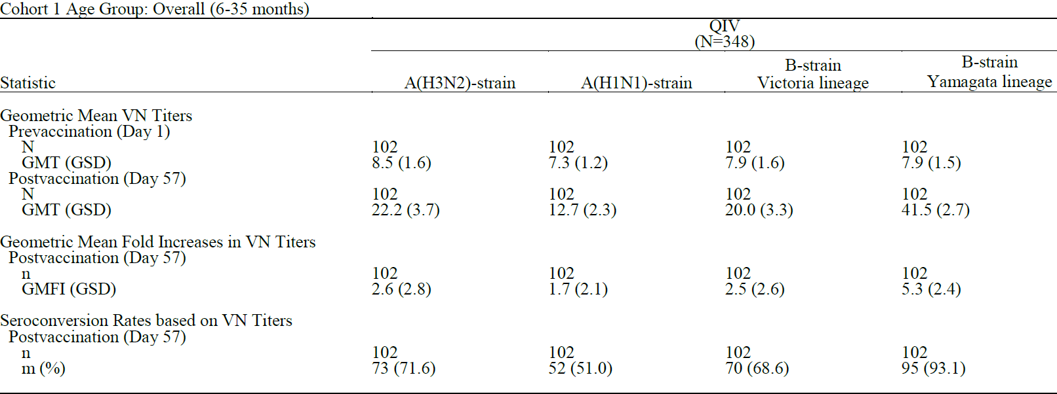

GMFI = geometric mean fold increase; GMT = geometric mean titre; GSD = geometric standard deviation; m = number of seroconverted subjects; N = total number of subjects; n = number of subjects with non-missing data; QIV = quadrivalent influenza vaccine; VN = virus neutralisation.

For seroconversion rates, percentages are calculated based on the number of subjects with non-missing data.

Table : Study INFQ3003 Neuraminidase inhibition titre results by strain (immunogenicity subset)

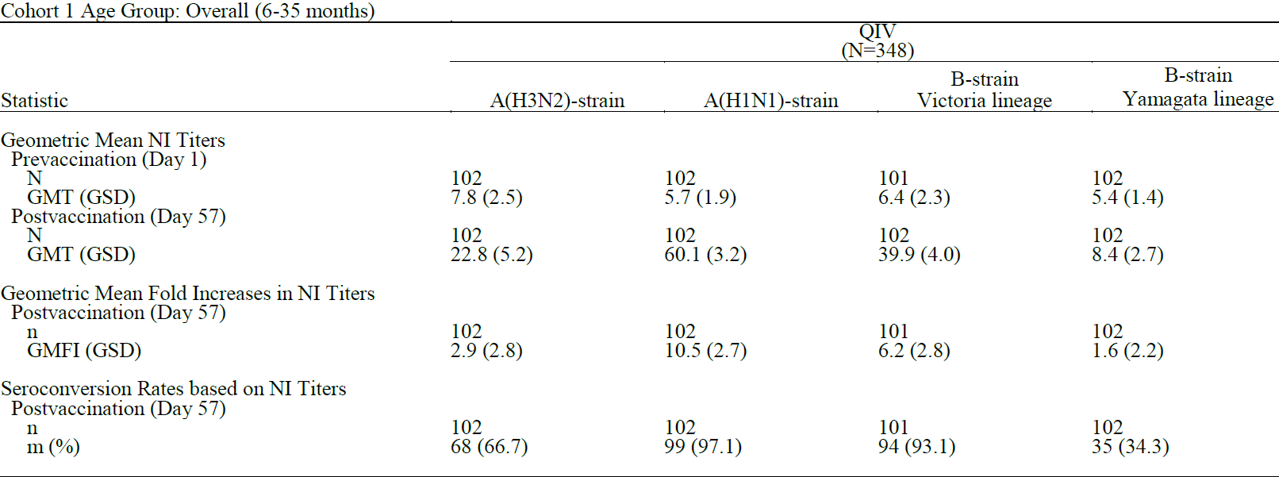

GMFI = geometric mean fold increase; GMT = geometric mean titre; GSD = geometric standard deviation; HI = neuraminidase inhibition; m = number of seroconverted subjects; N = total number of subjects; n = number of subjects with non-missing data; QIV = quadrivalent influenza vaccine.

For seroconversion rates, percentages are calculated based on the number of subjects with non-missing data.

At Visit 4 (approximately 12 months after primary vaccination with QIV), waning of antibody levels from Visit 3 was demonstrated, although the GMTs for the A‑strains remained higher than they were at Baseline (that is, prior to vaccination), indicating some degree of long term antibody persistence.

Revaccination with QIV elicited antibody responses; post-revaccination (Visit 5) antibody titres were higher than pre‑revaccination antibody titres for all strains in all serological assays performed.

The percentages of cluster of differentiation 4+ and cluster of differentiation 8+ T-cells producing interleukin 6+ increased after vaccination, upon stimulation with the influenza virus in the QIV group, while no change or slight decreases were observed in the NIV group. However, cell mediated immunity data were only available for a small number of subjects, limiting their interpretation.

A planned exploration of the immunological correlate of protection using the immunogenicity sample could not be performed, due to the small number of antigenically matching influenza cases.

#### Safety

Safety analyses were performed on the safety sample and all were descriptive.

Local reactions and systemic reactions were reported within 7 days after vaccination, and adverse events (AEs) were reported for 28 to 33 days post‑vaccination. Adverse events of special interest (AESI), medically attended adverse events (MAAEs), and new chronic illnesses were also followed up.

During the primary immunisation period, 991 subjects (98.6%) in the QIV group and 981 subjects (98.6%) in the NIV group received 2 doses of study vaccination as planned. Fourteen subjects each in the QIV and NIV groups received only one dose of study vaccination, mainly due to discontinuation from the study during the primary immunisation period (12 and 14 subjects in the QIV and NIV groups, respectively).

An additional 334 subjects (33.2%) in the QIV group received a third dose of study vaccination as planned.

Table 10 below summarises the AEs for the safety set.

Table : Study INFQ3003 Overall summary of primary immunisation adverse events (safety set)

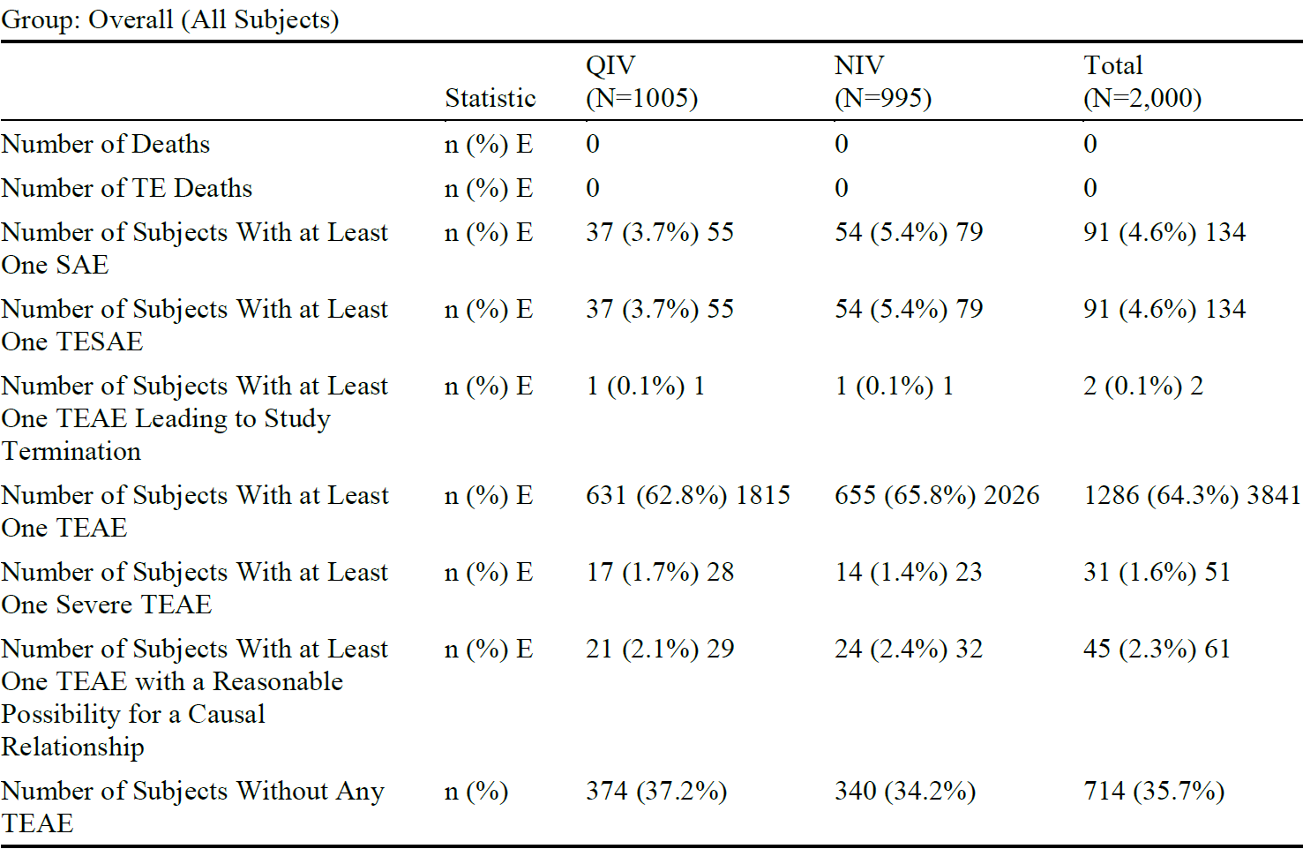

E= number of events; N = total number of subjects; n = number of subjects; NIV = non-influenza vaccine; QIV = quadrivalent influenza vaccine; SAE = serious adverse event; TEAE = treatment emergent adverse event; TE Death = treatment emergent death; TESAE = treatment emergent serious adverse event.

Percentages are based on the number of subjects in the safety sample.

A treatment emergent adverse event in the primary immunization period is defined as an adverse event that started or worsened in severity on or after the first study vaccination.

Treatment emergent adverse events leading to study termination are TEAEs reported on the adverse event/influenza-like illness case fatality rate (CRF) with Led to study termination = yes.

Severe = severity reported as severe or missing.

Reasonable possibility for a causal relationship = drug event relationship reported as possible, probable or missing.

Summary includes TEAEs which started or worsened on or before the TC3 date.

Treatment emergent death is defined as a fatal outcome of a treatment emergent serious adverse event.

During the primary immunisation period, the proportion of subjects with at least one treatment emergent adverse event (TEAE) was similar between the QIV group (n = 631 (62.8%)) and the NIV group (n = 655 (65.8%)). The most commonly reported AE was influenza like illness, reported by 415 (41.3%) subjects in the QIV group and 447 (44.9%) subjects in the NIV group. Most events were mild or moderate in severity in both groups. TEAEs reported in at least 1% of subjects are summarised in Table 11 below.

Table : Study INFQ3003 Incidence of primary immunisation treatment emergent adverse events in at least 1% of the subjects in any vaccination group (safety set)

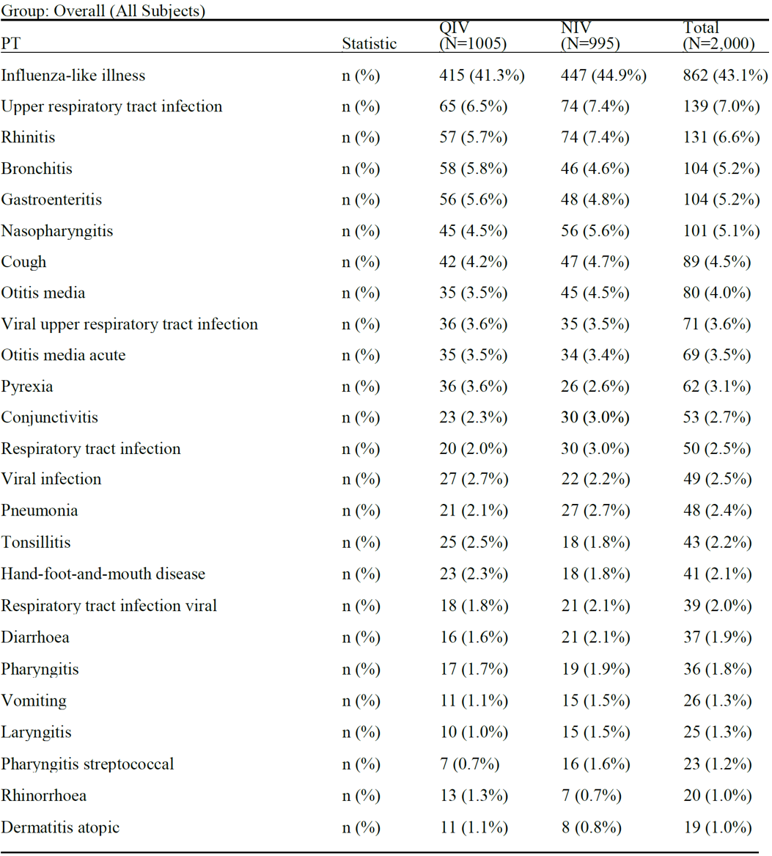

N = total number of subjects; n = number of subjects; NIV = non-influenza vaccine; PT = Preferred Term; QIV = quadrivalent influenza vaccine.

Percentages are based on the number of subjects in the safety sample.

A treatment emergent adverse event (TEAE) in the primary immunization period is defined as an adverse event that started or worsened in severity on or after the first study vaccination.

A cut-off point of 1% is applied to the incidence of PT.

Each subject is counted at most once within each PT.

Summary includes TEAEs which started or worsened on or before the TC3 date.

Adverse events were coded using Medical Dictionary for Regulatory Activities (MedDRA)[10] version 20.0.

##### Adverse events of special interest

Included all-cause pneumonia and otitis media, and autoimmune diseases and/or neurologic disorders that may have had an autoimmune etiology. These included febrile and non-febrile convulsions and autoimmune disorders such as Guillain-Barré syndrome, demyelinating disorders, vasculitis, non-infectious encephalitis, neuritis, and seventh nerve paralysis.

There were 7 events of febrile convulsions in the QIV group and 3 events in the NIV group, of which 5 and 3 events respectively were considered serious adverse events (SAEs). Only one of these, in the NIV group, was considered by the Investigator to be possibly causally related to study treatment. There were no febrile convulsions in the revaccination period.

Adverse events of special interests are summarised in Table 12 below.

Table : Study INFQ3003 Incidence of adverse events of special interest during primary immunisation period (safety set)

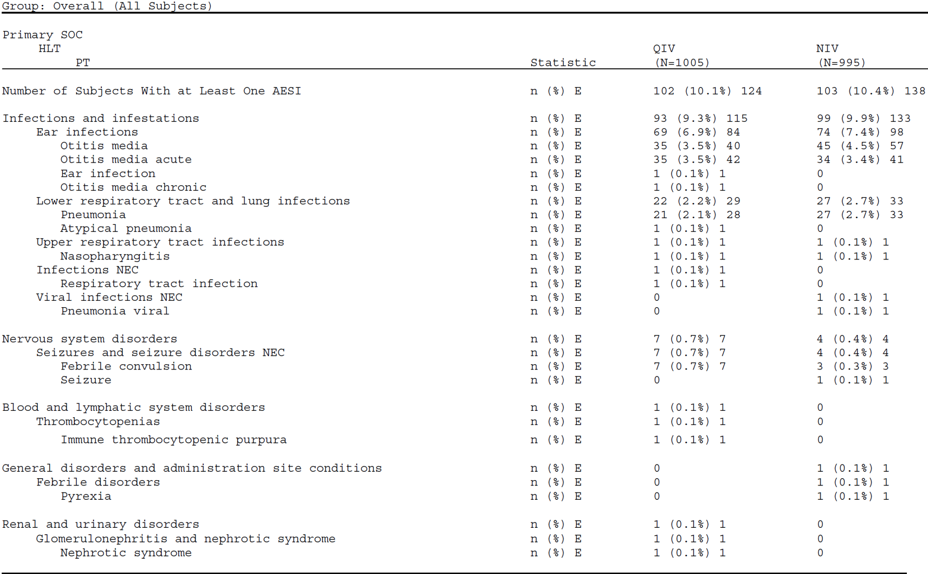

E = number of events; HLT = High-Level Term; N = total number of subjects; n = number of subjects; NIV = non-influenza vaccine; PT = Preferred Term; QIV = quadrivalent influenza vaccine; SOC = System Organ Class.

Percentages are based on the number of subjects in the safety sample.

A treatment-emergent adverse event (TEAE) in the primary immunization period is defined as an adverse event that started or worsened in severity on or after the first study vaccination.

Each subject is counted at most once within each primary SOC, HLT and PT. All TEAEs are counted for the event.

Summary includes TEAEs which started or worsened on or before the TC3 date.

Adverse Events were coded using Medical Dictionary for Regulatory Activities (MedDRA)10 version 20.0.

##### Solicited adverse events

During the primary immunisation period, there were no systematic differences between the QIV and NIV groups in the number of subjects for whom any systemic reaction was reported within 7 days after vaccination (51.4% and 52.5%, respectively). The incidence of any local reactions within 7 days of vaccination was generally lower in the QIV group (30.4%) than the NIV group (38.1%).

Table : Study INFQ3003 Incidence of any primary immunisation systemic reaction or local reaction within seven days after vaccination (safety set)

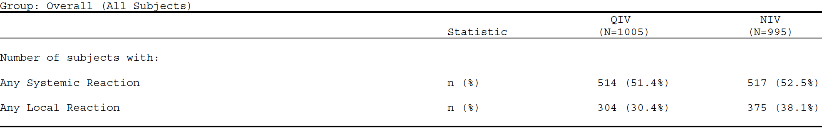

N = total number of subjects; n= the number of subjects with any reaction (Grade >0) recorded within seven days after study vaccination; NIV = non-influenza vaccine; QIV = quadrivalent influenza vaccine.

This includes reactions during either of the Day 1 to Day 7 periods after each of the Visit 1 and Visit 2 study vaccinations.

Percentages are based on the number of subjects with any non-missing data for each reaction type.

Majority of local reactions were mild and lasted for one to three days, with no difference in the reactogenicity between both vaccination groups. Vaccination site pain was more severe and lasted longer after the first dose.

Individual systemic reactions of Grades 1, 2, and 3 were comparable between the vaccination groups. Systemic reaction symptoms lasted for one to three days for the majority of subjects. Fever of Grade 1, 2 and 3 of was comparable between the two groups (19.3% for QIV versus 18.1% for NIV group).

Table : Study INFQ3003 Toxicity grading for primary immunisation systemic reactions within 7 days after vaccination (safety set)

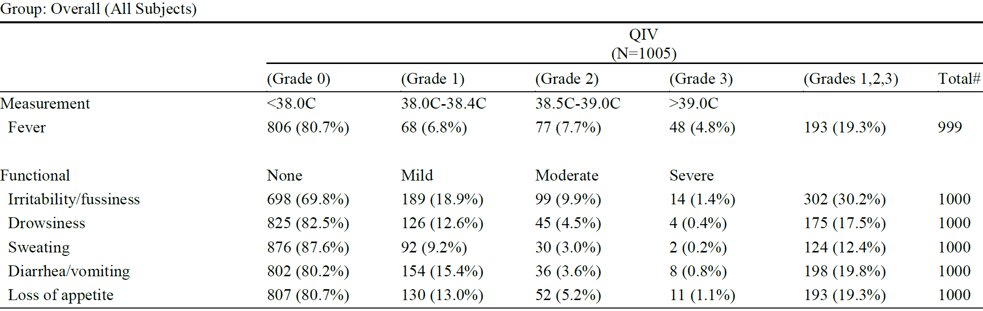

N = total number of subjects; QIV = quadrivalent influenza vaccine.

For each subject, the grades are the maximum ratings from each of the two Day 1 to Day 7 periods after each of the 2 study vaccinations.

# Total counts of subjects with non-missing data, used as denominator in percentages.

##### Treatment related adverse events

During the primary immunisation period, the incidence of TEAEs with an at least reasonable possibility for a causal relationship (investigator’s judgment) was generally low, which 21 subjects (2.1%) were in the QIV group and 24 subjects (2.4%) were in the NIV group. The most commonly experienced vaccine related TEAE by Preferred Term in both groups was influenza like illness (13 subjects (1.3%) in each group). There were no clinically meaningful differences noted in the incidence of vaccine related TEAEs between the QIV and NIV groups.

During the revaccination period, one subject in the QIV group reported one TEAE (moderate case of enterovirus infection) considered to have a reasonable possibility for a causal relationship. Two subjects experienced a TEAE leading to study termination (one in the QIV group due to suspected egg allergy, one in the NIV group due to pneumonia; both mild and not considered causal).

##### Deaths and other serious adverse events

No deaths were reported during this study.

Ninety-one (91) subjects (4.6%) had at least one SAE during the primary immunisation period, which 37 subjects (3.7%) and 54 subjects (5.4%) were in the QIV and NIV groups, respectively. By System Organ Class, the most common was infections and infestations, reported in 32 and 34 subjects in the QIV and NIV groups, respectively. By Preferred Term, the most frequent SAE was influenza like illness, reported in 7 subjects in the QIV group and 10 subjects in the NIV group, followed by pneumonia, reported in 6 subjects in each group.

One SAE (febrile convulsion), in the NIV group, was considered possibly related to the study vaccine.

During the revaccination period, one SAE (gastrointestinal virus) was reported in a subject in the QIV group. This was not considered related to the study vaccine.

### Risk management plan

The most recently evaluated EU-risk management plan (RMP) was version 3.2 (dated 5 April 2018; data lock point (DLP) 29 February 2016) and Australia specific annex (ASA) version 5.0 (dated January 2019), as amended by version 6.0 of the ASA submitted in March 2019. In support of the extended indication, the sponsor has submitted EU‑RMP version 4.2 (dated 15 September 2020; DLP 31 July 2020) and ASA version 7.0 (dated September 2020).

The summary of safety concerns and their associated risk monitoring and mitigation strategies are summarised in Table 15.[11]

Table : Summary of safety concerns

|  |  |  |  |  |  |
| --- | --- | --- | --- | --- | --- |
| Summary of safety concerns | | Pharmacovigilance | | Risk minimisation | |
| **Routine** | **Additional** | **Routine** | **Additional** |
| **Important identified risks** | Hypersensitivity to active substance or to any of the excipients | ✓ | – | ✓ | – |
| **Important potential risks** | Febrile and non-febrile convulsions | ✓ | – | ✓ | – |
| Adverse events following immunization of possible autoimmune nature (for example, Guillain-Barré syndrome, neuritis, encephalomyelitis, demyelinating disease, vasculitis, thrombocytopenia) | ✓ | – | ✓ | – |
| Vaccination failure | ✓ | – | ✓ | – |
| **Missing information** | Use in pregnant and breast-feeding women | ✓ | – | ✓ | – |
| Safety in immunocompromised patients | ✓ | – | ✓ | – |

* The safety concerns in the above table are specific to Australia, unchanged since the vaccine was approved for use in adults and children older than 3 years. The summary remains acceptable.
* Routine pharmacovigilance activities continue to be in place for the vaccine, as well as enhanced safety surveillance via AusVaxSafety.[12] The sponsor has committed to conducting an enhanced surveillance program when required based upon risk assessment. A condition of registration is recommended to the Delegate to facilitate the TGA request for an enhanced safety surveillance study in Australia when required.
* Routine risk minimisation is in place for this vaccine and continues to be acceptable.

### Risk-benefit analysis

#### Delegate’s considerations

##### Efficacy

The submission is supported by the single pivotal study (Study INFQ3003), conducted in line with the EMA guidance,9 at 56 centres across Europe and Asia, from 1 September 2017 to 31 January 2020 and included around 2000 subjects aged 6 to 35 months.

The study met its primary objective, which was to demonstrate absolute VE of Influvac Tetra compared with NIV in children aged 6 to 35 months (VE: 0.54; 95% CI: 0.37; 0.66); however, confidence interval was wide. Estimated VE was higher for antigenically matching strains (VE: 0.68; 95% CI: 0.45, 0.81), but due to the lower case rates caused by antigenically matching strains, this estimate is also not precise.

Vaccine efficacy was not demonstrated in the youngest subgroup, infants aged 6 to 11 months, although the study was not powered for this subgroup analysis.

Immunogenicity was noted to be low against the B-strains, as measured by haemagglutination inhibition GMTs and seroconversion rates. In Study INFQ3003, haemagglutination inhibition GMTs for the B‑strains across all cohorts were below 40, considerably lower than those reported in children aged 3 to 17 years in INFQ3002 (306.7 for B/Victoria strain and 280.8 for B/Yamagata strain). By way of comparison, another QIV;[13] demonstrated haemagglutination inhibition GMTs of 92.6 for the B/Victoria strain and 121.4 for the B/Yamagata strain in children aged 6 to 35 months, although its study was conducted during different influenza seasons to Study INFQ3003, and the comparison may be limited by other differences in the populations or design.

##### Safety

Most subjects at risk of influenza complications (for example, immunocompromised subjects) were excluded from Study INFQ3003. The study included 20 subjects (1% study population) at risk of influenza complications.

No data was available with concomitant vaccine administration.

Similar proportion of TEAEs were reported for subjects in the QIV group (62.8%) and the NIV group (65.8%) and majority were not considered causally related. A low and similar proportion of SAEs were reported for subjects in the QIV group (3.7%) and the NIV group (5.4%), with only one SAE considered to be possibly related to study vaccine (an event of moderate febrile convulsion reported for one subject in the NIV group). One AE in each group led to study withdrawal, both were mild, and neither was considered causally related to study vaccine. The incidence and severity of MAAEs, AESIs, and new chronic illnesses were generally comparable between the two vaccination groups. During the revaccination immunisation period, the proportion of TEAEs reported (47.0%) was lower than during the primary immunisation period.

There were 7 events of febrile convulsions in the QIV group and 3 events in the NIV group, of which 5 and 3 events were considered SAEs, respectively.

Systemic reactions were reported within 7 days after vaccination in similar proportions of subjects in the QIV (51.4 %) and NIV (52.5 %) groups. The majority were mild or moderate. The incidence of any local reactions within 7 days of vaccination was generally lower in the QIV (30.4%) than the NIV group (38.1%). Fever of Grade 1, 2 and 3 was comparable between the two groups (19.3% for QIV versus 18.1% for NIV group).

The vast majority of systemic and local reactions lasted for a period of one to three days in both vaccination groups. Reactogenicity after the second vaccination was lower compared with the first vaccination in both vaccination groups in terms of severity or duration, for most of the individual systemic reactions. Local reactions were generally similar between the first and second vaccinations in both groups. During the revaccination immunisation period, the incidence of systemic and local reactions within 7 days of vaccination was generally lower than the incidence of systemic and local reactions in the QIV group during the primary immunisation period, and most reactions were not considered severe.

In summary, the overall safety profile and reactogenicity of QIV was comparable with NIV and the data showed that it was well tolerated in subjects aged 6 to 35 months.

#### Proposed action

Single pivotal Phase III Study INFQ3003 to assess clinical efficacy, immunogenicity and safety has been submitted in support of the extension of indication to children 6 months to 3 years of age. The study was conducted over 3 influenza seasons (Northern hemisphere 2017/2018, Northern hemisphere 2018/2019, and Southern hemisphere 2019). A revaccination with QIV was conducted in the second influenza season for subjects of Cohort 1 vaccinated with QIV in the first year, to assess the persistence of the immune response to QIV and to assess the immunogenicity and safety following revaccination.

The CHMP guideline;9 states that for influenza vaccines for use in children aged 6 months to 3 years the study should be randomised, observer blind, non‑influenza vaccine controlled, multicentre and in-season, to demonstrate the safety, efficacy and immunogenicity of QIV as compared with non‑influenza child vaccine in children from 6 to less than 36 months of age.

Based on the assessment of the submitted data in this age group, the Delegate proposes the approval of the proposed indication as below:

*For the prevention of influenza caused by influenza virus, types A and B.*

*For full details regarding recommendations for influenza vaccination, please refer to the relevant National Immunisation Guidelines.*

*Influvac Tetra is indicated in adults and children from 6 months of age and older.*

The condition of registration is implemented from the Influvac Tetra EU‑RMP version 4.2 (dated 15 September 2020; DLP 31 July 2020) and ASA version 7.0 (dated September 2020) included with Submission PM-2020-04870-1-2, and any subsequent revisions, as agreed with the TGA.

#### Advisory Committee considerations[14]

The Advisory Committee on Vaccines (ACV), having considered the evaluations and the Delegate’s overview, as well as the sponsor’s response to these documents, advised the following.

##### Specific advice to the Delegate

1. ***Based on the submitted data, can the ACV advise if the benefits-risks balance is positive for the use of Influvac Tetra in children aged 6 months to 35 months?***

The ACV advised that the benefit-risk balance is positive for the use of Influvac Tetra in children 6 months to 35 months of age.

1. ***Does the ACV support the proposed indication for the 6 months to 35 months paediatric population, especially noting that the vaccine efficacy was not demonstrated in the youngest subgroup, infants aged 6 to 11 months?***

The ACV advised that the positive benefit-risk balance is for children 6 months to 35 months of age; the study was not powered to separately consider subgroup analysis for infants aged 6 to 11 months.

The ACV noted the apparent lack of efficacy in the 6 to 11 months age group (VE: 0.21; 95% CI: -0.70, 0.64) but, as above, the study protocol was not designed to investigate efficacy solely in this age group.

1. ***Can the ACV comment on poor immunogenicity against the B-strains, as measured by haemagglutination inhibition geometric mean titres and seroconversion?***

In the absence of a recognised serological correlate of protection in this age group, the relevance of the low haemagglutination inhibition GMTs observed against the B strains is not known. However, seroconversion rates based on virus neutralisation and neuraminidase inhibition offered some reassurance.

The ACV also noted that the haemagglutination inhibition GMTs were generally lowest in the 6 to 11 months old subgroups, consistent with the trend to lower vaccine efficacy in this subgroup.

1. ***Can the ACV comment on safety, especially in view of the higher incidences of febrile seizures in the vaccine group (7 events of febrile convulsions in the QIV group and 3 events in the NIV)?***

The ACV advised that safety of Influvac Tetra was acceptable for use in the 6 to 35 month age group.

The rate of fever was comparable between QIV and the NIV (control) group, noting the NIV group was administered one of 5 vaccines depending on the child’s age and prevailing immunisation program in that location (56 centres in Europe and Asia).

While the rate of Grade 3 fever appeared slightly higher than for other influenza vaccines, there was no head-to-head study on this outcome.

Routine pharmacovigilance, including AusVaxSafety, will address the safety concern of febrile convulsions.

Of the 7 events of febrile seizure associated with Influvac Tetra, narratives were only available for the 5 events that were considered serious (SAEs). None of these occurred in close proximity to vaccination. There was no evidence of a cluster of cases soon after vaccination.

1. ***Other advice***

The ACV noted that tick-borne encephalitis vaccine, used as one of several comparators in the NIV group, has been reported to have a high risk of fever in children (20.3%).[15] Analysis regarding the rates of fever by comparator vaccine within the NIV group would be useful, noting that tick borne encephalitis vaccine is not registered in Australia.

Additional data on immunogenicity and reactogenicity over additional seasons would be useful.

##### Conclusion

The ACV considered Influvac Tetra to have an overall positive benefit-risk profile, and therefore supports approval for the following:

*For the prevention of influenza caused by influenza virus, types A and B.*

*For full details regarding recommendations for influenza vaccination, please refer to the relevant National Immunisation Guidelines.*

*Influvac Tetra is indicated in adults and children from 6 months of age and older.*

### Outcome

Based on a review of quality, safety and efficacy, the TGA approved the registration of Influvac Tetra (influenza virus haemagglutinin) 60 µg/0.5 mL, suspension, prefilled syringe, for the following extension of indications (it is also the full indications at this time):

*For the prevention of influenza caused by influenza virus, types A and B.*

*For full details regarding recommendations for influenza vaccination, please refer to the relevant National Immunisation Guidelines.*

*Influvac Tetra is indicated in adults and children from 6 months of age and older.*

#### Specific conditions of registration applying to these goods

* The Influvac Tetra EU-risk management plan (RMP) (version 4.2, dated 15 September 2020, data lock point 31 July 2020), with Australian specific annex (version 7.0, dated September 2020), included with Submission PM-2020-04870-1-2, and any subsequent revisions, as agreed with the TGA will be implemented in Australia.
* An obligatory component of risk management plans is routine pharmacovigilance. Routine pharmacovigilance includes the submission of periodic safety update reports (PSURs).

Reports are to be provided in line with the current published list of EU reference dates and frequency of submission of PSURs until the period covered by such reports is not less than three years from the date of the approval letter.

The reports are to at least meet the requirements for PSURs as described in the European Medicines Agency’s Guideline on Good Pharmacovigilance Practices (GVP) Module VII periodic safety update report (Rev 1), Part VII.B Structures and processes. Note that submission of a PSUR does not constitute an application to vary the registration.

* The sponsor must conduct an enhanced safety surveillance study in Australia, if requested by TGA. A protocol for the proposed study will be required to be submitted with the annual strain update variation, if there is inadequate post-market safety data to demonstrate that the reactogenicity of that season’s vaccine has been adequately characterised and the vaccine is not supplied on the National Immunisation Program in that season.
* For all injectable products the Product Information must be included with the product as a package insert.

## Attachment 1. Product Information

The PI for Influvac Tetra approved with the submission which is described in this AusPAR is at Attachment 1. For the most recent PI, please refer to the TGA website at <<https://www.tga.gov.au/product-information-pi>>.

|  |
| --- |
| Therapeutic Goods Administration |
| PO Box 100 Woden ACT 2606 Australia  Email: [info@tga.gov.au](mailto:info@tga.gov.au) Phone: 1800 020 653 Fax: 02 6232 8605  [**https://www.tga.gov.au**](https://www.tga.gov.au) |

1. The **Black Triangle Scheme** provides a simple means for practitioners and patients to identify certain types of new prescription medicines, including those being used in new ways and to encourage the reporting of adverse events associated with their use. The Black Triangle does not denote that there are known safety problems, just that the TGA is encouraging adverse event reporting to help us build up the full picture of a medicine's safety profile.
2. Department of health, Australian Influenza Surveillance Report No. 12, 2019, 23 September to 6 October 2019. Available at: <https://www1.health.gov.au/internet/main/publishing.nsf/Content/7FAA4BEF2CFC472FCA258490001365C1/$File/flu-12-2019.pdf>.
3. Depart of health, Australian Influenza Surveillance Report No. 16, 2020, 2 to 15 November 2020. Available at: <https://www1.health.gov.au/internet/main/publishing.nsf/Content/D4A5C0624084EB5DCA2586260001701B/$File/flu-16-2020.pdf>.
4. Department of Health, Australian Immunisation Handbook, Influenza (Flu), last updated on 30 November 2021. Available at: <https://immunisationhandbook.health.gov.au/vaccine-preventable-diseases/influenza-flu>.
5. Department of health, National Immunisation Program Schedule, last updated on 14 January 2022. Available at: <https://www.health.gov.au/health-topics/immunisation/when-to-get-vaccinated/national-immunisation-program-schedule>.
6. Fluarix Tetra was first registered on the ARTG on 28 August 2013 (ARTG number: 200674).
7. FluQuadri was first registered on the ARTG on 2 December 2014 (ARTG number: 213963).
8. Vaxigrip Tetra was first registered on the ARTG on 20 May 2019 (ARTG number: 299922 and 315082).
9. European Medicines Agency (EMA), Committee for Medicinal Products for Human Use (CHMP), Guideline on Influenza Vaccines, EMA/CHMP/VWP/457259/2014, 21 July 2016.
10. The **Medical Dictionary for Regulatory Activities (MedDRA)** is a single standardised international medical terminology, developed as a project of the International Council for Harmonisation of Technical Requirements for Pharmaceuticals for Human Use (ICH) which can be used for regulatory communication and evaluation of data pertaining to medicinal products for human use. As a result, MedDRA is designed for use in the registration, documentation and safety monitoring of medicinal products through all phases of the development cycle (that is, from clinical trials to post-marketing surveillance). Furthermore, MedDRA supports ICH electronic communication within the ICH’s Electronic Common Technical Document (eCTD) and the E2B Individual Case Safety Report.
11. *Routine risk minimisation* activities may be limited to ensuring that suitable warnings are included in the product information or by careful use of labelling and packaging.

    *Routine pharmacovigilance* practices involve the following activities:

    All suspected adverse reactions that are reported to the personnel of the company are collected and collated in an accessible manner;

    Reporting to regulatory authorities;

    Continuous monitoring of the safety profiles of approved products including signal detection and updating of labelling;

    Submission of PSURs;

    Meeting other local regulatory agency requirements.
12. AusVaxSafety is a national vaccine safety system, led by the National Centre for Immunisation Research and Surveillance (NCIRS) and funded by the Australian Government Department of Health. It is a multi-component system and includes active vaccine safety surveillance; Adverse Events Following Immunisation-Clinical Assessment Network (AEFI-CAN); and vaccine safety in primary healthcare data.
13. Australian Product Information Fluarix Tetra (Influenza Virus Haemagglutinin) Suspension for Injection. Available at: <https://www.ebs.tga.gov.au/ebs/picmi/picmirepository.nsf/pdf?OpenAgent&id=CP-2013-PI-02216-1&d=202012141016933&d=20220223172310101> (accessed 14 December 2020).
14. The **Advisory Committee on Vaccines (ACV)** provides independent medical and scientific advice to the Minister for Health and the Therapeutic Goods Administration (TGA) on issues relating to the safety, quality and efficacy of vaccines supplied in Australia including issues relating to pre-market assessment, post-market monitoring and safe use in national immunisation programs.

    The Committee is established under Regulation 39F of the Therapeutic Goods Regulations 1990 and the members are appointed by the Minister for Health.

    The ACV was established in January 2017, following consolidation of previous functions of the Advisory Committee on the Safety of Vaccines (ACSOV) and the pre-market functions for vaccines of the Advisory Committee on Prescription Medicines (ACPM).

    Membership comprises professionals with expertise in specific scientific, medical or clinical fields, or consumer health issues.
15. Pavlova, B. G. et al. Tolerability of Modified Tick-Borne Encephalitis Vaccine FSME-IMMUN "New" in Children: Results of Post-Marketing Surveillance, *Vaccine*, 2003; 21 (7-8): 742-745.