|  |
| --- |
| **July 2020** |

|  |
| --- |
| Australian Public Assessment Report for Insulin degludec (rys) and Insulin aspart (rys) |
| Proprietary Product Names: Ryzodeg 70/30 FlexTouch, Ryzodeg 70/30 Penfill |
| Sponsor: Novo Nordisk Pharmaceuticals Pty Ltd |

About the Therapeutic Goods Administration (TGA)

* The Therapeutic Goods Administration (TGA) is part of the Australian Government Department of Health and is responsible for regulating medicines and medical devices.
* The TGA administers the Therapeutic Goods Act 1989 (the Act), applying a risk management approach designed to ensure therapeutic goods supplied in Australia meet acceptable standards of quality, safety and efficacy (performance) when necessary.
* The work of the TGA is based on applying scientific and clinical expertise to decision-making, to ensure that the benefits to consumers outweigh any risks associated with the use of medicines and medical devices.
* The TGA relies on the public, healthcare professionals and industry to report problems with medicines or medical devices. TGA investigates reports received by it to determine any necessary regulatory action.
* To report a problem with a medicine or medical device, please see the information on the TGA website <<https://www.tga.gov.au>>.

About AusPARs

* An Australian Public Assessment Report (AusPAR) provides information about the evaluation of a prescription medicine and the considerations that led the TGA to approve or not approve a prescription medicine submission.
* AusPARs are prepared and published by the TGA.
* An AusPAR is prepared for submissions that relate to new chemical entities, generic medicines, major variations and extensions of indications.
* An AusPAR is a static document; it provides information that relates to a submission at a particular point in time.
* A new AusPAR will be developed to reflect changes to indications and/or major variations to a prescription medicine subject to evaluation by the TGA.

Copyright

© Commonwealth of Australia 2020  
This work is copyright. You may reproduce the whole or part of this work in unaltered form for your own personal use or, if you are part of an organisation, for internal use within your organisation, but only if you or your organisation do not use the reproduction for any commercial purpose and retain this copyright notice and all disclaimer notices as part of that reproduction. Apart from rights to use as permitted by the *Copyright Act 1968* or allowed by this copyright notice, all other rights are reserved and you are not allowed to reproduce the whole or any part of this work in any way (electronic or otherwise) without first being given specific written permission from the Commonwealth to do so. Requests and inquiries concerning reproduction and rights are to be sent to the TGA Copyright Officer, Therapeutic Goods Administration, PO Box 100, Woden ACT 2606 or emailed to <[tga.copyright@tga.gov.au](mailto:tga.copyright@tga.gov.au)>.

Contents

Common abbreviations 4

I. Introduction to product submission 6

Submission details 6

Product background 7

Regulatory status 8

Product Information 9

II. Registration timeline 9

III. Submission overview and risk/benefit assessment 10

Quality 10

Nonclinical 10

Clinical 10

Risk management plan 16

Risk-benefit analysis 17

Outcome 19

Attachment 1. Product Information 20

## Common abbreviations

|  |  |
| --- | --- |
| Abbreviation | Meaning |
| ACM | Advisory Committee on Medicines |
| ARTG | Australian Register of Therapeutic Goods |
| ASA | Australian specific Annex |
| AUC | Area under the curve |
| BMI | Body mass index |
| CI | Confidence interval |
| Cmax | Maximum observed concentration |
| CMI | Consumer Medicines Information |
| DLP | Data lock point |
| EMA | European Medicines Agency (European Union) |
| EU | European Union |
| FAS | Full analysis set |
| FPG | Fasting plasma glucose |
| GLP-1 | Glucagon-like peptide 1 |
| HbA1c | Glycosylated haemoglobin |
| IAsp | Insulin aspart |
| IDeg | Insulin degludec |
| IDegAsp | Insulin degludec/insulin aspart (co-formulation) |
| IDet | Insulin detemir |
| IGlarg | insulin glargine |
| ISPAD | International Society for Paediatric and Adolescent Diabetes |
| MESI | Medical events of special interest |
| OD | Once daily |
| PD | Pharmacodynamic(s) |
| PDCO | Paediatric Committee (European Medicines Agency) |
| PG | Plasma glucose |
| PI | Product Information |
| PK | Pharmacokinetic(s) |
| PP | Per-protocol |
| PSUR | Periodic safety update report |
| PT | Preferred Term |
| RA | Receptor agonist |
| RMP | Risk management plan |
| SAE | Serious adverse event(s) |
| SC | Subcutaneous |
| SD | Single dose |
| SMPG | Self-measured plasma glucose |
| T1DM | Type 1 diabetes mellitus |
| T2DM | Type 2 diabetes mellitus |
| TEAE | Treatment-emergent adverse event(s) |
| tmax | Time to maximum observed concentration |
| U | Units |
| USA | United States of America |
| vs | Versus |

## I. Introduction to product submission

### Submission details

|  |  |
| --- | --- |
| *Type of submission:* | Extension of indication |
| *Decision*: | Approved |
| *Date of decision:* | 10 March 2020 |
| *Date of entry onto ARTG:* | 11 March 2020 |
| *ARTG numbers:* | 280432, 280433 |
| *Black Triangle Scheme* | Yes  This product will remain in the scheme for 5 years, starting on the date the new indication was approved |
| *Active ingredients:* | Insulin degludec (rys), insulin aspart (rys) |
| *Product names:* | Ryzodeg 70/30 FlexTouch and Ryzodeg 70/30 Penfill |
| *Sponsor’s name and address:* | Novo Nordisk Pharmaceuticals Pty Ltd  Level 3, 21 Solent Circuit, Baulkham Hills, NSW 2153 |
| *Dose form:* | Solution for injection |
| *Strength:* | 100 units (U)/mL |
| *Container:* | Cartridge, prefilled pen |
| *Pack size:* | Ryzodeg 70/30 FlexTouch: 1 x 3 mL, 5 x 3 mL  Ryzodeg 70/30 Penfill: 5 x 3 mL |
| *Approved therapeutic use:* | *For use in diabetes mellitus in adolescents and children aged 6 years and older* |
| *Routes of administration:* | Subcutaneous |
| *Dosage:* | Ryzodeg 70/30 is a soluble insulin product consisting of the ultra-long acting basal insulin degludec and the rapid acting prandial insulin aspart in a ratio of 70:30.  Ryzodeg 70/30 can be administered once or twice daily with the main meal(s). However, if advised by a healthcare professional, when needed, the patient can change the time of administration as long as Ryzodeg 70/30 is dosed with the main meal when taken once daily.  Ryzodeg 70/30 is to be dosed in accordance with individual patient’s needs. Pre-meal plasma glucose levels should be used to evaluate the adequacy of the preceding dose.  **Paediatric population**  Ryzodeg 70/30 can be used in children and adolescents from the age of 6 years. When changing from another insulin regimen to Ryzodeg 70/30, dose reduction of total insulin needs to be considered on an individual basis in order to minimise the risk of hypoglycaemia.  Ryzodeg 70/30 should be used with special caution in paediatric patients because data from the clinical trial indicate that there may be a higher risk for severe hypoglycaemia.  For further details please see the Product Information. |

### Product background

This AusPAR describes the application by Novo Nordisk Pharmaceuticals Pty Ltd (the sponsor) to register:

* Ryzodeg 70/30 FlexTouch 70% insulin degludec (rys) / 30% insulin aspart (rys) 100 U/mL solution for injection; and
* Ryzodeg 70/30 Penfill 70% insulin degludec (rys) / 30% insulin aspart (rys) 100 U/mL solution for injection; for the following proposed extension of indications:

*To improve glycaemic control in adults, adolescents and children from the age of 2 years with diabetes mellitus requiring basal and prandial insulin.*

Diabetes mellitus is chronic condition caused by absolute or relative insulin deficiency, resulting in hyperglycaemia.[1] Type 1 diabetes mellitus (T1DM) and type 2 diabetes mellitus (T2DM) are the main two types of diabetes mellitus. T1DM is a condition of insulin deficiency most commonly caused by immune-mediated destruction of the insulin‑producing pancreatic beta cells. Diabetes in children and adolescents is predominantly type 1, with the incidence of T1DM peaking in adolescence and young adulthood.1 In Australia, over 6,500 children aged 0 to14 years were estimated to have T1DM in 2017.[2] Patients with T1DM are insulin dependent.

In children and adolescents with T1DM, various insulin regimens are used;1 including:

* multiple daily injection (basal-bolus) regimen, usually with a long or intermediate acting insulin as basal insulin given once or twice daily, with rapid acting insulin as bolus insulin before meals.
* continuous subcutaneous (SC) insulin infusion administered with an insulin pump.
* mixed insulin regimen, using a mixture of rapid or short acting insulin and intermediate acting insulin, usually given twice daily.

Current Australian therapeutic guidelines state ‘if a multiple daily injection (basal–bolus) regimen is not feasible, a regimen requiring less frequent insulin injections (such as a mixed insulin regimen) can be considered for younger children.’1

Type 2 diabetes mellitus (T2DM) is a condition of relative insulin deficiency caused by progressive loss of pancreatic beta-cell insulin secretion on a background of insulin resistance, with onset typically in adulthood. An estimated 1 million (5%) adults had T2DM in Australia in 2017 to 2018.2

In addition to lifestyle management strategies, patients with T2DM usually require treatment with antidiabetic agents, often in combination, given the progressive decline in glycaemic control associated with the natural history of T2DM. There are multiple antidiabetic agents registered on the Australian Register of Therapeutic Goods (ARTG) including metformin, sulphonylureas, dipeptidyl peptidase-4 inhibitors, sodium-glucose co-transporter-2 inhibitors, acarbose, thiazolidinediones and glucagon-like peptide 1 (GLP-1) receptor agonists. Insulin therapy may be required in patients with T2DM, usually as add-on to antidiabetic agents when glycaemic control is suboptimal.

Of the 27,700 people in Australia who began to use insulin to treat diabetes in 2016, 9.5% had T1DM and 59% had T2DM.[3]

There are multiple basal (long-acting, intermediate-acting), bolus (short-acting, rapid‑acting) and mixed insulins registered in Australia for the treatment of diabetes mellitus. International Society for Paediatric and Adolescent Diabetes (ISPAD) guidelines acknowledge premixed insulins are available in some countries for paediatric use, can reduce potential errors in drawing up insulin, and may be useful to reduce the number of injections when compliance to the regimen is a problem.[4]

The Ryzodeg 70/30 co-formulation consists of 70% insulin degludec (IDeg) and 30% insulin aspart (IAsp). The combination of IDeg and IAsp may be referred to as IDegAsp. IAsp is a rapid acting human insulin analogue and has been used as the active component of NovoRapid and NovoMix, which are currently widely used in the treatment of diabetes in Australia. IDeg differs from human insulin in that the amino acid threonine in position B30 has been omitted and a side chain consisting of glutamic acid and a C16 fatty acid has been attached. IDeg forms soluble and stable multihexamer in the subcutaneous tissue after injection and IDeg monomers are slowly and continuously delivered into circulation leading to an ultra-long acting effect.

### Regulatory status

The product received initial registration in the Australian Register of Therapeutic Goods (ARTG) on 29 November 2017 for the indication:

*To improve glycaemic control in adult patients with diabetes mellitus requiring basal and prandial insulin.*

At the time the TGA considered this application, a similar application had been approved in the European Union (EU) and the United States of America (USA) as described below.

Ryzodeg was first registered in the EU in 2013 for use in adults. In July 2016, the indication was extended to include use in children over 2 years of age. The EU indication is at present:

*Treatment of diabetes mellitus in adults, adolescents and children from the age of 2 years.*

In the USA, Ryzodeg was first approved in 2015 to improve glycaemic control in adults with diabetes mellitus. In December 2016, the indication was extended to use in children aged 1 year and older. The US indications are at present:

*Ryzodeg 70/30 is indicated to improve glycemic control in patients 1 year of age and older with diabetes mellitus.*

Furthermore, Ryzodeg is registered in Switzerland for treatment of T1DM in adults, adolescents and children from the age of 2 years and T2DM in adults if insulin treatment is necessary.

### Product Information

The Product Information (PI) approved with the submission which is described in this AusPAR can be found as Attachment 1. For the most recent PI, please refer to the TGA website at <<https://www.tga.gov.au/product-information-pi>>.

## II. Registration timeline

The following table captures the key steps and dates for this application and which are detailed and discussed in this AusPAR.

Table : Timeline for Submission PM-2018-04154-1-5

|  |  |
| --- | --- |
| Description | Date |
| Submission dossier accepted and first round evaluation commenced | 2 January 2019 |
| First round evaluation completed | 5 June 2019 |
| Sponsor provides responses on questions raised in first round evaluation | 6 August 2019 |
| Second round evaluation completed | 16 September 2019 |
| Delegate’s Overall benefit-risk assessment | 19 December 2019 |
| Sponsor’s pre-Advisory Committee response | Not applicable |
| Advisory Committee meeting | Not applicable |
| Registration decision (Outcome) | 10 March 2020 |
| Completion of administrative activities and registration on the ARTG | 11 March 2020 |
| Number of working days from submission dossier acceptance to registration decision* | 250 |

*Statutory timeframe for standard applications is 255 working days

## III. Submission overview and risk/benefit assessment

The submission was summarised in the following Delegate’s overview and recommendations.

### Quality

There was no requirement for a quality evaluation in a submission of this type.

### Nonclinical

There was no requirement for a nonclinical evaluation in a submission of this type.

### Clinical

The dossier included the following paediatric pharmacokinetics, efficacy and safety data:

* Study NN5401-3816: Phase IIIb study to evaluate the efficacy and safety of IDegAsp once daily plus insulin aspart for remaining meals versus insulin detemir once or twice weekly with bolus insulin aspart in children and adolescents with T1DM.
* Study NN1250-3561: Phase III study to evaluate the efficacy and safety of insulin degludec and insulin detemir in children 1 to < 18 years with T1DM on a basal-bolus regimen with insulin aspart as bolus insulin.
* Study NN1250-3561 extension: 26 week extension of Study NN1250-3561.
* Study EX1250-4080 (DEVOTE trial): Phase IIIb study comparing cardiovascular safety of insulin degludec versus insulin glargine in subjects with T2DM at high risk of cardiovascular events.
* Pharmacokinetics (PK)/pharmacodynamics (PD) modelling study in children from 1 to < 18 years of age compared to adults, all with T1DM.

#### Pharmacology

##### Study NN5401-1982

Study NN5401-1982 was submitted as part of the initial application for IDegAsp.[5] It enrolled 38 patients with T1DM: twelve aged 6 to 11 years and thirteen aged 12 to 17 years. Patients were given a single dose of 0.5 units/kg. The exposure of both IDeg and IAsp were higher in children and adolescents than in adults (Table 2 and Table 3).

Table : Study NN5401-1982 Pair-wise comparison of pharmacokinetic endpoints for insulin degludec in insulin degludec/insulin aspart after single-dose administration between children, adolescents and adults with type 1 diabetes mellitus

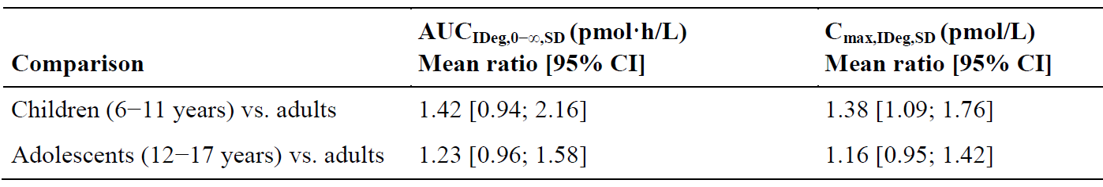

IDegAsp = insulin degludec/insulin aspart; IDeg = insulin degludec; IAsp = insulin aspart; AUC = Area under the curve; AUCIDeg, 0−∞, SD = total exposure of IDeg after a single dose; SD = single dose; CI = confidence interval; Cmax = maximum observed concentration; vs = versus

Study NN5401-1982: IDegAsp 0.5 units/kg (0.35 units/kg IDeg; 0.15 units/kg of IAsp). Statistical analyses were based on 11 children, 13 adolescents and 13 adults for AUCIDeg, 0−∞, SD and on 12 children, 13 adolescents and 13 adults for Cmax, IDeg, SD.

Table : Study NN5401-1982 Pair-wise comparison of pharmacokinetic endpoints for insulin aspart in insulin degludec/insulin aspart after single-dose administration between children, adolescents and adults with type 1 diabetes mellitus

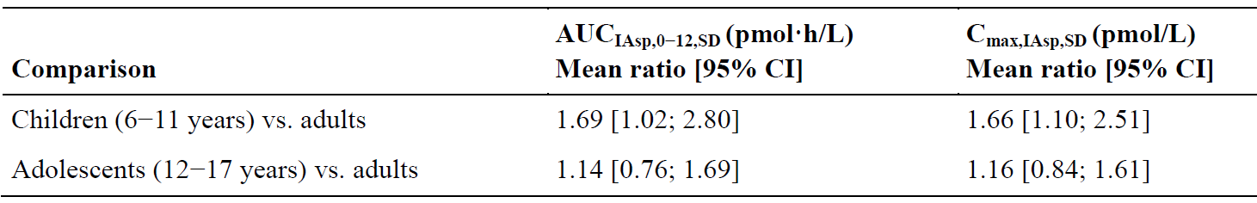

IAsp = insulin aspart; AUCIAsp, 0−12 = the area under the IAspconcentration-time curve during the first 12 hours of one dosing interval; SD = single dose; Cmax = maximum observed concentration; CI = confidence interval; vs = versus

Study NN5401-1982: IDegAsp 0.5 units/kg (0.35 units/kg IDeg; 0.15 units/kg of IAsp). Statistical analyses were based on 12 children, 13 adolescents and 13 adults.

A meal test was performed to study the PD effects by age. The shape of the mean plasma glucose profile over 6 hours following administration of single dose IDegAsp and standard meal was similar for children (6 to 11 years), adolescents (12 to 17 years) and adults (Figure 1).

Figure : Study NN5401-1982 Mean plasma glucose profiles, 0 to 6 hours for children (6 to 11 years), adolescents (12 to 17 years) and adults following single dose insulin degludec/insulin aspart

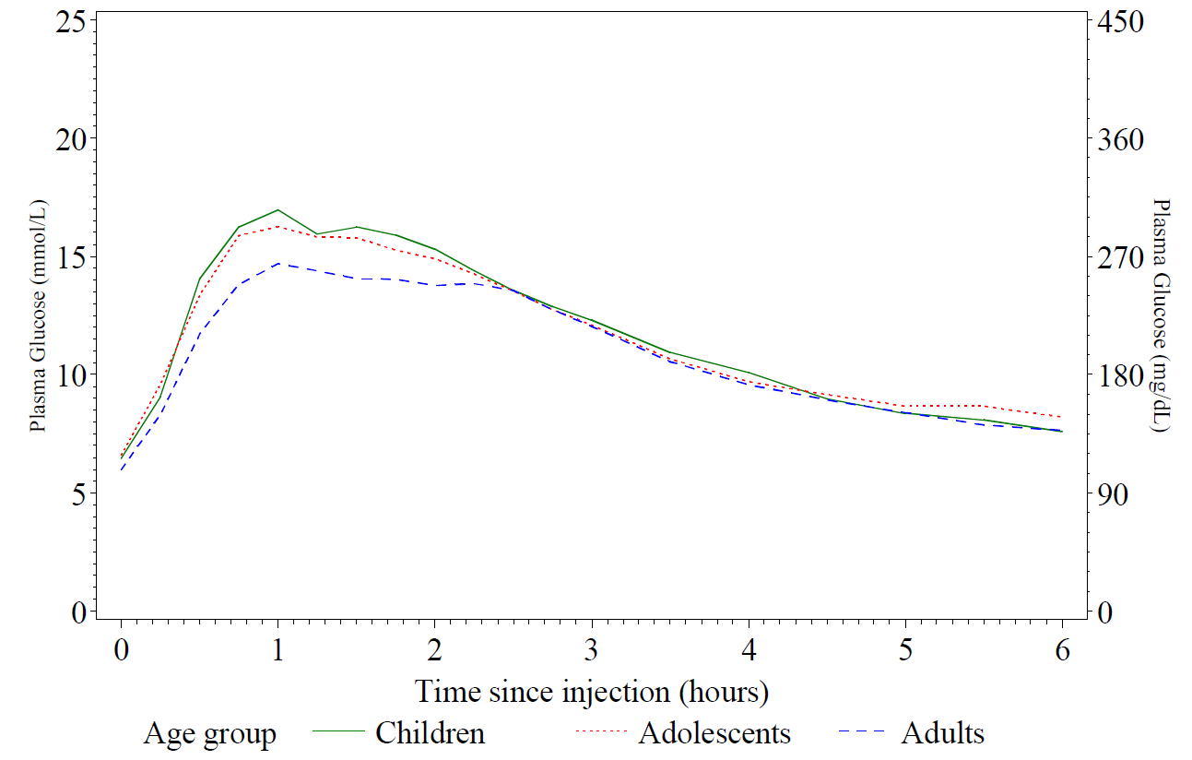

##### Study NN1250-1995

Study NN1250-1995 was also submitted as part of the initial registration of IDeg.5 It studied subjects aged 6 to 65 years with T1DM. Patients were given 0.4 U/kg of IDeg or insulin glargine (IGlarg).[6]

Following single dose administration of IDeg, total IDeg exposure (AUCIDeg,0-∞,SD) was higher in children compared to adults (estimated ratio children/adults 1.48 (95% confidence interval (CI): 0.98, 2.24)) and higher in adolescents compared to adults (estimated ratio adolescents/adults 1.33 (95% CI: 1.08, 1.64)). There were no statistically significant differences in Cmax, IDeg, SD between children and adults (estimated ratio children/adults 1.20 (95% CI: 0.90, 1.60)) or between adolescents and adults (estimated ratio adolescents/adults 1.23 (95% CI: 1.00, 1.51)). Median time to maximum observed concentration (tmax) was similar across the three age groups (11 to 15 hours).

##### Population pharmacokinetic analysis

A population pharmacokinetic (pop PK) analysis was performed using the pooled results of Studies NN1250-3561, NN5401-1982, and NN1250-1995. Pre-breakfast self-measured plasma glucose (SMPG) data from Study NN1250-3561 was used to develop an exposure‑response model, which was used to attempt to predict pre-breakfast SMPG in children younger than 6 years. NONMEM version 7.1.2 software was used for the pop PK and exposure-response analyses and for simulation.

The final pop PK model consisted of the base model (a one-compartment model with first‑order absorption through a single transit compartment and with first‑order elimination) with body weight as a covariate for clearance and volume of distribution, and race as a covariate for clearance (mainly driven by lower exposure in Asian subjects). Age group, body mass index (BMI) and gender were not significant covariates for clearance, and only the effect of body weight was investigated for volume of distribution.

The steady-state IDeg exposure from the pop PK analysis was found to be independent of age and the (IDeg) concentration-time profile in children aged 1 to 5 years was similar to the concentration-time profiles in children aged 6 to 11 years, adolescents (12 to 17 years) and adults (18 to 65 years) when IDeg is dosed per kg body weight.

There was no PK data for children 1 to 5 years.

The exposure-response relationship for pre-breakfast SMPG appeared to be similar across the paediatric age groups children 1 to 5 years, children 6 to 11 years and adolescents (12 to 17 years) given the small changes in dose levels during the 26 weeks of dose titration. However, the large variability in pre-breakfast SMPG shows that the robustness of the analysis was limited. Further, the analysis findings are in contrast to the usual observed differences in insulin requirements of the three age groups (as insulin resistance increases during puberty).

#### Efficacy

The data in support of this application included Study NN5401-3816, which evaluated the use of IDegAsp and Study NN1250-3561, which studied IDeg and was evaluated in the submission for extension of indications for IDeg.[7]

##### Study NN5401-3816

Study NN5401-3816 was a 16 week randomised, open label multinational, multicentre treat-to-target study comparing the efficacy and safety of IDegAsp once daily with a main meal plus IAsp with the remaining meals, and insulin detemir (IDet);[8] once daily or twice daily with IAsp at meal time in children and adolescents 1 to 18 years.

It was designed as a non-inferiority study, with a non-inferiority limit of 0.4% (European Medicines Agency (EMA) guidelines recommend 0.3%).[9]

Patients were stratified by age (1 to 6 years, 6 to 12 years and 12 to 18 years). Patients discontinued their usual diabetes treatment at Baseline. Study visits occurred every 4 weeks. The study was conducted from October 2013 to November 2014 at 63 sites in 14 countries in Europe, South Africa and the USA.

Devices using 0.5 dose increments were used for all participants. The study was conducted with a treat-to-target principle. Insulin was individually titrated on a continuous basis in accordance with pre-specified plasma glucose (PG) target range adopted from the ISPAD guidelines (2009).[10] The fasting, pre-meal and bedtime PG target was 5.0 to 8.0 mmol/L. Titration algorithms for basal and bolus insulin specified the PG target and the recommended insulin dose adjustments at different PG levels. At randomisation, all basal insulin doses were reduced by 20%. IAsp doses were titrated by sliding scale based on the post prandial blood glucose level or according to an insulin/carbohydrate ratio in patients familiar with that method.

The main outcome variable was change in glycosylated haemoglobin A1c (HbA1c);[11] from Baseline. Secondary endpoints included change from Baseline in fasting BGL, SMPG 4 point profiles and within subject variability, SMPG 8 point profile mean.

All observed HbA1c measurements available post randomisation at scheduled measurement times were analysed with a mixed model for repeated measures analysis. The model included treatment, sex, region, age group and visit as factors and baseline HbA1c as covariate.

###### Results

Of the 387 patients screened, 362 were randomised and 342 completed the study. Of the 362 subjects randomised, 82 were aged 1 to 5 years, 122 were aged 6 to 11 years and 158 aged 12 to 17 years. The majority of subjects (92.0%) were using basal plus bolus insulin therapy at Baseline with IDet and IGlarg, the most common basal insulin (45.3% and 40.6% respectively) and IAsp, the most common bolus insulin (58.6%) used at screening.

After 16 weeks of treatment, the mean change from Baseline in HbA1c was ‑0.27% and ‑0.23% for the IDegAsp and IDet groups, respectively. The mean treatment difference (IDegAsp minus IDet) was -0.04% (95% CI: -0.23, 0.15), well within the criteria for non‑inferiority but not reaching superiority.

At Week 16, mean fasting plasma glucose (FPG) was 8.4 mmol/L in the IDegAsp group and 8.3 mmol/L in the IDet group. The observed mean change in FPG from Baseline at Week 16 was -0.3 mmol/L and -0.1 mmol/L in the IDegAsp and IDet groups, respectively. There was no significant difference in the trend in 8 point SMPG.

##### Figure 2: Study NN5401-3816 Glycosylated haemoglobin A1c (%) by treatment week - mean plots

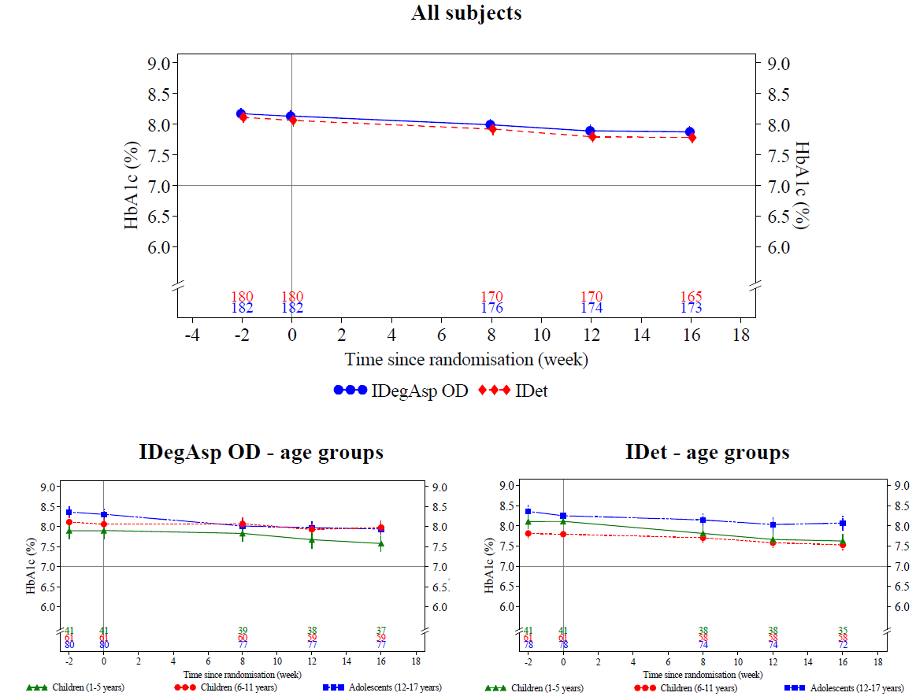

HbA1c = glycosylated haemoglobin A1c; IDegAsp = insulin degludec/insulin aspart; IDet = insulin detemir; OD = once daily

Full analysis set: Observed data, Error bars +/- standard error (mean). Numbers of subjects contributing to the data points are provided in the bottom section of each plot. In the lower panel, the age groups are presented from top to bottom: children 1 to 5 years, children 6 to 11 years and adolescents 12 to 17 years.

##### Study NN1250-3561

This was a 26 week, randomised, treat-to-target non-inferiority study comparing the efficacy and safety of IDeg and IDet basal insulin in children and adolescents aged 1 to 18 years with T1DM and IAsp as a basal insulin. For the primary endpoint, IDeg daily plus IAsp was non-inferior to IDet plus IAsp in terms of reducing HbA1c after 26 weeks of treatment, with an estimated treatment difference (IDeg minus IDet) of 0.15% (95% CI: ‑0.03, 0.32). After 26 weeks of treatment, mean change from Baseline in FPG was ‑0.67 mmol/L in the IDeg group and +0.50 mmol/L in the IDet group, with no statistically significant difference between groups (estimated treatment difference (IDeg minus IDet) = ‑0.42 mmol/L (95% CI: ‑1.65, 0.81)).

#### Safety

Evaluable safety data were provided in Study NN5401-3816. Safety assessments included incidence of treatment emergent adverse events (TEAE) during 16 weeks of treatment and 1 week of follow-up, hypoglycaemia, hyperglycaemia, vital signs, laboratory assessments (haematology, biochemistry, lipid profile), insulin dose, body weight and BMI.

Medical events of special interest (MESI) in the study were medication errors concerning trial products, neoplasm and severe hypoglycaemia.

The mean total daily insulin dose increased slightly during the study for both treatment groups, remaining slightly lower in the IDegAsp group during the 16 week treatment period. The mean total daily insulin doses were 0.88 U/kg and 1.01 U/kg in the IDegAsp and IDet groups, respectively at Week 16. In both treatment groups, the mean total daily insulin dose increased slightly from Week 1 to Week 16 in all age groups.

At Week 16, the mean total number of injections per day (IDegAsp plus IAsp and IDet plus IAsp) was 3.6 in the IDegAsp group and 4.9 in the IDet group.

The event rate for serious adverse events (SAE) was higher with IDeg Asp than IDet (26 versus 13 events per 100 patient years). The majority of AEs were mild in severity (70.8%). Severe AEs were reported by 12 (6.6%) or 26 events per 100 exposure years subjects in the IDegAsp group and 5 (2.8%) events or 9 events per 100 exposure years subjects in the IDet group. The difference between the two groups was driven by hypoglycaemia related AEs; 9 events in 9 subjects in the IDegAsp groups versus 2 events in 2 subjects in the IDeg group. All subjects with severe AEs were recovered or were recovering at end of study.

A hypoglycaemic episode was reported as an AE if it fulfilled the definition of an SAE or MESI (severe hypoglycaemia as per ISPAD definition). Hypoglycaemia was reported as an AE for 11 (6.1%) subjects in the IDegAsp group and 3 (1.7%) subjects in the IDet group. Further, hypoglycaemia seizure was reported as an AE for 2 (1.1%) subjects in the IDegAsp group.

The age group 1 to 5 years was at particularly high risk of severe hypoglycaemia.

For both treatment groups, the majority of severe hypoglycaemia episodes occurred in the daytime and were mostly single events in individual subjects. Three subjects in the IDegAsp groups reported 2 severe episodes each and 1 subject in the IDet group reported 2 episodes of severe hypoglycaemia. Two of the episodes in the IDegAsp group and 1 in the IDet group appeared to be related to exercise. For all cases of severe hypoglycaemia where plasma glucose levels were recorded, plasma glucose levels ranged from 1.5 mmol/L to 3.1 mmol/L. There was no information regarding possible skipped meals or inadequate carbohydrate intake.

There did not seem to be any trends in terms of treatment administration time (breakfast, lunch or dinner) or timing of the study. IDegAsp and IAsp were administered concomitantly at the same meal for 3 events of severe hypoglycaemia in the IDegAsp group (in the delegate’s opinion this represent a medication error).

The rate of nocturnal hypoglycaemia was similar between IDegAsp and IDet.

There were more episodes of hyperglycaemia with IDegAsp but more episodes of hyperglycaemia with ketosis with IDet.

There were similar numbers of reported medication errors in both groups. Also, similar number of injection site problems.

The clinical evaluator considered that Ryzodeg has a positive risk-benefit ratio in patients over 6 years of age, but was concerned about the risk of severe hypoglycaemia in patients 1 to 5 years. In the post round 2 response, the sponsor amended the indication to include patients over 6 years for T1DM and over 10 years for T2DM.

### Risk management plan

The most recently evaluated EU-risk management plan (RMP) was version 5.2 (dated 1 August 2016; data lock point (DLP) 1 June 2015) and the Australian specific Annex (ASA) version 1.1 (dated 29 May 2017). In support of the extended indication, the sponsor has submitted EU-RMP version 7.0 (dated 4 September 2018; DLP 31 January 2018) and ASA version 1.2 (dated 11 October 2018). At the second round of evaluation, the ASA was updated to version 1.3 (dated 21 June 2019).

The proposed summary of safety concerns and their associated risk monitoring and mitigation strategies are summarised below (Table 4). Compared to the summary of safety concerns at the time of approval for adult use, the sponsor removed important identified risks (allergic reactions) and areas of missing information (children and adolescents under 18 years; hepatic impairment; moderate and severe renal impairment; elderly patients over 75 years with type 1 diabetes mellitus; co-administration of GLP-1 receptor agonists) from the summary of safety concerns. The RMP evaluator has stated that changes were consistent with EU guidelines.

Table : Summary of safety concerns[12]

| **Summary of safety concerns** | | **Pharmacovigilance** | | **Risk Minimisation** | |
| --- | --- | --- | --- | --- | --- |
| **Routine** | **Additional** | **Routine** | **Additional** |
| Important potential risks | Medication errors due to mix-up between Ryzodeg and bolus insulin | ✓* | – | ✓ | – |
| Immunological events – formation of neutralising insulin antibodies | ✓ | – | ✓ | – |
| Missing information | Pregnant and lactating women | ✓ | – | ✓ | – |

* Follow up questionnaire

* Routine pharmacovigilance activities will address all safety concerns. A follow-up questionnaire will be used for reports of medication errors. This is acceptable for the extension of indications.
* No additional risk minimisation activity is required. The Consumer Medicines Information (CMI) is provided as a pack insert. This is acceptable for the extension of indications.

The RMP evaluator recommended the following in the second round of evaluation:

* Recommendation 2: The sponsor should retain ‘hypoglycaemia in patients under 18 years of age’ in the ASA as an important identified risk.
* Recommendation 12: The sponsor is requested to commit to submitting in the periodic safety update report (PSUR) a cumulative review of all cases of ‘hypoglycaemia’ reported in association with Ryzodeg use in patients aged below 18 years of age using the DLP in the PSUR. This cumulative review should include clinical data from all sources, including spontaneous reports, clinical trials and any relevant data from the literature. The review must focus on evaluating any new trends or differences in the reports of hypoglycaemia in these patients in Australia in comparison to international data and the need for any potential amendment to the PI and/or the RMP.

### Risk-benefit analysis

#### Delegate’s considerations

##### Extension of indication for use in children and adolescents

The sponsor has provided adequate data on the PK characteristics of Ryzodeg in this formulation. It is proposed that Ryzodeg will be administered with a re-usable pen able to give 0.5 unit increments of Ryzodeg. To the Delegate’s knowledge, these devices are available in Australia.

In the pivotal clinical study, Ryzodeg with meal time aspartate was non-inferior to IDet. However, this study may not be representative of the setting in Australia where the most widely used basal insulin is glargine. In this study, meal time aspartate was given as a fixed dose in some subjects, or using a flexible dosing regimen in others. There was a higher rate of severe hypoglycaemia in patients treated with Ryzodeg. Hypoglycaemia generally occurred during the day. Younger patients were more at risk.

Although hypoglycaemia is a well-recognised complication of insulin therapy, it is a serious problem with many adverse short and long term consequence. When managing diabetes, avoiding hypoglycaemia is as important as improving glycaemic control. In the past improving glycaemic control was often associated with an increased risk of hypoglycaemia, however with the advent of more intensive glucose monitoring and the ability to fine tune insulin dosing using analogues and insulin pumps, optimising glycaemic control without increasing the risk of hypoglycaemia is possible.

The Delegate agreed with the evaluator that for patients over 6 years, there is satisfactory evidence for the efficacy and safety of Ryzodeg for the treatment of type 1 diabetes and that the risk-benefit in younger children is negative due to the higher risk of hypoglycaemia.

The Delegate accepted the extrapolation of PK data from children and adolescents and clinical data from children in T1DM and adults with T2DM to support use in children aged 10 years and older with T2DM.

##### Cardiovascular safety

The information in the PI around cardiovascular safety should be consistent with that in the recently approve PI document for Tresiba FlexTouch and Tresiba Penfill.

##### Risk management plan

The Delegate agreed with the RMP evaluator that hypoglycaemia should be included in the ASA and that PSUR be submitted.

The Delegate was unsure if there is adequate information about the co-administration of GLP-1 agonists with IDegAsp to remove this from the RMP.

###### Question

1. Both insulin aspart and GLP-1 agonist reduce post prandial BGLs. What is the risk of hypoglycaemia when these agents are used together? Does there need to be additional information in the PI for prescribers to adequately adjust doses when these agents are used together.

###### Sponsor’s response

The sponsor acknowledges the TGA’s relevant question regarding the risk of hypoglycaemia when co-administering insulin aspart (bolus insulin) and GLP-1 receptor agonists (RAs).

At present, a limited number of studies have investigated the benefits of co-administration of bolus alone or bolus containing insulin regimen and GLP-1 RA to enable the subsequent evaluation of complete risk of hypoglycaemia.[13]

NovoMix 30, a biphasic insulin aspart, (Novo Nordisk insulin aspart marketed formulation) in combination with GLP-1 RAs has been approved for the treatment of T2DM in the EU, in 2019, based on the data from the LEADER trial (Trial 3748) as well as from the published real-world evidence studies where premix insulin was used in combination with GLP-1 RAs.[14],[15],[16],[17]

Davies et al., in 2016;13 reviewed eight studies (6 observational and 2 randomised trials) involving a combination of a GLP-1 RA and an insulin regimen, including bolus insulin. As expected from the pharmacological properties of GLP-1 RA, the use of GLP-1 RA in connection with insulin (basal or basal and bolus/pre-mix or bolus) was associated with a decrease in insulin requirements, improved glycaemic control, improved glycaemic variability, decreased risk of hypoglycaemia, including nocturnal and severe hypoglycaemic and induced weight loss.13

In one of the reported studies, few subjects on insulin intensive therapy on U-500 insulin;[18] experienced hypoglycaemic episodes soon after initiation of GLP-1 RA, thus emphasising the need for insulin dose reductions when starting a GLP-1 RA. None of these episodes were defined as severe or required assistance.13

In the trials and reports where GLP-1 RAs have been added to the existing basal-bolus therapy, bolus insulin was discontinued in some subjects, due to the complementary mechanism of GLP-1 RA, leading to lower hypoglycaemia and contributing weight loss.13

As communicated in the previous response document, only 14 global cases of Ryzodeg 70/30 in combination with GLP-RAs have been reported in the sponsor safety database from the cumulative post-marketing data.

Dosage and administration section of the Australian PI also clearly describes how Ryzodeg 70/30 in diabetes mellitus should be used.[19] Additionally, Ryzodeg 70/30, insulin aspart and GLP-1 RAs are provided by prescription only.

In conclusion, co-administration of bolus insulin (as part of basal and bolus regimen/pre-mix insulin or bolus alone) with GLP-1 RA has been reported to decrease insulin requirements, improve glycaemic control and decrease risk of hypoglycaemia among other benefits.13 In view of these effects, the Australian PI for Ryzodeg 70/30 includes information to the prescribers about the risk of hypoglycaemia and the possible need for dose reductions and increased frequency of glucose monitoring when combined with GLP‑1 RAs.19 Further, the risk mitigation activities are considered adequate and no changes to the PI are required.

#### Advisory Committee considerations[20]

The Delegate did not refer this application to the Advisory Committee on Medicines (ACM) for advice.

### Outcome

Based on a review of quality, safety and efficacy, the TGA approved the registration of Ryzodeg 70/30 FlexTouch 70% insulin degludec (rys) / 30% insulin aspart (rys) 100 U/mL for solution for injection and Ryzodeg 70/30 Penfill 70% insulin degludec (rys) / 30% insulin aspart (rys) 100 U/mL for solution for injection for the following extension of indication:

*For use in diabetes mellitus in adolescents and children aged 6 years and older.*

As such, **the full indications** are now:

*For use in diabetes mellitus in patients aged 6 years and older.*

#### Specific conditions of registration applying to these goods

* Ryzodeg 70/30 (insulin degludec / insulin aspart) is to be included in the Black Triangle Scheme. The PI and CMI documents for Ryzodeg 70/30 must include the black triangle symbol and mandatory accompanying text for five years, which starts from the date the new indication is registered.
* Any changes to which the sponsor has agreed should be included in a revised RMP and ASA. However, irrespective of whether or not they are included in the currently available version of the RMP document, the agreed changes become part of the risk management system.

The Ryzodeg 70/30 EU-RMP, version 7.0, dated 4 September 2018 (DLP 31 January 2018), with ASA, version 1.3, dated 21 June 2019, included with submission PM-2018-04154-1-5, to be revised to the satisfaction of the TGA, will be implemented in Australia.

An obligatory component of risk management plans is routine pharmacovigilance. Routine pharmacovigilance includes the submission of PSURs.

Unless agreed separately between the supplier who is the recipient of the approval and the TGA, the first report must be submitted to the TGA no later than 15 calendar months after the date of this approval letter. The subsequent reports must be submitted no less frequently than annually from the date of the first submitted report until the period covered by such reports is not less than three years from the date of the approval letter. The annual submission may be made up of two PSURs each covering six months. If the sponsor wishes, the six monthly reports may be submitted separately as they become available.

The reports are to at least meet the requirements for PSURs as described in the EMA’s Guideline on Good Pharmacovigilance Practices (GVP) Module VII-periodic safety update report (Rev 1), Part VII.B Structures and processes. Note that submission of a PSUR does not constitute an application to vary the registration. Each report must have been prepared within ninety calendar days of the DLP for that report.

* The CMI must be included with the products as a package insert.

## Attachment 1. Product Information

The PI for Ryzodeg 70/30 FlexTouch and Ryzodeg 70/30 Penfill approved with the submission which is described in this AusPAR is at Attachment 1. For the most recent PI, please refer to the TGA website at <<https://www.tga.gov.au/product-information-pi>>.

|  |
| --- |
| Therapeutic Goods Administration |
| PO Box 100 Woden ACT 2606 Australia  Email: [info@tga.gov.au](mailto:info@tga.gov.au) Phone: 1800 020 653 Fax: 02 6232 8605  [**https://www.tga.gov.au**](https://www.tga.gov.au) |

1. Therapeutic Guidelines. eTG complete. Diabetes. eTG April 2019 edition.
2. Australian Government Australian Institute of Health and Welfare. Diabetes snapshot. Updated 30th August 2019. <https://www.aihw.gov.au/reports/diabetes/diabetes-snapshot/contents/how-many-australians-have-diabetes>
3. Australian Government Australian Institute of Health and Welfare 2018. Australia’s health 2018. Australia’s health series no 16. AUS 221. Canberra: AIHW. <https://www.aihw.gov.au/getmedia/c172c33e-776d-44b0-b549-546d58cee33d/aihw-aus-221-chapter-3-8.pdf.aspx>
4. Danne T et al. (2018). ISPAD Clinical Practice Consensus Guidelines 2018: Insulin treatment in children and adolescents with diabetes. *Pediatric Diabetes,* 19 (Suppl. 27): 115–135.
5. AusPAR Ryzodeg 70/30 FlexTouch, Ryzodeg 70/30 Penfill insulin degludec (rys)/insulin aspart (rys) Novo Nordisk Pharmaceuticals Pty Ltd PM-2016-02723-1-5.
6. Insulin glargine is a long acting insulin analogue.
7. AusPAR Tresiba FlexTouch/Penfill insulin degludec (rys) Novo Nordisk Pharmaceuticals Pty Ltd PM-2016-02721-1-5.
8. Insulin detemir is a long acting insulin analog.
9. EMA, Committee for Proprietary Medicinal Products (CPMP), 15 November 2012. Guideline on clinical investigation of medicinal products in the treatment or prevention of diabetes mellitus, CPMP/EWP/1080/00.
10. Bangstad H-J et al. (2009). ISPAD Clinical Practice Consensus Guidelines 2009: Insulin treatment in children and adolescents with diabetes. *Pediatric Diabetes,* 10 (Suppl. 12): 82 – 99.
11. HbA1c is glycosylated haemoglobin and reflects the average blood glucose over the lifespan of the red blood cells containing it (approximately 12 weeks). HbA1c is regarded as a gold standard for assessing glycaemic control. HbA1c is also known as A1c, glycohaemoglobin and glycated haemoglobin.
12. Routine risk minimisation activities may be limited to ensuring that suitable warnings are included in the product information or by careful use of labelling and packaging. Routine pharmacovigilance practices involve the following activities:

    All suspected adverse reactions that are reported to the personnel of the company are collected and collated in an accessible manner;

    Reporting to regulatory authorities;

    Continuous monitoring of the safety profiles of approved products including signal detection and updating of labelling;

    Submission of PSURs;

    Meeting other local regulatory agency requirements
13. Davies ML et al. (2016). GLP1-RA Add-on Therapy in Patients with Type 2 Diabetes Currently on a Bolus Containing Insulin Regimen. *Pharmacotherapy*, 36(8):893-905
14. Novo Nordisk A/S. NovoMix 30 (biphasic insulin aspart) - Summary of Product Charateristics (SmPC). 16 August 2019
15. Montvida O et al. (2017). Addition of or switch to insulin therapy in people treated with glucagon-like peptide-1 receptor agonists: A real-world study in 66 583 patients. *Diabetes Obes Metab*. 19(1):108-17.
16. Yoon NM et al. (2009). Exenatide added to insulin therapy: a retrospective review of clinical practice over two years in an academic endocrinology outpatient setting. *Clin Ther.* 31(7):1511-23.
17. Li CJ et al. (2012). Efficacy and safety comparison between liraglutide as add-on therapy to insulin and insulin dose-increase in Chinese subjects with poorly controlled type 2 diabetes and abdominal obesity. *Cardiovasc Diabetol.* 11:142.
18. U-500 insulin is highly concentrated insulin containing 500 U/mL.
19. Novo Nordisk A/S. Ryzodeg 70/30 Australian Product Information. 22 May 2018.
20. The ACM provides independent medical and scientific advice to the Minister for Health and the Therapeutic Goods Administration (TGA) on issues relating to the safety, quality and efficacy of medicines supplied in Australia including issues relating to pre-market and post-market functions for medicines.

    The Committee is established under Regulation 35 of the Therapeutic Goods Regulations 1990. Members are appointed by the Minister. The ACM was established in January 2017 replacing Advisory Committee on Prescription Medicines (ACPM) which was formed in January 2010. ACM encompass pre and post-market advice for medicines, following the consolidation of the previous functions of the Advisory Committee on Prescription Medicines (ACPM), the Advisory Committee on the Safety of Medicines (ACSOM) and the Advisory Committee on Non-Prescription Medicines (ACNM). Membership comprises of professionals with specific scientific, medical or clinical expertise, as well as appropriate consumer health issues relating to medicines.