February 2013

AusPAR Attachment 2

Extract from the Clinical Evaluation Report for insulin detemir(rys)
  - Proprietary Product Name: Levemir Flexpen / Levemir Penfill / Levemir Innolet
  - Sponsor: Novo Nordisk Pharmaceuticals Pty Ltd

About the Therapeutic Goods Administration (TGA)
- The Therapeutic Goods Administration (TGA) is part of the Australian Government Department of Health, and is responsible for regulating medicines and medical devices.
- The TGA administers the Therapeutic Goods Act 1989 (the Act), applying a risk management approach designed to ensure therapeutic goods supplied in Australia meet acceptable standards of quality, safety and efficacy (performance), when necessary.
- The work of the TGA is based on applying scientific and clinical expertise to decision-making, to ensure that the benefits to consumers outweigh any risks associated with the use of medicines and medical devices.
- The TGA relies on the public, healthcare professionals and industry to report problems with medicines or medical devices. TGA investigates reports received by it to determine any necessary regulatory action.
- To report a problem with a medicine or medical device, please see the information on the TGA website <http://www.tga.gov.au>.
About the Extract from the Clinical Evaluation Report
- This document provides a more detailed evaluation of the clinical findings, extracted from the Clinical Evaluation Report (CER) prepared by the TGA. This extract does not include sections from the CER regarding product documentation or post market activities.
- The words [Information redacted], where they appear in this document, indicate that confidential information has been deleted.
- For the most recent Product Information (PI), please refer to the TGA website <http://www.tga.gov.au/hp/information-medicines-pi.htm>.
Copyright
© Commonwealth of Australia 2014
This work is copyright. You may reproduce the whole or part of this work in unaltered form for your own personal use or, if you are part of an organisation, for internal use within your organisation, but only if you or your organisation do not use the reproduction for any commercial purpose and retain this copyright notice and all disclaimer notices as part of that reproduction. Apart from rights to use as permitted by the Copyright Act 1968 or allowed by this copyright notice, all other rights are reserved and you are not allowed to reproduce the whole or any part of this work in any way (electronic or otherwise) without first being given specific written permission from the Commonwealth to do so. Requests and inquiries concerning reproduction and rights are to be sent to the TGA Copyright Officer, Therapeutic Goods Administration, PO Box 100, Woden ACT 2606 or emailed to <tga.copyright@tga.gov.au>.

Contents
List of abbreviations 5
1. Clinical rationale 8
2. Contents of the clinical dossier 8
2.1. Scope of the clinical dossier 8
2.2. Paediatric data 9
2.3. Good clinical practice 9
3. Pharmacokinetics 9
3.1. Studies providing pharmacokinetic data 9
3.2. Evaluator’s overall conclusions on pharmacokinetics 10
4. Pharmacodynamics 10
4.1. Studies providing pharmacodynamic data 10
4.2. Evaluator’s overall conclusions on pharmacodynamics 13
5. Dosage selection for the pivotal studies 13
6. Clinical efficacy 14
6.1. Change 1 14
6.2. Change 2 20
6.3. Change 3 24
7. Clinical safety 34
7.1. Studies providing evaluable safety data 34
7.2. Pivotal studies that assessed safety as a primary outcome 35
7.3. Patient exposure 35
7.4. Adverse events 35
7.5. Laboratory tests 49
7.6. Post-marketing experience 53
7.7. Evaluator’s overall conclusions on clinical safety 55
8. First round benefit-risk assessment 56
8.1. First round assessment of benefits 56
8.2. First round assessment of risks 57
8.3. First round assessment of risks 57
8.4. First round assessment of benefit-risk balance 58
9. First round recommendation regarding authorisation 58
10. Clinical questions 59
11. Second round evaluation of clinical data submitted in response to questions 59
12. Second round benefit-risk assessment 59
13. Second round recommendation regarding authorisation 59
14. Appendix 1: Additional tables 59

List of abbreviations
Abbreviation | Meaning
ADA | American Diabetes Association
AE | Adverse event
ALP | Alkaline phosphatase
ALT | Alanine aminotransferase
ANCOVA | Analysis of covariance
AUC_{0–24} | Area under the serum concentration–time curve from time 0 to 24 hours
AUC_{GIR,0–24} | Area under the glucose infusion rate curve from time 0 to 24 hours
B/T% | Percentage of bound antibodies versus total antibody level
CCDS | Core Company Data Sheet
CI | Confidence interval
C_{max} | Maximum concentration
CTR | Clinical trial report
DAE | Adverse event leading to discontinuation
DBP | Diastolic blood pressure
EMA | European Medicines Agency
FAS | Full analysis set
FAS_{Pregnant} | FAS for pregnant subjects
FFA | Free fatty acid
FPG | Fasting plasma glucose
GIR | Glucose infusion rate
GIR_{max} | Maximum glucose infusion rate
GW | Gestation week
h | Hour
HbA1c | Glycosylated haemoglobin
HDL-C | High density lipoprotein cholesterol
HOMA | Homeostasis model assessment
HOMA-B | HOMA index of beta-cell function
HOMA-IR | HOMA index of insulin resistance
IDF | International Diabetes Federation
IV/WRS | Interactive Voice/Web Response System
LDL-C | Low density lipoprotein cholesterol
LOCF | Last observation carried forwards
LS Mean | Least-square mean
MAA | Marketing Authorisation Application
MESI | Medical event of special interest
NPH | Neutral Protamine Hagedorn
OAD | Oral antidiabetic drug
PD | Pharmacodynamic(s)
PG | Plasma glucose
PK | Pharmacokinetic(s)
PP_{Pregnant} | Per-protocol data set for pregnant subjects
RPM | Repeated-measurement
SAE | Serious adverse event
SAS | Safety analysis set
SBP | Systolic blood pressure
SMPG | Self-measured plasma glucose
SOC | System organ class
t½ | Terminal elimination half-life
TEAE | Treatment-emergent adverse event
TG | Triglycerides
T1DM | Type 1 diabetes mellitus
T2DM | Type 2 diabetes mellitus
t_{GIRmax} | Time to maximal glucose infusion
t_{max} | Time to maximal serum concentration
U | Unit(s)
UNL | Upper normal limit
VLDL-C | Very low density lipoprotein cholesterol

Clinical rationale
The rationales provided by the Sponsor for each change are:
Change 1:
In T2DM “basal insulin, co-administered with liraglutide, would provide additional glucose-lowering potency, while the presence of liraglutide may substantially reduce weight gain associated with insulin, reduce required insulin dose and maintain low risk of hypoglycaemia. Insulin detemir, a basal insulin analogue shown to provide lower risk of hypoglycaemia and less weight gain compared to NPH insulin (intermediate-acting insulin), is a promising candidate to be tested for efficacy and safety in combination with a once-daily human GLP-1 analogue, such as liraglutide.”
Change 2:
“In connection with the approval of the paediatric indication of insulin detemir by EMA, a new long-term safety trial (NN304-1689) trial was discussed and agreed with EMA as part of a post-approval commitment”. The purpose of the application is to update the PI with long-term safety data from this trial.
Change 3:
“The use of insulin analogues is increasing in Type 1 as well as in Type 2 diabetes. Their use expands into special populations, such as children, elderly patients and patients with kidney failure. Use of insulin analogues implies that an increasing number of women conceive during insulin analogue treatment. Switching their treatment may carry a risk of deteriorated glycaemic control with an inherent risk of adverse influence on the pregnancy outcome. Pregnant women with diabetes need optimal glycaemic control with as few hypoglycaemic episodes as possible to reduce their risk of diabetes complications and to reduce the risk of adverse pregnancy outcome as described above. Hence, there is a medical need for optimising diabetic control in this population.”
Change 4:
The Sponsor proposes to align the PI more closely with the CCDS (v.12.0). The Sponsor also has made some editorial changes to align the PI with the format described in Appendix 8 of the Australian Regulatory Guidelines for Prescription Medicines.

Contents of the clinical dossier

Scope of the clinical dossier
The submission contained the following clinical information:
There was a separate Module 5 for each of Change 1, Change 2 and Change 3.
- Change 1 contained three studies: Study NN2211-3673 (PK/PD), Study NN2211-1842 (efficacy and safety), Study NN2211-1842-extension (long-term safety)
- Change 2 contained one study: Study NN304-1690 (long-term open label safety in children)
- Change 3 contained one study: Study NN304-1687 (efficacy and safety in pregnancy)

Paediatric data
The submission included paediatric safety data.

Good clinical practice
The studies submitted in the application were stated to have been conducted according to GCP.

Pharmacokinetics

Studies providing pharmacokinetic data
Study NN2211-3673 was an open label, three treatment phase, single sequence, PK and PD (euglycaemic clamp at 100 mg/dL) study of detemir, liraglutide and the combination of liraglutide and detemir (Table 1, Appendix 1). The study was conducted at a single centre in the US from April 2009 to September 2009. The study included male or female subjects ≥ 18 years of age; insulin naïve and diagnosed with T2DM; treated with stable doses of OAD(s) (one of which had to be metformin); BMI of ≤ 45 kg/m2, screening HbA1c of 7 to 10% on monotherapy and 7 to 9.5% on dual therapy; FPG ≤ 250 mg/dL at Visit 2; and FPG ≥ 140 and ≤ 240 mg/dL at Visit 5 (Study Day 1).
The study treatments were: insulin detemir 0.5 U/kg on Day 1, followed by 24 hour eugycaemic clamp; liraglutide titrated to 1.8 mg/day from Day 2 to Day 22, with 24 hour euglycaemic clamp on Day 22; liraglutide 1.8 mg daily from Day 22 to Day 36, and insulin detemir 0.5 U/kg on Day 36, with 24 hour euglycaemic clamp. All subjects were treated with metformin as a background medication.
There were 33 subjects: 23 (69.7%) male, 10 (30.3%) female, and the age range was 33 to 68 years (Table 2). Twenty subjects were treated with metformin alone and 13 with metformin and another OAD. There was no effect of liraglutide on exposure to detemir: the mean ratio (90% CI) detemir + liraglutide / detemir was 1.03 (0.97 to 1.09) for AUC₀₋₂₄ and 1.05 (0.98 to 1.13) for C_{max} (Table 1, Appendix 1). There was no effect of detemir on exposure to liraglutide: the mean ratio (90% CI) detemir + liraglutide / liraglutide was 0.97 (0.87 to 1.09) for AUC₀₋₂₄ and 1.03 (0.93 to 1.13) for C_{max}.
Table 2: Demography of Trial Population

Evaluator’s overall conclusions on pharmacokinetics
There was no evidence of a PK interaction between insulin detemir and liraglutide.

Pharmacodynamics

Studies providing pharmacodynamic data
In Study NN2211-3673 summarised in Table 1 (Appendix 1), from the euglycaemic clamp studies, the AUC for glucose infusion rate (AUC_{GIR}) was greater for detemir and liraglutide in combination than for detemir alone, and for liraglutide alone compared with detemir alone, but there was no significant difference between detemir and liraglutide in combination and liraglutide alone (Table 3).

Table 3: Summary of Pharmacodynamic Endpoints - Full Analysis Sets
The mean AUC_{GIR(0-24)} (SD) was 1057.6 (803.18) mg/kg for detemir alone, 1981.6 (1167.60) mg/kg for liraglutide alone and 2947.0 (1460.57) mg/kg for detemir and liraglutide in combination. The mean (95% CI) ratio for AUC_{GIR(0-24)} was 2.98 (1.84 to 4.81) for detemir+liraglutide/ detemir, 1.32 (0.82 to 2.14) for detemir+liraglutide/ liraglutide and 2.25 (1.39 to 3.64) for liraglutide/ detemir. Average C-peptide plasma concentrations over 24 hours were lower for detemir alone compared with detemir and liraglutide in combination, and higher for liraglutide alone (Table 4).
Table 4: Summary of AVG(0-24 hour), C_{max}, and C_{min} for C-peptide - Full Analysis Set
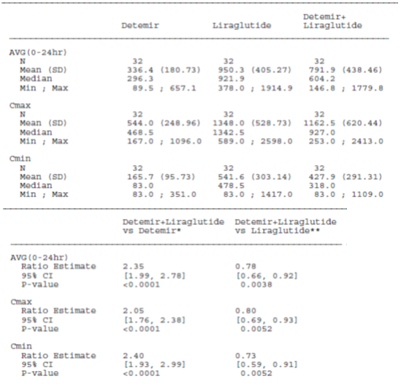
Glucagon concentrations were lower with detemir and liraglutide in combination than with detemir alone, but there was no significant difference compared with liraglutide alone (Table 5).
Table 5: Summary of AVG(0-24 hour), C_{max}, and C_{min} for Glucagon - Full Analysis Set

Evaluator’s overall conclusions on pharmacodynamics
Insulin detemir and liraglutide have a synergistic effect in decreasing plasma glucose. Insulin detemir when added to liraglutide decreases overall insulin secretion.

Dosage selection for the pivotal studies
Dosage selection was based on the approved dosing recommendations.

Clinical efficacy

Change 1

Pivotal efficacy study

Study NN2211-1842

Study design, objectives, locations and dates
Study NN2211-1842 was a multicentre, randomised, open label, two arm, parallel group trial with an additional open-label, non-randomised arm carrying subjects who achieved target glycaemic control after the run-in period (Table 6, Appendix 1). The study design is summarised in Table 7 (Appendix 1). The study was conducted at 202 centres in nine countries from March 2009 to April 2010.

Inclusion and exclusion criteria
The inclusion criteria included:
- Subjects diagnosed with T2DM, insulin naïve and treated with metformin as monotherapy for ≥ three months prior to screening, at a stable dose of ≥ 1500 mg/day or metformin (≥ 1500 mg/day) and a sulphonylurea (≤ half of the maximum approved dose according to local label), both at a stable dose for ≥ 3 three months prior to screening.
- HbA1c 7.0 to 10.0% inclusive for subjects on metformin monotherapy, HbA1c 7.0 to 8.5% inclusive for subjects on metformin in combination with a sulphonylurea
- Age 18 to 80 years, inclusive
The exclusion criteria included:
- Previous treatment with insulin (except for short-term treatment in connection with inter-current illness at the discretion of the investigator)
- Treatment with glucose-lowering agent(s) other than those stated in the inclusion criteria for a period of three months prior to screening
- Impaired liver function, ALT ≥ 2.5 times ULN
- Impaired renal function defined as serum-creatinine ≥ 133 μmol/L for males and ≥ 124 μmol/L for females
- History of chronic pancreatitis or idiopathic acute pancreatitis
- Known history of unstable angina, acute coronary event, other significant cardiac event, or cerebral stroke within the past six months
- Heart failure NYHA Class IV
- Known proliferative retinopathy or maculopathy requiring acute treatment
- Uncontrolled treated or untreated hypertension (SBP ≥ 180 mmHg and/or DBP ≥ 110 mmHg)
- Cancer (except basal cell skin cancer or squamous cell skin cancer) or any clinically significant disorder, except for conditions associated with T2DM history, which in the investigator’s opinion could interfere with the results of the trial
- Recurrent major hypoglycaemia or hypoglycaemic unawareness
- Use of any drug (except for those stated in the inclusion criteria), which in the investigator’s opinion could interfere with the glucose level (such as systemic corticosteroids)
- Surgery scheduled during the trial period (excluding minor surgical procedures performed under local anaesthesia)
- Known or suspected abuse of alcohol or narcotics
- Females of child bearing potential who were pregnant, breast-feeding or intended to become pregnant or were not using adequate contraceptive methods
The randomisation criterion was HbA1c measured at the randomisation visit ≥ 7.0%.

Study treatments
- Insulin detemir, starting at 10 U/day and adjusted by SMPG; liraglutide 1.8 mg/day; and metformin ≥ 1500 mg/day
- Liraglutide 1.8 mg /day and metformin ≥ 1500 mg/day

Efficacy variables and outcomes
The primary efficacy outcome measure was the change in HbA1c from baseline to Week 26. The secondary outcome measures were:
- Proportion of subjects reaching HbA1c targets: < 7%, ≤ 6.5%
- FPG
- Seven-point SMPG profiles
- Body weight
- Waist and hip circumference (and derived waist to hip ratio)
- Beta-cell function: fasting insulin; fasting C-peptide; fasting pro-insulin (and derived pro-insulin to C-peptide ratio), HOMA-B, HOMA-IR
- Fasting lipid profile: total cholesterol; HDL-C; LDL-C; VLDL-C; TG; and FFA
- SBP and DBP
However, due to cross-reactivity between insulin detemir and the insulin assay used to determine individual insulin concentrations in this trial, data on fasting insulin and HOMA-B and HOMA-IR indexes could not be assessed.
The safety endpoints were: AEs, hypoglycaemic episodes, physical examination, pulse, laboratory safety parameters, calcitonin and formation of liraglutide and insulin detemir antibodies.
The schedule of study visits is summarised in Table 7 (Appendix 1).

Randomisation and blinding methods
Subjects were randomised 1:1 using IV/WRS. There was no blinding, and all treatments were open label. The Sponsor’s argument in defence of this is that blinded treat-to-target administration of insulin detemir placebo was not feasible.

Analysis populations
The FAS included all randomised subjects with at least one efficacy value after the randomisation visit. The safety analysis set included all exposed subjects.

Sample size
The sample size calculation was based on a treatment difference (in HbA1c) of 0.5% (based on the liraglutide Phase III trials), SD of 1.2%, with a two-sided significance level of 0.05, a power of 90%, and a randomisation ratio of 1:1. This determined the sample size to be 123 subjects per group, and allowing for dropouts the final calculation was 150 subjects per treatment group.

Statistical methods
Hypothesis tests were performed using ANCOVA models with treatment, previous OAD and country as explanatory variables and baseline HbA1c as a covariate. Missing data were imputed using LOCF. A repeat measures analysis of HbA1c over the 26 weeks was also performed.

Participant flow
A total of 1658 subjects were screened; 162 were randomised to the detemir group; 161 to the control; and 498 were included in the non-randomised group. The most common reason for screening failure was HbA1c outside of the range required for inclusion. There were 144 (88.9%) subjects in the detemir group, 127 (78.9%) in the control and 470 (94.4%) in the non-randomised that completed the study (Table 8). There were 162 (100%) subjects in the detemir group and 157 (97.5%) in the control included in the FAS.
Table 8: Subject Disposition

Major protocol violations/deviations
The most common protocol violation was non-compliance: 30% of protocol deviations.

Baseline data
In the randomised population there were 177 (54.8%) males, 146 (45.2%) females and the age range was 31 to 79 years. The treatment groups were similar in demographic characteristics (Table 9 (Appendix 1). Overall the BMI for the treatment groups was high: mean (SD) 34.4 (6.2) kg/m². The treatment groups were similar in baseline efficacy outcome measures (Table 10 (Appendix 1).

Results for the primary efficacy outcome
There was a significant decrease in HbA1c to Week 26 in the detemir group compared with control. The LS mean (SE) change was -0.51 (0.07) % for detemir and 0.02 (0.07) % for control, LS mean (95% CI) difference -0.52 (-0.68 to -0.36) %, p <0.0001 (Table 11). The repeated measures ANOVA estimated a mean (95% CI) treatment difference of -0.43 (-0.55 to -0.31) p <0.0001 at Week 12 and -0.49 (-0.62 to -0.36) p <0.0001 at Week 26. A subgroup analysis was not performed for the primary efficacy outcome measure.
Table 11: Summary of Absolute Values and Change in HbA1c (%) - Full Analysis Set

Results for other efficacy outcomes
- At Week 26 the proportion achieving HbA1c < 7% was 71 (44.4%) subjects in the detemir group and 30 (20.1%) in the control, OR (95% CI) 3.75 (2.19 to 6.45), p <0.0001.
- At Week 26 the proportion achieving HbA1c ≤ 6.5% was 31 (19.4%) subjects in the detemir group and 11 (7.4%) in the control, OR (95% CI) 3.32 (1.58 to 7.00), p = 0.0016.
- FPG decreased in the detemir group compared with control (Table 12). The mean (SD) change from baseline was -2.13 (2.17) mmol/L for detemir and -0.23 (2.13) mmol/L for control; LS mean difference (95% CI) -1.73 (-2.16 to -1.30) mmol/L, p <0.0001.
Table 12: Summary of Absolute Values and Change in FPG (mmol/L) - Full Analysis Set
- The SMPG profiles were improved in the detemir group compared with control (Table 8). The LS mean difference (95% CI) in post-prandial PG at breakfast was -1.12 (-1.72 to -0.51) mmol/L, p = 0.0003; at lunch was -0.60 (-1.12 to -0.08) mmol/L, p = 0.0244; and at dinner was -0.70 (-1.25 to -0.14) mmol/L, p = 0.0141. There was no significant difference between the groups in prandial increase in PG at breakfast, lunch or dinner.
- The mean change in body weight to Week 26 was -0.31 (3.36) kg in the detemir group and -1.13 (3.17) in the control. The LS mean difference (95% CI) in the change in body weight was 0.79 (0.08 to 1.49) kg, p = 0.0283. This indicates greater weight loss in the control group. For waist circumference, there was no significant difference between treatments: LS mean difference (95% CI) detemir-control: -0.12 (-1.17 to 0.93) cm, p = 0.8229. There was no significant difference in waist circumference or in waist to hip ratio.
- Fasting insulin, HOMA-B and HOMA-IR could not be determined due to cross-reactivity between insulin detemir and the insulin assay.
- There was a decrease in proinsulin in the detemir group compared with control: LS mean difference (95% CI) detemir-control -8.66 (-16.1 to -1.21) pmol/L, p = 0.0230.
- There was a decrease in fasting C-peptide in the detemir group compared with control: LS mean difference (95% CI) detemir-control -0.24 (-0.33 to -0.15) nmol/L, p <0.0001. There was no difference between the groups in proinsulin to C-peptide ratio.
- There was no difference between the groups in the change in total cholesterol: LS mean difference (95% CI) detemir-control 0.01 (-0.15 to 0.17) mmol/L, p = 0.8600.
- There was no difference between the groups in the change in LDL-C: LS mean difference (95% CI) detemir-control 0.01 (-0.12 to 0.14) mmol/L, p = 0.8354.
- There was no difference between the groups in the change in VLDL-C: LS mean difference (95% CI) detemir-control -0.04 (-0.11 to 0.03) mmol/L, p = 0.3069.
- There was no significant difference between the groups in the change in VLDL-C: LS mean difference (95% CI) detemir-control 0.03 (-0.00 to 0.06) mmol/L, p = 0.0902.
- There was no significant difference between the groups in the change in TG: LS mean difference (95% CI) detemir-control -0.09 (-0.34 to 0.15) mmol/L, p = 0.4577.
- FFA decreased to a greater extend in the detemir group: LS mean difference (95% CI) detemir-control -0.08 (-0.13 to -0.03) mmol/L, p = 0.0017.
- There was no significant difference between the groups in the change in SBP: the LS mean difference (95% CI) detemir-control was -0.70 (-3.48 to 2.07) mmHg, p = 0.6192.
- There was no significant difference between the groups in the change in DBP: the LS mean difference (95% CI) detemir-control was 0.70 (-1.06 to 2.46) mmHg, p = 0.4325.

Other efficacy studies
Study NN2211-1842-extension included 140 subjects from the detemir group and 122 from the control. Of these, there were 130 subjects in the detemir group and 92 in the control that completed the 52 weeks of treatment. The mean (SD) change in HbA1c to Week 52 in the extension study was -1.12 (1.16) % in the detemir group and -0.76 (1.11) % in the control. The repeat measures ANOVA estimated the treatment difference at Week 56 to be -0.34 (-0.56 to -0.12) %, p = 0.0023. At Week 52, HbA1c <7% was achieved by 74 (59.2%) subjects in the detemir group and 27 (30.3%) in the control. HbA1c ≤6.5% was achieved by 37 (29.6%) subjects in the detemir group and ten (11.2%) in the control. The mean (SD) change from baseline in FPG was -2.18 (2.42) in the detemir group and -0.50 (1.90) in the control. The LS mean difference (95% CI) in post-prandial PG at breakfast was -1.74 (-2.32 to -1.16) mmol/L, p < 0.0001; at lunch was -0.63 (-1.21 to -0.04) mmol/L, p = 0.0357; and at dinner was -0.44 (-1.04 to 0.16) mmol/L, p = 0.1484. There was no significant difference between the groups in prandial increase in PG at breakfast, lunch or dinner. The mean (SD) change in body weight was -3.88 (5.49) kg in the detemir group and -5.09 (5.30) kg in the control.

Evaluator’s conclusions on clinical efficacy for Change 1
Insulin detemir in combination with liraglutide and metformin resulted in an incremental decrease in mean HbA1c of 0.51% over 26 weeks. This is a clinically significant improvement in diabetes control. The improvement was maintained over a 52 week period. There was weight loss in the group treated with detemir, liraglutide and metformin in combination, but less than in those treated with liraglutide and metformin alone.

Change 2

Study NN304-1690
Study NN304-1690 was an open label, multicentre, single arm, 52-week extension of Study NN304-1689 investigating insulin detemir administered once or twice daily to children and adolescents diagnosed with T1DM (Table 13, Appendix 1). The Study was conducted at 29 sites in eleven countries from February 2008 to September 2009. The study included subjects who had completed 52 weeks of treatment in Study NN304-1689 (see Table 14) previously evaluated in application TGA PM-2010-01598-3-5. Insulin detemir was administered as a subcutaneous injection in the thigh once or twice daily, with the dose adjusted individually and aiming for FPG of 4 to 7 mmol/L. In addition, insulin aspart was administered as subcutaneous injections in the abdomen, pre-prandial, two to four times a day, in connection with main meals. The study was not primarily designed as an efficacy study, but some efficacy variables were included as secondary outcome measures. The outcome measures were: insulin detemir-insulin aspart cross reacting antibodies, insulin detemir specific antibodies, insulin aspart specific antibodies, HbA1c, FPG, hypoglycaemic episodes, BMI, weight, AEs, diabetic ketoacidosis, laboratory safety parameters, and vital signs.
The study included 146 subjects: 37 were aged 2 to 5 years, 59 were aged 6 to 12 years, and 50 were aged 13 to 16 years. A total of 141 (96.6%) subjects completed the study. All the subjects were included in the efficacy and safety analyses. There were 77 (52.7%) females, 69 (47.3%) males, and the age range was 3.1 to 17.9 years. The subject demographics are summarised in Table 14.

Table 14: Subject Characteristics at Baseline by Age Group, SAS, Extension Period
Diabetic complications were not assessed when entering the extension period, but the most common other concomitant illnesses at the extension Visit 1 were lipohypertrophy (reported in 3.4 % of subjects), liver disorder and varicella (both reported in 2.7% of subjects), autoimmune thyroiditis, coeliac disease, dental caries, myopia, headache, asthma and adenoidectomy (reported in 2.1% of subjects). The daily dose of detemir ranged from 0.17 to 1.40 U/kg (Table 15).
Table 15: Daily Basal and Bolus Insulin Doses (U/kg) at Baseline by Age Group, Extension Period
There was a slight increase in HbA1c during the extension period for all the age groups: mean (SD) 0.10 (0.77) % for the 2 to 5 year age group, 0.27 (1.08) % for the 6 to 12 year, 0.11 (1.60) % for the 13 to 16 year and 0.17 (1.22) % for the total population (Table 16 and Figure 1). This translates to a mean (95% CI) change of 0.10 (-0.16 to 0.36) % for the 2 to 5 year age group, 0.27 (-0.01 to 0.55) % for the 6 to 12 year, 0.11 (-0.34 to 0.56) % for the 13 to 16 year and 0.17 (-0.03 to 0.37) % for the total population. Of the total population, 15 (10.3%) were within the target range for pre-prandial PG of ≥ 4 mmol/L and ≤ 7 mmol/L (Table 17). Mean FPG also increased slightly during the trial (Figure 2).
Table 16: Summary of Change from Visit 1 and Visit 1Ext in HbA1c (%) by Age Group, FAS
Figure 1: Mean HbA1c (%) over Time by Age Group, FAS, Whole Treatment Period
Figure 2: Mean FPG (mmol/L) over Time by Age Group, FAS, Whole Treatment Period
Table 17: Subjects Having Targeted Glucose Values at End of Trial by Age Group, FAS, Whole Treatment Period

Evaluator’s conclusions on clinical efficacy for Change 2
The data presented for Change 2 were primarily intended as safety data. The efficacy data are difficult to interpret in the absence of a control group. There appears to be a loss of efficacy over the second year of treatment but this most likely reflects the natural history of T1DM in a paediatric clinical trial population.

Change 3

Study NN304-1687

Study design, objectives, locations and dates
Study NN304-1687 was a multicentre, open label, randomised, parallel group efficacy and safety study to compare detemir with NPH insulin, in combination with insulin aspart as bolus insulin, in the treatment of pregnant women with T1DM (Table 18, Appendix 1). The study was conducted at 79 sites in 17 countries from May 2007 to August 2010.

Inclusion and exclusion criteria
The inclusion criteria included:
- Female, aged ≥ 18 years
- T1DM treated with insulin for at least 12 months before randomisation
- The subject was either:
  - Planning to become pregnant in the immediate future and willing to undertake pregnancy counselling and a screening HbA1c ≤ 9.0% (National Glycohaemoglobin Standardisation Program) or
  - Pregnant with an intrauterine singleton living foetus, GW = 8-12 at randomisation, confirmed by an ultra sound scan and an HbA1c ≤ 8.0% at confirmation of pregnancy
- Willingness to take folic acid before pregnancy and during the first trimester according to local guidelines
For non-pregnant subjects only: willingness to discontinue any concomitant medication, for example, certain anti-hypertensives, like angiotensin converting enzyme inhibitors, contraindicated in pregnancy according to local labelling prior to conception
The exclusion criteria included:
- Untreated hyper or hypothyroidism
- Known or suspected abuse of alcohol or narcotics
- Cardiac problems as evaluated by either:
  - Cardiac failure or
  - Diagnosis of unstable angina pectoris or
  - Previous myocardial infarction
- Impaired renal function as evaluated by any of the following: diagnosis of diabetic nephropathy; serum creatinine ≥ 125 mmol/L; macro-albuminuria (urine albumin:creatinine ratio > 300 mg/g in random spot urine sample)
- History of severe hyperemesis gravidarum (requiring hospitalisation)
- Subject being treated or became pregnant with assistance of in vitro fertilisation or other medical infertility treatment
- Impaired hepatic function as evaluated by ALT, or ALP ≥ two times upper reference limit
- Uncontrolled hypertension (SBP ≥ 140 mmHg and/or DBP ≥ 90 mmHg) in the supine position
- Proliferative retinopathy or maculopathy requiring acute treatment
- Any disease or condition which the investigator felt would interfere with the trial, for example, clinically significant gynaecological conditions
- Known to be human immunodeficiency virus positive
- Known to be Hepatitis B or C positive
- Any concomitant medication, for example, certain anti-hypertensives like angiotensin converting enzyme inhibitors, contraindicated in pregnancy

Study treatments
The study treatments were:
- Insulin detemir 100 U/mL, 3 mL cartridge, administered using a NovoPen
- NPH insulin 100 U/mL, 3 mL cartridge, administered using a NovoPen
All subjects also received insulin aspart as bolus insulin. The insulin dose was adjusted in order to achieve preprandial PG in the range 4.0 to 6.0 mmol/L, and 2 hour postprandial PG < 7.0 mmol/L.

Efficacy variables and outcomes
The primary efficacy outcome measure was HbA1c at GW36. Secondary efficacy outcome measures were:
- HbA1c through pregnancy
- Response categories: HbA1c ≤ 6.0% at GW24 and GW36
- 8-point SMPG
- FPG
The safety outcome measures were: hypoglycaemic episodes; mode of delivery; AEs and laboratory parameters during pregnancy; insulin antibodies; diabetic complications; birth weight; prematurity; perinatal mortality; neonatal mortality; insulin antibodies in cord blood; and presence of detemir in cord blood. The definition of neonatal hypoglycaemia as an AE was restrictive: AEs of neonatal hypoglycaemia were recorded only when they were SAEs according to the following: the infant had severe symptoms of hypoglycaemia (for example, convulsions) disappearing after treatment with glucose (irrespectively of whether it was per oral or as intravenous glucose).
The schedule of study visits is summarised in Table 19.
Table 19: Trial Flow Chart 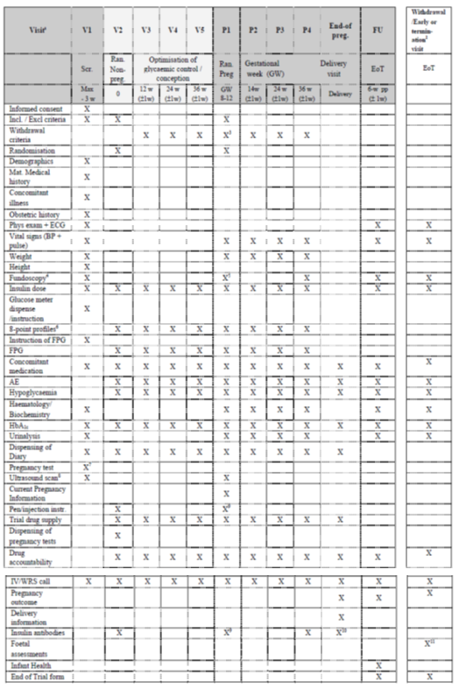

Randomisation and blinding methods
Randomisation was performed using IV/WRS. The study was open label.

Analysis populations
The FAS for pregnant subjects (FAS_{Pregnant}) comprised all randomised subjects who were exposed to at least one dose of trial product and who were pregnant during the trial. The PP_{Pregnant} comprised all subjects from the FAS_{Pregnant} analysis set except subjects who significantly violated the inclusion/exclusion criteria or other aspects of the protocol considered to potentially affect the primary endpoint.

Sample size
The sample size calculation was performed for a non-inferiority analysis in the PP_{Pregnant} population for the primary efficacy outcome measure. In previous trials, the range of SD for HbA1c was 0.8 to 1.5; and a SD of 1.1 was used for the calculation. The non-inferiority margin was 0.4%, the level of significance was 0.05, and the power was 80%. A total of 120 subjects in each treatment group would be required to complete to GW36. Given an expected dropout rate of 20%, and the expected pregnancy rate in randomised subjects, the final calculation was for 460 subjects.

Statistical methods
The study was designed as a non-inferiority study with the margin for non-inferiority for the primary efficacy outcome measure (HbA1c at GW36) being 0.4%. Hypothesis tests were performed using the 95% CI. Missing values were imputed using LOCF.

Participant flow
There were 600 subjects screened, and 470 were randomised to treatment: 233 to detemir and 237 to NPH. Of these, 263 subjects completed: 127 (83.6%) in the detemir group and 136 (84.5%) in the NPH (Figure 3).
Figure 3: Subject Disposition by Pregnancy Status – Safety_{Pregnant}

There were 152 (65.2%) subjects in the FAS_{Pregnant} population exposed to detemir and 158 (66.7%) exposed to NPH; and 127 (54.2%) in the PP_{Pregnant} population exposed to detemir and 137 (57.8%) exposed to NPH (Table 20).
Table 20: Subject Disposition, All Subjects

Major protocol violations/deviations
For all the subjects that were included in the FAS_{Pregnant}, but excluded from the PP_{Pregnant}, the reason for exclusion was “delivery not after Gestational Week 32”.

Baseline data
All subjects were female and the age range was 20 to 43 years. The treatment groups were similar in demographic characteristics (Table 21).
Table 21: Subject Characteristics, Safety Pregnant
The treatment groups were similar in baseline efficacy measures and duration of diabetes (Table 22).
Table 22: Diabetes History, Safety Pregnant
More subjects in the detemir group had diabetic neuropathy at baseline: seven (4.6%) compared with three (1.9%) in the NPH (Table 23).
Table 23: Diabetic Complications at Baseline, Safety Pregnant
Clinically significant fundoscopic abnormalities were present in 12 subjects in each group. Obstetric history was similar for the two treatment groups (Table 24).
Table 24: Obstetric History at Baseline, Safety Pregnant

Results for the primary efficacy outcome
Insulin detemir was not inferior to insulin NPH. The mean (SE) HbA1c at GW36 for the PP population was 6.22 (0.069) % for detemir and 6.37 (0.067) % for NPH, mean (95% CI) difference -0.15 (-0.34 to 0.04) %. For the FAS the mean (SE) HbA1c at GW36 was 6.27 (0.053) % for detemir and 6.33 (0.052) % for NPH, mean (95% CI) difference -0.06 (-0.21 to 0.08) %. For subjects pregnant at randomisation, mean (SE) HbA1c was 6.39 (0.072) % in the detemir group and 6.44 (0.070) % in the NPH. For subjects pregnant after randomisation mean (SE) HbA1c was 6.11 (0.080) % in the detemir group and 6.19 (0.082) % in the NPH.

Results for other efficacy outcomes
- At each time point there was no significant difference between detemir and NPH in HbA1c (Figure 4). At GW24 mean SE HbA1c was 6.04 (0.050) % in the detemir group and 6.14 (0.049) % in the NPH.
Figure 4: Mean (±SEM) HbA1c (%) during Pregnancy and at Follow-up, LOCF, Full Analysis Set Pregnant
- HbA1c ≤ 6% at GW24 and GW36 was achieved by 57 (41.3%) subjects in the detemir group and 46 (31.5%) in the NPH.
- At the GW24 visit mean (SE) FPG was 5.38 (0.271) mmol/L in the detemir group and 6.32 (0.255) mmol/L in the NPH, mean (95% CI) difference -0.94 (-1.67 to -0.21) mmol, p = 0.012.
- At the GW36 visit mean (SE) FPG was 4.76 (0.200) mmol/L in the detemir group and 5.41 (0.187) mmol/L in the NPH, mean (95% CI) difference -0.94 (-1.19 to -0.12) mmol, p = 0.017.
- The 8 point SMPG profiles were similar for the two treatment groups at the GW24 and GW36 visits (Figure 5). A mixed model estimation of mean (SE) plasma glucose at GW24 was 6.95 (0.105) mmol/L for detemir and 7.38 (0.101) mmol/L for NPH, mean (95% CI) difference -0.43 (-0.72 to -0.14) mmol/L, p = 0.003; and at GW36 was 6.61 (0.098) mmol/L for detemir and 6.85 (0.094) mmol/L for NPH, mean (95% CI) difference -0.24 (-0.51 to 0.03) mmol/L, p = 0.082.
Figure 5: Mean (±SEM) 8-point PG Profile (mmol/L) at GW24 (Top) and GW36 (Bottom), LOCF, FAS Pregnant

Evaluator’s conclusions on clinical efficacy for Change 3
Insulin detemir has similar efficacy to NPH in the management of diabetes during pregnancy.

Clinical safety

Studies providing evaluable safety data
Evaluable safety data were available from all the clinical studies. These were:
- Change 1: Study NN2211-3673 (PK/PD), Study NN2211-1842 (efficacy and safety), and Study NN2211-1842-extension (long-term safety).
- Change 2: Study NN304-1690 (long-term open label safety in children)
- Change 3: Study NN304-1687 (efficacy and safety in pregnancy)

Pivotal studies that assessed safety as a primary outcome
There were no additional pivotal safety studies.

Patient exposure
Change 1:
In Study NN2211-3673, summarised in Table 1(Appendix 1), there were 32 subjects exposed to a single dose of detemir 0.5 U/kg in combination with liraglutide 1.8 mg during a PK/PD study.
In Study NN2211-1842, summarised in Table 6 (Appendix 1), there were 162 subjects exposed to detemir in combination with liraglutide and metformin for up to 26 weeks. The median duration of exposure was 182.5 days. In the extension study, Study NN2211-1842-extension, 140 subjects from the detemir group and that had completed 26 weeks treatment were included. Of these, 130 subjects completed the 52 weeks of treatment. The total patient years exposure to detemir in this study was 144.5 years.
Change 2:
In Study NN304-1690 summarised in Table 13 (Appendix 1), there were 146 subjects exposed to detemir for up to one year. There were 37 subjects aged 2 to 5 years, 59 aged 6 to 12 years and 50 aged 13 to 16 years. There were 105 subjects exposed to detemir for a total duration of 104 weeks in the original and extension studies. At the end of the study the median (range) daily dose of detemir was 0.61 (0.09 to 1.63) U/kg.
Change 3:
In Study NN304-1687, summarised in Table 18 (Appendix 1), there were 152 subjects exposed to detemir during pregnancy, corresponding to 119.4 subject years exposure. The mean duration of exposure during pregnancy was 6.5 months.

Adverse events

All adverse events (irrespective of relationship to study treatment)
Change 1:
In Study NN2211-3673, summarised in Table 1 (Appendix 1), there were 16 TEAEs reported in 14 (42%) subjects with insulin detemir alone (Day 1), 20 in 17 (52%) treated with liraglutide at steady state; and 13 in 13 (39%) when both trial drugs were co-administered. Detemir in combination with liraglutide did not appear to result in an increased rate of TEAEs (Table 25, Appendix 1).
In Study NN2211-1842 and its extension, there were 845 TEAEs reported in 132 (81.0%) subjects in the detemir group and 716 in 124 (78.0%) in the control. The non-randomised group, which was not exposed to detemir, had 2389 TEAEs reported in 433 (86.8%) subjects. Increased serum lipase was reported as a TEAE in 26 (16.0%) subjects in the detemir group compared with 16 (10.1%) in the control (Table 26, Appendix 1). The most commonly reported TEAEs were diarrhoea, nausea and vomiting.
Change 2:
In Study NN304-1690, there were 714 TEAEs reported in 116 (79.5%) subjects in the combined population including 178 in 29 (78.4%) subjects in the 2 to 5 year age group, 383 in 50 (84.7%) in the 6 to 12 year and 153 in 37 (74.0%) in the 13 to 16 year. The overall rate of TEAEs was 246.9/100 exposure years, in the 2 to 5 year group 243.1/100 exposure years, in the 6 to 12 year group 325.9/100 patient years exposure and in the 13 to 16 year group 155.4/100 patient years exposure. The most common TEAEs fitted the pattern of common childhood illnesses (Table 27).
Table 27: Common Treatment Emergent AEs (> 5%) by System Organ Class, SAS, Whole Treatment Period
Change 3:
In Study NN304-1687, there were 650 TEAEs reported in 138 (90.8%) subjects in the detemir group (corresponding to an event rate of 788.9/100 exposure years) and 678 in 141 (89.2%) in the NPH (corresponding to an event rate of 785.9/100 exposure years). The pattern of TEAEs was similar for the two groups (Table 28, Appendix 1).
In the neonatal population, there were 121 TEAEs reported in 56 (36.8%) subjects in the detemir group and 152 in 55 (34.8%) in the NPH. The pattern of TEAEs was similar for the two groups (Table 29, Appendix 1).

Treatment-related adverse events (adverse drug reactions)
Change 1:
In Study NN2211-1842 there were 95 treatment related TEAEs in 46 (28.2%) subjects in the detemir group and 57 in 29 (18.2%) in the control. There were more subjects with diarrhoea and vomiting attributed to treatment in the detemir group than in the control group (Table 30).
Table 30: Possibly or Probably Related to Treatment Emergent Adverse Events (TEAE) During Main Period by System Organ Class and Preferred Term - Safety Analysis Set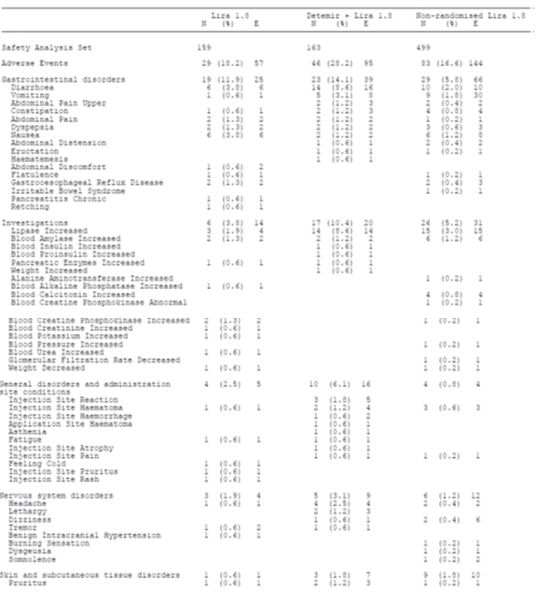

Table 30: Possibly or Probably Related to Treatment Emergent Adverse Events (TEAE) During Main Period by System Organ Class and Preferred Term - Safety Analysis Set continued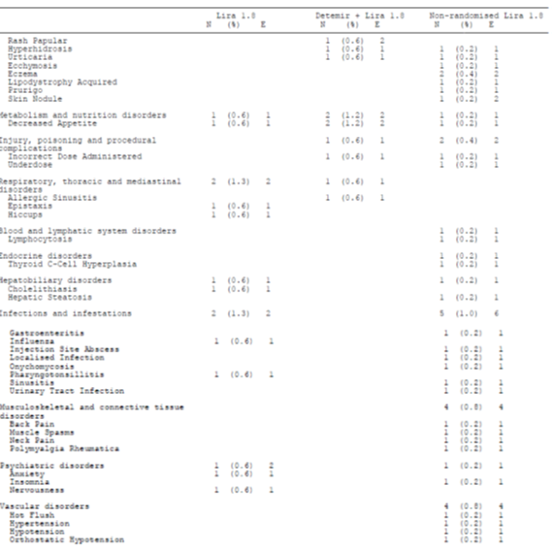
In the extension there were 14 treatment related TEAEs in 12 (7.4%) subjects in the detemir group and 17 in 12 (7.5%) in the control. The patterns of treatment related TEAEs were similar for the detemir and control groups (Table 31).
Table 31: Possibly or Probably Related to Treatment Emergent Adverse Events (TEAE) During Extension Period by System Organ Class and Preferred Term - Safety Analysis Set 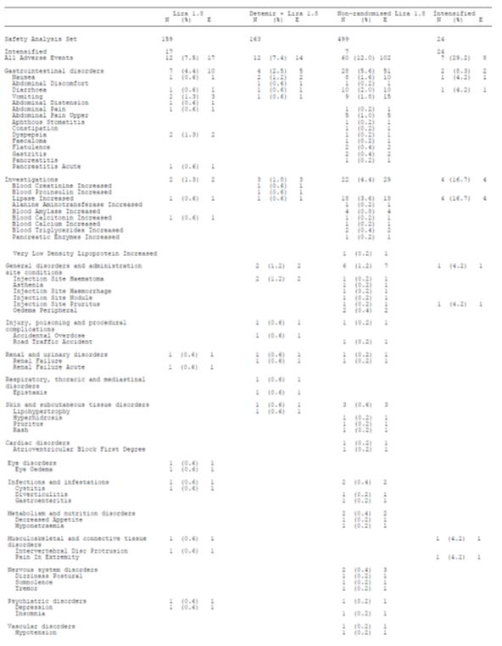
Change 2:
In Study NN304-1690, there were ten probable treatment (with detemir) related TEAEs reported in nine (6.2%) subjects in the combined population including one in one (2.7%) subjects in the 2 to 5 year age group, four in three (5.1%) in the 6 to 12 year and five in five (10.0%) in the 13 to 16 year. The overall rate of TEAEs was 3.5/100 exposure years, in the 2 to 5 year group 1.4/100 exposure years, in the 6 to 12 year group 3.4/100 patient years exposure and in the 13 to 16 year group 5.1/100 patient years exposure. Most of the detemir treatment related TEAEs were those commonly associated with insulin administration but there were three subjects with pruritus and one with urticaria (Table 32).
Table 32: Treatment Emergent AEs Probably/Possibly Related to Basal Insulin by System Organ Class, SAS, Whole Treatment Period
Change 3:
In Study NN304-1687, there were 21 treatment related TEAEs reported in 18 (11.8%) subjects in the detemir group (corresponding to an event rate of 25.5/100 exposure years) and 27 in 16 (10.1%) in the NPH (corresponding to an event rate of 31.3/100 exposure years). Four subjects in each group were reported with hypoglycaemia. Hypoglycaemic unconsciousness was reported in one subject in the detemir group and seven in the NPH (Table 33).
Table 33: Treatment Emergent AEs Possibly/Probably Related to Basal Insulin by System Organ Class and Preferred Term, During Pregnancy, Mother, Safety Pregnant 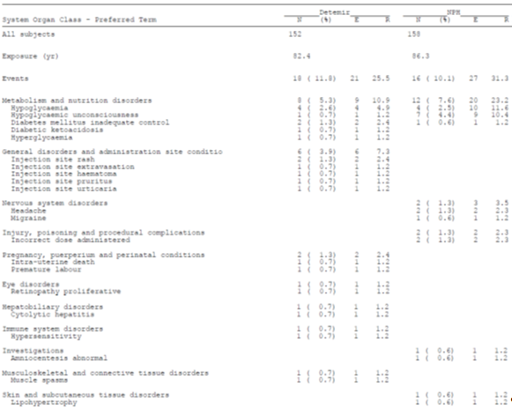
In In the neonatal population, treatment related TEAEs were reported in one (0.7%) subject in the detemir group (foetal distress syndrome) and none in the NPH.

Deaths and other serious adverse events
Change 1:
In Study NN2211-3673 there were no deaths or SAEs.
In Study NN2211-1842, there were no deaths reported during the main period of the trial (to Week 26) but there were two deaths in the control groups (treated with liraglutide and metformin): bronchogenic cancer, gall bladder cancer. There were 21 SAEs reported in 17 (10.4%) subjects in the detemir group and 16 in eleven (6.9%) in the control. There was no clear pattern to the SAEs to Week 26 (Table 34).
Table 34: SAEs during Main Period by System Organ Class and Preferred Term - Safety Analysis Set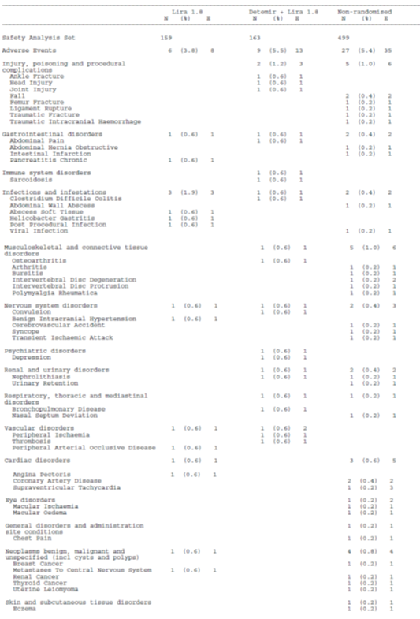
Chronic pancreatitis was reported in one subject in the control group. In the extension study there were four subjects in the detemir group with neoplasia, but none in the control (Table 35).
Table 35: Serious Treatment Emergent Adverse Event (TEAE) during Extension Period by System Organ Class and Preferred Term – Safety Analysis Set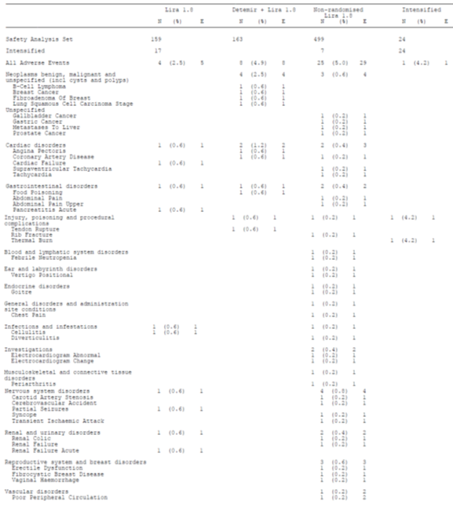
Change 2:
In Study NN304-1690, there were no deaths reported during the study. There were 17 SAEs reported in 116 (79.5%) subjects in the combined population including four in three (8.1%) subjects in the 2 to 5 year age group, nine in six (10.2%) in the 6 to 12 year and four in three (6.0%) in the 13 to 16 year. The overall rate of SAEs was 5.9/100 exposure years, in the 2 to 5 year group 5.5/100 exposure years, in the 6 to 12 year group 7.7/100 patient years exposure and in the 13 to 16 year group 4.1/100 patient years exposure. There were three subjects with ketoacidosis and two with hypoglycaemia (Table 36).
Table 36: Treatment Emergent SAEs by System Organ Class, SAS, Whole Treatment Period
Change 3:
In Study NN304-1687 there were no maternal deaths. There were three perinatal deaths: two in the detemir group (stillbirth, intrauterine death) and one in the NPH (Dandy-Walker malformation/pulmonary hypoplasia). In addition there were two early pregnancy losses: one in the detemir group (intrauterine death) and one in the NPH (spontaneous abortion). There were 94 SAEs reported in 61 (40.1%) maternal subjects in the detemir group (corresponding to an event rate of 114.1/100 exposure years) and 76 in 49 (31.0%) in the NPH (corresponding to an event rate of 88.1/100 exposure years). There was a higher rate of spontaneous abortion in the detemir group: eight (5.3%) subjects compared with four (2.5%) in the NPH; and also of pre-eclampsia: eight (5.3%) subjects compared with one (0.6%) in the NPH (Table 37).
Table 37: Treatment Emergent Serious AEs by System Organ Class and Preferred Term, During Pregnancy, Mother, Safety Pregnant 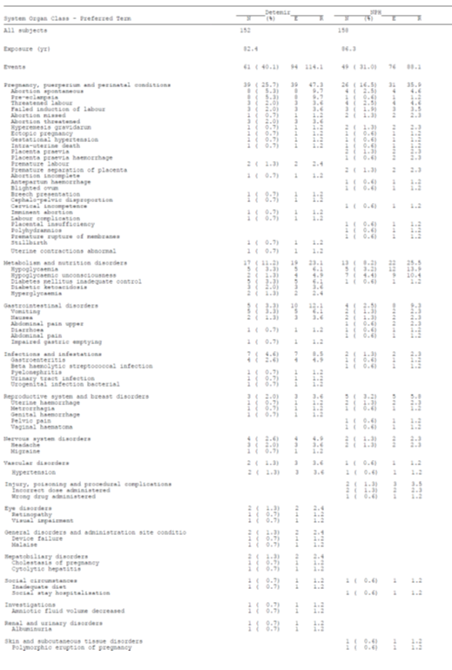
In the neonatal population, there were 51 SAEs reported in 36 (23.7%) subjects in the detemir group and 53 in 32 (20.3%) in the NPH. The pattern of SAEs in neonates was similar for the two treatment groups (Table 38).
Table 38: Treatment Emergent Serious AEs by System Organ Class and Preferred Term, Child, Safety Pregnant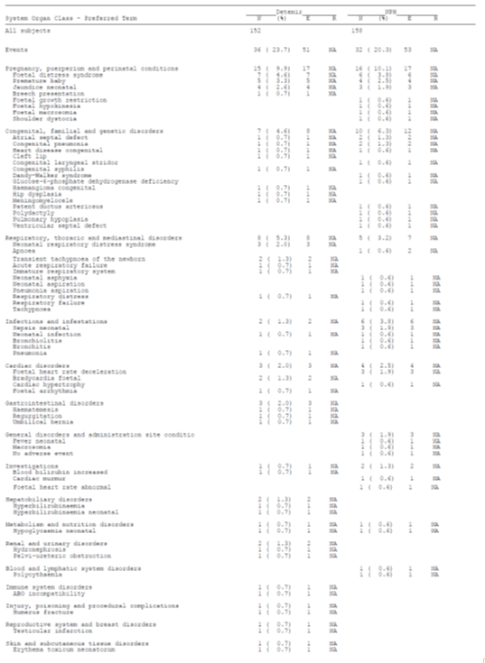
The rates and patterns of congenital malformations for both populations were consistent with the known patterns of malformations in infants of diabetic mothers (Table 39).
Table 39: Congenital Malformations

Discontinuation due to adverse events
Change 1:
In Study NN2211-3673 there were no DAEs.
In Study NN2211-1842 and its extension, there were eight DAEs in seven (4.3%) subjects in the detemir group and 13 in nine (5.7%) in the control discontinued due to AEs (Table 40, Appendix 1). The events in the detemir group were: lipase increased, pancreatic enzymes increased, convulsion, bronchopulmonary disease, abdominal pain/diarrhoea, breast cancer and renal failure.
Change 2:
In Study NN304-1690 there were no DAEs.
Change 3:
In Study NN304-1687, DAE occurred in 13 (8.6%) subjects in the detemir group and six (3.8%) in the NPH. The AEs leading to discontinuation primarily related to pregnancy loss (Table 41). One AE in a neonate in the NPH group resulted in withdrawal: neonatal death.
Table 41: Possibly or Probably Related to Treatment Emergent Adverse Events (TEAE) During Extension Period by System Organ Class and Preferred Term - Safety Analysis Set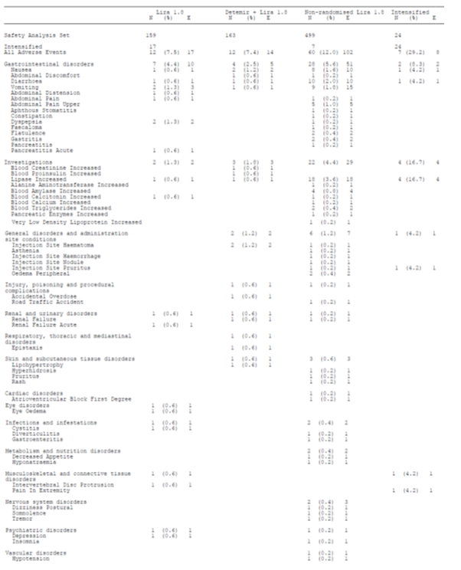

Laboratory tests

Liver function
There were no indications of drug induced liver injury.

Kidney function
There were no indications of drug induced renal injury.

Other clinical chemistry
Change 1:
In Study NN2211-3673 there were no clinically significant treatment emergent abnormalities of laboratory tests. There were no hypoglycaemic episodes on study days.
In Study NN2211-1842 and its extension, to Week 52 the most commonly reported clinically significant abnormality in laboratory tests was elevated lipase: 26 (16.0%) subjects in the detemir group compared with 16 (10.1%) in the control (Table 42, Appendix 1). Two subjects in the detemir group and one in the control were reported with elevated ALT.
Change 2:
In Study NN304-1690, there were no clinically significant abnormalities in biochemistry or haematology reported during the study.
Change 3:
The abnormalities in laboratory values were consistent with those seen in normal pregnancy. These were primarily anaemia (28 events in the detemir group and 27 in the NPH). No subjects were withdrawn due to laboratory AEs.

Haematology
Change 3:
Anaemia was reported at a similar rate in the detemir group and the NPH.

Immunology

Pivotal studies
Change 1:
In Study NN2211-3673 no subjects were positive for antibodies to insulin detemir.
In Study NN2211-1842 and its extension two subjects in the detemir group developed antibodies to liraglutide. The level of antibodies to detemir was mean 1.59 % B/T at Week 0; 2.20 % B/T at Week 26; and 4.30 % B/T at Week 53.
Change 2:
Levels of cross-reacting, detemir-specific and aspart-specific antibodies increased during the first year of treatment, and then decreased during the second year - Table 43, Table 44 and Table 45. At end of study the levels were slightly higher than at baseline.
Table 43: Estimated Cross-reacting Antibodies (% B/T), Time Intervals 3 h, 2.5 h, Sensitivity, Corrected Data, SAS, Whole Treatment Period

Table 44 Estimated Insulin Detemir Specific Antibodies (% B/T), Time Intervals 3 h, 2.5 H, Sensitivity, Corrected Data, SAS, Whole Treatment Period

Table 45: Estimated Insulin Aspart-specific Antibodies (% B/T), Time Intervals 3 h, 2.5 H, Sensitivity, Corrected Data, SAS, Whole Treatment Period
Change 3:
The mean (SD) level of detemir specific antibodies was 1.29 (0.98) % B/T at baseline and 1.80 (1.72) % B/T at GW36.

Electrocardiograph
Change 1:
In Study NN2211-1842 and its extension in the detemir group, there was one shift in ECG finding from abnormal not clinically significant to abnormal clinically significant at Week 26. There were no changes to Week 52.

Vital signs
Change 1:
In Study NN2211-1842 and its extension, to Week 52 there were eleven (6.75%) subjects with a change in physical examination in the detemir group and five (3.52%) in the control.
Change 2:
There were no clinically significant changes in vital signs. Weight SD did not change significantly during the study (Figure 6). Mean BMI did not change significantly during the study (Figure 7).
Figure 6: Mean Weight SD-score over Time by Age Group, SAS, Whole Treatment Period
Figure 7: Mean BMI (kg/m²) over Time by Age Group, SAS, Whole Treatment Period

Pancreatitis
Change 1:
In Study NN2211-1842, there were two subjects with pancreatitis, both during the run-in period (liraglutide and metformin treated). Pancreas related AEs were reported in 18 (11%) subjects in the detemir group and 14 (8.8%) in the control (Table 46, Appendix 1). There was one report of chronic pancreatitis and one of acute pancreatitis in the control group.

Medullary C-cell carcinoma
Change 1:
In Study NN2211-1842, one subject was diagnosed with medullary C-call thyroid cancer but this appears to have been pre-existing. One subject discontinued due to suspected medullary C-cell carcinoma but this was not proven.

Hypoglycaemia
Change 1:
In Study NN2211-1842 and its extension one major hypoglycaemic event was reported in a subject during the run-in period (liraglutide and metformin). To Week 52, minor hypoglycaemic events were reported in 21 (12.9%) subjects in the detemir group and four (2.5%) in the control. The rate ratio (95% CI) for hypoglycaemic episodes (detemir compared with control) was 4.13 (1.75 to 9.73) p = 0.0012.
Change 2:
In Study NN304-1690, there were 16074 hypoglycaemic episodes reported in 145 (99.3%) subjects in the combined population including 4028 in 37 (100%) subjects in the 2 to 5 year age group, 7438 in 59 (100%) in the 6 to 12 year and 4608 in 49 (98.0%) in the 13 to 16 year. Severe hypoglycaemic episodes were reported in two (5.4%) subjects in the 2 to 5 year age group, two (3.4%) in the 6 to 12 year and two (4.0%) in the 13 to 16 year. Severe nocturnal hypoglycaemic episodes were reported in one subject in each age group.
Change 3:
The rates of hypoglycaemic events were similar for the two treatment groups (Table 47).
Table 47: All Hypoglycaemic Episodes during Pregnancy, Safety Pregnant
There were 9496 hypoglycaemic events reported in 144 (95.0%) subjects in the detemir group (corresponding to an event rate of 115.3/100 exposure years) and 9453 in 146 (92.0%) in the NPH (corresponding to an event rate of 109.6/100 exposure years). There were 90 major hypoglycaemic events reported in 25 (16.0%) subjects in the detemir group (corresponding to an event rate of 1.1/100 exposure years) and 105 in 33 (21.0%) in the NPH (corresponding to an event rate of 1.2/100 exposure years). There were 24 major nocturnal hypoglycaemic events reported in 13 (9.0%) subjects in the detemir group (corresponding to an event rate of 0.3/100 exposure years) and 21 in ten (6.0%) in the NPH (corresponding to an event rate of 0.2/100 exposure years).

Pregnancy
Change 3:
Pregnancy outcome was slightly better in the NPH group. There were 128 (90.14%) live children at follow up in the detemir group and 135 (93.10%) in the NPH (Table 48).
Table 48: Pregnancy Outcome at Follow-up, Safety Pregnant
Three subjects in the detemir group and six in the NPH developed clinically significant abnormalities in fundoscopy. Two subjects in the detemir group and one in the NPH developed a high urine albumin creatinine ratio.
A total of 26 (26.5%) of 98 neonates had quantifiable detimir concentrations in cord blood. The highest concentration was 209.6 pmol/L.

Post-marketing experience
No post-marketing data were included in the submission for Change 1 or Change 2.
The amendments to the PI for the section on pregnancy refer to post-marketing data presented in the Summary of Clinical Safety for Change 3. These data relate to a total of 528 pregnancies and are limited in detail (Table 49).
Table 49: Pregnancy Outcomes Based on Post-marketing Surveillance
In the absence of a comparator group it is difficult to make conclusions from these data but the outcomes, and spectrum of congenital malformations, appear to be typical for T1DM in pregnancy (Table 50).
Table 50: Post-marketing Cases with Congenital Anomalies or Foetal Defects

Table 50: Post-marketing Cases with Congenital Anomalies or Foetal Defects continued
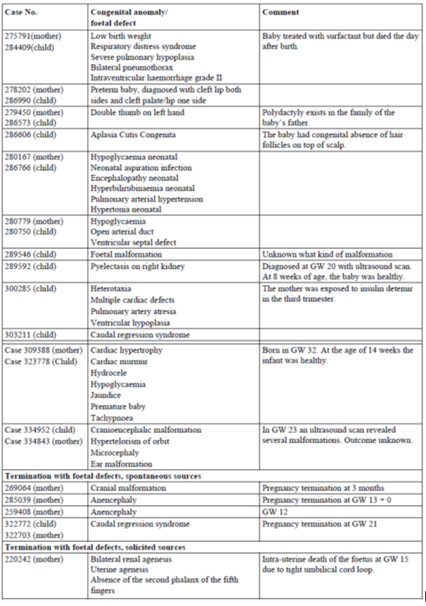

Evaluator’s overall conclusions on clinical safety
Change 1:
The rate of TEAEs with detemir in combination with liraglutide and metformin was similar to that for liraglutide and metformin. There were no deaths in the detemir treated patients. More subjects were reported with neoplasia in the detemir group in the extension study but there was no apparent pattern to this. The rates of DAE were similar for detemir and control. To Week 52, elevated lipase was reported at a greater rate in the detemir group than in the control: 26 (16.0%) subjects in the detemir group compared with 16 (10.1%) in the control. Levels of antibodies to detemir increased through the study to 4.30 % B/T at Week 53. Minor hypoglycaemic events were more common with detemir than control: 21 (12.9%) subjects in the detemir group and four (2.5%) in the control.
Change 2:
The rate of TEAEs with detemir was not influenced by age and the profile was predominantly that expected for the paediatric age group alone. Treatment related TEAEs were as expected for insulins. The rate of SAEs was not affected by age group. The rate of hypoglycaemic events was similar for the three age groups.
Change 3:
The rates and patterns of TEAEs were similar for detemir and NPH for both mothers and infants. Treatment related TEAEs were similar for detemir and NPH. There were no maternal deaths. There were three perinatal deaths: two in the detemir group (stillbirth, intrauterine death) and one in the NPH (Dandy-Walker malformation/pulmonary hypoplasia). In addition there were two early pregnancy losses: one in the detemir group (intrauterine death) and one in the NPH (spontaneous abortion). There was a higher rate of spontaneous abortion in the detemir group: eight (5.3%) subjects compared with four (2.5%) in the NPH; and also of pre-eclampsia: eight (5.3%) subjects compared with one (0.6%) in the NPH. The rates of SAEs for infants were similar for detemir and NPH. The rates and patterns of congenital malformations for both populations were consistent with the known patterns of malformations in infants of diabetic mothers. DAE occurred at a higher rate in the detemir group: 13 (8.6%) subjects compared with six (3.8%) in the NPH. The rates of hypoglycaemia were similar for detemir and NPH.
Pregnancy outcome was slightly better in the NPH group. There were 128 (90.14%) live ldren at follow up in the detemir group and 135 (93.10%) in the NPH. This was not statistically significant (Chi2 Fisher’s exact test performed by the Evaluator, p = 0.40).

First round benefit-risk assessment

First round assessment of benefits
Change 1:
Insulin detemir in combination with liraglutide and metformin resulted in an incremental decrease in mean HbA1c of 0.51% over 26 weeks. This is a clinically significant improvement in diabetes control. The improvement was maintained over a 52 week period. There was weight loss in the group treated with detemir, liraglutide and metformin in combination, but less than in those treated with liraglutide and metformin alone. The evaluator considers that the usual sequence of treatment would be liraglutide and metformin, with detemir added if patients were not adequately controlled on that combination.
Change 2:
The data presented for Change 2 were primarily intended as safety data. The efficacy data are difficult to interpret in the absence of a control group. There appears to be a loss of efficacy over the second year of treatment but this most likely reflects the natural history of T1DM in a paediatric clinical trial population.
Change 3:
Insulin detemir has similar efficacy to NPH in the management of diabetes during pregnancy.

First round assessment of risks
Change 1:
The rate of TEAEs with detemir in combination with liraglutide and metformin was similar to that for liraglutide and metformin. There were no deaths in the detemir treated patients. More subjects were reported with neoplasia in the detemir group in the extension study but there was no apparent pattern to this. The rates of DAE were similar for detemir and control. To Week 52, elevated lipase was reported at a greater rate in the detemir group than in the control: 26 (16.0%) subjects in the detemir group compared with 16 (10.1%) in the control. Levels of antibodies to detemir increased through the study to 4.30 % B/T at Week 53. Minor hypoglycaemic events were more common with detemir than control: 21 (12.9%) subjects in the detemir group and four (2.5%) in the control.
Change 2:
The rate of TEAEs with detemir was not influenced by age and the profile was predominantly that expected for the paediatric age group alone. Treatment related TEAEs were as expected for insulins. The rate of SAEs was not affected by age group. The rate of hypoglycaemic events was similar for the three age groups.
Change 3:
The rates and patterns of TEAEs were similar for detemir and NPH for both mothers and infants. Treatment related TEAEs were similar for detemir and NPH. There were no maternal deaths. There were three perinatal deaths: two in the detemir group (stillbirth, intrauterine death) and one in the NPH (Dandy-Walker malformation/pulmonary hypoplasia). In addition there were two early pregnancy losses: one in the detemir group (intrauterine death) and one in the NPH (spontaneous abortion). There was a higher rate of spontaneous abortion in the detemir group: eight (5.3%) subjects compared with four (2.5%) in the NPH; and also of pre-eclampsia: eight (5.3%) subjects compared with one (0.6%) in the NPH. The rates of SAEs for infants were similar for detemir and NPH. The rates and patterns of congenital malformations for both populations were consistent with the known patterns of malformations in infants of diabetic mothers. DAE occurred at a higher rate in the detemir group: 13 (8.6%) subjects compared with six (3.8%) in the NPH. The rates of hypoglycaemia overall and nocturnal hypoglycaemia were similar for detemir and NPH.
Pregnancy outcome was slightly better in the NPH group. There were 128 (90.14%) live children at follow up in the detemir group and 135 (93.10%) in the NPH. This was not statistically significant (Chi2 Fisher’s exact test performed by the Evaluator, p = 0.40).

First round assessment of risks
Change 1:
The rate of TEAEs with detemir in combination with liraglutide and metformin was similar to that for liraglutide and metformin. There were no deaths in the detemir treated patients. More subjects were reported with neoplasia in the detemir group in the extension study but there was no apparent pattern to this. The rates of DAE were similar for detemir and control. To Week 52, elevated lipase was reported at a greater rate in the detemir group than in the control: 26 (16.0%) subjects in the detemir group compared with 16 (10.1%) in the control. Levels of antibodies to detemir increased through the study to 4.30 % B/T at Week 53. Minor hypoglycaemic events were more common with detemir than control: 21 (12.9%) subjects in the detemir group and four (2.5%) in the control.
Change 2:
The rate of TEAEs with detemir was not influenced by age and the profile was predominantly that expected for the paediatric age group alone. Treatment related TEAEs were as expected for insulins. The rate of SAEs was not affected by age group. The rate of hypoglycaemic events was similar for the three age groups.
Change 3:
The rates and patterns of TEAEs were similar for detemir and NPH for both mothers and infants. Treatment related TEAEs were similar for detemir and NPH. There were no maternal deaths. There were three perinatal deaths: two in the detemir group (stillbirth, intrauterine death) and one in the NPH (Dandy-Walker malformation/pulmonary hypoplasia). In addition there were two early pregnancy losses: one in the detemir group (intrauterine death) and one in the NPH (spontaneous abortion). There was a higher rate of spontaneous abortion in the detemir group: eight (5.3%) subjects compared with four (2.5%) in the NPH; and also of pre-eclampsia: eight (5.3%) subjects compared with one (0.6%) in the NPH. The rates of SAEs for infants were similar for detemir and NPH. The rates and patterns of congenital malformations for both populations were consistent with the known patterns of malformations in infants of diabetic mothers. DAE occurred at a higher rate in the detemir group: 13 (8.6%) subjects compared with six (3.8%) in the NPH. The rates of hypoglycaemia overall and nocturnal hypoglycaemia were similar for detemir and NPH.
Pregnancy outcome was slightly better in the NPH group. There were 128 (90.14%) live children at follow up in the detemir group and 135 (93.10%) in the NPH. This was not statistically significant (Chi2 Fisher’s exact test performed by the Evaluator, p = 0.40).

First round assessment of benefit-risk balance
Change 1:
The benefit-risk balance of insulin detemir, given the proposed usage, is favourable.
Change 2:
The benefit-risk balance of insulin detemir, given the proposed usage, is favourable.
Change 3:
The benefit-risk balance of insulin detemir, given the proposed usage, is favourable.
Change 4:
No data were presented for this proposed change as it relates to alignment of the PI with the CCDS.

First round recommendation regarding authorisation
The Evaluator recommends that the proposed changes to the conditions of registration for Levemir Flexpen/Levermir Penfill / Levemir Innolet should be approved. The proposed changes are:
Change 1: Update of the Product Information (PI) to include information on the use of Levemir® (insulin detemir [rys]) as add-on therapy to Victoza®(liraglutide [rys]).
Change 2: Update of the Product Information (PI) to include safety data from long-term trials in use of Levemir® in adolescents and children (from 2 years old) with T1DM.
Change 3: Update of the Product Information (PI) to allow use of Levemir® in pregnancy.
Change 4: Update of the Product Information (PI) to more closely align with the Core Company Data Sheet (CCDS) (v. 12.0).

Clinical questions
The Evaluator does have any clinical questions.

Second round evaluation of clinical data submitted in response to questions
[Insert all information]

Second round benefit-risk assessment
[Insert all information]

Second round recommendation regarding authorisation
[Insert all information]

Appendix 1: Additional tables

Table 1: Studies providing pharmacokinetic data
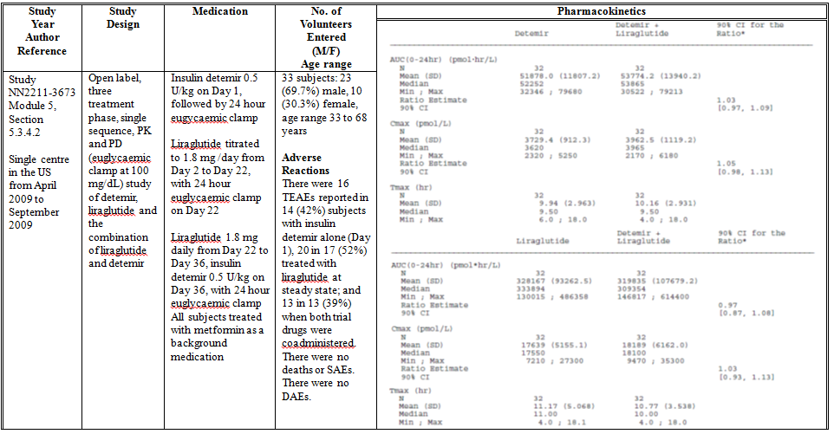

Table 6: Tabular summary of Study NN2211-1842
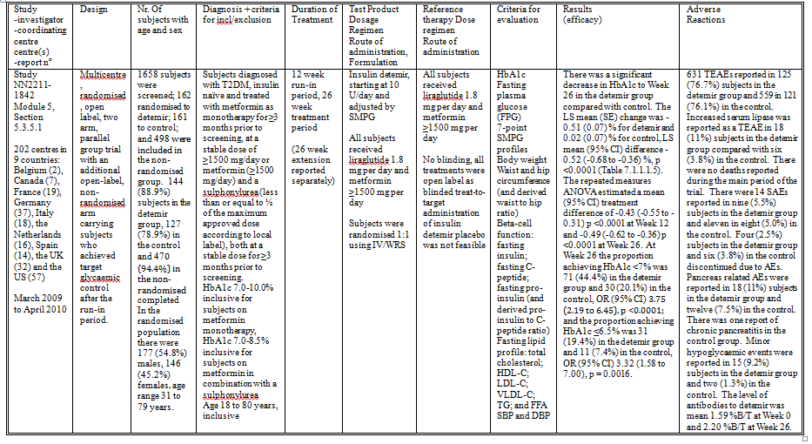

Table 7: Trial Flow Chart – Randomised Subjects
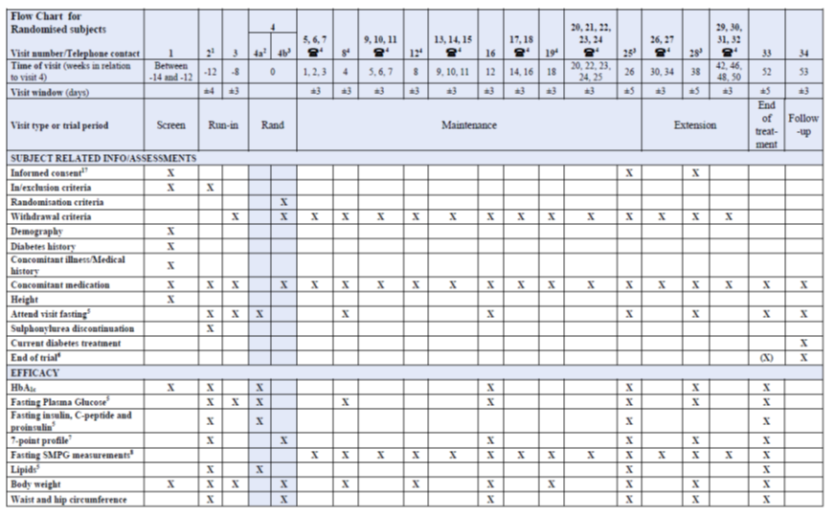
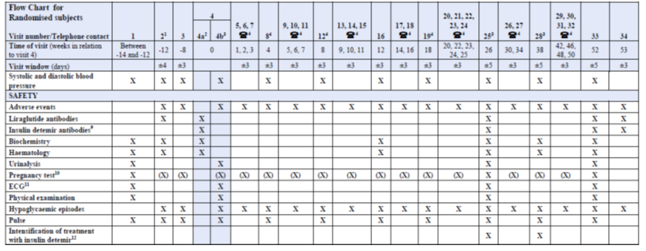

Table 9: Summary of Subject Demographics and Characteristics - All Exposed Subjects
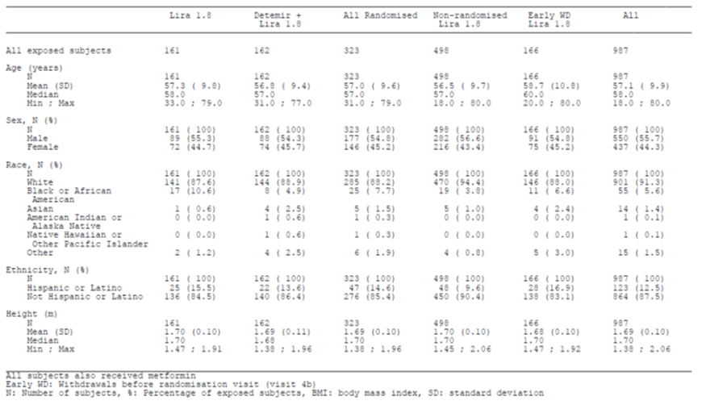

Table 9: Summary of Subject Demographics and Characteristics - All Exposed Subjects continued
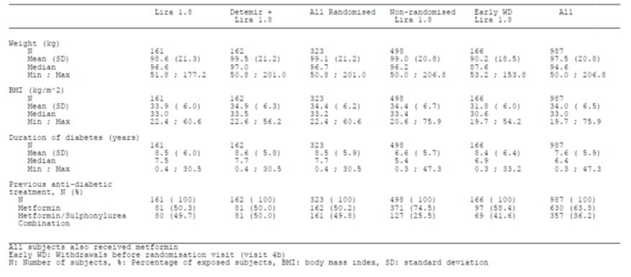

Table 10: Summary of Run-in Efficacy Parameters - All Exposed Subjects
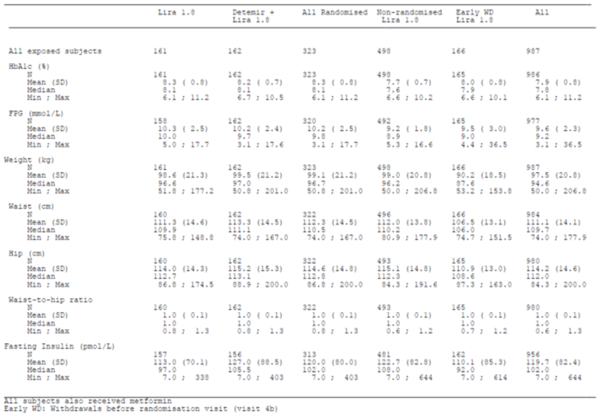

Table 10: Summary of Run-in Efficacy Parameters - All Exposed Subjects continued
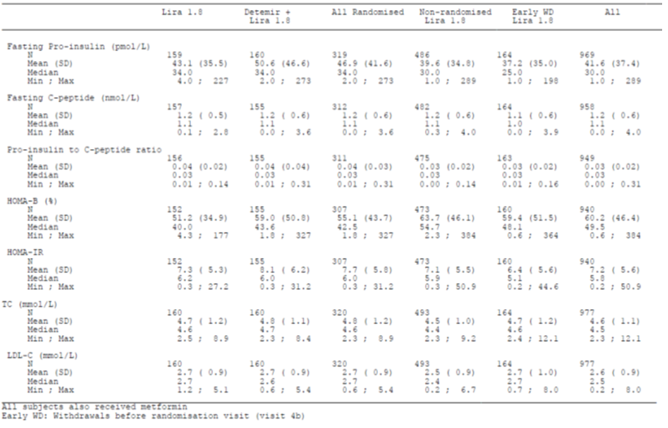

Table 10: Summary of Run-in Efficacy Parameters - All Exposed Subjects continued
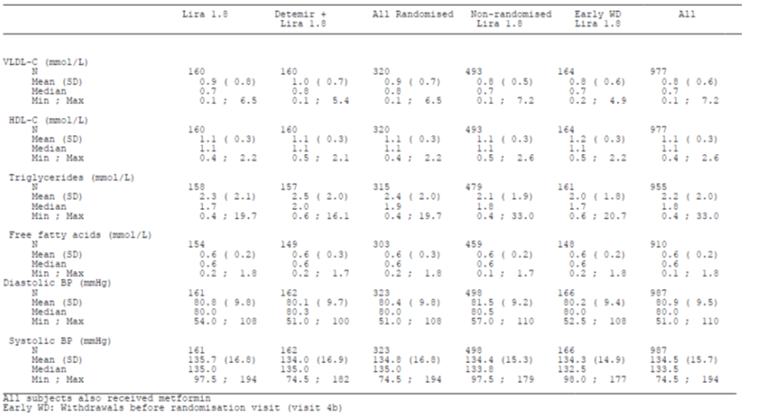

Table 13: Tabular summary of Study NN304-1690
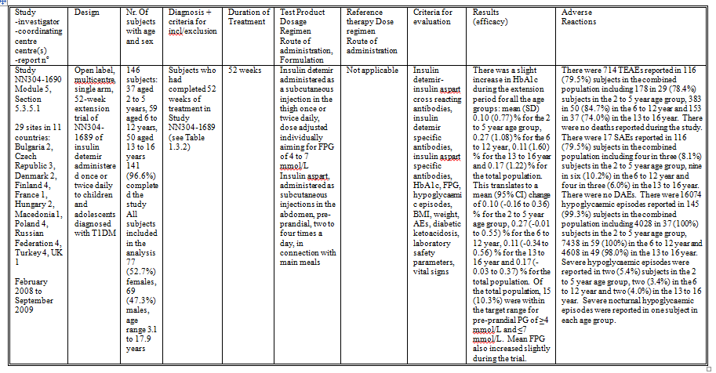

Table 14: Tabular summary of Study NN304-1689
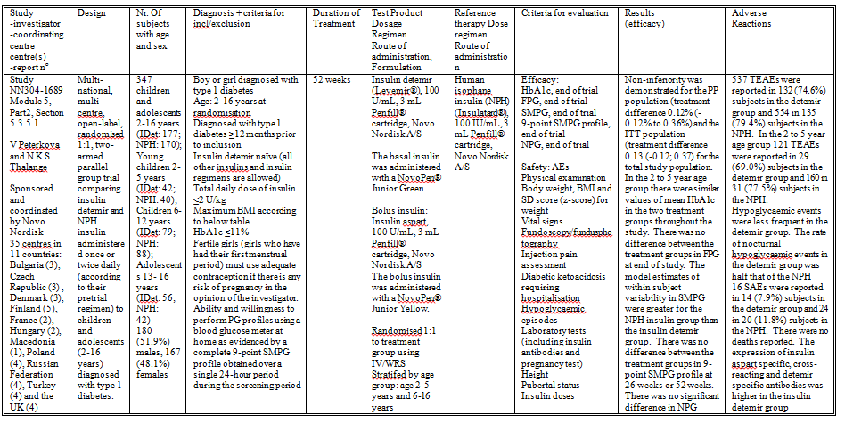

Table 18: Tabular summary of Study NN304-1687
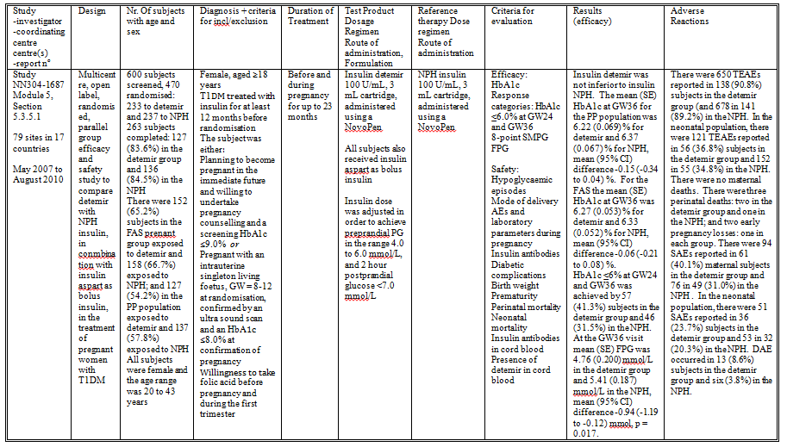

Table 26: Treatment Emergent Adverse Events Occurring in >10% of Subjects (SOC and Preferred Terms) - Full Analysis Set 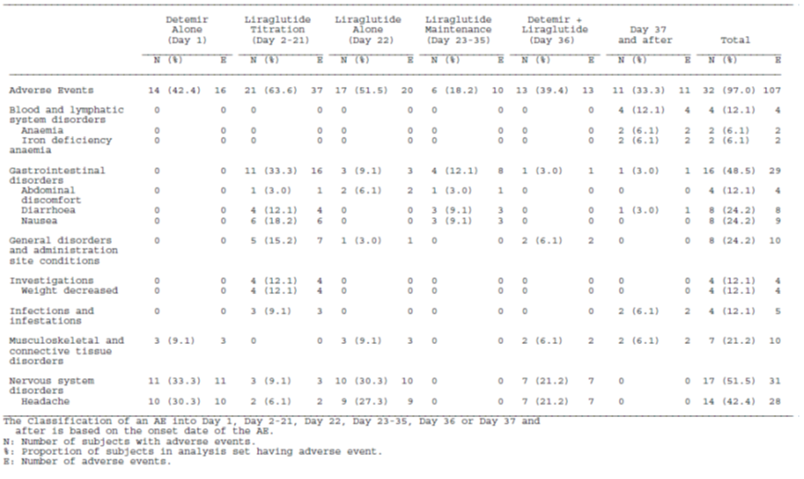

Table 25: Treatment Emergent Adverse Events (TEAE) with an Incidence ≥ 5% of Subjects in Any Treatment group by System Organ Class and Preferred Term - Safety Analysis Set
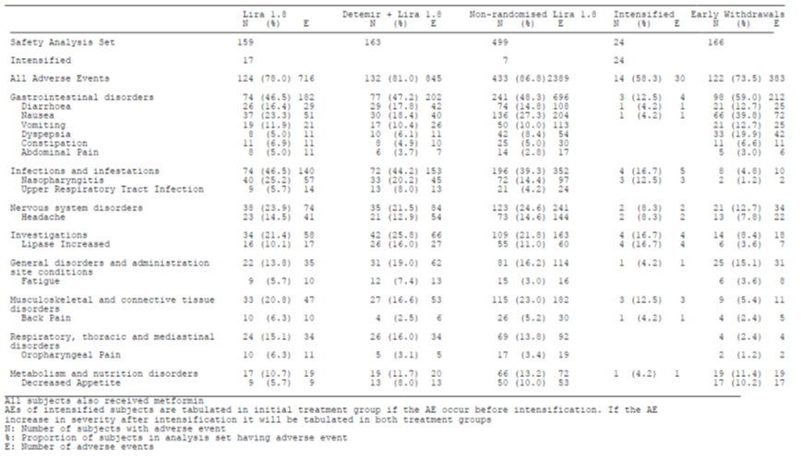

Table 28: Common Treatment-emergent AEs (≥5%) by SOC and Preferred Term, during Pregnancy, Mother, Safety Pregnant
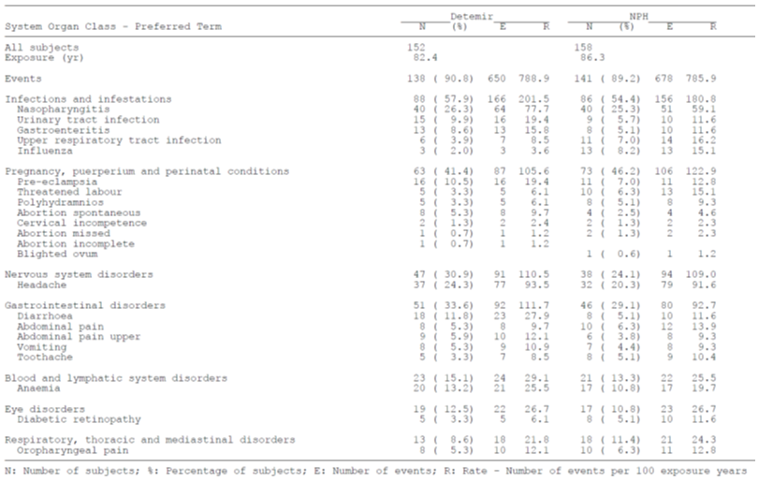

Table 28: Common Adverse Events (Occurring in ≥4 Children in Any Treatment Group) by System Organ Class and Preferred Term, Child, Safety Pregnant
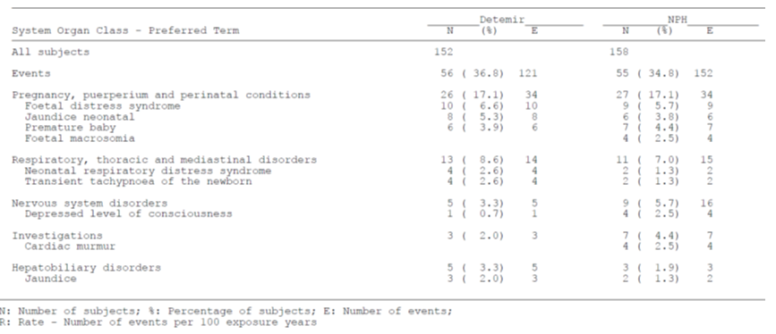

Table 40: Treatment Emergent Adverse Event Leading to Discontinuation by System Organ Class - Safety Analysis Set

Table 40: Treatment Emergent Adverse Event Leading to Discontinuation by System Organ Class - Safety Analysis Set continued

Table 40: Treatment Emergent Adverse Event Leading to Discontinuation by System Organ Class - Safety Analysis Set continued

Table 42: Laboratory abnormalities reported as TEAEs – safety set
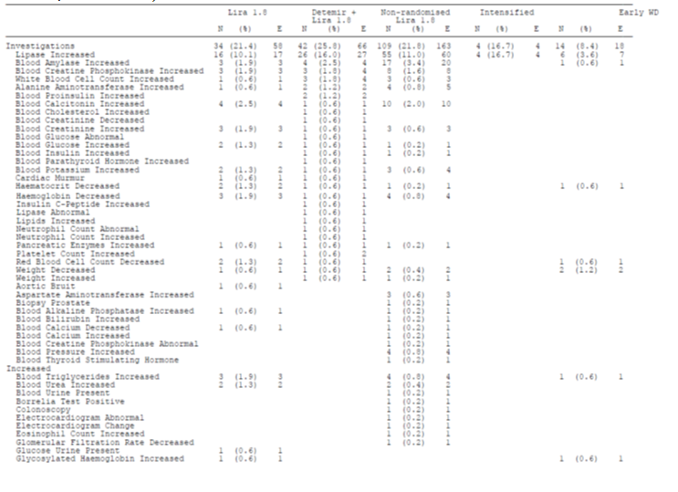

Table 42: Laboratory abnormalities reported as TEAEs – safety set continued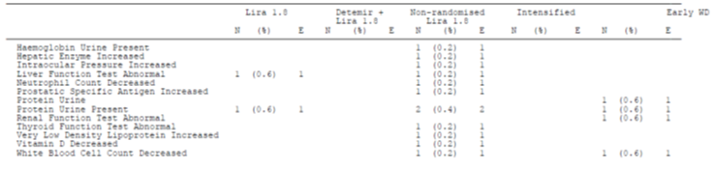

Table 46: Pancreas Related Treatment Emergent Adverse Events (TEAEs) Classified as MESIs by System Organ Class and Preferred Term - Safety Analysis Set

Therapeutic Goods Administration
PO Box 100 Woden ACT 2606 Australia
Email: info@tga.gov.au Phone: 1800 020 653 Fax: 02 6232 8605
http://www.tga.gov.au

