|  |
| --- |
| **Date of CER: August 2012** |

|  |
| --- |
| AusPAR Attachment 2 |
| Extract from the Clinical Evaluation Report for interferon beta-1a |
| Proprietary Product Name: Rebif |
| Sponsor: Merck Serono Australia Pty Ltd |

About the Therapeutic Goods Administration (TGA)

* The Therapeutic Goods Administration (TGA) is part of the Australian Government Department of Health, and is responsible for regulating medicines and medical devices.
* The TGA administers the *Therapeutic Goods Act 1989* (the Act), applying a risk management approach designed to ensure therapeutic goods supplied in Australia meet acceptable standards of quality, safety and efficacy (performance), when necessary.
* The work of the TGA is based on applying scientific and clinical expertise to decision-making, to ensure that the benefits to consumers outweigh any risks associated with the use of medicines and medical devices.
* The TGA relies on the public, healthcare professionals and industry to report problems with medicines or medical devices. TGA investigates reports received by it to determine any necessary regulatory action.
* To report a problem with a medicine or medical device, please see the information on the TGA website <<http://www.tga.gov.au>>.

About the Extract from the Clinical Evaluation Report

* This document provides a more detailed evaluation of the clinical findings, extracted from the Clinical Evaluation Report (CER) prepared by the TGA. This extract does not include sections from the CER regarding product documentation or post market activities.
* The words [Information redacted], where they appear in this document, indicate that confidential information has been deleted.
* For the most recent Product Information (PI), please refer to the TGA website <<http://www.tga.gov.au/hp/information-medicines-pi.htm>>.

**Copyright**© Commonwealth of Australia 2013  
This work is copyright. You may reproduce the whole or part of this work in unaltered form for your own personal use or, if you are part of an organisation, for internal use within your organisation, but only if you or your organisation do not use the reproduction for any commercial purpose and retain this copyright notice and all disclaimer notices as part of that reproduction. Apart from rights to use as permitted by the *Copyright Act 1968* or allowed by this copyright notice, all other rights are reserved and you are not allowed to reproduce the whole or any part of this work in any way (electronic or otherwise) without first being given specific written permission from the Commonwealth to do so. Requests and inquiries concerning reproduction and rights are to be sent to the TGA Copyright Officer, Therapeutic Goods Administration, PO Box 100, Woden ACT 2606 or emailed to <[tga.copyright@tga.gov.au](mailto:tga.copyright@tga.gov.au)>.

Contents

List of abbreviations 5

1. Clinical rationale 8

2. Contents of the clinical dossier 9

2.1. Scope of the clinical dossier 9

2.2. Paediatric data 9

2.3. Good clinical practice 9

3. Pharmacokinetics 9

4. Pharmacodynamics 10

5. Dosage selection for the pivotal studies 10

6. Clinical efficacy 11

6.1. Pivotal efficacy study, Study 27025, “REFLEX” (n=517) 11

6.2. Other efficacy studies 30

6.3. Analyses performed across trials (pooled & meta analyses) 31

6.4. Evaluator’s conclusions on clinical efficacy for Rebif in CIS 31

7. Clinical safety 32

7.1. Pivotal studies that assessed safety as a primary outcome 32

7.2. Patient exposure 32

7.3. Adverse events 34

7.4. Laboratory tests 41

7.5. Post-marketing experience 49

7.6. Safety issues with the potential for major regulatory impact 50

7.7. Other safety issues 50

7.8. Evaluator’s overall conclusions on clinical safety 51

8. First round benefit-risk assessment 51

8.1. First round assessment of benefits 51

8.2. First round assessment of risks 52

8.3. First round assessment of benefit-risk balance 53

9. First round recommendation regarding authorisation 53

10. Clinical questions 54

10.1. Pharmacokinetics 54

10.2. Pharmacodynamics 54

10.3. Efficacy 54

10.4. Safety 54

11. Second round evaluation of clinical data submitted in response to questions 54

11.1. Question 1 54

11.2. Question 2 55

11.3. Sponsor’s response to question 1 55

11.4. Sponsor’s response to question 2 60

12. Second round benefit-risk assessment 60

13. Second round recommendation regarding authorisation 60

14. References 61

14.1. References supplied by the sponsor 61

14.2. Additional references 63

## List of abbreviations

| **Abbreviation** | **Meaning** |
| --- | --- |
| AE | Adverse Event |
| ALT | Alanine Aminotransferase |
| ARR | Annualised Relapse Rate |
| AST | Aspartate Aminotransferase |
| BAbs | Binding Antibodies |
| CCSI | Company Core Safety Information |
| CDMS | Clinically Definite Multiple Sclerosis |
| CI | Confidence Interval |
| CIS | Clinically Isolated Syndrome |
| CNS | Central Nervous System |
| CPMP/CHMP | Committee for Medicinal Products for Human Use |
| CSF | Cerebrospinal Fluid |
| CTCAE | Common Toxicity Criteria Adverse Event |
| CTR | Clinical Trial Report |
| CUA | Combined Unique Active |
| DB | Double-Blind |
| DMD | Disease-Modifying Drug |
| eCRF | electronic Case Report Form |
| EDSS | Expanded Disability Status Scale |
| EMA/EMEA | European Medicines Agency |
| EPAR | European Public Assessment Report |
| EWP | Efficacy Working Party |
| FBS | Fetal Bovine Serum |
| FLS | Flu-Like Syndrome |
| Gd | Gadolinium |
| HR | Hazard Ratio |
| HSA | Human Serum Albumin |
| IFN | Interferon |
| IMP | Investigational Medicinal Product |
| ITT | Intent-To-Treat |
| IV | Intravenous |
| KM | Kaplan-Meier |
| LOV | Last Observed Value |
| MedDRA | Medical Dictionary for Regulatory Activities |
| MRI | Magnetic Resonance Imaging |
| MS | Multiple Sclerosis |
| NAbs | Neutralising Antibodies |
| NU | Neutralising Unit |
| OL | Open-Label |
| ow | Once weekly |
| PE | Point Estimate |
| PP | Per-Protocol |
| RNF | Rebif HSA-free formulation (Rebif New Formulation) |
| RRMS | Relapsing-Remitting Multiple Sclerosis |
| SAE | Serious Adverse Event |
| SC | Subcutaneously, subcutaneous |
| SD | Standard Deviation |
| SE | Standard Error |
| SPMS | Secondary Progressive Multiple Sclerosis |
| TEAE | Treatment-Emergent Adverse Event |
| tiw | Three times weekly |
| WBC | White Blood Cell |

## Clinical rationale

Multiple sclerosis (MS) is a relatively common neurological condition in young adults, in which plaques of demyelination develop in the central nervous system (CNS): the brain, spinal cord or optic nerve. Demyelination of the peripheral nervous system (PNS) does not occur in MS, and Rebif is not indicated for PNS demyelination – a point that should be clarified in the PI.

MS can be subdivided into a primary progressive form (primary progressive MS, or PPMS) and a relapsing remitting form (relapsing and remitting MS, RRMS). In the relapsing form, patients present with episodes of focal neurological deficit that eventually improve, but they subsequently develop new episodes and eventually most patients accumulate disability because of a combination of incomplete recovery from relapses and some background progression of disease between relapses; this is known as secondary progressive MS, or SPMS. Many SPMS patients reach a stage in which relapses are no longer identifiable and they then show continuous progression. Rebif is currently indicated for RRMS patients or SPMS patients with on-going relapses, but it should not be initiated in SPMS patients without relapses. RRMS and SPMS-with-relapses are sometimes grouped as ‘relapsing MS’.

A key feature of MS is that patients experience demyelinating CNS lesions that are *disseminated in time and space*. The term clinically isolated syndrome (CIS) refers to the situation in which a patient has had a bout of demyelination typical of MS, such as optic neuritis or transverse myelitis, but does not yet satisfy diagnostic criteria for MS because they have not shown dissemination in both time and space.

Early diagnostic criteria for MS required *clinical* dissemination in time and space: that is, separate episodes of demyelination leading to a focal neurological deficit at different times and due to involvement of different parts of the CNS. MS diagnosed by these criteria is usually called “Clinically Definite MS” (CDMS). More recently, MRI criteria have been included. Several MRI studies have revealed that many of the individual lesions of MS are clinically silent, and only ~10% of radiological lesions are clinically apparent at the time they occur. This partially reflects the fact that some lesions are mild, and signal transmission continues through the inflammatory plaque. More importantly, it reflects the fact that lesions are much more obvious when they affect functionally specialised regions of the brain, such as the optic nerve, and much less obvious in other areas. Lesions are relatively well tolerated when they merely remove a small portion of fibres from a much larger, diffuse structure, such as the corona radiata. Even lesions that are clinically silent on an individual basis, however, are likely to contribute to overall disability as the white matter tracts of the brain progressively lose bandwidth. Recent diagnostic criteria for MS have therefore allowed radiological lesions to be included when assessing the patient for dissemination of lesions in space and time (McDonald 2001, Polman 2005, Polman 2011), and this is known as “McDonald MS”.

Evidence has accumulated over many decades that MS has an inflammatory basis, and this is clearest for the RRMS form. This evidence includes: pathological analysis of plaques, which contain numerous lymphocytes; improvement in symptoms in response to immune suppression with steroids; and amelioration of the disease with a variety of immunomodulators including the beta interferons. All registered therapies for disease modulation in MS have an immune mechanism of action: these include the beta interferons, glatiramer acetate, natalizumab, fingolimod and cladribine.

There is also increasing evidence suggesting that early immune modulation is more effective than delayed treatment (Gold et al, 2010). In particular, for most of the established, first-line MS treatments, published studies have already shown that early treatment of CIS delays progression to multiple sclerosis. The two competing beta interferon products, Avonex and Betaferon, are already registered for this indication. Thus, there is a strong a priori case to be made that Rebif, administered after a CIS episode, would be expected to reduce the incidence of a second episode of demyelination, and hence reduce conversion to MS, as has already been demonstrated for the other beta interferons including Avonex, which is in many ways an IM form of Rebif.

## Contents of the clinical dossier

### Scope of the clinical dossier

This was a small submission, with a single pivotal study (IMP27025, published as the ‘REFLEX’ study) and one open label extension study (IMP28981).

The sponsor also submitted a number of relevant references relating to CIS and definitions of Clinically Definite Multiple Sclerosis (CDMS).

### Paediatric data

The submission did not include any paediatric data and the pivotal study excluded subjects younger than 18. Given that MS is rare in children, this is reasonable. It is unlikely that adequate recruitment would ever occur in a CIS study in children. Clinicians looking after children with a single demyelinating event will have to decide to what extent the results in adult studies can be extrapolated to children.

### Good clinical practice

The sponsor has declared that all studies were performed in agreement with accepted standards of Good Clinical Practice (GCP).

## Pharmacokinetics

No pharmacokinetic studies were submitted. The pharmacokinetic properties of Rebif have been adequately explored in previous submissions, but an assessment of that data is beyond the scope of this evaluation. The pharmacokinetic profile of Rebif is described in the approved PI as follows:

*The pharmacokinetic and pharmacodynamic profiles of the Rebif HSA free formulation were investigated in Phase I Study 25827, a double blind, randomised, two period, crossover study in which 41 healthy subjects received single 44 µg doses of Rebif (containing Human Serum Albumin (HSA)) and the Rebif HSA free formulation. The geometric mean Cmax (17.1 IU/mL) and AUC (54.0 IU·h/mL) of the current formulation were approximately 70% higher than that of the previous formulation (10.2 IU/mL and 31.9 IU·h/mL, respectively). The median Tmax was 0.25 h (versus 0.33 h for the previous formulation). There was high inter patient variability in the pharmacokinetics of interferon beta-1a with both formulations. Bioequivalence was not demonstrated for PK parameters. However, in this study, both Rebif HSA and Rebif HSA free formulations were shown to be bioequivalent on the basis of two markers of biological activity, neopterin and beta-2 microglobulin.*

*The raw neopterin responses measured for Rebif HSA and Rebif HSA free formulations were similar. Median Tmax was 24 h after dosing for both formulations. Mean (± SD) Cmax was 42 ± 21 nmol/L for Rebif HSA free formulation, and 40 ± 19 nmol/L for Rebif HSA formulation. Mean AUClast were 3882 ± 1804 nmol·h/L for Rebif HSA free formulation and 3581 ± 1475 nmol·h/L for the Rebif HSA formulation.*

*The beta-2 microglobulin responses of Rebif HSA and Rebif HSA free formulations were similar. For both formulations the median Tmax was 48 h after administration. Mean Cmax was 3017 ± 597ng/mL for Rebif HSA free formulation, and 2970 ± 646 ng/mL for Rebif HSA formulation. Mean AUClast were 401 ± 67 μg·h/mL and 392 ± 70 μg·h/mL for the Rebif HSA free and Rebif HSA formulations, respectively.*

## Pharmacodynamics

No new pharmacodynamic studies were submitted. Given that MS plaques are relatively infrequent over the course of a year of treatment, the pharmacodynamic effects of treatment on disease risk can only be inferred indirectly. Endogenous immune compounds, such as neopterin and beta-2 microglobulin have been used as surrogate markers of pharmacodynamic activity, as described above.

The pivotal efficacy study included two dose groups, a 44 µg three times weekly (tiw) dose group and a 44 µg once weekly (ow) dose group. Endogenous markers of the biological activity of beta interferon suggest that the main effects of interferon therapy persist for 3-4 days after treatment, so once weekly dosing may leave the patient under treated for part of each week. For instance, Durelli (2004) writes:

*“Evidence from pharmacokinetic and pharmacodynamic studies have [sic] shown that a single dose of beta interferon results in an increase in beta interferon activity in the serum within several hours of injection, reaching a maximum level after 12-18 h, followed by a gradual decrease to baseline within 48 hours following injection. Increases in BRM [biological response marker] levels reach a maximum after 24-36 hours, and return to baseline levels a further 48-96 h later.”*

This could partially account for the weaker therapeutic effect of Rebif ow versus Rebif tiw in the submitted pivotal study.

## Dosage selection for the pivotal studies

Underlying the treatment of CIS patients with immunomodulators is the notion that most of these patients have the same disease as patients diagnosed with MS; it is just that they have not yet had a second clinical event allowing the diagnosis of MS to be made. Thus, it would be expected that the dose used in MS would be suitable for CIS as well, and the pivotal study primarily sought to assess the standard Rebif dose of 44 µg tiw. For each of the other beta interferons, a similar approach was adopted, and the same dose has been registered for both indications (CIS and MS).

The sponsor also studied a low-dose once-weekly regimen (44 µg ow) in addition to the standard regimen (44 µg tiw). This was a reasonable approach, which tested the hypothesis that very early disease might be milder and require lower doses. Although the results subsequently showed that the low-dose regimen was inferior, there was a need to show that the full tiw regimen was necessary. There is a widespread belief amongst MS researchers, and increasing evidence, that early MS is more responsive to treatment than established MS (Rolf et al, 2010). Also, the low-dose regimen in this submission was broadly similar to the dose already registered for the competing product, Avonex – though the Avonex dose is even lower (30 µg ow). A once-weekly regimen would have been cheaper and would have been more attractive to patients than the three-times-weekly regimen, had it proven effective.

## Clinical efficacy

Only one pivotal study was submitted for the new indication. Its open-label extension was also mentioned, but this extension is ongoing and the results were unavailable. Thus, the submission rests on a single study.

### Pivotal efficacy study, Study 27025, “REFLEX” (n=517)

#### Study design, objectives, locations and dates

The REFLEX study was a randomised, double-blind, placebo-controlled study carried out over two-years and involving 517 patients considered at risk of developing MS, due to a recently experienced isolated demyelinating event (CIS) of the CNS, consisting of optic neuritis, myelopathy or a brainstem syndrome.

Participants were randomised to receive Rebif 44 µg three times weekly (tiw), Rebif 44 µg once weekly (ow) or placebo as a subcutaneous injection for a period of two years (or up to the time when they experienced a second clinical attack leading to a diagnosis of CDMS or experienced progression defined by a sustained increase of at least 1·5 points in the EDSS, at which time they qualified for open-label Rebif treatment).

The primary endpoint was the time to progression to MS, as defined by the McDonald 2005 criteria. In practice this meant the development of a second clinical episode, a new MRI lesion, or progression of disability.

#### Inclusion and exclusion criteria

In broad terms, the study recruited adult patients of either sex with a single, first clinical event suggestive of MS within 60 days prior to randomisation. Subjects were required to have at least 2 clinically silent lesions on the T2-weighted MRI scan, with a size of at least 3 mm, at least one of which was ovoid or periventricular or infratentorial, and a disability score (EDSS) of ≤5.0. The defining clinical event had to be a new neurological abnormality present for at least 24 hours, and could be either mono- or polysymptomatic, other than paraesthesia, vegetative symptoms or cerebral dysfunction.

More specific inclusion and exclusion criteria are listed below. In most cases the criteria are obvious and commonsensical, aimed at recruiting patients who truly represented the target population with CIS, excluding those who already had MS, and minimising the risk of including patients with other neurological illnesses.

A couple of the inclusion and exclusion criteria are worthy of comment: exclusion of patients with <2 clinically silent MRI lesions, and exclusions based on the McDonald 2005 criteria for diagnosing MS. These are addressed below the lists of inclusion and exclusion criteria, below.

##### Inclusion criteria

* Single, first clinical event suggestive of MS with an onset within 60 days prior to randomisation. The event had to be a new neurological abnormality present for at least 24 hours, either mono- or polysymptomatic, other than paraesthesia, vegetative symptoms or cerebral dysfunction.
* At least two clinically silent lesions on the T2-weighted MRI scan, with a size of at least 3 mm, at least one of which was ovoid or periventricular or infratentorial.
* EDSS 0-5 during the screening period.
* Between 18 and 50 years old, inclusive.
* Willing to follow study procedures.
* If female, the patient had to be:
  + neither pregnant nor breast-feeding nor attempting to conceive;
  + using a highly effective method of contraception.

##### Exclusion criteria

* Diagnosis of Multiple Sclerosis (per McDonald criteria 2005).
* Any other disease that could better explain the patient's signs and symptoms.
* Complete transverse myelitis or bilateral optic neuritis.
* Subject using or had used any other approved MS disease-modifying agent.
* Subject had used any investigational drug or undergone any experimental procedure within 12 weeks prior to study day 1.
* Oral or systemic corticosteroids or ACTH within 30 days prior to study day 1.
* Subject has total bilirubin, aspartate aminotransferase (AST) or alanine aminotransferase (ALT) or alkaline phosphatase > 2.5 times the upper limit of normal values at both month 24 and previous visit.
* Inadequate bone marrow reserve, defined as a total white blood cell count < 3.0 x 109/L, platelet count < 75 x 109/L, or haemoglobin < 100 g/L.
* Current autoimmune disease (not counting the CIS).
* Major medical or psychiatric illness (including history of severe depressive disorders and/or suicidal ideation) that in the opinion of the investigator creates undue risk to the subject or could affect compliance with the study protocol.
* History of seizures not adequately controlled by treatment.
* Cardiac disease, such as angina, congestive heart failure or arrhythmia.
* Known allergy to IFN-beta or the excipients of the study medication.
* Any condition that could interfere with the MRI evaluation.
* Known allergy to gadolinium-DTPA.
* Participated in any clinical trial within the past 6 months prior to study day 1.
* Any immunomodulatory or immunosuppressive therapy at any time prior to study day 1, including: any interferon, glatiramer acetate, cyclophosphamide, cyclosporine, methotrexate, linomide, azathioprine, mitoxantrone, eriflunomide, laquinimod, cladribine, total lymphoid irradiation, anti-lymphocyte monoclonal antibody treatment (e.g. natalizumab, lemtuzumab/Campath, anti-CD4), IvIg, cytokines or anti-cytokine therapy.
* Any experimental MS treatment prior to study day 1, including, but not limited to, any statins (if given to prevent MS) and pentoxyfilline.
* History of alcohol or drug abuse.
* Intolerance or any contraindication to both paracetamol (acetaminophen) and ibuprofen.
* Inability to administer subcutaneous injections either by self or by caregiver.
* Moderate to severe renal impairment.

##### Requirement for ≥2 silent MRI lesions

The population of CIS subjects recruited to the pivotal study all had at least 2 cerebral MRI lesions. Subjects with only one MRI lesion, or no lesion, would be expected to have a lower risk of developing MS. It is unknown if Rebif is useful in subjects with ≤ 1 lesion, and the PI should reflect this.

##### Changes in McDonald criteria from 2005 to 2010

The McDonald criteria for diagnosing MS were first published in 2001; they have since been revised in 2005 and 2010 (McDonald 2001, Polman 2005, Polman 2011). In the sponsor’s submission and in this report, the term “McDonald MS” refers to the 2005 criteria unless the 2010 criteria are explicitly mentioned.

Some patients who would have been considered CIS patients according to old clinical criteria were (quite appropriately) excluded from the REFLEX study on the basis that they could already be diagnosed with MS by the newer MRI-based criteria. In particular, those with MS according to the McDonald 2005 criteria were explicitly excluded – these patients had already reached the primary endpoint.

After the study was already underway, further revisions of the McDonald criteria were agreed upon in 2010 and published in 2011 (Polman 2011). Both sets of criteria (2005 and 2010) allow the results of MRI scans to be used for demonstrating dissemination in time (DIT) and dissemination in space (DIS), but the 2010 criteria are more inclusive, implying that some subjects in REFLEX are likely to have had MS at baseline by the new criteria.

The key differences for demonstrating DIT are that the 2005 criteria required a contrast-enhancing lesion (Gadolinium-positive [Gd+] lesion) to be present at least 3 months after the initial event (with enhancement implying active inflammation and hence newness), or a new T2 lesion at least one month after the event (with newness demonstrated by comparison with an earlier scan). The 2010 criteria allow DIT to be inferred from any new lesion, regardless of MRI timing, or from a mix of contrast-enhancing and non-enhancing lesions within a single scan.

For demonstrating DIS, the main difference is that the 2005 criteria required combinations of lesions at various sites, and in most cases multiple lesions (3 periventricular lesions or 9 total lesions); this could be relaxed if a contrast-enhancing lesion was present. The 2010 criteria are much simpler: as long as at least 2 characteristic MS regions are involved (periventricular, juxtacortical, infrantentorial or spinal cord), a single lesion in each of the 2 involved regions suffices. A patient could therefore be diagnosed with MS from just 2 appropriate lesions.

The 2010 McDonald criteria were established after reviewing all of the literature on the 2005 criteria, and discussion with MS experts around the world (Tables 1-3). They almost certainly represent an improvement over the early criteria. They are even more sensitive in making a diagnosis of MS, without apparent loss of specificity (Polman et al, 2011). Because of this increased sensitivity, however, some patients accepted into the REFLEX study according to the 2005 criteria would have been rejected by the 2010 criteria on the basis that they could already be diagnosed with MS at baseline. In fact, the sponsor has estimated that about 38% of the study cohort already had MS by the 2010 criteria at the time of randomisation. This does not reflect a fault in the study, because the best available diagnostic criteria were used at the time, but it does mean that the target population studied in REFLEX no longer closely reflects the population to whom the new indication would apply, because clinicians will generally work from the new criteria.

Table 1: Magnetic Resonance Imaging criteria to demonstrate dissemination of lesions in time.

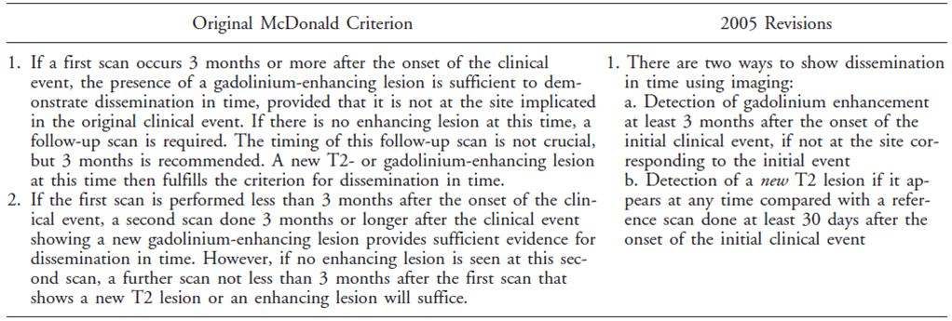

Table 2: Magnetic Resonance Imaging criteria to demonstrate brain abnormality and demonstration of dissemination in space.

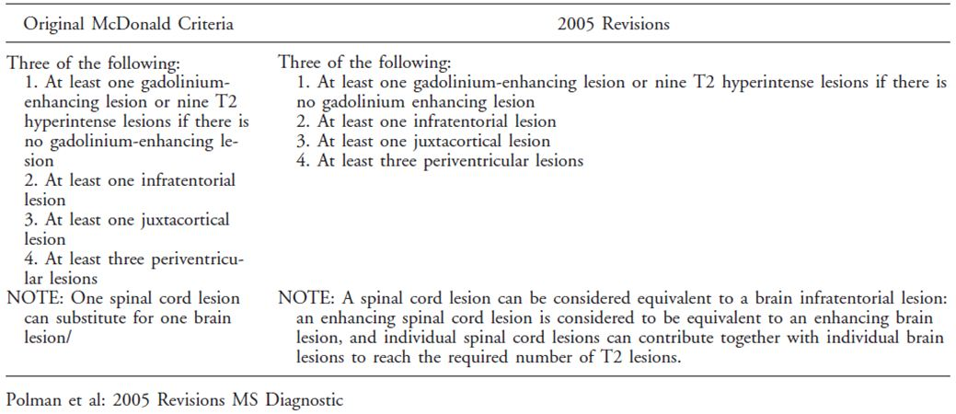

Table 3: 2010 McDonald MRI criteria for demonstration of DIS (left) and for demonstration for DIT (right).

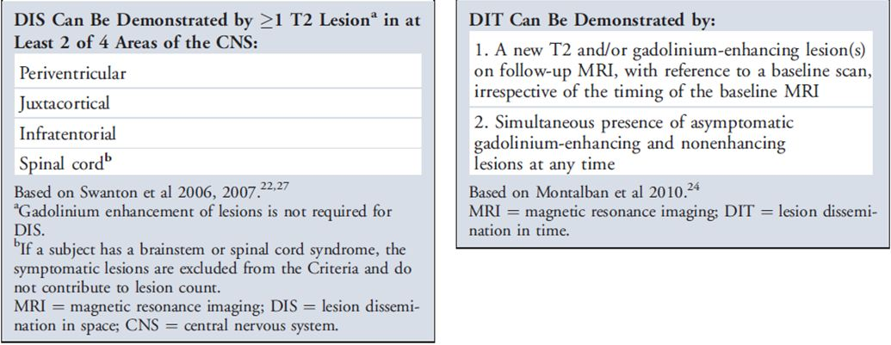

Importantly, the same logic is likely to apply to the other interferons, which were registered for the CIS indication using old diagnostic criteria, so this is not a problem with Rebif in particular. Also, it confirms the notion that CIS and MS lie on a spectrum and that the distinction between them is somewhat arbitrary and prone to diagnostic shift – in which case, it is even more appropriate to treat CIS patients with medications known to be useful in MS.

From a purist perspective, though, the recent changes in the diagnostic criteria for MS (and hence for CIS) weaken the sponsor’s submission. It is already accepted that Rebif is effective in MS; if 38% of the purported CIS population in the pivotal study actually had MS at baseline (by 2010 criteria), then the apparent finding of efficacy in CIS could have come, in part, from the inclusion of MS patients in the CIS study cohort. These patients would already be eligible for Rebif treatment under existing indications, and would not need the new CIS indication. The relevant question is whether the remaining 62% of patients also stand to benefit from Rebif. This question could be addressed by a suitable sub-group analysis, but no such analysis was submitted.[1]

##### MRI of the spinal cord

The submission made frequent reference to “MRI” without specifying what was scanned. In most cases, context made it clear that a cerebral MRI was performed but it remained unclear if a spinal MRI was also performed. The diagnosis of McDonald MS (by either 2005 or 2010 criteria) can be made by including spinal cord lesions, so it seems likely that all subjects had a spinal cord MRI at baseline and at regular intervals afterwards, along with their cerebral MRI; the sponsor should be asked to confirm this.[2]

#### Study treatments

* Rebif 44 µg subcutaneously three times weekly
* Rebif 44 µg subcutaneously once weekly
* Placebo

Appropriate placebo injections were employed in the placebo group and the once-weekly Rebif group in an attempt to maintain blinding. After the development of CDMS, patients switched to standard, open-label Rebif 44 µg tiw, while keeping their initial treatment blinded.

In the active groups, patients received 20% of the full dose for 2 weeks, 50% for the next 2 weeks, and the full dose for the remainder of the study. This is a fairly standard approach aimed at improving tolerance.

Patients were also advised to take ibuprofen (400 mg) or paracetamol (1000 mg) prophylactically with each injection during the first 12 weeks of treatment, to minimise flu-like symptoms.

Short courses of corticosteroid treatment for MS relapses were permitted at the discretion of the treating physician.

#### Efficacy variables and outcomes

The primary efficacy variable was the time to diagnosis of MS by the McDonald 2005 criteria.

Additional major efficacy variables were:

* **Main Secondary Endpoint:** Diagnosis of clinically definite MS (CDMS). This requires a second clinical event at a new CNS location, rather than accepting MRI lesions as evidence of disease activity.
* **Main MRI-based Secondary Endpoint:** Number of combined unique active lesions (CUA lesions) on MRI. This is the combination of new or enhancing lesions on the MRI, per patient per scan, during double-blind treatment.

As discussed above, the McDonald criteria require demonstration of dissemination in space and time using a mix of clinical and MRI criteria. If a patient developed MS by having a second clinical event, they could be diagnosed with MS by the McDonald 2005 criteria and they could also be diagnosed with CDMS, reaching two main study endpoints at once. If they developed MS by satisfying an MRI criterion but not a clinical one, they reached the primary study endpoint but not the secondary endpoint of CDMS.

The primary efficacy outcome was the time to McDonald MS for the high-dose group vs placebo, using a log-rank test in the intent-to-treat (ITT) population. Given that there were *three* main efficacy variables (time to McDonald MS, time to CDMS and number of CUA lesions) and *two* active groups (high-dose and low-dose), a total of *six* major endpoints were examined in a hierarchical fashion: time to McDonald MS, time to CDMS, and number of CUA lesions for the high-dose group vs placebo, and then the same three endpoints for the low-dose group vs placebo. Lower-ranked endpoints in the hierarchy were only considered positive if the previous endpoints had achieved significance. This approach corrects for the presence of multiple endpoints.

Other efficacy outcomes included:

* Other MRI-based lesion counts and lesion volumes
* Annualised relapse rate
* Proportion of subjects relapse-free
* Change in EDSS
* Change in MS Functional Composite (MSFC) and its components (Paced Auditory Serial Addition Test [PASAT], timed 25-foot walk, 9-hole peg test)
* Mean improvement from baseline in the EQ-5D quality of life assessments

#### Randomisation and blinding

Randomisation to the three treatment arms was performed on a 1:1:1 basis with stratification for four factors known to affect prognosis:

* Age (< 30 years, ≥ 30 years)
* Classification of first clinical demyelinating event (monofocal, multifocal)
* Steroid use at first clinical demyelinating event (yes, no)
* Presence of at least 1 Gadolinium-enhancing lesion at baseline (yes, no)

Blinding in this study was threatened by the occurrence of characteristic Rebif side effects, including flu-like symptoms and injection-site reactions. An attempt was made to preserve blinding by using an independent, blinded “evaluating” physician who performed neurological exams but was not involved in patient care, an independent, blinded Adjudication Committee who assessed conversions to McDonald MS and to CDMS, and a central neuroradiology centre, blinded to treatment, who assessed all MRI scans. Neurological examinations were performed with the injection sites covered. The treating physician viewed clinical laboratory results and assessed AEs, but did not adjudicate on any if the important efficacy endpoints.

This design minimised the risk of unblinding, but it should be noted that the sponsor did not perform any formal assessment of unblinding, such as asking physicians to guess the patient’s treatment group or repeating the efficacy analysis in the subgroup of subjects without telltale side effects.

#### Analysis populations

The primary analysis population was the intent-to-treat (ITT) population, which included all randomised subjects (n=517). The sponsor repeated all major analyses on the per-protocol (PP) population, which consisted of all randomised subjects who did not have any major protocol deviations likely to interfere with assessment of the primary efficacy endpoint (conversion to McDonald MS) (n=458).

#### Sample size

Sample size requirements were based on observations of the BENEFIT study (Kappos et al, 2006), in which a similar population of CIS subjects were treated with interferon beta-1b (Betaferon).

It was estimated that a total of 450 subjects (150 per treatment group) would produce ~165 events (McDonald conversions) for the comparison RNF 44 µg tiw vs placebo after approximately 21 months of recruitment. This number of events was sufficient to provide 90% power using a 2-sided log-rank test at a 0.05 alpha-error for detecting a hazards ratio (HR) of 0.6 in the primary efficacy endpoint for the main comparison RNF 44 µg tiw vs placebo. This HR corresponded to 15% subjects being free of conversion over 24 months in the placebo group and 32% in the RNF 44 µg tiw group, a clinically worthwhile difference.

Allowing for withdrawals, the proposed sample size was increased to 480 subjects equally allocated to each of the 3 treatment groups (ie. 160 subjects per group), and this target was exceeded.

#### Statistical methods

For the primary efficacy endpoint, the primary analysis was a pair-wise comparison of the ITT treatment groups using a 2-sided stratified log-rank test at the 0.05 significance level: RNF 44 µg tiw vs placebo and RNF 44 µg ow vs placebo. (RNF 44 µg tiw vs RNF 44 µg ow was compared in an exploratory manner.) Stratification was performed using the same four prognostic factors that were used to stratify randomisation (age, unifocal vs multifocal disease, steroid use and contrast-enhancing [Gd+] lesions).

The probability of subjects developing McDonald MS in each treatment group was estimated with survival curves using the non-parametric Kaplan-Meier (KM) method.

The primary efficacy endpoint was also subjected to a secondary analysis to estimate the magnitude of the treatment effect in terms of the hazard ratio, using an adjusted Cox’s proportional hazards model. Adjustments were performed for the original four stratification factors.

The same analyses were also performed on the PP population, to confirm robustness of the primary analysis.

#### Participant flow

Of the 517 randomised subjects, 448 (86.7%) completed the study; the other 69 subjects (13.3%) withdrew prematurely (10.9% in the 44 µg ow group and 14.6% in both placebo and 44 µg tiw groups). This is a relatively high completion rate for a study of this duration. All subjects entered the ITT analysis, even if they withdrew.

#### Major protocol violations/deviations

The number of protocol violations was acceptable overall, and a review of the individual reasons as shown in Table 4 did not suggest that the violations introduced any systemic bias to the study.

Table 4: 24 month analysis: subjects excluded from the PP population by reasons for exclusion (ITT population).

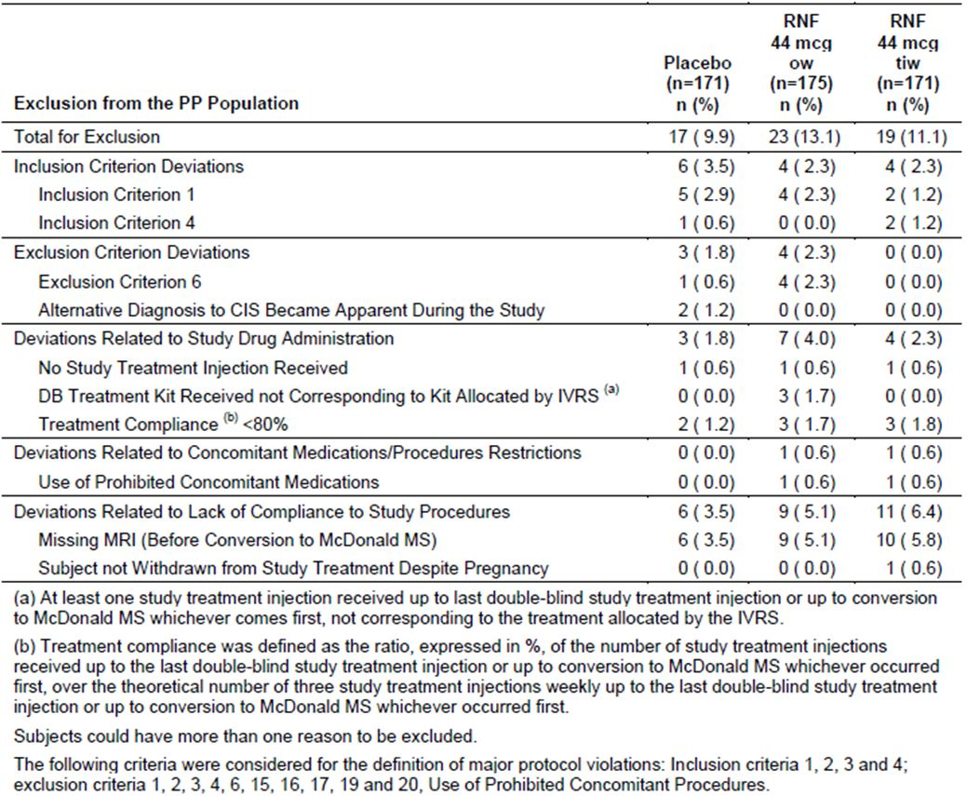

#### Baseline data

The 517 subjects had a mean age of 30.7 years, a median EDSS score of 1.5, and 64.2% were female, in keeping with the known gender bias of CIS and MS. The mean time from onset of the first event to randomisation was 57.6 days.

The treatment groups were reasonably well balanced at baseline. Because this was a CIS study, they all had a disease duration limited to the qualifying event, and they were stratified in a manner that balanced prognostic factors. Considering the high-dose group, there was a very slight excess of subjects with a monofocal onset and a slightly lower portion of Gd+ lesions, which would improve the baseline prognosis of this group, but there was also a slight excess of patients with ≥9T2 lesions, which would worsen the prognosis of this group. These factors would be expected to balance out and they were also included the stratified analysis, so no important biases are expected on the basis of baseline characteristics.

These baseline characteristics appear to be typical of the target population, and resemble those observed in the BENEFIT Study, which assessed the competing product Betaferon in CIS (Kappos, 2006) (Table 5).

Table 5: Baseline demographics (ITT population; n = 517).

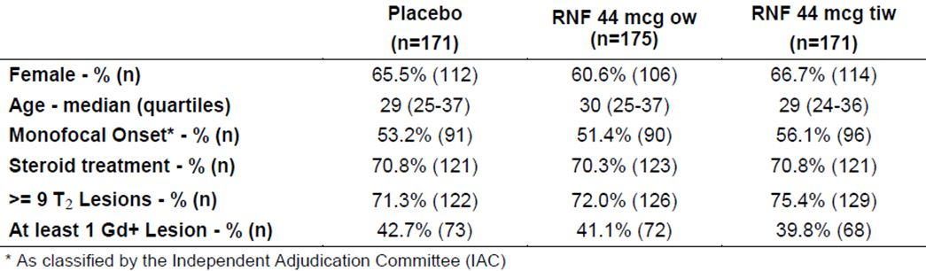

#### Results for the primary efficacy outcome, conversion to McDonald MS

Conversion to McDonald MS (using 2005 criteria) over the course of the study is shown for all three treatment groups in the Kaplan-Meier (KM) plot in Figure 1. The total number of subjects diagnosed with McDonald MS was 106/171 (62.0%), 129/175 (73.7%), and 144/171 (84.2%) in Rebif 44 µg tiw, 44 µg ow, and placebo groups, respectively. From the first MRI scan after randomisation, there was a clear separation of the curves with an excess of conversions to MS in the placebo group.

Figure 1: Time to conversion to McDonald MS: Kaplan-Meier cumulative incidence curves (ITT population; n = 517).

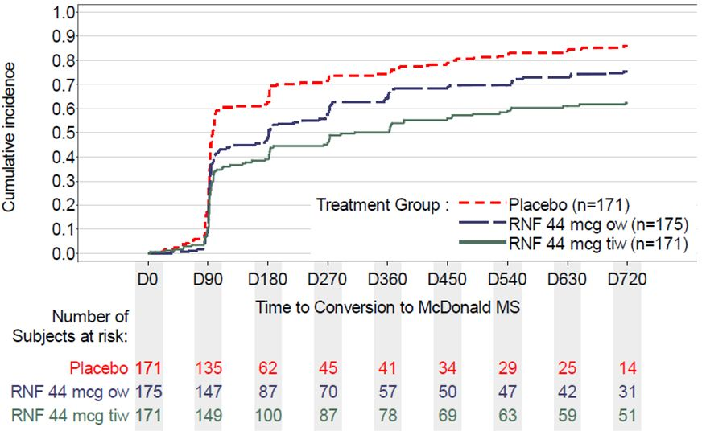

By the log-rank test, Rebif 44 µg tiw and 44 µg ow each delayed progression significantly compared to placebo (p<0.001 and p=0.008, respectively). In the adjusted proportional hazards model, the risk of progression was reduced by:

* 51% for Rebif 44 µg tiw compared to Placebo (HR = 0.49, 95% CI [0.38, 0.64])
* 31%for Rebif 44 µg ow compared to Placebo (HR = 0.69, 95% CI [0.54, 0.87])

The median time for conversion to McDonald MS was 97, 182, and 310 days in the Placebo, the Rebif 44 µg ow, and 44 µg tiw groups, respectively.

Additional methods of analysis, including a *non*-stratified log-rank test and a *non*-adjusted proportional hazards model, produced very similar results, adding confidence to the overall conclusions.

The results in the PP population were also similar (Rebif 44 µg tiw vs placebo, p<0.001; Rebif 44 µg ow vs placebo p=0.017; Rebif 44 µg tiw versus Rebif 44 µg ow, p=0.030).

Note that the risk reduction cited in HR analysis relates to *instantaneous hazard rates* in at-risk patients, and it is not the same as the *cumulative risk reduction* over two years (partly because patients converting to MS early in the study are no longer at risk of conversion, and they are censored from that point onwards in the hazard analysis). The two-year risk reduction can be estimated from the difference in overall conversions: 62.0% in the 44 µg tiw group versus 84.2% in the placebo group, an absolute difference of 22.2%, which is 26.4% of the two-year placebo conversion rate. Using the stratified, adjusted model, the two-year probability of conversion was similar to the raw conversion rates (62.5% and 85.8% for the proposed dose and placebo, respectively, which gives an absolute risk reduction of 23.3% and a relative risk reduction of 27.1%). *For patients and clinicians, this relative risk reduction of ~26-27% is likely to be more meaningful than the 51% cited in the analysis.*

The hazard reduction of 51% observed with Rebif 44 µg tiw vs placebo is broadly comparable to that achieved with IFN-beta-1b sc vs placebo in the similarly designed BENEFIT study (46%, Kappos et al 2006). This suggests that the findings have external validity, though the BENEFIT study used a slightly different beta interferon preparation.

In clinical terms, this result is modest but worthwhile. Clinicians can tell patients that their absolute risk of progressing to MS in the first two years of treatment will be reduced by approximately 1 in 4 if they commence Rebif treatment. That is, given 5 patients with CIS and an MRI suggestive of MS, about 4 of them (84.2% or 85.8% by the model) would be expected to convert to McDonald MS without treatment, and Rebif would be expected to reduce this to about 3 (62.0% or 62.5% by the model) – the number needed to treat (NNT) to prevent one conversion over two years is therefore ~5. For most patients this is likely to offset the inconvenience of injections and the known side effects of beta interferons.

Comparisons between the tiw and ow Rebif groups were considered exploratory, but they support the proposed tiw dose. The KM curves show a clear benefit of tiw dosing, and this was statistically significant (p=0.009 by log-rank test). The HR for Rebif 44 µg tiw versus ow was also significant, with the 95%CI <1 (HR: 0.71; 95% CI: [0.54; 0.91]).

The overall results of the hazards model are shown in Table 6. In addition to randomised treatment, a number of other factors influenced the likelihood of progressing to McDonald MS, as expected. These included multifocal clinical disease and the presence of a Gd+ MRI lesion.

Table 6: 24 month analysis: time to conversion to McDonald MS – estimated Hazard Ratio – Adjusted Cox’s proportional hazards modelb for randomisation stratification factors (ITT population).

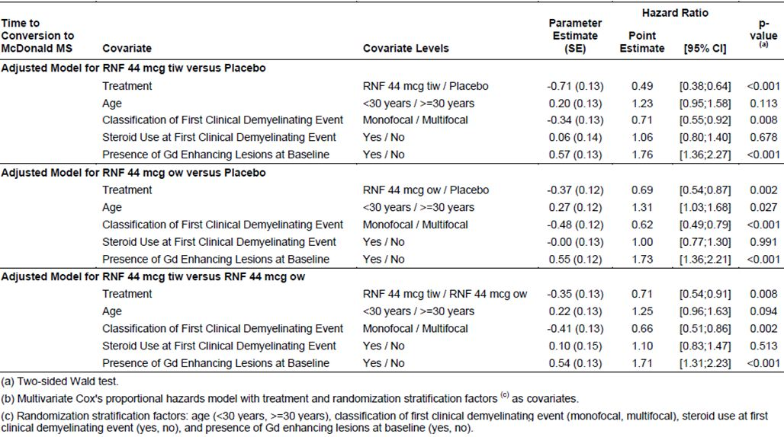

#### Results for other efficacy outcomes

##### Conversion to CDMS

Conversion to clinically definite MS (diagnosed because of a second clinical episode) occurred at a slower rate than conversion to McDonald MS. Active treatment slowed the conversion rate, as shown in Figure 2. Over the course of the two-year study, this difference was statistically significant (p<0.001 and p=0.002 for the 44 µg tiw and 44 µg ow groups, respectively, compared to placebo). To visual inspection, a benefit of active treatment appears in the KM curve after about six months. For this endpoint, there was no apparent difference between the two active dose groups.

Figure 2: Time to conversion to CDMS: Kaplan-Meier cumulative incidence curves (ITT population; n = 517).

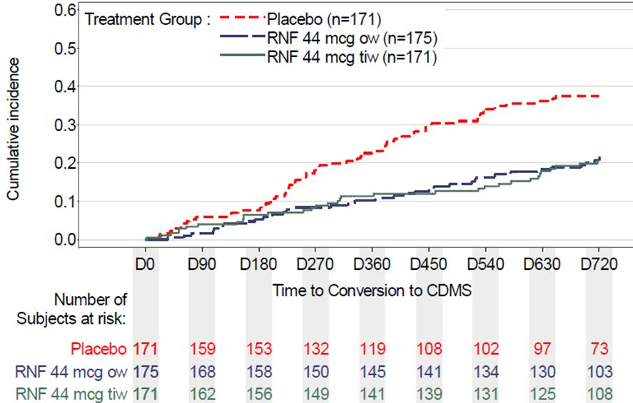

The hazard reduction ratios using the adjusted Cox’s proportional hazard model showed a significant hazard reduction for Rebif 44 µg tiw (HR: 0.48; 95% CI: [0.31; 0.73]) and Rebif 44 µg ow (HR=0.53; 95% CI: [0.35; 0.79]) relative to placebo.

As noted in discussion of the primary endpoint, these hazard reductions differ from the cumulative risk reduction over two years. The model-adjusted conversion rates to CDMS over two years were 21%, 22% and 38% in the 44 µg tiw group, 44 µg ow group and placebo group, respectively, giving an absolute risk reduction of 17% for the proposed tiw dose, and a relative risk reduction of 45%.

The fact that the study was positive for this clinical endpoint is generally reassuring, because the primary endpoint included radiological criteria that are in some ways merely surrogate markers for disease activity. It would be theoretically possible for an immune-modifying agent to alter the radiological appearance of MS plaques (say, by reducing oedema) without producing substantial benefit (by allowing myelin and axonal damage to continue independently of the epiphenomenon of oedema, for instance). While there is no evidence that such a radiological-clinical dissociation occurs in response to beta-interferon treatment, it is a common observation in neurological practice that the severity of scan changes and clinical changes may be discordant in individual patients. A treatment that merely improved scan appearances would not be worthwhile. Thus, although this endpoint was secondary in terms of the protocol, it has an importance equal to the primary endpoint.

As shown in Table 7, results for this secondary endpoint are broadly concordant with the primary endpoint, apart from the lack of an apparent dose-response relationship. The lack of a dose response is somewhat unexpected given the strong and statistically significant dose response seen for the primary endpoint. Given that this secondary endpoint was reached less often than the primary endpoint, the secondary endpoint may simply have been underpowered for the comparison between dose groups. Alternatively, there may be biological factors that cause radiological conversions to MS and clinical conversions to MS to have a different dose response. Other CIS studies, such as BENEFIT, did not employ a low-dose group, so the apparent lack of a dose-response relationship for CDMS, compared to McDonald MS, remains an isolated observation of unknown significance.

Table 7: Results for time to CDMS and time to McDonald MS (ITT population; n = 517).

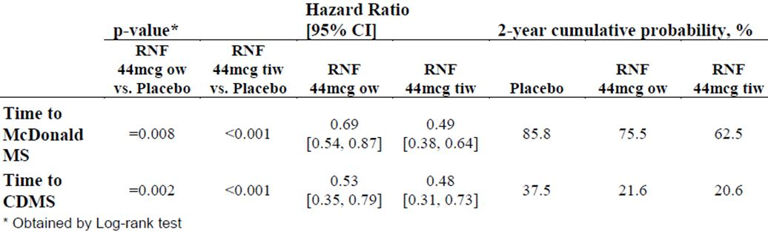

##### Combined unique active lesions

The main secondary MRI-based endpoint was the mean number of combined unique active lesions (CUA). MRI scans were performed at 3-monthly intervals and active lesions were counted using centralised, blinded neuroradiological experts. Active lesions included those that were new, enlarging or contrast-enhancing. These lesions represent a useful non-clinical surrogate for disease activity, with improved sensitivity over clinical relapses – it is estimated that only 10% of inflammatory plaques produce an obvious clinical correlate. On the other hand, as discussed previously, it would be theoretically possible for an agent to modify the radiological appearance of lesions in a way that provided little clinical benefit. This endpoint can therefore only be considered supportive.

The mean number of active lesions per subject per scan is shown in Table 8: there was a clear and significant reduction in lesion counts from 2.58 in the placebo group to 0.95 in the ow group and 0.50 in the tiw group. Comparisons between each active group and placebo, and between the two active groups, all showed a highly significant p-value (p<0.001) using an ANCOVA.

Table 8: Estimates for treatment effect on number of CUA lesions per subject per scan using adjusted negative binomial model (ITT population; n = 517).

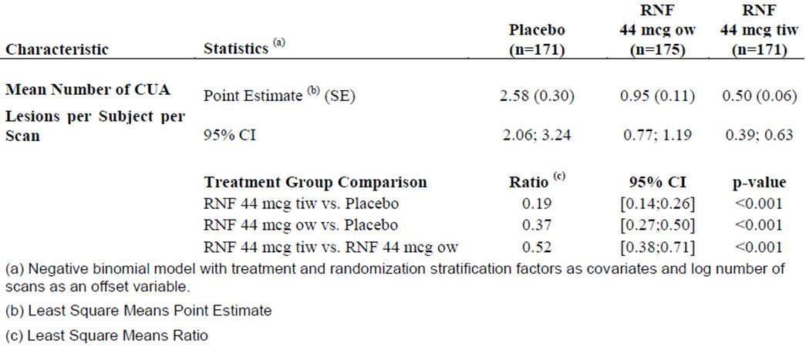

##### Minor efficacy endpoints

Most tertiary endpoints significantly favoured active treatment, as shown in the tables below.

The sponsor analysed the relapse rate and the proportion of subjects who were free of “qualifying relapses”, where a qualifying relapse was defined as *“a new or worsening neurological symptom, in the absence of fever, lasting for ≥ 24 hours, accompanied by an objective change in the relevant functional system, and preceded by at least 30 days of clinical stability or improvement”*. Relapses that did not satisfy this definition – for instance, those that resolved before being assessed, or those that were purely symptomatic without objective signs on examination, were considered non-qualifying relapses.

As expected from the lower conversion rates to CDMS (diagnosed with the first qualifying relapse), a significantly greater proportion of subjects were free of qualifying relapses at the end of the two-year study period in the Rebif 44 µg tiw (70.2%) and ow (70.9%) groups than in the placebo group (53.8%) (Table 9). Withdrawing subjects were *not* counted as being relapse-free (worst-case imputation).

Table 9: 24 month analysis: qualifying relapse-free subjects during the whole study period (ITT population).

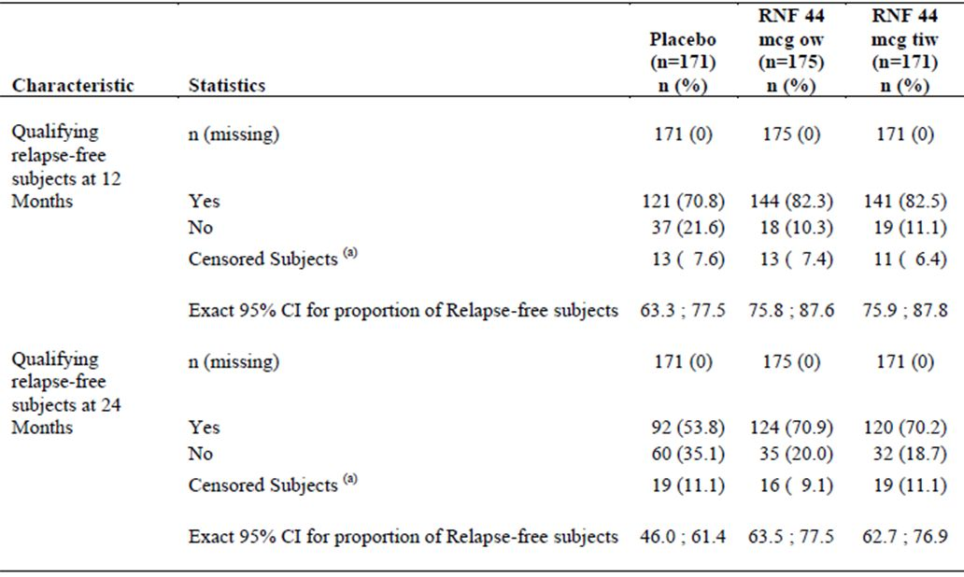

(a) Censored = withdrew and did not have relapse status.

The annualised relapse rate (for qualifying relapses) was approximately halved by active treatment from 0.22 relapses/year to 0.12 relapses/year, without any apparent difference between active dose groups, as shown in Table 10. The direction and magnitude of this benefit is broadly comparable to the original study showing that beta interferon was useful in reducing relapse rate in MS (PRISMS, 1998) and a more recent study in early MS (SPECTRIMS, 2001) that failed to show prevention of progression with Rebif 44 µg tiw, but did show improvements in annualised relapse rate.

Table 10: Qualifying relapses during the whole study period (ITT population; n = 517).

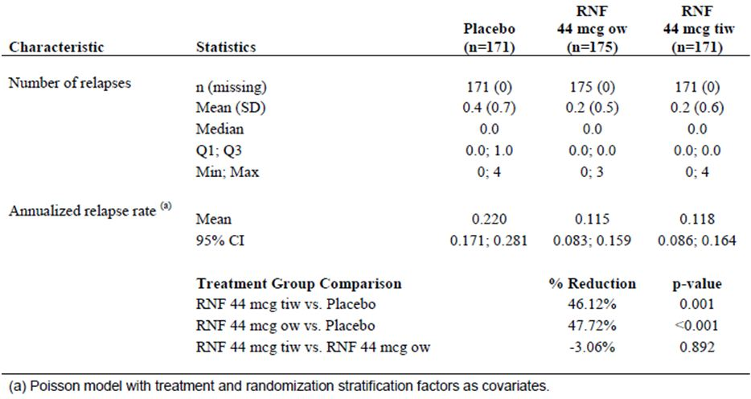

Disease progression, as quantified with the widely used Extended Disability Status Scale (EDSS), was delayed with active treatment. The study used a last-observed-value (LOV) approach in which the EDSS was recorded when the patient converted to CDMS (and hence qualified for open-label Rebif), or at the end of the 24 months if they failed to convert. This approach would tend to underestimate the magnitude of the treatment effect, because placebo recipients tended to reach CDMS earlier, and progression beyond this point was not captured. Nonetheless, there was a significant benefit with tiw Rebif treatment, by ANCOVA (p=0.011, Rebif tiw vs placebo). Placebo recipients showed a mean increase in EDSS (a deterioration of 0.14 points) while the high-dose group showed a mean reduction (an improvement of 0.09 points). The *median* change was zero in all groups, because most patients did not progress at this early stage of their illness (Table 11).

Table 11: 24 month analysis: change from baseline in EDSS score at LOVa during the DB period (ITT population).

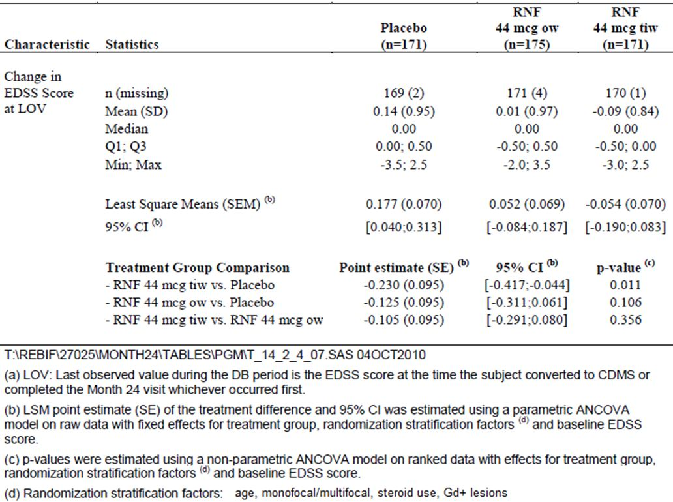

Progression was also assessed with the MS functional composite (MSFC), which is a performance-based assessment of neurological disability in 3 domains: upper limb function is assessed with the 9-hole peg test, lower limb function with a 25-ft timed walk, and cognitive function with a paced auditory serial addition test (PASAT). This score did not show a difference between groups; nor did the individual performance tests show a significant difference. Given that the patients had early disease and little disability, the failure of this test to show a treatment effect is not surprising.

Minor MRI endpoints (active T1 Gd+ lesions, new T2 lesions, new T1 hypointense lesions) also favoured active therapy, showing significantly less disease activity during double-blind treatment compared to placebo. The results for each of these minor endpoints are shown in Tables 12-14. For the proposed tiw dose, all comparisons versus placebo were associated with a p-value <0.001. The between-dose comparison (44 µg tiw vs 44 µg ow) was also statistically significant for all MRI parameters, in favour of the higher dose.

Table 12: 24 month analysis: number of new T2 lesions during the DB period – stratified non parametric ANCOVA (ITT population).

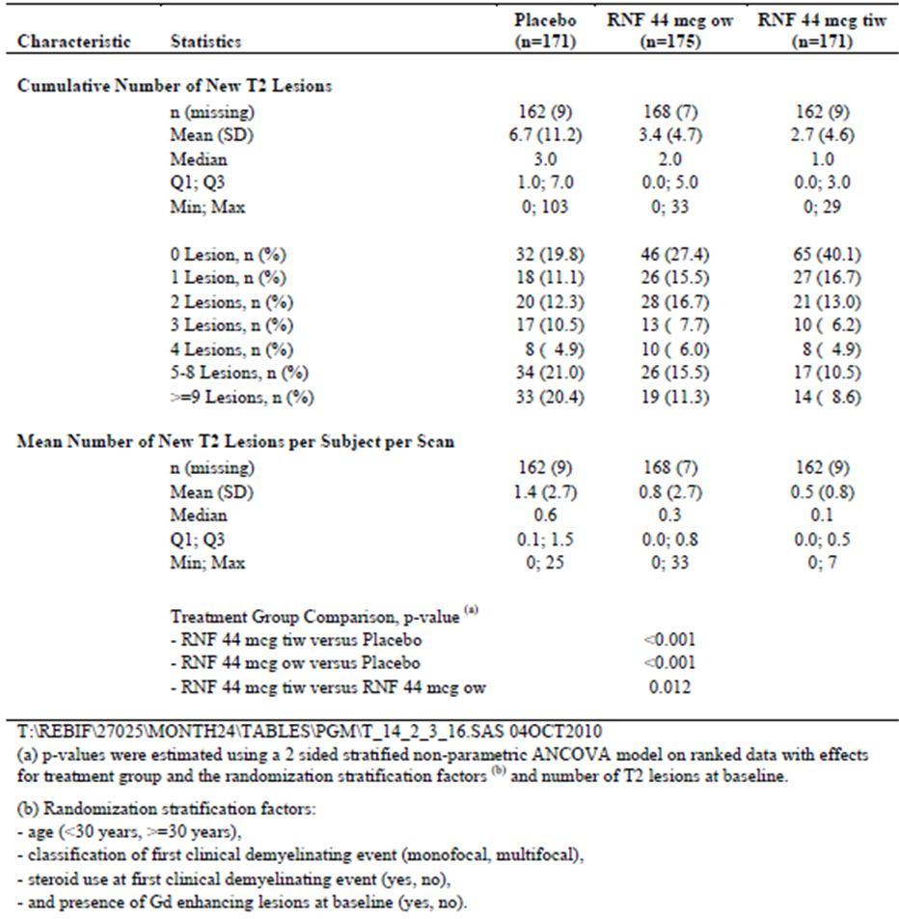

Table 13: 24 month analysis: number of new T1 hypointense lesions during the DB period – stratified non parametric ANCOVA (ITT population).

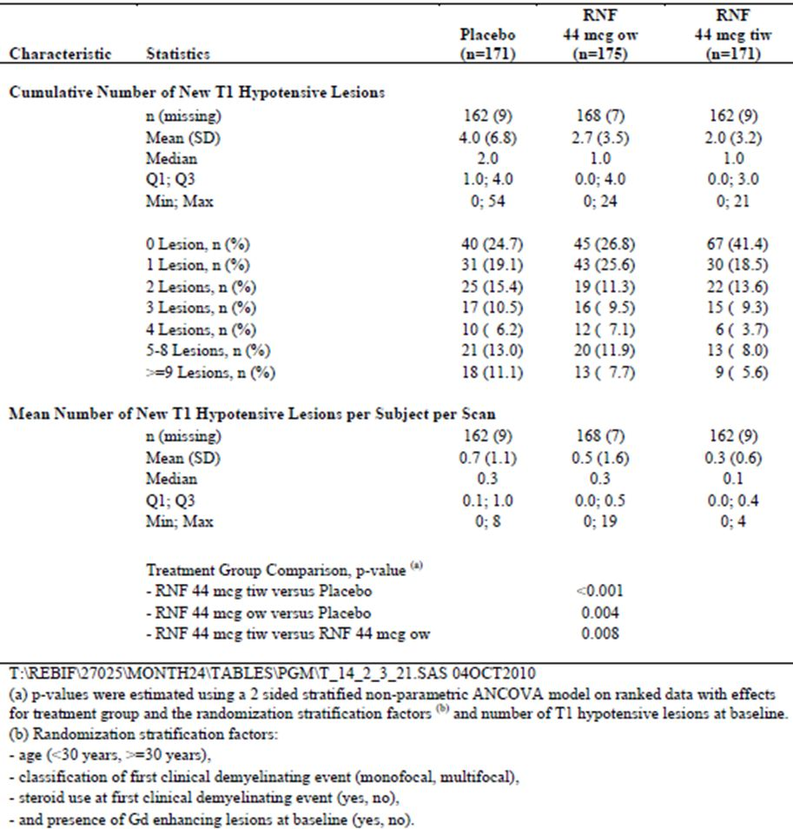

Table 14: 24 month analysis: number of new GD enhancing lesions during the DB period – stratified non parametric ANCOVA (ITT population).

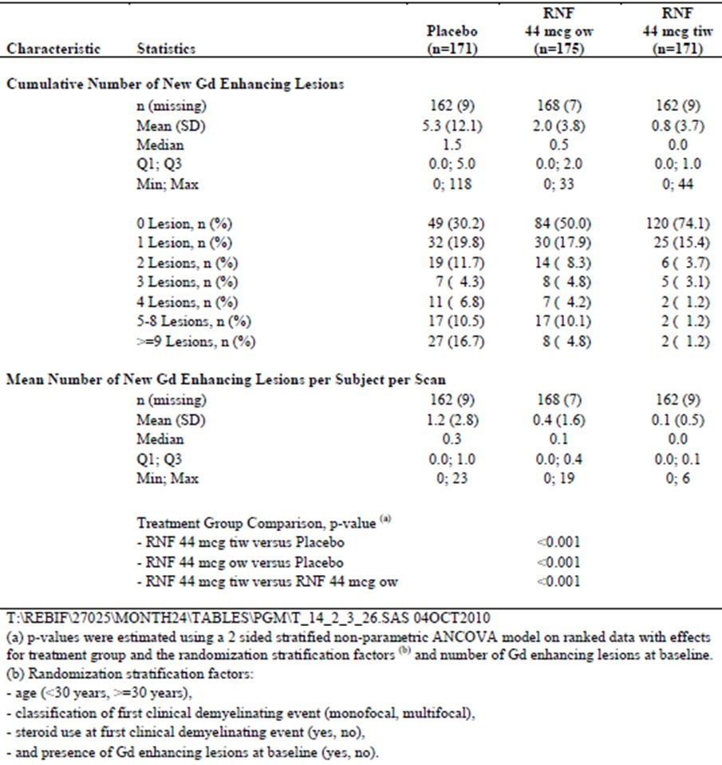

The sponsor also collected quality-of-life data using a validated questionnaire, the EQ-5D, but the groups were essentially similar, showing no major changes over the course of 24 months, and no difference with active treatment vs placebo. The median scores in all 3 groups at 24 months were the same (data not shown). This is not surprising given the very early stage of the disease.

#### Subgroup analyses

Subgroup analyses were performed based on the four pre-specified stratification factors: age, multifocal vs unifocal clinical disease, steroid use at disease onset, and the presence of Gd+ lesions on MRI. The sponsor also assessed subgroups based on gender and on the number of T2 lesions on MRI at baseline (<9 vs ≥9).

The subgroup analyses for the primary endpoint (McDonald MS) are shown in the table below. In all subgroups, the hazard ratio numerically favoured active treatment, even at the low, once-weekly dose. For the proposed tiw dose, the treatment effect was statistically significant in nearly every subgroup. The only exception was male gender, which was not one of the pre-specified stratification factors. In males, the hazard ratio was 0.71 in favour of active treatment, but the 95%CI crossed unity (0.46-1.08), as shown in Table 15. For females, the benefit appeared more pronounced: the hazard ratio was 0.44 with the 95%CI showing clear statistical significance (0.32 – 0.61).

Table 15: Analysis of the time to conversion to McDonald MS according to pre specified subgroups (ITT population; n = 517).

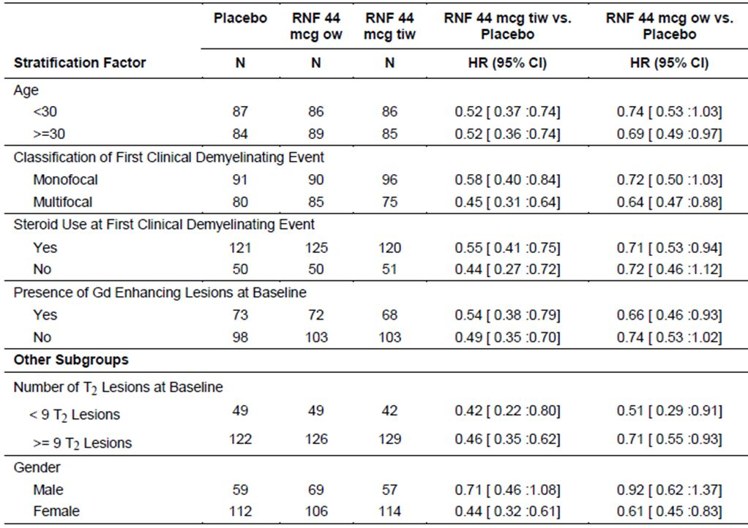

The reasons behind the lack of significant benefit in males are unclear, but this subgroup was smaller than the female subgroup, and the study was not powered to address efficacy according to gender. The *direction* of the effect in males was at least favourable. Also, when a similar subgroup analysis was performed for the secondary endpoint (CDMS), as shown in the subsequent table, the hazard ratios in the two gender-based subgroups were numerically similar (males 0.53, females 0.46), suggesting a broadly consistent treatment effect in the two genders. For the secondary endpoint of CDMS, the 95%CI in the male subgroup crossed unity, but this subgroup was about half the size of the female subgroup, reducing the statistical power of the analysis.

Subgroup analysis for the secondary endpoint (CDMS) is shown in Table 16. This endpoint was reached less frequently than the primary endpoint, and the subgroup analysis was therefore underpowered. The direction of the treatment effect was favourable in every subgroup, but this did not always reach statistical significance.

Table 16: Analysis of the time to conversion to CDMS according to pre specified subgroups (ITT population; n = 517).

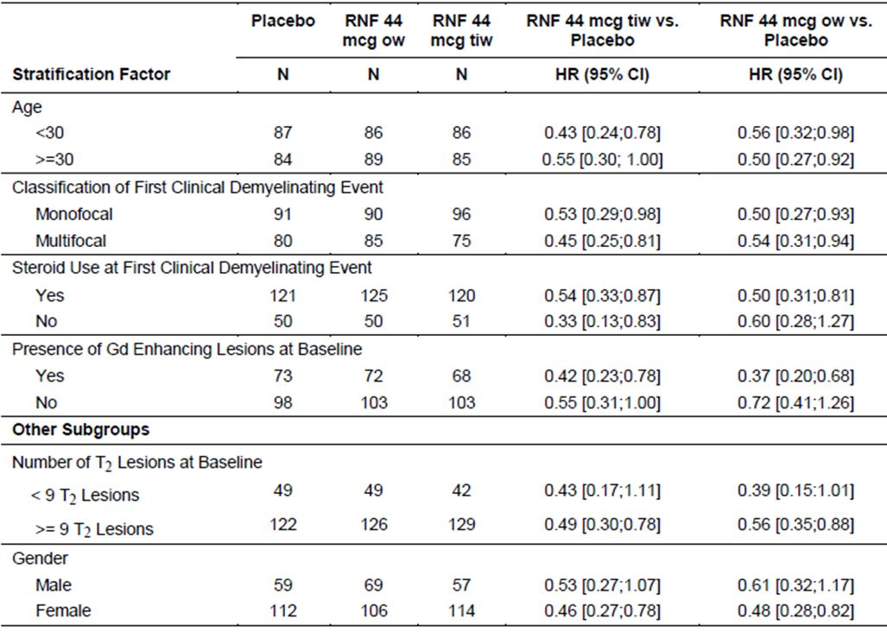

### Other efficacy studies

#### Extension study (REFLEXION, 28981)

The sponsor has designed an open-label extension study, which is still on-going. No interim results for this study were submitted. In the Clinical Overview, the sponsor described it as follows:

*“To further explore the long-term benefits of early RNF treatment in subjects with a single demyelinating event, subjects who completed Study 27025 (REFLEX) were offered enrolment into a pre-planned double-blind extension study. The ongoing extension Study 28981 (REFLEXION) will examine subjects for a total observation period of 60 months after the start of treatment in Study 27025 (REFLEX). Relapses, neurological disability, safety, and immunogenicity will be evaluated, among other outcome variables, for both RNF 44 µg tiw and 44 µg ow. After 2 years in Study 27025 (REFLEX), subjects who had not converted to CDMS were switched to RNF 44 µg tiw at Month 24 in a double-blind manner if they were initially randomized to Placebo, and those initially randomised to the active treatment (RNF 44 µg tiw or 44 µg ow) continue with their treatment schedule.”*

#### Previously published study of Rebif in CIS

**The ETOMS study** was not submitted but has been published previously. Comi et al (2001) recruited CIS patients with MRI scans suggestive of MS. (It is likely that some of them would have been diagnosed with MS by modern diagnostic criteria, given the increasing sensitivity of the McDonald 2005 and 2010 criteria.) They were randomised to a ***very low dose of Rebif*** (22 µg SC once weekly) or to placebo, and they were followed for two years to see if they developed CDMS. There was a narrowly significant treatment effect, as summarised in the abstract:

*“241 (78%) of 308 randomised patients received study treatment for 2 years; 278 (90%) remained in the study until termination. 57 (85%) of 67 who stopped therapy did so after conversion to clinically definite multiple sclerosis. Fewer patients developed clinically definite multiple sclerosis in the interferon group than in the placebo group (52/154 [34%] vs 69/154 [45%]; p=0·047).”*

By log-rank analysis, the p-value was slightly more significant (p=0.034) and to visual inspection the KM curves in Figure 3 showed a plausible treatment effect.

Figure 3: Kaplan-Meier survival curve of probability of no conversion to clinically definite multiple sclerosis (CDMS) over 2 years.

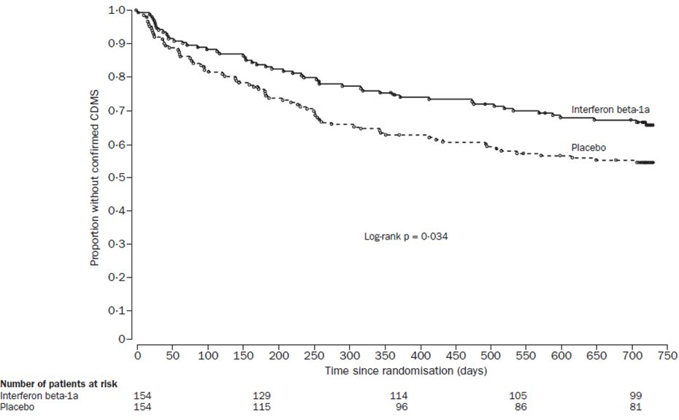

This result adds to the external validity of the submitted study, in that it helps fill in the likely dose response curve for Rebif in CIS, showing that even this very low dose had some efficacy in preventing CDMS. Differences in cohorts across studies and changing definitions of MS mean that stronger conclusions cannot be drawn, and the ETOMS study should be considered exploratory. Most importantly, the relevance of the ETOMS study to CIS has been questioned because of the high lesion count in the study cohort.

### Analyses performed across trials (pooled & meta analyses)

None applicable.

### Evaluator’s conclusions on clinical efficacy for Rebif in CIS

The submission rests on a single pivotal efficacy study. In the cohort studied, which included patients with a clinically isolated demyelinating syndrome and a Magnetic Resonance Imaging (MRI) scan suggestive of MS, Rebif reduced the development of MS, including radiologically defined (McDonald 2001 criteria) MS, which was the primary endpoint, and clinically defined MS (Clinically Definite MS, CDMS), which was the main secondary endpoint. There were also clear benefits on disease activity as measured with MRI. All of these treatment effects were statistically significant.

Over the course of the study, the total number of subjects diagnosed with McDonald MS was 106/171 (62.0%), 129/175 (73.7%), and 144/171 (84.2%) in the Rebif 44 µg tiw, 44 µg ow, and placebo groups, respectively. Using the stratified, adjusted model, the two year probability of conversion was similar to the raw conversion rates (62.5% and 85.8% for the proposed dose and placebo, respectively, which gives an absolute risk reduction of 23.3% and a relative risk reduction of 27.1%).

The model adjusted conversion rates to CDMS over two years were 21%, 22% and 38% in the 44 µg tiw group, 44 µg ow group and placebo group, respectively, giving an absolute risk reduction of 17% for the proposed tiw dose, and a relative risk reduction of 45%.

The mean number of active lesions per subject per MRI scan was reduced from 2.58 in the placebo group to 0.95 in the ow group and 0.50 in the tiw group.

In conclusion, Rebif shows worthwhile efficacy in this cohort of CIS patients. The only caveat is that the cohort studied included many patients who would be diagnosed with MS by more recent criteria, and it did not include any subjects with <2 cerebral MRI lesions. The efficacy of Rebif in the setting of milder CIS cases is therefore unclear.

## Clinical safety

The only new study providing safety data was the pivotal efficacy study, ‘REFLEX’, in which the following safety data were collected:

* General adverse events (AEs) were assessed by blinded treating clinicians during regular scheduled visits, unscheduled visits and hospital presentations.
* AEs of particular interest, including those expected from the known tolerability profile of Rebif, were drawn from the main AE database.
* Laboratory tests, including routine haematological and biochemical monitoring (liver function tests and electrolytes), were performed at each visit.
* Serum samples for neutralising antibody surveillance (antibodies directed against beta interferon itself) were collected at baseline and at six monthly intervals; these were processed using standard methodology that distinguished between antibodies (Abs) that merely showed binding to beta interferon (Binding Abs, BAbs) and antibodies capable of neutralising the usual in vitro biological effects of beta interferon (Neutralising Abs, NAbs).

### Pivotal studies that assessed safety as a primary outcome

No studies were performed in which safety was the primary outcome measure.

### Patient exposure

Exposure in the pivotal study as shown in Tables 17-19 was fairly limited - as expected for a submission merely aimed at extending the existing indications for the drug.

Table 17: Subject safety populations.

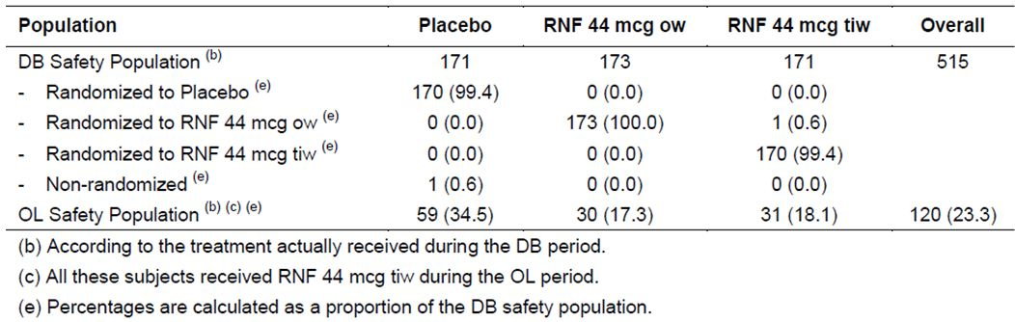

Table 18: Exposure to DB treatment (DB Safety Population; n = 515).

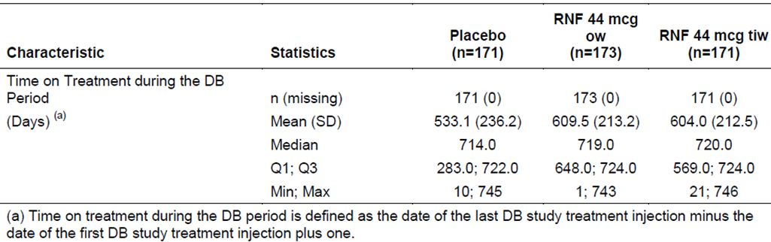

Table 19: Exposure to OL treatment (OL Safety Population; n = 120).

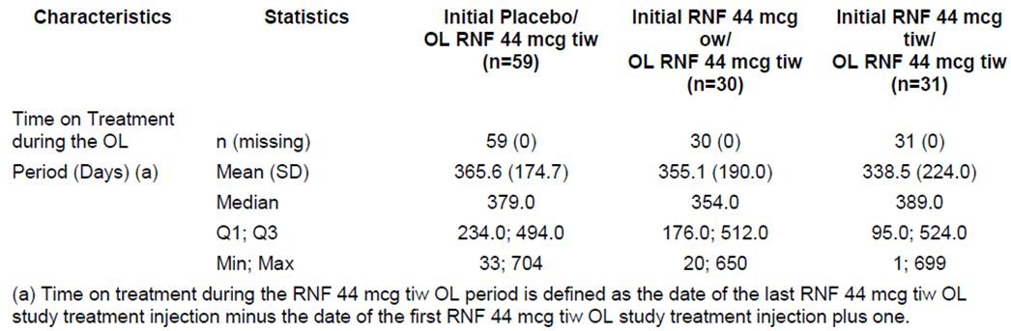

The demographic characteristics of the pivotal study population are shown in Table 20. The target population for the CIS indication closely resembles the population of early MS patients for whom the drug is already indicated. In effect, it is the same population considered 1-2 years earlier; they would be expected to be slightly younger and have less disability, factors which might be expected to improve tolerability.

Table 20: Demographic characteristics: DB Safety Population (n = 515).

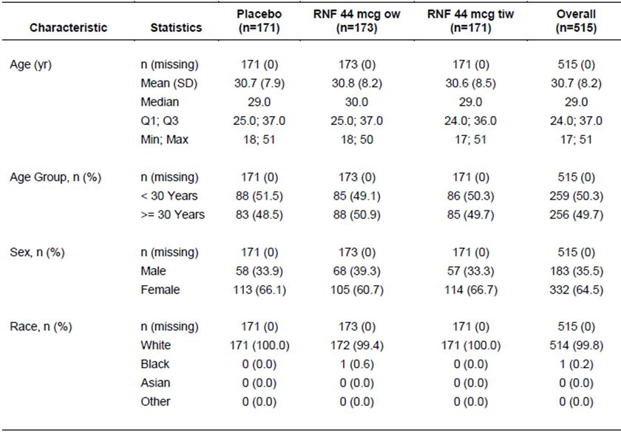

### Adverse events

#### All adverse events

Treatment-emergent adverse events (TEAEs) are summarised in Tables 21-22. AEs were common in all groups (placebo 78.4%, Rebif ow 91.3%, Rebif tiw 87.1%), with a mild excess in both active groups relative to placebo (12.9% attributable incidence in the ow group, and 8.7% in the tiw group). When placebo recipients converted to open-label (OL) Rebif treatment, they experienced an excess of TEAEs compared to subjects already habituated to Rebif (Table 22).

Table 21: Overview of incidence of TEAEs during the DB Treatment Period (DB Safety Population; n = 515).

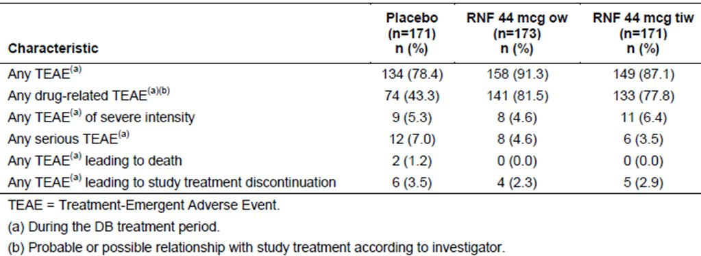

Table 22: Overview of incidence of TEAEs during the OL Treatment Period (OL Safety Population; n = 120).

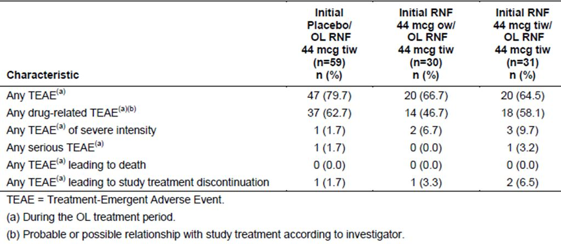

The most common TEAEs were those expected from the many years of Rebif usage in the MS population. Influenza-like illness, injection-site erythema and pyrexia showed an excess with active treatment, as shown in the table below (Table 23). Other common AEs were those expected in any population studied for two years, and included headache, nasopharyngitis and upper respiratory tract infection; these did not show an excess with active treatment. (Note that the table below only shows TEAEs with an incidence of at least 10%).

Table 23: Incidence of most common TEAEs (reported by 10% or more of subjects) during the DB treatment period by MedDRA preferred term (DB Safety Population; n = 515).

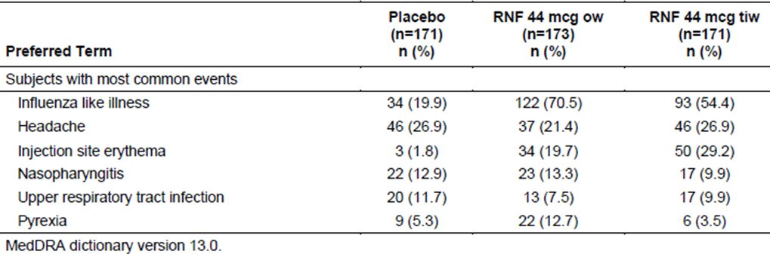

Interestingly, some of the immune-mediated symptoms, including influenza-like illness (ILI) and pyrexia, were more common in the once-weekly group than the thrice-weekly group, indicating that constant levels of immune modulation and stable cytokine levels may produce better tolerance than intermittent therapy once per week. The absolute excess of ILI in the once-weekly group was 16.1%, relative to the tiw group (70.5% vs 54.4%), which seems unlikely to be due to chance alone, though the sponsor did not subject this result to statistical analysis. The incidence of ILI in both active groups was in clear excess of ILI in the placebo group (19.9%). The incidence of ILI might have been even higher if subjects had not received the usual advice to take anti-inflammatory agents (ibuprofen 400mg or paracetamol 1000mg) prophylactically in the first 12 weeks of treatment.

Injection site erythema was much more common with active treatment, as expected. This is likely to have led to some unblinding of the Treating Physician, but the protocol specified that efficacy endpoints were to be assessed by an Evaluating Physician who was not involved in the treatment of the patients and did not discuss side effects with the patients. Injection sites were covered with clothing prior to assessment by the Evaluating Physician. These measures are likely to have limited the extent of unblinding, but the sponsor did not perform any checks on the adequacy of unblinding (such as performing subgroup analyses excluding those with injection site reactions, or asking physicians to guess treatment assignment).

When patients switched to open-label Rebif, there was an excess of ILI in subjects who had been treatment naïve (previously receiving placebo) (Table 24). To some extent, this is likely to represent tolerance in the active groups, and is in keeping with the long-standing clinical observation that patients on beta interferon usually develop tolerance with continued use. Also, this AE may have been under-reported in the open-label phase by patients who had already reported it during double-blind therapy, because they and their clinicians may have considered the matter already documented.

Table 24: Incidence of most common TEAEs (reported by 10% or more of subjects) during the OL treatment period by MedDRA preferred term (OL Safety Population; n = 120).

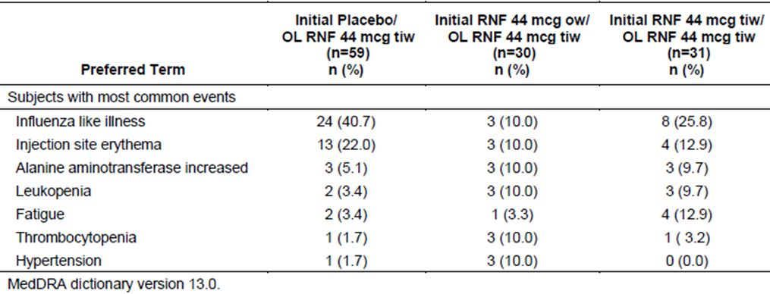

#### Treatment-related adverse events (adverse drug reactions)

Investigators in the pivotal study were asked to indicate whether they thought AEs were related to treatment, as is standard practice in placebo-controlled trials. In general, this is an unreliable method of assessing causality, because investigators may be less likely to ascribe causation to study drug for idiosyncratic or unexpected AEs, those that mimic natural disease processes, or those without an obvious temporal relation to treatment. In this study, however, clinicians were already familiar with the AE profile of Rebif and identified a clear excess of apparently drug-related AEs in the active groups: drug-related AEs were mistakenly identified in some placebo recipients (43.3%), but were much more commonly identified in recipients of the Rebif ow (81.5%) or the Rebif tiw dose (77.8%), as shown above. The *attributable* incidence of drug-related AEs was therefore 38.2% and 34.5% in the ow and tiw groups, respectively.

#### Pre-specified AEs of interest

Based on the extensive post-marketing experience with Rebif, the sponsor flagged a number of AE categories of special interest, including: cytopaenias, depression and suicidal ideation, flu-like syndrome, hepatic disorders, injection site reactions, skin rashes and thyroid disorders. These are shown in the multipage tables below (Table 25 for the double-blind period and Table 26 for the open-label period).

Cytopenias were more common with active treatment, especially neutropaenia or leukopaenia, and showed a dose-response relationship. This reflects the immunomodulatory action of Rebif. Hepatic and thyroid disorders were also more common with active treatment, but in most cases consisted of mild changes in blood tests that are commonly observed with beta interferon and usually settle with continued treatment.

Interestingly, pooled terms related to depression and suicidal ideation were not more common in the tiw Rebif group than the placebo group (8.2% in each); “depression” was slightly more common in the thrice-weekly group but “depressed mood” was only reported in the placebo group. No suicidal ideation or suicide occurred in any group.

Influenza-like symptoms have already been discussed.

Hypersensitivity terms were more frequently reported with tiw active treatment, as shown in the table below, but some of this excess was due to “erythema” which may reflect injection-site reactions despite the fact that injection-site erythema was listed as a separate term. The same applies to pooled dermatological reactions, which also included the term “erythema”. The once-weekly group had a lower incidence of hypersensitivity reactions and dermatological reactions than the placebo group.

Injection-site reactions were substantially more common in the active groups (35.7%, 24.3% and 7.0% in the tiw, ow and placebo groups, respectively), but most of this was due to injection-site erythema (seen in 29.2% of the tiw group and 19.7% of the ow group, but only 1.8% of the placebo group. Other reactions in the tiw group consisted of haematoma (4.7%) and local pain (4.7%).

Table 25: Overview of the incidence of pre-specified AEs during the DB Treatment Period (DB Safety Population; n = 515).

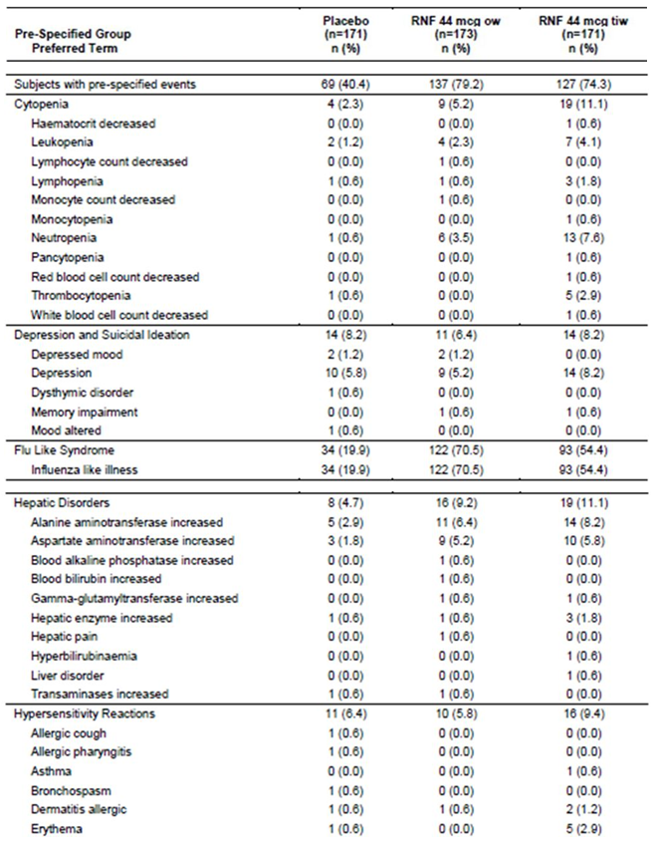

Table 25 (continued): Overview of the incidence of pre-specified AEs during the DB Treatment Period (DB Safety Population; n = 515).

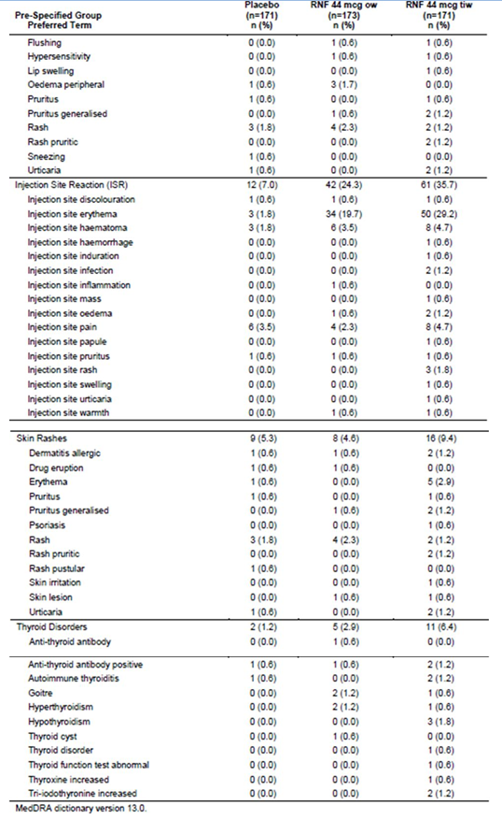

Table 26: Incidence of pre-specified TEAEs during the OL treatment period by pre-specified group and MedDRA preferred term (OL Safety Population; n = 120).

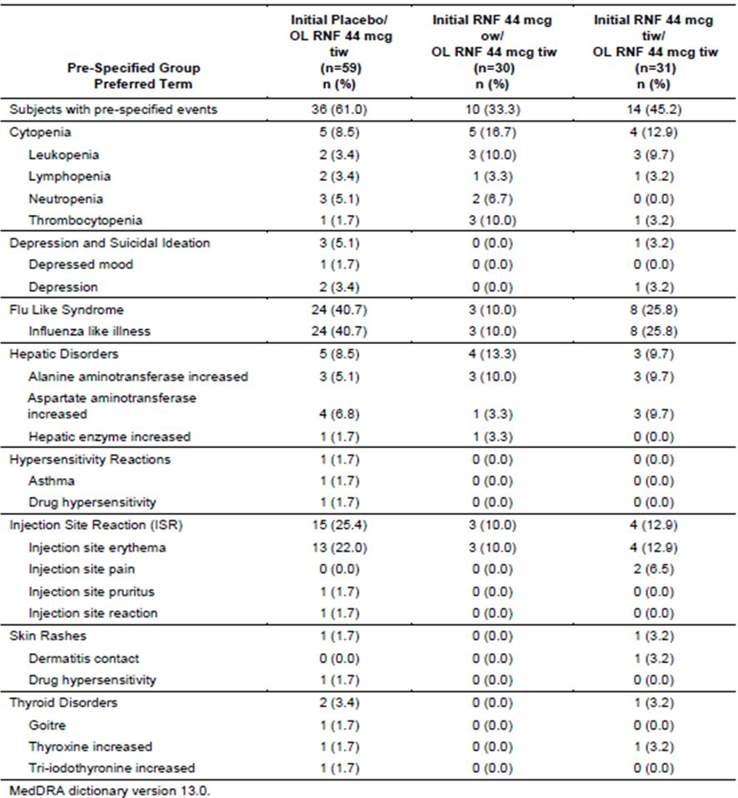

Table 27: 24 month analysis: incidence rate of TEAEs – during the DB treatment period leading to death by MedDRA primary System Organ Class and Preferred Term (DB Safety Population).

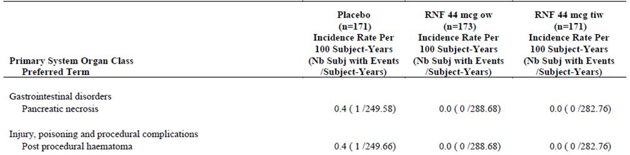

#### Deaths and other serious adverse events

##### Deaths

Two deaths occurred in the pivotal study. Both occurred in placebo recipients, and appeared causally unrelated to involvement in the study. One subject died of severe pancreatitis on a background of pre-existing cholelithiasis. The other subject had a glioblastoma diagnosed in the double-blind period but present, in retrospect, at baseline; the tumour was visible on the pre-treatment scans. This subject suffered a fatal hematoma following surgery for subtotal excision of the tumour.

##### Severe and serious adverse events

AEs rated as severe were observed in all three treatment group (9, 8, and 11 subjects in the placebo, ow, and tiw groups, respectively). The sponsor listed these events as follows (Summary of Clinical Safety):

*“In the Placebo group, the 12 severe AEs reported by 9 subjects were headache (n=3), paresthesia, (n=1), tension headache (n=1), pancreatic necrosis (n=1), anxiety (n=1), post-procedural hematoma (n=1) unstable angina (n=1), cholelithiasis (n=1), hypertriglyceridemia (n=1) and spontaneous abortion (n=1).*

*In the RNF 44 µg ow group, the 10 severe AEs reported by 8 subjects include: headache (n=2), alanine aminotransferase (ALT) increase (n=2) migraine with aura (n=1) influenza like illness (n=1), injection site edema (n=1), periostitis (n=1) neutropenia (n=1), and hepatic pain (n=1).*

*In the RNF 44 µg tiw group, the 13 severe AEs reported by 11 subjects include influenza like illness (n=2), injection site papule (n=1), appendicitis (n=2), headache (n=5), tonic convulsion (n=1), gastritis (n=1), and acute myocardial infarction (n=1).”*

No new concerns are raised by this listing, although in some cases it seems highly likely that Rebif played a causal role, as in the cases of severe influenza-like illness.

Non-fatal serious adverse events (SAEs) were reported in 12, 8 and 6 subjects in the placebo, ow and tiw treatment groups, respectively. The events are in Table 28.

In most cases, these SAEs were not considered related to study drug, and a review of the individual study narratives raised no particular concerns. SAEs rated as “possibly” related to treatment were:

* varicella in a subject receiving Rebif 44 µg ow
* 1 spontaneous abortion in a placebo recipient
* 1 spontaneous abortion in a subject receiving Rebif 44 µg ow.

Table 28: 24 month analysis: incidence rate of serious TEAEs – during the DB treatment period by MedDRA primary System Organ Class and Preferred Term (DB Safety Population).

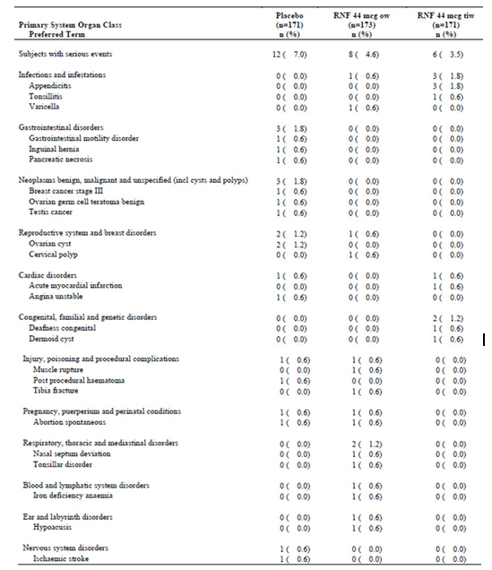

#### Discontinuation due to adverse events

Discontinuations due to AEs occurred in 6 placebo recipients (3.5%), 4 subjects in the Rebif 44 µg ow group (2.3%), and 5 in the Rebif 44 µg tiw treatment group (2.9%). A review of the withdrawals in the Rebif groups raised no new concerns; the main reasons for withdrawing were flu-like syndrome, abnormal liver function tests and depression.

### Laboratory tests

#### Biochemistry

The incidence of abnormal *post-baseline* biochemistry results is shown in Table 29. The totals listed after ‘Post Baseline Value Available’ refer to *all* subjects with a post-baseline value available (without regard to baseline values), whereas those listed after ‘Any Status’ refer to the subjects with an *abnormal* post-baseline value (again, without regard to baseline values). The subsequent rows for each test of interest (<LLN, LLN-<ULN, >ULN) show the results for subjects with at least one abnormal post-baseline value, but subdivided according to the *baseline* results. The line ‘Missing’ refers to missing baseline values, whereas ‘(missing)’ refers to missing post-baseline values.

Table 29: 24 month analysis: biochemistry laboratory parameters – at least one post-baseline value outside safety range during the DB treatment period (DB Safety Population).

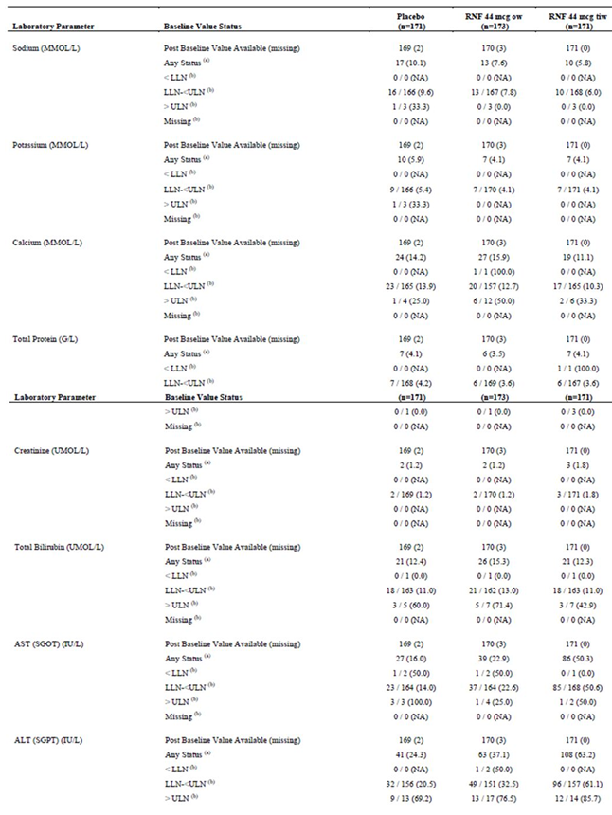

Table 29 (continued): 24 month analysis: biochemistry laboratory parameters – at least one post-baseline value outside safety range during the DB treatment period (DB Safety Population).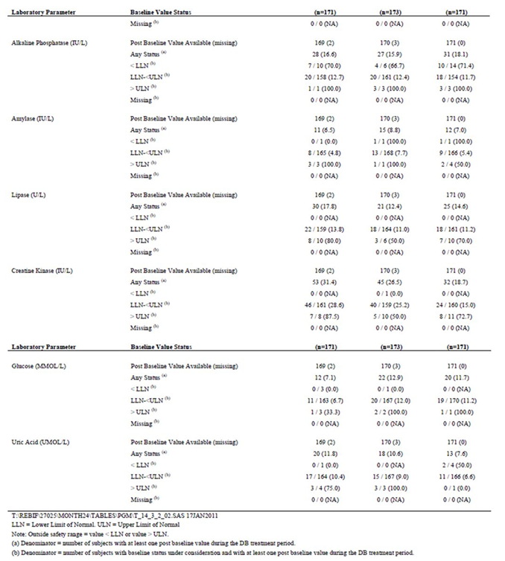

Overall, biochemical abnormalities were infrequent, and were similar in the placebo and Rebif groups for most parameters, with the exception of abnormal liver enzymes, discussed below.

#### Liver function

Rebif, like other beta interferons, is known (from the original pivotal trials and post-marketing experience) to produce mild and reversible abnormalities in liver function tests. The new pivotal study in CIS confirms this. In the tiw group, abnormal ALT values were seen in 61% of those with normal baseline AST, compared to 33% of the once-weekly group and 21% of the placebo group (Table 29).

Table 30: 24 month analysis: selected biochemistry laboratory parameters – worst post-baseline CTCAE grade during the DB period (DB Safety Population).

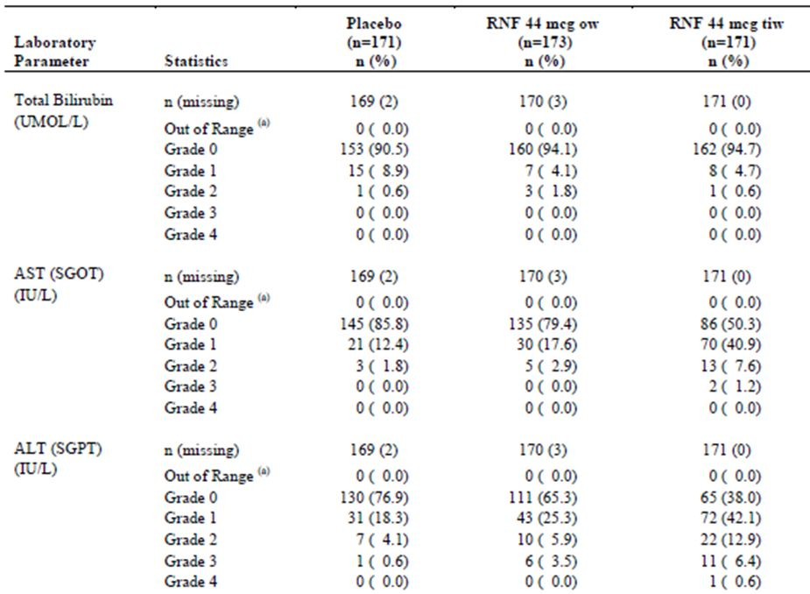

There was an excess of Grade 1, Grade 2 and Grade 3 abnormalities of AST and ALT in the active groups, and an excess of Grade 1 and Grade 2 bilirubin abnormalities. The AST and ALT abnormalities showed a dose trend, being more prominent with tiw dosing (see the table above, Table 30).

Clinically significant hepatic disease is rare with Rebif treatment, however, and the only Grade 4 abnormality observed in the CIS study was a single case of elevated ALT in a recipient of 44 µg tiw.

The PI recommends regular biochemistry checks on Rebif recipients, including liver function tests, and this advice remains appropriate.

#### Endocrine function

The post-marketing experience of Rebif has demonstrated that its use may be associated with thyroid abnormalities. The PI recommends testing at baseline, and then repeat testing every 6-12 months if the baseline tests are abnormal or there is clinical suspicion of thyroid dysfunction. This advice remans appropriate. Abnormal thyroid function results were more common with active treatment (Table 31).

Table 31: 24 month analysis: endocrinology laboratory parameters – at least one post-baseline value outside safety range during the DB treatment period (DB Safety Population).

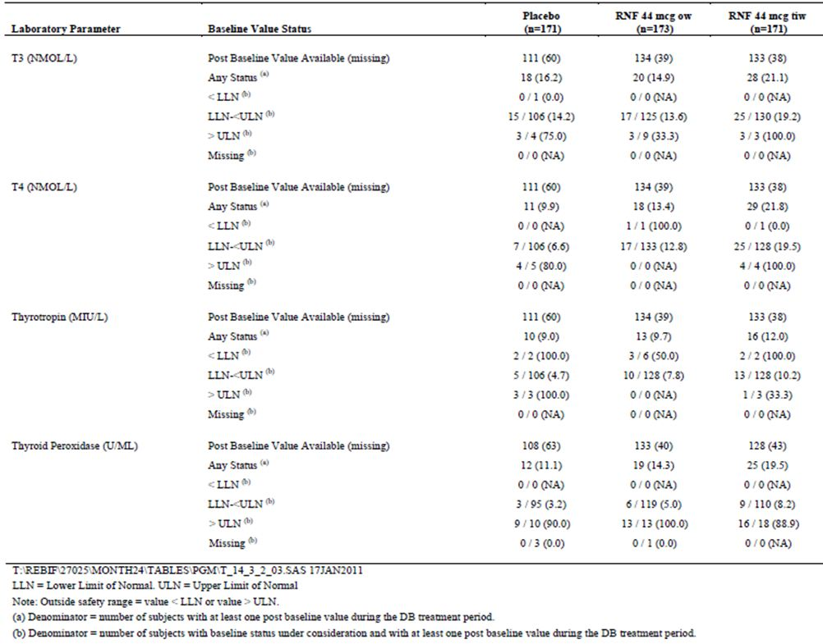

#### Haematology

Rebif therapy may produce cytopaenias, though these are rarely of clinical significance. Table 32 shows the incidence of abnormalities of blood counts in the new CIS study, which is consistent with the original pivotal studies and the previous post-marketing experience of Rebif. Neutropaenia and lymphopaenia were more common with active treatment, especially with the tiw regimen. The PI already contains appropriate recommendations to perform regular full blood counts.

Table 32: 24 month analysis: selected haematology laboratory parameters – worst post-baseline CTCAE grade during DB period (DB Safety Population).

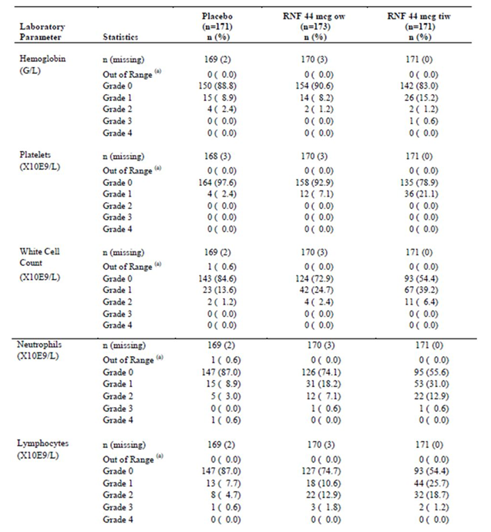

#### Neutralising antibodies

Because Rebif is a protein product, it is potentially antigenic; the fact that Rebif closely resembles an endogenous immune compound limits this reaction in most subjects, and Rebif is generally accepted as being less antigenic than Betaferon (interferon beta 1b).

Generally, the development of neutralising antibodies in a beta interferon recipient raises concerns about efficacy rather than safety. The antibodies bind to the administered treatment, potentially rendering it less effective. Not all antibodies persist, however, and it is not widely accepted that NAbs have a major effect on the efficacy of interferons. For instance, in the BENEFIT study, NAb positive patients did not show reduced efficacy (Kappos et al, 2006).

Results for NAb assays in the pivotal study are shown in Tables 33-35. Persistent antibody positivity was uncommon, affecting 11-13% of the subjects receiving active treatment. For subjects receiving the proposed tiw dose, 25 (14.8%) were NAb-positive at the last observed value of the study period. A slightly higher proportion (15.4%) were positive at any time during the 24 months. Results in the low-dose group were similar.

This result is broadly consistent with a previous Phase IIIb study in patients with relapsing multiple sclerosis treated with Rebif (RNF 44 µg tiw): 17.4% of the subjects were NAb-positive at week 96 or at the last assessment (Giovannoni, 2009). It also compares favourably to results observed in the similarly designed BENEFIT study (Kappos et al, 2006), where neutralizing activity was detected at least once in 75 of 251 subjects (29.9%) receiving the competing product Betaferon (interferon beta-1b) for two years.

It would have been of some interest to see a subgroup analysis involving NAb+ vs NAb- patients in the submitted study (as was performed in the BENEFIT study) but this analysis would have been underpowered. Overall, this study does not help to resolve controversies about the role of antibody monitoring in interferon recipients, but it does suggest that NAbs are no more likely to be a problem with CIS patients than is already the case with MS patients. If NAbs compromised efficacy in this study, that is already factored in to the observed efficacy results. Significant safety issues related to NAbs did not arise.

Table 33: Neutralising antibody and binding antibody status during the whole study period (DB Safety Population; n = 515).

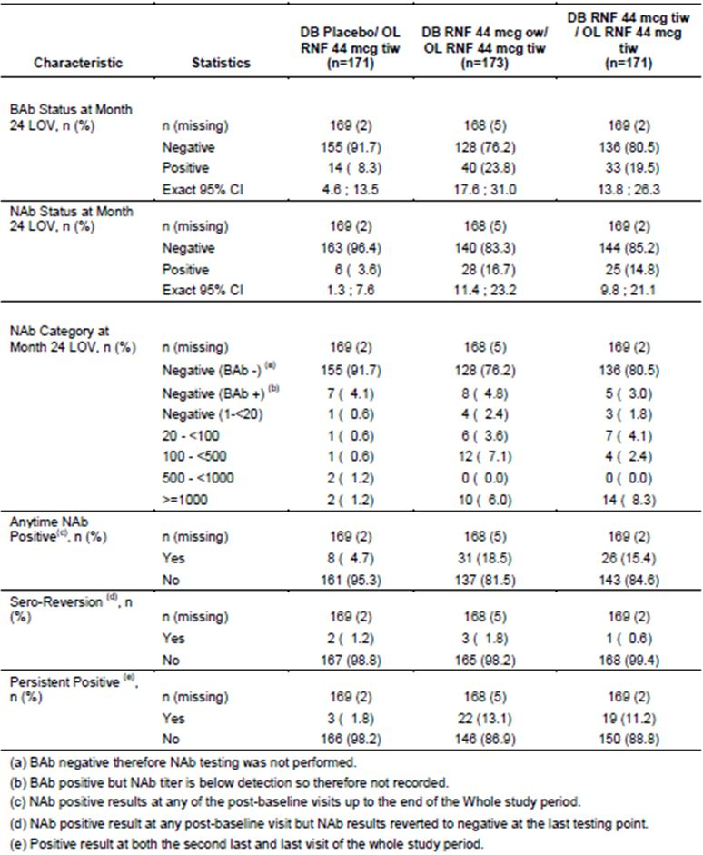

Table 34: Neutralising antibody and binding antibody status at end of the DB period (DB Safety Population; n = 515).

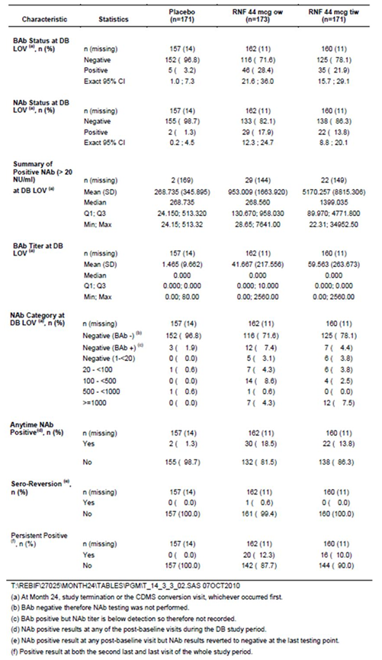

Table 35: NAb and BAb development over time during the whole study period (DB Safety Population; n = 515).

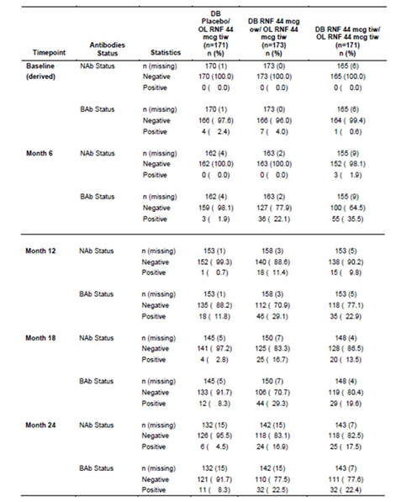

#### Electrocardiograph

Rebif treatment is not known to be associated with abnormalities of cardiac conduction, and no new information was provided.

#### Vital signs

AEs related to abnormalities of vital signs were similar in the placebo and active groups. Fever may occur as part of the influenza-like reaction to beta interferons, but this is usually short-lived and would have occurred at home if the patients dosed in the evening.

### Post-marketing experience

Rebif has been used as a disease-modifying agent in MS for several years throughout the world, since it was first launched in 1998, and its safety profile is therefore well established. Its use is associated with several tolerability issues, but no major safety concerns.

With regard to the post-marketing data, the sponsor writes:

*“Extensive post-marketing safety data is available for Rebif/RNF, regardless of its formulation, with a cumulative patient exposure in the post-marketing setting, since its first launch in 1998 up to end of October 2010, estimated to 839,084 patient-years. RNF was first launched in September 2007, and has now replaced the old formulation of Rebif in more than 70 countries. The cumulative exposure to RNF, estimated from its sales figures, approximates 155,000 patient-years, as of end of October 2010.*

*The cumulative safety data of Rebif are regularly reviewed and presented in 6-monthly Periodic Safety Reports (PSURs). The safety data presented in the latest PSUR (covering the review period from 04-May-2010 and 03-Nov-2010 (PSUR23)) indicated that the benefit-risk balance of Rebif remains positive.”*

### Safety issues with the potential for major regulatory impact

The safety and tolerability profile in the submitted study is in keeping with the known profile of this drug, which is already in widespread use for the treatment of MS. No major safety concerns with the potential for regulatory impact have been identified during post-marketing surveillance for Rebif, and the new indication does not involve a group more susceptible to serious side effects. If approved, the proposed indication would merely expose eligible patients to the drug 1-2 years earlier than they would have qualified for the drug anyway.

### Other safety issues

#### Safety in special populations

The safety of beta interferons in children is generally undefined. MS is rare in children and this population has been excluded from efficacy and safety studies; adequately powered studies are unlikely to be performed in children at any stage. The proposed CIS indication is no different in this regard than the current MS indication.

There is somewhat better data in older MS patients, because of post-marketing surveillance, but this point was not specifically addressed in the sponsor’s safety analysis. MS and CIS are relatively unlikely to develop for the first time in a geriatric population, as MS is primarily a disease of young and middle-aged adults. MS patients often survive into the geriatric age group, but there has been no indication in post-marketing surveillance that this group is particularly prone to toxicity from Rebif or other beta interferons. Given that the proposed indication relates to *earlier* use of Rebif, it does not raise any new safety concerns in the geriatric population.

#### Safety related to drug-drug interactions and other interactions

Corticosteroids are often given to Rebif recipients, and no specific safety concerns have arisen from this widespread practice. Steroids were used in the CIS study at the discretion of the treating physician, so the safety data considered above already factors in the occasional use of steroids. Patients also used antidepressants and oral contraceptives as needed, with no apparent problems (though the incidence of AEs with various combinations was not formally analysed).

The safety of combining beta interferons with other immunomodulators or disease-modifying agents is unclear. It remains possible that synergistic efficacy or synergistic toxicity could occur. Such combinations should generally not be employed without adequate evidence from combination trials.

The PI also points out that interferons can interact with hepatic enzyme systems, as follows:

*“However, interferons have been reported in the literature to reduce the activity of hepatic cytochrome P450-dependent enzymes in humans and animals. Exploratory results from a study in 8 normal volunteers on the effect of REBIF on the CYP450 system showed an effect on CYP1A2 only, however this study was of limited power. The effect of interferon beta on the CYP450 system suggests a down-regulation of CYP1A1 and CYP1A2 in rats and of CYP1A1, CYP2B1 and CYP3A and total hepatic cytochrome P450 in mice. Caution should be exercised when administering REBIF in combination with medicinal products that have a narrow therapeutic index and/or are dependent on the hepatic cytochrome P450 system for clearance, for example:*

* + - *antiepileptics, which may include phenytoin, carbamazepine, sodium valproate, benzodiazepines (such as clonazepam); and*
    - *some classes of antidepressants, which may include MAOI, SSRIs, tricyclic antidepressants, etc.”*

This advice remains appropriate. The new CIS submission did not provide any further relevant information on the potential for these interactions.

Pharmacodynamic interactions with non-immunomodulating drugs have not caused specific concerns, though it would be expected that drugs causing fatigue, such as CNS depressants used to treat spasm, might produce additive effects on fatigue with beta interferons. Clinicians treating MS patients are in the best position to monitor the tolerability of such combinations and make changes as needed.

No new data was submitted that would clarify these issues. The proposed CIS indication does not pose any new risks that are not already inherent in the existing indications.

### Evaluator’s overall conclusions on clinical safety

Rebif is already familiar to neurologists treating MS, and its proposed use in CIS does not pose any new safety issues. The drug has some tolerability issues, including an influenza like syndrome, mood disturbances, fatigue, spasm, and injection site reactions, but it is generally safe. Its use is associated with an increased incidence of abnormal liver function tests and thyroid abnormalities. Some patients may develop antibodies to the product, but hypersensitivity reactions are relatively rare; it remains unclear whether these antibodies have a significant effect on efficacy.

## First round benefit-risk assessment

### First round assessment of benefits

The benefits of Rebif in the proposed CIS usage are:

* **A reduced incidence of progression to radiologically defined MS (MS by McDonald 2005 criteria).** The cumulative risk of conversion over the study was 62.0%, 73.7% and 84.2% in the Rebif 44 µg tiw, 44 µg ow, and placebo groups, respectively. (In the adjusted model, the risk of conversion was 62.5% with the proposed tiw dose and 85.8% with placebo. In the adjusted proportional hazards model, the instantaneous risk of progression was reduced by 51% for Rebif 44 µg tiw compared to placebo (HR [Hazard Ratio] = 0.49, 95% CI [0.38, 0.64]), and 31% for Rebif 44 µg ow compared to placebo (HR = 0.69, 95% CI [0.54, 0.87]). The absolute risk reduction over two years was 22.2% (84.2%-62.0%) based on raw numbers or 23.3% (85.8%-62.5%) in the adjusted model.
* **A delay in progression to McDonald MS.** The median time for conversion to McDonald MS was 97, 182, and 310 days in the placebo, Rebif 44 µg ow, and 44 µg tiw groups, respectively.
* **A reduced incidence of conversion to Clinically Definite MS.** The model adjusted conversion rates to CDMS over two years were 21%, 22% and 38% in the 44 µg tiw group, 44 µg ow group and placebo group, respectively, giving an absolute risk reduction of 17% for the proposed tiw dose, compared to placebo, and a relative risk reduction of 45%.
* **A reduced relapse rate.** The annualised relapse rate (for qualifying relapses) was approximately halved by active treatment from 0.22 relapses/year in the placebo group to 0.12 relapses/year in both active groups, without any apparent difference between ow and tiw dosing (p≤ 0.001 for either dose group versus placebo).
* **Reduced activity on MRI, with a lower number of unique active lesions.** The mean number of active lesions per subject per scan was 2.58 in the placebo group, 0.95 in the ow group and 0.50 in the tiw group (p<0.001).
* **Possible long term benefit.** A small benefit was demonstrated in the Extended Disability Status Score (EDSS, p=0.011) over two years: this score attempts to capture cumulative disability but it is insensitive for small lesions and early disease. The brain and spinal cord have poor regenerative capacity and individual relapses may produce lasting deficits, because axonal damage in the CNS is usually permanent. Eventually, therefore, the cumulative effect of apparently silent lesions is likely to contribute to overall disability. Avoiding radiological and clinical activity from the earliest stage of the disease is therefore likely to preserve cerebral function that would otherwise be compromised, and is a sensible treatment goal, even if short term clinical studies do not easily confirm this effect.

### First round assessment of risks

The risks of Rebif in the proposed usage are:

* Some subjects will experience influenza like illness, fatigue, spasm, mood changes and injection site reactions. Drug related Treatment Emergent Adverse Events (TEAEs) were observed in 77.8% of Rebif tiw recipients, compared to 43.3% of placebo recipients, an excess of 34.5%.
* Subjects with CIS who are not destined to progress to MS in the near future will be exposed to Rebif side effects without apparent gain. Whether this is considered a substantial problem partly depends on one’s definition of MS. Over two years of treatment, this non progressing group would be expected to be only 16% of the initial cohort, using McDonald 2005 criteria (because 84% of placebo recipients converted). The non progressing group would be much larger, however, and would constitute the majority of the cohort, if older clinical criteria were used (62% of subjects in the placebo group did not progress to CDMS).
* Some subjects will progress to MS despite active treatment. Only 23% of subjects (85%-62%) treated over two years can expect to have McDonald MS prevented by active treatment, and only 17% of subjects (38%-21%) treated over two years can expect to have CDMS prevented.
* The shifting definitions of MS – in particular, the changes from McDonald 2005 to McDonald 2010 criteria – mean that **subjects fulfilling modern CIS criteria have milder disease than those treated in the pivotal CIS study, ~38% of whom already had McDonald 2010 MS at baseline**. The chance that these milder CIS subjects would receive Rebif “unnecessarily” (in the sense that they would not have progressed to MS anyway) is therefore increased under the new diagnostic criteria - but this increase has not been quantified by the sponsor.
* Discontinuation rates with injected treatments for MS are relatively high (Giovannoni 2012), and subjects with a single episode of demyelination may have even less motivation to continue treatment. The clinical benefit observed in the REFLEX study may not be achieved in the real world, where compliance is poorer. Encouraging patients to start treatment very early might even mean that some abandon treatment before they get diagnosed with MS, so they are off treatment when their disease activity is greater. (This is less of an issue now that the number of available MS treatments is increasing and oral agents are available.)

### First round assessment of benefit-risk balance

The benefit-risk balance of Rebif, given the proposed usage, appears favourable but there are substantial uncertainties surrounding the group of CIS patients with milder disease.

The benefit of treatment in CIS subjects with <2 MRI lesions has not been tested. This group was excluded from the pivotal study, is expected to have a relatively low chance of conversion to MS, and the risks and side effects of Rebif treatment do not appear justified given that most of these subjects will do well anyway. The PI should explicitly exclude such low risk subjects.

More subtly, the benefit of treatment is still unclear in subjects with a single clinical demyelinating event who do not have McDonald 2010 MS. The CIS cohort in the pivotal study, defined using McDonald 2005 criteria included ~38% of subjects who actually had McDonald 2010 MS, and who would therefore *not* be diagnosed with CIS by modern criteria. This inclusion of patients with MS is likely to have inflated the apparent benefit of active treatment. This was not a design fault, but merely reflects shifting definitions of MS that took place as the study was underway. It is not a problem unique to Rebif, either, because the pivotal CIS studies for Avonex, Betaferon and Copaxone are all likely to have had the same issues (in retrospect) as they were designed using older definitions of MS. Nonetheless, the issue has arisen during the conduct and submission of the Rebif CIS study, and clinicians deserve to have this issue clarified to help them discuss the benefit-risk balance with their patients.

In the pivotal study, the proportion of McDonald 2010 MS patients (~38%) is approximately double the proportion of patients who had progression to MS prevented by active treatment (22% by 2005 radiological criteria, 17% by clinical criteria). If it was these McDonald 2010 patients who benefited from treatment in the pivotal study, then the new CIS indication is not needed, because such subjects could be treated under the indication of “MS”.

A subgroup analysis of “true CIS” subjects without McDonald 2010 MS should be performed by the sponsor prior to finalising the PI and prior to final approval of the CIS indication. The primary and secondary endpoints of this proposed analysis should remain the same as in the original pivotal study. This analysis might prove to be underpowered, but it should at least show a quantitative benefit of treatment in “true CIS” subjects (defined using McDonald 2010 criteria) before the CIS indication is approved. Accurate assignment of subjects to the categories of “true CIS” or “McDonald 2010 MS” might be difficult in retrospect, but should be reasonably accurate in most cases. The assignment depends entirely on MRI analysis, so it could be done by blinded, independent radiologists without collecting or considering new clinical data. Statistical analysis should be performed with the same methods as in the original cohort.

If this subgroup analysis does not show substantial benefit of Rebif in “true CIS” subjects, but instead suggests that the benefit was largely confined to those who already had McDonald 2010 MS at baseline, then it would be reasonable to conclude that competing products are likely to face the same problem. In fact, there are grounds for suspecting that Avonex, a once weekly, lower dose preparation of interferon beta 1a, is likely to have less efficacy in this setting than Rebif.

## First round recommendation regarding authorisation

Approval of the CIS indication for Rebif should be declined for now, pending clarification of efficacy in the CIS population as defined by modern criteria.

The sponsor should perform the subgroup analysis proposed above, based on modern definitions of MS (McDonald 2010 criteria) and resubmit.

## Clinical questions

### Pharmacokinetics

None applicable.

### Pharmacodynamics

None applicable.

### Efficacy

Please perform a subgroup analysis, as described above:

*“A subgroup analysis of “true CIS” subjects without McDonald 2010 MS should be performed by the sponsor prior to finalising the PI and prior to final approval of the CIS indication. The primary and secondary endpoints of this proposed analysis should remain the same as in the original pivotal study. This analysis might prove to be underpowered, but it should at least show a quantitative benefit of treatment in “true CIS” subjects (defined using McDonald 2010 criteria) before the CIS indication is approved. Accurate assignment of subjects to the categories of “true CIS” or “McDonald 2010 MS” might be difficult in retrospect, but should be reasonably accurate in most cases. The assignment depends entirely on MRI analysis, so it could be done by blinded, independent radiologists without collecting or considering new clinical data. Statistical analysis should be performed with the same methods as in the original cohort.”*

Please clarify when patients received a spinal cord MRI and how this contributed to eligibility at baseline and the occurrence of the McDonald MS endpoint.

### Safety

None applicable.

## Second round evaluation of clinical data submitted in response to questions

The sponsor submitted data in response to the following two questions arising from the first round clinical evaluation:

### Question 1

*The CIS cohort in the pivotal study, defined using McDonald 2005 criteria, appeared to include ~38% of subjects who actually had McDonald 2010 MS, and who would therefore not be diagnosed with CIS by modern criteria. This proportion of McDonald 2010 MS patients (~38%) is approximately double the proportion of patients who had progression to MS prevented by active treatment (22% by 2005 radiological criteria, 17% by clinical criteria). It is not clear whether the McDonald 2010 patients are the patients who benefited from treatment in the pivotal study.*

*In view of the above, please perform a subgroup analysis of “true CIS” subjects without McDonald 2010 MS or provide justification for why this should not be required. The primary and secondary endpoints of the subgroup analysis should remain the same as in the original pivotal study. As the assignment of subjects to the categories of “true CIS” or “McDonald 2010 MS” depended entirely on MRI analysis, this could be done by blinded, independent radiologists without collecting or considering new clinical data. Statistical analysis should be performed with the same methods as in the original cohort.*

### Question 2

*Please clarify when patients received a spinal cord MRI and how this contributed to eligibility at baseline and the occurrence of the McDonald MS endpoint.*

The sponsor’s response to both questions was comprehensive and reassuring. The new data is evaluated below: Question 1 and Question 2.

### Sponsor’s response to question 1

The pivotal CIS study (REFLEX) was intended to exclude patients who had MS, because it was already clear from prior studies that Rebif is useful in subjects with MS, and Rebif is already registered for this indication. At the time of recruitment, MS was diagnosed using McDonald 2005 (M2005) criteria. Because definitions of MS have changed in recent years, becoming more inclusive, ~38% of the original cohort recruited to the pivotal CIS study would now be considered to have had MS *at the time of recruitment,* using McDonald 2010 (M2010) diagnostic criteria. That is, they would not have been considered to have CIS if the study had been designed at the time of the submission and evaluation, and would not be eligible; instead they would be considered to have MS already and would potentially receive Rebif according to existing indications.

The inclusion of these borderline MS subjects raises problems in interpreting the REFLEX study. If the benefit demonstrated in REFLEX was largely due to accidental inclusion of these borderline MS subjects (positive for M2010 MS, but negative for M2005 MS), then this would leave open the possibility that Rebif has a substantially weaker benefit in “true CIS” subjects (negative for both M2010 MS and M2005 MS). In that case, the new CIS indication would not be appropriate.

In response to this concern, the sponsor has submitted a post-hoc subgroup analysis in which the original cohort of M2005-negative CIS subjects was divided into M2010-positive subjects who could, in retrospect, be diagnosed with MS, and M2010-negative subjects who would still be considered to have CIS by modern diagnostic criteria (“true CIS”). Although retrospective, this post-hoc subgroup assignment could be achieved by reassessing MRI data that was obtained prospectively, and it is likely to have been substantially accurate. (One imperfection in the data, impossible to correct in retrospect, was that spinal cord MRIs were only performed in case of spinal symptoms, for purposes of differential diagnosis at baseline. Lesions in the spinal cord can contribute to a diagnosis of M2010 MS, so a few cases of M2010-positive subjects could have been missed. This is very unlikely to have had a substantial impact on the analysis – see the discussion of Question 2).

The sponsor reassessed the primary endpoint (conversion to M2005 MS) and the main secondary endpoint (conversion to CDMS) in this subgroup analysis, using the same statistical methods as in the intent-to-treat (ITT) cohort. Because the analysis was post hoc, it was considered to be exploratory.

The results are shown in the tables below.

In the overall study population, 37.7% of subjects could be retrospectively diagnosed with M2010 MS at baseline. Dissemination of disease in space (as demonstrated by MRI or multifocal presentation) was present at baseline in 83.4% of subjects, and dissemination in time was suggested by a contrasting-enhancing lesions in 41% of subjects, with the M2010-positive subgroup showing both types of dissemination. The incidence of M2010 positivity was broadly similar in the group receiving the standard, proposed dose of Rebif 44 µg TIW (36.3%) as in the placebo group (39.2%) (Table 36).

Table 36: Baseline characteristics leading to retrospective McDonald 2010 MS diagnosis.

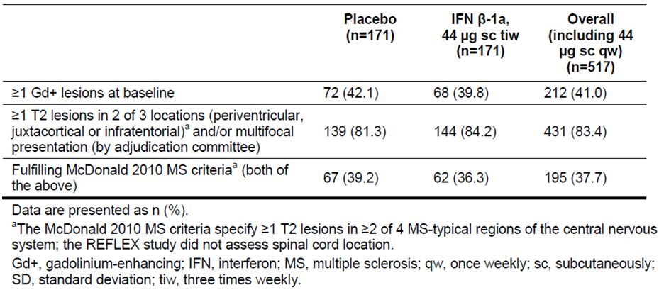

Baseline disease characteristics in the M2010-positive and M2010-negative subgroups are shown in Table 37. Not surprisingly, the two subgroups show substantial differences for those features leading to the M2010 diagnosis, such as multifocal disease and contrast enhancing lesions.

Table 37: Baseline demographic, disease and magnetic resonance imaging characteristics.

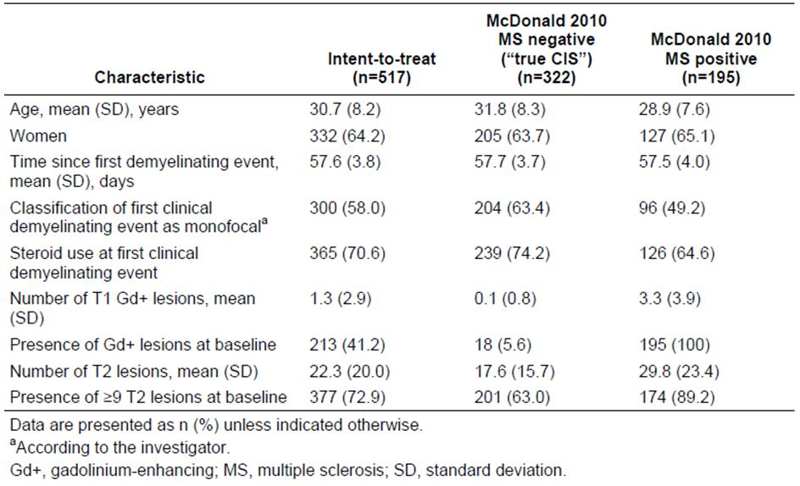

Results for the primary endpoint are in Table 38. Even in M2010-negative (“true CIS”) subjects, there was a substantial risk of converting to M2005 MS after two years, amounting to a 79% cumulative risk in the placebo treated subjects. Active treatment with the proposed 44 µg TIW dose reduced this risk significantly, to 53% over two years, consistent with a HR of 0.49 (95%CI 0.35; 0.69, p<0.001). This HR is the same as estimated in the original cohort of M2010-positive and M2010-negative patients, but with a slightly broader 95% Confidence Interval (CI).

Table 38: Analysis of the time to conversion to McDonald 2005 MS by McDonald 2010 MS status at baseline.a

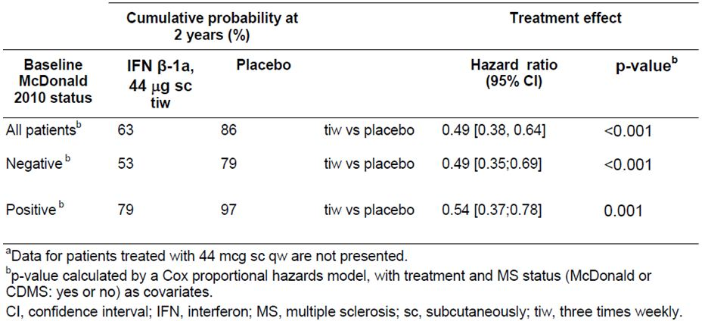

In subjects who already had M2010 MS at baseline, the risk of converting to M2005 MS over two years was very high – 97% in the placebo group – confirming the notion that the new M2010 criteria have high specificity for MS and merely enable earlier diagnosis. Active treatment of M2010-positive patients reduced conversion to M2005 MS over two years, but a clear majority of these patients (79%) converted anyway. From one perspective, it appears disappointing that only 18% of these subjects (97%-79%) managed to avoid M2005 MS through active treatment, but from another perspective they were “converting” to a disease that they already had, and were merely crossing a subtle diagnostic threshold from one set of diagnostic criteria to another. The HR in this subgroup was favourable, at 0.54, with clear statistical significance (95%CI 0.37; 0.78. p=0.001).

For the main secondary endpoint of CDMS, broadly similar results were obtained, though this endpoint was reached less commonly and the analysis had less statistical power (Table 39). The two year risk of CDMS in placebo recipients was 38% overall, with a somewhat lower risk (32%) in M2010-negative subjects and a higher risk (46%) in M2010-positive subjects. Active treatment with Rebif 44 µg TIW significantly reduced the risk of CDMS in both M2010-negative and M2010-positive subjects, even though the study was not originally powered for such an analysis. In the M2010-negative subgroup, conversion to CDMS was reduced to 19% with active treatment, consistent with an attributable reduction of 13% and a HR of 0.53 (95%CI 0.30; 0.93, p<0.028). In the higher risk M2010-positive subgroup, conversion was reduced to 24%, consistent with an attributable reduction of 22% and a HR of 0.44 (95%CI 0.23; 0.83, p=0.011).

Table 39: Analysis of the time to conversion to CDMS by McDonald 2010 MS status at baseline.a

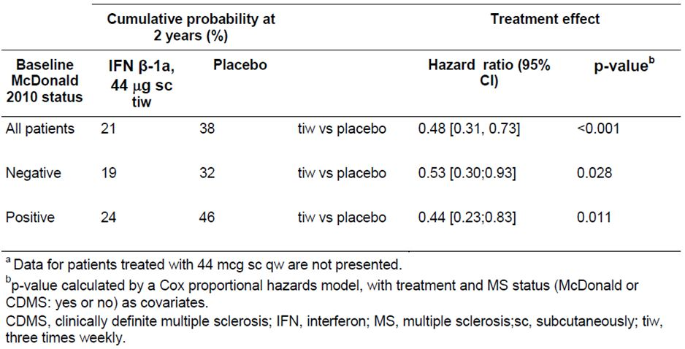

As part of their response to this question, the sponsor included a poster presented at the 5th Joint Triennial Congress of the European and Americas Committees for Treatment and Research in Multiple Sclerosis (ECTRIMS/ACTRIMS) in 2011; this poster was entitled “Efficacy of subcutaneous interferon-beta-1a in patients with a first clinical demyelinating event: the REbif FLEXible dosing in early multiple sclerosis (REFLEX) study – outcomes in patients stratified by the 2010 McDonald criteria” essentially presented the same analysis requested in the first round evaluation, though the analysis was performed independently of the evaluation process. Figures from that poster are reproduced below and illustrate that both M2010-negative and M2010-negative patients in the REFLEX study showed a significant benefit with active treatment, though the absolute risk of progression was higher, as expected, in M2010-positive patients.

Figure 4: Conversion to McDonald 2005 MS by McDonald 2010 MS criteria status at baseline.

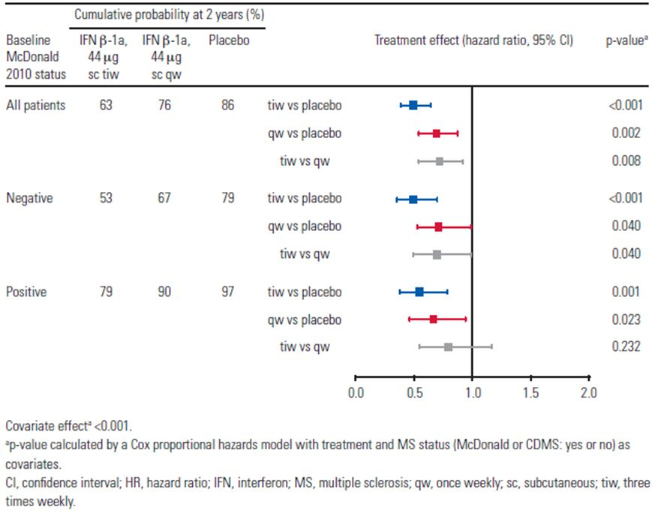

Figure 5: Time to McDonald 2005 MS by McDonald 2010 MS status at baseline: Kaplan-Meier cumulative incidence curves.a

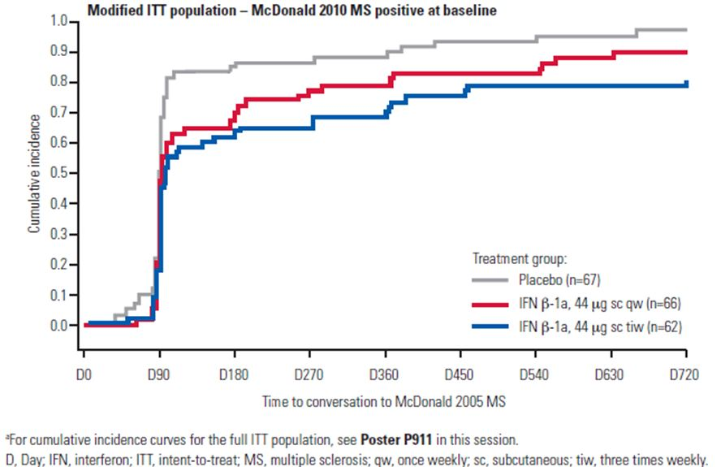

Figure 6: Conversion to CDMS by McDonald 2010 MS criteria status at baseline.

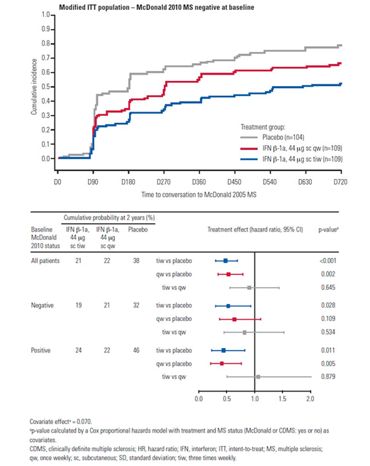

Figure 7: Time to CDMS by McDonald 2010 MS status at baseline: Kaplan-Meier cumulative incidence curves.a

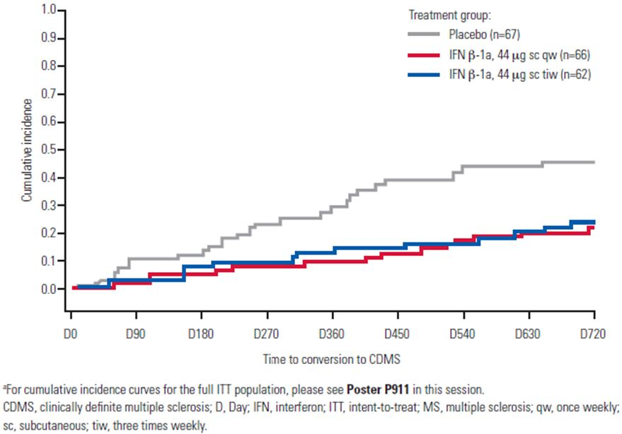

Overall, the sponsor’s post hoc analysis is reassuring. It confirms that the purported benefits in CIS patients can be achieved in subjects who are M2010-negative or M2010-positive, and that the proposed CIS indication identifies a group of subjects who can benefit from Rebif, regardless of which MS criteria are applied in defining CIS.

The results must be interpreted with one important caveat: subjects in the REFLEX study were required to have *at least two* cerebral MRI lesions at baseline, and were therefore at higher risk than CIS subjects with a lighter MRI lesion load. The M2010-negative patients in the study were not, therefore, representative of the broader M2010-negative CIS population encountered in clinical practice, some of whom would be expected to have only one or no cerebral MRI lesions. There is still no evidence that these single lesion or zero lesion CIS subjects can obtain benefit from Rebif. Thus, Rebif is indicated for CIS subjects at high risk of conversion to MS, but not in subjects at low risk.

The first round evaluation pointed out that the definition of high risk MS, in particular the requirement for at least two cerebral lesions, needs to be included in the PI. This new data does not change the need for such a definition.

### Sponsor’s response to question 2

In the initial submission, it was somewhat unclear when spinal MRIs were performed. The sponsor has now indicated that spinal MRI scans were *not* performed routinely in all subjects at baseline, and *not* performed routinely in monitoring for conversion to M2005 MS. Instead, subjects with symptoms suggestive of spinal cord disease (that is, paraparesis, a transverse sensory level, or bladder dysfunction) received an MRI at baseline to exclude alternative diagnoses and subjects developing such symptoms during the study were scanned as needed.

This suggests that a small number of study patients may have had asymptomatic spinal cord lesions that were missed, but this is very unlikely to have significantly modified the study’s results. Firstly, the spinal cord is a region in which plaques are highly likely to become symptomatic. Secondly, the same MRI approach was used in the active and placebo groups, with no likely source of bias. Thirdly, it is common clinical practice amongst neurologists to perform cerebral MRIs to monitor disease activity, and spinal MRIs only when prompted by symptoms, so the use of MRIs in the REFLEX study is fairly typical of the expected use of MRI in the target population of CIS subjects. This indicates that the results of the REFLEX study are likely to translate well into clinical practice.

## Second round benefit-risk assessment

The second round benefit risk assessment is essentially unchanged compared to the first round assessment. The new data provides extra reassurance in that benefit has been demonstrated even in those subjects with “true CIS”, in whom a diagnosis of MS cannot be made with McDonald 2010 criteria. HRs in the M2010-positive and M2010-negative subgroups were broadly similar.

## Second round recommendation regarding authorisation

Following the recommended revisions to the proposed PI, the sponsor’s application to register Rebif 44 µg tiw for treatment of subjects with CIS and at least two cerebral MRI lesions should be approved.

## References

### References supplied by the sponsor

1. Panitch H, Goodin DS, Francis G, Chang P, Coyle PK, O'Connor P. Randomized, comparative study of interferon β-1a treatment regimens in MS. The EVIDENCE trial. Neurology 2002; 59(10):1496-1506.
2. Freedman MS, PRISMS Study Group. PRISMS 4-year results: Evidence of clinical dose effect of interferon beta-1a in relapsing MS. Neurology 54[(2 of 2)], 2351. 2000. Ref Type: Abstract
3. Li DKB, Zhao GJ, Paty DW, University of British Columbia MS/MRI Analysis Research Group, SPECTRIMS Study Group. Randomized controlled trial of interferon-beta-1a in secondary progressive MS: MRI results. Neurology 2001; 56(11):1505-1513.
4. SPECTRIMS Study Group, Hughes RAC. Randomized controlled trial of interferon-beta-1a in secondary progressive MS: Clinical results. Neurology 2001; 56(11):1496-1504.
5. PRISMS Study Group, University of British Columbia MS/MRI Analysis Group. PRISMS-4: Long-term efficacy of interferon-β-1a in relapsing MS. Neurology 2001; 56(12):1628-1636.
6. Goodin DS, Frohman EM, Garmany GP, Halper J, Likosky WH, Lublin FD. Disease modifying therapies in multiple sclerosis. Report of the Therapeutics and Technology Assessment Subcommittee of the American Academy of Neurology and the MS Council for Clinical Practice Guidelines. Neurology 2002; 58(2):169-178.
7. Kappos L, Polman CH, Freedman MS, Edan G, Hartung HP, Miller DH et al. Treatment with interferon beta-1b delays conversion to clinically definite and McDonald MS in patients with clinically isolated syndromes. Neurology 2006; 67(7):1242-1249.
8. Comi G, Filippi M, Barkhof F, Durelli L, Edan G, Fernández O. Effect of early interferon treatment on conversion to definite multiple sclerosis: a randomised study. Lancet 2001; 357:1576-1582.
9. Jacobs LD, Beck R, Simon JH, Kinkel RP, Brownscheidle CM, Miller A et al. Results of a phase III trial of interferon beta-1a treatment in patients at high risk of developing multiple sclerosis. Neurology 54[June (2 of 2)], 2351. 2000. Ref Type: Abstract
10. Biogen Idec I. Avonex. Biogen Idec . 2006. Ref Type: Pamphlet
11. Betaseron (interferon beta-1b) for sc injection. 2010. Bayer HealthCare Pharmaceuticals. Ref Type: Pamphlet
12. Comi G, Martinelli V, Rodegher M, Moiola L, Bajenaru O, Carra A et al. Effect of glatiramer acetate on conversion to clinically definite multiple sclerosis in patients with clinically isolated syndrome (PreCISe study): a randomised, double-blind, placebo-controlled trial. Lancet 2009; 374(9700):1503-1511.
13. TEVA MP. Package insert: COPAXONE (glairamer acetate for injection). Package Insert 1997;15-18.
14. Polman CH, Reingold SC, Edan G, Filippi M, Hartung H-P, Kappos L et al. Diagnostic criteria for multiple sclerosis. 2005 revisions to the "McDonald Criteria". Ann Neurol 2005; 58:840-846.
15. Uitdehaag BMJ, Barkhof F, Chang P, Coyle PK, Jeffery DR, Mikol DD et al. The changing face of multiple sclerosis clinical trial populations: implications for ongoing and future clinical studies. 60th Annual Meeting of the AAN P02.155. 2008. Ref Type: Abstract
16. Traboulsee A. MRI: role in optimising treatment. J Neurol 2004; 251(Suppl 5):v36-v41.
17. The IFNβ Multiple Sclerosis Study Group. Interferon beta-1b is effective in relapsing-remitting multiple sclerosis. I. Clinical results of a multicenter, randomized, double-blind, placebo-controlled trial. Neurology 1993; 43:655-661.
18. PRISMS Study Group. Randomised double-blind placebo-controlled study of interferon β-1a in relapsing/remitting multiple sclerosis. Lancet 1998; 352(9139):1498-1504.
19. Hughes RAC. "Relapsing" versus "nonrelapsing" SPMS: Different prognosis and response to interferon therapy in the SPECTRIMS study. Neurology 54[Suppl 3], A233. 2000. Ref Type: Abstract
20. Frohman EM, Goodin DS, Calabresi PA, Corboy JR, Coyle PK, Filippi M et al. The utility of MRI in suspected MS: Report of the Therapeutics and Technology Assessment Subcommitee of the American Academy of Neurology. Neurology 2003; 61:602-611.
21. Korteweg T, Tintore M, Uitdehaag B, Rovira A, Frederiksen J, Miller D et al. MRI criteria for dissemination in space in patients with clinically isolated syndromes: a multicentre follow-up study. Lancet Neurol 2006; 5(3):221-227.
22. Confavreux C, Vukusic S, Adeleine P. Early clinical predictors and progression of irreversible disability in multiple sclerosis: an amnesic process. Brain 2003; 126:770-782.
23. Barkhof F, Filippi M, Miller DH, Scheltens P, Campi A, Polman CH et al. Comparison of MRI criteria at first presentation to predict conversion to clinically definite multiple sclerosis. Brain 1997; 120:2059-2069.
24. European Public Assessment Report (EPAR). Betaferon. 2006. European Medicines Agency. Ref Type: Report
25. Morrissey SP, Miller DH, Kendall BE, Kingsley DPE, Kelly MA, Francis DA et al. The significance of brain magnetic resonance imaging abnormalities at presentation with clinically isolated syndromes suggestive of multiple sclerosis. Brain 1993; 116:135-146.
26. O'Riordan JI, Thompson AJ, Kingsley DPE, MacManus DG, Kendall BE, Rudge P et al. The prognostic value of brain MRI in clinically isolated syndromes of the CNS. A 10-year follow-up. Brain 1998; 121:495-503.
27. Brex PA, Ciccarelli O, O'Riordan JI, Sailer M, Thompson AJ, Miller DH. A longitudinal study of abnormalities on MRI and disability from multiple sclerosis. N Engl J Med 2002; 346(3):158-164.
28. Fisniku LK, Brea PA, Altmann DR, Miszkiel KA, Benton CE, Lanyon R et al. Disability and T2 MRI lesions: a 20-year follow-up of patients with relapse onset of multiple sclerosis. Brain 2008; 131:808-817.
29. Polman CH, Reingold SC, Banwell B, Clanet M, Cohen JA, Filippi M et al. Diagnostic criteria for multiple sclerosis: 2010 revisions to the "McDonald criteria". Ann Neurol 2011.
30. Swanton JK, Fernando K, Dalton CM, Miszkiel KA, et al. Modification of MRI criteria for multiple sclerosis in patients with clinically isolated syndromes. J Neurol Neurosurg Psychiatry 2006; 77(7):830-833.
31. Swanton JK, Rovira A, Tintore M, Altmann DR, Barkhof F, et al. MRI criteria for multiple sclerosis in patients presenting with clinically isolated syndromes: a multicentre retrospective study. Lancet Neurol 2007; 6(8):677-686.
32. Minneboo A, Barkhof F, Polman CH, Uitdehaag BMJ, Knol DL, Castellijins JA. Infratentorial lesions predict long-term disability in patients with initial findings suggestive of multiple sclerosis. Arch Neurol 2004; 61:217-221.
33. Francis GS, Rice GPA, Alsop JC. Interferon β-1a in MS: results following development of neutralizing antibodies in PRISMS. Neurology 2005; 65(1):48-55.
34. Mikol DD, Barkhof F, Chang P, Coyle PK, Jeffrey DR, Schwid SR et al. Comparison of subcutaneous interferon beta-1a with glatiramer acetate in patients with relapsing multiple sclerosis (the REbif vs Glatiramer Acetate in RElapsing MS Disease [REGARD] study): a multicentre, randomized, parallel, open-label trial. Lancet Neurol 2008.
35. Giovannoni G, Barbarash O, Casset-Semanaz F, King J, Metz L, Pardo G et al. Safety and immunogenicity of a new formulation of interferon beta-1a (Rebif New Formulation) in a Phase IIIb study in patients with relapsing multiple sclerosis: 96-week results. Mult Scler 2009; 15:219-228.

### Additional references

In addition to the references supplied by the sponsor, the following references were consulted:

1. Durelli L. Is multiple sclerosis a disease that requires frequent beta interferon dosing? Neurology, 2004; 251 [Suppl 4] : IV/13–IV/24
2. Giovannoni G, Barbarash O, Casset-Semanaz F, King J, Metz L, Pardo G et al. Safety and immunogenicity of a new formulation of interferon beta-1a (Rebif New Formulation) in a Phase IIIb study in patients with relapsing multiple sclerosis: 96-week results. Mult Scler 2009; 15:219-228.
3. Giovannoni G. The REFLEX study: a missed opportunity? Lancet Neurol 2012; 11: 22
4. Korteweg T, Tintore M, Uitdehaag B, Rovira A, Frederiksen J, Miller D et al. MRI criteria for dissemination in space in patients with clinically isolated syndromes: a multicentre follow-up study. Lancet Neurol 2006; 5(3):221-227.
5. Ralf Gold, Jerry S. Wolinsky, Maria Pia Amato and Giancarlo Comi, Evolving expectations around early management of multiple sclerosis. Therapeutic Advances in Neurological Disorders, 2010; 3(6): 351367

1. The sponsor has since submitted an appropriate subgroup analysis showing that benefit was obtained in CIS patients even when those with MS by the McDonald 2010 criteria were excluded.
2. The sponsor has subsequently indicated that spinal MRI was only performed if clinically indicated, so MRI monitoring was primarily restricted to cerebral MRI. The approach taken is consistent with routine neurological practice, and does not change the overall interpretation of the results.