|  |
| --- |
| **First round 21 December 2015**  **Second round 18 July 2016** |

|  |
| --- |
| AusPAR Attachment 2 |
| Extract from the Clinical Evaluation Report for Ixazomib citrate |
| Proprietary Product Name: Ninlaro |
| Sponsor: Takeda Pharmaceuticals Australia Pty Ltd |

About the Therapeutic Goods Administration (TGA)

* The Therapeutic Goods Administration (TGA) is part of the Australian Government Department of Health, and is responsible for regulating medicines and medical devices.
* The TGA administers the *Therapeutic Goods Act 1989* (the Act), applying a risk management approach designed to ensure therapeutic goods supplied in Australia meet acceptable standards of quality, safety and efficacy (performance), when necessary.
* The work of the TGA is based on applying scientific and clinical expertise to decision-making, to ensure that the benefits to consumers outweigh any risks associated with the use of medicines and medical devices.
* The TGA relies on the public, healthcare professionals and industry to report problems with medicines or medical devices. TGA investigates reports received by it to determine any necessary regulatory action.
* To report a problem with a medicine or medical device, please see the information on the TGA website < <https://www.tga.gov.au>> .

About the Extract from the Clinical Evaluation Report

* This document provides a more detailed evaluation of the clinical findings, extracted from the Clinical Evaluation Report (CER) prepared by the TGA. This extract does not include sections from the CER regarding product documentation or post market activities.
* The words [Information redacted], where they appear in this document, indicate that confidential information has been deleted.
* For the most recent Product Information (PI), please refer to the TGA website < <https://www.tga.gov.au/product-information-pi>> .

Copyright

© Commonwealth of Australia 2017  
This work is copyright. You may reproduce the whole or part of this work in unaltered form for your own personal use or, if you are part of an organisation, for internal use within your organisation, but only if you or your organisation do not use the reproduction for any commercial purpose and retain this copyright notice and all disclaimer notices as part of that reproduction. Apart from rights to use as permitted by the *Copyright Act 1968* or allowed by this copyright notice, all other rights are reserved and you are not allowed to reproduce the whole or any part of this work in any way (electronic or otherwise) without first being given specific written permission from the Commonwealth to do so. Requests and inquiries concerning reproduction and rights are to be sent to the TGA Copyright Officer, Therapeutic Goods Administration, PO Box 100, Woden ACT 2606 or emailed to < [tga.copyright@tga.gov.au](mailto:tga.copyright@tga.gov.au)> .

Contents

List of abbreviations 6

1. Introduction 11

1.1. Drug class and therapeutic indication 11

1.2. Dosage forms and strengths 11

1.3. Dosage and administration 11

2. Clinical rationale 11

3. Contents of the clinical dossier 12

3.1. Scope of the clinical dossier 12

3.2. Paediatric data 12

3.3. Good clinical practice 12

4. Pharmacokinetics 13

4.1. Studies providing pharmacokinetic data 13

4.2. Summary of pharmacokinetics 14

4.3. Pharmacokinetics in patients with cancer 15

4.4. Distribution 21

4.5. Metabolism 23

4.6. Excretion 24

4.7. Pharmacokinetics in special populations 26

4.8. Pharmacokinetic interactions 34

4.9. PK parameters derived from non-compartmental analysis 34

4.10. PPK analysis 35

4.11. Drug-Drug interactions (DDI); in vitro 36

4.12. Population pharmacokinetics 42

4.13. Evaluator’s overall conclusions on pharmacokinetics 45

5. Pharmacodynamics 49

5.1. Studies providing pharmacodynamic data 49

5.2. Effect of ixazomib on 20S proteasome activity 49

5.3. Effect of ixazomib on QTc interval 52

5.4. Exposure safety Analyses 58

5.5. Evaluator's overall conclusions on pharmacodynamics 62

6. Dosage selection for the pivotal studies 62

6.1. Study C16004 (once weekly, single agent) and Study C16003 (twice weekly, single agent) 63

6.2. Study C16003 63

6.3. Study 16004 64

6.4. Study C16005 (ixazomib in combination with LenDex) 67

7. Clinical efficacy 69

7.1. Pivotal efficacy Study C16010 69

7.2. Supportive efficacy studies 97

7.3. Evaluator's conclusion on clinical efficacy 98

8. Clinical safety 102

8.1. Studies providing evaluable safety data 102

8.2. Pivotal safety data; Study C16010 104

8.3. Adverse events (treatment emergent adverse events) 107

8.4. Overall summary of TEAEs 107

8.5. Drug related treatment emergent adverse events 110

8.6. Deaths and serious adverse events 111

8.7. Adverse events of special interest 114

8.8. Laboratory tests 128

8.9. Supportive safety data; overall safety analysis population 131

8.10. Post-marketing data 153

8.11. Evaluator's overall conclusions on clinical safety 155

9. First round benefit-risk assessment 156

9.1. First round assessment of benefits 156

9.2. First round assessment of risks 158

9.3. First round assessment of benefit-risk balance 163

10. First round recommendation regarding authorisation 163

11. Clinical questions 163

11.1. Pharmacokinetics 163

11.2. Pharmacodynamics 164

11.3. Efficacy 164

11.4. Safety 164

12. Second round evaluation of clinical data submitted in response to questions 165

12.1. Background 165

12.2. Sponsor’s response to first round clinical questions 167

13. Second round benefit-risk assessment 219

13.1. Second round assessment of benefits 219

13.2. Second round assessment of risks 221

13.3. Second round assessment of benefit-risk balance 226

14. Second round recommendation regarding authorisation 226

15. References 227

## List of abbreviations

| Abbreviation | Meaning |
| --- | --- |
| ADL | activities of daily living |
| AE | adverse event |
| ALT | alanine aminotransferase |
| ANC | absolute neutrophil count |
| ASCT | autologous stem cell transplant |
| AST | aspartate aminotransferase |
| AUC | area under the plasma concentration versus time curve |
| BMA | bone marrow aspirate |
| BMB | bone marrow biopsy |
| BPI-SF | Brief Pain Inventory–Short Form |
| CBC | complete blood count CI confidence interval |
| CER | clinical evaluation report |
| CIOMS | Council for International Organizations of Medical Sciences |
| CL | clearance |
| Cmax | Maximum (peak) observed plasma concentration |
| CMH | Cochran-Mantel-Haenszel |
| COPD | chronic obstructive pulmonary disease |
| CR | complete response |
| CRF | case report form |
| CRO | contract research organization |
| CSR | clinical study report |
| CT | computed tomography |
| CTCA | Common Terminology Criteria for Adverse Events |
| CYP | cytochrome P450 Del deletion |
| DLT | dose-limiting toxicity |
| DOR | duration of response |
| DVT | deep vein thrombosis |
| ECG | electrocardiogram |
| ECOG | Eastern Cooperative Oncology Group |
| eCRF | electronic case report form |
| EDC | electronic data capture |
| EMA | European Medicines Agency |
| EORTC QLQ-C30 | European Organization for Research and Treatment of Cancer Quality of Life Questionnaire |
| EOT | End of Treatment (visit) |
| EQ-5D | EuroQol 5-Dimensional Health Questionnaire |
| FDA | Food and Drug Administration |
| FISH | fluorescence in situ hybridization |
| FLC | free light chain |
| GCP | Good Clinical Practice |
| G-CSF | granulocyte colony stimulating factor |
| gm | geometric mean |
| GM-CSF | granulocyte macrophage-colony stimulating factor |
| HLT | high-level term |
| IC50 | concentration producing 50% inhibition |
| ICH | International Conference on Harmonisation |
| IDMC | Independent Data Monitoring Committee |
| IEC | independent ethics committee |
| IMiD | immunomodulatory drugs |
| IMWG | International Myeloma Working Group |
| IRB | institutional review board |
| IRC | independent review committee |
| ISS | International Staging System |
| ITT | intent-to-treat |
| IV | intravenous; intravenously |
| IVRS | interactive voice response system |
| K-M | Kaplan-Meier |
| LDH | lactate dehydrogenase |
| LenDex | lenalidomide and dexamethasone |
| LMWH | low-molecular-weight heparin |
| LS | least squares |
| LSM | least square mean |
| MedDRA | Medical Dictionary for Regulatory Activities |
| MID | minimally important difference |
| MR | minimal response |
| MRI | magnetic resonance imaging |
| MTD | maximum tolerated dose |
| NCCN | National Comprehensive Cancer Network |
| NCI | National Cancer Institute |
| nCR | near complete response |
| NDMM | newly diagnosed multiple myeloma |
| EC | not elsewhere classified |
| OME | oral morphine equivalent |
| OR | odds ratio |
| ORR | overall response rate |
| OS | overall survival |
| PD | progressive disease or pharmacodynamic |
| PET | positron emission tomography |
| PFS | progression-free survival |
| PK | pharmacokinetic(s) |
| PO | orally |
| PP | per protocol |
| PR | partial response |
| PRO | patient-reported outcome |
| PT | preferred term |
| QD | once daily |
| QOL | quality of life |
| QTc | rate-corrected QT interval (millisecond) of electrocardiograph |
| RBC | red blood cell (count) |
| RRMM | relapsed and/or refractory multiple myeloma |
| SAE | serious adverse event |
| SAP | statistical analysis plan |
| sCR | stringent complete response |
| SCT | stem cell transplant |
| SD | stable disease or standard deviation |
| SJS | Stevens-Johnson Syndrome |
| SmPC | summary of product characteristics |
| SMQ | standardised MedDRA query |
| SOC | system organ class |
| SPEP | serum protein electrophoresis |
| t½ | terminal disposition phase half-life |
| TE | thromboembolism |
| TEAE | treatment emergent adverse event |
| TEN | Toxic Epidermal Necrolysis |
| Tmax | first time of occurrence of maximum(peak) observed plasma concentration |
| TTP | time to progression |
| ULN | upper limit of the normal range |
| UPEP | urine protein electrophoresis |
| US | United States |
| VAS | visual analogue scale |
| VGPR | very good partial response |
| WHO | World Health Organization |

## Introduction

This is a Category 1 submission to register the new chemical entity Ninlaro (ixazomib as citrate).

### Drug class and therapeutic indication

The sponsor states that ixazomib is an orally bioavailable, potent, reversible, and selective small molecule inhibitor of the 20S proteasome.

The proposed indication is:

*the treatment of patients with multiple myeloma who have received at least one prior therapy.*

### Dosage forms and strengths

The submission proposes registration of the following dosage forms and strengths: oral capsule with 4 mg, 3 mg and 2.3 mg strengths.

### Dosage and administration

It is proposed that ixazomib be administered in combination with lenalidomide and dexamethasone.

The recommended starting dose of ixazomib is 4 mg (one capsule) administered orally once a week on Days 1, 8 and 15 of a 28 day treatment cycle. Dose modifications are recommended for haematological toxicities (thrombocytopenia), non-haematological toxicities (rash) and other non-haematological toxicities (peripheral neuropathy, other Grade 3 or 4 toxicities).

## Clinical rationale

The sponsor's application letter included a clinical rationale for the development of ixazomib based on multiple myeloma (MM) being an incurable disease and the inevitability of relapse after available first line therapies. The sponsor comments that, while bortezomib based therapies are frequently the preferred choice of treatment for relapse following previous treatment, "*a new generation proteasome inhibitor is required to improve clinical outcomes with greater efficacy, less toxicity, and greater patient convenience*" (for example, ixazomib). The sponsor states MM remains a disease of high clinical unmet need.

**Comment:** The sponsor's clinical rationale is acceptable.

The latest updated edition of the Clinical Practice Guideline Multiple Myeloma (August 2015; V.3), co-ordinated on behalf of the Medical Scientific Advisory Group (MSAG) of the Myeloma Foundation of Australia (MFA), states that, "despite improved therapies, MM remains an incurable disease [with] approximately one third of patients not responding to front-line therapy, and eventual relapse occurring in virtually all patients who obtain an initial response". The guidelines indicate that the "main treatment options for relapsed/resistant disease are newer agents (thalidomide, bortezomib, lenalidomide and pomalidomide), alkylating agents, anthracyclines, bendamustine and corticosteroids administered alone or in various combinations, with selected patients undergoing high dose therapy (HDT) with autologous stem cell transplant (AuSCT)". The guideline notes that, while various agents can be used in different combinations and sequences for relapsed/resistant disease, no best sequence has been defined.

Ixazomib citrate is the citrate ester of the biologically active dipeptide boronic acid (ixazomib). Ixazomib citrate drug substance is a pro-drug that rapidly hydrolyses under physiological conditions to ixazomib, its biologically active form. Ixazomib was initially formulated for intravenous (IV) use and subsequently for oral (PO) use as immediate release capsules.

## Contents of the clinical dossier

### Scope of the clinical dossier

The submission contained the following clinical information:

* 12 dedicated clinical pharmacology studies
* 2 population pharmacokinetic analyses (1 preliminary, 1 final)
* 1 pivotal Phase III efficacy and safety Study C16010
* 2 Phase I, single agent, dose finding studies (C16004, C16003)
* 1 exposure response report; 1 integrated safety summary; 1 severe cutaneous adverse event report; 1 ad hoc analysis based on 262 PFS events; 1 safety summary in special populations; literature references
* 23 in vitro bioanalytical reports; 2 in vitro plasma protein binding studies
* Clinical Overview; Summary of Biopharmaceutics; Summary of Clinical Efficacy; Summary of Clinical Pharmacy; Summary of Clinical Safety; tabular summary of studies; literature references.

### Paediatric data

The submission did not include paediatric data. The sponsor states that it has waiver from having to present a Paediatric Investigation Plan (PIP) in Europe. The sponsor states that MM is currently on the list of paediatric class waivers published by the Paediatric Committee (PDCO) of the EMA. Confirmation that ixazomib for treatment of RRMM falls under this class waiver was received by the sponsor from the EMA on 12 April 2013 (EMA/143949/2013). The sponsor states that it has a waiver from the US FDA from having to submit a Paediatric Assessment. The waiver is based on US legislative provisions which exempt drugs with an orphan designation from the requirement to submit paediatric studies.

**Comment:** The sponsor's decision not to submit paediatric data to the TGA is considered to be acceptable. The proposed indication relating to patients with RRMM who have previously been treated with at least one prior therapy is likely to occur almost exclusively in adults.

### Good clinical practice

The sponsor states that the clinical studies were conducted in accordance with Good Clinical Practice (GCP), according to the International Conference on Harmonisation (ICH) final guideline (01 May 1996).

## Pharmacokinetics

### Studies providing pharmacokinetic data

A total of 14 clinical studies have contributed to the characterisation of the clinical pharmacology of ixazomib in this submission.

All studies were conducted in patients with cancer, including MM (RRMM and NDMM) and other advanced haematological and non-haematological malignancies. In total, clinical pharmacokinetic data were available from the 14 studies on approximately 990 patients of both sexes, with a median age of approximately 66 years. Blood samples (rich or sparse sampling) were collected in each study for assessment of PK endpoints.

The PK data in the individual study reports were calculated from plasma, whole blood or urinary concentrations of ixazomib using standard non-compartmental analysis (NCA). Tabulated summaries of the 14 pharmacokinetic (PK) studies were provided. In addition to the PK data from the individual studies, the submission also included a population pharmacokinetic (PPK) report performed using PK data from 755 patients (108 IV; 647 PO) from 10 clinical PK studies. All individual clinical pharmacology reports were of high quality, as were the two PPK analyses (initial and updated). The approach to the evaluation of the PK data has been to include all relevant data in the body of the CER. The 14 individual studies contributing PK data are summarised below in Table 1.

Table 1: Clinical studies contributing to the clinical pharmacology of ixazomib included in the submission

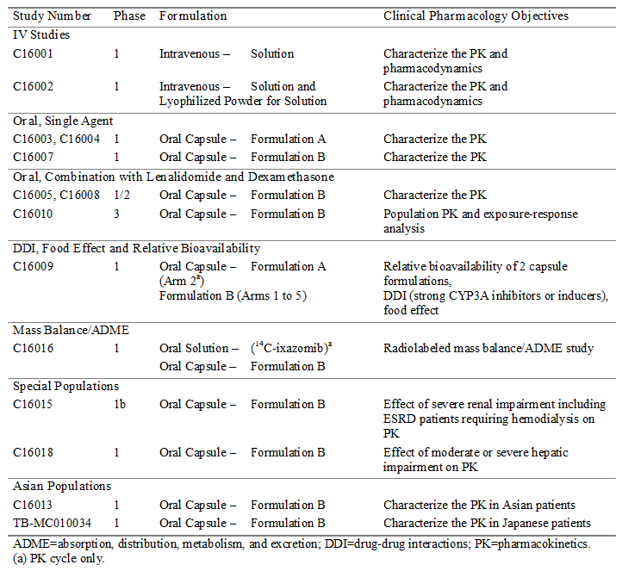

#### Analytical methods (plasma, whole blood, urine concentrations)

A single laboratory located in the US assayed all PK samples (whole blood, plasma, and urine) for ixazomib concentrations collected in the clinical program. Analysis of total radioactivity following administration of radiolabelled ixazomib in the samples collected in the mass balance Study C16016 was conducted at a second site in the US using an accelerator mass spectrometry (AMS) method. The potential enantiomer of ixazomib in clinical samples (C16016) was analysed at a third site in the US.

Ixazomib is unstable in plasma and, consequently, it required treatment with citric acid at the time of sample processing. Four methods were used to analyse the plasma samples and these were developed in the following order: (1) non-lyophilized; (2) lyophilized; (3) gelled; and (4) urea methods. The sponsor states that the methods were validated, precise and accurate. Ixazomib is stable in whole blood and addition of citric acid (as used in the plasma assay) was not required. The sponsor states that ixazomib concentrations in whole blood and urine were determined by validated and sensitive liquid chromatography tandem mass spectrometry (LC‑MS/MS) methods.

### Summary of pharmacokinetics

#### Physicochemical characteristics of the active substance

The following information is derived from the clinical summaries in the dossier. The drug substance, ixazomib citrate, is a new chemical entity and a pro-drug of ixazomib (the active moiety). The structural formula is presented below in Figure 1. The molecular formula of the drug is C20H23BCl2N2O9 and the molecular weight is 517.12 g/mol. Ixazomib citrate contains 1 chiral centre. A number of polymorphic crystal forms of ixazomib citrate were identified and characterised. One has been identified as the most thermodynamically stable form and was selected for development and commercial manufacture. The general properties of the drug were provided.

Figure 1: Ixazomib citrate, structural formula

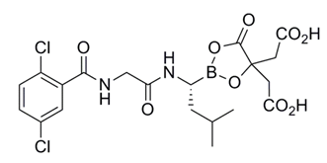

Ixazomib is classified by BCS criteria as a Class 3 compound (that is, low permeability, high solubility). In vitro dissolution studies are reported to show that ixazomib citrate is highly soluble across a broad aqueous pH range, which includes the physiological pH range (1.2 to 6.85). The drug is reported rapidly hydrolysed to ixazomib across the broad aqueous pH range tested. The capsules were reported to be rapidly dissolving, with > 85% of the drug substance dissolving within 30 minutes across the physiological pH range using the USP apparatus defined in the BCS guidance documents. Because the molecule is not ionized and its solubility remains high throughout the physiological pH range, pH is expected to have minimal impact on ixazomib absorption.

In the Caco-2 cell model, ixazomib was reported to show low permeability and appeared to be a substrate for the efflux pumps. The apparent permeability coefficient (Papp), A-to-B of ixazomib in Caco-2 cells at pH 7.4 was 2.0 x 10-6 cm/sec, and the Papp in the basolateral to-apical (B-to-A) direction was 5.8 x 10-6 m/sec at 5 µM. The Papp, A-to-B and B-to-A were 2.2 x 10-6 cm/sec and 6.8 x 10-6 m/sec at 50 µM. These results are reported to indicate that the affinity of ixazomib for efflux transporters is low. In a further study using the Caco-2 model specifically designed to classify the permeability of ixazomib using the BCS criteria, the Papp of ixazomib at 5 µM was 2.4 x 10-6 cm/sec in the A-to-B direction at both pH 6.5 and 7.4.

The partition coefficient of ixazomib citrate could not be determined experimentally because of the hydrolysis of ixazomib citrate to ixazomib in aqueous systems. The corresponding distribution coefficient at pH 7.4 is 2.00.

### Pharmacokinetics in patients with cancer

#### Absorption

##### Sites and mechanisms of absorption

Data from the clinical studies showed that ixazomib was rapidly absorbed, with a median Tmax of 1 hour and a half-life (t½) ranging from 3.6 to 11.3 days. Plasma exposures increased proportionately over the dose range 0.8 to 3.95 mg/m2 (1.4 mg to 8.9 mg of actual administered dose).

#### Bioavailability

##### Absolute bioavailability

Based on a population PK (PPK) analysis, the absolute bioavailability of ixazomib in adult patients with cancer was estimated to be 58%, with a precision [%RSE] of 9%. The PPK analysis was performed using PK data from 755 patients (108, IV administration; 647, oral administration) across 10 clinical studies, including 7 x Phase I Studies (C16001, C16002, C16003, C16004, C16007, C16013, and TB-MC010034), 2 x Phase I/II Studies (C16005, C16008) and 1 x Phase III Study C16010.

**Comment:** The submission did not include a dedicated absolute bioavailability study for ixazomib, but used data from a PPK analysis to estimate this parameter. The sponsor noted the TGA's requirements regarding the types of biopharmaceutic studies to be provided for an application to register a NCE (Australian Regulatory Guidance for Prescription Medicines [ARGPM]; Guidance 15), which include an absolute bioavailability study or in the absence of such a study a relative bioavailability study comparing the NCE to an oral solution or suspension. The sponsor provided a justification for the absence of an absolute bioavailability study in accordance with the ARGPM Guidance 15. [Information redacted] The justification was acceptable.

##### Bioavailability relative to an oral solution or micronised suspension

The submission included no relative bioavailability study comparing the oral capsule formulation of ixazomib to an oral solution or micronised suspension.

**Comment:** The only oral formulation of ixazomib proposed for registration is a capsule, with no oral suspension formulations being proposed for registration. The sponsor did not undertake a dedicated absolute bioavailability using IV and capsule formulations in a crossover design and in the absence of an absolute bioavailability study elected not to exercise the option of determining the relative bioavailability of the oral capsule compared to an oral solution or suspension of defined particle size. However, the sponsor provided a satisfactory justification for estimating the absolute bioavailability of ixazomib based on a PPK analysis. Therefore, due to no oral solution being proposed for registration and the justifiable use of a PPK analysis to estimate absolute bioavailability, the absence of a relative bioavailability study comparing the oral capsule formulation to an oral solution or micronised suspension is considered to be acceptable.

##### Bioequivalence of individual enantiomers in racemic drug substance

Ixazomib citrate contains one (1) chiral centre, but is manufactured as a single stereoisomer with the absolute R-configuration. Therefore, the requirement for studies to determine the relative bioavailabilities of the individual enantiomers in racemic drug substance is not applicable.

##### Bioequivalence of clinical trial and market formulations

The sponsor states that the capsule formulation (formulation B) and strengths (2.3, 3 and 4 mg) intended for registration in Australia were used in the single pivotal Study C16010. Consequently, no bioequivalence studies are required comparing the clinical trial and market formulations. The justification not to provide bioequivalence studies comparing clinical trial and market formulations of the three proposed strengths is considered to be acceptable.

##### Bioequivalence of different dosage forms and strengths

###### Study C16009 (Arm 2); relative bioavailability of capsules A and B (4 mg strength)

Two capsule formulations (A and B) were used throughout the development of ixazomib. Formulation A was used in the first two oral Phase I clinical studies while Formulation B was used in the subsequent ten Phase I/II and III clinical studies (including the pivotal Phase III Study C16010). Formulation B was developed to improve the stability and the manufacturability of Formulation A. Formulation B consists of ixazomib citrate, microcrystalline cellulose, magnesium stearate, and talc encapsulated in a hard gelatin capsule shell.

The bioavailability of these two formulations were compared in the Phase I Study C16009 (Arm 2), using a 2 period, 2 way crossover design. In Arm 2, adult patients with metastatic and/or advanced solid tumour malignancy or lymphoma for which no effective standard treatment was available received a single 4 mg dose of either capsule A or B on Day 1, followed by a single 4 mg dose of the alternate capsule B or A on Day 15. Twenty patients (20) of median age 64 years were enrolled and treated in Arm 2 (9 males, 11 females), and 14 patients were PK evaluable. The PK evaluable patients were defined as those who received the protocol-specified dosing regimen during Cycle 1 without dose reductions or interruptions, did not receive excluded concomitant medications through the completion of PK sampling, and had sufficient concentration time data to permit reliable estimation of PK parameters by non-compartmental analysis.

All doses were administered fasting from food and fluids, except for water and prescribed medications, for 2 hours before and 1 hour after each dose. Serial blood samples were taken at predetermined time points to assess the PK of ixazomib after administration of capsule A (reference) and capsule B (reference). Blood samples were collected at the following time points after the Day 1 and Day 15 dose of ixazomib in Cycle 1 for the measurement of plasma ixazomib concentrations: 0 (pre-dose), and then post-dose at 0.5, 1, 1.5, 2, 3, 4, 8, 24, 48, 72, 96, 168, 192, and 216 hours. Each of the time points included a suitable time window within which the sample could be collected. Plasma concentrations of ixazomib were measured using a validated LC-MS/MS assay with a dynamic range of 0.5 to 500 ng/mL.

The Cmax, Tmax, and the AUC(0-216h) were calculated after the Day 1 and Day 15 dose of ixazomib. The terminal disposition phase half-life was also calculated, if permitted by the data, after the Day 1 dose of ixazomib. For the relative bioavailability estimation of capsule B versus A, the geometric LS mean ratios for AUC(0-216h) and Cmax with associated 2 sided 90% CIs were calculated on the basis of the within-patient variance calculated via a mixed effects ANOVA fitting terms for treatment (Capsule A or Capsule B), sequence, and period as fixed effects. Patient within sequence was treated as a random effect in the model. After log transformation, AUC(0-216h) and Cmax were separately analysed. Point estimates and adjusted 90% CIs for the difference of LSM between treatments (B versus A) were calculated and then were exponentially back transformed to provide point and CI estimates for the ratios of interest. The results are summarised below in Table 2.

Table 2: Study C16009; Plasma PK parameters for ixazomib after administration of capsule A and B; PK evaluable population

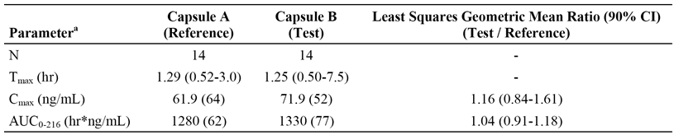

a = Values are geometric mean (%CV) for AUC(0-216h) and Cmax. Median and range are reported for Tmax.

**Comment:** A statistically significant period effect was observed in the ANOVA analysis for AUC(0-216h) indicating higher exposures in Period 2 versus Period 1 (ratio of Period 2 AUC to Period 1 AUC estimated to be 1.63). The significant period effect appears to be due to carry over effects of plasma ixazomib concentrations from Period 1 to Period 2, due to the relatively short washout period between doses compared to the long terminal half-life of the drug. The terminal half-life of ixazomib is estimated to be 9.5 days based on the PPK analysis, while the wash-out period was 15 days. It is generally accepted that in order to ensure adequate elimination following single dose administration of a drug the washout period should be at least 3 half-lives and ideally 5 half-lives. Therefore, based on a half-life of 9.5 days an acceptable washout period between dosing on C1D1 (Period 1) and C1D15 (Period 2) for ixazomib would be at least 28 days.

The statistical analysis, which was reported to have incorporated the period effect, demonstrated that total exposure (AUC(0-216h)) of ixazomib was equivalent for the two formulations, with a geometric LSM ratio (capsule B versus A) of 1.04 (90%: 0.91, 1.18). The 90% CI of the AUC(0-216h) was enclosed entirely within the accepted bioequivalence criteria of 0.8 to 1.25. The corresponding geometric LSM ratio (90% CI) for Cmax was 1.16 (90% CI: 0.84, 1.61), and the 90% CI was not enclosed entirely within the accepted bioequivalence criteria of 0.80 to 1.25 However, the difference between the Cmax values for the two formulation are unlikely to be clinically significant. The mean plasma ixazomib concentration - time plots for the two formulations were similar through to 216 hours after administration, which support the likely clinical equivalence of the two formulations following single dose administration. No separate safety data for the two formulations could be identified. Overall, the results support combining the PK data for the two formulations for those analyses requiring the pooling of data (for example, PPK analysis).

##### No studies comparing bioequivalence among different strengths

It is a requirement of the ARGPM (Guidance 15) that biopharmaceutic data assessing bioequivalence among different strengths of a NCE proposed for registration is submitted, unless otherwise justified. The sponsor proposes registration of oral capsules of 2.3 mg, 3 mg and 4 mg strengths. No clinical studies were provided assessing bioequivalence of the three proposed strengths. However, the sponsor provided a justification for not submitting the required studies. The sponsor stated that the two lower strengths were provided to allow dose reduction in patients experiencing treatment emergent toxicities with the highest strengths, and that the two lowest strengths cannot be used to "make-up" the highest 4 mg strength. In addition, all three strengths were used in the pivotal clinical Study C16010, and contributed to the benefit-risk profile of ixazomib at the proposed dosage regimen for the proposed indication. The sponsor also commented that ixazomib is a highly soluble drug that displays linear pharmacokinetics. The in-vitro dissolution results for 4 mg and 2.3 mg capsules demonstrate rapid dissolution and superimposable dissolution profiles, suggesting the same dissolution profile would occur for the 3 mg capsule strengths as observed for the 4 mg and 2.3 mg capsule strengths. Overall, the sponsor concluded that evaluation of bioequivalence among the different strengths proposed for registration is not relevant to the biopharmaceutic assessment of ixazomib.

**Comment:** The sponsor's justification for not providing clinical bioequivalence data for the different strengths of the ixazomib proposed for registration is considered to be acceptable. The in-vitro dissolution results for the 4 mg and 2.3 mg capsules referred to by the sponsor in its justification document have been examined and show that the two profiles are virtually superimposable at pH 1.2 (the most discriminatory medium). The sponsor's justification document provided a detailed argument for not providing comparative bioequivalence data for the three strengths proposed for registration based on pharmaceutical chemistry considerations. These arguments appear to be sound, but it is anticipated that the quality evaluator will evaluate the data and provide a definitive opinion.

#### Influence of food

##### Study C16009 (Arm 3) - effects of food on bioavailability

The effect of food (high fat meal) was assessed in Study C16009 (Arm 3), using a 2 period, 2 way crossover design. In this arm, adult patients with metastatic and/or advanced solid tumour malignancy or lymphoma for which no effective standard treatment was available received a single 4 mg dose of ixazomib (capsule, formulation B) under fed or fasted conditions on Day 1 and Day 15 (crossover administration). Twenty-four (24) patients with a median age of 62.5 years were enrolled and treated in Arm 3 (13 males, 11 females), and 15 patients were PK evaluable.

The fasted state was the reference for the fed state. For fasted treatment, ixazomib was administered with approximately 240 mL of water following an overnight fast of approximately 10 hours, including no medications. In addition, no food was allowed for 4 hours post-dose. Water was allowed as desired except for 1 hour before and 1 hour after drug administration. For fed treatment, following an overnight fast of approximately 10 hours, including no medications, patients started the high fat meal in the clinic at least 30 minutes before administration of ixazomib. Patients were required to finish the meal in no more than 30 minutes. The ixazomib dose was taken with approximately 240 mL water no earlier than 30 minutes after the start of the meal. No other food was allowed for at least 4 hours post-dose. Water was allowed as desired except for 1 hour before and 1 hour after drug administration. The approximate nutritional content of the high fat meal was total fat 55.6 g (500 calories), total carbohydrate 55 g (220 calories), and total protein 31 g (124 in calories). Blood samples in Arm 3 (that is, food effect study) were collected at the same time points as those described above for Arm 2 (that is, relative bioavailability arm). Plasma concentrations of ixazomib were measured using a validated LC-MS/MS assay with a dynamic range of 0.5 to 500 ng/mL.

The Cmax, Tmax, AUC(0-216h) and t½ were calculated for fed and fasted conditions. The parameters of interest were the geometric LSM ratios of the AUC(0-216h) and Cmax (fed versus fasted state) and the associated 2 sided 90% CIs. The methods used to calculate the ratios were those described above for Arm 2 of the Study C16009. The results are summarised below in Table 3.

Table 3: Study C16009; Plasma PK parameters for ixazomib after administration of ixazomib 4 mg in the fasted and fed state; PK evaluable population

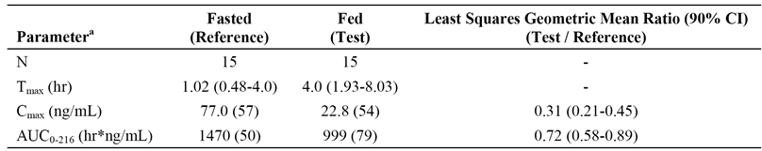

a = Values are geometric mean (%CV) for AUC0-216h and Cmax . Median and range are reported for Tmax.

**Comment:** A statistically significant period effect was observed in the ANOVA analysis for Cmax and AUC(0-216h) indicating higher exposures in Period 2 versus Period 1 (ratio of Period 2 AUC to Period 1 AUC estimated to be 2.21). The potential reason for the significant period effect has been discussed above for Arm 2 (that is, relative bioavailability) of the study. The median Tmax was 1.02 hours (fasted) and 4.0 hours (fed), indicating that a high fat meal notably delayed absorption of ixazomib from the capsule formulation. The geometric mean concentrations for Cmax and AUC(0-216h) were both lower in the fed compared to the fasting state, indicating that the high fat meal notably reduced the extent of absorption of ixazomib from the capsule formulation. The statistical analysis, which was reported to have incorporated the period effect, demonstrated that a high fat meal decreased the total systemic exposure (AUC(0-216h) of ixazomib by 28%, and decreased the Cmax by 69%. The 90% CI of the geometric LSM ratios (fed versus fasted) for both the Cmax and the AUC(0‑216h) were not enclosed within the accepted bioequivalence criteria of 0.8 to 1.25. Overall, the results support administration of ixazomib without food. The proposed PI recommends that the drug should be taken at the same time on days 1, 8, and 15 at least 1 hour before or at least 2 hours after food. This recommendation is supported by the food effect study.

#### Dose proportionality

Dose proportionality of ixazomib PK was assessed based on exploratory analyses in Studies C16001 (IV), C16002 (IV), C16003 (oral capsule formulation A), and C16004 (oral capsule formulation A) by fitting the observed data to the following power model using linear regression: ln(Y) = a + b * ln(dose) + ε. In this equation, Y was the AUC parameter (either AUC(0‑168h) or AUC(0-72h)), a and b were the estimated intercept and slope parameters, respectively, dose was the actual ixazomib dose administered in milligrams, and ε was a normally distributed error term. A value of b equal to 1.0 implies dose proportionality. If 1.0 was contained within the 95% CI for b, then the data were inferred to be consistent with dose proportionality. Definitive assessment of dose-proportionality/PK linearity was based on the cross study PPK analysis.

##### Study C16004

The most relevant exploratory dose proportionality analysis based on individual studies is considered to derived from Study C16004, as this study involved an oral capsule (formulation A) administered once weekly for 3 weeks (Days 1, 8, and 15) in 28 day cycles (that is, same days and cycle length being proposed for registration). Patients with relapsed and/or refractory (RRMM) were enrolled into the following dosing cohorts: 0.24, 0.48, 0.80, 1.20, 1.68, 2.23, 2.97, and 3.95 mg/m2. Blood samples were collected at multiple time points after dosing on Days 1 and 15 to characterise the plasma PK profile of ixazomib. After dosing on Day 1, samples were collected at 0 (pre-dose), and then post-dose at 0.25, 0.5, 1, 1.5, 2, 4, 8, 24, 48, 96, and 168 hours. After dosing on Day 15, samples were taken at 0 (pre-dose), and then post-dose at 0.25, 0.5, 1, 1.5, 2, 4, 8, 24, 48, 96, and 336 hours. The plasma PK parameters following administration on Days 1 and 15 were provided and the mean plasma ixazomib concentration time profiles following administration on Days 1 and 15 were provided.

Dose proportionality was performed for the relationship between AUC(0-168h) and actual dose (mg) using the power model described above. Data were available from 24 patients on Day 1 and 16 patients on Day 15 treated with ixazomib 0.8 to 3.95 mg/m2 (1.4 to 8.9 mg actual), and fitted to the power model. On Day 1, the calculated slope (95% CI) of the linear regression line using log transformed data was 1.34 (0.29, 2.40). The corresponding value on Day 15 was 1.01 (0.46, 1.55). Both of 95% CI intervals contained 1.0, which is consistent with dose proportionality for ixazomib over the administered dose range. The actual dose range includes the dose proposed for initiation of treatment (that is, 4 mg) and the doses proposed for downwards adjustment in the event of toxicities to the 4 mg dose (that is, 3 mg and 2.3 mg). The dose proportionality results following administration on Days 1 and 15 were presented graphically.

#### Bioavailability during multiple-dosing

The PK of ixazomib (single agent) following multiple oral dosing was assessed in Studies C16003, C16004, and C16007. The data from Studies C16004 and C16007 are considered to be the most relevant, as both studies used a once weekly for 3 weeks (Days 1, 8, and 15) in 28 day cycles regimen (that is, proposed for registration). The dosing regimen in Study C16003 was notably different from that being proposed, with ixazomib in this study being administered orally twice weekly for 2 weeks (Days 1, 4, 8, and 11) in 21 day cycles. The results from Studies C16004 and C16007 are summarised below. Non-compartmental analysis was used in both studies to calculate the PK parameters.

##### Study C16004

The data from Study C16004 have been referred to above. Plasma PK parameters were calculated for individual patients on Days 1 and 15 of Cycle 1, and ixazomib concentration versus time plots were constructed The calculated parameters included the AUC(0-168h), dose normalised AUC(0-168h), Cmax, dose normalised Cmax, Tmax, t½ (only for Day 15), and the accumulation ratio after Day 15 dosing. PK parameters were summarised using descriptive statistics. The key plasma PK parameters for Days 1 and 15 for the maximum tolerated dose (MTD) cohort (2.97 mg/m2) are summarised below in Table 4.

Table 4: Study C16004; Plasma PK parameters (geometric mean [%CV] for the ixazomib MTD cohort 2.97 mg/m2) on Days 1 and 15 after dosing on Days 1, 8 and 15

| Parameters | Day 1 (n = 24) [a] | Day 15 (n = 17) [b] |
| --- | --- | --- |
| Tmax (hr) | 1 (0.5, 4) | 1 (0.5, 4.03) |
| Cmax (ng/mL) | 69.8 (CV 61%) | 65.4 (CV 61%) |
| AUC(0-168h) (hr*ng/mL) | 906 (CV 49%) | 1710 ( CV 53%) |
| Accumulation ratio |  | 2.12 (CV 24%) |

Source: CSR, adapted from Table 11-2. Tmax is reported as median (range) [a] n = 17 for AUC(0-168h) [b] n = 10 for AUC(0- 168h).

**Comment:** The results showed that ixazomib was rapidly absorbed after oral administration, with the median Tmax being 1 hour on Days 1 and 15. After achieving Cmax, ixazomib exhibited a multi-exponential disposition profile that included a slow terminal phase that begins approximately 24 hours after both single dose and multiple dose administration. This slow terminal phase, along with limited PK sampling, prevented the accurate determination of terminal half-life after Day 1 administration. On Day 15, the geometric mean (%CV) terminal half-life of the MTD cohort (2.97 mg/m2) was 144 hours (39%).

##### Study C16007

In Study C16007, fixed doses of ixazomib (4 mg and 5.5 mg) were administered orally once weekly for 3 weeks (Days 1, 8, and 15) in 28 day cycles to patients with relapsed and/or refractory AL amyloidosis. Although the patient population is different from that being proposed for approval, it is considered that the PK information relating to the fixed dose (4 mg) cohort in this study is relevant to the starting regimen proposed for registration.

Blood samples were collected at multiple time points after Day 1 (4 mg cohort only) and Day 15 (4 and 5.5 mg cohorts) dosing in Cycle 1. Blood samples were collected at the following time points for the relevant cohorts on Day 1 and Day 15 pre-dose (within 1 hour before dosing), and then post-dose at  30 ( ± 5) minutes, 1 ( ± 0.25) hour, 2 ( ± 0.25) hours, 4 ( ± 0.75) hours, 6 ( ± 0.75) hours, 24 ( ± 1.0) hours (Days 2 and 16), and 168 ( ± 4.0) hours (Days 8 and 22). The 168 hour sample following the administration of ixazomib on Day 1 was obtained prior to the Day 8 dose. In this study, the dynamic range of the validated plasma assay was 0.5 to 500 ng/mL and was 0.5 to 250 ng/mL for the validated whole blood assay.

For each dosing cohort, mean ixazomib plasma and whole blood concentrations were determined from the individual, PK evaluable, patient data at each time point after Day 1 and Day 15 dosing during Cycle 1, and these values were used to construct the concentration versus time plots. Descriptive statistics were calculated for each dosing cohort for Cmax, Tmax, AUC(0-168h), dose normalised Cmax, dose normalised AUC(0-168h) accumulation ratio, and for the blood-to-plasma ratios for Cmax and AUC(0-168h). The plasma PK parameters following administration on Days 1, 8 and 15 for the 4 mg cohort are summarised below in Table 5, the plasma and whole blood PK parameters following administration on Days 1, 8 and 15 for both dose cohorts are summarised in Table 55, page 250 and the mean plasma ixazomib concentration time profiles for Days 1 and 15 were provided.

Table5: Study C16007; Plasma PK parameters (geometric mean [%CV] for the ixazomib 4 mg cohort on Days 1 and 15 after dosing on Days 1, 8 and 15

| Parameters | Day 1 (n = 15) [a] | Day 15 (n = 18) [b] |
| --- | --- | --- |
| Tmax (hr) | 1 (0.5, 2) | 1 (0.5, 6.08) |
| Cmax (ng/mL) | 41.6 (CV 80%) | 40.7 (CV 66%) |
| AUC(0-168h) (hr*ng/mL) | 577 (CV 142%) | 990 (CV 42%) |
| Accumulation ratio |  | 2.09 (CV 18%) |

Tmax is reported as median (range) [a] n = 14 for AUC(0-168h). [b] n = 15 for AUC(0-168h).

**Comment:** The results showed that ixazomib was rapidly absorbed after oral administration, with the median Tmax values on Days 1 and 15 being 1 hour after 4 mg dosing. The accumulation ratio based on the AUC(0-168h) was 2.09, which was consistent with the accumulation ratio of 2.12 based on the AUC(0-168) observed in Study C16004 in the MTD cohort (ixazomib 2.97 mg/m2). Higher concentrations were observed in whole blood than in plasma throughout the dosing interval, suggesting extensive partitioning of ixazomib into red blood cells. After achieving Cmax, ixazomib exhibited different disposition profiles in plasma and whole blood, with plasma concentrations declining more rapidly than whole blood concentrations during the first 24 hours post-dose. The terminal disposition phase appeared to be slow in both plasma and whole blood. The terminal half-life values in both plasma and whole blood could not be accurately estimated due to the limited PK sampling schedule in the terminal disposition phase.

### Distribution

#### Volume of distribution

The steady state volume of distribution of ixazomib is estimated to be 543 L, based on the PPK analysis. The volume of distribution is large, indicating that ixazomib is extensively distributed to the extravascular tissues.

#### Plasma protein binding

In vitro studies using a rapid equilibrium dialysis method demonstrated that ixazomib is highly bound to human serum albumin and moderately bound to human alpha 1 - acid glycoprotein AGP (see Table 6, below).

Table 6: In-vitro ixazomib protein binding assay results or human serum albumin (HSA) and human alpha 1 - acid glycoprotein (AGP) solutions after 3 hours of incubation

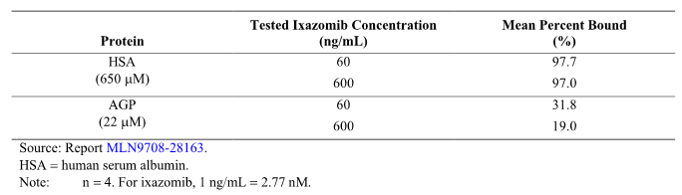

Definitive evaluation of the human in vitro free fraction in 75 patients with advanced solid tumours, lymphomas or MM from Studies C16015 (normal and impaired renal function) and C16018 (normal and impaired hepatic function) was conducted using pre-dose samples (spiked with 70 or 280 ng/mL ixazomib), to characterise the plasma protein binding of ixazomib in cancer patients. The results from Studies C16015 and C16018 are summarised below in Tables 7 and 8 respectively.

Table 7: Study C16015; Mean ± SD plasma protein binding parameters for ixazomib by renal function category; patients with MM or untreatable advanced malignant solid tumours

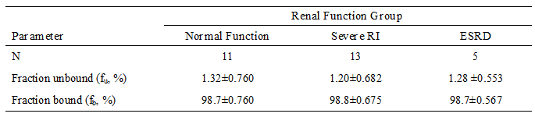

Table 8: Study C16018; Mean ± SD plasma protein binding parameters for ixazomib by hepatic function category; patients with untreatable advanced malignant solid tumour or haematological malignancies

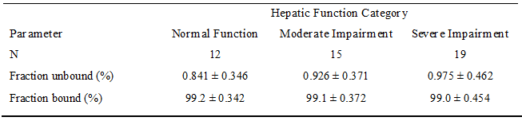

**Comment:** The data from Studies C16015 and C16018 showed that ixazomib is highly protein bound (approximately 99% both studies). Additionally, severe renal impairment (including ESRD requiring haemodialysis) and moderate or severe hepatic impairment did not significantly alter protein binding.

#### Erythrocyte distribution

In vitro studies were reported to show partitioning of ixazomib into red blood cells (RBCs) in a concentration dependent and saturable manner. Mean ± SD blood-to-plasma ratios at 0.1 µg/mL ixazomib concentrations following 10 and 60 minute incubations were 1.88 ± 0.15 and 1.96 ± 0.10, respectively, while the ratios at 1 µg/mL ixazomib concentrations following 10 and 60 minute incubations were 0.901 ± 0.060 and 0.920 ± 0.027, respectively.

Extensive partitioning of ixazomib into RBCs was confirmed in clinical Study C16007, where concentrations of ixazomib were higher in whole blood compared to plasma. In patients with AL amyloidosis receiving 4 mg ixazomib once weekly for 3 weeks (Days 1, 8, and 15) in 28 day cycles, the whole blood to plasma ratios for Cmax were 2.38 (CV = 56%) on Day 1 and 2.89 (CV = 65%) on Day 15, and for AUC(0-168h) were 12.7 (CV = 64%) on Day 1 and 9.86 (CV = 50%) on Day 15.

**Comment:** The sponsor speculates that partitioning of ixazomib into RBCs is most likely the result of ixazomib binding to RBC proteasomes.

#### Tissue distribution

There were no data on distribution of ixazomib to human tissues, other than RBCs.

### Metabolism

#### Interconversion between enantiomers

Ixazomib citrate contains 1 chiral centre and the sponsor states that it has been unambiguously determined to be the R-stereoisomer. Plasma samples from patients in Study C16016 were used to confirm the lack of chiral interconversion between enantiomers following oral dose administration (Report 96N-1425). Concentrations of ixazomib and its potentially interconverted enantiomer were measured in pooled plasma samples over 24 hours post-dose from 5 PK evaluable patients. The S-stereoisomer was reportedly not detected in any of the pooled plasma samples.

#### Sites of metabolism and mechanisms / enzyme systems involved

It was reported that in vitro studies human cDNA CYP expressing microsomes (rCYP) indicate that no specific CYP isozymes predominantly contribute to the metabolism of ixazomib and that non-CYP proteins contribute to the overall metabolism of the drug. The contribution of 7 CYP isozymes was evaluated in an in vitro study using rCYPs (Report MLN9708-31259). It was reported that CYP3A4 was the major CYP isozyme contributing to the metabolism of ixazomib, followed by CYP1A2 and CYP2B6. The relative contributions of the 7 major CYP isozymes were; 3A4 (42.3%), 1A2 (26.1%), 2B6 (16.0%), 2C8 (6.0%), 2D6 (4.8%), 2C19 (4.8%) and 2C9 (< 1%). The study was conducted at a supratherapeutic concentration of ixazomib of 10 µM, which is approximately 90 fold higher than the geometric mean clinical Cmax at the 4 mg oral once weekly dose of 0.11 µM on Day 15.

It was reported that the rate of formation of measurable metabolites and the rate of disappearance of ixazomib at concentrations of 0.1 and 0.5 µM (which are close to the clinically relevant concentration of 0.11 µM) showed little difference between the rates of metabolism of ixazomib in control incubations containing no active CYP isozymes and in rCYP isozyme incubations. These data indicate that, at clinically relevant concentrations of ixazomib, non-CYP proteins contribute to the clearance of ixazomib, and no specific CYP isozyme predominantly contribute to the clearance of the drug.

#### Non-renal clearance

Plasma systemic clearance of ixazomib is 1.86 L/hr (RSE = 7%), based on the results of the PPK analysis. Based on an estimated plasma systemic clearance (CL) of 1.86 L/hr and a blood/plasma AUC ratio of approximately 10, it can be inferred that ixazomib is a low clearance drug. Based on the absolute oral bioavailability (F) of 58% and the estimated systemic plasma clearance (CL) of 1.86 L/hr, it can be calculated that the apparent oral clearance (CL/F) of ixazomib is 3.21 L/hr.

The geometric mean terminal half-life for ixazomib is estimated to be 9.5 days based on the PPK analysis. There is an approximately 2 fold accumulation of ixazomib (based on AUC) following the Day 15 dose compared to the Day 1 dose for the once weekly schedule (Days 1, 8, 15). Trough concentrations increase throughout Cycle 1 (28 day cycle), indicating that steady state is not achieved with the once weekly dosing regimen by the time of administration of the last dose in a cycle.

#### Metabolites identified in humans

There were no definitive data in the dossier on metabolites identified in humans. The metabolism of ixazomib was explored in 3 patients after oral administration of ixazomib 2 mg/m2 twice weekly (Days 1, 4, 8, and 11 of a 21 day cycle) in Study C16003. Plasma samples obtained after dosing on Days 1 and 11 were pooled and analysed for preliminary metabolite identification. Unchanged ixazomib was the major drug related component observed on both days in human plasma. Only 1 metabolite (M8) was present in appreciable levels over the first 8 hours following dosing (approximately 10% of parent by comparison of AUC(0-8h)). Other metabolites previously identified in human liver microsomes or human hepatocytes were not detected in human plasma.

#### Consequences of genetic polymorphism

There were no data on the PK consequences of genetic polymorphisms.

### Excretion

#### Routes and mechanisms of excretion

Metabolism is expected to be the major mechanism of CL of ixazomib. Renal clearance contributes approximately only 3.5% to apparent plasma clearance (CL/F), and 6.4% to total body clearance CL.

##### Mass balance studies; Study C16016

The submission included one mass balance/ADME study in humans, Study C16016. This study was a Phase I, 2 part, open label study undertaken at a single centre in the US in patients with advanced solid tumours or lymphoma. A total of 7 patients were enrolled and included in the safety population (including 5 females), and 5 patients were included in the PK evaluable population (3 female, 2 male).

In Part A of the study, patients received a single oral dose of 4.1 mg [14C]-ixazomib on Day 1 administered as a solution containing approximately 500 nCi of total radioactivity. Blood samples were collected over the 35 day period for calculation of the plasma PK of ixazomib and total radioactivity, and identification of ixazomib metabolites. Complete urinary and faecal outputs were collected during the initial confinement period (Days 1 to 8). Total radioactivity in plasma, whole blood, urine, and faeces was measured using accelerator mass spectrometry. Metabolite profiling work is ongoing and the results were not included in the dossier.

In Part A of the study, patients returned to the clinic for 4 additional overnight visits (Days 14, 21, 28, and 35). Blood, urine and faecal samples were collected during each 24 hour overnight visit period. Patients were instructed to collect faeces for a 24 hour period before returning to the clinic for each overnight visit and these at home collections were only analysed if a faecal specimen was not produced during the overnight clinic visit. On Days 14 and 21 of Part A, patients received a single 4 mg non-radioactive dose of ixazomib as the capsule formulation. Following completion of Part A, patients were permitted to enrol in Part B of the study and ixazomib capsules were administered orally at a once weekly dose of 4 mg on Days 1, 8, and 15 of 28 day cycles.

###### Results

Ixazomib was rapidly absorbed into the systemic circulation, with a median Tmax of 0.5 hours for both parent drug and total recovered radioactivity in both plasma and whole blood. The majority of systemic exposure is attributable to ixazomib, based on the plasma AUC(0-312h)ratio of ixazomib and total recovered radioactivity (that is, % mean ± SD = 70.0 ± 14.2%).

In the 5 patients with data, the mean ± SD total recovery of the administered radioactive dose was 83.9 ± 20.7%, with 62.1 ± 21.2% of the dose being recovered in urine and 21.8 ± 3.4% of the dose being recovered in faeces. The mean ± SD urinary recovery of unchanged ixazomib in the urine was 3.2 ± 2.1% of the administered dose, suggesting that the total radioactivity in the urine (62.1%) is mostly attributable to metabolites of ixazomib.

**Comment:** The results from the mass balance study indicate that ixazomib is extensively metabolised with urinary excretion representing the predominant route of excretion of drug related material. Urinary excretion of unchanged ixazomib was 3.2% of the administered dose, indicating that renal clearance does not significantly contribute to the total clearance of the drug. Taken together, the mass balance data suggest that at least 62.1% of orally administered ixazomib was absorbed into the systemic circulation. The mean plasma AUC(0-312h) ratio of ixazomib to total radioactivity (TRA) was approximately 70%, indicating that the majority of systemic exposure to ixazomib-derived radioactivity was attributable to parent drug.

Due to stability concerns of [14 C]-labelled ixazomib and the long half-life of ixazomib, [14C]-ixazomib was administered at low specific activity and low radioactive dose. The radioactive dose administered in this study was about 200 fold lower than that typically used in traditional radiolabelled studies. To enable the quantitation of low dose radioactivity, accelerator mass spectrometry (AMS) was used to measure radioactivity. AMS counts the isotope ratio and measures the actual amount of [14C] in the sample and is reported to be greater than 1000 times more sensitive than liquid scintillating counting (LSC).

#### Renal clearance

Urinary excretion information on ixazomib was available from a Phase I study of IV ixazomib, Study C16002, and from the radiolabelled mass balance study of oral ixazomib Study C16016. In Study C16002, renal CL values on Days 1 and 15 were 0.07 L/hr and 0.06 L/hr, respectively. These values are approximately 3.5% of the total body CL estimate of 1.86 L/hr from the PPK analysis. In Study C16016, the geometric mean renal CL for oral ixazomib was 0.119 L/hr, which is 6.4% of the total body CL estimate of 1.86 L/hr from the PPK analysis and therefore qualitatively consistent with the results observed in Study C16002. Taken together, these results support the conclusion that renal CL does not significantly contribute to ixazomib total CL in humans. In Study C16016, approximately 62% of the administered radioactive oral dose was recovered in the urine and 22% was recovered in the faeces. Only 3.2% of the administered ixazomib dose was recovered in the urine as unchanged drug up to 168 hours after oral dosing, suggesting that most of the total radioactivity in urine was attributable to metabolites of ixazomib.

#### Intra and inter individual variability of pharmacokinetics

The inter individual variability in the PK of ixazomib is moderate to high with CV being greater than 50% in most studies for Cmax and AUC values. Ixazomib undergoes extensive metabolism and there is likely to be significant inter-subject differences in the metabolism of the drug in patients with cancer. There were no data in the submission on intra individual variation in the PK of ixazomib.

### Pharmacokinetics in special populations

#### Pharmacokinetics in subjects with impaired hepatic function

The PK of ixazomib in patients with impaired hepatic function was investigated in Study C16018. This was a Phase I, open label, multicentre, 2 part, 3 arm study in patients with advanced solid tumours or haematological malignancies with varying degrees of liver dysfunction as defined by the NCI Organ Dysfunction Working Group. Patients were assigned to 1 of 3 hepatic function groups (normal, moderate, severe) on the basis of their total bilirubin and aspartate aminotransferase (AST) values (see Table 9, below). The study did not include patients with mild hepatic impairment.

Table 9: Study C16018; hepatic function categories

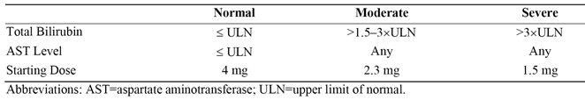

The administered ixazomib dose was lower in patients with impaired hepatic function compared to patients with normal hepatic function in order to mitigate the risk of substantially increased exposures in hepatically impaired patients. Patients with normal function, moderate or severe impairment received 4 mg (n = 12), 2.3 mg (n = 13) and 1.5 mg (n = 18) of ixazomib, respectively. Because of the long plasma terminal half-life of ixazomib, patients were administered a single oral dose of ixazomib on Day 1 of Part A, followed by 13 days without dosing to ensure adequate time for PK characterisation. Serial blood samples were collected at pre-specified time points on Days 1 through 15. The time points were pre-dose (0) and then post-dose at 0.5 h ± 5 min, 1 h ± 15 min, 1.5 h ± 15min, 2 h ± 15 min, 3 h ± 30 min, 4 h ± 45 min, 8 h ± 1 h, 24 h ± 1 h, 48 h ± 2 h, 72 h ± 3 h, 96 h ± 4 h, 120 h ± 4 h, 144 h ± 4 h, 168 h ± 4 h, 240 h ± 4 h, 264 h ± 4 h, and 336 h ± 4 h. After collection of the last PK sample on Day 15 (completion of Part A), patients had the option of continuing in Part B of the study. During Part B, patients received ixazomib on Days 1, 8, and 15 of a 28 day cycle at the same dose as administered in Part A, unless adjustment was required for safety, tolerability, or a change in hepatic function.

The sponsor stated that the dose linear PK of ixazomib allowed the analysis of the effect of hepatic impairment on ixazomib PK to be based on comparisons of dose normalised PK parameters (to account for the different doses of ixazomib administered based on the degree of hepatic impairment). For estimation of the effect of hepatic impairment on the PK of ixazomib, separate mixed effect ANOVAs on natural log transformed, unbound dose normalised Cmax and AUC(0-last) were performed, with hepatic function group as a fixed effect. Geometric LSM ratios for the Cmax and AUC(0-last) values for the comparisons of interest were calculated using standard back transformation methods. The normal hepatic function group was the reference group for each of the two hepatic impairment groups and the combined hepatic impairment groups. The results for the geometric LSM ratios are summarised below in Table 10. The results for the PK parameters for patients with normal hepatic function and with moderate and severe hepatic function were summarised and the concentration time profiles were provided.

Table 10: Study C16018; Geometric least squares mean ratios (90% CI) for unbound dose normalised Cmax and AUC(0-last)

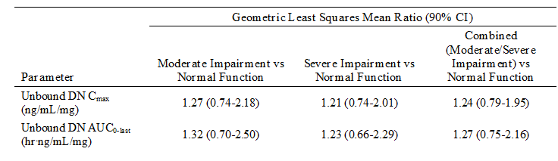

Source: CSR, Table 11.c. Abbreviations: AUC0-last = area under the plasma ixazomib concentration time curve from time 0 to the time of the last quantifiable concentration; CI = confidence interval; Cmax = maximum observed plasma concentration; DN = dose normalised

**Comment:** The results indicate that moderate and hepatic impairment both increased systemic exposure to ixazomib by 32% and 23%, respectively, based on unbound dose normalised AUC(0-last). In addition, moderate and hepatic impairment both increased the unbound dose normalised Cmax by 27%% and 21%, respectively. The results were similar for patients with moderate and severe hepatic impairment. The results suggest that a 3 mg dose of ixazomib in patients with moderate or severe hepatic impairment would be expected to result in similar exposure (based on unbound AUC) to a 4 mg dose of ixazomib in patients with normal hepatic function. The sponsor proposes a starting dose of 3 mg in patients with moderate or severe hepatic impairment. There was no dedicated study assessing the effect of mild hepatic impairment on the PK of ixazomib. However, based on the results of the PPK analysis no dose adjustment of ixazomib is required for patients with mild hepatic impairment.

#### Pharmacokinetics in subjects with impaired renal function

The PK of ixazomib in patients with impaired renal function was investigated in Study C16015. This was a Phase I/Ib, open label, multicentre, 2 arm study in patients with RRMM or advanced solid tumours with normal renal function or severe renal impairment (CrCL < 30 mL/min, including end stage renal disease [ESRD]). The study planned to enrol 28 PK evaluable patients, including 12 in Arm 1 (normal renal function) and 16 in Arm 2 (severe renal impairment including 6 with ESRD on haemodialysis).

The study was conducted in 2 parts. In Part A, patients received a single, 3 mg oral dose of ixazomib administered fasting on Day 1. PK blood samples were taken on Day 1 through to Day 15 at predetermined time points and a PK analysis was conducted after the completion of Part A. Patients in Part A who did not have adequate PK assessments or who did not follow the study design were to be replaced.

In patients with normal renal function and severe RI, blood samples were collected at the following times after the administration of ixazomib on Day 1: pre-dose (0), and then post-dose at 30 ± 5 minutes, 1 ± 0.25 hours, 1.5 ± 0.25 hours, 2 ± 0.25 hours, 3 ± 0.5 hours, 4 ± 0.75 hours, 8 ± 1.0 hours, 24 ± 1.0 hours (Day 2), 29 ± 1 hours (Day 2) for patients on dialysis, 30 ± 1 hours (Day 2) for patients on dialysis, 48 ± 2.0 hours (Day 3), 72 ± 3.0 hours (Day 4), 96 ± 4.0 hours (Day 5), 120 ± 4.0 hours (Day 6), 144 ± 4.0 hours (Day 7),168 ± 4.0 hours (Day 8), 240 ± 4.0 hours (Day 11), 264 ± 4.0 hours (Day 12), and 336 ± 4.0 hours (Day 15). Plasma concentrations of ixazomib were measured using a validated LC/MS/MS assay with a dynamic range of 0.5 to 500 ng/mL.

Additionally, pre- and post-dialyser samples were to be collected from the lines at the following times during the first haemodialysis session: initiation of HD (± 0.5 hours) (24 hours post-dose]), 1 ± 0.25 hours after initiation of HD (25 hours post-dose), 2 ± 0.25 hours after initiation of HD (26 hours post-dose, 3 ± 0.25 hours after initiation of HD (27 hours post-dose), and 4 ± 0.25 hours after initiation of HD (28 hours post-dose).

Patients who tolerated ixazomib in Part A could choose to participate in Part B of the study, which began following collection of the Day 15 PK sample of Part A. Oral ixazomib was administered in Part B on Days 1, 8, and 15 of each 28 day cycle. The first dose of ixazomib administered in Part B was 4 mg for those patients who tolerated the dose in Part A, or alternatively, a dose of 3 or 2.3 mg was administered per protocol dose modification guidelines. At the discretion of the investigator, dexamethasone (40 mg or 20 mg [patients aged > 75 years]) were administered to patients with RRMM on Days 1, 8, 15, and 22 in Part B. In Part B of the study, pre-dose blood samples were collected on Days 1, 8, and 15 of Cycle 1, and on Day 1 of Cycles 2, 3, and 4.

For the estimation of the effect of renal impairment (RI) on the PK of ixazomib, separate mixed effects ANOVA on the natural log transformed, unbound Cmax and AUC(0-last) were performed, with renal function group as a fixed effect. Geometric LSM ratios for the Cmax and AUC(0-last) values for the comparisons of interest were calculated using standard back transformation methods. The normal renal function group was the reference group for each of the two renal impairment groups and for the combined renal impairment group. The results for the geometric LSM ratios of interest are summarised below in Table 11. The results for the PK parameters for patients with normal renal function and with renal impairment were summarised and the concentration time profiles were provided.

Table 11: Study C16015; Geometric least squares mean ratios (90% CI) for unbound dose normalised Cmax and AUC(0-last)

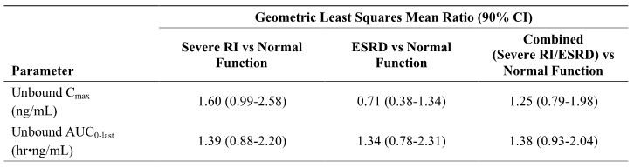

Source: CSR, Table 11.c. Abbreviations: AUC(0-last) = area under the plasma ixazomib concentration time curve from time 0 to the time of the last quantifiable concentration; CI = confidence interval; Cmax = maximum observed plasma concentration; ESRD = end-stage renal disease; RI = renal impairment.

In the 6 ESRD patients requiring haemodialysis, ixazomib concentrations were similar in the pre- and post-dialyser lines throughout the haemodialysis session (see Figure 2, below). Therefore, ixazomib does not appear to be readily dialysable, which is consistent with its high plasma protein binding.

Figure 2: Study C16015; Mean (SD) ixazomib concentrations in samples collected from the pre-and post-dialyser lines during the haemodialysis session occurring 24 to 48 hours after ixazomib administration in Part A of the study; PK evaluable population

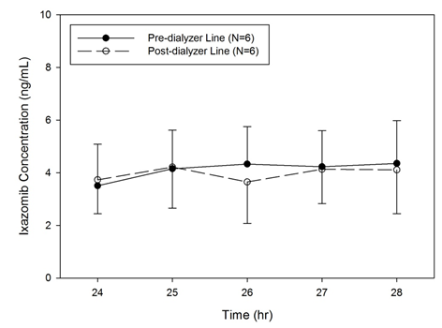

**Comment:** The results indicate that severe RI and ESRD requiring haemodialysis both increased systemic exposure to ixazomib by 39% and 34%, respectively, based on unbound AUC(0-last). The results suggest that the effects on exposure of severe RI and ESRD requiring haemodialysis are similar, with exposure based on unbound AUC(0-last) being increased by 38% in the combined severe RI/ESRD group compared to the normal renal function group. Severe renal impairment increased the unbound Cmax by 60% compared to normal renal function, while ESRD reduced the Cmax by 29% compared to normal renal function. However, unbound Cmax increased by 25% in the combined severe RI/ESRD group compared to normal renal function. The results suggest that a 3 mg dose of ixazomib in patients with severe RI (including patients with ESRD requiring haemodialysis) would be expected to result in similar exposure (based on unbound AUC) to a 4 mg dose of ixazomib in patients with normal renal function. The sponsor proposes a starting ixazomib dose of 3 mg in patients with severe renal impairment (CrCl < 30 mL/min) or ESRD requiring dialysis). There was no dedicated study assessing the effect mild or moderate RI on the PK of ixazomib. However, based on the results of the PPK analysis the sponsor proposes no ixazomib dose adjustment in patients with mild or moderate renal impairment (CrCL ≥ 30 mL/min). Ixazomib is not dialysable and can be administered without regard to the timing of haemodialysis.

#### Pharmacokinetics according to age

Age was not a statistically significant covariate in the PPK analysis, indicating that the PK of ixazomib is similar across the age range examined (median age 65 [range: 23 to 91 years]). In the final PPK model, age (covariate) had no significant effect on clearance, absolute oral bioavailability, or the volume of the second peripheral compartment. Individual predicted exposures following a single 4 mg ixazomib dose were also calculated using the final model. The model showed that the percent difference in the AUCinf at the 5th and 95th percentiles of age relative to the median AUCinf were -14% (95% CI: -19, 9) and 12% (95% CI: 8, 17), respectively. The magnitudes of percent difference in AUCinf at the 5th or 95th percentiles of age relative to the median AUCinf was < 20%, and these values were well below the variability in AUCinf in the study population (that is, 5th or 95th percentiles of individual predicted exposures were -50% and +98% relative to the median AUCinf). The correlation between age and individual predicted exposures in patients receiving oral ixazomib is summarised below in Figure 3.

Figure 3: Correlation between age and individual predicted exposures in patients receiving oral ixazomib 4 mg

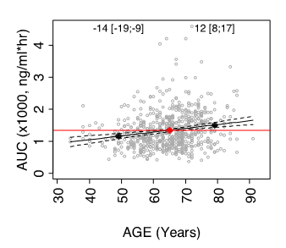

Source: PPK Report, Figure 21. Red and black dots indicate the median and 5th and 95th percentile of individual covariate values. Numbers (brackets) show the percent change in AUCinf at the 5th and 95th percentile relative to the value at the median, based on the shown linear regression (and 95% CI).

**Comment:** Based on the data from the PPK analysis, no dose adjustment is required on the basis of age in adults. The PK of ixazomib have not been characterised in a paediatric population.

#### Pharmacokinetics according to sex

Sex was not a statistically significant covariate in the PPK analysis (males = 371, females = 276). In the final PPK model, sex (covariate) had no significant effect on clearance, absolute oral bioavailability, or the volume of the second peripheral compartment. Individual predicted exposures following a single 4 mg ixazomib dose were also calculated using the final model. The model showed that the median AUCinf was 13% (95% CI: 6, 21) higher in males compared to females. The magnitude of the percent difference in AUCinf between females and males was < 20%, suggesting no clinically meaningful difference in exposures between the two groups. The boxplots for individual predicted exposure stratified by sex for patients receiving oral ixazomib 4 mg is summarised below in Figure 4.

Figure 4: Boxplots for individual predicted exposure stratified by sex for patients receiving oral ixazomib 4 mg

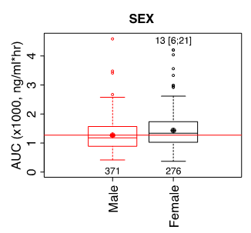

Source: PPK Report Figure 22. Red and black dots indicate the mean exposure in the most prevalent category and in other categories, respectively. Numbers (brackets) in the top of plots show the percent change in AUCinf (with 95% CI) in other categories relative to the most prevalent category, while numbers at the bottom show patients in each category.

**Comment:** Based on the data from the PPK analysis, no dose adjustment is required based on sex.

#### Pharmacokinetics according to race

##### PPK analysis

The effect of race on the PK of ixazomib was investigated in the PPK analysis. Based on the final PPK model, race was not identified as a statistically significant covariate on clearance, absolute oral bioavailability, or the volume of the second peripheral compartment. Individual predicted exposures following a single 4 mg ixazomib dose were also calculated using the final model. The percent changes in median AUCinf for the racial categories examine relative to the most common category (White) were 35% (95% CI: 25, 45) for Asian, 6% (95% CI: -9, 20) for Black, and -5% (95% CI: -25, 14) for Other. The boxplots for individual predicted exposure stratified by race for patients receiving oral 4 mg ixazomib are summarised below in Figure 5.

Figure 5: Boxplots for individual predicted exposure stratified by race for patients receiving oral ixazomib 4 mg

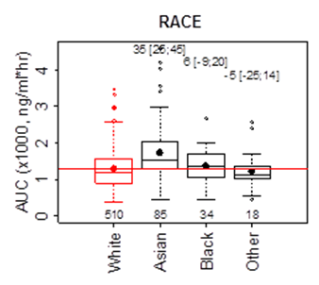

Source: Population PK Report Figure 21. Red and black dots indicate the mean exposure in the most prevalent category and in other categories, respectively. Numbers (brackets) in the top of plots show the percent change in AUCinf (with 95% CI) in other categories relative to the most prevalent category, while numbers at the bottom show patients in each category.

There was no clinically meaningful difference in AUCinf (< 20%) between Whites and Blacks. However, the median AUCinf was > 20% higher in Asian patients than in Whites, although there was an overlap in AUCinf across the two race groups. The sponsor states that, despite the higher AUCinf in Asian patients, exposures achieved after a 4 mg weekly dose in Asian subjects are not expected to exceed exposures observed at the maximum tolerated dose of MTD of 5.5 mg in "Western" subjects. The sponsor states that, "based on these considerations, and considering that the adverse events following ixazomib treatment are monitorable, reversible and manageable through protocol-specified dose modification guidelines, no prospective starting dose adjustment is proposed for Asian patients". The sponsor commented that patients across races, including patients enrolled in Asian countries, are being administered a common global dose of ixazomib in the ongoing Phase III clinical program, including the pivotal Study C16010.

**Comment:** Based on the PK data from the PPK analysis and the safety data from the pivotal Study C16010, it is considered that no dose adjustment based on race is required.

#### PK studies specifically in Asian patients

The submission included two studies in Asian patients, including Study C16013 in Asian patients with RRMM and Study TB-MC010034 in Japanese patients with RRMM. The PK results from these two studies are summarised below.

##### Study C16013

In Study C16013, ixazomib (4 mg) was administered orally once weekly for 3 weeks (Days 1, 8, and 15) in 28 day cycles to adult Asian patients (n = 24) with RRMM (that is, 10 Chinese, 10 Korean and 4 Other [Singapore, Hong Kong and South Korea]). Patients also received lenalidomide (25 mg) on Days 1 through 21, and dexamethasone (40 mg) on Days 1, 8, 15 and 22, in 28 day cycles. Blood samples were collected at multiple time points after ixazomib administration on Days 1 and 15 of Cycle 1 to characterise the PK of ixazomib in combination with lenalidomide and dexamethasone (LenDex). The ixazomib concentration time profiles on Days 1 and 15 are presented below in Figure 6 and the PK parameters were provided.

Figure 6: Study C16013. Mean plasma ixazomib concentration time profiles on Day 1 (left panel) and Day 15 (right panel) following once weekly oral administration of ixazomib 4 mg in combination with LenDex in Asian patients with RRMM

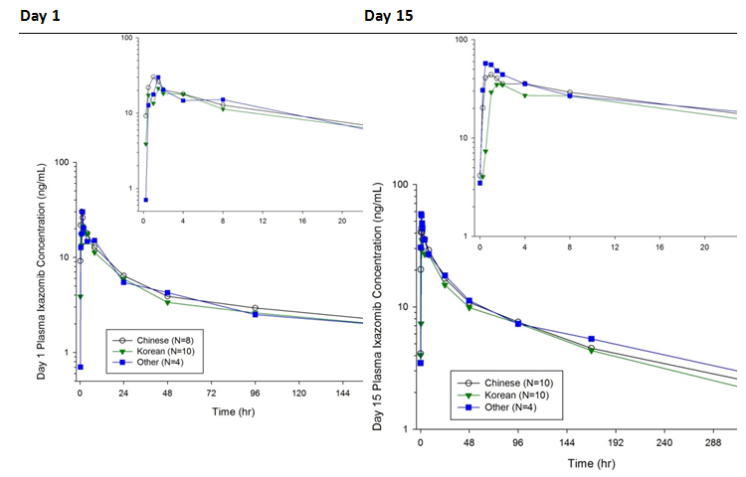

Source: CSR, Figures 11-1 and 11-3. The insets show mean plasma ixazomib concentration over the first 24 hours following dosing on Days 1 and 15.

Ixazomib was rapidly absorbed after oral administration on both Days 1 and 15 with the overall median Tmax in Asian patients being 1.5 hours and 2 hours, respectively. Ixazomib plasma concentrations declined in a multi-exponential manner with a slow terminal phase. The overall geometric mean terminal half-life after multiple dosing was 144 hours (6 days) and the geometric mean accumulation ratio for AUC(0-168h) on Day 15 was 2.46. AUC(0-168h) values in the 3 Asian subgroups were similar after both single and multiple dosing, with a < 25% difference in the Day 15 geometric mean AUC(0-168h) being observed noted across the Asian subgroups/races. When viewed in relation to the overall PK variability, the data suggest that the observed differences in ixazomib exposures among the Asian subgroups evaluated in this study are unlikely to be clinically significant. However, the data should be interpreted cautiously due to the small number of patients from the different Asian subgroups.

##### Study TB-MC010034

In Study TB-MC010034, 4 mg ixazomib was administered orally once weekly for 3 weeks (Days 1, 8, and 15) in 28 day cycles to Japanese patients with RRMM. Two cohorts were studied, including ixazomib monotherapy and ixazomib combination therapy with 25 mg of lenalidomide (Days 1 to 21, once daily) and 40 mg of dexamethasone (Days 1, 8, 15, and 22). Blood samples were collected at multiple time points after dosing on Days 1 and 15 of Cycle 1 to characterise the plasma PK profile of ixazomib. The ixazomib concentration time profiles on Days 1 and 15 are presented below in Figure 7 and the PK parameters were provided.

Figure7: TB-MC010034; Mean plasma ixazomib concentration time profiles on Day 1 (left panel) and Day 15 (right panel) following once weekly oral administration of ixazomib 4 mg in Japanese patients with RRMM for monotherapy and combination LenDex cohorts

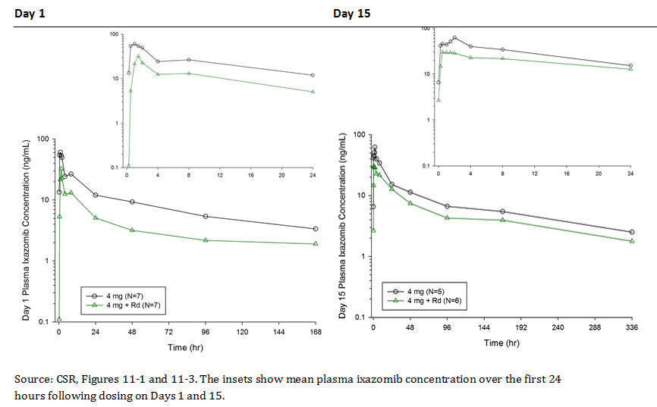

Mean plasma concentrations of ixazomib in the ixazomib monotherapy cohort were higher than in the combination therapy cohort on Day 1, and similar profiles for ixazomib were observed in the ixazomib monotherapy and combination therapy cohorts on Day 15. Ixazomib was rapidly absorbed after single and multiple oral dose administration, both as monotherapy and combination therapy, with a median Tmax of 1 to 2 hours. After Tmax, ixazomib concentrations declined in a multi-exponential manner with a slow terminal phase (geometric mean terminal half-life of 125 hours in the combination therapy cohort to 137 hours in the monotherapy cohort). The accumulation ratios for AUC(0-168h) after monotherapy and combination therapy were approximately 2.1 and 1.8, respectively.

### Pharmacokinetic interactions

#### Effect of lenalidomide/dexamethasone on PK of ixazomib

Five studies have been conducted with oral ixazomib in combination with LenDex. PK data for ixazomib derived from non-compartmental analysis following oral ixazomib in combination with LenDex were available from 2 studies in patients with MM (C16005, C16008) and 2 studies in Asian patients with RRMM (C16013 and TB-MC010034). In addition, the Phase III Study C16010 included sparse PK sampling to contribute to the population PK and exposure response (E-R) analyses.

### PK parameters derived from non-compartmental analysis

The PK parameters for ixazomib co-administered with LenDex, Studies C16005 and C16008 were similar to those observed when ixazomib was administered as a single agent, Studies C16004, and C16003. In order to compare the plasma PK of ixazomib following ixazomib administered as monotherapy and in combination with Len/Dex, a cross study comparison of data from the ixazomib once a week Studies C16004 (monotherapy) and C16005 (combination) for the 2.97 mg/m2 cohorts are summarised below in Table 12. The 2.97 mg/m2 dose of ixazomib was chosen as this dose was determined to be the MTD in both Studies C16004 and C16005 and more patients in both studies were exposed to this dose than to other doses. In both Studies (C16004, C16005), ixazomib was administered once weekly on Days 1, 8, and 15 of a 28 day cycle with plasma PK parameters for ixazomib being calculated in the first cycle. In the combination Study (C16005), ixazomib was combined with dexamethasone 40 mg on Days 1, 8, 15, and 22 and lenalidomide 25 mg on Days 1 through 21 of a 28 day cycle. Patients in Study C16004 had RRMM and patients in Study C16005 had previously untreated NDMM.

Table 12: Comparison of the plasma PK of ixazomib in patients (RRMM) treated with ixazomib monotherapy (Study C16004) or patients (NDMM) with ixazomib in combination with Len/Dex (Study C16005) on Days 1 and 15

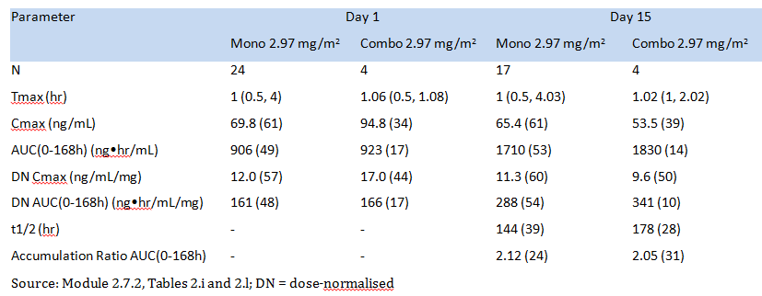

**Comment:** Systemic exposure parameters based on plasma ixazomib AUC(0-168h) were greater for ixazomib in combination with Len/Dex than for ixazomib monotherapy on both Days 1 and 15. However, the difference in systemic exposure between the two treatment regimens is unlikely to be clinically significant, as on both days the difference in the AUC(0-168h) parameters between the two regimens was < 20%.

### PPK analysis

Based on the final PPK model, the Len/Dex combination was not identified as a statistically significant covariate on ixazomib clearance, absolute oral bioavailability, or the volume of the second peripheral compartment. Individual predicted exposures following a single 4 mg ixazomib dose were also calculated using the final model. The percent increase in the median AUCinf of ixazomib when ixazomib was combined with Len/Dex was 7% (95% CI: 0, 17) lower than when ixazomib was administered alone. The magnitude of the percent increase in ixazomib AUCinf was < 20%, suggesting no clinically meaningful difference in ixazomib exposure between the two regimens. The boxplots for individual predicted exposure stratified by Len/Dex and single agent for patients receiving oral 4 mg ixazomib are summarised below in Figure 8.

Figure 8: Boxplots for individual predicted ixazomib exposure stratified by Len/Dex combination and singe-agent regimens for patients receiving oral ixazomib 4 mg

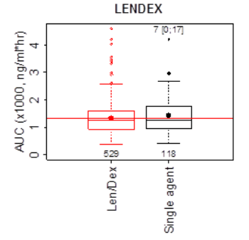

Source: PPK Report Figure 22. Red and black dots indicate the mean exposure in the most prevalent category and in other categories. Numbers (brackets) in the top of plots show the percent change in AUCinf (with 95% CI) in other categories relative to the most prevalent category, while numbers at the bottom show patients in each category.

#### Effect of ixazomib on the PK of lenalidomide/dexamethasone

There were no clinical data in the submission assessing the effect of ixazomib on the PK of Len/Dex.

### Drug-Drug interactions (DDI); in vitro

#### CYP effects

##### CYP inhibitors

Hepatic metabolism appears to be the major route of elimination of ixazomib following oral administration. In vitro studies are reported to show that ixazomib is metabolised by multiple CYP450 and non-CYP enzymes. In vitro data were reported to show that CYP3A4 was the major CYP isozyme contributing to the metabolism of ixazomib at supratherapeutic concentration of 10 µM, followed by CYP1A2 and then CYP2B6. The reported relative contributions of the 7 major CYP isozymes to the in vitro metabolism of ixazomib were; 3A4 (42.3%), 1A2 (26.1%), 2B6 (16.0%), 2C8 (6.0%), 2D6 (4.8%), 2C19 (4.8%) and 2C9 (< 1%). The relative contribution of both CYP3A4 and CYP1A2 to the in vitro metabolism of ixazomib was greater than 25%. Therefore, these two CYP isozymes were selected for clinical DDI assessment based on the recommendation in the relevant TGA guideline recommending that, "in general, enzymes [CYP and non-CYP] involved in metabolic pathways estimated to contribute to ≥ 25% of drug elimination should be identified and if possible the in vivo contribution quantified" (Guideline on the Investigation of Drug Interactions [CPMP/ EWP/560/95/Rev.1/Corr. 2**/21 June 2012]).

###### Co-administration of ixazomib with CYP3A inhibitors

In Study C16009, the effects of two strong CYP3A4 inhibitors (ketoconazole and clarithromycin) on the PK of ixazomib were assessed in patients with advanced non-haematological malignancy or lymphoma.

In Arm 1, the effect of repeat oral doses of ketoconazole on the PK of a single oral dose ixazomib was investigated using a 2 period, fixed-sequence design in 16 patients. Ketoconazole 400 mg was administered once daily on Day 12 through 25 during Cycle 1 and ixazomib 2.5 mg was administered on Days 1 and 15 during Cycle 1. All doses were administered fasting from food and fluids, except water and prescribed medications, for 2 hours before and 1 hour after each dose. Serial blood samples were taken at predetermined time points after ixazomib administered alone on Day 1 and after ixazomib co-administered with ketoconazole on Day 15.

In Arm 1, when ixazomib was co-administered with ketoconazole in Period 2, the geometric mean AUC(0-264h) was higher than the value observed when ixazomib was administered alone in Period 1 (1150 versus 552 hr.ng/mL, respectively). The geometric LSM ratio (with ketoconazole versus without ketoconazole) for the AUC(0-264h) was 2.08 (90% CI: 1.91, 2.27). The geometric mean Cmax was similar with and without ketoconazole (39.3 versus 39.0 ng/mL, respectively). The corresponding geometric LSM ratio (90% CI) for Cmax was 1.01 (90% CI: 0.78, 1.30). The results suggest a clinically significant effect of ketoconazole on systemic exposure to ixazomib, based on an approximately 2 fold increase in ixazomib AUC(0-264h) observed with ixazomib plus ketoconazole compared to ixazomib alone.

However, statistical analysis of PK data from Arms 2 and 3 of Study C16009 demonstrated an unanticipated period effect on plasma exposures of ixazomib. In both Arm 2 (relative bioavailability analysis; capsule B versus A) and Arm 3 (effect of food analysis on capsule B) a 2 period, 2 way, crossover design was used to compare the two treatments of interest. The statistical analysis showed significantly higher exposures in Period 2 compared to Period 1, with Period 2 versus Period 1 exposure ratios based on AUC(0-216h) estimated to be 1.63 for Arm 2 and 2.21 for Arm 3. Therefore, the true treatment effect of a strong inhibitor of CYP3A such as ketoconazole on the PK of ixazomib may be confounded by a potential period effect, resulting in an overestimation of the geometric LSM ratio for AUC.

Consequently, to further characterise the effect of a strong CYP3A inhibitor on the PK of ixazomib, an additional arm (Arm 5) was added to the study to investigate the effect of clarithromycin (a strong CYP3A4 inhibitor) on the single dose PK of ixazomib. In Arm 5, clarithromycin was used rather than ketoconazole due to the fact that in 2013, after completion of Arm 1, the FDA advised against using oral ketoconazole in DDI studies because of potential serious side effects. In Arm 5, 21 patients were enrolled and 15 were included in the PK analysis. In Cycle 1 (21 day PK cycle), the 15 patients in the PK analysis received a single 2.5 mg oral dose of ixazomib (Capsule B) on Day 6 and oral clarithromycin at a dose of 500 mg BD on Days 1 through 16. Ixazomib was administered fasting from food and fluids except water and prescribed medications, for 2 hours before and 1 hour after each dose.

Serial blood samples for PK assessment were taken at pre-determined time points after ixazomib and clarithromycin administration, starting on Day 6 (that is, after 5 days on clarithromycin). Blood samples were collected at the following time points after ixazomib administration in Cycle 1 for the measurement of plasma ixazomib concentrations: 0 (pre-dose) and then post-dose at 0.5, 1, 1.5, 2, 3, 4, 8, 24, 48, 72, 96, 168, 240, and 264 hours. Each time‑point had an appropriate time window during which the sample could be collected. There were no ixazomib alone reference data collected in Arm 5. Therefore, the data collected from the 16 patients in Arm 1, following the first dose of ixazomib (that is, the Day 1 dose of Cycle 1 [Period 1]), were used as the without clarithromycin reference treatment for the assessment of the effect of clarithromycin on the PK of ixazomib.

In Arm 5, Cmax, Tmax, and AUC(0-264h) were calculated. For the estimation of the effect of clarithromycin on the PK of ixazomib, the ixazomib geometric LSM ratios (with 90% CI) were calculated for AUC(0-264h) and Cmax (with clarithromycin [Arm 5] versus without clarithromycin [Day 1 of Cycle 1 in Arm 1]). The calculations used separate mixed effects ANOVA models, fitting terms for treatment. The methods were standard for calculating geometric LSM ratios (with 90% CI) for between treatment comparison of Cmax and AUC. Based on previous data, it was estimated that 16 patients in each treatment group would provide for the 90% CI of the relevant ratios of Cmax and AUC(0-264h) to be contained within the interval 0.70 to 1.43 (presumably indicating no clinically meaningful DDI). The results for the analysis are summarised below in Table 13, and the plasma ixazomib concentration time profiles were provided.

Table 13: Study C16009; Plasma PK parameters for ixazomib with and without co‑administration of clarithromycin; PK evaluable population

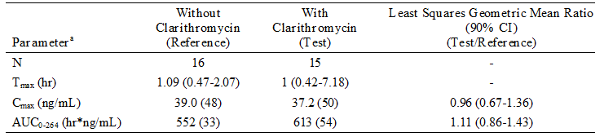

Source: CSR (addendum), Table 2.e. [a] = Geometric mean (CV%) for AUC(0-264h) and Cmax; median and range for Tmax.

**Comment:** The plasma ixazomib PK parameters were similar for ixazomib with clarithromycin (Arm 5) and ixazomib without clarithromycin (Arm 1). The 90% CI of the ixazomib geometric LSM ratio (Test/Reference) for AUC(0-264h) was 0.86 to 1.43, which was almost entirely enclosed within the pre-specified interval of 0.70 to 1.43. The results indicate that no ixazomib dose adjustment is required when the drug is co-administered with strong CYP3A4 inhibitors.

###### Co-administration of ixazomib with CYP1A2 inhibitors

The effect of strong CYP1A2 inhibitors (ciprofloxacin) on the PK of ixazomib was examined in the PPK analysis as a time dependent categorical covariate. The analysis dataset included 36 patients on ciprofloxacin during the active ixazomib treatment period. No significant effects of strong CYP1A2 inhibitors on ixazomib clearance could be identified. The PPK model estimated a 9% higher median ixazomib AUCinf (95% CI: 6, 12%) for patients receiving strong CYP1A2 inhibitors compared to those not receiving strong CYP1A2 inhibitors. However, a limitation of the analysis was that only 36 patients (that is, 1.4% of the total patient population) took ciprofloxacin. Nevertheless, the limited data from the PPK analysis suggest that no dose adjustment is necessary for ixazomib when co-administered with strong CYP 1A2 inhibitors.

##### CYP inducers

###### Co-administration of ixazomib with CYP3A4 inducers

Study C16009 (Arm 4) investigated the effect of rifampin on the PK of ixazomib; rifampin is a pleiotropic inducer of multiple PXR inducible drug metabolising enzymes and transporters and a strong CYP3A inducer. In Arm 4, 18 patients with advanced non-haematological malignancies or lymphoma were enrolled and 16 were included in the PK analysis. After 7 days of pre‑treatment with rifampin (600 mg once daily on Days 1 to 7 of Cycle 1), 16 patients received a single oral dose of ixazomib 4 mg on Day 8 of Cycle 1 (the 21 day PK cycle) and administration of rifampin continued on Days 8 to 14 of Cycle 1. Blood samples were collected at the following time points after ixazomib administration in Cycle 1 Day 8 for the measurement of plasma ixazomib concentrations: 0 (pre-dose) and then post-dose at 0.5, 1, 1.5, 2, 3, 4, 8, 24, 48, 72, 96, and 168 hours. The reference data for ixazomib alone were from 14 patients in Arm 2, following the first dose of ixazomib administered alone (that is, the Day 1 dose of Cycle 1 [Period 1]).

In Arm 4, Cmax, Tmax, and AUC(0-last) were calculated. For the estimation of the effect of rifampin on the PK of ixazomib, the ixazomib geometric LSM ratios (with 90% CI) were calculated for AUC(0-last) and Cmax (with rifampin [Arm 4] versus without rifampin [Day 1 of Cycle 1 in Arm 2]). The calculations used separate mixed effects ANOVA models, fitting terms for treatment. The methods were standard for calculating geometric LSM ratios (with 90% CI) for between treatment comparison of Cmax and AUC. Based on previous data, it was estimated that 14 patients in the ixazomib group and 16 patients in the ixazomib plus rifampin group would provide for the 90% CI of the relevant Cmax and AUC(0-last) ratios to be contained within the interval 0.70 to 1.43 (presumably indicating no clinically meaningful DDI). The results for the analysis are summarised below in Table 14, and the plasma ixazomib concentration time profiles were provided.

Table 14: Study C16009; Plasma PK parameters for ixazomib with and without co‑administration of rifampin; PK evaluable population

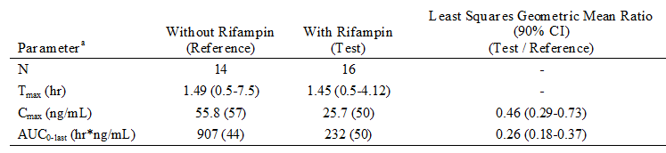

Source: CSR, Table 11.e [a] = Geometric mean (CV%) for AUC(0-264h) and Cmax; median and range for Tmax.

**Comment:** The results showed a notable reduction in ixazomib exposure following co-administration with rifampin, with a 76% reduction in systemic exposure based on the AUC(0-last) and a 54% reduction based on the Cmax. The results suggest a clinically significant DDI will be observed when ixazomib and potent CYP3A4 inducers are co‑administered. The sponsor speculates that the findings are largely explained by the increased contribution of PXR-inducible enzymes and possibly P-gp mediated efflux transport to the total clearance of ixazomib under induced conditions achieved with treatment with a strong inducer like rifampin. Based on these data, the co-administration of strong CYP3A inducers with ixazomib is not recommended.

###### Co-administration of ixazomib with CYP1A2 inducers

CYP1A2 activity is induced by smoking. In the PPK analysis, smoking status was not identified as a significant covariate on the PK of ixazomib (that is, clearance, absolute oral bioavailability, or volume of the second peripheral compartment). Individual predicted exposures following a single 4 mg ixazomib dose were also calculated using the final model. The percent decrease in median ixazomib AUCinf for patients who were current smokers compared to patients who had never smoked was 8% (95% CI: -23, 9). The magnitude of percent difference in AUCinf between patients who self-identified as current smokers and patients who had never smoked was < 20%, suggesting no clinically meaningful difference in exposures between the two groups. However, it is important to note that the smoking history was self-reported. The boxplots for individual predicted exposure stratified smoking status in patients receiving oral 4 mg ixazomib are summarised below in Figure 9.

Figure 9: Boxplots for individual predicted exposure stratified by smoking status treatment for patients receiving oral ixazomib 4 mg

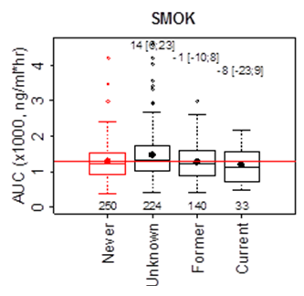

Source: PPK Report, Figure 22. Red and black dots indicate the mean exposure in the most prevalent category and in other categories. Numbers (brackets) in the top of plots show the percent change in AUCinf (with 95% CI) in other categories relative to the most prevalent category, while numbers at the bottom show patients in each category.

**Comment:** Based on the data from the PPK analysis, no dosage adjustment appears to be indicated when ixazomib is co-administered with CYP1A2 inducers.

#### Effect of ixazomib on drugs which are CYP substrates

There were no clinical studies in the submission on the effect of ixazomib on the PK of drugs which are metabolised by CYP isoenzymes. However, it was reported that, in vitro, ixazomib is neither a time dependent nor reversible inhibitor of CYPs 1A2, 2B6, 2C8, 2C9, 2C19, 2D6, or 3A4 (IC50 > 30 µM, Ki > 15 µM). Therefore, the potential for ixazomib to produce DDIs via CYP isozyme inhibition is low. It was also reported that in vitro data indicate that ixazomib (at concentrations up to 9.67 µM) did not induce CYP 1A2, 2B6, or 3A4 activity or corresponding immunoreactive protein levels under conditions where prototypical inducers caused anticipated increases in CYP activity. Therefore, ixazomib is unlikely to produce DDIs via induction of metabolism. Furthermore, it was reported that, because the arylhydrocarbon receptor (AhR) regulates induction of CYP1A2, and pregnane X receptor (PXR) and constitutive androstane receptor (CAR) cross regulate induction of CYP2B6 and CYP3A, it is unlikely that ixazomib will cause transporter induction (and hence transporter mediated DDIs) via AhR-, PXR-, or CAR-mediated mechanisms.

#### Transporter based interactions

There were no clinical studies in the submission investigating the effects of ixazomib as a substrate for transporter enzyme systems or as an inhibitor of transporter substrates. However, ixazomib has been studied in vitro as a substrate and inhibitor of relevant drug transporters in accordance with the relevant TGA adopted EMA DDI guidance document (Guideline on the Investigation of Drug Interactions. European Medicines Agency Committee for Human Medicinal Products. 2012. Publication No. CPMP/EWP/560/95). The results of these in vitro studies are summarised below.

##### Hepatic uptake transporters

Ixazomib is reported not to be a substrate of OATP transporters in human hepatocytes based on comparison of ixazomib uptake rates in the presence and absence of known OATP inhibitors (rifampin and cyclosporine A). On the basis of these in vitro findings, there is low probability of ixazomib disposition being affected by OATP1B1 or OATP1B3 inhibitors or inducers, or by clinically meaningful genetic polymorphisms for OATP1B1 or OATP1B3.

##### Renal uptake transporters

Ixazomib was not evaluated in vitro as a potential substrate of organic anion transporter (OAT) OAT1, OAT3, or OCT2. However, these renal uptake transporters are unlikely to be major determinants of ixazomib clearance, as the renal clearance of unchanged ixazomib (0.119 L/hr, Study C16016) is approximately 3.7% of ixazomib CL/F and 6.4% of CL. In addition, the renal clearance of unchanged ixazomib (0.119 L/hr) is similar to the product of the fraction unbound and glomerular filtration rate (GFR) (fu*GFR = 0.072 L/hr), suggesting that glomerular filtration instead of active secretion is the predominant mechanism of renal clearance. As such, the risk of DDIs between ixazomib and inhibitors or inducers of OAT1, OAT3, and OCT2 is predicted to be low.

##### Efflux transporters

Ixazomib is reported to be a low affinity substrate for P-glycoprotein (P-gp), but not a substrate for breast cancer resistance protein (BCRP) or multidrug resistance protein 2 (MRP2) transporters. P-gp mediated transport reportedly accounted for 19% of the total transport of ixazomib in Caco-2 cells, indicating the contribution of P-gp to the overall membrane permeability clearance of ixazomib is low. Considering the low contribution of P-gp to the membrane permeability clearance of ixazomib in Caco-2 cells, and the physicochemical properties of ixazomib of moderate permeability and high solubility, it is unlikely that P-gp mediated efflux in the intestine is a major determinant of the absolute oral bioavailability of ixazomib. Ixazomib consistently demonstrated dose linear PK following oral dosing over the 0.2 to 10.6 mg dose range (from the PPK analysis). In addition, biliary secretion and renal secretion of unchanged ixazomib are estimated to be minor routes of elimination relative to hepatic metabolism. Low biliary elimination of ixazomib (< 10%) was reportedly observed in human hepatocytes. Furthermore, as noted above, renal clearance of unchanged ixazomib is low and is consistent with passive glomerular filtration as opposed to active tubular secretion. Therefore, it is unlikely that potential P-gp mediated efflux in the liver or kidney contributes meaningfully to the overall clearance of ixazomib. Based on the estimated low contributions of intestinal, hepatic, and renal P-gp to ixazomib bioavailability and clearance, the likelihood of clinical DDIs between ixazomib and P-gp inhibitors is predicted to be low.

##### P-gp, BCRP, MRP2 transporter inhibition

Studies in Caco-2 cells are reported to show that ixazomib is not an inhibitor of P-gp or BCRP (IC50 > 100 µM), and studies in the MRP2-transfected membrane vesicle model are reported to show that ixazomib is not an inhibitor of MRP2 at concentrations of 0.02 to 100 µM. Consequently, ixazomib is not anticipated to inhibit P-gp, BCRP, or MRP2 at total maximum plasma concentrations or at estimated intestinal lumen concentrations associated with a 4 mg oral dose of ixazomib administered once weekly on Days 1, 8, and 15 of a 28 day cycle. Given the low risk of DDIs between ixazomib and P-gp, BCRP, or MRP2 substrates, in vivo DDI studies were not conducted with probe substrates of these efflux transporters.

##### OATP inhibition

Ixazomib is reported to be not an inhibitor of hepatic OATPs (IC50 > 10 µM). Ixazomib is therefore not expected to inhibit hepatic OATPs at total maximum plasma concentrations or at estimated unbound maximum hepatic inlet concentrations associated with a 4 mg oral dose administered once weekly on Days 1, 8, and 15 of a 28 day cycle. Therefore, the risk of ixazomib interacting with OATP substrates is predicted to be low. As such, in vivo DDI studies were not conducted with ixazomib and a known substrate of OATP.

##### OCT2, OAT1, OAT3, MATE1, and MATE2-K Inhibition

Studies in human hepatocytes or transporter expressing cell lines showed that ixazomib is not an inhibitor of OCT2, OAT1, OAT3, MATE 1 and MATE2-K at clinically relevant concentrations (IC50 > 10 µM). Ixazomib is therefore not anticipated to inhibit OCT2, OAT1, or OAT3 at unbound maximum plasma concentrations associated with a 4 mg oral dose of ixazomib administered once weekly on Days 1, 8, and 15 of a 28 day cycle. Ixazomib is also not expected to inhibit MATE1 or MATE2-K at clinically relevant concentrations. Therefore, there is low potential for ixazomib to cause DDIs with OCT2, OAT1, OAT3, MATE1, or MATE2-K substrates

##### Induction of transporters

No in vitro studies were performed to evaluate ixazomib as an inducer of drug transporters. However, as indicated above, based on the reported observation that ixazomib did not induce CYP1A2, CYP2B6, or CYP3A4 immunoreactive protein or activity in human hepatocytes, it is unlikely that ixazomib will cause transporter induction via AhR-, PXR-, or CAR-mediated mechanisms.

### Population pharmacokinetics

The submission included two PPK Reports. The reporting of the results of the two PPK analyses was consistent with the TGA adopted EMA guidance document (Guideline on reporting the results of population pharmacokinetic analyses. CHMP/EWP/185990/06. London, 21 June 2007).

The first PPK analysis (preliminary PPK analysis report) was conducted using data from the first 4 clinical Studies C16001, C16002, C16003 and C16004, in order to evaluate the possibility of switching from a BSA based dosing regimen to a fixed dose regimen. Data were pooled from 226 adult patients with MM, lymphoma, or solid tumours from the 4 Phase I clinical Studies which used BSA based ixazomib dosing (PO or IV, once or twice weekly). The preliminary population PK modelling was undertaken using NONMEM version 7.2. The final report for this analysis was dated 21 May 2015.

The Final PPK Report (MIL-PKPD-MLN9708-021), dated 22 May 2015, superseded the preliminary PPK Report. The PPK data summarised in this CER are from the final report. The Final PPK Report included data from seven Phase I Studies C16001, C16002, C16003, C16004, C16007, C16013, and TB-MC010034, two Phase I/II Studies C16005, and C16008, and one Phase III Study C16010. The pooled PPK analysis dataset, including data from 755 patients (108 IV; 647 PO), was constructed based on data from all ten trials. Patients were treated with BSA-adjusted ixazomib doses in Studies C16001, C16002, C16003, C16004, and C16005 (Phase 1 part), and fixed ixazomib doses in Studies C16005 (Phase 2 part), C16007, C16008, C16010, C16013, and TB-MC010034. Treatment with ixazomib was administered weekly (Days 1, 8 and 15 of a 28 day cycle) or twice weekly (Days 1, 4, 8 and 11 of a 21 day cycle). The final dataset for the PPK analysis is summarised below in Table 15, and the studies contributing to the Final PPK Report are (summary provided).

Table 15: Final PPK Report - Data included in the analysis set

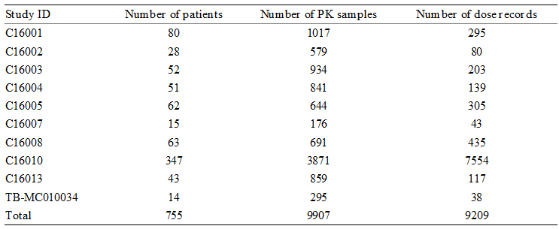

The goals of the PPK analysis were:

1. To develop a PPK model based on available data from relevant Phase I, I/II, and III studies, including identification and quantification of statistically significant and clinically relevant covariates on PPK parameters.
2. To estimate individual PK parameters for patients included in the analysis based on the final PPK model.

A mixed effects modelling approach was used to describe individual ixazomib plasma concentration time profiles based on compartmental PK models. Covariates were selected for inclusion in the final population PK model based on a pre-defined list of relevant parameter covariate relationships. All covariates were included in the analysis dataset as subject specific baseline covariates, except CYP-modulatory concomitant drugs which were included as time dependent covariates. The analysis dataset included 36 patients on strong CYP1A2 inhibitors (ciprofloxacin) and 16 patients on strong CYP3A4 inhibitors (9 clarithromycin, 4 itraconazole, 3 voriconazole) during the active ixazomib treatment period. Univariate and multivariate covariates were tested for significance based on the likelihood ratio test and included if they resulted in a statistically significant (p < 0.01) improvement in model fit and reduced the corresponding random effect variance of the parameter by more than 10%. The final model was constructed using a forward selection (p < 0.01), backward elimination method (p < 0.001) as described in the pre-specified analysis plan. NONMEM (version 7.2) and R (version 3.0.0 or higher) were used for all analyses.

#### Results

1. The observed ixazomib IV and oral plasma concentration data were described by a three compartment model with linear distribution and elimination kinetics, including first order linear absorption with lag time describing the oral dose PK profile (see Figure 10, below). The developed model included log-normally distributed patient level random effects on systemic clearance (CL), absolute bioavailability of an oral dose (F), and volume of the second peripheral compartment (V4). Individual CL and F were correlated, with the coefficient of correlation estimated at 82%. Covariates were selected based on statistical significance and impact on the random effect variance. Residual unexplained variability of the log transformed ixazomib plasma concentration was described by an additive error model with time varying variance.

Figure 10: Final PPK Report; Structural model describing the PK of ixazomib

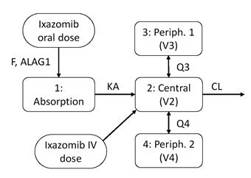

1. Covariates were selected based on statistical significance and affect on the random effect variance. The covariate values included in the PPK analysis were summarised. Body surface area (BSA) on V4 was included in the final model as it was the only statistically significant patient covariate identified. Inclusion of BSA explained 12.6% of the variability on V4. Patients at the 5th and 95th percentiles of BSA were predicted to have 37% lower and 46% higher V4, respectively, than the median patient. BSA was not identified as a covariate on CL and, consequently, does not affect systemic exposure based on the AUCinf
2. The lack of a discernible relationship between BSA and ixazomib clearance over a relatively wide BSA range (1.4 to 2.6 m2) indicated that total systemic exposure (AUCinf) following fixed dosing should be independent of individual BSA. Therefore, BSA was not expected to influence the Cmax or the AUCinf after IV or oral dosing, and fixed dosing was considered to be appropriate for both oral and IV routes of administration. Consequently, the clinical development or ixazomib shifted from BSA based dosing in the earlier studies to fixed-dosing in later studies. The starting dose of ixazomib in the pivotal Phase III Study C16010 was a fixed dose of 4 mg, on the basis of the recommended dose of 2.23 mg/m2 (using a mean patient BSA of 1.86 mg/m2 from the 2,208 patients with MM in VELCADE clinical studies for conversion to a fixed dose).
3. Other patient covariates, including sex, age, race, mild or moderate renal impairment (creatinine clearance > 30 mL/min), mild hepatic impairment (total bilirubin 1 to 1.5 x ULN), and smoking status, were found not to influence the PK of ixazomib, suggesting that no dose adjustment is required based on these covariates. Additionally, neither CYP1A2 nor CYP3A4 modulatory drugs administered concomitantly with ixazomib (as time dependent covariates) had an effect on the PK of ixazomib. Individual random effects on CL, F, and V4 versus categorical covariates in the final model were summarised.
4. The IV and PO data were analysed jointly to estimate log-normally distributed individual estimates of absolute oral bioavailability. The population typical value of absolute oral bioavailability (F) was estimated to be 58%. The geometric mean of individual estimated terminal disposition half-life and steady state volume of distribution were 9.53 days (95% CI: 9.32, 9.75) and 543 L (95% CI: 534, 551), respectively. The parameter estimates based on the base and final PK models are summarised below in Table 16.

Table 16: PPK Report; Base and final population PK model estimates

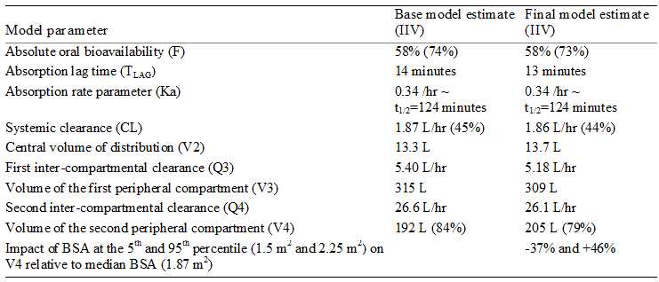

1. Based on the final model, ixazomib exposure was simulated in 10,000 individual patients. The median (95% CI) of individual total exposures (AUCinf) following a single oral 4 mg ixazomib dose was 1,243 ng/mL.hr (range: 1,195, 1,298 ng/mL.hr), while the 5th and 95th percentiles (95% CI) of the individual exposures were 603 ng/mL.hr (range: 563, 638 ng/mL.hr) and 2,586 ng/mL.hr (range: 2,414, 2,755 ng/mL.hr), respectively.

### Evaluator’s overall conclusions on pharmacokinetics

* The PK of ixazomib have been adequately characterised in 14 clinical studies with clinical pharmacology data and in the Final PPK Report. All PK data were from patients with cancer.
* The proposed ixazomib oral formulation is an immediate release capsule. It is administered as a stable citrate ester and the conversion of ixazomib citrate in plasma to ixazomib is reported to be immediate and complete. Based on BCS criteria, ixazomib is categorised as a Class 3 compound (that is, high solubility, low permeability). Absorption following oral administration of ixazomib was rapid, with Tmax values of approximately 1 hour being consistently observed across studies when the drug was administered in the fasting state.
* Based on the final PPK analysis, the observed ixazomib IV and oral plasma concentration data were adequately described by a three compartment model with linear distribution and elimination kinetics, including first order linear absorption with lag time describing the oral dose PK profile. The ixazomib plasma concentration time profile was multi exponential after both IV and PO dosing.
* The absolute bioavailability of ixazomib is estimated to be 58% (RSE: 9%), based on PPK data from 10 clinical studies (108 IV; 647 PO). No dedicated absolute bioavailability study was submitted. However, the sponsor justified the absence of such a study based on ixazomib being cytotoxic and the practical difficulties of conducting a crossover study due to the long half-life of the drug. In addition, the sponsor doubted that a dedicated study would provide additional data on absolute bioavailability to that obtained from the PPK analysis. The sponsor also noted that the absolute bioavailability estimate of 58% from the PPK analysis was consistent with the percent of administered drug absorbed (62%) calculated from the mass balance Study C16016. Overall, it is considered that the sponsor's justification for not submitting a dedicated absolute bioavailability is acceptable.
* The submission included a relative bioavailability Study C16009, Arm 2 comparing the two ixazomib 4 mg capsule formulations (A and B) used in the clinical development program. Formulation A was used in the first two oral Phase I studies and formulation B was used in all 9 subsequent oral Phase I/II studies and in the one pivotal oral Phase III study. In Study C16009 (Arm 2), both formulations A and B (single dose) were bioequivalent based on the 90% CI of the AUC(0-216h) ratio (B/A), which was within the accepted interval of 0.80 to 1.25 (that is, geometric LSM ratio = 1.04 [90% CI: 0.91, 1.18]) However, the 90% CI of the Cmax ratio (B/A) was not enclosed entirely within the accepted interval of 0.80 to 1.25 (that is, geometric LSM ratio = 1.16 [0.84, 1.61]). The median Tmax values of the two formulations were similar (that is, 1.3 hours). In addition, the mean plasma concentration time profiles of the two formulations over the first 216 hours after administration demonstrated similar disposition of ixazomib over this time period. Overall, the two formulations are considered to have similar systemic exposures, but cannot be categorised as bioequivalent due to the difference in the Cmax values.
* The submission included a food effect Study C16009, Arm 3 comparing the bioavailability of ixazomib (4 mg capsule, formulation B, single dose) administered in the fasting and the fed states. Exposure to ixazomib was significantly reduced when it was administered with a high fat meal, with reductions of 28% in the AUC(0-216h) and 69% in the Cmax. In addition, the median Tmax was delayed by approximately 3 hours in the fed state (that is, increasing from 1 hour fasting to 4 hours fed). The results indicate that ixazomib should be administered without food. The proposed PI recommends that ixazomib should be taken at the same time on days 1, 8, and 15 at least 1 hour before or at least 2 hours after food.
* The pivotal Phase III study was conducted with capsule formulation B, which is the capsule formulation proposed for registration. Consequently, no bioequivalence study comparing the oral formulation used in the pivotal Phase III study with the proposed oral commercial formulation was required.
* The steady state volume of distribution is estimated to be 543 L (final PPK analysis). The volume of distribution is large, indicating that ixazomib is extensively distributed to the extravascular tissues. Ixazomib is highly bound (99%) to plasma proteins (predominantly serum albumin) and the extent of binding is not altered by severe renal impairment Study C16015 or moderate or severe hepatic impairment Study C16018. Ixazomib concentrations were higher on Day 15 in whole blood than in plasma, with blood-to-plasma ratios for Cmax and AUC(0-168h) of 2.89 and 9.86, respectively Study C16007. The data suggest extensive partitioning of ixazomib into red blood cells, possibly due to binding to 20S proteasomes reportedly found in high concentrations in red blood cells.
* The systemic clearance of ixazomib was estimated to be 1.86 L/hr (RSE = 7%), based on the final PPK analysis. The geometric mean estimate for the terminal half-life was 9.5 days (95% CI: 9.32, 9.75 days), based on the final PPK analysis. Ixazomib is a low clearance drug (based on a plasma clearance of 1.86 L/hour and a blood/plasma ratio of approximately 10), which appears to account for the prolonged terminal half-life of the drug. There was an approximately 2 fold accumulation of ixazomib (based on AUC) following the Day 15 dose for the proposed 4 mg once weekly schedule (Days 1, 8, and 15). Trough ixazomib concentrations suggest that steady state is not achieved within the first cycle of either the once weekly or twice weekly ixazomib dosing regimen.
* Based on the estimated absolute bioavailability of 58% and the systemic clearance of 1.86 L derived from the final PPK analysis, it can be calculated that the apparent oral clearance (CL/F) of ixazomib is 3.21 L/hr. The geometric mean renal clearance of ixazomib is 0.119 L/hour (Study C16016), which is 3.7% of the estimated apparent oral clearance of 3.21 L/hr, suggesting that renal clearance does not meaningfully contribute to ixazomib clearance in humans.
* As indicated above, metabolism appears to be the major route of elimination of ixazomib. In vitro studies suggest that ixazomib is metabolised by multiple cytochrome P450 (CYP) and non-CYP proteins. It was reported that at supra-therapeutic concentrations of ixazomib (10 µM), which were > 90 fold higher than the geometric mean clinically relevant Cmax (0.11 µM), ixazomib was metabolised in vitro by multiple CYP isoforms, with estimated relative contributions for 3A4 (42.3%), 1A2 (26.1%), 2B6 (16.0%), 2C8 (6.0%), 2D6 (4.8%), CYP2C19 (4.8%), and 2C9 (< 1%). However, at more clinically relevant concentrations of ixazomib (0.1 and 0.5 µM), it was reported that non-CYP proteins seemed to have a major role in ixazomib clearance in vitro.
* In vitro, ixazomib was reported to be neither a time dependent inhibitor nor a reversible inhibitor of CYP 1A2, 2B6, 2C8, 2C9, 2C19, 2D6, or 3A4. In addition, ixazomib was reported in vitro not to induce CYP 1A2, 2B6, or 3A4 activity or corresponding immunoreactive protein levels. Consequently, based on the in vitro data it can be reasonably inferred that the potential for ixazomib to produce significant drug-drug interactions via CYP isozyme induction or inhibition is low.
* In vitro, ixazomib was reported to be a low affinity substrate of P-gp, with P-gp mediated ixazomib transport accounting for 19% of the total transport of the drug in Caco-2 cells. In vitro, ixazomib was reported not to be a substrate for BCRP, MRP2 and OATPs, or an inhibitor of P-gp, BCRP, MRP2, OATP1B1, OATP1B3, OAT1, OAT3, OCT2, MATE1 and MATE2-K. Consequently, based on the in vitro data it can be reasonably inferred that ixazomib is unlikely to cause or be susceptible to clinically significant drug-drug interactions with substrates or inhibitors of drug transporters.
* The mass balance (ADME) clinical study showed that approximately 62% of the administered radioactivity was recovered in the urine and 22% was recovered in the faeces. Only 3.2% of the administered ixazomib dose was recovered in the urine as unchanged drug collected up to 168 hours after oral dosing, suggesting that renal elimination is a minor clearance pathway for ixazomib and that most of the total radioactivity in urine was attributable to metabolites of ixazomib.
* In clinical Study C16009, co-administration of ixazomib with the strong CYP3A4 inhibitor clarithromycin did not result in a clinically meaningful increase in ixazomib exposure. The geometric LSM ratios for the Cmax and AUC(0-264h) were 0.96 (90% CI: 0.67, 1.36) and 1.11 (90% CI: 0.86, 1.43), respectively. The analysis compared data for ixazomib alone (2.5 mg, single dose) from patients treated on C1D1 in Arm 1, and for ixazomib (2.5 mg, single dose) administered on Day 6 after 5 days of repeat dosing with clarithromycin (500 mg BD) with clarithromycin continuing from Day 6 through 16 of C1 in Arm 5. This design was adopted in order to avoid the period effect observed in Arm 1, where ixazomib exposure in Period 2 (ixazomib co-administered with ketoconazole) might have been confounded by the fixed-sequence design in which ixazomib alone had been administered in Period 1. The ixazomib concentration in Period 2 might have been confounded due to an ixazomib carry over effect from Period 1 due to an inadequate wash-out between the two periods resulting from the long terminal half-life of the drug.
* The 2.5 mg dose of ixazomib used in Study C16009 investigating the effect of co-administration ixazomib and clarithromycin was lower than the proposed starting dose of 4 mg. On the basis of in vitro drug metabolism data and the contribution of renal clearance to the elimination of the drug, a less than 2 fold increase was expected in ixazomib systemic exposure (AUC) with strong CYP3A inhibition. Therefore, the 2.5 mg dose was anticipated to provide an adequate margin of safety for conduct of the drug-drug interaction studies with ketoconazole and clarithromycin, as ixazomib exposures during co-administration with these inhibitors were anticipated to be less than those observed at the MTD of 5.5 mg that had been estimated in an earlier clinical pharmacology study in patients with RRMM (Study C16004). In addition, the reduced 2.5 mg dose of ixazomib (relative to the Phase III clinical dose of 4 mg) was considered appropriate for evaluation of exposure when co-administered with strong CYP3A inhibitors, on the basis of dose linear PK of ixazomib. Overall, the DDI data indicate that no ixazomib dosage adjustment is required when co-administered with strong CYP3A4 inhibitors.
* In clinical Study C16009, a clinically meaningful reduction in ixazomib exposure was observed when co-administered with the strong CYP3A4 inducer rifampin. When co-administered with rifampin, the AUC(0-last) was reduced by 74% (that is, geometric LSM ratio = 0.26 [90% CI: 0.18, 0.37]) and the Cmax was reduced by 54% (that is, geometric LSM ratio = 0.46 [90% 0.29, 0.73]). The results of this clinical DDI study indicate that ixazomib should not be co-administered with strong CYP3A4 inducers.
* In the PPK analysis, the effect of smoking status on the PK of ixazomib was assessed. It was inferred that PK differences between smokers and non-smokers would be due to induction of CYP1A2 metabolic activity in smokers. In the PPK analysis, smoking status was not identified as a significant covariate on the PK of ixazomib (that is, clearance, absolute oral bioavailability, or the volume of the second peripheral compartment). In addition, based on the final PPK model the predicted percent decrease in median ixazomib AUCinf for patients who were current smokers compared to patients who had never smoked was 8% (95% CI: ‑23, 9). The magnitude of the difference (8%) in AUCinf between patients who self-identified as current smokers and patients who had never smoked was < 20%, suggesting no clinically meaningful difference in exposures between the two groups. However, it is important to note that the smoking history was self-reported. Based on the results of the PPK analysis, no ixazomib dosage adjustment is required when co-administered with CYP1A2 inducers.
* In the PPK analysis, the effect of strong CYP1A2 inhibitors (ciprofloxacin) on the PK of ixazomib was examined as a time dependent categorical covariate. No significant effects of strong CYP1A2 inhibitors on ixazomib clearance could be identified. The PPK model estimated a 9% higher median ixazomib AUCinf (95% CI: 6, 12%) for patients receiving strong CYP1A2 inhibitors compared to those not receiving strong CYP1A2 inhibitors. The magnitude of the difference (9%) in AUCinf between the two treatment groups was < 20%, suggesting no clinically meaningful difference in exposures between the two groups. The data suggest that no dose adjustment is necessary for ixazomib when co-administered with strong CYP 1A2 inhibitors.
* In the PPK analysis, the effect of Len/Dex co-administered with ixazomib was assessed. Based on the final PPK model, Len/Dex co-administered with ixazomib was not identified as a statistically significant covariate on ixazomib clearance, absolute oral bioavailability, or the volume of the second peripheral compartment. In addition, based on the final PPK model the predicted percent decrease in median ixazomib AUCinf for ixazomib co-administered with Len/Dex compared to ixazomib administered alone was 7% (95% CI: 0, 17). The magnitude of the difference (7%) in AUCinf between the two treatment groups was < 20%, suggesting no clinically meaningful difference in exposures. There were no data on the effect of ixazomib on the PK of Len/Dex.
* The effect of severe renal impairment was investigated in a dedicated Study C16015. In patients with severe renal impairment (including patients with ESRD, the unbound AUC(0-last) increased by 38% (that is, geometric LSM ratio = 1.38 [90% CI: 0.93, 2.04]) and the unbound Cmax increased by 25% (that is, geometric LSM ratio = 1.25 [90% CI: 0.79, 1.98]) compared to patients with normal renal function. The results indicate that a lower starting dose of ixazomib 3 mg in patients with severe renal impairment should result in similar ixazomib exposure to a higher starting dose of ixazomib 4 mg in patients with normal renal function. Study C16015 also showed that ixazomib was not dialysable in patients with ESRD requiring haemodialysis.
* The effect of moderate or severe hepatic impairment on the PK of ixazomib was investigated in a dedicated Study C16018. In this study, the effects of moderate and severe hepatic impairment on the PK of ixazomib were similar. In patients with moderate/severe hepatic impairment, the unbound dose normalised AUC(0-last) increased by 27% (geometric LSM ratio = 1.27 [90% CI: 0.75, 2.16]) and the unbound dose normalised Cmax increased by 24% (that is, geometric LSM ratio = 1.24 [90% CI: 0.79, 1.95]) compared to patients with normal hepatic function. The results indicate that a lower starting dose of ixazomib 3 mg in patients with severe or moderate hepatic impairment should result in similar ixazomib exposure to a higher starting dose of ixazomib 4 mg in patients with normal hepatic function.
* The PPK analysis showed that covariates of age, sex, or race had no significant effects on the PK of ixazomib, and that the predicted effects on AUCinf were unlikely to be clinically meaningful. The only covariate included in the final model was BSA on V4, and inclusion of BSA explained 12.6% of the variability on V4. Patients at the 5th and 95th percentiles of BSA were predicted to have a 37% lower and a 46% higher V4, respectively, than the median patient. However, BSA does not affect exposure (AUCinf), as BSA was not identified as a covariate on CL.

## Pharmacodynamics

### Studies providing pharmacodynamic data

The submission included the following studies providing pharmacodynamic data:

* 2 Phase I Studies C16001 and C16002 investigating the effect of ixazomib IV on 20S proteasome inhibition;
* 1 study (Millennium-A2PG-0001 Report) investigating the effects of ixazomib on QTc prolongation;
* 1 Exposure response analysis investigating the relationship between ixazomib exposure and clinical response; and
* 1 Exposure safety analysis investigating the relationship between ixazomib exposure and selected treatment emergent adverse events (TEAEs).

### Effect of ixazomib on 20S proteasome activity

The pharmacodynamic effect of ixazomib was assessed by measuring the inhibition of 20S proteasome activity in whole blood after once weekly and twice weekly IV bolus dosing of ixazomib in Studies C16001 and C16002, respectively.

#### Study C16001

Study C16001 was a Phase I, open label, multicentre (USA, Canada), first-in-humans, dose escalation study in adult patients with non-haematological malignancies. The primary objectives of the study were to determine the safety profile of ixazomib, establish the MTD of ixazomib and determine the IV dose to be used in the proposed Phase 2 of the study. The secondary objectives of the study included, among others, the description of the pharmacodynamics of ixazomib administered IV by measuring the inhibition of 20S proteasome activity in blood. The focus in this CER on the data from Study C16001 is on the pharmacodynamics of ixazomib relating to inhibition of 20S proteasome activity.

The study enrolled at total of 116 patients, and 35 (30%) of these patients were included in the pharmacodynamic analysis population. Each treatment cycle consisted of 21 days, with ixazomib dosing on Days 1, 4, 8, and 11 followed by a rest period of 10 days. The ixazomib starting dose was 0.125 mg/m2, and an accelerated titration design was used for dose escalation. Dose doubling was to proceed with 1 patient at each subsequent level (0.25, 0.5 and 1 mg/m2) until specified frequencies of adverse events were observed. Dose escalation was then to follow a traditional (“3 + 3”) escalation scheme with increases of 33% relative to the previous dose. Blood samples for calculation of percent 20S proteasome inhibition were collected on Days 1 and 11, at the same time points used for PK sampling. On Day 1, blood samples were collected pre-dose (within 1 hour before dosing) and then post-dose at 5, 15, 30 minutes, 1, 2, 4, 9, 24 and 48 hours. On Day 11, blood samples were collected pre-dose (within 1 hour before dosing), and then post-dose at 5, 15, 30 minutes, 1, 2, 4, 9, 24, 48, 96, 120, 168 and 264 hours.

The pharmacodynamic effect at each time point was calculated as the percent change in blood 20S proteasome activity from the pre-dose baseline value (that is, relative to the pre-dose sample taken on Day 1 of Cycle 1). Pharmacodynamic parameters were calculated for individual patients on Days 1 and 11 of Cycle 1, using non compartmental analysis, from individual 20S proteasome inhibition versus time data. The calculated parameters were the area under the blood 20S proteasome percent inhibition - time curve from 0 to 72 hours (AUE(0-72h)), maximum observed blood 20S proteasome inhibition (Emax), and time of Emax. Pharmacodynamic parameters were summarised using descriptive statistics.

The Day 1 and Day 11 time courses of mean whole blood 20S proteasome inhibition were provided, and the data are summarised below in Table 17. There appears to be dose-dependent maximum inhibition (Emax) of 20S proteasome activity. Maximum 20S proteasome inhibition ranged from < 10% in the 0.125 mg/m2 dosing cohort to approximately 70% in the 2.34 mg/m2 dosing cohort. At the MTD of 1.76 mg/m2, maximum 20S proteasome inhibition was approximately 60%. The time to Emax in most patients was within 30 minutes, suggesting that the rapid pharmacodynamic effect was directly related to the maximal ixazomib plasma concentrations occurring immediately after IV bolus dosing. With the exception of the 2.34 mg/m2 cohort, mean 20S proteasome activity was similar to pre-dose levels by 24 hours after ixazomib administration on Day 1. On Day 11, approximately 20% inhibition of mean 20S proteasome activity was observed 24 hours after ixazomib dosing in the higher dose cohorts of 1.33, 1.76, and 2.34 mg/m2.

Table 17: Study C16001; Day 1 and Day 11 mean ± SD whole blood 20S proteasome inhibition following twice weekly IV bolus administration of ixazomib

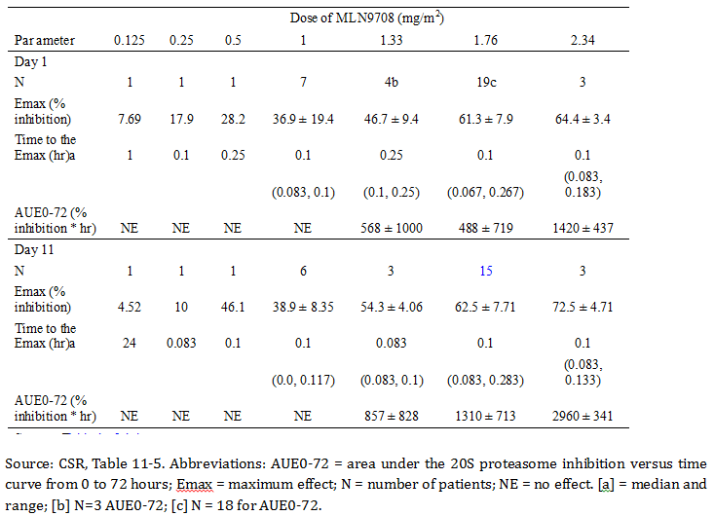

**Comment:** At the MTD of 1.76 mg/m2, 60% inhibition of 20S proteasome activity was observed. Except for the 2.34 mg/m2 dose cohort, prolonged inhibition of 20S proteasome activity (> 24 hours) was not apparent. The maximal inhibition was observed within 30 minutes after ixazomib IV administration, indicating a close temporal association between whole blood 20S proteasome inhibition and plasma drug concentrations. The observed pharmacodynamic profile was consistent with ixazomib being a reversible proteasome inhibitor. In an additional analysis of pre-dose and post-dose tumour biopsies for assessment of the PK/D effects of ixazomib, all evaluable post-dose biopsies (10/10) contained quantifiable concentrations of ixazomib, while a statistically significant increase in activating transcription factor-3 (ATF-3) level was detected in 6/7 of the evaluable paired biopsies. The results suggest that ixazomib can penetrate tumours and modulate the target pathway (ATF-3 is pathway modulation biomarker).

#### Study C16002

Study C16002 was a Phase I, open label, multicentre (US, Canada), dose escalation study in adult patients with lymphoma for whom at least 2 previous chemotherapeutic regimens had failed. The primary objectives of the study were to determine the safety profile of ixazomib, establish the MTD of ixazomib and determine the IV dose to be used in Phase 2 of the study. The secondary objectives of the study included the description of the pharmacodynamics of IV ixazomib by measuring the inhibition of 20S proteasome activity in blood. The focus in this CER on the data from Study C16002 is on the pharmacodynamics of ixazomib relating to inhibition of 20S proteasome activity.

The initial dose of ixazomib was 0.125 mg/m2 in one patient and the dose was doubled to 0.25, 0.5, and 1.0 mg/m2, respectively, for each subsequent patient until specified adverse events occurred or the 1.0 mg/m2 was evaluated. Dose escalation then proceeded according to the more traditional ("3 + 3") dose escalation scheme and the dose was then increased by 26% to 40% increments of the previous dose or from 1.0 mg/m2 to 1.4 mg/m2, 1.76 mg/m2, 2.34 mg/m2, and 3.11 mg/m2 (highest dose tested). Once the MTD was established, a total of 16 patients (including those enrolled into the MTD during dose escalation) were treated at the MTD to more fully characterise the safety, tolerability, PK, and PD of ixazomib and to evaluate disease response.

Serial blood samples were collected at multiple time points during Cycle 1 to measure the plasma PK of ixazomib and inhibition of whole blood 20S proteasome activity. After Day 1 administration, blood samples were collected at 0 (pre-dose), 0.083, 0.25, 0.5, 1, 2, 4, 8, 24, 48, 96, and 168 hours post-dose. After dosing on Day 15, samples were taken at 0 (pre-dose) and then post-dose at 0.083, 0.25, 0.5, 1, 2, 4, 8, 24, 48, 96, 168, and 336 hours. The pharmacodynamic effect at each time point was calculated as percent inhibition of blood 20S proteasome activity from the pre-dose baseline value. Pharmacodynamics were calculated for individual patients on Days 1 and 15 of Cycle 1 by using non-compartmental analysis based on whole blood 20S proteasome inhibition time data. The calculated parameters were the area under the whole blood 20S proteasome inhibition versus time curve from time 0 to 168 hours post-dose (AUE(0-168h), maximum observed whole blood 20S proteasome inhibition (Emax), and the first observed time to Emax. Descriptive statistics were used to summarise PD parameters. Thirty (30) patients received at least one dose of ixazomib and were included in the safety population, and 23 (74%) of these patients were included in pharmacodynamic analysis population.

The Day 1 and Day 15 time-courses of mean whole blood 20S proteasome inhibition were provided and the data are summarised below in Table 18. Mean maximum whole blood 20S proteasome inhibition (Emax) was dose dependent and ranged from 5% in the 0.125 mg/m2 dose cohort to over 80% in the higher dose cohorts. At the MTD of 2.34 mg/m2, the mean Emax was 82% on Day 1 and 80% on Day 15. In all patients, maximum 20S proteasome inhibition was observed within 30 minutes, indicating rapid target engagement in blood.

Table18: Study C16002; Day 1 and Day 15 mean ± SD whole blood 20S proteasome inhibition following once weekly IV bolus administration of ixazomib

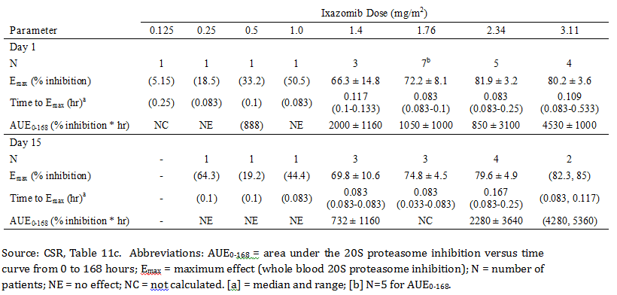

**Comment:** Maximum 20S proteasome inhibition (Emax) was dose dependent, and was approximately 80% after single dose and multiple dose administration in patients who received the MTD. In all patients, maximum 20S proteasome inhibition (Emax) was observed within 30 minutes, indicating a close temporal association between the maximum pharmacodynamic effect and the maximum plasma concentration of ixazomib occurring immediately after IV bolus administration. Prolonged inhibition of 20S proteasome activity was not apparent, which is in agreement with ixazomib being a reversible proteasome inhibitor.

### Effect of ixazomib on QTc interval

#### Millennium-A2PG-0001

The submission included a pooled analysis of the effect of ixazomib on the QTc interval in patients with cancer. The analysis was dated 25 October 2013 (Millennium-A2PG-0001) and presented in the clinical module. The primary objectives of the analysis were:

1. to relate QTc intervals to plasma concentrations of ixazomib in cancer patients; and
2. to predict mean drug-induced changes in QTc at clinically relevant concentrations and calculate the 90% CI (2 sided) of these mean predictions.

Data from four Phase I safety and tolerability studies of ixazomib in cancer patients were pooled to develop a population model relating heart rate corrected QT intervals (QTc) to plasma concentrations of ixazomib. A total of 275 patients were enrolled in the four studies including 101 subjects with advanced non-haematological malignancies Study C16001, 34 subjects with lymphoma Study C16002 and 140 subjects with RRMM, Studies C16003 and C16004. Each of the four studies were open label, dose escalation studies in adult subjects 18 years of age or older. Data from a total of 245 cancer patients were included in the analysis, including 105 (43%) females and 140 (57%) males. The mean ± SD age of the subjects in the analysis was 56.5 ± 16.1 years, with a range of 23 to 86 years.

A total of 1,023 of 1,302 data points (79%) were available for inclusion in the concentration-QTc analysis. The reasons for data being excluded were: (1) the PK sample was not reportable, the PK sample volume was not sufficient for analysis, or quantity of the sample was not sufficient; (2) the PK sampling time was missing; (3) the ECG was outside the designated time window for collection; or (4) ECG replicates were missing. One sample data point was excluded due to a very high plasma concentration of ixazomib (1,920 ng/mL) compared to other observations (0 to 823 ng/mL).

Among available data points (n = 1,023), 26% (270 observations) had higher concentration values than the geometric mean Cmax (48 ng/mL) of the 4 mg weekly dose. Therefore, the drug concentrations assessed in the analysis included ixazomib concentrations not only in the therapeutic range but also in the supratherapeutic range. The endpoints were the heart rate corrected QT intervals (QTc) of Fridericia’s (QTcF) and Population (QTcP) (that is, study specific population correction of QTc for heart rate). The ECG data used in the analysis were derived using averages of ECG triplicates calculated at each nominal time point, where each replicate was composed of three sub-replicates. Data records with missing QT/QTc values (mean of the replicates), missing PK concentrations, or missing actual post dose (or clock) times were flagged and excluded from the PK-QTc analysis.

Linear mixed effects models relating ixazomib plasma concentration to QTc prolongation were fitted as specified in the population modelling analysis plan using the QTcF and QTcP data. The fixed effects included an intercept, a female effect on baseline, study effects, and ixazomib concentration effect parameters. Subject-specific random effects were specified to be included on the intercept and ixazomib concentration effect slope to capture the between subject variability in these parameters (that is, a random coefficient model). Within subject random effects (residual) parameters were also included. Maximum likelihood estimation was implemented.

##### Results

1. Linear mixed effects models were concluded to be adequate to describe the data and for prediction of drug-induced placebo corrected changes in QTc from baseline (Δ∆QTcF and ΔΔQTcP). The models included fixed effects for study, sex, study day and time, and random effects on intercept and study day.
2. The slope estimates from the final model were 0.00148 msec/(ng/mL) (SE = 0.00372) and 0.00123 msec/(ng/mL) (SE = 0.00385) for QTcF and QTcP, respectively. Based on these slope estimates, model predictions of mean drug induced changes in QTc (denoted as ΔΔQTcF and ΔΔQTcP) and two 90% CIs of these predictions were calculated. Model predictions of mean ΔΔQTcF and mean ΔΔQTcP at the geometric mean of Cmax (48 ng/mL) for a 4 mg single dose were 0.0710 msec (90% CI: -0.221, 0.363 msec) for ΔΔQTcF and 0.0591 msec (90% CI: -0.242, 0.361 msec) for ΔΔQTcP (see Figure 11, below). The upper limits of the 90%CI for the means of both ΔΔQTcF and the ΔΔQTcP were well below 5 msec.

Figure 11: QTc Report; Model predicted mean ∆∆QTcF and ∆∆QTcP and 90% CIs

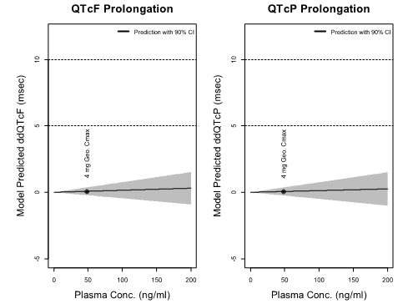

Source: QTc report, Figure ES1. CI = confidence interval; Cmax = maximal concentrations; mg = milligram; msec = millisecond; ΔΔQTcF = placebo corrected, change from baseline predicted QT interval after correction for heart rate (Fridericia’s correction); relative to concentration of 0; ΔΔQTcP = placebo corrected, change from baseline predicted QT interval after correction for heart rate (Population correction)

1. There were no observed QTcF and QTcP values greater than 500 msec, and less than 1% of observed QTcF and QTcP values were greater than 480 msec. Increases greater that 60 msec in QTcP were observed in one patient and no observations greater than 60 msec in QTcF were observed in any patients. Less than 2% of ΔQTcF and ΔQTcP observations were greater than 30 msec. The number and percentage of data points greater than specified thresholds are summarised below in Table 19.

Table 19: QTc Report; Number (N) and percentage (%) of data points greater than specified thresholds

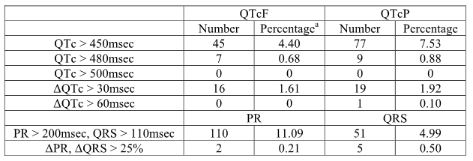

Source: QTc Report, Table 3. QTcF = Fridericia’s correction of the QT interval for heart rate; QTcP = Population or study-specific correction of the QT interval for heart rate; PR = ECG interval measured from the onset of the P wave to the onset of the QRS complex; QRS = ECG interval measured from the onset of the QRS complex to the J point. [a] = To calculate percentage (%), total data points of 1023 were used for QTcF, QTcP, and QRS, 991 data points were used for ΔQTcF, ΔQTcP and ΔQRS, 992 data points were used for PR, and 950 data points were used for ΔPR.

1. There was no discernible relationship between ixazomib plasma concentration and RR interval. The resulting slope estimate of the final model for RR was small, 0.016 (SE = 0.0270) msec/(ng/mL), and there was no clinically meaningful effect predicted on heart rate at Cmax of 4 mg weekly dose (that is, 90% CIs of ΔΔRR at 48 ng/mL were -1.35 msec to 2.88 msec).

**Comment:** The results of the concentration QTc modelling analysis showed that ixazomib was not associated with clinically significant effects on prolongation of the QTc interval. The sponsor stated that the analysis was submitted to the FDA’s interdisciplinary review team, which provides expert review advice to sponsors and FDA review divisions on evaluation of QTc. The sponsor stated that it received feedback from the FDA on 19 August 2014 that was in agreement with the sponsor's assessment that there is no impact of ixazomib dose or exposure on QTc prolongation.

#### Pivotal Study C16010; QTc data

In Study C16010, 360 patients in the ixazomib regimen and 360 patients in the placebo regimen were evaluated for changes in QTcF (Fridericia’s correction and QTcB (Bazett’s correction). The results are discussed below and a summary was provided.

##### QTcF changes

In most patients, the maximum post-dosing QTcF was < 450 msec during the study (that is, 87% [n = 277] ixazomib regimen; 88% [n = 275]) placebo regimen). Three (< 1%) patients in the ixazomib regimen and 5 (2%) patients in the placebo regimen had a maximum post-dosing QTcF ≥ 500 msec. Increases from baseline of ≥ 30 msec in the QTcF were observed in 16% (n = 49) and 13% (n = 40) of patients in the ixazomib and placebo regimens, respectively, and increases from baseline of ≥ 60 msec in the QTcF were observed in 3% (n = 10) and 6% (n = 19) of patients in the ixazomib and placebo regimens, respectively. The mean ± SD change in QTcF from baseline to last assessment was 4.97 ± 29.27 msec in the ixazomib regimen and 4.64 ± 33.26 msec in the placebo regimen.

##### QTcB changes

In most patients, the maximum post-dosing QTcB was < 450 msec (that is, 76% [n = 242] ixazomib regimen; 77% [n = 242] placebo regimen). Thirteen (4%) patients in the ixazomib regimen and 10 (3%) patients in the placebo regimen had a maximum post-dosing QTcB ≥ 500 msec. Increases from baseline of ≥ 30 msec in the QTcB were observed in 19% (n = 59) and 17% (n = 50) of patients in the ixazomib and placebo regimens, respectively, and increases from baseline of ≥ 60 msec in the QTcB were observed in 5% (n = 14) and 7% (n = 20) of patients, respectively. The mean ± SD change in QTcB from baseline to last assessment was 2.70 ± 33.06 msec in the ixazomib regimen and 2.86 ± 37.71 msec in the placebo regimen.

##### Treatment emergent adverse events (TEAEs)

TEAEs associated with non-ventricular arrhythmias were reported in 3 patients, with increases from baseline in QTcF or QTcB of ≥ 60 msec (1 ixazomib regimen; 2 placebo regimen). A TEAE of electrocardiogram QT prolonged was reported in 2 patients in the ixazomib regimen.

**Comment:** It is considered that there were no clinically meaningful differences between the placebo regimen (LenDex) and the ixazomib regimen (ixazomib + LenDex) in the incidence of QTc prolongation. Neither regimen appears to be causally associated with clinically significant effects on QTc prolongation.

#### Exposure Response Report

##### Background

The submission included an Exposure Response (E-R) Analysis, dated 12 June 2015, and provided as a Clinical Pharmacology Supplemental Report in the clinical module.

The objectives of the E-R analyses were:

1. to evaluate the relationship between ixazomib exposure and clinical response to treatment (for example, complete response [CR], ≥ very good partial response [VGPR] and ≥ partial response [PR]) in patients treated with ixazomib + LenDex;
2. to explore the relationship between ixazomib exposure and progression free survival (PFS) in patients treated with ixazomib + LenDex;
3. to assess the relationship between ixazomib exposure and selected adverse events (AEs) in patients treated with ixazomib + LenDex; and (4) to assess the relationship between ixazomib exposure and time to first dose reduction of ixazomib in patients treated with ixazomib + LenDex.

The E-R analyses were conducted in patients with RRMM from the pivotal Phase III Study C16010 in order to describe the relationship between ixazomib exposure and efficacy and safety outcomes using logistic regression or time-to-event Cox proportional hazard (PH) models. The E-R analyses were based on progression free survival (PFS), clinical responses, and safety outcomes. Only patients with both PK and response information (efficacy or safety) were included in the analyses. In Study C16010, patients were treated with ixazomib 4 mg or placebo on Days 1, 8 and 15 in a 28 day cycle in combination with a Len/Dex regimen.

The exposure metric for ixazomib in the E-R analyses was time averaged systemic exposure (that is, AUC/day), which was derived for each patient from the available dosing information, the individual patient oral clearance (CL/F) values from the final PPK model previously described in this CER (Final PPK Report), and the number of days to the first event. Dose proportionality has been demonstrated based on no discernible relationship between apparent oral clearance and ixazomib dose (range of 0.2 to 10.6 mg) using a PPK approach. As a result, time averaged ixazomib AUC was used as the exposure metric as it is a measure of total systemic exposure of ixazomib and accounts for the overall dose received, including dose reductions or interruptions.

Events examined in the E-R analysis included PFS, confirmed best clinical response (that is, CR, ≥ VGPR, ≥ PR), maximum grade of AE (≥ Grade 3 for haematological AEs, ≥ Grade 2 for non-haematological AEs), and the time to first ixazomib dose reduction. If the best clinical response, or maximum grade of AE, occurred more than once, the time to the first occurrence of the response/AE was used in the exposure response analyses.

In Study C16010, the ITT analysis population included a total of 360 patients treated with the ixazomib + LenDex regimen. Of these 360 patients, 358 were considered for PPK analysis after the exclusion of 2 patients for whom PK samples were not available at the time of the analysis. Of the 358 patients, 347 had sufficient PK data available to estimate oral clearance from the PPK analysis. For the 347 patients with oral clearance estimates, 342 were included in the exposure PFS analysis and 5 were censored at randomisation. A total of 338 patients (out of the 347 with oral clearance estimates) were included in the exposure clinical response analysis as 9 patients were not response evaluable. All 347 patients were included in the exposure AE and exposure time to the first ixazomib dose reduction analyses. The patient populations used for the E-R analyses are summarised below in Table 20.

Table 20: E-R Report; patient numbers included in the E-R analyses, Study C16010

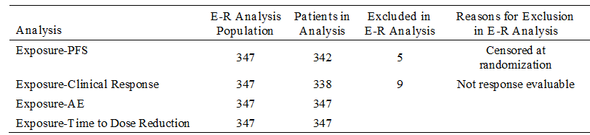

##### Exposure; PFS Analysis

In this analysis, the Kaplan-Meier (KM) estimates for PFS in the ixazomib regimen were stratified by 4 ixazomib exposure quartiles and compared to the placebo regimen. The KM curves for each exposure quartile populations for the ixazomib regimen and for the total population for the placebo regimen are summarised below in Figure 12.

Figure 12: E-R Report - KM curves of PFS by ixazomib exposure quartiles compared to the placebo regimen

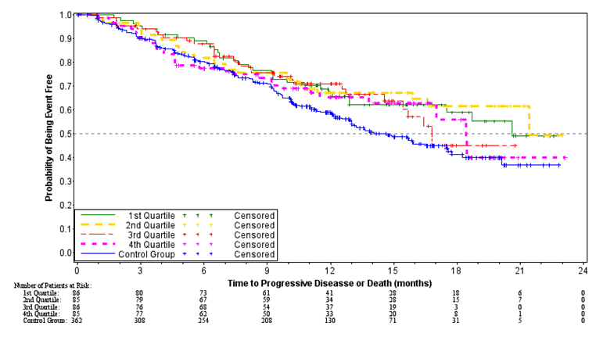

Median PFS estimates in all exposure quartiles (range: 16.8, 21.4 months) in the ixazomib regimen were longer than the median PFS estimate of 14.7 months in the placebo regimen (see Table 21, below). The results of the exposure PFS analysis among the 4 ixazomib exposure quartiles demonstrated a similar trend with the treatment effect being in favour of ixazomib (that is, hazard ratios in all ixazomib exposure quartiles relative to placebo were < 1 [range: 0.646, 0.794]). However, using the proportional hazards regression model, ixazomib exposure as a continuous variable, was not a significant predictor of PFS, with a p-value of 0.2569 and a hazard ratio of 1.002 (905% CI: 0.998, 1.006). Therefore, no subsequent covariate analysis was performed.

Table 21: E-R Report; PFS by ixazomib exposure quartile compared to placebo regimen

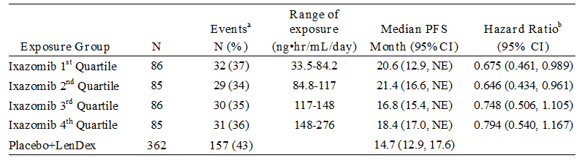

Source: E-R Report, Table 4.b. Abbreviations: NE = not estimable .a. The event included disease progression and death, which ever occurred first. b. Hazard ratios are based on a Cox proportional hazard regression model with placebo + LenDex as the reference group.

**Comment:** There was no evidence from the exposure PFS analysis that plasma ixazomib concentrations were a significant predictor of PFS.

##### Exposure; Clinical Response Analyses

The best response rates for CR, ≥ VGPR and ≥ PR in the placebo regimen for all patients and for patients in each of the 4 quartiles of the ixazomib regimen are summarised below in Table 22.

Table 22: E-R Report; Best response in the 4 ixazomib exposure quartiles compared to the placebo regimen

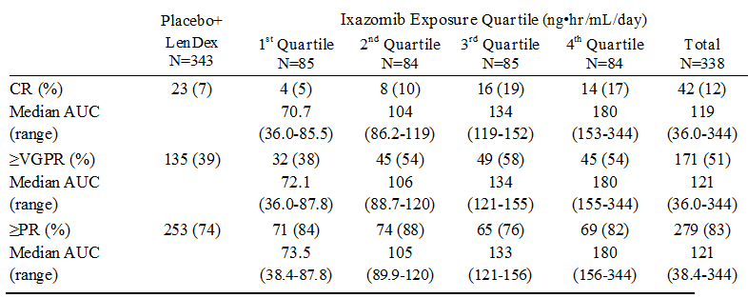

The estimated odds ratio for the exposure-clinical response analysis from the final logistic regression models are summarised below in Table 23, and the logistic regression model fits and 95% CIs are were provided.

Table 23: E-R Report; Estimated odds ratio (95% CI) for the exposure clinical response analysis

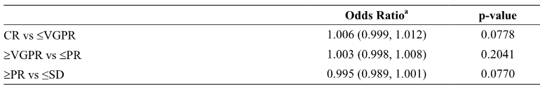

Source: E-R Report, Table 4.d. Abbreviations: CR = complete response; VGPR = very good partial response; PR = partial response; SD = stable disease. a. Estimated odds ratio corresponding to an increase in ixazomib exposure of 1 ng.hr/mL/day.

**Comment:** There was no evidence of a relationship between ixazomib exposure and the probability of achieving a clinical response (that is, CR, ≥ VGPR, ≥ PR).

### Exposure safety Analyses

#### Exposure-haematological adverse events analysis

The relationship between ixazomib exposure and selected haematological and AEs was examined using logistic regression. The haematological AEs examined included ≥ Grade 3 anaemia, neutropenia, and thrombocytopenia. The results are summarised below in Table 24.

Table 24: E-R Report; haematological AEs (≥ Grade 3) by ixazomib + Len/Dex exposure quartiles compared to placebo + Len/Dex

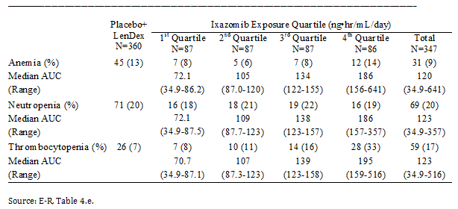

A statistically significant relationship between ixazomib exposure and the probability of ≥ Grade 3 anaemia and ≥ Grade 3 thrombocytopenia was observed. However, ixazomib exposure was not a significant predictor of the probability of ≥ Grade 3 neutropenia. The final logistic regression modelling results for the haematological AEs are summarised below in Table 25. Plots of the observed incidence and predicted probability of haematological AEs (≥ Grade 3) versus the time averaged exposure to ixazomib from the logistic regression models and 95% CIs were provided.

Table 25: E-R Report; estimated odds ratio (95% CI) for the exposure safety analysis of ≥ Grade 3 selected haematological adverse events

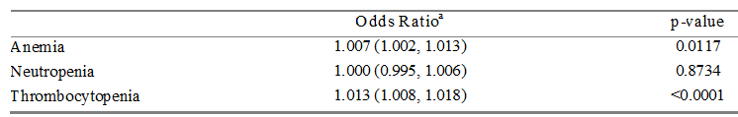

a. The odds ratio reported corresponds to an increase in ixazomib time averaged exposure of ng.hr/mL/day

Exposure related increases in the probability of ≥ Grade 3 anaemia and thrombocytopenia were estimated from the logistic regression models. On the basis of the Day 15 geometric mean AUC(0‑168) (990 ng.hr/mL) after administration of a 4 mg weekly ixazomib dose in Study C16007, the time averaged (daily) AUC was estimated to be approximately 141 ng.hr/mL/day (that is, 990 ng.hr/mL divided by 7 days). As ixazomib displays dose linear PK, the corresponding daily AUC after administration of a 3 mg dose was estimated as approximately 106 ng.hr/mL/day. Of note, the difference between these 2 time averaged daily AUC estimates (35 ng.hr/mL/day) is similar to the difference observed between the median ixazomib exposure in the 2nd AUC quartile and the 3rd AUC quartile. Therefore, it was estimated that a change in daily ixazomib exposure of 35 ng.hr/mL/day is comparable to a change in the weekly ixazomib dose from 3 mg to 4 mg for the purposes of interpreting the observed exposure-AE relationships. An increase in ixazomib exposure of 35 ng.hr/mL/day was predicted to be associated with a 58% and 28% increase in the odds of ≥ Grade 3 thrombocytopenia and anaemia, respectively.

Other covariates examined were: ECOG score (0/1 versus 1); ISS (I/II versus III); demographics (gender, race, BSA, age); cytogenetic risk (standard, high, not available); prior immunomodulatory drug therapy (exposed versus naive); prior lines of therapy (1 versus 2/3); prior proteasome inhibitor therapy (exposed versus naive); and creatinine clearance. However, no additional covariates examined in the exposure safety analyses were identified after the forward addition/backward deletion procedure.

**Comment:** Based on the estimated odds ratios derived from logistic regression modelling, ixazomib exposure was a statistically significant predictor of the probability of experiencing Grade ≥ 3 anaemia or Grade ≥ 3 thrombocytopenia in patients in the ixazomib regimen, compared to patients treated in the placebo regimen.

#### Exposure-non haematological adverse events analysis

The relationship between ixazomib exposure and selected non-haematological AEs was examined using logistic regression modelling. The incidence of non-haematological AEs (≥ Grade 2 diarrhoea, fatigue, nausea, peripheral neuropathy, rash, and vomiting) in all patients in placebo regimen and in patients in each of the 4 quartiles in the ixazomib regimen are summarised below in Table 26.

Table 26: E-R Report; summary of ≥ Grade 2 non-haematological AEs by ixazomib + Len/Dex exposure quartile compared to the placebo + Len/Dex regimen

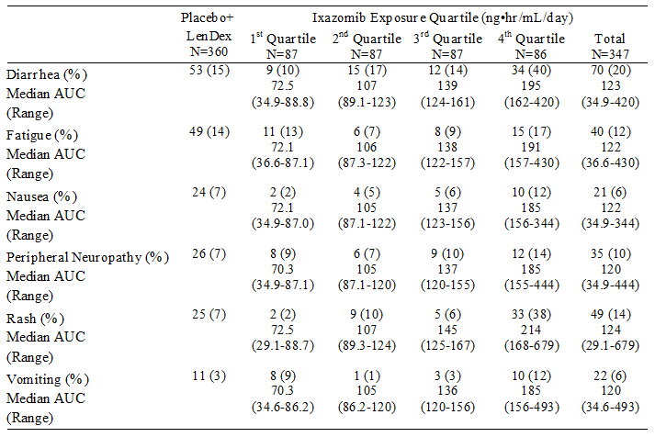

The estimated odds ratios for the exposure safety analyses for significant selected non‑haematological AEs are summarised below in Table 27. Significant covariate effects were observed in the final model for age on fatigue (OR = 1.055 [95% CI: 1.014, 1.098], p = 0.0088) and gender (female versus male) on vomiting (OR = 6.185 [95% CI: 2.030, 18.845], p = 0.0013). Plots of the observed incidence and predicted probability of haematological AEs (≥ Grade 3) versus the time averaged exposure to ixazomib from the logistic regression models and 95% CIs were provided.

Table 27: E-R Report; estimated odds ratios (95% CI) for the exposure safety analysis of ≥ Grade 2 non-haematological AEs

| Adverse Event | Odds Ratio a (95% CI) | p - value |
| --- | --- | --- |
| Diarrhoea | 1.012 (1.007, 1.017) | < 0.0001 |
| Nausea | 1.012 (1.004, 1.019) | 0.0019 |
| Peripheral neuropathy | 1.006 (1.000, 1.012) | 0.0495 |
| Rash | 1.020 (1.014, 1.026) | < 0.0001 |
| Vomiting | 1.008 (1.001, 1.014) | 0.0248 |
| Fatigue | 1.006 (1.000, 1.012) | 0.0358 |

a. The odds ratio reported corresponds to an increase in ixazomib time averaged exposure of 1 ng.hr/mL/day.

As predicted by the final logistic regression models for each non-haematological AE, a 35 ng.hr/mL/day increment in the ixazomib exposure was predicted to be associated with 52%, 23%, 52%, 23%, 101%, and 32% increases in the odds of ≥ Grade 2 diarrhoea, fatigue, nausea, peripheral neuropathy, rash, and vomiting, respectively. Conversely, a decrease in the ixazomib dose from 4 mg to 3 mg was predicted to result in a decrease in the odds of ≥ Grade 2 diarrhoea, fatigue, nausea, peripheral neuropathy, rash, and vomiting by 34%, 19%, 34%, 19%, 50%, and 24%, respectively.

**Comment:** The E-R analyses for non-hematologic AEs showed statistically significant relationships between ixazomib exposure and ≥ Grade 2 rash, peripheral neuropathy, diarrhoea, fatigue, nausea, and vomiting AEs. In addition, based on the logistic regression analyses assessing the effect of pre-specified covariates on safety outcomes, the odds of experiencing ≥ Grade 2 fatigue statistically significantly increased with age (p = 0.009), and the odds of experiencing ≥ Grade 2 vomiting was statistically significantly greater in female than in male patients (p = 0.001). Of note, the effect of age and gender were not confounded by exposure, as the PPK analysis showed no statistically or clinically significant relationships between ixazomib CL/F and age or gender.

As predicted by the final logistic regression model, an increment of 10 years of age showed 70% higher odds of experiencing ≥ Grade 2 fatigue. In the Phase III Study C16010 the median age of patients in both regimens was 66 years and the incidence of ≥ Grade 2 fatigue was similar in patients in the ixazomib (12% [9% Grade 2, 3% Grade 3]) and placebo (14% [11% Grade 2, 3% Grade 3]) regimens. Based on the similar incidence of ≥ Grade 2 fatigue across both treatment regimens in the E-R analysis, it can be reasonably inferred that the statistically significant E-R relationship observed between ixazomib exposure and ≥ Grade 2 fatigue in the analysis is unlikely to be clinical significant. The sponsor speculated that the observed age effect in the covariate analysis may reflect known increased toxicity in the elderly (≥ 65 years) due to increased comorbidities, decline in physiologic reserve, increased frailty, and increased disability.

On the basis of the final logistic regression model, the odds of experiencing ≥ Grade 2 vomiting was greater in female patients in the ixazomib regimen compared to male patients (that is, odds ratio of 6.185). Based on the exposure response analysis population, female patients in the placebo regimen had an incidence rate of ≥ Grade 2 vomiting approximately 3 fold higher than the rate observed in male patients (that is, 5% versus 1.5%, respectively). In Study C16010, the rate of ≥ Grade 2 vomiting was 6% in the ixazomib regimen and 3% in the placebo, and was largely attributable to Grade 2 vomiting (5% versus 3%, respectively). No patient discontinued study treatment due to vomiting. The sponsor states that the difference in the incidence of vomiting between male and female patients noted in the exposure safety analysis are unlikely to be clinically relevant and may be an artefact due to reporting bias (that is, more reporting of experienced events in females than in males). However, despite the sponsor's comments, it cannot be discounted that the observed results demonstrate a true increased risk of vomiting in female patients compared to male patients treated with ixazomib.

##### Exposure-time to first ixazomib dose reduction analysis

The relationship between ixazomib exposure and the time to first ixazomib dose reduction was assessed by Kaplan-Meier (KM) analysis. The results of the Cox proportional hazard model indicate that ixazomib exposure was not a predictor of time to first ixazomib dose reduction, with a hazard ratio of 1.004 (95% CI: 1.000, 1.009), p = 0.0693. In the pivotal Phase III Study C16010, after a median number of 12 cycles, 80% of patients in the ixazomib regimen continued treatment at the starting dose of ixazomib 4 mg without a dose reduction, with 20% of patients reporting 1 dose reduction, and 3% reporting 2 dose reductions.

### Evaluator's overall conclusions on pharmacodynamics

* The data from the Phase I Studies C16001 and C16002 showed that the maximum tolerated doses of IV ixazomib reversibly inhibited 20S proteasome activity. Maximal inhibition of 20S proteasome inhibition occurred within 30 minutes of IV administration, indicating a close temporal association between maximum pharmacodynamic effect and maximum plasma concentration.
* The Millennium-A2PG-0001 Report demonstrated no clinically meaningful differences between the placebo and ixazomib regimens in the incidence of QTc prolongation. Neither regimen appears to be associated with clinically significant effects on QTc prolongation. The pooled data from the analysis indicate that the risk of pro-arrhythmia associated with ixazomib is low. Model predictions of mean ΔΔQTcF at the geometric mean of Cmax (48 ng/mL) for a 4 mg single dose were 0.07 msec (90% CI: -0.22, 0.36 msec). The upper limit of the 90% CI was well below 5 msec.
* The E-R analyses demonstrated that ixazomib exposure was not a significant predictor of clinical responses (CR, ≥ VGPR, ≥ PR) and was not a significant predictor of PFS.
* The E-R analyses demonstrated a significant relationship (p < 0.05) between ixazomib exposure and selected TEAEs (rash, peripheral neuropathy, diarrhoea, nausea, vomiting, fatigue, thrombocytopenia, and anaemia).

## Dosage selection for the pivotal studies

The submission included one pivotal Phase III Study C16010. In this study, the starting dose of ixazomib was 4 mg administered on Days 1, 8, and 15 of a 28 day cycle in combination with LenDex regimen. The sponsor states that the proposed dosing regimen was supported by nonclinical data and clinical trial results in which ixazomib was administered as a single agent and in combination with the LenDex. The sponsor reports that the weekly ixazomib dosing schedule was well tolerated in in vivo toxicology studies, and was predicted to allow dosing on a schedule that produced maximum antitumor activity in mouse models.

The sponsor stated that selection of the Phase III dose and schedule was based on the Phase I single agent ixazomib studies in patients with RRMM; Studies C16004 and C16003 and on the Phase I/II ixazomib + LenDex combination study in patients with NDMM (C16005). Although the Phase I studies in patients with RRMM were conducted with the objective of understanding safety and pharmacokinetics, the dose escalation design allowed determination of MTD, DLTs and assessment of twice weekly and once weekly dosing schedules. However, it should be noted that efficacy in the two Phase I studies in patients with RRMM was a secondary objective and was evaluated descriptively in the absence of control group.

### Study C16004 (once weekly, single agent) and Study C16003 (twice weekly, single agent)

In the early clinical development program for oral ixazomib, both twice weekly single agent ixazomib (Days 1, 4, 8, and 11 of a 21 day cycle [Study C16003]) and once weekly single agent ixazomib (Days 1, 8, and 15 of a 28 day cycle [Study C16004]) dosing schedules were investigated in patients with RRMM. In both studies the baseline demographic and disease characteristics of the enrolled populations were similar. Both Studies C16003 and C16004 had 2 patient cohorts, including an initial MTD dose escalation cohort followed by an MTD extension-cohort where patients were treated at the established MTD to further assess safety and to obtain preliminary efficacy data. Both C16003 and C16004 were conducted using BSA based dosing rather that fixed dosing. However, data from the Preliminary PPK Report showed no discernible relationship between BSA and ixazomib clearance over a relatively wide BSA range (1.4 to 2.6 m2), indicating that total systemic exposure (AUC) following fixed dosing should be independent of individual BSA. Therefore, the clinical development of ixazomib shifted from BSA based dosing in the earlier studies to fixed dosing in the later studies.

### Study C16003

Study C16003 was the first clinical study to investigate an oral dose of ixazomib in patients with MM. In C16003, a total of 60 patients were enrolled from 5 centres in the US, including 40 patients treated at the MTD (2 mg/m2, equivalent to a fixed dose of 3.7 mg). In the MTD dose escalation cohort, patients were required to have relapsed after receiving at least 2 prior lines of therapy that had to include some combination of VELCADE, immunomodulatory drugs (IMiDs), and corticosteroids. After determination of the MTD, additional patients were enrolled and treated with the MTD in the MTD expansion cohort. In the MTD expansion-cohort, patients were required to have been previously treated with at least 1 line of therapy involving VELCADE, thalidomide or lenalidomide, or corticosteroids.

In the MTD dose escalation cohort, patients were administered ixazomib orally on Days 1, 4, 8, and 11 during a 21 day treatment cycle, at a starting dose of 0.24 mg/m2. A 3 + 3 dose escalation scheme was used to determine the MTD following a modified Fibonacci sequence to guide escalation with doses of 2.0, 1.67, 1.50, 1.40, and 1.33 fold over the previous dose level. The MTD was defined as the highest dose that generated a dose limiting toxicity (DLT) rate of 0 of 6 or 1 of 6 patients during Cycle 1. In the dose escalation period, each planned dose level started with the treatment of 3 patients. The next cohort of 3 patients was only treated after the previous cohort of 3 patients completed Cycle 1. When necessary and according to the DLT escalation rules, up to 3 additional patients were enrolled at a dose level. Once the MTD was established, patients were enrolled into 1 of the 4 MTD expansion cohorts to more fully characterise the safety, tolerability, and efficacy of ixazomib at the MTD.

A total of 60 patients were enrolled and treated with at least 1 dose of study drug, and included in the safety analysis. A total of 26 patients were enrolled in the MTD dose escalation cohorts, and a total of 40 patients were enrolled to receive 2 mg/m2 in the MTD dose-expansion cohorts. Of the 60 enrolled patients, 55 patients comprised the response evaluable population, including 39 patients treated in the MTD expansion cohorts. The response evaluable population was defined as all patients who received at least one dose of ixazomib, had measurable disease at baseline, and had at least one post-baseline disease assessment.

The actual ixazomib doses used in the MTD dose escalation cohorts (n = 21) were 0.24 mg/m2 (n = 2), 0.48 mg/m2 (n = 3), 0.8 mg/m2 (n = 3), 1.2 mg/m2 (n = 3), 1.68 mg/m2 (n = 2); 2 mg/m2 (n = 6), 2.23 mg/m2 (n = 2). After progressing from the dose of 1.68 mg/m2 to the dose of 2.23 mg/m2, 1 DLT of macular rash and 1 event of Grade 4 thrombocytopenia conservatively counted as a DLT were observed. Therefore, the intermediate dose of 2 mg/m2 was chosen for further exploration. Of the 6 evaluable patients enrolled at this dose, none experienced a DLT. Therefore 2 mg/m2 was selected as the MTD and the dose for further exploration in the intended Phase 2 part of the study. At the MTD of 2 mg/m2 (n = 6), 50% (n = 3) of patients had stable disease and 50% (n = 3) of patients had progressive disease. No patients in the MTD dose escalation cohort of 2 mg/m2 had a CR, PR or MR. The response evaluable patients in the 4 MTD expansion cohorts (n = 39) were: (1) relapsed and refractory MTD expansion cohort (n = 20); (2) VELCADE-relapsed expansion cohort (n = 12); (3) proteasome inhibitor naive MTD expansion cohort (n = 6); and (4) carfilzomib MTD expansion cohort (n = 2).

The median age of the 60 enrolled patients was 65.0 years (range: 50, 86 years) and the majority were male (53%, n = 32) and White (90%, n = 54) with median BSA of 1.92 m2 (range: 1.2, 2.5). The median time since diagnosis was 57.4 months (range: 12, 291). A total of 38 patients (63%) had IgG myeloma, 11 patients (18%) had IgA myeloma, and the remaining 11 patients (18%) had light chain myeloma. The proportion of patients with an ISS stage of I, II, and III disease was 33%, 33%, and 32%, respectively (with unknown stage in 2%). Fifty-seven patients (95%) had measurable disease at baseline, and most patients (71%) had lytic disease at baseline. The median number of lines of prior therapy received overall was 4 (range: 1, 28). The median haemoglobin levels were 105.0 g/L in both the overall population and the MTD expansion cohorts. Thirty-three patients (55%) had albumin levels < 3.5 g/dL at baseline. The median calculated creatinine clearance was 73.6 mL/min overall, and 67.7 mL/min in the MTD expansion cohorts. Overall, 37% of patients entered the study with creatinine clearance < 60 mL/min. Cytogenetic data were available from 50 patients, 29 (58%) of whom had abnormalities. Twelve of the 29 patients had high risk cytogenetics (41%), all with myeloma harbouring del(17). Of the 12 patients with del(17), 2 patients also had t(4;14) and 1 also had t(14;16).

The majority of patients in the safety population (83%) had received at least 3 lines of prior therapy before study entry and 27% of patients had received ≥ 6 lines of prior therapy. Overall, 60% of patients had undergone a previous an autologous stem cell transplant. A total of 34 patients (60%) were refractory to their last prior therapy, including 15 patients (25%) refractory to bortezomib, 1 patient (2%) refractory to carfilzomib, and 18 patients (30%) refractory to lenalidomide or thalidomide. A total of 29 (58%) patients were refractory to bortezomib in any line of prior therapy.

### Study 16004

In C16004, a total of 60 patients were enrolled from 6 centres in the US, including 31 patients treated at the MTD (2.97 mg/m2, equivalent to a fixed dose of 5.5 mg). In the MTD dose escalation cohort, patients were required to have relapsed after receiving at least 2 prior lines of therapy, which had to include some combination of VELCADE, immunomodulatory drugs (IMiDs), and corticosteroids. After determination of the MTD, additional patients were enrolled into the expansion cohort and treated with the MTD. In the MTD expansion cohort, patients were required have been previously treated with at least 1 line of therapy involving VELCADE, thalidomide or lenalidomide, or corticosteroids.

In the MTD dose escalation cohort, patients were administered ixazomib orally once a week on Days 1, 8, and 15 of a 28 day treatment cycle, at a starting dose of 0.24 mg/m2. A 3 + 3 dose escalation scheme was used to determine the MTD following a modified Fibonacci sequence to guide escalation with doses of 2.0, 1.67, 1.50, 1.40, and 1.33 fold over the previous dose level. The MTD was defined as the highest dose that generated a dose limiting toxicity (DLT) rate of 0 of 6 or 1 of 6 patients during Cycle 1. In the dose escalation period, each planned dose level started with the treatment of 3 patients. The next cohort of 3 patients was only treated after the previous cohort of 3 patients completed Cycle 1. When necessary and according to the DLT escalation rules, up to 3 additional patients were enrolled to a dose level. Once the MTD was established, patients were enrolled into 1 of the 4 MTD expansion cohorts to more fully characterise the safety, tolerability, and efficacy of ixazomib at the MTD.

A total of 60 patients were enrolled and treated with at least 1 dose of study drug, and were included in the safety analysis. A total of 32 patients were enrolled and treated in the MTD dose escalation cohorts, and a total of 31 patients were enrolled to receive 2.97 mg/m2 in the MTD dose expansion cohorts. Of the 60 enrolled patients, 50 patients comprised the response evaluable population, including 31 patients treated in the MTD expansion cohorts. The response evaluable population was defined as all patients who received at least one dose of ixazomib, had measurable disease at baseline, and had at least one post-baseline disease assessment

The actual ixazomib doses used in the MTD dose escalation response evaluable population (n = 23) were 0.24 mg/m2 (n = 2), 0.48 mg/m2 (n = 3), 0.8 mg/m2 (n = 2), 1.2 mg/m2 (n = 3), 1.68 mg/m2 (n = 2); 2.23 mg/m2 (n = 3), 2.97 mg/m2 (n = 4), and 3.95 mg/m2 (n = 4). The MTD was 2.97 mg/m2 (fixed dose equivalent of 5.5 mg). The response evaluable-population in the 4 MTD expansion cohorts (n = 30) were: (1) relapsed and refractory MTD expansion cohort (n = 11); (2) VELCADE-relapsed expansion cohort (n = 9); (3) proteasome inhibitor naive MTD expansion cohort (n = 6); and (4) carfilzomib MTD expansion cohort (n = 4).

The median age of the 60 enrolled patients was 64.0 years (range: 40, 79 years), the majority were male (55%, n = 33) and White (85%, n = 51). The median BSA was 1.92 m2 (range: 1.2, 2.6). The median time since diagnosis was 58.6 months (range: 18, 226). A total of 41 patients (68%) had IgG myeloma, 10 patients (17%) had IgA myeloma, and the remaining 9 patients (15%) had light chain myeloma. The proportion of patients with an ISS stage of I, II, or III disease was 30% (n = 18), 48% (n = 29), and 20% (n = 12), respectively, and 1 (2%) patient had unknown ISS stage. Fifty-four patients (90%) had measurable disease at baseline, and most patients (60%, n = 36) had lytic disease at baseline. The median β2-microglobulin level was 3.80 mg/L, with 11 patients (18%) had a high level (> 5.5 mg/L) at baseline. Thirty patients (50%) had albumin levels < 3.5 g/dL at baseline. The median calculated creatinine clearance was 76.6 mL/min overall, and 67.7 mL/min in the MTD expansion cohort. Overall, 23% (n = 14) of patients entered the study with moderate renal impairment (CLcr 3 to 60 mL/min) or severe renal impairment (CLcr 21 to 30 mL/min) (22% [n = 13] and 2% [n = 1], respectively). Ten of the 50 patients (20%) with data had high risk cytogenetic abnormalities, including 6 with the del(17) abnormality.

The median number of lines of prior therapy received was 4.0 overall, with a range of 1 to 13 lines. The majority of patients in the safety population had received at least 3 lines of prior therapy (70%; n = 42) before study entry and 28% (n = 17) of patients had received ≥ 6 lines of prior therapy. Overall, 77% (n = 46) of patients had undergone a previous autologous stem cell transplant. A total of 42 (72%) patients were refractory to their last prior therapy, with 11 (18%) patients being refractory to VELCADE, and 23 (38%) patients being refractory to lenalidomide or thalidomide. A total of 27 (68%) patients were refractory to VELCADE, and 3 (5%) patients were refractory to carfilzomib, in any line of prior therapy.

#### *Results; Studies C16003 and C16004*

In both C16003 and C16004, the analysis of efficacy was descriptive, and the number and percentage of patients in each disease response category (ORR [CR+PR], CR+PR+MR, CR, PR, MR, and SD) were presented for patients in each of the 4 MTD expansion cohorts and for all patients combined (that is, all response evaluable patients). Disease response was assessed by investigators using IMWG criteria, with the addition of MR and near CR from EBMT criteria. A CR had to be confirmed with follow-up assessments of serum protein electrophoresis (SPEP), urine protein electrophoresis (UPEP), immunofixation of blood and urine, and serum free light chains. One bone marrow assessment had to occur to document CR, but no second bone marrow confirmation was needed. PD could have been confirmed per standard clinical practice at site, and local laboratories could have been used to confirm PD. The key efficacy and safety outcomes from the two Phase I studies in patients with RRMM are provided below in Table 28.

Table 28: Comparison of efficacy and safety between Studies C16003 and C16004 in patients with RRMM

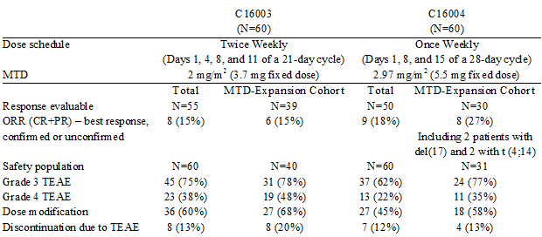

**Comment:** The ORR (rate of best response [confirmed and unconfirmed] of PR or better) in the whole study population and MTD expansion cohort was 15% in both populations in C16003, and 18% and 27%, respectively, in C16004. Although the response rates were similar between the 2 studies in the total study populations, the ORR in the MTD expansion cohorts was higher in C16004 (MTD = 5.5 mg fixed dose; once weekly regimen) than in C16003 (MTD = 3.7 mg fixed dose; twice weekly regimen). The median duration of response of PR or better for patients treated at the MTD was 5.6 months (range: 0.9, 7.5 months) in C16004 and 5.7 months (range: 2.8, 6.9 months) in C16003.

The MTD was 2.97 mg/m2 (5.5 mg fixed dose) in C16004 and 2 mg/m2 (3.7 mg fixed dose) in C16003. DLTs included nausea, vomiting, diarrhoea and rash in C16004 and rash and thrombocytopenia in C16003. The incidences of Grade 3 and Grade 4 TEAEs were lower in the total population in C16004 than in C16003 (Grade 3, 62% versus 75%; Grade 4, 22% versus 38%). At the MTD, the incidences of Grade 3 TEAEs were similar in Studies C16004 and C16003 (77% and 78%, respectively), but the incidence of Grade 4 TEAEs was lower in C16004 than in C16003 (35% versus 48%). The incidence of dose modifications due to AEs was lower in C16004 compared to C16003 in the total populations (45% versus 60%, respectively) and in the MTD expansion cohorts (58% versus 68%, respectively). Although the incidences of drug discontinuation due to AEs were similar in the total C16004 and C16003 populations, in the MTD expansion cohorts, more patients experienced TEAEs leading to drug discontinuation in C16003 than in C16004 (20% versus 13%, respectively).

The sponsor considered that the preliminary observations from the two Phase I studies in patients with RRMM supported selection of the ixazomib once weekly dose schedule over the twice weekly dose schedule. Additionally, the sponsor commented that "the once weekly schedule in a 28 day cycle combines seamlessly with the 28 day LenDex treatment cycle, without compromising the LenDex schedule and dose intensity, while allowing dosing with oral ixazomib to be convenient for patients and their caregivers". In summary, the once weekly, single agent (5.5 mg ixazomib) regimen had a higher ORR and better tolerability than the twice weekly, single agent (3.7 mg ixazomib). The data support selection of the once weekly ixazomib treatment regimen (Days 1, 8 and 15) in a 28 day cycle.

### Study C16005 (ixazomib in combination with LenDex)

Study C16005 was a Phase I/II Study conducted in the US (10 sites) of once weekly ixazomib + LenDex in a 28 day cycle in patients with NDMM. The primary objectives of the study were to determine the safety, tolerability, and MTD of ixazomib administered weekly in combination with Len/Dex and to determine the recommended Phase 2 dose (RP2D). The secondary objectives included an assessment of efficacy based on the CR+VGPR.

The study enrolled a total of 65 patients, and all 65 patients received at least 1 dose of any study drug and were included in the safety analysis. There were 15 subjects enrolled in the 4 dose escalation cohorts (Phase I) and 50 patients enrolled in Phase 2 of the study. Of the 65 patients, 64 were included in the response evaluable population, with 1 enrolled patient being excluded from this population due to the absence of a post-baseline assessment. All patients in Phase 2 were treated with the RP2D (that is, 2.23 mg/m2 = 4 mg fixed dose).

The median age of the 65 enrolled patients was 66 years (range: 34, 86 years), and the majority were male (55%, n = 36) and White (80%, n = 52). The median time since initial diagnosis of MM to first dose of ixazomib was 1.4 months (range: 0, 28 months). MM at study entry was IgG in 68% (n = 44) of patients, IgA in 22% (n = 14) of patients, and light chain in 9% (n = 5).

Lenalidomide 25 mg was administered orally once daily from Days 1 through 21 and dexamethasone 40 mg was administered orally on Days 1, 8, 15, and 22. Ixazomib dose escalation followed a 3 + 3 dose escalation scheme. The ixazomib dose was escalated from 1.68 mg/m2 (n = 3) to 2.23 mg/m2 (n = 3) to 2.97 mg/m2 (n = 6) and finally to 3.95 mg/m2 (n = 3), with doses of LenDex unchanged; the BSA based doses were equivalent to fixed doses of 3 mg, 4 mg, 5.5 mg, and 7.2 mg, respectively. No DLTs were seen at doses up to 2.97 mg/m2 in the initial dose escalation per protocol. Therefore, 3 patients were treated at the next dose level of 3.95 mg/m2, and all 3 patients experienced DLTs at this level. Consequently, dosing was reduced to 2.97 mg/m2. Three additional patients were enrolled at 2.97 mg/m2 and 1 of the 3 patients experienced a DLT. The MTD of once weekly ixazomib in combination with a 28 day cycle of LenDex was therefore established at 2.97 mg/m2 (equivalent to 5.5 mg fixed dose). In summary, 4 patients experienced DLTs in Cycle 1. In the 2.97 mg/m2 (MTD) cohort, 1 patient out of 6 experienced Grade 3 urticaria. In the 3.95 mg/m2 dose cohort (1 dose level above the MTD), 3 patients out of 3 experienced DLTs, including 1 patient with Grade 2 nausea and vomiting, 1 patient with Grade 2 peripheral neuropathy and Grade 3 vomiting, syncope, and nausea, and 1 patient with Grade 2 dizziness and orthostatic hypotension and Grade 3 nausea and vomiting.

The RP2D was selected after evaluation of the available data from the Phase I portion of the study, based on drug tolerability, exposure and dose modification data in Cycle 1 and beyond. The MTD was 2.97 mg/m2 (equivalent to 5.5 mg fixed dose) and the RP2D was 2.23 mg/m2 (equivalent to 4 mg fixed dose). In the dose escalation phase, DLTs had been observed in 1/6 patient in the 2.97 mg/m2 cohort and 0/3 patients in the 2.23 mg/m2 cohort. The sponsor commented that the median dose intensity for lenalidomide was lower when combined with 2.97 mg/m2 compared to 2.23 mg/m2 (that is, 84.6% versus 96.0%, respectively).

The CR+VGPR rate was the primary Phase 2 efficacy endpoint. Overall response was determined by the investigator according to the IMWG uniform response criteria for MM. The CR+VGPR (Phase 2) in response evaluable patients treated with ixazomib 4 mg + Len/Dex was 59% (29/49), comprising a CR of 20% (10/49) and a VGPR of 39% (19/49). The results for the overall response to treatment based on the investigators' confirmed best response over time in the response evaluable population were summarised.

In the Phase 2 patients treated with ixazomib 4 mg + LenDex (n = 49), the median time to first response was 0.95 months (range: 0.9, 5.8), the median time to best response of CR was 4.42 months (range: 2.5, 11.3 months), the median time to VGPR or better was 3.71 months (range: 1.0, 11.3), and the median time to best response of PR or better was 2.96 months (range: 0.9, 11.3 months). In the response evaluable patients, the median duration of response was not estimable for subjects with CR or with CR+VGPR. In the response evaluable patients, the median time to progression was not estimable and the median time to follow-up in censored patients was 7.39 months.

In this study, all 65 patients in the safety analysis had at least 1 TEAE and at least 1 TEAE related to 1 or more of the 3 drugs in the combination. A total of 36 (55%) patients had at least 1 drug related Grade 3 TEAE, and 4 (6%) patients had at least 1 drug related Grade 4 TEAE. The most common preferred terms of TEAE (regardless of causality) were diarrhoea (60%), fatigue (58%), nausea (51%), constipation (40%), peripheral oedema (38%), vomiting (38%), upper respiratory tract infection (35%), and back pain, insomnia, peripheral neuropathy, and thrombocytopenia (32% each). Peripheral neuropathy was reported in 21 (32%) patients and peripheral sensory neuropathy was reported in 8 (12%) patients.

Skin rash was seen in a substantial number of patients, though it was the DLT toxicity in only 1 patient and in that case likely represented an effect of lenalidomide as well as ixazomib. Overall, skin rash was reported in 42 (65%) patients, and was described using various preferred terms including, rash erythematous, ecchymosis, rash macular, rash maculopapular, rash pruritic, pruritus, rash, rash papular, rash pustular, urticaria, acute febrile neutrophilic dermatosis (Sweet’s syndrome), and drug eruption (pruritic rash associated with morphine). Macular rash was the most common term reported (in 10 patients). The majority (67%; 38/57) of rash events occurred in the Phase 2 cohort, and the majority (77%; 44/57) were Grade 1 or 2. Of the 57 rash events, 21 were self-limiting and resolved without intervention and 36 required intervention. If treatment for rash was needed, rash was manageable with dose modifications (including reductions or holding of either lenalidomide or ixazomib, whichever was the causative agent) and oral or topical antihistamines.

Two deaths had occurred in this study at the time of the database lock on 8 March 2013. One patient died of unrelated cardio-respiratory arrest and the other patient died from respiratory syncytial viral pneumonia considered to be related to the full study drug regimen. A total of 28 (43%) patients experienced at least 1 serious adverse event (SAE) and 14 (22%) patient experienced at least 1 SAE related to at least 1 of the 3 study drugs. The most common Treatment related SAEs were nausea (3%), vomiting (3%), diarrhoea (3%), and dehydration (3%), each reported for 2 patients. Overall, 5 (8%) patients experienced a TEAE resulting in study drug discontinuation. The TEAEs resulting in study drug discontinuation were each reported in 1 patient (2%), and were 1 x bone abscess, 1 x respiratory syncytial viral pneumonia, 1 x cardio-respiratory arrest, 1 x gastrointestinal haemorrhage, and 1 x amnesia, peripheral sensory neuropathy, and resting tremor.

Fifteen patients (23%) experienced a TEAE of anaemia, and 4 (6%) patients experienced Grade 3 events. Eighteen patients (28%) had at least 1 TEAE of neutropenia. Of these 18 patients, 9 (14%) experienced Grade 3 neutropenia, and 2 (3%) experienced Grade 4 neutropenia. Thrombocytopenia was a common TEAE, with 21 (32%) patients having at least 1 event, the majority of which were related to the study drug. Overall, 6 (9%) patients had Grade 3 thrombocytopenia and 2 (3%) patients had Grade 4 thrombocytopenia. Both cases of Grade 4 thrombocytopenia were transient and did not require administration of platelets.

There were several shifts to Grade 3 or 4 haematological adverse events. Among patients who had a baseline value of Grade 0, 1, or 2, 14% shifted to a worst platelet value of Grade 3; 8% shifted to a worst haemoglobin value of Grade 3; 39% shifted to a worst lymphocyte value of Grade 3; 26% shifted to a worst neutrophil value of Grade 3; and 12% shifted to a worst leukocyte value of Grade 3. Shifts to a worst Grade 4 value occurred in ≤ 3% of patients for any haematology parameter.

**Comment:** Based on the data from the combination Study C16005 and the two single agent Studies C16003 and C16004, it is considered that the sponsor's decision to assess the efficacy of ixazomib 4 mg once weekly on Days 1, 8 and 15 of a 28 day cycle in combination with Len/Dex in the pivotal Phase III Study C16010 is appropriate. The TEAEs observed in Study C16005 were generally manageable with dose modification (that is, reduction, temporarily holding) and/or standard supportive care. The types of TEAEs observed were generally expected on the basis of clinical experience with the first-in-class proteasome inhibitor, VELCADE, and clinical experience with the Len/Dex background regimen.

## Clinical efficacy

### Pivotal efficacy Study C16010

#### Study design, objectives, locations and dates

##### Study title, locations and dates

Study Title: A Phase III, randomized, double blind, multicentre study comparing oral MLN9708 Plus Lenalidomide and Dexamethasone versus Placebo plus Lenalidomide and Dexamethasone in adult patients with relapsed and/or refractory multiple myeloma.

Between 28 August 2012 and 27 May 2014, a total of 722 patients were randomised at 147 study centres in 26 countries. The majority of patients (67%, n = 483) were from Europe, with the remainder being from the Asia Pacific region (20%, n = 143), and North America (13%, n = 96). The study included 17 (2%) patients from Australia.

The submitted CSR was dated 27 May 2015. The data cut-off date for the results of the first interim analysis (final analysis of PFS for statistical testing purposes) reported in the CSR was 30 October 2014, and 387 patients were continuing on treatment at that date (199 in the ixazomib regimen [55%] and 188 [52%] in the placebo regimen).

The sponsor is Millennium Pharmaceuticals, Inc., Cambridge, MA, USA, a wholly owned subsidiary of Takeda Pharmaceuticals, Inc. The sponsor states that the study was performed in accordance with Good Clinical Practice (GCP), according to the International Conference on Harmonisation (ICH) final guideline dated 1 May 1996.

##### Objectives

* The primary objective of the study was to determine whether the addition of oral ixazomib to background therapy of lenalidomide and dexamethasone (LenDex) improves progression free survival (PFS) in patients with relapsed and/or refractory multiple myeloma (RRMM) who have been treated with at least 1 line of prior therapy.
* The key secondary objectives were:
  + to determine whether the addition of oral ixazomib to LenDex improves overall survival (OS); and
  + to determine whether the addition of oral ixazomib to LenDex improves OS in high risk patients carrying the genetic variation del(17).
* The study also included a large number of other secondary (non-key) objectives, and exploratory objectives.

#### Design and investigational plan

The following nomenclature was used throughout the CSR and has been adopted in this clinical evaluation report (CER): (1) the term “randomised drug” refers to either ixazomib or placebo; (2) study drug regimen refers to either ixazomib + LenDex (that is, ixazomib regimen) or placebo + LenDex (that is, placebo regimen); and (3) study treatment or study therapy refers to any of the 4 drugs (ixazomib, placebo, lenalidomide, or dexamethasone) used in the study.

Study C16010 was a Phase III, multinational, multicentre, randomised, double blind, multicentre clinical trial evaluating the safety and efficacy of ixazomib versus placebo in patients with RRMM who were being treated with LenDex as their standard therapy. The patient population consisted of adult men and women who had a previously confirmed diagnosis of MM, who had received at least 1 prior line of therapy, and who met the other eligibility criteria (see inclusion and exclusion criteria described below). Approximately 703 patients were planned to be enrolled in the study. The flow diagram for the study is provided below in Figure 13 and the study schedule was provided.

Figure 13: Study C16010 - Study flow diagram

Figure 13: Study C16010 - Study flow diagram
The formal screening period lasted for up to 28 days prior to randomisation
Randomization; stratification 1 versus 2 or 3 prior therapies, PI exposed versus PI naive ISS stage 1 or 2 versus stage 3
Treated: MLN9708 4 mg on days 1 8 and 15, lenonloamide 25mg on days 1-21, Dexamethasone 40mg on days 1, 8, 15 and 22. 
Placebo: single dose on Days 1,8 and 15.lenonloamide 25mg on days 1-21, Dexamethasone 40mg on days 1, 8, 15 and 22. 

Repeat this every 28 dyas until disease progressionor unacceptable toxicity.

End of treatment visit
Follow up PFS every 4 weeja 
Follow up survival every 12 weeks


The formal screening period lasted for up to 28 days prior to randomisation. Determination of disease progression as an entry criterion may have been based on patient data obtained during or following the patient’s most recent prior antineoplastic therapy. Following the screening period, patients were stratified by the number of prior therapies, prior use proteasome inhibitors and ISS stage and randomised in a 1:1 ratio to receive either the ixazomib or the placebo regimen.

Patients received ixazomib 4 mg or matching placebo capsule on Days 1, 8, and 15 plus 25 mg lenalidomide on Days 1 through 21 and 40 mg dexamethasone on Days 1, 8, 15, and 22 of a 28 day cycle. Treatment was to continue until progressive disease (PD) or unacceptable toxicity, whichever occurred first. Dose modifications were made based on toxicities according to pre‑specified protocol guidelines. Patients with a creatinine clearance ≤ 60 mL/min (or ≤ 50 mL/min, according to the lenalidomide local practice prescribing information) received a reduced lenalidomide dose of 10 mg once daily (QD) on Days 1 through 21 of a 28 day cycle. The lenalidomide dose may have been escalated to 15 mg QD after 2 cycles if the patient was not responding to treatment and was tolerating treatment. If renal function normalised (that is, creatinine clearance > 60 mL/min or > 50 mL/min, according to lenalidomide local practice prescribing information) and the patient continued to tolerate treatment, lenalidomide may have been escalated to 25 mg QD.

Patients were seen at regular treatment cycle intervals while they were participating in the study, including twice a treatment cycle for the first 3 cycles, once a treatment cycle for the remainder of the active treatment phase, and then (if applicable) every 4 weeks in the PFS follow-up phase and every 12 weeks in the OS follow-up phase. Patients were followed for survival after disease progression and were contacted every 12 weeks until death or termination of the study by the sponsor. OS follow-up was to continue until 486 deaths had been reported. The duration of the study was to be approximately 80 months (6 years 8 months), including 20 months for enrolment and 60 months of follow-up from the last patient enrolled.

Patients were assessed for disease response and progression by an independent review committee (IRC), which was blinded to treatment assignment and had no knowledge of the principal investigator’s response and progression evaluation. As specified in the IRC charter, the IRC used standard myeloma serum and urine test results (including serum free light chain [FLC] analyses) from a central laboratory for response and progression assessments, based on established International Myeloma Working Group (IMWG) response and progressive disease (PD) criteria. Response assessment was undertaken after every cycle of therapy (every 28 days) during the treatment period and every 4 weeks after the patient was off study treatment during the pre-PD follow up period. There were 2 primary IRC readers for each patient and, if they disagreed on either the response or the date of the assessment, a third reader adjudicated the evaluation. Data from the IRC were not provided to the investigator during the conduct of the study.

An unblinded independent data monitoring committee (IDMC), consisting of 3 myeloma experts and 2 statisticians and supported by an independent statistical centre, reviewed safety on a regular basis and the efficacy data at the interim analyses pre-specified in the IDMC charter. Three interim analyses were planned during the study, with the primary objective of the first interim analysis to determine if the ixazomib regimen improves PFS compared to the placebo regimen in patients with RRMM. The IDMC also provided a recommendation regarding study continuation, based on the safety and efficacy parameters.

**Comment:** The general design of the study is considered to be satisfactory. Randomisation to the treatment arms and double blind treatment comparison are standard methods aimed at mitigating bias in clinical trials. All patients with RRMM in the study were being treated with LenDex prior to double blind, randomisation to ixazomib or placebo. In Australia, the approved indications for lenalidomide include the treatment of MM in patients whose disease has progressed after one therapy. The lenalidomide PI recommends that the drug be administered in combination with dexamethasone for this indication. However, the dose of dexamethasone used in C16016 was lower than the dose recommended in the lenalidomide PI for patients with MM whose disease has progressed after one therapy.

The lenalidomide PI recommends a starting dose of lenalidomide for previously treated MM of 25 mg orally once daily on days 1 to 21 of repeated 28 day cycles, used in combination with dexamethasone 40 mg orally on days 1 to 4, 9 to 12 and 17 to 20 of each 28 day cycle for the first 4 cycles and then 40 mg once daily on days 1 to 4 every 28 days. The dose regimen of dexamethasone being proposed for approval is 40 mg on Days 1, 8, 15, and 21 of a 28 day cycle, which is lower than the dose regimen approved in the lenalidomide PI. In the CSR the sponsor states that the "dosing regimen of dexamethasone is lower than the dose originally studied in the lenalidomide dexamethasone combination [Weber et al., 2007; Dimopoulos et al., 2007], but is consistent with current standard of care, after a randomized ECOG study of lenalidomide low dose dexamethasone versus lenalidomide high dose dexamethasone showed improved PFS with the lower dose dexamethasone regimen [Rajkumar S, et al., 2010]". However, the Rajkumar et al., 2010 publication relates to the use of low dose dexamethasone (Days 1, 8, 15, and 22 of a 28 day cycle) in combination with lenalidomide in patients with newly diagnosed MM, not in patients with previously treated MM. In addition, in Rajkumar et al., 2010 patients randomised to the high dose regimen remained on this regimen after the first 4 cycles rather than switching to the low dose regimen. Furthermore, the published report specifically states that the "trial was designed as an induction trial; since it was expected that patients would proceed to autologous stem cell transplantation after four cycles. Thus accurate determination of the efficacy and safety of long term primary therapy with low dose dexamethasone is difficult, and the trial by itself does not establish as a new standard of care and needs to be compared with other active regimens, such as bortezomib plus dexamethasone".

The US and EU prescribing information documents for lenalidomide recommend the high dose dexamethasone regimen in patients with MM who have received a least one prior therapy. Therefore, the use of the low dose dexamethasone regimen as part of the LenDex combination for the treatment of patients with MM who have received at least one prior therapy is inconsistent with the current recommendations from the TGA, the FDA and the EMA for this indication. However, there is a move in Australian clinical practice to the use of the low dose dexamethasone regimen in combination with lenalidomide for the treatment of RRMM (eviQ [Cancer Treatments Online] and MSAG clinical practice guideline, August 2015).

The current eviQ (Cancer Treatments Online) guideline recommends the low dose dexamethasone regimen (40 mg on days 1, 8, 15, 21) in combination with lenalidomide (25 mg on days 1-21) over a 28 day cycle for "salvage treatment for patients with relapsed/refractory multiple myeloma (after failure of at least one prior therapy)". The guideline specifically states that "it is the consensus of the Haematology Reference Committee that 40 mg dexamethasone weekly is to be used as per [Rajkumar et al., 2010] and [Benboubker et al., 2014] trials and clinical practice". In Benboubker et al., 2014, the low dose dexamethasone in combination with lenalidomide regimen was assessed in patients with previously untreated, symptomatic, and measurable myeloma who were either 65 years of age or older or were younger than 65 years but ineligible for stem cell transplantation. In this study, continuous lenalidomide low dose dexamethasone was associated with a significant improvement in PFS, as compared to melphalan prednisone thalidomide (MPT) (HR = 0.72 [95% CI: 0.61, 0.85]; p < 0.001). The MSAG clinical guidelines (August 2015) recommend the use of the standard high dose dexamethasone in combination with lenalidomide regimen for the salvage treatment of RRMM, but include a statement that use of the low dose dexamethasone regimen should be considered "in view of the ECOG trial showing higher toxicity with standard dose dex [Rajkumar et al., 2010]". Overall, based on current Australian clinical guidelines for the salvage treatment of patients with RRMM, the sponsor's decision to use low dose dexamethasone rather than high dose dexamethasone in combination with lenalidomide as the control regimen is considered to be acceptable.

#### Inclusion and exclusion criteria

##### Inclusion criteria

The inclusion criteria included adult patients with RRMM who had received 1 to 3 prior therapies. This patient population included the following three categories of patients: (1) patients who relapsed from their previous treatment(s) but were not refractory to any previous treatment; (2) patients who were refractory to all lines of previous treatment(s) (that is, patients who had never responded to any therapies received); and (3) patients who relapsed from at least 1 previous treatment AND additionally were refractory to at least 1 previous treatment. For the purposes of this study, refractory disease was defined as disease progression on treatment or progression within 60 days after the last dose of a given therapy.

A line of therapy was defined as 1 or more cycles of a planned treatment program. This may have consisted of 1 or more planned cycles of single agent therapy or combination therapy, as well as a sequence of treatments administered in a planned manner. For example, a planned treatment approach of induction therapy followed by autologous stem cell transplantation, followed by maintenance was considered 1 line of therapy. Autologous and allogenic transplants were permitted. The complete inclusion criteria were provided in Table 29.

**Comment:** The inclusion criteria are acceptable. The RRMM categories were broad and would capture a range of patients with advance disease at different stages of disease progression.

##### Exclusion criteria

The exclusion criteria were extensive. The study excluded patients who were refractory to lenalidomide or proteasome inhibitor based therapy at any line (that is, disease progression on treatment or progression within 60 days after the last dose of a given therapy). However, the study did not exclude patients treated with these drugs who relapsed, defined as having progressed after 60 days from the last dose of a given therapy. Patients who were refractory to thalidomide were eligible. The complete exclusion criteria were provided in Table 29.

**Comment:** The exclusion criteria are satisfactory.

Table 29: Study C16010; inclusion and exclusion criteria

| Inclusion and exclusion criteria for Study C16010 | |
| --- | --- |
| **Inclusion criteria** | 1. Male or female patients 18 years of age or older 2. Multiple myeloma diagnosed according to standard criteria either currently or at the time of initial diagnosis. NOTE: The initial diagnosis must have been symptomatic multiple myeloma, although the relapsed disease did not need to be symptomatic. 3. Patients must have had measurable disease, defined by at least 1 of the following 3 measurements:  * Serum M-protein ≥ 1 g/dL (≥ 10 g/L). * Urine M-protein ≥ 200 mg/24 hours. * Serum FLC assay: involved FLC level ≥ 10 mg/dL (≥ 100 mg/L), provided that the serum FLC ratio was abnormal.  1. Patients with RRMM who had received 1 to 3 prior therapies. NOTE: This patient population included the following 3 categories of patients:  * Patients who relapsed from their previous treatment(s) but were not refractory to any previous treatment. * Patients who were refractory to all lines of previous treatment(s) (that is, patients who had never responded to any therapies received). * Patients who relapsed from at least 1 previous treatment AND additionally were refractory to at least 1 previous treatment. For the purposes of this study, refractory disease was defined as disease progression on treatment or progression within 60 days after the last dose of a given therapy.   A line of therapy was defined as 1 or more cycles of a planned treatment program. This may have consisted of 1 or more planned cycles of single agent therapy or combination therapy, as well as a sequence of treatments administered in a planned manner. For example, a planned treatment approach of induction therapy followed by autologous stem cell transplantation, followed by maintenance was considered 1 line of therapy. Autologous and allogenic transplants were permitted.   1. Patients must have met the following clinical laboratory criteria:   Absolute neutrophil count (ANC) ≥1000/mm3 and platelet count ≥ 75,000/mm3. Platelet transfusions to help patients meet eligibility criteria were not allowed within 3 days prior to randomization.   * Total bilirubin ≤ 1.5 x the upper limit of the normal range (ULN). * Alanine aminotransferase (ALT) and aspartate aminotransferase (AST) ≤ 3 x ULN. * Calculated creatinine clearance ≥ 30 mL/min. NOTE: Patients with a low creatinine clearance ≤ 60 mL/min (or ≤ 50 mL/min, according to lenalidomide PI) were to receive a reduced lenalidomide dose of 10 mg QD on Days 1 through 21 of a 28 day cycle. The lenalidomide dose may have been escalated to 15 mg QD after 2 cycles if the patient was not responding to treatment and was tolerating the treatment. If renal function normalized (that is, creatinine clearance >60 mL/min or > 50 mL/min, according to lenalidomide PI and the patient continued to tolerate this treatment, lenalidomide may then have been escalated to 25 mg QD.  1. ECOG performance status of 0, 1, or 2. 2. Patients who received prior allogenic transplant must have had no active graft versus host disease. 3. Female patients who:  * Were postmenopausal for at least 24 months before the screening visit, OR * Were surgically sterile, OR * If they were of childbearing potential must have: had a negative pregnancy test with a sensitivity of at least 25 mIU/mL within 10 to 14 days and again within 24 hours prior to starting Cycle 1 of lenalidomide; either agreed to practice true abstinence, when this was in line with the preferred and usual lifestyle of the patient. (Periodic abstinence [for example, calendar, ovulation, symptothermal, postovulation methods] and withdrawal were not acceptable methods of contraception.) OR begun 2 reliable methods of birth control (1 highly effective method and 1 additional effective method) at the same time, at least 28 days before starting study treatment through 90 days after the last dose of study treatment; and agreed to ongoing pregnancy testing AND must have also adhered to the guidelines of the RevAssist program (US participants), RevAid program (Canadian participants), iAccess program (Australian participants), RevMate program (Japanese participants) or The Lenalidomide Pregnancy Risk Minimisation Plan as outlined in the Study Manual (all other participants who were not using commercial supplies).   Male patients, even if surgically sterilized (that is, status post vasectomy), who:   * Agreed to practice true abstinence, when this was in line with the preferred and usual lifestyle of the patient. (Periodic abstinence [for example, calendar, ovulation, symptothermal, post-ovulation methods] and withdrawal were not acceptable methods of contraception.) OR * Agreed to practice effective barrier contraception during the entire study treatment period and 90 days after the last dose of study treatment if their partner was of childbearing potential, even if they had a successful vasectomy, AND * Must have also adhered to the guidelines of the RevAssist program (US participants), RevAid program (Canadian participants), iAccess program (Australian participants), RevMate program (Japanese participants) or The Lenalidomide Pregnancy Risk Minimisation Plan as outlined in the study Manual (all other participants who were not using commercial supplies)  1. Must have been able to take concurrent aspirin 81 to 325 mg daily (or enoxaparin 40 mg subcutaneously daily [or its equivalent] if allergic to aspirin), per published standard or institutional standard of care, as prophylactic anticoagulation. NOTE: For patients with prior history of deep vein thrombosis (DVT), low molecular weight heparin (LMWH) was mandatory. 2. Voluntary written consent must have been given before performance of any study-related procedure not part of standard medical care, with the understanding that consent may have been withdrawn by the patient at any time without prejudice to future medical care. 3. Patient was willing and able to adhere to the study visit schedule and other protocol requirements. |
| **Exclusion criteria** | 1. Patient was refractory to lenalidomide or proteasome inhibitor-based therapy at any line.   NOTE: Refractory disease was defined as disease progression on treatment or progression within 60 days after the last dose of a given therapy. Patients who progressed after 60 days from the last dose of a given therapy were considered relapsed and were eligible for inclusion in the study.  Patients who were refractory to thalidomide-based therapy were eligible.   1. Female patients who were breast feeding or pregnant. 2. Failure to have fully recovered (that is, ≤ Grade 1 toxicity) from the effects of prior chemotherapy (except for alopecia) regardless of the interval since last treatment. 3. Major surgery within 14 days before randomization. 4. Radiotherapy within 14 days before randomization. 5. Central nervous system involvement. 6. Infection requiring systemic antibiotic therapy or other serious infection within 14 days before randomization. 7. Diagnosis of Waldenstrom’s macroglobulinemia, POEMS syndrome, plasma cell leukaemia, primary amyloidosis, myelodysplastic syndrome, or myeloproliferative syndrome. 8. Evidence of current uncontrolled cardiovascular conditions, including uncontrolled hypertension, uncontrolled cardiac arrhythmias, symptomatic congestive heart failure, unstable angina, or myocardial infarction within 6 months before randomization in the study. 9. Systemic treatment with strong inhibitors of cytochrome P450 (CYP) 1A2 (CYP1A2) (fluvoxamine, enoxacin, ciprofloxacin), strong inhibitors of CYP3A (clarithromycin, telithromycin, itraconazole, voriconazole, ketoconazole, nefazodone, posaconazole) or strong CYP3A inducers (rifampin, rifapentine, rifabutin, carbamazepine, phenytoin, phenobarbital), or use of Ginkgo biloba or St. John’s wort within 14 days before randomization in the study. 10. Ongoing or active systemic infection, active hepatitis B or C virus infection, or known human immunodeficiency virus positive. 11. Comorbid systemic illnesses or other severe concurrent disease which, in the judgment of the investigator, would make the patient inappropriate for entry into this study or interfere significantly with the proper assessment of safety and toxicity of the prescribed regimens (for example, peripheral neuropathy that is Grade 1 with pain or Grade 2 or higher of any cause). 12. Psychiatric illness/social situation that would limit compliance with study requirements. 13. Known allergy to any of the study medications, their analogues, or excipients in the various formulations of any agent. 14. Inability to swallow oral medication, inability or unwillingness to comply with the drug administration requirements, or gastrointestinal condition that could interfere with the oral absorption or tolerance of treatment. 15. Diagnosed or treated for another malignancy within 2 years before randomization or previously diagnosed with another malignancy and any evidence of residual disease. Patients with non-melanoma skin cancer or carcinoma in situ of any type were not excluded if they had undergone complete resection. |

##### Removal of patients from treatment or assessment

The study included pre-specified criteria for removing patients from treatment or assessment. Following withdrawal from the study, no new information was collected from that patient without his/her permission or was added to the existing data or any database. However, every effort was made to follow all surviving patients for safety. Patients were considered to have completed treatment if they had received study drug until disease progression or until discontinuation for unacceptable toxicity, withdrawal of consent, or death. Patients were considered to have completed the study if they were followed until death, or until the sponsor terminated the study.

**Comment:** The criteria for discontinuing treatment with the study drugs and withdrawing patients from the study have been examined and are considered to be acceptable.

#### Study treatments

##### Treatment regimen

###### Ixazomib and placebo

Ixazomib was given as single, oral 4 mg doses once weekly (Days 1, 8, and 15) for 3 weeks in a 28 day cycle, and matching placebo was given to patients randomised to the placebo regimen. Patients were instructed to swallow ixazomib or placebo capsules whole with approximately 240 mL of water, and not to break, chew, or open the capsules. Ixazomib or placebo was to be taken on an empty stomach, at least 1 hour before or no sooner than 2 hours after food. Missed doses could have been taken as soon as the patient remembered as long as the next scheduled dose was 72 hours or more away. A double dose was not to be taken to make up for a missed dose. Patients who vomited a dose after ingestion did not receive an additional dose, but resumed dosing at the time of the next scheduled dose.

###### Dexamethasone

Dexamethasone was given as a single, oral dose of 40 mg once weekly on Days 1, 8, 15, and 22 the 28 day cycle. Patients were instructed to take dexamethasone at approximately the same time, preferably with food/milk to avoid stomach irritation. Missed doses could have been taken as soon as the patient remembered. If enough time had elapsed that it was almost time for the next dose (within 6 hours), the missed dose could have been skipped and the next dose taken according to the regular dosing schedule. A double dose was not to be taken to make up for a missed dose. Patients who vomited a dose after ingestion did not receive an additional dose, but resumed dosing at the time of the next scheduled dose.

###### Lenalidomide

Lenalidomide was given as a single, daily oral dose of 25 mg for a total of 21 days out of a 28 day cycle (that is, Days 1 through 21). Patients with a low creatinine clearance ≤ 60 mL/min (or ≤ 50 mL/min [local practice/PI]) received a reduced lenalidomide dose of 10 mg QD on Days 1 through 21 of a 28 day cycle. The lenalidomide dose may have been escalated to 15 mg QD after 2 cycles if the patient was not responding to treatment and was tolerating the treatment. If renal function normalised (that is, creatinine clearance > 60 mL/min or > 50 mL/min [local practice/PI], and the patient continued to tolerate this treatment, lenalidomide may have then been increased to 25 mg QD. Administration of lenalidomide was at approximately the same time each day. Patients were instructed to swallow lenalidomide capsules whole with or without food and not to break, chew, or open the capsules. Missed doses were to be taken as soon as possible on the same day. If a dose was missed for the entire day, it was not to be made up.

##### Dose modifications to the treatment regimen

###### Toxicity evaluation

Toxicity was evaluated according to the National Cancer Institute (NCI) Common Terminology Criteria for Adverse Events (CTCAE), Version 4.03. Each AE was to be attributed to a specific drug, if possible, so that the dose modifications could be made accordingly. Only 1 dose adjustment per cycle was performed for a given agent when toxicity was suspected to be related primarily to that agent. Reduction of 1 agent and not the other was appropriate if the toxicity was suspected to be related primarily to 1 of the agents. For toxicities known to be associated with lenalidomide, the approach to dose modification was to reduce the lenalidomide dose first. If the event continued or recurred, then the ixazomib or placebo dose was to be reduced on subsequent occurrence. Dose reduction of multiple agents may have been considered after consultation with the sponsor. If multiple toxicities were noted, dose adjustments and/or delays were to be made according to the most severe toxicity guidelines. Alternative dosing modifications could be undertaken in consultation with the sponsor.

###### Recovery from toxicity before beginning the next treatment cycle

The criteria for toxicity recovery before the patient could begin the next cycle of treatment were: (1) ANC ≥ 1000/mm3; (2) platelet count ≥ 75,000/mm3; or (3) other significant non‑haematologic toxicities ≤ Grade 1 or returned to the patient's baseline condition. If a patient failed to meet the criteria for beginning the next cycle of treatment, initiation of the next cycle was delayed for 1 week. At the end of that time, the patient was re-evaluated to determine whether the criteria for re-treatment were met. The maximum delay before treatment was discontinued (except in the case of investigator determined clinical benefit and discussion with the sponsor) was 3 weeks.

##### Criteria for dose modifications (delays, reductions, and discontinuations)

###### Lenalidomide

A decision regarding which study drug required dose reduction was dependent upon the toxicity, its onset, and time course. Dose adjustments for the study drug (ixazomib or placebo) and lenalidomide for thrombocytopenia, neutropenia, and rash were provided. Dose adjustments for lenalidomide due to non-haematological events were allowed based on clinical and laboratory findings. Sequential dose reductions from the starting dose of 25 mg daily were recommended for toxicity using the following regimen: (1) first dose reduction to 15 mg once daily; (2) second dose reduction to 10 mg once daily; and (3) third dose reduction to 5 mg once daily. The guidelines for lenalidomide treatment modifications (delays, reductions, discontinuations) due to non-haematological toxicities were provided.

###### Study drug (ixazomib or placebo)

Dose adjustments to ixazomib or placebo were allowed based on clinical and laboratory findings. Sequential dose reductions from the starting dose of 4 mg daily were recommended for toxicity using the following regimen: (1) first dose reduction to 3 mg once daily; (2) second dose reduction to 2.3 mg once daily; and (3) third dose reduction was to discontinue the study drug. Recommended study drug treatment modifications (delays, reductions, and discontinuations) due to ixazomib/placebo adverse events were provided.

###### Dexamethasone

Dose adjustments to dexamethasone were allowed based on the occurrence of adverse events known to be related to the drug. Sequential dose reductions of the study drug from the starting dose of 40 mg were recommended for toxicity using the following regimen: (1) first dose reduction to 20 mg; (2) second dose reduction to 8 mg once daily; and (3) third dose reduction was to discontinue dexamethasone. Recommended dexamethasone dose modifications (delays, reductions, and discontinuations) due to adverse events were provided.

##### Prior and concomitant therapy

All blood products and concomitant medications received from the first dose of study drug until 30 days after the final dose were recorded in the eCRFs. The following medications and treatments procedures were permitted during the study: (1) myeloid growth factors (for example, G-CSF, GM-CSF); (2) erythropoietin; (3) red cell and platelet transfusions; (4) digoxin; (5) bisphosphonates; and (6) supportive measures consistent with optimal patient care.

The following medications were prohibited during the study: (1) strong CYP1A2 inhibitors; (2) strong CYP3A4 inhibitors; and (3) St John's wort and Ginkgo biloba. Treatment with strong CYP3A4 inducers was to be avoided unless there were no appropriate alternative medications.

The following procedures were prohibited during the study: (1) antineoplastic treatment with activity against MM, other than the study drugs; (2) radiation therapy, but palliative radiotherapy for pain to control pre-existing lesion could be considered; (3) platelet transfusions to help patients meet eligibility criteria were not allowed within 3 days prior to drug dosing.

#### Efficacy variables and outcomes

##### Main efficacy variables

###### Response assessment

Patients were assessed for disease response and progression by the IRC and investigators. There were 2 primary IRC readers for each patient and, if they disagreed on either the response or the date of progression, a third reader reviewed the data and adjudicated the disputed evidence. The IRC response and progression evaluations were not provided to the investigators. Response was assessed according to the IMWG criteria, versions 2006 and 2011, every 4 weeks until disease progression. All patients were followed for survival after disease progression. The sponsor/designee was to confirm the investigator assessment of PD prior to the investigator taking the patient off treatment. Following confirmed disease progression, patients were contacted by site personnel every 12 weeks until death or termination of the study by the sponsor. IMWG response and relapse criteria were provided. The response of near complete response (nCR) is not included in the IMWG criteria but was a sponsor-defined category. In addition, the IRC did not capture minimal response (MR).

A complete response (CR) was to be confirmed with follow-up assessments of serum protein electrophoresis (SPEP), urine protein electrophoresis (UPEP), immunofixation of blood and urine, and serum free light chain (FLC). One bone marrow assessment had to occur to document CR, but no second bone marrow confirmation was needed. To determine a stringent CR (sCR), serum FLC assay for kappa:lambda (κ/λ) ratio was performed for all patients suspected to be in CR. Patients with measurable disease based on either SPEP or UPEP or both were assessed for response based only on these 2 tests and not by the FLC assay. FLC response criteria were only applicable to patients without measurable disease based on SPEP or UPEP, and to fulfil the requirements of the category of sCR for patients with measurable disease based on SPEP or UPEP.

###### Bone marrow evaluations

Central laboratory

Bone marrow aspirates were obtained at screening, and CD138-enriched plasma cells were used for the assessment of high risk cytogenetic markers (including t(4;14), t(14;16), and del(17)) by fluorescent in-situ hybridization (FISH) at the certified central laboratory. Positivity was defined by the percentage of positive cells being above the technical background cut-off levels established for the FISH probes according to the standard operating procedure of the testing laboratory. Remaining purified CD138 plasma cells were used for the extraction of DNA and RNA. These samples were used to evaluate mutations in multiple myeloma-associated genes (for example, RAS/RAF), and to assess expression levels of genes/pathway associated with the disease. An optional bone marrow aspirate was collected at the time of disease relapse for patients who had previously responded to study drug and consented to this procedure. This sample may have been collected at the time of PD confirmation, at the EOT visit, or prior to starting a new therapy. Blood samples were obtained at screening for the assessment of the levels of circulating proteasomes, using ELISA methodology.

Local laboratory assessments

Bone marrow aspirates were evaluated at local laboratories for samples taken at screening and at any other time samples were obtained to assess CR or to investigate suspected PD. Presence/absence of clonal cells was based on the κ/λ ratio by immunohistochemistry or immunofluorescence to assess for sCR when a CR had been documented. A bone marrow biopsy could have additionally been performed per local standards for disease assessments. An additional bone marrow aspirate sample may have also been submitted for cytogenetics to be analysed locally, according to local standards, if the site had capability to perform analysis and there was sufficient sample available. The certified central laboratory cytogenetic results were utilised for study analysis, whereas local laboratory cytogenetic results (where available) were only utilised in instances when central laboratory results were not available.

###### Radiographic disease assessment

For patients with documented extramedullary disease, other assessments and scans, such as a CT, PET-CT or MRI, may have been required to better delineate the sites and measurements of extramedullary disease. Scans were performed at the time points specified in the study schedule, until disease progression. All follow-up scans should follow the same imaging modality used at screening. Radiographs were analysed locally and reports maintained with the patient record for review during monitoring visits.

###### Pain response assessments

Pain assessments were to be performed at study visits defined in the study schedule. Pain evaluation included quantified assessments of intensity, frequency and duration, degree of discomfort, location, and likely relationship to MM (versus prior therapy or comorbidities). The Brief Pain Inventory-Short Form (BPI-SF) was the principal pain assessment tool. The BPI-SF contains 15 items designed to capture pain severity ("worst", "least", "average", and "now" [current pain]), pain location, medication to relieve the pain, and the interference of pain with various daily activities including general activity, mood, walking activity, normal work, relations with other people, sleep, and enjoyment of life. The questionnaire employs a 24 hour recall period. The pain severity items are rated on a 0 to 10 scale, with 0 = no pain and 10 = pain as bad as you can imagine. Time to pain progression was based on pain assessments using the worst pain item on the BPI-SF rated on a scale from 0 to 10. The patient reported outcome (PRO) secondary endpoint was "pain response rate" as measured by the worst pain item (Item 3) in the BPI-SF or analgesic use. At the time of each pain assessment, including unscheduled visits, the patient was asked about concomitant use of analgesics. The patient recalled amount of analgesic used during the 24 hours prior to pain assessment was recorded on both the 24 hour analgesic form and concomitant medication eCRFs.

###### Quality of life assessments

The quality of life (QOL) assessments (European Organisation for Research and Treatment of Cancer Quality of Life Questionnaire [EORTC-QLQ-C30] and MY-20) were completed by the patient as specified in the study schedule. The EORTC-QLQ-30 and MY-20 are considered to be reliable and valid measures of health-related QOL in patients with cancer. These QOL assessments were to be completed before other assessments were performed or study drug was administered.

The EORTC QLQ-C30 incorporates 5 functional scales (physical functioning, role functioning, emotional functioning, cognitive functioning, and social functioning), 1 global health status scale, 3 symptom scales (fatigue, nausea and vomiting, and pain), and 6 single items (dyspnoea, insomnia, appetite loss, constipation, diarrhoea, and financial difficulties). The time recall period for this instrument is 1 week (the week immediately preceding the assessment). The MY‑20 multiple myeloma module (20-items) has 4 independent subscales, 2 functional subscales (body image, future perspective), and 2 symptom scales (disease symptoms and side-effects of treatment). The MY-20 was administered subsequent to the EORTC QLQ-C30.

#### Efficacy outcomes

##### Primary efficacy endpoint

The primary efficacy endpoint was progression free survival (PFS), defined as the time from randomisation to the date of first documentation of disease progression based on central laboratory results and IMWG criteria as evaluated by the IRC, or death due to any cause, whichever occurred first.

**Comment:** PFS is considered to be an acceptable primary endpoint, and is in accordance with the current TGA approved EU guideline relating to the clinical evaluation of anticancer medicinal products (Guideline on the evaluation of anticancer medicinal products in Man [EMA/CHMP/205/95/Rev.4/13 December 2012]). The sponsor stated that PFS as the primary efficacy endpoint was agreed with the FDA and the EMA in scientific advice meetings regarding Study C16010 "as a relevant and clinically meaningful endpoint for patients with RRMM". Evaluation of the PFS endpoint using blinded IRC assessment mitigates the chance of assessment bias associated with individual investigator assessment. The IMWG criteria used by the IRC to assess disease progression are standard for MM trials. The use of central laboratory assessments mitigates bias potentially associated with local.

##### Key secondary efficacy endpoints

* Overall survival (OS), measured from the time of randomisation to the date of death.
* OS in high risk patients carrying del(17).

##### Other efficacy endpoints

There were a number of other secondary and exploratory endpoints and these were provided.

#### Randomisation and blinding methods

After written informed consent was obtained, patients were assigned an enrolment code using an interactive voice response system (IVRS). Patient eligibility was confirmed by the sponsor/designee before randomisation. Centralised randomisation was performed using an IVRS, and the randomisation scheme was generated by an independent statistician who was not on the study team. Patients were randomised strictly sequentially at each centre. Patients who discontinued were not allowed to re-enrol and that randomisation code was not reused.

Patients underwent stratified randomisation in a 1:1 ratio either the ixazomib or the placebo regimen. The stratification factors were number of prior therapies (1 versus 2 or 3), previous proteasome inhibitor use (exposed versus naive), and ISS stage at screening (I or II versus III). ISS Stage was defined on the basis of the baseline β2-microglobulin and baseline albumin level measurements: that is, Stage I - serum β2-microglobulin < 3.5 mg/L, serum albumin ≥ 3.5 g/dL; Stage II - neither Stage I nor Stage III; Stage III - serum β2-microglobulin ≥ 5.5 mg/L. Patients were randomised.

The study was double blinded, and procedures were in place to allow for emergency unblinding if necessary. All study personnel, including investigators, site personnel, study clinicians, and the sponsor, were blinded to treatment assignment prior to the analysis provided in the submitted CSR. Only the independent statistical centre and the IDMC had access to unblinded individual patient data in the electronic data capture system. Following IDMC review of data from the first efficacy analysis, the sponsor was notified that the pre-specified statistical boundary for the primary endpoint of PFS was met. After the first interim analysis and the sponsor's decision to file, 2 teams were created; 1 team continued to be blinded to manage the ongoing study conduct and 1 unblinded submission working group was created to complete the submitted CSR and other relevant documents.

#### Analysis populations

* The intention to treat (ITT) population was defined as all patients who were randomised. Patients were analysed according to the treatment they were randomised to receive, regardless of any errors in dosing. The ITT population was used for the primary and secondary efficacy analyses, and resource utilisation and PRO analyses.
* The Safety Population was defined as all patients who received at least 1 dose of any study drug. Patients were analysed according to the treatment actually received, regardless of which treatment they were randomised to receive.
* The Response evaluable Population consisted of patients who received at least 1 dose of study drug, had measurable disease at baseline, and at least 1 post-baseline response assessment. The Response evaluable population was used for the analyses of response rates, time to response, and duration of response. Patients must have had measurable disease defined by at least 1 of the following 3 measurements: (a) serum M-protein ≥ 1 g/dL (≥ 10 g/L); (b) urine M-protein ≥ 200 mg/24 hours; or (c) serum FLC assay (involved free light chain level ≥ 10 mg/dL [≥ 100 mg/L], provided the serum free light chain ratio was abnormal).
* The Per Protocol (PP) Population consisted of all ITT patients who did not violate the terms of the protocol in a way that would have significantly affected the study outcome, as determined by the medical monitor, who was blinded to study drug assignment. The PP population included patients who: (a) did not have major inclusion/exclusion violation (inclusion criteria # 3 and # 4; exclusion criteria # 1 and # 8); (b) did not have low drug compliance (compliance rate ≤ 70%) or overdose (compliance rate ≥ 120%) or dispensing error; and (c) had not taken excluded concomitant medication. All decisions to exclude patients from the PP population were made before unblinding the study for the interim analysis. The PP population was used as a sensitivity analysis of the ITT population for the primary efficacy endpoint (PFS). All patients in the PP population were analysed according to the actual treatment received.

#### Sample size

The study planned to enrol 703 patients. The total sample size was calculated to provide 80% power for the OS endpoint. The study was also adequately powered to test PFS. There were 3 planned interim analyses and 1 final analysis. The first analysis was to evaluate PFS when approximately 262 PFS events had occurred (that is, disease progression or death, whichever occurred first). A closed sequential testing procedure was used to control type I error rate at a 2 sided alpha level of 0.05 for the primary endpoint (PFS) and key secondary endpoints (OS, and OS in high risk patients carrying del(17)). The submitted CSR presented the results from the first interim analysis.

The parameters used for the sample size calculation based on OS were a 2 sided test at the significance level of α = 0.05, power of 80%, a control arm median OS of 30 months, and testing arm median OS of 39 months (assuming exponential distribution and hazard ratio [HR] of 0.77). A total of approximately 703 patients were needed to be randomised in a 1:1 ratio into those 2 arms, assuming an average enrolment rate of approximately 13 patients/month for the first 6 months, approximately 45 patients/month thereafter, and an approximately 10% dropout rate at month 35. The final analysis of OS was estimated to occur approximately 80 months from the enrolment of the first patient, including a 20-month randomisation period and an additional 60 month follow-up period from the last patient enrolled. With an observed HR of 0.833 (for example, median OS of 30 months for control versus 36 months for treatment; 20% improvement), statistical significance could be claimed at the final analysis with 486 death events.

Assuming an HR of 0.728 (median PFS of 15 months in control arm versus 20.6 months in treatment arm), 365 PFS events were needed (85% power and 2 sided alpha of 0.05) with 2 planned interim analyses and the second analysis as the final PFS analysis. The first analysis was to be performed when approximately 262 PFS events had occurred. With an assumption of approximately 13 patients/month for the first 6 months, 45 patients/month thereafter, and approximately 10% dropout rate over 30-month follow-up period, 262 PFS events were expected to occur at approximately 24.5 months after the first patient was enrolled and approximately 703 patients had been enrolled. This was the first analysis of the study with the opportunity to claim PFS benefit. The exact boundary for the first interim analysis would be determined by Lan-DeMets alpha spending function with an O’Brien-Fleming boundary, based on the number of observed events. With an observed HR of 0.743 (for example, median PFS of 15 months in control arm versus 20.2 months in treatment arm; 35% improvement), statistical significance would be claimed at the analysis for PFS with 262 progression/death events.

If the test for PFS was not statistically significant at the first interim analysis, the study would continue and PFS testing would be conducted at the second interim analysis when approximately 365 PFS events had occurred, which would also be the final analysis of PFS for statistical testing purpose. An observed HR of 0.810 (median PFS of 15 months in control arm versus 18.5 months in treatment arm) or better would lead to statistical significance being declared for the PFS endpoint.

#### Statistical methods

##### Statistical analyses: three interim analyses plus one final analysis; decision rules

Approximately 703 patients were planned to be enrolled in the study. Three analyses plus a final analysis were specified in the protocol. A closed sequential testing procedure was used to control type I error rate at a 2 sided alpha level of 0.05 for the primary endpoint (PFS) and key secondary endpoints (OS, and OS in high risk patients carrying del(17)). That is, the test of OS would be conducted on its own alpha spending functions only if PFS was significant based on the Lan-DeMets alpha spending function with O'Brien Fleming boundary at the first analysis or the second analysis, whichever was significant first.

Three interim analyses were planned for this study. The first interim analysis was planned to be undertaken when approximately 262 events had occurred based on IRC assessment. Based on the O’Brien-Fleming stopping boundary, the alpha level at the first interim analysis and second interim analysis on PFS would be 0.0163 and 0.0337, respectively, if the number of PFS events at the first interim analysis was exactly 262. If the test for PFS was statistically significant at the first interim analysis, a non-inferential analysis of PFS was to be performed at the second interim analysis where the PFS data is considered mature. If the test for PFS was not statistically significant at the first interim analysis, the study was to continue and PFS testing was to be conducted at the second interim analysis when approximately 365 PFS events had occurred, which was also to be the final analysis of PFS for statistical testing purpose. If the test for PFS was not statistically significant at the second interim analysis, the study was to be claimed to be unsuccessful and no further testing will be conducted. The statistical assumptions on which the analysis was based are shown below in Figure 14.

The actual O'Brien stopping boundary for the first interim analysis of PFS was to be adjusted if the actual number of events did not correspond to the projected number of events (that is, 262). If the first interim analysis of PFS was statistically significant, then this analysis would be the final analysis of PFS for statistical testing purposes. The actual number of PFS events at the first interim analysis was 286 and the O'Brien-Fleming stopping boundary alfa level for this number of events was < 0.02268. The p value for the final analysis of PFS of 286 events was 0.012, which was less than the pre-specified stopping boundary alfa level of p < 0.02268. Therefore, the first interim analysis of PFS became the final analysis of PFS for statistical testing purposes. Following the IDMC review of data from the first analysis, the sponsor was notified that the pre‑specified statistical boundary for the primary endpoint of PFS had been met and that the study should continue in a blinded fashion, with a non-inferential analysis of PFS to be undertaken at the second interim analysis. This recommendation was consistent with the protocol. However, following the IDMC's assessment, the sponsor decided to unblind the study and submit a dossier for registration to regulatory authorities.

Figure 14: Study C16010; Statistical assumptions

Figure 14: Study C16010; Statistical assumptions
1st 1A approximatley 262 PFS events P-value < 0.0163 
if Pass claim PFS benefir look at OS (assume 154 deaths p-value <0.0001)
if Fail than in 2nd 1a look at 365 PFS events  approx. 222 OS events p-value < 0.0017 
if PFS fails then STOP
if pass claim PFS benefit and continue monitoring



The key secondary endpoint, OS, was planned to be tested at the 3 planned interim analyses with approximately 154, 222, and 322 death events and again at the final analysis with approximately 486 events if necessary. The O’Brien-Fleming boundary will be calculated using the Lan-DeMets method. The study will not be stopped after the first interim analysis based on the test for OS. If there are exactly 154 death events at the first interim analysis, the null hypothesis for OS will be rejected if the observed p value of the stratified log-rank test is less than 0.0001. If there are exactly 222 death events at the second interim analysis, the null hypothesis for OS will be rejected if the observed p value of the stratified log-rank test is less than 0.0018. If there are exactly 322 death events at the second interim analysis, the null hypothesis for OS will be rejected if the observed p value of the stratified log-rank test is less than 0.0112. The trial will be stopped for futility if the observed p value is greater than 0.366 at the third interim analysis; otherwise, the OS hypothesis will be tested again at the final analysis. If the observed p value of the stratified log-rank test is less than 0.0462 at the final analysis (corresponding to a nominal alpha of 0.0382) the null hypothesis for OS will be rejected.

The hypothesis for the additional key secondary endpoint, OS in high risk patients carrying del(17), will be tested sequentially when the OS null hypothesis is rejected either at the interim analyses or at the final analysis. The significance levels will be the same as those used for OS.

##### PFS; statistical analysis

The primary endpoint of PFS was based on review by the blinded IRC using IMWG response criteria, including confirmation of PD based on central laboratory results.

The null hypothesis (Ho) was that PFS in the ixazomib regimen is equal to PFS in the placebo regimen, and the alternative hypothesis (Ha) was that PFS in the ixazomib regimen is greater than PFS in the placebo regimen. A 2 sided stratified log-rank test was to be used to compare the treatment groups with respect to PFS at a 2 sided alpha level of 0.0163 and 0.0337 at the first and second analyses if the number of PFS events at the first analysis was exactly 262. However, the actual number of PFS events at the first interim analysis was 286 and the O'Brien-Fleming stopping boundary alfa level for this number of events was < 0.02268. The p value for the final analysis of PFS of 286 events based on the stratified log-rank test was 0.012, which was less than the pre-specified stopping boundary of < 0.02268. Therefore, the first interim analysis of PFS became the final analysis for statistical testing purposes for this endpoint, as specified in the protocol and confirmed by the IDMC.

Other statistical methods used to analyse the PFS include an unadjusted stratified Cox model to estimate the HR and its 95% CIs for the treatment effect using the stratification factors. The Kaplan Meier (K-M) survival curves and K-M medians (if estimable), along with their 2 sided 95% CIs, were also provided for each treatment group. Subgroup analyses were performed for PFS relative to baseline stratification factors, demographic data such as sex, race and age, and disease characteristics such as type of prior regimen.

Sensitivity analyses for PFS included: (1) PFS assessed by investigator analysed in the ITT population; and (2) PFS assessed by IRC analysed in the PP population. PFS assessed by IRC using different censoring mechanisms was analysed in the ITT population, for example, not censoring for patients who discontinued treatment and underwent transplant or received alternative neoplastic therapy. Sensitivity analyses were performed on the basis of 1 alteration at a time, not on combined alterations, unless specified otherwise. In addition, a stepwise Cox model was implemented to identify potential predictive factors using relevant demographic or diagnostic covariates, with the entry level fixed at 0.25 and a stay level fixed at 0.10. In addition to treatment and stratification factors, the model may have included, but was not limited to, the following prognostic factors: age; race (White; Non-White); prior therapy (IMiD-exposed versus IMiD-naïve); baseline ECOG score; cytogenetic test (high risk versus normal); and corrected serum calcium.

In the analysis of PFS (PD or death due to any cause, whichever occurs first), patients without documentation of PD were censored at the date of last response assessment that was stable disease (SD) or better. The EMA has published methodological considerations for using PFS in confirmatory trials and these include guidelines for handling missing assessments and censoring for PFS sensitivity analysis (Appendix 1 to the guidelines on the evaluation of anticancer medicinal products in man. Methodological considerations for the using progression-free survival (PFS) or disease-free survival (DFS) in confirmatory trials. European Medicines Agency. 15 February 2015). These methods were provided. In addition, methods for handling missing assessments and censoring for PFS primary analysis based on FDA guidance were provided.

##### Key secondary efficacy endpoints

###### Overall survival (OS) in the ITT population

The key secondary efficacy endpoint of OS was tested only after statistical significance was achieved for PFS. A 2 sided stratified log-rank test was to be used to compare the treatment groups with respect to OS. The test significance level at the interim analyses and final analysis was decided by the O’Brien-Fleming alpha spending function (the Lan-DeMets method). In addition, an unadjusted stratified Cox model was to be used to estimate the HR and its 95% CIs for the treatment effect using the stratification factors. The K-M survival curves and K-M medians (if estimable), along with their 2 sided 95% CIs, were also provided for each treatment group. In addition, a stratified Cox regression model was to be used to further evaluate the treatment effects on OS after adjusting for some prognostic factors. Besides treatment and the stratification factors, the model could have included, but was not limited to, the following prognostic factors simultaneously: age; race (White; Non-White); prior therapy (IMiD-exposed versus IMiD-naïve); baseline ECOG score; cytogenetic results (high risk versus normal); and corrected serum calcium. Statistical methods to adjust for potential effects of subsequent therapies after patients discontinued study treatment were also applied. Subgroup analyses were performed for OS relative to baseline stratification factors, demographic data such as sex, race, age, and disease characteristics such as type of prior regimen.

###### Overall survival in high risk patients with del(17)

The hypothesis for the additional key secondary endpoint would be tested sequentially when the OS null hypothesis was rejected either at the interim analyses or at the final analysis. The testing levels of significance would be the same as those used for OS. The rejection boundary for OS in high risk patients carrying del(17) at the final analysis would be calculated on the basis of the actual correlation between the test statistics at the interim analyses and the final analysis. Overall survival within the high risk patients with del(17) subgroup was analysed using similar methods as those used for the OS in the overall ITT population.

##### Other efficacy endpoints

The statistical methods used to analyse the other secondary efficacy endpoints and PROs have been examined and are considered to be appropriate.

##### Independent Data Monitoring Committee (IDMC)

An IDMC periodically reviewed safety and efficacy data at scheduled meetings pre-specified in the IDMC charter. The IDMC meeting advised at the first analysis (5 February 2015) that the primary endpoint had been met based on the O’Brien-Fleming spending function and that the trial should continue as prospectively planned in a double blind fashion to allow for further maturation of OS. However, the sponsor decided to unblind the study and submit a dossier to regulatory authorities based on data included in the first interim analysis (final analysis of PFS for statistical testing purposes).

##### Changes to the protocol and statistical analysis plan (SAP)

The original protocol was finalised on 21 February 2012 and was followed by Amendment 1 (14 September 2012), Amendment 2 (27 November 2013, China only), Amendment 3 (8 July 2014), and Amendment 4 (27 August 2014, China only). There were 138 patients enrolled under the original protocol, and the remaining 584 patients were enrolled under Amendment 1. There were numerous amendments to the protocol made by Amendment 1. Review of these amendments suggests that the efficacy and safety data for patients enrolled under the original protocol or Amendment 1 can be combined.

The SAP was changed by protocol Amendment 3, and this amendment was in place prior to the first interim analysis and prior to breaking the treatment blind to the internal submission working team. No changes were made to the statistical analysis plan after unblinding. The primary reason for the amendment was to change the method of analysis for PFS. The first interim analysis was to be performed when approximately 262 PFS events had occurred. This became the first analysis for PFS for statistical testing purpose. The alpha allocation for PFS was to be based on the O’Brien-Fleming alpha spending function (the Lan-DeMets method). If the test for PFS was statistically significant at the first interim analysis, a non-inferential analysis of PFS was to be performed at the second interim analysis when the PFS data is considered mature. If the test for PFS was not statistically significant at the first interim analysis, the study was to continue and PFS testing was to be conducted at the second interim analysis when approximately 365 PFS events had occurred, which was also be the final analysis of PFS for statistical testing purposes.

#### Participant flow

Between 28 August 2012 and 27 May 2014, a total of 722 patients were randomised to treatment with either the ixazomib regimen (n = 360) or the placebo regimen (n = 362). These 722 patients comprised the ITT population, while 701 (97%) patients comprised the PP population and 690 (96%) patients comprised the response evaluable population. The safety population comprised 720 patients (360 in each treatment arm) rather than 722 patients, due to 2 patients randomised to ixazomib not being dosed. Study treatment was discontinued in a total of 335 (46%) patients, comprising 174 (48%) patients in the placebo regimen and 161 (45%) patients in the ixazomib regimen. The most frequently reported reason for discontinued study treatment in the total population was progressive disease, which was reported in 190 (26%) patients, comprising 106 (29%) patients in the placebo regimen and 84 (23%) patients in the ixazomib regimen. The next most frequently reported reasons for discontinued study treatment in the total population was adverse event, which was reported in 85 (12%) patients, comprising 39 (11%) patients in the placebo regimen and 46 (13%) patients in the ixazomib regimen. There were a total of 387 (54%) patients receiving ongoing treatment, comprising 188 (52%) patients in the placebo regimen and 199 (55%) patients in the ixazomib regimen. The patient disposition was provided.

#### Major protocol violations/deviations

Major protocol deviations were reported in a total of 32 (4%) patients in the safety population (n = 720), including 14 (4%) patients in the placebo regimen (n = 360) and 18 (5%) patients in the ixazomib regimen (n = 360). The major protocol deviations are summarised below in Table 30.

Table 30: Study C16010; Major protocol deviations; safety population

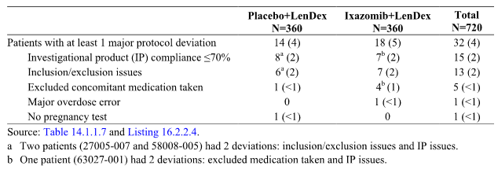

As of the data cut-off date, a total of 15 patients had been unblinded. Of the 259 patients who experienced disease progression, 12 patients (2 in the ixazomib regimen and 10 in the placebo regimen) were unblinded in order for the treating physician to choose subsequent therapy. Two additional patients were unblinded due to toxicity, 1 for fever (placebo regimen) and 1 for acute heart failure (ixazomib regimen). One placebo regimen patient withdrew consent and was unblinded.

#### Baseline data

##### Baseline demographics and stratification factors (ITT population)

The mean ± SD age of the total population was 65.7 ± 9.41 years (range: 30, 91 years), with 48% (n = 344) of patients being ≤ 65 years, 37% (n = 270) of patients being > 65 to ≤ 75 years, and 15% (n = 108) of patients being > 75 years. The total population included 409 (57%) males and 313 (43%) females. The majority of patients in the total population were White (85%, n = 611).

The majority of patients in the total population had received 1 line of prior therapy (59%, n = 425 [1 line] versus 41%, n = 297 [2-3 lines]), had been previously exposed to a proteasome inhibitor (70%, n = 503 [exposed] versus 30%, n = 219 [naive]), and were categorised as ISS stage I or II at screening (88%, n = 632 [I or II] versus 12%, n = 90 [III]).

The baseline demographics and stratification factors were well balanced between the two treatment arms. The baseline demographic factors were provided.

**Comment:** Overall, the baseline demographics of the patient population are considered to be reasonably representative of an Australian population of patients with RRMM previously treated with at least 1 line of therapy and likely to be offered further treatment with ixazomib.

##### Key baseline disease characteristics relevant to MM (ITT population)

In the total population, the median time since initial diagnosis of MM and the first dose of study drug was 42.8 months (range: 3, 306 months), and the median times for this parameter were similar in the placebo and ixazomib regimens (42.2 and 44.2 months, respectively). The majority of patients in the total population had IgG myeloma (55%, n = 397), while IgA myeloma was reported in 17% (n = 124) of patients. The percentage of patients with IgG myeloma was the same (55%) in the placebo and ixazomib regimens, while the percentage of patients with IgA myeloma was higher in the ixazomib regimen than in the placebo regimen (21% versus 13%, respectively). In the total population, ECOG performance status was either 0 or 1 in 92% of patients, and was similar in the two treatment regimens (92% of patients in the placebo regimen and 93% of patients in the ixazomib regimen).

Myeloma related organ dysfunction is defined by the "CRAB" criteria (calcium elevation, renal insufficiency, anaemia, and lytic bone lesions or osteoporosis). Worsening of hypercalcaemia (corrected serum calcium level > 2.875 mmol/L [> 11.5 mg/dL]) is indicative of PD or relapse. Renal dysfunction may be a sign of underlying disease or treatment toxicity. The relevant baseline findings relating to CRAB criteria are summarised below.

The median serum creatinine was the same (0.9 mg/mL) in the two treatment regimens, as was the median creatinine clearance (78.4 mL/min). The majority of patients in the ixazomib and placebo regimens had normal or mildly impaired renal function, defined as creatinine clearance of ≥ 60 mL/min (78% and 72%, respectively), with moderate renal insufficiency (defined as creatinine clearance ≥ 30 to < 60 mL/min) reported in 21% and 26% of patients, respectively. Severe renal dysfunction (defined as creatinine clearance < 30 mL/min) was noted at baseline in 5 patients (1%) in each arm, all of whom met eligibility criteria at screening.

Median haemoglobin values at baseline were similar in the 2 treatment regimens (116 g/L in the ixazomib regimen and 115 g/L in the placebo regimen), and were within the central laboratory normal range (females, 115 to 150 g/L and males, 125 to 170 g/L).

Skeletal survey findings were abnormal in 572 of 659 patients who had skeletal surveys performed Lytic lesions were frequent, and were reported in 70% of patients in the ixazomib regimen and 67% of patients in the placebo regimen. In the total population, the median corrected calcium concentration at baseline was 2.3 mmol/L (range: 2, 4 mmol/L), with the central laboratory normal range being 2.125 to 2.65 mmol/L.

The key baseline MM disease characteristics were provided.

##### Other baseline disease characteristics relevant to MM (ITT population)

All patients were required to have measurable disease by serum M-protein, urine M-protein, or serum FLC assay. Median serum and urine M-protein levels were similar in the 2 treatment regimens. A total of 153 patients (67 ixazomib regimen and 86 placebo regimen) had light chain disease involvement, and 27 ixazomib regimen patients and 32 placebo regimen patients had measurable disease by free light chains only. The total number of patients with a bone marrow aspirate (BMA) sample was 715, and 681 (95%) of these patients had a sample that was adequate for interpretation (97% [345/357) ixazomib regimen and 94% [336/358] placebo regimen). The total number of patients with a bone marrow biopsy (BMB) sample was 34, and 31 (91%) of these patients had sample that was adequate for interpretation (90% [9/10] ixazomib regimen and 92% [22/24] placebo regimen. The median percentage of plasma cells in the BMA or BMB was 18% in the ixazomib regimen and 20% in the placebo regimen.

Seventy percent of the total population had a β2-microglobulin level < 3.5 mg/L (71% and 70% in the ixazomib and placebo regimens, respectively), with 20% having a β2-microglobulin level from 3.5 to 5.5 mg/L (corresponding to Stage II disease, 19% and 21%, respectively) and 9% of patients having a β2-microglobulin value ≥ 5.5 mg/L (corresponding to Stage III disease, 10% and 8%, respectively). Hypoalbuminaemia is considered a negative prognostic factor, reflecting an increase in the gamma globulin fraction of serum protein. In the total population, 15% had serum albumin levels < 3.5 g/dL (16% in the ixazomib regimen and 14% in the placebo regimen) and 85% had levels ≥ 3.5 g/dL at baseline (84% in the ixazomib regimen and 86% in the placebo regimen).

Computed tomography (CT scan) or magnetic resonance imaging (MRI) was performed in 190 patients (26%), and plasmacytomas were present in 48% (43/90) of patients in the ixazomib regimen and 51% (51/100) patients in the placebo regimen. Lytic bone plasmacytomas found on CT scan or MRI had a median total size of 19.68 cm2 in the ixazomib regimen and 15.27 cm2 in the placebo regimen.

Other baseline disease characteristics relevant to MM were provided.

##### Cytogenetic testing at baseline

A total of 137 patients had myeloma with high risk cytogenetic findings at baseline consisting of del(17), t(4;14), or t(14;16), including 75 (21%) patients in the ixazomib regimen and 62 (17%) patients in the placebo regimen. A total of 69 high risk patients had a myeloma harbouring del(17), including 36 of the 75 patients in the ixazomib regimen (48%) and 33 of the 62 patients in the placebo regimen (53%).

##### Prior therapy for MM (ITT population)

Patients in the study were categorised at enrolment as relapsed, refractory, or relapsed and refractory. The relapsed category was defined as patients who had relapsed from at least 1 previous treatment but were not refractory to any previous treatment; 77% (n = 556) of the study population was categorised as relapsed (77% [n = 276] ixazomib regimen, 77% [n = 280], placebo regimen). The refractory category was defined as patients who were refractory (disease progressed on or within 60 days of last study drug) to at least 1 prior line of therapy: 11% (n = 82) of the study population was categorised as refractory (12% [n = 42] ixazomib regimen, 11% [n = 40] placebo regimen). The relapsed and refractory category was defined as patients who relapsed from at least 1 previous treatment and additionally were refractory to at least 1 previous treatment; 11% (n = 83) of the study population was categorised as relapsed and refractory (11% [n = 41] ixazomib regimen, 12% [n = 42] placebo regimen).

A blinded sponsor's clinician reviewed the prior therapy for all patients enrolled in Study C16010 to standardise the number of lines of prior therapy (that is, 1, 2, or 3) and to determine refractoriness to a prior line. This review took into consideration both the eligibility criteria prior to randomisation and data entered into the electronic data system. A second blinded sponsor's clinician verified the output. The output of this review was utilised for analysis purposes. This analysis was done prior to database unblinding. The proportion of patients in the total population with 1, 2, or 3 lines of prior therapy (sponsor review) was 61% (n = 441), 29% (n = 208), and 10% (n = 73), respectively. The proportion of patients with 1, 2, or 3 lines of therapy (sponsor review) was similar for the 2 treatment regimens. In the total population, the median interval between the last dose of prior therapy to first dose of study drug was 14.0 months (14.5 months ixazomib regimen, 13.2 months placebo regimen).

Overall, 70% (n = 502) of the total patient population had been exposed to proteasome inhibitor therapy and 55% (n = 397) had been exposed to IMiD therapy. Most prior regimens contained corticosteroids (98%), and the majority contained melphalan (81%, including 57% with stem cell transplant) or bortezomib (69%). Eighty-eight patients (12%) had received prior lenalidomide containing regimens, and 5 patients (< 1%) had previously received carfilzomib. In the total population, the best response to prior therapy was CR in 33% (n = 240) of patients and PR in 57% (n = 408) of patients. However, on the last prior therapy, 82% (n = 594) of the total population had relapsed, while 16% (n = 114) were refractory on last prior therapy. In the total population, 411 (57%) patients had undergone stem cell transplantation, with a median interval of 35.3 months between transplant and first dose of study drug. Of the 411 patients who had undergone prior stem cell transplantation, 395 had undergone autologous stem cell transplantation, 10 had undergone allogenic stem cell transplantation, and 6 had undergone both.

Of the 397 patients with prior exposure to IMiD therapy, 41 of 193 ixazomib regimen patients (21%) and 50 of 204 placebo regimen patients (25%) were refractory to any prior IMiD therapy, with all but 1 patient in each regimen noted as being refractory to thalidomide. Of the 502 patients who had prior exposure to proteasome inhibitor therapy, 22 of 249 ixazomib regimen patients (9%) and 17 of 253 placebo regimen patients (7%) were refractory to any prior proteasome inhibitor therapy. Overall, 46 patients (24 ixazomib regimen [7%] and 22 placebo regimen [6%]) were primary refractory (that is, had never responded to any prior therapy [best response of SD or PD]).

The prior therapies in the ITT population were provided.

##### Concomitant medications (ITT population)

Concomitant medications were used by 99.6% (n = 719) of the total population, with only 3 patients not using concomitant medications. Concomitant medications by ATC pharmacologic subgroup reported in ≥ 30% of patients overall were: antithrombotic agents (97%); drugs for peptic ulcer and gastro-oesophageal reflux (73%); other analgesics and antipyretics (64%); direct-acting antivirals (62%); opioids (50%); drugs affecting bone structure and mineralisation (48%); beta-lactam antibacterials and penicillins (43%); laxatives (34%); and sulfonamides and trimethoprim (31%). Concomitant medications by WHO generic term reported in ≥ 20% of patients overall were: acetylsalicylic acid (77%); paracetamol (53%); acyclovir (42%); omeprazole (37%); sulfamethoxazole and trimethoprim (30%); enoxaparin (24%); pamidronic acid (23%); red blood cells (20%); and valaciclovir (20%). Concomitant medication use; by ATC pharmacological group and by WHO generic term were generally comparable in the 2 treatment regimens.

Prophylactic use of antithrombotic agents was recommended per protocol to prevent thromboembolic complications that may occur with lenalidomide based regimens in combination with dexamethasone, and 91% of patients received antithrombotic agents prophylactically. Concomitant use of antithrombotic agents (WHO generic term) in ≥ 10% in at least 1 of the 2 treatment groups (ixazomib versus placebo, respectively) were acetylsalicylic acid (78% versus 77%), enoxaparin (24% versus 24%), and nadroparin (7% versus 11%, respectively).

##### Subsequent antineoplastic therapy (safety population)

As of the data cut-off for the interim analysis, 85 patients (24%) in the ixazomib regimen and 91 patients (25%) in the placebo regimen had received subsequent therapy. Twelve patients (2 in ixazomib regimen and 10 in placebo regimen) were unblinded in order for the treating physician to choose subsequent therapy. The median time to subsequent antineoplastic therapy was not estimable in either treatment regimen, but showed a trend in favour of the ixazomib regimen (HR = 0.930). The types of agents used were generally similar between the 2 regimens. Overall, the most frequently reported subsequent antineoplastic therapies were dexamethasone (18%), bortezomib (14%), and cyclophosphamide (9%). A summary of subsequent antineoplastic therapies used by at least 1% of patients in either regimen was provided.

#### Results for the primary efficacy outcome

The results for the primary analysis of the PFS based on the IRC assessment in the ITT population are summarised below in Table 31. The median follow up was 14.8 months in the ixazomib regimen and 14.6 months in the placebo regimen. The KM estimates at 6, 9, 12, 18 and 24 months were provided.

Table 31: Study C16010; PFS primary analysis based on IRC assessment; ITT population

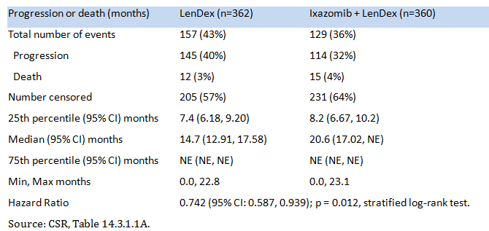

The reasons for censoring in the IRC assessment of PFS in the ITT population are summarised below in Table 32.

Table 32: Study C16010; Reason for patient censoring from IRC assessment of PFS; ITT population

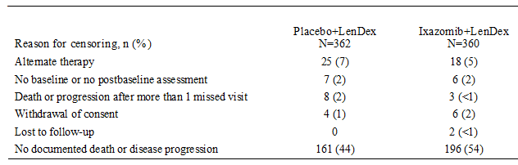

The KM plot of PFS, based on IRC assessment, is presented below in Figure 15. The plot shows separation of the curves for the ixazomib and placebo regimens beginning at 8 months and improving over time, with a median PFS of 20.6 versus 14.7 months.

Figure 15: Study C16010; Kaplan-Meier plot of PFS survival based on IRC assessment; ITT population

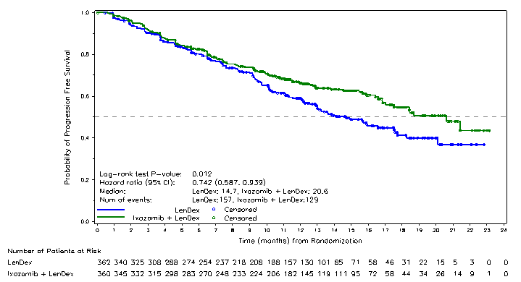

The concordance rate between the 2 primary IRC readers on the documentation of PD and its date of occurrence for each patient was high (approximately 95%). The number of subjects with at least 1 confirmed PD requiring adjudication by a third blinded IRC reviewer was 33 (5%) in the total population, comprising 16 (4%) patients in the ixazomib regimen and 17 (5%) patients in the placebo regimen. In 28 of the 33 patients, both reviewers confirmed the PD assessment but differed on the PD data and in 5 (< 1%) patients the reviewers differed in the assessment of confirmed PD.

Sensitivity analyses were performed for PFS to evaluate the robustness of treatment effects. In the first sensitivity analysis, PFS assessed by the IRC was analysed in the PP population. Results for the PP population were consistent with those for the ITT population, with a median PFS of 20.6 months in the ixazomib regimen and 14.7 months in the placebo regimen (HR = 0.713, 95% CI: 0.561, 0.905, p = 0.005). The results for the PP analysis of PFS were provided and the KM plot was provided. Additional supportive analyses for PFS assessed by the IRC were based on different rules relating to handling of missing assessments and censoring was consistent with the primary analysis.

A sensitivity analysis of PFS based on the investigators’ determinations of PFS was analysed in the same manner as the primary analysis based on IRC assessment. In the investigator's PFS analysis, based on 282 observed PFS events, the median PFS was prolonged by 3.4 months in the ixazomib regimen compared to the placebo regimen (median PFS of 19.6 months versus 16.2 months), and the HR of 0.827 (95% CI: 0.653, 1.047) indicated a 21% improvement in progression or death in the ixazomib regimen compared to the placebo regimen (p = 0.113, stratified log-rank test). The results of the investigator's analysis of the PFS were not statistically significant. The results of the PFS based on the investigator's determination in the ITT were provided and a KM plot of PFS was provided. An assessment of PFS by the investigator was also conducted in the ITT population according to the EMA censoring rules and the results were similar to the overall investigator analysis. The EMA analysis used disease progression documented between scheduled visits counted as a progression event at the date of disease progression, alternate antineoplastic therapy started prior to disease progression counted as an event at the date of disease progression, and disease progression or death after more than 1 missed visit counted as an event at the date of disease progression or death.

Concordance rates between the IRC and investigator assessments of PD status were high (91% [659/722]); see Table 33 below.

Table 33: Study C16010; Concordance rate between IRC and investigator assessments of progressive disease status; ITT population

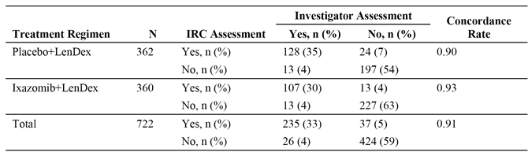

However, the investigator notably differed from the IRC in the designation of date of PD. Among the 235 patients with PD as assessed by both the IRC and the investigator, the majority of cases (160; 68%) had the same PD date and the PD date differed between the IRC and investigator in 75 (32%) cases. In the 75 cases where the PD date differed between the IRC and the investigator assessments, the IRC assessed data was earlier than the investigator assessed date in 57 of the cases (76%). To investigate the differences between the IRC and investigator determined PFS, the sponsor performed an assessment of the 57 PD dates that differed by 28 days or more. Blinded to the patient treatment assignment, 2 clinicians independently reviewed the patients, using the same central laboratory data and locally read imaging and bone marrow results that were available to the IRC and the investigator. The sponsor's review demonstrated that the IRC most closely followed the IMWG criteria, as dictated per protocol. Of the 57 cases, the sponsor's reviewers aligned with the IRC for 51 cases (90%), with the investigator for 3 cases (5%), and with neither for 3 cases (5%).

PFS assessed by the IRC was evaluated relative to 20 baseline characteristics, including baseline stratification factors, demographic characteristics, disease characteristics, and prior therapy. The forest plot for these assessments was provided. As illustrated in the forest plot, with 1 exception (creatinine clearance < 60 mL/min, HR = 1.032), the HRs were consistently < 1 across the pre-planned subgroups, indicating a lower risk of progression or death with the ixazomib regimen than with the placebo regimen.

**Comment:** The PFS analysis was performed on 286 events in 722 patients. The difference in PFS was clinically meaningful, with an absolute increase in PFS of 5.9 months in the ixazomib regimen compared to the placebo group (∆ = 5.9 months [20.6 to 14.7 months]). Compared to the placebo regimen, the ixazomib regimen had a 35% improvement in median PFS (that is, reciprocal of HR = 0.742). The p value for the PFS comparison between the two treatment arms was 0.012, stratified log-rank test. Therefore, based on the pre-specified O’Brien-Fleming spending function (stopping boundary p-value of < 0.2268 for observed 286 events), this was the final analysis of PFS for statistical testing purposes for this study.

The sensitivity analysis of the PFS assessed by the IRC in the PP was consistent with the primary analysis of PFS assessed by the IRC in the ITT population. However, while the sensitivity analysis based on investigator assessment of PFS showed that the median PFS was PFS was prolonged by 3.4 months in the ixazomib regimen compared to the placebo regimen (median PFS of 19.6 months versus 16.2 months), the difference between the two regimens was not statistically significant (that is, HR = 0.827 [95% CI: 0.653, 1.047], p = 0.013).

The HRs for the PFS sub-group analyses were < 1, apart from patients with baseline serum creatinine < 60 mL/min. The HR value of 1 was included within the 95% CI for most of the sub-group analyses indicating that the difference between the two treatment regimens in PFS was not statistically significant. However, the subgroup analyses were not powered to detect a statistically significant difference between the ixazomib and placebo treatment regimens.

In relapsed, refractory, and relapsed and refractory patients the HRs favoured the ixazomib regimen for each of the three subgroups: that is, HR = 0.769 (95% CI: 0.588, 1.005); HR = 0.784 (95% CI: 0.389, 1.582); and HR = 0.506 (95% CI: 0.240, 1.068), respectively. In patients with prior therapies (sponsor's medical review), the HRs for 1, 2 and 3 prior therapies favoured the ixazomib regimen for each of the three subgroups: that is, HR = 0.832 (95% CI: 0.616, 1.123); HR = 0.749 (95% CI: 0.484, 1.161); and HR = 0.366 (95% CI: 0.169, 0.791), respectively.

#### Results for the key secondary efficacy outcomes

##### Overall survival in the ITT population

Given that PFS was positive at the first analysis, the sequential testing procedure continued, per protocol, with the first key secondary endpoint, overall survival in the ITT population, calculated from the date of randomisation to the date of patient death due to any cause. As this was the first analysis, with the median durations of follow-up of 14.8 months and 14.6 months in the ixazomib and placebo regimens, respectively, the overall survival data were not mature and median OS had not been reached for either of the two treatment regimens.

A total of 107 deaths had occurred at the time of the analysis, 51 (14%) in the ixazomib regimen and 56 (15%) in the placebo regimen. The remaining 615 patients in the ITT population were alive and censored from the analysis. The 107 deaths included in the analysis represent 22% of the 486 deaths planned for the final analysis of OS. The HR for OS in the ITT population was 0.90 (95% CI: 0.615, 1.316), p = 0.586, indicating a non-statistically significant reduction of 10% in the risk of death in the ixazomib regimen. Based on KM estimates, the probability of survival at 18 months is 83% in the ixazomib regimen and 80% in the placebo regimen. The result for the OS analysis was provided and the KM plot was provided.

##### Overall survival in high risk patients harbouring del(17)

A total of 69 patients (36 ixazomib regimen and 33 placebo regimen) had the del(17) chromosomal abnormality in myeloma plasma cells. In these patients the median duration of follow-up was 12.5 months and 14.6 months in the ixazomib and placebo regimens, respectively, and the median OS had not been reached for either of the two treatment regimens.

A total of 13 deaths had occurred in these patients at the time of the final analysis, 4 (11%) patients in the ixazomib regimen and 9 (27%) patients in the placebo regimen. The remaining 56 high risk patients harbouring del(17) were alive and censored from the analysis. The HR was 0.506 (95% CI: 0.144, 1.777), p = 0.280, indicating a non-statistically significant reduction of 49% in the risk of death in the ixazomib regimen. Based on KM estimates, the probability of survival at 18 months is 86% in the ixazomib regimen and 67% in the placebo regimen. The results for the OS analysis in high risk patients harbouring del(17) were provided.

#### Other secondary efficacy endpoints

In addition to the two key secondary efficacy endpoints, there were a number of other secondary efficacy endpoints. No statistical adjustments for multiplicity were made for the numerous pairwise comparisons of the two treatment arms.

##### Time to progression

Time to progression was measured as the time from the date of randomisation to the date of first documentation of disease progression. Patients without documentation of PD were censored at the date of the last response assessment that was SD or better. In the ITT population, PD was documented by the IRC in 114 (32%) patients in the ixazomib regimen and 145 (40%) patients in the placebo regimen. The median time to disease progression by the IRC population was 21.4 months (95% CI: 18.43, NE) in the ixazomib regimen and 15.7 months (95% CI: 13.21, 18.27) in the placebo regimen (HR = 0.712 [95% CI: 0.556, 0.912], p = 0.007). The results indicate that the ixazomib regimen delays time to progression by 5.7 months. The results for time to progression were provided and the KM plot was provided.

###### Overall response rate (ORR)

The ORR was determined from the start of the study treatment until the end of treatment. In the ITT population, the confirmed ORR (CR+PR [including sCR and VGPR]) determined by the IRC was 78.3% in the ixazomib regimen and 71.5% in the placebo regimen (odds ratio = 1.44 [95% CI: 1.03, 2.03]; p = 0.035). The confirmed CR rate in the ixazomib regimen was almost double that in the placebo regimen (11.7% [n = 42] versus 6.6% [n = 24], respectively; OR = 1.87 [95% CI: 1.10, 3.16]; p = 0.019). The response to treatment based on IRC assessment in the ITT population was provided. The ORR in the ixazomib regimen relative to the placebo regimen remained relatively constant over time based on the treatment cycle, but the patient numbers were small after Cycle 18. The concordance rate between the IRC and investigator assessments for the ORR was 95% (668/722) in the total population, comprising 96% (344/360) in the ixazomib regimen and 95% (344/362) in the placebo regimen.

###### Duration of response (DoR)

DOR was measured as the time from the date of first documentation of PR or better to the date of first documented PD. The median DOR for patients with PR or better was 20.5 months (95% CI: 16.62, NE) in the ixazomib regimen and 15.0 months (95% CI: 11.99, NE) in the placebo regimen. Among patients who responded, 187 (67%) patients in the ixazomib regimen and 151 (59%) patients in the placebo regimen had not subsequently progressed or died at the last assessment and were censored from the assessment.

###### PFS in patients with high risk cytogenetics

A total of 137 patients (75 ixazomib regimen and 62 placebo regimen) had high risk cytogenetic abnormalities, including 69 patients with myeloma harbouring del(17) alone or in combination with either or both of the translocations, 61 patients with myeloma with the t(4;14) translocation alone, and 7 patients with the t(14;16) translocation alone. In the ITT population, the median PFS was notably longer in the high risk group harbouring del(17) alone in patients in the ixazomib group compared to patients in the placebo regimen (21.4 months [95% CI: 8.25, NE) versus 9.7 months [95% CI: 3.75, 20.11], respectively), with a HR of 0.596 (95% CI: 0.286, 1.243), p = 0.162. The KM plot was provided. There were 14 (39%) PFS events in the ixazomib regimen (13 progression, 1 death) and 20 (63%) PFS events in the placebo regimen; (18 progressions, 2 deaths). Similar results for the median PFS were seen in the combined high risk subgroup of patients harbouring del(17), t(4;14), or t(14;16) in the ixazomib regimen compared to patients in the placebo regimen in the ITT population (21.4 months versus 9.7 months, respectively; HR = 0.543 [95% CI; 0.321, 0.918), p = 0.021.

###### ORR in patients with high risk cytogenetics

Improvements in confirmed response rates with the ixazomib regimen were observed in the different response categories for the del(17) subgroup, with significant improvements in the overall high risk cytogenetic population. The improvement in the CR rate was significant both in patients with del(17) and the overall high risk cytogenetic population. In the ITT population, the confirmed ORR (CR+PR) was 72.2% (26/36) in the ixazomib regimen and 48.5% (16/33) in the placebo regimen (odds ratio = 2.93 [95% CI: 1.06, 8.13], p = 0.076, and for all high risk cytogenetic patients the confirmed ORR (CR+PR) was 78.7% (59/75) in the ixazomib regimen and 59.7% (37/62) in the placebo regimen (odds ratio = 2.47 [95% CI: 1.15, 5.29], p = 0.030). Response to treatment; based on the IRC assessment in high risk (cytogenetic) patients in the ITT population were provided.

###### Paraprotein and M-protein assessments

One hundred and twenty-seven (127) patients in the ixazomib regimen (37%) and 107 patients in the placebo regimen (32%) demonstrated a 100% reduction in their paraprotein, with 26% and 21%, respectively, being immunofixation negative. A higher proportion of patients in the ixazomib regimen than in the placebo regimen also had at least a 90% reduction in M-protein (54% [n = 185] versus 46% [n = 155]), with 88% (n = 301] and 86% [n = 291], respectively, having at least a 50% reduction.

##### Exploratory efficacy endpoints

The CSR included a number of exploratory end points, but data were not available on some of these endpoints. Data were not available regarding the association between response or resistance to ixazomib treatment and (1) mutations in key pathways, such as RAS/RAF and (2) tumour gene expression patterns, including expression of [information redacted] NF-κB and protein synthesis gene signatures. In addition, data were not available regarding mechanisms of treatment-emergence resistance, such as somatic mutations in proteasome subunits and key signalling pathways in tumours that initially respond to therapy and then exhibit disease progression. The sponsor stated that these data might be reported separately at a later time or might be combined in future exploratory analyses. Similarly, the sponsor stated that data regarding circulating proteasome levels will be reported in the future when the clinical data are more mature. The exploratory endpoints reviewed below relate to outcomes that compare quality of life in patients treated with the ixazomib and placebo regimens.

###### EORTC QLQ-C30 and MY-20

Quality of life, as measured by the EORTC QLQ-C30, was maintained during treatment with both treatment regimens, and the addition of ixazomib to the LenDex combination did not appear to have either a negative or positive impact compared to LenDex. Global health scores over time in the EORTC QLQ-C30 global health status score were consistently similar in the 2 treatment regimens. The mean ± SD and median change from baseline to EOT in the EORTC QLQ-C30 global health status scores were -4.0 ± 27.23 and 0.0, respectively, for the ixazomib regimen and -3.8 ± 25.53 and 0.0, respectively, for the placebo regimen. There was a trend for better physical functioning, emotional functioning, and fatigue scores in patients treated with the ixazomib regimen compared to the placebo regimen. Symptoms of nausea and vomiting were similar in the two treatment regimens and stable across treatment cycles, while symptoms of diarrhoea appeared to worsen in the ixazomib regimen in later cycles. Results of the MY-20 were generally similar in the 2 treatment regimens, with mean ± SD and median change from baseline to EOT in disease symptom scores being -1.62 ± 22.113 and 0.00, respectively, for the ixazomib regimen and -3.38 ± 22.916 and 0.00, respectively, for the placebo regimen.

###### Pain

The pain response definition included a 30% reduction from baseline in BPI-SF worst pain score over the last 24 hours without an increase in analgesic use at 2 consecutive evaluations. Over time, the proportions of patients with increased, decreased or stable analgesic use (oral morphine equivalents) were generally similar in the 2 treatment regimens. The median time to increased or decreased analgesic use was not estimable in either treatment regimen. Patients needed a pain score at baseline of 4 or more in order to demonstrate at least a 30% reduction from baseline. Among patients with a baseline worst pain score of ≥ 4 (n = 356), 99 of 184 ixazomib regimen patients (54%) and 86 of 172 (50%) placebo regimen patients achieved a pain response, as defined above (p = 0.3909), with a median time to pain response of 4.7 months in the ixazomib regimen and 6.0 months in the placebo regimen. In the overall ITT population (N = 722), 87 (24%) ixazomib regimen patients and 82 (23%) placebo regimen patients experienced pain progression, and the median time to pain progression was not estimable in either group (HR = 1.044; 95% CI: 0.770, 1.415; p = 0.782). Overall, improvement in pain was similar in the two treatment regimens.

##### Efficacy outcomes in the demographic subgroups

###### Age

The ixazomib regimen was efficacious in all age groups. The results for the three age categories show that the ORR, CR+VGPR, and CR or better outcomes were greater in the ixazomib regimen compared to the placebo regimen for each of the three age categories (≤ 65 years, > 65 to ≤ 75 years, and > 75 years). Of note, in patients aged > 75 years higher proportions of patients in the ixazomib regimen than in the placebo regimen responded to treatment, with a significant difference for the CR+VGPR rate (53.2% versus 32.8%; OR = 2.40; p = 0.033). The median PFS was longer in the ixazomib regimen than in the placebo regimen for patients aged < 65 years (∆ = 6.5 months [20.6 versus 14.1 months, respectively]) and for patients aged > 75 years (∆ = 5.4 months [18.5 versus 13.1 months, respectively], while the median PFS was similar in the two regimens in patients aged > 65 to ≤ 75 years (17.5 versus 17.6 months, respectively). The HR was < 1 in each of the three age categories, and favoured the ixazomib regimen. The HR values were: HR = 0.683 (95% CI: 0.481, 0.971), p = 0.033, in patients aged < 65 years; HR = 0.833 (95% CI: 0.554, 1.250), p = 0.375, in patients aged > 65 to ≤ 75 years; and HR = 0.868 (95% CI: 0.462, 1.632), p = 0.0659 in patients aged > 75 years. The results for median time to progression were generally consistent with those for median PFS. The efficacy results based on the three age categories were provided.

* There were 10 patients (1.4%) aged ≥ 85 years (6 males, 4 females), including 6 in the placebo regimen and 4 in the ixazomib regimen. As of the data cut-off, 8 of these patients were alive (5 in the placebo regimen, 3 in the ixazomib regimen). The report provided descriptive efficacy data for the 10 patients aged ≥ 85 years, but the patient numbers are considered too small to make meaningful comparisons.

###### Sex

The efficacy outcomes for males and females were similar, and the results were consistently better for patients treated with the ixazomib regimen compared to the placebo regimen. The efficacy results based on sex were provided.

###### Race

The majority of patients in the ITT population were White (85%, n = 611). Compared to the placebo regimen, the ixazomib regimen demonstrated superior efficacy in White patients. In Asian patients (9%, n = 64), the ORR was greater in patients treated with the placebo regimen compared to patients treated with the ixazomib regimen, as was the proportion of patients with CR or better. The number of patients who were Black/African American (2%, n = 13) is too small to draw meaningful conclusions relating to efficacy in this racial group. The efficacy results for White and Asian patients were provided.

###### High risk patients

While the ixazomib regimen was efficacious in the overall patient population (ITT), response to treatment and improvement in PFS and TTP were also observed among heavily pre-treated patients, patients refractory to prior treatments, patients with high risk cytogenetics, patients older than 75 years of age, and patients with advanced stage disease (for example, ISS Stage III). The results for the high risk groups were provided.

### Supportive efficacy studies

The sponsor nominated Study C16003 (Phase I) and Study C16004 (Phase I), in a total of 120 patients (ITT population) with RRMM, as supportive efficacy studies (n = 60 in each of the two studies). Both of these studies have been reviewed above in Section 6 (Dosage selection for the pivotal study). It is considered that these two studies provided preliminary efficacy data rather than supportive efficacy data for the following reasons: (a) the primary objective of both studies was to determine the safety profile, tolerability, and MTD of ixazomib administered as a single agent twice weekly in C16003 and once weekly in C16004; (b) the secondary objectives of both studies included the response rates presented descriptively; (c) measures of activity in both studies focused both on paraprotein reduction and investigator assessed IMWG response criteria, rather than PFS assessed by an IRC and OS; (d) the studies were open label, and single arm in design with no comparative control arms; (e) in Study C16003 the MTD was 2 mg/m2 (approximately equivalent to 4 mg fixed dose) administered twice weekly, which was twice as frequently as the 4 mg dose of ixazomib administered in combination with LenDex in the pivotal study; and (f) in Study C16004 the MTD was 2.97 mg/m2 based on BSA (approximately equivalent to 5.5 mg fixed dose), which was greater than the 4 mg dose of ixazomib administered in combination with LenDex in the pivotal study.

The response to treatment outcomes for each of the three studies have been summarised in Table 34. The MTD expansion cohorts for Study C16003 were treated with ixazomib 2 mg/m2 (approximately equivalent to 4 mg fixed dose) twice weekly as a single agent, and the MTD expansion cohorts for Study C16004 were treated with ixazomib 2.97 mg/m2 (approximately equivalent to 5.5 mg fixed dose) once weekly as a single agent.

Table 34: Response to treatment in response evaluable patients in Studies C16010, C16004 and C16003

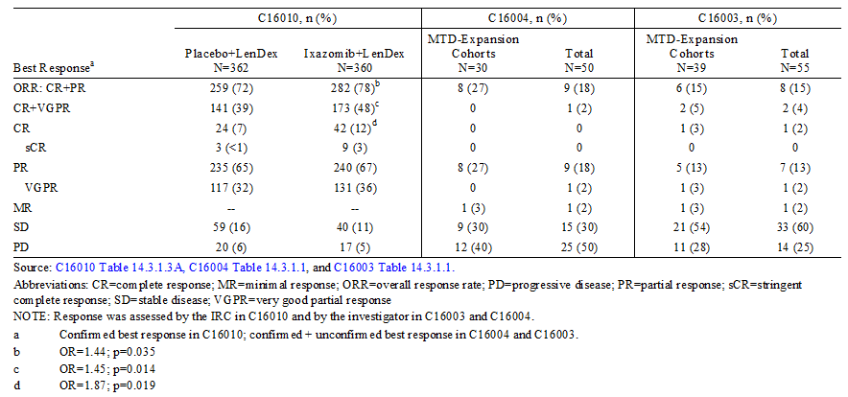

### Evaluator's conclusion on clinical efficacy

#### Efficacy; pivotal Phase III Study C16010

1. The efficacy of the proposed ixazomib regimen for the proposed indication is based primarily on the final analysis PFS from one pivotal Phase III Study C16010. The sponsor nominated two Phase I studies as supportive efficacy Studies (C16003, C16004), but these studies are considered to have provided preliminary efficacy data rather than supportive efficacy data for the previously discussed reasons.
2. In the pivotal study, the median duration of follow-up was 14.8 months in the ixazomib regimen and 14.6 months in the placebo regimen, and the number of PFS events in the two regimens was 129 (36%) and 157 (43%), respectively. The study achieved its primary efficacy endpoint as it demonstrated a statistically significant improvement in PFS based on IRC assessment in patients in the ixazomib regimen compared to patients in the placebo regimen. The median PFS was 5.9 months longer for patients in the ixazomib regimen compared to patients in the placebo regimen, with the median PFS being 20.6 months and 14.7 months, respectively. The HR was 0.742 (95% CI: 0.587, 0.939), p = 0.012 (stratified log-rank test), which corresponds to a 35% improvement in PFS in the ixazomib regimen compared to the placebo regimen. The results for the PFS (IRC assessed) sensitivity analyses were consistent with the primary analysis. The KM plot of PFS showed separation of the curves for the ixazomib and placebo regimens beginning at 8 months and improving over time in favour of ixazomib.
3. The median investigator assessed PFS was 3.4 months longer in patients in the ixazomib regimen compared to patients in the placebo regimen, with the median PFS being 19.6 months and the 16.2 months, respectively. The HR was 0.827 (95% CI: 0.653, 1.047), p = 0.113 (stratified log-rank test), which corresponds to a 21% improvement in PFS in the ixazomib regimen compared to the placebo regimen. However, the results were not statistically significant for the investigator assessed PFS sensitivity analysis. The main difference between IRC and investigator assessments was that investigators assessed PD as occurring later than assessed by the IRC. In a review of discordant PD assessment between the IRC and investigators, the sponsor identified that in almost all cases the IRC correctly implemented the pre-specified progression criteria.
4. Subgroup analyses of the PFS consistently showed that the median duration of PFS was longer with the ixazomib regimen compared to the placebo regimen. However, while the HRs were < 1 (that is, favouring the ixazomib regimen) for all analyses apart from patients with a creatinine clearance < 60 mL/min, in general the results were not statistically significant based on the 95% CI for the HR. However, the subgroup analyses were not powered to detect statistically significant differences between the ixazomib and placebo treatment regimens.
5. In relapsed, refractory, and relapsed and refractory patients the HR results favoured the ixazomib regimen for each of the three subgroups, although the results were not statistically significant. Nevertheless, it is considered that the HR results indicate that the increases in PFS in patients treated with the ixazomib regimen were clinically meaningful for each of the subgroups (that is, relapsed = 30% improvement; refractory = 28% improvement; refractory and relapsed = 97% improvement).
6. In patients with prior therapies (sponsor's medical review), the HR results favoured the ixazomib regimen for each of the three subgroups (1, 2 and 3 prior therapies), although the results were not statistically significant. Nevertheless, it is considered that the HR results indicate that the increases in PFS in patients treated with the ixazomib regimen were clinically meaningful for each of the subgroups (that is, 1 prior therapy = 20% improvement; 2 prior therapies = 34% improvement; 3 prior therapies = 173% improvement).
7. The survival data for the key secondary efficacy endpoint of OS in the ITT population were not mature and median OS had not been reached at the time of the analysis in either of the two treatment regimens. A total of 107 deaths had occurred at the time of the analysis, 51 (14%) patients in the ixazomib regimen and 56 (15%) patients in the placebo regimen. The remaining 615 patients in the ITT were alive and were therefore censored from the analysis. The HR was 0.90 (95% CI: 0.615, 1.316), p = 0.586, in favour of the ixazomib regimen, indicating a non-statistically significant reduction in the risk of death of 10% in the ixazomib regimen relative to the placebo regimen.
8. The analysis of the other secondary efficacy endpoint of OS in high risk patients harbouring del(17) demonstrated that the HR was 0.506 (95% CI: 0.144, 1.777), p = 0.280, in favour of the ixazomib regimen. The HR indicates a non-statistically significant reduction in the risk of death of 49% in the ixazomib regimen relative to the placebo regimen. A total of 13 deaths had occurred at the time of the final analysis, including 4 (11%) patients in the ixazomib regimen and 9 (27%) patients in the placebo regimen. The remaining 56 high risk patients harbouring del(17) were alive and were therefore censored from the analysis.
9. The other secondary efficacy endpoints of time to progression, duration of response, ORR (CR+PR [including sCR and VGPR]), and PFS and ORR in patients with high risk genetics all favoured the ixazomib regimen compared to the placebo regimen. Exploratory quality of life endpoints (EORTC-30 and MY-20), showed little change from baseline through to end of treatment in either of the two treatment regimens, and no clinically meaningful differences between the two treatments. The improvement in pain was similar in the two treatment regimens.
10. A total of 160 patients (84 ixazomib regimen and 76 placebo regimen) completed 18 or more cycles of treatment. Significant differences in favour of the ixazomib regimen compared to the placebo regimen were observed for CR+VGPR at every cycle between Cycle 2 and Cycle 15, and for CR at every cycle between Cycle 5 and Cycle 14.

#### Potential limitations of the efficacy analysis

* The final analysis of the PFS was the first of two pre-specified interim analyses. The first interim analysis took place when 286 PFS events had occurred in 722 patients. Based on this analysis meeting the pre-specified alpha level based on the O'Brien-Fleming boundary, the protocol specified that the second interim analysis of the PFS was to be a non-inferential analysis when approximately 365 PFS events had occurred. Therefore, the first interim analysis was the final analysis of the PFS for statistical testing purposes based on pre-specified criteria. It could be reasonably argued that the sponsor should have chosen the second interim analysis of the PFS to have been the final analysis and made this second interim analysis inferential. Nevertheless, 78% (n = 286) of the final planned number of PFS events (n = 365) is considered to be a reasonable percentage on which to make a meaningful assessment of PFS. Furthermore, the statistically significant 5.9 month increase in median PFS based on IRC assessment in patients in the ixazomib regimen compared to patients in the placebo regimen is considered to be clinically meaningful. The KM plot for the PFS based on IRC assessment showed separation of the curves in favour of the ixazomib regimen compared to the placebo regimen from 8 months, with continuing improvement over time. In addition, the key secondary efficacy endpoints and other clinically relevant secondary efficacy endpoints consistently favoured treatment in the ixazomib regimen compared to the placebo regimen. Overall, it is considered that PFS assessment based on data in the first interim analysis (final analysis of PFS for statistical testing purposes) is acceptable for regulatory purposes.
* The efficacy of ixazomib for the proposed indication is based on data from only one pivotal Phase III Study. The TGA has adopted an EMA a "points to consider" guidance document on applications with only one pivotal study (CPMP/EWP/23330/99). The guidance document notes that the minimum requirement for Phase III documentation supporting an application for registration is "generally one controlled study with statistically compelling and clinical relevant evidence". The guidance document lists a number of factors that the regulatory evaluation should pay special attention to in cases where the confirmatory evidence is provided by only one pivotal study. These factors, as they are considered to apply to Study C16010, are as follows:
  + The study is considered to be internally valid. The study was well designed (randomised, controlled and double blind). The selected endpoints and analyses of these endpoints were appropriate and commonly used for haematological oncology studies. There was no evidence that significant potential biases might have confounded the results. The study showed consistent superiority of the ixazomib regimen compared to the placebo regimen, irrespective of the endpoints chosen to compare the efficacy of the two treatments.
  + The study is considered to be to be externally valid. The patient population is considered to be representative of the general Australian population of patients with RRMM whose disease has progressed despite one line of prior therapy who might be offered treatment with ixazomib if the drug is approved for registration. The mean age of the total ITT population in the pivotal study was 65.7 years (range: 30, 91 years), with 48% of the population being aged ≤ 65 years, 47% being aged > 65 to ≤ 75 year and 15% being aged > 75 years. The total population was well balanced between the sexes (57% male, 43% female) and 85% of the population was White. The mean age of incidence of myeloma in the Australian population is 68.6 years (Australian Institute of Health and Welfare & Australasian Association of Cancer Registries 2012. Cancer in Australia: an overview, 2012. Cancer series no. 74. Cat. no. CAN 70. Canberra: AIHW). Overall, the age of the population treated in C16010 is consistent with the age of the Australian population likely to be offered treatment with the ixazomib regimen.
  + Clinical relevance. The estimated size of the treatment benefit is large enough to be clinically valuable. The primary efficacy endpoint of PFS, as assessed by the blinded IRC, statistically significantly favoured the ixazomib regimen compared to the placebo regimen (median PFS 20.6 versus 14.7 months, respectively; HR = 0.742 (95% CI: 0.587, 0.939), p = 0.012). The median PFS was 5.9 months longer in the ixazomib regimen compared to the placebo regimen, and this is considered to be large enough to be clinically valuable in patients with RRMM. In addition, ixazomib is administered orally, which is an important benefit for patients with malignant disease. The two key secondary OS endpoints both showed non-statistically significant trends towards a survival benefit with the ixazomib regimen compared to the placebo regimen (that is, OS in total ITT population and OS in high risk del(17) harbouring ITT population). The secondary efficacy endpoint of confirmed ORR (CR+PR [including sCR+VGPR]) was 78.3% in the ixazomib regimen and 71.5% in the placebo regimen; p = 0.035. The confirmed CR in the ixazomib regimen was almost double that in the placebo regimen (11.7% versus 6.6%, p = 0.019). In the patient-reported exploratory efficacy endpoints there was no evidence that quality of life deteriorated in patients treated with the ixazomib regimen. Patient-reported outcomes relating to the quality of life were similar in both treatment regimens over the duration of treatment and remained largely unchanged from baseline.
  + The degree of statistical significance. The HR for the PFS was 0.742 (95% CI: 0.587, 0.939), p = 0.012, with the result favouring the ixazomib regimen over the placebo regimen. The p-value, adjusted for the interim analysis of p = 0.012 (stratified log-rank test), was notably lower than p < 0.05. The HR was < 1 and the 95% CI excluded 1 and was reasonably narrow (suggesting limited inter-subject variability in PFS).
  + Data quality. It is considered that the data quality was very good in Study C16010.
  + Internal consistency. The PFS was analysed in a number of pre-specified subgroups and with 1 exception (creatinine clearance < 60 mL/min, HR = 1.032), the HRs were consistently < 1 across the pre-planned subgroups. The data are considered to show internal consistency.
  + Centre effects. The HRs for PFS were < 1 in patients from North America, Europe and Asian Pacific Countries. The HR was statistically significant for Europe but not for the two other regions. The HRs were < 1 from patients from Western and Non-Western countries, with the HR being significant for Western countries but not for Non-Western countries. Randomisation to the two treatment groups was not stratified by country. No data could be identified assessing whether there was a treatment by centre interaction on PFS. However, such an analysis would be of limited value given that the study included patients from 147 centres in 26 countries.
  + The plausibility of the hypothesis tested. Study C16010 was designed to test the hypothesis that treatment with ixazomib plus LenDex has a favourable benefit-to-risk profile for the treatment of RRMM in patients who have received at least one prior therapy. Based on the mode of action of ixazomib (proteasome inhibition) this is considered to be a reasonable hypothesis.
* The LenDex control regimen used in Study C16010 is not approved in Australia, the EU or the US for the treatment of RRMM. While the lenalidomide dose is the same as that approved in the three jurisdictions, the dexamethasone dose is lower than the approved dose. This matter has been discussed previously in this CER. It is noted that there appears to be a move in Australian clinical practice to the use of the low dose dexamethasone regimen in combination with lenalidomide for the treatment of RRMM. On balance, it is considered that the use of low dose dexamethasone in combination with lenalidomide is an acceptable control regimen.
* Patients in Study C16010 were categorised at enrolment as relapsed (77%, n = 522), refractory (11%, n = 82), or relapsed and refractory (11%, n = 83). There was a numerical imbalance across the subgroups with the majority of patients in the study being categorised as relapsed. This raises the question of whether the efficacy results were primarily driven by the largest subgroup of relapsed patients. However, despite the imbalance in patient numbers, support for the efficacy of the ixazomib regimen in each of the patient subgroups comes from the PFS subgroup analyses. In relapsed, refractory, and relapsed and refractory patients the HRs favoured the ixazomib regimen for each of the three subgroups: that is, HR = 0.769 (95% CI: 0.588, 1.005); HR = 0.784 (95% CI: 0.389, 1.582); and HR = 0.506 (95% CI: 0.240, 1.068), respectively. The HR results for the PFS were < 1 for each of the subgroups, but were not statistically significant as the 95% CI included 1 for each subgroup. However, the study was not powered to detect statistically significant differences between the two treatment regimens for each of the subgroups. Overall, it is considered that the subgroup analyses support the inclusion of the three patient subgroups in the indication, despite the numerical imbalance across the subgroups.
* Patients in Study C16010 were stratified at enrolment into those who had received 1 prior therapy (n = 425, 59%) and those that had received 2 or 3 prior therapies (n = 297, 41%). The median PFS in patients who had received 1 prior therapy was 20.6 months in the ixazomib regimen (80 events in 212 patients) and 16.6 months in the placebo regimen (88 events in 213 patients): HR = 0.882 (95% CI: 0.616, 1.123). The median PFS in patients who had received 2 or 3 prior therapies was not estimable in patients in the placebo regimen (148 events in 49 patients) and 12.9 months in the placebo regimen (69 events in 149 patients): HR = 0.580 (95% CI: 0.401, 0.838). The results for patients with 1 prior therapy indicate a clinically meaningful improvement of 4 months in the median PFS in the ixazomib group compared to the placebo group. The results for PFS subgroup analyses for patients categorised by the sponsor on the basis of 1, 2, or 3 prior therapies support treatment with ixazomib for patients who have progressed on at least 1 prior therapy.
* The subgroup analyses showed that that ixazomib was efficacious in patients who were either refractory or not refractory to thalidomide, and in patients who had either previously been exposed or not exposed to a proteasome inhibitor, IMiD therapy, or Velcade therapy. Consequently, it is considered that patients with RRMM can be treated with ixazomib irrespective of the prior therapy that they have received.

#### Overall conclusion

On balance, it is considered that the efficacy data from Study C16010 are sufficiently robust to support approval of the proposed ixazomib regimen for the treatment of patients with RRMM whose disease has progressed on at least one prior therapy.

## Clinical safety

### Studies providing evaluable safety data

The submission included an Integrated Summary of Safety (ISS), which was conducted in accordance with a pre-specified Statistical Analysis Plan (SAP). Two routes of administration have been evaluated in the ixazomib clinical development program; an intravenous (IV) route (2 studies) and an oral (PO) route (18 studies). The total number of patients enrolled in the ixazomib clinical trials with safety data was 1,622 (990 [PO studies] + 146 [IV studies] + 486 [studies contributing death and SAE listings, but not integrated into the overall safety analysis population]). The safety data for 5 patients enrolled in the mass balance study were not included in the ISS as the ixazomib oral solution was radiolabelled. The studies contributing patients to the safety assessment are summarised in Table 35 (oral) and Table 36 (IV).

Table 35: Safety population, dosing schedule and accrual status of oral ixazomib studies

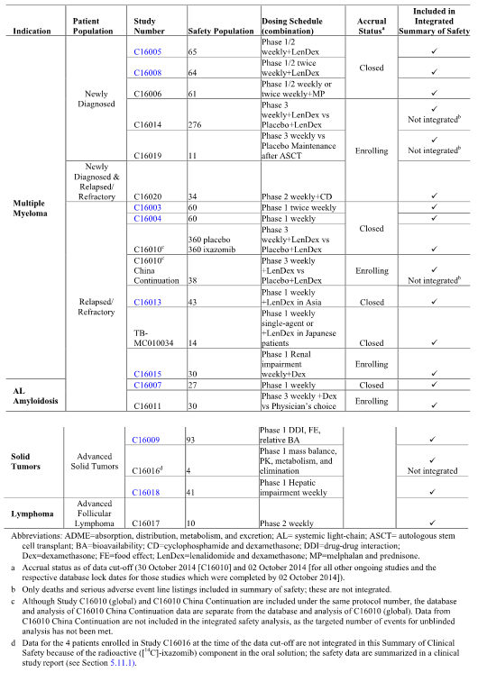

Table 36: Safety population, dosing schedule and accrual status of IV ixazomib studies

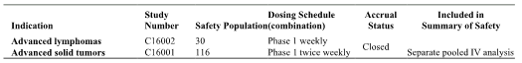

The overall safety analysis population for the primary pooled analysis included a total of 990 patients who received at least 1 dose of oral ixazomib (either as a single agent or in combination with other agents, regardless of cancer type) in 15 Studies (C16003, C16004, C16005, C16006, C16007, C16008, C16009, C16010, C16011, C16013, C16015, C16017, C16018, C16020, and TB-MC010034). The overall safety analysis population included a total of 990 patients, comprising 360 patients treated with the ixazomib regimen from the pivotal Phase III Study C16010 (data cut-off of 30 October 2014) and 630 patients from ongoing studies (data cut-off of 2 October 2014) and completed studies (respective database lock dates).

In addition to the key overall safety analysis population, the ISS included 3 other key analysis populations (patients with MM):

* The RRMM analysis population, which included all patients with RRMM who received at least 1 dose of oral ixazomib either as a single agent or in combination with other chemotherapeutic regimens (open label or unblinded; N = 572). This analysis population included patients from Studies C16003, C16004, C16010, C16013, C16015, C16020 (RRMM arm) and TB-MC010034
* The RRMM (single agent) analysis population, which included all patients with RRMM who received at least 1 dose of oral ixazomib as a single agent on a weekly or twice weekly dosing schedule (N = 127). This analysis population included patients from Studies C16003, C16004, and TB-MC010034 (single agent cohort)
* The ixazomib + LenDex analysis population, which included all patients with MM who received at least 1 dose of oral ixazomib in combination with LenDex, regardless of patient population (RRMM or NDMM) (N = 539). This analysis population included patients from Studies C16005, C16008, C16010, C16013, and TB-MC010034 (combination cohort).

Of the patients evaluated in 3 of the 4 key ISS analysis populations (overall safety analysis population [n = 990], RRMM [n = 572], and ixazomib + LenDex [n = 539]), 360 patients were from the pivotal Phase III Study C16010. The balance of patients in each of these 3 analysis populations were enrolled across Phase I dose escalation and Phase I/II clinical studies. The results of the 3 additional key analysis populations were generally consistent with the overall safety analysis population and the safety data from Study C16010. However, the RRMM (single agent) analysis population reported a higher incidence of more severe TEAEs than the other safety analysis populations. This difference may have been due to twice weekly dosing schedules, ixazomib doses above the recommended Phase III dose of 4 mg, and number of prior therapies received by patients in the RRMM (single agent) analysis population.

There was considerable sharing of patient safety data across the 4 key safety analysis populations, due to the same studies contributing patients to the different populations. Therefore, this CER focuses primarily on the safety data from the pivotal Phase III Study C16010, supplemented by the safety data from the overall safety analysis population identified in the ISS. It is considered that this approach should capture all significant safety data from the 4 key safety analysis populations described in the ISS. The evaluation of safety data for Study C16010 is based primarily on the separate CSR for this study, while evaluation of the safety data for the overall safety analysis is based on the data provided in the ISS and the Summary of Clinical Safety. The safety data from Study C16010 are considered to be the pivotal safety data relating to the application to register ixazomib for the proposed indication, and the safety data from the overall safety analysis population are considered to be supportive.

### Pivotal safety data; Study C16010

#### General

The safety population included all patients who received at least 1 dose of study drug. This population consisted of 720 treated patients, 360 in the ixazomib regimen and 360 in the placebo regimen. Two patients randomised to the placebo regimen were accidentally given the incorrect blinded treatment, with 1 patient taking ixazomib in Cycle 10 only and the other patient taking ixazomib in Cycles 1 and 2 only. All of the toxicity data from these two patients are included in the data for the ixazomib regimen.

Throughout the discussion of safety provided in the CSR, differences between regimens were noted if the difference was ≥ 10 percentage points. For TEAEs based on PT, Grade 3 TEAEs, Grade 4 TEAEs, SAEs, and TEAEs of clinical importance, differences between regimens were noted if the difference was ≥ 5 percentage points. Regimen differences that did not meet the above criteria were termed similar or generally similar.

The IDMC reviewed unblinded safety data 4 times between May 2013 and February 2015 and recommended continuing the study as planned after each review. The IDMC did not recommend any changes in study conduct based on safety-related observations.

#### Patient exposure

Patients were scheduled to receive study drug (ixazomib 4 mg or matching placebo capsule) on Days 1, 8, and 15 plus 25 mg lenalidomide on Days 1 through 21 and 40 mg dexamethasone on Days 1, 8, 15, and 22 of a 28 day cycle. The extent of exposure in the safety population is summarised in Table 37.

Table 37: Study C16010; extent of exposure; safety population

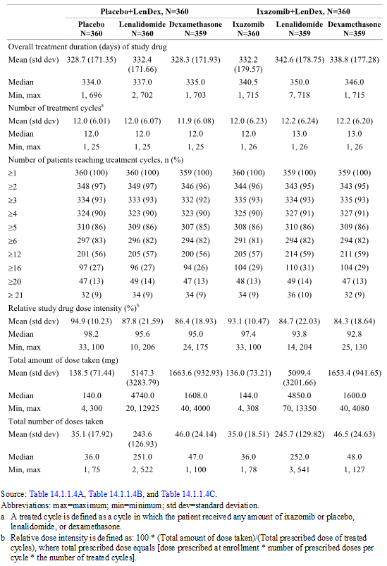

The median number of treatment cycles of the treatment in the safety population (n = 720) was similar in the ixazomib regimen and the placebo regimen (that is, 13.0 cycles [range: 1, 26] and 12.0 cycles [range: 1, 25 cycles], respectively). Overall, 296 (82%) patients in the ixazomib regimen and 298 (83%) patients in the placebo regimen received at least 6 cycles, while 215 (60%) patients in the ixazomib regimen and 205 (57%) patients in the placebo regimen received at least 12 cycles. There were 199 (55%) patients in the ixazomib regimen still on treatment at the data cut-off date compared to 188 (52%) patients in the placebo regimen.

Considering each of the individual agents in the regimen separately: (1) the median number of ixazomib treatment cycles was 12 (range: 1, 26) in the ixazomib regimen and the median number of placebo cycles was 12 (range: 1, 25 cycles) in the placebo regimen; (2) the median number of treatment cycles for lenalidomide was 13.0 (range: 1, 26) in the ixazomib regimen and 12.0 (range: 1, 26) in the placebo regimen; and (3) the median number of treatment cycles for dexamethasone was 13.0 (range: 1, 26) in the ixazomib regimen and 12.0 (range: 1, 26) in the placebo regimen.

The median relative dose intensity for both ixazomib and placebo was high (97.4% ixazomib regimen; 98.2% placebo regimen). In addition, the median relative dose intensity was high and similar in both treatment regimens for lenalidomide (93.8% ixazomib regimen; 95.6% placebo regimen) and dexamethasone (92.8% ixazomib regimen; 95.0% placebo regimen). The mean percent compliance to protocol schedule for ixazomib or placebo was 98.6% and 97.9% in the ixazomib and placebo regimens, respectively, with similar compliance for lenalidomide (98.9% and 98.7%, respectively) and dexamethasone (96.7% and 97.0%, respectively).

### Adverse events (treatment emergent adverse events)

#### General

An adverse event (AE) was defined as any untoward medical occurrence in a patient administered any agent in the study drug regimen. The untoward medical occurrence was not required to be causally related to the administered treatment. An abnormal laboratory value was not an AE unless that value led to discontinuation or delay in treatment, dose modification, or therapeutic intervention or was considered by the investigator to be a clinically significant change from baseline. AEs included any newly occurring event, or a previous condition that had increased in severity or frequency since the administration of any of the study drugs. Treatment emergent AEs (TEAEs) were defined as any AEs that occurred after administration of the first dose of any study drug and through 30 days after the last dose of any study drug or until the start of subsequent antineoplastic therapy. TEAEs were coded according to the Medical Dictionary for Regulatory Activities (MedDRA). For all AEs, the investigator obtained information adequate to determine both the outcome of the AE and whether it met the criteria for classification as a serious adverse event (SAE). If the AE or its sequelae persisted, follow-up was required until resolution or stabilisation occurred at a level acceptable to the investigator and sponsor. Given that the study involved a drug combination regimen, if a TEAE was related to any drug in the drug combination, it was recorded as “drug related,” meaning related to any drug in the regimen and not specifically to ixazomib.

### Overall summary of TEAEs

The overall summary of TEAEs is presented for the safety population in by ixazomib and placebo regimens is presented below in Table 38.

Table 38: Study C16010; overall summary of TEAEs; safety population

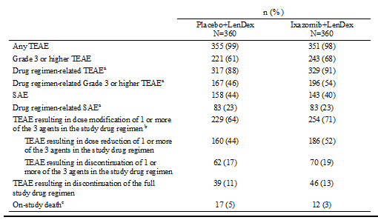

a. TEAE assessed by the investigator as that was related to any drug in the drug combination (placebo, ixazomib, lenalidomide, or dexamethasone) was considered to be treatment related. b. Dose modification includes dose delay, dose reduction, and drug discontinuation, the latter which could represent discontinuation of an individual drug in the combination or a discontinuation of the full treatment regimen. c. On-study deaths are defined as deaths that occur within 30 days of the last dose of study drug.

A summary of TEAEs reported among patients completing ≥ 12 cycles was provided. In the ixazomib regimen, the incidence of most categories of TEAEs declined with continued exposure. In the ixazomib regimen, TEAEs leading discontinuation of at least 1 of the 3 drugs occurred most frequently in Cycles 13 to 18. Similar patterns were noted in the placebo regimen. Dose modifications of ixazomib specifically were more common in Cycles 1 to 6 and decreased in frequency over time. Dose modifications of lenalidomide specifically were also most common in Cycles 1 to 6, followed by Cycles 7 to 12 after which they decreased. Dose modifications of dexamethasone specifically were most common in Cycles 1 to 6 and then in Cycles ≥ 19. Therefore, dose modifications could be made for different drugs in the regimen over time. Overall, the results indicate that the ixazomib regimen was tolerated with prolonged treatment with no evidence of cumulative toxicity.

#### TEAEs regardless of causality

##### Most commonly reported TEAEs by system, organ, class (SOC)

TEAEs by SOC occurring in ≥ 30% of all patients, and the 2 most common preferred terms in each SOC were provided. The most commonly reported TEAEs by SOC occurring in ≥ 50% of all patients were reported in a similar percentage of patients in the ixazomib and placebo regimens. The SOCs were gastrointestinal disorders (72% ixazomib versus 66% placebo), infections and infestations (72% ixazomib versus 69% placebo), general disorders and administration site conditions (63% ixazomib versus 62% placebo), musculoskeletal and connective tissue disorders (60% ixazomib versus 59% placebo), and nervous system disorders (59% ixazomib versus 55% placebo).

SOCs reported in ≥ 5% more patients in the ixazomib regimen than in the placebo regimen were (respectively), gastrointestinal disorders (72% versus 66%), skin and subcutaneous tissue disorders (49% versus 36%), and eye disorders (26% versus 16%). The higher frequency of TEAEs in the eye disorders SOC was accounted for by differences in low grade events denoting conjunctival irritation, such as blurred vision (6% ixazomib regimen versus 3% placebo regimen), conjunctivitis (6% ixazomib regimen versus 1% placebo regimen), and dry eye (5% ixazomib regimen versus 1% placebo regimen). The sponsor comments that conjunctival irritation of the type observed with ixazomib in the pivotal study has been reported for bortezomib in a Phase 2 study of bortezomib with rituximab in RR Waldenstrom’s macroglobulinaemia at a rate of 16%, and also in the lenalidomide prescribing information, where blurred vision was reported in 17.3% of patients on lenalidomide and 11.4% of patients on dexamethasone.

Blood and lymphatic system disorders (SOC) were experienced by 47% of patients in the ixazomib regimen and 43% of patients in the placebo regimen, and these disorders were primarily driven by the increased frequency of thrombocytopenia in the ixazomib regimen compared to the placebo regimen (20% versus 10%, respectively). Skin and subcutaneous tissue disorders (SOC) were experienced by 49% of patients in the ixazomib regimen and 36% of patients in the placebo regimen, and these disorders were primarily driven by the higher level term (HLT) "Rashes, eruptions, and exanthems NEC" in the ixazomib regimen compared to the placebo regimen (19% versus 11%, respectively). Renal and urinary disorders (SOC) were experienced by 10% of patients in the ixazomib regimen and 17% of patients in the placebo regimen. Cardiac disorders (SOC) occurred in the same proportion of patients (14%) in both treatment regimens.

##### Most commonly reported TEAEs by preferred term (PT)

TEAEs (by PT) occurring in ≥ 10% of patients in either the ixazomib regimen or the placebo regimen were provided. TEAEs occurring in ≥ 20% of patients in either the ixazomib regimen or the placebo regimen were (respectively), diarrhoea (42% versus 36%), constipation (34% versus 25%), fatigue (28% versus 26%), anaemia (26% versus 25%), neutropenia (26% versus 22%), nausea (26% versus 21%), peripheral oedema (25% versus 18%), vomiting (22% versus 11%), back pain (21% versus 16%), nasopharyngitis (20% versus 18%), thrombocytopenia (20% versus 10%), insomnia (19% versus 25%), and muscle spasms (18% versus 25%).

TEAEs (by PT) of any grade reported in ≥ 5% more patients in the ixazomib regimen than in the placebo regimen, in decreasing order of frequency in the ixazomib regimen, were (respectively), diarrhoea (42% versus 36%), constipation (34% versus 25%), nausea (26% versus 21%), peripheral oedema (25% versus 18%), vomiting (22% versus 11%), back pain (21% versus 16%), thrombocytopenia (20% versus 10%), upper respiratory tract infection (19% versus 14%), peripheral sensory neuropathy (19% versus 14%), and maculopapular rash (9% versus 3%). TEAEs (by PT) of any grade reported in ≥ 5% fewer patients in the ixazomib regimen than in the placebo regimen were (respectively), insomnia (19% versus 25%), muscle spasm (18% versus 25%), and pyrexia (13% versus 19%).

##### Grade 3 and 4 TEAEs (PT)

Grade 3 or higher TEAEs (PT) were reported in 68% (n = 243) of patients in the ixazomib regimen and 61% (n = 221) of patients in the placebo regimen. In all patients, Grade 3 TEAEs were reported more commonly than Grade 4 or 5 TEAEs. Grade 3 TEAEs were reported more commonly in the ixazomib regimen than in the placebo regimen (49% versus 43%, respectively). Similar proportions of patients in the two regimens experienced Grade 4 TEAEs (15% ixazomib regimen versus 14% placebo regimen) and Grade 5 TEAEs (4% ixazomib regimen versus 5% placebo regimen). The most commonly reported Grade 3, Grade 4 and Grade 3 or higher TEAEs in the two treatment regimens are summarised below.

Grade 3 TEAEs (PT) reported in at least 5 patients in either the ixazomib regimen or the placebo regimen were provided. Grade 3 TEAEs (PT) were reported in 49% (n = 177) of patients in the ixazomib regimen and 43% (n = 153) of patients in the placebo regimen. Grade 3 TEAEs (PT) reported by ≥ 5% of patients in either the ixazomib regimen or the placebo regimen were (respectively) neutropenia (15% versus 12%), anaemia (9% versus 13%), thrombocytopenia (8% versus 3%), diarrhoea (6% versus 2%), and pneumonia (6% and 7%). The only Grade ≥ 3 TEAE (PT) reported in ≥ 5% more patients in the ixazomib regimen than in the placebo regimen was thrombocytopenia (8% versus 3%).

Grade 4 TEAEs (PT) reported in at least 2 patients in either the ixazomib regimen or the placebo regimen were provided. Grade 4 TEAEs (PT) were reported in 15% (n = 53) of patients in the ixazomib regimen and 14% (n = 51) of patients in the placebo regimen. Grade 4 TEAEs (PT) reported in ≥ 1% of patients in either the ixazomib regimen or the placebo regimen were (respectively), thrombocytopenia (6% versus 2%), neutropenia (4% each), hypokalaemia (2% versus < 1%,), platelet count decreased (1% each), sepsis (1% versus < 1%), neutrophil count decreased (< 1% versus 1%), pneumonia (< 1% versus 1%), and septic shock (< 1% versus 1%). The only Grade 4 TEAE (PT) reported in ≥ 2% more patients in the ixazomib regimen than in the placebo regimen was thrombocytopenia (6% versus 2%).

Grade 3 or higher TEAEs (PT) were reported in 68% (n = 243) of patients in the ixazomib regimen and 61% (n = 221) of patients in the placebo regimen. Grade ≥ 3 TEAEs (PT) reported in ≥ 5 % of patients in either the ixazomib regimen or the placebo regimen, in decreasing order of frequency in the ixazomib regimen, were (respectively), neutropenia (19% versus 16%), thrombocytopenia (13% versus 5%), anaemia (9% versus 13%), pneumonia (6% versus 8%), and diarrhoea (6% versus 2%). Grade 3 or higher TEAEs (PT) reported in ≥ 2 % more patients in the ixazomib regimen than in the placebo regimen were neutropenia (19% versus 16%), thrombocytopenia (13% versus 5%), diarrhoea (6% versus 2%), hypokalaemia (4% versus 1%), leukopenia (4% versus 2%), nausea (2% versus 0%),

### Drug related treatment emergent adverse events

#### Most commonly reported treatment related adverse events

Given that the study involved a drug combination regimen, if a TEAE was related to any drug in the drug combination, it was recorded as “drug related,” meaning related to any drug in the regimen and not specifically to ixazomib. Treatment related TEAEs were reported in 91% (n = 329) of patients in the ixazomib regimen and 88% (n = 317) of patients in the placebo regimen.

Treatment related TEAEs by SOC reported in ≥ 20% of the total population (ixazomib regimen versus placebo regimen) were gastrointestinal disorders (54% versus 40%), nervous system disorders (43% versus 37%), general disorders and administration site conditions (41% versus 38%), blood and lymphatic disorders (39% versus 32%), skin and subcutaneous tissue disorders (34% versus 24%), infections and infestations (28% versus 23%), psychiatric disorders (23% versus 24%), and musculoskeletal and connective tissue disorders (20% versus 25%).

Treatment related TEAEs reported in ≥ 5% of patients in either of the two treatment groups were provided. Treatment related TEAEs reported in ≥ 10% of patients in either the ixazomib or placebo regimen were (respectively), diarrhoea (28% versus 18%), neutropenia (24% versus 20%), constipation (19% versus 16%), fatigue (19% versus 18%), thrombocytopenia (18% versus 8%), nausea (18% versus 8%), vomiting (15% versus 4%), insomnia (15% versus 19%), peripheral sensory neuropathy (15% versus 12%), anaemia (14% versus 14%), peripheral oedema (11% versus 9%) and muscle spasms (11% versus 18%).

Treatment related TEAEs reported in ≥ 5% more patients in the ixazomib regimen than in the placebo regimen were diarrhoea (28% versus 18%), thrombocytopenia (18% versus 8%), nausea (18% versus 8%), vomiting (15% versus 4%), and maculopapular rash (8% versus 3%). There was one Treatment related TEAEs reported in ≥ 5% fewer patients in the ixazomib regimen than in the placebo regimen (muscle-spasms [11% versus 18%]).

#### Grade 3 and 4 Treatment related TEAEs

Grade 3 Treatment related TEAEs were provided. Grade 3 Treatment related TEAEs were reported in 42% (n = 152) of patients in the ixazomib regimen and 35% (n = 127) of patients in the placebo regimen. Grade 3 Treatment related TEAEs reported in ≥ 5% of patients in either the ixazomib regimen or the placebo regimen were (respectively), neutropenia (13% versus 11%), thrombocytopenia (7% versus 3%), anaemia (4% versus 6%), and pneumonia (3% versus 5%). There were no Grade 3 Treatment related TEAEs with a difference of ≥ 5 percentage points between the two treatment regimens.

Grade 4 Treatment related TEAEs were summarised. Grade 4 Treatment related TEAEs were reported in 11% (n = 40) of patients in the ixazomib regimen and 11% (n = 38) of patients in the placebo regimen. The only Grade 4 Treatment related TEAE reported in ≥ 5% of patients in either of the two treatment regimens was thrombocytopenia, which was reported in 5% of patients in the ixazomib group and 2% of patients in the placebo group. There were no Grade 4 Treatment related TEAEs with a difference of ≥ 5 percentage points between the two treatment regimens.

### Deaths and serious adverse events

#### Deaths

On-study deaths were defined as deaths that occurred within 30 days of the last dose of study drug. A listing of on-study deaths by patient, including treatment response at the most recent assessment, is presented by MedDRA preferred term of the causative events was provided.

A total of 29 on-study deaths were reported at the time of the database lock on 30 October 2014. On-study deaths were reported in 12 (3%) patients in the ixazomib regimen and 17 (5%) patients in the placebo regimen. In general, deaths were more frequently documented early (Cycles 1 to 3) in therapy (6 of 12 deaths in ixazomib regimen; 8 of 17 deaths in placebo regimen), although deaths also occurred later in therapy during Cycles 12 to 21 (1 of 12 deaths in ixazomib regimen; 3 of 17 deaths in placebo regimen).

Of the 29 on-study deaths, 5 were reported as being related to study drug treatment (3 in the ixazomib regimen; 2 in the placebo regimen). Drug related on-study deaths reported in the placebo regimen included myocardial infarction and pulmonary embolism. In the ixazomib regimen, drug related on-study deaths included pulmonary embolism, fungal pneumonia, and coma (with concurrent diagnosis of stroke).

Of the total number of on-study deaths, 28% (n = 8) were attributed to disease progression. Of the 12 deaths associated with cardiovascular events (6 ixazomib regimen, 6 placebo regimen), 8 were considered not related to study treatment (4 ixazomib regimen [cardiac arrest, cardiovascular insufficiency, myocardial infarction, diastolic dysfunction]; 4 placebo regimen [cardiac failure, acute cardiac failure, cardiogenic shock, aortic dissection]). Of the 5 deaths associated with infectious events (2 ixazomib regimen, 3 placebo regimen), 4 were considered not related to study treatment (1 ixazomib regimen [aspiration pneumonia]; 3 placebo regimen [aspiration pneumonia, sepsis, pneumococcal pneumonia]) The remaining 4 on-study deaths were associated with other organ failure.

Among the 29 patients who died on-study, 11 patients had responded (PR or better) to treatment (7 ixazomib regimen, 4 placebo regimen had stable disease (all in the placebo regimen), 10 patients had PD (3 ixazomib regimen, 7 placebo regimen), and 4 patients had assessments that were not evaluated (2 ixazomib regimen, and 2 placebo regimen).

#### Other SAEs

##### SAEs irrespective of causality

SAEs reported in ≥ 1% of patients in either of the two treatment regimens were summarised. SAEs were reported in 40% (n = 143) of patients in the ixazomib regimen and 44% (n = 158) of patients in the placebo regimen. SAEs were most commonly reported in the SOC of infection and infestations, 18% of patients in the ixazomib regimen and 23% of patients in the placebo regimen, with SAEs of HLT "Lower respiratory tract and lung infections" reported in 8% of patients in the ixazomib regimen and 12% of patients in the placebo regimen. Other SAE SOCs reported in ≥ 5% of patients in either the ixazomib regimen or placebo regimen (respectively) were cardiac disorders (6% and 4%), general disorders and administration site conditions (5% and 6%), gastrointestinal disorders (5% and 2%), respiratory disorders (5% and 6%), and blood and lymphatic system disorders (4% and 5%).

SAEs reported in ≥ 2% of patients in either the ixazomib regimen or placebo regimen (respectively) were pneumonia (6% versus 8%), pyrexia (3% versus 4%), diarrhoea (2% versus < 1%), pulmonary embolism (2% in each regimen), atrial fibrillation (1% versus 2%), back pain (< 1% versus 2%), plasma cell myeloma (1% versus 2%), anaemia (< 1% versus 2%), bronchitis (< 1% versus 2%), and febrile neutropenia (< 1% versus 2%). There were no SAEs with a difference of ≥ 5 percentage points between the two treatment regimens.

##### Treatment related SAEs

Treatment related SAEs were reported in 23% (n = 83) of patients in the ixazomib regimen and 23% (n = 83) of patients in the placebo regimen. Treatment related SAE SOCs reported in ≥ 2% of patients in either the ixazomib or placebo regimen (respectively) were infection and infestations (8% and 11%), respiratory, thoracic and mediastinal disorders (3% and 4%), blood and lymphatic system disorders (3% and 3%), gastrointestinal disorders (3% and < 1%), general disorders and administration site conditions (3% and 1%), cardiac disorders (2% and 3%), vascular disorders (2% each), metabolism and nutrition disorders (1% and 2%), and nervous system disorders (1% and 2%).

Treatment related SAEs reported in ≥ 2% of patients in either the ixazomib or placebo regimen were (respectively), pneumonia (3% versus 5%), diarrhoea (2% versus < 1%), pyrexia (2% versus 1%), and pulmonary embolism (1% versus 2%). There were no treatment related SAEs with a difference of ≥ 5 percentage points between the two treatment regimens.

#### Other significant adverse events

##### Adverse events leading to discontinuation

###### TEAEs resulting in discontinuation of ≥ 1 of the 3 agents in the study drug regimen

TEAEs resulting in discontinuation of 1 or more of the 3 agents in the study drug regimen in at least 2 patients in either of the two regimens were summarised. At least 1 TEAE leading to discontinuation of 1 or more of the 3 agents in the study drug regimen was reported by 19% (n = 70) of patients in the ixazomib regimen and 17% (n = 62) of patients in the placebo regimen. These TEAEs could include TEAEs related to myeloma progression. TEAEs leading to discontinuation in ≥ 1% patients in either the ixazomib or placebo regimen (respectively) by HLT were "Asthenic conditions" (2% versus < 1%), "Heart failures NEC" (< 1% versus 2%), "Peripheral neuropathies NEC" (1% each), "Diarrhoea (excluding infective)" (1% versus < 1%), and "Disturbances in initiating and maintaining sleep" (0% versus 1%).

There were no treatment related SAEs with a difference of ≥ 5 percentage points between the two treatment regimens. There were no TEAEs leading to discontinuation with an incidence > 1% in either treatment regimen. The most commonly reported TEAEs leading to discontinuation of 1 or more of the 3 agents in at least 4 patients in either the ixazomib or placebo regimen (respectively) were, diarrhoea (5 [1%] versus 3 [< 1%]), fatigue (5 [1%] versus 3 [< 1%)]), insomnia (0 [0%] versus 5 [1%]), and cardiac failure (1 [< 1%] versus 4 [1%]).

###### TEAEs resulting in study drug discontinuation of individual agents in regimen

TEAEs resulting in study drug discontinuation of individual agents in the regimen in at least 3 patients were summarised. Investigators were not blinded to the administration of lenalidomide and dexamethasone, but were blinded to the administration of ixazomib or placebo. Discontinuations due to the individual study drugs in the ixazomib and placebo regimens were (respectively), dexamethasone (16% [n = 58] versus 16% [n = 57]) and lenalidomide (15% [n = 55] versus 14% [n = 49]). The results showed that the incidence of discontinuation of either lenalidomide or dexamethasone due to TEAEs was similar in the two treatment regimens. Discontinuation of ixazomib in the ixazomib regimen due to TEAEs was reported in 15% (n = 54) of patients, and discontinuation of placebo in the placebo regimen due to TEAEs was reported in 14% (n = 49) of patients.

The most commonly reported events (≥ 4 patients in either regimen) resulting in discontinuation of ixazomib or placebo were thrombocytopenia (3 [< 1%] ixazomib regimen versus 6 [2%] placebo regimen), peripheral neuropathy (pooled PTs: 5 [1%] ixazomib regimen versus 3 [< 1%] placebo regimen), neutropenia (pooled PTs: 3 [< 1%] ixazomib regimen versus 4 [1%] placebo regimen), renal failure (pooled PTs: 3 [< 1%] ixazomib regimen versus 4 [1%] placebo regimen), heart failure (pooled PTs: 2 [< 1%] ixazomib regimen versus 5 [1%] placebo regimen), diarrhoea (5 [1%] ixazomib regimen versus 1 (< 1%] placebo regimen), fatigue (5 [1%] ixazomib regimen versus 1 (< 1%] placebo regimen), plasma cell myeloma (1 [< 1%] ixazomib regimen versus 4 [1%] placebo regimen), and pneumonia (1 [< 1%] ixazomib regimen versus 4 [1%] placebo regimen).

###### Discontinuation of all 3 study drugs in the regimen

Discontinuations of all three study drugs in the regimen were reported in 13% (n = 46) of patients in the ixazomib regimen and 11% (n = 39) of patients in the placebo regimen. The rate of discontinuation of all 3 study drugs due to a TEAE was similar between the 2 regimens and the rate decreased over time. The rates of treatment discontinuation due to TEAE over the duration of the study in patients who discontinued in the two treatment regimens were as follows: (a) Cycles 1 to 6 (61% [n = 28] ixazomib regimen versus 67% [n = 26] placebo regimen): Cycle 1 (26% [n = 12] ixazomib regimen versus 15% [n = 6] placebo regimen), first 3 cycles (34% [n = 16] ixazomib regimen versus 44% [n = 17] placebo regimen); (b) Cycles 7 to 12 (24% [n = 11] ixazomib regimen versus 21% [n = 8] placebo regimen); and (c) beyond 12 cycles (15% [n = 7 ixazomib regimen versus 13% [n = 6] placebo regimen).

##### TEAEs leading to dose modification or dose reduction

###### TEAEs leading to dose modification

Dose modification included dose reduction, dose delay and dose discontinuation. A decision regarding which study drug required dose reduction was dependent upon the type of toxicity, its onset, and time course. For those toxicities known to be associated with lenalidomide (for example, rash, neutropenia), lenalidomide was reduced at the first occurrence. Alternative dose modifications may have been recommended after discussion with the investigator and the sponsor to maximise exposure to study treatment while protecting patient safety, given that there may be overlapping dose-limiting toxicities (for example, thrombocytopenia, neutropenia, rash, and peripheral neuropathy).

TEAEs leading to dose modification of 1 or more of the 3 agents in the study regimen were reported in 71% (n = 254) of patients in the ixazomib regimen and 64% (n = 229) of patients in the placebo regimen. In Cycles 1 to 6, dose modifications due to TEAEs were reported in 49% (n = 105) of patients in the ixazomib regimen and 40% (n = 82) of patients in the placebo regimen, with the respective percentages being 41% (n = 87) and 32% (n = 66) in Cycles 7 to 12, 28% (n = 51) and 20% (n = 34) in Cycles 13 to 18, and 6% (n = 4) and 18% (n = 11) beyond 19 cycles.

###### TEAEs leading to dose reductions

TEAEs leading to dose reduction were reported in 52% (n = 186) of patients in the ixazomib regimen and 44% (n = 160) of patients in the placebo regimen. In Cycles 1 to 6, dose reductions due to TEAEs were reported in 36% (n = 77) patients in the ixazomib regimen and 30% (n = 62) of patients in the placebo regimen, with the respective percentages being 27% (n = 57) and 22% (n = 46) in Cycles 7 to 12, 16% (n = 30) and 9% (n = 15) in Cycles 13 to 18, and 4% (n = 3) and 11% (n = 7) beyond 19 cycles.

Dose reductions of the prescribed amount of ixazomib in the ixazomib regimen due to TEAEs were reported in 20% (n = 73) of patients and dose reductions of the prescribed amount of placebo in the placebo regimen due to TEAEs were reported in 9% (n = 34) of patients. Dose reductions of the prescribed amount of lenalidomide due to TEAEs were reported in 38% (n = 135) of patients in the ixazomib regimen and 28% (n = 99) of patients in the placebo group. Dose reductions of the prescribed amount of dexamethasone due to TEAEs were reported in 31% (n = 113) of patients in the ixazomib regimen and 27% (n = 97) of patients in the placebo group.

Study drug dose reductions of at least 1 agent due to TEAEs reported in ≥ 5 patients in either treatment regimen were summarised. The primary reasons (reported in ≥ 10 patients in either regimen) for dose reduction of ixazomib or placebo (respectively) were thrombocytopenia (pooled PTs: 5% [n = 18] versus 1% [n = 4]), peripheral neuropathy (pooled PTs: 4% [n = 15] versus 3% [n = 10), rash (pooled PTs: 4% [n = 13] and < 1% [n = 1]), and neutropenia (pooled PTs: 3% [n = 12] versus 3% [n = 10]).

Investigators were unblinded to patients receiving lenalidomide and dexamethasone. The most common events reported in ≥ 10 patients in either the ixazomib or placebo regimens resulting in dose reduction of lenalidomide were (respectively), thrombocytopenia (pooled PTs; 24 [7%] versus 8 [2%]), rash (pooled PTs; 23 [6%] versus 11 [3%]), neutropenia (pooled PTs; 22 [6%] in each regimen), diarrhoea (11 [3%] versus 7 [2%]), and renal failure (pooled PTs; 9 [3%] versus 10 [3%]). The most common events reported in ≥ 10 patients in either the ixazomib or placebo regimens resulting in dose reduction of dexamethasone were (respectively), insomnia (11 [3%] versus 12 [3%]), altered mood (11 [3%] in each regimen), peripheral oedema (10 [3%] versus 7 [2%]), and diarrhoea (10 [3%] versus 4 [1%]).

**Comment:** There were differences noted in the overall incidence of TEAEs leading to dose reduction for lenalidomide and dexamethasone reported in CSR Tables 12.k, 14.1.1.B and 14.1.1.5C. The sponsor comments that this is due to the way that the data were collected in the eCRF. In any event, the differences are not marked and do not influence the interpretation of the data.

### Adverse events of special interest

#### Skeletal related TEAEs

Skeletal related events were defined as new fractures (excluding vertebral compression or rib fractures), irradiation or surgery on bone, or spinal cord compression. Based on skeletal survey reports, lytic lesions at baseline were present in a similar percentage of patients in both regimens (70% ixazomib regimen versus 67% placebo regimen). The use of drugs affecting bone structure and mineralisation (ATC Pharmacologic subgroup, including generic terms of pamidronic acid and zoledronic acid) was similar in the ixazomib and placebo regimens (49% versus 48%, respectively). Skeletal related TEAEs and/or concomitant procedures are summarised below in Table 39.

Table 39: Study C16010; skeletal related TEAEs and/or concomitant procedures; safety population

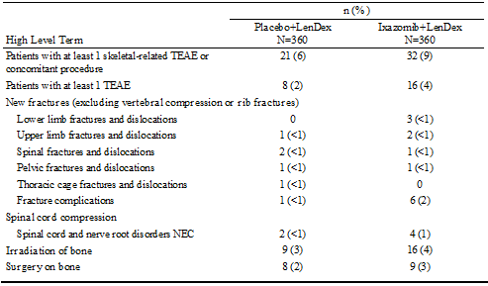

#### Thrombotic events

Thromboprophylaxis was required per protocol, with 97% of patients reporting concomitant use of an antithrombotic agent (96% ixazomib regimen, 98% placebo regimen). Acetylsalicylic acid was the most frequently used agent in both regimens (78% ixazomib regimen, 77% placebo regimen).

The addition of ixazomib to LenDex did not increase the risk of venous thromboembolism. A review of venous thrombosis Standardized MedDRA Query (SMQ) identified embolic and thrombotic events in 24 patients (7%) in the ixazomib regimen, and 36 patients (10%) in the placebo regimen. Arterial thromboembolic events, assessed according to the thrombosis, arterial SMQ, were reported infrequently (1% ixazomib regimen, 2% placebo regimen). The median time to first report of a thromboembolic event was 120 days (approximately Cycle 4). Thromboembolic events occurring within 90 days of the start of the study drug regimen were reported in 14 (4%) patients in the ixazomib regimen and 11 (3%) patients in the placebo regimen.

In the ixazomib regimen, 7 (2%) patients reported a Grade 3 or higher thromboembolic event within the first 3 cycles, and 4 of the 7 patients reported taking aspirin as thromboprophylaxis, 1 reported taking Clexane as thromboprophylaxis, and 2 reported no thromboprophylaxis. Grade 3 thromboembolic events were experienced by 8 (2%) and 10 (3%) patients in the ixazomib and placebo regimens, respectively, and Grade 4 thromboembolic events were experienced by 1 (< 1%) patient in each regimen. Two on-study deaths (1 ixazomib, 1 placebo) were due to pulmonary embolism. Thromboembolic events resulted in discontinuation in 2 patients in the ixazomib group (1 each for pulmonary embolism and deep vein thrombosis), and in 2 patients in the placebo group (both pulmonary embolism). One patient in the ixazomib regimen discontinued lenalidomide due to retinal vein thrombosis, but continued on ixazomib and dexamethasone for 12 additional cycles until disease progression, without the retinal vein thrombosis recurring or worsening.

#### Herpes zoster

Use of prophylactic antiviral agents was at the discretion of the treating physician. Approximately two-thirds of patients reported taking antiviral agents prophylactically (247 [67%] ixazomib, 237 [66%] placebo). TEAEs of herpes zoster were experienced by 20 patients (14 [4%] ixazomib regimen, 6 [2%] placebo regimen); 3 patients had events that were Grade 3 (2 ixazomib regimen, 1 placebo regimen) and none was Grade 4. The event was categorised as serious in 4 patients (3 ixazomib regimen and 1 placebo regimen). Median time to herpes zoster reactivation was Cycle 6 (range Cycle 2 to 14), with 19 of the 20 patients (13 ixazomib regimen, 6 placebo regimen) receiving treatment for the event. Discontinuation due to herpes zoster was reported in 2 patients in the ixazomib regimen. Of the 20 patients who experienced TEAEs of herpes zoster, 2 patients (1 in each regimen) used prophylactic antiviral agents, and 4 patients (3 ixazomib regimen, 1 placebo regimen) had a low lymphocyte count at the time of the event. The sponsor states that, based on the data relating to herpes zoster infection, "the use of antiviral medications as prophylaxis should remain at the discretion of the treating physician".

#### New primary malignancy

New primary malignancies were reported during treatment in 15 patients, including 8 patients (2%) in the ixazomib regimen and 5 patients (1%) in the placebo regimen, and 1 patient (< 1%) in each regimen during the PFS follow-up. Of the 13 new primary malignancies occurring during treatment, 11 were non-haematologic (7 ixazomib regimen, 4 placebo regimen), including 7 skin malignancies (3 ixazomib regimen, 4 placebo regimen), and 2 were haematologic (1 ixazomib regimen, 1 placebo regimen; both myelodysplastic syndrome). Of the 2 new primary malignancies during PFS follow-up, both were non-haematologic.

In the ixazomib regimen (total of 9 tumours), there was 1 myelodysplastic syndrome, 5 solid tumours, and 3 skin cancers. Of the 5 patients with a newly diagnosed solid tumour, 4 patients had a clinically relevant medical history relating to the tumour. In the placebo regimen (total of 6 tumours), there was 1 myelodysplastic syndrome, 1 solid tumour, and 4 skin cancers. For the patients who were diagnosed with myelodysplastic syndrome and the solid tumour, there was no informative medical history. However, the 1 patient with myelodysplastic syndrome in the placebo regimen had been previously treated with melphalan, cyclophosphamide, thalidomide, and autologous stem cell transplant. The patient with the solid tumour in the placebo regimen had been previously treated with cyclophosphamide and thalidomide.

Among the 13 patients, (8 ixazomib regimen, 5 placebo regimen) who had a new primary malignancy during treatment, 5 patients (1%) in the ixazomib regimen and 2 patients (< 1%) in the placebo regimen had an event that was reported as an SAE. The SAE of myelodysplastic syndrome occurred in both regimens.

The study drug regimen was prematurely discontinued due to a new primary malignancy in 4 patients (1%) in the ixazomib regimen and 1 patient (< 1%) in the placebo regimen. Another patient had ongoing prostate cancer (treatment completed more than 2 years before study entry), and was diagnosed with metastatic prostate cancer 8 months after study entry and was discontinued from the study 5 months later.

#### Other adverse events of clinical importance

##### Background

The sponsor designated selected AEs as being of clinical importance based on, but not limited to, the following factors: (1) identified by searches of the clinical database considering the context of the intended patient population; (2) common adverse reactions for lenalidomide (for example, gastrointestinal events, rash, neutropenia, and thrombocytopenia); (3) adverse events reported at higher rates both across ixazomib clinical trials and within Study C16010 (that is, gastrointestinal events, thrombocytopenia, neutropenia, and rash); and (4) adverse reactions reported with the proteasome inhibitors bortezomib (for example, thrombocytopenia, peripheral neuropathy, hypotension) and carfilzomib (for example, cardiac events, hepatic AEs, and renal adverse events).

The AEs selected as being of clinical importance were peripheral neuropathy, heart failure, arrhythmias, myocardial infarction, renal impairment, liver impairment, rash, hypotension, encephalopathy, thrombocytopenia, neutropenia, nausea, vomiting, and diarrhoea. The sponsor commented that some of the AEs of clinical importance for ixazomib (for example, thrombocytopenia, diarrhoea, nausea, vomiting, and rash) overlap with lenalidomide toxicities. The definitions of TEAEs of special interest and TEAEs of clinical importance were provided. The results for the TEAEs of clinical importance were summarised and are discussed below.

##### Cardiac events

Cardiac events (that is, heart failure, myocardial infarction, and arrhythmias) were considered TEAEs of clinical importance based on adverse reactions reported with the overseas commercially available proteasome inhibitor carfilzomib (for example, cardiac toxicities listed in the US label for carfilzomib including new onset of worsening cardiac failure, restrictive cardiomyopathy, myocardial ischaemia, and myocardial infarction). The Australian PI for lenalidomide lists the following cardiac disorders as occurring commonly in patients in the main MM and myelodysplastic (MDS) studies: myocardial infarction (including acute); atrial fibrillation; tachycardia; cardiac failure (including congestive).

The results for cardiac events of clinical importance for heart failed (pooled PTs), arrhythmias (pooled PTs) and myocardial infarction (pooled PTs) are summarised below in Table 40. The results showed no notable differences between the two treatment regimens in the incidence of cardiac TEAEs of clinical importance.

Table 40: Study C16010; number (%) of patients with cardiac TEAEs of clinical importance; safety population

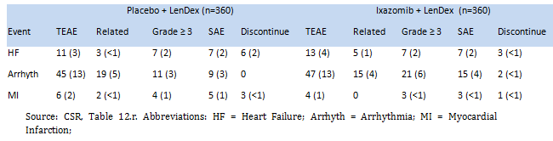

Of note (heart failure), 4 (1%) patients in the ixazomib regimen and 2 (< 1%) patients in the placebo regimen had Grade 3 heart failure TEAEs, 2 (< 1%) patients in each regimen reported a Grade 4 heart failure event, and 1 (< 1%) patient in the ixazomib regimen and 3 (< 1%) patients in the placebo regimen had a Grade 5 event (that is, died due to TEAE of heart failure). Peripheral oedema was assessed separately from cardiac failure. Of the 157 patients reporting peripheral oedema, 91 (25%) were in the ixazomib regimen and 66 (18%) were in the placebo regimen. Peripheral oedema TEAEs were mostly low grade, with Grade 3 events being reported in only 2% and 1% of patients in the ixazomib and placebo regimens, respectively. No Grade 4 or Grade 5 peripheral oedema events were reported in either treatment regimen. An association between peripheral oedema and cardiac failure was identified in 4 patients (1%) in the ixazomib regimen and 2 patients (< 1%) in the placebo regimen. No patients discontinued treatment due to peripheral oedema. The sponsor notes that the majority or reported events of peripheral oedema were independent of cardiac function, were of low grade intensity, and probably related to fluid retention induced by dexamethasone and vascular permeability effects described for proteasome inhibitors.

Of note (arrhythmia), supraventricular arrhythmias were the most commonly reported arrhythmias (5% ixazomib regimen, 7% placebo regimen), while ventricular arrhythmias were less commonly reported (2% ixazomib regimen, < 1% placebo regimen). Per protocol, ECGs were completed at baseline, after Cycle 2, and at the EOT assessment. Grade 3 arrhythmia TEAEs, were reported in 17 (5%) patients in the ixazomib regimen and 10 (3%) patients in the placebo regimen, Grade 4 events were reported in 3 (< 1%) patients in the ixazomib regimen and 1 (< 1%) patient in the placebo regimen, and Grade 5 events were reported in 1 (< 1%) patient in the ixazomib regimen. The one death due to a TEAE of arrhythmia in the ixazomib regimen occurred in a 76 year old male with a history of cardiovascular disease who died due to cardiac arrest, possibly related to administration of perflutren contrast used at the end of an echocardiogram undertaken to investigate the patient's cardiac function while hospitalised for weakness and septicaemia. TEAEs of electrocardiogram QT prolonged (1 x Grade 3 and 1 x Grade 1) were reported in 2 patients in the ixazomib regimen. One of these patients continued on the study drug without modification of dose for a total of 12 cycles, and in one of these patients the event was noted at the EOT visit. In neither case did the investigator consider the event to be related to treatment with the ixazomib regimen. No patients in either regimen experienced Torsade de pointes.

Of note (myocardial infarction), Grade 3 myocardial infarction TEAEs were reported in no patients in the ixazomib regimen and 1 (< 1%) patient in the placebo regimen, while Grade 4 events were reported in 2 (< 1%) patients in each regimen and Grade 5 events were reported in 1 (< 1%) patient in each regimen. The 1 death due to MI in the ixazomib regimen was considered by the investigator to be not related to the study drug regimen, and the 1 death due to MI in the placebo regimen was considered by the investigator to be related to lenalidomide or underlying coronary artery disease.

###### Cardiac events in patients with high risk cardiac factors

The sponsor extracted cardiac risk factors (defined as diabetes, hypertension, obesity, and hypercholesterolemia/hyperlipidaemia) and terms indicating prior or ongoing heart disease (for example, records of myocardial infarction, cardiac ischemia and angina, and congestive heart failure) from medical histories. Of the 720 patients in the safety population, 434 patients had cardiac risk factors or pre-existing heart disease, including 199 (55%) patients in the ixazomib regimen and 235 (65%) patients in the placebo regimen. A total of 391 patients, including 180 (50%) patients in the ixazomib regimen and 211 (59%) patients in the placebo regimen, had cardiac risk factors, while 154 patients, including 66 (18%) in the ixazomib regimen and 88 (24%) in the placebo regimen, had prior/ongoing heart disease.

The reported cardiac TEAEs were similar in both treatment regimens in patients with high risk cardiac factors. The only term numerically different event was cardiac arrest, which occurred in 3 patients in the ixazomib regimen and no patients in the placebo regimen. All 3 of these events in the ixazomib regimen were considered by the investigator to be not related to ixazomib. In 1 patient, the investigator considered underlying cardiac disease or perflutren contrast used at the end of the echocardiogram to be possible causes. In 1 patient, the event occurred more than 30 days after the last documented dose of study drug and was considered to be due to an acute cardiac event and progressive myeloma. In 1 patient, underlying coronary artery disease was considered to be the cause. Cardiac events of clinical importance in patients with cardiac risk factors or pre-existing heart disease are summarised below in Table 41.

Table 41: Study C16010; number (%) of patients with cardiac TEAEs of clinical importance in patients with cardiac risk factors or pre-existing heart disease

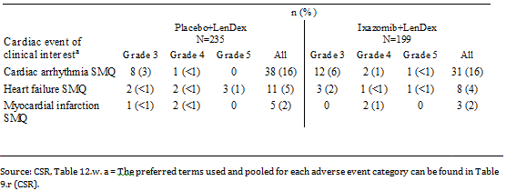

TEAE cardiac events of special interest by age group are summarised below in Table 42. The results showed that cardiac events increased with increasing age in both treatment regimens. There were no notable difference in the incidence of cardiac arrhythmias SMQ between the two treatment regimens in the ≤ 65 years and > 65 to ≤ 75 years age groups, but cardiac arrhythmias SMQ occurred notably more frequently in patients aged > 75 years in the ixazomib regimen than in the placebo regimen (21% versus 15%, respectively). The sponsor is requested to comment on the possible reasons for the difference between the two treatment regimens in the incidence of cardiac arrhythmias SMQ in patients aged > 75 years. There were no notable differences between the two treatment regimens in the incidence of heart failure SMQ and the incidence of MI SMQ based on age.

Table 42: Study C16010; TEAE cardiac events of clinical importance by age; safety population

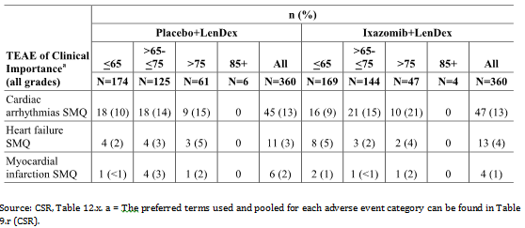

The sponsor comments that rash has been described during administration of lenalidomide, dexamethasone, and ixazomib. TEAEs for rash (pooled PTs) of clinical importance are summarised below in Table 43, and rash by PT was summarised and provided.

Table 43: Study C16010; number (%) of patients with TEAEs associated with rash (pooled PTs) of clinical importance; safety population

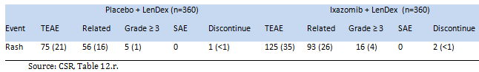

The incidence of rash (pooled PTs) was notably higher in the ixazomib regimen than in the placebo regimen (35% versus 21%, respectively), with the difference being mainly due to low grade events (that is, Grade 1 and 2 events). The most frequently reported rash TEAEs by PT reported in ≥ 5% of patients in either the ixazomib or placebo regimens (respectively) were pruritus (10% versus 7%), maculopapular rash (9% versus 3%), and macular rash (6% both regimens). No patients in either treatment regimen experienced a Grade 4 or 5 event related to rash. There were 2 cases of Grade 3 Sweet’s syndrome (acute febrile neutrophilic dermatosis), both in patients in the ixazomib regimen. No patient in either regimen experienced Stevens-Johnson Syndrome (SJS) or toxic epidermal necrolysis.

Across both treatment regimens, lenalidomide was the most frequently reduced agent due to rash (pooled PTs), followed by ixazomib and dexamethasone. Dose reductions due to rash were reported for ixazomib in 13 (4%) patients (ixazomib regimen) and for placebo in 1 (< 1%) patient (placebo regimen), while in the ixazomib and placebo regimens, respectively, lenalidomide dose was reduced in 23 (6%) and 11 (3%) patients and dexamethasone dose was reduced in 6 (2%) and 1 (< 1%) patients

The incidence of rash (pooled PTs) was highest during the first 3 months of treatment and generally declined over time. The incidence of rash (pooled PTs) in the first 3 months of treatment was 30% (n = 109) in the ixazomib regimen and 17% (n = 61) in the placebo regimen. The cumulative incidence of Grade 3 events across time was similar in the 2 regimens, and there were no Grade 4 TEAEs associated with rash in either treatment regimen. The cumulative incidence rates of rash (pooled PTs) over time from first dose are represented graphically below in Figure 16.

Figure 16: Study C16010; Cumulative incidence of rash (pooled PTs); safety population

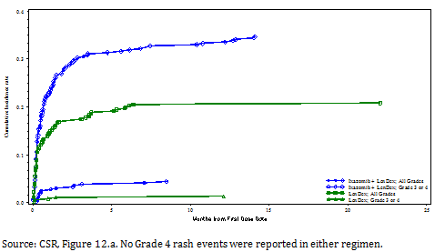

The protocol recommended symptomatic measures such as antihistamines or corticosteroids (oral or topical) to manage rash or to use prophylactic treatment in subsequent cycles. For a rash event, a higher proportion of patients in the ixazomib regimen than in the placebo regimen used systemic antihistamines (27% versus 19%, respectively).

##### Gastrointestinal

Gastrointestinal TEAEs of clinical importance are summarised below in Table 44. The results showed that nausea, vomiting, and diarrhoea all occurred more frequently in the ixazomib regimen than in the placebo regimen. The observed differences between the two treatment regimens in the incidence of gastrointestinal TEAEs of clinical importance are considered to be clinically meaningful. However, the majority of TEAEs for the three gastrointestinal events of clinical importance were Grade 1 or 2 in intensity, and SAEs and discontinuations due to these events were infrequent in both treatment regimens. No Grade 4 or 5 events were reported for nausea, vomiting or diarrhoea. Discontinuations due to diarrhoea occurred in both treatment regimens, while no discontinuations for nausea or vomiting were reported in either of the two treatment regimens.

Table 44: Study C16010; number (%) of patients with TEAEs associated gastrointestinal conditions (PT) of clinical importance; safety population

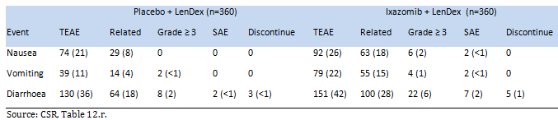

Potential clinical complications associated with nausea, vomiting or diarrhoea: Dehydration was reported infrequently in both the ixazomib regimen and the placebo regimen (1% [n = 4] versus 2% [n = 6], respectively), while the use of IV solutions was reported in 20% of patients in both treatment regimens (71 versus 72 patients, respectively) and weight decrease (TEAE) was reported in 6% (n = 23) and 5% (n = 18) of patients, respectively. The most frequently reported electrolyte abnormality in the two treatment regimens was hyperkalaemia (TEAEs all grades in 11% [n = 40] of patients in the ixazomib regimen versus 9% [n = 33] of patients in the placebo regimen; and Grade ≥ 3 TEAEs in 9% [n = 33] of patients in the ixazomib regimen versus 1% [n = 4] of patients in the placebo regimen). Hyponatraemia was reported in 2% of patients in each of the two treatment regimens, and hypomagnesaemia was reported in 4% of patients in each of the two treatment regimens. Nausea and vomiting were not associated with upper gastrointestinal bleeding in either treatment regimen.

Medical management of nausea and vomiting included pharmacological treatment and dose modification. The protocol allowed standard anti-emetics for emesis if it occurred once treatment was initiated, and prophylactic anti-emetics could be used at the physician’s discretion. Prophylactic use of anti-emetics starting prior to the first dose of study drugs was reported in 3% of patients (5% ixazomib regimen, 2% placebo regimen), while 7% of patients reported starting prophylaxis only after the first dose of study treatment (10% ixazomib regimen, 4% placebo regimen). Dose modifications for nausea and vomiting were also permitted at the discretion of the physician. Across both regimens, lenalidomide was the most frequently reduced agent for nausea, followed by dexamethasone and ixazomib/placebo. Dose reductions due to nausea were reported for ixazomib in 5 (1%) patients and for placebo in 1 (< 1%) patient, while lenalidomide dose was reduced in 6 (2%) and 3 (< 1%) patients in the ixazomib and placebo regimens, respectively, and dexamethasone dose was reduced in 4 (1%) patients in each treatment regimen. The only dose reductions for vomiting occurred in the ixazomib regimen, with ixazomib dose reductions being reported in 4 (1%) patients, lenalidomide dose reductions in 3 (< 1%) patients, and dexamethasone dose reductions in 4 (1%) patients. No patients in either treatment regimen discontinued treatment due to nausea or vomiting.

Medical management of diarrhoea included pharmacological treatment and dose modification. The use of anti-propulsives to treat diarrhoea was reported in 18% (n = 63) of patients in the ixazomib regimen and 14% (n = 49) of patients in the placebo regimen. Dose reductions due to diarrhoea were reported for ixazomib in 9 (3%) patients (ixazomib regimen) and for placebo in 3 (< 1%) patient (placebo regimen), while lenalidomide dose was reduced in 11 (3%) and 7 (2%) patients in the ixazomib and placebo regimens, respectively, and dexamethasone dose was reduced in 10 (3%) and 4 (1%) patients in the ixazomib and placebo regimens, respectively. Dose discontinuations due to diarrhoea were reported in 5 (1%) patients treated with ixazomib and in 1 (< 1%) patient treated with placebo, while lenalidomide dose was reduced in 4 (1%) and 1 (1 < %) patients in the ixazomib and placebo regimens, respectively, and dexamethasone dose was reduced in 4 (1%) and 3 (< 1%) patients in the ixazomib and placebo regimens, respectively.

The incidence of nausea, vomiting, and diarrhoea was highest during the first 3 months of treatment, and generally declined over time. In the ixazomib and placebo regimens, respectively, in the first 3 months of treatment the incidence of nausea was 20% (n = 72) versus 15% (n = 55), the incidence of vomiting was 15% (n = 55) versus 5% (n = 17), and the incidence of diarrhoea was 25% (n = 89) versus 19% (n = 69). The cumulative incidence of each of the events was provided.

##### Haematological

###### Thrombocytopenia (pooled PTs)

Thrombocytopenia is a recognised adverse drug reaction of lenalidomide, and can also be associated with the underlying malignancy. The incidence of thrombocytopenia (pooled PTs) was notably greater in patients in the ixazomib regimen than in the placebo regimen for all Grade TEAEs and Grade ≥ 3 TEAEs, while the incidence of SAEs and discontinuations due to thrombocytopenia were similar in the two treatment regimens (see Table 45, below).

Table 45: Study C16010; number (%) of patients with TEAEs associated with thrombocytopenia (pooled PTs) of clinical importance; safety population

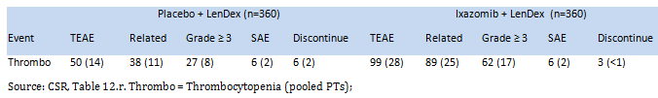

Thrombocytopenia (pooled PTs) Grade 3 (< 50,000/mm3 to 25,000/mm3) TEAEs were reported in 37 (10%) patients in the ixazomib regimen and 16 (4%) patients in the placebo regimen, while Grade 4 (< 25,000/mm3) TEAEs were reported in 25 (7%) and 11 (3%) patients in the two treatment regimens, respectively. No Grade 5 TEAEs were reported in either of the two regimens. The need for platelet transfusions was similar in both the ixazomib and placebo regimens (6% [n = 22] and 5% [n = 18], respectively).

Dose reductions due to thrombocytopenia (pooled PTs) were reported in 5% (n = 18) of patients in the ixazomib regimen and 1% (n = 4) of patients in the placebo regimen. Across both regimens, lenalidomide was the most frequently reduced agent for thrombocytopenia (pooled PTs), followed by ixazomib/placebo and dexamethasone (see Table 46, below). Discontinuations were similar in both treatment arms and were reported infrequently. The proportion of patients with delays in treatment cycle due to thrombocytopenia (pooled PTs) were similar in the ixazomib and placebo regimens (10 [n = 36] versus 11% [n = 39], respectively).

Table 46: Study C16010; number (%) of patients with dose reductions or discontinuation due to thrombocytopenia (pooled PTs) of clinical importance by treatment; safety population

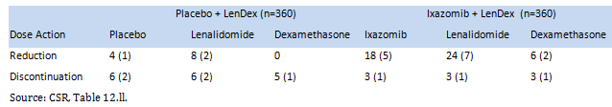

A box plot of platelet values over time was provided. Following the first 3 cycles, when platelet counts were assessed on Day 1 and Day 14, findings remained consistent throughout the study. Median platelet counts generally demonstrated a cyclical pattern when measured throughout Cycles 1 through 3, with nadirs around Day 14 in both regimens, and returning to baseline levels before the next dose. The incidence of thrombocytopenia was highest during the first 3 months of treatment (19% [n = 68] ixazomib versus 8% [n = 28] placebo), and generally decreased over time. Time to first occurrence of thrombocytopenia were summarised and the cumulative incidence of thrombocytopenia over time was provided.

The sponsor undertook a review of TEAEs to identify patients with thrombocytopenia (pooled PTs) to see if there were any associated haemorrhagic events. The overall incidence of haemorrhagic events (TEAEs within haemorrhage SMQ) was similar in the ixazomib and placebo regimens (18% versus 16%, respectively). The overall incidence of Grade ≥ 3 haemorrhagic events (TEAEs within the haemorrhage SMQ) was similar in the ixazomib and placebo regimens (2% versus < 1%, respectively).

###### Neutropenia

Neutropenia is a recognised adverse drug reaction of anti-myeloma agents (for example, lenalidomide), and can also be associated with the underlying malignancy. The incidence of neutropenia (pooled PTs) was similar in the ixazomib and placebo regimens (see Table 47 below). Neutropenia (all PTs) Grade ≥ 3 TEAEs were reported in 20% (n = 73) patients in the ixazomib regimen and 20% (n = 71) of patients in the placebo group, and included Grade 3 TEAEs in 16% (n = 57) and 14% (n = 51) of patients, respectively, and Grade 4 TEAES in 4% (n = 16) and 6% (n = 20) of patients, respectively. Colony stimulating factors were used by 21% of patients in the ixazomib regimen and 17% of patients in the placebo regimen.

Table 47: Study C16010; number (%) of patients with TEAEs associated with neutropenia (pooled PTs) of clinical importance; safety population

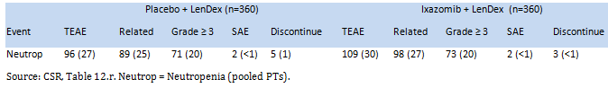

The incidence of patients reporting Grade ≥ 3 "neutropenia/neutrophil count decreased" and a concurrent Grade ≥ 3 higher infection event was similar in the ixazomib and placebo regimens (2% [n = 8] versus 3% [n = 11], respectively). Serious infections in patients with Grade ≥ 3 "neutropenia/neutrophil count decreased" were reported in 6 patients (2%) in the ixazomib regimen and 10 patients (3%) in the placebo regimen. Serious infections reported in ≥ 2 patients overall and concurrently with Grade ≥ 3 "neutropenia/neutrophil count decreased" included pneumonia (9 patients [3 ixazomib regimen [1 of which was fatal] versus 6 placebo regimen [including 1 patient with septic shock]), respiratory tract infection (2 patients [1 ixazomib regimen versus 1 placebo regimen]), and septic shock (3 patients [1 ixazomib regimen versus 2 placebo regimen]). The remaining serious infections were reported in 1 patient each and occurred in the placebo regimen (1 x skin infection, 1 x lower respiratory tract infection). The 1 fatal event of fungal pneumonia was assessed by the investigator to be related to all drugs in the ixazomib regimen.

Febrile neutropenia was reported in 9 patients (2 patients [< 1%] in the ixazomib regimen versus 7 patients [2%] in the placebo regimen). Of the 2 patients in the ixazomib regimen with febrile neutropenia, 1 reported a concurrent infection (SAE pneumonia) and 1 did not report a concurrent infection but did experience a concurrent TEAE of influenza-like illness. All 7 patients in the placebo regimen with febrile neutropenia reported concurrent infections, including 4 patients experiencing SAE infections (1 x pseudomonal sepsis, 1 x skin infection, 1 x pneumonia, and 1 x Escherichia sepsis) and 3 patients experiencing non-serious infections (1 x upper respiratory tract infection, 1 x Escherichia bacteraemia, and 1 x influenza and lung infection). All febrile neutropenia events in both regimens resolved. There were no discontinuations due to febrile neutropenia or concurrent infections.

##### Liver impairment

The incidence of TEAEs potentially associated with liver impairment was similar in patients in the ixazomib and placebo treatment regimens (see Table 48, below). The incidence of liver impairment by preferred term and regimen is summarised in Table 119, page 314. Events reported in ≥ 2% of the total population were ALT increased (2% [n = 6] ixazomib; 3% [n = 11] placebo), AST increased (< 1% [n = 3] ixazomib; 2% [n = 6] placebo), blood alkaline phosphatase increased (2% [n = 6] ixazomib; < 1% [n = 1] placebo).

Table 48: Study C16010; number (%) of patients with TEAEs associated with liver impairment (pooled PTs) of clinical importance; safety population

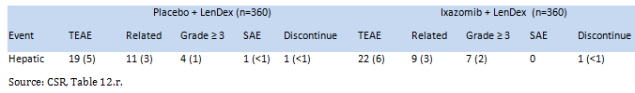

Two patients (1 in each treatment regimen) had laboratory values that met the biochemical criteria for Hy’s law relating to drug induced liver injury (that is, ALT and/or AST ≥ 3 x ULN and total bilirubin ≥ 2 x ULN at the same post-baseline visit). In the ixazomib regimen, the patient had liver function test changes secondary to sepsis and septic shock occurring in the first cycle of therapy with further complications of multi-organ failure and post-hypoxic encephalopathy. This case did not meet the full criteria of Hy’s law due to the confounding, ongoing medical condition of sepsis and multi-organ failure. In addition to these 2 patients, 1 patient in the ixazomib regimen experienced 3 episodes of what were termed “drug- induced hepatotoxicity.” The patient continued on treatment without dose modifications and in at least 1 cycle without recurrence with re-challenge. The incidence rates of ALT and AST events ≥ 3 x ULN and total bilirubin events ≥ 2 x ULN at any time during treatment were summarised.

##### Nervous system

The incidence of peripheral neuropathy (pooled PTs) in the two treatment regimens is summarised below in Table 49.

Table 49: Study C16010; number (%) of patients with TEAEs associated with peripheral neuropathy (pooled PTs) of clinical importance; safety population

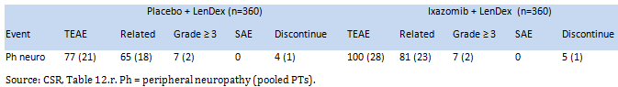

A total of 190 patients (26%) (82 [23%] ixazomib; 108 [30%] placebo) had either a medical history or current condition of peripheral neuropathy at baseline. Additionally, more than 50% of patients in each treatment regimen reported at least a little tingling in their hands or feet on the MY-20 PRO questionnaire, even if the physician did not document a medical history of peripheral neuropathy. Furthermore, 32 (17%) of the 177 patients with a TEAE of peripheral neuropathy had a worsening of their baseline condition (15 [18%] ixazomib; 17 [16%] placebo). Per protocol, patients were still eligible to enrol in the study if they had peripheral neuropathy at baseline, but it had to be no worse than Grade 1 without pain.

The incidence of peripheral neuropathy (pooled PTs) was higher in the ixazomib regimen than in the placebo regimen (28% versus 21%, respectively), which was mainly due to the increased incidence of low grade TEAEs (that is, Grade 1 and 2 events). In the ixazomib and placebo regimens, respectively, peripheral sensory neuropathy was reported in 67 (19%) patients and 50 (14%) patients, peripheral neuropathy was reported in 37 (10%) patients and 29 (8%) patients, and both peripheral sensorineuromotor and motor neuropathy was each reported in 1 (< 1%) patient in both regimens. The maximum intensity of peripheral neuropathy (pooled PTs) TEAEs in the ixazomib and placebo regimens (respectively) were Grade 1 (18% [n = 64] versus 14% [n = 51]), Grade 2 (8% [n = 29] versus 5% [n = 19]), and Grade 3 (2% [n = 7] versus 2% [n = 7]). Among the 177 patients (100 ixazomib; 77 placebo) who reported a TEAE of peripheral neuropathy (pooled PTs), the median time to onset was 116 days in the ixazomib regimen and 113 days in the placebo regimen.

Across both regimens, ixazomib/placebo was the most frequently reduced agent for peripheral neuropathy (pooled PTs), followed by dexamethasone and lenalidomide. Discontinuation of study drug agents due to peripheral neuropathy occurred in similar frequency in both regimens. The results for dose reduction and dose discontinuation for each agent in the regimens are summarised below in Table 50.

Table 50: Study C16010; summary of action taken in patients (number [%]) with peripheral neuropathy (pooled PTs) of clinical importance by treatment; safety population

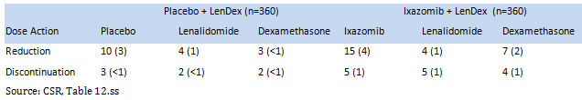

The overall incidence of peripheral neuropathy specifically with pain was 3% (n = 12) in the ixazomib regimen and 2% (n = 7) in the placebo regimen. The majority of cases with pain were Grade 1 or Grade 2 in both the ixazomib (10/12 patients) and placebo (5/7 patients) regimens. Six of the 19 patients (3 in each regimen) were noted to have peripheral neuropathy at baseline. Although the median time to first onset of peripheral neuropathy with pain was shorter in the ixazomib regimen (116.5 days/Cycle 5) than in the placebo regimen (169 days/Cycle 6), a smaller percentage of patients in the ixazomib regimen than in the placebo regimen required concomitant treatment (33% [4/12] and 57% [4/7], respectively). Actions taken with ixazomib/placebo dose due to peripheral neuropathy with pain were reduced dose (5 ixazomib; 5 placebo); held dose (3 ixazomib; 3 placebo); and discontinued dose (0 ixazomib; 1 placebo). Actions taken with lenalidomide dose due to peripheral neuropathy with pain were reduced dose (2 ixazomib; 1 placebo) and held dose (1 ixazomib; 1 placebo). Six patients in the ixazomib regimen and 3 patients in the placebo regimen had a cycle delay due to peripheral neuropathy with pain.

The incidence of peripheral neuropathy was highest during the first 3 months of treatment and generally declined over time. In the first 3 months of treatment, peripheral neuropathy (pooled PTs) was reported in 11% (n = 40) patients in the ixazomib regimen and 9% (n = 32) of patients in the placebo regimen. For all grades of peripheral neuropathy (pooled PTs), there was a steady increase in cumulative frequency, with the ixazomib regimen affecting < 30% of patients until a cumulative dose of 180 mg (15 cycles). The placebo regimen affected up to 20% of patients, with a similar slope. The frequency of Grade 3 peripheral neuropathy was low and similar in both regimens, with no appreciable increase with increasing cumulative dose. No Grade 4 peripheral neuropathy events were reported in either treatment regimen. The cumulative incidence of peripheral neuropathy (pooled PTs) is summarised below in Figure 17.

Figure 17: Study C16010; cumulative incidence of peripheral neuropathy (pooled PTs); safety population

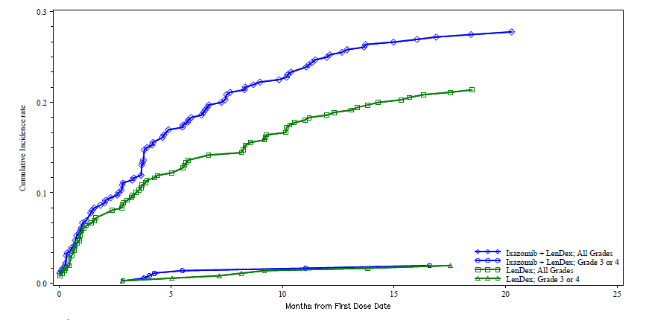

Concomitant medications for the treatment of peripheral neuropathy were used in 20% (20/100) of patients in the ixazomib regimen and 23% (18/77) of patients in the placebo regimen. No concomitant medications were used for the treatment of peripheral neuropathy in ≥ 10 patients in either of the two treatment regimens. Medications for the treatment of peripheral neuropathy used by ≤ 2 patients overall were pregabalin (n = 9 [3%]), gabapentin (n = 4 [1%]) and neurobion (vitamins B1, B6 and B12 (n = 2 [< 1%]).

##### Encephalopathy (pooled PTs)

The incidence of encephalopathy (non-infectious encephalopathy/delirium SMQ) in the two treatment regimens is summarised below in Table 51. In each of the 5 patients (2 ixazomib regimen, 3 placebo regimen) who reported a TEAE, confounding medical histories and/or concurrent TEAEs were connected to these events. None of the 5 patients reported a TEAE in the HLT of "Seizures and seizure disorders NEC".

Table 51: Study C16010; number (%) of patients with TEAEs associated with encephalopathy (pooled PTs) of clinical importance; safety population

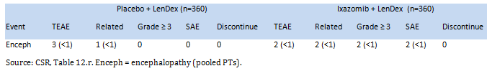

##### Renal impairment

The incidence of TEAEs associated with renal impairment (based on the acute renal failure SMQ) was similar in the ixazomib and placebo regimens (8% and 10%, respectively). Six patients (2%) in the ixazomib regimen and 10 patients (3%) in the placebo regimen reported Grade 3 events, and 2 patients (< 1%) in the ixazomib regimen and 3 patients (< 1%) in the placebo regimen reported Grade 4 events. No patient in either of the two treatment regimens had a Grade 5 event. The results for renal impairment are summarised below in Table 52.

Table 52: Study C16010; number (%) of patients with TEAEs associated with renal impairment (acute renal failure SMQ) of clinical importance; safety population

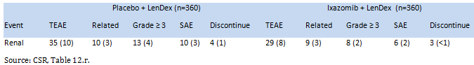

The PTs associated with renal impairment were summarised. Of the 36 patients with PTs of renal failure or acute renal failure (15 [4%] ixazomib; 21 [6%] placebo), 9 patients had events associated with disease progression (5 ixazomib regimen; 4 placebo regimen), 10 patients had events associated with a concurrent septic TEAE (4 ixazomib regimen; 6 placebo regimen), 5 patients had events associated with other comorbid events (2 ixazomib regimen; 3 placebo regimen), 3 patients had events associated with gastrointestinal TEAEs (2 ixazomib regimen; 1 placebo regimen), and 9 patients had events of unknown aetiology (2 ixazomib regimen; 7 placebo regimen). In 8 of the 36 patients the events has resolved as of the last data entry (2 ixazomib regimen; 6 placebo regimen), while in 1 patient (placebo regimen) the event was ongoing.

##### Hypotension

The incidence of hypotension (as defined by a modified Vascular hypotensive disorders HLT and modified Vascular test HLT) was similar in the ixazomib and the placebo regimens (see Table 53, below).

Table 53: Study C16010; number (%) of patients with TEAEs associated with hypotension (pooled PTs) of clinical importance; safety population

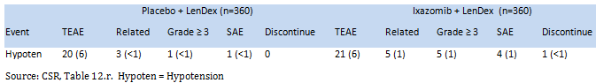

Of the 41 patients (21 ixazomib; 20 placebo) who reported hypotension (pooled PTs), 9 patients had a subsequent fall, dizziness, syncope, and/or pre-syncopal event (4 ixazomib regimen; 5 placebo regimen). These subsequent events occurred in a similar number of patients in both treatment regimens, were infrequent, primarily transient, low grade (Grade 1 or 2 in 7 of 9 patients), and did not require treatment or modification of the study drug regimen (8 of 9 patients). In 1 of the 9 patients (placebo regimen) with subsequent events, the events were Grade 3 SAEs of orthostatic hypotension and syncope. Four patients (1%) in the ixazomib regimen and 1 patient (< 1%) in the placebo regimen had Grade 3 hypotension (pooled PTs) events. No patients in either regimen reported Grade 4 events, and 1 patient (< 1%) in the ixazomib regimen had a Grade 5 event (cardiac arrest secondary to pulmonary embolism considered related to lenalidomide) and no patients in the placebo regimen had a Grade 5 event.

#### Adverse events in subgroups

##### Age

The overall TEAE profiles, summarised by age (≤ 65 years, > 65 to ≤ 75 years, and > 75 years) were provided. The results showed a trend towards a higher incidence with increasing age of most TEAE categories in the ixazomib regimen, with a similar pattern being observed in the placebo regimen. However, the incidence of SAEs and Treatment related SAEs remained relatively constant over the age groups.

The study included 10 patients (4 ixazomib regimen; 6 placebo regimen) aged ≥ 85 years who reported at least 1 TEAE. TEAEs reported by 2 or more of the 10 patients included anaemia (including decreased haemoglobin and B12 deficiency) in 5 patients (1 ixazomib regimen; 4 placebo regimen), rash in 5 patients (3 ixazomib regimen; 2 placebo regimen), diarrhoea (including intermittent and loose stools) in 4 patients (2 ixazomib regimen; 2 placebo regimen), other gastrointestinal TEAEs (including constipation  [1 patient] and nausea/vomiting [3 patients]) in 4 patients (2 ixazomib regimen; 2 placebo regimen), thrombocytopenia in 3 patients (2 ixazomib regimen; 1 placebo regimen), depression in 3 patients (2 ixazomib regimen; 1 placebo regimen), and abnormal renal chemistry tests (including blood creatinine increased, blood urea increased, glomerular filtration rate decreased [1 patient], and creatinine renal clearance decreased [1 patient]) in 2 patients (1 ixazomib regimen, 1 placebo regimen). Two patients discontinued the study because of TEAEs, including 1 patient in the ixazomib regimen because of a rash and 1 patient in the placebo regimen because of severe anaemia.

##### Sex

The overall TEAE profiles, summarised by sex, were provided. In the ixazomib regimen, a notably higher percentage of female patients than male patients reported Grade 3 or higher TEAEs (72% versus 64%), TEAEs resulting in dose modification of 1 or more of the 3 agents in the study regimen (77% versus 66%), and TEAEs resulting in dose reduction of 1 or more of the 3 agents in the study drug regimen (63% versus 44%). These trends were not observed in the placebo regimen. In the ixazomib regimen, the frequency of SAEs, TEAEs leading to discontinuation of 1 or more of the 3 agents in the study drug regimen, and on-study deaths was similar between male and female patients. The overall pattern of TEAE categories in males and females differed between the ixazomib and placebo regimens, with no marked differences being observed between the sexes in the placebo regimen and marked increased frequency in females compared to males in the ixazomib regimen for some TEAE categories.

##### Race

The overall TEAE profiles, summarised by race, were provided. The majority of patients in both treatment regimens were White (83-86%) or Asian (8-10%). In the ixazomib regimen, no differences were observed between White and Asian patients for Grade 3 or higher TEAEs, TEAEs leading to dose reduction, TEAEs leading to dose modification, and on-study deaths However, the following TEAE categories were reported in a notably higher percentage of White patients than Asian patients in the ixazomib regimen: SAEs (41% and 30%, respectively) and TEAEs leading to discontinuation of 1 or more of the 3 agents in the study drug regimen (21% and 7%, respectively). Similar trends to those observed in the ixazomib regimen were seen in the placebo regiment for SAEs and TEAEs leading to discontinuation of 1 or more of the 3 agents in the study drug regimen. No comparisons were made within the regimens for Black/African American (7 ixazomib regimen; 6 placebo regimen) or Other (6 ixazomib regimen; 6 placebo regimen) races due to the small number of patients in these groups.

### Laboratory tests

#### Liver function

The maximum post-baseline alkaline phosphatase, ALT, and AST values were largely within the normal range, with marked consistency in mean values over time in the majority of patients. Box plots for liver function tests (ALT, AST, bilirubin and alkaline phosphatase) over time were provided. As discussed above, 2 patients (1 in each treatment regimen) had laboratory values meeting the criteria for Hy’s law relating to drug induced liver injury (that is, ALT and/or AST ≥ 3 x ULN at total bilirubin ≥ 2 x ULN at the same post-baseline visit). However confounding factors were present in both patients, resulting in explanations other than drug related liver injury for the abnormal liver function test findings.

ALT, AST and bilirubin shifts from Grade 0, 1, or 2 at baseline to Grade ≥ 3 were reported in a small number of patients in both treatment groups. Shifts to ≥ Grade 3 abnormalities in ALT levels were reported in 1% of patients in both the ixazomib (5/355) and placebo (3/349) regimens; shifts to ≥ Grade 3 abnormalities in AST levels were reported in 1% of patients in the ixazomib (2/356) and placebo (3/348) regimens; and shifts to ≥ Grade 3 abnormalities in bilirubin levels were reported in 1% of patients in both the ixazomib (3/352) and placebo regimens (3/350).

TEAEs related to abnormal ALT increased laboratory values were reported in 2% (n = 6) and 3% (n = 11) of patients in the ixazomib and placebo regimens, respectively; TEAEs related to abnormal AST increased laboratory values were reported in < 1% (n = 3) and 2% (n = 6) of patients in the ixazomib and placebo regimens, respectively; TEAEs related to abnormal bilirubin increased laboratory values were reported in < 1% of patients in both the ixazomib (n = 1) and placebo regimens (n = 2); and TEAEs related to abnormal blood alkaline phosphatase increased laboratory values were reported in 2% (n = 6) and < 1% (n = 1) of patients in the ixazomib placebo regimens, respectively.

#### Kidney function

Among patients with a Grade 0, 1, or 2 creatinine value at baseline, 1% (n = 5) and 2% (n = 6) of patients in the ixazomib and placebo regimens, respectively, had a shift to Grade 3 (which indicates increased creatinine values). One patient (< 1%) in each regimen had a shift to Grade 4.

TEAEs related to abnormal glomerular filtration rate decreased laboratory values were reported in 1% (n = 5) and 0% of patients in the ixazomib and placebo regimens, respectively; and TEAEs related to abnormal creatinine renal clearance decreased laboratory values were reported in < 1% of patients in both the ixazomib (n = 3) and placebo regimens (n = 2).

#### Other clinical chemistry results

Clinical laboratory evaluations were performed by a central laboratory, with individual local laboratory evaluations added if spontaneously captured by the investigator. Chemistry panel evaluations were conducted at screening, on Day 1 of each cycle, and at the EOT visit. Patients with Grade 0, 1, or 2 clinical chemistry values at Baseline with shifts to Grade 3 or 4 abnormalities as worst value on were provided. Shifts to Grade 3 or 4 reported in ≥ 2% of patients in either the ixazomib or placebo regimen were, respectively): phosphate (shift to low) 9% (33/356) versus 6% (20/354); potassium (shift to low) 5% (16/357) versus 2% (7/355); calcium (shift to low) 4% (15/258) versus 5% (19/354); creatinine (shift to high) 2% (7/355) versus 2% (6/356); sodium (shift to low) 2% (8/349) versus 3% (11/350); and potassium shift to high 1% (3/357) versus 2% (7/352). Shifts to Grade 4 reported in more than 1 patient in either regimen were calcium (shift to low), calcium (shift to high), and potassium (shift to high).

##### Haematology

Clinical laboratory evaluations were performed by a central laboratory, with individual local laboratory evaluations added if spontaneously captured by the investigator. Haematology evaluations were conducted at screening, weekly during the first 2 cycles, prior to Day 1 of each cycle, Day 14 of Cycle 3, and at the EOT visit, with weekly repeats of CBC if a patient was found to have an ANC < 0.5 x 109/L or platelet count < 30,000/mm3 at any time during the study. Mean haemoglobin and haematocrit values remained stable during treatment in both regimens. Moderate decreases in mean leukocyte counts and in mean platelet counts were observed at the start of the cycles and were similar in both regimens. Transient decreases of mean platelet counts were observed at Day 14 and Day 21 of the cycles and were more pronounced in the ixazomib regimen than in the placebo regimen. Box plots for platelet counts and for neutrophil counts over time were provided.

Patients with Grade 0, 1, or 2 clinical haematology values at Baseline with shifts to Grade 3 or 4 abnormalities as worst value on study were provided. Haematology parameters with relevant shifts reported in ≥ 10% of patients in either of the two treatment regimens and occurring more frequently in patients in the ixazomib regimen than in the place regimen were: platelets (shift to low) 25% (89/358) versus 10% (34/353); lymphocytes (shift to low) 33% (110/330) versus 24% (81/333); and leucocytes (shift to low) 19% (68/360) versus 14% (51/355).

##### TEAEs by SOC relating to laboratory tests

TEAEs associated with laboratory values were identified in the SOCs of blood and lymphatic disorders, investigations, and metabolism and nutrition disorders.

A similar percentage of patients in the ixazomib and placebo regimens experienced TEAEs in the SOC of metabolism and nutrition disorders (32% [n = 116] and 31% [n = 110, respectively). The most commonly occurring laboratory TEAEs in this SOC reported in ≥ 2% of patients in either the ixazomib or placebo regimen were (respectively) hypokalaemia (11% versus 9%), hypocalcaemia (6% versus 4%), hyponatraemia (2% each group), and hypophosphatemia (1% versus 2%).

TEAEs in the SOC of investigations were experienced by 31% (n = 113) of patients in the ixazomib regimen and 26% (n = 95) of patients in the placebo regimen. The most commonly occurring laboratory TEAEs in this SOC reported in ≥ 2% of patients in either the ixazomib or placebo regimen were (respectively) platelet count decreased (8% versus 5%), neutrophil count decreased (6% each regimen), blood creatinine increased (3% each regimen), White blood cell count decreased (3% each regimen), ALT increased (2% versus 3%), lymphocyte count decreased (2% each regimen), blood alkaline phosphatase increased (2% versus < 1%), and AST increased (< 1% versus 2%).

The only Grade 3 TEAE in the SOC of metabolism and nutrition disorders related to abnormal laboratory values and reported in ≥ 2% of patients in either the ixazomib or placebo regimen was hypokalaemia (3% and < 1%, respectively). Grade 3 TEAEs in the SOC of investigations related to abnormal laboratory values and reported in ≥ 2% of patients in either the ixazomib or placebo regimen were platelet count decreased (3% and 1%, respectively) and neutrophil count decreased (2% and 3%, respectively).

Grade 4 TEAEs reported in the SOC of metabolism and nutrition disorders in the ixazomib and placebo regimens were (respectively), hypokalaemia (2% versus < 1%), hypercalcaemia (< 1% in both regimens), and hypocalcaemia (< 1% in both regimens ). Grade 4 TEAEs reported in the SOC of investigations in the ixazomib and placebo regimens were (respectively) platelet count decreased (1% in each regimen), neutrophil count decreased (< 1% versus 1%), blood creatinine increased (< 1% in both regimens), lymphocyte count decreased (< 1% in both regimens), and amylase increased (< 1% in both regimens).

SAEs in the SOC of blood and lymphatic system disorders were reported in 4% (n = 13) of patients in the ixazomib regimen and 5% (n = 18) of patients in the placebo regimen. TEAEs reported in ≥ 2% of patients in either the ixazomib regimen or the placebo regimen were (respectively), anaemia (< 1% versus 2%) and febrile neutropenia (< 1% versus 2%). SAEs in the SOC of investigations were reported in < 1% of patients in both the ixazomib regimen and the placebo regimen, and the 2 SAEs were platelet count decreased (< 1% in each regimen) and blood creatinine increased (0% versus < 1%). SAEs in the SOC of metabolism and nutrition disorders were reported in 2% (n = 8) of patients in both of the ixazomib regimen and the placebo regimen, and the respective incidences of the 4 SAEs were hypercalcaemia (< 1% both regimens), hyperglycaemia (< 1% both regimens), hypokalaemia (< 1% both regimens), and hyponatraemia (< 1% in both regimens).

#### Electrocardiography

##### QTc interval

Overall, neither regimen appeared to have clinically meaningful effects on QTc prolongation, with both regimens having similar effects on this parameter. Most patients (87% ixazomib regimen, 88% placebo regimen) had a maximum post-dosing QTcF < 450 msec during the study. Three (< 1%) patients in the ixazomib regimen and 5 (2%) patients in the placebo regimen had a maximum post-dosing QTcF ≥ 500 msec. Increases from baseline of ≥ 30 msec were observed in 16% and 13% of patients in the ixazomib and placebo regimens, respectively, and increases from baseline of ≥ 60 msec were observed in 3% and 6% of patients, respectively. The results were summarised.

Most patients (76% ixazomib regimen, 77% placebo regimen) had a maximum post-dosing QTcB < 450 msec during the study. Thirteen (4%) patients in the ixazomib regimen and 10 (3%) patients in the placebo regimen had a maximum post-dosing QTcB ≥ 500 msec. Increases from baseline of ≥ 30 msec were observed in 19% and 17% of patients in the ixazomib and placebo regimens, respectively, and increases from baseline of ≥ 60 msec were observed in 5% and 7% of patients, respectively. The results were summarised.

Mean change in QTcB and QTcF intervals from baseline to each scheduled evaluation showed no clinically important differences between the two treatment regimens. In the ixazomib and placebo regimens, the mean ± SD changes in QTcB from baseline to last assessment were  2.70 ± 33.06 msec (range:-154.5, 131.4 msec) and 2.86 ± 37.71 msec (range: -155.2, 187.7 msec), respectively. In the ixazomib and placebo regimens, the mean ± SD changes in QTcF from baseline to last assessment were 4.97 ± 29.27 msec (range: -147.8, 127.5 msec) and 4.64 ± 33.26 msec (range: -170.9, 177.8 msec), respectively.

TEAEs associated with non-ventricular arrhythmias were reported in 3 patients who had an increase from baseline in QTcF or QTcB ≥ 60 msec, including 1 patient in the ixazomib regimen (atrial tachycardia) and 2 patients in the placebo regimen (1 x atrial fibrillation; 1 x AV block). A TEAE of electrocardiogram QT prolonged was reported in 2 patients in the ixazomib regimen.

##### Vital signs

The systolic blood pressure, diastolic blood pressure, and heart rate data demonstrated that the 25th to 75th percentiles, mean values, and median values were similar in the two treatment regimens, were consistent across time on study, and were not of clinical concern. The results in the ixazomib and placebo regimens were similar with regards to mean ± SD change from baseline to last assessment in systolic blood pressure (-4.18 ± 18.21 versus -4.14 ± 17.29 mmHg, respectively), diastolic blood pressure (-2.74 ± 12.01 versus -2.26 ± 11.42 mmHg, respectively), heart rate (-1.66­ ± 12.97 versus -2.39 ± 13.65 beats/min, respectively), and weight (-1.40 ± 5.13 versus -1.85 ± 55.17 kg, respectively). Box plots overtime for systolic blood pressure, diastolic blood pressure, and heart rate were provided. Overall, the results indicate no significant differences between the two treatment regimens as regards changes in vital signs over time.

##### Other safety parameters

In both treatment regimens, ECOG performance status was similar and stable over time, with no worsening in mean scores. In the ixazomib and placebo regimens, the mean ± SD change from baseline to last assessment in the ECOG score was 0.22 ± 0.83 and 0.23 ± 0.75, respectively. In those patients with a Baseline ECOG score of 0, post-baseline ECOG scores in the ixazomib (n = 180) versus placebo (n = 168) regimens were (respectively): 0 (72% versus 66%); 1 (23% versus 28%); 2 (2% versus 5%); 3-4 (3% versus 1%). In patients with a Baseline ECOG score of 1, post-baseline ECOG scores in the ixazomib (n = 152) versus placebo regimens (n = 161) were (respectively): 0 (20% versus 18%); 1 (61% versus 62%); 2 (13% versus 13%); 3 (3% versus 6%) and 4 (5% versus 1%). In patients with a Baseline ECOG score of 2, post-baseline ECOG scores in the ixazomib (n = 18) versus placebo (n = 22) regimens were (respectively): 0 (6% versus 0%); 1 (44% versus 41%); 2 (39% versus 3%); 3-4 (11% versus 23%).

### Supportive safety data; overall safety analysis population

#### Demographics and baseline characteristics

The mean age of the overall safety population (n = 990) was 64.5 years (median 66 years, range 24 to 91 years), with the age distribution being 45% < 65 years, 38% ≥ 65 to < 75 years, and 17% ≥ 75 years. The population was evenly balanced between the sexes, with 55% male and 45% female patients. The majority of the population was White (79%), followed by Asian (10%), and Black or African American (7%) with all other racial groups being ≤ 2%.

The predominant disease type was MM (80%), followed by solid tumours (12%), AL amyloidosis (6%), lymphoma (1%), and other (1%). Of the patients with MM (n = 791), 61% had IgG disease had 20% had IgA disease and 3% had biclonal disease. In patients with MM, ISS at study entry was stage I, II, or III in 47%, 28% and 17% of patients, respectively, 69% had lytic bone lesions, and approximately 10% had plasmacytomas. Mean baseline ECOG performance status was score 0 = (42%), 1 = (51%), 2 = (7%) and missing (n = 7).

Mean baseline serum creatinine was 1.0 mg/dL (median 0.92 mg/dL, range 0.4 to 9.9 mg/mL), mean baseline creatinine clearance was 82.4 mL/min (median 78 mL/min, range 6 to 244 mL/min) and the distribution of creatinine clearance (mL/min) across the population was < 30 (3%), ≥ 30 and < 60 (24%), ≥ 60 and < 90 (38%), and ≥ 90 (36%). The percentage of patients with impaired liver function was low (5%) (that is, ALT ≥ 1.5 x ULN, AST ≥ 1.5 x ULN, or total bilirubin ≥ 1.5 x ULN), due to the exclusion of patients with major hepatic impairment (ALT or AST > 3 x ULN or total bilirubin > 1.5 x ULN).

#### Exposure

The overall safety analysis population included 990 patients from 15 studies who received at least one dose of oral ixazomib (either a single agent or in combination with other therapeutic regimens). Of the 990 patients, 360 were from Study C16010 and 630 were from the other 14 studies (which were either completed or ongoing).

In the 990 patients in the overall safety analysis population, the mean ± SD duration of treatment was 242.7 ± 237.4 days (median 174.5 days, range 1 to 1447 days), the mean ± SD number of treatment cycles was 9.2 ± 8.7 (median 7.0, range 1 to 69 days), and the mean ± SD dose intensity was 88.6 ± 17.5% (median 96%, range 25% to 300%).

#### Adverse events

##### Overview

The overall TEAE profile of the overall safety analysis population were summarised and compared with Study C16010 population and pooled data for the ixazomib 4 mg (weekly) combined with LenDex population. Of the 990 patients in the overall safety analysis population, the percentage of patients who experienced at least 1 TEAE (96%) was similar to the ixazomib regimen in Study C16010 (98%). In addition, the percentage of patients who experienced a Grade 3 or higher TEAE was similar in the overall safety analysis population and in the ixazomib regimen in Study C16010 (67% and 68%, respectively). In addition, in the overall safety analysis population the percentages of patients with an SAE irrespective of causality and an SAE related to the study drug regimen (41% and 19%, respectively) were similar to the corresponding percentages in the ixazomib regimen in Study C16010 (40% and 23%, respectively).

The percentage of patients with a TEAE resulting in dose modification of 1 or more agent was 58% in the overall safety analysis population and 71% in the ixazomib regimen in Study C16010. The higher incidence of dose modifications in the ixazomib regimen in Study C16010 might be due, at least in part, to the greater opportunity for dose modification in a triplet regimen compared to a single agent regimen. In the overall safety analysis population, not all studies involved a triplet regimen with some studies using an ixazomib single agent regimen.

In the overall safety analysis population, 5 of the 41 on-study deaths were considered to be related to the drug regimen (that is, 1 x coma with concurrent stroke, 1 x pulmonary embolism, 1 x fungal pneumonia, 1 x viral pneumonia respiratory syncytial, and 1 x cardio-respiratory arrest). The incidence of on-study death decreased over time and was 0% in cycles ≥ 25. Similar profiles of decreased incidence over time were observed for SAEs, Treatment related SAEs, and discontinuations of the full study drug regimen.

**Comment:** In general, the safety profile for ixazomib in the overall safety analysis population was consistent with the safety profile for the ixazomib regimen in Study C16010.

##### Most common TEAEs, regardless of causality

SOCs TEAEs reported in ≥ 30% of patients with TEAEs of any grade regardless of causality were: gastrointestinal disorders (75%), general disorders and administration site conditions (67%), infections and infestations (56%), nervous system disorders (54%), musculoskeletal and connective tissue disorders (51%), skin and subcutaneous tissue disorders (47%), blood and lymphatic system disorders (47%), metabolism and nutrition disorders (44%), respiratory, thoracic, and mediastinal disorders (42%), investigations (32%), and psychiatric disorders (31%).

TEAEs occurring in ≥ 20% of patients in the overall safety analysis population (n = 990) were generally similar to those in the ixazomib regimen in Study C16010. TEAEs reported in ≥ 20% of patients treated with ixazomib in the overall safety analysis versus the ixazomib regimen in Study C16010 were (respectively): diarrhoea (42% in each population); nausea (37% versus 26%); fatigue (36% versus 28%); vomiting (29% versus 22%); constipation (28% versus 34%); thrombocytopenia (25% versus 20%); peripheral oedema (24% versus 25%); anaemia (22% versus 26%); and neutropenia (22% versus 26%). TEAEs that occurred in ≥ 10% of patients in the overall safety analysis population or ≥ 10% of patients in either the ixazomib or placebo regimens in Study C16010 were summarised.

##### Grade 3 and Grade 4 TEAEs, irrespective of causality

The incidence of Grade 3 TEAEs in the overall safety analysis population was similar to the incidence of Grade 3 TEAEs in the ixazomib regimen in Study C16010 (47% versus 49%, respectively). Overall, the most commonly reported Grade 3 TEAEs, reported with an incidence of ≥ 5%, regardless of causality, in the overall safety analysis population were similar to those in the ixazomib regimen in Study C16010. The commonly reported Grade 3 TEAEs (≥ 5%) in the overall safety analysis population compared to the ixazomib regimen Study C16010 were (respectively), neutropenia (13% versus 15%), thrombocytopenia (8% each), anaemia (8% versus 9%), diarrhoea (7% versus 6%), and fatigue (6% versus 3%). Grade 3 TEAEs that occurred in at least 5 patients in the overall safety analysis population or at least 5 patients in either the ixazomib or placebo regimens in Study C16010 were summarised.

The incidence of Grade 4 TEAEs in the overall safety analysis population was the same as the ixazomib regimen in Study C16010 (15%). Grade 4 TEAEs reported by ≥ 2% of patients, regardless of causality, in the overall safety analysis population were similar to those in the ixazomib regimen in Study C16010 and included thrombocytopenia (8% and 6%, respectively) and neutropenia (3% and 4%, respectively). Grade 4 TEAEs that occurred in at least 2 patients in the overall safety analysis population or at least 2 patients in either the ixazomib or placebo regimens in Study C16010 were summarised.

##### Treatment related TEAEs

In each study, the investigator recorded all observed or volunteered AEs and provided an opinion of the relationship of the events to the study treatment. In the combination studies, if a TEAE was related to any drug in the drug combination, it was recorded as "drug related", meaning related to any drug in the regimen and not specifically to ixazomib, while in the single agent studies the relationship was specific to ixazomib.

The incidence of TEAEs related to the study drug regimen in the overall safety analysis population was similar to that of the ixazomib regimen in Study C16010 (85% and 91%, respectively). TEAEs related to the study drug regimen reported by ≥ 20% of patients in the overall safety analysis population were similar to those reported in the ixazomib regimen in Study C16010. These events included (overall safety analysis population versus ixazomib regimen in C16010, respectively), diarrhoea (29% versus 28%), nausea (28% versus 18%), fatigue (25% versus 19%), vomiting (22% versus 15%), and thrombocytopenia (22% versus 18%).

In the overall safety analysis population, the incidence of TEAEs related to the study drug regimen was highest during Cycles 0 (PK cycle in relevant PK studies) to 1 (n = 990; 67%) and Cycles 2 through 6 (n = 847; 80%), started to decrease at Cycles 7 through 12 (n = 503; 65%), and continued to decrease at subsequent cycles, with an incidence of 48% at the final interval of cycles (Cycles ≥ 25 [N = 48]).

The incidence of Grade 3 TEAEs related to study drug regimen in the overall safety analysis population was similar to that of the ixazomib regimen in Study C16010 (38% and 42%, respectively). Grade 3 TEAEs related to study drug regimen reported by ≥ 5% of patients in the overall safety analysis population were similar to those in the ixazomib regimen in Study C16010 and were (respectively), neutropenia (12% versus 13%,), thrombocytopenia (7% each), diarrhoea (5% versus 4%), and fatigue (5% versus 3%).

The incidence of Grade 4 TEAEs related to study drug regimen in the overall safety analysis population was similar to that of the ixazomib regimen in Study C16010 (10% and 11%, respectively. Thrombocytopenia was the only Grade 4 TEAE related to study drug regimen reported by ≥ 5% of patients in the overall safety analysis population and occurred with a similar frequency in the ixazomib regimen in Study C16010 (6% and 5%, respectively).

#### Deaths and other serious adverse events

##### Deaths

The incidence of on-study deaths in the overall safety analysis population (4% [n = 41]) was similar to the incidence in the ixazomib regimen and in the placebo regimen in Study C16010 (3% [n = 12] versus 5% [n = 17], respectively). Of the 41 deaths in the overall safety analysis population, 5 were considered related to the study drug regimen (that is, 1 x respiratory syncytial viral pneumonia, 1 x cardiorespiratory arrest, 1 x coma with concurrent stroke, 1 x pulmonary embolism, and 1 x fungal pneumonia). The causes of death reported in ≥ 2 patients in the overall safety analysis population are summarised below in Table 54. The causes of death reported by 1 patient each were arrhythmia, bronchial obstruction, cardiac failure congestive, cardiovascular disorder, cholangiocarcinoma, hypoxia, lung cancer metastatic, malignant peritoneal neoplasm, ovarian cancer metastatic, pancreatic carcinoma, pneumonia, pneumonia respiratory syncytial viral, rectal cancer, renal failure acute, small cell lung cancer, and un-coded cause of death (colon mass).

Table 54: Causes of on-study deaths reported by at least 2 patients (n [%]) in the overall safety analysis population

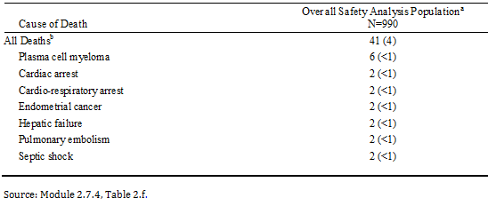

a. Studies C16003, C16004, C16005, C16006, C16007, C16008, C16009, C16010, C16011, C16013, C16015, C16017, C16018, C16020, and TB-MC010034. b. A patient is counted once for each preferred term. Percentages use the number of treated patients as the denominator

The incidence of on-study deaths during Cycles 0 (PK cycle in relevant PK studies) to 1 (n = 990) and Cycles 2 through 6 (n = 847) was 2%. The incidence of on-study deaths decreased over time and was 0% during Cycles ≥ 25 (n = 48).

Of the 41 on-study deaths, 18 were attributed to progression of disease, 12 were associated with cardiovascular events, 6 were associated with infectious events, 2 were associated with respiratory events, 2 were due to other organ failure, and 1 was not coded (colon mass).

Thirty deaths (3%) occurred within 90 days of the first dose of study drug, with the most commonly reported causes of death within this time interval being plasma cell myeloma (6 patients; < 1%), cardiac arrest (2 patients; < 1%), endometrial cancer (2 patients; < 1%), and hepatic failure (2 patients; < 1%).

##### Other SAEs

The incidence of SAEs in the overall safety analysis population (41% [403 patients]) was similar to that in the ixazomib regimen in Study C16010 (40% [143 patients]). SAEs reported in ≥ 2% of patients in the overall safety population were similar to those reported in the ixazomib regimen in Study C16010. SAEs reported in ≥ 2% of patients in the overall safety population versus the ixazomib regimen in Study C16010, respectively, included pneumonia (5% versus 6%), pyrexia (3% each), diarrhoea (2% each), dehydration (2% versus 0%), vomiting (2% versus < 1%), and acute renal failure (2% versus 1%). One patient in the overall safety analysis population (Study C16008) reported an SAE of transverse myelitis with ixazomib that was not well characterised. The sponsor commented that "it is not known whether ixazomib causes transverse myelitis; however, the possibility that ixazomib may have contributed to transverse myelitis cannot be excluded". One patient in the overall safety population reported a TEAE of tumour lysis syndrome. Treatment emergent SAEs reported in at least 1% of patients in the overall safety analysis population or at least 1% of patients in either the ixazomib or placebo regimen in Study C16010 were summarised. Grade 3 SAEs were reported by 236 patients (24%) and Grade 4 SAEs were reported by 51 patients (5%) in the safety analysis populations.

In the overall safety analysis population, a similar pattern was noted for the incidence of SAEs of pneumonia, pyrexia, diarrhoea, dehydration, and vomiting during Cycles 0 (PK cycle) to 1 (1%, 1%, < 1%, < 1%, and < 1%, respectively) and Cycles 2 through 6 (3%, 1%, 2%, 2%, and 1%, respectively), with a decreased incidence over time (Cycles 19 through 24; 0% for each PT). The incidence of all other SAEs was highest during Cycles 0 (PK cycle) to 1 and Cycles 2 through 6 and decreased over time.

In the overall safety analysis population, at least 1 SAE related to the study drug regimen was experienced by 186 (19%) patients (compared to 23% of patients in the ixazomib regimen in Study C16010). SAEs related to study drug regimen reported by ≥ 2% of patients in the overall safety analysis population were similar those reported in the ixazomib regimen in Study C16010 and included pneumonia (2% and 3%, respectively) and diarrhoea (2% each). The majority of patients in the overall safety analysis population who reported SAEs related to study drug regimen had Grade 3 events (12%).

##### TEAEs leading to discontinuation the study drug

The incidence of TEAEs, including signs and symptoms of disease progression and progression of the cancer itself, resulting in discontinuation of the full study drug regimen in the 990 patients in the overall safety analysis population (12%; 122 patients) was similar to the ixazomib regimen in Study C16010 (13%; 46 patients). TEAEs resulting in discontinuation of the study drug regimen reported by at least 5 patients in the overall safety analysis population were similar to those in the ixazomib regimen in Study C16010. TEAEs resulting in discontinuation of the study drug regimen reported by at least 5 patients in the overall safety analysis population included thrombocytopenia (8 patients; < 1%), diarrhoea (6 patients; < 1%), fatigue (6 patients; < 1%), peripheral neuropathy (6 patients; < 1%), and pneumonia (5 patients; < 1%). TEAES resulting in discontinuation of at least 2 patients in the overall safety analysis population and at least 2 patients in either the ixazomib or placebo regimen Study C16010 were summarised. Of the TEAEs that led to discontinuation of the study drug regimen in the overall safety analysis population, 6% were Grade 3 and 2% were Grade 4 events.

#### Adverse events of special interest

##### New primary malignancy

Among the 990 patients in the overall safety analysis population, the incidence of new primary malignancies was the same as in the ixazomib regimen in Study C16010 (2% in each population). In the overall safety analysis population, of the 19 new primary malignancies reported in 18 patients, 17 were non-haematologic (including 11 skin malignancies), 1 was haematologic, and 1 could not be determined (that is, malignant neoplasm [undifferentiated tumour]). Eight patients (< 1%) had a new primary malignancy that was considered an SAE, including 2 patients (< 1%) with adenocarcinoma of the colon and 1 patient (< 1%) each with myelodysplastic syndrome, malignant melanoma, metastatic gastric cancer, malignant neoplasm, renal cell carcinoma, and squamous cell carcinoma. The study drug regimen was prematurely discontinued due to a new primary malignancy in 4 patients (< 1%), including 1 patient each (< 1%) prematurely discontinuing the study drug regimen due to adenocarcinoma of colon, metastatic gastric cancer, malignant neoplasm, and myelodysplastic syndrome.

#### Adverse events of clinical importance

##### Overall

TEAEs of clinical importance in the overall safety analysis population and the Study C16010 are summarised in Table 55.

Table 55: TEAEs of clinical importance

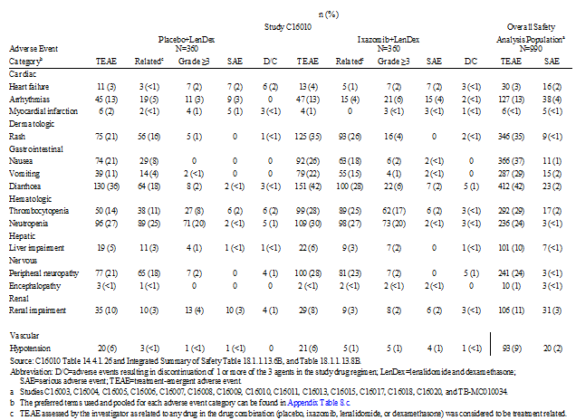

##### Cardiac events

###### Heart failure (pooled PTs)

The incidence of heart failure (pooled PTs) in patients in the overall safety analysis population was similar to the incidence in the ixazomib regimen in Study C16010 (3% [n = 30] and 4% [n = 13], respectively). In the overall safety analysis population, heart failure events by PT reported in ≥ 2 patients were congestive cardiac failure (n = 12 [1%]), cardiac failure (n = 11 [1%]), pulmonary congestion (n = 3 [< 1%]), and cardiomegaly (n = 2 [< 1%]). Cardiac events (TEAE) in the overall safety analysis population and the ixazomib regimen in Study C16010 were provided.

Grade 3 events were reported with the same frequency in the overall safety analysis population and the ixazomib regimen in Study C16010 (1% in each population). In the overall safety analysis population, 11 (1%) patients experienced Grade 3 heart failure events (pooled PTs), including congestive cardiac failure (n = 7 [< 1%]), cardiac failure (n = 7 [< 1%]) and LV dysfunction (n = 1 [< 1%]). Similarly, less than 1% of patients in the overall safety analysis population and in the ixazomib regimen in Study C16010 reported Grade 4 events.

Across the clinical development program for oral ixazomib, 2 patients (< 1%) experienced a fatal (Grade 5) TEAE associated with heart failure, including 1 patient in the ixazomib regimen in Study C16010 and 1 patient in Study C16007 considered related to the underlying AL amyloidosis with cardiac involvement.

SAEs associated with heart failure were reported with the same frequency in the overall safety analysis population and the ixazomib regimen in Study C16010 (2% in each population). In the overall safety analysis population, SAEs of heart failure (pooled PTs) included 7 patients (< 1%) with congestive cardiac failure, 6 patients (< 1%) with cardiac failure, and 1 patient (< 1%) each with pulmonary congestion, cardiac failure acute, diastolic dysfunction, and left ventricular dysfunction.

Heart failure (pooled PTs) leading to discontinuation of study drug regimen occurred with the same frequency in the overall safety analysis population and the ixazomib regimen in Study C16010 (< 1% each in each population). In the overall safety analysis population, the study drug regimen was prematurely discontinued due heart failure in 3 (< 1%) patients, including discontinuation due to acute cardiac failure (1 patient), congestive cardiac failure (1 patient), and diastolic dysfunction (1 patient).

###### Arrhythmias (pooled PTs)

The incidence of arrhythmia (pooled PTs) in patients in the overall safety analysis population was the same as in the ixazomib regimen in Study C16010 (13% [n = 127] and 13% [n = 47], respectively). In the overall safety analysis population, TEAEs associated with arrhythmias (pooled PTs) reported in ≥ 2% of patients were atrial fibrillation (3% [n = 26]), syncope (2% [n = 24]), palpitations (2% [n = 21]), and tachycardia (2% [n = 18]). The incidence of Grade 3 TEAEs associated with arrhythmias was similar in the overall safety analysis population and the ixazomib regimen in Study C16010 (4% and 5%, respectively), with the only Grade 3 TEAE associated with arrhythmia reported in ≥ 2% of patients in the overall safety analysis population being syncope (2% [n = 17]). Less than 1% of patients in the overall safety analysis population and the ixazomib regimen in Study C16010 reported a Grade 4 TEAE associated with arrhythmias. In the overall safety analysis population there were 7 (< 1%) patients with TEAEs of QT prolongation (including 2 patients in the ixazomib regimen in Study C16010). None of these 7 patients experienced Torsades de pointes. TEAEs associated with arrhythmias in the overall safety population were provided.

Arrhythmia (pooled PTs) was reported as an SAE with the same frequency in the overall safety analysis population and the ixazomib regimen in Study C16010 (4% each). In the overall safety analysis population, SAEs associated with arrhythmia included 13 patients (1%) with atrial fibrillation, 9 patients (< 1%) with syncope, 5 patients (< 1%) with atrial flutter, 4 patients (< 1%) with cardiac arrest, 3 patients (< 1%) with cardiorespiratory arrest, 2 patients (< 1%) with arrhythmia, and 1 patient (< 1%) each with bradycardia, supraventricular tachycardia, ventricular extrasystoles, and trifascicular block.

Across the clinical development program for oral ixazomib, 5 patients (< 1%) experienced a fatal (Grade 5) TEAE associated with arrhythmia. Four of these 5 patients died due to cardiac arrest (2 patients) or cardio-respiratory arrest (2 patients), and 1 patient died due to arrhythmia with concurrent deterioration of heart failure (AL amyloidosis).

The incidence of arrhythmia (pooled PTs) leading to discontinuation of study drug regimen was the same in the overall safety analysis population and the ixazomib regimen in Study C16010 (< 1%). In the overall safety analysis population, the study drug regimen was prematurely discontinued due to cardiac arrest in 3 patients (< 1%), cardiorespiratory arrest in 2 patients (< 1%), and atrial fibrillation and atrial tachycardia in 1 patient (< 1%) each.

###### Myocardial infarction (pooled PTs)

The incidence of myocardial infarction (pooled PTs) in patients in the overall safety analysis population was similar to the incidence in the ixazomib regimen in Study C16010 (< 1% [n = 6] and 1% [n = 4], respectively). The incidences of Grade 3 and Grade 4 TEAEs associated with myocardial infarction in the overall safety analysis population (< 1% for each grade) were similar to the corresponding incidences in the ixazomib regimen in Study C16010 (0% and < 1%, respectively). Myocardial infarction (pooled PTs) was reported as an SAE with the same frequency in the overall safety analysis population and the ixazomib regimen in Study C16010 (< 1% each). In the overall safety analysis population, SAEs associated with myocardial infarction included 3 patients (< 1%) with myocardial infarction and 1 patient (< 1%) each with troponin increased and acute myocardial infarction. Across the clinical development program for oral ixazomib, 1 patient (< 1%) experienced a fatal (Grade 5) TEAE of myocardial infarction. Myocardial infarction leading to discontinuation of study drug regimen occurred with the same frequency in the overall safety analysis population and the ixazomib regimen in Study C16010 (< 1% in each population). TEAEs associated with myocardial infarction in the overall safety analysis population and in Study C16010 were provided.

##### Rash

The incidence of rash (pooled PTs) in patients in the overall safety analysis population was the same as in the ixazomib regimen in Study C16010 (35% [n = 346] and 35% [n = 125], respectively). The incidence of TEAEs associated with rash and reported by ≥ 2% of patients in the overall safety analysis population were maculopapular rash (10%), macular rash (8%), pruritus (8%), pruritic rash (4%), rash (4%), papular rash (3%) and erythematous rash (2%). The incidence of Grade 3 TEAEs associated with rash was similar in the overall safety analysis population and the ixazomib regimen in Study C16010 (6% versus 4%, respectively). No patients in the overall safety analysis population or the ixazomib regimen in Study C16010 reported Grade 4 or a Grade 5 TEAEs associated with rash. The median time to onset of rash was 22.0 days in the overall safety analysis population. TEAEs associated with rash in the overall safety analysis population and Study C16010 were provided.

Rash (pooled PTs) was reported as an SAE in 9 (< 1%) patients in the overall safety analysis population and no patients in the ixazomib regimen in Study C16010. In the overall safety analysis population the SAEs associated with rash included 2 patients (< 1%) with Steven-Johnson syndrome (SJS), and 1 patient (< 1%) each with maculopapular rash, macular rash, rash generalised, rash morbilliform, erythema multiforme, acute febrile neutrophilic dermatosis, and interstitial granulomatous dermatitis.

In the 2 (< 1%) patients reporting SJS, 1 patient had been treated with single agent ixazomib administered on a weekly schedule at a dose of 3.95 mg/m2 in Study C16004 and 1 patient had been treated with ixazomib in combination with LenDex in Study C16008. In Study C16004, ixazomib was used as a single agent at 2 dose levels above that used in the pivotal trial and the patient experienced the serious skin condition of bullous erythema multiforme which, per MedDRA version 16.0, codes to SJS. Based on the current MedDRA (version 18.0), the reported event in this patient codes to erythema multiforme. The event was considered to be related to the study drug and completely resolved after a short course of systemic corticosteroids and supportive measures. The patient’s disease progressed rapidly and he was removed from study. In Study C16008, ixazomib was administered in combination with lenalidomide and dexamethasone, and the investigator considered the SJS to be related to lenalidomide therapy and unrelated to ixazomib and dexamethasone. The patient completed 1 cycle of study drug administration before withdrawing from the study due to SJS. The patient completely recovered from condition after being taken off study treatment.

The incidence of rash (pooled PTs) leading to discontinuation of study drug regimen was the same in the overall safety analysis population and in the ixazomib regimen in Study C16010 (< 1% in each). Maculopapular rash resulted in premature discontinuation of the study drug regimen in 2 patients (< 1%) in the overall safety analysis population, and 1 (< 1%) patient each prematurely discontinued the study drug regimen due to papular rash, pruritic rash, SJS, and acute febrile neutrophilic dermatosis.

An updated review of serious cutaneous adverse events is presented in this CER.

##### Gastrointestinal

###### Nausea (PT)

The incidence of nausea was higher in the overall safety analysis population than in the ixazomib regimen in Study C16010 (37% [366 patients] and 26% [92 patients], respectively). However, the incidence of Grade 3 nausea was the same in the overall safety analysis population and in the ixazomib regimen in Study C16010 (2% each population). No patients in either of the two populations reported Grade 4 of Grade 5 TEAEs of nausea. The median time to onset of nausea was 15.0 days in the overall safety analysis population. Nausea was reported as an SAE in 11 (1%) patients in the overall safety analysis population and 2 (< 1%) patients in the ixazomib regimen in Study C16010. The study drug regimen was prematurely discontinued due to nausea in 2 patients (< 1%) in the overall safety analysis population and no patients in the ixazomib regimen in Study C16010.

###### Vomiting (PT)

The incidence of vomiting was higher in the overall safety analysis population than in the ixazomib regimen in Study C16010 (29% [287 patients] and 22% [79 patients], respectively). However, the incidence of Grade 3 vomiting was similar in the overall safety analysis population and in the ixazomib regimen in Study C16010 (3% and 1%, respectively). No patients in either of the two populations reported Grade 4 of Grade 5 TEAEs of vomiting. The median time to onset of vomiting was 16.0 days in the overall safety analysis population. The incidence of vomiting reported as an SAE was similar in the overall safety analysis population and in the ixazomib regimen in Study C16010 (2% [15 patients] and < 1% [2 patients], respectively). The study drug regimen was prematurely discontinued due to vomiting in 1 patient (< 1%) in the overall safety analysis population and in no patients in the ixazomib regimen in Study C16010.

###### Diarrhoea (PT)

The incidence of diarrhoea was the same in the overall safety analysis population and the ixazomib regimen in Study C16010 (42% [412 patients] and 42% [151 patients]). The incidence of Grade 3 diarrhoea was similar in the overall safety analysis population and in the ixazomib regimen in Study C16010 (7% and 6%, respectively). No patients in either of the two populations reported Grade 4 of Grade 5 TEAEs of diarrhoea. The median time to onset of diarrhoea was 36.0 days in the overall safety analysis population. The incidence of diarrhoea reported as an SAE was 2% in both the overall safety analysis population and the ixazomib regimen in Study C16010 (23 and 7 patients, respectively). The incidence of diarrhoea leading to discontinuation of the study drug regimen was similar in the overall safety analysis population and the ixazomib regimen in Study C16010 (< 1% [6 patients] and 1% [5 patients], respectively).

##### Haematological

###### Thrombocytopenia (pooled PTs)

The incidence of thrombocytopenia (pooled PTs) was similar in the overall safety analysis population and the ixazomib regimen in Study C16010 (29% [292 patients] and 28% [99 patients], respectively). The incidence of Grade 3 thrombocytopenia (pooled PTs) was similar in the overall safety analysis population and the ixazomib regimen in  Study C16010 (11% and 10%, respectively), as was the incidence of Grade 4 thrombocytopenia (pooled PTs) (8% and 7%, respectively). The median time to onset of thrombocytopenia was 29.0 days in the overall safety analysis population. The use of platelet transfusions was reported in 6% of patients in both the overall safety analysis population and the ixazomib regimen in Study C16010. Thrombocytopenia (pooled PTs) was reported as an SAE in 2% of patients in both the overall safety analysis population and the ixazomib regimen in Study C16010. The study drug regimen was prematurely discontinued due to thrombocytopenia (pooled PTs) in < 1% of patients in both the overall safety analysis population and the ixazomib regimen in Study C16010 (8 and 3 patients, respectively).

###### Neutropenia (pooled PTs)

The incidence of neutropenia (pooled PTs) was lower in the overall safety analysis population than in the ixazomib regimen in Study C16010 (24% [236 patients] and 30% [109 patients], respectively). The incidence of Grade 3 neutropenia (pooled PTs) was similar in the overall safety analysis population and the ixazomib regimen in Study C16010 (14% and 16%, respectively), as was the incidence of Grade 4 neutropenia (pooled PTs) (3% and 4%, respectively). Neutropenia (pooled PTs) was reported as an SAE in < 1% of patients in both the overall safety analysis population and the ixazomib regimen in Study C16010. The incidence of neutropenia (pooled PTs) leading to discontinuation of study drug regimen was reported in < 1% of patients in both the overall safety analysis population and the ixazomib regimen in Study C16010.

##### Liver impairment (pooled PTs)

The incidence of liver impairment (pooled PTs) was higher in the overall safety analysis population than in the ixazomib regimen in Study C16010 (10% [101 patients] and 6% [22 patients], respectively). TEAEs associated with liver impairment reported in ≥ 2% of patients in the overall safety analysis were ALT increased (4%), AST increased (3%), blood alkaline phosphatase increased (2%) and hypoalbuminaemia (2%). The incidence of Grade 3 liver impairment (pooled PTs) was similar in the overall safety analysis population and the ixazomib regimen in Study C16010 (4% and 2%, respectively), while < 1% (n = 4) and no patients reported Grade 4 liver impairment (pooled PTs), respectively. Two patients (< 1%) in Study C16018, the dedicated PK study of ixazomib in hepatic dysfunction, experienced a fatal (Grade 5) TEAE of hepatic failure considered to be due to the disease under study and not the study drug. TEAEs associated with liver impairment in the overall safety analysis population and in Study C16010 were provided.

There were 3 patients with biochemical abnormalities meeting Hy's law criteria (2 in the overall safety analysis population [Studies 16018 and 16005] and 1 in the ixazomib regimen in Study C16010). The patient in Study C16018 did not meet all the criteria for Hy’s law, as other important comorbidities that might have contributed to the biochemical abnormalities were reported (that is, pre-existing liver dysfunction, hepatic cirrhosis, and liver metastases from known NSCLC and pancreatic cancer). The patient in Study C16005 had abnormal liver enzyme changes secondary to sepsis occurring in Cycle 3 of therapy. The treatment regimen was temporarily discontinued and the liver function values returned to near baseline levels. The treatment regimen was reintroduced at Cycle 4, Day 1, with the lenalidomide dose being reduced and the liver enzymes did not increase with re-challenge. The patient in Study C16010 has been previously discussed.

SAEs consistent with liver impairment (pooled PTs) were reported in 7 patients (< 1%) in the overall safety analysis population and no patients in the ixazomib regimen in Study C16010. SAEs associated with liver impairment reported in the overall safety analysis population included 3 patients (< 1%) with hepatic failure (2 in the dedicated PK Study C16018 of ixazomib in hepatic dysfunction and 1 in Study C16009 in a patient with underlying colon malignancy) and 1 patient (< 1%) each with ALT increased, blood bilirubin increased, ascites, and transaminases increased. These patients were noted to have liver impairment prior to entry into the studies.

The incidence of liver impairment (pooled PTs) leading to discontinuation of study drug regimen was the same in the overall safety analysis population and the ixazomib regimen in Study C16010 (< 1% in each population).

##### Nervous system disorders

The incidence of peripheral neuropathy (pooled PTs) was similar in the overall safety analysis population and the ixazomib regimen in Study C16010 (24% [241 patients] and 28% [100 patients], respectively). The incidence of Grade 3 peripheral neuropathy (pooled PTs) was the same in the overall safety analysis population and the ixazomib regimen in Study C16010 (2% in each population). No patients in the overall safety analysis population or the ixazomib regimen in Study C16010 reported Grade 4 peripheral neuropathy (pooled PTs). The median time to onset of peripheral neuropathy (pooled PTs) was 85.0 days in the overall safety analysis population. Peripheral neuropathy (pooled PTs) was reported as an SAE in 3 patients (< 1%) in the overall safety analysis population and no patients in the ixazomib regimen in Study C16010. In the overall safety analysis population, SAEs associated with peripheral neuropathy (pooled PTs) included 2 patients (< 1%) with peripheral neuropathy and 1 patient (< 1%) with peripheral sensory neuropathy. The study drug regimen was prematurely discontinued due to TEAEs associated with peripheral neuropathy in 1% of patients in both the overall safety analysis population and 5 (1%) patients in the ixazomib regimen in Study C16010 (10 and 5 patients, respectively). Peripheral neuropathy (pooled PTs) leading to discontinuation of the study regimen in the overall safety analysis population in a total of 10 (1%) patients included 6 patients (< 1%) due to peripheral neuropathy and 4 patients (< 1%) due to peripheral sensory neuropathy. TEAEs associated with peripheral neuropathy in the overall safety analysis population and in Study C16010 were provided.

###### Encephalopathy (non-infectious encephalopathy/delirium SMQ)

The incidence of TEAEs within the non-infectious encephalopathy/delirium SMQ was 1% (10 patients) in the overall safety analysis population and < 1% (2 patients) in the ixazomib regimen in Study C16010. In the overall safety analysis population, the TEAEs included delirium (5 patients), hepatic encephalopathy (2 patients in the dedicated PK Study C16018 of ixazomib in hepatic dysfunction), and 1 patient each with encephalopathy, posterior reversible encephalopathy syndrome, and vascular encephalopathy. Grade 3 events were reported by < 1% of patients in both the overall safety analysis population and the ixazomib regimen in Study C16010 (5 and 2 patients, respectively). No patient in the overall safety analysis population or the ixazomib regimen in Study C16010 reported a Grade 4 TEAE. TEAEs associated with encephalopathy in the overall safety analysis population and in study were provided.

TEAEs within the non-infectious encephalopathy/delirium SMQ were reported as an SAE in < 1% of patients in both the overall safety analysis population and the ixazomib regimen in Study C16010 (3 and 2 patients, respectively). SAEs in the overall safety analysis population included 1 patient (< 1%) each with delirium, posterior reversible encephalopathy syndrome, and vascular encephalopathy. Two of these patients were in the ixazomib regimen in Study C16010 and 1 patient was in Study C16009 (posterior reversible encephalopathy syndrome considered to be related to ixazomib). No patients prematurely discontinued the study drug regimen due to TEAEs in the overall safety analysis population or the ixazomib regimen in Study C16010.

##### Renal impairment (pooled PTs)

The incidence of renal impairment (pooled PTs) was similar in the overall safety analysis population and the ixazomib regimen in Study C16010 (11% [106 patients] and 8% [29 patients], respectively). In the overall safety analysis population, TEAEs associated with renal impairment reported in ≥ 2% of the population were blood creatinine increased (5% [n = 54]), acute renal failure (3% [n = 25]) and renal failure (2% [n = 18]).

The incidence of Grade 3 renal impairment (pooled PTs) was similar in the overall safety analysis population and the ixazomib regimen in Study C16010 (3% [28 patients] and 2% [6 patients], respectively). Similarly, Grade 4 renal impairment (pooled PTs) was reported in < 1% of patients in both the overall safety analysis population and the ixazomib regimen in Study C16010 (4 and 2 patients, respectively). TEAEs associated with renal impairment in the overall safety analysis population and in Study C16010 were provided.

Across the clinical development program of oral ixazomib, 1 patient in Study C16005 required dialysis for chronic renal failure due to ESRD related to progression of myeloma. The incidence of renal impairment (pooled PTs) reported as an SAE was similar in the overall safety analysis population (31 patients; 3%) and the ixazomib regimen in Study C16010 (3% [n = 31] versus 2% [n = 6], respectively). SAEs associated with renal impairment (pooled PTs) in the overall safety analysis population included 18 (2%) patients with acute renal failure, 5 (< 1%) patients with blood creatinine increased, 5 (< 1%) patients with renal failure, and 1 (< 1%) patient each with renal impairment, renal tubular necrosis, and tubulointerstitial nephritis. One of the 31 patients (C16018 [hepatic dysfunction study]) died from acute renal failure.

The study drug regimen was prematurely discontinued due to acute renal failure in < 1% (n = 3) patients in both the overall safety analysis population and the ixazomib regimen in Study C16010. In the overall safety analysis population, 2 (< 1%) patients each prematurely discontinued the study drug regimen due to increased blood creatinine and renal failure and 1 (< 1%) patient prematurely discontinued the study drug regimen due to renal impairment.

##### Hypotension (pooled PTs)

The incidence of hypotension (pooled PTs) was similar in the overall safety analysis population and the ixazomib regimen in Study C16010 (9% [93 patients] and 6% [21 patients], respectively). The incidence of Grade 3 hypotension (pooled PTs) was similar in the overall safety analysis population (2%) and the ixazomib regimen in Study C16010 (1%). Two patients (< 1%) in the overall safety analysis population and no patients in the ixazomib regimen in Study C16010 reported Grade 4 hypotension (pooled PTs). There was one Grade 5 hypotension (pooled PTs) reported in Study C16010, in which the patient died due to cardiovascular insufficiency. TEAEs associated with hypotension in the overall safety analysis population and in Study C16010 were summarised and provided.

The incidence of hypotension (pooled PTs) reported as an SAE was similar in the overall safety analysis population (20 patients; 2%) and the ixazomib regimen in Study C16010 (4 patients; 1%). In the overall safety analysis population SAEs associated with hypotension (pooled PTs) included 12 patients (1%) with hypotension, 7 patients (< 1%) with orthostatic hypotension, and 1 patient (< 1%) with cardiovascular insufficiency. The study drug regimen was prematurely discontinued due to cardiovascular insufficiency in 1 patient (< 1%) in both the overall safety analysis population and the ixazomib regimen in Study C16010.

#### Clinical laboratory values

##### Haematology

The shift results for selected haematology laboratory parameters for overall safety analysis population and Study C16010 are summarised below in Table 56.

Table 56: Patients with Grade 0, 1, or 2 abnormalities shifting to Grade 3 or 4 abnormalities as worst values for selected haematology laboratory parameters

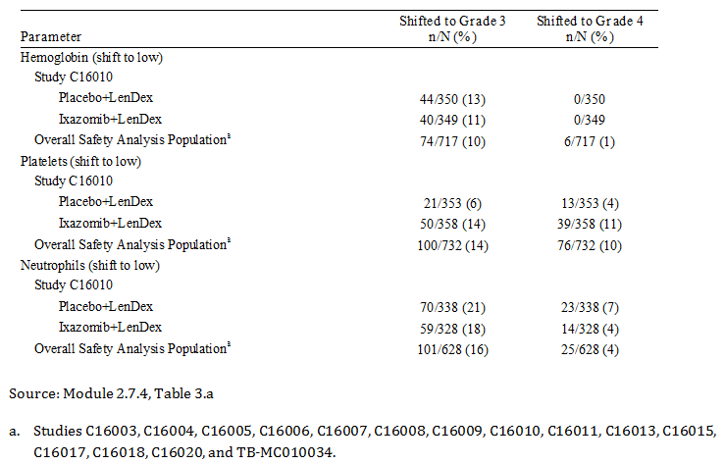

The same percentage of patients in the overall safety analysis population and the ixazomib regimen in Study C16010 had a platelet shift to a worst value of Grade 3 (14% in each population). A similar percentage of patients in the overall safety analysis population and the ixazomib regimen in Study C16010 had a platelet shift to a worst value of Grade 4 (10% and 11%, respectively). Of the patients in the overall safety analysis population with a Grade 0, 1, or 2 haemoglobin value at baseline, the percentage of patients with a shift to a worst value of Grade 3 was similar to that of the ixazomib regimen in Study C16010 (10% and 11%, respectively). In the overall safety analysis population, 6 patients (1%) had a worst shift in haemoglobin to Grade 4 compared to no patients in the ixazomib regimen in Study C16010. Of the 628 patients with a Grade 0, 1, or 2 neutrophil value at baseline in the overall safety analysis set, the percentage of patients with a shift to a worst value of Grade 3 was similar to that in the ixazomib regimen in Study C16010 (16% and 18%, respectively). The percentage of patients with a shift to a worst value of Grade 4 neutropenia was 4% in both the overall safety analysis population and the ixazomib regimen in Study C16010.

In the 990 patients in the overall safety analysis population, 277 (28%) had at least 1 worst post-baseline Grade 3 haematology value (including haemoglobin, platelet count, and/or absolute neutrophil count) and 108 (11%) had at least 1 Grade 4 haematology value post-baseline. The percentage of patients with at least 1 Grade 3 or at least 1 Grade 4 platelet count value was 17% and 8%, respectively. The percentage of patients with at least 1 Grade 3 or at least 1 Grade 4 haemoglobin value was 10% and < 1%, respectively. The percentage of patients with at least 1 Grade 3 or at least 1 Grade 4 absolute neutrophil count value was 14% and 3%, respectively.

The median decreases from baseline to last assessment in the overall safety analysis population were: -1.00 g/L (range: -80.2, 60.0) for the haemoglobin concentration (n = 975); -0.01 x 109/L (range: -15.9, 20.5) for neutrophil count (n = 869); and -23.0 x 109/L (range: -429.0, 428.0) for the platelet count (n = 973). Median changes from baseline for haemoglobin and neutrophil counts were generally small and similar across all time points. The incidence of discontinuation of the study drug regimen due to thrombocytopenia was low in the overall safety analysis population and the ixazomib regimen in Study C16010 (< 1% in each population).

##### Clinical chemistry

The shift results for chemistry laboratory parameters for the overall safety analysis population and the ixazomib regimen in Study C16010 were provided. In the overall safety analysis population, in patients with a Grade 0, 1, or 2 ALT, alkaline phosphatase, AST, bilirubin, or creatinine values at baseline, no more than 1% shifted to a worst value of Grade 3. This was generally similar to the ixazomib regimen in Study C16010 (≤ 1%). A similar percentage of patients in the overall safety analysis population and the ixazomib regimen in Study C16010 had a phosphate shift to a worst value of Grade 3 (6% and 9%, respectively) and Grade 4 (< 1% in each population). In the overall safety population, shifts to Grade 4 occurred in < 1% of patients for bilirubin and creatinine, and no patient had an AST, ALT or alkaline phosphatase shift to Grade 4. The results for median changes from baseline to last assessment in clinical chemistry parameters for the overall safety analysis population and other pooled analysis populations were provided.

In the overall safety population, at least 1 ALT or AST elevation > 3 x ULN was observed in 45 patients (5%), > 5 x ULN in 20 patients (2%), > 10 x ULN in 3 patients (< 1%), and > 20 x ULN in no patients. In the overall safety analysis population, 20 patients (2%) were noted to have a bilirubin > 2 x ULN. As discussed above, 3 patients (< 1%) treated with ixazomib were identified as having abnormal liver function laboratory values that met Hy’s law criteria. The results for AST, ALT and bilirubin levels were provided.

##### Vital signs

No integrated analyses of vital signs (including ECG changes) were performed for the summary of safety.

##### Special groups

###### Age

The summary of categorised TEAEs for the overall safety analysis population and Study C16010 were provided. In the overall safety analysis population, the incidence of Grade 3 or higher TEAEs, and TEAEs resulting in study drug regimen dose modification, dose reduction, or discontinuation tended to increase with baseline age, while the incidence of both SAEs and on-study deaths was similar (≤ 10% percentage point difference) across the three age groups.

In the overall safety analysis population, TEAEs reported in ≥ 20% of patients in the total population and with a higher incidence in patients aged ≥ 65 to < 75 years or ≤ 75 years compared to patients aged < 65 years were (respectively), diarrhoea (47%, 43%, and 36%) and thrombocytopenia (28%, 35%, and 19%). There were no TEAEs reported in ≥ 20% of patients in the total population with higher incidence (≥ 10% of patients) in the ≥ 75 years of age group than in the ≥ 65 years to < 75 years of age group. The overall summary of TEAEs (PT) reported in ≥ 20% of patients in the overall safety analysis population and other pooled analysis populations are provided in Table 57.

Table 57: Overall summary of TEAEs (PT) reported in ≥ 20% of patients in the overall safety analysis population and TEAEs of special interest and/or clinical importance by age; key pooled safety analysis populations

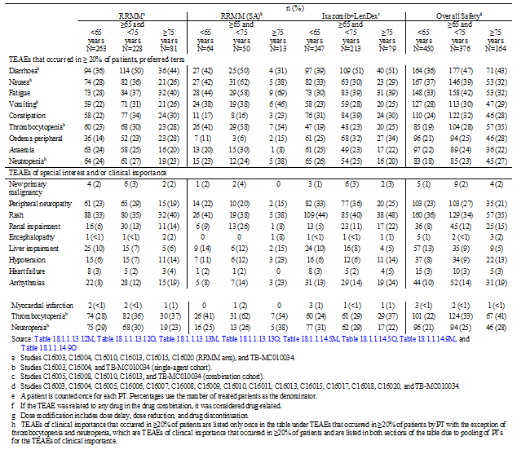

For TEAEs of special interest and/or clinical importance, in addition to diarrhoea (PT), an increased incidence of thrombocytopenia (pooled PTs) was observed in patients aged both ≥ 65 to < 75 years and ≥ 75 years compared to patients aged < 65 years (33%, 41%, and 22%, respectively). There were no events of clinical importance with a higher incidence (≥ 10% patients) in the ≥ 75 years of age group than in the ≥ 65 years to < 75 years of age group. The overall summary of TEAEs of special interest and/or clinical importance reported in the overall safety analysis population and other pooled analysis populations is provided in Table 57.

###### Sex

In the overall safety analysis population, there were no categorised TEAEs with a ≥ 10% difference between males and female patients. The difference between males and females for TEAEs resulting in dose reduction of 1 or more of the 3 agents in the study drug regimen was smaller in the overall safety analysis population (44% female versus 37% male) than in the ixazomib regimen in Study C16010 (63% female versus 44% male). For TEAEs resulting in dose modification of 1 or more of the 3 agents in the study drug regimen, the difference was again smaller in the overall safety analysis population (62% female versus 55% male) than in the ixazomib regimen in Study C16010 (77% female versus 66% male). The summary of categorised TEAE by sex for the overall safety analysis population and study was provided.

In the overall safety analysis population, TEAEs reported in ≥ 20% in the total population and reported with a higher incidence (≥ 10% patients) in females compared to males were diarrhoea (49% versus 35%), nausea (48% versus 28%), and vomiting (41% versus 19%). With the exception of diarrhoea (PT), nausea (PT) and vomiting (PT), there were no TEAEs of special interest and/or clinical importance with a ≥ 10% difference in patient incidence between the sexes. Summaries of TEAEs (PT) reported in ≥ 20% of patients in the overall safety analysis population and TEAEs of special interest and/or clinical importance by sex for the overall safety analysis population and other pooled safety analysis populations was provided.

###### Race

In the overall safety analysis population, the majority of patients were White (81% [785/975]), with the remaining patients being evenly divided between Asians (10% [98/975]) and Others (10% [92/975]). Categorised TEAE by race with a difference in incidence among groups of ≥ 10% patients, were: (1) Treatment related Grade 3 or higher TEAEs (50% White, 54% Asian, and 35% Other); (2) SAEs (40% White, 39% Asian, and 51% Other); (3) TEAEs resulting in study drug regimen dose modification (58% White, 65% Asian, and 50% Other), and (4) TEAEs resulting in study drug regimen dose reduction (40% White, 49% Asian, and 25% Other). The overall summary of categorised TEAE by race for the overall safety analysis population and Study C16010 is presented in Table 58.

Table 58: Overall summary of TEAEs by race; Study C16010 and overall safety analysis population

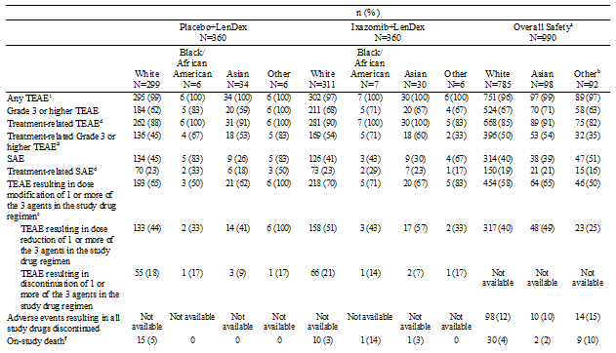

Summaries of TEAEs (PT) reported in ≥ 20% of patients in the overall safety analysis population and TEAEs of special interest and/or clinical importance by race for the overall safety analysis population and other pooled safety analysis populations were provided. The most commonly reported differences in the safety parameters in the overall safety analysis population by racial group are described below.

TEAEs (PT) reported in ≥ 20% of patients in the overall safety analysis population by race, with a difference in incidence among groups of ≥ 10% of patients, were: (1) diarrhoea (41% White, 53% Asian, and 41% Other); (2) nausea (36% White, 33% Asian, and 49% Other); (3) fatigue (36% White, 22% Asian, and 52% Other); (4) vomiting (26% White, 36% Asian, and 42% Other); (5) thrombocytopenia (25% White, 32% Asian, and 16% Other); (6) peripheral oedema (25% White, 10% Asian, and 27% Other); and (7) neutropenia (22% White, 31% Asian, and 10% Other).

For TEAEs of special interest and/or clinical importance, in addition to diarrhoea (PT), nausea (PT), and vomiting (PT), a difference in the incidence (≥ 10% of patients) by race was observed for rash (pooled PTs) (34% White, 46% Asian, and 28% Other), thrombocytopenia (pooled PTs) (29% White, 45% Asian, and 21% Other) and neutropenia (pooled PTs) (24% White, 38% Asian, and 11% Other).

###### Renal function impairment

In the overall safety analysis population, safety was assessed in different patient groups based on baseline creatinine clearance. In the overall safety analysis population, TEAE comparisons among the ≥ 30 to < 60 mL/min, ≥ 60 to < 90 mL/min, and ≥ 90 mL/min groups were based on a difference in incidence of ≥ 10 percentage points. Comparisons to the < 30 mL/min group were based on a difference in incidence of ≥ 20 percentage points.

The overall summary of TEAEs by categories, TEAEs reported in ≥ 20% of patients in the overall safety analysis population and TEAEs of special interest and/or clinical importance by renal function based on baseline creatinine clearance (mL/min) for the overall safety analysis population and other key pooled safety analysis populations was provided. The most commonly reported differences in the safety parameters in the overall safety analysis population by renal function based on creatinine clearance (mL/min) are described below.

Categorised TEAEs by renal function with a difference in incidence of ≥ 20 percentage points among the < 30 mL/min group and the ≥ 30 to < 60 mL/min, ≥ 60 to < 90 mL/min, or ≥ 90 mL/min groups were: (1) Grade 3 or higher TEAEs (81%, 74%, 68%, and 59%, respectively); (2) SAEs (67%, 44%, 43%, and 34%, respectively); and (3) TEAEs resulting in study drug regimen dose reduction (19%, 48%, 43%, and 33%, respectively).

Categorised TEAEs with a difference in incidence of ≥ 10 percentage points among the ≥ 30 to < 60 mL/min, ≥ 60 to < 90 mL/min, and ≥ 90 mL/min groups were: (1) Grade 3 or higher TEAEs (74%, 68%, and 59%, respectively); (2) Treatment related Grade 3 or higher TEAEs (60%, 52%, and 39%, respectively); (3) SAEs (44%, 43%, and 34%, respectively), (4) Treatment related SAEs (23%, 21%, and 13%, respectively); (5) TEAEs resulting in study drug regimen dose modification (67%, 61%, and 50%, respectively), and (6) TEAEs resulting in study drug regimen dose reduction (48%, 43%, and 33%, respectively).

TEAEs (PT) reported in ≥ 20% of patients in the overall safety analysis population, with a difference in incidence of ≥ 10 percentage points among the ≥ 30 to < 60 mL/min, ≥ 60 to < 90 mL/min, and ≥ 90 mL/min groups were: (1) diarrhoea (47%, 43%, and 37%, respectively); (2) vomiting (35%, 31%, and 23%, respectively); (3) thrombocytopenia (36%, 27%, and 15%, respectively); (4) anaemia (32%, 20%, and 18%, respectively); and (4) neutropenia (28%, 22%, and 18%, respectively). A difference in the incidence of ≥ 20 percentage points for thrombocytopenia (PT) was observed between the < 30 mL/min and the ≥ 30 to < 60 mL/min groups (15% in < 30 mL/min and 36% in ≥ 30 to < 60 mL/min).

For TEAEs of special interest and/or clinical importance, in addition to diarrhoea (PT) and vomiting (PT), a difference in incidence among groups of ≥ 10 percentage points for renal impairment (pooled PTs) was observed between the ≥ 30 to < 60 mL/min and ≥ 90 mL/min groups (19% and 5%, respectively). A difference of ≥ 10 percentage points among groups for thrombocytopenia (pooled PTs) was observed among the ≥ 30 to < 60 mL/min, ≥ 60 to < 90 mL/min, and ≥ 90 mL/min groups (43%, 31%, and 19%, respectively). Differences in incidence of ≥ 20% percentage points between the < 30 mL/min group and the other groups included renal impairment (pooled PTs; 26% in < 30 mL/min and 5% in ≥ 90 mL/min) and hypotension (pooled PTs; 26% in < 30 mL/min and 6% in ≥ 90 mL/min).

**Comment:** Increased baseline creatinine clearance was associated with an increased incidence of Grade 3 or higher TEAEs, SAEs and TEAEs resulting in study drug reduction. The commonly reported TEAEs (PTs) of diarrhoea, vomiting, thrombocytopenia and neutropenia all increased as baseline renal impairment increased. Overall, the safety profile of ixazomib in the overall safety analysis population worsened as renal impairment increased.

###### Liver function impairment

In the overall safety analysis population, safety was assessed in different patient groups by liver function based on baseline ALT or AST or total bilirubin (< 1 x ULN, ≥ 1 x ULN). Comparisons in the overall safety analysis population were based on a difference in incidence between the groups of ≥ 10 percentage points. It is important to note that patients with major hepatic impairment at baseline were excluded from most oral ixazomib studies (that is, Studies C16003, C16004, C16005, C16006, C16007, C16008, C16010, C16011, C16013, C16015, C16017, C16018, C16020, and TB-MC010034).

The overall summary of TEAEs by categories, TEAEs reported in ≥ 20% of patients in the overall safety analysis population and TEAEs of special interest and/or clinical importance by liver function for the overall safety analysis population and other key pooled safety analysis populations was provided. The most commonly reported differences in the safety parameters in the overall safety analysis population by liver function are described below.

Categorised TEAE with a difference in incidence of ≥ 10 percentage points between the < 1 x ULN and ≥ 1 x ULN groups was observed for TEAEs resulting in study drug regimen dose reduction (44% in the < 1 x ULN group, 34% in the ≥ 1 x ULN group). There were no TEAEs reported in ≥ 20% of patients in the overall safety analysis population with a difference in incidence of ≥ 10 percentage points between the two liver function groups. For TEAEs of special interest and/or clinical importance, a difference in incidence of ≥ 10 percentage points between the two liver function groups was observed for liver impairment (7% in the < 1 x ULN group, 20% in the ≥ 1 x ULN group).

**Comment:** There were no marked differences in the safety profile of ixazomib in patients with and without hepatic impairment. However, the cut-off point for patients with hepatic impairment of ≥ 1 x ULN for ALT, AST and bilirubin is too low to adequately define a population with hepatic impairment. In addition, patients with significant hepatic impairment were excluded from most of the studies contributing data to the overall safety population.

###### ECOG performance status

The overall safety analysis population included an assessment of safety based on baseline ECOG status (0, 1, or 2). Comparisons in the overall safety population were based in a difference in incidence among groups of ≥ 10 percentage points. The overall summary of TEAEs by categories, TEAEs reported in ≥ 20% of patients in the overall safety analysis population and TEAEs of special interest and/or clinical importance by baseline ECOG status for the overall safety analysis population and other key pooled safety analysis populations were provided. The key results are described below.

TEAE categories with a difference in incidence of ≥ 10 percentage points among the three ECOG status groups 0, 1, and 2 were: (1) Grade 3 or higher TEAEs (61%, 70%, and 76%, respectively); (2) Treatment related Grade 3 or higher TEAEs (46%, 50%, and 59%, respectively); (3) SAEs (33%, 45%, and 51%, respectively); (4) TEAEs resulting in study drug regimen dose modification (63%, 55%, and 52%, respectively); and (5) TEAEs resulting in study drug regimen dose reduction (45%, 37%, and 32%, respectively).

The only TEAE (PT) reported in ≥ 20% of patients in the overall safety analysis population, with a difference in incidence of ≥ 10 percentage points among the ECOG status groups, was anaemia (20% in ECOG 0, 23% in ECOG 1, and 30% in ECOG 2). TEAEs of special interest and/or clinical importance with a difference in incidence of ≥ 10 percentage points among the three ECOG status groups 0, 1, and 2 were peripheral neuropathy (pooled PTs; 31%, 21%, and 11%, respectively) and rash (pooled PTs; 42%, 30%, and 28%, respectively).

**Comment:** There were no consistent differences in the safety profiles of ixazomib among patients with baseline ECOG status 0, 1, or 2.

###### Region

The overall safety analysis population included an assessment based on region categorised by North America, Europe, and Asian and categorised by western versus Non-western countries. The overall summary of TEAEs by categories, TEAEs reported in ≥ 20% of patients in the overall safety analysis population and TEAEs of special interest and/or clinical importance for western versus Non-western countries for the overall safety analysis population and other key pooled safety analysis populations were provided. The key results for the comparison between western and Non-western countries are summarised below.

There were no TEAE categories with a difference in incidence of ≥ 10 percentage points between western and Non-western countries. TEAEs (PT) reported in ≥ 20% of patients in the overall safety analysis population, with a difference in incidence of ≥ 10 percentage points were nausea (44% in Western countries and 27% in Non-Western countries), fatigue (46% in Western countries and 22% in Non-Western countries), and neutropenia (15% in Western countries and 31% in Non-Western countries). In addition to nausea (PT), the only TEAE of special interest and/or clinical importance with a difference in incidence of ≥ 10 percentage points between western and Non-western countries was neutropenia (pooled PTs; 16% and 34%, respectively).

**Comment:** There were a small number differences in the safety profile of ixazomib between Western and Non-western countries. However, the clinical significance of these findings is unclear.

###### Lines of prior therapy

The RRMM and RRMM (single agent) analysis populations included an assessment based on the number of lines of prior therapy (1, 2, and ≥ 3). The overall summary of TEAEs by categories, TEAEs reported in ≥ 20% of patients in the overall safety analysis population and TEAEs of special interest and/or clinical importance based on the number of lines of prior therapy in the RRMM analysis population was provided. Comparisons in the RRMM analysis population were based on a difference in incidence of ≥ 10 percentage points and the key results for the comparison based on the number of lines of prior therapy (1, 2, 3 and above) in the RRMM are summarised below. No comparisons were made in the RRMM (single agent) analysis population due to the small number of patients with 1 line of prior therapy (6 patients) and 2 lines of prior therapy (23 patients).

In the RRMM analysis population, categorised TEAEs with a difference in incidence of ≥ 10 percentage points among groups by the number of lines of prior therapies 1, 2, or ≥ 3 were, TEAEs resulting in study drug regimen dose modification (72%, 65%, and 55%, respectively) and TEAEs resulting in study drug regimen dose reduction (53%, 46%, and 38%, respectively). TEAEs (PT) reported in ≥ 20% of patients, with a difference in incidence of ≥ 10 percentage points among the groups by the number of lines of prior therapy 1, 2, or ≥ 3 were: (1) nausea (28%, 27%, and 39%, respectively); (2) fatigue (29%, 27%, and 44%, respectively); (3) vomiting (23%, 23%, and 33%, respectively); (4) thrombocytopenia (PT; 22%, 21%, and 37%, respectively); and (5) peripheral oedema (23%, 23%, and 12%, respectively). In addition to nausea (PT) and vomiting (PT), differences among the groups in TEAEs of special interest and/or clinical importance (1, 2, and ≥ 3 lines of therapy) included, peripheral neuropathy (pooled PTs; 29%, 24%, and 19%, respectively), and thrombocytopenia (pooled PTs; 30%, 27%, and 40%, respectively).

**Comment:** In the RRMM analysis population, the incidence of Grade 3 or higher TEAEs, SAEs, TEAEs resulting in discontinuation of study drug regimen, and on-study death was similar among patients with 1, 2, and ≥ 3 lines of prior therapy. Nausea, vomiting, fatigue, and thrombocytopenia (pooled PTs) were reported in a larger percentage of patients with ≥ 3 lines of prior therapy compared to patients with < 3 lines of prior therapy. Peripheral oedema and peripheral neuropathy were reported in a smaller percentage of patients with ≥ 3 lines of prior therapy compared to patients with < 3 lines of prior therapy.

###### Drug interactions

Drug interactions have been described in the PK section of this CER for strong CYP3A4 inhibitors (Study C16009 Arm 5), strong CYP3A4 inducers (Study C16009 Arm 4) and strong CYP1A2 inhibitors (PPK analysis). Co-administration with clarithromycin (a strong CYP3A4 inhibitor) did not result in a clinically meaningful change in the systemic exposure of ixazomib. Therefore, the sponsor considers that no dose modification is required for ixazomib with Co-administration of strong CYP3A inhibitors. Co-administration of ixazomib with rifampin (a strong CYP3A4 inducer) resulted in a clinically meaningful decrease in the systemic exposure of ixazomib. Therefore, the sponsor considers that co-administration of strong CYP3A inducers with ixazomib is not recommended. Co-administration of ixazomib with strong CYP1A2 inhibitors, such as ciprofloxacin, did not result in a clinically meaningful change in the systemic exposure of ixazomib based on a population PK analysis. Therefore, the sponsor considers that no dose modification is required for ixazomib with co-administration of strong CYP1A2 inhibitors.

###### Use in pregnancy and lactation

No analyses were planned or performed in pregnancy or lactation. There are no adequate and well-controlled studies in pregnant or lactating women. At the data cut-off date for the submission, no pregnancies had been reported in the clinical development program of oral ixazomib, the 2 studies of IV ixazomib, the lupus nephritis study, or the Investigator-Initiated Sponsored Research Studies Pregnant and lactating women were excluded from participation in ixazomib clinical trials, and male as well as female study participants of childbearing potential were instructed to use effective birth control measures. It is not known whether ixazomib is excreted in human milk.

###### Overdose

Among the 720 patients in Study C16010, 13 patients (5 ixazomib regimen, 8 placebo regimen) were reported to have experienced a TEAE of overdose of 1 of the 3 drugs in the regimen. Based on details in the clinical database and/or in CIOMS reports, the overdoses consisted primarily of medication errors. The overdoses appear not to have been associated with significant clinical sequelae.

###### Drug abuse

There is no known drug abuse potential with ixazomib.

###### Effects on ability to drive or operate machinery

No specific data were collected during the ixazomib clinical development to assess the impact of ixazomib on the ability to drive, operate machinery, or impair mental ability. However, since ixazomib may be associated with fatigue, dizziness, syncope, orthostatic and/or postural hypotension, diplopia, or blurred vision, patients should be advised to use caution when operating hazardous machinery or driving until they are reasonably certain that ixazomib will not adversely affect them.

#### Serious cutaneous adverse events report; 25 June 2015

The submitted dossier included safety data up to the cut-off date of 30 October 2014. However, subsequent to the data cut-off date the sponsor became aware of 5 additional serious cases of cutaneous adverse events. Consequently, the sponsor performed a cumulative review of all available data in the Global Pharmacovigilance (PV) Safety Database, regardless of causality, as of a data lock point (DLP) of 9 June 2015 to evaluate the risk of severe cutaneous reactions reported in patients from ongoing and completed company clinical studies and investigator-initiated sponsored research (IISR) studies. Serious adverse events (SAEs) contained in the Standardised MedDRA Query version 18.0 (SMQ, narrow) "Severe cutaneous adverse reactions" were analysed and cases were presented in the submitted report dated 25 June 2015.

As of 9 June 2015, a total of 9 serious cases of severe cutaneous adverse reactions (per the SMQ, narrow) had been identified by the sponsor from clinical trial sources. Of these 9 cases, 4 cases had been included in the "marketing application" including 2 cases of erythema multiforme, 1 case of Stevens-Johnson Syndrome (SJS), and 1 case of cutaneous vasculitis. The 5 additional cases included 2 cases of drug reaction with eosinophilia and systemic symptoms (DRESS) syndrome, 2 cases of SJS and 1 case of toxic epidermal necrolysis (TEN). Overall, 8 cases have been reported from company-sponsored clinical trials and 1 case has been reported from an IISR study. The 9 cases are summarised in Table 59.

Table 59: Severe cutaneous adverse reactions MedDRA Query (SMQ, narrow) in patients participating in the clinical trials of ixazomib; serious cutaneous adverse events report of 25 June 2015

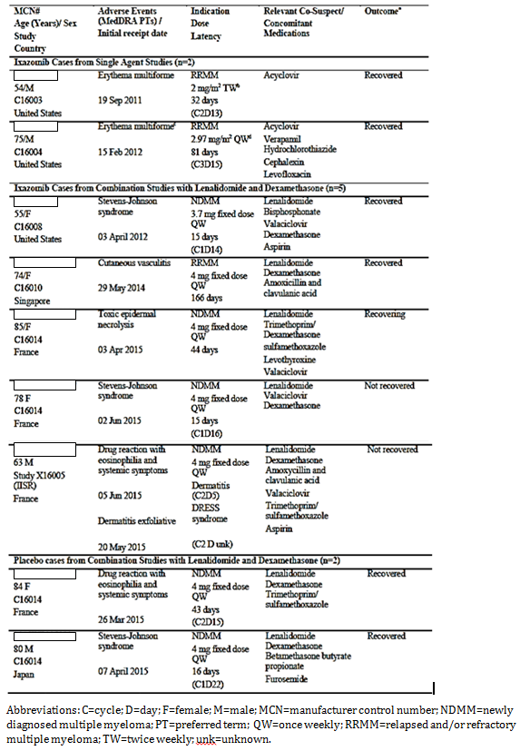

All 9 cases were assessed as serious and related to the study drug regimen by either the investigator or the sponsor (2 cases in single agent studies and 7 cases in combination studies). In 3 cases, the patient had a diagnosis of RRMM and in 6 cases the patient had a diagnosis of NDMM. Four cases were reported from non-randomised, open label studies and 5 cases were reported from ongoing double blind, placebo controlled studies in which ixazomib or placebo were administered in combination with LenDex. The 5 cases originating from blinded studies were unblinded by the sponsor to enable an accurate and comprehensive safety evaluation and assessment of benefit/risk related to severe cutaneous adverse reactions. In these 5 cases, 3 patients received ixazomib in combination with LenDex (1 case each of TEN, SJS, and cutaneous vasculitis), and 2 patients received placebo in combination with LenDex (1 case each of DRESS syndrome and SJS).

Overall, ixazomib was administered as part of the treatment regimen in 7 of the 9 cases (5 in combination with LenDex and 2 as a single agent), resulting in an incidence of 0.31% (7/2242). Placebo was administered with LenDex in 2 out of the 9 cases, resulting in an incidence of 0.31% (2/646). Of the 7 cases involving ixazomib, 3 occurred in patients with RRMM (2 in single agent studies and 1 in a combination study with LenDex), and all 3 patients recovered. Of the 7 cases involving ixazomib, 4 occurred in patients with NDMM treated with ixazomib in combination with LenDex, and 1 patient recovered, 1 patient was assessed as recovering, and 2 patients were not recovered as of the DLP. The sponsor states that the available data for the 7 cases reported in ixazomib treated patients demonstrate that confounding factors, including stage of disease (NDMM versus RRMM), use of concomitant regimens and other concomitant medications, may place certain patients at higher risk for developing clinically important cutaneous events. However, the incidence of serious cutaneous adverse events in ixazomib-treated patients continues to be low and similar to placebo treated patients. The sponsor states that, as additional patients are enrolled and as more data becomes available, it will continue to ascertain the potential implications of serious cutaneous events to patients who receive ixazomib and lenalidomide in combination.

**Comment:** The incidence of serious cutaneous adverse events in ixazomib treated patients is low and similar in the placebo treated patients (0.31% in each treatment group).

### Post-marketing data

There were no post-marketing data. At the date of the submission ixazomib had not been approved for marketing in any country.

#### ADRs for proposed by the sponsor for labelling

The Clinical Overview included a safety review relating to the identification and presentation of adverse drug reactions (ADRs) for the prescribing information (label), presumably for the FDA and the EMA. The Clinical Overview stated that the method used was "conducted in accordance with the European Guidance and FDA guidance and regulations". The Clinical Overview stated that the identified ADRs "are considered to be ADRs with a plausible connection with ixazomib. ADR determinations are not intended to be an appraisal of the medical cause of a particular event; instead, they represent an evaluation based on review of the available relevant information at the time of the evaluation". The ADRs associated with ixazomib identified in the Clinical Overview from the pivotal study data are summarised below in Table 60.

Table 60: Study C16010 - Adverse drug reactions (all grade, Grade 3, Grade 4); safety population

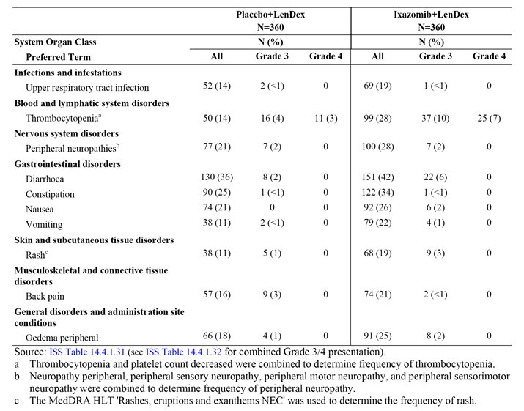

The Clinical Overview stated that the ADRs were "limited to those events for which there is some basis for believing that there is a causal relationship between the occurrence of an AE and the use of a drug. Decisions on whether there is a reason to believe that there is a causal relationship are a matter of clinical judgment and are based on factors such as but not limited to: the frequency, severity, and seriousness of reporting; whether the AE incidence for the drug exceeds the placebo incidence; the extent of dose response; the extent to which the AE is consistent with the pharmacology of the drug; the investigator assessment of causality; the timing of the event relative to the time of drug exposure; and whether the AE is known to be caused by related drugs, for example, other proteasome inhibitors".

TEAEs considered to be ADRs for ixazomib in the Clinical Overview included diarrhoea, constipation, thrombocytopenia, nausea, peripheral oedema, vomiting, upper respiratory tract infection, peripheral sensory neuropathy, maculopapular rash, and back pain. The frequency of ADRs was based on data from Study C16010. The frequency of some ADRs was determined by pooling PTs that represent the same medical concept or by the use of a MedDRA HLT. For thrombocytopenia, the frequency was determined using the pooled PTs thrombocytopenia and decreased platelet count. For peripheral neuropathy, the frequency was determined using the pooled PTs peripheral neuropathy, peripheral sensory neuropathy, peripheral motor neuropathy, and peripheral sensorimotor neuropathy. Maculopapular rash was presented as "Rash" and the frequency for the HLT "Rashes, eruptions and exanthems NEC" was used to characterise "rash".

### Evaluator's overall conclusions on clinical safety

It is considered that the safety of the proposed ixazomib regimen for the treatment of the proposed patient population has been satisfactorily established by the safety data from the pivotal Phase III Study C16010, supported by the safety data from the overall safety analysis population in which ixazomib was administered as a single agent or part of a combined regimen for various conditions including, but not limited to MM.

In general, the safety profile of the ixazomib regimen (n = 360) in the pivotal Study C16010 in patients with RRMM was consistent with the safety profile of ixazomib in patients included in the overall safety analysis population (n = 990), of whom 80% had a diagnoses of MM (RRMM or NDMM). The 990 patients in the overall safety analysis population treated with ixazomib included 360 (36%) patients from the ixazomib regimen in the pivotal study. Based on the "rule of threes" and a patient population of 360 exposed to the proposed ixazomib regimen in the pivotal study, adverse drug reactions to the proposed regimen with a frequency of greater than or equal to 1 in 120 (that is, approximately ≤ 1%) can be reasonably excluded.

In the pivotal study, the safety population included 720 patients, comprising 360 patients each in the proposed ixazomib plus LenDex regimen (the ixazomib regimen) and the placebo plus LenDex regimen (the placebo regimen). The duration of exposure was similar for the two treatment regimens and, consequently, the TEAE rates did not have to have to be adjusted to account for differences in exposure. The median number of treatment cycles was 13.0 (range: 1, 26) in the ixazomib regimen and 12.0 (range: 1, 25) in the placebo regimen. The median duration of treatment was similar in the ixazomib and placebo regimens (340.5 and 334.0 days, respectively). Overall, 296 (82%) patients in the ixazomib regimen and 298 (83%) patients in the placebo regimen received at least 6 cycles, while 215 (60%) patients in the ixazomib regimen and 205 (57%) patients in the placebo regimen received at least 12 cycles. The median dose intensity was 97.4% for ixazomib and 98.2% for placebo. There were 271 (75%), 148 (41%), 45 (13%), and no patients treated with ixazomib for ≥ 6, ≥ 12, ≥ 18 and ≥ 24 months, respectively. There were 199 (55%) patients in the ixazomib regimen still on treatment at the data cut-off date compared to 188 (52%) patients in the placebo regimen.

The overall safety analysis population included 990 patients exposed to at least 1 dose of oral ixazomib (either as a single agent or in combination with other chemotherapeutic regimens, regardless of patient population) from Studies C16003, C16004, C16005, C16006, C16007, C16008, C16009, C16010, C16011, C16013, C16015, C16017, C16018, C16020, and TB‑MC010034. The median number of ixazomib treatment cycles was 7.0 (range: 1, 69 cycles). Overall, 153 patients (15%) received at least 18 cycles of ixazomib, while 58 patients (6%) received at least 24 cycles of ixazomib. The maximum number of cycles of ixazomib was 69 (approximately 4 years). The median dose intensity of ixazomib was 96.2%. There were 483 (49%), 241 (24%), 105 (11%), and 32 (3%) patients treated with ixazomib for ≥ 6, ≥ 12, ≥ 18 and ≥ 24 months, respectively.

In general, the incidence of categorised TEAEs was similar in the ixazomib and placebo regimens in the pivotal study. The categorised TEAEs in which there were greater than 5% more patients in the ixazomib regimen compared to the placebo regimen were Grade ≥ 3 TEAEs (68% versus 61%, respectively), drug regimen-related Grade ≥ 3 TEAEs (54% versus 46%), TEAES resulting in dose modification of 1 or more of the 3 agents in the study regimen (71% versus 64%), and TEAEs resulting in dose reduction of 1 or more of the 3 agents in the study regimen (52% versus 44%). The incidence of the following TEAE categories was similar in patients in the ixazomib and placebo regimens (< 5% difference), all TEAEs (98% versus 99%, respectively), drug regimen-related TEAEs (91% versus 88%, respectively), SAEs (40% versus 44%, respectively), drug related SAEs (23% each regimen), TEAEs resulting in discontinuation of 1 or more of the 3 agents in the study regimen (19% versus 17%, respectively), TEAEs resulting in discontinuation of the full drug regimen (13% versus 11%, respectively), and on-study deaths (3% versus 5%, respectively). Overall, the results suggest that the increased toxicity in the ixazomib regimen compared to the placebo regimen is manageable by dose reductions rather than treatment discontinuation.

The sponsor nominated a number of TEAEs as being of clinical importance, based on PTs or pooled PTs depending on the events. The TEAEs of clinical importance were heart failure, arrhythmias, myocardial infarction, rash, nausea, vomiting, diarrhoea, thrombocytopenia, neutropenia, liver impairment, peripheral neuropathy, encephalopathy, renal impairment, and hypotension. In the pivotal Study C16010, TEAEs of clinical importance reported in ≥ 5% more patients in the ixazomib regimen compared to the placebo regimen were diarrhoea (PT: 42% versus 36%), rash (pooled PTs: 35% versus 21%), thrombocytopenia (pooled PTs: 28% versus 14%), peripheral neuropathy (pooled PTs: 28% versus 21%), nausea (PT: 26% versus 21%), and vomiting (PT: 22% versus 11%). There was < 5% difference in the percentage of patients for all other TEAEs of clinical importance, namely, heart failure (pooled PTs), arrhythmias (pooled PTs), myocardial infarction (pooled PTs), neutropenia (pooled PTs), liver impairment (pooled PTs), encephalopathy (pooled PTs), renal impairment (pooled PTs), and hypotension (pooled PTs).

The major limitation of the safety data in the pivotal Study C16010 relates to the relatively small number of patients treated for ≥ 12 months (that is, 148 [41%] patients). This is a limitation as the sponsor is proposing no time limit on the duration of treatment. Therefore, in the absence of disease progression and adverse events continued treatment with the regimen for the proposed indication can be anticipated. However, some reassurance comes from the long-term data from the pivotal study that showed that the incidence of most TEAE categories declined with continued exposure in patients who had completed ≥ 12 cycles. In addition, dose modifications of ixazomib specifically due to TEAEs were more common in Cycles 1 to 6 and decreased in frequency over time. Furthermore, in the overall safety analysis population, 241 (24%) of the 990 patients were treated with ixazomib for ≥ 12 months, 105 (11%) patients for ≥ 18 months, and 32 (3%) patients for ≥ 24 months. Similar to the findings in the pivotal study, the incidence of TEAEs in the overall safety analysis population decreased over time. Overall, the available data relating to prolonged administration suggest that long-term treatment with the proposed ixazomib regimen will be reasonably well tolerated and that cumulative toxicity is unlikely to occur. However, the occurrence of an increased number of new primary malignancies is a potential concern associated with long-term treatment with the proposed ixazomib regimen.

Other limitations of the safety data in the pivotal study include the absence of data in patients with significant hepatic impairment as patients with ALT and/or AST > 3 x ULN were excluded, as were patients with total bilirubin > 1.5 x ULN, and in patients with severe renal impairment (creatinine clearance < 30 mL/min). In addition, in the pivotal study there were limited data in patients identified as Black, Asian or Other as the majority of the patients in the safety population were identified as White (85%).

## First round benefit-risk assessment

### First round assessment of benefits

* The benefits of treatment with ixazomib in combination with LenDex in patients with RRMM treated with at least one prior therapy have been satisfactorily established in one pivotal Phase III Study C16010. The data summarised below relate to the first interim analysis of the pivotal study, which is the final analysis of PFS for statistical testing purposes.
* The median duration of follow-up was 14.8 months in the ixazomib regimen and 14.6 months in the placebo regimen. PFS based on IRC assessment (primary efficacy endpoint) in the ixazomib regimen (n = 360) was 5.9 months longer than in the placebo regimen (n = 362), with median PFS being 20.6 months and 14.7 months respectively. The HR in the ITT population was 0.742 (95% CI: 0.587, 0.939), p = 0.012, which translates into a 35% improvement in median PFS in the ixazomib regimen compared to the placebo regimen. In the ixazomib regimen, 129 (36%) patients experienced a PFS event (114 [32%] PD; 15 [4%] deaths) compared to 157 (43%) patients in the placebo regimen (145 [40%] PD; 12 [3%] deaths). The PFS events indicate that the primary benefit of treatment with the ixazomib regimen relative to the placebo regimen is a reduced risk of experiencing disease progression.
* The KM plot of PFS based on IRC assessment showed clear separation of the two treatment regimen curves in favour of the ixazomib regimen compared to the placebo regimen beginning at 8 months after initiation of treatment, and increasing over time.
* The HRs for PFS based on IRC assessment were consistently < 1 (that is, favouring the ixazomib regimen relative to the placebo regimen) across the pre-planned subgroups defined by age, sex, race, region, cytogenetic risk, ISS stage at screening, ECOG performance status, number of prior therapies, types of prior therapies, and renal function. These results indicate a lower risk of progression or death in the ixazomib regimen compared to the placebo regimen in each of the subgroups.
* OS in the ITT population was a key secondary efficacy endpoint. The median duration of follow-up was 14.8 months in the ixazomib regimen and 14.6 months in the placebo regimen. A total of 107 deaths were reported, representing 22% (107/486) of the pre‑specified number of deaths projected for the final OS analysis in the ITT population. Median OS had not been reached in either of the two treatment regimens. However, the HR was 0.90 (95% CI: 0.615, 1.316), p = 0.586, indicating a non-statistically significant reduction of 10% in the risk of death in the ixazomib regimen relative to the placebo regimen. Of the 107 deaths included in the analysis, 51 (14%) had occurred in the ixazomib regimen and 56 (15%) had occurred in the placebo regimen.
* OS in high risk patients harbouring the del(17) chromosomal abnormality was a key secondary efficacy endpoint. The median duration of follow-up was 12.5 months in the ixazomib regimen and 14.6 months in the placebo regimen. A total of 13 deaths had occurred in these high risk patients, comprising 4 (11%) deaths in 36 patients in the ixazomib regimen and 9 (27%) deaths in 33 patients in the placebo regimen. The HR in the ITT population was 0.506 (95% CI: 0.144, 1.777), p = 0.280, indicating a non-statistically significant reduction of 49% in the risk of death in the ixazomib regimen relative to the placebo regimen. Median OS had not been reached in either of the two treatment regimens.
* In patients with progressive disease (114 [32%] in the ixazomib regimen; 145 [40%] in the placebo regimen), the median time to progression in the ITT population was 21.4 months (95% CI: 18.43, NE) in the ixazomib regimen and 15.7 months (95% CI: 13.21, 18.27) in the placebo regimen. The results indicate that ixazomib regimen delays time to progression by 5.7 months compared to the placebo regimen (HR = 0.712 [95% CI: 0.556, 0.912], p = 0.007).
* The confirmed ORR (CR + PR [including sCR and VGPR]) based on IRC assessment in the ITT population was 78.3% (n = 282) in the ixazomib regimen and 71.5% (n = 259) in the placebo regimen (odds ratio = 1.44 [95% CI: 1.03, 2.03]; p = 0.035). The confirmed CR rate in the ixazomib regimen was almost double that in the placebo regimen (11.7% [n = 42] versus 6.6% [n = 24], respectively; odds ratio = 1.87 [95% CI: 1.10, 3.16]; p = 0.019). The ORR in the ixazomib regimen relative to the placebo regimen remained relatively constant over time based on the treatment cycle, but the patient numbers were small after Cycle 18.
* Time to response was measured from date of randomisation to the first documentation of PR or better. In the response evaluable population (all responders), a response was achieved by 279 patients in the ixazomib regimen and 255 patients in the placebo regimen. The median time to response was rapid in both treatment regimens, being 1.0 month in the ixazomib regimen and 1.1 months in the placebo regimen (HR = 1.209 [95% CI: 1.014, 1.443]).
* The duration of response (DOR) was measured as the time from the date of first documentation of PR or better to the date of first documented PD. In the response evaluable population (all responders), events had occurred in 92 (33%) patients in the ixazomib regimen and 104 (41%) patients in the placebo regimen. The median DOR was 20.5 months (95% CI: 16.62, NE) in the ixazomib regimen and 15.0 months (95% CI: 11.99, NE) in the placebo regimen.
* Quality of life assessments demonstrated that treatment with the ixazomib regimen was not associated with deterioration in the quality of life over the assessment period, with quality of life in both the ixazomib and placebo regimens remaining largely unchanged at the end of the first analysis.

### First round assessment of risks

* In the pivotal Study C16010, TEAEs were reported in 98% (351/360) of patients in the ixazomib regimen and 99% (355/360) of patients in the placebo regimen. In the overall safety analysis population 96% (951/990) of patients experienced at least one TEAE. The data indicate that nearly all patients treated with the proposed ixazomib regimen are at risk of experiencing at least one TEAE. The majority of TEAEs in both the pivotal study and the overall safety analysis population were reported by investigators to be related to the administered drug regimen. Drug regimen related TEAEs were experienced by 91% and 88% of patients the ixazomib and placebo regimens, respectively, in the pivotal study and 85% of patients in the overall safety analysis population. In the evaluation of risks discussed below, TEAEs refer to events reported regardless of causality unless otherwise stated.
* The data from the pivotal study suggest that most TEAEs can be managed by dose reductions (with or without symptomatic treatment) rather than discontinuation from treatment. In the pivotal study, TEAEs resulting in dose reduction of 1 or more of the 3 agents in the study regimen were reported in 52% of patients in the ixazomib regimen and 44% of patients in the placebo regimen, while TEAEs resulting in discontinuation of 1 or more of the 3 agents in the study regimen were reported in 19% and 17% of patients, respectively. In the pivotal study, TEAEs resulting in discontinuation from the full study drug regimen were reported in 13% of patients in the ixazomib regimen and 11% of patients in the placebo regimen, with the corresponding figure for ixazomib treated patients in the overall safety analysis population being 12%. As of the data cut-off date for the submission, 199 patients (55%) in the ixazomib regimen and 188 patients (52%) in the placebo regimen in the pivotal study were still on study treatment.
* TEAEs leading to discontinuation of 1 or more of the 3 agents in the study drug regimen in the pivotal study were reported in 19% of patients in the ixazomib regimen and 17% of patients in the placebo regimen. There were no TEAEs (PTs) leading to discontinuation of 1 or more of the 3 agents in the study drug regimen with an incidence > 1% in either regimen. TEAEs leading to discontinuation in 3 or more patients in either the ixazomib or placebo regimens (respectively) were diarrhoea (5 [1%] versus 3 [< 1%]), fatigue (5 [1%] versus 3 [< 1%]), insomnia (0 versus 5 [1%]), cardiac failure (1 [< 1%] versus 4 [1%]), neutropenia (3 [< 1%] each regimen), peripheral sensory neuropathy (3 [< 1%] versus 2 [< 1%]), acute renal failure (3 [< 1%] versus 0), thrombocytopenia (3 [< 1%] in each regimen), and platelet count decreased (3 [< 1%] versus 0).
* The E-R analyses demonstrated a significant relationship (p < 0.05) between ixazomib exposure and TEAEs of rash, peripheral neuropathy, diarrhoea, nausea, vomiting, fatigue, thrombocytopenia, and anaemia. These TEAEs appear to be manageable by dose reduction and/or symptomatic treatment.

#### Risks associated with TEAEs of clinical importance

* The TEAEs of clinical importance nominated by the sponsor were heart failure, arrhythmias, myocardial infarction, rash, nausea, vomiting, diarrhoea, thrombocytopenia, neutropenia, liver impairment, peripheral neuropathy, encephalopathy, renal impairment, and hypotension. In the pivotal study, TEAEs of clinical importance reported in ≥ 5% more patients in the ixazomib regimen compared to the placebo regimen were diarrhoea (PT: 42% versus 36%), rash (pooled PTs: 35% versus 21%), thrombocytopenia (pooled PTs: 28% versus 14%), peripheral neuropathy (pooled PTs: 28% versus 21%), nausea (PT: 26% versus 21%), and vomiting (PT: 22% versus 11%). There was < 5% difference between the two treatment regimens in the incidence of patients experiencing all other TEAEs of clinical importance, namely, heart failure (pooled PTs), arrhythmias (pooled PTs), myocardial infarction (pooled PTs), neutropenia (pooled PTs), liver impairment (pooled PTs), encephalopathy (pooled PTs), renal impairment (pooled PTs), and hypotension (pooled PTs). The risks associated with the TEAEs of clinical importance reported in ≥ 5% more patients in the ixazomib regimen than in the placebo group in the pivotal study are reviewed below.
* The risk of experiencing thrombocytopenia (pooled PTs) was 2 fold greater in patients treated with the ixazomib regimen than with the placebo regimen, with the incidence being 28% and 14%, respectively. Furthermore, the risks of experiencing Grade 3 thrombocytopenia (pooled PTs) was greater in the ixazomib regimen than in the placebo regimen (10% versus 4%), as was the risk of experiencing a Grade 4 event (7% versus 3%). However, there were no deaths reported due to thrombocytopenia (pooled PTs) in either treatment regimen. Discontinuation of at least 1 of the 3 agents in the study drug regimen due to thrombocytopenia (pooled PTs) was reported infrequently in both treatment regimens, with < 1% of the patients in the ixazomib regimen and 2% of patients in the placebo regimen discontinuing treatment due to these events. Ixazomib and placebo doses were each held in < 1% of patients due to thrombocytopenia (pooled PTs), while 5% and 1% of patients had their dose reduced due to these events. The need for platelet transfusion was similar in the ixazomib and placebo regimens (6% and 5%, respectively). A similar percentage of patients in the ixazomib and placebo regimens had a haemorrhagic event of any grade (18% and 16%, respectively) or a Grade 3 or higher haemorrhagic event (2% and < 1, respectively). In both treatment regimens, median platelet counts generally demonstrated a cyclical pattern when measured throughout Cycles 1 through 3, with nadirs around Day 14 of each 28 day cycle and returning to baseline levels before the next cycle. The incidence of thrombocytopenia was highest in the first 3 months of treatment and then declined over time.
* The risk of diarrhoea was higher in the ixazomib regimen than in the placebo regimen (42% versus 36%). Grade 3 diarrhoea being reported in 6% and 2% of patients in the two regimens respectively, and SAEs of diarrhoea being reported in 2% of patients in each regimen. No Grade 4 or 5 diarrhoea was reported in either of the two treatment regimens. The risk of discontinuation due to diarrhoea was low in both the ixazomib and placebo regimens (1% versus < 1%, respectively). The use of anti-propulsives to treat diarrhoea was reported in 18% of patients in the ixazomib regimen and 14% of patients in the placebo regimen. Dose reductions due to diarrhoea were reported for ixazomib in 3% of patients and for placebo in < 1%) patients, while lenalidomide dose was reduced in 3% and 2% of patients in the ixazomib and placebo regimens, respectively, and dexamethasone dose was reduced in 3% and 1% of patients in the ixazomib and placebo regimens, respectively. The incidence of diarrhoea was highest in the first 3 months of treatment in bot treatment regimens and decreased over time.
* The risk of nausea was 5% higher in the ixazomib regimen (26%) than in the placebo regimen (21%), while the risk of vomiting was 2 fold higher in the ixazomib regimen than in the placebo regimen (22% versus 11%, respectively). Grade 3 or higher nausea was infrequent and only occurred in patients in the ixazomib regimen (2%). Grade 3 or higher vomiting was also infrequent and occurred in a similar proportion of patients in the ixazomib and placebo regimens (1% and < 1%, respectively). SAEs due to nausea and vomiting were each reported in < 1% of patients in the ixazomib regimen and no patients in the placebo regimen. In total, 3 patients, all in the ixazomib regimen, were hospitalised for management of nausea and/or vomiting. No patients in either of the two treatment regimens discontinued due to nausea or vomiting, while dose reductions due to nausea were reported in 2% of patients in the ixazomib regimen and 1% of patients in the placebo regimen and dose reductions due to vomiting were reported in 1% of patients in the ixazomib regimen and no patients in the placebo group. Standard anti-emetic agents were recommended (Per Protocol) for emesis if it occurred once treatment was initiated, and prophylactic anti-emetics were to be used at the physician’s discretion. Prophylactic use of anti-emetics starting prior to the first dose of study drugs was reported in 5% of patients in the ixazomib regimen and 2% of patients in the placebo regimen, while 10% and 4% of patients, respectively, reported starting these agents for prophylactic use only after the first dose of study treatment. Nausea and vomiting both occurred most frequently in the first 3 months of treatment in both treatment regimens.
* The risk of rash (pooled PTs) was greater in the ixazomib regimen than in the placebo regimen (35% versus 31%, respectively), and the difference was primarily due to a higher frequency of low grade events (that is, Grades 1 and 2). Grade 3 rash (pooled PTs) was reported in 4% of patients in the ixazomib regimen and 1% of patients in the placebo regimen, while no patients in either of the two treatment regimens reported Grade 4 TEAEs, Grade 5 TEAEs or SAEs associated with rash. Rash (pooled PTs) leading to discontinuation of at least 1 of the 3 agents in the study drug regimen occurred in 1% of patients in the ixazomib regimen and < 1% of patients in the placebo regimen. The most common causes of rash reported in ≥ 5% of patients in either of the two treatment regimens were pruritus (10% ixazomib regimen versus 7% placebo regimen), maculopapular rash (9% ixazomib regimen versus 3% placebo regimen), and macular rash (6% in both regimens). No patient in either regimen in the pivotal study experienced in the pivotal study experienced SJS or TEN. However, 2 (0.2%) patients in the overall safety analysis population were reported to have experienced SJS. In the pivotal study, the use of systemic anti-histamines was reported more frequently in the ixazomib regimen than in the placebo regimen (27% versus 19%, respectively).
* Updated safety data relating to the occurrence of rash in the ixazomib clinical program were submitted by the sponsor. The data identified a total of 9 patients with severe cutaneous adverse reactions (SMQ, narrow) as of the data lock point of 9 June 2015, including 7 patients treated with ixazomib (0.31% [7/2242] and 2 patients treated with placebo (0.31% [2/646]). The 7 cases in ixazomib treated patients included, 2 cases of erythema multiforme (both single agent), 2 cases of SJS (both in combination with LenDex), 1 case of cutaneous vasculitis (combination with LenDex), 1 case of TEN (combination with LenDex), and 1 case of DRESS syndrome (combination with LenDex). The 2 cases in placebo treated patients included 1 case of DRESS syndrome (combination with LenDex) and 1 case of SJS (combination with LenDex). Of the 7 cases reported with ixazomib, 5 patients experienced onset of rash after 1 to 8 weeks of treatment, 4 patients were over 70 years of age, and all were confounded with one or more medications that are associated with skin reactions.
* The risk of peripheral neuropathy (pooled PTs) was greater in the ixazomib regimen than in the placebo regimen (28% versus 21%, respectively), with both regimens having a 2% incidence of Grade 3 events and no patients in either regimen had a Grade 4 event. The majority of PT events in both treatment regimens were peripheral sensory neuropathy (19% ixazomib regimen versus 14% placebo regimen), with most of the remaining PT events being peripheral neuropathy (10% in the ixazomib regimen and 8% in the placebo regimen). Discontinuations due to peripheral neuropathy (pooled PTs) were infrequent (1% in each regimen).
* The risk of other TEAEs (pooled PTs) of clinical importance in the ixazomib regimen and placebo regimen (respectively) were heart failure (4% versus 3%), arrhythmia (13% each regimen; no increased risk of QT prolongation), myocardial infarction (1% versus 2%), neutropenia (30% versus 27%), liver impairment (6% versus 5%), encephalopathy (< 1% both regimens), renal impairment (8% versus 10%), and hypotension (6% each regimen).

#### Risks associated with TEAEs of special interest

* Skeletal related events were defined as new fractures (excluding vertebral compression or rib fractures), bone irradiation or surgery, or spinal cord compression. In the pivotal study, the incidence of Skeletal related TEAEs was similar in the ixazomib and placebo regimens (4% versus 2%, respectively). The use of drugs affecting bone structure and mineralisation (for example, pamidronic acid or zoledronic acid), was similar in the ixazomib and placebo regimens (49% versus 48%, respectively).
* The prophylactic use of anti-thrombotic agents was recommended in all patients, due to the risk of thromboembolic events associated with the use of lenalidomide, and approximately 97% of patients in the pivotal study reported taking such agents. Thrombosis (SMQ) was reported in 7% of patients in the ixazomib regimen and 10% of patients in the placebo regimen, indicating that patients treated with the proposed ixazomib regimen are not at increased risk of thrombosis compared to patients treated with LenDex.
* In the pivotal study, TEAEs of herpes zoster were experienced by 4% of patients in the ixazomib regimen and 2% of patients in the placebo regimen. The use of antiviral agents was at the discretion of the treating physician and 67% of patients in the ixazomib regimen and 66% of patients in the placebo regimen reported taking antiviral agents during the study. In the pivotal study, herpes zoster infection rarely occurred in patients taking antiviral agents prophylactically (1 patient in each regimen).
* New primary malignancies were reported in 2% of patients in the ixazomib regimen and 1% of patients in the placebo regimen during treatment, and < 1% (n = 1) of patients in each regimen during follow-up. Of the 13 new primary malignancies during treatment, 4 were non-haematologic (excluding skin malignancies) and 2 were haematologic. In the ixazomib regimen the reported malignancies were 1 case of myelodysplastic syndrome, 5 cases of solid tumours (sigmoid colon, caecal, gall bladder, gastric, and undifferentiated tumour), and 3 cases of skin cancers. Four of the 5 patients with a newly diagnosed solid tumour had a clinically relevant medical history. In the placebo regimen the reported malignancies were 1 case of myelodysplastic syndrome, 1 case of solid tumour (NSCLC), and 4 cases of skin cancers.

#### Risks associated with TEAEs (PTs)

* In the pivotal study, TEAEs (PTs) were reported in ≥ 20% of patients in either the ixazomib regimen or the placebo regimen (respectively) were, diarrhoea (42% versus 36%,), constipation (34% versus 25%), fatigue (28% versus 26%), anaemia (26% versus 25%), neutropenia (26% versus 22%), nausea (26% versus 21%), peripheral oedema (25% versus 18%), vomiting (22% versus 11%), back pain (21% versus 16%), nasopharyngitis (20% versus 18%), thrombocytopenia (20% versus 10%), and insomnia (19% versus 25%).
* TEAEs (PT) reported in ≥ 5% more patients in the ixazomib regimen than in the placebo regimen in the pivotal study were diarrhoea (42% versus 36%), constipation (34% versus 25%), nausea (26% versus 21%), peripheral oedema (25% versus 18%), vomiting (22% versus 11%), back pain (21% versus 16%), thrombocytopenia (20% versus 10%), upper respiratory tract infection (19% versus 14%), peripheral sensory neuropathy (19% versus 14%), and maculopapular rash (9% versus 3%). TEAEs (PT) reported in ≥ 5% fewer patients in the ixazomib regimen than in the placebo regimen were insomnia (19% v 25%), muscle spasm (18% versus 25%), and pyrexia (13% versus 19%).
* For all TEAEs, except thrombocytopenia (PT), reported in ≥ 5% more patients in the ixazomib regimen than in the placebo regimen in the pivotal study the difference between the two treatment regimens was primarily due to a higher frequency of Grade 1 and 2 events. For thrombocytopenia, the difference in frequency of TEAEs was across all grades, including Grade 3 or higher. However, potential clinical consequences of thrombocytopenia were similar in the ixazomib and placebo regimens, with bleeding (all grades) being reported in 18% and 16% of patients, respectively, and the need for platelet transfusions being reported in 6% and 5% of patients, respectively.
* In the pivotal study, the risk of experiencing a Grade 3 TEAE (PT) was higher in the ixazomib regimen than in the placebo regimens (49% versus 43%, respectively). Grade 3 TEAEs (PT) reported by ≥ 5% of patients in either the ixazomib or placebo regimen (respectively) were neutropenia (15% versus 12%), anaemia (9% versus 13%), thrombocytopenia (8% versus 3%), diarrhoea (6% versus 2%), and pneumonia (6% versus 7%). The only Grade 3 TEAE (PT) reported in ≥ 5% more patients in the ixazomib regimen than in the placebo regimen was thrombocytopenia (8% versus 3%).
* In the pivotal study, the risk of experiencing a Grade 4 TEAE (PT) was similar in the ixazomib and placebo regimens (15% versus 14%, respectively). Grade 4 TEAEs (PT) reported by ≥ 1% of patients in either the ixazomib or placebo regimens (respectively) were thrombocytopenia (6% versus 2%), neutropenia (4% each), hypokalaemia (2% versus < 1%,), platelet count decreased (1% each), sepsis (1% versus < 1%), neutrophil count decreased (< 1% versus 1%), pneumonia (< 1% versus 1%), and septic shock (< 1% versus 1%). The only Grade 4 TEAE (PT) reported in ≥ 2% more patients in the ixazomib regimen than in the placebo regimen was thrombocytopenia (6% versus 2%).
* There was no evidence from the pivotal study that the addition of ixazomib to LenDex increases the risk of death. In the pivotal study, the incidence of on-study deaths, defined as occurring within 30 days of the last dose of study drug, was similar in the ixazomib and placebo regimens (3% and 5%, respectively). Of the 29 on-study deaths (12 ixazomib regimen, 17 placebo regimen), 5 were reported as being related to study drug treatment (3 in the ixazomib regimen [pulmonary embolism, fungal pneumonia, coma with concurrent stroke] and 2 in the placebo regimen [myocardial infarction, pulmonary embolism]). One additional patient in the ixazomib regimen died 31 days after the last dose of study drug due to Grade 4 influenza and Grade 5 staphylococcal bacteraemia. The investigator considered these two events to be related to the full drug regimen and noted immunosuppression due to myeloma to be an alternative aetiology. Of the 29 on-study deaths reported in the pivotal study, 8 (28%) were attributed to disease progression (6 patients in the ixazomib regimen and 2 patients in the placebo regimen).
* In the overall safety analysis population, there were 41 (4%) on-study deaths. The most common causes of death were plasma cell myeloma (6 patients; < 1%), cardiac arrest (2 patients; < 1%), cardiorespiratory arrest (2 patients; < 1%), endometrial cancer (2 patients; < 1%), hepatic failure (2 patients; < 1%), pulmonary embolism (2 patients; < 1%), and septic shock (2 patients; < 1%). Of the 41 deaths, 5 were considered related to the study drug regimen (1 x respiratory syncytial viral pneumonia; 1 x cardiorespiratory arrest; 1 x coma with concurrent stroke; 1 x pulmonary embolism; and 1 x fungal pneumonia). Of the 41 on-study deaths, 18 (44%) were attributed to disease progression. There were 30 (3%) deaths within 90 days of the first dose of study drug. The most common causes of death during this time were plasma cell myeloma (6 patients; < 1%), cardiac arrest (2 patients; < 1%), endometrial cancer (2 patients; < 1%), and hepatic failure (2 patients; < 1%).

#### Risks associated with special groups (pivotal study)

* The risk of treatment with both treatment regimens increased with age. There were limited safety data on the risks of treatment in patients aged > 85 years. However, no adjustment to the starting dose of ixazomib appears to be required based on age. The risks of some TEAEs were greater in females than in males (that is, diarrhoea, nausea, vomiting), and there was a higher percentage of female than male patients reporting TEAEs resulting in dose reduction of 1 or more of the 3 agents in the ixazomib regimen (63% versus 44%) and TEAEs resulting in dose modification of 1 or more of the 3 agents in the ixazomib regime (77% versus 66%). However, no adjustment to the starting dose of ixazomib appears to be required based on sex.
* There were no safety data in the pivotal study in patients with significant hepatic impairment. However, based on the PK study in patients with advanced solid tumours with hepatic impairment (Study C16018) a starting ixazomib dose of 3 mg is recommended for patients with moderate to severe hepatic impairment and a starting ixazomib dose of 4 mg is recommended for patients with mild hepatic impairment (that is, no adjustment to the starting dose).
* Based on the PK study in patients with renal impairment and normal renal function or severe renal impairment (CrCl < 30 mL/min, including ESRD) a starting ixazomib dose of 3 mg is recommended for patients with severe renal impairment, including ESRD renal disease requiring dialysis. There were no PK data in patients with mild or moderate renal impairment. However, safety data from the overall safety analysis population based on baseline creatinine clearance suggests that the risk of a number of TEAEs is higher in patients with baseline CrCl ≥ 30 to < 60 mL/min compared to patients with baseline CrCl ≥ 60 mL. The results suggest that the starting dose of ixazomib should also be reduced to 3 mg in patients with moderate renal impairment (CrCL ≥ 30 to < 60 mL/min).

### First round assessment of benefit-risk balance

The benefit-risk balance of the proposed ixazomib regimen is favourable for the treatment of patients with RRMM whose disease has progressed on at least one prior therapy.

## First round recommendation regarding authorisation

It is recommend that ixazomib in combination with lenalidomide and dexamethasone be approved for the treatment of patients with relapsed and/or refractory multiple myeloma whose disease has progressed on at least one prior therapy.

## Clinical questions

### Pharmacokinetics

1. In Study C16009, statistically significant period effects were observed in the ANOVA analyses in Arm 2 (relative bioavailability capsule B versus A) and in Arm 3 (food effect on the bioavailability of capsule B). The sponsor stated that in both arms the period effect "was accounted for during estimation of least squares geometric mean ratios of the 90% CIs" for the Cmax and AUC values. No discussion in the submission could be identified relating to possible reasons for the period effects. However, it appears that the period effect observed in both arms might be due to an inadequate washout (15 days) between the two periods, given the long terminal half-life of ixazomib (9.5 days). Please comment on the possible reasons for the period effect observed in the two arms, and clarify the comment in C16009 that the period effects were "accounted for during estimation of least squares geometric mean ratios of the 90% CIs".

### Pharmacodynamics

Nil

### Efficacy

1. In the pivotal Study C16010, the first interim analysis of PFS was based on 286 PFS events in 722 patients. A second interim analysis of the PFS (non-inferential) is planned when 365 events have occurred. As Per Protocol amendment 3, the first interim analysis became the final analysis of the PFS for statistical testing purposes due to the O'Brien-Fleming stopping boundary being crossed. Based on IDMC assessment of PFS in the first interim analysis the committee recommended that the analysis of PFS should be the final analysis of this endpoint for statistical testing purposes and that the trial should continue in a placebo controlled blinded fashion to allow further maturation of long-term efficacy and safety endpoints. Therefore, why did the sponsor choose to unblind the study and submit a regulatory dossier based on the first interim analysis of PFS (final analysis for statistical testing purposes) when the second interim analysis will include more mature PFS data?
2. The FDA website includes a Summary Review of the application to register ixazomib in the US. This review includes the following statements:

*An updated final analysis of PFS and 2nd interim analysis for other efficacy endpoints were submitted during the review of this NDA submission. Based on this updated analysis, the estimated hazard ratio (HR) for PFS was 0.82 (95% confidence interval: 0.67 – 1.0, p‑value = 0.0548) for the Ixazomib arm versus Placebo arm; the median PFS was 20.0 months in Ixazomib arm, and was 15.9 months in placebo arm; the estimated HR for overall survival (OS) was 0.87 (95% confidence interval: 0.64 – 1.18) based on 171 deaths, median OS was not reached for either treatment arm. The submitted data for 1st interim analysis of PFS per IRC support the applicant’s claim of efficacy of Ixazomib in combination with lenalidomide and dexamethasone for patients with relapsed and/or refractory multiple myeloma. However, we identified some statistical issues in this submission: Although 1st interim analysis results of PFS per IRC crossed the pre-specified superiority boundary, the final analysis results of PFS were not statistically significant. . There were discordance between PFS per IRC and PFS per investigator. Analysis results for PFS per investigator were not significant for both interim and final analysis. There were some discrepancies between 1st interim and final PFS data. Due to these issues, reliable estimate of the magnitude of treatment effect based on PFS could not be ascertained.*

Please provide the updated data referred to in the FDA Summary Review. Please comment on the statistical issues identified in the FDA Summary Review resulting in a "reliable estimate of the magnitude of treatment effect based on PFS" not being able to be ascertained. Please re-assess the benefit risk-balance of ixazomib for the proposed indication based on the updated data, given that the FDA Summary Review states that the "updated final analysis of PFS" was not statistically significant and indicates that the magnitude of the treatment effect based on PFS could not be reliably estimated due to "some statistical issues".

In addition, please comment on the internal validity of the study, given that the final (first interim) statistical analysis of the PFS (inferential analysis) was statistically significant while the "updated final analysis" of the PFS referred to in the FDA Summary Review was not statistically significant.

### Safety

1. There were no notable differences in the incidence of cardiac arrhythmias SMQ between the two treatment regimens in the ≤ 65 years and > 65 to ≤ 75 years age groups, but cardiac arrhythmias SMQ occurred notably more frequently in patients aged > 75 years in the ixazomib regimen than in the placebo regimen (21% versus 15%, respectively). Please comment on the possible reasons for the difference between the two treatment regimens in the incidence of cardiac arrhythmias SMQ in patients aged > 75 years.

## Second round evaluation of clinical data submitted in response to questions

### Background

On 26 May 2016, the Committee for Medicinal Products for Human Use (CHMP) recommended refusal of EU marketing authorisation for Ninlaro intended for the treatment of multiple myeloma. The CHMP considered that the data from the main Study [C16010] were insufficient to demonstrate a benefit of Ninlaro for the treatment of multiple myeloma. The committee concluded that, “based on the currently available data, the benefits of Ninlaro did not outweigh its risks” (EMA Website, 27 May 2016; EMA/358656/2016; EMEA/H/C/003844).

The CHMP’s negative opinion became known after completion of the first round clinical evaluation report. Consequently, the TGA requested the sponsor to provide additional clinical information relating to the CHMP’s negative opinion. Therefore, the sponsor provided two responses to the TGA: the first dated 3 June 2016 included a consolidated response to the TGA’s first s31 request for information relating to the first round evaluation; and the second dated 13 June 2016 included a response to the TGA’s second request for information relating to the CHMP’s negative opinion. In addition, the sponsor provided a small amount of additional clinical data requested during the course of the second round clinical evaluation (that is, sponsor’s response to TGA’s third s31 request for information).

#### TGA’s questions relating to the CHMP’s negative opinion

The TGA’s questions raised in the second request for information relating to the CHMP’s negative opinion were: (1) please provide an updated analysis of the efficacy endpoints as at the second interim analysis and any subsequent analysis time points; and (2) please provide any EMA reports that have been provided to you or Millennium Pharmaceuticals.

The sponsor’s response to question 1 was as follows; “Please be advised that, as requested by the Clinical evaluator, the data from the second interim analysis was included in our response to the TGA’s first request; consolidated list of questions, submitted to TGA on the 2 June 2016”, with the supporting document being Addendum 1 to the pivotal Study CSR 16010.

The sponsor’s response to Question 2 was as follows: (i) the CHMP’s opinion is based on a different interpretation of the same data that led to approval in the US, following a priority review; an oral presentation at ASH 2015; and a publication in the New England Journal of Medicine; (ii) Ninlaro was launched in the USA on 11 December 2015; (iii) the CHMP considered the safety profile of ixazomib in combination with lenalidomide and dexamethasone to be acceptable; (iv) the CHMP considered the quality and nonclinical aspects of Ninlaro to be acceptable; (v) Takeda is appealing [the CHMP’s negative opinion] and has requested a re-examination by the CHMP on 2 June, 2016; and (iv) there are on-going Ninlaro applications in other major reference agencies that is, Canada, Switzerland.

Takeda states that it is committed to making Ninlaro available to multiple myeloma patients in Europe and will continue to work closely with the CHMP and European Commission to address outstanding concerns. In the interim, Takeda states that it will continue to submit Ninlaro filings in other countries around the world.

The sponsor provided relevant CHMP reports and the company’s clinical response to the reports (see summary in Table61).

Table 61: Summary of CHMP reports and company’s clinical responses

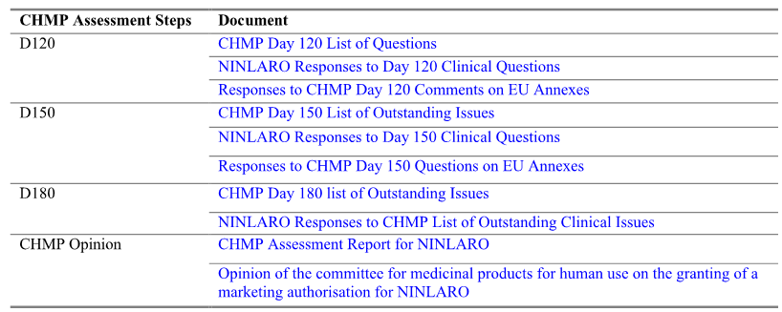

The grounds for the CHMP’s negative opinion

The grounds for the CHMP’s negative opinion relating to Ninlaro are provided in the EMA document titled; Opinion of the committee for medicinal products for human use on the granting of a marketing authorisation for [Ninlaro] (London, 26 May 2016, EMEA/CHMP/66748/2016). The grounds for refusal were:

*Whereas the evidence of efficacy in the proposed indicated patient populations (adult patients with multiple myeloma who have experienced at least one relapse with ISS stage III disease or elevated-risk cytogenetics [del(17), t(4;14), t(14;16), or 1q21+]; or experienced at least 2 relapses) is considered insufficient. The data are currently immature, especially for overall survival which is not yet evaluable. Efficacy data in the overall ITT population from the first and second interim analyses do not provide the statistically compelling evidence expected for an application based on a single pivotal trial. Point estimates for efficacy measures are not sufficiently outstanding in the context of other available treatment options. There is a lack of clinical rationale for post-hoc arguments that efficacy is greater in the higher risk subgroups proposed for the revised indications. There is substantial uncertainty associated with the interpretation of post-hoc subgroup analyses, including a number of inconsistencies in the data regarding risk factors for early progression. Analyses in these subgroups were not statistically compelling and differences from the overall ITT population are considered likely to be chance findings, the CHMP is of the opinion that pursuant to Article 12 of Regulation (EC) No 726/2004, the efficacy of the above mentioned medicinal product is not properly or sufficiently demonstrated.*

*Therefore, the CHMP has recommended the refusal of the granting of the marketing authorisation for NINLARO.*

It is noted that the sponsor was seeking EU marketing authorisation for a restricted indication in high risk adult patients with multiple myeloma who have experienced at least one relapse with ISS stage III disease or elevated-risk cytogenetics [del(17), t(4;14), t(14;16), or 1q21+]; or experienced at least 2 relapses. The request for the restricted indication appears to have arisen in discussions between the EMA and the sponsor during the course of the agency’s evaluation of the marketing application. The broader indication being sought in Australia is the treatment of patients with relapsed and/or refractory multiple myeloma who have received at least one prior therapy.

#### Preparation of the second round CER

In preparing the second round clinical evaluation, an integrated approach to the sponsor’s responses to the TGA’s first, second and third requests for information has been adopted based on the clinical questions raised in the first round clinical evaluation report. This is followed by comments on the sponsor’s response to other issues raised by the clinical evaluator and evaluation of the efficacy and safety data provided in Addendum 1 to Study C16010. The second round benefit-risk balance evaluation and recommendation relating to authorisation of ixazomib for the proposed indication are then provided, based on the totality of the submitted data. The first and second round clinical evaluation reports have been prepared by the same evaluator.

The sponsor provided a tabulated list of errors and omissions identified in the first round CER and these have been corrected in the current report. The identified errors and omissions are considered to be minor and not to have impacted on the substance of the report.

### Sponsor’s response to first round clinical questions

#### Pharmacokinetics

##### Question 1

*In Study C16009, statistically significant period effects were observed in the ANOVA analyses in Arm 2 (relative bioavailability capsule B versus A) and in Arm 3 (food effect on the bioavailability of capsule B). The sponsor stated that in both arms the period effect "was accounted for during estimation of least squares geometric mean ratios of the 90% CIs" for the* Cmax *and AUC values. No discussion in the submission could be identified relating to possible reasons for the period effects. However, it appears that the period effect observed in both arms might be due to an inadequate washout (15 days) between the two periods, given the long terminal half-life of ixazomib (9. 5 days). Please comment on the possible reasons for the period effect observed in the two arms, and clarify the comment in C16009 that the period effects were "accounted for during estimation of least squares geometric mean ratios of the 90% CIs".*

***Sponsor’s Response:***

The exact cause of the period effect observed in Arm 2 (relative bioavailability study) and in Arm 3 (food effect study) of Study C16009 is unknown. In the population pharmacokinetic (PK) analysis, a 3 compartment PK model with linear elimination adequately described the data after the first dose, and after once weekly and twice weekly repeat-dose administration. This suggests that the period effect was not caused by any apparent time dependencies in the PK of ixazomib following repeat dosing.

A possible explanation for the period effect may be the 14 day washout period between doses in arms 2 and 3, in the context of the 9.5 day half-life of ixazomib. Most patients in Arms 2 and 3 had quantifiable ixazomib concentrations in their Period 2 pre-dose samples (although the mean pre-dose concentration in Period 2 was < 5% of the mean Period 2 maximum observed plasma concentration [Cmax]), indicating the presence of residual ixazomib from the Period 1 dose. This may have partly contributed to the higher exposures observed in Period 2 versus Period 1, but is unlikely to fully explain the approximately 2 fold difference in exposures between Period 2 and Period 1. Also, it should be noted that ixazomib is cytotoxic and therefore can only be administered to patients with cancer. Accordingly, a longer washout period between doses was not possible as it would have required patients to receive only 2 doses of ixazomib in two 28 day cycles (as compared to the 6 doses normally received with the once weekly dosing regimen); thereby reducing the opportunity for clinical benefit from ixazomib treatment in these patients with advanced cancers.

For the relative bioavailability (Arm 2) and food effect estimation (Arm 3), the geometric least squares mean ratios and associated 2 sided 90% confidence intervals (CIs) for Cmax and area under the plasma concentration time curve (AUC) were calculated on the basis of the within patient variance using a mixed effects analysis of variance (ANOVA) model that included terms for treatment, sequence, and period as fixed effects. Patient within sequence was treated as a random effect in the model. Since the ANOVA model includes a fixed effect for period (that is, accounts for the period effect), the reported point estimates and 90% confidence intervals for the treatment effect on Cmax and AUC are adjusted for any period effect. Accordingly, the impact of the period effect on the reported point estimates and 90% confidence intervals for the treatment effect on Cmax and AUC has been removed from the between-treatment comparisons. Consequently, the reported geometric least squares mean ratios and 90% confidence intervals represent an accurate estimation of the relative bioavailability of Capsule B versus Capsule A (Arm 2), and the effect of food on the PK of ixazomib (Arm 3).

***Clinical evaluator’s comment:***

The sponsor’s response is considered to be satisfactory.

#### Efficacy

##### Question 1

*In the pivotal Study C16010, the first interim analysis of PFS was based on 286 PFS events in 722 patients. A second interim analysis of the PFS (non-inferential) is planned when 365 events have occurred. As Per Protocol amendment 3, the first interim analysis became the final analysis of the PFS for statistical testing purposes due to the O'Brien-Fleming stopping boundary being crossed. Based on IDMC assessment of PFS in the first interim analysis the committee recommended that the analysis of PFS should be the final analysis of this endpoint for statistical testing purposes and that the trial should continue in a placebo controlled blinded fashion to allow further maturation of long-term efficacy and safety endpoints. Therefore, why did the sponsor choose to unblind the study and submit a regulatory dossier based on the first interim analysis of PFS (final analysis for statistical testing purposes) when the second interim analysis will include more mature PFS data?*

***Sponsor’s Response:***

Global Study C16010, a randomized double blind, placebo controlled trial, is one of the most rigorously designed trials for patients with relapsed and/or refractory multiple myeloma (RRMM). The study was powered to be able to detect an OS benefit at the final analysis, and the target for PFS analysis at the first analysis time point was chosen to ensure that patients had sufficiently meaningful follow-up and statistical significance could be claimed if the presumed large effect size was observed at the first analysis. On the basis of the design of Study C16010 and conventional statistical principles, this robust, large, well-conducted study met its primary endpoint by demonstrating improvement in PFS at the first analysis time point. The addition of ixazomib to LenDex led to a 35% improvement in PFS for patients with RRMM (hazard ratio [HR] = 0.742; p = 0.012), crossing the statistical efficacy boundary of p < 0.02268, with the median PFS increased to 20.6 months from 14.7 months. This median PFS of ≥ 20 months is amongst the best reported for patients with RRMM. For the reasons discussed herein, the sponsor agreed with the [IDMC] recommendation and submitted a regulatory dossier based on the first interim analysis of PFS, the final analysis for statistical testing purposes. Study C16010 continues ongoing in a blinded fashion and patients are being followed for OS. The sponsor is confident that the study can continue without being influenced from unblinding of patients and that OS survival can be provided at the 2 planned analysis time points.

In the Study C16010 protocol and its accompanying statistical analysis plan (SAP), a total of 4 pre-specified analyses were planned to assess the long-term endpoints of the study: 3 interim analyses and 1 final analysis (OS). Per the pre-specified statistical plan and the principle of group sequential design, once the primary endpoint, PFS as assessed by the [IRC] was met, that would be the final statistical testing of PFS. In other words, if the primary endpoint was met at the first analysis, per group sequential design, the focus of the next analysis would be OS. If the primary endpoint was not met at the first analysis, the second analysis was a second chance to test the study’s hypothesis. If the study continued, the third interim analysis and final analysis were to be based on OS. Study C16010 met the primary endpoint based on the first analysis which is also the primary analysis, with a data cut-off of 30 October 2014. The second analysis, with a data cut-off of 12 July 2015, focused on OS with a non-inferential analysis of PFS additionally conducted. PFS assessment beyond the second analysis is not part of the SAP because, per the statistical methodology, the final statistical testing of PFS has occurred and response/progression data would be increasingly confounded by public disclosure of study data (that is, prescribing information, conference presentations, and publications). Consistent with this SAP, the IRC has not reconvened to assess progression data since the July 2015 analysis. The IDMC charter specifically indicates that the third and final analyses (OS) by the IDMC will focus on OS and will not include PFS information.

*Statistical Considerations for PFS Endpoint*

The first analysis in Study C16010 was planned to be performed when approximately 262 of the IRC assessed PFS events (disease progression or death) had occurred. The projected timing of the analysis was approximately 5 months after the end-of-enrolment period, when approximately 90% of patients would have had the opportunity to have been enrolled for approximately 12 months. Furthermore, assuming that the survival function was exponentially distributed, statistical significance would be claimed with an observed hazard ratio [HR] of 0.74, which is close to the survival assumption for the sample size calculation (median PFS of 15.0 months versus 20.6 months; HR = 0.73). It is believed that HR = 0.74 represents strong evidence of clinical benefit in patients with RRMM, who still represent a population of highly unmet medical need. Thus, the PFS target for analysis was chosen to ensure that patients had sufficiently meaningful follow-up and statistical significance could be claimed if the presumed large effect size could be observed at the first analysis.

The Lan-DeMets alpha spending function with O’Brien-Fleming boundary approach was to be used to determine the significance level. The actual boundary was to be adjusted if the actual number of events did not exactly correspond to the projected events in the analyses. If the first analysis for PFS were statistically significant in this study, the first analysis would be the first and final analysis for PFS for statistical testing purposes, on the basis of the principle of the group sequential testing approach. Further details regarding the principle and interpretation of the group sequential design in regards to the internal validity of the global C16010 study are discussed in Question 2, Part 4. With the observed 286 IRC-determined PFS events (information fraction: 78.4% of the planned 365 events), an O’Brien-Fleming stopping boundary (with the Lan-DeMets alpha spending function) of p < 0.02268 would demonstrate statistical significance.

*Study unblinding*

Upon recommendation of the IDMC that the study had crossed the stopping boundary for efficacy, the sponsor formed two separate teams: one unblinded to the study results, including patient level data, charged with submitting the regulatory dossier and a second one that remained blinded to ensure unbiased conduct of the study. Study C16010 continues ongoing in a blinded fashion and patients are being followed for OS. As of January 2016, 207 deaths had occurred. There has not been an increase in unblinding of ongoing patients since public release of the aggregate results. Therefore, the sponsor is not concerned about the potential for increased unblinding of ongoing patients after any marketing authorization of ixazomib in Australia. For example, 15 cases were unblinded before 30 October 2014, 13 cases between 30 October 2014 and 12 July 2015, and only 10 patients were unblinded between 12 July 2015 and January 2016, during which ixazomib received United States Food and Drug Administration (US FDA) approval (on 20 November 2015). Patients are not routinely unblinded after progression, and there is no formal mechanism for automatic crossover of patients in the study.

***Clinical evaluator’s comment:***

The second interim, pre-specified, non-inferential analysis of PFS showed a numerical advantage in median PFS in favour of ixazomib of 4.1 months compared to placebo (that is, 20.0 versus 15.9 months, respectively). The first interim, pre-specified, primary analysis of PFS showed a statistically significant advantage for median PFS in favour of ixazomib of 5.9 months compared to placebo (that is, 20.6 versus 14.7 months, respectively). The HR for the second, non-inferential analysis of PFS was 0.818 (95% CI: 0.67, 1.0), nominal p-value = 0.054, and the HR for the first, primary analysis of PFS was 0.742 (95% CI: 0.587, 0.939), confirmatory p-value = 0.012. The CHMP concluded that the “first and second interim analyses [of PFS] do not provide the statistically compelling evidence expected for an application based on a single pivotal trial”. In contrast, the FDA appear to have approved ixazomib for marketing in the USA based on the same data that was available to the EMA for the first and second analyses of PFS. Overall, it is considered that approval of the application rests on the weight to be given to the second interim, non-inferential analysis of PFS as regards the first interim, primary analysis of PFS. This matter is discussed below in the section relating to the second round evaluation of benefits of treatment with the proposed regimen for the proposed indication.

##### Question 2

*The FDA website includes a Summary Review of the application to register ixazomib in the US. This review includes the following statements:*

*An updated final analysis of PFS and 2nd interim analysis for other efficacy endpoints were submitted during the review of this NDA submission. Based on this updated analysis, the estimated hazard ratio (HR) for PFS was 0.82 (95% confidence interval: 0.67 – 1.0, p-value = 0.0548) for the Ixazomib arm versus Placebo arm; the median PFS was 20.0 months in Ixazomib arm, and was 15.9 months in placebo arm; the estimated HR for overall survival (OS) was 0.87 (95% confidence interval: 0.64 – 1.18) based on 171 deaths, median OS was not reached for either treatment arm. The submitted data for 1st interim analysis of PFS per IRC support the applicant’s claim of efficacy of Ixazomib in combination with lenalidomide and dexamethasone for patients with relapsed and/or refractory multiple myeloma. However, we identified some statistical issues in this submission: Although 1st interim analysis results of PFS per IRC crossed the pre-specified superiority boundary, the final analysis results of PFS were not statistically significant. . There were discordance between PFS per IRC and PFS per investigator. Analysis results for PFS per investigator were not significant for both interim and final analysis. There were some discrepancies between 1st interim and final PFS data. Due to these issues, reliable estimate of the magnitude of treatment effect based on PFS could not be ascertained.*

*Please provide the updated data referred to in the FDA Summary Review. Please comment on the statistical issues identified in the FDA Summary Review resulting in a "reliable estimate of the magnitude of treatment effect based on PFS" not being able to be ascertained. Please re-assess the benefit risk-balance of ixazomib for the proposed indication based on the updated data, given that the FDA Summary Review states that the "updated final analysis of PFS" was not statistically significant and indicates that the magnitude of the treatment effect based on PFS could not be reliably estimated due to "some statistical issues".*

*In addition, please comment on the internal validity of the study, given that the final (first interim) statistical analysis of the PFS (inferential analysis) was statistically significant while the "updated final analysis" of the PFS referred to in the FDA Summary Review was not statistically significant.*

***Sponsor’s Response:***

***Part 1 - Updated data referred to in the FDA summary***

The New Drug Application (NDA) to register NINLARO was submitted to the US FDA on 10 July 2015, based on the primary analysis of Study C16010 (data cut-off 30 October 2014). The application was granted Priority Review with a [PUDFA] date of 10 March 2016. The efficacy results referred to in the US FDA Summary Review cited by the evaluator refer to data from the 12 July 2015 data cut-off, and include OS and a non-inferential PFS analysis. The submission of these data was requested by the US FDA during pre-NDA dialogue and provided in the form of a summary. The US FDA approved NINLARO in combination with lenalidomide and dexamethasone for the treatment of patients with MM who have received at least 1 prior therapy on 20 November 2015, 4 months ahead of the PDUFA date.

Subsequently, in January 2016, the CSR Addendum for the C16010 global study became available; this document includes all data from the global study as of the 12 July 2015 cut-off provided to the US FDA, but is in the format prescribed by ICH Guideline E3 Structure and Contents of Study Reports. This document is included for reference, and a discussion of these data in the context of the items raised by the clinical evaluator are presented below.

The sponsor notes the clinical evaluator’s comment on efficacy in the Asian population and percentage of Non-Caucasian patients studied (see Other Matters Raised by clinical evaluator). Here within, the sponsor presents high-level results, which were not available at the time of the US NDA or the initial Category 1 Application of ixazomib or placebo added to LenDex in patients solely enrolled in China. The results from the China continuation provide valuable information in a Non-Caucasian population and further confirmation of the benefit-risk of ixazomib and validity of the C16010 global study, as requested by the clinical evaluator.

1. *Interpreting second analysis results based on the outcome of the first analysis*

As discussed in Efficacy Question 1, as of the first analysis (30 October 2014) the test for PFS crossed the O'Brien-Fleming stopping boundary and was statistically significant, thereby rejecting the null hypothesis and supporting the alternative hypothesis that patients treated with ixazomib+LenDex live longer without disease progression or death. Per the pre-specified SAP and principle of group sequential design, once the first analysis for PFS was statistically significant, it would be the final analysis for PFS for statistical testing purposes. Consequently, PFS at the second analysis (12 July 2015) is considered non-inferential (descriptive) and was done as requested by the US FDA during protocol development and pre-submission discussions.

The key endpoints at the 12 July 2015 analysis were OS in the ITT population and OS in patients with del(17p). As of 12 July 2015, there were 171 deaths, with a p-value threshold for statistical significance of < 0.00031. Given the rules for statistical testing of hierarchical endpoints, OS in patients harbouring del(17p) would be assessed for statistical significance only if OS in the ITT population, the first key endpoint, was found to be statistically significant.

1. *Overview of C1610 global study results as of 12 July 2015*

As of the 12 July 2015 analysis, the OS data continued to be immature, with only 35% (171/486) of the pre-specified events required for final OS analysis reported. The median OS had not been reached with either treatment regimen. However, similar to the findings from the 30 October 2014 analysis, the current data showed a survival trend in favour of the ixazomib regimen (HR = 0.868; 95% CI: 0.642, 1.175; p = 0.359). The p-value for OS in the ITT population did not cross the pre-specified efficacy boundary. Therefore, survival continues to be monitored as per the protocol, and the study continues to be conducted in a double blind, placebo controlled fashion in accordance with the recommendation of the IDMC.

An overview of the main efficacy parameters as of 12 July 2015 includes:

* Consistent with the findings of the 30 October 2014 analysis in the high risk subgroup of patients whose tumour harboured del(17), a pre-specified key secondary endpoint, an OS benefit continued to be observed in favour of ixazomib regimen (9 deaths in 36 patients [25%] in the ixazomib regimen versus 15 deaths in 33 patients [45%] in the placebo regimen; HR = 0.487).
* Patients with high risk cytogenetic abnormalities continued to demonstrate an overall survival trend in favour of the ixazomib regimen, overall high risk (del[17], t[4;14], or t[14;16]) HR = 0.576 and individually for del(17) HR = 0.487 and t(4:14) HR = 0.456.
* A positive treatment effect in favour of ixazomib+LenDex continued to be observed in the non-inferential exploratory analysis of PFS, per IRC assessment (median 20.0 months in the ixazomib regimen versus 15.9 months in the placebo regimen). It is this change that is noted in the US FDA Summary Review.
* In the investigation of the change in PFS from the primary analysis (30 October 2014) to the 12 July 2015 analysis, the following observations were made:
  + The PFS curve for the ixazomib regimen remained stable from the primary to the second analysis with a median PFS of 20 months. The change noted in the FDA's review occurred in the PFS curve for the placebo regimen which increased from the primary analysis to the 12 July 2015 analysis. It is noteworthy that a median PFS of ≥ 20 months is one historically seen in newly diagnosed MM and is among the best results ever in RRMM.
  + A contribution of asymmetric censoring was observed; however, a positive treatment effect was additionally observed in a sensitivity analysis of PFS that counted initiation of alternate therapy as a PFS event.
  + There was a contribution from patients in Japan on PFS at the 12 July 2015 analysis, due to late enrolment of Japanese subpopulation. The efficacy results in the ITT population, including in patients with high risk cytogenetics, remain robust (see Question 2, for further details).
  + A contribution from patients with free light chain (FLC) measurable disease only at study entry. These patients have not to date been well characterized in terms of outcomes.

1. *OS and non-inferential PFS results in C16010 global study as of 12 July 2015*
   1. OS (key secondary endpoint)

As of the data cut-off for the 12 July 2015 analysis, survival data were still immature, with only 35% (171/486) of the pre-specified events required for final OS analysis reported. Median OS had not been reached with either treatment regimen. However, similar to the findings from the 30 October 2014 analysis, the current data showed a survival trend in favour of the ixazomib regimen (HR = 0.868; 95% CI: 0.642, 1.175; p = 0.359). The 2 year estimate for OS is 77.5%, among the highest reported in contemporary trials of RRMM, and there is no evidence of reduced treatment outcomes with longer follow up.

* 1. Non-inferential PFS

Because the test for PFS crossed the O’Brien-Fleming stopping boundary and was statistically significant at the first analysis, it was the first and only formal analysis of PFS for statistical testing purpose. Per statistical principle of group sequential design, PFS testing after the first analysis was non-inferential and was not intended for formal statistical testing. Based on 372 IRC assessed events, the non-inferential PFS results continued to show a positive treatment effect in favour of the ixazomib regimen over the placebo regimen (median PFS 20.0 versus 15.9 months; HR = 0.818). Sensitivity analyses of IRC assessed PFS, including analyses in the [PP] population and using various censoring alterations, were consistent with the overall PFS analysis, with hazard ratios ranging from 0.792 to 0.822. PFS was evaluated relative to baseline stratification factors, demographic characteristics, disease characteristics, and number and types of prior therapy. There was a continued positive treatment effect observed in favour of the ixazomib regimen for the majority of the pre-planned subgroups.

[The PFS results] are the data that the US FDA notes in their review. The apparent shift in the effect noted is in the difference in median PFS values between the ixazomib and placebo regimens, from 5.9 months at the primary analysis to 4.1 months at the 12 July 2015 analysis, and the resulting shift in the HR for PFS from 0.742 at the primary analysis and 0.818 at the 12 July 2015 analysis. This apparent shift does not bring into question the efficacy of the ixazomib regimen, which was consistent across the 2 analyses. Rather, the shift is a result of a change in the middle part of the slope of the placebo (not ixazomib) regimen at that time point, resulting in a change in median PFS from 14.7 months at the primary analysis to 15.9 months at the 12 July 2015 analysis. This change in the median PFS with placebo+LenDex is believed to be the result of multiple confounding factors.

* 1. OS and PFS analyses in patients with high risk cytogenetic abnormalities

The addition of ixazomib to LenDex background therapy continued to produce pronounced therapeutic benefits in patients with high risk cytogenetics. Among the high risk subgroup combined (n = 137), 15 of 75 ixazomib regimen patients (20%) and 24 of 62 placebo regimen patients (39%) had died; patients treated with the ixazomib regimen had a 42% reduction in the risk of death compared to patients treated with the placebo regimen (HR = 0.576). The median OS was not reached with the ixazomib regimen and was 28.6 months with the placebo regimen. Median PFS was 18.7 months in the ixazomib regimen and 9.3 months in the placebo regimen; compared to placebo, the ixazomib regimen had a 60% improvement in PFS (HR = 0.625), which was clinically meaningful.

Approximately half of the overall high risk group had myeloma harbouring del(17p), typically considered the ultra-high risk group. Remarkable clinical benefits were observed in patients with del(17p) treated with ixazomib regimen. Compared to the placebo regimen, patients in the ixazomib regimen had a longer OS (NE versus 30.9 months; HR = 0.487) and longer PFS (15.7 versus 9.7 months; HR = 0.821). Although median PFS in the ixazomib regimen was shorter in patients with del(17p) than those without del(17p) (15.7 months and 20.5 months, respectively), the ixazomib-treated patients with del(17p) had a median PFS similar to PFS in placebo-treated patients without evidence of del(17p) (15.7 and 16.4 months, respectively).

Similar results were seen in the high risk subgroup of patients with translocation t(4;14) alone. Patients with t(4;14) alone in the ixazomib regimen had a longer OS (NE versus 28.6 months; HR = 0.456) and longer PFS (19.1 versus 9.3 months; HR = 0.590) than patients in the placebo regimen.

1. *Conclusions of C16010 Global Study a of 12 July 2012*

In summary, in the analysis of the C16010 global study as of 12 July 2015, OS results were immature but continue to show a trend in favour of ixazomib+LenDex in the overall study population. A positive treatment effect in favour of ixazomib+LenDex continues to be observed in the non-inferential exploratory analysis of PFS and in particular in patients with high risk cytogenetic abnormalities or other poor prognosis characteristics.

***Overview of C16010 China continuation as of 12 July 2015***

The China continuation dataset is a randomized, double blind, placebo controlled evaluation of ixazomib or placebo combined with LenDex in patients with RRMM in China. The purpose of the China continuation was to expand on the C16010 global study by enrolling a sufficient number of patients to assess the consistency of the data in the Chinese population as compared to the C16010 global population. A total of 115 patients in China who had received 1 to 3 prior lines of therapy were randomized in a 1:1 ratio to receive LenDex in combination with either ixazomib or placebo. The sample size of 115 patients was not based on a formal statistical hypothesis but was driven by Chinese regulatory requirements. Patients in the China continuation were not included in the C16010 global ITT population; the data in this separate dataset were recorded in a separate database from the C16010 global study and were analysed according to a separate SAP.

The China continuation had an identical study design to the C16010 global study with respect to the eligibility criteria, stratification factors, dosing regimen, and primary endpoint (PFS by IRC), including central laboratory determination of M-protein FLC levels, using an IRC to assess response and progression based on International Myeloma Working Group (IMWG) criteria. Similar secondary endpoints were also assessed, including OS, time to progression (TTP), response rate, duration of response, and safety endpoints. Efficacy endpoints related to high risk cytogenetics were not included in the China continuation because, per local export regulations, biologic samples could not be exported in real-time for central laboratory cytogenetics testing. Exploratory endpoints relating to patient-reported outcomes were sufficiently characterized in the larger patient population of the C16010 global study and were not included in the China continuation.

The primary analysis for the China continuation (data cut-off 12 July 2015) was based on the protocol-specified number of PFS events observed. The China continuation is the only other randomized, placebo controlled dataset of ixazomib+LenDex in RRMM to date. The uniformity of the study design and execution with the C16010 global study enables results from the China continuation to serve as a separate supportive dataset. Results from the China ITT population support the clinical benefit of ixazomib demonstrated in the C16010 global ITT population.

1. *Baseline characteristics*

Variation in patient characteristics by region is to be expected given the heterogeneous nature of the disease and differences in treatment practices in China in comparison to North America and European countries. Overall, all demographic and disease characteristic subcategories were represented in both the China continuation and Study C16010 global ITT population, as expected in studies with identical eligibility criteria.

At initial diagnosis, patients in the China placebo controlled study had characteristics of advanced disease, which was expected, but was more frequent when compared to the global ITT population. At initial diagnosis, a greater number of patients in the China study had International Staging System (ISS) stage III disease compared to patients in the global ITT population (37% versus 22%, respectively). Likewise, a greater number of patients in the China study had Durie-Salmon stage III disease compared to patients in the global ITT population (69% versus 43%, respectively). However, the 2 populations had similar rates of lytic bone disease, (70% in the China study versus 66% in the global ITT) and extramedullary disease at the time of diagnosis (9% and 7%, respectively). These observations are consistent with the results of large retrospective analyses of outcomes of Chinese patients with MM indicating that in China, patients at diagnosis already have more advanced-stage disease, renal dysfunction, and bone destruction. Baseline characteristics, including some initial diagnosis, prior therapy, and baseline disease characteristics in the Chinese population, point towards a more biologically advanced disease (and therefore poorer prognosis) than the C16010 global ITT population.

Because of these patient population differences, the absolute values in median PFS and OS in the China continuation are not directly comparable to those observed in the Study C16010 global ITT population. However, the relative improvement in treatment outcomes between the 2 treatment regimens in the China continuation are consistent with the observations in the Study C16010 global study and offer supportive evidence for the efficacy and safety of ixazomib in combination with LenDex.

1. *Efficacy*
   1. *PFS*

On 12 November 2015, the China IDMC reviewed the primary study analysis of PFS, based on a data cut-off of 12 July 2015 with 67 PFS events in the China study. PFS events (disease progression or death) were observed in 30 patients (53%) in the ixazomib regimen and 37 patients (64%) in the placebo regimen. When assessed for the China continuation ITT population of 115 patients using the unstratified log-rank test or Cox regression model per protocol and SAP (unstratified due to the small sample size), the primary endpoint of median PFS was significantly improved in the ixazomib regimen as compared to the placebo regimen (median 6.7 months versus 4.0 months, respectively; HR = 0.598; 95% CI: 0.367 to 0.972; p = 0.035) with a median follow-up of 8.0 months in the ixazomib regimen and 7.8 months in the placebo regimen, respectively [Figure 18, below]. These results constitute the primary and final PFS analysis in the China continuation.

Figure 18: Kaplan-Meier Plot of PFS (IR C Assessments), China ITT Population

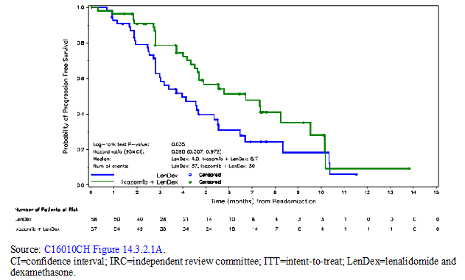

The sponsor additionally conducted a meta-analysis that combined data from the C16010 global study and the China continuation. This analysis was not prospectively planned but rather was conducted to explicate the true PFS benefit of ixazomib and justify that the data are sufficiently compelling to support the current submission. This combined analysis includes all of the available Phase III, unblinded study data of ixazomib+LenDex versus placebo+LenDex in patients with RRMM. The meta-analysis for the primary endpoint of PFS for the C16010 global study (ITT population) and China study (ITT population) using individual patient data (IPD) included a total of 837 patients (ixazomib regimen: n = 417; placebo regimen: n = 420). The overall effects were estimated using the Cox proportional hazards (CPH) model stratified by the study and protocol-specified stratification factors. The results of the IPD meta-analyses are shown [below in Table 62]. The IPD meta-analyses results demonstrated prolonged median PFS in the ixazomib regimen compared to the placebo regimen (median 18.4 months [CI: 16.43, NE] versus 13.0 months [CI: 11.10, 15.64], respectively). The overall treatment effect was statistically significant (HR = 0.699; 95% CI: 0.564, 0.866) with p = 0.0011. The statistical results are considered sufficiently extreme (p 0.00125) to support the positive benefit of the ixazomib regimen.

Table 62: Meta-analysis of PFS using C16010 Global Study and China continuation data

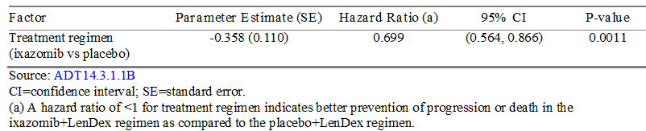

In addition to the IPD meta-analysis of the primary analysis datasets from the C16010 global study and the China continuation, the sponsor performed an additional meta-analysis using the non-inferential exploratory PFS analysis from the 12 July 2015 data cut-off. The results of the 12 July 2015 analysis is consistent with the results from the 30 October 2014 analysis, with sufficiently extreme statistical evidence (HR = 0.770; 95% CI: 0.636, 0.932; p = 0.0075).

* 1. *OS*

As of the 12 July 2015 data cut-off, the OS data from the China continuation were not mature. With a median follow-up of 8.0 months in the ixazomib regimen and 7.8 months in the placebo regimen, 6 patients (11%) in the ixazomib regimen and 16 patients (28%) in the placebo regimen had died. While the median OS is not estimable in either treatment regimen, a positive treatment effect on OS with a HR of 0.323 (p = 0.013) in favour of the ixazomib regimen was noted [see Figure 19, below]. The study's IDMC has recommended that the China placebo controlled study continue in a double blind, placebo controlled manner in order to obtain more mature data on overall survival.

Figure 19: Kaplan-Meier plot of OS, China population

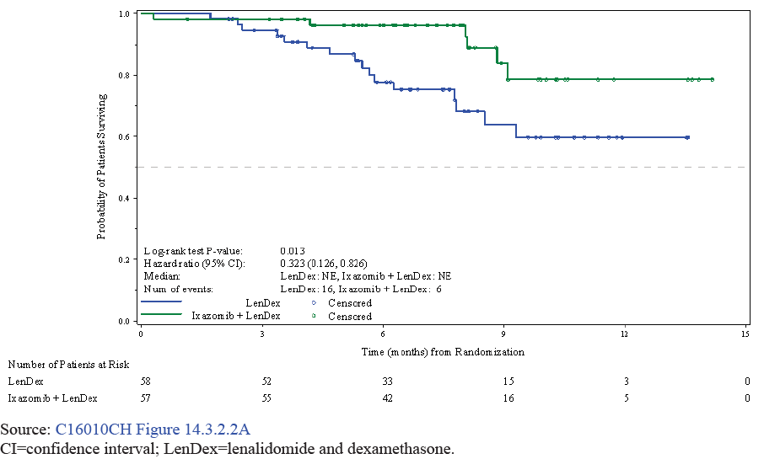

1. *Safety*
   1. *Exposure*

At the time of this primary PFS analysis, the median number of treatment cycles in the China continuation was 7 for the ixazomib regimen and 5 for the placebo regimen. Although the exposure in the overall population to the study drug regimen was shorter in the China continuation (median of 6 cycles) as compared to the C16010 global study (median of 13 cycles), this was attributable to the shorter PFS in the China study; consistent with the shorter treatment duration, the cumulative doses of the individual drugs in the treatment regimens were also smaller. However, there was no difference in the number of patients who discontinued the study treatment regimen because of an adverse event (AE) (9% in the China study versus 12% in the C16010 global study). Furthermore, the relative dose intensities of the 3 agents in the treatment regimen were high and similar across the 2 datasets.

* 1. *Adverse events*

The overall safety profile for patients in the China continuation was similar in both treatment groups. Treatment emergent adverse events (TEAEs) of any grade were reported in 100% of patients in the ixazomib regimen and 95% of patients in the placebo regimen. TEAEs of Grade 3 or higher were reported in 56% and 62% of patients in the ixazomib regimen and placebo regimen, respectively. Serious adverse events (SAEs) were reported in 23% and 26% of patients in the ixazomib regimen and placebo regimen, respectively. A total of 7% of patients in the ixazomib regimen and 11% of patients in the placebo regimen discontinued 1 or more of the 3 agents in the study drug regimen owing to TEAEs. On-study deaths, defined as death during treatment or up to 30 days after last dose of the study drug regimen, were observed in 2 patients (4%) in the ixazomib regimen and 3 patients (5%) in the placebo regimen.

1. *Conclusions of C16010 China continuation*

Both the C16010 global study and the China continuation analyses are based on the ITT population and the results demonstrate the treatment benefit of ixazomib in both ITT populations. In comparing results from the China continuation to the C16010 global study, it is important to note that the China continuation included patients with more advanced disease characteristics at both initial diagnosis (that is, ISS and Durie-Salmon score) and baseline (that is, 2 to 3 prior lines of treatment, more refractory disease) than in the C16010 global study, despite the use of identical eligibility criteria. This observation is consistent with results of large retrospective analyses of outcomes of Chinese patients with MM, which indicated that Chinese patients at diagnosis already have more advanced-stage disease, renal dysfunction, and bone destruction.

This population observation should be considered when interpreting the China continuation results, which, in terms of absolute time to event and response results, are lesser in both treatment regimens than observations in the C16010 global study. Results from the China continuation may therefore be illustrative of antitumor activity of the ixazomib+LenDex regimen in patients with more advanced disease characteristics. Furthermore, the sponsor has identified a subpopulation at higher risk of progression within the C16010 global ITT population in which the positive benefit-risk ratio is indisputable (that is, not only is there consistent PFS benefit in both analyses but there is also a positive survival benefit [HR = 0.706, p = 0.047]). This subpopulation includes patients with adverse risk characteristics similar to those observed in China, including at least 2 prior therapies and/or ISS stage III disease.

Because of these patient population differences, the absolute values in median PFS results are not comparable to the C16010 global population. However, the relative differences between the 2 treatment regimens take into account this underlying difference and offer an additional placebo controlled dataset that supports the efficacy and safety of ixazomib in combination with LenDex [see Table 63, below]. In patients from China with RRMM, the addition of ixazomib to LenDex resulted in a significant improvement in PFS as compared to the standard LenDex combination at the primary PFS analysis (HR = 0.598, p = 0.035). A clear treatment benefit in the ixazomib regimen was additionally observed for the secondary efficacy endpoint of OS (HR = 0.323, p = 0.013). These data support the treatment-benefit conclusions of the ixazomib regimen observed in the Chinese population, and further support the treatment-benefit conclusions observed in the C16010 global study.

As Chinese patients at initial diagnosis already had more advanced disease, and key disease characteristics such as cytogenetics could not be obtained, a matched pair analysis of patients in the 2 datasets could not be performed. However, a meta-analysis was performed for the primary endpoint of PFS for the C16010 global study (ITT population) and China continuation (ITT population) with a total of 837 patients (ixazomib regimen: n = 417; placebo regimen: n = 420) to evaluate the overall treatment improvement. The overall treatment effect was statistically significant (HR = 0.699, 95% CI: 0.564–0.866) with p = 0.0011. The statistical results support the positive benefit of the ixazomib regimen.

Consistent with the differences in absolute values of efficacy parameters between the China continuation and the C16010 global study, there were also differences in overall exposure. These exposure differences were attributable to the shorter PFS in the China continuation; there were similar percentages of patients who discontinued the study treatment regimen because of an AE. Furthermore, the relative dose intensities of the 3 agents in the treatment regimen were high and similar across studies.

The combination of ixazomib+LenDex appears well tolerated, with limited additional toxicity over LenDex alone. Safety results of the C16010 China continuation confirm the observation from the C16010 global study that the ixazomib regimen has a favourable safety profile, with limited additional toxicity over the control regimen. The positive benefit-risk profile of adding ixazomib to LenDex in the Chinese population further supports the overall positive benefit-risk profile of this regimen.

Table 63: Comparative table of key efficacy and safety analyses between the C16010 Global Study and the China continuation

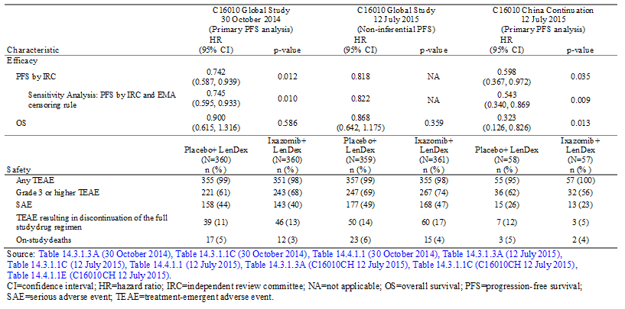

***Clinical evaluator’s comment:***

The sponsor’s response included a comprehensive overview of the updated efficacy data (12 July 2015) from Study C16010 referred to in the FDA review of the US application. The updated data from global Study C16010 has been evaluated and is discussed later in this CER. The Chinese continuation data from Study C16010 are new data claimed by the sponsor to support the findings of the global Study C16010. The Chinese continuation data included a total of 115 patients with more advanced baseline disease compared to the global ITT population. The sponsor noted that, because of clinical differences in the China patient population compared to the global patient population, the absolute values in the median PFS and OS in the China continuation population are not directly comparable to those observed in the global ITT population. Nevertheless, despite the heterogeneity of the two populations the sponsor pooled the data from the two populations and conducted a meta-analysis of PFS. However, the heterogeneity of the two populations raises doubts about the validity of conducting a meta-analysis of PFS on the pooled data.

In the separate analysis of the Chinese continuation population, the primary analysis of PFS (12 July 2015) demonstrated a statistically significant HR of 0.598 (95% CI0.367, 0.972), p = 0.035, in favour of the ixazomib+LenDex group compared to the placebo+LenDex group. The median PFS was 2.7 months longer in patients in the ixazomib group than in the placebo group in the Chinese continuation population, which was shorter than the median difference in PFS between the two treatment groups in both the primary and non-inferential PFS analyses in the global ITT population. The median OS was not estimable in either treatment group in the Chinese continuation population, and the OS data are considered too immature to make meaningful comparisons between the two treatment groups. Overall, the PFS data in the Chinese continuation population are considered to provide limited support for the PFS data in the global ITT population.

***Part 2 - Sponsor’s response; statistical issues referred to in the FDA summary***

Although first interim analysis results of PFS per IRC crossed the pre-specified superiority boundary, the final analysis results of PFS were not statistically significant.

The efficacy benefit for patients treated with the ixazomib regimen was consistent between the primary analysis (30 October 2014) and the analysis conducted after almost 2 years of follow-up (12 July 2015) in Study C16010. The US FDA review noted a shift in the HR for PFS from 0.742 at the primary analysis to 0.818 at the non-inferential analysis (descriptive analysis; 12 July 2015) and a median PFS difference that changed from 5.9 months at the primary analysis to 4.1 months at the non-inferential analysis. The sponsor evaluated the change in HR and determined that it does not bring into question the efficacy of the ixazomib regimen, which was consistent across the 2 analyses, with a median PFS of ≥ 20 months [see Figure 3, below]. However, a change in the HR was driven by a change in the middle part of the slope of the placebo (not ixazomib) curve, resulting in a change in median PFS from 14.7 months at the primary analysis to 15.9 months at the 12 July 2015 analysis for the placebo regimen. A median PFS in the ixazomib regimen was 20.6 months and 20 months in these 2 analyses. A median PFS of ≥ 20 months is among the highest reported in contemporary trials of RRMM. Therefore, in the ITT population treated with the ixazomib regimen, there is no evidence of reduced treatment outcomes with longer follow-up.

Figure 20: Changes in IRC PFS results between the primary analysis and 12 July 2C analysis ITT population

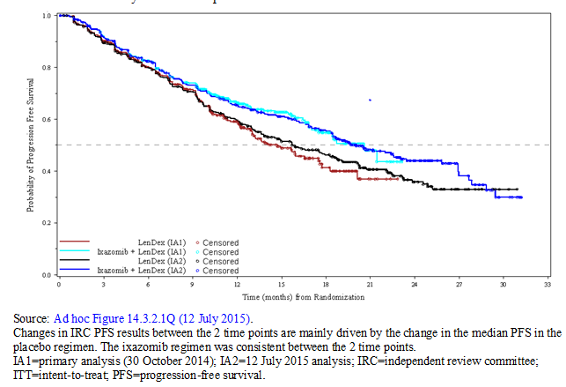

The sponsor evaluated a number of factors that had the potential to impact PFS results at the 12 July 2015 analysis. There was no evidence of an increase in unblinding (15 patients had been unblinded at the primary analysis; 12 additional patients had been unblinded at the 12 July 2015 analysis) and no evidence of an increase in missing data. However, it is possible (though difficult to measure) that there were changes in the investigator actions after the public press release (in February 2015) and communication among investigators that the study had met its primary endpoint at the primary analysis (also in February 2015). For example, not knowing a patient’s treatment regimen in this placebo controlled trial, with the announced positive outcome but without clear differences in toxicity profile between the 2 treatment regimens, may have influenced how long the patient was kept on treatment, and this may have affected the placebo regimen predominantly (see the sensitivity analysis described below).

In investigating the change in PFS from the primary analysis (30 October 2014) to the 12 July 2015 analysis, the following observations, consisting of a combination of partial factors affecting predominantly the placebo regimen, together attributed to the observed shift:

* A contribution of asymmetric (unbalanced) censoring was observed; however, a positive treatment effect was additionally observed in a sensitivity analysis of PFS that counted the initiation of alternative therapy as a PFS event (see analysis below).
* A contribution from patients in Japan on PFS at the 12 July 2015 analysis; these patients enrolled late. The efficacy results in the ITT population, including in patients with high risk cytogenetics, remain robust (see discussion below).
* A contribution from patients with FLC-measurable disease only at study entry. These patients have not to date been well characterized in terms of outcomes.

These 3 contributors to the change in the PFS curve are described in detail below.

*Asymmetric (unbalanced) censoring*

The sponsor conducted a sensitivity analysis of PFS based on IRC assessments and investigated the impact of asymmetric censoring due to the start of alternate therapy prior to obtaining a PFS event. At almost 2 years of follow-up, 22 patients in the ixazomib regimen and 32 patients in the placebo regimen had started an alternate therapy without an IRC-determined PFS event. In this analysis, initiation of alternate therapy was counted as [a progression event at the date of initiation of therapy]. The results of this analysis were consistent with those of the overall analysis and showed prolonged median PFS in the ixazomib regimen compared to the placebo regimen (median PFS 18.4 months versus 13.6 months; HR = 0.792 [95% CI: 0.654, 0.960]; p = 0.017) (see Figure 21, below).

Figure21: Kaplan-Meier plot of PFS, counting alternate therapy as events (sensitivity analysis)

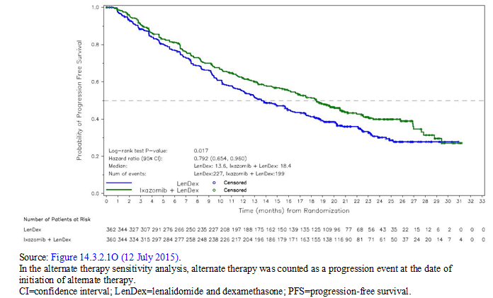

*Contribution from Japan and asymmetric censoring*

The sponsor stopped enrolment in Study C16010 in all regions except Japan as of 15 January 2014 to allow for enrolment of patients in Japan (to support registration requirements in Japan). [In the Global ITT population, the date of the first patient in was 28 August 2012 and date of the last patient in was 15 January 2015. In the Japanese subpopulation, the date of first patient in was 25 November 2013 and the date of the last patient in was 27 May 2014]. Given the late enrolment of patients from Japan into Study C16010 and the resulting disproportionate effect on the 12 July 2015 analysis compared with the primary analysis, the sponsor investigated the contribution of the Japanese subpopulation to the PFS results. The median PFS at the 12 July 2015 analysis among patients outside of Japan and those not subject to the asymmetric censoring described above revealed data consistent with the primary analysis in the ITT population: 18.5 months with the ixazomib regimen, versus 13.2 months with the placebo regimen, for a PFS benefit with ixazomib of 5.3 months (HR = 0.775, p = 0.011). The median PFS data at the primary analysis in the ITT population was 20.6 months versus 14.7 months, for a PFS benefit of 5.9 months with ixazomib (HR = 0.742, p = 0.012).

*Patients with FLC Measurable Disease Only*

A comparison of patients with FLC measurable disease only also showed that PFS events occurred in more patients in the ITT population at the 12 July 2015 analysis than at the primary analysis: 19% versus 8% Patients with disease measurable only by serum FLC assay is a new category according to the IMWG. These patients were typically excluded from earlier clinical trials and their prognosis is not well characterized.

*Conclusion*

Ixazomib added to the LenDex combination comprises an active all-oral treatment option that is manageable and more convenient than the options currently available for treating RRMM. Study C16010 shows a clinically relevant benefit when taking into account the totality of the data from the double blind, placebo controlled trial. The efficacy benefit and safety for the ITT population treated with the ixazomib regimen was consistent between the primary analysis and the analysis conducted after almost 2 years of follow-up in Study C16010; at these analyses, the median PFS was 20.6 months and 20 months, respectively. A median PFS of ≥ 20 months is among the best ever reported in RRMM, historically seen only in patients with newly diagnosed MM not eligible for stem-cell transplantation. As per myeloma experts, even moderate benefits combined with low toxicity provide value for the patient. This consistency in PFS results is supported by consistency in the secondary efficacy endpoint results in the ixazomib regimen at the 2 analyses; for example, time to progression was also > 20 months at both analyses (21.4 months at the primary analysis and 22.4 months at the 12 July 2015 analysis). The apparent shift in the HR for PFS between the primary and 12 July 2015 analyses is a result of a change in the middle part of the PFS curve in the placebo regimen. This change is believed to be the result of several contributing factors (asymmetric censoring, contribution of Japan results, and contribution from FLC-measurable patients). The 2 year estimate for OS is 77.5%, among the highest reported in contemporary trials of RRMM. Therefore, in the sponsor’s view, the efficacy and safety of ixazomib has been shown for the ITT population.

*There was discordance between PFS per IRC and PFS per investigator. Analysis results for PFS per investigator were not significant for both interim and final analysis.*

The pre-specified primary endpoint was PFS based on review by the blinded IRC using established IMWG response criteria, including requiring confirmation of progressive disease (PD). Laboratory assessments for disease status (SPEP, UPEP, FLC, calcium) were performed at a central laboratory; bone marrow assessments for plasma-cell percentage and absence of clonal plasma cells by immunohistochemistry or cytometry were done locally. Additionally, imaging tests were completed, and results were read locally and entered into the electronic data system by the investigator’s site. All central laboratory results, as well as results of the local reads of bone marrow and imaging tests as entered into the electronic case report form, were provided to the IRC. There were 2 primary IRC readers for each patient and, if they disagreed on either the response or the date of the assessment, a third reader reviewed the data and adjudicated the disputed evidence. The IRC was blinded to the treatment assignment and had no knowledge of the principal investigator’s response and progression evaluation.

*C16010 Global Study Data as of 30 October 2014*

As of the 30 October 2014 data cut-off, concordance between the 2 IRC reviewers on the documentation of PD and the date of its occurrence was high. Of the 259 patients with PD, 13% (33/259) required at least 1 PD adjudication by a third blinded IRC reviewer. In 28 of these 33 patients, both reviewers confirmed the PD assessment but differed on the PD date, and in 5 patients, the reviewers differed in the assessment of confirmed PD.

Multiple sensitivity analyses were performed for PFS based on the details of the handling of missing assessments and censoring to evaluate the robustness of treatment effects. These analyses were consistent with the primary analysis, with statistically significant and clinically meaningful prolonged median PFS in the ixazomib regimen compared to the placebo regimen.

The data reviewed for disease status were the same central laboratory and imaging data available to both the IRC and the investigator except that it was clear at times the investigator considered local laboratory results rather than the central results. The IRC did not have access to local laboratory results because as per protocol the primary endpoint was to be assessed, by both the IRC and the investigator, using central laboratory data. However, concordance rates between the IRC and investigator assessments of PD status were high: 91%. Among the 235 patients with PD as assessed by both the IRC and the investigator, the majority (160; 68%) of cases had the same PD date between the IRC and investigator. In 34 cases overall, the absolute difference between the IRC and the investigator was minimal (≤ 4 weeks) with 18 cases less than 4 weeks and 16 cases equal to 4 weeks different. In 41 cases, the absolute difference between the IRC and investigator was > 4 weeks. A summary of the IRC and investigator assessments of PD is presented [below in Table 64]. A scatter plot of days from randomization for confirmed PD by IRC and investigator assessments [showed good concordance].

Table 64: Concordance between IRC and Investigator assessments of PD status ITT population

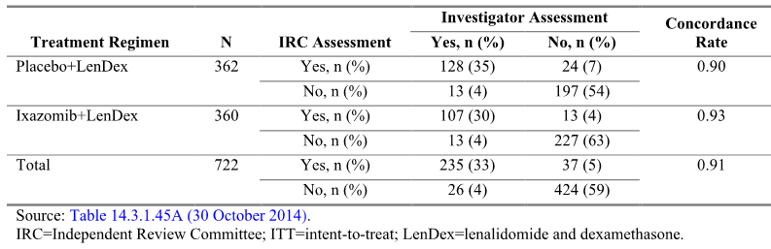

[The sponsor undertook a number of approaches to better understand the difference in PFS as assessed by the IRC and investigators, and details of these were provided in the response. The sponsor undertook a review of the data by two blinded sponsor clinicians. The review showed that the IRC most closely followed the protocol mandated IMWG criteria. The findings of the sponsor’s reviewers aligned with the IRC in 90% of cases]. The sponsor reviewers found that the investigator made 2 main errors with the IMWG criteria: (1) they picked the latest date of disease progression rather than the first date of progression as is expected by the IMWG criteria; and (2) they had difficulty with FLC measurable disease and IMWG criteria [the sponsor notes that] this is one of the first Phase III trials prospectively evaluating treatment outcomes in patients with FLC measurable disease). [The response included a detailed list of the findings of the IRC and investigators for 57 cases. The comparison of the two assessment methods showed that] placebo regimen PD dates were longer when assessed by the investigator [compared to when assessed by the IRC], while in the ixazomib regimen they more correctly assessed PFS. This delay in PD assessments that happened more frequently in the placebo regimen than in the ixazomib regimen explains in [the sponsor’s] view why the therapeutic effect observed in the investigator assessments was smaller than that in the IRC assessments. [Overall, the sponsor considers that, compared to the IRC, some investigators made fundamental errors in the assessment of disease progression].

To further evaluate the discordance between the IRC and investigator assessments, the sponsor conducted a sensitivity analysis of PFS after incorporating discordance between the IRC and investigator assessments. In this analysis, the date of PD used was the date agreed upon by the sponsor clinician reviewers. For the cases where the sponsor reviewers agreed with the IRC, the IRC assessed PD date was used; where the reviewers agreed with the investigator, the investigator-assessed PD date was used, and lastly where the reviewers didn't agree with either the IRC or the investigator, the sponsor assessed PD date was used. Results of this analysis, were consistent with the primary analysis, with significant and clinically meaningful prolonged median PFS in the ixazomib regimen compared to the placebo regimen; median PFS 20.6 months for the ixazomib regimen compared to 14.9 months for the placebo regimen. The PFS was improved by 35% with the ixazomib+LenDex regimen compared to the placebo+LenDex regimen (HR = 0.742, 95% CI: 0.586, 0.939; p = 0.012).

*C16010 Global Study data as of 12 July 2015*

[The outcome of the sponsor’s review of discordance between the IRC and investigator assessments of PD status as of 12 July 2015 was similar to those as of 12 July 2015]. Consistent with observations in the 30 October 2014 analysis, concordance rates between the IRC and investigator assessments of PD status were high: 90% (650/722). Among the 318 patients with PD as assessed by both the IRC and the investigator, the majority (209; 66%) of cases had the same PD date, and the PD date differed between the IRC and investigator in 109 cases. Overall, the absolute difference was ≤ 4 weeks in 49 cases (15%) and > 4 weeks in 60 (19%) cases. The IRC assessed PD date was earlier than the investigator-assessed PD date in 77% (84 of the 109 cases).

[The] sponsor performed its own assessment on the discordant cases. In addition to the 57 cases reviewed as of the 30 October 2014 data cut-off, an additional 29 cases of discordance were reviewed that occurred between 30 October 2014 and 12 July 2015. The sponsor reviewers aligned with the IRC for 27 cases (93%) and with the investigator in 0 cases. In the remaining 2 cases (7%), the sponsor reviewers aligned with neither the IRC nor the investigator: in 1 case, a different date of PD was assigned by the sponsor reviewers; in the other case, the data did not appear to support a confirmed PD, although the patient started alternate therapy.

Overall, for both primary and current analyses combined, 86 cases were reviewed. Of the 86 cases, the sponsor reviewers aligned with the IRC for 78 cases (91%), with the investigator for 3 cases (3%), and with neither for 5 cases (6%). [For] for the patients for whom the IRC and the investigator PD date differed by ≥ 28 days, the placebo regimen PD dates were generally longer when assessed by the investigator than by the IRC. This delay in PD assessment that was more frequent in the placebo regimen than in the ixazomib regimen may have contributed to the observation that the therapeutic effect observed in the investigator-determined PFS analysis was smaller than that in the IRC-determined PFS analysis.

The sponsor also performed a sensitivity analysis of PFS after incorporation of discordance between the IRC and investigator assessments as of the 12 July 2015, using the same methods as used for the 30 October 2014 data cut-off. This resulted in identical median PFS durations as were seen in the original PFS at this current analysis - 20.0 months with ixazomib+LenDex and 15.9 months with placebo+LenDex; and a similar HR (0.823 versus 0.818). Thus, these sensitivity analysis results are consistent with the current PFS assessment.

[The sponsor states that it] is unclear why the investigators consistently delayed calling PD in the placebo regimen more than in the ixazomib regimen, as observed in both the 30 October 2014 data cut-off and the 12 July 2015 data cut-off. In contrast, there were very few PD-event discrepancies between the IRC and the investigator in the ixazomib regimen. The median PFS in the ixazomib regimen was, both in the IRC assessment and in the investigator assessment at both data cut-offs, in the order of 19.5 to 20.5 months, which is clinically meaningful when taking into the consideration the historic PFS results where LenDex has produced median PFS in the range of 11.1 to 14.9 months. In addition, retrospective multicenter analyses of LenDex in real-world settings demonstrated treatment durations and investigator-reported PFS results shorter than the observed results in C16010. The median PFS by investigator in the placebo regimen at both the 30 October 2014 and 12 July 2015 data cut-offs (16.2 months and 17.7 months, respectively) was higher than these historic PFS results for LenDex and higher than reported in the noted real-world setting for this regimen. Together these data support the PFS results from the IRC and add questions to the quality of the PFS results from the investigator.

The US FDA additionally recommended an analysis taking into consideration the impact of the start of alternate therapy to better clarify the actual clinical benefit of adding ixazomib to LenDex. As of the 30 October 2014 data cut-off, the number of patients starting subsequent myeloma therapy was similar; therefore, such an analysis was considered not informative and was not undertaken [on the 30 October 2104 data]. As of the 12 July 2015 data cut-off, approximately 15% of patients started a subsequent therapy (22 [6%] and 32 [9%] of patients, respectively, on the ixazomib and placebo regimens) prior to PD and thus this analysis was conducted [that is, the asymmetric censoring analysis discussed above]. This was not a pre-specified endpoint, criteria for start of subsequent therapy are not defined in the protocol, and the decision about next therapy can be influenced by factors of treatment access, patient decisions, prior therapies, investigator preference; etcetera. Of note, the latter are factors primarily controlled by the investigator and are not controlled at all by the IRC, therefore represent real-life treatment considerations by a physician. In this analysis, the initiation of alternate therapy, as decided by the investigator, was counted as a PFS event. These results were consistent with the overall primary PFS analysis.

***Clinical evaluator’s comment***

The sponsor’s response included a comprehensive overview of the issues raised by the FDA in its summary review of the application relating to results of the second interim, non-inferential analysis of PFS, and the discordance between IRC and investigator assessments of PFS. The evaluator notes that the revised US label (dated November 2015) includes reference to the results of the non-inferential PFS analysis and the planned interim analysis OS undertaken at the same time as the non-inferential PFS analysis. The issue relating to discordance of assessments has been adequately addressed by the sponsor. The issue relating to the interpretation of the second interim, non-inferential analysis of PFS is discussed later in this CER in the second round benefit analysis.

***Part 3; Sponsor’s response; Benefit-risk based on results as of July 2015***

Patients with RRMM represent a heterogeneous group with regard to their demographic characteristics, their prior treatment experience, and the genetic composition of their myeloma. An ideal treatment option would be a combination regimen that targets multiple biological pathways of dysregulation, is tolerable for prolonged treatment periods with minimal toxicity, and has proven clinical benefit across patient groups. In particular, patients with MM characterized as "high risk" by cytogenetic abnormalities tend to respond poorly or are resistant to currently available therapies. The C16010 study enrolled patients with a broad spectrum of characteristics (that is, light chain disease, primary refractory status, prior allogeneic stem cell transplant, high risk cytogenetic abnormalities, moderate renal impairment) so as to accurately represent the patient population seen in clinical practice. The all-oral regimen of ixazomib+LenDex represents a triplet regimen that has demonstrated activity, tolerability, and manageable toxicity in patients with RRMM, including those with high risk cytogenetic abnormalities.

As discussed in the initial submission, data from the primary PFS analysis showed clinical benefit with ixazomib+LenDex in patients with RRMM who received at least 1 prior line of therapy. In C16010 global study as of 12 July 2015, a positive treatment effect in favour of ixazomib+LenDex continues to be observed in the non-inferential exploratory analysis of PFS, and benefit is further supported by positive trends in the predefined secondary endpoints. In the C16010 China continuation, the addition of ixazomib to LenDex resulted in a significant improvement in PFS as compared to the standard LenDex combination at the primary PFS analysis, which supports the results observed in the primary analysis of the C16010 global study. With more prolonged therapy, the safety data as of 12 July 2015 demonstrate that the addition of ixazomib to the background regimen of LenDex did not substantially alter the safety profile of the background regimen.

Despite the increase in the number of therapeutic options for patients with RRMM, the disease remains incurable and there is a need for new and better agents, allowing prolonged disease control while maintaining quality of life. Ixazomib is being developed as a component of an all-oral regimen (ixazomib+LenDex) and has shown compelling activity, tolerability, and manageable toxicity in patients with RRMM. The efficacy demonstrated by the ixazomib regimen at the primary analysis continued at the 12 July 2015 analysis in the C16010 global study, as well as the C16010 China continuation, with no substantial differences in the previously described safety profile. These data continue to demonstrate that adding ixazomib to LenDex has a positive benefit-risk profile for patients with MM who have received at least 1 prior therapy. Therefore, the benefits of the addition of ixazomib to LenDex continue to outweigh the risks in the treatment of patients with RRMM.

[The sponsor summarised the efficacy results from C16010 Global Study, and these results are provided above in the sponsor’s response to other questions. The sponsor stated that the] safety data indicate that the ixazomib regimen (versus the placebo regimen) is similarly well tolerated, and ixazomib does not add clinically significant toxicity to the LenDex background therapy. The treatment emergent adverse events (AEs) in this combination study are consistent with the reported safety profile of the individual agents in the combination regimen and were generally expected on the basis of nonclinical studies with ixazomib, early clinical studies with ixazomib, and clinical experience with the LenDex background regimen. The most common adverse reactions (occurring in ≥ 20% of patients) are diarrhoea, constipation, thrombocytopenia, peripheral neuropathy, nausea, peripheral oedema, vomiting, and back pain, which are primarily low grade and manageable with routine medical measures. No treatment associated safety concern was identified for cardiac, pulmonary, hepatic, thrombovascular, hypertension, or renal toxicity in Study C16010. Additionally, the ixazomib+LenDex regimen provides the convenience of an all-oral dosing regimen that reduces the burden for patients, caregivers, and the healthcare system. [The sponsor summarised the specific safety findings from the 12 July 2015 analysis. The safety findings from this analysis are discussed later in this second round clinical evaluation report].

[The sponsor summarised the efficacy and safety results as of 12 July 2015 from the previously discussed C1610 China continuation study. The sponsor considered that the results of this study support the treatment benefit of the proposed treatment regimen observed in the C16010 global study. In addition, the sponsor considers that the proposed treatment regimen was well tolerated in the C1610 China continuation study, with limited additional toxicity over LenDex].

***Clinical evaluator’s comment***

The sponsor’s response has provided an adequate summary of its position regarding the benefit-risk balance of ixazomib in combination with lenalidomide and dexamethasone for the proposed indication, based on the updated 12 July 2015 efficacy and safety data.

***Part 4; Sponsor’s response; group sequential design; internal validity***

*Principle and interpretation of group sequential design*

Methodology for group sequential clinical trials has been extensively developed, evaluated, and documented, which allows valid analyses of interim data so that a trial can be stopped early. Under this paradigm, a single null hypothesis of no efficacy in the study treatment is set up and several attempts of rejecting the null hypothesis are made during the planned interim and final analyses. The total number of analyses, the analysis timing, and the rate at which the overall significance level is “used up” are usually fixed in advance. The statistical significance threshold at each interim analysis is carefully chosen to maintain the overall type I error rate at some desired level (for example, 1 sided 0.025 level or 2 sided 0.05 level). Once an interim test statistically surpasses the pre-specified threshold, the null hypothesis is rejected, (that is, claiming efficacy of the study drug) and the trial can be stopped. No further inferential statistical testing procedure should be performed as the null hypothesis is already rejected. Any additional analysis would be non-inferential and should be referred to as a non-inferential sensitivity analysis, with only descriptive statistics reported. Group sequential designs with alpha spending functions (for example, Lan-DeMets alpha-spending approach) allows additional flexibility in terms of spending alpha at various time points in the trial based on the actual observed number of events. These designs have been relied upon for many years by the scientific statistical and the clinical trial community as well as regulatory bodies.

The US FDA guidelines of E9 Statistical Principles for Clinical Trials and published draft US FDA guideline on adaptive designs also recognizes group sequential statistical design and analysis methods as “well understood” designs. This is also reflected in recently released draft US FDA guidance on adaptive designs for medical device clinical studies. For C16010 study [see Figure 22, below], the pre-specified first analysis was performed when 286 IRC assessed PFS events occurred. The Lan-DeMets alpha spending function with O’Brien-Fleming boundary approach was also pre-specified for determination of the significance level.

Figure 22: C16010 Global study statistical design

Figure 22: C16010 Global study statistical design
the pre-specified first analysis was performed when 286 IRC assessed PFS events occurred (107 death events
2nd analysis 372 PFS events 171 OS events non-iferential PFS analysisi p-value < 0.00031 calim OS benefit
3rd analysisi 322 death events 44 months from FPI, 322 OS events p-valus < 0.010 
end of study final analysis  486 death events 80 months from FPI 486 OS events p-valuye < 0.0382


An IDMC was established to monitor the C16010 study. At the first analysis, the IDMC recommended that the primary endpoint had been met based on the O’Brien-Fleming spending function and that the trial should continue as prospectively planned in a double blind fashion to allow for further maturation of OS, a key secondary endpoint. Thus, the first analysis is the first and only formal analysis of PFS for statistical testing purpose, and additional statistical testing is not consistent with the statistical principle of group sequential design. Non-inferential analysis of PFS after formal statistical testing was recommended by the agency [presumably the FDA] and agreed to by the sponsor at the End of Phase 2 (EOP2) meeting. Accordingly, as pre-specified in the protocol and SAP, in the event of significant result in first analysis, the PFS analysis at 12 July 2015 is non-inferential and is not to be used for formal statistical testing purpose. Based on a discussion with [information redacted], the leading author of group sequential design with alpha spending approach, we have confirmed that our application of statistical principles in group sequential design is rigorous and accurate.

*Integrity of the study design*

The double blind, placebo controlled study design of Study C16010 allowed for an accurate assessment of the efficacy and safety of ixazomib compared to placebo without knowledge of a patient’s treatment regimen. This eliminated bias that could have been introduced on the basis of expected response or toxicity to treatment. Internal validity was shown conclusively by site and investigator reports that stated the blind was not broken during the study. The double blind design was further upheld because the added toxicity from ixazomib to the background therapy of LenDex was not different enough to distinguish the ixazomib regimen from the placebo regimen. This was supported by the similar rates of dose modifications due to particular AEs that are characteristic of proteasome inhibitors (that is, peripheral neuropathy) between the 2 treatment regimens. Furthermore, having a blinded IRC assess disease progression protected the validity of the primary endpoint and standardized the results across the multiple study centres and investigators. Response assessments were performed every 4 weeks until PD, even if a patient discontinued study treatment, to avoid any potential bias due to a prolonged assessment interval. To the sponsor’s knowledge this degree of rigor is exceptional in MM trials.

*Internal validity conclusions*

For reasons mentioned above, the sponsor justifies utilizing the C16010 pivotal study results in support of marketing approval for ixazomib. The integrity to which the data were collected and analysed supports the internal validity of the study. The relevance of the design, including the broad inclusion criteria for the study population and the clinically meaningful PFS difference, enable extrapolation of the results to the patient population with MM.

***Clinical evaluator’s comment***

The sponsor’s response provided a detailed justification for the statistical method used to analyse the efficacy data. This response is considered to be satisfactory.

##### Sponsor’s response; overall conclusions

[The sponsor provided a summary of the data provided above in its previous response to the clinical questions]. The sponsor justifies utilizing through C16010 pivotal study results in support of market approval for ixazomib in support of marketing approval for ixazomib on the basis of the studies validity, statistical significance, and clinically meaningful benefits in the absence of substantial additional toxicity. [The sponsor concluded that in] a general RRMM patient population, the ixazomib regimen is more effective at improving PFS (median 20.6 months), has high response rates with clinically meaningful durability, adds little clinically significant toxicity, and maintains QoL compared with the LenDex background therapy. The estimated size of the treatment effect (4 to 6 months with an absolute median of 20 to 20.6 months, in line with that reported for patients with newly diagnosed myeloma) is clinically valuable. Additionally, the study population was generally unselected, including patients with either cardiac risk factors or with impaired renal function, which allowed the establishment of the benefit-risk profile in these subgroups. Furthermore, this all oral regimen, not requiring premedication or pre-hydration, is an important factor when considering the age of patients with RRMM, their comorbidities, the toxicities resulting from prior therapy, and the unmet medical need of therapeutic options that are suitable for long-term, continuous treatment. Additionally, the safety profile of ixazomib speaks to patients’ ability to have a long-term regimen combined with disease control maintenance.

***Clinical evaluator’s comment***

The sponsor’s overall conclusions regarding the pivotal Study C16010 are noted.

#### Safety Question 1

*There were no notable differences in the incidence of cardiac arrhythmias SMQ between the two treatment regimens in the ≤ 65 years and > 65 to ≤ 75 years age groups, but cardiac arrhythmias SMQ occurred notably more frequently in patients aged > 75 years in the ixazomib regimen than in the placebo regimen (21% versus 15%, respectively). Please comment on the possible reasons for the difference between the two treatment regimens in the incidence of cardiac arrhythmias SMQ in patients aged > 75 years.*

***Sponsor’s response***

Age was not a pre-specified stratification factor; however, the number of patients in the ≤ 65 years age group and the 85 + years age groups was similar between the 2 regimens. However, the number of patients in the > 65 to ≤ 75 years age group and > 75 years age group were dissimilar between the 2 regimens. More patients in the > 65 to ≤ 75 years age group were in the ixazomib regimen than in the placebo regimen (144 versus 125 patients). Fewer patients in the > 75 years age group were in the ixazomib regimen than in the placebo regimen (47 versus 61 patients).

As of the primary analysis (30 October 2014), cardiac arrhythmia (per Cardiac arrhythmia Standardized MedDRA Query [SMQ]) was reported in 10 patients aged > 75 years (21%) in the ixazomib regimen versus 9 patients aged > 75 years (15%) in the placebo regimen [see Table 65 below]. Because of the lower number of patients aged > 75 years in the ixazomib regimen versus the placebo regimen (47 versus 61 patients), each patient in the ixazomib regimen has a greater effect on the incidence than a patient in the placebo regimen. Thus, the single patient difference in number of patients with an arrhythmia event in the ixazomib regimen compared with the placebo regimen (10 versus 9 patients) resulted in a 6% difference in the incidence (21% versus 15%). In other words, this is an artefact of the imbalance between the regimens of the low number of patients in the > 75 age group.

At almost 2 years of follow-up (data cut-off 12 July 2015), which included an additional 8.5 months of follow-up since the primary analysis, the frequency of cardiac arrhythmia in patients > 75 years was similar between the 2 regimens (11 patients [23%] in the ixazomib regimen and 12 [20%] in the placebo regimen; see Table 65 below). The absolute difference between the ixazomib and placebo regimens noted in the incidence of cardiac arrhythmia occurring in patients aged > 75 years is attributed to 1 additional patient in the placebo regimen.

A review was conducted to identify patients with cardiac risk factors (defined as diabetes, hypertension, obesity, or hypercholesterolemia/hyperlipidaemia) and terms indicating prior or ongoing heart disease (for example, records of myocardial infarction, cardiac ischemia and angina, and congestive heart failure) from medical histories. The majority of the 23 patients (11 in the ixazomib and 12 in the placebo regiment, respectively) aged > 75 years who had an arrhythmia event (pooled) had pre-existing cardiac risk factors and/or pre-existing cardiac disease at baseline. Among 11 patients in the ixazomib regimen aged > 75 years who had an arrhythmia, 7 had pre-existing cardiac risk factors, 5 had pre-existing cardiac disease, and only 1 had no risk factors or cardiac history. Two patients had overlapping pre-existing cardiac risk factors and/or pre-existing cardiac disease. Among the 12 patients in the placebo regimen aged > 75 years who had an arrhythmia, 11 had pre-existing cardiac risk factors, 6 had a pre‑existing cardiac disease, and only 1 had no risk factors or cardiac history. Six patients had overlapping pre-existing risk factors and/or pre-existing cardiac disease.

Given the low number of arrhythmia events observed at both interim analyses, and the similar frequency seen in both regimens, there is no safety concern with respect to ixazomib and arrhythmia events in patients aged ˃ 75 years. The arrhythmias in patients in this age group are more likely a function of their age, previous therapies, and underlying medical history than ixazomib related toxicity.

Table 65: Treatment emergent cardiac arrhythmias by age- safety population

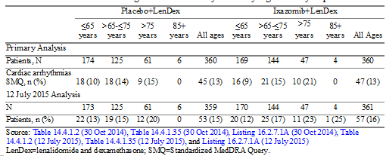

***Clinical evaluator’s comment***

The sponsor’s response is satisfactory.

#### C16010 Clinical Study Report Addendum 1

##### Background

The sponsor’s response to the TGA’s second request for additional information included Addendum 1 to the CSR for the pivotal Phase III Study C16010. The data cut-off for Addendum 1 was 12 July 2015, and the addendum was dated 29 January 2016. As Study C16010 is an ongoing study with an open database, investigators could not only enter new data, but also provide modifications or updates to data included in the C16010 CSR. Resolution of data queries, investigator-initiated changes to characterise evolving data between the data cut-offs, and reclassification of one placebo regimen patient to the ixazomib regimen in the safety population resulted in a changed frequency of some baseline and safety parameters between the primary analysis and the analysis provided in this CSR addendum.

##### Primary efficacy analysis

The primary efficacy analysis in the addendum was OS in the ITT population (that is, the first key secondary efficacy endpoint). A 2 sided, stratified log-rank test was used to compare the treatment groups with respect to OS, and the test significance level was decided by the O’Brien‑Fleming alpha spending function (the Lan-DeMets method). Given the rules for statistical testing of hierarchical endpoints, OS in patients harbouring del(17p) (that is, the second and last key secondary efficacy endpoint) would be assessed for statistical significance only if OS in the ITT population (that is, the first key secondary efficacy endpoint) was found to be statistically significant. The p value for OS in the ITT population in this analysis did not cross the pre-specified efficacy boundary. Therefore, death events continue to be monitored as per the protocol, and the study continues to be conducted in a double blind, placebo controlled fashion in accordance with the recommendation of the IDMC.

##### Patient disposition

Patient disposition, as of 12 July 2015, is summarised below in Table 66. At the cut-off date, 269 (37%) patients were continuing on treatment (136 ixazomib [38%]; 133 [37%] placebo), and 453 (63%) patients had discontinued study treatment (224 ixazomib [62%]; 229 [63%] placebo). The 2 most common primary reasons for patients discontinuing study treatment were progressive disease (124 ixazomib [34%]; 146 [40%] placebo) and adverse event (60 ixazomib [17%]; 50 [14%] placebo). Patients who stopped treatment for any reason other than disease progression were to continue in the PFS follow-up phase until documented disease progression. Of the 453 patients who had discontinued treatment, 87 (12%) patients participated in PFS follow-up phase (52 [14%] ixazomib; 35 [10%] placebo). After disease progression, patients continued in the OS follow-up phase, and 357 (49%) patients participated in OS follow-up (172 [48%] ixazomib; 185 [51%] placebo).

As of 12 July 2015, a total of 52 (7%) patients had withdrawn from study treatment with a primary reason of “other” (31 [9%] ixazomib; 21 [6%] placebo). Of these 52 patients, 40 decided to discontinue study treatment (of whom 37 agreed to continue with follow-up); 5 withdrew to undergo stem cell transplant; 2 withdrew due to patient and physician decision (for example, degradation of general health status); 2 were withdrawn due to progressive disease (PD) on the basis of local standards; 1 discontinued to initiate another anti-multiple myeloma regimen; 1 withdrew due to a deterioration in performance status; and 1 experienced a serious pre-treatment adverse event and never received study drug.

Table 66: Patient disposition, as of 12 July 2015

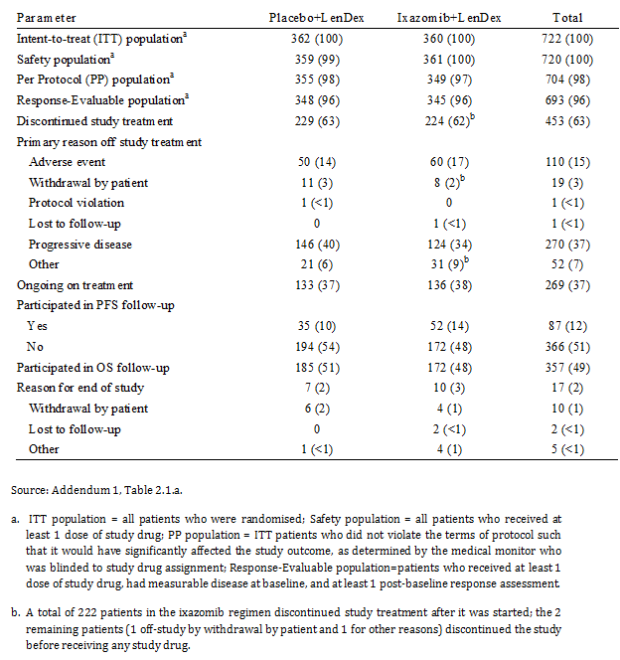

##### Protocol violation

As of the data cut-off date (12 July 2015), major protocol deviations had been reported in 12 (3%) patients in the placebo group and 18 (5%) patients in the ixazomib group. The major reasons for protocol violations in the ixazomib group (versus placebo group) were inclusion and/or exclusion criteria issues (n = 10, 3% versus n = 6, 2%). As of the data cut-off date, a total of 27 patients (n = 6, ixazomib; n = 21, placebo) had been unblinded. Of the 372 patients who had experienced disease progression or death, 17 patients (n = 4, ixazomib; n = 13, placebo) were unblinded in order for the treating physician to choose subsequent therapy; 2 additional placebo group patients with PD did not have alternate therapy data available; and 1 additional placebo group patient with PD did not receive alternate therapy. Three (3) additional patients were unblinded due to toxicity: 1 for fever (placebo), 1 for hypercalcaemia (placebo), and 1 for acute heart failure (ixazomib); 3 patients died (n = 1, ixazomib; n = 2, placebo); and 1 patient withdrew consent and was unblinded (placebo).

##### Efficacy results for 12 July 2015

###### Overall survival (OS) in the ITT population

OS in the ITT population, a pre-specified key secondary efficacy endpoint, was an inferential efficacy endpoint for the 12 July 2015 analysis. OS was calculated from the date of randomisation to the date of patient death due to any cause. As of 12 July 2015, 35 months after the first patient was enrolled and with median durations of follow-up of 23.3 months and 22.9 months in the ixazomib and placebo groups, respectively, a total of 171 deaths had been observed (81 [23%] in the ixazomib group and 90 [25%] in the placebo group). Three (3) patients in the ixazomib group had been lost to follow-up, while the remaining 548 patients in the study were alive at last contact and were censored (276 [77%] ixazomib; 272 [75%] placebo). At the current analysis, only 35% (171/486) of the pre-specified number of events required for the final OS analysis had been reported, and the median OS had not been reached in either treatment group. Therefore, the OS data for the study remain immature. As recommended by the IDMC, the study is continuing in a double blinded manner. The results are summarised below in Table 67.

Table 67: Overall survival, as of 12 July 2015, ITT population

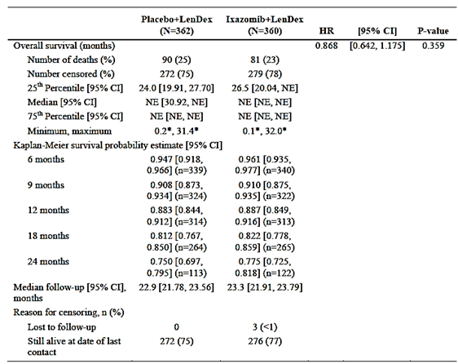

The Kaplan-Meier curves for OS for the two treatment groups are summarised below in Figure 23. The individual curves for the ixazomib and placebo groups were virtually superimposable throughout the observation period.

Figure 23: Kaplan-Meier curves of overall survival (OS), as of 12 July 2015, ITT population

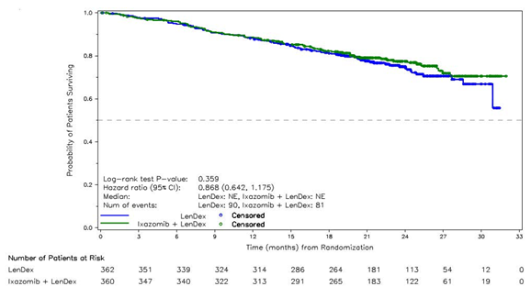

To investigate whether the survival results were influenced or confounded by the type and frequency of subsequent therapy, the sponsor performed an analysis on the subsequent antineoplastic therapies undertaken following disease progression. As of the 12 July 2015 data cut-off date in the safety population, 135 (37%) patients in the ixazomib group and 145 (40%) patients in the placebo group had received subsequent antineoplastic therapy. Seventeen (17) patients) were unblinded after disease progression in order for the treating physician to choose subsequent therapy (n = 4, ixazomib; n = 13, placebo). The median time to subsequent antineoplastic therapy was not estimable in either treatment regimen, but showed a trend in favour of the ixazomib regimen (HR = 0.893).

The types of subsequent antineoplastic therapies reported remained balanced between the 2 treatment groups. Overall, the most frequently reported subsequent antineoplastic therapies were dexamethasone (n = 102, 28%, ixazomib; n = 116, 32%, placebo), bortezomib (n = 79, 22%, ixazomib; n = 88, 25%, placebo), and cyclophosphamide (n = 48, 13%, ixazomib; n = 63, 18%, placebo). Three (3) patients in the placebo regimen (< 1%) subsequently received ixazomib. Five (5) patients (n = 4, ixazomib; n = 1, placebo) withdrew to undergo stem cell transplant. The subsequent antineoplastic therapies taken after disease progression are summarised below in Table 68.

Table 68: Summary of subsequent antineoplastic therapy used by ≥ 1% of patients in either treatment group, safety population

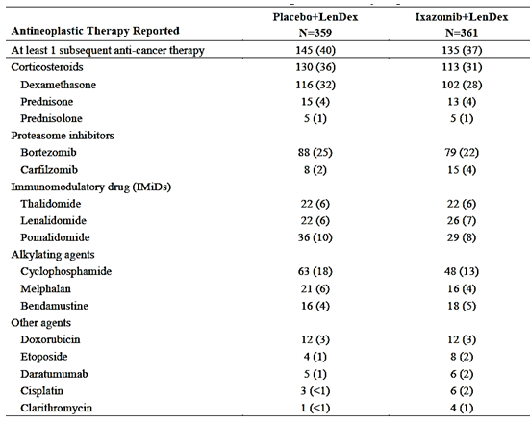

##### Overall survival in high risk patients harbouring del(17p)

The updated OS data in high risk patients harbouring del(17p) in the ITT population remain immature. A total of 69 patients (n = 36, ixazomib; n = 33, placebo) had del(17p) chromosomal abnormality in the myeloma plasma cells, which is a negative prognostic factor in MM. With median durations of follow-up of 21.5 months and 23.0 months in the ixazomib and placebo groups, respectively, 9 (25%) patients in the ixazomib group and 15 (45%) patients in the group had died. The remaining 45 high risk patients harbouring del(17p) were alive and were censored (n = 27 [75%] ixazomib; n = 18 [55%] placebo). The median OS was not reached in the ixazomib group and was 30.9 months in the placebo group. The HR was 0.487, and in accordance with the pre-specified hierarchical statistical testing procedure no inferential analysis of the results was undertaken. The results are summarised below in Table 69.

Table 69: Overall survival in high risk patients harbouring del(17p), as of 12 July 2015, ITT population

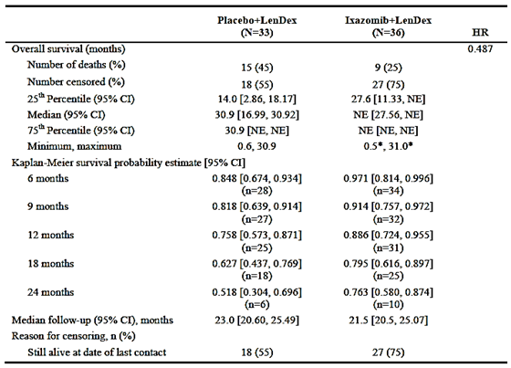

The Kaplan-Meier curves for OS for high risk patients harbouring del(17p) began to separate in favour of the ixazomib group compared to the placebo group at about 3 months after randomisation (see Figure 24, below).

Figure 24: Kaplan-Meier curves of overall survival (OS) for high risk patients harbouring del(17p), as of 12 July 2015, ITT population

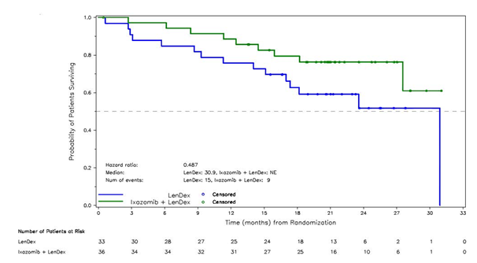

##### Progression-free survival (PFS); non-inferential

PFS was measured as the time from randomisation to the date of first documented PD or death. As of the data cut-off date for the analysis, with median durations of follow-up of 23.3 months and 22.9 months in the ixazomib and placebo groups, respectively, 177 (49%) patients in the ixazomib group and 195 (54%) patients in the placebo group had experienced PD or death. Based on the 372 IRC assessed events, the median PFS was 20.0 months in the ixazomib group and 15.9 months in the placebo group (HR = 0.818 [95% CI: 0.67, 1.0]; p = 0.054). The majority of events in both treatment groups was disease progression rather than death. The descriptive results for PFS are summarised below in Table 70.

Table 70: Progression-free survival (PFS) based on IRC assessment, as of 12 July 2015, descriptive results, ITT population

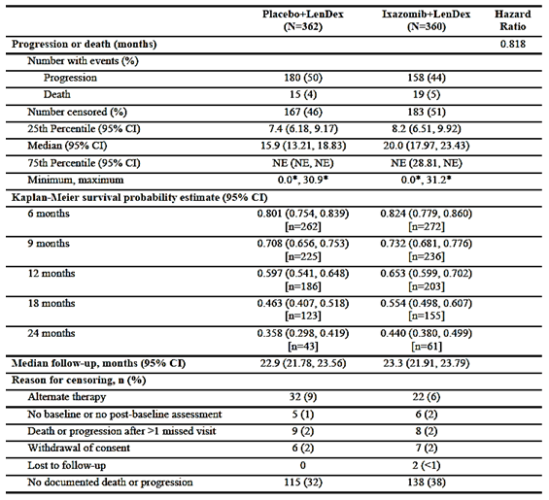

The Kaplan-Meier curves for PFS showed separation in favour of the ixazomib group compared to the placebo group beginning at about 6 months after randomisation and continuing throughout the observation period (see Figure 25).

Figure 25: Kaplan-Meier curves of progression-free survival (PFS) based on IRC assessments, as of 12 July 2015, ITT population

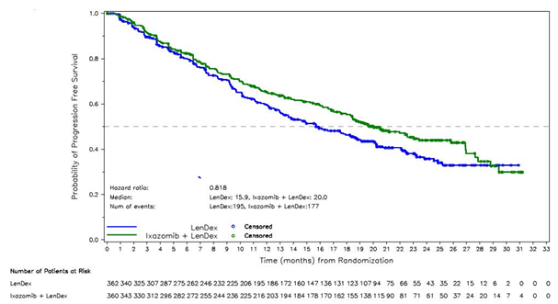

The Kaplan-Meier curves for the initial (primary) inferential analysis of PFS and the updated non-inferential analysis of PFS are provided below in Figure 26. Of note, the two ixazomib curves are very similar while the two placebo curves begin to separate at approximately 12 months after randomisation, with PFS favouring the placebo group at the time of the second (non-inferential analysis) compared to the placebo group at the time of the primary analysis. The shift in PFS in the placebo group in the second (non-inferential) analysis had the effect of shifting the HR closer to unity.

Figure 26: PFS based on IRC assessment in the primary analysis and the updated (non‑inferential) analysis, ITT population

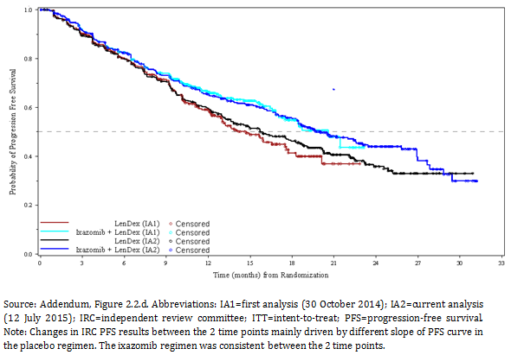

The sponsor evaluated a number of factors with the potential to have affected the second, non-inferential PFS analysis. The sponsor found no evidence of study conduct issues post-primary analysis, no evidence of an increase in unblinding in the second analysis (15 patients had been unblinded at the first analysis; 12 additional patients had been unblinded at the second analysis) and no evidence of an increase in missing data. The sponsor also determined that the PFS results at the second, non-inferential analysis were not driven by post-primary analysis revision to IRC assessments.

The sponsor also examined the potential effects on the second, non-inferential PFS analysis of asymmetric censoring between the two treatment groups, late enrolment of patients from Japan, and the contribution from patients with disease measurably only by serum FLC assay at study entry. The effects of these factors have been previously discussed. In the PFS analyses accounting for asymmetric censoring, and the contribution of patients from Japan plus asymmetric censoring, the results were consistent with those observed in the primary PFS analysis. A comparison of patients in the ITT population with only FLC measurable disease showed that PFS events occurred more frequently in the second analysis compared to the primary analysis. A total of 19% of patients (6 in the ixazomib group and 11 in the placebo group of 90 patients overall who had a new PFS event after the primary analysis) had PFS in the 12 July 2015 analysis compared to 8% of patients (14 in the ixazomib group and 10 in the placebo group of 286 patients overall who had a PFS event in the 30 October 2014 analysis) in the primary PFS analysis. The sponsor states that patients with disease; measurable only by serum FLC assay is a new category according to the IMWG. These patients were typically excluded from earlier clinical trials and their prognosis is not well characterised. The PFS results based on the characteristics of measurable disease are summarised below in Table 71.

Table 71: Characteristics of measurable disease for evaluation of PFS at primary analysis and 12 July 2015 analysis; ITT population

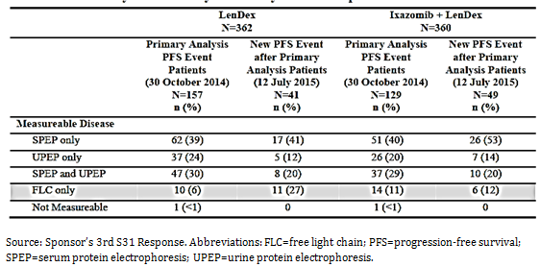

The sponsor also provided the updated results for the pre-specified sensitivity analyses of PFS based on IRC assessment. The results of the sensitivity analyses of PFS were numerically consistent with the result for the analysis of PFS in the ITT based on IRC assessment. The results of the sensitivity PFS analyses are provided below, with the outcomes of the statistical analyses being provided for information only:

* Alteration 1: Disease progression documented between scheduled visits was counted as a progression event at the date of disease progression. Median PFS: ixazomib = 20.0 months versus placebo = 15.9 months; HR = 0.818 (95% CI: 0.666, 1.004); p = 0.054.
* Alteration 2: Alternate antineoplastic therapy started prior to disease progression was counted as an event at the date of disease progression. Median PFS: ixazomib = 19.6 months versus placebo = 15.7 months; HR = 0.819 (95% CI: 0.669, 1.001); p = 0.051.
* Alteration 3: Death or disease progression after more than 1 missed visit was counted as an event at the date of disease progression or death. Median PFS: ixazomib = 19.5 months versus placebo = 15.7 months; HR = 0.813 (95% CI: 0.665, 0.994); p = 0.043.
* Alteration 4: EMA criteria: Disease progression documented between scheduled visits was counted as a progression event at the date of disease progression. Alternate antineoplastic therapy started prior to disease progression was counted as an event at the date of disease progression. Death or disease progression after more than 1 missed visit was counted as an event at the date of disease progression or death. In this analysis, the median PFS was 18.8 months in the ixazomib group and 15.0 months in the placebo group: HR = 0.822 (95% CI: 0.677, 0.999); p = 0.048. The results were based on a total of 416 IRC assessed results, including 196 (55%) in the ixazomib group and 217 (60%) in the placebo group.

The sensitivity analysis of PFS based on investigator assessment showed that the median duration of PFS was 19.7 months in the ixazomib group (175 events) and 17.7 months in the placebo group (189 events).

Non-inferential PFS analysis (based on IRC determinations) was assessed in a large number of subgroups. These subgroup analyses explored the effects of various covariates that might confound PFS outcomes, such as baseline stratification factors, demographic characteristics, and number and types of prior therapy. The PFS subgroup analyses consistently favoured the ixazomib group compared to the placebo group. Subgroups associated with poor prognosis were pre-specified in the statistical analysis plan and included patients with high risk cytogenetics, patients refractory to any prior therapy, patients who had received 2 to 3 prior lines of therapy, patients refractory to thalidomide, patients with ISS Stage III at screening, patients with ECOG = 2, and patients over 75 years of age. The results for all subgroup PFS analyses are summarised below in Figure 27.

Figure 27: Forest plot for PFS survival by subgroup, data cut-off 12 July 2015, ITT population

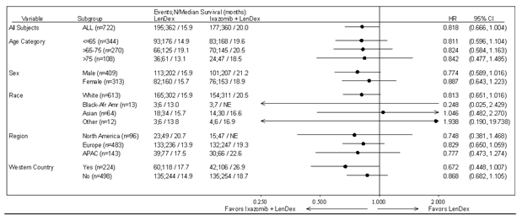

Figure 27 (continued): Forest plot for PFS survival by subgroup, data cut-off 12 July 2015, ITT population.

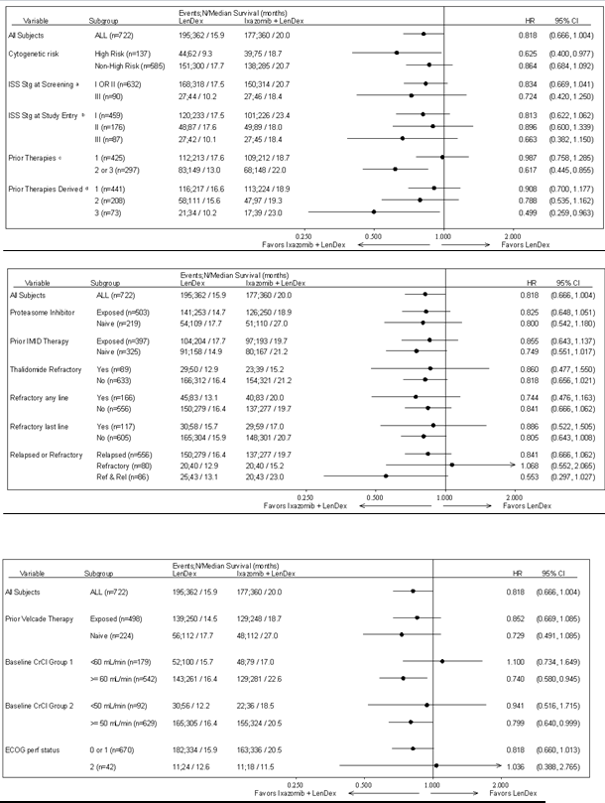

##### Secondary efficacy endpoints

* Time to progression (TTP), assessed by the IRC was measured as the time from the date of randomisation to the date of first documentation of disease progression. Patients without documentation of PD were censored at the date of the last response assessment classified as SD or better. Documented PD was reported in 44% (n = 158) of patients in the ixazomib group and 50% (n = 180) of patients in the placebo group. The median time to progression was 22.4 months in the ixazomib group and 17.6 months in the placebo group (HR = 0.792).
* The overall response rate (ORR), defined as partial response [PR] or better, was determined from the start of the study treatment until the end of treatment, taking into account any requirement for confirmation. The confirmed ORR (complete response [CR] + PR [including stringent complete response (sCR) and very good partial response (VGPR)]) was 78.6% (n = 283) in the ixazomib group and 73.2% (n = 265) in the placebo group; Odds Ratio = 1.35, p = 0.089. The confirmed VGPR or better rate (CR+VGPR including sCR) was 51.4% (n = 185) in the ixazomib group and 43.9% (n = 159) in the placebo group; Odds Ratio = 1.35. The confirmed CR rate in the ixazomib group was higher than in the placebo group (14.7% [n = 53] versus 10.2% [n = 37]); Odds Ratio = 1.52. Stable disease was reported by 37 (10.3%) patients in the ixazomib group and 53 (14.6%) patients in the placebo group. Twenty-three patients (6.4%) in each treatment regimen were not evaluable.

##### Quality of life outcomes

* Global Health Status scores on the EORTC QLQ-C30 were similar in the 2 treatment groups over time when analysed by mean score at each cycle.
* MY-20 scores for side effects of treatment were similar in the 2 treatment groups over time when analysed by mean score at most cycles.

##### Safety results for 12 July 2015

###### Overview

The C16010 CSR, Addendum 1, included updated safety data with a cut-off date of 12 July 2015. Throughout the discussion of safety provided in the addendum, the sponsor noted differences between treatment groups of ≥ 10 percentage points. For treatment emergent adverse events (TEAEs) based on preferred term (PT), Grade 3 TEAEs, Grade 4 TEAEs, serious adverse events (SAEs), and TEAEs of clinical importance, the sponsor noted differences between treatment groups of ≥ 5 percentage points. Differences between treatment groups that did not meet the above criteria were termed by the sponsor to be similar or generally similar.

The safety population consisted of 720 patients who received at least 1 dose of study drug (n = 361, ixazomib; n = 359, placebo). The sponsor stated that an IDMC reviewed the unblinded safety data 5 times between May 2013 and October 2015 and recommended continuing the study as planned after each review.

###### Exposure

The median number of treatment cycles was 17.0 (range: 1, 34 cycles) in the ixazomib group and 15.0 (range: 1, 34 cycles) in the placebo group. Overall, 233 (65%) patients in the ixazomib group and 227 (63%) patients in the placebo group received at least 12 cycles of therapy. Eighteen (18) cycles of therapy were received by 174 (48%) patients in the ixazomib group and 156 (43%) patients in the placebo group, and 24 cycles of therapy were received by 84 (23%) and 81 (23%) patients in the ixazomib and placebo groups, respectively. At the time of the data cut-off for the analysis, 136 (38%) patients in the ixazomib group were still on study treatment compared to 133 (37%) patients in the placebo group.

The median dose intensity for ixazomib and placebo was similar in the ixazomib and placebo groups (97.4% versus 98.8%, respectively). In addition, the median dose intensity was similar in both the ixazomib and placebo groups for lenalidomide (93.8% versus 96.6%, respectively), and for dexamethasone (92.2% versus 94.9%, respectively).

###### Adverse events

Overview of adverse events

High level AEs in the two treatment groups are summarised below in Table 72.

Table 72: Overall summary of treatment emergent adverse events, safety population

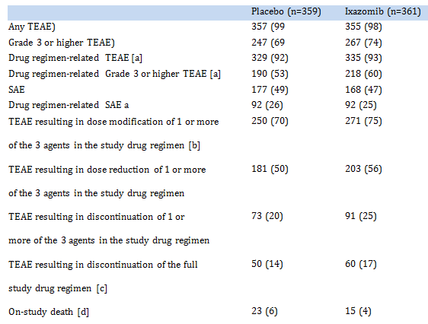

a. TEAE assessed by the investigator as that was related to any drug in the drug combination (placebo, ixazomib, lenalidomide, or dexamethasone) was considered to be treatment related. b. Dose modification includes dose delay, dose reduction, and drug discontinuation, the latter which could represent discontinuation of an individual drug in the combination or a discontinuation of the full treatment regimen. c. Discontinuation of full study drug regimen data are given for the intent-to-treat population (N = 362 for placebo+LenDex and N = 360 for ixazomib+LenDex). d. On-study deaths are defined as deaths that occur within 30 days of the last dose of study drug.

###### Most commonly reported TEAS by SOC

TEAEs reported in ≥ 50% of patients in either the ixazomib, or placebo group by SOC and the 2 most commonly events in each grouping are summarised below:

* Infections and infestations (74%, placebo versus 76%, ixazomib); URTI (19% versus 23%, respectively); nasopharyngitis (20% versus 22%, respectively).
* Gastrointestinal disorders (68%, placebo versus 74%, ixazomib); diarrhoea (39% versus 45%, respectively); constipation (26% versus 35%, respectively).
* General disorders and administration site conditions (65%, placebo versus 66%, ixazomib); fatigue (28% versus 29%, respectively); oedema peripheral (20% versus 28%, respectively).
* Musculoskeletal and connective tissue disorders (63%, placebo versus 65%, ixazomib); muscle spasms (26% versus 18%, respectively); back pain (17% versus 24%, respectively).
* Nervous system disorders (58%, placebo versus 61%, ixazomib); peripheral sensory neuropathy (15% versus 19%, respectively); headache (12% versus 12%, respectively).
* Skin and subcutaneous disorders (39%, placebo versus 51%, ixazomib); pruritus (7% versus 11%, respectively); rash macular (7% versus 7%, respectively).
* Blood and lymphatic system (48%, placebo versus 51%, ixazomib); anaemia (27% versus 29%, respectively); neutropenia (26% versus 29%, respectively).

For the following TEAEs by SOC occurring in ≥ 30% of patients in either treatment group, the patient incidence was ≥ 5 percentage points higher in the ixazomib group than in the placebo group: gastrointestinal disorders (74% versus 68%, respectively); skin and subcutaneous tissue disorders (51% versus 39%, respectively); and eye disorders (32% versus 23%, respectively). Conversely, the patient incidence of TEAEs by SOC was ≥ 5 percentage points lower in the ixazomib group than in the placebo group for psychiatric disorders (34% versus 40%, respectively).

###### Most commonly reported TEAEs by PT

TEAEs reported in ≥ 10% of patients in either the ixazomib or the placebo group are summarised below in Table 73.

Table 73: TEAEs reported in ≥ 10% of patients in either the ixazomib or placebo group by preferred term, safety population

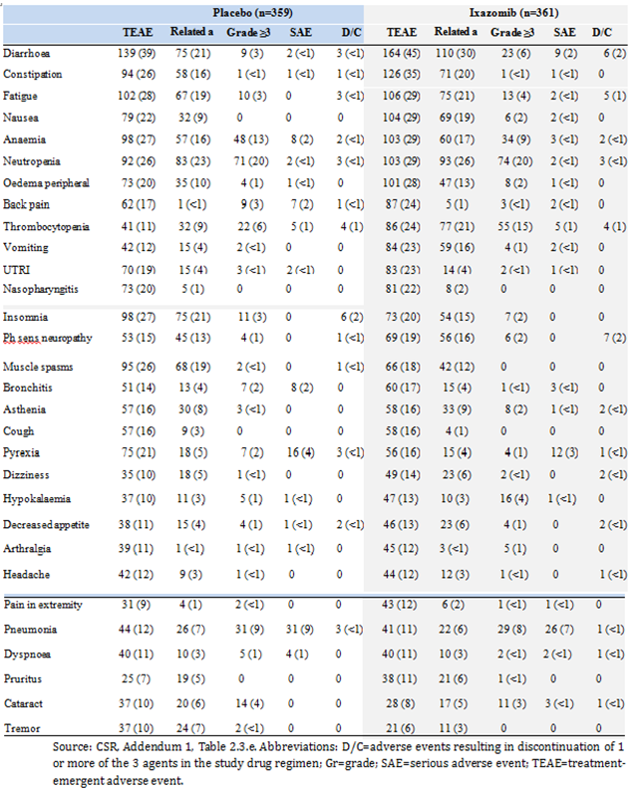

a. TEAE assessed by the investigator as related to any drug in the drug combination (placebo, ixazomib, lenalidomide, or dexamethasone) was considered to be treatment related.

TEAEs (PT) of any grade reported in ≥ 10% patients in either treatment group and in ≥ 5% more patients in the ixazomib group than in the placebo group, respectively, were diarrhoea (45% versus 39%), constipation (35% versus 26%), nausea (29% versus 22%), peripheral oedema (28% versus 20%), back pain (24% versus 17%), thrombocytopenia (24% versus 11%), and vomiting (23% versus 12%). TEAEs (PT) of any grade reported in ≥ 10% of patients in either treatment group and in ≥ 5% fewer patients in the ixazomib group than in the placebo, respectively, were insomnia (20% versus 27%), muscle spasms (18% versus 26%), and pyrexia (16% versus 21%).

###### Grade 3 and 4 TEAEs

Grade 3 TEAEs reported in ≥ 5 patients in either treatment group are summarised below in Table 74. Grade 3 TEAEs were reported in 52% (n = 187) of patients in the ixazomib group and 47% (n = 170) of patients in the placebo group. Grade 3 TEAEs reported in ≥ 2% more patients in the ixazomib group compared to the placebo group were neutropenia (17% versus 15%), thrombocytopenia (9% versus 4%), diarrhoea (6% versus 3%), leukopenia (4% versus < 1%), hypertension (3% versus 1%), and nausea (2% versus 0%).

Table 74: Grade 3 TEAEs reported in at least 5 patients in either the ixazomib of placebo group, safety population

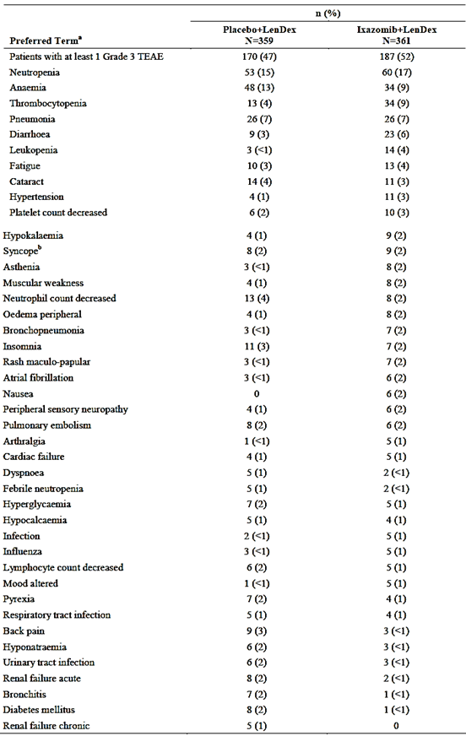

a. A patient reporting the same event more than once had that event counted only once within each preferred ,term using the highest intensity. b. Per CTCAE Version 4.03, syncope has only 1 grade, which is Grade 3.

Grade 4 TEAEs were reported in 18% (n = 65) and 15% (n = 54) of patients in the ixazomib and placebo groups, respectively. The most commonly reported Grade 4 TEAEs (≥ 2% in either treatment group [ixazomib versus placebo, respectively]) were thrombocytopenia (6% versus 3%), neutropenia (4% versus 5%), and hypokalaemia (2% versus < 1%). No Grade 4 TEAEs occurred in ≥ 5% more or fewer patients in one treatment group compared to the other.

##### Treatment related TEAEs; related to any of the 3 study drugs

Treatment related TEAEs (as determined by the investigator) were reported in 93% of patients in the ixazomib group and 92% of patients in the placebo group. Treatment related TEAEs reported in ≥ 10% of patients in the ixazomib group (versus the placebo group), in descending order of frequency, were, diarrhoea (30% versus 21%), neutropenia (26% versus 23%), thrombocytopenia (21% versus 9%), fatigue (21% versus 19%), constipation (20% versus 16%), nausea (19% versus 9%), anaemia (17% versus 16%), vomiting (16% versus 4%), peripheral sensory neuropathy (16% versus 13%), insomnia (15% versus 21%), oedema peripheral (13% versus 10%), and muscle spasms (12% versus 19%).

Treatment related TEAEs reported in ≥ 10% more patients in the ixazomib group compared to the placebo group were thrombocytopenia (21% versus 9%), nausea (19% versus 9%), and vomiting (16% versus 4%). No other Treatment related TEAEs were reported in ≥ 10% more or fewer patients in one treatment group compared to the other treatment group.

Grade 3 treatment related TEAEs reported in ≥ 2% of patients in the ixazomib group are summarised below in Table 75. Grade 3 Treatment related TEAEs related to any of the 3 study drugs were reported in 47% (n = 171) of patients in the ixazomib group and 40% (n = 144) of patients in the placebo group. The only Grade 3 treatment related TEAE reported in ≥ 5% more or fewer patients in one treatment group than in the other treatment group was thrombocytopenia (9%, ixazomib versus 3%, placebo).

Grade 4 treatment related TEAEs were reported in 12% (n = 43) of patients in each of the two treatment groups. Grade 4 Treatment related TEAEs reported in ≥ 2 more patients in either treatment group (ixazomib versus placebo, respectively), in descending order of frequency in the ixazomib group were thrombocytopenia (n = 19, 5% versus n = 7, 2%), neutropenia (n = 14, 4% versus n = 17, 5%), hypokalaemia (n = 3, < 1% versus n = 1, < 1%), neutrophil count decreased (3, < 1% versus n = 1, 4%), platelet count decreased (n = 3, < 1% versus n = 3, < 1%), septic shock (n = 2, < 1% versus n = 2, < 1%), leukopenia (n = 1, < 1% versus n = 3, < 1%), pneumonia (n = 1, < 1% versus n = 3, < 1%), cardiac failure (n = 0 versus n = 2, < 1%), febrile neutropenia (n = 0 versus n = 2, < 1%), and sepsis (n = 0 versus n = 2, < 1%). There was no Grade 4 Treatment related TEAEs with ≥ 5% more or fewer patients in one treatment group compared to the other treatment group.

Table 75: Grade 3 TEAEs reported in at least 5 patients in either the ixazomib of placebo group, safety population

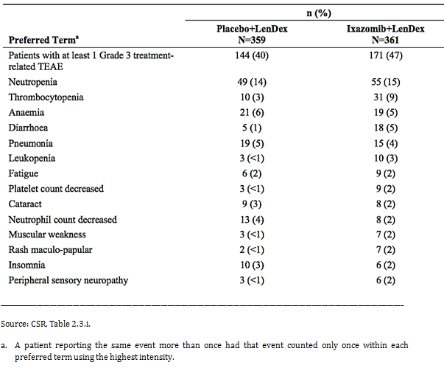

##### TEAEs leading to study drug modification

TEAEs leading (at least in part if not the primary reason) to study drug dose modification (dose reduction, dose or cycle delay, discontinuation of 1 or more of the 3 agents in the study drug regimen) were reported in 75% (n = 271) of patients in the ixazomib group and 70% (n = 250) in the placebo group. Dose reductions of at least 1 agent due to TEAEs occurring on or before the reduction date and reported in ≥ 5 patients in either the ixazomib group or the placebo group are summarised below in Table 76. TEAEs leading to ixazomib dose reduction in the ixazomib group were reported in 23% (n = 83) of patients and TEAEs leading to placebo dose reduction in the placebo group were reported in 11% (n = 40) of patients. TEAEs leading to ixazomib dose reduction in ≥ 2 patients in the ixazomib group (versus TEAEs leading to placebo dose reduction in the placebo group) were thrombocytopenia pooled PTs (n = 20, 6% versus n = 6, 2%), peripheral neuropathy pooled PTs (n = 19, 5% versus n = 10, 3%), rash pooled PTs (n = 14, 4% versus n = 2, < 1%), neutropenia pooled PTs (n = 13, 4% versus n = 13, 4%), diarrhoea (n = 10, 3% versus n = 4, 1%), and insomnia (n = 7, 2% versus n = 0, 0%). TEAEs leading to lenalidomide dose reductions were reported more frequently in the ixazomib group than in the placebo group (38% versus 27%, respectively), as were TEAEs leading to dexamethasone dose reductions (35% versus 31%).

Table 76: Study drug reductions of at least 1 agent due to TEAEs (occurring on or before the dose reduction date) reported in ≥ 5 patients in either the ixazomib group or the placebo group

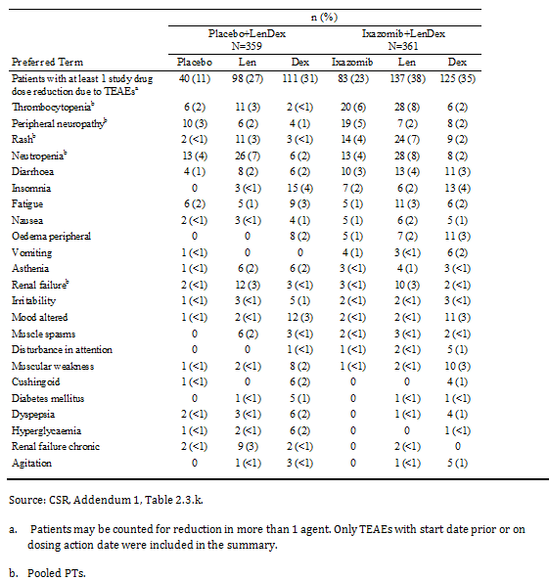

##### Deaths and other SAEs

###### Deaths

On study deaths were defined as deaths that occurred within 30 days of the last dose of study drug. A total of 38 on-study deaths were reported at the time of the database lock on 12 July 2015. Of these 38 on-study deaths, 9 deaths (3 ixazomib group, 6 in the placebo group) were reported between the first analysis and the second analysis. The frequency of on-study deaths in the ixazomib and placebo groups as of 12 July 2015 (15 [4%] and 23 [6%], respectively) was generally similar to that reported as of 30 October 2014 (3% and 5%, respectively).

Of the 38 on-study deaths, 7 were reported as being related to the study regimen (n = 4, ixazomib; n = 3, placebo). Treatment related on-study deaths reported in the placebo group included myocardial infarction, pulmonary embolism, and cardiac arrest. In the ixazomib group, on study deaths deemed Treatment related included pulmonary embolism, fungal pneumonia, coma (with concurrent diagnosis of stroke), and sudden death.

Of the 38 on-study deaths, 9 were attributed to disease progression. Of the 15 deaths associated with cardiovascular events (7 ixazomib; 8 placebo), 10 were considered not related to study treatment (4 ixazomib [1 x each for cardiac arrest, cardiovascular insufficiency, myocardial infarction, diastolic dysfunction]; 6 placebo [2 x cardiac failure, 1 x each for cardiogenic shock, myocardial infarction, acute cardiac failure]). Of the 9 deaths associated with infectious events (4 ixazomib; 5 placebo), 8 were considered not related to study treatment (3 ixazomib [1 x each for pneumonia, aspiration pneumonia, acute respiratory distress syndrome]; 5 placebo [1 x each for cellulitis, aspiration pneumonia, sepsis, influenzal pneumonia, pneumococcal pneumonia]) Of the 5 remaining on-study deaths, 4 were associated with other organ failure and 1 was associated with “other” (PT: completed suicide).

Among the 38 patients who died on study, 16 patients had responded to treatment with PR or better (9 ixazomib; 7 placebo), 4 had stable disease (all placebo), 14 had PD (4 ixazomib; 10 placebo), and 4 had assessments that were not evaluated (2 ixazomib; 2 placebo).

On-study deaths are summarised below in Table 77.

Table 77: On study deaths in primary analysis (shadowed) and updated analysis (non-shadowed) safety population

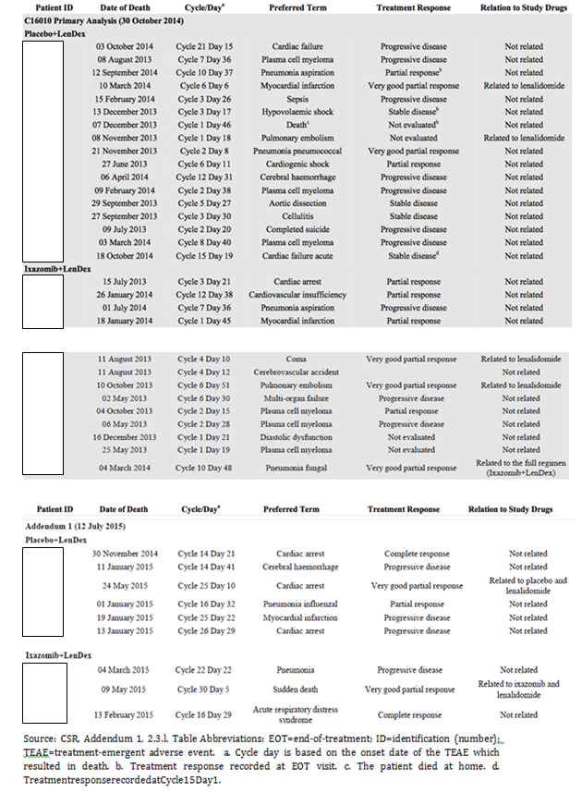

In addition to the 38 deaths reported on study, an additional 133 deaths occurred during the follow-up phase (that is, > 30 days after the last dose of any study drug). Of these 133 deaths, 66 were in patients treated with the ixazomib regimen and 67 were in patients treated with the placebo regimen. The majority of deaths reported more than 30 days after the last dose of any study drug occurred after initiation of subsequent therapy (that is, 70% [46/66] ixazomib; 67% [45/67] placebo).

###### Other SAES

SAEs occurred in 47% (n = 168) of patients in the ixazomib group and 49% (n = 177) of patients in the placebo group. SAEs reported in ≥ 2% of patients in the ixazomib group (versus placebo), in descending order of frequency, were pneumonia (7%, n = 26 versus 9%, n = 31), pyrexia (3%, n = 12 versus 4%, n = 16), diarrhoea (2%, n = 9 versus < 1%, n = 2), plasma cell myeloma (2%, n = 9 versus 2%, n = 8), pulmonary embolism (2%, n = 7 versus 3%, n = 9), bronchopneumonia (2%, n = 6 versus < 1%, n = 3), influenza (2%, n = 6 versus < 1%, n = 3), and lower respiratory tract infection (2%, n = 6 versus 1%, n = 4). SAEs reported in at least 1% of patients in either treatment group are summarised below in Table 78.

Table 78: Serious treatment emergent adverse events that occurred in at least 1% of patients in either the ixazomib group or the placebo group, safety population

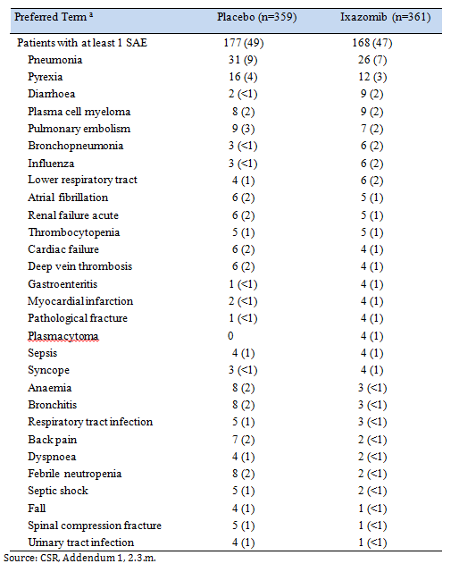

##### Adverse events leading to discontinuation

TEAEs leading to discontinuation of 1 or more of the 3 agents in the study regimen were reported in 25% (n = 91) of patients in the ixazomib group and 20% (n = 73) of patients in the placebo group. TEAEs leading to discontinuation in ≥ 1% of patients in the ixazomib group (versus placebo), in descending order of frequency, were peripheral sensory neuropathy (2%, n = 7 versus < 1%, n = 1), diarrhoea (2%, n = 6 versus < 1%, n = 3), fatigue (1%, n = 5 versus < 1%, n = 3), plasma cell myeloma (1%, n = 4 versus < 1%, n = 2), and thrombocytopenia (1%, n = 4 versus 1%, n = 4). All other TEAEs leading to discontinuation reported in the ixazomib group were reported in < 1% (< 4) of patients.

TEAEs leading to discontinuation of ixazomib in the ixazomib group and discontinuation of placebo in the placebo group were reported in 19% (n = 70) and 16% (n = 57) of patients, respectively. TEAEs leading to discontinuation of ixazomib in the ixazomib group (versus discontinuation of placebo in the placebo group) reported in ≥ 1% of patients were peripheral neuropathy (n = 9, 2% versus < 1%, n = 2), diarrhoea (2%, n = 6 versus < 1%, n = 1), thrombocytopenia pooled PTs (1%, n = 5 versus 2%, n = 7), fatigue (1%, n = 4 versus < 1%, n = 2), and arrhythmias pooled PTs (1%, n = 4 versus < 1%, n = 2).

TEAs leading to discontinuation of lenalidomide in the ixazomib and placebo groups occurred in 19% (n = 70) and 17% (n = 60) of patients, respectively. TEAEs leading to discontinuation of dexamethasone in the ixazomib and placebo groups occurred in 20% (n = 72) and 19% (n = 69) of patients, respectively. Discontinuation of all 3 study drugs due to TEAEs, which included events of disease progression as well as signs and symptoms of disease progression, was reported in 17% (n = 60) of patients in the ixazomib group and 14% (n = 50) of patients in the placebo group. The rates of discontinuation of all 3 study drugs in the ixazomib and placebo groups were highest in the first 6 cycles (10%, n = 37 v 9%, n = 32, respectively), with the number of patients in both treatment arms declining after the Cycle 6.

##### Adverse events of special interest

###### Skeletal related TEAES

Skeletal events or concomitant procedures were reported in 9% (n = 31) of patients in the ixazomib group and 6% (n = 20) of patients in the placebo group. Events reported in ≥ 1% of patients in the ixazomib group (versus placebo) were irradiation of bone (5%, n = 18 versus 3%, n = 10), surgery on bone (3%, n = 10 versus 3%, n = 9), and new fracture complications (2%, n = 7 versus < 1%, n = 1).

###### Thromboembolic events

In Study C16101, thromboprophylaxis was required per protocol, with 97% and 98% of patients in the ixazomib and placebo groups, respectively, reporting use of an anti-thrombotic agent. Venous thrombosis Standardized MedDRA Query (SMQ) assessment identified a thromboembolism event in 29 (8%) patients in the ixazomib group and 38 (11%) patients in the placebo group. Arterial thromboembolic events, assessed according to the thrombosis, arterial SMQ, were reported in 2% of patients in each treatment group. Grade 3 thromboembolic events were experienced by 2% (n = 9) and 3% (n = 11) of patients in the ixazomib and placebo groups, respectively, and Grade 4 events were reported in < 1% of patients in each of the two groups (n = 2, ixazomib; n = 1, placebo). On-study death due to pulmonary embolism was reported in 2 patients (1 in each treatment group).

###### Herpes zoster events

Antiviral prophylaxis was allowed at the physician’s discretion. TEAEs of herpes zoster were reported in 5% (n = 18) of patients in the ixazomib group and 2% (n = 7) of patients in the placebo group. In patients not receiving antiviral prophylaxis starting at the beginning of study treatment (Cycle 1 Day 1), the patient incidence of herpes zoster reactivation was 8% (n = 11) the ixazomib group and 3% (n = 5) in the placebo group. In patients who received antiviral prophylaxis from Cycle 1 Day 1 onwards, the patient incidence of herpes zoster reactivation in the ixazomib and placebo groups was < 1% (n = 2) and 1% (n = 3), respectively. The results indicate that the incidence of herpes zoster reactivation was greater in patients not taking antiviral prophylaxis compared to patients taking antiviral prophylaxis.

###### Interstitial lung disease (ILD)

TEAEs characterised as ILD (PT and pooled events per standardised MedDRA query broad) were reported in 1% (n = 4) of patients in the ixazomib group and 2% (n = 7) of patients in the placebo groups. SAEs were reported in < 1% (n = 3) of patients in the ixazomib group (1 event each of acute respiratory distress syndrome, ILD, and organising pneumonia) and 1% (n = 4) of patients in the placebo group (2 events of pneumonitis, 1 event each of acute respiratory syndrome, and ILD).

###### Hypertension

Hypertension (PT) was reported in 7% (n = 24) of patients in the ixazomib group and 5% (n = 19) of patients in the placebo group, with SAEs being reported in < 1% (n = 1) and 0% (n = 0) of patients, respectively. Discontinuation of 1 or more of the 3 agents due to hypertension was reported in 1 (< 1%) patient in the ixazomib group and no patients in the placebo group. Hypertensive crisis (PT) was reported in 1 (< 1%) patient in the ixazomib group and no patients in the placebo group, while pulmonary hypertension (PT) was reported in 1 (< 1%) patient in each of the two treatment groups.

###### New primary malignancy

The cumulative incidence of new primary malignancies in patients in the ixazomib and placebo groups was similar (5% [n = 17] and 4% [n = 14], respectively). New primary malignancies were reported during treatment in 4% (n = 15) of patients in the ixazomib group and 3% (n = 11) of patients in the placebo group, and in < 1% of patients in both treatment groups during the PFS follow-up period. New primary malignancies are summarised below in Table 79.

Table 79: Number (%) of patients with adverse events associated with new primary malignancy by preferred term safety population

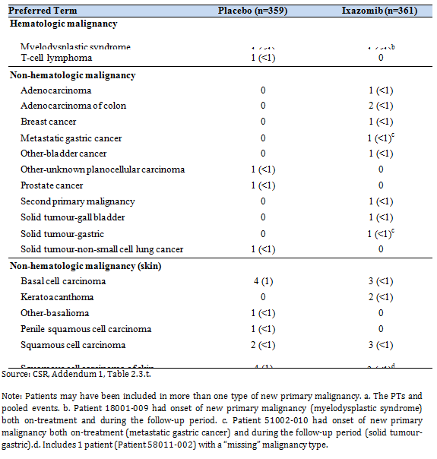

##### Adverse events of clinical importance

TEAEs of clinical importance in the safety population with follow-up for a further 8.5 months through to 12 July 2015 are summarised below in Table 80. Overall, TEAEs of clinical importance were reported in a similar proportion of patients in the two treatment groups in both the first and second analysis.

Table 80: TEAES of clinical importance; safety population

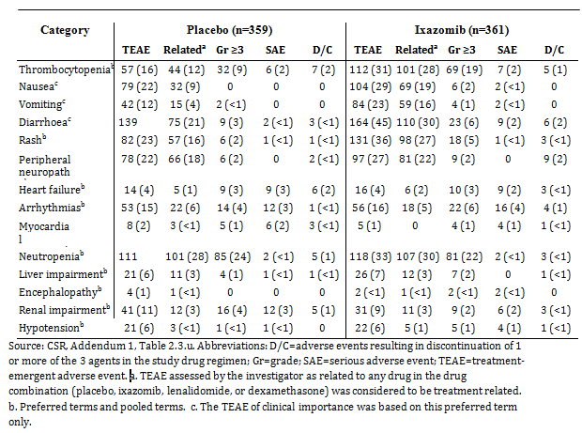

##### Laboratory findings

###### Haematologic

The changes from baseline in haematologic parameters in the second analysis following a further 8.5 months of follow up were consistent with those in the first analysis. Patients with Grade 0, 1, or 2 haematologic values at baseline with shifts to Grade 3 or 4 worst values on study are summarised below in Table 81. The main differences between the two treatment groups relate to the notably greater proportion of patients in the ixazomib group than in the placebo group shifting to low platelet counts, low leucocyte counts and low lymphocyte counts.

Table 81: Patients with Grade 0, 1, or 2 haematologic values at baseline with shift to Grade 3 or 4 abnormalities as worst value on study, safety population n (%)

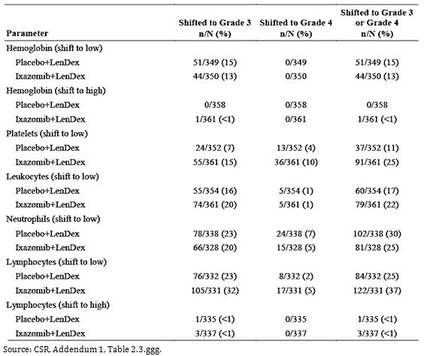

###### Chemistry

The changes from baseline in chemistry parameters in the second analysis following a further 8.5 months of follow up were consistent with those in the first analysis. Shifts in chemistry parameters from Grade 0, 1, or 2 values at baseline to Grade 3 or 4 abnormalities as worst values in ≥ 5% of patients in either treatment group (ixazomib versus placebo) were calcium shifts to low (5%, n = 18 versus 6%, n = 21), phosphate shift to low (10%, n = 37 versus 8%, n = 30), and potassium shift to low (5%, n = 18 versus 2%, n = 8).

Changes in LFT parameters (shifts to high) were similar in the two treatment groups. Shifts in ALT values from Grade 0, 1, or 2 at baseline to Grade 3 or 4 abnormalities (high) as worst values on study were observed in 2% (n = 7) of patients in the ixazomib group and < 1% (n = 3) of patients in the placebo group, with the corresponding results for both AST and bilirubin being ≤ 1% in each group.

In the ixazomib and placebo groups, respectively, elevations of ALT or AST > 3 x ULN were observed in 4% (n = 14) and 2% (n = 8) of patients, > 5 x ULN in 2% (n = 7) and < 1% (n = 3) of patients, > 10 x ULN in < 1% (n = 2) and < 1% (n = 1) of patients, and > 20 x ULN in < 1% (n = 1) of patients and no patients. Elevation of bilirubin (any) to levels > 2 x ULN were observed in 1% (n = 5) of patients in the ixazomib group and 2% (n = 6) of patients in the placebo group.

Potential Hy’s law cases (that is, patients with any elevated ALT or AST of > 3 x ULN, alkaline phosphatase < 2 x ULN, and associated with an increase in bilirubin ≥ 2 x ULN) were observed in 1 (< 1%) patient in each of the two treatment groups. The patient in the ixazomib group had liver function test changes secondary to sepsis and septic shock occurring in the first cycle of therapy, with further complications of multi-organ failure and post-hypoxic encephalopathy. Therefore, this case was considered by the sponsor not to meet the full criteria of Hy’s law due to the confounding, ongoing medical conditions.

Changes in serum creatinine levels (shift to high) were similar in the two treatment groups. In patients with Grade 0, 1, or 2 creatinine values at baseline, shifts to high Grade 3 or 4 abnormalities as worst values on study were observed in 2% (n = 6) in the ixazomib group and 3% (n = 9) in the placebo group.

##### Other safety measures

###### Vital signs

In patients in the ixazomib and placebo groups mean change from baseline to last assessment were similar for systolic blood pressure (-3.4 mmHg and -2.8 mmHg, respectively), diastolic blood pressure (-2.7 mmHg and -1.9 mmHg, respectively), heart rate (-1.1 beats/min and -1.5 beats/min, respectively), and weight (-1.8 kg and -2.1 kg, respectively).

###### Electrocardiogram (12 lead)

Most patients in both treatment groups (85% ixazomib; 87% placebo) had a maximum post-dosing QTcF < 450 ms during the study. Maximum post-dosing QTcF ≥ 500 ms was observed in 1% (n = 4) of patients in the ixazomib group and 2% (n = 5) of patients in the placebo group. Increases in QTcF ≥ 30 ms from baseline were observed in 17% and 16% of patients in the ixazomib and placebo groups, respectively, while increases in QTcF ≥ 60 ms were observed in 4% and 7% of patients, respectively.

Most patients in both treatment groups (72% ixazomib; 71% placebo) had a maximum post-dosing QTcB< 450 ms during the study. Maximum post-dosing QTcB ≥ 500 ms was observed in 4% (n = 14) of patients in the ixazomib group and 3% (n = 10) of patients in the placebo group. Increases in QTcB ≥ 30 ms from baseline were observed in 21% and 20% of patients in the ixazomib and placebo groups, respectively, while increases in QTcB ≥ 60 ms were observed in 5% and 8% of patients, respectively.

##### Safety in special groups

###### Age

The high level overview of TEAEs by age is summarised below in Table 82. Overall, patients aged ≤ 65 years had fewer AEs in each of the AE categories than patients aged > 65 years in both treatment groups.

Table 82: Overall summary of TEAEs by age, safety population

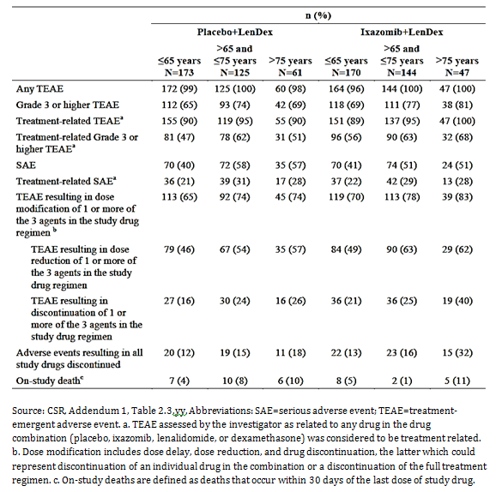

In patients aged > 65 to ≤ 75 years, the patient incidence of all high level TEAE categories was similar in the ixazomib and placebo groups. However, the patient incidence of most high level TEAE categories was higher in the ixazomib group than in the placebo group.

In patients aged > 75 years, TEAE categories with ≥ 5% more patients in the ixazomib group than in the placebo group (respectively) were Grade ≥ 3 TEAEs (81% versus 69%), treatment related TEAEs (100% versus 90%), treatment related Grade ≥ 3 TEAEs (68% versus 51%), TEAEs resulting in dose modification of 1 or more of the 3 agents in the study drug regimen (83% versus 74%), TEAEs resulting in dose reduction of 1 or more of the 3 agents in the study drug regimen (62% versus 57% ), TEAEs resulting in discontinuation of 1 or more of the 3 agents in the study drug regimen (40% versus 26%), and AEs resulting in discontinuation of all 3 study drugs in the regime (32% versus 18%). The only TEAE category in patients aged > 75 years with ≥ 5% more patients in the placebo group compared to the ixazomib group was SAEs (57% versus 51%).

Overall, the results suggest that the safety profile of the ixazomib regimen in patients aged > 75 years is inferior to the placebo regimen. This is confirmed by examination of individual adverse events reported in patients aged > 75 years, which showed that the majority of events occurred in ≥ 5% more patients in the ixazomib group compared to the placebo group (see Table 83, below). There were 10 patients in the safety population aged ≥ 85 years of age, and no meaningful conclusions can be made about the comparative safety of the two treatment groups in this age group due to the small patient numbers.

Table 83: TEAEs in patients aged ≥ 75 years, safety population

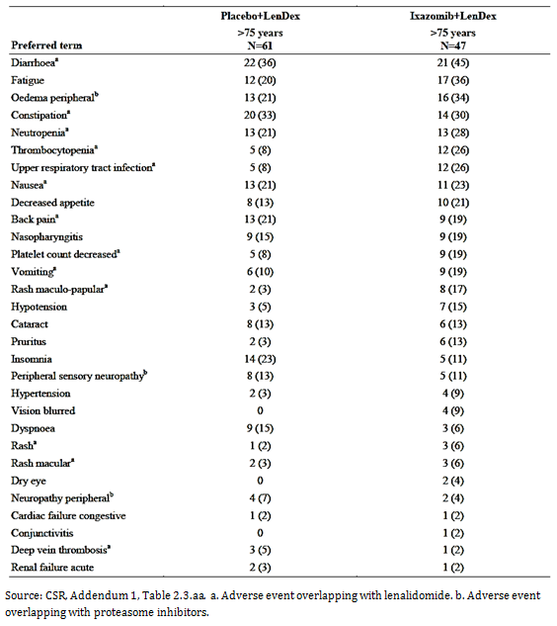

###### Sex

In general, the high level overview of TEAEs in patients by sex showed no marked differences between the sexes as regards treatment with the ixazomib or placebo regimens. However, in the ixazomib group the following high level TEAE categories occurred in ≥ 5% more female patients compared to male patients: Grade ≥ 3 TEAEs (79% versus 70%); Treatment related Grade ≥ 3 or higher TEAE (66% versus 56%); TEAEs resulting in dose modification of 1 or more of the 3 agents in the study drug regimen (79% versus 72%); and TEAEs resulting in dose reduction of 1 or more of the 3 agents in the drug regimen (64% versus 50%). In general, the safety profile in females in the ixazomib group was inferior to females in the placebo group, while the safety profile in males in the two treatment groups appeared to be similar.

###### Race

The majority of patients in the study were categorised as White, which makes comparisons of safety in this study based on race unreliable.

###### Creatinine clearance

In the ixazomib group, the frequency of treatment related TEAEs, treatment related Grade ≥ 3 TEAEs, SAEs, treatment related SAEs, and TEAEs resulting in dose reduction or discontinuation of 1 or more of the 3 agents in the study regimen all occurred in ≥ 5% more patients in the CrCL < 60 mL/min group compared to patients in the CrCL ≥ 60 mL/min group. In the placebo group, the frequency of Grade ≥ 3 TEAEs, treatment related Grade ≥ 3 TEAEs, SAEs, treatment related SAEs, and TEAEs resulting in dose reduction of 1 or more of the 3 agents in the study regimen occurred in ≥ 5% more patients in the CrCL < 60 mL/min group compared to patients in the CrCL ≥ 60 mL/min group. The high-level comparisons of adverse events between the two treatment groups for patients with CrCL < 60 mL/min were comparable. The results for the two groups are summarised below in Table 84.

Table 84: Overall summary of TEAEs by creatinine clearance category (< 60 versus ≥ 60 mL/min), safety population

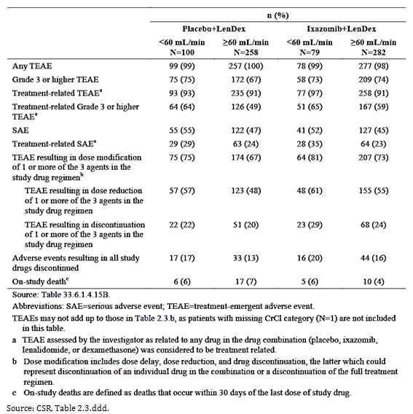

## Second round benefit-risk assessment

### Second round assessment of benefits

The benefits of ixazomib for the proposed indication are considered to be favourable, based on the totality of the efficacy data.

The primary efficacy endpoint in the single pivotal Study C16010 was PFS (IRC assessment) in the ITT population, based on analysis of the interim data at the cut-off date of 30 October 2014. In the primary analysis, PFS was 20.6 months in the ixazomib group (n = 360) and 14.7 months in the placebo group (n = 362): HR = 0.742 (95% CI: 0.587, 0.939), p = 0.012. The primary analysis of PFS was based on a median duration of follow-up of 14.8 months in the ixazomib group and 14.6 months in the placebo group. In the ixazomib group, 129 (36%) patients experienced a PFS event (114 [32%] PD; 15 [4%] deaths) compared to 157 (43%) patients in the placebo group (145 [40%] PD; 12 [3%] deaths). The KM curves for PFS showed clear separation of the two treatment groups in favour of ixazomib compared to placebo, beginning at approximately 8 months after initiation of treatment and increasing over the remaining observation period.

The key issue relating to the benefits of ixazomib for the proposed indication relates to the interpretation of the results of the pre-specified, non-inferential PFS analysis (IRC assessment) in the pivotal Study C16010, based on updated data in the ITT population at the cut-off date of 12 July 2015. This analysis showed that the median PFS was 20.0 months in the ixazomib group (n = 360) and 15.9 months in the placebo group (n = 362): HR = 0.818 (95% CI: 0.67, 1.0), nominal p = 0.054. The non-inferential of analysis of PFS was based on a median duration of follow-up of 23.3 months in the ixazomib group and 22.9 months in the placebo group. The numerical difference in PFS between the two treatment groups was 4.1 months in favour of ixazomib.

The numerical difference in the non-inferential PFS analysis in favour of the ixazomib group compared to the placebo group was smaller than the corresponding numerical difference between the two groups observed in the primary PFS analysis (that is, 4.1 months versus 5.9 months, respectively). However, it is considered that the difference of 4.1 months between the two treatment groups remains clinically meaningful. The non-inferential PFS analysis is based on an additional 8.5 months of observation and includes a total of 372 events, consisting of 195 (54%) events in the placebo group (PD = 180 [50%]; death = 15 [4%]) and 177 (49%) events in the ixazomib group (PD = 158 [44%]; death = 19 [5%]).

In the ixazomib group, median PFS in the non-inferential analysis was consistent with median PFS in the primary inferential analysis (20.0 versus 20.6 months, respectively), and the Kaplan-Meier curves for the ixazomib groups for the two PFS analyses are virtually superimposable. In the placebo group, median PFS in the non-inferential analysis was longer than median PFS in the primary analysis (15.9 versus 14.7 months, respectively). The smaller difference in median PFS between the two treatment groups following the longer period of observation raises the possibility that the PFS advantage of ixazomib compared to placebo observed in the two analyses might dissipate with prolonged treatment (that is, beyond 2 years). However, if such an effect is observed it is likely to be difficult to interpret due to confounding factors that might arise with prolonged treatment (for example, placebo group switching to ixazomib; differential effects between treatment groups arising from switching to, or co-administration of, other anti-myeloma medicines; differential effects between treatment groups arising from different co-morbidities). It is noted that no further analyses of PFS are planned for the pivotal study.

The sponsor considers that the apparent shift in the HR for PFS between the primary and non-inferential analyses is as a result of a change in the middle part of the PFS curve in the placebo region. The sponsor believes the change to be the result of several contributing factors (that is, asymmetric censoring, contribution of results from late enrolment of Japanese patients, and contribution of results from patients with only FLC-measurable disease with poorly characterised prognoses). It is reasonable to infer that that these factors might have contributed to the observed change, but it is difficult to determine their overall importance.

The updated efficacy data included a number of pre-specified sensitivity and sub-group PFS analyses. The results of these analyses consistently supported the numerical outcome in favour of the ixazomib group compared to the placebo group in the non-inferential PFS analysis in the ITT population. In addition, the results of the non-inferential secondary efficacy endpoints of TTP and ORR numerically favoured the ixazomib group compared to the placebo group. QoL outcomes continued to show no significant difference between the two treatment groups after an additional 8.5 months of follow-up.

The updated analysis continues to show that the overall survival (OS) data are immature. In the updated data, the pre-specified inferential analysis of OS in the ITT population (first key secondary efficacy endpoint) showed that median survival had not been reached in either treatment group. At the time of the analysis, there had been 90 deaths in 362 patients in the placebo group (25%) and 81 deaths in 360 patients in the ixazomib group (23%), with a median duration of follow-up of 23.3 and 22.9 months in the two groups, respectively. The HR was 0.868 (95% CI: 0.642, 1.175), p = 0.359. In the first analysis, median OS had not been reached in either treatment group and the HR was 0.90 (95% CI: 0.615, 1.316), p = 0.586. Overall, the results of the initial and updated analyses showed a non-statistically significant trend towards improved OS in patients in the ixazomib group compared to the placebo group, with a similar HR in both treatment groups.

The updated analysis continues to show that the overall survival (OS) data in high risk patients harbouring del(17p) are immature. In the updated data, OS in high risk patients harbouring del(17p) in the ITT population (second key secondary efficacy endpoint) was 30.9 months in the placebo group, and had not been reached in the ixazomib group. There had been 15 deaths in 33 patients (45%) in the placebo group, with a median duration of follow-up of 23.0 months, and 9 deaths in the 36 patients in the ixazomib group (25%), with a median follow-up of 21.5 months. The HR was 0.487. In accordance with the pre-specified rules for statistical testing, no inferential analysis of OS in high risk patients harbouring (del17p) was undertaken, as inferential analysis of OS in the total ITT population had not shown statistical significance. The results of the updated analysis were consistent with the results of the initial analysis, with the respective HRs being 0.487 and 0.506. Overall, the results of the initial and updated analyses both showed a non-statistically significant trend towards improved OS in a small group of high risk patients harbouring del(17p) treated with the proposed ixazomib regimen compared to placebo.

In the sponsor’s response to the TGA’s first request for information, additional efficacy and safety data were provided for a China continuation dataset. The China continuation study had an identical design to the C16010 global study, and included a total of 115 patients, randomised to receive either the ixazomib regimen (n = 57) or the placebo regimen (n = 58). The data from this study were submitted by the sponsor to support the data from the single pivotal Study C16010.

The analysis of the PFS efficacy data in the China continuation was based of 67 events at the data cut-off of 12 July 2015 (30 [53%] in the ixazomib group; 37 [64%] in the placebo group). The primary endpoint of median PFS was significantly improved in the ixazomib group compared to the placebo group (median 6.7 months versus 4.0 months, respectively; HR = 0.598 [95% CI: 0.367, 0.972]; p = 0.035), with a median follow-up of 8.0 and 7.8 months in the two groups, respectively. These results constitute the primary and final PFS analysis in the China continuation study. The OS data for the China continuation study were not mature at the 12 July 2015 cut-off date. With a median follow-up of 8.0 months in the ixazomib group there 6 deaths (11%), and with a median follow-up of 7.8 months in the placebo group there were 16 deaths (28%). The median OS was not estimable in either treatment group, but there was a favourable trend in OS in favour of the ixazomib group compared to the placebo group (HR = 0.323; p = 0.013).

Overall, it is considered that the China continuation PFS and OS efficacy data provide limited support for the pivotal global C16010, due to the small number of patients included in the study (n = 115), the short median follow-up for the PFS analysis (approximately 8 months for both treatment groups), and the immature OS data.

In conclusion, the submission included a single pivotal Study C16010. The CHMP considered that the “efficacy data in the overall ITT from the first and second interim analyses [of PFS] do not support the statistically compelling evidence expected for an application based on a single pivotal trial. Point estimates are not sufficiently outstanding in the context of other available treatment options”. However, despite the CHMP’s negative opinion it is considered that the first and second interim analyses both showed clinically meaningful improvements in PFS in the ixazomib group compared to the placebo group. The numerous additional analyses of the PFS supported the analyses in the total ITT population, as did the secondary efficacy analyses of TTP and ORR. The QoL measures showed no meaningful clinical differences between the two treatment groups. No OS benefit for treatment with the proposed ixazomib regimen was observed in either the total ITT population or the high risk group harbouring del(17p). However, there was no evidence of an OS detriment in the ixazomib group compared to the placebo group in either the first or second interim analyses. Overall, it is considered that the submission has adequately demonstrated the efficacy of the proposed ixazomib regimen for the proposed indication.

### Second round assessment of risks

The risks of ixazomib for the proposed indication are considered to be favourable, based on the totality of the submitted safety data. The safety data in the initial report of pivotal Study C16010 was consistent with the updated safety data in Addendum 1 of pivotal Study C16010. Important clinical risks associated with ixazomib include thrombocytopenia, gastrointestinal toxicities (diarrhoea, nausea and vomiting), and peripheral neuropathy. The comments in this section of the second round CER relating to the risks of treatment with the proposed ixazomib regimen are based on the updated safety data presented in the pivotal study.

The updated safety population included 720 patients who had received at least 1 dose of study drug up to the data cut-off date of 12 July 2015 (n = 361, placebo; n = 359, placebo). At the time‑point for the updated safety analysis, the median number of treatment cycles was 17.0 (range: 1, 34 cycles) for patients in the ixazomib group and 15.0 (range: 1, 34 cycles) for patients in the placebo group. Overall, 233 patients (65%) in the ixazomib group and 227 patients (63%) in the placebo group had received at least 12 cycles of therapy.

TEAEs were reported in 98% (355/361) of patients in the ixazomib group and 99% (357/359) of patients in the placebo group. Treatment related TEAEs were experienced by 93% (335/361) and 92% (329/359) of patients in the ixazomib and placebo groups, respectively. In the evaluation of risks discussed below, TEAEs refer to events reported regardless of causality unless otherwise stated.

The data from the pivotal study suggest that most TEAEs can be managed by dose reductions, prophylactic treatment and/or symptomatic treatment rather than by treatment discontinuation. TEAEs resulting in dose reduction of 1 or more of the 3 agents in the study drug regimen were reported in 56% of patients in the ixazomib group and 50% of patients in the placebo group. TEAEs resulting in dose discontinuation of 1 or more of the 3 agents in the study drug regimen were reported in 25% of patients in the ixazomib group and 20% of patients in the placebo group. TEAEs resulting in discontinuation from the full study drug regimen were reported in 17% of patients in the ixazomib group and 14% of patients in the placebo group.

TEAEs leading to discontinuation of 1 or more of the 3 agents in the study drug regimen were reported in 25% of patients in the ixazomib group and 20% of patients in the placebo group. TEAEs leading to discontinuation reported in ≥ 1% of patients in the ixazomib group (versus placebo group), in descending order of frequency were peripheral sensory neuropathy (2% [n = 7] versus < 1% [n = 1]), diarrhoea (2% [n = 6] versus < 1% [n = 3]), fatigue (1% [n = 5] versus < 1% [n = 3]), plasma cell myeloma (1% [n = 4] versus < 1% [n = 2]), and thrombocytopenia (1% [n = 4] versus 1% [n = 4]).

#### Risks associated with TEAEs of clinical importance

The TEAEs of clinical importance nominated by the sponsor were heart failure, arrhythmias, myocardial infarction, rash, nausea, vomiting, diarrhoea, thrombocytopenia, neutropenia, liver impairment, peripheral neuropathy, encephalopathy, renal impairment, and hypotension. TEAEs of clinical importance reported in ≥ 5% more patients in the ixazomib group compared to the placebo group were diarrhoea (45% versus 39%), rash pooled PTs (36% versus 23%), thrombocytopenia pooled PTs (31% versus 16%), peripheral neuropathy pooled PTs (27% versus 22%), nausea (29% versus 22%), and vomiting (23% versus 12%). There was < 5% difference between the two treatment regimens in the incidence of patients experiencing all other TEAEs of clinical importance (pooled PTs), namely, heart failure, arrhythmias, myocardial infarction, neutropenia, liver impairment, encephalopathy, renal impairment, and hypotension. The risks associated with the TEAEs of clinical importance reported in ≥ 5% more patients in the ixazomib regimen than in the placebo group in the pivotal study are reviewed below.

##### Thrombocytopenia (pooled PTs)

The risk of experiencing thrombocytopenia was 2 fold greater in patients in the ixazomib group than in the placebo group, with the incidence being 31% and 16%, respectively. Furthermore, the risk of experiencing Grade ≥ 3 thrombocytopenia was also 2 fold greater in patients in the ixazomib group than in the placebo group, with the incidence being 19% and 9%, respectively. However, despite the greater patient incidence of thrombocytopenia in the ixazomib group compared to the placebo group the need for platelet transfusions was similar in both groups (8% and 6%, respectively). In addition, discontinuation of at least 1 of the 3 agents in the study drug regimen due to thrombocytopenia was reported infrequently in both treatment groups (1% [n = 5] ixazomib; 2% [n = 7] placebo). There were no deaths due to thrombocytopenia reported in either treatment group.

Thrombocytopenia followed a cyclical pattern, with nadirs around Day 14 to 21 in both treatment groups and typically returning to baseline levels prior to initiation of the next cycle. The patient incidence of thrombocytopenia was highest in the first 3 months of treatment (61%, ixazomib; 51%, placebo) and then declined over time.

Thrombocytopenia alone, without associated AEs, may not require significant treatment delays or dose reductions. In both treatment groups, lenalidomide was the most frequently reduced agent for thrombocytopenia (pooled PTs) and was observed in 3% of patients in the placebo group and 8% of patients in the ixazomib group. The dose reduction of placebo in the placebo group due to thrombocytopenia was 2% compared to the dose reduction of ixazomib in the ixazomib group of 6%.

Haemorrhagic events (TEAEs within the haemorrhage SMQ) were reported in 20% of patients in the ixazomib group and 19% of patients in the placebo group, with serious haemorrhagic events being reported in 2% and 1% of patients, respectively. Death due to haemorrhagic events was reported in < 1% of patients in both the ixazomib group (n = 1; haemorrhagic stroke) and the placebo group (n = 2; both cerebral haemorrhage). The most commonly reported haemorrhagic event was contusion, which occurred in 6% of patients in the ixazomib group and 5% of patients in the placebo group.

The laboratory data showed that platelet counts ≤ 10,000/mm3 were reported in 2% of patients in the ixazomib group and 1% of patients in the placebo group, while platelet counts ≤ 5,000/mm3 were reported in < 1% of patients in both treatment groups.

##### Nausea (PT) and vomiting (PT)

Nausea was reported in 29% of patients in the ixazomib group and 22% of patients in the placebo group, with Grade ≥ 3 AEs being reported in 2% and 0% of patients, respectively. Vomiting was reported in 23% of patients in the ixazomib group and 12% of patients in the placebo group, with Grade ≥ 3 AEs being reported in 1% and < 1% of patients, respectively. The results indicate that the risks of Grade ≥ 3 AEs nausea and vomiting are low in patients treated with the ixazomib regimen. No patients in either treatment group discontinued due to nausea or vomiting. The use of prophylactic anti-emetics before or on Cycle 1 Day 1 was reported in 5% of patients in the ixazomib group and 2% of patients in the placebo group. The percentage of patients taking prophylaxis for nausea and/or vomiting starting after Cycle 1 Day 1 increased to 11% in the ixazomib group and 5% in the placebo group.

##### Diarrhoea (PT)

Diarrhoea was reported in 45% of patients in the ixazomib group and 39% of patients in the placebo group, with Grade ≥ 3 AEs being reported in 6% and 3% of patients in the two groups, respectively. Discontinuations of 1 of more of the treatment agents in the study drug regimens due to diarrhoea were reported in 2% of patients in the ixazomib group and < 1% of patients in the placebo group. The use of anti-propulsive agents was used in a relatively high proportion of patients in both treatment groups (19%, ixazomib; 16%, placebo). Hypokalaemia (which is a potential complication of severe vomiting or diarrhoea) was reported in 13% of patients in the ixazomib group and 10% of patients in the placebo group, while hypomagnesaemia occurred in 4% and 5% of patients, respectively, and hyponatraemia occurred in 2% of patients in both groups.

##### Rash (pooled PTs)

Rash was reported in 36% of patients in the ixazomib group and 23% of patients in the placebo group, with Grade 3 AEs being reported in 5% and 2% of patients, respectively. No patients reported Grade 4 AEs or fatal AEs associated with rash. Discontinuations of 1 of more of the treatment agents in the study drug regimens due to rash were reported in < 1% of patients in both treatment groups. In both treatment groups (ixazomib versus placebo), lenalidomide was the most frequently reduced agent for rash (7% versus 3%), followed by ixazomib (4% versus < 1% [placebo]), and dexamethasone (2% versus < 1%). The most frequently reported PTs (≥ 5%) in the ixazomib group (versus placebo) were pruritus (11% versus 7%), rash maculo-papular (9% versus 4%), and rash macular (7% versus 7%). There were 2 cases of Grade 3 Sweet’s syndrome (acute febrile neutrophilic dermatosis), both of which occurred in patients in the ixazomib group. No patients in either of the two treatment groups experienced Stevens-Johnson Syndrome or toxic epidermal necrolysis.

##### Peripheral neuropathy (pooled PTs)

Peripheral neuropathy occurred in 27% of patients in the ixazomib group and 22% of patients in the placebo group, with Grade 3 events being reported in 2% of patients in both treatment groups and Grade 4 or fatal events being reported in no patients in either treatment group. Peripheral neuropathy leading to discontinuation of at least 1 of the agents in the study drug regimen were reported in 2% of patients in the ixazomib group and < 1% of patients in the placebo group. The incidence of first occurrence of peripheral neuropathy was highest during the first 3 months of treatment in both the ixazomib and placebo groups (34% versus 38%, respectively), with resolution recorded in 46% and 47% of patients in the two groups, respectively.

The most frequently reported PT in the grouping of peripheral neuropathy (pooled PTs) was peripheral sensory neuropathy (19%, ixazomib; 15%, placebo), followed by neuropathy peripheral (9%, ixazomib; 7%, placebo), peripheral motor neuropathy (< 1%, both groups) and peripheral sensorimotor neuropathy (< 1%, both groups).

#### Other TEAEs of clinical importance

The risk of other TEAEs (pooled PTs and/or SMQs) of clinical importance in the ixazomib and placebo groups (respectively) were heart failure (4% in both groups), arrhythmia (16% [most commonly atrial fibrillation; no cases of QT prolongation] versus 15%), myocardial infarction (1% versus 2%), neutropenia (33% versus 31%), liver impairment (7% versus 6%), encephalopathy (< 1% versus 1%), renal impairment (9% versus 11%), and hypotension (6% in both groups).

#### Risks associated with TEAEs of special interest

Skeletal related events were defined as new fractures (excluding vertebral compression or rib fractures), bone irradiation or surgery, or spinal cord compression. The incidence of Skeletal related TEAEs was similar in patients in the ixazomib and placebo groups (9% versus 6%, respectively). The use of drugs affecting bone structure and mineralisation (for example, pamidronic acid or zoledronic acid) was the same in the ixazomib and placebo groups (50% of patients in each group).

The prophylactic use of anti-thrombotic agents was recommended in all patients, due to the risk of thromboembolic events associated with the use of lenalidomide. In the total population, 98% of patients were reported to have taken anti-thrombotic agents (97%, ixazomib; 98%, placebo). Acetylsalicylic acid was the most frequently used agent in both treatment groups. Arterial thromboembolic events, assessed according to the thrombosis, arterial SMQ, were reported infrequently (2% in each group). Grade 3 thromboembolic events were experienced by 2% and 3% of patients in the ixazomib and placebo groups, respectively, while Grade 4 thromboembolic events were experienced by < 1% of patients in each group. Two on-study deaths (1 ixazomib; 1 placebo) were due to pulmonary embolism.

TEAEs of herpes zoster were experienced by 5% of patients in the ixazomib group and 2% of patients in the placebo regimen. The use of antiviral agents was at the discretion of the treating physician and 66% of patients in the ixazomib group and 62% of patients in the placebo group reported taking antiviral agents during the study. In the pivotal study, herpes zoster infection rarely occurred in patients taking antiviral agents prophylactically (1 patient in each group). In patients not receiving antiviral prophylaxis starting at the beginning of study treatment (Cycle 1 Day 1), the incidence of herpes zoster reactivation was 8% in the ixazomib group and 3% in the placebo group. In patients who received antiviral prophylaxis from Cycle 1 Day 1 onwards, the incidence of herpes zoster reactivation in the ixazomib and placebo groups was < 1% and 1% of patients, respectively.

New primary malignancies were reported in 5% of patients in the ixazomib group and 4% of patients in the placebo group during treatment and < 1% of patients in each group during the PFS follow-up. In the total population, 31 patients were reported to have experienced new primary malignancies occurring either during treatment and/or during the PFS follow-up phase. Of the 31 patients in the total population reporting new malignancies, 28 reported non-haematologic malignancies (including 18 skin malignancies) and 3 reported haematologic malignancies. Haematologic malignancies were reported in 1 patient in the ixazomib group (myelodysplastic syndrome) and 2 patients in the placebo group (1 each for myelodysplastic syndrome and T-cell lymphoma), non-haematologic (non-skin) malignancies were reported in 9 patients in the ixazomib group and 3 patients in the placebo group, and non-haematologic malignancies were reported in 11 patients in the ixazomib group and 12 patients in the placebo group. Patients might have been included in more than one type of new primary malignancy category.

PTs grouped as interstitial lung disease were reported in 1% of patients in the ixazomib group and 2% of patients in the placebo group, and the only PT in the grouping reported in > 1 patient was pneumonitis (3 patients in the placebo group; 0 patients in the ixazomib group). PTs grouped as hypertension were reported in 7% of patients in the ixazomib group and 5% of patients in the placebo group, with the most frequently reported PT in each group being hypertension (6%, ixazomib; 5%, placebo). No cases of tumour lysis syndrome were reported in either of the two treatment groups.

##### Risks associated with TEAEs (PTS)

TEAES (PTs) were reported in 98% of patients in the ixazomib group and 99% of patients in the placebo group. TEAEs (PTs) reported in ≥ 20% of patients in either the ixazomib or the placebo group (respectively) were, diarrhoea (45% versus 39%), constipation (35% versus 26%), fatigue (29% versus 28%), nausea (29% versus 22%), anaemia (29% versus 27%), neutropenia (29% versus 26%), peripheral oedema (28% versus 20%), back pain (24% versus 17%), thrombocytopenia (24% versus 11%), vomiting (23% versus 12%), URTI (23% versus 19%), nasopharyngitis (22% versus 20%), and insomnia (20% versus 27%), muscle spasms (18% versus 26%), and pyrexia (16% versus 21 %).

TEAEs (PT) reported in ≥ 10% of patients in either treatment group and in ≥ 5% more patients in the ixazomib group than in the placebo group were diarrhoea (45% versus 39%), constipation (35% versus 26%), nausea (29% versus 22%), peripheral oedema (28% versus 20%), back pain (24% versus 17%), thrombocytopenia (24% versus 11%), and vomiting (23% versus 12%).

The risk of experiencing a Grade 3 TEAE (PT) was higher in the ixazomib group than in the placebo group (52% versus 47%, respectively). Grade 3 TEAEs (PT) reported in ≥ 5% of patients in either the ixazomib or placebo group (respectively) were neutropenia (17% versus 15%), anaemia (9% versus 13%), thrombocytopenia (9% versus 4%), pneumonia (7% versus 7%), and diarrhoea (6% versus 3%). The only Grade 3 TEAE (PT) reported in ≥ 5% more patients in the ixazomib group than in the placebo group was thrombocytopenia (9% versus 4%).

The risk of experiencing a Grade 4 TEAE (PT) was higher in the ixazomib group than in the placebo group (18% versus 15%, respectively). Grade 4 TEAEs (PT) reported by ≥ 1% of patients in either the ixazomib or placebo groups (respectively) were thrombocytopenia (6% versus 3%), neutropenia (4% versus 5%), hypokalaemia (2% versus < 1%), platelet count decreased (1% versus 1%), sepsis (1% versus < 1%), neutrophil count decreased (1% versus 1%), pneumonia (< 1% versus 1%), and septic shock (< 1% versus 1%). The only Grade 4 TEAE (PT) reported in ≥ 2% more patients in the ixazomib group than in the placebo group was thrombocytopenia (6% versus 3%).

The incidence of on study deaths, defined as occurring within 30 days of the last dose of study drug, was similar in the ixazomib and placebo groups (4% [n = 15] and 6% [n = 23], respectively). Of the 38 on study deaths (15 ixazomib; 23 placebo), 7 were reported as being related to study drug treatment (4 in the ixazomib group [1 each for pulmonary embolism, fungal pneumonia, coma with concurrent stroke, sudden death] and 3 in the placebo group [1 each for myocardial infarction, pulmonary embolism, cardiac arrest]).

The risk of experiencing a SAE was similar in the ixazomib and placebo groups (47% versus 49%, respectively). SAEs reported in ≥ 2% of patients in either the ixazomib group or the placebo group (respectively) were pneumonia (7% versus 9%), pyrexia (3% versus 4%), diarrhoea (2% versus < 1%), plasma cell myeloma (2% versus 2%), pulmonary embolism (2% versus 3%), bronchopneumonia (2% versus < 1%), influenza (2% versus < 1%), LRTI (2% versus 1%), atrial fibrillation (< 1% versus 2%), renal failure acute (1% versus 2%), cardiac failure (1% versus 2%), deep vein thrombosis (1% versus 2%), anaemia (< 1% versus 2%), bronchitis (< 1% versus 2%), back pain (< 1% versus 2%), and febrile neutropenia (< 1% versus 2%).

##### Laboratory parameters

Shifts (to low) from Grade 0, 1 or 2 haematology laboratory abnormalities to Grade 3 or 4 abnormalities as worst value on study were reported notably more frequently (≥ 5% difference) in patients in the ixazomib group compared to the placebo group for platelet count (25% versus 11%), leucocyte count (22% versus 17%), and lymphocyte count (37% versus 25%). No shifts from Grade 0, 1 or 2 clinical chemistry laboratory abnormalities to Grade 3 or 4 abnormalities as worst value on study were reported notably more frequently (≥ 5% difference) in patients in the ixazomib group compared to the placebo group.

##### Vital signs

There were no clinically meaningful differences between the two treatment groups as regards changes over time in blood pressure, pulse rate or weight. There was no evidence that the proposed ixazomib regimen resulted in a clinically meaningful increased risk of QTc prolongation compared to the placebo regimen.

##### Risks in special groups

TEAEs in both the ixazomib and placebo groups increased with age. The incidence of high level TEAE categories was higher in patients aged < 65 years than in patients aged ≥ 65 years in both treatment groups. In patients aged > 65 to ≤ 75 years, the patient incidence of all high level TEAE categories was similar in the ixazomib and placebo groups. However, the patient incidence of most high level TEAE categories in patient aged > 75 years was higher in the ixazomib group than in the placebo group. Furthermore, the majority of TEAEs (PTs) reported with an incidence of ≥ 2% of patients in either treatment group in patients aged > 75 years occurred in ≥ 5% more patients in the ixazomib group compared to the placebo group. Therefore, it is considered that the safety profile of the ixazomib group in patients aged > 75 years is inferior to the safety profile of patients in the placebo group.

Comparison of high level TEAE categories suggested that safety profile in female patients in the ixazomib group was inferior to patients in the placebo group, while the safety profiles of male patients were similar in the two treatment groups.

Comparison of high level TEAE categories indicates that the safety profile of patients with CrCL < 60 mL/min was inferior to the safety profile of patients with CrCL ≥ 60 mL/min in both treatment groups, while the safety profiles of patients with CrCL < 60 mL/min were comparable in the two treatment groups.

The majority of patients in the pivotal study were categorised as White, which makes comparisons of safety based on race on data in this study unreliable. There were no safety data in patients with hepatic impairment in the addendum to C16010.

### Second round assessment of benefit-risk balance

It is considered that the benefit-risk balance is favourable for the proposed ixazomib regimen for the treatment of patients with relapsed and/or refractory multiple myeloma who have received at least one prior therapy. This assessment is based on the totality of the submitted efficacy and safety data.

## Second round recommendation regarding authorisation

It is recommended that the proposed treatment regimen of ixazomib in combination with lenalidomide and dexamethasone be approved for the treatment of patients with relapsed and/or refractory multiple myeloma who have received at least one prior therapy.

## References

Australian Institute of Health and Welfare & Australasian Association of Cancer Registries 2012. Cancer in Australia: an overview, 2012. Cancer series no. 74. Cat. no. CAN 70. Canberra: AIHW

Appendix 1 to the guidelines on the evaluation of anticancer medicinal products in man. Methodological considerations for the using progression-free survival (PFS) or disease-free survival (DFS) in confirmatory trials. European Medicines Agency. 15 February 2015

Benboubker et al., Lenalidomide and dexamethasone in transplant-ineligible patients with myeloma*. N Engl J Med* 2014;371: 906-917.

Clinical Practice Guideline Multiple Myeloma. Medical Scientific Advisory Group (MSAG) to the Myeloma Foundation of Australia (MFA). Co-ordinated on behalf of the MSAG, Dr H Quach and Professor Miles Prince. V.3 Updated August 2015.

Dimopoulos M, et al. Lenalidomide plus dexamethasone for relapsed or refractory multiple myeloma. *N Engl J Med* 2007; 357: 2123-2132.

eviQ Cancer Treatments Online, Cancer Institute NSW, Multiple Myeloma Protocols, viewed November and December 2015, https://www.eviq.org.au/

Guideline on the evaluation of anticancer medicinal products in Man (EMA/CHMP/205/95/Rev.4/13 December 2012)

Rajkumar S, et al. Lenalidomide plus high dose dexamethasone versus lenalidomide plus low dose dexamethasone as initial therapy for newly diagnosed multiple myeloma: an open- label randomised controlled trial. *Lancet Oncol* 2010; 11: 29-37.

Weber DM, et al. Lenalidomide plus dexamethasone for relapsed multiple myeloma in North America. *N Engl J Med* 2007; 357: 2133-2142.

|  |
| --- |
| Therapeutic Goods Administration |
| PO Box 100 Woden ACT 2606 Australia  Email: [info@tga.gov.au](mailto:info@tga.gov.au) Phone: 1800 020 653 Fax: 02 6232 8605  [**https://www.tga.gov.au**](https://www.tga.gov.au) |