May 2017

AusPAR Attachment 2

Extract from the Clinical Evaluation Report for Ixekizumab
  - Proprietary Product Name: Taltz
  - Sponsor: Eli Lilly Pty Ltd

About the Therapeutic Goods Administration (TGA)
- The Therapeutic Goods Administration (TGA) is part of the Australian Government Department of Health, and is responsible for regulating medicines and medical devices.
- The TGA administers the Therapeutic Goods Act 1989 (the Act), applying a risk management approach designed to ensure therapeutic goods supplied in Australia meet acceptable standards of quality, safety and efficacy (performance), when necessary.
- The work of the TGA is based on applying scientific and clinical expertise to decision-making, to ensure that the benefits to consumers outweigh any risks associated with the use of medicines and medical devices.
- The TGA relies on the public, healthcare professionals and industry to report problems with medicines or medical devices. TGA investigates reports received by it to determine any necessary regulatory action.
- To report a problem with a medicine or medical device, please see the information on the TGA website <https://www.tga.gov.au>.
About the Extract from the Clinical Evaluation Report
- This document provides a more detailed evaluation of the clinical findings, extracted from the Clinical Evaluation Report (CER) prepared by the TGA. This extract does not include sections from the CER regarding product documentation or post market activities.
- The words (Information redacted), where they appear in this document, indicate that confidential information has been deleted.
- For the most recent Product Information (PI), please refer to the TGA website <https://www.tga.gov.au/product-information-pi>.
Copyright
© Commonwealth of Australia 2017
This work is copyright. You may reproduce the whole or part of this work in unaltered form for your own personal use or, if you are part of an organisation, for internal use within your organisation, but only if you or your organisation do not use the reproduction for any commercial purpose and retain this copyright notice and all disclaimer notices as part of that reproduction. Apart from rights to use as permitted by the Copyright Act 1968 or allowed by this copyright notice, all other rights are reserved and you are not allowed to reproduce the whole or any part of this work in any way (electronic or otherwise) without first being given specific written permission from the Commonwealth to do so. Requests and inquiries concerning reproduction and rights are to be sent to the TGA Copyright Officer, Therapeutic Goods Administration, PO Box 100, Woden ACT 2606 or emailed to <tga.copyright@tga.gov.au>.

Contents
List of common abbreviations 5
1. Introduction 11
2. Clinical rationale 11
3. Contents of the clinical dossier 12
3.1. Scope of the clinical dossier 12
3.2. Paediatric data 13
3.3. Good clinical practice 13
4. Pharmacokinetics 13
4.1. Studies providing pharmacokinetic data 13
4.2. Primary population pharmacokinetic (PopPK) analysis 33
4.3. Other studies 39
4.4. Summary of pharmacokinetics ixekizumab 40
4.5. Evaluator's comments on pharmacokinetics 45
5. Pharmacodynamics 45
5.1. Studies providing pharmacodynamic data 45
5.2. Immunogenicity 60
5.3. Evaluator's comments of pharmacodynamics 64
6. Dosage selection for the pivotal studies 67
7. Clinical efficacy 69
7.1. Pivotal studies 71
7.2. Analyses performed across studies (integrated analysis) 110
7.3. Evaluator's comments on clinical efficacy data 116
8. Clinical safety 118
8.1. Studies providing safety data 118
8.2. Exposure 120
8.3. Adverse events 122
8.4. Laboratory tests 133
8.5. Other safety issues 140
8.6. Post-marketing experience 143
8.7. Special safety topics and adverse events of special interest (AESI) in patients with psoriasis 144
8.8. Evaluator’s overall conclusions on clinical safety 172
9. First round benefit-risk assessment 174
9.1. First round assessment of benefits 174
9.2. First round assessment of risks 180
9.3. First round benefit-risk balance 194
10. First round recommendation regarding authorisation 195
11. Clinical questions 195
11.1. Pharmacokinetics 195
11.2. Pharmacodynamics 195
11.3. Efficacy 195
11.4. Safety 195
12. Second round evaluation of clinical data submitted in response to questions 196
12.1. Clinical efficacy 196
12.2. Safety 197
13. Second round benefit-risk assessment 206
14. Second round recommendation regarding authorisation 207
15. References 207

List of common abbreviations
Abbreviation | Meaning
%CV | Percent coefficient of variation
ADA | Anti-drug antibody
AE | Adverse events
AESI | Adverse events of special interest
AI | Auto injector
ALT | Alanine transaminase
ANCOVA | Analysis of covariance
ARTG | Australian Register of Therapeutic Goods
AST | Aspartate transaminase
ATTC | Anti-thrombotic Trialists’ Collaberation
AUC_{0-14d} | Area under the concentration-time curve from time 0 to Day 14
AUC_{0-inf} | Area under the curve from time 0 to infinite
AUC_{0-last} | area under the curve from time 0 to the last quantifiable concentration
AUC_{0-τ,ss} | Area under the curve from time 0 to dosing interval τ at steady state
bDMARD | Biological disease-modifying anti-rheumatic drug
bpm | Beats per minute
BSA | Body surface area
CEC | Clinical Events Committee, Cleveland Clinic (US)
CER | Clinical Evaluation Report
CHMP | Committee for Medicinal Products for Human Use
CHOK1SV | Chinese hamster ovary cell line
CI | Confidence interval
CK | Creatine kinase
CL | Clearance
C_{max} | Maximal (peak) serum concentration
C_{max,ss} | Maximum concentration in serum at steady state
CMH | Cochran-Mantel-Haenszel test
CRF | Case report form
CRP | C-reactive protein
CSR | Clinical Study Report
CTCAE | Common Terminology Criteria for Adverse Event
C_{trough,ss} | Steady state trough concentration
CYP | Cytochrome p450
DLQI | Dermatology Life Quality Index
DMC | Data Monitoring Committee
DSM-IV | Diagnostic and Statistical Manual of Mental Disorders IV (4th ed.)
E₀ | Placebo effect
EC₅₀ | Half maximal-effect concentration
ECG | Electrocardiogram
eCRF | Electronic case report form
ED₅₀ | Median effective dose
ELISA | Enzyme-linked immunosorbent assay
E_{max} | Maximal possible effect
ETV | Early Termination Visit
ETV | Early Termination Visit
EU | European Union
F | Absolute bioavailability
FDA | Food and Drug Administration (United States)
GCP | Good Clinical Practice
GGT | Gamma-glutamyl transaminase
HLT | High level term
HLT | High level term
HRQoL | Health-related quality of life
hs-CRP | High-sensitivity C-reactive protein
IEA | Integrated Efficacy Analysis
IgG1 | Immunoglobulin G subclass 1
IgG4 | Immunoglobulin G subclass 4
IL | Interleukin
IL-17a | Interleukin 17A
IL-6 | Interleukin 6
ILD | Interstitial lung disease
ISS | Integrated Summary of Safety
Itch NRS | Itch numeric rating scale
ITT | Intent-to-treat
IV | Intravenous
IVRS | Interactive Voice Response System
Ka | First-order absorption rate constant
LDL | Low density lipoprotein
LFT | Liver function test
LLN | Lower limit of normal
LLOQ | Lower limit of quantification
LOAEL | Lowest observed adverse effect level
LOCF | Last observation carried forward
LS | Least square
MACE | Major Adverse Cardiovascular Event(s)
mBOCF | Modified baseline observation carried forward
MCHC | Mean corpuscular haemoglobin concentration
MCV | Mean corpuscular/cell volume
MedDRA | Medical Dictionary for Regulatory Activities
MI | Myocardial infarction
MMRM | Mixed-effects model for repeat measures
MOF | Minimum objective function
mRNA | Messenger RNA (ribonucleic acid)
NAb | Neutralising antibody
NAPSI | Nail Psoriasis Severity Index
NCA | Non-compartmental analysis
NMSC | Non-melanoma skin cancer
NNT | Numbers need to treat
NONMEM | Nonlinear mixed effects modelling
NRI | Non-responder imputation
OR | Odds ratio
PASI | Psoriasis Area and Severity Index
PBAC | Pharmaceutical Benefits Advisory Committee
PBS | Pharmaceutical Benefit Scheme
PCP | Pneumocystis pneumonia
PD | Pharmacokinetic
PFP | Prefilled pen
PFS | Prefilled syringe
PI | Product information
PIP | Paediatric Investigation Plan
PK | Pharmacokinetic
pMI | Placebo multiple imputation
Pop PK | Population pharmacokinetics
PPASI | Palmoplantar Psoriasis Area Severity Index
PPD | Purified protein derivative
PPS | Per-Protocol Set
PSAP | Program Safety Analysis Plan
PsN | Perl-Speaks NONMEM
PSSI | Psoriasis Scalp Severity Index
PT | Preferred term
Q | Inter-compartmental clearance
Q2W | Every 2 weeks
Q4W | Every 4 weeks
QIDS-SR₁₆ | Quick Inventory of Depressive Symptomatology 16 Item Self Report
QTc | Corrected QT interval
RA | Rheumatoid arthritis
RT-PCR | Reverse transcription polymerase chain reaction
SAC | Statistical Analysis Centre
SAE | Serious adverse event
SAE | Serious Adverse Event
SAP | Statistical Analysis Plan
SC | Subcutaneous(ly)
SCM | Stepwise covariate modelling
SMQ | Standardised MedDRA query
sPGA | Static Physician Global Assessment
SQAAQ | Subcutaneous administration assessment questionnaire
T_{1/2} | Half-life
TE-ADA | Treatment-emergent anti-drug antibodies
TEAE | Treatment-emergent adverse event
TGA | Therapeutic Goods Administration
T_{max} | Time to maximal (peak) serum concentration
T_{max,ss} | Time of maximum serum concentration at steady state
TNFα | Tumour necrosis factor alpha
ULN | Upper limit of normal
ULOQ | Upper limit of quantification
UNCOVER-1 | Study RHAZ
UNCOVER-2 | Study RHBA
UNCOVER-3 | Study RHBC
US | United States
V2 | Central volume
V3 | Peripheral volume
VAS | Visual Analog Scale
VLDL | Very low density lipoprotein
VPC | Visual predictive check

Introduction
This is an application to register Taltz (ixekizumab), a new biological entity for the proposed indication of:
‘the treatment of adult patients with moderate to severe plaque psoriasis.’
Ixekizumab is a humanised immunoglobulin G subclass 4 (IgG4) monoclonal antibody designed and engineered to bind with high affinity and specificity to interleukin (IL) 17A (IL-17A). IL-17A is a pro-inflammatory cytokine produced primarily by a subset of CD4+ T cells, called Th17 cells. Elevated levels of IL-17A and Th17 cells have been implicated in the pathogenesis of a variety of autoimmune diseases, including psoriasis. Ixekizumab has a high specificity to IL-17A and does not bind to other IL-17 ligands (that is, IL-17B through to IL-17F).
The submission proposes registration of the following dosage forms and strengths:
• Taltz ixekizumab 80 mg/mL solution for injection prefilled pen (PFP); and
• Taltz ixekizumab 80 mg/mL solution for injection prefilled syringe (PFS).
The proposed Product Information (PI) states that the recommended dose is 160 mg by subcutaneous (SC) injection (two 80 mg injections) at Week 0, followed by an 80 mg injection (one injection) every 2 weeks at Weeks 2, 4, 6, 8, 10 and 12, then 80 mg (one injection) every 4 weeks.

Clinical rationale
The sponsor's letter of application included a clinical rationale for the development of Taltz. The sponsor commented that psoriasis is a common, life-long and life-shortening chronic inflammatory disease characterised by prototypic red, thick and scaly plaques. The Australian prevalence of psoriasis has been reported to be in the range of 2.3% to 6.6%. It has been estimated that approximately 20% to 30% of patients with psoriasis suffer from moderate to severe disease (Dubin et al., 2003). There are 3 primary forms of treatment for psoriasis, namely, topical therapy, phototherapy and systemic therapy. Conventional systemic therapies, including methotrexate, cyclosporine and acitretin, are stated by the sponsor to rarely provide a high level response in patients with moderate to severe psoriasis. While these treatment options may be effective in some patients, most patients will need to transition to other therapies over time to achieve appropriate treatment goals. Available biologic agents, including tumour necrosis factor alpha (TNFα) antagonists (adalimumab, etanercept, infliximab) and anti-IL-12/IL-23 agents (ustekinumab), are generally superior in efficacy to conventional systemic therapies. However, the majority of patients treated with biological agents do not reach high level response of 90% improvement from baseline on the Psoriasis Area and Severity Index (PASI 90), and only a minority attain complete clearance of their psoriatic plaques (PASI 100). Therefore, the sponsor states that considerable need continues to exist for new medicines for the treatment of psoriasis, with new modes of action that can provide rapid onset of effect, attain and maintain high level response, and minimise the impact of the disease, while offering an acceptable safety profile that allows chronic use.
Evaluator’s comment: The sponsor's clinical rationale for development of Taltz is acceptable. The Therapeutic Goods Administration (TGA) recently registered secukinumab (Cosentyx), a fully human immunoglobulin G subclass 1 (IgG1) antibody that selectively binds to and neutralises IL-17A, for the treatment of moderate to severe plaque psoriasis in adult patients who are candidates for systemic therapy or phototherapy. The ARTG (Australian Register of Therapeutic Goods) start date for Cosentyx was 12 January 2015. The mode of action of Taltz and Cosentyx appear to be identical. However, Cosentyx is a first in class fully human monoclonal antibody of the IgG1 type while Taltz is a humanised monoclonal antibody of the IgG4 type produced in Chinese hamster ovary (CHOK1SV) cells.

Contents of the clinical dossier

Scope of the clinical dossier
The clinical evaluation of the dossier is based on data submitted by the sponsor to the TGA. The sponsor states that the ixekizumab clinical development program includes scientific advice from the European Union (EU) Committee for Medicinal Products for Human Use (CHMP) obtained before completion of the Phase II studies, and complies with the CHMP ‘Guideline on Clinical Investigation of Medicinal Products Indicated for the Treatment of Psoriasis’. The relevant CHMP guidelines relating to the treatment of psoriasis (CHMP/EWP/2454/02 corr., London 18 November 2004) have been formally adopted by the TGA. The relevant clinical information provided in the dossier is summarised below:
- 3 pivotal Phase III studies evaluating efficacy and safety in adult patients for the proposed indication (Studies RHAZ, RHBA and RHBC).
- One Phase III study evaluating efficacy and safety in adult Japanese patients with plaque, pustular, and erythrodermic psoriasis (Study RHAT); one Phase II study evaluating dose-ranging and efficacy in patients with moderate to severe plaque psoriasis (Study RHAJ).
- One Phase I study evaluating pharmacokinetics (PK), multiple-doses and tolerability in patients with chronic plaque psoriasis (Study RHAG); one Phase III study evaluating PK following administration using the PFS and autoinjector (AI) device in patients with chronic plaque psoriasis (Study RHBL).
- One Population PK (PopPK) and Pharmacodynamics (PD) Report based on data from Study RHAJ; one Population and Exposure Response Report based on pooled data from Studies RHAG, RHAZ, RHAJ; one Observed Exposure Response Analyses based on pooled data from Studies RHAZ, RHBA, RHBC; one Exposure Response Analysis Plan based on pooled data from Studies RHAZ, RHBA, RHBC.
- One study comparing the PK of EU and the United States (US) Food and Drug Administration (FDA) approved etanercept in healthy subjects.
- 5 studies in patients with rheumatoid arthritis (Studies RHAF, RHAK, RHAL, RHAM, RHAP).
- 2 in-vitro human biomaterial reports relating to the effect if IL-17 on cytochrome P450 isoforms in human hepatocytes.
- 4 in vitro bioanalytical reports relating to the validation of the enzyme-linked immunosorbent assay (ELISA) used to detect human antibodies against ixekizumab in human serum and validation of an anti-ixekizumab neutralizing antibody assay.
- A Clinical Overview, Appendix and Supplement; Clinical Summary including Summary of Biopharmaceutics and Associated Analytical Methods, Summary of Clinical Pharmacology including Appendix; Summary of Clinical Efficacy and Appendix; Summary of Clinical Safety including Appendices I, 2, and 3; Literature References; and Synopses of Individual Studies.

Paediatric data
No paediatric data were submitted supporting the proposed indication. The sponsor indicated that it had not submitted paediatric data for the proposed indication to either the EU or the US (FDA) regulatory authorities. The sponsor indicated that it has an agreed Paediatric Investigation Plan (PIP) with the EU. The sponsor indicated that it has a waiver from the US (FDA) to have a Paediatric Plan for patients younger than 6 years ‘on the basis that the majority of paediatric patients with psoriasis experience mild-to-moderate symptoms that can be managed with topical and/or phototherapies, with fewer than 10% of paediatric patients experiencing severe manifestations of the disease. Therefore, treatment with ixekizumab would not likely offer a meaningful therapeutic benefit over risk for this age group compared with existing therapies, and is unlikely to be used in this age group’.
Evaluator’s comment: The EMA waiver of 29 May 2012 (obtained from the EMA website) indicates that the PIP waiver for ixekizumab solution of injection for the ‘treatment of psoriasis vulgaris’ applies to the paediatric population from birth to less than 6 years on the grounds that the product does not represent a significant therapeutic benefit over existing treatments. The PIP indicates that a ‘multicentre, double-blind, randomised, active- and placebo-controlled study to evaluate safety, tolerability, and efficacy of Ixekizumab in patients from 6 to less than 18 years of age with plaque psoriasis’ is to be undertaken. The date given for completion of the PIP, which includes treatment of both chronic idiopathic arthritis and psoriasis vulgaris, is ‘by October 2025’. The sponsor is requested to outline its plan regarding the submission of studies to the TGA investigating the efficacy and safety of ixekizumab for the treatment of children and adolescents with moderate to severe plaque psoriasis (see Section 12 of this document).

Good clinical practice
The sponsor states that studies included in the dossier have been performed in compliance with the principles of good clinical practice (GCP).

Pharmacokinetics

Studies providing pharmacokinetic data
The objectives of the PK and exposure-response analyses in patients with moderate to severe plaque psoriasis were:
- to characterise the PK of ixekizumab in the target population;
- to identify intrinsic or extrinsic factors that may influence the PK of ixekizumab;
- to establish the exposure-response relationships for efficacy parameters (that is, the static Physician Global Assessment (sPGA) and PASI), and safety parameters (that is, adverse events of special interest (AESI));
- to support commercial dosing regimen selection through population PK and exposure-response modelling of integrated Phase I, 2, and 3 data; and
- to assess the impact of immunogenicity on the PK of ixekizumab and on the ixekizumab exposure-efficacy relationship.
Ixekizumab PK and exposure-response data were provided in 7 clinical studies in patients with moderate to severe plaque psoriasis, using SC doses of ixekizumab ranging from 5 mg to 160 mg. No studies with ixekizumab have been conducted in healthy studies. The 7 studies contributing ixekizumab PK and exposure response data were: one Phase I study (Study RHAG); one Phase III study (Study RHAJ); one Phase I biopharmaceutical study (RHBL) comparing PFS and an autoinjector (AI) administration devices; one Phase I study (Study RHAT), Japanese patients; and 3 Phase III clinical efficacy and safety studies (Studies RHAZ, RHBA and RHBC). The clinical studies providing clinical pharmacology data are outlined in Table 1, below.

Table 1. Clinical studies providing PK, PopPK, and PK/PD data in patients with moderate-severe psoriasis
Study ID | Relevant PK and PD data | Ixekizumab Dosing Regimen
RHAG Phase I | Single-dose PK; PopPK; PD (histology)  SC bioavailability  PK/PD (exposure-response/efficacy) | Q2W given on 3 occasions: 5, 15, 50, 150 mg SC, 15 mg IV  All data were available to Week 16  N = 46 randomised; N = 37 exposed to ixekizumab; N = 9 exposed to placebo
RHAJ Phase II | PopPK Report; PK/PD (exposure response/efficacy)  Immunogenicity | Part A: SC injections of 10, 25, 75, and 150 mg at 0, 2, 4, 8, 12, and 16 weeks;  Final PK dataset = 114 patients/651 concentrations;  Final PD dataset = 142 patients/1445 PASI scores
RHBL Phase III | Single-dose PK (up to Day 14 after 160 mg starting dose)  Biopharmaceutics PFS versus AI  Effect of intrinsic and extrinsic factors on PK | PFS and AI SC 160 mg starting dose, 80 mg Q2W first 12 weeks  Optional safety extension 80 mg Q4W; N = 204 randomised and exposed to ixekizumab
Primary PopPK, exposure response analyses | PopPK (RHAG; RHAJ; RHAZ)  Exposure-response (RHAJ to Week 16, RHAZ to Week 60)  Immunogenicity (RHAJ to Week 32, RHAZ to Week 60)  Safety data (RHAZ to Week 60) | RHAG, as above  RHAJ (Part A): SC 10, 25, 75 and 150 mg at 0, 2, 4, 8, 12 and 16 weeks  RHAZ induction = starting dose of 160 mg SC then 80 mg Q2W or Q4W for up to 12 weeks; maintenance = 80 mg SC Q4W or Q12W from Week 12 to Week 60
Secondary exposure response analyses | Observed data from studies RHAZ, RHBA, RHBC  Exposure-response/efficacy/safety  Effect of immunogenicity on PK  RHAZ data through Week 60; RHBA data through Week 36 in all patients and Week 60 in a subset; RHBC data through Week 12 | RHAZ, as above  RHBA, induction = starting dose 160 SC, then 80 mg SC Q2W or Q4W up to Week 12; maintenance = 80 mg SC Q4W or Q12W from Week 12 up to Week 60  RHBC, induction = starting dose 160 mg SC then 80 mg SC Q2W or Q4W up to Week 12
RHAT | Descriptive PK data up to Week 52 in Japanese patients | Induction = starting dose 160 mg SC then 80 mg SC up to Week 12; Maintenance = 80 mg SC Q4W from Week 12 to Week 52  N = 91 entered study and exposed to ixekizumab
The key PK and exposure-response data for ixekizumab presented in the submission were derived from the Primary PopPK and Exposure-Response Analyses based on data from three studies in 1399 patients with psoriasis (Study RHAG (Phase I); Study RHAJ (Phase II); and Study RHAZ (Phase III)). These analyses were undertaken to characterise the PK of ixekizumab, to model the relationship between ixekizumab exposure and both efficacy and safety outcomes, and to evaluate the effect of potential covariates on the PK of ixekizumab and on the exposure-efficacy models. Exposure-response analyses were performed by correlating efficacy with model-predicted exposure estimates at Week 12 (end of the induction dosing period and time of the primary efficacy endpoint assessment) and at Week 60 (end of the maintenance dosing period). In addition, a time course model over the 60 week duration was developed for sPGA scores. Data from these analyses were used to support the proposed commercial dosing regimen.
Secondary Exposure-Response Analyses were conducted by using observed concentration data (trough concentrations) from the three pivotal Phase III studies (Studies RHAZ, RHBA, and RHBC). Analyses were performed at Week 12 (end of the induction dosing period and time of the primary efficacy endpoint assessment) and at Week 60 (end of the maintenance dosing period). Data from the Secondary Exposure-Response Analyses were used to confirm the results of the Primary Exposure-Response Analyses.
The approach to the evaluation of the PK data presented in this Clinical Evaluation Report (CER) has been, firstly, to individually review Studies RHAG, RHAJ, RHBL, and RHAT, and the Primary PK and Exposure-Response Analyses (RHAZ, RHBA, RHBC) and, secondly, to summarise the PK of ixekizumab based on the data from the studies using the relevant headings provided in the TGA's CER Template.
In addition to the clinical studies providing PK and/or PD data, the submission also included 4 in vitro reports detailing the bioanalytical methods and analytical methods used to detect antibodies against ixekizumab in human serum, and 2 in vitro human biomaterial reports relating to the effects of IL-17 on hepatic cytochrome p450 (CYP) isoforms. The evaluation of these in vitro reports is primarily a matter for the quality, biological and non-clinical evaluators. However, the data from the 2 in vitro human biomaterial reports have been briefly presented in the text of this CER relating to drug-drug interactions.

Study RHAG (Phase I)

Introduction
Ixekizumab was administered for the first time to subjects with psoriasis in the Phase I, Study RHAG. The study was conducted in the US in 9 centres between 3 September 2008 (first subject entered) and 20 April 2010 (last subject completed). Eligible subjects included men and women aged ≥ 18 and < 65 years with chronic psoriasis vulgaris for at least 6 months prior to randomisation. Specific disease requirements were plaque psoriasis involving at least 15% body surface area (BSA), and a PASI total score of at least 13. Subjects with psoriatic arthritis were allowed to participate if they met the specific disease requirements relating to plaque psoriasis. Subjects with erythrodermic psoriasis or generalised pustular psoriasis were excluded from the study. The sponsor believed that the study subjects were representative of the population with plaque psoriasis likely to receive a biological therapy.
The complete list of inclusion and exclusion for the report were provided in the study protocol. These criteria have been examined and are considered appropriate. The criteria for enrolment were required to be followed explicitly. The study included appropriate criteria leading to discontinuation from the study, which included adverse events (AE) and administrative reasons.

Objectives
The primary objective of the study was to assess the safety and tolerability of multiple doses of ixekizumab compared to placebo. The secondary objectives of the study were: to evaluate the serum PK of ixekizumab after multiple doses; to evaluate the absolute bioavailability of ixekizumab following SC administration; to evaluate clinical and pathologic response to ixekizumab using the PASI, the PGA, and skin histopathology; and to explore the relationships between ixekizumab dose, systemic exposure, and various parameters of response in skin tissue and in the systemic circulation.
Evaluator’s comment: The evaluation of Study RHAG provided in this clinical evaluation focuses on the secondary objectives relating to the serum PK of ixekizumab after multiple doses, the absolute bioavailability of the drug after SC administration, and the exposure-response relationship.

Investigational plan and study design
The study was multicentre, randomised, subject- and investigator-blinded, placebo-controlled, and dose-escalation in design in 46 randomised subjects with chronic psoriasis vulgaris. Five dose groups received study drug: 4 SC administered dose groups and one intravenous (IV) infusion dose group. Study drug was dosed every 2 weeks (Q2W) for 3 doses (Week 0 (Visit 2, Day 1), Week 2 (Visit 7, Day 15), and Week 4 (Visit 8, Day 29)) with safety evaluations performed throughout the study and efficacy evaluations performed at Week 2, Week 6 (Visit 9, Day 43), Week 12 (Visit 10, Day 85), Week 16 (Visit 11, Day 113), and Week 20 (Visit 12, Day 141) (see Figure 1, below).
Figure 1. Design for a dose group; Study RHAG
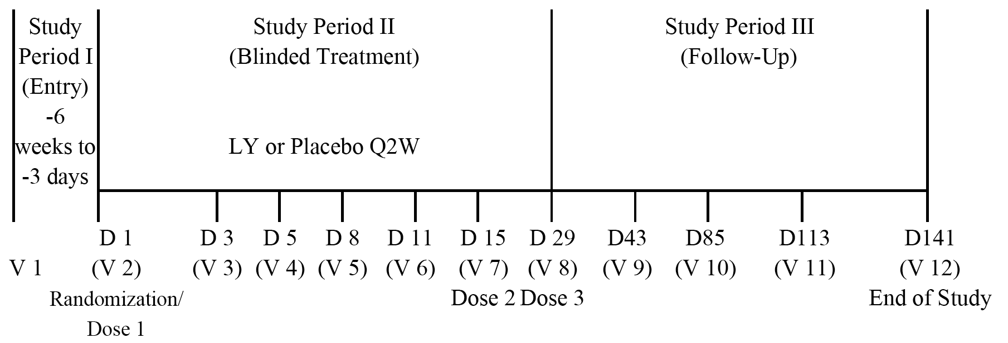
D = Day; LY = LY2439821 (ixekizumab); Q2W = every 2 weeks; V = Visit. Note: Although the protocol began at Day 0 for randomisation, for the purpose of reporting, the Randomisation Visit was Day 1 and each subsequent visit day was also Day +1 relative to the protocol defined day (as reflected in this diagram).

Study drug formulation and administration
The ixekizumab formulation used in this study was the low-dose lyophilised (20 mg/vial) formulation. The following ixekizumab SC doses were administered Q2W on 3 occasions: 5 mg (1 x injection); 15 mg (1 x injection); 50 mg (2 x 25 mg injections); and 150 mg (4 x 37.5 mg injections). Placebo (normal saline) was administered as 1, 2 or 4 SC injections to maintain the blinding at each dose level. In addition to SC administration, ixekizumab 15 mg was administered as an IV infusion Q2W on 3 occasions as was placebo (normal saline) to maintain blinding.

Evaluation methods

Bioanalytical analysis
The human serum samples were analysed for ixekizumab using a validated ELISA method. The lower limit of quantification (LLOQ) was 7.5 ng/mL, and the upper limit of quantification (ULOQ) was 300 ng/mL.

Pharmacokinetic (NCA and PopPK) analysis
Non-compartmental analysis (NCA) of PK parameters was conducted using WinNonlin Enterprise software. Single-dose PK parameters were calculated from ixekizumab serum concentrations sampled over the first dosing interval of 14 days. PK parameters included maximal (peak) serum concentration (C_{max}), time of maximal serum concentration (t_{max}), and area under the concentration-time curve from Time 0 to Day 14 (AUC_{0-14d}).
A PopPK analysis approach was used to characterise the time-course of serum concentrations following SC administration of multiple doses of ixekizumab. Nonlinear mixed-effect population analysis was conducted using NONMEM (Version VI). PK parameters obtained using PopPK methods included absolute bioavailability (F) for the SC route, first-order absorption rate constant (Ka), clearance (CL), inter-compartmental clearance (Q), central volume (V2), and peripheral volume (V3). Models for between-subject variability were examined on F, Ka, V2, and CL.

Pharmacokinetic/pharmacodynamic analysis
PK/PD analysis was conducted to describe the time-course relationship between ixekizumab exposure and clinical efficacy measured as absolute PASI scores. The PD parameters estimated through modelling included baseline PASI score, ixekizumab concentrations required to achieve half the maximum effect (EC₅₀), and half-life of PASI scores to relapse following SC (Tout SC) and IV (Tout IV) routes of administration.

Sample size
There was no formal sample size calculation. It was planned that approximately 45 subjects would be enrolled (10 for each SC cohort (8 ixekizumab; 2 placebo) and 5 for the IV cohort (4 ixekizumab; 1 placebo)). The sample size was chosen to provide adequate placebo control and was considered sufficient to evaluate the primary objective. The number of subjects required to make a safety evaluation prior to dose escalation was 5 (4 ixekizumab; 1 placebo). For evaluation of clinical efficacy and PD effects of ixekizumab, 10 subjects (8 ixekizumab; 2 placebo) were required.

Statistical methods

Pharmacokinetics
The primary PK parameters for statistical analysis were AUC_{0-14d} and C_{max}. Dose proportionality was assessed based on AUC_{0-14d} and C_{max} using a power model.

Pharmacokinetic/pharmacodynamic assessment
The PASI combines assessments of the extent of body-surface involvement in 4 anatomical regions (head, trunk, arms, and legs) and the severity of desquamation, erythema, and plaque induration (thickness) in each region, resulting in an overall score of 0 for no psoriasis to 72 for severe disease. PASI scores were summarised by descriptive statistics. Changes from baseline in PASI were analysed using a mixed-effects model, with baseline PASI score as a covariate, dose, day, and their interaction as fixed-effects, and subject as a random-effect. Pairwise treatment comparisons between ixekizumab dose groups and placebo were performed post-baseline on the days on which PASI was measured. Mean differences and 90% confidence intervals (CIs) were calculated using the within-subject error and degrees of freedom derived from the mixed-effects model.

Baseline data
A total of 46 randomised subjects with psoriasis vulgaris with a mean age of 42 years (range: 20 to 65 years) participated in the study. Of the 46 randomised subjects, 38 were males, 8 were females, 38 were Caucasian, 6 were Hispanic and 2 were East Asian. The mean body mass index (BMI) of the overall population was 29.8 kg/m² (range: 19.0 to 39.7 kg/m²). The mean duration of disease in the overall population was 17 years (range: 1 to 56 years), with a median of 11 years. The mean PASI at baseline of the overall population was 21.5 (range: 13.0 to 44.7), and the mean PGA of the overall population at baseline was 5 (range: 4 to 6). In general, randomisation resulted in a balanced distribution of baseline demographic characteristics across the six study groups (5 mg SC (n = 8); 15 mg SC (n = 8); 50 mg SC (n = 8); 150 mg SC (n = 8); 15 mg IV (n = 8); and placebo SC and IV (n = 9).

Participant flow
Of the 46 randomised subjects, 37 received at least 1 dose of ixekizumab (32 received SC ixekizumab; 5 received 15 mg IV ixekizumab) and 9 received at least 1 dose of placebo (8 received SC placebo; 1 received IV placebo). Of the 46 subjects, 42 completed all 3 administrations of study drug (2 subjects received 1 dose and 2 subjects received 2 doses), 33 completed the study (Day 140), and 13 did not complete the study. The reasons for 2 subjects receiving only 1 of the 3 planned doses of the study drug were, serious adverse event (SAE) in 1 subject (post-procedural cellulitis post skin biopsy; ixekizumab 50 mg SC group) and 1 subject elected to discontinue (no improvement in psoriasis; ixekizumab 15 mg IV group) and was replaced. The reasons for 2 subjects receiving only 2 of the 3 planned doses of the study drug were, SAE in 1 subject (ankle fracture; ixekizumab 15 mg SC group) and AE in 1 subject (worsening hypothyroidism; placebo SC group).
Of the 13 subjects not completing the study, 9 received ixekizumab and 4 received placebo. Of the 13 subjects who discontinued, 7 discontinued due to physician decision to allow initiation of alternative treatment for psoriasis, 3 elected to discontinue, 2 were lost to follow-up, and 1 discontinued due to a SAE (post-procedural cellulitis post skin biopsy).

Results for pharmacokinetics

Analysis set
Data for the NCA were available from 37 subjects. There were 390 serum ixekizumab samples, including 10 (3%) that were below the LLOQ (< 7.5 ng/mL). 3 subjects given ixekizumab did not complete the intended dosing regimen and contributed incomplete PK profiles. However, since all 3 subjects received at least 1 dose of ixekizumab, their data were included in all PK analyses. Of the 390 ixekizumab serum samples, 30 (8%) were collected outside the protocol specified time window but were included for all PK related analyses.

Single-dose pharmacokinetics
The single-dose PK parameters for ixekizumab are summarised in Table 2, below.

Table 2. PK parameters (NCA) following single-dose ixekizumab; Study RHAG
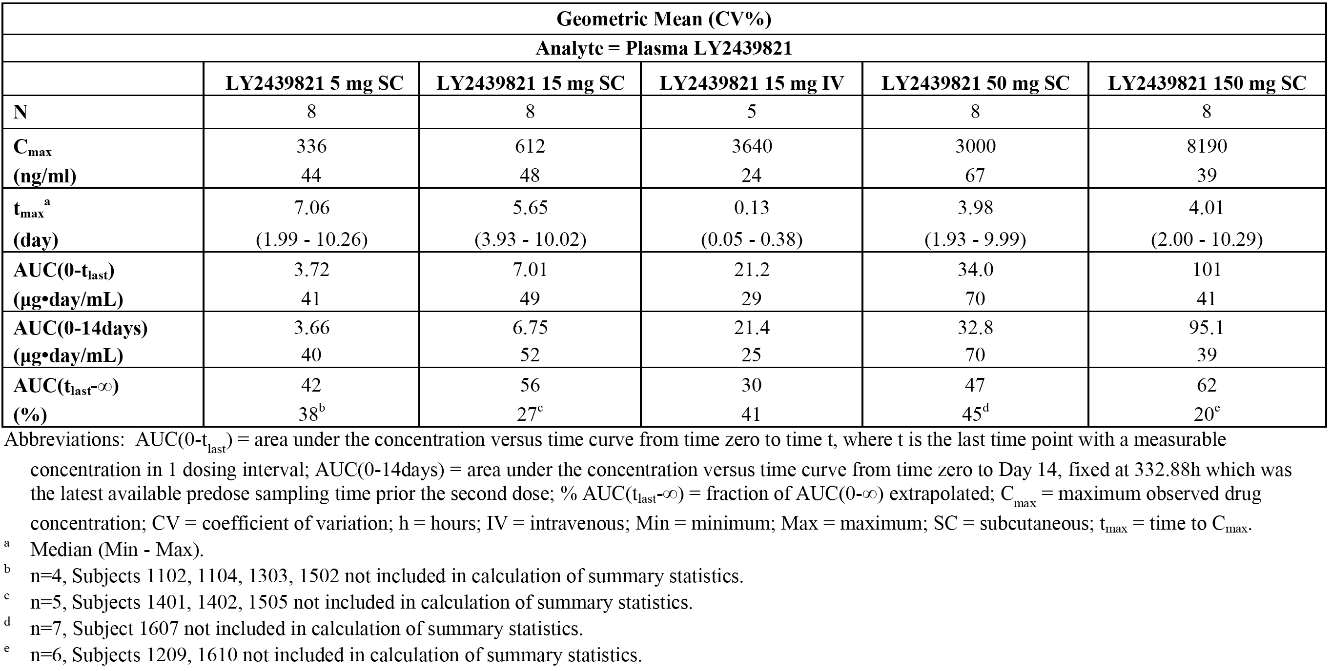
Evaluator’s comment: The terminal elimination phase following administration of single-dose administration of ixekizumab (SC or IV) cannot be adequately characterised, as the 2 week dosing interval is too short to allow satisfactory sampling (the extrapolated fraction of the area under the curve from time 0 to infinite (AUC_{0-inf}) was 42%). In general, the extrapolated fraction of the AUC_{0-inf} should be less than 20% of the area under the curve from time 0 to the last quantifiable concentration (AUC_{0-last}) in order to conclude that sampling has been sufficient to adequately characterise the terminal elimination phase. The absorption of ixekizumab from the SC injection sites was slow, as shown by T_{max} values of approximately 4 to 7 days following SC dosing.

Dose-proportionality single-dose over range 15 to 150 mg SC
Based on the power model for dose proportionality, the ratio of the dose normalised geometric mean values, with accompanying 90% CI, after a single SC dose of ixekizumab over the dose range of5 mg to 150 mg were 0.9 (90% CI: 0.6 to 1.4) for the C_{max} and 1.0 (90% CI: 0.7 to 1.5) for the AUC_{0-14d}.
Evaluator’s comment: Dose proportionality over a specified range was declared if the 90% CI for the predicted ratio of dose-normalised geometric means lay entirely within the interval (0.70 to 1.43), where a ratio of 1.0 denotes ideal proportionality. The 90% CIs for the dose-normalised geometric ratios of both the C_{max} and AUC_{0-14d} were not enclosed completely within the pre-specified interval of 0.70 to 1.43. Therefore, the results indicate that ixekizumab deviates from dose proportionality over the dose range 5 mg to 150 mg.

Multiple-dosing
The arithmetic mean concentration-time profiles for each ixekizumab dose level following multiple doses (Days 0, 14, and 28) are presented in linear and semi-log scales below in Figure 2. The mean concentration-time profiles for each ixekizumab dosing regimen are similar in shape across the SC multiple-dose range of 5 mg to 150 mg. The plasma concentrations fell more rapidly after reaching the C_{max} for the IV dose compared to the SC doses. This is due to prolonged drug absorption following SC administration, as evident by the delayed T_{max} comparing SC and IV profiles at 15 mg.
Figure 2. Ixekizumab mean plasma concentration-time profile following bi-weekly administration of 3 doses; a. linear scale (left) and b. semi-log scale (right); Study RHAG
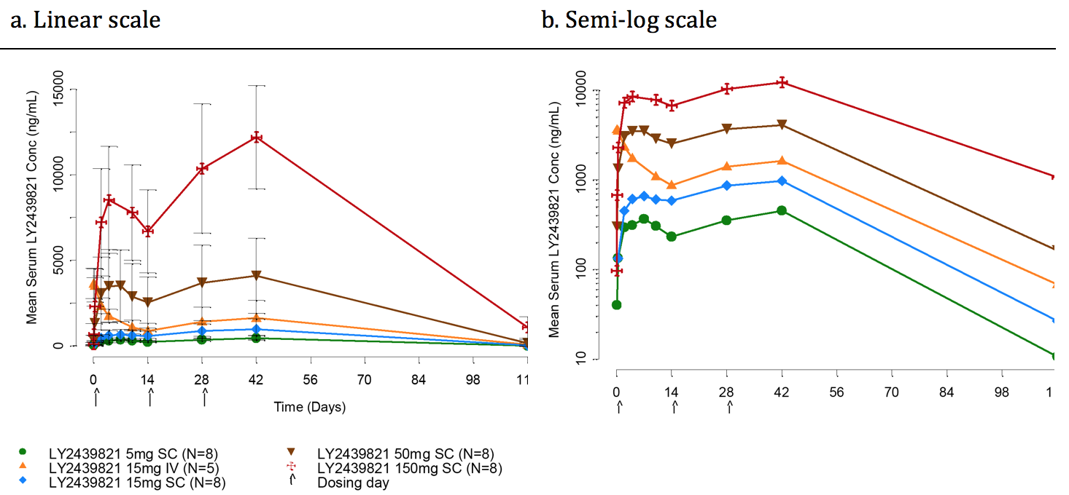
Abbreviations: LY2439821 = ixekizumab; conc = concentration; IV = intravenous; SC = subcutaneous. Arrows depict time of dosing. Note: horizontal axis denotes time from first dose.

Results for population pharmacokinetics (PopPK)
The PopPK analysis showed that a 2-compartment PK model with first-order SC absorption and elimination adequately described the disposition of ixekizumab. The PopPK parameters with covariate values are summarised below in Table 3.

Table 3. PopPK parameters with covariate values based on the final PopPK model; Study RHAG
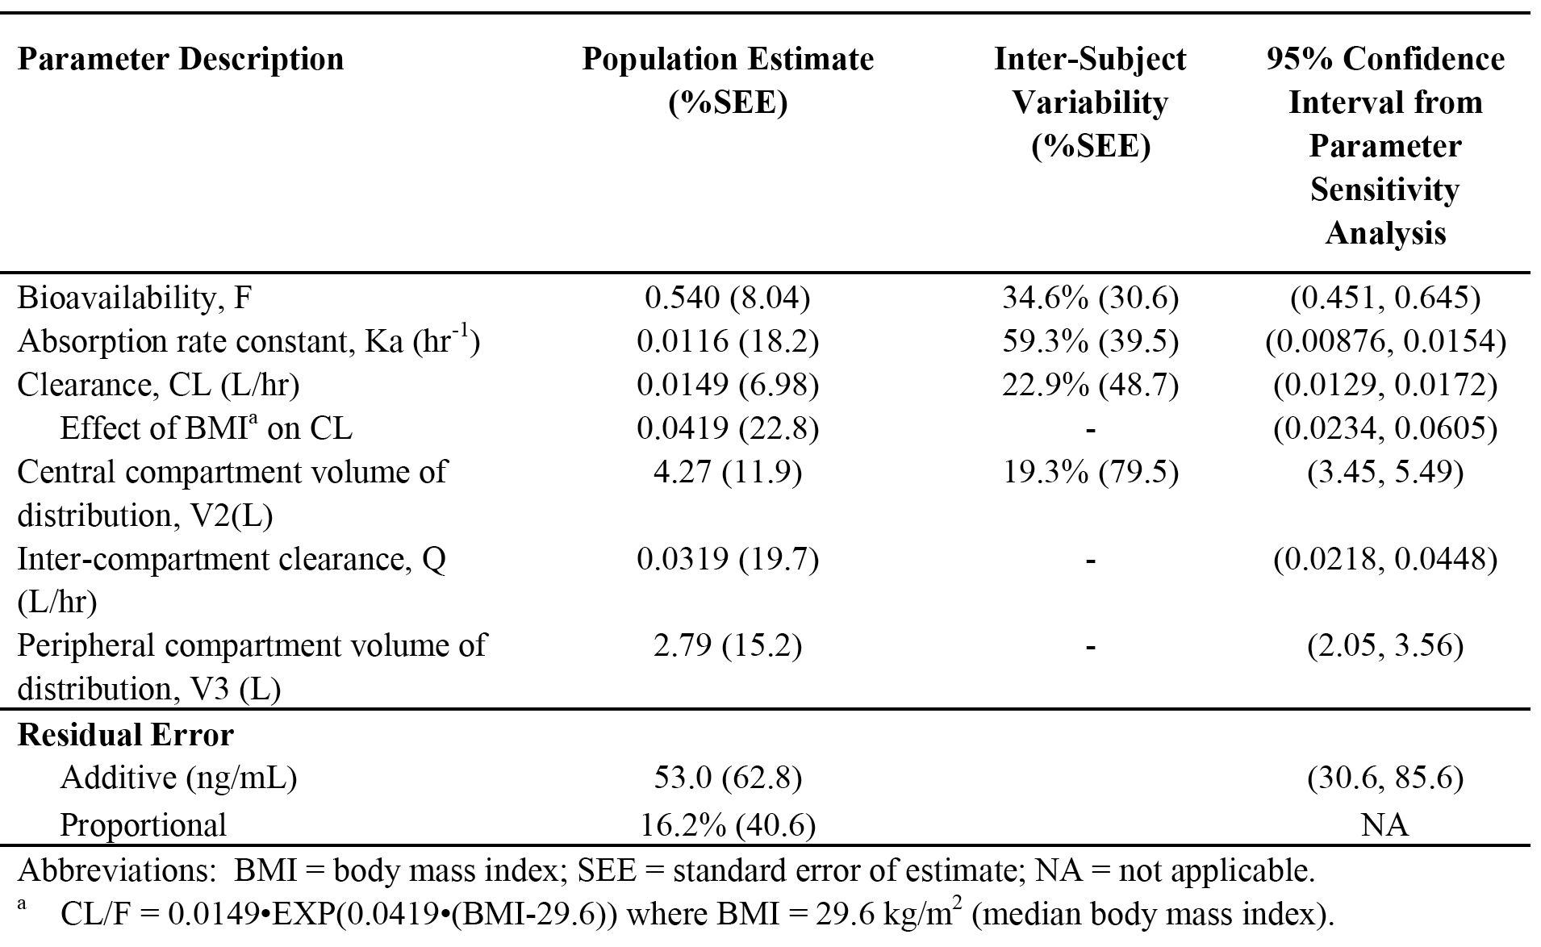
In the exploratory covariate analysis, BMI achieved statistical significance as a covariate on CL and reduced inter-subject variability by 10.6%. Consequently, simulations were performed for ixekizumab exposures at steady-state over a dosing interval of 4 weeks (area under the curve from time 0 to dosing interval τ at steady state (AUC_{0-τ,ss})). The simulation dataset for 1012 subjects was created through replicating the actual data set consisting of 46 subjects by 22 times (N = 46 x 22 = 1012). The ratio of the median fixed-dose AUC_{0-τ,ss} to the BMI adjusted dose AUC_{0-τ,ss} was 1.04 (6000/5760 µg hr/mL), with the 5th to 95th percentile being 0.93 to 1.04.
Evaluator’s comment: The population estimate of the absolute bioavailability of ixekizumab following SC administration was 54% (95% CI: 45% to 65%), with an inter-subject variability of 34.6%. Among the covariates tested, which included dose, only BMI was identified as having a statistically significant effect on CL. Therefore, modelling of simulated data was undertaken to assess the difference in steady state exposure AUC_{0-τ,ss} between a fixed-dose regimen and a BMI adjusted-dose regimen. Based on the modelling data, a BMI adjusted-dose regimen appears to provide no benefit over a fixed-dose regimen as regards steady-state exposure, even though BMI has a significant effect on CL. The ratio of the median fixed-dose AUC_{0-τ,ss} to the BMI adjusted-dose AUC_{0-τ,ss} was 1.04, with the 5th to 95th percentile being 0.93 to 1.04. The clinical significance of the effect of BMI on CL is unknown.

Results for pharmacokinetics/pharmacodynamics
A total of 247 PASI measurements from 46 subjects were available for the analysis. A PK/PD model linking ixekizumab concentrations to clinical efficacy measured as absolute PASI scores was applied to describe the data. The exposure-efficacy model showed that increasing exposure resulted in increasing reduction in mean PASI score (that is, clinical improvement). Population PD parameter estimates and their inter-subject variability, where applicable, are summarised below in Table 4.

Table 4. PK/PD parameters in final population model, Study RHAG
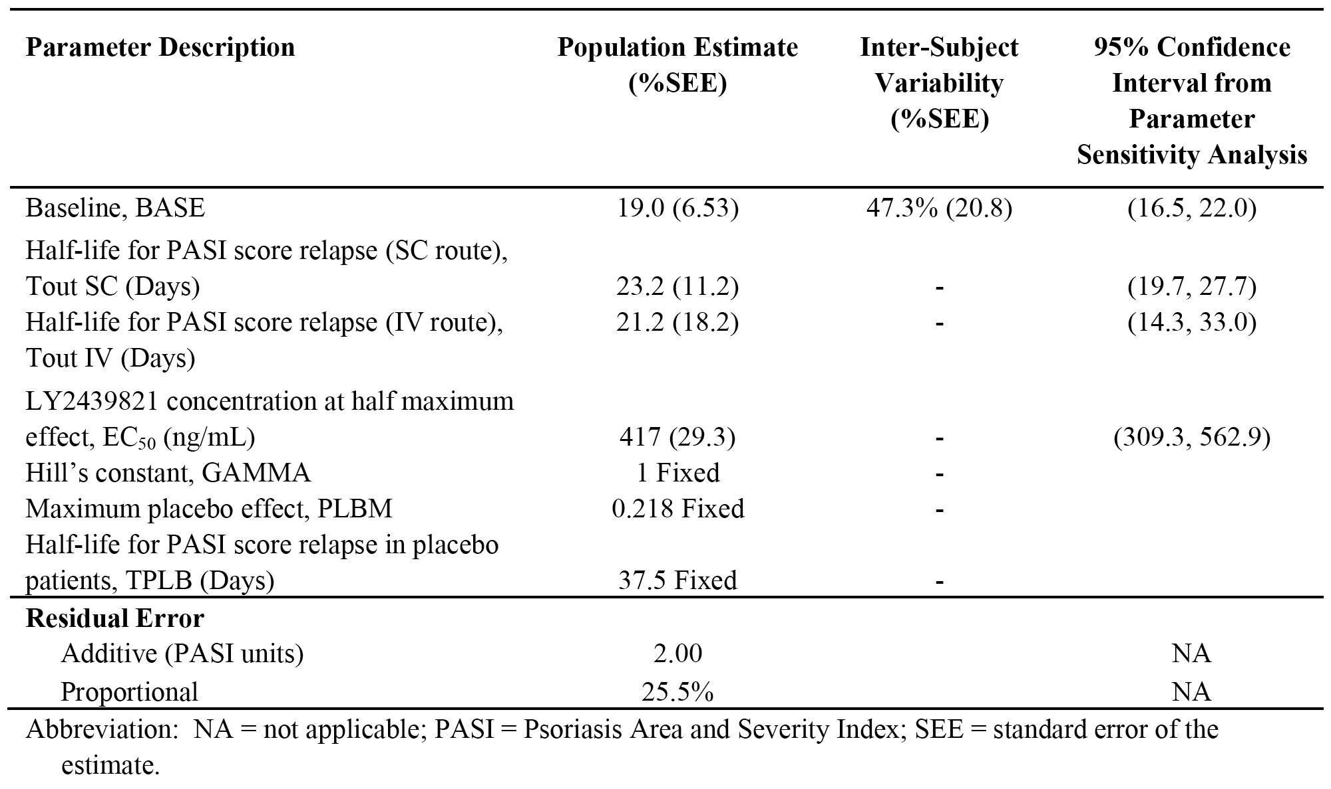
Evaluator’s comment: In general, the PD parameters were estimated with good precision. The model identified an EC₅₀ of 417 ng/mL, following a regimen for 3 doses given for a Q2W dosing regimen. An SC dose of 15 mg was anticipated to produce mean ixekizumab concentrations close to, or exceeding EC₅₀ following Q2W dosing. Based on the exposure-efficacy model, the ixekizumab dose range selected for further development of patients with moderate to severe psoriasis was 10 mg to 150 mg.

Results for pharmacodynamics

PASI Scores
Mean PASI scores and the mean percent improvement in PASI scores from baseline by dose group suggest an overall dose response to ixekizumab (see Figure 3, below). Based on the maximal possible effect (E_{max}) model, at an ixekizumab dose of 18 mg SC approximately 50% of maximum effect was achieved, and at an ixekizumab dose of 50 mg SC approximately 95% of the maximum effect was achieved. The median effective dose (ED₅₀) for ixekizumab was observed to be 18.3 mg (95% CI: 6.7 to 30.5 mg), the placebo effect (E₀) for improvement in PASI scores was estimated to be 7.7% (95% CI: -7.1% to 22.4%), and the ixekizumab E_{max} for improvement in PASI scores was estimated to be 83.5% (95% CI: 54.0% to 100%).
Figure 3. Mean (SD) PASI score-time profile (a; left) and mean percent improvement in PASI score-time profile (b; right) following Q2W ixekizumab or placebo for the doses; Study RHAG
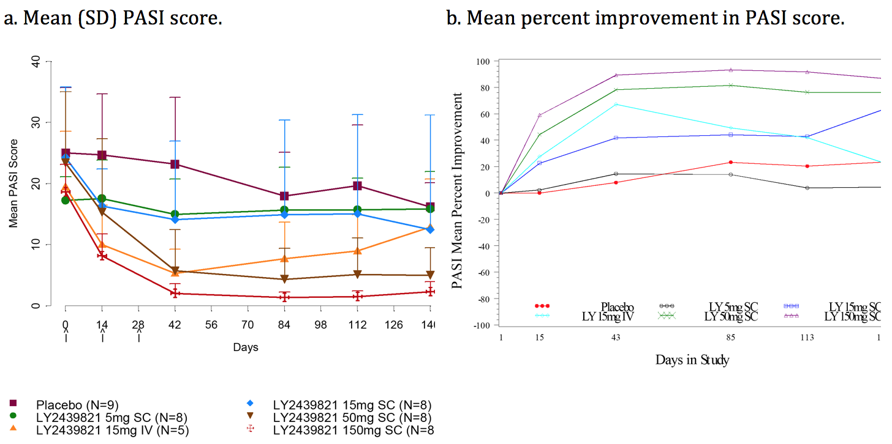

Physician's Global Assessment (PGA)
The PGA data were consistent with the PASI data and showed a dose-related improvement in mean PGA. At Day 141, there was a nominal statistically significant difference (p < 0.05) in least square (LS) mean improvement in PGA from baseline between both ixekizumab SC 50 mg and 150 mg and placebo in favour of active treatment (see Table 5, below). A linear mixed-effects model with treatment, time, and treatment-by-time interaction as fixed-effects, baseline as covariate, and subject as a random-effect was used for treatment comparisons.

Table 5. PGA improvement from baseline (Day 141 all randomised patients); Study RHAG
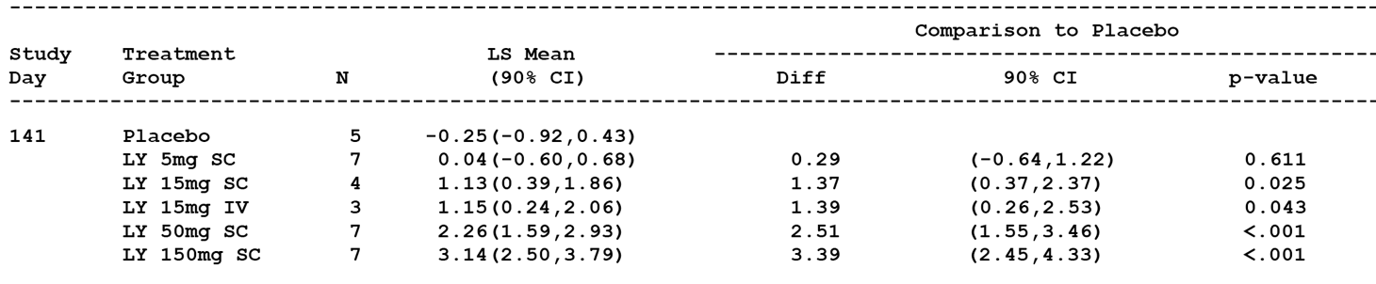
Note: LY = ixekizumab; SC = subcutaneous; IV = intravenous; LS mean = least square mean; diff = difference between LY group and placebo; CI = confidence interval; for 2 subjects discontinued study drug earlier than Visit 9, their last visits were labeled as V

Skin biopsy histology/immunochemistry
There was a decrease in mean epidermal thickness at Days 15 and 43 for all ixekizumab doses compared to baseline. The decreases in thickness were most marked in the 15 mg IV, 50 mg SC and 150 mg SC dose groups. The change from baseline in epidermal thickness was statistically significantly decreased at Days 15 and 43 for the 15 mg IV, 5 mg SC, 50 mg SC, and 150 mg SC dose groups compared to placebo. The proportion of subjects with K16+ cells decreased from baseline to Days 15 and 43 at all ixekizumab doses for all randomised subjects, but was more marked in the 15 mg IV, 50 mg SC and 150 mg SC dose groups. At all ixekizumab doses there was a decrease in the mean number of CD3+ cells in the epidermis at Days 15 and 43 compared to baseline. The decrease from baseline in CD3+ cells was statistically significant at Days 15 and 43 for the 15 mg IV, 50 mg SC and 150 mg SC dose groups compared to placebo. At day 15 but not Day 43, the decrease from baseline in CD3+ cells was statistically significant for the 15 mg SC dose group compared to placebo. There was a general trend towards decreasing CD11c+ cells in the epidermis with increasing ixekizumab dose at days 15 and 43 compared to baseline. The decrease from baseline in CD11c+ cells was statistically significant at Days 15 and 43 for the 150 mg SC dose group compared to placebo, and at day 15 for the 50 mg SC dose group compared to placebo.

Study RHBL (Phase III)

Introduction
Study RHBL was a Phase III, multicentre, randomised, open-label, parallel-group, 12-week study in patients with moderate to severe plaque psoriasis examining the effects on the PK of ixekizumab of the drug delivery device (PFS or AI), the site of injection (arm, thigh, or abdomen), and body weight. In this study, ixekizumab was initiated with a 160 mg SC dose followed by 80 mg SC Q2W for 12 weeks, followed by a 40 week optional safety extension period during which the dose was administered every 4 weeks (Q4W) using a PFS and self-selected injection sites.
The study was undertaken in the USA at 26 centres. The first patient was enrolled on 12 March 2013 and the database lock was 25 June 2014. The study report presented results based on data collected through 25 June 2014, including all data through to the end of the treatment period (Week 12; Visit 5) of the study. The study was performed in compliance with the principles of GCP.

Objectives

Primary objective
The primary objective of the study was to evaluate the effect of drug delivery device, either by PFS or AI, on the PK of ixekizumab in patients with moderate to severe plaque psoriasis. The dose, volume, and formulation of ixekizumab were identical for the two devices. Consequently, the sponsor anticipated that the PK of ixekizumab following SC administration using either a PFS or AI would be similar. The PK assessment was undertaken over 2 weeks after the 160 mg starting dose.

Secondary objectives
The study included a number of secondary objectives, including an evaluation of the effect of body weight and site of injection (arm, thigh, or abdomen) on the PK of ixekizumab following single-dose SC administration via PFS or AI. The study also included a number of exploratory objectives, including, but not limited to, the evaluation of the ease of use and confidence of ixekizumab SC administrations via PFS using the subcutaneous administration assessment questionnaire (SQAAQ) at Weeks 0, 4, and 8, and the evaluation of the duration of injection for the AI and the PFS.
Evaluator’s comment: In this clinical evaluation, the focus is limited to those objectives of the study which were specifically designed to assess the PK of the two delivery devices.

Investigational plan and study design
The study consisted of four periods:
- Screening Period (4 to 30 days): occurred from approximately Day 4 to Day 30 (Visits 1 and 1A) prior to the treatment period to assess patient eligibility.
- Treatment Period (12 weeks): occurred from Week 0 (baseline; Visit 2) to Week 12 (Visit 5). The primary evaluation of ixekizumab PK occurred from Week 0 (Visit 2) to Week 2 (Visit 2E) after the ixekizumab 160 mg starting dose. Evaluation of secondary efficacy objectives occurred at Week 12.
- Optional Safety Extension Period (40 weeks): occurred after Week 12 (Visit 5) to Week 52 (Visit 9), inclusive, to evaluate long-term safety of ixekizumab and to allow patients who benefited from treatment with study drug the opportunity to continue receiving ixekizumab.
- Post-Treatment Follow-Up Period: occurred from last Treatment Period visit or Early Termination Visit (ETV) to a minimum of 12 weeks following that visit, to monitor for safety.
The study design is summarised below in Figure 4.
Figure 4. Study design; Study RHBL
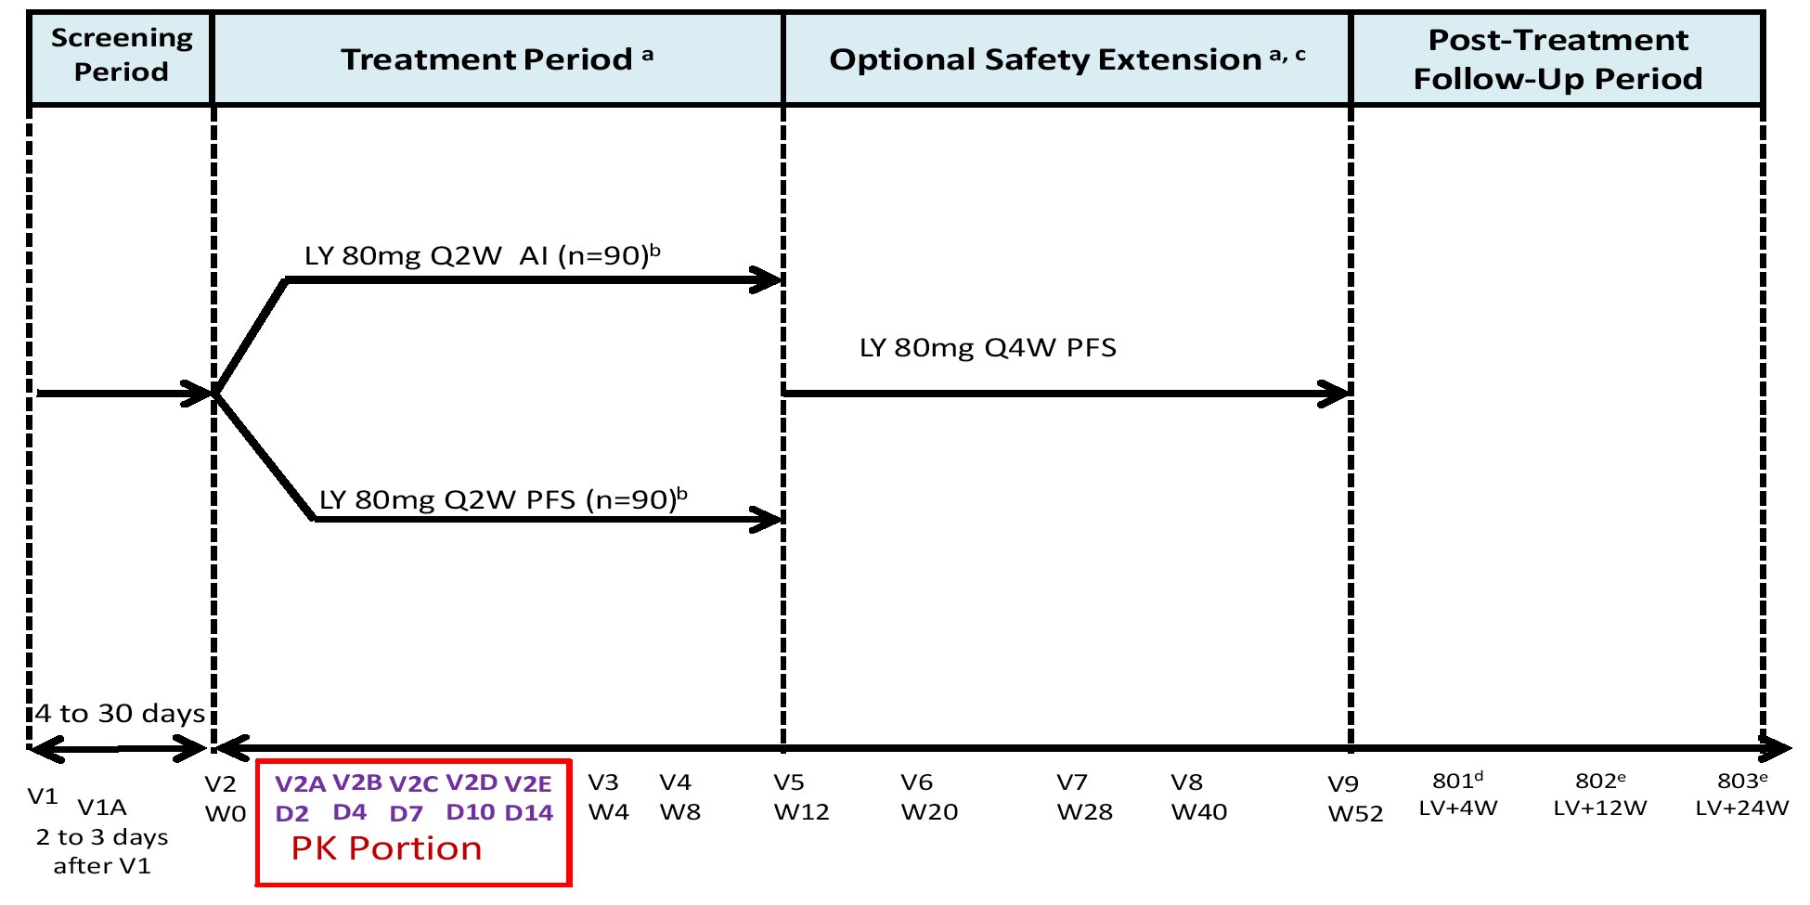
Abbreviations: AI = auto-injector; D = day; LV = date of last visit; LY = ixekizumab (LY2439821); n = number of patients; PFS = prefilled syringe; PK = pharmacokinetic; Q2W = every 2 weeks; Q4W = every 4 weeks; V = study visit; W = study week. Notes: a) Patients who discontinued the Treatment Period for any reason and who had received at least 1 dose of ixekizumab continued to Early Termination Visit A before entering the Post-Treatment Follow-Up Period. Patients who discontinued the Optional Safety Extension Period for any reason continued to Early Termination Visit B before entering the Post-Treatment-Follow-Up Period; b) Patients received a starting dose of 160 mg (as 2 injections of 80 mg) at Week 0; c. Patients who elected not to participate in the Optional Safety Extension Period entered the Post-Treatment Follow-Up Period after completion of the Treatment Period; d) All patients who received study drug entered the Post-Treatment Follow-Up Period and completed through Visit 802; e) Patients were followed beyond Visit 802 for continued monitoring of their neutrophil count if needed, or additional monitoring as needed.
The study planned to screen 320 patients and randomise 180 patients in 1:1 ratio to ixekizumab 80 mg Q2W SC administered by PFS (n = 90) or AI (n = 90). At Week 0 (baseline, Visit 2), patients who met all criteria for enrolment during the Screening Period (Visits 1 and 1A) were to be stratified into 1 of 3 weight categories: < 80 kg (low, n = 60), 80 to 100 kg (medium, n = 60), and > 100 kg (high, n = 60). Within each weight category, patients were assigned by interactive voice response system (IVRS) to an injection site (arm, thigh, or abdomen). Patients were expected to use their assigned injection site for all injections of ixekizumab (80 mg Q2W) during the 12 week treatment period. All patients received a starting dose of 160 mg at Week 0 (baseline, Visit 2). From Week 0 (Visit 2) to Week 2 (Visit 2E), patients participated in PK sampling for evaluation of the primary objective.
During the 12 week treatment period, patients assigned to the arm injection site had an injection assistant who administered all injections of ixekizumab to the patient. The injection assistant was trained at Visit 2 on the proper procedure for administering ixekizumab, and administered the second injection of the starting dose. The injection assistant was to attend all subsequent injection visits in the treatment period.

Study population
The study enrolled male and female patients aged 18 years or older with psoriasis, based on a confirmed diagnosis for at least 6 months prior to baseline, who were candidates for phototherapy and/or systemic therapy, had ≥ 10% BSA involvement, were willing to inject study drug by themselves (or had an injection assistant willing to inject the study drug), were willing to have blood drawn for PK sampling, had an sPGA score of ≥ 3, and a PASI score ≥ 12 at screening (Visit 1) and at baseline (Week 0, Visit 2).
Patients were excluded if they had pustular, erythrodermic, and/or guttate forms of psoriasis, a history of drug-induced psoriasis, or a clinically significant flare of psoriasis during the 12 weeks prior to baseline. There were a number of other exclusion criteria, including previous treatments with other therapies for psoriasis within a protocol specified period before baseline. The study also included appropriate discontinuation criteria for removing patients from therapy or assessment.

Study treatments
The study was open-label in design. The study was not blinded because the primary objective was to evaluate the effect of the drug delivery device (PFS or AI) on the PK of ixekizumab after the administration of the starting dose (160 mg). Open-label ixekizumab was administered by PFS or AI Q2W from Week 0 through Week 10 of the treatment period. At Week 0 (Visit 2), all patients received a starting dose of 160 mg as two 80-mg SC injections. At Week 2 (Visit 2E), patients started to receive 80 mg Q2W SC. During the Treatment Period, efforts were made to maintain specified intervals between injections, every 14 days. On weeks with scheduled visits, injections of ixekizumab were administered at the study site. For injections scheduled between study visits, if the scheduled injection day was missed, the missed dose was to be administered within 5 days of the scheduled day. During the ongoing optional safety extension period, all patients receive 80 mg Q4W SC by PFS. The final dose of ixekizumab was to be given at Week 48.
All medications (other than study drug) taken during the study were recorded on the case report form (CRF). Allowed prior therapies included systemic psoriasis therapy, topical therapies, phototherapy, and vaccines. To avoid drug-drug interactions or direct effects of concomitant therapies on study endpoints, each allowed previous therapy must have been discontinued prior to baseline for a specific period detailed in the protocol. During the study, limited use of topical therapies was allowed, as was the use of non-live seasonal vaccinations and/or emergency vaccination. Patients were able to continue their usual medication for other concomitant diseases throughout the study, unless specifically excluded in the protocol. Patients taking concomitant medications were to be on stable doses at the time of baseline and to remain at a stable dose throughout the study, unless changes needed to be made for an AE or for appropriate medical management.

Pharmacokinetic assessments
In the PK assessment period, Week 0 (Visit 2) to Week 2 (Visit 2E), blood was collected on Day 2 (Visit 2A), Day 4 (Visit 2B), Day 7 (Visit 2C), Day 10 (Visit 2D), and then prior to the second ixekizumab injection on Day 14 (Visit 2E). Each patient was scheduled to have 5 blood samples taken during the 14-day dosing interval, with each sample being collected at approximately the same time of day as the Week 0 (Visit 2) first injection of ixekizumab. Ixekizumab serum concentrations were assayed using a validated ELISA, with a LLOQ of 7.5 ng/mL and an ULOQ of 300 ng/mL.

Pharmacokinetic outcomes and analytical methods

Primary pharmacokinetic outcomes
Ixekizumab serum concentration-time data obtained after the starting dose during the dosing interval (0 to 14 days) was analysed using NCA methods. The primary PK parameters were C_{max} and AUC_{0-14d} following the starting dose of 160 mg. The two parameters were summarised as geometric mean and geometric 90% CIs for comparison of ixekizumab exposure using the test AI with the control PFS. Graphical methods were also used to compare exposure following AI and PFS injections.
All PK analyses addressing the primary objective were conducted using patients with evaluable PK data. A patient was considered to be evaluable for PK analysis if compliant with the dosing regimen, had all 5 ixekizumab serum concentration values with the actual date and time identified, and had the final PK sample taken on Day 14 ± 24 hours. In addition, patients with 4 of the 5 scheduled PK samples were considered evaluable if the final PK sample was taken on Day 14 ± 24 hours, and if the patient was not determined to be an outlier. Patients with insufficient data (that is, ≤ 3 ixekizumab serum concentration values or if the last time point on Day 14 was missing or outside the ± 24 hour time window) were excluded from the analysis.

Secondary pharmacokinetic outcomes
The effect of body weight was assessed as continuous and categorical variables. A linear regression model was applied to quantitatively describe the relationship between ixekizumab exposure (C_{max} or AUC_{0-14d}) and body weight as a continuous variable. The analysis was conducted on the combined ixekizumab exposure parameters (PFS plus AI), as exposure was anticipated to be similar for both drug delivery devices. In addition, analyses by drug delivery device group were also presented. Analyses for body weight were also investigated using BMI as a surrogate for body weight. The effect of injection site (arm, thigh, or abdomen) on ixekizumab C_{max} or AUC_{0-14d} was assessed using geometric mean and geometric 90% CI descriptive summary statistics for each drug delivery device. Graphical methods were also used to assess the effect of weight and injection site on the PK of ixekizumab.

Sample size
The sponsor stated that 144 patients would be adequate to assess the effect of delivery device, injection site, and body weight on the PK of ixekizumab (that is, 24 PK evaluable patients per injection site (arm, thigh, and abdomen)), with a total of 72 PK evaluable patients per drug delivery device (PFS versus AI) for a total of 144 PK evaluable patients. If there were < 8 patients in any body weight and injection site category, additional patients were to be enrolled in that category in order to have at least 8 patients in each category. At least 6 patients weighing ≤ 65 kg were to be enrolled in each of the 2 treatment groups in the ‘low weight’ category for a total of 12 patients or more.

Disposition and baseline characteristics of PK evaluable patients
192 patients from the randomised patient population (94%) were included in the PK analysis. 181 patients had all 5 samples taken according to the protocol, while 11 patients had 4 of the 5 samples taken, including the final sample on Day 14 ± 24 hours.
12 patients were excluded from the PK analysis, including 3 patients with no samples analysed at the bioanalytical laboratory (that is, having no PK information), 8 patients with ≤ 3 samples, and one patient with 4 samples but with only 3 evaluable samples due to the last sample having been taken at Day 17 instead of Day 14. In addition, there were 2 patients who had the 160 mg starting dose injected into 2 different sites (that is 80 mg each) rather than the same site (2 x 80 mg). These 2 patients were included in the PK evaluation by device and by weight, but were removed from the PK analysis by injection site location. PK evaluable patients summarised by weight, injection site, and device are provided below in Table 6.

Table 6. Summary of PK evaluable patients stratified by weight, injection site and device; Study RHBL
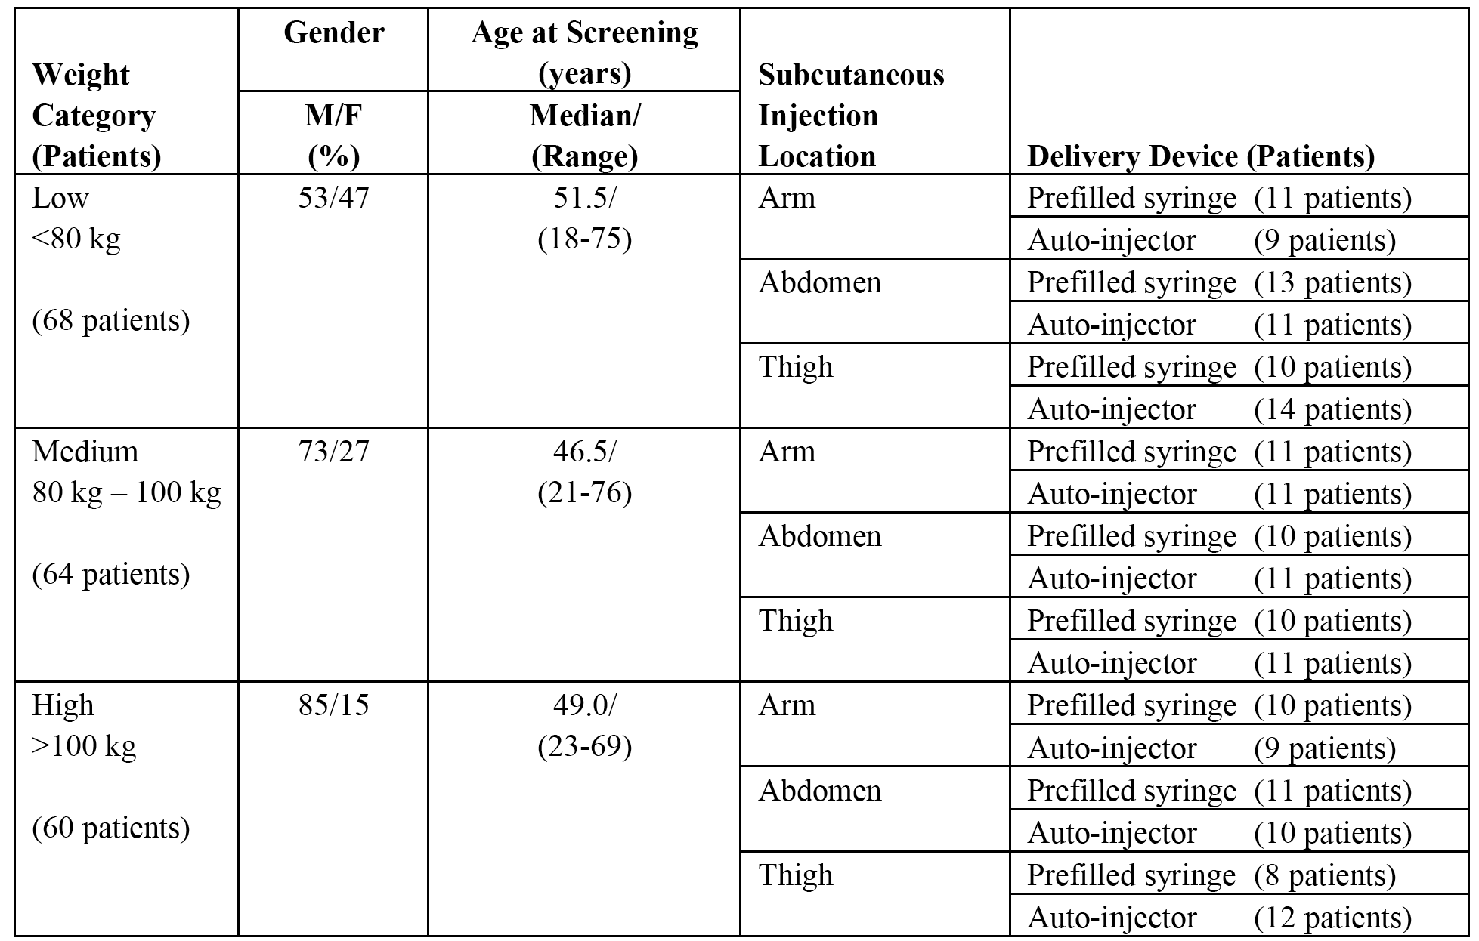

Pharmacokinetic results

Pharmacokinetics of ixekizumab (PFS versus AI)
The PK results following a single dose of ixekizumab 160 mg administered using the PFS or AI are summarised below in Table 7. The mean ixekizumab serum concentration versus time profiles for the PFS and AI groups are presented below in Figure 5.

Table 7. Serum ixekizumab PK parameters following 160 mg SC by PFS or AI in patients with moderate-severe plaque psoriasis; Study RHBL
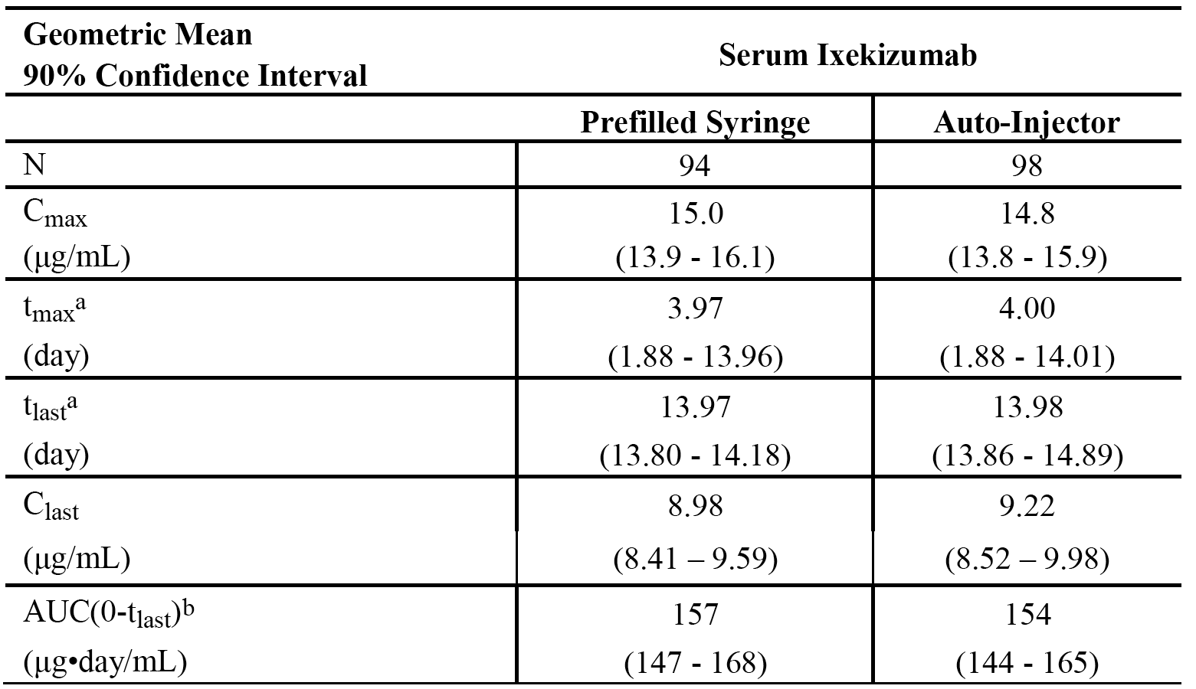
Notes: a) Median (minimum to maximum values); b) AUC(0-tlast) (or AUC0-last) is equal to AUC0-14d where the last time-point was 14 days ± 24 hours.
Figure 5. Mean ± SD serum ixekizumab concentration versus time, 160 mg SC dose using either a PFS or AI in patients with moderate to severe plaque psoriasis; Study RHBL
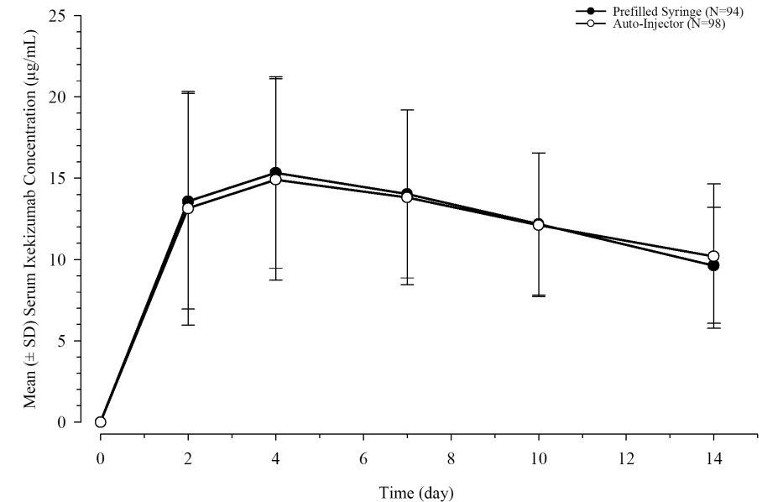
Evaluator’s comment: The PK of ixekizumab were similar following administration of the starting dose (160 mg) as SC injection by the PFS or the AI. The 90% CI for the both the C_{max} and the AUC_{0-last} overlapped for both device groups. Inter-subject variability in these parameters was also similar for each device group, with percent coefficient of variation (%CV) estimates in the range of 41% to 46% for C_{max} and AUC_{0-last}. The median t_{max} was approximately 4 days after dosing for each device. The mean ± SD ixekizumab versus time profiles through 14 days were almost superimposable after single-dose 160 mg SC administration using each device.

Effect of body weight on PK of ixekizumab
As the PK of ixekizumab were found to be similar between device groups, the effect of body weight was evaluated on the combined PK data for the PFS and the AI. The primary body weight categorisation was done in 3 groups: low (patients < 80 kg); medium (patients 80 to 100 kg); and high (patients > 100 kg). The PK results stratified by weight are summarised below in Table 8, and the mean ± SD versus time profiles stratified by weight are presented below in Figure 6.

Table 8. Ixekizumab PK parameters in serum stratified by weight following a 160 mg SC dose in patients with moderate to severe plaque psoriasis; Study RHBL
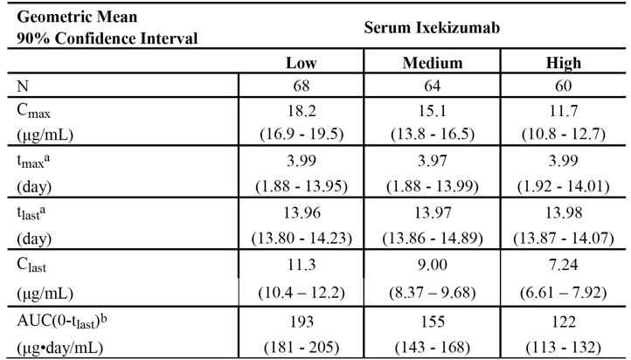
Abbreviations: AUC = area under the curve; AUC(0-14 days) = AUC from time 0 to 14 days; Clast = observed concentration at the last time point; Cmax = maximum observed concentration; N = number of patients; tlast = last time point; tmax = time of Cmax . Note: Low category corresponds to patients < 80 kg, medium to patients 80 to 100 kg, and high to patients > 100 kg. Notes: a) Median (minimum to maximum values), b) AUC(0-tlast) is equal to AUC0-14d, where the last time point was 14 days ± 24 hours.
Figure 6. Mean ± SD serum ixekizumab concentration versus time profiles following a 160 mg SC dose stratified by weight in patients with moderate to severe plaque psoriasis; Study RHBL
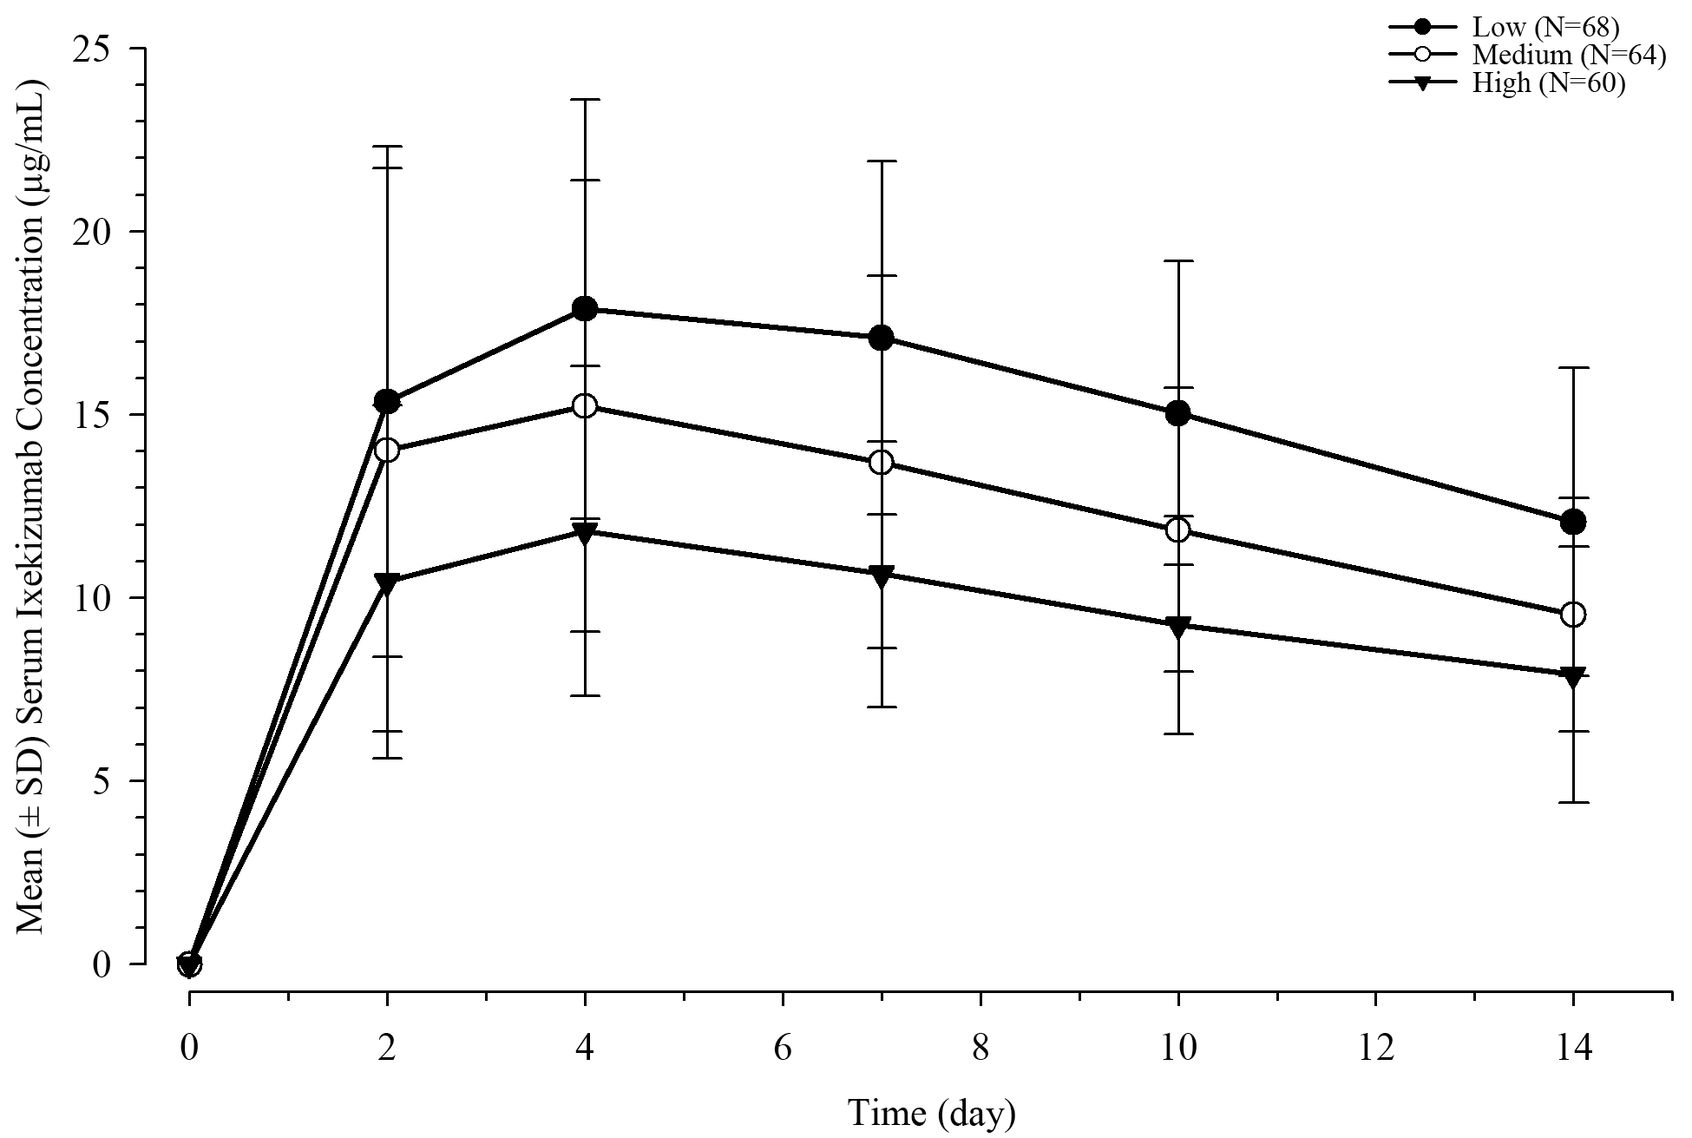
Note: Low category corresponds to patients < 80 kg, Medium to patients 80 to 100 kg, and High to patients > 100 kg.
Evaluator’s comment: Exposure to ixekizumab was highest in the low body weight group. Relative to the high body weight category, the mean AUC_{0-last} was 27% and 58% higher for the medium and low weight categories, respectively. The effect of weight on exposure was similar when ixekizumab was administered by PFS or AI. When AUC_{0-last} was plotted against weight as a continuous variable, increasing exposure was associated with decreasing weight over the weight range of approximately 50 kg to 180 kg. A linear regression model was used to describe the relationship and showed that a 5 kg decrease in body weight was associated with an approximate 6 μg day/mL increase in AUC_{0-last}.
The data were also analysed using BMI category. Five BMI categories were defined: underweight (n = 2 patients < 18 kg/m²), normal (n = 40 patients ≥ 18 and < 25 kg/m²), overweight (n = 58 patients ≥ 25 and < 30 kg/m²), obese (n = 67 patients ≥ 30 and < 40 kg/m²), and extremely obese (n = 24 patients ≥ 40 kg/m²). Exposure increased with decreasing BMI, with mean estimates of AUC being 85%, 45%, and 30% higher for the normal, overweight, and obese BMI categories relative to the extremely obese BMI category, respectively.

Effect of injection site on PK of ixekizumab
Three sites of administration were evaluated (arm, abdomen, and thigh). The PK parameters stratified by injection site using the PFS and the AI are summarised below in Table 9.

Table 9. Ixekizumab PK parameters in serum following 160 mg SC using PFS or AI in patients with moderate-severe plaque psoriasis, stratified by injection site; Study RHBL
 | Pre-filled syringe (PFS) |  |  | Auto-injector (AI)
Injection site | Arm | Abdomen | Thigh | Arm | Abdomen | Thigh
N | 30 | 34 | 28 | 29 | 32 | 47
C_{max} (µg/mL) | 14.4  (12.4, 16.8) | 12.7  (11.3, 14.2) | 18.5  (17.0, 20.1) | 11.5  (10.1, 13.0) | 15.4  (13.5, 17.5) | 17.6  (16.0, 19.4)
t_{max} (day)ª | 3.97  (2.0, 14.0) | 4.01  (1.9, 9.9) | 3.97  (2.0, 7.0) | 4.02  (2.1, 10.0) | 4.00  (1.9, 14.0) | 3.99  (1.9, 14.0)
t_{last} (day)ª | 13.96  (13.9, 14.1) | 13.97  (13.8, 14.2) | 13.98  (13.9, 14.1) | 14.00  (13.9, 14.1) | 13.97  (13.9, 14.9) | 13.97  (13.9, 14.1)
C_{last} (µg/mL) | 8.88  (7.9, 10.0) | 8.09  (7.3, 9.0) | 10.2  (9.2, 11.4) | 7.91  (6.9, 9.1) | 9.77  (8.6, 11.1) | 9.88  (8.6, 11.4)
AUC_{0-last}^{b}  (µg day/mL) | 151  (131, 173) | 135  (122, 150) | 190  (176, 206) | 124  (109, 142) | 159  (140, 180) | 178  (163, 194)
Abbreviations: AUC0-last = AUC from time 0 to last quantifiable time-point; Clast = observed concentration at the last time point; Cmax = maximum observed concentration; N = number of patients; tlast = last time point; tmax = time of Cmax Note: Low category corresponds to patients < 80 kg, medium to patients 80 to 100 kg, and high to patients > 100 kg. a) Median (minimum, maximum values); b) AUC0-last is equal to AUC0-14d, where the last time point was 14 days ± 24 hours.
Evaluator’s comment: Using the PFS, mean exposure (AUC_{0-last}) was highest when ixekizumab was administered in the thigh and lowest when administered in the abdomen (the geometric mean AUC_{0-last} was 21% and 30% lower for the arm and abdomen groups, respectively, compared with the thigh group). There was substantial overlap between the exposures in the arm versus the thigh and abdomen groups but only minimal overlap in exposures between the abdomen and thigh groups. Variability in exposure estimates was greatest for the arm group with CV estimates of 53% and 48% for C_{max} and AUC_{0-last}, respectively, and lowest in the thigh group with CV estimates of 27% and 26% for C_{max} and AUC_{0-last}, respectively. Median t_{max} estimates were approximately 4 days after dosing via each injection site.
Using the AI, mean exposure (AUC_{0-last}) was highest when administered in the thigh and lowest when administered in the arm (the geometric mean AUC_{0-last} was 30% and 11% lower for the arm and abdomen groups, respectively, compared with patients who administered ixekizumab via the thigh). There was substantial overlap in exposures across all 3 injection sites. Variability in exposure estimates was lowest for the thigh group with CV estimates of 36% and 33% for C_{max} and AUC_{0-last}. Variability in exposure estimates was higher in the arm and abdomen groups with CV estimates ranging from 43% to 47% for C_{max} and AUC_{0-last}. Median t_{max} estimates were approximately 4 days after dosing via each injection site.

Study RHAJ (Phase II) PopPK and PK/PD report

Introduction
Study RHAJ was a Phase II, multicentre, multinational (US, Denmark) dose-ranging study designed to evaluate the efficacy, safety, tolerability, PK, PD, and immunogenicity of ixekizumab SC compared to placebo in adults with plaque psoriasis. The results of the PopPK and PK/PD analyses are discussed below and the clinical efficacy and safety data are reviewed later in this clinical evaluation.

Objectives of the PopPK and PD analyses
The objectives of the PopPK analyses were to characterise the PK of ixekizumab in patients with moderate to severe psoriasis, evaluate the intra- and inter-patient variability of ixekizumab PK, and to evaluate the effect of potential covariates on ixekizumab PK parameters.
The objectives of the PD analyses were to evaluate the ixekizumab dose/exposure-efficacy response relationship for the clinical endpoints of PASI score and PASI 75, and to evaluate the effect of potential covariates on ixekizumab PD parameters of efficacy.

Study design
The study had two parts (A and B). Part A was randomised, double-blind, placebo-controlled, parallel-group, and dose-ranging (approximately 20 to 40 weeks); and Part B was an optional extension period with an open-label design (approximately 246 weeks) for patients who completed Part A. Data from Part B data were outside the scope of the PK/PD Report.
In Part A, 142 patients were randomised to treatment with ixekizumab or placebo. The mean age of the 142 patients (61 female/81 male) was 46.2 years (range: 18 to 72 years), and the mean BMI was 31.5 kg/m² (range: 18.9, to 56.2 kg/m²). The majority of the population was Caucasian (91% (129/142)).
The 142 patients were randomised to 1 of 5 treatment groups (4 ixekizumab or 1 placebo), with 27 to 30 patients per group. The patients received SC injections of ixekizumab (10, 25, 75, or 150 mg) or placebo at 0, 2, 4, 8, 12, and 16 weeks. Patients were evaluated for efficacy at multiple visits as described in the study schedule. The primary efficacy variable was the PASI 75 and secondary efficacy variables included sPGA responder rate, scalp, nail and joint effectiveness, as well as health outcomes. The primary endpoint analysis was at Week 12. Study treatment continued through Week 20, which included an additional 4 weeks after the last injection at Week 16, to determine whether the response seen at Week 12 persisted with continued therapy, and to explore whether maximum treatment response had been reached by Week 12. Patients who participated in Part A and elected not to continue treatment in Part B were followed for an additional 12 to 20 weeks (32 to 40 weeks total) after treatment in order to continue safety monitoring and to explore the durability of efficacy. The durability of treatment efficacy was measured by the loss of efficacy (PASI 75) over this treatment-free period. All patients who completed the treatment period in Part A of the study were eligible to enter Part B beginning at Week 20.

Analytical methods
Nonlinear mixed-effect population analysis was conducted with NONMEM (Version VII). Reporting of the PopPK analysis complied with the relevant TGA adopted guideline relating to such analyses (CHMP/EWP/185990/06). Serum samples were analysed for ixekizumab using a validated ELISA, with a LLOQ of 1.5 ng/mL and an ULOQ of 60 ng/mL.

Data set
Patients were allocated to 1 of 2 sparse sampling schemes (A and B) with an approximately equal number of patients being assigned to each sampling scheme at each dose. In sampling scheme A, a total of 6 samples were collected for each patient including 3 pre-dose samples at weeks 4, 8, and 16 and 3 random samples at weeks 1, 24 and 32. In sampling scheme B, a total of 6 samples were collected for each sample including 3 pre-dose samples at weeks 1, 12, and 16 and 3 random samples at weeks 6, 20 and 28. The sampling schedule for PASI score included 13 random samples at screening, weeks 0, 1, 2, 4, 6, 8, 12, 16, 20, 24, and 32.

PopPK results
The final PK NONMEM data set included 651 observations from 115 patients. A 2-compartment model with first-order absorption and linear clearance best described the data. The values for bioavailability and its inter-individual variability were fixed to values obtained from Study RHAG, as the bioavailability of the ixekizumab could not be directly estimated from study RHAJ due to the lack of a comparative IV administration arm. The model predicted an absorption lag time of 97.4 hours following SC administration. The absorption rate constant (Ka) and V2 were estimated to be 0.0207/h and 5.88 L, respectively. Due to the sparse sampling scheme the parameters V3 and Q could not be estimated with reasonable precision and were fixed to final model estimates from Study RHAG.
The estimated population CL of ixekizumab was low at 0.0177 L/hr and was independent of dose over the dose range of 10 mg to 150 mg. Body weight was found to have a statistically significant effect on CL. Patients with body weights < 100 kg and ≥ 100 kg had mean CL estimates of 0.0177 L/h and 0.0232 L/h, respectively, the difference being approximately 30% and less than the estimated inter-individual variability in CL (35.5%). The central and peripheral volumes of distribution were 5.88 L and 2.79 L, respectively, resulting in a total of 8.67 L. Subsequent to the conduct of Study RHAJ, a disease-state (psoriasis) cut point for the anti-drug antibody (ADA) screening assay was established, therefore, the effect of immunogenicity is assessed in the Primary PopPK Analyses. The PK and covariate parameters in the final population model are summarised below in Table 10.

Table 10. Pharmacokinetic, covariate parameters in final population model; Study RHAJ
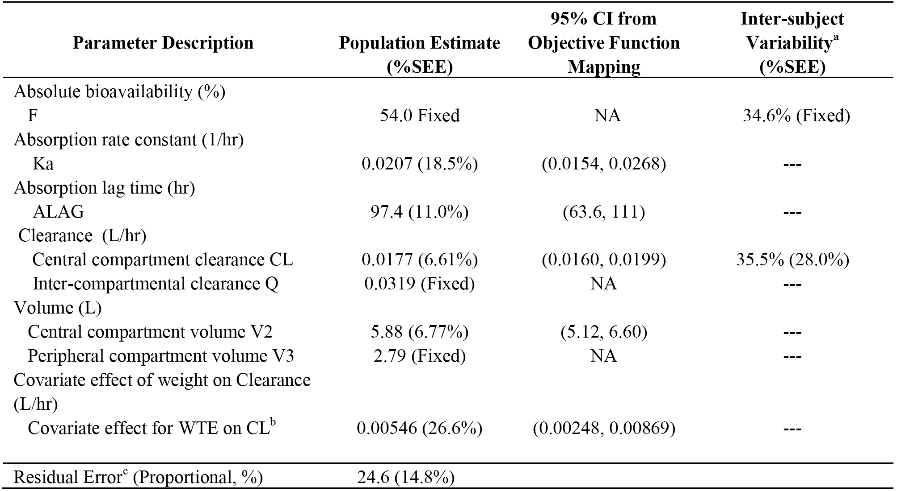
Abbreviations: CI: confidence interval; %SEE = relative standard error of estimate; dashed line = fixed to zero; NA = not applicable. Notes: a) reported as %CV; b) WTE is screening body weight, CL is 0.0177 L/hr when body weight is < 100 kg; CL is (0.0177 + 0.00546) = 0.0232, L/hr when body weight is ≥ 100 kg; c) reported as %CV.

Exposure-efficacy results
The final PD NONMEM data set included 1445 PASI Scores from 142 patients. The relationship between drug exposure and the time-course of PASI response was well described by an indirect-response model. However, the model could not precisely estimate the EC₅₀. However, when PASI 75 responder status at Week 12 was included as a covariate on EC₅₀ in the final model, improvements were observed on the model fits for PASI 75 and PASI 90 at 10 mg and PASI 90 at 100 mg. Following 16 weeks of dosing, the population mean EC₅₀ values of PASI 75 non-responders (1460 ng/mL) was approximately 150-fold greater compared to PASI 75 responders (9.73 ng/mL). This suggests that responders displayed higher sensitivity to ixekizumab exposure than non-responders.

Primary population pharmacokinetic (PopPK) analysis

Introduction
The submission included exploratory Population Pharmacokinetic and Exposure Response Analyses based on data from three clinical studies, namely Study RHAG (Phase I), Study RHAJ (Phase II), and Study RHAZ (Phase III). The three studies were undertaken over varying time periods from September 2008 to August 2014, and Studies RHAJ and RHAZ were ongoing at the completion date for the primary PopPK analysis. The report of the primary population analysis was dated 3 March 2015. The primary PopPK analysis will be described in this section of the clinical evaluation, while the primary PK/PD analysis will be described in the Pharmacodynamics section.

Objectives
The objectives of analyses were:
- characterisation of the PK of ixekizumab to determine the magnitude of within-patient and between-patient variability, and identification of potential intrinsic and extrinsic factors that may impact the PK of ixekizumab;
- characterisation of the exposure-response relationships describing the efficacy endpoints (sPGA and PASI score), and identification of potential factors that may impact the relationship;
- characterisation of the exposure-response relationships describing the key safety endpoints;
- evaluation of the potential development of anti-ixekizumab antibodies and their impact on the efficacy and PK of ixekizumab.

Pharmacokinetic model development
Pre-specified population PK and exposure-response analyses were performed using NONMEM (Version 7.3.0). The methodology was extensively described and reporting of the analyses were consistent with the relevant TGA adopted guidelines (CHMP/EWP/185990/06).
4. Observed concentration data
Blood samples were collected according to predefined schedules for each study. The number of samples per patient ranged from 1 to 11, with an average of approximately 4 samples per patient. In the final data set for the PK analysis there were 6059 ixekizumab concentrations from 1399 patients. Out of a total of 6059 PK samples, 56% were trough concentrations, 3% were samples taken during the absorption phase (that is, up to 4 days after a dose) and 16% were samples collected after the first dose. The range of doses across the three studies included 5 mg to 160 mg SC and 15 mg IV. The majority of the data were from Study RHAZ (a pivotal Phase III study) and, consequently, there is a large amount of data from this study for the 80 mg dose administered SC every Q2W or Q4W The breakdown of PK data from the different studies is shown below in Table 11.

Table 11. Primary PopPK analysis, PK data
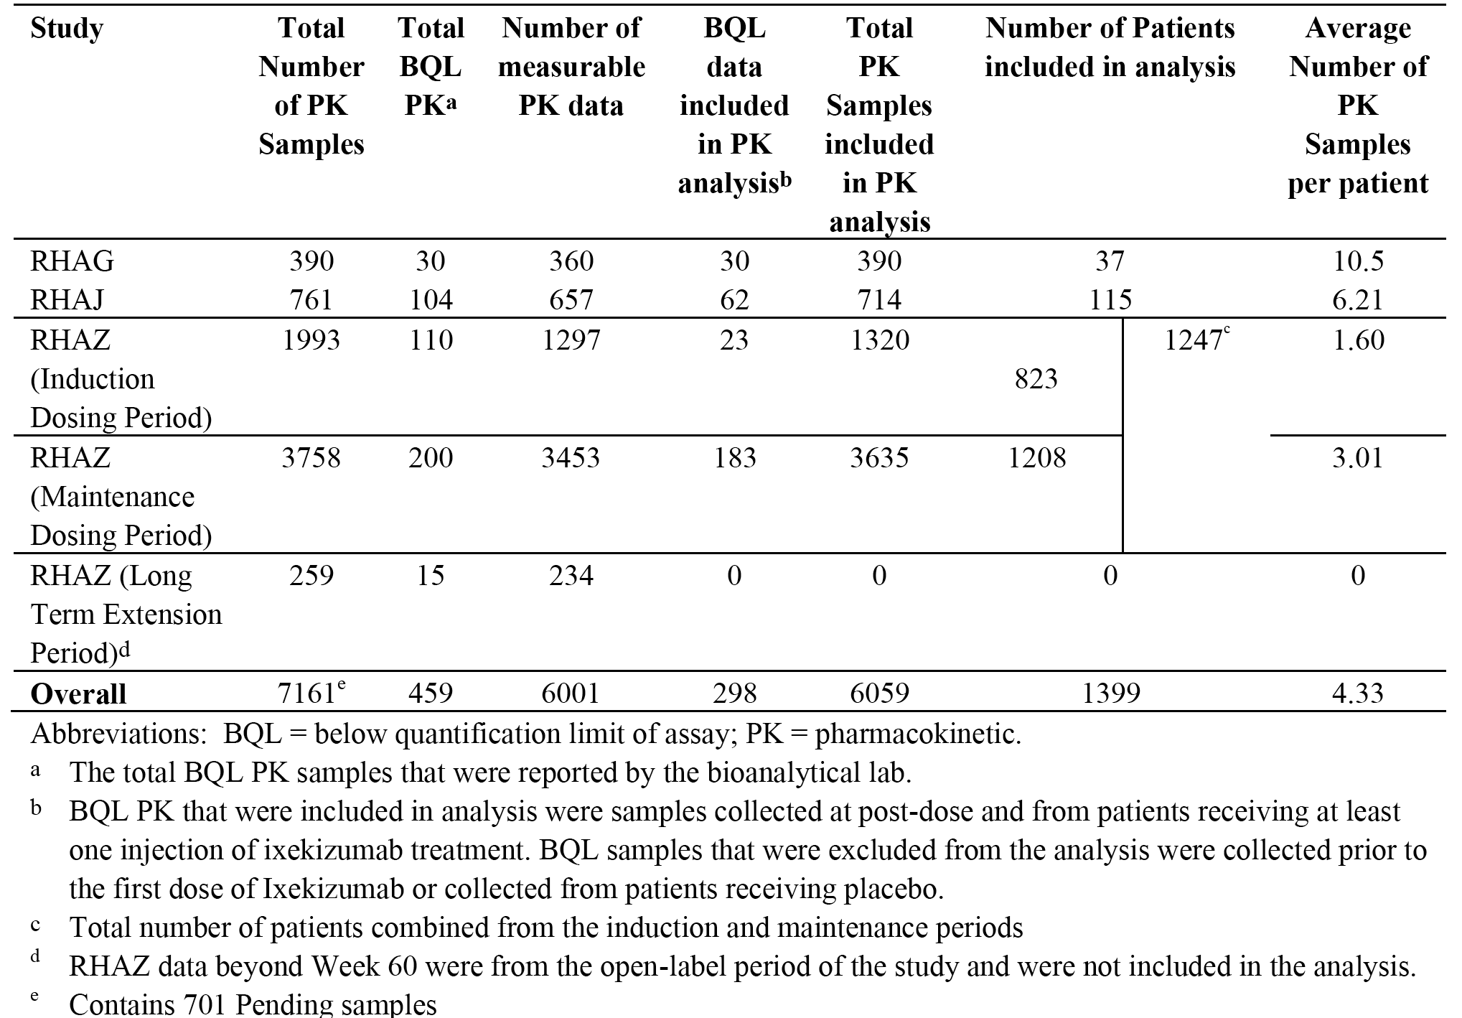

Baseline demographics
The median age for the patients in the PopPK analysis was 46 years (range: 17 to 88 years), and the median body weight was 88.9 kg (range: 46 to 220 kg). Female patients accounted for 32.2% of the population, and the majority of patients were Caucasian (92.4%). The median BSA covered with psoriasis was 21% (range: 10% to 95%). The overall baseline demographic characteristics for the patients in the PopPK and PK/PD analyses were similar.

Results

Final model
The final model that best described the PK of ixekizumab was a 2-compartment model with first order absorption and first order elimination. Significant predictors (covariates) of the PK of ixekizumab included body weight (on clearances and volumes of distribution), study (on bioavailability), injection site (on bioavailability), and ADA titre and presence of neutralising antibodies (NAb) (on clearance). The parameter estimates from the final model are summarised below in Table 12.

Table 12. Primary PopPK analysis, PK parameter estimates from the final model
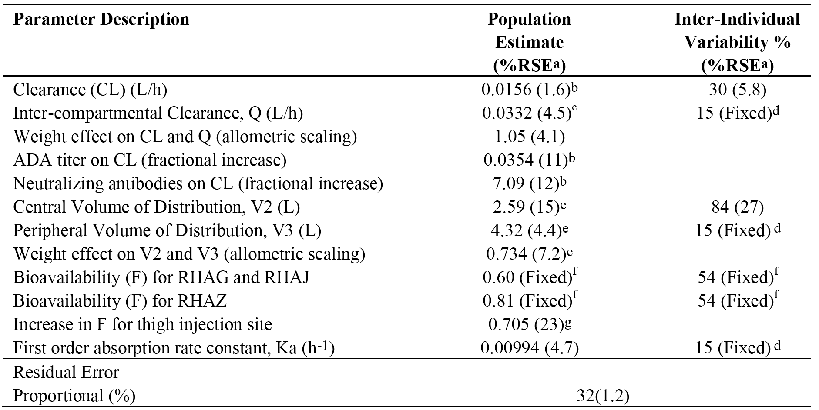
Abbreviations: ADA = anti-drug antibodies; Q = inter-compartmental clearance. Notes: a) SE, relative standard error b) CLind = CL x (bodyweight/90)1.05 x (1 + 0.035 x LOG(ADA titre)) x (1 + 7.09 x NAb), where NAb is 0 or 1; c) Qind = Q x (bodyweight/90)1.05 d) variability fixed to 15% to optimize efficiency of SAEM algorithm (NONMEM 7.3.0 user guide); e) V2,ind = V2 x (bodyweight/90) 0.73, V3,ind = V3 * (bodyweight/90)0.73; f) estimate fixed to that from FOCE model where BQL data were not included; g) estimate is on the logit parameter for bioavailability. This translates to an increase in bioavailability for the thigh injection site from 0.60 to 0.75 for RHAG/J and an increase from 0.81 to 0.90 for RHAZ.

Covariate effects

Body weight (CL and V)
The influence of body weight on CL and volume of distribution parameters was best characterised by an allometric relationship of body weight to parameter terms in which the exponents of the relationships were estimated by the model. The exponent for weight on CL in the allometric relationship was estimated to be 1, which implies a linear relationship between weight and CL. Therefore, the magnitude of increase in CL (and hence decrease in exposure) was directly proportional to the increase in weight with heavier patients having lower exposure. The exponent for weight on V in the allometric relationship was estimated to be 0.73, which implies a less than proportional increase in V as weight increases. Overall, the combined effects of weight on CL and V resulted decreased exposure (C_{trough,ss}) as weight increased.
When the exposure data were summarised by induction dosing regimen and baseline body weight category (< 100 kg and ≥ 100 kg), exposure was higher, on average, in the low weight compared to the high weight category (consistent with lower clearance, on average, in the low weight compared to the high weight category). However, there was substantial overlap in exposure across the weight groups based on ixekizumab trough concentrations (see Figure 7, below).
Figure 7. Primary PopPK analysis, boxplots showing distribution of observed ixekizumab trough concentrations at Week 12 by dosing regimen and weight category; Studies RHAZ, RHBA and RHBC
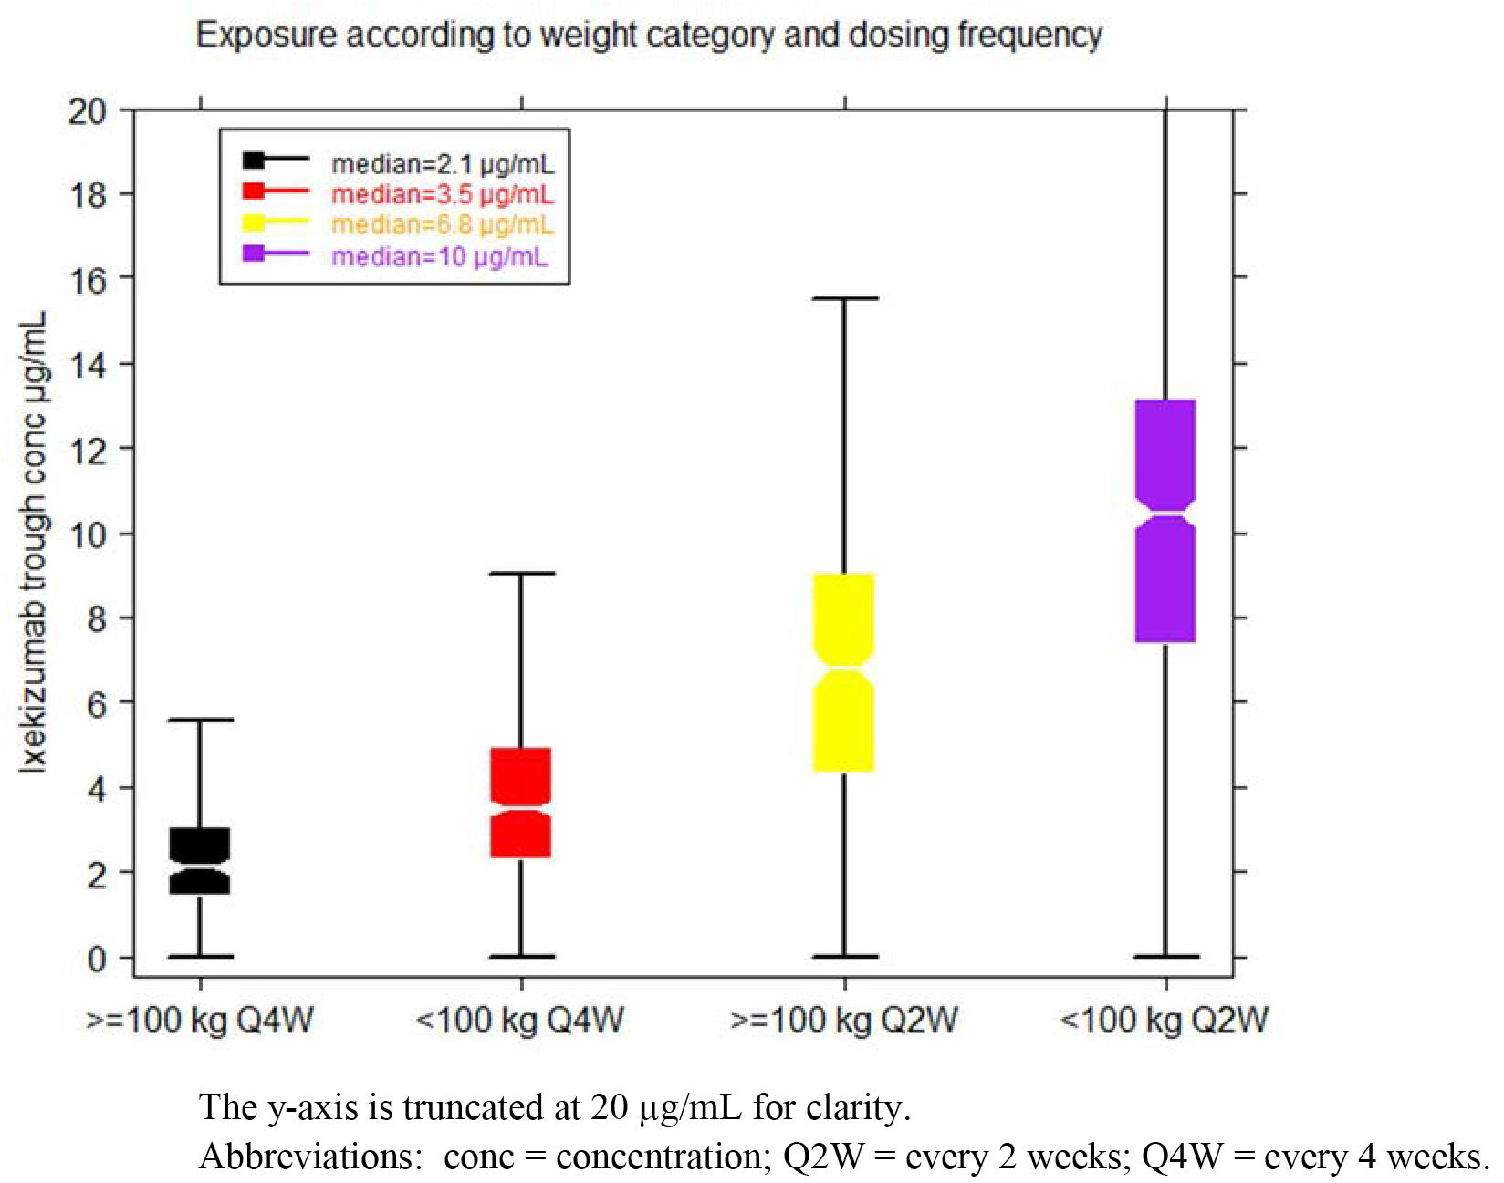

Bioavailability (by injection site)
Overall, the typical values for SC bioavailability of ixekizumab across injection sites was estimated to be in the range of 60% to 90%, with population typical values of 75% for the thigh and 60% for other sites in Studies RHAG and RHAJ and population estimates of 90% for the thigh and 81% for other sites in study RHAZ. It should be noted that there were are limited IV data in the PopPK analysis for determination of SC bioavailability (that is, one cohort in Study RHAG who received IV doses only). However, the sponsor comments that the range of estimates of SC bioavailability is in agreement with the range of SC bioavailability estimates reported for other IgG human monoclonal antibodies. Administration of ixekizumab via the thigh resulted in higher bioavailability of 11% to 25% compared to the arm, abdomen, or buttock, and the effect was consistent across each study included in the PPK analyses, and was consistent with the findings in study RHBL. However, the magnitude of the increased exposure following injection into the thigh was within the range of inter-patient variability in exposure observed across all sites of administration. The sponsor comments that the difference in bioavailability at the difference injection sites is not anticipated to be clinically relevant. Consequently, the sponsor concluded that in clinical practice ixekizumab can be administered via any site.

Bioavailability (by study)
The bioavailability of ixekizumab following SC injection differed across studies. There were a number of differences in the conduct of the studies that might have accounted for the differences in variability. These include differences in the time the studies were conducted, differences in geographic region, differences in injection site administration, and differences in ixekizumab formulation (solution in Study RHAZ, but lyophilised in Studies RHAG and RHAJ). The sponsor considered that these factors precluded definitive identification of the actual cause for the differences in bioavailability across studies. However, the sponsor concludes that, as the Phase III formulation is the same as the commercial formulation, the model estimated difference in bioavailability between the studies does not affect the commercial dose or dose recommendation.

Immunogenicity (clearance)
Moderate-to-high ADA titre and/or a positive NAb status both led to higher CL compared to low/no ADA titre and NAb negative. The median value of the post hoc estimates of CL was approximately 2-fold higher in patients with a moderate-to-high ADA titre (1 : > 160) compared to patients who were ADA negative or had a low titre (< 1 : 160), with CL median estimates being 0.0325 L/hr, 0.0158 L/hr and 0.0179 L/hr, respectively. From the PK model, the effect of being NAb positive resulted in an 8-fold increase in the typical value of CL compared to CL in ADA negative patients. Furthermore, based on post hoc CL estimates at Week 12, the median estimate of CL for patients who were ADA positive and developed NAb was 0.286 L/hr, an approximate 18-fold increase in CL compared to patients who were ADA negative (median value of 0.0158 L/hr). However, the large CL values were only observed in patients who were both ADA positive and NAb positive.

Other potential co-variates
Baseline age was found to be not a clinically significant covariate on the PK of ixekizumab, but there was a marked imbalance in the age categories with approximately 94% of the population being aged < 65 years. Consequently, the covariate data on the effects of age on the PK of ixekizumab from this PopPK analysis should be interpreted cautiously. Sex (68% male; 32% female), ethnicity, and race were not found to be clinically significant covariates on PK of ixekizumab. However, the covariate data on the effects of race on the PK of ixekizumab from this PPK analysis should be interpreted cautiously due to the marked imbalance in the racial distribution of the population, with approximately 92% being Caucasian. Creatinine clearance, baseline disease severity, percentage of BSA covered with psoriasis, comorbid psoriatic arthritis, baseline C-reactive protein (CRP) level, geographical location, and common comorbidities had no significant effects on the PK of ixekizumab. In addition, drugs being taken concomitantly with ixekizumab by ≥ 10% of patients with psoriasis (HMG Co-A reductase inhibitors, ACE inhibitors, and NSAIDs) had no significant effects on the PK of ixekizumab. However, concomitant medications being taken by < 10% of patients were not evaluated due to the small amount of data.

Simulations
Using the final PK model, simulations in approximately 25,000 patients were performed to predict exposure associated with the SC dosing regimen evaluated in the Phase III Study RHAZ (that is, starting dose of 160 mg, followed by 80 mg Q2W or Q4W up to Week 12). The simulations were carried out using multiple replicates of the observed distribution of covariates in the study population. Since some covariates were time-varying in the original dataset (that is, ADA titre, NAb and injection site), the within-subject median value for ADA titre or within-subject modal value for NAb and injection site were calculated and used as a constant covariate, reflecting the average occurrence of each covariate for each individual in the constructed simulated dataset. Baseline weight was used for the simulations. The PK profiles from the time of starting the dose for both of the 12 week induction dosing regimens in the Phase III Study RHAZ are provided below in Figure 8, and the PK parameters are summarised below in Table 13.
Figure 8. Ixekizumab model-predicted concentration time profile following a 160 mg starting dose then 80 mg Q2W (red line) or Q4W (black line) from Week 0 to Week 12 (induction period)
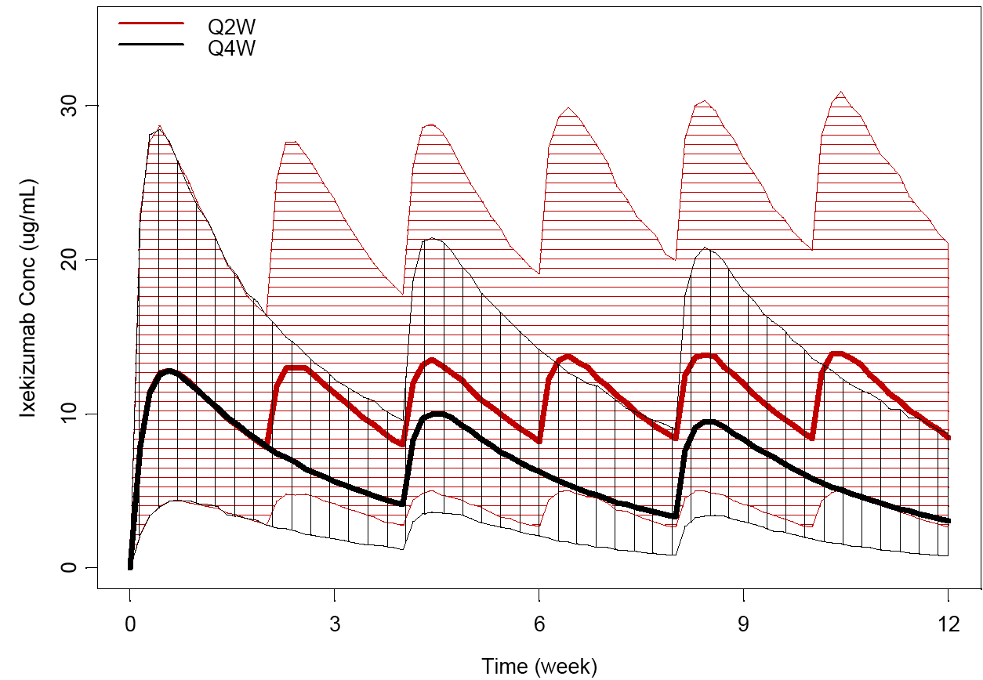
Notes: The solid red line depicts the median predicted concentration profile for the Q2W dosing regimen, and the red shaded area defines the 90% prediction interval around the median of the simulated data. The solid black line depicts the median concentration predicted profile for the Q4W dosing regimen, and the black shaded area defines the 90% prediction interval around the median of the simulated data.

Table 13. Summary of model-predicted ixekizumab PK parameters following a 160 mg starting dose then 80 mg Q2W or Q4W up to Week 12
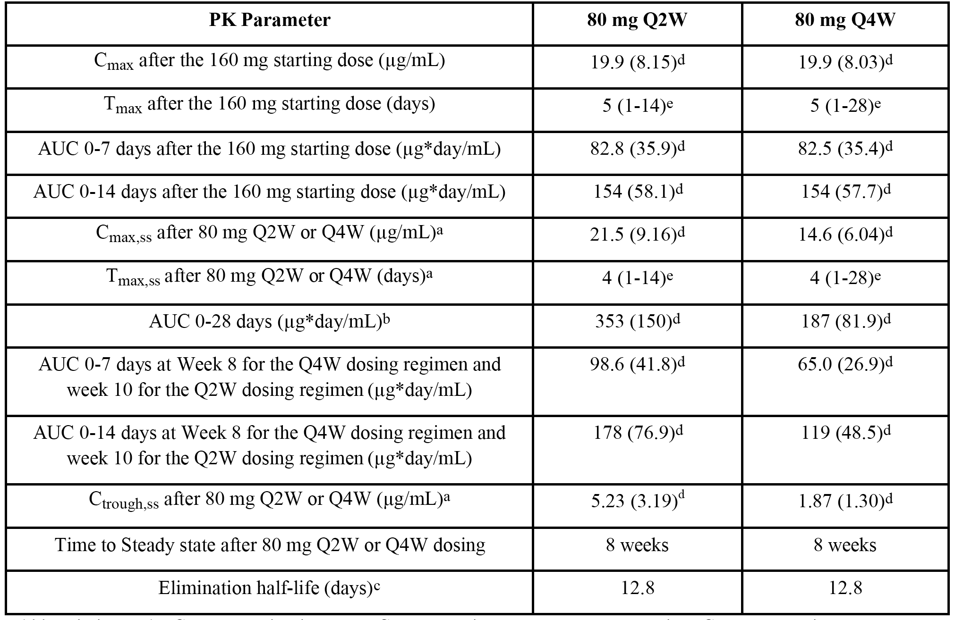
Abbreviations: AUC = area under the curve; Cmax = maximum serum concentration; Cmax,ss = maximum concentration of drug in serum at steady state; Ctrough,ss = steady state trough concentration; PK = pharmacokinetic; Q2W = every 2 weeks; Q4W = every 4 weeks; Tmax = time of maximum serum concentration; Tmax,ss = time of maximum serum concentration at steady state. Notes: a) for the Q2W dosing regimen, data are summarized from week 10 to week 12 and for the Q4W dosing regimen, data are summarized from week 8 to week 12 after the starting dose at week 0; b) AUC0-28 days is calculated from week 8 to 12 for both the Q2W and Q4W dosing regimens; c) elimination half-life = (V2 + V3) x 0.693/CL; d) Mean (SD); e) median (range).
Evaluator’s comment: Based on simulations from the final PopPK model, mean (SD) C_{max} and AUC_{0-14d} estimates in the 160 mg starting dose group (followed by 80 mg Q2W) were 19.9 (8.15) μg/mL and 154 (58.1) μg day/mL, respectively, and in the 160 mg starting dose group (followed by 80 mg Q4W) the corresponding parameters were 19.9 (8.03) µg/mL and 154 (57.7) µg day/mL, respectively, with the median T_{max} values for both groups being 5 days. These estimates compared well with the observed data from the NCA in Study RHBL, where mean C_{max} and AUC_{0-14d} estimates after the 160 mg starting dose were 15 μg/mL and 157 μg day/mL, respectively, for the PFS and 14.8 µg/mL and 154 µg day/mL, respectively, for the AI, with median T_{max} values of 4 days for both devices.
Steady state was achieved by Week 8 after the 160 mg starting dose for both the 80 mg Q2W and 80 mg Q4W induction dosing regimens, with > 80% of steady state for the 80 mg Q2W dosing regimen being achieved with the 160 mg starting dose alone. The mean (SD) C_{max,ss} and C_{trough,ss} estimates were 21.5 (9.16) μg/mL and 5.23 (3.19) μg/mL, respectively, for the 80 mg Q2W dosing regimen, and 14.6 (6.04) μg/mL and 1.87 (1.30) μg/mL, respectively, for the 80 mg Q4W dosing regimen. In patients treated with 80 mg Q2W in the induction period and switching to 80 mg Q4W in the maintenance period it was estimated that a new steady state level will be reached approximately 10 weeks after switching the dose.

Other studies

Study RHAT (Phase III, Japanese subjects)
Study RHAT, was a Phase III, single-country (Japan), multicentre efficacy and safety study of open-label ixekizumab in Japanese patients with moderate to severe plaque psoriasis, erythrodermic psoriasis, and generalised pustular psoriasis. The study was undertaken from 5 July 2012 to 29 March 2014, and the database lock for the 52 week data analysis was 17 June 2014. The primary objective of the study was to estimate the response at Week 12 to ixekizumab administered at a starting dose of 160 mg SC followed by 80 mg SC Q2W, as measured by the proportion of patients achieving a ≥ 75% improvement in the PASI (PASI 75). The secondary objectives of the study included an assessment of the PK of ixekizumab in Japanese subjects.
The PK samples for ixekizumab concentrations were collected following a sparse sample scheme, where patients were randomly assigned to 1 of 4 sampling cohorts with various PK sampling events from Week 1 through Week 24. In addition, ixekizumab concentrations were also assayed in patients who became ADA positive. Further, a few patients had unplanned site visits where PK samples were also collected.
The descriptive PK analyses presented in the study report focused on ixekizumab concentrations collected from Week 1 (that is, 1 week after the first dose in the induction period (Period 2) through Week 52 (that is, the end of maintenance dosing period (Period 3)). A total of 417 concentration-time data records from 91 patients were available and were all above the detection limit of the PK assay. At least one missed dose in Period 2 and/or Period 3 was reported for 14 patients, and for these patients ixekizumab samples collected beyond the first missed dose were excluded from the PK dataset. As a result, the PK dataset used for descriptive PK analyses include 396 concentration-time records from 90 patients.
The results for the descriptive PK analyses are summarised below in Table 14. The mean trough serum ixekizumab concentration ranged from 8 to 13 μg/mL across the 4 study cohorts in the 12 week induction dosing period (80 mg Q2W). In the maintenance dosing period (80 mg Q4W), the mean trough serum ixekizumab concentrations gradually declined from the levels observed in the induction period due to the longer duration between doses. By Week 24, the mean trough serum ixekizumab concentration had decreased by approximately 3-fold, with the mean serum trough concentration being approximately 3.5 µg/mL.

Table 14. Ixekizumab serum concentrations at each sampling event for sampling cohorts; Study RHAT
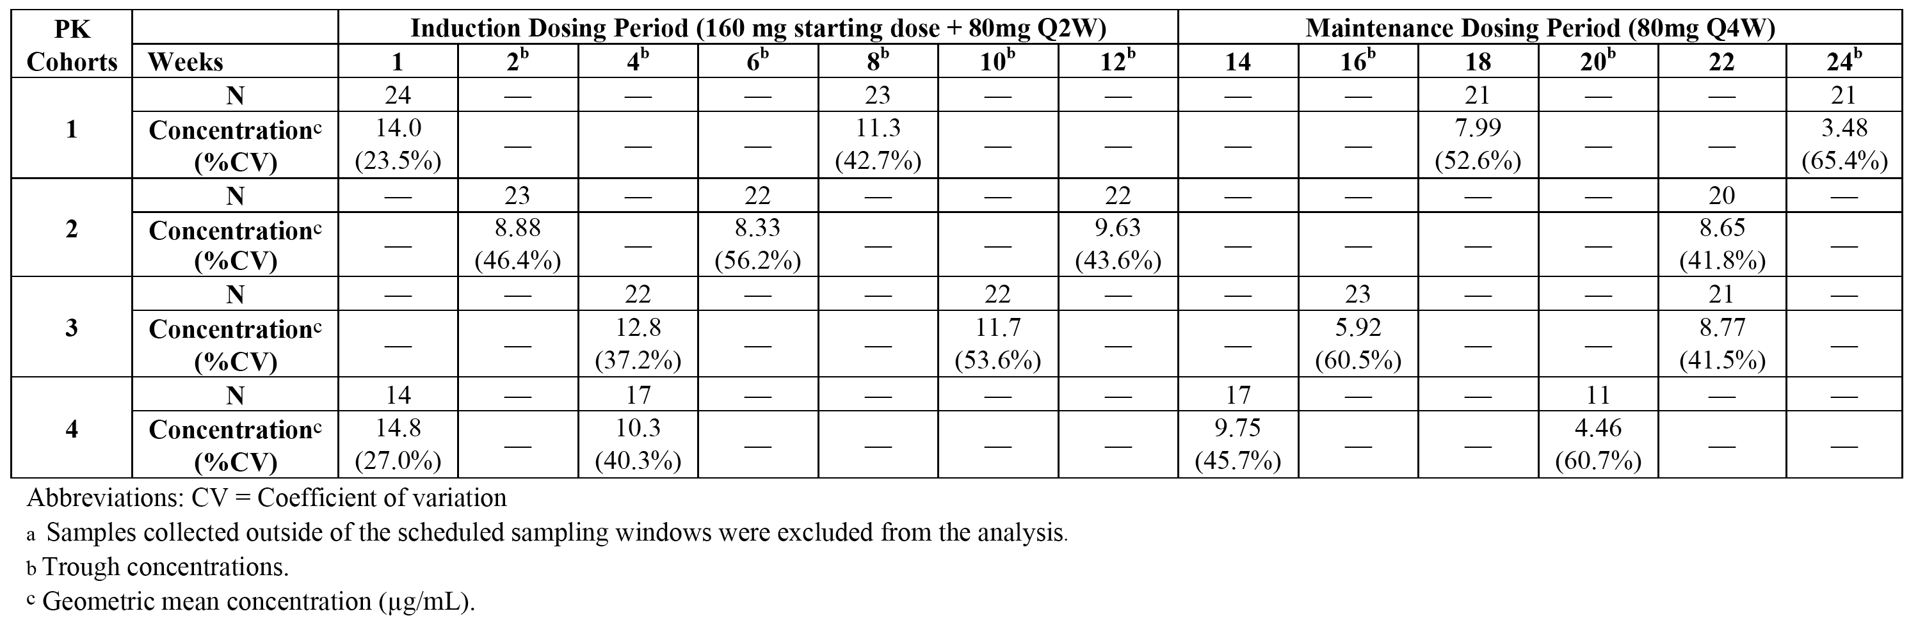During the induction and maintenance dosing periods, 22 treatment-emergent ADA samples from 10 patients were identified as positive by the screening assay, and all samples were inconclusive in the neutralizing assay. The potential impact of ADA on drug exposure was evaluated by comparing ixekizumab exposure between ADA negative patients and 17 positive ADA treatment-emergent samples from 8 patients. Based on the limited and highly variable drug concentration data, median ixekizumab serum concentrations in persistent ADA positive treatment-emergent samples appeared to be lower than in ADA negative samples at Week 24 and Week 36, but not at Week 52. However, in general, the drug concentrations in persistent ADA positive treatment-emergent patients overlapped those in ADA negative patients.

Summary of pharmacokinetics ixekizumab

Physicochemical characteristics of the active substance
The following information has been taken from sponsor summaries. Ixekizumab is a humanised immunoglobulin G4 (IgG4) isotype monoclonal antibody. It is composed of two identical light chain polypeptides of molecular weight 24,098 Dalton and two identical heavy chain polypeptides of molecular weight 48,986 Dalton, resulting in a total molecular weight of 146,158 Dalton for the protein backbone of the ixekizumab molecule. Each heavy chain polypeptide of ixekizumab contains an N-linked glycosylation site at Asn296, which is modified with oligosaccharides. The predominant forms of oligosaccharide at the Asn296 site are G0F and G1F representing 1445 and 1607 Dalton, respectively. The overall molecular weight of ixekizumab calculated from the molecular weights of the peptide backbone and the predominant oligosaccharides, is 149,049 Dalton. The overall structure of ixekizumab is depicted schematically below in Figure 9. The figure shows the disulphide bonding pattern and the location of the N linked glycosylation sites, with the constant regions of the molecule being shown in black and the variable regions in grey.
Figure 9. Schematic of ixekizumab structure
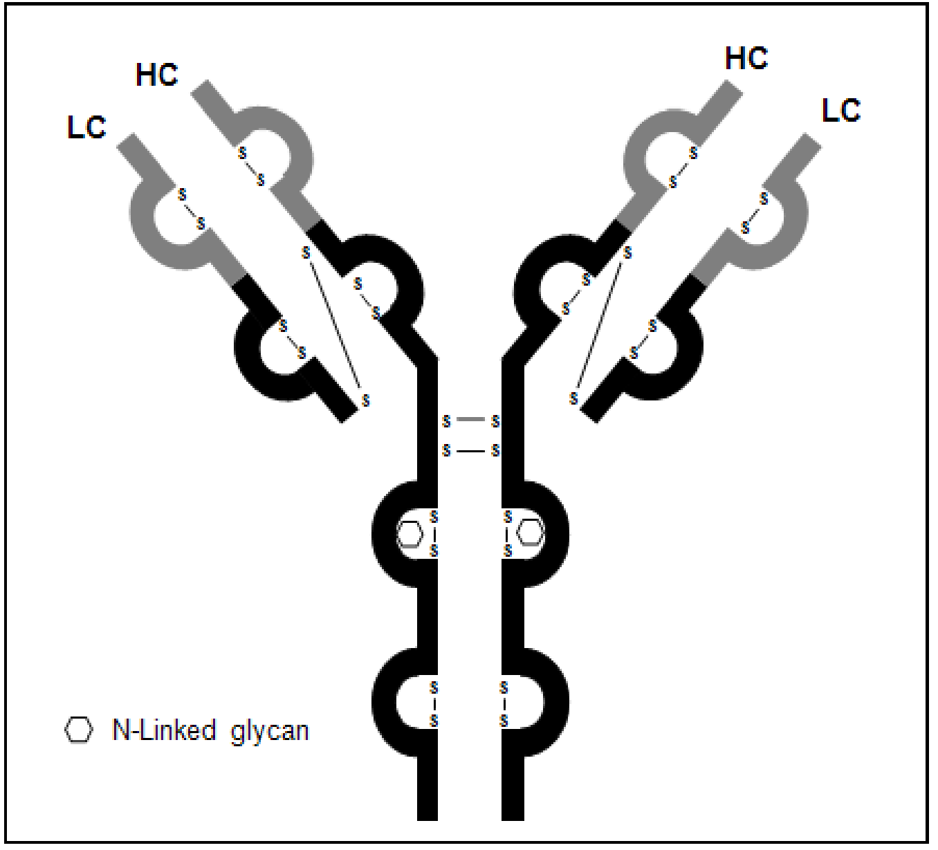

Pharmacokinetics in patients with moderate to severe plaque psoriasis

Absorption
Based on the Primary PopPK Analysis, the final PK model that best described the PK of ixekizumab was a 2-compartment model with first-order absorption and first-order elimination (linear clearance). The final PK model demonstrated that significant predictors (covariates) of ixekizumab PK included body weight (on clearance and volume of distribution), study (on bioavailability), injection site (on bioavailability), and ADA-titre and presence of NAbs (on clearance).
Based on simulations from the final PK model, ixekizumab mean (SD) C_{max} and AUC_{0-14d} estimates in the 160 mg starting dose group (80 mg Q2W regimen) were 19.9 (8.15) μg/mL and 154 (58.1) μg day/mL, respectively, and the ixekizumab mean (SD) Cmax and AUC_{0-14d} estimates in the 160 mg starting dose group (80 mg Q4W regimen) were 19.9 (8.03) µg/mL and 154 (57.7) µg day/mL, respectively. Absorption following SC injection was slow, with the median T_{max} estimated from the final PK model being 5 days (Primary PopPK Analysis). The estimate for the T_{max} from the Primary PK Analysis compared well with the observed PK data (NCA) from Study RHBL following a 160 mg starting dose. The PopPK analysis (Study RHAJ), estimated the model predicted absorption lag time to be 97.4 hours following SC injection.

Bioavailability

Subcutaneous bioavailability
The average SC bioavailability of ixekizumab across injection sites was estimated to be in the range of 54% to 90% (54% with 35% inter-individual variability in Study RHAG alone; 60% to 90% in the Primary PopPK Analysis). The data are in line with published SC bioavailability estimates for other IgG human monoclonal antibodies, including mepolizumab (73%), omalizumab (62%), golimumab (51%), efalizumab (50%), and adalimumab (64%).⁶
The SC bioavailability was highest when ixekizumab was administered via the thigh compared to administration via the abdomen or arm. Population typical values for SC bioavailability of 75% were observed for thigh administration and 60% for other sites of administration in Studies RHAG and RHAJ, and population estimates for SC bioavailability of 90% for thigh administration and 81% for other sites of administration for Study RHAZ.

Bioequivalence of clinical trial and market formulation
The formulation of the solution used in the pivotal Phase III study is the same as the proposed commercial formulation. Therefore, no bridging study is needed to establish PK comparability between the Phase III solution and the commercial formulation. Likewise, the container closure system (specifically, the semi-finished syringe) used in the Phase III clinical trial devices is the same as the container closure system used in the proposed commercial devices. Therefore, no bridging study is needed to establish PK comparability between the clinical trial devices and the commercial devices.

Bioequivalence of PFS and AI administration devices
Similar PK of ixekizumab were observed when ixekizumab 160 mg SC was administered as a single-dose by PFS or AI (Study RHBL). Following PFS and AI administration, the geometric mean (range) serum C_{max} values were 15.0 (13.9, 16.1) µg/mL and 14.8 (13.8, 15.9) µg/mL, respectively, and the geometric mean (range) serum AUC_{0-last} values were 157 (147 to 168) µg day/mL and 154 (144 to 165) µg day/mL, respectively. Inter-subject variability in these parameters was similar for each device, with percent coefficient of variation (%CV) estimates in the range of 41% to 46% for C_{max} and AUC_{0-last}. The median T_{max} was 4 days for both devices, with the range being approximately 2 to 14 days. The mean ixekizumab versus time profiles through 14 days were almost identical for the two devices.

Dose proportionality
In Study RHAG, based on the power model for dose proportionality the ratio of the dose normalised geometric mean (90% CI) values after a single SC dose of ixekizumab over the dose range 5 mg to 150 mg were 0.9 (0.6, 1.4) for the C_{max} and 1.0 (0.7, 1.5) for the AUC_{0-14d}. The 90% CIs for the dose normalised geometric ratios of both parameters were not enclosed completely within the pre-specified interval of 0.70 to 1.43. Therefore, the results indicate that ixekizumab marginally deviates from dose proportionality over the dose range 5 mg to 150 mg. However, the deviations are not considered to be clinically significant. Furthermore, in the Primary PopPK Analysis the final PK model with linear clearance best described the data over the dose range 5 mg to 160 mg SC, which supports the PK of ixekizumab being linear with dose.

Bioavailability following multiple dosing
Based on the final PK model (Primary PopPK Analysis), simulations were performed to predict exposure associated with SC dosing regimens of 160 mg starting dose followed by 80 mg Q2W or Q4W up to Week 12 (induction dosing regimens). The time to reach steady state was estimated to be 8 weeks for both dosing regimens. Once steady state had been reached, mean (SD) C_{max,ss} and C_{trough,ss} estimates were 21.5 (9.16) μg/mL and 5.23 (3.19) μg/mL, respectively, for the Q2W dosing regimen, and 14.6 (6.04) μg/mL and 1.87 (1.30) μg/mL, respectively, for the Q4W dosing regimen. The median T_{max,ss} for both dosing regimens was 4 days. Administration of the first dose (160 mg) resulted in > 80% of steady state for the Q2W dosing regimen, based on AUC_{0-14d} after the first dose relative to AUC_{0-14d} at Week 10 repeated doses. Following the switch from 80 mg Q2W (induction dosing) to 80 mg Q4W (maintenance dosing) it was estimated that steady state would be reached in approximately 10 weeks.

Distribution
Based on the Primary PopPK Analysis, the geometric mean estimates (geometric coefficient CV%) of the central (V2) and peripheral (V3) volumes of distribution were 2.73 L (44%) and 4.28 L (19%), respectively, resulting in a total volume of distribution at steady-state of 7.11 L (29%). The steady state volume of distribution suggests that ixekizumab has limited distribution into the extravascular tissues. The volume of distribution parameters are comparable with those reported for other IgG monoclonal antibodies., The Primary PopPK Analysis identified body weight as significant predictor of volume of distribution, with the volume of distribution increasing as body weight increased.

Metabolism
The submission included no clinical studies investigating the metabolism of ixekizumab. However, ixekizumab is a large monoclonal antibody with a molecular weight of 149,049 Dalton and is expected to be degraded into small peptides and amino acids via catabolic pathways in the same manner as endogenous IgGs. The TGA approved Guideline on the Clinical Investigation of the Pharmacokinetics of Therapeutic Proteins (CHMP/EWP/89249/2004) states that, while the main elimination pathway should be identified for therapeutic proteins this can be ‘predicted, to a large extent, from molecular size and specific studies may not be necessary’. The guideline states that large protein molecules are eliminated primarily through mechanisms such as receptor-mediated endocytosis followed by catabolism rather than renal filtration. The guideline also states that mass-balance studies are not useful for determining the excretion pattern of therapeutic proteins as these products are not necessarily recovered in urine or faeces as intact substance. Instead, therapeutic proteins are metabolised and reabsorbed as amino acids and incorporated in general protein synthesis.

Excretion
Based on the Primary PopPK Analysis, the geometric mean (geometric CV%) serum clearance for ixekizumab was 0.0161 L/hr (37%) and appeared to be independent of dose over the range 5 mg to 160 mg. The geometric mean (geometric CV%) of the half-life (t_{1/2}) calculated from the individual post hoc estimates was approximately 13 days (40%).
Body weight was a significant covariate on the clearance of ixekizumab, with the Primary PopPK Analysis showing a linear relationship between body weight and clearance. Consequently, there was an overall trend for serum trough concentrations to decrease as body weight increased. When the exposure data were summarised by induction dosing regimen and baseline body weight category (< 100 kg and ≥ 100 kg), exposure (C_{trough,ss}) was higher, on average, in the low versus high weight group, but there was substantial overlap between weight groups for both dosing regimens. Therefore, dose adjustment based on body weight is not warranted.
The Primary PopPK Analysis showed that ADA titre and NAb status were both significant predictors of clearance. The final PK model showed that moderate-to-high ADA titre (≥ 1:160) resulted in a 2-fold increase in the median clearance estimate predicted from the model, while NAb positive status was associated with an 8-fold increase. The combined influence of titre and NAb both being positive, using post hoc clearance estimates from the PK model at Week 12, showed an approximate 18-fold increase in median clearance compared to ADA negative patients.

Intra- and inter-individual variability of pharmacokinetics
The inter-individual variability in the PK of ixekizumab following SC injection was moderately high. In Study RHAG (PopPK analysis), the SC bioavailability of ixekizumab was estimated to be 54% with 35% inter-individual variability. In Study RHBL, inter-individual variability of C_{max} and AUC_{0-last} values were similar for ixekizumab following administration by PFS and AI devices, with CV% estimates in the range 41% to 46%. In the Primary PopPK Analysis, geometric CV% values for the geometric mean estimates of clearance and t_{1/2} were 37% and 40%, respectively. No data on intra-individual variability of the PK of ixekizumab could be identified in the submitted data.

Pharmacokinetics in special populations

Pharmacokinetics in subjects with impaired hepatic function
There were no PK studies in subjects with impaired hepatic function. However, ixekizumab is an IgG monoclonal antibody and is expected to be eliminated via proteolytic degradation to amino acids. Therefore, it can be predicted that the molecule will not undergo hepatic metabolism. Consequently, it is expected that hepatic impairment will not affect the PK ixekizumab.

Pharmacokinetics in subjects with impaired renal function
There were no PK studies in subjects with impaired renal function. However, ixekizumab is a large monoclonal antibody and is expected to be eliminated via proteolytic degradation to amino acids and not through renal elimination of the intact molecule. Consequently, it is expected that renal impairment will not affect the PK ixekizumab. Data from the Primary PopPK Analysis showed that creatinine clearance had no significant effect the PK of ixekizumab.

Pharmacokinetics and body weight
In the Primary PopPK Analysis, body weight was a significant predictor of clearance and volume. Of particular note, increased body weight resulted in increased clearance of ixekizumab. Consequently, steady state serum trough concentrations of ixekizumab decreased with increasing weight. However, inter-subject variability in exposure was high and there was considerable overlap of exposures when patients were stratified either by body weight category (< 100 kg and ≥ 100 kg), or by the lower and upper ends of the dose range studied (that is, 59 kg and 136 kg, respectively). Based on the available data, dose adjustment by body weight is not warranted.

Pharmacokinetics and sex
In the Primary PopPK Analysis, sex (68% male; 32% female) was not identified as a clinically significant predictor of the PK of ixekizumab.

Pharmacokinetics and race
In the Primary PopPK Analysis, race was not identified as a clinically significant predictor of the PK of ixekizumab. The majority of patients in the analysis were Caucasian (92.4%) with other ethnicities/races tested being Asian (4.36%), African Descent (2.22%), Native American (0.357%), Hispanic (0.286%), and Other (0.429%). The submission included a Phase III clinical efficacy and safety study in Japanese subjects with psoriasis, which included limited descriptive PK serum concentration - time data on 90 patients (396 samples) (Study RHAT). The data from this study showed that the mean trough serum concentration at steady state in the induction period (Weeks 0 to 12) ranged from 8 to 13 µg/mL in the 4 cohorts following a starting dose of 160 mg SC and then 80 mg SC Q2W through Week 12, falling to approximately 3.5 ug/mL at Week 24 of the maintenance period (Weeks 12 to 24) following switching the dose to 80 mg SC Q4W.

Pharmacokinetic interactions
There were no clinical studies assessing the PK effects of drug-drug interactions involving ixekizumab. However, as ixekizumab is neither hepatically metabolised nor renally excreted it can be predicted that PK drug-drug interactions between ixekizumab and drugs that affect these clearance pathways are unlikely to occur.
The submission included two human biomaterial studies investigating the effect of IL-17 on modulation of CYP enzymes. The results reported by the sponsor for these two studies are outlined below.

Human biomaterial study (Study Report 440001024)
This in vitro human biomaterial study investigated the potential of IL-17 to modulate liver CYP450 enzymes in cultures of human hepatocytes. Interleukin-6 (IL-6) has been shown to reduce the activity of CYPs such as CYP3A both in vitro and in vivo and was utilised as a functional control to indicate that the hepatocyte lots were responsive. The modulation effect was measured by enzyme activity assays selective for the CYPs of interest and by assessing relative changes in messenger RNA (mRNA) levels using quantitative reverse transcription polymerase chain reaction (RT-PCR) assays.
The study was reported to show that IL-6 at the highest concentration of 100,000 pg/mL decreased CYP1A2, CYP2B6, CYP2C8, CYP2C9, CYP2C19 and CYP3A4 activity and mRNA expression to different extents, demonstrating that the lots of hepatocytes chosen for investigation were responsive to cytokines. No marked decreases in CYP2D6 and CYP2E1 endpoints or CYP2J2 (mRNA) were found after treatment with IL-6 at the concentrations tested. Similarly, no marked decreases in activity and mRNA for any of the CYP450 enzymes tested were found for IL-17 at the concentrations tested, except for CYP3A4 mRNA in one hepatocyte lot where a marked decrease was observed (to 35% of control at 50,000 pg/mL versus to 1% of control for IL-6 at 100,000 pg/mL). The sponsor concluded that the study demonstrated that IL-6 and IL-17 differentially modulate CYP activity and mRNA expression in cultured human hepatocytes. Modulation by IL-6 was extensive and across many CYPs, while IL-17 showed modulation of CYP3A4 mRNA in only one donor hepatocyte lot out of three at very high concentrations with no corresponding changes in CYP3A4 activity.

Human biomaterial study (LY2439821-2013IV-Explor)
In this human biomaterial study, a novel three-dimensional hepatocyte culture, HepatoPac, in the absence or presence of Kupffer cells cytokine responsive cells in the liver, was used to explore the impact of interleukin IL-17 on mRNA expression of multiple CYP 450 enzymes utilising IL-6 response as a positive control. The sponsor reported that IL-6 reduced the mRNA expression of multiple CYPs (CYP1A2, CYP2C8, CYP2C9, CYP2C19, CYP2D6, and CYP3A4) in a concentration dependent manner in HepatoPac cultures validating the models integrity, whereas IL-17 did not decrease mRNA expression for the tested CYPs. Therefore, the sponsor concluded that clinical modulation of CYP mRNA expression by IL-17 is unlikely.

Evaluator's comments on pharmacokinetics
The PK of ixekizumab administered by SC injection in patients with moderate to severe plaque psoriasis has been reasonably well characterised. The Primary Population PK and Exposure-Response Analyses were performed using data from 3 studies (Phase I, Study RHAG; Phase II, Study RHAJ; and Phase III, Study RHAZ) in 1399 patients with psoriasis.

Pharmacodynamics

Studies providing pharmacodynamic data
The submission included exposure-response data from the Primary PopPK and Exposure Response Analyses (data from Studies RHAG, RHAJ, RHAZ) supported by data from the Secondary Exposure-Response Analyses (data from Studies RHAZ, RHBA, and RHBC). In addition to efficacy and safety exposure-response analyses for both efficacy and safety endpoints, both of the primary and secondary analyses also included an assessment of the relationship between ixekizumab exposure and immunogenicity.

Primary PopPK and exposure-response analyses
The relevant objectives of the exposure-response analyses included:
- characterisation of the exposure-response relationships that describe the efficacy endpoints sPGA and PASI score, and identification of potential factors that may impact the dose exposure-response relationship; and
- characterisation of the exposure-response relationships (dose-safety) that describe the key safety endpoints.
The analyses included data from Study RHAG (Phase I, n = 37), Study RHAJ (Phase II, n = 115) and Study RHAZ (Phase III n = 1247) in patients with psoriasis. The PopPK analysis included 6059 observations from 1399 patients. Ixekizumab was administered SC over a dose range of 5 to 160 mg, and IV at 15 mg. The PK sampling regimes ranged from sparse sampling (up to 4 samples per patient, primarily trough concentrations from Studies RHAZ and RHAZ) to rich sampling (for 14 days after the first dose and 12 weeks after the third (last) dose from Study RHAJ).

Exposure-response analyses relating to efficacy

Overview
The primary efficacy measures for exposure-response relationship investigations were sPGA and PASI responses using modelling approaches.
The sPGA is the physician’s determination of the patient’s psoriatic lesions overall at a given time point. Lesions were categorised by descriptions of duration, erythema, and scaling. For the analysis of responses, psoriasis was assessed as clear (0), minimal (1), mild (2), moderate (3), severe (4), or very severe (5).
PASI scoring of psoriatic plaques is based on 3 criteria: redness (R), thickness (T), and scaliness (S). Severity is rated for each index (R, S, and T) on a 0 to 4 scale (0 for no involvement up to 4 for severe involvement). The body is divided into 4 areas comprising the head (h), upper extremities (u), trunk (t), and lower extremities (l). In each of these areas, the fraction of the total surface area involved is graded on a 0 to 6 scale (0 for no involvement to 6 for 90% to 100% involvement). The various body regions were weighted to reflect their respective proportion of BSA. The categorical variable PASI 75 response was defined to be equal to 1 for percent improvement from baseline in PASI scores of ≥ 75% and equal to 0 for < 75% improvement. This definition was introduced for the purpose of identifying patients who respond to the treatment (1 = responder, 0 = non-responder). Similarly, the categorical variables PASI 90 and PASI 100 response are equal to 1 for patients with improvements of ≥ 90% and 100% from baseline in PASI score respectively. PASI 75, 90, and 100 responses were analysed separately for the Week 12 and Week 60 time-points.

Exposure-response results for efficacy endpoints

Model development
For the assessment of exposure-efficacy relationships, the following time points for assessment were included in the analyses: (1) Week 12 endpoint for evaluation of the induction dosing regimens in Study RHAZ and all dose regimens from Study RHAJ; and (2) Week 60 endpoint for evaluation of the maintenance dosing regimens from Study RHAZ only. Model-predicted serum concentrations for ixekizumab were calculated for each patient from the final PK model on the day of the sPGA and PASI assessments at Week 12 (end of induction dosing period) and Week 60 (end of maintenance dosing period). The model-predicted serum concentrations that met the definition of being a trough concentration (C_{trough}) were then used as exposure inputs for exposure-response modelling of single time-point data (901 concentrations at Week 12 and 270 concentrations at Week 60).
The primary efficacy measures for exposure-response modelling were sPGA and PASI response. For the analysis of sPGA, an ordered categorical model was developed to determine the probability of a patient being a responder (defined as sPGA 0 or 1) or a non-responder (sPGA > 1) after 12 weeks of treatment and another model was developed to assess outcomes after 60 weeks of treatment. For the analysis of PASI, logistic regression modelling was used to estimate the probability of a patient achieving a PASI 75, 90 or 100 response at Week 12 and Week 60 (each PASI response was analysed separately). In addition, an ordered categorical model was developed to determine the probability of a patient being a responder (defined as sPGA 0 or 1) or a non-responder (sPGA > 1) over the course of the study using data collected from all time-points (that is, time course exposure-response model).
The effects of patient factors (covariates) were tested in the Week 12 logistic regression models using stepwise covariate modelling (SCM) implemented in Perl-Speaks NONMEM (PsN). For the Week 12 models, the effect of patient factors (covariates) was assessed for their clinical relevance on the relationship between exposure and response. The covariates were tested on the drug effect parameters (E_{max} or EC₅₀ ). The criterion for forward inclusion was a p-value no greater than 0.01 (Δ 6.635 minimum objective function (MOF) for inclusion of one parameter) with a backward deletion threshold of 0.001 (Δ 10.828 MOF for exclusion of one parameter). The criteria for forward inclusion and backward elimination were identical to those used for the PK model. For the Week 60 models, a reduced list of covariates was explored based on the findings from the Week 12 sPGA and PASI models. Covariates tested at Week 60 included those that were retained in the final Week 12 models and those that were significant (p < 0.01) in the first step of the forward search of the Week 12 SCMs. An additional covariate for the effect of 80 mg Q2W versus 80 mg Q4W dosing in the induction dosing period was also evaluated. These covariates were tested in the Week 60 models using the SCM implemented in PsN. For the time course models, covariates tested included those for the Week 60 models.
Model evaluation used a bootstrap analysis to assess the precision of the final parameter estimates of the final model, and a visual predictive check (VPC) was performed on the model to ensure that the model maintained fidelity with the data used to develop it.

sPGA assessment

sPGA week 12 analysis
The Week 12 sPGA score analysis included 1437 patients who had concentration data or received placebo (1296 were from Study RHAZ and 141 were from Study RHAJ). Of these, 1358 patients had trough PK predictions that were within ± 7 days of the Week 12 sPGA endpoint (or were placebo) and were included in the analysis dataset (1227 were from Study RHAZ and 131 were from Study RHAJ). In Study RHAZ, 431 patients were in the placebo arm, 406 patients received ixekizumab 80 mg Q2W and 390 patients received ixekizumab 80 mg Q4W after an initial starting dose of ixekizumab 160 mg. In Study RHAJ, 26 patients were in the placebo arm, 25 were in the 10 mg arm, 28 in the 25 mg arm, 26 in the 75 mg arm, and 26 in the 150 mg arm. The observed percentage of patients achieving Week 12 sPGA scores by study and dosing regimen is summarised below in Table 15.
The final covariate model used to describe the sPGA response to ixekizumab is presented below in Table 16. The model indicates that patients with palmoplantar psoriasis had a 13% lower E_{max} compared to patients with no palmoplantar involvement, resulting in a reduced probability of achieving an sPGA (score of 0 or 1) score at Week 12. Therefore, using the median Week 12 serum trough ixekizumab concentration of 5.71 μg/mL, the probability of achieving an sPGA (score of 0 or 1) would be 0.79 in a patient with palmoplantar involvement compared to 0.88 in a patient without palmoplantar involvement. Heavier patients had a lower maximum effect 4estimate (E_{max}) and thus a lower probability of achieving an sPGA (score of 0 or 1) score compared to lighter patients. This effect of weight is in addition to the effect of weight previously identified in the PK model where an increase in weight was associated with a decrease in exposure.

Table 15. Observed percentage of patients achieving Week 12 sPGA scores by study and dosing regimen in the exposure-response analysis data set
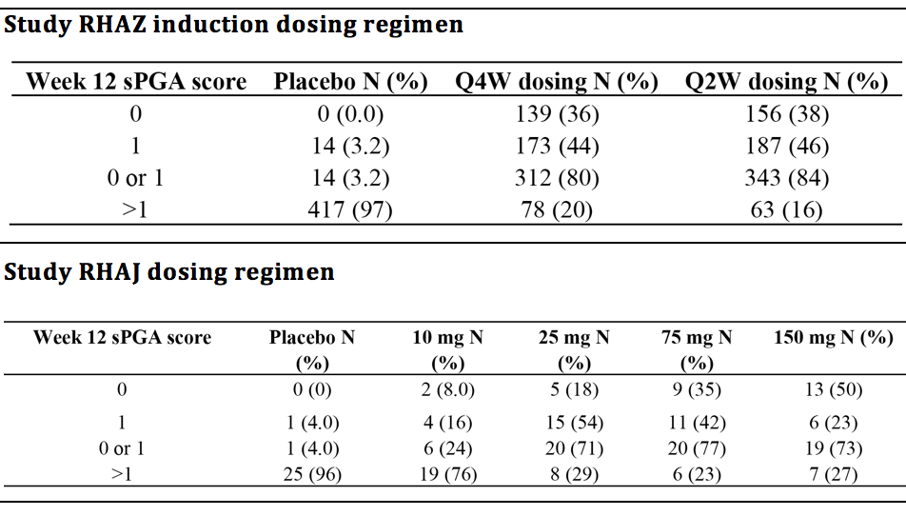
Abbreviations: N = number of patients; Q2W = every 2 weeks; Q4W = every 4 weeks; sPGA = static Physician Global Assessment

Table 16. Parameter estimates of the sPGA covariate model at Week 12
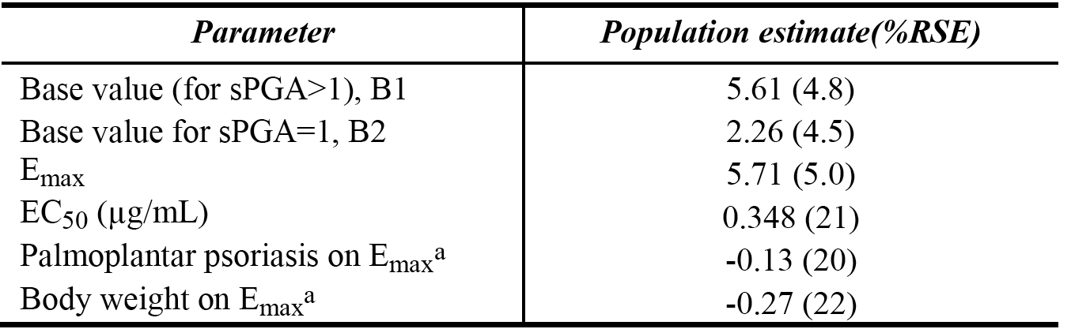
Abbreviations: %RSE = relative standard error; B1 = Base value (for sPGA > 1); B2 = Base value (for sPGA = 1); EC₅₀ = drug concentration that produces 50% of E_{max} ; E_{max} = maximum effect; sPGA = static Physician Global Assessment. Note: a) Emax.ind = Emax.pop x (1 - 0.13 x palm) x (body weight/89) -0.27; where Emax.ind is an individual’s Emax estimate, Emax.pop is the typical value, palm is an indicator variable with a value of 0 for patients with no palmoplantar psoriasis involvement and a value of 1 when it is present.
The sPGA model was also used to determine the impact of the Study RHAZ induction dosing regimen on the probability of a patient achieving an sPGA response to ixekizumab treatment at Week 12. The model predicted percentages of patients responding to 80 mg Q2W and 80 mg Q4W regimens in the induction dosing period were determined and compared to the observed percentages (see Table 17, below). Overall, the 80 mg Q2W regimen was associated with a higher predicted percentage response rate compared to the 80 mg Q4W regimen. The higher range of predicted concentrations for patients in the 80 mg Q2W regimen group ensured that the majority of patients were on the plateau of the exposure response curve and, consequently, were likely to achieve a response. This is compared to the 80 mg Q4W regimen group where the range of exposures was lower and encompassed the slope of the exposure response curve resulting in fewer patients being predicted to achieve a response.

Table 17: Primary PK/PD analysis, comparison of model-predicted and observed sPGA outcomes at Week 12 for ixekizumab 80 mg Q2W and Q4W induction dosing regimens
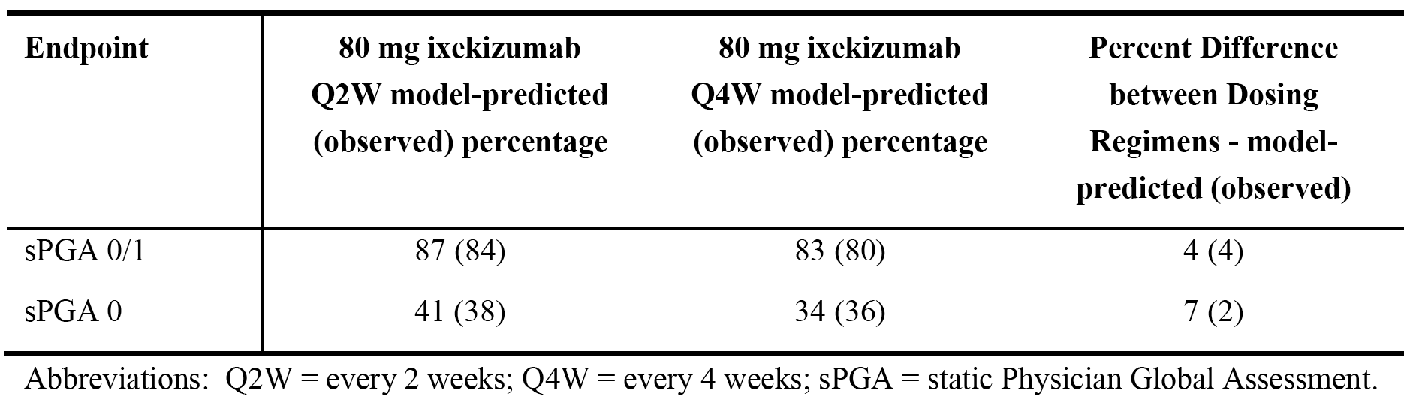
Body weight was a predictor of exposure in the PK model, with exposure showing a trend to decrease as body weight increased. In addition to the effect on exposure, higher body weight was associated with a lower response in the Week 12 exposure response model due to reducing the E_{max} of the drug. When the data were evaluated by induction dosing regimen within each body weight category, the benefit of the 80 mg Q2W regimen was greater than the 80 mg Q4W regime across every weight strata, based on the predicted response rates for both sPGA measures (that is, sPGA (score of 0 or 1) and sPGA (0)). The results are summarised below in Table 18. When the data were plotted by dosing regimen and body weight category (<100 kg and ≥ 100 kg), there was an increase in response rate with the 80 mg Q2W regimen compared to the 80 mg Q4W regimen in both weight groups. For both body weight categories, the range of exposures in patients on the 80 mg Q2W regimen were higher up on the exposure response curve compared with the 80 mg Q4W regimen, which resulted in consistently greater predicted response rates across both sPGA endpoints.

Table 18. Primary PK/PD analysis, model predicted impact of body weight on exposure and response for the sPGA Week 12 score; Q2W and Q4W induction regimens
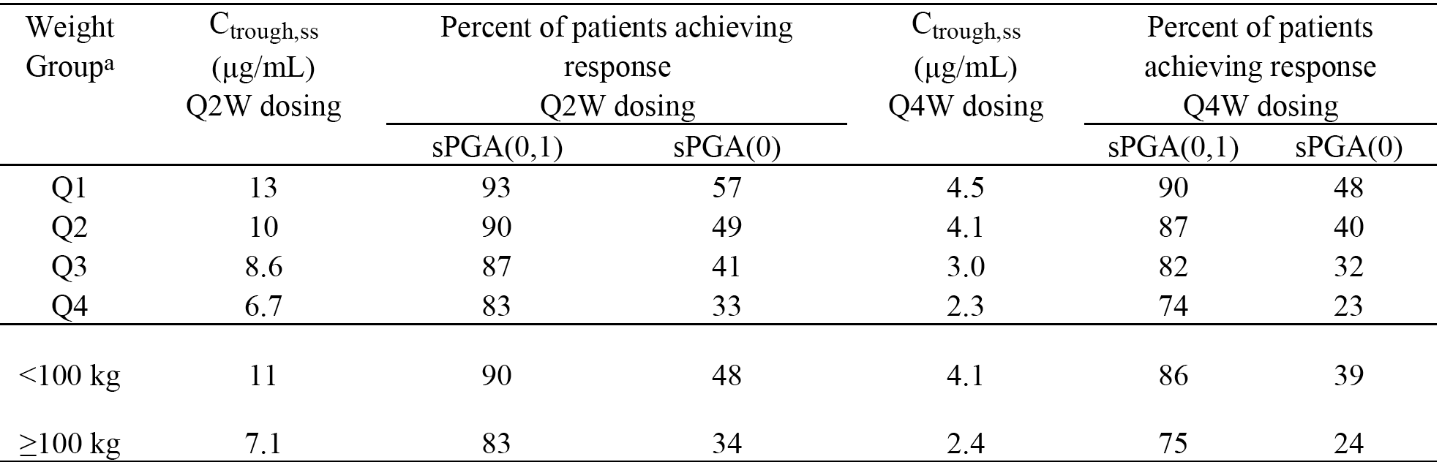
Abbreviations: C_{trough,ss} = model-predicted trough concentration estimates; Q2W = every 2 weeks; Q4W = every 4 weeks; sPGA = static Physician Global Assessment. Note: a) Q = quartile; the median (range) weight of each quartile for Q2W dosing is 69 (48-76) kg for Q1, 83 (76 to 90) kg for Q2, 98 (90 to 104) kg for Q3 and 118 (105 to 191) kg for Q4. The median (range) weight of each quartile for Q4W dosing is 67 (47 to 76) kg for Q1, 83 (76 to 90) kg for Q2, 97 (90 to 105) kg for Q3 and 119 (106 to 170) kg for Q4.

sPGA week 60 analysis
The patient population for the Week 60 sPGA analysis included 369 patients who had been on active treatment (80 mg Q2W or 80 mg Q4W) during the induction period (Weeks 0 to 12) and were assigned or randomised to the 80 mg Q4W arm in the maintenance period (Weeks 12 to 60). The dataset for the Week 60 analysis included 270 patients (that is, concentration predictions within ± 7 days of the end of the previous dosing interval). A maximum effect model could not be identified for the Week 60 data due to the limited patient population, and the fact that there were no placebo data included in the analysis. Therefore, a power model was used to described the exposure-response relationship. The covariates tested were a subset of covariates tested in the Week 12 sPGA and PASI models and included ethnicity, race, treatment-emergent ADA, NAb, palmoplantar involvement, previous systemic treatment with a non-biologic agent, previous systemic treatment with a biologic agent, number of previous treatments (> 3), baseline PASI score, baseline CRP, BMI, baseline body weight and induction dosing frequency (Q2W or Q4W). No covariates were found to be significant, and therefore the base model was the final model. The final model is summarised below in Table 19.

Table 19. Primary PK/PD analysis, final power model describing the Week 60 data
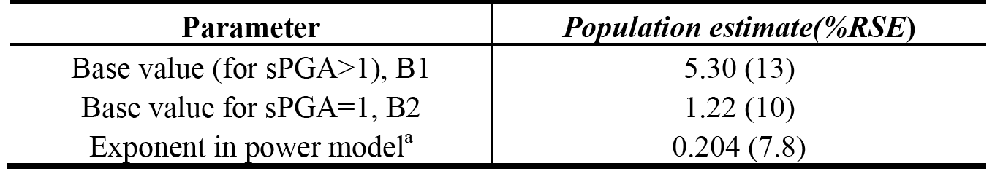
Abbreviations: %RSE = relative standard error; B1 = Base value (for sPGA > 1); B2 = Base value (for sPGA = 1); sPGA = static Physician Global Assessment. a) Drug effect = Ctrough^{0.204.}
The results of a comparison between the Week 12 and Week 60 exposure-response relationships are presented below in Figure 10, below. A maximal predicted sPGA (score of 0 or 1) response was attained at similar concentrations at Week 12 and Week 60, although the effective EC₅₀ was higher for the Week 60 data. For an sPGA (0) response, there is a higher response at Week 60 compared to Week 12 for the same exposure at the higher end of the exposure range (that is, an anti-clockwise hysteresis). This suggests that in addition to adequate drug exposure, time may play a role in obtaining complete skin clearance.
Figure 10. Primary PK/PD analysis, typical exposure-response profile for the Week 12 and Week 60 sPGA endpoints; left panel sPGA 0 or 1, right panel sPGA 0
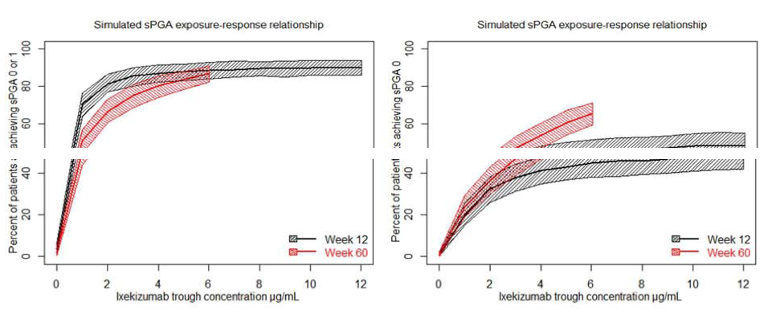
Abbreviations: sPGA = static Physician Global Assessment. The shaded area is the 95% confidence interval from the model simulation for a typical patient whilst the continuous line is the median for the simulation. The simulations for the week 60 curve were truncated at the 95th percentile of the predicted trough concentration to avoid extrapolating beyond the range of observed data.

PASI - week 12 analyses
The analysis dataset used to assess Week 12 PASI and sPGA outcomes was identical. The distribution of the Week 12 PASI responders in RHAZ and RHAJ are shown below in Table 20.

Table 20. Observed Week 12 PASI responders by study and dosing regimen in the exposure-response analysis data set
a. Study RHAZ induction dosing regimen
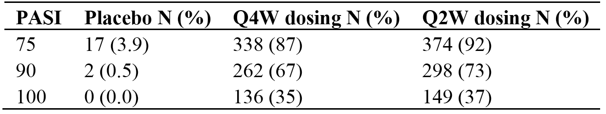
b. Study RHAJ dosing regimen
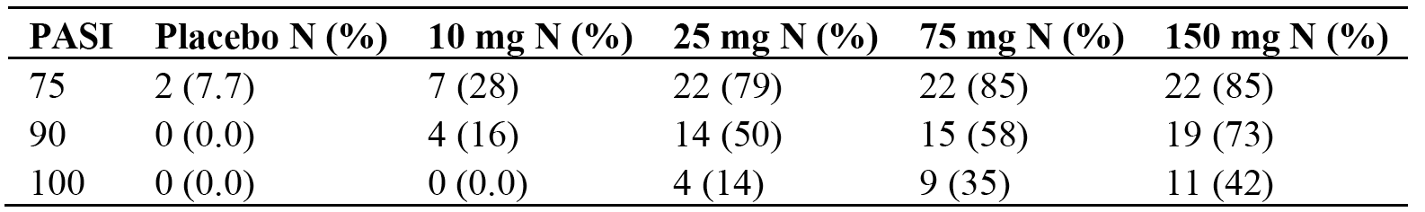
Abbreviations: N = number of patients; PASI = Psoriasis Area and Severity Index; PASI 75 = at least a 75% improvement from baseline in PASI score; PASI 90 = at least a 90% improvement from baseline in PASI score; PASI 100 = a 100% improvement from baseline in PASI score; Q2W = every 2 weeks; Q4W = every 4 weeks.
In the final model for PASI 75 (covariates effects), no covariates were found to be significant. In the final model for PASI 90 (covariate effects) patients with palmoplantar psoriasis had an 11% lower E_{max} estimate for PASI 90 compared to patients with no palmoplantar involvement. This resulted in a reduced probability of achieving PASI 90 for patients with palmoplantar psoriasis at Week 12. For example, in a patient with palmoplantar involvement using the median Week 12 trough ixekizumab serum concentration of 5.71 μg/mL would have a probability of 0.67 of achieving PASI 90, while a patient without palmoplantar involvement would have a probability of 0.80. Heavier patients had a lower E_{max} estimate and, consequently, a lower probability of achieving PASI 90 than lighter patients. Higher baseline PASI score led to a higher E_{max} (that is, the greater the degree of BSA involvement at baseline, the higher the probability of achieving a PASI 90 response at Week 12). For example, a patient with a median Week 12 trough ixekizumab serum concentration of 5.71 μg/mL with a baseline PASI score of 10, 20, or 50 would have a probability of achieving a PASI 90 of 0.71, 0.82 and 0.92, respectively. Previous treatment with a biologic agent resulted in about a 3-fold higher EC₅₀, thereby reducing the probability of achieving PASI 90. For example, a patient with a median Week 12 trough ixekizumab serum concentration of 5.71 μg/mL without a history of previous biologic treatment would have a probability of 0.80 of achieving a PASI 90, while a patient with the same exposure but with a previous history of treatment with a biologic would have a probability of 0.73.
In the final model for PASI 100 (covariate effects), patients with palmoplantar psoriasis had a 13% lower E_{max} compared to patients without palmoplantar involvement. This effect resulted in a reduced probability of achieving PASI 100 for patients with palmoplantar psoriasis at Week 12. For example, a patient with palmoplantar involvement using the median Week 12 ixekizumab serum trough concentration of 5.17 μg/L, would have a probability of 0.25 of achieving a PASI 100 while a patient without palmoplantar involvement would have a probability of 0.43. Also, heavier patients had a lower E_{max} estimate and thus a lower probability of achieving PASI 100.
The final covariate models describing PASI 75, PASI 90 and PASI 100 are summarised below in Table 21.

Table 21. Primary PK/PD Analysis - Parameter estimates of covariate models for PASI 75, 90, 100
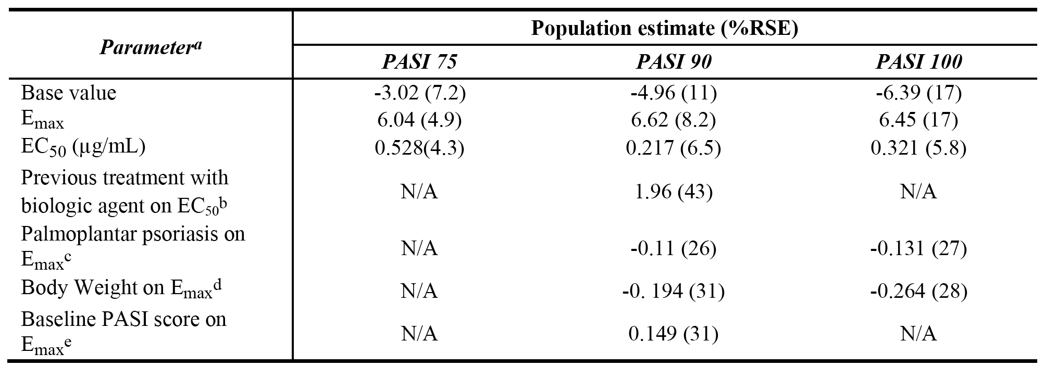
Abbreviations: EC50 = drug concentration that produces 50% of Emax; Emax = maximum effect; N/A = not applicable; PASI = Psoriasis Area and Severity Index; PASI 75 = at least a 75% improvement from baseline in PASI score; PASI 90 = at least a 90% improvement from baseline in PASI score; PASI 100 = a 100%
Improvement from baseline in PASI score.
a. Not all covariates were significant in all the models. N/A signifies a covariate that was not selected for a particular model.
b. EC50.ind = EC50.pop x (1 + 1.96 x ptx4) for PAS 90
c. Emax.ind = Emax.pop x (1 - 0.11 x palm) for PASI 90. Replace -0.11 with -0.131 for PASI 100
d. Emax.ind = Emax.pop x (weight/88.95) -0.194 for PASI 90. Replace -0.194 with -0.264 for PASI 100
e. Emax.ind = Emax.pop x (PAS/17.45) 0.149 for PASI 90, where EC50.ind is an individual’s EC50 estimate, EC50.pop is the typical value, Emax.ind is an individual’s Emax estimate, Emax.pop is the typical value. ptx4 is 1 for patients who received previous treatment with biologic agent, palm is an indicator variable with a value of 0 for patients with no palmoplantar psoriasis involvement, BPAS is baseline PASI score, weight is the patient weight at baseline.
The PASI models were also used to determine the impact of the induction dosing regimen on the probability of a patient achieving PASI 75/90/100 responses to ixekizumab treatment. The model-predicted percent of patients responding to 80 mg Q2W and 80 mg Q4W dosing were determined and compared to the observed percentages (see Table 22, below). Overall, the 80 mg Q2W regimen was associated with a higher predicted percentage response rate for all three end points compared to the 80 mg Q4W regimen. The higher range of predicted concentrations for patients in the 80 mg Q2W regimen group ensured that the majority of patients were on or closer to the plateau of the exposure-response curve and thus were likely to achieve a response. This is compared to the 80 mg Q4W regimen group where the range of exposures was lower and encompassed more of the slope of the exposure-response curve resulting in fewer patients predicted to achieve a response.

Table 22. PK/PD Analysis - Comparison of model predicted and observed PASI outcomes for ixekizumab Q2W and Q4W induction dosing regimens at Week 12
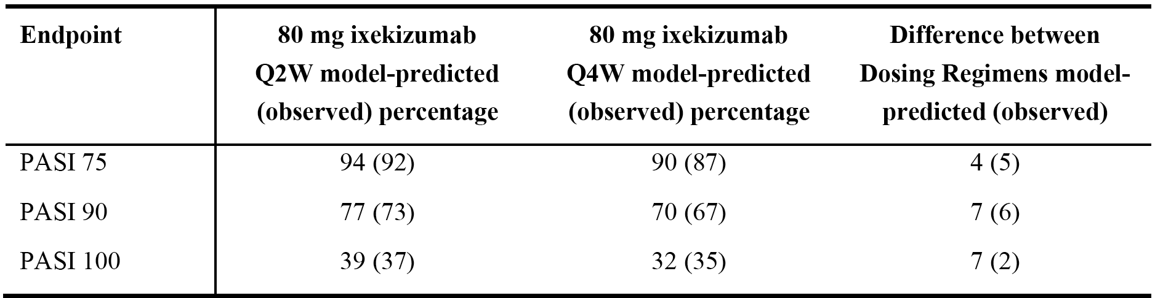
Abbreviations: PASI = Psoriasis Area and Severity Index; PASI 75 = at least a 75% improvement from baseline in PASI score; PASI 90 = at least a 90% improvement from baseline in PASI score; PASI 100 = a 100% improvement from baseline in PASI score; Q2W = every 2 weeks; Q4W = every 4 weeks.
In general, lighter weight patients had higher predicted response rates compared to heavier weight patients. The benefit of the 80 mg Q2W regimen compared to the 80 mg Q4W regimen was observed across all weight categories for all PASI measures (see Table 23, below). The data were plotted by dosing regimen and body weight category (< 100 kg and ≥ 100 kg), and in both weight groups, there was an increase in response rate for the 80 mg Q2W regimen compared to the 80 mg Q4W regimen.

Table 23. Primary PK/PD Analysis - Model predicted impact of body weight on exposure and response for the PASI Week 12 score; Q2W and Q4W induction regimens
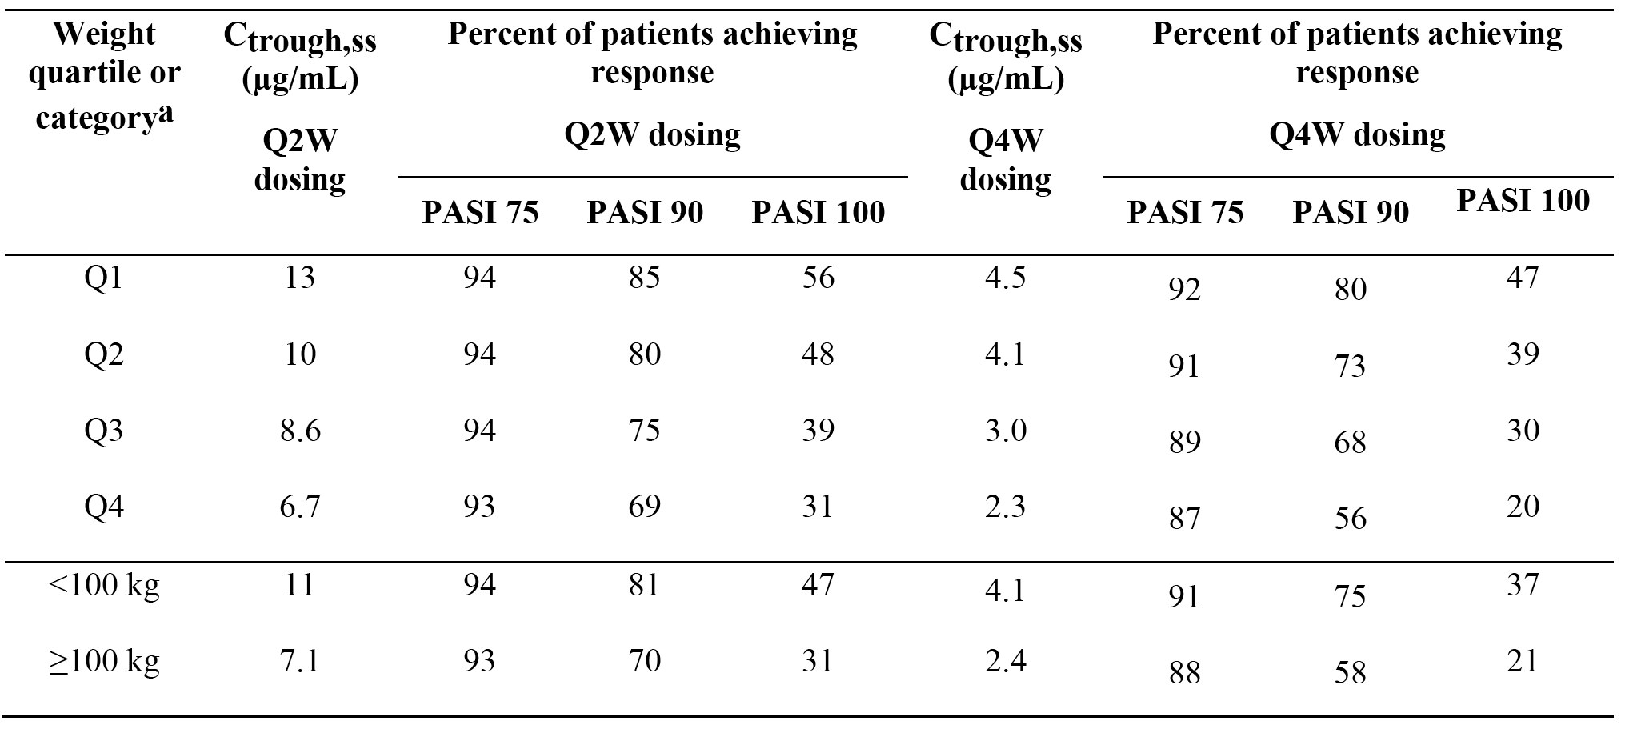
Abbreviations: PASI = Psoriasis Area and Severity Index; PASI 75 = at least a 75% improvement from baseline in PASI score; PASI 90 = at least a 90% improvement from baseline in PASI score; PASI 100 = a 100% improvement from baseline in PASI score; Q = quartile; Q2W = every 2 weeks; Q4W = every 4 weeks. Notes: a. the median (range) weight of each quartile for Q2W dosing is 69 (48-76) kg for Q1, 83 (76-90) kg for Q2, 98 (90 to 104) kg for Q3 and 118 (105-191) kg for Q4. The median (range) weight of each quartile for Q4W dosing is 67 (47 to 76) kg for Q1, 83 (76-90) kg for Q2, 97 (90-105) kg for Q3 and 119 (106-170) kg for Q4

PASI week 60 analyses
The patient population and covariates tested were the same as previously described for the sPGA Week 60 model, with the addition of baseline PASI score. A power model adequately described the exposure-response relationship and parameters were estimated with good precision for PASI 75, 90 and 100 models (see Table 24, below). No covariates were found to be significant for the Week 60 endpoint.

Table 24. Primary PK/PD analysis, parameter estimates of final PASI Week 60 model
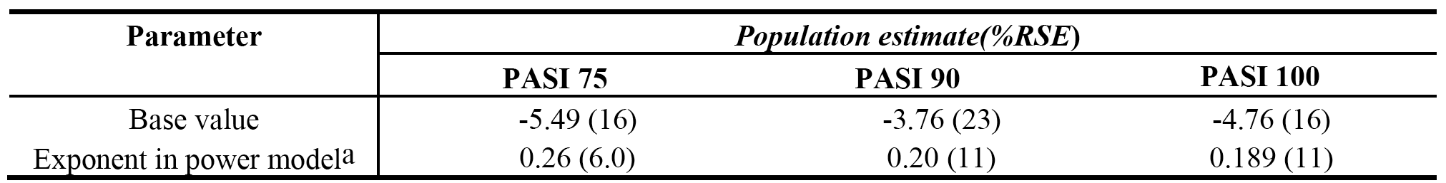
Abbreviations: %RSE = relative standard error; PASI = Psoriasis Area and Severity Index; PASI 75 = at least a 75% improvement from baseline in PASI score; PASI 90 = at least a 90% improvement from baseline in PASI score; PASI 100 = a 100% improvement from baseline in PASI score. Notes: a) Drug effect = Cmin 0.26 for PASI 75. Replace 0.26 with 0.20 for PASI 90 and 0.189 for PASI 100.
Exposure-response curves showed that for a PASI 75 or PASI 90 response, maximal responses were attained at similar concentrations at the Week 12 and Week 60 time-points. For a PASI 100 response, there was a higher predicted response at Week 60 compared to Week 12 for the same exposure. This suggests a delay in drug action (anti-clockwise hysteresis) and that in addition to adequate drug exposure, time may play a role in obtaining complete skin clearance.

Time-course models
The covariates tested for sPGA time-course model were the same as previously described for the sPGA Week 60 model. The covariates retained in the sPGA time-course model were previous use of a systemic biologic agent, which increased EC₅₀ by 34%, and palmoplantar involvement, which produced a small decrease in total drug effect of 1.9%.
The model predicted sPGA time-course can be used to evaluate different dosing regimens for short or long term efficacy. The simulations assumed that patients would remain on their dosing regimen, and do not account for patients that may discontinue treatment. In exploring the time required to achieve a specific sPGA(score of 0 or 1) response rate, an 80 mg Q2W regimen in the induction dosing period (up to Week 12) is projected to achieve an 80% response rate by Week 12, whereas an 80 mg Q4W regimen is projected to achieve an 80% response rate by Week 19. The results demonstrate a faster onset of response with the 80 mg Q2W induction dosing regimen than with the 80 mg Q4W induction dosing regimen. The response rates for the induction/maintenance dosing regimens at Week 60 were 75%, 75%, 48%, and 49% for the Q2W/Q4W, Q4W/Q4W, Q2W/Q12W, and Q4W/Q12W regimens, respectively.

Exposure-response analyses relating to safety
Model-predicted C_{trough} concentrations were determined for each patient in Study RHAZ who participated through to Week 12 and for those patients who participated through to Week 60. Exposures were divided into quartiles with the median (range) for each quartile being calculated for Week 12 and Week 60, and the incidence of adverse events were calculated for each quartile. Placebo data were included in the comparison of the induction dosing period at Week 12.
AESI were summarised for each exposure quartile for injection site reactions, infections, hypersensitivity reactions, Candida infections and staphylococcal infections. There appeared to be a concentration relationship with injection site reactions, with a higher incidence at higher ixekizumab concentrations. There was no apparent ixekizumab concentration relationship for the other AESI.
AESI for which no exposure-safety analyses by quartile were undertaken were major adverse cardiovascular events, and Crohn’s disease. In the induction dosing period, one patient on the 80 mg Q4W regimen had an acute myocardial infarction (MI) and a predicted C_{trough} level of 2.33 μg/mL, which was in the lowest quartile of exposure. In the maintenance dosing period, one patient on the 80 mg Q4W regimen had an MI and a predicted C_{trough} level of 4.39 μg/mL, which was in the highest quartile of exposure. A second patient also had as MI during the maintenance dosing period, but did not have a trough concentration and so was not included in the exposure safety analysis. One patient on 80 mg Q4W developed Crohn’s disease during the induction dosing period, but did not have a trough concentration and so was not included in the exposure safety analysis. Another patient developed Crohn’s disease during the maintenance dosing period and had a predicted C_{trough} level of 0.472 μg/mL, which was in the lowest exposure quartile.

Secondary exposure response analyses

Overview
The Secondary Exposure-Response Report described the results of analyses based on data from the three pivotal, Phase III clinical efficacy and safety studies in patients with psoriasis (Studies RHAZ, RHBA, RHBC). The report included exposure-efficacy analyses, exposure-safety (AESI) analyses and assessment of the impact of immunogenicity on the PK of ixekizumab. The methods used in the analyses were similar to those used in Primary Population PopPK and Exposure-Response Analyses. However, no PopPK modelling was performed in the analyses. Graphical visualisation and population exposure-response modelling, based on the nonlinear mixed effects modelling (NONMEM), were the principal analysis techniques.
The sponsor states that the additional exposure-response analyses in this secondary report were designed to supplement existing analyses included in the ixekizumab submission by integrating data across the three Phase III studies. Additionally, the analyses in the secondary report addressed a request from the FDA to evaluate the impact of immunogenicity on the PK, safety and efficacy of ixekizumab.
The results for the exposure-response efficacy and safety analyses from the Secondary Exposure-Response Analyses were generally consistent with the corresponding results from the Primary Exposure-Response Analyses. However, there were distinct differences in the exposure inputs between the two PK/PD analyses. Firstly, the Secondary Exposure-REsponse Analyses used only trough ixekizumab concentrations for PK samples taken at the same time as the immunogenicity samples, whereas the Primary Exposure-Response Analyses included trough PK samples from both patient serial sampling and sparse population PK sampling. Secondly, the Secondary Exposure-Response Analyses were based on observed ixekizumab trough concentrations from the three Phase III studies (Studies RHAZ, RHBA and RHBC), whereas the Primary Exposure-Response Analyses were based on model predicted ixekizumab trough concentrations from a PopPK analysis of data from Studies RHAG, RHAJ, and RHAZ. A further difference between the two analyses was that the Secondary Exposure-Response Analyses investigated the safety exposure-response relationship for a more extensive range of AESI than the Primary Exposure-Response Analyses.

Objectives
The objectives of the analyses using observed ixekizumab Ctrough exposure data in patients with psoriasis included:
- graphical comparison of the PK data in patients who are ADA positive and negative, NAb positive and negative and evaluation of exposure in relation to the drug tolerance level of the assays;
- characterisation of the exposure-response relationships that describe the key efficacy endpoints (sPGA; PASI), and identification of potential patient factors that may impact on the exposure-response relationship; and
- characterisation of the exposure-response relationships describing the relationship between observed C_{trough} concentrations and key safety endpoints (AESI) using descriptive statistics.

Dosing regimens and PK sampling schedules
Ixekizumab was administered by SC injection. In the induction dosing period (Weeks 0 to 12), the starting dose was 160 mg followed by 80 mg SC Q2W or 80 mg SC Q4W, and in the maintenance period (Weeks 12 to 60) the dose was as 80 mg SC Q4W or 80 mg SC Q12W.
The immunogenicity and companion PK data were based on C_{trough} levels assessed at Week 0, Week 4 (28 ± 2 days), Week 12 (84 ± 4 days), Week 24 (168 ± 4 days), Week 36 (252 ± 7 days), Week 48 (336 ± 7 days), and Week 60 (420 ± 7 days). For Study RHBC, only the Week 0, Week 4 and Week 12 time-points were included in the analysis. Other PK data for Study RHAZ taken at different time points from those specified according to the PopPK sampling scheme were not included, since the analyses in the report were focused only on time-points with immunogenicity samples. In Study RHBA, the database lock occurred after all patients completed or discontinued Week 36, and as the study is ongoing, a number of Week 48 and Week 60 samples were not available for inclusion in the data analyses.

Exposure-response analyses (efficacy)

Methods
The efficacy endpoints for the exposure-efficacy analyses were the sPGA and the PASI (PASI 75, PASI 90 and PASI 100). The analyses were undertaken at Week 12 (end of the induction dosing period) and Week 60 (end of the maintenance dosing period). The primary efficacy endpoints in the three Phase III studies was response defined as sPGA (score of 0 or 1) and PASI 75 at Week 12.
For the sPGA analyses at Week 12, ordered categorical or logistic regression models were developed to determine the probability of a patient being a responder (defined as sPGA 0 or 1) or a non-responder (sPGA > 1) after 12 weeks of treatment. For the PASI data, logistic regression modelling was used to estimate the probability of a patient achieving a particular PASI score (75, 90, or 100) after 12 weeks of treatment. Power models were developed for the Week 60 data for both sPGA and PASI analyses. Observed C_{trough} values were obtained at Week 12 (Studies RHAZ, RHBA and RHBC) and Week 60 (Studies RHAZ and RHBA) and used as exposure inputs to the sPGA and PASI models.
The effects of patient factors (covariates) were tested in the Week 12 logistic regression using the SCM implemented using PsN. The criterion for forward inclusion was a p-value no greater than 0.01 (Δ 6.635 MOF for inclusion of one parameter) with a backward deletion threshold of 0.001 (Δ 10.828 MOF for exclusion of one parameter). The final backward model from the SCM process was further reduced in a step-wise manner taking into account factors such as parameter precision, and magnitude of the covariate effect. The models were evaluated using VPC.

Results of sPGA analyses

Week 12 sPGA analyses
The Week 12 sPGA score analysis included 2994 patients who had ixekizumab trough concentration data or received placebo (1253 from Study RHAZ, 833 from Study RHBA and 908 from Study RHBC). Of the 2994 patients, 2888 had trough PK samples that met the sampling time criteria and were included in the integrated analysis dataset (1216 from Study RHAZ, 798 from Study RHBA and 874 from Study RHBC).
After forward inclusion and backward elimination from the SCM procedure in PsN, the covariates retained in the Week 12 sPGA model were body weight (heavier patients had a lower E_{max}), palmoplantar psoriasis involvement (patients with palmoplantar psoriasis had a lower E_{max}) and baseline CRP level (higher baseline CRP was associated with a higher EC₅₀). Patients with palmoplantar psoriasis had a 9.9% lower E_{max} compared to patients without palmoplantar psoriasis involvement, resulting in a reduced probability of achieving an sPGA (score of 0 or 1). Heavier patients had a lower E_{max} estimate and resulting in a lower probability of achieving an sPGA (score of 0 or 1) response compared to lighter patients. Higher baseline CRP was associated a higher EC₅₀ and a lower probability of achieving an sPGA (score of 0 or 1) response, but this effect was very small.
Overall, the 80 mg Q2W regimen was associated with a higher predicted percentage response rate compared to the 80 mg Q4W regimen at Week 12. The model-predicted (versus observed) response rates for sPGA (score of 0 or 1) at Week 12 were 86% (versus 85%) and 84% (versus 79%) for the 80 mg Q2W and 80 mg Q4W dosing regimens, respectively, and 42% (versus 41%) and 37% (versus 36%) for sPGA (0), respectively. As can be seen from the data, the results for the model-predicted response rates were consistent with the observed response rates.

Week 60 sPGA analyses
The patient population for the Week 60 sPGA response analyses included 350 patients who had been treated with ixekizumab (80 mg Q2W or 80 mg Q4W) during the induction dosing period, and had been assigned or randomised to the 80 mg Q4W regimen in the maintenance dosing period. Of these 350 patients, 292 had observed trough concentrations at Week 60 that met the sampling time criteria and were included in the integrated analysis dataset (261 from Study RHAZ and 31 from Study RHBA).
The exposure-response relationship at Week 60 was adequately described by a power model. After forward inclusion and backward elimination from the SCM procedure in PsN, the only covariate retained in the Week 60 sPGA model was previous systemic treatment with a biologic agent on the exponent in the power model. Previous systemic treatment with a biologic agent was found to result in a reduced probability of response.
A comparison of the Week 12 and Week 60 exposure-response relationships was performed through simulation and the results were similar to those previously described for the Primary Exposure-Response Analysis.

Results for the PASI analyses

Week 12 PASI analyses
The Week 12 PASI analyses included 2994 patients who had trough concentration data or received placebo (1253 from Study RHAZ, 833 from Study RHBA and 908 from Study RHBC). Of these 2994 patients, 2888 had trough PK samples that met the sampling time criteria and were included in the integrated analysis dataset (1216 from Study RHAZ, 798 from Study RHBA and 874 from Study RHBC).
After forward inclusion and backward elimination from the SCM procedure in PsN, the covariates that were significant and retained in the final models included palmoplantar psoriasis, (where patients with palmoplantar had a lower drug effect (either lower E_{max} or higher EC₅₀), PASI score at baseline (where a higher baseline PASI score was associated with a higher E_{max}), and baseline body weight (where heavier patients had a lower E_{max}).
In the final model for PASI 75, patients with palmoplantar psoriasis had a 13% lower E_{max} compared to patients without palmoplantar psoriasis. Consequently, this effect resulted in a reduced probability of achieving PASI 75 for patients with palmoplantar psoriasis at Week 12. For example, using the median Week 12 trough concentration (5.25 μg/mL), a patient with palmoplantar psoriasis would have a probability of 0.88 of achieving a PASI 75 response while a patient without palmoplantar psoriasis would have a probability of 0.94. Heavier patients had a lower E_{max} estimate and resulting in a lower probability of achieving PASI 75. A higher baseline PASI score led to a higher E_{max} (the greater the degree of psoriasis severity at baseline, the higher the probability of achieving a PASI 75 response at Week 12). For example, a patient with the median exposure of 5.25 μg/mL, but with a baseline PASI score of 10, 20, or 50 would have a probability of achieving PASI 75 of 0.88, 0.95 and 0.98, respectively.
Overall, the 80 mg Q2W regimen was associated with a higher model-predicted percentage response rate compared with the 80 mg Q4W regimen for PASI 75 (3% higher), PASI 90 (6% higher) and PASI 100 (5% higher).

PASI week 60 analyses
The patient population and covariates tested were the same as previously described for the sPGA Week 60 model, with the addition of baseline PASI score. A power model adequately described the exposure-response relationship and parameters were estimated with good precision for PASI 75, PASI 90, and PASI 100 models. No covariates were found to be significant for the Week 60 endpoint.
The Week 12 and Week 60 exposure-response relationships were compared using simulations. The results were similar to those observed in the Primary E/R Analysis.

Exposure-response analyses (safety)

Methods
Exposure-safety relationships were explored for AESIs for data up to Week 12 (end of the induction dosing period) and from Week 12 to Week 60 (maintenance dosing period). Observed C_{trough} concentrations at Week 12 were used as the exposure input for exposure-safety assessments for each patient who participated in the induction dosing period (Studies RHAZ, RHBA, and RHBC). Observed C_{trough} concentrations at Week 60 were used as the exposure input for exposure-safety assessments for patients who participated in the maintenance dosing period (up to Week 60) of Studies RHAZ and RHBA, and if these concentrations were not available then the last trough concentration for the patient taken during the maintenance dosing period was used.
The AESI assessed included infections (all infections, all infections requiring therapy, infection-related serious adverse events (SAE), herpes viral infections, staphylococcal and Candida infections), injection site reactions, hypersensitivity reactions, ulcerative colitis, Crohn’s disease, major adverse cardiovascular events (MACE), and neutropenia Common Terminology Criteria for Adverse Event (CTCAE) grade 2 or higher. Exposures (C_{trough} levels) for all patients included in the analysis were separated into quartiles and the median (range) for each quartile was calculated, and the frequency of AESI were summarised for each of the quartiles. Data were summarised separately for the induction period and for the maintenance period.

Results for the safety analyses
The overall incidence of pooled treatment emergent adverse events (TEAE) for each quartile of exposure was similar across the exposure range in both the induction and maintenance dosing period (see Figure 11, below).
Figure 11. Incidence of TEAEs by induction dosing period (left panel) and maintenance dosing period (right panel)
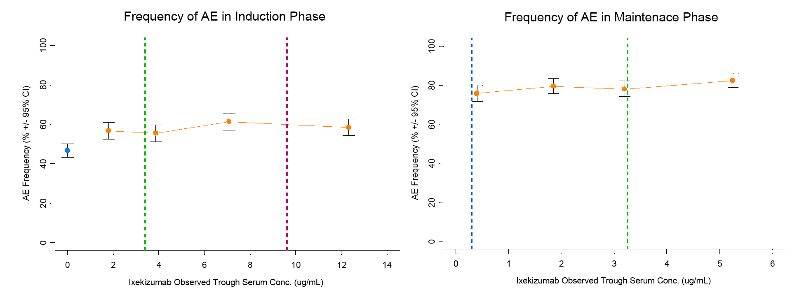
Dotted line represent the mean trough concentration (Red = Q2W, Green = Q4W and Blue = Q12W. Orange dots represent the incidence of adverse events at each quartile and the median concentration at each quartile. Blue dot represents placebo).
There was a concentration relationship between C_{trough} levels and injection site reactions, with more frequent injection site reactions being observed at higher ixekizumab concentrations in the induction and maintenance dosing periods. In the induction dosing period, the incidence of injection site reactions was greater in patients in the 80 mg Q2W group compared to patients in the 80 mg Q4W group (16.3% (n = 173) versus 13.2% (n = 137), respectively). In the maintenance dosing period the incidence of injection site reactions was greater in patients in the 80 mg Q4W group compared to patients in the 80 mg Q12W group (10.8% (n = 153) versus 6.2% (n = 13), respectively).
Candida infections were assessed using three categories (I = High level term (HLT) only; 2 = HLT plus selected preferred terms (PT); 3 = oral infections only by PT). There was a relationship between exposure and the incidence of all 3 categories of Candida infections during the induction dosing period, with incidences of patients with Candida in each exposure quartile of less than 2%. An exposure relationship was not observed for Candida infections occurring in the maintenance dosing period. Looking specifically at oral Candida infections, the incidence was less than 1% of patients in each exposure quartile during the induction dosing period with a total of 9 patients reporting events, with 4 of these patients being in the highest exposure quartile. The incidence of oral Candida infections was less than 3% of patients in each exposure quartile during the maintenance dosing period, and no relationship was observed with exposure. When looking at incidence by dose in the induction dosing period, 7 patients on the 80 mg Q2W regimen and 2 patients on the 80 mg Q4W regimen reported oral Candida events. In the maintenance dosing period, 27 patients on the 80 mg Q4W regimen reported oral Candida events compared with 3 patients on the 80 mg Q12W regimen.
There was a higher incidence of new or worsening neutropaenia Grade 2 or higher in the highest exposure quartile in the induction dosing period, but no relationship was observed during the maintenance dosing period. In the induction dosing period, 2 cases of Grade 3 neutropaenia were reported in patients who had exposures in the fourth quartile and 1 case of Grade 4 neutropaenia was reported in the second exposure quartile. The remaining reports were of Grade 2 neutropaenia, therefore the relationship with exposure is primarily driven by the occurrence of Grade 2 neutropaenia rather than Grade > 2 neutropaenia. This is confirmed by the data in the maintenance dosing period where all events were grade 2 except for 2 cases of Grade 4 neutropaenia (1 patient from the lowest quartile and 1 patient from the highest exposure quartile). In the induction dosing period, 28 reports of Grade 2 neutropaenia were reported in patients in the 80 mg Q2W group and 24 reports in patients in the 80 mg Q4W group.
Apart from injection site reactions, Candida infections and grade ≥ 2 neutropenia no other relationships between exposure and AESI were identified. However, no satisfactory evaluable exposure data were available for 5 patients with Crohn's disease, while evaluable data were available for only 5 patients with ulcerative colitis in the two dosing periods and for only 2 patients with MACE in the induction dosing period.
Evaluator’s comment: A limitation of the analysis was that AEs were spontaneously reported making it impossible to match them to a C_{trough} level occurring at the time of event. Therefore, C_{trough} levels at the end of the dosing period in which the event was reported (induction and maintenance dosing periods) or the last observation (maintenance dosing period) were used as the exposure inputs. A further limitation of the analysis was that, apart from infections, injection site reactions, and hypersensitivity reactions, the incidence of all other AESI was low. Consequently, only small numbers of patients were present in each of the exposure quartiles, which limits the interpretation of the data.

Immunogenicity
The Clinical Summary of Clinical Pharmacology Studies included integrated analyses of immunogenicity (ixekizumab specific ADAs and NAbs) based on the data from the clinical Phase II and 3 studies. The analyses included an exploration of the relationship between antibody formation and PK, efficacy and safety. More detailed information on the effect of immunogenicity on efficacy was provided in the Clinical Summary of Efficacy and on safety in the Clinical Summary of Safety.

Assays for immunogenicity
For the integrated analyses of immunogenicity, ixekizumab serum samples collected in the Phase II and Phase III clinical studies in patients with psoriasis were evaluated using a 4-tiered approach. In Tier 1 (screening) all samples were assessed and those above the assay cut-point were assessed in Tier 2 (confirmation). Any samples confirmed as specific for ixekizumab in Tier 2 were reported as ‘detected’. All samples below the assay cut-point in Tier 1 or not confirmed in Tier 2 were reported as ‘not detected’. Any ‘detected’ sample in Tier 2 was assessed in Tier 3 (titre assessment) and Tier 4 (neutralizing ADA assay). Additionally, samples demonstrating a ≥ 4-fold (2 dilutions) increase in titre over baseline in Tier 3 were defined as treatment-emergent.
Both the ADA screening assay (Tiers 1, 2, and 3) and the neutralising ADA assay (Tier 4) were validated in accordance with the FDA Guidance for Industry Assay Development for Immunogenicity Testing of Therapeutic Proteins (FDA 2009), the CHMP Guideline on Immunogenicity Assessment of Biotechnology-Derived Therapeutic Proteins (EMA 2007), and other published recommendations., The assay method used to detect ADA was a validated ELISA and NAbs were detected by a validated assay.

Results for incidence of immunogenicity

Induction dosing period
Immunogenicity results at Week 12 in the pooled data from Studies RHAZ, RHBA, and RHBC were:
- the incidence of treatment-emergent anti-drug antibodies (treatment-emergent ADA) positive at base-line in all ixekizumab-treated patients was 4.5% (104/2293);
- the incidence of treatment-emergent ADA positive at any time post-baseline in all ixekizumab-treated patients was 11.2% (256/2293);
- the incidence of NAb positive in all ixekizumab-treated patients was 1.0% (24/2293);
- the incidence of NAb positive in confirmed treatment-emergent ADA positive ixekizumab-treated patients was 9.4% (24/256);
- the incidence of treatment-emergent ADA positive in ixekizumab-treated patients with a low titre (<1:160) was 61.3% (157/256);
- the incidence of treatment-emergent ADA positive in ixekizumab-treated patients was higher in the less frequent dosing group of 80 mg Q4W (13.4% (153/1143)) compared to the more frequent dosing group of 80 mg Q2W (9.0% (103/1150));
- in placebo-treated patients (n = 781), treatment-emergent ADA positive was reported in 4.4% of patients at baseline and 0.5% of patients at any time post-baseline, while NAb positive was reported in 1 (25%) of the 4 ADA positive patients.
All evaluable patients had either an evaluable baseline sample and at least 1 evaluable post-baseline sample taken after administration of the study drug, or no evaluable baseline sample and all ADA negative post-baseline samples taken after administration of the study drug.

Maintenance dosing period
Immunogenicity results at Week 60 in the pooled data from Studies RHAZ and RHBA were:
- the incidence of treatment-emergent ADA in all patients who had been treated with ixekizumab in the induction dosing period and randomised to ixekizumab in the maintenance dosing period (IXE/IXE) was 21.4% (141/659) compared to 24.2% (80/330) in patients who had been treated with ixekizumab in the induction dosing period and randomised to placebo in the maintenance dosing period (IXE/placebo);
- the incidence of NAb positive in IXE/IXE treated patients was 0.8% (5/659) compared to 1.2% (4/330) in IXE/placebo treated patients;
- the incidence of treatment-emergent ADA positive in IXE/IXE patients with a low titre (< 1:160) was 90.8% (128/141) compared to 85.0% (65/80) in IXE/placebo patients;
- the incidence of treatment-emergent ADA positive in patients who were responders to ixekizumab at Week 12 and re-randomised to 80 mg Q4W was 17.3% (57/330) compared to 22.5% (84/329) of patients re-randomised to 80 mg Q12W;
- in patients who were initially randomised to placebo in the induction period and were non-responders at Week 12 and subsequently received ixekizumab 80 mg Q4W in the maintenance dosing period the incidence of treatment-emergent ADA positive was 13.6% (74/543); among the treatment-emergent ADA positive patients, 70.3% (52/74) had low ADA titres (< 1:160).

All psoriasis ixekizumab exposures integrated analysis set
The all psoriasis ixekizumab exposures integrated analysis set included pooled data for all treatment periods for all ixekizumab-treated patients (all doses, all durations) in studies with the disease specific cut-point for the ADA assay (Studies RHAJ, RHAT, RHAZ, RHBA, RHBC and RHBL, with data from RHAG being excluded). Patients from the pooled studies were included if they had received at least one dose of ixekizumab for the treatment of psoriasis. Across all ixekizumab psoriasis studies, the incidence in patients of ADA at baseline was 4.5% (186/4107). Of all psoriasis patients treated with ixekizumab, 20.1% (826/4107) were treatment-emergent ADA positive at any time post-baseline, with 47% (388/4107) and 53% (438/4107) of these patients being transient treatment-emergent ADA positive or persistent treatment-emergent ADA positive, respectively. Of the patients who were ADA positive at any time post-baseline, 10.8% (89/826) were NAb positive.

Results for effect of immunogenicity on exposure-efficacy relationships

Induction dosing period
In the induction dosing period, in treatment-emergent ADA positive patients treated with ixekizumab (80 mg Q2W or 80 mg Q4W), 65.6% (168/256) achieved an sPGA (score of 0 or 1) at Week 12, while in treatment-emergent ADA negative patients 81.1% (1652/2037) achieved an sPGA (score of 0 or 1).
treatment-emergent ADA positive patients with low ADA titres (< 1:160) had sPGA (score of 0 or 1) response rates similar to patients who were treatment-emergent ADA negative in both the 80 mg Q2W group (78.8% versus 83.6%, respectively) and the 80 mg Q4W group (74.7% versus 78.5%, respectively). In the confirmed NAb-positive group, 4.2% (1/24) of patients achieved sPGA (score of 0 or 1) compared to 42.1% (8/19) of patients in the confirmed NAb-negative group.
The treatment-by-ADA subgroup interaction test was statistically significant, but the effect appears to have been driven by the small number of treatment-emergent ADA positive patients in the placebo group (n = 4), where the single sPGA (score of 0 or 1) responder contributed to the high response rate in the placebo group of 25.0% (1/4). In the placebo group there were 781 evaluable patients, 4 (0.5%) were ADA-positive (1 (25%) achieved a positive sPGA response at Week 12), and 777 (99.5%) were ADA-negative (30 (3.9%) achieved a positive result at Week 12).
In the induction period, in patients treated with ixekizumab (80 mg Q2W or 80 mg Q4W), a PASI 75 at Week 12 was observed in 72.7% (186/256) of treatment-emergent ADA positive patients and 87.9% (1791/2037) of treatment-emergent ADA negative patients. In the placebo group, 25% (1/4) of ADA-positive patients achieved a PASI 75 at Week 12 compared to 4.4% (34/777) of ADA-negative patients.

Maintenance dosing period
In the patients in the induction period treated with ixekizumab and then re-randomised to 80 mg Q4W in the maintenance period, 75.4% (43/57) of those who were treatment-emergent ADA positive had an sPGA (score of 0 or 1) at Week 60 compared to 74.0% (202/273) of those who were treatment-emergent ADA negative. Of the treatment-emergent ADA positive patients in 80 mg Q4W group, 94.7% (54/57) had a low ADA titre (< 1:160), and 75.9% (41/54) of these patients had an sPGA (score of 0 or 1) response compared to 74.0% (202/273) of treatment-emergent ADA negative patients. Of the treatment-emergent ADA positive patients in the 80 mg Q4W group, 3 (5.3%) of the 57 patients had a moderate-to-high ADA titre and 2 of these 3 patients maintained or achieved an sPGA (score of 0 or 1) response.
In the patients in the induction dosing period treated with ixekizumab and then re-randomised to 80 mg Q12W in the maintenance period, 39.3% (33/84) of those who were treatment-emergent ADA positive had an sPGA (score of 0 or 1) at Week 60 compared to 38.0% (93/245) of those who were treatment-emergent ADA negative. Of the treatment-emergent ADA positive patients in the 80 mg Q12W group, 88.1% (74/84) had a low ADA titre (< 1:160), and 43.2% (32/74) of these patients had an sPGA (score of 0 or 1) response at Week 60 compared to 38.0% (93/245) of treatment-emergent ADA negative patients. Of the treatment-emergent ADA positive patients in the 80 mg Q12W group, 10 (11.9%) of the 84 patients had a moderate-to-high ADA titre and 1 of these 10 patients maintained or achieved an sPGA (score of 0 or 1) response.
In the maintenance dosing period, patients treated with ixekizumab (80 mg Q4W or 80 mg Q12W), 61.7% (87/141) of treatment-emergent ADA positive patients and 63.5% (329/518) of treatment-emergent ADA negative of patients, respectively, achieved a PASI 75 at Week 60.

Results for effect of immunogenicity on exposure-safety relationships
The Summary of Clinical Safety included an integrated assessment of treatment-emergent adverse events by ADA status (treatment-emergent ADA). For analyses of TEAEs and discontinuations due to AEs, only TEAEs that occurred within 14 days before or after treatment-emergent ADA positive results were included in the analysis (treatment-emergent ADA status was tested at baseline, Week 4 and Week 12 for the induction dosing period). Patients who discontinued treatment due to AEs earlier than 14 days prior to and later than 14 days after the positive treatment-emergent ADA episode were excluded from the analysis. There were no data for the maintenance dosing period.
The sponsor acknowledged that there are limitations to the interpretation of the available results based on low numbers of specific event types, the study designs (for example, the low number of samples obtained from patients, particularly in the induction period) and the potential inequality in counting TEAEs associated with positive or negative treatment-emergent ADA status due to the definition of the length of treatment-emergent positive treatment-emergent ADA status.

Induction dosing period
The key features of the safety profile in ixekizumab treated patients in the treatment groups based on pooled data from Studies RHAZ, RHBA, and RHBC were:
- The overall incidence of TEAEs was lower in the ADA-positive group than in the ADA-negative group (34.4% (88/256) versus 58.3% (1187/2037), respectively). SAEs were reported in 3.1% (8/256) of ADA-positive patients and 1.8% (36/2037) of ADA-negative patients, with discontinuations of the study drug being reported in 2.0% (5/256) and 1.8% (37/2037) of patients, respectively. No deaths were reported in either patient group.
- TEAE injection site reactions were reported in 7.4% (19/256) of ADA-positive patients and 13.6% (277/2037) of ADA-negative patients. No SAE injection reactions were reported in the treatment group and no injection site reactions resulted in discontinuation of the study drug in ADA-positive patients (compared to 5 patients in the ADA-negative group).
- TEAE anaphylaxis was reported in no patients in the ADA-positive group and 8 (0.4%) patients in the ADA-negative group (all events reported as mild (n = 6) or moderate (n = 2) in severity). No discontinuations of the study drug due to TEAE anaphylaxis were reported in either treatment group.
- TEAE allergic reactions/hypersensitivities (non-anaphylaxis) were reported in 3.1% of patients in both the ADA-positive group (8/256) and the ADA-negative group (64/2037). SAE allergic reactions/hypersensitivities (non-anaphylaxis) were reported in 1 (0.4%) patient in the ADA positive group and 3 (0.1%) patients in the ADA-negative group, and discontinuations of the study drug were reported in no patients and 3 patients (0.1%) in the two groups, respectively.

All psoriasis exposures integrated analysis set
In the all psoriasis ixekizumab exposures integrated analysis set (n = 4107) from Studies RHAJ, RHAT, RHAZ, RHBA, RHBC and RHBL, TEAEs were reported more frequently in ADA-negative patients than in ADA-positive (persistent or transient) (78.4% versus 47.2%, respectively). The incidence of patients in the two treatment groups (ADA-positive (persistent or transient) versus ADA-negative) for the following TEAEs were: death (0% versus 0.1%); SAEs (8.0% versus 6.9%); discontinuation of the study drug (2.3% versus 4.4%); injection site reactions (7.4% versus 14.3%); anaphylaxis (0.2% versus 0.5%); and non-anaphylaxis allergic reactions/hypersensitivities (3.5% versus 8.6%).

Evaluator's comments of pharmacodynamics

Analyses of exposure-response relationships (efficacy and safety)
The PD of ixekizumab were primarily explored through exposure-response (PK/PD) relationships relating to efficacy, safety and immunogenicity. The goal of the analyses was to determine the optimal benefit-risk balance for the registration and commercialisation of ixekizumab for the treatment of patients with moderate to severe plaque psoriasis. The exposure-response relationships were described in the Primary Exposure-Response Analyses Report (Primary PopPK and Exposure-Response Analyses) and Secondary Exposure-Response Analyses Report (Secondary Exposure-Response Analyses).
The Primary Exposure-Response Analyses were performed using data from three studies (Study RHAG (Phase I); Study RHAJ (Phase II) and Study RHAZ (Phase III)) in 1399 patients. In the primary analyses, modelling used C_{trough.ss} estimates derived from the PopPK model as the exposure parameter and observed parameters as the outcome parameters (efficacy, safety and immunogenicity). The Secondary ER Analyses were performed using data from three Phase III studies (Studies RHAZ, RHBA and RHBA). In the secondary analyses, modelling used observed C_{trough.ss} levels as the exposure parameter and observed outcomes parameters as the response parameters (efficacy, safety and immunogenicity). The methods used in the Secondary Exposure-Response Analyses were largely based on the methods used in the Primary Exposure-Response Analyses, but data used to derive the exposure estimates for the primary analyses were more extensive than for the secondary analyses. The exposure-response data derived from the Secondary Exposure-Response Analyses are considered by the sponsor to provide supportive data for the Primary Exposure-Response Analyses.
The exposure-response relationships (efficacy and safety) discussed below relate primarily to results reported in the Primary Exposure-Response Analyses. The exposure-response relationships (efficacy and safety) reported in the Secondary Exposure-Response Analyses were consistent with those reported in the Primary Exposure-Response Analyses and support the conclusions derived from the primary analyses.
The overall objective of the Primary Exposure-Response Analyses was to correlate steady-state exposure of ixekizumab to key efficacy outcomes in the Phase II Study RHAJ and the Phase III Study RHAZ. Efficacy data from the Phase I Study RHAG were not included in the primary analyses due to the short duration of the study and absence of relevant covariate data. The exposure-response model (efficacy) developed for the primary exposure-response analyses explored the relationship between PopPK model-predicted C_{trough.ss} estimates and measurements of efficacy (sPGA and PASI scores). Single-time points measurements (Week 12 and Week 60) were assessed for sPGA and PASI, while time course modelling was also used to assess the sPGA.
The conclusion of the primary efficacy analyses in the Phase III clinical studies were sPGA (score of 0 or 1) and PASI 75 outcomes at Week 12. In the Primary Efficacy-Response Analyses, the response rates predicted by the exposure-response models were higher for the 80 mg Q2W regimen compared to the 80 mg Q4W regimen for both the sPGA (score of 0 or 1) model (87% versus 83%, respectively) and the PASI 75 model (94% versus 90%, respectively). The model predicted estimates were similar to the observed data for the two efficacy outcomes. For the efficacy endpoints associated with the higher measures of response (PGA (0), PASI 90 and PASI 100) the predicted response rates were greater with the 80 mg Q2W regimen compared to the 80 mg Q4W regimen. Overall, the results indicate that the more frequent induction dosing regimen of 80 mg Q2W provides additional benefits compared to the 80 mg Q2W regimen, with increases in the predicted percentage of responders being in the range of 4% to 7%. The higher range of predicted concentration exposures for patients in the 80 mg Q2W group resulted in the majority of patients being on or close to the plateau of the exposure response curve, while the range of predicted concentration exposures for patients in the 80 mg Q4W group was lower and encompassed more of the slope of the curve resulting in fewer patients predicted to achieve a response.
When the Week 12 data were evaluated by body weight (< 100 kg versus ≥ 100 kg), lighter weight patients had higher predicted response rates compared to heavier weight patients, particularly for the higher clinical response measures. A higher percentage of patients in each weight group consistently achieved increased predicted response rates of up to 12% for the 80 mg Q2W dosing regimen compared to the 80 mg Q4W dosing regimen across all sPGA and PASI endpoints.
In the Primary Exposure-Response Analyses, the Week 60 (end of the maintenance dosing period) sPGA time course model demonstrated sustainability of response. Exposures in patients on the 80 mg Q4W dosing regimen at Week 60 were associated with a 25% to 27% higher predicted sPGA (score of 0 or 1) and sPGA (0) response rate than exposures in patients on the 80 mg Q12W dosing regimen. In the sPGA time course model, the 80 mg Q2W dosing regimen in the induction dosing period was projected to achieve an 80% response rate by Week 12, whereas the 80 mg Q4W dosing regimen in the induction period was projected to achieve an 80% response rate by Week 19 (demonstrating faster onset of response with the 80 mg Q2W induction dosing regimen).
In the Primary ER Analyses, in the Week 12 sPGA models significant patient predictors (covariates) of exposure were palmoplantar psoriasis and body weight. Patients with palmoplantar psoriasis had a 13% lower E_{max} compared to patients with no palmoplantar involvement, resulting in a reduced probability of achieving a sPGA (score of 0 or 1) score at Week 12. Heavier patients had a lower E_{max} and thus a lower probability of achieving a sPGA (score of 0 or 1) score at Week 12 compared to lighter patients. The effect of weight was in addition to the effect of weight previously identified in the PopPK model, where an increase in weight was associated with a decrease in exposure. In the Week 60 endpoint analyses (Primary Exposure-Response Analyses), no covariates significantly affected the sPGA. In the time course model for sPGA (Primary Exposure-Response Analyses), previous use of a biologic agent increased the EC₅₀ resulting in a decreased probability of achieving sPGA (score of 0 or 1) compared to no previous use of a biologic agent, and palmoplantar psoriasis reduced the drug effect on sPGA (score of 0 or 1) by 1.9% compared to no palmoplantar psoriasis.
In the Week 12 PASI 75 model (Primary Exposure-Response Analyses), no covariates were found to significantly affect exposure. In the Week 90 model (Primary Exposure-Response Analyses), patients with higher baseline PASI scores had higher E_{max} levels and an increased probability of achieving this endpoint, while patients previously treated with biologic agents had higher EC₅₀ values and a reduced probability of achieving this endpoint. In the Week 12 PASI 90 and PASI 100 models (Primary Exposure-Response Analyses), both patients with palmoplantar psoriasis and patients with higher body weight had lower E_{max} values compared to both patients without palmoplantar psoriasis and patients with lower body weight, resulting in reduced probabilities of achieving these endpoints in both patients with palmoplantar psoriasis and higher body weight. In the Week 60 endpoint analyses (Primary Exposure-Response Analyses), no covariates significantly affected the PASI scores (75, 90 or 100).
In the Primary Exposure-Response Analyses, exposure-response relationships were explored for a number of safety outcomes of special interest based on data from the Phase III Study RHAZ. The only safety outcomes of special interest that showed exposure-response relationships were injection site reactions, with higher incidences being observed at higher ixekizumab concentrations in both the induction and maintenance periods. In the Secondary Exposure-Response Analyses, the same safety outcomes of special interest as those assessed in the Primary Exposure-Response Analyses plus additional outcomes were explored in the integrated data from the three Phase III Studies RHAZ, RHBA and RHBC. Consistent with the Primary Exposure-Response Analyses, the secondary analysis showed the same exposure-response relationship for injection site reactions. In addition, in the Secondary Exposure-Response Analyses the incidence of neutropaenia Grade 2 and the incidence of Candida infections both increased with exposure, but only in the induction period.

Immunogenicity
In the induction dosing period 11.2% (256/2293) of the evaluable ixekizumab-treated patients were treatment-emergent ADA positive at Week 12 and 1.0% (24/2293) were NAb positive. In the treatment-emergent ADA positive patients, 61.3% (157/256) had low ADA titres (< 1:160). More frequent administration of ixekizumab was associated with lower rates of immunogenicity, with the incidence of treatment-emergent ADA positive patients being 9.0% in the 80 mg Q2W group and 13.4% in the 80 mg Q4W group.
In the maintenance dosing period, 21.4% (141/659) of patients were treatment-emergent ADA positive and 0.8% (5/659) were NAb positive in the efficacy evaluable patients who were ixekizumab-treated sPGA (score of 0 or 1) responders during the induction period and remained on ixekizumab through to Week 60. Of the treatment-emergent ADA positive patients, 90.8% (128/141) had low ADA titres (< 1:160). In patients who were sPGA (score of 0 or 1) responders to ixekizumab at Week 12 and re-randomised in the maintenance period, the incidence of treatment-emergent ADA positive patients at Week 60 was 17.3% in those re-randomised to 80 mg Q4W, 25.5% in those re-randomised to 80 mg Q12W and 24.2% in those re-randomised to placebo.
In patients initially randomised to placebo in the induction period who were non-responders at Week 12 and subsequently received ixekizumab 80 mg Q4W during the maintenance period, the incidence of treatment-emergent ADA positive patients was 13.6% (74/543) and the incidence of NAb positive patients was 2.4% (13/543).
In ixekizumab-treated patients, in the pooled data from the three pivotal studies (Studies RHAZ, RHBA and RHBC) the proportion of patients achieving an sPGA (score of 0 or 1) response at Week 12 was lower in treatment-emergent ADA positive patients compared to treatment-emergent negative patients (65.6% (168/256) versus 81.1% (1652/2037)), as was the proportion of patients achieving a PASI 75 (72.7% (186/256) versus 87.9% (1791/2037)). These results are considered to be clinically meaningful and suggest that consideration should be given to testing ixekizumab ADA status in patients not responding to the drug during the induction dosing period. In general, patients who were NAb positive had reduced ixekizumab concentrations and responded poorly or not at all to treatment with ixekizumab. In the maintenance period, the incidence of patients achieving or maintaining an sPGA (score of 0 or 1) or PASI 75 was similar in the treatment-emergent ADA positive and treatment-emergent ADA negative groups. The safety profile of ixekizumab was similar in treatment-emergent ADA positive and treatment-emergent ADA negative patients.

Skin histopathology
An exploratory evaluation of the impact of ixekizumab on skin histopathology was conducted during the Phase I study RHAG. At all dose levels tested (15 mg IV and 5, 15, 50, and 150 mg SC), there was a dose-related trend toward decreased epidermal thickness, number of patients with K16+ cells, numbers of CD3+ cells, and CD11c+ cells from baseline to Day 43, reflecting disease improvement. Significant reductions in epidermal thickness, CD3+ cells, and CD11c+ cells from baseline were most persistent at the 15 mg IV dose level and at the 50 mg SC and 150 mg SC dose levels.

Dosage selection for the pivotal studies
The sponsor stated that the final doses selected for the pivotal Phase III studies were based on safety, efficacy, PK, and exposure-response data from Phase I and II studies. In addition, it is stated that the selected doses also took into account chemistry, manufacturing, and control requirements and regulatory feedback on draft study protocols. In selecting the doses consideration was given to cumulative product exposure over time, exploration of lower and/or less frequent dosing regimens, and investigation of an induction phase separately from a maintenance phase.
During the induction dosing period (Weeks 0 to 12), two dose regimens were chosen for assessment comprising a starting dose of 160 mg SC for both regimens followed by 80 mg Q2W SC at Weeks 2, 4, 6, 8, 10 and 12 or 80 mg Q4W SC. During the maintenance dosing period (Weeks 12 to 60) two long-term dose regimens were investigated; namely, 80 mg Q4W and 80 mg Q12W.
The results from the Phase I dose range Study RHAG (5 to 150 mg; 3 doses Q2W) informed the dose-ranging selection for the Phase II dose-ranging Study RHAJ. In Study RHAJ, significant and consistent dose-dependent and exposure-dependent improvement in the major efficacy measures of PASI and sPGA scores were observed across the ixekizumab dose range of 10 mg to 150 mg administered at Weeks 0, 2, 4, 8, 12 and 16. A statistically significant dose-response relationship (p < 0.001) was observed based on percent improvement of PASI (last observation carried forward (LOCF)) at Week 12 using a predefined maximal effect (E_{max}) model. Additional nonlinear logistic regression analyses based on the PASI 75 response rate (LOCF) at Week 12 confirmed the dose response relationship (p < 0.001).
Furthermore, Study RHAJ met its primary objective, as the percentage of patients who achieved PASI 75 at Week 12 was superior to placebo in all ixekizumab dose groups, including statistically significant improvements (p < 0.001) compared to placebo for the 25 mg, 75 mg, and 150 mg dose groups, but not for the 10 mg group. The time course of the PASI 75 response by dose groups demonstrated increasing rapidity of onset of effect with increasing dose. Consistent with the results for the PASI 75, the percentage of sPGA (score of 0 or 1) responders was statistically significantly greater compared to placebo for the 25 mg, 75 mg, and 150 mg ixekizumab dose groups at Week 12 (p < 0.001), but not for the 10 mg group.
Based on the PASI 75 and sPGA (score of 0 or 1) response rates at Week 12, the minimally efficacious dose in Study RHAJ at Week 12 was 25 mg. However, the 25 mg dose was considered to be clinically suboptimal compared to the 75 mg and 150 mg doses based on the response rates for sPGA (0), PASI 90, PASI 100, itch Visual Analog Scale (VAS), Dermatology Life Quality Index (DLQI), Nail Psoriasis Severity Index (NAPSI), and Psoriasis Scalp Severity Index (PSSI). The 75 mg and 150 mg doses demonstrated clinically greater and consistent responses in the proportion of patients achieving sPGA (0), PASI 90, PASI 100 responses, in the rapidity of onset of PASI score improvements, and in the secondary efficacy endpoints such as itch VAS, NAPSI, and PSSI. Overall, the dose of 150 mg dose consistently resulted in the best outcomes based on the totality of data. Additionally, there were no clinically significant safety concerns associated with the 150 mg dose.
Inherent molecular properties affecting the solution stability resulted in a practical lower limitation of approximately 80 mg ixekizumab per mL drug product and a higher limitation of approximately 120 mg ixekizumab per mL drug product. As a 1 mL injection volume was desired for SC administration, an 80 mg Q4W induction dosing regimen was selected to approximate the 75 mg Phase II dosing regimen, and an 80 mg Q2W induction dosing regimen (total of 160 mg over 4 weeks) was selected to approximate the average exposure of the 150 mg Q4W Phase II dosing regimen. Based on PopPK modelling and simulations, it was predicted that comparable cumulative exposure and sPGA and PASI responses at Week 12 would be observed for the 80 mg Q4W and 75 mg Q4W dosing regimens and for the 80 mg Q2W and 150 mg Q4W dosing regimens (see Table 25, below). The intent of studying both the 80 mg Q4W and 80 mg Q2W induction dosing regimens was to evaluate the effect of each dosing interval on efficacy and safety, with an assumption that the 80 mg Q2W dosing regimen would increase the probability of achieving remission (that is, sPGA 0). At steady state (Weeks 8 to 12), the average ixekizumab concentration using the 80 mg Q4W dosing regimen was predicted to be approximately 50% lower than it was for 80 mg Q2W.

Table 25. Comparison of simulated exposures at Week 12 for doses used in Study RHAJ (Phase II) and proposed for the Phase III induction dosing period (Weeks 0 to 12); data are based on simulations of dosing regimens using the PPK model developed from the RHAJ data
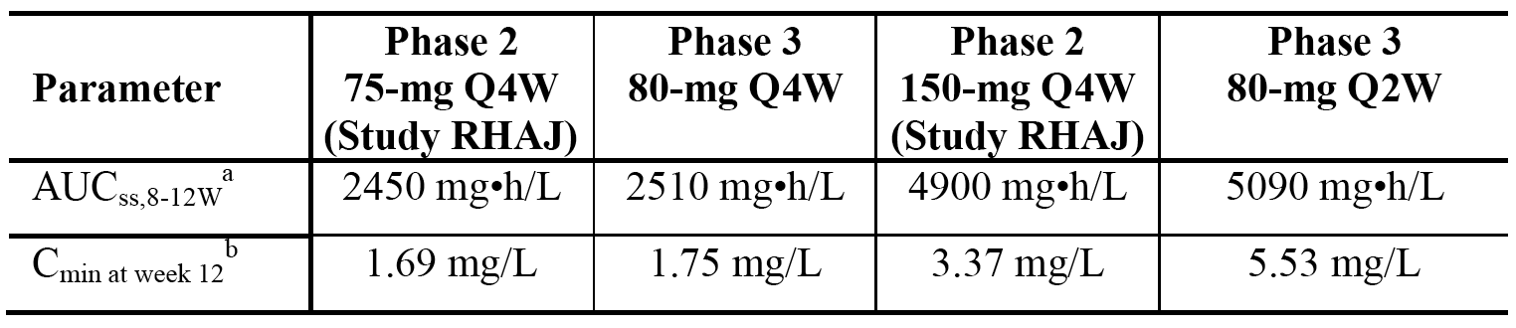
Abbreviations: AUCss = area under the curve at steady state; Cmin = minimum serum concentration; PK = pharmacokinetics; Q2W = every 2 weeks; Q4W = every 4 weeks. Notes: a) Area under the concentration versus time curve at steady state from Weeks 8 to 12; b) Minimum concentration at Week 12.
In view of the 150 mg dose in Study RHAJ being associated with higher responses by Week 2 compared to the lower doses studied (10 mg, 25 mg, and 75 mg), a 160 mg starting dose (two 80 mg injections) was selected for evaluation in the Phase III studies to allow for steady state to be achieved earlier and to obtain a more rapid onset of clinical response. Simulations of dosing regimens using the PopPK model developed from the Study RHAJ data showed that 80 mg Q4W and 80 mg Q2W regimens with a 160 mg starting dose reached steady-state ixekizumab concentrations earlier than regimens without a 160 mg starting dose (see Figure 12, below).
Figure 12. Model-predicted median ixekizumab concentration-time profiles with and without a starting dose of 160 mg for 80 mg Q4W and 80 mg Q2W regimens
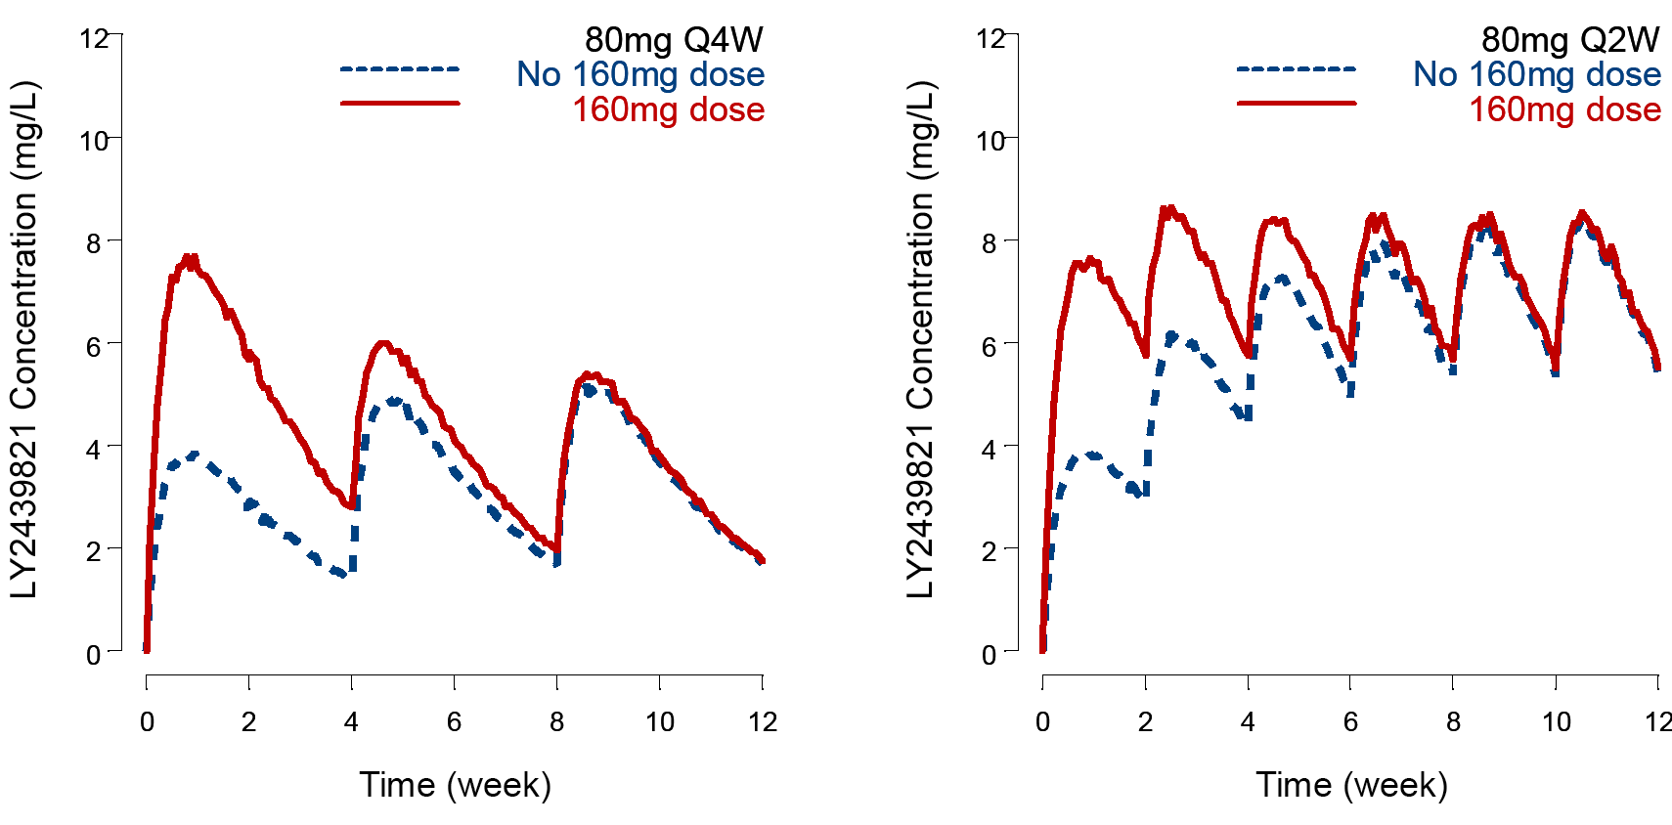
Based on Phase I and 2 data, the sponsor considered that once an initial response was achieved during the induction dosing period, less frequent dosing would be needed to maintain that response during longer-term therapy. Therefore, an 80 mg Q4W regimen was chosen to determine if the response achieved at Week 12 could be maintained with this regimen during the maintenance dosing period (Weeks 12 to 60). In addition, to determine whether even less frequent dosing would maintain the response an 80 mg Q12W dose was also evaluated. These 2 dosing regimens (80 mg Q4W and 80 mg Q12W) were expected to result in distinct exposures, allowing for adequate comparison of the 2 dosing frequencies for maintenance therapy. It was predicted that the 80 mg Q12W dosing regimen would provided exposures similar to the 25 mg Q4W dosing regimen evaluated in the Phase II study, RHAJ.
In Study RHAJ, no clinically significant dose-related safety concerns had been noted in patients with moderate to severe plaque psoriasis treated with multiple ixekizumab doses up to 150 mg at Weeks 0, 2, 4, 8, 12, and 16. Additionally, there had been no major dose-related safety concerns detected up to the maximum dose of 2 mg/kg IV Q2W for 10 weeks (Study RHAF) and 180 mg SC Q2W for 12 weeks (Study RHAK) in patients with rheumatoid arthritis. The 2-mg/kg IV dose used in Study RHAF in a 100 kg patient is approximately equivalent to a 370 mg SC dose (bioavailability of SC administration is 54%). In addition, the sponsor reported an approximate 113-fold margin of safety for the maximum anticipated steady state exposure at 80 mg Q2W relative to the lowest-observed-adverse-effect level (LOAEL) exposure in the 9-month monkey toxicology study. Therefore, based on the totality of the data, the proposed induction treatment regimens of 80 mg Q2W and 80 mg Q4W nor the maintenance treatment regimens of 80 mg Q4W and 80 mg Q12W raised significant safety concerns.
Evaluator’s comment. The sponsor's rationale for selecting the ixekizumab doses used in the pivotal Phase III studies is considered to be acceptable.

Clinical efficacy
The submission included 3 pivotal, Phase III clinical efficacy and safety studies (Studies RHAZ, RHBA, and RHBC); see Table 26, below. Each of the three pivotal studies included a placebo control group, while two of the studies (Studies RHBA and RHBC) also included an etanercept active control group. In each of the three studies, the primary efficacy analysis was based on the Week 12 data (that is, at the end of the induction dosing period), while Studies RHAZ and RHBA also included and efficacy analysis based on the Week 60 data (that is, at the end of the maintenance dosing period). In addition to the efficacy data from each of the three individual pivotal Phase III studies, the submission also included an integrated efficacy assessment for the induction and maintenance dosing periods based on pooled data from the pivotal Phase III studies. The individual efficacy data from each of the three pivotal Phase III studies and the integrated analysis of efficacy based on pooled data have been evaluated in this clinical evaluation.

Table 26. Design features of the three, pivotal Phase III studies
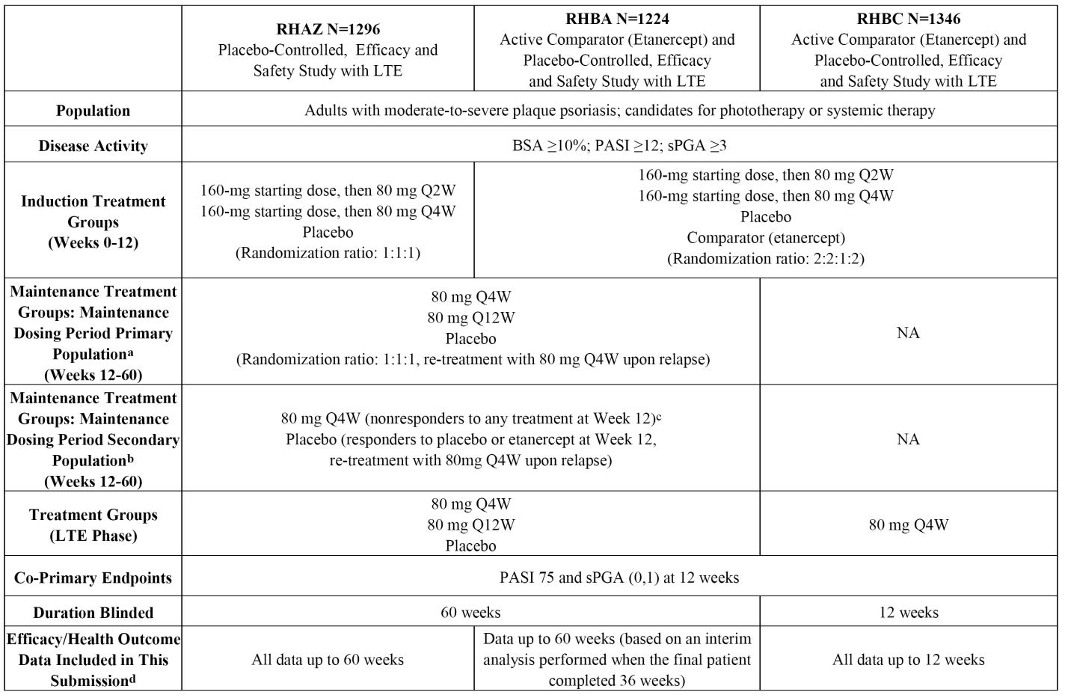
Notes: a) Ixekizumab-treated patients who responded to treatment, that is, who achieved sPGA (score of 0 or 1), during the period; b) Patients randomised to either placebo or etanercept at Week 0 or ixekizumab-treated patients who did not respond to therapy (achieve sPGA 0/1) during the induction period; c) etanercept non-responders received placebo for a 4-week washout period, before commencing treatment with ixekizumab 80 mg Q4W at Week 16; d) For the maintenance period, efficacy data reported are from patients who completed Week 60, discontinued prior to Week 60, or relapsed prior to Week 60.
Evaluator’s Comment: The three pivotal studies are referred to in the PI as UNCOVER-1 (Study RHAZ), UNCOVER-2 (Study RHBA) and UNCOVER-3 (Study RHBC). The 12-week data from UNCOVER-2 (Study RHBA) and UNCOVER-3 (Study RHBC) comparing ixekizumab to etanercept and placebo have been published.
It was noted that the Statistical Analysis Plans (SAP) for the three pivotal studies stated that additional Australian specific efficacy analyses will be conducted to meet Pharmaceutical Benefits Advisory Committee (PBAC) criteria. Specifically, the sPGA (score of 0 or 1), sPGA (0), PASI 75, PASI 90 and PASI 100 at Week 12 (NRI) and Week 60 (NRI) will be analysed using PBAC induction dosing period and maintenance dosing period populations. The PBAC induction dosing period population is a subset of the intent-to-treat (ITT) population and is defined as all randomised patients with a PASI score > 15 at baseline. The PBAC maintenance dosing period population is a subset of the maintenance dosing period primary population and is defined as patients with a PASI score > 15 at baseline.
The Australian specific PBAC was not included in the sponsor's submission to the TGA. However, for the purposes of this clinical evaluation report prepared specifically for registration purposes, it is considered that the evaluation of the additional Australian specific efficacy data prepared for PBAC is not required. It is anticipated that the additional Australian specific efficacy data will be evaluated by the PBAC if an application from the sponsor is made to list ixekizumab on the Pharmaceuticals Benefit Scheme (PBS).

Pivotal studies

Study RHAZ (Phase III)

Study design, objectives, locations and dates

Introduction
Study RHAZ: ‘A multicentre study with a randomised, double-blind, placebo-controlled induction dosing period followed by a randomised maintenance dosing period and a long-term extension period to evaluate the efficacy and safety of LY2439821 in patients with moderate-to-severe plaque psoriasis.’
The study was conducted at 108 study centres in 11 countries (Australia (6 sites), USA (33 sites), Canada (14 sites), Germany (17 sites), Denmark (2 sites), Italy (2 sites), UK (4 sites), Hungary (7 sites), Japan (10 sites), Romania (4 sites), Poland (9 sites)). The principal investigator was located in the USA.
The first patient was randomised on 6 December 2011, the last patient visit for the 60 week data analysis was 24 June 2014, the database lock for the 60 week data analysis was 7 August 2014, and the approval date for the CSR (Clinical Study Report) was 9 February 2015. The study was sponsored by Eli Lilly. The sponsor states that study was performed in compliance with the principles of GCP.

Objectives
The co-primary objectives were to assess whether ixekizumab 80 mg Q2W or 80 mg Q4W was superior to placebo at Week 12 for the treatment of patients with moderate to severe plaque psoriasis as measured by:
- the proportion of patients with a sPGA (score of 0 or 1) with at least a 2-point improvement from baseline; and
- the proportion of patients achieving at least a 75% improvement from baseline in PASI score (PASI 75) from baseline.
The major secondary objectives were to assess whether ixekizumab 80 mg Q2W or 80 mg Q4W induction dosing and 80 mg Q4W or 80 mg Q12W maintenance dosing were superior to placebo for the treatment of patients with moderate to severe plaque psoriasis as measured by:
- proportion of patients achieving sPGA (0) (remission) at Week 12;
- proportion of patients achieving at least a 90% improvement from baseline in PASI score (PASI 90) at Week 12;
- proportion of patients achieving a 100% improvement from baseline in PASI score (PASI 100) at Week 12;
- proportion of patients maintaining sPGA (score of 0 or 1) from Week 12 after re-randomisation at the start of the maintenance period to Week 60;
- proportion of patients achieving an Itch numeric rating scale (Itch NRS) ≥ 4-point reduction from baseline for patients who had baseline Itch NRS ≥ 4;
- change from baseline in DLQI at Week 12; and
- change from baseline in NAPSI score in patients with fingernail involvement at Week 12.
There were a large number of other secondary and exploratory objectives. In the review of Study RHAZ presented in this clinical evaluation, the evaluation of efficacy focuses on the primary and major secondary objectives, while other relevant study objectives will be reviewed for the integrated analysis of the three pivotal efficacy and safety studies.

Study design and investigational plan
Study RHAZ is an ongoing, Phase III, multicentre, randomised, double-blind, placebo-controlled, parallel-group, outpatient study comparing the efficacy and safety of ixekizumab to placebo in 1296 patients with moderate-to-severe plaque psoriasis.
The duration of the study is up to 5 years for investigational product administration and up to 5 years plus 28 weeks for patient participation. The study includes 5 periods and the submitted study report presented data through 1 August 2015, which includes all data from Periods I, 2, and 3 of the study and safety data collected during Periods 4 and 5. The 5 study periods are summarised below:
- Period I (Screening Period) was from 4 to 30 days prior to the induction dosing period (baseline; Week 0).
- Period 2 (Induction Dosing Period) was a double-blind treatment period from Week 0 (baseline) to Week 12. The purpose of this period was to compare the efficacy and safety of ixekizumab (80 mg Q2W and 80 mg Q4W) to placebo. The primary efficacy endpoints of the study were evaluated at Week 12.
- Period 3 (Maintenance Dosing Period) was a double-blind treatment period from Week 12 to Week 60. The purpose of this period was to evaluate the optimum dosing interval, the maintenance of response and/or remission, the occurrence of relapse or rebound following treatment withdrawal and the response to re-treatment with ixekizumab following relapse in a re-randomised patient population. At Week 12, patients entering the maintenance period were classified as either responders (sPGA score of 0 or 1) or non-responders (sPGA score > 1). In the maintenance dosing period, two ixekizumab regimens were compared (80 mg Q4W and 80 mg Q12W).
- Period 4 (Long-Term Extension Period) is for long-term evaluation of safety and efficacy parameters from Week 60 to Week 264. This period is blinded until after all patients reach Week 60 or discontinue (moved into the Post-Treatment Follow-Up Period), after which the study is open-label. Patients who maintained efficacy response with adequate overall safety during the maintenance period are permitted to enter the long-term extension period.
- Period 5 (Post-Treatment Follow-Up Period) is for safety monitoring after treatment discontinuation for any patient receiving at least 1 dose of investigational product. Period 5 takes place from the last treatment period visit or Early Termination Visit (ETV) up to a minimum of 12 weeks after that visit. No investigational products are administered in this period.
A data monitoring committee (DMC), consisting of members external to the sponsor and not in contact with the clinical sites, was responsible for interim safety monitoring. The first interim analysis for safety was performed when 20% of the patients completed or discontinued from Period 2 (Induction Dosing Period) across all Phase III studies of ixekizumab in patients with psoriasis. Additional interim safety analyses were performed when 50% and 75% of the patients completed or discontinued Period 2 across all Phase III studies of ixekizumab in patients with psoriasis.

Inclusion and exclusion criteria
The study enrolled male and female patients age 18 years or older who had a confirmed diagnosis of chronic plaque psoriasis for at least 6 months; who were candidates for phototherapy and/or systemic therapy; and who had ≥ 10% BSA involvement, an sPGA score ≥ 3, and PASI score ≥ 12 at screening and at baseline.
Patients were excluded if they had pustular, erythrodermic, and/or guttate forms of psoriasis, a history of drug-induced psoriasis, or a clinically significant flare of psoriasis during the 12 weeks prior to baseline. Patients were also excluded if they had received systemic non-biologic psoriasis therapy or phototherapy (within 4 weeks of baseline), certain types of topical psoriasis treatment (within 2 weeks of baseline), previous biologic therapies (within specific washout periods), therapy with agents that target alpha-4-integrin, or previous use of ixekizumab or any other IL-17A antagonist.

Study treatments

Induction dosing period (Period 2)
During the induction dosing period (Weeks 0 to 12), patients were administered 1 of 3 regimens:
- 80 mg ixekizumab Q2W: A starting dose of 160 mg (Week 0) given as two SC injections followed by 80 mg given as one SC injection Q2W (Weeks 2, 4, 6, 8, and 10).
- 80 mg ixekizumab Q4W: A starting dose of 160 mg (Week 0) given as two SC injections followed by 80 mg given as one SC injection Q4W (Weeks 4 and 8); placebo given at Weeks 2, 6, 8 and 10 to maintain blinding with Q2W regimen.
- Placebo: Placebo given as two SC injections initially (Week 0) followed by placebo given as one injection Q2W (Weeks 2, 4, 6, 8, and 10).

Maintenance dosing period (Period 3)
During the maintenance dosing period (Weeks 12-60 and the long-term extension period (Weeks 60-124), patients were administered 1 of 3 dosing regimens:
- 80 mg ixekizumab Q4W: A dose of 80 mg given as one SC injection plus placebo given as one SC injection at Week 12; 80 mg given as one SC injection Q4W thereafter.
- 80 mg ixekizumab Q12W: A dose of 80 mg given as one SC injection plus placebo given as one SC injection at Week 12; 80 mg given as one SC injection Q12W thereafter. To maintain blinding with Q4W regimen, placebo given as one SC injection at Weeks 16, 20, 28, 32, 40, 44, 52, 56, and so on, until the study is unblended.
- Placebo: Placebo given as two SC injections at Week 12 followed by one SC injection Q4W thereafter.
Wherever possible, investigational product was administered on the same days of the week, at approximately the same time each day. If an injection was not administered on the scheduled day the missed dose was administered within 3 days of the scheduled day, and after Week 12 the missed dose was administered within 5 days of the scheduled day. Dates of subsequent study visits were not modified to account for the delay.

Prior and concomitant therapy
All medications (other than study drug) taken during the study were recorded on the electronic case report form (eCRF). The allowed prior therapies included systemic psoriasis therapy (biologic and non-biologic, excluding IL-17A antagonists or alpha-4-integrin agents), topical therapies, phototherapy, and vaccines. Each allowed prior therapy must have been discontinued prior to baseline for a protocol-specified time-period. During the study, limited use of topical therapies was allowed, as was the use of non-live seasonal vaccinations and/or emergency vaccinations. Patients were able to continue their usual medication for concomitant diseases throughout the study, unless specifically excluded by the protocol. Patients taking concomitant medications were to be on stable doses at baseline and were to remain on stable dose throughout the study, unless changes were needed due to an AE or for appropriate medical management.

Treatment compliance
Throughout the study, patients recorded information in a Study Drug Administration Log, The Log included the date, time, and anatomical location of administration of investigational product, syringe number, who administered the investigational product, and the reason for the investigational product being not fully administered. Site personnel assessed compliance with the required study drug regimen at each visit by review of the Log, return of empty investigational product packaging, and/or by direct questioning. A patient was considered non-compliant if two consecutive doses of study drug had been missed; or > 20% of the expected doses had been missed; or double-dosing had occurred. Non-compliant patients could be discontinued from the study.

Removal of patients from therapy or assessment
The study included criteria for discontinuing patients from therapy or assessment. These criteria included, but were not limited to neutropaenia, leukopaenia, lymphopaenia, thrombocytopaenia, increased liver enzymes (alanine transaminase (ALT) and/or aspartate transaminase (AST)), increased blood pressure, lupus like syndrome positive for antibodies against double-stranded DNA, severe AEs, SAEs, clinically significant changes in laboratory values, clinical significant hypersensitivity reactions, pregnancy, malignancy, purified protein derivative (PPD) positive skin test; change in psoriatic disease and phenotype.

Efficacy variables and outcomes

Primary efficacy measures
The primary efficacy measures were the sPGA and the PASI:
- The sPGA is the physician's determination of the patient's psoriasis severity at a given time point on a 6 point scale (0 = cleared, 1 = minimal, 2 = mild, 3 = moderate; 4 = marked, 5 = severe). Overall lesions are categorised by descriptions for induration, erythema, and scaling.
- The PASI combines assessments of the extent of body-surface involvement in 4 anatomical regions (head, trunk, arms, and legs) and the severity of desquamation, erythema, and plaque induration/infiltration (thickness) in each region, yielding an overall score of 0 for no psoriasis to 72 for the most severe disease. The PASI scores were categorised as at least 50%, 75%, 90% or 100% improvement in PASI score from baseline.
Evaluator’s comment: The two primary efficacy measures are considered to be acceptable. The CHMP Guideline on Clinical Investigation of Medicinal Products Indicated for the Treatment of Psoriasis (CHMP/EWP/2454/02 corr; London 18 November 2004) ‘strongly recommends’ two endpoints to assess efficacy (that is, a validated standardised global score, such as the sPGA, in conjunction with PASI). The guidelines consider that PASI alone is not sufficient to evaluate psoriasis severity at baseline and on treatment. The guidelines go on to state that the PASI is not adapted for palmoplantar, flexural, scalp and nail locations of psoriasis, and comment that for all these forms of psoriasis there are no validated tools to assess efficacy. The guidelines indicate that, for the forms of psoriasis for which the PASI is not adapted, assessment based on local skin and nail signs and PASI can be used.

Secondary efficacy measures
The secondary efficacy measures were the PASI, NAPSI, PSSI, Palmoplantar Psoriasis Area Severity Index (PPASI), and percentage of BSA involvement of psoriasis:
- The PASI had been described above.
- The NAPSI was used only if the patient had fingernail psoriasis at baseline. This scale was used to evaluate the severity of fingernail bed psoriasis and fingernail matrix psoriasis by area of involvement in the fingernail unit. In this study, only fingernail involvement was assessed. Each fingernail was divided with imaginary horizontal and longitudinal lines into quadrants. Each fingernail was then given a score for fingernail bed psoriasis (0 to 4) and fingernail matrix psoriasis (0 to 4) depending on the presence (score of 1) or absence (score of 0) of any of the features of fingernail bed and fingernail matrix psoriasis in each quadrant. The NAPSI score for a fingernail was the sum of scores in fingernail bed and fingernail matrix from each quadrant (maximum of 8). Each fingernail was evaluated. The sum of all the fingernails was the total NAPSI score(range, 0 to 80).
- The PSSI was used if the patient had scalp psoriasis at baseline. The PSSI is a composite score derived from the sum scores for erythema, induration, and desquamation multiplied by a score for the extent of scalp area involved (range, 0 to 72).
- The PPASI was used if the patient had palmoplantar psoriasis at baseline. The PPASI is a composite score derived from the sum scores for erythema, induration, and desquamation multiplied by a score for the extent of palm and sole area involvement (range, 0 to 72).
- The BSA involvement with psoriasis was evaluated by the investigator on a continuous scale from 0% (no involvement) to 100% (full involvement), in which 1% corresponds to the size of the patient’s palm of the hand (including the palm, fingers, and thumb).
- Other efficacy variables included a number of health outcome measures.

Primary efficacy endpoints
The co-primary efficacy endpoints were PASI 75 and sPGA (score of 0 or 1).
Evaluator’s comment: The proportion of patients with an sPGA assessed as either 0 or 1 (sPGA 0/1), represents a clinically meaningful response of complete resolution (score = 0) of plaque psoriasis or of minimal plaque severity (score = 1). The PASI 75 represents at least a 75% decrease (improvement) from the baseline PASI score and is considered to be a clinically meaningful response to treatment. Higher levels of clearance (PASI 90) as well as complete resolution of plaque psoriasis (PASI 100) were additional endpoints due to the increasing recognition of the association of higher clearance with greater health-related quality of life (HRQoL).

Secondary efficacy endpoints
The following secondary efficacy endpoints assessed in this study were PASI 50, PASI 90, PASI 100, NAPSI, PSSI, PPASI 50, PPASI 75, and PPASI 100.

Randomisation and blinding methods

Randomisation
At Week 0 (Visit 2), patients who met all criteria for enrolment at Visits 1/1A and 2 were randomised 1:1:1 to double-blind treatment groups of 80 mg ixekizumab Q2W, 80 mg ixekizumab Q4W, or placebo, as determined by a computer-generated random sequence using an interactive voice response system (IVRS). Patients were stratified by geographic regions, previous non-biologic systemic therapy (inadequate response to, intolerance to, or contraindication to < 3 or ≥ 3 conventional systemic therapies), and weight (< 100 kg or ≥ 100 kg).
At Week 12 (Visit 7), patients who entered the blinded maintenance dosing period were classified as responders (sPGA score of 0 or 1 with at least a 2-point improvement from baseline) or a non-responders (sPGA score of > 1). Patients who received ixekizumab during the induction dosing period who were responders were re-randomised 1:1:1 using the IVRS to 80 mg Q4W, 80 mg Q12W, or placebo. Patients were stratified by weight (< 100 kg or ≥ 100 kg) and by ixekizumab induction dosing regimen (80 mg Q2W or 80 mg Q4W). Patients who received placebo during the induction dosing period who were responders were assigned using the IVRS to continue to receive placebo until relapse occurred (defined as a loss of response equal to an sPGA score of ≥ 3). Non-responders who received any investigational product during the induction dosing period were assigned using the IVRS to receive treatment with 80 mg Q4W. At Week 60, patients who had maintained an efficacy response with adequate overall safety during the maintenance dosing period could elect to enter the long-term extension period.

Blinding
The study was double-blind. Patients and study site personnel were blinded to study treatment until after all patients discontinued from treatment or completed Week 60. A minimum number of sponsor personnel not in direct contact with study sites, including an external DMC, were able to see the randomisation table and treatment assignments before the study was unblinded. Unblinding did not occur until the reporting database was validated and locked for the Week 60 interim statistical analysis. Unblinding occurred on 7 August 2014. After unblinding, the long term extension period (Period 4) became an open-label treatment period. Satisfactory procedures were in place for emergency unblinding.

Analysis populations
ITT Population: Efficacy and health outcome analyses for Period 2 (induction dosing period) were conducted on the ITT Population. The ITT Population was defined as all randomised patients, even if the patient did not take the assigned treatment, did not receive the correct treatment, or otherwise did not follow the protocol. Patient data were analysed according to the treatment assigned.
Per-Protocol Set (PPS): The primary analyses were repeated using the per-protocol set (PPS). The PPS was a subset of the ITT Population and was defined as all randomised patients who were compliant with therapy, who did not have major protocol violations, and whose study site did not have significant GCP issues that required a report to regulatory agencies prior to Week 12 (Visit 7). Patients were analysed according to the treatment assigned.
Safety Population: Safety analyses for Period 2 (induction dosing period) were conducted on the safety population, defined as all randomised patients who received at least 1 dose of study treatment. Patients were analysed according to the treatment assigned.
Maintenance Dosing Period Primary Population: Efficacy, health outcomes, and safety analyses for Period 3 (maintenance dosing period) were conducted on the maintenance dosing period primary population, defined as all re-randomised patients (patients randomised to ixekizumab in Period 2 who achieved an sPGA (score of 0 or 1) and were re-randomised at Week 12) who received at least 1 dose of study treatment during the maintenance dosing period. Data were analysed according to the re-randomised treatment group. Only information prior to relapse was presented. A subset of efficacy, health outcomes, and safety analyses for combined Periods 3 and 4 (that is, maintenance dosing and long-term extension periods) were conducted on the maintenance dosing period primary population.
Maintenance Dosing Period Secondary Population: Efficacy, health outcomes, and safety analyses for Period 3 (maintenance dosing period) were also conducted on the maintenance dosing period secondary population. This population was defined as ixekizumab treated patients who were not re-randomised at Week 12 or patients who were randomised to placebo at Week 0, who received at least 1 dose of study treatment during the maintenance dosing period. Patient data were analysed according to the treatment assigned on entry into Period 3.
Long-Term Extension Period Population: Efficacy, health outcomes, and safety analyses for Period 4 were also conducted on the long-term extension period population, defined as all patients who received at least 1 dose of study drug treatment during the long-term extension period. Only information prior to relapse was presented.
Maintenance Dosing Period Relapse Population: Categorical efficacy, health outcomes, and safety analyses were conducted on the maintenance dosing period relapse population, defined as all patients who were responders at Week 12 who first experienced a relapse (sPGA ≥ 3) at any point during the maintenance dosing period (Period 3). Although all patients received 80 mg Q4W, patients were analysed according to the treatment to which they had been re-randomised or assigned at Week 12.
Total Relapse Population: Categorical efficacy, health outcomes, and safety analyses were conducted on the total relapse population, defined as all patients who were responders at Week 12 who first experienced a relapse (sPGA ≥ 3) at any point during Period 3 or Period 4. Although all patients received 80 mg Q4W, patient data were analysed according to the treatment to which the patient had been re-randomised or assigned at Week 12.
Follow-Up Population: Safety analyses for Period 5 (Follow-Up Period) were conducted on the follow-up population, defined as all randomised patients who received at least 1 dose of study drug treatment and entered Period 5. Patient data were analysed according to the last treatment the patient received before entering Period 5.

Sample size

Induction dosing period
In the induction dosing period, a total sample size 1296 patients was planned with double-blind randomisation 1:1:1 to 80 mg Q2W, 80 mg Q4W, or placebo. In order to account for multiple testing for the 2 ixekizumab groups, a 2-sided Fisher’s exact test at the 0.025 level was assumed for the sample size calculations. With 432 patients per treatment group, the study had > 99% power to test the superiority of each ixekizumab regimen compared to placebo for sPGA (score of 0 or 1) and PASI 75 at Week 12, assuming response rates of 70% for each ixekizumab group and 10% for the placebo group for both parameters. The response assumptions were based on the results of the Phase II Study RHAJ and review of historical clinical studies in psoriasis.

Maintenance dosing period
In the maintenance dosing period, assuming 70% of the ixekizumab patients were re-randomised 1:1:1 at Week 12 to 80 mg Q4W, 80 mg Q12W, or placebo, approximately 100 patients were expected to be included in each treatment group. This sample size provided at least 99% power to test the difference in the proportion of patients maintaining sPGA (score of 0 or 1) or PASI 75 from Week 12 to Week 60 between each ixekizumab dosage regimen (Q4W or Q12W) and placebo within the original treatment group (the treatment received during the induction dosing period), assuming the proportions of patients maintaining either sPGA (score of 0 or 1) of PASI 75 were 70% for 80 mg Q4W, 40% for 80 mg Q12W, and 10% for placebo within each original treatment group at Week 60. In order to account for multiple testing, a 2-sided Fisher’s exact test at the 0.0125 significance level was assumed for the sample sized calculations.

Statistical methods

General considerations
The protocol was approved on 24 August 2011 and was amended on 15 March 2012 (Amendment a) and 30 October 2012 (Amendment b). The SAP was approved on 20 April 2012 and subsequently amended on 20 December 2012 (Amendment a) and 19 May 2014 (Amendment b). The reporting database was validated and locked for analysis on 7 August 2014. Subsequent to database lock, the following errors in the reporting database were identified: 4 patients who had not achieved sPGA (score of 0 or 1) at Week 12 were re-randomised in error and included in the maintenance dosing period primary population. These errors and other identified errors remained in the reporting database that was used for all analyses in the submitted CSR. The sponsor stated that it ‘believed that (the errors) are minor and did not affect any conclusions in (the) CSR’. It is considered that the sponsor's position is reasonable.
The SAP described a subset of analyses that were to be was performed on patients enrolled at centres in Japan. Furthermore, additional analyses meeting PBAC criteria described in the SAP are planned solely for submission in Australia. The sponsor indicated that these analyses will be presented in separate reports.
The study results were summarised using standard statistical methods appropriate for the description of continuous and categorical data. All CIs and statistical tests were 2-sided unless otherwise specified.

Induction dosing period
Treatment comparisons of categorical outcome variables were conducted using a logistic regression analysis, with the randomisation stratification factors of treatment, geographic region, previous non-biologic systemic therapy, and baseline weight category being included as covariates in the model. Secondary analysis of the categorical outcome variables was conducted using a Fisher’s exact test. Missing data were imputed using non-responder imputation (NRI), where patients were deemed non-responders for the NRI analysis if they did not meet the clinical response criteria or had missing clinical response data at Week 12. All non-responders at Week 12, as well as all patients who discontinued study treatment at any time prior to Week 12, or for any reason, were defined as non-responders for the NRI analysis for all categorical sPGA and PASI analyses at Week 12. Randomised patients without at least 1 post-baseline observation were also defined as non-responders for the NRI analysis.
The primary analysis for continuous outcome variables was made using a mixed-effects model for repeated measures (MMRM) analysis. The MMRM model included treatment, geographic region, previous non-biologic systemic therapy, baseline weight category, baseline value, visit, and the interaction of treatment-by-visit as fixed factors. The covariance structure to model the within-patient errors will be unstructured. If the unstructured covariance matrix results in a lack of convergence, the heterogeneous Toeplitz covariance structure, followed by the heterogeneous autoregressive covariance structure will be used. The Newton-Raphson with ridging optimisation technique will be used to aid with convergence. The Kenward-Roger method will be used to estimate the denominator degrees of freedom. Type III tests for the LS mean were used for the statistical comparison, and the 95% CI for the LS mean was also reported. Treatment group comparisons with placebo at Week 12 (Visit 7) and all other visits were tested.
As secondary analyses, the analysis of covariance (ANCOVA) model with LOCF and modified baseline observation carried forward (mBOCF) for missing data were used for continuous outcome variables. The model included treatment, geographic region, previous non-biologic systemic therapy, baseline weight category, and baseline value. In the mBOCF imputation method for missing data, for patients discontinuing investigational product because of an AE, the baseline observation was carried forward to the corresponding primary endpoint for evaluation, and for patients discontinuing investigational product for any other reason, the last non-missing post-baseline observation before discontinuation was carried forward to the corresponding primary endpoint for evaluation. In the LOCF imputation method for missing data, the last missing post-baseline observation before discontinuing the investigational product for any reason was carried forward to the corresponding primary endpoint for evaluation.
The placebo multiple imputation (pMI) method was used for the analysis of co-primary efficacy endpoints, sPGA (score of 0 or 1) and PASI 75, and for the analysis of the percentage improvement in PASI score at Week 12 (Visit 7). The pMI method assumes that the statistical behaviour of drug-treated and placebo-treated patients after discontinuing study medication becomes that of placebo-treated patients. Multiple imputations were used to replace missing outcomes (sPGA score and PASI score) for drug-treated and placebo-treated patients who discontinued using multiple draws from the posterior predictive distribution estimated from the placebo arm. The binary outcomes, sPGA (score of 0 or 1) and PASI 75, were then derived from the imputed data.
The Kaplan-Meier product limit method was used to estimate the survival curves for time-to event variables. Treatment comparisons were performed using the log-rank test.

Maintenance dosing period (primary population)
Treatment comparisons of categorical outcome variables were analysed using a logistic regression model with treatment group and baseline weight category fitted as explanatory variables, and secondary analyses were conducted using the Fisher’s exact test. All non-responders at Week 60, as well as all patients who discontinued study treatment at any time prior to Week 60, or for any reason, were deemed as non-responders for the NRI analysis for all categorical sPGA and PASI analyses at Week 60. Patients without at least 1 post-baseline observation during Period 3 were also defined as non-responders for the NRI analysis.
Treatment comparisons for continuous outcome variables were made using an MMRM model and an ANCOVA model with LOCF and mBOCF. The MMRM model included treatment, baseline weight category, baseline value, visit, and a treatment-by-visit interaction term as fixed factors. The ANCOVA model included treatment, baseline weight category, and baseline value.

Gatekeeping procedure for multiple comparisons/multiplicity
In order to account for the multiple primary and major secondary endpoint analyses a gatekeeping testing strategy was implemented to control the overall type I error rate at a 2-sided alpha level of 0.05. This allowed simultaneous statistical inference of all of the primary and major secondary endpoints. The underlying gatekeeping testing strategy was derived using the methodology developed in. The gatekeeping procedure is based on the Bonferroni test for multiplicity and uses an intuitive, stepwise testing algorithm. The alpha levels for the p-values associated with the primary and secondary analyses were computed at each step depending on the outcomes of the preceding significance tests. In order to reflect the test order and how the multiple doses were analysed, the doses were renamed, and the treatment comparisons performed in each dosing period are summarised below in Table 27.

Table 27. Treatment comparisons during the induction dosing period and the maintenance dosing period
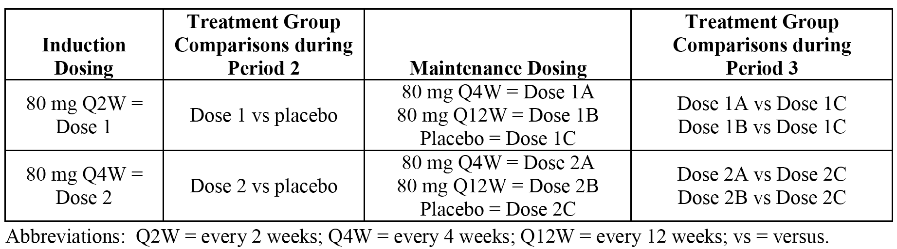
In total, there were 9 statistical tests ordered in hierarchal manner beginning at Primary Test 1 (Test 1) (the proportion of patients with a sPGA (score of 0 or 1) at Week 12 (NRI) compared to placebo), followed by Primary 2 (Test 2) (the proportion of patients with PASI 75 at Week 12 compared to placebo). All remaining tests (3 to 9) for pairwise comparisons were classified as secondary (1 to 7). The 9 statistical tests were grouped into 2 parallel branches. The first branch included tests of Dose 1 versus placebo in Period 2, as well as Dose 1A versus Dose 1C and Dose 1B versus Dose 1C in Period 3. The second branch included tests of Dose 2 versus placebo in Period 2, as well as Dose 2A versus Dose 2C and Dose 2B versus Dose 2C in Period 3. Test 2 was performed at a dose only if Test 1 of that dose was significant. Similarly, each test for a particular dose was performed only if all prior tests of that dose were significant. For each dose, if a test was not significant, all subsequent tests were not significant.

Changes to the planned analyses
Two amendments were made and 2 addenda added to the study after approval of the original protocol. No changes to the conduct of the study were made after the time of the first unblinding of sponsor personnel to study data. Protocol Amendments a and b have been examined and do not give rise to concern, and similarly Protocol Addenda 1 and 2 have been examined and do not give rise to concern. Of note, many of the protocol amendments were made following feedback and recommendations from the FDA relating to the protocol.
Per the SAP Amendment b, sPGA (score of 0 or 1) and PASI 75 at Week 12 (Visit 7) were to be analysed using a pMI approach with the logistic regression model with treatment as the factor. The sponsor recognised after unblinding that this was an oversight in the SAP, where the logistic regression model for pMI should have been consistent with the one used for the primary analyses, which included treatment, geographic region, previous non-biologic systemic therapy, and baseline weight category in the model. Subsequently, the pMI analyses on sPGA (score of 0 or 1) and PASI 75 were conducted using the logistic regression model with treatment, geographic region, previous non-biologic systemic therapy, and baseline weight category in the model. This change to the planned analyses was deemed by the sponsor to have negligible impact on the interpretation of data. This change does not give rise to concern.

Participant flow

Induction dosing period
The study included 1660 patients who consented to treatment, 1296 of whom were randomised to one of the three treatment groups in the induction dosing period. The percentage of patients completing the induction period was similar in the three treatment groups and ranged from 94.4% to 95.8%. Patient disposition in the induction period is summarised below in Table 28.

Table 28. Patient disposition in the induction dosing period, ITT population; Study RHAZ
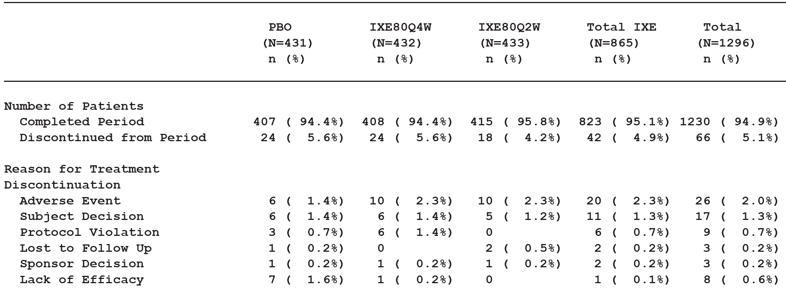

Maintenance dosing period
In the maintenance dosing period, 682 patients who had responded to ixekizumab treatment at Week 12 of the induction dosing period were re-randomised to placebo, ixekizumab 80 mg Q12W or ixekizumab 80 mg Q4W. This population was termed the maintenance dosing period primary population and disposition in this population is summarised below in Table 29. The percentage of patients completing the maintenance dosing period was notably higher in patients who had been re-randomised to ixekizumab than to placebo, and higher in patients re-randomised to ixekizumab 80 mg Q4W than to ixekizumab 80 mg Q12W. The percentage of patients who relapsed in the maintenance dosing period was notably higher in patients who had been re-randomised to placebo than to ixekizumab, and was higher in patients re-randomised to ixekizumab 80 mg Q12W than to ixekizumab 80 mg Q4W.

Table 29. Patient disposition in the maintenance period; maintenance dosing population; Study RHAZ
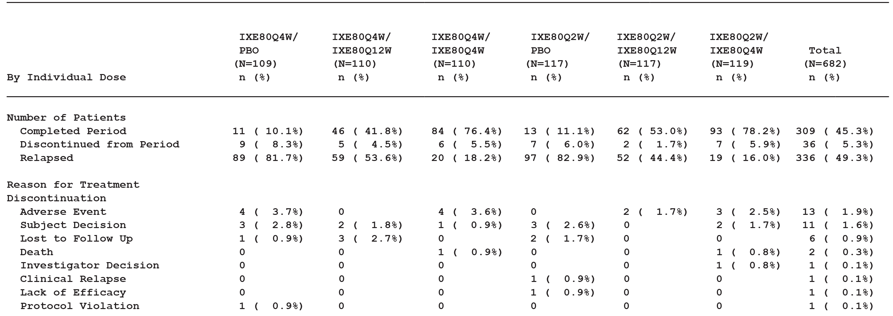

Major protocol deviations

Induction dosing period
In the induction dosing period, major protocol deviations were reported in 12.8% (55/431), 16.2% (70/432) and 13.2% (57/433) of patients in the placebo, ixekizumab 80 mg Q4W, and ixekizumab 80 mg Q2W groups, respectively. Major protocol violations in each of the three treatment groups were reported most frequently due to missing data (primarily electrocardiogram (ECG) data). The major protocol deviation profiles were similar for each of the three treatment groups. The major protocol violations reported in ITT population are considered not to have invalidated the efficacy analyses undertaken in the induction dosing period.

Maintenance dosing period
In the maintenance dosing period primary population, 15.2% (107/682) of patients had a major protocol deviation, and the percentage of major protocol deviations varied from 12.8% to 20.5% across the six treatment groups. Major protocol violations were reported most frequently for missing data (primarily ECG data) in each of the six treatment groups. The minor differences in the major protocol deviation profiles in the six treatment groups are considered not to have invalidated the efficacy analyses in the maintenance dosing period analyses in the primary population.

Baseline data

Induction dosing period (ITT population)
The baseline demographic and other characteristics (ITT population) were similar for the three treatment groups (placebo, ixekizumab 80 mg Q4W, ixekizumab 80 mg Q2W). The mean age of the total ITT population (n = 1296) was 45.7 years (range: 17 to 88 years), with 92.7% aged < 65 years, 6.3% aged ≥ 65 to < 75 years, and 1.1% aged ≥ 75 years. The mean weight of the total population was 92.3 kg (range: 45.8 to 200.0 kg), and the mean BMI was 30.7 kg/m² (range: 16.1 to 76.4 kg/m²) with 78.1% of the population having a BMI ≥ 25 kg/m². The majority of the total population were male (68.1% male versus 31.9% female), and the majority of the population were classified as White (92.5%).
The mean duration of psoriasis symptoms in the total population was 19.6 years (range: 0.5 to 61.7 years), and the mean age of onset of the condition was 26.5 years (range: 0 to 72 years). In the total population, baseline sPGA scores of 3, 4, or 5 were reported in 48.8%, 44.5% and 6.7% of patients, respectively. Of the total population, systemic therapy had been previously used by 71.3% of patients (31.0% had used only non-biologic therapies, 13.0% had used only biologic therapies and 27.3% had used both non-biologic and biologic therapies).
In the total ITT population, the medical history associated with specific cardiovascular risk factors (based on solicited responses to a pre-specified list of medical history terms) included hypertension (30.9%), dyslipidaemia (17.1%), type 2 diabetes mellitus (9.0%), coronary artery disease (1.9%), type I diabetes mellitus (1.3%), and stroke (1.5%). There were no statistically significant differences between treatment groups in the incidence of any of the pre-specified medical history terms. In the total ITT population, 29.9% of patients had a medical/surgical history of ≥ 1 condition, and there were no statistical or clinically significant differences between the treatment groups.
Evaluator’s Comment: The mean age of the population at baseline was approximately 46 years, and patients were predominantly aged < 65 years (92.7%) with only 6.3% of the total population being aged ≥ 65 years and 1.1% being aged ≥ 75 years. The mean BMI in the total population was 30.7 kg/m², which would classify the average patient in this study as being obese, based on definitions used by the sponsor in the submission (obese BMI ≥ 30 and < 40 kg/m²). In addition, 78.1% of the population had a BMI ≥ 25 kg/m², which would classify the majority of patient in this study as being overweight, based on definitions used by the sponsor in the submission (overweight BMI ≥ 25 and < 30 kg/m²).

Maintenance dosing period primary population
Within the maintenance dosing period primary population, the mean baseline age of patients was 44.8 years (range: 17 to 88 years), 67.4% were male, and 92.2% were White. Patients had a mean weight of 91.0 kg (range: 47.0 to 176.8 kg) and a mean BMI of 30.2 kg/m² (range: 16.1 to 56.6 kg/m²). Systemic therapy had been previously used by approximately 70.7% of patients (33.7% had used only non-biologic therapies, 12.8% had used only biologic therapies, and 24.2% had used both non-biologic and biologic therapies). Baseline characteristics were well-balanced across treatment groups within this population.

Treatment compliance
Overall, compliance in the induction dosing period in the total population was 98.1%, and no significant differences were seen between the placebo and ixekizumab treatment groups. Overall, compliance in the maintenance dosing period in the total primary population was 97.5%, and no statistically significant differences were seen between the treatment groups.

Results for the primary efficacy outcomes
The results for the co-primary efficacy endpoints at Week 12 using the gatekeeping strategy are summarised below in Table 30.

Table 30. Week 12 primary analyses with gatekeeping testing procedure; ITT population; Study RHAZ
Gatekeeping Testing | Treatment Comparison | p-value | 2-sided significance level (α) | Result of significance test
P1 (Test 1) sPGA (score of 0 or 1) | IXE80Q2W versus PBO | < 0.001 | 0.25 | Significant
 | IXE80Q4W versus PBO | < 0.001 | 0.25 | Significant
P2 (Test 2) PASI 75 | IXE80Q2W versus PBO | < 0.001 | 0.25 | Significant
 | IXE80Q4W versus PBO | < 0.001 | 0.25 | Significant
Abbreviations: IXE80Q2W = ixekizumab 80 mg every 2 weeks; IXE80Q4W = ixekizumab 80 mg every 4 weeks; P1 = primary 1; P2 = primary 2; PASI 75 = the proportion of patients achieving a 75% reduction in the Psoriasis Area and Severity Index; PBO = placebo; sPGA (score of 0 or 1) = the proportion of patients achieving a score of 0 or 1 in the static Physician Global Assessment.
Evaluator’s comment: The primary objectives of the study were met for all four, pairwise ixekizumab versus placebo comparisons (p < 0.001), using a gatekeeping strategy to account for multiple testing.
The results for sPGA (score of 0 or 1) response rates at Week 12 for the pairwise comparisons between ixekizumab and placebo are summarised below in Table 31.

Table 31. sPGA (score of 0 or 1) response rates (NRI) in the induction dosing period; ITT population; Study RHAZ
 | PBO  (n = 431) | IXE 80 mg Q4W  (n = 432) | IXE 80 mg Q2W (n = 433)
sPGA (score of 0 or 1) at Week 12 (NRI) | 14 (3.2%) | 330 (76.4%) | 354 (81.8%)
Odds Ratio IXE versus PBO¹ |  | 102.89 | 146.51
95% CI |  | (57.52, 184.04) | (81.02, 264.92)
p-value |  | p < 0.001 | p < 0.001
Abbreviations: PBO = Placebo; IXE = Ixekizumab; CI = confidence interval; N = number of patients in the analysis population; n = number of patients in the specified category. Notes: 1) OR derived from a logistic regression analysis with treatment, geographic region, previous non-biologic systemic therapy, and baseline weight category as factors (non-responder imputation (NRI)).
Evaluator’s comment: After 12 weeks of treatment, both ixekizumab treatment groups were superior to placebo as measured by the proportion of patients achieving sPGA (score of 0 or 1) with least a 2-point improvement from baseline (a co-primary objective). The sPGA (score of 0 or 1) response rates in both ixekizumab dose groups were markedly higher than in the placebo group, and both pairwise comparisons between ixekizumab and placebo were statistically significant (p < 0.001). The sPGA (score of 0 or 1) response rate at Week 12 in the ixekizumab 80 mg Q2W group was numerically higher than in the ixekizumab 80 mg Q4W group.
The results for PASI 75 response rates at Week 12 for the pairwise comparisons between ixekizumab and placebo are summarised below in Table 32.

Table 32. PASI 75 response rates (NRI) in the induction dosing period; ITT population; Study RHAZ
 | PBO  (n = 431) | IXE 80 mg Q4W  (n = 432) | IXE 80 mg Q2W  (n = 433)
PASI 75 at Week 12 (NRI) | 17 (3.9%) | 357 (82.6%) | 386 (89.1%)
Odds Ratio IXE versus PBO¹ |  | 125.54 | 223.94
95% CI |  | (72.26, 218.10) | (125.05, 401.03)
p-value |  | p < 0.001 | p < 0.001
Abbreviations: PBO = Placebo; IXE = ixekizumab; CI = confidence interval; N = number of patients in the analysis population; n = number of patients in the specified category. Notes: 1) OR derived from a logistic regression analysis with treatment, geographic region, previous non-biologic systemic therapy, and baseline weight category as factors (non-responder imputation (NRI)).
Evaluator’s comment: After 12 weeks of treatment, both ixekizumab treatment groups were superior to placebo as measured by the proportion of patients achieving PASI 75 (a co-primary objective). The PASI 75 response rates at Week 12 in both ixekizumab dose groups were markedly higher than in the placebo group, and both pairwise comparisons between ixekizumab and placebo were statistically significant (p < 0.001). The PASI 75 response rate at Week 12 in the ixekizumab 80 mg Q2W group was numerically higher than in the ixekizumab 80 mg Q4W group.
Sensitivity analyses of the co-primary efficacy outcomes were repeated in the PPS. These were shown to be consistent with the primary analyses in the ITT population for both sPGA (score of 0 or 1) and PASI 75 at Week 12.

Results for the other efficacy outcomes

Major secondary analyses (gated)
The gatekeeping testing strategy, which commenced with the primary analyses, was continued for the analyses of the major secondary objectives. All major secondary objectives for the analysis of the 12-week induction dosing period and for the maintenance dosing period (Weeks 12 to 60) were met (all comparisons p < 0.001; gatekeeping procedure). In general, the pairwise ixekizumab versus placebo comparisons were tested using logistic regression analyses. However, where the response rate was 0% in the placebo group the comparisons were tested using Fisher's exact test. The results for the major secondary analyses (gated) are summarised below.

sPGA (0) at week 12
At Week 12, the response rates for the ixekizumab 80 mg Q2W, ixekizumab 80 mg Q4W, and placebo groups were 37.0% (160/433), 34.5% (149/432), and 0% (0/431), respectively. Each pairwise ixekizumab versus placebo comparison was statistically significant; p < 0.001, Fisher's exact test.

PASI 90 at week 12
At Week 12, the response rates for the ixekizumab 80 mg Q2W, ixekizumab 80 mg Q4W, and placebo groups were 70.9% (307/433), 64.6% (279/432), and 0.5% (2/431), respectively. Each pairwise ixekizumab versus placebo comparison was statistically significant; p < 0.001, logistic regression analysis.

PASI 100 at week 12
At Week 12, the response rates for the ixekizumab 80 mg Q2W, ixekizumab 80 mg Q4W, and placebo groups were 35.3% (153/433), 33.6% (145/432), and 0% (0/431), respectively. Each pairwise ixekizumab versus placebo comparison was statistically significant; p < 0.001, Fisher's exact test.

sPGA (score of 0 or 1) at week 60
The sPGA (score of 0 or 1) response rates at Week 60 in patients who had received ixekizumab 80 mg Q2W during the induction dosing period were 74.8% (89/119), 41.0% (48/117), and 7.7% (9/117) for patients re-randomised to ixekizumab 80 mg Q4W, ixekizumab 80 mg Q12W, or placebo, respectively; p < 0.001 for each pairwise comparison via both logistic regression and Fisher's exact test. The sPGA (score of 0 or 1) response rates at Week 60 in patients who had received ixekizumab 80 mg Q4W during the induction dosing period were 70.9% (78/110), 33.6% (37/110), and 7.3% (8/109) for patients re-randomised to ixekizumab 80 mg Q4W, ixekizumab 80 mg Q12W, or placebo, respectively; p < 0.001 for each pairwise comparison via both logistic regression and Fisher's exact test analyses.

Itch nrs greater than or equal to 4-point reduction from baseline to week 12
At Week 12, the proportion of patients with baseline scores ≥ 4 points in Itch NRS achieving a ≥ 4-point reduction in the Itch NRS scale in the ixekizumab 80 mg Q2W, ixekizumab 80 mg Q4W, and placebo groups were 85.9% (336/391), 80.5% (305/379), and 15.5% (58/374), respectively; p < 0.001 for each pairwise comparison via both logistic regression and Fisher's exact test analyses.

DLQI at week 12
At baseline, mean (SD) DLQI total scores (on the 30-point DLQI) for patients randomised to ixekizumab 80 mg Q2W, ixekizumab 80 mg Q4W, and placebo were 13.4 (7.02), 13.2 (7.02), and 12.8 (7.11), respectively. At Week 12, the LS mean reductions in DLQI total scores were 11.1, 10.7, and 1.0 for the ixekizumab 80 mg Q2W, ixekizumab 80-mg Q4W, and placebo groups, respectively. After 12 weeks of treatment, both ixekizumab groups showed a statistically significant therapeutic advantage over placebo, as measured by change from baseline (MMRM) in DLQI total scores. The LS mean difference between placebo (n = 403) and ixekizumab 80 mg Q4W (n = 407) was -9.7 (95% CI: -10.4 to -9.1); p < 0.001. The LS mean difference between placebo (n = 403) and ixekizumab 80 mg Q2W (n = 414) was -10.1 (95% CI: -10.7 to -9.4); p < 0.001.

NAPSI at week 12
At baseline, mean (SD) NAPSI scores for patients who had fingernail involvement and were randomised to ixekizumab 80 mg Q2W, ixekizumab 80 mg Q4W, or placebo were 24.64 (18.916), 24.12 (18.243), and 26.09 (20.492), respectively. At Week 12, the LS mean changes from baseline in NAPSI scores were -7.24, -7.19, and 2.17 for the ixekizumab 80 mg Q2W, ixekizumab 80 mg Q4W, and placebo groups, respectively. After 12 weeks of treatment, both ixekizumab groups showed a statistically significant therapeutic advantage over placebo, as measured by change from baseline (MMRM) in NAPSI total scores. The LS mean difference between placebo (n = 267) and ixekizumab 80 mg Q4W (n = 266) was -9.36 (95% CI: -11.17 to -7.55); p < 0.001. The LS mean difference between placebo (n = 267) and ixekizumab 80 mg Q2W (n = 275) was -9.41 (95% CI: -11.20 to -7.61); p < 0.001.

Non-responder analysis
In patients who did not respond to ixekizumab 80 mg Q2W at Week 12, treatment with 80 mg Q4W during the maintenance dosing period resulted in 25.8% (16/62) of patients achieving an sPGA (score of 0 or 1) and 51.6% (32/62) of patients achieving a PASI 75 response at Week 60 (NRI). In patients who did not respond to ixekizumab 80 mg Q4W at Week 12, treatment with 80 mg Q4W during the maintenance dosing period resulted in 44.9% (35/78) of patients achieving an sPGA (score of 0 or 1) and 62.8% (49/78) of patients achieving a PASI 75 response at Week 60 (NRI).
These findings suggest that after initial non-response in the induction dosing period, continued treatment up to 60 weeks in the maintenance dosing period resulted in a clinically meaningful improvement in patients with psoriasis. However, the non-responder data need to be interpreted cautiously due to the absence of a comparator placebo control group in the maintenance dosing period.
In patients who failed to respond to placebo during the induction dosing period and were treated for 48 weeks continuously with ixekizumab 80 mg Q4W in the maintenance dosing period, at Week 24 (that is, after 12 weeks of ixekizumab treatment), 80.1% achieved an sPGA (score of 0 or 1) and 88.2%, a PASI 75 response. These high response rates persisted during the maintenance dosing period with an sPGA (score of 0 or 1) response rate of 74.7% (292/391) and a PASI 75 response rate of 84.4% (330/391) after 48 weeks of ixekizumab treatment (Week 60 (NRI)).

Study RHBA (Phase III)

Study design, objectives, locations and dates

Background
‘A multicentre, randomised, double-blind, placebo-controlled study comparing the efficacy and safety of LY2439821 to etanercept and placebo in patients with moderate-to-severe plaque psoriasis.’
The study was conducted at 127 study sites in 12 countries (Australia (8 sites), USA (41 sites), Canada (17 sites), Germany (13 sites), Poland (7 sites), France (8 sites), Netherlands (3 sites), Austria (4 sites), Czech Republic (3 sites), Spain (10 sites), UK (7 sites), Romania (6 sites)). The coordinating investigator was located in the USA.
The first patient was randomised on 30 May 2012, the last patient visit for the 36-week data analysis was 11 September 2014, the database lock for this analysis was 1 October 2014, and the approval date for the CSR was 16 February 2015. The study was sponsored by Eli Lilly. The sponsor states that study was performed in compliance with the principles of GCP.

Primary objectives
The primary objectives were to investigate whether ixekizumab 80 mg Q2W or Q4W for the treatment or moderate to severe plaque psoriasis was superior to placebo, non-inferior to etanercept, or superior to etanercept at Week 12 as measured by the proportion of patients:
- with an sPGA (score of 0 or 1) with at least a 2-point improvement from baseline; and
- achieving a ≥ 75% improvement in PASI (PASI 75) from baseline.

Secondary objectives
The major secondary objectives were to assess whether:
the efficacy of ixekizumab 80 mg Q2W or Q4W induction dosing was superior to placebo, or superior to etanercept at Week 12 as measured by the proportion of patients achieving:
- an sPGA (0)
- a ≥ 90% improvement in PASI (PASI 90)
- a 100% improvement in PASI (PASI 100)
- the efficacy of ixekizumab 80 mg Q4W or Q12W maintenance dosing was superior to placebo as measured by the proportion of patients maintaining an sPGA (score of 0 or 1) from Week 12 (after re-randomisation at the start of the maintenance dosing period) through to Week 60.
There were a large number of other secondary and exploratory objectives. In the review of Study RHBA presented in this clinical evaluation, evaluation of efficacy focuses on the primary and major secondary objectives, while other efficacy objectives will be reviewed as part of the integrated analysis of the three pivotal efficacy and safety studies.

Study design and investigational plan
Study RHBA is an ongoing Phase III, multicentre, randomised, double-blind, placebo-controlled, active-comparator, parallel-group study comparing the efficacy and safety of ixekizumab to etanercept and placebo in 1224 patients with moderate-to-severe plaque psoriasis. The study includes 5 periods:
- Period I: Screening Period from 7 to 30 days prior to the start of the blinded Induction Dosing Period (baseline; Week 0).
- Period 2: Induction Dosing Period was a double-blind treatment period from Week 0 (baseline) to Week 12. Data generated during this period was used to evaluate the efficacy and safety of ixekizumab over a 12-week treatment period, with the primary efficacy endpoints of the study being evaluated at Week 12 (that is, sPGA score of 0 or 1 and PASI 75).
- Period 3: Maintenance Dosing Period was a double-blind treatment period from Week 12 to Week 60. At Week 12, patients entering the maintenance period were classified as either responders (sPGA score of 0 or 1) with at least a 2-point improvement from baseline or non-responders (sPGA score > 1). Ixekizumab-treated patients classified as responders were re-randomised to treatment in the maintenance dosing period at a 1:1:1 ratio to ixekizumab 80 mg Q4W, ixekizumab 80 mg Q12W, or placebo. These patients were called the maintenance dosing period primary population. Placebo-treated or etanercept-treated patients classified as responders were assigned to placebo and patients classified as non-responders were assigned to ixekizumab 80 mg Q4W in the maintenance dosing period. Data generated during the maintenance dosing period were used to determine maintenance of response/remission, to evaluate relapse or rebound following treatment withdrawal, and to measure response to re-treatment with ixekizumab following relapse.
- Period 4: Long-Term Extension Period is an ongoing treatment period from Week 60 to Week 264. At Week 60, patients who maintained their efficacy response with adequate overall safety during the maintenance dosing period were permitted to enter the long-term extension period where efficacy and safety continue to be monitored. Maintenance dosing period responders will remain on their assigned dosing regimens through the long-term extension period until relapse (defined as a loss of response equal to an sPGA score ≥ 3), and then switch to ixekizumab 80 mg Q4W for the remainder of the long-term extension period. Maintenance dosing period non-responders remained on ixekizumab 80 mg Q4W for the duration of the study.
- Period 5: Post-Treatment Follow-Up Period extends from the last treatment visit or ETV) for a minimum of 12 weeks for those patients who received at least one dose of investigational product.
The submitted study report presented the results of an interim analysis following a database lock after the last patient enrolled completed the Week 36 visit of the maintenance dosing period. The maintenance dosing, long-term extension, and post-treatment follow-up periods were ongoing at the time of the database lock for the CSR. As for Study RHAZ, an independent DMC is responsible for interim safety monitoring.
Evaluator’s comment: The study design involves randomisation and double-blind treatment in the induction and maintenance dosing periods. These design features reduce the potential for bias during the assessment of treatments. The choice of etanercept as an active control is acceptable. In Australia, etanercept is approved for the treatment of adult patients with moderate to severe chronic plaque psoriasis who are candidates for phototherapy or systemic therapy. The etanercept dose (50 mg SC twice weekly for 3 months) is recommended in the etanercept PI to obtain high response rates. The primary efficacy endpoints at Week 12 of sPGA (score of 0 or 1) and PASI 75 are acceptable. As mentioned previously in this clinical evaluation, the two endpoints are consistent with the TGA adopted EU guidelines relating to the investigation of medicines to treat psoriasis. In addition, the PASI 75 at Week 12 was the primary efficacy endpoint for the two clinical trials supporting approval of etanercept for the treatment of plaque psoriasis (see etanercept PI).

Inclusion and exclusion criteria
The study enrolled male and female patients age 18 years or older with a confirmed diagnosis of chronic plaque psoriasis for at least 6 months; who were candidates for phototherapy and/or systemic therapy; and who had ≥ 10% BSA involvement, an sPGA score of ≥ 3, and PASI score ≥ 12 at screening and at baseline. Patients with prior etanercept use were excluded from this study.
Evaluator’s comment: The inclusion and exclusion criteria for this study were consistent with those for Study RHAZ, apart from patients with prior etanercept use being excluded from Study RHBA.

Study treatments

Induction dosing period
During the induction dosing period (Weeks 0 to 12), patients were administered 1 of 2 regimens of ixekizumab; placebo; or etanercept:
- 80 mg ixekizumab Q2W: A starting dose of 160 mg (Week 0) given as two SC injections followed by 80 mg given as one SC injection Q2W (Weeks 2, 4, 6, 8, and 10). Placebo for etanercept (one SC) injection given twice weekly starting at Week 0 up to Week 12.
- 80 mg ixekizumab Q4W: A starting dose of 160 mg (Week 0) given as two SC injections followed by 80 mg given as one SC injection Q4W (Weeks 4 and 8). Placebo for ixekizumab given as one SC injection at Weeks 2, 6, and 10. Placebo for etanercept (one SC injection) given twice weekly starting at Week 0 up to Week 12.
- Placebo: Placebo for ixekizumab (Week 0) given as two SC injections followed by placebo as one injection for ixekizumab Q2W (Weeks 2, 4, 6, 8, and 10). Placebo for etanercept (one SC injection) given twice weekly (every 3 to 4 days) starting at Week 0 up to Week 12.
- 50 mg etanercept twice weekly: Etanercept 50 mg (one SC injection) given twice weekly (every 3 to 4 days) starting at Week 0 and up to Week 12. Placebo for ixekizumab given as two SC injections (Week 0) followed by placebo for ixekizumab Q2W given as one SC injection (Weeks 2, 4, 6, 8, and 10).

Maintenance dosing period
During the maintenance dosing period (Weeks 12 to 60) and the long-term extension period (Weeks 60 to 264), patients were administered 1 of 2 regimens of ixekizumab or placebo:
- 80 mg ixekizumab Q4W: 80 mg given as 1 SC injection plus one placebo SC injection at Week 12; 80 mg Q4W given as one SC injection thereafter. To maintain blinding with Q4W dose regimen, placebo will be given as one SC injection at Weeks 16, 20, 28, 32, 40, 44, 52, 56, and so on, until the study is unblinded. Following relapse, a dose regimen of 80 mg Q4W SC (one injection) will be administered and will continue to be administered for the remainder of the study to evaluated whether the response observed earlier can be regained on treatment with a higher dose.
- 80 mg ixekizumab Q12W: 80 mg given as 1 SC injection plus one placebo injection at Week 12; 80 mg Q12W given as 1 SC thereafter. To maintain blinding with the 80 mg Q4W dose regimen, placebo is given as 1 SC injection at Week 16 and then Q4W until the study is unblinded. Following relapse, a dose regimen of 80 mg Q4W will be administered and will continue for the remainder of the study to evaluate whether the response observed earlier can be regained on treatment with a higher dose.
- Placebo: Placebo given as two SC injections at Week 12 followed by placebo given as one SC injection Q4W thereafter until unblinding of the study occurs. Following relapse, a dose regimen of 80 mg Q4W (one SC injection) was administered and will continue to be administered for the remainder of the study.
Wherever possible, investigational product was administered on the same days of the week, at approximately the same time each day, during the induction dosing period from Week 0 to Week 12. If an injection was not administered on the scheduled day, the missed dose was administered within 1 day of the scheduled day and after Week 12, the missed dose was administered within 5 days of the scheduled day. Dates of subsequent study visits were not modified according to this delay.

Prior and concomitant therapy
The approach relating to prior and concomitant therapy was the same as that previously described for Study RHAZ.

Compliance
The approach relating to assessment of compliance was the same as that previously described for Study RHAZ.

Removal of patients from therapy or assessment
The approach relating to assessment of compliance was consistent with that previously described for Study RHAZ.

Efficacy variables and outcomes

Co-primary efficacy endpoints
The co-primary efficacy endpoints were the proportion of patients achieving an sPGA (score of 0 or 1) and the proportion of patients achieving PASI 75 at Week 12 (NRI).

Secondary efficacy endpoints
The major secondary efficacy endpoints were sPGA (0), PASI 90 and PASI 100 at Week 12 (NRI) and sPGA (score of 0 or 1) at Week 60 (NRI).

Randomisation and blinding methods

Randomisation
At Week 2 (Visit 2), patients who met all enrollment criteria during the Screening Period were randomised to double-blind treatment in the induction dosing period at a 2:2:2:1 ratio to ixekizumab 80 mg Q2W, ixekizumab 80 mg Q4W, etanercept 50 mg twice weekly, or placebo. Randomisation to the treatment groups was determined by a computer-generated random sequence using an IVRS. Randomisation at the beginning of the induction dosing period was stratified by treatment centre.
At Week 12 (Visit 7), patients who entered the maintenance dosing period were classified as responders or non-responders. Re-randomisation and assignment to treatment in the maintenance dosing period was via the IVRS. Patients who received ixekizumab during the induction dosing period and who were responders were re-randomised 1:1:1 to ixekizumab 80 mg Q4W, ixekizumab 80 mg Q12W, or placebo. Patients were stratified by weight (< 100 kg or ≥ 100 kg) and by ixekizumab induction dosing regimen (80 mg Q2W or 80 mg Q4W). Patients who received placebo during the induction dosing period and who were responders were assigned to continuing treatment with placebo until relapse (defined as a loss of response equal to an sPGA score ≥ 3). Patients who received etanercept during the induction dosing period and who were responders were assigned to placebo until relapse. Non-responders who received any investigational product during the induction dosing period were assigned to ixekizumab 80 mg Q4W (etanercept non-responders received the first dose of ixekizumab at Week 16).

Blinding
The study was double-blind from Week 0 through Week 60. Patients, study site personnel, and sponsor personnel having direct contact with sites remain blinded to study treatment until all patients reach Week 60 or discontinue from the study (that is, moved into Period 5). Patients, study site personnel, and other personnel involved in conducting the study will be unblinded after the last patient reaches Week 60. The long-term extension period (Period 4) is an open-label treatment period up to Week 264. Appropriate procedures were in place for emergency unblinding.
Interim safety analyses were performed by the DMC according to the specifications in the protocol and the DMC Charter. In addition to the DMC interim safety reviews, a limited number of study team and non-study team personnel had access to unblinded data once all patients completed Week 12 and Week 36 for the purpose of a potential regulatory submission.

Analysis populations
The analysis populations were the same as those described above for Study RHAZ.

Sample size

Induction dosing period
The planned sample size for the study was 1225 patients randomised 2:2:2:1 at the start of the double-blind induction dosing period to ixekizumab 80 mg Q2W, ixekizumab 80 mg Q4W, etanercept, or placebo (350 versus 350 versus 350 versus 175 patients per treatment group, respectively). In order to account for multiple testing of the two ixekizumab groups, a 2-sided Fisher’s exact test at the 0.025 level was assumed for the sample size calculations. The study has > 93% power to test the superiority of each ixekizumab dose regimen compared to etanercept and > 99% power to test the superiority of each ixekizumab dose regimen compared to placebo for sPGA (score of 0 or 1) and PASI 75 at Week 12 (Visit 7).
The following assumptions for response rates for the primary efficacy variables were used for the power calculations at Week 12:
- 70% for sPGA (score of 0 or 1) and PASI 75 for each ixekizumab treatment group;
- 56% for sPGA (score of 0 or 1) and 53% for PASI 75 for the etanercept group; and
- 10% for sPGA (score of 0 or 1) and PASI 75 for the placebo group.
These assumptions were based upon the Phase II Study RHAJ results and review of historical clinical studies in psoriasis.
The study also included non-inferiority analyses, which appear to have been requested by the FDA (USA) and the CHMP (EU). These two approaches are described below in the Section on analyses performed across studies, below.
Using the FDA non-inferiority fixed-margin approach, the sample size of 350 patients for each ixekizumab and etanercept regimen provides > 80% power to achieve non-inferiority on the co-primary endpoints of sPGA (score of 0 or 1) and PASI 75. The following assumptions were used for the power calculation at Week 12:
- non-inferiority margin = –12.0% for the co-primary endpoints, sPGA (score of 0 or 1) and PASI 75;
- response rates of 56% for sPGA (score of 0 or 1) and 53% for PASI 75 for each ixekizumab regimen and for the etanercept regimen;
- response rate of 10% for sPGA (score of 0 or 1) and PASI 75 for the placebo group; and
- 2-sided alpha = 0.025.
Using the CHMP (EU) non-inferiority retention rate approach, the sample size of 350 patients to each ixekizumab and etanercept regimen provides > 90% power to achieve non-inferiority. The power calculation assumes the following:
- retention rate of 70% for the co-primary endpoints, sPGA (score of 0 or 1) and PASI 75;
- response rates of 56% for sPGA (score of 0 or 1) and 53% for PASI 75 for each ixekizumab regimen and for the etanercept regimen;
- response rate of 10% for sPGA (score of 0 or 1) and PASI 75 for the placebo group; and
- 2-sided, alpha = 0.025.

Maintenance dosing period
Assuming 70% of the ixekizumab patients would be re-randomised (1:1:1) in the maintenance dosing period at Week 12 (Visit 7) to 80 mg Q4W, 80 mg Q12W, or placebo, approximately 80 patients would be included in each treatment group. This sample size would provide approximately 97% power to test the difference in the proportion of patients maintaining sPGA (score of 0 or 1) or PASI 75 from Week 12 (Visit 7) after re-randomisation at the start of the maintenance dosing period to Week 60 (Visit 19) between each ixekizumab regimen and placebo within the original treatment group, assuming the proportions of patients maintaining sPGA (score of 0 or 1) are 70% for 80 mg Q4W, 40% for 80 mg Q12W, and 10% for placebo within each original treatment group. A 2-sided Fisher’s exact test at the 0.0125 significance level was assumed.

Statistical methods

General comments
The protocol was approved on 18 October 2011 and was amended on 15 March 2012 and 31 October 2012. The SAP, which superseded the statistical plans described in the protocol, was approved on 18 June 2012 and amended on 21 December 2012 and 13 May 2014. The study results were summarised using standard statistical methods appropriate for the description of continuous and categorical data. All CIs and statistical tests were 2-sided unless otherwise specified. The SAP described a proposed efficacy analysis specifically for submission to the PBAC, and this has been referred to at the start of the section on efficacy.

Induction dosing period (Period 2)
The efficacy outcomes were the proportion of patients with sPGA (score of 0 or 1) and at least a 2-point improvement from baseline at Week 12, and the proportion of patients achieving PASI 75 at Week 12. Comparisons between each ixekizumab dose regimen (80 mg Q2W or 80 mg Q4W), etanercept, and placebo (that is, each ixekizumab group versus placebo, each ixekizumab group versus etanercept, and etanercept versus placebo) were performed for all analyses in the induction dosing period.
Treatment comparisons of categorical outcome variables used the Cochran-Mantel-Haenszel (CMH) test stratified by pooled centre, with missing data imputed using the previously described NRI method. The analysis is different from Study RHAZ due to different randomisation stratification factors being used in Studies RHBA and RHAZ. Secondary analysis of the categorical outcome variables was conducted using a Fisher’s exact test.
A categorical, pseudo-likelihood-based MMRM estimating the percentage of patients achieving response across post-baseline visits included the fixed, categorical effects of treatment, pooled centre, visit, and treatment-by-visit interaction, as well as the continuous, fixed covariate of baseline value. Significance tests were based on LS means (LSM and Type 3 tests, using a 2-sided α = 0.05 (2-sided 95% CIs). P-values for the treatment effect and the treatment-by-visit interaction were also reported. For the treatment difference in response rates between each ixekizumab dose regimen (80 mg Q2W or 80 mg Q4W), etanercept, and placebo at each visit, the model estimate, standard error, p-value, and 2-sided 95% CI were reported.
The primary analysis for continuous efficacy and health outcome variables was made using MMRM analysis. The model included treatment, pooled centre, baseline value, visit, and the interaction of treatment-by-visit as fixed effects. The MMRM model was similar to that used in Study RHAZ. Type 3 tests for the LS mean were used for the statistical comparison, and the 95% CI was also reported. Treatment group comparisons between each ixekizumab dosing regimen (80 mg Q2W or 80 mg Q4W), etanercept, and placebo at Week 12 (Visit 7) and all other visits were tested. Treatment comparisons for continuous efficacy and health outcomes variables were also made using ANCOVA, including treatment, pooled centre, and baseline.
Each continuous efficacy and health outcomes measure score, change from baseline and percent improvement from baseline were summarised by treatment group at all scheduled visits during the induction dosing period, including Week 12 (mBOCF, and LOCF) using descriptive statistic.
The Kaplan-Meier product limit method was used to estimate the survival curves for time-to event variables. Treatment comparisons were performed using the log-rank test and the log-rank test stratified by pooled centre.

Maintenance dosing period
Analysis of the study data occurred after the last patient completed 24 weeks of treatment (Week 36 of the study) in the maintenance dosing period to allow for a second, independent assessment of maintenance of effect. Due to the Week 36 database lock, the analysis of efficacy took place in efficacy evaluable patients (a subset of the maintenance dosing period primary population), defined as patients who completed Week 60, discontinued prior to Week 60, or relapsed prior to Week 60 at the time of the Week 36 interim database lock.
Treatment comparisons of categorical outcome variables were analysed using a Fisher’s exact test, with proportions and 95% CIs being reported. Missing data were imputed using the NRI method.
Treatment comparisons for continuous outcome variables were made using MMRM and ANCOVA models, with LOCF and mBOCF imputation for missing variables. The MMRM model included treatment, baseline value, visit, and a treatment-by-visit interaction term as fixed effects. The ANCOVA model included treatment and baseline value, with Type 3 sums of squares for the LS mean was used for the statistical comparison between treatment groups.
The re-randomisation of patients who took ixekizumab during the induction dosing period and were responders at Week 12 was stratified by ixekizumab induction dosing regimen (80 mg Q2W or 80 mg Q4W). Unless otherwise specified, all efficacy and health outcomes analyses using the maintenance dosing period primary population did not include the re-randomised stratification in the model.

Non-inferiority/superiority comparisons with etanercept (induction dosing period)
Non-inferiority was determined by an NRI method using a fixed margin approach (preferred approach by the FDA) and a retention rate approach (preferred approach by the EU/CHMP).
Using the fixed margin approach, a non-inferiority margin of –12.0% for both sPGA (score of 0 or 1) and PASI 75 was considered to be sufficiently small to be a clinically unimportant difference in outcome between etanercept and ixekizumab. The null hypothesis was rejected if the lower bound of the 2-sided 97.5% CI for the difference in proportions of responders on ixekizumab minus etanercept was greater than the pre-specified margin, meaning ixekizumab is deemed non-inferior to etanercept. If the lower bound of the CI exceeded 0 (the corresponding p-value was also produced), ixekizumab was deemed superior to etanercept.
Using the retention rate approach, a retention rate of 70%, or a proportion of 0.70, was used in the non-inferiority test to rule out that ixekizumab was less effective than etanercept. A retention rate of 70% represents a 70% preservation of the active treatment group effect observed in the study. The CI for the retention rate estimator was constructed using the method of Fieller (1932). Using the method of Rothmann et al. (2003) non-inferiority between ixekizumab and etanercept was claimed if the lower bound of the 2-sided 97.5% CI of the ratio of the differences in the primary endpoints (that is, sPGA 0/1 and PASI 75) at Week 12 was greater than 0.70. If the lower bound of CI was greater than 1.0, ixekizumab was deemed superior to etanercept.

Gatekeeping procedure for multiple comparisons/multiplicity
A gatekeeping testing strategy for the primary and major secondary analyses was implemented to control the overall type I error rate at a 2-sided alpha level of 0.05. The method was consistent with that previously described for Study RHAZ. The alpha levels for the p-values associated with the primary and secondary analyses were computed at each step depending on the outcomes of the preceding significance tests. In order to reflect the test order and how the multiple doses were analysed, the doses were renamed. The treatment comparisons performed in each dosing period are below shown in Table 33.

Table 33. Treatment comparisons during the induction dosing period and the maintenance dosing period; Study RHBA
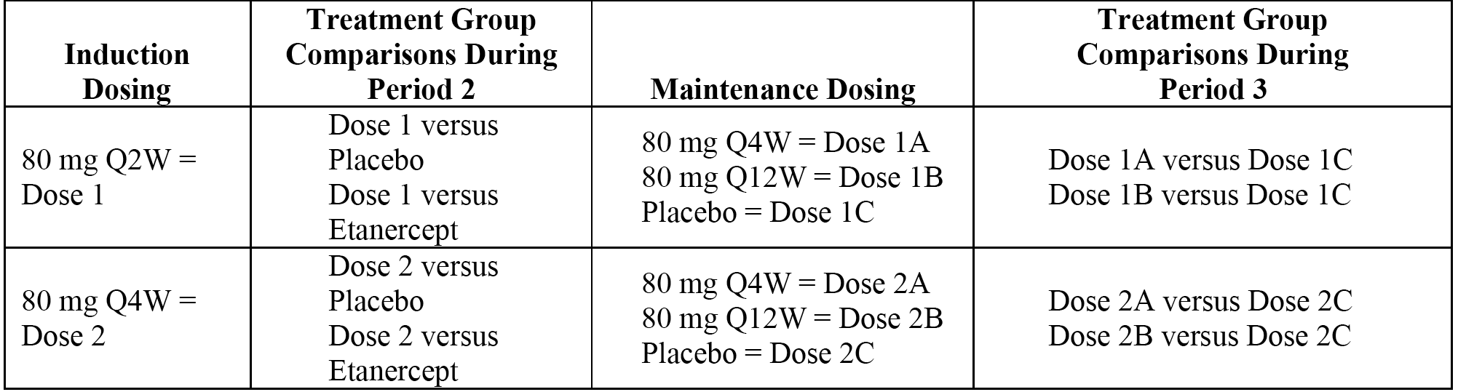
In total, there were 13 statistical tests grouped into 2 parallel branches. The first branch included tests of Dose 1 versus placebo and etanercept in Period 2 (induction dosing period), as well as Dose 1A versus Dose 1C, and Dose 1B versus Dose 1C in Period 3 (maintenance dosing period). The second branch included tests of Dose 2 versus placebo and etanercept in Period 2 (induction dosing period), as well as Dose 2A versus Dose 2C, and Dose 2B versus Dose 2C in Period 3 (maintenance dosing period). Test 2 was performed at a dose only if Test 1 of that dose was significant. Similarly, each test for a particular dose was performed only if all prior tests of that dose were significant. For each dose, if a test was not significant, all subsequent tests were not significant.

Changes to the planned analyses
There were a number of changes to the planned analyses made prior to the first patient entering the study and after the first patient was randomised, and the original protocol was amended to incorporate the changes. In general, the changes to the protocol were made in response to feedback from the FDA relating to the protocol. The protocol amendments have been examined and do not give rise to concern.
No changes to the conduct of the study or the planned analyses were made after the time of the first unblinding. Consequently, the sponsor considers that the changes ‘have limited implications for the interpretation of the study’. This is considered to be a reasonable assumption.

Participant flow

Induction dosing period
The study included 1658 patients who consented to treatment, including 434 who discontinued prior to randomisation and 1224 who were randomised to 1 of the 4 treatment groups in the 12-week induction dosing period (ITT population). Randomisation was 2:2:2:1 to ixekizumab 80 mg Q2W (n = 351), ixekizumab 80 mg Q4W (n = 347), etanercept 50 mg twice weekly (n = 358), or placebo (n = 168), respectively. The percentage of patients completing the induction dosing period was 94.9% (ITT population). Patient disposition is summarised below in Table 34.

Table 34. Patient disposition in the induction dosing period; ITT population; Study RHBA
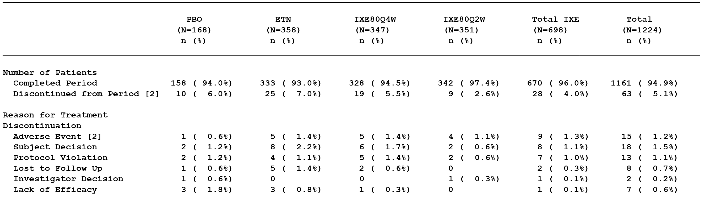

Maintenance dosing period (primary population)
The CSR included the results of an interim analysis following a database lock after the last enrolled patient completed the Week 36 visit of the maintenance dosing period. Therefore, not all of the 1158 patients who entered the maintenance dosing period have completed treatment. The maintenance dosing period primary population included 544 patients treated with ixekizumab in the induction period who achieved sPGA (score of 0 or 1) at Week 12 and who received at least one dose of study treatment during the maintenance dosing period. The maintenance dosing period secondary population included 614 patients treated with ixekizumab in the induction dosing period who did not achieve sPGA (score of 0 or 1) at Week 12, and all patients treated with etanercept during the induction dosing period who received at least one dose of study treatment during the maintenance dosing period.
At the time of the database lock for the Week 36 interim analysis, 152 (27.9%) patients of the 544 patients in the maintenance dosing period primary population had completed Week 60, 131 (24.1%) patients were ongoing, 234 (43.0%) patients had relapsed, and 27 (5.0%) patients had discontinued study treatment. The disposition of patients in the maintenance dosing period primary population is summarised in below in Table 35.

Table 35. Patient disposition maintenance dosing period, primary population; Study RHBA
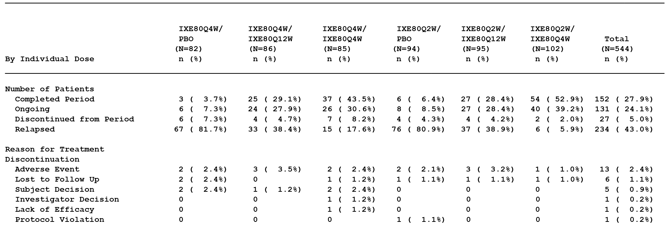

Major protocol deviations
In the induction dosing period, major protocol deviations were reported in 31.0% (52/168), 27.9% (100/358), 27.4% (95/347), and 25.4% (89/351) of patients in the placebo, etanercept, ixekizumab 80 mg Q4W, and ixekizumab 80 mg Q2W groups, respectively. The most frequently reported major protocol deviations in the treatment groups were taking incorrect study medication, and provision of improper informed consent. The major protocol deviations were similar for each of the 4 treatment groups. The major protocol violations reported in the ITT population are considered not to have invalidated the efficacy analyses undertaken in this dosing period.
In the maintenance dosing period primary population, major protocol deviations were reported in 23.2% (19/82), 22.1% (19/86), 23.5% (20/85), 18.1% (17/94), 20.0% (19/95), and 21.6% (22/102) of patients in the ixekizumab 80 mg Q4W/placebo, ixekizumab 80 mg Q4W/Q12W, ixekizumab 80 mg Q4W/ Q4W, ixekizumab 80 mg Q2W/placebo, ixekizumab 80 mg Q2W/ Q12W, and ixekizumab 80 mg Q2W/Q4W groups, respectively. The major protocol deviations were similar for each of the 6 treatment groups. The major protocol violations reported in maintenance dosing period primary population are considered not to have invalidated the efficacy analyses undertaken in this dosing period.

Baseline data

Induction dosing period (ITT population)
Overall, baseline demographic and other characteristics were well balanced across the 4 treatment groups. The mean age of the total ITT population (n = 1224) was 45.0 years (range: 18 to 84 years), with 93.7% being < 65 years, 5.1% being ≥ 65 to < 75 years, and 1.2% being > 75 years. The majority of patients were male (67.1%) and White (92.6%). The mean (SD) weight was 91.6 kg (22.2 kg), with 32.3% of patients weighing ≥ 100 kg at baseline. The mean (SD) BMI was 30.7 kg/m² (7.0 kg/m²), the median BMI was 29.6 kg/m² (range: 15.2 to 60.6 kg/m²), and 570 patients (47%) were considered to be obese (BMI ≥ 30 to < 40 kg/m²) or extremely obese (BMI ≥ 40 kg/m²).
At baseline, patients had a median disease duration of 16.4 years (range: 0.5 to 63.4 years) with a median percentage BSA involvement of psoriasis of 20.0% (range: 10% to 95%). The majority of patients had an sPGA score of 3 (50.3%) or 4 (44.2%), and the mean (SD) and median PASI scores were 19.6 (7.2) and 17.4 (range: 12.0 to 61.2), respectively. Approximately 64% of the study population reported using systemic psoriasis therapy prior to enrolment, with approximately 24% reporting prior use of a biologic therapy.
In general, the percentages of patients reporting pre-specified medical history terms were well balanced across the treatment groups. The medical history associated with specific cardiovascular risk factors (based on solicited responses to a pre-specified list of medical history terms) in the ITT population in the induction dosing period included hypertension (25.2%), dyslipidaemia (12.4%), type 2 diabetes mellitus (8.2%), coronary artery disease (3.1%), and stroke (0.7%).
Evaluator’s comment: The mean age of the population was approximately 45 years, with the majority of patients being aged < 65 years (93.7%) and only 1.2% being aged > 75 years. The BMI data indicate that 47% of the population were considered to be obese or extremely obese.

Maintenance dosing period (primary population)
The mean baseline age of patients in the maintenance dosing period primary population (n = 544) was 44.0 years (range: 18 to 84 years), with 66.4% being male, and 94.5% White. The mean baseline weight was 89.2 kg (range: 46.4 to 166.6 kg) and the mean baseline BMI was 29.8 kg/m² (range: 17.8 to 54.8 kg/m²). Systemic therapy had been previously used by approximately 67.6% of patients (44.3% had used only non-biologic therapies, 7.7% had used only biologic therapies, and 15.6% had use both non-biologic and biologic therapies). Baseline characteristics were well-balanced across treatment groups in the maintenance dosing period primary population, and were consistent with those for the ITT population in the induction dosing period.

Compliance
In the induction dosing period, 93.6% of the total number of patients in the ITT population were categorised as treatment compliant, and compliance ranged from 91.9% to 95.1% across the 4 treatment groups. In the maintenance dosing period primary population, 93.8% of patients were categorised as treatment compliant, and compliance ranged from 92.2% to 95.3% across the 6 treatment groups.

Results for the primary efficacy outcomes

Overview
The primary objectives of this study were to assess, using a gatekeeping testing strategy, the efficacy of two ixekizumab dose regimens (80 mg Q2W and 80 mg Q4W) versus placebo and versus the active comparator, etanercept (50 mg twice weekly), measured by the proportion of patients achieving an sPGA (score of 0 or 1) with at least a 2 point improvement from baseline and the proportion of patients achieving a ≥ 75% improvement from baseline on the PASI (PASI 75) after 12 weeks of treatment (using NRI) in the induction dosing period.

Superiority analyses (week 12)
The results for the superiority analyses at Week 12 are summarised below in Table 36.

Table 36. Response rates, n (%), at Week 12 for sPGA (score of 0 or 1) and PAS 75 in the induction dosing period, ITT population (NRI); Study RHBA
 | PBO  (N = 168) | ETN  (N = 358) | IXE 80 mg  Q4W (N = 347) | IXE 80 mg  Q2W (N = 351)
sPGA (score of 0 or 1)¹ | 4 (2.4%) | 129 (36.0%) | 253 (72.9%) | 292 (83.2%)
versus PBO; p-value² |  | < 0.001 | < 0.001 | < 0.001
versus ETN; p-value² |  |  | < 0.001 | < 0.001
PASI 75¹ | 4 (2.4%) | 149 (41.6%) | 269 (77.5%) | 315 (89.7%)
versus PBO; p-value² |  | < 0.001 | < 0.001 | < 0.001
versus ETN; p-value² |  |  | < 0.001 | < 0.001
Abbreviations: PBO = Placebo; ETN = Etanercept; IXE = Ixekizumab; ITT = intention to treat; NRI = non-responder imputation; N = number of patients in the analysis population/number of patients in the specified category. Notes: 1) At Week 12; 2) Cochran-Mantel-Haenszel (CMH) test stratified by pooled centre, the 2-sided significance level for each of the pairwise comparisons was α = 0.025.
Evaluator’s comment: Based on the gatekeeping strategy, both the ixekizumab regimens were statistically significantly superior to placebo and etanercept as regards both primary efficacy variables of sPGA (score of 0 or 1) and PASI 75 at Week 12. The ixekizumab 80 mg Q2W regimen was numerically superior to the ixekizumab 80 mg Q4W regimen as regards the response rates for both co-primary endpoints.

Non-inferiority analysis using the fixed margin approach (Week 12)
The results for the non-inferiority analysis (ixekizumab compared to etanercept) for the two primary analysis variables at Week 12 using the fixed margin approach (FDA) are summarised below in Table 37.

Table 37. Non-inferiority of ixekizumab to etanercept using the fixed margin approach (FDA) at Week 12 in the induction dosing period, ITT population (NRI); Study RHBA
 | PBO  (N = 168) | ETN  (N = 358) | IXE 80 mg Q4W  (N = 347) | IXE 80 mg Q2W  (N = 351)
sPGA (score of 0 or 1)¹ | 4 (2.4%) | 129 (36.0%) | 253 (72.9%) | 292 (83.2%)
IXE – ETN² |  |  | 36.88% | 47.16%
CI 97.5% |  |  | 29.07% to 44.68% | 39.92% to 54.39%
PASI 75¹ | 4 (2.4%) | 149 (41.6%) | 269 (77.5%) | 315 (89.7%)
IXE – ETN² |  |  | 35.90% | 48.12%
CI 97.5% |  |  | 28.20% to 43.60% | 41.25% to 55.00%
Abbreviations: PBO = Placebo; ETN = Etanercept; IXE = Ixekizumab; ITT = intention to treat; NRI = non-responder imputation; N = number of patients in the analysis population; n = number of patients in the specified category. Notes: 1) At Week 12; 2) Confidence intervals are constructed using the simple asymptotic method, without continuity correction (i.e., normal approximation to the binomial distribution). The lower bound of 97.5% CI is used to determine the non-inferiority and the superiority to etanercept.
Evaluator’s comment: The results showed that both ixekizumab regimens were non-inferior to etanercept based on the sPGA (score of 0 or 1) and PASI 75 rates at Week 12, using the fixed margin approach (FDA). For each of the 4 pairwise comparisons, the lower bound 97.5% CI of the difference in responder rates was greater than the pre-specified non-inferiority margin of -12.0%. In addition, for each of the 4 pairwise comparisons the lower bound 97.5% CI of the difference in responder rates was greater than the pre-specified superiority threshold of 0%, indicating that each ixekizumab regimen was superior to etanercept for both the sPGA (score of 0 or 1) and PASI 75 at Week 12.

Non-inferiority analysis using the retention rate approach (Week 12)
The results for the non-inferiority analysis (ixekizumab compared to etanercept) for the two primary analysis variables at Week 12 using the retention rate approach (CHMP) are summarised below in Table 38.

Table 38. Non-inferiority of ixekizumab to etanercept using the retention rate approach (CHMP) at Week 12 in the induction dosing period, ITT population (NRI); Study RHBA
 | PBO  (N = 168) | ETN  (N = 358) | IXE 80 mg  Q4W (N = 347) | IXE 80 mg  Q2W N = 351)
sPGA (score of 0 or 1)¹ | 4 (2.4%) | 129 (36.0%) | 253 (72.9%) | 292 (83.2%)
IXE - PBO |  |  | 70.53% | 80.81%
ETN - PBO |  | 33.65%
Retention Rate: (IXE - PBO)/(ETN - PBO) (CI 97.5%)² |  |  | 2.10 (1.75 to 2.58) | 2.40 (2.03 to 2.94)
PASI 75¹ | 4 (2.4%) | 149 (41.6%) | 269 (77.5%) | 315 (89.7%)
IXE - PBO |  |  | 75.14% | 87.36%
ETN - PBO |  | 39.24%
Retention Rate: (IXE - PBO)/(ETN - PBO) (CI 97.5%)² |  |  | 1.91 (1.64 to 2.29) | 2.23 (1.92 to 2.65)
Abbreviations: PBO = Placebo; ETN = Etanercept; IXE = Ixekizumab; ITT = intention to treat; NRI = non-responder imputation; N = number of patients in the analysis population; n = number of patients in the specified category. Notes: 1) At Week 12; 2) Confidence intervals are constructed using Fieller's method. The lower bound of 97.5% CI is used to determine the non-inferiority and the superiority to etanercept.
Evaluator’s comment: The results showed that both ixekizumab regimens were non-inferior to etanercept based on the sPGA (score of 0 or 1) and PASI 75 rates at Week 12, using the retention rate approach (CHMP). The lower bound 97.5% CI of the retention rate for both ixekizumab regimens for both primary efficacy variables was greater than the pre-specified non-inferiority threshold of 0.70. In addition, the lower bound 97.5% CI for each of the retention rates was greater than the pre-specified superiority threshold of 1.00, indicating that each ixekizumab regimen was superior to etanercept based on the sPGA (score of 0 or 1) and the PASI 75 at Week 12.

Sensitivity analyses (week 12)
The primary efficacy analyses were repeated on the PPS and the results were consistent with the analyses in the ITT population. In addition, the number and percentage of patients in the ITT population achieving sPGA(score of 0 or 1) and PASI 75 at Week 12 using the pMI method were consistent with the NRI method. No statistically significant treatment-by-centre or treatment-by-pooled centre effect was found for either the sPGA (score of 0 or 1) or the PASI 75.

Results for the major secondary efficacy outcomes
The major secondary efficacy outcome variables were sPGA (0), PASI 90 and PASI 100 at Week 12 (NRI) and sPGA (score of 0 or 1) at Week 60 (NRI). The gatekeeping testing strategy, which commenced with the primary analyses, was continued for the analysis of the major secondary objectives. At Week 12, those patients treated with ixekizumab in the induction dosing period and who were considered responders, were re-randomised to treatment in the maintenance dosing period (maintenance dosing period primary population). Due to the database lock occurring after the last patient enrolled completed the Week 36 visit of the maintenance dosing period, data from an efficacy evaluable patient population were used to assess efficacy responses over the maintenance dosing period from Week 12 to Week 60. For the Week 60 analyses, maintenance dosing period treatment groups are presented as induction/maintenance dosing regimens.

sPGA (0) week 12 ixekizumab versus placebo
At Week 12, ixekizumab 80 mg Q2W and ixekizumab 80 mg Q4W were superior to placebo, as measured by the percentage of patients achieving sPGA (0). After 12 weeks of treatment, 41.9% (147/351) and 32.3% (112/347) of patients from the 80 mg Q2W and 80 mg Q4W treatment groups, respectively, achieved sPGA (0) compared to 0.6% (1/168) from the placebo group (p < 0.001 for both comparisons; CMH test stratified by pooled centre).

PASI 90 week 12 ixekizumab versus placebo
At Week 12, ixekizumab 80 mg Q2W and ixekizumab 80 mg Q4W were superior to placebo, as measured by the percentage of patients achieving at least a 90% improvement in PASI score from baseline (PASI 90). After 12 weeks of treatment, 70.7% (248/351) and 59.7% (207/347) of patients from the 80 mg Q2W and 80 mg Q4W treatment groups, respectively, achieved PASI 90 compared to 0.6% (1/168) from the placebo group (p < 0.001 for both comparisons; CMH test stratified by pooled centre).

PASI 100 week 12 ixekizumab versus placebo
At Week 12, ixekizumab 80 mg Q2W and ixekizumab 80 mg Q4W were superior to placebo, as measured by the percentage of patients achieving 100% improvement in PASI score from baseline (PASI 100). After 12 weeks of treatment, 40.5% (142/351) and 30.8% (107/347) of patients from the 80 mg Q2W and 80 mg Q4W treatment groups, respectively, achieved PASI 100 compared to 0.6% (1/168) from the placebo group (p < 0.001 for both comparisons; CMH test stratified by pooled centre).

sPGA (0) week 12 ixekizumab versus etanercept
At Week 12, ixekizumab 80 mg Q2W and ixekizumab 80 mg Q4W were superior to etanercept, as measured by the percentage of patients achieving sPGA (0). After 12 weeks of treatment, 41.9% (147/351) and 32.3% (112/347) of patients from the 80 mg Q2W and 80 mg Q4W treatment groups, respectively, achieved sPGA (0) compared to 5.9% (21/35) from the etanercept group (p < 0.001 for both comparisons; CMH test stratified by pooled centre).

PASI 90 week 12 ixekizumab versus etanercept
At Week 12, ixekizumab 80 mg Q2W and ixekizumab 80 mg Q4W were superior to etanercept, as measured by the percentage of patients achieving PASI 90. After 12 weeks of treatment, 70.7% (248/351) and 59.7% (207/347) of patients from the 80 mg Q2W and 80 mg Q4W treatment groups, respectively, achieved PASI 90 compared to 18.7% (67/358) from the etanercept group (p < 0.001 for both comparisons; CMH test stratified by pooled centre).

PASI 100 week 12 ixekizumab versus etanercept
At Week 12, ixekizumab 80 mg Q2W and ixekizumab 80 mg Q4W were superior to etanercept, as measured by the percentage of patients achieving PASI 100. After 12 weeks of treatment, 40.5% (142/351) and 30.8% (107/347) of patients from the 80 mg Q2W and 80 mg Q4W treatment groups, respectively, achieved PASI 100 compared to 5.3% (19/358) from the etanercept group (p < 0.001 for both comparisons; CMH test stratified by pooled centre).

sPGA (score of 0 or 1) week 60 ixekizumab 80 mg Q4W versus placebo
At Week 60, the percentages of patients from the two ixekizumab 80 mg Q4W maintenance treatment groups (75.8% (47/62) Q2W/Q4W and 59.6% (34/57) Q4W/Q4W) maintaining

sPGA (score of 0 or 1) week 60 ixekizumab 80 mg Q12W versus placebo
At Week 60, the percentages of patients from the ixekizumab 80 mg Q12W maintenance groups (29.9% (20/67) Q2W/Q12W and 34.4% (21/61) Q4W/Q12W) maintaining sPGA (score of 0 or 1) were statistically significant compared to the respective placebo groups (7.0% (6/86) Q2W/PBO and 4.2% (3/72) Q4W/PBO]) (p < 0.001; Fisher's exact test).

Non-responders to etanercept
Patients (n = 200) who failed to respond to etanercept during the induction dosing period (Week 12) were treated with ixekizumab 80 mg Q4W during the maintenance dosing period (Week 12 to Week 60). In these patients, treatment with ixekizumab for 12 weeks in the maintenance dosing period resulted in 73.0% achieving sPGA (score of 0 or 1) and 83.5% achieving PASI 75 responses. These findings suggest that non-response to etanercept does not prevent patients from achieving a clinically meaningful response after switching to ixekizumab treatment. However, this data should be interpreted cautiously as there was no placebo control group for the ixekizumab 80 mg Q4W group in the 12 week period following the switch from etanercept.

Study RHBC (Phase III)

Study design, objectives, locations and dates

Background
‘A 12-week multicentre, randomised, double-blind, placebo-controlled study comparing the efficacy and safety of LY2439821 to etanercept and placebo in patients with moderate to severe plaque psoriasis with a long-term extension period.’
This ongoing multicentre study is being conducted at 125 study sites across 10 countries (Argentina, Chile, Mexico, Bulgaria, Germany, Hungary, Poland, Russia, Canada, and the US). The coordinating investigator is located in the USA.
The first patient was enrolled on 11 August 2012, the last patient visit for the 14 July 2014, database lock was 22 May 2014, and the approval date for the CSR was 23 January 2015. The study is sponsored by Eli Lilly. The sponsor states that study was performed in compliance with the principles of GCP.

Primary objectives
The primary objectives of the study were to assess whether the efficacy of ixekizumab 80 mg Q2W or Q4W at Week 12 was superior to placebo, non-inferior to etanercept or superior to etanercept as measured by:
- proportion of patients with a sPGA (score of 0 or 1) with at least a 2-point improvement from baseline;
- proportion of patients achieving PASI 75 from baseline.

Secondary objectives
The major secondary objectives of the study were to assess whether the efficacy of ixekizumab 80 mg Q2W or Q4W was superior to placebo or etanercept at Week 12 as measured by:
- proportion of patients achieving an sPGA (0) (remission);
- proportion of patients achieving a ≥ 90% improvement in PASI (PASI 90);
- proportion of patients achieving a 100% improvement in PASI (PASI 100);
and whether the efficacy of ixekizumab 80 mg Q2W or Q4W was superior to placebo at Week 12 as measured by:
- proportion of patients achieving an Itch NRS ≥ 4 point reduction from baseline for patients who had baseline Itch NRS ≥ 4;
- change from baseline in DLQI;
- change from baseline in NAPSI score in patients with fingernail involvement.
There were a large number of other secondary and exploratory objectives. In the review of Study RHBC presented in this clinical evaluation, evaluation of efficacy focuses on the primary and major secondary objectives, while other selected efficacy objectives will be reviewed as part of the integrated analysis of the three pivotal efficacy and safety studies.

Study design and investigational plan
Study RHBC is an ongoing, Phase III, multicentre, randomised, double-blind, placebo-controlled, active-comparator, parallel-group study examining the effect of ixekizumab (160 mg starting dose followed by 80 mg Q2W or 80 mg Q4W) compared to placebo and etanercept (50 mg twice weekly) on the primary efficacy endpoints (PASI (score of 0 or 1); PAS 75) measured at 12 weeks in patients with moderate-to-severe plaque psoriasis. Long-term safety and efficacy of ixekizumab 80 mg Q4W will be evaluated in an extension phase for up to a total of 5 years.
The study includes 4 periods:
- Period 1, Screening Period: Visits 1 and 1A lasting from 7 to 30 days prior to Period 2 (baseline, Week 0, Visit 2).
- Period 2, Blinded Induction Dosing Period: From Week 0 (baseline, Visit 2) up to Week 12 (Visit 7). The purpose of Period 2 was to compare the safety and efficacy ixekizumab versus etanercept and versus placebo. The primary efficacy endpoints of the study were evaluated at Week 12. Treatment at Week 12 remained blinded until all patients completed Week 12 or had discontinued from the study treatment (moved into the post-treatment follow-up period (Period 4)), after which it will be open-label through Week 264.
- Period 3, Long-Term Extension Period: From Week 12 (Visit 7) up to Week 264 (Visit 36). The purpose of Period 3 is continued, longer-term evaluation of safety and efficacy of ixekizumab 80 mg Q4W treatment in participating patients. The long-term extension period was ongoing at time of the CSR.
- Period 4, Post-Treatment Follow-Up Period: From last treatment period visit or ETV up to a minimum of 12 weeks following that visit. The purpose of Period 4 is to monitor safety following treatment discontinuation.
As for Studies RHAZ and RHBA, an independent DMC was responsible for interim safety monitoring. So far, three interim analyses for safety have been performed by the DMC when at least 20%, 50%, and 75% of the patients had completed or discontinued from Period 2 (blinded induction dosing period) across this study and the two other Phase III studies of ixekizumab in patients with psoriasis.
Evaluator’s Comment: In general, the comments relating to the study design provided for Study RHBA are applicable to Study RHBC. However, in Study RHBC randomised, double-blind treatment applied only to the induction dosing period (Weeks 0 to 12). Study RHBC does not include a re-randomised, double-blind, maintenance dosing period. In Study RHBC, the long-term extension period (Weeks 12 to 264) is open label.

Inclusion and exclusion criteria
The study enrolled male and female patients age 18 years or older with a confirmed diagnosis of chronic plaque psoriasis of at least 6 months; who were candidates for phototherapy and/or systemic therapy; and who had ≥ 10% BSA involvement, an sPGA score of ≥ 3, and PASI score ≥ 12 at screening and at baseline. Patients with prior etanercept use were excluded from this study.
Evaluator’s Comment: The inclusion and exclusion criteria for this study were consistent with those for Study RHBA.

Study treatments

Induction dosing period
During the induction dosing period (Weeks 0 to 12), patients were administered ixekizumab, placebo or etanercept using the same regimens as those summarised above for Study RHBA.

Extension dosing period
During the ongoing long-term extension period (Weeks 12 to 264), patients received ixekizumab 80 mg Q4W given as one SC injection Q4W. Patients who received etanercept during the induction dosing period received placebo (two SC injections) at Week 12, then ixekizumab 80 mg Q4W (one SC injection Q4W) thereafter. Patients who received placebo during the induction dosing period received 160 mg ixekizumab (two SC injections) at Week 12 and then received ixekizumab 80 mg Q4W (one SC injection Q4W) thereafter.

Prior and concomitant therapy
The approach relating to prior and concomitant therapy was the same as that previously described for Study RHBA.

Compliance
The approach relating to assessment of compliance was the same as that previously described for RHAZ.

Removal of patients from therapy or assessment
The criteria for removing patients from therapy or assessment were consistent with that previously described for RHAZ and RHBA.

Efficacy variables and outcomes

Primary efficacy endpoints
The co-primary efficacy endpoints were the proportion of patients achieving a sPGA (score of 0 or 1) and the proportion of patients achieving PASI 75 at Week 12 (NRI).

Secondary efficacy endpoints
The major secondary efficacy endpoints were sPGA (0), PASI 90 and PASI 100, Itch NRS, DLQI, and NAPSI at Week 12.

Randomisation and blinding methods

Randomisation
At Week 0 (Visit 2), patients who met all criteria for enrolment at Visits 1/1A and 2 were randomised 2:2:2:1 to 1 of the 4 double-blind treatment groups (that is ixekizumab 80 mg Q2W, ixekizumab 80 mg Q4W, etanercept, or placebo) as determined by a computer-generated random IVRS. The treatment groups were stratified by centre.

Blinding
The study was double-blind from Week 0 through Week 12. Patients, investigators, and all other personnel involved in the conduct of the study were blinded to individual treatment assignments until all patients had either completed Week 12 or had discontinued from the study treatment (moved into the post-treatment follow-up period). To preserve the blind, a minimum number of sponsor personnel not in direct contact with study sites had access to the randomisation table and treatment assignments before the study was unblinded. Interim unblinded safety analyses were planned for the study. Access to the unblinded data was limited to a DMC and unblinded Statistical Analysis Centre (SAC). Appropriate procedures were in place for emergency unblinding. During the study unblinding took place for 1 patient due to hospitalisation for Crohn's disease for which a TNFα blocker was considered to be a treatment option.

Analysis populations
ITT population: Efficacy and health outcome analyses for the induction dosing period (Period 2) were conducted on the ITT population. The definitions of this analysis set were as for Studies RHAZ and RHBA.
PPS population: The primary analyses were repeated using the PPS. The definitions of this analysis set were as for Studies RHAZ and RHBA.
Safety Population Safety: Safety analyses for Period 2 were conducted on the Safety Population, defined as all randomised patients who received at least one dose of study treatment. Patients were analysed according to the treatment to which they were assigned.
Long-Term Extension Period Population: Efficacy, health outcomes and safety analyses for Period 3 were also conducted on the long-term extension period population, defined as all patients who received at least one dose of study treatment during the long-term extension period (Period 3). As the study is ongoing, the safety analyses in this population included only data available at the time of the database lock.
Follow-Up Population: Safety analyses for the follow-up period (Period 4) have been conducted on the follow-up population, defined as all randomised patients who received at least one dose of study treatment and entered Period 4. Patients were analysed according to the treatment to which they were assigned in Period 2.

Sample size

Induction dosing period
The planned sample size was 1225 patients randomised 2:2:2:1 at the start of the double-blind induction dosing period to ixekizumab 80 mg Q2W, ixekizumab 80 mg Q4W, etanercept, or placebo (that is, 350 versus 350 versus 350 versus 175 patients per treatment group, respectively). In order to account for multiple testing for the two ixekizumab groups, a 2-sided Fisher’s exact test at the 0.025 level was assumed for the sample size calculations. The study has > 93% power to test the superiority of each ixekizumab dose regimen to etanercept and > 99% power to test the superiority of each ixekizumab dose regimen to placebo for sPGA (score of 0 or 1) and PASI 75 at Week 12 (Visit 7). The assumptions relating to the response rates for each treatment used to calculate the sample size were the same as those previously described for Study RHBA. The study also included non-inferiority analyses using both fixed-margin (FDA) and retention rate (CHMP) approaches. The non-inferiority methods used in Study RHBC were identical to those previously described for Study RHBA.

Statistical methods

General comments
The protocol was approved on 3 November 2011 and was amended on 15 March 2012 and 5 November 2012. The SAP, which superseded the statistical plans described in the protocol, was approved on 21 December 2012 and amended on 12 May 2014 (Amendment 1) prior to unblinding of the study team. The reporting database was validated, locked, and unblinded for analysis on 14 July 2014. Categorical and continuous data were summarised using standard statistical methods.

Induction dosing period (Period 2)
The statistical methods used to analyse the efficacy outcomes in the induction dosing period (Period 2) of Study RHBC were the same as those previously described to analyse Study RHBA.

Gatekeeping and multiple comparisons/multiplicity
A gatekeeping testing strategy for the primary and major secondary analyses was implemented to control the overall type I error rate at a 2-sided alpha level of 0.05. The method was essentially the same as that previously described for Study RHBA.

Changes to the planned analyses
There were a number of changes to the planned analyses made prior to the first patient entering the study, and the original protocol was amended (15 March 2012) to incorporate these changes. There were a number of changes to the planned analyses made after the first patient was randomised, but prior to first unblinding of the sponsor's personnel. These changes resulted in a protocol amendment (5 November 2012). There were a number of changes to the planned analyses made after the first patient was randomised, but prior to first unblinding of the sponsor's personnel. These changes resulted in a protocol amendment (12 May 2014).
Evaluator’s Comment: No changes to the conduct of the study or the planned analyses were made after the time of the first unblinding. The changes to the study resulting in amendments to the protocol prior to first unblinding of the study have been examined and are considered to be acceptable. The majority of the changes appear to have been undertaken following FDA feedback on the protocol. The sponsor considers that the changes ‘have limited implications for the interpretation of the study’, as none of the changes were made after the time of first unblinding of the study.

Participant flow
The study included 1783 patients who consented to treatment, including 437 who discontinued prior to randomisation and 1346 who were randomised to 1 of the 4 treatment groups in the 12-week induction dosing period (ITT population). Randomisation was in a ratio of 2:2:2:1 to ixekizumab 80 mg Q2W (n = 385), ixekizumab 80 mg Q4W (n = 386), etanercept 50 mg twice weekly (n = 382), or placebo (n = 193), respectively. The percentage of patients in the total ITT population completing the induction dosing period was 94.7%. Patient disposition in the induction dosing period is summarised below in Table 39.

Table 39. Patient disposition in the induction dosing period, ITT population; Study RHBC
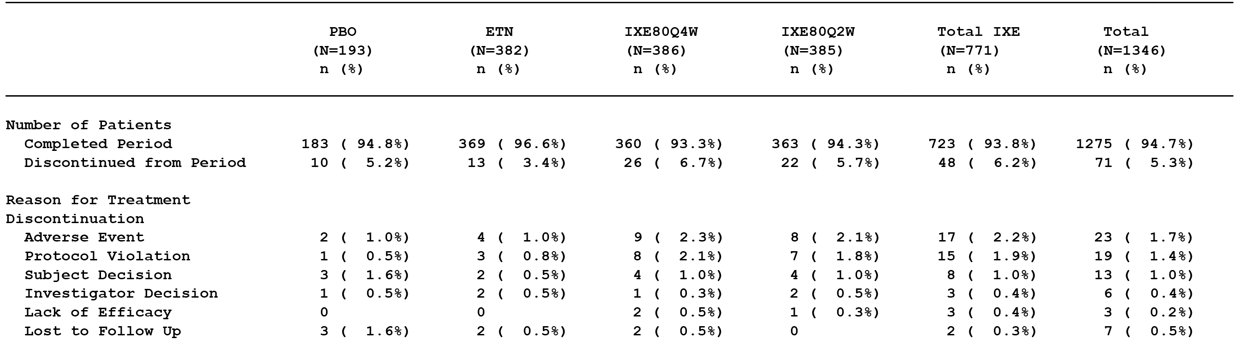
At the Week 12 (Visit 7), patients who completed the induction dosing period (Period 2) could elect to proceed to the long-term extension period (Period 3). All patients completing Period 2 (n = 1295) proceeded to Period 3, apart from one patient who had received ixekizumab 80 mg Q2W in the induction dosing period. All patients entering Period 3 were assigned to ixekizumab 80 mg Q4W.

Major protocol deviations
In the induction dosing period, major protocol deviations were reported in 25.9% (50/153), 23.3% (89/382), 22.0% (85/386) and 23.9% (92/385) of patients in the placebo, etanercept, ixekizumab 80 mg Q4W, and ixekizumab 80 mg Q2W groups, respectively. The most commonly reported major protocol deviation was ‘missing data’ (11.1% of the total population), consisting primarily of missing ECG data (10.4% of the total population). The pattern of major protocol deviations was similar for each of the 4 treatment groups and considered not to have invalidated the efficacy analyses.

Baseline data

Induction dosing period (ITT population)
Overall, baseline demographic and other characteristics were well balanced across the 4 treatment groups. The mean age of the total ITT population (n = 1346) was 45.8 years (range: 17 to 88 years), with 91.9% being < 65 years, 7.4% being ≥ 65 to < 75 years, and 0.7% being > 75 years. The majority of patients were male (68.2%) and White (92.7%). The mean (SD) weight was 91.2 kg (23.6 kg), with 29.6% of patients weighing ≥ 100 kg at baseline. The mean (SD) BMI was 30.5 (7.2) kg/m², the median BMI was 29.1 kg/m² (range: 16.9 to 61.3 kg/m²), and 589 patients (44%) were considered to be obese (BMI ≥ 30 to < 40 kg/m²) or extremely obese (BMI ≥ 40 kg/m²).
At baseline, the study population had a median disease duration of 16.0 years (range: 0.4 to 63.4 years), with a median % BSA involvement of psoriasis of 23.0% (range: 10% to 95%). The majority of patients had a sPGA score of 3 (51.7%) or 4 (43.3%), and the mean (SD) and median PASI scores were 20.9 (8.2) and 18.3 (range: 12.0 to 63.0), respectively. Systemic therapy had been previously used by approximately 57% of patients (41.4% of patients had taken only non-biologic therapies, 6.7% of patients had taken only biologic therapies, and 8.8% of patients had taken both non-biologic and biologic therapies).
In general, the percentages of patients reporting pre-specified medical history terms were well balanced across the treatment groups. The medical history associated with specific cardiovascular risk factors in the ITT population in the induction dosing period, based on solicited responses to a pre-specified list of medical history terms, included hypertension (30.1%), dyslipidaemia (11.8%), type 2 diabetes mellitus (9.5%), coronary artery disease (2.8%), and stroke (0.6%).
Evaluator’s comment: The mean age of the population was approximately 46 years, and 91.9% of patients were aged < 65 years with only 0.7% being aged > 75 years. Based on BMI criteria the majority of the population were considered to be obese or extremely obese.

Compliance
In the induction dosing period, 94.1% of patients in the ITT population were categorised as treatment compliant, and compliance ranged from 91.2% to 95.1% across the 4 treatment groups.

Results for the primary efficacy outcomes

Overview
The primary objectives of this study were to assess, using a gatekeeping testing strategy, the efficacy of two ixekizumab dose regimens (80 mg Q2W and 80 mg Q4W) compared to placebo and to etanercept (50 mg twice weekly), measured by the co-primary efficacy endpoints of the proportion of patients achieving an sPGA (score of 0 or 1) with at least a 2 point improvement from baseline and by the proportion of patients achieving a ≥ 75% improvement from baseline in the PASI 75 after 12 weeks of treatment (using NRI).

Superiority analyses (Week 12)
The results for the superiority analyses at Week 12 are summarised below in Table 40.

Table 40. Response rates: n (%), at Week 12 for sPGA (score of 0 or 1) and PASI 75 in the induction dosing period, ITT population (NRI); Study RHBC
 | PBO  (N = 193) | ETN  (N = 382) | IXE 80 mg  Q4W (N = 386) | IXE 80 mg  Q2W (N = 385)
sPGA (score of 0 or 1)¹ | 13 (6.7%) | 159 (41.6%) | 291 (75.4%) | 310 (80.5%)
versus PBO; p-value² |  | < 0.001 | < 0.001 | < 0.001
versus ETN; p-value² |  |  | < 0.001 | < 0.001
PASI 75¹ | 14 (7.3%) | 204 (53.4%) | 325 (84.2%) | 336 (87.3%)
versus PBO; p-value² |  | < 0.001 | < 0.001 | < 0.001
versus ETN; p-value² |  |  | < 0.001 | < 0.001
Abbreviations: PBO = Placebo; ETN = Etanercept; IXE = Ixekizumab; ITT = intention to treat; NRI = non responder imputation; N = number of patients in the analysis population; n = number of patients in the specified category. Notes: 1) At Week 12; 2) Cochran-Mantel-Haenszel (CMH) test stratified by pooled centre. The 2-sided significance level for each of the pairwise comparisons was α = 0.025.
Evaluator’s comment: Based on the gatekeeping strategy, both ixekizumab regimens were statistically significantly superior to placebo and etanercept as regards both primary efficacy variables of sPGA (score of 0 or 1) and PASI 75 at Week 12. The ixekizumab 80 mg Q2W regimen was numerically superior to the ixekizumab 80 mg Q4W regimen as regards the response rates for both co-primary endpoints.

Non-inferiority analysis using the fixed margin approach (week 12)
The results for the non-inferiority analysis (ixekizumab compared to etanercept) for the two primary analysis variables at Week 12 using the fixed margin approach (FDA) are summarised below in Table 41.

Table 41. Non-inferiority of ixekizumab to etanercept using the fixed margin approach (FDA) at Week 12 in the induction dosing period, ITT population (NRI); Study RHBC
 | PBO (N = 193) | ETN (N = 382) | IXE 80 mg Q4W (N = 386) | IXE 80 mg Q2W (N = 385)
sPGA (score of 0 or 1)¹ | 13 (6.7%) | 159 (41.6%) | 291 (75.4%) | 310 (80.5%)
IXE – ETN² |  |  | 33.77% | 38.90%
CI 97.5% |  |  | 26.28% to 41.26% | 31.66% to 46.14%
PASI 75¹ | 14 (7.3%) | 204 (53.4%) | 325 (84.2%) | 336 (87.3%)
IXE – ETN² |  |  | 30.79% | 33.87%
CI 97.5% |  |  | 23.72% to 37.87% | 27.00% to 40.74%)
Abbreviations: PBO = Placebo; ETN = Etanercept; IXE = Ixekizumab; ITT = intention to treat; NRI = non-responder imputation; N = number of patients in the analysis population; n = number of patients in the specified category. Notes: 1) At Week 12 2) Confidence intervals are constructed using the simple asymptotic method, without continuity correction (normal approximation to the binomial distribution). The lower bound of 97.5% CI is used to determine the non-inferiority and the superiority to etanercept.
Evaluator comment: The results showed that both ixekizumab regimens were non-inferior to etanercept based on the sPGA (01) and PASI 75 response rates at Week 12, using the fixed margin approach (FDA). For each of the 4 pairwise comparisons, the lower bound 97.5% CI of the difference in responder rates was greater than the pre-specified non-inferiority margin of -12.0%. In addition, for each of the 4 pairwise comparisons the lower bound 97.5% CI of the difference in responder rates was greater than the pre-specified superiority threshold of 0%, indicating that each ixekizumab regimen was superior to etanercept for both the sPGA (score of 0 or 1) and PASI 75 at Week 12.

Non-inferiority analysis using the retention rate approach (week 12)
The results for the non-inferiority analysis (ixekizumab compared to etanercept) for the two primary analysis variables at Week 12 using the retention rate approach (CHMP) are summarised below in Table 42.

Table 42. Non-inferiority of ixekizumab to etanercept using the retention rate approach (CHMP) at Week 12 in the induction dosing period, ITT population (NRI); Study RHBC
 | PBO (N = 193) | ETN (N = 382) | IXE 80 mg Q4W (N = 386) | IXE 80 mg Q2W (N = 385)
sPGA (score of 0 or 1)¹ | 13 (6.7%) | 159 (41.6%) | 291 (75.4%) | 310 (80.5%)
IXE - PBO |  |  | 68.65% | 73.78%
ETN - PBO |  | 34.89%
Retention Rate: (IXE-PBO)/(ETN-PBO) (CI 97.5%)² |  |  | 1.97 (1.66 to 2.41) | 2.11 (1.79 to 2.59)
PASI 75¹ | 14 (7.3%) | 204 (53.4%) | 325 (84.2%) | 336 (87.3%)
IXE - PBO |  |  | 76.94% | 80.02%
ETN - PBO |  | 46.15%
Retention Rate: (IXE-PBO)/(ETN-PBO) (CI 97.5%)² |  |  | 1.67 (1.46 to 1.94) | 1.73 (1.52 to 2.01)
PBO = Placebo; ETN = Etanercept; IXE = Ixekizumab; ITT = intention to treat; NRI = non-responder imputation; N = number of patients in the analysis population; n = number of patients in the specified category. Notes: 1) At Week 12; 2) Confidence intervals are constructed using Fieller's method. The lower bound of 97.5% CI is used to determine the non-inferiority and the superiority to etanercept.
Evaluator’s comment: The results showed that both ixekizumab regimens were non-inferior to etanercept based on the sPGA (score of 0 or 1) and PASI 75 response rates at Week 12, using the retention rate approach (CHMP). The lower bound 97.5% CI of the retention rate for both ixekizumab regimens for both primary efficacy variables was greater than the pre-specified non-inferiority threshold of 0.70. In addition, the lower bound 97.5% CI for each of the retention rates was greater than the pre-specified superiority threshold of 1.00, indicating that each ixekizumab regimen was superior to etanercept based on the sPGA (score of 0 or 1) and the PASI 75 at Week 12.

Sensitivity analyses (week 12)
The primary efficacy analyses were repeated on the PPS. The results of the PPS analyses were consistent with the ITT analyses. In addition, the number and percentage of patients in the ITT population achieving sPGA (score of 0 or 1) and PASI 75 at Week 12 using the placebo multiple imputation (pMI) method were consistent with the NRI method. No statistically significant treatment-by-centre or treatment-by-pooled centre effect was found for either the sPGA (score of 0 or 1) or the PASI 75.

Results for the major secondary efficacy outcomes
The major secondary efficacy measures were sPGA (0), PASI 90, PASI 100, Itch NRS, DLQI and NAPSI at Week 12. The gatekeeping testing strategy, which commenced with the primary analyses, was continued for the analyses of the major secondary objectives.

sPGA (0) week 12 ixekizumab versus placebo
Both ixekizumab 80 mg Q2W and ixekizumab 80 mg Q4W were superior to placebo, as measured by the percentage of patients achieving sPGA (0). After 12 weeks of treatment, 40.3% (155/385) and 36.0% (139/386) of patients from the 80 mg Q2W and 80 mg Q4W treatment groups, respectively, achieved sPGA (0) compared to 0% (0/193) from the placebo group (p < 0.001 for both comparisons; CMH test stratified by pooled centre).

PASI 90 week 12 ixekizumab versus placebo
Both ixekizumab 80 mg Q2W and ixekizumab 80 mg Q4W were superior to placebo, as measured by the percentage of patients achieving at least a 90% improvement in PASI score from baseline (PASI 90). After 12 weeks of treatment, 68.1% (262/385) and 65.3% (252/386) of patients from the 80 mg Q2W and 80 mg Q4W treatment groups, respectively, achieved PASI 90 compared to 3.1% (6/193) from the placebo group (p < 0.001 for both comparisons; CMH test stratified by pooled centre).

PASI 100 week 12 ixekizumab versus etanercept
Both ixekizumab 80 mg Q2W and ixekizumab 80 mg Q4W were superior to placebo, as measured by the percentage of patients achieving 100% improvement in PASI score from baseline (PASI 100). After 12 weeks of treatment, 37.7% (145/385) and 35.0% (135/386) of patients from the 80 mg Q2W and 80 mg Q4W treatment groups, respectively, achieved PASI 100 compared to 0% (0/193) from the placebo group (p < 0.001 for both comparisons; CMH test stratified by pooled centre).

sPGA (0) week 12 ixekizumab versus etanercept
Both ixekizumab 80 mg Q2W and ixekizumab 80 mg Q4W were superior to etanercept, as measured by the percentage of patients achieving sPGA (0). After 12 weeks of treatment, 40.3% (155/385) and 36.0% (139/386) of patients from the 80 mg Q2W and 80 mg Q4W treatment groups, respectively, achieved sPGA (0) compared to 8.6% (35/382) from the etanercept group (p < 0.001 for both comparisons; CMH test stratified by pooled centre).

PASI 90 week 12 ixekizumab versus etanercept
Both ixekizumab 80 mg Q2W and ixekizumab 80 mg Q4W were superior to etanercept, as measured by the percentage of patients achieving at least a 90% improvement in PASI score from baseline (PASI 90). After 12 weeks of treatment, 68.1% (262/385) and 65.3% (252/386) of patients from the 80 mg Q2W and 80 mg Q4W treatment groups, respectively, achieved PASI 90 compared to 25.7% (98/382) from the etanercept group (p < 0.001 for both comparisons; CMH test stratified by pooled centre).

PASI 100 week 12 ixekizumab versus etanercept
Both ixekizumab 80 mg Q2W and ixekizumab 80 mg Q4W were superior to etanercept, as measured by the percentage of patients achieving 100% improvement in PASI score from baseline (PASI 100). After 12 weeks of treatment, 37.7% (145/385) and 35.0% (135/386) of patients from the 80 mg Q2W and 80 mg Q4W treatment groups, respectively, achieved PASI 100 compared to 7.3% (28/382) from the etanercept group (p < 0.001 for both comparisons; CMH test stratified by pooled centre).

Itch NRS week 12 ixekizumab versus placebo versus etanercept
Both ixekizumab 80 mg Q4W and Q2W had a significantly higher itch responder rate compared to both placebo and etanercept, with responders being defined as patients with a baseline Itch NRS ≥ 4 points who achieved a ≥ 4 point reduction in Itch NRS. At Week 12, the Itch NRS responder rates were 20.9% (33/158), 64.1% (200/312), 79.9% (250/313) and 82.5% (264/320) in the placebo, etanercept, ixekizumab 80 mg Q2W and ixekizumab 80 mg Q2W groups, respectively. Each of the pairwise comparisons involving both ixekizumab groups versus placebo and versus etanercept were statistically significant and favoured ixekizumab (p < 0.001 for each comparison; CMH stratified by pooled centre and Fisher's exact test).

DLQI week 12 ixekizumab versus placebo versus etanercept
At baseline, mean (SD) DLQI total score (on the 30-point DLQI) for patients randomised to all treatment groups was 12.0 (6.9) and was similar across groups. The LSM mean difference in DLQI total score from baseline to Week 12 was significantly greater for both ixekizumab groups compared to both placebo and etanercept. The LS mean difference between ixekizumab 80 mg Q4W and placebo was -7.9 (95% CI: -8.7 to -7.1) and between ixekizumab 80 mg Q2W and placebo was -8.4 (95% CI: -9.2 to -7.7). The LS mean difference at Week 12 between ixekizumab 80 mg Q4W and etanercept was -1.6 (95% CI: -2.2 to -1.0) and between ixekizumab 80 mg Q2W and etanercept was -2.2 (95% CI: -2.8 to -1.5). The LS mean difference between etanercept and placebo was significant, with the difference being -6.3 (95% CI: -7.1 to -5.5).

NAPSI week 12 ixekizumab versus placebo versus etanercept
For patients who reported nail involvement at baseline, patients treated with ixekizumab had statistically significantly greater improvement in fingernail involvement than in patients receiving placebo or etanercept. The LS mean difference in NAPSI score from baseline to Week 12 was significantly greater for both ixekizumab groups compared to placebo and etanercept. The LS mean difference between ixekizumab 80 mg Q4W and placebo was -11.6 (95% CI: -14.3 to -9.0) and between ixekizumab 80 mg Q2W and placebo was -12.1 (95% CI: -14.7 to -9.4). The LS mean difference at Week 12 between ixekizumab 80 mg Q4W and etanercept was -3.6 (95% CI: -5.7 to -1.4) and between ixekizumab 80 mg Q2W and etanercept was -4.0 (95% CI: -6.2, -1.9). The LS mean difference between etanercept and placebo was significant, the difference being -8.0 (95% CI: -10.7 to -5.4).

Analyses performed across studies (integrated analysis)

Integrated efficacy analysis

Introduction
The submission included a pre-specified integrated efficacy analysis (IEA) including:
- placebo-controlled data from three Phase III psoriasis studies (Studies RHAZ, RHBA, RHBC) from screening through Week 12 (the primary psoriasis placebo-controlled integrated analysis set);
- placebo- and active-controlled data from two Phase III psoriasis studies (Studies RHBA and RHBC) from screening through Week 12 (secondary integrated analysis set); and
- data from maintenance dosing periods from two Phase III studies (Studies RHAZ and RHBA) for patients randomised to ixekizumab at Week 0 who met sPGA (score of 0 or 1) response criteria at Week 12 (NRI) and were re-randomised to maintenance treatment from Week 12 to Week 60. The maintenance dosing period starts at the first injection of study treatment at Week 12 and ends prior to the first injection of study treatment at Week 60 or the date of the early termination visit or the date of the visit where the patient meets relapse criteria (that is, sPGA ≥ 3).
The results of the IEA were presented in Summary of Clinical Efficacy.

Patient population
In the induction period, the primary psoriasis placebo-controlled integrated analysis set (Studies RHAZ, RHBA and RHBC) included a total of 3126 patients in the ITT population, comprising 1169 patients in the 80 mg Q2W group, 1165 patients in the 80 mg Q4W group, 792 patients in the placebo group, and 740 patients in the etanercept group. The mean age of the total population was 45.5 years (range: 17 to 88 years), with 92.8% of the population being aged < 65 years, 6.3% aged ≥ 65 to < 75 years, and 1.0% aged ≥ 75 years. The majority of patients were male (67.7%) and White (92.6%). The mean (SD) height was 173.0 (9.7) cm, the mean (SD) weight was 91.5 (23.2) kg, and the mean (SD) BMI was 30.5 (7.2) kg/m². Of the total population, 64.9% had used previous systemic therapy for psoriasis, 36.7% had used non-biologic treatment only, 9.9% had used biologic treatment only, and 18.4% had used both non-biologic and biologic treatments. The mean (SD) duration of psoriasis was 18.9 (12.2) years, and the median age at onset of the disease was 24.2 years (range: 0, 84 years). The mean (SD) sPGA score at baseline was 3.6 (0.6), with 50.2% of patients having a baseline sPGA score of 3 and 43.8% of patients having a baseline sPGA score of 4. The mean (SD) baseline PASI was 20.3 (7.9). The mean (SD) baseline percentage of BSA involvement was 27.5% (17.1%). The baseline demographic and disease characteristics were well balanced across the 4 treatment groups.
In the induction dosing period, the psoriasis placebo- and active-controlled integrated analysis set (Studies RHBA and RHBC) included a total of 2570 patients in the ITT population, comprising 361 patients in the placebo group, 740 patients in the etanercept group, 733 patients in the ixekizumab 80 mg Q4W group and 736 patients in the ixekizumab 80 mg Q2W group. The baseline demographic and disease characteristics in the psoriasis placebo- and active-controlled integrated analysis set (ITT total population) were similar to those in the primary psoriasis placebo-controlled integrated analysis set (ITT total population). The baseline demographic and disease characteristics in the psoriasis placebo- and active-controlled integrated analysis set (ITT population) were well balanced across the 4 treatment groups.
In the maintenance dosing period, the maintenance dosing period primary population (Studies RHAZ and RHBA) included a total of 1087 efficacy evaluable patients, comprising 181 patients in the IXE80Q4W/PBO group, 171 patients in the IXEQ4W/IXE80Q12W group, 167 patients in the IXEQ4W/IXEQ4W group, 203 patients in the IXE80Q2W/PBO group, 184 patients in the IXWQ2W/IXWQ12W group, and 181 patients in the IXE80Q2W/IXEQ4W group. The baseline demographic and disease characteristics of the maintenance dosing period primary population (total efficacy evaluable patients) were similar to those for the two induction dosing period integrated analysis sets (total ITT populations). Overall, the baseline demographic and disease characteristics in the maintenance dosing period primary population (efficacy evaluable patients) were well balanced across the 6 treatment groups.

Patient disposition
Patient disposition in the induction dosing period for the primary psoriasis placebo-controlled integrated analysis set (Studies RHAZ, RHBA and RHBC) is summarised below in Table 43. The completion rate in the total population was 94.8%, and was similar across the 4 treatment groups ranging from 94.1% to 95.8%. The proportion of patients discontinuing due to lack of efficacy was higher in the placebo group than in the two ixekizumab groups.

Table 43. Patient disposition in the induction dosing period in the primary psoriasis placebo-controlled integrated analysis set, ITT population; IEA (Studies RHAZ, RHBA and RHBC)
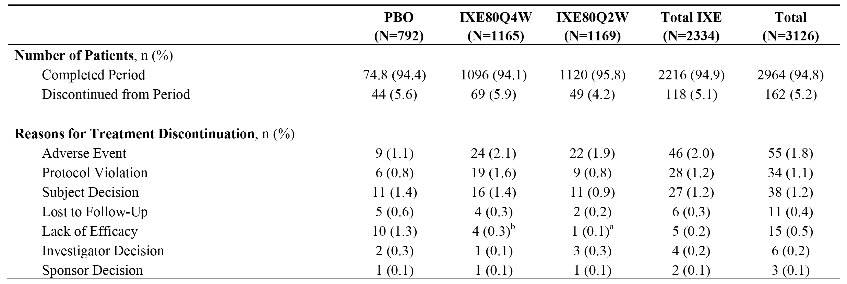
Notes: a) p < 0.001 versus PBO; b) p ≤ 0.05 versus PBO.
The patient disposition in the maintenance dosing period for the maintenance dosing period primary population efficacy evaluable patients (Studies RHAZ and RHBA) is summarised below in Table 44. In the maintenance dosing period, ixekizumab responders at Week 12 re-randomised to ixekizumab had notably higher completion rates than ixekizumab responders at Week 12 re-randomised to placebo. The relapse rates in the maintenance dosing period in patients re-randomised to placebo were notably higher than patients re-randomised to ixekizumab, while the relapse rates were notably higher in patients re-randomised to ixekizumab 80 mg Q12W compared to ixekizumab 80 mg Q4W.

Table 44. Patient disposition in the maintenance dosing period in the maintenance dosing period primary population efficacy evaluable patients, psoriasis maintenance integrated analysis set IEA; Studies RHAZ and RHBA)
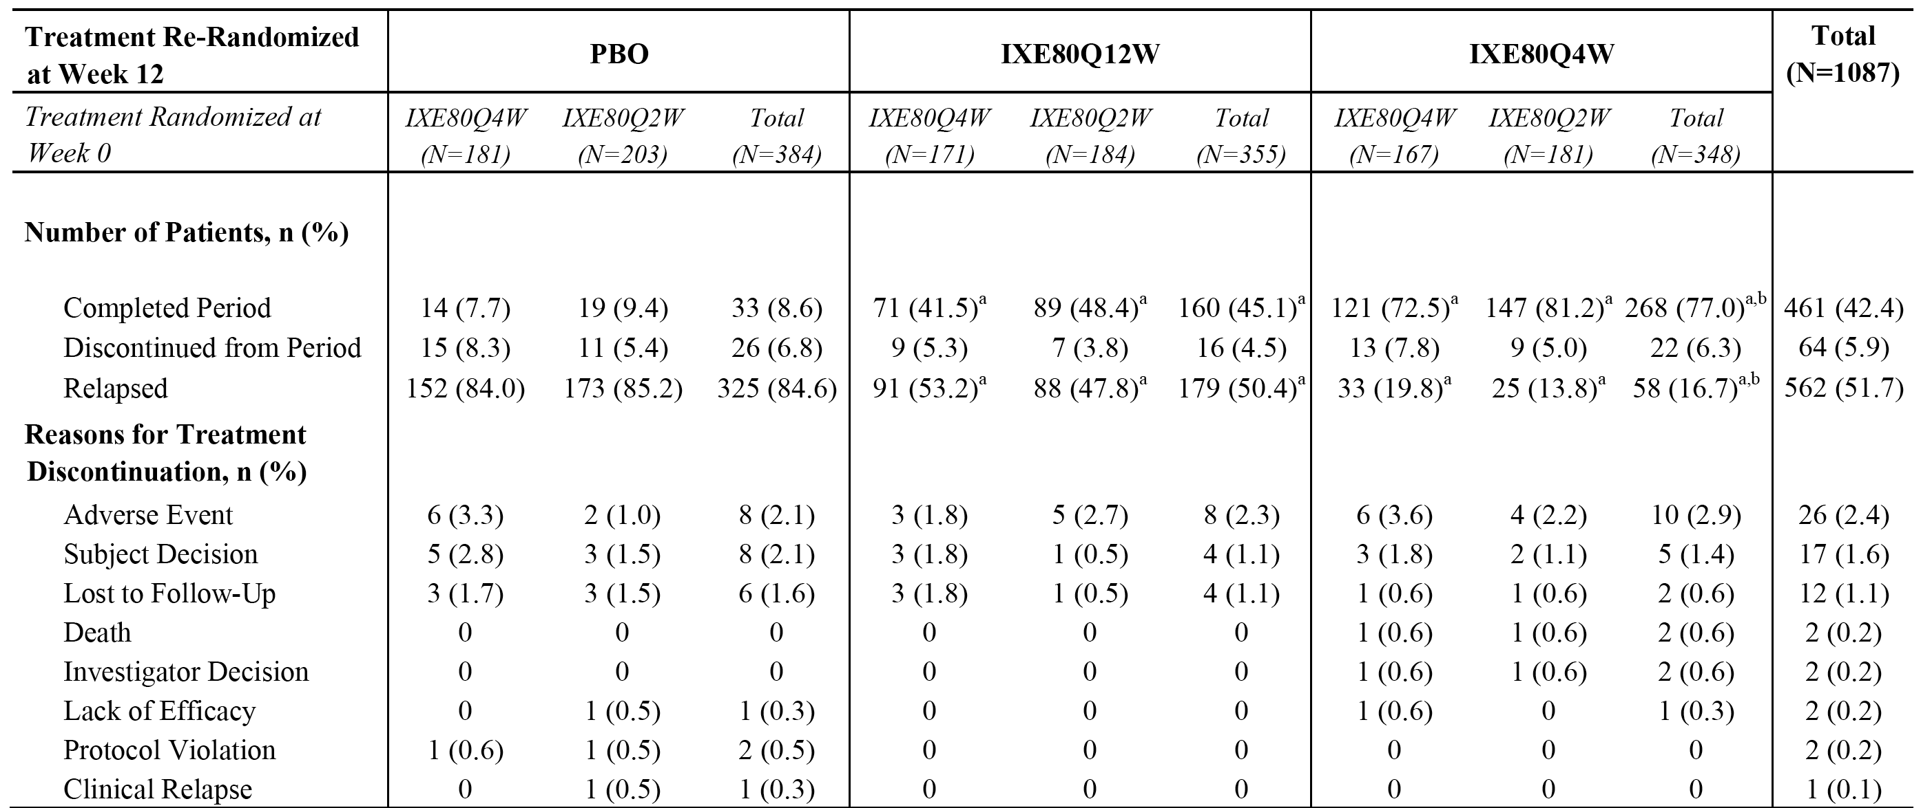
Notes: a) p < 0.001 versus PBO; b) p ≤ 0.001 versus 80 mg Q12W.

Statistical methods
The statistical methods were defined a priori and were consistent with the methods previously described for the individual Phase III studies.

Induction dosing period - results

Ixekizumab versus placebo (RHAZ, RHBA, RHBC)

Co-primary efficacy endpoints - sPGA (score of 0 or 1) and PASI 75
The primary analysis of the co-primary efficacy endpoints was the proportion of patients achieving sPGA (score of 0 or 1) and PASI 75 at Week 12 in the primary psoriasis placebo-controlled integrated analysis set. The pairwise treatment comparisons were analysed using the CMH test stratified by study. The response rates at Week 12 are summarised below in Table 45.

Table 45. Response rates (NRI) at Week 12 for sPGA (score of 0 or 1) and PAS 75 in the induction dosing period; primary psoriasis placebo-controlled integrated analysis set, ITT population; IEA (Studies RHAZ, RHBA and RHBC)
 | PBO (N = 792) | IXE 80 mg Q4W (N = 1165) | IXE 80 mg Q2W (N = 1169)
sPGA (score of 0 or 1) (Week 12) | 31 (3.9%) | 874 (75.0%) | 956 (81.8%)
versus PBO; p-value |  | < 0.001 | < 0.001
versus IXE80Q4W; p-value |  |  | < 0.001
PASI 75 (Week 12) | 35 (4.4%) | 951 (81.6%) | 1037 (88.7%)
versus PBO; p-value |  | < 0.001 | < 0.001
versus IXE80Q4W; p-value |  |  | < 0.001
Evaluation comment: In the IEA, the response rates for both the sPGA (score of 0 or 1) and the PASI 75 at Week 12 were statistically significantly greater for both ixekizumab treatment regimens compared to placebo. In addition, the difference between both ixekizumab and placebo treatment regimens in the response rates for both primary efficacy endpoints was statistically significant at each visit from Week 1 through Week 12. In addition, the response rates for both primary efficacy endpoints at Week 12 were statistically significantly greater for the ixekizumab 80 mg Q2W treatment regimen compared to the ixekizumab 80 mg Q4W treatment regimen.

Results for the other efficacy endpoints
At Week 12, the response rates (NRI) for both ixekizumab treatment groups were statistically significantly higher compared to placebo (p < 0.001) for all primary, major secondary, and other secondary efficacy endpoints (i.e., sPGA, PASI, Itch NRS, DLQI, NAPSI). The response rates in the 80 mg Q2W group were statistically significantly greater (p ≤ 0.05) compared to the response rates in the 80 mg Q4W group for all primary, major secondary, and other secondary efficacy endpoints, with the exception of NAPSI (0) for which the response rate was numerically higher.

Ixekizumab versus etanercept (Studies RHBA and RHBC)
Integrated data from the induction dosing period from the 2 studies with etanercept (secondary integrated analysis set) confirmed the superiority of both ixekizumab regimens to etanercept, across a range of efficacy and health outcome endpoints.
The proportion of patients achieving sPGA (score of 0 or 1) at Week 12 was 4.7%, 38.9%, 74.2% and 81.8% in the placebo, etanercept, ixekizumab 80 mg Q4W and ixekizumab 80 mg Q2W groups, respectively. The pairwise comparisons significantly favoured both etanercept and ixekizumab treatment regimens over placebo (p < 0.001, each comparison), while pairwise comparisons significantly favoured both ixekizumab treatment regimens over etanercept (p < 0.001, each comparison).
The proportion of patients achieving PASI 75 at Week 12 was 5.0%, 47.7%, 81.0% and 88.5% in the placebo, etanercept, ixekizumab 80 mg Q4W and ixekizumab 80 mg Q2W groups, respectively. The pairwise comparisons significantly favoured both etanercept and ixekizumab treatment regimens over placebo (p < 0.001, each comparison), while pairwise comparisons significantly favoured both ixekizumab treatment regimens over etanercept (p < 0.001, each comparison).

Maintenance dosing period, ixekizumab versus placebo (Studies RHAZ and RHBA)
In the maintenance integrated analysis set (Studies RHAZ and RHBA), statistically significant superiority (p < 0.001, all comparisons) for both ixekizumab regimens (80 mg Q12W and 80 mg Q4W) compared to placebo at Week 60 was demonstrated across a range of efficacy and health outcome endpoints.
The proportion of patients achieving sPGA (score of 0 or 1) at Week 60 was 6.8%, 35.5%, and 71.0% in the placebo, ixekizumab 80 mg Q12W and ixekizumab 80 mg Q4W groups, respectively. The pairwise comparisons significantly favoured both ixekizumab treatment regimens over placebo (p < 0.001, each comparison), while pairwise comparison significantly favoured ixekizumab 80 mg Q4W over ixekizumab 80 mg Q12W (p < 0.001).
The proportion of patients achieving PASI 75 at Week 60 was 7.3%, 42.5%, and 76.7% in the placebo, ixekizumab 80 mg Q12W and ixekizumab 80 mg Q4W groups, respectively. The pairwise comparisons significantly favoured both ixekizumab treatment regimens over placebo (p < 0.001, each comparison), while the pairwise comparison significantly favoured ixekizumab 80 mg Q4W over ixekizumab 80 mg Q12W (p < 0.001).
Patients treated with placebo experienced a significant loss of sPGA response from Week 16 compared to patients treated with 80 mg Q4W, and from Week 20 compared to patients treated with 80 mg Q12W. For PASI 75, patients treated with placebo experienced a significant loss of PASI 75 response from Week 20 compared to patients treated with 80 mg Q4W, and from Week 24 compared to patients treated with 80 mg Q12W.
Evaluator’s comment: The results demonstrate that successful response to ixekizumab at Week 12 can be maintained with continued ixekizumab treatment from Week 12 through to Week 60. The Week 60 response was greater in the ixekizumab 80 mg Q4W group compared to the ixekizumab 80 mg Q12W group.

Data supporting Q2W (induction)/Q4W (maintenance) dosing
Although statistical comparisons were not made between the individual induction/maintenance dosing regimens, patients who were treated with ixekizumab 80 mg Q2W during the induction dosing period and re-randomised to ixekizumab 80 mg Q4W during the maintenance dosing period had better outcomes at Week 60 than patients treated with ixekizumab 80 mg Q4W during the induction dosing period and re-randomised to ixekizumab 80 mg Q4W in the maintenance period. The results for the two induction/maintenance treatment regimens are summarised below in Table 46.

Table 46. Response rates at Week 60 (NRI) by induction dose (Q2W or Q4W), maintenance dosing period primary population efficacy evaluable patients psoriasis maintenance integrated analysis set, maintenance dosing period (Q4W); Studies RHAZ and RHBA
Endpoints at Week 60 | Ixekizumab 80 mg Q2W/Q4W  (n = 181) | Ixekizumab 80 mg Q4W/Q4W  (n = 167)
sPGA (score of 0 or 1) | 74.6% (n = 135) | 67.1% (n = 112)
sPGA (0) | 55.2% (n = 100) | 48.5% (n = 81)
PASI 75 | 80.1% (n = 145) | 73.1% (n = 122)
PASI 90 | 72.9% (n = 132) | 65.9% (n = 110)
PASI 100 | 53.6% (n = 97) | 49.1% (n = 82)
Itch NRS ≥ 4 | 75.0% (114/152) | 70.2% (99/141)
DLQI (score of 0 or 1) | 67.4% (103/167) | 61.7% (103/167)
DLQI ≥ 5 | 79.2% (122/154) | 72.9% (105/144)
NAPSI (0) | 51.8% (59/114) | 46.4% (52/112)
Evaluator’s comment: The proposed treatment regimen of ixekizumab 80 mg Q2W (induction)/80 mg Q4W (maintenance) showed numerically superior results compared for all Week 60 endpoints (including quality of life (DLQI)) to an alternative regimen of ixekizumab 80 mg Q4W (induction)/80 mg Q4W (maintenance). Data in the induction dosing period demonstrated numerically superior results for the ixekizumab 80 mg Q2W treatment regimen compared to the ixekizumab 80 mg Q4W regimen. Overall, the submitted data support the efficacy of the proposed treatment regimen (Q2W/Q4W).

Relapse during maintenance treatment
Relapse during the maintenance dosing period was defined as an sPGA ≥ 3. Of the patients who responded to ixekizumab at Week 12, the relapse rates in the maintenance dosing period were 84.4% (324/384) for patients re-randomised to placebo, 50.4% (179/355) for patients re-randomised to ixekizumab 80 mg Q12W and 17.2% (60/348) for patients re-randomised to ixekizumab 80 mg Q4W (Psoriasis Maintenance Integrated Analysis Set Efficacy Evaluable Patients (RHAZ, RHBA)). The median time to relapse in the maintenance dosing period for the three re-randomised treatment groups was 148 days for the placebo group, 337 days for the ixekizumab 80 mg Q12W group and could not be calculated for the ixekizumab 80 mg Q4W group as too few patients in this group had relapsed by Week 60. The high rate of relapse with placebo indicates that continued treatment after 12 weeks is necessary to maintain the treatment response observed at Week 12 with ixekizumab treatment.

Rebound or worsening of psoriasis severity during maintenance
A clinical question is whether discontinuation of ixekizumab could result in disease flare or rebound, with patients experiencing significant worsening of psoriasis compared to baseline. Rebound was defined as an sPGA score > baseline sPGA score; a PASI score > 125% of baseline PASI score, or a change in psoriasis phenotype. In the maintenance integrated analysis set (Studies RHAZ and RHBA), of the patients who responded to ixekizumab at Week 12 and were re-randomised to placebo in the maintenance dosing period (n = 384), only 3 (0.8%) patients experienced disease rebound within 8 weeks of re-randomisation (maintenance dosing period primary population efficacy evaluable patients). Of these 3 patients, 2 (1.1%) had received ixekizumab 80 mg Q4W in the induction dosing period and 1 (0.5%) had received ixekizumab 80 mg Q2W in the induction dosing period.

Response to re-treatment of relapse in the maintenance period
Patients who relapsed (sPGA ≥ 3) at any point during the maintenance dosing period of Studies RHAZ and RHBA were re-treated with ixekizumab 80 mg Q4W. For patients who relapsed on placebo and were then re-treated with ixekizumab 80 mg Q4W, 69.6% (220/316) re-achieved or achieved sPGA (score of 0 or 1) and 84.5% (267/316) re-achieved or achieved PASI 75 within 12 weeks of ixekizumab re-initiation.

Integrated subgroup analysis of the two co-primary efficacy endpoints
The submission included extensive integrated selected subgroup analyses of the two co-primary efficacy endpoints (sPGA (score of 0 or 1); PASI 75) at Week 12 using the primary psoriasis placebo-controlled integrated analysis set (Studies RHAZ, RHBA and RHBC), and at Week 60 using the maintenance dosing period primary population (Studies RHAZ and RHBA) in efficacy evaluable patients. The results for the subgroup analyses in the induction and maintenance dosing periods consistently showed greater response rates for the two co-primary efficacy endpoints for patients in the ixekizumab treatment groups compared to patients in the placebo groups.

Evaluator's comments on clinical efficacy data
- The proposed treatment regimen is ixekizumab administered by SC injection at a starting dose of 160 mg followed by 80 mg Q2W (that is, Weeks 2, 4, 6, 8, 10 and 12) and then 80 mg Q4W (maintenance treatment every 4 weeks). This treatment regimen was assessed in the three Pivotal Phase III studies (Studies RHAZ, RHBA and RHBC), and was compared with ixekizumab induction/maintenance regimens of 80 mg Q2W/Q12W, 80 mg Q4W/Q4W, and 80 mg Q4W/Q12W, with each regimen being initiated with a starting dose of 160 mg.
- The submitted data demonstrated that treatment with ixekizumab 80 mg Q2W in the induction dosing period (Weeks 0 to 12) was significantly more efficacious than both placebo and etanercept. In addition, in the induction dosing period the ixekizumab 80 mg Q2W treatment regimen was consistently more efficacious than the ixekizumab 80 mg Q4W treatment regimen. The submitted data also showed that ixekizumab 80 mg Q4W in the maintenance dosing period (Weeks 12 to 60) was significantly more efficacious than placebo. In addition, the submitted data showed that ixekizumab 80 mg Q4W was more efficacious in the maintenance dosing period (Weeks 12 to 60) than ixekizumab 80 mg Q12W, and that the induction/maintenance regimen of ixekizumab 80 mg Q2W/ Q4W was more efficacious than ixekizumab 80 mg Q2W/Q12W. Furthermore, data showed that at Week 60 the induction/maintenance regimen of ixekizumab 80 mg Q2W/Q4W was more efficacious than the induction/maintenance regimen of ixekizumab 80 mg Q4W/Q4W.
- The efficacy of ixekizumab has been satisfactorily demonstrated in the three, pivotal Phase III studies in adult patients with moderate-to-severe plaque psoriasis (Studies RHAZ, RHBA and RHBC). In each of the three studies, all patients were required to be candidates for systemic therapy or phototherapy, with a ≥ 6-month history of plaque psoriasis, an sPGA score of ≥ 3, a PASI 75 score of ≥ 12 and percentage BSA involvement of ≥ 10% at baseline and screening. Patients were excluded if they had pustular, erythrodermic, and/or guttate forms of psoriasis.
- In pivotal studies, all primary and major secondary efficacy endpoints were met in the induction dosing period (Weeks 0 to 12) and the maintenance dosing period (Weeks 12 to 60). The statistical methods used to analyse the primary and major secondary efficacy endpoints were extensively described in the submission and are considered appropriate. In order to adjust for the multiple pairwise comparisons undertaken in the studies to assess efficacy, a gatekeeping strategy was used to control the family-wise type 1 error rate at a 2-sided alpha level of 0.05. Missing data were handled using appropriate imputation methods.
- In the pivotal studies, the co-primary efficacy endpoints were the proportion of patients achieving an sPGA (score of 0 or 1) and PASI 75 at Week 12. Both of these endpoints are considered to be clinically appropriate for the assessment of treatment of patients with moderate to severe plaque psoriasis. In each of the pivotal studies, the same ixekizumab SC treatment regimens were used in the induction dosing period (Weeks 0 to 12), consisting of a starting dose of 160 mg followed by 80 mg Q2W or 80 mg Q4W. In each of the pivotal studies, the proportion of patients achieving each of the co-primary efficacy endpoints was significantly greater (p < 0.001) in the two ixekizumab groups (80 mg Q2W, 80 mg Q4W) than in the placebo group.
- In each of the pivotal studies, the proportion of patients with a co-primary efficacy response at Week 12 was numerically higher in patients treated with ixekizumab 80 mg Q2W compared to ixekizumab 80 mg Q4W. In two of the three pivotal studies, the higher response rates for the co-primary efficacy endpoints in the ixekizumab Q2W group were nominally statistically significant compared to ixekizumab Q4W (p ≤ 0.05, ad hoc comparison, Studies RHAZ and RHBA). In the primary psoriasis placebo-controlled set (Studies RHAZ, RHBA and RHBC), the pre-specified integrated analysis showed that the Week 12 response rates for sPGA (score of 0 or 1), PASI 75, PASI 90, sPGA (0) and PASI 100 were statistically significantly greater in the ixekizumab Q2W group compared to the ixekizumab Q4W group (p ≤ 0.05).
- In the pre-specified integrated analysis (Studies RHAZ, RHBA and RHBC), both ixekizumab treatment regimens (80 mg Q2W, 80 mg Q4W) showed significantly greater response rates than placebo for both co-primary efficacy endpoints as early as Week 1 (first visit) of the 12-week induction dosing period, and the difference in response rates increased throughout the remaining induction dosing period (primary psoriasis placebo-controlled integrated analysis set, ITT population).
- In the two pivotal studies that included an etanercept group in the 12-week induction dosing period (Studies RHBA and RHBC), the proportion of patients achieving each of the co-primary efficacy endpoints was significantly greater (p < 0.001) in the two ixekizumab groups (80 mg Q2W, 80 mg Q4W) compared to the etanercept group. In addition, pre-specified non-inferiority testing using fixed-margin and retention rate approaches showed that both ixekizumab treatment regimens were non-inferior (and superior) to etanercept, based on Week 12 co-primary endpoint response rates.
- In Studies RHAZ and RHBA, patients responding to treatment with ixekizumab (Q2W or Q4W) in the induction period (sPGA (score of 0 or 1); PASI 75) and re-randomised to continued treatment with ixekizumab (80 mg Q4W or Q12W) at Week 12 were more likely to maintain response at Week 60 compared to patients who had been re-randomised to placebo. In the maintenance dosing period, the sPGA (score of 0 or 1) and PASI 75 response rates at Week 60 were almost 2-fold higher in patients treated with ixekizumab 80 mg Q4W compared to ixekizumab 80 mg Q12W in both Studies RHAZ and RHBA. In both Studies RHAZ and RHBA, responders to ixekizumab 80 mg Q2W in the induction dosing period who were re-randomised at Week 12 to ixekizumab 80 mg Q4W in the maintenance dosing period (Q2W/Q4W) had numerically higher sPGA (score of 0 or 1) and PASI 75 response rates at Week 60 compared to responders to ixekizumab 80 mg Q4W in the induction dosing period who were re-randomised at Week 12 to ixekizumab 80 mg Q4W regimen in the maintenance dosing period (Q4W/Q4W), indicating that the more frequent induction regimen (Q2W) was associated with improved long-term patient outcomes.
- In both Studies RHAZ and RHBA, high-level sPGA (0), PASI 90 and PASI 100 endpoints at Week 60 were observed significantly more frequently with both ixekizumab maintenance regimens (80 mg Q12W and 80 mg Q4W) compared to placebo (p < 0.001), with the greatest response rates for each of the high-level outcomes being observed with the Q2W/Q4W regimen. Other secondary efficacy endpoints of itch NRS, DLQI, and NAPSI significantly favoured both ixekizumab maintenance regimens (80 mg Q12W and 80 mg Q4W) compared to placebo (p < 0.001), with the greatest response rates for each of the high-level outcomes being observed with the Q2W/Q4W regimen.
- The large number of subgroup analyses in the induction and maintenance dosing periods consistently showed that ixekizumab was superior to placebo based on sPGA (score of 0 or 1) and PASI 75.

Clinical safety

Studies providing safety data

Overview
The submitted data included an Integrated Summary of clinical Safety (ISS). The safety data in the ISS were derived from 11 clinical trials (7 in patients with psoriasis and 4 in patients with rheumatoid arthritis). The ISS was conducted in accordance with the methods detailed in the pre-specified program safety analysis plan (PSAP). A copy of this plan was included in the submitted data.
Of the 4736 patients included in the ISS dataset, the majority (88.8%, n = 4204) were from 7 psoriasis studies, and the remainder (11.2%, n = 532) were from 4 rheumatoid arthritis studies. The sponsor commented that the safety conclusions derived from the ISS were primarily driven by the three pivotal studies in patients with moderate to severe psoriasis, comprising the induction dosing period primary placebo-controlled analysis set (Studies RHAZ, RHBA and RHBC) and the maintenance dosing period maintenance analysis set (Studies RHAZ and RHBC).
In this clinical evaluation, the evaluation of the safety of ixekizumab for the proposed indication is based on the data included in the ISS, in particular on the data from the three pivotal Phase III studies (Studies RHAZ, RHBA and RHBC). The safety data included in the ISS is considered to be an accurate representation of the relevant data from the individual studies contributing to the integrated analysis sets.
The integrated safety data from the 4 studies assessing ixekizumab for the treatment of rheumatoid arthritis have been examined, but have not been considered in detail in this CER. The sponsor stated that data from the psoriasis and rheumatoid arthritis studies were not combined because the 2 populations were sufficiently different to justify separate safety profile characterisations. The sponsor's decision to assess the safety profiles of the two diseases separately is considered to be appropriate.

Integrated analyses providing safety data

Integrated analysis sets
The 5 integrated analysis sets used to assess the safety of ixekizumab are outlined below.

Primary psoriasis placebo-controlled integrated analysis set
The primary psoriasis placebo-controlled integrated analysis set (n = 3119) provided safety data from the induction dosing period (Weeks 0 to 12) from 3 pivotal Phase III studies (Studies RHAZ, RHBA and RHBC) for ixekizumab 80 mg Q2W (n = 1167), ixekizumab 80 mg Q4W (n = 1161), total ixekizumab (n = 2328) and placebo (n = 791). This analysis set was the primary safety set for comparing ixekizumab and placebo.

Psoriasis placebo- and active-controlled integrated analysis set
The psoriasis placebo- and active-controlled integrated analysis set (n = 2562) provided safety data from the induction dosing period (Weeks 0 to 12) from 2 pivotal studies Phase III studies (Studies RHBA and RHBC) for ixekizumab 80 mg Q2W (n = 734), ixekizumab 80 mg Q4W (n = 729), total ixekizumab (n = 1463), placebo (n = 360), and etanercept (n = 739). This analysis provided for comparison of safety between ixekizumab and etanercept. This analysis set (Studies RHBA and RHBC) is a subset of the primary psoriasis placebo-controlled integrated analysis set (Studies RHAZ, RHBA and RHBC), and the safety data for the placebo groups from the two analysis sets are similar.

Psoriasis maintenance integrated analysis set
The psoriasis maintenance integrated analysis set (n = 1226) provided safety data from the maintenance period (Weeks 12 to 60) from 2 pivotal Phase III studies (Studies RHAZ and RHBC) for ixekizumab 80 mg Q12W (n = 408), ixekizumab 80 mg Q4W (n = 416), total ixekizumab (n = 824) and placebo (n = 402). The analysis set included patients randomised to ixekizumab 80 mg Q2W or 80 mg Q4W at Week 0 who met sPGA (score of 0 or 1) response criteria at Week 12 and were re-randomised to maintenance treatment with ixekizumab 80 mg Q12W or 80 mg Q4W.

All psoriasis ixekizumab exposures integrated analysis set
The all psoriasis ixekizumab exposures integrated analysis set (n = 4204) provided safety data from all dosing periods for all ixekizumab doses from the 7 studies in patients with psoriasis. Of the 7 psoriasis studies included in this analysis set, the 3 pivotal Phase III studies and one Phase II study allowed patients to participate in long-term extension studies for a total treatment period of up to 5 years, and data from the extension periods are included in this analysis set. The 7 studies with data from patients with psoriasis were Studies RHAZ, RHBA, RHBC, RHAT, RHBL, RHAJ, and RHAG. No control groups were included in the integrated analysis set.

All rheumatoid arthritis (RA) ixekizumab exposures integrated analysis set
The all rheumatoid arthritis (RA) ixekizumab exposures integrated analysis set (n = 532), provided safety data from all dosing periods for all ixekizumab doses from the 4 studies in patients with RA. No control groups were included in the integrated analysis set.

Methods
In the ISS, AEs were summarised using frequencies (that is, unadjusted incidence rates in patients) and exposure-adjusted incidence rates per 100 patient years (person-time adjusted incidence rates). Unadjusted incidence rates were used as the primary means to assess AEs in the induction dosing period (Weeks 0 to 12), while exposure-adjusted incidence rates (per 100 patient-years) were the focus of maintenance dosing period TEAE evaluations (Weeks 12 to 60). The maintenance dosing period was notably longer than the induction dosing period (48 versus 12 weeks, respectively), and the duration of treatment was more variable in patients in the maintenance dosing period compared to the induction dosing period.
In addition to the analyses of all TEAEs, safety analyses were also conducted for AESIs, namely:
- those potentially associated with immune-modulating biologics, including infections, neutropenia, cardiovascular events, depression and malignancies;
- those potentially associated with injection of foreign proteins including, hypersensitivity, injection related reactions, ADAs and autoimmune disorders;
- those potentially involved with disruption of the IL-17 pathway, including Crohn’s disease and ulcerative colitis; and
- those potentially associated with all new active substances, such as hepatotoxicity and effects on corrected QT (QTc) interval.

Statistical methods
In the ISS, unless otherwise stated the following statistical methods were used for descriptive purposes to compare treatment groups:
- treatment comparisons for categorical data were analysed using the CMH test stratified by study. In addition to the CMH test, the Mantel-Haenszel odds ratio (OR) and the Breslow-Day test for homogeneity of OR were presented;
- treatment comparisons using mean change for continuous measurements were assessed using an ANCOVA model with terms for treatment, study, and the continuous covariate of baseline measurement. Type 3 sums of squares were used. The significance of within-treatment group changes was evaluated by testing whether the treatment group LS mean changes were different from zero using a t-statistic. In addition to the LS means and tests, the standard deviation, minimum, quartile 1, median, quartile 3, and maximum were presented.
In the ISS, statistical tests with 2-sided p-values of < 0.05 were referred to as being ‘significant’ unless otherwise noted. However, the sponsor states that the p-values should be interpreted with caution as the analyses were intended to be descriptive rather than hypothesis testing. Therefore, while the reported p-values and CIs were stated by the sponsor to provide some evidence of the strength of the findings the results were only useful as flagging mechanisms. The approach adopted in the ISS to describing TEAE comparisons as ‘significant’ has been followed in this clinical evaluation.

Exposure
In total, 4736 patients have been studied in 11 clinical trials of psoriasis and rheumatoid arthritis (7 psoriasis, 4 rheumatoid arthritis). In the 7 psoriasis studies, 4204 patients have been exposed to ixekizumab (as of 15 September 2014), representing 4729.7 patients-years of exposure, with over 2190 patients treated with any dose regimen for at least 1 year. The exposure data for patients with psoriasis meets the TGA adopted guideline (CPMP/ICH/375/95) relating to the extent of population exposure required to assess clinical safety for non-life threatening conditions (that is, > 1500 patients exposed in total, 300 to 600 patients exposed for 6 months, and > 100 patients exposed for 1 year). In the 4 RA studies, 532 patients have been exposed to ixekizumab representing 533.5 patient-years of exposure. Exposure in the ISS data sets are summarised below in Table 47.

Table 47. Study drug exposure in the ISS datasets
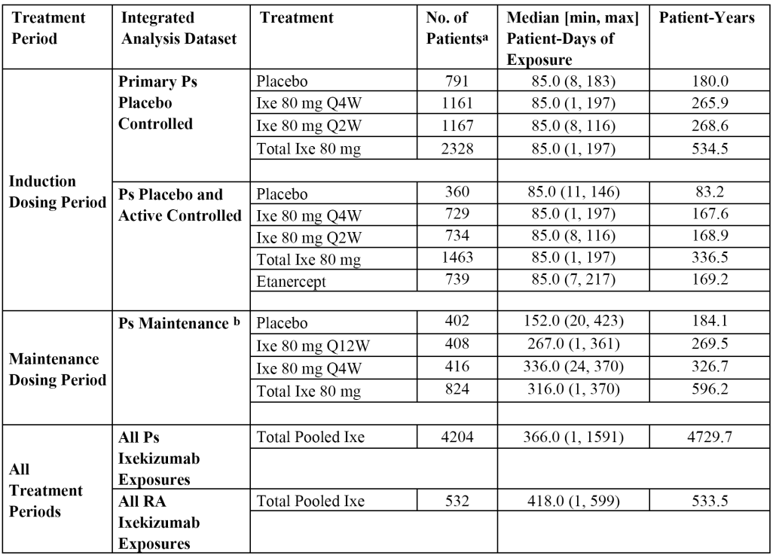
Notes: a) Note that the exposure numbers for the induction period, maintenance period, and overall categories at any time (that is, all psoriasis (Ps) and all RA) cannot be summed across categories; b) 1226 patients who were responders to treatment during the Induction Period (as measured by sPGA (score of 0 or 1) at Week 12 and were then re-randomised in the Maintenance Period were included in the Psoriasis Maintenance Integrated Analysis Set (Studies RHAZ and RHBA).
The ixekizumab exposure data based on the number of exposure days for the 4 datasets including patients treated with psoriasis are summarised below in Table 48. The table does not include data for the comparator placebo or etanercept treatment groups. However, the relevant exposure data for placebo were:
- 791 patients in the primary psoriasis placebo-controlled analysis set (12 weeks) representing 180.0 patient-years of exposure;
- 360 patients in psoriasis placebo- and active controlled analysis set (12 weeks), representing 83.2 patient-years of exposure; and
- 402 patients in the psoriasis maintenance analysis set (48 weeks) representing 184.1 patient-years of exposure.
The relevant exposure data for etanercept were 739 patients in the psoriasis placebo- and active controlled analysis set (12 weeks), representing 739 patient-years of exposure.
Table 48. Ixekizumab exposure data from the four analysis sets in patients with psoriasis
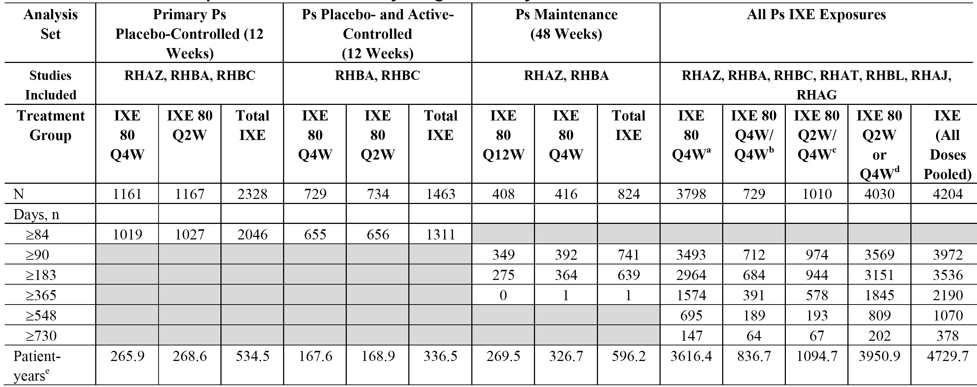
Note: Grey shading indicates that a value was not calculated or not applicable; a) data from patients who received at least one dose of ixekizumab 80 mg Q4W in Studies RHAT, RHAZ, RHBA, RHBC and RHBL; b) data from patients who received 80 mg Q4W/Q4W treatment in Studies RHAZ, RHBA and RHBC; c) data from patients who received 80 mg Q2W/Q4W treatment in Studies RHAT, RHAZ, RHBA, RHBC and RHBL; d) data from patients who started 80 mg Q2W or Q4W and either switched or remained on 80 mg Q4W in Studies RHAT, RHAZ, RHBA, RHBC and RHBL; e) total patient-years are calculated as sum of duration of exposure in days (for all patients in treatment group)/365.25.

Adverse events

Overview
TEAEs reported in the induction dosing period (primary psoriasis placebo-controlled integrated analysis set) are summarised below in Table 49. AEs were considered treatment-emergent if they first occurred or worsened following the start of treatment during a study period. TEAEs were reported irrespective of their causal relationship to treatment.

Table 49. Induction dosing period, summary of adverse events in the primary psoriasis placebo-controlled integrated analysis set; Studies RHAZ, RHBA and RHBC
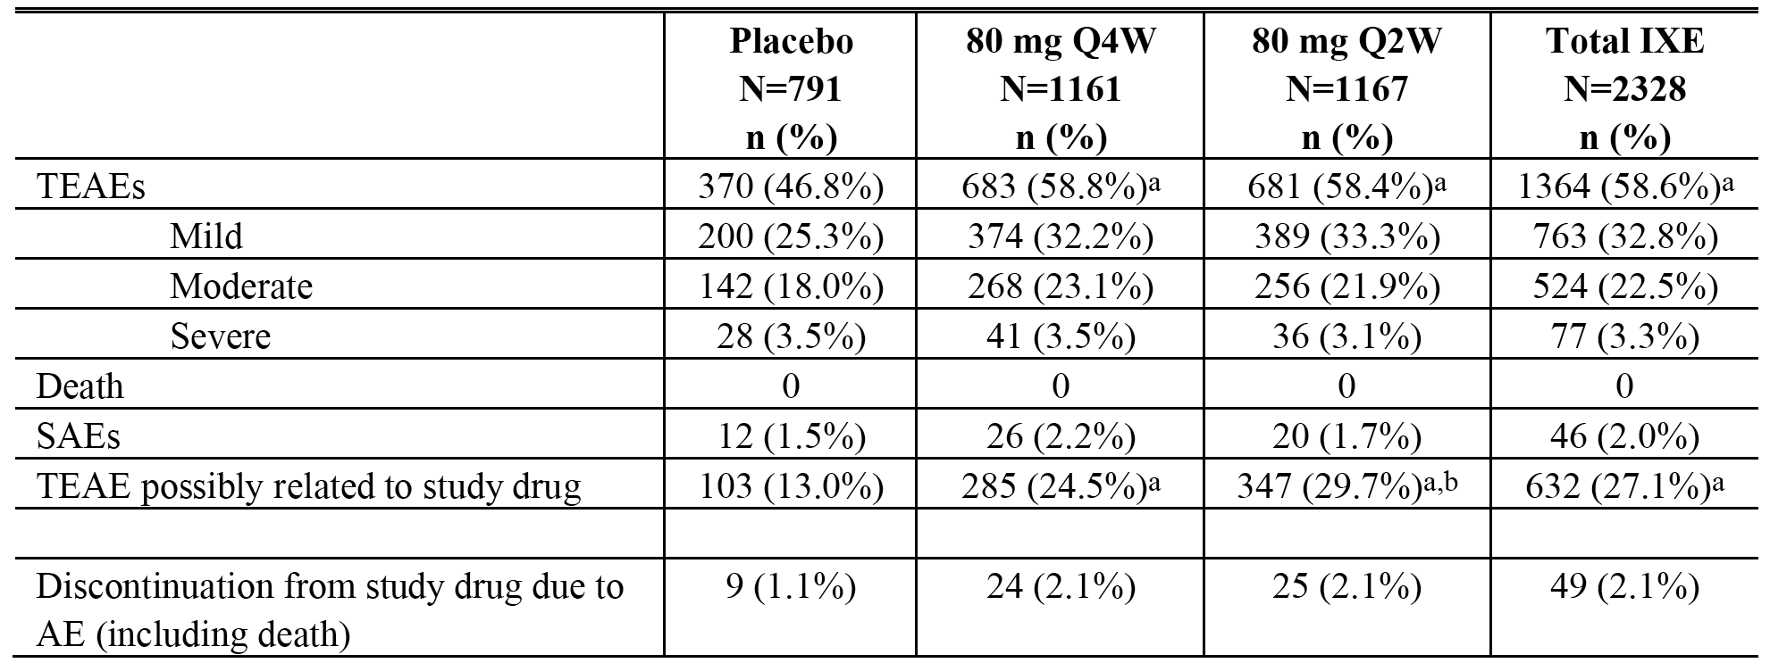
Notes: a) statistically significant compared with placebo (p < 0.05), CMH test stratified by study; b) statistically significant compared with ixekizumab 80 mg Q4W (p < 0.05), CMH test stratified by study.
Evaluator’s comment: The majority of TEAEs in the treatment groups were reported as mild or moderate in severity. TEAEs were reported significantly more commonly in patients in both ixekizumab groups compared to the placebo group, while TEAEs occurred in a similar proportion of patients in the two ixekizumab groups. No deaths were reported in the treatment groups. There were no marked differences in the proportion of patients with SAEs or discontinuations due to AEs across the treatment groups. TEAEs considered to be possibly related to the study drug were reported approximately twice as frequently in both ixekizumab groups compared to the placebo group, and the differences between ixekizumab and placebo were significant. TEAEs possibly related to the study drug were reported more frequently in the 80 mg Q2W group compared to the 80 mg Q4W group, but this difference was driven almost entirely by the higher rate of injection site reactions in the 80 mg Q2W group.
TEAEs reported in the induction dosing period (psoriasis placebo and active-controlled integrated analysis set) are summarised below in Table 50.

Table 50. Induction dosing period, summary of adverse events in the psoriasis placebo- and active-controlled integrated analysis set; Studies RHBA and RHBC
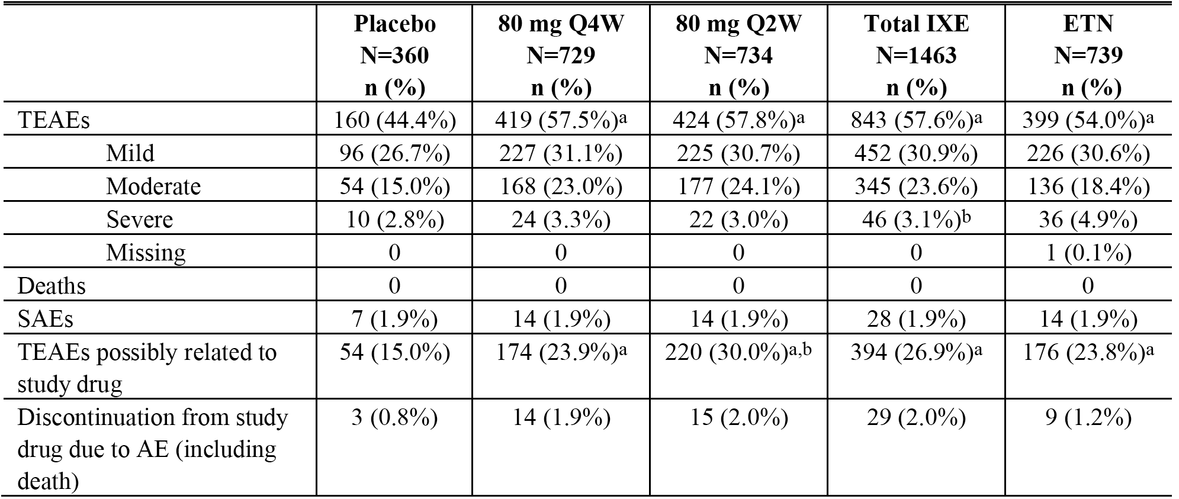
Notes: a) statistically significant compared with placebo (p < 0.05), CMH test stratified by study; b) statistically significant compared with ixekizumab 80 mg Q4W (p < 0.05), CMH test stratified by study.
Evaluator’s comment: The majority of TEAEs in the treatment groups were reported as mild or moderate in severity. TEAEs were reported significantly more commonly in patients in both ixekizumab groups and the etanercept group compared to the placebo group, while TEAEs occurred in a similar proportion of patients in the two ixekizumab groups and more frequently in both of these groups than in the etanercept group. No deaths were reported in the treatment groups. There were no marked differences in the proportion of patients with SAEs or discontinuations due to AEs across the treatment groups. TEAEs considered to be possibly related to the study drug were reported more frequently in both ixekizumab groups and the etanercept group than in the placebo group. The percentage of patients with TEAEs reported as possibly related to the study drug was significantly higher in the ixekizumab Q2W group than in the ixekizumab Q4W group.

Maintenance dosing period
Exposure-adjusted incidence rates for the TEAEs in the maintenance dosing period (psoriasis maintenance integrated analysis set) are summarised below in Table 51.

Table 51. Summary of AEs in the psoriasis maintenance integrated analysis set, maintenance dosing period; Studies RHAZ and RHBA
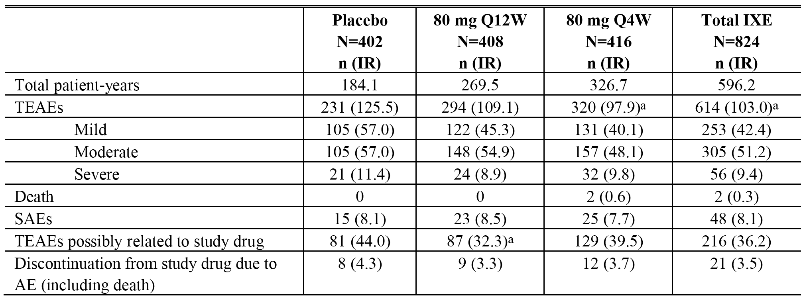
Note: the bracketed numbers are the exposure-adjusted incidence rates (TEAEs/100 patient years). a) statistically significant compared with placebo (p < 0.05), CMH test stratified by study.
Evaluator’s comment: The majority of TEAEs in the three treatment groups were reported as mild or moderate in severity. The exposure-adjusted incidence rates for TEAEs (any) were notably lower in both ixekizumab groups than in the placebo group, with the exposure-adjusted incidence rate for TEAEs (any) being lower in the ixekizumab 80 mg Q4W group than in the 80 mg Q12W group. The exposure-adjusted incidence rates for TEAEs (any) was significantly lower in the ixekizumab 80 mg Q4W group than in the placebo group. There were two deaths reported in the maintenance period, both occurring in the 80 mg Q4W group (0.6/100 patient-years). The exposure-adjusted incidence rate for TEAEs possibly related to the study drug was higher in the placebo group than in both ixekizumab groups, and the difference was significant for the comparison between the placebo and ixekizumab 80 mg Q12W group. There were no notable differences across the three treatment groups in the exposure-adjusted incidence rates of SAEs or discontinuations due to AEs (including death).
TEAEs reported in the maintenance dosing period (psoriasis maintenance integrated analysis set) for responders to ixekizumab 80 mg Q4W or 80 mg Q2W at Week 12 re-randomised to ixekizumab maintenance treatment (80 mg Q4W) from Week 12 through Week 60 (IXEQ4W/Q4W versus IXEQ2W/Q4W) are summarised below in Table 52.

Table 52. Summary of AEs in psoriasis maintenance integrated analysis set, maintenance dosing period; Studies RHAZ and RHBA
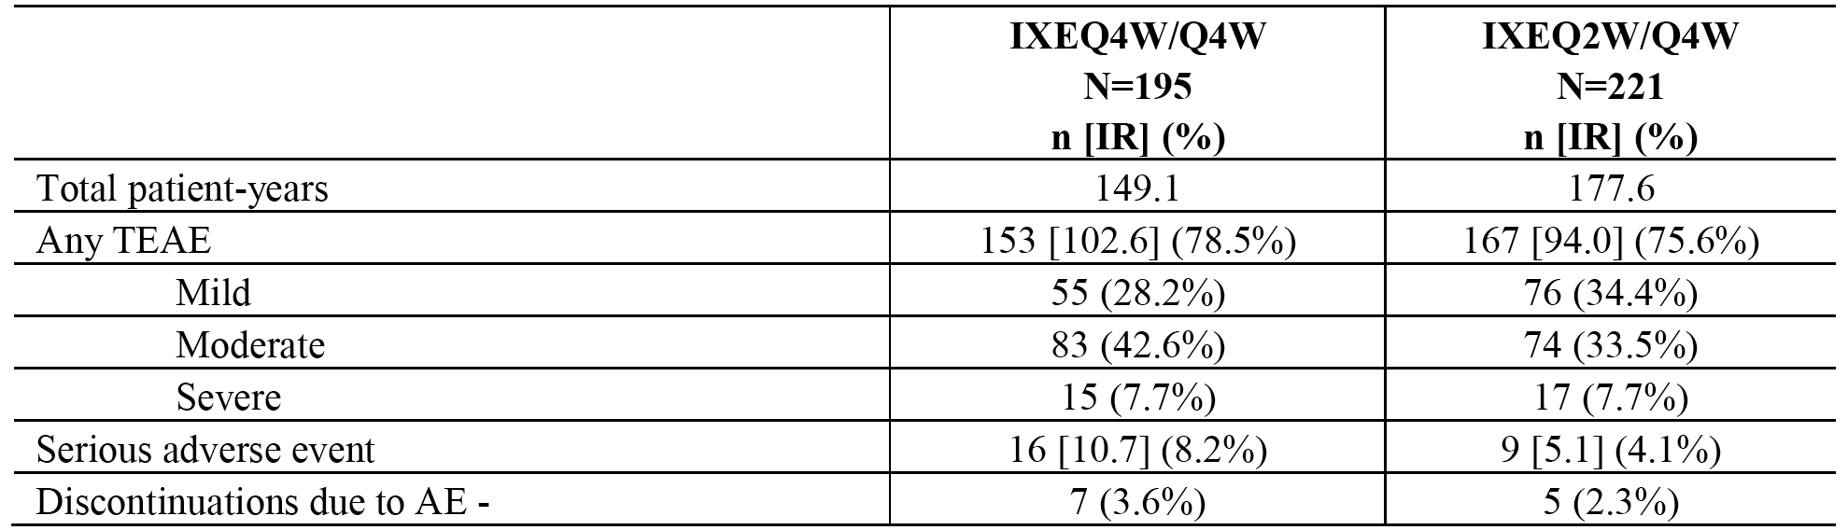
Note: the square bracketed numbers ( ) are the exposure-adjusted incidence rates per 100 patient-years.
Evaluator’s comment: The majority of TEAEs in both treatment groups were reported as mild or moderate in severity. The exposure-adjusted incidence rates for TEAEs (any) were higher in the IXEQ4W/Q4W group compared to the IXEQ2W/Q4W group, while the exposure-adjusted incidence rate for SAEs was approximately two-fold higher in the IXEQ4W/Q4W group than in the IXEQ2W/Q4W group. The unadjusted rate for discontinuations due to AEs was higher in IXEQ4W/Q4W group than in the IXEQ2W/Q4W group.
In the all psoriasis ixekizumab exposures integrated analysis set (n = 4204), TEAEs were reported in 78.3% of patients (n = 3293) (28.7% mild, 40.4% moderate, 9.2% severe), death in 0.1% (n = 5) of patients, SAEs in 7.2% (n = 303) of patients, TEAEs possibly related to the study drug in 34.2% (n = 1436) of patients, and discontinuations due to AEs in 4.5% (n = 190) of patients. In the all RA ixekizumab exposures integrated analysis set (n = 403), the safety profile was consistent with that for the all psoriasis ixekizumab exposures integrated analysis set (n = 4204).

Treatment-emergent adverse events by system organ class

Induction dosing period (primary psoriasis placebo-controlled integrated analysis set)
TEAEs occurred most frequently in the SOC of ‘infections and infestations’, with 27.2% (633/2328) of patients in the total ixekizumab group reporting at least 1 infection related TEAE compared to 22.9% (181/179) of patients in the placebo group. TEAEs in the SOC of ‘infections and infestations’ were reported in a similar proportion of patients in the ixekizumab 80 mg Q2W and 80 mg Q4W groups (27.0% (315/1167) and 27.4% (318/1161)).
Overall, SOCs reported in ≥ 5% of patients in the total ixekizumab group compared to the placebo group (n = 791), in descending order of frequency, were (respectively), ‘infections and infestations’ (27.2% versus 22.9%), ‘general disorders and administration site conditions’ (17.7% versus 6.7%), ‘skin and subcutaneous tissue disorders’ (9.7% versus 9.0%), ‘gastrointestinal disorders’ (8.3% versus 8.2%), ‘musculoskeletal and connective tissue disorders’ (7.6% versus 6.7%), and ‘nervous system disorders’ (7.0% versus 4.8%).
The only notable differences in TEAEs by SOC between the two ixekizumab treatment groups was the higher incidence of patients with ‘general disorders and administration site conditions’ in the ixekizumab 80 mg Q2W group compared to the ixekizumab 80 mg Q4W group (19.5% (228/1167) versus 15.8% (183/1161), respectively). The difference was driven by the higher incidence of injection site reactions, injection site erythema, and injection site pain in the 80 mg Q2W group due to the higher number of injections administered in this group compared to the 80 mg Q4W group.

Induction dosing period (psoriasis placebo and active-controlled integrated analysis set)
TEAEs occurred most frequently in the SOC of ‘infections and infestations’, with 26.0% (381/1463) of patients in the total ixekizumab group reporting at least 1 infection related TEAE compared to 20.6% (74/360) of patients in the placebo group and 21.5% (159/739) of patients in the etanercept group. TEAEs in the SOC of ‘infections and infestations’ were reported in a similar proportion of patients in the ixekizumab 80 mg Q2W and 80 mg Q4W groups (25.9% (190/734) versus 26.2% (191/729), respectively). The incidence of TEAEs in the SOC of ‘infections and infestations’ was higher in both ixekizumab groups than in both the placebo and etanercept groups.
SOCs accounting for ≥ 5% of TEAEs in patients in the total ixekizumab group (n = 1463) compared to patients in the placebo (n = 369) and etanercept (n = 739) groups were (respectively), ‘infections and infestations’ (26.0% versus 20.6% versus 21.5%), ‘general disorders and administration site conditions’ (18.0% versus 8.3% versus 20.4%), ‘skin and subcutaneous tissue disorders’ (9.8% versus 7.5% versus 6.5%), ‘gastrointestinal disorders’ (8.5% versus 4.7% versus 6.2%), ‘musculoskeletal and connective tissue disorders’ (8.5% versus 6.9% versus 6.0%), and ‘nervous system disorders’ (6.6% versus 3.6% versus 6.6%).

Maintenance dosing period (psoriasis maintenance integrated analysis set)
TEAEs analysed by exposure-adjusted incidence rates occurring in ≥ 1 for patients in the total ixekizumab group by SOC were summarised. TEAEs occurred most frequently in the SOC of ‘infections and infestations’, with exposure adjusted-incidence rates in the total ixekizumab group and the placebo group being 72.1 and 77.7 per 100 person-years, respectively. For ‘general disorders and administrative site conditions’ the exposure-adjusted incidence rate (SOC) was notably higher in the total ixekizumab group than in the placebo group (16.6 versus 10.9 per 100 patient-years, respectively).

All psoriasis ixekizumab exposures integrated analysis set
In the all psoiasis ixekizumab exposures integrated analysis set (n = 4204), TEAEs occurred most frequently in the SOC of ‘infections and infestations’, with 52.8% of patients treated with ixekizumab reporting at least 1 infection-related TEAE. Other SOCs with AEs occurring in ≥ 10% of patients included, ‘general disorders and administration site conditions’ (21.1%), ‘skin and subcutaneous tissue disorders’ (19.5%), ‘musculoskeletal and connective tissue disorders’ (19.2%), ‘gastrointestinal disorders’ (16.2%), ‘injury, poisoning and procedural complications’ (13.8%), ‘nervous system disorders’ (11.7%), and ‘respiratory, thoracic, and mediastinal disorders’ (10.8%).

All RA ixekizumab exposures integrated analysis set
In the all RA arthritis ixekizumab exposure integrated analysis set (n = 532), TEAEs occurred most frequently in the SOC of ‘infections and infestations’, with 45.7% of patients treated with ixekizumab reporting at least 1 infection-related TEAE. Other SOCs with TEAEs occurring in ≥ 10% of patients included, ‘musculoskeletal and connective tissue disorders’ (24.1%), ‘general disorders and administration site conditions’ (22.4%), ‘gastrointestinal disorders’ (20.3%), ‘nervous system disorders’ (18.6%), ‘skin and subcutaneous tissue disorders’ (14.1%), and ‘injury, poisoning, and procedural complications’ (10.3%).

Commonly reported treatment-emergent adverse events ( PT)

Induction dosing period (primary psoriasis placebo-controlled integrated analysis set)
TEAEs were reported more frequently in the total ixekizumab group compared to the placebo group (58.6% versus 46.8%), and with a similar frequency in the ixekizumab 80 mg Q2W and 80 mg Q4W groups (58.4% versus 58.8%, respectively).
TEAEs reported in ≥ 2.0% of patients in the total ixekizumab group (versus the placebo group), in descending order of frequency, were (respectively), nasopharyngitis (9.2% versus 8.7%), injection site reaction (8.8% versus 1.1%), headache (4.3% versus 2.9%), URTI (4.1% versus 3.5%), injection site erythema (3.6% versus 0.3%), arthralgia (2.2% versus 2.1%), and pruritus (2.0% versus 2.3%).
In general, the TEAE profiles in the ixekizumab 80 mg Q4W and 80 mg Q2W groups were similar. The only two TEAEs reported in ≥ 1% of patients in the 80 mg Q2W group (n = 1167) and in ≥ 1% more patients than in the 80 mg Q4W group (n = 1161) were (respectively), injection site reaction (10.0% versus 7.7%) and injection site erythema (4.5% versus 0.3%).
TEAEs reported in ≥ 1% of patients in the ixekizumab 80 mg Q2W group and in ≥ 1% more patients than in the placebo group were (respectively), injection site reaction (10.0% versus 1.1%), injection site erythema (4.5% versus 0.3%), headache (4.4% versus 2.9%), diarrhoea (2.1% versus 1.0%), and nausea (2.0% versus 0.6%).

Induction dosing period (psoriasis placebo and active-controlled integrated analysis set)
The incidence rate was greater in patients in the total ixekizumab group than in both the placebo and etanercept groups (57.6% versus 44.4% versus 54.0%, respectively), and the incidence rates were similar in patients in the ixekizumab 80 mg Q2W and 80 mg Q4W groups (57.8% versus 57.5%, respectively).
TEAEs reported in ≥ 2.0% of patients in the total ixekizumab group (n = 1463) versus the placebo group (n = 360) versus the etanercept group (n = 739), in descending order of frequency in the total ixekizumab group, were (respectively), injection site reaction (9.4% versus 1.1% versus 10.8%), nasopharyngitis (8.1% versus 7.8% versus 7.4%), headache (4.6% versus 2.2% versus 4.2%), URTI (3.5% versus 3.3% versus 4.6%), injection site erythema (2.6% versus 0.6% versus 3.9%), arthralgia (2.6% versus 2.2% versus 2.3%), injection site pain (2.1% versus 1.4% versus 1.2%), and pruritus (2.1% versus 1.4% versus 1.1%).
In general, the TEAE profiles in the ixekizumab 80 mg Q4W and 80 mg Q2W groups were similar. The only TEAEs reported in ≥ 1% of patients in the 80 mg Q2W group (n = 734) and in ≥ 1% more patients than in the 80 mg Q4W group (n = 729) were (respectively), injection site reaction (10.4% versus 8.5%), injection site erythema (3.3% versus 1.9%), injection site pain (2.9% versus 1.4%), and diarrhoea (2.3% versus 1.1%).
TEAEs reported ≥ 1% of patients in the 80 mg Q2W group (n = 734) and in ≥ 1% more patients than in the placebo group (n = 360) and/or the etanercept group (n = 739), were (respectively), injection site reaction (10.4% versus 1.1% versus 10.8%), headache (4.5% versus 2.2% versus 4.2%), injection site erythema (3.3% versus 0.6% versus 3.9%), injection site pain (2.9% versus 1.4% versus 1.2%), diarrhoea (2.3% versus 0.8% versus 1.1%), and nausea (2.0% versus 0.6% versus 0.4%).

Maintenance dosing period (psoriasis maintenance integrated analysis set)
The exposure-adjusted incidence rate for TEAEs in the total ixekizumab group was significantly lower than in the placebo group (103.0 versus 125.5 per 100 person-years, respectively), and lower in the ixekizumab 80 mg Q4W group than in the ixekizumab 80 mg Q12W group (97.9 versus 109.1 per 100 person years, respectively).
Exposure-adjusted incidence rates for TEAEs of ≥ 5 per 100 person-years in the total ixekizumab group (n = 824) versus the placebo group (n = 402), in descending order of frequency in the total ixekizumab group were (respectively), nasopharyngitis (24.8 versus 25.0), URTI (12.7 versus 16.8), headache (7.2 versus 6.0), arthralgia (7.0 versus 6.5), injection site reaction (6.4 versus 1.1), sinusitis (5.2 versus 5.4) and back pain (5.2 versus 4.3).
The only TEAEs reported in the ixekizumab 80 mg Q4W group with an exposure-adjusted incidence rate of ≥ 2 per 100 patient-years compared to the ixekizumab 80 mg Q12W group were (respectively), injection site reaction (8.3 versus 4.1), and upper and abdominal pain (3.1 versus 0.7). The only TEAEs reported in the ixekizumab 80 mg Q4W group with an exposure-adjusted incidence rate of ≥ 2 per 100 patient-years compared to the placebo group were injection site reaction (8.3 versus 1.1), and tinea pedis (2.8 versus 0.5).

All psoriasis ixekizumab exposures integrated analysis set
In the all psoriasis ixekizumab exposures integrated analysis set (n = 4204), TEAEs were reported in 78.3% of patients. TEAEs reported in ≥ 5% of patients were nasopharyngitis (18.6%), injection site reaction (9.9%), URTI (9.8%), headache (6.5%), and arthralgia (5.1%).

All RA ixekizumab exposures integrated analysis set
In the all RA ixekizumab exposures analysis set (n = 403), TEAEs were reported in 75.8% of patients. TEAEs reported in ≥ 5% of patients were URTI (10.7%), headache (8.3%), rheumatoid arthritis (8.1%), nasopharyngitis (7.9%), urinary tract infection (7.9%), and injection site pain (6.2%).

TEAEs (PT) possibly related to the study drug by the investigator

Induction dosing period (primary psoriasis placebo-controlled integrated analysis set)
TEAEs considered by the investigator to be possibly related to treatment with the study drug were reported notably more frequently in the total ixekizumab group (27.1% (632/2328)) than in the placebo group (13.0% (103/791)). Treatment-related TEAEs reported in ≥ 1.0% of patients in the total ixekizumab group and more frequently than in the placebo group, in descending order of frequency, were (respectively), injection site reaction (8.2% versus 1.1%), injection site erythema (3.5% versus 0.1%), nasopharyngitis (2.3% versus 1.9%), injection site pain (1.8% versus 1.6%), and headache (1.2% versus 0.6%).
Treatment-related TEAEs were reported more frequently in the ixekizumab 80 mg Q2W group than in the ixekizumab 80 mg Q4W group (29.7% (347/1167) versus 24.5% (285/1161), respectively). Treatment-related TEAEs reported in ≥ 1.0% of patients in the ixekizumab 80 mg Q2W group and more frequently than in the 80 mg Q4W group, in descending order of frequency, were (respectively), injection site reaction (9.7% versus 6.7%), injection site erythema (4.5% versus 2.6%), injection site pain (2.3% versus 1.3%), headache (1.4% versus 1.1%), and nausea (1.0% versus 0.5%).

Induction dosing period (psoriasis placebo and active-controlled integrated analysis set)
TEAEs considered by the investigator to be possibly related to the study drug were reported notably more frequently in the total ixekizumab group (26.9% (394/1463)) than in the placebo group (15.0% (54/360)), and with a similar frequency in the total ixekizumab and etanercept groups (26.9% (394/1463) versus 23.8% (176/238), respectively). Treatment-related TEAEs reported in ≥ 1.0% of patients in the total ixekizumab group and more commonly than in the placebo group, in descending order of frequency, were (respectively), injection site reaction (8.9% versus 1.1%), injection site erythema (2.5% versus 0.3%), injection site pain (2.0% versus 1.1%), headache (1.3% versus 0.8%), and nausea (1.0% versus 0.3%).
Treatment related TEAEs considered to be possibly related to the study drug were reported more frequently in the ixekizumab 80 mg Q2W group (30.0% (220/734)) than in the ixekizumab 80 mg Q4W group (23.9% (174/729)). Treatment-related TEAEs reported in ≥ 1.0% of patients in the ixekizumab 80 mg Q2W group and more commonly than in the ixekizumab 80 mg Q4W group, in descending order of frequency, were (respectively), injection site reaction (10.1% versus 7.7%), injection site pain (2.9% versus 1.1%), nasopharyngitis (2.5% versus 1.9%), headache (1.5% versus 1.1%), nausea (1.2% versus 0.7%), and URTI (1.1% versus 0.5%).

Maintenance dosing period (psoriasis maintenance integrated data set)
TEAEs considered by the investigator to be possibly related to the study drug were reported notably more frequently in the total ixekizumab treatment group (26.2% (216/824)) than in the placebo group (20.1% (81/402)). Treatment-related TEAEs reported in ≥ 1.0% of patients in the total ixekizumab group and more frequently than in the placebo, in descending order of frequency, were (respectively), nasopharyngitis (6.4% versus 3.7%), injection site reaction (4.4% versus 0.2%), injection site erythema (1.7% versus 0.5%), oral candidiasis (1.1% versus 0.2%), and bronchitis (1.0% versus 0%).
TEAEs considered to be possibly related to the study drug were reported notably more frequently in the ixekizumab 80 mg Q4W group (31.0% (129/416)) than in the ixekizumab 80 mg Q12W group (21.3% (87/408)). Treatment-related TEAEs reported in ≥ 1.0% of patients in the ixekizumab 80 mg Q4W group and more frequently than in the ixekizumab 80 mg Q12W group, in descending order of frequency, were (respectively), nasopharyngitis (7.2% versus 5.6%), injection site reaction (6.0% versus 2.7%), oral candidiasis (1.4% versus 0.7%), tinea pedis (1.4% versus 0%), pharyngitis (1.0% versus 0.7%), pruritus (1.0% versus 0%), blood CK increased (1.0% versus 0.2%), and leukopenia (1.0% versus 0.2%).

All psoriasis ixekizumab exposures integrated analysis set
In the all psoriasis ixekizumab exposures integrated analysis set, TEAEs considered by the investigator to be possibly related to the study drug were reported in 34.6% (1436/4204) of patients. Treatment-related TEAEs reported in ≥ 1.0% of patients, in descending order of frequency, were, injection site reaction (9.2%), nasopharyngitis (5.2%), injection site erythema (3.1%), URTI (2.2%), injection site pain (1.6%), headache (1.3%), and bronchitis (1.1%).

All RA ixekizumab exposures integrated analysis set
In the all RA ixekizumab exposures integrated analysis set, TEAEs considered by the investigator to be possibly related to the study drug were reported in 39.1% (208/532) of patients. Treatment-related TEAEs reported in ≥ 1.0% of patients, in descending order of frequency, were, injection site pain (6.0%), injection site erythema (4.5%), URTI (3.9%), headache (2.8%), injection site reaction (2.4%), urinary tract infection (1.9%), nasopharyngitis (1.9%), leukopenia (1.7%), pharyngitis (1.3%), diarrhoea (1.3%), pneumonia (1.1%), and dizziness (1.1%).

Deaths and serious adverse events

Deaths

Overview
Nine deaths have been reported in patients randomised to treatment in all ongoing and completed studies with ixekizumab, and one additional death has occurred in a psoriasis patient who had been screened but not randomised to treatment. Of the 9 deaths reported in the randomised patients, 4 occurred in patients treated with ixekizumab in the psoriasis studies, 3 occurred in patients treated with ixekizumab in the rheumatoid arthritis studies, and one occurred in a patient treated with etanercept in the psoriasis studies.
The 5 deaths reported in psoriasis patients treated with ixekizumab comprised 2 deaths in the maintenance dosing period of the pivotal Study RHAZ (both in the ixekizumab 80 mg Q4W group), 2 deaths in the long-term extension period (Studies RHBA and RHBC), and one death in Study RHBL during the optional safety extension period in the ixekizumab 80 mg Q4W group. There were no deaths reported during the induction dosing period of the three pivotal Studies (RHAZ, RHBA and RHBC). The 3 deaths reported in rheumatoid arthritis patients treated with ixekizumab were all reported after discontinuation from Part B of Study RHAK (2 patients received 180 mg ixekizumab, and 1 patient received 10 mg ixekizumab during Part A of the study before starting and then discontinuing from Part B). The one death reported in a psoriasis treated patient treated with etanercept occurred in Study RHBC.

Details of the 9 deaths

Psoriasis patients treated with ixekizumab (5 deaths)

Study RHAZ
A 52-year-old male who received ixekizumab 80 mg Q4W during both the induction dosing and maintenance dosing periods died due to unknown causes after 49 days in the maintenance dosing period. The relationship to the study drug was given as unknown.
A 70-year-old female who received ixekizumab 80 mg Q2W during the induction dosing period and ixekizumab 80 mg Q4W during the maintenance dosing period had a MI after 162 days in the maintenance dosing period. The investigator rated the event as severe and possibly related to study drug.

Study RHBA
A 39-year-old male who received ixekizumab 80 mg Q4W during the induction dosing period and ixekizumab 80 mg Q12W during the maintenance dosing period had a sudden cardiac arrest on Day 31 of the long-term extension period and subsequently died. The investigator rated the event as not related to study drug.

Study RHBC
A 67-year-old female in the ixekizumab 80 mg Q2W/80 mg Q4W group died during the long-term extension period due to a cerebrovascular accident. This event occurred 134 days after initiation of study treatment in the long-term extension period, and was judged by the investigator to be not related to the study drug. The stroke was independently adjudicated as an ischaemic stroke, and the event was associated with atrial fibrillation and supraventricular tachycardia.

Study RHBL
A 55-year old male (age at study entry) in the ixekizumab 80 mg Q2W/Q4W group experienced a cardiorespiratory arrest resulting in death during the safety extension period reported 128 days after the starting dose. The patient had a history of coronary artery disease, type 2 diabetes mellitus, hypertension, dyslipidemia, back pain, obesity, and stent placement. Independent adjudication concluded the death met the criteria of a presumed CV event. In the opinion of the investigator, the cardiorespiratory arrest was not related to study drug.

RA patients treated with ixekizumab (3 deaths)
Study RHAK
A 64-year-old female patient with RA (TNFα inadequate responder population) completed therapy with ixekizumab 180 mg in Part A of the study and began treatment with ixekizumab 160 mg in Part B of the study. The patient was discontinued about 3 months after starting Part B, and died shortly after discontinuation due to metastatic lung adenocarcinoma. The investigator assessed the death as unrelated to ixekizumab.
A 70-year-old male patient with RA (biological disease-modifying anti-rheumatic drug (bDMARD)-naive population) completed therapy with ixekizumab 180 mg in Part A of the study and received 2 doses of ixekizumab in Part B of the study before discontinuing treatment due to lack of efficacy. Progressive hearing loss began a few weeks after study drug discontinuation. Clinical manifestations were thought to be most consistent with an autoimmune process in the inner ear and patient was started on immunosuppressive treatments. Later, a mass at the base of the brain was discovered. Biopsy revealed granulomatous meningitis with negative stains and cultures for fungi, mycobacteria, and other microorganisms. The patient was put on multiple immunosuppressive agents, including high dose corticosteroids, infliximab, rituximab, and other biologics, but eventually died despite different treatments. The investigator assessed the event of granulomatous meningitis as possibly related to ixekizumab.
A 69-year-old female with RA (bDMARD-naive population) completed therapy with ixekizumab 10 mg in Part A and received approximately 7.5 months of treatment with this dose of ixekizumab in Part B. She discontinued treatment due to thrombocytopenia, later thought to be related, at least in part, to methotrexate, which was also discontinued. Platelets recovered, but about 5 months after last receiving ixekizumab she was hospitalised with a urinary tract infection. She died of unknown causes about 3 weeks later. Both the investigator and the sponsor assessed the event of death as unrelated to ixekizumab. During her participation in the study, possible autoimmune hepatitis was diagnosed.

Psoriasis patient treated with etanercept (1 death)

Study RHBC
A 61-year-old male died after study participation. The patient was randomised to receive etanercept, but was non-compliant after 2 weeks of treatment. The patient reported a fall 2 days after his first dose. He was discontinued from the study 18 days post-dose by the physician for non-compliance. The patient showed elevated hepatic enzymes at baseline that had worsened by the early termination visit. The patient did not return for follow up visits. The site became aware that the patient had died 152 days after initiation of study treatment. Available information was adjudicated, and it was concluded that the cause of death was related to non-cardiovascular gastrointestinal causes.

Serious adverse events (SAEs)

Induction dosing period (primary psoriasis placebo-controlled integrated analysis set)
In this analysis set, 2.0% (46/2328) of patients in the total ixekizumab group reported at least 1 SAE compared to 1.5% (12/791) of patients in the placebo group. The incidence of SAEs was lower in patients in the ixekizumab 80 mg Q2W group than in the ixekizumab 80 mg Q4W group (1.7% (20/1167) versus 2.2% (26/1161)).
SAEs reported in ≥ 2 patients in the total ixekizumab group (n = 2328) and/or the placebo group (n = 791), were (respectively), cellulitis (3, 0.1% versus 1, 0.1%), appendicitis (2, 0.1% versus 0), depression (2, 0.1% versus 0%), chronic obstructive pulmonary disease (2, 0.1% versus 1, 0.1%), Crohn's disease (2, 0.1% versus 0%), suicide attempt (2, 0.1% versus 0%), and erysipelas (2, 0.1% versus 0%). No individual SAEs were reported in ≥ 2 patients in the placebo group.
SAEs reported in ≥ 2 patients in the ixekizumab 80 mg Q2W group (n = 1167) and/or the ixekizumab 80 mg Q4W group (n = 1161), were (respectively), cellulitis (1, 0.1% versus 2, 0.2%), appendicitis (2, 0.2% versus 0%), depression (2, 0.2% versus 0%), and erysipelas (0% versus 2, 0.2%).

Induction dosing period (psoriasis placebo and active-controlled integrated data set)
In this analysis set, 1.9% (28/1463) of patients in the total ixekizumab group, 1.9% (7/360) of patients in the placebo group, and 1.9% (14/739) of patients in the etanercept group reported at least 1 SAE. The incidence of SAEs in patients in the ixekizumab 80 mg Q2W and 80 mg Q4W treatment arms was identical (1.9% (14/734) versus 1.9% (14/729)).
SAEs reported in ≥ 2 patients in the total ixekizumab group and/or the placebo group and/or the etanercept group were (respectively), depression (2, 0.1% versus 0% versus 0%), suicide attempt (2, 0.1% versus 0% versus 0%), erysipelas (2, 0.1% versus 0%), and nephrolithiasis (0% versus 0% versus 2, 0.3%). SAEs reported in ≥ 2 patients in the ixekizumab 80 mg Q2W and/or the ixekizumab Q4W groups were (respectively), depression (2, 0.3% versus 0%), and erysipelas (0% versus 2, 0.3%).

Maintenance period (psoriasis maintenance integrated analysis set)
In this analysis set, the percentage of patients with at least 1 SAE was the same in patients in the total ixekizumab and placebo groups (8.1% (48/824) versus 8.1% (15/402), respectively). The incidence of SAEs in patients in the ixekizumab 80 mg Q4W and 80 mg Q12W groups was similar (7.7% (25/416) versus 8.5% (23/408), respectively).
SAEs reported in ≥ 2 patients in the total ixekizumab group and/or the placebo group were (respectively), fall (2, 0.3% versus 2, 1.1%), cholecystitis (2, 0.3% versus 0%), coronary artery disease (2, 0.3% versus 0%), inguinal hernia (2, 0.3% versus 0%), osteoarthritis (2, 0.3% versus 0%), intervertebral disc protrusion (2, 0.3% versus 0%), and Crohn's disease (2, 1.1% versus 0%). SAEs reported in ≥ 2 patients in the ixekizumab 80 mg Q4W group and/or the ixekizumab Q12W group were (respectively), fall (2, 0.3% versus 0%), cholecystitis (2, 0.6% versus 0%), and intervertebral disc protrusion (0 versus 2, 0.3%).

All psoriasis ixekizumab exposures integrated analysis set
In the all psoriasis ixekizumab exposures integrated analysis set, 7.2% (303/4204) of patients experienced at least at least 1 SAE. SAEs occurring in ≥ 0.2% of patients (≥ 7 patients) were cellulitis (0.3%, n = 14), fall (0.2%, n = 9), acute myocardial infarction (0.2%, n = 8), MI (0.2%, n = 8), and chronic obstructive pulmonary disease (0.2%, n = 7).

All RA ixekizumab exposures integrated analysis set
In the all RA ixekizumab integrated analysis set, 10.0% (53/532) of patients experienced at least at least 1 SAE. SAEs occurring in ≥ 2 patients were acute pancreatitis (3, 0.6%), pneumonia (3, 0.6%), anaemia (2, 0,4%), appendicitis (2, 0.4%), atrial fibrillation (2, 0.4%), ischaemic stroke, and non-cardiac chest pain (2, 0.4%).

Adverse events leading to discontinuation of the study drug

Discontinuation due to adverse events

Induction dosing period (primary psoriasis placebo-controlled integrated analysis set)
AEs (including death) leading to discontinuation of the study drug were reported in 2.1% (49/2328) of patients in the total ixekizumab group and 1.1% (9/791) of patients in the placebo group. The incidence of AEs (including death) resulting in discontinuation of the study drug was identical in patients in the ixekizumab 80 mg Q2W and 80 mg Q4W groups (2.1% (25/1167) versus 2.1% (24/1161), respectively).
AEs (including death) resulting in discontinuation of the study drug reported in ≥ 2 patients in the total ixekizumab group and/or the placebo group were (respectively), injection site reaction (4, 0.1% versus 0%), appendicitis (2, 0.1% versus 0%), AST increased (2, 0.1% versus 0%), psoriasis (2, 0.1% versus 2, 0.3%), cellulitis (2, 0.1% versus 0), Crohn's disease (2, 0.1% versus 0), and diarrhoea (2, 0.1% versus 0%). AEs (including death) resulting in discontinuation of the study drug reported in ≥ 2 patients in the ixekizumab 80 mg Q2W group and/or the ixekizumab 80 mg Q4W group were (respectively), injection site reaction (4, 0.2% versus 0%), appendicitis (2, 0.2% versus 0%), and AST increased (2, 0.2% versus 0%).

Induction dosing period (psoriasis placebo and active-controlled integrated analysis set)
AEs (including death) leading to discontinuation of the study drug were reported in 2.0% (29/1463) of patients in the total ixekizumab group, 0.8% (3/360) of patients in the placebo group and 1.2% (9/739) of patients in the etanercept group. The incidence of AEs (including death) resulting in discontinuation of the study drug was similar in patients in the ixekizumab 80 mg Q2W and 80 mg Q4W groups (2.0% (15/734) versus 1.9% (14/729), respectively).
AEs (including death) resulting in discontinuation of the study drug reported in ≥ 2 patients in the total ixekizumab group and/or the placebo group and/or the etanercept group were (respectively), psoriasis (2, 0.1% versus 1, 0.3% versus 0%), and diarrhoea (2, 0.1% versus 0% versus 0%). No AEs (including death) were reported in ≥ 2 patients in either the ixekizumab 80 mg Q2W group or the ixekizumab 80 mg Q4W group.

Maintenance dosing period (psoriasis maintenance integrated analysis set)
AEs (including death) leading to discontinuation of the study drug were reported in 2.5% (21/824) of patients in the total ixekizumab group and 2.0% (8/402) of patients in the placebo group. Patients with ≥ AEs (including death) leading to discontinuation of the study drug were reported more frequently in the ixekizumab 80 mg Q4W group than in the ixekizumab 80 mg Q12W group (2.9% (12/416) versus 2.2% (9/408), respectively).
AEs (including death) resulting in discontinuation of the study drug reported in ≥ 2 patients in the total ixekizumab group and/or the placebo group were (respectively), tuberculin test positive (2, 0.2% versus 0%); and mycobacterium tuberculosis complex test positive (2, 0.2% versus 0%). AEs (including death) resulting in discontinuation of the study drug reported in ≥ 2 patients in the ixekizumab Q4W group and/or the ixekizumab 80 mg Q12W group were (respectively), tuberculin test positive (2, 0.5% versus 0%), and mycobacterium tuberculosis complex test positive (0% versus 2, 0.5%).
Patients with AEs (including death) leading to discontinuation of the study drug were reported in 2.3% (5/221) of patients in the ixekizumab 80 mg Q2W/Q4W group and 3.6% (7/195) of patients in the ixekizumab 80 mg Q4W/Q4W group. In both ixekizumab treatment groups, no AEs (including death) leading to discontinuation of the study drug were reported in ≥ 2 patients.

All psoriasis ixekizumab exposures integrated analysis set
In the all psoriasis ixekizumab exposures integrated analysis set, AEs (including death) leading to discontinuation of the study drug were reported in 4.5% (190/425) of patients. AEs (including death) resulting in discontinuation of the study drug reported in ≥ 4 (0.1%) patients were, tuberculin test positive (14, 0.3%), latent tuberculosis (7, 0.2%), injection site reaction (6, 0.1%), ulcerative colitis (4, 0.1%), Crohn's disease (4, 0.1%), drug hypersensitivity (4, 0.1%), exposure during pregnancy (4, 0.1%), mycobacterium tuberculosis positive (4, 0.1%), and psoriasis (4, 0.1%).

All RA ixekizumab exposures integrated analysis set
In the all RA ixekizumab exposures integrated analysis set, AEs (including death) leading to discontinuation of the study drug were reported in 3.9% (21/532) of patients. AEs (including death) resulting in discontinuation of the study drug reported in ≥ 2 patients were furuncle (2, 0.4%), and RA (2, 0.4%).

Laboratory tests
The sponsor provided data on a comprehensive selection of clinically relevant haematology, clinical chemistry and urinalysis laboratory parameters. The data were summarised using the percentage of patients in each treatment group with treatment-emergent high and treatment-emergent low results, with treatment-emergent low results being defined as a change from values ≥ lower limit of normal (LLN) at baseline to values < LLN at any time post-baseline and treatment-emergent high results being defined a change from values ≤ upper limit of normal (ULN) at baseline to values > ULN at any time post-baseline. The data were also summarised using LS mean change from last observation at baseline to last observation post-baseline, based on a LS model adjusted for baseline and study effect. The haematology results for cytopaenia and the clinical chemistry results for liver function were presented in the ISS as AESI, and these are reviewed later in this clinical evaluation.
In order to account for all differences that might be clinically meaningful the sponsor presented treatment-emergent findings that were either statistically significantly higher in the ixekizumab treatment group or not statistical significantly in the ixekizumab treatment group but with a difference large enough to warrant further exploration (that is, Mantel Haenszel OR > 2 versus placebo; the absolute count among ixekizumab treated subjects is at least 4; and incidence > 1% for the total ixekizumab group).

Haematology

Induction dosing period (primary psoriasis placebo-controlled integrated analysis set)

Treatment-emergent low or treatment-emergent high values
The following differences refer to statistically significant pairwise comparisons between the total ixekizumab group and the placebo group based on the CMH test stratified by study (p < 0.05), and OR of > 1. Treatment-emergent low results were reported more frequently in patients in the total ixekizumab group compared to the placebo group were observed for neutrophils, segmented neutrophils, leucocytes, platelets, and CD8 fraction.

Mean change from baseline
The following differences refer to statistically significant pairwise comparisons between the total ixekizumab group and the placebo for LS mean change from baseline last observation to post-baseline last observation (p < 0.05), with LS mean change being greater for ixekizumab than for placebo. LS mean decrease from baseline larger in patients in the total ixekizumab group compared to the placebo group were observed for neutrophils, eosinophils, monocytes, haemoglobin, basophils, CD8 fraction, and mean corpuscular/cell volume (MCV); and LS mean increase from baseline higher in patients in the total ixekizumab group compared to the placebo group were observed for erythrocytes. The absolute differences in the haematology parameters for the total ixekizumab group and the placebo group were small and are unlikely to be clinically significant.

Induction dosing period (psoriasis placebo and active controlled integrated analysis set)

Treatment-emergent low or treatment-emergent high values
The following differences refer to statistically significant pairwise comparisons between the total ixekizumab group and the etanercept group based on the CMH test stratified by study (p < 0.05), and OR of > 1. treatment-emergent low CD16+ 56 fraction was reported significantly more frequently in the total ixekizumab group than in the etanercept group (5.3% (69/13310) versus 2.0% (13/639); p < 0.001); treatment-emergent high CD4 fraction was reported significantly more frequently in the total ixekizumab group than in the etanercept group (5.4% (66/1227) versus 1.3% (8/604); p < 0.001); and treatment-emergent high erythrocyte MCV levels were reported significantly more frequently in the total ixekizumab group than in the etanercept group (0.6% (8/1441) versus 0% (0/725); p = 0.044).
There were a number of significant differences in mean change from baseline last observation to post-baseline last observation between the total ixekizumab and etanercept groups, but the differences were numerically small and unlikely to be clinically significant.

Maintenance dosing period (psoriasis maintenance integrated analysis set)
There were a small number of significant differences (CMH stratified by study, p < 0.05 and OR > 1) between the total ixekizumab and placebo groups in proportions of patients with treatment-emergent high or treatment-emergent low haematology values (CD8 fraction treatment-emergent high; monocytes treatment-emergent high; mean corpuscular haemoglobin concentration (MCHC) treatment-emergent low). There only significant difference between the total ixekizumab group and the placebo group in mean change from baseline observation to post-baseline last observation was for the CD16+ 56 fraction. The observed differences between the two treatment groups were small and unlikely to be clinically significant.

All psoriasis ixekizumab exposures integrated analysis set
The most notable abnormalities reported in patients in this analysis set (n = 4204) were: leukocytes (4.8% abnormal low and 3.1% abnormal high); lymphocytes (3.5% abnormal low and 1.0% abnormal high); neutrophils (5.8% abnormal low and 5.4% abnormal high), platelets (3.4% abnormal low and 1.6% abnormal high); and CD4/CD8 ratio (treatment-emergent low 2.2% and treatment-emergent high 5.4%). No other potentially clinically significant trends were observed. Abnormal results were defined as change from normal at baseline to abnormal at any time during the treatment period. Treatment-emergent low and treatment-emergent high values were as defined above.

All RA ixekizumab exposures integrated analysis set
The most notable treatment-emergent high or treatment-emergent low values reported in patients in this analysis set (n = 4204) were: leukocytes (8.4% treatment-emergent low and 9.4% treatment-emergent high); lymphocytes (11.9% treatment-emergent low and 1.7% treatment-emergent high); segmented neutrophils (5.3% treatment-emergent low and 12.8% treatment-emergent high); platelets (2.5% treatment-emergent low and 4.8% treatment-emergent high; MCHC (treatment-emergent low 23.9%); and haematocrit (treatment-emergent low 9.6%).

Clinical chemistry

Induction dosing period (primary psoriasis placebo-controlled integrated analysis set)
The liver function test results are summarised in detail later in this CER as part of the review of AESI.
Apart from liver function tests (LFT), treatment-emergent high or treatment-emergent low clinical laboratory values with a ≥ 1 % difference between the total ixekizumab group and the placebo group were, treatment-emergent high apolipoprotein B higher in the total ixekizumab group compared to the placebo group (4.2% versus 2.7%), treatment-emergent high blood urea nitrogen higher in the total ixekizumab group compared to the placebo group (2.0% versus 0.9%), treatment-emergent high creatine kinase (CK) higher in the total ixekizumab group compared to the placebo group (6.8% versus 4.3%), treatment-emergent low glucose lower in the total ixekizumab group compared to the placebo group (2.1% versus 6.3%), and treatment-emergent high phosphate higher in the total ixekizumab group compared to the placebo group (2.7% versus 1.0%). There were no significant differences at any time between the total ixekizumab group and placebo for patients with TE CK values ≥ 800 U/L or ≥ 5,000 U/L.
There were no significant differences between the total ixekizumab and placebo groups in mean change from baseline to last observation post-baseline, as regards creatinine clearance, serum creatine, serum creatinine kinase, serum glucose, triglycerides, serum phosphate, serum protein, serum albumin, serum calcium, serum sodium, or serum bicarbonate.
Significant increases in mean change from baseline to last observation post-baseline in the pro-atherogenic components of the assessed lipid panel were observed in the total ixekizumab group compared to the placebo group (low density lipoprotein (LDL) cholesterol, very low density lipoprotein (VLDL) cholesterol, and apolipoprotein B). However, the size of the mean changes for each of the parameters was small and no further increases occurred during the maintenance dosing period. In addition, there was no dose response in the categorical analyses of the lipid panel parameters. The LS mean differences (95% CI) for the changes from baseline to last observation between the total ixekizumab group and the placebo group for the pro-atherogenic lipid parameters were, LDL cholesterol 3.2 mg/dL (1.4 to 4,9), VLDL 1.4 mg/dL (0.5 to 2.3), and apolipoprotein B 0.023 g/L (0.009 to 0.041).
The mean change in the serum urate concentration (mg/dL) from baseline to last observation decreased in the total ixekizumab group and increased in the placebo group, with the LS mean difference (95% CI) between the two groups being -0.15 (-0.22 to -0.08). The difference between the two groups was categorised as significant. The sponsor postulates that this may be due to a decrease in disease activity in the ixekizumab group resulting from decreased epidermal cell turnover. However, there were no related treatment-emergent high or treatment-emergent low findings for serum urate concentrations.
The mean reduction in high-sensitivity C-reactive protein (hs-CRP) in mg/L was greater in the total ixekizumab group than in the placebo group, with the LS mean difference being -1.189 (95% CI: -1.949 to -0.428). The difference between the two groups was categorised as significant. The sponsor postulates that this might be due to a decrease in disease reactivity in the ixekizumab group (decreased epidermal cell turnover).

Induction dosing period (psoriasis placebo active controlled integrated analysis set)
The results for the comparisons between the ixekizumab groups and the etanercept group for the laboratory parameters have been examined. Treatment-emergent high hs-CRP (mg/mL) activity was reported significantly more frequently in patients in the etanercept group compared to the total ixekizumab group (17.2% (53/309) versus 14.1% (176/1248); p = 0.004). Treatment-emergent high serum CK levels were reported significantly more frequently in patients in the total ixekizumab group than in the etanercept group (7.4% (105/1421) versus 4.9% (17/350); p = 0.010). Treatment-emergent low serum immunoglobulin M levels were reported significantly more frequently in patients in the total ixekizumab group than in the etanercept group (1.2% (16/1382) versus 0.9% (3/344); p = 0.005). Overall, observed differences across the ixekizumab and etanercept groups as regards the percentage of patients with treatment-emergent low or treatment-emergent high values post-baseline, and in mean change from baseline to last observation post-baseline are unlikely to be clinically significant. The liver function test results for this integrated analysis set are summarised in detail later in this clinical evaluation as part of the review of AESI.

Maintenance dosing period (psoriasis maintenance integrated analysis set)
The results for the ixekizumab and the placebo group have been examined. It is considered that the observed differences across the ixekizumab and placebo treatment groups as regards the percentage of patients with treatment-emergent low or treatment-emergent high values post-baseline, and in mean change from baseline to last observation post-baseline are unlikely to be clinically significant. The LFT results for this integrated analysis set are summarised in detail later in this clinical evaluation as part of the review of adverse events of special interest.

All psoriasis ixekizumab exposures integrated analysis set
Clinical chemistry values with treatment-emergent high or treatment-emergent low values in ≥ 10% of patients in descending order of frequency were: treatment-emergent low bicarbonate (59.3%); treatment-emergent high ALT (25.9%); treatment-emergent high VLDL cholesterol (23.8%); treatment-emergent high AST (22.0%); treatment-emergent high creatinine clearance (19.2%); treatment-emergent high CRP (16.4%); treatment-emergent high gamma-glutamyl transaminase (GGT) (12.2%); treatment-emergent low bilirubin (10.9%); treatment-emergent high CK (10.5%); and treatment-emergent low activated partial thromboplastin time (10.1%).
Treatment-emergent high CK values were reported in 10.5% of ixekizumab treated patients. For the majority of ixekizumab-treated patients with treatment-emergent high CK values > 5000 U/L, elevations were at only one time point or were transient in nature, and many of these elevations were associated with increased physical activity. In order to further evaluate the effect of ixekizumab on CK and potentially related clinical outcomes, TEAEs (for example, renal insufficiency and rhabdomyolysis) were evaluated by the sponsor. This sponsor stated that the analysis indicated no association with increased CK and AEs related to renal insufficiency. For 3 out of the 4 cases of rhabdomyolysis reported in ixekizumab-treated patients, 2 cases were attributed to physical exercise and all 3 CK values returned to baseline or near baseline while still on ixekizumab, while 1 case had other confounding conditions (cerebrovascular accident, supraventricular tachycardia, seizures) that may have contributed to an elevated CK value. No serious/severe neuromuscular events observed.

Immunoglobulin shifts from baseline to post-baseline

Induction dosing period, primary psoriasis placebo-controlled integrated analysis set
The proportion of patients in the total ixekizumab group experiencing shifts (increases or decreases) in immunoglobulin concentrations from baseline to post-baseline was low (0.3% for IgA, 0.6% for IgG, and 2.6% for IgM), and the proportions of patients with decreases and increases were similar for each of the immunoglobulins. There were no clear differences in the proportion of patients in the ixekizumab and placebo groups with shifts in immunoglobulins, or between the 2 ixekizumab treatment ixekizumab groups (80 mg Q2W and 80 mg Q4W).

Induction dosing period, psoriasis placebo active controlled integrated analysis set
The proportion of patients in the total ixekizumab group experiencing shifts (increases or decreases) in immunoglobulin concentrations from baseline to post-baseline was low (0.3% for IgA, 0.7% for IgG, and 2.6% for IgM), and the proportions of patients with decreases or increases were similar for each of the immunoglobulins.
The proportion of patients in the etanercept group experiencing shifts (increases or decreases) in immunoglobulin concentrations from baseline to post-baseline was low (0.7% for IgA, 0.4% for IgG, and 3.6% for IgM), and the proportion of patients with decreases was lower than increases for (0.1% versus 0.6%), IgG (0.1% versus 0.3%) and IgM (0% versus 3.6%).
The proportion of patients in the placebo group experiencing shifts (increases or decreases) in immunoglobulin concentrations from baseline to post-baseline was low (0% for IgA, 0.6% for IgG, and 2.8% for IgM), and the proportions of patients with decreases were similar to the proportions with increases.

Maintenance dosing period - primary population analysis set
The proportion of patients in the total ixekizumab group experiencing shifts (increases or decreases) in immunoglobulin concentrations from baseline to post-baseline was low (0.1% for IgA, 0.9% for IgG, and 4.2% for IgM). For IgA and IgG, proportions of patients with decreases were similar to proportions with increases, and there were no clear differences between ixekizumab and placebo or between the ixekizumab 80 mg Q4W and Q12W treatment groups. For IgM, decreases were more common than increases (3.8% versus 0.4% of total ixekizumab patients), and IgM decreases were more common in the total ixekizumab patient group (3.8%) than in the placebo group (2.3%).

All psoriasis ixekizumab exposures integrated analysis set
The proportion of patients treated with ixekizumab experiencing shifts (increases or decreases) in immunoglobulin concentrations from baseline to post-baseline was low (0.2% for IgA, 0.7% for IgG, and 4.1% for IgM). For IgA and IgG, proportions of patients with decreases were similar to proportions with increases, while for IgM, decreases were more common than increases (3.5% versus 0.6%, respectively).

All RA ixekizumab exposures integrated analysis set
The proportion of patients treated with ixekizumab experiencing shifts (increases or decreases) in immunoglobulin concentrations from baseline to post-baseline was low (0.5% for IgA, 0% for IgG, and 2.4% for IgM). For IgA and IgG, proportions of patients with decreases were similar to proportions with increases, while for IgM, decreases were more common than increases (2.2% versus 0.3%, respectively).

Vital signs
In the all psoriasis ixekizumab exposures integrated analysis set, 24.1% (812/4191) of patients had treatment-emergent high diastolic blood pressure (≥ 90 mmHg and ≥ 10 mmHg increase) and 15.6% had treatment-emergent high systolic blood pressure (≥ 140 mmHg and ≥ 20 mmHg increase). The percentages of patients reporting treatment-emergent low diastolic blood pressure (≤ 50 mmHg and ≥ 10 mmHg decrease) was 1.6% (69/4191), and the percentage of patients reporting treatment-emergent low systolic blood pressure (≤ 90 mmHg and ≥ 20 mmHg decrease) was 1.4%. The percentages of patients reporting treatment-emergent low pulse rate (< 50 beats per minute (bpm) and decrease ≥ 15 bpm) and treatment-emergent high pulse rate (> 100 bpm and increased ≥ 15 bpm) were 0.9% (35/4025) and 3.8% (153/4034), respectively. The percentages of patients reporting treatment-emergent low weight (decrease from baseline weight (kg) ≥ 7%) and treatment-emergent high weight (increase from baseline weight (kg) of ≥ 7%) were 0.9% (35/4025) and 3.8% (153/4034), respectively.
The only vital sign TE changes of note related to treatment-emergent high diastolic and treatment-emergent high systolic blood pressure. The incidence of these events in the induction and maintenance dosing periods are summarised below.

Induction dosing period (primary psoriasis placebo-controlled integrated analysis set)
treatment-emergent high diastolic blood pressure was reported in 13.2% (n = 77), 11.3% (n = 99) and 11.6% (n = 100) of patients in the placebo, ixekizumab 80 mg Q4W, and ixekizumab 80 mg Q2W groups, respectively. treatment-emergent high systolic blood pressure was reported in 7.1% (n = 39), 5.2% (n = 42) and 5.6% (n = 46) of patients in the placebo, ixekizumab 80 mg Q4W, and ixekizumab 80 mg Q2W groups, respectively. There were no notable differences in the proportion of patients in the three treatment groups with either treatment-emergent high diastolic and or treatment-emergent high systolic blood pressure.

Induction dosing period (psoriasis placebo and active-controlled integrated analysis set)
treatment-emergent high diastolic blood pressure was reported in 14.0% (n = 35), 11.6% (n = 64), 10.5% (n = 100) and 12.3% (n = 67) of patients in the placebo, etanercept, and ixekizumab 80 mg Q4W group and ixekizumab 80 mg Q2W groups, respectively. treatment-emergent high systolic blood pressure was reported in 5.9% (n = 14), 4.5% (n = 22), 5.6% (n = 28) and 6.6% (n = 35) of patients in the placebo, etanercept, and ixekizumab 80 mg Q4W group and ixekizumab 80 mg Q2W groups, respectively. There were no notable differences in the proportion of patients in the four treatment groups with either treatment-emergent high diastolic and or treatment-emergent high systolic blood pressure.

Maintenance dosing period (psoriasis maintenance integrated analysis set)
Treatment-emergent high diastolic blood pressure was reported in 18.2% (n = 61), 21.2% (n = 75) and 20.2% (n = 70) of patients in the placebo, ixekizumab 80 mg Q12W, and ixekizumab 80 mg Q4W groups, respectively. treatment-emergent high systolic blood pressure was reported in 11.8% (n = 39), 16.6% (n = 55) and 17.1% (n = 58) of patients in the placebo, ixekizumab 80 mg Q12W, and ixekizumab 80 mg Q4W groups, respectively. There were no notable differences in the proportion of patients with treatment-emergent high diastolic blood pressure in the three treatment groups, while high treatment-emergent systolic blood pressure was observed in a greater proportion of patients in both ixekizumab treatment groups compared to placebo. There was a significantly higher proportion of patients with high treatment-emergent systolic blood pressure in the total ixekizumab group compared to placebo (16.9% (n = 113) versus 11.8% (n = 39). This finding was inconsistent with the results in the primary psoriasis placebo-controlled integrated analysis set where the proportion of patients with treatment-emergent high systolic pressure was similar in the total ixekizumab and placebo groups (5.4% (n = 88) versus 7.1% (n = 38), respectively). The reason for the inconsistent findings is unknown.

Electrocardiographic changes
There were no significant differences in the incidence of patients with treatment-emergent high or treatment-emergent low ECG intervals or heart rate values at any time post-baseline for any ixekizumab group versus placebo in primary psoriasis placebo-controlled integrated analysis set, for any ixekizumab group versus etanercept in the placebo- and active-controlled integrated analysis set, or for any ixekizumab group versus placebo in the maintenance integrated analysis set.

Induction dosing period (primary psoriasis placebo-controlled integrated analysis set)
The only significant mean changes from baseline to post-baseline in ECG parameters were greater mean increases in PR duration (ms) in the ixekizumab 80 mg Q2W group compared to the placebo group (LS mean difference = 1.3 ms (95% CI: 0.3, 2.2)) and for the ixekizumab 80 mg Q2W group compared to the ixekizumab 80 mg Q4W group (iLS mean difference = 1.0 ms (95% CI: 0.2, 1.9)). However, the absolute LS mean differences between the groups were small and are unlikely to be clinically significant.

Induction dosing period (psoriasis placebo active controlled integrated analysis set)
The only significant mean changes from baseline to post-baseline in ECG parameters between ixekizumab and etanercept were larger decreases in the QRS interval for the ixekizumab 80 mg Q4W group versus the etanercept group (LS mean difference = -0.6 (95% CI: -1.2, 0.1)), and for the ixekizumab 80 mg Q2W group versus the etanercept group (LS mean difference = -0.6 (95% CI: -1.1, -0.0)). However, the absolute LS mean differences between the groups were small and are unlikely to be clinically significant.

Maintenance dosing period (psoriasis maintenance integrated analysis set)
There were no significant mean changes from baseline to post-baseline in ECG parameters for the ixekizumab groups (80 mg Q4W; 80 mg Q2W) and for the placebo group.

QTc interval changes

Induction dosing period (primary psoriasis placebo-controlled integrated analysis set)
In the induction dosing period (primary psoriasis placebo-controlled integrated analysis set), analysis of the post-baseline results for the QTc interval and the QTcLCTPB interval (that is, clinical trial population based correction factor = QT/RR^{0.413}) showed the following:
- there were no patients with QTcF or QTcLCTPB post-baseline maximum interval increases of > 30 ms, > 60 ms or > 75 ms from maximum baseline levels;
- there was a significantly higher incidence of patients with QTcLCTPB intervals > 500 ms in the ixekizumab 80 mg Q2W group compared to the ixekizumab 80 mg Q4W group (4 patients (0.4%) versus no patients; p = 0.045);
- there was a numerically higher incidence of patients with QTcLCTPB intervals > 500 ms in the ixekizumab 80 mg Q2W group compared to the placebo group (4 patients (0.4%) versus 1 (0.1%); OR = 3.28; not statistically significant);
- there were 4 patients in the ixekizumab 80 mg Q2W group who had QTcLCTPB intervals > 500 ms (2 patients also had QTcF intervals > 500 ms), including 1 patient who experienced atrial fibrillation (SAE) on the day of randomisation to ixekizumab, was started on ramipril and indapamide and 1 week later had a QTcLCTPB interval > 500 ms and was discontinued due to sponsor decision, 1 patient with baseline QTcLCTPB interval of 506 ms meeting the QTcLCTPB interval > 500 ms criteria at the visit resulting in discontinuation due to nausea; and 2 patients continued in the study on ixekizumab with QTcLCTPB interval decreasing to < 500 ms;
- there was 1 placebo-treated patient with both elevated QTcLCTPB and QTcF intervals > 500 ms.

Induction dosing period (psoriasis placebo, active controlled integrated analysis set
In the induction dosing period (psoriasis placebo- active-controlled integrated analysis set), analysis of the post-baseline results for the QTc and QTcLCTPB intervals showed the following:
- there were no patients with QTcF or QTcLCTPB post-baseline maximum interval increases of > 30 ms, > 60 ms or > 75 ms from maximum baseline levels;
- there were 2 patients in the ixekizumab 80 mg Q2W group with QTcLCTPB intervals > 500 ms, with 1 of these patients also having QTcF intervals > 500 ms. These 2 patients have been discussed above.

Maintenance dosing period (psoriasis maintenance integrated analysis set)
In the maintenance dosing period (psoriasis maintenance integrated analysis set), analysis of the post-baseline results for the QTc and the QTcLCTPB intervals showed 9 ixekizumab-treated patients (1.2%) with QTcF post-baseline maximum interval increases of > 30 ms compared to maximum baseline intervals, and 13 ixekizumab-treated patients (1.7%) versus 3 placebo-treated patients (0.9%) with QTcLCTPB post-baseline maximum interval increases of > 30 ms compared to maximum baseline intervals. There were no patients with QTcF or QTcLCTPB post-baseline maximum increases > 60 ms or > 75 ms compared to maximum baseline intervals, and no patients with intervals > 500 ms.

All psoriasis ixekizumab exposures integrated analysis set
In the all psoriasis ixekizumab exposures integrated analysis set, 5.3% (190/3569) of patients had treatment-emergent high QTcLCTPB intervals and 2.2% (83/3744) of patients had treatment-emergent high QTcF intervals. QTcF intervals > 30 ms than maximum baseline intervals at any time post-baseline were reported in 1.6% (61/3902) of patients, and 4 patients (0.1%) had QTcLCTPB intervals > 500 ms, with 2 of these patients (0.1%) also having QTcF intervals > 500 ms. The 4 patients with QTc intervals > 500 ms have been discussed above in the paragraph relation to the induction dosing period in the primary psoriasis placebo-controlled integrated analysis set.

Other safety issues

Safety in special populations
TEAE subgroup analyses were performed in each of the 3 placebo-controlled integrated analysis sets using baseline demographic factors. Safety in special groups was assessed by summarising the most common TEAEs (reported by at least 1% of total ixekizumab-treated patients). Treatment-by-subgroup interactions were evaluated at a significance level of p <0.1 from a logistic regression model with incidence of TEAE as the response variable and study, treatment, subgroup, and treatment-by-subgroup interaction as predictor variables. A significant treatment-by-subgroup interaction suggests that the difference between treatments is not consistent across the subgroups. Comments on the treatment-by-subgroup interactions for relevant subgroups are presented below.

Age
Of the 4204 patients with psoriasis enrolled in the ixekizumab studies, 3903 (92.8%) were aged < 65 years and 301 (7.2%) were aged ≥ 65 years (265 (6.3%) aged ≥ 65 to < 75 years; 34 (0.8%) aged ≥ 75 to 34 years; and 2 (0.05%) aged ≥ 85 years). The majority of patients were aged < 65 years and, consequently, comparisons of safety data across age groups should be interpreted cautiously due to the imbalance in ages across the treatment population. Treatment-by-age subgroup interactions were not significant (p > 0.1) for any TEAEs (SOC or PT) in any of the 3 placebo-controlled integrated analysis sets. The tested age subgroups were < 65, ≥ 65 and < 75, ≥ 75 years).
The submission included an assessment of AEs by specified age categories. The observed differences in the safety findings across the age groups are not of sufficient concern to recommend different ixekizumab dosing regimens based on age. However, the imbalance between the number of patients aged < 65 and ≥ 65 years is considered to be too great to draw definitive conclusions regarding the effect of age on the safety of ixekizumab.

Sex
Of the 4204 patients with psoriasis enrolled in the ixekizumab studies, 2846 (67.7%) were male and 1358 (32.3%) were female. Treatment-by-sex interactions were significant (p < 0.1) for a number of TEAEs (SOC or PT), but inspection of raw incidence data suggests that the identified interactions are unlikely to be clinically significant.

Induction dosing period (primary psoriasis placebo-controlled integrated analysis set)
In the induction dosing period (primary psoriasis placebo-controlled integrated analysis set), the following interactions were significant (p < 0.1):
- The difference between the ixekizumab doses and placebo in the percentage of patients reporting at least 1 TEAE and the percentage of patients reporting injection site reaction was greater in males than in females.
- The interaction was significant for back pain and cough. However, the differences between ixekizumab and placebo were not significant within either sex for either of the TEAEs. Males treated with ixekizumab had numerically higher rates of back pain than females treated with ixekizumab. There were inconsistent findings of subgroup effect for cough in the ixekizumab Q4W group compared to placebo group and in the ixekizumab Q2W group compared to the placebo group (that is, in males, the rates were higher in the ixekizumab Q2W group but lower in the ixekizumab Q4W group compared to placebo, while in females, the rates were higher in the ixekizumab Q4W group and lower in the ixekizumab Q2W group compared to placebo).
- At the SOC level, there were significant interactions for ‘respiratory, thoracic, and mediastinal disorders’. However, the differences between ixekizumab and placebo were not significant for within sex group comparisons.

Induction dosing period (psoriasis placebo active-controlled integrated analysis set)
In the induction dosing period (psoriasis placebo active-controlled integrated analysis set), the following interactions were significant (p < 0.1):
- Treatment difference in injection site reactions (higher rate in both ixekizumab groups and the etanercept group compared to placebo group) was greater in males than in females.
- Treatment difference in the SOC of ‘musculoskeletal and connective tissue disorders’ (higher rate in both ixekizumab groups and the etanercept group compared to placebo group) was greater in females than in males.

Maintenance dosing period (psoriasis maintenance integrated analysis set)
In the maintenance dosing period (psoriasis maintenance integrated analysis set), the treatment-by-sex interaction was significant (p < 0.1) for nasopharyngitis. There were significantly more males in the total ixekizumab group who experienced nasopharyngitis than in the placebo group, while there were no significant findings in females.

Race
Of the 4199 patients in the all psoriasis ixekizumab exposures integrated analysis set, the majority were ‘White’ (90.5%, n = 3802), followed by ‘Asian’ (5.5%, n = 230), and ‘Black or African American’ (2.8%, n = 116), with all other racial groups having ≤ 22 (0.5%) patients. There were no significant treatment-by-race interactions (American Indian/Alaska Native versus Asian, Black/African American versus Native Hawaiian or other Pacific Islander versus White versus multiple). However, the data should be interpreted cautiously due to the notably higher number of ‘White’ patients compared to other racial groups.

Weight

Induction dosing period (primary psoriasis placebo-controlled integrated analysis set)
In the induction dosing period (primary psoriasis placebo-controlled integrated analysis set), the following treatment-by-weight group (<80 kg versus 80 to 100 kg versus ≥ 100 kg) interactions were significant (p < 0.1):
- There was a significantly lower rate of arthralgia in ixekizumab-treated patients in the < 80 kg group than in placebo-treated patients. In patients ≥ 100 kg, the rates of arthralgia were higher in ixekizumab-treated patients compared to placebo-treated patients, although the difference did not reach significance.
- The treatment-by-weight interaction was significant for the SOC of ‘skin and subcutaneous tissue disorders’ SOC with a higher rate in the total ixekizumab group than in the placebo group, but only in the < 80 kg group.

Maintenance dosing period (psoriasis maintenance integrated analysis set)
In the maintenance dosing period (psoriasis maintenance integrated analysis set), the following treatment-by-weight group (<80 kg versus 80 to 100 kg versus ≥ 100 kg) interactions were significant (p < 0.1): ‘skin and subcutaneous tissue’ (SOC) and ‘nervous system disorders’ (SOC) both showed a significant interaction between treatment difference and weight (< 100 kg versus 100 kg), with the treatment difference (higher rate in both ixekizumab groups than in the placebo group) being significantly greater in the ≥ 100 kg group but not in the < 100 kg group.

Other intrinsic factors
Interactions between the following subgroups and treatment were not significant (p > 0.1) for TEAEs by SOC or PT in any of the 3 placebo-controlled data sets: BMI (underweight (< 18.5 kg/m²), normal (≥ 18.5 and < 25 kg/m²), overweight (≥ 25 and < 30 kg/m²), obese (≥ 30 and < 40 kg/m²), or extreme obese (≥ 40 kg/m²); ethnicity (Hispanic/Latino, Non-Hispanic/Non-Latino); and geographic region.

Other special populations

Renal or hepatic impairment
There were no safety data in patients with renal or hepatic impairment. Patients with renal or hepatic disorders were excluded from the psoriasis studies. However, ixekizumab is not metabolised by the liver. Consequently, it is not anticipated that the safety of the drug will be notably different in patients with hepatic or renal impairment compared to patients with normal renal function.

Drug-drug interactions
There were no safety data relating to interactions between ixekizumab and other drugs. Controlled clinical studies of co-administration of ixekizumab with live or inactivated vaccines, other biologic therapies, or systemic oral therapies approved for psoriasis have not been performed. The proposed indication for ixekizumab does not include its use in combination therapy for the treatment of psoriasis. No data are available on the response to inactive vaccination while being treated with ixekizumab. Live vaccines should not be administered to patients on ixekizumab. The sponsor states that a study investigating the effectiveness of inactive vaccination with ixekizumab is being planned.
Drug-drug interactions between ixekizumab and low molecular weight drugs were not investigated, because hepatic metabolising enzymes are not presumed to be involved in ixekizumab elimination. The sponsor comments that potential adverse interactions between ixekizumab and small molecules is expected to be low, but treatment with cytokines or cytokine modulators can interfere with CYP regulation although difficult to predict from in vitro studies.

Women of childbearing potential, pregnancy and breast-feeding
In clinical studies, pregnant and breast-feeding women were excluded from enrolment and women who became pregnant were discontinued from the studies. However, 14 women became pregnant during the psoriasis studies. These women were all exposed to ixekizumab during their first trimester of pregnancy and were then discontinued from study treatment. Information is currently available for 12 of the 14 women and indicate that 3 infants were carried to term and delivered without evidence of fetal adverse effect, 3 fetuses were spontaneous or missed abortions, 4 fetuses were elective terminations, and 2 infants were premature births. The data on outcomes in pregnant women exposed to ixekizumab are too limited to draw meaningful conclusions about the effects of the drug in this patient group. It is not known whether ixekizumab is excreted in human milk or absorbed systemically after ingestion.
There were 24 pregnancies in partners of male patients exposed to ixekizumab during the studies. Of the 24 pregnancies: 13 were carried to term and delivered without evidence of fetal adverse effect; 1 infant was born with pyelocaliectasis to right kidney; 2 resulted in spontaneous abortion or miscarriage; 6 outcomes are still pending, and 2 outcomes are unknown as they were lost to follow-up or patient/partner refused to provide the outcome.

Withdrawal and rebound
To date, no withdrawal symptoms have been observed in the ixekizumab clinical studies, while rebound was observed in < 1% of patients following treatment withdrawal. Rebound (significant worsening of psoriasis over baseline severity) was defined as an sPGA score > baseline sPGA score, a PASI score > 125% of baseline PASI score, or a change in psoriasis phenotype. Less than 1% of patients met rebound criteria during maintenance within 8 weeks after re-randomisation to placebo.

Drug abuse
Ixekizumab is unlikely to be associated with illicit drug use.

Effects on ability to drive or operate machinery
No specific studies have been undertaken assessing the effects of ixekizumab on the ability to drive or operate machinery.

Overdosage
In the pivotal Phase III studies, a total of 2328 patients were randomised and received at least 1 injection of ixekizumab. Of these patients, 11 (0.5%) received double the 80 mg assigned dose (160 mg), and 1 patient (< 0.1%) received triple the 80 mg assigned dose (240 mg). Events reported following these overdoses were flu-like symptoms, tinea pedis, upper respiratory tract infection, and seasonal allergy, some of which have also been attributed to ixekizumab at normal doses. The severity of these events was classified as mild (3 events) to moderate (1 event), and none were classified as severe. None of the reported events were considered ‘serious’. The limited data on overdose in the clinical studies suggests that there are unlikely to be significant risks at the doses reported.

Post-marketing experience
There was no post-marketing experience with ixekizumab at the date of the submission.

Special safety topics and adverse events of special interest (AESI) in patients with psoriasis
The ISS included a review of special safety topics and AESIs. The AESIs were selected based on standard drug registration topics (such as hepatic), safety findings from the Phase I and Phase II ixekizumab program, known potential risks associated with biologic immunomodulators, and comorbidities and risk factors prevalent in the psoriasis population (such as major adverse cerebro-cardiovascular events and inflammatory bowel disease). In line with CHMP scientific advice, the sponsor states that all malignancy-related events, including non-melanoma skin cancer (NMSC), were monitored.
Although AEs were collected by spontaneous report, for some AESIs (infection, injection site reaction, and general allergic/hypersensitivity reactions), principal investigators completed follow-up forms. In addition, cardiovascular-related preferred terms were identified to facilitate independent adjudication. The AESIs analyses were conducted using standardised Medical Dictionary for Regulatory Activities (MedDRA) queries (SMQs) or by sponsor-defined MedDRA preferred term listings. Broad terms were used to identify all possible cases, and narrow terms were used to identify the cases most likely to represent the condition of interest. For most AESI there was no difference between rates defined by broad or narrow terms.
The p-values given for the pairwise comparisons between treatment groups for the AESIs were calculated by the sponsor using the CMH test stratified by study. The p-values were provided for descriptive purposes only and statistical testing of AESI was not based on any pre-specified hypotheses. The discussion of AESI provided below includes only the psoriasis integrated analysis sets.

Infections
Infections were defined using all the PTs from the SOC of ‘infections and infestations’ as defined in MedDRA. The number and percentage of patients with TEAEs, TEAE by maximum severity, SAEs, and AEs resulting in study drug discontinuation were summarised. Exposure-adjusted incidence rates (per 100 patient-years) for TEAEs and SAEs were also presented.

Induction dosing period (primary psoriasis placebo-controlled integrated analysis set)
The infection-related TEAE rate in the total ixekizumab group was significantly higher than in the placebo group (27.2% versus 22.9%; p = 0.008), while the rates were similar in the two ixekizumab groups (p = 0.829). Infection-related TEAEs reported in ≥ 1.0% of patients in the total ixekizumab group are summarised below in Table 53.

Table 53. Induction dosing period, infection-related TEAEs reported in ≤ 1.0% of patients in the total ixekizumab group in the primary psoriasis placebo-controlled integrated analysis set; Studies RHAZ, RHBA and RHBC
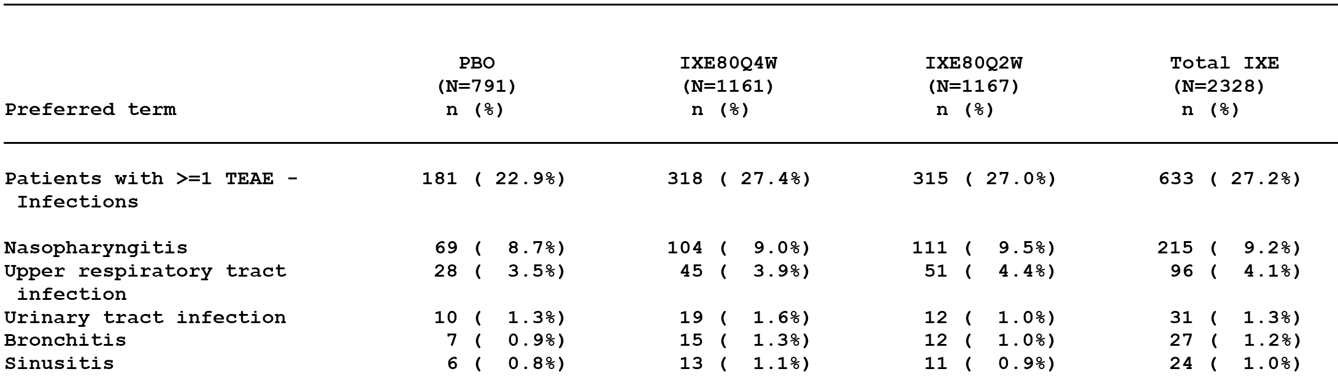
The most commonly reported infection in the three treatment groups was nasopharyngitis (approximately 9% of patients in each of the three treatment groups), while all other infections were reported in ≤ 5% of patients in each of the three treatment groups. The only infection-related TEAEs reported significantly more frequently in the total ixekizumab group compared to the placebo group were rhinitis (0.8% versus 0%; p < 0.01) and influenza (0.8% versus 0%; p < 0.015). The only infection-related TEAE reported significantly more frequently in the ixekizumab 80 mg Q2W group compared to the ixekizumab 80 mg Q4W group was conjunctivitis (0.7% versus 0.1%; p = 0.020).
The proportion of patients with at least 1 infection-related SAE was similar in the total ixekizumab and placebo groups (0.6% (13/1167) versus 0.4% (3/791), respectively). Infection-related SAEs were reported in 5 (0.4%) patients in the ixekizumab 80 mg Q2W group (2 x appendicitis; 1 x each cellulitis, oral abscess, peritonitis) and 8 (0.7%) patients in the ixekizumab 80 mg Q4W group (2 x each cellulitis and erysipelas; 1 x each bronchopneumonia, acute pyelonephritis, tonsillitis, urinary tract infection, urosepsis). In the 3 (0.4%) patients in the placebo group with infection-related SAEs the events (1 each) were cellulitis, infectious mononucleosis, and bacterial skin infection.
Most infections were mild or moderate in intensity and did not result in discontinuation of the study drug. Infection-related TEAEs leading to discontinuation of the study drug were reported in 0.3% (n = 8) of patients in the total ixekizumab group and 0.3% (n = 2) patients in the placebo group. Infection-related TEAEs leading to discontinuation of the study drug were reported in 4 (0.3%) patients in the ixekizumab 80 mg Q2W group (2 x appendicitis; 1 x each cellulitis, osteomyelitis), 4 (0.3%) patients in the ixekizumab 80 mg Q4W group (1 x each cellulitis, bronchopneumonia, ear infection, urosepsis), and 2 (0.3%) patients in the placebo group (1 x each herpes zoster and tonsillitis).
The data included an analysis of the duration of those infections observed in ≥ 1% of patients in the total ixekizumab group. The median duration of infection in the placebo group and both ixekizumab groups (80 mg Q4W and 80 mg Q2W) was 1 to 2 weeks for bronchitis, nasopharyngitis, sinusitis, URTI, and urinary tract infection.
There was one TEAE of tuberculosis in the ixekizumab 80 mg Q2W group (< 0.1%), and no cases in the ixekizumab 80 mg Q4W or placebo groups. However, this patient had a positive QuantiFERON-TB Gold test at screening and was then enrolled in study RHBA prior to treatment for latent TB (as opposed to treatment for active TB). The sponsor states that this patient was inappropriately classified as a TEAE. Therefore, no cases of active TB were observed in the primary placebo-controlled integrated analysis set.
Candida infections are discussed separately later in this CER. Staphylococcal infections were reported in a 2 patients in each of the ixekizumab 80 mg Q2W, ixekizumab 80 mg Q4W and placebo groups (0.2%, n = 2 versus 0.2%, n = 2 versus 0.3%, n = 2).
Herpes zoster infections were reported in 2 (0.3%) patients in the placebo group and no patients in the two ixekizumab groups. Herpes simplex infections were reported in 4 (0.5%) patients in the placebo group, 15 (1.3%) patients in the ixekizumab 80 mg Q4W group and 5 (0.6%) patients in the ixekizumab 80 mg Q2W group. The majority of the 26 reported cases of herpes simplex were oral herpes, with only 2 cases of genital herpes being reported (both occurring in the ixekizumab 80 mg Q4W group). There were no reported cases of viral hepatitis in this analysis set.
Opportunistic infections were analysed using 3 categories defined by the sponsor: infections typically considered to be opportunistic which, included mycobacterial infections and multiple types of fungal infections; infections due to common pathogens observed in patients with neutropenia, including many common bacterial pathogens and infections due to Candida and Aspergillus; and additional types of infection possibly associated with other immunocompromised states. Opportunistic infections (overall) were identified in 0.8% (n = 6) of patients in the placebo group, 0.9% (n = 10) of patients in the ixekizumab 80 mg Q4W group, and 1.9% (n = 22) of patients in the ixekizumab 80 mg Q2W group. The majority of opportunistic infections in the three treatment groups were related to non-invasive Candida infections (primarily oral and/or vulvovaginal). No invasive fungal infections were reported.
Infections preceded or accompanied by neutropenia (≥ CTCAE grade 2) were reported in 0.3% (n = 2) of patients in the placebo group (1 x each bacterial arthritis, GIT infection), 0.3% (n = 4) of patients in the ixekizumab 80 mg Q4W group (2 x nasopharyngitis; 1 x each urinary tract infection, URTI), and 0.2% of patients in the 80 mg Q2W group (1 x each urinary tract infection, sinobronchitis).
Multiple or recurrent infections were reported in 3.3% (n = 26) of patients in the placebo group, 5.1% (n = 59) of patients in the ixekizumab 80 mg Q4W group and 5.1% (n = 59) of patients in the ixekizumab 80 mg Q2W group.

Induction dosing period (psoriasis placebo and active-controlled integrated analysis set)
In the review of infection-related TEAEs in this analysis set, the emphasis is on the comparison between the two ixekizumab groups and the etanercept group. The infection-related TEAE rate in the total ixekizumab group was significantly higher than in the etanercept group (26.0% versus 21.5%; p = 0.018). However, the only TEAE reported significantly more frequently in the total ixekizumab treatment group than in the etanercept treatment group was tonsillitis (0.5% versus 0%; p = 0.044). Infection-related TEAEs reported in ≥ 1% of patients in the total ixekizumab group are summarised below in Table 54.

Table 54. Induction dosing period, infection-related TEAEs reported in ≤ 1.0% of patients in the total ixekizumab group in the psoriasis placebo and active-controlled integrated analysis set; Studies RHBA and RHBC
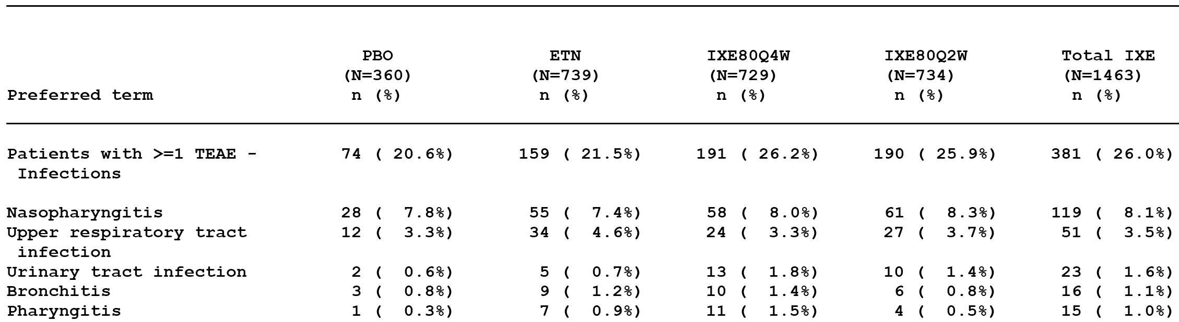
Infection-related TEAEs were reported significantly more frequently in the ixekizumab 80 mg Q2W group than in the etanercept group (25.9% versus 21.5%, p = 0.044), and significantly more frequently in the ixekizumab 80 mg Q4W group than in the etanercept group (26.2% versus 20.6%, p = 0.032). Infection-related TEAEs were reported in a similar proportion of patients in both ixekizumab groups. The proportion of patients with infection-related TEAEs was similar in the etanercept and the placebo groups (21.5% versus 20.6%, p = 0.779). The proportion of patients with infection-related TEAEs was significantly higher in the total ixekizumab group than in the placebo group (26.0% versus 20.6%, p = 0.034).
The only infection-related TEAE reported significantly more commonly in the ixekizumab 80 mg Q4W group compared to etanercept was tonsillitis (0.8%, n = 6 versus 0%, p = 0.013). There were no infection-related TEAEs reported significantly more frequently in the ixekizumab 80 mg Q2W group compared to the etanercept group.
Infection-related SAEs were reported in 2 (0.3%) patients in the ixekizumab 80 mg Q2W group (1 x each oral abscess, appendicitis), 5 (0.7%) patients in the ixekizumab 80 mg Q4W group (2 x erysipelas, 1 x each acute pyelonephritis, urinary tract infection, urosepsis), and 3 (0.4%) patients in the etanercept group (1 x each cellulitis, intestinal abscess, streptococcal cellulitis).
Infection-related TEAEs leading to discontinuation of the study drug were reported in 2 (0.3%) patients in the ixekizumab 80 mg Q2W group (1 x each appendicitis, osteomyelitis), 2 (0.3%) patients in the ixekizumab 80 mg Q4W (1 x each ear infection, urosepsis), and no patients in the etanercept group.
The data included an analysis of the duration of those infections observed in ≥ 1% of patients in the total ixekizumab group. The median duration for urinary tract infection was > 1 week longer in the etanercept group (3.14 weeks) compared to the total ixekizumab group (1.14 weeks). For the other commonly reported TEAEs related to the respiratory tract, the median duration of each event was similar for the total ixekizumab group and the etanercept treatment group (1 to 2 weeks).
There were no TEAEs of TB in the etanercept group, and 1 previously described TEAE of TB in the ixekizumab group. There were no active cases of TB reported in either the ixekizumab or etanercept groups.
Candida infections are separately later in this clinical evaluation. Staphylococcal infections were reported in 1 (0.1%) patient in the ixekizumab 80 mg Q2W group, 1 (0.1%) patient in the ixekizumab 80 mg Q4W group and no patients in the etanercept group.
Herpes zoster infections were reported in 1 (0.1%) patient in the etanercept group and no patients in the two ixekizumab groups. Herpes simplex infections were reported in 0.8% (n = 6) of patients in the etanercept group, 1.5% (n = 11) of patients in the ixekizumab 80 mg Q4W group and 0.7% (n = 5) of patients in the ixekizumab 80 mg Q2W group. There were no reported cases of viral hepatitis in this analysis set.
Opportunistic infections were identified in 0.7% (n = 5) of patients in the etanercept group, 0.8% (n = 6) of patients in the ixekizumab 80 mg Q4W group, and 1.8% (n = 15) of patients in the ixekizumab 80 mg Q2W group. The majority of opportunistic infections in the three treatment groups were related to non-invasive Candida infections (primarily oral and/or vulvovaginal). No invasive fungal infections were reported with any pathogenic fungi.
Infections preceded or accompanied by neutropaenia (≥ CTCAE grade 2) were reported in 0.3% (n = 2) of patients in the etanercept group (1 x each nasopharyngitis, GIT infection), 0.5% (n = 4) of patients in the ixekizumab 80 mg Q4W group (2 x nasopharyngitis; 1 x each urinary tract infection, URTI), and 0.3% (n = 2) of patients in the ixekizumab 80 mg Q2W group (1 x each urinary tract infection, sinobronchitis).
Multiple or recurrent infections were reported in 3.1% (n = 23) of patients in the placebo group, 4.5% (n = 33) of patients in the ixekizumab 80 mg Q4W group and 4.2% (n = 31) of patients in the ixekizumab 80 mg Q2W group.

Maintenance dosing period (psoriasis maintenance integrated analysis set)
Infection-related TEAE exposure-adjusted incidence rates in the total ixekizumab and the placebo groups were similar (72.1 versuss 77.7 per 100 patient years, respectively), as were the rates in the ixekizumab 80 mg Q12W and 80 mg Q4W groups (73.1 versus 71.3 per 100 patient-years, respectively). Infection-related TEAEs reported with an exposure-adjusted incidence rate of ≥ 2 per 100 patient years in the total ixekizumab group are summarised below in Table 55.

Table 55. Maintenance dosing period, infection-related TEAEs reported with an exposure-adjusted incidence rate of ≥ 2 per 100 patient-years in the total ixekizumab group in the psoriasis integrated analysis set; Studies RHAZ and RHBA
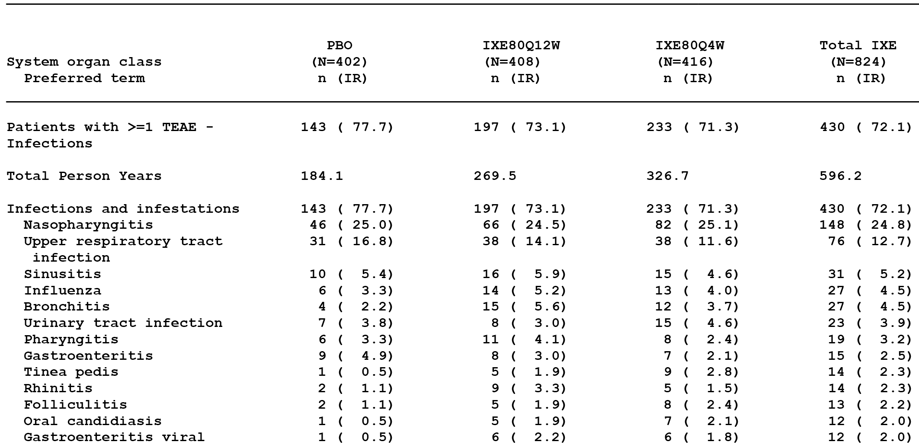
The percentages of patients reporting at least 1 infection-related TEAE were 56.0%, 48.3%, 52.2% and 35.6% in the ixekizumab 80 mg Q4W, ixekizumab 80 mg Q12W, total ixekizumab and placebo groups, respectively. The difference between each ixekizumab group and the placebo group was significant for the unadjusted incidence rates, but not for the exposure-adjusted incidence rates (per 100 person-years).
Exposure-adjusted incidence rates for infection-related SAEs were comparable among treatment groups (1.8 (6 patients) versus 1.1 (3 patients) versus 1.6 (3 patients) per 100 person years in the ixekizumab 80 mg Q4W, ixekizumab 80 mg Q2W and placebo groups, respectively). The unadjusted incidence rates were 1.4%, 0.7% and 0.7% in the ixekizumab 80 mg Q4W, ixekizumab 80 mg Q12W and placebo groups, respectively. The SAEs in the 6 patients in the ixekizumab 80 mg Q4W group were 1 each for pilonidal cyst, subcutaneous abscess, abscess, chronic tonsillitis, infected skin ulcer, post-operative wound infection, and sepsis. The SAEs in the 3 patients in the ixekizumab 80 mg Q12W group were 1 each for appendicitis, infectious mononucleosis, and pseudomonal pneumonia. The SAEs in the 3 patients in the placebo group were pilonidal cyst, subcutaneous abscess Clostridium difficile infection and pneumonia.
Infection-related AEs leading to discontinuation of the study drug were reported in 2 (0.5%) patients in the ixekizumab 80 mg Q4W group (1 each HIV infection, latent TB), 1 (0.2%) patient in the ixekizumab 80 mg Q12W group (1 x otitis media), and 1 (0.2%) patient in the placebo group (1 x staphylococcal cellulitis).
In the total ixekizumab group, the following commonly reported infection-related TEAEs (reported in ≥ 1% of patients in the total ixekizumab group) had a median duration of < 2 weeks: bronchitis; gastroenteritis; viral gastroenteritis; influenza; nasopharyngitis; oral herpes; pharyngitis; sinusitis; tonsillitis; URTI; and urinary tract infection. In the total ixekizumab group, the following commonly reported infection-related TEAEs (that is., reported in ≥ 1% of patients in the total ixekizumab group) had a median duration of > 2 weeks: tinea pedis (9.14 weeks); oral candidiasis (7.93 weeks); folliculitis (6.71 weeks); conjunctivitis (3.57 weeks); otitis externa (3.00 weeks); and rhinitis (2.07 weeks). The median duration was longer in the total ixekizumab group than in the placebo, respectively, for oral candidiasis (7.93 versus 5.86 weeks), folliculitis (6.71 versus 4.57 weeks), and rhinitis (2.07 versus 1.79 weeks).
One patient in the ixekizumab 80 mg Q4W group (0.2%) had a latent TB event and was discontinued from treatment. No TB TEAEs were observed in the ixekizumab 80 mg Q12W treatment group or the placebo group.
Candida infections are discussed separately later in this CER. Staphylococcal infections were reported in 0.5% (n = 2) of patients in the ixekizumab 80 mg Q4W group, no patients in the ixekizumab 80 mg Q12W group, and 1 (0.2%) patient in the placebo group.
Herpes zoster infections were reported in 0.2% (n = 1) of patients in the ixekizumab 80 mg Q4W group, 0.2% (n = 1) of patients in the ixekizumab 80 mg Q12W group, and 0.2% (n = 1) of patients in the placebo group. Herpes simplex infections were reported in 1.4% (n = 6) of patients in the ixekizumab 80 mg Q4W group, 2.0% (n = 8) of patients in the ixekizumab 80 mg Q12W group, and 1.5% (n = 6) of patients in the placebo group. There were no reported cases of viral hepatitis in this analysis set.
Opportunistic infections were identified in 5.3% (n = 22) of patients in the ixekizumab 80 mg Q4W group, 2.7% (n = 11) of patients in the ixekizumab 80 mg Q12W group, and 2.0% (n = 8) of patient in the placebo group. No invasive fungal infections were reported. The only fungal infections specifically identified were non-invasive Candida or tinea infections.
Infections preceded or accompanied by neutropenia (≥ CTCAE grade 2) were reported in 0.5% (n = 2) of patients in the ixekizumab 80 mg Q4W group (2 x nasopharyngitis), 0.2% (n = 1) of patients in the ixekizumab 80 mg Q12W group (1 x URTI), and no patients in the placebo group.
The exposure-adjusted incidence rates (per 100 patient years) for multiple or recurrent infections were 27.5, 30.8 and 25.0 for the ixekizumab 80 mg Q4W, ixekizumab 80 mg Q12W and placebo groups, respectively, and the corresponding unadjusted incidence rates were 21.6%, 20.3% and 11.4%, respectively.

All psoriasis ixekizumab exposures integrated analysis set
In the all psoriasis ixekizumab integrated analysis set (n = 4204), 52.8% of patients reported at least 1 infection-related TEAE. Infection-related TEAEs reported in ≥ 2% of patients were nasopharyngitis (18.6%), URTI (9.8%), sinusitis (4.2%), urinary tract infection (3.6%), bronchitis (3.4%), pharyngitis (2.8%), influenza (2.7%), and gastroenteritis (2.2%). Most of the reported events were mild to moderate in severity. The exposure-adjusted incidence rate for infection-related TEAEs was 46.9 per 100-patient years.
Infection-related SAEs were reported in 1.6% (n = 69) of patients, with no events being reported in ≥ 0.5% of patients. The most commonly reported SAE was cellulitis (0.3%, n = 14), and other events reported in ≥ 2 patients were 4 (0.1%) patients for appendicitis, 3 (0.1%) patients each for bronchopneumonia, diverticulitis, erysipelas, pneumonia, urinary tract infections, and 2 (< 0.1%) patients each for clostridium difficile infection, cystitis, gastroenteritis, osteomyelitis, post-operative wound infection, pyelonephritis, staphylococcal bacteraemia, and staphylococcal infection.
Infection-related AEs resulting in discontinuation of the treatment drug were reported in 0.8% (n = 32) of patients, with no events being reported in ≥ 0.5% of patients. The most commonly reported infection-related AE leading to discontinuation of the study drug was latent TB (0.2%, n = 7), and other events reported in ≥ 2 patients were cellulitis (0.1%, n = 3), appendicitis (< 0.1%, n = 2), and bronchopneumonia (< 0.1%, n = 2).
TB was reported in 9 (0.2%) of patients, including latent TB in 8 (0.2%) patients and TB in 1 (<0.1%) patient. There were no confirmed events of new active TB or of reactivation of TB. Candida infections were reported in 2.6% (n = 109) of patients, with infections being reported in ≥ 1.0% of patients being vulvovaginal candidiasis 1.6% (n = 22 women), and oral candidiasis 1.3% (n = 56). Staphylococcal infections were reported in 0.6% (n = 26) of patients. Herpes zoster was reported in 0.5% (n = 23) of patients, and herpes simplex was reported in 2.2% (n = 94) of patients. There were no reports of viral hepatitis.
Opportunistic infections were identified in 4.9% (n = 208) of patients, with no invasive fungal infections being identified. With the exception of a non-serious, non-invasive external otitis due to Aspergillus species not further defined, no specific fungal infections apart from Candida or tinea infection were reported. Multiple infections were reported in 26.4% (n = 111) of patients.
Infection-related TEAEs preceded or accompanied by neutropenia (≥ CTCAE grade 2) were reported in 0.5% (n = 19) of patients, with the majority of events being nasopharyngitis 0.3% (n = 19) followed by URTI 0.1% (n = 4), urinary tract infection < 0.1% (n = 2), infected cyst < 0.1% (n = 1), sinobronchitis < 0.1% (n = 1) and skin infection < 0.1% (n = 1).

Candida infections
An exploratory analysis was undertaken by the sponsor for Candida infections based on both high-level terms (HLT) for Candida and additional terms likely to represent Candida infections. In this exploratory analysis in the induction dosing period (psoriasis primary placebo-controlled integrated analysis set), TE Candida infections were reported in 1.0% (n = 23) of patients in the total ixekizumab group and 0.5% (n = 4) of patients in the placebo group, and more commonly in the ixekizumab 80 mg Q2W group (1.4% (n = 16)) than in the ixekizumab 80 mg Q4W group (0.6% (n = 7)). The majority of Candida infections in ixekizumab treated patients were oral candidiasis followed by vulvovaginal candidiasis.
In the exploratory analysis in the induction dosing period (psoriasis placebo- and active-controlled integrated analysis set), TE Candida infections were reported in 0.6% (n = 2), 0.7% (n = 5), 0.5% (n = 4), and 1.6% (n = 12), of patients in the placebo, etanercept, ixekizumab 80 mg Q4W and ixekizumab 80 mg Q2W groups, respectively. The majority of Candida infections in patients in the ixekizumab groups were oral candidiasis followed by vulvovaginal candidiasis.
In the exploratory analysis in the maintenance dosing period (psoriasis maintenance integrated analysis set), the exposure-adjusted incidence rate for TE Candida infections were 2.2, 2.2, and 4.9 per 100 patient-years for the placebo, ixekizumab 80 mg Q12W and ixekizumab 80 mg Q4W groups, respectively. The majority of Candida infections in patients in the ixekizumab groups were oral candidiasis followed by vulvovaginal candidiasis. No Candida infections reported during the maintenance dosing period were SAEs or led to discontinuation of the study drug. The exposure-adjusted incidence rate for patients in the 80 mg Q4W group in the maintenance dosing period (psoriasis maintenance integrated analysis set) was higher compared to patients in the 80 mg Q4W group in the induction dosing period (primary psoriasis placebo-controlled integrated analysis set), with the rates being 4.9 and 2.6 per 100 patient-years, respectively). The exposure-adjusted incidence rates for the total ixekizumab groups were similar in the maintenance and induction dosing periods (3.7 versus 4.3 events per 100 patient years).

Cytopenias

Treatment emergent cytopenias
Assessment of TEAEs for cytopaenias included evaluation of AE reports of leukopenia, neutropenia, and thrombocytopenia and related PTs defined in the ‘blood and lymphatic disorder’ SOC as well as the ‘haematopoietic cytopenias’ SMQ (and sub-SMQs) as defined in MedDRA Version 17.1.

Induction dosing period (primary psoriasis placebo-controlled integrated dataset)
The results are summarised below in Table 56.

Table 56. Induction dosing period, treatment-emergent cytopaenias in the primary psoriasis placebo-controlled integrated analysis set; Studies RHAZ, RHBA and RHBC
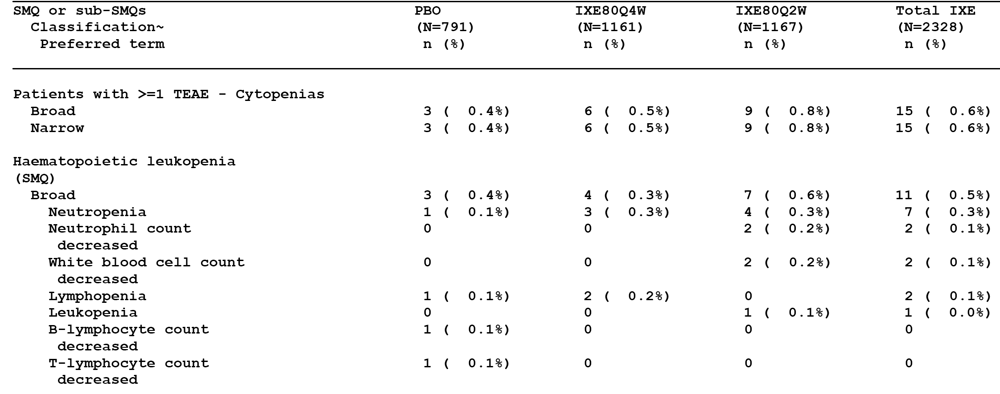
Evaluator’s comment: The distribution of patients with cytopaenias was identical using the broad and narrow SMQ categorisations. Cytopaenias occurred infrequently in the three treatment groups (< 1.0% of patients), and the most commonly reported event in the two ixekizumab groups was neutropenia. The proportion of patients in the ixekizumab 80 mg Q2W group with cytopaenias was marginally greater than the proportion of patients in the ixekizumab 80 mg Q4W and placebo groups, but the differences are unlikely to be clinically significant. There were no treatment-emergent SAEs of cytopaenia or reports of cytopaenia leading to discontinuation of the study drug.

Induction dosing period (psoriasis placebo and active-controlled integrated analysis set)
The results set are summarised below in Table 57.

Table 57. Induction dosing period, treatment-emergent cytopenias in the psoriasis placebo and active controlled integrated analysis set; Studies RHBA and RHBC
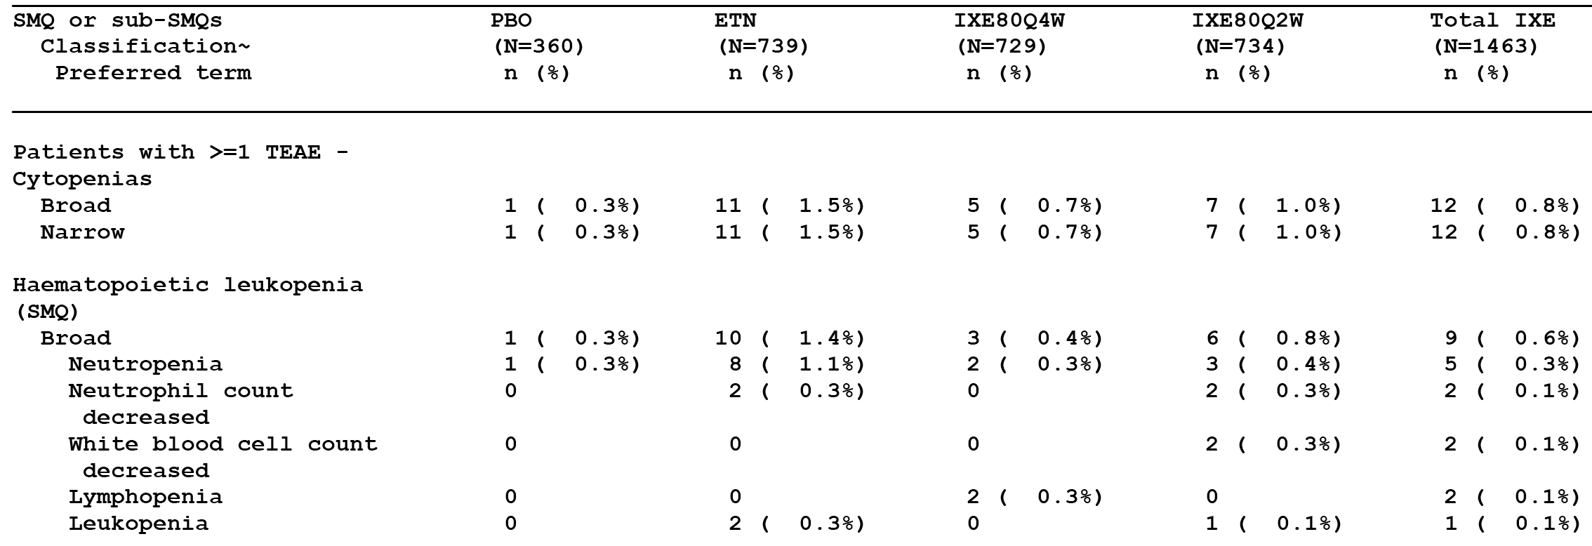
Evaluator’s Comment: The distribution of patients with cytopaenias was identical using the broad and narrow SMQ categorisations. The proportion of patients reporting cytopaenias was greater in the etanercept group than in the two ixekizumab groups (80 mg Q4W, 80 mg Q2W). There were no treatment-emergent SAEs of cytopenia or reports of cytopenia leading to discontinuation of the study drug.

Maintenance dosing period (psoriasis maintenance integrated analysis set)
The results for the psoriasis maintenance integrated analysis, exposure-adjusted incidence rates per 100 person-years, are summarised below in Table 58.

Table 58. Maintenance dosing period, exposure-adjusted incidence rates (events per 100 person years) for treatment-emergent cytopaenias in the psoriasis maintenance integrated analysis set; Studies RHAZ and RHBA
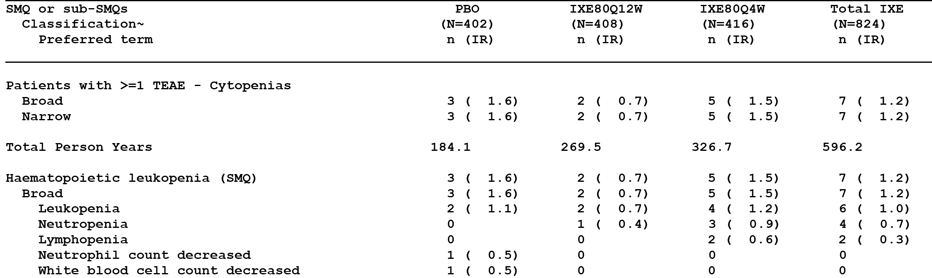
Evaluator’s comment: The distribution of patients with cytopaenias was identical using the broad and narrow SMQ categorisations. The exposure-adjusted incidence rates for cytopaenias were similar in the ixekizumab 80 mg Q4W and placebo groups. There were no treatment-emergent SAEs of cytopaenia or reports of cytopaenia leading to discontinuation of the study drug.

All psoriasis ixekizumab exposure integrated analysis set
In the all psoriasis ixekizumab exposure integrated analysis set (n = 4204), 1.1% (n = 46) of patients reported at least 1 TEAE of cytopenia, comprising neutropenia 0.5% (n = 21), leukopaenia 0.4% (n = 15), thrombocytopaenia 0.2% (n = 10), lymphopaenia 0.1% (n = 6), neutrophil count decreased 0.1% (n = 6), White blood cell count decreased < 0.1% (n = 2), and platelet count decreased < 0.1% (n = 2). There were no treatment-emergent SAEs of cytopaenia, while 3 (0.1%) patients discontinued the study drug due to cytopaenias (2 x neutropaenia, 1 x thrombocytopenia).

Laboratory assessment of cytopaenias
The laboratory data included mean changes from baseline in total leukocyte, neutrophil, lymphocyte, and platelet counts during the induction and maintenance periods, along with percentages of populations and treatments reporting a value below the LLN and analyses of shifts below the LLN for leukocytes, neutrophils, and platelets. The LLN were set as:
- leukocytes = 4.0 x 10⁹/L;
- neutrophils = 2.0 x 10⁹/L;
- lymphocytes = 1.1 x 10⁹/L; and
- platelets = 150 x 10⁹/L.
The numbers and percentages of patients who recovered from Grade 2 or 3 neutropaenia (absolute neutrophil count < 1.5 x 10⁹/L) were analysed for patients who had normal or Grade I absolute neutrophil counts (≥ 1.5 x 10⁹/L) and then shifted to Grade 2 or 3 neutropaenia. Recovery was defined as shifting back to normal or Grade I at the end of the treatment period. In the pairwise comparisons described below, the word ‘significantly’ relates to statistical significance assessed by the CMH test stratified by study (p < 0.05).

Induction dosing period (primary psoriasis placebo-controlled integrated analysis set)

Mean change from baseline to last post-baseline visit
Mean reductions from baseline to last post-baseline visit for leucocyte, neutrophil and platelet counts were significantly greater in both ixekizumab groups (80 mg Q4W, 80 mg Q2W) compared to the placebo group. The mean reduction from baseline to last post-baseline visit in the lymphocyte count was significantly greater in the placebo group compared to both ixekizumab groups (80 mg Q4W, 80 mg Q2W). There were no significant differences between the two ixekizumab treatment groups.

Treatment emergent blood counts less than LLN at any time post-baseline
The proportion of patients with leucocyte and neutrophil counts less than the LLN of normal at any time post-baseline was significantly greater in both ixekizumab groups (80 mg Q4W, 80 mg Q2W) compared to placebo. The proportion of patients with platelet counts less than the LLN of normal at any time post-baseline was significantly greater in the ixekizumab 80 mg Q4W group compared to placebo, but not in the ixekizumab 80 mg Q2W group compared to placebo. There were no significant differences between both ixekizumab groups (80 mg Q4W, 80 mg Q2W) and placebo in the proportion of patient with lymphocyte counts less than the LLN at any time post-baseline. There were no significant differences between the two ixekizumab treatment groups.

Shifts from baseline to post-baseline values below the LLN
In the majority of patients in the three treatment groups (placebo versus ixekizumab 80 mg Q4W versus ixekizumab 80 mg Q2W), baseline and post-baseline counts were the same for each of the haematological parameters: leucocytes (94.9% versus 90.0% versus 89.7%, respectively); neutrophils (95.4% versus 90.8% versus 90.1%, respectively); lymphocytes (88.1% versus 89.0% versus 87.8%, respectively); and platelets (97.8% versus 95.4% versus 96.8%, respectively).

Leukopaenia, neutropaenia, lymphopaenia, or thrombocytopaenia based on newly occurring or worsening CTCAE grades
Higher proportions of patients had worsening CTCAE grades or shifts to a higher grade (further reductions below LLN) in the ixekizumab 80 mg Q4W and ixekizumab 80 mg Q2W groups compared to the placebo group for leucocytes, neutrophils, and platelets, but not for lymphocytes.

Induction dosing period (psoriasis placebo and active controlled integrated analysis set)

Mean change from baseline to last post-baseline visit
The mean reduction from baseline to last post-baseline observation in the leucocyte count was significantly greater for both ixekizumab groups (80 mg Q4W, 80 mg Q2W) and for the etanercept group compared to placebo, with the reductions between both ixekizumab groups and the etanercept group being not significant.
The mean reductions from baseline to last post-baseline observation in the neutrophil, lymphocyte and platelet counts were significantly greater for both ixekizumab dose groups (80 mg Q4W, 80 mg Q2W) and for the etanercept group compared to placebo, with the reductions being significantly greater in the etanercept group compared to both ixekizumab groups.
There were no significant differences between the groups in mean reductions from baseline to last post-baseline levels in leucocyte, neutrophil, lymphocyte or platelet counts.

Treatment emergent blood counts less than LLN at any time post-baseline
There was no significant difference in the proportion of patients with leucocyte and platelet counts less than the LLN at any time post-baseline between both ixekizumab groups (80 mg Q4W, 80 mg Q2W) and the etanercept group.
The proportion of patients with lymphocytes counts less than the lower limit of normal was significantly higher in both ixekizumab groups (80 mg Q4W, 80 mg Q2W) compared to etanercept.
The proportion of patients with neutrophil counts less than the LLN at any time post-baseline was significantly higher in the etanercept group compared to both ixekizumab groups (80 mg Q4W, 80 mg Q2W).
The proportion of patients with leucocyte, neutrophil and platelet counts less than the LLN at any time post-baseline was significantly greater in the etanercept group compared to the placebo group, and the proportion of patients with lymphocyte counts less than the LLN at any time post-baseline was significantly greater in the placebo group compared to the etanercept group.

Shifts from baseline to post-baseline values
In the majority of patients in the four treatment groups (placebo versus etanercept versus ixekizumab 80 mg Q4W versus ixekizumab 80 mg Q2W), baseline and post-baseline counts were the same for each of the haematological parameters: leucocytes (94.7% versus 90.5% versus 89.8% versus 90.0%, respectively); neutrophils (95.0% versus 85.6% versus 89.9% versus 89.6%, respectively); lymphocytes (88.0% versus 88.1% versus 88.8% versus 88.4%, respectively); and platelets (97.8% versus 94.4% versus 95.1% versus 96.6%).

Leukopaenia, neutropaenia, lymphopaenia, or thrombocytopaenia based on newly occurring or worsening CTCAE grades
There were no notable differences in the proportions of patients experiencing worsening CTCAE grades or shifts to a higher grade (further reductions below LLN) between the two ixekizumab groups (80 mg Q4W, 80 mg Q2W) and the etanercept group.

Psoriasis maintenance integrated analysis set

Mean change from baseline to last post-baseline visit
The Summary of Clinical Safety included a discussion of the mean changes from last observation at baseline to the last post-baseline observation analyses. However, the data in this section could not be verified as the reference to the source Table appears to be incorrect. This matter has been raised in Section 12 (Questions) of this clinical evaluation.

Treatment emergent blood counts less than LLN at any time post-baseline
The proportion of patients with leucocyte counts less than the LLN was significantly greater in the ixekizumab Q4W group compared to the placebo group, while there were no significant differences in this parameter between the ixekizumab Q12W and placebo groups. There were no significant differences between each of the ixekizumab groups (80 mg Q12W, 80 mg Q4W) and the placebo group in the proportion of patients with lymphocyte, neutrophil, and platelet counts less than the LLN at any time post-baseline.
There were no significant differences between the ixekizumab 80 mg Q12W and the 80 mg Q4W groups in the proportion of patients with leucocyte, lymphocyte, neutrophil, or platelet counts less than the LLN at any time post-baseline.

Shifts from baseline to post-baseline values
In the majority of patients in the three treatment groups (placebo versus ixekizumab 80 mg Q4W versus ixekizumab 80 mg Q2W), baseline and post-baseline counts were the same for each of the haematological parameters: leucocytes (92.0% versus 90.3% versus 86.5%, respectively); neutrophils (90.8% versus 91.8% versus 90.6%, respectively); lymphocytes (92.5% versus 92.6% versus 89.6%, respectively); and platelets (96.5% versus 97.0% versus 96.4%, respectively).

All psoriasis ixekizumab exposures integrated analysis set
Mean change from baseline was not calculated for this analysis set. The proportions of patients with a treatment-emergent value below the LLN was 11.5% (466/4055) for leucocytes, 10.2% (390/3809) for lymphocytes, 11.0% (450/4100) for neutrophils, and 5.9% (239/4078) for platelets.
The frequencies of shifts to lower laboratory values were 11.9% (n = 496) for leucocytes, 10.4% (n = 434) for lymphocytes, 11.5% (n = 482) for neutrophils, and 5.8% (n = 240) for platelets.
A possible association between reductions in platelet count and bleeding events were evaluated based on 232 patients reporting a bleeding event. Three percent (3%) of these events were associated with a low platelet count. Two patients had low platelet counts at baseline, 4 others had transient reductions post-baseline, and most had a treatment-emergent low platelet counts at a single time point. There were no platelet counts below 50 x 10⁹/L during the study.
The proportions of patients with a worsening to CTCAE Grade 2 or higher in the pooled ixekizumab group were: leukocytes (1.8%), neutrophils (3.0%), lymphocytes (2.2%), and platelets (0.2%).

Allergic reactions and hypersensitivities
Allergic reactions/hypersensitivity events were categorised as either anaphylaxis or non-anaphylaxis events and summarised separately. The search strategy was extensive and included MedDRA PTs from the anaphylactic reaction SMQ, Sampson criteria for anaphylaxis (2 out of 4) (that is, involvement of skin-mucosal tissue, respiratory compromise, reduced blood pressure or associated symptoms, persistent gastrointestinal symptoms); and TEAEs of allergic reaction/hypersensitivity categorised as non-anaphylaxis events defined by the narrow terms within the Hypersensitivity SMQ (with pre-specified exclusions). The observed incidence rates were consistent irrespective of the method used to assess the events (Sampson criteria, SMQ algorithm, MedDRA PTs). However, it should be noted that allergic reactions/hypersensitivity events were not limited to the site of injection and that events characterised as anaphylaxis were not required to demonstrate a close temporal relationship with the injection. Consequently, the criteria for the definition of anaphylaxis were broad and not limited to ‘serious allergic (reactions) that (are) rapid and may cause death’.¹⁶

Induction dosing period (primary psoriasis placebo-controlled integrated analysis set)
Potential anaphylaxis (defined by Sampson criteria) and non-anaphylaxis TEAEs were reported more frequently in patients in the ixekizumab 80 mg Q4W and ixekizumab 80 mg Q2W groups than in the placebo group with the respective frequencies being 4.0% (n = 46), 3.5% (n = 41) and 2.1% (n = 17). Most of the events in the three treatment groups were mild to moderate in severity.
SAE allergic reactions/hypersensitivity were reported in 0.1% (n = 1) of patients in the ixekizumab 80 mg Q4W group (1 x angioedema), 0.3% (n = 3) of patients in the ixekizumab 80 mg Q2W group (1 x each drug hypersensitivity, hypersensitivity vasculitis, urticaria, angioedema), and 0.1% (n = 1) of patients in the placebo group (1 x drug eruption). There were no SAEs of anaphylaxis in the three treatment groups.
Discontinuations due to allergic reactions/hypersensitivity (non-anaphylaxis) were reported in 0.2% (n = 2) of patients in the ixekizumab 80 mg Q4W group (1 x allergic oedema, 1 x angioedema), 0.2% (n = 2) of patients in the ixekizumab 80 mg Q2W group (1 x drug hypersensitivity, 1 x urticaria), and no patients in the placebo group. There were no TEAEs of anaphylaxis leading to discontinuation of the study drug in the three treatment groups.
Anaphylaxis defined by Sampson criteria was reported in 4 (0.3%) patients in the ixekizumab 80 mg Q4W group, 4 (0.3%) patients in the ixekizumab 80 mg Q4W group and 2 (0.3%) patients in the placebo group. Among the 8 ixekizumab-treated patients, the maximum severity of the event for 6 patients was mild and for 2 patients the maximum severity was moderate. For 5 of these patients, the symptoms occurred on the same day as the ixekizumab injection. However, for these 5 patients, all events were mild, and only 1 patient had a single event typically associated with hypersensitivity reactions (generalized pruritus). The other events identified in these 5 patients were nonspecific for such reactions (including dizziness, nausea and cough).
In the 5 patients with anaphylaxis events identified by Sampson criteria occurring on the same day as the injection, none of the events were considered by the sponsor to represent an anaphylactic reaction. In the 3 patients with anaphylaxis identified by Sampson criteria not occurring on the same day as the injection, none of the events were considered by the sponsor to be an anaphylactic reaction. No patients in the total ixekizumab treatment group or the placebo group had an event that met the criteria for anaphylaxis based on specific MedDRA PTs. No patients in the total ixekizumab treatment group had an event that met the criteria for anaphylaxis based on SMQ algorithm categories of PTs, while 1 (0.1%) patient in the placebo group met the criteria. Overall, the sponsor concluded that no ixekizumab-treated patients experienced an anaphylactic reaction. This is considered to be a reasonable conclusion based on the submitted data.
Non-anaphylaxis events reported in ≥ 2 patients in the total ixekizumab group are summarised below in Table 59. The most notable differences between the ixekizumab and placebo groups were the higher incidences of urticaria and dermatitis in the two ixekizumab groups compared to placebo.

Table 59. Induction dosing period, non-anaphylaxis events reported in ≥ 2 patients in the total ixekizumab group in the primary psoriasis placebo-controlled integrated analysis set; Studies RHAZ, RHBA and RHBC
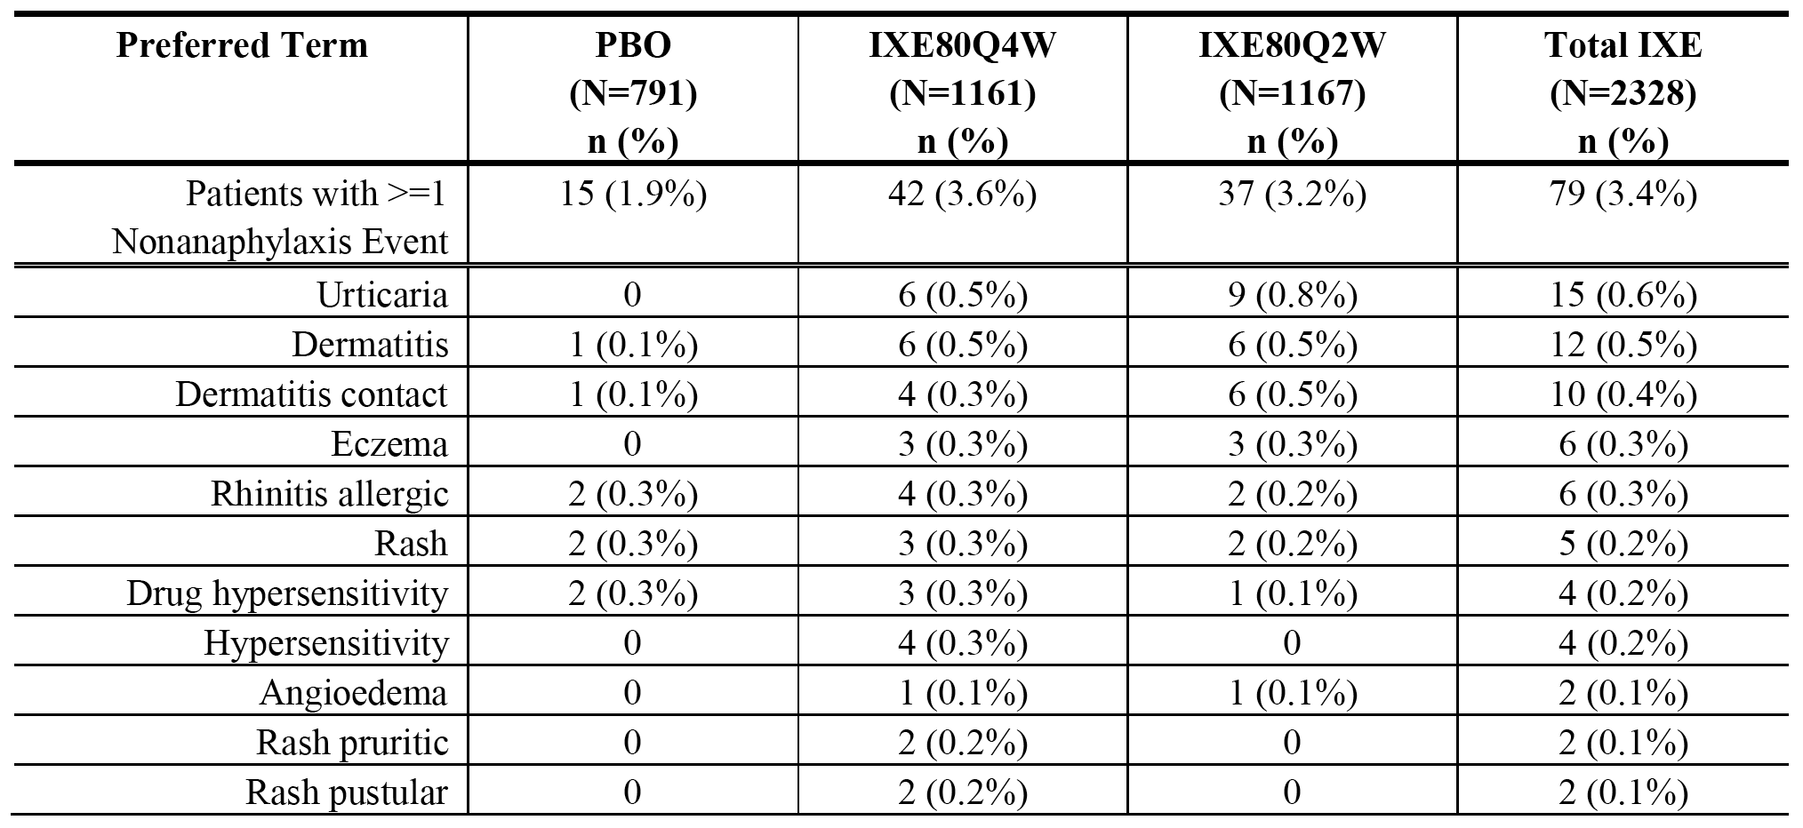

Induction dosing period (psoriasis placebo and active-controlled integrated analysis set)
Potential anaphylaxis (defined by Sampson criteria) and non-anaphylaxis TEAEs were reported more frequently in patients in the ixekizumab 80 mg Q4W (3.7% (n = 27) and 80 mg Q4W (3.7% (n = 27)) groups than in the etanercept (2.6% (n = 19)) and placebo (1.9% (n = 7)) groups.
Allergic reaction/hypersensitivity SAEs occurred in 1 (0.1%) patient in the 80 mg Q4W group (1 x angioedema) and 1 (0.1%) patient in the 80 mg Q2W group (1 x hypersensitivity vasculitis), compared to no patients in the placebo or etanercept groups. No patients in the four treatment groups had an SAE meeting the criteria for anaphylaxis.
Discontinuations due to allergic reaction/hypersensitivity (non-anaphylaxis) TEAEs occurred in 1 (0.1%) patient in the 80 mg Q4W group (1 x angioedema) and 1 (0.1%) patient in the 80 mg Q2W group (1 x urticaria), compared to no patients in the placebo or etanercept groups. No patients in the four treatment groups discontinued due to anaphylaxis.
Anaphylaxis defined by Sampson criteria was reported in 2 (0.3%) patients in the ixekizumab 80 mg Q4W group, 2 (0.3%) patients in the ixekizumab 80 mg Q2W group, 2 (0.3%) patients in the etanercept group and no patients in the placebo group (n = 360). The 4 ixekizumab-treated patients were a subset of those identified in the primary placebo-controlled integrated analysis set previously discussed. No patients in any treatment group had an anaphylaxis event that met the criteria for anaphylaxis based on SMQ algorithm categories of PTs. Non-anaphylaxis events reported in ≥ 2 patients in the total ixekizumab group are summarised below in Table 60.

Table 60. Induction dosing period, non-anaphylaxis events reported in ≥ 2 patients in the total ixekizumab group in the psoriasis placebo and active-controlled integrated analysis set; Studies RHBA and RHBC
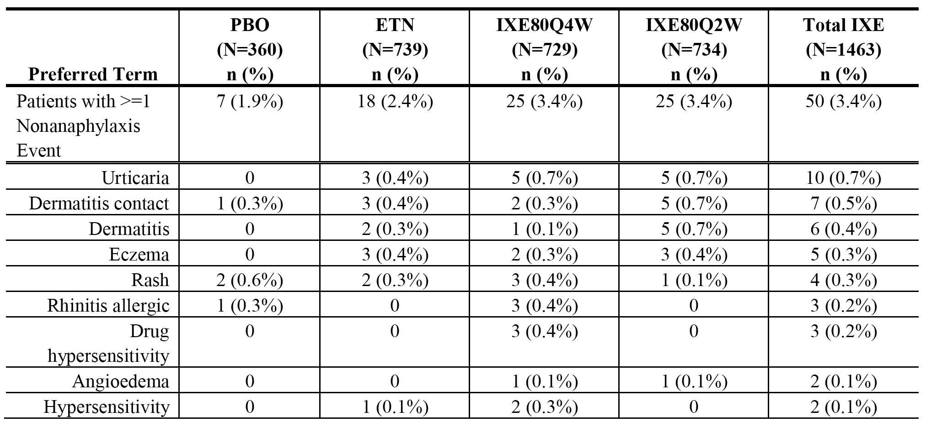

Maintenance dosing period (psoriasis maintenance integrated analysis set)
One patient (0.1%) in the ixekizumab 80 mg Q12W group had an anaphylaxis event defined by Sampson search criteria compared to no patients in the placebo group. This patient experienced events of dizziness and dyspnoea of mild severity reported several weeks after the time of the most recent ixekizumab injection. These events were considered not to meet the criteria for anaphylaxis, due to the long interval between the injection and the events. No patients in the three treatment groups had events meeting the criteria for anaphylaxis based on SMQ algorithm categories of PTs. There were no SAE allergic reaction/hypersensitivity reports (anaphylaxis and non-anaphylaxis) in the three treatment groups. Discontinuation due to allergic reaction/hypersensitivity (non-anaphylaxis) TEAEs was reported in 1 (0.2%) patient in the ixekizumab 80 mg Q4W group (1 x allergic dermatitis). There were no discontinuations due to anaphylaxis in the three treatment groups.
The non-anaphylaxis events with an exposure-adjusted incidence rate ≥ 0.3 per 100 patient years in the total ixekizumab group are summarised below in Table 61. The exposure-adjusted incidence rate was higher in the ixekizumab 80 mg Q4W group than in the ixekizumab 80 mg Q12W and placebo groups. Most non-anaphylaxis events were assessed as being mild or moderate in severity, with 2 events (allergic rhinitis and angioedema) being assessed as severe in a single patient in the ixekizumab 80 mg Q4W group.
The exposure-adjusted incidence rates for non-anaphylaxis events was higher in the total ixekizumab group in the induction dosing period in the primary psoriasis placebo-controlled integrated analysis set compared to total ixekizumab group in the maintenance dosing period (14.8 versus 7.9 per 100 patient-years, respectively), with the placebo results being 8.3 and 6.5 per 100 patient-years, respectively.

Table 61. Maintenance dosing period, non-anaphylaxis events with an exposure-adjusted incidence rate greater than or equal to 0.3 per 100 patient-years in the total ixekizumab group in the psoriasis maintenance integrated analysis set; Studies RHAZ and RHBA
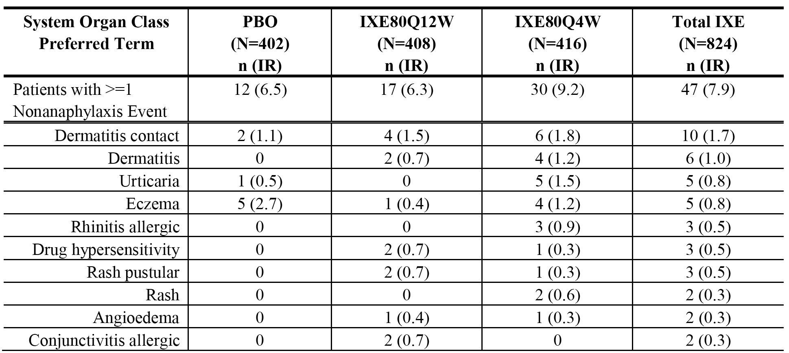

All psoriasis ixekizumab-exposure integrated analysis set
Of the 4204 patients in the all psoriasis ixekizumab exposures integrated analysis set, 20 (0.5%) patients had a least 1 potential anaphylaxis event defined by Sampson criteria. However, apart from the 5 patients in the primary psoriasis placebo-controlled analysis set noted above, none of the 20 patients had potential anaphylaxis events on the same day as dosing with ixekizumab. Two patients had at least 1 anaphylaxis event based on specific MedDRA PTs (both reported as anaphylactic reaction). In both cases, the events were SAEs, and symptoms included widespread urticaria as well as dyspnoea that did not require specific treatment. However, in both cases, the events occurred approximately 2 weeks after the first dose of ixekizumab. There were 3 patients with a potential anaphylaxis event based on the SMQ algorithm, including the 2 patients noted above with the specific MedDRA PTs and 1 other patient who did not have events on the day of ixekizumab dosing. None of the 3 patients identified using the SMQ algorithm were considered to meet criteria for anaphylaxis of occurring shortly after exposure to the precipitating agent.
Allergic reactions/hypersensitivity (non-anaphylaxis) TEAEs were reported in 9.1% (n = 382) of patients. TEAEs reported in ≥ 1.0% of patients were eczema (1.7%), contact dermatitis (1.6%), urticaria (1.2%), and dermatitis (1.0%). For most patients, the maximum severity of a non-anaphylaxis event was mild (9.1%) or moderate (2.9%), with severe events being reported in 0.4% of patients. The exposure-adjusted incidence rate for non-anaphylaxis events was 8.1 per 100 patient years.
SAE allergic reactions/hypersensitivity (MedDRA PTs) were reported in 14 (0.3%) patients, including 2 (< 0.1%) patients with anaphylaxis and 12 (0.3%) patients with non-anaphylaxis. Non-anaphylaxis SAEs reported in ≥ 2 patients were urticaria (n = 3 (0.3%)), angioedema (n = 2 (<0.1%)), and hypersensitivity vasculitis (n = 2 (<0.1%)).
Discontinuations due to allergic reactions/hypersensitivity (MedDRA PTs) were reported in 20 (0.5%) patients, including 2 (<0.2%) patients with anaphylaxis and 18 (0.4%) patients with non-anaphylaxis. Non-anaphylaxis TEAEs reported in ≥ 2 patients were drug hypersensitivity (n = 4 (0.1%)), hypersensitivity (n = 3 (0.1%)), urticaria (n = 3 (0.1%)), and generalised rash (n = 2 (<0.1%)).

Injection site reactions

Induction dosing period (primary psoriasis placebo-controlled integrated analysis set)
Injection site reactions were defined using PTs from the MedDRA HLT Injection Site Reactions, and were reported notably more frequently in the ixekizumab Q2W group than in the ixekizumab 80 mg Q4W and placebo groups (16.8% (n = 196) versus 12.9% (n = 150) versus 3.3% (n = 26), respectively). Injection site reactions reported in ≥ 1.0% of patients in the ixekizumab Q2W group were injection site reaction (10.0%), injection site erythema (4.5%), and injection site pain (2.4%). Most injection site reactions were reported as mild to moderate in severity.
Injection site reaction exposure-adjusted incidence rates were 5.3 per 100 patient-years in the ixekizumab 80 mg Q2W group, 5.9 per 100 patient-years in the ixekizumab 80 mg Q4W group and 0.7 per 100 patient-years in the placebo group. The majority of patients experiencing injection site reactions reported 1 to 3 events. In the ixekizumab 80 mg Q4W group, of the 196 (16.8%) patients reporting an injection site reaction, 93 (8.0%) reported 1 event, 70 (6.0%) reported 2 or 3 events, and 33 (2.8%) reported ≥ 4 events. In the placebo group, of the 26 (3.3%) patients reporting an injection site reaction, 12 (1.5%) reported 1 event, 9 (1.1%) reported 2 or 3 events, and 4 (0.6%) reported ≥ 4 events.
In the three treatment groups there were no injection reaction SAEs. Discontinuations due to injection site reactions were reported in 5 (0.4%) patients in the ixekizumab 80 mg Q2W group (4 x injection site reaction, 1 x injection site erythema), 1 (0.1%) patient in the ixekizumab 80 mg Q4W group (1 x injection site pain), and no patients in the placebo group.
The median duration of injection site reactions was 0.4 weeks (range: 0.1 to 13.7 weeks) in the ixekizumab Q2W group, 0.4 weeks (range: 0.1 to 11.7 weeks) in the ixekizumab 80 mg Q4W group, and 0.1 weeks (range: 0.1 to 11.7 weeks) in the placebo group.

Induction dosing period (psoriasis placebo and active controlled integrated analysis set)
Injection site reactions were reported in a similar proportion of patients in the etanercept and ixekizumab 80 mg Q4W groups, and more frequently in both groups than in the ixekizumab 80 mg Q2W group (16.4% (121/739) versus 17.3% (127/734) versus 13.3% (97/729), respectively). The majority of injection site reactions were mild to moderate in severity. SAE injection site reactions were reported in 1 (0.1%) patient in the etanercept group and no patients in the two ixekizumab groups. Discontinuations due to injection site reactions were reported in 3 (0.4%) patients in the etanercept group (2 x injection site reaction, 1 x injection site hypersensitivity), 1 (0.1%) patient in the ixekizumab 80 mg Q4W group (1 x injection site pain), and 1 (0.1%) patient in the ixekizumab 80 mg Q2W group (1 x injection site reaction).
There were 3.3 injection site reactions per 100 injections in the etanercept group compared to 6.3 in the ixekizumab 80 mg Q4W group, 6.6 in the ixekizumab 80 mg Q2W group and 0.7 in the placebo group. The median duration of the injection site reaction was 0.4 weeks in the etanercept group, 0.4 weeks in the ixekizumab 80 mg Q2W group, 0.29 weeks in the ixekizumab 80 mg Q2W group and 0.1 weeks in the placebo group.

Maintenance dosing period (psoriasis maintenance integrated analysis set)
Injection site reactions were reported more frequently in the ixekizumab 80 mg Q4W group than in the ixekizumab 80 mg Q12W and placebo groups (8.9% (n = 37) versus 5.1% (n = 21) versus 2.0% (n = 8), respectively). Injection site reactions reported in ≥ 1% of patients in the ixekizumab 80 mg Q4W group were injection site reaction (8.9%), injection site erythema (6.5%) and injection site swelling (1.9%). The majority of injection site reactions were mild to moderate in severity.
No patients reported injection site reaction SAEs in the three treatment groups. Injection site reactions resulting in discontinuation of the study drug were reported in 1 (0.2%) patient in the ixekizumab 80 mg Q4W group and no patients in the ixekizumab 80 mg Q12W or placebo groups.
There were 3.3 injection site reactions per 100 injections in the ixekizumab Q4W group compared to 3.4 in the ixekizumab 80 mg Q12W group and 1.2 in the placebo group. The median duration of injection site reaction was 0.3 weeks in the ixekizumab group, 0.1 weeks in the ixekizumab 80 mg Q12W group and 0.1 weeks in the placebo group.
Exposure-adjusted incidence rates for injection site reactions were 11.3, 7.8 and 4.3 per 100 patient-years for the ixekizumab 80 mg Q4W versus ixekizumab 80 mg Q12W versus placebo groups, respectively. In the ixekizumab 80 mg Q4W and ixekizumab 80 mg Q2W groups, exposure-adjusted incidence rates were notably higher in the induction dosing period (primary psoriasis place-controlled integrated analysis set) compared to the ixekizumab 80 mg Q4W group in the maintenance dosing period (psoriasis maintenance integrated analysis set), with the rates being 56.4 (80 mg Q4W induction) versus 73.0 (80 mg Q2W induction) versus 11.3 (80 mg Q4W maintenance) per 100 patient-years.

All psoriasis ixekizumab exposure integrated analysis set
Injection site reactions were reported in 15.2% (n = 638) of patients, and events reported in ≥ 1% of patients were injection site reaction (9.9%), injection site erythema (3.2%), injection site pain (1.7%), and injection site swelling (1.0%). Injection site reactions categorised as severe were reported in 0.6% (n = 27) of patients. No patients reported SAE injection site reactions. Injection site reactions leading to discontinuation of the study drug were reported in 0.2% (n = 8) of patients.
The exposure-adjusted incidence rate for injection site reactions was 13.5 per 100 patient-years. There were 3.3 injection site reactions per 100 active injections, and the median duration of the event was 0.3 weeks. In patients who reported at least 1 injection site reaction (n = 638), 46.2% (n = 295) reported a single event, 28.7% (n = 183) patients reported 2-3 events, and 25.1% (n = 160) reported ≥ 4 events.

Cerebro-cardiovascular cardiovascular events

Adjudicated major adverse cerebro-cardiovascular events
In the Phase III studies (Studies RHAT, RHAZ, RHBA, RHBC, and RHBL) in patients with psoriasis, cerebro-cardiovascular events (based on the selected MedDRA PTs) were reported by investigators for adjudication according to criteria specified in the study protocols. An independent, external clinical events committee (CEC) at the Cleveland Clinic (US) adjudicated all investigator reported CV events according to pre-specified criteria. The Antithrombotic Trialists’ Collaboration (ATTC) subset of CEC-confirmed events was pre-specified for the selected analyses, as these events were considered to more specifically reflect acute atherothrombotic complications. ATTC events included vascular death (including cardio-vascular and cerebrovascular causes excluding haemorrhagic deaths outside of the central nervous system), non-fatal MI, and non-fatal stroke (ischaemic, haemorrhagic, unknown stroke type). The composite of the ATTC events was referred to as MACE in the Summary of Clinical Safety and was the basis of the primary analyses of the effect of ixekizumab on acute atherothrombotic complications. All MACE events referred to below are adjudicated ATTC events.

Induction dosing period (primary psoriasis placebo-controlled integrated analysis set)
In the induction dosing period (primary psoriasis placebo-controlled integrated analysis set), MACE events were reported in 1 (0.1%) patient in the placebo group (1 x non-fatal MI), 2 (0.2%) patients in the ixekizumab 80 mg Q4W mg group (1 x non-fatal MI, 1 x non-fatal stroke), and no patients in the ixekizumab Q2W group. All MACE events were SAEs. Discontinuations due to MACE were reported in 1 (0.1%) patient in the ixekizumab 80 mg Q2W group (1 x acute MI). The onset of MACE events from the start of treatment was 72 days for the patient in the placebo group, and the median time to onset was 70 days for the 2 patients in the ixekizumab 80 mg Q4W group. The exposure-adjusted incidence rates for MACE events in the placebo, ixekizumab 80 mg Q4W, and ixekizumab 80 Q2W groups were 0.6, 0.8 and 0 per 100 patient-years, respectively.

Induction dosing period (psoriasis placebo and active-controlled integrated analysis set)
In the induction dosing period (psoriasis placebo- and active-controlled integrated analysis set), MACE events were reported in 1 (0.3%) patients in the placebo group (1 x non-fatal MI), 1 (0.1%) patient in the etanercept group (1 x non-fatal MI), 1 (0.1%) patient in the ixekizumab 80 mg Q4W 80 group (1 x non-fatal stroke), and no patients in the ixekizumab 80 mg Q2W group. All MACE events were SAEs. MACE events leading to discontinuation of the study drug were reported in 1 (0.1%) patient in the etanercept group (1 x non-fatal MI), and no patients in the two ixekizumab groups and the placebo group. The exposure-adjusted incidence rates for MACE events in the placebo, etanercept, and ixekizumab 80 mg Q4W, and ixekizumab 80 Q2W groups were 1.2, 0.6, 0.6 and 0 per 100 patient-years, respectively.

Maintenance dosing period (psoriasis maintenance integrated analysis set)
In the maintenance dosing period (psoriasis maintenance integrated analysis set), MACE events were reported in 1 (0.2%) patient in the placebo group (1 x non-fatal stroke), 3 (0.7%) patients in the ixekizumab 80 mg Q4W group (2 x vascular deaths, 1 x non-fatal MI), and no patients in the ixekizumab 80 mg Q12W group. All MACE events were SAEs. The exposure-adjusted incidence rates for MACE events in the placebo, ixekizumab 80 mg Q4W, and ixekizumab 80 Q12W groups were 0.5, 0.9 and 0 per 100 patient-years for, respectively. The time to onset was 61.0 days for the 1 patient in the placebo group and the median time to onset was 162.0 days for the 3 patients in the ixekizumab 80 mg Q4W group.

All psoriasis ixekizumab exposures integrated analysis set
In the all psoriasis ixekizumab exposures integrated analysis set, MACE events were reported in 0.8% (31/4030) of patients (5 x vascular deaths, 20 x non-fatal MI, 6 x non-fatal stroke). The median time to onset of MACE events was 242.0 days. All MACE events were SAEs (apart from 1 non-fatal stroke). MACE event leading to discontinuation of the study drug were reported in 9 (0.2%) patients (5 x vascular deaths, 4 x MI, 1 x ischaemic stroke). The exposure-adjusted incidence rate for MACE events was 0.72 per 100 patient-years.

Adjudicated cardiovascular events other than MACE
Non-MACE cardiovascular events included cardiogenic shock due to MI, resuscitated cardiac death, hospitalisation due to unstable angina, coronary revascularisation, peripheral arterial event, peripheral revascularisation procedure, serious arrhythmia, hospitalisation for heart failure, and hospitalisation for hypertension.

Induction dosing period (primary psoriasis placebo-controlled integrated analysis set)
In the induction dosing period (primary psoriasis placebo-controlled integrated analysis set), adjudicated CV events other than MACE events were reported in 1 (0.1%) patient in the placebo group (1 x coronary revascularisation), 3 (0.3%) patients in the ixekizumab 80 mg Q4W group (2 x serious arrhythmia; 1 x coronary revascularisation), and no patients in the ixekizumab 80 mg Q2W group. All the CEC-confirmed non-MACE CV events were reported as SAEs. Discontinuation of the study drug was reported in 1 (0.1%) patient in the ixekizumab 80 mg Q4W group (1 x coronary revascularisation).

Induction dosing period (psoriasis placebo and active-controlled integrated analysis set)
In the induction dosing period (psoriasis placebo- active-controlled integrated analysis set), adjudicated CV events other than MACE events were reported in 1 (0.3%) patient in the placebo group (1 x coronary revascularisation), 2 (0.2%) patients in the etanercept group (1 x coronary revascularisation 1 x peripheral revascularisation), 1 (0.1%) patient in the ixekizumab 80 mg Q4W group (1 x serious arrhythmia), and no patients in the ixekizumab 80 mg Q2W group. All the CEC-confirmed non-MACE CV events were reported as SAEs. Discontinuation of the study drug was reported in 1 (0.1%) patient in the etanercept group (1 x coronary revascularisation).

Maintenance dosing period (psoriasis maintenance integrated analysis set)
In the maintenance dosing period (psoriasis maintenance integrated analysis set), adjudicated CV events other than MACE events were reported in 2 (0.4%) patients in the placebo group (1 x peripheral revascularisation, 1 x serious arrhythmia), 3 (0.7%) patients in the ixekizumab 80 mg Q12W group (3 x coronary revascularisation), and 2 (0.4%) patients in the ixekizumab 80 mg Q4W group (1 x coronary revascularisation, 1 x heart failure). All CEC-confirmed non-MACE CV events were reported as SAEs. Discontinuation of the study drug was reported in 1 (0.2%) patient in the ixekizumab 80 mg Q4W group (coronary revascularisation).

All psoriasis ixekizumab exposures integrated analysis set
In the all psoriasis ixekizumab exposures integrated analysis set, adjudicated CV events other than MACE were reported in 36 (0.9%) patients (17 x coronary revascularisation, 12 x serious arrhythmia, 4 x hospitalisation due to unstable angina, 2 x peripheral revascularisation, 1 x hospitalisation due to unstable angina). SAEs were reported 27 (0.7%) patients, including 3 (0.1%) patients with hospitalisation for unstable angina, 17 (0.5%) patients with coronary revascularisation, 1 (0.02%) patient with hospitalisation for heart failure, 1 (0.02%) patient with peripheral revascularisation, and 5 (0,1%) patients with serious arrhythmia. Coronary revascularisation resulted in discontinuation of the study drug in 3 (0.1%) patients.

Malignancies

Induction dosing period (primary psoriasis placebo-controlled group)
In the induction dosing period (primary psoriasis placebo-controlled group), malignancy related TEAEs were reported in 2 (0.3%) patients in the placebo group (1 x SCC, 1 x hypopharyngeal cancer), 3 (0.3%) patients in the ixekizumab Q4W group (1 x BCC, 1 x invasive ductal breast carcinoma, 1 x thyroid cancer), and 3 (0.3%) patients in the ixekizumab Q2W group (2 x BCC, 1 x thyroid neoplasm). The median time from the start of the treatment period to the onset of treatment-emergent malignancies was 45.5 days for the total ixekizumab group compared to 21.0 days for the placebo group. The incidence of patients experiencing a malignancy related TEAE leading to discontinuation of the study drug was similar among treatment the groups (2 patients (0.2%) in the ixekizumab 80 mg Q4W group (1 x invasive ductal carcinoma, 1 x thyroid cancer), no patients in the ixekizumab 80 mg Q2W group, and 1 patient (0.1%) in the placebo group (hypopharyngeal cancer)).

Induction dosing period (psoriasis placebo and active-controlled integrated analysis set)
In the induction dosing period (psoriasis placebo- active-controlled integrated analysis set), malignancy related TEAEs were reported in no patients in the placebo group, 1 (0.1%) patient in the etanercept group, no patients in the ixekizumab 80 mg Q4W group, and 3 (0.4%) patients in the ixekizumab 80 mg Q2W group (2 x BCC, 1 x thyroid neoplasm). The median time from the start of the treatment period to the onset of treatment-emergent malignancies was 59.0 days for the total ixekizumab group compared to 86.0 days for the etanercept group. There were no cases of patients experiencing a malignancy related TEAE leading to discontinuation of the study drug.

Maintenance dosing period (psoriasis maintenance integrated analysis set)
In the maintenance dosing period (psoriasis maintenance integrated analysis set), malignancy related TEAEs were reported in 1 (0.2%) patient in the placebo group (1 x papillary thyroid cancer), 4 (1.0%) patients in ixekizumab Q12W group (1 x BCC, 1 x SCC, 1 x prostate cancer, 1 x small intestine adenocarcinoma), and 1 (0.2%) patient in the ixekizumab Q4W group (1 x SCC). The exposure-adjusted incidence rate was 1.5 per 100 patient-years in the ixekizumab 80 mg Q12W group, 0.3 per 100 patient years in the ixekizumab 80 mg Q4W group, and 0.5 per 100 patient-years in the placebo group. The median time from the start of the treatment period to the onset of treatment-emergent malignancies was 72.0 days for the total ixekizumab group compared to 203.0 days for the placebo group. The incidence of patients experiencing a malignancy related TEAE leading to discontinuation of the study drug was similar among treatment groups, with 1 patient (0.2%) in the ixekizumab 80 mg Q12W group (small intestinal adenocarcinoma), no patients in the ixekizumab 80 mg Q4W group, and 1 patient (0.2%) in the placebo group (papillary thyroid cancer).

All psoriasis psoriasis ixekizumab exposures integrated analysis set
In the all psoriasis psoriasis ixekizumab exposures integrated analysis set, malignancy TEAEs were reported in 46 (1.1%) patients (23 x NMSC (16 x BCC, 7 x SCC, 1 x Bowen's disease); 23 non-NMSC (3 x prostate, 4 x thyroid neoplasms, 2 x B-cell lymphoma, 2 x colon cancer, 1 x each for a variety of cancers)). The exposure-adjusted incidence rate was 1.0 per 100 patient-years (0.5 per 100 patient-years NMSC and 0.5 per 100 patient-years non-NMSC). Other potentially clinically important cancers reported in the psoriasis studies included cases of lymphoma (2 cases (1 x follicular lymphoma stage III B-cell type; 1 x large B-cell lymphoma)), thyroid (2 cases), colon cancer (1 case), and osteosarcoma (1 case). There were 14 patients (0.3%) experiencing at least 1 malignancy (all non-NMSC) leading to discontinuation of the study drug. No psoriasis patients taking ixekizumab died from malignancy. There was 1 fatality (metastatic lung adenocarcinoma) in the all RA ixekizumab exposures integrated analysis set.

Hepatic

Hepatic related adverse events

Induction dosing period (primary psoriasis placebo-controlled integrated analysis set)
Hepatic TEAEs were reported in 0.9% (n = 7), 1.2% (n = 14), 1.5% (n = 18) and 1.4% (n = 32) of patients in the placebo, ixekizumab 80 mg Q4W, ixekizumab 80 mg Q2W, and total ixekizumab group, respectively. The events reported in ≥ 2 patients in the total ixekizumab group versus placebo, in descending order of frequency, were (respectively), AST increased (11, 0.5% versus 3, 0.4%), ALT increased (9, 0.4% versus 2, 0.3%), GGT increased (7, 0.3% versus 2, 0.3%), transaminases increased (4, 0.2% versus 1, 0.1%), hepatic steatosis (3, 0.1% versus 0), and hepatic function abnormal (2, 0.1% versus 0). One (< 0.1%) patient in the total ixekizumab group (80 mg Q4W) had a TEAE of drug induced liver injury due to methotrexate at baseline.
Hepatic SAEs (1 x hepatic function abnormal) were reported in 1 (< 0.1%) patient in the total ixekizumab group (1 (0.1%) 80 mg Q2W), with liver function returning to normal during the study and the patient continuing ixekizumab treatment. Hepatic TEAEs leading to discontinuation of the study drug were reported in 1 (0.1%) patient in the placebo group and 4 (0.2%) patients in the total ixekizumab group (1 (0.1%) 80 mg Q4W; 3 (0.3%) 80 mg Q2W). Events leading to discontinuation of the study drug in the 4 patients in the total ixekizumab group were 2 x AST increased (2 (0.2%) 80 mg Q2W), 1 x ascites (0.1%) 80 mg Q2W), and 1 x ALT increased (1 (0.1%) 80 mg Q4W). The event leading to discontinuation in the placebo group was liver function test abnormal.

Induction dosing period (psoriasis placebo- and active-controlled integrated data set)
Hepatic TEAEs were reported in 0.3% (n = 1), 2.2% (n = 16), 1.0% (n = 1.9%) and 1.4% (n = 22) of patients in the placebo, etanercept, ixekizumab 80 mg Q2W, ixekizumab 80 mg Q4W, and total ixekizumab groups, respectively. TEAEs reported in ≥ 0.1% of patients in either the total ixekizumab group or the etanercept group, in descending order of frequency in the total ixekizumab group, were (respectively), ALT increased (0.5%, n = 7 versus 0.8%, n = 6), AST increased (0.5%, n = 7 versus 0.4%, n = 3), GGT increased (0.3%, n = 5 versus 0.5%, n = 4), hepatic steatosis (0.1%, n = 2 versus 0), blood bilirubin increased (0 versus 0.3%, n = 2), and hepatic enzyme increased (0 versus 0.3%, n = 2). The results were summarised.
Hepatic SAEs were reported in 1 (0.2%) patient in the total ixekizumab group (1 x hepatic function abnormal) and no patients in the etanercept group. Hepatic TEAEs leading to discontinuation of the study drug were reported in 2 (0.1%) patients in the total ixekizumab group (1 x ascites, 1 x ALT increased) and 2 (0.3%) patients in the etanercept group (1 x hepatocellular injury, 1 x ALT increased).

Maintenance dosing period (psoriasis maintenance integrated analysis set)
The exposure-adjusted incidence rates were 4.9, 4.1, 5.5 and 4.9 per 100 person-years in the placebo, ixekizumab Q12W, ixekizumab 80 mg Q4W, and total ixekizumab groups, respectively. There were no statistically significant differences between treatment groups in exposure-adjusted incidence rates for any of the hepatic TEAEs. Unadjusted incidence rates in patients relating to hepatic TEAEs were 2.2% (n = 9), 2.7% (n = 11), 4.3% (n = 18) and 3.5% (n = 29) in the placebo, ixekizumab Q12W, ixekizumab 80 mg Q4W, and total ixekizumab groups, respectively.
Hepatic TEAEs reported in ≥ 2 patients in the total ixekizumab group versus the placebo group in descending order of frequency, were (respectively), GGT increased (7, 0.8%, (1.2) versus 1, 0.2%, (0.5)), transaminases increased (n = 7, 0.8%, 1.2 per 100 patient-years versus n = 1, 0.2%, 0.5 per 100 patient-years), ALT increased (n = 7, 0.8%, 1.2 per 100 patient-years versus n = 1, 0.2%, 0.5 per 100 patient-years), hepatic enzyme increased (n = 4, 0.5%, 0.7 per 100 patient-years versus 0), AST increased (n = 33, 0.4%, 0.5 per 100 patient-years versus 0), and hepatic steatosis (2, 0.3%, 0.5 per 100 patient-years versus 0).
Hepatic SAEs were reported in 1 (0.2%) patient in the placebo group (1 x hepatic mass) and 1 (0.1%) patient in the total ixekizumab group (1 x cholestasis). Hepatic TEAEs leading to discontinuation of the study drug were reported in 2 (0.5%) patients in the placebo group (1 x hepatic function abnormal, 1 x liver function test abnormal), and 1 (0.1%) patient in the total ixekizumab group (1 x cholestasis).

All psoriasis ixekizumab exposure integrated analysis set
Hepatic TEAEs were reported in 3.6% (151/4204) of patients with an exposure-adjusted incidence rate of 3.2 per 100 person-years. Events reported in ≥ 0.5% of patients were GGT increased (1.0%, n = 40), ALT increased (0.9%, n = 38), AST increased (0.5%, n = 27), hepatic steatosis (0.6%, n = 27), and hepatic enzyme increased (0.5%, n = 22).
Hepatic SAEs were reported in 4 (0.1%) patients (1 x cholestasis, 1 x drug induced liver injury, 1 x hepatic steatosis, 1 x hepatic function abnormal). Hepatic TEAEs leading to discontinuation of the study drug were reported in 0.3% (n = 12) of patients (3 x liver function test abnormal, 2 x ALT increased, 2 x AST increased, 2 x hepatic enzyme increased, 1 x cholestasis, 1 x ascites, 1 x acute hepatitis).

Hepatic enzymes

Induction dosing period (primary psoriasis placebo-controlled integrated analysis set)
The results showed: (1) statistically significant increase from baseline in LS mean ALT level in the 80 mg Q2W group compared to placebo; (2) statistically significant increase from baseline in LS mean total bilirubin level in the 80 mg Q2W group compared to placebo; and (3) statistically significant decrease from baseline in LS mean alkaline phosphatase level in both ixekizumab groups (80 mg Q4W, 80 mg Q2W) compared to placebo. The size of the mean differences between the ixekizumab groups and placebo group are considered to be too small to be considered clinically meaningful.
Treatment-emergent post-baseline elevations in serum ALT, AST, total bilirubin, and alkaline phosphatase levels for the pre-specified cut-off points based on multiples of ULN were summarised. There were no statistically significant differences between the ixekizumab groups and the placebo group for the tested hepatic enzymes at any cut-off points.
ALT shifts from baseline to higher maximum post-baseline levels were reported in a greater proportion of patients in the ixekizumab 80 mg Q4W and ixekizumab 80 mg Q2W groups compared to the placebo group (12.4% versus 11.1% versus 10.4%, respectively). AST shifts from baseline to higher maximum post-baseline levels were reported in a greater proportion of patients in the ixekizumab 80 mg Q4W and ixekizumab 80 mg Q2W groups compared to the placebo group (12.9% versus 13.2% versus 9.0%, respectively). Bilirubin shifts from baseline to higher maximum post-baseline levels were reported in a greater proportion of patients in the ixekizumab 80 mg Q4W and ixekizumab 80 mg Q2W groups compared to the placebo group (4.4% versus 3.5% versus 2.6%, respectively). Alkaline phosphatase shifts from baseline to higher maximum post-baseline levels were reported in a similar proportion of patients in the ixekizumab 80 mg Q4W, 80 mg Q2W and placebo groups (1.1%, 1.6% and 1.6%, respectively).
There were no patients in the treatment groups with drug induced liver injury (i.e., hepatotoxicity) based on post-baseline pre-specified hepatic enzyme and bilirubin levels of maximum ALT levels ≥ 3 x ULN, maximum total bilirubin levels ≥ 2 x ULN and ALP levels < 2 x ULN.

Induction dosing period (psoriasis placebo- active-controlled integrated analysis set)
Changes from baseline to post-baseline in LS mean hepatic enzyme levels were summarised. Statistically significant differences between etanercept and the ixekizumab 80 mg Q4W and 80 mg Q2W group for changes from baseline to post-baseline in hepatic enzymes were: (1) notably greater increase in ALT and AST levels in the etanercept group compared to the ixekizumab 80 mg Q2W group (doubtful clinical significance); (2) greater increase in bilirubin level in the etanercept group than both ixekizumab groups (clinically insignificant); and (3) greater reduction in alkaline phosphatase level in the etanercept group compared to both ixekizumab groups (clinically insignificant).
Treatment-emergent post-baseline elevations in serum ALT, AST, total bilirubin, and alkaline phosphatase levels for the pre-specified cut-off points based on multiples of ULN were summarised. There were no statistically significant differences between the ixekizumab groups and the etanercept and placebo groups for the tested hepatic enzymes at any cut-off points.
ALT shifts from baseline to higher maximum post-baseline levels were reported in a greater proportion of patients in the etanercept group than in the ixekizumab 80 mg Q4W, ixekizumab 80 mg Q2W and placebo groups (15.8% versus 12.1% versus 10.7% versus 10.1%, respectively). AST shifts from baseline to a higher maximum post-baseline levels were reported in a greater proportion of patients in the etanercept group than in the ixekizumab 80 mg Q4W, ixekizumab 80 mg Q2W and placebo groups (14.9% versus 14.3% versus 13.0% versus 10.6%, respectively). Bilirubin shifts from baseline to higher maximum post-baseline levels were reported in a greater proportion of patients in the etanercept group than in the ixekizumab 80 mg Q4W, ixekizumab 80 mg Q2W and placebo groups (5.5% versus 4.3% versus 3.7% versus 2.5%, respectively). Alkaline phosphatase shifts from baseline to higher maximum post-baseline levels were reported in a larger proportion of patients in the etanercept, ixekizumab 80 mg Q4W, and ixekizumab 80 mg Q2W than in the placebo group (0.7% versus 1.0% versus 1.2% versus 0.6%, respectively).
There were no patients in the treatment groups with drug induced liver injury (i.e., hepatotoxicity) based on post-baseline pre-specified hepatic enzyme and bilirubin levels of maximum ALT levels ≥ 3 x ULN, maximum total bilirubin levels ≥ 2 x ULN and ALP levels < 2 x ULN.

Maintenance period (psoriasis maintenance integrated analysis set)
No clinically significant differences were observed between the ixekizumab groups and the placebo groups in LS mean changes from baseline to post-baseline levels for ALT, total bilirubin, ALP, and GGT. Treatment-emergent post-baseline elevations in serum ALT, AST, total bilirubin, and alkaline phosphatase levels for the pre-specified cut-off points based the ULN were summarised. There were no statistically significant differences between the ixekizumab groups and the etanercept and placebo groups at any cut-off points. The number of patients reporting shifts was small in each category and for each treatment group.
ALT shifts from baseline to higher maximum post-baseline levels were reported in a greater proportion of patients in the ixekizumab Q4W group than in the ixekizumab 80 mg Q12W and placebo groups (21.2% versus 13.3% versus 17.0%, respectively). AST shifts from baseline to higher maximum post-baseline levels were reported in a greater proportion of patients in the ixekizumab Q4W group than in the ixekizumab 80 mg Q12W and placebo groups (16.1% versus 10.9% versus 14.0%; respectively). Bilirubin shifts from baseline to higher maximum post-baseline levels were reported in a greater proportion of patients in the placebo group than in the ixekizumab 80 mg Q12W and ixekizumab 80 mg Q4W groups (5.8% versus 4.2% versus 4.6%, respectively). Alkaline phosphatase shifts from baseline to higher maximum post-baseline levels were reported in a greater proportion of patients in the ixekizumab Q4W group than in the ixekizumab 80 mg Q12W and placebo groups (2.7% versus 2.2% versus 1.3%, respectively).
There was 1 (0.3%) patient in the placebo group with maximum ALT levels ≥ 3 x ULN, maximum total bilirubin levels ≥ 2 x ULN and ALP levels < 2 x ULN and no patients the ixekizumab groups (80 mg Q4W, 80 mg Q2W) with this combination of parameters.

All psoriasis ixekizumab exposures integrated analysis set
Mean change from baseline was not calculated and shifts from baseline to maximum post-baseline values were not analysed in this analysis set. In the pooled ixekizumab group, 2.8% (117/4189) of patients had post-baseline ALT levels ≥ 3x ULN and 2.2% (93/4189) of patients had post-baseline AST levels ≥ 3x ULN. Post-baseline ALT levels ≥ 5 x ULN were reported in 0.7% (30/4189) of patients, and post-baseline levels ALT levels ≥ 10 x ULN were reported in 0.1% (6/4189) of patients. Post-baseline AST levels ≥ 5 x ULN were reported in 0.6% (26/4189) of patients, and post-baseline levels AST levels ≥ 10 x ULN were reported in 0.2% (8/4189) of patients. In many patients with post-baseline elevated ALT and AST levels, the findings were confounded by known contributing factors associated with elevated transaminase levels. Most of the elevations in ALT and AST levels were transient and had returned to baseline, or were trending towards baseline, while on treatment with ixekizumab.
Two independent reviewers, blinded to study drug treatment, conducted a case review of patients treated with ixekizumab with either ALT ≥ 5 x ULN or maximum ALT ≥ 3 x ULN with maximum total bilirubin ≥ 2 x ULN. The assessed outcomes were categorised as: excluded (not a liver injury); unlikely to be related (< 25% likelihood); possibly related (25% to 49% likelihood); probably related (≥ 50% likelihood); and indeterminate (insufficient information). There were 34 cases meeting the criteria for assessment: 21 cases were judged unlikely to be related to the study drug; 9 cases were judged as possibly related to the study drug; 3 cases were judged as probably related to the study drug; and 2 cases were excluded. Most patients with elevations continued on treatment.
The sponsor states that 1 patient being treated with ixekizumab 80 mg Q2W (RHBL 122-5218) in the all psoriasis ixekizumab exposures integrated analysis set met criteria of maximum ALT ≥ 3x ULN, maximum total bilirubin ≥ 2x ULN, and ALP <2 x ULN. This 43 year-old male had a history of mild hepatic steatosis. After 144 days on ixekizumab the ALT increased to ≥ 3x ULN to 154 U/L and AST 54 U/L. After 166 days on ixekizumab the total bilirubin was ≥ 2 x ULN measuring 44 mol/L, and at this visit the ALT was 99 U/L and the AST was 50 U/L. The maximum total bilirubin (≥ 2x ULN) was reported non-concurrently with the maximum ALT (≥ 3x ULN). Post-baseline hepatic serologies were negative. The investigator discontinued the patient due to the AE of liver function test abnormal. No other relevant AEs and no concomitant medications were reported. The ALP was within the normal limits throughout the study, while total bilirubin, ALT, AST, CK, and GGT fluctuated above the ULN throughout the study. The last available ALT remains ≥3 x ULN and the patient continues to be followed by the site. While it is possible that ixekizumab drug induced liver injury (hepatotoxicity) might account for the findings, the previous history of mild hepatic steatosis complicates interpretation of the data.
There were three ixekizumab-treated patients from study RHBA with maximum ALT ≥ 3 x ULN, maximum bilirubin ≥ 2 x ULN and ALP ≥ 2 x ULN (rather than < 2 x ULN). Each of these three patients developed hepatic conditions while on treatment, and these conditions were more likely than ixekizumab to have accounted for the findings: 1 patient was diagnosed with severe cholangitis (SAE) due to extensive post-inflammatory granulomatous transformation of the extra hepatic bile duct following a previously reported cholecystectomy, the patient continued in the study; 1 patient had a bile duct stone (SAE) while on treatment and underwent a laparoscopic cholecystectomy, the patient continued in the study; 1 patient developed cholestasis (considered by the investigator to be possibly related to the study drug, but considered by the treating hospital to be due to NSAIDs, and was discontinued from the study.
There was 1 placebo-treated patient from study RHAZ with a maximum ALT ≥ 3x ULN, maximum total bilirubin ≥ 2x ULN, and ALP <2 x ULN (i.e. hepatotoxicity). The provided data suggest that the findings might be due to the antibiotics taken for sinusitis while on treatment (i.e., amoxicillin-clavulinic acid; cefuroxime).

Depression and suicide/self-injury

Depression-related and suicidality treatment-emergent adverse events

Induction dosing period (primary psoriasis placebo-controlled integrated analysis set)
In the induction dosing period (primary psoriasis placebo-controlled integrated analysis set), the percentage of patients reporting at least 1 TEAE in the ‘Depression’ (excluding suicide and self-injury) sub-SMQ was similar in the treatment groups (0.4%, n = 5, ixekizumab 80 mg Q4W; 0.3%, n = 4, ixekizumab 80 mg Q2W; 0.4%, n = 9, total ixekizumab; 0.6%, n = 5 placebo). Mood swings were reported in 1 (0.1%) patient in the ixekizumab 80 mg Q4W group, and no patients in the other two treatment groups. Two events of depression reported in 2 (0.2%) patients in the ixekizumab 80 mg Q2W group were considered to be SAEs and were reported as recovered or resolved. One non-SAE of depression in 1 (0.1%) patient in the ixekizumab 80 mg Q2W led to discontinuation of the study drug.
In the ‘Suicide/Self-Injury’ sub-SMQ, suicide attempts were reported in 2 patients; 1 (0.1%) in the 80 mg Q4W group and 1 (0.1%) in the 80 mg Q2W group. Apart from suicide attempt, no other ‘Suicide/Self-Injury’ events were reported. The sponsor notes that in the Phase I placebo-controlled study (Study RHAG), 1 patient in the placebo group reported a suicide attempt and suicidal ideation.

Induction dosing period (psoriasis placebo- active-controlled integrated analysis set)
In the induction dosing period (psoriasis placebo- active-controlled integrated analysis set), the percentage of patients reporting at least 1 TEAE in the ‘Depression’ (excluding suicide and self-injury) sub-SMQ was higher in the etanercept group compared to the total ixekizumab group (0.8%, n = 6 versus 0.4%, n = 9). In the "Suicide/Self-Injury" sub-SMQ, suicide attempt was reported in 2 (0.1%) patients in the total ixekizumab group and no patients in the etanercept group, while suicidal ideation was reported in 1 (0.1%) patient in the etanercept group compared to no patients in the total ixekizumab group. There were no reports of suicide/self-injury SAEs or TEAEs of depression or suicide/self-injury leading to discontinuation of the study drug in the etanercept group.

Maintenance dosing period (psoriasis maintenance integrated analysis set)
In the maintenance dosing period (psoriasis maintenance integrated analysis set), exposure-adjusted incidence rates (per 100 patient-years) for ‘depression and suicide/self injury’ SMQ (broad) were similar in the placebo and total ixekizumab groups (1.1 (2 patients) versus 1.2 (7 patients)). There was 1 (0.2%) suicide attempt in a patient the total ixekizumab group (1 (0.4%) in the 80 mg Q12W group)), and no suicide attempts in the placebo group. The suicide attempt in the patient in the ixekizumab Q12W group was considered to be serious and resulted in discontinuation from the study.

All psoriasis ixekizumab exposures integrated analysis set
In the all psoriasis ixekizumab exposures integrated analysis set, ‘depression and suicide/self injury’ SMQ (broad) event were reported in 1.4% (n = 57) of patients, with the most common events being depression (1.1%, n = 47). Suicide attempt was reported in 5 (0.1%) patients. SAEs were reported in 9 (0.2%) patients, including 6 (0.1%) patients with depression, 5 (0.1%) patients with suicide attempt, 1 (< 0.1%) patient with depressed mood and 1 (< 0.1%) patient with mood swings. Discontinuation of the study drug due to TEAEs was reported in 5 (0.1%) patients, including 3 (0.1%) patients due to depression and 2 (< 0.1%) patients due to suicide attempt. There were no completed suicides. The exposure-adjusted incidence rate for the 57 patients with depression (including suicide/self-injury) was 1.2 per 100 patient-years. The sponsor states that after the database lock, 4 patients in the all psoriasis ixekizumab exposures integrated analysis set reported suicide attempts (that is, 4 patients in addition to the 5 patients reported before the database lock). In the all RA ixekizumab exposures integrated analysis set, no suicide/self-injury related TEAEs were reported.
Clinical vignettes were provided for the 5 patients reporting suicide attempt in the all psoriasis ixekizumab exposures integrated analysis set. These showed that all 5 patients had risk factors for suicide, including: 2 patients with undisclosed histories of past suicide attempts (including 1 with a prior history of anxiety, and 1 with a history of untreated depression and 3 previous suicide attempts); 1 patient with intermittent alcohol abuse and no previous suicide attempts; 1 patient with a pre-existing history of mild depression and concomitant antidepressant medication and no previous suicide attempt; and 1 patient with no previous history of depression, although had been previously treated with anti-depressants, and no previous suicide attempts. None of the 5 suicide attempts were considered to be related to the study drug. The 2 patients with previous suicide attempts should have been excluded from the studies, as this was an exclusion criterion. Overall, the data raise concerns about the possibility of suicide attempt associated with ixekizumab in patients with a history of suicide attempt, depression and/or mood disorders.

QIDS-SR₁₆ assessments
In the ixekizumab studies, the Quick Inventory of Depressive Symptomatology 16 Item Self Report (QIDS-SR₁₆) scale was used to assess the potential impact of treatment on new onset or changes in depression, and thoughts of death and/or suicidal ideation. The scale assesses depression as described in the American Psychiatric Association Diagnostic and Statistical Manual of Mental Disorders, 4th Edition (DSM-IV). Total scores for the QIDS-SR₁₆ range from 0 to 27 with total scores being classified in the following severity categories:
- 0 - 5: None (not depressed);
- 6 - 10: Mild;
- 11 - 15: Moderate;
- 16 - 20: Severe; and
- 21 - 27: Very severe.
The QIDS-SR₁₆ also includes a specific question (Item 12), which assesses thoughts of death or suicide in the preceding 7 days.

Induction dosing period (primary psoriasis placebo-controlled integrated analysis set)
In the induction dosing period (primary psoriasis placebo-controlled integrated analysis set), the baseline mean total scores in the placebo and both ixekizumab group (80 mg Q2W; 80 mg Q4W) were ≥ 4.5 to < 5 (that is, ‘None’ = not depressed). At the last post-baseline observation, a statistically significantly higher percentage of patients had QIDS-SR₁₆ total score of ‘None’ (or, not depressed) in the ixekizumab 80 mg Q4W and 80 mg Q2W groups compared to the placebo group (78.8% versus 83.6% versus 70.8%, respectively). There were no significant differences across the treatment groups for the maximum post-baseline QIDS-SR₁₆ total score, or across the treatment groups for the maximum post-baseline Item 12 score (thoughts of death or suicide).

Induction dosing period (psoriasis placebo and active controlled integrated analysis set)
In the induction dosing period (psoriasis placebo and active controlled integrated analysis set), the baseline mean total scores in the placebo, etanercept and both ixekizumab groups (80 mg Q2W; 80 mg Q4W) were ≥ 4.5 to < 5 (or ‘None’ = not depressed). At the last post-baseline observation, a numerically higher percentage of patients had a QIDS-SR₁₆ total score of ‘None’ (not depressed) in the ixekizumab 80 mg Q4W and 80 mg Q2W groups compared to the etanercept group (78.5% versus 83.4% versus 75.2%), respectively. The comparison between the ixekizumab 80 mg Q2W and the etanercept groups was statistically significant. There were no significant differences among the treatment groups for the maximum post-baseline QIDS-SR₁₆ total score, or among the treatment groups for the maximum post-baseline Item 12 score (thoughts of death or suicide).

Maintenance dosing period (psoriasis maintenance integrated analysis set)
In the maintenance dosing period (psoriasis maintenance integrated analysis set), the baseline mean total scores in the placebo and both ixekizumab groups (80 mg Q12W; 80 mg Q4W) were ≥ 4.4 to ≤ 4.6 (or ‘None’ = not depressed). At the last post-baseline observation, a statistically significantly higher percentage of patients had QIDS-SR₁₆ total score of ‘None’ (that is, not depressed) in the ixekizumab 80 mg Q12W and 80 mg Q4W groups compared to the placebo group (83.8% versus 88.7% versus 75.9%, respectively). There were no significant differences across the treatment groups for the maximum post-baseline QIDS-SR₁₆ total score, or across the treatment groups for the maximum post-baseline Item 12 score (thoughts of death or suicide). For QIDS-SR₁₆ Item 12 scores (thoughts of death or suicide), the exposure-adjusted incidence rates for patients worsening were 4.9 per 100 patient-years for the placebo group and 3.5 per 100 patient-years for the total ixekizumab group.

All psoriasis ixekizumab exposures integrated analysis set
In the all psoriasis ixekizumab exposures integrated analysis set, the mean (SD) baseline QIDS-SR₁₆ total score was 4.6 (4.09). The maximum post-baseline category of the QIDS-SR₁₆ total score was unchanged from baseline (i.e., same) in 62% of patients. Improvement in the maximum post-baseline category of the QIDS-SR₁₆ total score was observed in 18.4% of patients, while worsening was for observed in 13.4% of patients. QIDS-SR₁₆ Item 12 (thoughts of suicide or death) was not analysed in this dataset. QIDS-SR₁₆ data were not collected in the ixekizumab studies in RA.

Autoimmune disease, including Crohn's disease and ulcerative colitis

All psoriasis ixekizumab exposures analysis set
In the all psoriasis ixekizumab exposures analysis set, 21 (0.5%) patients reported an autoimmune disorder-related TEAE, including 9 (0.2%) patients with ulcerative colitis, 4 (0.1%) patients with Crohn's disease, 2 (< 0.1%) patients each with alopecia areata and autoimmune thyroiditis, and 1 (< 0.1%) patient each with coeliac disease, atrophic gastritis, multiple sclerosis, and rheumatic disorder. There were 7 (0.2%) patients with autoimmune disorder-related TEAEs, including 5 (0.1%) patients with Crohn's disease (3 x Crohn's disease, 1 x anal fistula, 1 x rectal fistula) and 2 (< 0.1%) patients with ulcerative colitis. Autoimmune disorder-related TEAEs leading to discontinuation of the study drug were reported in 4 (0.1%) patients with Crohn's disease and 4 (0.1%) patients with ulcerative colitis.

Induction dosing period (primary psoriasis placebo-controlled integrated analysis set)
In the induction dosing period (primary psoriasis placebo-controlled integrated analysis set), in the total ixekizumab group there were 2 (0.1%) patients with Crohn's disease, 2 (0.1%) patients with ulcerative colitis, and 1 (<0.1%) patient with rheumatoid arthritis, compared to no patients in the placebo group with an autoimmune disorder-related TEAE. In the induction dosing period (psoriasis placebo and active-controlled integrated analysis set), there were no patients in the etanercept group with an autoimmune disorder-related TEAE.

Maintenance dosing period (psoriasis maintenance integrated analysis set)
In the maintenance dosing period (psoriasis maintenance integrated analysis set), the exposure-adjusted incidence rate for autoimmune disorder related TEAEs was 1.6 per 100 person-years in the placebo group (3, 0.7% patients with Crohn's disease) and 0.5 per 100 person years in the total ixekizumab group (2, 0.2%, patients with ulcerative colitis and 1, 0.1%, patient with multiple sclerosis). No patients in the total ixekizumab group experienced Crohn's disease. In the 3 patients in the placebo group with Crohn's disease, 2 were SAEs leading to discontinuation of the study drug. Of note, the 3 patients in the placebo group in the maintenance period with Crohn's disease had been treated with ixekizumab in the induction period, with the disease being reported 23, 70 and 134 days after the last dose of ixekizumab. The sponsor comments that ‘due to the long pharmacodynamic activity of ixekizumab, it cannot be excluded that the drug may have contributed to these events’.
All 4 reported cases of Crohn’s disease reported with ixekizumab in the psoriasis all ixekizumab exposures analysis set were newly diagnosed, while none of the 7 patients with pre-existing Crohn's disease experienced an exacerbation of their underlying disease during the studies. Of the 11 patients with pre-existing ulcerative colitis, 4 patients experienced an exacerbation of their condition while enrolled in the clinical trial program. Overall 10 new cases or exacerbations of pre-existing cases of ulcerative colitis were reported (9 of whom were being treated with ixekizumab at the time of reporting).

Pneumocystis pneumonia (PCP) and interstitial lung disease (ILD)
In the induction dosing period (primary psoriasis placebo-controlled integrated analysis set), TEAEs related to ILD were reported in 2 patients (1 (0.1%) patient in the ixekizumab 80 mg Q2W group with moderate sarcoidosis and 1 (0.1%) patient in the placebo group with mild ILD), with no cases being reported in the ixekizumab Q4W group. No cases of ILD were reported in the etanercept group (psoriasis placebo and active-controlled integrated analysis set). No cases of ILD were reported in either the placebo or ixekizumab groups in the maintenance dosing period (psoriasis maintenance integrated analysis set). In the all psoriasis ixekizumab exposures integrated analysis set, 3 (0.1%) patients reported TEAEs related to ILD (1 x each of moderate bronchiolitis, mild pulmonary sarcoidosis, and moderate sarcoidosis). There were no cases of PCP reported in the all psoriasis or all RA ixekizumab exposures integrated analysis sets.

Evaluator’s overall conclusions on clinical safety

Exposure
The safety of ixekizumab for the treatment of patients with moderate to severe plaque psoriasis has been satisfactorily established in the submitted data. In the all psoriasis ixekizumab exposures integrated analysis set, 4204 patients were exposed to ixekizumab at various doses and for various dosing periods, representing 4729.7 patients-years of exposure, with 2190 patients treated for ≥ 365 days and 1070 patients treated for ≥ 548 days and 378 patients treated for ≥ 378 days. Based on the ‘rule of threes’, 4204 patients should be adequate to reliably detect adverse drug reactions occurring with ixekizumab with an incidence of up to 1 in 1401 patients.

Induction dosing period (week 0 to week 12), pivotal studies
In the induction dosing period (pooled data from pivotal studies), 2328 patients were exposed to ixekizumab (1167 to 80 mg Q2W; 1161 to 80 mg Q4W), 791 patients were exposed to placebo and 739 patients were exposed to etanercept. The proposed maintenance dose in the induction period is 80 mg Q2W (following a starting dose of 160 mg). Overall, the safety profiles of ixekizumab and etanercept were inferior to placebo, while the safety profiles of ixekizumab and etanercept were similar. The safety profiles of ixekizumab 80 mg Q2W and ixekizumab 80 mg Q4W were similar.
In the primary psoriasis placebo-controlled integrated analysis set (Studies RHAZ, RHBA and RHBC), TEAEs were reported notably more frequently in patients in the total ixekizumab group compared to the placebo group (58.6% (n = 1364) versus 46.8% (n = 370); p < 0.05). There were no deaths in the ixekizumab or placebo groups. SAEs were reported in a similar proportion of patients in the total ixekizumab and placebo groups (2.0% (n = 46) versus 1.5% (n = 12), respectively). TEAEs leading to discontinuation of the study drug were reported infrequently in patients in the total ixekizumab and placebo groups (2.1% (n = 49) versus 1.1% (n = 9), respectively). TEAEs considered by the investigator to be possibly related to the study drug were reported notably more frequently in patients in the total ixekizumab group compared to the placebo group (27.1% (n = 632) versus 13.0% (n = 103); p < 0.05).
AESIs reported notably more frequently in the total ixekizumab group than in the placebo group included, infection-related TEAEs (including Candida infections), allergic/hypersensitivity reactions, reductions in laboratory assessed leukocyte, neutrophil and platelet counts, injection-site reactions, and autoimmune disorder-related TEAEs. There was an imbalance in patients reporting attempted suicide between patients in the total ixekizumab group compared to the placebo group (0.1% (n = 2) versus 0%).
Adverse events of special interest reported in a similar proportion of patients in the total ixekizumab and placebo groups included treatment-emergent elevated ALT and AST levels, and shifts from baseline to post-baseline higher ALT, AST, ALP and total bilirubin levels.
Adverse events of special interest reported infrequently and in a similar proportion of patients in the total ixekizumab and placebo groups included, cytopaenia-related TEAEs, adjudicated MACE events and non-MACE CV events, malignancy-related TEAEs, hepatic-related TEAEs; depression (excluding suicide/self-injury), and ILD. There were no cases of PCP in either the total ixekizumab or the placebo group.
In the psoriasis placebo and active-controlled integrated analysis set (Studies RHBA and RHBC), TEAEs were reported in a similar proportion of patients in the total ixekizumab and etanercept groups (57.6% (n = 483) versus 54.0% (n = 399), respectively). There were no deaths in the ixekizumab or etanercept groups. SAEs were reported in the same proportion of patients in the total ixekizumab and etanercept groups (1.9% (n = 20) versus 1.9% (n = 14), respectively). TEAEs leading to discontinuation of the study drug were reported infrequently in both the total ixekizumab and etanercept groups (2.0% (n = 29) versus 2.0% (n = 9), respectively). TEAEs considered by the investigator to be possibly related to the study drug were reported in a similar proportion of patients in the total ixekizumab and placebo groups (26.9% (n = 394) versus 23.8% (n = 176); p < 0.05). Overall, the observed differences in the safety profiles of the total ixekizumab group and the etanercept group are considered to be clinically insignificant.

Maintenance dosing period (week 12 to week 60), pivotal studies
In the maintenance dosing period (pooled data from pivotal Studies RHAZ and RHBA), 1226 responders to treatment during the induction dosing period (sPGA (score of 0 or 1) at Week 12) were re-randomised to ixekizumab or placebo and included in the psoriasis maintenance integrated analysis set. In this integrated analysis set, 416 patients were randomised to ixekizumab 80 mg Q4W (326.7 patient-years of exposure), 408 patients were randomised to ixekizumab 80 mg Q12W (269.5 patient-years of exposure), and 402 patients were randomised to placebo (184.1 patient-years of exposure). The total number of patients randomised to ixekizumab was 824 (596.1 patient-years of exposure). The proposed maintenance dose of ixekizumab is 80 mg Q4W. There was only 1 patient in the total ixekizumab group exposed for more than 1 year.
The proportion of patients completing the maintenance dosing period was notably higher in in the ixekizumab 80 mg Q2W group compared to the ixekizumab 80 mg Q12W and placebo groups (64.4% (n = 268) versus 39.2% (n = 160) versus 8.2% (n = 33), respectively). The proportion of patients reported as relapsing and being censored from the psoriasis maintenance analysis set was notably higher in the ixekizumab 80 mg Q12W and the placebo groups compared to the ixekizumab 80 mg Q4W group (44.4% (n = 181) versus 81.8% (n = 329) versus 4.4% (n = 60), respectively).
The TEAE exposure-adjusted incidence rate in patients in the total ixekizumab group was significantly lower than in the placebo group (103.0 versus 125.5 per 100 patient-years, respectively; p < 0.05). The TEAE exposure-adjusted incidence rate in patients the ixekizumab 80 mg Q4W group was numerically lower than in the ixekizumab Q12W group (97.9 versus 109.1 per 100 patient-years, respectively), and significantly lower (p < 0.05) than in the placebo group.
There were 2 deaths reported in the psoriasis maintenance analysis set, both occurring in the ixekizumab 80 mg Q4W group (0.6 per 100 patient-years). The SAE (including death) exposure-adjusted incidence rates was the same in patients in the total ixekizumab and placebo groups (8.1 per 100 patient years), and were similar in patients in the ixekizumab 80 mg Q4W and 80 mg Q12W groups (7.7 versus 8.5 per 100-patient years, respectively).
The exposure-adjusted incidence rates for discontinuation from the study drug due to TEAEs were similar in patients in the total ixekizumab and placebo groups (3.5 versus 4.3 per 100 patient-years, respectively), and in patients in the ixekizumab 80 mg Q4W and 80 mg Q12W groups (3.7 versus 3.3 per 100 patient-years, respectively).
The exposure-adjusted incidence rates for TEAEs considered by investigators to be possibly related to the study drug was lower in patients in the total ixekizumab group compared to the placebo group (36.2 versus 44.0 per 100 patient-years, respectively), and higher in patients in the ixekizumab 80 mg Q4W group compared to the ixekizumab 80 mg Q12W group (39.5 versus 32.3 per 100 person years, respectively).
Adverse events of special interest reported with a higher exposure-adjusted incidence rate per 100 patient-years in patients the total ixekizumab group compared to the placebo group were (respectively), Candida infections (3.7 versus 2.2), non-anaphylaxis allergic/hypersensitivity related TEAEs (7.9 versus 6.5), injection site reaction related TEAEs (9.7 versus 4.3), malignant related TEAEs (0.8 versus 0.5), depression and suicide self-injury (broad) (1.2 versus 1.1), and suicide attempt (broad) (0.2 versus 0).
Adverse events of special interest reported with a lower (or the same) exposure-adjusted incidence rate per 100 patient-years in patients in the total ixekizumab group compared to the placebo group were (respectively), infection-related (72.1 versus 77.1), cytopaenia TEAEs (1.2 versus 1.6), adjudicated MACE events (0.5 veruss 0.5), adjudicated non-MACE CV events (0.8 versus 1.0), hepatic related TEAEs (4.9 versus 4.9), autoimmune disorder related TEAEs (0.5 versus 1.6), PCP (0 versus 0), and ILD (0 versus 0).
Overall, in both the induction and maintenance dosing periods, the observed differences in laboratory parameters (haematology, clinical chemistry, and urinalysis), vital signs, and ECG changes (including QTc interval prolongation) between the total ixekizumab group and the placebo group are unlikely to be clinically significant. In addition, observed differences between the total ixekizumab group and the placebo group based on age, sex, and weight are unlikely to be clinically significant. However, the safety profile in patients aged ≥ 65 years should be interpreted cautiously due to the relative small number of patients in this age group compared to patients aged < 65 years. The numbers of patients in racial groups other than ‘White’ are too small to draw meaningful conclusions regarding safety across the racial groups. There are no safety data on patients with hepatic or renal impairment, but based on the pharmacokinetics of ixekizumab it is unlikely that the safety of the drug will significantly differ in patients with these conditions compared to patients without these conditions.

First round benefit-risk assessment

First round assessment of benefits
The benefits of the sponsor's proposed treatment regimen of ixekizumab administered by SC injection at a starting dose of 160 mg followed by 80 mg Q2W in the induction dosing period (that is, Weeks 2, 4, 6, 8, 10 and 12) and then maintenance treatment with 80 mg Q4W (that is, every 4 weeks) have been satisfactorily demonstrated in the three pivotal Phase III studies. The submitted data have established that the proposed treatment regimen (Q2W/Q4W) is superior to the other treatment regimens tested in the pivotal studies (Q4W/Q4W, Q2W/Q12W and Q4W/Q12W). The benefits of the proposed treatment regimen (Q2W/Q4W) for the proposed indication are considered to be favourable. The benefits of treatment of the proposed treatment regimen (Q2W/Q4W) for the proposed indication are described below.
- The two co-primary efficacy endpoints in the three pivotal studies were sPGA (score of 0 or 1) and PASI 75 at Week 12 of the induction dosing period (Weeks 0 to 12). The response rates for both co-primary efficacy endpoints observed with the 80 mg Q2W treatment regimen in the induction dosing period were significantly greater compared to placebo in each of the three pivotal studies, and significantly greater compared to etanercept in the two pivotal studies that included this active control. The results are summarised below in Table 62.

Table 62. Induction dosing period, co-primary efficacy endpoints at Week 12 (NRI); ITT population
Study | Endpoint | Placebo | Etanercept | IXE 80 mg Q2W | IXE versus PBO | IXE versus ETN
RHAZ | sPGA (score of 0 or 1) | 3.2%  (14/431) | - | 81.8%  (354/433) | p < 0.001 | -
RHBA | sPGA (score of 0 or 1) | 2.4%  (4/168) | 36.0%  (129/358) | 83.2%  (292/351) | p < 0.001 | p < 0.001
RHBC | sPGA (score of 0 or 1) | 6.7%  (13/193) | 41.6%  (159/382) | 80.5%  (310/385) | p < 0.001 | p < 0.001
RHAZ | PASI 75 | 3.9%  (17/431) | - | 89.1%  (386/433) | p < 0.001 | -
RHBA | PASI 75 | 2.4%  (4/168) | 41.6%  (149/358) | 89.7%  (315/351) | p < 0.001 | p < 0.001
RHBC | PASI 75 | 7.3%  (14/193) | 53.4%  (204/382) | 87.3%  (336/385) | p < 0.001 | p < 0.001
Notes: sPGA (score of 0 or 1) = complete clearance of plaques (0), minimal plaque severity (1); PASI 75 at least 75% improvement from baseline in PASI.
- In the primary psoriasis placebo-controlled integrated analysis set (RHAZ, RHBA, RHBC), the response rates at Week 12 (NRI) for ixekizumab 80 mg Q2W versus placebo were 81.8% (956/1169) versus 3.9% (31/792) for sPGA (score of 0 or 1), and 88.7% (1037/1169) versus 4.4% (35/792) for PASI 75 (p < 0.001 for both comparisons; ITT populations). Based on the absolute difference in response rates between ixekizumab 80 mg Q2W and placebo for the co-primary efficacy endpoints it can be estimated that the number of patients needed to be treated with ixekizumab order to achieve an sPGA (score of 0 or 1) or PASI 75 is two (that is, numbers needed to treat (NNT) = 2, both endpoints). The results indicate that the proposed ixekizumab induction dosing regimen of 80 mg Q2W is highly efficacious.
- The results from the primary psoriasis placebo-controlled integrated analysis set (Study RHAZ, RHBA and RHBC) demonstrated that the benefits of treatment with ixekizumab 80 mg Q2W compared to placebo for both co-primary efficacy endpoints were observed as early as Week I after initiation of treatment with ixekizumab 160 mg. The data also showed that the benefits of treatment with ixekizumab 80 mg Q2W compared to placebo continued to increase throughout the remainder of the induction dosing period (that is, through to Week 12).
- In the induction dosing period (pivotal studies), high-level responses (sPGA (0), PASI 90, and PASI 100) at Week 12 (NRI) were observed significantly (p < 0.001) more frequently in patients treated with ixekizumab 80 mg Q2W than with placebo or etanercept (see Table 63, below).

Table 63. Induction dosing period, high-level response rates at Week 12 (NRI); ITT population
Study | Endpoint | Placebo | Etanercept | IXE 80 mg Q2W | IXE versus PBO | IXE versus ETN
RHAZ | PASI 90 | 0.5%  (2/431) | - | 70.9%  (307/418) | p < 0.001 | NA
RHBA | PASI 90 | 0.6%  (1/168) | 18.7%  (67/358) | 70.7%  (248/351) | p < 0.001 | p < 0.001
RHBC | PASI 90 | 3.1%  (6/193) | 25.7%  (98/382) | 68.1%  (262/385) | p < 0.001 | p < 0.001
RHAZ | PASI 100 | 0%  (0/431) | - | 35.3%  (153/433) | p < 0.001 | NA
RHBA | PASI 100 | 0.6%  (1/168) | 5.3%  (19/358) | 40.5%  (142/351) | p < 0.001 | p < 0.001
RHBC | PASI 100 | 0%  (0/193) | 7.3%  (28/382) | 37.7%  (145/385) | p < 0.001 | p < 0.001
RHAZ | sPGA (0) | 0%  (0/431) | - | 37.0%  (160/433) | p < 0.001 | NA
RHBA | sPGA (0) | 0.6%  (1/168) | 5.9%  (21/358) | 41.9%  (147/351) | p < 0.001 | p < 0.001
RHBC | sPGA (0) | 0%  (0/193) | 8.6%  (33/382) | 40.3%  (155/385) | p < 0.001 | p < 0.001
Notes: sPGA (0) = complete clearance of plaques; PASI 90 = at least 90% improvement from baseline in PASI; PASI 100 = 100% improvement from baseline PASI.
In the induction dosing period (ITT population), the response rates for Itch NRS, DLQI (score of 0 or 1), and DLQI total score at Week 12 (NRI) were statistically significantly greater in the ixekizumab 80 mg Q2W group compared to the placebo group in each of the three pivotal studies (p < 0.001). Similarly, the response rates for Itch NRS, DLQI (score of 0 or 1), and DLQI total score at Week 12 (NRI) were statistically significantly greater in the ixekizumab 80 mg Q2W group compared to the etanercept group in each of the two pivotal studies testing the active control (p<0.001). However, the response rates for NAPSI (0) were statistically significantly greater in the ixekizumab 80 mg Q2W groups than in the placebo groups in Studies RHAZ and RHBC (p < 0.001), but not for the ixekizumab 80 mg Q2W versus placebo comparison in Study RHBA (p = 0.121). Similarly, the response rate for NAPSI (0) was statistically significantly greater in the ixekizumab 80 mg Q2W group compared to the etanercept group in Study RHBC (p = 0.009), but not in Study RHBA (p = 0.152). The results for Itch NRS, DLQI (score of 0 or 1), DLQI total score and NAPSI (0) for the relevant treatment comparisons in the pivotal studies are summarised below in Table 64. The quality of life outcomes at Week 12, as measured by reduction in itch and improvement in DLQI outcomes, are markedly improved in patients treated with ixekizumab 80 mg Q2W compared to both placebo and etanercept.

Table 64. Induction dosing period, selected secondary efficacy endpoint responses at Week 12 (NRI); ITT population
Study | Endpoint | Placebo | Etanercept | IXE 80 mg Q2W | IXE versus PBO | IXE versus PBO
RHAZ | Itch NRS | 15.5% (58/374) | - | 85.9% (336/391) | p < 0.001 | -
RHBA | Itch NRS | 14.1% (19/135) | 57.8% (177/306) | 85.1% (258/303) | p < 0.001 | p < 0.001
RHBC | Itch NRS | 20.9% (33/158) | 64.1% (200/312) | 82.5% (264/320) | p < 0.001 | p < 0.001
RHAZ | DLQI (score of 0 or 1) | 4.6% (20/431) | - | 66.3% (287/433) | p < 0.001 | -
RHBA | DLQI (score of 0 or 1) | 6.0% (10/168) | 33.8% (121/358) | 64.1% (225/351) | p < 0.001 | p < 0.001
RHBC | DLQI (score of 0 or 1) | 7.8% (15/193) | 43.7% (167/382) | 64.7% (249/385) | p < 0.001 | p < 0.001
RHAZ | DLQI total score | 25.3% (95/375) | - | 89.6% (345/385) | p < 0.001 | -
RHBA | DLQI total score | 32.2% (46/143) | 69.6% (218/313) | 91.8% (280/305) | p < 0.001 | p < 0.001
RHBC | DLQI total score | 32.7% (56/171) | 73.0% (233/319) | 87.6% (283/323) | p < 0.001 | p < 0.001
RHAZ | NAPSI (0) | 3.5% (10/283) | - | 16.9% (48/284) | p < 0.001 | -
RHBA | NAPSI (0) | 8.8% (10/113) | 10.5% (24/229) | 15.3% (32/209) | p = 0.121 | p = 0.152
RHBC | NAPSI (0) | 4.3% (5/116) | 10.2% (24/236) | 17.5% (40/229) | p < 0.001 | p = 0.009
Notes: Itch NRS (itch numeric rating scale) = proportion of patients with Itch NRS score of ≥ 4 point reduction from baseline in patients with Itch NRS score ≥ 4 at baseline at Week 12. DLQI (score of 0 or 1) (dermatology life quality index) = proportion of patients with DLQI (score of 0 or 1) scores at Week 12 (representative of psoriasis having no effect on HRQoL). DLQI total score (dermatology life quality index) = proportion of patients with DLQI total score ≥ 5 improvement from baseline in patients with DLQI total score ≥ 5 at baseline at Week 12 (clinically relevant improvement). NAPSI (0) (Nail psoriasis severity index) = proportion of patients with fingernail involvement at baseline with NAPSI total score of 0 at Week 12 for patients (no nail involvement).
In the two pivotal studies that examined the maintenance effect of ixekizumab (RHAZ, RHBA), the benefits of treatment with ixekizumab 80 mg Q2W observed in responders at Week 12 were maintained with 80 mg Q4W administered from Week 12 through Week 60 (maintenance dosing period). Responders were defined as ixekizumab-treated patients who achieved an sPGA (score of 0 or 1) at Week 12. This responder criterion was sufficiently stringent to ensure that only those patients who achieved a clinically meaningful clinical response were re-randomised at Week 12. The results for sPGA (score of 0 or 1) and PASI 75 at Week 60 (NRI) show that the proportion of patients maintaining response through to Week 60 was significantly higher (p < 0.001) for both endpoints in the 80 mg Q2W/Q4W group than in the placebo group (see Table 65, below).

Table 65. Maintenance dosing period, sPGA (score of 0 or 1) and PASI 75 responses at Week 60 (NRI); maintenance dosing period primary population (Study RHAZ) and maintenance dosing period primary population efficacy evaluable patients (Study RHBA)
Study | Endpoint | IXE 80 mg Q2W/PBO | IXE 80 mg Q2W/80 mg Q4W | IXE versus PBO
RHAZ | sPGA (score of 0 or 1) | 7.7% (9/117) | 74.8% (89/119) | p < 0.001
RHBA | sPGA (score of 0 or 1) | 7.0% (6/86) | 75.8% (47/62) | p < 0.001
RHAZ | PASI 75 | 9.4% (11/117) | 78.2% (93/119) | p < 0.001
RHBA | PASI 75 | 5.8% (5/86) | 85.5% (53/62) | p < 0.001
Notes: sPGA (score of 0 or 1) = complete clearance of plaques (0) of minimal plaque severity (1); PASI 75 at least 75% improvement from baseline in PASI
In the maintenance dosing period, high-level responses (that is, sPGA (0), PASI 90, and PASI 100) at Week 60 (NRI) were observed significantly more frequently in the ixekizumab 80 mg Q2W/Q4W group than in the 80 mg Q2W/placebo group in the relevant pivotal studies (see Table 66, below).

Table 66. Maintenance dosing period, high-level response rates at Week 60 (NRI); maintenance dosing period primary population (Study RHAZ) and maintenance dosing period primary population efficacy evaluable patients (Study RHBA)
Study | Endpoint | IXE 80 mg Q2W/PBO | IXE 80 mg Q2W/80 mg Q4W | IXE versus PBO
RHAZ | PASI 90 | 5.1% (6/117) | 72.3% (86/119) | p < 0.001
RHBA | PASI 90 | 3.5% (3/86) | 75.8% (47/62) | p < 0.001
RHAZ | PASI 100 | 3.4% (4/117) | 52.1% (62/119) | p < 0.001
RHBA | PASI 100 | 2.3% (2/86) | 56.5% (35/62) | p < 0.001
RHAZ | sPGA (0) | 3.4% (4/117) | 54.6% (65/110) | p < 0.001
RHBA | sPGA (0) | 2.3% (2/86) | 56.5% (35/62) | p < 0.001
Notes: sPGA (0) = complete clearance of plaques; PASI 90 = at least 90% improvement from baseline in PASI; PASI 100 = 100% improvement from baseline PASI.
The results for the proportion of patients with change from baseline at Week 60 (NRI) for selected secondary efficacy endpoints for the ixekizumab 80 mg Q2W/Q4W and the 80 mg Q2W/placebo groups are summarised below in Table 67. In both studies, all pairwise comparisons for the selected endpoints significantly favoured the ixekizumab 80 mg Q2W/Q4W group compared to the 80 mg Q2W/placebo group (p < 0.001). The results indicate that the quality of life at Week 60, as measured by the reduction in Itch NRS and improvement in DLQI outcomes, are markedly improved in patients treated with ixekizumab 80 mg Q2W/Q4W compared to patients treated with ixekizumab 80 mg Q2W/PBO.

Table 67. Maintenance dosing period, selected secondary efficacy endpoint responses at Week 60 (NRI); maintenance dosing period primary population (Study RHAZ) and maintenance dosing period primary population efficacy evaluable patients (Study RHBA)
Study | Endpoint | IXE 80Q2W/PBO | IXE 80Q2W/80Q4W | IXE/IXE versus IXE/PBO
RHAZ | Itch NRS | 8.6% (9/105) | 72.3% (73/101) | p < 0.001
RHBA | Itch NRS | 3.9% (3/77) | 82.4% (42/51) | p < 0.001
RHAZ | DLQI (score of 0 or 1) | 6.8% (8/117) | 67.2% (80/119) | p < 0.001
RHBA | DLQI (score of 0 or 1) | 4.7% (4/86) | 69.4% (43/62) | p < 0.001
RHAZ | DLQI total score | 10.5% (11/105) | 78.1% (82/105) | p < 0.001
RHBA | DLQI total score | 5.2% (4/77) | 83.7% (41/49) | p < 0.001
RHAZ | NAPSI (0) | 0 (0/77) | 50.0% (38/76) | p < 0.001
RHBA | NAPSI (0) | 2.0% (1/50) | 57.9% (22/38) | p < 0.001
Notes: Itch NRS (itch numeric rating scale) = proportion of patients with Itch NRS score of ≥ 4 point reduction from baseline in patients with Itch NRS score ≥ 4 at baseline at Week 60. DLQI (score of 0 or 1) (dermatology life quality index) = proportion of patients with DLQI (score of 0 or 1) scores at Week 60 (psoriasis had no effect on HRQoL). DLQI total score (dermatology life quality index) = proportion of patients with DLQI total score ≥ 5 improvement from baseline in patients with DLQI total score ≥ 5 at baseline at Week 60 (clinically relevant improvement). NAPSI (0) (Nail psoriasis severity index) = proportion of patients with fingernail involvement at baseline with NAPSI total score of 0 at Week 60 for patients (no nail involvement).
Of the patients responding to treatment with ixekizumab 80 mg Q2W at Week 12 (that is, those achieving sPGA (score of 0 or 1)), relapse (defined as sPGA ≥ 3) was reported during the maintenance period in 84.7% (172/203) of patients re-randomised to placebo, 47.8% (88/184) of patients re-randomised to ixekizumab 80 mg Q12W and 14.4% (26/181) of patients re-randomised to ixekizumab 80 mg Q4W (psoriasis maintenance integrated analysis set efficacy evaluable patients (Studies RHAZ and RHBA)). The median time to relapse in the maintenance dosing period for the three re-randomised treatment groups was 164 days for the placebo group, 340 days for ixekizumab 80 mg Q12W group and could not be calculated for the ixekizumab 80 mg Q4W group as too few patients in this group had relapsed by Week 60. The results show that the maintenance treatment with 80 mg Q4W is highly efficacious in preventing relapse.
Of the patients not responding to treatment with ixekizumab 80 mg at Week 12 (that is, those who did not achieve sPGA (score of 0 or 1)), switching to ixekizumab 80 mg Q4W during the maintenance dosing period resulted in 25.8% (16/62) of patients achieving an sPGA (score of 0 or 1) and 51.6% (32/62) of patients achieving a PASI 75 at Week 60 (NRI). The results suggest that, after initial non-response in the induction dosing period (Weeks 0 to 12) to ixekizumab 80 mg Q2W, continuing treatment with ixekizumab 80 mg Q4W in the maintenance dosing period (Weeks 12 to 60) achieved a clinically meaningful improvement. However, the non-responder data need to be interpreted cautiously due to the absence of a comparator placebo control group in the maintenance dosing period.
In the subgroup analyses, superior efficacy of ixekizumab compared to placebo and etanercept at Week 12 was consistent across all subgroups of age, race, body weight, geographical region, disease severity, previous exposure to systemic psoriasis therapy, and or failure of previous systemic psoriasis therapy (including anti-TNF and other biologics). In addition, greater response were observed with ixekizumab 80 mg Q2W in almost every subgroup compared to ixekizumab 80 mg Q4W.

First round assessment of risks
The proposed ixekizumab SC dosing regimen for the proposed indication is a starting dose of 160 mg followed by 80 mg Q2W though to and including Week 12, with subsequent maintenance doses of 80 mg Q4W. No limitations have been proposed on the duration of treatment with ixekizumab for moderate to severe plaque psoriasis, but due to the chronic nature of the condition, it can be anticipated that in the absence of loss of efficacy or adverse events treatment will continue indefinitely.
The assessment of the risks of ixekizumab for the proposed indication primarily focuses on the data from the pivotal studies for the ixekizumab 80 mg Q2W regimen (n = 1167) in the induction dosing period (Weeks 0 to 12) and the ixekizumab 80 mg Q4W (n = 416) regimen in the maintenance dosing period (Weeks 12 to 60). The pivotal studies included only 1 patient treated with ixekizumab for ≥ 365 days (1 x 80 mg Q4W). Consequently, there are no pivotal safety data in patients with moderate to severe plaque psoriasis treated with the proposed regimen for longer than 1 year.
The main risks associated with ixekizumab were infections, injection site reactions, and allergic reactions/hypersensitivity events. The majority of these events were categorised as mild to moderate in intensity and did not result in discontinuation of the study drug. The most commonly observed infections were nasopharyngitis and upper respiratory tract infections. Candida infections were also observed (primarily oral candidiasis), while the only other fungal infections seen in the pivotal studies were associated with tinea. There were no invasive fungal infections observed in the pivotal studies. There were no active cases of TB associated with ixekizumab. The most commonly reported allergic reactions reported were urticaria. No confirmed anaphylactic reactions were observed in the pivotal studies.
In general, incidence rates for MACE events, cytopaenias, hepatic TEAEs including shifts in hepatic enzyme levels, malignancies, and auto-immune disorders were low in patients treated with ixekizumab and did not markedly differ from placebo. There was no increased risk of PCP or ILD in patients treated with ixekizumab. There were no pivotal long-term (> 1 year) safety data and, consequently, an association with conditions with long latency periods such as malignancy cannot be excluded.
Suicide attempts were observed in patients with a previous history of self-harm treated with ixekizumab, but there did not appear to be an increased risk of depression associated with the drug. The drug should not be used in patients with a history of self-harm or in patients considered to be at risk of self-harm.
In general, the risk of the treatment with ixekizumab was higher in the first 12 weeks of treatment (induction dosing period) than in the subsequent 48 weeks of treatment (maintenance dosing period).
An association between treatment-emergent ADA positive status and TEAEs including allergic/hypersensitivity reactions was not observed in the pivotal clinical studies.

Induction dosing period, psoriasis placebo-controlled integrated analysis set
The proportion of patients reporting at least 1 TEAE was statistically significantly higher in the ixekizumab 80 mg Q2W group than in the placebo group (58.4% (n = 1364) versus 46.8% (n = 370); p < 0.001). TEAEs reported in ≥ 2.0% of patients in the 80 mg Q2W group (versus placebo), in descending order of frequency, were (respectively), injection site reaction (10.0% versus 1.1%), nasopharyngitis (9.5% versus 8.7%), injection site erythema (4.5% versus 0.3%), headache (4.4% versus 2.9%), upper respiratory tract infection (4.4% versus 3.5%), arthralgia (2.5% versus 2.1%), injection site pain (2.4% versus 1.8%), diarrhoea (2.1% versus 1.0%), and nausea (2.1% versus 0.6%). The risk of multiple or recurrent infections was greater in patients in the ixekizumab Q2W group than in the placebo group (5.1% (n = 59) versus 3.3% (n = 26)).
No deaths were reported in either the ixekizumab 80 mg Q2W group or the placebo group. The risk of experiencing a SAE was similar for patients in the ixekizumab 80 mg Q2W and placebo groups (1.7% (n = 20) versus 1.5% (n = 12), respectively). SAEs reported in ≥ 2 patients in the ixekizumab 80 mg Q2W group compared to the placebo group were (respectively), appendicitis (0.2% (n = 2) versus 0%), and depression (0.2% (n = 2) versus 0%).
AEs leading to discontinuation of the study drug were reported in 2.1% (n = 25) of patients in the ixekizumab 80 mg Q2W group and 1.1% (n = 9) of patients in the placebo group. AEs leading to treatment discontinuation reported in ≥ 2 patients in the ixekizumab 80 mg Q2W group (versus the placebo group) were (respectively), injection site reaction (0.3% (n = 4) versus 0%)), appendicitis (0.2% (n = 2) versus 0%), and AST increased (0.2% (n = 2) versus 0%)).
TEAEs considered to be possibly related to treatment with the study drug were reported in 29.7% (n = 347) of patients in the ixekizumab 80 mg Q2W group and 13.0% (n = 103) of patients in the placebo group (p<0.001). Treatment-related TEAEs reported in ≥ 1.0% of patients in the ixekizumab 80 mg Q2W group (versus placebo), in descending order of frequency, were (respectively), injection site reaction (9.7% versus 1.1%), injection site erythema (4.5% versus 0.1%), injection site pain (2.3% versus 1.6%), nasopharyngitis (2.1% versus 1.9%), headache (1.4% versus 0.6%), upper respiratory tract infection (1.1% versus 0.6%), and nausea (1.0% versus 0.3%)

Infection-related TEAEs (AESIs)
The risk of discontinuation from the study drug due to a TEAE was higher in the ixekizumab 80 mg Q2W group than the placebo group (2.1% (n = 25) versus 1.1% (n = 9)), but the incidence rates were relatively small. TEAEs leading to discontinuation of the study drug reported in ≥ 2 patients in the ixekizumab 80 mg Q2W group compared to the placebo group were (respectively), appendicitis (0.2% (n = 2) versus 0%)), and AST increased (0.2% (n = 2) versus 0%).
The risk of infection-related TEAEs was statistically significantly higher for patients in the ixekizumab 80 mg Q2W group compared to the placebo group (27.0% (n = 315) versus 22.9% (n = 22.9%), respectively; p = 0.022), and for most patients in both treatment groups the maximum severity was assessed as mild or moderate. Infections identified in ≥ 1.0% of patients in the ixekizumab 80 mg Q2W group compared to the placebo group, in descending order of frequency, were (respectively), nasopharyngitis (9.5% versus 8.7%), upper respiratory tract infection (4.4% versus 3.5%), urinary tract infection (1.0% versus 1.3%), and bronchitis (1.0% versus 0.9%). The risk of infection-related SAEs was the same (0.4%) in both the ixekizumab 80 mg Q2W group and the placebo group. Infection-related SAEs in the ixekizumab 80 mg Q2W group were appendicitis (x 2), cellulitis (x 1), oral abscess (x 1), and peritonitis (x 1), and in the placebo group were cellulitis (x 1), infectious mononucleosis (x1) and bacterial skin infection (x 1). Infection-related TEAEs resulting in discontinuation were identified in 0.2% (n = 3) of patients in the ixekizumab 80 mg Q2W group (1 x appendicitis; 1 x osteomyelitis) and no patients in the placebo group.
No patients in either the ixekizumab Q2W or placebo group had active TB during the induction dosing period, but 1 patient in the ixekizumab Q2W group had latent TB at screening which was inappropriately classified as a TEAE. Staphylococcal infections were identified using HLTs in 2 (0.2%) patients in the ixekizumab group and 2 (0.3%) patients in the placebo group. Herpes simplex (broad search) was identified in a similar proportion of patients in the ixekizumab Q2W and placebo groups (0.6% (n = 7) versus 0.5% (n = 4)), and these infections were predominantly oral herpes in both groups. Herpes zoster (broad search) was identified in no patients in the ixekizumab 80 mg Q2W group and 2 (0.3%) patients in the placebo group. No herpes infections were serious, and only 1 herpes zoster infection in a patient in the placebo group led to discontinuation of the study drug. No patients had viral hepatitis.
Opportunistic infections (broad terms: sponsor defined categories) were identified in a greater proportion of patients in the ixekizumab 80 mg Q2W group than in the placebo group (1.9% (n = 22) versus 0.8% (n = 6)), with the most frequently reported opportunistic infections in the ixekizumab group being oral candidiasis (8 patients) and erysipelas (4 patients). No invasive fungal infections were reported. In an exploratory analysis searching for both HLTs for Candida and additional clinical terms likely to represent Candida, the proportion of patients with at least 1 TEAE of Candida was higher in patients in the ixekizumab 80 mg Q2W group compared to the placebo group (1.4% (n = 16) versus 0.5% (n = 4)). Most of the Candida infections in the ixekizumab 80 mg Q2W group were oral candidiasis (0.7% (n = 8)), with the only other Candida infection identified in 2 or more patients being skin candida (0.2% (n = 2)). None of the Candida infections in the two groups were SAEs or led to discontinuation of the study drug.
The proportion of patients with TEAEs preceded or accompanied by neutropenia (≥ CTCAE grade 2) was similar in the ixekizumab 80 mg Q2W and placebo groups (0.2% (n = 2) versus 0.3% (n = 2), respectively), with the TEAEs being urinary tract infection (x 1) and sinobronchitis (x 1) in the ixekizumab 80 mg Q2W group, and bacterial arthritis (x1), and gastrointestinal infection (x 1) in the placebo group.

Injection site reactions (AESI)
Injection site reactions were observed significantly more frequently in the ixekizumab 80 mg Q2W group compared to the placebo group (16.8% (n = 196) versus 3.3% (n = 26); p<0.001). Injection site reactions reported in ≥ 1.0% of patients in the ixekizumab 80 mg Q2W group (versus the placebo group) were injection site reaction (10.0% versus 1.1%), injection site erythema (4.5% versus 0.3%), and injection site pain (2.4% versus 1.8%). The number of injection site reactions per 100 active injections was 5.9 in the ixekizumab 80 mg Q2W group and 0.8 in the placebo group. No injection site reactions were recorded as SAEs in either of the two groups. Injection site reactions leading to discontinuation of the study drug were reported in 0.4% (n = 5) of patients in the ixekizumab Q2W group (4 x injection site reaction; 1 x injection site erythema) and no patients in the placebo group.

Allergic reactions/hypersensitivities (AESI)
Allergic reactions/hypersensitivity events (anaphylaxis (Sampson criteria) and non-anaphylaxis) were observed in 3.5% (n = 41) of patients in the ixekizumab 80 mg Q2W group (0.3% (n = 4) anaphylaxis; 3.2% (n = 37) non-anaphylaxis), and 2.1% (n = 17) of patients in the placebo group (0.3% (n = 2) anaphylaxis; 1.9% (n = 15) non-anaphylaxis). Non-anaphylaxis events reported in ≥ 0.5% of patients in the ixekizumab 80 mg Q2W group (versus placebo) were (respectively), urticaria (0.8% versus 0%), dermatitis (0.5% versus 0.1%), and contact dermatitis (0.5% versus 0.1%). Angioedema was reported in 1 (0.1%) patient in the ixekizumab 80 mg Q2W group and no patients in the placebo. No confirmed anaphylactic reactions occurred in either of the two groups.
Allergic reactions/hypersensitivity events (anaphylaxis (Sampson criteria) and non-anaphylaxis) classified as SAEs were observed in 0.3% (n = 3) of patients in the ixekizumab 80 mg Q2W group (1 x drug hypersensitivity, 1 x hypersensitivity vasculitis, 1 x urticaria) and 0.1% (n = 1) of patients in the placebo group (1 x drug eruption). Allergic reactions or hypersensitivity events (anaphylaxis (Sampson criteria) and non-anaphylaxis) leading to discontinuation of the study drug were observed in 0.2% (n = 2) of patients in the ixekizumab 80 mg Q2W group (1 x drug hypersensitivity, 1 x urticaria) and no patients in the placebo group.
In the induction dosing period, the incidence of treatment-emergent ADA positive patients was 11.2% (n = 256), and the incidence of confirmed NAb positive patients was 1.0% (n = 24) in all evaluable ixekizumab treated patients. More frequent administration of ixekizumab was associated with lower rates of immunogenicity, with the incidence of treatment-emergent ADA positive patients being 9.0% (n = 103) in the 80 mg Q2W group and 13.4% (n = 153) in the 80 mg Q4W group.
Allergic reactions/hypersensitivity events (non-anaphylaxis) in patients with persistent or transient treatment-emergent (TE) anti-drug antibody (ADA) positive status were reported in 4.9% (n = 5) of patients in the total ixekizumab group and no patients in the placebo group within a 14-day window around treatment-emergent ADA positive status, while allergic reactions/hypersensitivity events (non-anaphylaxis) in patients without persistent or transient treatment-emergent ADA positive status were reported in 2.7% (n = 28) of patients in the ixekizumab 80 mg Q2W group and 1.9% (n = 15) of patients in the placebo group. In the primary placebo-controlled integrated analysis set there was no statistically significant treatment by treatment-emergent ADA status interaction (p = 0.290).

Cytopenias (AESI)
Cytopaenia assessed using the Haematopoietic SMQ, including the hematopoietic leukopenia and hematopoietic thrombocytopenia SMQ, showed a similar proportion of patients in the ixekizumab 80 mg Q2W group and the placebo group with at least 1 TEAE of cytopaenia (0.8% (n = 9) versus 0.4% (n = 3), respectively). Cytopaenias observed in ≥ 2 patients in either the ixekizumab 80 mg Q2W group or the placebo group were (respectively), neutropenia (0.3% (n = 4) versus 0.1% (n = 1)), neutrophil count decreased (0.2% (n = 2) versus 0%), White blood cell count decreased (0.2% (n = 2) versus 0%), and thrombocytopenia (0.2% (n = 2) versus 0%). No SAEs or discontinuation of the study drug due cytopenia was reported.
Laboratory assessment showed greater reductions in mean change from baseline to last observation post-baseline in the ixekizumab 80 mg Q2W group compared to the placebo group for leucocyte (p<0.001), neutrophil (p<0.001) and platelet (p<0.001) counts, while the increase in mean change from baseline to last observation post-baseline for lymphocytes in the ixekizumab 80 mg Q2W group was greater than in the placebo group (p<0.05).
The percentage of subjects with treatment-emergent laboratory values that went below the LLN post-baseline was significantly higher in the ixekizumab 80 mg Q2W group compared to the placebo group for leucocytes (8.8% versus 2.7%) and neutrophils (8.8% versus 3.3%), but not for platelets (2.8% versus 1.4%, respectively) or lymphocytes (6.7% versus 7.7%, respectively).
The proportion of patients with normal or grade 1 levels at baseline worsening to grade 2 post-baseline was higher in the ixekizumab 80 mg Q2W group compared to the placebo group for leucocytes (1.2% (n = 14) versus 0.4% (n = 3)) and neutrophils (2.1% (n = 25) versus 0.3% (n = 2)), but not for lymphocytes (0.9% (n = 11) versus 1.9% (n = 15) or platelets (0% versus 0.1% (n = 1)). The proportion of patients with normal, grade 1 or grade 2 neutropenia levels values at baseline worsening to grade 3 post-baseline was 0% in the ixekizumab 80 mg Q2W group and 0.3% (n = 1) in the placebo group.

Cerebro-cardiovascular events (AESI)
Adjudicated major adverse cerebro-cardiovascular events (ATTC MACE) were reported in no patients in the ixekizumab 80 mg Q2W group and 1 (0.1%) patient in the placebo group (1 x non-fatal MI, reported as a SAE). Adjudicated treatment-emergent cardiovascular events other than ATTC MACE events were observed in no patients in the ixekizumab 80 mg Q2W group and 1 (0.1%) patient in the placebo group (coronary revascularisation).

Malignancies (AESI)
Malignancy related TEAEs were reported in 3 (0.3%) of patients in the ixekizumab 80 mg Q2W group (2 x BCC, 1 x ‘thyroid neoplasm’; none classified as SAEs) and 2 (0.3%) patients in the placebo group (1 x SCC, 1 x hypopharyngeal cancer (SAE)). Discontinuations due to malignancies were reported in 1 (0.1%) patient in the placebo group (hypopharyngeal cancer) and no patients in in the ixekizumab 80 mg Q2W group.

Hepatic events (AESI)
Hepatic TEAEs were observed more frequently in patients in the ixekizumab 80 mg Q2W group compared to the placebo group (1.5% (n = 18) versus 0.9% (n = 7)). TEAEs reported in ≥ 2 patients in the ixekizumab 80 mg Q2W group (versus the placebo group) were AST increased (0.5% (n = 6) versus 0.4% (n = 3)), ALT increased (0.4% (n = 2) versus 0.3% (n = 2)), GGT increased (0.4% (n = 5) versus 0.3% (n = 2)) and hepatic steatosis (0.2% (n = 2) versus 0%). Hepatic SAEs were observed in 0.1% (n = 1) of patients in the ixekizumab 80 mg Q2W group (1 x hepatic function abnormal) and no patients in the placebo group. Hepatic TEAEs leading to discontinuation of the study drug were reported in a similar proportion of patients in the ixekizumab 80 mg Q2W and placebo groups (0.3% (n = 3) (2 x AST increased, 1 x ascites) versus 0.1% (n = 1) (1 x liver function abnormal); respectively).
The incidence of patients in the ixekizumab 80 mg Q2W and placebo groups with maximum post-baseline ALT levels greater than pre-specified cut-off points based on the ULN were (respectively), ALT ≥ 3 x ULN (1.4% versus 0.9%), ≥ 5 x ULN (0.3% versus 0.1%), and ≥ 10 x ULN (0% versus 0%). The incidence of patients in the ixekizumab 80 mg Q2W and placebo groups with maximum post-baseline AST levels greater than pre-specified cut-off points based on the ULN were (respectively), ≥ 3 x ULN (1.0% versus 0.9%), ≥ 5 x ULN (0.3% versus 0.3%), and ≥ 10 x ULN (0.1% versus 0%). The incidence of patients in the ixekizumab 80 mg Q2W and placebo groups with maximum post-baseline bilirubin levels greater than pre-specified cut-off points based on the ULN were (respectively), ≥ 1.5 x ULN (1.0% versus 1.3%), and ≥ 2 x ULN (0.2% versus 0.3%).
No patients in either group met the criteria for drug related liver injury (hepatotoxicity) of maximum ALT ≥ 3 x ULN, maximum total bilirubin ≥ 2 x ULN, and ALP < 2 x ULN.

Depression and suicide/self-injury (AESI)
Depression and suicide/self-injury (SMQ) (broad search strategy) TEAEs were reported in 4 (0.3%) patients in the ixekizumab 80 mg Q2W group and 5 (0.6%) patients in the placebo group. The events in the ixekizumab 80 mg Q2W group were 4x depression and 1 x suicide attempt, and the events in the placebo group were 4 x depression and 1 x depressed mood. There were no suicide attempts in the placebo group.
Depression and suicide/self-injury (SMQ) (broad search strategy) SAEs were reported 2 (0.2%) patients in the ixekizumab 80 mg Q2W group (2 x depression; 1 x suicide attempt) and no patients in the placebo group. Depression and suicide/self-injury (SMQ) (broad search strategy) TEAEs leading to discontinuation of the study drug were reported in 1 (0.1%) patient in the ixekizumab 80 mg Q2W group (1 x suicide attempt) and no patients in the etanercept group.

Autoimmune disorders (AESI)
Autoimmune disorder-related TEAEs were reported in 4 (0.3%) patients in the ixekizumab 80 mg Q2W group (2 x ulcerative colitis; 1 x Crohn's disease; 1 x rheumatic disorder) and no patients in the placebo group. The 1 case of Crohn's disease in the ixekizumab 80 mg Q2W group was classified as a SAE and led to discontinuation of the study drug.

PCP and ILD (AESI)
There were no cases of PCP in either the ixekizumab 80 mg Q2W or placebo groups. ILD was reported in 1 (0.1%) patient in the ixekizumab 80 mg Q2W group (moderate severity) and 1 (0.1%) patient in the placebo group (mild severity).

Induction dosing period, psoriasis placebo and active-controlled integrated analysis set
The proportion of patients reporting at least 1 TEAE was similar in the ixekizumab 80 mg Q2W and etanercept groups (57.8% (n = 424) versus 54.0% (n = 399), respectively; p = 0.138). TEAEs reported in ≥ 2.0% of patients in the 80 mg Q2W group (versus etanercept), in descending order of frequency, were (respectively), injection site reaction (10.4% versus 10.8%), nasopharyngitis (8.3% versus 7.4%), headache (4.5% versus 4.2%), upper respiratory tract infection (3.7% versus 4.6%), injection site erythema (3.3% versus 3.9%), injection site pain (2.9% versus 1.8%), and arthralgia (2.7% versus 1.2%). The risk of multiple or recurrent infections was greater in patients in the ixekizumab Q2W group than in the etanercept group (4.2% (n = 31) versus 3.1% (n = 23)).
No deaths were reported in either the ixekizumab 80 mg Q2W group or the etanercept group. The risk of experiencing a SAE was the same for patients in the ixekizumab 80 mg Q2W and etanercept groups (1.9% (n = 14) versus 1.9% (n = 14), respectively). The only SAE reported in ≥ 2 patients in the ixekizumab 80 mg Q2W group (versus etanercept) was depression (0.3% (n = 2) versus 0%, respectively).
AEs leading to discontinuation of the study drug were reported in 2.0% (n = 15) of patients in the ixekizumab 80 mg Q2W group and 1.2% (n = 9) of patients in the etanercept group. No TEAEs leading to treatment discontinuation were reported in ≥ 2 patients in either the ixekizumab 80 mg Q2W group or the etanercept group.
TEAEs considered to be possibly related to treatment with the study drug were reported in 30.0% (n = 220) of patients in the ixekizumab 80 mg Q2W group and 23.8% (n = 176) of patients in the placebo group (p < 0.001). Treatment-related TEAEs reported in ≤ 1.0% of patients in the ixekizumab 80 mg Q2W group (versus etanercept), in descending order of frequency, were (respectively), injection site reaction (10.1% versus 10.3%), injection site erythema (3.3% versus 3.7%), injection site pain (2.9% versus 1.1%), nasopharyngitis (2.5% versus 2.0%), headache (1.5% versus 0.7%), and nausea (1.2% versus 0.3%), and upper respiratory tract infection (1.1% versus 0.8%).

Infection-related TEAEs (AESI)
The risk of infection-related TEAEs was numerically higher in patients in the ixekizumab 80 mg Q2W group compared to the etanercept group (25.9% (n = 190) versus 21.5% (n = 159); p = 0.057). The maximum severity of the events was assessed as mild or moderate in most patients in both groups. Infections observed in ≥ 1.0% of patients in the ixekizumab Q2W group (versus etanercept) in descending order of frequency, were (respectively), nasopharyngitis (8.3% versus 7.4%), upper respiratory tract infection (3.7% versus 4.6%), urinary tract infection (1.4% versus 0.7%), and gastroenteritis (1.0% versus 0.7%).
The risk of infection-related SAEs was similar in the ixekizumab 80 mg Q2W and etanercept groups (0.3% (n = 2) versus 0.4% (n = 3)). Infection-related SAEs in ixekizumab 80 mg Q2W group were appendicitis (x 1) and oral abscess (x 1), and in the etanercept group were cellulitis (x 1), intestinal abscess (x1), and streptococcal tonsillitis (x 1). Infection-related TEAEs resulting in discontinuation of the study drug were observed in 0.3% (n = 2) of patients in the ixekizumab Q2W group (1 x appendicitis; 1 x osteomyelitis) and no patients in the etanercept group.
No patients in either the ixekizumab 80 mg Q2W group or the etanercept group had active TB during the induction dosing period, but 1 patient in the ixekizumab 80 mg Q2W group had latent TB at screening which was inappropriately classified as a TEAE. Staphylococcal infections were identified using HLTs in 1 (0.1%) patient in the ixekizumab 80 mg Q2W group and no patients in the etanercept group. Herpes simplex (broad search) was identified in a similar proportion of patients in the ixekizumab Q2W and etanercept groups (0.7% (n = 5) versus 0.8% (n = 6)), and these infections were predominantly oral herpes in both groups. Herpes zoster (broad search) was identified in no patients in the ixekizumab 80 mg Q2W group and 1 (0.1%) patient in the placebo group. No patients had viral hepatitis.
Opportunistic infections (broad terms: sponsor defined categories) were identified in a greater proportion of patients in the ixekizumab 80 mg Q2W group than in the etanercept group (1.8% (n = 13) versus 0.7% (n = 5)), with the most frequently reported opportunistic infection in the ixekizumab group being oral candidiasis (5 patients). No invasive fungal infections were reported. In an exploratory analysis searching for both HLTs for Candida and additional clinical terms likely to represent Candida, the proportion of patients with at least 1 TEAE of Candida was higher in patients in the ixekizumab 80 mg Q2W group compared to the etanercept group (1.6% (n = 12) versus 0.7% (n = 5)). Most of the Candida infections in the ixekizumab 80 mg Q2W group were oral candidiasis (0.7% (n = 5)), with the only other Candida infection identified in 2 or more patients being skin Candida (0.3% (n = 2)). None of the Candida infections in the two groups were SAEs or led to discontinuation of the study drug.
The proportion of patients with TEAEs preceded or accompanied by neutropenia (≥ CTCAE grade 2) was the same in the ixekizumab 80 mg Q2W and etanercept groups (0.3% (n = 2) versus 0.3% (n = 2), respectively), with the TEAEs being urinary tract infection (x 1) and sinobronchitis (x 1) in the ixekizumab 80 mg Q2W group, and nasopharyngitis (x 1) and gastroenteritis (x 1) in the etanercept group.

Injection site reactions (AESI)
Injection site reactions were observed in a similar proportion of patients in the ixekizumab 80 mg Q2W and etanercept groups (17.3% (n = 127) versus 16.4% (n = 1216); p = 0.626). Injection site reactions reported in ≥ 1.0% of patients in the ixekizumab 80 mg Q2W group (versus etanercept) were injection site reaction (10.4% versus 10.8%), injection site erythema (3.3% versus 3.9%), injection site pain (2.9% versus 1.2%), and injection site bruising (1.0% versus 0.7%). The number of injection site reactions per 100 active injections was 6.6 in the ixekizumab 80 mg Q2W group and 3.3 in the etanercept group. Injection site reactions were recorded as SAEs in no patients in the ixekizumab 80 mg Q2W group and 1 (0.1%) patient in the etanercept group. Injection site reactions leading to discontinuation of the study drug were reported in 1 (0.1%) patient in the ixekizumab 80 mg Q2W group (1 x injection site reaction) and 3 (0.4%) patients in the etanercept group (2 x injection site reaction, 1 x injection site hypersensitivity).

Allergic reactions/hypersensitivities (AESI)
Allergic reactions/hypersensitivity events (anaphylaxis (Sampson criteria) and non-anaphylaxis) were observed in 3.7% (n = 27) of patients in the ixekizumab 80 mg Q2W group (0.3% (n = 2) anaphylaxis; 3.4% (n = 25) non-anaphylaxis), and 2.6% (n = 17) of patients in the etanercept group (0.3% (n = 2) anaphylaxis; 2.4% (n = 18) non-anaphylaxis). Non-anaphylaxis events reported in ≥ 0.5% of patients in the ixekizumab 80 mg Q2W group (versus etanercept) were (respectively), urticaria (0.7% (n = 5) versus 0.4% (n = 3)), contact dermatitis (0.7% (n = 5) versus 0.4% (n = 3)), dermatitis (0.7% (n = 5) versus 0.3% (n = 2)), and eczema (0.4% (n = 3) versus 0.4% (n = 3)). Angioedema was reported in 1 (0.1%) patient in the ixekizumab 80 mg Q2W group and no patients in the etanercept group. No confirmed anaphylactic reactions occurred in either of the two groups.
Allergic reactions/hypersensitivity events (anaphylaxis (Sampson criteria) and non-anaphylaxis) classified as SAEs were observed in 1 (0.3%) patient in the ixekizumab 80 mg Q2W group (1 x hypersensitivity vasculitis) and no patients in the etanercept group. Allergic reactions/hypersensitivity events (anaphylaxis (Sampson criteria) and non-anaphylaxis) leading to discontinuation of the study drug were observed in 1 (0.1%) patient in the ixekizumab 80 mg Q2W group (1 x urticaria) and no patients in the etanercept group.
Allergic reactions/hypersensitivity events (non-anaphylaxis) in patients with persistent or transient treatment-emergent (TE) anti-drug antibody (ADA) positive status was reported in 4 (6.8%) patients in the ixekizumab 80 mg Q2W group and no patients in the placebo group within a 14-day window around treatment-emergent ADA positive status, while allergic reactions/hypersensitivity (non-anaphylaxis) events in patients without persistent or transient treatment-emergent ADA positive status were reported in 2.7% (n = 18) of patients in the ixekizumab 80 mg Q2W group and 2.4% (n = 17) of patients in the etanercept group. In the psoriasis placebo- active-controlled integrated analysis set there was no statistically significant treatment by treatment-emergent ADA status interaction (p = 0.707).

Cytopaenias (AESI)
Cytopaenia assessed using the Haematopoietic SMQ, including the hematopoietic leukopenia and haematopoietic thrombocytopenia SMQ, showed a similar proportion of patients in the ixekizumab 80 mg Q2W group and the etanercept group with at least 1 TEAE of cytopaenia (1.0% (n = 7) versus 1.5% (n = 11), respectively). Cytopaenias observed in ≥ 2 patients in either the ixekizumab 80 mg Q2W group or the etanercept group were (respectively), neutropenia (0.4% (n = 3) versus 1.1% (n = 8)), neutrophil count decreased (0.3% (n = 2) versus 0.3% (n = 2)), White blood cell count decreased (0.3% (n = 2) versus 0%), leukopenia (0.1% (n = 1) versus 0.3% (n = 2)), and thrombocytopenia (0.1% (n = 1) versus 0.3% (n = 2)). No SAEs or discontinuation of the study drug due to cytopenias was reported.
Laboratory assessment showed greater reductions in mean change from baseline to last observation post-baseline in the etanercept group compared to the ixekizumab 80 mg Q2W group for leucocyte (p>0.05), neutrophil (p<0.001) and platelet (p<0.001) counts, while the increase in mean change from baseline to last observation post-baseline was greater in the etanercept group compared to the ixekizumab group for the lymphocyte count (p < 0.001).
The proportion of patients with treatment-emergent laboratory values below the LLN at any time post-baseline was similar in the ixekizumab 80 mg Q2W and etanercept groups for leucocytes (8.2% versus 8.5%) and platelets (3.1% versus 4.8%), higher in the ixekizumab 80 mg Q2W group than in the etanercept group for lymphocytes (6.5% versus 3.6%), and higher in the etanercept group than in the ixekizumab 80 mg Q2W group for neutrophils (13.0% versus 9.2%).
The proportion of patients with normal or grade 1 levels at baseline worsening to grade 2 post-baseline was similar in the ixekizumab 80 mg Q2W and etanercept groups for leucocytes (1.5% (n = 11) versus 1.5% (n = 11), respectively), neutrophils (2.6% (n = 19) versus 3.3% (n = 24), respectively), lymphocytes (0.3% (n = 6) versus 0.3% (n = 6), respectively), and platelets (0% versus 0.3% (n = 2), respectively). No patients in either group with normal, grade 1 or grade 2 neutropenia levels at baseline worsened to grade 3 post-baseline.

Cerebro-cardiovascular events (AESI)
Adjudicated major adverse cerebro-cardiovascular events (ATTC MACE) were reported in no patients in the ixekizumab 80 mg Q2W group and 1 (0.1%) patient in the etanercept group (1 x non-fatal MI, reported as a SAE). Adjudicated treatment-emergent cardiovascular events other than ATTC MACE events were observed in no patients the ixekizumab 80 mg Q2W group and 2 (0.3%) patients in the etanercept group (1 x coronary revascularisation, 1 x peripheral revascularisation).

Malignancies (AESI)
Malignancy-related TEAEs were reported in 3 (0.4%) patients in the ixekizumab 80 mg Q2W group (2x BCC, 1 x "thyroid neoplasm") and 1 (0.1%) patient in the etanercept group (1 x malignant melanoma). Malignancy-related SAEs were reported in no patients in the ixekizumab 80 mg Q2W group and 1 (0.1%) patient in the etanercept group (1 x malignant melanoma). Discontinuations due to malignancies were reported in no patients in either group.

Hepatic events (AESI)
Hepatic TEAEs were observed in a similar proportion of patients in the ixekizumab 80 mg Q2W and etanercept groups (1.9% (n = 14) versus 2.2% (n = 16), respectively). TEAEs reported in ≥ 2 patients in either the ixekizumab 80 mg Q2W group or the etanercept group were (respectively), ALT increased (0.5% (n = 4) versus 0.8% (n = 6)), AST increased (0.5% (n = 4) versus 0.4% (n = 3)), GGT increased (0.5% (n = 4) versus 0.5% (n = 4)), bilirubin increased (0% versus 0.3% (n = 2)), and hepatic enzyme increased (0% versus 0.3% (n = 2)). Hepatic SAEs were observed in 1 (0.1%) patient in the ixekizumab 80 mg Q2W group (1 x hepatic function abnormal) and no patients in the etanercept group. Hepatic TEAEs leading to discontinuation of the study drug were reported in a similar proportion of patients in the ixekizumab 80 mg Q2W and etanercept groups (0.1% (n = 1) (1 x ascites) versus 0.3% (n = 2) (1 x hepatocellular injury, 1 x ALT increased).
The incidence of patients in the ixekizumab 80 mg Q2W and etanercept groups with maximum post-baseline ALT levels greater than pre-specified cut-off points based on the ULN were (respectively), ALT levels ≥ 3 x ULN (1.5% versus 1.5%), ≥ 5 x ULN (0.1% versus 0.3%), and ≥ 10 x ULN (0% versus 0.1%). The incidence of patients in the ixekizumab 80 mg Q2W and etanercept groups with maximum post-baseline AST levels greater than pre-specified cut-off points based on the ULN were (respectively), ≥ 3 x ULN (1.1% versus 1.5%), ≥ 5 x ULN (0.3% versus 0.5%), and ≥ 10 x ULN (0% versus 0%). The incidence of patients in the ixekizumab 80 mg Q2W and etanercept groups with maximum post-baseline bilirubin levels greater than pre-specified cut-off points based on ULN were (respectively), ≥ 1.5 x ULN (1.1% versus 2.3%), and ≥ 2 x ULN (0% versus 0.8%).
No patients in either group met the criteria for drug related liver injury (hepatotoxicity) of maximum ALT ≥ 3 x ULN, maximum total bilirubin ≥ 2 x ULN, and ALP < 2 x ULN.

Depression and suicide/self injury (AESI)
Depression and suicide/self-injury (SMQ) (broad search strategy) TEAEs were reported in 3 (0.4%) patients in the ixekizumab 80 mg Q2W group and 6 (0.8%) patients in the etanercept group. The events in the ixekizumab 80 mg Q2W group were 3x depression and 1 x suicide attempt, and the events in the etanercept group were 3x depression, 1 x depressed mood, 1 x apathy, 1 x hypersomnia, and 1 x suicidal ideation. There were no suicide attempts in the etanercept group.
Depression and suicide/self-injury (SMQ) (broad search strategy) SAEs were reported 2 (0.3%) patients in the ixekizumab 80 mg Q2W group (2x depression; 1 x suicide attempt) and no patients in the etanercept group. Depression and suicide/self-injury (SMQ) (broad search strategy) TEAEs leading to discontinuation of the study drug were reported in 1 (0.1%) patient in the ixekizumab 80 mg Q2W group (1 x suicide attempt) and no patients in the etanercept group.

Autoimmune disorders (AESI)
Autoimmune disorder-related TEAEs were reported in 3 (0.4%) patients in the ixekizumab 80 mg Q2W group (1 x ulcerative colitis; 1 x Crohn's disease; 1 x rheumatic disorder) and no patients in the etanercept group. The 1 case of Crohn's disease in the ixekizumab 80 mg Q2W group was classified as a SAE and led to discontinuation of the study drug.

PCP and ILD (AESI)
There were no cases of PCP in either the ixekizumab 80 mg Q2W or placebo groups. ILD was reported in 1 (0.1%) patient in the ixekizumab 80 mg Q2W group (moderate severity) and no patients in the etanercept group.

Maintenance dosing period, psoriasis maintenance integrated analysis set
The duration of treatment in the maintenance dosing period was 48 weeks (Weeks 12 to 60), and patient exposure to treatment with the study drug was notably longer in the 416 patients in the ixekizumab 80 mg Q4W group compared to the 402 patients in the placebo group (326.7 versus 184.1 patient-years). Consequently, the risks of treatment with ixekizumab 80 mg Q2W and placebo have been compared using both exposure-adjusted incidence rates (IRs) (per 100 patient-years) and unadjusted IRs (percentages).
Overall, the safety profile of patients treated with ixekizumab 80 mg Q2W in the induction dosing period and then re-randomised to 80 mg Q4W in the maintenance dosing period (n = 221) was consistent with the safety profile for all ixekizumab-treated patients re-randomised to ixekizumab 80 mg Q4W in the maintenance dosing period (n = 416) (i.e., consistent safety profiles for ixekizumab 80 mg Q4W/Q2W and ixekizumab 80 mg Q4W/Q4W groups). Therefore, the evaluation of the risks of treatment with ixekizumab in the maintenance dosing period focuses on patients treated in this period with 80 mg Q4W (n = 416), irrespective of the ixekizumab dose received in the induction dosing period.
The TEAE exposure-adjusted IR was significantly lower in patients in the ixekizumab 80 mg Q2W group compared to the placebo group (97.9 versus 125.5 per 100 person-years, respectively; p < 0.001), with the unadjusted IRs being 76.9% (n = 320) and 57.5% (n = 231), respectively. Exposure-adjusted IRs per 100 person years and unadjusted IRs (%) for TEAEs reported in ≥ 2% of patients in the ixekizumab 80 mg Q4W group (versus placebo), in descending order of frequency, were (respectively), nasopharyngitis (25.1, 19.7% versus 25.0, 11.4%), upper respiratory tract infection (11.6, 9.1% versus 16.8, 7.7%), injection site reaction (8.3, 6.5% versus 1.1, 0.5%), headache (5.8, 4.6% versus 6.0, 2.7%), arthralgia (5.8, 4.6% versus 6.5, 3.0%), sinusitis (4.6, 3.6% versus 5.4, 2.5%), urinary tract infection (4.6, 3.6% versus 3.8, 2.0%), back pain (4.0, 3.1% versus 4.3, 2.0%), influenza (4.0, 3.1% versus 3.3, 3.4%), bronchitis (3.7, 2.9% versus 2.2, 1.0%), diarrhoea (3.4, 2.6% versus 6.5, 3.0%), oropharyngeal pain (3.4, 2.6%) versus 2.7, 1.2%), upper abdominal pain (3.1, 2.4% versus 1.6, 0.7%), and tinea pedis (2.8, 2.2%, versus 0.5, 0.2%).
There were 2 deaths (0.6 per 100 patient years) in the ixekizumab 80 mg Q4W group (1 x unknown cause, 1 x MI) compared to no deaths in the placebo group. The SAE (including death) exposure-adjusted IR was similar in patients in the ixekizumab 80 mg Q4W and placebo groups (7.7 versus 8.1 per 100 patient-years, respectively), corresponding to unadjusted IRs of 6.0% (n = 25) and 3.7% (n = 15), respectively. SAEs (exposure-adjusted IRs per 100 patient-years) reported in ≥ 2 patients in the ixekizumab Q4W group (versus placebo) were (respectively), fall (0.6, n = 2, versus 1.1, n = 2), and cholecystitis (0.6, n = 2 versus 0). All other SAEs reported in the ixekizumab 80 mg Q4W group, apart from death, were each reported in 1 patient only.
Discontinuations due to AEs (including death) were reported in 12 patients (3.7 per 100 patient-years) in the ixekizumab 80 mg Q4W group and 8 patients (4.3 per 100 patient-years) in the placebo group), corresponding to unadjusted IRs of 2.9% and 2.0%, respectively. The only discontinuation due to AEs (exposure-adjusted IR per 100 years) other than death reported in ≥ 2 patients in the ixekizumab 80 mg Q4W group (versus placebo) was (respectively) tuberculin test positive (0.6, n = 2 versus n = 0).
TEAEs considered to be possibly related to treatment with the study drug were reported in 31.0% (n = 129) of patients in the ixekizumab 80 mg Q4W group and 20.1% (n = 81) of patients in the placebo group. The unadjusted IRs for treatment-related TEAEs reported in ≥ 1.0% of patients in the ixekizumab 80 mg Q4W group (versus placebo) were (respectively), nasopharyngitis (7.2% versus 3.7%), oral candidiasis (1.4% versus 0.2%), tinea pedis (1.4% versus 0.2%), upper respiratory tract infection (1.2% versus 1.7%), and pharyngitis (1.0% versus 0.2%).

Infection-related TEAEs (AESI)
Exposure-adjusted IRs for infection-related TEAEs were similar in patients in the ixekizumab 80 mg Q4W and the placebo groups (71.3 versus 77.7 per 100 patient-years, respectively), corresponding to unadjusted IRs of 56.0% (n = 233) and 35.6% (n = 143), respectively. Infections (unadjusted IRs) reported in ≥ 2.0% of patients in the ixekizumab 80 mg Q4W group compared to the placebo group, in descending order of frequency, were (respectively), nasopharyngitis (19.7% versus 11.4%), upper respiratory tract infection (9.1% versus 7.7%), sinusitis (3.6% versus 2.5%), urinary tract infection (3.6% versus 1.7%), influenza (3.1% versus 1.5%), bronchitis (2.9% versus 1.0%), and tinea pedis (2.2% versus 0.2%).
Exposure-adjusted IRs (per 100 person-years) for infections reported in ≥ 2.0% of patients in the ixekizumab 80 mg Q4W group compared to the placebo group, in descending order of frequency, were (respectively), nasopharyngitis (25.1 versus 25.0), upper respiratory tract infection (11.6 versus 16.8), sinusitis (4.6 versus 5.4), urinary tract infection (4.6 versus 3.8), influenza (4.0 versus 3.3), bronchitis (3.7 versus 2.2), and tinea pedis (2.8 versus 0.5). There were no statistically significant differences in the exposure-adjusted IRs between the ixekizumab 80 mg Q4W and placebo for any of the reported infection-related TEAEs.
The exposure-adjusted IR for infection-related TEAEs for the ixekizumab 80 mg Q4W group in the maintenance dosing period was lower than the exposure-adjusted IR for the ixekizumab 80 mg Q2W group in the induction dosing period in the psoriasis placebo-controlled integrated analysis set (71.3 versus 117.3 per 100 patient-years, respectively).
Exposure-adjusted IRs for infection-related SAEs were similar in the ixekizumab 80 mg Q4W and placebo groups (1.8 versus 1.6 per 100 patient-years, respectively), corresponding to unadjusted IRs of 1.4% (n = 6) and 0.7% (n = 3), respectively. The SAEs reported in the 6 patients in the ixekizumab 80 mg Q4W group were 1 each for pilonidal cyst, subcutaneous abscess, abscess, chronic tonsillitis, infected skin ulcer, post-operative wound infection, and sepsis. The SAEs reported in the 3 patients in the placebo group were 1 each for pilonidal cyst, subcutaneous abscess, Clostridium difficile infection and pneumonia.
Exposure-adjusted IRs for infection-related AEs leading to discontinuation of the study drug were not calculated for the psoriasis maintenance integrated analysis set, but the unadjusted IRs were similar for patients in the ixekizumab 80 mg Q4W and placebo groups (0.5% (n = 2) versus 0.2% (n = 1), respectively). Infection-related AEs leading to discontinuation of the study drug were HIV infection (x1) and latent TB (x1) in the ixekizumab 80 mg Q4W group, and staphylococcal cellulitis (x1) in the placebo group.
One (0.2%) patient in the ixekizumab 80 mg Q4W treatment group had latent TB (broad search, HLT) leading to discontinuation of the study drug. No TB events were observed in the placebo group. Staphylococcal infections (broad search) were reported in a similar proportion of patients in the ixekizumab 80 mg Q4W and placebo groups (0.5% (n = 2) versus 0.2% (n = 1), respectively). TEAEs of herpes simplex (broad term) were observed in a similar proportion of patients in the ixekizumab 80 mg Q4W and placebo groups (1.4% (n = 6) versus 1.5% (n = 6), respectively), and TEAEs of herpes zoster (broad term) were observed in 1 (0.2%) patient in each of the two treatment groups. No patients in either or the two groups had a TEAE or viral hepatitis.
Opportunistic infections (broad terms, sponsor defined categories) were identified in 5.3% (n = 22) of patients in the ixekizumab 80 mg Q4W group and 2.0% (n = 8) of patients in the placebo group. Opportunistic infections observed in ≥ 2 patients in the ixekizumab 80 mg Q4W group (versus placebo) were (respectively) oral candidiasis (1.7% (n = 7) versus 0.2% (n = 1)), streptococcal pharyngitis (0.7% (n = 3) versus 0.5% (n = 2)), TB test positive (0.5% (n = 2) versus 0), and skin candida (0.5% (n = 2) versus 0.2% (n = 1)). No invasive fungal infections were reported.
In an exploratory analysis searching for both HLTs for Candida and additional clinical terms likely to represent Candida, the exposure-adjusted IR was higher in the ixekizumab 80 mg Q4W group than in the placebo group (4.9 versus 2.2 per 100 person-years). Candida infections reported with an exposure adjusted IR of ≥ 2.0 person years in the ixekizumab 80 mg Q4W group (versus placebo) were (respectively), oral candidiasis (2.1 versus 0.5) and vulvovaginal infections (2.0 versus 0, based on exposure in female patients). The exposure-adjusted IR for Candida infections in the ixekizumab 80 mg Q4W group in the maintenance dosing period was lower than for the ixekizumab 80 mg Q2W group in the induction dosing period in the psoriasis placebo-controlled integrated analysis set (4.9 versus 6.0 per 100 patient-years, respectively). No Candida infections in the two groups were reported as SAEs or resulted in discontinuation of the study drug.
There were 2 (0.5%) patients in the ixekizumab 80 mg Q4W group with infection-related TEAEs (2 x nasopharyngitis) preceded or accompanied by neutropenia (≥ CTCAE grade 2) compared to no patients in the placebo group. The exposure-adjusted IR for patients with multiple or recurrent infections was similar in the ixekizumab 80 mg Q4W and placebo groups (27.5 versus 25.0 per 100 patient-years, respectively).

Injection site reactions (AESI)
Exposure-adjusted IRs for injection site reactions were significantly greater in the ixekizumab 80 mg Q4W group compared to the placebo group (11.3 versus 4.3 per 100 patient-years; p = 0.014). The exposure-adjusted IR for injection site reactions was notably greater in the ixekizumab 80 mg Q2W and 80 mg Q4W groups in the induction dosing period in the psoriasis placebo-controlled integrated analysis set than in the ixekizumab 80 mg Q4W group in the maintenance dosing period (73.0 versus 56.4 versus 11.3 per 100 patient-years, respectively).
Injection site reactions (unadjusted IRs) were reported in 8.9% (n = 37) of patients in the ixekizumab 80 mg Q4W group and 2.0% (n = 8) of patients in the placebo group. Injection site reactions reported in ≥ 2 patients in the ixekizumab 80 mg Q4W group (versus placebo) were injection site reaction (6.5% (n = 27) versus 0.5% (n = 2)), injection site erythema (1.9% (n = 8) versus 0.5% (n = 2)), injection site swelling (0.7% (n = 3) versus 0%), and injection site pruritus (0.5% (n = 2) versus 0.2% (n = 1). No patients in the two groups had a SAE injection site reaction. Injection site reactions leading to discontinuation of the study drug were reported in 1 (0.2%) patient in the ixekizumab 80 mg Q2W group (1 x injection site reaction) and no patients in the placebo group.
The number of injection site reaction events per 100 active injections was notably higher in the ixekizumab 80 mg Q2W group compared to the placebo group (3.3 versus 1.2).

Allergic reactions/hypersensitivity events (AESI)
The exposure-adjusted IR for allergic reactions/hypersensitivity events (anaphylaxis (Sampson criteria) and non-anaphylaxis) was higher in the ixekizumab 80 mg Q4W group compared to the placebo group (9.2 versus 6.5 per 100 patient-years, respectively). The exposure-adjusted IR for allergic reactions/hypersensitivity events (anaphylaxis (Sampson criteria) and non-anaphylaxis) was notably greater in the ixekizumab 80 mg Q2W group in the induction dosing period in the psoriasis placebo-controlled integrated analysis set than in the ixekizumab 80 mg Q4W group in the maintenance dosing period (15.3 versus 9.2 per 100 patient-years, respectively).
Allergic reactions/hypersensitivity events (anaphylaxis (Sampson criteria) and non-anaphylaxis) unadjusted for exposure were observed in 7.2% (n = 30) of patients in the ixekizumab 80 mg Q4W group and 3.0% (n = 12) of patients in the placebo group, with no anaphylaxis (Sampson criteria) events being reported in either of the two treatment groups. Allergic reactions/hypersensitivity events (non-anaphylaxis) reported in ≥ 2 patients in the ixekizumab 80 mg Q4W group (versus placebo) were contact dermatitis (1.4% (n = 6) versus 0.5% (n = 2)), urticaria (1.2% (n = 5) versus 0.2% (n = 1)), dermatitis (1.0% (n = 4) versus 0%), eczema (1.0% (n = 4) versus 1.2% (n = 5)), allergic rhinitis (0.7% (n = 3) versus 0%), and rash (0.5% (n = 2) versus 0%). There was 1 (0.2%) patient in the ixekizumab 80 mg Q4W group with angioedema compared to no patients in the placebo group. No confirmed anaphylactic reactions occurred in either of the two groups.
Most allergic reactions/hypersensitivities events (non-anaphylaxis) were of mild or moderate severity, with 2 events (allergic rhinitis and angioedema) assessed as severe in a single patient in the ixekizumab 80 mg Q4W group. No patients in either of the two groups had allergic reactions/hypersensitivity serious adverse events (anaphylaxis (Sampson criteria) and non-anaphylaxis). Allergic reactions/hypersensitivity events (anaphylaxis (Sampson criteria) and non-anaphylaxis) resulting in discontinuation of the study drug were reported in 1 (0.2%) patient in the ixekizumab 80 mg Q4W group (1 x allergic dermatitis) and no patients in the placebo group.
In the maintenance dosing period, the incidence of treatment-emergent ADA positive patients was 21.4% (n = 141) and the incidence of confirmed NAb was 0.8% (n = 5) in the efficacy evaluable patients who were ixekizumab treated sPGA (score of 0 or 1) responders during the induction dosing period and who remained on ixekizumab up to Week 60. The incidence of treatment-emergent ADA positive patients in the maintenance dosing period was 17.3% in those who had been re-randomised to 80 mg Q4W, 25.5% in those re-randomised to 80 mg Q12W, and 24.2% in those re-randomised to placebo.

Cytopenias (AESI)
The exposure-adjusted IR for cytopenic TEAEs was similar in the ixekizumab 80 mg Q4W and placebo groups (1.5 versus 1.6 per 100 patient-years, respectively), and the unadjusted IRs were 1.2% (n = 5) versus 0.7% (n = 3), respectively. Cytopenic TEAEs reported in ≥ 2 patients in the ixekizumab 80 mg Q4W group (versus placebo) were leucopenia (1.0% (n = 4) versus 0.5% (n = 2)), neutropenia (0.7% (n = 3) versus 0%), and lymphopenia (0.5% (n = 2) versus 0%). Thrombocytopenia was reported in 1 (0.2%) patient in the placebo group and no patients in the ixekizumab 80 mg Q4W group. There were no cytopenic SAEs reported in either of the two groups. No cytopaenic TEAEs resulted in discontinuation of the study drug in either of the two groups.
It was stated in the ISS that mean changes from last observation at baseline to the last post-baseline observation were not different for any of the treatment groups compared to the placebo group for lymphocytes and platelets during the maintenance period, while for leukocytes and neutrophils, significant reductions were observed for the ixekizumab 80 mg Q4W group versus the placebo group. However, the table summarising the data could not be identified in the submission.
The proportion of patients with treatment-emergent laboratory values below the LLN post-baseline was significantly higher in the ixekizumab 80 mg Q4W group compared to the placebo group for leucocytes (10.8% versus 4.8%), and numerically higher for lymphocytes (7.2% versus 5.6%), neutrophils (7.9% versus 6.4%) and platelets (3.2% versus 2.8%).
Shifts from baseline levels to minimum post-baseline levels with higher CTCAE grades than at baseline were observed in a greater proportion of patients in the ixekizumab 80 mg Q4W group compared to the placebo group for leucocytes (11.3% (n = 47) versus 5.0% (n = 20)), neutrophils (8.4% (n = 35) versus 6.5% (n = 26)), lymphocytes (7.7% (n = 32) versus 5.8% (n = 20)) and platelets (3.1% (n = 13) versus 2.8% (n = 11)).
The proportion of patients with CTCAE grade ≥ 2 neutropenia at any time post-baseline was reported in 1.9% (n = 8) of patients in the ixekizumab 80 mg Q4W group and 1.2% (n = 5) of patients in the placebo group, with no patients in either of the two groups having CTCAE grade ≥ 3 neutropenia at any time post-baseline.

Cerebro-cardiovascular events (AESI)
Adjudicated major adverse cerebro-cardiovascular events (ATTC MACE) were reported in 3 (0.7%) patients in the ixekizumab 80 mg Q4W group (2 x vascular deaths; 1 x non-fatal MI), and 1 (0.2%) patient in the placebo group (1 x non-fatal stroke). All MACE events were reported as SAEs. Discontinuations of the study drug due to MACE were reported in 3 (0.7%) patients in the ixekizumab 80 mg Q4W group (2x vascular deaths (1 x MI; 1 x unknown cause); 1 x non-fatal MI) and no patients in the placebo group.
Adjudicated treatment-emergent cardiovascular events other than ATTC MACE events were observed in 2 patients in the ixekizumab 80 mg Q4W group (1 x coronary revascularisation (0.2%; 0.3 per 100 patient-years); 1 x hospitalisation due to heart failure (0.2%; 0.3 per 100 patient-years)), and 2 patients in the placebo group (1 x peripheral revascularisation (0.2%; 0.5 per 100 patient-years); and 1 x serious arrhythmia (0.2%; 0.5 per 100 patient-years)).

Malignancies (AESI)
Exposure-adjusted IRs for malignant-related TEAEs were similar in the ixekizumab 80 mg Q4W and placebo groups (0.3 versus 0.5 per 100 person-years, respectively), with the events being 1 (0.2%) squaemous cell carcinoma in the ixekizumab 80 mg Q4W group and 1 (0.2%) papillary thyroid cancer in the placebo group. Malignant-related SAEs were reported in no patients in the ixekizumab 80 mg Q4W group and 1 (0.2%) patient in the placebo group (1 x papillary thyroid cancer). Discontinuations of the study drug due to malignant-related TEAEs were reported in no patients in the ixekizumab 80 mg Q4W group and 1 (0.2%) patient in the placebo group (1 x papillary thyroid cancer).

Hepatic events (AESI)
Exposure-adjusted IRs for hepatic TEAEs were similar for patients in the ixekizumab 80 mg Q4W and placebo groups (5.5 versus 4.9 per 100 patient-years, respectively). The unadjusted IRs were 4.3% (n = 18) in the ixekizumab 80 mg Q4W group and 2.2% (n = 9) in the placebo group. Hepatic TEAEs reported in ≥ 2 patients in the ixekizumab 80 mg Q4W group (versus placebo) were (respectively), GGT increased (1.2% (n = 5) versus 0.2% (n = 1), transaminase increased (1.2% (n = 5) versus 0.2% (n = 1)), ALT increased (0.7% (n = 3) versus 0.2% (n = 1)), and hepatic enzyme increased (0.7% (n = 3) versus 0%).
Hepatic SAEs were reported in no patients in the ixekizumab 80 mg Q4W group and 1 (0.2%) patient in the placebo group (1 x hepatic mass). Hepatic AEs leading to discontinuation of the study drug were reported in no patients in the ixekizumab 80 mg Q4W group and 2 (0.5%) patients in the placebo group (1 x hepatic function abnormal, 1 x liver function test abnormal).
The incidence of patients in the ixekizumab 80 mg Q4W and placebo groups with maximum post-baseline ALT levels greater than pre-specified cut-off points based on the ULN were (respectively), ≥ 3 x ULN (1.9% versus 2.4%), ≥ 5 x ULN (0.2% versus 0%), and ≥ 10 x ULN (0% versus 0%). The incidence of patients in the ixekizumab 80 mg Q4W and placebo groups with maximum post-baseline AST levels greater than pre-specified cut-off points based on the ULN were (respectively), ≥ 3 x ULN (1.7% versus 2.0%), ≥ 5 x ULN (0.5% versus 1.0%), ≥ 10 x ULN (0.2% versus 0%), and ≥ 20 x ULN (0.2% versus 0%). The incidence of patients in ixekizumab 80 mg Q4W and placebo groups with maximum post-baseline bilirubin levels greater than pre-specified cut-off points based on the ULN were (respectively), ≥ 1.5 x ULN (2.2% versus 1.0%), and ≥ 2 x ULN (0.5% versus 0.5%).
There was 1 (0.3%) patient in placebo group and no patients in the ixekizumab 80 mg Q4W group who met the criteria for drug related liver injury (hepatotoxicity) of maximum ALT ≥ 3 x ULN, maximum total bilirubin ≥ 2 x ULN, and ALP < 2 x ULN.

Depression and suicide/self-injury (AESI)
The exposure-adjusted IR for depression and suicide/self-injury TEAEs (broad) was similar for patients in the ixekizumab 80 mg Q4W and placebo groups (0.9 versus 1.1 per 100 patient-years, respectively), corresponding to unadjusted IRs of 0.7% (n = 3) and 0.5% (n = 2), respectively. The TEAEs in the ixekizumab 80 mg Q4W group were depression (x 2) and alcohol abuse (x 1) and the TEAEs in the placebo group were depression (x 2). No depression and suicide/self-injury SAEs were reported in either of the two groups, and no depression and suicide/self-injury AEs leading to discontinuation of the study drug were reported in either of the two groups. There were no reports of suicide/self-injury in either of the two groups.

Autoimmune disorders (AESI)
The exposure-adjusted IRs for autoimmune disorder-related TEAEs was 0.3 per 100 person years in the ixekizumab 80 mg Q4W group (1 x ulcerative colitis) and 1.6 per 100 patient-years in the placebo group (3 x Crohn's disease). SAEs were reported in 2 patients with Crohn's disease in the placebo group (1.1 per 100 patient-years) and no patients in the ixekizumab 80 mg Q4W group. Autoimmune disorder-related AEs leading to discontinuation of the study drug were reported in 2 patients with Crohn's disease in the placebo group (1.1 per 100 patient-years) and no patients in the ixekizumab 80 mg Q4W group.

PCP and ILD (AESI)
• There were no cases of PCP or ILD reported in either the ixekizumab 80 mg Q4W or placebo groups.

Immunogenicity
The proposed PI states that 9% to 17% of patients treated with ixekizumab at the proposed dose developed ADA based on the immunogenicity data. The majority were low titres and not associated with reduced clinical response up to 60 weeks of treatment. The PI goes on to state that approximately 1% of patients treated with ixekizumab had confirmed NAbs with low drug concentrations and reduced clinical response. However, no association between immunogenicity and TEAEs has been established.
Of note, the Cosentyx PI states the incidence rate of patients developing antibodies to secukinumab was less than 1% of patients treated with the drug for up to 52 weeks, with about half of the treatment-emergent ADA being NAbs. There was no reported loss of efficacy or PK abnormalities in patients with NAbs.

First round benefit-risk balance
The first round benefit-risk balance is favourable for ixekizumab at the proposed dosage regimen for the treatment of moderate to severe plaque psoriasis in adult patients who are candidates for systemic therapy or chemotherapy.

First round recommendation regarding authorisation
It is recommended that ixekizumab be approved for the treatment of moderate to severe plaque psoriasis in adult patients who are candidates for systemic therapy or phototherapy.
Evaluator’s comment: The wording of the recommended indication differs from that being proposed by the sponsor as it includes reference to treatment of candidates for systemic therapy or phototherapy. These were inclusion criteria for each of the pivotal Phase III studies.

Clinical questions

Pharmacokinetics
The clinical evaluator had no pharmacokinetic questions for the sponsor.

Pharmacodynamics
The clinical evaluator had no pharmacodynamic questions of the sponsor.

Efficacy
- The sponsor is requested to indicate whether it intends to submit studies to the TGA for evaluation investigating the efficacy and safety of ixekizumab for the treatment of children and adolescents with moderate to severe plaque psoriasis.
- In the primary psoriasis placebo-controlled integrated analysis set (Studies RHAZ, RHBA and RHBC), the baseline mean BMI (SD) was 30.5 (7.15) kg/m², which indicates that, on average, patients in the pivotal studies were obese (BMI criterion for obese ≥ 30 and < 40 kg/m²). Furthermore, based on BMI criteria 33.7% of the patient population were overweight, 34.9% were obese and 10.2% were extremely obese with only 19.7% of the patient being normal weight. Please comment on whether the BMI values for the study population patient are representative of the general population of patients with moderate to severe plaque psoriasis likely to be treated with ixekizumab.

Safety
- The submitted data indicates that the 5 (0.1%) patients in the all psoriasis ixekizumab-exposure analysis set reported the suicide/self-injury related TEAE of suicide attempt, and that suicide attempt was reported in a further 4 patients in this analysis set after the database lock. Please update all data on suicide/self-injury related TEAEs, including suicide attempts, and compare these events in patients in the placebo, etanercept and ixekizumab treatment groups.
- The submitted data indicate that treatment emergent high CK levels in the all psoriasis ixekizumab-exposure integrated analysis set were reported in 10.5% of patients, and that in order to further evaluate the effect of ixekizumab on CK and potentially related clinical outcomes, TEAEs (for example, renal insufficiency and rhabdomyolysis) were evaluated. Please provide the results of the TEAE evaluation.
- In the pooled data, there was a significantly higher proportion of patients in the psoriasis maintenance integrated analysis set with treatment emergent high systolic blood pressure in the total ixekizumab group compared to placebo (16.9% (n = 113) versus 11.8% (n = 39)). This finding is inconsistent with the results in the primary psoriasis placebo-controlled integrated analysis set, where the proportion of patients with treatment emergent high systolic pressure was similar in the total ixekizumab and placebo groups (5.4% (n = 88) versus 7.1% (n = 38), respectively). Please comment on this observation.
- The Summary of Clinical Safety included a discussion of the mean changes from last observation at baseline to the last post-baseline observation laboratory cytopaenic events in the psoriasis maintenance integrated analysis set. However, the data in this section could not be verified, as the reference to the source Table was incorrect. Please provide the table with the relevant data.
- The sponsor's attention is drawn to what appears to be an incorrect heading in the table summarising potential drug induced liver injury in the primary psoriasis placebo controlled integrated analysis set. The heading refers to the psoriasis placebo-controlled and active controlled integrated analysis set (Studies RHBA and RHBC), but the data in the table appears to refer to the primary psoriasis placebo-controlled integrated analysis set (Studies RHAZ, RHBA and RHBC).
- The sponsor's attention is drawn to what appears to be an incorrect heading in the table summarising the hepatotoxicity data for the all psoriasis ixekizumab exposures integrated analysis set. The data appear to relate to the maintenance dosing period (psoriasis maintenance integrated analysis set). Please provide a table with the data for the all psoriasis ixekizumab exposures integrated analysis set.

Second round evaluation of clinical data submitted in response to questions

Clinical efficacy

Question 1
The sponsor is requested to indicate whether it intends to submit studies to the TGA for evaluation investigating the efficacy and safety of ixekizumab for the treatment of children and adolescents with moderate to severe plaque psoriasis.

Sponsor’s response
At this point in time, there is no plan to conduct or submit any paediatric trial in Australia. However, Eli Lilly and Company (hereafter Lilly) hereby confirms that the company is planning to conduct trials in children from 6 to 17 years old. Lilly is currently working on a harmonised global study design to satisfy both the European Medicines Agency (EMA) and the United States (US) Food and Drug Administration (FDA). Once the design of the study has been agreed upon, the trial on paediatric patients will start.

Evaluator’s comment
The sponsor’s response is acceptable.

Question 2
In the primary psoriasis placebo-controlled integrated analysis set (Studies RHAZ, RHBA and RHBC), the baseline mean BMI (SD) was 30.5 (7.15) kg/m², which indicates that, on average, patients in the pivotal studies were obese (BMI criterion for obese ≥ 30 and < 40 kg/m²). Furthermore, based on BMI criteria 33.7% of the patient population were overweight, 34.9% were obese and 10.2% were extremely obese with only 19.7% of the patient being normal weight. Please comment on whether the BMI values for the study population patient are representative of the general population of patients with moderate to severe plaque psoriasis likely to be treated with ixekizumab.

Sponsor’s response
Reference is made to the Australasian Psoriasis Registry (APR) dated May 2015 (APR 2015). The registry has collected BMI data of 939 patients (333 female, 606 male). In comparing the mean, median, and distribution of average BMI of patients from the registry and the recruited in the pivotal studies, we observe the following (see Table 68 and Table 69 below).

Table 68. Sponsor’s comparison of patient BMI from the APR and pivotal submission trials
Abbreviations: BMI = body mass index; APR = Australian Psoriasis Registry.

Table 69. Sponsor’s comparison of patient BMI from the APR and pivotal submission trials
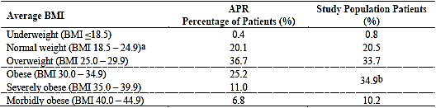
Abbreviations: BMI = body mass index; APR = Australian Psoriasis Registry. Notes: a) This row was mislabelled ‘Normal or Underweight (≥ 18.5 and < 25 kg/m²)’ in the submission. The correct label is ‘Normal (≥ 18.5 and < 25 kg/m²)’; b) BMI 30.0-39.9.
The above results show that the population from the registry and the pivotal studies are comparable. Overall, patients with psoriasis, independently of its severity, are shown to be predominantly above normal weight. In addition, the studies conducted by the company did not target patients on the basis of BMI inclusion or exclusion criteria that would bias the selection of obese patients. As such, Eli Lilly believe the study population reflects the profile of the patients to be treated by ixekizumab.

Evaluator’s comment
The sponsor’s response is acceptable.

Safety

Question 3
The submitted data indicates that the 5 (0.1%) patients in the all psoriasis ixekizumab-exposure analysis set reported the suicide/self-injury related TEAE of suicide attempt, and that suicide attempt was reported in a further 4 patients in this analysis set after the database lock. Please update all data on suicide/self-injury related TEAEs, including suicide attempts, and compare these events in patients in the placebo, etanercept and ixekizumab treatment groups.

Sponsor’s response (edited)
The initial assessment in the Biologics License Application (BLA) (data cut off 15 September 2014 (for Studies RHAZ and RHBC) or 01 October 2014 (Study RHBA)) was based on a review of adverse data via the ‘Depression and Suicide/Self-Injury’ MedDRA SMQ (20000035) and an analysis of the QIDS-SR₁₆.
The Applicant would like to inform the TGA that it has since completed an ‘Evaluation of Suicidal Ideation and Behaviour by Columbia Classification Algorithm of Suicide Assessment (C-CASA) in Clinical Studies of Ixekizumab’ at the request of another agency (FDA). The C-CASA evaluation included the 5 patients mentioned in the BLA submission, the 4 patients reported after the initial data lock, and an additional patient who had an event 2 months after ixekizumab treatment was discontinued. This response will summarise the findings of the C-CASA assessment (data cut off date of 09 April 2015) and provide the additional data on the suicide/self-injury related treatment-emergent adverse event available at the 12-month safety update with a data cut off date of 15 September 2015.
The C-CASA evaluation included a review and analysis of adverse data for suicide-related events via a text string search with adjudication to the C-CASA categories (see Table 70 below for definitions). The search strategy used to identify all Possibly Suicide-Related Adverse Events (PSRAEs) followed the guidance document from FDA (‘Advice for the Pharmaceutical Industry in Exploring Their Placebo-Controlled Clinical Trials Databases for Suicidality and Preparing Data Sets for Analysis by FDA’ (FDA 2005)). The search was conducted on all patient data from the ixekizumab clinical studies. For psoriasis studies, the integrated database cut off 09 April 2015 was used. For rheumatoid arthritis studies, the cut off from the initial submission was used. For the psoriatic arthritis study, a 26 February 2015 cut off was used.

Table 70. C-CASA related codes and definitions
The key findings from the retrospective C-CASA analysis of the integrated ixekizumab clinical trial database are as follows:
- Across the entire ixekizumab clinical development programme (more than 7000 patient-years of exposure), there were no completed suicides (Code 1) among all studies of ixekizumab for the treatment of psoriasis, psoriatic arthritis, and rheumatoid arthritis.
- The incidence of suicidal behaviour and ideation (Codes 1 through 4) events was low, consistent with the background incidence rates observed in patients with psoriasis, and was comparable across ixekizumab, placebo, and etanercept treatment groups (0.1% across each treatment arm).
- The results from the assessment of suicidal behaviour and ideation using the C-CASA retrospective methodology are consistent with the results provided in the BLA submission.
- Of the 10 events of nonfatal suicide attempt reported by ixekizumab-treated patients at the time of the data cut-off date for the C-CASA, 2 events occurred in the placebo-controlled Induction Dosing Period, 1 reported in the Maintenance Dosing Period, 6 were reported in long-term or open-label extension periods (which includes a patient that previously had an event reported as a suicidal ideation in Study RHBC, later determined to be a nonfatal suicide attempt based on additional information, an intentional overdose) and 1 was reported in a post-treatment follow-up period 2 months after discontinuing ixekizumab treatment. The timing of the reported suicide attempts does not suggest a relationship to treatment with ixekizumab. As noted in the BLA submission, all ixekizumab-treated patients who reported a suicide attempt had at least 1 risk factor, including history of past suicide attempts, depression, and bipolar disorder, anxiety, alcohol or other substance use disorder, and the presence of major, acute psycho-social triggers.
- There were no events of suicidal behaviour and ideation reported in the psoriatic arthritis and rheumatoid arthritis clinical trials. The overall incident rate of suicidal behaviour or ideation observed among patients with moderate-to-severe psoriasis who are exposed to ixekizumab (1.39 per 1000 person- years) is within the range reported in the literature for patients with severe psoriasis (95% CI: 0.57 to 1.41).
- The meta-analyses did not show evidence of an increased risk of suicide-related behaviour or ideation with ixekizumab compared with placebo or etanercept in psoriasis clinical trials.

Table 71. Possible suicide related adverse events by retrospective C-CASA outcome codes, all post-baseline observations including follow up-up periods, all psoriasis ixekizumab exposures, integrated analysis set
Abbreviations: C-CASA = Columbia Classification Algorithm of Suicide Assessment; IXE = ixekizumab. Notes: No cases meeting Code 7 and 8 criteria; Code 7 = self-injurious behaviour, no suicidal intent; Code 8 = not self-harm related, accident, psychiatric, medical, out-of context. Notes: a) the group of patients who were exposed to ixekizumab at any time during a study.
The 12-month safety update (data cut off 15 September 2015), all psoriasis ixekizumab exposures integrated analysis set, includes suicide/self-injury-related TEAE data since the C-CASA/April 2015 database cut off. Two additional patients (one each in Studies RHBA and RHBC) were reported in this time. This gives a total of 11 patients in the pooled psoriasis ixekizumab-exposure group: 2 patients from the Induction Dosing Period; 2 patients from the maintenance dosing period; and 7 from the long-term extension or open-label extension periods (plus the 1 aforementioned event that occurred 2 months post ixekizumab treatment (Study RHBC); this is not captured in the all psoriasis ixekizumab exposures integrated analysis set). Clinical vignettes for 9 events were captured in the SCS with the initial BLA submission and are not presented in this report. Clinical vignettes for the case in Study RHAZ (whose event occurred between the original submission and the C-CASA/April 2015 data cut off) and the 2 new events reported after the C-CASA April 2015 database cutoff (from Studies RHBA and RHBC) were included in the response.

Table 72. Incidence of possibly suicide-related AEs determined by retrospective C-CASA outcome codes during induction/double-blind periods and follow-up period, safety population; Studies RHAG, RHAJ, RHAZ, RHBA, and RHBC
Abbreviations: C-CASA = Columbia Classification Algorithm of Suicide Assessment; IXE OTH = ixekizumab doses other than IXEQ4W and IXEQ2W; IXEQ2W = ixekizumab 80 mg every 2 weeks; IXEQ4W = ixekizumab 80 mg every 4 weeks; n1 = number of patients with events reported during the Double-Blind Treatment Period; n2 = number of patients with events reported during the Double-Blind Treatment and follow-up periods; data from the follow-up period are included in n2 if patient discontinued or completed the Double-Blind Treatment Period and the next period was the follow-up period. Notes: a) patients who randomised to placebo during the Double-Blind Placebo-Controlled Period (Studies RHAG, RHAJ, RHAZ, RHBA, and RHBC); b) patients randomised to etanercept during the Double-Blind Placebo- and Active-Controlled Period (Studies RHBA and RHBC); c) patients randomised to IXEQ4W during the Double-Blind Placebo-Controlled Period (Studies RHAZ, RHBA, and RHBC); d) patients randomised to IXEQ2W during the Double-Blind Placebo-Controlled Period (Studies RHAZ, RHBA, and RHBC); e) patients randomised to ixekizumab doses other than ixekizumab 80 mg Q4W or ixekizumab 80 mg Q2W (Studies RHAG and RHAJ).

Table 73. TEAEs: suicide/self-injury, MedDRA preferred term by decreasing frequency within SMQ, person-time adjusted incidence rate, all treatment periods (all psoriasis ixekizumab exposure safety population), all psoriasis ixekizumab exposure integrated analysis set
Abbreviations: IXE = Ixekizumab; IR= Incidence Rate per 100 patient years; N = number of patients in the analysis population; n = number of patients with at least 1 TEAE in the specified category; SMQ = Standardized MedDRA Queries; TEAE = treatment-emergent adverse event; Total patient years = total time at risk in years. Notes: A TEAE is defined as an event that first occurred or worsened in severity after baseline and on or prior to the date of the last visit within the treatment period. AE is coded using MedDRA Version 18.0. * Broad definition includes narrow definition. Notes: a) the event of one patient (Study RHBC) is included as both ‘suicide ideation’ and ‘intentional overdose.’ The second suicide ideation event is new (that is, reported after the April 2015 cut off) Study RHBC.
All 8 patients in the all psoriasis ixekizumab exposures integrated analysis set who were reported to have suicide attempts were discontinued from study drug. For 4 patients, the reason for study drug discontinuation was the event term ‘suicide attempt’ and for 1 patient, the reason was the event term ‘suicidal ideation.’ The remaining 3 patients with suicide attempts were discontinued from study drug for other reasons (depression, lost to follow-up (would not return for early termination visit after investigator learned of suicide-related event), and cardiac exclusion criterion (Phase II study)).
In evaluating exposure-adjusted IRs for suicide/self-injury-related TEAEs in the updated (15 September 2015 data cut off) all psoriasis ixekizumab exposure integrated analysis set, the IR (1.40 per 1000 person-years) is within the range reported in patients with severe psoriasis.²⁰
Overall, these results of suicide/self-injury related AEs from the C-CASA evaluation and the 12-month safety update are consistent with those reported in the BLA submission. The additional C-CASA meta-analyses did not show evidence of an increased risk of suicide-related behaviour or ideation with ixekizumab compared with placebo or etanercept in psoriasis clinical trials, and the overall rates are similar to background rates in patients with severe psoriasis. In addition to the analyses of AE reports, the initial BLA submission provided available information from analysis of the QIDS scale (Item 12: thoughts of suicide or death). That analysis indicated no significant difference in Item 12 scores with ixekizumab treatment compared to placebo or etanercept and does not suggest any increased risk of suicidal behaviour and ideation associated with ixekizumab treatment.

Evaluator’s comment
The sponsor provided a comprehensive response to the question. The sponsor notes that all ixekizumab-treated patients who reported a suicide attempt had at least one risk factor, including history of past suicide attempts, depression, and bipolar disorder, anxiety, alcohol or other substance use disorder, and the presence of major, acute psycho-social triggers. Review of the 3 new clinical narratives showed that none of the three patients had a previous history of suicide attempt, and none of the three patients reported depression or suicidal ideation at baseline. One of the new patients had a history of anxiety and was being treated with citalopram, one patient developed anxiety while on treatment and was treated with venlafaxine, and one patient harmed himself while under the influence of alcohol.
Days on treatment at the time of the 10 non-fatal suicide attempts (C-CASA Code 2) ranged from 52 days to 669 days, with one event being reported greater than 2 months after the last dose of ixekizumab. The data show to apparent relationship between duration of treatment with ixekizumab and non-fatal suicide attempt. The exposure-adjusted incidence rate for suicide/self injury related TEAEs in the updated all psoriasis ixekizumab exposure analysis set was 1.40 per 1000 person-years, which the sponsor states is within the range reported in patients with severe psoriasis.²⁰ The publication referred to by the sponsor has been examined. The publication reported the results of a population-based cohort study using data collected as part of the patient’s electronic medical record from 1987 to 2002 (UK General Practice Research Database). The hazard ratio for suicidality (adjusted for age and sex) in patients with psoriasis compared to controls was 1.51 (95% CI: 0.92 to 2.49). The unadjusted incidence rate for suicidality was 0.93 (95% CI: 0.85 to 1.00) per 1000 person years in patients with mild psoriasis, and 0.92 (95% CI: 0.57 to 1.41) in patients with severe psoriasis. The attributable risk of suicidality (adjusted for age and sex) was 0.4 per 1000 person years for both patients with mild psoriasis and severe psoriasis (that is, excess risk for suicidality corresponds to 1 case per 2500 patients per year).
Overall, patients with psoriasis are at an increased risk of suicidality compared to patients without the condition. The available data suggests that ixekizumab treatment in patients with psoriasis does not increase the risk of suicidality above the background risk of this event in patients with the disease.

Question 4
The submitted data indicate that treatment emergent high CK levels in the all psoriasis ixekizumab-exposure integrated analysis set were reported in 10.5% of patients, and that in order to further evaluate the effect of ixekizumab on CK and potentially related clinical outcomes, TEAEs (for example, renal insufficiency and rhabdomyolysis) were evaluated. Please provide the results of the TEAE evaluation.

Sponsor’s response (edited by evaluator)
As noted in the question, data from the initial submission indicated that in the all psoriasis ixekizumab-exposures integrated analysis set treatment-emergent high CK levels were reported at any time post-baseline in 10.5% of ixekizumab-treated patients. Further evaluation was done which included comparisons of ixekizumab-, placebo-, and etanercept-treated patients in the 12-week induction dosing period. High treatment-emergent levels of CK at any time were observed in higher proportions ixekizumab 80 mg Q4W, Q2W, and total ixekizumab patients compared to placebo patients during the induction dosing period, but there was no dose effect (see Table 74 below). There was also no difference between treatment groups for patients who met high treatment-emergent CK criteria (> 265 to 1105 U/L, depending on age and gender, and with the upper limits of the ranges based on the Lilly large clinical trial population-based reference limits for the integrated data) at endpoint of the period. Findings were similar for comparison of high treatment-emergent CK for total ixekizumab patients to etanercept patients in this period. Furthermore, analysis of least squares mean changes from baseline to last observation in CK levels showed no significant differences between ixekizumab patients and placebo or etanercept patients.
Table 74. Treatment-emergent high creatine kinase category at any time induction dosing period primary psoriasis placebo-controlled integrated analysis set (Studies RHAZ, RHBA, and RHBC)
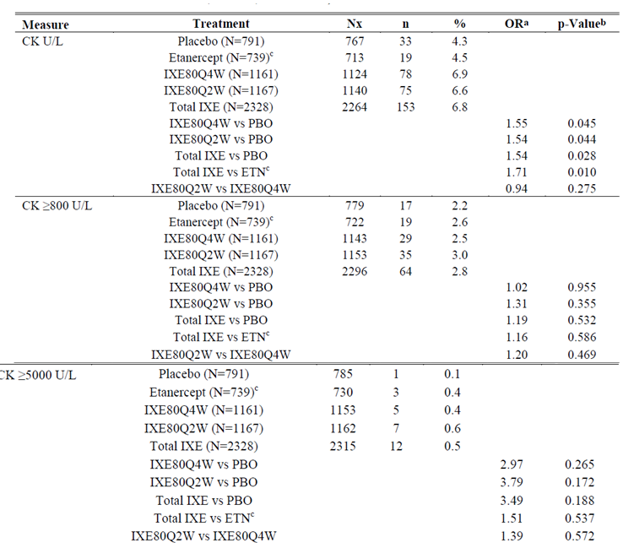
Abbreviations: CK = creatine kinase; ETN = etanercept; IXE = ixekizumab; IXE80Q4W = ixekizumab 80 mg every 4 weeks; IXE80Q2W = ixekizumab 80 mg every 2 weeks; IXE = ixekizumab; N = number of patients in the analysis population; n = number of patients for the named laboratory parameter with at least 1 post-baseline value in a given assessment category and for whom baseline value was not in the same assessment category; Nx = number of patients whose baseline result was not in the given assessment category and who provided a post-baseline value; OR = odds ratio; PBO = placebo; TE = treatment-emergent. Notes: Percentages are based on n and Nx. A TE CK ≥800 U/L is defined as a change from values <800 U/L at baseline, to a value ≥800 U/L at any time during the treatment period. A TE CK ≥5000 U/L is defined as a change from values <5000 U/L at baseline, to a value ≥5000 U/L at any time during the treatment period; a) Mantel-Haenszel OR. The denominator is PBO (IXE versus PBO) and IXE Q4W (high dose versus low dose); b) p-Value from CMH test stratified by study; c) etanercept data and statistical comparisons are from the Psoriasis placebo- and active-controlled integrated analysis set (studies rhba and rhbc).
To further evaluate the effect of ixekizumab on CK and potentially related clinical outcomes (rhabdomyolysis and renal failure), TEAEs were searched for using the MedDRA rhabdomyolysis/myopathy SMQ or the relevant MedDRA HLT groups associated with renal failure in the all psoriasis ixekizumab-exposures integrated analysis set. Patients with treatment-emergent CK levels ≥ 800 U/L or ≥ 5000 U/L and any of the TEAE PTs from these searches were evaluated. These analyses found no association of increased treatment-emergent CK of the levels noted with TEAEs of renal failure. The single patient (Study RHBC) identified, with a CK level ≥ 800 U/L but < 5000 U/L, did not have concurrent treatment-emergent high CK and a renal AE. Furthermore, for 3 of the 4 patients with reported TEAEs of rhabdomyolysis in ixekizumab-treated patients, 2 had the events attributed to physical exercise and all 3 had CK values that returned to baseline or near baseline while still receiving ixekizumab. The fourth patient had other confounding conditions (cerebrovascular accident, supraventricular tachycardia, and seizures) that may have contributed to an elevated CK level. All 4 patients with a reported TEAE of rhabdomyolysis had CK levels that were ≥ 800 U/L but < 5000 U/L. None of these 4 patients were reported to have myoglobinuria to document the diagnosis of rhabdomyolysis.
There were 3 other patients with SMQ broad TEAEs of ‘Myopathy’, ‘Myalgia’ or ‘Musculoskeletal pain’ who had levels of CK ≥ 5000 U/L sometime during observation. One of these patients (Study RHBA) with 2 reported events of myopathy, had no temporal association between the first myopathy event with a high CK level (8914 U/L, that occurred approximately 5.5 months prior to the onset of myopathy and was within normal limits 10 days later), and a second event concurrent with another CK elevation (4245 U/L) that normalised upon a subsequent assessment 1 week later, while the patient remained on ixekizumab treatment. Another patient (Study RHBC) had a TEAE of myalgia concurrent with the elevated CK level, whilst the third (Study RHBC), with an event of musculoskeletal pain, did not. The latter patient was receiving placebo at the time of the elevated CK level in the Induction Dosing Period. All 3 of these patients were reported to have undergone vigorous exercise, and all had prompt normalisation of CK elevations while remaining on study treatment. There were no serious or severe neuro-muscular events.
In the all psoriasis ixekizumab-exposures integrated analysis set, the majority of ixekizumab treated patients with treatment emergent elevations of CK ≥ 5000 U/L had elevations that occurred at one time point or were transient in nature; many of these were associated with physical activity. Of note, no patients in the analysis set discontinued ixekizumab treatment specifically due to elevation of CK.
While treatment emergent high CK levels were commonly observed in the induction dosing period in higher proportions of ixekizumab-treated patients than compared to placebo- or etanercept-treated patients, as well as in 10% to 11% of all ixekizumab-treated patients in the psoriasis clinical studies, incidences of potentially clinically meaningful high levels of CK were not observed in significant disproportion in ixekizumab patients relative to comparator patients, and no relationship with concerning clinical outcomes was found. In many cases, increased physical activity was reported in association with such elevated levels, and rapid normalisation of levels was observed. The sponsor does not consider elevated CK to be a clinically important effect of ixekizumab use in patients with moderate-to-severe plaque psoriasis.

Evaluator’s comments
The sponsor provided a comprehensive response to the question. It is considered that patients treated with ixekizumab are at an increased risk of treatment-emergent high CK levels. The risk does not appear to be associated with muscular AEs (myopathy, myalgia, musculoskeletal pain), or with other potentially related serious clinical outcomes of rhabdomyolysis or acute renal failure. No patients were reported to have discontinued ixekizumab treatment specifically due to elevation of CK. However, due to the frequency of the event it is considered that the PI should include a statement relating to the risk of elevated CK levels in patients being treated with ixekizumab. This information will be of particular relevance to patients taking statins.

Question 5
In the pooled data, there was a significantly higher proportion of patients in the psoriasis maintenance integrated analysis set with high treatment-emergent systolic blood pressure in the total ixekizumab group compared to placebo (16.9% (n = 113) versus 11.8% (n = 39)). This finding is inconsistent with the results in the primary psoriasis placebo-controlled integrated analysis set, where the proportion of patients with treatment emergent-high systolic pressure was similar in the total ixekizumab and placebo groups (5.4% (n = 88) versus 7.1% (n = 38) respectively). Please comment on this observation.

Sponsor’s response
The sponsor agrees that the significantly higher proportion of patients with high values of treatment emergent systolic blood pressure in the total ixekizumab group compared to the placebo group in the psoriasis maintenance primary population integrated analysis set appears to be inconsistent with the similar proportions between these groups found in the psoriasis primary placebo-controlled analysis set. The sponsor considers this apparent inconsistency to be due to the marked difference in durations of exposure to study drug between these groups during the maintenance dosing period. This is illustrated in Table 75 (below), which shows the number of patients, total exposure, and mean exposure per patient among the treatment groups for re-randomised patients in the Maintenance Dosing Period. Of note, Tables 75 and 76 use updated data through 09 April 2015 for the completed maintenance dosing period, including all primary population patients observed through Week 60 in Studies RHAZ and RHBA. Data in the original submission only included data for the primary population patients who had completed at least 36 weeks of treatment during the maintenance dosing period in Study RHBA, in addition to complete 60-week data for Study RHAZ. The difference in mean exposure between the total ixekizumab and the placebo treatment groups was similar in the submission dataset to that shown for the updated dataset.

Table 75. Study drug exposure, maintenance dosing period primary population, psoriasis maintenance integrated analysis set; Studies RHAZ and RHBA
Table 76 (below) shows that there was a higher mean exposure for the patients in the total ixekizumab group than in the placebo group. This difference allowed for more clinic visits and greater opportunity for high systolic blood pressure values to be recorded for patients in the total ixekizumab group than in the placebo group. Similar to the original submission, the proportion of patients with treatment-emergent high systolic high blood pressure values was significantly greater in the total ixekizumab group than in the placebo group (17.6% versus 11.8%, respectively (p = 0.018)). However, when the numbers of patients with treatment-emergent high systolic blood pressure values were adjusted for differing exposure between the groups, there was no significant difference in the incidence rates between the total ixekizumab and the placebo groups (23.0 per 100 patient-years versus 25.4 per 100 patient-years, respectively (p = 0.585)), with the rate numerically lower in the total ixekizumab group.

Table 76. Incidence of treatment-emergent high systolic blood pressure maintenance dosing period primary population at any time post-baseline psoriasis maintenance integrated analysis set; Studies RHAZ and RHBA
In conclusion, the sponsor considers that when appropriate exposure-adjustment is utilised for evaluation of treatment-emergent high systolic blood pressure values, there is no difference found between ixekizumab and placebo treatment, and that the maintenance dosing period data are consistent with the lack of finding such a treatment effect in the primary placebo-controlled analysis set.

Evaluator’s comment
The sponsor’s response is satisfactory.

Question 6
The Summary of Clinical Safety included a discussion of the mean changes from last observation at baseline to the last post-baseline observation laboratory cytopaenic events in the psoriasis maintenance integrated analysis set. However, the data in this section could not be verified, as the reference to the source Table was incorrect. Please provide the table with the relevant data.

Sponsor’s response
The correct table can be found in the Summary of Clinical Safety labelled [Table reference given]. Eli Lilly apologises for erroneously cross-referencing this table.

Evaluator’s comment
[Response] noted.

Question 7
The sponsor's attention is drawn to what appears to be an incorrect heading in the table summarising potential drug induced liver injury in the primary psoriasis placebo controlled integrated analysis set. The heading refers to the psoriasis placebo-controlled and active controlled integrated analysis set (Studies RHBA and RHBC), but the data in the table appears to refer to the primary psoriasis placebo-controlled integrated analysis set (Studies RHAZ, RHBA and RHBC).

Sponsor’s response
Eli Lilly acknowledges the error in the heading of this table. The data shown in the table do indeed refer to the primary psoriasis placebo-controlled integrated analysis set (Studies RHAZ, RHBA and RHBC).

Evaluators comment
[Response] noted.

Question 8
The sponsor's attention is drawn to what appears to be an incorrect heading in the table summarising the hepatotoxicity data for the all psoriasis ixekizumab exposures integrated analysis set. The data appear to relate to the maintenance dosing period (psoriasis maintenance integrated analysis set). Please provide a table with the data for the all psoriasis ixekizumab exposures integrated analysis set.

Sponsor’s response
Eli Lilly acknowledges its error with the [specified] table. It had been intended to provide the table for the all psoriasis ixekizumab exposures integrated analysis set here, but a duplicate of the maintenance dosing period table was inserted by mistake. [The correct table was provided in the response to evaluator’s questions].

Evaluator’s comment
[Response] noted. The data from the all psoriasis ixekizumab exposure integrated analysis set showed that there was 1 patient out of 4186 meeting the elevated hepatic criteria (maximum ALT ≥ 3 x ULN, maximum total bilirubin ≥ 2 x ULN, with all ALP < 2 x ULN).

Second round benefit-risk assessment
Second round assessment of benefits
After consideration of the responses to clinical questions, the benefits of ixekizumab for the proposed usage are unchanged from those identified in the First round assessment of benefits.
Second round assessment of risks
After consideration of the responses to clinical questions, the risks of ixekizumab for the proposed usage are unchanged from those identified in the First round assessment of risks.
Second round assessment of benefits-risk balance
The benefit-risk balance of ixekizumab, given the proposed usage, is favourable.

Second round recommendation regarding authorisation
It is recommended that Taltz be approved for the treatment of moderate to severe plaque psoriasis in adult patients who are candidates for systemic therapy or chemotherapy. The inclusion criteria for each of the 3 pivotal studies required that patients be candidates for phototherapy and/or systemic therapy. Therefore, it is considered that for completeness this condition should be added to the indication.

References
CHMP (Committee for Medicinal Products for Human Use). Guideline on immunogenicity assessment of biotechnology-derived therapeutic proteins. 2007. Dubin DB, Tanner W, Ellis R. Biologics for psoriasis. Nat Rev Drug Discov. 2003;2(11):855-856.
Dmitrienko A, Tamhane AC. Mixtures of multiple testing procedures for gatekeeping applications in clinical trials. Statist Med. 2011;30(13):1473-1488.
Dubin DB, Tanner W, Ellis R. Biologics for psoriasis. Nat Rev Drug Discov. 2003;2(11):855-856.
Fredriksson et al. Severe psoriasis—oral therapy with a new retinoid. Dermatologica. 1978;157(4):238-244.
FDA (Food and Drug Administration). Guidance for industry: assay development for immunogenicity testing of therapeutic proteins. December 2009.
Fieller E et al. The distribution of the index in a bivariate Normal distribution. Biometrika. 1932;24(3-4):428-440.
Griffiths C et al. Comparison of ixekizumab with etanercept or placebo in moderate-to-severe plaque psoriasis (UNCOVER-2 and UNCOVER-3): results from two Phase III randomised trials. NEJM.
Gupta S et al. Recommendations for the validation of cell-based assays used for the detection of neutralizing antibody immune responses elicited against biological therapeutics. J Pharm Biomed Anal. 2011;55(5):878-888.
Lobo E et al. Antibody pharmacokinetics and pharmacodynamics. J Pharm Sci. 2004;93(11): 2645-2668.
Ortega H et al. Pharmacokinetics and absolute bioavailability of mepolizumab following administration at subcutaneous and intramuscular Sites. Clin Pharm in Drug Dev. 2014;3(1):57-62.
Parisi et al. for Identification and Management of Psoriasis and Associated ComorbidiTy (IMPACT) project team. Global epidemiology of psoriasis: a systematic review of incidence and prevalence. J Invest Dermatol. 2013;133(2):377-385.
Rothmann M et al. Design and analysis of noninferiority mortality trials in oncology. Stat Med. 2003;22(2):239-264
Sampson H et al. Second symposium on the definition and management of anaphylaxis: summary report—Second National Institute of Allergy and Infectious Disease/Food Allergy and Anaphylaxis Network symposium. J Allergy Clin Immunol. 2006;117(2):391-397.
Schmitt J et al. Efficacy and safety of systemic treatments for moderate-to-severe psoriasis: meta-analysis of randomized controlled trials. Br J Dermatol. 2014;170(2):274-303.
Shankar G et al. Recommendations for the validation of immunoassays used for detection of host antibodies against biotechnology products. J Pharm Biomed Anal. 2008;48(5):1267-1281.
Smith B et al. Confidence interval criteria for assessment of dose proportionality. Pharm Res. 2000;17(10):1278-1283.
Wang W et al. Monoclonal antibody pharmacokinetics and pharmacodynamics. Clin Pharmacol Ther. 2008;84(5):548-558.

Therapeutic Goods Administration
PO Box 100 Woden ACT 2606 Australia
Email: info@tga.gov.au Phone: 1800 020 653 Fax: 02 6232 8605
https://www.tga.gov.au

Parisi R et al. Identification and Management of Psoriasis and Associated ComorbidiTy (IMPACT) project team. Global epidemiology of psoriasis: a systematic review of incidence and prevalence. J Invest Dermatol. 2013;133(2):377-385.
Dubin DB, Tanner W, Ellis R. Biologics for psoriasis. Nat Rev Drug Discov. 2003;2(11):855-856.
Schmitt J et al. Efficacy and safety of systemic treatments for moderate-to-severe psoriasis: meta-analysis of randomized controlled trials. Br J Dermatol. 2014;170(2):274-303.
Smith B et al. Confidence interval criteria for assessment of dose proportionality. Pharm Res. 2000;17(10):1278-1283.
Fredriksson T, Pettersson U. Severe psoriasis: oral therapy with a new retinoid. Dermatologica. 1978;157(4):238-244.
Ortega H et al. Pharmacokinetics and absolute bioavailability of mepolizumab following administration at subcutaneous and intramuscular Sites. Clin Pharm in Drug Dev. 2014;3(1):57-62.
Lobo E et Al. Antibody pharmacokinetics and pharmacodynamics. J Pharm Sci. 2004;93(11): 2645-2668.
Wang W et al. Monoclonal antibody pharmacokinetics and pharmacodynamics. Clin Pharmacol Ther. 2008;84(5):548-558.
Shankar G et al. Recommendations for the validation of immunoassays used for detection of host antibodies against biotechnology products. J Pharm Biomed Anal. 2008; 48(5):1267-1281.
Gupta S et al. Recommendations for the validation of cell-based assays used for the detection of neutralizing antibody immune responses elicited against biological therapeutics. J Pharm Biomed Anal. 2011; 55(5):878-888.
Griffiths C et al. Comparison of ixekizumab with etanercept or placebo in moderate-to-severe plaque psoriasis (UNCOVER-2 and UNCOVER-3): results from two Phase III randomised trials. NEJM.
The PPD skin test is a method used to diagnose silent (latent) tuberculosis (TB) infection.
Dmitrienko A, Tamhane AC. Mixtures of multiple testing procedures for gatekeeping applications in clinical trials. Statist Med. 2011;30(13):1473-1488.
Fieller E. The distribution of the index in a bivariate Normal distribution. Biometrika. 1932;24(3-4):428-440.
Rothmann M et al. Design and analysis of non-inferiority mortality trials in oncology. Stat Med. 2003;22(2):239-264
Sampson H et al. Second symposium on the definition and management of anaphylaxis: summary report. Second National Institute of Allergy and Infectious Disease/Food Allergy and Anaphylaxis Network symposium. J Allergy Clin Immunol. 2006;117(2):391-397.
Rush et al. QIDS-SR16. Biol Psychiatry (2003) 54: 573-83.
American Psychiatric Association. (2000). Diagnostic and statistical manual of mental disorders (4th ed., text rev.). Washington, DC
Food and Drug Administration. Appendix 2: Request to Sponsors. Advice for the pharmaceutical industry in exploring their placebo-controlled clinical trials databases for suicidality and preparing data sets for analysis by FDA. August 2005. In: Laughren TP. Memorandum: Overview for December 13 meeting of Psychopharmacologic Drugs Advisory Committee (PDAC). November 16, 2006:p 54-64.
Kurd S et al. The risk of depression, anxiety, and suicidality in patients with psoriasis: a population-based cohort study. Arch Dermatol. 2010;146(8):891-895

