|  |
| --- |
| **February 2014** |

|  |
| --- |
| Australian Public Assessment Report for Japanese Encephalitis Vaccine (live, attenuated) |
| Proprietary Product Name: Imojev |
| Sponsor: Sanofi-Aventis Australia Pty Ltd |

About the Therapeutic Goods Administration (TGA)

* The Therapeutic Goods Administration (TGA) is part of the Australian Government Department of Health, and is responsible for regulating medicines and medical devices.
* The TGA administers the *Therapeutic Goods Act 1989* (the Act), applying a risk management approach designed to ensure therapeutic goods supplied in Australia meet acceptable standards of quality, safety and efficacy (performance), when necessary.
* The work of the TGA is based on applying scientific and clinical expertise to decision-making, to ensure that the benefits to consumers outweigh any risks associated with the use of medicines and medical devices.
* The TGA relies on the public, healthcare professionals and industry to report problems with medicines or medical devices. TGA investigates reports received by it to determine any necessary regulatory action.
* To report a problem with a medicine or medical device, please see the information on the TGA website <<http://www.tga.gov.au>>.

About AusPARs

* An Australian Public Assessment Record (AusPAR) provides information about the evaluation of a prescription medicine and the considerations that led the TGA to approve or not approve a prescription medicine submission.
* AusPARs are prepared and published by the TGA.
* An AusPAR is prepared for submissions that relate to new chemical entities, generic medicines, major variations, and extensions of indications.
* An AusPAR is a static document, in that it will provide information that relates to a submission at a particular point in time.
* A new AusPAR will be developed to reflect changes to indications and/or major variations to a prescription medicine subject to evaluation by the TGA.

Copyright

© Commonwealth of Australia 2014  
This work is copyright. You may reproduce the whole or part of this work in unaltered form for your own personal use or, if you are part of an organisation, for internal use within your organisation, but only if you or your organisation do not use the reproduction for any commercial purpose and retain this copyright notice and all disclaimer notices as part of that reproduction. Apart from rights to use as permitted by the *Copyright Act 1968* or allowed by this copyright notice, all other rights are reserved and you are not allowed to reproduce the whole or any part of this work in any way (electronic or otherwise) without first being given specific written permission from the Commonwealth to do so. Requests and inquiries concerning reproduction and rights are to be sent to the TGA Copyright Officer, Therapeutic Goods Administration, PO Box 100, Woden ACT 2606 or emailed to <[tga.copyright@tga.gov.au](mailto:tga.copyright@tga.gov.au)>.

Contents

I. Introduction to product submission 4

Submission details 4

Product background 4

Regulatory status 6

Product Information 6

II. Quality findings 6

III. Nonclinical findings 6

Nonclinical summary and conclusions 8

IV. Clinical findings 9

Introduction 9

Pharmacokinetics 10

Pharmacodynamics 10

Efficacy 11

Safety 13

Clinical summary and conclusions 13

List of questions 14

V. Pharmacovigilance findings 14

Risk management plan 14

VI. Overall conclusion and risk/benefit assessment 20

Quality 20

Nonclinical 20

Clinical 20

Risk management plan 26

Risk-benefit analysis 26

Outcome 29

Attachment 1. Product Information 30

Attachment 2. Extract from the Clinical Evaluation Report 30

## I. Introduction to product submission

### Submission details

|  |  |  |
| --- | --- | --- |
| *Type of submission:* | Major Variation | |
| *Decision*: | Approved | |
| *Date of decision:* | 11 December 2013 | |
| *Active ingredient:* | Japanese Encephalitis Vaccine (live, attenuated) |
| *Product name:* | Imojev |
| *Sponsor’s name and address:* | Sanofi-Aventis Australia Pty Ltd Talavera Corporate Centre Building D 12-24 Talavera Road Macquarie Park NSW 2113 |
| *Dose forms:* | 1 dose of freeze dried vaccine and 1 dose of diluent in separate vials |
| *Strengths:* | Live, attenuated, recombinant Japanese encephalitis virus Vaccine: 4.0-5.8 log PFU (plaque forming units) |
| *Pack sizes:* | 1 powder vial and 1 diluent vial, 1 syringe and 2 needles |
| *Approved therapeutic use:* | Imojev is indicated for prophylaxis of Japanese encephalitis caused by the Japanese encephalitis virus, in individuals from 12 months of age and over. |
| *Route of administration:* | Subcutaneous (SC) injection |
| *Dosage:* | Individuals 12 months of age and over: a 0.5 mL single injection of the reconstituted vaccine |
| *ARTG number:* | Aust R 162215 |

### Product background

This AusPAR describes a submission by the sponsor, Sanofi-Aventis Australia Pty Ltd, to amend the dosage schedule for Imojev, a ChimeriVax Japanese Encephalitis Vaccine (JE-CV). This is a monovalent, live attenuated viral vaccine against the Japanese Encephalitis virus. The virus was obtained via recombinant DNA technology. The approved indication is:

*Imojev is indicated for prophylaxis of Japanese encephalitis caused by the Japanese encephalitis virus, in individuals from 12 months of age and over.*

In the current application, the sponsor proposes to:

* *recommend a booster dose in paediatric populations; and*
* *update the approved Product Information (PI) to include the long term follow up data in adults.*

Imojev is currently registered in Thailand and Australia. A similar application has been submitted in Thailand in May 2012 and, at the time of this submission, is under review by the Thai Food Drug and Administration. The submission to Australia includes the adult data (that is, the Final Addendum to the clinical study report for H-040-005) but the submission to Thailand does not include any adult data as they were already assessed during the evaluation of registration in Thailand. Both applications include the same paediatric data. The same application has not been submitted in any other countries.

The following dosage forms and strengths are currently registered: JE-CV comes as 0.5 mL dose, once reconstituted using 0.4% sodium chloride solution into the vial of freeze dried vaccine, using the syringe and one of the needles provided in the carton. The vial is gently swirled. After complete dissolution, a 0.5 mL dose of the reconstituted suspension is withdrawn into this same syringe. For injection, the syringe is fitted with the second needle provided in the package. No new dosage forms or strengths are proposed.

To comply with the condition of the registration, the sponsor also submitted two reproductive and developmental toxicity studies in rabbits in order to clarify the potential developmental risk.

#### Dosage and administration

##### Primary vaccination:

Individuals 12 months of age and over: a 0.5 mL single injection of the reconstituted vaccine.

##### Booster:

###### Adult population (18 years of age and over):

There is no need for a booster dose up to 5 years after the administration of a single dose of Imojev.

*Proposed Change: Additional information shows that there is no need for a booster dose in adult population up to 5 years after the primary vaccination.*

###### Paediatric population:

A booster dose of Imojev should be given after primary vaccination in order to confer long term protection.[1] The booster dose should be given preferably 12 months after primary vaccination and can be given up to 24 months after primary vaccination.

Imojev can also be given as a single booster vaccination in children who were previously given an inactivated JE vaccine for primary vaccination, in accordance with the recommended timing for the booster of the inactivated JE vaccine.

*Proposed Change: Addition of the recommendation of booster dose in paediatric populations. In individuals 2 years of age and over, the recommended injection site is the deltoid region of the upper arm.*

In individuals between 12 and 24 months of age, the recommended injection site is the anterolateral aspect of the thigh or the deltoid region.

### Regulatory status

Table 1 shows countries in which Imojev has been approved at the time of the current Australian application to amend the dosage schedule.

Table 1: List of countries where Imojev has been approved.

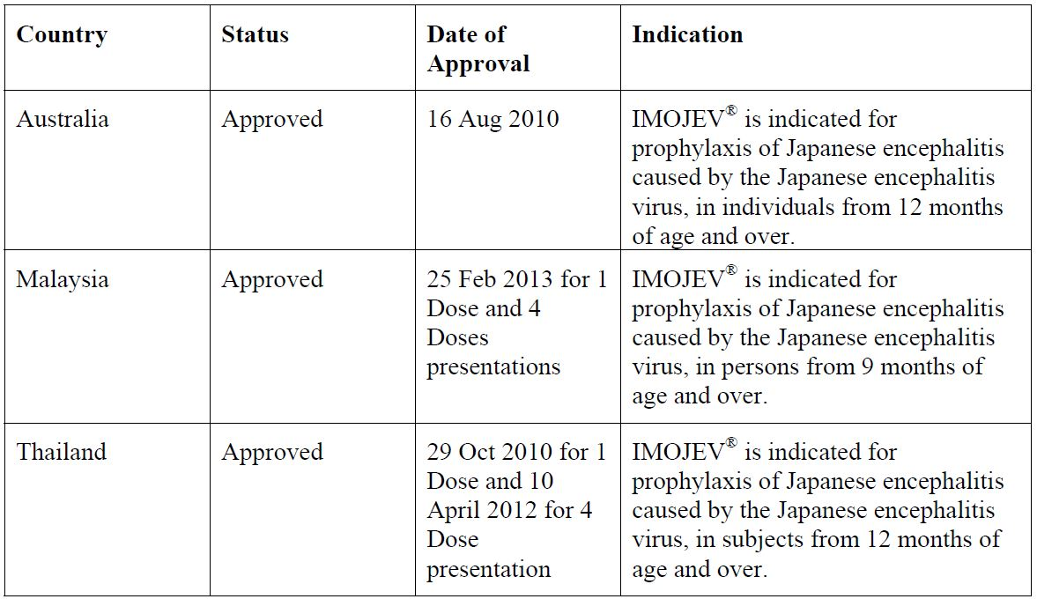

At the time of the current Australian application, Imojev submissions had been made to Hong Kong, Indonesia, Lao People’s Democratic Republic, Myanmar, Pakistan, Philippines, Singapore, Sri Lanka and Taiwan.

### Product Information

The approved PI current at the time this AusPAR was prepared can be found as Attachment 1.

## II. Quality findings

There was no requirement for a quality evaluation in a submission of this type.

## III. Nonclinical findings

Imojev is a chimeric virus vaccine based on the 17D-204 yellow fever (YF) vaccine virus in which two genes have been replaced by the corresponding pre membrane and envelope genes from the SA14-14-2 live attenuated JE virus. In common with other live attenuated viral vaccines, Imojev is contraindicated in pregnancy and breast feeding, and pregnancy should be avoided for 28 days after vaccination. None of the currently registered live virus vaccines have been conclusively demonstrated to pose a risk to the developing foetus[2] on the basis of epidemiological data collected post registration. No nonclinical developmental toxicity studies were submitted for Imojev. A number of published studies have reported normal rates of abortions, still births, and major foetal malformations in YF epidemics and after inadvertent immunisation with the YF 17D vaccine during pregnancy. Human data concerning JE virus infection and pregnancy are very limited as infection of women of childbearing age may be limited by acquisition of immunity in childhood. However, high incidences of stillborn and moribund piglets, and dead foetuses, with central nervous system (CNS) malformations have been observed in JE virus outbreaks since the 1940s, and similar effects were induced experimentally in pregnant pigs after intravenous (IV) administration. The high attenuation and low viremia of Imojev would mitigate against a potential developmental risk; however, it was recommended that a reproductive and developmental toxicity study be conducted to clarify the potential risk, as a condition of registration (ACPM 270th meeting, resolution 9440).

The sponsor submitted two Good Laboratory Practice (GLP) compliant developmental toxicity studies in rabbits for Imojev, in accordance with relevant nonclinical guidelines.[3] The study reports stated that the rabbit was selected as the test species for the following reasons:

(i) it is a standard species for developmental studies;

(ii) the rabbit strain is sensitive to developmental toxicants;

(iii) the test facility has historical data and experience for the species; and

(iv) a preliminary repeat dose immunogenicity study demonstrated a robust antibody response to Imojev in rabbits (no. SP0116 IS1008, not submitted).

However, not all rabbits seroconverted in either study, with seroconversion rates (SCRs) ranging from 1-6/10 does per treatment group in the single dose study, and 6-9/10 does per group in the repeat dose study, indicating a higher SCR after repeat dosing. SCRs in foetuses and pups, from the same dose whenever possible, showed a similar trend to maternal samples. Previously evaluated studies showed 100% seroconversion in rhesus and cynomolgus monkeys after a subcutaneous (SC) dose of Imojev. It is likely that the lower SCR in rabbits reflects a species difference rather than inappropriate sample times or lack of sensitivity of the assay.

Rhesus and cynomolgus monkeys and mice have been commonly used as animal models of wild type JE virus infection, with the development of encephalitis dependent on the route of administration and animal age. Pigs are amplifying hosts for JE virus, and abortions and stillbirths, with CNS malformations, have been reported after transplacental infection. Transplacental infection has been reported after an SC dose of JE virus in mice, and abortions and stillbirths were reported after an intraperitoneal (IP) injection. Although rabbits are a standard species for developmental toxicity studies, it has been reported that they develop asymptomatic JE virus infection regardless of the route of inoculation.[4] Sensitive nucleic acid tests in preliminary study (No. SP0116 IS1008) showed detection of low levels of YFNS5 RNA in sera from female rabbits; however, in the rabbit single dose developmental toxicity study the tests failed to detect vaccine YFNS5 RNA in maternal or pup sera, foetuses or milk on the day after injection of Imojev. A low, transient viremia was previously observed in monkeys and humans after a SC dose of Imojev. The lack of seroconversion in some, and compete lack of detectable viremia, indicates limitations of the rabbit model for live attenuated JE vaccines.

In both rabbit studies there were no Imojev related effects on treated does, ovarian and uterine parameters, natural delivery parameters, foetal external, soft tissue and skeletal abnormalities, and pup survival, growth and development. The repeat dose study also showed no effects of Imojev on female rabbit mating or fertility. Vaccine specific antibodies were detected in foetuses in both studies, but transfer to pups via milk was not detected in the single dose study, and only 1/10 pup samples was seropositive in the repeat dose study.

The full human dose of the vaccine in rabbits (2.5 kg body weight [bw]), on a mg/kg basis, is 20x the human dose in adults (50 kg bw), and 3.6x the dose in 12 month old females (8.9 kg, 50th percentile, US Centres for Disease Control clinical growth charts). These dose multiples were adequate, although such comparisons may be inaccurate for a live virus vaccine if replication levels differ between species post injection.

### Nonclinical summary and conclusions

#### Summary

* Imojev (JE-CV) is a live, attenuated Japanese encephalitis vaccine, registered in Australia and Thailand in 2010, for prophylaxis of JE caused by the JE virus in individuals 12 months of age or older. A single 0.5 mL SC dose of 4.0-5.8 log PFU is recommended. The chimeric vaccine is manufactured by recombinant DNA technology and is based on the 17D-204 YF vaccine in which two genes have been replaced by the corresponding premembrane and envelope genes from the SA14-14-2 live attenuated JE virus.
* This major variation application seeks to update the clinical PI with new long term immunogenicity data, and the addition of a recommendation for a booster dose 12-24 months after primary vaccination in the paediatric population. A booster dose is not required in adults for up to 5 years after primary vaccination.
* In common with other live virus vaccines, Imojev is contraindicated in pregnancy, but may be used in women of childbearing potential. No reproductive or developmental toxicity studies were submitted for registration of Imojev, but they were recommended on the basis of published evidence of developmental toxicity in animals administered one of the vaccine parent wild type viruses, JE virus. Two developmental toxicity studies were submitted for Imojev by Section 31 response.
* In both GLP compliant studies, female NZW rabbits were injected with the human dose of the vaccine SC. In the single dose study rabbits were injected on Gestational Day (GD) 6, 9, 12, 15, 18 or Postnatal Day (PND) 15, and in the repeat dose study they were injected 30 and 10 days prior to mating and on GD 6, 12 and 27. Rabbits were terminated on either GD 29, or after natural delivery on PND 35. In both studies there were no vaccine related effects on treated females, ovarian and uterine parameters, natural delivery parameters, foetal external, soft tissue and skeletal abnormalities, and pup survival, growth and development. The repeat dose study also showed no vaccine effects on female rabbit mating or fertility.

In the single dose study, vaccine YFNS5 RNA was not detected by nucleic acid tests in any samples of maternal or pup sera, foetuses or milk on the day after the injection. Immunogenicity testing by neutralisation assay showed seroconversion in some rabbits and some of their foetuses, but antibody transfer in milk after injection on PND 15 was not detected on PND 35. In the repeat dose study, the majority of treated does seroconverted, and antibodies were transferred to most foetuses, and to 1/10 pup samples examined. The lack of seroconversion in some does and complete lack of detectable viremia indicate some limitations of the rabbit model for live attenuated JE virus vaccines.

#### Recommendations

The sponsor has submitted two reproductive and developmental toxicity studies in rabbits for Imojev, a live, attenuated virus vaccine. Although Imojev is contraindicated in pregnancy, it may be used in women of childbearing potential, and studies to clarify the potential developmental risk were a condition of registration (ACPM resolution 9440).

Administration of repeated human doses of Imojev to female rabbits prior to mating and during gestation, or once during gestation or postnatally, had no adverse effects on female fertility or mating, pregnancy, embryofoetal or postnatal development. Vaccine antigen specific antibodies were transferred to foetuses. Sensitive nucleic acid tests in the single dose study did not reveal vaccine YFNS5 RNA in maternal or pup sera, foetuses or milk. Although rabbits are a standard model for developmental toxicity studies, the lack of seroconversion in some treated does in both studies, and complete lack of detectable viremia, indicates limitations of the rabbit model for live attenuated JE vaccines.

The Imojev PI should be amended as recommended.

## IV. Clinical findings

A summary of the clinical findings is presented in this section. Further details of these clinical findings can be found in Attachment 2.

### Introduction

This clinical dossier contains clinical information relating to the development program of JE-CV including the pharmacodynamic, dose finding, pivotal and other clinical trials. It contains the final addendum report for the adult Study H-040-005 and interim results for three paediatric studies, JEC01, JEC05 and JEC015 (the latter two are follow on trials for JEC02) which relate to the proposed change of scheduling.

The clinical study reports supporting the long term immunity data in adults and the booster dose in paediatric populations consist of the following:

* H-040-005: Randomised, Double Blind, Phase II Study of the Safety, Immunogenicity, and Duration of Immunity of ChimeriVax-JE, Live Attenuated Vaccine in Healthy Adults (Final Addendum dated 9 November 2009)

The final clinical study report was provided in the original application submitted for registration in 2009 (Category 1 Submission). This application includes a copy of this report again together with the Final Addendum dated 9 November 2009, which includes information pertaining to the persistence of immunity up to 5 years after a single dose of Imojev in adults.

* JEC01: A Controlled Study of the Safety and Immunogenicity of ChimeriVax-JE Vaccine in Thai Toddlers and Children (Interim Report version 5.0, 10 February 2012).
* The preliminary safety and immunogenicity data from JEC01 was submitted during the evaluation of Category 1 submission in 2009. This application includes the Interim Clinical Study Report, which includes immunogenicity and safety data up to 3 years after a single dose of Imojev. This study is ongoing.
* JEC05: Long Term Follow Up of Immunogenicity of a Single Dose of Japanese Encephalitis Chimeric Virus Vaccine in Toddlers in Thailand and the Philippines (Interim Report version 2.0,12 May 2011).
* JEC15: Assessment of the Memory Immune Response, Safety of Japanese Encephalitis Chimeric Virus Vaccine (JE-CV) in Children Previously Immunised with a Single Dose of JE-CV and Long Term Follow Up (Interim Report version 2.0, 11 April 2012).

### Pharmacokinetics

#### Studies providing pharmacokinetic data

Consistent with published guidelines,[5] the pharmacodynamic profile for JE-CV was defined by its immunogenicity profile and no pharmacokinetic studies were conducted.

#### Evaluator’s overall conclusions on pharmacokinetics

Not relevant to this submission.

### Pharmacodynamics

#### Studies providing pharmacodynamic data

The clinical pharmacology program in an adult population consisted of five Phase I/II studies: H-040-001, H-040-003, H-040-005, H-040-006, and H-040-007. Studies H-040-008 and H-040-009 also contained immunogenicity assessments, but as the aims of these studies were to evaluate the efficacy (based on a serological correlate of protection), they are presented in the ‘Efficacy’ section of this report.

Immunogenicity data in paediatric populations are available from Studies H-040-004, JEC01, JEC02, JEC05, and JEC15. Data from Study H-040-004 are presented in this section since this study was designed to provide safety data and local immunogenicity data of JE-CV in paediatric populations. By contrast, the aim of the immunogenicity assessments in Studies JEC01 and JEC02 was to evaluate the efficacy (based on a serological correlate of protection) of JE-CV in paediatric populations; thus, immunogenicity results from these studies are presented in the ‘Efficacy’ section of this report. Repeated administration of JE-CV was evaluated in two studies in adults. Administration of a second dose 28 days after the first JE-CV dose was assessed in Study H-040-003 to determine the benefit of more than one dose of vaccine. Moreover, to assess the need for a booster dose, Study H-040-005 evaluated the administration of a second dose at Month 6 after the first JE-CV vaccination.

The development of the lyophilised formulation started with a dose ranging study (H-040-007) testing doses between 3.0 log PFU/0.5 mL dose and 5.0 logPFU/0.5 mL dose. Based on immunogenicity and safety results, a dose with a lower potency limit of 4.0 logPFU/0.5 mL dose was chosen.

The assessment of the immunogenicity profile of JE-CV in the Clinical Development Program was based on the measurement of neutralising antibodies (SCRs and geometric mean titres [GMTs]). The serum titre required to reduce dengue viral plaques by 50% (PRNT50) ≥ 1:10 was defined as protective according to World Health Organisation (WHO) recommendations.[6] The persistence of the antibody response was assessed in a 5 year follow up study after one or two JE-CV vaccinations (single dose of liquid formulation JE-CV and a single dose of placebo in a crossover study with vaccinations on Day 0 and Day 28, followed by a vaccination booster 6 months later for a subset of the subjects) in Study H-040-005.

Results of GMTs to homologous JE-CV virus following JE-CV administration are detailed for Studies H-040-005, H-040-006, and H-040-007. The GMTs observed following vaccination with the liquid formulation of JE-CV (Studies H-040-005 and H-040-006) were similar to the GMTs observed following vaccination with the lyophilised formulation of JE-CV (Study H-040-007). All three studies showed that JE-CV elicits an immune response 30 days after a single dose administration. Subjects who fulfilled the criteria for seroconversion have a protective level of neutralising antibodies (PRNT50 titres ≥1:10). The rate of seroconversion/seroprotection is therefore more clinically relevant than the absolute level of neutralising antibodies expressed as GMTs.

#### Evaluator’s overall conclusions on pharmacodynamics

The information in this section is all by way of background (apart from long term immunogenicity) and these studies were formally assessed in the original licensing submission. They do, however, provide important information about the immunogenicity of the chosen dose, preliminary information about the durability of the response. They also provide data showing no clinically significance interference with YF vaccination or interference with the response to JE-CV from prior YF immunity (either from infection or vaccination).

### Efficacy

#### Pivotal efficacy study: Study H-040-005

The initial study was a randomised, double blind, Phase II Study of the safety, immunogenicity, and duration of immunity of ChimeriVax-JE, Live Attenuated Vaccine (JE-CV) in Healthy Adults The objectives of the Long term Immunogenicity Follow up Period (LIFP) were to assess the durability of the immune response, based on PRNT using JE-CV virus and 4 different wild type strains, in adult volunteers up to 60 months following one or two doses of JE-CV. The initial clinical study report (CSR), covered all data generated under Study H-040-005 through the Month 24 follow up visit. The current CSR final report has data on all three of the LIFP clinic visits that were conducted subsequent to the Month 24 visit and represent the remainder of the five year immunogenicity follow up. This study was conducted in Australia. The treatment phase of the study was conducted between 14 April 2003 and 5 January 2004. Analysis of the SCRs over time was performed at the protocol defined threshold, which required that subjects must either experience a 4 fold rise in neutralising antibody titres between pre and post immunisation samples or subjects who were seronegative at baseline (that is, PRNT50 <1:10) were required to have a PRNT50 titre of ≥1:20 to meet the criteria for seroconversion. In addition, SCRs were analysed at the WHO defined threshold for protection, which required that subjects who were seronegative at baseline (that is, PRNT50 <1:10) required a PRNT50 titre of ≥1:10 to meet the criteria for seroconversion. For subjects who had pre-existing neutralising antibody to JE at baseline (that is, PRNT50 titre of ≥1:10), seroconversion was defined as a ≥ 4 fold rise in neutralising antibody titre between pre and post immunisation.

#### Pivotal efficacy study: Study JEC01 (up to Year 3 of follow-up)

This was a randomised, crossover, open, active controlled (Hepatitis A vaccine), multicentre trial in 100 children and 200 toddlers in Thailand. Subjects received one single dose of Japanese encephalitis chimeric virus vaccine (JE-CV, also referred to as JE-CV in the trial protocol) and one dose of Hepatitis A vaccine one month apart, and were to receive a second dose of Hepatitis A 6 months later. There will be a 5 year follow up. Enrolment was sequential in two age cohorts.

#### Evaluator’s conclusions on clinical efficacy for a single dose of JE-CV in adults (final report on H-050-004) and two doses in children (interim data only)

In adults, vaccination with JE-CV demonstrated high and sustained SCRs with both the single and two dose vaccination schedules with no statistically significant differences in SCRs between the two schedules prior to the end of the 60 month LIFP study. The differences in GMTs between the two dose and single dose regimens during the first 48 months of the LIFP are unlikely to be clinically relevant (given that both a well above cut off levels).

The paediatric study data shows that a single dose of JE-CV induces a protective immune response in both JE naïve and immune paediatric subjects. The immune response of a single dose of JE-CV in toddlers is high both in terms of seroconversion and GMT. A high protective immune response persists up to at least 3 years after a single dose administration of JE-CV, in children previously vaccinated against JE. A protective immune response after a single dose persists in the majority of subjects up to at least 3 years after a single dose administration of JE-CV with a seroprotection rate of 75.2% (sensitivity analysis in the Full Analysis Set [FAS]) in toddlers not previously vaccinated against JE (studies on the long term persistence up to 5 years are still ongoing), but it does seem to decrease over time. JE-CV was administered as a booster dose in Study JEC01 to children aged 2 to 5 years who previously completed a two dose primary vaccination regimen with a mouse brain derived vaccine (MBDV) in accordance with the Thai immunisation schedule. One dose of JE-CV provided a good booster response in all subjects: 100.0% of children were seroprotected after JE-CV vaccination and the response persisted at least up to three years after vaccination. A booster dose of JE-CV was administered in Study JEC15 to children aged 36 to 42 months who received 2 years earlier a first dose of JE-CV in Study JEC02 at the age of 12 to 18 months resulted in 100.0% seroprotection 28 days after administration of the booster dose. This confirms the induction of immune memory by the first dose and suggests a booster effect on neutralising antibody titres. Long term persistence of immunity up to 5 years after the booster dose is ongoing.

In toddlers and children it would appear that a single dose of JE-CV would be adequate in children previously immunised with either a live or inactivated (two dose) JE vaccine, but in previously unimmunised children/toddlers, a two dose course of vaccination with JE-CV will provide long term immunity (although immunogenicity results out to 5 years are pending).

### Safety

#### Pivotal efficacy studies

In the pivotal efficacy studies (H-040-005, JECV01, JECV015), the following safety data were collected:

* General and specific adverse events (AEs) were recorded and assessed by investigators as relevant, either by observation, diary or telephone call. There was a list of specific (solicited) local and systemic symptoms and participants were also asked to record any other AEs in a diary (and investigators in the electronic case report form [eCRF]).
* AEs of particular interest, including viscerotropic disease were assessed by investigators.

#### Pivotal studies that assessed safety as a primary outcome

Safety was a co-primary outcome in Study H-040-005, JEC01 and JEC15.

#### Evaluator’s overall conclusions on clinical safety

The safety data submitted with this application, does not contain any new triggers or safety concerns. In particular, in adults, the booster dose appeared to be at least as well tolerated as the first dose of JE-CV and in the paediatric population, was as well tolerated as the comparators (Hepatitis A and varicella vaccines).

### Clinical summary and conclusions

#### First round benefit-risk assessment

##### First round assessment of benefits

The benefits of JE-CV in the proposed usage are:

* Protective efficacy one month after vaccination in more than 99% of the subjects from a single dose vaccine.
* Sufficient level of seroprotection in adults 5 years after JE-CV single dose for primary immunisation is sufficiently high to consider that no JE-CV booster is needed before 5 years.
* In paediatric populations not previously JE primed, JE-CV provides a protective immune response in more than 95% of toddlers (aged 12 to 24 months). Long term follow up of the persistence of the seroprotection rate after administration of a single dose of JE-CV in paediatric populations has shown some decline of the seroprotection rates to 84.4% seroprotection at 1 year, 80% seroprotection at 2 years, and 75% seroprotection at 3 years.
* A second dose of JE-CV (2 years after the first) resulted in seroprotection of 99.4% of children measured1 year after the JE-CV booster vaccination.
* All the children who previously received a JE primary immunisation with an inactivated JE vaccine and were then boosted with a JE-CV were seroprotected 3 years later. Hence, a booster dose of JE-CV is highly recommended in paediatric populations after primary vaccination (with either JE-CV or an inactivated JE vaccine) in order to provide long term protection (supported by data up to 3 years). The booster dose should be given preferably 12 months after primary vaccination with JE-CV and can be given up to 24 months after primary vaccination (according to available data).

##### First round assessment of risks

The potential risks of JE-CV in the proposed usage include hypersensitivity reactions (allergic, anaphylactic/anaphylactoid), neurological disorders including convulsions, encephalopathy, encephalitis, Acute Disseminated Encephalomyelitis (ADEM), myelitis, Guillain-Barré Syndrome (GBS), peripheral neuropathy, facial (Bell’s) palsy (based on experience with other attenuated and inactivated) JE vaccines.

The sample size of the studies conducted in paediatric populations allowed the detection of events with a rate of 0.2% or more (with 95% probability). Overall, 1444 children aged 9 months to 10 years received JE-CV in three clinical studies conducted in Thailand, the Philippines, and India.

The overall safety profile of JE-CV in adult populations is similar to that of the inactivated MBDV and placebo.

The safety profile in paediatric populations is similar to that of a registered inactivated Hepatitis A vaccine. No safety issue has been identified in clinical studies in adult and paediatric populations (including the long term follow up assessments). JE-CV either as a primary or booster vaccination appears to be safe at a dose which elicits a protective immune response.

Overall, JE-CV was well tolerated and there was no evidence to indicate any new concerns in this submission.

##### First round assessment of benefit-risk balance

The benefit-risk balance of JE-CV, given the proposed usage, is favourable.

#### First round recommendation regarding authorisation

Overall, a single dose of JE-CV for primary immunisation in adults demonstrated high SCRs, rapid onset of immunity, and a good safety profile. The data obtained so far supports the recommendation of vaccination from 12 months of age in populations at risk. The single dose vaccination schedule in adults is expected to favour compliance to treatment and lessen exposure and post vaccinal side effects. This will be particularly useful in Australia where it tends to be given as a pre travel vaccination for people travelling to endemic areas. The recommendation of two doses of JE-CV in children (if not previously vaccinated) or of JE-CV as a long term booster dose, for children previously immunised will increase the rate of long term seroprotection from 75% at three years (for a single unprimed dose). The final data (out to 5 years) from the paediatric studies (JEC01, JEC05 and JEC15) is pending.

### List of questions

None.

## V. Pharmacovigilance findings

### Risk management plan

The sponsor submitted a Risk Management Plan (RMP) which was reviewed by the TGA’s Office of Product Review (OPR).

#### Safety specification

The sponsor provided a summary of Ongoing Safety Concerns which are shown at Table 2.

Table 2: Ongoing Safety Concerns for Imojev.

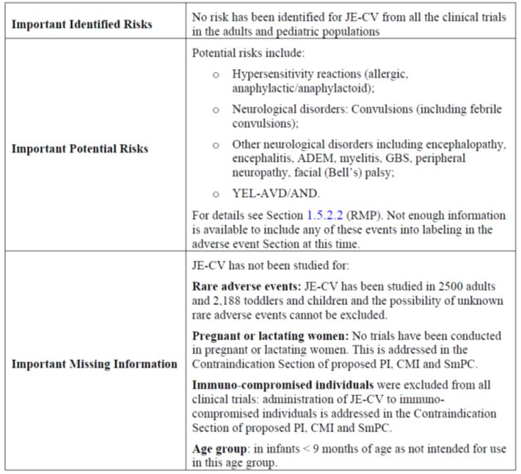

##### OPR reviewer comment

Notwithstanding the evaluation of the nonclinical and clinical aspects of the Safety Specification (SS), this is considered acceptable.

The identified Ongoing Safety Concerns are essentially the same concerns as identified by the sponsor in their RMP for the original submission in 2009. The sponsor states in the RMP that no new important identified risks have arisen.

#### Pharmacovigilance plan

##### Proposed pharmacovigilance activities

The sponsor proposes routine pharmacovigilance activities for important identified and potential risks and missing information (as stated above). Furthermore, additional activities are planned for some of the risks. These activities are summarised in Table 3.

Table 3: Activities additional to routine planned by the sponsor regarding certain safety concerns.

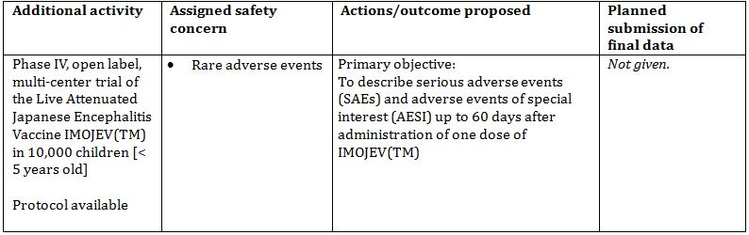

##### OPR reviewer’s comments in regard to the pharmacovigilance plan (PP) and the appropriateness of milestones

The sponsor only plans routine and one additional pharmacovigilance activity item. This is considered acceptable.

The sponsor should provide a date for the planned submission of final data for the following study:

* Phase IV, open label, multicentre trial of the Live Attenuated Japanese Encephalitis Vaccine Imojev in 10,000 children.

#### Risk minimisation activities

##### Sponsor’s conclusion in regard to the need for risk minimisation activities

The sponsor states that no additional risk minimisation activities are necessary.

##### OPR reviewer comment

The sponsor’s conclusion is acceptable.

##### Potential for medication errors

For the purposes of this RMP evaluation, different types of medication error, as suggested by Ferner and Aronson,[7] have been considered. Furthermore different types of vaccination failure, as suggested by CIOMS/WHO Working Group on Vaccine Pharmacovigilance[8] have been considered.

##### OPR reviewer comment

The sponsor’s actions regarding name confusion, labelling and presentation are considered acceptable. Medication errors leading to vaccination failure may arise from improper administration of the drug. The instructions in regard to proper storage and administration given in the proposed PI are considered acceptable.

##### Potential for overdose

The sponsor states that ‘[n]o case of overdose has been reported.’ This is considered acceptable.

#### Summary of recommendations

The OPR provides these recommendations in the context that the submitted RMP Risk Management Plan (in EU-RMP format) Version 6.0 (dated 18/04/2012, DLP 31/01/2012) is supportive to the application; the implementation of a RMP satisfactory to the TGA is imposed as a condition of registration; the submitted EU-RMP is applicable without modification in Australia unless so qualified; and the draft PI and consumer medicine information documents should *not* be revised until the Delegate’s Overview has been received:

##### Further safety considerations

1. Safety considerations may be raised by the clinical evaluator through the consolidated Section 31 request and/or the Clinical Evaluation Report. It is important to ensure that the information provided in response to these includes a consideration of the relevance for the RMP, and any specific information needed to address this issue in the RMP. For any safety considerations so raised, please provide information that is relevant and necessary to address the issue in the RMP.

Unless the sponsor can provide compelling justification against any of the following recommendations, the following should be considered:

##### Recommendations in regard to pharmacovigilance activities

2. The sponsor should provide a date for the planned submission of final data for the following study: Phase IV, open label, multicentre trial of the Live Attenuated Japanese Encephalitis Vaccine Imojev in 10,000 children.

##### Recommendations in regard to risk minimisation activities

3. In regard to the proposed routine risk minimisation activities, it is recommended to the Delegate that the draft PI document be revised as follows:

a. In the ‘Precautions’ section, the PI should include a statement that the current version of the Australian Immunisation Handbook should be consulted in regard to information related to vaccines, in particular the section on vaccination procedures in general and any information in regard to Japanese Encephalitis vaccination.

b. In the ‘Dosage and administration’ section, the sponsor should consider adding that vaccines should be observed for 30 minutes after vaccination in particular when considering that this precaution was undertaken in clinical trials conducted by the sponsor. Furthermore, a warning about a possible delayed hypersensitivity reaction should be added with the advice to remain in an area with medical care for at least 10 days post vaccination.

4. In regard to the proposed routine risk minimisation activities, it is recommended to the Delegate that the draft Consumer Medicine Information (CMI) document be revised as follows:

In the ‘How Imojev is given’ section, the sponsor should consider adding that vaccines should be observed for 30 minutes after vaccination. Furthermore, a warning about a possible delayed hypersensitivity reaction should be added with the advice to remain in an area with medical care for at least 10 days post vaccination.

#### Second round evaluation of the sponsor’s response to the RMP evaluation

Reconciliation of issues outlined in the RMP report is as follows.

##### Recommendation in RMP evaluation report:

1. Safety considerations may be raised by the nonclinical and clinical evaluators through the consolidated section 31 request and/or the nonclinical and clinical evaluation reports respectively. It is important to ensure that the information provided in response to these includes a consideration of the relevance for the RMP, and any specific information needed to address this issue in the RMP. For any safety considerations so raised, please provide information that is relevant and necessary to address the issue in the RMP.
2. The sponsor should provide a date for the planned submission of final data for the following study: Phase IV, open label, multicentre trial of the Live Attenuated Japanese Encephalitis Vaccine Imojev in 10,000 children.

##### Sponsor’s response (or summary of the response):

The final report is planned to be available in May 2016.

##### OPR evaluator’s comment:

This is considered acceptable.

##### Recommendation in RMP evaluation report:

1. In regard to the proposed routine risk minimisation activities, it is recommended to the Delegate that the draft product information document be revised as follows:
   * In the ‘Precautions’ section, the PI should include a statement that the current version of the Australian Immunisation Handbook should be consulted in regard to information related to vaccines, in particular the section on vaccination procedures in general and any information in regard to Japanese Encephalitis vaccination

##### Sponsor’s response (or summary of the response):

No response.

##### OPR evaluator’s comment:

Recommendation remains unchanged: In the ‘Precautions’ section, the PI should include a statement that the current version of the Australian Immunisation Handbook should be consulted in regard to information related to vaccines, in particular the section on vaccination procedures in general and any information in regard to Japanese Encephalitis vaccination.

##### Recommendation in RMP evaluation report:

In the ‘Dosage and administration’ section, the sponsor should consider adding that vaccinees should be observed for 30 minutes after vaccination in particular when considering that this precaution was undertaken in clinical trials conducted by the sponsor. Furthermore, a warning about a possible delayed hypersensitivity reaction should be added with the advice to remain in an area with medical care for at least 10 days post vaccination.

##### Sponsor’s response (or summary of the response):

###### 30 minute observation post vaccination

In response to the OPR comment on the 30 minutes observation requirement, the applicant wishes to comment that the current PI already has included the following statement:

*As with all injectable vaccines, appropriate medical treatment and supervision should always be readily available in case of a rare anaphylactic event following administration of the vaccine.*

This statement is aligned with the recommendation from the current Australian Immunisation Handbook, which recommends the vaccinated person to remain under observation for a short interval to ensure that they do not experience an immediate adverse events, and hence the applicant considers that it is not necessary to add another similar statement in the ‘Dosage and administration’ section of the PI.

[...]

###### 10 day monitoring post vaccination

[...]

The serious systemic hypersensitivity reactions, whether they are delayed or not, following administration of inactivated mouse brain derived JE vaccines have not been observed with other JE vaccines. During the clinical development of Imojev, there was no identification of hypersensitivity reactions which were part of the AESIs investigated. In addition Imojev does not contain gelatin which has a possible role in hypersensitivity reactions. Therefore, 10 days monitoring post vaccination is not required for Imojev.

##### OPR evaluator’s comment:

This is considered acceptable.

##### Recommendation in RMP evaluation report:

4. In regard to the proposed routine risk minimisation activities, it is recommended to the Delegate that the draft CMI document be revised as follows:

In the ‘How Imojev is given’ section, the sponsor should consider adding that vaccines should be observed for 30 minutes after vaccination. Furthermore, a warning about a possible delayed hypersensitivity reaction should be added with the advice to remain in an area with medical care for at least 10 days post vaccination.

##### Sponsor’s response (or summary of the response):

See response to recommendation 3.

##### OPR evaluator’s comment:

See response to recommendation 3.

##### Outstanding issues

###### Issues in relation to the RMP

In the ‘Precautions’ section, the PI should include a statement that the current version of the Australian Immunisation Handbook should be consulted in regard to information related to vaccines, in particular the section on vaccination procedures in general and any information in regard to JE vaccination.

###### Advice from the Advisory Committee on the Safety of Vaccines (ACSOV)

ACSOV advice was not sought for this submission.

##### Comments on the safety specification of the RMP

###### Office of Medicines Authorisation (OMA) Clinical Evaluation Report

Note: The first round clinical report is the final report.

The clinical evaluator made the following summary first round comment in regard to safety specifications in the draft RMP:

The Safety Specification in the draft Risk Management Plan is satisfactory.

###### Office of Scientific Evaluation (OSE) Nonclinical Evaluation Report

The nonclinical evaluator made no summary comment in regard to safety specifications in the draft RMP. It is noted that the pregnancy category remains unchanged (Category B2).

##### Key changes to the updated RMP

Not applicable.

##### Suggested wording for conditions of registration

###### RMP

Implement Risk Management Plan (in EU-RMP format) Version 6.0 (dated 18/04/2012, DLP 31/01/2012), and any future updates as a condition of registration.

###### Periodic Safety Update Reports

OMA to provide new wording when finalised.

## VI. Overall conclusion and risk/benefit assessment

The submission was summarised in the following Delegate’s overview and recommendations:

### Quality

There was no requirement for a quality evaluation in a submission of this type.

### Nonclinical

Two reproductive and developmental toxicity studies in rabbits were submitted. Although Imojev is contraindicated in pregnancy, it may be used in women of childbearing potential, and studies to clarify the potential developmental risk were required as a condition of registration (see ACPM resolution 9440).

Administration of repeated human doses of Imojev to female rabbits prior to mating and during gestation, or once during gestation or postnatally, had no adverse effects on female fertility or mating, pregnancy, embryofoetal or postnatal development. Vaccine antigen specific antibodies were transferred to foetuses. Sensitive nucleic acid testing in the single dose study did not reveal vaccine YFNS5 RNA in maternal or pup sera, foetuses or milk. Although rabbits are a standard model for developmental toxicity studies, the lack of seroconversion in some treated does in both studies, and complete lack of detectable viremia, indicates limitations of the rabbit model for live attenuated JE vaccines.

The nonclinical evaluator recommended some amendments to the PI under the headings of “Effects on fertility”, “Use in Pregnancy”, and “Use in lactation”.

### Clinical

The submitted data supporting the long term immunity in adults is the Final Addendum to the clinical study report for Study H-040-005 and the submitted data supporting the booster dose in paediatric populations includes study reports for Studies JEC01, JEC05, and JEC15.

#### Efficacy

##### Study H-040-005 in adults

Study H-040-005 is a randomised, double blind, Phase II crossover study. The study assessed the immunogenicity, safety, and duration of immunity of JE-CV in healthy adults. The clinical study report was provided in the original registration application submitted in 2009. The current application includes a copy of this report together with the final addendum (dated 9 November 2009) which includes the immune persistence data up to 5 years after a single dose of Imojev.

A total of 202 adults were recruited into this cross over study to receive randomised (Group A or Group B), double blind treatment. Subjects randomised to Group A received JE-CV vaccine on Day 0 and vaccine diluent on Day 28 while subjects randomised to Group B received vaccine diluent on Day 0 and JE-CV vaccine on Day 28. About half the subjects in each treatment group were selected to receive a JE-CV booster vaccination at Month 6. A total of 140 subjects were recruited into the long term immunogenicity follow up period.

The analysis of the SCRs was performed at the protocol defined threshold, which required that subjects must either experience a 4 fold rise in neutralising antibody titres between pre and post immunisation samples or subjects who were seronegative at baseline (that is, PRNT50 <1:10] were required to have a PRNT50 titre of ≥1:20 to meet the criteria for seroconversion. In addition, SCRs were analysed at the WHO defined threshold for protection, which required that subjects who were seronegative at baseline (that is, PRNT50 <1:10) to have a PRNT50 titre of ≥1:10 to meet the SCR criteria. For subjects who had pre-existing neutralising antibody to JE at baseline (that is, PRNT50 titre of ≥1:10), seroconversion was defined as a ≥4 fold rise in neutralising antibody titre between pre and post immunisation.

For the primary efficacy outcome, the Kaplan-Meier SCR estimates showed that the expected protection provided by JE-CV in subjects seropositive at Month 6 is sustained for up to 60 months (5 years) in 95.7% of vaccinated subjects in the two dose treatment group and 86.6% in the single dose treatment group. Statistical comparison of the distribution of the two Kaplan-Meier survival curves from Month 6 to Month 60 for the two dose and single dose groups using the log rank test yielded a Chi-square of 3.99 on one degree of freedom with a resulting p-value of 0.046. These data demonstrate that by the Month 60 time point, the proportion of seropositive in the subjects with single dose was significantly less than the proportion of seropositive in the subjects who had two doses. The Month 60 was the first time point at which a difference between the single dose and two dose groups was observed.

At the Month 12 follow up visit, the GMT for the two dose group was 180.5 while the GMT for the single dose group was 97.4. At Months 24, 36, and 48 visits, the GMT for the two dose group were 137.4, 213.9, and 141.3 while the GMT for the single dose group were 82.9, 91.2, and 87.7, respectively. At Month 60, the GMTs were comparable with the two dose group at 78.9 and the single dose at 61.5, and the values were no longer different statistically.

The final addendum report contains the long term follow up date up to 5 years after vaccination. This was evaluated with a Kaplan-Meier estimate analysis. Kaplan-Meier estimates (Intent To Treat [ITT] population) showed that for a subject with a booster dose, the probability of remaining with titre ≥1:10 was 100.0% (Month 6), 98.8% (Month 12), 98.8% (Month 24), 98.8% (Month 36), 98.8% (Month 48), and 95.7% (Month 60). For the single dose group, the Kaplan-Meier estimates of seroprotection (and corresponding 95% CI) at the Month 24 to Month 60 visits appeared somewhat lower that observed for the group who received a booster dose, that is, 100.0% (Month 6), 97.5% (Month 12), 93.2% (Month 24), 91.5% (Month 36), 89.6% (Month 48) and 86.8% (Month 60). Statistical comparison of the distribution of the Kaplan-Meier survival curves for the single dose and booster dose groups using the log-rank test showed no significant difference between the groups for the curves up to Month 48. A difference between groups was observed for the curve from Month 6 to Month 60. Interestingly, at this time point the two groups had comparable GMTs. It was concluded that the difference between the groups is small and from a medical viewpoint it does not justify a booster dose at 5 years since the persistence of immunity is considered sufficient in the single dose. Even the GMTs in the single dose group are well above those thought to be clinically important.

Overall, the study showed that vaccination with JE-CV induced high and sustained SCRs with both the single and two dose schedules and there is no statistically significant differences in SCRs between the two schedules prior to the end of the 60 month (5 years/ LIFP/the Long term Immunogenicity Follow up Period). The differences in GMTs between the schedules during the first 48 months are unlikely to be clinically relevant given that the immune responses induced by both schedules are well above cut off levels.

##### Study JEC01 in paediatrics (up to Year 3 of follow-up)

Study JEC01 is an open, randomised, Phase II, crossover, multicentre, active controlled study. The study assessed the safety and immunogenicity of JE-CV in Thai toddlers and children. The preliminary results from JEC01 were submitted in 2009. The current application includes the interim report of the safety and immunogenicity data up to 3 years after a single dose of IMOJEV (Interim Report version 5.0, dated 10 February 2012). The long term persistence phase (up to 5 years) of this study is ongoing. The study was conducted in 100 children and 200 toddlers in Thailand. The study subjects received one single dose of JE-CV and one dose of hepatitis A vaccine one month apart, and were to receive a second dose of Hepatitis A 6 months later. Enrolment was sequential in two age cohorts. The immune response in the two age groups at various time points post vaccination is presented in Tables 5-6.

Table 5: Immune response in children 2 to 5 years – FAS (main and sensitivity analysis).

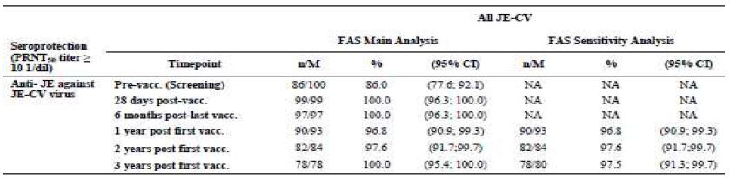

Table 6: Immune response in toddler 12 to 24 months – FAS (main and sensitivity analysis).

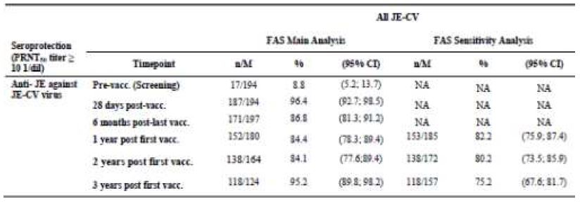

In children 2-5 years, the JE-CV was administered as a booster dose as these children previously completed a two dose primary vaccination regimen with an MBDV in accordance with the Thai immunisation schedule. The study showed that one dose of JECV provided a good booster response in all subjects: 100.0% of children were seroprotected after JE-CV vaccination and the response persisted at least up to 3 years after vaccination.

In toddler 12-24 months, the immune response to the JE-CV virus (FAS) persisted at least up to 3 years post vaccination in the main analysis, although the seroprotection rate decreased from 96.4% at 28 days post vaccination to 86.8% at 6 months post vaccination, it remained stable at 84.4% 1 year after vaccination and at 84.1% 2 years after vaccination, and increased to 95.2% 3 years after vaccination. The seroprotection rate obtained with the sensitivity analysis was similar to that of the main analysis in the FAS one year after vaccination, but slightly lower 2 years after vaccination and markedly lower 3 years after vaccination, mainly due to subjects with antibody titres below seroprotection who were withdrawn from the trial. This difference indicated that the sensitivity analysis is the most relevant for the assessment of persistence of immune response as it takes into account subjects with antibody titres below the seroprotection threshold who were withdrawn from the trial. Based on the sensitivity analysis the seroprotection rates decreased over time to 82.2% one year after vaccination, 80.2% 2 years after vaccination, and 75.2% 3 years after vaccination. The immune response decreased for the four tested wild type JE virus strains at 6 months after vaccination. The increased seroprotection rate 3 years after vaccination was mainly due to the withdrawal of subjects presenting with neutralising antibody titres below the threshold for protection as per protocol (so is essentially an artefact), as suggested by the results from the sensitivity analysis.

Overall, the study shows that a single dose of JE-CV induces a protective immune response in both JE naive and JE immune paediatric subjects. In children who were previously vaccinated with inactivated MBDV, a single dose of JE-CV induced a high protective immune response and it persists up to at least 3 years post vaccination. In toddlers who were not previously vaccinated against JE, a single dose of JE-CV induced a protective immune response and it persists in the majority of subjects up to at least 3 years with a seroprotection rate of 75.2% (sensitivity analysis in the FAS), but it does seem to decrease over time.

##### Study JEC05

Study JEC05 is a Phase III, multicentre, multinational, long term follow up of immunogenicity of a single dose of JE-CV in toddlers in Thailand and the Philippines (Interim Report version 2.0, 12 May 2011). This was a follow on trial for JEC02. The submitted report includes immunogenicity data up to Year 2. The study was conducted in approximately 700 subjects who were vaccinated at 12 to 18 months of age with one dose of JE-CV in JEC02. No JE vaccine is administered in JEC05. In JEC02, study subjects received one dose of JE-CV and one dose of Hepatitis A vaccine one month apart, and were to receive a second dose of Hepatitis A 6 months later. There will be a 5 year follow up. There are 5 visits and 5 blood samplings (1 visit with blood sampling per year). Subjects Disposition for Year 1 and 2 are presented in Table 7.

Table 7: Subjects disposition for Year 1 and 2 in Study JEC05.

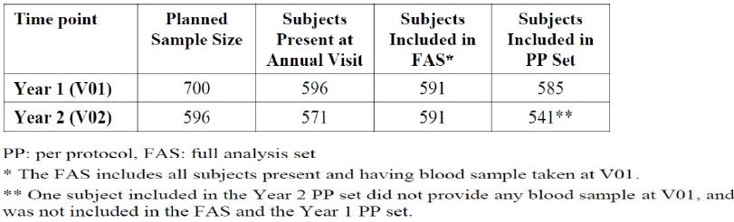

A total of 2.6% of subjects enrolled in JEC05 (PP set) had pre-existing neutralising antibody titres before vaccination with JE-CV in JEC02. All subjects (100.0%) were seroprotected 28 days after a single dose of JE-CV, and the majority (88.2% [95% CI 85.3; 90.7]) was seroprotected 1 year after vaccination (Year 1 PP set and FAS). Two years after vaccination with JE-CV, **90.0%** (95% CI: 87.2; 92.4) of the subjects who attended the Year 2 visit were still seroprotected (Year 2 PP set) (Table 8).

Table 8: Seroprotection rates after Year 2.

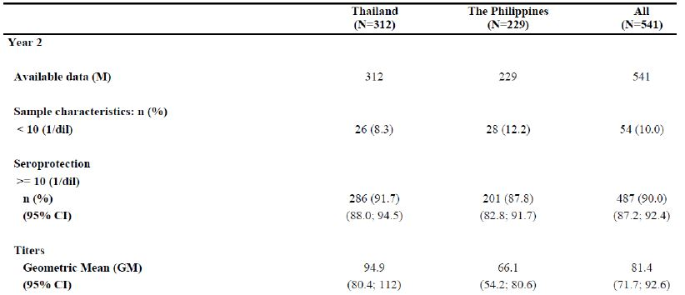

For evaluation of the long term persistence of immune response, a sensitivity analysis is performed with the same rule for missing values as for JEC01, any seronegative subject will be assumed to be seronegative at the next visits. Consequently, more subjects appear in the denominator for the sensitivity analysis as subjects known for having antibody titres below the threshold of protection are taken into account. This analysis is to be produced using the FAS and the PP set, from Year 2. The sensitivity analysis performed at Year 2 in the FAS showed a slight difference for seroprotection rate and GMT compared to those of the main analysis performed in the FAS. According to the sensitivity analysis at Year 2, **85.9%** (95% CI: 82.8; 88.6) of subjects were seroprotected 2 years postvaccination and the GMT was 71.4 1/dil (95% CI: 62.7; 81.3).

No confirmed JE cases were reported from 6 months to 2 years after JE-CV administration in JEC02.

Overall, about **85.9%** of the subjects who were still seroprotected at 2 years after the single dose of JE-CV.

##### Study JEC15 in paediatrics (immune memory)

###### JEC15

Study JEC15 is an open, controlled, multicentre, Phase III trial conducted in approximately 505 children aged 36 to 42 months. The study assessed the safety and memory immune response of JE-CV in children who were previously immunised with a single dose of JE-CV and then received a booster dose of JE-CV (Interim Report version 2.0, 11 April 2012). This study was also a follow on trial for JEC02. The study subjects were to be enrolled in 3 groups:

* Group 1: A maximum of 400 children who were previously vaccinated at 12 to 18 months of age with a single dose of JE-CV were to receive a booster dose of JE-CV at Visit 1, Day 0 (D0).

The 105 JE vaccine naïve control children were to be randomised into 2 groups:

* Group 2: (immunogenicity control group): 45 children were to receive one single dose of JE-CV on D0
* Group 3: (safety control group): 60 children were to receive a varicella vaccination on D0

Group 1 included a total of 340 children who previously vaccinated (2 years earlier at 12 to 18 months of age) with a single dose of JE-CV in Study JEC02 and who received a booster dose of JE-CV at Visit 1 (D0). These subjects had blood samples at baseline (pre vaccination on D0), and on Day 7, Day 28 post JE-CV vaccination and will provide blood samples at Year (Y) 1, Y2, Y3, Y4, and Y5.

###### SPR and SCR at 28 Days after JE-CV vaccination

The seroprotection rate (SPR) on D0 and seroprotection and SCRs on Day 7 and 28 after a booster dose of JE-CV (JECV Dose 2) are presented in Table 9 for subjects in Group 1 and for the JE vaccine naive control subjects in Group 2 (JE-CV Dose 1), as assessed by JE-CV virus PRNT50 (PP set).

Table 9: JEC15, Summary of SPR and SCR up to Day 28 after Vaccine Injection – Per Protocol Set.

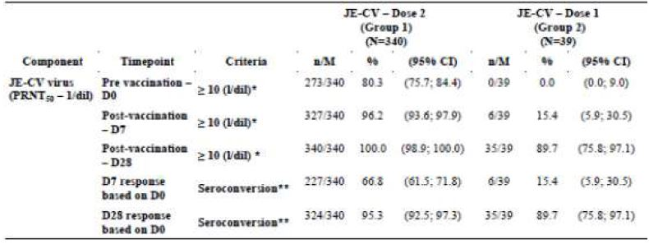

M: number of subjects with available data for the endpoint;

* Corresponds to seroprotection, that is, a titre ≥ 1/10;

** Seroconversion: subjects with a pre-vaccination titre < 1/10 and post vaccination titre ≥ 1/10, or subjects with pre vaccination titre ≥ 1/10 and 4-fold increase from pre to post-vaccination;

%: percentages and 95% CI are calculated according to the subjects with available data for the endpoint

At 28 days after the booster dose, 100.0% subjects were seroprotected (Table 10). This result confirms the induction of immune memory by the first dose and suggests a booster effect on neutralising antibody titres. Long term persistence of immunity up to 5 years after the booster dose is ongoing.

Table 10: JEC15, Summary of Seroprotection up to Year 1 after Vaccine Injection – FAS.

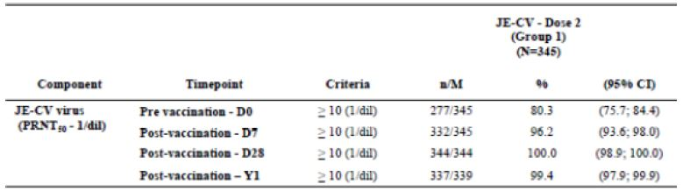

M: number of subjects with available data for the endpoint; %: percentages and 95% CI are calculated according to the subjects with available data for the endpoint; Only Group 1 remains in the trial for the 5 year follow up (V04-V08).

Seroprotection up to 1 year after the booster dose of JE-CV in Group 1 (FAS) as assessed by JE-CV virus PRNT50 is presented in the table above. The immune response to JE-CV persisted at least up to 1 year after the booster dose JE-CV in nearly all of the subjects in Group 1: 99.4% of subjects remained seroprotected 1 year after receiving the booster dose of JE-CV; only 2 subjects presented with antibody titres below the threshold considered for protection.

#### Clinical safety

The safety data submitted with this application does not reveal any new triggers or safety concerns. In adults, the booster dose appeared to be at least as well tolerated as the first dose of JE-CV. In the paediatric population, the booster dose was as well tolerated as the comparators (hepatitis A and varicella vaccines).

The sample size of the studies conducted in paediatric populations allowed the detection of events with a rate of 0.2% or more (with 95% probability). Overall, 1444 children aged 9 months to 10 years received JE-CV in three clinical studies conducted in Thailand, the Philippines, and India.

### Risk management plan

The submitted RMP was evaluated by OPR evaluator. ACSOV advice was not sought for this submission. The RMP evaluator recommends the inclusion in the ‘Precautions’ section of the PI a statement that the current version of the Australian Immunisation Handbook should be consulted in regard to information related to vaccines, in particular the section on vaccination procedures in general and any information in regard to Japanese Encephalitis vaccination.

The RMP evaluator recommends that implement Risk Management Plan (in EU-RMP format) Version 6.0 (dated 18/04/2012, DLP 31/01/2012), and any future updates as a condition of registration.

### Risk-benefit analysis

#### Delegate considerations

Study H-040-005 in adults showed that one month after a single dose of JE-CV, the protective level of immunity were achieved in more than 99% of the vaccine receipts. The long term follow up data showed that at 5 years after the single dose, 86.8% of subjects remain seroprotected GMT is 61.5. It is therefore considered that no JE-CV booster is needed before 5 years.

The results of Study JEC01 showed that in toddlers (aged 12 to 24 months) who did not previously vaccinated with any JE vaccine (JEC01), a single dose of JE-CV provides a protective immune response in more than 95% of the vaccinated subjects, and the long term follow up showed the rates of seroprotection declined to 84.4% at 1 year, 80% at 2 years, and 75% at 3 years. In children who previously received primary immunisation with inactivated MBDV (two dose), one dose of JE-CV provided a good booster response in 100% of the subjects (SPR = 100.0%), and the response persisted at least up to 3 years after vaccination.

Study JEC05 showed that at 2 year after the single dose of JE-CV, about 85.9% of the subjects were seroprotected (based on sensitivity analysis). Study JEC15 demonstrated that a booster dose of JE-CV (2 years after the first JE-CV) resulted in seroprotection of 99.4% of children at 1 year after the booster vaccination.

Overall, a booster dose of JE-CV provides a higher level and longer term protection (supported by data up to 3 years) in paediatric subjects who had primary vaccination with an inactivated JE vaccine. Similarly, a booster dose of JE-CV given to children who had a previous dose of JE-CV (2 years earlier) provides a higher level of protection.

The potential risks of JE-CV in the proposed usage could include hypersensitivity reactions (allergic, anaphylactic/anaphylactoid), neurological disorders including convulsions, encephalopathy, encephalitis, ADEM, myelitis, GBS, peripheral neuropathy, facial (Bell’s) palsy (based on experience with other attenuated and inactivated) JE vaccines.

No safety issue has been identified in the submitted studies in adult and paediatric populations. The overall safety profile of JE-CV in adult populations is similar to that of the inactivated MBDV and placebo. The safety profile in paediatric populations is similar to that of a registered inactivated hepatitis A vaccine.

The clinical evaluator is of the view that a single dose of JE-CV for primary immunisation in adults demonstrated high SCRs, rapid onset of immunity, and a good safety profile. The single dose vaccination schedule in adults will be particularly useful in Australia where it tends to be given as a pre travel vaccination for people travelling to endemic areas. The recommendation of two doses of JE-CV in children (if not previously vaccinated) or of JE-CV as a long term booster dose for children previously immunised will increase the rate of long term seroprotection. The final data out to 5 years from the paediatric studies (JEC01, JEC05 and JEC15) is still awaited. The benefit-risk balance of JECV, given the proposed usage, is considered favourable.

#### Indication

*Current: Imojev is indicated for prophylaxis of Japanese encephalitis caused by the Japanese encephalitis virus, in individuals from 12 months of age and over.*

Proposed: No changes are proposed to Indications:

*Imojev is indicated for prophylaxis of Japanese encephalitis caused by the Japanese encephalitis virus, in individuals from 12 months of age and over.*

#### Summary of issues

Results from Study H-040-005 in adults showed:

* One month after a single dose of JE-CV, the protective level of immunity were achieved in more than 99% of the vaccine receipts and the level of immune response 5 years after the single dose is still sufficiently high. It is therefore considered that no JE-CV booster is needed before 5 years.

Results from Study JEC01 showed:

* In toddlers who did not previously vaccinated with any JE vaccine, a single dose of JE-CV provides a protective immune response in more than 95% of them. Long term follow up showed the rates of seroprotection declined to 84.4% at 1 year, 80% at 2 years, and 75% at 3 years.
* In children who previously received primary immunization with inactivated MBDV (two-dose), one dose of JE-CV induced a good booster response in 100% of the subjects (SPR = 100.0%) and the immune response persisted at least up to 3 years after vaccination.

Results from Study JEC05 showed:

* At 2 year after the single dose of JE-CV, about 85.9% of the subjects were still seroprotected (based on sensitivity analysis).

Results from Study JEC15 showed:

* A booster dose of JE-CV (2 years after the first JE-CV) resulted in seroprotection in 99.4% of children at 1 year after the booster vaccination.

Overall, a booster dose of JE-CV provides a higher level and longer term protection (supported by data up to 3 years) in paediatric subjects who had primary vaccination with an inactivated JE vaccine (Study JEC01). Similarly, a booster dose of JE-CV given to children who had a previous dose of JE-CV (2 years earlier) provides a higher level of protection (Study JEC15).

The potential risks of JE-CV could include hypersensitivity reactions (allergic, anaphylactic/anaphylactoid), neurological disorders including convulsions, encephalopathy, encephalitis, ADEM, myelitis, GBS, peripheral neuropathy, facial (Bell’s) palsy (based on experience with other attenuated and inactivated) JE vaccines.

No safety issue has been identified in the submitted studies in adult and paediatric populations. The overall safety profile of JE-CV in adult populations is similar to that of the inactivated MBDV and placebo. The safety profile in paediatric populations is similar to that of a registered inactivated Hepatitis A vaccine.

#### Advice sought

The committee is requested to provide advice on the following specific issues:

1. Whether the committee consider that a booster dose is necessary for paediatric subjects who received primary vaccination with either inactivated MBDV (two doses) or one dose of Imojev (live, attenuated, recombinant JE virus vaccine).
2. Whether the committee agree that no booster dose is required for adults before 5 years post JE-CV vaccination. The committee is (also) requested to provide advice on any other issues that it thinks may be relevant to a decision on whether or not to approve this application.

#### Pre ACPM preliminary assessment

The Delegate has no reason to say, at this time, that the application for the proposed changes to the vaccination schedule for children and the proposed updates to the PI should not be approved.

#### Response from sponsor

This application was to update the PI to include the long term follow up data in adults and change the dosage to recommend a booster dose in paediatric populations (12 months to 17 years of age) for Imojev, Japanese encephalitis vaccine (live, attenuated). Imojev is indicated for prophylaxis of Japanese encephalitis caused by the Japanese encephalitis virus in individuals from 12 months of age and over.

A similar application has been submitted in Thailand to recommend a booster dose in paediatric population and it has been approved by the Thai FDA in November 2012.

The sponsor concurs with the Delegate’s comments outlined in the Request for ACPM’s Advice dated 29 August 2013. The sponsor also agrees with the changes recommended to the PI and the PI has been updated accordingly with slight modifications. The sponsor’s comments on the PI are provided in appendices. The changes recommended to the PI do not impact the proposed CMI and hence only the non-annotated version of CMI is provided in appendices.

#### Advisory committee considerations

The ACPM, taking into account the submitted evidence of efficacy, safety and quality, agreed with the delegate and considered Imojev powder for injection containing 4.0‑5.8 PFU of Japanese encephalitis virus (live, attenuated) to have an overall positive benefit-risk profile for a booster dose in paediatric populations.

In making this recommendation the ACPM:

* Noted the lack of clinical data in adults beyond 5 years post-administration of initial dose and in children beyond 3 years of initial dose.
* Expressed some concern over the lack of data on the need for a booster dose in children 5-18 years and the lack of guidance from the sponsor on this age group.
* Noted the limitations with the developmental toxicity studies due to the selection of rabbits as a test species, given the lack of evidence for virus replication and complete seroconversion in this species.

The committee was requested to provide advice on the following specific issues:

1. Whether the committee consider that a booster dose is necessary for paediatric subjects who received primary vaccination with either inactivated MBDV (two doses) or one dose of Imojev (live, attenuated, recombinant Japanese encephalitis virus vaccine).
   * There are incomplete long term data in children (5 year data awaited).
   * In vaccine naïve toddlers and children protection was demonstrated at about 75% at 3 years with a single dose.
   * The booster dose (in children vaccinated with Imojev) was shown to confer protective immunity in children for at least 1 year.
   * At 28 days post booster, 100% were seroprotected (compared to 89.7% of previously unvaccinated controls who had received a single dose of JE-CV at Day 0).
   * The ACPM noted there are no data submitted for children vaccinated with IMOJEV beyond 1 year after booster dose. However, there is good immunity persistence data for 3 years post vaccination with the inactivated JE vaccine. Some apparent waning of immunity by 2-3 years suggests that booster dose is required.
   * The ACPM expressed concern that no data were presented in children between 5 years and 18 years.
   * The evidence, though incomplete, suggests the booster dose increases the level of immunity and percentage of the population provided with immunity.
2. Whether the committee agree that no booster dose is required for adults before 5 years post JE-CV vaccination.
   * There is good evidence that seroprotection persists after primary dose for at least 5 years in adults. In adults > 99% protection was demonstrated at one month and 86.8% at 5 years, suggesting no booster is needed up to 5 years.

##### Proposed conditions of registration:

The ACPM advised on the inclusion of the following:

* Negotiation of PI and CMI to the satisfaction of the TGA.
* Submission to the TGA of the results of the 5 year post booster data in children as soon as they become available.

##### Proposed Product Information (PI)/Consumer Medicine Information (CMI) amendments:

The ACPM agreed with the delegate to the proposed amendments to the Product Information (PI) and Consumer Medicine Information (CMI) and specifically advised on the inclusion of the following:

* A statement in the *Dosage and Administration* section of the PI and relevant sections of the CMI on the lack of evidence for efficacy and safety of a booster dose in children and adolescents 5 to 18 years of age.

The ACPM advised that the implementation by the sponsor of the recommendations outlined above to the satisfaction of the TGA, in addition to the evidence of efficacy and safety provided would support the safe and effective use of these products.

### Outcome

Based on a review of quality, safety and efficacy, TGA approved the registration of Imojev powder for injection containing 4.0‑5.8 PFU of Japanese encephalitis virus (live, attenuated), indicated for:

*Imojev is indicated for prophylaxis of Japanese encephalitis caused by the Japanese encephalitis virus, in individuals from 12 months of age and over.*

## Attachment 1. Product Information

The Product Information approved at the time this AusPAR was published is at Attachment 1. For the most recent Product Information please refer to the TGA website at <<http://www.tga.gov.au/hp/information-medicines-pi.htm>>.

## Attachment 2. Extract from the Clinical Evaluation Report

1. Immunity is maintained at a high level at least 3 years after the booster dose.
2. Australian Government, Department of Health. The Australian Immunisation Handbook, 10th ed., 2013, pp. 133-140.
3. European Medicines Agency, “Committee for proprietary medicinal products (CPMP): Guideline on the evaluation of medicinal products in the treatment of primary osteoporosis (CPMP/SWP/465/95)”, 17 December 1997, Web, accessed 8 January 2014 <www.ema.europa.eu/docs/en_GB/document_library/Scientific_guideline/2009/10/WC500004004.pdf>; FDA Food and Drug Administration, “Considerations for developmental toxicity studies for preventive and therapeutic vaccines for infectious disease indications”, February 2006, Web, accessed 8 January 2014 <www.fda.gov/downloads/BiologicsBloodVaccines/GuidanceCompliance RegulatoryInformation/Guidances/Vaccines/ucm092170.pdf>; European Medicines Agency, “ICH Topic S5 (R2) Detection of Toxicity to Reproduction for Medicinal Products & Toxicity to Male Fertility, Step 5: Note for Guidance on the Detection of Toxicity to Reproduction for Medicinal Products & Toxicity to Male Fertility (CPMP/ICH/386/95)”, March 1994, Web, accessed 8 January 2014 <www.ema.europa.eu/docs/en_GB/document_library/Scientific_guideline/2009/09/ WC500002809.pdf>.
4. Cited in Kimura T, et al. (2010) Flavivirus encephalitis. Pathological aspects of mouse and other animal models. *Veterinary Pathology* 47: 806-818.
5. European Medicines Agency, “Committee for medicinal products for human use (CHMP): Guideline on clinical evaluation of new vaccines (EMEA/CHMP/VWP/164653/2005)”, 18 October 2006, Web, accessed 8 January 2014 <www.ema.europa.eu/docs/en_GB/document_library/ Scientific_guideline/2009/09/WC500003870.pdf>.
6. World Health Organisation Expert Committee on Biological Standardisation, “Proposed revision recommendations for Japanese encephalitis vaccine, inactivated, for human use (WHO/BS/07.2064)” Geneva, 8-12 October 2007, Web, accessed 8 January 2014 <www.who.int/ biologicals/publications/trs/areas/vaccines/jap_encephalitis/Japanese%20Encephatis%20 guidelines%202007%20revised%20211207%20rev07.pdf>.
7. Ferner RE, Aronson JK (2006) Clarification of terminology in medication errors: definitions and classification. *Drug Saf.* 29: 1011-1022.
8. CIOMS/WHO Working Group on Vaccine Pharmacovigilance. *Vaccination Failure: Position Paper.* Geneva: Council for International Organisations of Medical Sciences (CIOMS), 2008.