Date of first round report: 29 March 2017
Date of second round report: 22 May 2017

AusPAR Attachment 2

Extract from the Clinical Evaluation Report for Pembrolizumab
  - Proprietary Product Name: Keytruda
  - Sponsor: Merck Sharp & Dohme Australia Pty Ltd

About the Therapeutic Goods Administration (TGA)
- The Therapeutic Goods Administration (TGA) is part of the Australian Government Department of Health, and is responsible for regulating medicines and medical devices.
- The TGA administers the Therapeutic Goods Act 1989 (the Act), applying a risk management approach designed to ensure therapeutic goods supplied in Australia meet acceptable standards of quality, safety and efficacy (performance), when necessary.
- The work of the TGA is based on applying scientific and clinical expertise to decision-making, to ensure that the benefits to consumers outweigh any risks associated with the use of medicines and medical devices.
- The TGA relies on the public, healthcare professionals and industry to report problems with medicines or medical devices. TGA investigates reports received by it to determine any necessary regulatory action.
- To report a problem with a medicine or medical device, please see the information on the TGA website <https://www.tga.gov.au>.
About the Extract from the Clinical Evaluation Report
- This document provides a more detailed evaluation of the clinical findings, extracted from the Clinical Evaluation Report (CER) prepared by the TGA. This extract does not include sections from the CER regarding product documentation or post market activities.
- The words [Information redacted], where they appear in this document, indicate that confidential information has been deleted.
- For the most recent Product Information (PI), please refer to the TGA website <https://www.tga.gov.au/product-information-pi>.
Copyright
© Commonwealth of Australia 2018
This work is copyright. You may reproduce the whole or part of this work in unaltered form for your own personal use or, if you are part of an organisation, for internal use within your organisation, but only if you or your organisation do not use the reproduction for any commercial purpose and retain this copyright notice and all disclaimer notices as part of that reproduction. Apart from rights to use as permitted by the Copyright Act 1968 or allowed by this copyright notice, all other rights are reserved and you are not allowed to reproduce the whole or any part of this work in any way (electronic or otherwise) without first being given specific written permission from the Commonwealth to do so. Requests and inquiries concerning reproduction and rights are to be sent to the TGA Copyright Officer, Therapeutic Goods Administration, PO Box 100, Woden ACT 2606 or emailed to <tga.copyright@tga.gov.au>.

Contents
List of common abbreviations 5
1. Submission details 8
1.1. Identifying information 8
1.2. Submission type 8
1.3. Drug class and therapeutic indication 8
1.4. Dosage and administration 8
1.5. Proposed changes to the product documentation 8
2. Background 9
2.1. Information on the condition being treated 9
2.2. Current treatment options 9
2.3. Clinical rationale 11
2.4. Formulation 11
2.5. Guidance 12
2.6. Evaluator’s commentary on the background information 12
3. Contents of the clinical dossier 12
3.1. Scope of the clinical dossier 12
3.2. Paediatric data 13
3.3. Good clinical practice 14
3.4. Evaluator’s commentary on the clinical dossier 14
4. Pharmacokinetics 14
4.1. Studies providing pharmacokinetic information 14
4.2. Summary of pharmacokinetics 14
4.3. Evaluator’s overall conclusions on pharmacokinetics 17
5. Pharmacodynamics 17
6. Dosage selection for the pivotal studies 18
6.1. Proposed 200 mg Q3W Dosing Regimen 18
6.2. Evaluator’s conclusions on dose finding for the pivotal studies 19
7. Clinical efficacy 19
7.1. Pivotal or main efficacy studies 19
7.2. Other efficacy studies 40
7.3. Analyses performed across trials: pooled and meta-analyses 42
7.4. Evaluator’s conclusions on clinical efficacy 42
8. Clinical safety 44
8.1. Studies providing evaluable safety data 44
8.2. Patient exposure 45
8.3. Adverse events 46
8.4. Evaluation of issues with possible regulatory impact 56
8.5. Other safety issues 66
8.6. Post marketing experience 67
8.7. Evaluator’s overall conclusions on clinical safety 67
9. First round benefit-risk assessment 68
9.1. First round assessment of benefits 68
9.2. First round assessment of risks 68
9.3. First round assessment of benefit-risk balance 69
10. First round recommendation regarding authorisation 69
11. Clinical questions 69
12. Second round evaluation 73
12.2. Pharmacokinetics 73
12.3. Efficacy 73
12.4. Safety 77
12.5. Updated data – efficacy 78
12.6. Updated data – safety 79
13. Second round benefit-risk assessment 80
13.1. Second round assessment of benefits 80
13.2. Second round assessment of risks 80
13.3. Second round assessment of benefit-risk balance 80
14. Second round recommendation regarding authorisation 80
15. References 80

List of common abbreviations
Abbreviation | Meaning
ADA | Anti-drug antibody
AE | Adverse event
AEOSI | Adverse event of special interest (also called ESI)
ALP | Alkaline phosphatase
ALT | Alanine aminotransferase
AN | allocation number
APaT | All patients as treated
ASaT | All subjects as treated
AST | Aspartate aminotransferase
ASCT/ auto-SCT | autologous Stem Cell Transplantation
BICR | Blinded, independent central review
BV | Brentuximab vedotin
cHL | classical Hodgkin Lymphoma
CI | Confidence interval
CR | Complete response or remission
CRR | Complete Remission Rate
CSR | Clinical study report
CT | Computerized tomography
CTCAE | Common Terminology Criteria for Adverse Events
DOR | Duration of Response
ECI | Events of Clinical Interest
ECOG | Eastern Cooperative Oncology Group
EORTC | European Organization for Research and Treatment of Cancer
EU | European Union
EuroQoL EQ-5D | European Quality of Life Five Dimensions Questionnaire
FAS | Full Analysis Set
FDA | Food and Drug Administration
GCP | Good Clinical Practice
GVHD | Graft versus host disease
HL | Hodgkin lymphoma
HNSCC | Head and neck squamous cell cancer
ICH | International Conference on Harmonization
IEC | Independent Ethics Committee
IND | Investigational New Drug
irAE | immune-related adverse event
ISS | integrated summary of safety
IV | Intravenous
IWG | International Working Group
IVRS/IXRS | Interactive Voice Response System/web access system
KN013 | Phase Ib clinical study KEYNOTE -013
KN087 | Phase II clinical study KEYNOTE -087
mAb | monoclonal antibody
MDS | myelodysplastic syndrome
MedDRA | Medical Dictionary of Regulatory Activities
MK-3475P | embrolizumab
MM | multiple myeloma
MSI-H | Microsatellite instability high
NCI | National Cancer Institute
ND | Not determined
NSCLC | Non-small cell lung cancer
ORR | Objective Response Rate / Overall Response Rate (used interchangeably)
OS | Overall Survival
PD | Progressive disease
PD-1 | Programmed cell death 1
PD-L1 | Programmed cell death 1 ligand 1
PD-L2 | Programmed cell death 1 ligand 2
PFS | Progression Free Survival
PK | Pharmacokinetic
PMBCL | primary mediastinal B-cell lymphoma
PR | Partial remission
PRO | Patient Reported Outcome
PT | Preferred term (MedDRA)
Q2W | Every two weeks
Q3W | Every three weeks
QC | Quality Control
QLQ-C30 | Quality of Life Questionnaire C30
QoL | Quality of life
rrcHL | relapsed/refractory classical Hodgkin lymphoma
SAE | Serious adverse event
SAP | Statistical analysis plan
SCT | Stem cell transplant
SD | Stable disease
SFU | Survival follow-up
SOC | System Organ Class (MedDRA)
UC | Urothelial cancer
ULN | Upper limit of normal
US | United States

Submission details

Identifying information
Sponsor | Merck Sharp & Dohme (Australia) Pty Limited
Trade name | Keytruda
Active substance | pembrolizumab

Submission type
This is a Category 1 Type C application to extend the indications for pembrolizumab (Keytruda) to include classical Hodgkin lymphoma with subsequent change to the PI.

Drug class and therapeutic indication
Keytruda (pembrolizumab) is a selective humanized monoclonal antibody designed to block the interaction between PD-1 and its ligands, PD-L1 and PD-L2. Pembrolizumab is an IgG4 kappa immunoglobulin with an approximate molecular weight of 149 kDa. Pembrolizumab is produced in Chinese hamster ovary cells by recombinant DNA technology.
The suggested new indications are:
Keytruda® is indicated for the treatment of patients with refractory classical Hodgkin Lymphoma, or those who have relapsed after 3 or more prior lines of therapy.

Dosage and administration
For melanoma the currently approved dose of pembrolizumab is 2 mg/kg administered intravenously over 30 minutes every 3 weeks.
The sponsor is proposing a fixed dose of 200 mg pembrolizumab administered intravenously every 3 weeks for classical Hodgkin lymphoma.
The FDA has approved the fixed dose of 200 mg every three weeks for HNSCC.
Comment: Study KEYNOTE-087, which is the pivotal study in HL subjects, is performed using the suggested fixed dose.

Proposed changes to the product documentation
The sponsor proposes the following changes to the product information (PI):
- CLINICAL TRIALS: Description of KEYNOTE-13 and KEYNOTE-87 under the heading ‘Classical Hodgkin Lymphoma’ with the efficacy data presented.
- There are updates on immunogenicity.
- INDICATIONS: The sponsor proposes the following in patients with cHL: Keytruda® is indicated for the treatment of patients with refractory classical Hodgkin Lymphoma, or those who have relapsed after 3 or more prior lines of therapy.
- ADVERSE EFFECTS: There are updates to the number of patients in the safety population. The data supporting these changes have not been submitted in this application. The most common treatment related AEs and SAEs are unchanged. The sponsor wants to remove the numbers/percentages of SAEs and AEs previously supplied. There is an updated version of the table ‘Immune-mediated Adverse Reactions’ but no table of Adverse Reactions for cHL.
- DOSAGE AND ADMINISTRATION: In cHL a 200 mg ‘flat dose’ is being introduced as opposed to the weight based dose used so far. The pivotal trial in cHL (KN087) has been conducted using this dose.
Detailed evaluation of the proposed changes to the PI is beyond the scope of this AusPAR.

Background

Information on the condition being treated
Hodgkin lymphoma (HL) accounts for approximately 10% of all lymphomas and approximately 0.6% of all cancers diagnosed in the developed world annually.
The likelihood of relapse of Hodgkin lymphoma (HL; formerly called Hodgkin's disease) from initial therapy in the current era of systemic or combined modality therapy is approximately 10 to 15 percent for localized HL and 20 to 40 percent for more advanced stages (that is, IIIB or IV), dependent on prognostic factors. Approximately 40 to 50 percent of these relapses will occur in the first 12 months from induction. In addition, approximately 10 to 15 percent will have disease resistant to initial therapy. Salvage therapy can achieve durable responses and remissions in approximately one-half of these patients. Patients with high risk disease, a second relapse, or progressive, resistant disease are candidates for high dose chemotherapy and autologous hematopoietic cell transplantation.
Second and third-line chemotherapy combinations generally achieve complete remission (CR) in 30 to 40 percent of patients with aggressive or resistant disease. They are frequently used as cytoreductive agents prior to proceeding to high dose chemotherapy and autologous hematopoietic cell transplantation (ASCT). Salvage chemotherapy without progression to high-dose chemotherapy and autologous stem cell transplantation results in 8- to 10-year overall survival rates of 21 to 27 percent with freedom from treatment failure of 16 percent.
Patients who relapse following autologous SCT can only achieve palliation with conventional dose chemotherapy. Options for such patients include treatment with an immunotoxin (for example, brentuximab vedotin), PD-1 blockade or referral for allogeneic transplantation.
Excerpts from Canellos, 2016

Current treatment options
The standard of care for patients with relapsed or refractory cHL (rrcHL) to frontline chemotherapy is salvage chemotherapy followed by autologous stem cell transplantation (ASCT) unless ineligible. For patients who are ineligible for or fail auto-SCT, treatments include other chemotherapy agents such as brentuximab vedotin (BV).
A systematic literature review was performed to characterise the response in heavily pretreated refractory/relapsed HL patients with the treatments recommended by National Comprehensive Cancer Network. The systematic literature review found studies in HL patients who are refractory/relapsed after ≥ 3 treatments (similar to the population studied in KEYNOTE-013 and KEYNOTE-087) as shown in Table 1.
Table 1: Studies in Patients Who Have Relapsed After ≥ 3 Treatments (by Decreasing Study Size)
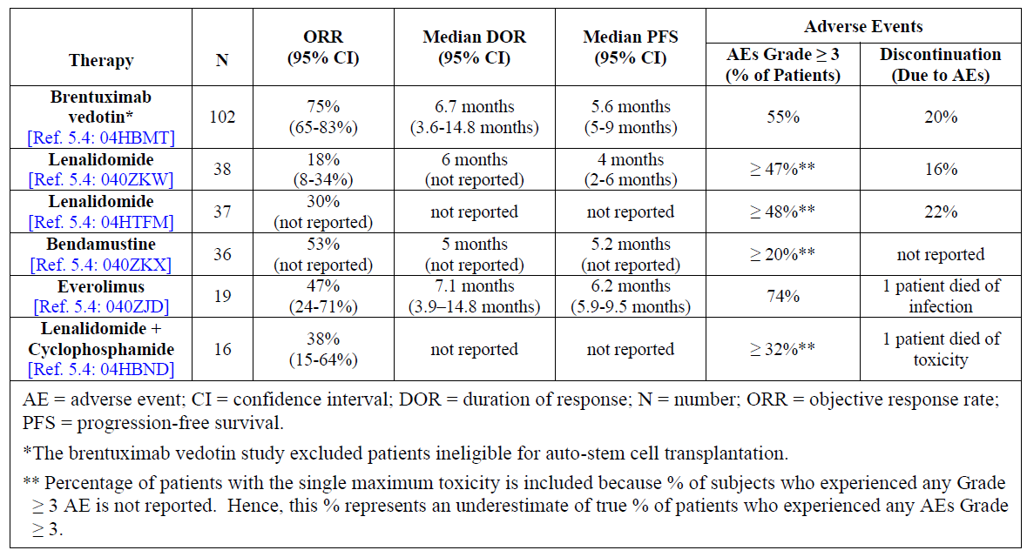
Comment: In Cohort 3 in Study KN087 24 subjects (40%) had <3 prior treatments, so this cohort is ‘less similar’ to the studies above.
In Figure 1 an algorithm for treatment of relapse after ASCT is presented.
Figure 1: Suggested algorithm for the treatment of patients who relapse after ASCT
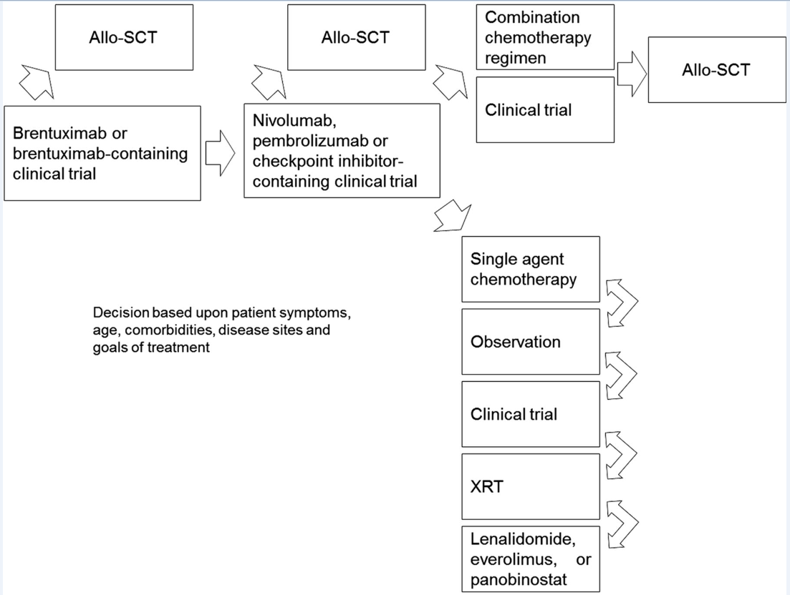
Alinari and Blum, Blood 2016

Clinical rationale
Pembrolizumab is a monoclonal antibody that inhibits the PD-1 receptor (also known as CD279), which is expressed on activated T-lymphocytes. Similar to the CTLA-4 receptor, stimulation of PD-1 results in an inhibitory effect on T-cell function. The normal function of the PD-1 receptor is to limit or ‘check’ overstimulation of immune responses. There are two known normal ligands for PD-1: PD-L1 (also known as CD274 or B7-H1) and PD-L2 (also known as CD273 or B7-DC). Multiple normal tissues express PD-L1, whereas PD-L2 is expressed primarily on haematopoietic cells.
Several different tumours, including melanoma, express PD-L1. Tumour expression of PD-L1 may result in inhibition of T-cell mediated anti-tumour effects. The clinical rationale for PD-1 receptor blockade with pembrolizumab is to remove such inhibition.
The PD-1/PD-L1 pathway plays a critical role in tumor evasion and is an attractive target for therapeutic intervention in HL. High frequency of expression of PD-L1 by immunohistochemistry and flow cytometry has been demonstrated in cHL [Ref. 5.4: 03H8DY]. A recent integrated analysis reveals selective 9p24.1 amplification, which includes the PD-L1 and PD-L2 loci, increased PD-L1 and PD-L2 expression, and further induction via Janus Kinase 2 in nodular sclerosing HL. Furthermore, Epstein–Barr virus infection of malignant Reed Sternberg cells, which is implicated in approximately 40% of cases of HL, contributes to overexpression of PD-L1 even in the absence of 9p24.1 amplification. The Epstein-Barr virus latent membrane protein 1 exerts direct and indirect effects on PD-L1 promoter and enhancer elements leading to increased PD-L1 protein expression. The high expression of PD-L1 on tumor cells has been found to correlate with poor prognosis and survival in various cancers. The observed correlation of clinical prognosis with PD-L1 expression in multiple cancers suggests that the PD-1/PD-L1 pathway plays a critical role in tumor evasion and is thus an attractive target for therapeutic intervention. Preclinical in vitro and in vivo experiments have shown that PD-1 and/or PD-L1 blockade using monoclonal antibodies can result in activation of anti-tumor T cells and subsequent tumor regression. Emerging clinical data and the recent US Food and Drug Administration (FDA) accelerated approval in cHL for nivolumab, a PD-1 inhibitor, further validates the PD-1/PD-L1 pathway for therapeutic intervention.
Pembrolizumab is a potent and highly selective humanized mAb of the immunoglobulin G4 (IgG4)/kappa isotype designed to directly block the interaction between PD-1 and its ligands, PD-L1 and PD-L2. This blockade enhances functional activity of the target lymphocytes to facilitate tumor regression and ultimately immune rejection. In vitro and in vivo experiments have shown that PD-1 and/or PD-L1 blockade using monoclonal antibodies can result in activation of anti-tumor T cells and subsequent tumor regression.
Question to the sponsor: Reference 5.4: 03H8DY deals with T-cell NHL, not cHL. Please clarify.

Formulation

Formulation development
The sponsor states the following in the Clinical Overview, section 2:
No new biopharmaceutical information is provided in this submission; a brief overview of previously submitted results is provided in this section. Pembrolizumab is provided as 50 mg lyophilized powder in vials that are reconstituted in sterile water, or as 100 mg liquid solution in vials, which is then diluted further in normal saline or 5% dextrose for intravenous (IV) administration. A lyophilized formulation was used throughout the initial clinical development program. Different supply chains have been used for manufacture of this formulation, resulting in 3 drug materials: Material A, WAG/BNY50LYO, and FMC/BNY50LYO. The liquid drug product (with an identical composition) was subsequently introduced in clinical trials. An extensive set of analytical tests have demonstrated that the clinical materials and the commercial material (including that available for treatment of melanoma, HNSCC, and NSCLC in many markets) are comparable at both the drug substance and the drug product level. Validated bioanalytical methods were employed for determination of serum concentrations of pembrolizumab, anti-pembrolizumab antibodies, and neutralizing antibodies. Different generations of bioanalytical methods for the determination of pembrolizumab serum concentrations were used at different contract research organizations. Population pharmacokinetic (PK) analysis has demonstrated that the results are comparable.

Guidance
The following EMA guideline, which has been adopted by the TGA, is considered relevant to the current submission:
EMA: Guideline on the evaluation of anticancer medicinal products in man (see References).
Key highlights of the US regulatory history in HL include Orphan Disease Designation granted on 30 December 2015, Pediatric Waiver granted on 21 January 2016, and Breakthrough Therapy Designation granted on 12 April 2016.
A Pediatric Investigation Plan covering the condition ‘Treatment of Hodgkin Lymphoma’ was adopted by EMA for pembrolizumab on 01-Aug-2016 (EMEA-001474-PIP02-16).

Evaluator’s commentary on the background information
The background information is satisfactory.

Contents of the clinical dossier

Scope of the clinical dossier
The submission contained the following clinical information including a table summarising the studies in the HL clinical development program (Table 2):
Table 2: Summary of studies in the Hodgkin Lymphoma clinical development program
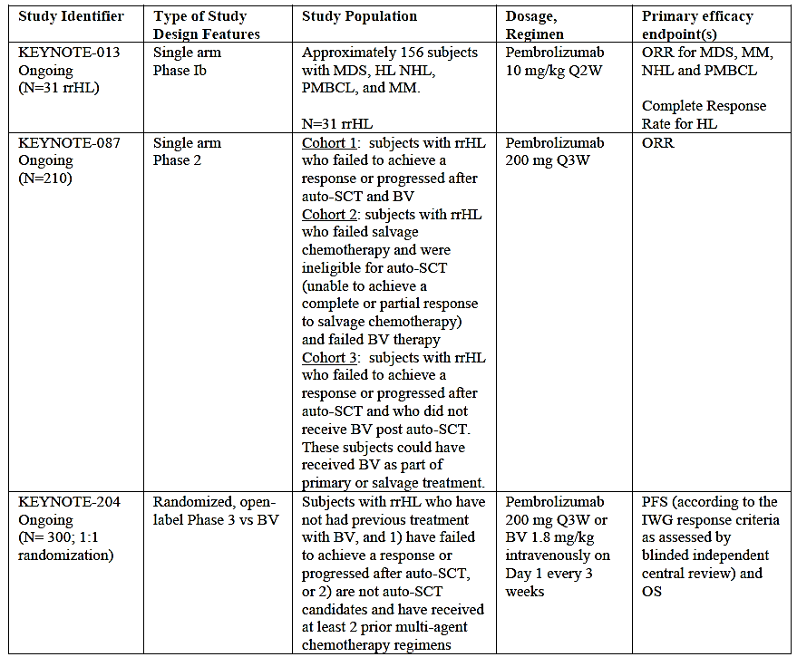
- Four interim reports of bioanalytical and analytical methods for human studies: regarding detection of anti-MK-3475 antibodies in human serum in Study KN013 and KN087.
- One pivotal Phase II safety and efficacy clinical study report of pembrolizumab in subjects with relapsed or refractory classical Hodgkin lymphoma: KEYNOTE -087.
- One supportive Phase Ib safety and efficacy clinical study report of pembrolizumab in the cohort of subjects with relapsed or refractory nodular sclerosing or mixed cellularity Hodgkin lymphoma. The entire study was performed in subjects with hematologic malignancies: KEYNOTE -013.
- One PopPK study; Application of Population Pharmacokinetic Model for Pembrolizumab (MK-3475) to Patients with Hodgkin Lymphoma (Protocol 001, 002, 006, 013 and 087)
- One Study of Dose-Tumor size Relationship in Pembrolizumab-(MK-3475) Treated Subjects with Refractory/Relapsed Classical Hodgkin Lymphoma (rrcHL) From Protocols KN013 and KN087.
- One Study of Pharmacokinetics of Pembrolizumab in First-Line NSCLC on Protocol 024.
- Literature references.

Paediatric data
There is no paediatric data provided. There is no paediatric development plan.
FDA: Pediatric Waiver granted on 21 January 2016.
A Pediatric Investigation Plan covering the condition ‘Treatment of Hodgkin Lymphoma’ was adopted by EMA for pembrolizumab on 01 August 2016 (EMEA-001474-PIP02-16).

Good clinical practice
Section 5.2 of the clinical study reports for KN013 and KN087 include the following statement:
‘This trial was conducted in substantial conformance with GCP requirements and applicable country and/or local statutes and regulations regarding ethical committee review, informed consent, and the protection of human subjects participating in biomedical research.’

Evaluator’s commentary on the clinical dossier
The data are well presented. The main issue regarding these studies are the short follow-up with regards to efficacy (7.1 months) and the use of ORR as a substitute for PFS and ultimately OS. In regards to safety, the follow up is also short but there is experience with pembrolizumab in other cancer types in particular melanoma and NSCLC, and the safety profile appears to be approximately the same. There are still unresolved issues for the use in patients who have undergone allo-SCT or patients that are proceeding to allo-SCT after previous PD-1 inhibitor treatment (section 8).

Pharmacokinetics

Studies providing pharmacokinetic information
No designated pharmacokinetics studies but sparse samples (see below) for pharmacokinetic analysis and immunogenicity samples were collected in KN013 (10 mg/kg Q2W) and KN087 (200 mg Q3W).

Sampling in Study KN087:
For both PK and anti-pembrolizumab antibody; Pre-dose trough PK and anti-pembrolizumab antibody samples will be collected at Cycles 1, 2, 4, 6, 8 and every 4 cycles thereafter, 30 days after discontinuation of study drug and 3 months after discontinuation of study drug (or until the subject starts new anti-cancer therapy). All pre-dose trough samples should be drawn within 24 hours before infusion of pembrolizumab.
For PK sample collection only; Additional post-dose peak PK samples will be drawn within 30 minutes after end of pembrolizumab infusion at Cycles 1 and 8. An additional single PK sample should be drawn at 24 hours (Day 2), between 72 and 168 hours (Day 4-8) and 336 hours (Day 15) after Cycle 1 dosing.

Summary of pharmacokinetics

Physicochemical characteristics of the active substance
No new information.

Pharmacokinetics in the target population
The population PK analysis in rrcHL subjects yielded consistent results with the definitive population PK analysis. This was anticipated as the earlier analysis already integrated data across two different indications (melanoma and NSCLC) in >2000 subjects, thus providing a definitive PK assessment unlikely to be impacted in any meaningful way by further addition of PK data. PK data in subjects with rrcHL and subjects included in the definitive population PK analysis were utilized to propose pharmacokinetic and clinical pharmacology information that is relevant across patient populations (rather than an indication by indication description of PK data). Importantly, there is no evidence that the PK properties of pembrolizumab vary by indication, such that this consolidated approach to PK description will facilitate the availability of clear, simple information to prescribers in the label for pembrolizumab.
Question to the sponsor: Where in the dossier is reference? (Question 2)

Pharmacokinetics in special populations
No new intrinsic factor labelling has been proposed as part of this submission. Given the large size of the dataset for the prior definitive population PK analysis, including the available covariate information, and considering consistent pharmacokinetics between the definitive population PK analysis and observed PK in rrcHL subjects (see below), previously developed intrinsic and extrinsic factor labelling is appropriate for subjects with rrcHL.

Body weight:
The relationship between clearance or volume distribution and body weight was determined by inclusion of an estimated allometric exponent (α = 0.667 for clearance) in the population PK model. As with other mAbs, body weight is related to pembrolizumab clearance and volume of distribution parameters, but the relationship between body weight and clearance supports the use of either fixed dose or body weight-based dosing. The details are provided below.

Body Weight based Dosing or Fixed Dosing
In early clinical studies, a body-weight-based dosing strategy of 2 mg/kg every 3 weeks (Q3W) to 10 mg/kg every 2 weeks (Q2W) was employed. In more recent trials, a fixed-dose regimen at 200 mg Q3W (fixed irrespective of body weight) has been introduced.
Based on the established relationship between body weight and clearance, both body-weight-based dosing and fixed-dosing for pembrolizumab are appropriate. The rationale and results in support of the selection of the 200 mg fixed dose as a switch from the 2 mg/kg dose previously studied in the melanoma and previously treated NSCLC trials is detailed in a White paper and in an additional report. In brief, the PK properties of pembrolizumab, and specifically the weight-dependency in clearance and volume of distribution, are consistent with no meaningful advantage to weight-based dosing relative to fixed dosing. Further, fixed dosing has several clinical/logistical advantages over weight-based dosing, including reduced dosing complexity and reduced chance for dosing errors.

Population pharmacokinetics
Previously, a pooled population PK analysis using data from the KN001, KN002 and KN006 studies was performed to characterize serum pembrolizumab concentrations over time based on a dataset including 2188 subjects across the melanoma and NSCLC indications. Given the large size of the dataset for this prior analysis, including the richness of available covariate information, this analysis is considered the definitive population PK analysis to characterize pembrolizumab PK and inform the label for pembrolizumab.
In support of this specific submission, a focused PK analysis was conducted primarily to show the similarity of observed concentrations in subjects with rrcHL cancer in KN013 (10 mg/kg Q2W) and KN087 (200 mg Q3W) with the predictions from the definitive population PK analysis, and is presented in the PK report. The definitive population PK model was adequate to describe the PK data in subjects with rrcHL.
As a check of the adequacy of the previous definitive population PK model to describe data from rrcHL subjects, the observed concentrations from KN013 and KN087 were overlaid on the predicted median and 90% prediction interval based on the definitive PK model developed from data in melanoma and NSCLC subjects. These observed and predicted pembrolizumab concentration-time profiles following 200 mg Q3W and 10 mg/kg Q2W administration are illustrated in Figures 2 and 3, respectively. Consistency between predicted and observed concentration-time profiles shows that the PK data in rrcHL subjects is in agreement with the definitive population PK model.
Figure 1: Consistency of Observed Concentrations in HL Subjects with Predictions Based on Definitive Population PK Model: Pembrolizumab Concentration-Time Profiles during the First Dose (left panel) and at Steady State (right panel) at 200 mg Q3W
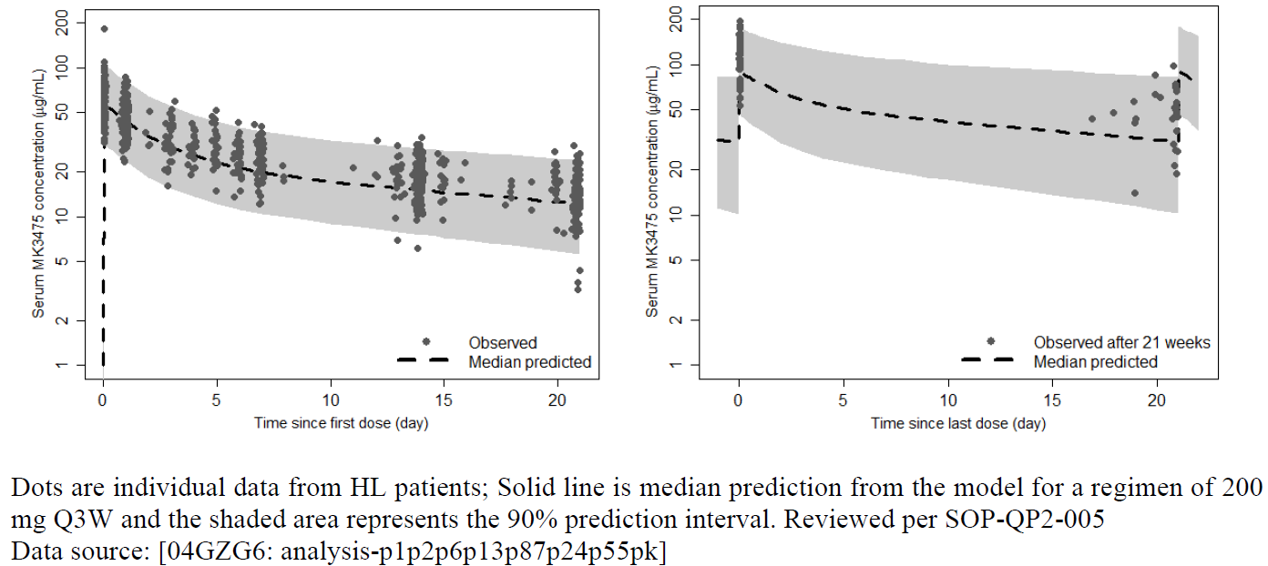
Figure 1: Consistency of Observed Concentrations in HL Subjects with Predictions Based on Definitive Population PK Model: Pembrolizumab Concentration-Time Profiles during the First Dose (left panel) and at Steady State (right panel) at 10 mg/kg Q2W
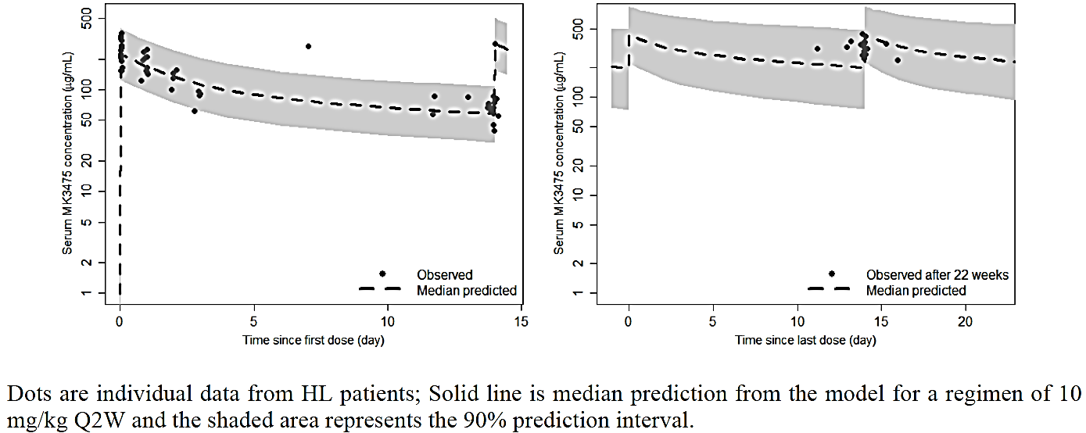
To further establish the similarity in pembrolizumab exposures across indications, several comparisons have been made of peak and trough concentrations between indications. Observed peak and trough concentrations at 200 mg Q3W in HL patients are compared to predicted peak and trough concentrations in melanoma and NSCLC patients at this dose regimen in Figure 4 and Table 3. The similarity in concentrations observed in these comparisons provides further support to the adequacy of the definitive population PK model for pembrolizumab as established on data in melanoma and NSCLC to describe the pharmacokinetics in HL patients.
Figure 4: Comparison of Distributions of Observed Peak and Trough Concentrations (Cycle 1) of Pembrolizumab in HL Patients at 200 mg Q3W with Predicted Concentrations in Melanoma and NSCLC Patients at the Same Dose Regimen
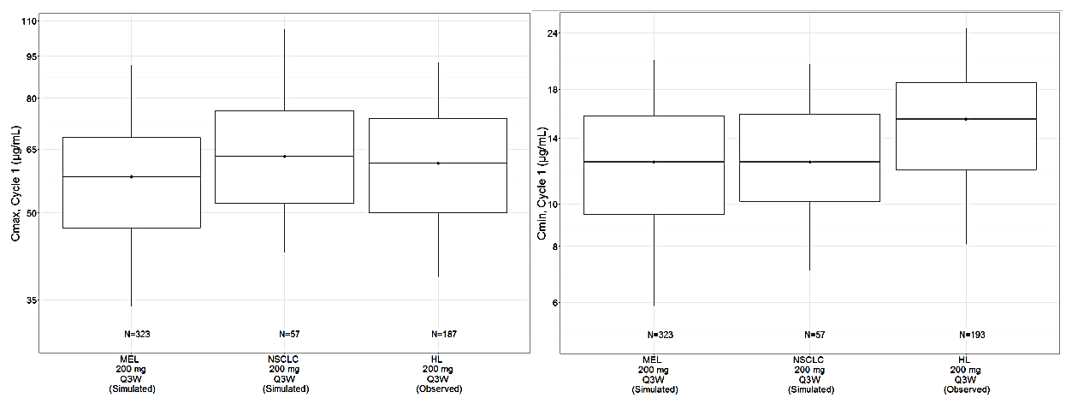
Table 3: Descriptive Statistics of Observed Peak and Trough Concentrations (Cycle 1) of Pembrolizumab in HL Patients at 200 mg Q3W and Predicted Peak and Trough Concentrations in Melanoma and NSCLC Patients at the Same Dose Regimen
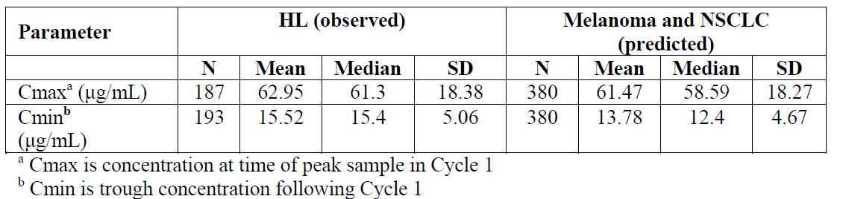

Pharmacokinetic interactions
As pembrolizumab is an IgG4 antibody that is administered parentally and cleared by catabolism, food and drug-drug interactions are not anticipated to affect exposure. Therefore, no dedicated drug-drug interaction studies have been performed. However, as systemic corticosteroids may be used to treat immune-mediated adverse reactions concomitant with pembrolizumab, the potential for a PK drug-drug interaction with pembrolizumab as a victim was assessed. No relationship was observed between prolonged use of systemic corticosteroids and pembrolizumab exposure.

Evaluator’s overall conclusions on pharmacokinetics
Overall, the proposed dose of 200 mg Q3W is supported by data in rrcHL subjects along with evidence in melanoma, NSCLC and HNSCC subjects. Pembrolizumab pharmacokinetics is consistent across indications and is typical for therapeutic monoclonal antibodies with low clearance and limited volume of distribution. Pembrolizumab has a low potential to elicit the formation of anti-drug antibodies.

Pharmacodynamics
There is no new information regarding pharmacodynamics.

Dosage selection for the pivotal studies

Proposed 200 mg Q3W Dosing Regimen
A dosing regimen of 200 mg Q3W is recommended for pembrolizumab in the treatment of rrcHL. The proposed 200 mg Q3W regimen was included in the rrcHL trial KN087. The basis for this is:
- Previous data demonstrate that dose choice should be independent of cancer type for pembrolizumab: In clinical dose-ranging studies in melanoma, NSCLC and HNSCC, an essentially flat relationship between pembrolizumab exposure (or dose) and efficacy or safety was established across the tested dose regimens (2 mg/kg Q3W, 200 mg Q3W, 10 mg/kg Q3W or 10 mg/kg Q2W). These clinical findings are consistent with the biological rationale: pembrolizumab is a high affinity antibody against PD-1, which exerts dual ligand blockade of the PD-1 pathway, including PD-L1 and PD-L2, on antigen presenting tumor cells. By inhibiting the PD-1 receptor from binding to its ligands, pembrolizumab activates tumor specific cytotoxic T lymphocytes in the tumor microenvironment and reactivates anti-tumor immunity. Because the mechanism of action does not involve direct binding of pembrolizumab to cancer cells, differences across cancer types would be less relevant for antitumor activity than for a therapy directly targeting tumor tissue. On this basis, the approved dose for melanoma and NSCLC is 2 mg/kg Q3W and for HNSCC is 200 mg Q3W, and the proposed dosing regimen for rrcHL is 200 mg Q3W.
Comment: The dose of 200 mg Q3W in HNSCC is only approved in the US.
- 200 mg Q3W fixed dose maintains exposures in rrcHL subjects within the previously established therapeutic window in melanoma and NSCLC: The comparisons of observed maximum serum concentrations (C_{max}) and trough concentrations (C_{min}) for rrcHL subjects receiving 200 mg Q3W and 10 mg/kg Q2W regimens with those in melanoma, NSCLC and HNSCC subjects receiving doses from 2 mg/kg Q3W to 200 mg Q3W to 10 mg/kg Q2W demonstrate no clinically meaningful difference in PK variability for fixed-dosing compared to weight-based dosing. The comparisons of observed C_{max} and C_{min} at 200 mg Q3W and 10 mg/kg Q2W with parameters for respective doses from other indications also show no clinically meaningful differences across indications. Since for the same dosing frequency (for example, Q3W) exposures (AUC) are usually correlated with C_{max} and C_{min}, these comparisons also confirm that the exposures from 200 mg Q3W regimen are close, and slightly higher compared, to those at 2 mg/kg, and are within the therapeutic window defined by the exposure-range previously observed from 2 mg/kg Q3W to 10 mg/kg Q2W in melanoma and NSCLC subjects. Therefore, 200 mg Q3W is an appropriate dosing regimen in rrcHL subjects.
- Clinical response from the rrcHL trials including arms dosed at 200 mg Q3W (KN087) and 10 mg/kg Q2W (KN013) supports the proposed regimen of 200 mg Q3W: Clinical response in HL subjects in KN013 and KN087 support the dose selection of 200 mg Q3W. Efficacy results in rrcHL subjects show no clinically meaningful difference between 200 mg Q3W and 10 mg/kg Q2W dosing regimens. In KEYNOTE-087, the ORR observed at 200 mg Q3W (68.1%; 95% CI: 61.3, 74.3) is similar to KEYNOTE-013 at 10 mg/kg Q2W (58.1%; 95% CI: 39.1, 75.5). Additionally, t the changes in tumor-size from baseline between 200 mg Q3W and 10 mg/kg Q2W in KN013 and KN087 are similar. These comparisons have the limitations of small number of subjects at 10 mg/kg Q2W and non-randomised study designs in KN013 and KN087.
- Positive benefit/risk for efficacy and safety as compared to current available options for rrcHL subjects: The response achieved at 200 mg Q3W is clinically meaningful as viewed in the historical context of standard-of-care agents. A systematic literature review was performed to characterize the response in heavily pretreated refractory/relapsed HL patients with the treatments recommended by National Comprehensive Cancer Network. The systematic literature review found studies in HL patients who are refractory/relapsed after ≥ 3 treatments (similar to the population studied in KEYNOTE- 013 and KEYNOTE-087) as shown in Table 1. The responses in the subgroup of heavily pretreated refractory patients were not separately reported. Additionally, the benefit/risk in most of these studies was poorly characterized considering the small study sizes (only one study with 102 patients; the remaining studies with 16 to 38 patients). These studies represent therapies with different mechanisms of action, which is likely driving differences in response. Hence, a meta-analysis was not performed to obtain an overall average response across studies/therapies.

Evaluator’s conclusions on dose finding for the pivotal studies
The sponsor has demonstrated that the proposed fixed regimen of 200 mg IV Q3W is acceptable by showing that exposure is maintained within previously established therapeutic window and that efficacy is comparable in cHL, although KN013 is a small study. Safety is also comparable to previous studies in other malignancies using other (higher and lower) doses.

Clinical efficacy

Pivotal or main efficacy studies

KEYNOTE-087; A Phase II Clinical Trial of MK-3475 (Pembrolizumab) in Subjects with Relapsed or Refractory (R/R) Classical Hodgkin Lymphoma (cHL)

Study design, objectives, locations and dates
This is a multicenter, single arm, multi-cohort, nonrandomised trial of pembrolizumab in subjects with rrcHL (Figure 5). The trial is ongoing and an interim report is presented.
Subjects meeting eligibility criteria were allocated to one of three cohorts in KEYNOTE-087, depending on their prior disease history and therapy:
- Cohort 1: subjects who failed to respond or progressed after auto-SCT therapy and relapsed or failed to respond after treatment with BV post auto-SCT.
- Cohort 2: subjects who were ineligible for an auto-SCT (unable to achieve a complete or partial response to salvage therapy) and have relapsed after treatment with or failed to respond to BV.
- Cohort 3: subjects who failed to respond to or progressed after auto-SCT and have not received BV post-auto-SCT. These subjects could have received BV as part of primary treatment or salvage therapy.
Comment: Of note: Twenty-five patients (41.7%) in Cohort 3 had received BV before ASCT [35 patients (58.3%) had not].
Figure 5: Trial design KEYNOTE-087
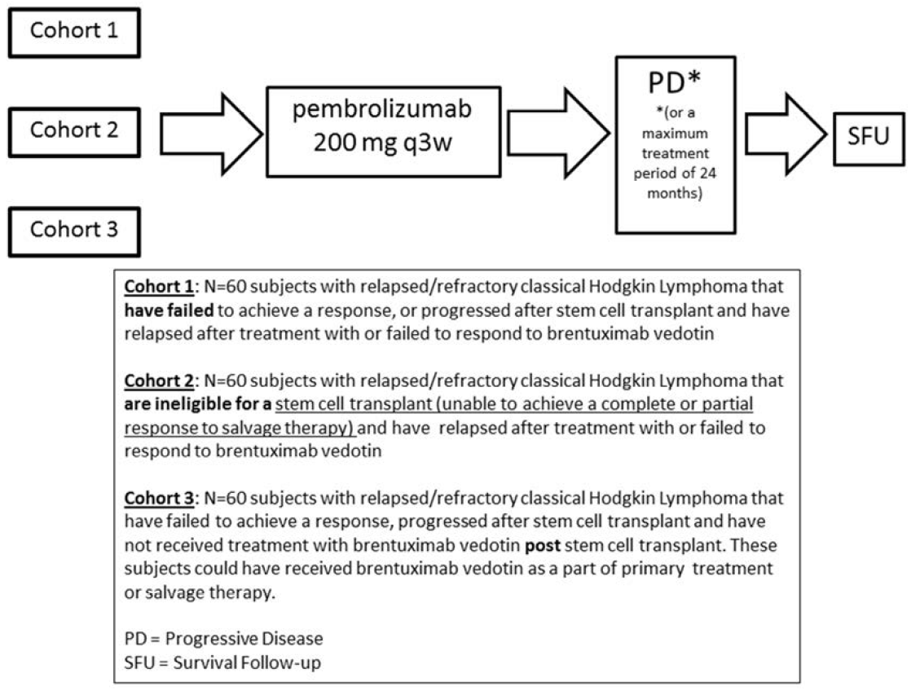

Primary Objectives
Within each of the 3 specified cohorts with rrcHL and pooled:
Objective: To determine the safety and tolerability of pembrolizumab.
Within each of the 3 cohorts of subjects with rrcHL:
Objective: To evaluate the Objective Response Rate (ORR) of pembrolizumab by blinded, independent central review (BICR) according to the IWG response criteria.

Secondary Objectives
Within each of the 3 cohorts of subjects with rrcHL:
Objective: Evaluate ORR of pembrolizumab by investigator assessment according to the IWG response criteria; and additionally by BICR using the 5-point scale according to the Lugano Classification.
Objective: Evaluate Complete Remission Rate (CRR) of pembrolizumab by BICR and by investigator assessment according to the IWG response criteria; and additionally by BICR using the 5-point scale according to the Lugano Classification.
Objective: Evaluate Progression Free Survival (PFS) and Duration of Response (DOR) of pembrolizumab by BICR and by investigator assessment according to the IWG response criteria.
Objective: Evaluate the Overall Survival (OS) of pembrolizumab.

Exploratory Objectives
Within each of the 3 cohorts, and potentially pooled, of subjects with rrcHL:
Objective: To evaluate ORR, CRR, PFS and DOR for subjects who continue treatment with pembrolizumab beyond documented progression; see Section 8.6.1 of the protocol.
Objective: To explore the pharmacokinetic (PK) profile of pembrolizumab; see Section 7.1.3.2.1 of the protocol.
Objective: To evaluate changes in health-related quality-of-life assessments from baseline using the European Organization for Research and Treatment of Cancer (EORTC) Quality of Life (QoL) Questionnaire C30 (QLQ-C30) and European Quality of Life Five Dimensions Questionnaire (EuroQoL EQ-5D); see Section 4.2.3.2.1.2 of the protocol.
Objective: To further evaluate pembrolizumab immunogenicity and exposure of the proposed dose and dosing regimen; see Section 4.2.3.3 of the protocol.
Objective: To compare the extent of pre-pembrolizumab PD-L1 expression in tumor biopsies for pembrolizumab responders versus non-responders; see Section 4.2.3.2.1.1 of the protocol.
Objective: To investigate the relationship between candidate efficacy biomarkers and anti-tumor activity of pembrolizumab utilizing pre and post-treatment lymph node biopsies and blood sampling; see Section 4.2.3.4 of the protocol.
Objective: To explore the relationship between genetic variation and response to the treatment(s) administered. Variation across the human genome will be analysed for association with clinical data collected in this study; see Section 4.2.3.4 of the protocol.

Endpoints Not Analysed – Interim Clinical Study Report
Analyses of efficacy and safety in subjects with rrcHL treated in KEYNOTE-087 are the primary focus of this interim CSR. Consequently, not all of the objectives listed in [Sec. 8.3] were analysed and reported at this time, but may be addressed in the final analysis. The following objectives have limited or no corresponding analyses presented in this report:
Secondary Objective:
- Responses by BICR using the 5-point scale according to the Lugano Classification.
Exploratory Objectives:
- Compare the extent of pre-pembrolizumab PD-L1 expression in tumor biopsies for pembrolizumab responders versus non-responders.
- Investigate the relationship between candidate efficacy biomarkers and anti-tumor activity of pembrolizumab utilizing pre and post-treatment lymph node biopsies and blood sampling.
- Explore the relationship between genetic variation and response to treatment(s) administered.

Locations
This trial was conducted at 51 centers which allocated subjects to study treatment. Eleven of these trial centers were in the US; 7 in Japan; 4 each in France, Israel, and Spain; 3 each in Italy, Russia, and the United Kingdom; 2 each in Australia, Germany, Greece, Hungary, and Sweden; and 1 each in Canada and Norway.

Dates
The first subject was enrolled in study KEYNOTE-087 on 24-Jun-2015 and the last subject enrolled on 02-Mar-2016. The trial is ongoing.
According to the sponsor all data provided in the CSR are based on a 27-Jun-2016 cut-off date.
There is a Report Dates of 07-Sep-2016 with a Revised Report Date of 22-Sep-2016 (see KN087 synopsis).
This is an interim report.
Comment: This study is the pivotal study: it has been performed using the dose the sponsor is seeking approval for, and it is the largest study (210 versus 31 subjects in KN013). The evaluation will focus on this study primarily.

Inclusion and exclusion criteria

Inclusion Criteria
- Be willing and able to provide written informed consent/assent for the trial. The subject may also provide consent/assent for Future Biomedical Research. However, the subject may participate in the main trial without participating in Future Biomedical Research.
- Be ≥ 18 years of age on day of signing informed consent.
- Have relapsed* or refractory* de novo classical Hodgkin lymphoma and meet one of the following cohort inclusions:
*Relapsed: disease progression after most recent therapy *Refractory: failure to achieve CR or PR to most recent therapy.
- Cohort 1: Have failed to achieve a response or progressed after auto-SCT. Subjects must have relapsed after treatment with or failed to respond to brentuximab vedotin post auto-SCT.
- Cohort 2: Were unable to achieve a complete or a partial response to salvage chemotherapy and did not receive auto-SCT. Subjects must have relapsed after treatment with or failed to respond to brentuximab vedotin.
- Cohort 3: Have failed to achieve a response or progressed after auto-SCT and have not have received brentuximab vedotin post auto-SCT. Note: These subjects could have received brentuximab vedotin as part of primary treatment, or salvage treatment.
- Have measureable disease defined as at least one lesion that can be accurately measured in at least two dimensions with spiral CT scan. Minimum measurement must be > 15 mm in the longest diameter or > 10 mm in the short axis.
- Be able to provide an evaluable core or excisional lymph node biopsy for biomarker analysis from an archival or newly obtained biopsy at Screening. In addition subjects may provide additional biopsy at Week 12 and at the time of discontinuation due to progression. If submitting unstained cut slides, freshly cut slides should be submitted to the testing laboratory within 14 days from when the slides are cut. See Section 7.1.2.6.8 for an explanation.
- Must have a performance status of 0 or 1 on the ECOG Performance Scale.
- Must demonstrate adequate organ function as defined in Table 4; all screening labs should be performed within 7 days of treatment initiation.
Table 4: Lymphoma Adequate Organ Function Laboratory Values
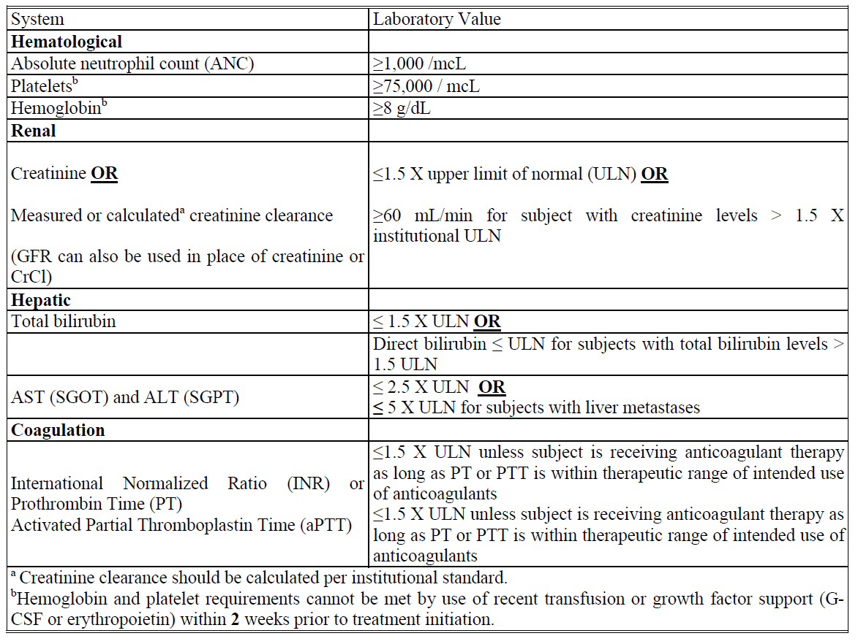
- Female subject of childbearing potential should have a negative urine or serum pregnancy within 72 hours prior to receiving the first dose of study medication. If the urine test is positive or cannot be confirmed as negative, a serum pregnancy test will be required.
- Female subjects of childbearing potential must be willing to use an adequate method of birth control as outlined in Section 5.7.2 – Contraception, for the course of the study through 180 days after the last dose of study medication.
Note: Abstinence is acceptable if this is the usual lifestyle and preferred contraception for the subject.
Male subjects of childbearing potential (Section 5.7.2) must agree to use an adequate method of contraception as outlined in section 5.7.2 – Contraception, starting with the first dose of study therapy through 180 days after the last dose of study therapy.
Note: Abstinence is acceptable if this is the usual lifestyle and preferred contraception for the subject.

Exclusion Criteria
- Is currently participating and receiving study therapy or has participated in a study of an investigational agent and received study therapy or used an investigation device within 4 weeks of the first dose of treatment.
- Has a diagnosis of immunosuppression or is receiving systemic steroid therapy or any other form of immunosuppressive therapy within 7 days prior to the first dose of trial treatment. The use of physiologic doses of corticosteroids may be approved after consultation with the sponsor.
- Has had a prior monoclonal antibody within 4 weeks prior to study Day 1 or who has not recovered (that is, ≤ Grade 1 or at baseline) from adverse events due to agents administered more than 4 weeks earlier.
- -Note: Subjects with ≤ Grade 2 neuropathy are an exception to this criterion and may qualify for the study.
- Has had prior chemotherapy, targeted small molecule therapy, or radiation therapy within 2 weeks prior to study Day 1 or who has not recovered (that is, ≤ Grade 1 or at baseline) from adverse events due to a previously administered agent.
    - Note: Subjects with ≤ Grade 2 neuropathy are an exception to this criterion and may qualify for the study.
    - Note: If subject received major surgery, they must have recovered adequately from the toxicity and/or complications from the intervention prior to starting therapy.
    - Note: Toxicity that has not recovered to ≤ Grade 1 is allowed if it meets the inclusion requirements for laboratory parameters defined in Table 4.
- Has undergone prior allogeneic haematopoietic stem cell transplantation within the last 5 years. (Subjects who have had a transplant greater than 5 years ago are eligible as long as there are no symptoms of GVHD.)
- Has a known additional malignancy that is progressing or requires active treatment. Exceptions include basal cell carcinoma of the skin, squamous cell carcinoma of the skin, or in situ cervical cancer that has undergone potentially curative therapy.
- Has known clinically active CNS involvement.
- Has active autoimmune disease that has required systemic treatment in past 2 years (that is, with use of disease modifying agents, corticosteroids or immunosuppressive drugs). Replacement therapy (for example, thyroxine, insulin, or physiologic corticosteroid replacement therapy for adrenal or pituitary insufficiency, etc.) is not considered a form of systemic treatment
- Has evidence of active, non-infectious pneumonitis.
- Has an active infection requiring intravenous systemic therapy.
- Has known psychiatric or substance abuse disorders that would interfere with cooperation with the requirements of the trial.
- Is pregnant or breastfeeding, or expecting to conceive or father children within the projected duration of the trial, starting with the pre-screening or screening visit through 180 days after the last dose of trial treatment.
- Has received prior therapy with an anti-PD-1, anti-PD-L1, anti-PD-L2, anti-CD137, or anti-Cytotoxic T-lymphocyte-associated antigen-4 (CTLA-4) antibody (including ipilimumab or any other antibody or drug specifically targeting T-cell co-stimulation or checkpoint pathways).
- Has a known Human Immunodeficiency Virus (HIV) (HIV 1/2 antibodies).
- Has known active Hepatitis B (for example, HBsAg reactive) or Hepatitis C (for example, HCV RNA [qualitative] is detected).
- Has received a live vaccine within 30 days prior to first dose.

Study treatments
Trial treatment: Pembrolizumab 200 mg Q3W IV, Infusion Day 1 of each treatment cycle.
Trial treatment should begin on the day of randomisation or as close as possible to the date on which the subject is allocated/assigned.

Efficacy variables and outcomes
The primary efficacy objective of this study was to evaluate the anti-tumor activity of pembrolizumab in subjects with relapsed or refractory classical Hodgkin lymphoma. The primary efficacy endpoint for Hodgkin lymphoma was ORR as assessed by BICR per IWG response criteria.
Secondary efficacy outcomes were:
- ORR according to investigator (site) assessment using IWG criteria
- ORR according to central review using Lugano 5-point classification
- Complete remission rate (CRR), defined as the proportion of subjects in the analysis population who have complete remission (CR) by IWG criteria
- Progression-free survival (PFS), defined as the time from first dose to the first documented disease progression according to IWG criteria or death due to any cause, whichever occurs first
- Duration of response (DOR), defined as time from first IWG response to disease progression in subjects who achieve a PR or better
- Overall survival (OS), defined as time from first dose to date of death.

Assessment of Disease
Anti-tumor activity of pembrolizumab was evaluated using the IWG response criteria by CT/PET (Cheson et al., 2007).
The criteria were applied by the site as the primary measure for assessment of disease response and as a basis for all protocol guidelines related to disease status (for example, discontinuation of study therapy).
Disease response assessments were to occur every 12 weeks until documented disease progression, the start of new anti-cancer treatment, withdrawal of consent, death, or the end of the study, whichever occurred first. Assessment of lymphoma B symptoms occurred with each lymphoma disease response assessment.

Patient Reported Outcomes (PROs)
The EuroQol EQ-5D and EORTC QLQ-C30 questionnaires were administered by trained site personnel and completed electronically by the subjects themselves. It was strongly recommended that all electronic PROs were administered prior to drug administration, adverse event evaluation and disease status notification. The electronic PROs were completed in the following order: EuroQol EQ-5D first, then EORTC QLQ-C30 at the time points specified in the Trial Flow Charts of the protocol.

Biopsy Collection and Correlative Studies Blood Collection
Bone marrow biopsies were to be collected at screening, and to confirm complete remission (in subjects who had marrow involvement), or if clinically indicated. Lymph node biopsies were to be collected at Screening and Week 12. Blood for correlative biomarkers studies was to be collected at Screening, Week 12, and upon PD.

Pharmacokinetic/Pharmacodynamic and Immunogenicity Measurements
The PK properties of pembrolizumab and the relationship of candidate efficacy/resistance biomarkers and anti-tumor activity of pembrolizumab were investigated as exploratory objectives. Blood was to be collected for measurement of serum pembrolizumab and anti-pembrolizumab antibodies as described in the trial protocol.
The primary efficacy objective of this study was to evaluate the anti-tumor activity of pembrolizumab in subjects with relapsed or refractory classical Hodgkin lymphoma. The primary efficacy endpoint for Hodgkin lymphoma was ORR as assessed by BICR per IWG response criteria.
Secondary efficacy outcomes were:
- ORR according to investigator (site) assessment using IWG criteria
- ORR according to central review using Lugano 5-point classification
- Complete remission rate (CRR), defined as the proportion of subjects in the analysis population who have complete remission (CR) by IWG criteria
- Progression-free survival (PFS), defined as the time from first dose to the first documented disease progression according to IWG criteria or death due to any cause, whichever occurs first
- Duration of response (DOR), defined as time from first IWG response to disease progression in subjects who achieve a PR or better
- Overall survival (OS), defined as time from first dose to date of death.
Comment: According to the CSR secondary efficacy outcome (2) has not been analysed in this interim report.

Randomisation and blinding methods
This was not a randomised trial but a Phase II trial with a single arm. There were three cohorts which were analysed separately and pooled.

Analysis populations
The analysis of primary efficacy endpoints was based on the All-Subjects-as-Treated (ASaT) population, that is, subjects were included if they received at least one dose of study medication.
Supportive analyses were conducted in the Full-Analysis-Set (FAS) population, which consisted of all subjects who 1) received at least one dose of study medication; 2) had a baseline disease assessment, and 3) had a post baseline disease assessment OR discontinued the trial due to progressive disease/drug-related AE.

Sample size
The proposed sample size for each of the three cohorts was 60 subjects in the primary analysis population (ASaT), that is, 180 subjects in all. Table 5 provides a summary of subjects included in the analysis population.
Table 5: Subjects accounting for analysis populations by cohort
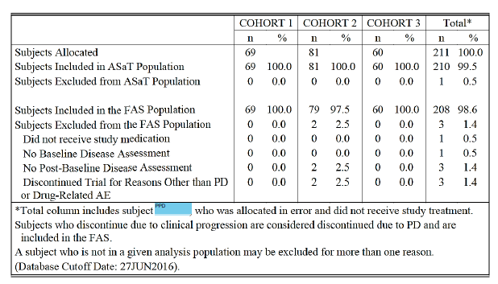

Statistical methods
Table 6: Efficacy Analysis Methods for Primary and Secondary Efficacy Endpoints
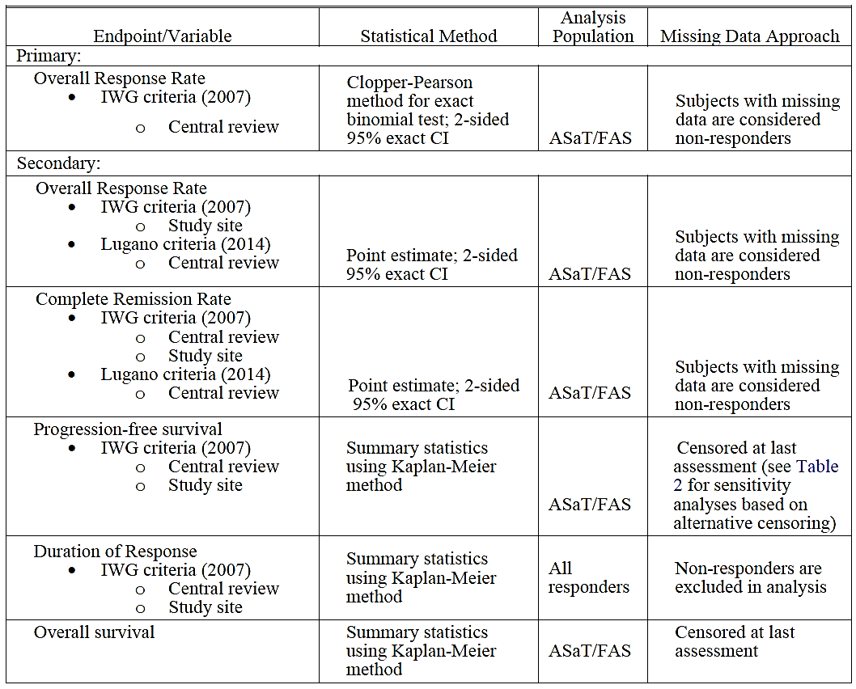

Participant flow
Table 7 displays the disposition of all subjects who were not enrolled. Of the 32 subjects who were not enrolled, 28 (87.5%) subjects were screen failures. The term ‘randomised’ is synonymous with ‘allocated’ because there was no randomisation in this single-arm study.
Table 7: Disposition of subjects not randomised, Study KN087
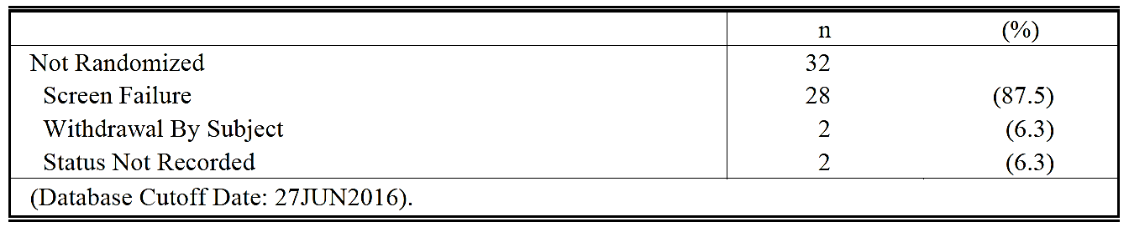
The number of subjects included in the various cohorts is depicted in Table 5:
A total of 210 subjects were enrolled and analyzed, 69 subjects in Cohort 1; 81 subjects in Cohort 2, and 60 subjects in Cohort 3. As of the cutoff date, 62 (29.5%) subjects had discontinued study treatment. The primary reason for discontinuation for 24 (11.4%) subjects was disease progression. Discontinuations due to AEs were reported for 8 (3.8%) subjects. Treatment was ongoing in 145 (69.0%) subjects.
Comment: As the treatment for responders could go on for up to 2 years, and the cut-off date for this interim analysis is 1 year after the first patient was included, no patients have had the full planned treatment.

Major protocol violations/deviations
A pre-defined list of major protocol deviations was created at the start of the trial; however, as the trial progressed with continued monitoring, new major deviations may be added to the list. There were 104 major protocol deviations. A listing of clinically relevant major protocol deviations can be found in attachment 16.2.2 of the CSR. The most commonly occurring major deviation was 65 incidents regarding informed consent. No subject was excluded from analyses due to protocol deviations.
Comment: There is no summary of types of protocol deviations. Going through the above mentioned attachment it does not seem likely that the violations will have a major impact on the efficacy analyses.
Question for the sponsor: Subject [information redacted] in cohort 2 only had one line of treatment (AVD+ BV). This subject seems to be included in the efficacy analyses. What is the justification for this?

Baseline data
Demographic and baseline characteristics for all subjects (N=210), and by Cohorts 1, 2, and 3, which comprises the ASaT population: Median age was 35 years (34 y, 40 y and 32 y for cohort 1, 2 and 3, respectively). All subjects had cHL according to the following subgroups: 169 (80.5%) subjects had nodular sclerosing HL, 24 (11.4%) subjects had mixed cellularity HL, 8 (3.8%) subjects had lymphocyte rich HL, and 5 (2.4%) subjects had lymphocyte depleted HL. All subjects (N=210) were refractory to a previous therapy or had relapsed after ≥ 3 lines of therapy; 145 (69.0%) had relapsed after ≥ 3 lines of therapy and 74 (35.2%) were primary refractory (Table 8). Subjects in Cohorts 1 and 3 were post-auto-SCT (n = 129 total), and subjects in Cohort 2 (n = 81) had not received an auto-SCT. A total of 175 (83.3%) subjects had also previously failed to respond to or relapsed after treatment with BV. Seventy-six (36.2%) subjects had prior radiation therapy. The median number of prior lines of therapy was 4.0 (range: 1 to 12).
The number of patients in Cohort 3, who had received BV pre-ASCT: (25/60; 41.7%).
Table 8: Baseline Characteristic’s for status of Refractory or Relapsed ≥ 3 Lines of Therapy (ASaT Population), Study KN087
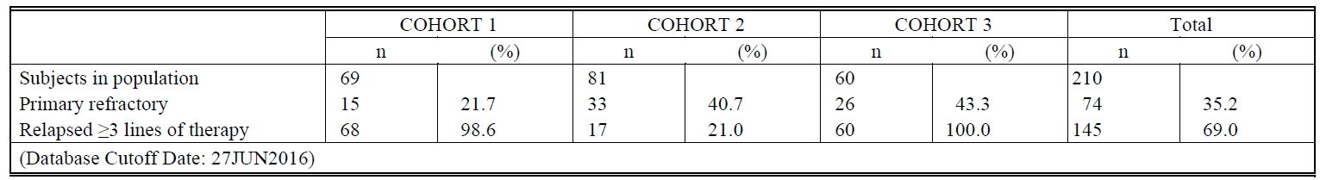
Comment: In Cohort 2 only 17 (21%) have relapsed after ≥ 3 lines of treatment (Table 8). Traditionally and when observing the inclusion criteria for this cohort (section 7.1.1.2) you get the impression that this group have received ≥ 3 lines of treatment: primary treatment, salvage therapy and BV. The remaining patients (79%) have apparently received BV as part of primary or salvage treatment. The inclusion criteria gives the impression that they have had more treatments than they have, so it is important to take into account that only 21% had ≥ 3 lines of treatment when evaluating the efficacy, as you would expect better results in patients with fewer prior treatments.
Questions for the sponsor:
- 15 of the 19 patients >65 years (79%) in KN087 are in cohort 2. Were they all (15) scheduled for ASCT and then failed salvage therapy as opposed to not being scheduled for ASCT because of age (which is not part of the inclusion criteria, see section 7.1.1.2)? (Question 4)
- In Cohort 3 (Table 8), 60 patients (100%) have relapsed after ≥ 3 lines of therapy. How is that possible when only 36 subjects (60%) have had ≥ 3 lines of treatment? (Question 5)
- There are almost twice as many patients with primary refractory disease in Cohort 3 compared to Cohort 1. Generally they have a poor prognosis but here the ORR and CR are approximately the same as in Cohort 1. Primary refractory disease means refractory to first line of treatment: Is this what is described here (as opposed to refractory to later treatments)? (Question 6)

Results for the primary efficacy outcome
The primary efficacy endpoint for this study is the Overall Response Rate (ORR), defined as the proportion of subjects who have response (CR or PR) according to the IWG criteria, and will be analysed separately by cohort. The final analysis will be conducted for that cohort when the last subject in that cohort has reached the Week 12 response assessment or has discontinued study therapy.
The analysis will consist of the point estimate and 95% 2-sided exact confidence interval (CI) using the Clopper-Pearson method which will have at least 95% coverage of the true rate. An exact binomial test will be conducted for each cohort versus a fixed control rate for each cohort.
In the CSR results are presented for:
- all subjects (N=210)
- by cohort
- by response (refractory or relapsed) to prior therapies, and by number of prior therapies
- demographic subgroups
According to the protocol these are the various subgroups that were to be analysed for ORR:
- Age category (≤65 versus >65 years)
- Sex (female versus male)
- Race (White versus non-White)
- Region (US, ex-US)
- Number of prior therapies ( ˂ 4 vs ≥ 4)
For Cohorts 1 and 3 only:
  - Time elapsed since transplant failure (˂12 months versus ≥ 12)

Results for All subjects and for Cohorts:

All subjects
ORR was 68.1% (143/210; 95% confidence interval [CI]: 61.3%, 74.3%) per BICR in the ASaT in all subjects (N=210) (Table 9). Five subjects were considered ‘not evaluable’ (NE) for response by BICR and were considered non-responders. Four of these subjects discontinued the study without their first efficacy assessment at Week 12, and the fifth subject was considered PD at Day 16 by the site review leading to discontinuation, but not read by central review as an on-study scan.
Table 9: Summary of Best Overall Response Based on Central Review per IWG (ASaT Population), Study KN087
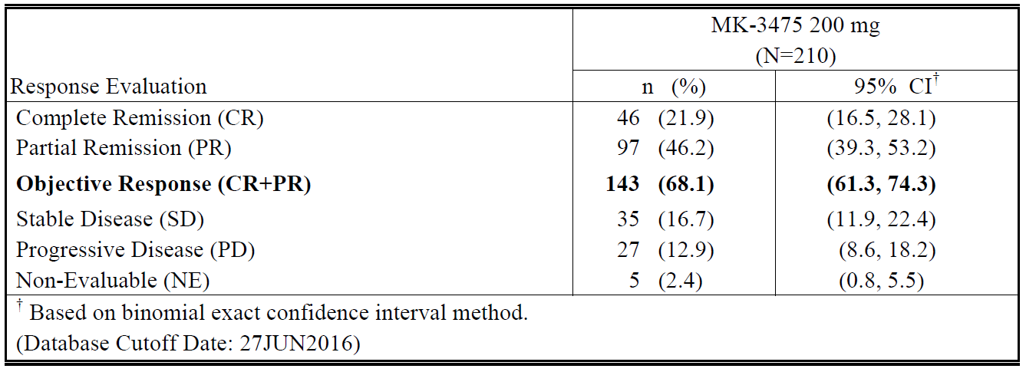

Cohort 1 (Relapsed after ASCT and BV)
Objective response rate, defined as the percentage of subjects achieving CR or PR, was 72.5% (50/69; 95% CI: 60.4%, 82.5%) per BICR in the ASaT population of Cohort 1 (N=69) (Table 10). The proportion of subjects achieving a CR or PR in Cohort 1 was statistically significantly greater than 20% (p-value < 0.001).
Table 10: Summary of Best Overall Response Based on Central Review per IWG (Cohort 1, Study KN087) (ASaT Population)
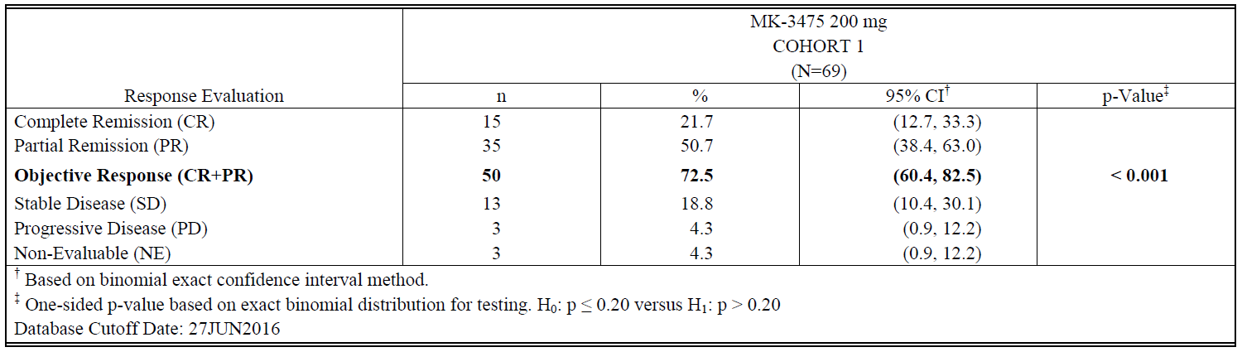
Tumor change from baseline by BICR in the overall ASaT population is depicted in (Figure 6), showing that 66 of 69 subjects had some degree of tumor reduction, with over half of subjects achieving > 50% reduction.
Figure 6: Waterfall Plot of Best Tumor Change from Baseline per Central Review (Cohort 1, Study KN087)
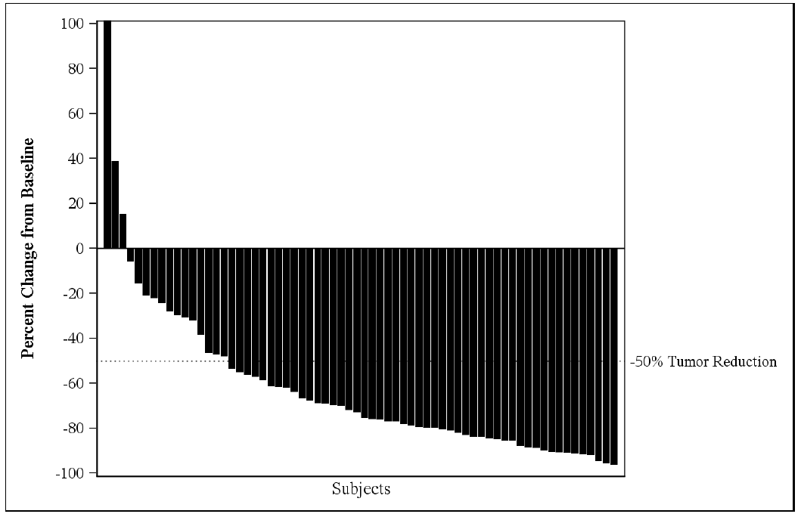

Cohort 2: (SD or worse after salvage therapy and no ASCT and relapsed or refractory to BV at one point)
Objective response rate, defined as the percentage of subjects achieving CR or PR, was 65.4% (53/81; 95% CI: 54.0%, 75.7%) per BICR in the ASaT population of Cohort 2 (N=81) (Table 11). The proportion of subjects achieving a CR or PR in Cohort 2 was statistically significantly greater than 20% (p-value < 0.001).
Table 11: Summary of Best Overall Response Based on Central Review per IWG (Cohort 2, Study KN087) (ASaT Population)
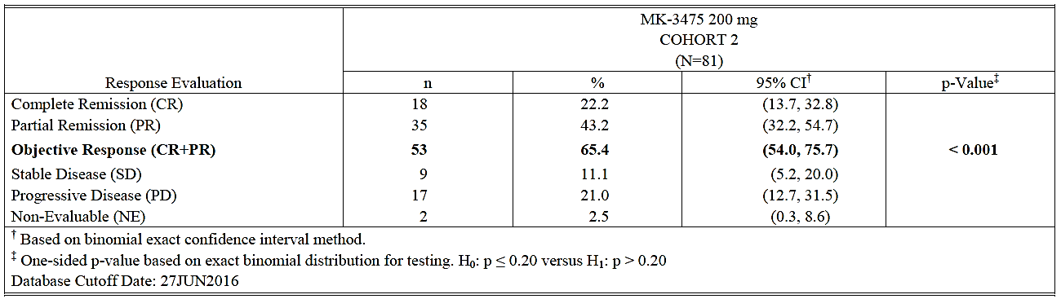
Tumor change from baseline by BICR in the overall ASaT population is depicted in Figure 7, showing that 75 of 81 subjects had some degree of tumor reduction, with over half of subjects achieving > 50% reduction.
Figure 7: Waterfall Plot of Best Tumor Change from Baseline per Central Review (Cohort 2, Study KN087)
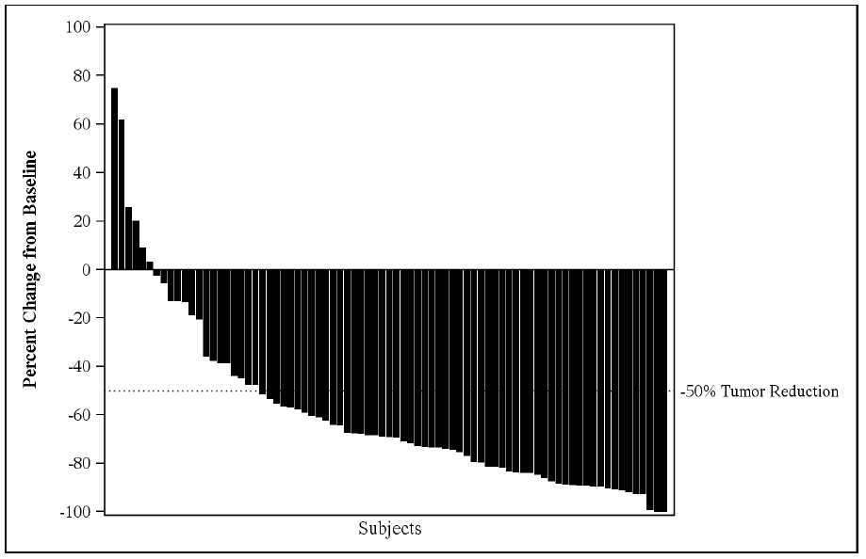

Cohort 3: (RR after ASCT but no BV post-ASCT, 41.7% had BV prior to ASCT)
Objective response rate, defined as the percentage of subjects achieving CR or PR, was 66.7% (40/60; 95% CI: 53.3%, 78.3%) per BICR in the ASaT population of Cohort 3 (N=60) (Table 12). The proportion of subjects achieving a CR or PR in Cohort 3 was statistically significantly greater than 20% (p-value < 0.001).
Table 12: Summary of Best Overall Response Based on Central Review per IWG (Cohort 3, Study KN087) (ASaT Population)
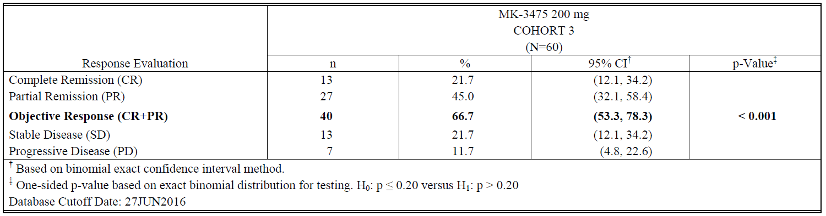
Tumor change from baseline by BICR in the overall ASaT population is depicted in Figure 8, showing that 56 of 60 subjects had some degree of tumor reduction, with over half of subjects achieving > 50% reduction.
Figure 8: Waterfall Plot of Best Tumor Change from Baseline per Central Review (Cohort 3, Study KN087)
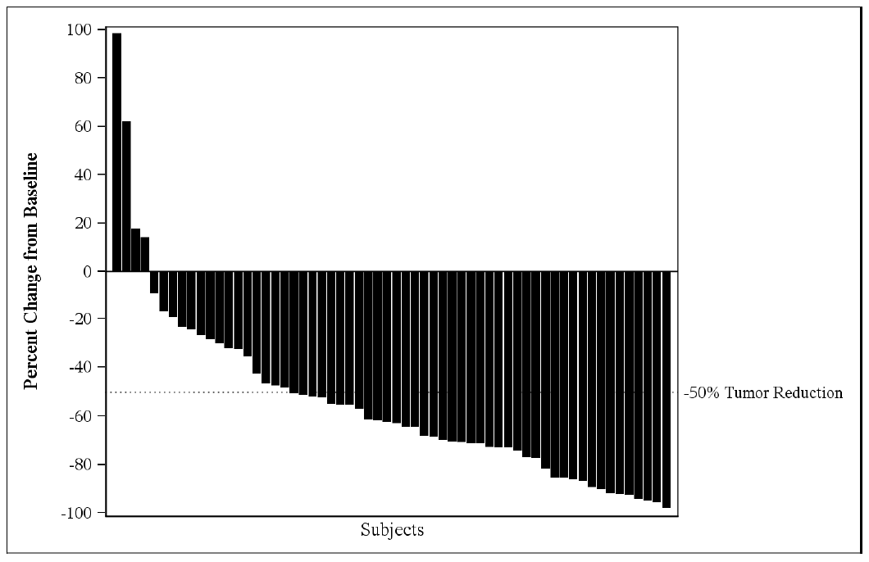
Comment: In Cohort 3 25 patients received BV before ASCT whereas 35 did not.
Question to the sponsor: Was there a difference in Cohort 3 between the 25 patients who had received BV before transplantation and those (35), who had not received BV? (Question 7)

Results for subgroups
These results are not part of the primary endpoint but are presented here in connection with the ORR results for the whole group and by cohorts.
According to the protocol these are the various subgroups that were to be analysed for ORR:
  - Age category (≤65 versus >65 years)
  - Sex (female versus male)
  - Race (White versus non-White)
  - Region (US, ex-US)
  - Number of prior therapies ( ˂ 4 versus ≥ 4)
For Cohorts 1 and 3 only:
  - Time elapsed since transplant failure ( ˂12 months versus ≥ 12)
To determine whether ORR is consistent across various subgroups, the point estimate (n in the following tables) of the ORR (with an exact 95% CI) will be provided and plotted within each category of the following classification variables within each Cohort. (Protocol KN087, section 8.10).
If the observed numbers for a particular subgroup are too small to make a meaningful clinical interpretation, then that subgroup analysis will not be conducted.

Age
The ORR for patients ≥ 65 and <65 years is shown in Table 13. As there were no patients who were ≥ 65 years of age in cohort 1 and only 3/60 in Cohort 3, the data for Cohort 2 are presented. Only 9% of the patients were >65 years of age.
Table 13: Summary of Best Overall Response Based on Central Review per IWG by Age Category (Cohort 2) (ASaT Population, KN087)
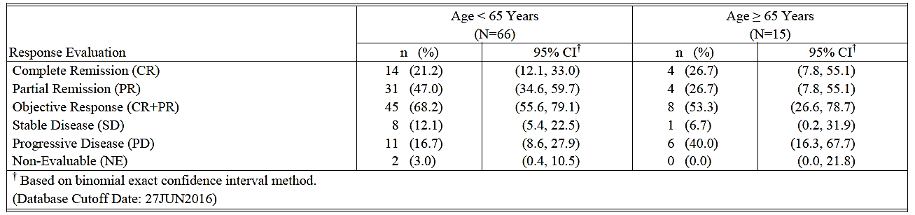

Sex
Differences in ORR by BICR by gender (males: n=113 versus females: n=97) were minimal. The ORR in male subjects was 68.1% (95% CI: 58.7%, 76.6%), while among female subjects the ORR was 68.0% (95% CI: 57.8%, 77.1%).

Race
ORR by BICR was consistent across race categories [White: n=185 (88%) versus non-White n=22]. The ORR in White subjects was 68.6% (95% CI: 61.4%, 75.3%) and in non-White subjects was 63.6% (95% CI: 40.7%, 82.8%).

Region
Differences in ORR by BICR by region (US: n=52 versus ex-US: n=158) were minimal. The ORR in US subjects was 73.1% (95% CI: 59.0%, 84.4%), while among ex-US subjects, ORR was 66.5% (95% CI: 58.5%, 73.8%).

Number of prior therapies
Differences in ORR by BICR by number of prior therapies (< 3: n=28 versus ≥ 3: n=182) were minimal (Table 14). The ORR in subjects with < 3 prior therapies was 64.3% (18/28; 95% CI: 44.1%, 81.4%), while among subjects with ≥ 3 prior therapies, ORR was 68.7% (125/182; 95% CI: 61.4%, 75.3%).
In Cohort 1, differences in ORR by number of prior therapies were unable to be assessed because almost all of the subjects had at least 3 prior therapies (68/69).
In Cohort 2, differences in ORR by number of prior therapies are difficult to discern because almost all of the subjects had at least 3 prior therapies (78/81).
In Cohort 3, differences in ORR by BICR by number of prior therapies (< 3: n=24 versus ≥ 3: n=36) were minimal. The ORR in subjects with fewer than 3 prior therapies was 62.5% (95% CI: 40.6%, 81.2%), while among subjects with 3 or more prior therapies, ORR was 69.4% (95% CI: 51.9%, 83.7%).
Table 14: Summary of Best Overall Response Based on Central Review per IWG by Number of Prior Therapy (ASaT Population, Study KN087)
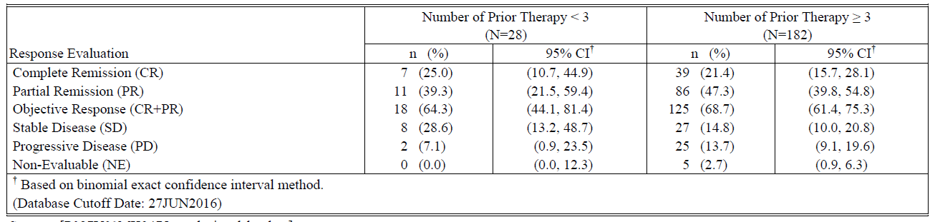
Comment: When you receive an ASCT for relapsed Hodgkin’s lymphoma, usually you would have had a relapse or be refractory to first line treatment, then you would receive salvage therapy and then ASCT, which comes to three treatments (see Johnson and McKenzie, 2015, ESMO Guidelines by Eichenauer et al., 2014, and section 2.2 regarding standard of care). So having less than three therapies including ASCT does not seem to be a typical treatment and thus 40% of Cohort 3 are not as advanced in their disease (in terms of number of prior treatments) as you would expect. The ORR for these two groups has been compared, though, and it actually shows a higher ORR for the group with more treatments (<3 prior treatments: ORR 62.5%, ≥ 3: ORR 69.4%), but the numbers are small.
Question to the sponsor: 24 (40%) patients in Cohort 3 (KN087) had <3 lines of treatment according to Table 10-4 in the CSR: how is that possible when they have gone through ASCT (see description of Cohort 3 in Figure 5)? (Question 9)
Question to the sponsor: What are the results for the patients in Cohort 3 that had ≥ 3 prior treatments and BV compared to the same group without BV and compared to Cohort 1? Are there more patients in Cohort 3/≥ 3 prior treatments that have had BV than in Cohort 3/< 3 prior treatments? In the tabular overview of the various combinations in Cohort 3 please fill in the corresponding results for ORR and CR and the number of subjects in each subgroup. The numbers will be small, but this is just to see if there is a trend in any direction or if the ORR and CR are similar in all subgroups. (Question 10)
If there is a big difference between Cohort 1 and Cohort 3/ ≥ 3 prior treatments without BV pre-ASCT in favour of Cohort 1, then this could imply that having BV post-ASCT is important for the high ORR, as these two groups are comparable. If the results from Cohort 3/ ≥ 3 prior treatments with BV are better than for the same group without BV pre-ASCT, then having BV at any stage before pembrolizumab could be important.
There does not seem to be a clear difference in response in Study KN087 between patients having <3 or ≥ 3 prior treatments (Table 14). 24 of the 28 patients having <3 prior treatments are in Cohort 3, though, which is why these subgroups in Cohort 3 has to be compared to Cohort 1.
Question to the sponsor: What are the ORR and CR for these subgroups? Please fill in the missing data. (Question 10)

Time elapsed since transplant failure (˂12 months versus ≥ 12) (only relevant for cohort 1 and 3)
Differences in ORR by BICR by time since transplant failure (< 12 months: n=85 versus ≥ 12 months: n=44) were minimal (Table 15). The ORR in subjects with less than 12 months since transplant failure was 65.9% (95% CI: 54.8%, 75.8%), while among subjects with 12 months or more since transplant failure, ORR was 77.3% (95% CI: 62.2%, 88.5%).
Table 15: Summary of Best Overall Response Based on Central Review per IWG by Time Relapsed since SCT Failure (ASaT Population, Study KN087)
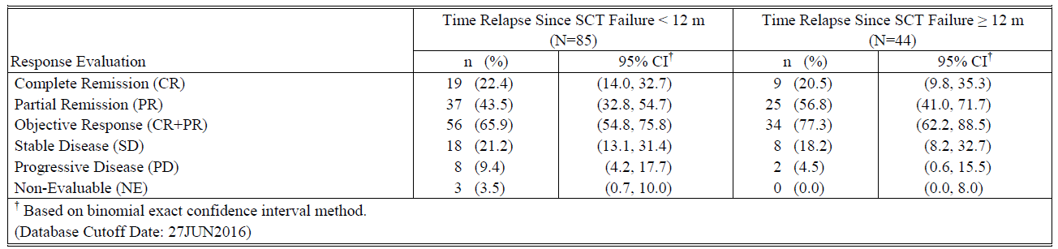
Additional analyses in subgroups not defined in the protocol were performed: there was no difference between refractory or relapsed after ≥ 3 therapies or whether the subjects in the refractory group were refractory to first, last or any other therapy received.
An additional analysis was conducted in subjects who were refractory to first line therapy and never achieved a response (CR or PR) to subsequent therapies (primary refractory); (N=36). The ORR in these subjects was 80.6% (29/36; 95% CI: 64.0%, 91.8%) based on IWG criteria by BICR.
Comment: The numbers are small but it appears that pembrolizumab works just as well in heavily pre-treated as less heavily pre-treated patients and in refractory as well as relapsed patients, which you would not expect for traditional chemotherapy.

Results for other efficacy outcomes
The order of results relates to the order presented in the protocol, see section 7.1.1.4.
- The ORR (all subjects) based on site review was 66.7% (Table 16) compared to 68.1% per BICR (Table 9).
Table 16: Summary of Best Overall Response Based on Site Review per IWG (ASaT Population) Study KN087
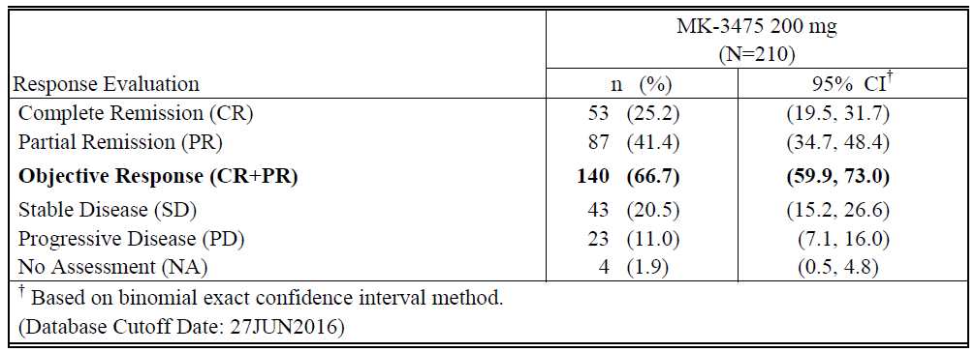
- ORR according to central review using Lugano 5-point classification has not been analysed in this interim report.
- CR (all subjects) by BICR was 21.9% and 25.2% by site review (Table 9 and Table 16, respectively).
CR by cohort is listed in Table 17 with the results for all subjects for comparison.
Table 17: Summary of ORR, CR, PR and DOR Based on Central Review per IWG (All subjects and by cohorts) (ASaT Population) Study KN087
 | All subjects  N=210 | Cohort 1  N=69 | Cohort 2  N=81 | Cohort 3  N=60
Number of subjects with response (%) (ORR=CR+PR) | 143 (68.1) | 50 (72.5) | 53 (65.4) | 40 (66.7)
-Complete remission (%)(CR)  95% CI | 46 (21.9)  (16.5, 28.1) | 15 (21.7)  (12.7, 33.1) | 18 (22.2)  (13.7, 32.8) | 13 (21.7)  (12.1, 34.2)
-Partial remission (%)(PR)  95% CI | 97 (46.2)  (39.3, 53.2) | 35 (50.7)  (38.4, 63.0) | 35 (43.2)  (32.2, 54.7) | 27 (45.0)  (32.1, 58.4)
DOR – Median (Range)  95% CI | Not reached (0.0+ - 8.3+)  (5.7, Not reached) | Not reached (0.0+ - 8.3+)  (5.6, Not reached) | Not reached (0.0+ - 6.3+)  (Not reached, Not reached) | Not reached (0.0+ - 6.0+)  (5.5, Not reached)
Subjects with response ≥ 3 Months (%) | 45 (86.9) | 18 (84.1) | 17 (87.2) | 10 (90.3)
Subjects with response ≥ 6 Months (%) | 4 (65.3) | 1 (63.1) | 2 (80.5) | 1 (52.7)
- The median PFS in all subjects per BICR was 10.8 months (95% CI: 8.3 months, not reached) [Table 18]. The PFS rate at 3 and 6 months was 86.3% and 71.7%, respectively (Figure 9).
Among subjects in the ASaT population in all subjects, the median PFS per site review was 11.1 months (95% CI: 8.1 months, not reached), which is similar to the BICR. The site-assessed PFS rate at 3 and 6 months was 89.9% and 73.1%, respectively.
Table 18: Summary of Progression-Free Survival (PFS) Based on Central Review per IWG (ASaT Population) Study KN087
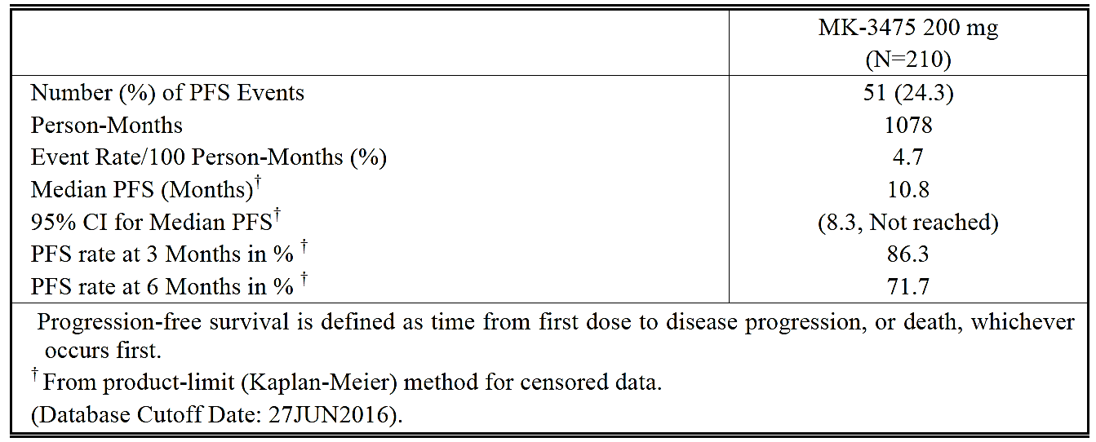
Figure 9: Kaplan-Meier Estimates of Progression-Free Survival Based on Central Review per IWG (ASaT Population) Study KN087
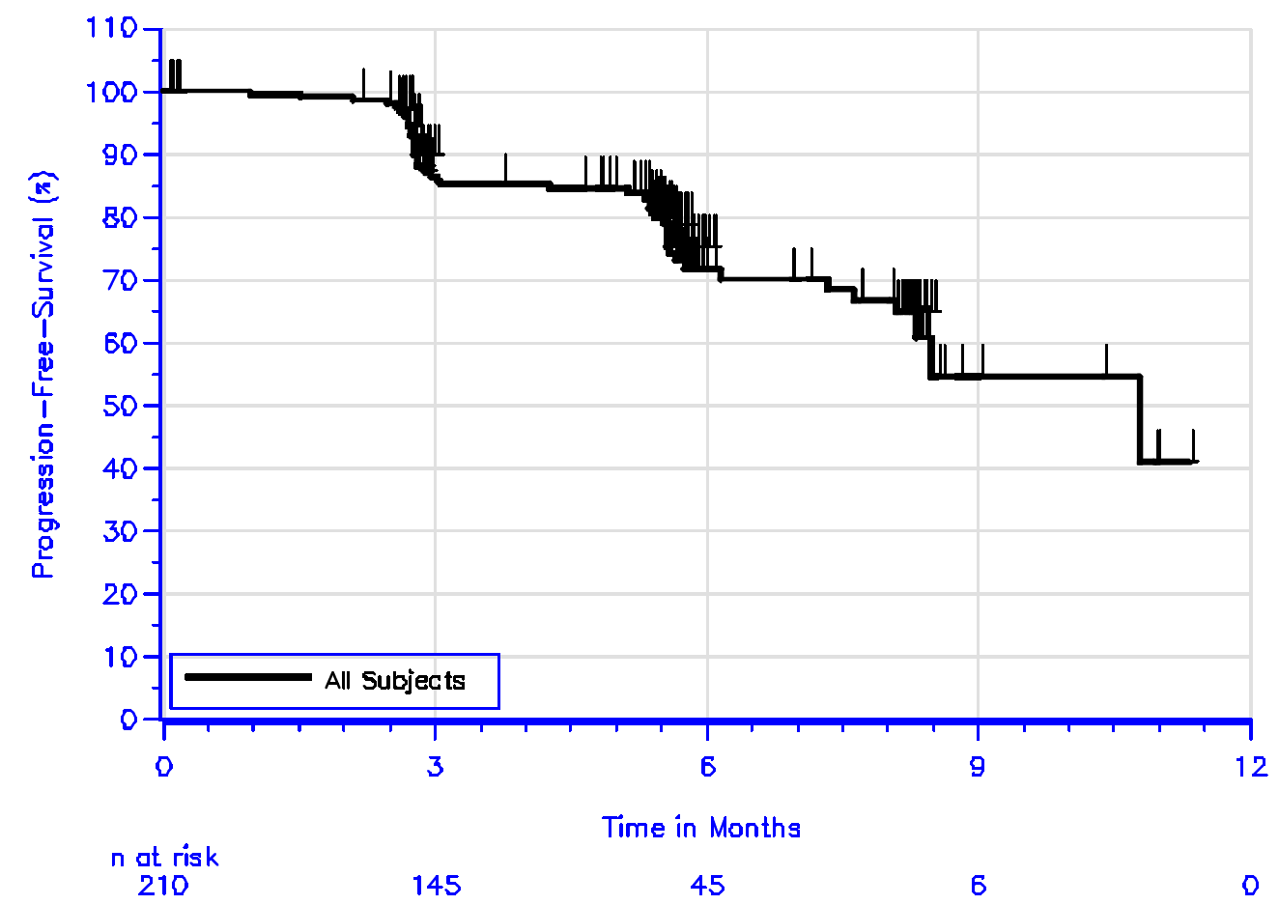
PFS by cohort is listed in Table 19 with the results for all subjects for comparison.
Table 19: Summary of Progression-Free Survival (PFS) Based on Central Review per IWG (All subjects and by cohort) (ASaT Population) Study KN087
 | All subjects  N=210 | Cohort 1  N=69 | Cohort 2  N=81 | Cohort 3  N=60
Number (%) of PFS Events | 51 (24.3) | 14 (20.3) | 23 (28.4) | 14 (23.3)
Person-Months | 1078 | 377 | 404 | 298
Event Rate/100 Person-Months (%) | 4.7 | 3.7 | 5.7 | 4.7
Median PFS (Months) | 10.8 | Not reached | Not reached | 10.8
95% CI for Median PFS | (8.3, Not reached) | (8.1, Not reached) | (7.3, Not  reached) | (6.1, Not reached)
PFS rate at 3 Months in % | 86.3 | 95.4 | 78.0 | 86.5
PFS rate at 6 Months in % | 71.7 | 74.2 | 68.6 | 73.3
- DOR: Subjects were followed for a median of 7.1 months (range 1.0 to 12.1 months). The median time to response (for all subjects) by BICR was 2.8 months (range 2.0 to 8.1 months), and median DOR was not reached (range 0.0+ to 8.3+ months) [Table 20]. Among the 143 subjects with response, a response of at least 3 months in duration was observed in 45 subjects (86.9% by Kaplan-Meier method), and a response of at least 6 months in duration was observed in 4 subjects (65.3% by Kaplan-Meier method). At the time of the data cutoff, 115 (80.4%) responders had ongoing response.
DOR by cohort is listed in Table 17 with the results for all subjects for comparison.
Table 20: Summary of Time to Response and Response Duration Based on Central Review per IWG in Subjects with Response (ASaT Population) Study KN087
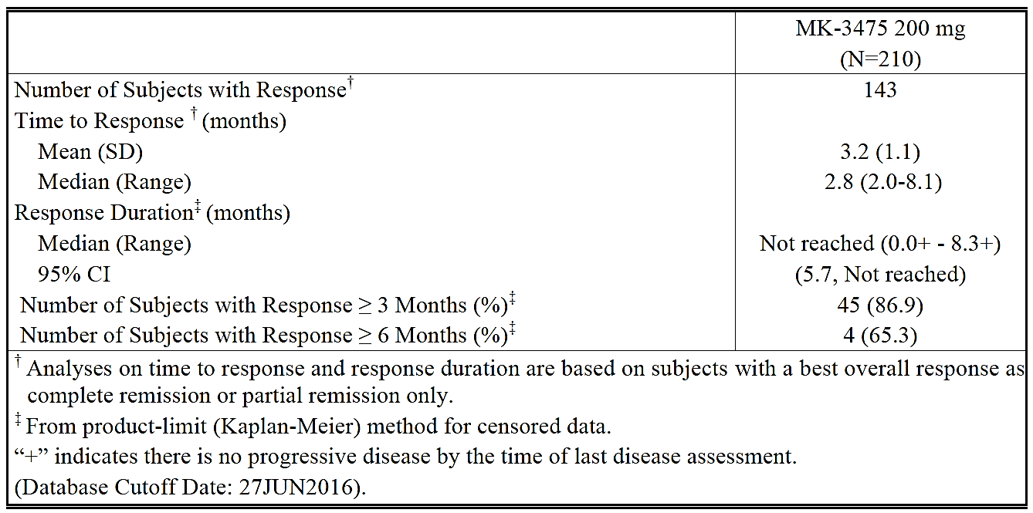
- Median OS in all subjects was not reached [Table 21]. The OS rate at 6 months was 99.5%.
Due to the short follow-up of 7.1 months and few events, OS by cohort is not listed here.
Table 21: Summary of Overall Survival (ASaT Population) Study KN087
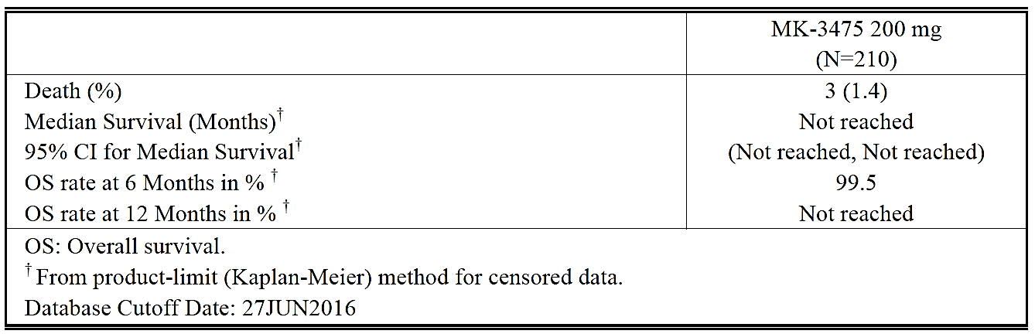
The only exploratory efficacy endpoint (see 7.1.1.1) evaluated in this interim report relates to the following:
3. Objective: To evaluate changes in health-related quality-of-life assessments from baseline using the European Organization for Research and Treatment of Cancer (EORTC) Quality of Life (QoL) Questionnaire C30 (QLQ-C30) and European Quality of Life Five Dimensions Questionnaire (EuroQoL EQ-5D); see Section 4.2.3.2.1.2 of the protocol.

Overall Summary of PRO Results
The improved benefit as assessed by ORR for pembrolizumab in the population studied is corroborated by improvements in health-related QoL. Results from the PRO analyses indicated a net improvement in the EORTC QLQ-C30 global health status/QoL score from baseline to Week 12, across all response groups. Subjects with CR/PR had the largest improvement (+9.9 points) in their global health status/QoL score and the highest proportion (42.4%) with a 10-point or greater change from baseline to Week 12, as compared to those with SD (+7.3 points and 39.6%, respectively) or PD (5.0+ points and 32.0%, respectively) (Table 22). Mean differences of 10 points or more have been widely viewed as being clinically meaningful when interpreting the results of randomised trials employing EORTC QLQ-C30. Consistency of findings were seen in the EQ-5D measures, with a change in VAS score from baseline to Week 12 that may be considered clinically important in those who responded (10.7+ points for CR/PR), as compared to those who did not respond (5.2+ points for SD patients and 3.2+ points for PD patients).
Table 22: Analysis of Change from Baseline in EORTC QLQ-C30 Global Health Status/QoL at Week 12 (ASaT Population, Study KN087)
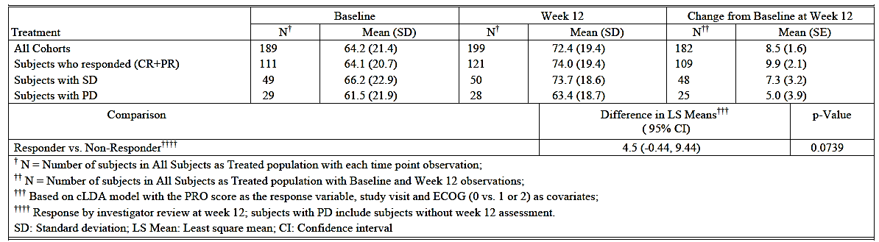

Evaluator commentary
From Cheson et al., 2007: ‘End points based on tumor measurements are greatly influenced by response criteria. Overall and complete response rates usually can be assessed accurately in single-arm as well as randomised trials. However, response rates do not necessarily influence other measures of overall clinical benefit or outcome in patients with lymphoma, and are not considered as important as other end points. Exceptions are Phase II trials of novel new agents, in which identification of biologic activity is of interest. Durable complete responses, if associated with measures of clinical benefit, may also be relevant.’
The follow-up period in the pivotal Study KN087 is only 7.1 months, which makes it difficult to evaluate DOR.
Regarding subgroups and ORR: The numbers are small but it appears that pembrolizumab works just as well in heavily pretreated as less heavily pretreated patients (Table 14) and in refractory as well as relapsed patients (36 primary refractory patients).

Other efficacy studies

Study KEYNOTE-013 (KN013)
Study KEYNOTE-013 was a multicenter, multi-cohort, Phase Ib trial of pembrolizumab in subjects with haematological malignancies to determine the safety and efficacy of pembrolizumab. Subjects were enrolled in five different cohorts determined by disease and disease state. The dossier provides the results for the HL cohort (Cohort 3 in KN013), which included 31 subjects with rrcHL who
- had failed ASCT and failed BV (n=16) (comparable to Cohort 1 in KN087)
- were ineligible for ASCT and failed BV (n=8) (comparable to Cohort 2 in KN087)
- had failed BV and then failed ASCT (n=7) (comparable to 25/60 subjects in Cohort 3 in KN087)
The subjects were treated with pembrolizumab 10 mg/kg every 2 weeks until documented disease progression, unacceptable adverse events (AEs), intercurrent illness that prevented further administration of treatment, investigator’s decision to withdraw the subject, subject withdrew consent, pregnancy of the subject, noncompliance with trial treatment or procedure requirements, administrative reasons, or receipt of up to 52 doses (approximately 2 years).
The primary objectives of the study were to determine safety, tolerability, and efficacy (complete remission rate [CRR] per the Revised Response Criteria for Malignant Lymphoma (2007) from the International Working Group) of pembrolizumab.
All data provided in the dossier are based on a 03-Jun-2016 cutoff date. The first rrcHL subject was enrolled (signed informed consent) in the study on 03-Dec-2013 and the last rrcHL subject was enrolled on 23-Jul-2014.
Subjects were 58.1% male and 93.5% White. Median age was 32.0 years. Enrollment was approximately equal between US (51.6%) and ex-US (48.4%) subjects. All subjects were refractory to a previous therapy, or had relapsed after ≥ 3 lines of therapy, and had previously failed treatment with BV. Most of the subjects had nodular sclerosing HL (30 [96.8%]), previous auto-SCT (23 [74.2%]), or were ineligible for auto-SCT (8 [25.8%]). The median number of prior lines of therapy was 5.0 (range 2 to 15).
Table 23 summarises the efficacy results.
Table 23: Summary of efficacy results, (ASaT population), Study KN013
 | All subjects  N=31 | Failed ASCT and failed BV  N=16 | Ineligible for ASCT and failed BV  N=8 | Failed BV and then failed ASCT  N=7
Number of subjects with response (%) (ORR=CR+PR) (95% CI) | 18 (58.1)  (39.1, 75.5) | 11 (68.8)  (41.3, 89.0) | 3 (37.5)  (8.5, 75.5) | 4 (57.1)  (18.4, 90.1)
-Complete remission (%)(CR) 95% CI | 6 (19.4)  (7.5, 37.5) | 3 (18.8)  (4.0, 45.6) | 2 (25.0)  (3.2, 65.1) | 1 (14.3)  (0.4, 57.9)
-Partial remission (%)(PR) 95% CI | 12 (38.7)  (21.8, 57.8) | 8 (50.0)  (24.7, 75.3) | 1 (12.5)  (0.3, 52.7) | 3 (42.9)  (9.9, 81.6)
DOR – Median (months)  (Range) 95% CI | Not reached  (2.1 -21.4+) (3.7, not reached) | Not reached  (2.1 -21.4+)  (3.7, not reached) | Not reached (0.0+ - 19.1+)  (3.4, not reached) | 14.7  (1.4+, 14.7)  (not reached, not reached)
Subjects with response ≥ 6 Months (%) | 9 (80.0) | 7 (81.8) | 1 (50.0) | 1 (100)
Subjects with response ≥ 12 Months (%) | 7 (70.0) | 5 (68.2) | 1 (50.0) | 1 (100)
Median PFS (months) (95% CI) | 11.4 (4.9, not reached) | ND | ND | ND
At the database cutoff there were 4 (22.2%) patients with an ongoing response.
Median OS was not reached. OS rate at 12 months was 87%. OS was not analysed by transplant status.
The median duration of follow-up is 24.9 months (7.0 to 29.7 months).
Comment: There is a longer follow up than in KN087, but the study population is small (31). KEYNOTE-013 data has been published (Armand et al.).

Evaluator commentary: other efficacy studies
Compared to the Phase II study KEYNOTE-087, with 210 subjects, this is a small Phase Ib study of 31 subjects with cHL comprising one cohort of a total of five cohorts in study KEYNOTE-013. It serves to show a trend for the effect of pembrolizumab in this group, but is too small for meaningful statistical analysis.
With regards to the proposed indication the dose is significantly different with a 5-6 fold difference (Table 24) making the study less relevant for the proposed indication/dose.
KN013: 10 mg/kg every 2 weeks (in the study it is given for up to two years).
Proposed dose as in Study KN087: 200 mg every 3 weeks (in the study it is planned to be given for up to two years).
Table 24: Cumulative doses in Study KEYNOTE-013 and KEYNOTE-087
 | KN013: 10 mg/kg Q2W | KN087: 200 mg Q3W
70 kg person ,  3 months treatment | 4550 mg | 870 mg
70 kg person ,  1 year treatment | 18200 mg/ 18.2 g | 2800 mg/ 2.8 g
70 kg person ,  2 years treatment | 36400 mg/ 36.4 g | 5600 mg/ 5.6 g

Analyses performed across trials: pooled and meta-analyses
Not applicable.

Evaluator’s conclusions on clinical efficacy
The indication population consist of 241 subjects with rrcHL from the Phase Ib study KEYNOTE-013 (31 subjects=13%) and Phase II study KEYNOTE-087 (230 subjects=87%).
Study KEYNOTE-013 (KN013) is a multicenter, multi-cohort trial of pembrolizumab in subjects with haematological malignancies to determine the safety and efficacy of pembrolizumab. Subjects were enrolled in five different cohorts determined by disease and disease state. The current clinical study report includes results as of 03-Jun-2016 for the classical Hodgkin lymphoma (cHL) cohort (Cohort 3) only. Cohort 3 included subjects with relapsed/refractory nodular sclerosing or mixed cellularity HL that had failed (22/31), were ineligible for, or refused (9/31) a stem cell transplant and had relapsed after treatment with or failed to respond to brentuximab vedotin (100%). The dose is different (10 mg/kg Q2W) from the proposed dose in the PI (200 mg Q3W). This is an interim report.
KEYNOTE-087 (KN087) is the pivotal trial in this application. It is a multicenter, single arm, multi-cohort, non-randomised trial of pembrolizumab in 210 subjects with rrcHL, who have failed to achieve a response or progressed after autologous stem cell transplant (auto-SCT) and have relapsed after treatment with, or failed to respond to, brentuximab vedotin post auto-SCT (Cohort 1); who were unable to achieve a complete response (CR) or partial response (PR) to salvage chemotherapy and did not receive auto-SCT, but have relapsed after treatment with, or failed to respond to, brentuximab vedotin (Cohort 2); and subjects who have failed to respond to, or progressed after, auto-SCT and have not received brentuximab vedotin post auto-SCT. These subjects may or may not have received brentuximab vedotin as part of primary or salvage treatment (Cohort 3; 41.7% had BV pre-ASCT). This study is performed using the proposed fixed dose of 200 mg Q3W. This is an interim report.
Background: cHL patients relapsing after second or third line treatment including ASCT have a poor prognosis, so there is a need for improved treatment.
Second and third-line chemotherapy combinations generally achieve complete remission (CR) in 30 to 40 percent of patients with aggressive or resistant disease (cHL). They are frequently used as cytoreductive agents prior to proceeding to high dose chemotherapy and autologous hematopoietic cell transplantation (ASCT). Salvage chemotherapy without progression to high-dose chemotherapy and ASCT results in 8- to 10-year overall survival rates of 21 to 27 percent with freedom from treatment failure of 16 percent (Canellos, 2016).
‘The median overall survival (OS) of patients who relapse after ASCT was initially reported to be <1 year. More recent data suggest that the median OS may be closer to 2 years. The availability of novel therapies to treat cHL patients that relapse after ASCT as well as the availability of allogeneic stem cell transplant (SCT) for selected patients may all contribute to this improved OS.’ (Alinari and Blum 2016).
The results of Study KN087 indicate that pembrolizumab produces objective responses in a substantial proportion of patients with relapsed/refractory cHL (ORR 68.1%, CR 21.9%).
High response rates were observed in all three cohorts but the follow-up is very short (7.1 months): Among the 143 subjects with response, a response of at least 3 months in duration was observed in 45 subjects (86.9% by Kaplan-Meier method), and a response of at least 6 months in duration was observed in 4 subjects (65.3% by Kaplan-Meier method). At the time of the data cut-off, 115 (80.4%) responders had ongoing response.
Median PFS is 10.8 months. Overall survival data are not mature.
The efficacy results observed were comparable to brentuximab vedotin (ORR 75%, CR 33%) registered for the treatment of relapsed/refractory cHL.
The dose was higher in KN013 but the efficacy results were comparable in the two trials (KN087/ KN013: ORR 68.1%/58%, CR 21.9%/ 19.4%) making the suggested fixed dose of 200 mg Q3W acceptable with regards to efficacy.
The data are limited in that pembrolizumab has not been compared with a registered agent in a randomised controlled trial. Its place in the therapy of relapsed/refractory cHL is therefore uncertain. However the data clearly indicate that the drug has clinically significant activity in this disease.
The results of KEYNOTE-204 will hopefully demonstrate the place relative to BV: This is an ongoing Phase III, randomised, open-label clinical trial to compare pembrolizumab with brentuximab vedotin in subjects with relapsed or refractory cHL (with and without ASCT). The primary objectives of the study are to compare PFS by blinded independent central review and OS between treatment arms. Approximately 300 patients will be enrolled to receive either pembrolizumab 200 mg intravenous every 3 weeks or brentuximab vedotin 1.8 mg/kg intravenous every 3 weeks. The trial is recruiting.
Conclusion: ORR is convincing but demonstration of longer DOR due to the short follow up of 7.1 month in KN087 is lacking (4 patients have > 6 months DOR). OS data are immature. There are no randomised trials with pembrolizumab in this patients group.

Clinical safety

Studies providing evaluable safety data
The main safety data included in the submission were those generated in study KEYNOTE-087. See 7.1.1 for further details about the study. No studies assessed safety as the sole primary outcome.

KEYNOTE-087

Primary Objectives
Within each of the 3 specified cohorts (See 7.1.1) with rrcHL and pooled:
- Objective: To determine the safety and tolerability of pembrolizumab.
Within each of the 3 cohorts of subjects with rrcHL:
- Objective: To evaluate the Objective Response Rate (ORR) of pembrolizumab by blinded, independent central review (BICR) according to the IWG response criteria.
The primary safety objective of this study was to characterise the safety and tolerability of pembrolizumab in subjects with relapsed or refractory Hodgkin Lymphoma. The primary safety analysis was based on subjects who experienced toxicities as defined by CTCAE criteria. Safety was assessed by quantifying the toxicities and grades experienced by subjects who have received pembrolizumab, including SAEs and ECIs.
Safety was assessed by reported adverse events using CTCAE, Version 4.0. The attribution to drug, time-of-onset, duration of the event, its resolution, and any concomitant medications administered were recorded. AEs were analysed including but not limited to all AEs, SAEs, fatal AEs, and laboratory changes. Furthermore, the occurrence of a Grade 2 or higher immune-related adverse events (irAEs) were collected and designated as immune-related events of clinical interest.

Other studies
Study KEYNOTE-013 was a multicenter, multi-cohort, Phase Ib trial of pembrolizumab in subjects with haematological malignancies to determine the safety and efficacy of pembrolizumab. Cohort 3 included 31 subjects with rrcHL, which are described in the CSR. See 7.2.1 for further details. This study is not described separately in this CER but is included in the rrcHL group in the integrated analysis of safety where it contributes 31 of the 241 subjects (12.8%).
KEYNOTE-087, which comprises 210 subjects subdivided into three cohorts, is described in detail.
In the Summary of Safety document the safety data are presented for the two studies in rrcHL combined and for the two populations described in Table 25.
The Reference Population, or Reference Safety Dataset, comprises subjects treated with pembrolizumab in studies KEYNOTE-001 (Part B1, B2, B3, D, C, F1, F2, and F3), KEYNOTE-002 (original phase), KEYNOTE-006, and KEYNOTE-010. This population is included to enable a safety profile comparison of the HL Population to the established safety profile of the non-small cell lung cancer (NSCLC) and melanoma populations, according to the sponsor, page 8 in SCS.
Table 25: Study populations for safety analyses
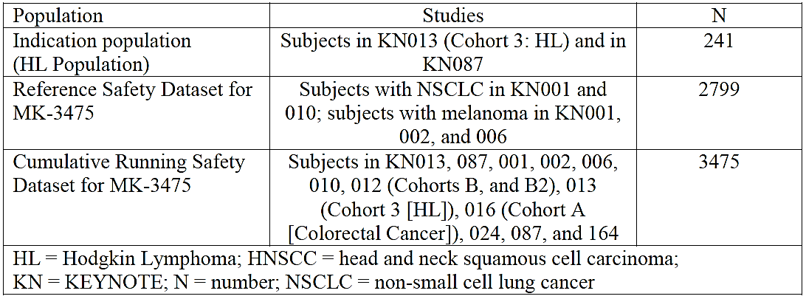
Comment: The Reference Safety Dataset is the dataset referred to in the PI. The doses vary from 2 g/kg Q3W, 10 mg/kg Q3W and 10 mg/kg Q2W and as such include doses higher than the proposed dose of 200 mg Q3W for cHL patients.

Patient exposure
The exposure for the two studies in rrcHL (KN013 and KN087), the reference safety dataset and the cumulative running safety dataset is shown in Table 26.
Table 26: Clinical Trial Exposure to Drug by Duration. Subjects Treated with Pembrolizumab (HL and Reference Safety Dataset) (APaT Population)
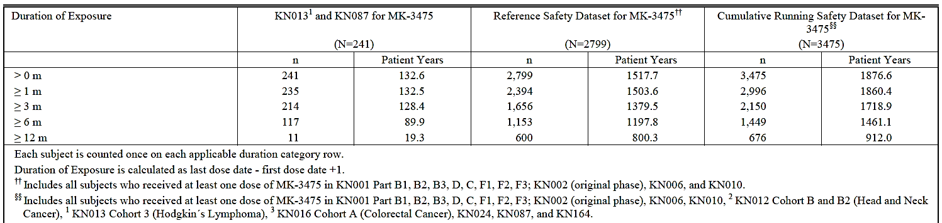

KEYNOTE-087
Duration of exposure was measured from the date of the first dose to the date of the last dose of treatment received.
Subjects were exposed to pembrolizumab for a median of 176 days (range: 1 to 357), resulting in a median of 9 administrations (range: 1 to 18) (Table 27). Overall, 189 of 210 (90.0%) subjects remained on pembrolizumab for ≥ 3 months and 99 (47.1%) remained on pembrolizumab for ≥ 6 months (Table 28). No subject has yet to be exposed to pembrolizumab for 12 months or more.
Table 27: Summary of Drug Exposure by Cohort (ASaT Population, Study KN087)
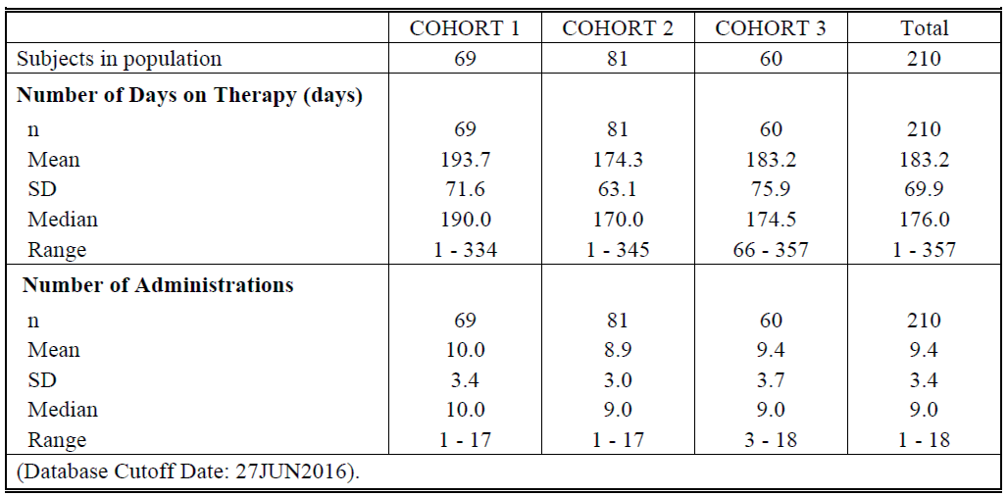
Table28: Clinical Trial Exposure to Pembrolizumab by Duration (ASaT Population, Study KN087)
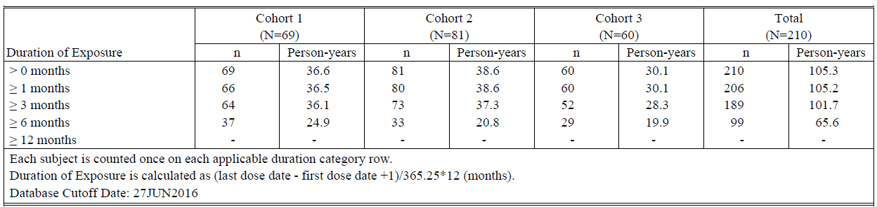

Adverse events

All adverse events (irrespective of relationship to study treatment)

Integrated safety analyses
The incidence of the various types of AEs among subjects in the HL Population was comparable to that of the Reference Safety Dataset (Table 29).
Table 29: Adverse Event Summary: Subjects Treated with Pembrolizumab (HL and Reference Safety Dataset) (APaT Population)
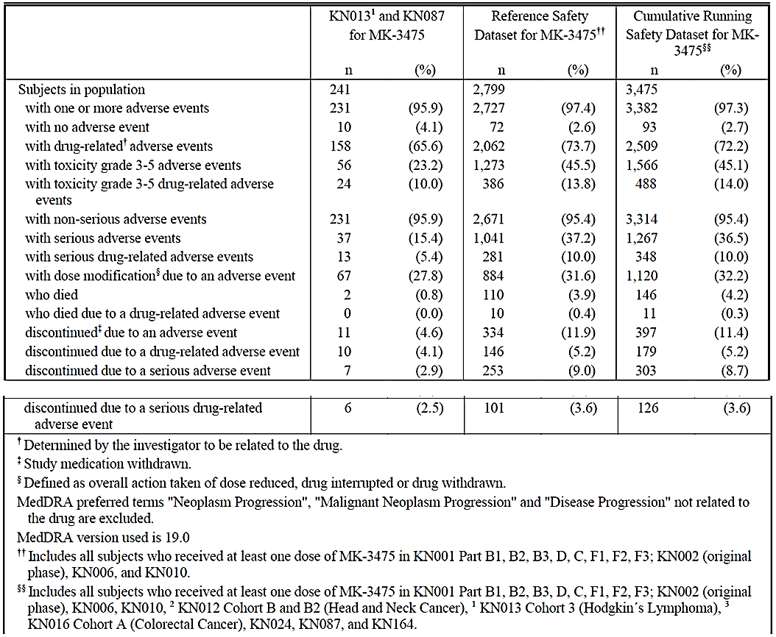
The incidence of AEs, regardless of causality, including the most commonly reported AEs among subjects in the HL Population, was comparable to the Reference Safety Dataset (Table 30).
Table 30: Subjects with adverse events (Incidence ≥ 10% in One or More Treatment Groups) treated with Pembrolizumab (HL and Reference Safety Dataset) by Decreasing Frequency of Preferred Term (APaT Population)
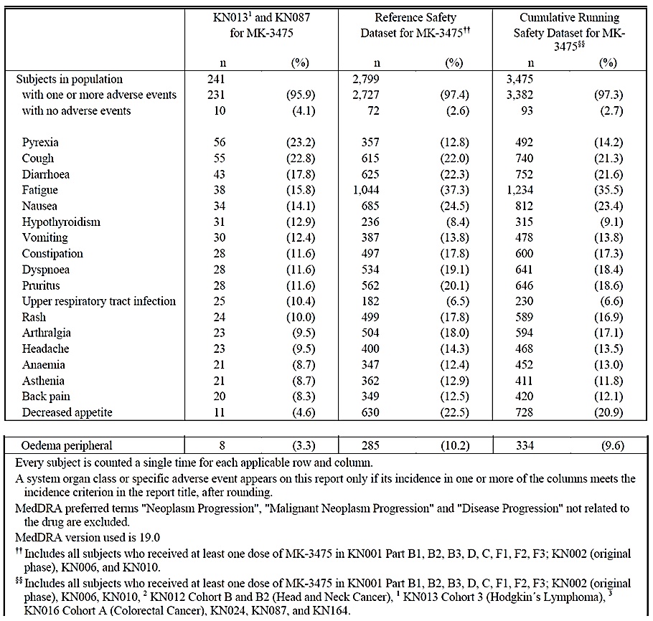
Comment: There are more subjects with pyrexia in the HL group, which is not unexpected, as patient with haematological malignancies are more prone to infections. On the other hand HL patients had less fatigue. Hypothyroidism was more prevalent in HL patients, which is reflected in the draft PI.

Pivotal and/or main efficacy studies

KEYNOTE-087
The incidences of the various AEs are summarised in Table 31 by cohorts and all subjects.
Table 31: Adverse Event Summary by Cohort (ASaT Population, Study KN087)
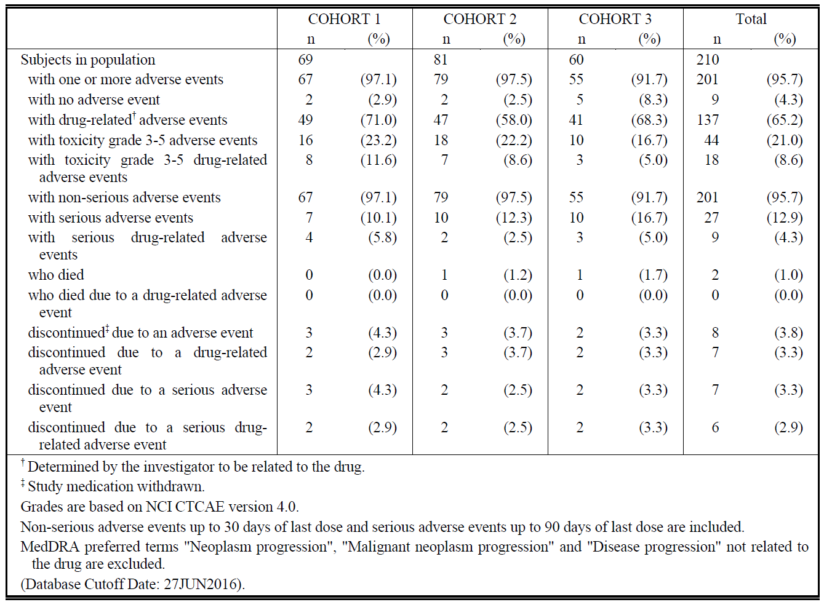
The incidence of AEs regardless of grade was high overall. Across cohorts, 201 of 210 (95.7%) subjects experienced at least 1 AE. The most common (incidence > 10%) AEs (Table 32) included
- pyrexia (49 / 23.3%)
- cough (44 / 21.0%)
- fatigue (32 / 15.2% )
Table 32: Subjects with Adverse Events by Decreasing Incidence (Incidence ≥ 10% in One or More Treatment Groups) By Cohort (ASaT Population, Study KN087)
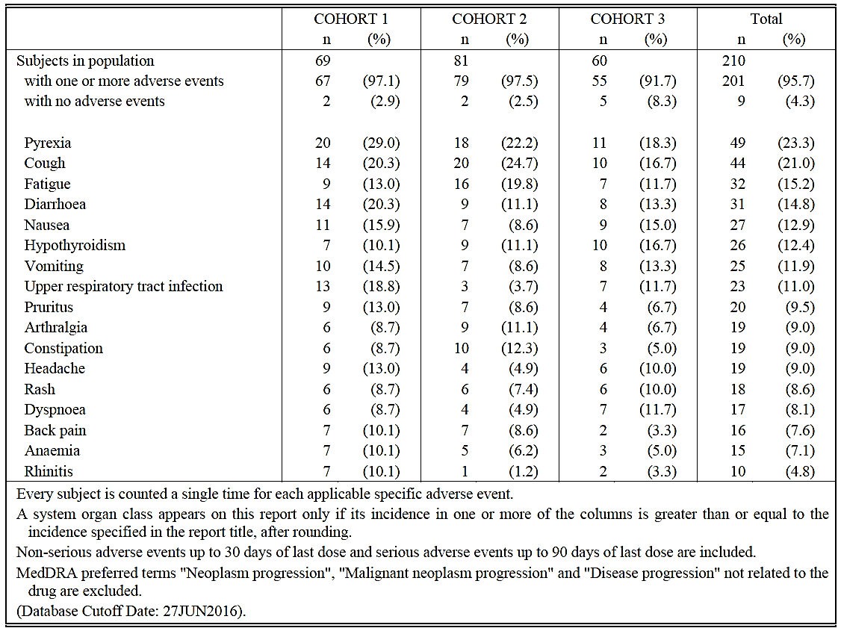

Treatment related adverse events (adverse drug reactions)

Integrated safety analyses
The incidence of drug-related AEs was lower among subjects in the HL Population than in the Reference Population; however, the incidence of drug-related AEs varied between populations In the HL Population, 158 of 241 (65.6%) subjects had a drug-related AE (Table 29), the most common (incidence >5%) of which included (Table 33):
- hypothyroidism (26 / 10.8%)
- pyrexia (23 / 9.5%)
- diarrhea (20 / 8.3%)
- fatigue (17 / 7.1%)
- nausea (16 / 6.6%)
- headache (14 / 5.8%)
- rash (13 / 5.4%)
In comparison, 2062 of 2799 (73.7%) subjects in the Reference Population had a drug-related AE, the most common of which included (Table 33):
- fatigue (678 / 24.2%)
- pruritus (467 / 16.7%)
- rash (386 / 13.8%)
- diarrhea (343 / 12.3%)
- hypothyroidism (213 / 7.6%)
Table 33: Subjects with Drug-Related Adverse Events (Incidence ≥ 5% in One or More Treatment Groups). Subjects Treated with Pembrolizumab (HL and Reference Safety Dataset) by Body System or Organ Class and Preferred Term (APaT Population)
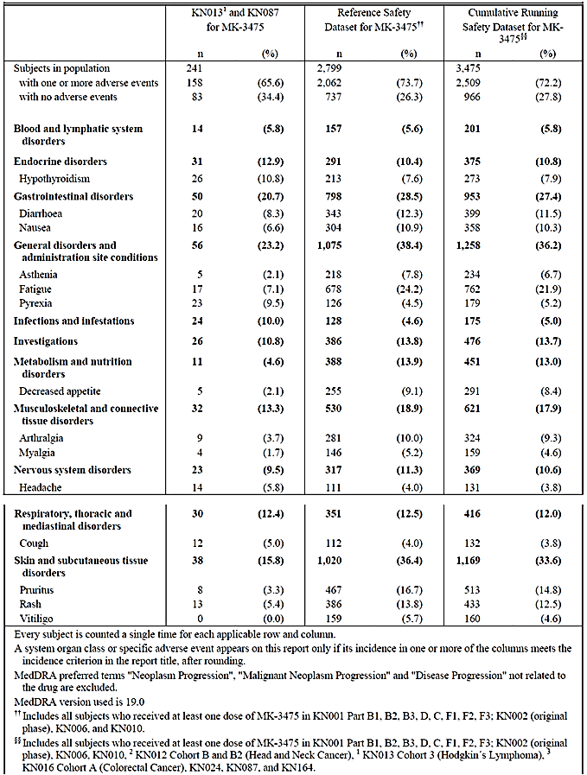
The incidence of drug-related AEs categorised as Grade 3, 4, or 5 among subjects in the HL Population was consistent with the Reference Population. Drug-related AEs categorized as Grade 3, 4, or 5 occurred in 24 of 241 (10.0%) subjects compared to 386 of 2799 (13.8%) subjects in the Reference Population (Table 29). Based on the incidence of drug-related AEs categorized as Grade 3, 4, or 5, there is no change in the safety profile of pembrolizumab with the addition of new data from subjects with HL.
Comment: There are twice as many patients (%) with pyrexia (Tables 30 and 33) and infections (Table 33) in the cHL population compared to the reference safety dataset, which is not unexpected in this group of patients but should be mentioned nevertheless.

Pivotal and/or main efficacy studies

KEYNOTE-087
Drug-related AEs were reported in 65.2% of subjects (Table 31). The most common (incidence > 5%) were
- pyrexia (23 / 11.0%)
- hypothyroidism (22 / 10.5%)
- diarrhea (14 / 6.7%)
- fatigue (14 / 6.7%)
- headache (13 / 6.2%)
- rash (13 / 6.2%)
Most drug-related AEs were low grade. Drug-related AEs categorized as Grade 3, 4, or 5 occurred in 18 of 210 (8.6%; Table 31) subjects overall, the most common of which were neutropenia, which occurred in 3 (1.4%) subjects, and diarrhea and thrombocytopenia, which occurred in 2 (1.0%) subjects. All other Grade-3-to-5 drug-related AEs occurred in only 1 (0.5%) subject overall.
Comment: The sponsor speculates regarding hypothyroidism in HL patients: ‘although a higher incidence of drug-related hypothyroidism occurred among subjects in the HL Population relative to those in the Reference Population, the observed frequency of hypothyroidism in HL subjects is likely related to the significant proportion of subjects who received radiation to the neck and/or mediastinum, and reflects the increased risk for hypothyroidism in this population.’ Given the following information from the CSR and looking at Table 14.1-7 in that report, this seems a likely explanation:
‘Fourteen subjects (53.8%) with hypothyroidism had a history of radiation therapy to the neck and/or mediastinum. Furthermore, 6 subjects, 5 of whom had prior neck and/or mediastinal radiation, had either a past medical history of hypothyroidism or a baseline elevated TSH.’

Deaths and other serious adverse events

Integrated safety analyses

Deaths
The incidence of deaths in the HL Population was low and comparable to that of the Reference Population. In the HL population, deaths occurred in 2 of 241 (0.8%) subjects, neither of which was drug related; both deaths occurred in KEYNOTE-087. One (0.4%) subject died as a result of graft-versus-host disease (GVHD) and 1 (0.4%) subject died as a result of septic shock. In comparison, 110 of 2799 (3.9%) subjects died in the Reference Population, and 10 (0.4%) of these deaths were drug related (Table 29). Based on the incidence of deaths, there is no change in the safety profile of pembrolizumab for subjects with HL.
Comment: See discussion regarding GVHD in section 8.3.3.2.

SAEs
The incidence of SAEs up to 90 days after the last dose of pembrolizumab among subjects in the HL Population was lower than that of the Reference Population (Table 34). In the HL Population, 37 of 241 (15.4%, Table 29) subjects had an SAE, the most frequent (incidence >1%) of which included
- pneumonia (5 / 2.1%)
- pneumonitis (4 / 1.7%)
- pyrexia (4 / 1.7%)
In comparison, 1041 of 2799 (37.2%, Table 29) subjects in the Reference Population had an SAE, of which the most commonly reported was
- pneumonia (85 / 3.0%)
- pleural effusion (48 / 1.7%)
- dyspnea (45 / 1.6%)
- pneumonitis (46 / 1.6%)
Based on the incidence of SAEs, there is no change in the safety profile of pembrolizumab with the addition of new serious SAE data from subjects with HL.
Table 34: Subjects with Serious Adverse Events Up to 90 Days of Last Dose (Incidence ≥ 1% in One or More Treatment Groups). Subjects Treated with Pembrolizumab (HL and Reference Safety Dataset) by decreasing frequency of Preferred Term (APaT Population)
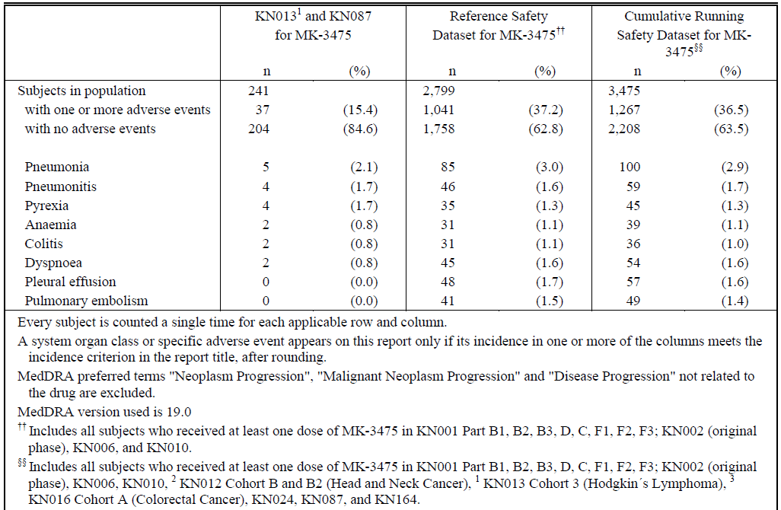

Drug-related SAEs
The incidence of drug-related SAEs that occurred up to 90 days after the last dose of pembrolizumab was generally comparable between subjects in the HL and Reference Population (Table 35). In the HL Population, drug-related SAEs occurred in 13 of 241 (5.4%) subjects (Table 29), the most common of which was pneumonitis (4 subjects [1.7%], Table 35). In comparison, 281 of 2799 (10.0%) subjects in the Reference Population had a drug-related SAE (Table 29), the most common of which was also pneumonitis (44 subjects [1.6%], Table 35). Based on the incidence of drug-related SAEs, there was no change in the safety profile of pembrolizumab with the addition of new drug-related SAE data from subjects with HL.
Table 35: Subjects with Drug-Related Serious Adverse Events Up to 90 Days of Last Dose (Incidence ≥ 1% in One or More Treatment Groups). Subjects Treated with Pembrolizumab. HL and Reference Safety Dataset by Body System or Organ Class and Preferred Term (APaT population)
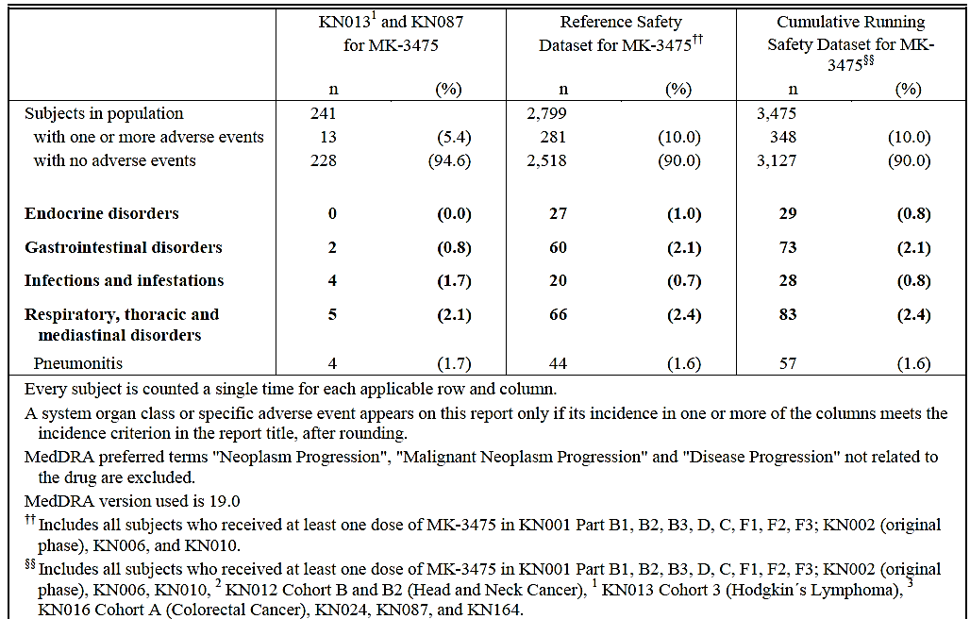

Pivotal and/or main efficacy studies

KEYNOTE-087

Deaths
As described under the ‘Integrated safety analyses/ Deaths’, there were two deaths in this study. One from septic shock and one from GVHD both deemed not drug related. The subject with GVHD received 7 doses of pembrolizumab, the last on Day 127, after which he was assessed to have CR and then went on to allo-SCT (FC D. 150-153 and cells infused D. 156/D. 0 of transplant). The first signs of GVHD were observed D. 211/D. 55 of transplant and the patient died on D. 258/D. 102.
Comment: There have been theoretical speculations that GVHD might be triggered or exacerbated by checkpoint inhibitors. Singh et al. describes a case of fatal GVHD after treatment of relapsed HL (after allo-SCT) with pembrolizumab: it is thus difficult to entirely exclude pembrolizumab from contributing to the GVHD in the patient in Study KN087.
The subject who died of septic shock had progressive disease [information redacted]according to the narrative.

SAEs
Overall, 27 of 210 (12.9%) subjects had an SAE up to 90 days after the last dose of pembrolizumab (Table 31). The incidence and types of SAEs is almost identical to that described in the integrated analysis section above for all HL subjects, as this study constitute 210/241 (87%) of subjects in that population. The subjects with Serious Adverse Events up to 90 days after last dose (Incidence > 0% in one or more treatment groups) by cohort and for all subjects were listed.

Drug-related SAEs
Drug-related SAEs occurred in 9 of 210 (4.3%) subjects (Table 31). The most common drug-related SAE was pneumonitis, which occurred in 3 (1.4%) subjects overall. All other drug-related SAEs were reported with incidences of < 0.5%.
Comment: CSR, s. 12.2.4.1: ‘Narratives for subjects with SAEs are in [16.2.7.1].’ There are only narratives for the Drug-related SAEs, not all SAEs. Comparing the preferred term for the SAEs and the drug-related SAEs, it does not seem likely, though, that the narratives for the non-drug-related SAEs will assist in revealing whether the SAEs are drug related or not, as most of them are related to infections/pyrexia.

Discontinuations due to adverse events

Integrated safety analyses
The incidence of drug-related AEs that resulted in discontinuation of pembrolizumab was comparable between the HL and Reference Population (Table 29). Among subjects with HL, 10 of 241 (4.1%) discontinued pembrolizumab due to a drug-related AE, the most common (incidence > 1%) of which was pneumonitis (5 [2.1%]). In comparison, 146 of 2799 (5.2%) subjects in the Reference Population had a drug-related AE that resulted in discontinuation of pembrolizumab, the most common of which was also pneumonitis (34 [1.2%]). Thus, based on the incidence of drug-related AEs that resulted in treatment discontinuation, there is no change in the safety profile of pembrolizumab for subjects with HL.

Pivotal and/or main efficacy studies

KEYNOTE-087
Eight of 210 (3.8%) subjects discontinued pembrolizumab due to an AE; for 7 (3.3%) of these subjects pembrolizumab was discontinued due to a drug-related AE (Table 36). Thus, pembrolizumab was generally well tolerated among rrcHL subjects as evidenced by the incidence of drug-related AEs that resulted in treatment discontinuation.
Table 36: Subjects with Drug-Related Adverse Events Resulting in Treatment Discontinuation (Incidence > 0% in One or More Treatment Groups) By Cohort (ASaT Population, Study KN087)
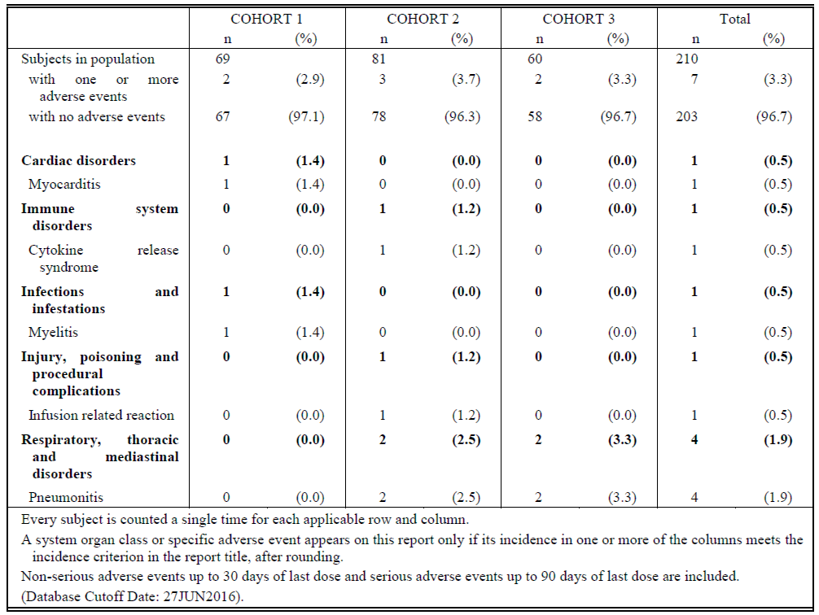

Evaluation of issues with possible regulatory impact
From SCS, s. 3:
To assess whether laboratory abnormalities represented clinically meaningful changes from baseline, an analysis of the shifts from baseline in the CTCAE grades of laboratory abnormalities (based on the highest CTCAE grade for a given laboratory test during the study) was performed. A clinically meaningful worsening in CTCAE Grade was defined as a shift from less than Grade 3 to Grade 3, 4, or 5; or a shift from Grade 0 to Grade 2. Clinically meaningful worsening in laboratory CTCAE grades was comparable between subjects in the HL Population and the Reference Population. In the HL Population, the laboratory abnormalities with the most frequent (incidence > 10%), clinically meaningful worsening in CTCAE grade, included phosphate decreased (46 [19.1%]), lymphocytes decreased (31 [12.9%]), and neutrophils decreased (31 [12.9%]) [Sec. 5.3.5.3.3.3] [Table 5.3.5.3.3-hl: 1]. In comparison, the most frequently occurring laboratory abnormalities with a clinically meaningful worsening in CTCAE grades among the 2799 subjects in the Reference Population included phosphate decreased (470 [16.8%]), lymphocytes decreased (438 [15.6%]), and glucose increased (296 [10.6%]). Thus, no change occurred in the safety profile of pembrolizumab with the addition of new data from subjects with HL.

Liver function and liver toxicity

Integrated safety analyses
The incidences of abnormal LFTs HL subjects (Study KN013 and KN087) are presented in the Integrated Summary of Safety. Clinically significant changes from baseline were uncommon and of the same order as the Reference Safety data Set.

Pivotal and/or main efficacy studies

KEYNOTE-087
No subject met the pre-specified drug-induced liver injury criteria of an increase in ALT or AST ≥ 3 x ULN, bilirubin ≥ 2 x ULN, or alkaline phosphatase (ALP) < 2 x ULN with ALT or AST in any cohort in this study.
There were no AEs related to liver toxicity: AEs in ≥ 10% (Table 30), drug-related AEs in ≥ 5% (Table 33) or SAEs in >1% (Table 34).

Renal function and renal toxicity

Integrated safety analyses
The incidences of abnormal creatinine in HL subjects (Study KN013 and KN087) are presented in Table 37. Clinically significant changes from baseline were uncommon and of the same order as the Reference Safety data Set.
Table 37: Summary of Worsening in Creatinine from Baseline to Worst Value Post-baseline. HL and Reference Safety Dataset (APaT Population)
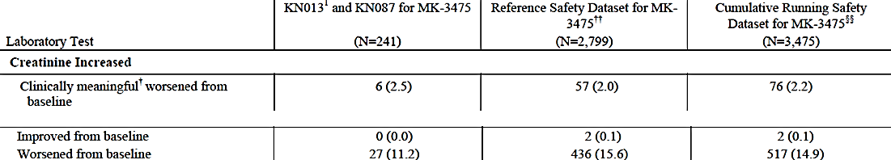

Pivotal and/or main efficacy studies

KEYNOTE-087
Changes from baseline in creatinine are summarised in Table 38. Clinically meaningful changes occurred in 1.9% of subjects. Results for urea were not reported, presumably because no clinically meaningful changes were observed.
Table 38: Summary of Worsening in Creatinine from Baseline to Worst Value Post-baseline by Cohort (ASaT Population, Study KN087)
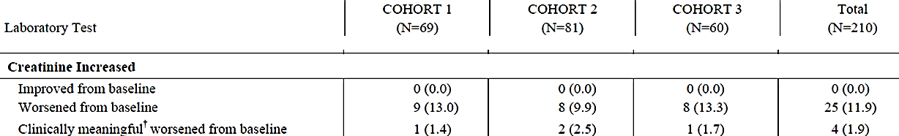
There were no AEs related to renal toxicity: AEs in ≥ 10% (Table 30), drug-related AEs in ≥ 5% (Table 33) or SAEs in >1% (Table 34).

Other clinical chemistry

Integrated safety analyses
Regarding thyroid related AEs, see section 8.4.8.

Pivotal and/or main efficacy studies

KEYNOTE-087
Because of the known risk of thyroid function abnormalities with immune therapies, thyroid function tests (thyroid stimulating hormone [TSH], free T3, and free thyroxine [FT4]) were obtained at baseline and at regular intervals in all subjects.
Of the 196 subjects with available baseline and post-baseline TSH results, 1 (0.5%) experienced a decrease (Grade 2) in TSH and 3 (1.5%) experienced an increase (1 subject, Grade 1; 2 subjects, Grade 2). Of the 169 subjects with baseline and post-baseline free T3 results available, 1 (0.6%) experienced an increase (Grade 1) in free T3. And of the 194 subjects with available baseline and post-baseline FT4 results available, 1 (0.5%) experienced a decrease (Grade 1) and 1 (0.5%) experienced an increase.
Comment: Regarding hypothyroidism see section 8.3.2.2, Table 42 and section 8.4.8.2.

Haematology and haematological toxicity

Integrated safety analyses
Not unexpectedly, in a heavily treated population with a haematological malignancy there are more subjects with a clinical meaningful worsening in leukocytes/neutrophils and platelets than in the reference population (Table 39). Decreased haemoglobin is seen less frequently in HL subjects than in the reference safety dataset, though.
Table 39: Summary of Worsening in Haematological Parameters from Baseline to Worst Value Post-baseline. HL and Reference Safety Dataset (APaT Population)
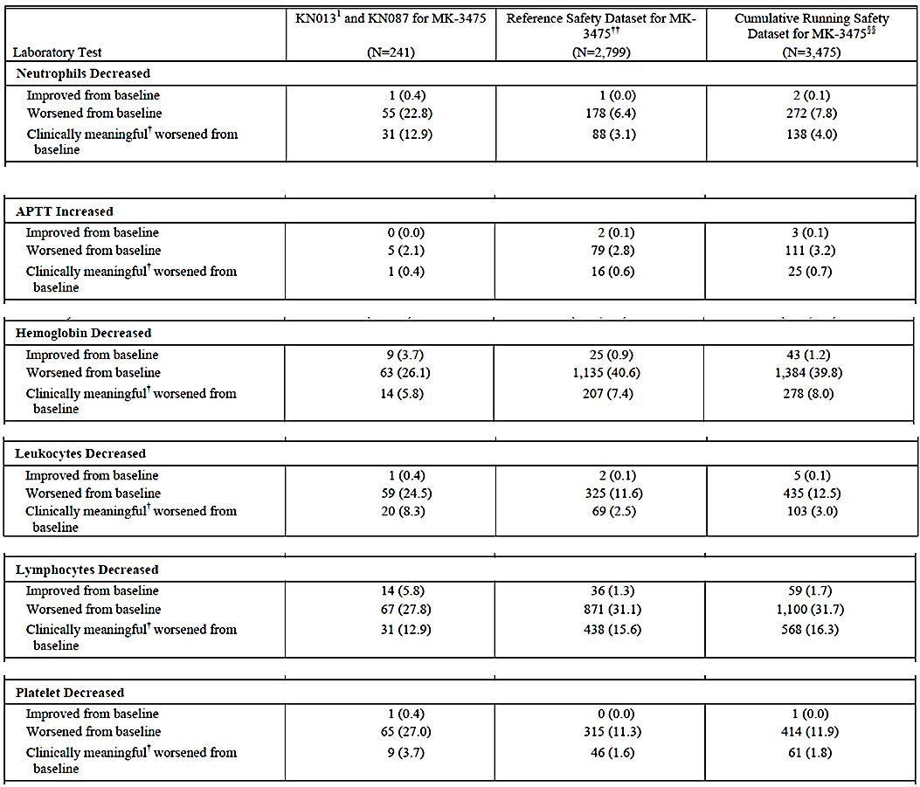
Regarding haematological AEs, anaemia was seen in 8.7% of the HL population compared to 12.4% in the Reference Safety Dataset (Table 30). Drug-related AEs in Body System ‘Blood and lymphatic disorders’, was observed in 5.8% and 5.6%, (Table 33) and SAEs in 0.8% and 1.1%, respectively (Table 34).

Pivotal and/or main efficacy studies

KEYNOTE-087
Overall, the most frequent (> 10%) clinically meaningful worsening in CTCAE grades among the 210 subjects across cohorts included decreased phosphate (36 (17.1%), decreased lymphocytes (27 [12.9%]), and decreased neutrophils (23 [11.0%], Table 40). Thus, the majority of clinically meaningful worsening changes in CTCAE grades were of hematologic values.
Table 40: Summary of Worsening in Haematological Parameters from Baseline to Worst Value Post-baseline by Cohort (ASaT Population, Study KN087)
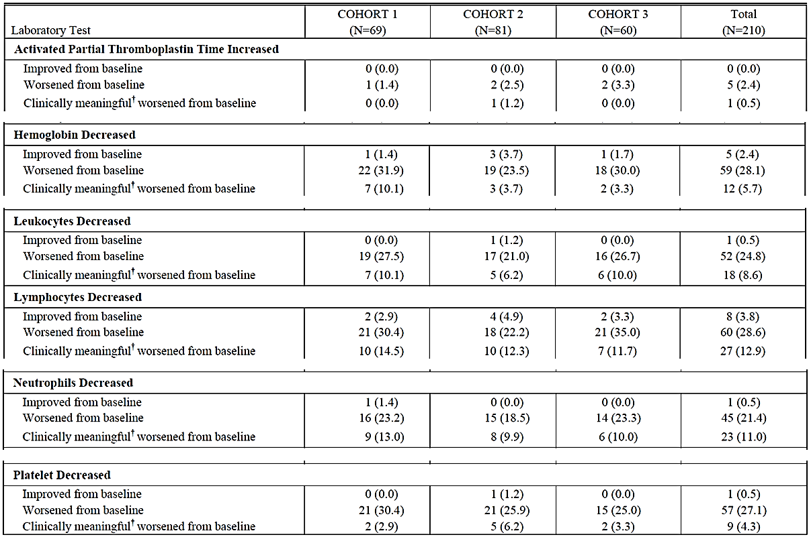
Regarding haematological AEs see above under Integrated safety analyses as KN087 comprises 87% of the subjects in the HL group. See also Table 32, where the incidence of anaemia is 7.1% for all subjects, Table 53 [no in this Attachment 2) where there is 1 SAE for anaemia and section 8.3.2.2, which shows there are no haematological drug-related AEs with an incidence > 5% in the group as a whole, but divided into cohorts, neutropenia is >5% for Cohort 1 and 3.

Other laboratory tests

Integrated safety analyses
The most frequently occurring laboratory abnormalities with a clinically meaningful worsening in CTCAE grades among the 2799 subjects in the Reference Population included phosphate decreased (470 [16.8%]), lymphocytes decreased (438 [15.6%]), and glucose increased (296 [10.6%]).

Pivotal and/or main efficacy studies

KEYNOTE-087
See 8.4.4.1

Electrocardiograph findings and cardiovascular safety
No electrocardiographic observations or findings were presented in this extension of indication neither in the SCS nor in the CSR for KEYNOTE-087.

Vital signs and clinical examination findings
No analyses were presented for vital signs (blood pressure, heart rate, temperature etc.) neither in the SCS nor in the CSR for KEYNOTE-087.

Immunogenicity and immunological events AND Adverse Events of Special interest (AEOSI)
Most of the Adverse Events of Special Interest (AEOSI) are immunological in nature and are therefore described in this section. They have been identified based on the cumulative clinical study experience with pembrolizumab through 02-May-2016:

Important Identified Risks:
- Immune-mediated Pneumonitis
- Immune-mediated Colitis
- Immune-mediated Hepatitis
- Immune-mediated Nephritis
- Immune-mediated Endocrine Disorders:
  - Adrenal Insufficiency
  - Hypophysitis
  - Hyperthyroidism
  - Hypothyroidism
  - Thyroiditis
  - Type 1 Diabetes Mellitus

Other Events:
- Uveitis
- Pancreatitis
- Myositis
- Guillain-Barré Syndrome
- Severe Skin Reactions
- Infusion Reactions

Potential Risks:
Two important potential risks have been identified for pembrolizumab:
- Myasthenic syndrome
- For hematologic malignancies: increased risk of severe complications of allogeneic stem cell transplantation (SCT) in patients who have previously received pembrolizumab

Integrated safety analyses
As part of the clinical development program for pembrolizumab pre- and post-baseline serum samples from subjects treated with pembrolizumab have been analysed for anti-drug antibodies (ADA).
The total of 3268 subjects were included in the immunogenicity assessment (1535 Melanoma subjects, 1237 NSCLC, 101 HNSCC subjects, 121 UC subjects, 54 MSI-H subjects and 220 HL subjects at 2 mg/kg Q3W, 10 mg/kg Q3W/Q2W, and 200 mg Q3W).
The overall immunogenicity incidence was defined as the proportion of treatment emergent positive subjects to the total number of evaluable subjects (treatment emergent positive, non-treatment emergent positive and negative immunogenicity status). Out of the 3268 subjects included in the immunogenicity assessment, 1619 subjects were evaluable. The observed incidence of treatment emergent ADA in evaluable subjects based on a pooled analysis of Melanoma, NSCLC, HNSCC, UC, MSI-H and HL subjects is 1.8% (29 out of 1619), based on 29 subjects with confirmed treatment emergent positive status, relative to all evaluable subjects including 29 with treatment emergent positive, 16 with non-treatment emergent positive and 1574 with negative immunogenicity status.
The subjects (N=29) with a treatment emergent immunogenicity response were evaluated for potential impact on exposure, safety and efficacy. Pembrolizumab exposures for these subjects with treatment emergent immunogenicity response were in the range of exposures observed for other subjects who were treated with pembrolizumab in the same regimen. Therefore, exposure to pembrolizumab was not compromised by the observed immune response. The treatment emergent positive subjects did not have any adverse events associated with neutralizing antibodies, such as hypersensitivity events (for example, anaphylaxis, urticaria, angioedema) or injection site reactions. No clinically significant impact on efficacy (that is, tumor size change) was established.
Furthermore, the immunogenicity evaluation was stratified by treatments (2 mg/kg Q3W, 10 mg/kg Q3W, 10 mg/kg Q2W, or 200 mg) or indications (Melanoma, NSCLC, HNSCC, UC, MSI-H and HL subjects). The incidence of treatment emergent ADA was low (less than 2.8%) for all different stratifications used (dose levels or indication). The evaluation has confirmed the assessment that pembrolizumab has a limited potential to elicit the formation of ADA and this is consistent with the results of prior immunogenicity evaluations of pembrolizumab.
The incidence of AEOSI among subjects in the HL Population was comparable to the Reference Population regardless of AEOSI category (eg, drug-related AEs, AEs categorized as Grade 3, 4, or 5, drug-related AEs categorized as Grade 3, 4, or 5, SAEs, drug-related SAEs, deaths, and discontinuations due to drug-related AEs or drug-related SAEs, Table 41). In the HL Population, 54 of 241 (22.4%) subjects had 1 or more AEOSI, compared to 536 of 2799 (19.1%) subjects in the Reference Population. Based on the incidence of AEOSI, there is no change in the safety profile of pembrolizumab with the addition of new data from subjects with HL.
Table 41: Adverse Event Summary for Important Identified AEOSI. Subjects Treated with Pembrolizumab. HL subjects and Reference Safety Dataset
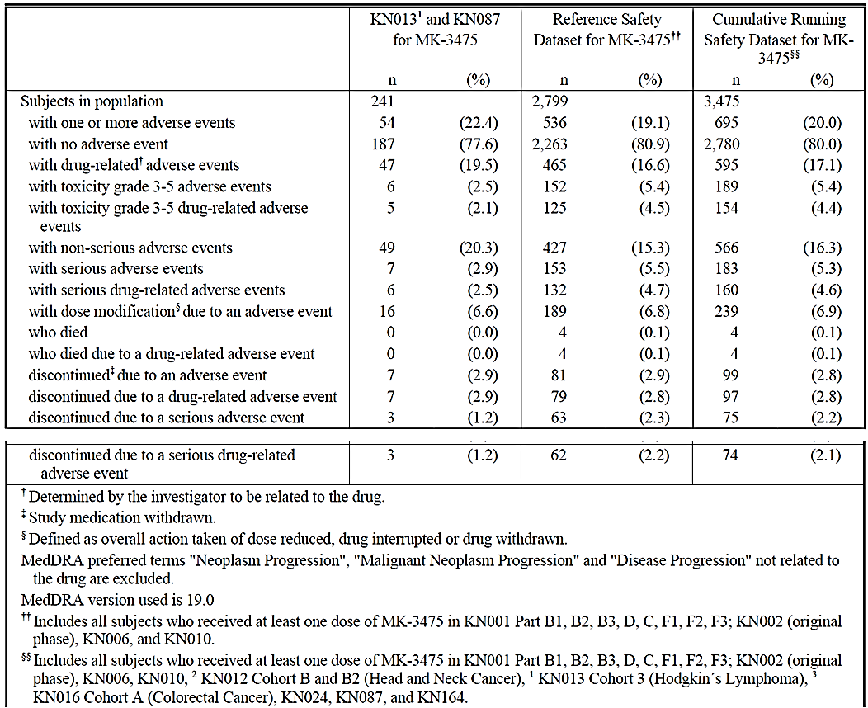
In the HL Population, the most common AEOSI reported during pembrolizumab treatment was hypothyroidism, which occurred in 31 of 241 (12.9%) subjects overall (Table 42).
Table 42: Subjects with Adverse Events by Maximum Toxicity Grade (Incidence >0% in One or More Treatment Groups), AEOSI- Hypothyroidism, HL Subjects and Reference Safety Dataset
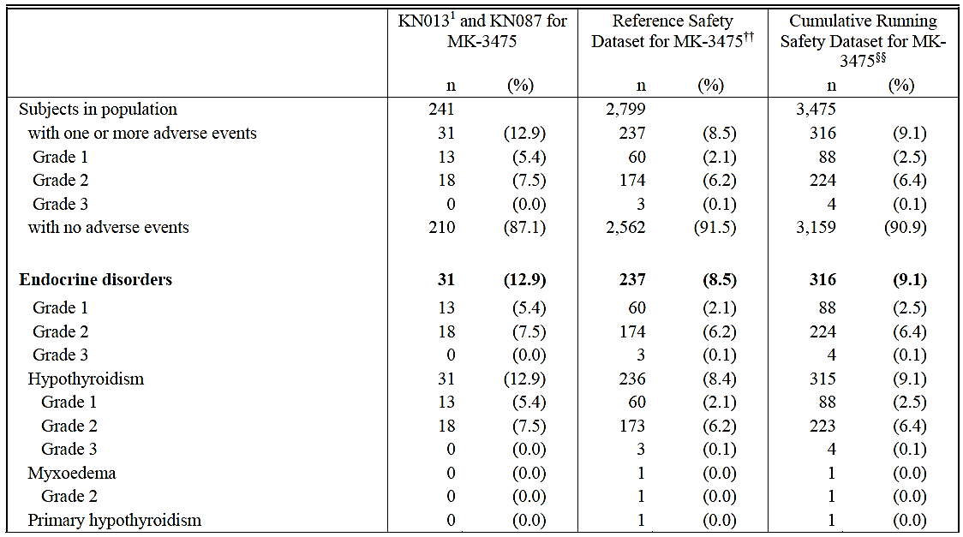
The incidence of infusion reactions among subjects in the HL Population was higher than that of the Reference Population.
Sixteen of 241 (6.6%) subjects in the HL Population had at least 1 infusion reaction. Of the 16 subjects who experienced an infusion reaction, 15 (6.2%) subjects experienced infusion reactions considered drug related; all subjects with infusion reactions were in KEYNOTE-087. Of the infusion reactions reported, 1 (0.4%) was categorized as Grade 3 and considered serious and drug- related, resulting in discontinuation of pembrolizumab. The median time to onset of an infusion reaction episode was 1 day. The majority of infusion reactions were low grade (Grade 1 or 2); no one died of an infusion reaction. Few infusion reactions were managed with corticosteroids among subjects with HL.
Cytokine release syndrome is not reported in the SCS other than as a cause of treatment discontinuation in a HL patient with no discontinuations in the Reference Safety Dataset.

Pivotal and/or main efficacy studies

KEYNOTE-087
From Study KN087 and KN013 there were 182 evaluable subjects evaluable for immunogenicity. Three subjects had treatment emergent ADA, and they were all from Study KN087.
The most common AEOSI reported during pembrolizumab treatment was hypothyroidism (see section 8.3.2.2), which occurred in 26 of 210 (12.4%) subjects overall. The median time to onset was 95.5 days. All events were Grade 1 or 2, and no subject received corticosteroid treatment. Hypothyroidism resolved for 10 of 26 (38.5%) subjects and was resolving for 13 (50.0%) subjects as of the data cutoff date. In the 26 subjects with a reported AE of hypothyroidism during treatment, a total of 14 (53.8%) had a prior history of radiation therapy to the mediastinum, cervical node, and/or supraclavicular node.
Table 43: Subjects with Adverse Events (Incidence > 0% in One or More Treatment Groups) By Cohort (ASaT Population, Study KN087) – Immune System Disorders
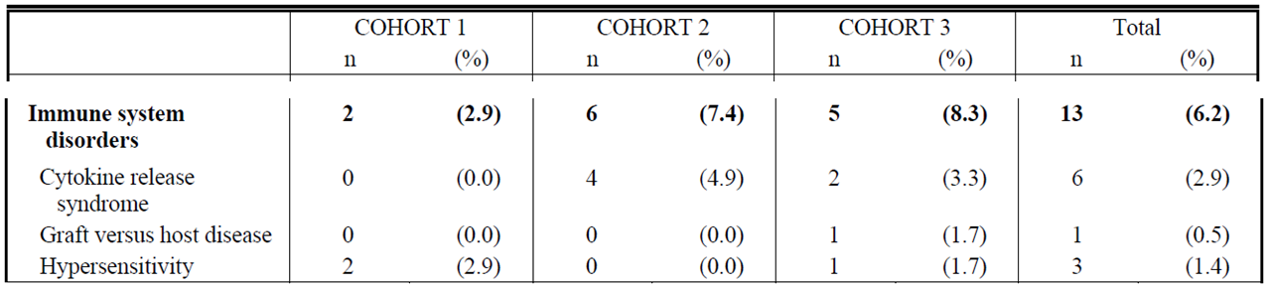
Infusion reactions occurred in 16 of 210 (7.6%) subjects, all but 1 of which was drug-related. Overall, 1 (0.5%) subject (in Cohort 2) experienced an infusion reaction that was reported as an SAE and considered drug related by the Investigator; the subject was discontinued from pembrolizumab.
Overall, the median time to onset of the first episode of an infusion reaction was 1 day and ranged from 1 to 240 days. Most subjects experienced only 1 episode of an infusion reaction during the study, with an episode lasting from 1 to 41 days.
The majority of infusion reactions that occurred across cohorts were not managed with corticosteroids. Of the 16 subjects across cohorts who had at least 1 infusion reaction episode, only 2 (12.5%) were treated with corticosteroids.
Cytokine-release syndrome is also considered an infusion reaction (MedDRA v. 19.0) and is listed under Immune system disorders (Table 43). This was observed in 6 subjects (2.9%) and was classified as grade 1 in five subjects and grade 3 in one subject.
Graft-versus-Host Disease was seen in one subject (Table 43), see discussion section 8.3.23.2.
Comment: Based on the incidence of AEOSI, there is no change in the safety profile of pembrolizumab with the addition of new data from subjects with HL. In the PI the higher incidence of hypothyroidism in cHL patients has been emphasised.

Serious skin reactions

Integrated safety analyses
Table 44: Subjects with Grade 3-5 Adverse Events (Incidence ≥ 1% in One or More Treatment Groups) Subjects Treated with Pembrolizumab (HL and Reference Safety Dataset) by Body System or Organ Class and Preferred Term
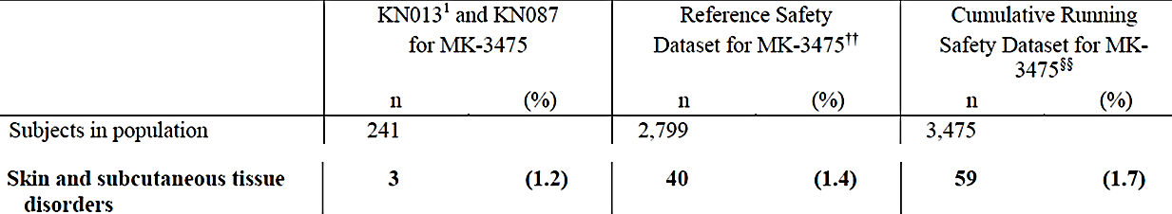
Table 33 shows subjects with drug-related AEs (incidence ≥ 5% in one or more treatment groups). The incidence of skin disorder is lower in the HL population (15.8%) versus the Reference safety dataset (36.4%). Rash, pruritus and vitiligo are the preferred terms with the latter not seen in the HL population.

Pivotal and/or main efficacy studies

KEYNOTE-087
There were three subjects with Grade 3-4 AEs and no SAEs for the body system ‘Skin and subcutaneous disorders’. All drug-related AEs in HL subjects with an incidence of ≥ 5% (13 subjects, Table 33) in this body system came from this study.

Other safety issues

Safety in special populations
Report and comment on any data regarding the frequency or pattern of AEs, laboratory abnormalities and other safety parameters in special populations defined by age, genetic factors (gender, ethnicity, CYP isoform status, etc), and co-morbidities. It should be noted that the safety profile may be more or less favourable in some populations. This should also include data and information in pregnancy and lactation if available.

Age
In the HL Population, older subjects (≥ 65 years of age) experienced more AEs in all categories than younger subjects (< 65 years of age), which was comparable to the Reference Population.
Only 20/241 subjects (8%) in the HL population were >65 years of age. The relatively small number does not provide for a meaningful comparison to the HL Population < 65 years of age, or the Reference Population.

Gender
The incidence of AEs by gender among subjects in the HL Population was similar and comparable to that of the Reference Population. With the exception of drug-related AEs, which were more frequent among females than males in the HL Population, but comparable between males and females in the Reference Population, subjects with HL had a lower incidence of AEs of any category than did subjects in the Reference Population. Thus, based on the AE summary by gender, there was no change in the safety profile of pembrolizumab for subjects with HL.

Race

KEYNOTE-087
Across cohorts, the overall incidence of AEs was similar among White and non-White subjects; 177 of 185 (95.7%) White subjects reported AEs compared with 21 of 22 (95.5%) non-White subjects. The numbers are small, though.

Region
The overall incidence of AEs, regardless of AE category, among US and ex-US subjects in the HL Population was comparable to that of the Reference Population. Thus, based on the AE summary by region, there was no change in the safety profile of pembrolizumab for subjects with HL.

Safety related to drug-drug interactions and other interactions
As pembrolizumab is an IgG4 antibody that is administered parentally and cleared by catabolism, food and drug-drug interactions are not anticipated to affect exposure. Therefore, no dedicated drug-drug interaction studies have been performed. However, as systemic corticosteroids may be used to treat immune-mediated adverse reactions concomitant with pembrolizumab, the potential for a PK drug-drug interaction with pembrolizumab as a victim was assessed. No relationship was observed between prolonged use of systemic corticosteroids and pembrolizumab exposure.

Post marketing experience
No information provided in the dossier.

Evaluator’s overall conclusions on clinical safety
The indication population consisted of 241 subjects with rrcHL from the phase Ib study KEYNOTE-013 (31 subjects) and Phase II KEYNOTE-087 (230 subjects=87%), who received at least one dose of pembrolizumab. There are no Phase III studies. The median extent of exposure was 5.82 months with 117 patients (48.5%) receiving ≥ 6 months of treatment and 11 patients (4.6%) receiving ≥ 12 months of treatment. Median follow up was 7.4 months.
The dose administered in Study KN013 was 10 mg/kg Q2W and 200 mg Q3W (fixed dose) in KN087, the latter is the dose the sponsor is applying for.
The indication population was compared to the Reference Safety Dataset (also called Reference Population), which consisted of NSCLC and melanoma subjects from earlier studies (2799 subjects). The median extent of exposure was 4.17 months with 1656 patients (41.2%) receiving ≥ 6 months of treatment and 600 patients (21.4%) receiving ≥ 12 months of treatment.
The incidence of AEs and drug-related AEs among subjects in the cHL population was overall comparable to that of the Reference Population with no new AEs. The main exceptions were in the preferred term ‘Pyrexia’ (see Table 30 and Table 33) and SOC ‘Infections’ (Table 33) with twice as many (%) in the cHL population compared to the Reference Dataset. Although not unexpected, the way that that will affect long-term outcome is uncertain due to the short exposure and follow-up in this group. Age ≥ 65 years was a risk factor in the reference population as well as in the cHL population, although the numbers are small (11 subjects) in the latter group.
In the cHL population the adverse events of special interest (AEOSIs), including immune-mediated AEs, were comparable to the reference population apart from there being more cHL subjects with hypothyroidism, which can be explained by previous radiation therapy.
The contribution of pembrolizumab to the development of GVHD in patients receiving allogeneic-SCT is still unclear; more data is needed. The other PD-1 inhibitor on the market, nivolumab, has a warning in the EMA SmPC:
‘Complications of allogeneic Haematopoietic Stem Cell Transplant (HSCT) in classical Hodgkin Lymphoma
Preliminary results from the follow-up of patients undergoing allogeneic HSCT after previous exposure to nivolumab showed a higher than expected number of cases of acute graft-versus-host-disease (GVHD) and transplant related mortality (TRM). Until further data become available, careful consideration to the potential benefits of HSCT and the possible increased risk of transplant related complications should be made case by case (see section 4.8).’
Going through the safety conclusions in the Clinical overview the evaluator agrees with the sponsor’s statements except regarding allo SCT and GVHD, which the evaluator believes is unresolved, see above.
The exposure to pembrolizumab is still short with 5.82 months for the cHL population and 4.17 months for the Reference Safety Dataset (Table 45), which makes long term side-effects difficult to evaluate although 600 patients in the Reference Dataset has had >12 months of treatment, so there is some long term data in these patient groups (melanoma and NSCLC). As there are more infections and pyrexia in the cHL population, the effect on long-term outcome is uncertain.
Table 45: Summary of Drug Exposure. Subjects Treated with MK-3475 from KN0131, KN087, KN001, KN002, KN006, KN010, KN0122, KN0163, KN024, and KN164 (APaT Population)
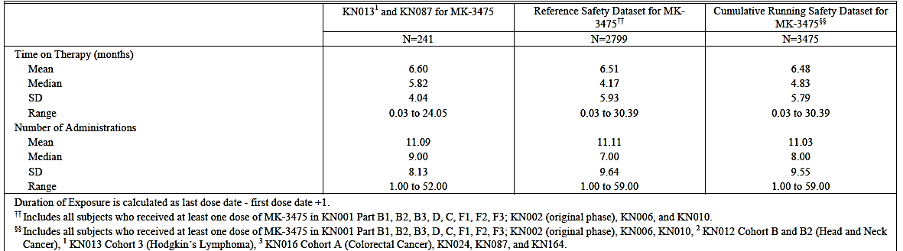

First round benefit-risk assessment

First round assessment of benefits
Indication
Benefits | Strengths and Uncertainties
There is an unmet need for improvement in cHL pt.’s who progress after ≥ 3 lines of therapy, which this study seem to meet, at least short-term:  ORR of 68.1% and CR 21.9% in the pivotal Study KN087, which is high relative to other treatments and comparable to BV. It is also comparable to nivolumab in cHL patients after ASCT and BV (ORR 68%) and higher than the CR of 8% seen in this study (EMA SmPC).  The smaller Phase Ib Study KN013 supports these results.  DOR not reached (Range 0.0+ - 8.3+ months) (KN087). | Strength:  Most patients had ≥ 3 lines of therapy and still the ORR and CR were high.  Uncertainties:  No randomised study (no comparator).  Surrogate endpoint: will this result in a longer PFS, DOR and ultimately OS?  The place relative to BV is uncertain mainly due to lack of data from phase 3 trials, one of which is ongoing, and due to an heterogeneous Cohort 3, where 40% had <3 prior treatments and 41.7% had BV pre-ASCT and so is difficult to compare to Cohort 1.  Short exposure (5.8 months) and follow-up (7.1 months): Interim report.

First round assessment of risks
Risks | Strengths and Uncertainties
Well known adverse events of special interest (AEOSIs).  Infections/pyrexia twice that of the Reference Dataset.  More AEs with age > 65 years and few patients in this category  Allo-SCT: potentially heightened risk of GVHD based on anecdotal reports. | Strengths:  Mainly comparable to previously observed AEOSI in large reference dataset (2799).  Uncertainties:  No randomised study (no comparator).  Few patients > 65 years of age in KN087 [19 (9%), 15 of these were in Cohort 2].  Study KN087/interim report: Long-term AEs due to short exposure (5.8 months) and follow-up (7.1 months) are unknown.

First round assessment of benefit-risk balance
Overall, it is considered that the benefits of pembrolizumab outweigh its risks in this patient population although the data is sparse in the elderly population. However, the data submitted with this application are immature. Specific limitations of the data include the following:
- Data on DOR and PFS are not mature.
- There are no randomised comparisons of pembrolizumab against other agents registered for use in the proposed patient population.
The indication proposed by the sponsor is: Keytruda is indicated for the treatment of patients with refractory classical Hodgkin Lymphoma, or those who have relapsed after 3 or more prior lines of therapy. This is a broad indication, which would include patients eligible for treatment with traditional salvage therapy and subsequent ASCT (primary refractory) and without the need for treatment with brentuximab vedotin, which is approved for third line therapy.
It is therefore recommended that pembrolizumab be approved for registration, but with a more restricted indication than the one proposed by the sponsor:
Keytruda as monotherapy is indicated for the treatment of adult patients with relapsed or refractory classical Hodgkin lymphoma (cHL):
Following autologous stem cell transplant (ASCT) or
Following at least two prior therapies when ASCT or multi-agent chemotherapy is not a treatment option.

First round recommendation regarding authorisation
It is recommended that the application be approved but with the restricted indication outlined above and with a warning regarding the heightened risk of infections in the elderly population (>65 years of age) including sparse data in this population.

Clinical questions

General
Question 1: Reference 5.4: 03H8DY deals with T-cell NHL, not cHL. Please clarify. (Section 2.3)

Pharmacokinetics
Question 2: Where in the dossier is reference? (Section 4.2.2)

Pharmacodynamics
There is no new information regarding pharmacodynamics.

Efficacy
Question 3: Subject [information redacted] in cohort 2 only had one line of treatment (AVD+ BV). This subject seems to be included in the efficacy analyses. What is the justification for this? (Section 7.1.1.10)
Question 4: 15 of the 19 patients >65 years (79%) in KN087 are in cohort 2. Were they all (15) scheduled for ASCT and then failed salvage therapy as opposed to not being scheduled for ASCT because of age (which is not part of the inclusion criteria, see section 7.1.1.2)? (Section 7.1.1.11)
Question 5: In Cohort 3 (Table 8), 60 patients (100%) have relapsed after ≥ 3 lines of therapy. How is that possible when only 36 subjects (60%) have had ≥ 3 lines of treatment? (Section 7.1.1.11)
Question 6: There are almost twice as many patients with primary refractory disease in Cohort 3 compared to Cohort 1. Generally they have a poor prognosis but here the ORR and CR are the same as in Cohort 1. Primary refractory disease means refractory to first line of treatment: Is this what is described here (as opposed to refractory to later treatments)? (Section 7.1.1.11)
Question 7: Was there a difference in Cohort 3 between the 25 patients who had received BV before transplantation (Table 48) and those (35), who had not received BV?
Question 8: How does these two BV subgroups in Cohort 3 (above) compare to Cohort 1? Please fill in the missing data in Table 46.
Question 9: 24 (40%) patients in Cohort 3 (KN087) had <3 lines of treatment according to Table 10-4 in the CSR: how is that possible when they have gone through ASCT (see description of Cohort 3 in Figure 5)?
Question 10: What are the results for the patients in Cohort 3 that had ≥ 3 prior treatments and BV compared to the same group without BV and compared to Cohort 1? Are there more patients in Cohort 3/≥ 3 prior treatments that have had BV than in Cohort 3/< 3 prior treatments? See
for a tabular overview of the various combinations in Cohort 3 and please fill in the corresponding results for ORR and CR and the number of subjects in each subgroup. The numbers will be small, but this is just to see if there is a trend in any direction or if the ORR and CR are similar in all subgroups.
Question 11: There does not seem to be a clear difference in response in Study KN087 between patients having <3 or ≥ 3 prior treatments (Table 14). 24 of the 28 patients having <3 prior treatments are in Cohort 3, though, which is why these subgroups in Cohort 3 has to be compared to Cohort 1. What are the ORR and CR for these subgroups? Please fill in the missing data in Table 46.

Table 46: Characteristics and efficacy results for the various cohorts in KN087:
 | Inclusion criteria:  Have relapsed* or refractory* de novo classical Hodgkin lymphoma and meet one of the following cohort inclusions:  *Relapsed: disease progression after most recent therapy  *Refractory: failure to achieve CR or PR to most recent therapy | Median  no. of prior  treat-ments/  ASCT (%) | BV  after  ASCT | ORR  No  %  (95% CI) | CR  No  % | Comments
All cohorts  N: 210 |  |  |  | 143  68.1%  (61.3, 74.3) | 46  21.9%  (16.5, 28.1)
Cohort 1  N: 69 | Have failed to achieve a response or progressed after auto-SCT. Subjects must have relapsed after treatment with or failed to respond to brentuximab vedotin post auto-SCT.  68/69 had ≥ 3 prior treatments. | 4.0  100% | 100% | 50  72.9%  (60.4, 82.5) | 15  21.7%  (12.7, 33.3)
Cohort 2  N: 81 | Were unable to achieve a complete or a partial response to salvage chemotherapy and did not receive auto-SCT. Subjects must have relapsed after treatment with or failed to respond to brentuximab vedotin.  78/81 had ≥ 3 prior treatments. | 4.0  0% | NA | 53  65.4%  (54.0, 75.7) | 18  22.2%  13.7, 32.8) | Question 4  See also section 7.1.1.11.
Cohort 3  N: 60 | Have failed to achieve a response or progressed after auto-SCT and have not have received brentuximab vedotin post auto-SCT. Note: These subjects could have received brentuximab vedotin as part of primary treatment, or salvage treatment.  36/60 (60%) had ≥ 3 prior treatments. | 3.0  100% | 0 | 40  66.7%  (53.5, 78.3) | 13  21.7%  (12.1, 34.2) | See section 11.1 under INDICATIONS for comments re. number of prior treatments and ±BV treatment.
Cohort 3  BV pre-ASCT  N: 25 (41.7%) |  |  |  | N:?  %? | N:?  %? | See Questions 7 and 8.
Cohort 3  No BV pre-ASCT, N: 35 (58.3%) |  |  |  | N:?  %? | N:?  %? | See Questions 7 and 8.
Cohort 3  <3 prior treatments  N: 24 (40%) |  |  |  | N:?  62.5%  (40.6%, 81.2%), | N:?  %? | See Question 11.
Cohort 3  ≥ 3 prior treatments  N: 36 (60%) |  |  |  | 69.4%  (51.9%, 83.7%) | N:?  %? | See Question 11
Cohort 3  <3 prior treatments ±BV (N: 24)  N (+BV): ?  N (-BV): ? |  |  |  | +BV: N:?  %?  -BV: N:?  %? | +BV: N:?  %?  -BV: N:?  %? | See Question 10
Cohort 3  ≥ 3 prior treatments ±BV.  N (+BV): ?  N (-BV): ? |  |  |  | +BV: N:?  %?  -BV: N:?  %? | +BV: N:?  %?  -BV: N:?  %? | See Question 10

Safety
The issues are mainly related to the PI and are beyond the scope of this AusPAR.

Second round evaluation

Question 1: Reference 5.4: 03H8DY deals with T-cell NHL, not cHL. Please clarify. (Section 2.3)
Sponsor’s Response: The sponsor agrees that Reference 5.4: 03H8DY is an incorrect citation and have supplied the correct one.
Evaluator’s Comment: The sponsor’s response is satisfactory.

Pharmacokinetics

Question 2: Where in the dossier is reference 04DDV3? (Section 4.2.2)
Sponsor’s Response: Reference has been previously provided to the TGA.
Evaluator’s Comment: The sponsor’s response is satisfactory although there should be no references in the dossier that cannot be found in the dossier unless there is a clear reference to where it can then be found, like sequence 0013 and 0014.

Efficacy

Question 3: Subject [information redacted] in cohort 2 only had one line of treatment (AVD+ BV). This subject seems to be included in the efficacy analyses. What is the justification for this? (Section 7.1.1.10)
Sponsor’s Response: Efficacy analyses were conducted on the All-Subjects-as-Treated population, ie, subjects were included if they received at least one dose of study medication, as described in the statistical analysis plan. Subject [information redacted]was refractory (best response of progressive disease) to 4 months of treatment with AVD + BV. This subject was considered to meet the inclusion criteria of ineligible for auto-SCT due to chemorefractory disease since the subject had no response to prior chemotherapy and BV.
Evaluator’s Comment: The evaluator disagrees with this interpretation of the inclusion criteria: it specifically says ‘salvage chemotherapy’ (see section 7.1.1.2, which is chemotherapy you give when the first treatments isn’t working, which this patient did not receive. In the evaluator’s opinion this patients should not have been included in the study, but as it is only one patient it does not change the risk/benefit evaluation.

Question 4: 15 of the 19 patients >65 years (79%) in KN087 are in cohort 2. Were they all (15) scheduled for ASCT and then failed salvage therapy as opposed to not being scheduled for ASCT because of age (which is not part of the inclusion criteria, see section 7.1.1.2)? (Section 7.1.1.11)
Sponsor’s Response: The sponsor has not collected the information whether the initial intention was to perform an auto-SCT. It is assumed based on previous use of salvage regimens rather than palliative therapy that the intention must have been to perform auto-SCT even in subjects who are ≥ 65 years of age. Note that there are 3 subjects ≥ 65 years of age in Cohort 3 who received auto-SCT.
Evaluator’s Comment: The evaluator finds it logical to suspect that the main reason for these patients being non-eligible for ASCT is age when so many (15) of the patients are ≥ 65 years of age, which is why I have asked for the reason they were non-eligible. The description of Cohort 2 is: ‘subjects who were ineligible for an auto-SCT (unable to achieve a complete or partial response to salvage therapy) and have relapsed after treatment with or failed to respond to BV.’ It could also be that these patients were unable to complete salvage chemotherapy because of the higher toxicity seen with higher age. The sponsor’s response is not entirely satisfactory.

Question 5: In Cohort 3 (Table 8), 60 patients (100%) have relapsed after ≥ 3 lines of therapy. How is that possible when only 36 subjects (60%) have had ≥ 3 lines of treatment? (Section 7.1.1.11)
Sponsor’s Response: The criteria for ‘relapsed ≥ 3 lines of therapy’ in Table 14.1.3, as well as other efficacy assessments, includes prior SCT as a separate line of therapy (as indicated in Section 9.9 of the KEYNOTE-087 CSR) whereas CSR Table 10.4 does not count prior SCT as an additional line of therapy. Table 10-4 was intended to summarise baseline characteristics according to investigator assessment as recorded on baseline CRFs, where the line of therapy (‘first line’, ‘second line’, ‘third line’, ‘fourth line’, ‘fifth line or greater’) was entered for each prior regimen. Based on this information, 24 subjects in Cohort 3 did not receive a regimen considered ‘third line’ by the investigator (though they could have received more than 1 first or second line therapy). When SCT is included as a separate ‘prior line,’ all 60 subjects in Cohort 3 have met this criterion.
Evaluator’s Comment: The explanation is satisfactory although the evaluator find it confusing that the sponsor makes use of two different definitions of ‘prior lines of therapy’.

Question 6: There are almost twice as many patients with primary refractory disease in Cohort 3 compared to Cohort 1. Generally they have a poor prognosis but here the ORR and CR are the same as in Cohort 1. Primary refractory disease means refractory to first line of treatment: Is this what is described here (as opposed to refractory to later treatments)? (Section 7.1.1.11)
Sponsor’s Response: Correct, 15 of the 69 subjects (22%) in Cohort 1 were refractory, defined as best response of PD or SD, to the first regimen received compared to 26 of the 60 subjects (43%) in Cohort 3, as well as 33 of the 81 (41%) in Cohort 2, yet the ORR and CRR were consistent across the cohorts. It should be noted that these subjects could be refractory to subsequent regimens as well. As indicated, refractory to front-line therapy represents a poor prognosis for HL patients, thus this factor was placed first in the hierarchy used in the statistical analyses to further evaluate efficacy and refractory status, such as Table 11-18 of the KEYNOTE-087 CSR.
Evaluator’s Comment: The answer is satisfactory.

Question 7: Was there a difference in Cohort 3 between the 25 patients who had received BV before transplantation and those (35), who had not received BV?
Sponsor’s Response: A summary of efficacy (ORR, DOR, PFS and OS), based on the updated data cutoff (25Sep2016) for KEYNOTE-087 Cohort 3 subjects who received prior BV and those who were BV-naïve (Table 47). The efficacy results for the subgroups were generally similar.
Table 47: Summary of efficacy by brentuximab vedotin status KEYNOTE-087 Cohort 3
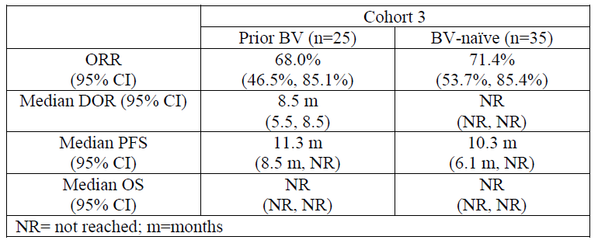
Evaluator’s Comment: The answer is satisfactory.

Question 8: How does these two BV subgroups in Cohort 3 (above) compare to Cohort 1? Please fill in the missing data in Table 46.
Sponsor’s Response: See data for Cohort 3 in Table 48 (below) with a cutoff-date of 25 Sept 2016. The response rates of the 2 BV subgroups were generally consistent with Cohort 1.
Evaluator’s Comment: The answer is satisfactory.
Table 48: Characteristics and efficacy results for the various cohorts in KN087 (Cut-off date 25 September 2016)
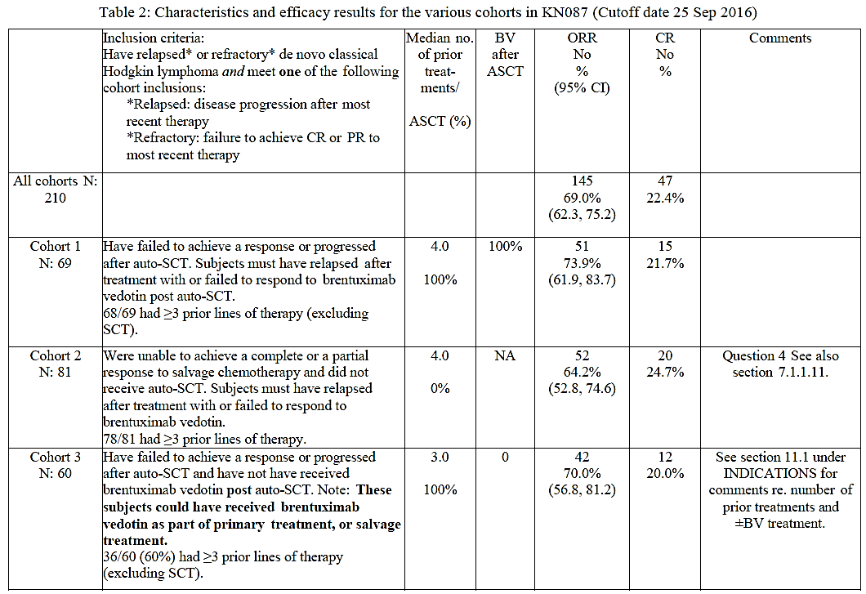
Table 48 continued: Characteristics and efficacy results for the various cohorts in KN087 (Cut-off date 25 September 2016)
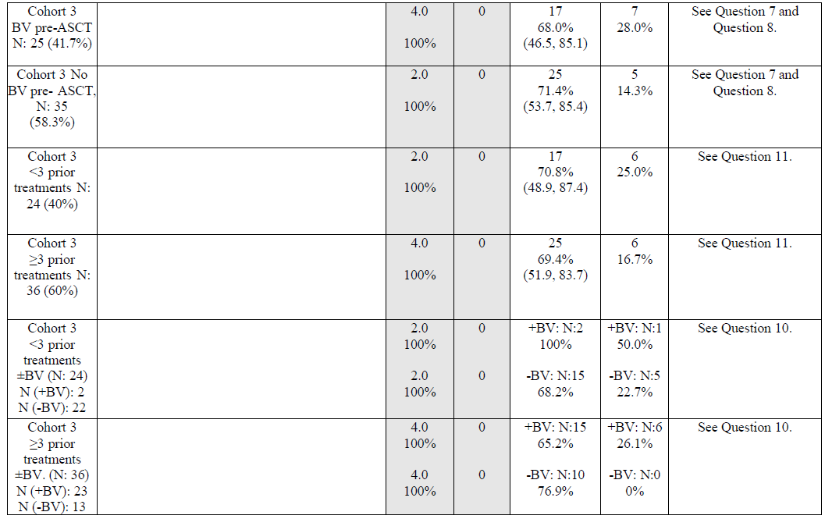

Question 9: 24 (40%) patients in Cohort 3 (KN087) had <3 lines of treatment according to Table 10-4 in the CSR: how is that possible when they have gone through ASCT (see description of Cohort 3 in Figure 5)?
Sponsor’s Response: See response to Question 5.
Evaluator’s Comment: The answer is satisfactory.

Question 10: What are the results for the patients in Cohort 3 that had ≥ 3 prior treatments and BV compared to the same group without BV and compared to Cohort 1? Are there more patients in Cohort 3/≥ 3 prior treatments that have had BV than in Cohort 3/< 3 prior treatments? See Table 46 for a tabular overview of the various combinations in Cohort 3 and please fill in the corresponding results for ORR and CR and the number of subjects in each subgroup. The numbers will be small, but this is just to see if there is a trend in any direction or if the ORR and CR are similar in all subgroups.
Sponsor’s Response: See data for Cohort 3 in Table 2 with a cutoff-date of 25 Sept 2016. The response rates of the BV subgroups by < 3 or ≥ 3 prior treatments were generally consistent with Cohort 1, although small numbers preclude meaningful comparisons.
Evaluator’s Comment: The answer is satisfactory.

Question 11: There does not seem to be a clear difference in response in Study KN087 between patients having <3 or ≥ 3 prior treatments (Table 14). 24 of the 28 patients having <3 prior treatments are in Cohort 3, though, which is why these subgroups in Cohort 3 has to be compared to Cohort 1. What are the ORR and CR for these subgroups? Please fill in the missing data in Table 46.
Sponsor’s Response: See data for Cohort 3 in Table 2 with a cutoff-date of 25 Sept 2016. The response rates of Cohort 3 by < 3 or ≥ 3 prior treatments were generally consistent with Cohort 1.
Evaluator’s Comment: The answer is satisfactory.

Safety

Sponsor’s response to other comments

Comment 1
There are more subjects with pyrexia in the HL group, which is not unexpected, as patient with haematological malignancies are more prone to infections. On the other hand HL patients had less fatigue. Hypothyroidism was more prevalent in HL patients, which is reflected in the draft PI.

Comment 2
There are twice as many patients (%) with pyrexia (Table 30 and Table 33) and infections (Table 33) in the cHL population compared to the reference safety dataset, which is not unexpected in this group of patients but should be mentioned nevertheless.
Sponsor’s Response: The sponsor considers that cHL patients are at an increased risk of pyrexia and infection because of their underlying disease. B symptoms, which are considered a part of cHL and NHL, include pyrexia; and lymphoma patients are at increased risk of infection because of immunosuppression caused by their disease. It would not be unexpected that this risk would be even larger in a cohort of heavily pretreated patients, such as seen in KEYNOTE-013 and KEYNOTE-087. As noted by the evaluator, pyrexia and infections are not unexpected in cHL patients. [Evaluator’s comment: There are more subjects with pyrexia in the HL group, which is not unexpected, as patient with haematological malignancies are more prone to infections.]
For these reasons, the sponsor considers that the increased frequencies of pyrexia and infection are confounded by the underlying disease and treatments received prior to enrollment in KEYNOTE-013 or KEYNOTE-087, and are not causally associated with pembrolizumab. The sponsor, therefore, has not included these terms in the Product Information.
Evaluator’s Comment: The sponsor’s argument that because infections and pyrexia are common in cHL patients, especially heavily pre-treated patients, these adverse reactions do not have to be included in the PI is not an acceptable argument: The prescribing physician may think that this is some kind of wonder drug that doesn’t cause infections and pyrexia, since it is not mentioned.
In the FDA Prescribing Information for cHL (March 2017) the following is stated under section 6; ADVERSE REACTIONS, subsection 6.1; Clinical Trials Experience, under cHL (page 14, second last paragraph): ‘The most frequent serious adverse reactions (>1%) included pneumonia, pneumonitis, pyrexia, dyspnea, graft versus host disease and herpes zoster.’
And furthermore (last paragraph, page 14): ‘Table 7 (see below) summarizes the adverse reactions that occurred in at least 10% of patients treated with Keytruda.’
Leaving out the information regarding the higher rate of infections and pyrexia in cHL patients is not acceptable: please amend. That could be done by adding the above statement from the FDA PI to the statement in the annotated PI page 27, under Other Cancers.
Table 49: Adverse reactions in ≥10 % of patients with cHL
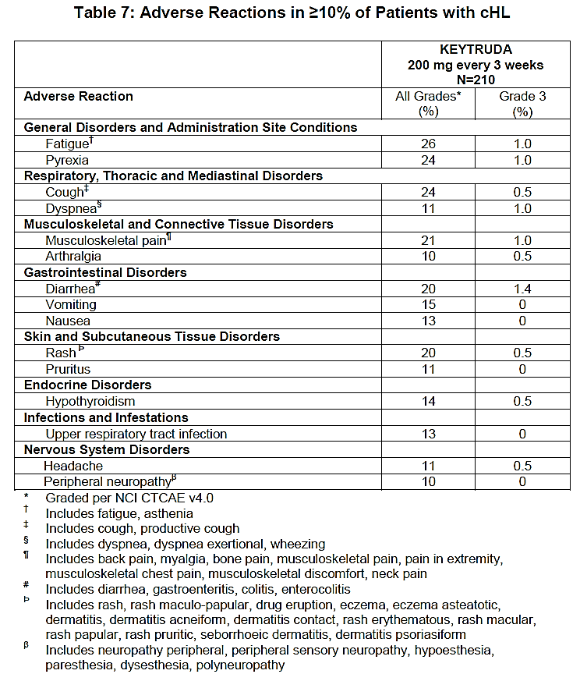

Updated data – efficacy
The sponsor has provided an Efficacy Update Report and a Safety Update Report with additional follow-up data on the studies KEYNOTE-087 and KEYNOTE-013.
Table 50: Updated efficacy data from Study KN087 compared to the initial data; +3.0 months
Response Evaluation Study | MK-3475 200 mg (N=210) |  | MK-3475 200 mg (N=210)
Response Evaluation Study | n (%) | 95% CI | n (%) | 95% CI*
Complete Remission (CR)  Partial remission (PR)  Objective Response (CR+PR)  Stable Disease (SD)  Progressive Disease (PD)  No Assessment (NA) | 46 ( 21.9)  97 (46.2)  143 (68.1)  35 (16.7)  27 (12.9)  5 (2.4) | (16.5, 28.1)  (39.3, 53.2)  (61.3, 74.3)  (11.9, 22.4)  (8.6, 18.2)  (0.8, 5.5) | 47 (22.4)  98 (46.7)  145 (69.0)  31 (14.8)  30 (14.3)  4 (1.9) | (16.9, 28.6)  (39.8, 53.7)  (62.3, 75.2)  (10.3, 20.3)  (9.9, 19.8)  (0.5, 4.8)
Duration of Response (DOR) (median, months) | Not reached (0.0+ - 8.3+) | (5.7, Not reached) | 11.1  (0.0+ - 11.1) | (8.7, 11.1)
Database Cutoff Date: | 27JUN2016 |  | 25SEP2016
*Based on binominal exact confidence interval method.
Comment: The updated data are consistent with those of the initial application except for the median DOR being reached in KEYNOTE-087. The data evaluated is from this pivotal study.

Updated data – safety
The sponsor has provided a Safety Update Report with additional follow-up data on studies KEYNOTE-087 and KEYNOTE-013.
Table 51: Updated safety data from Study KN087 and KN013 compared to the initial data; +3.0 months and 3.8 months, respectively
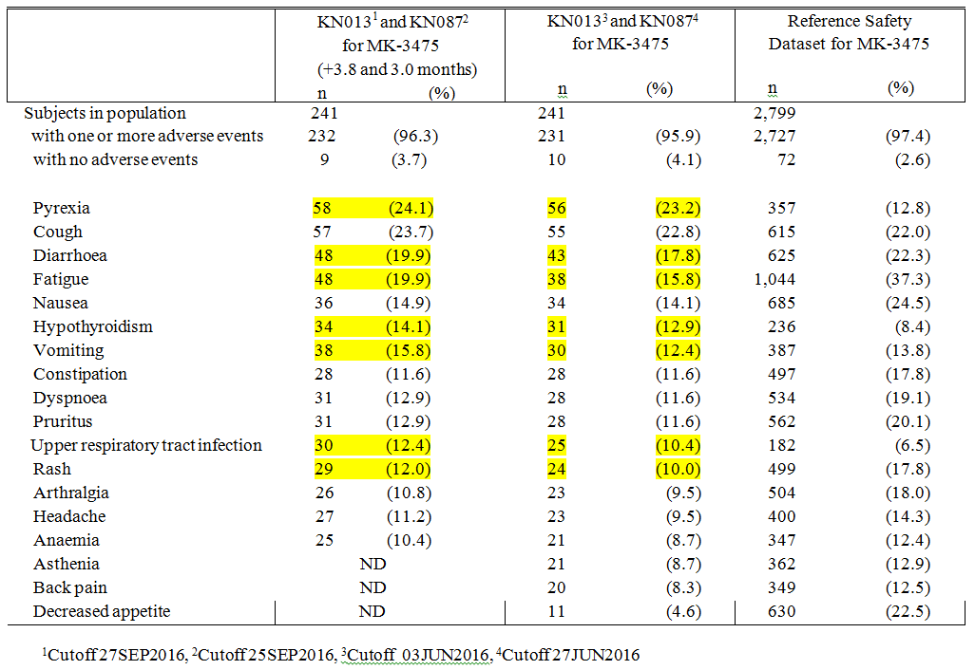
Comment: There is an increase of 1-2 percent points in most adverse events (PT) during this 3-3.8 month period, which may not be unexpected but there is still a need for longer follow-up to make sure the AEs do not affect the long-term benefit-risk balance. Compared to the Reference Safety Dataset the difference in the PT Pyrexia, Upper respiratory tract infection and Hypothyroidism has increased further.

Second round benefit-risk assessment

Second round assessment of benefits
There is no change to the overall benefits as set out at the first round evaluation stage.

Second round assessment of risks
There is no change to the overall assessment of risks as set out at the first round evaluation stage.

Second round assessment of benefit-risk balance
There is no change to the overall benefit-risk balance as set out at the first round evaluation stage.

Second round recommendation regarding authorisation
It is recommended that pembrolizumab for cHL is approved with the updated indication:
Keytruda as monotherapy is indicated for the treatment of adult patients with relapsed or refractory classical Hodgkin lymphoma (cHL):
- following autologous stem cell transplant (ASCT) or
- following at least two prior therapies when ASCT or multi-agent chemotherapy is not a treatment option.
The approval of this indication is on the basis of objective response rate (ORR). Data on progression free and overall survival is limited.
and with modifications of the PI and CMI which all relate to safety issues (pyrexia and infections).

References
Alinari L and Blum KA. How I treat classical Hodgkin lymphoma after autologous stem cell transplant. Blood 2016; 127: 287-295.
Armand P, Shipp MA, Ribrag V, et al. Programmed Death-1 Blockade with Pembrolizumab in Patients With Classical Hodgkin Lymphoma After Brentuximab Vedotin Failure. J Clin Oncol 2016; 34: 3733-3739.
Canellos GP. Second and third line chemotherapy regimens and biologic therapy for relapsing or resistant classical Hodgkin lymphoma. UpToDate. Literature review current through: September 2016. Updated October 18, 2016.
Cheson BD, Pfistner B, Juweid ME, Gascoyne RD, Specht L, Horning SJ, et al. Revised response criteria for malignant lymphoma. J Clin Oncol 2007; 25: 579-586.
Eichenauer DA, Engert A, André M et al. Hodgkin’s lymphoma: ESMO Clinical Practice Guidelines for diagnosis, treatment and follow-up. Ann. Oncol. 2014; 25 (Suppl. 3): iii70-iii75.
European Medicines Agency. Guideline on The Evaluation of Anticancer Medicinal Products In Man (CPMP/EWP/205/95/Rev.4); 2012. (Accessed December 2016). Available from: http://www.tga.gov.au/industry/pm-euguidelines-adopted-clinical.htm#antineoplastic
Johnson P and McKenzie H. How I treat advanced classical Hodgkin lymphoma. Blood 2015; 125: 1717-1723.
Singh AK, Porrata LF, Aljitaw O, et al. Fatal GvHD induced by PD-1 inhibitor pembrolizumab in a patient with Hodgkin’s lymphoma (Letter). Bone Marrow Transplantation 2016; 51: 1268-1270.
Wilcox RA, Feldman AL, Wada DA et al. B7-H1 (PD-L1, CD274) suppresses host immunity in T-cell lymphoproliferative disorders. Blood 2009; 114(10): 2149-58.
Therapeutic Goods Administration
PO Box 100 Woden ACT 2606 Australia
Email: info@tga.gov.au Phone: 1800 020 653 Fax: 02 6232 8605
https://www.tga.gov.au

KEYTRUDA is indicated for the treatment of patients with refractory classical Hodgkin Lymphoma, or those who have relapsed after 3 or more prior lines of therapy.

