May 2018

Australian Public Assessment Report for Pembrolizumab
  - Proprietary Product Name: Keytruda
  - Sponsor: Merck Sharp & Dohme Australia Pty Ltd

About the Therapeutic Goods Administration (TGA)
- The Therapeutic Goods Administration (TGA) is part of the Australian Government Department of Health and is responsible for regulating medicines and medical devices.
- The TGA administers the Therapeutic Goods Act 1989 (the Act), applying a risk management approach designed to ensure therapeutic goods supplied in Australia meet acceptable standards of quality, safety and efficacy (performance) when necessary.
- The work of the TGA is based on applying scientific and clinical expertise to decision-making, to ensure that the benefits to consumers outweigh any risks associated with the use of medicines and medical devices.
- The TGA relies on the public, healthcare professionals and industry to report problems with medicines or medical devices. TGA investigates reports received by it to determine any necessary regulatory action.
- To report a problem with a medicine or medical device, please see the information on the TGA website <https://www.tga.gov.au>.
About AusPARs
- An Australian Public Assessment Report (AusPAR) provides information about the evaluation of a prescription medicine and the considerations that led the TGA to approve or not approve a prescription medicine submission.
- AusPARs are prepared and published by the TGA.
- An AusPAR is prepared for submissions that relate to new chemical entities, generic medicines, major variations and extensions of indications.
- An AusPAR is a static document; it provides information that relates to a submission at a particular point in time.
- A new AusPAR will be developed to reflect changes to indications and/or major variations to a prescription medicine subject to evaluation by the TGA.
Copyright
© Commonwealth of Australia 2018
This work is copyright. You may reproduce the whole or part of this work in unaltered form for your own personal use or, if you are part of an organisation, for internal use within your organisation, but only if you or your organisation do not use the reproduction for any commercial purpose and retain this copyright notice and all disclaimer notices as part of that reproduction. Apart from rights to use as permitted by the Copyright Act 1968 or allowed by this copyright notice, all other rights are reserved and you are not allowed to reproduce the whole or any part of this work in any way (electronic or otherwise) without first being given specific written permission from the Commonwealth to do so. Requests and inquiries concerning reproduction and rights are to be sent to the TGA Copyright Officer, Therapeutic Goods Administration, PO Box 100, Woden ACT 2606 or emailed to <tga.copyright@tga.gov.au>.

Contents
Common abbreviations 4
I. Introduction to product submission 8
Submission details 8
Product background 8
Regulatory status 12
Product Information 12
II. Registration timeline 13
III. Quality findings 13
Drug product 13
IV. Nonclinical findings 14
V. Clinical findings 14
Introduction 14
Pharmacokinetics 16
Pharmacodynamics 16
Dosage selection for the pivotal studies 16
Efficacy 17
Safety 18
First Round Benefit-Risk Assessment 22
First Round Recommendation Regarding Authorisation 23
First round recommendation regarding authorisation 23
Second Round Evaluation of clinical data submitted in response to questions 23
Second Round Benefit-Risk Assessment 24
Second round recommendation regarding authorisation 24
VI. Pharmacovigilance findings 24
Risk management plan 24
VII. Overall conclusion and risk/benefit assessment 27
Quality 27
Nonclinical 27
Clinical 27
Risk management plan 39
Risk-benefit analysis 40
Outcome 53
Attachment 1. Product Information 53
Attachment 2. Extract from the Clinical Evaluation Report 53

Common abbreviations
Abbreviation | Meaning
ADA | Anti-drug antibody
AE | Adverse event
AEOSI | Adverse event of special interest (also called ESI)
ALP | alkaline phosphatase
ALT | Alanine aminotransferase
AN | allocation number
APaT | All patients as treated
ASaT | All subjects as treated
AST | Aspartate aminotransferase
ASCT | autologous stem cell transplantation
BICR | Blinded, independent central review
BV | brentuximab vedotin
cHL | classical Hodgkin lymphoma
CI | Confidence interval
CO | Clinical overview
CR | Complete response or remission
CRR | Complete Remission Rate
CSR | Clinical study report
CT | Computerized tomography
CTCAE | Common Terminology Criteria for Adverse Events
DOR | Duration of Response
ECI | Events of Clinical Interest
ECOG | Eastern Cooperative Oncology Group
EORTC | European Organization for Research and Treatment of Cancer
EU | European Union
EuroQoL EQ-5D | European Quality of Life Five Dimensions Questionnaire
FAS | Full Analysis Set
FDA | Food and Drug Administration
GCP | Good Clinical Practice
GVHD | Graft versus host disease
HL | Hodgkin lymphoma
HNSCC | Head and neck squamous cell cancer
ICH | International Conference on Harmonization
IEC | Independent Ethics Committee
IND | Investigational New Drug
irAE | immune-related Adverse Event
ISS | integrated summary of safety
IV | Intravenous
IWG | International Working Group
IVRS/IXRS | Interactive Voice Response System/web access system
KN013 | Phase Ib clinical study KEYNOTE -013
KN087 | Phase II clinical study KEYNOTE -087
mAb | monoclonal Antibody
MDS | Myelodysplastic Syndrome
MedDRA | Medical Dictionary of Regulatory Activities
MK-3475 | Pembrolizumab
MM | Multiple Myeloma
MSI-H | Microsatellite instability high
NCI | National Cancer Institute
ND | Not determined
NSCLC | Non-small cell lung cancer
ORR | Objective Response Rate / Overall Response Rate (used interchangeably)
OS | Overall Survival
PD | Progressive disease
PD-1 | Programmed cell death 1
PD-L1 | Programmed cell death 1 ligand 1
PD-L2 | Programmed cell death 1 ligand 2
PFS | Progression Free Survival
PK | Pharmacokinetic
PMBCL | Primary Mediastinal B-Cell Lymphoma
PR | Partial remission
PRO | Patient Reported Outcome
PT | Preferred term (MedDRA)
Q2W | Every two weeks
Q3W | Every three weeks
QC | Quality Control
QLQ-C30 | Quality of Life Questionnaire C30
QoL | Quality of life
rrcHL | relapsed/refractory classical Hodgkin Lymphoma
SAE | Serious adverse event
SAP | Statistical analysis plan
SCT | Stem cell transplant
SD | Stable disease
SFU | Survival follow-up
SOC | System Organ Class (MedDRA)
UC | Urothelial cancer
ULN | Upper limit of normal
US | United States

I. Introduction to product submission

Submission details
Type of submission: | Extension of indications
Decision: | Approved
Date of decision: | 1 September 2017
Date of entry onto ARTG | 7 September 2017
Active ingredient(s): | Pembrolizumab
Product name(s): | Keytruda
Sponsor’s name and address: | Merck Sharp & Dohme (Australia) Pty Ltd  26 Talavera Road Macquarie Park 2113 NSW
Dose form(s): | Powder for injection and Concentrated solution for injection
Strength(s): | 50 mg and 100 mg/4 mL
Container(s): | Single use vial
Pack size(s): | 1’s
Approved therapeutic use: | Keytruda as monotherapy is indicated for the treatment of adult patients with relapsed or refractory classical Hodgkin Lymphoma (cHL):  - following autologous stem cell transplant (ASCT) or  - following at least two prior therapies when ASCT or multi-agent chemotherapy is not a treatment option.  The approval of this indication is on the basis of objective response rate (ORR). See Clinical Trial.
Route(s) of administration: | Intravenous (IV) infusion over 30 minutes every 3 weeks.
Dosage: | The recommended dose of Keytruda is 200 mg for head and neck cancer, classical Hodgkin Lymphoma, or previously untreated NSCLC.
ARTG number (s): | 226597, 263932

Product background
This AusPAR describes the application by the sponsor to extend the indications for pembrolizumab (Keytruda) to include classical Hodgkin lymphoma as follows;
Keytruda is indicated for the treatment of patients with refractory classical Hodgkin Lymphoma, or those who have relapsed after 3 or more prior lines of therapy.
Amendments to the proposed indications were proposed by the TGA clinical evaluator and the TGA Delegate (see First Round Recommendation Regarding Authorisation and Overall conclusion and risk benefit analysis below).
Keytruda is currently approved at the same dose for the treatment non-small cell lung cancer and head and neck squamous cell carcinoma, and dosed at 2 mg/kg bodyweight for the treatment of melanoma or previously treated non-small cell lung cancer.
The proposed dose for classical Hodgkin Lymphoma is a fixed dose of 200 mg pembrolizumab administered intravenously every 3 weeks.

Mechanism of action of pembrolizumab
Pembrolizumab is a selective humanised monoclonal antibody designed to block the interaction between PD-1 and its ligands, PD-L1 (also known as CD274 or B7-H1) and PD-L2 (also known as CD273 or B7-DC), on activated T-lymphocytes. Pembrolizumab is an IgG4 kappa immunoglobulin with an approximate molecular weight of 149 kDa. Pembrolizumab is produced in Chinese hamster ovary cells by recombinant DNA technology.
Similar to the CTLA-4 receptor, stimulation of PD-1 results in an inhibitory effect on T-cell function. The normal function of the PD-1 receptor is to limit or ‘check’ overstimulation of immune responses. Multiple normal tissues express PD-L1, whereas PD-L2 is expressed primarily on haematopoietic cells.
Several different tumours, including melanoma, express PD-L1. Tumour expression of PD-L1 may result in inhibition of T-cell mediated anti-tumour effects.
The clinical rationale for PD-1 receptor blockade with pembrolizumab is to remove such inhibition.

Classical Hodgkin lymphoma (HL)
Hodgkin lymphoma (HL) is an uncommon B-cell lymphoid malignancy which accounts for approximately 10% of all lymphomas and approximately 0.6% of all cancers diagnosed in the developed world annually. ‘Classic’ Hodgkin lymphoma (cHL) is the more common entity, a monoclonal lymphoid malignancy characterised by the presence of multinucleated Reed-Sternberg (R-S) cells, mostly of B-cell origin and accounting for 1 to 10% of the cells in the tumour tissue. Programmed death 1 (PD-1) ligands PD-L1 and PD-L2 are overexpressed by Reed-Sternberg cells in classical HL. The remaining cells are a mixed infiltrate of various lymphoid cells, including regulatory T-cells and macrophages. In nearly all cases of cHL, R-S cells express CD30, a glycoprotein belonging to the tumour necrosis factor receptor superfamily.
The 2011 incidence and 2012 mortality rates for HL in Australia were 606 and 78, respectively. The age-adjusted incidence rate for this period is 2.7/100,000 population.
The likelihood of relapse of Hodgkin lymphoma (HL; formerly called Hodgkin's disease) from initial therapy in the current era of systemic or combined modality therapy is approximately 10 to 15 percent for localised HL and 20 to 40 percent for more advanced stages (that is, IIIB or IV), dependent on prognostic factors. Approximately 40 to 50 percent of these relapses will occur in the first 12 months from induction. In addition, approximately 10 to 15 percent will have disease resistant to initial therapy.

Current treatment options
The standard of care for patients with relapsed or refractory cHL (rrcHL) to frontline chemotherapy is salvage chemotherapy followed by ASCT unless ineligible.
Salvage chemotherapy regimens such as dexamethasone/high-dose Ara-C/cisplatin (DHAP), ifosfamide/gemcitabine/vinorelbine (IGEV) or ifosfamide/carboplatin/ etoposide (ICE) are given to reduce the tumour burden and determine eligibility for autologous hematopoietic cell transplantation (ASCT). See excerpt from the NCCN guideline for Hodgkin Lymphoma below.
Table 1: Excerpt from the NCCN Guideline for Hodgkin Lymphoma
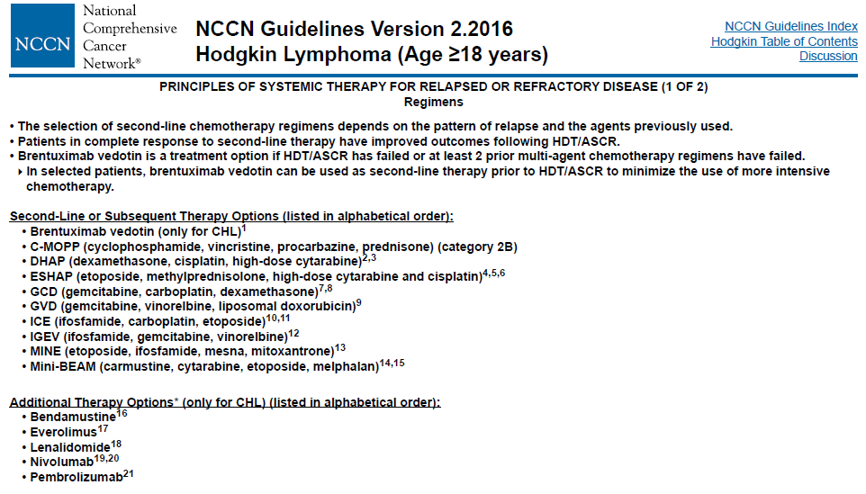
Salvage therapy can achieve durable responses and remissions in approximately one-half of these patients. Patients with high risk disease, a second relapse, or progressive, resistant disease are candidates for high dose chemotherapy and ASCT.
Second and third line chemotherapy combinations generally achieve complete remission (CR) in 30 to 40 percent of patients with aggressive or resistant disease. They are frequently used as cytoreductive agents prior to proceeding to high dose chemotherapy and ASCT. Salvage chemotherapy without progression to high dose chemotherapy and autologous stem cell transplantation results in 8 to 10 year overall survival rates of 21 to 27 percent with freedom from treatment failure of 16 percent.
Patients who are ineligible for or relapse following ASCT can only achieve palliation with conventional dose chemotherapy. Options for such patients include treatment with an immunotoxin (for example, brentuximab vedotin), PD-1 blockade or referral for allogeneic transplantation.
A systematic literature review was performed to characterise the response in heavily pretreated refractory/relapsed HL patients with the treatments recommended by National Comprehensive Cancer Network. The systematic literature review found studies in HL patients who are refractory/relapsed after ≥ 3 treatments (similar to the population studied in KEYNOTE-013 and KEYNOTE-087) as shown in Table 2.
Table 2: Studies in Patients Who Have Relapsed After ≥ 3 Treatments (by Decreasing Study Size)
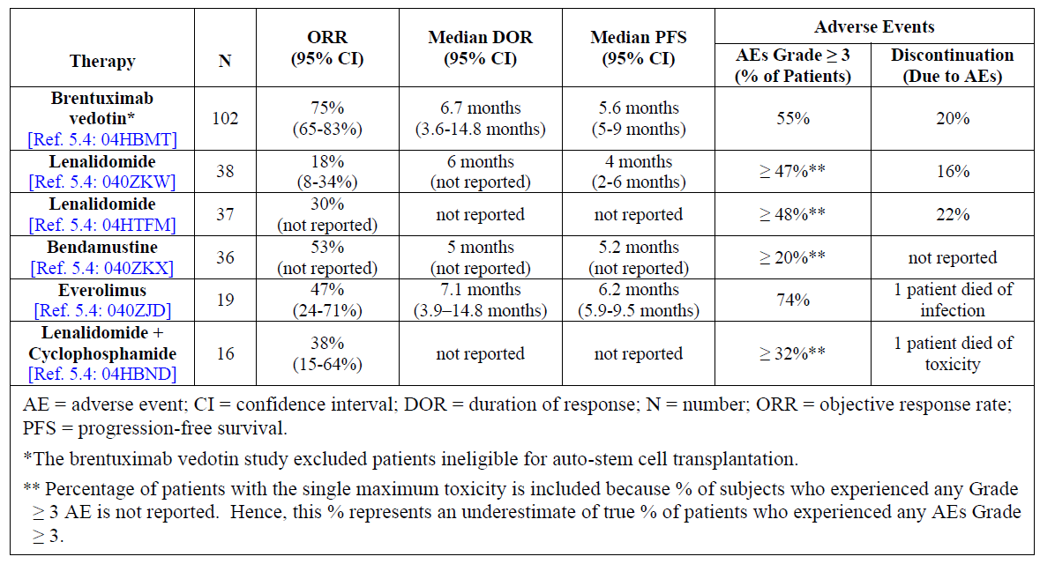
For patients who are ineligible for or fail ASCT, treatments include other chemotherapy agents such as the antibody drug conjugate brentuximab vedotin (BV). Figure 1 in Attachment 2 provides an example of a suggested algorithm for the treatment of patients who relapse after ASCT by Alinari L and Blum KA.
In December 2013, brentuximab vedotin was approved in Australia for the indications of:
Treatment of adult patients with relapsed or refractory CD30+ Hodgkin lymphoma (HL):
- Following autologous stem cell transplant (ASCT) or
- Following at least two prior therapies when ASCT or multi-agent chemotherapy is not a treatment option
Treatment of adult patients with relapsed or refractory systemic anaplastic large cell lymphoma (sALCL)
www.ebs.tga.gov.au/ebs/picmi/picmirepository.nsf/pdf?OpenAgent&id=CP-2014-PI-01042-1&d=2017022816114622483
In May 2017, the indications for nivolumab (Opdivo) were extended in Australia. Approval was granted for the following additional indication:
‘Opdivo, as monotherapy is indicated for the treatment of adult patients with relapsed or refractory classical Hodgkin lymphoma (cHL) after autologous stem cell transplant and treatment with brentuximab vedotin. The approval of this indication is based on objective response rate. See CLINICAL TRIALS.’

Regulatory guidelines
The following guidelines, which have been adopted by the TGA, are considered relevant to the current application:
- Guideline on the evaluation of anticancer medicinal products in man EMA/CHMP/205/95/Rev.4 (and relevant appendices).The TGA has adopted the EU (3).
- EMA/CPMP/EWP/2330/99: ‘Points to consider on application with 1) Meta-analyses; 2) One pivotal study’ (4).
Guidelines are not legally binding but variation from recommendations in such guidelines may suggest a need for close examination of particular quality, efficacy and/ or safety issues.

Regulatory status
Pembrolizumab was first included in the Australian Register of Therapeutic Goods (ARTG) on 16 April 2015. The most recent amendment at the time of writing this overview was 20 March 2017.
The following is a summary of international regulatory status of Keytruda (as of 19 June 2017):

United States of America (USA)
On 14 March 2017 FDA granted accelerated approval to pembrolizumab (Keytruda) for the treatment of adult and paediatric patients with refractory classical Hodgkin lymphoma (cHL) or those who have relapsed after three or more prior lines of therapy.
The wording of the approved indication in this setting is as follows:
‘For the treatment of adult and pediatric patients with refractory cHL, or who have relapsed after 3 or more prior lines of therapy. This indication is approved under accelerated approval based on tumor response rate and durability of response. Continued approval for this indication may be contingent upon verification and description of clinical benefit in the confirmatory trials.’
See United States Product Information document at: www.accessdata.fda.gov/drugsatfda_docs/label/2017/125514s014lbl.pdf

European Union (EU) – European Medicines Agency (EMA) (as of 19 June 2017)
On 2 May 2017, an application to extend the indications of pembrolizumab (Keytruda) to include monotherapy treatment of adult patients with relapsed or refractory classical Hodgkin Lymphoma (cHL) who have failed ASCT and have brentuximab vedotin (BV) or who are transplant ineligible and have failed BV was approved.
The wording of the approved indication in this setting is as follows:
‘Keytruda as monotherapy is indicated for the treatment of adult patients with relapsed or refractory classical Hodgkin lymphoma (cHL) who have failed autologous stem cell transplant (ASCT) and brentuximab vedotin (BV), or who are transplant-ineligible and have failed BV.’
See European Union SmPC at: www.ema.europa.eu/docs/en_GB/document_library/EPAR_-_Product_Information/human/003820/WC500190990.pdf

Product Information
The Product Information (PI) approved with the submission which is described in this AusPAR can be found as Attachment 1. For the most recent PI, please refer to the TGA website at <https://www.tga.gov.au/product-information-pi>.

II. Registration timeline
Table 3: Registration timeline for Submission PM-2016-02736-1-4
Description | Date
Submission dossier accepted and 1st round evaluation commenced | 31 October 2016
1st round evaluation completed | 3 April 2017
Sponsor provides responses on questions raised in 1st round evaluation | 27 April 2017
2nd round evaluation completed | 27 June 2017
Request for Advisory Committee advice and/or Delegate’s Overview | 3 July 2017
Sponsor’s response to Delegate’s Overview | 15 July 2017
Advisory Committee meeting | 4 August 2017
Registration decision | 1 September 2017
Entry onto ARTG | 7 September 2017
Number of TGA working days from commencement of evaluation to registration decision * | 195
* Statutory timeframe: 255 working days.

III. Quality findings
There was no requirement for a quality evaluation in a submission of this type.
No new dosage forms or strengths are proposed.

Drug product

Powder for solution for infusion
Keytruda powder for solution for infusion is a sterile, preservative-free white to off-white lyophilised powder.
One vial contains 50 mg of pembrolizumab.
After reconstitution, 1 mL of solution contains 25 mg of pembrolizumab.

Solution for infusion
Keytruda solution for infusion is a sterile, preservative-free, clear to slightly opalescent, colourless to slightly yellow solution.
One vial contains 100 mg of pembrolizumab in 4 mL of solution.

List of excipients
Histidine
Histidine hydrochloride monohydrate Sucrose
Polysorbate-80 Water for Injections

IV. Nonclinical findings
There was no requirement for a nonclinical evaluation in a submission of this type.

V. Clinical findings
A summary of the clinical findings is presented in this section. Further details of these clinical findings can be found in Attachment 2.

Introduction

Clinical rationale
Several different tumours, including melanoma, express PD-L1. Tumour expression of PD-L1 may result in inhibition of T-cell mediated anti-tumour effects. The clinical rationale for PD-1 receptor blockade with pembrolizumab is to remove such inhibition.
The PD-1/PD-L1 pathway plays a critical role in tumor evasion and is an attractive target for therapeutic intervention in HL. High frequency of expression of PD-L1 by immunohistochemistry and flow cytometry has been demonstrated in cHL. A recent integrated analysis reveals selective 9p24.1 amplification, which includes the PD-L1 and PD-L2 loci, increased PD-L1 and PD-L2 expression, and further induction via Janus Kinase 2 in nodular sclerosing HL. Furthermore, Epstein–Barr virus infection of malignant Reed Sternberg cells, which is implicated in approximately 40% of cases of HL, contributes to overexpression of PD-L1 even in the absence of 9p24.1 amplification. The Epstein-Barr virus latent membrane protein 1 exerts direct and indirect effects on PD-L1 promoter and enhancer elements leading to increased PD-L1 protein expression. The high expression of PD-L1 on tumor cells has been found to correlate with poor prognosis and survival in various cancers. The observed correlation of clinical prognosis with PD-L1 expression in multiple cancers suggests that the PD-1/PD-L1 pathway plays a critical role in tumor evasion and is thus an attractive target for therapeutic intervention. Preclinical in vitro and in vivo experiments have shown that PD-1 and/or PD-L1 blockade using monoclonal antibodies can result in activation of anti-tumor T cells and subsequent tumor regression. Emerging clinical data and the recent US FDA accelerated approval in cHL for nivolumab, a PD-1 inhibitor, further validates the PD-1/PD-L1 pathway for therapeutic intervention.
Pembrolizumab is a potent and highly selective humanised mAb of the immunoglobulin G4 (IgG4)/kappa isotype designed to directly block the interaction between PD-1 and its ligands, PD-L1 and PD-L2. This blockade enhances functional activity of the target lymphocytes to facilitate tumor regression and ultimately immune rejection. In vitro and in vivo experiments have shown that PD-1 and/or PD-L1 blockade using monoclonal antibodies can result in activation of anti-tumor T cells and subsequent tumor regression.

Contents of the clinical dossier

Scope of the clinical dossier
The submission contained the following clinical information including a table summarising the studies in the sponsor’s HL clinical development program (Table 4):

Table 4: Summary of studies in the sponsor’s Hodgkin Lymphoma clinical development program
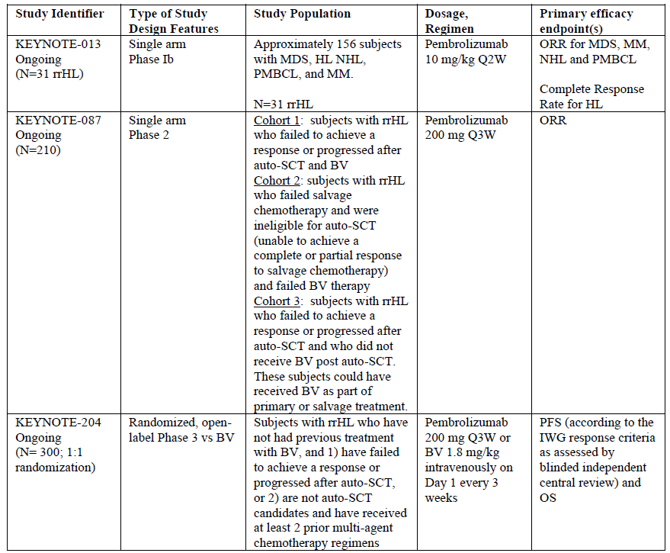
The submission included:
- Four interim reports of bioanalytical and analytical methods for human studies: regarding detection of anti-MK-3475 antibodies in human serum in Study KN013 and KN087.
- One pivotal Phase II safety and efficacy clinical study report of pembrolizumab in subjects with relapsed or refractory classical Hodgkin lymphoma: KEYNOTE -087.
- One supportive Phase Ib safety and efficacy clinical study report of pembrolizumab in the cohort of subjects with relapsed or refractory nodular sclerosing or mixed cellularity Hodgkin lymphoma. The entire study was performed in subjects with hematologic malignancies: KEYNOTE -013.
- One PopPK study; Application of Population Pharmacokinetic Model for Pembrolizumab (MK-3475) to Patients with Hodgkin Lymphoma (Protocol 001, 002, 006, 013 and 087)
- One Study of Dose-Tumor size Relationship in Pembrolizumab-(MK-3475) Treated Subjects with Refractory/Relapsed Classical Hodgkin Lymphoma (rrcHL) From Protocols KN013 and KN087.
- One Study of Pharmacokinetics of Pembrolizumab in First-Line NSCLC on Protocol 024.
- Literature references.

Paediatric data
There were no paediatric data provided. There was no paediatric development plan.
A Pediatric Waiver was granted by the FDA on 21 January 2016.
A Pediatric Investigation Plan covering the condition ‘Treatment of Hodgkin Lymphoma’ was adopted by EMA for pembrolizumab on 01 August 2016 (EMEA-001474-PIP02-16).

Good clinical practice
The clinical study reports for KN013 and KN087 include the following statement:
This trial was conducted in substantial conformance with GCP requirements and applicable country and/or local statutes and regulations regarding ethical committee review, informed consent, and the protection of human subjects participating in biomedical research.

Pharmacokinetics

Studies providing pharmacokinetic data
No designated pharmacokinetics studies but sparse samples (see below) for pharmacokinetic analysis and immunogenicity samples were collected in KN013 (10 mg/kg Q2W) and KN087 (200 mg Q3W).

Evaluator’s conclusions on pharmacokinetics
Overall, the proposed dose of 200 mg every 3 weeks (Q3W) is supported by data in rrcHL subjects along with evidence in melanoma, NSCLC and HNSCC subjects. Pembrolizumab pharmacokinetics are consistent across indications and are typical for therapeutic monoclonal antibodies with low clearance and limited volume of distribution. Pembrolizumab has a low potential to elicit the formation of anti-drug antibodies.

Pharmacodynamics
There was no new information regarding pharmacodynamics.

Dosage selection for the pivotal studies

Proposed 200 mg Q3W Dosing Regimen
A dosing regimen of 200 mg Q3W is recommended for pembrolizumab in the treatment of rrcHL. The proposed 200 mg Q3W regimen was included in the rrcHL trial KN087. The basis for this and the evaluator’s discussion of dosage selection is detailed in Attachment 2.

Evaluator’s conclusions on dose finding for the pivotal studies
The sponsor has demonstrated that the proposed fixed regimen of 200 mg IV Q3W is acceptable by showing that exposure is maintained within previously established therapeutic window and that efficacy is comparable in cHL, although KN013 is a small study. Safety is also comparable to previous studies in other malignancies using other (higher and lower) doses.

Efficacy

Studies providing efficacy data
- One pivotal Phase II safety and efficacy clinical study report in subjects with relapsed or refractory classical HL: KEYNOTE -087.
- One supportive Phase Ib safety and efficacy clinical study in the cohort of subjects with relapsed or refractory nodular sclerosing or mixed cellularity HL. The entire study was performed in subjects with hematologic malignancies: KEYNOTE -013.

Evaluator’s conclusions on efficacy
The indication population consist of 241 subjects with rrcHL from Phase Ib study KEYNOTE-013 (31 subjects=13%) and the pivotal trial Phase II study KEYNOTE-087 (230 subjects=87%).
In Study KEYNOTE-013 (KN013) the dose is different (10 mg/kg every 2 weeks (Q2W)) from the proposed dose in the PI (200 mg Q3W). This is an interim report.
KEYNOTE-087 (KN087) used the proposed fixed dose of 200 mg Q3W. This is an interim report.
More details of these two studies are provided in Attachment 2.

Background
cHL patients relapsing after second or third line treatment including ASCT have a poor prognosis, so there is a need for improved treatment.
Second and third-line chemotherapy combinations generally achieve complete remission (CR) in 30 to 40 percent of patients with aggressive or resistant disease (cHL). They are frequently used as cytoreductive agents prior to proceeding to high dose chemotherapy and ASCT. Salvage chemotherapy without progression to high-dose chemotherapy and ASCT results in 8 to 10 year overall survival rates of 21 to 27 percent with freedom from treatment failure of 16 percent.
‘The median overall survival (OS) of patients who relapse after ASCT was initially reported to be <1 year. More recent data suggest that the median OS may be closer to 2 years. The availability of novel therapies to treat cHL patients that relapse after ASCT as well as the availability of allogeneic stem cell transplant (SCT) for selected patients may all contribute to this improved OS.’³
The results of Study KN087 indicate that pembrolizumab produces objective responses in a substantial proportion of patients with relapsed/refractory cHL (objective response rate (ORR) 68.1%, CR 21.9%).
High response rates were observed in all three cohorts but the follow-up is very short (7.1 months): Among the 143 subjects with response, a response of at least 3 months in duration was observed in 45 subjects (86.9% by Kaplan-Meier method) and a response of at least 6 months in duration was observed in 4 subjects (65.3% by Kaplan-Meier method). At the time of the data cut-off, 115 (80.4%) responders had ongoing response.
Median PFS is 10.8 months. Overall survival data are not mature.
The efficacy results observed were comparable to brentuximab vedotin (ORR 75%, CR 33%) registered for the treatment of relapsed/refractory cHL.
The dose was higher in KN013 but the efficacy results were comparable in the two trials (KN087/ KN013: ORR 68.1%/58%, CR 21.9%/ 19.4%) making the suggested fixed dose of 200 mg Q3W acceptable with regards to efficacy.
The data are limited in that pembrolizumab has not been compared with a registered agent in a randomised controlled trial. Its place in the therapy of relapsed/refractory cHL is therefore uncertain. However the data clearly indicate that the drug has clinically significant activity in this disease.
The results of KEYNOTE-204 will hopefully demonstrate the place relative to BV: This is an ongoing Phase III, randomised, open-label clinical trial to compare pembrolizumab with brentuximab vedotin in subjects with relapsed or refractory cHL (with and without ASCT). The primary objectives of the study are to compare progression free survival (PFS) by blinded independent central review and OS between treatment arms. Approximately 300 patients will be enrolled to receive either pembrolizumab 200 mg intravenously every 3 weeks or brentuximab vedotin 1.8 mg/kg intravenous every 3 weeks. The trial is recruiting.

Conclusion
ORR is convincing but demonstration of longer Duration of Response (DOR) due to the short follow up of 7.1 month in KN087 is lacking (4 patients have > 6 months DOR). OS data are immature. There are no randomised trials with pembrolizumab in this patients group.

Safety

Studies providing safety data
The main safety data included in the submission were those generated in study KEYNOTE-087. See Attachment 2 Efficacy for further details about this study. No studies assessed safety as the sole primary outcome.

KEYNOTE-087

Primary Objectives
Within each of the 3 specified cohorts with rrcHL and pooled:
- To determine the safety and tolerability of pembrolizumab.
Within each of the 3 cohorts of subjects with rrcHL:
- To evaluate the Objective Response Rate (ORR) of pembrolizumab by blinded, independent central review (BICR) according to the International Working Group (IWG) response criteria.
The primary safety objective of this study was to characterise the safety and tolerability of pembrolizumab in subjects with relapsed or refractory Hodgkin Lymphoma. The primary safety analysis was based on subjects who experienced toxicities as defined by Common Terminology Criteria for Adverse Events (CTCAE) criteria. Safety was assessed by quantifying the toxicities and grades experienced by subjects who have received pembrolizumab, including serious adverse events (SAEs) and Events of Clinical Interest (ECIs).
Safety was assessed by reported adverse events using CTCAE, Version 4.0. The attribution to drug, time-of-onset, duration of the event, its resolution, and any concomitant medications administered was recorded. AEs were analysed including but not limited to all AEs, SAEs, fatal AEs and laboratory changes. Furthermore, the occurrence of a Grade 2 or higher immune-related adverse events (irAEs) were collected and designated as immune-related events of clinical interest.

Other studies
Study KEYNOTE-013 was a multicenter, multi-cohort, Phase Ib trial of pembrolizumab in subjects with haematological malignancies to determine the safety and efficacy of pembrolizumab. Cohort 3 included 31 subjects with rrcHL, which are described in the CSR. See Attachment 2 Efficacy for further details. This study is not described separately in Attachment 2 but is included in the rrcHL group in the integrated analysis of safety where it contributes 31 of the 241 subjects (12.8%).
In the Summary of Safety document the safety data are presented for the two studies in rrcHL combined and for the two populations described in Table 5.
The Reference Population, or Reference Safety Dataset, comprises subjects treated with pembrolizumab in studies KEYNOTE-001 (Part B1, B2, B3, D, C, F1, F2, and F3), KEYNOTE-002 (original phase), KEYNOTE-006 and KEYNOTE-010. This population is included to enable a safety profile comparison of the HL Population to the established safety profile of the non-small cell lung cancer (NSCLC) and melanoma populations, according to the sponsor.

Table 5: Study populations for safety analyses
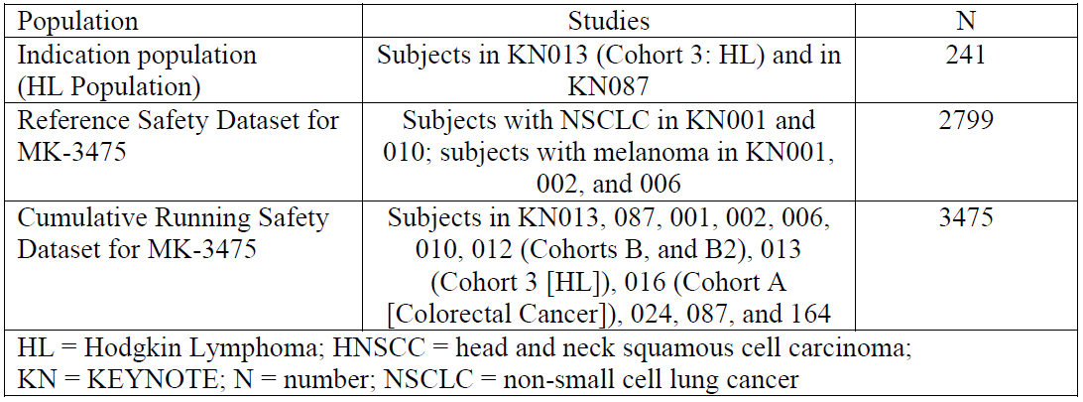
The Reference Safety Dataset is the dataset referred to in the PI. The doses vary from 2 g/kg Q3W, 10 mg/kg Q3W and 10 mg/kg Q2W and as such include doses higher than the proposed dose of 200 mg Q3W for cHL patients.

Patient exposure
The exposure for the two studies in rrcHL (KN013 and KN087), the reference safety dataset and the cumulative running safety dataset is shown in Table 6.
Table 6: Clinical Trial Exposure to Drug by Duration. Subjects Treated with Pembrolizumab (HL and Reference Safety Dataset) (APaT Population)
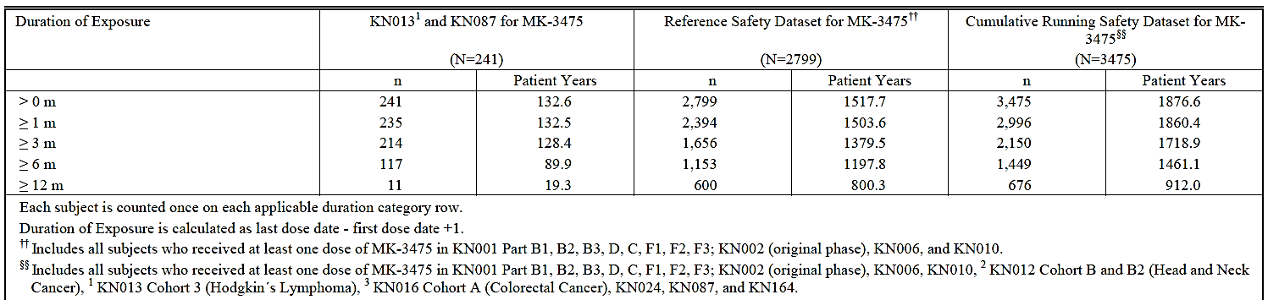

KEYNOTE-087
Duration of exposure was measured from the date of the first dose to the date of the last dose of treatment received.
Subjects were exposed to pembrolizumab for a median of 176 days (range: 1 to 357), resulting in a median of 9 administrations (range: 1 to 18) (Table 7). Overall, 189 of 210 (90.0%) subjects remained on pembrolizumab for ≥ 3 months and 99 (47.1%) remained on pembrolizumab for ≥ 6 months (Table 8). No subject has yet to be exposed to pembrolizumab for 12 months or more.

Table 7: Summary of Drug Exposure by Cohort (ASaT Population, Study KN087)
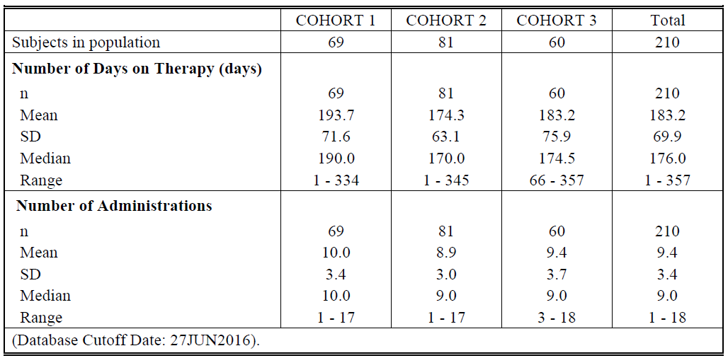

Table 8: Clinical Trial Exposure to Pembrolizumab by Duration (ASaT Population, Study KN087)
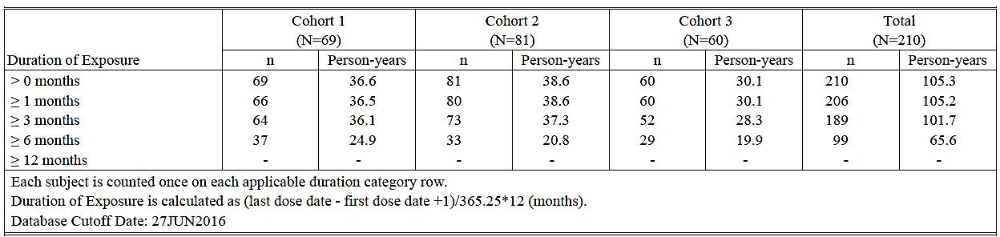

Safety issues with the potential for major regulatory impact
To assess whether laboratory abnormalities represented clinically meaningful changes from baseline, an analysis of the shifts from baseline in the CTCAE grades of laboratory abnormalities (based on the highest CTCAE grade for a given laboratory test during the study) was performed. A clinically meaningful worsening in CTCAE Grade was defined as a shift from less than Grade 3 to Grade 3, 4, or 5; or a shift from Grade 0 to Grade 2.
Clinically meaningful worsening in laboratory CTCAE grades was comparable between subjects in the HL Population and the Reference Population. In the HL Population, the laboratory abnormalities with the most frequent (incidence > 10%), clinically meaningful worsening in CTCAE grade, included phosphate decreased (46 [19.1%]), lymphocytes decreased (31 [12.9%]), and neutrophils decreased (31 [12.9%]). In comparison, the most frequently occurring laboratory abnormalities with a clinically meaningful worsening in CTCAE grades among the 2799 subjects in the Reference Population included phosphate decreased (470 [16.8%]), lymphocytes decreased (438 [15.6%]), and glucose increased (296 [10.6%]). Thus, no change occurred in the safety profile of pembrolizumab with the addition of new data from subjects with HL.
For details of thyroid related AEs and haematological toxicity see Attachment 2 Evaluation of issues with possible regulatory impact.

Postmarketing data
No information was provided in the dossier.

Evaluator’s conclusions on safety
The indication population consisted of 241 subjects with rrcHL from the Phase Ib study KEYNOTE-013 (31 subjects) and Phase II KEYNOTE-087 (230 subjects=87%), who received at least one dose of pembrolizumab. There are no Phase III studies. The median extent of exposure was 5.82 months with 117 patients (48.5%) receiving ≥ 6 months of treatment and 11 patients (4.6%) receiving ≥ 12 months of treatment. Median follow up was 7.4 months.
The dose administered in Study KN013 was 10 mg/kg Q2W and 200 mg Q3W (fixed dose) in KN087, the latter is the dose the sponsor is applying for.
The indication population was compared to the Reference Safety Dataset (also called Reference Population), which consisted of NSCLC and melanoma subjects from earlier studies (2799 subjects). The median extent of exposure was 4.17 months with 1656 patients (41.2%) receiving ≥ 6 months of treatment and 600 patients (21.4%) receiving ≥-12 months of treatment.
The incidence of AEs and drug-related AEs among subjects in the cHL population was overall comparable to that of the Reference Population with no new AEs. The main exceptions were in the preferred term ‘Pyrexia’ and System Organ Class (SOC) ‘Infections’ with twice as many (%) in the cHL population compared to the Reference Dataset. Although not unexpected, the way that that will affect long-term outcome is uncertain due to the short exposure and follow-up in this group. Age ≥ 65 years was a risk factor in the reference population as well as in the cHL population, although the numbers are small (11 subjects) in the latter group.
In the cHL population the adverse events of special interest (AEOSIs), including immune-mediated AEs, were comparable to the reference population apart from there being more cHL subjects with hypothyroidism which can be explained by previous radiation therapy.
The contribution of pembrolizumab to the development of Graft versus host disease (GVHD) in patients receiving allogeneic-SCT is still unclear; more data is needed. The other PD-1 inhibitor on the market, nivolumab, has a warning in the EMA SmPC:
Complications of allogeneic Haematopoietic Stem Cell Transplant (HSCT) in classical Hodgkin Lymphoma
Preliminary results from the follow-up of patients undergoing allogeneic HSCT after previous exposure to nivolumab showed a higher than expected number of cases of acute graft-versus-host-disease (GVHD) and transplant related mortality (TRM). Until further data become available, careful consideration to the potential benefits of HSCT and the possible increased risk of transplant related complications should be made case by case (see section 4.8).
Going through the safety conclusions in the sponsor’s Clinical overview the evaluator agrees with the sponsor’s statements except regarding allogenic SCT and GVHD, which the evaluator believe are unresolved, see above.
The exposure to pembrolizumab is still short with 5.82 months for the cHL population and 4.17 months for the Reference Safety Dataset (Table 9), which makes long term side-effects difficult to evaluate although 600 patients in the Reference Dataset has had >12 months of treatment, so there is some long term data in these patient groups (melanoma and NSCLC). As there are more infections and pyrexia in the cHL population, the effect on long-term outcome is uncertain.
Table 9: Summary of Drug Exposure. Subjects Treated with MK-3475 from KN0131, KN087, KN001, KN002, KN006, KN010, KN0122, KN0163, KN024, and KN164 (APaT Population)
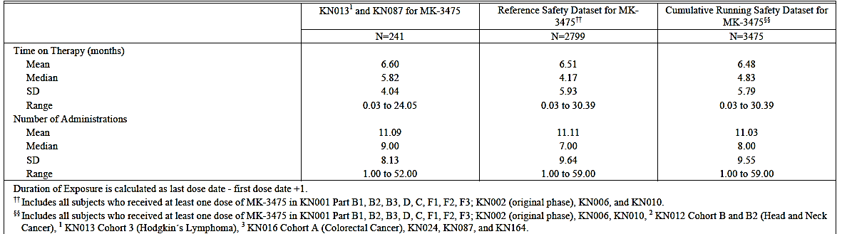

First Round Benefit-Risk Assessment

First round assessment of benefits
The following table summarises the clinical evaluator’s first round assessment of benefits:
Table 10: First round assessment of benefits
Indication
Benefits | Strengths and Uncertainties
There is an unmet need for improvement in cHL pt.’s who progress after ≥ 3 lines of therapy, which this study seem to meet, at least short-term:  ORR of 68.1% and CR 21.9% in the pivotal Study KN087, which is high relative to other treatments and comparable to BV. It is also comparable to nivolumab in cHL patients after ASCT and BV (ORR 68%) and higher than the CR of 8% seen in this study (EMA SmPC).  The smaller phase Ib Study KN013 supports these results. DOR not reached (Range 0.0+ - 8.3+ months) (KN087). | Strength:  Most patients had ≥ 3 lines of therapy and still the ORR and CR were high.  Uncertainties:  No randomised study (no comparator).  Surrogate endpoint: will this result in a longer PFS, DOR and ultimately OS?  The place relative to BV is uncertain mainly due to lack of data from Phase III trials, one of which is ongoing, and due to an heterogeneous Cohort 3, where 40% had <3 prior treatments and 41.7% had BV pre-ASCT and so is difficult to compare to Cohort 1.  Short exposure (5.8 months) and follow-up (7.1 months): Interim report.

First round assessment of risks
The following table summarises the clinical evaluator’s first round assessment of risks:
Table 11: First round assessment of risks
Risks | Strengths and Uncertainties
Well known adverse events of special interest (AEOSIs).  Infections/pyrexia twice that of the Reference Dataset.  More AEs with age > 65 years and few patients in this category  Allo-SCT: potentially heightened risk of GVHD based on anecdotal reports. | Strengths:  Mainly comparable to previously observed AEOSI in large reference dataset (2799).  Uncertainties:  No randomised study (no comparator).  Few patients > 65 years of age in KN087 [19 (9%), 15 of these were in Cohort 2].  Study KN087/interim report: Long-term AEs due to short exposure (5.8 months) and follow-up (7.1 months) are unknown.

First Round Recommendation Regarding Authorisation
Overall, it is considered that the benefits of pembrolizumab outweigh its risks in this patient population although the data is sparse in the elderly population. However, the data submitted with this application are immature. Specific limitations of the data include the following:
- Data on DOR and PFS are not mature.
- There are no randomised comparisons of pembrolizumab against other agents registered for use in the proposed patient population.
The indication proposed by the sponsor is: Keytruda is indicated for the treatment of patients with refractory classical Hodgkin Lymphoma, or those who have relapsed after 3 or more prior lines of therapy. This is a broad indication, which would include patients eligible for treatment with traditional salvage therapy and subsequent ASCT (primary refractory) and without the need for treatment with brentuximab vedotin, which is approved for third line therapy.
It is therefore recommended that pembrolizumab be approved for registration but with a more restricted indication than the one proposed by the sponsor:
Keytruda as monotherapy is indicated for the treatment of adult patients with relapsed or refractory classical Hodgkin lymphoma (cHL):
- following autologous stem cell transplant (ASCT) or
- following at least two prior therapies when ASCT or multi-agent chemotherapy is not a treatment option.

First round recommendation regarding authorisation
It is recommended that the application be approved but with the restricted indication outlined above and with a warning regarding the heightened risk of infections in the elderly population (> 65 years of age) including sparse data in this population.

Second Round Evaluation of clinical data submitted in response to questions
For details of the clinical questions raised, sponsor’s responses and the evaluation of these responses please see Attachment 2.

Second Round Benefit-Risk Assessment

Second round assessment of benefits
There is no change to the overall benefits as set out at the first round evaluation stage.

Second round assessment of risks
There is no change to the overall assessment of risks as set out at the first round evaluation stage.

Second round assessment of benefit-risk balance
There is no change to the overall benefit-risk balance as set out at the first round evaluation stage.

Second round recommendation regarding authorisation
It is recommended that pembrolizumab for cHL is approved with the updated indication:
Keytruda as monotherapy is indicated for the treatment of adult patients with relapsed or refractory classical Hodgkin lymphoma (cHL):
- following autologous stem cell transplant (ASCT) or
- following at least two prior therapies when ASCT or multi-agent chemotherapy is not a treatment option.
The approval of this indication is on the basis of objective response rate (ORR). Data on progression free and overall survival is limited.
and with modifications of the PI and Consumer Medicine Information (CMI) which all relate to safety issues (pyrexia and infections).

VI. Pharmacovigilance findings

Risk management plan
- The currently implemented Keytruda Risk Management Plan is Core-RMP version 10.0, 20 September 2016; data lock point (DLP) 27 June 2016 with Australian Specific Annex (ASA) version 6.0, 17 January 2017. This was approved in the evaluation of the extension of indications to include the treatment of head and neck squamous cell carcinoma.
- This evaluation will consider the most recent Keytruda Risk Management Plan submitted to the TGA by Merck Sharpe Dohme (Australia) Pty Ltd: Core-RMP version 13.0, 6 March 2017; DLP 8 December 2017 with ASA version 8.0 (updated with revised additional risk minimisation tools), 17 March 2017.
- The focus of this evaluation is on new safety related information, changes between the RMP versions and changes to the additional risk minimisation activities. A reconciliation of unresolved recommendations from previous evaluations is also provided.
- The sponsor’s proposed list of Safety Concerns and their associated risk monitoring and mitigation strategies are summarised below (Table 12). Changes since the previous evaluation are shown in bold.
Table 12: Summary of ongoing safety concerns
R=routine and A=additional
Safety concerns (ASA version 8.0) |  | Pharmacovigilance |  | Risk Minimisation
 |  | R | A | R | A
Important identified risks | Immune-mediated pneumonitis |  | *
Important identified risks | Immune-mediated colitis |  | *
Important identified risks | Immune-mediated hepatitis |  | *
Important identified risks | Immune-mediated nephritis |  | *
Important identified risks | Immune-mediated endocrinopathies  Hypophysitis (including hypopituitarism and secondary adrenal insufficiency)  Thyroid disorder (hypothyroidism, hyperthyroidism, thyroiditis)  Type 1 diabetes mellitus |  | *
Important identified risks | Severe skin reactions, including Stevens-Johnson syndrome (SJS) and Toxic Epidermal Necrolysis (TEN) |  | * |  | + DHCP letter
Important identified risks | Other immune mediated adverse reactions  Uveitis  Myositis  Guillain-Barre syndrome  Pancreatitis  Solid organ transplant rejection following Pembrolizumab treatment in donor organ recipients  Myocarditis |  | *
Important identified risks | Infusion-related reactions |  | *
Important potential risks | Immune mediated adverse events  Myasthenic syndrome |  | * | ‘n/a’ | –
Important potential risks | Immune mediated adverse events  For haematological malignancies: increased risk of severe complications of allogenic stem cell transplantation in patients who have previously received pembrolizumab |  |  | X | -
Important potential risks | Immunogenicity |  |  |  | –
Missing information | Safety in patients with moderate or severe hepatic impairment |  | – |  | –
Missing information | Safety in patients with severe renal impairment |  | – |  | –
Missing information | Safety in patients with active systemic autoimmune disease |  | – |  | –
Missing information | Safety in patients with HIV or Hepatitis B or Hepatitis C |  | – |  | –
Missing information | Safety in paediatric patients |  | - |  | -
Missing information | Reproductive and lactation data |  | * |  | -
Missing information | Safety in various ethnic groups |  | - | ‘n/a’ | -
Missing information | Potential pharmacodynamic interaction with systemic immunosuppressants |  | - |  | -
Missing information: ‘Long term safety’ has been deleted by the sponsor without adequate justification.
Key:
* Enhanced routine pharmacovigilance with the use of structured targeted follow-up questionnaires
X Risk minimisation content in PI/CMI considered to be inadequate
‘n/a’ Listed by the sponsor in the ASA as ‘n/a’
‘n/a’ Listed by the sponsor in the ASA as ‘n/a’; however, listed in the adverse events section of PI.

Pharmacovigilance activities
- Routine pharmacovigilance is proposed for all concerns, with the use of targeted follow up questionnaires for all the important identified risks and for the important potential risk: ‘Myasthenic syndrome’.
- Monitoring and analysis of safety data from the ongoing trials is listed as additional pharmacovigilance for all safety concerns; this includes monitoring of immunogenicity which will be assessed in anti-drug antibody assessments.
- No paediatric investigation plan is described in the Core-RMP with ASA.

Risk minimisation activities
Routine and additional risk minimisation activities are implemented to mitigate all the important identified risks, including:
- Educational materials for HCPs – updated, including a new ‘Adverse event management guide’. Further revision is recommended.
- Patient Alert cards – updated
- Patient educational brochure – updated
- Digital online/Apple store app educational tools – [not evaluated]
- Dear Healthcare Professional Letter addressing the new important identified risk of Severe Skin reactions

RMP evaluator recommendations

Safety Specification
Any safety concerns identified by the Clinical or Nonclinical Evaluators that impact on the safety specifications should be addressed in a revised RMP.
The following safety concerns should be added, or their removal justified:
- Add Important identified risk: ‘Encephalitis’
- Add important identified risk: ‘Sarcoidosis’
- Justify the removal of Missing Information: ‘Long term safety data’ from the list of safety concerns in the Core-RMP with ASA.

Administrative
Submit the current EU-RMP to TGA for reference, including the current approved EU-additional risk minimisation materials and a summary of all important differences between the current EU-RMP and the Core-RMP with ASA

Risk Minimisation plan
The additional risk minimisation tools should address the following safety concerns adequately:
- cHL specific increased risk of severe complications of allogenic stem cell transplantation in patients who have previously received pembrolizumab
- Solid organ transplant rejection following Pembrolizumab treatment in donor organ recipients

VII. Overall conclusion and risk/benefit assessment
The submission was summarised in the following Delegate’s overview and recommendations:

Quality
There was no requirement for a quality evaluation in a submission of this type.

Nonclinical
There was no requirement for a nonclinical evaluation in a submission of this type.

Clinical
The clinical evaluator’s views are presented in the clinical evaluation report (CER) round 2 (Attachment 2). Taking into consideration the proposed amended indication (see below), the limited data in the elderly population and the immature data presented; the evaluator recommends that the benefits of pembrolizumab outweigh the risks in this patient population and that the application be approved.
The evaluator recommended that the initial proposed indication should be narrowed on the basis that it would include patients eligible for treatment with traditional salvage therapy and subsequent ASCT (primary refractory) and without the need for treatment with brentuximab vedotin, which is approved for third line therapy. As a result, the evaluator recommended a more restricted indication:
Keytruda as monotherapy is indicated for the treatment of adult patients with relapsed or refractory classical Hodgkin Lymphoma (cHL) following autologous stem cell transplant (ASCT) or following at least two prior therapies when ASCT or multi-agent chemotherapy is not a treatment option.
The Delegate has proposed a further amendment to this indication (see discussion section below).

Overview of data
The clinical data package included one pivotal Phase II single-arm study investigating safety and efficacy of pembrolizumab in subjects with relapsed or refractory classical Hodgkin Lymphoma (KEYNOTE 087). This was supported by Phase Ib safety and efficacy study of pembrolizumab in a cohort of subjects with relapsed or refractory nodular sclerosing or mixed cellularity Hodgkin lymphoma (KEYNOTE 013). A population PK study titled ‘Application of Population Pharmacokinetic Model for Pembrolizumab (MK-3475) to Patients with Hodgkin Lymphoma’ was also submitted. In addition to this, the dossier included the following:
- Four interim reports of bioanalytical and analytical methods for human studies: regarding detection of anti-MK-3475 antibodies in human serum in Study KN013 and KN087.
- One Study of Dose-Tumor size Relationship in Pembrolizumab-(MK-3475) Treated Subjects with Refractory/Relapsed Classical Hodgkin Lymphoma (rrcHL) From Protocols KN013 and KN087.
- One Study of Pharmacokinetics of Pembrolizumab in First-Line NSCLC on Protocol 024.
- Literature references.
The sponsor provided a table summarising the studies in Hodgkin Lymphoma. This included reference to KEYNOTE-204, a randomised, open-label Phase III study of pembrolizumab versus BV in the setting of rrHL. The primary endpoints are PFS and OS and the current status is listed as ‘ongoing’ (see Table 13 below).
Table 13: Descriptive statistics of observed peak and trough concentrations (Cycle 1) in HL patients at 200 mg and Q3W and predicted peak and trough concentrations in melanoma and NSCLC patients at the same dose regimen
Question for Sponsor: Is an update available on the current status of KEYNOTE 204 including expected study completion and data submission?

Pharmacology
Serum pembrolizumab measurements using a sparse sampling model were obtained for both KN013 (pembrolizumab dose of 10 mg/kg Q2W) and KN087 (pembrolizumab dose of 200 mg Q3W). See Attachment 2 Pharmacokinetics and population PK report dated September 2016. Results were combined with data from other studies to develop the population PK model.
A relatively small number of subjects with cHL at the proposed dose of 200 mg Q3W contributed to the population PK pooled analysis dataset. A total of 8.52% of subjects in the data set were diagnosed with cHL and treated at the proposed dose (that is, subjects from Study KN087). This constituted 10.2% of the total PK observations in the data set.
The sponsor’s overall conclusions based on the population PK model are that:
- Pembrolizumab exposures are similar between HL and solid tumour indications and;
- The previously developed population PK model adequately describes the clinical pharmacokinetics of pembrolizumab in HL patients.
The basis for these conclusions is presented in the descriptive statistics of overall peak and trough concentrations in Table 14 below.
Table 14: Descriptive statistics of observed peak and trough concentrations (Cycle 1) in HL patients at 200 mg and Q3W and predicted peak and trough concentrations in melanoma and NSCLC patients at the same dose regimen
However, compared to the analysis with predicted descriptive statistics presented above, the analysis presented in report does indicate some differences in pharmacokinetics for the cHL population at a dose of 200 mg Q3W. Based on this observed data, there is an increase in C_{min} for cHL at 200 mg Q3W dosing compared to that for NSCLC and HNSCC at the same dose level (see Figure 1).
Figure 1: Comparison of distributions of observed trough concentrations (after cycle 1) between indications and dose regimens
This finding based on observed data has not been identified or discussed in the sponsor’s population pharmacokinetic report. In particular, the clinical significance of this finding is not known. Furthermore, steady-state data appears more limited with a small number of data points included in the analysis.
Data on other pharmacokinetic parameters such as clearance and an exposure-response analysis in cHL has not been provided.

Dose-tumour size analysis
A dose-tumour size analysis was submitted which was designed to explore the relationship between pembrolizumab dose and the anti-tumour response measured as the change from baseline of the sum of the area of index lesions in subjects with rrCHL. A graphical analysis was performed to evaluate the best overall change in tumour size versus dose (see Figure 2 below). The sponsor concluded that there is no dose-dependency in tumour size responses in rrcHL subjects treated with pembrolizumab at doses between 200 mg Q3W and 10 mg/kg Q2W. The sponsor also concluded that in KN087 the ORR observed at 200 mg Q3W is similar to that observed in KN013 at 10 mg/kg Q2W. However, the ORR observed at 200 mg Q3W in Study KN087 was 68.1% (95% CI 61.3 to 74.3), which is higher than that observed in Study KN013 (10 mg/kg Q2W) with an ORR of 58.1% (95% CI 39.1 to 75.5). The small number of patients in Study KN013 also limits the interpretation of this result.
Figure 2: Distribution of best overall individual percent change from baseline in tumour size by protocol and dose regimen
As a result of these pharmacokinetic differences in cHL based on the available data; additional wording is suggested in the Pharmacokinetics section of the Australian PI.

Efficacy
Efficacy in cHL is claimed based on the results described in the Interim Clinical Study Reports for the Phase II study KEYNOTE 087 and a Phase I study KEYNOTE 013, in a total of 241 subjects (230 subjects from KEYNOTE 087 and 31 subjects from KEYNOTE 013).
Interim reports from KEYNOTE 087 and KEYNOTE 013 have been presented as both studies are currently ongoing. Initially, efficacy data was presented with a cut-off date of 27 June 2016 for KEYNOTE 087 and 3 June 2016 for KEYNOTE 013. At the second round evaluation, an ‘Efficacy Update Report’ was submitted (no date) which provides approximately 3 months additional follow-up for KEYNOTE-087 and approximately 3.8 months additional follow-up for KEYNOTE-013. This ‘Efficacy Update Report’ presents data cut-off dates reported as of 25 September 2016 for KEYNOTE-087 and 27 September 2016 for KEYNOTE-013.

Study KEYNOTE 087
This is a Phase II multicentre, single arm, multi-cohort, non-randomised trial of pembrolizumab 200 mg Q3W, in subjects with rrcHL. For a full description of this study, please see Attachment 2).
Subjects meeting eligibility criteria were allocated to one of three cohorts in KEYNOTE-087, depending on their prior disease history and therapy:
- Cohort 1: subjects who failed to respond or progressed after auto-SCT therapy and relapsed or failed to respond after treatment with BV post auto-SCT.
- Cohort 2: subjects who were ineligible for an auto-SCT (unable to achieve a complete or partial response to salvage therapy) and have relapsed after treatment with or failed to respond to BV.
- Cohort 3: subjects who failed to respond to or progressed after auto-SCT and have not received BV post ASCT. These subjects could have received BV as part of primary treatment or salvage therapy. Of note: Twenty-five patients (25/60 or 41.7%) in Cohort 3 had received BV before ASCT (see CER page 25 and 35).
The primary objective of the study was to determine the safety and tolerability of pembrolizumab and to evaluate the objective response rate (ORR) of pembrolizumab by blinded, independent central review (BICR) according to the IWG response criteria, within each of the three cohorts.
Secondary objectives were listed as follows:
- Evaluate ORR of pembrolizumab by investigator assessment according to the IWG response criteria; and additionally by BICR using the 5-point scale according to the Lugano Classification. Note: this objective has not been analysed or reported at this time (see Attachment 2 for further details).
- Evaluate Complete Remission Rate (CRR) of pembrolizumab by BICR and by investigator assessment according to the IWG response criteria; and additionally by BICR using the 5-point scale according to the Lugano Classification.
- Evaluate Progression Free Survival (PFS) and Duration of Response (DOR) of pembrolizumab by BICR and by investigator assessment according to the IWG response criteria.
- Evaluate the Overall Survival (OS) of pembrolizumab.
A large number of exploratory objectives are listed in the clinical trial protocol, however only one is reported in the current submission (see Attachment 2). This objective was to evaluate changes in health-related quality-of-life assessments (see Attachment 2).
A total of 210 subjects were enrolled and analysed (69 subjects in Cohort 1; 81 subjects in Cohort 2, and 60 subjects in Cohort 3). Median age was 35 years of age (34 years, 40 years and 32 years for Cohort 1, 2 and 3, respectively). All subjects had cHL according to the following subgroups: 169 (80.5%) subjects had nodular sclerosing HL, 24 (11.4%) subjects had mixed cellularity HL, 8 (3.8%) subjects had lymphocyte rich HL, and 5 (2.4%) subjects had lymphocyte depleted HL. All subjects (N=210) were refractory to a previous therapy or had relapsed after ≥ 3 lines of therapy; 145 (69.0%) had relapsed after ≥ 3 lines of therapy and 74 (35.2%) were primary refractory. Subjects in Cohorts 1 and 3 were post ASCT (n = 129 total), and subjects in Cohort 2 (n = 81) had not received an ASCT. A total of 175 (83.3%) subjects had also previously failed to respond to or relapsed after treatment with BV. Seventy-six (36.2%) subjects had prior radiation therapy. The median number of prior lines of therapy was 4.0 (range: 1 to 12) (see Attachment 2).
As of the cutoff date of 27 June 2016, 62 (29.5%) subjects had discontinued study treatment. The primary reason for discontinuation for 24 (11.4%) subjects was disease progression. Discontinuations due to AEs were reported for 8 (3.8%) subjects. Treatment was ongoing in 145 (69.0%) subjects.
Efficacy results for the data cut-off date of 27 June 2016 for the primary study objectives are presented in Attachment 2. Notable findings include:
- The objective Response Rate (ORR) for all subjects across the three cohorts was 68.1% (143/210; 95% confidence interval [CI]: 61.3%, 74.3%) per BICR in the ASaT in all subjects (N=210). This is summarised in 15 below.
Table 15: Summary of Best Overall Response Based on Central Review per IWG (ASaT Population), Study KN087
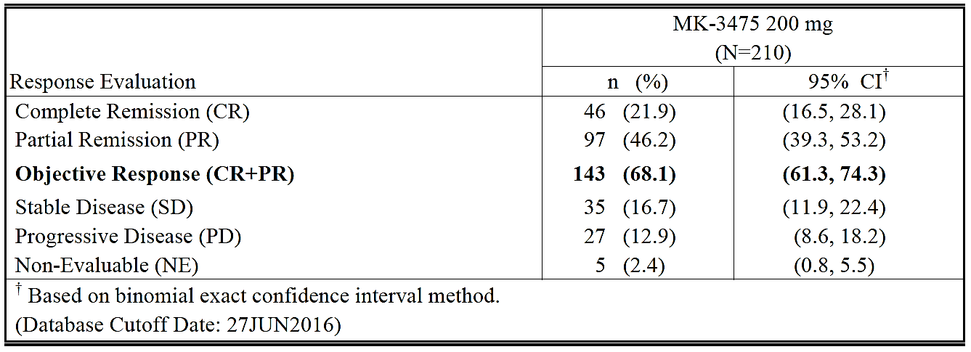
- The ORR for Cohort 1 (Relapsed after ASCT and BV) in the analysed population of 69 subjects was 72.5% (50/69; 95% CI: 60.4%, 82.5%) per BICR (see Attachment 2).
- The ORR for Cohort 2 (SD or worse after salvage therapy and no ASCT and relapsed or refractory to BV at one point) in the analysed population of 81 subjects was 65.4% (53/81; 95% CI: 54.0%, 75.7%) per BICR (see Attachment 2).
- The ORR for Cohort 3 (RR after ASCT but no BV post-ASCT, 41.7% had BV prior to ASCT) in the analysed population of 60 subjects was 66.7% (40/60; 95% CI: 53.3%, 78.3%) per BICR (see Attachment 2). An additional analysis for Cohort 3 is presented below stratified by prior BV status.
- Additional analysis was performed to determine if ORR was consistent across various subgroups (see Attachment 2). Of note, differences in ORR by BICR by number of prior therapies (< 3: n=28 versus ≥ 3: n=182) were minimal. However this was unable to be assessed or difficult to discern in Cohort 1 and 2 due to the large number of 3 prior therapies in these groups. The ORR in subjects with < 3 prior therapies was 64.3% (18/28; 95% CI: 44.1%, 81.4%), while among subjects with ≥ 3 prior therapies, ORR was 68.7% (125/182; 95% CI: 61.4%, 75.3%).
- The additional data submitted at the second round evaluation (cut-off date of 25 September 2016) supported the initial efficacy findings. The ORR was 69.0% per BICR in all subjects with rrcHL (see Table16 below), an increase of 0.9 percentage points (2 subjects) compared to the initial summary document. Four subjects did not have an assessment for response by BICR and were considered non-responders.
  - With further follow-up imaging, there were changes in best overall response obtained. Five subjects (2 in Cohort 1, and 3 in Cohort 3) whose images had previously showed stable disease now met the criteria for partial response. However, 3 subjects, 1 subject in each cohort of KEYNOTE-087, were re-categorised to SD or PD from PR upon re-review of all time-points by BICR including the additional follow-up data. None of the subjects in Cohort 2 demonstrated a response with further follow-up, resulting in a slight decrease in the ORR in Cohort 2 only.
  - Cohort 1: ORR was 73.9% (51/69) per BICR, an increase of 1.4 percentage points (1 subject) compared to the initial summary document.
  - Cohort 2: the ORR was 64.2% (52/81) per BICR, a decrease of 1.2 percentage points (1 subject) compared to the initial summary document.
  - Cohort 3, the ORR was 70.0% (42/60) per BICR, an increase of 3.3 percentage points (2 subjects) compared to the initial summary document.
Table 16: Summary of Best Overall Response Based on Central Review per IWG (ASaT Population), Study KN087
Efficacy results for secondary study objectives (data cut-off date of 27 June 2016 and 25 September 2016) are presented in the CER see Attachment 2. Notable findings include:
- PFS: The median PFS in all subjects per BICR was 10.8 months (95% CI: 8.3 months, not reached). The PFS rate at 3 and 6 months was 86.3% and 71.7%, respectively (see Attachment 2). Differences were noted across the three cohorts. Of note, the median PFS was not reached in Cohorts 1 and 2. Median PFS was 10.8 months in Cohort 3.
  - The data update (25 September 2016) reported the median PFS per BICR was 11.3 months (95% confidence interval: 10.8 months, not reached)
    - In Cohort 1, median PFS was 13.7 months and PFS rate at 9 months was 69.8%
    - In Cohort 2, median PFS not reached and PFS rate at 9 months was 52.9%
    - In Cohort 3, median PFS was 11.3 months and PFS rate at 9 months was 65.7%
- DOR: Subjects were followed for a median of 7.1 months (range 1.0 to 12.1 months). The evaluator notes that the short duration of follow up limits the evaluation of duration of response (see Attachment 2). The median time to response (for all subjects) by BICR was 2.8 months (range 2.0 to 8.1 months), and median DOR was not reached (range 0.0+ to 8.3+ months) (see Attachment 2). Among the 143 subjects with response, a response of at least 3 months in duration was observed in 45 subjects (86.9% by Kaplan-Meier method), and a response of at least 6 months in duration was observed in 65.3% (Kaplan-Meier method) (see Attachment 2).
  - The additional data cut off (25 September 2016) median follow-up was 10.1 months (range 1.0 to 15.0 months). Median DOR was reached at 11.1 months. A total of 69 (47.6%) subjects had an ongoing response by BICR, including 28 subjects (19.3%) with ongoing response ≥ 6 months. The median time to response by BICR was 2.8 months (range 2.1 to 8.8 months)
  - Differences in DOR in the updated data were noted across cohorts in KEYNOTE 087. In Cohort 1: Median DOR was 8.7 months (0.0+ to 11.1 months). In Cohort 2 median DOR was not reached and in Cohort 3 median DOR was 8.5 months (0.0+ to 8.7+ months).
  - Differences in response duration ≥ 6 months were noted. In Cohort 1, 82.2% or 13 subjects (Kaplan-Meier method) had response duration of ≥ 6 months. In Cohort 2, 70.0% (Kaplan-Meier method) or 9 subjects had response duration of ≥ 6 months and in Cohort 3, 75.6% (Kaplan- Meier method) or 9 subjects had response duration of ≥ 6 months.
- OS: Median OS in all subjects was not reached in either data cut (see Attachment 2).
Table 17: Updated efficacy data from Study KN087.
Response Evaluation Study | MK-3475 200 mg (N=210) |  | MK-3475 200 mg (N=210)
Response Evaluation Study | n (%) | 95% CI | n (%) | 95% CI*
Complete Remission (CR)  Partial remission (PR)  Objective Response (CR+PR)  Stable Disease (SD)  Progressive Disease (PD)  No Assessment (NA) | 46 ( 21.9)  97 (46.2)  143 (68.1)  35 (16.7)  27 (12.9)  5 (2.4) | (16.5, 28.1)  (39.3, 53.2)  (61.3, 74.3)  (11.9, 22.4)  (8.6, 18.2)  (0.8, 5.5) | 47 (22.4)  98 (46.7)  145 (69.0)  31 (14.8)  30 (14.3)  4 (1.9) | (16.9, 28.6)  (39.8, 53.7)  (62.3, 75.2)  (10.3, 20.3)  (9.9, 19.8)  (0.5, 4.8)
Duration of Response (DOR) (median, months) | Not reached (0.0+ - 8.3+) | (5.7, Not reached) | 11.1 (0.0+ - 11.1) | (8.7, 11.1)
Database Cutoff Date: | 27 June 2016 |  | 25 September 2016
*Based on binominal exact confidence interval method.

Additional data analysis Cohort 3 KEYNOTE 087
In the sponsor’s response, a summary of efficacy (ORR, DOR, PFS and OS) based on the updated data cut-off (25 September 2016) for KEYNOTE-087 Cohort 3 was provided. The supporting tables were provided in the sponsor’s response. The efficacy results for the subgroups were generally similar.
Table 18: Additional data analysis for Cohort 3 KEYNOTE 087 Summary of efficacy by brentuximab vedotin status Cohort 3
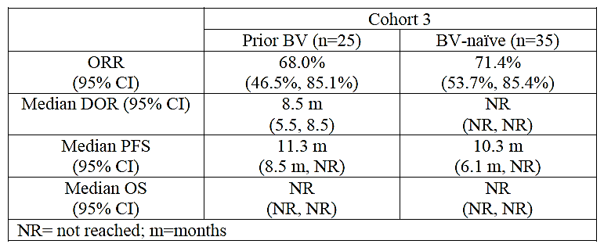
Question for sponsor: Please provide the baseline details of patients in Cohort 3 of KEYNOTE 087 stratified by BV status (including age, sex, etc). Please clarify any differences in outcomes in this cohort and please advise if any update to this data is available. Please provide the TGA with your position on the proposed wording of the indication which includes BV status.

Quality of life
Two questionnaires (European Organisation for Research and Treatment of Cancer Quality of Life Questionnaire Core 30 items [EORTC QLQ-C30] and European Quality of Life Five Dimensions Questionnaire [EQ-5D]), administered electronically, were included in KEYNOTE-087 trial. A total of 182 subjects from the treated population had baseline and 12 week observation data (see Attachment 2). Overall, baseline global health status/QoL score was similar across all response subgroups. There was an overall improvement of 8.5 points (standard error 1.6) compared to baseline. The difference in least squares (LS) means between responders and non-responders at Week 12 was 4.5 points (95% CI: -0.44%, 9.44%; two-sided nominal p = 0.0739) (see Table 19).
Table 19: Analysis of Change from Baseline in EORTC QLQ-C30 Global Health Status/QoL at Week 12 (ASaT Population, Study KN087).
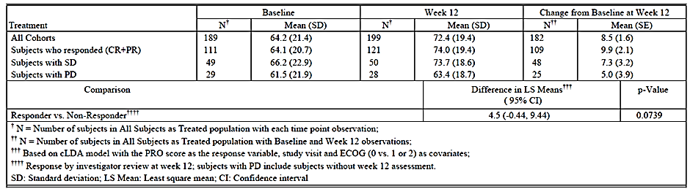
The additional data in the Efficacy Update Report supported these findings, with the difference in least squares (LS) means between responders and non-responders at Week 12 reported to be 4.7 points (95% CI: -0.20%, 9.66%; two-sided nominal p = 0.0600). In the EQ-5D measures, there was an overall improvement of 8.4 points from baseline (SE: 1.4). Improvement was greatest for those with CR/PR (+10.9 points).
This data supports the current available efficacy data and implies a clinically meaningful benefit is possible for patients.
Question for sponsor: Is there a validated minimally important difference (MID) available for these QOL studies?

Study KEYNOTE 013
KEYNOTE 013 is an ongoing study. All data provided in the dossier are based on a 03 June 2016 cut-off date. This study is small (n=31).
Study KEYNOTE-013 is a multicenter, multi-cohort, Phase Ib trial of pembrolizumab in subjects with haematological malignancies to determine the safety and efficacy of pembrolizumab. Subjects were enrolled in five different cohorts determined by disease and disease state.
The dossier provides the results for one cohort with HL (Cohort 3 in KN013), which included a total of 31 subjects with rrcHL who:
- had failed ASCT and failed BV (n=16) (comparable to Cohort 1 in KN087).
- were ineligible for ASCT and failed BV (n=8) (comparable to Cohort 2 in KN087).
- had failed BV and then failed ASCT (n=7) (comparable to 25/60 subjects in Cohort 3 in KN087).
The first rrcHL subject was enrolled (signed informed consent) in the study on 03 December 2013 and the last rrcHL subject was enrolled on 23 July 2014. The subjects were treated with pembrolizumab 10 mg/kg every 2 weeks until documented disease progression, unacceptable adverse events (AEs), intercurrent illness that prevented further administration of treatment, investigator’s decision to withdraw the subject, subject withdrew consent, pregnancy of the subject, noncompliance with trial treatment or procedure requirements, administrative reasons, or receipt of up to 52 doses (approximately 2 years).
The primary objectives of the study were to determine safety, tolerability, and efficacy (complete remission rate [CRR] per the Revised Response Criteria for Malignant Lymphoma (2007) from the International Working Group) of pembrolizumab.
Subjects were 58.1% male and 93.5% white. Median age was 32.0 years. Enrollment was approximately equal between US (51.6%) and ex-US (48.4%) subjects. All subjects were refractory to a previous therapy, or had relapsed after ≥ 3 lines of therapy, and had previously failed treatment with BV. Most of the subjects had nodular sclerosing HL (30 [96.8%]), had a previous ASCT (23 [74.2%]), or were ineligible for ASCT (8 [25.8%]). The median number of prior lines of therapy was 5.0 (range 2 to 15). The key efficacy results are summarised in Table 20 below. Of note, the median duration of follow-up was 24.9 months (7.0 to 29.7 months).

 | All subjects  N=31 | Failed ASCT and failed BV  N=16 | Ineligible for ASCT and failed BV  N=8 | Failed BV and then failed ASCT  N=7
Number of subjects with response (%) (ORR=CR+PR) 95% CI | 18 (58.1)  (39.1, 75.5) | 11 (68.8)  (41.3, 89.0) | 3 (37.5)  (8.5, 75.5) | 4 (57.1)  (18.4, 90.1)
-Complete remission (%)(CR) 95% CI | 6 (19.4)  (7.5, 37.5) | 3 (18.8)  (4.0, 45.6) | 2 (25.0)  (3.2, 65.1) | 1 (14.3)  (0.4, 57.9)
-Partial remission (%)(PR) 95% CI | 12 (38.7)  (21.8, 57.8) | 8 (50.0)  (24.7, 75.3) | 1 (12.5)  (0.3, 52.7) | 3 (42.9)  (9.9, 81.6)
DOR – Median (months)  (Range)95% CI | Not reached  (2.1 -21.4+) (3.7, not reached) | Not reached  (2.1 -21.4+)  (3.7, not reached) | Not reached (0.0+ - 19.1+)  (3.4, not reached) | 14.7  (1.4+, 14.7)  (not reached, not reached)
Subjects with response ≥ 6 Months (%) | 9 (80.0) | 7 (81.8) | 1 (50.0) | 1 (100)
Subjects with response ≥ 12 Months (%) | 7 (70.0) | 5 (68.2) | 1 (50.0) | 1 (100)
Median PFS (months) 95% CI | 11.4  (4.9, not reached) | ND | ND | ND
At the database cut-off of 3 June 2016 there were 4 (22.2%) patients with an ongoing response. Median OS was not reached. OS rate at 12 months was 87%. OS was not analysed by transplant status.
The data presented in the Efficacy Update Report (data cut-off reported as 27 September 2016) was supportive of the above efficacy results. ORR remained at 58.1% per BICR and the median PFS remained at 11.4 months (CI 4.9-27.8 months). Of note, the median time to response by BICR was 2.8 months (range 2.4 to 8.6 months) and median DOR was not reached as in the initial summary document (range 0.0 + to 26.1+ months).

Safety
A total of 241 patients with rrcHL were included in the safety analysis and received at least 1 dose of pembrolizumab. This comprised a total of 210 patients from the Phase II study KEYNOTE-087 (87%, dose pembrolizumab 200 mg Q3W) and 31 subjects from the Phase Ib study KEYNOTE-013 (dose 10 mg/kg Q2W). Corresponding to the data cut for each study, the initial pooled analysis included data cut dates of 3 June 2016 and 27 June 2016. At the second round evaluation, a ‘Safety Update Report’ was submitted which included data cut dates 27 September 2016 and 25 September 2016.
Of note, the first pooled analysis (data cut dates of 3 June 2016 and 27 June 2016) compared the Reference Safety Dataset (also called Reference Population – discussed in more detail below). The Safety Update Report (data cut dates 27 September 2016 and 25 September 2016) did not make this comparison. Therefore, any update to this Reference Safety Dataset has not been included in this dossier and all data for rrCHL has been compared to the same Reference Safety Dataset.
For ease of reading, the two pooled datasets are discussed in detail in this overview. Key points from each individual study are also included where relevant. For a detailed evaluation of the safety dataset please see Attachment 2.
Overall, based on the initial pooled data cut (reported dates 3 June 2016 and 27 June 2016) the median extent of exposure in patients with rrcHL was 5.82 months with 117 patients (48.5%) receiving ≥ 6 months of treatment and 11 patients (4.6%) receiving ≥ 12 months of treatment. Median follow up was 7.4 months. The ‘Safety Update Report’ provided an approximate additional 3 months and 4 administrations. Median exposure was reported to be 8.28 months. Of the 241 subjects with rrcHL, 219 (90.9%) remained on pembrolizumab for ≥ 3 months (an increase of 5 subjects), 169 (70.1%) for ≥ 6 months (an increase of 52 subjects), and 26 (10.8%) for ≥ 12 months (an increase of 15 subjects).
The first pooled analysis compared the indication population to the Reference Safety Dataset (also called Reference Population), which consisted of NSCLC and melanoma subjects from earlier studies (2799 subjects). The doses of pembrolizumab vary in this dataset from 2 g/kg Q3W, 10 mg/kg Q3W and 10 mg/kg Q2W (see Attachment 2). The median extent of exposure was 4.17 months with 1656 patients (41.2%) receiving ≥ 6 months of treatment and 600 patients (21.4%) receiving ≥ 12 months of treatment.
Key results from individual studies (where relevant) are noted here for ease of discussion.
- Overall, the clinical evaluator states that no new adverse events were identified in the Indication Population (IP) compared to the Reference Population (RP).
- A total of 232/241 (96.3%) of patients in the IP reported one or more adverse event compared to 97.4% in RP (see Table 2121). Of note, patients in Cohort 2 of KEYNOTE-087 had a higher overall rate of adverse events than both the IP and RP, at 97.5% (79/81 subjects). The Safety Update Report did not provide analysis by cohort for KEYNOTE-087.
- Differences in the rates of adverse events for the indication population can be seen compared to the Reference Population. See of note:
  - Pyrexia was higher in both pooled datasets. The Safety Update Report demonstrated pyrexia in 58/241 patients (24.1%) in the IP compared to 12.8% of the RP (see Table 2121).
    - The increased rate of pyrexia was noted across all three cohorts of KEYNOTE-087. The highest rate was seen in Cohort 1 at 29% (20/69 subjects). This correlated with increased rates of infections (see below).
  - Hypothyroidism occurred in 34/241 patients (14.1%) in the IP compared to 8.4% of the RP (see Table 21).
    - The increased rate of hypothyroidism was noted across all three cohorts of KEYNOTE-087. The highest rate was seen in Cohort 3 at 16.7% (10/60 subjects).
    - The sponsor comments that the observed frequency of hypothyroidism in the rrcHL population is likely related to the significant proportion of subjects who received radiation to the neck and/or mediastinum, and reflects the increased risk for hypothyroidism in this population.
Question for sponsor: Is an analysis available based on history of radiation and/or baseline thyroid status?
  - Upper respiratory tract infections occurred in 30/241 (12.4%) of the IP compared to 6.5% of the RP (see Table 21).
    - The increased rate of upper respiratory tract infections was particularly noted in Cohort 1 of KEYNOTE-087 at 18.8% (13/69 subjects).
  - Vomiting occurred in 38/241 (15.8%) of the IP compared to 13.8% of the RP (see Table 21).
  - Multiple adverse events increased in rate between the first and second data submissions (see Table 21). This included increased rates of rash (increased by 5 events to 12%), fatigue (increased by 10 events to 19.9%), and diarrhoea (increased by 5 events to 19.9%).
- Serious adverse events occurred in 15.4% in the IP (37/241) compared to 37.2% in the RP. This increased to 18.7% (45/241) in the updated dataset. A total of 6.2% reported serious drug-related adverse events compared to 10.0% in the RP.
- The overall incidence of drug-related AEs was lower among subjects in the IP than in the RP (65.6% versus 73.7% respectively). This increased to 68.5% in the updated dataset (see Table 21). However:
  - The incidence of drug-related AEs varied between populations in the IP Population, with Cohort 1 of study KEYNOTE-087 demonstrating a higher rate comparted to Cohort 2 (71.0% versus 58.0% respectively).
  - The incidence of certain drug-related adverse events was higher compared to the RP in both data sets. Of note:
    - The incidence of blood and lymphatic system disorders was higher in the IP compared to the RP (5.8% versus 5.6% respectively). This increased to 6.2% in the updated dataset.
    - The incidence of endocrine disorders was higher in the IP compared to the RP (12.9% versus 10.9% respectively). This increased to 14.5% in the updated dataset.
    - The incidence of infections and infestations was higher in the IP compared to the RP (10.0% versus 4.6% respectively). This increased to 10.4% in the updated dataset. Similarly the incidence of drug-related SAE’s relating to infections and infestations were higher at 1.7% versus 0.7%.
    - The incidence of cough was higher in the IP compared to the RP (5.0% versus 4.0 respectively). This increased to 5.4% in the updated dataset.
    - The incidence of drug-related pneumonitis occurred more frequently in the IP compared to the RP (1.7% versus 1.6% respectively).
- Discontinuation occurred in 4.6% of subjects in the IP (11/241) compared to 11.9% in the RP. This increased to 5.8% in the updated dataset. The incidence of drug-related AEs that resulted in discontinuation of pembrolizumab was comparable between the HL and RP. Among subjects with HL, 12 of 241 (5.0%) discontinued pembrolizumab due to a drug-related AE, the most common of which was pneumonitis (5/241 or 2.1%). For comparison, 146 of 2799 (5.2%) subjects in the Reference Population had a drug-related AE that resulted in discontinuation of pembrolizumab, the most common of which was also pneumonitis (34 [1.2%]).
- Dose modification due to adverse events occurred in 27.8% of subjects in the IP (67/241) compared to 31.6% in the RP. This increased to 30.7% in the updated dataset.
- No drug-related deaths were reported in the IP population in either dataset. However, two deaths were reported in KEYNOTE-087 (discussed below).
- The clinical evaluator notes that although the adverse events identified in the rrcHL population are not unexpected, it is currently not clear how this will affect long-term safety due to limited exposure and follow-up data currently available in this indicated population.
- Overall, 19 cHL patients who were ≥ 65 years were treated with pembrolizumab. Of these patients, 18 were between 65 and 75; only 1 was ≥ 75 years and there were no patients > 85 years. The rates of drug-related AEs, Grade ≥ 3 AEs, SAE and discontinuation were higher in the ≥ 65 year old cHL subpopulation in comparison to patients younger than 65 years. Although the sponsor’s response is acknowledged, additional information in the PI regarding this group is warranted.
Table 21: Updated safety data from Study KN087 and KN013 compared to the initial data; +3.0 months and 3.8 months
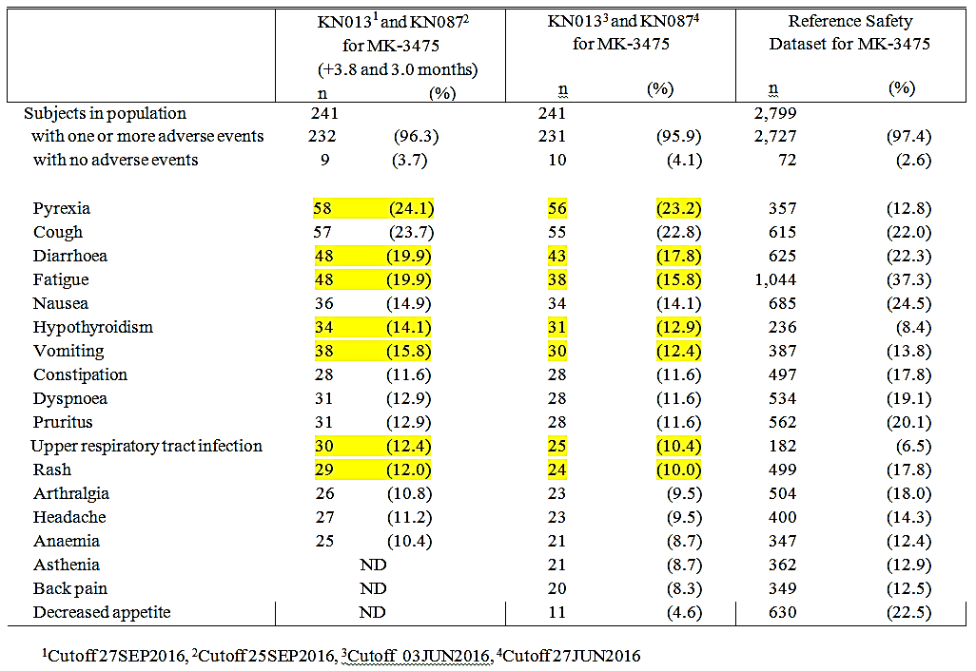

Two deaths occurred during Study KEYNOTE-087. One is listed as septic shock and one from GVHD with both deaths deemed not drug related. The subject with GVHD received 7 doses of pembrolizumab, the last on Day 127, after which the subject was assessed to have CR and then went on to allo-SCT (FC D. 150-153 and cells infused D. 156/D. 0 of transplant). The first signs of GVHD were observed Day 211/Day 55 of transplant and the patient died on Day 258/Day 102. The clinical evaluator notes that there have been theoretical speculations that GVHD might be triggered or exacerbated by checkpoint inhibitors. Singh et al describes a case of fatal GVHD after treatment of relapsed HL (after allo-SCT) with pembrolizumab. Therefore, it is difficult to entirely exclude pembrolizumab from contributing to the GVHD in the patient in Study KN087. The clinical evaluator has recommended an additional statement be included in the PI.
Based on the available data, there are important differences in the safety profile of pembrolizumab for patients with rrcHL. Whilst the Delegate acknowledges the sponsor’s response, it is essential that prescribers are aware of the rates recorded in these clinical trials. Excluding this data may mislead clinicians. As a result, changes to the Adverse Events section of the PI are recommended.
Question for sponsor: Could you please confirm how many patients in each cohort of KEYNOTE-087 required dose modification due to adverse events?
Question for sponsor: Is an update available regarding the number of patients with Grade 3-5 adverse events relating to skin and subcutaneous tissue disorders based on the data cut off of 27 September 2016 and 25 September 2016? This does not appear to be included in the table in the Safety Update Report (utilising incidence > 1%) however the incidence in the previous data set was 1.2%.

Risk management plan
A first-round RMP evaluation is available report dated 27 June 2016. A total of four outstanding recommendations are listed. These are as follows:
- Any safety concerns identified by the Clinical or Nonclinical Evaluators that impact on the safety specifications should be addressed in a revised RMP.
- The following safety concerns should be added, or their removal justified:
- Add Important identified risk: ‘Encephalitis’
- Add Important identified risk: ‘Sarcoidosis’
- Justify the removal of Missing Information: ‘Long term safety data’ from the list of safety concerns in the Core-RMP with ASA.
- Submit the current EU-RMP to TGA for reference, including the current approved EU-additional risk minimisation materials and a summary of all important differences between the current EU-RMP and the Core-RMP with ASA
- The additional risk minimisation tools should address the following safety concerns adequately:
- cHL specific increased risk of severe complications of allogenic stem cell transplantation in patients who have previously received pembrolizumab
- Solid organ transplant rejection following pembrolizumab treatment in donor organ recipients
Question to Sponsor: Please respond to the outstanding issues identified in the RMP report dated 27 June 2016.
No wording for the condition of registration has been proposed by the RMP team at the time of writing this overview.

Risk-benefit analysis

Delegate’s considerations

Efficacy
There is little regulatory guidance for the use of early phase or exploratory studies, rather than Phase III pivotal studies, as the basis for current approval in Australia. The TGA-adopted EMA Guideline on the evaluation of anticancer medicinal products in man acknowledges that it may not be possible to recruit a sufficiently large number of patients to conduct reasonably powered, randomised studies in ‘some truly rare tumours or very narrow indications’. The guideline notes that a ‘small, randomised, reference controlled study’ or ‘a within-patient TTP/PFS analysis (or the combination)’ with TTP on last prior therapy compared with time to progression or death on the experimental therapy ‘might be a better alternative.’ External (including historical) controls are noted ‘where the treatment effect is dramatic and the usual course of the disease highly predictable’. The EMA ‘Guideline on clinical trials in small populations’ notes that surrogate markers cannot serve as final proof of clinical efficacy or long-term benefit.
FDA guidance mentions objective response rates as a surrogate endpoint reasonably likely to predict a clinical benefit and that a significant rate of durable complete response could provide potentially useful additional evidence.
From the available data at this time the pivotal Study KEYNOTE-087 demonstrated an ORR of 69.0% (95% CI 62.3-75.2), with a median duration of response of 11.1 months (0.0+ - 11.1). This suggests that a meaningful clinical benefit is possible for the indicated group of patients. However the results are not sufficient to show overall survival benefit in cHL and no formal comparison can be made to standard of care approaches at this time. A confirmatory Phase III study named KEYNOTE 204 is ongoing (see Table22).

Question for Sponsor: Please clarify the expected submission dates for the final reports for each of the studies listed in Table22.

Table 22: Summary of studies in the Hodgkin Lymphoma clinical development program
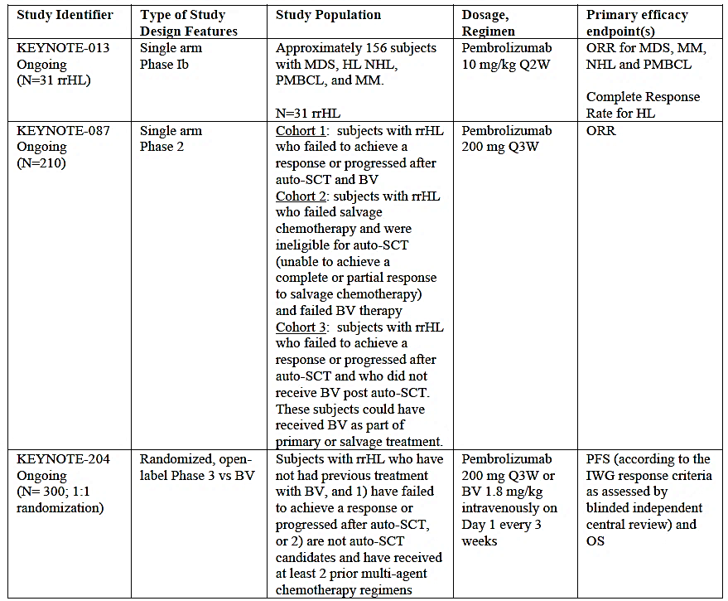

Safety
There is a limited exposure database for the cHL indication. The clinical evaluation suggested a higher frequency of some AE’s in the targeted population compared to the reference population for pembrolizumab which is composed on solid tumours (NSCLC and melanoma). However this is not clearly identified in the PI, with page 27 currently stating ‘Adverse events occurring in patients with cHL were generally similar to those occurring in patients with melanoma or NSCLC.’ Furthermore, (the current) Table 8 in the PI regarding immune-mediated adverse reactions lists the pooled rate of hypothyroidism at 8.5% with a footnote stating ‘In patients with cHL (n=241) the incidence of hypothyroidism was 14.1% (all Grades) with 0.4% Grade 3.’ Additional changes are proposed to the adverse events section of the PI.
The possible increased risk of transplant-related complications of allogeneic-HSCT following pembrolizumab treatment can also not be excluded, with one death noted in KEYNOTE-087 related to GVHD. This death was listed as not drug related.
Pembrolizumab is registered in Australia for other indications and has a cumulative running safety data set of 3475 patients. Pharmacovigilance and risk minimisation systems are currently in place in Australia and overseas. This includes routine and additional risk minimisation activities which have been updated for the proposed new indication in rrcHL. These activities include:
- Educational materials for HCPs
- Patient Alert cards
- Patient educational brochure
The RMP evaluator has proposed further changes to these materials (see above).

Overall risk-benefit, and indication
Balanced against the immature efficacy results in the pivotal study, there is evidence from the available studies that a meaningful clinical benefit is possible in relapsed or refractory classical Hodgkin Lymphoma (cHL) following autologous stem cell transplant (ASCT) and brentuximab vedotin (BV) or following at least two prior therapies including brentuximab vedotin (BV) when ASCT or multi-agent chemotherapy is not a treatment option. Of note, the pharmacokinetics and safety profile in cHL may vary from that seen in solid tumours based on the data evaluated. In addition, the possible increased risk of transplant-related complications of allogeneic-HSCT following pembrolizumab treatment cannot be excluded. The available data supports a positive risk-benefit balance for the majority of patients studied; however clear communication in the PI regarding the potential safety risk in the proposed indication is required.
In light of the clinical evaluation report and the sponsor’s response, the following wording of the indication is proposed by the Delegate:
Keytruda as monotherapy is indicated for the treatment of adult patients with relapsed or refractory classical Hodgkin Lymphoma (cHL):
- following autologous stem cell transplant (ASCT) and brentuximab vedotin (BV) or
- following at least two prior therapies including brentuximab vedotin (BV) when ASCT or multi-agent chemotherapy is not a treatment option.
The approval of this indication is on the basis of objective response rate (ORR). See CLINICAL TRIALS.

Summary of Issues
- Wording of proposed indication.
- Apparent differences in the pharmacokinetic and safety profile for the indicated population compared to the reference population for pembrolizumab.
Multiple changes recommended for the Australian PI.

Proposed action
It is the Delegate’s preliminary view that the application for Keytruda (pembrolizumab) should be approved for registration for the treatment of adult patients with relapsed or refractory classical Hodgkin Lymphoma (cHL) following autologous stem cell transplant (ASCT) and brentuximab vedotin (BV) or following at least two prior therapies including brentuximab vedotin (BV) when ASCT or multi-agent chemotherapy is not a treatment option.
However, this view is subject to the advice received from the ACM.

Request for ACPM advice
The committee is requested to provide advice on the following specific issues:
- Can the committee comment on the wording of the proposed indication. With note to the 35 patients in Cohort 3 of KEYNOTE 087 who were BV naïve and in light of the request for further information on this group, is additional amendment to the proposed indication required based on the data presented?
- In light of the Delegate’s proposed PI changes, does the ACM consider that the safety of pembrolizumab (Keytruda) in the proposed new indication is sufficiently well characterised and communicated in the PI?
The committee is also requested to provide advice on any other issues that it thinks may be relevant to a decision on whether or not to approve this application.

Delegate’s questions and recommendations to sponsor
- Please include a statement in the consumer medicines information regarding the risk of fever and infections for patients with cHL.
- Is an update available on the current status of KEYNOTE 204 including expected study completion and data submission? Please clarify the expected submission dates for the final reports for each of the studies listed in Table 22.
- Please provide the baseline details of patients in Cohort 3 of KEYNOTE 087 stratified by BV status (including age, sex, etc). Please clarify any differences in outcomes in this cohort and please advise if any update to this data is available. As noted in the PI recommendations in Attachment 2, please provide the TGA with your position on the proposed wording of the indication which includes BV status.
- Is there a validated minimally important difference (MID) available for these QOL studies?
- Could you please confirm how many patients in each cohort of KEYNOTE-087 required dose modification due to adverse events?
- Is an update available regarding the number of patients with grade 3-5 adverse events relating to skin and subcutaneous tissue disorders based on the data cut off of 27 September 2016 and 25 September 2016? This does not appear to be included in the table in the Safety Update Report (utilising incidence >1%) however the incidence in the previous data set was 1.2%).
- Is an analysis available based on history of radiation and/or baseline thyroid status?
- Please respond to the outstanding issues identified in the RMP report dated 27 June 2016.

Response from Sponsor

TGA Comment 1:
Wording of proposed indication:

Indication proposed by Clinical Evaluator and sponsor following the second round evaluation:
Keytruda as monotherapy is indicated for the treatment of adult patients with relapsed or refractory classical Hodgkin Lymphoma (cHL):
- following autologous stem cell transplant (ASCT) or
- following at least two prior therapies when ASCT or multi-agent chemotherapy is not a treatment option.
The approval of this indication is on the basis of objective response rate (ORR). Data on progression free and overall survival is limited.

Indication proposed by Delegate Overview:
Keytruda as monotherapy is indicated for the treatment of adult patients with relapsed or refractory classical Hodgkin Lymphoma (cHL):
- following autologous stem cell transplant (ASCT) and brentuximab vedotin (BV) or
- following at least two prior therapies including brentuximab vedotin (BV) when ASCT or multi-agent chemotherapy is not a treatment option.
The approval of this indication is on the basis of objective response rate (ORR). See CLINICAL TRIALS.

Sponsor response 1
The sponsor agrees with the indication proposed by the clinical evaluator in the first round evaluation but not with that proposed by the Delegate. The treatment algorithm of Alinari and Blum³ recommends BV prior to PD-1/PD-L1 therapy. It should be noted however that this algorithm predates registration of Keytruda in the United States and Europe for cHL and is therefore in need of re-evaluation.
The outcomes of KEYNOTE-204, an ongoing Phase III trial to evaluate efficacy of Keytruda versus BV in relapsed/ refractory cHL, will provide the statistical power required to confirm superiority of Keytruda over BV. However, the efficacy of Keytruda in relapsed/refractory cHL demonstrated by KEYNOTE-087 supports the use of Keytruda in both BV- relapsed/refractory and BV-naïve patients. Indeed, ‘The efficacy results observed were comparable to brentuximab vedotin (ORR 75%, CR 33%) registered for the treatment of relapsed/refractory cHL’ (see Attachment 2). Likewise, the clinical evaluator notes the ‘ORR of 68.1% and CR 21.9% in the pivotal Study KN087,… is high relative to other treatments and comparable to BV’.
It is worthwhile to note that the TGA approved indication for nivolumab which is restricted to BV- relapsed/refractory patients is supported by data from Cohort B of CHECKMATE-205, wherein all patients received BV following relapse/failure of ASCT. The clinical outcomes for the 35 BV-naïve patients in Cohort 3 of KEYNOTE-087 strongly support the use of Keytruda without the need for prior BV failure. As per response to clinical questions raised, the efficacy data for prior-BV versus BV-naïve patients of cohort 3 are comparable:

Table 23: Efficacy data (ORR, DOR, PFS and OS) for prior-BV versus BV-naïve patients of cohort 3
 | Cohort 3
 | Prior BV (n=25) | BV-naïve (n=35)
ORR (95% CI) | 68.0% (46.5%, 85.1%) | 71.4% (53.7%, 85.4%)
Median DOR (95% CI) | 8.5 m (5.5, 8.5) | NR (NR, NR)
Median PFS (95% CI) | 11.3 m (8.5, NR) | 10.3 m (6.1, NR)
Median OS (95% CI) | NR (NR, NR) | NR (NR, NR)
NR = not reached; m = months
With regard to nivolumab, the clinical evaluator notes that Keytruda ‘… is also comparable to nivolumab in cHL patients after ASCT and BV (ORR 68%) and higher than the CR of 8% seen in this study (EMA SmPC)’.
The availability of either BV or Keytruda for relapsed/refractory patients will enable physicians to decide on the most appropriate treatment for their patients. For example, patients with pre-existing myelotoxicity or neuropathy may need an alternate choice with a drug known not to be associated with these toxicities. As such, sponsor proposes to retain the indication as revised and in agreement with the clinical evaluation report.

TGA Comment 2
Apparent differences in the pharmacokinetic and safety profile for the indicated population compared to the reference population for pembrolizumab.

Sponsor’s response 2
Please refer to the sponsor’s Labeling Response document (not included here).

TGA Comment 3
Multiple changes recommended for the Australian Product Information.

Sponsor’s response 2
Please refer to the sponsor’s Labeling Response document (not included here).

Delegates Request for ACM advice. Response to additional questions

TGA Question 1
Is an update available on the current status of KEYNOTE-204 including expected study completion and data submission?

Sponsor’s response
There is no data available for KEYNOTE-204 at this time. No planned analyses have yet been conducted.
The results of the Phase III study KEYNOTE-204 will not be available until Q2 2021.

TGA Question 2
Please provide the baseline details in patients in cohort 3 of KEYNOTE-087 stratified by BV status (including age, sex, etc). Please clarify any differences in outcomes in this cohort and please advise if any update to this data is available. As noted in the PI recommendations in attachment 2, please provide the TGA with your position on the proposed wording of the indication which includes BV status.

Sponsor’s response Question 2
The baseline subject characteristics by prior BV (yes or no) in Cohort 3 (Table 24) show general similarity across the groups with the exception of the subjects without prior BV have fewer lines of prior therapy than those with prior BV, as might be expected.
There have been no updated analyses of the outcomes of Cohort 3 by BV status since the September 2016 data cut-off. The summary of efficacy for Cohort 3 by BV status is included here (Table 25).
The efficacy results for the subgroups were generally similar.
The sponsor proposes to retain the proposed indication:
Keytruda as monotherapy is indicated for the treatment of adult patients with relapsed or refractory classical Hodgkin Lymphoma (cHL):
- following autologous stem cell transplant (ASCT) and brentuximab vedotin (BV) or
- following at least two prior therapies including brentuximab vedotin (BV) when ASCT or multi-agent chemotherapy is not a treatment option.
The approval of this indication is on the basis of objective response rate (ORR). See CLINICAL TRIALS.
The rationale for retaining the proposed indication is provided in the Sponsor response 1 to TGA comment 1 above.

Table 24: Subject Characteristics By Brentuximab Use for Cohort 3 (ASaT Population)
 | Yes |  |  |  |  | No | Total
 | n |  | (%) | n |  | (%) | n |  | (%)
Subjects in population | 25 |  |  | 35 |  |  | 60
Gender
Male | 14 |  | (56.0) | 20 |  | (57.1) | 34 |  | (56.7)
Female | 11 |  | (44.0) | 15 |  | (42.9) | 26 |  | (43.3)
Age (Years)
<65 | 23 |  | (92.0) | 34 |  | (97.1) | 57 |  | (95.0)
>=65 | 2 |  | (8.0) | 1 |  | (2.9) | 3 |  | (5.0)
Mean | 38.2 |  |  | 35.9 |  |  | 36.8
SD | 15.2 |  |  | 12.0 |  |  | 13.4
Median | 32.0 |  |  | 32.0 |  |  | 32.0
Range | 18 to 73 |  |  | 20 to 67 |  |  | 18 to 73
Race
Asian | 0 |  | (0.0) | 1 |  | (2.9) | 1 |  | (1.7)
Black Or African American | 3 |  | (12.0) | 0 |  | (0.0) | 3 |  | (5.0)
Missing | 1 |  | (4.0) | 0 |  | (0.0) | 1 |  | (1.7)
White | 21 |  | (84.0) | 34 |  | (97.1) | 55 |  | (91.7)
Ethnicity
Hispanic Or Latino | 3 |  | (12.0) | 0 |  | (0.0) | 3 |  | (5.0)
Not Hispanic Or Latino | 17 |  | (68.0) | 31 |  | (88.6) | 48 |  | (80.0)
Not Reported | 3 |  | (12.0) | 1 |  | (2.9) | 4 |  | (6.7)
Unknown | 2 |  | (8.0) | 3 |  | (8.6) | 5 |  | (8.3)
Race Group
White | 21 |  | (84.0) | 34 |  | (97.1) | 55 |  | (91.7)
Non-White | 3 |  | (12.0) | 1 |  | (2.9) | 4 |  | (6.7)
Missing | 1 |  | (4.0) | 0 |  | (0.0) | 1 |  | (1.7)
US Region
US | 14 |  | (56.0) | 5 |  | (14.3) | 19 |  | (31.7)
Ex-US | 11 |  | (44.0) | 30 |  | (85.7) | 41 |  | (68.3)
Disease Subtype
Classical Hodgkin Lymphoma- Nodular Sclerosis | 23 |  | (92.0) | 26 |  | (74.3) | 49 |  | (81.7)
Classical Hodgkin Lymphoma- Mixed Cellularity | 0 |  | (0.0) | 5 |  | (14.3) | 5 |  | (8.3)
Classical Hodgkin Lymphoma- Lymphocyte Rich | 2 |  | (8.0) | 1 |  | (2.9) | 3 |  | (5.0)
 |  | Yes |  |  | No |  | Total
 | n | (%) |  | n | (%) |  | n | (%)
Disease Subtype
Classical Hodgkin Lymphoma- Lymphocyte Depleted | 0 | (0.0) |  | 1 | (2.9) |  | 1 | (1.7)
Missing | 0 | (0.0) |  | 2 | (5.7) |  | 2 | (3.3)
ECOG Performance Status
0 | 14 | (56.0) |  | 15 | (42.9) |  | 29 | (48.3)
1 | 11 | (44.0) |  | 20 | (57.1) |  | 31 | (51.7)
Prior Lines of Therapy Group
>= 3 | 23 | (92.0) |  | 13 | (37.1) |  | 36 | (60.0)
< 3 | 2 | (8.0) |  | 22 | (62.9) |  | 24 | (40.0)
Prior Lines of Therapy
Subjects with data | 25 |  |  | 35 |  |  | 60
Mean | 4.0 |  |  | 3.1 |  |  | 3.5
SD | 1.3 |  |  | 1.9 |  |  | 1.8
Median | 4.0 |  |  | 2.0 |  |  | 3.0
Range | 2.0 to 7.0 |  |  | 2.0 to 10.0 |  |  | 2.0 to 10.0
Refractory or Relapsed After 3 or More Lines
Yes | 25 | (100.0) |  | 35 | (100.0) |  | 60 | (100.0)
Time of relapse since SCT failure Group
>=12 months | 1 | (4.0) |  | 6 | (17.1) |  | 7 | (11.7)
<12 months | 24 | (96.0) |  | 29 | (82.9) |  | 53 | (88.3)
Time of relapse since SCT failure (Months)
Subjects with data | 25 |  |  | 35 |  |  | 60
Mean | 3.2 |  |  | 8.6 |  |  | 6.3
SD | 3.6 |  |  | 14.8 |  |  | 11.8
Median | 1.6 |  |  | 2.8 |  |  | 1.9
Range | 0.4 to 17.2 |  |  | 0.4 to 76.0 |  |  | 0.4 to 76.0
Prior Radiation
Yes | 8 | (32.0) |  | 16 | (45.7) |  | 24 | (40.0)
No | 17 | (68.0) |  | 19 | (54.3) |  | 36 | (60.0)
Bulky Lymphadenopathy
Yes | 2 | (8.0) |  | 1 | (2.9) |  | 3 | (5.0)
No | 23 | (92.0) |  | 34 | (97.1) |  | 57 | (95.0)
Baseline B Symptoms
Yes | 5 | (20.0) |  | 14 | (40.0) |  | 19 | (31.7)
 |  | Yes |  |  | No |  | Total
 | n | (%) |  | n | (%) |  | n | (%)
Disease Subtype
Classical Hodgkin Lymphoma- Lymphocyte Depleted | 0 | (0.0) |  | 1 | (2.9) |  | 1 | (1.7)
Missing | 0 | (0.0) |  | 2 | (5.7) |  | 2 | (3.3)
ECOG Performance Status
0 | 14 | (56.0) |  | 15 | (42.9) |  | 29 | (48.3)
1 | 11 | (44.0) |  | 20 | (57.1) |  | 31 | (51.7)
Prior Lines of Therapy Group
>= 3 | 23 | (92.0) |  | 13 | (37.1) |  | 36 | (60.0)
< 3 | 2 | (8.0) |  | 22 | (62.9) |  | 24 | (40.0)
Prior Lines of Therapy
Subjects with data | 25 |  |  | 35 |  |  | 60
Mean | 4.0 |  |  | 3.1 |  |  | 3.5
SD | 1.3 |  |  | 1.9 |  |  | 1.8
Median | 4.0 |  |  | 2.0 |  |  | 3.0
Range | 2.0 to 7.0 |  |  | 2.0 to 10.0 |  |  | 2.0 to 10.0
Refractory or Relapsed After 3 or More Lines
Yes | 25 | (100.0) |  | 35 | (100.0) |  | 60 | (100.0)
Time of relapse since SCT failure Group
>=12 months | 1 | (4.0) |  | 6 | (17.1) |  | 7 | (11.7)
<12 months | 24 | (96.0) |  | 29 | (82.9) |  | 53 | (88.3)
Time of relapse since SCT failure (Months)
Subjects with data | 25 |  |  | 35 |  |  | 60
Mean | 3.2 |  |  | 8.6 |  |  | 6.3
SD | 3.6 |  |  | 14.8 |  |  | 11.8
Median | 1.6 |  |  | 2.8 |  |  | 1.9
Range | 0.4 to 17.2 |  |  | 0.4 to 76.0 |  |  | 0.4 to 76.0
Prior Radiation
Yes | 8 | (32.0) |  | 16 | (45.7) |  | 24 | (40.0)
No | 17 | (68.0) |  | 19 | (54.3) |  | 36 | (60.0)
Bulky Lymphadenopathy
Yes | 2 | (8.0) |  | 1 | (2.9) |  | 3 | (5.0)
No | 23 | (92.0) |  | 34 | (97.1) |  | 57 | (95.0)
Baseline B Symptoms
Yes | 5 | (20.0) |  | 14 | (40.0) |  | 19 | (31.7)

Table 25: Summary of Efficacy by Brentuximab Vedotin Status, KEYNOTE-087 Cohort 3
 | Cohort 3
 | Prior BV (n=25) | BV-naïve (n=35)
ORR (95% CI) | 68.0% (46.5%, 85.1%) | 71.4% (53.7%, 85.4%)
Median DOR (95% CI) | 8.5 m (5.5, 8.5) | NR (NR, NR)
Median PFS (95% CI) | 11.3 m (8.5 m, NR) | 10.3 m (6.1 m, NR)
Median OS (95% CI) | NR (NR, NR) | NR (NR, NR)
NR= not reached; m=months
 | Cohort 3
 | Prior BV (n=25) | BV-naïve (n=35)
ORR (95% CI) | 68.0% (46.5%, 85.1%) | 71.4% (53.7%, 85.4%)
Median DOR (95% CI) | 8.5 m (5.5, 8.5) | NR (NR, NR)
Median PFS (95% CI) | 11.3 m (8.5 m, NR) | 10.3 m (6.1 m, NR)
Median OS (95% CI) | NR (NR, NR) | NR (NR, NR)
NR= not reached; m=months

TGA Question 3
Is there any validated minimally important difference (MID) available for these QOL studies?

Sponsor’s response Question 3
A minimally important difference (MID) of 10 points has been validated for EORTC QLQ- C30.
A MID of 7 points is considered acceptable for EQ-5D.

TGA Question 4
Is an analysis available based on history of radiation and/or baseline thyroid status?

Sponsor’s response Question 4
There were 34 subjects with treatment-emergent hypothyroidism as described in the Safety Update Report. Of the 34 subjects, 47% (16/34) had prior radiation. As described in the listing in the original filing, most subjects with prior radiation had received it to the mediastinum, cervical lymph nodes, or supraclavicular lymph nodes, which potentially could have involved the thyroid gland.
Of the 34 subjects with hypothyroidism, 5 had elevated TSH at baseline per laboratory tests, and 1 of 34 had a medical history of hypothyroidism

TGA Question 5
Could you please confirm how many patients in each cohort of KEYNOTE-087 required dose modification due to adverse events?

Sponsor’s response Question 5
Tables describing adverse events leading to treatment interruption or discontinuation in KEYNOTE-087 by cohort were provided. Overall 25.7% (54/210) of subjects had treatment interrupted and 5.2% (11/210) of subjects had treatment discontinued due to adverse events, which were similar across the cohorts. For adverse events that were reported as being drug-related, 12.4% (26/210) of subjects had treatment interrupted and 4.3% (9/210) of subjects had treatment discontinued.

TGA Question 6
Is an update available regarding the number of patients with Grade 3-5 adverse events relating to skin and subcutaneous tissue disorders based on the data cut off of 27 September 2016 and 25 September 2016? This does not appear to be included in the Safety Update Report (utilising incidence ≥ 1%) however the incidence in the previous data set was 1.2%.

Sponsor’s response Question 6
The number of subjects with Grade 3-5 adverse events under the System Organ Class (SOC) of Skin and Subcutaneous Tissue Disorders did not change with the updated data (cut-off of September 2016). It remained the same with 3 subjects (1.2%), 1 subject with the preferred term (PT) of ‘Dermatitis psoriasiform’, one subject with ‘Lichenoid keratosis’ and one subject with ‘Skin ulcer’. A summary of all Grade 3-5 AEs based on the September 2016 update, sorted by SOC and regardless of incidence were given. It should be noted that Table 2.7.4: 6 of the SUR presents PTs that have an incidence greater than 1% (in descending order), regardless of SOC categorisation; thus ‘Skin and Subcutaneous Tissue Disorders’ would not appear by design in that table.

TGA Question 7
Please respond to the outstanding issues identified in the RMP report dated 27 June 2016.

Sponsor’s response Question 7
The outstanding issues identified in the RMP report are addressed as follows:
- Add Important Identified Risks encephalitis and sarcoidosis to the RMP.
The marketing authorisation holder (MAH) has added encephalitis and sarcoidosis to the list of Important Identified Risks in the pembrolizumab core RMP v. 14.
- Provide (further) justification for the removal of ‘long-term safety data’ from the list of safety concerns (or reinstate it).
Protocol 001 (melanoma) provided the longest pembrolizumab exposure to date, with a mean exposure of nearly 1 year (347.4 days) across all doses (range of 1 to 1,338 days). The cumulative exposure to pembrolizumab in P001 is 498.9 patient-years for those treated for more than 12 months. Despite the long exposure to pembrolizumab in P001, exposure-adjusted analyses of AEOSIs did not reveal an increase in the incidence of AEOSIs over time, and no new safety signals were observed. Hence, the results from P001 provide evidence that the safety of long term pembrolizumab use is consistent with the known safety profile of pembrolizumab. Based on the evidence provided by the results in P001 for melanoma, the MAH no longer considers long term safety to be missing information; therefore it was removed from the summary of ongoing safety concerns in cRMPv11.0.
- Include GVHD and pyrexia in the Product Information/ CMI (also requested in clinical evaluation report)
Please refer to the Labeling Responses document (not included here).
- Revise HCP/patient materials to include (3), dose modifications for haematological malignancies, solid organ transplant
The sponsor agrees to provide these materials as per proposed labeling document.
- Provide the latest EU-RMP and EU educational materials
MAH will provide an approved EU RMP and EU educational materials as soon as available.

TGA Question 8
Please respond to the outstanding issues identified in the RMP report dated 27 June 2016.

Sponsor’s response Question 8
The outstanding issues identified in the RMP report are addressed as follows:
- Add Important Identified Risks encephalitis and sarcoidosis to the RMP.
The MAH has added encephalitis and sarcoidosis to the list of Important Identified Risks in the pembrolizumab core RMP v. 14.
- Provide (further) justification for the removal of ‘long-term safety data’ from the list of safety concerns (or reinstate it).
Protocol 001 (melanoma) provided the longest pembrolizumab exposure to date, with a mean exposure of nearly 1 year (347.4 days) across all doses (range of 1 to 1,338 days). The cumulative exposure to pembrolizumab in P001 is 498.9 patient-years for those treated for more than 12 months. Despite the long exposure to pembrolizumab in P001, exposure-adjusted analyses of AEOSIs did not reveal an increase in the incidence of AEOSIs over time, and no new safety signals were observed. Hence, the results from P001 provide evidence that the safety of long term pembrolizumab use is consistent with the known safety profile of pembrolizumab. Based on the evidence provided by the results in P001 for melanoma, the MAH no longer considers long term safety to be missing information; therefore it was removed from the summary of ongoing safety concerns in cRMPv11.0.
- Include GVHD and pyrexia in the Product Information/ CMI (also requested in Clinical Evaluation Report)
Please refer to the Labeling Responses document (not included here).
- Revise HCP/patient materials to include (3), dose modifications for haematological malignancies, solid organ transplant
The sponsor agrees to provide these materials as per proposed labeling document.
- Provide the latest EU-RMP and EU educational materials
MAH will provide an approved EU RMP and EU educational materials as soon as available.

TGA Question 9
Please clarify the expected submission dates for the final reports of each of the studies listed in Table 22.

Sponsor’s response Question 9
The final reports for the studies in Hodgkin lymphoma are projected to be: KEYNOTE-013: second half 2018
KEYNOTE-087: second half 2021 KEYNOTE-204: first half 2021

Advisory Committee Considerations
The Advisory Committee on Prescription Medicines (ACPM), having considered the evaluations and the Delegate’s overview, as well as the sponsor’s response to these documents, advised the following:
The ACM taking into account the submitted evidence of efficacy, safety and quality, agreed with the delegate and considered Keytruda powder for solution for infusion, solution for infusion containing 50 mg powder, 100 mg/4mL solution of pembrolizumab to have an overall positive benefit-risk profile for the treatment of adult patients with relapsed or refractory classical Hodgkin Lymphoma (cHL) following autologous stem cell transplant (ASCT) or following at least two prior therapies when ASCT or multi-agent chemotherapy is not a treatment option.

Current approved indications
Keytruda (pembrolizumab) is indicated as monotherapy for the treatment of unresectable or metastatic melanoma in adults.
Keytruda is indicated for the first-line treatment of patients with metastatic non-small cell lung carcinoma (NSCLC) whose tumours express PD-L1 with a ≥ 50% tumour proportion score (TPS) as determined by a validated test, with no EGFR or ALK genomic tumour aberrations.
Keytruda is indicated for the treatment of patients with advanced NSCLC whose tumours express PD-L1 with a ≥ 1% TPS as determined by a validated test and who have received platinum-containing chemotherapy. Patients with EGFR or ALK genomic tumour aberrations should have received prior therapy for these aberrations prior to receiving Keytruda.
Keytruda (pembrolizumab) is indicated for the treatment of patients with recurrent or metastatic head and neck squamous cell carcinoma (HNSCC) with disease progression on or after platinum-containing chemotherapy. This indication is approved based on overall response rate and duration of response. Improvements in overall survival, progression-free survival or health-related quality of life have not been established.

Proposed indication following the second round evaluation:
Keytruda as monotherapy is indicated for the treatment of adult patients with relapsed or refractory classical Hodgkin Lymphoma (cHL):
- following autologous stem cell transplant (ASCT) or
- following at least two prior therapies when ASCT or multi-agent chemotherapy is not a treatment option.
The approval of this indication is on the basis of objective response rate (ORR). Data on progression free and overall survival is limited.

Indication proposed by Delegate:
Keytruda as monotherapy is indicated for the treatment of adult patients with relapsed or refractory classical Hodgkin Lymphoma (cHL):
- following autologous stem cell transplant (ASCT) and brentuximab vedotin (BV) or
- following at least two prior therapies including brentuximab vedotin (BV) when ASCT or multi-agent chemotherapy is not a treatment option.
The approval of this indication is on the basis of objective response rate (ORR). See CLINICAL TRIALS.
In making this recommendation the ACM noted
- wording of proposed indication
- differences in PK and safety profile for indicated population compared to reference population for pembrolizumab.
- multiple changes recommended for the Australian Product Information

Proposed conditions of registration
The ACM agreed with the Delegate on the proposed conditions of registration and advised on the inclusion of the following:
- Subject to satisfactory implementation of the Risk Management Plan most recently negotiated by the TGA,
- Negotiation of the Product Information and Consumer Medicine Information to the satisfaction of the TGA.

Proposed Product Information (PI)/ Consumer Medicine Information (CMI) amendments
The ACM agreed with the Delegate to the proposed amendments to the Product Information (PI) and Consumer Medicine information (CMI) and specifically advised on the inclusion of the following:
- a statement in the Precautions’ section of the PI and relevant sections of the CMI to include to following statement:
Immune-mediated complications, including fatal events, occurred in patients who underwent allogeneic hematopoietic stem cell transplantation (HSCT) after being treated with Keytruda. Of 23 patients with cHL who proceeded to allogeneic HSCT after treatment with Keytruda on any trial, 6 patients (26%) developed graft-versus-host-disease (GVHD), one of which was fatal, and 2 patients (9%) developed severe hepatic veno-occlusive disease (VOD) after reduced-intensity conditioning, one of which was fatal. Cases of fatal hyperacute GVHD after allogeneic HSCT have also been reported in patients with lymphoma who received a PD-1 receptor blocking antibody before transplantation. These complications may occur despite intervening therapy between PD-1 blockade and allogeneic HSCT. Follow patients closely for early evidence of transplant-related complications such as hyperacute GVHD, severe (Grade 3 to 4) acute GVHD, steroid-requiring febrile syndrome, hepatic VOD, and other immune mediated adverse reactions, and intervene promptly.

Specific Advice
The ACM advised the following in response to the Delegate’s specific questions on the submission:
- Can the committee comment on the wording of the proposed indication. With note to the 35 patients in Cohort 3 of KEYNOTE 087 who were BV naïve and in light of the request for further information on this group, is additional amendment to the proposed indication required based on the data presented?
The ACM did not agree that the indication should include reference to BV status and recommended the following wording of indication:
Keytruda as monotherapy is indicated for the treatment of adult patients with relapsed or refractory classical Hodgkin Lymphoma (cHL):
- following autologous stem cell transplant (ASCT) or
- following at least two prior therapies when ASCT or multi-agent chemotherapy is not a treatment option.
The approval of this indication is on the basis of objective response rate (ORR). See CLINICAL TRIALS.
- In light of the Delegate’s proposed PI changes, does the ACM consider that the safety of pembrolizumab (Keytruda) in the proposed new indication is sufficiently well characterised and communicated in the PI?
The ACM agreed to include in the PI under ‘Precautions’ to add the warning statement regarding the use of pembrolizumab in patients undergoing allogeneic transplantation as worded in the ‘Proposed Product Information (PI)/ Consumer Medicine Information (CMI) amendments’ section.
The ACM advised that implementation by the sponsor of the recommendations outlined above to the satisfaction of the TGA, in addition to the evidence of efficacy and safety provided would support the safe and effective use of this product.

Outcome
Based on a review of quality, safety and efficacy, TGA approve the registration of Keytruda containing pembrolizumab (rch) for the new indication:
Keytruda as monotherapy is indicated for the treatment of adult patients with relapsed or refractory classical Hodgkin Lymphoma (cHL):
- following autologous stem cell transplant (ASCT) or
- following at least two prior therapies when ASCT or multi-agent chemotherapy is not a treatment option.
The approval of this indication is on the basis of objective response rate (ORR). See CLINICAL TRIALS.

Specific conditions of registration applying to these goods
The pembrolizumab (rch) Core-Risk Management Plan (Core-RMP), version 13.0, 6 March 2017; DLP 8 December 2016 with Australian Specific Annex version 8.0, 17 March 2017, and any subsequent revisions, as agreed with the TGA will be implemented in Australia.

Attachment 1. Product Information
The PI for Keytruda approved with the submission which is described in this AusPAR is at Attachment 1. For the most recent PI, please refer to the TGA website at <https://www.tga.gov.au/product-information-pi>.

Attachment 2. Extract from the Clinical Evaluation Report

Therapeutic Goods Administration
PO Box 100 Woden ACT 2606 Australia
Email: info@tga.gov.au Phone: 1800 020 653 Fax: 02 6232 8605
https://www.tga.gov.au

Currently approved indications: Keytruda (pembrolizumab) is indicated as monotherapy for the treatment of unresectable or metastatic melanoma in adults. Keytruda is indicated for the first-line treatment of patients with metastatic non-small cell lung carcinoma (NSCLC) whose tumours express PD-L1 with a ≥ 50% tumour proportion score (TPS) as determined by a validated test, with no EGFR or ALK genomic tumour aberrations. Keytruda is indicated for the treatment of patients with advanced NSCLC whose tumours express PD-L1 with a ≥ 1% TPS as determined by a validated test and who have received platinum-containing chemotherapy. Patients with EGFR or ALK genomic tumour aberrations should have received prior therapy for these aberrations prior to receiving Keytruda. Keytruda (pembrolizumab) is indicated for the treatment of patients with recurrent or metastatic head and neck squamous cell carcinoma (HNSCC) with disease progression on or after platinum-containing chemotherapy. This indication is approved based on overall response rate and duration of response. Improvements in overall survival, progression-free survival or health-related quality of life have not been established.
AIHW Canberra Cancer in Australia, An Overview 2014 http://www.aihw.gov.au/cancer/cancer-in-australia-overview-2014/appendixb/#t11
Alinari L and Blum KA. How I treat classical Hodgkin lymphoma after autologous stem cell transplant. Blood 2016; 127: 287-295.
European Medicines Agency. ‘Points to consider on application with 1) Meta-analyses; 2) One pivotal study’. EMA/CPMP/EWP/2330/99. Dated 31 May 2001. Available at: http://www.ema.europa.eu/docs/en_GB/document_library/Scientific_guideline/2009/09/WC500003657.pdf
European Union (EU) – European Medicines Agency (EMA). http://www.ema.europa.eu/ema/index.jsp?curl=pages/medicines/human/medicines/003820/human_med_001886.jsp&mid=WC0b01ac058001d124
Canellos GP. Second and third line chemotherapy regimens and biologic therapy for relapsing or resistant classical Hodgkin lymphoma. UpToDate. Literature review current through: September 2016. Updated October 18, 2016.
European Medicines Agency. ‘Guideline on evaluation of anticancer medicinal products in man. EMA/CHMP/205/95/Rev.5 (and relevant appendices). Draft format dated 25 February 2016. Available at: http://www.ema.europa.eu/docs/en_GB/document_library/Scientific_guideline/2016/03/WC500203320.pdf
http://www.ema.europa.eu/docs/en_GB/document_library/Scientific_guideline/2009/09/WC500003615.pdf
Guidance for Industry FDA Approval of New Cancer Treatment Uses for Marketed Drug and Biological Products. Accessed February 2017at: http://www.fda.gov/downloads/Drugs/GuidanceComplianceRegulatoryInformation/Guidances/UCM071657.pdf
King MT. The interpretation of scores from the EORTC quality of life questionnaire QLQ-C30. Quality of Life Research, 5, 1996; pp. 555-567
Pickard AS, Neary MP, and Cella D. Estimation of minimally important differences in EQ-5D utility and VAS scores in cancer. Health and Quality of Life Outcomes 2007, 5:70 doi:10.1186/1477-7525-5- 70

