|  |
| --- |
| **January 2020** |

|  |
| --- |
| Australian Public Assessment Report for Lacosamide |
| Proprietary Product Name: Vimpat |
| Sponsor: UCB Australia Pty Ltd |

About the Therapeutic Goods Administration (TGA)

* The Therapeutic Goods Administration (TGA) is part of the Australian Government Department of Health and is responsible for regulating medicines and medical devices.
* The TGA administers the *Therapeutic Goods Act 1989* (the Act), applying a risk management approach designed to ensure therapeutic goods supplied in Australia meet acceptable standards of quality, safety and efficacy (performance) when necessary.
* The work of the TGA is based on applying scientific and clinical expertise to decision-making, to ensure that the benefits to consumers outweigh any risks associated with the use of medicines and medical devices.
* The TGA relies on the public, healthcare professionals and industry to report problems with medicines or medical devices. TGA investigates reports received by it to determine any necessary regulatory action.
* To report a problem with a medicine or medical device, please see the information on the TGA website <<https://www.tga.gov.au>>.

About AusPARs

* An Australian Public Assessment Report (AusPAR) provides information about the evaluation of a prescription medicine and the considerations that led the TGA to approve or not approve a prescription medicine submission.
* AusPARs are prepared and published by the TGA.
* An AusPAR is prepared for submissions that relate to new chemical entities, generic medicines, major variations and extensions of indications.
* An AusPAR is a static document; it provides information that relates to a submission at a particular point in time.
* A new AusPAR will be developed to reflect changes to indications and/or major variations to a prescription medicine subject to evaluation by the TGA.

Copyright

© Commonwealth of Australia 2020  
This work is copyright. You may reproduce the whole or part of this work in unaltered form for your own personal use or, if you are part of an organisation, for internal use within your organisation, but only if you or your organisation do not use the reproduction for any commercial purpose and retain this copyright notice and all disclaimer notices as part of that reproduction. Apart from rights to use as permitted by the *Copyright Act 1968* or allowed by this copyright notice, all other rights are reserved and you are not allowed to reproduce the whole or any part of this work in any way (electronic or otherwise) without first being given specific written permission from the Commonwealth to do so. Requests and inquiries concerning reproduction and rights are to be sent to the TGA Copyright Officer, Therapeutic Goods Administration, PO Box 100, Woden ACT 2606 or emailed to <[tga.copyright@tga.gov.au](mailto:tga.copyright@tga.gov.au)>.

Contents

Common abbreviations 5

I. Introduction to product submission 7

Submission details 7

Product background 8

Regulatory status 8

Product Information 9

II. Registration time line 9

III. Quality findings 10

Introduction 10

Drug substance (active ingredient) 11

Drug product 11

Quality summary and conclusions 12

IV. Nonclinical findings 12

Introduction 12

Nonclinical summary and conclusions 17

V. Clinical findings 18

Introduction 18

Pharmacokinetics 22

Pharmacodynamics 28

Efficacy 28

Safety 32

First round benefit-risk assessment 54

First round recommendation regarding authorisation 58

Clinical questions and second round evaluation 59

Second round benefit-risk assessment 60

VI. Pharmacovigilance findings 63

Risk management plan 63

VII. Overall conclusion and risk/benefit assessment 65

Introduction 65

Quality 71

Nonclinical 71

Clinical 71

Risk-benefit analysis 109

Outcome 119

Attachments 1, and 2. Product Information 119

## Common abbreviations

|  |  |
| --- | --- |
| Abbreviation | Meaning |
| AE | Adverse event |
| AED | Anti-epileptic drug |
| ALT | Alanine aminotransferase |
| ANOVA | Analysis of variance |
| AUC | Area under the plasma/serum concentration versus time curve |
| AUCτ,ss | AUC during a dosing interval at steady state |
| AUCτ,ss,norm(BW) | AUC during a dosing interval at steady state geometric mean values for dose normalised by body weight |
| BD | Two times a day |
| CBZ | Carbamazepine |
| CBZ-CR | Carbamazepine controlled release |
| CL | Clearance |
| CLCR | Creatinine clearance |
| Cmax | Maximum observed plasma/serum concentration of drug |
| Cmax,ss,norm(BW) | Measured maximal concentration at steady state, normalised by body weight |
| CNS | Central nervous system |
| Cpeak | Maximum observed plasma/serum concentration of drug; also referred to as Cmax |
| Css | Average steady-state plasma concentration |
| CT | Computed tomography |
| Ctrough | Plasma concentration at end of dosing interval |
| EEG | Electroencephalogram |
| EMA | European Medicines Agency (EU) |
| EU | European Union |
| FAS | Full analysis set |
| FDA | Food and Drug Administration (USA) |
| ILEA | International League Against Epilepsy |
| IV | Intravenous |
| KM | Kaplan-Meier |
| λ | Estimated daily seizure frequency |
| LCM | Lacosamide |
| MAH | Marketing Authorisation Holder |
| MAOI | Monoamine oxidase inhibitor |
| MRHD | Maximum recommended human dose |
| MRI | Magnetic resonance imaging |
| MTD | Maximum tolerated dose |
| NOEL | No observable effect level |
| NOS | Not otherwise specified |
| PB | Phenobarbital |
| PD | Pharmacodynamic(s) |
| PHT | Phenytoin |
| PK | Pharmacokinetic(s) |
| PO | Oral |
| POS | Partial onset seizure(s) |
| PPS | Per protocol set |
| PPSS | Per protocol set subset |
| SPM 12809 | O-desmethyl metabolite of lacosamide (main metabolite) |
| SPM 927 | Lacosamide (drug development name) |
| SS | Safety Set |
| Tmax | Time of observed maximum concentration |
| VNS | Vagus nerve stimulation |

## I. Introduction to product submission

### Submission details

|  |  |  |
| --- | --- | --- |
| *Type of submission:* | Extension of indications and new dose form | |
| *Decision*: | Approved | |
| *Date of decision:* | 24 July 2018 | |
| *Date of entry onto ARTG:* | 14 August 2018 | |
| *ARTG numbers:* | 196449, 196450, 196451, 196452, 151815, 286810 | |
| *Black Triangle Scheme* | No | |
| *Active ingredient:* | | Lacosamide |
| *Product name:* | | Vimpat |
| *Sponsor’s name and address:* | | UCB Australia Pty Ltd  Level 1, 1155 Malvern Rd  Malvern VIC 2144 |
| *Dose forms:* | | Film coated tablets, solution for injection and oral solution |
| *Strengths:* | | Film coated tablets: 50 mg, 100 mg, 150 mg, and 200 mg  Solution for injection 200 mg/ in 20 mL  Oral solution 10 mg/ mL |
| *Containers:* | | Blister pack, injection vial and solution bottle |
| *Pack sizes:* | | Film coated tablets: 14, 56 and 168 tablets  Solution for injection: 1 x 20 mL vial, 5 x 20 mL vials  Oral solution: 200 mL bottle with 10 mL oral dosing syringe |
| *Approved therapeutic use:* | | * *Monotherapy in the treatment of partial seizures with or without secondary generalisation in patients with epilepsy aged 16 years and older.* * *Add on therapy in the treatment of partial seizures with or without secondary generalisation in patients with epilepsy aged 4 years and older* |
| *Routes of administration:* | | Oral and intravenous |
| *Dosage:* | | For dosage instructions please see the Product Information |

### Product background

This AusPAR describes the application by UCB Australia Pty Ltd (the sponsor) to extend the indications) for Vimpat lacosamide to:

*Vimpat is indicated as monotherapy and add-on therapy in the treatment of partial seizures with or without secondary generalisation in patients with epilepsy aged 4 years and older*

The sponsor has also included a new dose form in this application; a 10 mg/ mL solution for oral administration, provided as 200 mL in a bottle with a 10 mL oral dosing syringe. The product is currently supplied as a solution for intravenous (IV) infusion or as film coated tablets for oral administration.

The current submission seeks approval to extend the indications to include use of Vimpat lacosamide as a monotherapy and to extend the population to include children aged 4 years and over. The sponsor has also introduced a loading dose (oral and IV) and omitted the titration period when converting between oral and IV administration.

Epilepsy is a condition characterised by the long-term ongoing risk of recurrent seizures. There are two major types of epilepsy, partial epilepsy (≥ 60% of cases, characterised by partial seizures); and generalised epilepsy (≥ 30% of cases, characterised by primary generalised seizures). In partial epilepsy, seizures begin focally and may spread to involve neighbouring brain regions. The cause of partial seizures is often a structural lesion of the brain at the site of onset of the seizures. By contrast, in primary generalised epilepsy, seizures begin globally because of widespread network instability. The causes of generalised epilepsy are unclear, but genetic factors are often involved. In about 10% of cases, it remains unclear whether the underlying problem is partial or generalised.

Anticonvulsant therapy needs to be tailored to the type of epilepsy. Agents that are effective in partial epilepsy are not necessarily effective in generalised epilepsy and vice versa. In Australia, the standard first line therapy for partial seizures is with carbamazepine although many alternative agents are available, and carbamazepine is often not effective or tolerated.

The clinical rationale for this application is that most, new antiepileptic agents are first established as adjunctive therapy for partial seizures before the indications are broadened, if clinical experience and further clinical studies justify their use as monotherapy for partial seizures, or as therapy for generalised seizures.

### Regulatory status

The product received initial registration on the Australian Register of Therapeutic Goods (ARTG) on 20 July 2009 for the 200 mg/ mL solution for intravenous injection and for the film coated tablets (50 mg, 100 mg, 150 mg and 200 mg) strengths.

At the time of this submission the approved indications were:

For the oral form:

*Vimpat (lacosamide) is indicated as add-on therapy in the treatment of partial seizures with or without secondary generalisation in patients with epilepsy aged 16 years and older.*

For the intravenous form:

*Vimpat (lacosamide) injection for intravenous infusion is indicated as add-on therapy in the treatment of partial seizures with or without secondary generalisation in patients with epilepsy aged 16 years and older when oral administration is temporarily not feasible.*

At the time the TGA considered this application, similar applications had been approved or was under consideration in the countries as shown in Tables 1 and 2.

Table 1: International regulatory status for monotherapy use

|  |  |  |
| --- | --- | --- |
| Country/ region | Date of submission | Status |
| European Union (EU; via centralised procedure) | January 2016 | Approved December 2016 |
| United States of America (USA) | July 2013 | Approved August 2014 |
| Canada | March 2016 | Undergoing evaluation |
| Switzerland | May 2017 | Undergoing evaluation |

Table 2: International regulatory status for paediatric use

|  |  |  |
| --- | --- | --- |
| Country/ region | Date of submission | Status |
| EU (via centralised procedure) | July 2016 | Approved September 2017 |
| USA | January 2017 | Approved November 2017 |

### Product Information

The Product Information (PI) approved with the submission which is described in this AusPAR can be found as Attachment 1 and Attachment 2. For the most recent PI, please refer to the TGA website at <<https://www.tga.gov.au/product-information-pi>>.

## II. Registration time line

The following table captures the key steps and dates for this application and which are detailed and discussed in this AusPAR.

Table 3: Timeline for Submission PM-2016-04633-1-1

|  |  |
| --- | --- |
| Description | Date |
| Submission dossier accepted and first round evaluation commenced | 31 March 2017 |
| First round evaluation completed | 6 October 2017 |
| Sponsor provides responses on questions raised in first round evaluation | 7 December 2017 |
| Second round evaluation completed | 12 January 2018 |
| Delegate’s Overall benefit-risk assessment and request for Advisory Committee advice | 26 February 2018 |
| Sponsor’s pre-Advisory Committee response | 8 March 2018 |
| Advisory Committee meeting | 5-6 April 2018 |
| Registration decision (Outcome) | 24 July 2018 |
| Completion of administrative activities and registration on ARTG | 24 August 2018 |
| Number of working days from submission dossier acceptance to registration decision* | 250 |

*Statutory timeframe for standard applications is 255 working days

Evaluations included under Quality findings and Nonclinical findings incorporate both the first and second round evaluations.

## III. Quality findings

### Introduction

Lacosamide oral solution was initially registered as 15 mg/ mL in a glass bottle by the European Medicines Agency (EMA) and by the TGA in Australia in 2010, but was withdrawn by the sponsor in 2011 due to flake‑like precipitation of lacosamide appearing in this strength.

* This quality defect resulted from lacosamide becoming supersaturated in the oral solution matrix (the saturation solubility of lacosamide in the excipients mixture is 17.1 mg/mL). This behaviour was unpredictable and can impact the homogeneity of an administered dose.
* The lower strength 10 mg/ mL is developed to overcome the issue above, as well as for ease of administration with a standard dosing device.

The proposed oral solution 10 mg/ mL is a slightly viscous clear, colourless to yellowish or yellowish-brown syrup. It is supplied as a 200 mL fill in 200 mL amber glass bottles with child resistance polypropylene caps. This product also includes a 10 mL polypropylene oral dosing syringe, a high density polyethylene (HDPE) plunger and low density polyethylene (LDPE) bottle adaptor. The company also proposed that the product can be administered through a nasogastric feeding tube for paediatric use.

Lacosamide oral solution is not the subject of British Pharmacopoeia or United States Pharmacopeia (USP) monographs.

### Drug substance (active ingredient)

Given that the sponsor is proposing to increase the maximum daily dose to 600 mg/day:

* The heavy metal limit in lacosamide drug substance specification (assumed to be applied by the finished product manufacturer) has been tightened from 20 parts per million (ppm) to 10 ppm.
* This is applicable to lacosamide to be used in the manufacture of the oral formulation as well as parenteral formulation. The drug substance specifications have been provided for both oral grade and parenteral grade. These are acceptable.

Apart from heavy metal limit revision, it is unclear if the chemistry, manufacture and stability of the drug substance lacosamide is as previously approved for lacosamide film‑coated tablets and lacosamide solution for injections.[1]

### Drug product

The proposed lacosamide 10 mg/mL oral solution appears as a slightly viscous clear, colourless to yellowish or yellowish brown liquid. The unit formulation contains no overage.

The proprietary ingredients, Masking Flavor 501521T (P-ING 12943) and Strawberry Flavor 501440 T (P-ING 11565) are already registered on the database.

The lacosamide 10 mg/ mL oral solution was developed as an extension of the lacosamide 15 mg/mL oral solution which was registered in 2010 but cancelled in 2011 due to a quality defect[2]. The initial lacosamide 10 mg/mL formulation was developed and used in bioequivalence Study SP657 (comparing 2 x 100 mg film-coated lacosamide tablets and 20 mL of oral solution containing 200 mg lacosamide) to support registration of the 15 mg/mL strength.

The initial 10 mg/mL oral formulation contains sodium propyl parahydroxybenzoate as an additional antimicrobial preservative; however, during evaluation, the CHMP;[3] expressed concerns with this excipient due to its potential adverse effect. Hence, the proposed lacosamide 10 mg/ mL oral solution was developed with this excipient removed, and the quantities of the remaining excipients adjusted.

#### Manufacturing process development

Several development batches including the biobatch were manufactured at laboratory scale (10 L). The process was transferred for production scale manufacturing to another facility.

The process validation has been performed using three consecutive production scale batches. The in-process control results are acceptable. The batch results at release are acceptable and are consistent between batches, demonstrating that the manufacturing process is reproducible.

#### Stability summary and conclusion

The stability of the product under accelerated and normal storage conditions has been investigated. The proposed shelf life for the unopened product is 36 months store below 30°C, do not refrigerate. The proposed in-use shelf life for the opened product is 6 months without additional storage precaution.

#### Biopharmaceutics

Justification was given for not providing a bioequivalence study for the proposed lacosamide oral solution 10 mg/mL.

A bioequivalence study comparing the proposed lacosamide oral solution 10 mg/mL (current formulation) to the registered lacosamide tablet 100 mg was not provided. The company refers to the previously submitted bioequivalence Study SP657 which evaluated in support of the previously registered 15 mg/mL oral solution.[4]

* This study demonstrated acceptable bioequivalence between 2 x 100 mg lacosamide film-coated tablet (as currently registered) and 20 mL of lacosamide 10 mg/mL oral solution.
* Apart from the inclusion of sodium propyl parahydroxybenzoate as antimicrobial preservative in lacosamide 10 mg/ mL oral solution used in this study, the remaining excipients are qualitatively the same as those in the proposed formulation
  + The absence of the antimicrobial preservative in the proposed formulation is not expected to affect the dissolution and permeability of lacosamide oral solution.
  + Out of all excipients in the oral solution, the excipients that could adversely affect the drug absorption are sorbitol and polyethylene glycol.[5] However, since the quantities of these excipients are reduced in the proposed formulation, they are not expected to adversely affect the absorption of lacosamide (a Biopharmaceutical Classification System (BCS) Class I drug).[6]

Considering the points above, the bioequivalence established for the former lacosamide 10 mg/ mL oral solution to the film-coated tablet 100 mg can be extended to the proposed lacosamide 10 mg/ mL oral solution.

### Quality summary and conclusions

All issues raised in the questions to the sponsor have been adequately resolved. The registration of the proposed product is recommended from a pharmaceutical chemistry and biopharmaceutics’ perspective.

## IV. Nonclinical findings

### Introduction

Vimpat lacosamide is currently approved for the treatment of epilepsy (add-on therapy in the treatment of partial-onset seizures with or without secondary generalisation) in patients aged 16 years and older. It is available in tablet (50, 100, 150 and 200 mg film‑coated), as well as in injectable form (200 mg/20 ml solution for injection).

The sponsor has submitted an application to extend the indications of Vimpat lacosamide to include monotherapy (new indication) as well as add-on therapy in the treatment of partial-onset seizures with or without secondary generalisation in patients with epilepsy 4 years or older (paediatric indication). Applications to include a new dosage form (10 mg/ mL oral solution) and initial loading dose regimen (200 mg of lacosamide) have also been submitted. As part of this submission, the sponsor is also proposing an increased maximum recommended oral daily dose of 600 mg/day rather than 400 mg/day.[7] The maximum proposed dose in children from 4 years of age and adolescents weighing less than 50 kg is 8 to 12 mg/ kg/day. In children weighing less than 30 kg, due to an increased clearance compared to adults, a maximum dose of up to 12 mg/kg/day was recommended. In children weighing from 30 to under 50 kg, a maximum dose of 8 mg/kg/day was recommended. For adolescents greater than 50 kg, the adult dose of up to 600 mg/day is proposed.

The monotherapy and paediatric indications have recently been approved by the European Medicines Agency (EMA) and the United States (US) Food and Drug Administration (FDA).

New nonclinical data included a pre-/postnatal study in rats and a juvenile repeat dose toxicity study in dogs, with respective dose-range finding studies, to support the paediatric indication.[8] Details of these studies were provided [but are beyond the scope of this AusPAR]. Juvenile rat repeat dose toxicity and a pre- and postnatal rat studies, with respective dose‑range finding studies, have been previously evaluated in Submission PM‑2008‑1184‑1.

The subsequent pre and postnatal development study performed in rats was undertaken at the request of the FDA to investigate the effects of lacosamide on brain development using more sensitive techniques for assessing central nervous system (CNS) structure and function than those employed in the standard pre- and postnatal development study. This was due to concerns raised by the original juvenile rat repeat-dose toxicity study (Study 18602/04), in which the FDA evaluator reported long-term neuro-behavioural changes (impaired performance in the open field test and Morris water maze test) and decreased absolute and relative brain weights. The nonclinical evaluator also noted occasional group differences in the open field and water maze tests for this study in the original lacosamide submission to the TGA (Submission PM-2008-1184-1).

#### Lacosamide exposure

Table 4: Pivotal rat and dog lacosamide toxicity studies

|  |  |  |  |  |
| --- | --- | --- | --- | --- |
| Study | Age | PO Dose (mg/kg/day) | AUC0-24 h  (μg.h/mL) | Exposure Ratioand |
| Repeat dose toxicity | | | | |
| 6 week ± 4 week recovery rat | Juvenile 7/14 days | 30, 90, 180 | 95, 297, 559 (Week 6) | 0.4, 1.2, 2.2 |
| 26 week rat | Adult 5 weeks | 30, 90, 180 | 132, 297, 527 (Weeks 13, 26) | 0.5, 1.2, 2.1 |
| NEW 6 week dog (DF) | Juvenile 7‑8 weeks | 5, 10, 25 | 16, 28, 89 (Week 6) | < 0.1, 0.1, 0.4 |
| NEW 33 week ± 4 week dog | Juvenile 8 weeks | 3, 10, 25/30/35 and 50/60/70 (in 2 divided doses) | 13, 38, 56, 106 (Week 33) | < 0.1, 0.2, 0.2, 0.4 |
| 52 week dog | Adult 5.5 months | 5, 10, 20/25 | 24, 59, 137 (Weeks 13, 39, 52) | 0.1, 0.2, 0.5 |
| Reproductive toxicity | | | | |
| Rat GD7 toPND20 | Adult 10 weeks | 25, 70, 200 | ND+ | ~1 to 2+ |
| NEW Rat GD6 to delivery (DF) | Adult 12 weeks | 100, 300, 500 (in 2 divided doses) | 281, 629, 982 (GD6)  377, 1220, ND^ (GD18) | 1.1, 2.5, 3.9  1.5, 4.8, ND |
| NEW Rat GD6 to PND20 | Adult 14 weeks | 50, 100, 200 (in 2 divided doses) | 151, 277, 517 (PND10) | 0.6, 1.1, 2.1 |

andAUC**0-24 h** relative to a human value of 252 µg.h/ mL at a dose of 300 mg BD (refer to Submission PM‑2008-1184-1; Cmax = 14.5 µg/ mL); $pilot study data (AUC0-4 h); PO = orally; NEW = new studies submitted; GD = gestation day; PND = postnatal day; ND = no data; twice daily doses were given 10 hours apart; +toxicokinetic data estimated from the 13 week and 26 week study values (refer to Submission 2008-1184-1), ^GD6 values only due to high mortality rate.

Limited pharmacokinetic data were available in paediatric patients. In clinical Study SP847 in which 47 children and adolescents (aged 1 month to 17 years) underwent dose-titration to 8 or 12 mg/kg/day over a 4 or 6 week period, respectively, plasma Ctrough;[9] values for lacosamide were 3.9 to 4.5 µg/mL on Day 28 (as subjects titrated their dose to their maximum tolerated dose (MTD); 8 or 12 mg/kg/day) thereafter remaining relatively constant (Day 35 to 42; 4.0 to 4.8 µg/mL; 12 mg/kg/day). No area under the plasma/serum concentration versus time curve (AUC) data were available. In clinical Study SP588, for adult males given 300 mg orally (PO) two times a day (BD) for 13 days, Cmin was 7.4 µg/ mL (refer to Submission PM‑2008‑1184-1). Paediatric doses were based on pharmacokinetic modelling targeting plasma concentrations in the same range as in adults. Thus, in light of the limited paediatric exposure data available and anticipated paediatric exposure less than or equal to that proposed in adults at a comparable dose, adult systemic exposure parameters are employed to determine animal safety margins.

As with previously conducted lacosamide toxicity studies, systemic drug exposure margins were low, especially in dogs (even after twice daily dosing at the high dose level). However, no further escalation is feasible due to dose-limiting toxicity.

##### Repeat dose toxicity

Previously evaluated oral repeated-dose toxicity studies of up to 26 (rats) and 52 (dogs) weeks duration were characterised by severe CNS-related clinical signs, but without significant adverse tissue pathology in both species (Submission PM‑2008-1184-1). There were few other effects of treatment, but achieved systemic drug exposures based on plasma AUC were low, with high-dose values in the pivotal studies representing only 2.1 x (rats) and 0.5 x (dogs) lacosamide exposure anticipated at the maximum recommended human dose (MRHD) of 600 mg/day, as tabulated above. Calculation of corresponding high-dose Cmax;[10] values also indicated relatively low exposure ratios using a human value of 14.5 µg/mL (3-4 times in rodents, 2 times in dogs). Body weight and/or food consumption effects were observed in rats and dogs at doses from 180 mg/kg/day and 24 mg/ kg/day, respectively. Effects on the liver in rats (small increases in body weight-relative liver weights, elevated alkaline phosphatase and/or alanine aminotransferase (ALT) activities, hepatocytic hypertrophy, increased rough endoplasmic reticulum) appeared to be an adaptive response, with no evidence for hepatoxicity at this dose. Diuretic effects (increased urinary volumes, decreased urea and electrolyte concentrations) and/or increased kidney weight were also observed in rats at doses from 30 mg/kg/day, without histological changes, the significance of which was unclear. Tendencies for slightly increased heart rates were observed in dogs at doses of 24 to 25 mg/kg/day. The no observable effect levels (NOELs) were 30 mg/ kg/day and 10 mg/ kg/day in the 26 week rat and 52 week dog studies respectively which were below the MRHD (based on AUC).

A juvenile rat repeat dose toxicity study was also previously evaluated in 7 day old rats, at identical doses to those employed in the 6 month adult study (Study 18602/04; Submission 2008-1184-1). No remarkable additional toxicity was observed in this study, which also included assessment of physical development and reproductive potential, as well as neurofunctional tests. Treatment-related findings included decreased body weights, which persisted through the recovery period, increased liver weights and plasma chemistry changes, which resolved, and occasional group differences in the open field and water maze tests. As already discussed, the FDA raised concerns about these neurobehavioral changes (impaired performance in the open field test and Morris water maze test) and also reported decreased absolute and relative brain weights in this study. Systemic lacosamide exposure was similar at all doses, including the identical juvenile rat NOEL of 30 mg/ kg/day, which was below the MRHD (based on AUC).

In the current submission, a juvenile repeat dose toxicity study was performed in 7 to 8 week old dogs. CNS-related clinical signs, weight loss and marginally decreased body weight gain during the first month of dosing, marginally decreased growth parameters, a trend for a slight increase in heart rate, and brain changes in the periventricular region were observed at doses from 3 to 35 mg/kg/day. These findings were generally consistent with those observed in adult animals with the exception of the reduced growth parameters and periventricular changes. The reductions in growth parameters (tibia length, femur length and shoulder height) were minimal, occasionally significant at some doses, inconsistent between weeks, and without a clear dose relationship. In the absence of any other findings, a relationship to treatment is uncertain. Despite twice daily dosing, systemic lacosamide exposure at the juvenile dog NOEL of 10 mg/kg/day, was below the MRHD (based on AUC).

An accumulation of spongioblasts in the periventricular region of different brain localizations was considered by the sponsor to be age-related and a typical finding in young dogs. The spongioform changes of the periventricular nervous tissue in some localisations were also attributed by the sponsor to a perfusion fixation, and the enlargement of the myelin sheaths, which were increased in males only, was considered an artefact created by the removal of the fixed tissue. However, the higher incidence in treated terminal and recovery animals and evidence of a dose-relationship suggests that a relationship to treatment cannot be dismissed.

A request was sent to the sponsor to justify the assertion that these reported microscopic findings in the brain were not treatment related. In response, information was provided outlining the diverse pattern of spongioblast distribution and structure, in addition to historical data on the incidence of spongioblast accumulation, amongst the other brain findings noted. Historical data provided was limited to 3 studies (4 to 10 animals/sex/study) performed by the same laboratory but nonetheless demonstrated the high variability (0 to 90/100%) of this finding, with reported incidences in the recent study within the historical control ranges.

Table 5: results of incidences compared to historical control ranges

|  |  |  |  |  |  |  |
| --- | --- | --- | --- | --- | --- | --- |
| Brain microscopic finding | Historical control incidence (%) (male/female) | Dose (mg/kg/day) | | | | |
| 0 | 3 | 10 | 25-35 | 50-70 |
| Incidence (%) (male/female) | | | | |
| Accumulation of spongioblasts: CN | 0-90/0‑100 | 0/12.5 | 37.5/ 37.5 | 62.5/87.5 | 87.5/25 | 50/75 |
| Accumulation of spongioblasts: HC | 0-40/0-40 | 12.5/0 | 0/0 | 12.5/25 | 37.5/ 12.5 | 12.5/ 37.5 |
| Spongioform changes, periventricular: CN | 0-50/0-60 | 0/12.5 | 12.5/ 25 | 25/12.5 | 50/25 | 37.5/50 |
| Spongioform changes, periventricular: HC | 0-60/0-60 | 0/0 | 0/0 | 50/37.5 | 50/37.5 | 25/50 |
| MO1: Enlarged myelin sheaths | 0-100/0‑80 | 0/50 | 25/25 | 12.5/0 | 87.5/ 37.5 | 75/50 |
| MO2: Enlarged myelin sheaths | 0-100/0‑80 | 0/62.5 | 12.5/ 25 | 12.5/0 | 87.5/ 37.5 | 75/62.5 |

CN = caudate nucleus, HC = hippocampus, MO = medulla oblongata

It was noted that myelin was prone to artefact due to the high lipid content and reduced opportunity for protein cross-linking by chemical fixatives. However, no remarkable evidence was provided to support the claim that the spongioform and myelin sheath changes were not treatment-related. Nonetheless, these brain changes were also consistent with the historical control data.

Overall, whilst these changes are not considered adverse and are broadly consistent with the limited historical control data for the laboratory, an adaptive response to treatment or exacerbation of a typical finding in juvenile animals cannot be ruled out on the basis of the notably higher incidences in both treated and recovery animals.

***Reproductive toxicity***

A full complement of reproductive toxicity studies has been previously investigated for lacosamide in rats and rabbits (Submission PM‑2008-1184-1). CNS-related clinical signs and reduced body weight gains were observed in all studies at oral doses from 25 to 70 mg/kg/day. Adverse reproductive effects were observed in the rat pre- and post-natal study only at oral doses ranging from 25 to 200 mg/kg/day given from gestation Day 7 to lactation Day 20. At the maternotoxic high dose (200 mg/kg/day PO), neonatal toxicity (stillborn pups and reduced pup birth weight) was observed, which also resulted in deaths following prolonged gestation. Slightly lengthened gestation periods were seen with all doses. Systemic lacosamide exposures were low, as with other toxicity studies, with high-dose plasma AUC values similar (1 to 2 times) to the anticipated MRHD.

A second pre- and postnatal development study was performed in rats to investigate the effects of lacosamide on brain development using more sensitive techniques for assessing CNS structure and function and using twice daily dosing to increase systemic lacosamide exposure.

Oral lacosamide doses from 100 mg/ kg/day given from gestation Day 6 to lactation Day 20, were associated with maternotoxicity (deaths at 200 mg/kg/day; CNS-related clinical signs, body weight loss and reduced gain, and decreased food consumption). At the high dose of 200 mg/kg/day neonatal toxicity (CNS-related clinical signs, increased post implantation loss, total litter loss in some dams, reduced litter size, low birth weight and decreased postnatal survival) was observed. Developmental pup effects were limited to a transient decrease in memory and learning performance (Biel maze test) on lactation Day 22 (but not Day 62) in females only, and a slight nonsignificant decrease in forelimb and hind limb grip-strength. No effects on reproductive performance of the F1 generation were observed with the exception of a nonsignificant decrease in precoital interval at 200 mg/kg/day. No treatment-related microscopic or macroscopic changes, including brain structure in the developing pups were observed at any dose level. As expected, treatment-related reductions in maternal body weight gains were associated with lower body weights and body weight gains in the first filial (F1) and second filial (F2) generations. Maternal systemic exposures at the high dose were similar (2 times) to the anticipated MRHD.

Overall, no novel findings raising additional cause for concern were identified in a second adequately conducted pre- and postnatal development study. Fetotoxic effects were associated with maternotoxicity, as with previous studies, and no clear treatment-related developmental effects were observed. However, it is important to note though that systemic lacosamide exposure from maternal dosing only to developing pups *ex utero* would be limited. On lactation Day 10, pup plasma lacosamide concentrations at 4 hours post-dose (which are already considerably later than time of observed maximum (Tmax) of 0.5 to 1.5 hours post-dose), represented less than 10% of maternal concentrations, suggesting an absence of developmental effects in this study may be reflective of very low levels of systemic exposure.

***Impurities***

The proposed specifications for impurities/degradants in the drug product are below the International Conference on Harmonisation (ICH) qualification thresholds or have been adequately qualified.

### Nonclinical summary and conclusions

Overall, there were no new safety concerns identified in juvenile dog or rat pre- and postnatal toxicity studies that would preclude extension of the indications of lacosamide to paediatric (≥ 4 years of age) patients. However, as with previously evaluated toxicity studies in mature animals, it is noted that high doses employed did not result in appreciable systemic lacosamide exposure, and therefore would not have been adequate to detect the full spectrum of potential lacosamide toxicity. Moreover, in the pre- and postnatal development study, systemic lacosamide exposure from maternal dosing only to developing pups *ex utero* would be limited and is likely of limited value in assessing the paediatric indication.

There were no nonclinical data provided to support any other changes in the current lacosamide submission including increasing the maximum recommended daily dose from 400 to 600 mg/day. However, it is noted that all lacosamide systemic exposure comparisons in animal studies are based on the 600 mg/day (300 mg/day BD) MRHD as was done in the original lacosamide submission for registration. Therefore, no changes to animal safety margins are required.

## V. Clinical findings

A summary of the clinical findings is presented in this section.

### Introduction

This is a single submission proposing multiple major changes:

1. To register a new formulation based on physico-chemical similarity to a previously registered but cancelled product.
2. To extend the population for the existing additive therapy indications to include children 4 to 15 years inclusive based on population pharmacokinetic (PopPK) and safety data.
3. To extend the indications to include use as monotherapy in adults and adolescents;[11] (16 to 18 years);[12] based on efficacy and safety data.
4. To extend the Indications to include use as monotherapy in children 4 to 15 years inclusive based on no data.
5. To amend the dosage and administration to include omitting the oral initial dose titration period in adults and adolescents based on safety data.
6. To amend the dosage and administration to include using an oral loading dose in adults and adolescents based on pharmacokinetic (PK) and safety data.
7. To amend the dosage and administration to include an initial IV loading dose in adults and adolescents based on PK and safety data.
8. To amend the dosage and administration to include omitting the oral initial dose titration period in children.
9. To amend the dosage and administration to include using an oral loading dose in children.
10. To amend the dosage and administration to include using an initial IV loading dose in children.
11. To amend multiple sections of the PI.

#### Clinical rationale

The sponsor previously had a Vimpat oral solution in a 15 mg/mL concentration registered in Australia, however this was withdrawn from the Australian market in November 2011 and registration cancelled. In the interim report of Study SP848 there is a statement that the sponsor, in agreement with the CHMP, initiated the recall of Vimpat syrup 15 mg/mL due to a quality defect related to the formation of a flake-like precipitate of lacosamide in the syrup. Subsequently, the sponsor received approval for a 10 mg/mL syrup; thus, all subjects in the study were transitioned to lacosamide 10 mg/mL.

#### Background

##### Information on the condition being treated

There are two major types of epilepsy, partial (≥ 60% of cases) and generalised (≥ 30% of cases), and anticonvulsant therapy needs to be tailored to the type of epilepsy. Agents that are effective in partial epilepsy are not necessarily effective in generalised epilepsy and vice versa. In about 10% of cases, it remains unclear whether the underlying problem is partial or generalised.

In partial epilepsy, seizures begin focally and may spread to involve neighbouring brain regions. When this spreading process involves the whole brain, the seizures are known as secondarily generalised seizures; these seizures are still considered ‘partial seizures’, which is an accepted abbreviation for more explicit terms like ‘partial-onset seizures’. The symptoms of partial seizures depend on the brain regions involved, as well as the extent of spreading. The symptoms can include abnormal sensations, involuntary movements and loss of consciousness. The cause of partial seizures is often a structural lesion of the brain at the site of onset of the seizures. In Australia, standard first-line therapy for partial seizures is with carbamazepine although many alternative agents are available, and carbamazepine is often not effective or tolerated.

By contrast, in primary generalised epilepsy, seizures begin globally because of widespread network instability. This may produce brief non-convulsive seizures with temporary loss of awareness (absences), generalised tonic-clonic seizures, or myoclonic seizures in which the patient experiences brief, shock-like jerks of the limbs. The causes of generalised epilepsy are unclear, but genetic factors are often involved. Scans typically show no structural lesions.[13]

##### Clinical rationale

Most new antiepileptic agents are first established as adjunctive therapy for partial seizures and then the indications are broadened if clinical experience and further clinical studies justify their use as monotherapy for partial seizures, or as therapy for generalised seizures.

#### Guidance

The following guidance documents were referred to in the assessment of this submission.

* CPMP/EWP/QWP/1401/98 Rev.1/Corr: Guideline on the investigation of bioequivalence
* MEA/CHMP/EWP/147013/2004/Corr: Guideline on the role of pharmacokinetics in the development of medicinal products in the paediatric population
* CPMP/EWP/2339/02: Guideline on the evaluation of the pharmacokinetics of medicinal products in patients with impaired hepatic function
* EMA/83874/2014: Guideline on the evaluation of the pharmacokinetics of medicinal products in patients with decreased renal function
* CHMP/EWP/566/98 Rev.2/Corr Guideline on clinical investigation of medicinal products in the treatment of epileptic disorders (replaces CPMP/EWP/566/98 Rev 1; adopted by TGA 19 April 2001)
* EMA/129698/2012 Concept paper on extrapolation of efficacy and safety in medicine development.
* pp. 127 - 132 of Rules 1998 (3C) - 3CC6a Clinical Investigation of medicinal products for long-term use
* CPMP/ICH/2711/99 ICH Topic E 11 Note for Guidance on clinical investigation of medicinal products in the paediatric population.

#### Contents of the clinical dossier

The clinical dossier contained the following documents for evaluation:

* Clinical pharmacology studies:
  + Bioequivalence
    - Study SP657 (previously evaluated): a randomised, open, 2-period crossover trial to show bioequivalence following single oral dosing of a tablet and of a liquid of 200 mg lacosamide each in healthy subjects.
  + Pharmacokinetics
    - Study SP757 (previously evaluated): A post hoc PK analysis of lacosamide plasma concentrations with approximation of peak (Cpeak) and trough concentrations (Ctrough), Approximation of AUCτ,ss;[14] and total body clearance (CL/F) with data of lacosamide plasma concentrations.
    - Study SP847: a multicentre, open-label study to investigate the safety, tolerability and pharmacokinetics of lacosamide oral solution (syrup) as adjunctive therapy in children with partial onset seizures.
    - Study SP1047: a multicentre, open-label study to investigate the pharmacokinetics of commercial lacosamide oral formulation as therapy in children (aged 1 month to 17 years) with epilepsy.
    - Study SP952: a single-site, randomised, double-blind, placebo-controlled, parallel group, single/repeated dose trial to evaluate the pharmacokinetics and safety/tolerability of lacosamide in 3 dosages (50/100/200 mg, single; 100/200 mg BD, repeated) in healthy male Korean subjects.
  + Population pharmacokinetics (PopPK)
    - Study CL0096: anexploratory paediatric population physiologically-based pharmacokinetic analysis of lacosamide.
    - Study CL0177: apopulation pharmacokinetic analysis of lacosamide in epileptic paediatric patients from Studies SP847 and SP1047.
    - Study CL0266: a modelling and simulation for the evaluation of possible doses and dose adaptation rules of intravenous lacosamide in children.
  + Population pharmacodynamics
    - Study CL0161 amodel-based exposure-effect population analysis and simulations based on Phase II/III trials of adjunctive lacosamide in partial onset seizures.
* Efficacy studies
  + Study SP0993: amulticentre, double-blind, double-dummy, randomised, positive-controlled study comparing the efficacy and safety of lacosamide (200 to 600 mg/day) to controlled release carbamazepine (400 to 1200 mg/day), used as monotherapy in subjects (≥ 16 years) newly or recently diagnosed with epilepsy and experiencing partial-onset or generalised tonic-clonic seizures.
  + Study SP902: a historical controlled, multicentre, double-blind, randomised trial to assess the efficacy and safety of conversion to lacosamide 400 mg/day monotherapy in subjects with partial-onset seizures.
* Safety
  + Study SP0994: amulticentre, double-blind, double-dummy, follow-up study evaluating the long-term safety of lacosamide (200 to 600 mg/day) in comparison with controlled-release carbamazepine (400 to 1200 mg/day), used as monotherapy in subjects with partial-onset or generalised tonic-clonic seizures ≥ 16 years of age coming from the Study SP0993 interim report.
  + Study SP904: amulticentre, open-label extension trial to assess the long-term use of lacosamide monotherapy and safety of lacosamide monotherapy and adjunctive therapy in subjects with partial-onset seizures.
  + Study SP925: a multicentre, open-label trial to assess the safety and tolerability of a single intravenous loading dose of lacosamide followed by oral lacosamide maintenance as adjunctive therapy in subjects with partial-onset seizures.
  + Study SP926: amulticentre, open-label extension trial to assess the long-term safety and tolerability of lacosamide as adjunctive therapy in subjects with partial-onset seizures.
  + Study EP0034: aa multicentre, open-label, long-term extension study to investigate the efficacy and safety of lacosamide as adjunctive therapy in paediatric subjects with epilepsy with partial-onset seizures; interim report efficacy assessments are not included in this interim clinical study report (CSR).
  + Study SP848: An open-label study to determine safety, tolerability, and efficacy of long-term oral lacosamide (lacosamide) as adjunctive therapy in children with epilepsy; interim report efficacy assessments are not included in this interim CSR.
  + The dossier also contained multiple integrated summaries of safety.
* Post marketing monotherapy data: acumulative analysis from 29 August 2008 to 31 August 2015.

The submission is unusually complex in that rather than being a single submission, there are 4 separate submissions combined in 5 sets of documents.

#### Paediatric data

The submission included paediatric pharmacokinetic (PK) and safety data, no appropriate efficacy data was submitted.

#### Good clinical practice

No overarching statement was found in relation to all studies.

Review of the individual studies’ title pages showed all to be conducted according to Good Clinical Practice (GCP) except Study SP757 which contained no relevant statement (this study had been previously evaluated).

### Pharmacokinetics

#### Studies providing pharmacokinetic data

Table 6 shows the studies relating to each PK topic.

Table 6: Submitted pharmacokinetic studies

|  |  |  |  |
| --- | --- | --- | --- |
| PK topic | Subtopic | Study ID | * |
| PK in healthy adults | General PK (Multidose) | SP952 | * |
| Bioequivalence† (Single dose) | SP657 | * |
| PK in special populations | Adult population (Multidose) | SP757# |  |
| SP925 |  |
| Children population (Multidose) | SP847 | * |
| SP1047 | * |
| Population PK analyses | Children population | CL0096 | * |
| CL0177 | * |
| CL0266 | * |

* Indicates the primary PK aim of the study. † Bioequivalence of different formulations previously evaluated # previously evaluated

#### Evaluator’s conclusions on pharmacokinetics

The PK of lacosamide has been studied in young and elderly healthy adult human subjects, adults with epilepsy, and adults with neuropathic pain. lacosamide is rapidly and completely absorbed after oral administration, and has minimal protein binding properties, thus reducing the risk of displacement drug-drug interactions. The high oral bioavailability of approximately 95% is not affected by food. Peak plasma concentrations occur between 0.5 and 4 hours post-dose. The average maximal plasma concentration during 200 mg and 400 mg twice daily (BD) dosing is about 10 mg/L (around 40 µM) and 20 mg/L (around 80 µM), respectively. PK is linear to dose, with low intra- and inter-subject variability. Plasma half-life of the unchanged drug is approximately 13 hours and is not altered by different doses or by multiple dosing.

Approximately 40% of the dose is excreted unchanged by the kidney. The major metabolic pathway of lacosamide is demethylation. The O-desmethyl metabolite (SPM 12809) is excreted in the urine and represents about 30% of the dose. This metabolite has no known pharmacological activity.

##### Pharmacokinetics in healthy subjects

Study 952 was a single and repeated dose study conducted in healthy Koreans, The geometric mean values for dose normalised by body weight AUCτ,ss,norm(BW); and Cmax,ss,norm(BW);[15] of lacosamide were higher in Korean subjects compared to White subjects after 100 mg BD treatment, resulting in ratios of geometric means of 1.17 and 1.20, respectively. For 200 mg BD lacosamide treatment, there were no significant differences in the geometric mean values for AUCτ,ss,norm(BW) and Cmax,ss,norm(BW) between Korean subjects and other ethnic groups including White subjects after 200 mg BD treatment of lacosamide.

###### Bioavailability; (oral and IV (previous evaluation))

Very similar mean AUCs were observed for both treatments but a significantly higher Cmax was observed with the 15 minutes infusion. This is in contrast to the previous study, where slower infusions (over 30 or 60 minutes) had a Cmax similar to that observed with oral administration.[16]

Table 7: Study SP645 ANOVA results; test for bioequivalence between PO and IV administration of lacosamide

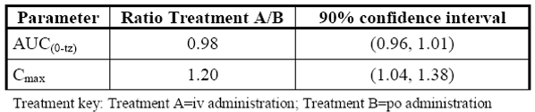

##### Pharmacokinetics; paediatric additive therapy

* Study SP847 had 23 subjects aged ≥ 4 years to < 12 years and 9 subjects ≥ 12 years to ≤ 17 years.
* Study SP1047 had 13 subjects aged ≥ 4 years to < 12 years and 9 subjects ≥ 12 years to ≤ 17 years.
* Study CL0096, using data from Studies SP754 and SP755, had 7 subjects aged 16 and 17 years of age and was considered exploratory.
* Studies CL0177 and CL0266 used data from 72 sparsely sampled (3 samples per subject; Studies SP1047 and SP0847) and 7 serially sampled (7 samples per subject; Study SP0847) only 54 subjects were in the proposed age range
* A PopPK model (Study CL0177) was developed for lacosamide in paediatric subjects consisting of a one-compartment model with first order absorption and elimination. Simulations of different dosing strategies and potentially suitable dosing adaptations in paediatric subjects with epilepsy to be used in follow-up studies were derived.
* Study CL0266: the data base is described as Studies SP847 and SP1047 (total 79 patients, 402 plasma concentrations) combining their data with the healthy volunteer data from Study SP640 (43 adults, 1735 plasma concentrations). A PK model for lacosamide after IV and PO administration in healthy adult subjects, subsequently, a combined adult-paediatric population PK model was developed using the adult IV/PO model and a paediatric PO model developed in Project CL0177. The final model was used to examine different dosing regimens of IV infusions of lacosamide in paediatric subjects with epilepsy and to propose dose adaptation rules. The population estimates from the healthy adult and paediatric subject with epilepsy reference model (run304b) were used to derive the median and 90% of the predicted average steady-state plasma concentration (Css) levels for adults receiving 400 mg/day lacosamide, without anti-epileptic drug (AED) co-administration. The target Css (7.93mg/L) was the predicted Css for a typical 70 kg healthy adult dosed with 400 mg/day. Paediatric simulations using the population estimates from the final paediatric model (run617a) were performed to provide weight-based dose predictions for the dose needed to reach the target Css.
* In Study CL0161(PK/pharmacodynamics (PD), there were 28 subjects studied, many with incomplete data;[17] the sponsor described it as a preliminary and ‘limited dataset’ and ‘limited information’. Complete information on the data set was not provided in the submission, but further information was provided on request for another evaluator.

Median steady state Cmax at the end of a 15 minute IV infusion were predicted to be 9 to 21% higher compared to median Cmax values after PO administration across the range of 5 to 75 kg with no AEDs co-administered. Simulated plasma concentrations and steady state PK parameters were lower with AED co-administration.

In Study SP847, neither placebo arm nor placebo period were present, therefore in the modelling of CL0161 it was assumed that the placebo effect estimated for adults was the same for children. No justification for the assumption was offered in the study.

Justification was offered in the Clinical Overview Addendum:

* focal epilepsies in children older than 4 years old have a similar clinical expression to focal epilepsies in adolescents and adults;[18]
* that results of adult studies of the treatment of partial-onset seizures can be extrapolated down to 4 years of age as long as the appropriate paediatric dosing is established;[19]
* the dose-proportional PK properties of lacosamide;[20]
* expected similarities in exposure-response between adults and children, (which is why the study was undertaken and does not justify extrapolation); and
* the PK modelling and simulation in paediatric subjects to support dosing adaptations (PopPK Studies CL0096, CL0177 and CL0266).

##### Pharmacokinetics; loading dose adults

###### Study SP757 PK report (intravenous infusion)

The sponsor submitted a post hoc analysis (12 April 2011) of previously submitted Study SP757 to approximate peak (Cpeak) and trough (Ctrough) lacosamide plasma concentrations under multiple dose administration of lacosamide, AUC during a dosing interval at steady state (AUCτ,ss) was also approximated and the total body clearance (CL/F) was calculated.

###### Study 925 (intravenous loading dose)

Study 925 was a multicentre, open-label trial to assess the safety and tolerability of a single intravenous loading dose of lacosamide followed by oral lacosamide maintenance as adjunctive therapy in subjects with partial-onset seizures.

On Day 1 (prior to the evening oral dose) and Day 2 (morning pre dose), the mean Ctrough was less than the peak plasma concentration achieved after infusion, but showed a slight increase over time.

Mean plasma concentrations of the main lacosamide metabolite, SPM 12809, were low across all IV lacosamide dose groups at the end of the lacosamide infusion and increased during the repeated administration of oral lacosamide.

Table 8: Summary of lacosamide plasma concentrations by lacosamide dose group

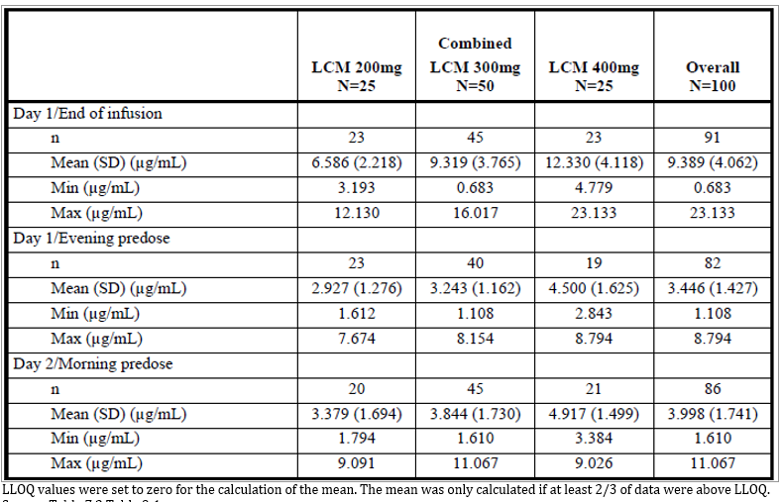

Table 9: Summary of metabolite SPM 12809 plasma concentrations by lacosamide dose group

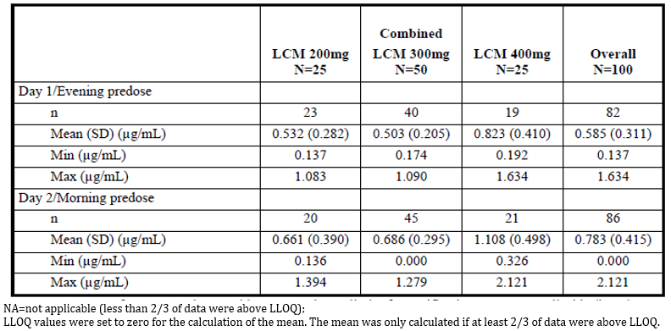

##### Modelling of initial and maintenance doses (loading dose: IV and oral adults)

Data from Study SP925 are used for a simulation to compare the accumulation of lacosamide plasma concentrations and achievement of steady state after an IV loading dose followed by twice-daily oral dosing, compared with oral administration.

The source for the oral administration is unclear.

The sponsor undertook simulations to show the expected lacosamide plasma concentration-over-time-profiles after an initial loading dose in comparison to a regimen of twice-daily dosing with lacosamide 100 mg (PO or IV) without a loading dose.

For each simulation, the first maintenance dose is administered 12 hours after the initial dose. The simulations are for the following 2 dosing schedules:

* Oral Only: initial dose of oral lacosamide 200 mg followed by multiple-dose administration of a maintenance dose of oral lacosamide 100 mg administered twice daily (that is, every 12 hours).
* IV Only: initial dose of IV lacosamide 200 mg followed by multiple-dose administration of a maintenance dose of IV lacosamide 100 mg administered twice daily (that is, every 12 hours).

Figure 1: Simulation of lacosamide plasma concentrations after oral administration; lacosamide 200 mg loading dose followed by lacosamide 100 mg BD, versus lacosamide 100 mg BD only

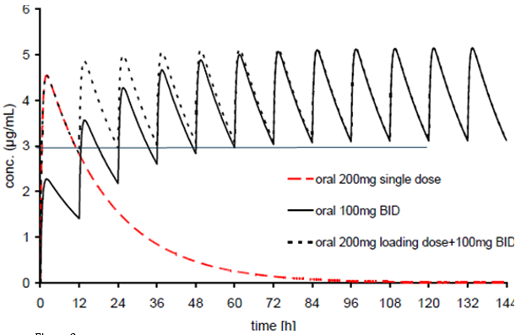

Figure 2: Simulation of lacosamide plasma concentrations after IV administration; lacosamide 200 mg loading dose followed by lacosamide 100 mg BD, versus lacosamide 100 mg BD only

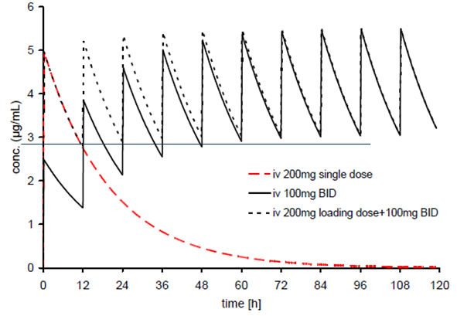

The results show that the lacosamide 200 mg loading dose followed by multiple-dose administration of lacosamide 100 mg twice daily results in plasma concentrations comparable to those achieved over time with twice-daily administration of lacosamide 100 mg whether IV only or oral only treatments are given.

The sponsor proposed support for this modelling from a Phase III study could be found in comparison with the results of multiple selected Phase I studies.

Based on previous oral data Cmax was expected to show a decrease of 47% by Day 1 prior to the evening oral dose (Ctrough), the observed decrease after the IV infusion (equivalent to the oral daily dose) was 62%.

The explanation offered is that the distribution of lacosamide may not be complete due to the rapid input into the central circulation with IV administration. Support for this pointed to Study SP645 which showed that 2 processes (elimination and distribution) were involved.

Ctrough on the morning of Day 2 was 20% higher than the Ctrough on Day 1 prior to the evening oral dose. The sponsor suggests that this shows lacosamide plasma concentrations are near steady state after administration of a single loading dose of IV lacosamide equivalent to the oral daily lacosamide dose.

##### Pharmacokinetics (loading dose children)

In PK/PD based Study CL0161 simulation showed that administration of loading doses achieved steady state plasma concentrations of lacosamide after the first dose independent of IV infusion duration or PO administration. The greatest effect on Cmax was seen with the 15 minute IV infusion.

It should not be forgotten that the sponsor described the PopPK analysis of Study 847 data as preliminary.

### Pharmacodynamics

#### Studies providing pharmacodynamic data

Table 10: Submitted pharmacodynamic studies

|  |  |  |  |
| --- | --- | --- | --- |
| PD Topic | Subtopic | Study ID | * |
| Population PD and PK-PD analyses | An exposure-response model developed for adults was applied to data originating from 28 paediatric subjects | CL0161 | * |

* Indicates the primary PD aim of the study.

#### Summary of pharmacodynamics

No specific studies have been performed to evaluate lacosamide PD effects in paediatric subjects.

In Study CL0161, an exposure-response model developed for adults was applied to data originating from 28 paediatric subjects (age range 3 to 17 years) who participated in Study SP847.

#### Evaluator’s overall conclusions on pharmacodynamics

The exposure-response model developed in adults seems to satisfactorily describe the paediatric observations. The distribution of simulated percentages of ≥ 50% responders matched the value observed in Study SP847. Based on the limited information coming from Study SP847 (that is, small subject number, short treatment period, no placebo), no signal was seen in this paediatric cohort to suggest any change in the exposure-response relationship established in adults.

In Study CL0161 there were 28 subjects studied, many with incomplete data;[21] the sponsor described it as a preliminary and ‘limited dataset’ and ‘limited information’. Complete information on the data set was not provided in the submission, but further information was provided on request.

### Efficacy

#### Studies providing efficacy data

The following studies provided efficacy data:

* Monotherapy in adults, monotherapy of partial seizures:
  + pivotal or main efficacy studies:
    - Study SP0993
    - Study SP902
* Paediatric adjunctive therapy of partial seizures, paediatric efficacy studies:
  + Paediatric adjunctive:
    - No appropriate paediatric efficacy study data has been submitted.
    - Open label Study SP847 looked at 28 day change in seizure frequency and was considered preliminary.
* The sponsor is relying on safety data from interim reports and the following PK studies:
  + Study SP847: s multicentre, open-label study to investigate the safety, tolerability and pharmacokinetics of lacosamide oral solution (syrup) as adjunctive therapy in children with partial‑onset seizures
  + Study SP1047: a multicentre, open-label study to investigate the pharmacokinetics of commercial lacosamide oral formulation as therapy in children (aged 1 month to 17 years) with epilepsy.
  + Study CL0096: an exploratory paediatric population physiologically-based pharmacokinetic analyses of lacosamide
  + Study CL0177: a PopPK analysis of lacosamide in epileptic paediatric patients from Studies SP847 and SP1047
  + Study CL0266: a modelling and simulation for the evaluation of possible doses and dose adaptation rules of intravenous lacosamide in children
  + Study CL0161: a model-based exposure-effect population analysis and simulations based on Phase-II/III trials of adjunctive lacosamide in partial onset seizures.

In Study CL0161 there were 28 subjects studied, many with incomplete data;21 the sponsor described it as a preliminary and ‘limited dataset’ and ‘limited information’. Complete information on the data set was not provided in the submission, but further information was provided on request for another evaluator.

Of concern, only 1 of 9 over 12 years enrolled in Study SP847 completed; most (6, 67%) discontinuing for adverse events (AE).

In Study SP847, neither placebo arm nor placebo period were present, therefore it was assumed in Study CL0161 that the placebo effect estimated for adults was the same for children. No justification for the assumption was offered in the study.

Justification was offered in a clinical overview addendum:

* focal epilepsies in children older than 4 years old have a similar clinical expression to focal epilepsies in adolescents and adults;[22]
* that results of adult studies of the treatment of partial-onset seizures can be extrapolated down to 4 years of age as long as the appropriate paediatric dosing is established;[23]
* the dose-proportional PK properties of lacosamide;[24]
* expected similarities in exposure-response between adults and children, (which is why the study was undertaken and does not justify extrapolation); and
* the PK modelling and simulation in paediatric subjects to support dosing adaptations (PopPK Studies CL0096, CL0177 and CL0266).

#### Evaluator’s conclusions on efficacy

##### Paediatric adjunctive therapy of partial seizures

No appropriate paediatric efficacy study data has been submitted.

###### Study SP0969

Study SP0969 (listed as completed 24 January 17 on ClinicalTrials.gov), was a Phase III, multicentre, double-blind, randomised, placebo-controlled, parallel-group study to evaluate the efficacy and safety of lacosamide as adjunctive therapy in paediatric subjects with epilepsy ≥ 4 to < 17 years of age with partial-onset seizures. Neither the protocol nor the results of this trial are available.[25] The sponsor states:

*‘[the] study is not part of the Paediatric Investigational Plan for the EU due to the planned efficacy extrapolation in this age group. [Study] SP0969 is a US registration study.’*

This is not logically consistent with the submission of Studies 847 and SP1047 with subjects’ inclusion criteria 1 month to 17 years of age. Further the PK/PD Study CL0161 used subjects from Study 847.

###### Study EP0034

Study EP0034 inclusion criteria were aged 1 month to 17 years; and for Study 848, direct admission criteria were 4 to ≤ 17 years of age.

The sponsor is relying on safety data from interim reports and the PK Studies SP847, SP1047, CL0096, CL0177, CL0266 and CL0161:

* Study SP847 had 23 subjects aged ≥ 4 years to < 12 years and 9 subjects ≥ 12 years to ≤ 17 years.
* Study SP1047 had 13 subjects aged ≥ 4 years to < 12 years and 9 subjects ≥ 12 years to ≤ 17 years.
* Study CL0096 had 7 subjects aged 16 and 17 years of age.
* This gives a total of 52 subjects in the proposed age range studied for PKs.
* Studies CL0177 and CL0266 used data from 72 sparsely sampled (3 samples per subject; Studies SP1047 and SP0847) and 7 serially sampled (7 samples per subject; Study SP0847).
* In Study CL0161 there were 28 subjects studied, many with incomplete data;[26] the sponsor described it as a preliminary and ‘limited dataset’ and ‘limited information’. Complete information on the data set was not provided in the submission, but further information was provided on request.

Of concern, only 1 of 9 over 12 years enrolled in Study SP847 completed (up to Day 27/ Day 28);[27] most (n = 6, 67%) discontinuing for AEs.

Study SP1047 was only a single dose study in those who had established on lacosamide for at least 1 month prior to study entry.

The sponsor has taken data from 16 to 18 years olds who participated in adult studies to include in the paediatric data base.

The population study data has been referred to another evaluator for concurrent evaluation. This evaluator thus can only comment (as here and elsewhere) on the population studies, agreeing with the sponsor that for establishing efficacy Study CL0161 is preliminary and limited.

The PK Studies SP847 and SP1047 by themselves are inadequate to establish efficacy.

A further concern is the lack of availability of a suitable formulation for paediatric dosing, this too is being concurrently evaluated by another evaluator.[28]

##### Adult monotherapy

###### Study SP0993

In the US, the efficacy and safety of lacosamide as monotherapy in partial-onset seizures were established in the FDA recommended Study SP902, a Phase III, historical-controlled, multicentre, double-blind, randomised, conversion to monotherapy study in 425 adult subjects.

According to the reference data submitted, the EMA has accepted this trial design previously for showing efficacy while the FDA has not.[29] The above statement suggests the FDA is still not entirely happy with the design.

The study criteria included unprovoked partial-onset seizures (IA, IB, IC with clear focal origin);[30] as well as generalised tonic-clonic seizures (without clear focal origin). Of these the 2013 International League Against Epilepsy (ILEA) reference given shows for adults with partial onset seizures the per-protocol 6-month seizure-free rate was 73.3% for carbamazepine, while for adults with generalised-onset tonic–clonic seizures it said there are no adequate comparators for this category. The only stratification used for the primary endpoint was the frequency of seizures. The subgroup analysis did show non inferiority for those diagnosed with partial onset seizures, but not for IC or IIE seizures. The effect size seen was greater than in the ILEA guideline. With around 90% efficacy in the primary endpoint for carbamazepine rather than the 60% used in the population size calculations or the cited 73%, this might interfere with showing a difference.

Overall there was a 40% discontinuation rate with both treatments. Those of 11% of lacosamide and 7% of carbamazepine patients were due to lack of efficacy and 11% and 16%, respectively, were due to AEs.

###### Study SP902

The criteria for inclusion restricted subjects to those with simple partial and/or complex partial seizures.

The sample size was based on an assumed 0.55 exit rate for the lacosamide 400 mg/day dose group, and a 0.653 exit rate for the historical control. Thus there are different exit rates 0.55 and 0.653 based on what appears to be mostly the same data. While the published references given for these exit rates were the same the source of additional unpublished data was not.

50% of the subjects in each treatment arm were to be taking carbamazepine as 1 of their 2 concomitant AEDs. 25% of those enrolled in the 300 mg/day group and 23% in the 400 mg/day group were taking carbamazepine.

The percentage of subjects meeting at least 1 exit criterion by Day 112 (cumulative exit rate) for the lacosamide 400 mg/day group was 0.300 (95% CI: 0.246, 0.355), that is, the upper limit of the 2-sided 95% CI for this estimate was lower than the historical-control exit rate (0.653).

##### Paediatric monotherapy of partial seizures

The sponsor submitted no trial data to support this extension of indications, but argued that evidence of efficacy of an AED as adjunctive therapy provides proof of the principle that the drug will be effective as a monotherapy for partial-onset seizures.

Despite this opinion the sponsor has submitted trial evidence to the FDA, EMA and now TGA to support the extension of indications for adults from adjunctive to also monotherapy.

The sponsor referred to an e-published article but gave no evidence of a literature search in support of their opinion. The sponsor had previously been prepared to undertake a bridging simulation from adult data in support of this indication but has withdrawn from that intent.

There is thus no efficacy evidence submitted to support this indication.

### Safety

#### Studies providing safety data

Table 11: Submitted studies with safety data

| Population | Indication | Synopsis |
| --- | --- | --- |
| Primary safety studies | | |
| Adult | Adjunctive therapy of partial seizures | SP925 |
| SP926 |
| Monotherapy of partial seizures | SP0994 |
| Children | Adjunctive therapy of partial seizures | SP848 |
| Studies evaluable for safety | | |
| Adult | Healthy PK | SP952 |
| Monotherapy of partial seizures | SP0993 |
| SP902 |
| SP904 |
| Children | Adjunctive therapy of partial seizures | SP847 |
| EP0034 |

#### Patient exposure

##### Adult adjunctive therapy studies that assessed safety as the sole primary outcome

###### Study SP925 (IV loading dose)

Table 12: Study SP925 Summary of exposure by lacosamide dose group (Safety set)

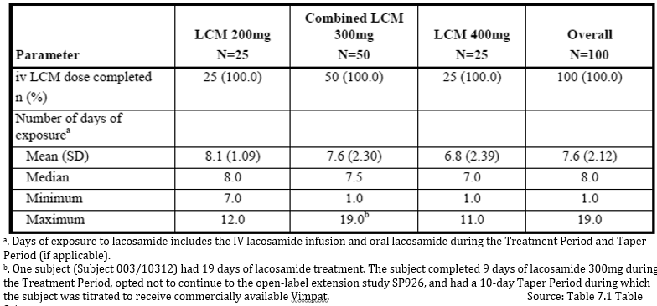

###### Study SP926

Table 13: Study SP926 Summary of lacosamide overall exposure (Safety set)

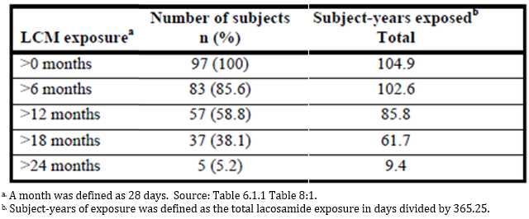

##### Paediatric adjunctive therapy studies that assessed safety as the sole primary outcome

###### Study EP0034

The oral solution formulation was 10 mg/mL.

After completion of the blinded transition period in the primary study, all subjects were transitioned (according to their weight at Baseline of the primary study):

* lacosamide 10 mg/kg/day (oral solution) for subjects weighing < 30 kg;
* lacosamide 6mg/kg/day (oral solution) for subjects weighing ≥ 30 kg to < 50 kg; or
* lacosamide 300 mg/day (tablets) for subjects weighing ≥ 50 kg.

Subjects remained on this dose during at least their first week in the treatment period of Study EP0034. After 1 week in Study EP0034, dose adjustment during the treatment period was possible within a range of 2 mg/kg/day to 12 mg/kg/day for the oral solution and 100 mg/day to 600 mg/day for the tablets. Regardless of formulation, the maximum dose was 600 mg/day or 12 mg/kg/day, whichever was lower based on body weight. Subjects could switch between formulations.

Table 14: Study EP0034 Summary of subject disposition and discontinuation reasons by age group (Safety set)

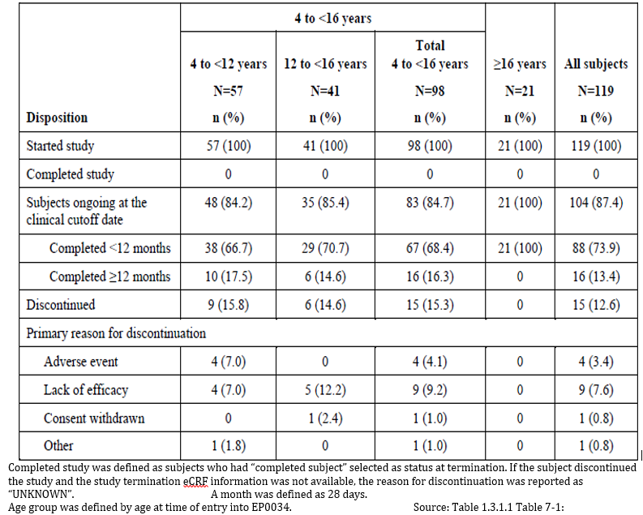

###### Study SP848

Table 15: Study SP848 Overall exposure summary by age group (Safety set)

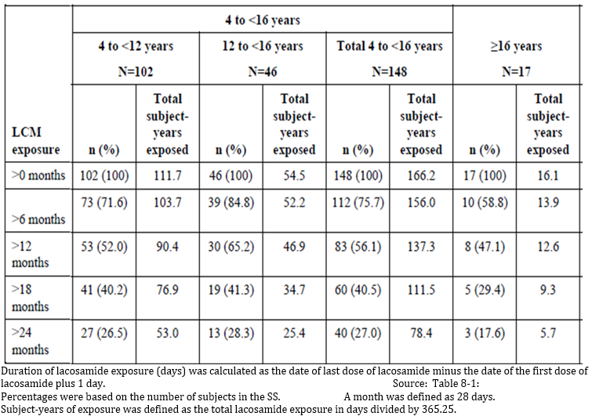

Table 16: Study SP848 Overall exposure summary by exposure enrolment group analysis set (Safety set, direct enrollers)

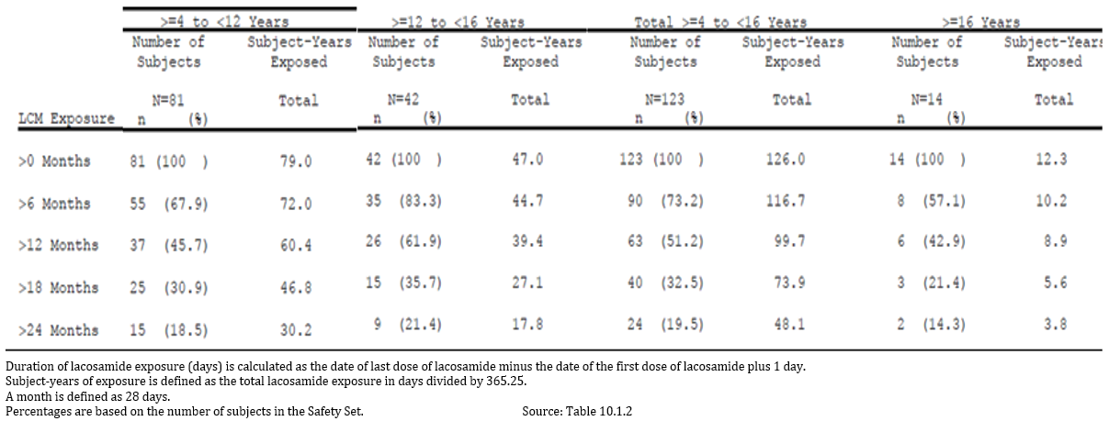

Table 17: Study SP848 Duration of exposure, maximum daily dose and modal daily

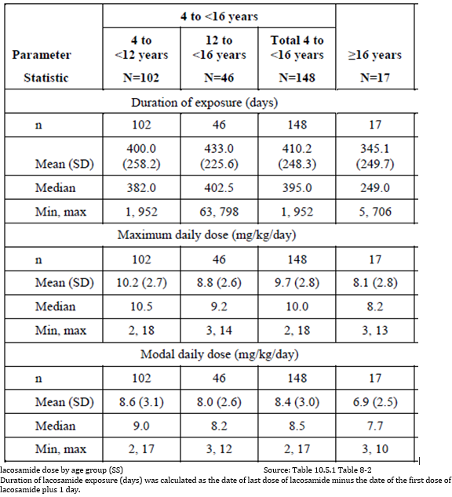

##### Monotherapy studies that assessed safety as the sole primary outcome

###### Study SP0994

Table 18: Study SP0994 Duration of exposure during the treatment period (Safety set)

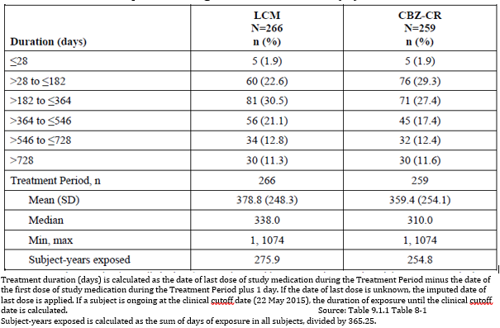

###### Study 904

Table 19: Study 904 Overall lacosamide exposure by modal dose and duration of exposure (Safety set)

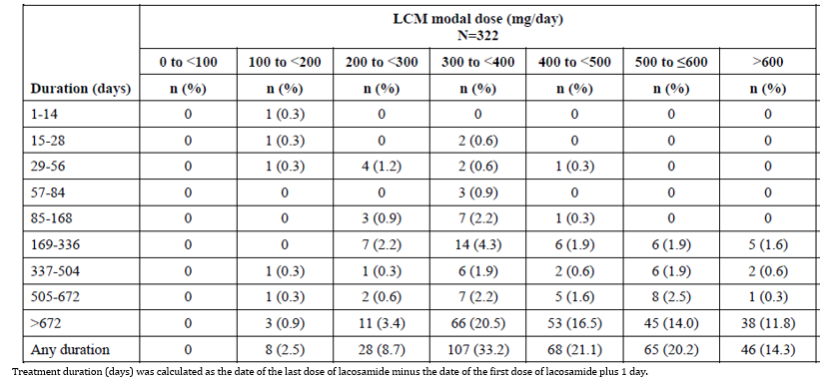

##### Other monotherapy studies with safety data

###### Study 0993

Table 20: Study 0993 Duration of lacosamide and carbamazepine CR exposure by period (Safety Set)

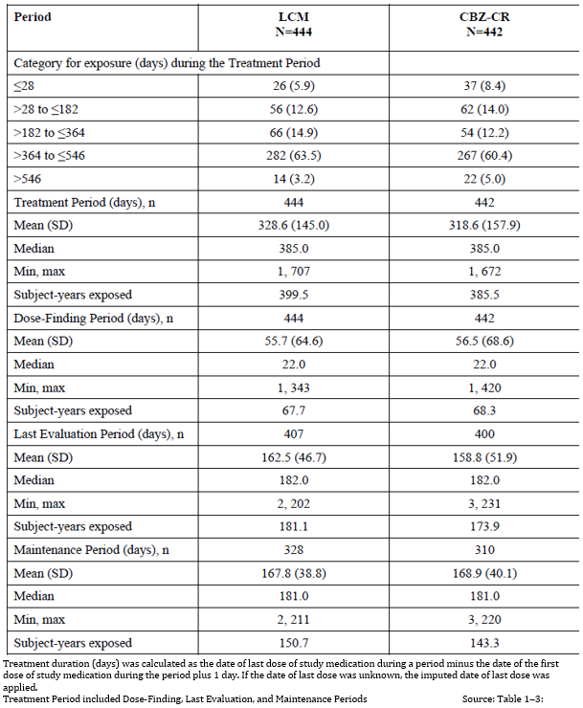

Table 21: Study SP0993 Duration of lacosamide and carbamazepine CR exposure by dose during the treatment period (Safety set)

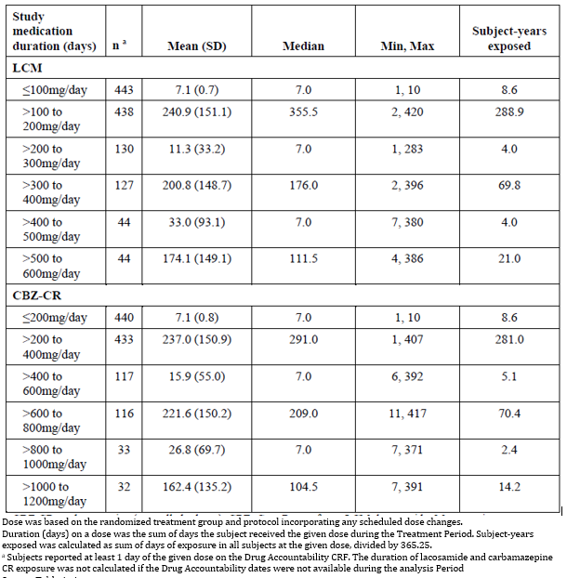

##### Safety adjunctive therapy of partial seizures in children

Table 22: Studies reviewed for safety for adjunctive therapy of partial seizures in children

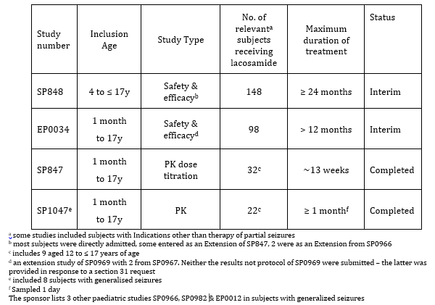

The sponsor’s Summary of Clinical Safety includes only Studies SP847, SP848, and EP0034.

The sponsor’s pooled analysis included 15 subjects < 4 years and 31 subjects ≥ 16 years, that is, 14% out of a total of 303 subjects.

Table 23: Pool SPX-1 Summary of study pooling (in sponsor’s safety summar*y)*

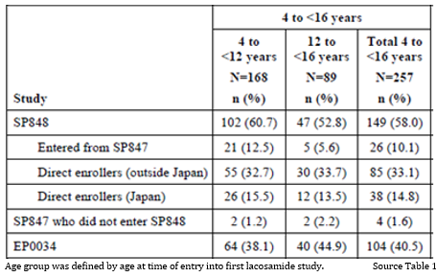

#### Patient exposure

The sponsor has submitted the following table in relation to combined analysis of subject exposure in the proposed age group.

Table 24: Overall exposure to lacosamide by age group

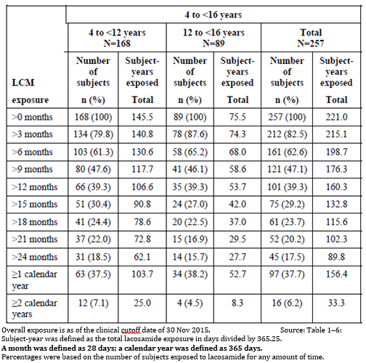

Table 25: Pool SPX-1 Overall exposure to lacosamide by weight band for subjects 4 to < 16 years of age

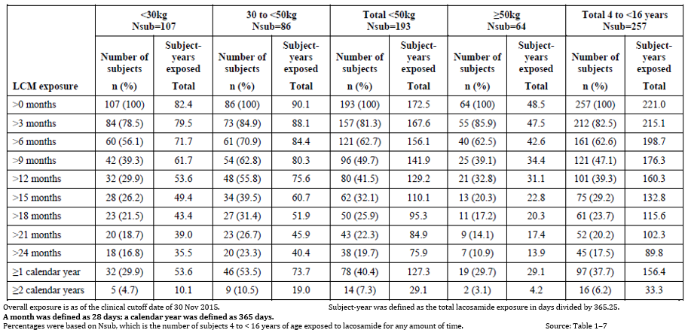

Table 26: Pool SPX-1 Overall exposure summary by modal daily lacosamide dose and weight band for subjects 4 to < 16 years of age

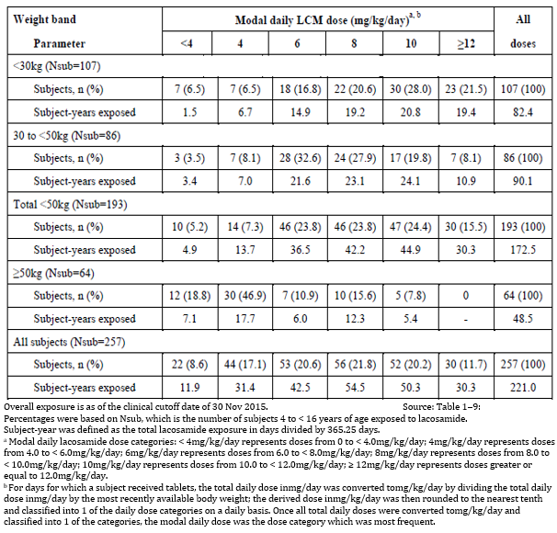

Table 27: Pool SPX-1 Duration of exposure, maximum daily dose, and modal daily lacosamide dose by age group

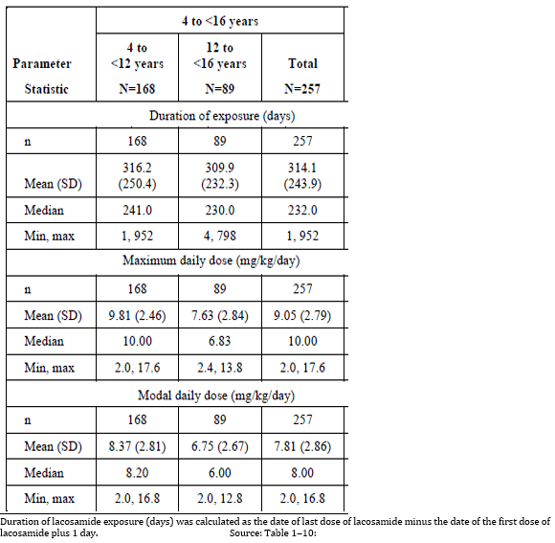

Table 28: Pool SPX-1 Duration of exposure, maximum daily dose, and modal daily lacosamide dose for subjects with ≥ 1 calendar year of lacosamide exposure

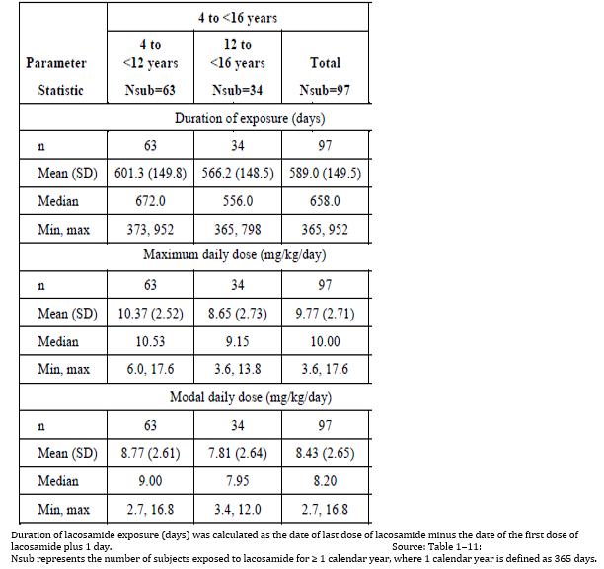

Table 29: Pool SPX-1 Duration of exposure, maximum daily dose, and modal daily lacosamide dose by weight band for subjects 4 to < 16 years of age

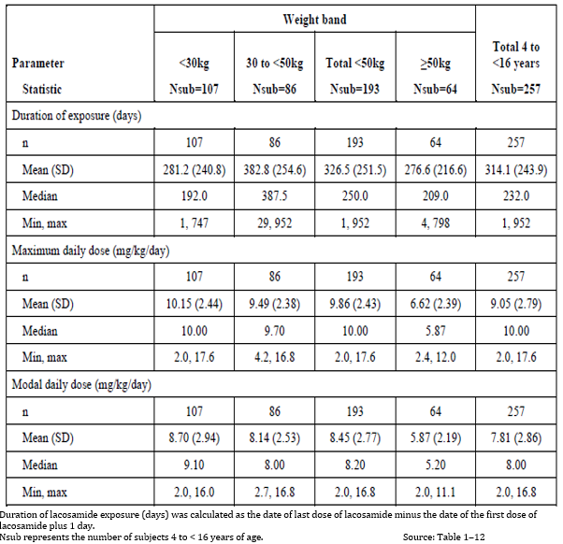

#### Safety issues with the potential for major regulatory impact

##### Decreased appetite

Within the 4 to < 16 year age group of Pool SPX-1, the incidence of decreased appetite was 6.6% (17 subjects -related to lacosamide in 10 of them), and the exposure-adjusted incidence was 0.69 events/person-months for this age group.

##### Lethargy

Within the 4 to < 16 year age group of Pool SPX-1, the incidence of lethargy was 4.3% (11 subjects; related to lacosamide in 7 of them), and the exposure-adjusted incidence was 0.52 events/person-months for this age group.

##### Abnormal behaviour

Within the 4 to < 16 year age group of Pool SPX-1, the incidence of abnormal behaviour was 1.9%. (5 subjects; related to lacosamide in all of them) and the exposure-adjusted incidence for abnormal behaviour was 0.21 events/person-months for this age group.

##### Pancreatitis

The severe treatment-emergent serious adverse event (SAE) of pancreatitis was reported at Day 705 of lacosamide exposure in a subject who was 13.63 years of age at the start of Study SP847 participation. The event was considered drug-related by the investigator, resolved after 9 days, did not result in dose change, and did not lead to study discontinuation. This event was concurrent with a severe treatment-emergent SAE of vomiting, a mild treatment-emergent SAE of diarrhoea, and non-serious ongoing events of headache, positive occult blood, and increased eosinophil count. Concomitant medications may have been a contributing factor to the development of pancreatitis.

##### Gender

No effect demonstrated except some slight increases for dizziness and pyrexia among females.

##### Liver function and liver toxicity

The effect of hepatic impairment was not evaluated in the paediatric studies.

##### Renal function and renal toxicity

In Study CL0177;[31] estimated glomerular filtration rate was not found to significantly influence lacosamide CL, but the study population from Studies SP847 and SP1047 did not include any paediatric patients with renal impairment. Based on the dose adjustments recommended for adults with renal impairment, similar dose adjustments are recommended for paediatric subjects with renal impairment.

##### Electrocardiograph findings and cardiovascular safety

While an increase in PR interval was observed, a similar increase was observed across weight bands and across studies. The mean change from Baseline to last visit for PR interval duration ranged from 5.91 to 9.52 ms in Study SP848 and from 4.77 to 7.56 ms in Study EP0034.

##### Drug interactions

No drug interaction studies have been performed in paediatric subjects.

Based on results from the covariate analyses conducted in Study CL0177, co‑administration of the hepatic enzyme-inducing AEDs carbamazepine, phenobarbital, and phenytoin increased lacosamide clearance.

However, this finding was not deemed to require dosage adjustment considering the broad efficacy and safety margin of lacosamide and the therapeutic approach of individual up-titration.

##### Suicide

Three subjects experienced positive responses for suicidal ideation, 1 subject experienced suicidal behaviour. Suicide was considered one possible cause of the reported death.

##### Overdose

There were 2 cases of accidental overdose:

* A male on the same date had a moderate, non-serious, and related event of vomiting, and the following day had a mild, non-serious, and related abnormal electrocardiograph which showed a nonspecific intraventricular conduction delay and sinus arrhythmia.
* A female on the same date had moderate, non-serious, and related events of dizziness, disorientation, gait disturbance, and vomiting.

#### Post marketing data

The sponsor submitted a cumulative analysis of off-label use.

914 cases in patients aged 4 to < 16 years were found in the lacosamide database; 674 were medically confirmed; the rest from consumers.

The search excluded 118/914 cases where the indication or history (if indication not given) showed one of a list of terms or the event was unevaluable.[32]

This left 796 cases (including an unreported number, where the indication or history was not given) that were all considered being given for the ‘targeted indication.’

Of these 399 were on lacosamide adjunctive therapy.

The ‘targeted indication’ was not defined except by exclusion, the sponsor considered this conservative. If one is looking at the total number of AEs it is an overestimate and conservative, however, if used as an indicator of exposure for the proposed indication it is also an overestimate, but now an exaggeration.

Thus for example cases with epilepsy not otherwise specified (NOS) and generalised uncontrolled epilepsy, were considered within the targeted indication, limiting the value of the review. The detected frequency of AEs specific to the proposed indication may thus be erroneous.

Table 30: Most frequently reported Preferred Terms (N = 20) in patients 4 to < 16 years of age within the ‘targeted indication’

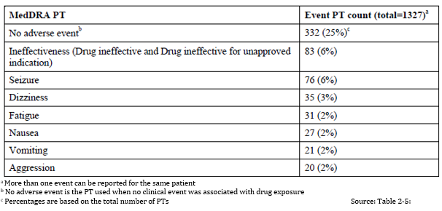

PT = Preferred Term; MedDRA = Medical Dictionary for Regulatory Activities

Table 31: Overview of post marketing analysis topic of interest number of cases in patients aged 4 to < 16 years, ‘targeted indication’ (N = 796 cases)

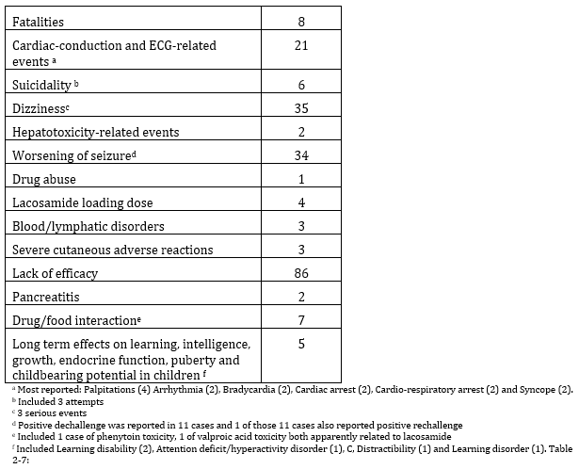

#### Safety monotherapy in adults

No integrated analyses were performed for this submission.

##### Patient exposure monotherapy

Table 32: Monotherapy studies with safety data

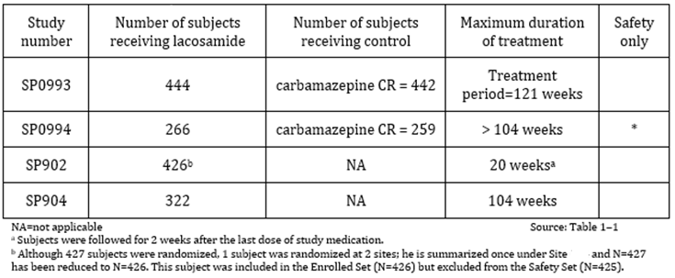

Table 33: Duration of exposure by days and dose of lacosamide

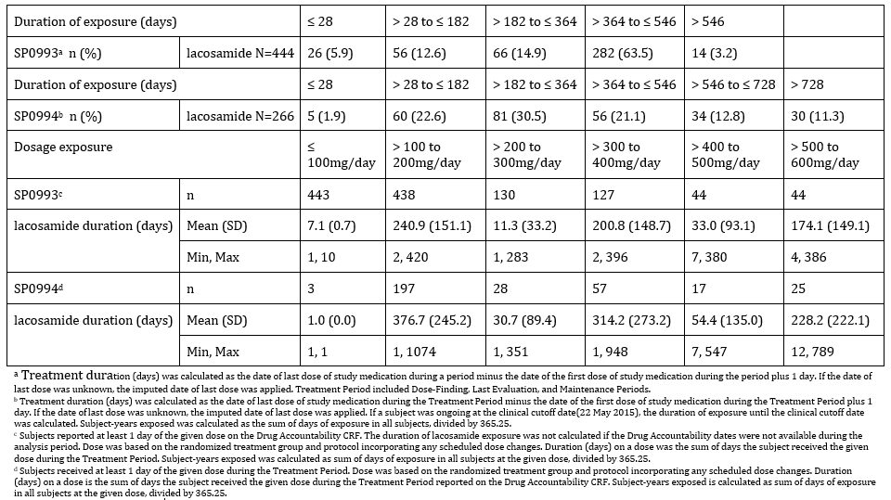

###### Post marketing data

A total of 5614 safety case reports related to post marketing lacosamide use compatible with a monotherapy exposure were identified in the sponsor’s Global Safety database during the cumulative period from 29 August 2008 to 31 August 2015.

A comprehensive review of the fatal cases (including sudden unexplained death in epilepsy (SUDEP)) and cases related to significant AEs related to cardiac, suicidality, dizziness, hepatotoxicity, worsening of seizures, and drug abuse did not display specificities for the use of lacosamide as monotherapy, as compared to the known safety profile of lacosamide in adjunctive therapy in partial-onset seizures.

A review of cases with a lacosamide daily dose up to 600 mg did not identify a new safety concern for the use of lacosamide as monotherapy.

A cumulative review of relevant publications describing the use of lacosamide as monotherapy and/or conversion to monotherapy did not identify a new safety concern in the use of lacosamide as monotherapy.

#### Safety omitting the oral initial dose titration period in adults

A post-hoc analysis was conducted to assess the tolerability profile of lacosamide treatment initiation at a dose of 200 mg/day versus the typical lacosamide up-titration initiation of 100 mg/day for 1 week followed by 200 mg/day during the second week.

The Study SP902 (conversion to monotherapy) data in the first 10 days of treatment initiation at lacosamide 200 mg/day were compared to the first 2 weeks of treatment initiation in pooled data from a subset of subjects (who were on 1 background AED);[33] from 3 adjunctive lacosamide Studies SP667, SP754, and SP755.

The adjunctive studies were double-blind, placebo controlled studies in which patients received an initial dose of 100 mg/day lacosamide followed by 200 mg/day after 1 week.

Also for Study SP0993, (lacosamide initiation) an analysis of incidences of AEs within 14 days since the first dose was conducted (that is, the first 2 weeks of the first up‑titration phase).

Table 34: Exposure oral loading dose in adults

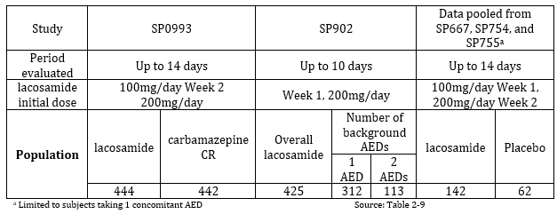

#### Safety oral loading dose in adults

The Phase I modified oral pool includes data from 15 previously submitted Phase I oral lacosamide studies (Studies SP587, SP588, SP599, SP600, SP602, SP603, SP640, SP644, SP657, SP660, SP661, SP835, SP836, SP863, and SP940) and 1 new Phase I oral lacosamide study (SP952).

All subjects were ≥ 18 years.

In the 16 selected Phase I oral lacosamide studies, a total of 439 subjects received initial doses of lacosamide ≥ 200 mg. The study providing the most exposures to an initial 200 mg dose of lacosamide was SP640. An additional 54 subjects received an initial dose of lacosamide < 200 mg.

Table 35: Summary of unique exposures by initial oral lacosamide dose classification (Phase I modified oral pool)

Summary of unique exposures by initial oral lacosamide dose classification (Phase I modified oral pool)


The overall incidence of treatment emergent adverse events (TEAE) in the Phase I modified oral pool increased across initial oral lacosamide dose. The most frequently reported TEAEs in the lacosamide 200 mg initial oral lacosamide dose category were dizziness, headache, and fatigue.

#### Safety IV loading dose in adults

##### Patient exposure IV

Phase I, IV pool consisted of 4 Phase I studies of IV lacosamide treatment in healthy subjects (Studies SP643, SP645, SP658, and SP834).

The EP pool, IV consisted of 2 Phase II/III studies of IV lacosamide treatment in subjects with partial-onset seizures (Studies SP616 and SP757).

Apart from the 7 subjects aged 16 and 17 years in EP pool IV all subjects were ≥ 18 years.

Table Summary of unique IV lacosamide exposures by infusion duration

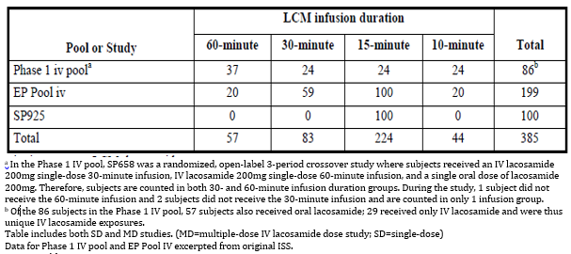

Table 36: Summary of unique exposures by initial IV lacosamide dose classification and infusion duration

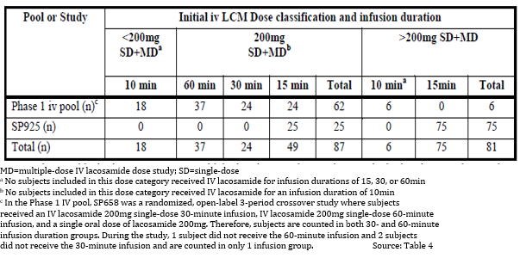

Table 37: Studies SP757 and SP925 Number of 10 and 15 minute infusions by individual lacosamide infusion dose

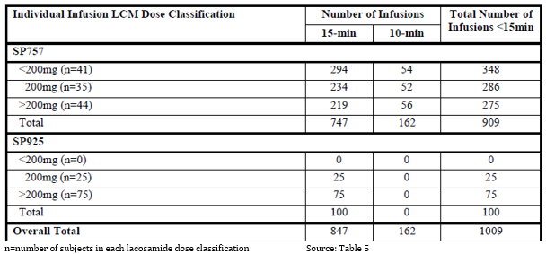

The incidence of TEAEs in Study SP925 was higher than that observed in previous studies where IV lacosamide was administered over a duration of 15 minutes as replacement therapy in subjects with partial-onset seizures (EP pool IV; Studies SP757 and SP616). This difference is explained by the fact that Study SP925 included lacosamide-naive subjects whereas subjects in Studies SP757 and SP616 were already maintained on stable doses of oral lacosamide prior to IV replacement. The overall incidence of TEAEs in Study SP925 was similar to that observed in the lacosamide total group of EP pool S1.

###### Post- marketing IV loading dose

A review of all case reports with potential for off-label use of a loading dose in acute conditions such as status epilepticus, of pregnancy and lactation cases, of paediatric cases, and of elderly cases compatible with an exposure to lacosamide as monotherapy did not identify any specific safety concern related to the use of lacosamide as monotherapy.

The paediatric use was very imprecise in the indications.

A total of 71 cases of AEs in patients receiving IV lacosamide August 2008 to August 2011 were reported over the 525 worldwide IV lacosamide patient-year exposures. Of these 71 cases, 19 cases included 21 events that are potentially related to treatment-emergent other significant AEs; the initial IV lacosamide dose was ≥ 200 mg in 11 of these cases (12 events). Twelve of the 19 cases reported relevant medical history (for example, known cardiovascular medical history). A positive de-challenge was reported in 8 of the 19 cases. A review of these cases did not identify any safety signals of concern for a loading dose of IV lacosamide at doses that are approved for use as adjunctive treatment for partial-onset seizures (that is, 200 mg/day to 400 mg/day).

#### Safety omitting the oral initial dose titration period in children

All subjects who entered these studies and whose safety data are included in Pool SPX-1 should have begun adjunctive lacosamide treatment using a starting dose of 2 mg/ kg/day or 100 mg/day and titrating up by 2 mg/ kg/day or 100 mg/day every week. Although there are no specific analyses of paediatric safety data during titration, these doses are similar to the approved doses for adults initiating adjunctive treatment.

#### Safety initial IV or oral loading dose in children

There are no clinical safety data specific to the use of IV or oral lacosamide loading doses in paediatric subjects. There was some very limited post marketing data of poor quality

#### Evaluator’s conclusions on safety

##### Adjunctive therapy in paediatrics

Assessment of safety in Study EP0034 is limited. It is not possible to assess the safety of the initiation of lacosamide therapy.

It is important to note that subjects who enrolled into Studies SP848 from SP847 were already taking lacosamide prior to study entry; therefore, this analysis does not reflect the initial exposure periods for all subjects in Pool SPX-1.

Study SP0969 (completed 24 January 2017), which was a Phase III, multicentre, double-blind, randomised, placebo-controlled, parallel-group study to evaluate the efficacy and safety of lacosamide as adjunctive therapy in paediatric subjects with epilepsy 4 to < 17 years of age with partial-onset seizures preceded the entry of almost all subjects into this trial. Neither the protocol nor the results of this trial are available.[34]

It appears that at the end of Study SP0969 all patients including those on placebo received lacosamide: After completion of the transition period in the primary study, subjects will have been transitioned to a dose of lacosamide according to their weight.

The randomisation in the primary study is not given, but many of the subjects in this study will have already had long term exposure to lacosamide prior to entry, and all had exposure to lacosamide in the transition period of the primary study. Thus the observed incidence of Discontinuations and AEs is could be less in this study than if initial exposure were included.

Study 848 included subjects from Study 847 who all were initiated on lacosamide before entering Study 848, direct enrolment was allowed with initiation of lacosamide being the start day for the Study848. There were no Japanese direct enrollers with a history of > 12 months exposure thus according to the CSR there were only 69 subjects age 4 to 18 years who were followed from initial exposure for > 12 months.

In the safety evaluation some discontinuations due to AEs were missed: Only AEs reported as leading to discontinuation from the last study in which a subject participated were classified as leading to study discontinuation in the pooled analyses.

##### Omitting the oral initial dose titration period in adults

Omitting the oral initial dose titration period in Adults resulted in a small increase in the incidence of some common AEs (dizziness, nausea, fatigue) and of discontinuations.

##### Initial oral loading dose in adults

The overall incidence of TEAEs in the Phase I modified oral pool increased across initial oral lacosamide dose. The most frequently reported TEAEs in the lacosamide 200 mg initial oral lacosamide dose category were dizziness, headache, and fatigue

##### Initial IV loading dose in adults

‘Very similar mean AUCs were observed for both treatments but a significantly higher Cmax was observed with the 15 min infusion. This is in contrast to the previous study, where slower infusions (over 30 or 60 minutes) had a Cmax similar to that observed with oral administration. The sponsor proposes that the IV form be administered over 15 to 60 minutes, which would give clinicians the option of achieving a slightly higher Cmax if desired, or a concentration curve more similar to oral administration.’

The sponsor argues for the Safety of the 15 minute, 200 mg infusion despite the greater Cmax

268 subjects received IV lacosamide over a duration of ≤ 15 minutes. Of these, 30 healthy subjects (Phase I IV pool) and 100 subjects with partial-onset seizures (Study SP925) received initial IV lacosamide doses ≥ 200 mg (200 mg (n = 25), 300 mg (n = 50) and 400 mg (n = 25)) over a ≤ 15 minute infusion duration (range: 10 to 15 minutes).

However, as one would expect the incidence AEs particularly of drug related CNS effects was higher.

##### Omitting the oral initial dose titration period in children

All subjects who entered these studies and whose safety data are included in Pool SPX-1 should have begun adjunctive lacosamide treatment using a starting dose of 2 mg/ kg/day or 100 mg/day and titrating up by 2 mg/ kg/day or 100 mg/day every week. Although there are no specific analyses of paediatric safety data during titration, these doses are similar to the approved doses for adults initiating adjunctive treatment.

##### Initial IV or oral loading dose children

There are no clinical safety data specific to the use of IV or oral lacosamide loading doses in paediatric subjects.

### First round benefit-risk assessment

#### First round assessment of benefits

##### To register a new formulation

The clinical submission contained some data relevant to this new formulation, which is necessary to support the proposed paediatric extension.

###### Palatability and ease of use

The majority of subjects responded that the syrup had an acceptable smell (97.9%), was easy to swallow (57.4%), and did not cause them to become nauseous or to vomit (66.0% and 91.5%, respectively). For the 42.6% of subjects who responded that there was a taste while the syrup was in their mouths, 21.3% considered the taste ‘ok’, 17.0% ‘bad’, and 6.4% ‘good’. For the subjects who provided responses to the question of whether the syrup had an unpleasant aftertaste, 25.5% considered the aftertaste to be unpleasant and 29.8% did not consider the aftertaste to be unpleasant.

Without the new formulation practical paediatric dosing would be very difficult and compliance low.

##### To extend the population for the existing additive therapy indications to include children 4 to 15 years inclusive

###### Efficacy

The sponsor submitted PopPK and PK/PD studies based on which the sponsor believes:

The benefits of lacosamide treatment for paediatric patients with partial-onset seizures down to 4 years of age are expected to be similar to those for adults where the PK, efficacy, and safety profile have been established.

And;

The established positive lacosamide efficacy profile seen in adults for partial-onset seizures, and the weight-based paediatric dosing adaptations targeting similar exposures as adults at therapeutic lacosamide doses support the benefits of lacosamide use in paediatric subjects with partial-onset seizures down to 4 years of age.

###### Safety

The sponsor submitted extensive analysis of 257 subjects in the proposed age range, showing ‘The safety profile of lacosamide in open-label studies in adjunctive therapy in paediatric subjects 4 to < 16 years of age was consistent with the safety profile observed in adults.’

##### To extend the indications to include use as monotherapy in adults and adolescents (16 to 18 years)

The general benefits of monotherapy as opposed to multiple AEDs include:

* a lower incidence of AEs related to AED therapy; and thus
* improved tolerability;
* increased patient compliance;
* a decreased risk of drug interactions; and
* potentially lower medication costs.

Study SP0993 showed non inferiority to carbamazepine for those newly diagnosed with partial onset seizures, however this was from a subgroup analysis, as the inclusion criteria were for both partial onset seizures, and generalised tonic-clonic seizures.

Study SP902 showed a statistically significantly lower exit rate in the lacosamide 400 mg/day group as compared to the historical results for carbamazepine for conversion from multiple AEDs to monotherapy for patients with partial onset seizures.

##### To extend the indications to include use as monotherapy in children 4 to 15 years inclusive

While similar general benefits might be expected from monotherapy, no data, only opinion, was submitted in support of this extension of Indications to include monotherapy for children.

##### To amend the dosage and administration to include omitting the oral initial dose titration period adults

The benefit shown by omitting the initial oral dose titration period is limited to the achievement of steady state concentrations quicker. Showing the extent of an associated faster onset of efficacy was not considered.[35]

##### To amend the dosage and administration to include using an oral loading dose adults

The benefit shown by using an oral loading dose is limited to showing the achievement of steady state concentrations quicker. Showing the extent of an associated faster onset of efficacy was not considered.[36]

##### To amend the dosage and administration to include an initial IV loading dose based on PK and safety data adults

The benefit shown by using an IV loading dose is limited to showing the achievement of steady state concentrations quicker. Showing the extent of an associated faster onset of efficacy was not considered.[37]

##### Omitting the oral initial dose titration period in children

There are no specific analyses of paediatric safety data during titration, thus evaluation of omission cannot be made. Theoretically achievement of steady state concentrations would be quicker.

##### Initial IV or oral loading dose children

Modelling showed faster achievement of steady state, it was however based on preliminary data analysis. There was some very limited post marketing data of poor quality.

#### First round assessment of risks

##### To register a new formulation

The sponsor, in agreement with the CHMP, initiated the recall of Vimpat syrup 15 mg/mL due to a quality defect related to the formation of a flake-like precipitate of lacosamide in the syrup.

This statement in the clinical data conflicts with that of the cover letter for this application.

##### To extend the population for the existing additive therapy indications to include children 4 to 15 years inclusive

The sponsor’s claim:

The combined lacosamide exposure of at least 100 paediatric subjects exposed to adjunctive lacosamide treatment for at least 1 year is provided as supportive safety data. Is misleading in that while 101 subjects in the safety database had completed 48 weeks (12 months) only 97 had completed 1 year (see Table 24).

Further in relation to exposure, this evaluator could only identify in the safety database 69 subjects aged from 4 to 18 years who were followed from initial exposure for > 12 months. It is thus not possible to assess the safety of the initiation of lacosamide therapy.

In Study EP0034, it appears that at the end of Study SP0969 all patients including those on placebo received lacosamide prior to entry to Study EP0034.

Study 848 included subjects from Study 847 who all were initiated on lacosamide before entering Study 848, direct enrolment was allowed with initiation of lacosamide being the start day for the Study848. There were no Japanese direct enrollers with a history of > 12 months exposure thus according the CSR there were only 69 subjects aged 4 to 18 years who were followed from initial exposure for > 12 months.

AEs were more common in the first 3 months despite that many of the subjects had received lacosamide prior to entry in the studies, which suggests that the initial incidence should be even higher.

While the safety analysis did show some consistency with that of adults it also showed, however, additional adverse reactions in paediatric subjects: decreased appetite (6.6%), lethargy (4.3%), and abnormal behaviour (1.9%).

There were no efficacy studies submitted instead the sponsor is relying on safety data and PK/PD modelling extrapolating from adult studies together with somewhat imprecise post marketing off label data.

While the evaluation of the PopPK/PD studies is being done elsewhere, this evaluator makes the following clinical comments:

In Study CL0161 there were 28 subjects studied, many with incomplete data;[38] the sponsor described it as a preliminary and ‘limited dataset’ and ‘limited information’. Complete information on the data set was not provided in the submission, but further information was provided on request.

##### To extend the indications to include use as monotherapy in adults and adolescents (16 to 18 years)

Study SP0993 Overall there was a 40% discontinuation rate with both treatments. Of those, 11% of lacosamide and 7% of carbamazepine patients were due to lack of efficacy and 11% and 16%, respectively, were due to AEs.

Study SP902 used an historical control AEDs show a high variability in trial results. The selection criteria were not met completely.[39]

‘Overall, the safety data obtained from the monotherapy Study SP0993 and its long-term extension Study SP0994 indicate a similar safety profile of lacosamide as has previously been reported for use in partial onset seizures add-on treatment.’[40]

##### To extend the indications to include use as monotherapy in children 4 to 15 years inclusive

The post marketing data submitted that relates to risk for this proposed extension of indications for this population was very imprecise.

##### To amend the dosage and administration to include omitting the oral initial dose titration period adults

Omitting the oral initial dose titration period in adults resulted in a small increase in the incidence of some common AEs (dizziness, nausea, fatigue) and of discontinuations.

##### To amend the dosage and administration to include using an oral loading dose adults.

The overall incidence of TEAEs in the Phase I modified oral pool increased across initial oral lacosamide dose. The most frequently reported TEAEs in the lacosamide 200 mg initial oral dose category were dizziness, headache, and fatigue.

##### To amend the dosage and administration to include an initial IV loading dose adults

An initial IV infusion was over 15 minutes is associated with a higher Cmax. As one would expect the incidence AEs particularly of drug related CNS effects was higher.

##### Omitting the oral initial dose titration period in children

There are no specific analyses of paediatric safety data during titration, thus evaluation of omission cannot be made.

##### Initial IV or oral loading dose children

There was some very limited post marketing data of poor quality that showed 1 in every 2 cases got an AE.

#### First round assessment of benefit-risk balance

##### To register a new formulation

This has been referred to the pharmaceutical chemistry evaluator.

##### To extend the population for the existing additive therapy indications to include children 4 to 15 years inclusive

The safety data is incomplete in extent and the PopPK/PD data appears clinically also limited.

To this evaluator the balance appears unfavourable for this extension of population for additive therapy, however evaluation is not complete with some evaluation being with another evaluator.

##### To extend the indications to include use as monotherapy in adults and adolescents (16 to 18 years)

The benefit-risk balance of lacosamide, to extend the indications to include use as monotherapy in adults and adolescents (16 to 18 years), is favourable.

##### To extend the indications to include use as monotherapy in children 4 to 15 years inclusive

The absence of data means the benefit risk balance for monotherapy in children must be considered unfavourable.

##### To amend the dosage and administration to include omitting the oral initial dose titration period adults

The risk benefit balance could be favourable if the sponsor shows the small increase in AEs is associated with a reasonably faster onset of seizure prevention, not just a faster achievement of steady state PKs.

##### To amend the dosage and administration to include using an oral loading dose adults

The risk benefit balance could be favourable if the sponsor shows the increase in AEs is associated with a faster onset of seizure prevention, not just a faster achievement of steady state PKs.

##### To amend the dosage and administration to include an initial IV loading dose adults

The risk benefit balance could be favourable if the sponsor shows the increase in AEs is associated with a faster onset of seizure prevention, not just a faster achievement of steady state PKs.

##### Omitting the oral initial dose titration period in children

Insufficient data.

##### Initial IV or oral loading dose children

Insufficient data.

### First round recommendation regarding authorisation

#### To register a new formulation

For the Delegate’s decision.

#### To extend the population for the existing additive therapy indications to include children 4 to 15 years inclusive

For the Delegate’s decision, needs an additional evaluator’s report.

#### To extend the indications to include use as monotherapy in adults and adolescents (16 to 18 years)

It is recommended that the use of lacosamide be approved for:

*Vimpat (lacosamide) injection for intravenous infusion is indicated as monotherapy and add-on therapy in the treatment of partial seizures with or without secondary generalisation in patients with epilepsy aged 16 years and older when oral administration is temporarily not feasible*

*Vimpat (lacosamide) tablets are indicated as monotherapy and add-on therapy in the treatment of partial seizures with or without secondary generalisation in patients with epilepsy aged 16 years and older.*

#### To extend the indications to include use as monotherapy in children 4 to 15 years inclusive

It is not recommended that the indications be extended to include monotherapy in children 4 to 15 years inclusive, however this is subject to the opinion of another evaluator.

#### To amend the dosage and administration to include omitting the oral initial dose titration period adults

Recommendation is dependent on further information.

#### To amend the dosage and administration to include an initial oral loading dose adults

Recommendation is dependent on further information.

#### To amend the dosage and administration to include an initial IV loading dose adults

Recommendation is dependent on further information.

#### Omitting the oral initial dose titration period in children

Insufficient data to recommend.

#### Initial IV or oral loading dose children

Insufficient data to recommend.

### Clinical questions and second round evaluation

#### Pharmacokinetics

1. Please briefly summarise the evidence that more rapidly achieving steady state PKs for lacosamide will result in a clinically reasonably faster onset of seizure control.
2. Please indicate the likely increase in speed of onset of seizure control compared with omitting the titration period.

#### Efficacy

1. In Study SP993 please clearly indicate the source of the predefined non inferiority margin of -0.12 absolute difference.

#### Safety

1. Within the Targeted indication group identified in the search of post marketing data how many of the reports had either an Indication, diagnosis or medical history of partial onset (or focal) seizures?
2. Please provide a copy of the final protocol for Study SP0969. Participation in this was an entry requirement for Study EP0034.

The sponsors responses to these have been incorporated into the second round clinical evaluation which is presented above apart from Question 4.

The sponsor did not appear to have responded to the question on post marketing data ‘Within the Targeted indication group identified in the search of post marketing data how many of the reports had either an Indication, diagnosis or medical history of partial onset (or focal) seizures.’

### Second round benefit-risk assessment

#### Second round assessment of benefits

##### To register a new formulation

Unchanged from those identified in the first round assessment of benefits.

##### To extend the population for the existing additive therapy indications to include children 4 to15 years inclusive

Unchanged from those identified in the first round assessment of benefits.

##### To extend the indications to include use as monotherapy in adults and adolescents (16 to 18 years)

The benefits were modified in response to the sponsor’s comments:

Study SP902 showed non inferiority a statistically significantly lower exit rate in the lacosamide 400 mg/day group as compared to the historical results for carbamazepine for conversion from multiple AEDs to monotherapy for patients with partial onset seizures.

##### To extend the indications to include use as monotherapy in children 4 to 15 years inclusive

Unchanged from those identified in the first round assessment of benefits.

##### To amend the dosage and administration to include omitting the oral initial dose titration period or using an oral loading dose

The benefits were modified by a footnote in response to the sponsor’s comments:

The benefit shown by omitting the initial oral dose titration period is limited to the achievement of steady state concentrations quicker. Showing the extent of an associated faster onset of efficacy was not considered.[41]

##### To amend the dosage and administration to include an initial IV loading dose based on PK and safety data

The benefits were modified by a footnote in response to the sponsor’s comments:

The benefit shown by using an IV loading dose is limited to showing the achievement of steady state concentrations quicker. Showing the extent of an associated faster onset of efficacy was not considered.[42]

##### To amend the dosage and administration to include an initial IV loading dose based on PK and safety data adults

The benefit shown by using an IV loading dose is limited to showing the achievement of steady state concentrations quicker. Showing the extent of an associated faster onset of efficacy was not considered.[43]

##### Omitting the oral initial dose titration period in children

Unchanged from those identified in the first round assessment of benefits.

##### Initial IV or oral loading dose children

Unchanged from those identified in the first round assessment of benefits.

#### Second round assessment of risks

Unchanged from those identified in the first round assessment of risks.

#### Second round assessment of benefit-risk balance

##### To register a new formulation

Unchanged from those identified in the first round assessment of benefit-risk balance.

##### To extend the population for the existing additive therapy indications to include children 4 to 15 years inclusive

Unchanged from those identified in the first round assessment of benefit-risk balance.

##### To extend the indications to include use as monotherapy in adults and adolescents (16 to 18 years)

Unchanged from those identified in the first round assessment of benefit-risk balance.

##### To extend the indications to include use as monotherapy in children 4 to 15 years inclusive

Unchanged from those identified in the first round assessment of benefit-risk balance.

##### To amend the dosage and administration to include omitting the oral initial dose titration period adults

The benefit-risk balance of lacosamide, to include omitting the oral initial dose titration period or using an oral loading dose in adults, is favourable.

##### To amend the dosage and administration to include using an oral loading dose adults

The benefit-risk balance of lacosamide, to include using an oral loading dose in adults, is favourable.

##### To amend the dosage and administration to include an initial IV loading dose adults

The benefit-risk balance of lacosamide, to include an initial IV loading dose in adults, is favourable.

##### Omitting the oral initial dose titration period in children

Insufficient data.

##### Initial IV or oral loading dose children

Insufficient data.

#### Second round recommendation regarding authorisation

##### To register a new formulation

Unchanged from that in the first round recommendation regarding authorisation.

##### To extend the population for the existing additive therapy indications to include children 4 to 15 years inclusive

Unchanged from that in the first round recommendation regarding authorisation.

##### To Extend the indications to include use as monotherapy in adults and adolescents (16 to 18 years)

Unchanged from that in the first round recommendation regarding authorisation.

##### To extend the indications to include use as monotherapy in children 4 to 15 years inclusive

Unchanged from that in the first round recommendation regarding authorisation.

##### To amend the dosage and administration to include omitting the oral initial dose titration period adults

It is recommended that lacosamide be approved for usage in adults to include the option of omitting the oral initial dose titration period.

##### To amend the dosage and administration to include an initial oral loading dose adults

It is recommended that lacosamide be approved for usage in adults to include the option of an initial oral loading dose.

##### To amend the dosage and administration to include an initial IV loading dose adults

It is recommended that lacosamide be approved for usage in adults to include the option of an initial IV loading dose.

##### Omitting the oral initial dose titration period in children

Unchanged from that in the first round recommendation regarding authorisation.

##### Initial IV or oral loading dose children

Unchanged from that in the first round recommendation regarding authorisation.

## VI. Pharmacovigilance findings

### Risk management plan

#### Summary of RMP evaluation[44]

* The sponsor has submitted EU risk management plan (RMP) version 12 (date 1 July  2016; data lock point 30 November 2015) and Australia specific annex (ASA) version 1.0 (date 21 February 2017) in support of this application. The TGA reviewed a RMP in 2009 for this product, however a comprehensive RMP evaluation has not been conducted in the past.
* With the responses to questions, the sponsor provided an updated ASA (version 1.0, date 15 November 2017).
* The proposed Summary of Safety Concerns and their associated risk monitoring and mitigation strategies are summarised in the Table below.

Table 38: Summary of safety concerns

|  |  |  |  |  |  |
| --- | --- | --- | --- | --- | --- |
| Summary of safety concerns | | Pharmacovigilance | | Risk Minimisation | |
| Routine | Additional | Routine | Additional |
| Important identified risks | Cardiac AEs that may be potentially associated with PR interval prolongation and sodium channel modulation | ✓ | – | ✓ | – |
| Suicidality | ✓ | – | ✓ | – |
| Dizziness | ✓ | – | ✓ | – |
| Important potential risks | Potential for hepatoxicity | ✓ | – | ✓ | – |
| Potential for worsening of seizures | ✓ | – | ✓ | – |
| Potential for abuse as a CNS-active product | ✓ | – | ✓ | – |
| Potential for off-label use of a loading dose in acute conditions such as status epilepticus | ✓ | – | ✓ | – |
| Missing information | Pregnant or lactating women | ✓ | ✓ | ✓ | – |
| Impact on long-term growth, long-term neurodevelopment, and on puberty in paediatric population aged 4 to < 16 years | ✓ | ✓ | ✓ | – |

*The missing information ‘Paediatric patients < 4 years’ has been removed from the safety summary in the EU RMP version 12.1 (date February 2017)

* Additional pharmacovigilance activities include ongoing clinical trials in paediatric patients, and registry studies to monitor pregnancy outcomes.
* Routine risk minimisation measures are in place for all safety concerns. This is consistent with the previously agreed RMP activities. The proposed changes do not warrant the introduction of additional risk minimisation activities as the Consumer Medicine Information (CMI) contains clear warnings for the risks identified.

#### New and outstanding recommendations from second round evaluation

The sponsor has satisfactorily addressed all the recommendations made by the RMP evaluator.

There is one major outstanding issue from an RMP perspective. The sponsor should address the following outstanding recommendation, as well as the two following issues in the response to the second round evaluation:

* Recommendation 8 (outstanding from the first round of evaluation): It is noted that the sponsor has modified the CMI to include instructions on how to use the dosing syringe with the oral solution. However, the sponsor has not clarified how the CMI will be provided to patients/carers. It is recommended that the CMI be provided in the pack for the oral solution.
* The sponsor has not updated the version number of the updated ASA. Keeping in line with good document control practices, it is advised to update the version number appropriately and resubmit the ASA.
* The sponsor should submit EU-RMP version 12.2, as the ASA has been prepared to accompany this version of the EU-RMP.
* The sponsor’s response to clinical evaluator’s recommendation regarding the safety specification (Recommendation 1) is raised for Delegate’s consideration.
  + Clinical evaluator’s comment:

*‘The safety specification in the draft risk management plan is not entirely satisfactory; there is no mention of Study SP0969. Participation in this was an entry requirement for Study EP0034.’*

* + Sponsor response:

‘Study SP0969 was a multicentre, double-blind, randomised, placebo-controlled, parallel-group study to evaluate the efficacy and safety of LCM as adjunctive therapy in subjects with epilepsy ≥ 4 years to < 17 years of age with uncontrolled partial-onset seizures. The final protocol for Study SP0969 is submitted as part of the response to the clinical question.

The primary objective of Study SP0969 was to evaluate the efficacy of LCM administered concomitantly with 1 to ≤ 3 antiepileptic drugs (AEDs) in subjects with epilepsy ≥ 4 years to < 17 years of age who currently have uncontrolled partial-onset seizures; the secondary objective was to evaluate the safety and tolerability of LCM in subjects ≥ 4 years to < 17 years of age. The study randomised 343 subjects, and was conducted in North America, Europe, Latin America, and the Asia/Pacific regions.

Study periods consisted of an 8 week Baseline Period, a 6 week flexible Titration Period, 10 week Maintenance Period. Subjects who completed the Maintenance Period and planned to participate in the open-label extension study (Study EP0034) entered the 4 week blinded Transition Period. Each subject’s total duration of study medication administration was up to 24 weeks. The total study duration was up to 36 weeks, including the 30-day Safety Follow-Up Period.Impact on long-term growth, long-term neurodevelopment and on puberty in paediatric population aged 4 to < 16 years is a missing information for LCM in the EU RMP. Additional pharmacovigilance activities include the long-term extension paediatric Studies SP848 and EP0034 from which this long-term data will be gathered. While Study SP0969 is a feeder study to the long-term extension Study, EP0034, the duration of Study SP0969 is much shorter than Study EP0034.For this reason, Study SP0969 was considered not to impact the safety specification within the EU RMP. No change to the EU RMP is proposed for the inclusion of Study SP0969.’

#### Proposed wording for conditions of registration

Any changes to which the sponsor has agreed should be included in a revised RMP and ASA. However, irrespective of whether or not they are included in the currently available version of the RMP document, the agreed changes become part of the risk management system. The wording for the condition of registration will be provided following the submission of the most recent RMP documents.

The suggested wording is:

Implement EU-RMP (version 12, date 1 July 2016, data lock point 30 November 2015) with Australian Specific Annex (version 1.0, date 15 November 2017) and any future updates as a condition of registration.

## VII. Overall conclusion and risk/benefit assessment

The submission was summarised in the following Delegate’s overview and recommendations.

### Introduction

The sponsor has submitted an application to affect various registration facets of lacosamide (Vimpat), an anti-epileptic drug (an anti-seizure drug, anti-convulsant therapy).

The currently approved indications for lacosamide are:

*Vimpat (lacosamide) injection for intravenous infusion is indicated as add-on therapy in the treatment of partial on set seizures (POS) with or without secondary generalisation in patients with epilepsy aged 16 years and older when oral administration is temporarily not feasible.*

*Vimpat (lacosamide) tablets are indicated as add-on therapy in the treatment of POS seizures with or without secondary generalisation in patients with epilepsy aged 16 years and older.*

#### Background

Regarding epilepsy, it is stated in the clinical evaluation report that there are two major types that is: partial (≥ 60% of cases) and generalised (≥ 30% of cases).

In partial epilepsy, seizures begin focally and may spread to involve neighbouring brain regions. When this spreading process involves the whole brain, the seizures are known as secondarilygeneralised seizures. The symptoms of partial seizures depend on the brain regions involved, as well as the extent of spreading. The symptoms can include abnormal sensations, involuntary movements and loss of consciousness. The cause of partial seizures is often a structural lesion of the brain at the site of onset of the seizures.

By contrast, in primary generalised epilepsy, seizures begin globally because of widespread network instability. This may produce brief non-convulsive seizures with temporary loss of awareness (absences), generalised tonic-clonic seizures, or myoclonic seizures in which the patient experiences brief, shock-like jerks of the limbs. The causes of generalised epilepsy are unclear, but genetic factors are often involved.

In about 10% of cases, it remains unclear whether the underlying problem is partial or generalised.

Anticonvulsant therapy needs to be tailored to the type of epilepsy. Agents that are effective in partial epilepsy are not necessarily effective in generalised epilepsy and vice versa. In Australia, the standard first-line therapy for partial seizures is with carbamazepine although many alternative agents are available, and carbamazepine is often not effective or tolerated.

As per the clinical evaluation report, the clinical rationale for this application is that most, new antiepileptic agents are first established as adjunctive therapy for partial seizures before the indications are broadened, if clinical experience and further clinical studies justify their use as monotherapy for partial seizures, or as therapy for generalised seizures.

##### Proposed drug class

The sponsor classed lacosamide (Vimpat) as an anti-epileptic drug (AED).

##### Proposed changes to the various therapeutic registration facets of lacosamide (Vimpat)

1. To register a new formulation based on physico-chemical similarity to a previously registered but cancelled product.
2. Extend the population for the existing additive therapy indications to include children 4 to 15 years inclusive based on PopPK and safety data.
3. Extend the indications to include use as monotherapy in adults and adolescents (16 to 18 years) based on efficacy and safety data.
4. Extend the indications to include use as monotherapy in children 4 to 15 years based on no data.
5. Amend the dosage and administration to include omitting the oral initial dose titration period in adults and adolescents based on safety data.
6. Amend the dosage and administration to include using an oral loading dose in adults and adolescents, based on PK and safety data.
7. Amend the dosage and administration to include an initial IV loading dose in adults and adolescents, based on PK and safety data.
8. Amend the dosage and administration to include omitting the oral initial dose titration period in children.
9. Amend the dosage and administration to include using an oral loading dose in children.
10. Amend the dosage and administration to include using an initial IV loading dose in children.
11. Amend multiple sections of the PI.

##### Proposed dosage form and strength

Vimpat (lacosamide) oral solution; 200 mL bottle, 10 mg/mL.

The following dosage forms and strengths are currently registered as shown in Table 39

Table 39: Currently registered dose forms of Vimpat

|  |  |  |
| --- | --- | --- |
| Dose form | Strength | Aust R |
| Film-coated tablets blister pack | 50 mg | 196449 |
| 100 mg | 196450 |
| 150 mg | 196451 |
| 200 mg | 196452 |
| Injection vial | 200 mg/20 mL | 151815 |

###### Proposed dosage and administration regimen

* For the oral tablet PI:

Vimpat therapy can be initiated with either oral or IV administration. The oral solution may be diluted in a glass of water. Both the film-coated tablets and oral solution may be taken with or without food.

Conversion to or from oral and IV administration can be done directly without titration. The total daily dose and twice daily administration should be maintained. In accordance with current clinical practice, if Vimpat has to be discontinued, it is recommended this be done gradually (for example, taper the daily dose by 200 mg/week).

* Children or adolescents weighing more than 50 kg and adults
  + Monotherapy

Vimpat must be taken twice a day. The recommended starting dose is 100 mg twice a day. Depending on response and tolerability, the dose can be further increased by 50 mg twice a day every week, to a maximum recommended daily dose of 600 mg (300 mg twice a day). In patients having reached a dose greater than 400 mg/day and who need an additional antiepileptic drug, the dosage that is recommended for add-on therapy below should be followed.

* + Add-on therapy

Vimpat must be taken twice a day. The recommended starting dose is 50 mg twice a day which should be increased to an initial therapeutic dose of 100 mg twice a day after one week. Depending on response and tolerability, the maintenance dose can be further increased by 50 mg twice a day every week, to a maximum recommended daily dose of 400 mg (200 mg twice a day).

* + Add-on therapy converting to monotherapy

For patients on add-on therapy who will convert to lacosamide monotherapy, once the maintenance dose has been administered for at least 3 days, a gradual withdrawal of the concomitant antiepileptic drugs over at least 6 weeks is recommended. If the patient is on more than one antiepileptic drug, the antiepileptic drugs should be withdrawn sequentially. Safety and efficacy of lacosamide have not been established for simultaneous conversion to monotherapy from two or more concomitant antiepileptic drugs.

* + Initiation of lacosamide treatment with a loading dose

Lacosamide treatment may also be initiated with a single loading dose of 200 mg, followed approximately 12 hours later by a 100 mg twice daily (200 mg/day) maintenance dose regimen. Subsequent dose adjustment should be performed according to individual response and tolerability as described above. A loading dose should be administered under medical supervision with consideration of the lacosamide pharmacokinetics (see Pharmacology - Pharmacokinetics) and the potential for increased incidence of CNS adverse reactions (see Adverse Effects). Administration of a loading dose has not been studied in acute conditions such as status epilepticus.

* Use in children (from 4 years of age or adolescents weighing less than 50 kg)

The dosage in children and adolescents is based on PK modelling targeting plasma concentrations in the same range as in adults.

* + Monotherapy

The recommended starting dose is 2 mg/ kg/day which should be increased to an initial therapeutic dose of 4 mg/kg/day after one week.

Depending on response and tolerability, the maintenance dose can be further increased by 2 mg/ kg/day every week, to a maximum recommended dose of up to 12 mg/ kg/day. The dose should be gradually increased until the optimum response is obtained.

Dosage in adolescents or children 50 kg or greater is the same as in adults (see above).

* + Add-on therapy

The recommended starting dose is 2 mg/ kg/day which should be increased to an initial therapeutic dose of 4 mg/ kg/day after one week.

Depending on response and tolerability, the maintenance dose can be further increased by 2 mg/ kg/day every week. In children weighing less than 30 kg, due to an increased clearance compared to adults, a maximum dose of up to 12 mg/kg/day is recommended. In children weighing from 30 to under 50 kg, a maximum dose of 8 mg/ kg/day is recommended, although in open-label studies (see Adverse effects and Pharmacology – Pharmacokinetic properties) a dose up to 12 mg/ kg/day has been used by a small number of these children. The maintenance dose should be gradually adjusted until the optimal response is obtained.

Dosage in adolescents or children 50 kg or greater is the same as in adults (see above).

* + Add-on therapy converting to monotherapy

For patients on add-on therapy who will convert to lacosamide monotherapy, once the maintenance dose has been administered for at least 3 days, a gradual withdrawal of the concomitant antiepileptic drugs over at least 6 weeks is recommended. If the patient is on more than one antiepileptic drug, the antiepileptic drugs should be withdrawn sequentially. Safety and efficacy of lacosamide have not been established for simultaneous conversion to monotherapy from two or more concomitant antiepileptic drugs.

* + Loading dose

Loading dose has not been studied in children.

However, in adolescents or children weighing 50 kg or greater, lacosamide treatment may also be initiated with a single loading dose. Dosage is the same as in adults (see above). A loading dose should be administered under medical supervision with consideration of the lacosamide pharmacokinetics (see Pharmacology – Pharmacokinetic properties) and the potential for increased incidence of CNS adverse reactions (see Adverse Effects).

Administration of a loading dose has not been studied in acute conditions such as status epilepticus.

Lacosamide is not recommended for use in children below the age of 4 as there is limited data on safety and efficacy in these age groups. The physician should prescribe the most appropriate formulation and strength according to weight and dose.

* Use in patients with impaired renal function

No dose adjustment is necessary in mildly and moderately renally impaired adult patients (creatinine clearance (CLCR) > 30 mL/min). Based on data in adults, no dose adjustment is necessary in paediatric patients with mild to moderate renal impairment (CLCR > 30 mL/min). A maximum dose of 250 mg/day is recommended for adult patients with severe renal impairment (CLCR < 30 mL/min) and in adult patients with end stage renal disease. In paediatric patients with severe renal impairment (CLCR ≤ 30 mL/min) and in those with end stage renal disease, a reduction of 25% of the maximum dose is recommended. For patients requiring haemodialysis a supplement of up to 50% of the divided daily dose directly after the end of haemodialysis is recommended. Treatment of patients with end-stage renal disease should be made with caution as there is little clinical experience and accumulation of a metabolite (with no known pharmacological activity). In all patients with renal impairment, the dose titration should be performed with caution (see Pharmacology – Pharmacokinetics in special patient groups).

* Use in patients with impaired hepatic function

A maximum dose of 300 mg/day is recommended for adult patients with mild to moderate hepatic impairment. The dose titration in these patients should be performed with caution considering co-existing renal impairment. Based on data in adults, in paediatric patients with mild to moderate hepatic impairment a reduction of 25% of the maximum dose should be applied. The pharmacokinetics of lacosamide has not been evaluated in severely hepatic impaired patients (see Pharmacology – Pharmacokinetics in special patient groups). lacosamide should be administered to adult and paediatric patients with severe hepatic impairment only when the expected therapeutic benefits outweigh the possible risks, and the dosage and administration need to be adjusted while carefully observing the symptoms of patient.

* Use in elderly (65 years and older)

No dose reduction is necessary in elderly patients. Age-associated decreased renal clearance should be considered in elderly patients (see 'Use in patients with impaired renal impairment' above and Pharmacology – Pharmacokinetics in special patient groups.

#### Proposed changes to the product documentation

The clinical evaluator stated that there are currently only 2 PIs on the website; (one for IV formulation route and one for oral tablets and solution formulations) and that, the sponsor wishes to propose using the same PIs as already existed above, that is maintain the only 2 PIs.

Changes under the Pharmacokinetics; Clinical Trials; Interactions with Other Medicines; and Adverse Effects sections of the two PIs are proposed by the sponsor.

#### Regulatory history

In Australia, both lacosamide film coated tablet (ARTG R 241506) and vial injection (ARTG R 241503) were registered on 20 July 2009.

##### Overseas regulatory status

###### European Medicines Agency

Vimpat lacosamide has been approved in the EU as follows:

* the oral solution was approved in February 2012;
* the loading dose was approved in November 201;
* monotherapy indication for partial onset seizures (POS), adjuvant and monotherapy, was approved on 20 July 2017; and
* paediatric indication for partial onset seizures (POS), adjuvant and monotherapy, was approved on 20 July 2017.

###### United States Food and Drug Administration

Vimpat lacosamide has been approved in the US as follows:

* the monotherapy indication for partial onset seizures (POS), adults and adolescents, on 3 November 2017; and
* paediatric indication for partial onset seizures POS, adjuvant and monotherapy, on 3 November 2017)

The sponsor commented that the monotherapy indication was approved in the EU and the US on 12 December 2016 and 29 August 2014, respectively. With regard to the paediatric indication, although the CHMP positive opinion was issued on 20 July 2017, the indication was approved on 14 September 2017 by the European Commission.

#### Present application

The application consists of quality, nonclinical, clinical and RMP data.

### Quality

#### Summary of pharmaceutical chemistry data evaluation report

* All issues raised, in relation to registering a new formulation (oral solution, 200 mL bottle, 10 mg/mL) of lacosamide (Vimpat), have been adequately resolved.
* The registration of the proposed product is recommended from a pharmaceutical chemistry and biopharmaceutical perspective.
* An acceptable PI from the quality perspective has been communicated to the sponsor.

##### Summary of microbiological data evaluation report

* In a letter dated 29 November 2017 the company has responded to the questions raised in the evaluation of sterility aspects dated 18 July 2017.
* There are no further objections from a microbiological viewpoint to the approval of the application to register Vimpat (lacosamide) 10 mg/mL oral solution, 200 mL bottle.

### Nonclinical

* Overall, there were no new safety concerns identified in juvenile dog or rat pre- and postnatal toxicity studies that would preclude extension of the indications of lacosamide to paediatric (≥ 4 years of age) patients. However, as with previously evaluated toxicity studies in mature animals, it is noted that high doses employed did not result in appreciable systemic lacosamide exposure, and therefore would not have been adequate to detect the full spectrum of potential lacosamide toxicity.
* Moreover, in the pre and postnatal development study, systemic lacosamide exposure from maternal dosing only to developing pups *ex utero* would be limited and is likely of limited value in assessing the paediatric indication.
* There were no nonclinical data provided to support any other changes in the current lacosamide submission, including increasing the maximum recommended daily dose from 400 to 600 mg/day. However, it is noted that all lacosamide systemic exposure comparisons in animal studies are based on the 600 mg/day (300 mg/day BD) maximum recommended human dose, as was done in the original lacosamide submission for registration. Therefore, no changes to animal safety margins are required.
* The proposed PI requires modifications**.**

### Clinical

#### Clinical evaluator’s comments on the clinical dossier

* The sponsor has submitted multiple instances of Module 1;[45] in this submission: this resulted in 28 proposed Australian clean PIs and 28 annotated, and 28 proposed clean CMIs and 28 annotated.
* Some of the 20 application covering letters stated ‘for ease of administration, the sponsor has provided a single PI incorporating changes from all 4 sequences’.
* However, this single definitive PI was not identified among the 28 versions submitted and the sponsor appeared to be wishing to continue the current ARTG practice of 2 PIs (one for IV and one for tablets and oral solution). Accordingly, the sponsor was requested to supply single definitive copies of clean and annotated PIs for IV and clean and annotated PIs for tablets and the proposed oral solution.
* There were multiple versions of Summaries and Overviews as well.

#### Pharmacokinetics

##### Studies identified by the clinical evaluator as providing pharmacokinetic information in the submission

Table 6 (see above) shows the studies relating to each PK topic.

##### Summary of pharmacokinetics (as per the clinical evaluator)

* The PK of lacosamide has been studied in young and elderly healthy adult human subjects, adults with epilepsy, and adults with neuropathic pain.
* Lacosamide is rapidly and completely absorbed after oral administration, and has minimal protein binding properties, thus reducing the risk of displacement drug-drug interactions.
* The high oral bioavailability of approximately 95% is not affected by food.
* Peak plasma concentrations occur between 0.5 and 4 hours post-dose.
* The average maximal plasma concentration during 200 mg and 400 mg twice daily (BD) dosing is about 10 mg/L (around 40 µM) and 20 mg/L (around 80 µM), respectively.
* PK is linear to dose, with low intra- and inter-subject variability.
* Plasma half-life of the unchanged drug is approximately 13 hours and is not altered by different doses or by multiple dosing.
* Approximately 40% of the dose is excreted unchanged by the kidney.
* The major metabolic pathway of lacosamide is demethylation. The O-desmethyl metabolite (SPM 12809) is excreted in the urine and represents about 30% of the dose. This metabolite has no known pharmacological activity.

##### Pharmacokinetics in healthy subjects

* Study 952 was a single and repeated dose study conducted in healthy Korean subjects.
* The geometric mean values for dose normalised by body weight AUCτ,ss,norm(BW) and Cmax,ss,norm(BW) of lacosamide were higher in Korean subjects compared to White subjects after 100 mg BD treatment, resulting in ratios of geometric means of 1.17 and 1.20, respectively. For 200 mg BD lacosamide treatment, there were no significant differences in the geometric mean values for AUCτ,ss,norm(BW) and Cmax,ss,norm(BW) between Korean subjects and other ethnic groups including White subjects after 200 mg BD treatment of lacosamide.

##### Bioavailability of oral and IV routes of administration (previous evaluation)

* Very similar mean AUCs were observed for both treatments but a significantly higher Cmax was observed with the 15 min infusion (Study SP645). This is in contrast to the previous study, where slower infusions (over 30 or 60 minutes) had a Cmax similar to that observed with oral administration.

Table 7 (shown above) above shows the relative bioavailability of oral to IV lacosamide (bioequivalence Study SP645)

##### Pharmacokinetics of paediatric additive therapy

* Study SP847 had 23 subjects aged ≥ 4 years to < 12 years and 9 subjects ≥ 12 years to ≤ 17 years.
* Study SP1047 had 13 subjects aged ≥ 4 years to < 12 years and 9 subjects ≥ 12 years to ≤ 17 years.
* Study CL0096 used data from Studies SP754 and SP755 and had 7 subjects, aged 16 and 17 years of age. Study CL0096 was considered exploratory.

Therefore, only 54 subjects could be considered as being in the proposed age range

* Studies CL0177 and CL0266 used data from 72 sparsely sampled (3 samples per subject; SP1047 and SP0847) and 7 serially sampled (7 samples per subject; SP0847) subjects.

Note: While the above may reflect poor sampling strategy, the sponsor stated ‘given the extensive previous data, pre-planned sparse sampling strategy which sought to minimise the burden to the patients was employed’.

* A population PK model (Study CL0177) was developed for lacosamide in paediatric subjects consisting of a one-compartment model with first order absorption and elimination. Simulations of different dosing strategies and potentially suitable dosing adaptations, in paediatric subjects with epilepsy to be used in follow-up studies were derived.
* The data base for Study CL0266 was described as Studies SP847 and SP1047 (total 79 patients, 402 plasma concentrations) combined with data from healthy volunteers in Study SP640 (a PK model for lacosamide after IV and PO administrations in healthy adult subjects, consisting of 43 adults and 1735 plasma concentrations). Subsequently, a combined adult-paediatric population PK model was developed using the adult IV/PO PK model and a paediatric PK model developed in project CL0177. The final model was used to examine different dosing regimens of IV infusions of lacosamide in paediatric subjects with epilepsy and to propose dose adaptation rules. The population estimates from the healthy adult and paediatric subjects with epilepsy, reference model (run304b), were used to derive the median and 90% of the predicted steady state concentration (C**ss**)levels for adults receiving 400 mg/day lacosamide, without AED co-administration. The target Css =7.93mg/L, was the predicted Css for a typical 70 kg healthy adult dosed with 400 mg/day. Paediatric simulations using the population estimates from the final paediatric model, (run617a), were performed to provide weight-based dose predictions for the dose needed to reach the target Css.
* In PK/PD Study CL0161, 28 subjects were studied and many had incomplete data – the sponsor described the study as preliminary with ‘limited dataset’ and ‘limited information’. Although, the complete information data set was not provided in the submission, further information was provided on request by another evaluator. Median steady state Cmax at the end of a 15 minute IV infusion was predicted to be 9 to 21% higher than median Cmax values after PO administration across the range of 5 to 75 kg, with no AEDs co-administered. Simulated plasma concentrations and steady state PK parameters were lower with AED co-administration.

The clinical evaluator’s commented in the clinical evaluation report:

* As there was neither placebo arm nor placebo period present in Study SP847, it was assumed therefore in the modelling of Study CL0161, that the placebo effect estimated for adults was the same for children. No justification for the assumption was offered in the study.
* However, justification was offered in a Clinical Overview Addendum, specifically:
  + Focal epilepsies in children older than 4 years old have a similar clinical expression to focal epilepsies in adolescents and adults
  + Results of adult studies of the treatment of partial-onset seizures can be extrapolated down to 4 years of age as long as the appropriate paediatric dosing is established
  + Lacosamide has dose-proportional PK properties
  + Expected similarities in exposure-response between adults and children, (which is why the study was undertaken and does not justify extrapolation)
  + There is the PK modelling and simulation in paediatric subjects to support dosing adaptations (PopPK Studies CL0096, CL0177 and CL0266).

##### Pharmacokinetics of the loading dose in adults

* In Study SP757, (PK Report; IV infusion), the sponsor submitted a *post hoc* analysis (12 April 2011) of the previously submitted latter study to approximate peak (Cpeak) and trough (Ctrough) lacosamide plasma concentrations under multiple dose administrations. AUC during a dosing interval at steady state (AUC ss) was also approximated and the total body clearance (CL/F) was calculated.
* Study 925 was a multicentre, open-label trial to assess the safety and tolerability of a single intravenous loading dose of lacosamide, followed by oral lacosamide maintenance as adjunctive therapy in subjects with partial-onset seizures.
  + On Day 1 (prior to the evening oral dose) and Day 2 (morning predose), the mean Ctrough was less than the peak plasma concentration achieved after infusion, but showed a slight increase over time.
  + Mean plasma concentrations of the main lacosamide metabolite, SPM 12809, were low across all IV lacosamide dose groups at the end of the lacosamide infusion and increased during the repeated administration of oral lacosamide.

Table 8 (shown above) above shows summary of lacosamide plasma concentrations by lacosamide dose group (PKS)

Lower limit of quantification (LLOQ) values were set to zero for the calculation of the mean. The mean was only calculated if at least 2 of 3 data were above LLOQ.

Table 9 (shown above) shows summary of the main lacosamide metabolite, SPM 12809, plasma concentrations by lacosamide dose group (PKS)

* For the modelling of initial and maintenance doses (loading dose; IV and oral) in adults, data from Study SP925 are used. The data are used for a simulation to compare the accumulation of lacosamide plasma concentrations and achievement of steady state after an IV loading dose followed by twice-daily oral dosing, compared with the oral administration situation (note: the source for the oral administration is unclear).
* The simulations show the expected lacosamide plasma concentration-over-time-profiles after:
  + an initial loading dose (oral or IV); or
  + an initial loading dose (oral or IV) followed by a regimen of BD dosing with lacosamide 100 mg (oral or IV) in comparison to a regimen of BD dosing with lacosamide 100 mg (oral or IV) without a loading dose.
* For each simulation, the first maintenance dose is administered 12 hours after the initial dose. The simulations are for the following 2 dosing schedules:
  + Oral only: Initial dose of oral lacosamide 200 mg followed by multiple-dose administration of a maintenance dose of oral lacosamide 100 mg administered twice daily (that is, every 12 hours).
  + IV only: Initial dose of IV lacosamide 200 mg followed by multiple-dose administration of a maintenance dose of IV lacosamide 100 mg administered twice daily (that is, every 12 hours).

Figure 1 (shown above) shows the simulation of lacosamide plasma concentrations after oral administration:

Figure 2 (shown above) shows simulation of lacosamide plasma concentrations after IV administration: lacosamide

The results show that the lacosamide 200 mg loading dose followed by multiple-dose administration of lacosamide 100 mg twice daily results in plasma concentrations comparable to those achieved over time with twice-daily administration of lacosamide 100 mg whether IV only or oral only treatments are given.

The clinical evaluator’s commented in the clinical evaluation report:

* The sponsor proposed that the support for this modelling from a Phase III study, could be found in comparison with the results of multiple selected Phase I studies.
* Based on previous oral data, Cmax was expected to show a decrease of 47% by Day 1 prior to the evening oral dose (Ctrough). In comparison, the observed decrease after the IV infusion (equivalent to the oral daily dose) was 62%.
* The explanation offered is that the distribution of lacosamide may not be complete, due to the rapid input into the central circulation with IV administration. Support for the latter pointed to SP645 Figure 13 which showed that 2 processes (elimination and distribution) were involved.
* Ctrough on the morning of Day 2 was 20% higher than the Ctrough on Day 1 prior to the evening oral dose. The sponsor suggests that this shows lacosamide plasma concentrations are near steady state after administration of a single loading dose of IV lacosamide, equivalent to the oral daily lacosamide dose.

Figure 3: Individual lacosamide concentrations over time by treatment population (PKS)

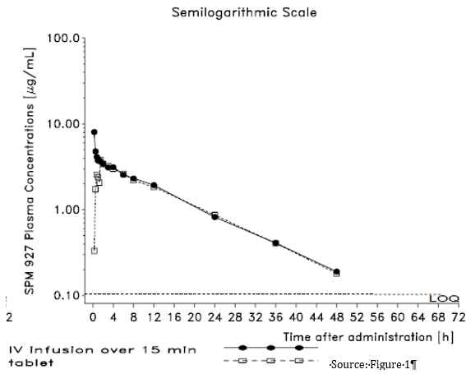

##### Pharmacokinetics of the loading dose children

* In the PK/PD based Study CL0161, simulation showed that administration of loading doses achieved steady state plasma concentrations of lacosamide after the first dose, independent of IV infusion duration or oral administration.
* The greatest effect on Cmax was seen with the 15 minute IV infusion.

The clinical evaluator commented in the clinical evaluation:

* It should be noted that the sponsor described the PopPK data analysis of Study 847 as preliminary.

#### Pharmacodynamics

##### Studies identified by clinical evaluator as providing pharmacodynamic information in the submission

Table 10 (shown above) shows the study relating to a PD topic.

##### Summary of pharmacodynamics (as per the clinical evaluator)

* No specific studies have been performed to evaluate lacosamide PD effects in paediatric subjects.
* In Study CL0161, an exposure-response model developed for adults was applied to data originating from 28 paediatric subjects (age range 3 to 17 years) who participated in Study SP847.

##### Clinical evaluator’s overall conclusions on pharmacodynamics

* The exposure-response model developed in adults seems to satisfactorily describe the paediatric observations. The distribution of simulated percentages of ≥ 50% responders matched the value observed in Study SP847. Based on the limited information coming from Study SP847 (that is, small number of subjects, short treatment period, no placebo), no signal was seen in this paediatric cohort to suggest any change in the exposure-response relationship established in adults.
* In the PK/PD based Study CL0161, 28 subjects were studied and many had incomplete data; the sponsor described the study as preliminary with ‘limited dataset’ and ‘limited information’. Although, the complete information data set was not provided in the submission, further information was provided on request by another evaluator.

#### Dosage selection for the pivotal studies

No studies were identified by the clinical evaluator as providing dosage selection information for the pivotal studies

#### Efficacy

##### Clinical evaluator’s summary of efficacy studies submitted for the paediatric add –on therapy indication

Studies identified by the clinical evaluator as providing evaluable efficacy data in the submission to extend the population for the currently approved indication to:

*Vimpat (lacosamide) tablets are indicated as add-on therapy in the treatment of partial seizures with or without secondary generalisation in patients with epilepsy aged 16 years and older’ to include children 4 to 15 years.*

* No appropriate paediatric efficacy study data has been submitted.
* Open label Study SP847 looked at the 28 day change in seizure frequency and was considered preliminary.
* The sponsor is relying on safety data from interim reports and the PK studies:
  + Study SP847: A multicentre, open-label study to investigate the safety, tolerability and pharmacokinetics of lacosamide oral solution (syrup) as adjunctive therapy in children with partial‑onset seizures.
  + Study SP1047: A multicentre, open-label study to investigate the pharmacokinetics of commercial lacosamide oral formulation as therapy in children (aged 1 month to 17 years) with epilepsy.
  + Study CL0096: Exploratory paediatric population physiologically-based pharmacokinetic analyses of lacosamide.
  + Study CL0177: Population Pharmacokinetic Analysis of lacosamide in Epileptic Paediatric Patients from Studies SP847 and SP1047
  + Study CL0266: Modelling and simulation for the evaluation of possible doses and dose adaptation rules of intravenous lacosamide in children.
  + Study CL0161: Model-based exposure-effect population analysis and simulations based on Phase-II/III trials of adjunctive lacosamide in partial onset seizures.

The clinical evaluator commented in the clinical evaluation report:

* In PK/PD Study CL0161, 28 subjects were studied and many had incomplete data; the sponsor described the study as preliminary with ‘limited dataset’ and ‘limited information’. Although, the complete information data set was not provided in the submission, further information was provided on request by another evaluator.
* Of concern, only 1 of 9 children over 12 years old enrolled in Study SP847 completed the study. Most (6, 67%) of the children discontinued for AEs.
* In Study SP847, neither placebo arm nor placebo period was present. Therefore, it was assumed in Study CL0161, that the placebo effect estimated for adults was the same for children. Although no justification for the assumption was offered in the study, a justification was offered in the Clinical Overview Addendum as follows:
  + Focal epilepsies in children older than 4 years old have a similar clinical expression to focal epilepsies in adolescents and adults
  + Results of adult studies of the treatment of partial-onset seizures can be extrapolated down to 4 years of age as long as the appropriate paediatric dosing is established
  + Lacosamide has dose-proportional PK properties
  + Expected similarities in exposure-response between adults and children, (which is why the study was undertaken and does not justify extrapolation*)*
  + There is the PK modelling and simulation in paediatric subjects to support dosing adaptations (PopPK Studies CL0096, CL0177 and CL0266).

##### Clinical evaluator’s summary of efficacy studies submitted for the adult and adolescent add-on therapy indication

Studies identified by the clinical evaluator as providing evaluable efficacy data in the submission to extend the currently approved indication to:

*Vimpat (lacosamide) tablets are indicated as add-on therapy in the treatment of partial seizures with or without secondary generalisation in patients with epilepsy aged 16 years and older’ to include use as monotherapy in adults and adolescents (16-18 years).*

Table 40: Efficacy studies

|  |  |  |
| --- | --- | --- |
|  | Indication | Study ID |
| Adult | Monotherapy of partial seizures | SP0993 |
| SP902 |

##### Pivotal or main efficacy study: Study SP0993

This was a multicentre, double-blind, double-dummy, randomised, positive-controlled study comparing the efficacy and safety of lacosamide (LCM; 200, 400, or 600 mg/day) to carbamazepine controlled release (CBZ-CR); (400, 800, or 1200 mg/day) used as monotherapy for up to a maximum of 121 weeks in subjects (≥ 16 years) newly or recently diagnosed with epilepsy and experiencing partial-onset seizures or generalised tonic-clonic seizures.

The objective was to compare the efficacy and safety of LCM (200 to 600 mg/day) to CBZ‑CR (400 to 1200 mg/day) used as monotherapy for at least 1 year, efficacy being measured as a primary endpoint by 6-month seizure freedom, in newly or recently diagnosed epilepsy subjects. The study employed a non- inferiority design to show at least a similar benefit-risk balance for LCM compared with CBZ-CR, using 6 month seizure freedom as primary endpoint.

###### Inclusion criteria

The inclusion criteria were:

* Male or female and ≥ 16 years of age.
* Newly or recently diagnosed epilepsy, having experienced unprovoked partial-onset seizures (IA, IB, IC with clear focal origin) or generalised tonic-clonic seizures that is IIE (without clear focal origin).
* Experienced at least 2 unprovoked seizures (separated by a minimum of 48 hours) in the 12 months preceding the Screening Visit out of which at least 1 unprovoked seizure occurred in the preceding 3 months.
* An electroencephalogram (EEG) and a brain computed tomography (CT) scan or magnetic resonance imaging (MRI) of the brain within the past 12 months.

###### Exclusion criteria

The exclusion criteria were:

* A history or presence of seizures of other types than partial-onset and generalised tonic-clonic seizures (for example, myoclonic, absence).
* A history or presence of seizures occurring in clustered patterns, defined as repeated seizures occurring over a short period of time (that is < 20 minutes) with or without function regained between 2 ictal events.
* A history, clinical, or EEG finding suggestive of idiopathic generalised epilepsy at randomization.
* Current or previous diagnosis of pseudo seizures, conversion disorders, or other non-epileptic ictal events that could have been confused with seizures based on expert opinion and/or EEG evidence.
* Had been treated for epilepsy with any AED (including benzodiazepines) in the last 6 months.
  + However, acute and subacute seizure treatment was accepted with a maximum of 2 weeks duration and if treatment was stopped at least 3 days prior to randomization.
  + Prior use of felbamate or vigabatrin was not allowed.
  + Benzodiazepines as rescue therapy for epilepsy may have been used as needed in this time period, but not more frequently than once per week.
* Had received treatment with phenobarbital or primidone within 28 days prior.
* Was taking benzodiazepines for a non-epilepsy indication.
* The use of monoamine oxidase inhibitors (MAOIs) was not allowed within 14 days of Visit 1.
* Was of Asian ancestry and tested positive for HLA-B*1502 allele.

###### Study treatments

The study treatments consisted of:

* An initial treatment titration to LCM 200 mg/day or CBZ-CR 400 mg/day (first target dose), followed by a week of stabilisation. This first target dose was maintained for 6 months (initial evaluation phase), followed by a further 6 months of treatment (initial maintenance phase).
* If subjects experienced seizure(s) during this initial Evaluation Phase, they were titrated to a dose of LCM 400 mg/day or CBZ-CR 800 mg/day (second target dose). Again, this dose was maintained for 6 months (second evaluation phase), followed by a further 6 months of treatment (second maintenance phase).
* If subjects experienced seizure(s) during this second Evaluation Phase, they were titrated to a dose of LCM 600 mg/day or CBZ-CR 1200 mg/day (third target dose). Again, this dose was maintained for 6 months (third evaluation phase), then a further 6 months (third maintenance phase).

Note:

* If subjects experienced seizure(s) during the final (third) evaluation or maintenance phase, they were offered entry to participate in extension Study SP0994.
* Participants leaving the trial had to undergo a tapering regimen.
* In case of a tolerability problem at the second or third target dose level, the subject was allowed to decrease the dose under evaluation by 100 mg/day for LCM or 200 mg/day for CBZ-CR, if medically justified.

The figure below depicts the Study SP0993 overall study schematic diagram.

Figure 4: Study SP0993 overall study schematic diagram

Study SP0993 overall study schematic diagram• An initial treatment titration to LCM 200 mg/day or CBZ-CR 400 mg/day (first target dose), followed by a week of stabilisation. This first target dose was maintained for 6 months (initial Evaluation Phase), followed by a further 6 months of treatment (initial Maintenance Phase).
• If subjects experienced seizure(s) during this initial Evaluation Phase, they were titrated to a dose of LCM 400 mg/day or CBZ-CR 800 mg/day (second target dose). Again, this dose was maintained for 6 months (second Evaluation Phase), followed by a further 6 months of treatment (second Maintenance Phase).
• If subjects experienced seizure(s) during this second Evaluation Phase, they were titrated to a dose of LCM 600 mg/day or CBZ-CR 1200 mg/day (third target dose). Again, this dose was maintained for 6 months (third Evaluation Phase), then a further 6 months (third Maintenance Phase).


The table below shows the overall dosing schedule for up-titration and stabilisation phase, evaluation phase, and maintenance phase.

Table 41: Study SP0993 Overall dosing schedule for up-titration and stabilisation phase, evaluation phase, and maintenance phase

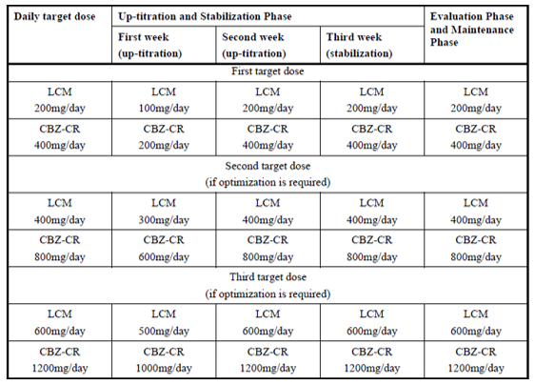

###### Efficacy variables

The efficacy outcome variables:

The primary efficacy outcome variable was the proportion of subjects remaining seizure free for 6 consecutive months (26 consecutive weeks) of treatment, following stabilisation at the last evaluated dose for each subject (based on subject diaries where types, dates and number of seizures are recorded).

Other efficacy outcome variable was the subgroup efficacy 6 months seizure free analysis of subjects with diagnosed partial epilepsy and unclassified epilepsy.

###### Analysis of populations

The full analysis set (FAS) was defined as all randomised subjects who took at least 1 dose of study medication.

The per protocol set (PPS) was defined as containing all subjects in the FAS, who did not have any important protocol deviations determined to impact the interpretation of primary efficacy:

* due to findings of non-compliance, Site [information redacted] was excluded from the PP set.
* Political events in the Crimea and Ukraine resulted in some exclusions.

The per protocol set subset(PPSS)was defined as all subjects in the PPS, further excluding subjects who discontinued during the 6-month seizure freedom evaluation period, due to reasons unrelated to efficacy.

###### Sample size

Based on:

1. a 2-group test for equivalence of proportions with a 0.05 significance level (2-sided);
2. an assumed seizure-free rate for carbamazepine CR of 0.60; and
3. a non-inferiority margin of -0.12 absolute difference, it is assumed that a sample size of 439 randomised subjects per treatment arm would provide approximately 0.90 power for the comparison of the Kaplan-Meier (KM) estimates for the difference in proportion of subjects seizure free for the 26-week Evaluation Phase, following stabilization at the last evaluated dose for LCM versus CBZ-CR.

Other assumptions included a 20% rate of important protocol deviations resulting in removal from the PPS.

Effect size of the active control as per the clinical evaluation report

In the 2006 and 2013 International League Against Epilepsy (ILAE) treatment guidelines, carbamazepine (CBZ) is considered an efficacious treatment as monotherapy for partial-onset seizures;[46] and is a first choice for treatment for partial-onset seizures.[47] Carbamazepine is the most commonly used reference treatment for partial-onset seizures.[48] Carbamazepine (controlled release) (carbamazepine CR) is preferred as it minimizes AEs and limits the number of discontinuations, in particular during titration. For these reasons, carbamazepine CR may be regarded as the best standard comparator.

The inclusion criteria included both partial-onset seizures and generalised tonic-clonic seizures the ILEA reference given, supporting the choice of comparator said:

Adults with partial onset seizures

Conclusions 1; There are four adequate comparators for this category: carbamazepine, levetiracetam, phenytoin, and zonisamide.

There were 2 Class I trials;

* + Brodie et al., (2007);[49] showed for the subset of patients with partial-onset seizures, the 6-month seizure-free rate was 73.3% for the 202 per-protocol patients on the CBZ arm (20% relative lower bound 58.6%)
  + The other trial was published in 2012, that is after the submitted trial commenced.

Adults with generalised-onset tonic–clonic seizures

Conclusions 1; There are no adequate comparators for this category.

Brodie et al., 2007 showed for the subset of patients with generalised -onset seizures, the 6-month seizure-free rate was 69.7% for the 33 per-protocol patients on the CBZ arm, the review also said However, CBZ is not an adequate comparator for this seizure type, which makes the study a Class III trial for this seizure type.

Karceski et al., 200147 was simply a survey of opinions on first choice of treatment.

Perucca, (2008) Designing monotherapy trials of antiepileptic drugs: ‘demonstrating equivalence or non-inferiority can be justified wherever evidence exists that, under specified study conditions, effective treatments can be consistently differentiated from less effective or ineffective treatments, and sufficient data exist to allow an estimate across studies of the magnitude of difference in outcome between the reference treatment and the placebo group. However, in newly diagnosed epilepsy, this level of evidence is not available.’

‘Of equal concern is the variation in seizure-free rates in patients randomised to carbamazepine monotherapy.’

‘In a recent review seizure-free rates during the double-blind maintenance phase ranged from 20% to 42% on an intent-to-treat (ITT) basis, and from 35% to 62% on an evaluable group analysis, leading the authors to conclude that ‘the case for using carbamazepine as an active comparator is not convincing’.’

A similar study was quoted, comparing levetiracetam and carbamazepine; the proportion of patients achieving 6-month seizure freedom at the last evaluated dosage was 72.8% in the per-protocol and 66.7% in the ITT populations on carbamazepine; The non-inferiority boundary set for the adjusted differences in seizure freedom rates was –15%.

‘It should be remembered that reported efficacy estimates may be biased by differences in tolerability.’

‘The FDA does not regard the data generated from this design as adequate to demonstrate efficacy.’

‘The trial was considered by EMEA to adequately meet regulatory requirements.’

‘The non-inferiority limit of –15% (in terms of absolute difference in seizure freedom rates) set in the levetiracetam trial may be greater than desirable, and the fact that confidence limits for the observed primary efficacy out-come difference in that trial were actually < 10% might be taken as an argument for a smaller non-inferiority’

Statistical methods

The primary efficacy analysis was a non-inferiority assessment of lacosamide versus carbamazepine CR for the proportion of subjects remaining seizure free for 6 months at the last evaluated dose. The primary efficacy assessment was based on the FAS and the PPS.

The hypothesis for the assessment of primary efficacy was as follows:

H0: S(t)lacosamide – S(t)CBZ ≤ -0.12; versus

HA: S(t)lacosamide – S(t)CBZ > -0.12

where S(t) (t = 182 days) was the cumulative rate of subjects remaining seizure free for 6 months following stabilisation at the last evaluated dose (also known as the survivorship function), and -0.12 represented the non-inferiority margin based on absolute difference.

Non-inferiority was concluded if both the following criteria were true:

* lower limit of CIlacosamide-CBZ ×100% > -12%
* (Lower limit of CIlacosamide-CBZ /SCBZ)×100% > -20

Kaplan-Meier methods were used to estimate the proportion of subjects remaining seizure free for 6 months, following stabilisation at the last evaluated dose for each treatment group.

The difference in 6-month seizure freedom was stratified by the past 3-month seizure count (≤ 2 and > 2), and the stratified difference in proportion of subjects seizure free on lacosamide versus carbamazepine CR and a corresponding 95% 2-sided CI for lacosamide versus carbamazepine CR was produced using Mantel Haenszel methods.

If the lower limit of CI lacosamide-CBZ was > 0, there was evidence for superiority and a supporting p-value of the corresponding superiority test (2-sided, α = 0.05) was given. The superiority test statistic was assessed by a chi-square distribution with 1 degree of freedom.

Protocol amendments

No subjects were randomised prior to Amendment 1.

Amendment 2 (18 November 2011) related to suicidality.

Amendment 3 (1 August 2012, after 103 patients randomised to each group) added an extra other efficacy variable.

Amendment 4 (27 November 2012) modified exclusion and withdrawal criteria and modified additional agents.

Amendment 5 no subjects were randomised under this amendment.

Amendment 6 (20 May 2013) excluded subjects of Asian ancestry who tested positive for the HLA-A*3101 allele and modified additional agents**.**

Major protocol violations/deviations

312 subjects (35.2%; 146 subjects (32.9%) and 166 subjects (37.6%) in the lacosamide and carbamazepine CR treatment groups, respectively) in the FAS had at least 1 important protocol deviation. The most common important protocol deviation in the lacosamide and carbamazepine CR treatment groups was dosing regimen (72 subjects (16.2%) and 76 subjects (17.2%), respectively), followed by prohibited medications (47 subjects (10.6%) and 57 subjects (12.9%), respectively).

###### Baseline data

An interactive voice response system (IVRS) was used to assign subjects to a treatment. The randomisation was stratified by the category for the number of seizures in the 3 month period prior to Visit 1 (≤ 2 seizures and > 2 seizures). Subjects were randomised to a treatment arm in a 1:1 ratio to either LCM or CBZ-CR.

Patients were issued with both assigned treatment (tablet or capsule) and placebo for the unassigned treatment (capsule or tablet).

The use of benzodiazepines as rescue therapy for epilepsy was allowed if taken at a maximum frequency of once per week.

Table 42: Study SP0993 Baseline demographic data

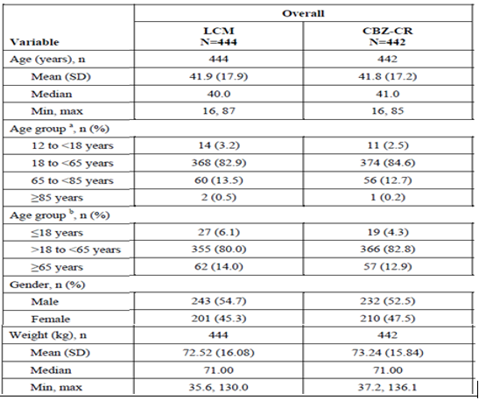

266 (59.9%) and 264 (59.7%) patients completed the study respectively in the LCM and CBZ-CR groups respectively.178 patients discontinued from each study group (LCM = 40.1% and CBZ-CR = 40.3%). Discontinuations due to adverse events were n = 48 (10.8%) for LCM; n = 69 (15.6%) for CBZ-CR and, due to lack of efficacy were n = 47 (10.6%) for LCM; n = 31(7.00%) for CBZ-CR.

Table 43: Study SP0993 Summary of seizure classification history (Full analysis set)

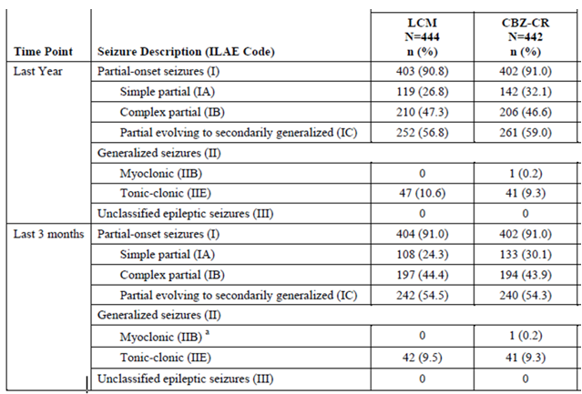

###### Primary efficacy outcome

The table below shows the Kaplan-Meier proportion of subjects’ seizure free for 6 months at the last evaluated dose (FAS and PPS).

Table 44: Study SP0993 Kaplan-Meier proportion of subjects’ seizure free for 6 months at the last evaluated dose (Full analysis and per protocol sets)

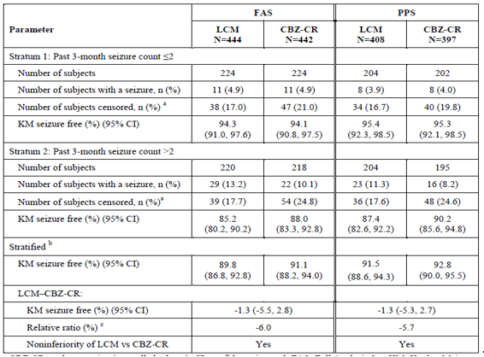

FAS=Full Analysis Set; KM=Kaplan-Meier; PPS = Per Protocol Set a Subjects censored prior to Day 182 b Estimated by Mantel Haenszel methods c Relative ratio = Lower limit of 2-sided 95% CI of the stratified difference between LCM and CBZ-CR in seizure-free rates, divided by CBZ-CR seizure-free rate.

###### Other efficacy outcomes

Table showing subgroup analyses of the KM stratified proportion of subjects’ seizure free for 6 months (FAS and PPS)

Table 45: Study SP0993 Subgroup analyses of the KM stratified proportion of subjects’ seizure free for 6 months (Full analysis and per protocol sets)

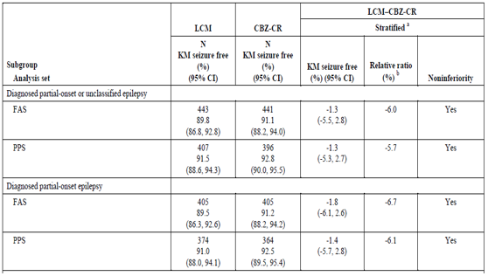a Note: Stratified proportion estimated by Mantel Haenszel methods. b Relative Ratio=Lower limit of 2-sided 95% CI of the stratified difference between LCM and CBZ- CR in seizure-free rates divided by CBZ-CR seizure-free rate.

The clinical evaluator’s commented in the clinical evaluation report:

* According to the reference data submitted, the EMA has previously accepted this trial design for showing efficacy while the FDA has not.
* The study criteria included unprovoked partial-onset seizures (IA; partial simple seizures, IB; complex partial seizures, IC; partial seizures evolving into Secondary generalised seizures, with clear focal origin) as well as IIE; ‘Primary’ generalised tonic-clonic seizures (without clear focal origin). Of these, the 2013 International League Against Epilepsy (ILAE) reference provided by the sponsor, shows that for Adults with partial onset seizures, the per-protocol 6-month seizure-free rate was 73.3% for carbamazepine, while for adults with generalised-onset tonic–clonic seizures it said, that there are no adequate comparators for this category.
* The only stratification used for the primary endpoint was the frequency of seizures. The subgroup analysis did show non inferiority for those diagnosed with partial onset seizures, but not for IC or IIE seizures (that is, none recorded).
* It is noted that the effect size seen was greater than shown in the ILAE guideline. With around 90% efficacy in the primary endpoint for carbamazepine rather than the 60% used in the population size calculations or the cited 73%, this might interfere with showing a difference (with a greater effect, the absolute (fixed) non inferiority margin becomes proportionally smaller compared to the effect).
* Overall, there was a 40% discontinuation rate with both treatments. Of those, 11% of lacosamide and 7% of carbamazepine patients were due to lack of efficacy and 11% and 16%, respectively, were due to AEs.

##### Other efficacy study; Study SP902

A historical-controlled, multicentre, double-blind, randomised study to assess the efficacy and safety of conversion to lacosamide monotherapy 400 mg/day, in subjects with partial-onset seizures (with or without secondary generalisation). A lacosamide 300 mg/day arm was added to blind the treatment group and to ensure a study design consistent with the historical control studies on which Study SP902 was based. The maximum duration of study participation was 19 weeks with the option of continuing in an open label phase of the study (Study SP904) for another 11 weeks, making a total possible participation duration of 30 weeks.

The objective was to demonstrate the efficacy and safety of conversion to lacosamide 400 mg/day monotherapy for partial-onset seizures (with or without secondary generalisation) in subjects 16 to 70 years of age who were withdrawn from 1 to 2 marketed antiepileptic drugs (AEDs).

###### Inclusion criteria

* Aged 16 to 70 years.
* A diagnosis of epilepsy with simple partial seizures (motor component) and/or complex partial seizures (with or without secondary generalisation).
* Maintained on a stable dose of 1 or 2 marketed AEDs for at least 28 days prior to and during Baseline.
* 50% of the subjects in each treatment arm were to be taking carbamazepine as 1 of their 2 concomitant AEDs.
* If a subject was on 2 AEDs, the second AED must have been ≤ 50% of the minimum recommended maintenance dose at Visit 1 and during Baseline, when used as an adjunctive therapy.
* The minimum required seizure frequency during the 8-week baseline phase was 2 partial-onset seizures (IA, IB, or IC) per 28 days. In the case of simple partial seizures, only those with motor signs (IA1) were counted towards meeting this inclusion criterion.
* Subject had ≤ 40 partial seizures (that is, IA1, IA2, IA3, IA4, IB, IC) per 28 days during the 8-week Baseline Phase.
* Subject had an EEG and a brain CT or MRI consistent with the diagnosis of partial-onset epilepsy.

###### Exclusion criteria

* A seizure disorder characterized primarily by isolated auras (that is, simple partial seizures without observable motor signs).
* A history of primary generalised or unclassified seizures.
* A history of status epilepticus within the 12-month period prior.
* A history of cluster seizures, defined as bouts of increased seizures which could not be reliably counted (but which did not represent status epilepticus) during the 8-week period prior to and during the 8-week baseline phase.
* A seizure-free period ≥ 28 consecutive days during the 8-week baseline phase.
* Had > 5 seizures of any type, including isolated auras, on any day during the 8-week baseline phase.
* Had a current or previous diagnosis of pseudo seizures, conversion disorders, or other non-epileptic ictal events which could have been confused with seizures.
* Subject had an implanted vagus nerve stimulation (VNS).
* Had received treatment with benzodiazepines, phenobarbital, or primidone within 28 days prior to or during Baseline.
* Taking 1 or more of the following medications on a regular basis within 28 days prior to or during Baseline: neuroleptics, monoamine oxidase (MAO) inhibitors, barbiturates, or narcotic analgesics.

###### Study treatments

* Lacosamide was titrated in 100 mg/week steps to 300 or 400 mg/day over 3 weeks.
* The subject then began the maintenance phase which was composed of a 6-week period for withdrawal of background AEDs, followed by a 10-week monotherapy phase at the targeted lacosamide dose.
* One dose reduction was allowed during the 16-week maintenance phase.
* At the end of 16 weeks, subjects were offered the option of entering an open-label Study SP904. The maximum duration of a subject’s study participation could therefore be 30 weeks.

###### Efficacy outcome variables

The primary efficacy outcome variable was the percentage of subjects identified as meeting at least 1 of the following exit criteria by Day 112 (last day of maintenance phase) relative to the start of the withdrawal of background AEDs:

1. A 2 fold or greater increase in average monthly (28-day) partial-onset seizure frequency (motor and non-motor) compared to average monthly partial-onset seizure frequency (motor and non-motor) during the baseline phase.
2. A 2 fold or greater increase in consecutive 2-day partial-onset seizure frequency (motor and non-motor) vs the highest consecutive 2-day partial-onset seizure frequency (motor and non-motor) that occurred during the baseline phase.

Note: If the highest consecutive 2-day partial-onset seizure frequency during the baseline phase was 1, a 2-day partial-onset seizure frequency of ≥ 3 was required to meet this exit criterion.

1. Occurrence of a single generalised tonic-clonic seizure if none had occurred in the 6 months prior to randomization.
2. A prolongation or worsening of overall seizure duration, frequency, type or pattern considered by the investigator as serious enough to warrant study discontinuation.
3. Status epilepticus or new onset of serial/cluster seizures.

Note: On Day 1, a 6 week period of withdrawal of background AEDs begins and at the same time, the titrated dose of lacosamide is maintained for 16 weeks

The secondary efficacy outcome variables included the following:

* Time to first occurrence of any exit event
* The sum of the exit event rate, the withdrawal due to adverse event (AE) rate, and the withdrawal due to lack of efficacy rate
* Duration of monotherapy treatment (days) during the Monotherapy Phase
* Clinical Global Impression of Change (CGIC) at study termination or completion
* Patient’s Global Impression of Change (PGIC) at study termination or completion.

###### Analysis of populations

* Enrolled set (ES) consisted of all subjects who signed an informed consent form (screened).
* Safety set (SS) included all randomised subjects who took at least 1 dose of study medication.
* Full analysis set (FAS) included subjects who completed the titration phase and started withdrawing background AEDs (for example, entered the maintenance phase and took at least 1 dose of maintenance medication). subjects who discontinued from the study prior to completing the titration phase and who did not begin to withdraw background AEDs were excluded from the FAS.
* Modified full analysis set (MFAS) consisted of subjects from the FAS, excluding those subjects from Sites [information redacted]. This was due to findings of serious breach of and persistent noncompliance with applicable FDA regulations, GCP, and ICH guidelines which could not be resolved in a satisfactory and timely manner as the data were inconsistent and unreliable with information recorded in the source.
* Per-protocol set (PPS) included all subjects in the FAS who did not have any important deviations for efficacy.

###### Sample size

A sample size of 338 subjects in the lacosamide 400 mg/day group was to provide approximately 90% power for the comparison of the Kaplan-Meier estimate for the percentage of subjects exiting by Day 112 of the maintenance phase versus a fixed historical-control exit rate. This sample size calculation was based on a one - sided, 0.025 significance level, an assumed 0.55 exit rate for the lacosamide 400 mg/day dose group, and a 0.653 exit rate for the historical control. Other assumptions included a 10% dropout rate (for non-exit criteria reasons) during the maintenance phase and a 20% dropout rate during the titration phase.

With the 3:1 randomisation (and the study being powered for the lacosamide 400 mg/day arm only), a total of 451 randomised subjects were required (including 113 subjects for the lacosamide 300 mg/day group).

If the dropout rate in the titration phase was higher than planned, additional subjects were to be enrolled so that at least 270 subjects randomised to lacosamide 400 mg/day would enter the maintenance phase.

The clinical evaluator’s comment in the clinical evaluation report:

* The statistical analysis plan (SAP) did not give the particular source of the assumed 0.55 exit rate.
* The certificate signing request (CSR) for SAP however stated that:
  + The estimate of 0.55 was calculated using exit rates from similar studies for other compounds; [50],[51],[52],[53],[54];[55],[56] and from subject disposition data from other studies conducted by the sponsor.
* Note: The ‘other studies’ were neither identified nor were the references submitted; likewise:
  + The 0.653 historical-control exit rate referenced above was based on the lower limit of a 2-sided 95% prediction interval for an estimate of the combined pseudo-placebo exit rate (controlling for inter-study variability) from a meta-analysis of a set of historical withdrawal to monotherapy studies with similar design as Study SP902. The 95% prediction interval for the historical control provides 97.5% confidence that a single repeated study would yield a pseudo-placebo exit rate of 0.653 or higher.
  + Note, the CSR was a meta-analysis, authors were identified as French JA, Wang S, Warnock B, Temkin N. ‘White paper on alternative monotherapy design in the treatment of epilepsy. Epilepsia (2010) Early View DOI number: 10.1111/j.1528-1167.2010.02650.x.’
  + The reference ‘French et al., 2010 paper’ was submitted to the FDA. It analysed the results of most of the above studies. The results of that meta-analysis, in the summary, stated:
  + The percent meeting exit criteria were uniformly high, ranging from 74.9 to 95.9%. The eight studies appear to meet the criteria set forth for use of historical control. The estimate of the combined percent exit based on the non-iterative mixed-effects model is 85.1%, with a lower bound of the 95% prediction interval of 65.3%, and 72.2% for an 80% prediction interval.
  + Thus, there are two different exit rates, 0.55 and 0.653, based on what appears to be mostly the same data.

###### Statistical methods

For the primary efficacy analyses, the upper limit of the CI for the estimate of the lacosamide 400 mg/day exit rate was compared with a pre-specified historical-control exit rate of 0.653. The lacosamide 400 mg/day dose group would be declared an effective withdrawal to monotherapy treatment, if the upper 95% confidence limit for the estimate of the exit rate was less than 0.653.

Primary Hypothesis:

H0: 1 – S(t) = 0.653; versus

HA: 1 – S(t) < 0.653,

where, S(t) was the cumulative rate of subjects who had not met exit criteria by Day 112 of the Maintenance Phase (that is, survival rate at Day 112).

Consistent with that observed in the pooled historical-control data, up to 10% of subjects in the lacosamide 400 mg/day group who withdrew from the study on or before Day 112 of the maintenance phase for non-exit criteria reasons, were to be censored as of the last maintenance phase dose.

No imputation for missing seizure diary data was performed when deriving exit criterion 1 or 2 because, the primary efficacy analysis must have been consistent with the analyses from which the historical control was derived. The impact of missing data on the determination of whether or not a subject met an exit criterion was evaluated through sensitivity analyses.

###### Protocol amendments

* Protocol amendment 1; provided clarifications.
* Protocol amendment 2 (September 2008); the secondary efficacy parameter, ‘duration of monotherapy treatment,’ was changed to ‘during the monotherapy phase,’ flexibility in the length of taper was permitted, the SAP was expanded and clarified.
* Protocol amendment 3 (January 2010); included statistical methods were updated to clarify the evaluation of efficacy data for subjects who discontinue from the study due to non-exit criteria reasons.
* Protocol amendment 4; the historical-control exit rate and sample size were updated.
* Protocol amendment 5; added an exclusion criterion for known sodium channelopathy.
* Protocol amendment 6; related to suicidality**.**

###### Major protocol violations/deviations

Table 46: Study SP902 Major protocol deviations

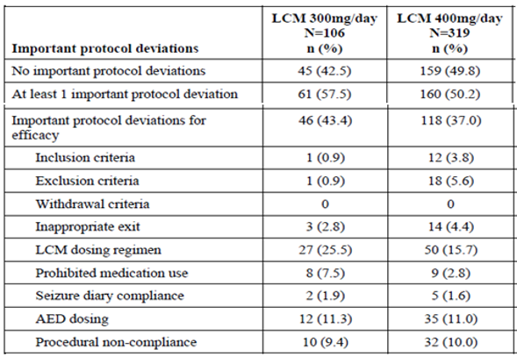

Important deviations for efficacy were defined as deviations that could have impacted the interpretation of efficacy results and thus, warranted removal of a subject from the PPS. Subjects may have had more than 1 important protocol deviation. A single deviation could be counted as important for efficacy and/or safety. All deviations were listed as conduct deviations.

###### Baseline data

Table 47: Study SP902 Summary of demographic characteristics

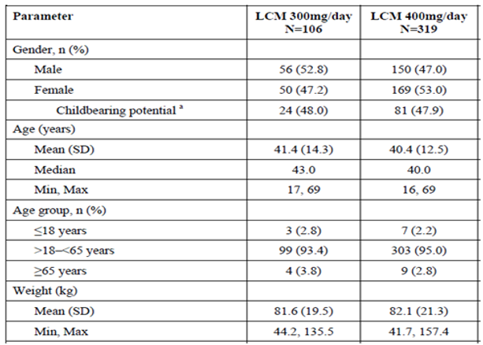

a Percentages were based on the number of females within each treatment group.

The other baseline characteristics (epilepsy and seizure characteristics, seizure classification history, summary of background AED use) appeared similar.

Table 48: Study SP902 Summary of background AED use

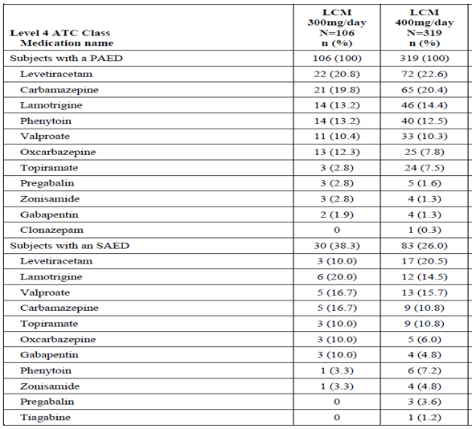 ATC=Anatomical Therapeutic Chemical; PAED=primary background AED; SAED=secondary background AED; Primary and secondary background AEDs were the stable AED(s) required for each subject at study entry.

Subjects reporting the same class or medication more than once were counted once per class or medication.

Percentages for the subjects with a primary (or secondary) background AED row were based on the number of subjects in the SS. All other percentages were based on the number of subjects with a primary (or secondary) background AED row.

Phenytoin use included phenytoin, phenytoin sodium, ethotoin, fosphenytoin, fosphenytoin sodium, and zentronal. Valproate use included valproic acid, valproate semi sodium, valproate sodium, valproate magnesium, ergenyl chrono, and valpromide.

Clinical evaluator’s comment: 50% of the subjects in each treatment arm were to be taking carbamazepine as 1 of their 2 concomitant AEDs. In the event that the study was accruing a population in which less than 50% of the enrolled subjects were taking CBZ, the Sponsor may have elected to restrict enrolment to include only those subjects taking CBZ.

###### Randomisation

Subjects who were taking stable doses of 1 or 2 marketed AEDs were randomised in a double-blind 3:1 scheme to either lacosamide 400 mg/day or 300 mg/day, respectively**.** The maximum 425 subjects were randomised (n = 106, for LCM 300 mg/day and n = 319, for LCM 400 mg/day).

###### Primary efficacy outcome:

* The Kaplan-Meier estimate of the percentage of subjects meeting at least 1 exit criterion by Day 112 (cumulative exit rate) for the lacosamide 400 mg/day group was 0.300 (95% CI: 0.246, 0.355), that is the upper limit of the 2-sided 95% CI for this estimate was lower than the historical-control exit rate (0.653).

The table below shows the predicted exit rate at Day 112 of the maintenance phase for subjects in the lacosamide 400 mg/day group with maximum 10% censoring due to dropout (FAS).

Table 49: Predicted exit rate at Day 112 of the maintenance phase for subjects in the lacosamide 400 mg/day group with maximum 10% censoring due to dropout (Full analysis set)

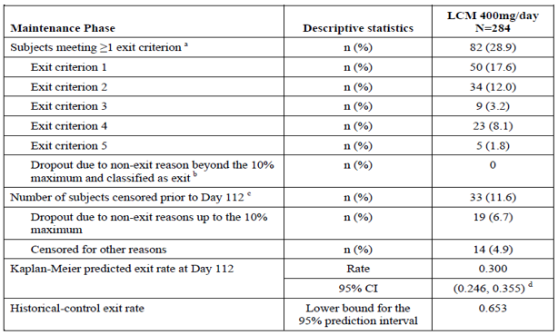a Subjects were counted under more than 1 individual exit criterion if they met more than 1; they were only counted once in the first row. For subjects meeting > 1 exit criterion, the predicted rate was based on the earliest date a criterion was met. b Subjects who dropped out due to non-exit criteria reasons over the 10% censoring maximum were to be counted as an exit; the dropout rate in the Maintenance Phase in the lacosamide 400 mg/day group was < 10%; therefore, no dropouts were classified as an exit. c For the calculation of the Kaplan-Meier estimate for the exit rate at Day 112, subjects who dropped out due to non-exit criteria reasons (up to the 10% maximum) were censored as of the last Maintenance Phase dose. Subjects were censored for other reasons: those who completed the Maintenance Phase prior to Day 112, those who added an AED during Monotherapy, or those who had a protocol disallowed seizure rescue; censoring occurred on the minimum of the date of the deviation and the last Maintenance Phase dose. d The upper 95% confidence limit of the lacosamide 400 mg/day predicted exit rate is lower than the historical-control exit rate (0.653).

The figure below shows the time to exit during the maintenance phase; lacosamide 400 mg/day group (FAS).

Figure 5: Study SP902 Time to exit during the Maintenance Phase; lacosamide 400 mg/day group (Full analysis set)

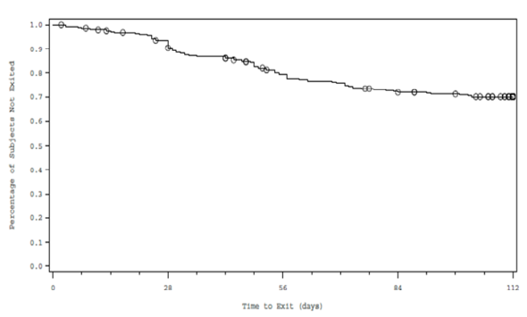

Time to Exit and survival rate estimates were based on the duration between the start of the Maintenance Phase and the earliest date an exit criterion was met. For the calculation of the exit rate at Day 112, subjects who dropped out due to non-exit criteria reasons or who completed prior to Day 112 were censored as of the last Maintenance Phase dose. Subjects who added an AED or who had a protocol disallowed seizure rescue were censored on the date of the deviation. Subjects who completed through Day 112 without meeting an exit were censored at Day 112. A ‘o’ represents ≥ 1 censored event.

The clinical evaluator commented in the clinical evaluation report:

* The criteria for inclusion restricted subjects to those with simple partial and/or complex partial seizures.
* The sample size was based on an assumed 0.55 exit rate for the lacosamide 400 mg/day dose group, and a 0.653 exit rate for the historical control. Thus there are different exit rates 0.55 and 0.653 based on what appears to be mostly the same data. While the published references given for these exit rates were the same, the source of additional unpublished data was not. The assumed 0.653 historical-control exit rate was based in addition, on 32 (8%) of subjects from unpublished sources. The assumed 0.55 exit rate in addition, included subject disposition data from other studies conducted by the sponsor.
* 50% of the subjects in each treatment arm were to be taking carbamazepine as 1 of their 2 concomitant AEDs. However, only 25% of those in the 300 mg/day group and 23% in the 400 mg/day group were taking carbamazepine.
* The percentage of subjects meeting at least 1 exit criterion by Day 112 (cumulative exit rate) for the lacosamide 400 mg/day group was 0.300 (95% CI: 0.246, 0.355), that is the upper limit of the 2-sided 95% CI for this estimate was lower than the historical-control exit rate (0.653).

##### Clinical evaluator’s summary of efficacy studies submitted for the paediatric monotherapy indication

Studies identified by the clinical evaluator as providing evaluable efficacy data in the submission to extend the indications to include use as monotherapy in children 4 to 15 years inclusive.

* The sponsor submitted no trial data to support this extension of indications, but made the following statement:

It is generally accepted, that evidence of efficacy of an AED as adjunctive therapy provides proof of the principle that the drug will be effective as a monotherapy for partial-onset seizures.

The clinical evaluator commented in the clinical evaluation report:

* Despite this ‘statemental opinion’, the sponsor has submitted trial evidence to the FDA, EMA and now TGA to support the extension of indications for adults from adjunctive to also include monotherapy.
* Further in its support of the statement, the sponsor refers to adult monotherapy approvals for the following 5 AEDs: levetiracetam, felbamate, lamotrigine, oxcarbazepine and topiramate.

The clinical evaluator commented that:

* Felbamate is ‘not registered in Australia’.
* Levetiracetam is only approved for monotherapy in the treatment of partial onset seizures, with or without secondary generalisation, in patients from 16 years of age with newly diagnosed epilepsy.
* Lamotrigine under Indications has ‘Initial monotherapy treatment in newly diagnosed paediatric patients is not recommended’.
* The oxcarbazepine PI contains under Clinical trials -Key Active-Controlled Monotherapy Trials; ‘Four double-blind, active-control trials compared the clinical utility, efficacy and safety of Trileptal with standard antiepileptic drugs: valproate (OT/F01) and phenytoin in newly diagnosed adults and adolescents (OT/F02) and adolescents and children (OT/F04) with epilepsy, and carbamazepine in newly diagnosed or untreated adult patients with epilepsy (OT/E25)’.
* The topiramate PI contains: ‘In Study EPMN-105, patients with newly diagnosed epilepsy (n = 613) were randomised to receive either 100 or 200 mg/day of Topamax or standard anti-epileptic treatment (carbamazepine or valproate). Topamax was at least as efficacious as carbamazepine or valproate in reducing seizures in these patients; the 95% confidence intervals for the difference between the two treatment groups were narrow and included zero, indicating that there was no statistically significant between-group difference. The two treatment groups were also comparable with respect to all clinical utility and efficacy endpoints including time to exit, proportion of seizure-free subjects and time to first seizure.
* Patients (n = 207; 32 were aged ≤ 16 years) who completed the double-blind phase of Study YI and Study EPMN-104 were enrolled in long term extension studies with the majority of patients receiving Topamax (topiramate) for 2 to 5 years. In these studies, sustained efficacy was demonstrated with long term administration of Topamax as monotherapy. There was no significant change in dosage during the extension period and no indication that effectiveness of Topamax monotherapy diminished with continued exposure.

Thus, the above statement is not supported. Further, the sponsor has submitted no adjunctive that is ‘add-on’ therapy efficacy studies for children.

* The sponsor then went on to point to an e-published personal view article: ‘Is a separate monotherapy indication warranted for antiepileptic drugs? www.thelancet.com/neurology Vol 14 December 2015 by Mintzer et al (all US authors), that pointed to the conflict between FDA and EMA policies and argued for a revision.

The clinical evaluator commented that:

* No evidence of a literature review was submitted.
* The submission contains the following sponsor’s comment:

‘It is now the sponsor’s position that the efficacy of lacosamide monotherapy of partial-onset seizures in adults can be extrapolated to paediatric patients down to 4 years of age, and this extrapolation is justifiable without the need for completion of the previously proposed bridging approach. Because efficacy extrapolation for partial-onset seizures is currently only accepted down to 4 years of age, the bridging simulation described above is still planned to support a future monotherapy indication in paediatric subjects < 4 years of age’.

##### Clinical evaluator’s summary of efficacy studies submitted to amend the initial loading dose in children ≥ 50 kg

Studies identified by the clinical evaluator as providing evaluable efficacy data in the submission to:

*Amend the dosage and administration to include using an initial IV or oral loading dose in children ≥ 50 kg.*

As per the clinical evaluator’s comments in the clinical evaluation report:

* No efficacy studies were submitted. However, the sponsor argues that:

‘the paediatric PK modelling undertaken shows that the recommended dose for children ≥ 50 kg is the same as that approved for adults and since, the US weight for age data shows that the median age for 50 kg is around 14 years, paediatric loading dose approval for this weight range should occur’.

* Based on PK modelling, lacosamide exposure in paediatric subjects weighing 50 kg or more is predicted to be the same as the exposure observed in adults. Therefore, the safety of administration of a 200 mg loading dose in paediatric subjects weighing 50 kg or more is expected to be similar to that observed in adults.
* In addition to referencing the established PK and safety profile of IV or oral lacosamide loading doses in adult subjects, support for the extension of the lacosamide PI to paediatric subjects weighing 50 kg or more for the initiation of lacosamide treatment of partial-onset seizures with or without secondary generalization using a loading dose is provided by:
  + PopPK simulations of paediatric IV or oral lacosamide loading doses to support dosing recommendations (Study CL0266).
  + Post marketing safety assessment of paediatric lacosamide loading doses (cut-off date 30 November 2015), which includes a separate literature review for the safety of lacosamide in paediatric subjects.

##### Clinical evaluator’s conclusions on clinical efficacy

For the sponsor’s proposal to extend the population for the currently approved indication ‘Vimpat (lacosamide) tablets are indicated as add-on therapy in the treatment of partial seizures with or without secondary generalisation in patients with epilepsy aged 16 years and older’ to include children 4 to 15 years:

* No appropriate paediatric efficacy study data has been submitted.

Study SP0969 (listed as completed 24 January 2017 on ClinicalTrials.gov), was a Phase III, multicentre, double-blind, randomised, placebo controlled, parallel group study to evaluate the efficacy and safety of lacosamide as adjunctive therapy in paediatric subjects with epilepsy ≥ 4 to < 17 years of age with partial-onset seizures. Neither the protocol nor the results of this trial are available. The sponsor states: ‘Study is not part of the Paediatric Investigational Plan for the EU due to the planned efficacy extrapolation in this age group. Study SP0969 is a US registration study’.

* The clinical evaluator commented that:

‘this is not logically consistent with the submission of Studies 847 and SP1047 with subjects’ inclusion criteria being 1 month to 17 years. Further, the PK/PD Study CL0161 used subjects from Study 847.Also, Study EP0034 inclusion criteria mentioned aged 1 month to 17 years and for Study 848 direct admission criteria stated were 4 to ≤ 17 years of age’.

* The sponsor also relies on safety data from interim reports and the PK studies, namely Studies SP0847, SP1047, CL0096, CL0177, CL0266 and CL0161:
  + Study SP847 had 23 subjects aged ≥ 4 years to < 12 years and 9 subjects ≥ 12 years to ≤ 17 years.
  + Study SP1047 had 13 subjects aged ≥ 4 years to < 12 years and 9 subjects ≥ 12 years to ≤ 17 years.
  + Study CL0096 had 7 subjects aged 16 and 17 years of age.
* Regarding the above, the clinical evaluator commented that:
  + This gives a total of 52 subjects in the proposed age range studied for PKs.
  + Studies CL0177 and CL0266 used data from 72 sparsely sampled (3 samples per subject; Studies SP1047 and SP0847) and 7 serially sampled (7 samples per subject; Study SP0847).
  + In Study CL0161 there were 28 subjects studied, many with incomplete data; the sponsor described it as a preliminary and ‘limited dataset’ and ‘limited information’. Complete information on the data set was not provided in the submission, but further information was provided on request.
  + Of concern, only 1 out of 9 children over the age of 12 years enrolled in Study SP0847 completed the study (up to day 27/28); most (6, 67%) discontinued for AEs.
  + Study SP1047 was only a single dose study in those who had established on lacosamide for at least 1 month prior to study entry.
  + The sponsor has taken data from 16 to 18 years olds, who participated in adult studies to include in the paediatric data base.
* Regarding the above, the clinical evaluator commented that:
  + The PopPK study data has been referred to another evaluator for concurrent evaluation.
  + This evaluator thus, can only comment (as here and elsewhere) on the population studies, agreeing with the sponsor that for establishing efficacy Study CL0161 is preliminary and limited.
  + The PK studies by themselves are inadequate to establish efficacy.
  + A further concern is the lack of availability of a suitable formulation for paediatric dosing; this too is being concurrently evaluated by another evaluator.

For the sponsor’s proposal to extend the currently approved indication ‘Vimpat (lacosamide) tablets are indicated as add-on therapy in the treatment of partial seizures with or without secondary generalisation in patients with epilepsy aged 16 years and older’ to include use as monotherapy in adults and adolescents (16-18 years):

* Study SP0993
  + According to the reference data submitted in association with Study SP0993, the EMA has accepted this trial design previously for showing efficacy while the FDA has not. The latter statement suggests that the FDA is still not entirely happy with the design.
  + The study criteria included unprovoked partial-onset seizures (IA, IB, IC with clear focal origin) as well as generalised tonic-clonic seizures (without clear focal origin). Of these, the 2013 International League Against Epilepsy (ILAE) reference given, shows that for `adults with partial onset seizures, the per-protocol 6-month seizure-free rate was 73.3% for carbamazepine, while for `adults with generalised -onset tonic–clonic seizures it said, there are no adequate comparators for this category.
  + The only stratification used for the primary endpoint was the frequency of seizures. The subgroup analysis did show non-inferiority for those diagnosed with partial onset seizures, but not for IC or IIE seizures.
  + The effect size seen was greater than in the ILAE guideline. With around 90% efficacy in the primary endpoint for carbamazepine rather than the 60% used in the population size calculations or the cited 73%, this might interfere with showing a difference.
  + Overall, there was a 40% discontinuation rate with both treatments. Of those, 11% of lacosamide and 7% of carbamazepine patients were due to lack of efficacy and 11% and 16%, respectively, were due to AEs.
* Study SP0902:
  + In the US, the efficacy and safety of lacosamide as monotherapy in partial-onset seizures were established in the Food and Drug Administration (FDA) recommended Sttudy SP902, a Phase III, historical-controlled, multicentre, double-blind, randomised, conversion to monotherapy study in 425 adult subjects.
  + The criteria for inclusion restricted subjects to those with simple partial and/or complex partial seizures.
  + The sample size was based on an assumed 0.55 exit rate for the lacosamide 400 mg/day dose group, and a 0.653 exit rate for the historical control. Thus, there are different exit rates 0.55 and 0.653 based on what appears to be mostly the same data. While the published references given for these exit rates were the same, the source of additional unpublished data was not.
  + 50% of the subjects in each treatment arm were to be taking carbamazepine as 1 of their 2 concomitant AEDs. However, only 25% of those enrolled in the 300 mg/day group and 23% in the 400 mg/day group were taking carbamazepine.
  + The percentage of subjects meeting at least 1 exit criterion by Day 112 (cumulative exit rate) for the lacosamide 400 mg/day group was 0.300 (95% CI: 0.246, 0.355), that is the upper limit of the 2-sided 95% CI for this estimate was lower than the historical-control exit rate (0.653)

For the sponsor’s proposal to extend the indications to include use as monotherapy in children 4 to 15 years inclusive:

* The sponsor submitted no trial data to support this extension of indications, but argued that evidence of efficacy of an AED as adjunctive therapy provides proof of the principle, that the drug will be effective as a monotherapy for partial-onset seizures.
* Despite this expressed opinion, the sponsor has submitted trial evidence to the FDA, EMA and now TGA to support the extension of indications for adults, from adjunctive to also monotherapy.
* The sponsor referred to an e-published article but gave no evidence of a literature search in support of their opinion. The sponsor had previously been prepared to undertake a bridging simulation from adult data in support of this indication but has withdrawn from that intent.
* There is thus no efficacy evidence submitted to support this indication.

#### Safety

Regarding the overall conclusions on clinical safety, the clinical evaluator stated that:

* It is not possible to assess the safety following the initiation of lacosamide in adjunctive that is ‘add-on’ therapy in paediatrics.
* Omitting the oral initial dose titration period in adults, resulted in a small increase in the incidence of some common AEs (dizziness, nausea, fatigue) and of discontinuations.
* The most frequently reported TEAEs in the lacosamide 200 mg initial oral loading dose were dizziness, headache, and fatigue
* The incidence of AEs, particularly of drug related CNS effects, was higher with the 15 minute IV infusion loading dose in adults.
* There are no clinical safety data provided, specific to the use of IV or oral lacosamide loading doses in paediatric subjects.

##### Assessment of benefits

Assessment of benefits as per the clinical evaluator at the first round of evaluation:

###### To register a new formulation

The clinical submission contained some data relevant to this new formulation, which may be useful in a proposed paediatric extension.

* Regarding palatability and ease of use: the majority of subjects responded that the syrup had an acceptable smell (97.9%), was easy to swallow (57.4%), and did not cause them to become nauseous or to vomit (66.0% and 91.5%, respectively). For the 42.6% of subjects who responded that there was a taste while the syrup was in their mouths, 21.3% considered the taste ‘ok’, 17.0% ‘bad’, and 6.4% ‘good’. For the subjects who provided responses to the question of whether the syrup had an unpleasant aftertaste, 25.5% considered the aftertaste to be unpleasant and 29.8% did not consider the aftertaste to be unpleasant.
* Without the new formulation practical paediatric dosing would be very difficult and compliance low.

###### To extend the population for the existing additive therapy ‘add-on’ indications to include children 4 to 15 years inclusive

Regarding efficacy:

* The sponsor submitted PopPK and PK/PD studies. Based on the studies, the sponsor believes that the:
  + benefits of lacosamide treatment for paediatric patients with partial-onset seizures down to 4 years of age are expected to be similar to those for adults where the PK, efficacy, and safety profile have been established; and
  + established positive lacosamide efficacy profile seen in adults for partial-onset seizures, and the weight-based paediatric dosing adaptations targeting similar exposures as adults at therapeutic lacosamide doses support the benefits of lacosamide use in paediatric subjects with partial-onset seizures down to 4 years of age.

Regarding safety:

* In its extensive analysis of 257 subjects in the proposed age range, the sponsor stated:

‘The safety profile of lacosamide in open-label studies in adjunctive therapy in paediatric subjects 4 to < 16 years of age was consistent with the safety profile observed in adults.’

###### To extend the indications to include use as monotherapy in adults and adolescents (16 to 18 years)

The general benefits of monotherapy as opposed to multiple AEDs include:

* a lower incidence of AEs related to AED therapy and thus improved tolerability.
* increased patient compliance.
* a decreased risk of drug interactions.
* potentially lower medication costs.

In support of the proposed extension of indication:

* Study SP0993 showed non-inferiority to carbamazepine for those newly diagnosed with partial onset seizures; however, this was from a subgroup analysis, as the inclusion criteria were for both partial onset seizures, and generalised tonic-clonic seizures.
* Study SP902 showed a statistically significantly lower exit rate in the lacosamide 400 mg/day group as compared to the historical results for carbamazepine for conversion from multiple AEDs to monotherapy for patients with partial onset seizures.

###### To extend the indications to include use as monotherapy in children 4 to 15 years inclusive.

While similar general benefits might be expected from monotherapy, no data, only opinion, was submitted in support of this extension of indications to include monotherapy for children.

###### To amend the dosage and administration to include omitting the initial oral dose titration period in adults.

The benefit shown by omitting the initial oral dose titration period is limited to the achievement of steady state concentrations quicker. The extent of an associated faster onset of efficacy was neither shown nor appeared considered.

In response to the clinical question later posted, the sponsor stated:

‘the lacosamide 200 mg loading dose (followed by lacosamide 100 mg twice daily dosing) is expected to provide similar PK exposure and the same therapeutic benefit after the first dose as LCM 100 mg twice daily dosing on Day 10 for adjunctive therapy with the approved titration regimen (1 week of titration (LCM 100 mg/day) and 3 days to reach steady state (LCM 200 mg/day)) and on Day 3 for monotherapy with omitting the titration period (3 days of LCM 200 mg/day to reach steady state)’.

###### To amend the dosage and administration to include using an oral loading dose in adults.

The benefit shown by using an oral loading dose is limited to showing the achievement of steady state concentrations quicker. The extent of an associated faster onset of efficacy was neither shown nor appeared considered. In response to the clinical question later posted, the sponsor stated:

* there is no direct clinical evidence that a clinically faster onset of seizure control is achieved by the loading dose.
* the minimum effective dose of LCM 200 mg/day is more rapidly reached (approximately 1 hour following an oral loading dose)

###### To amend the dosage and administration to include an initial IV loading dose based on PK and safety data in adults.

The benefit shown by using an IV loading dose is limited to showing the achievement of steady state concentrations quicker. The extent of an associated faster onset of efficacy was neither shown nor appeared considered.

In response to the clinical question later posted, the sponsor stated:

* there is no direct clinical evidence that a clinically faster onset of seizure control is achieved by the loading dose.
* the minimum effective dose of LCM 200 mg/day is more rapidly reached at the end of infusion with an IV loading dose.

###### Omitting the oral initial dose titration period in children

There are no specific analyses of paediatric safety data during titration, thus evaluation of omission cannot be made. Theoretically, achievement of steady state concentrations would be quicker.

###### Use of initial IV or oral loading dose in children

Modelling showed faster achievement of steady state, it was however based on preliminary data analysis. There was some very limited post marketing data of poor quality as per the submitted data.

##### Assessment of risks as per the clinical evaluator at the first round of evaluation

###### To register a new formulation

The sponsor in agreement with the CHMP initiated the recall of Vimpat syrup 15 mg/ mL due to a quality defect related to the formation of a flake-like precipitate of lacosamide in the syrup.

This statement in the clinical data conflicts with that of the covering letter of application.

###### To extend the population for the existing additive therapy indications to include children 4 to 15 years inclusive.

The sponsor’s claim that the combined lacosamide exposure of at least 100 paediatric subjects, exposed to adjunctive lacosamide treatment for at least 1 year, is a supportive safety data is misleading in that, while 101 subjects in the safety database had completed 48 weeks (12 months), only 97 had completed 1 year.

Further in relation to exposure, this evaluator could only identify in the safety database 69 subjects, age 4 to 18 years, who were followed from initial exposure for > 12 months. It is thus not possible to assess the safety of the initiation of lacosamide therapy:

* For Study EP0034, it appears that at the end of study SP0969, all patients including those on placebo received lacosamide prior to entry to Study EP0034.
* Study 848 included subjects from Study 847, who all were initiated on lacosamide before entering Study 848.Direct enrolment was also allowed with initiation of lacosamide being the start day for the Study848. There were no Japanese direct enrollers with a history of > 12 months exposure, thus according to the table in the CSR, there were only 69 subjects, aged 4 to 18 years, who were followed from initial exposure for > 12 months.
* AEs were more common in the first 3 months despite, that many of the subjects had received lacosamide prior to entry in the studies, which suggests that the initial incidence should be even higher.

While the safety analysis did show some consistency with that of adults, it also showed however, additional adverse reactions in paediatric subjects; decreased appetite (6.6%), lethargy (4.3%) and abnormal behaviour (1.9%).

There were no efficacy studies submitted, instead the sponsor is relying on safety data and PK/PD modelling extrapolating from adult studies together, with somewhat imprecise post marketing off label data.

While the evaluation of the PopPK/PD studies is being done elsewhere, the evaluator in the clinical evaluation report, makes the following clinical comments:

‘In Study CL0161, there were 28 subjects studied, many with incomplete data; the sponsor described it as a preliminary and ‘limited dataset’ and ‘limited information’. Complete information on the data set was not provided in the submission, but further information was provided on request.’

###### To extend the indications to include use as monotherapy in adults and adolescent (16 to 18 years).

Overall in Study SP0993, there was a 40% discontinuation rate with both (LCM and CBZ) treatments. Of those, 11% of lacosamide and 7% of carbamazepine patients were due to lack of efficacy and 11% and 16%, respectively, were due to AEs.

Study SP902 which used an historical control AEDs, showed a high variability in trial results. The selection criteria were not completely met.

‘Overall, the safety data obtained from the monotherapy Study SP0993 and its long-term extension SP0994 indicate a similar safety profile of lacosamide as has previously been reported, for use in partial onset seizures add-on treatment.

###### To extend the indications to include use as monotherapy in children 4 to 15 years inclusive.

The post marketing data submitted, that relates to risk for this proposed extension of indications for this population, was very imprecise.

###### To amend the dosage and administration to include omitting the oral initial dose titration period in adults.

Omitting the oral initial dose titration period in adults resulted in a small increase in the incidence of some common AEs (dizziness, nausea, fatigue) and of discontinuations.

###### To amend the dosage and administration to include using an oral loading dose in adults.

The overall incidence of TEAEs in the Phase I modified oral pool, increased across initial oral lacosamide dose. The most frequently reported TEAEs in the lacosamide 200 mg initial oral dose category were dizziness, headache, and fatigue.

###### To amend the dosage and administration to include an initial IV loading dose in adults.

An initial IV infusion over 15 minutes is associated with a higher Cmax. As one would expect the incidence AEs, particularly of drug related CNS effects, was higher.

###### Omitting the oral initial dose titration period in children.

There are no specific analyses of paediatric safety data during titration, thus evaluation of omission cannot be made.

###### Use of initial IV or oral loading dose in children.

There was some very limited post marketing data of poor quality which showed that half of the cases got an AE.

##### Assessment of benefit-risk balance as per the clinical evaluator at the first round of evaluation

###### To register a new formulation.

This has been referred to the pharmaceutical chemistry evaluator.

###### To extend the population for the existing additive ‘add-on’ therapy indications to include children 4 to 15 years inclusive.

The safety data is incomplete in extent and the PopPK/PD data, appears to be clinically limited also. To this evaluator, the balance appears unfavourable in this proposed population extension for additive therapy. However, evaluation is not complete with some evaluation still being carried out by another evaluator.

###### To extend the indications to include use as monotherapy in adults and adolescents (16 to 18 years).

The benefit-risk balance of lacosamide, to extend the indications to include use as monotherapy in adults and adolescents (16 to 18 years), is favourable.

###### To extend the indications to include use as monotherapy in children 4 to 15 years inclusive.

The absence of data means that the benefit risk balance for monotherapy in children must be considered unfavourable.

###### To amend the dosage and administration to include omitting the initial oral dose titration period in adults.

The risk benefit balance could be favourable, if the sponsor shows that the small increase in AEs is associated with a reasonably faster onset of seizure prevention, not just a faster achievement of steady state PKs.

###### To amend the dosage and administration to include using an oral loading dose in adults.

The risk benefit balance could be favourable if the sponsor shows the increase in AEs is associated with a faster onset of seizure prevention, not just a faster achievement of steady state PKs.

###### To amend the dosage and administration to include an initial IV loading dose in adults.

The risk benefit balance could be favourable if the sponsor shows the increase in AEs is associated with a faster onset of seizure prevention, not just a faster achievement of steady state PKs.

###### Omitting the initial oral dose titration period in children.

Insufficient data.

###### Use of initial IV or oral loading dose in children.

Insufficient data.

##### Recommendation regarding authorisation as per the clinical evaluator

###### To register a new formulation

For the Delegate’s decision.

###### To extend the population for the existing additive therapy indications to include children 4 to 15 years inclusive

For the Delegate’s decision, needs an additional evaluator’s report on PopPK.

###### To extend the indications to include use as monotherapy in adults and adolescents (16 to 18 years)

It is recommended that the use of lacosamide be approved for:

*Vimpat (lacosamide) injection for intravenous infusion is indicated as monotherapy and add-on therapy in the treatment of partial seizures with or without secondary generalisation in patients with epilepsy aged 16 years and older when oral administration is temporarily not feasible.*

*Vimpat (lacosamide) tablets are indicated as monotherapy and add-on therapy in the treatment of partial seizures with or without secondary generalisation in patients with epilepsy aged 16 years and older.*

###### To extend the indications to include use as monotherapy in children 4 to 15 years inclusive

It is not recommended that the indications be extended to include monotherapy in children 4 to 15 years inclusive, however this is subject to the opinion of another evaluator.

###### To amend the dosage and administration to include omitting the initial oral dose titration period in adults

Recommendation is dependent on further information.

###### To amend the dosage and administration to include an initial oral loading dose in adults

Recommendation is dependent on further information.

###### To amend the dosage and administration to include an initial IV loading dose in adults

Recommendation is dependent on further information.

###### Omitting the oral initial dose titration period in children

Insufficient data to recommend.

###### Use of initial IV or oral loading dose in children

Insufficient data to recommend.

##### Comments on draft RMP (Summary of safety concerns) as per the clinical evaluator at the first round of evaluation

The safety specification in the draft RMP is not entirely satisfactory; there is no mention of Study SP0969. Participation in this study was an entry requirement for Study EP0034.

##### Post first round of evaluation clinical questions

Clinical questions posed to the sponsor by the clinical evaluator post first round of evaluation and responses provided by the sponsor requiring first round re-evaluation or second round evaluation:

###### Pharmacokinetics

1. Please briefly summarise the evidence that more rapidly achieving steady state PKs for lacosamide will result in a clinically reasonably faster onset of seizure control.
2. Please indicate the likely increase in speed of onset of seizure control compared with omitting the titration period.

###### Efficacy

1. In Study SP993 please clearly indicate the source of the predefined non-inferiority margin of -0.12 absolute difference.

###### Safety

1. Within the Targeted indication group identified in the search of post marketing data (2.7.4 Summary of Clinical Safety Addendum page 179 on), how many of the reports had either an Indication, diagnosis or medical history of partial onset (or focal) seizures?
2. Please provide a copy of the final protocol for Study SP0969. Participation in this was an entry requirement for Study EP0034.

#### Second round clinical evaluation

The sponsor’s response showed in post-marketing: 87 reports reported partial-onset (or focal) seizures as the indication for use of lacosamide, and an additional 65 reported a medical history consistent with partial-onset (or focal) seizures for a total of 152 reports.

##### Clinical evaluator’s response to sponsor’s comments

The CSR for Study SP0993 under ‘3.3.1 Inclusion criteria’ has under Item 4:

‘Subjects had newly or recently diagnosed epilepsy having experienced unprovoked partial-onset seizures (IA, IB, IC with clear focal origin) or generalised tonic-clonic seizures (without clear focal origin).’

##### Second round benefit-risk assessment

For the assessment of benefits as per the clinical evaluator at the second round of evaluation) (please see above in the Section: Clinical; second round benefit risk assessment).

##### Recommendation regarding authorisation as per the clinical evaluator at the second round of evaluation

###### To register a new formulation

Unchanged from previous assessment.

###### To extend the population for the existing additive therapy indications to include children 4 to 15 years inclusive

Unchanged from previous assessment.

###### To extend the indications to include use as monotherapy in adults and adolescents (16 to 18 years)

Unchanged from previous assessment.

###### To extend the indications to include use as monotherapy in children 4-15 years inclusive

Unchanged from that identified previously.

###### To amend the dosage and administration to include omitting the initial oral dose titration period in adults

It is recommended that lacosamide be approved for usage in adults to include the option of omitting the oral initial dose titration period.

###### To amend the dosage and administration to include an initial oral loading dose in adults

It is recommended that lacosamide be approved for usage in adults to include the option of an initial oral loading dose.

###### To amend the dosage and administration to include an initial IV loading dose in adults

It is recommended that lacosamide be approved for usage in adults to include the option of an initial IV loading dose.

###### Omitting the initial oral dose titration period in children

###### Unchanged from previous assessment.

###### Using initial IV or oral loading dose in children

Unchanged from previous assessment.

### Risk-benefit analysis

#### Delegate’s considerations

The sponsor’s application affects various registration facets of lacosamide (Vimpat), an anti-epileptic drug.The proposed various therapeutic registration facets are:

1. To register a new formulation based on physico-chemical similarity to a previously registered but cancelled product.
2. Extend the population for the existing additive therapy indication to include children 4 to 15 years, based on PopPK and safety data.
3. Extend the indications to include use as monotherapy in adults and adolescents (16 to 18 years) based on efficacy and safety data.
4. Extend the indications to include use as monotherapy in children 4 to 15 years based on no data.
5. Amend the dosage and administration to include omitting the oral initial dose titration period in adults and adolescents based on safety data.
6. Amend the dosage and administration to include using an oral loading dose in adults and adolescents based on PK and safety data.
7. Amend the dosage and administration to include an initial IV loading dose in adults and adolescents based on PK and safety data.
8. Amend the dosage and administration to include omitting the oral initial dose titration period in children.
9. Amend the dosage and administration to include using an oral loading dose in children.
10. Amend the dosage and administration to include using an initial IV loading dose in children.
11. Amend multiple sections of the Product Information.

Only facets 2 to 4 are being specifically referred to the ACM.

There is no objection to the registration of the new formulation (facet 1, above) from the quality evaluators’ perspective. The Delegate is in support.

Based on the benefit-risk balance, the clinical evaluator recommended approval for lacosamide (Oral or IV) extension of indications (3 above) to include use as monotherapy, in the treatment of partial onset seizures (POS) with or without secondary generalisation in adults and adolescents (16 to 18 years). The analyses of Studies SP0993 (pivotal), SP0902 and SP0994 are in support. The Delegate agrees with the clinical evaluator that there was no authenticated comparator in the pivotal study to justify a consideration for the inclusion of patients with generalised tonic-clonic seizures. There are both safety and efficacy issues associated with sponsor’s attempt, implicit and explicit, to include the latter subgroup of patients in the PI and is deemed unacceptable. It is even more so, given the sponsor’s statement that an assessment of non-inferiority was not planned for this subgroup and it will appear that both EMA and FDA only approved monotherapy for POS.

The clinical evaluator stated that the sponsor’s proposed population extension use of lacosamide for the existing additive (adjunctive) therapy indication, to include children 4 to 15 years based on safety data and PopPK, is a Delegate’s decision. The clinical evaluator commented that:

* There were no efficacy studies submitted, instead the sponsor is relying on safety data and PK/PD modelling extrapolating from adult studies together, with somewhat imprecise Post marketing off label data. In particular, the sponsor argues that the:
  + benefits of lacosamide treatment for paediatric patients with partial onset seizures down to 4 years of age are expected to be similar to those for adults where the PK, efficacy, and safety profile have been established and;
  + established positive lacosamide efficacy profile seen in adults for partial onset seizures, and the weight-based paediatric dosing adaptations targeting similar exposures as adults at therapeutic lacosamide doses support the benefits of lacosamide use in paediatric subjects with partial onset seizures down to 4 years of age.
* The safety data is incomplete/inaccurate in extent and the PopPK/PD data, appears to be clinically limited also.
* While the available safety analysis did show some consistency with that of adults, it also showed however, additional adverse reactions in paediatric subjects; decreased appetite (6.6%), lethargy (4.3%) and abnormal behaviour (1.9%).

During the evaluation process, the clinical evaluator had commented that neither the protocol nor the results of this trial Study SP0969 were available. Study SP0969 was a Phase III, multicentre, double-blind, randomised, placebo-controlled, parallel-group study to evaluate the efficacy and safety of lacosamide as adjunctive therapy in paediatric subjects with epilepsy ≥ 4 to < 17 years of age with partial-onset seizures. The study reported was submitted to the EMA by its sponsor (Marketing Authorisation Holder (MAH)) although, it will appear that both the EMA and FDA registrations for adjunctive therapy extension in this sub-population were based on extrapolation from adults’ efficacy/safety data and PK/PD modelling.

The reported efficacy from Study SP0969 was in line with the efficacy known from studies in adult population. The safety profile observed in the SP0969 study was also consistent with the well-known safety profile of lacosamide in adults. No new safety concerns were identified in this study.

Given the above alone, the Delegate believes, that the sponsor’s proposed population extension use of lacosamide for the existing additive (adjunctive) therapy indication, to include children 4 to 15 years is approvable (2 above).

The clinical evaluator stated that the proposed extension of lacosamide indications to include, use as monotherapy in children 4 to 15 years is not approvable. As per the clinical evaluator, the:

* rationale is that while similar general benefits might be expected from monotherapy, the absence of direct efficacy data means that the benefit- risk balance for monotherapy in children must be considered unfavourable.
* post marketing data submitted, that relates to risk for this proposed extension of indications for this subpopulation, was very imprecise.
* sponsor referred to some guidelines relating to (a) extrapolating adult data to usage in paediatric < 4 years and (b) approach to paediatric monotherapy indication. It will appear that the guideline implication was for the generation of controlled paediatric clinical study.

Furthermore, the PopPK evaluator’s report stated that Study CL0266 did not address the issue of whether in younger children, with higher CF/L and shorter, trough t1/2 (Cmax) may become sub therapeutic. This might result in breakthrough seizures. This might necessitate three times daily dosing rather than twice daily in the proposed PI. The sponsor acknowledges that with the higher clearance observed in younger children, there is potential for exposure to become sub therapeutic.

The sponsor ‘claimed to have addressed this probability by employing and proposing higher mg/ kg maximum doses (12 mg/ kg/day) given twice daily for lighter children weighing < 30 kg compared to 8 mg/ kg/day for children weighing ≥ 30 kg to < 50 kg for adjunctive therapy. We have used Css as the exposure parameter in pharmacokinetic-pharmacodynamic (PK/PD) analyses and consider that this serves well as the exposure parameter. We have not used Cmin in PK/PD analyses’.

The sponsor was asked if it has simulations of three times daily dosing for patients < 30 kg, including Cmax, AUC and Cmin.

The sponsor responded that ‘We have not performed simulations of three times daily dosing for patients < 30 kg, including Cmax, AUC and Cmin. Given the PK of lacosamide, we believe that twice daily regimens are appropriate.

The TGA‘s PopPK working group considered the above and other PopPK lacosamide simulation issues, without AED co-administration, in children ≥ 4 years old and advised the Delegate that ‘appropriate dosing recommendations for younger children need to be based on experience from clinical trials’. The latter appears to further reinforce the requirement for a clinical efficacy study for the proposed extension of lacosamide indications to include, use as monotherapy in children ≥ 4 years old.

Taken together the Delegate believed, that a decision on the approvability of the sponsor’s proposed extension of lacosamide’s indications (facet 4 above) to include, use as monotherapy in children 4 to 15 years, should be deferred pending the outcome of a well-designed clinical trial on lacosamide’s monotherapy efficacy in the proposed sub population. The latter is even more so, given that the approvals for the AEDs (oxcarbazepine, topiramate) with paediatric monotherapy indication were based on clinical efficacy data. To do otherwise might be unsafe, efficacy-wise.

The European Summary of Product Characteristics (SPC) states under the Clinical trial section for paediatric population:

‘Partial-onset seizures have a similar clinical expression in children from 4 years of age and in adults. The efficacy of lacosamide in children aged 4 years and older has been extrapolated from data of adolescents and adults with partial-onset seizures, for whom a similar response was expected provided the paediatric dose adaptations are established and safety has been demonstrated’

According to the sponsor’s website:

‘The expanded FDA indication for Vimpat is based on the principle of extrapolation of its efficacy data from adults to children, and is supported by safety and pharmacokinetics data collected in children. Adverse reactions in paediatric patients are similar to those seen in adult patients*.* This principle of extrapolating clinical data from well controlled studies in adults has been recognized by the FDA as potentially addressing the challenge of limited paediatric data availability’.

While facets 5 to 7 of the submission have not been specifically referred to the ACM, the Delegate welcomes comments from the ACM. Based on the available data, the Delegate agrees with the clinical evaluator that the sponsor’s proposal to:

* Amend the dosage and administration to include omitting the oral initial dose titration period in adults and adolescents based on safety data is approvable (5 above).
* Amend the dosage and administration to include using an oral loading dose in adults and adolescents based on PK and safety data is approvable (6 above). The benefit is in achieving a faster steady state. The sponsor did not consider any extent of an associated faster efficacy onset of seizure control.
* Amend the dosage and administration to include an initial IV loading dose in adults and adolescents based on PK and safety data is approvable (7 above). The benefit is in achieving a faster steady state. The sponsor did not consider any extent of an associated faster efficacy onset of seizure control.

Again, while facets 8 to 10 of the submission have not been specifically referred to the ACM, the Delegate welcomes comments from the ACM. It appears that there was not sufficient data at the time of evaluation for the clinical evaluator to make recommendations. However, given the additional data, the Delegate believes that the sponsor’s proposal to:

* Amend the dosage and administration to include omitting the oral initial dose titration period in children, ≥ 4 years to 17 years, for the adjunctive partial onset seizure indication is approvable (facet 8 above), safety wise.
* Amend the dosage and administration to include using an oral loading dose in children, ≥ 4 years to 17 years, for the adjunctive partial onset seizure indication is approvable (facet 9 above), safety wise.
* Amend the dosage and administration to include using an initial IV loading dose in children, ≥ 4 years to 17 years, for the adjunctive partial onset seizure indication is approvable (facet 10 above), safety wise.
* Amend multiple sections of the PI (facet 11 above) requires further assessment to the satisfaction of the TGA, following the outcome of the ACM deliberations.

As per the non-clinical data evaluation report, there were no new safety concerns identified in juvenile dog or rat pre- and postnatal toxicity studies, that would preclude extension use of lacosamide in paediatric (≥ 4 years of age) patients. Modifications to the PI are suggested.

Any newly emergent RMP issues during ACM deliberations will be addressed when the draft PI is being reviewed post ACM, to the satisfaction of the TGA.

#### Proposed action

Based on the available evidence from the evaluated submitted data, the Delegate was inclined at this stage to:

* favour the approval of the application for:
  + ‘monotherapy, in the treatment of partial onset seizures with or without secondary generalisation in adults and adolescents (16 to 18 years)’
  + ‘adjunctive therapy for partial onset seizure in children 4 to 15 years’
  + ‘all the listed amendments’ above
* defer the approval of the application for:
  + ‘monotherapy for partial onset seizure in children 4 to 15 years’*,* pending the outcome of a well-designed clinical trial on lacosamide’s monotherapy efficacy in the proposed sub population.
* Any approval is subject to resolving issues, arising from the ACM deliberations and finalising matters pertaining to the draft PI, to the satisfaction of the TGA.

The summary of issues is as per the Delegate’s discussion in the body of the report for ACM.In particular, the Delegate draws the attention of the committee members to the proposed monotherapy use of lacosamide in children, ≥ 4 years old, with partial onset seizure in the absence of any direct, well documented efficacy data for the subpopulation. The Delegate believed that the latter did not occur in the past, for those AEDs with monotherapy paediatric indication.

#### Request for ACM advice

* Approvability of lacosamide’s use to include:
  + monotherapy, in the treatment of partial onset seizures with or without secondary generalisation in adults and adolescents (16 to 18 years).
  + adjunctive therapy for partial onset seizures in children 4 to 15 years.
* Deferment of lacosamide’s approval for use as:
  + monotherapy for partial onset seizures in children 4 to 15 years, pending the outcome of a well-designed clinical trial on lacosamide’s monotherapy efficacy in the proposed subpopulation.
* Comments to:
  + amend the dosage and administration to include omitting the oral initial dose titration period in adults and adolescents based on safety data.
  + amend the dosage and administration to include using an oral loading dose in adults and adolescents based on PK and safety data. The benefit is in achieving a faster steady state. The sponsor did not consider any extent of an associated faster efficacy onset of seizure control.
  + amend the dosage and administration to include an initial IV loading dose in adults and adolescents based on PK and safety data. The benefit is in achieving a faster steady state. The sponsor did not consider any extent of an associated faster efficacy onset of seizure control.
  + amend the dosage and administration to include omitting the oral initial dose titration period in children, ≥ 4 years to 17 years, for the adjunctive partial onset seizures indication, safety wise.
  + amend the dosage and administration to include using an oral loading dose in children, ≥ 4 years to 17 years, for the adjunctive partial onset seizures indication, safety wise.
  + amend the dosage and administration to include using an initial IV loading dose in children, ≥ 4 years to 17 years, for the adjunctive partial onset seizure indication, safety wise.

Request for the committee to provide advice on any other issues, that it thinks maybe relevant to decisions on all of the above.

#### Response from sponsor

Delegate’s comments:

‘Taken together, the Delegate believes, that a decision on the approvability of the sponsor’s proposed extension of lacosamide’s indications (facet 4 above) to include, use as monotherapy in children 4 to15 years, should be deferred pending the outcome of a well-designed clinical trial on lacosamide’s monotherapy efficacy in the proposed sub population. The latter is even more so, given that the approvals for the AEDs (oxcarbazepine, topiramate) with paediatric monotherapy indication were based on clinical efficacy data. To do otherwise might be unsafe, efficacy-wise.’

##### Sponsor response to delegates comments

###### Introduction

In comparison to treatment with > 1 AED, monotherapy treatment provides several advantages to the patient.[57],[58] For example, monotherapy treatment is likely to result in a lower incidence of AEs related to AED therapy and thus improved tolerability, a decreased risk of drug interactions, potentially lower medication costs, and increased patient compliance. In particular, compliance is extremely important to ensure optimized therapy while poor compliance can lead to increased health care costs and greater morbidity.[59],[60] Monotherapy that is both effective and well tolerated can be of particular value to certain patient groups. In patients newly or recently diagnosed with epilepsy, an effective initial monotherapy treatment with seizure control can enable patients to continue to lead normal lives without a prolonged period of poor seizure control while trying different AEDs.[61] More than 50% of newly diagnosed patients become seizure-free with a first or second AED.[62]

###### Endorsement of paediatric extrapolation approach as monotherapy in the EU and the US

It is generally accepted that evidence of efficacy of an AED as adjunctive therapy provides proof of the principle that the drug will be effective as a monotherapy for partial-onset seizures. Furthermore, it is generally accepted that the safety profile of an AED as adjunctive therapy will be similar to the safety profile when used as monotherapy. The EMA Guideline;[63] conclusions from the Paediatric Epilepsy Experts Group Meeting; [64] and the US FDA draft guidance;[65] endorse the paediatric extrapolation of efficacy without specific mention to adjunctive therapy or monotherapy. In fact, in 2017, the European Commission and US FDA approved the extension of both lacosamide monotherapy and adjunctive indications to adolescents and children from 4 years of age based on the extrapolation of efficacy data from the adult studies. Data from Study SP0969, which was a Phase III, multicentre, double-blind, randomised, placebo-controlled, parallel-group study to evaluate efficacy and safety of lacosamide as adjunctive therapy in children with epilepsy ≥ 4 years to < 17 years of age with uncontrolled partial-onset seizures, was not provided with the paediatric applications in the EU and the US and did not serve as basis for the efficacy or safety assessment. Study SP0969 was initially conducted upon request of the US FDA Division of Neurology Products to provide results of a paediatric confirmatory study, at a time when the extrapolation of adult efficacy data to the paediatric population aged ≥ 4 years was not yet accepted by the Division. This study will serve as the basis for the paediatric indication submission in countries that do not currently accept the extrapolation principle, such as Japan. Study SP0969 has been completed and the Market Authorisation Holder believes that the paediatric extrapolation approach can be further justified by the favourable efficacy and safety of lacosamide in Study SP0969. Furthermore, prior to the recent approvals in EU and US of lacosamide monotherapy and adjunctive therapy in adolescents and children from 4 years of age, a major publication by Mintzer et al., (2015);[66] suggested that the regulatory approach requiring separate indications for all monotherapy and adjunctive therapy in epilepsy is not warranted. The authors recommended that regulatory agencies approve AEDs for the treatment of specific seizure types or epilepsy syndromes, irrespective of concurrent medication use.

###### Challenges of conducting confirmatory clinical studies for monotherapy in children

As mentioned in the Delegate’s overview, Australian PI for oxcarbazepine and topiramate contain double-blind, randomised, active comparator-controlled clinical studies (Studies OT/F01, OT/F02, OT/F04, OT/E25 and EPMN-105);[67] for monotherapy in which children or adolescents were enrolled together with adults except for Study OT/F04. These studies were conducted before the extrapolation approach from adults to children was accepted by CHMP and FDA; the results of these studies were reported in 1997 (Studies OT/F01, F02 and F04), 1998 (Study OT/E25) and 2002 (Study EPMN-105). Clinical studies in paediatric subjects with epilepsy, and especially for monotherapy, pose significant and well recognized ethical, recruitment, and financial challenges.[68] Due to the infrequent occurrence of seizures, trials of new-onset monotherapy for partial-onset seizures need a long observation period and it limits the possibility of a placebo-controlled design. Adult efficacy studies supporting a monotherapy indication in the EU have been designed using an active comparator (as was done in the lacosamide adult monotherapy Study SP0993). However, a lacosamide non-inferiority study in the paediatric population could require comparison with more than 1 approved anti-epileptic drug (AED) active control, as has been done in the topiramate study (Study EPMN-105); this study has been criticised for a number of reasons;[69] including the use of numerous active controls (that is, valproate and carbamazepine). Furthermore, there are well known toxicities associated with carbamazepine and valproate (including high rates of birth defects and changes in sex hormones in women using valproate), which pose ethical concerns for enrolling paediatric subjects in a non-inferiority study of these AEDs. Thus, it has been sponsor’s position that a lacosamide monotherapy indication for treatment of partial-onset seizures with or without secondary generalisation was justifiable without performing an unnecessary paediatric monotherapy study.

###### Paediatric extrapolation in lacosamide monotherapy

Although there is no clinical trial data specific to the use of lacosamide monotherapy in paediatric subjects, relevant support for extrapolation of efficacy for monotherapy is provided by the following:

* Established safety of lacosamide adjunctive therapy in paediatric subjects 4 years to < 16 years of age (Pool SPX-1 population and Study SP0969).
* Established safety and efficacy of lacosamide monotherapy in subjects aged 16 years or older from Study SP0993.
* Similar lacosamide plasma concentrations observed in adult monotherapy (Studies SP0993 and SP902) and adjunctive therapy Studies SP754, SP755, and EP0008.
* Recommendations outlined in Mintzer et al., (2015);71 for a unified partial-onset seizure indication.
* General acceptance that the safety profile of an AED as adjunctive therapy will be similar to its safety profile when used as monotherapy, which was supported by CHMP during their assessment of the paediatric application of lacosamide in the EU.[70]
* Recommendations in the EMA Guideline;68 for extrapolation of efficacy for focal epilepsies down to 4 years of age.

In conclusion, it is the sponsor’s position that a lacosamide monotherapy indication for treatment of partial onset seizures with or without secondary generalisation is justifiable without performing an unnecessary paediatric monotherapy study. The sponsor believes that monotherapy indication can be extended to children aged 4 years and older based on clinical data for monotherapy in adults and safety data in adjunctive therapy in children.

##### Additional items identified

Note: some additional items identified related to changes to the PI and these are beyond the scope of the AusPAR

###### Amendments to dosage and administration, raised by the Delegate

*However, given the additional data, the Delegate believes that the sponsor’s proposal to:*

* *Amend the dosage and administration to include omitting the oral initial dose titration period in children, ≥ 4 years to 17 years, for the adjunctive partial onset seizure indication is approvable (facet 8 above), safety wise.*
* *Amend the dosage and administration to include using an oral loading dose in children, ≥ 4 years to 17 years, for the adjunctive partial onset seizure indication is approvable (facet 9 above), safety wise.*
* *Amend the dosage and administration to include using an initial IV loading dose in children, ≥ 4 years to 17 years, for the adjunctive partial onset seizure indication is approvable (facet 10 above), safety wise.*

###### Sponsor response

The sponsor would like to clarify that the proposed amendment of omitting the oral initial dose titration period in children is intended as monotherapy only for adolescents or children weighing 50 kg or greater. In addition, the proposed loading dose indication is for adolescents or children weighing 50 kg or greater in monotherapy and adjunctive therapy, as well as adults.

#### Advisory Committee Considerations[71]

The Advisory Committee on Medicines (ACM), having considered the evaluations and the Delegate’s overview, as well as the sponsor’s response to these documents, advised the following:

The ACM, taking into account the submitted evidence of efficacy, safety and quality, agreed with the Delegate and considered Vimpat (lacosamide) oral and parenteral dose forms, film coated tablets available in 50, 100, 150 or 200 mg strengths, along with solution (10 mg/ mL), injectable (200 mg/20 mL), to have an overall positive benefit-risk profile for the extended indication:

*Vimpat (lacosamide) for use as monotherapy in adults and adolescents (16 to 18 years) in the treatment of partial onset seizures with or without secondary generalisation*

In making this recommendation, the ACM distinguished the proposed extension of indication for use as monotherapy in children 4 to 15 years.

##### Proposed PI/CMI amendments

ACM agreed with the Delegate to the proposed amendments to the PI and CMI.

##### Specific advice

ACM advised:

* Agreement for ’lacosamide use as adjunctive therapy for partial onset seizure treatment in children 4 to 15 years weighing over 50 kg’.
* That ‘usage in children weighing less than 50 kg requires further consultation with the TGA’s PopPK analysis working group in relation to dosing.
* That there was insufficient efficacy and safety data to support monotherapy for partial onset seizure in children 4 to 15 years. Deferring the approval for that proposed paediatric monotherapy indication is an option, while gathering efficacy and safety data with regards to monotherapy use in this subpopulation, as there is currently limited data for monotherapy use in the subpopulation group.

#### Post ACM population pharmacokinetics assessment

On 30 May 2019 the PopPK working group held an out of session meeting to discuss the issues raised at the ACM.

##### Details of discussion

It was noted that two working group members had provided advice on 3 May 2018 as follows.

A weight-based dosing scheme was recommended for the maintenance period:

* subjects < 30 kg: lacosamide 8 mg/kg/day up to 12 mg/kg/day;
* subjects ≥ 30 kg to < 50 kg: lacosamide 6 mg/kg/day to 8 mg/kg/day; and
* subjects ≥ 50 kg: lacosamide 300 mg/day to 400 mg/day.

The working group noted that it appears that what is proposed in Australia by the sponsor agrees with the EU proposed changes.

From Figure 1 on page 15 of159 (taken from the Vimpat CL0177 PopPK analysis of lacosamide in epileptic paediatric patients from Studies SP847 and SP1047; dated 17 December 2014; shown below as Figure 6)), it is clear that some patients < 30 kg will require the 12 mg/kg/day to achieve a therapeutic concentration. However, others would be better managed on a lower dose (which is shown in the top right plots where the dose is 10 mg/kg/day in the < 30 mg/kg/day). In either case, clinical judgement is involved, which decreases concerns.

As the proposed dosing recommendation is to be ‘up to’ 12 mg/kg/day for < 30 kg, is acceptable.

The working group endorsed the out of session advice given by the two members.

Figure 6: Predicted steady state concentration (Css) by body weight using run617a for children < 17 years for the four different simulated dosing regimens

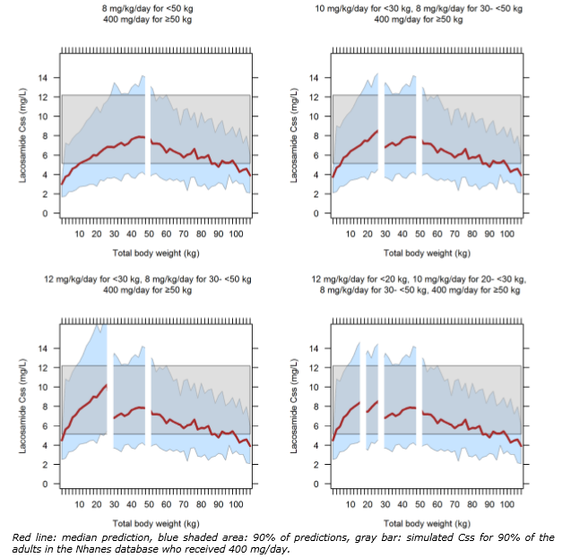run617a = Final paediatric pharmacokinetics model.

### Outcome

Based on a review of quality, safety and efficacy, the TGA approved the registration of:

* Vimpat lacosamide 10 mg/ mL oral solution bottle, indicated for:

*monotherapy in the treatment of partial seizures with or without secondary generalisation in patients with epilepsy aged 16 years and older.*

*add-on therapy in the treatment of partial seizures with or without secondary generalisation in patients with epilepsy aged 4 years and older.*

* Vimpat lacosamide 200 mg/20 mL injection vial; and 50 mg, 100 mg, 150 mg and 200 mg film coated tablets, indicated for:

*monotherapy in the treatment of partial seizures with or without secondary generalisation in patients with epilepsy aged 16 years and older.*

The full indications for which are now:

*monotherapy in the treatment of partial seizures with or without secondary generalisation in patients with epilepsy aged 16 years and older*

*add-on therapy in the treatment of partial seizures with or without secondary generalisation in patients with epilepsy aged 4 years and older.*

#### Specific conditions of registration applying to these goods

The Vimpat EU-Risk Management Plan (RMP) (version 12, date 1 July 2016; data lock point 30 November 2015), with Australian Specific Annex (version 1.0, date 15 November 2017), included with submission PM-2016-04633-1-1, and any subsequent revisions as agreed with the TGA will be implemented in Australia.

## Attachments 1, and 2. Product Information

The PI for Vimpat lacosamide 10 mg/ mL oral solution bottle, and lacosamide 50 mg, 100 mg, 150 mg and 200 mg film coated tablets approved with the submission which is described in this AusPAR is at Attachment 1.

The PI for Vimpat lacosamide 200 mg/20 mL injection vial approved with the submission which is described in this AusPAR is at Attachment 2.

For the most recent PI, please refer to the TGA website at <<https://www.tga.gov.au/product-information-pi>>.

|  |
| --- |
| Therapeutic Goods Administration |
| PO Box 100 Woden ACT 2606 Australia  Email: [info@tga.gov.au](mailto:info@tga.gov.au) Phone: 1800 020 653 Fax: 02 6232 8605  [**https://www.tga.gov.au**](https://www.tga.gov.au) |

1. Clarification: this matter was resolved prior to recommendation for registration.
2. Precipitation of lacosamide in excipients mixture at 15 mg/mL strength, which is borderline the saturation solubility level of lacosamide in the excipient mixture (determined as 17.1 mg/mL).
3. CHMP: Committee for Medicinal Products for Human Use (European Medicines Agency).
4. In the study evaluated previously, the 10 mg/mL oral solution was used in the study and was accepted for extrapolation to the 15 mg/mL, given that all the excipients in both strengths were qualitatively and quantitatively the same.
5. *The AAPS Journal, Vol. 15, No. 4, October 2013- Impact of Osmotically Active Excipients on Bioavailability and Bioequivalence of BCS Class III Drugs.* Both of these excipients are known to enhance GI motility and accelerate small intestine transit, thus reduce absorption.
6. The Biopharmaceutical Classification System (BCS) is a scientific approach based on the aqueous solubility and intestinal permeability characteristics of the drug substance. A drug substance categorised as BCS Class I is characterised as having high solubility, high permeability.
7. Assuming a 50 kg body weight, the new proposed dose in adults corresponds to 12 mg/kg/day, compared with the currently approved dose of 8 mg/kg/day
8. As recommended in the EMA ‘Guideline on the need for non-clinical testing in juvenile animals of pharmaceuticals for paediatric indications’; EMEA/CHMP/SWP/169215/2005
9. Ctrough = plasma concentration at end of dosing interval
10. Cmax : Maximum observed plasma/serum concentration of drug
11. EMEA/CHMP/EWP/147013/2004 Guideline on the role of Pharmacokinetics in the Development of Medicinal Products in the Paediatric Population defines adolescents as 12 to 17 years (Page 5).
12. The aim of this submission is the addition of monotherapy indication in the treatment of partial-onset seizures with or without secondary generalisation in adult and adolescent (16-18 years) patients with epilepsy.
13. CER submission 2008-1184
14. AUCτ,ss : AUC during a dosing interval at steady state
15. AUCτ,ss,norm(BW) AUC during a dosing interval at steady state geometric mean values for dose normalised by body weight; Cmax,ss,norm(BW) : measured maximal concentration at steady state, normalized by body weight
16. CER 2008-1184
17. There were 47 enrolled in study SP847 information on the individual ages and lean body weights of the 28 in this analysis from that study could not be found. Of that 28, 13 patient’s results had missing dosing information over several days.
18. CHMP/EWP/566/98 Rev.2/Corr; CHMP, Jul 2010
19. conclusions from the Paediatric Epilepsy Experts Group Meeting (EMA/153272/2010, 2010)
20. Cmax increases in a predictable, dose-proportionate manner. CER 2008-1184
21. There were 47 enrolled in Study SP847 information on the individual ages and lean body weights of the 28 in this analysis from that study could not be found. Of that 28, 13 patient’s results had missing dosing information over several days.
22. CHMP/EWP/566/98 Rev.2/Corr; CHMP, Jul 2010
23. conclusions from the Paediatric Epilepsy Experts Group Meeting (EMA/153272/2010, 2010)
24. Cmax increases in a predictable, dose-proportionate manner. CER 2008-1184
25. The protocol was submitted in response to a request for information
26. There were 47 enrolled in study SP847 information on the individual ages and lean body weights of the 28 in this analysis from that study could not be found. Of that 28, 13 patient’s results had missing dosing information over several days.
27. Overall mean exposure for this age group was 37.6 days
28. The sponsors claims ‘Suitable oral (syrup and tablets) and IV lacosamide formulations are already available that allow for flexible dosing and mode of administration based on patients’ unique needs.’
29. Perucca, E. 2008 Designing Clinical Trials to Assess Antiepileptic Drugs as Monotherapy Difficulties and Solutions. CNS Drugs 2008; 22: 917-938
30. Type IA = simple partial seizures with unimpaired consciousness, type IB = complex partial seizures with impaired consciousness), IC = partial seizures secondarily generalised (with clear focal origin)
31. Population Pharmacokinetic Analysis in Epileptic Paediatric Patients from Studies SP847 and SP1047
32. Indication: Status epilepticus, Lennox-Gastaut syndrome, Generalised tonic-clonic seizure, Myoclonic epilepsy, Early infantile epileptic encephalopathy with burst-suppression, Petit mal epilepsy + any non-epilepsy related PTs or too specific terms such as Tremor, Encephalopathy, Asperger’s disorder, Attention deficit/hyperactivity disorder, Anxiety, Neurodevelopmental disorder, Cerebral disorder, Acquired epileptic aphasia.

    Medical History: Lennox- Gastaut syndrome, Generalised tonic-clonic seizure, Myoclonic epilepsy, Rett's disorder, Early infantile epileptic encephalopathy with burst-suppression, Infantile spasms, Juvenile myoclonic epilepsy, Severe myoclonic epilepsy of infancy, Petit mal epilepsy.
33. in order to have a similar population as SP902 in which 70% of subjects were on 1 Baseline AED
34. The protocol was submitted in response to a Section 31 request
35. In the sponsor’s response to the clinical questions the LCM 200 mg loading dose (followed by LCM 100 mg twice daily dosing) is expected to provide similar PK exposure and the same therapeutic benefit after the first dose as LCM 100 mg twice daily dosing on Day 10 for adjunctive therapy with the approved titration regimen (1 week of titration [LCM 100 mg/day] and 3 days to reach steady state [LCM 200 mg/day]) and on Day 3 for monotherapy with omitting the titration period (3 days of LCM 200 mg/day to reach steady state).
36. In the sponsor’s response to the clinical questions:

    There is no direct clinical evidence that a clinically faster onset of seizure control is achieved by the loading dose.

    The minimum effective dose of LCM 200 mg/day is more rapidly reached (approximately 1 hour following an oral loading dose)
37. In the sponsor’s response to the clinical questions

    There is no direct clinical evidence that a clinically faster onset of seizure control is achieved by the loading dose.

    The minimum effective dose of LCM 200 mg/day is more rapidly reached at the end of infusion with an IV loading dose.
38. There were 47 enrolled in study SP847 information on the individual ages and lean body weights of the 28 in this analysis from that study could not be found. Of that 28, 13 patient’s results had missing dosing information over several days.
39. 50% of the subjects in each treatment arm were to be taking carbamazepine as 1 of their 2 concomitant AEDs. 25% of those in the 300mg/day group and 23% in the 400mg/day group were taking carbamazepine.
40. EMA assessment
41. In the sponsor’s response to the clinical questions the LCM 200 mg loading dose (followed by LCM 100 mg twice daily dosing) is expected to provide similar PK exposure and the same therapeutic benefit after the first dose as LCM 100 mg twice daily dosing on Day 10 for adjunctive therapy with the approved titration regimen (1 week of titration [LCM 100 mg/day] and 3 days to reach steady state [LCM 200 mg/day]) and on Day 3 for monotherapy with omitting the titration period (3 days of LCM 200 mg/day to reach steady state).
42. In the sponsor’s response to the clinical questions

    There is no direct clinical evidence that a clinically faster onset of seizure control is achieved by the loading dose.

    The minimum effective dose of LCM 200 mg/day is more rapidly reached at the end of infusion with an IV loading dose.
43. In the sponsor’s response to the clinical questions

    There is no direct clinical evidence that a clinically faster onset of seizure control is achieved by the loading dose.

    The minimum effective dose of LCM 200 mg/day is more rapidly reached at the end of infusion with an IV loading dose.
44. *Routine risk minimisation* activities may be limited to ensuring that suitable warnings are included in the product information or by careful use of labelling and packaging.

    *Routine pharmacovigilance* practices involve the following activities:

    All suspected adverse reactions that are reported to the personnel of the company are collected and collated in an accessible manner;

    Reporting to regulatory authorities;

    Continuous monitoring of the safety profiles of approved products including signal detection and updating of labelling;

    Submission of PSURs;

    Meeting other local regulatory agency requirements.
45. Module 1: Administrative information and prescribing information for Australia
46. Glauser T et al, 2006 ILAE Treatment Guidelines: Evidence-based Analysis of Antiepileptic Drug Efficacy and Effectiveness as Initial Monotherapy for Epileptic Seizures and Syndromes *Epilepsia* 2006; 47:1094–1120
47. Karceski S et al, 2001 The Expert Consensus Guideline Series Treatment of Epilepsy *Epilepsy & Behavior* 2001; 2: A1-A50
48. Perucca, E 2008 Designing Clinical Trials to Assess Antiepileptic Drugs as Monotherapy Difficulties and Solutions CNS Drugs 2008; 22: 917-938
49. Brodie MJ et al., 2007 Comparison of levetiracetam and controlled-release carbamazepine in newly diagnosed epilepsy. *Neurology* 2007; 68: 402–408
50. Sachdeo R et al, 1992 Felbamate monotherapy: controlled trial in patients with partial onset seizures. *Ann Neurol.* 1992; 32: 386-392
51. Fraught E et al, 1993 Felbamate monotherapy for partial-onset seizures: an active-control trial. *Neurology* 1993; 43: 688-692.
52. Beydoun A et al, 1997 Gabapentin monotherapy: II. A 26-week, double-blind, dose-controlled, multicenter study of conversion from polytherapy in outpatients with refractory complex partial or secondarily generalized seizures. The US Gabapentin Study Group 82/83. *Neurology* 1997; 49: 746-752
53. Sachdeo RC et al, 1997 Topiramate monotherapy for partial onset seizures. *Epilepsia* 1997; 38: 294-300.
54. Gilliam F et al, 1998 An active control trial of lamotrigine monotherapy for partial seizures. *Neurology* 1998; 51: 1018-1025
55. Beydoun A et al, 2000 Oxcarbazepine monotherapy for partial-onset seizures: a multicenter, double-blind, clinical trial*. Neurology* 2000; 54: 2245-2251
56. Sachdeo R et al, 2001 Oxcarbazepine (Trileptal) as monotherapy in patients with partial seizures. *Neurology* 2001; 57: 864-871
57. Faught E. 2007 Monotherapy in adults and elderly persons. *Neurology*. 2007; 69: S3-9.
58. Karceski S, et al 2005. Treatment of epilepsy in adults: expert opinion, 2005. *Epilepsy Behav*. 2005; 7: S1-64
59. Faught E, et al 2008. Non adherence to antiepileptic drugs and increased mortality: findings from the RANSOM Study. *Neurology*. 2008; 71: 1572-1578
60. Manjunath R, et al 2009 Association of antiepileptic drug non adherence with risk of seizures in adults with epilepsy. *Epilepsy Behav*. 2009; 14: 372-378
61. Glauser T, et al.2006 ILAE treatment guidelines: evidence-based analysis of antiepileptic drug efficacy and effectiveness as initial monotherapy for epileptic seizures and syndromes. *Epilepsia*. 2006; 47: 1094-1112
62. Brodie MJ, et al 2012. Patterns of treatment response in newly diagnosed epilepsy. *Neurology*. 2012; 78: 1548-1554
63. CHMP/EWP/566/98 Rev.2/Corr; CHMP, Jul 2010. Guideline on clinical investigation of medicinal products in the treatment of epileptic disorders (EMA) Rev 2, 20 Jan 2010
64. EMA/153272/2010. Conclusions of the Paediatric Epilepsy Experts Group Meeting, held in London 1 September 2009, 29 Apr 2010.
65. Drugs for Treatment of Partial Onset Seizures: Full Extrapolation of Efficacy from Adults to Pediatric Patients 4 Years of Age and Older. FDA draft guidance, 201
66. Mintzer S, et al. 2015 Is a separate monotherapy indication warranted for antiepileptic drugs? *Lancet Neurol.* 2015; 14:1229–1240
67. Wilby J, et al. 2005 Clinical effectiveness, tolerability and cost-effectiveness of newer drugs for epilepsy in adults: a systematic review and economic evaluation. *Health Technol Assess*. 2005; 9: 1-157.
68. Garofalo E. 2007 Clinical development of antiepileptic drugs for children. *Neurotherapeutics*. 2007; 4: 70-74.
69. Panayiotopoulos CP, et al. 2004 Efficacy and tolerability of the new antiepileptic drugs: commentary on the recently published practice parameters. *Epilepsia.* 2004; 45: 1646-1649.
70. EMA/CHMP/506450/2017. Assessment report of an application for a group of variations for lacosamide, including an extension of indication to include monotherapy and adjunctive therapy in the treatment of partial-onset seizures with or without secondary generalisation in children from 4 to less than 16 years old with epilepsy, 20July 2017.
71. The ACM provides independent medical and scientific advice to the Minister for Health and the Therapeutic Goods Administration (TGA) on issues relating to the safety, quality and efficacy of medicines supplied in Australia including issues relating to pre-market and post-market functions for medicines.

    The Committee is established under Regulation 35 of the Therapeutic Goods Regulations 1990. Members are appointed by the Minister. The ACM was established in January 2017 replacing Advisory Committee on Prescription Medicines (ACPM) which was formed in January 2010. ACM encompass pre and post-market advice for medicines, following the consolidation of the previous functions of the Advisory Committee on Prescription Medicines (ACPM), the Advisory Committee on the Safety of Medicines (ACSOM) and the Advisory Committee on Non-Prescription Medicines (ACNM). Membership comprises of professionals with specific scientific, medical or clinical expertise, as well as appropriate consumer health issues relating to medicines.