Australian Public Assessment Report for lapatinib
Proprietary Product Name: Tykerb
Sponsor: GlaxoSmithKline Australia Pty Ltd
About the Therapeutic Goods Administration (TGA)
- The Therapeutic Goods Administration (TGA) is part of the Australian Government Department of Health and Ageing, and is responsible for regulating medicines and medical devices.
- TGA administers the Therapeutic Goods Act 1989 (the Act), applying a risk management approach designed to ensure therapeutic goods supplied in Australia meet acceptable standards of quality, safety and efficacy (performance), when necessary.
- The work of the TGA is based on applying scientific and clinical expertise to decision-making, to ensure that the benefits to consumers outweigh any risks associated with the use of medicines and medical devices.
- The TGA relies on the public, healthcare professionals and industry to report problems with medicines or medical devices. TGA investigates reports received by it to determine any necessary regulatory action.
- To report a problem with a medicine or medical device, please see the information on the TGA website <www.tga.gov.au>.
About AusPARs
- An Australian Public Assessment Record (AusPAR) provides information about the evaluation of a prescription medicine and the considerations that led the TGA to approve or not approve a prescription medicine submission.
- AusPARs are prepared and published by the TGA.
- An AusPAR is prepared for submissions that relate to new chemical entities, generic medicines, major variations, and extensions of indications.
- An AusPAR is a static document, in that it will provide information that relates to a submission at a particular point in time.
- A new AusPAR will be developed to reflect changes to indications and/or major variations to a prescription medicine subject to evaluation by the TGA.
Copyright
© Commonwealth of Australia 2012
This work is copyright. You may reproduce the whole or part of this work in unaltered form for your own personal use or, if you are part of an organisation, for internal use within your organisation, but only if you or your organisation do not use the reproduction for any commercial purpose and retain this copyright notice and all disclaimer notices as part of that reproduction. Apart from rights to use as permitted by the Copyright Act 1968 or allowed by this copyright notice, all other rights are reserved and you are not allowed to reproduce the whole or any part of this work in any way (electronic or otherwise) without first being given specific written permission from the Commonwealth to do so. Requests and inquiries concerning reproduction and rights are to be sent to the TGA Copyright Officer, Therapeutic Goods Administration, PO Box 100, Woden ACT 2606 or emailed to <tga.copyright@tga.gov.au>.
Contents
I. Introduction to product submission 4
Submission details 4
Product background 4
Regulatory status 5
Product Information 5
II. Quality findings 5
III. Nonclinical findings 6
Introduction 6
Pharmacology 6
Pharmacokinetics 10
Toxicology 12
Nonclinical summary and conclusions 14
IV. Clinical findings 16
Introduction 16
Pharmacokinetics 16
Pharmacodynamics 21
Dosage selection for the pivotal studies 22
Efficacy 22
Safety 33
Ethnicity 46
First round of benefit-risk assessment 51
List of questions 53
Clinical summary and conclusions 53
V. Pharmacovigilance findings 54
Risk management plan 54
VI. Overall conclusion and risk/benefit assessment 56
Quality 56
Nonclinical 56
Clinical 57
Risk management plan 60
Risk-benefit analysis 60
Outcome 68
Attachment 1. Product Information 68

I. Introduction to product submission

Submission details
Type of Submission | Extension of indications
Decision: | Approved
Date of Decision: | 5 June 2012
Active ingredient(s): | Lapatinib
Product Name(s): | Tykerb
Sponsor’s Name and Address: | GlaxoSmithKline Australia Pty Ltd  PO Box 18095  Melbourne VIC 8003
Dose form(s): | Film coated tablet
Strength(s): | 250 mg
Container(s): | Blister pack
Approved Therapeutic use: | Tykerb, in combination with paclitaxel, is indicated for the first line treatment of patients with metastatic breast cancer whose tumours overexpress HER2 (ErbB2) and for whom trastuzumab is not appropriate (see Clinical Trials).
Route(s) of administration: | Oral
Dosage: | 1500 mg once daily
ARTG Number (s) | 132305, 185997

Product background
This AusPAR describes an application by the sponsor, GlaxoSmithKline Australia Pty Ltd, to extend the indications of Tykerb (lapatinib). The sponsor’s submission seeks approval for an additional indication for lapatinib in combination with paclitaxel for the treatment of patients with metastatic breast cancer (MBC) whose tumours overexpress HER2 (ErbB2).
Lapatinib is a tyrosine kinase inhibitor that inhibits both the epidermal growth factor receptor (EGFR, aka ErbB1) and the HER2 receptor (ErbB1). It is currently registered in Australia for the treatment of HER2 overexpressing, MBC in the following settings:
- In combination with an aromatase inhibitor, in post menopausal women where hormonal therapy is indicated; and
- In combination with capecitabine, in patients whose tumours have progressed after treatment with an anthracycline, a taxane and trastuzumab.
Tykerb is provided as a film coated tablet containing lapatinib dityosylate, which is member of the 4-anilinoquinazoline class of kinase inhibitors. Tykerb is provided as a 250mg tablet.
Current recommended doses for Tykerb are in combination with aromatase inhibitor 1500mg once daily continuously. When utilised in combination with capecitabine, the recommended dose of Tykerb is 1250 mg once daily continuously.
In relation to the proposed new indication, it is recommended that Tykerb in combination with paclitaxel be administered at a dose of 1500 mg once daily continuously in combination with paclitaxel. When co administered with Tykerb, the recommended dose of paclitaxel is 80mg/m² on Days 1, 8 and 15 over a 28 day schedule. Alternatively, paclitaxel may be given at a dose of 175mg/m² every 21 days.
It is proposed that treatment should continue until disease progression or the development of unacceptable toxicity.
There is one other agent registered in Australia for the treatment HER2 overexpressing, breast cancer: trastuzumab (Herceptin). Trastuzumab is currently registered for use in the first line treatment of metastatic disease, in combination with taxanes, and as a second or later line treatment as monotherapy.

Regulatory status
Table 1 shows the registration status globally for similar applications. Plans for submission are under consideration in the USA, Canada, Switzerland and New Zealand.
Table 1: Summary of international regulatory status of Tykerb (lapatinib) 250 mg tablets.
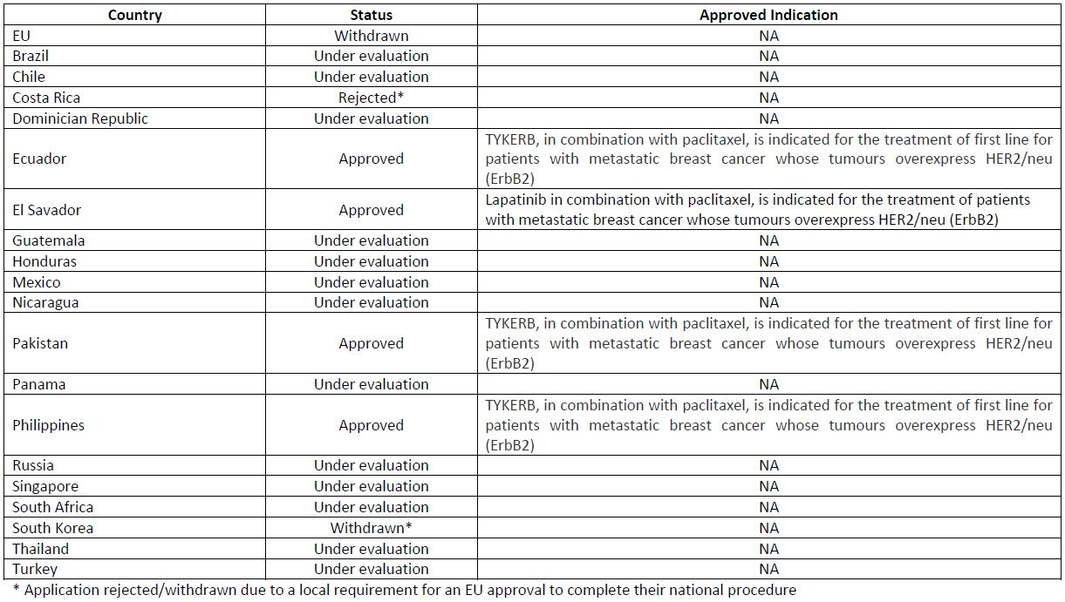

Product Information
The approved Product Information (PI) current at the time this AusPAR was prepared can be found as Attachment 1.

II. Quality findings
There was no requirement for a quality evaluation in a submission of this type.

III. Nonclinical findings

Introduction
The sponsor has applied for an extension of indication of lapatinib ditosylate (Tykerb) in combination with paclitaxel for the treatment of patients with MBC whose tumours over express HER2 (ErbB2).
The proposed dose of lapatinib is 1500 mg (990 mg/m² for a 50 kg person) once daily, continuously and taken in combination with paclitaxel administered at 80 mg/m² weekly, or 175 mg/m2 every 3 weeks. The recommended paclitaxel infusion speed was not specified in the product information document that was submitted with this submission.
Lapatinib (1250 mg/day) was first approved in Australia in 2007 for oral administration in combination with capecitabine for the treatment of patients with locally advanced or metastatic HER2 over expressing breast cancer. In 2010, lapatinib was approved for the extended indication of combination with an aromatase inhibitor for the treatment of postmenopausal women with hormone receptor positive MBC whose tumours over express HER2 and for whom hormonal therapy is indicated. This indication included an increase in dose from 1250 to 1500 mg per day.
Paclitaxel is approved for the treatment of a wide range of cancers including breast cancer, in Australia. Recommended treatment of breast cancer is 175 mg/m² administered intravenously (IV) over three hours every three weeks.
Thirty six new nonclinical studies were submitted with the current submission. A large number of these were not considered directly relevant to this submission and have been excluded from the assessment.
A number of previously submitted studies were considered highly relevant to the current application and have been included in the assessment.

Pharmacology

Primary pharmacology
Lapatinib is an orally active tyrosine kinase inhibitor that selectively inhibits autophosphorylation and substrate phosphorylation catalysed by growth factor receptors HER1 and HER2 resulting in decreased proliferation and increased apoptosis of cells that (over) express these receptors. Normal tissues have low levels of HER2 membrane protein. Over expression of this receptor is seen in 20% of breast cancers. Despite HER1 over expression in breast cancer and its association with worse prognosis, the inhibition of the HER1 receptor has so far not shown meaningful activity in breast cancer.
The mechanism of paclitaxel induced cytotoxicity is based on cell arrest at the G2/M phase of the cell cycle. Paclitaxel is a spindle poison that induces tubulin polymerization and microtubule stabilisation to induce cell apoptosis and has antineoplastic activity.

Efficacy of the combination
Two primary pharmacology studies on the combination of lapatinib with a taxane were submitted and evaluated in a previous submission (paclitaxel or docetaxel). These studies were not reviewed in detail in the original report since the studies were not relevant to the previous submission; this data was considered highly relevant to the current submission and was therefore evaluated in the current report.
The combination of lapatinib with paclitaxel was tested at different doses in female SCID (severe combined immunodeficiency) or CD-1 nude mice carrying one of three different subcutaneous xenografts:
- BT474 (human breast carcinoma over expressing HER2);
- NCI-H322 (human non small cell lung carcinoma expressing moderate levels of both HER1 and HER2); and
- HN5 (HER1 over expressing human head and neck carcinoma).
Lapatinib monotherapy (30 or 100 mg/kg PO [orally] twice daily for 21 days) reduced tumour growth in all cancers. In BT474 breast cancer xenograft bearing SCID mice, the tumour volume was 13-46% of control tumour volume after 21 days of lapatinib treatment. In BT474 tumours, the paclitaxel monotherapy (6 or 12 mg/kg IV for initial 5 days) was only effective at the high dose (62% of control tumour volume). The combination was more effective than the respective monotherapies. One breast cancer bearing mouse receiving lapatinib monotherapy (100mg/kg) died on Day 21. Combination of lapatinib (30 or 100 mg/kg) with 12 mg/kg IV paclitaxel inhibited tumour growth of breast cancer xenografts in SCID mice more effectively than lapatinib alone (tumour volume 52-67% of respective lapatinib monotherapy tumour volume) or paclitaxel alone (10-47% of respective paclitaxel monotherapy tumour volume) but also increased body weight loss by ~20% compared to vehicle treated control mice. One NCIH322 bearing SCID mouse receiving high dose combination treatment died on Day 3, and a control mouse died on Day 21.
The toxicity was even more pronounced in HN5 tumour bearing CD-1 nude mice where the combination of the high doses (100 mg/kg lapatinib and 12 mg/kg paclitaxel) was lethal. Within the first 14 days of treatment, 8/16 mice died. This is of concern since the administered doses (calculated per BSA [body surface area]) were in a clinically relevant range, either lower, 60% of the dose calculated by surface area (lapatinib 100 mg/kg: 600mg/m² BSA versus 990 mg/m² BSA) or comparable (paclitaxel 12 mg/kg: 180 mg/m² BSA) to the recommended human dose (175mg/m² every 21 days). Although some deaths occurred in the other groups, these generally occurred later on in the study and were less frequent.
Overall survival (OS) was not an efficacy endpoint and tumour burden related deaths were not recorded in these studies. The varying degree of toxicity was thought to depend on the mouse strain used in these experiments (SCID versus CD-1 nude) rather than the xenograft (HN5 versus BT474 or NCI-H322). In support of an increased toxicity of the lapatinib/paclitaxel combination, a two fold increase of the lapatinib dose (200 mg/kg once daily) was tolerated in the same mouse strain without occurrence of deaths (HN5 head/neck tumour bearing CD-1 nude) when lapatinib was administered as monotherapy (Study RD2002/00259/02). Additionally, the high dose (12 mg/kg) paclitaxel monotherapy was also tolerated without occurance of deaths in CD-1 nude mice (Study RD2005/00059/01).
The sponsor states in the M2 nonclinical summary P3:
“The combination of higher doses of lapatinib (100 mg/kg) and paclitaxel (12 mg/kg) resulted in increased body weight loss in SCID mice with BT474 and NCI-H322 tumour xenografts. However, it was lethal in HN5 bearing nude mice, which may reflect a difference in sensitivity of the different mouse strains.”
It is not clear which mouse strain presents the better human model. Signs of enhanced toxicity after administration of the combination, namely weight loss, lethality and earlier onset of death were observed independent of the mouse strain. Study 2005/00059/01 possibly underestimates the toxicity of the combination since the dosing regimen in this study consisted of more frequent dosing with lower doses than proposed clinically (lapatinib was dosed twice instead of once daily and paclitaxel was given on five consecutive days instead of once every 3 weeks).
The discussion of Study RH2005/00059/01 concludes:
“These results suggest a careful combination of these two agents in the clinic, starting at doses lower than their standard dose”.
The nonclinical evaluator agrees with this conclusion.
Different combinations of lapatinib with another taxane, docetaxel, were also more effective in reducing tumour growth than lapatinib treatment alone in BT474 breast cancer xenograft bearing SCID mice. Different dosing regimens of different combinations of lapatinib (100 or 200 mg/kg PO once or twice daily for 21 days) combined with either a single dose or 3 x 3 weeks of IP 25-50 mg/kg docetaxel was more effective than lapatinib monotherapy (tumour growth inhibition 7-98 % of volume under lapatinib monotherapy). This beneficial effect was achieved with exposures that were similar to the estimated clinical lapatinib exposure (200 mg/kg lapatinib BID [twice daily]: calculated daily exposure 1200 mg/m²) and a docetaxel exposure after treatment with 25 mg/kg docetaxel (75 mg/m²) that corresponded to the clinical recommendation.
In summary, the nonclinical studies indicate enhanced tumour growth inhibition after the combination of constant lapatinib therapy with a taxane compared to lapatinib or paclitaxel monotherapy. However, the nonclinical data also suggests that there may be a risk of enhanced toxicity.

Safety pharmacology
Tykerb monotherapy has been associated with reports of cardiac events, especially decreases in left ventricular ejection fraction that were asymptomatic or manifested as dyspnoea, cardiac failure and palpitations (see PI).
The current submission included two new safety pharmacology studies that aimed at further exploring the potential for lapatinib to induce cardiovascular toxicity.
Inhibition of cardiac hERG K⁺ channels leads to delayed repolarisation, QT interval prolongation and can induce arrhythmia. Lapatinib was found to inhibit hERG K⁺ channels in cell culture with an IC₂₅ (inhibitory concentration that eliminates 25% of a population of microorganisms) and IC₅₀ of 0.11 and 0.65 µg/mL, respectively. The values are significant insofar as this is 2 and 12 fold, respectively, the maximum anticipated human plasma lapatinib concentration of 0.053 µg/mL (C_{max} [maximum plasma drug concentration] 5.3 µg/mL, 99% protein binding). Concerns of proarrhythmogenic lapatinib activity remain since the current literature suggests that a minimum safety margin between recorded C_{max} of the unbound drug and hERG (human Ether-à-go-go-Related Gene) IC₅₀ of 30 fold is required.
The potential of in vivo cardiotoxicity was further explored in dogs. ECGs (electrocardiograms) were normal and no cardiovascular events were observed after single IV injection of 0.5 mg/kg lapatinib. It is to be noted that the C_{max} exposure associated with this dose was only 1.28 µg/mL, which was ~24% of the clinical C_{max} of 5.3 µg/mL (reported in Study EGF10009). The high protein binding of lapatinib (original application 2006-2423-4) was observed across species (~99% in mouse, rat, rabbit, dog and human). Exposure ratio calculations for in vivo studies should therefore be similar for free or total drug. Given the low exposure ratio the negative finding in the dog study does not provide a high level of assurance for the cardiac safety of the drug.
The cardiovascular safety pharmacology studies conducted in the original submission included studies in rats, guinea pigs and dogs following oral doses of up to 500 mg/kg that largely remained without effect. ECGs in dogs were normal after administration of an oral dose of 500 mg/kg (plasma C_{max} 5.9 µg/mL, relative exposure ratio of 1.1). Lapatinib treatment (C_{max} 2.6 µg/mL) did not alter action potential generation in isolated canine Purkinje fibres at an exposure ratio of 39 fold the systemic concentration of unbound lapatinib (0.053 µg/mL). However, 30 µM sotalol, the positive control used in this study, also only induced moderate increases in action potential duration compared to vehicle control. Unambiguous conclusions therefore cannot be drawn from this study.
In vitro studies indicate a potential for proarrythmic action with the clinical use of lapatinib. Higher exposures than 1.1 fold human C_{max} were not studied in in vivo nonclinical experiments. The extent of the proarrythmic risk associated with lapatinib treatment alone cannot be adequately assessed with the available nonclinical data.
QT interval prolongation has been reported in patients with advanced cancer receiving repeated daily dosing of lapatinib (Study EGF10003). The risk management plan (RMP) concludes that QT interval prolongation by lapatinib cannot be ruled out.
QT interval prolongation appears to be a class effect of tyrosine kinase inhibitors (erlotinib and gefitinib) that have been shown to partially block the hERG K⁺ channels (see Tarceva PI document, Precautions; Iressa PI document, Precautions).
In addition, “heart failure has been observed in patients receiving the HER2 targeting monoclonal antibody trastuzumab (Herceptin) alone or in combination with chemotherapy. This may be moderate to severe and has been associated with death.” The incidence of symptomatic heart failure increased from 4% after paclitaxel alone to 9% after combination of trastuzumab with paclitaxel (see Herceptin PI document).
Furthermore, paclitaxel is considered to be a prototypical proarrythmogenic cytotoxic drug. The mechanism via which paclitaxel induces arrhythmia is controversial including proposed effects directly on the Purkinje conduction system, on extracardiac autonomic control, or arrhythmia as a consequence of ischaemic hypoxia. However, paclitaxel induced arrhythmia seems to be independent of hERG K⁺ channel inhibition. Paclitaxel induces cardiac arrhythmias at doses ~10 times higher than therapeutic in the isolated guinea pig heart and in primary cultured cardiac myocytes from rats.
The combination of lapatinib with another potentially arrythmogenic drug is an additional safety concern. The most common cardiac events observed with paclitaxel at therapeutic concentrations in patients are cardiac arrhythmias (frequently asymptomatic) including bradycardia, tachycardia and atrioventricular block (see FDA Paclitaxel prescribing information). Congestive heart failure, including cardiac dysfunction and reduction of left ventricular ejection fraction or ventricular failure, has been reported typically in patients who have received other chemotherapy (FDA Paclitaxel prescribing information).
Taken together, these results suggest that the combination of lapatinib with paclitaxel has a potential for increased cardiac toxicity. The RMP states: “Caution should be taken if Tykerb is to be administered to patients with conditions that could impair left ventricular function (including co administration with potentially cardiotoxic agents)”.
Study EGF114271 has been planned by the sponsor to evaluate the effect of lapatinib on QT interval in patients with cancer. This approach seems appropriate; additional investigation of cardiac effects of the combination would be more informative regarding risks associated with the current submission.

Pharmacokinetics
Most nonclinical PK studies that investigated the potential interactions between lapatinib and paclitaxel were conducted and submitted with the original submission. Studies submitted with the current submission investigated effects of the combination on protein displacement and CNS (central nervous system) penetration.
Lapatinib is predominantly metabolised by CYP3A (4/5), with minor contributions of CYP2C19 and CYP2C8 (Studies RD2000/01947/00, RD2002/01031/00). Lapatinib is not only a substrate but also an inhibitor of several CYP (cytochrome P450) enzymes. Inhibition of CYP3A4/5 and CYP2C8 occurred with an IC₅₀ ~2µM (~1 µg/mL, exposure ratio 0.2 based on total drug plasma concentration) (Studies RD2001/01081/00, RD2001/01300/00, RD2002/00655/00).
The metabolism of paclitaxel is catalysed, in part, by CYP isoenzymes CYP3A4 and CYP2C8. Paclitaxel was shown to inhibit lapatinib metabolism in vitro with an IC₅₀ of 30-70 µM (25- 60 µg/mL, exposure ratio 5-13 based on total drug plasma concentration) (Study RD2002/00921/00). Lapatinib induced inhibition of CYP3A (4/5) and CYP2C8 could potentially increase systemic paclitaxel exposure and was shown to increase the half life of the related compound docetaxel in human microsomes (Study RD2001/01665/00).
Lapatinib is additionally a substrate for the transport protein P-glycoprotein (P-gp). Lapatinib, inhibited human P-gp in vitro at clinically relevant concentrations (IC₅₀ of 2.3 μg/mL [3.9 μM], exposure ratio 0.4 based on total drug plasma concentration) (Study RD2003/01012/00). Paclitaxel is also a P-gp substrate.
Inhibition of P-gp could potentially enhance paclitaxel CNS penetration (see CNS toxicity).
Therapeutically relevant lapatinib concentrations also inhibited the transporters murine BCRP (Breast Cancer Resistance Protein) with an IC₅₀ of 2.3 μg/mL and human organic anion transporting polypeptide (OATP1B1) with an IC₅₀ of 1.1 μg/mL.
Lapatinib did not alter protein binding of another taxane (docetaxel) in vitro.
In summary, the nonclinical evidence suggests that combination of lapatinib with paclitaxel has the potential to increase systemic exposure of each compound.

Exposure
The originally approved registration of lapatinib in combination with capecitabine was for a lower lapatinib dose (1250 mg/day) than proposed in subsequent applications for new drug combinations and/or indications. In patients that received 1250 mg/day lapatinib in combination with capecitabine, the clinical AUC_{0-24h} (area under the plasma concentration-time curve during the first 24 h after administration) was ~45.5 μg∙h/mL and C_{max} of 3.2 μg/mL (obtained from Study EGF10005).
The recommended lapatinib dose was increased from 1250 mg/day to 1500 mg/day lapatinib in combination with an aromatase inhibitor for treatment of an additional indication approved in 2010. The lapatinib AUC_{0-24h} and C_{max} associated with this combination were 27 μg⋅h/mL and 1.9 μg/mL (obtained from Study EGF10030). The exposure to lapatinib was therefore not increased with this combination despite the increase in lapatinib dose. It is noted that the dosing for the original combination with capecitabine remained the same (1250 mg/day).
The current submission proposes a new combination of lapatinib at 1500 mg/day PO with paclitaxel (including 175 mg/m²/3 h IV). Due to CYP 450 and/or P-gp interactions of the combination, the plasma levels of lapatinib are increased (AUC₀₋₂₄ 64.5 μg⋅h/mL and C_{max} of 5.3 μg/mL reported in Study EGF10009). These values were used to calculate relative exposure in this report. The lapatinib exposure with the proposed dose and combination was therefore increased by 42-140% compared to plasma levels achieved with currently approved combinations.
Paclitaxel exposure was additionally increased by 23% compared to paclitaxel monotherapy (19.126 versus 15.544 μg⋅h/mL) (Study EGF10009). This constitutes a further safety concern due to the narrow therapeutic window of the drug.
Attention is drawn to the currently approved Tykerb PI document that advises under Interactions that ‘caution should be exercised when dosing lapatinib concurrently with medications with narrow therapeutic windows that are substrates of CYP2C8 such as paclitaxel’. The nonclinical evaluator agrees with this assessment.
The increased exposures to both lapatinib and paclitaxel increase the potential for toxicity.

Pharmacodynamic drug interactions with paclitaxel comedication
Patients receiving paclitaxel are usually premedicated to prevent severe hypersensitivity reactions. According to the Taxol PI document, pre medication consists of dexamethasone PO (or its equivalent), promethazine IV and cimetidine IV (alternatively ranitidine). In response to the question regarding how this premedication may alter the toxicity profile of the lapatinib/paclitaxel combination, the sponsor replied:
“In summary, the premedication regimen minimises combined exposure with lapatinib and does not significantly affect the mechanisms important to lapatinib disposition. An increased incidence of diarrhoea, neutropenia and rash was reported among subjects who received lapatinib in combination with paclitaxel. The observed toxicity profile of lapatinib plus paclitaxel (L/P) in combination is likely due to the combined effect of these agents and not to the effect of the paclitaxel premedications. Regardless of any potential interaction of premedications with either paclitaxel or lapatinib, typical premedications for paclitaxel were utilised in Study EGF104535, following institutional practice. Similar approaches were used in the supportive studies. As such, the reported safety profile, and the risk benefit assessment of the current submission, fully encompasses the real world use of the paclitaxel premedications.”
According to ICH guideline:
“In general, toxicology studies investigating the safety of combinations of pharmaceuticals intended to treat patients with advanced cancer are not warranted. If the human toxicity profile of the pharmaceuticals has been characterised, a nonclinical study evaluating the combination is not usually warranted.”
The combination of L/P is not proposed as a fixed dose combination and the premedication regimen is intended as interval dosing, which further lowers the risk of interaction. The human toxicity profile of the individual compounds has been characterised. The approach is considered appropriate from a nonclinical perspective.

Toxicology
No toxicity studies were conducted to investigate the combination of lapatinib with paclitaxel. The newly submitted toxicity studies investigated the single and repeat dose toxicity of lapatinib monotherapy in regard to skin reactions, phototoxicity, central neurotoxicity and hepatotoxicity.

Single dose toxicity
The single dose toxicity of lapatinib alone was determined after IV bolus injection of 0.5 or 1 mg/kg lapatinib in rats. The AUC_{0-t} was 0.4 or 1.2 µg∙h/mL. In combination with paclitaxel, lapatinib exposure at the clinically recommended dose (1500 mg) was 64.5 µg∙h/m in humans. No toxicity was observed in this single dose toxicity study. However, at exposures that were 54 to 161 fold lower than the expected clinical exposure, only limited predictive value can be placed on the findings.

Repeat dose dermal toxicity
The repeat dose toxicity of lapatinib was assessed in mice with oral doses up to 600mg/kg/day. Five day treatment was associated with a systemic lapatinib exposure (AUC_{0-t}) of 269 µg∙h/mL (relative exposure ratio 5). Lapatinib toxicity at 5 fold the clinical exposure was moderate and consisted of body weight loss, dehydration and skin flaking. Tykerb treatment in patients has been associated with skin disorders such as dry skin and rash (Tykerb PI document). Rash is a known effect of small molecule tyrosine kinase HER1 receptor inhibitors due to their interaction with receptors in the skin (proposed RMP). It cannot be assessed whether co medication with drugs that possess additional dermal toxicity, like paclitaxel or glucocorticoids, will exacerbate lapatinib treatment associated adverse skin effects.
An increased incidence of rash amongst subjects who received lapatinib in combination with paclitaxel was reported by the sponsor.

Repeat dose phototoxicity
Since repeat dosing with lapatinib induced skin flaking, it was assessed whether this effect would be exacerbated by UV (ultraviolet) exposure. Skin conditions observed after lapatinib monotherapy with up to 600 mg/kg PO were only mildly exacerbated by UV exposure suggesting no, or only minor, photosensitising lapatinib activity at 5 times the estimated human exposure (AUC exposure 251 µg∙h/mL).
Despite the common occurrence of paclitaxel induced alopecia and hypersensitivity reactions (see Taxol PI document), the occurrence of phototoxicity associated with clinical paclitaxel treatment is rare.
Photosensitivity reactions after co treatment of lapatinib with paclitaxel were not directly investigated. It therefore cannot be determined if lapatinib induced photosensitivity will be exacerbated by the combination.

CNS toxicity
While paclitaxel induced peripheral neuropathy is a common adverse event (AE), treatment induced central neuropathy is very rare, probably because paclitaxel has little or no blood brain barrier penetration. A primary mechanism limiting paclitaxel blood brain barrier penetration is active efflux by P-gp.
Preclinical studies have shown that lapatinib does not cross the blood brain barrier to a significant degree (Study RD2007/00565/00). However, lapatinib is a known inhibitor of P-gp. Inhibition of P-gp by lapatinib has been shown to occur in vitro (IC₅₀ of 2.3 μg/mL) (Study RD2003/01012/00). Therapeutically relevant concentrations of lapatinib (up to 8 µg/mL) did not affect CNS penetration of verapamil in vivo in rats. No study investigated the interaction of lapatinib with paclitaxel directly, but a range of other anticancer drugs with P-gp inhibitor activity have been shown to increase paclitaxel CNS penetration 2.1-11 fold in different mouse strains. Lapatinib may therefore enhance paclitaxel CNS penetration which could potentially elevate the risk of paclitaxel induced CNS toxicity (Study RD2007/00565/00).

Repeat dose hepatotoxicity
Both lapatinib and paclitaxel treatment have been associated with hepatotoxicity (see Taxol PI document).
Three studies submitted with the current submission further investigated the mechanism of lapatinib induced hepato/biliary toxicity (Studies RD2008/01232/, RD2009/00198/00 RD2010/00289/00). Lapatinib itself did not inhibit hepatic biliary salt transporters NCTP (sodium taurocholate cotransporting polypeptide) or BSEP (bile salt export pump) in vitro. However, the active lapatinib metabolite GW90006 appears to be an inhibitor of dog and human but not rat BSEP at concentrations ≥10µM (exposure ratio >2.5 relative to total drug plasma concentration) in vitro, possibly contributing to the reported liver dysfunction in humans. Hepatotoxicity was further assessed in vivo in dogs. Lapatinib (360 mg/kg PO) over 8 days (AUC 102 µg∙h/mL, exposure ratio 2) induced vomiting, weight loss and diarrhoea. This was accompanied by increased liver dysfunction markers (ALT [alanine transaminase], bilirubin), degeneration of hepatocytes and signs of liver inflammation in zone 2 and 3 with biliary dysfunction in the form of cholestasis, and increased bile viscosity. Lapatinib induced hepatotoxicity was shown to be associated with changes in a range of genes including genes involved in regulating the immune response and biliary function.
The Tykerb PI document contains precautions regarding hepatotoxicity: “The hepatotoxicity may be severe and deaths have been reported, although the relationship to Tykerb is uncertain”. The nonclinical data suggests that lapatinib does indeed exert hepatotoxic activity.
Hepato biliary disorders are a known paclitaxel associated effect. Reported AEs are elevated liver dysfunction markers such as alkaline phosphatase, AST (aspartate transaminase), ALT (very common); elevated bilirubin (common); but lethal hepatic necrosis is rare (Taxol PI).
It is concluded that combination of lapatinib with another hepatotoxic drug like paclitaxel could enhance the hepatotoxicity.

Comments on the Safety Specification of the Risk Management Plan
The nonclinical evaluation has identified cardiotoxicity, CNS toxicity, and hepatotoxicity as major toxicities associated with the combination of lapatinib and paclitaxel. These effects should be adequately considered by the RMP, in addition to other known class effects of cytotoxic drugs such as gastrointestinal, nephro, pulmonary, dermal, bone marrow toxicity and peripheral neurotoxic effects.
CNS toxicity does not appear to have been adequately covered by the RMP.
Furthermore, the exposure margins that are stated in the RMP are overestimates since the clinical plasma C_{max} values after dosing with 1250 mg lapatinib (C_{max} 2430 ng/mL) was used for calculation. The exposure margins should be recalculated using the clinical C_{max} of 5311 ng/mL (Study EGF10009) measured after dosing 1500 mg/day lapatinib in combination with paclitaxel, the proposed dose in current submission.

Nonclinical summary and conclusions

Summary
- The sponsor has applied for an extension of indication of lapatinib ditosylate in combination with paclitaxel for the treatment of patients with MBC whose tumours over express HER2.
- The proposed dose of lapatinib is 1500 mg (990 mg/m² for a 50 kg person) once daily for the duration of the treatment and taken in combination with paclitaxel administered at 80 mg/m² weekly, or 175 mg/m² every 3 weeks.
- The nonclinical dossier comprised 36 new studies. Of these, 24 were considered not to be relevant to the current submission because they investigated diseases, mechanisms or drug combinations not relevant to the proposed indication. The remaining 12 relevant studies investigated pharmacokinetics (PK), safety pharmacology and toxicology mainly in relation to lapatinib monotherapy. A number of previously submitted studies on primary pharmacology, safety pharmacology and PK of lapatinib were considered highly relevant to the current submission and are included in the assessment.
- No primary pharmacology studies investigating the proposed combination were submitted in this application. A pivotal nonclinical pharmacology study from the original submission conducted in xenograft bearing mice suggest increased efficacy of lapatinib combined with paclitaxel in the treatment of HER2 overexpressing breast cancer compared to monotherapy with each compound, although the treatment regimen was noticeably different to the one proposed for clinical use.
- Lapatinib and paclitaxel interaction via their CYP450 metabolism and/or P-gp transport interactions increase the systemic exposure of both compounds after administration of the combination.
- Lapatinib is a P-gp inhibitor (IC₅₀ 2.3 µg/mL). P-gp inhibition could potentially increase paclitaxel CNS penetration leading to an increased risk of CNS toxicity. It is noted that this issue does not appear to have been adequately addressed in the RMP. On ground of this potential safety concern there is a need to adequately cover this potential risk in the RMP.
- No toxicity studies of the combination were submitted in this application. However, the pivotal nonclinical pharmacology study identified that the combination has the potential for synergistic toxicity in mice. This was indicated by increased weight loss and an increased incidence of lethality that occurred at earlier time points than observed for the few deaths under monotherapy.
- Both lapatinib and paclitaxel are potentially cardiotoxic, although the toxicity appears to be induced via different mechanisms. Paclitaxel can induce arrhythmia (mainly bradycardia but also tachycardia) and has been associated with decreased ventricular ejection fraction when administered in combination with other chemotherapy. Nonclinical studies show that lapatinib can inhibit hERG K⁺ channels in vitro, an indicator of possible QT interval prolongation in vivo. A decrease in left ventricular ejection fraction has been reported in patients treated with lapatinib. Considering the risk associated with the individual compounds, the combination of lapatinib with paclitaxel has the potential for an increased cardiotoxicity compared to the individual drugs given alone. The RMP states that “caution should be taken if Tykerb is to be administered to patients with conditions that could impair left ventricular function (including coadministration with potentially cardiotoxic agents)”.
- Both lapatinib and paclitaxel are hepatotoxic. Lapatinib is associated with changes in genes regulating immune and biliary function. Based on the activity of each individual compound, there is a risk of exacerbated hepatotoxicity in combination, compared to the individual drugs given alone.

Conclusions and recommendation
- Nonclinical pharmacology data submitted with the original registration application suggest that the combination of lapatinib with paclitaxel may be effective for the treatment of HER2 positive (HER2+) breast cancer.
- The major safety concern with the proposed combination is the potential for enhanced toxicity compared to the individual drugs alone.
  - Nonclinical studies of the individual drugs suggest that cardiotoxicity, CNS toxicity and hepatotoxicity inter alia have a potential to be increased by the combination. More evidence for potentially increased toxicity comes from the lethal toxicity of the combination that was observed in mice. This evidence suggests a potential for severe toxicity, especially in a subgroup of patients with higher sensitivity to the toxic effects of the drugs.
- This safety concern is further compounded by the fact that systemic exposure to lapatinib and paclitaxel, is increased by administration of the combination (1500 mg lapatinib PO with paclitaxel 175 mg/mm² over 3 h).
  - The increased exposure could contribute to increase incidence and severity of toxic events.
- Evidence to support the registration of lapatinib ditosylate in combination with paclitaxel should therefore rely on a clinical risk/benefit assessment, taking consideration of the proposed patient group and indication.

IV. Clinical findings

Introduction
The clinical dossier contains data of a total of six clinical studies together with an Ethnic Sensitivity summary.
In relation to PK, a PK interaction dose finding study of lapatinib in combination with paclitaxel Study EGF10009 is submitted. A further study emphasising PK data is Study EGF104578, which is a Phase III study of L/P versus paclitaxel alone in the second line treatment of HER2+ gastric cancer.
In relation to clinical efficacy and safety, the pivotal study is the Phase III trial EGF104535, which is a Phase III randomised placebo controlled double blind trial evaluating women with HER2+ MBC who have not received prior therapy for metastatic disease. All patients were randomised to receive treatment with paclitaxel with either lapatinib or placebo.
A supportive Study EGF30001 was a Phase III randomised placebo controlled double blind trial evaluating the safety and efficacy of paclitaxel in combination with lapatinib or placebo in patients with either HER2 negative (HER2-) or untested HER2 status.
A further supportive Study EGF105764 was an open label single arm multicentre Phase II study of oral lapatinib in combination with paclitaxel as first line treatment for ErbB2 amplified MBC patients.
A further Study EGF102580 was provided as a Phase II study of lapatinib and paclitaxel as neoadjuvant therapy in patients with inflammatory breast cancer. This study was principally provided for data in relation to Ethnic Sensitivity. The final Ethnic Sensitivity summary is also provided to evaluate pharmacology and efficacy and safety in relation to various ethnic populations.

Pharmacokinetics

Studies providing pharmacokinetic data
In this review, two studies are provided with relevant data re PK. The first Study EGF10009 is a Phase I open label study of the safety tolerability and PK of lapatinib in combination with paclitaxel in patients with solid tumours. The second Study EGF104578 is a randomised multicentre open label Phase III study of lapatinib in combination with weekly paclitaxel versus weekly paclitaxel alone in the second line treatment of ErbB2 amplified advanced gastric cancer. The PK data from this latter study is the principal information of relevance.
Study EGF10009 was undertaken as an open label administration dose escalation study of oral lapatinib and IV paclitaxel given in combination to subjects with advanced solid tumours. It was conducted to determine safety, tolerability and PK of lapatinib 750-1500 mg once daily in combination with paclitaxel 135-225mg/m² IV administered once every three weeks. The study also evaluated the safety and tolerability of lapatinib 1500 mg once daily with paclitaxel 80mg/m² IV once every week for three weeks out of four.
The PK phase of study was undertaken on the basis that pre clinical studies had shown that lapatinib may inhibit metabolism of Paclitaxel via CYP3A4 and CYP2C8 at concentrations of lapatinib achieved in therapeutic doses. Paclitaxel is also an inducer of CYP3A4 and P-gp. In vitro studies have also demonstrated lapatinib is highly bound to human plasma albumin and alpha-1 acid glycoprotein over a wide concentration range and lapatinib is a substrate and inhibitor of drug efflux transporters. Paclitaxel is a substrate for metabolism by CYP2C8 and CYP3A4, transport by P-gp-ABCB1 and is extensively bound to plasma albumin. These characteristics common to both drugs provide a potential for interaction.
Up to 50 subjects were to be enrolled on trial and given treatment once every three week regimen of paclitaxel combined with lapatinib, including 9-18 subjects in the PK part of the study. Only patients receiving the once every three weeks paclitaxel regimen were evaluated in the PK portion of the study. Up to 25 patients were to be enrolled in the cohort of subjects receiving the weekly paclitaxel regimen. A standard 3+3 design was used for dose escalation to determine the optimally tolerated regimen (OTR) for daily lapatinib in combination with paclitaxel administered either on a once every three week or weekly schedule. Patients in the PK portion were randomly assigned to three treatment sequences:
- paclitaxel alone as a single IV dose;
- lapatinib alone at steady state following 21 daily doses; and
- both agents together (steady state lapatinib plus a single IV dose of paclitaxel) in a crossover Latin square design.
The PK portion evaluated the OTR determined during dose escalation of the paclitaxel administered once every three weeks with daily lapatinib.
A total of 56 subjects were enrolled of whom 52% were male and 50% were Caucasian. The mean age was 56.2 years with a range of 38-88 years. Forty four patients received lapatinib 125-1500 mg daily plus paclitaxel 135-235 mg once every three weeks. Twelve of the patients received lapatinib 1500 mg daily plus once a week paclitaxel 80 mg/m² administered every week for three weeks out of four. A total of 17/18 subjects enrolled in the PK cohort completed the planned cohort PK evaluation.
The OTRs were defined as follows: lapatinib 1500 mg once daily in combination with paclitaxel 175 mg/m² administered once every three weeks and the lapatinib 1500 mg once daily in combination with paclitaxel 80 mg/m² administered on a weekly schedule for three weeks out of four.
In relation to PK data, of the 17 patients who completed the PK cohort, all received lapatinib 1500 mg/day administered with paclitaxel 175 mg/m² once every three weeks. Statistically significant small increases in systemic exposure to both drugs were observed.
In relation to lapatinib, paclitaxel increased lapatinib AUC_{0-t} by 21%, C_{max} by 39% and T_{max} by 0.8 h and is indicated in Table 2. These observations reflect a complex interaction and may involve several mechanisms.
Table 2: Summary of steady state plasma lapatinib PK parameters in subjects with solid tumours.
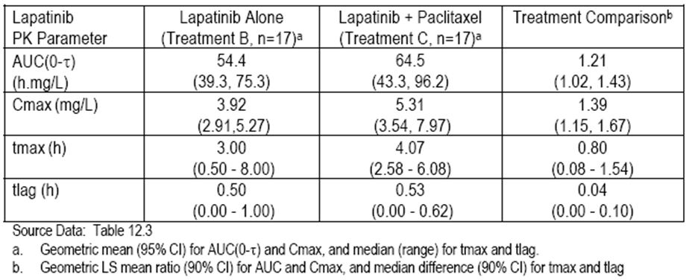
The relation to paclitaxel in the presence of lapatinib, paclitaxel AUC_{0-∞} will increase 23% suggesting either decreased clearance and/or increase bioavailability. Paclitaxel clearance was decreased by 19% but half life was unchanged due to a parallel correlated decrease (22%) in volume of distribution and is indicated in Table 3. Concentrations for lapatinib ranged up to ~5000 ng/ml sufficient to inhibit CYP2C8, CYP3A4 and P-gp-ABCB1. The data from this bidirectional interaction indicated a complex pattern of changes, which maybe explained in part by metabolic inhibition and/or by competitive inhibition of P-gp-ABCB1.
Table 3: Summary of plasma paclitaxel PK parameters in subjects with solid tumours.
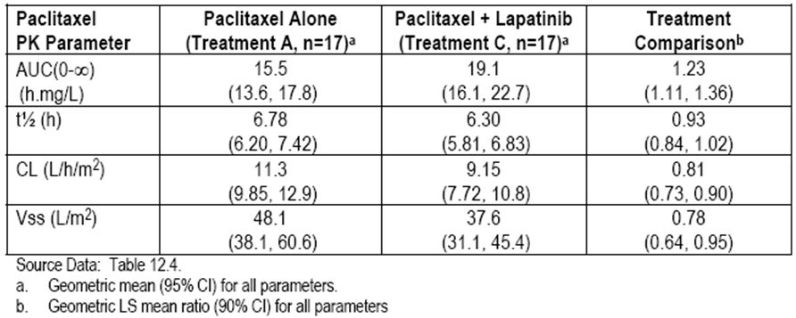

Comment
PK interaction between paclitaxel and lapatinib from the study indicates increased systemic exposure to both drugs by ~20%. These effects may be due in part to metabolic inhibition but also appear to be due to inhibition of P-gp-ABCB1. The increase in the lapatinib concentrations is likely to be meaningful because of its wide therapeutic index. Lapatinib increased paclitaxel concentrations in a manner consistent with inhibition of P-gp mediated enteral efflux. However the impact on metabolism may also contribute to the increased exposure. A 23% increase in systemic exposure to paclitaxel may be clinically meaningful due to its narrow therapeutic index, however the combination of lapatinib with paclitaxel once weekly 80 mg/m² and once every three week regimens were well tolerated.
The second Study EGF104578 was a randomised multicentre open label Phase III study of Lapatinib in combination with weekly paclitaxel versus weekly paclitaxel alone in the second line treatment of ErbB2 amplified advanced gastric cancer. This was a multicentre open label Phase III study, comparing the efficacy and tolerability of paclitaxel 80 mg/m² weekly for three weeks out of four alone or in combination with once daily lapatinib 1500 mg. There were two parts in the study: a pilot portion and a randomised portion. Objectives of the pilot portion of the study were to assess the safety, tolerability and PK of lapatinib and paclitaxel administered alone and in combination in gastric cancer patients with or without prior gastrectomy. The OTR identified for the combination of daily lapatinib and weekly paclitaxel in the pilot portion would be studied further in the randomised portion of the trial. For the pilot portion patients were to be enrolled into three cohorts:
- those with an intact stomach, cohort 1;
- those with partial gastrectomy which included preservation of pylorus, cohort 2; and
- patients with the pylorus removed, cohort 3.
Four dose levels were outlined for the evaluation of DLT (dose limiting toxicity) in the first cycle, that is:
- lapatinib 1500 mg per day plus paclitaxel 80 mg/m²
- lapatinib 1500 mg per day plus paclitaxel 60 mg/m²
- lapatinib 1250 mg per day plus paclitaxel 60 mg/m²;
- lapatinib 1250 mg per day plus paclitaxel 80 mg/m².
Dosing strategy is outlined in Figure 1.
Figure 1: Pilot part dose reduction strategy.
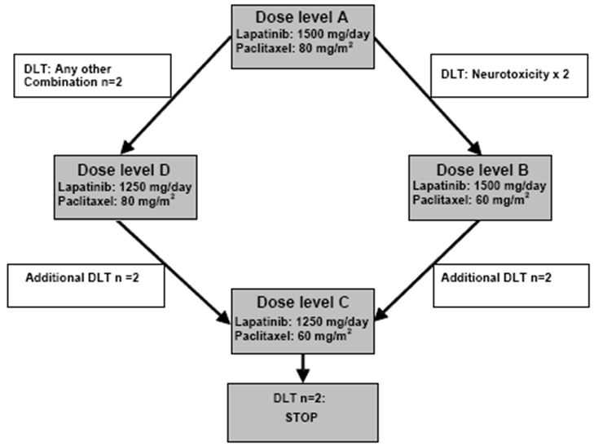
A total of 12 subjects were enrolled in the pilot portion: six subjects each in cohort 1 with an intact stomach, and six in cohort 3 in patients with the pylorus removed. All patients were of Japanese heritage with the majority (11/12) being male. The median age of subjects was 60 with a range of 35-66 years.
The PK results of lapatinib and paclitaxel were examined in Japanese subjects with gastric cancer with and without gastrectomy. The pattern in paclitaxel PK parameters in subjects with intact stomach are indicated in Table 4. These are considered most relevant to the indication of this submission. PK parameters of lapatinib alone in study were comparable to those made in Phase I study of Japanese subjects with solid tumours, that is, Study EGF10020.
Table 4: Summary of lapatinib and paclitaxel PK alone and in combination in Japanese subjects with gastric cancer with an intact stomach.
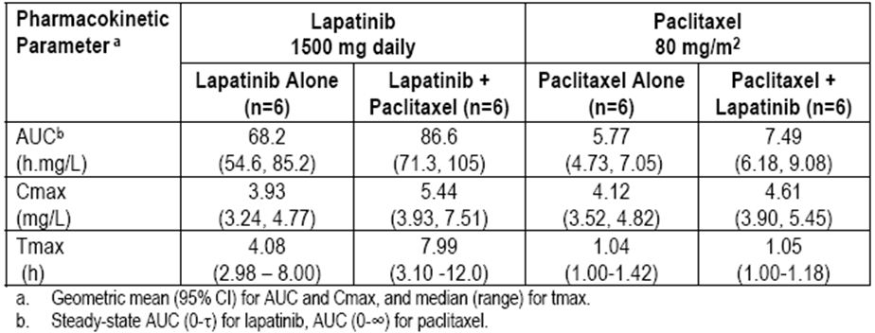
In this study in patients with an intact stomach, L/P co administration resulted in moderate increases in systemic exposure to lapatinib (that is, 27% AUC_{0-t}, 38% in C_{max}) and paclitaxel (33% in AUC_{0-∞}), which were comparable to those from Study EGF10009, where concomitant administration of paclitaxel at 75 mg/m² every three weeks with lapatinib 1500 mg per day at steady state resulted in a moderate increase in systemic exposure to lapatinib. Results in patients with the pylorus removed were similar in magnitude to those patients with an intact stomach.
Reviewing the data from these two studies again, the PK interaction between lapatinib and paclitaxel are summarised in Table 5 and Figures 2-3. As indicated in the Study EGF10009 administered to Western subjects with solid tumours, this resulted in a possibly 20% increase in lapatinib and paclitaxel AUC, while in Study EGF104578 administered to Japanese subjects with gastric cancer resulted in ~30% increase in lapatinib and paclitaxel AUC. Dose normalised paclitaxel data, which are indicated in Figure 3, indicate similar systemic exposure with a similar magnitude of interaction between Japanese and Western subjects.
Table 5: Effect of lapatinib and paclitaxel co administration in Western subjects with solid tumours and in Japanese subjects with gastric cancer with an intact stomach.
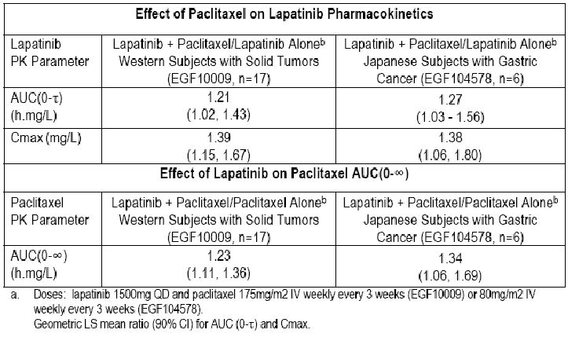
Figure 2: Lapatinib AUC_{0-t} following administration of 1500 mg once daily alone and with paclitaxel 80 mg/m² in Japanese subjects with gastric cancer or 175 mg/m² in Western subjects with solid tumours.
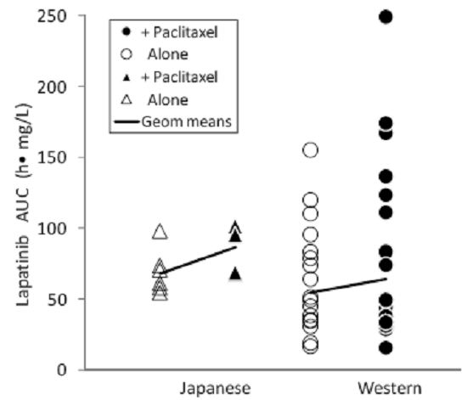
Figure 3: Paclitaxel AUC_{0-∞} after 80 mg/m² in Japanese subjects with gastric cancer or 175 mg/m² in Western subjects with solid tumours alone or with lapatinib 1500 mg once daily.
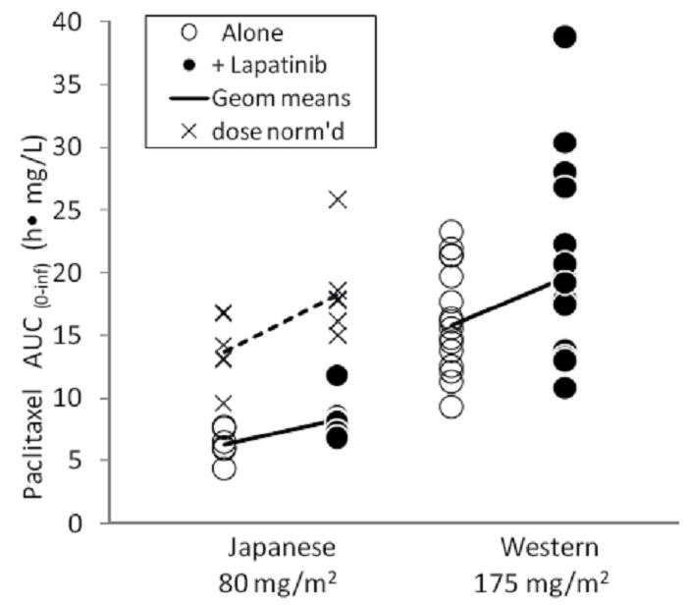
Conclusions
The PK interaction between paclitaxel and lapatinib increases systemic exposure to both drugs. These effects may be due in part to metabolic inhibition but also appear to be due to inhibition of P-gp-ABCB1. The increase of lapatinib concentrations is not clinically meaningful because of its wide therapeutic index. No alterations of lapatinib doses are recommended. The increase of systemic exposure to paclitaxel may be clinically meaningful due to its narrow therapeutic index; however, based on tolerability and response data, Phase III studies are continuing at OTR. The data presented indicate similar systemic exposure with a similar magnitude of interaction between Japanese and Western subjects. This will be considered further in the Ethnic Sensitivity summary.

Pharmacodynamics
No new data on pharmacodynamics is provided in this submission.

Dosage selection for the pivotal studies
The data on OTR provided from Study EGF10009 together with other clinical trial data has supported the appropriate dosage for lapatinib in combination with paclitaxel is either lapatinib 1500 mg once daily in combination with paclitaxel 175 mg/m² administered once every three weeks or a weekly schedule defined as lapatinib 1500 mg once daily in combination with paclitaxel 80 mg/m² per week for three weeks out of every four. These dosage regimens have been employed in the pivotal Study EGF104535 and the principal supportive Phase III Study EGF30001.

Efficacy
The pivotal study provided in this submission is Study EGF104535 Phase III multicentre randomised double blind placebo controlled study to evaluate and compare the efficacy and safety of L/P with placebo plus paclitaxel in men and women with HER2+ MBC who have not received prior therapy for metastatic disease.
Subjects were eligible to take part in this study if they had a histologically confirmed invasive MBC. HER2 status was determined by immunohistochemistry (IHC) or fluorescence in situ hybridisation (FISH) based on central testing prior to randomisation.
On Day 1, patients were randomised on a 1:1 basis to either paclitaxel 80mg/m² IV weekly for three weeks every four weeks plus lapatinib 1500 mg once daily or paclitaxel in the same dosage regimen plus placebo. To ensure adequate blinding placebo to match, oral lapatinib was used. Randomisation was stratified according to hormonal status and metastatic disease sites.
All patients were treated until disease progression, unacceptable toxicity or withdrawal of consent. Paclitaxel was administered for at least six cycles and continued longer at the discretion of the investigator. Lapatinib or placebo could be continued following discontinuation of paclitaxel in the combination arm if the subject had not progressed.
At the time of disease progression, the patient’s treatment was unblended; if on paclitaxel plus placebo, the patient had the option to continue with subsequent single agent lapatinib until disease progression, unacceptable toxicity, or withdrawal of consent. Efficacy assessments including disease assessments by clinical assessment and radiology and imaging were performed every eight weeks. Following discontinuation of treatment patients were followed on a 12 weekly basis if possible until death or completion of study.
The primary efficacy endpoint for the study was OS defined as the time from randomisation to death due to any cause. Key secondary efficacy endpoints included progression free survival (PFS), defined as the time from randomisation to the earliest date of disease progression or death; overall response rate (ORR); clinical benefit rate, which was defined as the percentage of subjects having either a confirmed complete or partial tumour response or stable disease of at least 24 weeks. Disease responses were classified according to RECIST (Response Evaluation Criteria In Solid Tumours) criteria. Statistical analyses involved intent to treat (ITT) population. Chi square evaluations as well as Cox regression analyses and Kaplan-Meier curves were used as appropriate.
The study began in January 2006 and was completed in June 2010. A total of 444 patients were randomised to the study, and 443 had at least one dose of study medication. A total of 222 patients were randomised to L/P and 159 patients randomised to placebo plus paclitaxel had the study treatment unblinded and 149 of the 222 patients randomised to placebo plus paclitaxel enrolled to receive ongoing lapatinib. At the time of analysis, 54% of patients in the L/P arm and 64% of patients in the placebo plus paclitaxel arm had completed study. Only one patient was continued on treatment at time of clinical cut off. The percentage of patients who discontinued from study was similar between the two treatment arms. No patients withdrew from study due to AEs.
The study was well balanced across treatment arms. Almost all of the patients were female 99% and Asian 86% and most were post menopausal 62%. The median age was 50 years with a range of 25-74 years although 93% of patients were <65 years. Treatment arms were also well balanced for race. 86% of patients were Asian reflected in the geographical regions in which the studies were conducted.
Baseline disease characteristics were well balanced across the two treatment arms. All patients had measurable disease, the most common site for metastases included lymph nodes, lung, liver and bone. Most patients had visceral metastases and 50% of patients were hormone receptor positive. The distribution of patients according to pre specified prognostic factors used in the primary Cox regression analyses of OS were balanced between the treatment arms. The majority of patients (80%) had received anti cancer therapy prior to study. Overall 76% of patients received adjuvant therapy, which was similar between treatment arms. Adjuvant therapy mainly comprised chemotherapy in 69% and hormone therapy in 19%. The nature of chemotherapy administered as adjuvant treatment and was well balanced between treatment groups.
Post progression therapy involved most often chemotherapy including capecitabine or vinorelbine. Follow up biologic therapy with trastuzumab was received by 10% of patients in the L/P arm versus 16% in the paclitaxel alone arm.
Reviewing results of the pivotal study, the primary endpoint was OS and based on a Cox proportional hazards model, the adjusted treatment Hazard Ratio (HR) was 0.64 with 95% CI (Confidence Interval) 0.49-0.82 and p=0.0005, which represented a 36% reduction in the risk of death for patients receiving L/P relative to patients treated with paclitaxel plus placebo. Results of the pre specified stratified log rank test were consistent with the primary Cox analysis. The Pike estimator of the HR was 0.74 with a stratified log rank of p=0.0124. The median OS was 27.8 months in the L/P arm and 20.5 months in the paclitaxel plus placebo arm as indicated in Figure 4. This effect was seen despite a total of 149 patients or 67% with disease progression crossing over from the placebo plus paclitaxel arm to lapatinib monotherapy. Additional pre specified analyses of OS confirmed the results of the primary Cox regression analysis and confirmed the robustness of the observed treatment effects.
Figure 4: Kaplan-Meier estimates of overall survival for Study EGF104535 (ITT population).
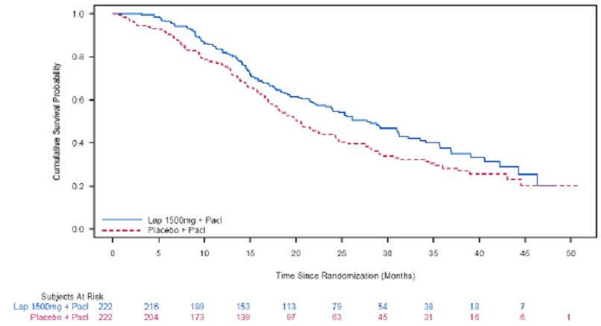
In relation to PFS as indicated in Table 6, the estimated HR was 0.52 with 95% CI 0.42-0.64 and a stratified log rank p<0.0001 representing a 48% reduction in the risk of progression or death for patients treated with L/P compared to paclitaxel plus placebo. Based on the Kaplan-Meier analysis, the median PFS was significantly longer in the L/P arm being 9.7 months compared with the placebo arm being 6.5 months and indicated in Figure 5.
Table 6: Progression free survival for Study EGF104535 (ITT population).
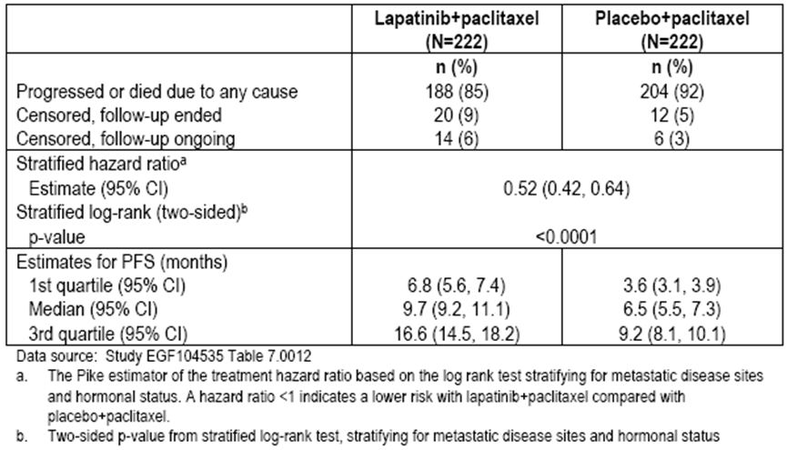
Figure 5: Kaplan-Meier estimates of progression free survival for Study EGF104535 (ITT population).
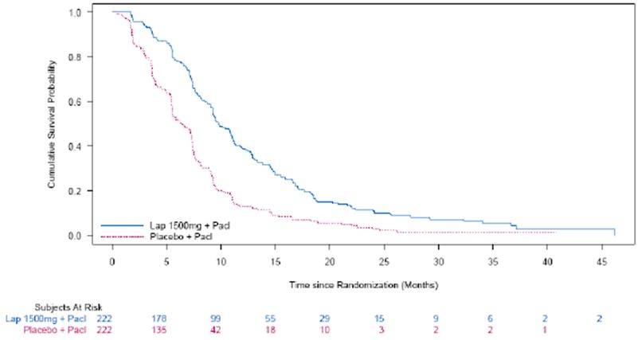
In relation to ORR, a significantly greater proportion of patients in the L/P arm (69%) had an overall response compared with the placebo plus paclitaxel arm (50%) as indicated in Table 7. The odds ratio using stratified Fischers exact test for treatment arms indicate that the ratio was 2.3 with a p<0.0001. The test for homogeneity across strata demonstrated that the odds ratio is constant across strata, that is, each level of the stratification factors and can be used to describe the likelihood of responding within each strata level. Similar ORR within each treatment arm and similar magnitude of benefit of L/P over placebo was observed in the hormonal status strata and the metastatic disease site strata as indicated in Table 8.
Table 7: Overall response rate for Study EGF104535 (ITT population).
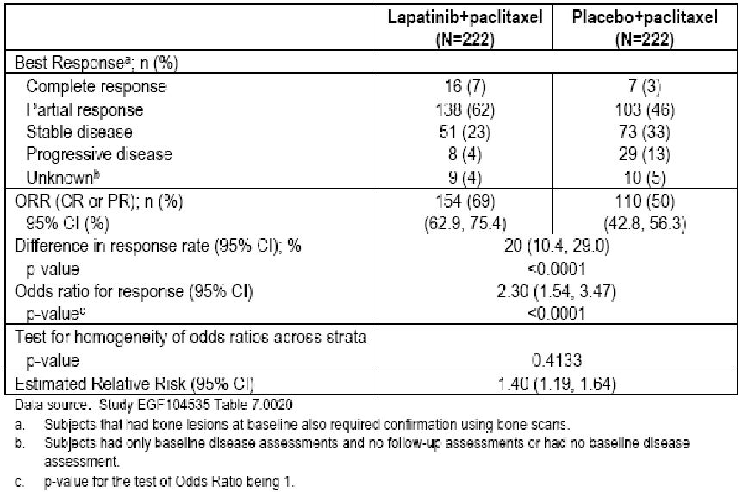
Table 8: Investigator evaluated overall response rate by stratification factors for Study EGF104535 (ITT population).
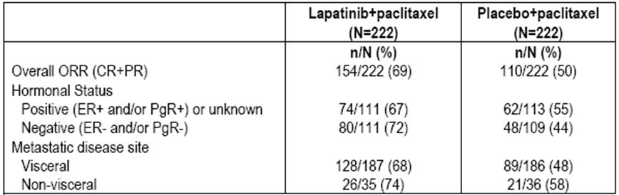
Clinical benefit rates assessed by the investigator were statistically significantly higher in the L/P arm being 75% compared with the placebo arm being 56% and is indicated in Table 9. Again the odds ratio using stratified Fischers exact test favoured the L/P arm and was significant over p<0.0001.
Table 9: Clinical benefit rate for Study EGF104535 (ITT population).
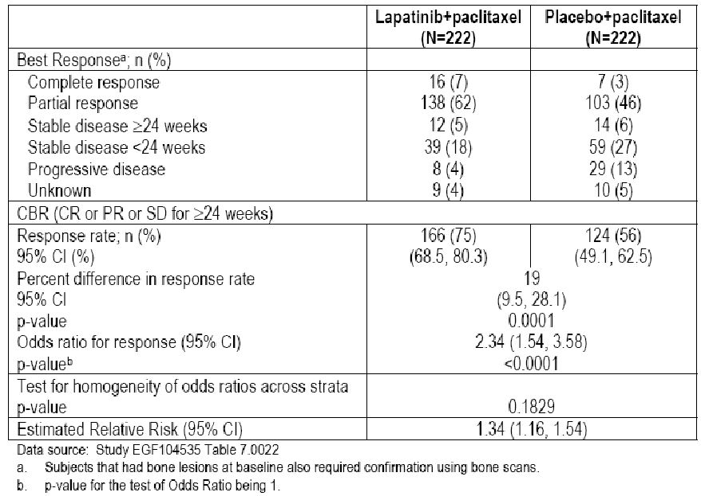
Regarding the OS in relation to race, as earlier indicated 86% of the patients were Asian while 8% were Hispanic and 5% White. The HR for OS for Asian patients (384 patients) was 0.84 while the HR for OS in Hispanic patients being 37 patients was 0.32. The HR for OS in White patients could not be estimated as there were no deaths in the L/P arm compared with six deaths in the paclitaxel plus placebo arm. It should be noted that among the Asian patients, 73% or 141 patients crossed over to lapatinib monotherapy after prior placebo plus paclitaxel treatment, whereas only 1/16 Hispanic patients randomised to placebo plus paclitaxel crossed over the lapatinib monotherapy.
The median PFS and HR observed in the Asian and Hispanic patients were similar to the overall population.
It is worth noting that in patients <65 years as well as those >65 years in the L/P arm had significantly longer OS and PFS.

Comment
This quite large and robust study has clearly indicated a significant benefit in terms of OS and PFS as well as objective response rate favouring the addition of lapatinib to paclitaxel as first line treatment for patients with MBC. It is noteworthy that this evidence of improved OS occurs irrespective of subsequent changeover for patients receiving paclitaxel alone to lapatinib monotherapy. This represents solid evidence favouring the combination therapy arm as first line treatment for these patients.
The principal supportive study was Study EGF30001. This is a randomised multicentre double blind placebo controlled two treatment group Phase III study to evaluate and compare the efficacy and tolerability of Lapatinib administered in combination with Paclitaxel versus placebo plus Paclitaxel in patients with advanced or MBC who had not received prior therapy for their metastatic disease.
Unlike Study EGF104535, patients were to have disease known to be HER2- or were untested. Stored tumour tissue was utilised for retrospective determination of HER2 over expression status. The study planned to enrol up to 570 patients over 18 months. Patients were randomised to receive either oral lapatinib at 1500 mg once daily with Paclitaxel 175 mg/m² IV every three weeks or oral placebo plus paclitaxel 175 mg/m² IV every three weeks.
Treatment groups were stratified according to sites of metastatic disease and stage of disease. Patients were treated until disease progression, unacceptable toxicity or withdrawal of consent. Efficacy assessments were performed on all patients every nine weeks until cessation of therapy and 12 weekly thereafter until the end of study or death.
In this trial unlike the pivotal study, an independent review committee (IRC) assessed imaging and cardiac safety and an independent data monitoring committee (IDMC) monitored safety data.
The primary efficacy endpoint of the study was time to tumour progression (TTP) defined as the interval between the date of randomisation and the earliest date of disease progression or death due to breast cancer. Disease progression is based on the assessments by the investigator. Response evaluations were assessed according to RECIST criteria.
Secondary endpoints included assessment of overall tumour response rate, clinical benefit rate, time to response, PFS and OS.
Statistical analyses were conducted on the ITT population. Chi square, log rank test, Kaplan-Meier curves were all utilised to assess the efficacy endpoints.
The study commenced in January 2004 and was completed in August 2010. A total of 580 patients were randomised to the study, and 579 received at least one dose of study medication. At the time of the clinical cut off date for this report being 26 August 2010, there were 200 patients in each treatment group who had discontinued and the reason for discontinuation were similar between the treatment groups. It should be noted that supporting efficacy data for this submission is taken from the pre defined retrospectively determined HER2+ subset of patients within the study. This was undertaken prior to unblinding. This retrospective determination of HER2 over expression status was possible in 492 or 85% of patients. The overall HER2+ population involved 91 or 16% of patients. The demographic characteristics for these patients are well balanced between the two groups. As indicated, 57% of these patients were White, 21% Hispanic, and 19% Asian. In the HER2- population, demographic characteristics are also similar between treatment groups.
In relation to baseline disease characteristics in the HER2+ population, these were well balanced. Hormonal status in the HER2+ population was also similar between treatment groups. Similar results to the HER2+ population were observed in the HER2- population.
The percentage of patients who received systemic, adjuvant or neoadjuvant anti cancer therapy prior to entering study was similar between the treatment groups, with the most common agents including cyclophosphamide, fluorouracil and doxorubicin. No patient had received prior systemic anti cancer therapy for metastatic disease. In the HER2+ population the systemic anti cancer therapies received were similar in both treatment groups.
The percentage of patients receiving post progression anti cancer therapy was similar in both treatment groups including chemotherapy, hormonal therapy and radiotherapy. In the HER2+ population a higher percentage of patients (17%) in the L/P group received trastuzumab as post progression anti cancer therapy compared with patients in the placebo group being 3%.
Reviewing results of the study the primary endpoint was TTP. In the HER2+ population there was a statistically significant 10 week benefit in median TTP for the L/P group, compared with the placebo group with an HR 0.57 and 95% CI 0.34-0.93 and p=0.011 and is indicated in Table 10 and Figure 6. It is noteworthy that in the overall population composed of predominantly HER2- or unknown subjects the study failed to demonstrate a significant improvement in TTP.
Table 10: Investigator evaluated time to progression for Study EGF30001.
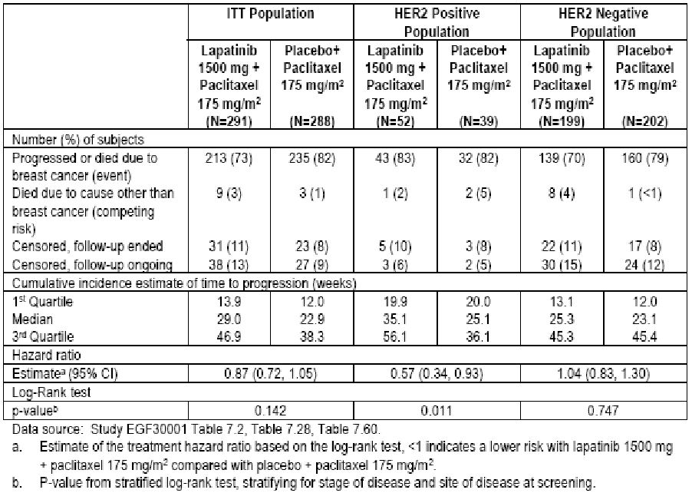
Figure 6: Kaplan-Meier estimates of investigator-evaluated time to progression for Study EGF30001 (HER+ population).
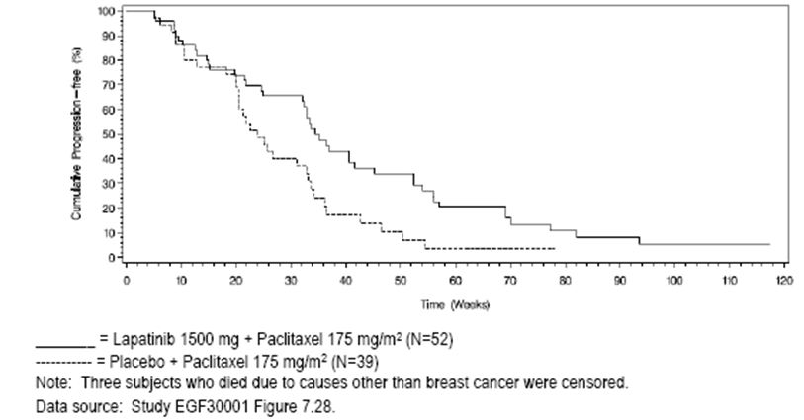

Reviewing OS, as of the cut off date of the 25 August 2010, 76% of patients had reached this endpoint. The pre specified analysis of the HER2+ subgroup showed a ~5 month benefit in median OS in the L/P group compared to the placebo group as indicated in Table 11. Kaplan-Meier estimates are indicated in Figures 7-8. These data do not reach statistical significance with an HR of 0.77 and p=0.281.

Table 11: Overall survival for Study EGF30001.
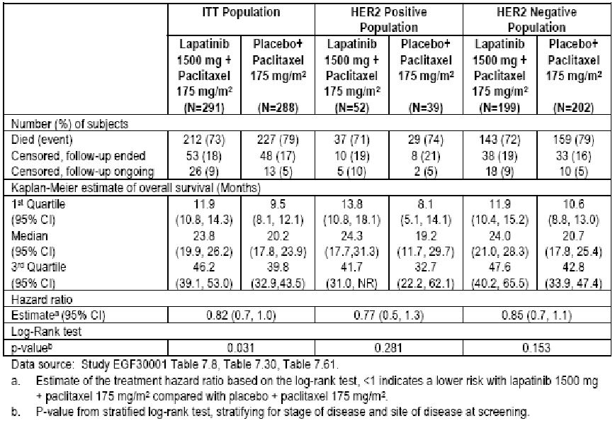
Figure 7: Kaplan-Meier estimates of overall survival for Study EGF30001 (ITT population).
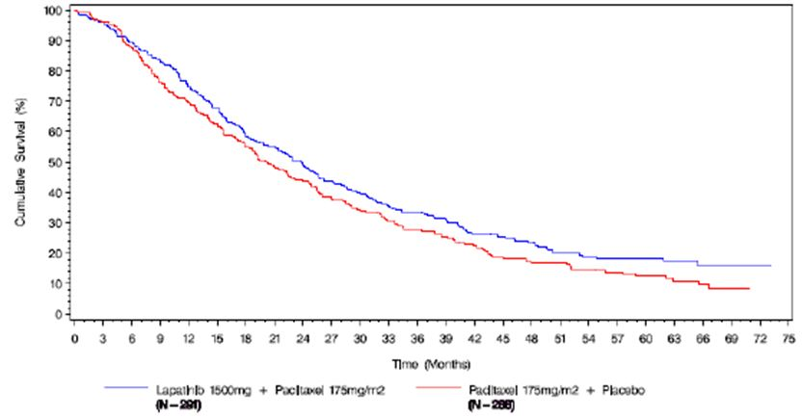

Figure 8: Kaplan-Meier estimates of overall survival for Study EGF30001 (HER2+ population).
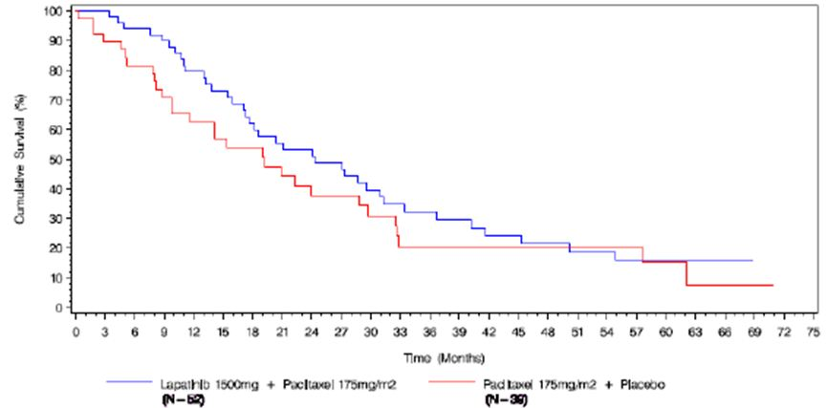

In relation to ORR, investigator assessment of tumour response shows statistically significantly higher response in the L/P group compared with the placebo group in both the ITT population and the HER2+ population as indicated in Table 12.
Table 12: Investigator evaluated response rate for Study EGF30001.
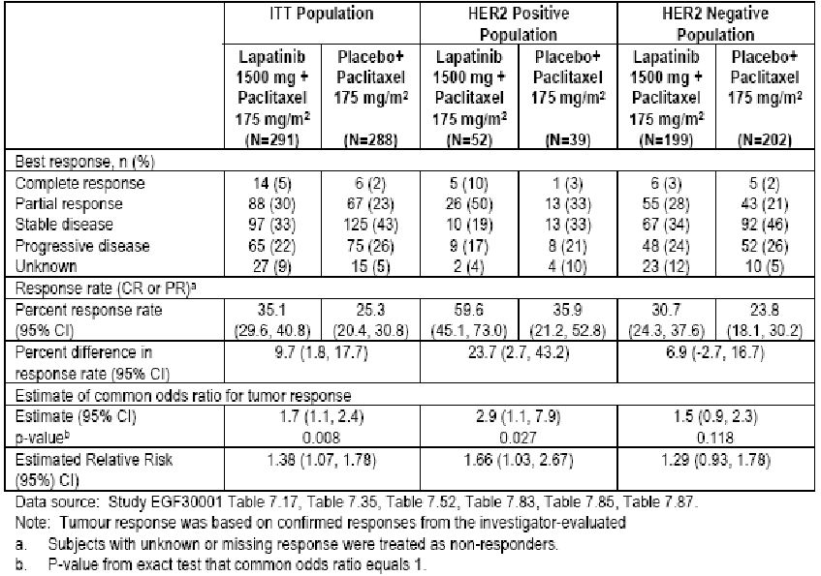

Comment
These data have shown that in this relatively small subpopulation of HER2+ patients the addition of Lapatinib to Paclitaxel results in a significant improvement in TTP but numbers are insufficient for evidence of a statistically significant difference in OS. Nevertheless, this does provided support for the indication that the addition of lapatinib to paclitaxel is associated with benefits that are of clinical significance.
The second supportive Study EGF105764 was a Phase II study to evaluate ORR of lapatinib administered as first line treatment in combination with Paclitaxel in patients with HER2 amplified MBC. Secondary objectives of the study also included assessment of OS, duration of response, time to response, TTP and PFS. A total of 12 centres from four Eastern European countries enrolled patients.
Patients received 1500 mg lapatinib once daily plus paclitaxel 80 mg/m² IV weekly for three weeks over a four week cycle for at least six months. Patients continued treatment until disease progression or unacceptable toxicity or consent withdrawal. All patients were followed for survival. Treatment assessments were undertaken every 12 weeks.
All patients were female of at least 18 years with histologically confirmed invasive breast carcinoma stage IV disease. They had documented evidence of HER2 amplification defined by FISH in primary metastatic tumour tissue and ECOG performance status 0-1.
RECIST criteria were utilised to assess response rates.
A total of 57 patients were enrolled on study and as of the cut off date of 18 June 2010, 37 patients or 65% had completed the study. At the time of the analysis, 20 patients were ongoing and two patients continued on study treatment. The most common reason for discontinuing study medication included disease progression in 70% of patients and AEs in 11% of patients.
The mean age of the study population was 52 years and all patients were White with an ECOG (Eastern Cooperative Oncology Group) performance status of 0 or 1.
The median time since diagnosis of breast cancer was 387.5 days. It is noteworthy that although all patients had initial evaluation of HER2+ status following central laboratory assessment, four of these were shown to have negative status and three unknown.
Of the 57 enrolled patients, 30% had received prior neoadjuvant anti cancer therapy and 51% pro adjuvant therapy. The most common previous chemotherapy agents administered in the adjuvant or neoadjuvant settings were cyclophosphamide, doxorubicin and 5-fluorouricil.
In relation to response the IRC assessed ORR was 51%, all were partial responses. This is indicated in Table 13.

Table 13: IRC assessed best response (ITT population).
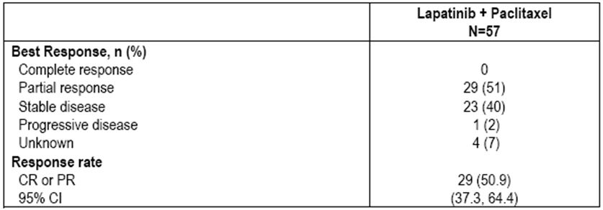

Reviewing duration of response, the Kaplan-Meier estimate for median duration of response was 39.7 weeks and 42.3 weeks according to IRC and investigator review respectively as indicated in Table 14.
Table 14: Summary of duration of response (ITT population).
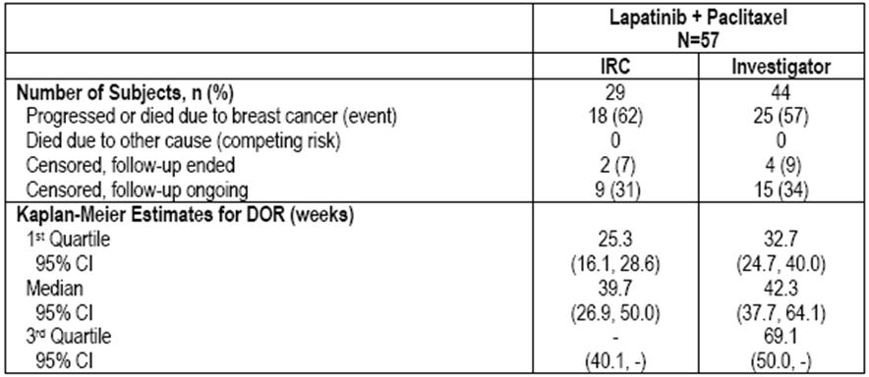
The Kaplan-Meier estimate for median PFS is 47.9 weeks and 50.9 weeks as assessed by the IRC and investigator respectively as indicated in Table 15.
Table 15: Summary of progression free survival (ITT population).
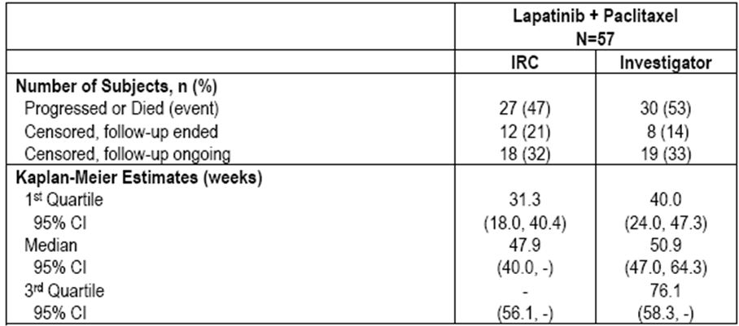
OS could not be adequately assessed and was therefore not provided in this submission.
In relation to ORR for those patients who were centrally defined HER2+ by IRC and investigator reported, response rates for these patients were similar compared to the HER2+ ITT cohort as indicated in Table 16.
Table 16: IRC and investigator assessed best response in centrally defined HER2 over expressing subjects.
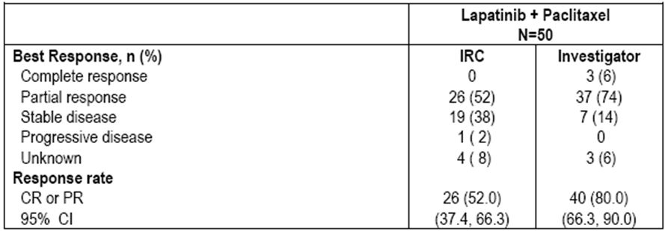

Comment
These data have lent some support for evidence of efficacy for the L/P combinations. However, the ORR observed in this trial was not clearly superior to those observed in the randomised studies involving paclitaxel alone. Accordingly, this data cannot be considered of any real value in determining the clinical benefit of the paclitaxel/lapatinib combination.

Efficacy conclusions
Overall, the pivotal Study EGF104535 together with the principal supportive study EGF30001 have demonstrated evidence of appropriate clinical benefit in terms of significant improvements in OS, TTP, and ORR for the drug combination of paclitaxel plus lapatinib compared to paclitaxel alone in patients with HER2+ MBC. It is important in the context although it would not be common for paclitaxel to be utilised as a single agent therapy for first line treatment of HER2+ MBC. The combination of L/P results in outcomes significantly superior to paclitaxel alone. Nevertheless, the most appropriate study that clearly defines the role of L/P as first line therapy for patients with HER2+ MBC would be a randomised trial comparing lapatinib with paclitaxel versus trastuzumab plus paclitaxel. If in fact such a study has not been either conducted or published, it is within reason to consider that L/P may represent an appropriate alternative first line therapy for patients with MBC who have previously received trastuzumab as adjuvant therapy and subsequently developed metastatic disease. It is reasonable to anticipate that clinicians would make suitable decisions regarding the choice of first line therapy for HER2+ MBC along the lines of either trastuzumab with paclitaxel or L/P on the basis of prior treatment in the adjuvant setting.

Safety
The safety data provided in this submission involves a total of five studies including the pivotal Phase III Study EGF104535 and the two supportive studies EGF30001 and EGF105764. Safety data is also provided in relation to Study EGF102580, which is a multinational Phase II study, designed to evaluate the efficacy and safety in patients receiving L/P as neoadjuvant therapy in patients with inflammatory breast cancer. Safety data from the Phase I combination agent therapy Study EGF10009 previously discussed under PK is also presented. A total of 1184 patients were treated and are included in safety evaluation.
The safety population in all studies comprised all patients who received at least one dose of study treatment. For the randomised studies, that is, Studies EGF104535 and EGF30001 the safety population is based on the actual treatment received rather than assigned treatment.
Safety analyses included the evaluation of the incidence of AEs with examination of toxicities known to be associated with lapatinib. All AEs were collected from the first dose of study treatment until 30 days after last dose of treatment and AEs recorded were graded according to NCI (National Cancer Institute) criteria. Particular note was made of certain toxicities associated with lapatinib and paclitaxel including diarrhoea, rash, decreased LVEF (left ventricular ejection fraction), hepatotoxicity and events of interstitial lung disease (ILD) or pneumonitis and nail changes. Standard laboratory evaluations were undertaken on a regular basis to assess safety aspects which included ECG evaluations and LVEF monitoring.
Patients in the four study pooled population ranged from 23-87 years of age with a median of 51 years. Overall 11% of patients were aged 65 years or older and <1% were 75 years or older. Most patients were women, that is, >99%. A total of 44% of patients were White, with 40% Asian and 13% Hispanic.
Demographic data from Study EGF10009 differed from the other four studies in that patients had advanced solid tumours rather than just breast cancer. The average age of these patients were 56.2 years with approximately half being male. The majority of patients were White, that is, 89%.
In relation to patient disposition and treatment discontinuation in the four pooled studies, the most common reason for discontinuation of lapatinib or placebo was disease progression for patients in both treatment arms. The rate of discontinuation due to disease progression was higher in the placebo plus Paclitaxel arm being 79% compared to L/P arm being 64%. The next most common reason for discontinuation due to AEs was higher in the L/P arm at 12% and the placebo arm at 7%. In relation to paclitaxel dose discontinuation, again the most common reason was disease progression followed by investigators decision and then AEs.
In relation to the Phase I Study EGF10009 for the once every three weeks paclitaxel regimen, six patients were withdrawn from treatment due to AEs, while no patients were withdrawn from the once weekly paclitaxel regimen for AEs.
With regard the extent of exposure to the two drugs involved in study, the safety population for the four study pool consisted of 1128 patients of who 621 received L/P and 507 placebo plus paclitaxel. In the integrated four study pool, overall exposure to lapatinib or placebo was higher in the L/P arm than the placebo arm. The median duration of exposure to lapatinib/placebo was similar in the L/P being 25.7 weeks and placebo plus paclitaxel arm being 23.6 weeks. The median daily dose of lapatinib for both treatment arms was similar to the planned dose of 1500 mg as indicated. The cumulative dose was greater in the L/P arm compared with the paclitaxel placebo arm.
In relation to the Phase I Study EGF10009, all 56 patients enrolled received at least one dose of study drug included.
In relation to AEs experienced, it is appropriate to assess the pivotal Study EGF104535 separately.
In relation to the pivotal Study EGF104535, the number of patients who experienced at least one AE was similar in both treatment arms as indicated in Table 17. Events known to be associated with lapatinib or paclitaxel were the most commonly reported AEs and occurred at a higher incidence in the L/P arm compared with the placebo arm, reflecting the longer period of observation for the L/P arm as well as the expected higher incidence of AEs with the combination therapies. The most commonly reported AEs were neutropenia being 77% in the L/P arm versus 47% in the placebo; diarrhoea 77% versus 29%; rash 59% versus 24%; leukopenia 53% versus 33% and alopecia 46% versus 51%. The majority of these events were low grade, although higher incidences in the L/P arm were Grade III diarrhoea and Grade III and IV neutropenia events. The majority of events with a higher incidence were considered related to study treatment by investigator, which is clinically expected since these were consistent with the established safety profiles of L/P.
Table 17: On therapy AEs regardless of causality reported in 10% or more of subjects in Study EGF104535 (safety population).
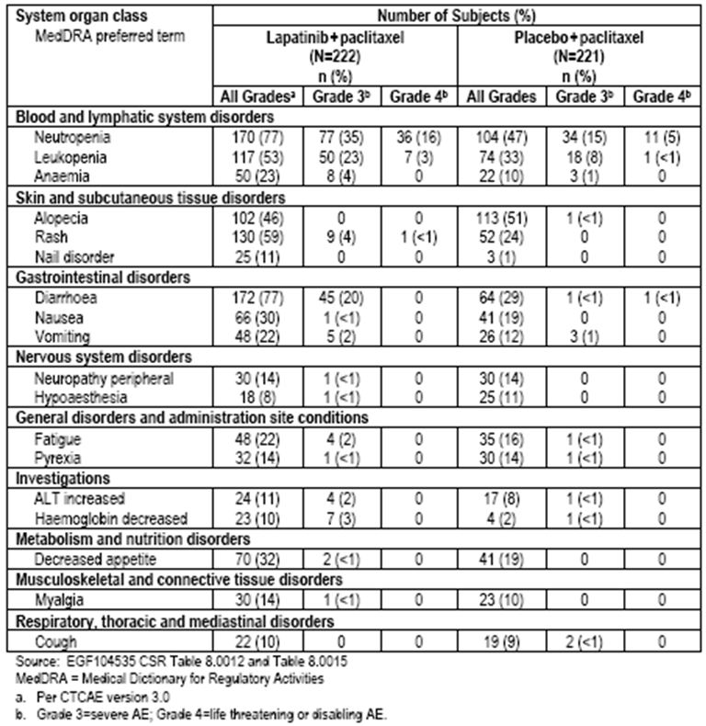

Reviewing AEs for the Phase III Study EGF30001 where paclitaxel was administered in the dose of 175mg every three weeks, again the overall number of patients reporting at least one AE was similar in both treatment arms and is indicated in Table 18. Events known to be associated with lapatinib or paclitaxel are the most common reported AEs occurring at a higher incidence in the L/P arm as might be expected. Again the most commonly reported AEs were diarrhoea followed by alopecia, rash and nausea. The majority of these events were low grade, although with a higher incidence in the L/P arm of Grade III diarrhoea and Grade III and IV neutropenic events. It is noteworthy that the incidence of neutropenia observed as an AE in the L/P arm of Study EGF30001 was 26%; in Study EGF104535 where paclitaxel was administered in a dose of 80mg/m² weekly, the L/P arm was 77%. The majority of events with a high incidence were considered related to study treatment as might be expected.
Table 18: On therapy AEs regardless of causality reported in 10% or more of subjects in Study EGF30001 (safety population).
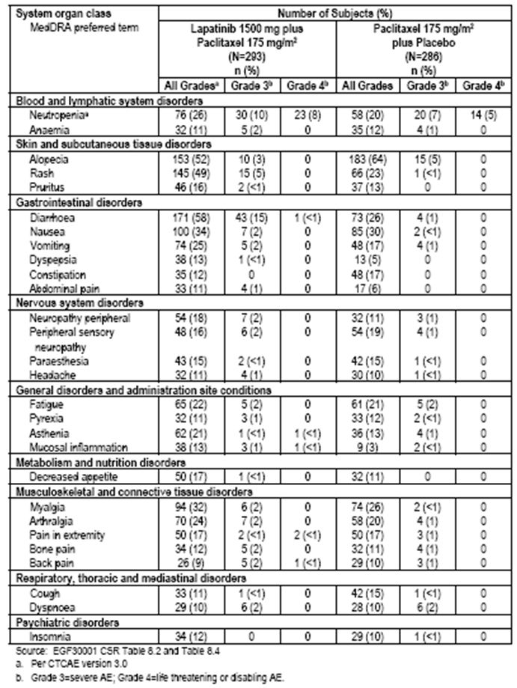

A review of the four combination studies apart from the Phase I study revealed there were a higher percentage of patients with AEs on the L/P arm. In particular, the incidence of alopecia was higher in the L/P arm. Consistent with the other studies, AEs considered related to study treatment by the investigator, serious adverse events (SAEs), and AEs leading to discontinuation of study treatment were all reported by fewer patients in the placebo arm. Table 19 reviews the incidence of AEs for the four study pool, with the most common AEs being diarrhoea (68% and 27% of patients, respectively) followed by alopecia (47% and 58%, respectively) and rash (54% and 23%, respectively). The most common AEs considered related to safety treatment by the investigator in L/P arm were diarrhoea (61%), rash (51%), neutropenia (39%), and alopecia 34%.
Table 19: On therapy AEs regardless of causality reported in 10% or more of subjects (four study pool: EGF104535, EGF30001, EGF105764, EGF102580: safety population).
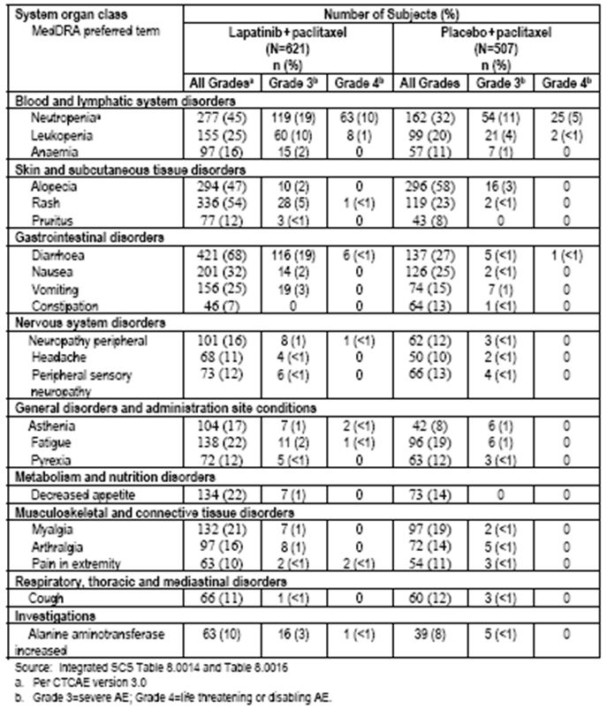

In relation to the Phase I Study EGF10009, all 44 patients experienced at least one AE during the study, with the most common being diarrhoea (80%), fatigue (75%), nausea (73%) and rash (73%).
When Study EGF104535 (weekly paclitaxel regimen) is compared to Study EGF30001 (three weekly paclitaxel regimen), it is noted that there is a similar toxicity profile for the L/P arms as indicated in Table 20. However there was a generally higher incidence of Grade III or IV nervous system disorders and muscular, skeletal and connective tissue disorders in Study EGF30001 (9% and 9%, respectively) compared to Study EGF104535 (1% and 2%, respectively). In Study EGF30001, Grade III or IV investigations in at least 10% of patients were elevated ALT and decreased Hb (haemoglobin), whereas in Study EGF104535 showed a higher incidence of haemalogic events including neutropenia and leukopenia and diarrhoea than that observed for Study EGF30001.
Table 20: On therapy AEs regardless of causality reported in 10% or more of subjects in any L/P treatment arm in Studies EGF104535 and EGF30001 (safety population).
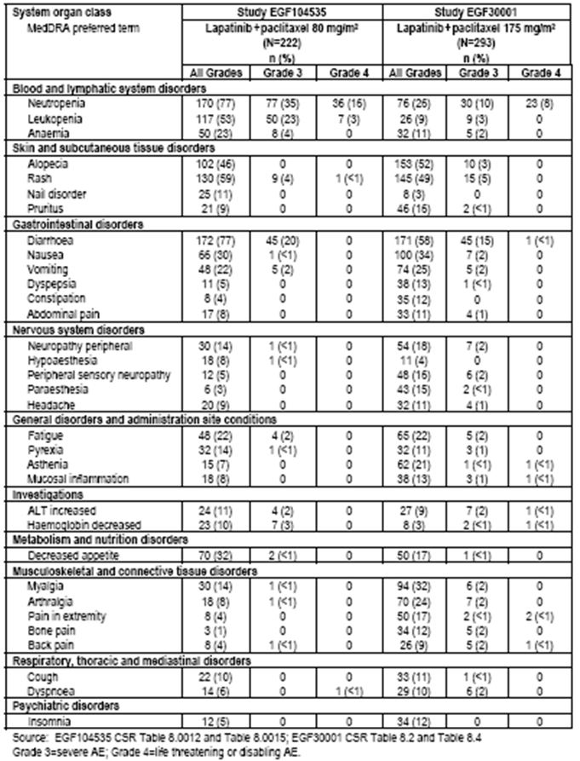
In relation to SAEs with a fatal outcome, in the pivotal study there were no fatal SAEs reported in the L/P arm, whereas on the placebo arm eight patients or 4% experienced fatal AEs, three of these including one episode of ischaemic lung disease, one septic shock, and one other death were considered unrelated to study treatment. The other five were considered to be related to study treatment, including multiorgan failure, hepatotoxicity and dyspnoea.
For the two other studies receiving weekly paclitaxel, there was one fatal SAE in Study EGF105764 and for Study EGF102580 being pulmonary failure and renal failure, respectively. Neither of these were considered to be related to study treatment.
In relation to the Phase III Study EGF30001 with the three weekly paclitaxel regimen, 10 patients experienced a fatal SAE, three of which were considered to be by the investigator potentially related to study treatment, all of which were in the L/P arm, including two patients with septic shock and one with febrile neutropenia.
In relation to the Phase I study, two fatal SAEs were experienced in the once every three week regimen, one patient experiencing fatal hepatic encephalopathy, which was considered possibly related to study treatment. There were no fatal SAEs with the weekly paclitaxel regimen.
In a review of the SAEs both fatal and non fatal, in the pivotal Phase III study the incidence of SAEs was higher in the L/P arm being 30% compared with the placebo arm 14%. Most of the SAEs occurring in at least two patients occurred at a higher incidence in the L/P arm with the exception of dyspnoea and femur fracture. The most common SAEs were neutropenia followed by decreased ejection fraction, diarrhoea and leukopenia. In the Study EGF30001, more patients experienced SAEs than the L/P group as indicated in Table 21. These included diarrhoea and neutropenia.

Table 21: Summary of on therapy SAEs by treatment arm (1% or more of subjects in either treatment arm (EGF30001, safety population).
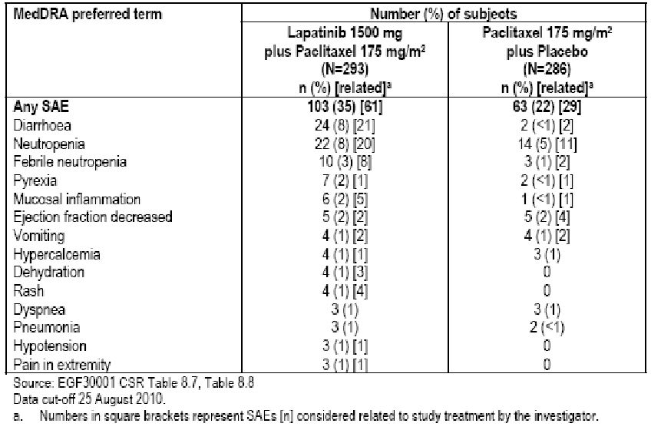

In the other weekly paclitaxel studies more SAEs occurred in the L/P arm compared to the placebo arm and consistent with the pivotal study, the most common were neutropenia followed by diarrhoea, decreased ejection fraction, febrile neutropenia and pyrexia.
In Study EGF10009, for the three weekly regimen, treatment related SAEs were fatal hepatic encephalopathy, Grade IV leukopenia, Grade II vomiting, Grade II nausea and Grade III dehydration. In relation to the weekly paclitaxel regimen 13 SAEs were experienced by 4/12 patients of whom two being Grade III nausea and vomiting which were considered by the investigator to be related to study drug.
A comparison between the Phase III Study EGF104535 and EGF30001 revealed that overall neutropenia, ejection fraction decrease, leukopenia and granulocytopaenia occurred in a higher incidence in Study EGF104535 whereas diarrhoea, pyrexia, dyspnoea, vomiting, mucosal inflammation, hypercalcaemia, dehydration, rash, pneumonia, hypertension and pain in the extremity occurred at a higher incidence in Study EGF30001 and is illustrated in Table 22.
Table 22: Summary of on therapy SAEs in the L/P treatment arm of studies EGF104535 or EGF3001 (1% or more of subjects in either study, safety populations).
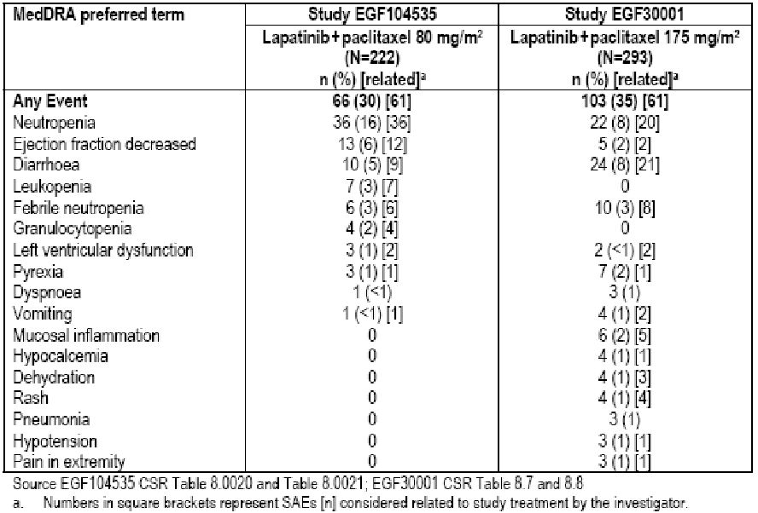
In relation to study discontinuation due to AEs in the pivotal Study EGF104535 as indicated in Table 23, the most common AEs leading to discontinuation were neutropenia, AST increased, decreased ejection fraction in L/P arm, whereas for the placebo arm it was AST increased and dyspnoea. Generally, AEs leading to discontinuation of study treatment in more than 1% of patients occurred more often in the L/P arm.
Table 23: Summary of AEs leading to permanent discontinuation of study treatment occurring in two or more subjects (EGF104535, safety population).
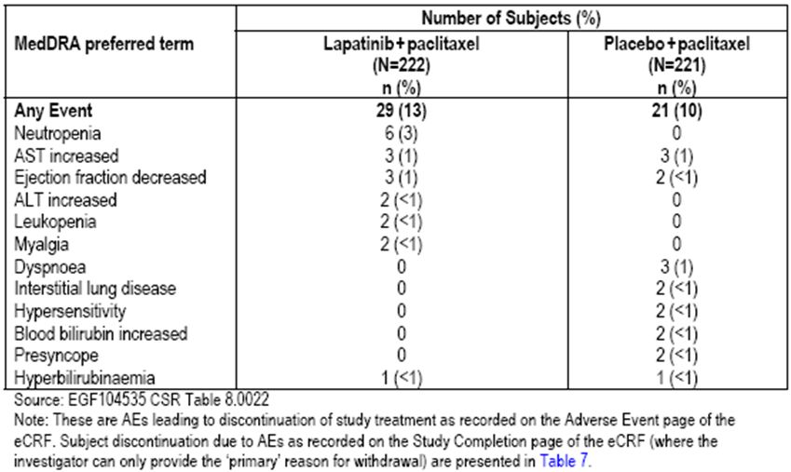
In Study EGF30001, the incidence of SAEs leading to permanent discontinuation of study treatment was higher in the L/P arm (16%) compared with the placebo arm (7%) as indicated in Table 24. These events were consistent with those from Study EGF104535. Again, diarrhoea was most common in the L/P group. This is in contrast to the EGF104535 where neutropenia was the most common AE leading to discontinuation.
Table 24: Summary of on therapy AEs leading to permanent discontinuation of study treatment occurring in two or more subjects in either treatment group (EGF30001, safety population).
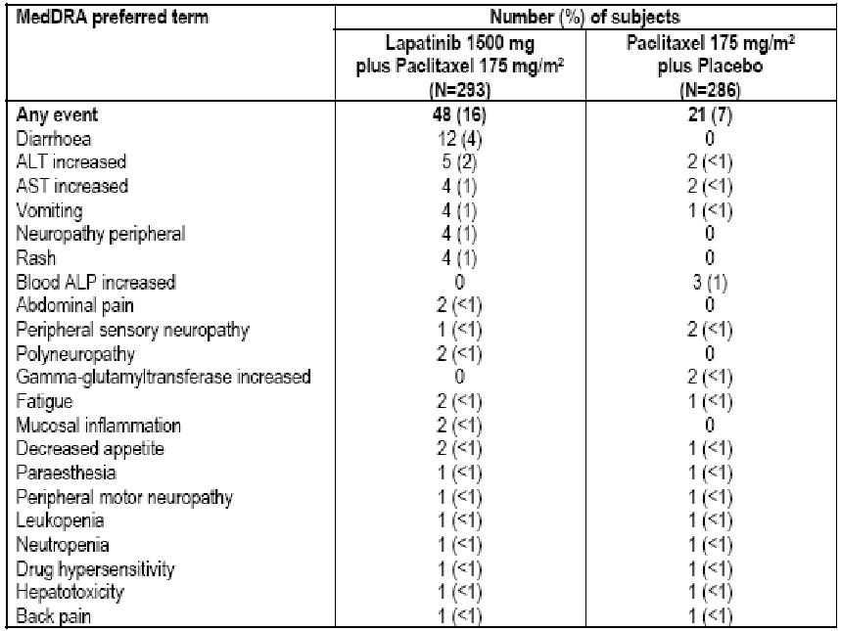

For the other weekly paclitaxel studies, the incidence of AEs leading to permanent discontinuation of study treatment was similar in both arms of treatment (10%) and consistent with the Study EGF104535 results. Again, the most common reason for discontinuing treatment included neutropenia followed by abnormal liver functions and diarrhoea in the L/P arm, whereas elevated AST and dyspnoea were most common in the placebo arm as indicated in Table 25.
Table 25: Summary of on therapy AEs leading to permanent discontinuation of study treatment occurring in two or more subjects in either treatment group (EGF30001, safety population).
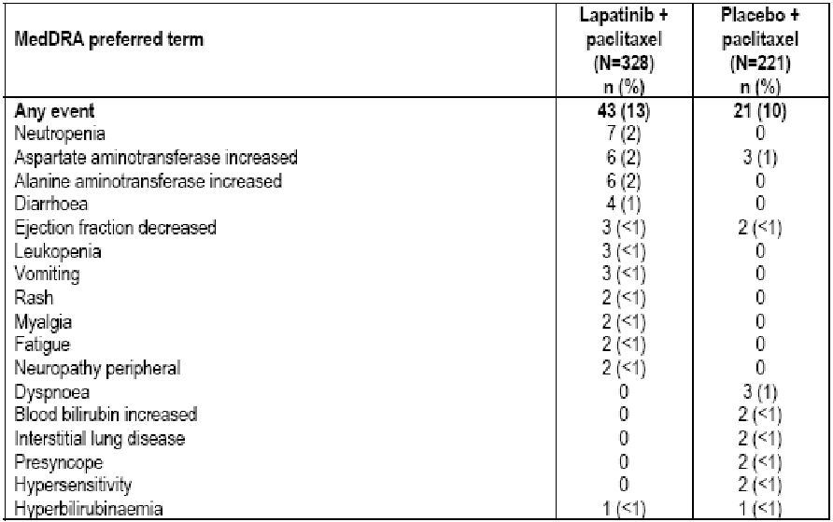
In relation to the Phase I study, six patients withdrew from the ‘in once every three week regimen’ including one episode of fatal hepatocephalopathy, Grade II ketoacidosis, Grade III dyspnoea and Grade III diarrhoea. One patient required permanent discontinuation on the weekly regimen.

Safety of events of special interest
In relation to neutropenia events, the incidence of neutropenia AEs for the pivotal study was noted to be higher in the L/P arm (77%) compared with placebo (47%). Most had a maximum toxicity of Grade II or III. The Grade IV events were noted in the L/P arm in 16% of patients compared with the placebo 5%. Most AEs resolved without residual sequelae.
In relation to the Phase III Study EGF30001, febrile neutropenia was reported in 4% and 1% of patients in the two arms of study. There was one death associated with febrile neutropenia. Laboratory toxicity Grade IV neutropenia was observed in 18% and 10% of patients, suggesting a slightly higher rate of myelosuppression in both paclitaxel containing arms for Study EGF30001 relative to the weekly paclitaxel experience. It should be noted that one patient experienced fatal sepsis, while two experienced fatal septic shock and all three had received L/P and these events were associated with neutropenia.
Comparing Studies EGF104535 and EGF30001, neutropenia incidence was similar in the two studies. Grade IV laboratory values of decreased neutrophils were noted in 18% and 5% of patients in Study EGF104535 and 18% and 10% of patients in EGF30001 in the L/P and placebo plus paclitaxel treatment arms, respectively. There were no deaths in the EGF104535 associated with neutropenia infectious processes, while there were four deaths associated with neutropenia infectious processes in Study EGF30001.
In relation to diarrhoea in the pivotal Study EGF104535, a higher incidence of diarrhoea was observed in patients treated with L/P (77%) compared with patients treated with placebo plus paclitaxel (29%). The majority of these events were related to treatment as expected. Most diarrhoea events in the study were Grade I or II. Grade III diarrhoea was reported by more patients in the L/P arm (20%) compared to placebo (1%). Majority of Grade III diarrhoea eventually resolved without residual sequelae. One patient in the placebo arm reported Grade IV diarrhoea. No deaths were associated with diarrhoea event in this study. Most resolved without dose modification although there were more dose interruptions in the L/P arm.
In the Phase III Study EGF30001, 58% of patients experienced diarrhoea in the L/P arm compared with 26% in the placebo arm. Most events were related to study treatment. SAEs were reported for 24 patients in the L/P arm and for 2 patients in the placebo arm. The majority of events were Grade I and II. A total of 15% of patients treated with L/P experienced Grade III or more. Diarrhoea resolved with appropriate management in the vast majority of patients. Thirteen patients permanently withdrew from treatment due to diarrhoea all from the L/P arm.
Comparing Studies EGF104535 and EGF30001, diarrhoea was a common AE in both studies being Grade III or greater in 20% of patients in Study EGF104535 and 15% in EGF30001 in the L/P arms. Similar rates of diarrhoea SAEs reported for the two arms of study being 5% and 8%, respectively. Less than 1% of patients in the pivotal study withdrew due to diarrhoea compared to 3% in Study EGF30001. There were four deaths associated with diarrhoea in Study EGF30001 although these were also complicated by neutropenic sepsis.
In relation to cardiac events for the pivotal study, incidences of patients with cardiac events in the L/P arm being 9% compared with placebo arm being 5% is indicated in Table 26. The majority of these events were Grade I or II asymptomatic, transient and reversible, and considered to be related to study treatment. These events were decreased ejection fraction and left ventricular dysfunction.
Table 26: Characteristics of cardiac AEs (Study EGF104535, safety population).
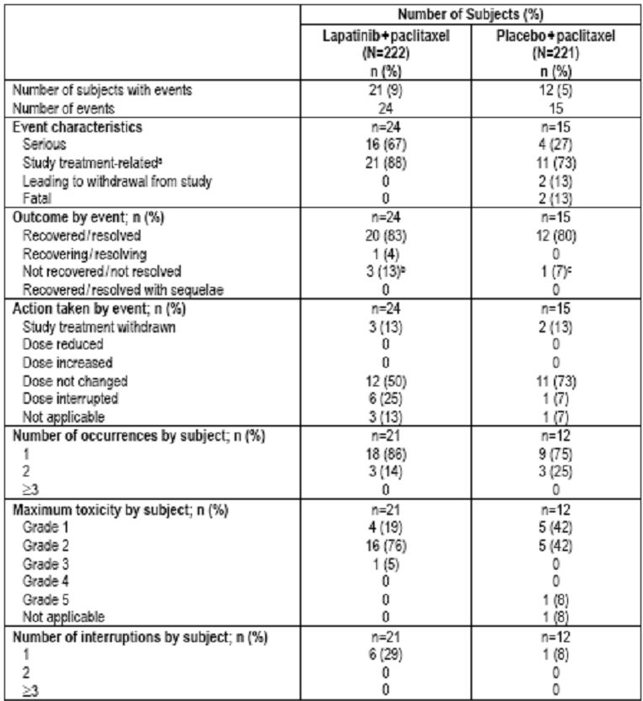
Serious cardiac events were reported for 16 patients in the L/P arm and 3 patients in the placebo arm. These were ejection fraction decrease in 13 patients (L/P arm) compared with 3 patients (placebo), left ventricular dysfunction in 3 patients (L/P arm) compared with zero (placebo), and chronic cardiac failure 0 (L/P arm) compared with 1 patient (placebo).
Ejection fraction decreases were reported as SAEs in 13 patients on the L/P arm and 3 in the placebo arm. None of these events were fatal while three patients discontinued treatment.
SAEs of left ventricular dysfunction were reported in 3 patients on the L/P arm but zero on the placebo arm. All were Grade I and II. Only one patient experienced symptomatic cardiac failure in the placebo arm and it was fatal and considered not be related to study treatment.
In relation to the Study EGF30001, 10 patients reported seven events of LVEF in each treatment arm. There were 7 cardiac AEs, 5 of which were in the L/P arm. Two were fatal, being cardiac arrest and cardiac failure. The majority of LVEF decreased events were Grade II or III in both treatment arms. None of the LVEF events resulted in a dose adjustment or withdrawal. Most of the LVEF events resolved. Grade III decreased LVEF events were reported for 5 patients and 3 patients in the L/P and placebo arms, respectively.
Comparing Studies EGF104525 and EGF30001, cardiac dysfunction was identified in more patients participating in the pivotal study. A total of 7% of patients in the pivotal study on L/P met the criteria of at least 20% relative decrease in LVEF. This compared to only 2% of patients in Study EGF30001. None of the patients in either study withdrew from treatment due to cardiac dysfunction in the combination therapy arms.
In relation to hepatobiliary events, in the pivotal study the incidence of hepatobiliary AEs specified as hepatic laboratory abnormalities were similar in both treatment arms being 23% for L/P and 21% for placebo. These were consistent with the known safety profile for lapatinib and paclitaxel. There were three hepatobiliary SAEs reported on study all occurring in the placebo plus Paclitaxel arm. Otherwise adverse grades were I or II in severity. No patients experienced a fatal event. Three patients withdrew from study due to hepatobiliary events, one in the combination arm and two in the placebo arm.
In relation to Study EGF30001, one patient in each treatment group experienced a hepatobiliary event and withdrew from treatment. Two patients experienced Grade III hepatobiliary events in the L/P arm, one was classified as serious. That patient has discontinued from study. There were no fatal hepatobiliary events reported in the study.
In relation to rash for the pivotal study, rash occurred more frequently in the L/P arm (59%) compared to placebo (24%). Most of these were not related to treatment. There were no SAEs of rash and no fatal rash events in either treatment arm.
Most patients with rash had a maximum toxicity of Grade I or II. There were nine patients with Grade III rash in the L/P arm and one with Grade IV. There were none however in the placebo arm. Three patients withdrew from study due to rash.
In relation to the Phase III Study EGF30001, a higher percentage of patients experienced events with rash in the L/P group (49%) compared to placebo (23%). The majority were Grade I or II in intensity, although 5% of patients in the L/P group had Grade III intensity rashes. The rash was generally managed by dose delay and 4% resolved without sequelae.
In relation to ILD in the pivotal study, the incidence was low (<1%) and similar in both arms of therapy. One patient had a Grade I event in the L/P arm that resolved without any dose modification. One patient in the placebo arm had a Grade II event that resulted in withdrawal from study treatment. One patient in the placebo plus Paclitaxel arm had a Grade V ILD event.
In Study EGF30001, one patient had a serious AE of Grade III level pneumonitis considered by the investigator related to study treatment and resulted in permanent discontinuation of therapy.

Laboratory evaluations

Haematology assessments
In relation to the pivotal study, the majority of haematological toxicities were Grade I-II and occurred in similar incidences in the two treatment arms. Both neutrophil and WBC (white blood cell) counts were the most frequently reported Grade III or IV haematologically related toxicities in both treatment arms. As clinically expected, more subjects reported those in the L/P arm.
In relation to the supportive Study EGF30001, again the majority of abnormalities were related to neutropenia and Grade I and II in severity. There was an ~18% incidence of Grade III and IV neutropenia on the L/P arm, which is only minimally increased compared to the paclitaxel alone arm.

Clinical chemistry assessments
In relation to the pivotal study, the majority of clinical chemistry toxicities were Grade I and II and occurred in similar incidences in both arms of study. Hepatobiliary laboratory abnormalities were observed in a small percentage of patients in both treatment arms. A similar incidence of clinical laboratory abnormalities was noted in Study EGF30001.
There were no clinically significant trends in vital signs of patients for any of the studies evaluated and similarly ECG observations showed little changes of clinical relevance.

Post marketing experience
There is no post marketing experience available in relation to the L/P combination at this time.

Conclusions
The data provided from the safety evaluation – with particular emphasis on the two principal Studies EGF104535 and EGF30001 – essentially indicate a toxicity profile that could be anticipated for either lapatinib and paclitaxel combination where AEs were those related to the individual agents previously well established. This is consistent with the current prescribing information for each agent, although it is noted that there was an enhanced presentation of an incidence of diarrhoea requiring appropriate management. There were little differences in the safety profile data for the two studies despite the differences in paclitaxel administration. The most common AEs reported for both studies included diarrhoea, alopecia and rash. The most common SAEs for the L/P combination for both studies included diarrhoea, neutropenia and ejection fraction decreased. Overall, no new toxicities were defined from the relevant studies to raise extra concern regarding the use of the combination of L/P.

Ethnicity
In this section, discussion will be held regarding any potential ethnic influences on the L/P combination for patients with HER2+ MBC. This discussion is derived from data provided in the Ethnic Sensitivity summary of lapatinib in combination with paclitaxel for MBC as well as pivotal Study EGF104535 and EGF30001. Additional data will also be presented from a further study submitted, namely Study EGF102580, the Phase II study of L/P as neoadjuvant therapy in patients with inflammatory breast cancer.
In the Ethnic Sensitivity summary, comparisons are made between Study EGF104535, which was undertaken principally in Asian countries, with three lapatinib studies conducted predominantly in patients of White/European ancestry in Europe and North America including Study EGF30001 and Study EGF30008, which was a Phase III study designed to evaluated the efficacy and tolerability of lapatinib and letrozole compared with letrozole and placebo in patients with HER2+ or HER2- breast cancer. A further Study EGF104383 was included: this was a Phase III study comparing the activity of paclitaxel plus trastuzumab plus lapatinib to paclitaxel plus trastuzumab plus placebo in subjects with HER2+ breast cancer. Demographics for these four studies is provided. As shown in relation to age, the average age of patients for Study EGF104535 is 49.2 years overall and for Study EGF30001 was 51.8 years overall. In terms of weight, it is noted that in Study EGF104535 the mean weight of patients was 61.6kg; this was 8-16kg lighter than the mean weight for patients in the Western studies, which was 69.6-78kg. This was as might be expected for Asian populations versus Western populations.
In relation to race and ethnicity as indicated the majority of patients in Study EGF104535 of East Asian ancestry resident in China, whereas the other three studies were of White European ancestry resident in Europe and North America.
All of the baseline demographics and disease characteristics were essentially well matched across studies in particular between Study EGF104535 and EGF30001.
In relation to prior therapy particularly prior adjuvant therapy, there was again appropriate matching between studies, in particular Studies EGF104535 and EGF30001. It is noteworthy that a greater proportion of patients in the Study EGF104535 had received prior adjuvant therapy compared to the other studies. This would tend to be an adverse prognostic factor in terms of subsequent response to treatment for metastatic disease. It is worth commenting that relatively few patients in either Study EGF104535 or EGF30001 had received prior trastuzumab as part of their adjuvant therapy programme. This is because these studies were initiated prior to the approval of trastuzumab as a relevant therapy for HER2+ breast cancer.
In relation to any potential differences for efficacy of lapatinib in Asian populations compared to Western, there is data available from the use of trastuzumab for treatment of breast cancer China which is currently undertaken at the same dose as in Europe and the US.
In relation to lapatinib PK, the PK of Lapatinib monotherapy are broadly similar in East Asian, that is, Japanese and Western subjects at a dose of 1800 mg per day. There is a trend to higher exposure at steady state in some East Asian than Western subjects of white European ancestry with a considerable overlap between the ethnic groups observed. Considerable inter individual variation of lapatinib C_{max} and AUC values is observed at the same dose in both ethnic groups. The lapatinib PK observed and the profiles of the activities of the PK determinants both indicate that the PK in East Asian/Chinese subjects would be generally similar to that of subjects of white European ancestry.
In relation to lapatinib efficacy, earlier studies of lapatinib monotherapy in patients with advanced MBC refractory to prior chemotherapy had been undertaken in Japanese women in Study EGF100642; there was also a further study in Western women, Study EGF20008. Both studies were Phase II open label studies including patients who had HER2+ tumours refractory to trastuzumab. The overall tumour response rate observed for HER2+ Japanese patients was greater than that observed in the HER2+ Western subjects. Similarly TTP, PFS and OS were longer in the Japanese patients. This is demonstrated to be related to more favourable disease characteristics at baseline including an ECOG status of 0 in 78% of Japanese versus 37% Western, and prior exposure to individual anti cancer therapies with a greater than five lines of prior chemotherapy in Japanese 29% versus Western 46%.
In relation to safety in these two studies, the incidence of AEs was generally higher in the Japanese study. However, the incidence of SAEs was lower in the Japanese patients being 10% versus 27% for the Western subjects. The spectrum of AEs was similar for both patient populations with the most common being diarrhoea and rash.
In relation to paclitaxel, which has been widely use for treatment of advanced breast cancer in Asia, Europe and the US, the approved dosage regimens are also similar: either 175 mg every three weeks or 80 mg weekly for three out of four weeks. Data available in relation to PK reveals that the PK profiles for C_{max} and AUC_{0-∞} are similar for both Japanese and Western patients as illustrated in Figure 9.
Figure 9: Paclitaxel C_{max} and AUC_{0-∞} following single infusion of paclitaxel (in cremophor EL and dehydrated alcohol, 1:1 v/v) in East Asian and Western subjects with solid tumours.
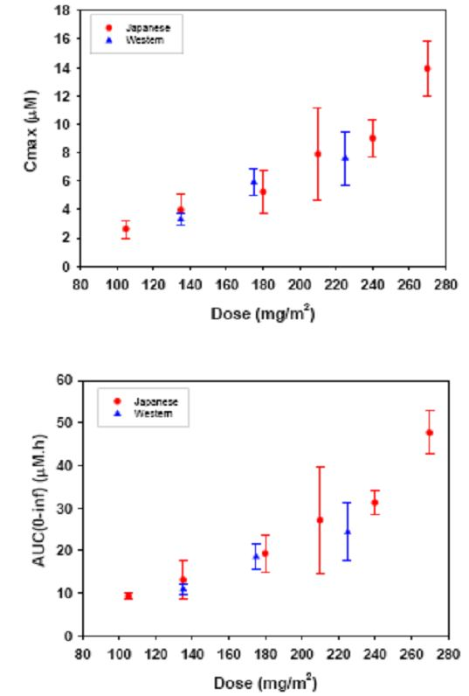

In relation to paclitaxel efficacy as monotherapy, there have been several studies in both Japanese and Western subjects with breast cancer. These data suggest that dose dense paclitaxel monotherapies are associated with a favourable response in both East Asian and Western patients with advanced MBC. In addition, Figure 10 indicates that Kaplan-Meier estimates of OS and TTP for Japanese and European patients follow similar profiles. Median TTP and OS are also essentially similar.
Figure 10: Kaplan-Meier analysis of TTP (upper panel) and OS (lower panel) in Japanese and Western subjects with metastatic breast cancer following weekly infusions of paclitaxel 80 mg/m².
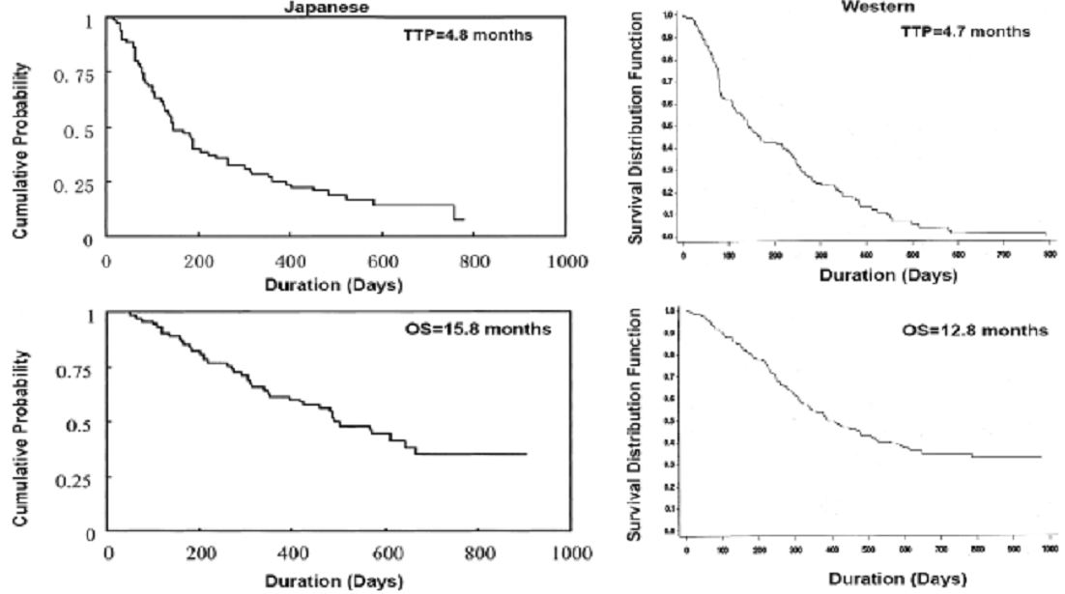

In relation to paclitaxel safety, the review of these Japanese and Western studies also demonstrates that the spectrum of haematological and non haematological AEs in the East Asian subjects were generally consistent with the spectrum of AEs in the European/Western subjects. The most common reported treatment related AEs in the Japanese patients were neutropenia, anaemia, fatigue, neuropathy and alopecia; these are similarly also reported as the most common in the European subjects. Some treatment related AEs including anaemia, neuropathy and diarrhoea were more frequent in the European than the Japanese subjects. It is noteworthy that as indicated in Figure 11 maximum reduction in absolute neutrophil counts as estimated by the E_{max} (maximum drug response) model was similar in Japanese and European subjects. The shape of the curves was also similar.
Figure 11: Percent reduction in granulocyte or absolute neutrophils count (ANC) versus the duration of time at a plasma paclitaxel concentration greater than or equal to 0.05μM in Japanese and Western subjects with solid tumours.
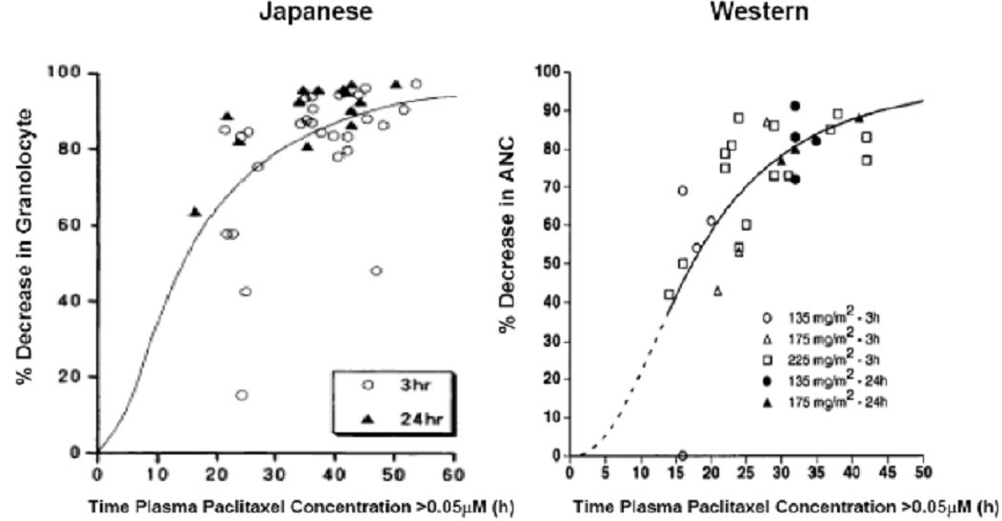
Symbols represent individuals treated at different paclitaxel doses (Japanese 105, 135, 180, 210, 240, 270 mg/m²; Western 135, 175, 225 mg/m²) and schedules. Curves depict the E_{max} sigmoid models fitted to the data.
In relation to PK, early PK conducted in Studies EGF10009 and EGF104578 essentially demonstrate the PK parameters are comparable for both Caucasians and Japanese as illustrated in Table 27. The extent of interaction of both lapatinib and paclitaxel as previously discussed under the PK section was similar in both Japanese and White/European subjects.
Table 27: Comparison of lapatinib (LAP) and paclitaxel (PAC) AUC between dose regimens and subject ancestry/ethnicity.
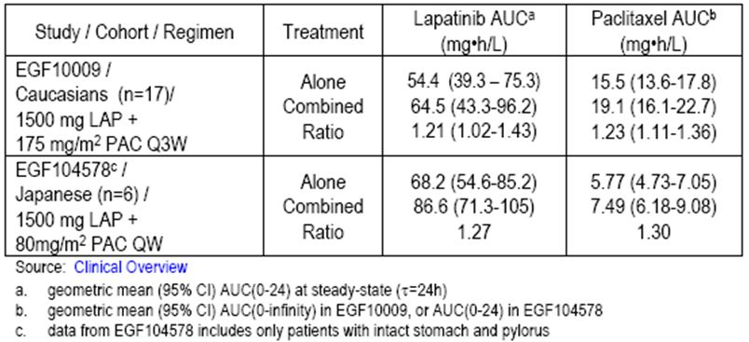

Study EGF102580
This study was a single arm multicentre Phase II study of L/P as neoadjuvant therapy in patients with inflammatory breast cancer. The study’s primary objective was to evaluate the pathological response rate in two cohorts of treatment naïve patients receiving lapatinib monotherapy for 14 days followed by combination therapy with daily lapatinib and weekly paclitaxel for 12 weeks. The first cohort was HER2+ while the second was HER2-. Doses of lapatinib were 1500 mg orally per day and paclitaxel 80 mg/m² weekly.
A total of 49 patients were enrolled with a median age of 53 years. 94% of patients were of White racial origins. A total of 32 patients were shown to be HER2+.
An overall partial response rate of 78% was noted among the 32 HER2+ patients of which all were partial responses.

Comment
These data indicate that in terms of response rates the utilisation of L/P combination essentially results in response rates in a Western group of patients comparable to that seen for the pivotal study in which patients were predominantly Asian.

Ethnicity conclusions
The data provided in the Ethnicity Sensitivity summary together with the data from the neoadjuvant trial are all indicative of no clear differences in relevant criteria between Asian and Western patients with respect to PK, efficacy and safety in relation to treatment with paclitaxel and lapatinib combinations. Accordingly, it is appropriate to accept the data from the pivotal Study EGF104535 is appropriate for consideration in Caucasian patients.

First round of benefit-risk assessment

First round assessment of benefit
Efficacy data provided in this submission essentially comes from the two major studies: the pivotal Study EGF104535 and the principal supportive Study EGF30001. The pivotal study involved evaluation of L/P at a dose of 80 mg/m² weekly for three weeks out of four compared to paclitaxel plus placebo. While Study EGF30001 evaluated lapatinib in combination with paclitaxel at a dose of 175 mg/m² every three weeks compared to paclitaxel plus placebo. With Study EGF30001, initially no specific testing for HER was undertaken and this was only evaluated retrospectively defining an HER2+ group that was then evaluated. Accordingly, only a sub group of patients were appropriate for assessment in relation to the current submission.
In relation to the pivotal study, analyses revealed that the primary endpoint of OS demonstrated a significant reduction in risk of death for patients treated with L/P. The HR was 0.64 with p=0.0005 by the Cox regression model. When the primary analysis was evaluated by a stratified log-rank test, the HR was 0.74 with a p=0.0124. The median OS was 27.8 months on L/P arm compared to 20.5 months on the placebo arm. It was also noteworthy that this survival benefit was observed despite the fact that some 67% of patients on the placebo arm of therapy crossed over to single agent lapatinib on evidence of disease progression when receiving paclitaxel plus placebo. Furthermore secondary endpoints including PFS, ORR and clinical benefit rate all demonstrated significant benefits favouring the combination of L/P.
It is recognised that this pivotal study involved predominantly Asian patients (86%) but nevertheless other data presented in this submission demonstrates that there is no evidence to support a potential difference in responsiveness to this combination related to ethnicity. This is based on PK and clinical data.
Furthermore, the supportive Study EGF30001 involved patients of Caucasian origin receiving L/P. In this study, the HER2+ patients revealed that the primary endpoint of TTP was significantly in favour of L/P group with an HR 0.57 and p=0.011. The median TTP for L/P group was 35.1 weeks compared to 25.1 weeks in the placebo group. No significant benefits were observed for OS but it is recognised that the number of patients in the HER2+ sub group tended to under power the study. Nevertheless, this data clearly indicates that the combination of L/P as first line therapy for MBC in HER2+ patients is associated with a significant benefit compared to paclitaxel alone.
It is noted that the current first line therapy in Australia for HER2+ MBC involves a combination of trastuzumab plus paclitaxel. At the time of this submission, there is no published data directly comparing the combination of L/P to trastuzumab plus paclitaxel in an equivalent patient population. This leaves open the question of possible superiority of one regimen versus the other. Nevertheless, there is available data to indicate that patients who receive lapatinib after progression on trastuzumab demonstrate significant responsiveness. This opens the likelihood the L/P combination would still be an active one and irrespective of possible prior trastuzumab therapy.
It is worth commenting that an earlier study evaluated the combination of trastuzumab in conjunction with either anthracyclines or paclitaxel versus the chemotherapy alone. The data was provided from several European, American and Australian centres involving 469 patients. The overall data demonstrated the addition of trastuzumab to chemotherapy prolonged TTP as the primary endpoint for a median of 7.4 months versus 4.6 months with a p=0.001, and OS of a median of 25.1 months versus 20.3 months with a p=0.046. When the data was broken down, according to the trastuzumab plus paclitaxel combination versus paclitaxel alone in 188 patients the median survival was 22.1 months for combination versus 18.4 months for paclitaxel alone with a p=0.17. Accordingly, at this time it would appear that the only combination which has shown a significant benefit in terms of OS is the current pivotal Study EGF104535.

First round assessment of risk
The AE profile for the combination of L/P described in this submission principally relates to the two major Studies EGF104535 and EGF30001. Overall, the data essentially confirms the well documented side effect profile for the individual agents. The safety profile data for the two studies was similar with the most common AEs being diarrhoea, alopecia and rash. In the L/P arm, the vast majority of these AEs were Grade I or II in severity and resolved without sequelae. The most common SAEs in the combination arm included diarrhoea, neutropenia and ejection fraction decrease. No patients experienced fatal AEs in the L/P arm in Study EGF104535, but three treatment related fatalities occurred in Study EGF30001. All of these were associated with fatal sepsis and at the time had Grade IV diarrhoea.
Diarrhoea in patients was in fact common in both studies and in particular Grade III or greater (20%) in Study EGF104535 and a little less often in EGF30001 (15%). Stringent guidelines for the management of diarrhoea have been established in relation to the use of L/P.
Grade IV neutropenia on the L/P arm of each study was observed in 18% of patients and febrile neutropenia was uncommon (<4%). Haematologic toxicity was the most common reason for reduction of paclitaxel dose and required frequent use of GCSF (Granulocyte Colony Stimulating Factor). As previously indicated, there were three deaths associated with neutropenia and infectious processes in Study EGF30001.
Overall, the incidence of symptomatic cardiac events was low and cardiac dysfunction only occurred in <2% of patients in the L/P arm for both studies. No new cardiac safety signals were noted. Similarly there was a relatively low incidence of hepatic dysfunction disorders, principally associated with laboratory changes that were rarely associated with any clinical sequale. Other AEs including rash were similar to that previously reported for use of individual agents. There were three reports of ILD, which is an occasional recognised toxicity for paclitaxel and lapatinib.
Overall, the safety profile demonstrated in these two studies was similar. It is noted that this involved both Asian and Western patients, therefore indicating that it is reasonable to assume that a toxicity profile for Western patients would be similar to that observed in the Asian population. There were no new indications of major increases in toxicity associated with the L/P combination, although it is recognised that diarrhoea is more common particularly when the dose of paclitaxel 80mg/m² weekly. There is a slightly greater increase in incidence of neutropenia when the three weekly regimen of paclitaxel is utilised.
Overall, the safety profile generally follows well recognised criteria for that associated with either lapatinib or paclitaxel when used in combination and represents a generally manageable area of clinical approach.

First round assessment of benefit/risk balance
The data from the current submission generally supports that the combination of L/P as first line therapy in patients with HER2+ MBC is associated with a significant benefit in terms of improvement in OS and other endpoints when compared to paclitaxel alone. No new safety signals have been derived from the studies to raise concern regarding a greater potential for AEs outweighing the relative benefits.
It is recognised that the combination of trastuzumab plus paclitaxel currently represents first line chemotherapy for patients with previously untreated HER2+ MBC. Nevertheless, on the basis of the data provided in this submission, together with the recognition that lapatinib shows evidence of efficacy in patients previously treated with trastuzumab, there is every reason to believe that L/P combination would have significant efficacy. Accordingly, it would seem reasonable to afford support for this combination in the context that clinicians would determine on the basis of prior trastuzumab therapy, what was the most appropriate first line treatment for patients with HER2+ MBC. For those patients who had not received trastuzumab, it is likely that this would be chosen as part of the first line therapy, while the alternative lapatinib with paclitaxel would be available in the context of prior trastuzumab as adjuvant therapy.
Overall, this evaluator considers that the potential benefits in relation to approval for the combination of paclitaxel plus lapatinib as first line therapy for patients with HER2+ MBC is appropriate and supported. I consider that the overall benefit profile discussed outweighs concerns regarding relative risks and also represents a suitable alternative for first line therapy in these patients.

List of questions
During 2010, the TGA began to change the way applications were evaluated. As part of this change, a list of questions to the sponsor after an initial evaluation is generated.
The only outstanding question to be asked of the sponsor relates to the issue of whether or not studies are either proposed or being conducted in relation to a direct comparison of L/P to trastuzumab plus paclitaxel as first line therapy in patients with HER2+ MBC.
It should be noted that it is not considered by this evaluator that the lack of such a study being conducted would necessarily limit approval for the proposed new indication.

Clinical summary and conclusions
On the basis of the submission and evaluation, this evaluator supports the proposed new indication of lapatinib (Tykerb) in combination with paclitaxel as indicated for the treatment of patients with MBC whose tumours over express HER2 (ErbB2).

V. Pharmacovigilance findings

Risk management plan
The sponsor submitted a RMP which was reviewed by the TGA’s Office of Product Review (OPR).

Safety specification
Subject to the evaluation of the nonclinical aspects of the Safety Specification (SS) by the Toxicology area of the OSE (Office of Scientific Evaluation), the summary of the ongoing safety concerns as specified by the sponsor are shown in Table 28.
Table 28: Ongoing Safety Concerns for Tykerb (lapatinib).
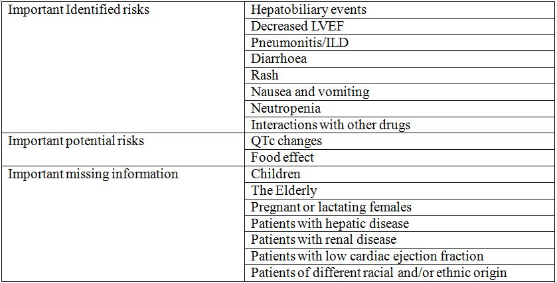

OPR reviewer comment:
Pursuant to the evaluation of the nonclinical aspects of the SS, the above summary of the ongoing safety concerns is considered acceptable.

Pharmacovigilance plan

Proposed pharmacovigilance activities
Routine and additional pharmacovigilance activities are proposed to monitor and further characterise the ongoing safety concerns associated with lapatinib (Table 29).

Additional pharmacovigilance activities
The sponsor will use targeted follow up questionnaires and also a Safety Review Team to monitor any changes in signals for hepatobiliary, decreased LVEF and pulmonary/ILD AEs during routine pharmacovigilance.
The sponsor proposes one new study (Study EGF114271) to investigate QTc changes associated with lapatinib.
Study EGF114271 – Important Potential risk (QTc changes)
This placebo controlled, single sequence crossover will investigate the effect of lapatinib on cardiac repolarisation (QTc interval duration) in ~36 subjects with advanced solid tumours. Participants will receive placebo followed by lapatinib 2000 mg, which will be given as three separate doses 12 h apart. Continuous ECG (via Holter monitor) and also PK samples will be taken to estimate the effect of lapatinib on the baseline adjusted, time matched QTc duration.
Table 29: Summary of ongoing and proposed studies.
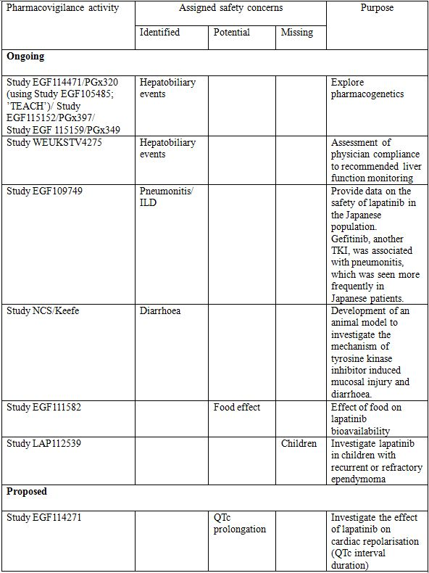

OPR reviewer comment in regard to the pharmacovigilance plan and the appropriateness of milestones:
The pharmacovigilance plan is considered sufficient to monitor and further inform the safety concerns associated with lapatinib. The proposed study (Study EGF114271) will investigate the effect of lapatinib on QTc changes. The study’s design, outcome measurements and sample size are considered adequate.
The calendar timelines, including milestones, for the reporting of the studies included in the pharmacovigilance plan are considered appropriate.

Risk minimisation activities

Sponsor’s conclusion in regard to the need for risk minimisation activities
The sponsor has provided a table summarising the planned actions for each safety concern associated with lapatinib. The sponsor concludes that routine risk minimisation activities are sufficient, except for hepatobiliary events, decreased LVEF, diarrhoea and rash.

OPR reviewer comment:
This is considered acceptable.

Potential for medication errors
Lapatinib should only be prescribed by physicians experienced in the administration of anti cancer treatments.
As reported in the RMP, routine pharmacovigilance indicates that as of 12 September 2010, there were errors in administration of lapatinib in 29 patients. The most common error was splitting the dose and taking 250 mg five times daily, or splitting the daily dose into two doses. Reported symptoms associated with increased lapatinib exposure included diarrhoea, dizziness, nausea and vomiting. Another common administration error was crushing the tablets, which was associated with nausea, throat irritation and pain. There were also several reports from a French observational study where lapatinib was given as monotherapy without capecitabine.
Medication errors will be monitored via routine pharmacovigilance activities. The sponsor has developed a patient leaflet that contains information to assist patients in identifying their medicine.

OPR reviewer comment:
Medication administration errors are unlikely to be reported unless the patient suffers an AE. Routine pharmacovigilance activities are therefore unlikely to detect or monitor medication errors. Given the very low anticipated incidence of overdoses, the use of a patient leaflet, aimed at helping patients identify their tablets and avoid administration errors, is considered an adequate risk minimisation measure at this time.

Summary of recommendations
The OPR provides these recommendations in the context that the submitted RMP is supportive to the application; the implementation of a RMP (Version 11, dated 22 March 2011, and any subsequent updates) is imposed as a condition of registration.
If the submission is approved, it is recommended to the Delegate that the sponsor update the information provided in RMP (Version 11) as per nonclinical evaluation report.

VI. Overall conclusion and risk/benefit assessment
The submission was summarised in the following Delegate’s overview and recommendations:

Quality
There was no requirement for a quality evaluation in a submission of this type.

Nonclinical
The preclinical evaluator raised a number of safety concerns:
- In a new in vitro study, lapatinib was shown to inhibit hERG K⁺ channels, raising the possibility that the drug could be associated with QT prolongation and cardiac arrhythmias. Toxicity studies in animals did not demonstrate any ECG effects; however, the evaluator considered that overall the proarrythmic risk associated with lapatinib could not be adequately assessed based on current data. The sponsor is planning to conduct a clinical study of the effect of lapatinib on QT interval in cancer patients.
- Due to PK interactions, co administration of L/P had the potential to increase systemic exposure to both agents, with subsequent increased toxicity. CNS toxicity of paclitaxel could also be increased due to inhibition of P-gp by lapatinib.
- Both lapatinib and paclitaxel are associated with hepatotoxicity.
Overall, the evaluator considered that an assessment of the risk/benefit balance of the combination would have to be based on clinical data.

Clinical
The clinical evaluator has recommended approval of the application.

Pharmacokinetics
The submission included two studies (EGF10009 and EGF 104578) which examined the interactions between lapatinib and paclitaxel. Administration of lapatinib resulted in a modest increase in the systemic exposure to paclitaxel (23-34% increase in paclitaxel AUC). Similarly, administration of paclitaxel resulted in a modest increase in the systemic exposure to lapatinib (21-27% increase in lapatinib AUC).
Study EGF10009 was also a dose ranging study designed to determine the maximum tolerated dose (MTD) and dose limiting toxicity for the combination of lapatinib and paclitaxel. The dosages of paclitaxel and lapatinib used in the efficacy studies and proposed for approval are based on the MTD determined in this study.

Efficacy
Evidence for efficacy comes from one pivotal Phase III study and two supportive studies.
The pivotal study (EGF104535) was a randomised, double blind, placebo controlled Phase III trial. Subjects enrolled had HER2+ MBC (Stage IV) and had not received any prior chemotherapy for their metastatic disease. HER2 positivity was determined by a central laboratory and required a positive FISH test or 3+ staining on IHC.
All subjects received chemotherapy with paclitaxel 80 mg/m² IV on Days 1, 8 and 15 of a 28 day cycle and were randomised to receive concurrent lapatinib 1500 mg daily or placebo.
The primary endpoint for the study was OS. The addition of lapatinib to paclitaxel resulted in a statistically significant improvement in OS:
HR = 0.64 (95% CI 0.49-0.082); p <0.0005 by Cox proportional hazards model;
HR = 0.74 (95% CI 0.58-0.094); p = 0.0124 by log rank test.
Median survival was increased in the lapatinib arm by ~7 months (27.8 versus 20.5).
Lapatinib treatment was also associated with significant improvement in the secondary endpoints of PFS, ORR and clinical benefit rate. Quality of life measures were not included in the study.
The first supportive study (EGF30001) was also a randomised double blind, placebo controlled Phase III trial. Subjects enrolled had advanced or MBC (Stages IIIb, IIIc, or IV) and had not received any prior chemotherapy for their metastatic disease. Subjects were required to have untested or negative HER2 status at enrolment. It was also a requirement that tumour tissue must be available in order to analyse tumour response according to various biomarkers. A pre defined determination of the HER2 status of these samples was conducted prior to unblinding of the study results.
All subjects received chemotherapy with paclitaxel 175 mg/m² IV on Day 1 of a 21 day cycle and were randomised to receive concurrent lapatinib 1500 mg daily or placebo. A total of 580 subjects were randomised in the trial. Of these, 91 were subsequently determined to have HER2+ disease.
The primary endpoint for the study was TTP. For the HER2+ population, there was a statistically significant improvement in TTP: HR=0.57 (95%CI: 0.34-0.93); p=0.011. Median TTP was increased by approximately 10 weeks (35.1 versus 25.1). There was no statistically significant benefit in OS. ORR was significantly improved (59.6% versus 35.9%).
The second supportive study (EGF105764) was an open single arm study in patients with previously untreated metastatic HER2+ disease. All subjects were treated with paclitaxel 80 mg/m² IV on Days 1, 8 and 15 of a 28 day cycle and concurrent lapatinib 1500 mg daily. The primary efficacy parameter was ORR as assessed by an independent review committee. The ORR was 50.9% which is notably lower than that observed in the lapatinib arm of the pivotal study (69%).

Safety
Safety data in the submission come from the studies described above together with the results of another Phase II single arm study (EGF102580) of the L/P combination in the neoadjuvant treatment of inflammatory breast cancer. A total of 677 subjects were treated with the L/P combination, including 621 subjects with breast cancer. Mean duration of treatment in the breast cancer population was 36.2 weeks.
The most informative safety data come from the two Phase III studies which were randomised, double blind and placebo controlled. The overall safety profile of the two treatment arms in these two studies in terms of incidence of AEs is summarised in Tables 30-31.
Table 30: Overall safety profile in terms of incidence of AEs in Study EGF104535.
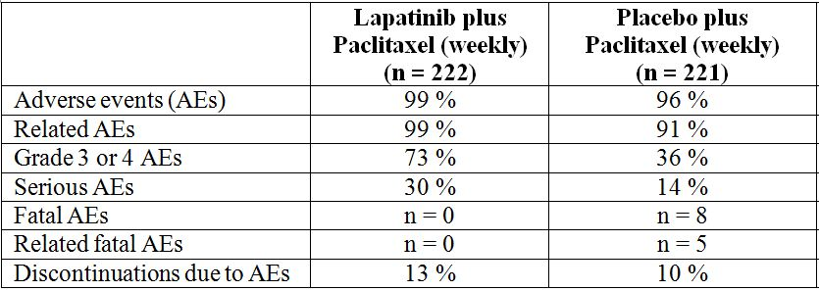
Table 31: Overall safety profile in terms of incidence of AEs in Study EGF30001.
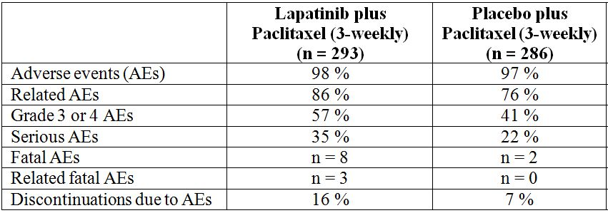
In terms of specific AEs, lapatinib treatment was associated with increased incidences of the following:
- Haematological toxicity – neutropaenia, leukopaenia and anaemia;
- Skin toxicity – rash, pruritus, nail disorders;
- Gastrointestinal toxicity – diarrhoea, nausea and vomiting;
- Asthenia and fatigue.
Apart from the increase in haematological toxicity, the AE profile of lapatinib appeared consistent with that previously documented. There was no increase in CNS toxicity in the lapatinib treatment arms.
Most of the excess toxicity in the lapatinib arms was Grade I/II in severity. However, Grade III/IV haematological toxicity and diarrhoea were notably increased.

Cardiac function
Both lapatinib and trastuzumab have been associated with impairment of left ventricular function. Impairment of cardiac function was therefore an adverse event of special interest in both Phase III studies.
In Study EGF104535, all AE terms indicating left ventricular dysfunction were grouped and called ‘cardiac events’. The incidence of such events was increased in the lapatinib arm (9% versus 5%). There were 16 SAEs in the lapatinib arm compared to 4 in the placebo arm. The incidence of Grade III or higher events was not increased in the lapatinib arm.
In Study EGF30001, all patients had measurement of LVEF at intervals through the study. The incidence of LVEF decrease events was comparable in the two study arms.

Ethnicity issues
The pivotal study in the submission (Study EGF104535) recruited subjects mainly from Asia, with 86% of subjects being described as being of Asian race. The issue therefore arises as to whether the efficacy and safety findings from this study can be extrapolated to Western populations such as that in Australia. As part of the submission, the sponsor submitted an ‘Ethnic Sensitivity Summary’ with data to support the applicability of the findings in Asian subjects to a Western population. The evaluator concluded that there were no clear differences between Western and Asian populations in the PK, efficacy and safety of either lapatinib or paclitaxel.
A cross trial comparison of the efficacy results obtained with the L/P combination in the two Phase III studies is shown in Table 32.
Table 32: Cross trial comparison of efficacy results obtained with the L/P combination in Studies EGF104535 and EGF30001.
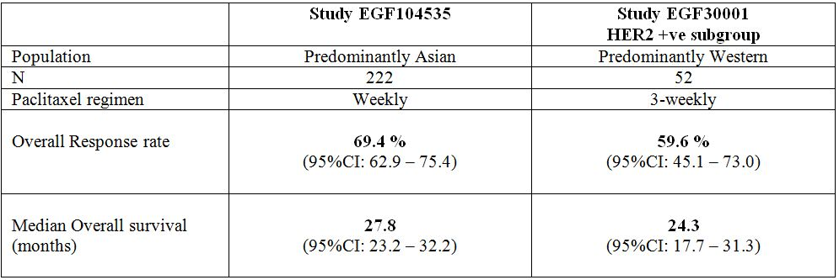

Risk management plan
The RMP proposed by the sponsor was considered acceptable by the TGA’s OPR.

Risk-benefit analysis

Choice of comparator
The comparator regimen used in the pivotal study was paclitaxel monotherapy. Standard first line treatment for metastatic HER2+ breast cancer in Australia would be a taxane combined with trastuzumab. The indication sought by the sponsor would effectively allow the use of lapatinib in this setting as an alternative to trastuzumab. However, equivalent efficacy and safety have not been demonstrated.
The EMA (European Medicines Agency) guideline on anticancer agents, which has been adopted by the TGA, states the following in relation to the choice of comparator regimen for Phase III studies:
“The choice of reference regimen should be justified and normally this regimen should be selected from best available, evidence based therapeutic options.”
Two studies which compared the efficacy and safety of trastuzumab and lapatinib in the neoadjuvant/adjuvant treatment of early breast cancer have recently been published (NeoALTTO and GeparQuinto). In the GeparQuinto study, lapatinib was shown to be inferior to trastuzumab. In both studies, discontinuations due to AEs were more frequent in the lapatinib arm than in the trastuzumab arm.
The sponsor has withdrawn a similar application in Europe following a negative recommendation from the EMA’s advisory committee. The negative recommendation appears to have been made due to the lack of comparative data with trastuzumab.
In a response to a question raised by the clinical evaluator, the sponsor has confirmed that a study directly comparing trastuzumab with lapatinib in the first line metastatic setting is currently underway and is expected to be completed by August 2013.
The pivotal study has demonstrated a clinically meaningful improvement in OS, with an improvement in median survival of ~7 months. The overall toxicity of the drug, when combined with paclitaxel, appeared manageable. However, patients in Australia already have access to a safe and effective treatment in trastuzumab. The published studies on neoadjuvant/adjuvant treatment raise a concern that use of lapatinib in the first line metastatic setting may result in patients receiving a less effective, more toxic treatment. Therefore, I consider that it would be prudent to await the outcome of the ongoing Phase III study directly comparing lapatinib with trastuzumab in the first line metastatic setting, prior to approving this indication. I thereby propose to reject the application.

Indication
If the Advisory Committee on Prescription Medicines (ACPM) considers that the application should be approved, I consider that the indication should be amended to restrict its use to the first line metastatic setting, as this was the population studied in the pivotal trial. The second sentence should also state that safety relative to trastuzumab has not been established. A proposed wording would be:
In combination with paclitaxel, for the first line treatment of patients with metastatic breast cancer whose tumours overexpress HER2 (ErbB2). Efficacy and safety relative to trastuzumab, in combination with paclitaxel, has not been established.

Delegate considerations

Proposed action
I propose to reject the application on the grounds that efficacy and safety relative to current standard treatment have not been established. The advice of the ACPM is requested.

Response from Sponsor

Executive Summary
The clinical evaluator supports approval of the proposed indication of lapatinib (Tykerb) in combination with paclitaxel for the treatment of patients with MBC whose tumours over express HER2 (ErB2). In contrast, the sponsor notes that the Delegate has not recommended approval.
The sponsor believes the application should be approved for the following reasons:
1. In Australia there is an unmet clinical need for some patients with MBC as trastuzumab is the only other HER2 targeted agent available.
2. A direct comparison with trastuzumab should not be deemed mandatory for approval.
3. Tolerability and efficacy signals from the cited neoadjuvant studies are not applicable to the metastatic setting.
4. Delaying approval by three years to await Study EGF108919 results is not necessary given the robustness of the survival benefit observed in the pivotal study.
If ACPM recommend the application be approved, the Delegate has proposed the following wording:
Tykerb, in combination with paclitaxel, is indicated for the first line treatment of patients with MBC whose tumours overexpress HER2 (ErbB2). Efficacy and safety relative to trastuzumab, in combination with paclitaxel, has not been established.
The sponsor accepts this revised wording and believes the application should be approved. Should ACPM consider it necessary to further limit the indication to patients for whom trastuzumab is not appropriate, the sponsor would be accepting of the following indication:
Tykerb, in combination with paclitaxel, is indicated for the first line treatment of patients with MBC whose tumours overexpress HER2 (ErbB2) and for whom trastuzumab is not appropriate. Efficacy and safety relative to trastuzumab, in combination with paclitaxel, has not been established.

Sponsor’s comments for ACPM

1. In Australia there is an unmet clinical need for some patients with MBC as trastuzumab is the only other HER2 targeted available
There are several categories of HER2+ patients seeking first line therapy for MBC who would benefit from L/P. The choice of the most optimal HER2 targeted agent will be unique for each individual patient. Lapatinib may be the favoured option in several settings, such as:
- those with recent rapid progression on trastuzumab;
- those with lack of access to convenient infusion services;
- those with specific health conditions that might be more suitable for the distinct safety profile of lapatinib relative to trastuzumab; or
- other factors that become apparent as our knowledge base improves in this clinical setting.
In providing a supporting clinical statement, an expert external to the sponsor has stated the following:
“In the following patient groups, L/P therapy would be preferred to trastuzumab plus taxane first line therapy:
- Patients with HER2+ breast cancer who require first line therapy for metastatic disease less than 12 months since receiving adjuvant trastuzumab therapy have an increased risk of disease that is resistant to trastuzumab plus taxane therapy and therefore L/P therapy would be a preferred first line treatment option, as it provides access to a potentially non cross resistant HER2 targeted agent.
- Patients with HER2+ MBC with brain metastases may derive a better clinical outcome from first line L/P therapy compared with trastuzumab plus taxane therapy due to better penetration of the HER2 targeted therapy lapatinib into the CNS compared with trastuzumab, resulting in the potential for better control of metastatic disease in the CNS.”
An additional group of patients has been highlighted by another external expert. In their supporting clinical statement, the expert states:
“...there is a suggestion in the existing clinical trial literature that lapatinib may be less cardiotoxic than trastuzumab, although there a number of recognised biases in this observation. Nevertheless, many clinicians would use lapatinib in preference to trastuzumab if that were possible, in the setting of a woman with metastatic disease and known left ventricular dysfunction.”

2. A direct comparison with trastuzumab should not be deemed mandatory for approval
The sponsor acknowledges that the TGA adopted EU guidance document for evaluation of anticancer medicinal products states:Error: Reference source not found
“the choice of reference regimen should be justified and normally this regimen should be selected from best available, evidence based therapeutic options.”
It also states that:Error: Reference source not found
“if the aim is to demonstrate non inferiority, the selected reference regimen must enable a proper definition of the non inferiority margin. In most cases, this would require randomised well controlled studies have showed the superiority of the selected reference versus control.”
The only randomised trial testing the effect of trastuzumab when administered with paclitaxel has proven superiority of added trastuzumab for prolonging TTP, but failed to prove an advantage in OS. Thus, if Study EGF104535 had been conducted using a single control arm of trastuzumab with paclitaxel, the primary endpoint would have had to be TTP (or closely related PFS), rather than the more robust endpoint of OS chosen for use in Study EGF104535.
The clinical evaluator comments that Study EGF104535
“has clearly indicated a significant benefit in terms of OS and PFS as well as objective response rate favouring the addition of lapatinib to paclitaxel as first line treatment for patients with MBC. It is noteworthy that this evidence of improved OS occurs irrespective of subsequent changeover for patients receiving paclitaxel alone to lapatinib monotherapy. This represents solid evidence favouring the combination therapy arm as first line treatment for these patients.”
EGF104535 enrolled patients with metastatic disease who were not intended for trastuzumab, using a very similar trial design as the trastuzumab Study H0648g, but with a broader patient population (that is, including anthracycline naïve) and including a more robust primary endpoint (OS). In relation to Study H0648g, the clinical evaluator comments that
“an earlier study evaluated the combination of trastuzumab in conjunction with either anthracyclines or paclitaxel versus the chemotherapy alone. The data was provided from several European, American and Australian centres involving 469 patients.”
The clinical evaluator also added that
“When the data was broken down, according to the trastuzumab plus paclitaxel combination versus paclitaxel alone, in 188 patients the median survival was 22.1 months for combination versus 18.4 months for paclitaxel alone with a p=0.17. Accordingly, at this time it would appear that the only combination which has shown a significant benefit in terms of OS is the current pivotal Study EGF104535.”
It is true that at present there is no direct randomised controlled trial data comparing lapatinib to trastuzumab. However, there is no data to suggest that trastuzumab is superior to lapatinib in HER2+ MBC.
Figure 12 presents all randomised controlled trial data that has led to the approval of these agents in the metastatic setting. The HR are included for both lapatinib and trastuzmab in the first line treatment of HER2+ MBC when combined with paclitaxel, in first line HER2+ MBC when combined with aromatase inhibitors, and in second line setting when combined with capecitabine. The HRs clearly overlap, suggesting there is no difference in the amount of relative benefit delivered by each agent in combination.
Figure 12: Similar treatment benefit in first and second line MBC.
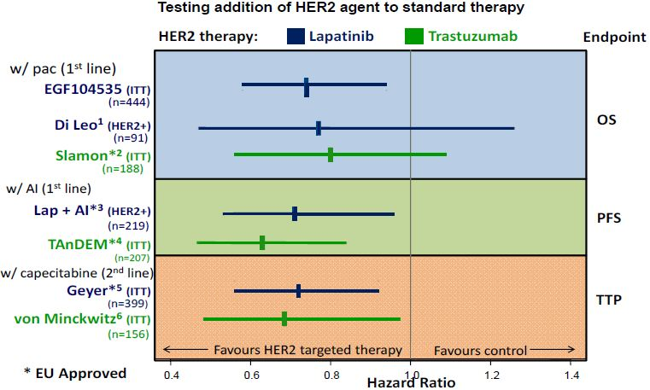
Source: 1. Di Leo et al. (2008) J. Clin. Oncol. 26:5544‐5552. 2. Slamon et al. (2001) NEJM 344:783‐792. 3. Johnston et al. (2009) J. Clin. Oncol. 27:5538‐5546. 4. Kaufman et al. (2009) J. Clin. Oncol. 27:5529‐5537. 5. Geyer et al. (2006) NEJM 355:2733‐2743. 6. von Minckwitz et al. (2011) Eur. J. Cancer 47:2273-2281.

As the observed OS benefit of lapatinib in this setting is substantial and compares favourably to the only other similar study that employed trastuzumab, one can further conclude that no loss of efficacy would be expected to result from selecting lapatinib as the HER2 targeted agent in this treatment setting.
Both agents target the same receptor but have a different mode of action and therefore a slightly different adverse event profile. An evaluation of specific AEs of special interest suggests some potential difference in the safety profile of lapatinib and trastuzumab when in combination with paclitaxel (for example, increased diarrhoea/rash and potential for hepatic toxicity for lapatinib and infusion reactions for trastuzumab, and a trend towards more frequent symptomatic cardiac toxicity for trastuzumab). The AEs associated with the L/P combination are well described in the proposed prescribing information which also includes detailed guidance on their management.
The publicly available safety data for Study H0648g are somewhat limited and thus the full trial results are shown in Table 33, while results specific for the paclitaxel treated patients are shown in Table 34 where AEs of special interest are summarised for the two pivotal Studies EGF104535 and H0648g, together with the supportive Study EGF30001.
Table 33: Adverse event summary in first line MBC studies testing HER2 agent + chemo/paclitaxel.
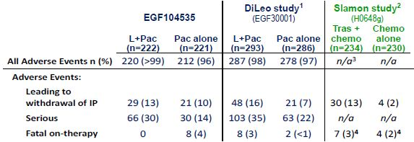
Source: 1. Di Leo et al. (2008) J. Clin. Oncol. 26:5544‐5552. 2. Slamon et al. (2001) NEJM 344:783‐792. 3. n/a = not available, very limited data available in public domain. 4. Data sourced from number of patients with early death. FDA Clinical Review of BLA 98‐0369 (trastuzumab) 1998.

Table 34: Safety profile of first line MBC studies.
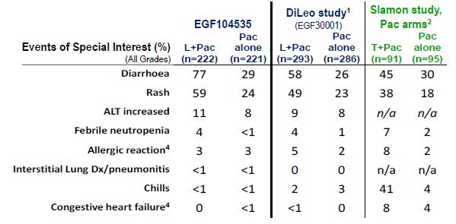
Source: 1. Di Leo et al. J Clin Oncol. 2008; 26:5544‐52. 2. Slamon, et al. NEJM 2001; 344:783‐792. 3. n/a = not available. 4. Term represents a combination of terms in that category

In relation to the safety profile demonstrated in Studies EGF104535 and EGF30001, the sponsor concurs with the clinical evaluator’s comment that
“overall no new toxicities were defined from the relevant studies to raise extra concern regarding the use of the combination of lapatinib and paclitaxel.”
The sponsor concludes that all evidence from the MBC setting is consistent with lapatinib and trastuzumab having comparable efficacy and tolerability, when combined with paclitaxel. This is further supported by evidence from other MBC settings.
The draft reflection paper on the need for active control in therapeutic areas where use of placebo is deemed ethical and one or more established medicines are available (EMA/759784/2010) states that:
“it is not necessary for the benefit-risk profile of an experimental medicine to at least as favourable as the benefit-risk profile of any or all established medicines in order to receive marketing authorisation. This is appropriate as frequently more than one treatment is required per indication (some medicines suit some people better than others) and clinical trials do not definitively capture all information on benefits and risks; knowledge accumulates during a product’s lifecycle. It is important to recognise that the purpose of regulatory approval is not to determine clinical practice (over and above the act of issuing a particular license for a medicine) and there is no limit to the number of medicines that can be licensed for any given therapeutic indication providing the benefit risk of each is favourable” (lines 68-76).
The sponsor agrees that it should not be mandatory to prove the relative efficacy and safety of a new agent to that of an established agent, especially when available data suggest that a new agent in that indication has comparable efficacy and acceptable safety in a broader range of patients than the established therapy. Such a proof would seem particularly unnecessary when the new agent presents the first demonstration of a statistically significant benefit using the gold standard endpoint for that indication (OS).

3. Tolerability and efficacy signals from the cited neoadjuvant studies are not applicable to the metastatic setting
The sponsor does not consider that tolerability signals from the NeoALTTO and GeparQuinto studies should be applied to compare L/P versus trastuzumab plus paclitaxel in MBC. The neoadjuvant and metastatic treatment settings differ in biology, chemotherapy combinations used, and, importantly, aspects of the overall benefit-risk evaluation.
In the NeoALTTO study, discontinuation rules for liver chemistry abnormalities were not applied equally across treatment arms and disadvantaged the lapatinib containing arms with more frequent protocol mandated discontinuations.
The GeparQuinto study is unique in that it used the alternative taxane (docetaxel) rather than paclitaxel like the NeoALTTO and EGF104535. Dose intensity was substantially imbalanced and favoured the trastuzumab docetaxel arm of this study. Even though the point estimates for pCR (pathologic complete response) are clinically similar (25% versus 30%); they were statistically different. The authors reporting this study point out that among those patients who received treatment according to protocol, the pCR rates were no longer statistically different. The data from the neoadjuvant setting, when taken together, show that the efficacy of lapatinib and trastuzumab are clinically similar.

4. Delaying approval by three years to await Study EGF108919 results is not necessary
There is one ongoing study that evaluates a direct comparison of lapatinib plus a taxane (paclitaxel or docetaxel) with trastuzumab plus taxane (paclitaxel or docetaxel) as first line therapy in patients with HER2+ MBC. No additional studies are currently proposed comparing these combinations in this clinical setting.
The ongoing Study EGF108919 is a randomised, Phase III, open label study comparing the efficacy of taxane based chemotherapy plus lapatinib to taxane based chemotherapy plus trastuzumab in women with documented evidence of HER2+ MBC, with no prior chemotherapy and/or HER2 targeted therapy in the metastatic setting. The study, which commenced in October 2008, is led by NCIC CTG (National Cancer Institute Clinical Trials Group) and is being conducted in 21 countries. Further description of this study is provided in Question 4 of the sponsor’s response to consolidated questions (dated 16 December 2011). Final PFS analysis is anticipated in August 2013. If the data are considered appropriate for registration, current timelines would indicate TGA pre submission in January 2014 with anticipated TGA approval in March 2015.
The primary goal of Study EGF108919 is to estimate the treatment effect. Statistical assumptions used in trial design included the preservation of at least 50% of the demonstrated PFS effect of trastuzumab plus taxane when treated with lapatinib plus taxane. For the hypothesis of H0: HR=1.25, for LTax/L as compared with TTax/T; H1: HR=0.9 (assumes that LTax/L is slightly better than TTax/T), 390 PFS events in the centrally confirmed HER2+ patient population are required for 90% power and one sided alpha of 2.5% for this test of non inferiority. For this to be the case, a sample size of 536 patients who are HER2+ by central laboratory testing is required. The primary analysis will be performed on ITT population defined as all randomised patients.
The NCIC Data Safety Monitoring Committee published a summary report dated 24 October 2011 stating that they have reviewed Study EGF108919 with respect to safety, trial conduct, including accrual, and where applicable, efficacy. The recommendation is that there are no concerns with the trial and that it should continue until target sample size is reached. To protect the integrity of the data, the sponsor is unable to provide safety related information from this trial at this time.
The sponsor believes that results from this trial should provide estimates of PFS and thus address the question of relative efficacy of the two HER2 targeted agents when combined with taxanes for the treatment of first line HER2+ MBC and should provide further evidence of comparability between lapatinib plus a taxane and trastuzumab plus a taxane. However, the sponsor believes that any data from the NCIC CTG trial mentioned would represent a small increment in knowledge relative to what is known today regarding lapatinib and paclitaxel and that delaying access to L/P to patients for a further three years is not appropriate.

Sponsor’s comments for ACPM
The sponsor believes that the submitted evidence supports the safe and effective use of lapatinib (Tykerb) in combination with paclitaxel as indicated for the first line treatment of patients with MBC whose tumours over express HER2 (ErB2). The sponsor does not support delaying an approval a further three years pending TGA consideration of Study EGF108919 data. Approval of lapatinib for use in combination with paclitaxel in first line HER2+ MBC would allow a second treatment alternative for these patients and is particularly valuable to those patients with an unmet clinical need for a HER2 targeted agent and for whom trastuzumab treatment is not appropriate.

Advisory Committee Considerations
The ACPM, having taking into account the submitted evidence of efficacy, safety and quality, considered this product to have an overall positive benefit-risk profile for the indication:
Tykerb, in combination with paclitaxel, is indicated for the first line treatment of patients with metastatic breast cancer whose tumours overexpress HER2 (ErbB2) and for whom trastuzumab is not appropriate.
Efficacy and safety relative to trastuzumab, in combination with paclitaxel, has not been established.
In making this recommendation the ACPM noted that while the studies have demonstrated efficacy and a survival benefit, the data to support equivalence or superiority with a suitable comparator (for example, trastuzumab) are pending.
The ACPM noted that this product in combination with paclitaxel has proven clinical benefit with a manageable safety profile and there may be a patient subgroup who may benefit from its availability as an alternative to trastuzumab.
The ACPM agreed with the Delegate to the proposed amendments to the PI and Consumer Medicine Information (CMI) and specifically advised on inclusion of the following:
- Inclusion in the Dosage and Administration section of more information on dosage reduction/interruption used in the pivotal study to reflect current practice where dosing is frequently adjusted and the recommended dosages of lapatinib and paclitaxel are unlikely to be appropriate in many cases.
The ACPM agreed with the Delegate on the proposed conditions of registration and specifically advised on the inclusion of the following:
- The sponsor providing outcomes from comparative studies as soon as they are available.
The ACPM advised that the implementation by the sponsor of the recommendations outlined above to the satisfaction of the TGA, in addition to the evidence of efficacy and safety provided would support the safe and effective use of these products.

Outcome
Based on a review of quality, safety and efficacy, TGA approved the registration of Tykerb (lapitinib) 250 mg tablets (oral administration) in combination with paclitaxel for the first line treatment of patients with metastatic breast cancer whose tumours overexpress HER2 (ErbB2) and for whom trastuzumab is not appropriate (see Clinical Trials).
The approved full indications now read as follows:
Tykerb, in combination with an aromatase inhibitor, is indicated for the treatment of postmenopausal women with hormone receptor positive metastatic breast cancer whose tumours overexpress HER2 (ErbB2) and for whom hormonal therapy is indicated.
Tykerb, in combination with capecitabine, is indicated for the treatment of patients with advanced/metastatic breast cancer whose tumours overexpress HER2 (ErbB2) and whose tumours have progressed after treatment with an anthracycline, a taxane and trastuzumab.
Tykerb, in combination with paclitaxel, is indicated for the first line treatment of patients with metastatic breast cancer whose tumours overexpress HER2 (ErbB2) and for whom trastuzumab is not appropriate (see Clinical Trials).
Specific conditions of registration applying to these therapeutic goods:
1. Details of the distribution of the drug including quantities and forms of products distributed and related batch numbers should be supplied on request while the drug remains on the ARTG.
2. The implementation in Australia of the lapatinib (as ditosylate monohydrate) RMP Version 11, dated 22 March 2011, included with this submission, and any subsequent revisions, as agreed with the TGA and its OPR.
3. It is a condition of registration that the sponsor submits to the TGA for evaluation the finalised Clinical Study Report for Study EGF108919 (COMPLETE). This should be done as soon as practicable after the sponsor receives the finalised Clinical Study Report.

Attachment 1. Product Information
The following Product Information was approved at the time this AusPAR was published. For the current Product Information please refer to the TGA website at <http://www.tga.gov.au/hp/information-medicines-pi.htm>.

Gutierrez C, Schiff R. (2011) HER2: biology, detection, and clinical implications. Arch. Pathol. Lab. Med. 135:55-62.
Oakman C, et al. (2010) Role of lapatinib in the first-line treatment of patients with metastatic breast cancer. Cancer Manag. Res. 2:13-25.
Matson DR, Stukenberg PT. (2011) Spindle poisons and cell fate: A tale of two pathways. Mol. Interv. 11:141-50.
Doses were calculated cumulatively over a one day treatment period. Dose per square metre BSA was estimated from doses (mg/kg using a mouse standard conversion multiplier of 3). Protein binding in mice is similar to humans ~89%: Verweij J, et al. (1994) Paclitaxel (Taxol™) and docetaxel (Taxotere™): Not simply two of a kind. Annals of Oncology 5:495-505.
Calculated from the mg/kg dose for a 50 kg human with a standard conversion multiplier of 33.
Paclitaxel doses were calculated over a cumulative 21 day period for mice.
Pollard CE, et al. (2010) An introduction to QT interval prolongation and non-clinical approaches to assessing and reducing risk. Br. J. Pharmacol. 159:12-21.
Brana I, Tabernero J. (2010) Cardiotoxicity. Ann. Oncol. 21 Suppl 7:vii173-179.
Yeh ET, Bickford CL. (2009) Cardiovascular complications of cancer therapy: incidence, pathogenesis, diagnosis, and management. J. Am. Coll. Cardiol. 53:2231-2247.
Brouty-Boye D, et al. (1995) Antiproliferative activity of taxol on human tumor and normal breast cells versus effects on cardiac cells. Int. J. Cancer. 60:571-575; Alloatti G, et al. (1998) Differential effects of paclitaxel and derivatives on guinea pig isolated heart and papillary muscle. J. Pharmacol. Exp. Ther. 284:561-567.
Guglin M, et al. (2009) Introducing a new entity: chemotherapy-induced arrhythmia. Europace 11:1579-1586.
Breedveld P, et al. (2006) Use of P-glycoprotein and BCRP inhibitors to improve oral bioavailability and CNS penetration of anticancer drugs. Trends Pharmacol. Sci. 27:17-24.
European Medicines Agency, “ICH Topic S9 Nonclinical Evaluation for Anticancer Pharmaceuticals Step 4: Note for Guidance on Nonclinical Evaluation for Anticancer Pharmaceuticals (EMEA/CHMP/ICH/646107/ 2008)”, November 2009, Web, accessed 17 October 2012 <http://www.ema.europa.eu/docs/en_GB/ document_library/ Scientific_guideline/2009/09/WC500002867.pdf>.
Cohen PR. (2009) Photodistributed erythema multiforme: paclitaxel-related, photosensitive conditions in patients with cancer. J. Drugs Dermatol. 8:61-64.
Kemper E M, et al. (2003) Increased penetration of paclitaxel into the brain by inhibition of P-Glycoprotein. Clin. Cancer Res. 9:2849-2855.
Rice A, et al. (2005) Chemical modification of paclitaxel (Taxol) reduces P-glycoprotein interactions and increases permeation across the blood-brain barrier in vitro and in situ. J. Med. Chem. 48:832-838.
Polli JW, et al. (2008) The role of efflux and uptake transporters in [N-{3-chloro-4-[(3-fluorobenzyl)oxy]phenyl}-6-[5-({[2-(methylsulfonyl)ethyl]amino}methyl)-2-furyl]-4-quinazolinamine (GW572016, lapatinib) disposition and drug interactions. Drug Metab. Dispos. 36:695-701.
Kemper E M, et al. (2003) Increased penetration of paclitaxel into the brain by inhibition of P-Glycoprotein. Clin. Cancer Res. 9:2849-2855; Breedveld P, et al. (2006) Use of P-glycoprotein and BCRP inhibitors to improve oral bioavailability and CNS penetration of anticancer drugs. Trends Pharmacol. Sci. 27:17-24.
Oken MM, et al. (1982) Toxicity and response criteria of the Eastern Cooperative Oncology Group. Am. J. Clin. Oncol. 5:649-655.
The ECOG score (also called ECOG/WHO/Zubrod score) runs from 0 to 5, with 0 denoting perfect health and 5 death: 0 Asymptomatic (fully active, able to carry on all pre disease activities without restriction) 1 Symptomatic but completely ambulatory (restricted in physically strenuous activity but ambulatory and able to carry out work of a light or sedentary nature, for example, light housework, office work) 2 Symptomatic, <50% in bed during the day (ambulatory and capable of all self care but unable to carry out any work activities, up and about more than 50% of waking hours) 3 Symptomatic, >50% in bed, but not bedbound (capable of only limited self care, confined to bed or chair 50% or more of waking hours) 4 Bedbound (completely disabled, cannot carry on any self care, totally confined to bed or chair) 5 Death
European Medicines Agency, “Guideline on the evaluation of anticancer medicinal products in man (EMA/CHMP/205/95/rev.4)”, 15 December 2011, Web, accessed 17 October 2012 <www.ema.europa.eu/docs/en_GB/document_library/Scientific_guideline/2011/12/WC500119966.pdf>.
European Medicines Agency, “Reflection paper on the need for active control in therapeutic areas where use of placebo is deemed ethical and one or more established medicines are available (EMA/759784/2010)”, November 2010, Web, accessed 17 October 2012 <www.ema.europa.eu/docs/en_GB/document_library/ Scientific_guideline/2011/01/WC500100710.pdf>.
Subsequent to ACPM consideration, a meeting of the Independent Data Safety Monitoring Committee (IDMC) for Study EGF108919 was held to review safety and efficacy data. The IDMC recommended termination of the study due to superior efficacy in the trastuzumab + taxane arm. This recommendation was not due to safety concerns in either arm of the study. Based on the IDMC’s recommendation, the sponsor terminated Study EGF108919 and communicated this finding to the TGA. Given the findings from Study EGF108919, the TGA and sponsor agreed that the proposed sentence in the indication statement "Efficacy and safety relative to trastuzumab, in combination with paclitaxel, has not been established" is no longer appropriate. Additional text was inserted in the precautions and clinical trials section of the Tykerb PI describing the interim findings from Study EGF108919.

