|  |
| --- |
| **December 2020** |

|  |
| --- |
| Australian Public Assessment Report for Larotrectinib |
| Proprietary Product Name: Vitrakvi |
| Sponsor: Bayer Australia Limited |

About the Therapeutic Goods Administration (TGA)

* The Therapeutic Goods Administration (TGA) is part of the Australian Government Department of Health and is responsible for regulating medicines and medical devices.
* The TGA administers the *Therapeutic Goods Act 1989* (the Act), applying a risk management approach designed to ensure therapeutic goods supplied in Australia meet acceptable standards of quality, safety and efficacy (performance) when necessary.
* The work of the TGA is based on applying scientific and clinical expertise to decision-making, to ensure that the benefits to consumers outweigh any risks associated with the use of medicines and medical devices.
* The TGA relies on the public, healthcare professionals and industry to report problems with medicines or medical devices. TGA investigates reports received by it to determine any necessary regulatory action.
* To report a problem with a medicine or medical device, please see the information on the TGA website <<https://www.tga.gov.au>>.

About AusPARs

* An Australian Public Assessment Report (AusPAR) provides information about the evaluation of a prescription medicine and the considerations that led the TGA to approve or not approve a prescription medicine submission.
* AusPARs are prepared and published by the TGA.
* An AusPAR is prepared for submissions that relate to new chemical entities, generic medicines, major variations and extensions of indications.
* An AusPAR is a static document; it provides information that relates to a submission at a particular point in time.
* A new AusPAR will be developed to reflect changes to indications and/or major variations to a prescription medicine subject to evaluation by the TGA.

Copyright

© Commonwealth of Australia 2020  
This work is copyright. You may reproduce the whole or part of this work in unaltered form for your own personal use or, if you are part of an organisation, for internal use within your organisation, but only if you or your organisation do not use the reproduction for any commercial purpose and retain this copyright notice and all disclaimer notices as part of that reproduction. Apart from rights to use as permitted by the *Copyright Act 1968* or allowed by this copyright notice, all other rights are reserved and you are not allowed to reproduce the whole or any part of this work in any way (electronic or otherwise) without first being given specific written permission from the Commonwealth to do so. Requests and inquiries concerning reproduction and rights are to be sent to the TGA Copyright Officer, Therapeutic Goods Administration, PO Box 100, Woden ACT 2606 or emailed to <[tga.copyright@tga.gov.au](mailto:tga.copyright@tga.gov.au)>.

Contents

Common abbreviations 4

I. Introduction to product submission 7

Submission details 7

Product background 8

Regulatory status 10

Product Information 10

II. Registration timeline 10

III. Submission overview and risk/benefit assessment 11

Quality 11

Nonclinical 11

Clinical 12

Risk management plan 26

Risk-benefit analysis 27

Outcome 28

Attachment 1. Product Information 29

## Common abbreviations

|  |  |
| --- | --- |
| Abbreviation | Meaning |
| ACM | Advisory Committee on Medicines |
| ADR | Adverse drug reaction |
| AE | Adverse event |
| ALT | Alanine transaminase |
| ARTG | Australian Register of Therapeutic Goods |
| ASA | Australian Specific Annex |
| AST | Aspartate transaminase |
| AUC | Area under the plasma concentration time curve |
| AUC0-24hr | Area under the plasma concentration time curve during 24 hours |
| AusPAR | Australian public assessment report |
| BCRP | Breast cancer resistance protein |
| BSA | Body surface area |
| CHMP | Committee for Medicinal Products for Human Use (European Medicines Agency/European Union) |
| CI | Confidence interval |
| CL/F | Oral clearance |
| CLIA | Clinical laboratory improvement amendments |
| Cmax | Maximum plasma concentration |
| CMI | Consumer Medicines Information |
| CNS | Central nervous system |
| CR | Complete response |
| CV | Coefficient of variation |
| CYP | Cytochrome P450 |
| DCR | Disease control rate |
| DLP | Data lock point |
| ECOG | Eastern Cooperative Oncology Group |
| EMA | European Medicines Agency |
| ePAS | Extended primary analysis set |
| ESMO | European Society for Medical Oncology |
| ETV | Translocation Ets leukemia virus |
| EU | European Union |
| ERN EURACAN | European reference networks on rare adult solid cancers |
| FDA | Food and Drug Administration (United States) |
| FISH | Fluorescence *in situ* hybridisation |
| GIST | Gastrointestinal stromal tumour |
| GVP | Good pharmacovigilance practices |
| IC50 | Half-maximal inhibitory concentration |
| IFS | Infantile fibrosarcoma |
| IHC | Immunohistochemistry |
| IRC | Independent review committee |
| iSAS | Immature supplemental analysis set |
| ISE | Integrated summary of efficacy |
| MASC | Mammary analogue secretory carcinoma |
| MSAC | Medical Services Advisory Committee (United States) |
| NATA | National Association of Testing Authorities (United States) |
| NE | Not estimable |
| NGS | Next generation sequencing |
| NSCLC | Non-small-cell lung carcinoma |
| *NTRK* | Neurotrophic tyrosine receptor kinase |
| ORR | Overall response rate |
| OS | Overall survival |
| PAS | Primary analysis set |
| PBAC | Pharmaceutical Benefits Advisory Committee |
| PCR | Polymerase chain reaction |
| PFS | Progression-free survival |
| P-gp | P-glycoprotein |
| PI | Product Information |
| PK | Pharmacokinetic |
| PR | Partial response |
| PSUR | Periodic safety update report |
| PT | Preferred Term |
| RMP | Risk management plan |
| RNA | Ribonucleic acid |
| RT-PCR | Reverse transcription-polymerase chain reaction |
| SAE | Serious adverse event |
| SAS | Supplementary analysis set |
| RECIST | Response evaluation criteria in solid tumours |
| SOC | System Organ Class |
| TEAE | Treatment emergent adverse event |
| TGA | Therapeutic Goods Administration |
| TNK | Tyrosine kinase non receptor |
| TPM | Tropomyosin |
| TPR | Translocated promotor region, nuclear basket protein |
| TRK | Tropomyosin receptor kinase |
| USA | United States of America |
| Vss | Volume of distribution |
| 14C | Carbon 14 |

## I. Introduction to product submission

### Submission details

|  |  |
| --- | --- |
| *Type of submission:* | New chemical entity |
| *Product name:* | Vitrakvi |
| *Active ingredient:* | Larotrectinib |
| *Decision*: | Approved for provisional registration |
| *Date of decision:* | 27 August 2020 |
| *Date of entry onto ARTG:* | 7 September 2020 |
| *ARTG numbers:* | 320237, 320238, 320239 |
| Black Triangle Scheme:*[1]* | **Yes** As a provisionally registered product, this medicine will remain in the Black Triangle Scheme for the duration of its provisional registration |
| *Sponsor’s name and address:* | Bayer Australia Limited 875 Pacific Highway Pymble, NSW, 2073 |
| *Dose forms:* | Oral liquid solution (20 mg/mL), hard capsule (25 mg and 100 mg) |
| *Strengths:* | 20 mg/mL, 25 mg, 100 mg |
| *Container:* | Bottle |
| *Pack sizes:* | Single bottle (20 mg/mL), 56 capsules (25 mg and 100 mg) |
| *Approved therapeutic use:* | *Vitrakvi (larotrectinib) has provisional approval in Australia for the treatment of adult and paediatric patients with locally advanced or metastatic solid tumours that:*   * *have a neurotrophic tyrosine receptor kinase (NTRK) gene fusion without a known acquired resistance mutation,* * *are metastatic or where surgical resection is likely to result in severe morbidity, and* * *have either progressed following treatment or who have no satisfactory alternative therapy.*   *The decision to approve this indication has been made on the basis of objective response rate and duration of response from single arm clinical studies. The sponsor is required to submit further clinical data to confirm the clinical benefit of the medicine.* |
| *Route of administration:* | Oral |
| Dosage: | The recommended dose of Vitrakvi in adults is 100 mg taken orally, twice daily until the patient is no longer clinically benefiting from therapy or until unacceptable toxicity occurs.  The patient should be advised to swallow the capsule whole with a water. The capsule should not be opened, chewed or crushed. Administer the oral solution by mouth or enterally by naso- or gastric- feeding tube with a dosing syringe. The oral solution can be administered with or without food using an oral syringe of 1 mL or 5 mL volume or enterally by using a nasogastric feeding tube.  Dosing in paediatric patients is based on body surface area (BSA). The recommended dose of Vitrakvi in paediatric patients (one month to 18 years) is 100 mg/m2 taken orally, twice daily with a maximum of 100 mg per dose until the patient is no longer clinically benefiting from therapy or until unacceptable toxicity occurs.  For further information regarding dosage, refer to the product information (PI). |
| *Pregnancy category:* | C  Drugs which, owing to their pharmacological effects, have caused or may be suspected of causing, harmful effects on the human foetus or neonate without causing malformations. These effects may be reversible. Accompanying texts should be consulted for further details.  The use of any medicine during pregnancy requires careful consideration of both risks and benefits by the treating health professional. This must not be used as the sole basis of decision making in the use of medicines during pregnancy. The TGA does not provide advice on the use of medicines in pregnancy for specific cases. More information is available from obstetric drug information services in your State or Territory. |

### Product background

This AusPAR describes the application by Bayer Australia Limited (the sponsor) to register Vitrakvi (larotrectinib) 20 mg/mL oral liquid solution and Vitrakvi (larotrectinib) 25 mg and 100 mg hard capsules for the following proposed indication:

*Vitrakvi is indicated for the treatment of adult and paediatric patients with locally advanced or metastatic solid tumours harbouring an NTRK gene fusion.*

Solid tumours harbouring an *NTRK* gene fusion are a heterogeneous group of tumours. They have not traditionally been considered as one group and typically have different treatment options. The annual incidence of *NTRK* fusion-driven tumours is estimated to be 1500 to 5000 cases in the United States of America (USA). It is not well established what is the annual incidence in Australia.

*NTRK* fusion positive tumours include extremely rare tumours such as mammary analogue secretory carcinomas (MASC), secretory breast carcinomas and infantile fibrosarcomas (IFS) (where the frequency of *NTRK* fusions is high) and common cancer types such as lung, prostate and colorectal cancer (where the frequency of *NTRK* fusions is low).

In Australia, currently there are no approved specific targeted therapies for patients with tropomyosin receptor kinase (TRK) fusion cancer, nor are there national consensus guidelines or literature references with recommendations for the clinical management of patients with TRK fusion cancer. Patients with advanced TRK fusion cancer are clinically managed based on care standards for the tumour site of origin. Initial treatments include surgery and radiotherapy, and radioactive iodine for thyroid cancers. Systemic therapy options (including chemotherapy and treatment with biologics) are then considered.

There are only few treatment options available for patients with advanced TRK fusion cancer, once standard treatment has failed. Ongoing salvage treatment with existing alternatives is not considered beneficial due to known toxicities of available treatments or co-morbidities of the patient which predict for a deterioration in quality of life with ongoing therapy.

Patients with advanced cancers with *NTRK* gene fusions have a life-threatening condition and represent an area of unmet medical need.

Larotrectinib is an inhibitor of the tropomyosin receptor kinases (TRK) a family of tyrosine kinases that bind neurotrophin growth factors. These TRKs are important to the formation and function of the nervous system. The TRK family includes the tropopomyosin receptor kinases TRKA, TRKB and TRKC which are coded by the *NTRK*1, *NTRK*2 and *NTRK*3 genes, respectively. *NTRK* genes fusions lead to the overexpression and constitutive activation of these TRK proteins which can lead to malignancy. There are many different possible fusion partners for *NTRK*.

This tissue agnostic approach for drug development is a new approach. In both the USA and Australia, the only medication to be approved for a tissue agnostic indication is pembrolizumab, which was approved for an indication in microsatellite instability-high or mismatch repair deficient solid tumours.

This application also had small numbers of patients in many cancer types who were pooled to make up the efficacy population like the larotrectinib application. A difference between the two applications is that there was a much larger safety population for pembrolizumab than larotrectinib.

With respect to larotrectinib, there is a strong scientific rationale that inhibition of TRK would cause shrinkage of tumours with *NTRK* fusions. There is strong non-clinical support of the anti-tumour activity of larotrectinib across multiple cell lines and *NTRK*-fusion partners. There is clinical evidence of durable tumour shrinkage in a variety of tumour types harbouring a diverse range of *NTRK* fusions.

An issue related to tumour agnostic indications is that it can be difficult to ascertain whether the treatment effect is approximately equal across all tumour types. For larotrectinib, there was clearly a high objective response rate (ORR) in tumour types such as infantile fibrosarcoma and mammary salivary analogue carcinomas (rare cancers that frequently harbour an *NTRK* fusion). However, the treatment effect of larotrectinib in tumour types such as lung cancer and colon cancer (which are common cancers that rarely harbour an *NTRK* fusion) is less well characterised.

When considering this uncertainty regarding the treatment effect in various tumour types, the United States Food and Drug Administration (FDA) considers that it is acceptable given the safety profile of larotrectinib and the fact that the patients would likely have no remaining satisfactory treatment options.

### Regulatory status

This product is considered to be a new chemical entity for Australian regulatory purposes.

At the time the TGA considered this application, similar applications had been either been approved in the USA (on 26 November 2018), or were under consideration in European Union (EU) (submitted 24 August 2018), Switzerland (submitted 28 September 2018) and Canada (submitted 18 September 2018).

### Product Information

The PI approved with the submission which is described in this AusPAR can be found as Attachment 1. For the most recent PI, please refer to the TGA website at <<https://www.tga.gov.au/product-information-pi>>.

## II. Registration timeline

The following table captures the key steps and dates for this application and which are detailed and discussed in this AusPAR.

Table : Timeline for Submission PM-2019-03170-1-4

|  |  |
| --- | --- |
| Description | Date |
| Designation: Provisional[2] | 20 June 2019 |
| Submission dossier accepted and first round evaluation commenced | 30 August 2019 |
| First round evaluation completed | 30 March 2020 |
| Sponsor provides responses on questions raised in first round evaluation | 2 June 2020 |
| Second round evaluation completed | 21 July 2020 |
| Delegate’s Overall benefit-risk assessment | 7 July 2020 |
| Sponsor’s pre-Advisory Committee response | Not applicable |
| Advisory Committee meeting | Not applicable |
| Registration decision (Outcome) | 27 August 2020 |
| Completion of administrative activities and registration on the ARTG | 7 September 2020 |
| Number of working days from submission dossier acceptance to registration decision* | 250 |

*Statutory timeframe for standard applications is 255 working days

## III. Submission overview and risk/benefit assessment

The submission was summarised in the following Delegate’s overview and recommendations.

### Quality

Larotrectinib a chemically synthesised small molecule (see Figure 1), is stated to be a selective inhibitor of *NTRK*. Larotrectinib is proposed as hard capsule (25 mg, 100 mg) and oral solution (20 mg/mL) formulations with equivalent oral bioavailability, and may be used interchangeably. The oral solution can also be enterally administered by naso- or gastric- feeding tube with a dosing syringe.

Figure : Chemical structure of larotrectinib

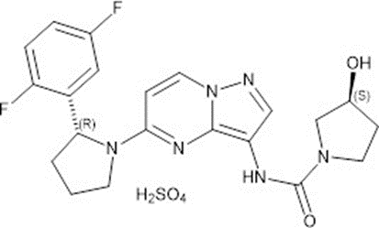

No objections were raised to the proposed tradename on initial screening.

The application and the supporting data relating to the composition, development, manufacture, quality control, stability and bioavailability of the product have been assessed and checked for compliance, as applicable, with Australian legislation and requirements for new medicines and in accordance with pharmacopoeial standards and the technical guidelines adopted by the TGA.

Microbial and preservative efficacy aspects of the oral solution have been reviewed separately.

No objection to provisional approval from the quality evaluator.

### Nonclinical

The nonclinical evaluator has noted that the information submitted was of satisfactory quality with no major deficiencies were identified in the nonclinical dossier.

The following points were summarised from the nonclinical evaluation.

* Primary pharmacology studies adequately demonstrate nonclinical efficacy of larotrectinib for the intended pharmacological targets (TRKA, TRKB and TRKC) and support its use in the treatment of solid tumours positive for *NTRK* gene fusion mutations.
* Overall, the safety data provided in nonclinical indicate the following concerns of potential clinical relevance:
  + Larotrectinib is a substrate of cytochrome P450 (CYP);[3] 3A4, P-glycoprotein (P-gp) and breast cancer resistance protein (BCRP), highlighting that inhibitors of these enzymes/transporters may increase plasma larotrectinib in patients.
  + The central nervous system (CNS) of juvenile rats was more sensitive to the pharmacological effects of larotrectinib than that of adult rats, suggesting potential adverse CNS effects in paediatric patients.
  + Larotrectinib may affect fertility in female patients due to a pharmacological action on TRK receptors involved in oocyte development.
  + Relatively uncommon visceral abnormalities were observed in fetuses of both rats and rabbits, indicating that larotrectinib may adversely affect embryofetal development.
* There are no nonclinical objections to the registration of larotrectinib (Vitrakvi) for the proposed indication provided there were no serious safety issues (for example adverse CNS effects) in clinical trials, particularly in paediatric patients.
* All outstanding issues with regards to the PI were resolved prior to provisional approval of larotrectinib.

### Clinical

#### Pharmacology

The below sections are extract from FDA full prescribing information for Vitrakvi.[4]

Larotrectinib is an inhibitor of TRK, TRKA, TRKB, and TRKC. In a broad panel of purified enzyme assays, larotrectinib inhibited TRKA, TRKB, and TRKC with half-maximal inhibitory concentration (IC50) values between 5 to 11 nM. One other kinase TNK2 was inhibited at approximately 100-fold higher concentration. TRK A, B, and C are encoded by the genes *NTRK1*, *NTRK2*, and *NTRK3* respectively.

Chromosomal rearrangements involving in-frame fusions of these genes with various partners can result in constitutively activated chimeric TRK fusion proteins that can act as an oncogenic driver, promoting cell proliferation and survival in tumour cell lines.

In *in vitro* and *in vivo* tumour models, larotrectinib demonstrated anti-tumour activity in cells with constitutive activation of TRK proteins resulting from gene fusions, deletion of a protein regulatory domain, or in cells with TRK protein overexpression. Larotrectinib had minimal activity in cell lines with point mutations in the TRKA kinase domain, including the clinically identified acquired resistance mutation, *G595R*. Point mutations in the TRKC kinase domain with clinically identified acquired resistance to larotrectinib include G623R, G696A, and F617L.

##### Pharmacokinetics

The pharmacokinetics (PK) of larotrectinib were studied in healthy subjects and adult and paediatric patients with locally advanced or metastatic solid tumours. In healthy subjects who received a single dose of Vitrakvi capsules, systemic exposure (maximum plasma concentration (Cmax) and area under the plasma concentration time curve (AUC)) of larotrectinib was dose proportional over the dose range of 100 mg to 400 mg (one to four times the recommended adult dose) and slightly greater than proportional at doses of 600 mg to 900 mg (six to nine times the recommended adult dose).

In adult patients who received Vitrakvi capsules 100 mg twice daily in Study LOXO-TRK-14001;[5] Cmax of larotrectinib were achieved at approximately one hour after dosing and steady state was reached within three days. Mean steady state larotrectinib (coefficient of variation (CV%)) for Cmax was 788 (81%) ng/mL and area under the plasma concentration time curve during 24 hours (AUC0-24hr) was 4351 (97%) ng * h/mL.

###### Absorption

The mean absolute bioavailability of Vitrakvi capsules was 34% (range: 32% to 37%).

In healthy subjects, the AUC of Vitrakvi oral solution was similar to that of the capsules and the Cmax was 36% higher with the oral solution.

###### Effect of food

The AUC of larotrectinib was similar and the Cmax was reduced by 35% after oral administration of a single 100 mg capsule of Vitrakvi to healthy subjects taken with a high-fat meal (approximately 900 calories, 58 grams carbohydrate, 56 grams fat and 43 grams protein) compared to the Cmax and AUC in the fasted state.

###### Distribution

The mean (CV%) volume of distribution (Vss) of larotrectinib is 48 L (38%) following intravenous administration of larotrectinib in healthy subjects.

Larotrectinib is 70% bound to human plasma proteins *in vitro* and binding is independent of drug concentrations. The blood to plasma concentration ratio is 0.9.

###### Elimination

The mean (CV%) oral clearance (CL/F) of larotrectinib is 98 (44%) L/h and the half-life is 2.9 hours following oral administration of Vitrakvi in healthy subjects.

###### Metabolism

Larotrectinib is metabolised predominantly by CYP3A4. Following oral administration of a single carbon 14 (14C) radiolabelled 100 mg dose of larotrectinib to healthy subjects, unchanged larotrectinib constituted 19% and an O-linked glucuronide constituted 26% of the major circulating radioactive drug components in plasma.

###### Excretion

Following oral administration of a single (14C) radiolabelled 100 mg dose of larotrectinib to healthy subjects, 58% (5% unchanged) of the administered radioactivity was recovered in faeces and 39% (20% unchanged) was recovered in urine.

###### Paediatric patients

In paediatric patients, the larotrectinib geometric mean (%CV) AUC0-24hr by age subgroup was: 3348 (66%) ng*h/mL in patients one month to < two years (n = 9), 4135 (36%) ng * h/mL in patients two to < 12 years (n = 15), and 3108 (69%) ng*h/mL and in patients 12 to < 18 years (n = 9).

##### Efficacy

The efficacy and safety of larotrectinib was demonstrated in three multicentre, open label, single arm clinical studies in adult and paediatric cancer patients (see Table 2).

Data from the three clinical studies were pooled for the efficacy analysis.

The data cut-off for the primary analysis set (PAS) was 17 July 2017, approximately 6 months after enrolment of the 55th patient in the PAS (the basis for the FDA approval).

The dates of other data cut-offs were: 19 February 2018 (extended primary analysis set (ePAS)), 30 July 2018 (ePAS2) (the basis of the European Medicines Agency (EMA) approval), 15 July 2019 (ePAS4) (data submitted to the TGA after the first round of evaluation).

The supplementary analysis set (SAS3) included paediatric and adult patients with primary CNS tumours with a documented *NTRK* gene fusion who received 1 or more doses of larotrectinib.

Table : Clinical studies contributing to the pooled analysis set (Therapeutic Goods Administration submission extended primary analysis set 4)

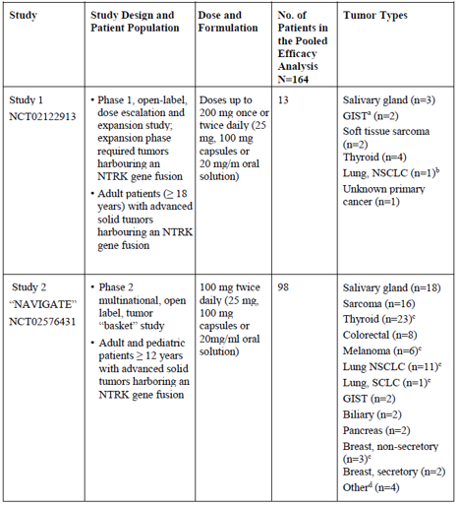

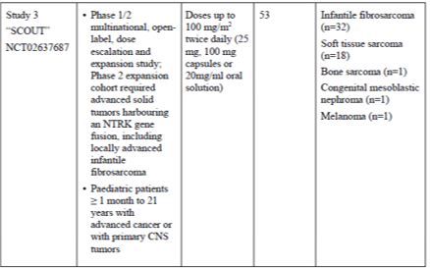

a GIST=gastrointestinal stromal tumour

b Brain metastases observed in one lung NSCLC patient (Study 1)

c Brain metastases observed in five lung NSCLC patients, one SCLC lung patients, four thyroid patients; two melanoma patients and one breast (non-secretory) patient (Study 2 ‘NAVIGATE’)

d Other tumour types included appendix (n=1), bone sarcoma (n=1), hepatic (hepatocellular carcinoma), (n=1) and prostate (n=1)

###### NTRK fusion testing in the efficacy datasets

Identification of *NTRK* gene fusions relied upon the molecular test methods next generation sequencing (NGS), reverse transcription-polymerase chain reaction (RT-PCR) and fluorescence *in situ* hybridisation (FISH) as routinely performed at Clinical Laboratory Improvement Amendments (CLIA) or other similarly certified laboratories.

In the three clinical studies, for the 164 *NTRK* gene fusion patients in ePAS4 as of 15 July 2019, the identification of *NTRK* gene fusions relied upon the following molecular test methods as routinely performed at certified labs:

* NGS were used in 143 patients (87%);
* polymerase chain reaction (PCR), used in eight patients (5%) (one patient with nested PCR, seven patients with RT-PCR);
* FISH were used in 12 patients (7%); and
* Nanostring’s technology, used in one patient (1%).

For the 24 *NTRK* patients in SAS3 as of 15 July 2019, NGS was used in 23 patients (96%), and RT-PCR was used in one patient (4%) (see Table 3).

Table : Pooled analysis set composition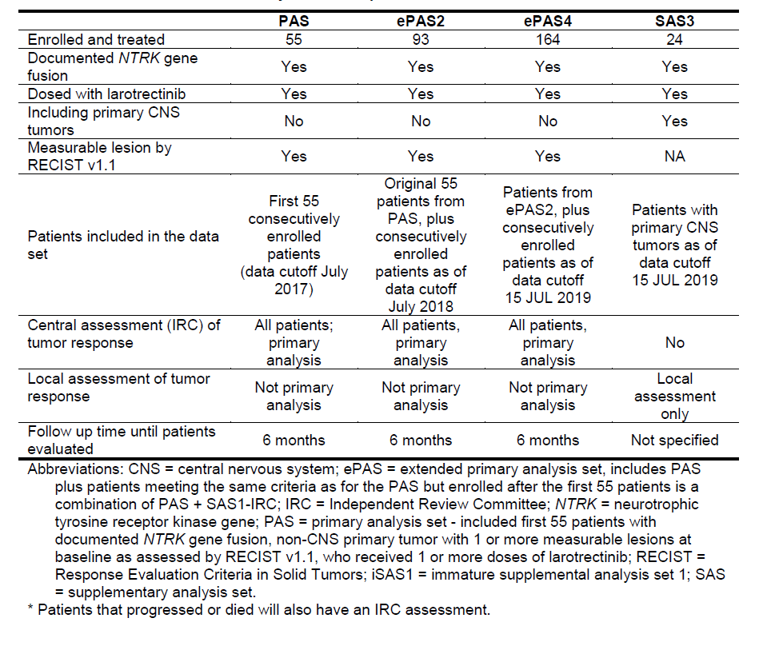

Table : Baseline disease characteristics in pooled analysis sets

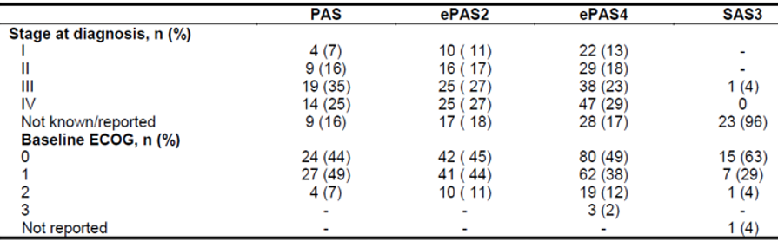

a No data available

b Comprising two cases of secretory breast cancer and three cases of non-secretory breast cancer.

Baseline characteristics for the ePAS4 pooled 164 patients with solid tumours harbouring an *NTRK* gene fusion were as follows: median age 42 years (range 0.1 to 84 years); 34% < 18 years of age, and 66% ≥ 18 years; 77% white and 49% male; and Eastern Cooperative Oncology Group (ECOG)[6] performance status (PS) 0 to 1 (86%), 2 (12%), or 3 (2%) (Table 4).

Ninety four percent of patients had received prior treatment for their cancer, defined as surgery, radiotherapy, or systemic therapy (Table 5). Of these, 77% had received prior systemic therapy with a median of two prior systemic treatment regimens received. Twenty seven percent of all patients had received three or more prior systemic therapies and 51% of all patients had received one to two prior systemic therapies. Twenty two percent of all patients had received no prior systemic therapy.

The most common tumour types represented were soft tissue sarcoma (22%), infantile fibrosarcoma (20%), thyroid cancer (16%), salivary gland tumour (13%) and lung cancer (8%).

Table : Prior cancer-related treatments in pooled analysis sets

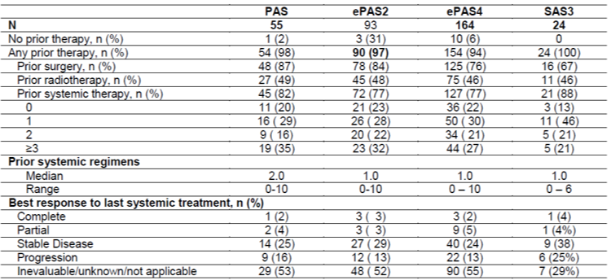

###### Efficacy analysis

For the pooled efficacy analysis, the primary efficacy endpoint was ORR, as determined by an independent review committee (IRC). ORR was defined as the proportion of patients with the best overall response of confirmed complete response (CR) or confirmed partial response (PR) based on the Response Evaluation Criteria In Solid Tumours (RECIST) version 1.1;[7] for solid tumours. Secondary efficacy endpoints for the pooled analysis included time to first response, duration of response and disease-control rate (DCR; best overall response of CR, PR, or stable disease lasting 16 or more weeks).

Additional secondary efficacy endpoints were progression-free survival (PFS) and overall survival (OS) and time on treatment.

The pooled analysis set of efficacy includes 164 patients with TRK fusion cancer enrolled across the three studies who had measurable disease assessed by RECIST, a non-CNS primary tumour and received at least one dose of larotrectinib.

SAS3 (n = 24), included paediatric and adult patients with primary CNS tumours with a documented *NTRK* gene fusion who received one or more doses of larotrectinib.

These patients were required to have received prior standard therapy appropriate for their tumour type and stage of disease and have progressed following treatment or have no satisfactory alternative therapy and surgical resection was likely to result in severe morbidity.

For ePAS4, the ORR was 73% (95% CI (65, 79)) (Table 6).

Table : Pooled efficacy results (best overall response, independent review committee assessment)

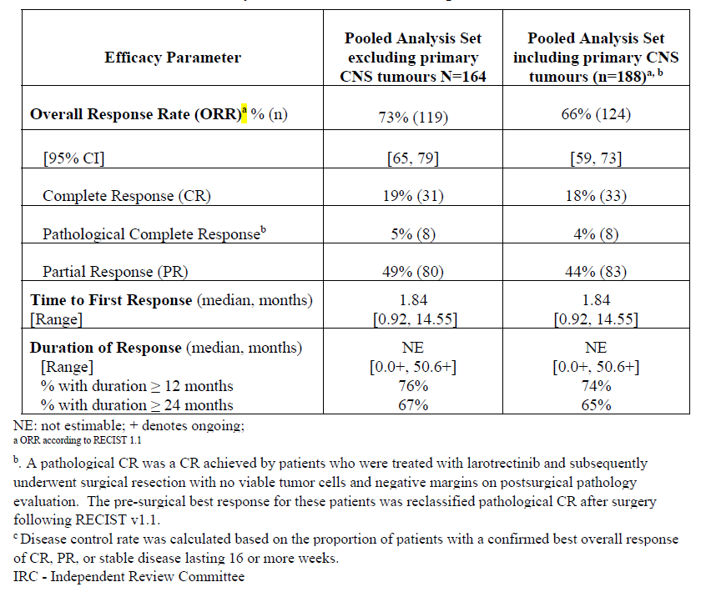

The response rate observed across the different tumour types supports the use of larotrectinib in a tumour agnostic population (Figure 2).

Figure : Overall response by tumour type based on independent review committee assessments (extended primary analysis set 4)

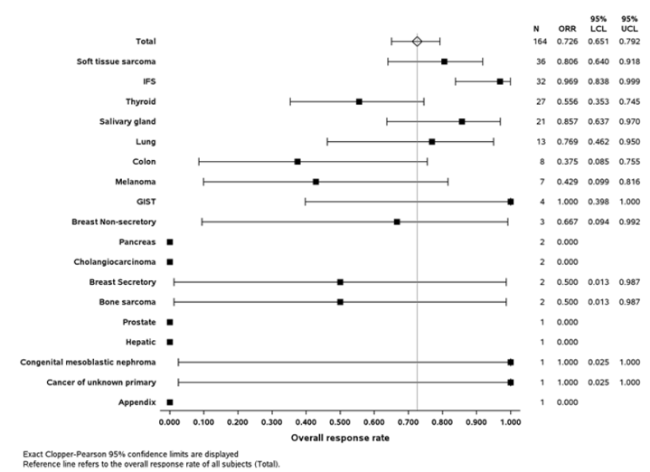

Figure : Swimmer plot of time to response and treatment duration (extended primary analysis set 4)

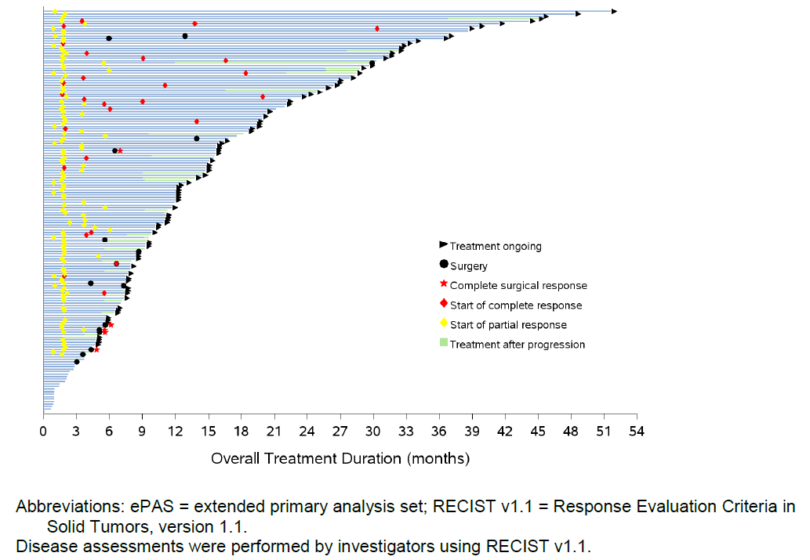

Diseases assessments were performed by investigators using RECIST V1.1.

Figure : Maximum change in tumour size - independent review committee assessment (extended primary analysis set 4)

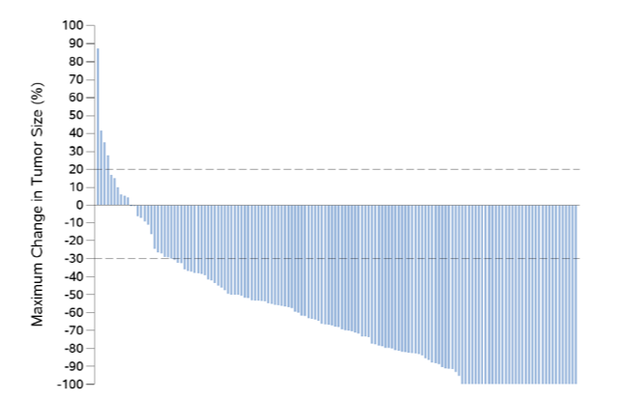

Disease assessments based on IRC using RECIST v1.1.

Patients of the pooled analysis set with measurable disease in IRC and at least 1 post-baseline assessment (n = 106) (Figure 4).

Figure 5 shows more detail on tumour types.[8]

Figure : Waterfall plot of the maximum percentage change in tumour size according to tumour type.

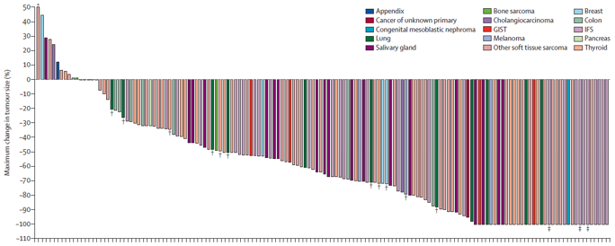

The waterfall plot excludes patients who had clinical deterioration before an initial response assessment and six patients who were not evaluable due to insufficient time on therapy. * Maximum change in tumour size of 93% tumour growth. † Patients with brain metastases. ‡Patients with a pathological complete response.

The majority of patients (98%) had either the *NTRK3* or *NTRK1* gene fusion (Table 7).

Responses were seen for most *NTRK* gene fusion partner isoforms, suggesting that larotrectinib is effective regardless of the *NTRK* gene fusion.

Table : Overall response rate by neurotrophic tyrosine receptor kinasegene fusion and by major neurotrophic tyrosine receptor kinaseisoforms – independent review committee assessment (extended primary analysis set 4)

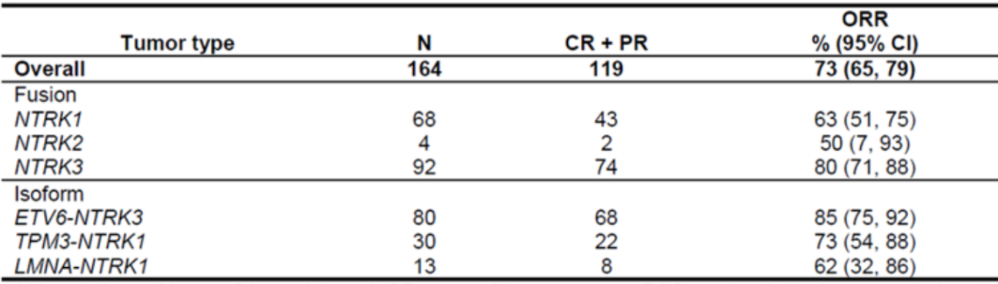

*NTRK* gene isoforms reported by > five patients are shown in the table

###### Paediatric data

In the paediatric sub-population (n = 55), the ORR was 91%.

###### Conclusion

A wide range of tumour types were represented in the clinical program evaluating patients with TRK fusion cancer treated with larotrectinib. In the ePAS4, patients with 17 tumour types were included, and SAS3 included patients with primary CNS tumours. CNS tumour types include astrocytoma, glioblastoma, glioma, glioneural, NOS, neuronal and mixed neuronal-glial tumours, primitive neuroectodermal tumour.

For ePAS4, the ORR was 73% (95% CI (65, 79)). In total, by IRC assessment, 31 patients (19%) had a CR, eight had a pathological CR (5%) and 80 had a PR (49%).

In the paediatric sub-population (n = 55), the ORR was 91%.

Disease control rate;[9] was 84% (95% CI (77, 89)) for the ePAS4.

Responses of 38% to 100% were seen in most types of tumours, except for primary CNS (21%) and some of the sparsely represented tumour types. Across all tumour types, the data suggest that patients with TRK fusion cancer can benefit from treatment with larotrectinib.

The response rate observed across the different tumour types supports the use of larotrectinib in a tumour agnostic population. A higher proportion of patients with less common cancer types (such as salivary gland tumours, infantile fibrosarcoma) were enrolled compared to those with more common cancers (lung and colorectal), reflecting the prominent role of TRK fusions in defining the rare cancer types and the routine use of testing to identify such molecular findings.

Responses were seen for most *NTRK* gene fusion partner isoforms, suggesting that larotrectinib is effective regardless of the *NTRK* gene fusion.

Fusions of *NTRK* genes are critical to establishing the diagnosis of cancers such as IFS and MASC and by definition are pathognomonic of such cancers. The enrolment of patients with variable tumour types supports the high unmet medical need for patients with advanced malignancies who progress on prior standard available therapies. Safety

The overall safety results presented in this overview comprise integrated safety data from all adult and paediatric patients in studies 20288 (n = 75), 20289 (n = 116), and 20290 (n = 88) enrolled as of the data cut-off for this submission (15 July 2019) (see Table 8).

This population comprised 279 patients with a median exposure of 6.8 months (range 0.03 to 51.6 months), although 83 (30%) patients have been treated for more than 12 months.

Table : Demographic and disease characteristics in pooled safety analysis

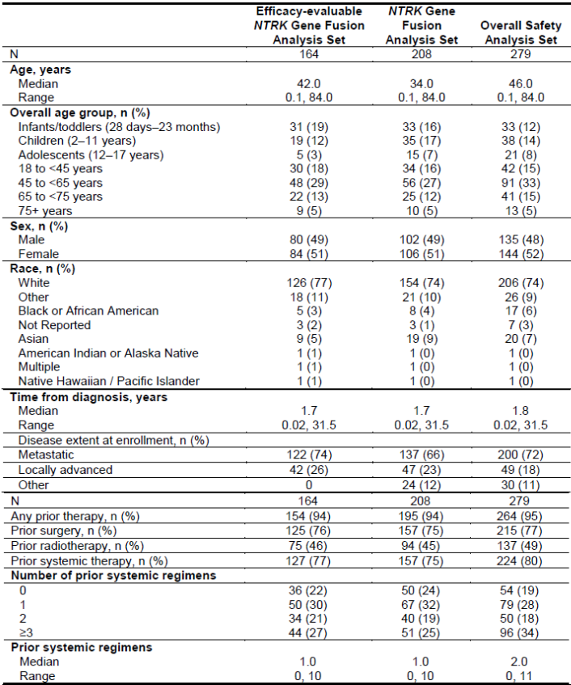

Status as of 15 July 2019

Table : Adverse drug reactions for larotrectinib (overall safety analysis set)

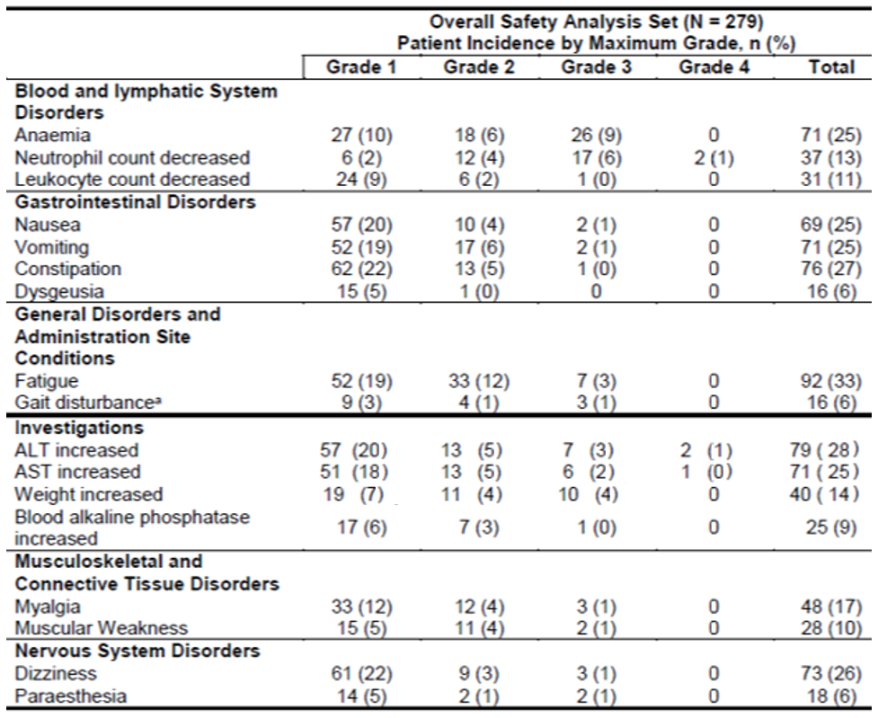

a The preferred term of ‘Gait disturbance’ is included as a neurologic event in the safety analyses being coded under the primary system organ class (SOC) general disorders and administration site conditions and the secondary SOC nervous system disorders.

Data cut-off date 15 July 2019

All PT are grouped to SOCs according to the source table and original reporting.

The threshold of: ≥ 5% was applied for selection of the adverse drug reactions (ADRs) from the common related adverse events. Severity of AEs is maximum grade severity. No Grade 5 events occurred.

A total of 22 patients died within 30 days of receiving larotrectinib (data cut-off 15 July 2019).

Sixteen (6%) patients died in the overall safety analysis set (serious adverse event (SAE) with a fatal outcome). In the 29 single patient protocols, six (20.7%) patients experienced SAEs with a fatal outcome. None of these deaths were attributed to larotrectinib (see Table 9).

In the overall safety analysis set, all deaths were attributed to either disease progression (12 patients) or to a complication of the primary malignancy.

In the overall safety analysis set, the primary malignancies for the 12 patients who died within 30 days of the start of therapy due to disease progression were pancreas (two patients), bone sarcoma (two patients), sarcoma (two patients), colorectal or colon, hepatocellular, thymus, breast, biliary, and medulloblastoma (one patient each). Five of these 12 patients had an *NTRK* gene fusion (per the clinical dossier).

In the single patient protocols all deaths occurred in the setting of progressive disease; one death was attributed to ascites, one death to hemiparesis, and all others progressive disease (see Table 9).

A total of 96 (34%) patients in the overall safety analysis set (clinical dossier) and 11 (38%) patients treated in the 29 single patient protocols had a reported SAE.

None of the SAEs reported in the single patient protocols were considered related to larotrectinib treatment. No SAEs were reported in the clinical pharmacology studies.

In the overall safety analysis set, pneumonia and pyrexia were the most common SAEs, occurring in eight (3%) patients each. Other SAEs reported in at least 2% of patients were diarrhoea, abdominal pain, and dyspnoea. In general, most SAEs appeared to be related to the underlying disease. Fifteen (5%) patients experienced at least one SAE that was considered related to larotrectinib, the most common being nausea, aspartate aminotransferase (AST) increased, and alanine transaminase (ALT) increased, which were reported as treatment related in two patients each (per the clinical dossier).

###### Paediatric patients

For the 92 patients in the paediatric age category, treatment emergent adverse event (TEAE) incidences were broken down further by paediatric subgroups: infants or toddlers (28 days to 23 months), children (two to 11 years), and adolescents (12 to < 18 years) (see Table 10).

The risk of ‘neurodevelopment impairment in paediatric patients’ was evaluated in the context of important potential risk ‘severe neurologic reactions’. Paediatric patients experienced dizziness at 8%, insomnia at 4%, paraesthesia at 2%, dysgeusia at 2%, gait disturbance at 4%, delirium at 1%, somnolence at 5% and there were no paediatric patients with memory impairment. No further neuro-developmental data are currently available.

Adverse events in paediatric patients were assessed to be serious by the investigator for 12 (36%) infants or toddlers, ten (26%) children and seven (33%) adolescents.

Table : Common adverse events, occurring in 20% in any paediatric age subgroup within paediatric age subgroups (overall safety analysis set)

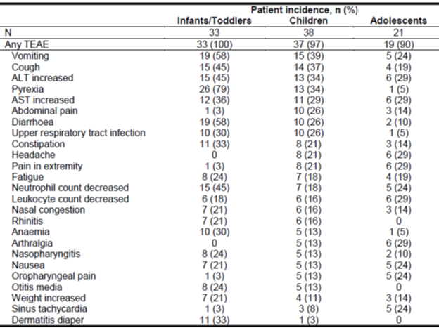

Paediatric subgroups: infants and toddlers (28 days to 23 months), children (two to 11 years), adolescents (12 to < 18 years)

Status as of 15 July 2019

##### Conclusion

Larotrectinib has a manageable safety profile characterised by recognisable toxicities which are acceptable in the context of the seriousness of the diseases being treated.

### Risk management plan

The sponsor has submitted EU-Risk management plan (RMP) version 0.5 (1 June 2019; data lock point (DLP) 30 July 2018) and Australian Specific Annex (ASA) version 1.0 (15 July 2019) in support of this application. At the second round, EU-RMP version 1.0 (30 September 2019; DLP 12 August 2019) and ASA version 1.1 (26 March 2020) were provided.

The proposed summary of safety concerns and their associated risk monitoring and mitigation strategies are summarised in Table 11.[10]

Table : Summary of safety concerns and their associated risk monitoring and mitigation strategies

|  |  |  |  |  |  |
| --- | --- | --- | --- | --- | --- |
| Summary of safety concerns | | Pharmacovigilance | | Risk Minimisation | |
| **Routine** | **Additional** | **Routine** | **Additional** |
| Important identified risks | None identified | – | – | – | – |
| Important potential risks | Severe neurologic reactions | ✓ | ✓* | ✓ | – |
| Severe drug-induced liver injury | ✓ | ✓* | ✓ | – |
| Serious infections secondary to neutropenia | ✓ | ✓* | ✓ |  |
| Impairment of neurodevelopment in paediatric patients | ✓ | ✓* | – | – |
| Missing information | Use in pregnancy and lactation | ✓ | ✓* | ✓ | – |
| Long-term safety | ✓ | ✓* | – | – |

* Clinical studies; non-interventional post-authorisation safety studies (PASS); and European Reference Network – rare adult cancers (EURACAN) registry for adult rare solid cancers

The summary of safety concerns reflects limited clinical experience; the first periodic safety update report (PSUR) advises that approximately 329 patients have been enrolled in company sponsored interventional clinical trials with Vitrakvi, resulting in a cumulative clinical trials exposure of approximately 300 patient-years. The summary is adequate at this time.

The sponsor has proposed routine pharmacovigilance activities for all safety concerns, and clinical studies, nonclinical studies and cancer registry (in Europe) involvement as additional activities. This is acceptable, given the arrangements for provisional registration, including the requirements of the black triangle scheme.

The sponsor has proposed routine risk minimisation for severe neurologic reactions, severe drug induced liver injury, serious infections secondary to neutropenia, and use in pregnancy and lactation. No additional risk minimisation activities have been proposed. Amendments to the PI and Consumer Medicines Information (CMI) will be addressed in the label negotiation phase.

As a provisional registration submission, the sponsor has provided a clinical study plan summarising the anticipated confirmatory trial data. The Delegate will determine whether the clinical study plan with its anticipated milestones is acceptable.

The sponsor has proposed wording relating to the provisional registration in the PI; this is subject to the Delegate’s advice.

### Risk-benefit analysis

#### Delegate’s considerations

Oncogenic *NTRK* fusions are seen in many cancer types. They are common in select rare tumour types, whereas rare in common tumours. Identification of these fusions may provide important therapeutic opportunities for patients with advanced or unresectable cancers.

Appropriate screening and/or confirmation of *NTRK* fusions depends on the tumour type and available material, and in the Australian context, available diagnostic tests.

Patients who enrolled in the clinical trials for larotrectinib had a high unmet medical need as they had either progressed on prior therapy or did not have any satisfactory therapies available. Adult and paediatric patients with TRK fusion cancers treated with larotrectinib exhibited rapid, substantial, clinically meaningful responses with durable disease control across *NTRK* isoforms, tumour types and patient ages.

For ePAS4, the ORR was 73% (95% CI (65, 79)). In total, by IRC assessment, 31 patients (19%) had a CR, eight had a pathological CR (5%) and 80 had a PR (49%).

In the paediatric sub-population (n = 55), the ORR was 91%.

Larotrectinib has a manageable safety profile.

The benefit-risk balance of larotrectinib in adult and paediatric patients with locally advanced or metastatic solid tumours harbouring a *NTRK* gene fusion is considered favourable in the setting of provisional registration in Australia.

Clinical testing for TRK fusions remains crucial to identify patients likely to benefit from treatment with larotrectinib. Some issues with the availability of a companion diagnostic test in Australia still require further work.

Resistance to larotrectinib can develop over time and is a probable contributory factor in patients with primary progressive disease. Mechanisms of acquired resistance in patients with larotrectinib-treated TRK fusion-positive tumours, include the emergence of *NTRK* kinase domain mutations or bypass tract activation.

Early clinical data suggest that particular on target resistance mechanisms might be overcome by next generation TRK inhibitors, such as selitrectinib and repotrectinib.8

#### Proposed action

For consistency, the Australian indication for larotrectinib should align with the FDA approved indication and the recently approved entrectinib (Rozlytrek) Australian indication.

*Vitrakvi (larotrectinib) has provisional approval in Australia for the treatment of adult and paediatric patients with locally advanced or metastatic solid tumours that: have a NTRK gene fusion without a known acquired resistance mutation, are metastatic or where surgical resection is likely to result in severe morbidity, and have either progressed following treatment or have no satisfactory alternative therapy.*

*The decision to approve this indication has been made on the basis of objective response rate and duration of response from single arm clinical studies. The sponsor is required to submit further clinical data to confirm the clinical benefit of the medicine.*

Testing for TRK fusions in clinical practice remains crucial to identify patients likely to benefit from treatment with larotrectinib. Some issues with the availability of a companion diagnostic test in Australia still require further work.

#### Advisory Committee considerations[11]

The Delegate did not refer this application to the Advisory Committee on Medicines (ACM) for advice.

### Outcome

Based on a review of quality, safety and efficacy, the TGA approved the registration of Vitrakvi (larotrectinib) 20 mg/ml oral liquid solution and 25 mg, 100 mg hard capsule, indicated for:

*Vitrakvi (larotrectinib) has provisional approval in Australia for the treatment of adult and paediatric patients with locally advanced or metastatic solid tumours that:*

* *Have a neurotrophic tyrosine receptor kinase (NTRK) gene fusion without a known acquired resistance mutation,*
* *are metastatic or where surgical resection is likely to result in severe morbidity, and*
* *have either progressed following treatment or who have no satisfactory alternative therapy.*

*The decision to approve this indication has been made on the basis of ORR and duration of response from single arm clinical studies. The sponsor is required to submit further clinical data to confirm the clinical benefit of the medicine.*

#### Specific conditions of registration applying to these goods

* Vitrakvi (larotrectinib) is to be included in the Black Triangle Scheme. The PI and CMI for Vitrakvi must include the black triangle symbol and mandatory accompanying text for five years, which starts from the date that the sponsor notifies the TGA of supply of the product, or for the period of provisional registration, whichever is longer.
* The larotrectinib EU-RMP (version 1.0, dated 30 September 2019, data lock point 12 August 2019), with ASA (version 1.1, dated 26 March 2020), included with submission PM-2019-03170-1-4, and any subsequent revisions, as agreed with the TGA will be implemented in Australia.

An obligatory component of risk management plans is routine pharmacovigilance. Routine pharmacovigilance includes the submission of PSURs.

Reports are to be provided in line with the current published list of EU reference dates and frequency of submission of PSURs until the period covered by such reports is not less than three years from the date of this approval letter, or for the period of provisional registration, whichever is longer.

The reports are to at least meet the requirements for PSURs as described in the European Medicines Agency’s Guideline on good pharmacovigilance practices (GVP) Module VII-periodic safety update report (Rev 1), Part VII.B Structures and processes. Note that submission of a PSUR does not constitute an application to vary the registration.

* Confirmatory trial data (as identified in the sponsor’s plan to submit comprehensive clinical data on the safety and efficacy of the medicine before the end of the 6 years that would start on the day that registration would commence) must be provided.

Specifically, the sponsor must conduct studies as described in the clinical study plan in version 1.1 (dated 26 March 2020) of the ASA. The following study reports should be submitted to TGA:

* + Study 20289 (also known as LOXO-TRK-15002 and *NTRK* fusion positive solid tumours (NAVIGATE)), ‘A Phase II basket study of the oral TRK inhibitor larotrectinib in subjects with *NTRK* fusion-positive tumours’, final study report due first quarter of 2024
  + Study 20290 (also known as LOXO-TRK-15003 and SCOUT), ‘A Phase I or II study of the oral TRK inhibitor LOXO-101 in paediatric patients with advanced solid or primary central nervous system tumours‘, final study report due first quarter of 2027
  + Study 20288 (also known as LOXO-TRK-14001), ‘A Phase I study of the oral TRK inhibitor larotrectinib in adult patients with solid tumours‘, final study report due second quarter of 2022

Further guidance for sponsors is available on the TGA website.

## Attachment 1. Product Information

The PI for Vitrakvi approved with the submission which is described in this AusPAR is at Attachment 1. For the most recent PI, please refer to the TGA website at <<https://www.tga.gov.au/product-information-pi>>.

|  |
| --- |
| Therapeutic Goods Administration |
| PO Box 100 Woden ACT 2606 Australia  Email: [info@tga.gov.au](mailto:info@tga.gov.au) Phone: 1800 020 653 Fax: 02 6232 8605  [**https://www.tga.gov.au**](https://www.tga.gov.au) |

1. The **Black Triangle Scheme** provides a simple means for practitioners and patients to identify certain types of new prescription medicines, including those being used in new ways and to encourage the reporting of adverse events associated with their use. The Black Triangle does not denote that there are known safety problems, just that the TGA is encouraging adverse event reporting to help us build up the full picture of a medicine's safety profile.
2. As part of the provisional approval pathway, the provisional registration process will allow certain medicines to be provisionally registered in the Australian Register of Therapeutic Goods (ARTG) for a limited duration. These medicines are registered on the basis of preliminary clinical data, where there is the potential for a substantial benefit to Australian patients. The TGA will re-assess risks related to the absence of evidence through data provided at a later stage, as part of the confirmatory data. Confirmatory data should confirm the relationship between outcomes predicted by the surrogate endpoint, or other preliminary data, and the clinical benefit as demonstrated by direct clinical outcomes.

   The sponsor may apply to transition to full registration at any time up until the provisional registration lapse date, once they have completed the obligations outlined for the provisional registration period and complete confirmatory data on safety and efficacy are available.
3. **Cytochrome P450 (CYP) enzymes:** CYPs are the major enzymes involved in drug metabolism, accounting for large part of the total metabolism. Most drugs undergo deactivation by CYPs, either directly or by facilitated excretion from the body. Also, many substances are bioactivated by CYPs to form their active compounds.

   Many drugs may increase or decrease the activity of various CYP isozymes either by inducing the biosynthesis of an isozyme (enzyme induction) or by directly inhibiting the activity of the CYP (enzyme inhibition). This is a major source of adverse drug interactions, since changes in CYP enzyme activity may affect the metabolism and clearance of various drugs. Such drug interactions are especially important to take into account when using drugs of vital importance to the patient, drugs with important side-effects and drugs with small therapeutic windows, but any drug may be subject to an altered plasma concentration due to altered drug metabolism.
4. FDA full prescribing information for Vitrakvi. Access via FDA.gov
5. The CHMP assessment report page 84-90 was used as a reference for this section about Study 14001.
6. **ECOG Performance Status:** The Eastern Cooperative Oncology Group (ECOG) has developed criteria used by doctors and researchers to assess how a patient's disease is progressing, assess how the disease affects the daily living abilities of the patient, and determine appropriate treatment and prognosis. The following are used:

   0 - Fully active, able to carry on all pre-disease performance without restriction

   1- Restricted in physically strenuous activity but ambulatory and able to carry out work of a light or sedentary nature, for example, light house work, office work

   2 - Ambulatory and capable of all self-care but unable to carry out any work activities. Up and about more than 50% of waking hours

   3 - Capable of only limited self-care, confined to bed or chair more than 50% of waking hours

   4 - Completely disabled. Cannot carry on any self-care. Totally confined to bed or chair

   5 – Dead
7. **RECIST:** The Response Evaluation Criteria in Solid Tumors (RECIST) is a voluntary, international standard using unified, easily applicable criteria for measuring tumor response using X-ray, CT and MRI.
8. Hong, D.S. et al. Larotrectinib in Patients with TRK fusion-positive Solid Tumours: a Pooled Analysis of Three Phase 1/2 Clinical Trials, *Lancet Oncol*, 2020; 21: 531–540.
9. **Disease control rate:** is defined as the proportion of patients with best overall response of confirmed CR, pathological CR, PR, or stable disease lasting 16 weeks or more following the initiation of larotrectinib.
10. Routine risk minimisation activities may be limited to ensuring that suitable warnings are included in the product information or by careful use of labelling and packaging.

    Routine pharmacovigilance practices involve the following activities:

    • All suspected adverse reactions that are reported to the personnel of the company are collected and collated in an accessible manner;

    • Reporting to regulatory authorities;

    • Continuous monitoring of the safety profiles of approved products including signal detection and updating of labelling;

    • Submission of PSURs;

    • Meeting other local regulatory agency requirements.
11. The ACM provides independent medical and scientific advice to the Minister for Health and the Therapeutic Goods Administration (TGA) on issues relating to the safety, quality and efficacy of medicines supplied in Australia including issues relating to pre-market and post-market functions for medicines.

    The Committee is established under Regulation 35 of the Therapeutic Goods Regulations 1990. Members are appointed by the Minister. The ACM was established in January 2017 replacing Advisory Committee on Prescription Medicines (ACPM) which was formed in January 2010. ACM encompass pre and post-market advice for medicines, following the consolidation of the previous functions of the Advisory Committee on Prescription Medicines (ACPM), the Advisory Committee on the Safety of Medicines (ACSOM) and the Advisory Committee on Non-Prescription Medicines (ACNM). Membership comprises of professionals with specific scientific, medical or clinical expertise, as well as appropriate consumer health issues relating to medicines.