|  |
| --- |
| **October 2015** |

|  |
| --- |
| Australian Public Assessment Report for ledipasvir / sofosbuvir |
| Proprietary Product Name: Harvoni |
| Sponsor: Gilead Sciences Pty Ltd |

About the Therapeutic Goods Administration (TGA)

* The Therapeutic Goods Administration (TGA) is part of the Australian Government Department of Health and is responsible for regulating medicines and medical devices.
* The TGA administers the *Therapeutic Goods Act 1989*, applying a risk management approach designed to ensure therapeutic goods supplied in Australia meet acceptable standards of quality, safety and efficacy (performance) when necessary.
* The work of the TGA is based on applying scientific and clinical expertise to decision-making, to ensure that the benefits to consumers outweigh any risks associated with the use of medicines and medical devices.
* The TGA relies on the public, healthcare professionals and industry to report problems with medicines or medical devices. TGA investigates reports received by it to determine any necessary regulatory action.
* To report a problem with a medicine or medical device, please see the information on the TGA website <<https://www.tga.gov.au>>.

About AusPARs

* An Australian Public Assessment Report (AusPAR) provides information about the evaluation of a prescription medicine and the considerations that led the TGA to approve or not approve a prescription medicine submission.
* AusPARs are prepared and published by the TGA.
* An AusPAR is prepared for submissions that relate to new chemical entities, generic medicines, major variations, and extensions of indications.
* An AusPAR is a static document, in that it will provide information that relates to a submission at a particular point in time.
* A new AusPAR will be developed to reflect changes to indications and/or major variations to a prescription medicine subject to evaluation by the TGA.

Copyright

© Commonwealth of Australia 2015  
This work is copyright. You may reproduce the whole or part of this work in unaltered form for your own personal use or, if you are part of an organisation, for internal use within your organisation, but only if you or your organisation do not use the reproduction for any commercial purpose and retain this copyright notice and all disclaimer notices as part of that reproduction. Apart from rights to use as permitted by the *Copyright Act 1968* or allowed by this copyright notice, all other rights are reserved and you are not allowed to reproduce the whole or any part of this work in any way (electronic or otherwise) without first being given specific written permission from the Commonwealth to do so. Requests and inquiries concerning reproduction and rights are to be sent to the TGA Copyright Officer, Therapeutic Goods Administration, PO Box 100, Woden ACT 2606 or emailed to <[tga.copyright@tga.gov.au](mailto:tga.copyright@tga.gov.au)>.

Contents

Common abbreviations 5

I. Introduction to product submission 7

Submission details 7

Product background 7

Regulatory status 8

Product Information 9

II. Quality findings 9

Drug substance (active ingredient) 9

Drug product 10

Biopharmaceutics 11

Quality summary and conclusions 12

III. Nonclinical findings 12

Introduction 12

Pharmacology 13

Pharmacokinetics 14

Toxicology 15

Phototoxicity 19

Nonclinical summary and conclusions 19

IV. Clinical findings 21

Introduction 21

Pharmacokinetics 23

Pharmacodynamics 24

Dosage selection for the pivotal studies 25

Efficacy 25

Safety 27

First Round Benefit-Risk Assessment 29

First Round Recommendation Regarding Authorisation 32

Clinical Questions 32

Second Round Evaluation of clinical data 32

Second Round Benefit-Risk Assessment 36

Second Round Recommendation Regarding Authorisation 36

V. Pharmacovigilance findings 37

Risk management plan 37

VI. Overall conclusion and risk/benefit assessment 45

Quality 46

Nonclinical 46

Clinical 46

Risk management plan 54

Risk-benefit analysis 55

Outcome 63

Attachment 1. Product Information 63

Attachment 2. Extract from the Clinical Evaluation Report 63

## Common abbreviations

|  |  |
| --- | --- |
| Abbreviation | Meaning |
| ACPM | Advisory Committee on Prescription Medicines |
| AE | adverse event |
| ASA | Australian Specific Annex |
| AUC | area under the plasma concentration-time curve |
| AUC(t1)-(t2) | area under the plasma concentration-time curve from (t1) to (t2) |
| CC50 | half maximal cytotoxic concentration |
| CHC | chronic hepatitis C |
| Cmax | maximum plasma drug concentration |
| DAE | diagnostic adverse event |
| EC50 | half maximal effective concentration |
| EMA | European Medicine Agency |
| FDA | US Food and Drug Administration |
| FDC | fixed dose combination |
| HCV | hepatitis C virus |
| IC50 | half maximal inhibitory concentration |
| IFN | interferon |
| IV | intravenous |
| LDV | ledipasvir |
| PI | Product Information |
| PO | per os (oral) |
| RAV | resistance associated variant |
| RBV | ribavirin |
| RMP | Risk Management Plan |
| SAE | serious adverse event |
| SOF | sofosbuvir |
| SVR | Sustained Virological Response |
| t1/2 | elimination half life |
| TEAE | treatment emergent adverse event |
| Tmax | time taken to reach the maximum plasma drug concentration |

## I. Introduction to product submission

### Submission details

|  |  |
| --- | --- |
| *Type of submission:* | New chemical entity |
| *Decision*: | Approved |
| *Date of decision:* | 8 May 2015 |
| *Date of entry onto ARTG:* | 13 May 2015 |

|  |  |
| --- | --- |
| *Active ingredient(s):* | Ledipasvir / sofosbuvir |
| *Product name(s):* | Harvoni |
| *Sponsor’s name and address:* | Gilead Sciences Pty Ltd  Level 6, 417 St Kilda Road  Melbourne VIC 3004 |
| *Dose form(s):* | Fixed dose combination, film coated tablet |
| *Strength(s):* | Ledipasvir 90 mg / sofosbuvir 400 mg |
| *Container(s):* | High density polyethylene (HDPE) bottles with child resistant polypropylene (PP) caps |
| *Pack size(s):* | 28 tablets |
| *Approved therapeutic use:* | Harvoni (ledipasvir/sofosbuvir fixed dose combination) is indicated for the treatment of chronic hepatitis C (CHC) genotype 1 infection in adults. |
| *Route(s) of administration:* | Oral |
| *Dosage:* | Recommended dose is one fixed dose combination tablet (90 mg ledipasvir and 400 mg sofosbuvir) once daily with or without food. |
| *ARTG number (s):* | 222848 |

### Product background

This AusPAR describes the application by Gilead Sciences Pty Ltd to register ‘Harvoni’ fixed dose combination (FDC) film coated immediate release tablets containing 90 mg ledipasvir (LDV) and 400 mg sofosbuvir (SOF) for the treatment of chronic hepatitis C (CHC) genotype 1 infection in adults. LDV is a new chemical entity whereas sofosbuvir has been recently registered by Gilead as a 400 mg tablet (Sovaldi [sofosbuvir] 400 mg tablet, ARTG 211019). LDV inhibits hepatitis C virus (HCV) replication through NS5A. In cell based replicon assays it has high potency, selectivity and specificity for HCV. SOF is a pro-drug of 2ʹ-deoxy-2ʹ-fluoro-2ʹ-C-methyluridine monophosphate. It is converted to the active form in the hepatocyte. It inhibits HCV replication by inhibiting RNA replication through inhibition of NS5B.

The recommended dose of Harvoni tablets is one tablet, taken orally, once daily with or without food. Duration of treatment:

* For treatment naïve patients without cirrhosis, the recommended duration of treatment with Harvoni is 8 or 12 weeks.
* For treatment naïve patients with cirrhosis and treatment experienced patients without cirrhosis, the recommended duration of treatment with Harvoni is 12 weeks.
* For treatment experienced patients with cirrhosis, the recommended duration of treatment with Harvoni is 24 weeks.

No dose adjustment is warranted for elderly patients.

No dose adjustment of Harvoni is required for patients with mild or moderate renal impairment. The safety of Harvoni has not been assessed in patients with severe renal impairment (eGFR <30 mL/min) or end stage renal disease (ESRD) requiring haemodialysis.

No dose adjustment of Harvoni is required for patients with mild, moderate or severe hepatic impairment (Child-Pugh Class A, B or C).

### Regulatory status

The regulatory status of Harvoni at the time of this submission to TGA is shown in Table 1.

Table 1: Regulatory status of Harvoni at time of submission.

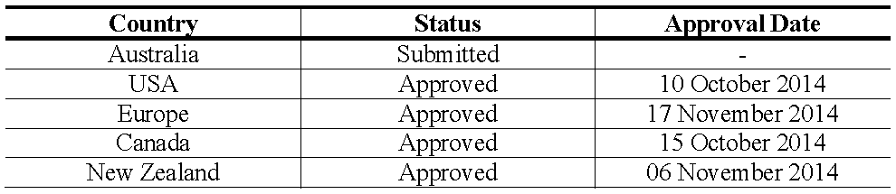

Approved indications in the major markets for Harvoni tablets are shown in Table 2.

Table 2: Approved indications for Harvoni tablets.

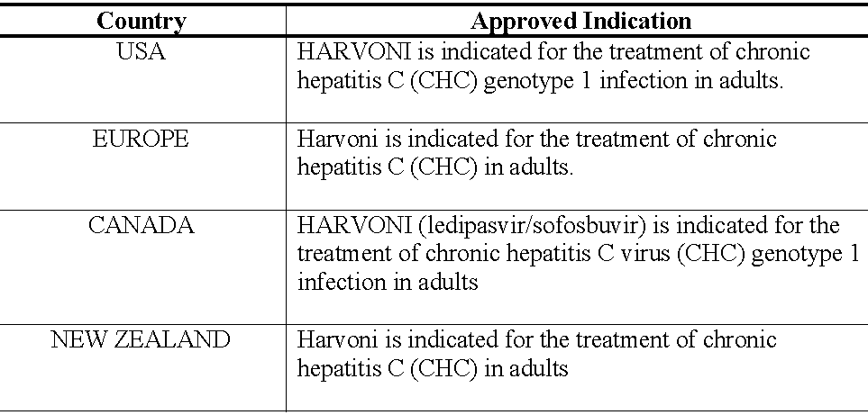

### Product information

The approved Product Information (PI) current at the time this AusPAR was prepared can be found as Attachment 1. For the most recent PI, please refer to the TGA website at <<https://www.tga.gov.au/product-information-pi>>.

## II. Quality findings

### Drug substance (active ingredient)

LDV (Figure 1) is a HCV inhibitor targeting the HCV NS5A protein, which is essential for both RNA replication and the assembly of HCV virions.

Figure 1: Chemical structure of LDV.

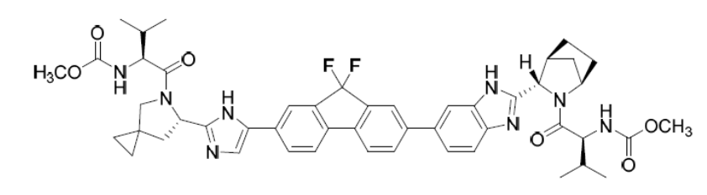

LDV has six chiral centres and is produced as a single isomer. It is slightly soluble at low pH (pH 2.3; 1.1 mg/mL) but practically insoluble at pH 4-7 (<0.01 mg/mL). It is highly soluble in ethanol (≥ 500 mg/mL).

Particle size and polymorphic form are not considered critical as the drug substance is isolated as a stabilised amorphous solid.

Based on its high apparent permeability and low solubility, LDV is a Class 2 drug with respect to the Biopharmaceutics Classification System (BCS).

The drug substance has consistently low impurity levels and shows very good solid state stability. Stability data have been provided to support a retest period for the drug substance of 24 months stored below 25°C.

The proposed drug substance specifications comply with TGA requirements and are considered adequate to ensure the quality and consistency of manufacture of the finished product.

SOF (Figure 2) is a prodrug of nucleotide monophosphate, which is ultimately converted within the hepatocyte to the active triphosphate form. This is an HCV NS5B directed inhibitor that has displayed potent *in vitro* inhibition of HCV replicon RNA replication.

Figure 2: Chemical structure of SOF.

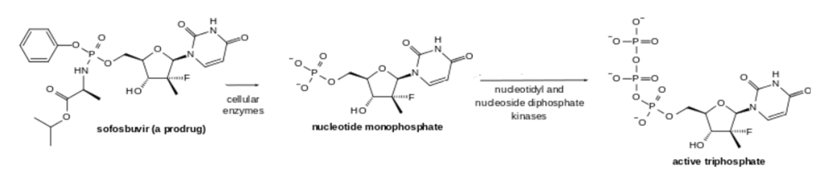

SOF is slightly soluble across the physiological pH range (pH 2-7.7; ~2 mg/mL). SOF has six stereocenters and is chirally pure. Based on the low apparent permeability and high solubility, SOF is a Class 3 drug with respect to the Biopharmaceutics Classification System (BCS).

Data relating to SOF is identical to that previously submitted for registration of the SOF monotherapy tablet.

The previously agreed drug substance specifications comply with TGA requirements and are considered adequate to ensure the quality and consistency of manufacture of the combination tablets.

### Drug product

The proposed products are immediate release, unscored, FDC film coated tablets containing 90 mg LDV and 400 mg SOF.

The proposed tablets are described as:

*Orange, diamond-shaped, biconvex, film-coated tablets with “GSI” debossed on one side and “7985” on the other side.*

For use in manufacture of the combination tablet, LDV acetone solvate is converted to a stabilised amorphous solid. This amorphous solid has no known ability to crystallise on storage. Use of this stabilised amorphous solid was found to improve the biopharmaceutical performance of LDV, as discussed below. Appropriate specifications are applied to this intermediate LDV, including control of particle size. Acceptable stability data has been provided to support a separate shelf life for the intermediate of 24 months stored below 25°C.

The excipients used in the tablet cores are all substances with well-known properties and functions and which are used in many registered tablet formulation.

The manufacturing method of the combination tablet is a conventional process in which the intermediate LDV and SOF drug substance are blended together with the intra-granular excipients.

Product performance was tested during development and for routine Quality Control testing using a dissolution test whose parameters have been adequately justified and which had been shown to be acceptably discriminating.

The proposed finished product specifications have been adequately justified and comply with TGA requirements. They are considered adequate to ensure the quality of the finished product at release and throughout the shelf life.

The tablets show good stability and a shelf life of 24 months when stored below 30C, has been established.

#### Formulation development

LDV was initially formulated in single agent tablets of 1 mg and 10 mg strength using amorphous LDV free base drug substance and evaluated in Phase I clinical trials. The drug substance was subsequently changed to crystalline LDV acid salt and formulated as 10 mg and 30 mg (free base equivalent) strengths in LDV single agent tablets for early Phase II clinical trials. The approach of using LDV as LDV intermediate was introduced to mitigate food effects observed with LDV single agent tablets containing crystalline LDV salt. LDV single agent 30 mg tablets, (free base equivalent) were demonstrated to have superior *in vivo* performance relative to crystalline LDV salt 30 mg tablets, in the human pharmacokinetic Study GS-US-256-0110. Accordingly, LDV drug product intermediate single agent tablets of 30 mg and 90 mg LDV strengths were adopted for the remainder of Phase II clinical trials.

The 90 mg strength LDV drug product intermediate single agent tablet formulation and the 400 mg strength SOF drug substance, equivalent to that used in the registered SOF tablet, demonstrated equivalent pharmacokinetic performance to the two co-administered single agents in human pharmacokinetic Study GS-US-337-0101.

The LDV/SOF FDC tablet formulation (SOF/LDV) was subsequently evaluated in pivotal Phase III clinical trials. This is the tablet core formulation proposed for the commercial drug product, albeit with a different coating.

### Biopharmaceutics

Following oral administration, LDV median peak concentrations were observed 4.0 to 4.5 hours post dose.

SOF was absorbed quickly and the peak median plasma concentration was observed ~0.8 to 1 hour post dose. Median peak plasma concentration of the active metabolite of SOF was observed between 3.5 to 4 h post dose.

LDV is not significantly metabolised. Following a single dose of 90 mg [14C]-LDV, systemic exposure was almost exclusively to the parent drug (>98%). Unchanged LDV is the major species present in faeces.

SOF is extensively metabolised in the liver to form the pharmacologically active nucleoside triphosphate analogue which is dephosphorylated to the inactive nucleoside metabolite. After a single 400 mg oral dose of [14C]-SOF, the nucleoside triphosphate active metabolite accounted for approximately >90% of total systemic exposure.

For LDV, biliary excretion of unchanged drug is a major route of elimination with renal excretion being a minor pathway (approximately 1%). The median terminal half-life of LDV was 47 hours.

For SOF renal clearance is the major elimination pathway of the active nucleoside triphosphate metabolite. The median terminal half-lives of SOF and the triphosphate metabolite were 0.4 and 27 h, respectively.

LDV AUC is dose proportional over the dose range of 3 to 100 mg. SOF and he active nucleoside triphosphate metabolite AUCs are near dose proportional over the dose range of 200 mg to 1200 mg.

The proposed combination tablet can be administered without regard to food.

#### Bioequivalence and Food Effect

Study GS-US-337-0101 was an open label, randomised, single-dose, four cohort, single centre, crossover study to evaluate the relative bioavailability of concurrent administration of single doses of LDV 90 mg (1 x 90 mg tablet) and SOF 400 mg (1 x 400 mg tablet) administered orally, under fasted conditions, against a single dose of the proposed LDV/SOF 90/400 mg a FDC tablet. In addition, the effect of food (fasted/low fat meal/high fat meal) on the bioavailability of a single dose of the proposed LDV/SOF 90/400 mg a FDC tablet was investigated. The following was concluded from the study:

* LDV mean plasma exposure (Cmax, and AUC0-t), and median Tmax and t1/2 were similar in both treatments (estimates FDC/single tablets were 98 and 96%, respectively).
* SOF mean plasma exposures parameters (Cmax, and AUC0-t) were slightly lower (18% and 13% respectively) upon administration of the FDC treatment relative to SOF and LDV treatment as single agents. Median Tmax and t1/2 remained comparable in both treatments. The slightly lower mean plasma exposures of SOF as a component of the FDC treatment were not considered clinically significant.
* LDV plasma exposure parameters (Cmax and AUC0-t) were similar upon dosing of the proposed SOF/LDV FDC tablet with a moderate-fat meal (9% and 14% higher, respectively) or a high-calorie/high-fat meal (estimates versus fasting were 12% lower and 4% higher, respectively). LDV median Tmax was slightly prolonged following administration of the FDC with food compared with fasted administration while median t1/2 remained comparable in all treatments. This supports administration without regard for food.
* SOF plasma exposure parameters (Cmax and AUC0-t) were somewhat greater upon dosing of the proposed SOF/LDV FDC tablet with a moderate-fat meal (26% and 95% higher, respectively) or a high-calorie/high-fat meal (15% and 78% higher, respectively). Median Tmax was prolonged in the fed state as compared with fasted administration, indicative of an effect of food slowing the rate of absorption. Median t1/2 remained similar in all treatments. Considering the fed exposure increase was <2 fold and SOF’s transient systemic exposure and favourable safety profile, the company considers that the proposed combination tablet may be administered without regard to food.

#### Absolute bioavailability

No study specifically designed to determine absolute bioavailability of the drug substances was submitted. The company submitted a justification for not providing such data. The justification concludes:

*Therefore, based on Gilead’s thorough understanding of the formulation challenges, clinical development program and the estimation of bioavailability from available data, an absolute bioavailability study for SOF/LDV was not deemed necessary and therefore not performed.*

### Quality summary and conclusions

Registration of the proposed Harvoni FDC film coated tablets containing 90 mg LDV and 400 mg SOF packed into HDPE bottles with child resistant PP caps containing 28 tablets, is recommended with respect to quality and biopharmaceutic aspects. All issues raised during the initial evaluation of this application have been satisfactorily resolved.

As no significant pharmaceutical chemistry issues were identified, the submission was not referred to the Pharmaceutical Subcommittee of the Advisory Committee on Prescription Medicines (ACPM).

## III. Nonclinical findings

### Introduction

Gilead Sciences Pty Ltd has applied to register (Harvoni). Harvoni is a FDC of a new chemical entity LDV with SOF an agent already approved for the treatment of HCV infection. Harvoni is proposed to be used for the treatment of CHC genotype 1 infection in adults. The recommended dose is one tablet, containing 90 mg LDV and 400 mg SOF, taken orally, once daily with or without food. For treatment naïve patients without cirrhosis the recommended duration of treatment is 8 weeks. For treatment naïve patients with cirrhosis and all treatment experienced patients the recommended duration of treatment is 12 weeks.

The overall quality of the nonclinical dossier was good with all pivotal studies conducted according to GLP. The submission also contained sponsor responses to the European Medicine Agency (EMA) 120 day list of questions.

This submission included the previous application on SOF. With the exception of carcinogenicity studies which were not complete at the time of the earlier submission these were all previously assessed. This assessment covers reports relating to LDV, combination studies of LDV with SOF and SOF carcinogenicity studies.

A possible deficiency is the absence of any combination toxicity studies with LDV and SOF. There were no combination toxicity studies with the SOF/LDV combination, this issue is addressed below.

### Pharmacology

#### Primary pharmacology

All pharmacodynamic studies (primary, secondary and interaction) submitted were *in vitro* studies. Most of the pharmacodynamic studies submitted were conducted using HCV subgenomic replicons. One study was conducted on the action of LDV against infectious HCV genotype 2a (J6/JFH-1) in Lunet-CD81 cells.

LDV and SOF are both inhibitors of HCV replication. LDV inhibits non-structural protein 5A (NS5A), a zinc binding and proline rich hydrophilic phosphoprotein which interacts with other viral and cellular proteins, probably functioning as a transcriptional activator. The action of LDV is quite specific and it showed no activity against other HCV targets NS3, NS5b or the HCV internal ribosome entry site. LDV was most potent against HCV genotypes 1a and 1b (EC50 0.031nmol/L and 0.004 nmol/L, respectively). LDV was comparatively less active against HCV genotypes 2a-6a and 2b, with EC50 values ranging from 0.15 nmol/L (GT 5a) to 530 nmol/L (GT 2b). LDV was active against infectious HCV genotype 2a (J6/JFH-1) in Lunet-CD81 cells with EC50 3.2 nmol/L. LDV was active against treatment naïve HCV GT1a and GT 1b clinical isolates with EC50 values of 0.022 nmol/L and 0.006 nmol/L, respectively. The EC50 for activity against GT 1a was reduced 13.3-fold in the presence of 40% human serum.

HCV replicons with reduced susceptibility to LDV were selected in culture for genotypes 1a and 1b, associated with the NS5A amino acid substitution Y93H in both genotypes. A high level of resistance was also conferred by site directed mutagenesis of Y93H in both genotypes. There was no evidence of cross resistance between LDV and SOF *in vitro*, but NS5A substitutions conferring resistance to LDV may reduce the antiviral activity of other NS5A inhibitors.

#### Pharmacodynamic drug interactions

LDV in combination with the anti-viral agents boceprevir, simeprevir, telaprevir and daclatasvir showed additive activity against HCV genotype 1a. LDV showed synergistic interactions in combination with IFN-α, ribavirin, GS-9190, GS-9256, GS-9451 and R7128 against genotype 1b.

LDV was tested in combination with anti-HIV drugs. Combination with efavirenz (EFV), elvitegravir (EVG), tenofovir (TFV), darunavir (DRV), emtricitabine (FTC), atazanavir (ATV), rilpivirine (RPV), and raltegravir (RAL) had no effect on the anti-HIV activity of these drugs or on the anti-HCV activity of LDV against genotype 1a.

#### Secondary pharmacodynamics and safety pharmacology

Potential off target activity was screened in 68 mammalian ion channels and receptors. Significant interactions were detected with 3 ion channel sites and one receptor. IC50 values were determined for the L-type Ca channel dihydropyridine site (3.47 µmol/L) and the Na channel site 2 (0.210 µmol/L). 50% inhibition of binding to the L-type Ca channel benzothiazepine site and the androgen receptor occurred at 10 µmol/L. LDV were screened against a panel of human kinases. Weak competition for binding was detected for Bruton’s tyrosine kinase (BTK) at 0.1 µmol/L and homeodomain interacting protein kinase 1 (HIPK1) at 1 µmol/L. The anticipated clinical Cmax is 409 nmol/L with an unbound concentration of approximately 0.2 nmol/L so the interactions are unlikely to have any clinical relevance.

##### Activity against other viruses

LDV was tested for antiviral activity against RSV, HBV, HIV-1, HRV, influenza A and B, and a panel of flaviviruses (bovine viral diarrhoea virus, West Nile virus, yellow fever virus, dengue virus, and banzai virus). LDV showed no significant antiviral activity against any of the other viruses at the highest concentration tested or the highest concentration without cytotoxicity

##### In vitro cytotoxicity

The cytotoxicity of LDV was evaluated in a number of cell lines. In some cell lines no cytotoxicity was observed at the highest concentrations tested but measurable cytotoxicity occurred in some lines. CC50 values ranged from >50 µmol/L (Huh-7 cells) to ~3 µmol/L (MT-4 cells). The Selectivity Index (CC50 divided by EC50) of LDV in GT 1a replicon assays was > 837,000 and in GT 1b assays > 10,829,000 in Huh cells.

##### Safety pharmacology

Safety studies covered hERG channel inhibition *in vitro* and cardiovascular, respiratory and CNS studies *in vivo*. LDV had no effect of hERG currents at the highest concentration tested (0.5 µmol/L). Single doses of LDV up to 30 mg/kg had no effect on any cardiovascular parameters in dogs. Single doses of LDV up to 100 mg/kg had no effect on any CNS or respiratory parameters in rats.

### Pharmacokinetics

#### Absorption

Rates of oral absorption were similar across rats, dogs and monkeys (Tmax 4-4.7 h). Systemic clearance was low in these species and less than 12% of hepatic blood flow indicative of low metabolic conversion. Volumes of distribution in these species were greater than total body water indicting wide tissue distribution. Bioavailability was moderate in rats (32.5 %) and somewhat higher in dogs (53%) and monkeys (42 %). Increases in exposure were mostly less than dose proportional in rats and generally dose proportional in mice and dogs. No significant sex differences in exposure were seen in non-clinical species and the propensity to accumulate with repeat dosing was low. Plasma half-life ranged from 4.7 to 10.3 h in rats, dogs, and monkeys in single dose studies.  
Distribution: Plasma protein binding by LDV was high in humans and laboratory animal species with less than 1% free in all species tested. The free fraction was estimated to be around 0.05% in humans. Tissue distribution in mice and rats after PO administration of radiolabelled LDV was rapid and wide and the liver was among the organs with the highest levels of radioactivity following oral 14C-LDV in tissue distribution studies in male mice and rats. CNS penetration was low in mice and rats indicating little ability to cross the blood-brain barrier. Both brain and testes were among the organs with lowest radioactivity levels in these studies. No affinity for melanin was detected in Long Evans rats.

#### Metabolism

LDV displayed minimal metabolism in isolated hepatocytes and in whole animal studies. There were no major metabolites identified in nonclinical species or in humans. Unchanged drug was the dominant circulating species in nonclinical species and humans and accounted for 70 % of faecally excreted radioactivity in humans. Based on *in vitro* studies with human liver microsomes LDV is unlikely to be metabolised by cytochrome P450 enzymes. The enzymes tested were CYP1A2, 2B6, 2C8, 2C9, 2C19, 2D6, and 3A4. Results showed IC50 values greater than 25 µmol/L with all CYPs except 3A4 with testosterone (IC50 = 9.9 μmol/L) but the metabolism of midazolam was again very low (IC50 > 25 μmol/L) indicating that CYP3A4 is unlikely to be significantly involved in LDV metabolism.

#### Excretion

Excretion of LDV was almost exclusively via the faecal route in humans and laboratory species (less than 0.9 % renal excretion in laboratory species). Biliary excretion was confirmed following IV LDV in bile duct-cannulated dogs.

#### Conclusion

The pharmacokinetic profiles in the laboratory animal species (particularly those used in the pivotal repeat-dose toxicity studies) were sufficiently similar to allow them to serve as appropriate models for the assessment of drug toxicity in humans.

#### Pharmacokinetic drug interactions

These results were consistent with the investigation of the potential for LDV to activate AhR and PXR which showed no activation of AhR and activation lower than the weakest inducer tested against PXR at high LDV concentrations. Similarly, UGT1A1 had an IC50 value of 7.95 μmol/L and is therefore not expected to be inhibited by LDV clinically. LDV showed no potential to induce CYPs 1A2 and 2C9 or UGT1A1 or Pgp. There were small increases in activity of CYP2B6 and CYP3A4 (<2-fold) and increases in CYP2B6 and CYP3A4 mRNA were ≤10 % of positive control but these effects were at concentrations between 1 and 10 μmol/L and are not expected to be clinically relevant. LDV has the potential to inhibit efflux transport of Pgp and BCRP substrates during intestinal absorption with dose-dependent inhibition approaching 50% inhibition at 1 μmol/L. Since SOF is transported by P-gp the combination with LDV may lead to increases in SOF intestinal absorption compared to monotherapy with SOF. Since both drugs are substrates for intestinal efflux transporters the absorption of both SOF and LDV may be increased by concomitant administration of inhibitor drugs or decreased by administration of inducer drugs. LDV is an inhibitor of transporters OATP1B1, OATP1B3 and BSEP only at concentrations exceeding those achieved in plasma in the clinic (IC50 values 3.5, 6.5 and 6 μmol/L, respectively) therefore no clinically relevant inhibition of transporters in systemic circulation in anticipated at anticipated clinical LDV concentrations.

### Toxicology

#### Acute toxicity

No single dose toxicity studies with LDV or LDV and SOF in combination were submitted.

#### Repeat dose toxicity

Repeat dose toxicity studies with LDV alone were conducted in three species: mouse, rat and dog. All studies were conducted using the clinical (oral) route. The mouse study employed LDV acetone solvate, all other studies employed LDV free base. The durations of the pivotal studies, the species used and the group sizes were consistent with ICH guidelines.

##### Relative exposure

Exposure ratios have been calculated based on animal:human plasma AUC0–24 h and Cmax (Table 3). Human reference values are from clinical studies: P7977-0523, GS-US-337-0118, GS-US-337-0102, GS-US-337-0108, and GS-US-337-0109. Exposure ratios calculated based on AUC are considered low but adequate. The levels of the relative exposure are higher when considered in terms of Cmax.

Table 3: Relative exposure in repeat-dose toxicity studies.

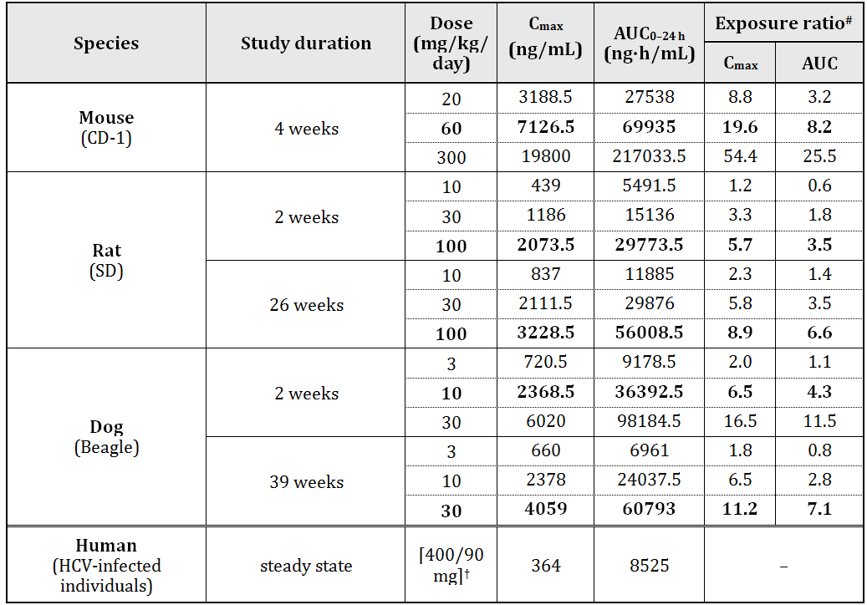

# = animal:human plasma AUC0–24 h or animal:human Cmax; † FDC 400/90 mg SOF/LDV

##### Major toxicities

The repeat dose toxicity of LDV was low and no potentially serious organ toxicities were seen in any of the pivotal long term toxicity studies. Sporadic elevations in ALT and ALP and in serum cholesterol and triglycerides were seen in rodents but no histopathological changes accompanied these observations. Elevated cholesterol was reported in a 2 week study in dogs (30 mg/kg/day) but not in the 39 week study at the same dose.

Increased adrenal gland weights were observed in rats (100 mg/kg/day) in several studies and increased liver weights were seen in females at the same dose in the 26 week study. As there were no histopathological correlates it is not clear that these effects were adverse.

The lack of identified target organs for toxicity might be regarded as a shortcoming of the toxicity studies. In reply to the EMA Day 120 List of Questions on this point, the sponsor noted that 3 different formulations were examined in mice, rats and rabbits, and the maximum feasible dose was tested in each species. In dogs, bodyweights were adversely affected in the 2 week study, and additional formulations were not examined. The low solubility of LDV precluded large increases in drug exposure by twice daily oral dosing, or intravenous (IV) dosing.

##### Lack of toxicity studies with the SOF/LDV combination

No toxicity studies with LDV and SOF in combination were performed. The drugs target different non-structural HCV proteins, and the proposed SOF dose in the combination is the same as the currently approved dose. The sponsor provided the following justification for the absence of combination studies:

*Based on the well-defined toxicity profiles of the single agents, the combination of SOF and LDV is not anticipated to exacerbate known toxicities or lead to new toxicities.*

The ICH M3(R2) Guidance for marketing authorization[1] states:

*For most combinations which involve two late stage entities and for which there is adequate clinical experience with co-administration, combination studies would generally not be recommended to support clinical studies or marketing unless there is sufficient toxicological concern.*

The associated ICH M3(R2) Q&As (R2) guideline[2] notes that co-administration of two or more late stage entities is common practice with HCV drugs. The draft FDA guidance[3] for HCV drugs states:

*Nonclinical combination studies of an investigational DAA plus an approved DAA or IFN and RBV generally are not needed. Therefore, unless data from nonclinical studies of an approved investigational DAA suggest a potential for serious synergistic toxicity with an approved therapeutic drug, combination toxicology studies are not anticipated.*

The lack of combination studies is therefore consistent with relevant guidelines.

#### Genotoxicity

LDV was evaluated for its potential to induce reverse mutations in *S. typhimurium* and *E. coli*, its mutagenic potential *in vitro* in primary human lymphocytes, and its mutagenic potential *in vivo* in a rat bone marrow micronucleus study (Option 1 in ICH S2(R1)). LDV was negative in all the tests and is unlikely to pose a mutagenic or clastogenic risk to humans. Genotoxicity studies with the SOF/LDV combination were not required.

#### Carcinogenicity

No carcinogenicity studies with LDV were submitted but the sponsor indicated that a 6-month RasH2 transgenic mouse study mice and a rat 2 year study are due for completion in December 2015. Two year carcinogenicity studies in mice and rats with SOF were included in this submission.

The 2 year study with SOF in mice used daily oral dosing up to 200 mg/kg/day (ERAUC =7) in males and 600 mg/kg/day (ERAUC = 24) in females. The dosages were selected by the sponsor in consultation with the USFDA Carcinogenicity Assessment Committee (CAC) and were based on a 3 month oral toxicity study conducted in mice (SA-PSI-7977-09-0008, evaluated previously) in which mice were given daily oral doses of SOF at dosages of 100, 300, and 1000 mg/kg/day. The two year study in rats used daily oral dosing up to 750 mg/kg/day (ERAUC =11) in males and (ERAUC = 15) in females, based on the main metabolite, GS-331007. The dosages were selected by the sponsor in consultation with the US FDA Carcinogenicity Assessment Committee (CAC) and were based on a 90 day oral toxicity study conducted in rats (SA-PSI-7977-09-0007) in which rats were given daily oral doses of SOF at dosages of 20, 100, and 500 mg/kg/day.

There were no statistically significant tumour findings in males or female mice or rats following treatment with SOF.

#### Reproductive toxicity

Reproductive toxicity was assessed in rats and rabbits in GLP compliant studies. The studies investigated potential effects on male and female fertility in rats, embryofoetal toxicity (rats and rabbits) and pre/postnatal development (rats). Adequate animal numbers were used in the pivotal studies and treatment periods were appropriate. The fertility and pre and postnatal development studies were conducted using LDV acetone solvate, the embryofoetal studies in rats and rabbits employed LDV free base. Toxicokinetic data were obtained either from animals in the studies or from similarly treated animals in accompanying studies. Reproductive toxicity studies with the SOF/LDV combination were not required.

##### Relative exposure

The animal:human Cmax and AUC exposure ratios achieved in these studies are adequate (up to 8 times). Placental transfer and excretion in milk were inferred by concentrations in rat pups.

LDV had no effects on fertility in rats. There was, however, a small but statistically significant reduction in the number of corpora lutea and implantations at the highest dose tested (100 mg/kg/day, exposure ratio 6x). There was no such effect at 30 mg/kg/day. Exposure ratios based on AUC at the NOAEL were approximately 7x and 3x in males and females respectively (Table 4).

Table 4: Exposure ratios.

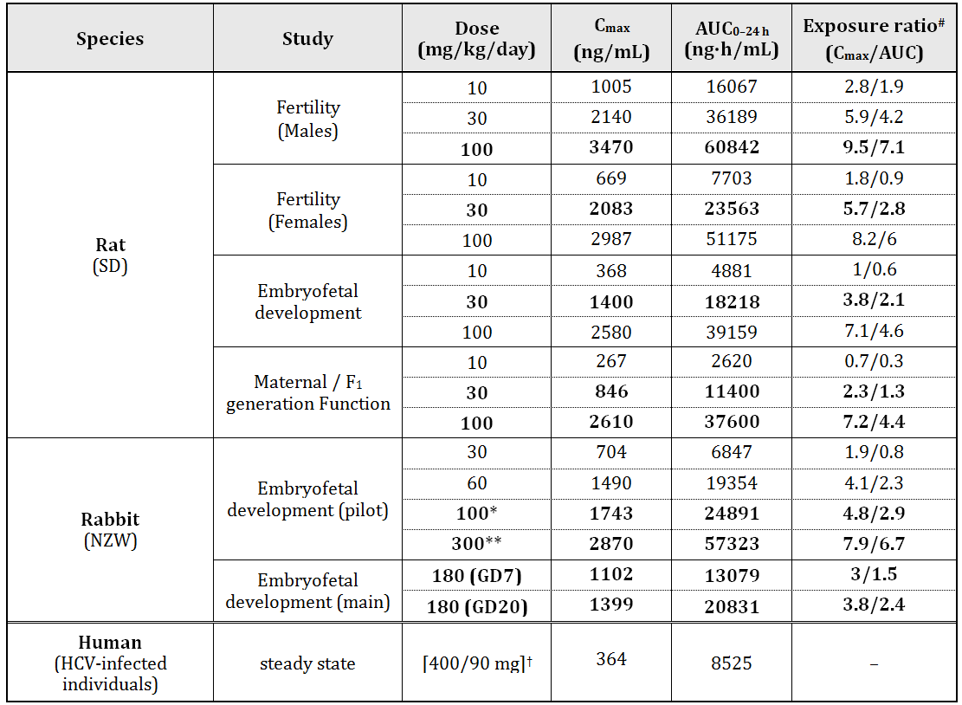

# = animal:human plasma Cmax and AUC0–24 h ; † FDC 400/90 mg SOF/LDV; * maternal NOAEL, ** embryofetal NOAEL

LDV had no effects on embryofetal development in rats up to the highest dose of 100 mg/kg/day (exposure ratio 4.6x), but there was some reduction in weight gain in the high dose dams and the maternal NOAEL was 30 mg/kg/day (exposure ratio 2.1x). LDV was also without effect on embryofetal development in rabbits (maternal and fetal NOAEL 180 mg/kg/day, exposure ratio 2.4x).

LDV at the highest dose tested (100 mg/kg/day, exposure ratio 4.4x) caused reduced weight gain in pups during the postnatal period but had no other effects on postnatal development in rats including reproductive function and there were no effects in F2 pups. The NOAEL for effects on postnatal development was 30 mg/kg/day (exposure ratio 1.3x).

##### Pregnancy classification

The sponsor has proposed Pregnancy Category B2. Since LDV had no effects on embryofoetal development in rats and rabbits, a pregnancy category of B1 would be appropriate.[4] LDV was assigned a USA pregnancy category of B (“Animal reproduction studies have failed to demonstrate a risk to the fetus…”).

#### Local tolerance

LDV showed no evidence of skin irritation following topical application to the skin of rabbits and no evidence of ocular irritation in the *in vitro* bovine corneal opacity and permeability assay. There was no evidence of skin sensitisation by LDV following topical application to the ears of mice. All local tolerance studies were conducted using LDV acetone solvate.

##### Phototoxicity

Phototoxicity was assessed in Crl:SKH1-hr mice following 30 minutes UV exposure and LDV at doses up to 300 mg/kg. The salt of LDV was used in these experiments and exposure is likely to have been lower than it would have been if the free base had been used. There were no skin reactions at any dose and no indication of phototoxicity.

##### Paediatric use

LDV is not proposed for paediatric use and no specific studies in juvenile animals were submitted.

#### Comments on the safety specification of the risk management plan

Results and conclusions drawn from the nonclinical program for LDV detailed in the sponsor’s draft Risk Management Plan (RMP) for Australia (Version 0.1) are in general concordance with those of the nonclinical evaluator. The statement in relation to carcinogenicity of SOF in mice is not accurate. Doses up to 600 mg/kg/day were tested in females; males were only tested up to 200 mg/kg/day.

### Nonclinical summary and conclusions

#### Summary

* The overall quality of the nonclinical dossier was good with all pivotal studies conducted according to GLP. However, there were no combination toxicity studies with LDV and SOF.
* Primary pharmacology studies were conducted entirely in vitro. Most studies were conducted using HCV subgenomic replicons. Primary pharmacology studies established inhibition of GT 1a, 1b, 2a, 2b, 3a, 4a, 5a and 6a replicons by LDV, with the greatest potency against GT1 a and b. LDV was also active against infectious HCV genotype 2a (J6/JFH-1) in Lunet-CD81 cells.
* LDV had no off target actions *in vitro* that were considered potentially clinically significant.
* LDV did not have any notable effects on CNS, cardiovascular or respiratory function following oral administration and had no effects on hERG channels in vitro.
* LDV was absorbed relatively quickly (more slowly than SOF) and widely in humans and nonclinical species. Systemic clearance was low in these species and less than 12% of hepatic blood flow indicative of low hepatic metabolism. Volumes of distribution in these species were greater than total body water indicting wide tissue distribution. Bioavailability was moderate in rats, dogs, and monkeys. Plasma half-life ranged from 4.7 to 10.3 hours in rats, dogs, and monkeys in single dose studies. LDV does not readily cross blood-brain or blood-tested barriers. Excretion of LDV was almost exclusively via the faecal route in humans and laboratory species. LDV is an inhibitor of drug transporter P-gp and BCRP and may increase intestinal absorption of co-administered drug substrates for these transporters. The absorption of both SOF and LDV may be increased by administration of inhibitors or decreased by administration of inducers of intestinal efflux transporters.
* No acute toxicity studies were conducted. There was no evidence of acute toxicity of LDV in any repeat dose toxicity studies.
* No major toxicities were apparent in repeat dose studies at doses up to ERAUC 25.5 (mouse), 6.6 (rat), and 11.5 (dog). No combination toxicity studies were conducted with LDV and SOF.
* The potential genotoxicity of LDV was investigated in a standard battery of tests. The results were negative in all tests and LDV is unlikely to pose a mutagenic or clastogenic risk to humans. No carcinogenicity studies with LDV were submitted but the sponsor indicated that long-term studies on mice and rats are ongoing.
* The sponsor included 2 previously unfinished carcinogenicity studies with SOF. No treatment related increase in tumour incidence was observed with SOF in mice or rats in 2 year oral carcinogenicity studies not evaluated previously. The high doses achieved an ERAUC of 7 (males) and 24 (females) in mice and 11 (males) and 15 (females) in rats.
* LDV had no effects on fertility, embryofoetal or post-natal development in rats or on embryofoetal development in rabbits.
* LDV did not produce skin or ocular irritation and did not cause skin sensitisation.

#### Conclusions and recommendation

* There are no major deficiencies in the nonclinical dossier.
* Primary pharmacology studies established anti-HCV activity against HCV genotype 1 and other genotypes, and the efficacy of LDV against an infectious HCV genotype *in vitro*.
* No clinically relevant hazards were identified in LDV safety studies.
* LDV is an inhibitor of drug transporter P-gp and BCRP and may increase intestinal absorption of co-administered drug substrates for these transporters. The absorption of both SOF and LDV may be increased by administration of inhibitors or decreased by administration of inducers of intestinal efflux transporters.
* No major organ toxicities were observed with LDV in repeat-dose studies in any species. Drug exposures were limited by the low solubility of LDV, but were adequate. There were no toxicity studies with the LDV/SOF combination.
* LDV was negative in standard genotoxicity assays. Carcinogenicity studies in mice and rats with SOF were negative. LDV carcinogenicity studies are in progress in mice and rats and should be submitted upon completion (December 2015).
* There was no evidence of developmental toxicity with LDV and Australian Pregnancy category B1 is appropriate.
* There are no nonclinical objections to the registration of LDV.
* Based on the nonclinical data provided in this submission for LDV and evaluated in the previous submission for SOF, there are no nonclinical objections to the registration of Harvoni for treatment of genotype 1 infection.

## IV. Clinical findings

### Introduction

This is a Category 1, Type A application to register Harvoni (90 mg LDV/400 mg SOF) FDC tablets.

#### Clinical rationale

As stated in the Clinical Summary:

*Chronic HCV infection is a global health problem with an estimated 170 million individuals infected worldwide. In the US, an estimated 3.2 million people have chronic HCV infection. Chronic HCV infection leads to approximately 16,000 deaths each year in the US. In Europe, an estimated 7.3 to 8.8 million people have chronic HCV infection leading to approximately 86,000 deaths each year. Up to 85% of individuals infected with HCV fail to clear the virus and progress to chronic infection: over the ensuing 20 years, as many as 20% of patients with chronic HCV infection are estimated to develop complications, including cirrhosis, end-stage liver disease, and hepatocellular carcinoma (HCC). Complications from chronic HCV infection are responsible for approximately half of all liver transplants; HCV is therefore the most frequent indication for orthotopic liver transplantation.*

*For genotype 1 HCV infection (subtypes 1a or 1b), which represents the majority of all cases of chronic HCV infection in the US (70% to 75%, predominantly subtype 1a) and Europe (69%, predominantly subtype 1b), the current standard treatment for treatment-naive patients is 12 to 24 weeks of an oral protease inhibitor (PI) combined with 24 to 48 weeks of Peg-IFN+RBV, with duration of therapy guided by on-treatment response.*

However, up to 50% of patients are not eligible for these treatments, and there are also serious disadvantages to these treatments, including poor tolerability, frequent adverse effects and high pill burdens.

Hence:

*There remains a significant unmet medical need for simplified treatment regimens that are more effective than the current standard of care, with better safety/tolerability profiles.*

#### Guidance

Two EMA guidelines relate to the present application.[5] The sponsor states:

*As outlined during the initial SOF pre-submission meeting on 21 January 2013, Gilead does not meet TGA adopted EMA guideline "Guideline on the Clinical Evaluation of Direct Acting Antiviral Agents Intended for Treatment of Chronic Hepatitis C" as the duration for determining Sustained Virological Response (SVR) is shorter than noted in this guideline. During the pre-submission meeting this was discussed and considered acceptable, based on shorter SVR duration being validated and pre-agreed with US FDA and EMA.*

The Guideline recommends the primary efficacy outcome measure should be SVR at 6 months.

The sponsor later states in the study report for Study GS-US-337-0102:

*During a Type C meeting with the US Food and Drug Administration (FDA) on 3 June 2013, it was agreed that if 12 weeks of SOF/LDV ± RBV was able to achieve an SVR12 ≥ 90% in subjects with and without cirrhosis separately, efficacy data from the 24-week treatment groups would not be necessary for the initial SOF/LDV new drug application (NDA) filing.*

#### Contents of the clinical dossier

The submission contained the following clinical information:

* 25 clinical pharmacology studies, including 24 that provided pharmacokinetic data and one that provided pharmacodynamic data. The pharmacokinetic studies were: Study GS-US-256-0110, Study GS-US-337-0101, Study GS-US-256-0101, Study GS-US-0108, Study GS-US-334-0111, Study GS-US-256-0102, Study GS-US-248-0117, Study GS-US-344-0101, Study GS-US-344-0108, Study GS-US-119-0113, GS-US-169-0105, Study GS-US-248-0102, Study GS-US-248-0104, Study GS-US-248-0107, Study GS-US-248-0125, Study GS-US-248-0127, Study GS-US-256-0129, Study GS-US-334-0101, Study GS-US-334-0146, Study GS-US-334-0148, GS-US-337-0127, Study GS-US-337-0128, Study GS-US-344-0102, and Study MK-5172-pn023. The pharmacodynamic study was: Study GS-US-344-0109
* The pharmacokinetic studies were supplemented by 16 reports of *in vitro* studies: Study AD-256-2094, Study AD-256-2095, Study AD-256-2096, Study AD256-2097, Study AD-256-2098, Study AD-256-2109, Study AD-256-2132, Study AD-256-2133, Study AD-256-2134, Study AD-256-2139, Study AD-256-2140, Study AD-256-2143, Study AD-256-2144, Study AD-256-2146, Study AD-256-2150, and Study AD-256-2108
* Three population pharmacokinetic analyses: Pop-PK of GS331007, Pop-PK of SOF and Pop-PK of LV
* Three pivotal efficacy/safety studies: Study GS-US-337-0102, Study GS-US-337-0108 and Study GS-US-337-0109
* Three other efficacy/safety studies: GS-US-337-0118, GS-US-337-0122 and Study P7977-0523
* An Integrated Summary of Efficacy and an Integrated Summary of Safety.

#### Paediatric data

The submission did not include paediatric data.

#### Good clinical practice

The studies submitted in the present application all appeared to have been conducted according to GCP.

### Pharmacokinetics

#### Studies providing pharmacokinetic data

Table 5 shows the studies relating to each pharmacokinetic topic and the location of each study summary.

Table 5: Submitted pharmacokinetic studies.

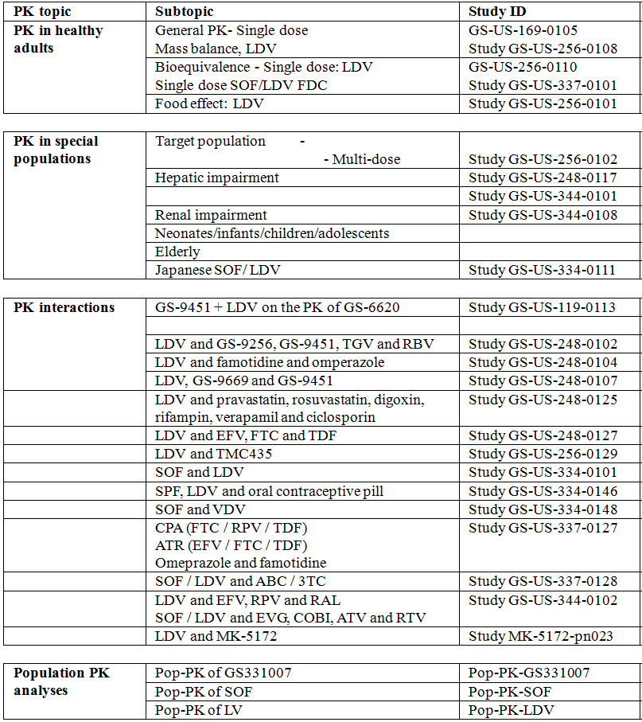

None of the pharmacokinetic studies had deficiencies that excluded their results from consideration.

#### Evaluator’s conclusions on pharmacokinetics

SOF is a pro-drug that undergoes extensive metabolism. Its active form is GS-461203 and it appears in the serum as (and is excreted as) GS-331007. Clearance of GS-331007 is primarily renal and is correlated with CLCR. Hence, in ESRF there could be accumulation. The only clinically significant demonstrated drug-drug/food/herbal interaction was with potent P-gp inducers.

LDV has solubility limited absorption at doses greater than 100 mg. Bioavailability is decreased 50% with food. It has low protein binding and a high volume of distribution. It is primarily excreted unchanged in the faeces, with minimal metabolism and minimal excretion unchanged in the urine. Dose adjustment is not necessary in subjects with mild, moderate or severe hepatic impairment. Dose adjustment is not necessary in renal failure. LDV is a substrate of P-gp and BCRP. There is evidence of interactions with drugs that induce or inhibit transporters, but the clinically significant interactions were with drugs such as rifampin, EFV/FTC/TDF, and DRV/RTV (inducers of transporters) which resulted in decreased exposure to LDV. LDV was a moderate to weak inhibitor of BCRP and P-gp, and also inhibits OATP1B1 and OATP1B3. Hence, there was some evidence of interactions with digoxin and with pravastatin.

The pharmacokinetic interactions between SOF and LDV in combination are favourable. LDV significantly increased the exposure to SOF, GS-566500 and GS-331007. SOF did not have any significant effect on exposure to LDV.

Combining treatments with SOF/LDV FDC will be complex because of the potential for drug-drug interactions. The interactions table in the PI is useful but would be of more practical value if the clinically significant drug interactions were highlighted in some way.

### Pharmacodynamics

#### Studies providing pharmacodynamic data

Table 6 shows the studies relating to each pharmacodynamic topic and the location of each study summary.

Table 6: Submitted pharmacodynamic studies.

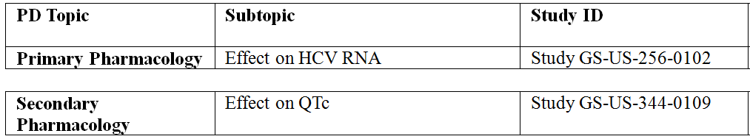

None of the pharmacodynamic studies had deficiencies that excluded their results from consideration.

#### Evaluator’s conclusions on pharmacodynamics

The pharmacodynamic data were used to select the dose to be taken into the efficacy trials. Study GS-US-256-0102 indicated a dose of 30 mg or more would be sufficient to obtain near maximal effect.

There was no indication of QTC prolongation of regulatory interest with LDV at a dose of 120 mg. However, 120 mg is only 33% higher than the proposed dosing regimen. A study conducted at higher dose levels would be more reassuring.

### Dosage selection for the pivotal studies

Study GS-US-256-0102 demonstrated that exposures of LDV at doses of ≥30 mg/day would result in >95% maximal response in subjects with GT 1a HCV infection. Consequently, the 30 mg and 90 mg dose levels of LDV were selected for further development.

The 400 mg dose level for SOF appears to have been carried through from the development of SOF.

### Efficacy

#### Studies providing efficacy data

* Study GS-US-337-0102 (was a Phase III, multicentre, randomised, open label study to investigate the efficacy and safety of SOF/LDV FDC with and without RBV.
* Study GS-US-337-0108 was a Phase III, multicentre, randomized, open label study to investigate the efficacy and safety of SOF/LDV FDC ± RBV for 8 weeks and SOF/LDV FDC for 12 weeks in treatment naïve subjects with chronic GT1-HCV.
* Study GS-US-337-0109 was a Phase III, multicentre, randomised, open label study to investigate the efficacy and safety of SOF/LDV FDC ± RBV for 12 and 24 weeks in treatment experienced subjects with chronic GT1-HCV.
* Study GS-US-337-0118 was a Phase II, randomised, open label study of SOF/LDV FDC ± RBV in subjects with chronic GT1-HCV.
* Study GS-US-337-0122 was a Phase II, multicentre, open label study to evaluate safety and efficacy of SOF containing regimens administered for up to 12 weeks in subjects with chronic GT3-HCV HCV infection.
* Study P7977-0523 was a Phase IIa, multiple dose, open label study to evaluate different treatment regimens of SOF 400 mg alone or SOF/LDV for 6, 8, or 12 weeks administered with and without RBV and/or PEG-IFN in subjects with GT 1, 2, or 3 HCV infection and with and without LDV or GS-9669 in subjects with GT 1 HCV infection.

#### Evaluator’s conclusions on efficacy

The efficacy data are supportive of efficacy in the proposed indication; however, in the opinion of the evaluator, the proposed treatment regimen may require modification.

In HCV treatment naïve subjects, with or without cirrhosis (Study GS-US-337-0102) SVR12 was achieved by 209 (97.7%) subjects in the SOF/LDV 12 week group, 95% CI 94.6% to 99.1%, p <0.001. There was no additional benefit by also including RBV: SVR12 was achieved by 211 (97.2%) subjects in the SOF/LDV + RBV 12 week group, 95% CI 94.1% to 99.0%, p <0.001.

In treatment naïve subjects with chronic GT1-HCV without cirrhosis (Study GS-US-337-0108) SVR12 was achieved by 202 (94.0%) subjects in the SOF/LDV FDC 8 week group, 95% CI 89.9% to 96.7%, p <0.001. There was no additional benefit by also including RBV: SVR12 was achieved by 201 (93.1%) subjects in the SOF/LDV FDC + RBV 8 week group, 95% CI 88.8% to 96.1%, p <0.001. There was no significant additional benefit with a longer, 12 week, treatment period: SVR12 was achieved by 206 (95.4%) subjects in the SOF/LDV FDC 12 week group, 95% CI 91.7% to 97.8%, p <0.001.

In treatment experienced subjects with chronic GT1-HCV, that is, with prior treatment failure with a Peg-IFN + RBV, (Study GS-US-337-0109) SVR12 was achieved by 102 (93.6%) subjects in the SOF/LDV FDC 12 week group, 95% CI 87.2% to 97.4%, p <0.001 (compared to the historical 25% response rate). There was better efficacy in those subjects treated with RBV and for longer treatment duration:

* SVR12 was achieved by 107 (96.4%) subjects in the SOF/LDV FDC + RBV 12 week group, 95% CI 91.0% to 99.0%, p <0.001
* SVR12 was achieved by 108 (99.1%) subjects in the SOF/LDV FDC 24 week group, 95% CI 95.0% to 100.0%, p <0.001
* SVR12 was achieved by 110 (99.1%) subjects in the SOF/LDV FDC + RBV 24 week group, 95% CI 95.1% to 100.0%, p <0.001

Study GS-US-337-0118 was supportive of the pivotal studies but of too small a sample size to be pivotal.

Relapse is more likely in subjects with higher viral burden, male gender, cirrhosis and baseline thrombocytopenia. In Study GS-US-337-0108, there was a higher relapse rate in the 8 week groups compared with the 12 week: 11 (5.1%) subjects in the SOF/LDV FDC 8 week group, 9 (4.2%) in the SOF/LDV + RBV 8 week, and 3 (1.4%) in the SOF/LDV 12 week group; and relapse was more likely if subjects were male and/or baseline HCV RNA was ≥800,000 (IU/mL). In Study GS-US-337-0109, relapse risk was increased in subjects with cirrhosis and/or baseline thrombocytopenia.

In all three pivotal studies, subjects with <80% adherence to study treatment had reduced efficacy. However, in all three pivotal studies there was no effect on response for demographic characteristics and SOF/LDV FDC was equally effective for GT1a-HCV and GT1b-HCV. Baseline disease characteristics did not influence efficacy.

Baseline RAVs should not preclude treatment with SOF/LDV FDC. However, baseline NS5A RAVs appear to be more common in subjects that relapse and treatment emergent NS5A RAVs are more common than NS5B RAVs. In Study GS-US-337-0102, RAVs were reported in 32 (15.0% subjects in the SOF/LDV 12 week group, and 36 (16.7%) in the SOF/LDV + RBV 12 week group; and the one subject in the 12 week group who relapsed did not develop a RAV. In Study GS-US-337-0108, of the 23 subjects that relapsed, ten had NS5A RAVs at baseline; of the 13 that did not, six had emergent NS5A RAVs at relapse. In Study GS-US-337-0109, of the 12 subjects that relapsed, 5 of 11 had no baseline RAVs, and the other 7 subjects had baseline NS5A RAVs. All 12 subjects had detectable NS5A RAVs at virologic failure, but no NS5B NI RAVs were detected. Phenotypic analysis showed a reduced susceptibility to LDV, but no change in susceptibility to SOF or RBV.

In all three pivotal studies, Quality of Life decreased during treatment for those subjects treated with RBV. Hence, the place of RBV as add-on therapy may be in those subjects with prior treatment failure, with or without cirrhosis.

Study GS-US-337-0122 did not support efficacy in subjects with chronic GT3-HCV. Study P7977-0523 did not support efficacy in subjects with GT2-HCV or GT3-HCV infection or a shorter duration of treatment of 6 weeks in subjects with GT1-HCV.

The studies presented in the submission were mostly in accordance with published guidelines.[6] The deficiencies in the submission are:

* Studies were open label rather than double blind
* Long term follow up data were not presented
* Data for SVR24 were incomplete
* Studies in subjects with HCV/HIV co-infected patients were not included

However, in the opinion of the evaluator, the potential benefits of SOF/LDV FDC outweigh the deficiencies in the study methodologies. The outcome measures were highly objective, which makes the open label design more acceptable. Also, when available, the SVR24 data were in concordance with the SVR12 data.

### Safety

#### Studies providing safety data

The following studies provided evaluable safety data:

* Three pivotal efficacy/safety studies: Study GS-US-337-0102, Study GS-US-337-0108 and Study GS-US-337-0109
* Three other efficacy/safety studies: GS-US-337-0118, GS-US-337-0122 and Study P7977-0523
* 25 clinical pharmacology studies: Study GS-US-256-0110, Study GS-US-337-0101, Study GS-US-256-0101, Study GS-US-0108, Study GS-US-334-0111, Study GS-US-256-0102, Study GS-US-248-0117, Study GS-US-344-0101, Study GS-US-344-0108, Study GS-US-119-0113, GS-US-169-0105, Study GS-US-248-0102, Study GS-US-248-0104, Study GS-US-248-0107, Study GS-US-248-0125, Study GS-US-248-0127, Study GS-US-256-0129, Study GS-US-334-0101, Study GS-US-334-0146, Study GS-US-334-0148, GS-US-337-0127, Study GS-US-337-0128, Study GS-US-344-0102, Study MK-5172-pn023, and Study GS-US-344-0109
* An Integrated Summary of Efficacy and an Integrated Summary of Safety.

##### Pivotal efficacy studies

In the pivotal efficacy studies, the following safety data were collected:

* General adverse events (AEs) were assessed by report.
* Laboratory tests, including AST, ALT, bilirubin and FBC
* ECG and vital signs

##### Pivotal studies that assessed safety as a primary outcome

There were no studies that assessed safety as a primary outcome.

##### Dose-response and non-pivotal efficacy studies

In the pivotal efficacy studies, the following safety data were collected:

* General adverse events (AEs) were assessed by report.
* Laboratory tests, including AST, ALT, bilirubin and FBC
* ECG and vital signs

##### Other studies evaluable for safety only

There were 14 additional studies that contained clinical data. These studies used different drug combinations and/or different indications than those of the present application. These studies were: Study GS-US-248-0120, Study GS-US-248-0121, Study GS-US-248-0131, Study GS-US-248-0132, Study GS-US-256-0124, Study GS-US-256-0148, Study GS-US-334-0107, Study GS-US-334-0108, Study GS-US-334-0110, Study GS-US-334-0123, Study GS-US-334-0133, Study p2938-0721, Study p7977-1231, and Study p7977-2025. No additional safety concerns regarding SOF/LDV FDC were identified from these data.

#### Patient exposure

##### Overall exposure to SOF/LDV FDC:

In the development program for SOF/LDV FDC, there were 1952 subjects exposed to SOF/LDV FDC. This included:

* Subjects exposed to SOF/LDV FDC for treatment durations of 8 weeks: 215
* Subjects exposed to SOF/LDV FDC for treatment durations of 12 weeks: 539
* Subjects exposed to SOF/LDV FDC for treatment durations of 24 weeks: 326
* Subjects exposed to SOF/LDV FDC + RBV for treatment durations of 8 weeks: 216
* Subjects exposed to SOF/LDV FDC + RBV for treatment durations of 12 weeks: 328
* Subjects exposed to SOF/LDV FDC + RBV for treatment durations of 24 weeks: 328

There were 1175 (60.2%) males and 777 (39.8%) females. There were 152 (7.8%) subjects aged ≥ 65 years. There were 1234 (77.2%) subjects with confirmed GT1a-HCV and 356 (22.3%) with GT1b-HCV. There were 169 (10.6%) subjects with cirrhosis.

##### Exposure in efficacy trials

In Study GS-US-337-0102, in the 12 Week treatment groups there were 214 subjects exposed to SOF/LDV FDC (192 for 12 weeks) and 217 to SOF/LDV FDC + RBV (194 for 12 weeks). In the 24 Week treatment groups there were 217 subjects exposed to SOF/LDV FDC (213 for 12 weeks, 186 for 24 weeks) and 217 to SOF/LDV FDC + RBV (216 for 12 weeks, 178 for 24 weeks)

In Study GS-US-337-0108, there were 215 subjects exposed to SOF/LDV FDC in the 8 week group, with 202 exposed for 8 weeks; 216 exposed to SOF/LDV FDC + RBV with 203 exposed for 8 weeks; and 216 in the SOF/LDV FDC 12 week group, with 194 exposed for 12 weeks.

In Study GS-US-337-0109, there were 109 subjects exposed to SOF/LDV FDC in the SOF/LDV FDC 12 week group (106 for 12 weeks), 111 in the SOF/LDV FDC + RBV 12 week (103 for 12 weeks), 109 in the SOF/LDV FDC 24 week (94 for 24 weeks) and 111 in the SOF/LDV FDC + RBV 24 week (99 for 24 weeks).

In Study GS-US-337-0118, there were 41 subjects exposed to SOF/LDV FDC ± RBV in the 8 week groups, 40 or whom completed 8 weeks, and 59 exposed to SOF/LDV FDC ± RBV in the 12 week groups, all of whom completed 12 weeks.

In Study GS-US-337-0122, 25 subjects were exposed to SOF/LDV FDC for up to 12 weeks and 26 to SOF/LDV FDC + RBV for up to 12 weeks.

In Study P7977-0523, there were 10 subjects that were null responder GT1 treated with SOF/LDV FDC for 12 weeks; 9 subjects with null responder GT1 treated with SOF/LDV FDC + RBV for 12 weeks; 10 subjects with treatment naïve GT2/3 treated with SOF/LDV FDC for 12 weeks; 14 subjects with haemophilia and GT1-HCV treated with SOF/LDV FDC + RBV for 12 weeks, and 25 of subjects with treatment naïve GT1 treated with SOF/LDV for 6 weeks.

#### Safety issues with the potential for major regulatory impact

There were no safety issues with the potential for major regulatory impact identified in the data.

#### Post marketing data

No post marketing data were included in the submission.

#### Evaluator’s conclusions on safety

SOF/LDV FDC has a favourable safety profile. The most frequently reported TEAEs were fatigue, headache, insomnia, nausea and arthralgia. These TEAEs were more frequent in the groups treated with RBV. Quality of life improved during treatment in those patients treated with SOF/LDV FDC by itself, but decreased in those subjects also treated with RBV.

There were no deaths in the efficacy studies or in the clinical pharmacology studies. SAEs were infrequent and there was no clear pattern attributable to SOF/LDV FDC. There were few DAEs.

One subject had AST or ALT >3xULN and bilirubin >2xULN with no signs of liver disease that resolved on treatment (and was not attributed to SOF/LDV).

Anaemia was reported in up to 9.2% of the subjects treated with RBV.

In the efficacy studies there was a higher than expected rate of significant elevation in serum lipase, but the frequency was ≤1.8% in any individual study. Although this may be a feature of the underlying condition, it may also be a safety signal.

The thorough QT study did not indicate any significant QTc prolongation however the dose used in that study was only 33% higher than the proposed dosing regimen.

There were no long term safety data included in the submission. Hence, it is not possible to comment on the long-term safety effects of SOF/LDV FDC.

### First round benefit-risk assessment

#### First round assessment of benefits

The efficacy data are supportive of efficacy in the proposed indication but in the opinion of the Evaluator the proposed treatment regimen may require modification.

In HCV treatment naïve subjects, with or without cirrhosis (Study GS-US-337-0102) SVR12 was achieved by 209 (97.7%) subjects in the SOF/LDV 12 week group, 95% CI 94.6% to 99.1%, p <0.001. There was no additional benefit by also including RBV: SVR12 was achieved by 211 (97.2%) subjects in the SOF/LDV + RBV 12 week group, 95% CI 94.1% to 99.0%, p <0.001.

In treatment naïve subjects with chronic GT1-HCV without cirrhosis (Study GS-US-337-0108) SVR12 was achieved by 202 (94.0%) subjects in the SOF/LDV FDC 8 week group, 95% CI 89.9% to 96.7%, p <0.001. There was no additional benefit by also including RBV: SVR12 was achieved by 201 (93.1%) subjects in the SOF/LDV FDC + RBV 8 week group, 95% CI 88.8% to 96.1%, p <0.001. There was no significant additional benefit with a longer, 12 week, treatment period: SVR12 was achieved by 206 (95.4%) subjects in the SOF/LDV FDC 12 week group, 95% CI 91.7% to 97.8%, p <0.001.

In treatment experienced subjects with chronic GT1-HCV, that is, with prior treatment failure with a Peg-IFN + RBV, (Study GS-US-337-0109) SVR12 was achieved by 102 (93.6%) subjects in the SOF/LDV FDC 12 week group, 95% CI 87.2% to 97.4%, p <0.001 (compared to the historical 25% response rate). There was better efficacy in those subjects treated with RBV and for longer treatment duration:

* SVR12 was achieved by 107 (96.4%) subjects in the SOF/LDV FDC + RBV 12 week group, 95% CI 91.0% to 99.0%, p <0.001
* SVR12 was achieved by 108 (99.1%) subjects in the SOF/LDV FDC 24 week group, 95% CI 95.0% to 100.0%, p <0.001
* SVR12 was achieved by 110 (99.1%) subjects in the SOF/LDV FDC + RBV 24 week group, 95% CI 95.1% to 100.0%, p <0.001

Relapse is more likely in subjects with higher viral burden, male gender, cirrhosis and baseline thrombocytopenia. In Study GS-US-337-0108 there was a higher relapse rate in the 8 week groups compared with the 12 week: 11 (5.1%) subjects in the SOF/LDV FDC 8 week group, 9 (4.2%) in the SOF/LDV + RBV 8 week, and 3 (1.4%) in the SOF/LDV 12 week group; and relapse was more likely if subjects were male and/or baseline HCV RNA was ≥800,000 (IU/mL). In Study GS-US-337-0109 relapse risk was increased in subjects with cirrhosis and / or baseline thrombocytopenia.

In all three pivotal studies, subjects with <80% adherence to study treatment had reduced efficacy. However, in all three pivotal studies there was no effect on response for demographic characteristics and SOF/LDV FDC was equally effective for GT1a-HCV and GT1b-HCV. Baseline disease characteristics did not influence efficacy.

Baseline RAVs should not preclude treatment with SOF/LDV FDC. However, baseline NS5A RAVs appear to be more common in subjects that relapse and treatment emergent NS5A RAVs are more common than NS5B RAVs. In Study GS-US-337-0102 RAVs were reported in 32 (15.0% subjects in the SOF/LDV 12 week group, and 36 (16.7%) in the SOF/LDV + RBV 12 week group; and the one subject in the 12 week group who relapsed did not develop a RAV. In Study GS-US-337-0108 of the 23 subjects that relapsed, ten had NS5A RAVs at baseline; of the 13 that did not, six had emergent NS5A RAVs at relapse. In Study GS-US-337-0109 of the 12 subjects that relapsed, 5 of 11 had no baseline RAVs, and the other 7 subjects had baseline NS5A RAVs. All 12 subjects had detectable NS5A RAVs at virologic failure, but no NS5B NI RAVs were detected. Phenotypic analysis showed a reduced susceptibility to LDV, but no change in susceptibility to SOF or RBV.

In all three pivotal studies, Quality of Life decreased during treatment for those subjects treated with RBV. Hence, the place of RBV as add-on therapy may be in those subjects with prior treatment failure, with or without cirrhosis.

Efficacy has not been demonstrated for HCV genotypes other than GT1-HCV. Study GS-US-337-0122 did not support efficacy in subjects with chronic GT3-HCV HCV. Study P7977-0523 did not support efficacy in subjects with GT2-HCV or GT3-HCV infection or shorter treatment duration of 6 weeks in subjects with GT1-HCV.

The studies presented in the submission were mostly in accordance with published guidelines.[7] The deficiencies in the submission are:

* Studies were open label rather than double blind
* Long term follow up data were not presented
* Data for SVR24 were incomplete
* Studies in subjects with HCV/HIV co-infected patients were not included.

However, in the opinion of the evaluator, the potential benefits of SOF/LDV FDC outweigh the deficiencies in the study methodologies. The outcome measures were highly objective, which makes the open-label design more acceptable. Also, when available, the SVR24 data were in concordance with the SVR12 data.

In the opinion of the evaluator:

* An SOF/LDV FDC 8 week treatment regimen is supported in treatment naïve subjects with chronic GT1-HCV without cirrhosis;
* An SOF/LDV FDC 12 week treatment regimen is supported in treatment naïve subjects with chronic GT1-HCV with cirrhosis;
* An SOF/LDV FDC 24 week treatment regimen is supported in treatment experienced subjects with chronic GT1-HCV; and
* In the above treatment regimens, RBV does not offer additional benefit and may decrease Quality of life.

#### First round assessment of risks

SOF/LDV FDC has a favourable safety profile. The most frequently reported TEAEs were fatigue, headache, insomnia, nausea and arthralgia. These TEAEs were more frequent in the groups treated with RBV. Quality of life improved during treatment in those patients treated with SOF/LDV FDC by itself, but decreased in those subjects also treated with RBV.

There were no deaths in the efficacy studies or in the clinical pharmacology studies. SAEs were infrequent and there was no clear pattern attributable to SOF/LDV FDC. There were few DAEs.

One subject had AST or ALT >3xULN and bilirubin >2xULN with no signs of liver disease that resolved on treatment (and was not attributed to SOF/LDV).

Anaemia was reported in up to 9.2% of the subjects treated with RBV.

In the efficacy studies there was a higher than expected rate of significant elevation in serum lipase, but the frequency was ≤1.8% in any individual study. Although this may be a feature of the underlying condition, it may also be a safety signal.

The thorough QT study did not indicate any significant QTc prolongation however the dose used in that study was only 33% higher than the proposed dosing regimen.

There were no long term safety data included in the submission. Hence, it is not possible to comment on the long-term safety effects of SOF/LDV FDC.

#### First round assessment of benefit-risk balance

The benefit-risk balance of register Harvoni (90 mg LDV/400 mg SOF) FDC tablets, given the proposed usage, is favourable.

However, consideration needs to be given as to the most appropriate dosing recommendation. In the opinion of the evaluator, this should be:

* SOF/LDV FDC once daily for 8 weeks in treatment naïve subjects with chronic GT1-HCV without cirrhosis
* SOF/LDV FDC once daily for 12 weeks in treatment naïve subjects with chronic GT1-HCV with cirrhosis
* SOF/LDV FDC once daily for 24 weeks in treatment experienced subjects with chronic GT1-HCV, with or without cirrhosis
* RBV does not offer additional benefit as add-on therapy and may decrease Quality of Life

### First round recommendation regarding authorisation

The evaluator has no objection to the approval of Harvoni (90 mg LDV/400 mg SOF) FDC tablets for the indication of:

*Harvoni is indicated for the treatment of chronic hepatitis C (CHC) genotype 1 infection in adults.*

Consideration should be given to amending the dosing recommendations.

### Clinical questions

#### Additional expert input

The evaluator has no additional recommendation for additional expert input.

#### Clinical questions

##### Pharmacokinetics

* The evaluator has no questions relating to pharmacokinetics.

##### Pharmacodynamics

* The evaluator has no questions relating to pharmacodynamics.

##### Efficacy

* Can the sponsor please provide the SVR24 data for the pivotal studies?
* Does the sponsor have access to any long term follow-up data (1 to 2 years) with regard maintenance of efficacy?

##### Safety

* Does the sponsor have access to any long term follow-up data (1 to 2 years) with regard safety?

### Second round evaluation of clinical data

#### (Q) Can the sponsor please provide the SVR24 data for the pivotal studies?

##### Sponsor’s response

The sponsor has provided the final study report for Study GS-US-337-0102, and update reports for Study GS-US-337-0108 and Study GS-US-337-0109.

The final study report contained the data for SVR24 and also for the 24 week treatment regimen. There were 217 subjects randomised to SOF/LDV FDC, of whom 207 (95.4%) completed, and 217 to SOF/LDV + RBV, of whom 204 (94.0%) completed. For the primary efficacy outcome measure, the results were:

* SVR12 was achieved by 211 (98.6%) subjects in the SOF/LDV 12 week group, 95% CI 96.0% to 99.7%, p <0.001
* SVR12 was achieved by 211 (97.2%) subjects in the SOF/LDV + RBV 12 week group, 95% CI 94.1% to 99.0%, p <0.001
* SVR12 was achieved by 213 (97.7%) subjects in the SOF/LDV 24 week group, 95% CI 95.3% to 99.5%, p <0.001
* SVR12 was achieved by 215 (97.2%) subjects in the SOF/LDV + RBV 24 week group, 95% CI 96.7% to 99.9%, p <0.001

There was a similar response rate in subjects with cirrhosis treated with SOF/LDV compared to those treated with SOV/LDV + RBV. In the SOF/LDV 24 week group, 181 (98.4%) subjects without cirrhosis responded, compared with 32 (97.0%) subjects with cirrhosis. In the SOF/LDV 24 week group one subject had on treatment virological failure and one relapsed. In the SOF/LDV + RBV 24 week group there were no virological failures or relapses. SVR4 was achieved by 215 (99.1%) subjects in the SOF/LDV 24 week group, 95% CI 96.7% to 99.9%; SVR4 was achieved by 215 (99.1%) subjects in the SOF/LDV + RBV 12 week group, 95% CI 96.7% to 99.9%. All of the subjects with SVR12 response in all the study groups also had SVR24 response (that is, the results are identical to those for SVR12).

All of the subjects with SVR12 response also had SVR24 response (that is, the results were identical to those for SVR12).

* SVR24 was achieved by 202 (94.0%) subjects in the SOF/LDV FDC 8 week group, 95% CI 89.9% to 96.7%
* SVR24 was achieved by 201 (93.1%) subjects in the SOF/LDV FDC + RBV 8 week group, 95% CI 88.8% to 96.1%
* SVR24 was achieved by 208 (96.3%) subjects in the SOF/LDV FDC 12 week group, 95% CI 92.8% to 98.4%, p <0.001

The results for the SOF/LDV FDC 12 week group were updated as these data were incomplete in the interim report initially submitted.

The sponsor provided the post treatment Week 24 HCV RNA data in the Section 31 response. All the subjects that achieved SVR12 response also achieved SVR24 response. The results by treatment group were:

* SVR24 was achieved by 102 (93.6%) subjects in the SOF/LDV FDC 12 week group, 95% CI 87.2% to 97.4%
* SVR24 was achieved by 107 (96.4%) subjects in the SOF/LDV FDC + RBV 12 week group, 95% CI 91.0% to 99.0%
* SVR24 was achieved by 108 (99.1%) subjects in the SOF/LDV FDC 24 week group, 95% CI 95.0% to 100.0%
* SVR24 was achieved by 110 (99.1%) subjects in the SOF/LDV FDC + RBV 24 week group, 95% CI 95.1% to 100.0%

##### Evaluator’s comments

The sponsor’s response is acceptable and has resolved the issue. All of the subjects that achieved SVR12 response in the pivotal studies also achieved SVR24 response.

#### (Q) Does the sponsor have access to any long term follow-up data (1 to 2 years) with regard maintenance of efficacy?

##### Sponsor’s response

The sponsor did not respond by providing additional long term follow up efficacy data. The sponsor provided the protocols for two long term follow up studies that are currently being conducted:

* Study GS-US-248-0122: a long term follow-up registry study for subjects who achieve a sustained virologic response to treatment in Gilead sponsored trials in subjects with CHC infection. Subjects will be followed for up to 3 years. Visits will occur at Baseline and then at Weeks 24, 48, 72, 96, 120 and 144. At each visit, subjects will have blood drawn for plasma HCV RNA quantification, liver function tests, platelets, coagulation test, α-fetoprotein, and a quality of life survey will be completed.
* Study GS-US-248-0123: a long term follow-up registry study of subjects who did not achieve sustained virologic response in Gilead sponsored trials in subjects with CHC infection. The study procedures are similar to those for Study GS-US-248-0122.

The sponsor will provide the results of these studies to the TGA once the clinical reports are available.

##### Evaluator’s comments

The sponsor’s response is acceptable and has resolved the issue.

#### (Q) Does the sponsor have access to any long term follow-up data (1 to 2 years) with regard maintenance of safety?

##### Sponsor’s response

The sponsor did not respond by providing additional long term follow up safety data. The sponsor provided the protocols for two long term follow up studies that are currently being conducted:

* Study GS-US-248-0122: a long term follow-up registry study for subjects who achieve a sustained virologic response to treatment in Gilead sponsored trials in subjects with CHC infection. The safety data from this study will be limited as the definition for reporting an AE is:

*an AE is any untoward medical occurrence in a clinical investigation subject associated with procedures mandated by this Registry protocol. An AE can therefore be any unfavorable and unintended sign, symptom, or disease temporally associated with procedures mandated by this Registry (for example, hematoma following venipuncture).*

The definition of SAE is similarly restrictive.

* Study GS-US-248-0123: a long term follow-up registry study of subjects who did not achieve sustained virologic response in Gilead sponsored trials in subjects with chronic hepatitis C infection. The definitions for reporting AEs are the same as for Study GS-US-248-0122.

The sponsor will provide the results of these studies to the TGA once the clinical reports are available.

##### Evaluator’s comments

The sponsor’s response is not acceptable. The proposed studies will not identify safety data due to the restricted definitions of AE and SAE used in the studies. In the opinion of the evaluator, the sponsor should also use these studies to identify potential long term adverse effects of SOF/LDV.

**However, consideration needs to be given as to the most appropriate dosing recommendation. In the opinion of the evaluator, this should be:**

* **SOF/LDV FDC once daily for 8 weeks in treatment naïve subjects with chronic GT1-HCV without cirrhosis**
* **SOF/LDV FDC once daily for 12 weeks in treatment naïve subjects with chronic GT1-HCV with cirrhosis**
* **SOF/LDV FDC once daily for 24 weeks in treatment experienced subjects with chronic GT1-HCV, with or without cirrhosis**
* **RBV does not offer additional benefit as add-on therapy and may decrease Quality of Life**

##### Sponsor’s response

The sponsor intends to retain the originally proposed dosing recommendations which are:

* For treatment naïve patients without cirrhosis the recommended duration of treatment with Harvoni is 8 weeks.
* For treatment naïve patients with cirrhosis and all treatment experienced patients the recommended duration of treatment with Harvoni is 12 weeks.

The reasons for retaining this dosing recommendation are to avoid over-treating those patients who respond to this shorter treatment course, and thereby exposing them to more AEs. The sponsor quotes 95% of subjects would be over-treated in order to prevent 5% of relapses. The sponsor also believes there would be greater cost and healthcare utilisation with the longer treatment course and lesser adherence to the treatment regimen.

##### Evaluator’s comments

The sponsor’s response is not acceptable. Based upon the data submitted, there is greater efficacy in treatment experienced subjects with the 24 week treatment course. These data are based upon the full analysis set (which included subjects who were randomised and received at least one dose of study drug) and therefore non-adherence is taken into account in the analysis, and the longer treatment course still had greater efficacy. The adverse event profile of SOF/LDV is favourable so the argument that the longer treatment course has unacceptable risk is not valid. In the opinion of the evaluator, the 5% of subjects that would relapse with a shorter course represents a greater burden to the healthcare system than does the longer treatment course.

#### Additional data included in the Section 31 response

##### Sponsor’s response

The sponsor has provided preliminary data in the form of an interim report from Study GS-US-337-1306. This study is a Phase I drug interaction study. The key findings reported by the sponsor with regard SOF and LDV are:

Simultaneous co-administration of a complete HIV ARV regimen of ATV/r + TVD with LDV/SOF increased systemic exposures of LDV by 96%, 68%, and 118% as assessed AUCtau, Cmax, and Ctau, respectively. A 12 h separation of ATV/r + TVD did not minimise the interaction, as assessed by similar increases in LDV AUCtau, Cmax, and Ctau of 131%, 75%, and 164%, respectively. LDV is known to be a substrate of Pgp and BCRP drug transporters and is also subject to slow oxidative metabolism. The putative mechanism for this interaction is persistent ATV and RTV inhibition of Pgp and BCRP drug transporters.

The sponsor does not intend to make any dose change recommendations with regard SOF/LDV FDC as a result of the interaction, and does not consider the interaction to be clinically relevant.

However, LDV/SOF FDC resulted in increased exposure to TFV. AUCtau increased by 33 to 35%, Cmax by 47% to 49%, and Ctau by 47% to 38% following administration of LDV/SOF and ATV/r + TVD either simultaneously or 12 h apart. The mechanism is likely due to inhibition of intestinal Pgp and BCRP by LDV. The sponsor has included a warning of this interaction in the PI.

##### Evaluator’s comments

The provision of this additional information, and the sponsor’s conclusions, are acceptable. The sponsor intends to lodge the full study report at a later date.

### Second round benefit-risk assessment

#### Second round assessment of benefits

After consideration of the responses to clinical questions, the benefits of Harvoni (90 mg LDV/400 mg SOF) FDC tablets in the proposed usage are unchanged from those identified in the first round.

#### Second round assessment of risks

After consideration of the responses to clinical questions, the risks of Harvoni (90 mg LDV/400 mg SOF) FDC tablets in the proposed usage are unchanged from those identified in the first round.

#### Second round assessment of benefit-risk balance

The benefit-risk balance of register Harvoni (90 mg LDV/400 mg SOF) FDC tablets, given the proposed usage, is favourable.

However, consideration needs to be given as to the most appropriate dosing recommendation. In the opinion of the evaluator, this should be:

In the opinion of the evaluator:

* SOF / LDV FDC once daily for 8 weeks in treatment naïve subjects with chronic GT1-HCV without cirrhosis
* SOF / LDV FDC once daily for 12 weeks in treatment naïve subjects with chronic GT1-HCV with cirrhosis
* SOF / LDV FDC once daily for 24 weeks in treatment experienced subjects with chronic GT1-HCV, with or without cirrhosis
* RBV does not offer additional benefit as add-on therapy and may decrease Quality of Life

### Second round recommendation regarding authorisation

The evaluator has no objection to the approval of Harvoni (90 mg LDV/400 mg SOF) FDC tablets for the indication of:

*Harvoni is indicated for the treatment of chronic hepatitis C (CHC) genotype 1 infection in adults.*

Consideration should be given to amending the dosing recommendations in line with the comments.

## V. Pharmacovigilance findings

### Risk management plan

The sponsor submitted an Australian RMP (AU-RMP Version 0.1, dated 1 April 2014, and the EU-RMP Version 0.2, dated 19 August 2014) which was reviewed.

#### Safety specification

The sponsor provided a summary of ongoing safety concerns which are shown at Table 7.

Table 7: Ongoing safety concerns.

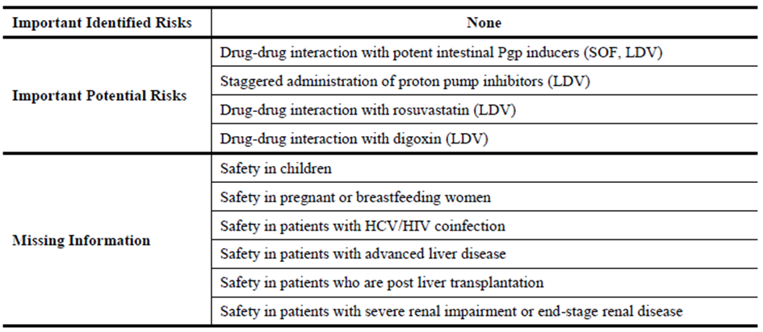

In contrast, the EU-RMP provides the following summary of the ongoing safety concerns as shown in Table 8.

Table 8: Ongoing safety concerns (EU-RMP).

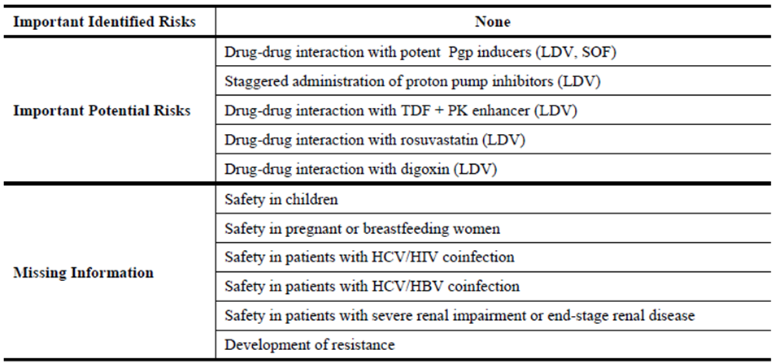

Furthermore the RMP Advice – Post Round 2 for SOF 400 mg tablet (27 June 2014) states:

*The following should be added as ongoing safety concerns:*

*Important Potential Risk*

* + - *Drug resistance (including cross-resistance); and*

*Missing Information*

* + - *Treatment experienced patients (antiviral medicines) (as indicated by the sponsor in the revised PI);*
    - *History of solid organ transplantation (post-liver transplant patients indicated by the sponsor in the revised PI);*
    - *Long-term safety (as indicated by the sponsor in the revised PI);*
    - *Patients with portal hypertension;*
    - *Patients awaiting liver transplantation;*
    - *Patients with untreated HIV co-infection (as indicated by the sponsor in the revised PI);*
    - *Patients with HBV co-infection (as indicated by the sponsor in the revised PI); and*
    - *Effectiveness of hormonal contraception.*

*It is noted that the sponsor has agreed to add the following to the list ongoing safety concerns:*

* + - *Patients with genotypes 5 or 6 HCV infections;*
    - *Asian patients;*
    - *Patients over 65; and*
    - *Use with agents other than ribavirin and peginterferon alfa.*

#### Pharmacovigilance plan

The sponsor proposes routine pharmacovigilance activities to monitor all the specified ongoing safety concerns. However, there does not appear to be any description of the sponsor’s routine pharmacovigilance systems in Australia.

The AU-RMP states that the following additional pharmacovigilance activities are proposed to further characterise the specified ongoing safety concerns in Australia:

* For the important potential risk: ‘Drug-drug interaction with potent intestinal Pgp inducers (SOF, LDV)’, a planned Phase I study to evaluate the pharmacokinetic drug-drug interaction and safety of SOF when co-administered with rifampicin is proposed (GS-US-334-0144). No protocol is available for this study.
* For the important missing information: ‘Safety in children’, a planned two part, open label, single arm study to investigate pharmacokinetics, biodistribution, efficacy and safety of SOF/LDV for 12 weeks in adolescents and children with GT-1-6 chronic HCV infection is proposed (BP-US-337-0104). No protocol is available for this study, although the table ‘Required Additional Pharmacovigilance Activities’ appears to indicate date of initiation to be November 2014. Furthermore a planned 5 year follow-up study of paediatric patients to evaluate growth, development, and viral relapse in adolescents and children who received SOF/LDV in Study BP-US-337-0104 is proposed. No protocol is available for this study.
* For the important missing information: ‘Safety in patients with HCV/HIV co-infection’, ongoing clinical studies are being conducted to assess the safety and efficacy of SOF/LDV in patients with HCV/HIV co-infection (GS-US- 337-0115, CO-US-337-0116, CO-FR-337-1321). Protocols for these studies have been provided.
* For the important missing information: ‘Safety in patients with advanced liver disease’ & ‘Safety in patients who are post liver transplantation’, ongoing clinical studies are being conducted to assess the safety and efficacy of SOF/LDV+RBV in patients with advanced liver disease and in patients who are post liver transplantation (GS-US-337-0123, GS-US-337-0124). Protocols for these studies have been provided.
* For the important missing information: ‘Safety in patients with severe renal impairment or end-stage renal disease’, a clinical study has been initiated to assess the safety, efficacy and pharmacokinetics of SOF+RBV in subjects with chronic genotype 1 or 3 HCV infection and severe renal impairment (GS-US-334-0154). A protocol for this study has been provided.

In contrast, the EU-RMP states that the following additional pharmacovigilance activities are proposed to further characterise the specified ongoing safety concerns in Europe:

* For the important potential risk: ‘Drug-drug interaction with TDF + PK enhancer (LDV)’ and the important missing information: ‘Safety in patients with HCV/HIV co-infection’, a planned prospective observational drug utilisation study to characterise the frequency of post-marketing co-use of LDV/SOF+TDF+PK enhancer in adult HCV/HIV co-infected patients and the rates of renal ADRs is proposed. Annex 6 states that no protocol is available for this study.
* For the important missing information: ‘Safety in children’, a planned 2-part, open-label, single-arm study to evaluate the PK, efficacy, and safety of LDV/SOF for 12 weeks in adolescents and children with GT-1-6 chronic HCV infection is proposed (GS-US-337-1116, formerly GS-US-337-0104). No protocol is available for this study, although table: ‘Required Additional Pharmacovigilance Activities (Category 3)’ indicates that this study was to be initiated in October 2014. Furthermore, a planned 5-year follow-up study of paediatric patients to evaluate growth, development, and viral relapse in adolescents and children who received SOF/LDV in Study GS-US-337-1116 is proposed (BP-US-337-1117). No protocol is available for this study.
* For the important missing information: ‘Safety in patients with HCV/HBV co-infection’, one cohort from a Phase II, multicentre, open label clinical study to assess the safety and efficacy of combination therapy with SOF containing regimens for the treatment of chronic HCV infection has been initiated (Electron 2: GS-US-337-0122). A protocol for this study has been provided.
* For the important missing information: ‘Development of resistance’, an ongoing long term follow-up registry study is being conducted to evaluate HCV viral sequences and the persistence or evolution of treatment-emergent viral mutations in subjects who fail to achieve an SVR after treatment with a Gilead oral antiviral containing regimen in a previous Gilead sponsored hepatitis C study (GS-US-248-0123). A protocol for this study has been provided. Furthermore, an ongoing open label, multicentre clinical study is being conducted to determine the efficacy of SOF/LDV ± RBV and to evaluate the emergence of viral resistance to LDV and SOF during and after treatment discontinuation (GS-US-337-1118). A protocol for this study has been provided.

#### Risk minimisation activities

The sponsor has concluded that routine risk minimisation activities for all the specified ongoing safety concerns are sufficient, except for the important missing information: ‘Safety in patients with HCV/HIV co-infection’, ‘Safety in patients with advanced liver disease’ & ‘Safety in patients who are post liver transplantation’ for which no risk minimisation is proposed.

#### Reconciliation of issues outlined in the RMP report

##### Recommendation #1 in RMP evaluation report

The RMP Questions and Answers (Version 1.3, October 2012), as found on the TGA website, states that when an existing EU RMP is available, the TGA strongly recommends submission of the EU-RMP with an ASA. Consequently, it is strongly recommended that the sponsor submit such an ASA to the current EU-RMP.

##### Sponsor response

Gilead has provided an ASA and wishes for this to be used in conjunction with EU-RMP version 0.2 (19 August 2014) which was submitted to TGA on 23 September and is re-provided. The proposed ASA is version 0.1, dated November 2014. Upon TGA approval of the ASA, the version will be updated to v1.0 and the date will be amended to reflect the date of TGA approval.

##### OPR evaluator’s comment

This is acceptable.

##### Recommendation #2 in RMP evaluation report

Safety considerations may be raised by the nonclinical and clinical evaluators through the consolidated Section 31 request and/or the nonclinical and clinical evaluation reports, respectively. It is important to ensure that the information provided in response to these include a consideration of the relevance for the RMP, and any specific information needed to address this issue in the RMP. For any safety considerations so raised, the sponsor should provide information that is relevant and necessary to address the issue in the RMP.

##### Sponsor response

The sponsor states that it did not receive the TGA nonclinical evaluation at the time of the RMP evaluation report and no changes were proposed by the clinical evaluator.

##### OPR evaluator’s comment

The sponsor should explain the discrepancy observed in the Nonclinical Safety Specification of the draft RMP for Australia (Version 0.1) by the nonclinical evaluator.

##### Recommendation #3 in RMP evaluation report

Notwithstanding the evaluation of the nonclinical and clinical aspects of the Safety Specification, the sponsor should systematically identify and justify any differences between the related summaries of ongoing safety concerns. Any subsequent changes to the summary of the ongoing safety concerns in the current EU-RMP specific to Australia must be entirely captured in an ASA to be provided to the TGA for review. In addition, consideration must be given to proposing appropriate pharmacovigilance and risk minimisation activities for any new ongoing safety concerns, to be reflected accordingly in this ASA.

##### Sponsor response

Gilead provides an assurance that a table illustrating the ongoing safety concerns specific to Australia has been captured in the ASA provided. Gilead has also taken this opportunity to incorporate the applicable Australian specific safety concerns that were identified during the evaluation of SOF 400 mg tablets AUST R 211019. These differences are also highlighted in the ASA provided.

##### OPR evaluator’s comment

This is acceptable.

##### Recommendation #4 in RMP evaluation report

As per the RMP Questions and Answers (Version 1.3, October 2012) as found on the TGA website, a description of the sponsor’s routine pharmacovigilance systems in Australia should be provided in an ASA, including an assurance that routine pharmacovigilance activities conducted in Australia are in accordance with the current Australian requirements and recommendations for pharmacovigilance responsibilities of sponsors of medicines.

##### Sponsor response

Gilead provides an assurance that description of the Gilead’s routine pharmacovigilance systems in Australia is provided in the ASA. In addition, an assurance that routine pharmacovigilance activities conducted in Australia are in accordance with the current Australian requirements and recommendations for pharmacovigilance responsibilities of sponsors of medicines has been included in the ASA included.

##### OPR evaluator’s comment

This is acceptable.

##### Recommendation #5 in RMP evaluation report

The sponsor should systematically identify and justify any differences between the additional pharmacovigilance activities for Australia and Europe. Any subsequent changes to the pharmacovigilance plan in the current EU-RMP specific to Australia must be entirely captured in an ASA to be provided to the TGA for review. At least draft protocols for any planned studies should also be submitted. If they are not yet available, the sponsor should provide an assurance that draft protocols for these studies will be provided to the TGA once they become available.

##### Sponsor response

Gilead provides an assurance that a table illustrating the ongoing safety concerns specific to Australia has been captured in the ASA provided.

##### OPR evaluator’s comment

This is acceptable.

##### Recommendation #6 in RMP evaluation report

The ongoing and initiated studies are not considered to be part of the planned clinical studies in the pharmacovigilance plan. Therefore, the related study documentation has not been reviewed. Nevertheless, the studies referenced in the PP will generate safety data that either simply support the known safety profile of the medicine or generate data that will provoke applications to amend the Australian registration details. To this end, it is suggested that the sponsor provide an attachment to the ASA setting out all the forthcoming studies and the anticipated dates for their submission in Australia.

##### Sponsor response

A table outlining forthcoming studies and anticipated dates for submission in Australia is provided. To note, these timelines are estimates only and may change depending on global filing dates.

##### OPR evaluator’s comment

This is acceptable.

##### Recommendation #7 in RMP evaluation report

The sponsor should systematically identify and justify any differences between the information relating to the potential for medication error provided in the AU-RMP and the EU-RMP. Any subsequent changes to the information relating to this matter in the current EU-RMP specific to Australia must be entirely captured in an ASA to be provided to the TGA for review.

##### Sponsor response

The EU-RMP section concerning potential for medication errors (Section 6.4) was updated during evaluation (version 0.2) and is now applicable to Australia. There are therefore no differences to Australia and as such, not captured in the ASA.

##### OPR evaluator’s comment

This is acceptable.

#### Summary of recommendations

It is considered that the sponsor’s response to the TGA Section 31 Request has not adequately addressed all of the issues identified in the RMP evaluation report.

##### Outstanding issues

###### Issues in relation to the RMP

The sponsor was asked to respond to safety considerations raised by the nonclinical and clinical evaluators through the consolidated Section 31 request and/or the nonclinical and clinical evaluation reports, respectively, in the context of relevance to the RMP. The sponsor states that it did not receive the TGA nonclinical evaluation at the time of the RMP evaluation report and no changes were proposed by the clinical evaluator. Nevertheless, the sponsor should explain the discrepancy observed in the nonclinical Safety Specification of the draft RMP for Australia (Version 0.1) by the nonclinical evaluator.

The sponsor was advised that a risk minimisation activities table detailing all planned risk minimisation measures in the Australian context and the EU-RMP context should be provided in an ASA, taking into account any changes made to the summary of the ongoing safety concerns for Australia. This table should include a comparison of the actual content and wording of the EU Summary of Product Characteristics (SmPC) and the proposed Australian PI and Consumer Medicine Information (CMI) for all of the specified ongoing safety concerns and missing information to identify and provide reasons for any observed differences, particularly where it appears the EU SmPC is more restrictive. Upon receipt of such information specific recommendations to the Delegate in regard to the proposed routine risk minimisation activities can then be made. The sponsor has responded by stating:

*Gilead provides an assurance that a table identifying risk minimization measures in Australia and EU is provided (ASA), however as previously outlined above, a consolidated Section 31 for Harvoni was not provided to Gilead and as such, the PI and CMI may be updated post submission of the RMP response due to differing deadlines. Gilead provides a commitment that the ASA will be updated to reflect the final TGA approved wording following Harvoni approval in June 2015.*

However, table ‘Summary Table of Risk Minimization Measures’ does not include all the missing information for SOF as outlined in SOF AU-RMP which is applicable to Harvoni, as stated: ‘How risk minimization activities will be implemented in Australia’ of the ASA. In addition no detail regarding labelling has been provided for the missing information: ‘Drug resistance’. These oversights should be corrected in a revised ASA, preferably before this application is approved. Furthermore the sponsor should provide justification for not updating the ‘Precaution’ section of the Australian PI to state that the safety and efficacy of Harvoni has not been established in patients co-infected with HIV, while it does so for patients co-infected with HBV. It is noted that similar precautionary statements are proposed in the EU SmPC.

It was recommended to the Delegate that the EU SmPC posology statement:

*Harvoni treatment should be initiated and monitored by a physician experienced in the management of patients with CHC*

or similar wording be included in the ‘Dosage and Administration’ section of the Australian PI to enhance safe use of this medicine. Any such change should be adequately reflected in the draft CMI document. The sponsor has responded by stating:

*As stated in the TGA RMP evaluation report for Harvoni, the draft PI and CMI documents should NOT be revised until the Delegate’s Overview has been received, therefore Gilead has not provided edits or comments on the proposed draft product information or consumer information in regard to the RMP evaluation report as mentioned above.*

Consequently, this recommendation remains outstanding and should be adequately addressed preferably before this application is approved.

The sponsor was advised that a table summarising the pharmacovigilance and risk minimisation activities for all of the specified ongoing safety concerns and missing information proposed for Australia should be included in an ASA. The sponsor has responded by stating:

*A table summarizing the pharmacovigilance and risk minimization activities for all of the specified ongoing safety concerns and missing information proposed for Australia is provided in the ASA. Applicable information concerning SOF aligned to the SOF AU-RMP (version 1.0, provided to TGA on 06 October 2014) is included in the Harvoni ASA.*

However, table ‘Summary Table of Pharmacovigilance and Risk Minimisation activities proposed in Australia’ does not include all the missing information for SOF as outlined in SOF AU-RMP which is applicable to Harvoni, as stated: ‘How risk minimization activities will be implemented in Australia’ of the ASA. This oversight should be corrected in a revised ASA, preferably before this application is approved.

The sponsor was advised that the Advisory Committee on the Safety of Medicines (ACSOM) would be asked to comment on the adequacy of the summary of the ongoing safety concerns in the submitted AU-RMP. In particular, were there additional safety concerns that would require specific consideration with regard to post-market monitoring and/or additional risk minimisation measures? Furthermore, the committee would be asked whether it agrees that the important missing information: ‘Development of resistance’ and the additional pharmacovigilance activities proposed for this ongoing safety concern in the EU should also be adopted in Australia. In particular were the additional pharmacovigilance activities for the important missing information: ‘Development of resistance’ adequate and if it is not could the committee outline what other additional pharmacovigilance activities might be required. Consequently, the committee made the following recommendations which the sponsor should adequately address, revising the ASA if so required, preferably before this application is approved (see attached ratified advice for further detail):

* The committee advised that the safety concern list provided by the sponsor should be extended to include cardiotoxicity.
* The sponsor has identified an Important Potential drug-drug interaction with rosuvastatin. The committee advised that this needed to be broadened to refer to the possibility of interaction with other statins.
* In general, the committee noted the need for the sponsor to provide undertaking to contribute ongoing utilisation and pharmacovigilance data to Australian surveillance and regulatory systems, such as the National Centre in HIV Epidemiology and Clinical Research (NCHECR), especially of patients with co-morbidities or complex conditions.
* the sponsor should be requested to clarify the Use in Pregnancy categorisation for Harvoni therapy and when Harvoni is used in combination with other therapies; and
* the European Summary of Product Characteristics mentions the potential interaction with dabigatran and this should also be added to the PI.

###### Advice from ACSOM

The committee provided advice on specific questions asked by the TGA relating to a RMP.

* Can the committee comment on the adequacy of the safety concern list provided by the sponsor? In particular, are there additional safety concerns that would require specific consideration with regard to post market monitoring and/or additional risk minimisation measures?

The committee noted that the incidence of serious adverse events (SAEs) was low.

The committee advised that the safety concern list provided by the sponsor should be extended to include cardiotoxicity. Mitochondrial toxicity did not require additional emphasis in the summary of safety concerns. The committee noted that the Missing Information on safety in patients who are post liver transplantation will be addressed in one of the ongoing clinical studies.

The Missing Information on the development of resistance will be more important in the populations requiring longer term therapy, such as transplant and immunocompromised patients, compared to patients achieving SVR within 8 weeks of therapy.

The sponsor has identified an Important Potential drug-drug interaction with rosuvastatin. The committee advised that this needed to be broadened to refer to the possibility of interaction with other statins.

* Does the committee agree that the important missing information: ‘Development of resistance’ and the additional pharmacovigilance activities proposed for this ongoing safety concern in the EU should also be adopted in Australia? Can the committee comment on the adequacy of these additional pharmacovigilance activities for the important missing information: ‘Development of resistance’? If it is not considered to be adequate, can the committee outline what other additional pharmacovigilance activities might be required?

The committee advised that the proposed pharmacovigilance activities were generally adequate, but agreed that the additional activities proposed in the EU for the ‘development of resistance’ should also be adopted in Australia.

In general, the committee noted the need for the sponsor to provide undertaking to contribute ongoing utilisation and pharmacovigilance data to Australian surveillance and regulatory systems, such as the National Centre in HIV Epidemiology and Clinical Research (NCHECR), especially of patients with co-morbidities or complex conditions.

The committee also advised that:

* information obtained from post-marketing experience should be promptly included in updates to the PI so as to further assist prescribers;
* the sponsor should be requested to clarify the Use in Pregnancy categorisation for Harvoni therapy and when Harvoni is used in combination with other therapies; and
* the European SmPC mentions the potential interaction with dabigatran and this should also be added to the PI.

##### Comments on the safety specification of the RMP

###### Clinical evaluation report

The Safety Specification in the draft RMP is satisfactory.

The sponsor provided new clinical information after the first round but did not change the Safety Specification in the draft RMP. After consideration of the new clinical information, the Safety Specification in the draft Risk Management Plan is satisfactory.

###### Nonclinical evaluation report

Results and conclusions drawn from the nonclinical program for LDV detailed in the sponsor’s draft RMP for Australia (Version 0.1) are in general concordance with those of the nonclinical evaluator. The statement in relation to carcinogenicity of SOF in mice is not accurate. Doses up to 600 mg/kg/day were tested in females, males were only tested up to 200 mg/kg/day.

##### Key changes to the updated RMP

In their response to the TGA Section 31 requests, the sponsor provided an ASA (Version 0.1, dated November 2014). Key changes from the AU-RMP (Version 0.1, dated 1 April 2014) evaluated at Round 1 are summarised:

* The important potential risk: ‘Drug-drug interaction with TDF + PK enhancer (LDV)’ and the missing information: ‘Safety in patients with HCV/HBV co-infection’ & ‘Drug resistance’ have been added as safety concerns.
* The sponsor has justified why the missing information: ‘Safety in patients who are post liver transplantation’ & ‘Safety in patients with severe renal impairment or end-stage renal disease’ has been deleted.
* Section 3.1: ‘How risk minimization activities will be implemented in Australia’ states that the following missing information for SOF as outlined in SOF AU-RMP is also applicable to Harvoni:
  + Patients with portal hypertension
  + Patients with untreated HIV co‐infection
  + Patients with HBV co‐infection
  + Effectiveness of hormonal contraception
* Table 1-1: ‘Summary Table of Safety Concerns (Differences in Europe and Australia)’ has been added.
* Table 2-2: ‘Summary Table of Safety Concerns (Differences in HARVONI and SOVALDI Australia)’ has been added.
* Table 3: ‘Summary Table of Risk Minimization Measures’ has been added.
* Table 4: ‘Summary Table of Pharmacovigilance and Risk Minimisation activities proposed in Australia’ has been added.

##### Suggested wording for conditions of registration

###### RMP

At this time no wording can be provided, as it is recommended that an acceptably revised ASA be submitted before this application is approved.

## VI. Overall conclusion and risk/benefit assessment

The submission was summarised in the following Delegate’s overview and recommendations:

### Quality

From a pharmaceutical chemistry perspective, the evaluator has no objection to the registration of the proposed FDC film coated tablets containing 90 mg LDV and 400 mg SOF, in HDPE bottles with child resistant PP caps containing 28 tablets. All issues raised during the initial evaluation of this application have been satisfactorily resolved.

As no significant pharmaceutical chemistry issues were identified, the submission was not referred to the Pharmaceutical Subcommittee of the ACPM, in keeping with recent branch policy.

### Nonclinical

The nonclinical evaluator considers that the overall quality of the nonclinical dossier was good with all pivotal studies conducted according to GLP. It is noted that there were no combination toxicity studies with LDV and SOF. The evaluator made the following conclusion and recommendations to the Delegate:

* There are no major deficiencies.
* Primary pharmacology studies established anti-HCV activity against HCV genotype 1 and other genotypes, and the efficacy of LDV against an infectious HCV genotype in vitro.
* No clinically relevant hazards were identified in LDV safety studies.
* LDV is an inhibitor of drug transporter P-gp and BCRP and may increase intestinal absorption of co-administered drug substrates for these transporters. The absorption of both SOF and LDV may be increased by administration of inhibitors or decreased by administration of inducers of intestinal efflux transporters.
* No major organ toxicities were observed with LDV in repeat-dose studies in any species. Drug exposures were limited by the low solubility of LDV, but were adequate. There were no toxicity studies with the LDV/SOF combination.
* LDV was negative in standard genotoxicity assays. Carcinogenicity studies in mice and rats with SOF were negative. LDV carcinogenicity studies are in progress in mice and rats and should be submitted upon completion (December 2015).
* There was no evidence of developmental toxicity with LDV and Australian Pregnancy category B1 is appropriate.
* There are no nonclinical objections to the registration of LDV.
* Based on the nonclinical data provided in this submission for LDV and evaluated in the previous submission for SOF, there are no nonclinical objections to the registration of Harvoni for treatment of genotype 1 infection.
* No changes to the PI are recommended but the RMP should be corrected as directed.

### Clinical

#### Pharmacokinetics and pharmacodynamics

A total of 25 clinical pharmacology studies were conducted to characterise the PK of LDV and SOF when used as single agents or as the FDC. These studies have been discussed in detail in the clinical evaluation report. SOF is a pro-drug that undergoes extensive metabolism. Its active form is GS-461203 and it appears in the serum as (and is excreted as) GS-331007. Clearance of GS-331007 is primarily renal and is correlated with CLCR. Hence, in ESRF there could be accumulation. The pharmacokinetic and pharmacodynamic characteristics of SOF have been evaluated in previous submission and will not be discussed in detail here.

The pharmacokinetic and pharmacodynamic characteristics of LDV and the FDC of SOF/LDV are briefly summarised below:

* Absolute bioavailability studies were not provided for LDV due to the low solubility of LDV. LDV appears to have solubility limited absorption at oral doses greater than 100 mg in the fed state.
* Food decreased LDV bioavailability by 50% at the 30 mg dose level, with no effect on half-life. The exposures (to LDV and to GS-331007) were similar when SOF/LDV (FDC 400 mg/90 mg) was administered with or without food. It is also noted that SOF/LDV has been administered without regard to food throughout the clinical development program.
* LDV was dose proportional for Cmax and AUC in the dose range 3 mg to 100 mg.
* Volume of distribution is in the range of 876 to 1256 L. The high volume of distribution indicates extensive tissue distribution.
* LDV is >99.8% bound to human plasma protein
* LDV undergoes limited metabolism. Following a single dose of 90mg LDV, systemic exposure was almost exclusively to the parent drug. LDV is predominantly excreted by the faecal route. Renal clearance of LDV is minimal.
* Renal clearance is significant for determining GS-331007 exposure. However, there was no effect of renal clearance on LDV. Dose adjustment for LDV is not considered necessary in subjects with mild, moderate or severe hepatic impairment. Dose adjustment of LDV is not necessary in subjects with renal impairment.
* There was an increase in LDV clearance (26.7%) in healthy volunteers compared to subjects with HCV. Relative to healthy subjects, LDV exposure (AUC 0-24) was 24% lower in HCV subjects.
* Age, race, body mass index (BMI) had no clinically relevant effects on the on PK variables of LDV. There was a decrease in LDV clearance (-33%) in females which translated to an increase in AUC of 49%. Exposure to SOF and LDV was similar in Japanese and Caucasian subjects.
* There were no data relating to polymorphisms in transporters and effect on LDV pharmacokinetics.
* There was no indication of QTC prolongation of regulatory interest with LDV at a dose of 120 mg. However, 120 mg is only 33% higher than the proposed dosing regimen.
* LDV is a substrate of P-gp and BCRP. LDV is also a moderate to weak inhibitor of P-gp and BCRP. There is evidence of interactions with drugs that induce or inhibit transporters, but the clinically significant interactions were with drugs such as rifampin, EFV/FTC/TDF, and DRV/RTV (inducers of transporters) which resulted in decreased exposure to LDV. LDV also inhibits OATP1B1 and OATP1B3. There was some evidence of interactions with digoxin and with pravastatin. Detailed drug interactions have been discussed in detail in the clinical evaluation report
* The pharmacokinetic interactions between SOF and LDV in combination are considered favourable. LDV significantly increased the exposure to SOF, GS-566500 and GS-331007. SOF did not have any significant effect on exposure to LDV.
* The exposures of LDV at doses of ≥30 mg/day would result in >95% maximal response in subjects with GT 1a HCV infection (Study GS-US-0102). Consequently, the 30 mg and 90 mg dose levels of LDV were selected for further development. The 400 mg dose level for SOF appears to have been carried through from the development of SOF.

#### Efficacy

Three open label pivotal Phase III studies were submitted to support this application. Two studies were conducted in treatment naïve subjects (ION-1 and ION-3) and one study was conducted in treatment experienced subjects (ION-2).

##### Treatment naïve patients without cirrhosis: Study 0108 (ION-3)

Study 0108 was a multicentre, randomized, open label study, and the study assessed the efficacy and safety of SOF/LDV FDC ± RBV for 8 weeks and SOF/LDV FDC for 12 weeks in treatment naïve subjects without cirrhosis. The inclusion and exclusion criteria are detailed in the clinical evaluation report. Subjects were randomised in a ratio of 1:1:1, stratified by HCV genotype (1a or 1b). The study treatments were:

* SOF 400mg / LDV 90mg FDC once daily for 12 weeks
* SOF 400mg / LDV 90mg FDC once daily for 8 weeks
* SOF 400mg / LDV 90mg FDC once daily + RBV 1000mg or 1200mg twice daily for 8 weeks

The primary efficacy endpoint was SVR12. A total of 831 subjects were screened and 647 were randomised: 215 to SOF/LDV 8 weeks, 216 to SOF/LDV + RBV 8 weeks, and 216 to SOF/LDV 12 weeks. A total of 639 (98.8%) subjects completed treatment; 8 (1.2%) discontinued, 3 (0.5%) due to AE. There were 375 (58.0%) males, 272 (42.0%) females and the age range was 20 to 75 years. The treatment groups were similar in baseline demographic characteristics. There were 515 (79.6%) subjects with GT1a-HCV and 131 (20.2%) with GT1b-HCV. The treatment groups were similar in baseline disease characteristics. There was greater adherence to treatment regimen in the SOF/ DV FDC only treatment groups.

The results for the primary efficacy outcome (SVR12) are shown in Table 9.

Table 9: Results for the primary efficacy outcome (SVR12).

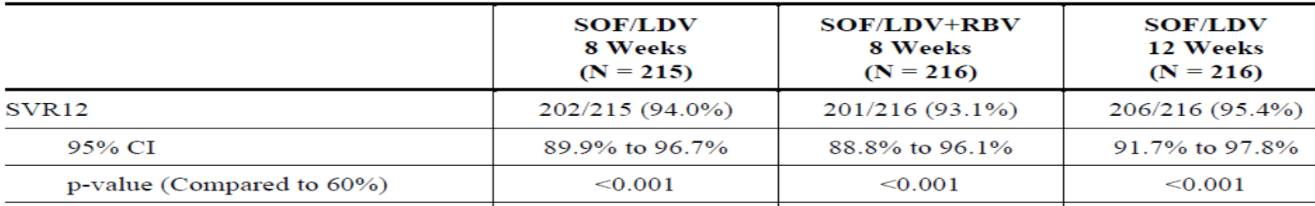

There was no statistically significant difference between the treatment groups in the primary efficacy outcome measure. There was decreased efficacy for subjects with <80% adherence to SOF/LDV FDC. There was similar efficacy for GT1a-HCV and GT1b-HCV.

The results for other efficacy outcomes are as follows:

* There was a higher relapse rate in the 8 week groups compared with the 12 week. Relapse was more likely if subjects were male and/or baseline HCV RNA was ≥800,000 (IU/mL).
* SVR4 rate was similar for the three treatment groups
* The proportion with HCV RNA <LLOQ increased to week 8 on-treatment for all 3 groups.
* HCV RNA decreased rapidly in the first 2 weeks of treatment in all three treatment groups.
* ALT normalisation at follow-up week 4 occurred for 115 (95.0%) subjects in SOF/LDV 8 week group, 122 (91.0%) in the SOF/LDV+RBV 8 week, and 134 (97.1%) in the SOF/ LDV 12 week group.
* 116 (17.9%) subjects were identified as having at least one baseline NS5A RAV by deep sequencing with a 1% assay cut off. Of these, 104 (89.7%) subjects with baseline NS5A RAVs achieved SVR12. Of the 23 subjects that relapsed, ten had NS5A RAVs at baseline; of the 13 that did not, six had emergent NS5A RAVs at relapse.

##### Treatment naïve patients with or without cirrhosis: Study 0102 (ION-1)

Study 0102 was a multicentre, randomised, open label study; and the study assessed the efficacy and safety of SOF/LDV FDC with and without RBV in treatment naïve patients with or without cirrhosis. Although 2 of the 4 treatment groups were treated for 12 weeks and two for 24 weeks, only the 12 week data were reported.

The study treatments were:

* SOF 400 mg/LDV 90 mg once daily for 24 weeks
* SOF 400 mg/LDV 90 mg once daily plus RBV 1000 mg or 1200 mg twice daily for 24 weeks
* SOF 400 mg/LDV 90 mg once daily for 12 weeks
* SOF 400 mg/LDV 90 mg once daily plus RBV 1000 mg or 1200 mg twice daily for 12 weeks

The primary efficacy endpoint was SVR12. Subjects were randomized in a ratio of 1:1:1:1. The full analysis set (FAS) included all subjects who were randomized and received at least one dose of study drug. A total of 1015 subjects were screened and 870 were randomised to treatment: 217 to SOF/LDV 12 weeks, 218 to SOF/LDV + RBV 12 weeks, 217 to SOF/LDV 24 weeks, and 218 to SOF/LDV + RBV 24 weeks. The FAS included 865 (99.4%) subjects; 838 (96.6%) completed treatment and 27 (3.1%) discontinued. There were 513 (59.3%) males, 352 (40.7%) females and the age range was 18 to 80 years. The demographic characteristics were balanced between the treatment groups. There were 581 (67.2%) subjects with GT1a-HCV and 273 (31.6%) with GT1b-HCV; and 136 (15.7%) subjects with cirrhosis. Baseline disease characteristics were similar for the four treatment groups. In the 12-week treatment groups, there was 97.2% adherence to SOF/LDV when administered alone and 95.4% when administered with RBV.

The results of SVR12 for subjects (FAS) in the 12 weeks treatment group are as shown in Table 10.

Table 10: Results of SVR12 for subjects (FAS) in the 12 weeks treatment group.

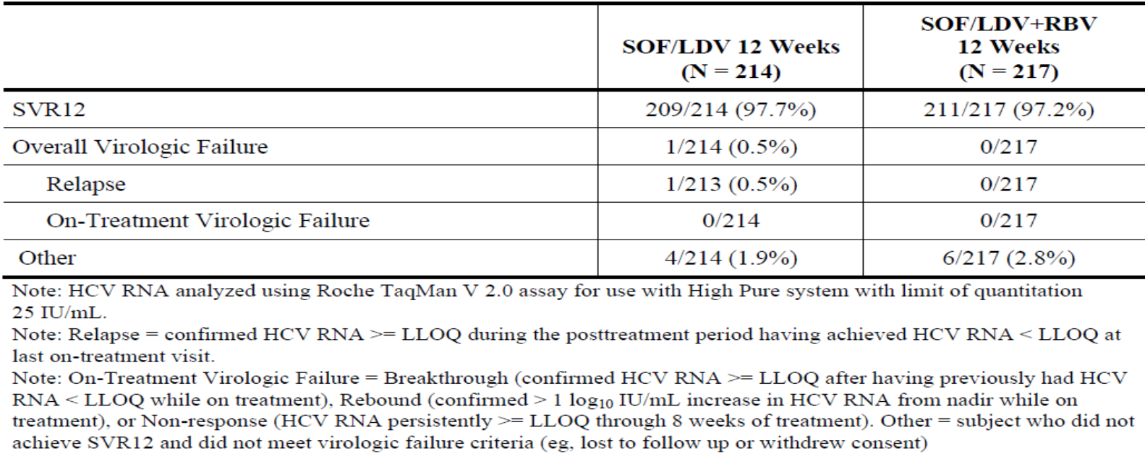

* SVR12 was achieved by 209 (97.7%) subjects in the SOF/LDV 12 week group, 95% CI 94.6% to 99.1%, p <0.001
* SVR12 was achieved by 211 (97.2%) subjects in the SOF/LDV + RBV 12 week group, 95% CI 94.1% to 99.0%, p <0.001

There was no effect on response for demographic characteristics. SOF/LDV FDC was equally effective for GT1a and GT1b-HCV and baseline disease characteristics did not influence efficacy. However, subjects with <80% adherence to study treatment had reduced efficacy.

The results for other efficacy outcomes are as follows:

* There was one subject in the SOF/LDV 12 week group with overall virological failure (VF). No subject in the SOF/LDV + RBV 12 week group had overall virological failure.
* SVR4 was achieved by 211 (98.6%) subjects in the SOF/LDV 12 week group, SVR4 was achieved by 213 (98.2%) subjects in the SOF/LDV+RBV 12 week group.
* There were 197 subjects that had post treatment week 12 and 24 data available and all of the subjects with SVR12 response also had SVR24 response.
* In all the treatment groups, near maximal response was achieved by Week 8 on-treatment
* ALT normalisation occurred for 87.1% to 93.0% of affected subjects.
* RAVs were reported in 32 (15.0% subjects in the SOF/LDV 12 week group, and 36 (16.7%) in the SOF/LDV + RBV 12 week group. The one subject in the 12 week group who relapsed did not develop a RAV

##### Treatment-experienced subjects: Study 0109 (ION-2)

Study 0109 was a multicentre, randomised, open label study to assess the efficacy and safety of SOF/LDV FDC ± RBV for 12 and 24 weeks in treatment-experienced subjects with chronic GT1-HCV. The data to Week 12 were included in the report (which is an interim report).The inclusion and exclusion criteria were the same as ION-1 except for the following inclusion criteria:

* Had prior virologic failure after treatment with a Peg-IFN + RBV regimen, including those who had failed treatment with an NS3/4A PI + Peg-IFN+RBV regimen. Subjects must not have discontinued prior therapy due to an adverse event (AE). Virologic failure included:
  + Non-response: Subject did not achieve undetectable HCV RNA while on treatment.
  + Relapse/Breakthrough: Subject achieved undetectable HCV RNA during treatment or within 4 weeks of the end of treatment, but did not achieve SVR.

Study treatments were

* SOF 400 mg / LDV 90 mg once daily for 24 weeks
* SOF 400 mg / LDV 90 mg once daily +RBV 1000 mg or 1200 mg twice daily for 24 weeks
* SOF 400 mg / LDV 90 mg once daily for 12 weeks
* SOF 400 mg / LDV 90 mg once daily + RBV 1000 mg or 1200 mg twice daily for 12 weeks

The primary efficacy endpoint was SVR12 in the FAS. The test of efficacy was that the response rate was greater than the historical response rate of 25%. Randomisation was in a ratio of 1:1:1:1, stratified by HCV genotype (1a or 1b), the presence or absence of cirrhosis at screening, and response to prior HCV therapy (relapse/breakthrough or nonresponse) at screening. Enrolment was managed so that approximately 20% of randomised subjects had compensated cirrhosis and approximately 50% of randomised subjects had failed prior treatment with a protease inhibitor (PI) + Peg-IFN + RBV regimen.

A sample size of 100 subjects in each treatment group provided over 99% power to detect at least a 45% improvement in the SVR12 from the adjusted historical null rate of 25% using a 2-sided exact 1-sample binomial test at a significance level of 0.0125 based on a Bonferroni correction. There were 551 subjects screened and 441 randomized to treatment: 109 subjects to the SOF/LDV FDC 12 Week group, 111 subjects to the SOF/LDV FDC + RBV 12 Week, 110 subjects to the SOF/LDV FDC 24 Week, and 111 subjects to the SOF/LDV + RBV 24 Week. A total of 437 (99.3%) subjects completed the study, and no subjects discontinued because of AE. There were 287 (65.2%) males, 153 (34.8%) females and the age range was 24 to 75 years. The groups were similar in demographic characteristics. There were 347 (78.9%) subjects with GT1a-HCV and 93 (21.1%) with GT1b-HCV. The treatment groups were similar in disease characteristics and prior HCV treatment.

Results for the primary efficacy outcome (SVR12) are as shown in Table 11.

Table 11: Results for the primary efficacy outcome (SVR12).

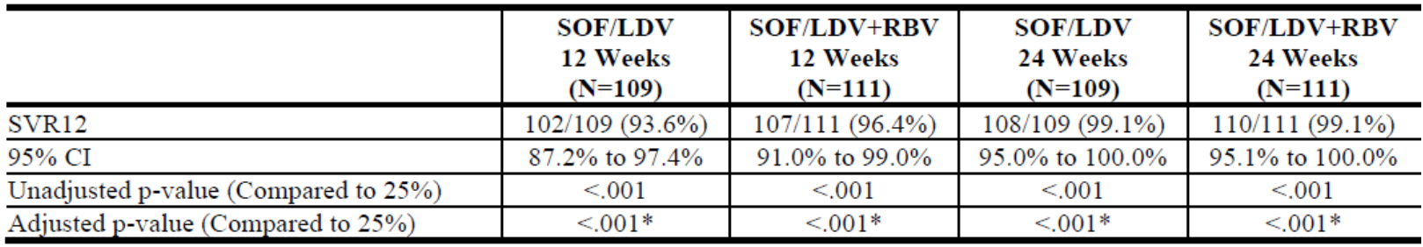

There was no effect on response for demographic characteristics. SOF/LDV was equally effective for GT1a and GT1b-HCV and baseline disease characteristics did not influence efficacy. However, in the SOF/LDV group, subjects with <80% adherence to study treatment had reduced efficacy.

The results for other efficacy outcomes are detailed in the CER. Of note, the overall virological failure was reported in 7 (6.4%) subjects in the SOF/LDV FDC 12 week group, 4 (3.6%) in the SOF/LDV FDC + RBV 12 week, none in the SOF/LDV FDC 24 week and 1 (0.9%) in the SOF/LDV FDC + RBV 24 week. Relapse was reported in 7 (6.5%) subjects in the SOF/LDV FDC 12 week group, 4 (3.6%) in the SOF/LDV FDC + RBV 12 week, none in the SOF/LDV FDC 24 week and none in the SOF/LDV FDC+RBV 24 week. Relapse risk was increased in subjects with cirrhosis and / or baseline thrombocytopenia. Twelve subjects failed to achieve SVR12, with 11 relapses and one on-treatment failure associated with study drug non-compliance. Of the 12 subjects, 5 of 11 had no baseline RAVs, and the other 7 subjects had baseline NS5A RAVs. All 12 subjects had detectable NS5A RAVs at virologic failure; however no NS5B NI RAVs were detected. Phenotypic analysis showed a reduced susceptibility to LDV, but no change in susceptibility to SOF or RBV. A total of 55 of 62 (88.7%) subjects with baseline NS5A RAVs achieved SVR12 following 12 or 24 weeks of treatment with SOF/LDV FDC ± RBV. In the SOF/LDV 12 Week group, 13 of 17 (76.5%) subjects with baseline NS5A RAVs achieved SVR12 (four relapsed), and 15 of 17 (88.2%) subjects in the SOF/LDV FDC + RBV 12 Week group achieved SVR12 (two relapsed).

##### Other efficacy studies

**Study 0118** was a Phase II, randomised, open label study of SOF/LDV FDC ± RBV in subjects with chronic GT1-HCV. There were 2 cohorts: those in Cohort 1 had no prior exposure to any interferon, RBV, or other HCV therapy and had documentation of absence of cirrhosis; those in Cohort 2 had previously experienced virologic failure with an approved or investigational PI + pegylated interferon (PEG) + RBV regimen and had documentation of the presence or absence of cirrhosis. The study treatments were:

* Cohort 1: non-cirrhotic, treatment naïve:
  + Group 1: SOF LDV FDC once daily for 8 weeks
  + Group 2: SOF LDV FDC + RBV 1000 mg or 1200 mg twice daily, once daily for 8 weeks
  + Group 3: SOF/LDV FDC once daily for 12 weeks
* Cohort 2: cirrhotic and non-cirrhotic treatment experienced:
  + Group 4: SOF/LDV FDC once daily for 12 weeks
  + Group 5: SOF LDV FDC + RBV 1000 mg or 1200 mg twice daily, once daily for 12 week

The primary endpoint was SVR12. There were 100 subjects randomised to treatment: 20 to Group 1, 21 to Group 2, 19 to Group 3, 19 to Group 4 and 21 to Group 5. Ninety nine subjects completed the study. There were 87.0% subjects with GT1a and 13.0% with GT1b and 22.0% with cirrhosis.

The results for SVR 12, n (% [95% CI]), were 19 (95.0% [75.1% to 99.9%]) for Group 1, 21 (100% [83.9% to 100.0%]) for Group 2, 18 (94.7% [74.0% to 99.9%]) for Group 3, 18 (94.7% [74.0% to 99.9%]) for Group 4 and 21 (100.0% [83.9% to 100.0%]) for Group 5. Relapse was reported for one (5.0%) subjects in Group 1 and one (5.3%) in Group 4. There was concordance for SVR12 and SVR24. There were insufficient subjects to perform subgroup analyses. Nine subjects had baseline NS5A Resistant-Associated Variants (RAVs) of whom seven achieved SVR12. Two of these subjects relapsed.

**Study 0122** was a Phase II, multicentre, open label study to evaluate safety and efficacy of SOF containing regimens administered for up to 12 weeks in subjects with chronic GT3-HCV infection. The data were presented as an interim report for the two cohorts treated with SOF/LDV ± RBV. The study treatments were:

* SOF/LDV FDC once daily
* SOF/LDV FDC once daily + RBV 1000 mg or 1200 mg, twice daily

Treatment duration was 12 weeks. The efficacy endpoint was SVR12. The study included 51 subjects: 25 in the SOF/LDV FDC group and 26 in the SOF/LDV FDC+RBV. SVR12 was achieved by 16 (64.0%, 42.5% - 82.0%]) in the SOF/LDV FDC group and 26 (100.0%: 86.8% - 100.0%]) in the SOF/LDV FDC+RBV group. Of the 9 subjects (36.0%) who did not achieve SVR12, 8 relapsed.

**Study P7977-0523** was a Phase IIa, multiple dose, open label study to evaluate different regimens of SOF 400mg alone or SOF/LDV for 6, 8, or 12 weeks administered with and without RBV and/or PEG-IFN in subjects with GT 1, 2, or 3 HCV infection and with and without LDV or GS-9669 in subjects with GT 1 HCV infection. Subjects with chronic HCV infection were enrolled in Parts 1 to 6 of this study. Subjects were determined to be non-cirrhotic (except for Groups 16, 17, and 20), and otherwise healthy. Subjects in Groups 16 and 17 were cirrhotic, and subjects in Group 20 had no restrictions on their cirrhosis status. Groups 16 to 21 were treated with SOF/LDV FDC once daily ± RBV twice daily. The efficacy endpoints were HCV RNA at follow-up weeks 4, 8, 12, 24, 36 and 48. There were 68 subjects treated with SOF/LDV FDC; 48 of whom also treated with RBV. SVR12 was achieved by 7 (70%) of subjects with null responder GT1 treated with SOF/LDV FDC for 12 weeks; 9 (100%) of subjects with null responder GT1 treated with SOF/LDV FDC + RBV for 12 weeks; 8 (80%) of subjects with treatment naïve GT2/3 treated with SOF/LDV FDC for 12 weeks; 17 (68%) of subjects with treatment naïve GT1 treated with SOF/LDV for 6 weeks.

Study 0118 was supportive of the pivotal studies but of too small a sample size to be pivotal.

Study 0122 did not support efficacy in subjects with chronic GT3-HCV HCV. Study P7977-0523 did not support efficacy in subjects with GT2-HCV or GT3-HCV infection or a shorter treatment duration of 6 weeks in subjects with GT1-HCV.

#### Safety

The following studies provided evaluable safety data:

* Three pivotal efficacy/safety studies (Study 0102, 0108 and 0109)
* Three other efficacy/safety studies (Study 0118, 0122 and P7977-0523)
* 25 clinical pharmacology studies
* An Integrated Summary of Efficacy and an Integrated Summary of Safety

In the development program for SOF/LDV FDC there were 1952 subjects exposed to SOF/LDV FDC. This included:

* Subjects exposed to SOF/LDV FDC for treatment durations of 8 weeks: 215
* Subjects exposed to SOF/LDV FDC for treatment durations of 12 weeks: 539
* Subjects exposed to SOF/LDV FDC for treatment durations of 24 weeks: 326
* Subjects exposed to SOF/LDV FDC + RBV for treatment durations of 8 weeks: 216
* Subjects exposed to SOF/LDV FDC + RBV for treatment durations of 12 weeks: 328
* Subjects exposed to SOF/LDV FDC + RBV for treatment durations of 24 weeks: 328

There were 1175 (60.2%) males and 777 (39.8%) females. There were 152 (7.8%) subjects aged ≥65 years. There were 1234 (77.2%) subjects with confirmed GT1a-HCV and 356 (22.3%) with GT1b-HCV. There were 169 (10.6%) subjects with cirrhosis.

Overall, SOF/LDV FDC have a favourable safety profile. The most frequently reported TEAEs were fatigue, headache, insomnia, nausea and arthralgia. These TEAEs were more frequent in the groups treated with RBV. Quality of life improved during treatment in those patients treated with SOF/LDV FDC by itself, but decreased in those subjects also treated with RBV.

There were no deaths in the efficacy studies or in the clinical pharmacology studies. SAEs were infrequent and there was no clear pattern attributable to SOF/LDV FDC. There were few discontinuations due to AEs.

One subject had AST or ALT >3xULN and bilirubin >2xULN with no signs of liver disease that resolved on treatment (and was not attributed to SOF/LDV).

Anaemia was reported in up to 9.2% of the subjects treated with RBV.

In the efficacy studies there was a higher than expected rate of significant elevation in serum lipase, but the frequency was ≤ 1.8% in any individual study. Although this may be a feature of the underlying condition, it may also be a safety signal.

The thorough QT study did not indicate any significant QTc prolongation however the dose used in that study was only 33% higher than the proposed dosing regimen.

There were no long term safety data included in the submission. Hence, it is not possible to comment on the long-term safety effects of SOF/LDV FDC.

No post-marketing data were included in the submission.

#### Clinical evaluator’s recommendation

The clinical evaluator identified the following deficiencies in the submission:

* Studies were open label rather than double blind
* Long term follow up data were not presented
* Data for SVR24 were incomplete
* Studies in subjects with HCV/HIV co-infected patients were not included

However, the clinical evaluator is of the view that the potential benefits of SOF/LDV FDC outweigh the deficiencies in the study methodologies. The outcome measures were considered as highly objective which makes the open label design more acceptable. Also, when available, the SVR24 data were in concordance with the SVR12 data. Efficacy has not been demonstrated for HCV genotypes other than GT1-HCV.

The evaluator recommends the approval of Harvoni FDC tablets for the treatment of CHC genotype 1 in adults, but proposes the following treatment duration for the once daily SOF/LDV:

* Treatment naïve without cirrhosis: 8 weeks
* Treatment naïve with cirrhosis: 12 weeks
* Treatment experienced with or without cirrhosis: 24 weeks.

### Risk management plan

* The evaluator identified a number of issues and requested the revisions to the ASA, including the revisions to Table 2, 3 and 4 of the ASA
* The RMP evaluator also requests a number of amendments to the Australian PI

This submission was discussed at the Advisory Committee on the Safety of Vaccines (ACSOV) meeting and the following recommendations are made:

* The safety concern list provided by the sponsor should be extended to include cardio-toxicity.
* In view of the identified potential drug-drug interaction with rosuvastatin, there is a need to refer to the possibility of interaction with other statins.
* The committee noted the need for the sponsor to provide undertaking to contribute ongoing utilisation and pharmacovigilance data to Australian surveillance and regulatory systems, such as the National Centre in HIV Epidemiology and Clinical Research (NCHECR), especially of patients with co-morbidities or complex conditions.
* the sponsor should be requested to clarify the Use in Pregnancy categorisation for Harvoni therapy and when Harvoni is used in combination with other therapies
* The European SmPC mentions the potential interaction with dabigatran and this should also be added to the Australian PI.

RMP evaluator states that at this time no wording can be provided, as it is recommended that an acceptably revised ASA be submitted before this application is approved.

### Risk-benefit analysis

#### Delegate’s considerations

##### Efficacy in treatment-naïve subjects

For treatment naïve subjects, the SVR12 results (SAF) from the two Phase III studies are as shown in Table 12.

Table 12: SVR12 results (SAF) from the two Phase III studies.

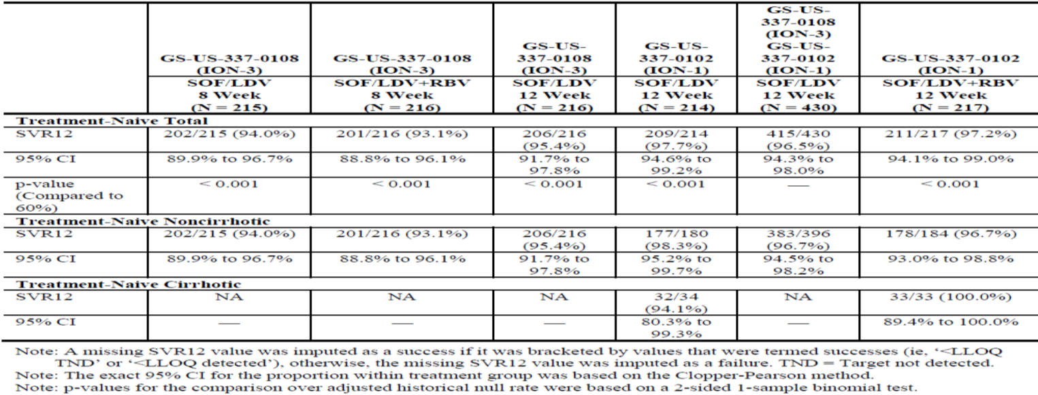

In treatment naïve subjects with or without cirrhosis (ION-1), SVR12 was achieved in 97.7% (94.6% to 99.2%) subjects in the SOF/LDV 12 week group. There was no additional benefit by adding RBV.

In treatment naïve subjects without cirrhosis (ION-3), SVR12 was achieved by 94.0% subjects (89.9% to 96.7%) in the SOF/LDV FDC 8 week group. There was no additional benefit by including RBV. There was a higher relapse rate in the 8 week groups compared with the 12 week group: 5.1% subjects in the 8 week group, 4.2% in the SOF/LDV+RBV 8 week, and 1.4% in the SOF/LDV 12 week group (Table 13).

Table 13: GS-US-337-0108: virologic outcomes (FAS).

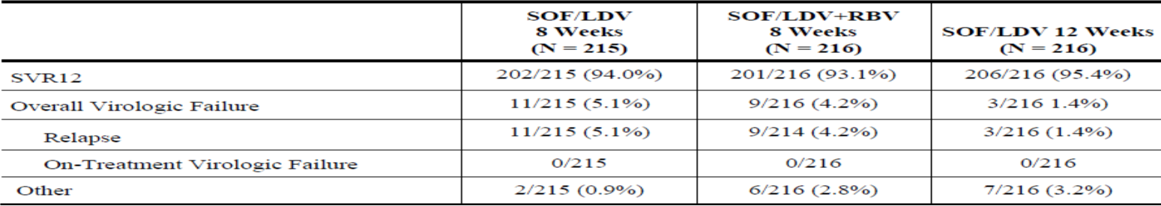

##### Efficacy in treatment experienced subjects

The SVR12 results for treatment experienced subjects in ION 2 are as shown in Table 14.

Table 14: SVR12 results for treatment experienced subjects in ION 2.

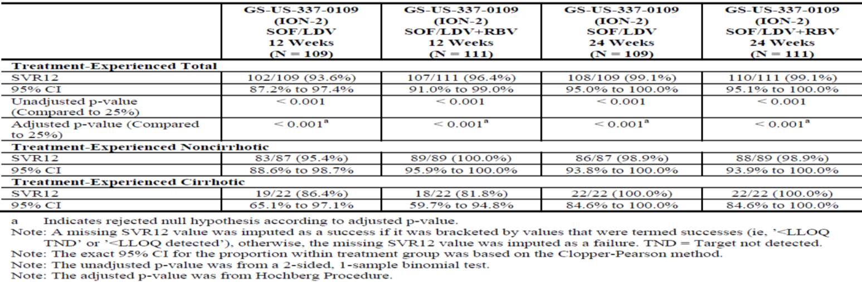

SVR12 was achieved by 93.6% subjects (87.2-97.4%) in the SOF/LDV 12 week group (compared to the historical 25% response rate). There was better efficacy in those subjects treated with RBV and for longer treatment duration. The relapse rates were higher in the groups treated with 12 weeks (3.6-6.5%) compared to those treated for 24 weeks (0-0.9%). The risk of relapse was increased in subjects with cirrhosis and/or baseline thrombocytopenia.

Table 15: GS-US-337-0109: virologic outcomes (FAS).

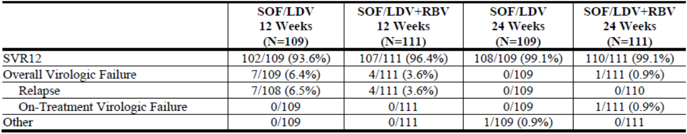

In all three pivotal studies subjects with <80% adherence to study treatment had reduced efficacy. However, there was no effect on response for demographic characteristics and SOF/LDV FDC was equally effective for GT1a-HCV and GT1b-HCV. Baseline disease characteristics did not influence efficacy. Quality of Life decreased during treatment for those subjects treated with RBV. Hence, the place of RBV as add-on therapy may be in those subjects with prior treatment failure, with or without cirrhosis.

Relapse is more likely in subjects with higher viral burden, male gender, cirrhosis, and baseline thrombocytopenia. Relapse was more likely if subjects were male and/or baseline HCV RNA was ≥800,000 (IU/mL).

Baseline NS5A RAVs appear to be more common in subjects who relapse, and treatment emergent NS5A RAVs are more common than NS5B RAVs. In Study 0102 RAVs were reported in 32 (15.0%) subjects in the SOF/LDV 12 week group, and 36 (16.7%) in the SOF/LDV + RBV 12 week group; and the one subject in the 12 week group who relapsed did not develop a RAV. In Study 0108, of the 23 subjects that relapsed, 10 had NS5A RAVs at baseline; of the 13 that did not, six had emergent NS5A RAVs at relapse. In Study 0109 of the 12 subjects that relapsed, 5 of 11 had no baseline RAVs, and the other 7 subjects had baseline NS5A RAVs. All 12 subjects had detectable NS5A RAVs at virologic failure, but no NS5B NI RAVs were detected. Phenotypic analysis showed a reduced susceptibility to LDV, but no change in susceptibility to SOF or RBV.

For treatment naïve non-cirrhotic patients, relapse may not be an immediate concern, as these patients are usually not at immediate risk of disease progression. Furthermore, as these patients have not had prior exposure to a NS3/4A inhibitor and likely have other curative retreatment options. However, for treatment experienced patients with cirrhosis, failure to reach SVR or relapse may be associated with a short term risk of disease progression, and all the available combination DAA treatment options might have reduced efficacy in patients who have pre-selected for viral resistance against both NS3/4A inhibitors and NS5A inhibitors. It is therefore important to avoid unnecessary relapses in patients with cirrhosis and in patients with prior NS3/4A exposure.

#### Summary of issues

Three open label Phase III studies were submitted to support this application. Two studies were conducted in treatment naïve subjects and one study was conducted in treatment experienced subjects.

In treatment naïve subjects without cirrhosis, SVR12 was achieved by about 94.0% subjects in the 8 weeks group and 97.7% in the 12 weeks treatment group. Ribavirin (RBV) does not provide additional benefit. The relapse rate was higher in subjects treated for 8 weeks compared to those treated for 12 weeks.

In treatment experienced subjects, SVR12 was achieved by around 93.6% of the subject in the SOF/LDV 12 week group (compared to the historical 25% response rate). There was better efficacy in those subjects treated with RBV and for longer treatment duration (24 weeks). The relapse rates were higher in the groups treated with 12 weeks (3.6-6.5%) compared to those treated for 24 weeks (0-0.9%).

#### Proposed action

The delegate is of the view that the submitted data has provided supportive evidence for the use of Harvoni (90 mg LDV/400 mg SOF) FDC for the treatment of CHC Genotype 1 infection in adults. The delegate has no objection to the approval of Harvoni FDC tablets for the proposed indication below:

*Harvoni is indicated for the treatment of chronic hepatitis C (CHC) genotype 1 infection in adults.*

The delegate is seeking the advice of the ACPM with regards to the most appropriate treatment duration for treatment naïve or treatment experienced subjects with or without cirrhosis.

#### Request for ACPM advice

The ACPM is requested to provide advice on the following specific issues:

* For treatment naïve subjects without cirrhosis, both the clinical evaluator and the sponsor proposed the 8 weeks treatment with Harvoni. Does ACPM consider that 8 weeks treatment is sufficient for this group and whether the higher relapse rate in the 8 weeks group is of concern?
* For treatment naïve subjects with cirrhosis, both and the clinical evaluator and the sponsor proposed the 12 weeks treatment with Harvoni. Does ACPM agree this is an appropriate treatment regimen?
* For treatment experienced subjects, the sponsor proposes the 12 weeks treatment of Harvoni while the clinical evaluator recommends the 24 weeks treatment of Harvoni. What is the view of the ACPM?

#### Response from sponsor

##### Summary

CHC virus infection is a serious, progressive, and potentially life threatening disease and a major public health concern globally. Worldwide, an estimated 180 million people have CHC.[8] The prevalence of HCV in Australia is estimated to be approximately 1.3%.[9]

HCV has significant genetic (RNA sequence) variability and is classified on this basis into at least 6 genotypes. The most common genotype in Australia is genotype 1 {23136}, whereby the current standard treatment for patients is 12 to 24 weeks of an oral protease inhibitor combined with 24 to 48 weeks of pegylated interferon (Peg-IFN) and ribavirin (RBV), with duration of therapy guided by on-treatment response.[10] Data from the registration studies for these drugs in combination with Peg-IFN+RBV showed sustained SVR rates between 66% and 75% in treatment naive patients with chronic genotype 1 HCV infection.[11] These regimens also provide a treatment option for patients who have previously failed to achieve SVR following interferon (IFN) based therapy. The SVR rates were approximately 70% to 86% and 40% to 59% in prior relapsers and partial responders, respectively.[12] In addition, the SVR rate was 32% in prior null responders following treatment with telaprevir in combination with Peg-IFN+RBV.[13]

There remains a significant unmet medical need for simplified treatment regimens that are more effective than the current standard of care, with better safety/tolerability profiles. The toxicity and tolerability issues associated with Peg-IFN+RBV regimens, which were made worse by the PI-containing regimens, have led to the unwillingness of many patients to be treated. Additionally, a substantial number of patients cannot receive Peg-IFN and/or RBV due to contraindications.[14] Thus, removing Peg-IFN and RBV from the treatment regimen has substantial benefits for improving the tolerability and completion rates of the treatment regimen.

Gilead has developed a direct acting antiviral (DAA) agent Harvoni, a FDC of 2 potent, direct acting antiviral agents, SOF and LDV. Harvoni has the potential to address a significant unmet medical need for an IFN free, all oral treatment for the treatment of chronic genotype 1 HCV infection.

Harvoni is already approved for the treatment of chronic HCV infection in the USA, European Union, Switzerland, Turkey, Canada and New Zealand.

Gilead’s rationale for proposed treatment recommendations for Harvoni is based on the Phase 3 program focused on genotype 1 HCV-infected patients. In 3 Phase III clinical trials 1952 patients were treated with chronic HCV infection, including > 200 patients with compensated cirrhosis and > 200 treatment-experienced patients who have previously failed a PI+PEG-IFN+RBV regimen. Of these, 96.7% (1888 of 1952) of patients achieved sustained virologic response at 12 weeks following treatment completion (SVR12). Of the 3.3% (64 of 1952) of patients who did not achieve a cure, only 1.8% (36 of 1952) relapsed.

Gilead believes that the totality of these data should determine the Harvoni treatment regimen the majority of patients will receive. The collective results from all Harvoni studies support a duration of 8 weeks for non-cirrhotic treatment naive patients and 12 weeks for all other patients.

##### Discussion of delegate’s comments

* *For treatment naïve subjects without cirrhosis, the clinical evaluator and the sponsor proposes the 8 weeks treatment with Harvoni. Does ACPM consider that the 8 weeks treatment is sufficient for this group and whether the higher relapse rate in the 8 weeks is of concern?*

Gilead supports the clinical evaluator’s recommendation that treatment-naïve patients without cirrhosis should be treated for 8 weeks with Harvoni. Gilead advises that 8 weeks of treatment is the optimal duration for treatment-naïve non-cirrhotic patients based on data from Study GS-US-337-0108 (ION-3).

To evaluate the appropriate duration of therapy in treatment naive, non-cirrhotic subjects, an intent-to-treat (ITT) analysis, that controlled for type 1 error, was performed for the predefined primary efficacy endpoint (SVR12). Eight weeks of treatment with Harvoni was non-inferior to 12 weeks Harvoni treatment, with a treatment difference of -2.3% (97.5% CI: -7.2 to 2.5). Overall, 94 of every 100 patients (94%) were cured with 8 weeks of treatment.

While Gilead recognises that SVR12 may not provide a complete picture regarding differences between 8 weeks and 12 weeks treatment with Harvoni, there are good reasons to weigh this analysis heavily. This ITT analysis used SVR12 as the primary endpoint and therefore takes into account pragmatic considerations, such as noncompliance and loss to follow-up. This analysis also conserves the original purpose of randomization: to maintain similar baseline characteristics among the treatment groups, especially when the factors affecting outcome may not be known. Finally, it addresses other potential reasons for failure; such as early discontinuations (which may or may not be due to an AE) while a patient still had detectable HCV RNA. An ITT analysis using the pre-specified primary endpoint (SVR12) is therefore the most scientific and stringent method to evaluate current and future treatment regimens, and should be the primary basis for making treatment recommendations, in order to ensure the highest likelihood that study results will reflect real-world clinical practice.

Gilead recognizes that, the relapse rate was numerically higher in the 8-week treatment groups, 5.1% (11 of 215) of patients and 4.2% (9 of 214) of patients without and with RBV, respectively, when compared with the 12 week treatment group (1.4% [3 of 216] of patients). However, Gilead believes that the demonstration of non-inferiority of the SVR rates between 8 and 12 weeks of Harvoni support the use of the shorter treatment duration. If all non-cirrhotic treatment-naïve patients were treated for 12 weeks, rather than 8 weeks, 98.5% of patients would be unnecessarily over treated for additional 4 weeks. Therefore, an 8 week duration of therapy of Harvoni provides a safe, short, RBV-free single tablet regimen for non-cirrhotic treatment naïve patients with chronic genotype 1 HCV infection.

* *For treatment naïve subjects with cirrhosis, the clinical evaluator and the sponsor proposes the 12 weeks treatment of Harvoni. Does ACPM agree that 12 weeks is appropriate treatment duration for this group?*

Gilead supports the clinical evaluator’s recommendation that treatment-naïve patients with cirrhosis should be treated for 12 weeks with Harvoni. Gilead advises that 12 weeks of treatment is the optimal duration for treatment naïve cirrhotic patients based on data from Study GS-US-337-0102 (ION-1) and additional data from Study GS-US-337-0113 (0113) (which was provided to TGA as part of the submission of the EU Day 120 questions and responses on 5 September 2014).

In the ION-1 study, 136 subjects with protocol defined cirrhosis were treated. In total, only 3 cirrhotic patients did not achieve SVR. One patient relapsed after 12 weeks of Harvoni treatment; this patient had IL28B TT genotype, an NS5A RAV, and a baseline HCV RNA of 19.6 million IU/mL. A second patient randomised to receive 12 weeks of HARVONI treatment also did not achieve SVR12; however, this patient did not relapse, but withdrew consent after < 1 week of therapy. A third patient with cirrhosis relapsed following 24 weeks of Harvoni treatment; this patient had IL28B TT genotype, an NS5A RAV, and a baseline HCV RNA of 4.4 million IU/mL. Therefore, no difference in the number of patients who relapsed was observed after 12 or 24 weeks of treatment: i.e., extending treatment duration did not reduce the relapse rate.

Additional data from Study 0113 in Japanese patients further support 12 week treatment duration in treatment naive patients with cirrhosis. Study 0113 is a randomised, open label study evaluating 12 weeks of Harvoni, with and without RBV, in treatment naive (n = 166) and treatment experienced (n = 175) patients with and without cirrhosis. Data from this study conducted in Japan is relevant to the Caucasian population based on similar pharmacokinetics between Japanese and Caucasian patients observed in the population PK in Study 0113 and the Harvoni Phase II/III population. Of the 166 treatment-naive patients, 83 were treated with Harvoni without RBV. All of these patients achieved SVR12, including the 13 treatment naive patients with cirrhosis. Additionally, of the 175 treatment experienced patients, 51 of them had cirrhosis. Of these, 28 patients received Harvoni. All 28 patients achieved SVR12. Thus, all treatment naive and treatment experienced patients with cirrhosis (n = 41) who received Harvoni for 12 weeks, achieved SVR.

Finally, emergent data from ION-4 (GS-US-337-0115) in HIV-1/HCV co-infected patients, recently presented by Gilead at a major medical conference (Conference on Retroviruses and Opportunistic Infections (CROI)) further support 12 week treatment duration in treatment naïve patients with cirrhosis. ION-4 is a single arm, open label study evaluating 12 weeks of Harvoni, without RBV, in 335 subjects, of whom 150 (45%) were treatment-naïve and 185 (55%) were treatment-experienced. In total, 67 (20%) had cirrhosis. Overall, 96% (321/335) achieved SVR12. Of the 20 treatment-naïve patients with cirrhosis, 17 (85%) achieved SVR12; of the 3 subjects who did not achieve SVR12: 1 died prior to the post-treatment week 12 visit due to complications of endocarditis/IVDU; the other two subjects relapsed (10%) Additionally, of the 47 treatment experienced patients with cirrhosis, 46 (98%) achieved SVR12. These data further support a treatment duration of 12 weeks for all patients with cirrhosis.

Therefore, a recommendation of 12 weeks of HARVONI for treatment-naïve cirrhotics is the most appropriate duration.

* *For treatment experienced subjects, the sponsor proposes 12 weeks treatment in Harvoni while the clinical evaluator recommends the 24 weeks treatment of Harvoni. What is the view of the ACPM?*

Gilead does not agree with the clinical evaluator’s recommendation of 24 weeks treatment of Harvoni for all treatment experienced patients.

Gilead believes that the most appropriate dosing recommendation for all treatment-experienced patients is 12 weeks. This recommendation is supported by a high SVR rate (94% (12 weeks of Harvoni) versus 99% (24 weeks of Harvoni (ION-2)). It is additionally supported by two additional, large Phase III studies, 0113 and ION-4 which show that the recommended treatment duration for all treatment experienced patients should be 12 weeks:

###### Study 0113

Study 0113, assessed 12 weeks of Harvoni with or without RBV in genotype 1 treatment naïve (n = 166) and treatment experienced (n = 175) patients in Japan. All treatment experienced patients who received Harvoni for 12 weeks without RBV (n = 88 [28 cirrhotics and 60 non-cirrhotics]) achieved SVR12. It is acknowledged, however, that the majority of these treatment-experienced patients were genotype 1b (93%). For this reason, data from ION-4, a co-infection study based in the US and Canada, where 95% of subjects were genotype 1a are also critical to consider.

###### Study ION-4

Emergent data from ION-4 in HIV-1/HCV coinfected patients further support 12 week treatment duration in treatment experienced patients. ION-4 is a single arm, open label study evaluating 12 weeks of Harvoni, without RBV, in 335 co-infected subjects, of whom 185 (55%) were treatment experienced. Overall, after 12 weeks of therapy, 97% (179/185) of treatment experienced subjects achieved SVR12. Of the 47 treatmentexperienced patients with cirrhosis, 46 (98%) achieved SVR12. Thus, the ION-4 study supports treatment duration of 12 weeks for all treatment experienced patients.

In conclusion, 12-week duration of therapy with Harvoni will provide a safe, short, RBV free single tablet regimen for cirrhotic treatment naive patients and all treatment experienced patients with chronic genotype 1 HCV infection.

##### RMP and advice from ACSOM

As agreed with the Delegate, a separate response document addressing outstanding issues from the RMP evaluation has been included.

##### Conclusion

Harvoni has the potential to address a significant unmet medical need for an IFN free, all oral treatment for the treatment of chronic genotype 1 HCV infection. Currently, a substantial number of genotype 1 HCV infected patients cannot receive Peg-IFN and/or RBV due to contraindications and many patients are unwilling to receive or intolerant to Peg-IFN. The use of Peg-IFN and RBV is accompanied by significant compliance issues and early treatment discontinuations due to safety or tolerability issues are common. Thus removing Peg-IFN and RBV from the treatment regimen has substantial benefits for improving the tolerability and completion rates of the treatment regimen for Australian patients.

Gilead and the TGA share a mutual goal of determining the best treatment recommendations of Harvoni for patients, which will optimise treatment success and minimise the burden of treatment.

Gilead believes that the data submitted to TGA should determine the Harvoni treatment regimen the majority of patients will receive. The collective results from all Harvoni studies support a duration of 8 weeks for non-cirrhotic treatment naive patients and 12 weeks for all other patients.

#### Advisory committee considerations

The ACPM, taking into account the submitted evidence of efficacy, safety and quality, agreed with the delegate and considered Harvoni FDC tablets containing 90 mg LDV/400 mg SOF to have an overall positive benefit-risk profile for the indication:

*Harvoni is indicated for the treatment of chronic hepatitis C (CHC) genotype 1 infection in adults.*

##### Proposed conditions of registration

The ACPM agreed with the delegate on the proposed condition of registration and advised on the inclusion of the following:

* Negotiation of PI and CMI to the satisfaction of the TGA.
* The need for an undertaking to regularly update the PI with emerging trial data, in this fast moving area of treatment

##### Proposed PI/CMI amendments

The ACPM agreed with the delegate to the proposed amendments to the PI and CMI and specifically advised on the inclusion of the following:

* Tabulated SVR12 and relapse outcomes stratified by subgroup data (where available) are clearly described to aid community prescribing. Important are baseline HCV viral load, genotype and presence/absence of cirrhosis) and prior treatment category). Emergence of RAV by treatment should be included.
* The ED5O of ledipasvir and SOF for HCV genotypes and *in vitro* and *in vivo* resistance associated mutations and probable cross resistance to other agents in class should be clearly provided.
* A statement in the Pregnancy category of the PI and relevant sections of the CMI referencing therapy with and without other combination therapies.

##### Specific advice

The ACPM advised the following in response to the Delegate's specific questions on this submission:

* For treatment-naive subjects without cirrhosis, the clinical evaluator and the sponsor proposes the 8 weeks treatment with Harvoni. Does ACPM consider that the 8 weeks treatment is sufficient for this group and whether the higher relapse rate in the 8 weeks group is of concern?

SVR12 was not different by duration or addition of ribavirin. The additional4 weeks does reduce the rate of relapse with associated resistance of HCV. Twelve weeks treatment for these treatment naive patients (with or without cirrhosis) is recommended in the USA, Canada and in Europe. It is not clear that the data allow successful identification of a subgroup of patients who need only 8 weeks therapy, for example, female, absence of mutations at baseline, baseline viral load (VL) < 6 million IU/mI. It may be possible to include an option for clinicians to shorten treatment time if VL, clinical features and genotype are favourable to early cessation.

* For treatment-naive subjects with cirrhosis, the clinical evaluator and the sponsor proposes the 12 weeks treatment with Harvoni. Does ACPM agree that 12 weeks is appropriate treatment duration for this group?

Treatment naive patients with cirrhosis achieved very high SVR12 and very few relapses with 12 weeks, subgroup analysis suggest the addition of RBV may increase the response rate amongst cirrhotic patients. In the US and Canada, 12 weeks is recommended while in EU the standard recommendation is 24 weeks. However, 12 weeks treatment results are adequate and treatment recommendations should include an option for clinicians to extend to 24 weeks or add RBV, depending on clinical factors.

* For treatment experienced subjects, the sponsor proposes 12 weeks treatment of Harvoni while the clinical evaluator recommends the 24 weeks treatment of Harvoni. What is the view of the ACPM?

Study 0109 showed about 3% or more patients gain SVR12 outcomes with 24 weeks of treatment compared to 12 weeks treatment. Treatment for 24 weeks rather than 12 almost eliminated the risk of relapse. All treatment experienced patients with cirrhosis should receive 24 week treatment. It seems likely that treatment experienced patients without cirrhosis would benefit from the extra 3 months treatment or the addition of ribavirin but data which clearly demonstrate this were not available.

The ACPM considered it important that the ERADICATE study should be submitted for evaluation and subsequent inclusion in the PI.

The ACPM advised that implementation by the sponsor of the recommendations outlined above to the satisfaction of the TGA, in addition to the evidence of efficacy and safety provided would support the safe and effective use of this product.

### Outcome

Based on a review of quality, safety and efficacy, TGA approved the registration of Harvoni (ledipasvir/sofosbuvir 90 mg/400 mg) indicated for:

*Harvoni (ledipasvir/sofosbuvir fixed dose combination) is indicated for the treatment of chronic hepatitis C (CHC) genotype 1 infection in adults.*

#### Specific conditions of registration applying to these goods

* The EU RMP (Version: 0.2, dated 19 August 2014) with an ASA (Version: 0.1, dated February 2015) must be implemented for the Harvoni (ledipasvir/sofosbuvir 90 mg/400 mg) tablet.

## Attachment 1. Product Information

The PI approved for Harvoni at the time this AusPAR was published is at Attachment 1. For the most recent PI, please refer to the TGA website at <[www.tga.gov.au/product-information-pi](http://www.tga.gov.au/product-information-pi)>.

## Attachment 2. Extract from the Clinical Evaluation Report

|  |
| --- |
| Therapeutic Goods Administration |
| PO Box 100 Woden ACT 2606 Australia  Email: [info@tga.gov.au](mailto:info@tga.gov.au) Phone: 1800 020 653 Fax: 02 6232 8605  [**https://www.tga.gov.au**](https://www.tga.gov.au) |

1. International Conference on Harmonisation, “Guidance on nonclinical safety studies for the conduct of human clinical trials and marketing authorization for pharmaceuticals (M3(R2))”, 11 June 2009.
2. International Conference on Harmonisation, “ICH guideline M3 (R2) - questions and answers”, May 2012.
3. US Department of Health and Human Services FDA (CDER), “Guidance for Industry. Chronic hepatitis C virus infection: Developing direct-acting antiviral drugs for treatment”, October 2013.
4. Pregnancy Category B1: “Drugs which have been taken by only a limited number of pregnant women and women of childbearing age, without an increase in the frequency of malformation or other direct or indirect harmful effects on the human foetus having been observed. Studies in animals have not shown evidence of an increased occurrence of foetal damage.”
5. European Medicines Agency, “Guideline on clinical evaluation of medicinal products for the treatment of chronic hepatitis C (EMEA/CHMP/51240/2011)”, 20 January 2011; European Medicines Agency, “Guideline on the clinical evaluation of direct acting antiviral agents intended for treatment of chronic hepatitis C (EMEA/CHMP/EWP/30039/2008)”, 23 April 2009.
6. European Medicines Agency, “Guideline on the clinical evaluation of direct acting antiviral agents intended for treatment of chronic hepatitis C (EMEA/CHMP/EWP/30039/2008)”, 23 April 2009.
7. European Medicines Agency, “Guideline on the clinical evaluation of direct acting antiviral agents intended for treatment of chronic hepatitis C (EMEA/CHMP/EWP/30039/2008)”, 23 April 2009.
8. Ghany MG, et al. (2009) Diagnosis, management, and treatment of hepatitis C: an update. *Hepatology* 49: 1335-74.
9. Dore GJ, et al. (2003) Epidemiology of hepatitis C virus infection in Australia. *J Clin Virol.* 26: 171-84.
10. Carey W. (2003) Tests and screening strategies for the diagnosis of hepatitis C. *Cleve Clin J Med.* 70 (Suppl 4): S7-S13; National Institutes of Health (2002) Consensus Development Conference Statement: Management of hepatitis C 2002 (June 10-12, 2002). *Gastroenterology* 123: 2082-99; Fattovich G, et al. (2001) Hepatitis C virus genotypes: distribution and clinical significance in patients with cirrhosis type C seen at tertiary referral centres in Europe. *J Viral Hepat.* 8: 206-16; Poordad F, et al. (2011) Boceprevir for untreated chronic HCV genotype 1 infection. *N Engl J Med.* 364: 1195-206; Jacobson IM, et al. Telaprevir for previously untreated chronic hepatitis C virus infection. *N Engl J Med.* 364: 2405-16.
11. Poordad F, et al. IL28B polymorphism predicts virologic response in patients with Hepatitis C Genotype 1 treated with Boceprevir (BOC) combination therapy [Oral Presentation]. 46th EASL, European Association for the Study of the Liver; 2011; Berlin, Germany; Jacobson IM, et al. Telaprevir for previously untreated chronic hepatitis C virus infection. *N Engl J Med.* 364: 2405-16.
12. Victrelis (boceprevir) Capsules. US Prescribing Information. Schering Corporation, Whitehouse Station, NJ, USA. Revised May 2011; Incivek (telaprevir) Film Coated Tablets. US Prescribing Information. Vertex Pharmaceuticals Incorporated. Cambridge, MA. May 2011.
13. Incivek (telaprevir) Film Coated Tablets. US Prescribing Information. Vertex Pharmaceuticals Incorporated. Cambridge, MA. May 2011.
14. Alter HJ, Liang TJ. (2012) Hepatitis C: the end of the beginning and possibly the beginning of the end. *Ann Intern Med.* 156: 317-8; Backus LI, et al. (2007) Predictors of response of US veterans to treatment for the hepatitis C virus. *Hepatology* 46: 37-47; Muir AJ, Provenzale D. (2002) A descriptive evaluation of eligibility for therapy among veterans with chronic hepatitis C virus infection. *J Clin Gastroenterol.* 34: 268-71; Falck-Ytter Y, et al. (2002) Surprisingly small effect of antiviral treatment in patients with hepatitis C. *Ann Intern Med.* 136: 288-92; Pegasys (peginterferon alfa-2a) Injection for Subcutaneous Use. U.S. Prescribing Information. Roche Pharmaceuticals. Nutley, NJ. Revised July 2013.