|  |
| --- |
| **March 2022** |

|  |
| --- |
| Australian Public Assessment Report for Lemborexant |
| Proprietary Product Name: Dayvigo |
| Sponsor: Eisai Australia Pty Ltd |

About the Therapeutic Goods Administration (TGA)

* The Therapeutic Goods Administration (TGA) is part of the Australian Government Department of Health and is responsible for regulating medicines and medical devices.
* The TGA administers the *Therapeutic Goods Act 1989* (the Act), applying a risk management approach designed to ensure therapeutic goods supplied in Australia meet acceptable standards of quality, safety and efficacy (performance) when necessary.
* The work of the TGA is based on applying scientific and clinical expertise to decision-making, to ensure that the benefits to consumers outweigh any risks associated with the use of medicines and medical devices.
* The TGA relies on the public, healthcare professionals and industry to report problems with medicines or medical devices. TGA investigates reports received by it to determine any necessary regulatory action.
* To report a problem with a medicine or medical device, please see the information on the TGA website <<https://www.tga.gov.au>>.

About AusPARs

* An Australian Public Assessment Report (AusPAR) provides information about the evaluation of a prescription medicine and the considerations that led the TGA to approve or not approve a prescription medicine submission.
* AusPARs are prepared and published by the TGA.
* An AusPAR is prepared for submissions that relate to new chemical entities, generic medicines, major variations and extensions of indications.
* An AusPAR is a static document; it provides information that relates to a submission at a particular point in time.
* A new AusPAR will be developed to reflect changes to indications and/or major variations to a prescription medicine subject to evaluation by the TGA.

Copyright

© Commonwealth of Australia 2022  
This work is copyright. You may reproduce the whole or part of this work in unaltered form for your own personal use or, if you are part of an organisation, for internal use within your organisation, but only if you or your organisation do not use the reproduction for any commercial purpose and retain this copyright notice and all disclaimer notices as part of that reproduction. Apart from rights to use as permitted by the *Copyright Act 1968* or allowed by this copyright notice, all other rights are reserved and you are not allowed to reproduce the whole or any part of this work in any way (electronic or otherwise) without first being given specific written permission from the Commonwealth to do so. Requests and inquiries concerning reproduction and rights are to be sent to the TGA Copyright Officer, Therapeutic Goods Administration, PO Box 100, Woden ACT 2606 or emailed to <[tga.copyright@tga.gov.au](mailto:tga.copyright@tga.gov.au)>.

Contents

List of abbreviations 4

I. Introduction to product submission 10

Submission details 10

Product background 11

Regulatory status 13

Product Information 14

II. Registration timeline 14

III. Submission overview and risk/benefit assessment 15

Quality 15

Nonclinical 16

Clinical 17

Efficacy 20

Risk management plan 43

Risk-benefit analysis 45

Outcome 50

Attachment 1. Product Information 51

## List of abbreviations

|  |  |
| --- | --- |
| Abbreviation | Meaning |
| ACM | Advisory Committee on Medicines |
| ARTG | Australian Register of Therapeutic Goods |
| AE | Adverse event |
| ASA | Australian specific annex |
| AUC | Area under the concentration versus time curve in plasma |
| AUC0-24h | Area under concentration versus time curve from zero time to 24 hours after dosing in plasma |
| AUC0-inf | Area under the concentration curve extrapolated to infinity in plasma |
| AUCss | Area under the concentration versus time curve at steady state in plasma |
| BAI | Beck anxiety inventory |
| BMI | Body mass index |
| BDI | Beck depression inventory |
| CBT | Cognitive behavioural therapy |
| CBT-I | Cognitive behavioral therapy for insomnia |
| CDR | Cognitive drug research |
| CHMP | Committee for Medicinal Products for Human Use (European Union) |
| Cmax | Maximum drug concentration |
| C-SSRS | Columbia-Suicide Severity Rating Scale |
| CYP | Cytochrome |
| DSM-5 | Diagnostic and Statistical Manual of Mental Disorders 5th Edition |
| DLP | Data lock point |
| ECG | Electrocardiogram |
| ESS | Epworth Sleepiness Scale |
| EMA | European Medicines Agency (European Union) |
| FDA | Food and Drug Administration (United States of America) |
| FSS | Fatigue Severity Scale |
| GLP | Good Laboratory Practice |
| HIV | Human immunodeficiency virus |
| ICH | International Council on Harmonisation of Technical Requirements for Registration of Pharmaceuticals for Human Use |
| IRLS | International Restless Legs Scale |
| ITT | Intention to treat |
| ICSD-3 | International Classification of Sleep Disorders, 3rd version |
| ISI | Insomnia Severity Index |
| KSS | Karolinska Sleepiness Scale |
| LEM | Lemborexant |
| LSM | Least square mean |
| OX1R | Human orexin type 1 receptor |
| OX2R | Orexin type 2 receptor |
| PBO | Placebo |
| PGI | Patient Global Impression |
| P-gp | P-glycoprotein |
| PI | Product Information |
| PopPK | Population pharmacokinetics |
| PK | Pharmacokinetic |
| PSG | Polysomnography |
| REM | Rapid eye movement |
| RMP | Risk management plan |
| SD | Standard deviation |
| STOPBang | Screens for obstructive sleep apnea |
| SDSB | Sleep Disorders Screening Battery |
| SE | Sleep efficiency |
| SOL | Subjective sleep onset latency |
| TEAE | Treatment-emergent adverse event |
| T-BWSQ | Tyrer Benzodiazepine Withdrawal Symptom Questionnnaire |
| Tmax | Time to reach the maximum (peak) concentration after drug administration |
| TST | Total sleep time |
| WPAI-GH | Work Productivity and Activity Impairment Questionnaire: General Health |
| WASO | Wake after sleep onset |
| QTcF | QT interval by Fredericia |

## I. Introduction to product submission

### Submission details

|  |  |
| --- | --- |
| *Type of submission:* | New chemical entity |
| *Product name(s):* | Dayvigo |
| *Active ingredient(s):* | Lemborexant |
| *Decision*: | Approved |
| *Date of decision:* | 15 July 2021 |
| *Date of entry onto ARTG:* | 16 July 2021 |
| *ARTG numbers:* | 338631 and 338645 |
| *Black Triangle Scheme:[1]* | Yes. This product will remain in the scheme for 5 years, starting on the date the product is first supplied in Australia |
| *Sponsor’s name and address:* | Eisai Australia Pty Ltd  437 St Kilda Road,  Melbourne, VIC, 3004 |
| *Dose form:* | Film coated tablets |
| *Strengths:* | 5 mg and 10 mg |
| *Container:* | Blister pack |
| *Pack sizes:* | 28 and 3 (3 tablets pack is for sample only) (5 mg tablets)  28 (10 mg tablets) |
| *Approved therapeutic use:* | *Dayvigo is indicated for the treatment of insomnia, characterised by difficulties with sleep onset and/or sleep maintenance in accordance with latest DSM criteria* |
| *Route of administration:* | Oral |
| *Dosage:* | The recommended dose of Dayvigo is 5 mg, taken no more than once per night and within a few minutes before going to bed, with at least 7 hours remaining before the planned time of awakening. If the 5 mg dose is well-tolerated but greater effect is needed, the dose can be increased to 10 mg once daily.  The maximum recommended dose of Dayvigo is 10 mg once daily. |
| *Pregnancy category:* | B3  Drugs which have been taken by only a limited number of pregnant women and women of childbearing age, without an increase in the frequency of malformation or other direct or indirect harmful effects on the human fetus having been observed.  Studies in animals have shown evidence of an increased occurrence of fetal damage, the significance of which is considered uncertain in humans.  The use of any medicine during pregnancy requires careful consideration of both risks and benefits by the treating health professional. This must not be used as the sole basis of decision making in the use of medicines during pregnancy. The TGA does not provide advice on the use of medicines in pregnancy for specific cases. More information is available from obstetric drug information services in your State or Territory. |

### Product background

This AusPAR describes the application by Eisai Australia Pty Ltd (the sponsor) to register the new chemical entity lemborexant, 5 mg and 10 mg film coated tablets as Dayvigo for the following indications:

*Dayvigo is indicated for the treatment of insomnia, characterised by difficulties with sleep onset and/or sleep maintenance.*

Insomnia is defined as repeated difficulty with sleep initiation, maintenance, consolidation, or quality that occurs despite adequate time and opportunity for sleep and that results in some form of daytime impairment. The International Classification of Sleep Disorders, Third Edition (ICSD-3)criteria are consistent with the changes to the Diagnostic and Statistical Manual of Mental Disorders 5th Edition (DSM-5).

According to the DSM-5 criteria, an adequate opportunity for sleep is required for the diagnosis to be made, which distinguishes insomnia from sleep deprivation. The updated DSM-5 criteria also require that the symptoms are associated with a negative functional impact in the daytime.

Insomnia criteria do not require a specific amount of sleep. Compared with good sleepers, individuals with insomnia characterised by self-reported sleep symptoms, such as sleep latency (time to fall asleep) or wake after sleep onset (WASO) >30 minutes[2] that concerns the patient and/or impacts his/her quality of life.

The prevalence of chronic insomnia disorder is presently unclear, as there are limited studies that have examined the prevalence and correlates of insomnia using definitions which correspond to the contemporary classifications of the ICSD‑3 and/or the DSM‑5. A survey was conducted between March and April 2019 on behalf of the Sleep Health Foundation[3] among 2,044 adults aged 18 years to determine the prevalence of insomnia disorder in the Australian population according to established current diagnostic criteria, and examine socio‑demographic and other correlates of insomnia in Australia.

Around 60% of people report at least one sleep symptom occurring three or more time per week, and this is consistent across age groups. However, the type of symptom varies with age. Older people are more likely to have difficulty maintaining sleep, while younger adults have trouble initially getting off to sleep. Self-reported daytime impairments related to sleep are more common among female respondents and younger adults. Most people who fulfil diagnostic criteria for chronic insomnia do not report a prior diagnosis of insomnia.

Overall, insomnia according to current diagnostic criteria is more common in older Australians. This occurs despite no apparent change in prevalence in overall sleep symptoms across age, and a decline in daytime symptoms with age, in the population more broadly. The main influence on this is that older adults are far more likely to report adequate opportunity to sleep than younger adults indicating that much of the sleep problem among younger adults can be attributed to circumscribed sleep opportunities from external social pressures and behaviour patterns.

Insomnia symptoms are often associated with other disorders and are risk factors for many of the disorders with which they co-exists, including coronary heart disease, depression, and Alzheimer’s disease.[4],[5],[6]. Adverse socioeconomic consequences are also associated with insomnia symptoms. The risk of accidents (including motor vehicle and workrelated) increases 2.5-fold to 4.5-fold in those with insomnia,[7] and work productivity is reduced. Insomnia is one of a number of sleep disorders which contributes to the $66.3 billion dollar cost of poor sleep in Australia (2016–17).[8]

Sleep restriction is commonly a major component of cognitive behavioural therapy (CBT) insomnia which may lead to daytime sleepiness, an unintended consequence of short sleep.[9] Consequently, a treatment with a mechanism of action that would avoid the daytime sleepiness caused by sleep restriction, while reducing wakefulness and facilitating sleep, which is the underlying goal of CBT for insomnia and is the key function of the orexin system, would be ideal in insomnia. Despite the many available therapeutic options, there remains a significant unmet medical need for a pharmacological treatment for insomnia without associated safety risks common among other sleep-promoting agents, including residual next day effects impairing daily function. Other important safety risks include tolerance and dependence, withdrawal symptoms, rebound insomnia, aberrant nocturnal behavior, respiratory depression and excessive daytime sleepiness.

Lemborexant belongs to the pharmacologic class of orexin receptor antagonists, a class of chemical compounds developed for the treatment for insomnia. To date, clinical proof of concept has been achieved by 6 orexin receptor antagonists (lemborexant, almorexant, suvorexant, filorexant, seltorexant, and nemorexant), demonstrating validity of the mechanism of action.[10],[11],[12],[13],[14] Nonclinical data show that lemborexant binds to and competitively antagonises human orexin type 1 receptor (OX1R; also called hypocretin receptor 1) and orexin type 2 receptor (OX2R), *in vitro*, with rapid association and dissociation kinetics at both receptors. *In vitro* data show that lemborexant does not substantially interact with other sleep-related receptors and channels.[15]

Based on multiple clinical studies, lemborexant has been demonstrated to provide significant and sustained efficacy for both sleep onset and sleep maintenance with a favorable safety profile, which includes minimal impact on daily functioning including the ability to drive the next morning. Lemborexant has a favorable profile with regards to potential concerns about other insomnia treatments (postural stability, cognition, driving, functioning, residual morning sleepiness, abuse liability). Efficacy and safety have been demonstrated in the elderly and adult patients.

### Regulatory status

This product is considered a new chemical entity or biosimilar medicine for Australian regulatory purposes.

Dayvigo (lemborexant) has been approved on the United States of America (USA), Japan and Canada. The application has not been deferred, withdrawn or rejected in any country.

The following table summarises the international regulatory status of lemborexant.

Table 1: International regulatory status

|  |  |  |  |
| --- | --- | --- | --- |
| Region | Approval | Status | Approved indications |
| United States of America | 20 December 2019 | Approved | *Dayvigo is an orexin receptor antagonist indicated for the treatment of adult patients with insomnia, characterized by difficulties with sleep onset and/or sleep maintenance* |
| Japan | 23 January 2020 | Approved | *Treatment of insomnia* |
| Canada | 6 November 2020 | Approved | *Dayvigo (lemborexant) is indicated for the treatment of insomnia, characterized by difficulties with sleep onset and/or sleep maintenance, with or without associated impairment in daily functioning* |

### Product Information

The Product Information (PI) approved with the submission which is described in this AusPAR can be found as Attachment 1. For the most recent PI, please refer to the TGA website at <<https://www.tga.gov.au/product-information-pi>>.

## II. Registration timeline

The following table captures the key steps and dates for this application, and which are detailed and discussed in this AusPAR.

Table 2: Timeline for Submission PM-2020-02421-1-1

|  |  |
| --- | --- |
| Description | Date |
| Submission dossier accepted and first round evaluation commenced | 30 June 2020 |
| First round evaluation completed | 1 December 2020 |
| Sponsor provides responses on questions raised in first round evaluation | 29 January 2021 |
| Second round evaluation completed | 5 March 2021 |
| Delegate’s Overall benefit-risk assessment and request for Advisory Committee advice | 6 May 2021 |
| Sponsor’s pre-Advisory Committee response | 21 May 2021 |
| Advisory Committee meeting | 3 and 4 June 2021 |
| Registration decision (Outcome) | 15 July 2021 |
| Completion of administrative activities and registration on the ARTG | 16 July 2021 |
| Number of working days from submission dossier acceptance to registration decision* | 224 |

*Statutory timeframe for standard applications is 255 working days

## III. Submission overview and risk/benefit assessment

The submission was summarised in the following Delegate’s overview and recommendations.

### Quality

Lemborexant is a new chemical entity and the active ingredient in Dayvigo tablets.

The molecular structure of lemborexant is shown in Figure 1, below.

Figure 1: Molecular structure of lemborexant

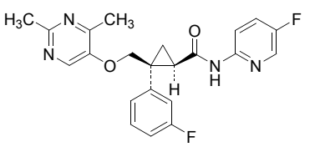

Empirical formula: C22H20F2N4O2

Chemical name: (1R,2S)-2-{[(2,4-Dimethylpyrimidin-5-yl)oxy]methyl}-2-(3-fluorophenyl)-  
*N*-(5-fluoropyridin-2-yl)cyclopropanecarboxamide

Dayvigo (lemborexant) is to be supplied in the dose form of film-coated oral tablets, in 2 strengths as follows:

* each 5 mg Dayvigo film-coated tablet contains 5 mg lemborexant and is supplied as a pale yellow, round, biconvex, film-coated tablet, debossed with the number ‘5’ on one side and ‘LЄM’ on the other side.
* each 10 mg Dayvigo film-coated tablet contains 10 mg lemborexant and is supplied as an orange, round, biconvex, film-coated tablets, and debossed with the number ‘10’ on one side and ‘LЄM’ on the other side.

Neither strength of tablet is scored.

Both strengths of tablets (5 mg and 10 mg) are packaged in polyvinyl chloride/aluminium blisters in packs of 28 tablets. A sample pack of 3 x 5 mg tablets in the same composition blister pack is also proposed for registration.

#### Conclusion regarding approval

Approval was recommended from a pharmaceutical chemistry and quality control perspective.

### Nonclinical

The overall quality of the dossier was reasonable with all pivotal safety studies conducted under Good Laboratory practice (GLP) conditions using the proposed clinical route and dosing regimen. The safety of M10, a significant human metabolite, has been adequately assessed.

Primary pharmacology studies demonstrated *in vitro* inhibition of orexin type 1 (OX1) and type 2 (OX2) receptors by lemborexant with an 50% inhibitory concentration value within expected clinical plasma concentrations. *In vivo* studies in mice and rats and with prepro‑orexin knockout mice and orexin neuron-deficient transgenic mice demonstrated efficacy supporting the drug’s use for the proposed indication. The metabolites are less likely to contribute to lemborexant’s pharmacological activities in humans.

The observation of an increased cataplexy type behaviour in a mouse model similar to the effects observed in dogs treated with suvorexant should be reported in the PI document.

No clinically relevant off-target effects were seen with lemborexant or its metabolites, M4, M9 and M10. Based on nonclinical studies, lemborexant has a low potential for exerting adverse effects on central nervous system, cardiovascular and respiratory functions.

Drug-related material was widely distributed to tissues in rats and monkeys. Drug-related material readily crossed the blood-brain barrier, desirable for its intended mode of action. Lemborexant was extensively metabolised in rats, monkeys and humans, with *in vitro* studies indicating a significant role of the cytochrome P450 isozyme CYP3A4 and a lesser role of isozyme CYP3A5 in the metabolism of lemborexant and its metabolites. Defluorinated metabolites were seen in material from rats and monkeys but not human biomaterials. Hepatobiliary excretion is the primary route of excretion for lemborexant.

Based on *in vitro* studies, potential pharmacokinetic drug interactions include changes in lemborexant exposure by inhibitors/inducers of CYP3A4/A5. Lemborexant and M10 have the potential to induce isozyme CYP2B6. Lemborexant is a poor substrate of P‑glycoprotein (P-gp), but M10 is a substrate of P-gp. No other pharmacokinetic drug-drug interaction is expected from lemborexant administration in clinical context.

Lemborexant has a low order of acute toxicity in rats and monkeys.

Repeat-dose toxicity studies up to 4 weeks duration were conducted in mice, 26 weeks in rats, and 39 weeks in monkeys using the clinical route. The only clinically relevant effect observed was insomnolence and decreased activity, consistent with the desired pharmacological activity of the drug. Non-adverse liver enlargement and hepatocellular hypertrophy were observed in all species, consistent with hepatic enzyme induction. Fluorosis effects (changes in the bone and teeth as well as iron metabolism) were seen in all species, which were attributed to metabolic defluorination. These effects are not considered a concern in an adult patient group.

Lemborexant was neither mutagenic nor clastogenic. Lemborexant demonstrated low carcinogenic potential in animal studies. The M10 metabolite was adequately assessed in these studies.

Based on fertility studies in rats, no effects on male or female fertility are expected in patients. Oral administration of lemborexant to pregnant rats and rabbits during the period of organogenesis caused maternal toxicities at high exposures. Adverse embryofetal development effects were seen at these high doses, though a direct effect on the incidence of the visceral malformation, membranous ventricular septum defect, cannot be completely dismissed. Exposures at the no adverse effect level for embryofetal development effects are sufficiently high that the effects are not of clinical concern. Signs of fluoride toxicity were seen in the offspring of rats treated orally with lemborexant during pregnancy and lactation. These effects are not of concern in human subjects at the proposed clinical dose. Lemborexant and its metabolites crossed the placenta in rats and were excreted in rat milk. The proposed Pregnancy Category B3 is acceptable.[16]

Lemborexant has a low risk for abuse liability.

#### Conclusion regarding approval

The nonclinical evaluation had the following conclusions regarding approval:

* The primary pharmacology studies support the proposed use of the drug.
* The combined safety studies do not raise any significant concerns for the intended patient group.
* There are no nonclinical objections to registration of lemborexant.
* All PI amendments proposed by the nonclinical evaluator have been accepted by the sponsor.

### Clinical

#### Guidance

Relevant guidance documents for this submission include:

* Guideline on medicinal products for the treatment of insomnia (17 February 2011 EMA/CHMP/16274/2009 previously EMEA/16274/2009) Rev. 1).
* Note for guidance on studies in support of special populations: Geriatrics (ICH Topic E7. (CPMP/ICH/379/95))
* Guideline on reporting the results of population pharmacokinetic analyses (21 June 2007; CHMP/EWP/185990/06).

#### Pharmacology

##### Pharmacokinetics

The conduct of the 16 Phase I studies that were provided in support of the current submission was satisfactory, the data analyses undertaken were appropriate and the analytical methods used to measure exposure levels were validated.

Dayvigo is to be administered orally once a day. Following a single 10 mg tablet dose to healthy subjects, median lemborexant time to peak plasma concentration (Tmax) occurred 1.0 h to 1.25 h after dosing.

The absolute bioavailability of lemborexant in humans has not been determined.

The to-be-marketed formulation was used in the pivotal efficacy and safety studies and key clinical pharmacology studies.

The clinical program for lemborexant used two formulations, a capsule formation that was initially being used in the single-ascending dose and multiple-ascending dose studies and a tablet formulation that was used in later clinical studies. The relative bioavailability of capsule and tablet formation was assessed in Study 005 in healthy adult subjects. The results show that the bioavailability of the tablet and capsule formulations was similar. Differences between tablet and capsule formulations for area under the plasma concentration versus time curve extrapolated to infinity (AUC0-inf) were each less than 13%, and the differences between the tablet and capsule formulations in peak plasma concentration (Cmax) across all dose levels were each less than 16%.

Compared to fasting conditions, following a high fat meal, lemborexant Cmax was slightly decreased, whereas AUC(0-inf) and median Tmax were increased by approximate 23% and 2 h, respectively which is adequately captured in the proposed PI.

Following single doses of 1 to 10 mg lemborexant, values ranged from 1 to 1.5 h post-dose, whereas, at doses of 25 to 200 mg Tmax occurred at 2 to 3 h post-dose. The geometric mean AUC(0-24h) increased approximately proportionally over the 1 mg to 200 mg dose range, whereas, Cmax increased in a slightly less than dose-proportional manner.

The exposure of lemborexant increases slightly less than dose-proportionally from 2.5 to 75 mg.

Following multiple dosing, the extent of accumulation of lemborexant at steady-state was 1.5-to 2-fold. Steady-state was attained by Day 7 to Day 10.

The apparent volume of distribution of lemborexant is approximately 1970 L.

Lemborexant is primarily metabolised by CYP3A4, and to a less extent by CYP3A5. Following a single dose of radioactive carbon [14C] lemborexant 10 mg, the predominant circulating component was lemborexant, which accounted for 26.5% of total radioactivity. Plasma metabolites identified included M10 (12.5% radioactivity), M9 (6.6%), M4 (6.3%) and M18 (6.0%). The sponsor indicates that M10 makes a minimal contribution to the pharmacological activity of lemborexant.

Following a single dose of 10 mg [14C] lemborexant, 57.4% of the dose was recovered in the feces and 29.1% in the urine (< 1% as unchanged). The effective half-life for lemborexant (5 mg and 10 mg) is approximately 18 hours.

Pharmacokinetics are similar in both patients and healthy subjects.

Dose adjustments are not required for subpopulations based on intrinsic patient factors of age, body mass index, race and sex. No study has been conducted to investigate the pharmacokinetics of lemborexant in paediatric patients.

Following a single tablet dose of lemborexant 10 mg, the values of lemborexant AUC0-inf were approximately 25% and 53% higher in subjects with mild and moderate hepatic impairment, respectively. The pharmacokinetics of lemborexant in subjects with severe hepatic impairment have not been investigated.

In subjects with severe renal impairment compared to healthy subjects, lemborexant concentrations were similar for the first 24 h following dosing, whereas thereafter, mean lemborexant concentrations were higher for subjects with severe renal impairment and lemborexant area under the concentration versus time curve in plasma (AUC) from time 0 to time t (AUC0-t) and AUC0-inf values were approximately 1.5-fold higher in subjects with severe renal impairment.

Lemborexant pharmacokinetics were similar in healthy elderly (mean age 69.4 years) and adult (30.7 years) subjects.

###### Drug-drug interactions

The following evidence of drug-drug interactions have been found:

* following co-administration of lemborexant 10 mg with the strong CYP3A inhibitor itraconazole 200 mg once daily, the lemborexant AUC0-inf increased by 3.7-fold.
* following co-administration of lemborexant 10 mg with the strong CYP3A inducer rifampin 600 mg once daily, the lemborexant AUC0-inf was decreased by 0.034-fold.
* following co-administration of lemborexant 10 mg with 75 mg bupropion, exposure to *S*-bupropion and [*S*,*S*] hydroxylated bupropion was halved.
* co-administration of lemborexant with alcohol resulted in a 35% and 70% increase in lemborexant Cmax and area under the plasma concentration versus time curve from time 0 to 72 h (AUC0-72h) respectively.
* co-administration of a single dose of lemborexant with a single dose of famotidine resulted in a 27% decrease in lemborexant Cmax and a 0.5 h delay in Tmax, whereas, no significant effects were observed on the AUC of lemborexant.
* co-administration of a single dose of lemborexant with fluconazole at steady-state resulted in an up to 4-fold increase in lemborexant AUC values, a 1.6-fold increase in lemborexant Cmax and a 2-fold increase in lemborexant half life (t1/2).
* no studies have investigated the potential for drug-drug interactions between lemborexant and other drugs routinely used for sleep dysfunction although the PI does mention that lemborexant is not to be administered with other drugs used for insomnia.

The Delegate agrees with the clinical evaluator that the proposed PI overall appears to accurately reflect the submitted PK data. The population pharmacokinetics (PopPK) working group also did not identify any major objections in relation to the physiologically-based pharmacokinetic analyses.

##### Pharmacodynamics

Lemborexant is thought to act by inhibiting the binding of wake-promoting neuropeptides to the OX1 and OX2 receptors.

Following a single dose of 2.5 or 10 mg lemborexant to otherwise healthy subjects with primary insomnia, latency to persistent sleep and wake after sleep onset (WASO) were reduced by almost 30 minutes and sleep efficiency was improved by 11% and 13%, respectively, which were similar to the improvements achieved following a 10 mg dose of zolpidem. In addition, lemborexant treatment resulted in a more substantial decrease in rapid eye movement (REM) latency compared with either zolpidem or placebo, whereas, sleep architecture was not affected by lemborexant, zolpidem or placebo.

Return-to-sleep latency decreased significantly in subjects administered lemborexant 5 mg, lemborexant 10 mg or 6.5 mg zolpidem compared to placebo and sleep latency was significantly improved in subjects administered lemborexant 10 mg compared to zolpidem.

In adults and elderly subjects with chronic insomnia treated for 14 days with lemborexant doses ranging from 1 mg to 25 mg there were dose related decreases in Insomnia Severity Index (ISI) scores[17] on both Day 2 and Day 15. These decreases in ISI score reached statistical significance on Day 15 following doses of 15 and 25 mg lemborexant.

There was no evidence of increase in residual sleepiness in doses up to 10 mg lemborexant. At approximately 8 h after dosing (that is, morning awakening) none of the treatments had a clinically meaningful effect on time-matched baseline body sway.

There was no effect on respiratory safety in subjects with mild obstructive sleep apnoea at doses up to 25 mg lemborexant.

The results indicated that unlike the positive control zopiclone, lemborexant at the doses tested did not impair driving performance following either single (Day 2) or multiple (Day 9) dose administration.

Following lemborexant doses of 10 mg, 20 mg or 30 mg, 30 mg zolpidem, 40 mg suvorexant or placebo to healthy, non-dependent, recreational sedative users, mean Drug Liking visual analogue scale peak maximum effect scores were statistically significantly higher for the active comparators (78.3 and 76.1 for zolpidem and suvorexant, respectively) and lemborexant (78.4 to 83.6) than for placebo (57.8).

All issues regarding potential effects related to abuse potential identified in the animal studies were adequately evaluated in the human pharmacokinetic-pharmacodynamic and clinical studies.

At Cmax values for doses of 5 mg and greater, lemborexant reduced WASO by greater than 45%.

##### Dose selection

The sponsor selected lemborexant 5 mg and lemborexant 10 mg after completing Studies 201 and 107. In Study 201, doses ranging from 1 mg to 25 mg were selected as meeting the primary objective of balancing efficacy (change from Baseline for sleep efficiency) and safety (subjective sleepiness on the Karolinska Sleepiness Scale (KSS) one hour after wakening).[18] The sponsor determined that doses of 5 mg and 10 mg balanced efficacy and safety. Figure 2, shown below, demonstrates that efficacy plateaus after 10 mg. Study 107 was completed to rule out a clinically meaningful effect on next-morning residual sleepiness for doses lemborexant 5 mg and lemborexant 10 mg compared to placebo. The sponsor felt the results of Study 107 confirmed that lemborexant 5 mg and lemborexant 10 mg were the appropriate doses for Phase III trials.

Figure 2: Study 201 Relationship between lemborexant dose, sleep efficiency, and somnolence (risk)

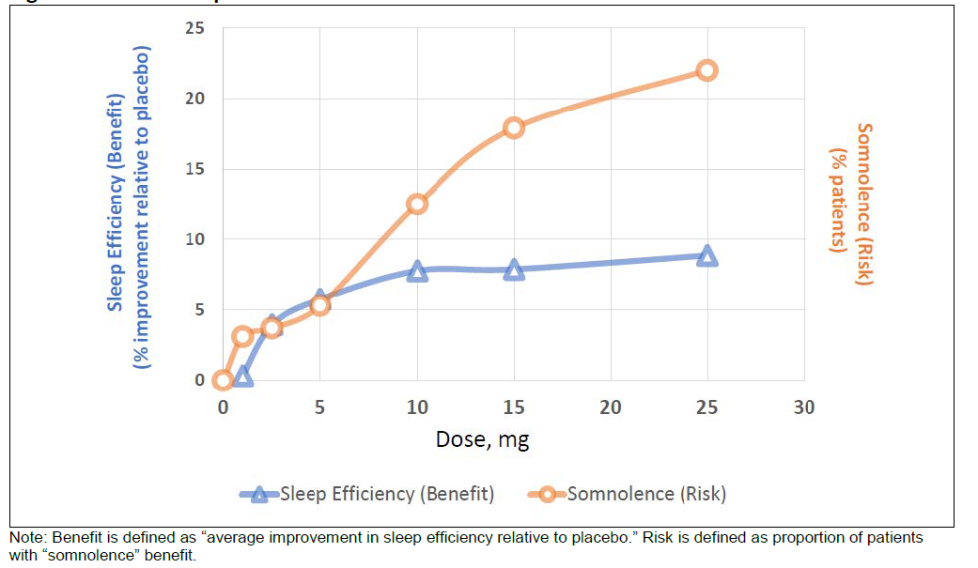

Source: FDA review https://www.accessdata.fda.gov/drugsatfda_docs/nda/2019/212028Orig1s000MultidisciplineR.pdf

#### Efficacy

##### Overview of efficacy studies

###### Pivotal studies

Two pivotal studies were submitted:

* Study E2006-G000-303 Core: A long-term multicentre, randomised, double-blind, controlled, parallel-group study of the safety and efficacy of lemborexant in subjects with insomnia disorder.
* Study E2006-G000-304: A multicentre, randomised, double-blind, placebo-controlled, active comparator, parallel-group study of the efficacy and safety of lemborexant in subjects 55 years and older with insomnia disorder.

###### Supportive studies

Three supportive studies were submitted:

* Study E2006-G000-303-ext: A long-term multicentre, randomised, double-blind, controlled, parallel-group study of the safety and efficacy of lemborexant in subjects with insomnia disorder.
* Study E2006-G000-201: A multicentre, randomised, double-blind, placebo-controlled, parallel-group, Bayesian adaptive randomisation design, dose-response study of the efficacy of E2006 in adults and elderly subjects with chronic insomnia.
* Study E2006-G000-202: A multicentre, randomised, double-blind, placebo-controlled, parallel-group study with open-label extension phase of the efficacy and safety of lemborexant in subjects with irregular sleep-wake rhythm disorder and mild to moderate Alzheimer’s disease dementia.

##### Study E2006-G000-303 Core

###### Study design

The following figure (Figure 3) details the study design for Study E2006-G000-303.

Figure 3: Study E2006-G000-303 Core Study design overview

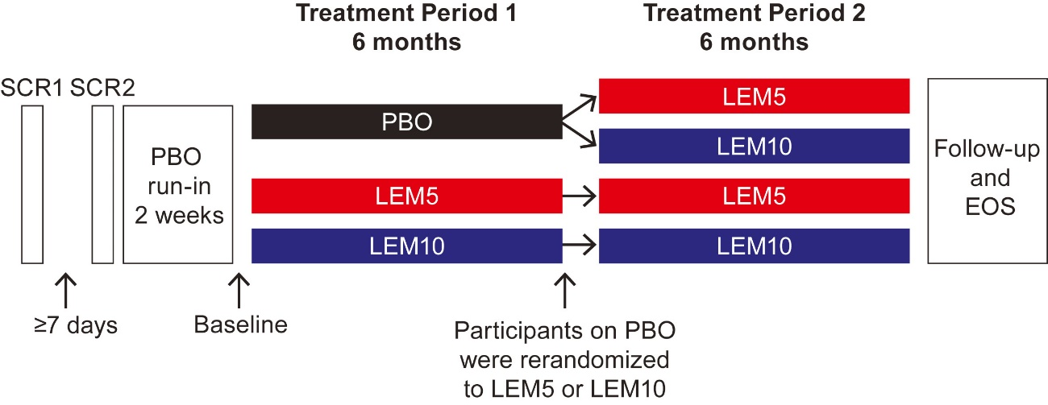

PBO = placebo; LEM5/LEM10 = lemborexant 5 mg/10 mg

This is a pivotal Phase III randomised, placebo-controlled study evaluated the efficacy and safety of proposed doses of lemborexant (5 mg and 10 mg once daily) in 971 adults (949 in the full analysis set) with insomnia disorder (meeting criteria per DSM-5) during treatment for at least 6 months.

Blinding to treatment was used to reduce bias during data collection and evaluation of endpoints during both treatment periods.

The study endpoints (self-reported) included a broad subjective evaluation (using a sleep diary) of effects on sleep onset (subjective sleep onset latency (SOL)), sleep maintenance (subjective sleep efficiency and subjective wake after sleep onset (subjective WASO)), total sleep time (TST), effects on daytime function (ISI, Fatigue severity scale (FSS)) and quality of life (Patient Global Impression - Insomnia (PGI Insomnia), EQ-5D-3L);[19] and work productivity (WPAI-GH).[20]

The advantages of the electronic sleep diary used in this study included that the questions and instructional text had been adapted from sleep diaries that were developed by clinicians and researchers with expertise in insomnia disorder, and had undergone linguistic validation and cognitive debriefing to optimise their use in this study.

Overall, the study design, endpoint and analysis complied with the European Union/European Medicine Agency’s Committee for Medicinal Products for Human Use (CHMP) guidelines for evaluation of medicinal products for treatment of insomnia.[21]

The study population was enrolled using relevant updated diagnostic criteria for insomnia (DSM-5 and ICSD-3) and other co-morbidities were excluded. It was representative of the target patient population of adults with insomnia characterised by difficulties in sleep onset and/or sleep maintenance.

###### Inclusion and exclusion criteria

Key inclusion criteria consisted of:

* subjects aged ≥ 18 years;
* confirmation of difficulty with sleep:
  + met DSM-5 diagnostic criteria for insomnia disorder; and
  + at screening: presence of a history of subjective SOL ≥ 30 minutes on at least 3 nights per week in the previous 4 weeks and/or subjective WASO ≥ 60 minutes on at least 3 nights per week in the previous 4 weeks; and
  + at screening and study Baseline: ISI score ≥ 15;16 and
  + at the second Screening Visit (Visit 2a) and Baseline (Visit 3a): confirmation of insomnia symptoms, determined from responses on the sleep diary completed on at least 7 consecutive mornings, such that subjective SOL ≥ 30 minutes and/or subjective WASO ≥ 60 minutes (for Screening Visit 2a: minimum 5 of 7 nights for eligibility, and for Baseline Visit 3a: minimum 3 of 7 nights).
* confirmation of regular bedtimes and waketimes and of sufficient duration, defined as:
  + at screening, report of regular trying to sleep 7 to 9 hours, a regular bedtime, and a regular getting out of bedtime; and
  + at first screening Visit 1, Visit 2a, and Baseline Visit 3a: reported regular bedtime, defined as the time the subject attempts to sleep, between 21:00 and 01:00 and regular waketime, defined as the time the subject got out of bed for the day, between 05:00 and 10:00 and regular time spent in bed, either sleeping or trying to sleep, between 7 and 10 hours.
* willingness to not to start other treatments for insomnia during the study, including behavioural treatments.

Key exclusion criteria consisted of:

* significant current medical diseases, positive for human immunodeficiency virus (HIV) or viral hepatitis, prolonged corrected QT interval by Fredericia (QTcF)[22] (> 450 ms), planned surgery, comorbid nocturia, and other clinically significant diseases that might interfere with study assessment;
* current sleep-related breathing disorder, periodic limb movement disorder, restless legs syndrome, circadian rhythm sleep disorder, symptoms of narcolepsy, polysomnography (PSG) in the past year with elevated hypopnea index, and history of complex sleep behaviour;
* exclusionary scores on the Sleep Disorders Screening Battery (SDSB) as follows: the Epworth Sleepiness Scale (ESS) score > 15, the STOPBang (screens for obstructive sleep apnea) score ≥ 5, and the International Restless Legs Scale (IRLS) score ≥ 16;
* Beck Depression Inventory–II (BDI-II) score > 19 at screening;
* Beck Anxiety Inventory (BAI) score > 15 at screening;
* suicidal ideation or any suicidal behavior in the past 10 years;
* other clinically significant disorders or diseases that might interfere with study assessments; and
* napping more than three times per week, frequent nocturia, excess caffeine use, drug or alcohol abuse/dependence, excessive alcohol consumption, recent insomnia treatment, failing suvorexant treatment deemed of appropriate dose and of adequate duration, in the opinion of the investigator.

###### Subject disposition

Figure 4 describes the subject disposition for this study.

Figure 4: Study E2006-G000-303 Core Subject disposition

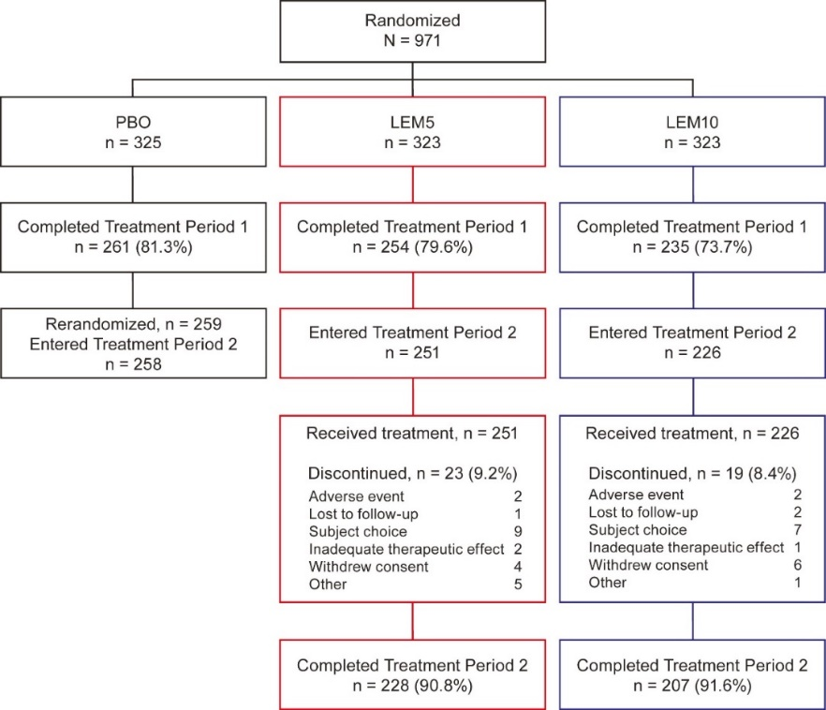

###### Demographic characteristics

Table 3 describes the demographic characteristics of the full analysis set population for this study.

Table 3: Study E2006-G000-303 Core Demographic characteristics (full analysis set population)

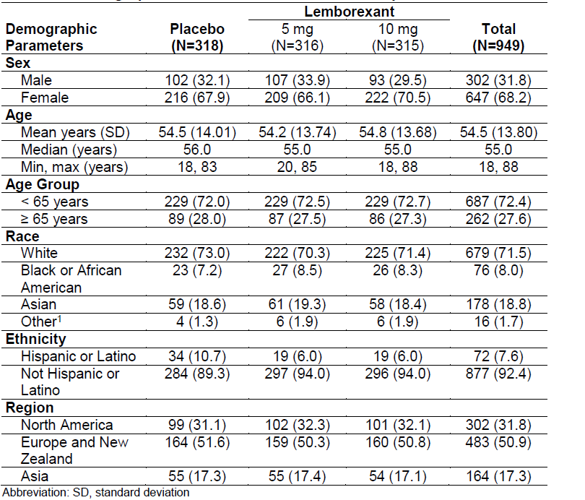

###### Results

Lemborexant 5 mg and 10 mg once daily showed statistically significant improvements in sleep onset (subjective sleep onset latency (SOL)), sleep maintenance (subjective sleep efficiency and subjective WASO) and subjective total sleep time (subjective TST) compared with placebo at six months. The onset of action was rapid with significant improvements observed from first seven days and maintained over the six-month treatment period. Results for the primary and secondary endpoints were robust and confirmed in the sensitivity analyses as well in analysis with and without application of data handling rules. Subgroup analysis showed that the primary efficacy endpoint results were not affected by age, sex, race, region, or body mass index (BMI).

Figure 5: Study E2006-G000-303 Core Changes from Baseline over 12 months in (a) subjective sleep onset latency by sleep diary, (b) subjective wake after sleep onset, (c) subjective sleep efficiency and (d) subjective total sleep time

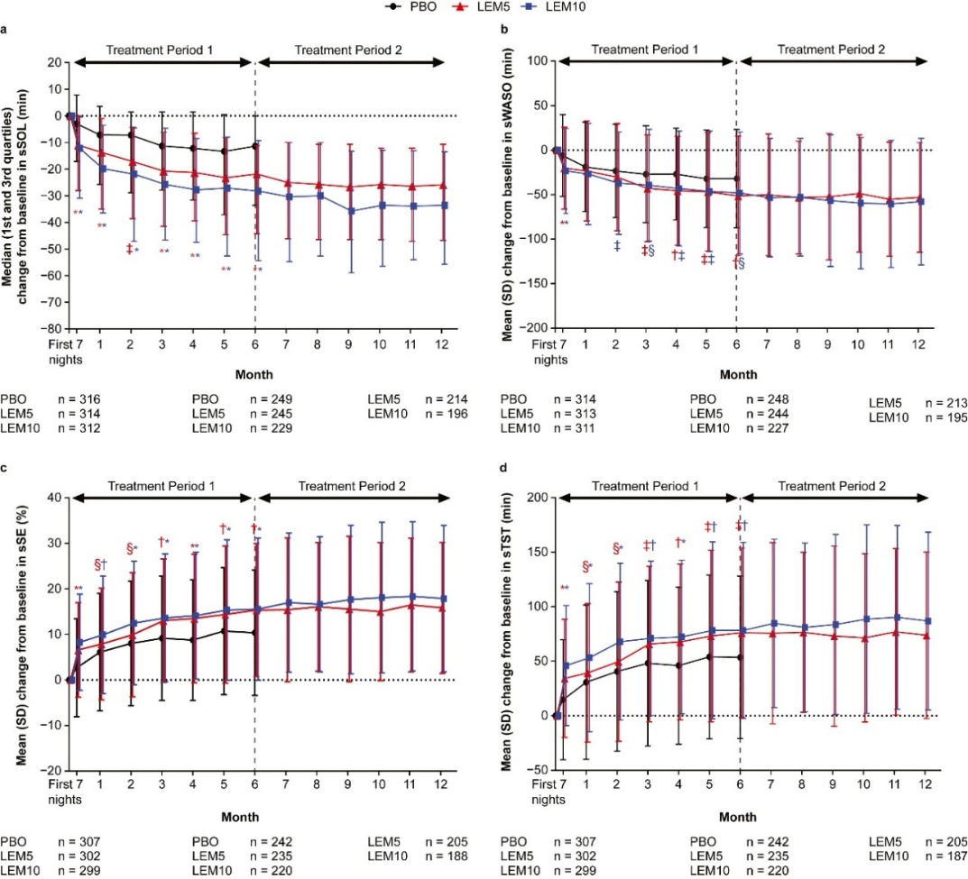

[Subjective sleep onset latency (SOL](https://www.sciencedirect.com/topics/medicine-and-dentistry/sleep-onset-latency)) values were log-transformed. N values correspond to the number of subjects with data at baseline, at Month 6 and at Month 12. p values are based on the mixed-effect model repeated measurement analysis evaluating the least squares mean treatment ratio (subjective SOL) or treatment difference (subjective wake after sleep onset (WASO), subjective sleep efficiency, subjective total sleep time (TST)) between placebo (PBO) and lemborexant (Treatment Period 1 only). For panel a: ∗p < 0.0001; ‡p < 0.01. For panel b: ∗p < 0.0001; †p < 0.001; ‡p < 0.01; §p < 0.05. For panel c: ∗p < 0.0001; †p < 0.001; §p < 0.05. For panel d: ∗p < 0.0001; †p < 0.001; ‡p < 0.01; §p < 0.05. LEM5 = 5 mg lemborexant; LEM10 = lemborexant 10 mg; PBO = placebo; SD = standard deviation.

Source: Yardley J, Kärppä M and Inoue Y (2021) Long-term effectiveness and safety of lemborexant in adults with insomnia disorder: results from a Phase III randomized clinical trial, Sleep Medicine, Volume 80, Pages 333-342.

Clinical relevance of improvements in mean and median values of subjective SOL, subjective sleep efficiency and subjective WASO were confirmed by a responder analysis for sleep onset (subjective sleep onset latency (SOL)) and sleep maintenance (subjective WASO); see Figure 6, below. Compared to placebo, both lemborexant 10 mg and lemborexant 5 mg showed significantly greater proportion of responders for subjective SOL and subjective WASO although it is important to note that the higher dose lemborexant 10 mg failed to provide additional benefit over lemborexant 5 mg and in fact the number of responders were numerically higher in the lemborexant 5 mg compared to the lemborexant 10 mg for both subjective SOL (30.1%, 31.2% and 17.7% in lemborexant 10 mg, lemborexant 5 mg and placebo groups, respectively) and subjective WASO (30%, 35% and 20.4%, respectively). Improvements in sleep parameters were supported by significant improvements in daytime functioning (ISS, FSS), quality of sleep and PGI‑Insomnia analysis. However, the quality of life (EQ-5D-3L) and work productivity (WPAI-GH) endpoints failed to show any significant improvements in the lemborexant groups compared with placebo. There was no evidence for rebound insomnia.

Figure 6: Study E2006-G000-303 Core Sleep onset responder profiles and sleep maintenance responder profiles over twelve months

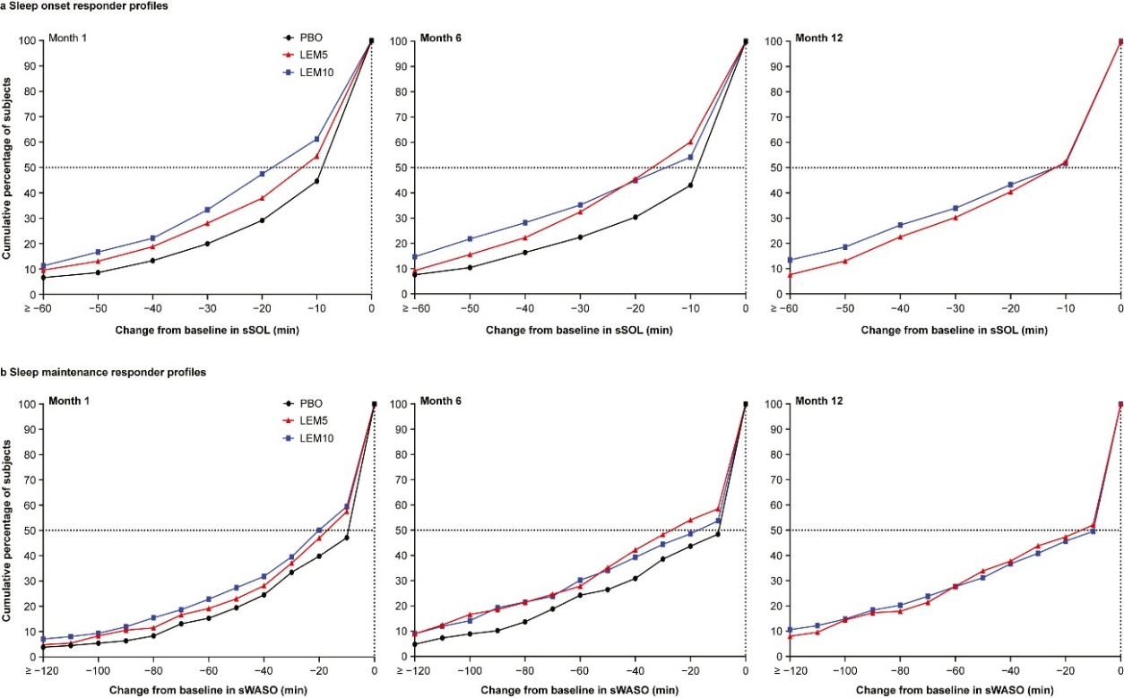

(a) Sleep onset responder profiles and (b) sleep maintenance responder profiles over twelve months. lemborexant 5 mg = lemborexant 5 mg; lemborexant 10 mg = lemborexant 10 mg; PBO = placebo; [sSOL](https://www.sciencedirect.com/topics/medicine-and-dentistry/sleep-onset-latency" \o "Learn more about sSOL from ScienceDirect's AI-generated Topic Pages) = subjective sleep onset latency; sWASO = subjective wake after sleep onset.

Source: Yardley J, Kärppä M and Inoue Y (2021) Long-term effectiveness and safety of lemborexant in adults with insomnia disorder: results from a phase 3 randomized clinical trial, Sleep Medicine, Volume 80, Pages 333-342.

The Delegate agrees with the clinical evaluator’s conclusion regarding Study E2006‑G000‑303 Core:

Overall, this pivotal, placebo-controlled study involving 971 adult patients with insomnia characterised by difficulty in sleep onset and/or maintenance demonstrated statistically and clinically significant improvements in subjective assessments of sleep onset, maintenance, daytime functioning and quality of life for both lemborexant 5 mg and 10 mg once daily following 6 months treatment although there was limited evidence of dose-related response.

##### Study E2006-G000-304

###### Study overview

This pivotal Phase III study evaluated the effects of the proposed doses of lemborexant (10 mg and 5 mg) versus zolpidem (as an extended release formulation; 6.25 mg) on objective (by PSG) and subjective (by sleep diary) sleep parameters in 1006 adults with DSM-5 diagnosis of insomnia.

The key inclusion criteria were:

* males aged 65 years or older, or females aged 55 years or older meeting DSM-5 diagnostic criteria for insomnia disorder;
* at screening:
  + a history of subjective WASO typically ≥ 60 minutes on at least 3 nights per week in the previous 4 weeks, confirmed during run-in period on sleep diary from 7 most recent mornings before the first PSG, such that subjective WASO ≥ 60 minutes occurred on at least 3 of the 7 nights; and
  + reported regular time in bed sleeping or trying to sleep, between 7 to 9 hours, confirmed using sleep diary (minimum 5 of 7 for eligibility) before the second screening visit; and
  + reported habitual bedtime defined as the time the subject attempted to sleep, between 21:00 and 24:00 and habitual waketime between 05:00 and 09:00, confirmed using a sleep diary; and
  + confirmed sufficient duration of sleep, defined as trying to sleep 7 to 9 hours and a regular bedtime and getting out of bedtime, confirmed in a completed sleep diary for at least 7 consecutive days during the second screening visit and again at the baseline visit;
  + Screening and study baseline ISI score greater than or equal to 13.
* confirmation during the run-in period: sufficient duration of sleep, defined as trying to sleep 7 to 9 hours and a regular bedtime and getting out of bed time; confirmed completed sleep diary for at least 7 consecutive days during second screening visit and again at baseline visit; insomnia symptoms (subjective WASO ≥ 60 minutes) using sleep diary data from the 7 most recent mornings before the PSG;
* objective PSG evidence of insomnia as follows: WASO average greater than or equal to 60 minutes on the 2 consecutive PSGs, with neither night less than 45 minutes; Confirmed regular bedtime, sufficient duration, and
* willingness to stay in bed at least 7 hours per night and agreement to not to start other treatments for insomnia during study.

The key exclusion criteria were:

* significant current medical diseases, positive for HIV or viral hepatitis, prolonged QTcF (> 450 ms), planned surgery, comorbid nocturia, or other clinically significant diseases that might interfere with study assessments;
* symptoms of narcolepsy, complex sleep behaviour, sleep-related breathing disorder, periodic limb movement disorder, restless legs syndrome, circadian rhythm sleep disorder, PSG in the past year with elevated hypopnea index, Apnea-Hypopnea Index greater than 15, or Periodic Limb Movement with Arousal Index greater than 15 as measured on the PSG at the second screening visit;
* an exclusionary score on the SDSB as follows: STOPBang[23] (Sleep apnea) score ≥ 5; International Restless Legs Scale (IRLS) score ≥ 16; Epworth Sleepiness Scale (ESS) score >15;
* BDI-II score[24] >19 at screening 6, BAI score[25] >15 at screening; any suicidal ideation with intent;
* napping more than 3 times per week, frequent nocturia, excess caffeine use, drug or alcohol abuse/dependence, excessive alcohol consumption, recent insomnia treatment, prohibited medication use, recent cross-time-zone travel, failing suvorexant treatment, woman of childbearing potential.

The Delegate commented that overall, selection criteria were reasonable. However, no clear explanation was given as to why males under 65 were excluded. Limiting subjects to only mild symptoms of anxiety and depression and excluding rescue medications for insomnia disorder also seems to limits generalisability to real-world clinical settings. Zolpidem 6.25 mg which is the recommended dose in elderly patients with insomnia as active comparator was reasonable.

The study endpoints used in this study were validated and study generally complied with CHMP guidelines for evaluation of treatments for insomnia.20 This study also evaluated effects on rebound insomnia, sleep architecture, quality of life and postural stability (Cognitive Drug Research (CDR) posture device) and cognitive Performance Assessment Battery (PAB) were also used to assess whether there were residual effects of study drug on morning postural stability and cognition.

Figure 7 shows Study E2006-G000-304 subject disposition.

Figure 7: Study E2006-G000-304 Subject disposition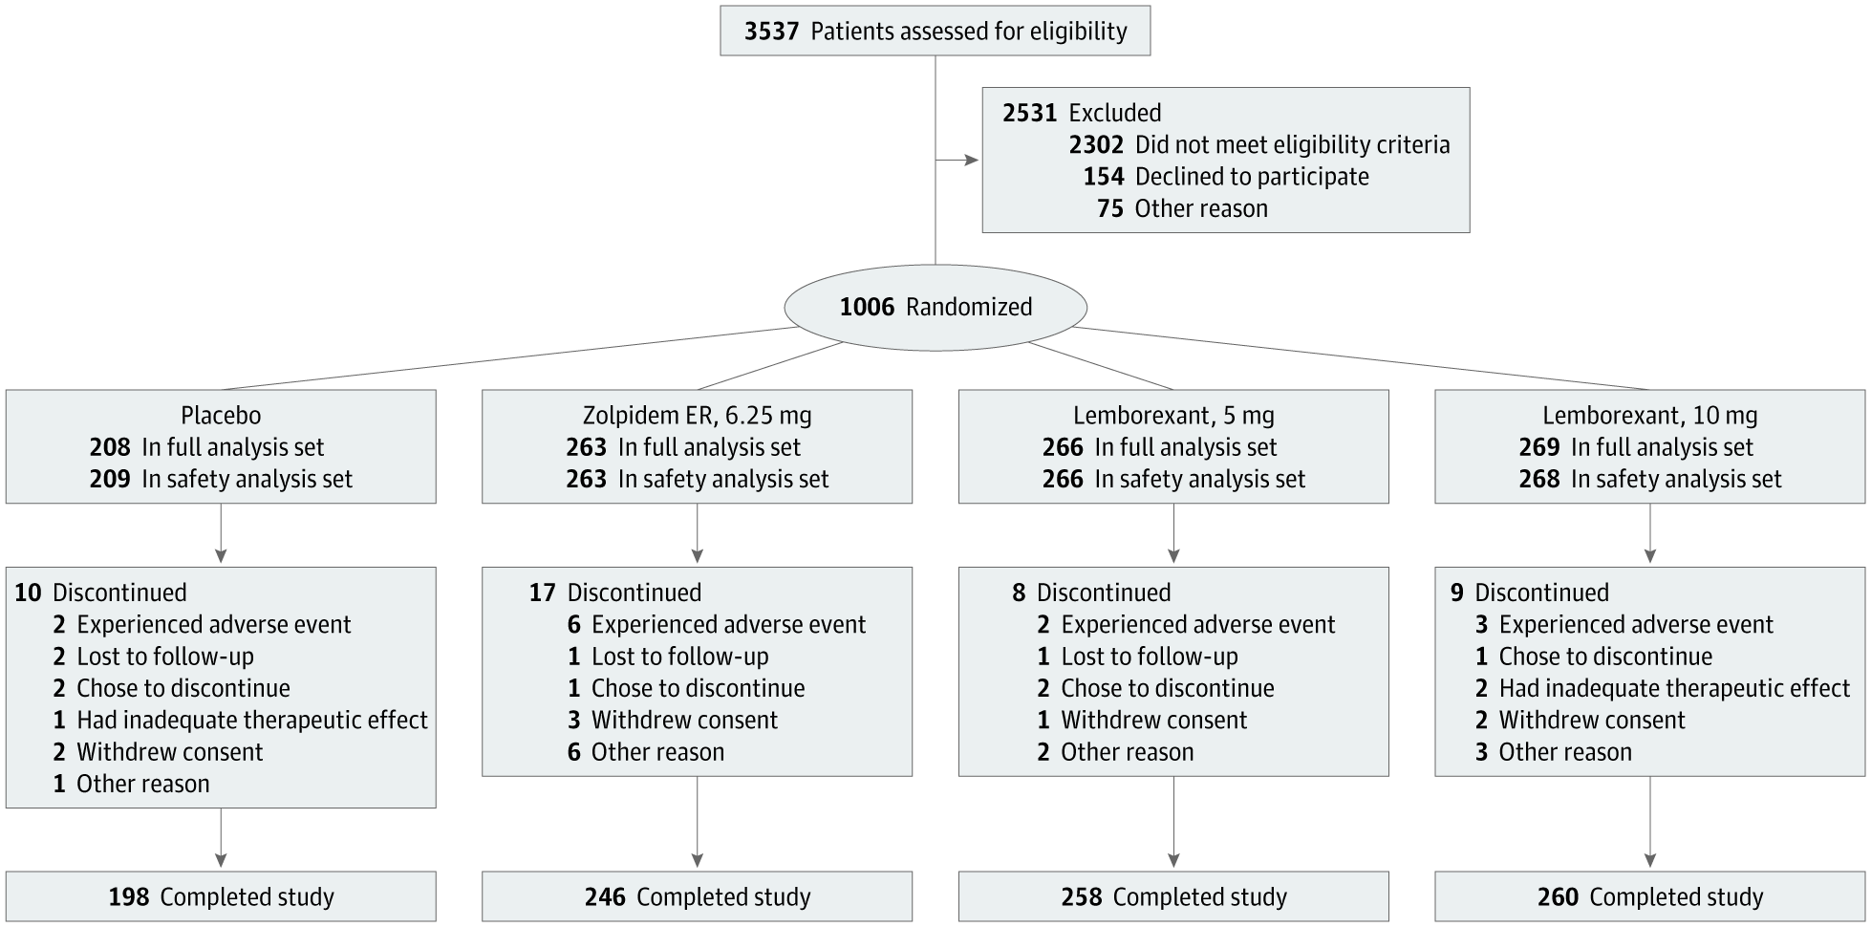

Source: Rosenberg R, Murphy P and Zammit G (2019). Comparison of Lemborexant With Placebo and Zolpidem Tartrate Extended Release for the Treatment of Older Adults With Insomnia Disorder A Phase 3 Randomized Clinical Trial. JAMA Netw Open. 2019;2(12).

The overall dropout rate was low for Study E2006-G000-304 (3 to 6.5% across the treatment groups). The discontinuation rates were lower in the lemborexant 5 mg and lemborexant 10 mg groups than the placebo or zolpidem groups. The zolpidem group had a higher incidence of discontinuation due to adverse events, suggesting it may not be tolerated as well as placebo or lemborexant.

The baseline characteristics for subjects in Study E2006-G000-304 are shown in Table 4, below.

Table 4: Study E2006-G000-304 Subject characteristics at Baseline

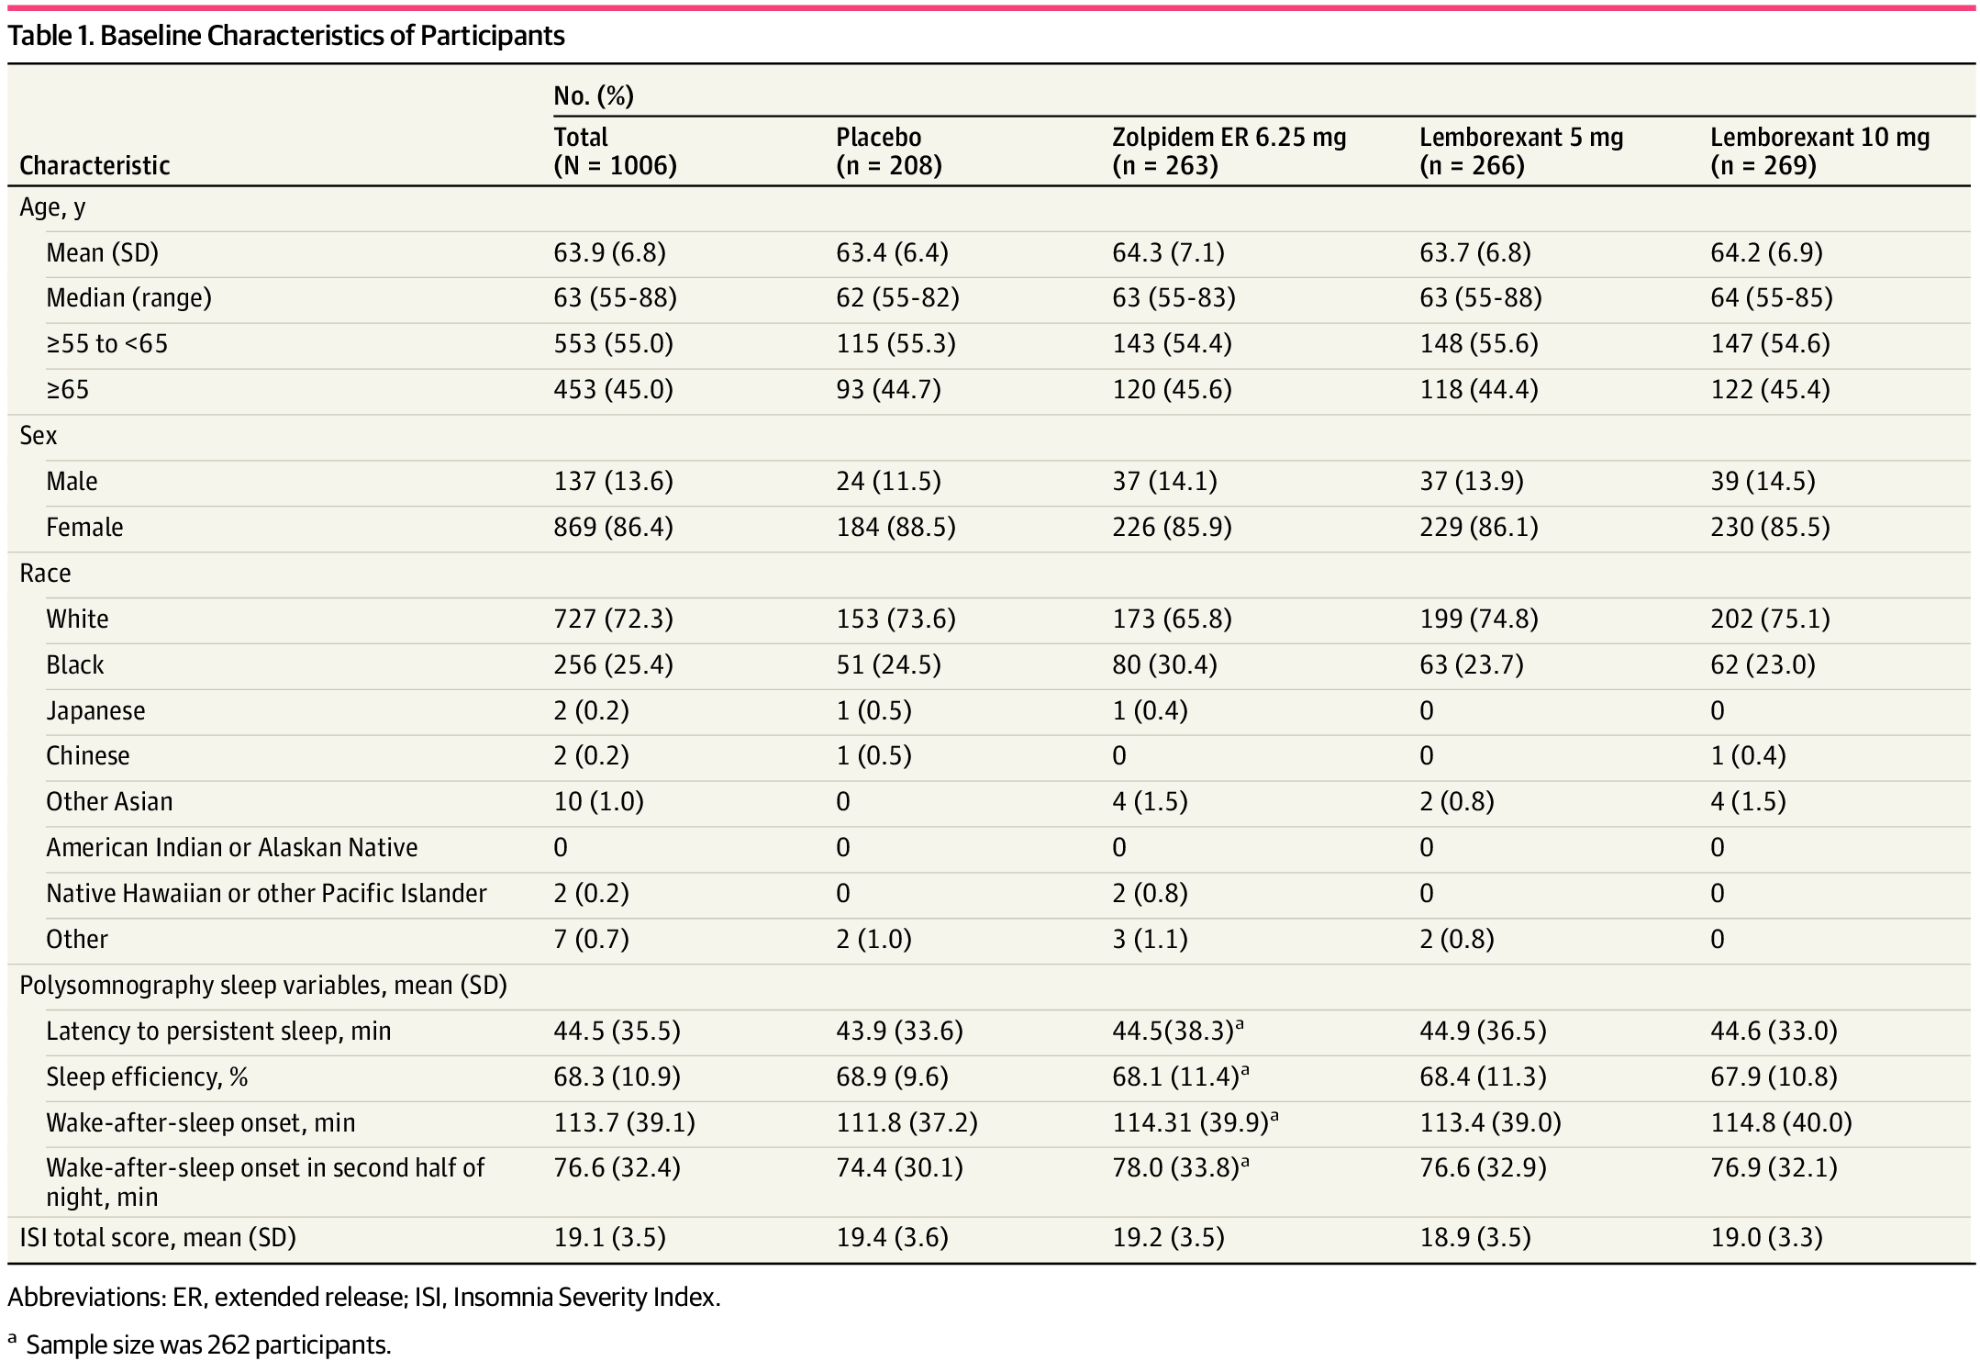

Abbreviations: ER, extended release; ISI, Insomnia Severity Index

*a Sample size was 262 participants

Source: Rosenberg R, Murphy P and Zammit G (2019). Comparison of Lemborexant With Placebo and Zolpidem Tartrate Extended Release for the Treatment of Older Adults With Insomnia Disorder A Phase III Randomized Clinical Trial. JAMA Netw Open. 2019;2(12).

The majority of subjects were female (86.4%) and White (72.3%). The overall median age was 63.9 years (range: 55 to 88 years). In general, demographic and baseline characteristics were similar across treatment groups. Weight, height, BMI, and baseline sleep parameters appear to be balanced across the groups. The baseline sleep parameters seem balanced across the groups.

Both doses of lemborexant consistently demonstrated statistically significant treatment differences compared to placebo for the primary efficacy endpoint (change from Baseline in latency to persistent sleep at Days 29/30) and for the key secondary efficacy endpoints (change from Baseline in sleep efficiency and WASO at Days 29/30) (see Table 5, below). Statistically significant treatment differences for the key secondary efficacy endpoint, change from Baseline in wake after sleep onset (WASO) in the second half of the night at Days 29/30, were also demonstrated for both doses of lemborexant compared to zolpidem.

Both doses of lemborexant showed efficacy for both sleep onset and sleep maintenance compared to placebo, as assessed by both PSG and Sleep Diary. The robust effects on both sleep onset and sleep maintenance were observed at the beginning of treatment and lasted for the entire month of treatment. Using the definition of clinically meaningful change from Baseline as outlined in Sateia et al., (2017)[26], all changes from Baseline for both doses of lemborexant may be considered clinically meaningful. The responder analyses of WASO and subjective WASO demonstrated that lemborexant 10 mg was more effective than lemborexant 5 mg for sleep maintenance.

There was no evidence for rebound insomnia with lemborexant although interpretation limited by conservative criteria for concluding rebound insomnia (sleep parameters after treatment was completed would have had to be substantially worse than at screening that is, prior to starting the placebo Run-in Period to be considered strong evidence for rebound insomnia.

Both doses of lemborexant were more effective than zolpidem for sleep onset, at both the beginning and end of one month of treatment, as assessed by both PSG and Sleep Diary. For sleep maintenance, PSG results indicated that both lemborexant doses were more effective than zolpidem at both the beginning and end of the 1 month of treatment.

Results of comparisons based on sleep diary data showed some discordance compared to the objective results. In general, subjects in the zolpidem treatment group had larger decreases from baseline in subjective WASO than were observed with PSG WASO, and subjects in the lemborexant 5 mg treatment group had smaller decreases in subjective WASO than were observed with PSG WASO. Effects on memory and recall due to zolpidem or lemborexant may be likely cause of discrepancy between the observed discrepancies between subjective and objective endpoints. Lemborexant treatment increased both non-rapid eye movement (non-REM) and REM sleep, while zolpidem only increased non-REM sleep.

The mean total ISS score and Items 4 to 7 ISS score was significantly improved with both lemborexant 10 mg and lemborexant 5 mg compared with placebo; the treatment differences between lemborexant (5 mg and 10 mg) were not significantly different to zolpidem. The change from Baseline to Day 31 in mean total FSS did not show any statistically significant differences between the lemborexant 10 mg/lemborexant 5 mg and placebo groups or between lemborexant 5 mg and zolpidem.

Both doses of lemborexant did not have any effect on postural stability (by body sway) while zolpidem showed greater effects compared to placebo (although it did not reach the prespecified threshold of 7 units). Compared to placebo, neither lemborexant (lemborexant 10 mg and lemborexant 5 mg) nor zolpidem showed any significant effects at either beginning or end of treatment on the continuity of attention, or the quality of memory and speed of memory retrieval.

Overall, the study was well conducted and provided evidence to demonstrate efficacy of lemborexant 10 mg and lemborexant 5 mg in the proposed indication using objective and subjective endpoints (see Figures 8 and 9 and Tables 5 and 6 below).

Table 5: Study E2006-G000-304 Sleep endpoints by treatment group

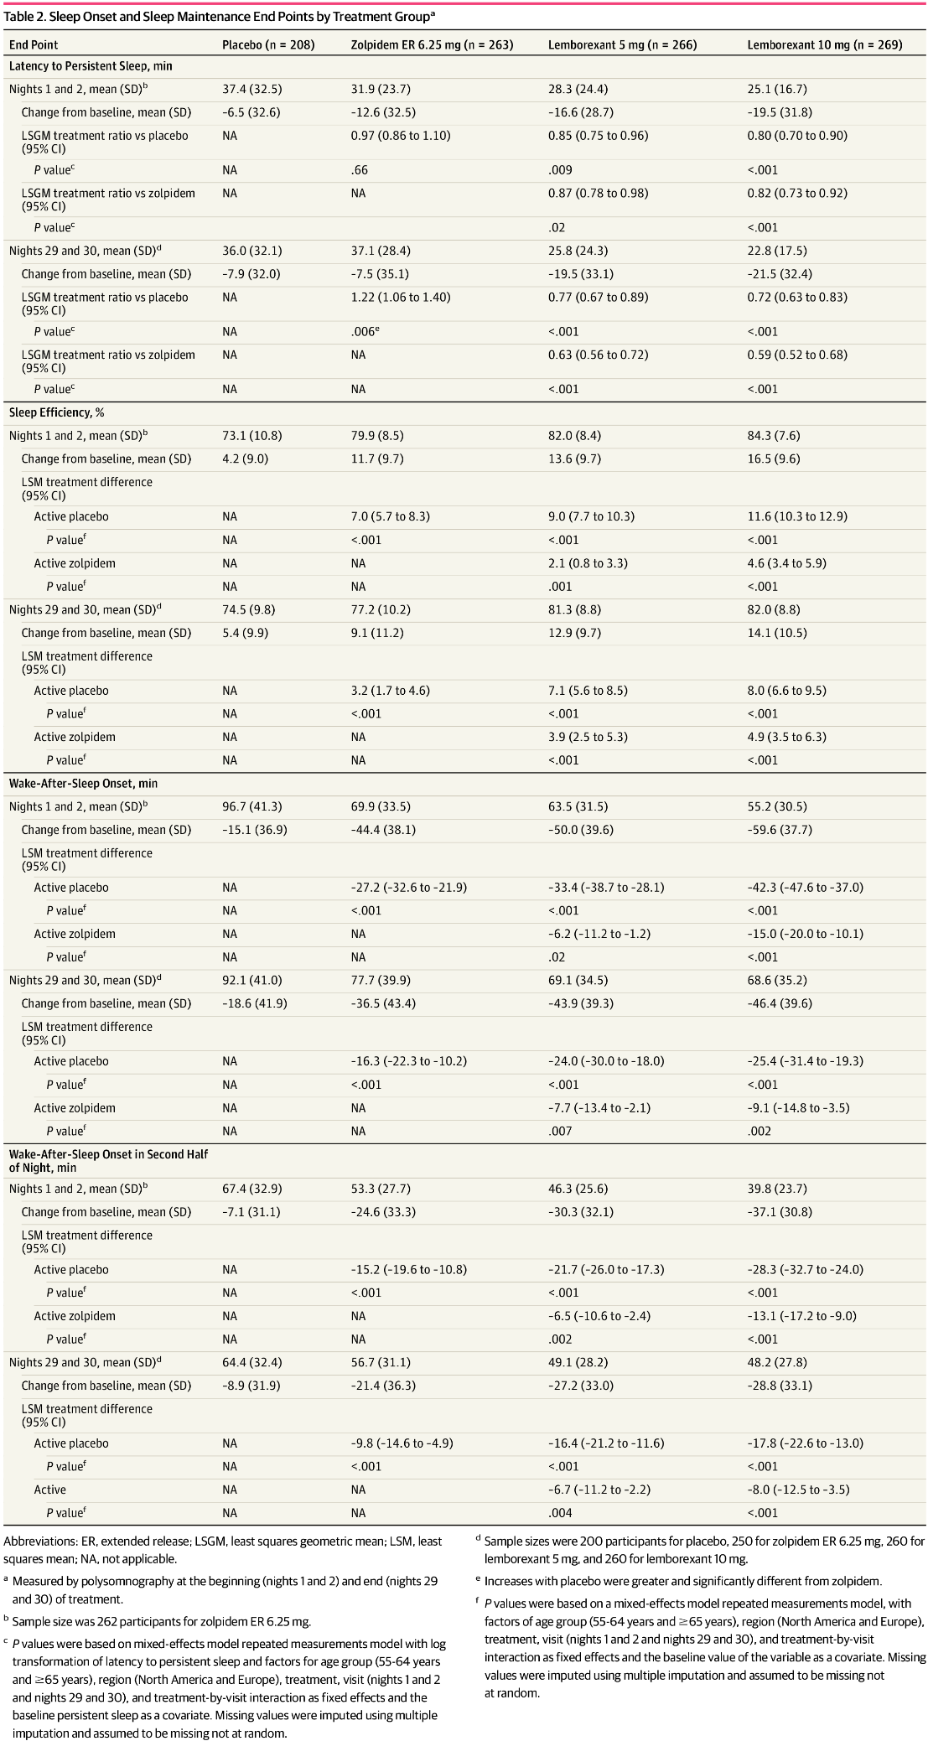

Source: Rosenberg R, Murphy P and Zammit G (2019). Comparison of Lemborexant With Placebo and Zolpidem Tartrate Extended Release for the Treatment of Older Adults With Insomnia Disorder A Phase 3 Randomized Clinical Trial. JAMA Netw Open. 2019;2(12).

Figure 8: Study E2006-G000-304 Sleep onset and sleep maintenance outcomes assessed by polysomnography, by treatment group outcomes were assessed at the beginning (Nights 1 and 2) and end (Nights 29 and 30) of treatment

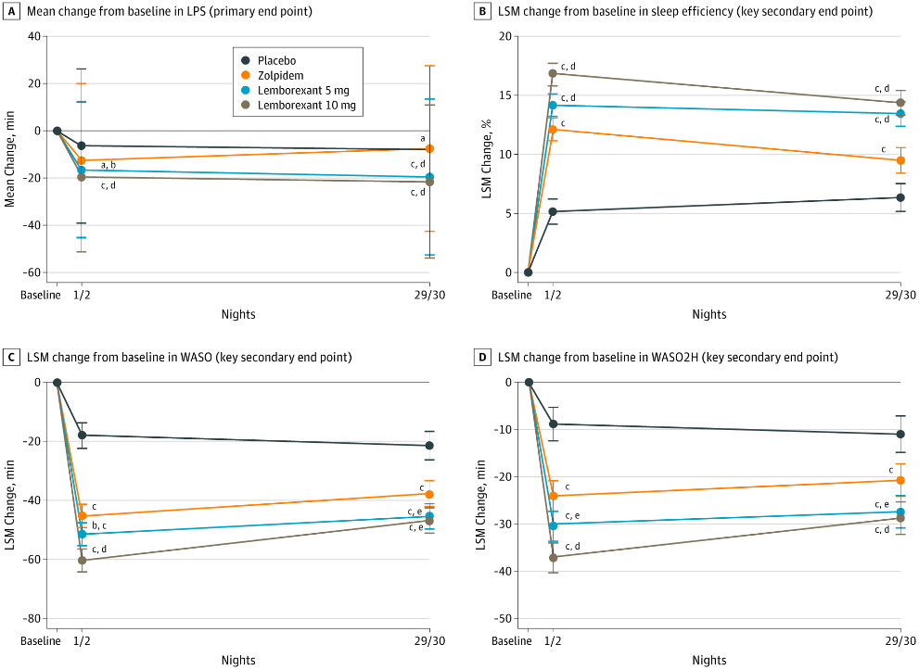

A total of 208 participants received placebo, 263 received 6.5 mg of zolpidem tartrate extended release, 266 received 5 mg of lemborexant, and 269 received 10 mg of lemborexant. A, Mean change from Baseline in latency to persistent sleep (LPS) (primary end point). As a result of the nonnormal distribution of LPS, the values were log transformed, and the geometric mean ratio was used to test for statistically significant treatment differences. B, The least squares mean (LSM) change from Baseline in sleep efficiency (key secondary end point). C, The LSM change from Baseline in wake-after sleep onset (WASO) (key secondary end point). D, The LSM change from Baseline in WASO in the second half of the night (WASO2H) (key secondary end point). aP < .01 vs placebo, bP < .05 vs zolpidem, cP < .001 vs placebo, dP ≤ .001 vs zolpidem. eP < .01 vs zolpidem. Source: Rosenberg R, Murphy P and Zammit G (2019). Comparison of Lemborexant With Placebo and Zolpidem Tartrate Extended Release for the Treatment of Older Adults With Insomnia Disorder A Phase 3 Randomized Clinical Trial. JAMA Netw Open. 2019;2(12).

Table 6: Study E2006-G000-304 Insomnia severity and daily functioning end points at the end of month

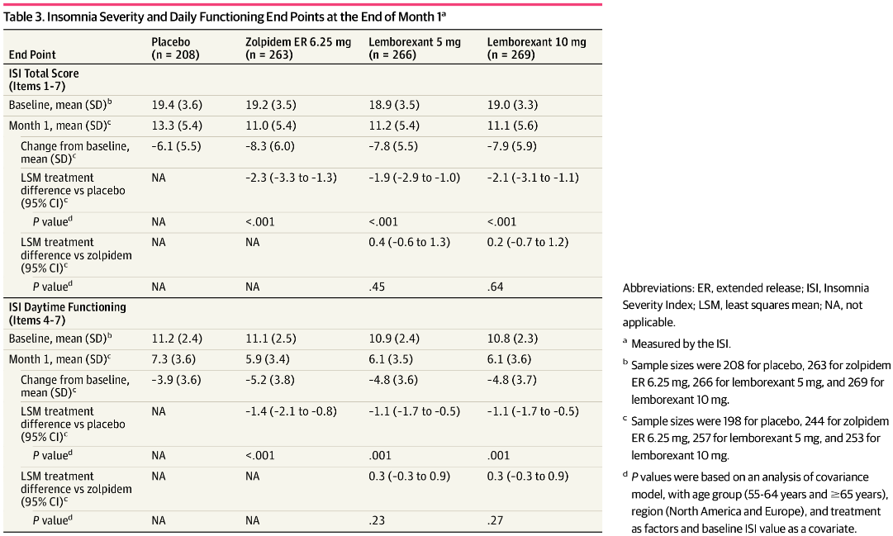

Source: Rosenberg R, Murphy P and Zammit G (2019). Comparison of Lemborexant With Placebo and Zolpidem Tartrate Extended Release for the Treatment of Older Adults With Insomnia Disorder A Phase 3 Randomized Clinical Trial. JAMA Netw Open. 2019;2(12).

Figure 9: Study E2006-G000-304 Sleep onset and sleep maintenance outcomes assessed by sleep diary, by treatment group. outcomes were assessed at the beginning (first 7 nights) and end (end of Month 1) of treatment

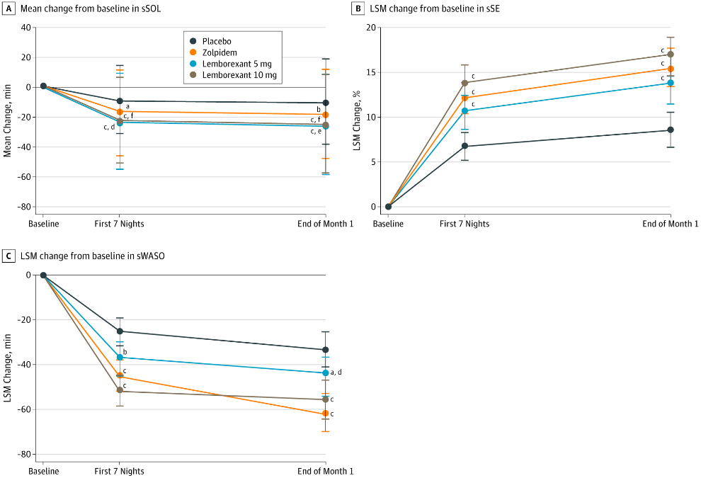

A total of 208 participants received placebo, 263 received 6.5 mg of zolpidem tartrate extended release, 266 received 5 mg of lemborexant, and 269 received 10 mg of lemborexant. A, Mean change from Baseline in subjective sleep onset latency (sSOL). As a result of nonnormal distribution of sSOL latency, values were log transformed, and the geometric mean ratio was used to test for statistically significant treatment differences. B, The least squares mean (LSM) change from Baseline in subjective sleep efficiency (sSE). C, The LSM change from Baseline in subjective wake-after-sleep onset (sWASO). aP < .05 versus placebo, bP < .01 versus placebo, cP < .001 versus placebo, dP ≤ .01 ersuvs zolpidem, eP < .05 versus zolpidem, fP < .001 versus zolpidem. Source: Rosenberg R, Murphy P and Zammit G (2019). Comparison of Lemborexant With Placebo and Zolpidem Tartrate Extended Release for the Treatment of Older Adults With Insomnia Disorder A Phase 3 Randomized Clinical Trial. JAMA Netw Open. 2019;2(12).

There was no evidence for rebound insomnia with lemborexant although interpretation limited by conservative criteria for concluding rebound insomnia (sleep parameters after treatment was completed would have had to be substantially worse than at Screening, that is, prior to starting the placebo Run-in Period to be considered strong evidence for rebound insomnia.

The mean total ISS score and Items 4-7 ISS score was significantly improved with both lemborexant 10 mg and lemborexant 5 mg compared with placebo; the treatment differences between lemborexant (5 mg and 10 mg) was not significantly different to zolpidem. The change from baseline to Day 31 in mean total FSS did not show any statistically significant differences between the lemborexant 10 mg/lemborexant 5 mg and placebo groups or between lemborexant/lemborexant 5 mg and zolpidem.

Both doses of lemborexant did not have any effect on postural stability (by body sway) while zolpidem showed ss greater effects compared to placebo (although it did not reach prespecified threshold of 7 units). Compared to placebo, neither 5 mg or 10 mg lemborexant or zolpidem showed any significant effects at either beginning or end of treatment on the power or continuity of attention, or the quality of memory and speed of memory retrieval.

Overall, the study was well conducted and provided evidence to demonstrate efficacy of lemborexant 10 mg and lemborexant 5 mg in the proposed indication using objective and subjective endpoints.

##### Study ID E2006-G000-303-ext

This was a Phase III, long-term multicentre, randomised, double-blind, controlled, parallel-group study with 2 treatment periods in the randomised treatment phase. Analysis and results from the first placebo controlled 6 month Period 1 was discussed above under Study E2006-G000-303. At the end of Month 6 (Period 2 Baseline), subjects who received placebo during Period 1 underwent a second randomisation to receive either lemborexant 5 mg or lemborexant 10 mg (approximately 1:1, stratified by country and age group (< 65 years old; ≥ 65 years old) during Period 2. Subjects who received lemborexant during Period 1 continued to receive lemborexant at the same dose level during Period 2.

All treatment in Periods 1 and 2 was double blind. In addition, subjects were informed only that all would receive placebo at some point in the study and that all would receive active drug for at least 6 months. They were not informed of the timing of the second randomisation (at the end of Month 6).

Subjects continued to complete the Sleep Diary every morning. Sleep diaries were checked on a monthly basis and subjects returned to the clinic for the 9- and 12-month visits. In between these clinic visits, at the end of Months 7, 8, 10 and 11, study site personnel conducted a phone call to the subject to review any issues with completion of the Sleep Diary and to query concomitant medications and adverse events (AEs). At each clinic visit, safety and tolerability were assessed, the Columbia-Suicide Severity Rating Scale (C-SSRS) was completed, a urine drug test was conducted, the Sleep Diary was reviewed for completeness, compliance was checked, and drug was dispensed (except at the end of Month 12).

At the end of Months 9 and 12, the ISI, FSS, EQ- 5D-3L, PGI-Insomnia and WPAI-GH scores were completed. At predefined visits, a blood sample was collected for PK analysis. For analysis purposes, a subject who completed assessments through Period 2 was defined as a study completer. The follow-up period began at the end of Period 2. Subjects ceased to take study drug but continued to complete the sleep diary each morning until the end of study visit (this was at least 14 days but no more than 18 days after completion of the treatment period).

At the end of study visit, in addition to standard safety assessments and the C-SSRS, a urine drug test was conducted, the Tyrer Benzodiazepine Withdrawal Symptom Questionnaire (T-BWSQ) was administered, and sleep diaries were collected.

Overall, 971 subjects were randomised to lemborexant 10 mg, lemborexant 5 mg and placebo in Period 1 (323, 323 and 325 subjects, respectively. 949 subjects received treatment, forming the full analysis set). A total of 258 subjects from the placebo group were re-randomised to lemborexant 10 mg and lemborexant 5 mg (125 and 133 subjects, respectively) in Period 2; 226 and 251 subjects continued on lemborexant 10 mg and lemborexant 5 mg in Period 2. Overall, treatment compliance in Period 2 was high (> 97%) and similar in the lemborexant 5 mg and lemborexant 10 mg groups.

###### Persistence of efficacy

Change from study Baseline/Period 2 Baseline of mean subjective SOL, mean subjective sleep efficiency, mean subjective WASO and mean subjective TST for one, 3, 6, 9, and 12 months exposure to lemborexant 5 mg and lemborexant 10 mg showed persistence of efficacy.

Mean change from Baseline of lemborexant 10 mg and lemborexant 5 mg at 3, 6, 9, and 12 months of exposure was above the lower bound of the 95% CI at one month of exposure for subjective sleep efficiency and subjective TST.

Mean change from Baseline of lemborexant 10 mg and lemborexant 5 mg at 3, 6, 9 and 12 months of exposure was below the upper bound of the 95% CI at one month of exposure for subjective SOL and subjective WASO.

The improvements in sleep onset and sleep maintenance with both doses were maintained at 3, 6, 9 and 12 months of exposure compared to one month of exposure, showing persistence of efficacy.

*Responder analysis*: The percentage of sleep onset (subjective SOL) responders were consistently > 22% in both lemborexant 10 mg and lemborexant 5 mg groups from 3 months onwards and maintained after 12 months of exposure with similar results observed for the sleep maintenance (subjective WASO) responders.

*Rebound insomnia:* Based on a definition of rebound insomnia as a value of subjective SOL or subjective WASO that was more than 5 minutes longer at specified timepoints than at Screening, the majority of subjects did not show rebound insomnia on subjective SOL or subjective WASO at either dose.

*Daytime function:* The mean change from Baseline of items 1 to 7 of the ISI for lemborexant 10 mg and lemborexant 5 mg were –11.2 (n = 204) and –11.5 (n = 220), respectively. The mean change in the Daytime Functioning Scores from Baseline for lemborexant 10 mg and lemborexant 5 mg were–6.6 and –7.0, respectively.

Both lemborexant 10 mg and lemborexant 5 mg were associated with modest reduction in fatigue severity; the mean average FSS scores for lemborexant 10 mg and lemborexant 5 mg were 3.8 (n = 437) and 3.9 (n = 444), respectively, at Baseline and mean change from Baseline of –1.2 and –1.5, respectively.

##### Study E2006-G000-201

This was a Phase II, multicentre, randomised, double-blind, placebo-controlled, parallel-group, Bayesian Adaptive randomisation design, dose-response study of the efficacy of lemborexant in adults and elderly subjects with chronic insomnia.

The primary objective of the study was to identify a dose or doses of lemborexant with maximum efficacy and minimum next-day residual sleepiness by comparing effects of 6 doses of lemborexant (1 mg, 2.5 mg, 5 mg, 10 mg, 15 mg, or 25 mg) with placebo using a composite utility function that incorporated changes from Baseline on sleep efficiency and change from baseline on the KSS at 1 hour after morning waketime after dosing on Day 1 and Day 2.

Lemborexant decreased the time to sleep onset and improved sleep maintenance after the first 2 doses as measured by both objective (PSG) and after the first week of treatment (sleep diary) measures. The decrease in time to sleep onset was statistically significantly different for latency to persistent sleep at all doses of lemborexant compared to placebo, and for subjective SOL (at doses of 2.5 mg and greater compared to placebo. The improvements relative to Baseline were maintained at the end of the 2 week treatment interval for dose groups at lemborexant 2.5 mg or higher.

The improvement in sleep maintenance was statistically significantly at all doses of lemborexant compared to placebo. In addition, the decrease in WASO was statistically significantly different at 10 mg compared to placebo. The decreases in WASO observed at the beginning of treatment were maintained at the end of the 2 week treatment interval. There was no evidence of rebound insomnia during the 2 day single blind placebo withdrawal period after cessation of treatment with any dose of lemborexant as measured by PSG, nor was there any evidence of rebound insomnia as measured by the sleep diary for the first and second weeks post treatment.

##### Analyses performed across trials: pooled and meta analyses

The efficacy results from the two Phase III studies were pooled. Both studies were multicentre, placebo-controlled, randomised studies which evaluated both proposed doses of lemborexant (5 mg and 10 mg). The study designs were similar although Study E2006-G000-304 had treatment duration of only 1 month and included an active control (zolpidem extended release 6.25mg) while Study E2006-G000-303 had a 6 month double blind placebo-controlled treatment period and an extended 6-month double blind active treatment period. PSG was only done in Study E2006-G000-304 but sleep diary data was collected in both studies.

Overall, 1956 subjects were randomised and received at least one dose of study treatment in the Phase III studies; 1181 were randomised to lemborexant (589 to 5 mg, 592 to 10 mg), 533 to placebo and 263 to zolpidem extended release 6.25mg (only in Study E2006-G000-304).

Results from the primary efficacy endpoints demonstrated the improvement in sleep onset of lemborexant 5 mg and lemborexant 10 mg compared to placebo. The secondary endpoints were the only endpoints to examine sleep maintenance. Clinically meaningful improvements were reported for lemborexant 5 mg and/or lemborexant 10 mg compared to placebo, including improvements in change from Baseline to end of treatment subjective sleep efficiency and subjective WASO in Study 303 and sleep efficiency%, WASO, and WASO in the second half of the night in Study E2006-G000-304.

Table 7: Studies E2006-G000-303 and E2006-G000-304 Results for the primary endpoint

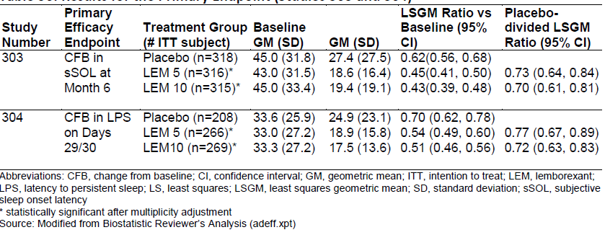

Abbreviations: CFB, change from Baseline; CI, confidence interval; GM, geometric mean; ITT, intention to treat;[27] LEM, lemborexant; LPS, latency to persistent sleep; LS, least squares; LSGM, least squares geometric mean; SD, standard deviation; sSOL, subjective sleep onset latency

*statistically significant after multiplicity adjustment

Source: FDA review <https://www.accessdata.fda.gov/drugsatfda_docs/nda/2019/212028Orig1s000MultidisciplineR.pdf>

The sponsor presented summary efficacy results for several subpopulations, including age, sex, race, and BMI. Efficacy was described for each subgroup during the First 7 days and at Month 1 of treatment.

Figure 10 to Figure 17 display Forest plots for subjective SOL, subjective sleep efficiency, subjective WASO by subgroup using pooled data from Studies E2006-G000-303 and E2006-G000-304.

Figure 10: Studies E2006-G000-303 and E2006-G000-304 Forest plot of change from Baseline for first 7 days in subjective sleep onset latency by age and sex subgroups (full analysis set)

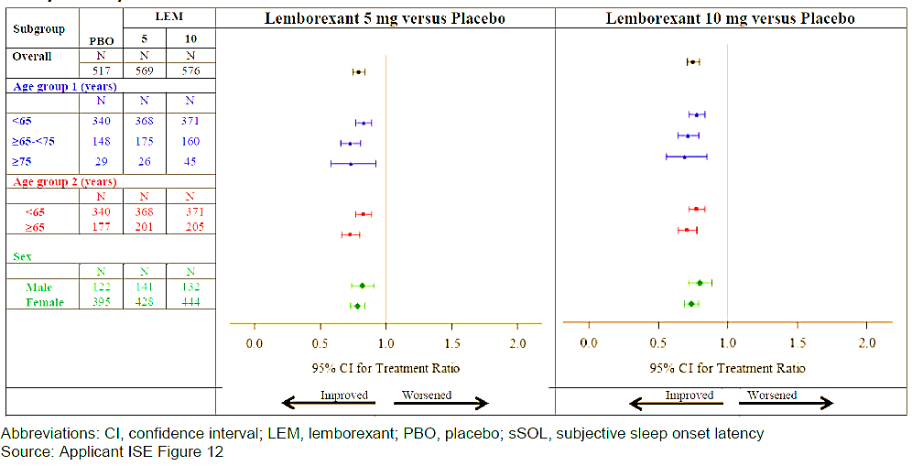

Abbreviations: CI, confidence interval; LEM, lemborexant; PBO, placebo; sSOL, subjective sleep onset latency

Figure 11: Studies E2006-G000-303 and E2006-G000-304 Forest plot of change from Baseline in subjective sleep onset latency for one month by age and sex subgroups (full analysis set)

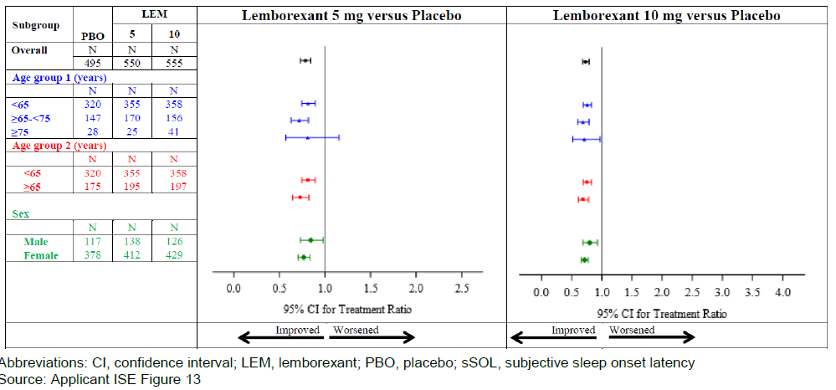

Abbreviations: CI, confidence interval; LEM, lemborexant; PBO, placebo; sSOL, subjective sleep onset latency

Figure 12: Studies E2006-G000-303 and E2006-G000-304 Forest plot of change from Baseline for first 7 days for subjective sleep efficiency by age and sex subgroups (full analysis set)

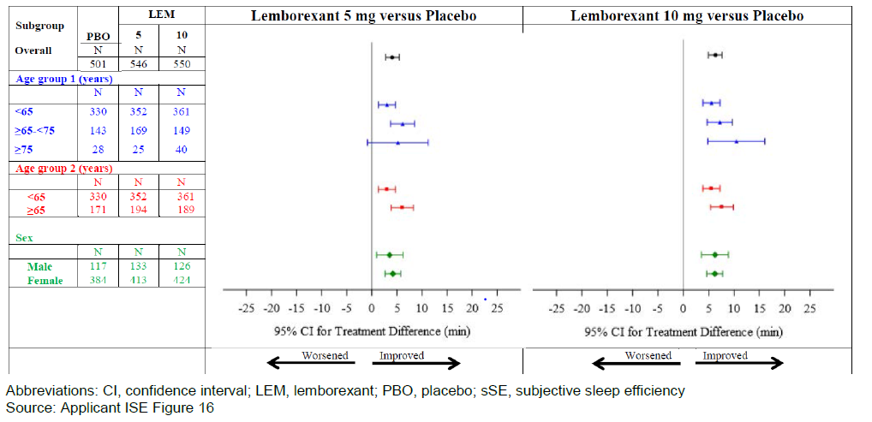

Abbreviations: CI, confidence interval; LEM, lemborexant; PBO, placebo; sSE, subjective sleep efficiency

Figure 13: Studies E2006-G000-303 and E2006-G000-304 Forest plot of change from Baseline for one month in subjective sleep efficiency by age and sex subgroups (full analysis set)

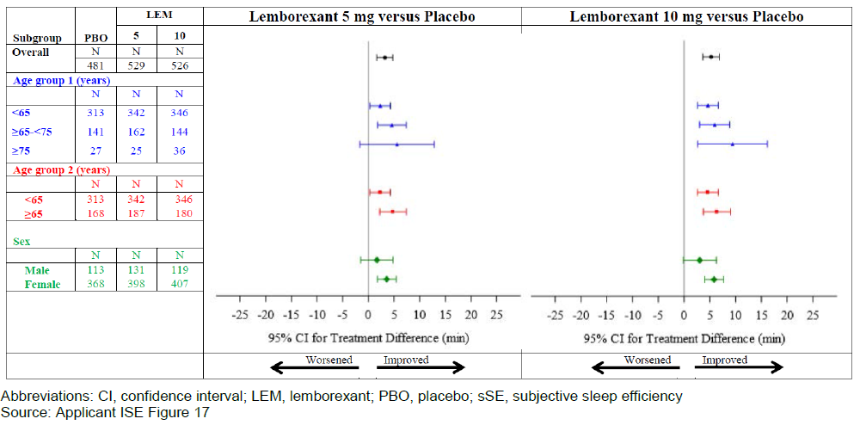

Abbreviations: CI, confidence interval; LEM, lemborexant; PBO, placebo; sSE, subjective sleep efficiency

Figure 14: Studies E2006-G000-303 and E2006-G000-304 Forest plot of change from Baseline for first 7 days for subjective wake after sleep onset by age and sex subgroups (full analysis set)

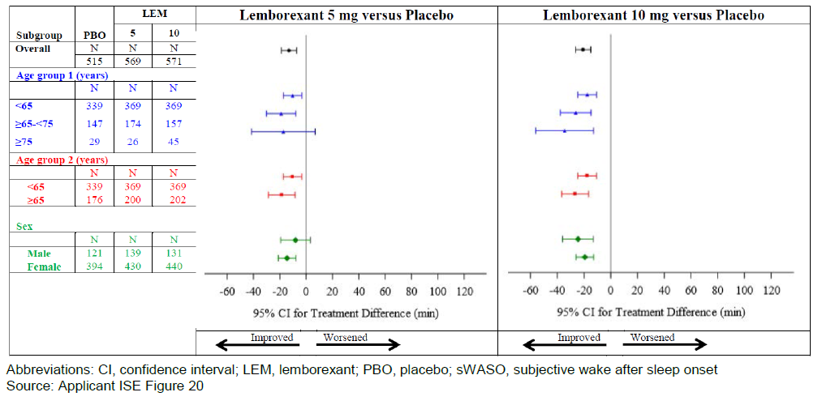

Abbreviations: CI, confidence interval; LEM, lemborexant; PBO, placebo; sWASO, subjective wake after sleep onset

Figure 15: Studies E2006-G000-303 and E2006-G000-304 Forest plot of change from Baseline for one month for subjective wake after sleep onset by age and sex subgroups (full analysis set)

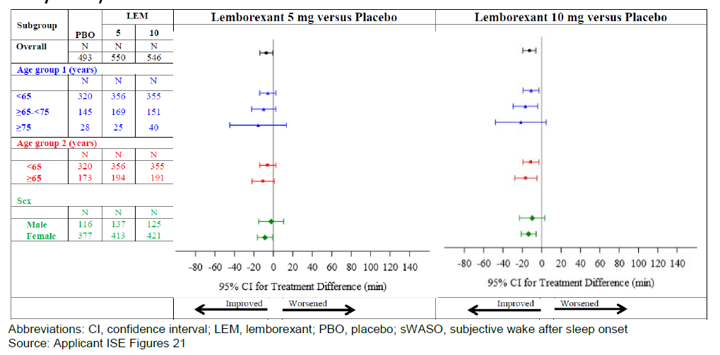

Abbreviations: CI, confidence interval; LEM, lemborexant; PBO, placebo; sWASO, subjective wake after sleep onset

Figure 16: Studies E2006-G000-303 and E2006-G000-304 Forest plot of change from Baseline for subjective sleep onset with data handling rules for the first 7 days by race, region, and body mass index subgroups (full analysis set)

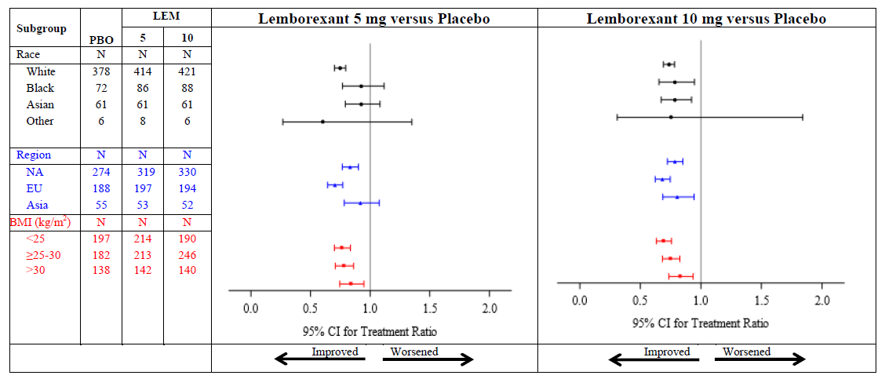

Figure 17: Studies E2006-G000-303 and E2006-G000-304 Forest plot of change from Baseline for subjective sleep onset latency with data handling rules at Month 1 by race, region, and body mass index subgroups (full analysis set)

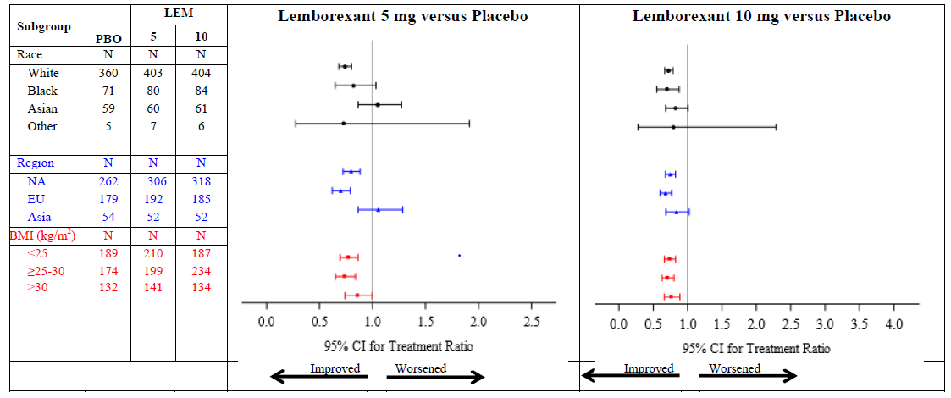

### Safety

The safety of lemborexant was evaluated in the proposed target patient population of patients with insomnia disorder as per the DSM-5. It is noted that the definition includes patients with or without medical or psychiatric comorbidities although patients with uncontrolled mood or anxiety disorders and many other psychiatric conditions were excluded in Phase III studies. In the pivotal Phase III studies, 784 subjects were exposed to lemborexant at proposed doses for at least 3 months (404 subjects on the 5 mg and 380 on 10 mg lemborexant dose, respectively); 635 were exposed for at least 6 months (332 and 303 subjects on the 5 mg and 10 mg doses, respectively), 456 for at least 9 months (243 and 213 subjects on the 5 mg and 10 mg dose, respectively) and 286 for at least 12 months (148 and 138 on the 5 mg and 10 mg dose, respectively). Safety was also evaluated in Alzheimer’s disease dementia patients with irregular sleep-wake rhythm disorder, and in subjects with mild obstructive sleep apnoea, representing a broad population with over 40% of subjects included in all these studies being elderly (aged ≥ 65 years old). Hence, exposure to lemborexant was adequate to evaluate safety for proposed indication.

The overall incidence of treatment emergent adverse events (TEAEs) for subjects treated with lemborexant 5 mg and lemborexant 10 mg in the Phase III pool (51.3% and 51.3%, on the 5 mg and 10 mg doses respectively) was slightly higher than that in the placebo group (47.9%). However, when adjusted by duration of exposure, the overall incidence (subjects per patient-year) was lower in the lemborexant groups (1.2, 1.1 and 1.6 events in the lemborexant 10 mg, lemborexant 5 mg and placebo, respectively) as was the overall rate (3.1, 3.1 and 3.3 events per patient-year, respectively). A similar TEAE profile was observed in all other study populations, including other sleep disorders (subjects withobstructive sleep apnoea, and irregular sleep-wake rhythm disorder) and special populations (subjects with renal impairment and hepatic impairment).

In all study pools, the most frequently reported TEAE was somnolence, which occurred at a higher incidence in the lemborexant 10 mg and lemborexant 5 mg groups compared with placebo (10.5%, 6.6% and 1.6%, respectively) in the Phase III pool. However, the differences were not as obvious when adjusted by duration of exposure: the overall incidence of somnolence was 0.3, 0.1 and 0.1 subjects per patient-year, respectively while the overall rate was 0.3, 0.2 and < 0.1 events per patient-year, respectively. In all studies, most TEAEs were mild or moderate in severity. Adverse drug reactions associated with lemborexant treatment were somnolence, fatigue, urinary tract infection and sleep paralysis. The incidence of sleep paralysis was low and similar in the lemborexant 5 mg and lemborexant 10 mg groups (1.1% and 1.6%, respectively); no event of sleep paralysis was reported in the placebo group.

Table 8: Studies E2006-G000-303 and E2006-G000-304 Overview of treatment-emergent adverse events

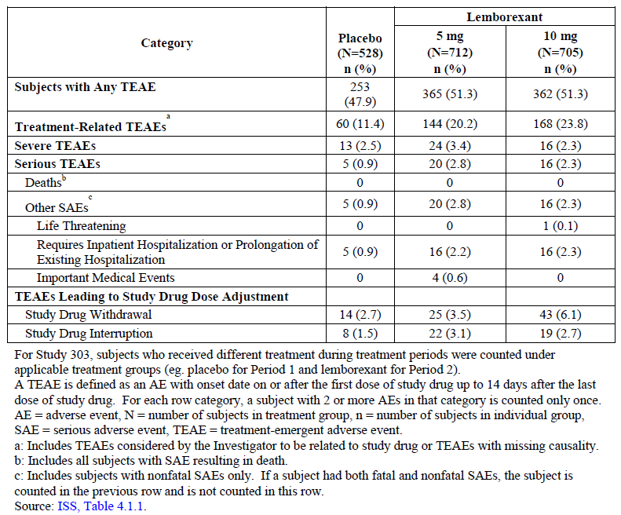

Table 9: Studies E2006-G000-303 and E2006-G000-304 Treatment-emergent adverse events in ≥ 2% of subjects in any treatment group

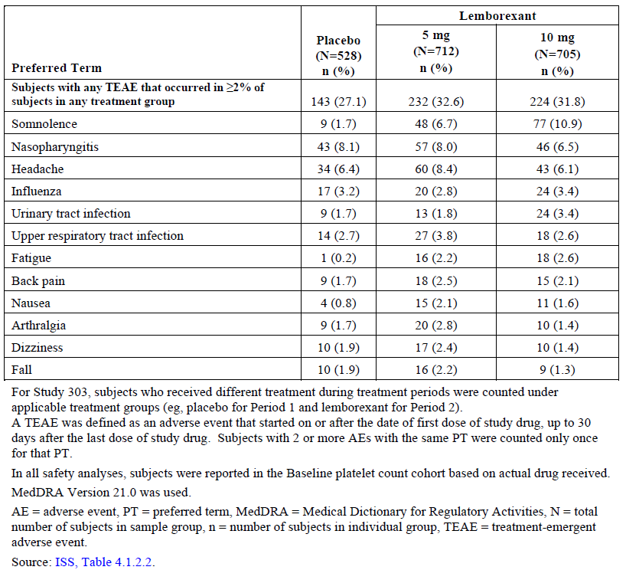

Due to the theoretical possibility that inhibiting orexin neurotransmission could lead to cataplexy symptoms, cataplexy was identified as a program specific TEAE and all potential cataplexy TEAEs were adjudicated by an independent committee blinded to treatment group. In the All sleep disorders pool, a total of 61 subjects (11 (1.5%) subjects in the placebo, 22 (2.6%) subjects in the lemborexant 5 mg, 23([2.6%) subjects in the lemborexant 10 mg, and 5 (3.8%) subjects in the lemborexant 15 to 25 groups) reported TEAEs related to cataplexy. None of the reported events were adjudicated as cataplexy. There was no evidence for a narcolepsy-like syndrome in any of the populations.

In the pivotal Phase III Study E2006-G000-303, no time-dependent or dose-related increases in suicidal ideation (based on analysis of Columbia-Suicide Severity Rating Scale results) was observed and no subjects reported any suicidal behaviour, or non-suicidal self injurious behaviour during Period 1. Overall, suicidality was rarely reported and the all insomnia pool analysis showed that the incidence of suicidality was low and similar across treatment groups (0.3%, 0.1% and 0.2% in the lemborexant 10 mg, lemborexant 5 mg and placebo groups, respectively).

No deaths were reported in any of the lemborexant clinical studies. The overall incidence of treatment-emergent serious adverse events for subjects treated with lemborexant 5 mg and lemborexant 10 mg in the Phase III pool was low (2.8% and 2.3%, respectively) but greater than placebo (0.9%). However, when adjusted by duration of exposure, the overall incidence (subjects per patient-year) was similar to placebo (< 0.1 for placebo, 0.1 for lemborexant 5 mg and 0.1 for lemborexant 10 mg). There were no treatment-emergent serious adverse events of cataplexy, potential cataplexy, seizure, somnolence, sleep paralysis, or abuse liability.

In the Phase III pool, the incidence of discontinuations due to AEs was slightly higher in the lemborexant groups compared with placebo (6.1%, 3.5% and 2.7% in lemborexant 10 mg, lemborexant 5 mg and placebo groups, respectively) and somnolence was the main AE leading to discontinuation in 2.3%, 1.1% and 0.6% of subjects, respectively.

There were no differences in safety profile based on intrinsic factors, including importantly, age and sex of subjects.

Long-term treatment up to 12 months was only evaluated in the Phase III Study E2006‑G000‑303 and did not show any new safety concerns compared to data up to one month’s treatment.

In the Phase III pool, the rates of AEs associated with dual orexin receptor antagonists and other classes of sleep-promoting drugs were low and similar across the placebo, lemborexant 5 mg and lemborexant 10 mg groups.

There was no evidence of suicidality, withdrawal symptoms or abuse liability following treatment with lemborexant.

Lemborexant did not cause morning residual effects assessed by the following parameters with similar results in elderly and younger subjects. Driving performance was not impaired in the on-road driving study after single and multiple doses of lemborexant. Lemborexant did not impair postural stability upon awakening in the morning. Tests of memory upon awakening did not show differences between lemborexant and placebo. Reaction time tests of performance showed no impairment across the day.

Lemborexant treatment was not associated with clinically meaningful changes in laboratory parameters (liver function tests, renal function, haematology), vital signs or the electrocardiogram (ECG) results.

### Risk management plan

The summary of safety concerns and their associated risk monitoring and mitigation strategies are summarised in Table 10.[28]

The sponsor has applied to register a new chemical entity, lemborexant, as the product Dayvigo. Dayvigo is proposed to be used for the treatment of insomnia. The proposed dosing regimen involves oral administration of one tablet (5 mg or 10 mg) daily at night.

The sponsor has submitted the Canadian risk management plan (RMP) version 1.0 (date 25 August 2019; data lockpoint (DLP) 11 January 2019) and Australian specific-annex (ASA) version 1.0 (date 8 May 2020) in support of this application. At round two the sponsor submitted ASA version 2.0 (date 27 January 2021) associated with the Canadian RMP version 1.0 (date 25 August 2019; DLP 11 January 2019).

Table 10: Summary of safety concerns

|  |  |  |  |  |  |
| --- | --- | --- | --- | --- | --- |
| Summary of safety concerns | | Pharmacovigilance | | Risk Minimisation | |
| Routine | Additional | Routine | Additional |
| **Important identified risks** | CNS depressant effects and daytime impairment | ✓ | – | ✓ | – |
| Drug-drug interactions (co-administration with moderate and strong CYP3A inhibitors or inducers) | ✓ | – | ✓ | – |
| Additive effects with alcohol | ✓ | – | ✓ | – |
| **Important potential risks** | Symptoms of narcolepsy | ✓ | – | ✓ | – |
| Abuse potential | ✓ | – | ✓ | – |
| **Missing information** | Pregnancy and lactation | ✓ | ✓* | ✓ | – |
| Patients with chronic obstructive pulmonary  disease (COPD) or moderate to severe obstructive sleep apnoea (OSA) | ✓ | ✓† | ✓ | – |
| Patients with clinically diagnosed depression | ✓ | – | ✓ | – |
| Effects of lemborexant in overdose | ✓ | – | ✓ | – |

* Registry Study E2006-A001-603 and observational Study E2006- A001-604

† Clinical Study E2006-A001-113

* The sponsor has updated the list of RMP safety concerns to include patient groups excluded from clinical trials, and class safety concerns for orexin antagonists. The summary of safety concerns is acceptable.
* Routine pharmacovigilance activities are proposed for all safety concerns. In response to a request, the sponsor has added additional pharmacovigilance for the missing information ‘pregnancy and lactation’ in the form of planned studies and for ‘patients with chronic obstructive pulmonary disease (COPD) or moderate to severe obstructive sleep apnoea (OSA)’ in the form of ongoing studies. The pharmacovigilance plan is acceptable.
* The sponsor proposes routine risk minimisation for all safety concerns. Additional risk minimisation activities have not been proposed. The sponsor has updated the risk minimisation materials as requested to address the added inclusions to the RMP list of safety concerns. The risk minimisation plan is acceptable.

Any changes to which the sponsor has agreed should be included in a revised risk management plan (RMP) and Australian Specific Annex (ASA). However, irrespective of whether or not they are included in the currently available version of the RMP document, the agreed changes become part of the risk management system:

*The Dayvigo Canadian Risk Management Plan (RMP) (version 1.0, dated 25 August 2019, data lock point 11 January 2019), with Australian Specific Annex (version 2.0, dated 27 January 2021), included with submission PM-2020-02421-1-1, and any subsequent revisions, as agreed with the TGA will be implemented in Australia.*

The following wording is recommended for the PSUR requirement:

*An obligatory component of risk management plans is routine pharmacovigilance. Routine pharmacovigilance includes the submission of periodic safety update reports (PSURs).*

*Unless agreed separately between the supplier who is the recipient of the approval and the TGA, the first report must be submitted to TGA no later than 15 calendar months after the date of this approval letter. The subsequent reports must be submitted no less frequently than annually from the date of the first submitted report until the period covered by such reports is not less than three years from the date of this approval letter. The annual submission may be made up of two PSURs each covering six months. If the sponsor wishes, the six monthly reports may be submitted separately as they become available.*

*If the product is approved in the EU during the three years period, reports can be provided in line with the published list of EU reference dates no less frequently than annually from the date of the first submitted report until the period covered by such reports is not less than three years from the date of this approval letter.*

*The reports are to at least meet the requirements for PSURs as described in the European Medicines Agency’s Guideline on good pharmacovigilance practices (GVP) Module VII-periodic safety update report (Rev 1), Part VII.B Structures and processes. Note that submission of a PSUR does not constitute an application to vary the registration. Each report must have been prepared within ninety calendar days of the data lock point for that report.*

As Dayvigo is a new chemical entity it should be included in the Black Triangle Scheme as a condition of registration. The following wording is recommended for the condition of registration:

*Dayvigo (lemborexant) is to be included in the Black Triangle Scheme. The PI and CMI for Dayvigo must include the black triangle symbol and mandatory accompanying text for five years, which starts from the date that the sponsor notifies the TGA of supply of the product.*

### Risk-benefit analysis

#### Delegate’s considerations

Lemborexant is an orexin receptor antagonist that has been developed for the treatment of insomnia in adults. The drug is intended to reduce the time to sleep onset and improve the maintenance of sleep by reducing the time awake during the night.

The standard of care for the treatment of insomnia disorder consists of cognitive behavioural therapy (CBT) for insomnia and pharmacological treatments if CBT alone is inadequate. There are a large number of TGA-approved and off label drugs used for the treatment of insomnia, including an orexin receptor antagonist, a melatonin receptor agonist, sedating antidepressants, benzodiazepines, and benzodiazepine receptor agonists. Current treatments for insomnia are limited by safety risks which vary by pharmacological class. The current insomnia treatment armamentarium would benefit from additional therapies with improved effectiveness, as evidenced by improvements in daytime functioning that was impaired by insomnia, as well as from therapies with improved safety profiles compared with many classes of existing treatments, particularly with respect to vulnerable populations such as elderly individuals.

The main evidence for efficacy of lemborexant (5mg and 10 mg once daily) in the proposed indication was provided by two Phase III studies involving 1956 adults with insomnia characterised by difficulties in sleep onset and/or sleep maintenance. Study E2006-G000-303 was a randomised, double-blind, placebo-controlled, parallel-group study, to evaluate safety and efficacy of long-term treatment (up to 12 months) with both proposed doses of lemborexant (lemborexant 5 mg and lemborexant 10 mg) in 971 adult subjects (≥ 18 years of age) with insomnia (subjects had difficulty in sleep onset and/or sleep maintenance). The other pivotal study was a randomised, double-blind, placebo- and active-controlled (zolpidem 6.25 mg once daily), parallel group, one month study to evaluate safety and efficacy of 2 doses of lemborexant (lemborexant 5 mg and lemborexant 10 mg) in 1006 subjects aged 55 years and older with insomnia disorder. This study evaluated older subjects with predominant sleep maintenance issues (as difficulty in sleep onset was not a necessary inclusion criterion).

Supportive evidence of efficacy was provided by proof-of-concept dose-ranging Phase II Study E2006-G000-201 in 291 subjects with insomnia while Study E2006-G000-202 provided preliminary evidence of efficacy in 62 subjects aged 60 to 90 years old and having irregular sleep-wake rhythm disorder and mild to moderate Alzheimer’s disease dementia.

The clinical studies were well conducted and utilised appropriate randomisation and blinding methods. The study endpoints included a broad subjective evaluation (using a sleep diary) of effects on sleep onset (subjective sleep onset latency), sleep maintenance (subjective sleep efficiency and subjective wake after sleep onset (WASO)), total sleep time, effects on daytime function (ISI and FSS scores) and quality of life (PGI Insomnia and EQ-5D-3L scores) and work productivity (WPAI-GH scores).

Objective evaluation of sleep parameters (by polysomnography) was undertaken in the Phase III Study E2006-G000-304. Electronic sleep diaries were used in both studies and were adequately validated systematic data handling rules were developed to address potential errors/illogical values in the sleep diary data and consistent results were observed for sleep parameters with and without data handling.

Overall, the study design, endpoint and analysis in the lemborexant clinical studies complied with the European Medicines Agency’s CHMP guidelines for evaluation of medicinal products for treatment of insomnia.20

It is important to note that in the Phase III studies, objective assessment of sleep parameters (by polysomnography) was only conducted in subjects aged > 55 years (Study E2006-G000-304 only).

The study population was enrolled using relevant updated diagnostic criteria for insomnia (DSM-5, ICSD-3) and other sleep co-morbidities were excluded. It was representative of the target patient population of adults with insomnia characterised by difficulties in sleep onset and/or sleep maintenance; majority of subjects enrolled in Phase III studies were female (78%), White (72%) and aged < 65 years (63%). The baseline disease characteristics were consistent with presence of insomnia (subjective sleep onset latency (SOL) ≥ 60 minutes, subjective WASO of approximately 2.5 hours and mean subjective sleep efficiency < 60%) and were similar across the lemborexant and placebo treatment groups. Patients with moderate/severe depression or anxiety were excluded from the studies.

The results of Studies E2006-G000-303 and E2006-G000-304 showed that sleep onset and sleep maintenance variables improved both within and between studies, and in all subpopulations following treatment with lemborexant 5 mg and 10 mg once daily.

Both lemborexant 5 mg and lemborexant 10 mg provided statistically significant efficacy compared to PBO on subjective and objective measures of time to sleep onset. Based on mean change from baseline in subjective SOL lemborexant 10 mg provided numerically better efficacy than lemborexant 5 mg although this was not observed in the subjective SOL responder analysis (12.6%, 12.4% and 4.7% in the lemborexant 10 mg, lemborexant 5 mg and placebo groups, respectively at end of first 7 days; 21.0%, 18.4% and 10.1%, respectively at the end of Month 1).

The effects of lemborexant on sleep maintenance were assessed using objective and subjective endpoints, including sleep efficiency/subjective sleep efficiency and WASO/subjective WASO/WASO in the second half of the night, with both does of lemborexant showing statistically significant greater improvements compared with placebo which were observed immediately at beginning of treatment and persisted through 6 months. Although the mean change from Baseline was numerically greater in the 10 mg group, the responder analysis for subjective WASO also failed to show dose-response (19.3%, 17.3% and 11.4% in lemborexant 10 mg, lemborexant 5 mg and placebo groups, respectively at the end of first 7 days; 23.6%, 23.4% and 17.7%, respectively at the end of Month 1).

All subpopulations showed improvement in sleep onset and sleep maintenance variables, and no dose adjustment is required across subpopulations. Subpopulation analyses demonstrated benefit for both doses with only 10 mg dose showing efficacy in Black and Asian populations, males and those with BMI >25kg/m2.

The findings on sleep diary and polysomnography were supported by additional endpoints (Quality of Sleep Ratings), PGI-I, ISI Total Score and ISI Daily Functioning Score. At the end of Month 1, both lemborexant groups (10mg and 5 mg) showed significantly greater percentage of responders compared to placebo in terms of percentage of subjects whose ISI Total Score decreased by ≥ 7 points (47.8%, 47.3% and 33.6% in the lemborexant 10 mg, lemborexant 5 mg and placebo groups, respectively) and by > 10 points (33.4%, 33.0% and 20.3%, respectively).

When compared to zolpidem, treatment differences for change from Baseline in objective measures of sleep efficiency and WASO were statistically significantly superior for both lemborexant 5 mg and lemborexant 10 mg for Days 1/2 and Days 29/30 (p ≤ 0.0154 for all comparisons). No significant difference in subjective measures of subjective sleep efficiency and subjective WASO were observed for lemborexant 5 mg or lemborexant 10 mg compared to zolpidem.

Overall, both proposed doses of lemborexant (5mg and 10 mg) provided consistent significant benefit for nocturnal sleep (sleep onset and sleep maintenance) without compromising the daytime functioning.

The onset of action was rapid with significant improvements observed for first 7 days, after 1 month with efficacy maintained for up to 12 months (evaluated in Study E2006‑G000-303 only).

Long term maintenance of efficacy was demonstrated up to 6 months in the placebo-controlled Period 1 of Study E2006-G000-303. The uncontrolled, double-blind extension Period 2 of Study E2006-G000-303 provided evidence of efficacy up to 12 months. The proportion of subjective SOL responders were 12.9%, 25.1% and 22.8% at one, 6 and 12 months, respectively in the lemborexant 5 mg group; it was 17.4%, 24.2% and 24.5%, respectively in the lemborexant 10 mg group. Similar response rates were also observed for subjective WASO responders.

Rebound insomnia was assessed from sleep diary data based on change from screening of subjective SOL and subjective WASO during the follow-up period in Studies E2006‑G000‑303, E2006-G000-304 and E2006-G000-201. Across the studies, there was no evidence that abrupt cessation of treatment with lemborexant was associated with rebound insomnia, and neither the group mean nor the proportion of subjects analyses indicated worse subjective SOL or subjective WASO compared to pretreatment values on those parameters.

The safety database for lemborexant included 1847 subjects with any sleep disorder who were exposed to at least one dose of lemborexant during the development program. The database included 708 subjects exposed to lemborexant for ≥ 6 months and 434 subjects for 12 months, which was an adequate duration of exposure to facilitate pre-marketing characterisation of safety. The most common adverse reactions to lemborexant were somnolence/fatigue, headache, and nightmare/abnormal dreams. Other significant adverse reactions that occurred infrequently in Phase III studies included sleep paralysis, hypnagogic hallucinations, and complex sleep behaviours.

Caution required in patients with pre-existing moderate/severe depression as these patients were excluded from lemborexant studies. There is no evidence on how to manage the dose titration which will be considered in real world clinical settings if efficacy was present but insufficient at lower doses.

The sponsor did not study for the potential of lemborexant to cause respiratory depression in patients with moderate to severe obstructive sleep apnoea or respiratory conditions such as chronic obstructive pulmonary disease. Because hypnotics are frequently used in elderly patients who may have compromised respiratory function and many hypnotics are associated with respiratory depression, the lack of this information is a safety uncertainty. Also, safety in pregnant and breastfeeding women and children is missing. However, the safety concerns of lemborexant can be managed in the post market setting by updating the PI with known and anticipated risks, post marketing pharmacovigilance, and the conduction of post marketing safety studies.

Overall, lemborexant has been demonstrated to provide significant and sustained efficacy for both sleep onset and sleep maintenance with a favorable safety profile, which includes minimal impact on daily functioning including the ability to drive the next morning. Lemborexant has a favorable profile with regards to potential concerns about other insomnia treatments (postural stability, cognition, driving, functioning, residual morning sleepiness, abuse liability).

Both proposed doses of lemborexant (5mg and 10 mg) provided consistent significant benefit for nocturnal sleep (sleep onset and sleep maintenance) without compromising the daytime functioning and would provide a safe and effective therapeutic option for adults with insomnia characterised by difficulties with sleep onset and/or sleep maintenance.

The benefit risk balance of lemborexant for the proposed indication is favourable.

##### Deficiencies of the data

The Delegate highlighted the following deficiencies of the data:

* use with cognitive behavioural therapy
* use in moderate to severe obstructive sleep apnoea
* dose titration data
* use in moderate to severe respiratory conditions
* safety of lemborexant in pregnant and breastfeeding women
* lack of an *in vitro* drug-drug interaction study to assess the potential of lemborexant as an inducer of CYP2C8, CYP2C9 and CYP2C19
* lack of an *in vitro* drug-drug interaction study to assess the potential of lemborexant as a P-gp substrate at clinically relevant concentrations.

#### Conclusion and summary of issues

The Delegate overall supports the clinical evaluator in recommending approval of lemborexant for the treatment of insomnia, characterised by difficulties with sleep onset and/or sleep maintenance.

The following key issues still to be addressed:

1. Cognitive behavioural therapy use prior to enrolment into the study
2. Dose titration data
3. Effects of lemborexant in moderate to severe obstructive sleep apnoea is unknown
4. Effects of lemborexant in chronic obstructive pulmonary disease are unknown
5. No data on pregnant or lactating women
6. No data in paediatric populations

Overall Dayvigo is approvable as the quality, nonclinical and clinical evaluators have all recommended approval. The Delegate considers that sufficient data and justification have been provided to support the registration of Dayvigo on quality, safety and efficacy grounds for *the treatment of insomnia, characterised by difficulties with sleep onset and/or sleep maintenance* (subjected to product information changes after Advisory Committee on Medicines (ACM) deliberations).

#### Delegate’s proposed action

The Delegate had no reason to say, at this time, that the application for Dayvigo should not be approved for registration for insomnia, characterised by difficulties with sleep onset and/or sleep maintenance.

Any approval is subject to taking into account all issues arising from the ACM deliberations and finalising matters pertaining to the PI, to the satisfaction of the TGA.

##### Proposed conditions of registration

The Delegate gave the following proposed conditions of registration:

* Dayvigo (lemborexant) is to be included in the Black Triangle Scheme. The PI and CMI for Dayvigo must include the black triangle symbol and mandatory accompanying text for five years, which starts from the date that the sponsor notifies the TGA of supply of the product.
* Submit the study report of *in vitro* drug-drug interaction study to assess the potential of lemborexant as an inducer for CYP2C8, CYP2C9 and CYP2C19.
* Submit the *in vitro* drug-drug interaction study report to assess the potential of lemborexant as a P-gp substrate at clinically relevant concentrations.

#### Questions for the sponsor

***Can you [the sponsor] please clarify if patients included in Studies E2006-G000-303 and E2006-G000-304 had a history of failed cognitive behavioural therapy for insomnia before the enrolment? If not please provide the explanation or rationale for their inclusion?***

For the pivotal Phase III studies, the sponsor did not require subjects to have had and/or failed previous treatment for insomnia, either nonpharmacological or pharmacological. Data on previous treatments were not collected.

These studies were designed to enrol patients with insomnia disorder. While Cognitive Behavioral Therapy for Insomnia (CBT-I) is a therapeutic entity with evidence-based efficacy, it is not widely used due to limited trained practitioners. Further, important differences exist in the duration and components of CBT- I treatment as well as variations in CBT-I delivery systems. Thus, it would not be feasible to include patients who had failed CBT-I.

#### Advisory Committee considerations[29]

The Advisory Committee on Medicines (ACM), having considered the evaluations and the Delegate’s overview, as well as the sponsor’s response to these documents, advised the following.

##### Specific advice to the Delegate

The ACM advised the following in response to the Delegate’s specific request for advice:

1. ***What are ACM’s views on the efficacy and to what extent is there sufficient clinical trial evidence to support the proposed indication for lemborexant (Dayvigo)?***

The ACM was of view that lemborexant 5 mg dose has been demonstrated to have meaningful and significant efficacy in improving sleep onset and maintenance for patients with diagnosed insomnia disorder. While the 10 mg dose was shown to be efficacious in the clinical trials, the ACM expressed concerns that the dose-response relationship has not been sufficiently established to substantiate the place in therapy of the 10 mg strength or the recommendation to increase dosing to 10 mg if additional effect is required. The ACM also emphasised that the 10 mg dose has an increase in adverse events compared to the 5 mg dose. Thus, the ACM was of the view to support the use of the 5 mg strength but not the 10 mg strength of lemborexant.

The ACM were supportive of limiting the target population in the proposed indication for lemborexant. The ACM noted that the target population in the sponsor’s proposed indication is wider than the population studied in the pivotal clinical trials and that secondary insomnia treatment was not studied within this submission. The ACM highlighted that secondary insomnia is a condition which requires management targeted primarily at addressing the underlying associated or causative factors. The ACM was of the view that based on the data submitted by the sponsor, the indication should be restricted to use in patients with insomnia disorder diagnosed in accordance with the latest Diagnostic and Statistical Manual of Mental Disorders (DSM) criteria.

1. ***Should the indication include cognitive behavioural therapy (CBT) as first choice of treatment and lemborexant should be initiated after CBT or with CBT?***

The ACM advised that cognitive behavioural therapy (CBT) for insomnia is established in all relevant clinical and professional guidance as first line treatment for primary insomnia disorder and many secondary insomnia disorders. The ACM was of the view CBT for insomnia should be utilised as a first line treatment and continued as concomitant therapy with lemborexant.

1. ***Does the ACM consider that the safety of lemborexant (Dayvigo) in the proposed new indication is sufficiently well characterised and communicated in the Production Information?***

The ACM considered the safety profile of 5 mg lemborexant to be acceptable based on the data submitted. The toxicity profile is of mild to moderate severity in a narrow range of adverse events, which the ACM agreed are readily anticipated and manageable. The ACM agreed that the safety of lemborexant is sufficiently well characterised and communicated in the Product Information.

1. ***The Committee is also requested to provide advice on any other issues that it thinks may be relevant to a decision on whether or not to approve this application.***

The ACM advised that there is a need to emphasise in the Product Information that there is no paediatric data on lemborexant. The ACM noted there is a possibility that lemborexant will be used within this population, especially for those on stimulants.

##### Conclusion

The ACM considered this product to have an overall positive benefit-risk profile for the indication:

*Dayvigo is indicated for the treatment of Insomnia Disorder diagnosed in accordance with the latest Diagnostic and Statistical Manual of Mental Disorders (DSM) criteria.*

*Dayvigo should be used for as short a duration as necessary and only as second-line treatment to non-pharmacological measures. These include: optimising sleep practices, stimulus control and Cognitive Behavioral Therapy for Insomnia (CBT-I), which are readily available and must be continued as concomitant therapy.*

### Outcome

Based on a review of quality, safety and efficacy, the TGA approved the registration of Dayvigo lemborexant 5 mg and 10 mg film coated blister pack, indicated:

*Dayvigo is indicated for the treatment of insomnia, characterised by difficulties with sleep onset and/or sleep maintenance in accordance with latest DSM criteria*

#### Specific conditions of registration applying to these goods

* Dayvigo (lemborexant) is to be included in the Black Triangle Scheme. The PI (Product Information) and CMI (Consumer Medicines Information) for Dayvigo must include the black triangle symbol and mandatory accompanying text for five years, which starts from the date that the sponsor notifies the TGA of supply of the product.
* The Dayvigo Canadian-risk management plan (RMP) (version 1.0, dated 25 August 2019, data lock point 11 January 2019), with Australian specific annex (version 2.0, dated 27 January 2021), included with Submission PM-2020-02421-1-1, and any subsequent revisions, as agreed with the TGA will be implemented in Australia.

An obligatory component of RMP is routine pharmacovigilance. Routine pharmacovigilance includes the submission of periodic safety update reports (PSURs).

Unless agreed separately between the supplier who is the recipient of the approval and the TGA, the first report must be submitted to TGA no later than 15 calendar months after the date of the approval letter. The subsequent reports must be submitted no less frequently than annually from the date of the first submitted report until the period covered by such reports is not less than three years from the date of the approval letter. The annual submission may be made up of two PSURs each covering six months. If the sponsor wishes, the six monthly reports may be submitted separately as they become available.

If the product is approved in the European Union (EU) during the three years period, reports can be provided in line with the published list of EU reference dates no less frequently than annually from the date of the first submitted report until the period covered by such reports is not less than three years from the date of the approval letter.

The reports are to at least meet the requirements for PSURs as described in the European Medicines Agency’s guideline on Good Pharmacovigilance Practices (GVP) Module VII-periodic safety update report (revision 1), Part VII.B structures and processes. Note that submission of a PSUR does not constitute an application to vary the registration. Each report must have been prepared within ninety calendar days of the data lock point for that report.

* Submit the study report of *in vitro* drug-drug interaction (DDI) study to assess the potential of lemborexant as an inducer for cytochrome P450 family 2 subfamily C member 8 (CYP2C8), cytochrome P450 family 2 subfamily C member 9 (CYP2C9) and cytochrome P450 family 2 subfamily C member 19 (CYP2C19).
* Submit the study report of *in vitro* DDI study to assess the potential of lemborexant as a P‑glycoprotein substrate at clinically relevant concentrations.

## Attachment 1. Product Information

The PI for Dayvigo approved with the submission which is described in this AusPAR is at Attachment 1. For the most recent PI, please refer to the TGA website at <<https://www.tga.gov.au/product-information-pi>>.

|  |
| --- |
| Therapeutic Goods Administration |
| PO Box 100 Woden ACT 2606 Australia  Email: [info@tga.gov.au](mailto:info@tga.gov.au) Phone: 1800 020 653 Fax: 02 6232 8605  [**https://www.tga.gov.au**](https://www.tga.gov.au) |

1. The **Black Triangle Scheme** provides a simple means for practitioners and patients to identify certain types of new prescription medicines, including those being used in new ways and to encourage the reporting of adverse events associated with their use. The Black Triangle does not denote that there are known safety problems, just that the TGA is encouraging adverse event reporting to help us build up the full picture of a medicine's safety profile.
2. Buysse DJ. Insomnia. JAMA. 2013 Feb 20;309(7):706-716.
3. The Sleep Health Foundation is a not for profit health promotion charity that aims to raise community awareness about the value of sleep and its common disorders, and to improve public health and safety. The Foundation receives no government resources and relies on the untied funding and support of its corporate partners, sponsors, members and donations. The Sleep Health Foundation states that its mission is to promote better sleep to optimise health, well-being and performance for all Australians.
4. Laugsand LE, Vatten LJ, Platou C, Janszky I. Insomnia and the risk of acute myocardial infarction: a population study. Circulation. 2011 Nov 8;124(19):2073-2081
5. Baglioni C, Battagliese G, Feige B, Spiegelhalder K, Nissen C, Voderholzer U, et al. Insomnia as a predictor of depression: a meta-analytic evaluation of longitudinal epidemiological studies. J Affect Disord. 2011 Dec;135(1-3):10-9.
6. Osorio RS, Pirraglia E, Agüera Ortiz LF, During EH, Sacks H, Ayappa I, et al. Greater risk of Alzheimer's disease in older adults with insomnia. J Am Ger Soc. 2011 Mar;59(3):559-562.
7. Roth T. Insomnia: definition, prevalence, etiology, and consequences. J Clin Sleep Med. 2007; 3(5 Suppl): S7–S10.
8. Chronic Insomnia Disorder in Australia, Special Report 2019. Available from the sleephealthfoundation.org.au.
9. Kyle SD, Miller CB, Rogers Z, Siriwardena AN, MacMahon KM, Espie CA. Sleep

   restriction therapy for insomnia is associated with reduced objective total sleep time, increased daytime somnolence, and objectively impaired vigilance: implications for the clinical management of insomnia disorder. Sleep. 2014;37(2):229-237.
10. Hoever P, Dorffner G, Beneš H, Penzel T, Danker-Hopfe H, Barbanoj MJ, et al. Orexin receptor antagonism, a new sleep-enabling paradigm: a proof-of-concept clinical trial. Clin Pharmacol Ther. 2012;91(6):975–85.
11. Herring WJ, Snyder E, Budd K, Hutzelmann J, Snavely D, Liu K, et al. Orexin receptor antagonism for treatment of insomnia: a randomized clinical trial of suvorexant. Neurology. 2012;79:2265–74.
12. Connor KM, Mahoney E, Jackson S, Hutzelmann J, Zhao X, Snyder E, et al. A Phase II dose-ranging study evaluating the efficacy and safety of the orexin receptor antagonist filorexant (MK-6096) in patients with primary insomnia. Int J Neuropsychopharmacol. 2016;19:1–10.
13. De Boer P, Drevets WC, Roael H, van der Ark P, Kent JM, Kezic I, et al. A randomized Phase 2 study to evaluate the orexin-2 receptor antagonist seltorexant in individuals with insomnia without psychiatric comorbidity. J Psychopharmacol. 2018;32:668–77.
14. Murphy P, Moline M, Mayleben D, Rosenberg R, Zammit G, Pinner K, et al. Lemborexant, a dual orexin receptor antagonist (DORA) for the treatment of insomnia disorder: results from a Bayesian, adaptive, randomized, double-blind, placebo-controlled study. J Clin Sleep Med. 2017;13:1289–99.
15. Beuckmann CT, Suzuki M, Ueno T, Nagaoka K, Arai T, Higashiyama H. In vitro and in silico characterization of lemborexant (E2006), a novel dual orexin receptor antagonist. The J Pharmacol Exp Ther. 2017;362:287-95.
16. **Pregnancy Category B3**: Drugs which have been taken by only a limited number of pregnant women and women of childbearing age, without an increase in the frequency of malformation or other direct or indirect harmful effects on the human fetus having been observed.

    Studies in animals have shown evidence of an increased occurrence of fetal damage, the significance of which is considered uncertain in humans.
17. The Insomnia Severity Index (ISI) is a brief 7-item instrument designed to assess the nature, severity, and impact of insomnia and monitor treatment response in adults. Each item is marked on a 5-point likert-scale. The total score categories are: 0-7 = no clinically significant insomnia; 8-14 = subthreshold insomnia, 15-21 = clinical insomnia (moderate severity); 22-28 = clinical insomnia (severe).
18. The Karolinska Sleepiness Scale measures the subjective level of sleepiness at a given time during the day. Subjects indicate which level best reflects the state of alertness or sleepiness experienced in the last 10 minutes. The scale runs from 1 to 9, with scores of 1 = extremely alert; and scores of 9 = very sleepy, great effort to keep awake.
19. The EQ-5D-3L descriptive system comprises the following five dimensions: mobility, self-care, usual activities, pain/discomfort and anxiety/depression. Each dimension has 3 levels: no problems, some problems, and extreme problems.
20. Work Productivity and Activity Impairment Questionnaire: General Health V2.0 (WPAI:GH).
21. EMA/CHMP/16274/2009 (previously EMEA/16274/2009) Rev. 1: Guideline on medicinal products for the treatment of insomnia (17 February 2011).
22. The QT interval is the time from the start of the QRS wave complex to the end of the corresponding T wave. It approximates to the time taken for ventricular depolarisation and repolarisation, that is to say, the period of ventricular systole from ventricular isovolumetric contraction to isovolumetric relaxation.

    The corrected QT interval (QTc) estimates the QT interval at a standard heart rate. This allows comparison of QT values over time at different heart rates and improves detection of patients at increased risk of arrhythmias. The QTcF is the QT interval corrected for heart rate according to Fridericia’s formula.
23. The STOP-BANG questionnaire is a screening tools for OSA (obstructive sleep apnea).
24. BDI-II is a 21-question [multiple-choice](https://en.wikipedia.org/wiki/Multiple_choice) [self-report inventory](https://en.wikipedia.org/wiki/Self-report_inventory), one of the most widely used [psychometric tests](https://en.wikipedia.org/wiki/Psychometric_tests) for measuring the severity of [depression](https://en.wikipedia.org/wiki/Clinical_depression).
25. Beck Anxiety Inventory (BAI) consists of 21 self-reported items (four-point scale) used to assess the intensity of physical and cognitive anxiety symptoms during the past week. Scores may range from 0 to 63: minimal anxiety levels (0–7), mild anxiety (8–15), moderate anxiety (16–25), and severe anxiety (26–63)
26. Sateia MJ, Buysse DJ, Krystal AD, Neubauer DN, Heald JL. Clinical practice guideline for the pharmacologic treatment of chronic insomnia in adults: an American Academy of Sleep Medicine clinical practice guideline. J Clin Sleep Med. 2017;13(2):307–49.
27. Randomised clinical trials analysed by the intent-to-treat (ITT) approach provide the unbiased comparisons among the treatment groups. In the ITT population, none of the patients are excluded and the patients are analysed according to the randomisation scheme.
28. *Routine risk minimisation* activities may be limited to ensuring that suitable warnings are included in the product information or by careful use of labelling and packaging.

    *Routine pharmacovigilance* practices involve the following activities:

    All suspected adverse reactions that are reported to the personnel of the company are collected and collated in an accessible manner;

    Reporting to regulatory authorities;

    Continuous monitoring of the safety profiles of approved products including signal detection and updating of labelling;

    Submission of PSURs;

    Meeting other local regulatory agency requirements.
29. The ACM provides independent medical and scientific advice to the Minister for Health and the Therapeutic Goods Administration (TGA) on issues relating to the safety, quality and efficacy of medicines supplied in Australia including issues relating to pre-market and post-market functions for medicines. Further information on TGA statutory advisory committees can be found here: <https://www.tga.gov.au/tga-statutory-advisory-committees>.