|  |
| --- |
| **Date of first round CER: January 2015**  **Date of second round CER: July 2015** |

|  |
| --- |
| AusPAR Attachment 2 |
| Extract from the Clinical Evaluation Report for Lenalidomide |
| Proprietary Product Name: Revlimid |
| Sponsor: Celgene Pty Ltd |

About the Therapeutic Goods Administration (TGA)

* The Therapeutic Goods Administration (TGA) is part of the Australian Government Department of Health, and is responsible for regulating medicines and medical devices.
* The TGA administers the *Therapeutic Goods Act 1989* (the Act), applying a risk management approach designed to ensure therapeutic goods supplied in Australia meet acceptable standards of quality, safety and efficacy (performance), when necessary.
* The work of the TGA is based on applying scientific and clinical expertise to decision-making, to ensure that the benefits to consumers outweigh any risks associated with the use of medicines and medical devices.
* The TGA relies on the public, healthcare professionals and industry to report problems with medicines or medical devices. TGA investigates reports received by it to determine any necessary regulatory action.
* To report a problem with a medicine or medical device, please see the information on the TGA website <<https://www.tga.gov.au>>.

About the Extract from the Clinical Evaluation Report

* This document provides a more detailed evaluation of the clinical findings, extracted from the Clinical Evaluation Report (CER) prepared by the TGA. This extract does not include sections from the CER regarding product documentation or post market activities.
* The words [Information redacted], where they appear in this document, indicate that confidential information has been deleted.
* For the most recent Product Information (PI), please refer to the TGA website <<https://www.tga.gov.au/product-information-pi>>.

Copyright

© Commonwealth of Australia 2016  
This work is copyright. You may reproduce the whole or part of this work in unaltered form for your own personal use or, if you are part of an organisation, for internal use within your organisation, but only if you or your organisation do not use the reproduction for any commercial purpose and retain this copyright notice and all disclaimer notices as part of that reproduction. Apart from rights to use as permitted by the *Copyright Act 1968* or allowed by this copyright notice, all other rights are reserved and you are not allowed to reproduce the whole or any part of this work in any way (electronic or otherwise) without first being given specific written permission from the Commonwealth to do so. Requests and inquiries concerning reproduction and rights are to be sent to the TGA Copyright Officer, Therapeutic Goods Administration, PO Box 100, Woden ACT 2606 or emailed to <[tga.copyright@tga.gov.au](mailto:tga.copyright@tga.gov.au)>.

Contents

List of abbreviations 5

1. Introduction 10

1.1. Dosage 11

1.2. Combination with dexamethasone 11

1.3. Combination with melphalan and prednisone followed by maintenance monotherapy 11

1.4. Combination with dexamethasone 11

1.5. Combination with melphalan and prednisone 12

2. Clinical rationale 13

3. Contents of the clinical dossier 14

3.1. Scope of the clinical dossier 14

3.2. Paediatric data 14

3.3. Good clinical practice 14

4. Pharmacokinetics 14

4.1. Studies providing pharmacokinetic data 14

4.2. Summary of pharmacokinetics 16

5. Pharmacodynamics 38

5.1. CC-5013-PK-007 38

6. Dosage selection for the pivotal studies 41

7. Clinical efficacy 41

7.1. Studies providing efficacy data 41

7.2. Studies supporting the new indication 43

7.3. Evaluator's conclusions on clinical efficacy 86

8. Clinical safety 89

8.1. Overview of the safety data 89

8.2. Safety data relating to the extension of indication 90

8.3. Evaluator's overall conclusions on clinical safety 144

9. First round benefit-risk assessment 156

9.1. First round assessment of benefits 156

9.2. First round assessment of risks 159

9.3. First round assessment of benefit-risk balance 166

10. First round recommendation regarding authorisation 169

10.1. Recommendation relating to the proposed extension of indication 169

10.2. Other recommendations relating to the submission 170

11. Clinical questions 170

11.1. Pharmacokinetics 170

11.2. Pharmacodynamics 171

11.3. Efficacy 171

11.4. Safety 171

12. Second round evaluation 171

12.1. Overview 171

12.2. Sponsor's response to clinical questions 171

12.3. Sponsor's response to first round clinical evaluation report 172

13. Second round benefit-risk assessment 179

13.1. Second round assessment of benefits 179

13.2. Second round assessment of risks 179

13.3. Second round assessment of benefit-risk balance 179

14. Second round recommendation regarding authorisation 179

15. References 179

## List of abbreviations

| Abbreviation | Meaning |
| --- | --- |
| AdEERS | Adverse Event Expedited Reporting System |
| ADR | Adverse drug reaction |
| AE | Adverse event |
| ALF | Acute liver failure |
| AMI | Acute myocardial infarction |
| AML | Acute myeloid leukaemia |
| ASCT/AuSCT | Autologous stem cell transplantation |
| ATLL | Adult T-cell leukaemia-lymphoma |
| AUC | Area under the curve |
| BCRP | Breast cancer resistance protein |
| BD / BID | Twice daily |
| BLQ | Below the limit of quantification |
| BM | Bone marrow |
| CALGB | Cancer and Leukaemia Group B |
| CER | Clinical evaluation report |
| CHD | Coronary heart disease |
| CHF | Congestive heart failure |
| CHMP | The Committee for Medicinal Products for Human Use |
| CI | Confidence interval |
| CL/F | Apparent clearance |
| CLL | Chronic lymphocytic leukaemia |
| CLr | Renal clearance |
| Cmax | Maximum concentration |
| CML | Chronic myeloid leukaemia |
| CMML | Chronic myelomonocytic leukaemia |
| CMI | Consumer medicine information |
| CNS | Central nervous system |
| CLcr | Creatinine clearance |
| CSF | Cerebrospinal fluid |
| CSR | Clinical study report |
| CVA | Cerebrovascular accident |
| CYP | 450 Cytochrome P450 |
| Del 5q | Deletion 5q |
| Del 13q | Deletion 13q |
| Del 17p | Deletion 17p |
| Dex | Dexamethasone |
| DILI | Drug-induced liver injury |
| DLBCL | Diffuse large B-cell lymphoma |
| DVT | Deep vein thrombosis |
| EBV | Epstein-Barr virus |
| EC | European Commission |
| ECG | Electrocardiogram |
| ECOG | Eastern Cooperative Oncology Group |
| EMA/EMEA | European Medicines Agency |
| EPO | Erythropoietin |
| ESA | Erythropoiesis-stimulating agent |
| EU | European Union |
| FCBP | Female of childbearing potential |
| FDA | Food and Drug Administration |
| FL | Follicular lymphoma |
| G-CSF | Granulocyte colony-stimulating factor |
| (β-)hCG | (β-)human chorionic gonadotropin |
| HDM | High dose melphalan |
| HLGT | High Level Group Term |
| HLT | Higher Level Term |
| HR | Hazard ratio |
| HRQoL | Health related quality of life |
| HSCT | Haematopoietic stem cell transplantation |
| IFM | Intergroupe Francophone du Myelome |
| Ig | Immunoglobulin |
| IHC | Immunohistochemistry |
| IL | Interleukin |
| IMiD | Immunomodulatory drug |
| INN | International Nonproprietary Name |
| INR | International normalised ratio |
| IPSS | International Prognostic Scoring System |
| ISS | International Staging System |
| ITT | Intent-to-treat |
| IV | Intravenous(ly) |
| Len | Lenalidomide |
| LC-MS | Liquid chromatography-mass spectrometry |
| LLOQ | Lower Limit of Quantification |
| LWMH | Low-molecular-weight heparin |
| MAA | Marketing Authorisation Application |
| MAH | Marketing Authorisation Holder |
| MCL | Mantle-cell lymphoma |
| MDS | Myelodysplastic syndrome(s) |
| MedDRA | Medical Dictionary for Regulatory Activities |
| MGUS | Monoclonal gammopathy of undetermined significance |
| MI | Myocardial infarction |
| MM | Multiple myeloma |
| MPp+p | Induction therapy (up to 9 cycles) with melphalan/prednisone plus placebo followed by maintenance therapy with single-agent placebo |
| MPR+p | Induction therapy (up to 9 cycles) with melphalan/prednisone plus lenalidomide followed by maintenance therapy with single-agent placebo |
| MPR+R | Induction therapy (up to 9 cycles) with melphalan/prednisone plus lenalidomide followed by maintenance therapy with single-agent lenalidomide |
| MPT | Melphalan, prednisone and thalidomide |
| MPV | Melphalan, prednisone and bortezomib |
| MRP | Multidrug resistance-associated protein |
| MS | Mass spectrometry |
| N/A | Not applicable |
| NA | Not available |
| NC | Not calculated |
| NCI | National Cancer Institute |
| NDMM | Newly diagnosed multiple myeloma |
| NEC | Not elsewhere classified |
| NHL | Non-Hodgkin’s lymphoma |
| NMSC | Non-melanoma skin cancer |
| NOS | Not otherwise specified |
| OAT | Organic anion transporter |
| OCT | Organic cation transporter |
| OS | Overall survival |
| PBO | Placebo |
| PD | Progressive disease |
| PE | Pulmonary embolism |
| PFS | Progression-free survival |
| P-gp | P-glycoprotein |
| PI | Product Information |
| PPP | Pregnancy Prevention Programme |
| PSUR | Periodic Safety Update Report |
| PT(s) | Preferred term(s) |
| PTLD | Post-Transplant Lymphoproliferative Disorders |
| QD | Once daily |
| QOD | Every other day |
| QTc | Corrected QT interval |
| RBC | Red blood cell |
| RCMD | Refractory cytopenia with multilineage dysplasia |
| Rd | Lenalidomide and low-dose dexamethasone given in 28-day cycles until documentation of progressive disease |
| Rd18 | Lenalidomide and low-dose dexamethasone given in 28-day cycles for up to 18 cycles (72 weeks) |
| RMP | Risk Management Plan |
| RRMM | Relapsed/refractory MM |
| SAE | Serious adverse event |
| SD | Standard deviation |
| SEER | Surveillance, Epidemiology and End Results |
| SIR | Standardised incidence ratio |
| SmPC | Summary of product characteristics |
| SMQ | Standardised MedDRA Query |
| SOC | System Organ Class |
| SPM | Second primary malignancies |
| SUSAR | Suspected unexpected serious adverse reaction |
| t1/2 | Half-life |
| TCL | T-cell lymphoma |
| TEE | Thromboembolic event |
| TLS | Tumour lysis syndrome |
| Tmax | Time to maximum concentration |
| TTP | Time to disease progression |
| ULN | Upper limit of normal |
| VTE | Venous thromboembolism |
| Vz/F | Apparent volume of distribution |
| WHO | World Health Organization |

## Introduction

This is an application to extend the indications of Revlimid to include the treatment of patients with multiple myeloma (MM) (including first line treatment of newly diagnosed disease), to add new capsule strengths (2.5, 7.5 and 20 mg), and to make a number of amendments to the Product Information (PI).

The current indications are:

*Revlimid in combination with dexamethasone is indicated for the treatment of multiple myeloma patients whose disease has progressed after one therapy.*

*Revlimid is indicated for treatment of patients with transfusion-dependent anaemia due to low- or intermediate-1 risk myelodysplastic syndromes associated with a deletion 5q cytogenetic abnormality with or without additional cytogenetic abnormalities.*

The proposed new indications are:

***Multiple Myeloma (MM)***

*Revlimid is indicated for the treatment of patients with multiple myeloma.*

***Myelodysplastic Syndrome (MDS)***

*Revlimid is indicated for treatment of patients with transfusion-dependent anaemia due to low- or intermediate-1 risk myelodysplastic syndromes associated with a deletion 5q cytogenetic abnormality with or without additional cytogenetic abnormalities.*

The following dosage forms and strengths are currently registered: 5, 10, 15 and 25 mg capsules. The submission proposes registration of the following dosage forms and strengths: 2.5, 7.5 and 20 mg capsules.

### Dosage

The recommended dosage and administration instructions for NDMM are taken from the proposed amended Revlimid PI.

### Combination with dexamethasone

The recommended starting dose of lenalidomide is 25 mg orally once daily on days 1-21 of repeated 28 day cycles. The recommended dose of low dose dexamethasone is 40 mg orally once daily on days 1, 8, 15 and 22 of repeated 28 day cycles. Patients may continue lenalidomide and dexamethasone therapy until disease progression or intolerance. Dosing is continued or modified based upon clinical and laboratory findings.

For elderly patients (> 75 years of age) with NDMM treated with lenalidomide in combination with dexamethasone, the starting dose of dexamethasone is 20 mg/day on Days 1, 8, 15 and 22 of each 28 day treatment cycle.

Lenalidomide treatment in combination with dexamethasone must not be started if the Absolute Neutrophil Count (ANC) < 1.5 x 109/L, and platelet count < 50 x 109/L.

### Combination with melphalan and prednisone followed by maintenance monotherapy

The recommended starting dose of lenalidomide is 10 mg/day orally on days 1-21 of repeated 28 day cycles for up to 9 cycles. The recommended dosage for melphalan and prednisone is 0.18 mg/kg and 2 mg/kg, respectively, orally on days 1-4 of repeated 28-day cycles.

Patients who complete 9 cycles or who are unable to complete the combination therapy due to intolerance can be treated with lenalidomide 10 mg orally on days 1-21 of repeated 28-day cycles given until disease progression. Dosing is continued or modified based upon clinical and laboratory findings.

Lenalidomide treatment in combination with melphalan and prednisone must not be started if the ANC < 1.5 x 109/L, and/or platelet count < 75 x 109/L (or < 30 x 109/L when ≥ 50% of bone marrow nucleated cells are plasma cells).

The PI includes **recommended dose adjustments** to manage Grade 3 or 4 neutropenia or thrombocytopenia, or other Grade 3 or 4 toxicities judged to be related to lenalidomide for patients with NDMM being treated with the drug and these are summarised below.

### Combination with dexamethasone

These are shown below.

Table 1: Dose reduction levels.

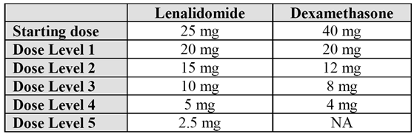

Table 2: Dose reduction guidance.

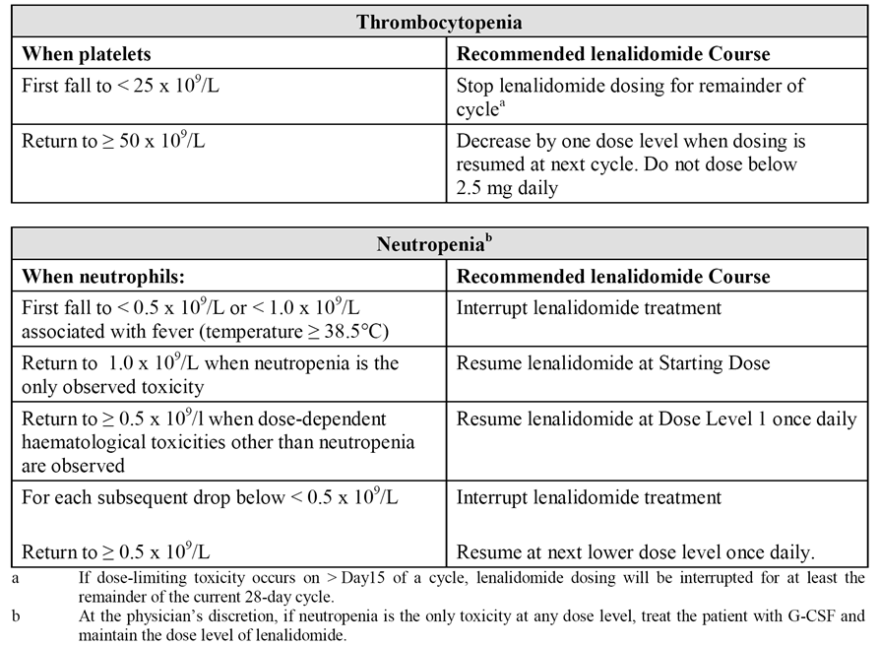

If the dose of lenalidomide was reduced for a haematologic dose limiting toxicity (DLT), the dose of lenalidomide may be re-increased to the next higher dose level (up to the starting dose) at the discretion of the treating physician if continued lenalidomide/dexamethasone therapy resulted in improved bone marrow function (no DLT for at least 2 consecutive cycles and an ANC ≥1.5 x 109/L with a platelet count ≥ 100 x 109/L at the beginning of a new cycle at the current dose level).

### Combination with melphalan and prednisone

These are shown below.

Table 3: Dose reduction levels.

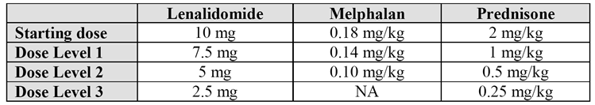

Table 4: Dose reduction guidance.

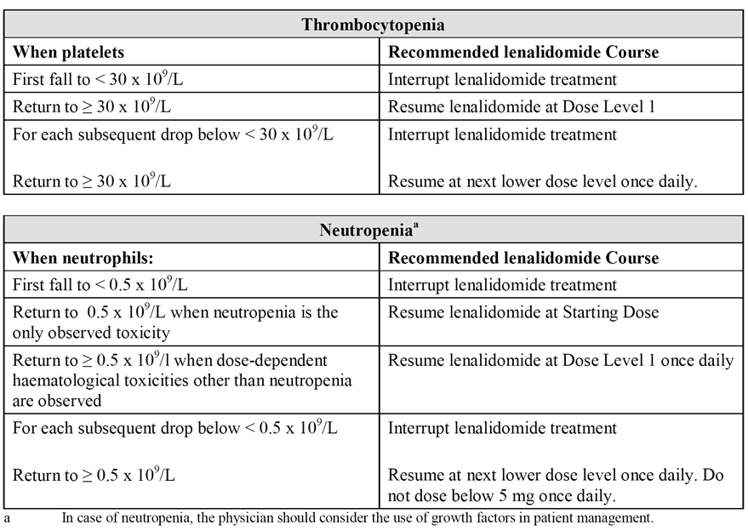

The PI also includes unchanged dose adjustments in patients with MM and MDS if treatment is associated with other Grade 3/4 toxicities and instructions on discontinuation of Revlimid, and unchanged recommendations relating to dose adjustment in patients with impaired renal function or impaired hepatic function.

## Clinical rationale

The clinical rationale is presented in the sponsor’s application letter. The letter refers to MM being an incurable haematological malignancy, accounting for approximately 15% of haematological malignancies in the US. The letter goes on to state that “[w]hile newer agents and treatment regimens (including ASCT for eligible patients) have improved the overall 5 year survival rate to 43%, MM still represents an incurable illness. First line treatment may represent the greatest opportunity to achieve extended disease control. Progression free survival (PFS) is impacted at each subsequent relapse. The ability to sustain response in myeloma (PFS or time to progression) is important for preservation of quality of life (QoL) and potential improvement in survival. Continuing research efforts to develop new agents and treatment regimens, and to optimise the utilisation of currently available treatments, are clearly needed. Until cure can be achieved, primary goals of first-line treatment include obtaining a high-quality, prolonged objective response to treatment with extended PFS and optimising overall survival (OS), with acceptable safety.”

*Clinical comment: The sponsor's rationale is acceptable. Australian data indicate that the aged standardised incidence rate for multiple myeloma in 2009 was 6.5/100,000 persons, and that the mortality rate due to the disease in 2010 was 3.3/100,000 persons.1 In addition, the data indicate that both the incidence rate and the mortality rate of multiple myeloma are higher in males compared to females. The Australian data indicate that mean age of onset of myeloma is 69.2 years, and mean age of death due to the disease is 74.3 years. Both the incidence and mortality rates of the disease increase sharply after the age of 50 years. In Australia, the incidence (2009) of myeloma represented 1.3% of all cancers, and the mortality due to the disease represented 1.9% of all cancers.*

## Contents of the clinical dossier

### Scope of the clinical dossier

The clinical dossier included new clinical study reports supporting the extension of indication, new clinical study reports supporting additional pharmacokinetic and pharmacodynamic data included in the PI, and updated efficacy and safety date from previously evaluated studies supporting the relevant amendments to the PI.

The submission contained the following clinical information:

* 2 bioequivalence studies.
* 7 pharmacokinetic studies,
* 1 population pharmacokinetic study, including pharmacokinetic/pharmacodynamic data.
* 1 “thorough QT/QTc” pharmacodynamic study.
* 1 pivotal efficacy and safety study.
* 5 supportive efficacy and safety studies.
* 1 integrated summary of efficacy, 1 integrated summary of safety, 1 summary document containing updated information on second primary malignancies (SPMs) in patients with MM.

### Paediatric data

The sponsor has a waiver from the EU relating to the submission of paediatric data on the grounds that MM “has not been reported in the paediatric population”. No formal application was made in the USA for a waiver relating to the submission of paediatric data, due to the marketing application for Revlimid in the US not being legally required to include a paediatric assessment as it related to an “orphan designated treatment of multiple myeloma”.

### Good clinical practice

The dossier indicated that all studies sponsored by Celgene complied with the principles of Good Clinical Practice. Information in the clinical studies not sponsored by Celgene indicated that the studies had been conducted in accordance with relevant ethical requirements.

## Pharmacokinetics

### Studies providing pharmacokinetic data

The submission included 10 clinical pharmacokinetic studies (Table 5). No *Evaluator's overall conclusions on pharmacokinetics* have been provided as the studies were submitted to supplement the current PI information relating to specific aspects of the pharmacokinetics of lenalidomide. The pharmacokinietic studies in Japanese and Chinese subjects have not been fully evaluated, but the results from the two studies have been briefly summarised.

Table 5: Clinical pharmacokinetic studies provided in the submission.

| ID | Topic | Study Objectives |
| --- | --- | --- |
| CC-5013-BE-005 | Bioequivalence | To investigate the bioequivalence of single oral dose lenalidomide administered as a 20 mg capsule (test) formulation relative to 4 x 5 mg capsules in healthy male subjects. |
| CC-5013-CP-010 | Bioequivalence | To demonstrate the bioequivalence of single oral dos lenalidomide administered as 2.5 mg capsule (test) relative to a 5 mg capsules (reference) in healthy male subjects when given a single dose (i.e., 4 x 2.5 mg capsules versus 2 x 5 mg capsules). |
| CC-5013-PK-008 | Distribution (semen) | **Primary**: to evaluate the distribution of lenalidomide into semen following multiple oral daily doses of lenalidomide 25 mg in healthy male subjects. **Secondary**: to characterise the multiple dose PK of lenalidomide 25 mg in healthy male subjects. |
| CC-5013-PK-006 | ADME  Mass balance | **Primary**: • To determine the total recovery, the routes and rates of excretion, and the metabolic profile of [14C]-lenalidomide in healthy male subjects following a single dose of an oral suspension. **Secondary**: • to assess the concentration of [14C]-lenalidomide in semen; • to describe the PK of lenalidomide and [14C]-lenalidomide and the major metabolites of lenalidomide. |
| 1398/142 | First in human  Ascending dose  Food effect | The objectives were: • to determine the safety and tolerability of ascending single doses of lenalidomide in healthy male subjects; • to determine the single dose PK of lenalidomide in healthy male subjects; • to determine the effect of ascending single oral doses of lenalidomide on CD4 and CD8 count in healthy male subjects; • to compare the effect of food on the PK of lenalidomide. |
| 1398-180 | Multiple dose | The objectives were: • to determine the safety, tolerability and PK of multiple oral dose lenalidomide in healthy male subjects; • to determine the effects of multiple oral dosing of lenalidomide on CD4 and CD8 cell counts in healthy males. |
| CC-5013-CP-011 | Drug-drug interaction (DDI) | **Primary**: Part 1 - to evaluate the effect of multiple doses of the P-gp inhibitor quinidine on the PK of single oral dose lenalidomide; Part 2 - to evaluate the effects of single IV dose of the P-gp inhibitor temsirolimus on the PK of single oral dose lenalidomide, and to evaluate the effect of a single oral dose of lenalidomide on the PK of temsirolimus and its active metabolite sirolimus. |
| CC-5013-MCL-001-PK | PPK  PK/PD | **Primary**: • to describe the PPK of lenalidomide in subjects with haematological malignancies, including subjects with MCL, MM, and MDS; • to quantitatively describe the lenalidomide exposure-response relationship for measures of toxicity (neutropenia and thrombocytopenia) in subjects with MCL, MM, and MDS. |
| CC-5103-MM-017-PK | PK - Japanese patients | **Primary**: • to determine the MTD and safety of lenalidomide alone and in combination with dexamethasone in Japanese subjects with previously treated MM. **Secondary**: • to determine the PK of lenalidomide alone and in combination with dexamethasone in Japanese patients with previously treated MM; • to determine the efficacy of lenalidomide alone and in combination with dexamethasone in Japanese subjects with previously treated MM. The submitted report addressed the PK objective only. |
| CC-5103-MM-021-PK | PK - Chinese patients | **Primary**: • to determine the efficacy of lenalidomide plus low-dose dexamethasone in Chinese subjects with relapsed MM or refractory MM. **Secondary**: • to determine the safety and PK of lenalidomide plus low-dose dexamethasone in Chinese subjects with relapsed MM or refractory MM. The submitted report addressed the PK objective only. |

### Summary of pharmacokinetics

#### Pharmacokinetics in healthy subjects

##### Bioavailability

###### Bioequivalence of new dosage strengths

Study CC-5013-BE-005

**Design**

This Phase I, open-label, randomised, single-dose, 2-way crossover study was designed to investigate the bioequivalence of a newly formulated 20 mg lenalidomide capsule (test) relative to 4 x 5 mg capsules (reference) in healthy male subjects aged 18 to 55 years. The study was sponsored by Celgene and undertaken at a single-centre in the USA, with the first subject being enrolled on 14 November 2008 and the last subject completing on 5 January 2009. The release date of the report was 24 December 2004. The study was stated to have been conducted in "accordance with the ethical principles of Good Clinical Practice (GCP), according to the international Conference on Harmonisation (ICH) Harmonized Tripartite Guideline". The study randomised all 28 enrolled subjects into one of 2 sequences (14 subjects per sequence). The study design is presented schematically below in Figure 1.

Figure 1. BE-005 - Study design.

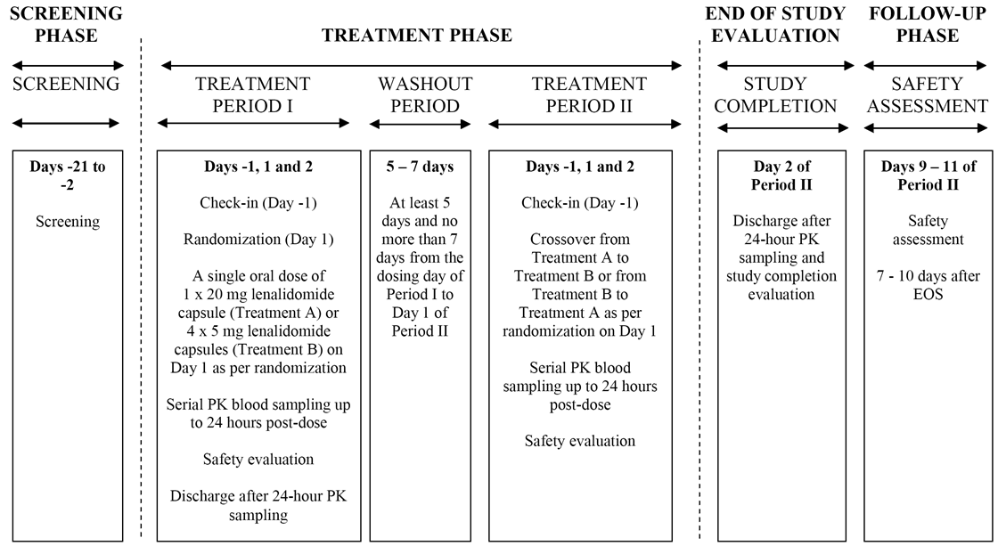

*Comment: The sponsor stated that the only difference between the 20 mg capsule used in this study and the 20 mg capsule proposed for registration relates to the capsule shell. The study design was typical for single-dose crossover bioequivalence studies in healthy male subjects. The inclusion and exclusion criteria have been examined and are considered to be acceptable. The two treatments were administered in the fasting state (i.e., administered after an 8 hour overnight fast with breakfast delayed for 4 hours after dosing). The wash-out period of 5-7 days was more than adequate for a drug with a half-life reported to be approximately 4 hours in healthy subjects (i.e., washout is more than 5 half-lives). Blood samples were collected at predose (Time = 0), and 0.25, 0.5, 0.75, 1, 1.5, 2, 2.5, 3, 4, 6, 9, 12, 16, and 24 hours post-dose for all subjects. These time intervals are considered to be satisfactory, and allow for adequate description of the plasma concentration time profile given that the known to Tmax occurs between 0.6 and 1.5 hours and the half-life is approximately 4 hours. Concentrations of lenalidomide in plasma were determined by a validated liquid chromatography-tandem mass spectrometry (LC/MS/MS) method. The lower limit of quantitation for lenalidomide in human plasma was 5 ng/mL, with linearity demonstrable to 1000 ng/mL.*

**Pharmacokinetics parameters, statistical methods and sample size**

The full range of standard PK parameters were assessed, with the parameters being calculated using non-compartmental methods from plasma concentration data using standard computer software designed for this purpose. Actual sampling times were used in the calculations.

The PK data were summarised using standard descriptive statistical methods. Bioequivalence was determined using analysis of variance (ANOVA) on natural log-transformed data of Cmax, AUCt and AUCinf. The model contained terms for sequence, period and treatment as fixed effects, and subject nested within sequence as a random effect. The mean square error for subjects within sequence was used to test sequence. The ratios of the geometric means (with 90% CIs) between the test formulation (20 mg capsule) and reference formulation (4 x 5 mg capsules) were estimated. Bioequivalence of the test and reference formulations was concluded if the 90% CIs of the geometric mean ratios for AUCt, AUCinf and Cmax were completely contained within the range 80%-125% (i.e., standard bioequivalence interval). The study was adequately powered (80%; sample size 24 subjects) to establish that the 90% CIs for the ratios of the geometric mean Cmax and AUC fall within 80%-125%. The assumptions on which the power calculations were based were provided and are considered to be acceptable. The total sample size for this study was 28 subjects to account for a possible drop out of 4 subjects.

**Study subjects**

All 28 subjects completed the 2 periods of the study and provided evaluable PK data. The mean age of the total population (n=28) was 33.6 years (range: 18, 52 years), the mean height was 178.3 cm (range: 165, 189 cm), the mean weight was 80.77 kg (range: 62.8, 99.6 kg), the mean BMI was 25.40 kg/m2 (range: 19.4, 29.2 kg/m2), the mean creatinine clearance was 101.2 mL/min (range: 66.7, 139.5 mL/min, 29% (n=8) of subjects were white and 71% (n=20) were black/African American.

**Pharmacokinetic results**

The mean ± SD plasma lenalidomide concentration profiles are presented below in Figure 2.

Figure 2. BE-005 – Mean ± SD plasma lenalidomide concentrations; left panel linear scale, right panel semi-log scale.

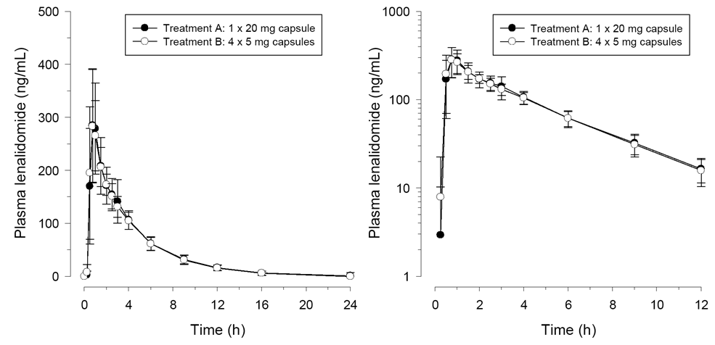

The results of the bioequivalence analysis are presented below in Table 6.

Table 6: BE-005 - Bioequivalence results.

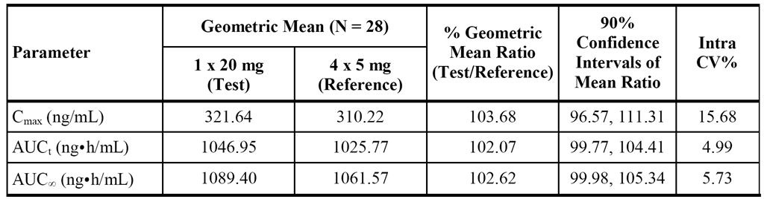

*Comment: The study showed that lenalidomide 1 x 20 mg (test) capsule and lenalidomide 4 x 5 mg capsules (reference) were bioequivalent, with the 90% CI interval for the mean ratios of Cmax, AUCt and AUCinf being enclosed entirely within the pre-specified bioequivalence interval of 80%-125%. The median Tmax values were 0.89 hours (range: 0.5, 3.0 hours) and 0.75 (range: 0.5, 2.5) for lenalidomide 1 x 20 mg and 4 x 5 mg, respectively. All other PK parameters for the two treatments were comparable. The lenalidomide plasma concentration curves for the two treatments were virtually superimposable, and the lenalidomide AUCt/AUCinf ratio was greater than 95% for both treatments indicating that sampling times were more than adequate to satisfactorily define the terminal elimination phase of the curves. The intra-subject variability was low for the Cmax and AUC variables. No information could be identified indicating whether the formulation of the lenalidomide 5 mg capsule used in this study was the same as that currently approved for marketing in Australia.*

Study CC-5013-CP-010

**Design**

This Phase I, open-label, randomised, single-dose, 2-way crossover study was designed to investigate the bioequivalence of lenalidomide 2.5 mg (4 x 2.5 mg) capsule (test) relative to 5 mg (2 x 5 mg) capsules (reference) when given as a 10 mg dose in healthy male subjects aged 18 to 55 years. The study planned to enrol 28 subjects and randomise the enrolled patients into one of 2 sequences (n = 14 per sequence). The study was sponsored by Celgene and undertaken at a single-centre in the USA, with the first subject being enrolled on 18 January 2010 and the last subject completing on 22 February 2010. The release date of the report was 22 June 2010. The study was stated to have been conducted in "accordance with the ethical principles of Good Clinical Practice (GCP), according to the international Conference on Harmonisation (ICH) Harmonized Tripartite Guideline". The study design is presented schematically in Figure 3.

Figure 3. CP-010 - Study design.

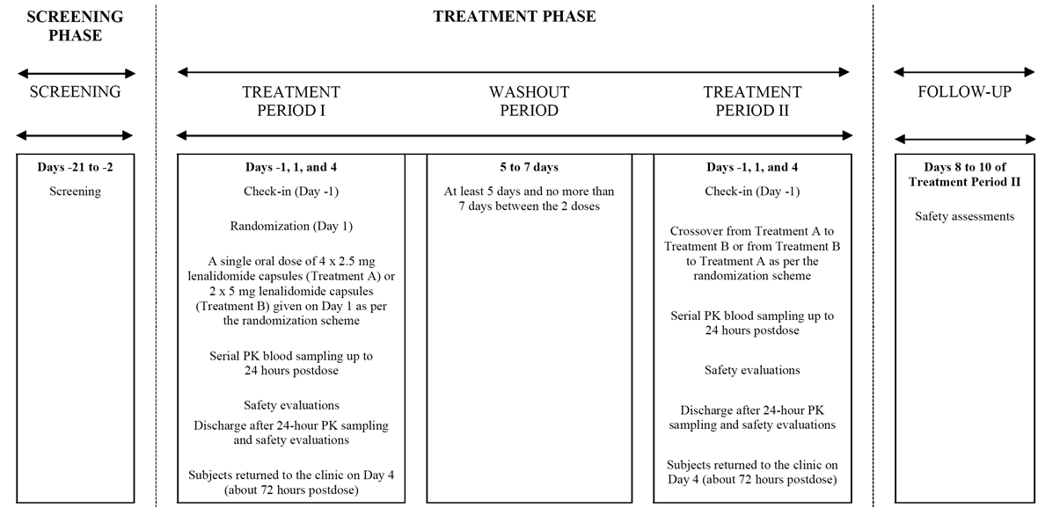

*Comment: The sponsor stated that the only difference between the 2.5 mg capsule used in this study and the 2.5 mg capsule proposed for registration relates to the capsule shell. In general, the comments provided above for study CC-5013-BE-005 are applicable to study CC-5013-CP-010. However, the lower limit of quantitation for lenalidomide in human plasma in the LC/MS/MS analysis was 1 ng/mL, with linearity demonstrable to 200 ng/mL.*

**Pharmacokinetics parameters, statistical methods and sample size**

The pharmacokinetic parameters, statistical methods and sample size for this study were consistent with those described above for study CC-5013-BE-005

**Study subjects**

Twenty-six (26) of the 27 enrolled subjects completed the study. One (1) enrolled subject was discontinued prior to treatment period II due to a positive cotinine test. This subject received a single oral dose of lenalidomide 10 mg (2 x 5 mg capsules) in treatment period I. The PK population included 27 patients. The mean age of this population (n=27) was 33 years (range: 18, 52 years), the mean height was 179.2 cm (range: 166.6, 188.8 cm), the mean weight was 82.7 kg (range: 64.8, 100.0 kg), the mean BMI was 25.7 kg/m2 (range: 20.4, 30.0 kg/m2), 81.5% (n=22) of subjects were white, 11.1% (n=3) were black/African American, 3.7% (n=1) were Asian and 3.7% (n=1) had multiple racial origin.

**Pharmacokinetic results**

The mean ± SD plasma lenalidomide concentration profiles are presented below in Figure 4.

Figure 4. CP-010 - Mean ± SD plasma lenalidomide concentrations; left panel linear scale, right panel semi-log scale.

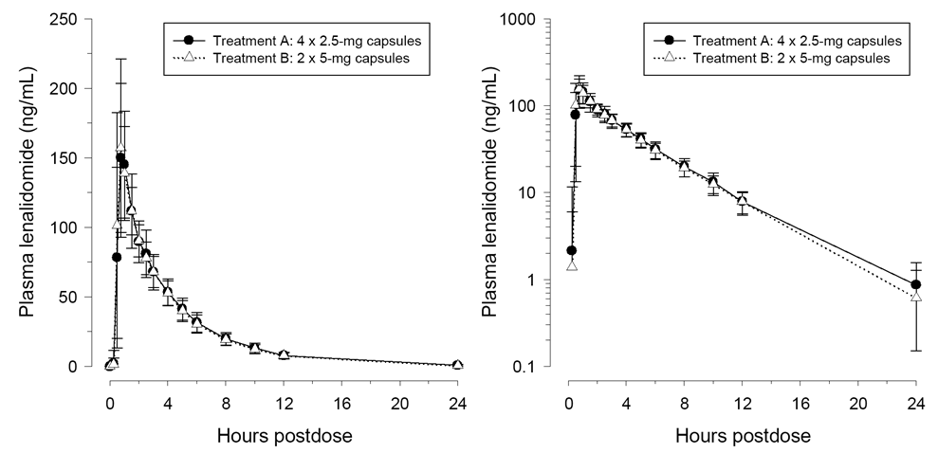

The results of the bioequivalence analysis are presented below in Table 7.

Table 7: CP-010 - Bioequivalence results.

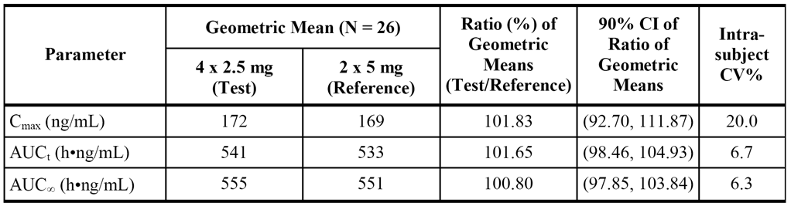

*Comment: The study showed that lenalidomide 4 x 2.5 mg (test) capsule and lenalidomide 2 x 5 mg capsules (reference) were bioequivalent, with the 90% CI interval for the mean ratios of Cmax, AUCt and AUCinf being enclosed entirely within the pre-specified bioequivalence interval of 80%-125%. The median Tmax values was 0.75 hours for both treatments. All other PK parameters for the two treatments were comparable. The lenalidomide plasma concentration curves for the two treatments were virtually superimposable, and the lenalidomide AUCt/AUCinf ratio was greater than 95% for both treatments indicating that sampling times were more than adequate to satisfactorily define the terminal elimination phase of the curves. The intra-subject variability was low for the Cmax and AUC variables. No information could be identified indicating whether the formulation of the lenalidomide 5 mg capsule used in this study was the same as that currently approved for marketing in Australia.*

Justification - no bioequivalence study with 7.5 mg capsule

The sponsor is proposing the addition of 3 additional capsule strengths, 2.5 mg, 7.5 mg and 20 mg. No bioequivalence data were submitted for the 7.5 mg strength capsule. The sponsor justifies this on the following grounds: (1) the 7.5 mg strength is bracketed by the 2.5 mg and 20 mg strengths; (2) it uses the same formulation blend as the currently approved 15 mg strength; and (3) it is dose proportional (active and inactive ingredients) to the approved 15 mg strength. The sponsor states that its decision not to submit bioequivalence data is consistent with the EMA Guideline on the investigation of bioequivalence (CPMP/EWP/QWP/1401/98 Rev. 1/Corr**; effective 16 June 2011).

*Comment: The sponsor's justification is considered to be clinically acceptable.*

###### Influence of food

Study 1398/142

**Design**

The submission included one, Phase I, single-blind, placebo-controlled, ascending single-dose, safety, tolerability, and pharmacokinetic study in healthy males subjects, incorporating a comparison of the fed/fasted kinetics of lenalidomide. In this CER, the focus is on the part of the study which examined the influence of food on the pharmacokinetics of lenalidomide. The study was sponsored by Celgene. It was undertaken at a single centre in the UK between 6 October 1999 and 7 December 1999 and the study report was dated 31 October 2000.

The food effect component of the study was undertaken on a group of subjects who received lenalidomide 200 mg (4 x 50 mg non-marketed capsule) in both the fasted and fed state (high fat breakfast, given 20 minutes prior to dosing and completed 5 minutes prior to dosing). Six (6) subjects received lenalidomide in the fasted state and 5 of these subjects received lenalidomide in the fed state. The interval between fasted and fed doses was at least 6 days.

**PK parameters, statistical methods, and sample size.**

The standard range of PK parameters was calculated from plasma samples using non-compartmental methods. Blood samples were collected pre-dose and then post-dose at 0.25, 0.5, 0.75, 1, 1.5, 2, 2.5, 3, 4, 6. 8, 10, 12, 18, 24, 36 and 48 hours. Lenalidomide concentration in plasma was determined using liquid chromatography with tandem spectrometric detection (LC-MS/MS), with a lower limit of quantification of 1 ng/mL.

No formal sample size calculations were undertaken in this study as this was the first time lenalidomide had been administered to humans. The sponsor stated that "this number of subjects is commonly used in early clinical pharmacology studies and is considered sufficient to achieve the objectives of the study".

To assess the effect of food on all parameters (except tmax and tlag) were analysed using an ANOVA model in the form - Response = subject + food regimen + random error. In this study the effect of period could not be evaluated because period effects were confounded with the food effect regimens. Mean differences between the fed and fasted states regimens were calculated. The residual variance from the ANOVA was used to calculate the 95% CIs for the mean difference between the fed and fasted regimens. These were back transformed to give point estimates and 95% CI for the ratio of the fed regime relative to the fasted regimen.

**Results for influence of food component of the study**

The key results for the influence of food component of the study are summarised in Table 8.

Table 8: 1398/142 - Summary of PK parameters fasted vs fed following single dose lenalidomide 200 mg in healthy subjects; geometric mean (CV%) values apart from median (range) for Tmax.

| Parameter | Fasted (n=6) | Fed (n=5) | Ratio of LS means (fed/fasted) with 95% CI (n=5) | |
| --- | --- | --- | --- | --- |
| AUCinf (ng.h/mL) | 12111 (CV=36.4%) | 12147 (CV=17.9%) | 1.03 | 95% CI: 0.762 to 1.40 |
| Cmax (ng/mL) | 3519 (CV=24.5%) | 2239 (CV=25%) | 0.610 | 95% CI: 0.485 to 0.767 |
| Tmax | 0.625 (range: 0.50, 2.00) | 3.00 (range: 2.00, 4.00) | - | - |

*Comment: The currently approved PI includes the statement - "co-administration with a high-fat meal in healthy volunteers reduces the extent of absorption, resulting in an approximately 20% decrease in the ... AUC and a 50% decrease in the ... Cmax in plasma." However, the limited data from the current study do not support this statement. The LS mean AUCinf was 3% higher in the fed compared to the fasted state and the LS mean Cmax was approximately 39% lower in the fed compared to the fasted sated. The sponsor is requested to comment on this apparent discrepancy and on why the study was submitted, particularly as the study report was dated 14 years ago (see Questions).*

###### Bioavailability after multiple dosing

Study 1398/180

The submission included one Phase 1, single-blind, placebo-controlled, multiple oral dose safety and tolerability pharmacodynamic and pharmacokinetic study in healthy male subjects aged between 18 and 55 years. The study was sponsored by Celgene. It was undertaken at a single centre in the UK between 27 March 2000 (first screening observation) and 19 April 2000 (final post-study observation), and the study report was dated 3 October 2000. The study was conducted in accordance with GCP and the Declaration of Helsinki.

Lenalidomide 100 mg (2 x 50 mg capsules) was administered in the fasted stated once in the morning on days 1 and 8, and twice daily (bd) on days 2 to 7, inclusive, with doses being given at 12 hour intervals. It was planned to study 8 subjects in a single treatment group, with 6 receiving 14 doses of lenalidomide and 2 receiving 14 doses of placebo. However, 1 subject (lenalidomide 100 mg bd) was withdrawn from the study prior to the morning dose on Day 3 due to an AE, and 1 subject (lenalidomide 100 mg bd ) was withdrawn from the study prior to the evening dose on Day 4 due to an AE.

The study assessed the standard range of PK parameters calculated from plasma concentration using non-compartmental methods. Blood samples were taken at the following time-points: Day 1 pre-dose and then post-dose at 0.25, 0.5, 1, 1.5, 2, 3, 4, 6, 8, 12 and 18 hours post-dose; Days 2 to 6 pre-morning; Day 7 pre-dose and 2 hour post-dose for both doses (am, pm); and Day 8 pre-dose and then post-dose at 0.25, 0.5, 1, 1.5, 2, 3, 4, 6, 8, 12, 18, 24, 36 and 48 hours. Lenalidomide plasma concentrations were determined using LC/MS/MS, with a lower limit of quantification of 1 ng/mL.

The plasma PK parameters on Day 1 (100 mg single-dose) and Day 8 (100 mg bd) are summarised. The mean accumulation ratios (CV%) for Day 8 compared to Day 1 for AUC(0-τ) and Cmax were 0.997 (14.2%) and 0.932 (49.5%), respectively, confirming that there was no accumulation of lenalidomide following multiple dosing.

Comment: There was little or no accumulation of lenalidomide in plasma after 100 mg bd dosing for 8 days, with mean AUC(0-τ) and Cmax ratios (Day 8 compared to Day 1) approximating 1. It is unclear why the sponsor submitted this study now, approximately 14 years after the study report was finalised. Furthermore, no new data based on this study could be identified in the PI. The approved PI already includes a statement that multiple dosing does not cause marked drug accumulation. The sponsor is requested to comment on these matters (see Questions).

##### Distribution

###### Study CC-5013-PK-008 - distribution of lenalidomide into semen

Design

Study CC-5013-PK-008 was a Phase 1, open-label, randomised, parallel-group study designed to evaluate the distribution of lenalidomide into semen following multiple oral daily doses of lenalidomide in healthy male subjects (the primary objective of the study). The study was sponsored by Celgene (USA). It was undertaken in a single centre in the USA (New Jersey). The first subject was enrolled on 28 February 2008, the last subjected completed on 22 April 2008 and the CSR was released on 24 November 2008.

Twenty-four (24) healthy male subjects were enrolled and randomised into four groups (6 subjects per group). The treatment was the same in all groups and consisted of lenalidomide 25 mg QD for four days. Semen was collected by ejaculation at approximately 2, 24, 72, and 168 hours following the day 4 dose in Groups 1, 2, 3, and 4, respectively. Serial sampling of blood for drug analysis was performed in all subjects for 24 hours after the last dose in order to assess the multiple-dose pharmacokinetics of lenalidomide in healthy male subjects (the secondary objective of the study). The study consisted of a screening phase (Days -21 to -1), a baseline phase (Day 0), a treatment and sample collection phase (Days 1 to 11), and a follow-up evaluation (Day 11 ± 1). Subjects were asked to abstain from any study-unrelated sexual activities from check-in (Day 0) until after completing collections of all the required PK samples. The study design is outlined below in Figure 5.

Figure 5. CC-5013-PK-008 - Design.

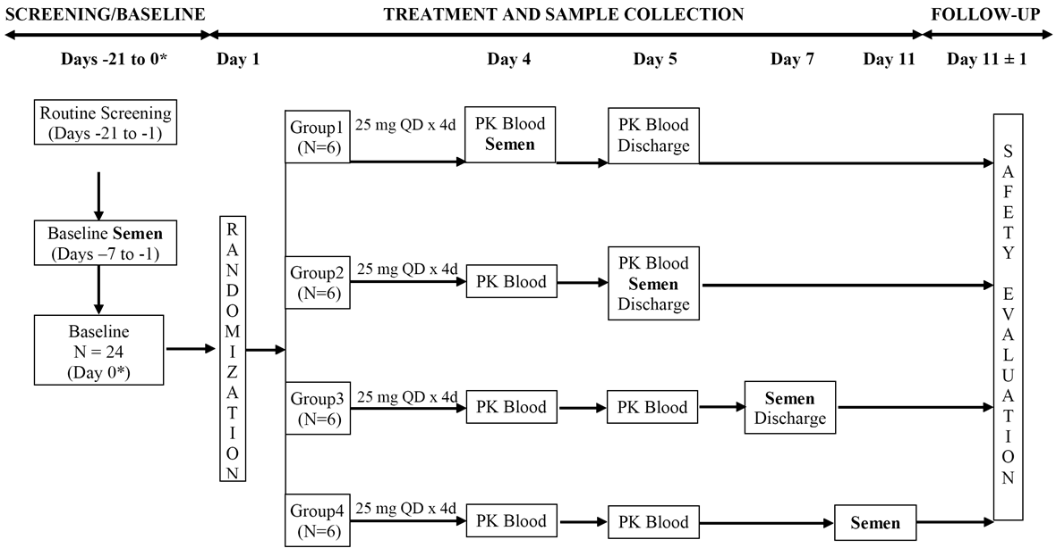

Semen and plasma pharmacokinetic assessments

* Semen PK parameters for lenalidomide: The following semen PK parameters for lenalidomide were calculated: Cs = semen concentration, expressed as ng/mL; As = amount excreted unchanged in each collected semen sample; and %Dose = percent of dose excreted unchanged in each collected semen sample.
* Plasma PK parameters for lenalidomide: The standard range of plasma PK parameters was calculated from plasma concentration data using non-compartmental methods. Actual times were used in the calculations. Blood samples were collected at predose (Time = 0), and 0.25, 0.5, 0.75, 1, 1.5, 2, 3, 4, 6, 9, 12, 16, and 24 hours following the day 4 dose for all subjects.
* Statistical methods: Standard statistical descriptive methods were used to summarise the PK data. Twenty-four (24) subjects were chosen to achieve the objective of the study (6 subjects for each semen collection sample). There were no formal sample size calculations.
* Lenalidomide concentration analyses: Lenalidomide concentrations were determined in semen and plasma by a validated achiral LC-MS/MS method, with a LLOQ of 5 ng/mL in both fluids.

Study subjects

All 24 subjects completed the semen and plasma PK assessments. The mean age of the 24 subjects was 32.7 years (range: 21, 44 years), the mean weight was 79.4 kg (range: 66.6, 95.1 kg), the mean height was 176 cm (range: 166, 189 cm), and the mean BMI was 25.6 kg/m2 (range: 21.7, 28.9 kg/m2). Eleven (11) subjects were Black, 8 were Hispanic, 4 were Caucasian, and 1 was Asian.

Results - lenalidomide semen pharmacokinetics

Semen PK results are summarised below in Table 9.

Table 9: PK-008 - Lenalidomide quantities in semen and the concentration of lenalidomide in plasma in healthy male subjects following lenalidomide 25 mg QD for 4 days; all values are presented as mean (range min, max).

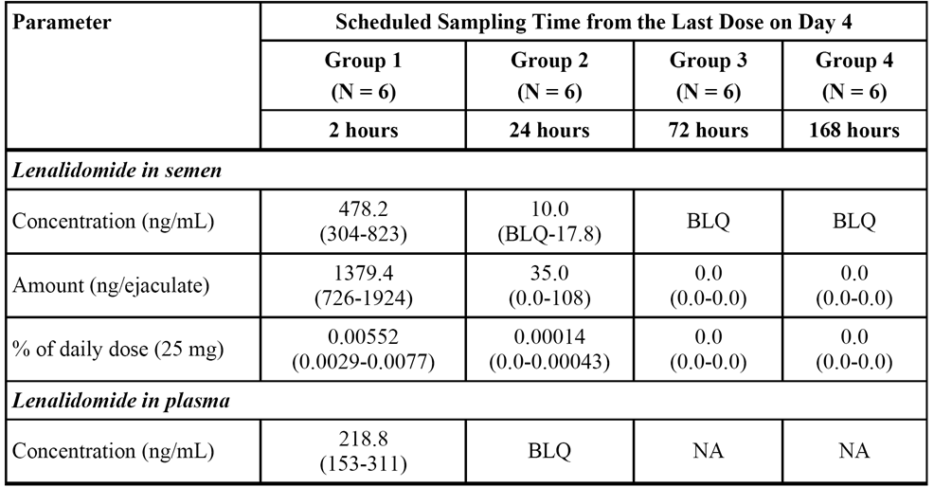

Note: The median semen volume per ejaculate ranged from 2.13 to 3.13 mL across the 4 treatment groups.

*Comment: Lenalidomide was present in semen at steady state for up to 24 hours following dosing on day 4 (25 mg QD for 4 days). Lenalidomide was undetectable in semen 3 days after discontinuation of the drug. The time course of lenalidomide concentration in semen roughly mirrored that in plasma. The sponsor stated that the lenalidomide concentrations in semen (304 to 823 ng/mL) at 2 hours post-dose approximated the therapeutic levels in plasma. However, due to the small volume of the ejaculates, the average amount of lenalidomide per ejaculate constituted only a small portion of the daily dose (< 2 μg/ejaculate or < 0.01% of the 25 mg dose). The data from this study supports the new statement in the revised PI (Distribution) that "lenalidomide is present in semen (<0.01% of the dose) after administration of 25 mg/day and the drug is undetectable in semen 3 days after stopping the drug."*

Results - lenalidomide plasma pharmacokinetics

The plasma PK results are summarised below in Table 10.

Table 10: PK PK-008 - Plasma PK parameters for lenalidomide in healthy subjects following multiple doses (25 mg QD for 4 days); mean (CV%) data are presented for all parameters except Tmax (median [range min-max]).

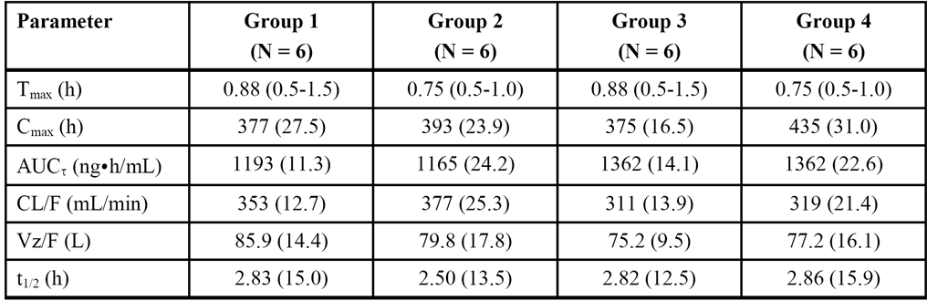

*Comment: The plasma pharmacokinetics of lenalidomide following 25 mg QD for 4 days were characterised by rapid absorption and elimination, with median Tmax being approximately 1 hour and the mean terminal half-life being approximately 3 hours in each of the 4 treatment groups. The mean Cmax, AUCt, CL/F and Vz/F values were consistent across the 4 treatment groups. The sponsor states that lenalidomide plasma exposure (Cmax and AUC) at steady state on Day 4 was similar to exposure following a single 25 mg dose in a previous study (study CC-5013-BE-044). The sponsor also states that dose-independent PK plasma parameters (Tmax, t1/2, CL/F, and Vz/F) on Day 4 were also comparable to those after a single oral dose in a previous study (study 1398/142). Based on the similarity in the PK profile between single- and multiple-dose and a terminal half-life of approximately 3 hours, it can be concluded that in this study steady-state lenalidomide plasma concentration was achieved on Day 4.*

##### Metabolism and excretion

###### Study CC-5013-PK-006

Design

Study CC-5013-PK-006 was an open-label Phase I study in healthy male subjects designed to evaluate the absorption, metabolism and excretion of [14C]-lenalidomide following a single 25 mg dose of an oral suspension. The study was sponsored by Celgene. It was undertaken at a single-centre in the USA between 27 February 2007 and 9 March 2009. The release data of the report was 15 October 2007. The sponsor stated that the study was conducted in accordance with the ethical principles of Good Clinical practice, according to the ICH Harmonised Tripartite Guideline.

The primary objectives of the study were to determine total recovery, the routes and rates of excretion, and the metabolic profile of [14C]-lenalidomide. The secondary objectives were to assess the concentration of [14C]-lenalidomide in semen and to describe the pharmacokinetics of lenalidomide and [14C]-lenalidomide and the major metabolites of lenalidomide.

The study consisted of: (1) a screening phase (day -12 to day 0); (2) a treatment phase (day 1 to day 10); and (3) a follow-up phase. On Day 1, each subject was to receive a single 25 mg dose of an oral suspension containing a mixture of [14C]-lenalidomide and unlabelled lenalidomide, with approximately 100 μCi of total radioactivity. No food was to be consumed from 8 hours pre-dose to 4 hours post-dose, and no water was to be taken from 2 hours pre-dose to 4 hours post-dose (other than that given with the study drug). Subjects were discharged on Day 10 or earlier if the total radioactivity recovered in urine and fecal samples from two consecutive days was ≤ 1% of the administered radioactive dose. Subjects were to have a follow-up evaluation before leaving the clinic or within 5 days after leaving the clinic.

Blood samples for radioactivity counting in whole blood and plasma were collected pre-dose and then post-dose at 0.25, 0.5, 1, 1.5, 2, 4, 6, 8, 10, 12, 24, 48, 72, 96, 120, 144, and 168 hours Blood samples for lenalidomide analysis were collected pre-dose and then post-dose at 0.25, 0.5, 1, 1.5, 2, 4, 6, 8, 10, 12, and 24 hours. Blood samples for metabolic profiling were collected pre-dose and then at 1, 2, 4, 6, 8, 12, and 24 hours post-dose. Two post-dose semen samples were collected between 2 and 3 and 72 and 73 hours. Urine was collected as voided at pre-dose (spot collection), and pooled post-dose over the intervals of 0-4, 4-8, 8-12, 12-24 hours on day 1, and over 24-hour intervals on days 2-10. Feces were collected as individual bowel movements at pre-dose and pooled post-dose over 24-hour intervals for up to 10 days.

Concentrations of the parent drug in plasma were determined using a validated LC-MS/MS method. Radioactivity in whole blood, plasma, urine, feces, and semen was determined by liquid scintillation counting (LSC). Based on the amount of radioactivity, selected samples of plasma, urine, feces, and semen were used for metabolic profiling. The CSR presented the results for lenalidomide data in plasma and radioactivity data in whole blood, plasma, urine, feces, and semen.

Determination of radioactivity concentration of equivalents of lenalidomide, lenalidomide concentrations and calculation of recovery of radioactivity used standard mathematical methods. The radioactivity in samples was expressed as disintegration per minute (dpm), and the amount of radioactivity (dpm) in samples was mathematically converted to equivalent concentrations of lenalidomide (ng/Eq/g or µgEq/g). The mass balance was also calculated using standard methods. The standard range of PK parameters were estimated for plasma lenalidomide and plasma whole blood [14C]-radioactivity. In addition, urine, fecal and semen radioactivity data were also collected. Quantitative metabolic profiles (including the identification and characterisation of lenalidomide metabolites) for lenalidomide in plasma, urine feces and semen were reported separately (CC-5013-DMPK-010), and this separate report has been reviewed.

Statistical methods and sample size

Pharmacokinetic parameters were estimated by non-compartmental methods using actual elapsed time from dosing. The parameters were summarised using standard statistical descriptive methods. No formal sample size calculation was undertaken. Six (6) subjects, with a minimum of 4 completing, were chosen as a suitable number to achieve the objects of the study.

Study population

The 6 healthy, male subjects who participated in the study had a mean age of 29.7 years (range: 20, 42 years), a mean height of 178.92 cm (range: 173.4, 181.5 cm), a mean weight of 83.95 kg (range: 77.7, 91.2 kg), and a mean BMI of 26.22 kg/m2 (range: 24.1, 27.8 kg/m2). Three (3) subjects (50%) were Black and 3 subjects (50%) were White. All 6 subjects had sufficient data to be included in mass balance and PK analyses, despite incomplete recovery data late in the collection period for two subjects. The details for these two subjects were provided and have been examined. Inclusion of the data from these two subjects is considered to be acceptable.

Mass balance results

Almost complete recovery of the administered [14C]-radioactivity was achieved. The geometric mean total recovery from excreta over 10 days was 94.26 (CV% = 3.1), including 90.30% (CV%=3.4) from urine, 3.56% (CV%=54.1) from feces, and 0.0059% (CV%=36.6) from semen. Urinary excretion was the primary route for elimination, with 90.3% of the dose being recovered in urine indicating that oral absorption of lenalidomide is high. Furthermore, urinary excretion of the radioactivity was rapid with approximately 84% of the administered dose being recovered in the urine during the first 12 hours and 88.4% being recovered during the first 24 hours. In contrast, total fecal elimination of radioactivity accounted for only 3.6% of the dose. Most fecal excretion was completed by Day 4 (96 hours). The cumulative total radioactivity recovery vs time profiles for urine and feces are summarised below in Figure 6.

Figure 6. PK-006 - Cumulative total radioactivity recovery vs time profiles for urine and feces.

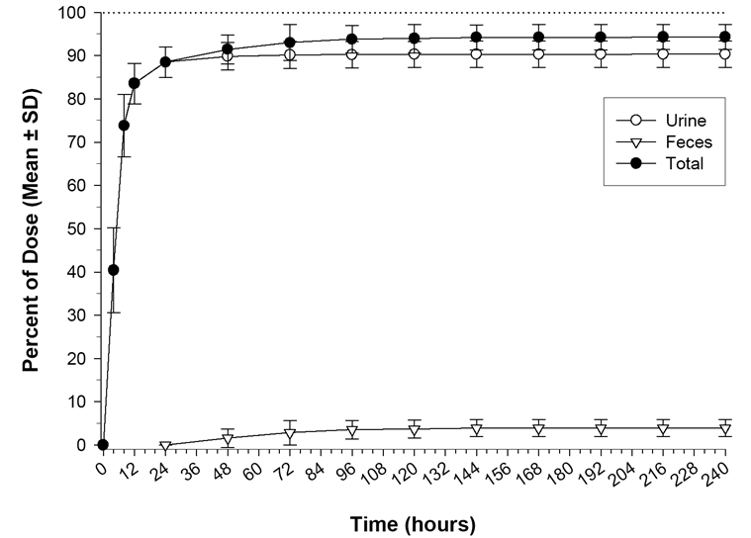

The total radioactivity recovered in semen accounted only for 0.0059% of the administered dose, which was equivalent to 1.479 μg lenalidomide. The amount of radioactivity in semen collected between 2 and 3 hours post-dose was 0.0055% of the administered dose. The geometric mean radioactive concentration equivalent in semen collected between 2 and 3 hours post-dose (453.6 ngEq/g) was similar to the radioactive Cmax equivalent observed in plasma (415.6 ngEq/g). The radioactive concentration was still detectable in semen, but at low levels (31 ngEq/g) three days after dosing.

Pharmacokinetic parameters

The pharmacokinetics of lenalidomide in plasma, plasma radioactivity and whole blood radioactivity are summarised below in Table 11.

Table 11: Study PK-006 - Summary of PK parameters; data expressed as geometric mean (geometric CV%), apart from Tmax (median and range).

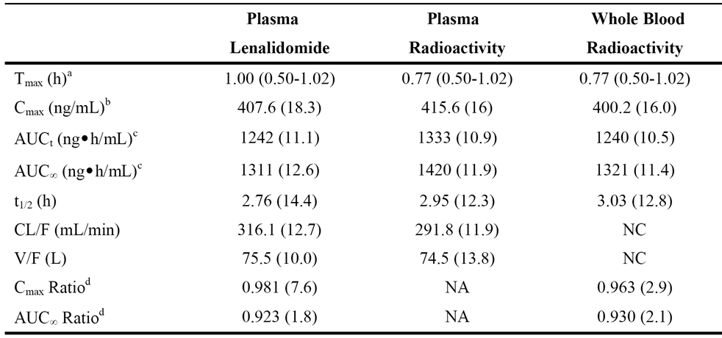

Notes: NA = not applicable; NC = not calculated.

a Median and range reported.

b Expressed as ngEq/mL for plasma radioactivity and as ngEq/g for whole blood radioactivity.

c Expressed as ngEq•h/mL for plasma radioactivity and as ngEq•h/g for whole blood radioactivity.

d Ratio to plasma total radioactivity.

The concentration vs time profiles for lenalidomide and plasma radioactivity, and concentration equivalent vs time profiles for total radioactivity in plasma vs whole blood are summarised below in Figure 7.

Figure 7. PK-006 - Concentration vs time profiles for lenalidomide and plasma radioactivity (Panel A), and concentration equivalent vs time profiles for total radioactivity in plasma and whole blood (Panel B).

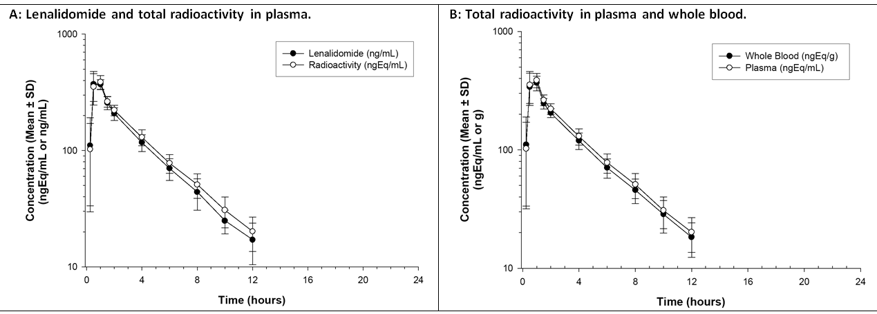

Plasma lenalidomide concentration and total plasma radioactivity pharmacokinetics

Maximum concentrations were achieved for plasma lenalidomide and plasma radioactivity between 0.5 and 1 hour post-dose followed by similar rates of elimination. After 12 hours post-dose, concentrations were BLQ. Geometric mean ratio of plasma lenalidomide concentrations to plasma radioactive concentration equivalents were 101% to 93% from 0.25 to 2 hours post-dose, and 90% to 83% from 4 to 12 hours post-dose. PK parameters for absorption (Tmax), elimination (t1/2 and CL/F), and distribution (V/F) were similar for plasma lenalidomide and plasma radioactivity. The geometric mean ratios of plasma lenalidomide to plasma radioactive Cmax and AUCinf were 0.98 and 0.92, respectively. The geometric mean renal clearance was estimated to be 260 mL/min based on the amount of radioactive equivalents recovered in urine from 0 to 12 hours and radioactive plasma AUC(0-12h). Renal clearance accounts for approximately 89% of apparent total body clearance which was estimated to be 292 mL/min by non-compartmental analysis of plasma radioactive concentration equivalents.

Whole blood and plasma radioactivity pharmacokinetics

In whole blood and plasma, maximum radioactive concentration was achieved between 0.5 and 1 hour post-dose, followed by similar rates of elimination in both whole blood and plasma. After 12 hours post-dose, radioactive concentration were BLQ. The geometric mean ratios of whole blood to plasma radioactive concentration equivalents ranged from 104% to 90 %. The average (geometric mean) distribution of radioactivity in erythrocytes ranged from 43% to 36% of the whole blood radioactivity from 0.25 to 12 hours post-dose. These values were similar to the percent hematocrit (42% to 43%) for study subjects.

Metabolic profiles

Plasma samples from 1, 2, 4, 6, 8 and 12 hours post-dose were selected for metabolic profiling with both inter-subject pooling (across subjects by time point) and intra-subject pooling (across time points by each subject). Urine samples from 0-24 hour post dose were used for metabolic profiling for each subject. Semen samples were selected from the 2 to 3 hour post-dose sample from each subject and from a pooled 72 to 73 hour post-dose sample from the six subjects. One to four fecal samples were selected from each subject.

Unchanged lenalidomide was the predominant component of both circulating and excreted radioactivity. Approximately 82% of the radioactive dose was excreted as lenalidomide, almost exclusively via the urinary route: i.e., mean ± SD unchanged lenalidomide 81.74 ± 3.61% (urine), 0.45% ± 0.24% (feces), semen (0.00271%). Minor quantities of metabolites were observed in excreta and plasma. Metabolites A (hydroxy-lenalidomide) and B (N-acetyl-lenalidomide) contributed 4.59% and 1.83% to the excreted radioactive dose, respectively. Five other minor unidentified metabolites, accounting for < 1% of the radioactive dose, were observed in excreta. In plasma, lenalidomide was the predominant component (77.44% of AUC of the total plasma radioactivity), with metabolites A and B accounting for 2.25% and 3.26%, respectively.

*Comment: The mass balance study and the metabolite profiling report support the following statement that has been added to the Metabolism and Excretion section of the proposed amended PI - "Following a single oral administration of [14C]-lenalidomide (25 mg) to healthy volunteers, approximately 90% and 4% of the radioactive dose is eliminated in urine and faeces, respectively. Approximately 82% of the radioactive dose is excreted as lenalidomide, almost exclusively via the urinary route. Hydroxy-lenalidomide and N-acetyl-lenalidomide represent 4.59% and 1.83% of the excreted dose, respectively. The renal clearance of lenalidomide exceeds the glomerular filtration rate and therefore is at least actively secreted to some extent".*

#### Pharmacokinetic interactions

##### Study CC-5013-CP-011 (P-gp inhibition)

###### Design

In vitro studies have been reported to show that lenalidomide is a weak substrate, but not an inhibitor of P-glycoprotein (P-gp). A P-gp inhibitor could potentially increase the systemic exposure to lenalidomide in two ways, enhancing oral absorption and/or reducing renal elimination. Therefore, study CC-5013, a Phase 1, open-label, two-part, fixed-sequence cross-over study, was designed to evaluate the effect of P-gp inhibition on the pharmacokinetics of lenalidomide in healthy male subjects. The study was sponsored by Celgene. It was undertaken at a single centre in the USA between 10 October 2012 (first subject enrolled) and 28 January 2013 (last subject completed), with the report being released on 29 July 2013. The sponsor stated that the trial was conducted in accordance with the ethical principles of GCP according to the ICH Harmonised Tripartite Guideline.

The primary objectives of the study were: Part 1 - to evaluate the effect of multiple oral doses of the P-gp inhibitor quinidine on the PK of a single oral dose of lenalidomide; and Part 2 - to evaluate the effect of a single iv dose of the P-gp inhibitor temsirolimus on the PK of a single oral dose of lenalidomide, and to evaluate the effect of a single oral dose of lenalidomide on the PK or temsirolimus and its active metabolite. There were no secondary or exploratory objectives in this study.

Quinidine (Part 1) was selected to maximize the possibility of determining an interaction with lenalidomide via P-gp. Quinidine is known to substantively inhibit renal clearance and/or enhance oral absorption of the prototypical P-gp substrate digoxin in both healthy subjects and patients. Temsirolimus (Part 2) was selected to evaluate the PK DDI potential with lenalidomide under settings similar to those of clinical practice. Both temsirolimus and its active metabolite sirolimus have been reported to be P-gp substrates as well as P-gp inhibitors in vitro.

In Part 1 (see Figure 8 below), lenalidomide was administered as a single 25 mg dose (fasting in the morning) on Day 1 of Period 1 and serial blood and urine samples were collected for lenalidomide plasma and urine concentration from pre-dose to 24 hours post-dose. Subjects were discharged from the study site on Day 2 of Period 1 and returned to the study centre 7 to 10 days later (after lenalidomide washout) to commence Period 2. In Period 2, extended-release quinidine was administered from Day 1 through Day 5 (300 mg bd on Day 1, 600 mg bd on Day 2 through 5), with the morning dose being given in the fasted state, and on the morning of Day 4 a single-dose of lenalidomide 25 mg was administered in the fasted state immediately following the morning dose of quinidine 600 mg. Serial blood and urine samples were collected for lenalidomide plasma and urine concentrations from pre-dose to 48 hours post-dose. In addition, blood was sampled at specified times to determine the quinidine concentration in plasma.

Figure 8. CC-5013-CP-011 - Overall design Part 1.

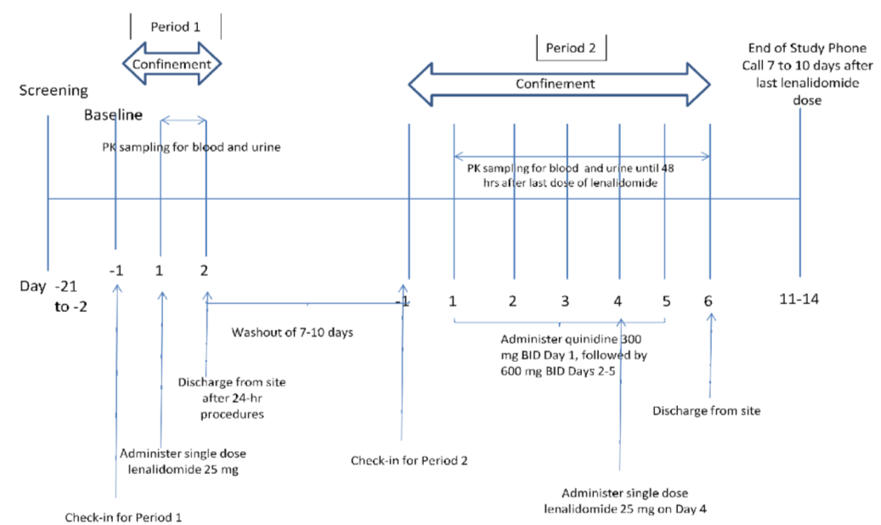

In Part 2 (see Figure 9 below), lenalidomide was administered as a single 25 mg dose (fasting in the morning) on Day 1 of Period 1, and serial blood and urine samples were collected for determination of lenalidomide plasma and urine concentrations from pre-dose to 24 hours post-dose. Subjects were discharged from the study site on Day 2 of Period 1 and returned to the study centre 7 to 10 days later (after lenalidomide washout) to commence Period 2 and remained in the study centre for 3 days. On Day 1 of Period 2, after pretreatment with iv diphenhydramine, temsirolimus was administered as a single 25 mg iv infusion over 30 minutes (fasted state). Serial blood samples were collected to determine the concentrations of temsirolimus and sirolimus in whole blood from pre-dose to 168 hours post-dose. Subjects were then discharged from the study centre on Day 3 of Period 2, returning on Day 8 to provide the 168 hour post-dose sample. After a temsirolimus washout of at least 14 days, subjects returned to the study centre to commence Period 3, and, after pretreatment with iv diphenhydramine, a single-dose of lenalidomide 25 mg was administered (fasted state) within 0 to 2 minutes of the start of a single temsirolimus 25 mg iv infusion administered over 30 minutes (fasted state). Serial blood and urine samples were collected pre-dose and post-dose for 48 hours to determine lenalidomide plasma and urine concentrations, and pre-dose and post-dose serial blood samples were collected for 168 hours to determine the whole blood concentrations of temsirolimus and sirolimus. Subjects were discharged from the study centre on Day 3 of Period 3, and returned to provide the 168 hour blood sample on Day 8.

Figure 9. CC-5013-CP-011 - Overall design Part 2.

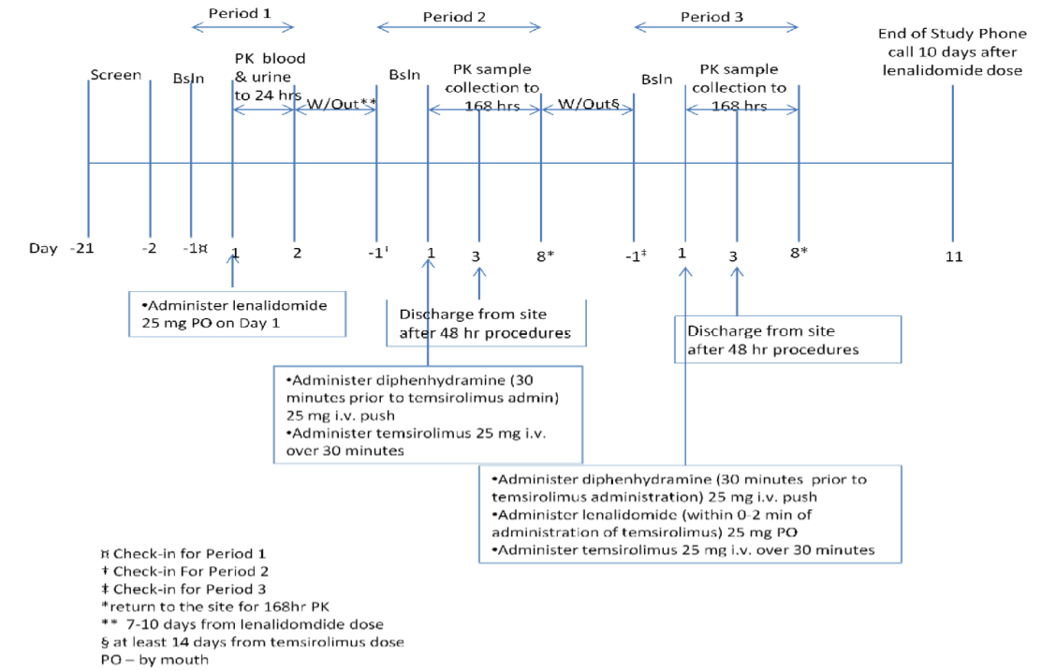

###### Pharmacokinetic assessments

In this study, a comprehensive range of standard plasma and urinary PK parameters for the analytes of interest were derived using non-compartmental methods. Actual sampling times were used in the calculations of PK parameters. The timing of serial sample collections were examined and considered to be adequate to determine the time vs concentration profiles of the analytes in plasma (lenalidomide), whole blood (temsirolimus and sirolimus) and urine (lenalidomide).

###### Statistical methods

The PK population included all subjects who had evaluable PK profiles. The PK data were summarised using standard descriptive statistical methods. The PK DDI data were analysed using the standard method of ANOVA on natural log transformed PK parameters to estimate the relevant geometric mean ratios between treatments with calculation of the 90% CI for the ratios. The ANOVA model includes treatment as a fixed effect and subject as random effect. Sample sizes were based on empirical considerations rather than on formal statistical power analyses. Approximately 28 healthy male subjects were to be enrolled (14 subjects in each part), with the goal of having at least 10 subjects having sufficient evaluable PK time points in each part of the study.

###### Subjects

All enrolled subjects (n=31) satisfied the inclusion and exclusion criteria with no clinically significant abnormalities being reported. The report included a summary of the demographic and baseline characteristics of the enrolled subjects. All 31 enrolled subjects (14 in Part 1 and 17 in Part 2) provided evaluable PK data in at least one period and were included in the PK analysis. In Part 2 Period 2, one subject did not provide the 168 hour PK sample due to withdrawing from the study. This led to insufficient sirolimus concentration data from this subject to adequately define the terminal phase of the concentration time curve in Period 2. Therefore, sirolimus PK parameters associated with the terminal phase (AUCinf, AUCt and t1/2,z) from this subject in Period 2 were excluded from summary statistics and ANOVA tests.

###### Pharmacokinetic results - lenalidomide alone and in combination with quinidine

The mean plasma concentration vs time profiles of lenalidomide alone and in combination with quinidine are presented below in Figure 10.

Figure 10. CC-5013-CP-011 - Mean ± SD lenalidomide plasma concentration vs time profiles alone and in combination with quinidine.

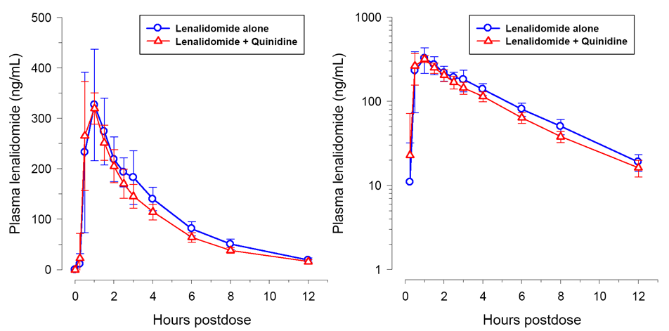

The statistical comparison of the key PK parameters of lenalidomide when administered alone and in combination with quinidine are summarised below in Table 12.

Table 12: CC-5013-CP-011 - Key PK parameters for lenalidomide alone and in combination with quinidine.

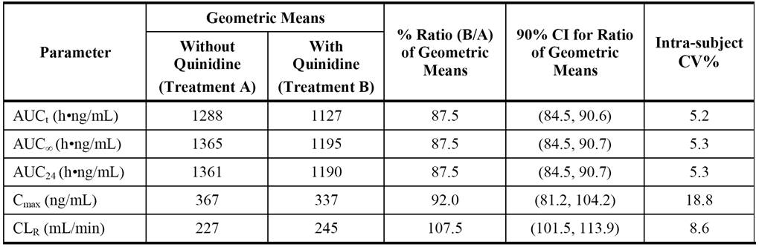

*Comment: The AUCinf and Cmax data for lenalidomide (with/without quinidine) indicate that co-administration with quinidine does not significantly effect exposure to lenalidomide. The 90% CI intervals for the geometric mean ratios for all lenalidomide AUC parameters and for the Cmax were enclosed entirely with the conventionally accepted bioequivalence limits of 80% to 125%. In addition, the plasma concentration vs time profiles for lenalidomide with and without quinidine were almost identical. Furthermore, inspection of the plasma and urinary PK parameters for lenalidomide with and without quinidine showed no clinically meaningful differences. It can be concluded that co-administration of the P-gp inhibitor quinidine and P-gp substrate lenalidomide had no clinically significant effects on systemic exposure to lenalidomide.*

###### Pharmacokinetic results - lenalidomide alone and in combination with temsirolimus

The mean plasma concentration vs time profiles of lenalidomide when administered alone and in combination with temsirolimus are presented below in Figure 11.

Figure 11. CC-5013-CP-011 - Mean ± SD plasma concentration vs time profiles for lenalidomide alone and in combination with temsirolimus.

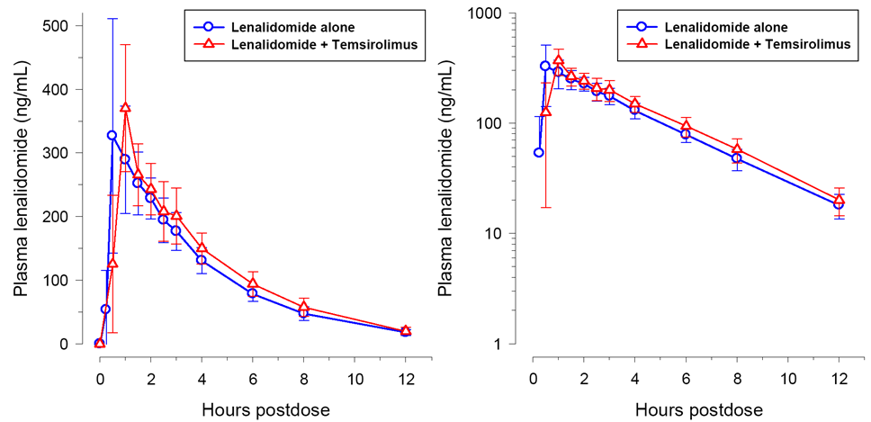

The statistical comparison of the key PK parameters of lenalidomide when administered alone and in combination with temsirolimus are summarised below in Table 13.

Table 13: CC-5013-CP-011 - Key PK parameters for lenalidomide alone and in combination with temsirolimus.

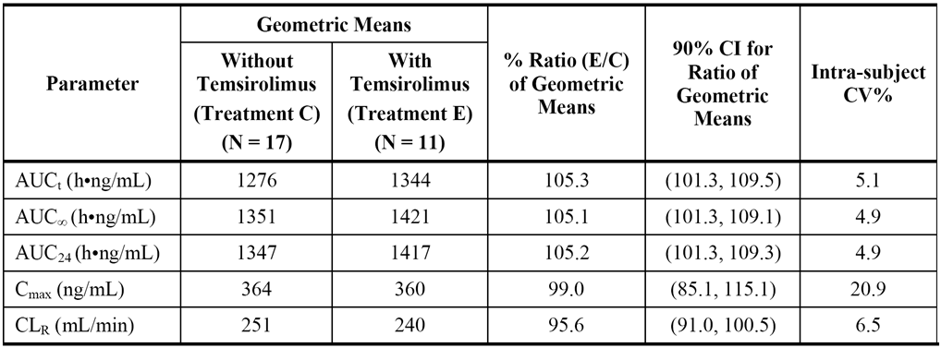

*Comment: The AUCinf and Cmax data for lenalidomide (with/without temsirolimus) indicate that co-administration with temsirolimus does not significantly effect exposure to lenalidomide. The 90% CI intervals for the geometric mean ratios for all lenalidomide AUC parameters and for the Cmax were enclosed entirely with the conventionally accepted bioequivalence limits of 80% to 125%. In addition, the plasma concentration vs time profiles for lenalidomide with and without temsirolimus were comparable. Furthermore, inspection of the plasma and urinary PK parameters for lenalidomide with and without temsirolimus showed no clinically meaningful differences, although the median Tmax for lenalidomide alone was shorter than when co-administered with temsirolimus (0.5 vs 1 hour, respectively). It can be concluded that co-administration of the P-gp inhibitor/substrate temsirolimus and lenalidomide (an in vitro P-gp substrate) had no clinically significant effects on systemic exposure to lenalidomide.*

###### Pharmacokinetic results - temsirolimus alone and in combination with lenalidomide

The mean whole blood concentration vs time profiles of temsirolimus alone and in combination with lenalidomide are summarised below in Figure 12.

Figure 12. CC-5013-CP-011 - Mean ± SD whole blood concentration vs time profiles for temsirolimus alone and in combination with lenalidomide.

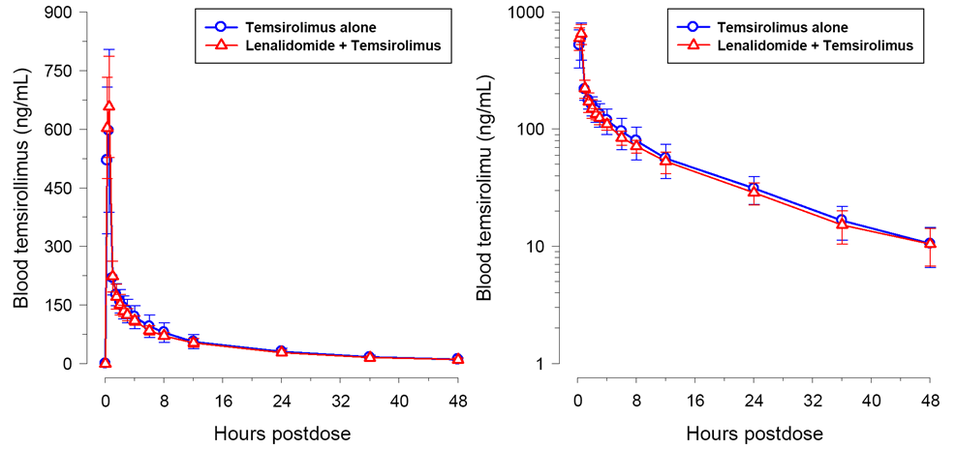

The statistical comparison of the PK parameters of temsirolimus when administered alone and in combination with lenalidomide are summarised below in Table 14.

Table 14: CC-5013-CP-011 - PK parameters for temsirolimus alone and in combination with lenalidomide.

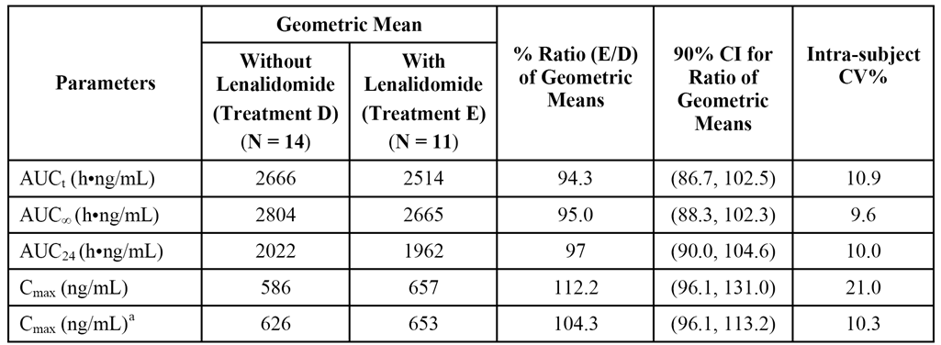

a = exclude one outlier

*Comment: The 90% CI intervals for the geometric mean ratios for all temsirolimus AUC parameters were enclosed entirely with the conventionally accepted bioequivalence limits of 80% to 125%. However, the upper 90% CI for the Cmax (131.0%) was marginally outside the conventionally accepted upper bioequivalence limit (125%) when all subjects were included in the analysis, but below the limit when one outlier was excluded from the analysis. The difference in the Cmax results with and without the outlier is considered to be clinically insignificant. The plasma concentration vs time profiles for temsirolimus with and without lenalidomide were almost identical. Furthermore, inspection of the whole blood PK parameters for temsirolimus with and without lenalidomide showed no clinically meaningful differences. It can be concluded that co-administration of lenalidomide had no clinically relevant effect on exposure to temsirolimus.*

###### Pharmacokinetic results - sirolimus alone and in combination with lenalidomide

The mean whole blood concentration vs time profiles of sirolimus alone and in combination with lenalidomide are summarised below in Figure 13.

Figure 13. CC-5013-CP-011 - Mean ± SD whole blood concentration vs time profiles for sirolimus alone and in combination with lenalidomide.

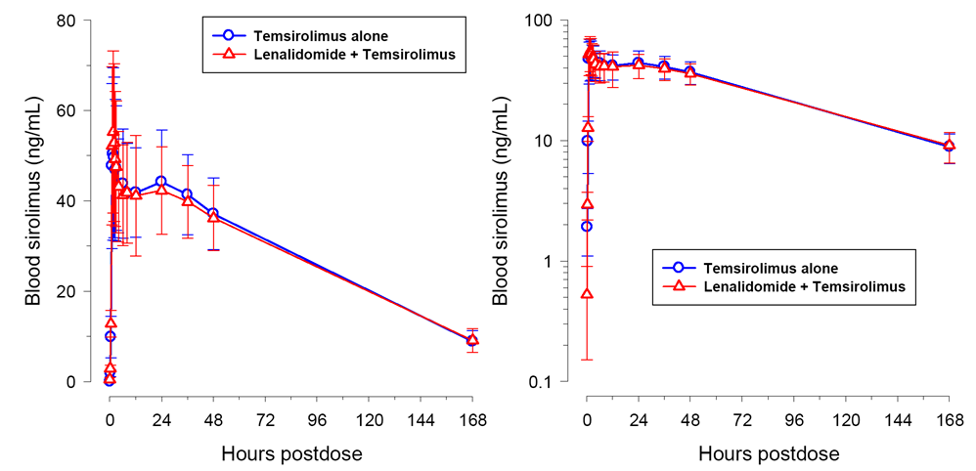

The statistical comparison of AUC and Cmax values for sirolimus when administered alone and in combination with lenalidomide are summarised below in Table 15.

Table 15: CC-5013-CP-011 - PK parameters for sirolimus alone and in combination with lenalidomide.

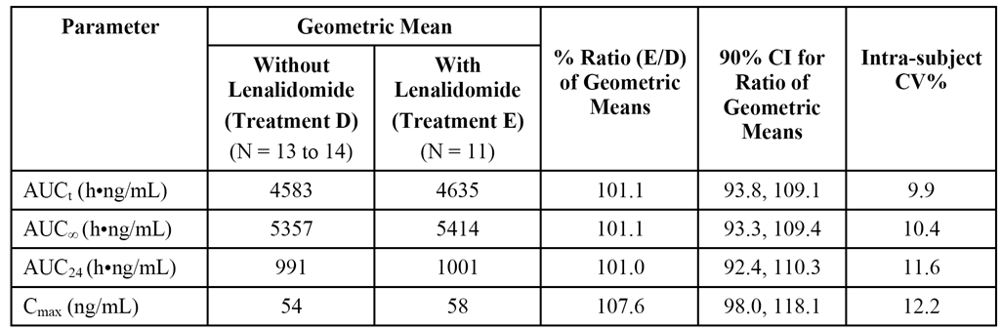

*Comment: The 90% CI intervals for the geometric mean ratios for all sirolimus AUC parameters and for sirolimus Cmax were enclosed entirely with the conventionally accepted bioequivalence limits of 80% to 125%. The plasma concentration vs time profiles for sirolimus with and without lenalidomide were almost identical. Furthermore, inspection of the whole blood PK parameters for sirolimus with and without lenalidomide showed no clinically meaningful differences. It can be concluded that co-administration of lenalidomide had no clinically relevant effect on exposure to sirolimus (the metabolite of temsirolimus).*

###### Conclusion

The study supports the addition of the new PI statement that - "Co-administration of multiple doses of P-gp inhibitor, quinidine (600 mg, twice daily) had no effect on the single dose pharmacokinetics of lenalidomide (25 mg). Single [add "dose"] co-administration of lenalidomide (25 mg) and P-gp inhibitor/substrate, temsirolimus (25 mg), does not affect the pharmacokinetics of either drug." However, the word "dose" needs to be included after the word "Single" at the start of the second sentence.

#### Pharmacokinetics in different racial groups

The submission included one Phase 1 PK study of lenalidomide alone and in combination with dexamethasone in Japanese patients (n=15) with previously treated MM undertaken in 2008 (CC-5103-MM-017-PK), and one Phase I PK study of lenalidomide alone and in combination with dexamethasone in Chinese patients (n=11) with previously treated MM undertaken in 2010 (CC-5013-MM-021-PK).

In study CC-5103-MM-017-PK, the PK characteristics and plasma exposure to lenalidomide in Japanese patients were reported as being comparable to those historically reported for Caucasian MM patients. In Japanese MM patients, after single or multiple dosing of 10 mg or 25 mg of lenalidomide absorption and elimination of lenalidomide were both rapid, with the plasma Cmax observed at a median time of 0.5 to 1.7 hours and the t1/2 averaging 2.4 to 3.1 hours. Multiple doses of lenalidomide did not cause the drug to accumulate in plasma. Following single and multiple doses of lenalidomide 25 mg, the mean ± SD Cmax was 622 ± 29.3 ng/mL on Day 1 (n=6) and 714 ± 512 ng/mL on Day 12 (n=6), and the mean ± AUCt on Day 1 (n=6) was 2600 ± 39.0 ng•h/mL and 2687 ± 34.6 ng•h/mL on Day 12 (n=6). There was no dose- or time-dependency for lenalidomide Tmax, t1/2, CL/F or Vz/F. Coadministration of lenalidomide with 40 mg dexamethasone had no significant effect on multiple-dose pharmacokinetics of lenalidomide. After a single oral dose of dexamethasone 40 mg, the median Tmax was 2.5 hours and the mean t1/2 was 4.2 hours. Following dexamethasone multiple dosing (40 mg QD on Days 2-4 and 9-12), the CL/F of dexamethasone increased 36% and the AUCt decreased 24% with little change in Cmax and Tmax values.

In study CC-5013-MM-021-PK, the PK characteristics and plasma exposure to lenalidomide in Japanese patients were reported as being comparable to those historically reported for Caucasian MM patients and were similar to those observed in Japanese patients with MM. In Chinese MM patients, absorption and elimination of lenalidomide was rapid with a median Tmax of approximately 1 hour and a mean t1/2,z of approximately 3 hours. Multiple doses of lenalidomide did not cause the drug to accumulate in plasma. Following single and multiple doses of lenalidomide 25 mg, the mean ± SD Cmax was 574 ± 28.3 ng/mL on Day 1 (n=11) and 478 ± 19.3 ng/mL on Day 7 (n=10), and the mean ± AUCt on Day 1 (n=11) was 2323 ± 40.1 ng•h/mL and 1963 ± 36.6 ng•h/mL on Day 7 (n=10). There was no time-dependent change t1/2,z CL/or Vz/F. Coadministration with 40 mg dexamethasone had no effect on the multiple-dose PK of lenalidomide.

#### Population pharmacokinetics

##### Study CC-5013-MCL-001-PK

The submission included one population pharmacokinetic study PPK (CC-5013-MCL-001-PK) dated 8 October 2012. The primary objectives of the study were: (1) to describe the PPK of lenalidomide in subjects with haematological malignancies under lenalidomide monotherapy: i.e., mantle cell lymphoma (MCL), multiple myeloma (MM), and myelodysplastic syndromes (MDS); and (2) to quantitatively describe the lenalidomide exposure-response relationship for measures of toxicities (neutropenia and thrombocytopenia) in subjects with MCL, MM, and MDS.

A total of 147 subjects from 7 studies contributed 2495 samples to the PPK analysis, with the majority of subjects providing less than 20 samples each. The median age of the 147 subjects was 62 years (range: 39, 85 years), the median body weight was 76.3 kg (range: 32.9, 135), and the majority of subjects were male (69%), and were white (75%).

Nonlinear mixed effects modelling was used to develop an integrated PPK model for lenalidomide. Standard PPK statistical software packages were used to undertake the analyses. The methodology was extensively described in the PPK report and met the reporting requirements of the relevant TGA adopted guideline (CHMP/EWA/185990/06).

Results are as follows:

* A two-compartment model with first order input with a two-stage absorption process and a lag-time appropriately characterised the plasma concentrations of lenalidomide.
* The typical value of lenalidomide CL/F at the mean CLcr of 79.36 mL/min was 10.2 L/h. The final covariate model for lenalidomide clearance at the population level was described as follows:



* Creatinine clearance was the only important and statistically significant predictor of lenalidomide clearance, while age, weight, race, sex, and mild hepatic impairment (total bilirubin > 1 to ≤ 1.5 x upper limit of normal [ULN] or aspartate aminotransferase [AST] > ULN) were not significant predictors of clearance.
* The typical value of lenalidomide central volume of distribution (V2/F) at the median body weight of 76.3 kg for a male subject was 48.3 L. The final covariate model for lenalidomide V2/F at the population level was described as follows:



* Body weight and sex had a limited effect on the volume of distribution (V2/F), but had no effect on CL/F and consequently on systemic exposure to lenalidomide (i.e., AUC). Therefore, the effect of body weight and sex on V2/F is not considered to be clinically relevant. Other factors such as disease, age, race and mild hepatic impairment had no effect on V2/F.
* The type of haematological malignancy had no effect on pharmacokinetics of lenalidomide PK, with the PK profile being similar in patients with MM, MDS, and MCL.
* Type of hematological malignancy, lenalidomide exposure (lnAUC), and baseline cell counts (neutrophils or platelets) were the key variables contributing to the probability of experiencing Grade 3 or 4 neutropenia or thrombocytopenia. Haematological malignancy (predominantly MDS) appeared to be a stronger predictor of developing Grade 3 or 4 neutropenia than lenalidomide exposure or baseline neutrophil or platelet counts.
* In patients with MM, the probability of experiencing Grade 3 or 4 neutropenia tended to increase with increased lenalidomide exposure (lnAUC), though this relationship did not reach statistical significance (Odds Ratio for one lnAUC increase = 1.982 [95% CI: 0.924, 4.249]). In patients with MM, lenalidomide lnAUC was a significant predictor of Grade 3 or 4 thrombocytopenia after accounting for the effect of baseline platelet count (Odds Ratio for one lnAUC increase = 2.972 [95% CI: 1.027, 8.598]).

## Pharmacodynamics

### CC-5013-PK-007

#### Study design

The "thorough QT/QTc" study (CC-5013-PK-007) was designed to evaluate the effect of lenalidomide on the time-matched changes from placebo in the baseline adjusted QT interval by using an individual corrected QT interval (QTcI) (primary objective). The study was a post-marketing commitment given to the FDA following approval of lenalidomide for the treatment of MDS and MM. The study was Phase I, single-centre, randomised, single-dose, and cross-over in design with 4 treatments, 4 periods and 4 sequences. It was conducted in healthy male subjects aged 18 to 50 years. The study was sponsored by Celgene. It was undertaken in the USA with the first subject being enrolled on 12 March 2012 and the last subject completing on 23 August 2011. The study was conducted in accordance with the ethical principles of GCP according to the ICH Harmonised Tripartite Guideline.

The study planned to enrol 60 male subjects, with each subject being randomised to one four treatment sequences (15 subjects per treatment sequence). For each treatment sequence, each subject went through a Screening phase, 4 baseline phases, 4 treatment periods, and an end-of-study (EOS) evaluation. The following treatments were administered under fasting conditions to subjects in a randomised order:

* Treatment 1: Five placebo capsules matching the 10 mg capsule of lenalidomide administered (double-blind) at approximately 08:00 on Day 1.
* Treatment 2: Five capsules (one 10 mg lenalidomide capsule and 4 matching placebo capsules) administered (double-blind) at approximately 08:00 on Day 1.
* Treatment 3: Five capsules of 10 mg lenalidomide administered (double-blind) at approximately 08:00 on Day 1.
* Treatment 4: One 400 mg moxifloxacin tablet administered (open-label) at approximately 08:00 on Day 1; moxifloxacin was the positive control.

On the morning of Day 1 of each period, ECGs were undertaken for baseline assessment pre-dose at 0, 0.5 and 1 hour. After administration of the study drug, triplicate ECGs were undertaken at 0.5, 1, 1.5, 2, 3, 4, 6, 8, 12, and 23 hours post-dose. The ECG data (12-lead) were collected from Holter recorders, and the QTcI (or QTcF) was derived by using all the QT and RR interval pairs collected prior to study drug administration in Period 1. For each subject, a linear regression model was fitted and the resulting slope was used to calculate the individual QT correction for that subject.

Time-matched blood samples were collected in order to determine plasma concentrations of lenalidomide for PK analysis. After a washout period of at least 7 days, but no more than 10 days, subjects returned to the site for the next treatment period. Follow-up assessments were performed at the EOS and 7 to 10 days after Day 2 (day of discharge) of Period 4. The follow-up assessments were also performed at the early termination (ET) or discontinuation visit if available. The central ECG laboratory and central ECG readers were blinded to all treatments and sequences.

A total of 60 subjects were enrolled in the study, and 52 subjects completed with 8 prematurely discontinuing (2 x withdrew consent, 1 x AEs, 4 x protocol deviations, 1 x lost to follow-up). The 60 healthy adult male subjects had a mean age of 28 years (range: 18, 49 years); a mean weight of 80.1 kg (range: 58.8, 103.8 kg); a mean height of 178.3 cm (range: 165.1, 191.7 cm); and a mean BMI of 25.1 kg/m2 (range: 19.1, 29.9 kg/m2). Forty (40) subjects (66.7%) were White; 18 (30.0%) were Black or African American; 1 (1.7%) was Asian; and 1 (1.7%) was American Indian/Alaska Native.

#### Statistical methods

A mixed-effect ANCOVA was performed on the change-from-baseline in QTcI with fixed effects for treatment, period, sequence, scheduled time, period-specific baseline value as a covariate, and the interaction of treatment by scheduled time with scheduled time as a repeated measure. All 4 treatment groups and all post-dose time points on Day 1 were included in this model. The upper limits of the 95% CI (one-sided) for pairwise mean differences between active treatments and placebo on Day 1 were calculated and compared with the 10 ms bound (non-inferiority margin). It was considered that lenalidomide did not prolong the QTc interval to a clinically significant degree if the upper limit of the 95% CI at Day 1 for all lenalidomide dose groups versus placebo fell below 10 ms. It was calculated that a sample size of 49 subjects with triplicate ECGs per time point provided at least 80% power (for up to 10 time points) to show that the upper limit of each one-sided 95% CI would fall below 10 ms. The data were presented as a 2-sided 90% CI (i.e., upper limit of 2-sided 90% CI is equivalent to the upper limit of a 1-sided 95% CI). Therefore, it was considered that lenalidomide did not significantly prolong the QTc interval if the upper limit of the 90% CI was less than 10 ms.

The effect of QTcI for moxifloxacin was assessed at 1, 2, 3, and 4 hours post-dose to evaluate assay sensitivity. At each time point, the change-from-baseline values relative to placebo values were estimated between the least squares (LS) means of moxifloxacin and placebo, and the lower 98.75% CI computed. The data were presented as a 2-sided 97.5% CI (i.e., lower limit of 2-sided 97.5% CI is equivalent to the lower limit of a 1-sided 98.75% CI). If the lower 97.5% CI for any of the post-dose time points exceeded 5 ms then it was considered that the assay was sensitive enough to detect a drug-induced change in QTc.

#### Results for the primary analysis

The results for the primary analysis for both the 10 mg and 50 mg doses of lenalidomide are summarised below in Figure 14. All LS mean ΔΔQTcI values for the 10 mg and 50 mg doses were below 3 ms, with the upper limit of the 2-sided 90% CI for both doses staying below 10 ms at all time-points (i.e., lenalidomide considered not to have a clinically significant effect on QTc prolongation). Least-squares mean ΔΔQTcI values for moxifloxacin were greater than 5 ms at all time-points between 1 and 4 hours post-dose, with the lower limit of the associated 2-sided 97.5% CI being greater than 5 ms at 2 and 4 hours after dosing (i.e., assay sensitivity established).

Figure 14. PK-007 - Mean and 90% CI (2-sided) for change from baseline and placebo-corrected QTcI vs time for lenalidomide 10 mg (Panel A) and 50 mg (Panel B).

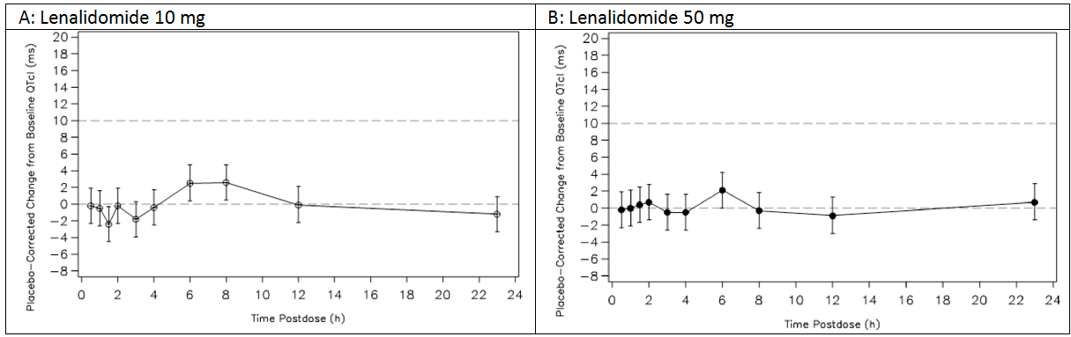

#### Results for the key secondary analyses

* All LS mean ΔΔQTcF (Fridericia corrected QT interval) values for the 10 mg and 50 mg dose of lenalidomide were below 3 ms, with the upper limit of the 2-sided 90% CI for both doses staying below 10 ms at all time-points. All LS mean ΔΔQTcB (Bazett corrected) values for the 10 mg and 50 mg dose of lenalidomide were below 5.4 ms, with the upper limit of the 2-sided 90% CI for both doses staying below 10 ms at all time-points. Least squares mean ΔΔQTcF and ΔΔQTcB values for moxifloxacin were greater than 5 ms at all time points between 1 and 4 hours post-dose. The lower limit of the 2-sided 97.5% CI of LS mean ΔΔQTcF was greater than 5 ms at 1, 2, and 4 hours post-dose. The lower limit of the 2-sided 97.5% CI of LS mean ΔΔQTcB was greater than 5 ms from 1 to 4 hours post-dose.
* The time-averaged ∆∆QTcI values were -0.3 ms (90% CI: 1.4, 0.9) for lenalidomide 5 mg, 0.1 ms (90% CI: -1.1, 1.3 ms) for lenalidomide 50 mg, and 6.7 ms (90% CI: 5.5, 7.9 ms) for moxifloxacin.
* In the categorical analysis, no subject in the four treatment groups had QTcI, QTcF or QTcB increases > 500 ms. For the QTcI analysis, 1 (1.9%) subject in the moxifloxacin group had a > 450 and ≤ 480 ms increase, with all other subjects in the four treatment groups having < 30 ms increases. For the QTcF analysis, all subjects in the four treatment groups had < 30 ms increases. For the QTcB analysis, 1 (1.9%) subject in the moxifloxacin group had a > 450 and ≤ 480 ms increase, and 6 (11.5%) subjects had ≥ 30 and ≤ 60 ms increases, in the lenalidomide 10 mg group, 2 (3.8%) subjects had > 30 and ≤ 60 ms increases, in the lenalidomide 50 mg group, 3 (5.8%) subjects had > 30 and ≤ 60 ms increases, and in the placebo group, 2 (3.8%) subjects had > 30 and ≤ 60 ms increases, with all other subjects in the four treatment groups having < 30 ms increases.
* There was no apparent relationship between plasma lenalidomide concentrations and the time-matched ΔΔQTcI intervals. Individual ΔΔQTcI values were distributed evenly around zero across lenalidomide concentrations up to 1522 ng/mL. Further concentration-QTc modelling was not conducted. The sponsor stated that mean Cmax (698 ng/mL) and AUCinf (2674 h•ng/mL) values achieved at the 50 mg dose were approximately 34% and 18% higher than those historically observed in MM subjects (Cmax 521 ng/mL and AUCinf = 2262 h•ng/mL) treated with 25 mg lenalidomide (study 1398/271).

#### Comments

This was a good quality "thorough QT/QTc", which met the TGA adopted guideline relating to such studies (ICH Topic E14). The study demonstrated that lenalidomide 10 mg and 50 mg administered as single-doses to healthy male subjects was not associated with clinically significant QT interval prolongation. The study did not include female patients, as the sponsor was concerned about teratogenicity associated with lenalidomide. The study supports the new statement in the Mechanisms of Action section of the PI under Cardiac Electrophysiology.

## Dosage selection for the pivotal studies

In the pivotal clinical study (MM-020) it was stated that at the time the protocol was developed, the dose and schedule for both lenalidomide 25 mg QD (once daily) on days 1-21 of a 28 day cycle combined with low dose dexamethasone 40 mg QD on days 1, 8, 15, 22 of a 28 day (Rd regimen), and methotrexate 0.25 mg/kg QD plus prednisone 2 mg/kg QD on days 1-4 of a 42 day cycle plus thalidomide 200 mg QD on days 1-42 of a 42 day cycle (MPT) had been studied in previous Phase III studies.[1] Twelve (12), 42-day cycles (72 weeks) of MPT treatment was consistent with the large Phase III IFM experience with the MPT regimen in elderly MM subjects.[2] Planned durations of 18, 28-day cycles (72 weeks) of Rd treatment (Rd18) and Rd treatment to documentation of PD (Rd) provided data as to whether continued Rd therapy beyond 72 weeks improved clinical outcomes. Subjects with impaired renal function and limited bone marrow function could be enrolled in this study. Starting doses were to be adjusted based on age, renal function, or ANC/platelet count, as appropriate, for all study drugs except prednisone (which was always to be dosed at 2 mg/kg per day).

## Clinical efficacy

### Studies providing efficacy data

The submission seeks to amend the approved indication for Revlimid to include the treatment of patients with MM. In the letter of application, the sponsor designates one Phase III study as pivotal (MM-020), and five Phase III studies as supportive (MM-015, ECOG E4A03, SWOG S0232, IFM 2005-02, and CALGB 100104). The efficacy and safety data from each of the six Phase III studies have been fully evaluated and the results of the evaluation presented in the text of the body of this clinical evaluation report and in the supporting tables and figures. The patient group, patient age, and treatment regimens for each of the six Phase III studies designated by the sponsor as being pivotal or supportive are outlined below in Table 16.

Table 16: Patient population and treatment regimen of pivotal and supportive studies.

|  |  |  |  |
| --- | --- | --- | --- |
| ID | Patient Group | Age y | Treatment regimens |
| MM-020 | NDMM AuSCT not eligible  (n=1623) | ≥ 18 | * Rd (28-day cycles until PD) = R 25 mg QD on days 1-21 + dex 40 mg QD on days 1, 8, 15, 22. * Rd18 (18 x 28-day cycles) = R 25 mg QD on days 1-21 + dex 40 mg QD on days 1, 8, 15, 22. * MPT (12 x 42-day cycles) = M 0.25 mg/kg QD + P 2 mg/kg QD on days 1-4 + T 200 mg QD on days 1-42. |
| MM-015 | NDMM AuSCT not eligible  (n=459) | ≥ 65 | * MPR+R = induction - 9 cycles x 28 days of M 0.18 mg/kg QD days 1-4 + P 2 mg/kg QD days 1-4 + R 10 mg QD days 1-21; maintenance - from cycle 10 with R 10 mg QD on days 1-21 of 28 day cycles. * MPR+P = induction - 9 cycles x 28 days of M 0.18 mg/kg QD days 1-4 + P 2 mg/kg QD days 1-4 + R 10 mg QD days 1-21; maintenance - from cycle 10 with P QD on days 1-21 of 28 day cycles. * MPp+p = induction - 9 cycles x 28 days of M 0.18 mg/kg QD on days 1-4 + P 2 mg/kg QD on days 1-4 + p days 1-21; maintenance - from cycle 10 with P QD on days 1-21 of 28 day cycles. |
| ECOG  E4A03 | NDMM AuSCT eligible  (n=445) | ≥ 18 | * Rd = R 25 mg QD on days 1-21 + dex (low dose) 40 mg QD on days 1, 8. 15, 22 of 28 day cycle. * RD = R 25 mg QD on days 1-21 + dex (high dose) 40 mg QD on days 1-4, 9-12, and 17-20 of 28 day cycle. |
| SWOG  S0232 | NDMM AuSCT eligible  (n= 198) | ≥ 18 | * R+dex = induction - 3 cycles x 35 days of R 25 mg QD on days 1-21 + dex 40 mg days 1-4, 9-12, 17-20 of 28-day cycles; maintenance - R 25 mg QD days 1-21 + dex 40 mg QD on days 1-4, 15-18 of 28 day cycles. * Placebo+dex = induction - 3 cycles x 35 days of placebo QD on days 1-21 + dex 40 mg days 1-4, 9-12, 17-20 of 28-day cycles; maintenance - placebo QD days 1-21 + dex 40 mg QD on days 1-4, 15-18 of 28 day cycles. |
| IFM  2005-02 | Post-transplant  (n=614) | 18 to < 65 | * R+R = 2 cycles of consolidation R 25 mg QD on days 1-21 of 28 day cycle followed by maintenance with R 10 mg QD for 28 days of 28 day cycles. * R+p = 2 cycles of consolidation R 25 mg QD on days 1-21 of 28 day cycle followed by maintenance p for 28 days of 28 day cycles. |
| CALGB  100104 | Post-transplant  (n=460) | 18 to  ≤ 70 | * R = R 10 mg QD for 3 months with escalation to 15 mg QD if treatment tolerated. * Placebo |

Note: NDMM = newly diagnosed multiple myeloma; AuSCT = autologous stem cell transplant; R = lenalidomide; d (low dose) = dexamethasone; M = melphalan; P = prednisone; T = thalidomide; D (high dose) = dexamethasone; p = placebo; dex = dexamethasone; QD = once daily; y=year.

If the submission to extend the indication is successful it will result in lenalidomide being approved for all patients with MM, given that the drug is already approved for previously treated patients with MM whose disease has progressed after one therapy. However, there are a number of separate and distinct clinical situations in which lenalidomide might be used to treat patients with MM. Therefore, it is considered that, for regulatory purposes, there should be separate indications for lenalidomide for the treatment of MM, with each indication being supported by at least one pivotal study. Examples of separate indications include, treatment of patients with NDMM who are not eligible for AuSCT, treatment of patients with NDMM who are eligible for AuSCT (induction and/or maintenance), and treatment of patients with relapsed or refractory MM.

Based on the criteria of separate and distinct indications, with each indication being supported by at least one pivotal study, it is considered that the data provided in the submission support only an extension of indication to patients with NDMM who are not eligible for AuSCT. Furthermore, it is noted that the Clinical Trials section of the amended PI includes reference only to the pivotal Study MM-020 and the supportive Study MM-015 under a heading of Newly Diagnosed Multiple Myeloma (NDMM)/Lenalidomide in Combination with Dexamethasone (in Patients who are Non-Eligible for Transplant), while the Dosage and Administration section of the PI refers to the dosing regimens used in these two studies without reference to AuSCT eligibility status. The amended PI makes no reference to supportive Studies ECOG E4A03 (NDMM AuSCT eligible), SWOG S0232 (NDMM AuSCT eligible), IFM 2005-02 (NDMM maintenance post transplant) or CALGB 100104 (NDMM maintenance post transplant).

### Studies supporting the new indication

#### Pivotal efficacy study - MM-020

##### Study design, objectives, locations and dates

###### Design

Study MM-020 is a Phase 3, multinational, multicentre, randomised, open-label, 3-arm, efficacy and safety study designed to compare three treatment regimens consisting of lenalidomide combined with dexamethasone (Rd) administered for 28-day cycles until progressive disease (PD), lenalidomide combined with dexamethasone (Rd18) administered or for up to 18, 28-day cycles (i.e., 72 weeks), and melphalan, prednisone/prednisolone, and thalidomide (MPT) administered for up to 12, 42-day cycles (i.e., 72 weeks).

*Comment: The sponsor states that MM-020 is the largest Phase 3 study undertaken in newly diagnosed multiple myeloma (NDMM) patients (i.e., 1623 randomised patients). The study is open-label and, consequently, is potentially subject to the well known biases of unblinded studies. However, the potential biases associated with the open-label design have been mitigated, at least in part, due to all efficacy assessments being determined by an Independent expert Response Adjudication Committee (IRAC) blinded to treatment allocation. The sponsor stated that an open-label design was selected because of the difficulty of incorporating double-blind, placebo-controlled features in a setting where 5 different anti-myeloma agents were used and the treatment groups received therapy for different time periods. The MPT treatment arm is considered to be an acceptable comparator, and is a standard upfront treatment for patients who are not eligible for ASCT, particularly for older patients. The sponsor notes that the melphalan/prednisone/bortezomib (MPV) regimen for NDMM was not approved in the US until 20 June 2008 (i.e., after the start of the study). Overall, it is considered that the open-label design of the study with an MPT control arm is adequate to provide a valid assessment of the efficacy of two Rd regimens for the treatment of patients with NDMM who are not eligible for ASCT.*

###### Objectives

The primary objective of the study was to compare the efficacy of Rd given until PD to that of MPT given for 12, 42-day cycles.

The secondary objectives were to: (a) to compare the efficacy of Rd given for 18, 28-day cycles (Rd18) to that of MPT given for 12, 42-day cycles; (b) to assess the safety of Rd versus MPT; and (c) to assess the safety and efficacy of Rd therapy given until PD vs the safety and efficacy of Rd given for 18, 28-day cycles

###### Study phases

The study included a screening phase, an active treatment phase, a progression free survival (PFS) follow-up stage (for subjects who withdrew from study treatment after receiving at least 6 cycles for reasons other than PD or who completed the treatment period [Rd18 and MPT arms]), and a long-term follow-up phase. The study design is presented schematically below in Figure 15.

Figure 15. Study MM-020 - Study design.

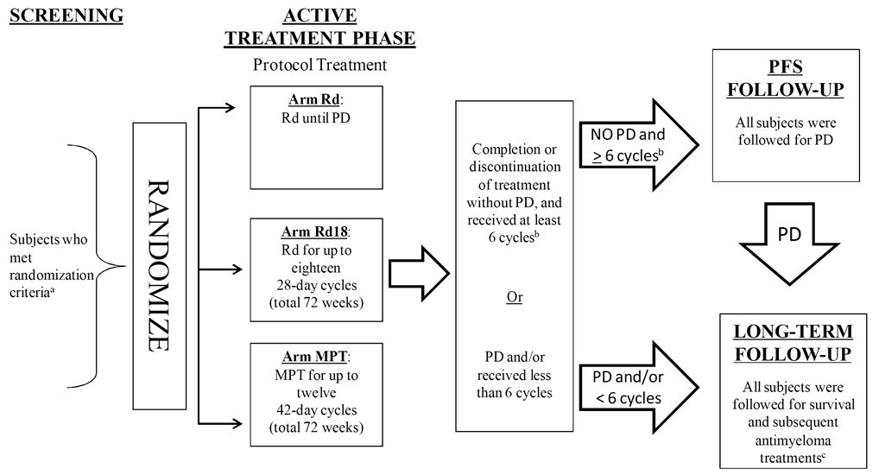

The screening phase was undertaken from Day -28 to Day -1 before randomisation. In this phase, eligibility was assessed and patients were provided with advice and counselling related to the risks of both thalidomide and lenalidomide. Eligibility was based on central laboratory results at screening, except for local laboratory screening of complete blood count (CBC) data. All patients (irrespective of age) had to be not eligible for ASCT and not to have had stem cell harvest. If patients were younger than 65 years of age, then they were considered to be not eligible for ASCT if they had declined to undergo ASCT or ASCT was not available for other reasons (including cost). The schedule of screening assessments is provided.

Eligible patients who completed the screening phase were randomised 1:1:1 to one of the three treatment arms and entered the active treatment phase. The results of the skeletal survey, the bone marrow aspirate (percent plasma cells), and radiographic assessments of extramedullary plasmacytomas obtained during the screening period provided both eligibility and baseline information. If the screening vital signs, CBC, serum chemistry, creatinine clearance (CrCl), and protein electrophoresis assessments were within 7 days of randomisation, they did not need to be repeated at Cycle 1 Day 1 and were used as baseline results. Study treatment began on the day patients were randomised. The active treatment phase ended when the study treatment was permanently discontinued (i.e., documented investigator determination of PD; completion of protocol specified treatment cycles for Rd18 and MPT arms; intolerable toxicity or any other reason). Following the active treatment phase, patients entered a PFS follow-up phase and/or a long-term follow-up phase.

Subjects in the Rd18 an MPT treatment arms who completed the maximum number of cycles entered the PFS follow-up phase and were followed-up until PD. No other anti-myeloma therapy was to be started in the PFS follow-up phase until the development of PD. Every attempt was made to keep subjects in the PFS follow-up phase until PD so that an accurate estimation of median PFS time for each treatment arm could be made. Subjects in any of the three treatment arms who permanently discontinued study treatment early due to reasons other than PD (such as unacceptable toxicity), entered the PFS follow-up phase as long as they had received at least 6 cycles of study treatment and their treating physician determined that additional new anti-myeloma therapy (AMT) was not required before the development of PD. Generally, subjects who permanently discontinued before the completion of 6 cycles received a new AMT.

Subjects who entered the long-term follow-up phase included: (a) subjects who developed PD in either the active treatment or the PFS follow-up phase; (b) subjects who had no documented PD in either the active treatment or the PFS follow-up phase, but who declined further participation; and (c) subjects who did not complete 6 cycles of treatment and who discontinued for reasons other than PD. Subjects who entered the long-term follow-up phase initially had assessments every 4 months and then (from protocol amendment 3 onward) every 2 months. Subjects who progressed were assessed for subsequent AMT (best response to the first AMT regimen used after study discontinuation), potential development of second primary malignancies (SPMs), subsequent PD after second-line therapy, and overall survival. Following protocol amendment 3, subjects who had not progressed and entered the long-term follow-up phase (i.e., subjects who discontinued from active treatment with < 6 cycles) also had ongoing response assessments (every 2 months) using local laboratory data and radiology scans (if increasing bone lesions or plasmacytoma confirmed PD) until the documented time of PD. Contacts during the long-term follow-up phase were made by clinic visit or documented telephone contact.

For subjects who had not reached PD before entering the long-term follow-up phase, every effort was made to obtain the required laboratory assessments. For subjects who declined further participation in the active treatment phase before documented occurrence of PD and who did not enter the long-term follow-up phase according to the criteria stated above, the study site was to attempt to contact the subject and capture documentation of PD. This was done retrospectively if PD or death had already occurred or prospectively by seeking to re-consent the subject in the long-term follow-up phase.

###### Locations and dates

The study is being conducted in Europe, Asia, North America and the Pacific (including Australia and New Zealand). Subjects have been randomised at 246 sites (165 in Europe, 23 in Asia, 39 in North America, and 19 in the Pacific).

The first subject was randomised on 29 August 2008 and the last subject was randomised on 10 March 2011 (i.e., enrollment is complete). The release date of the report was 23 December 2013. The study is ongoing in order to collect additional data for overall survival (OS) and SPMs. The data cutoff date was 24 May 2014, which was selected because approximately 950 PFS events (i.e., the protocol specified number of events required for the final PFS analysis) had occurred by that date. The trial is being conducted in accordance with the ethical principles of GCP, according to the relevant ICH guideline.

##### Inclusion and exclusion criteria

The study included patients aged ≥ 18 years with newly diagnosed, symptomatic MM who were not candidates for stem cell transplant. The inclusion criteria required three of the following to be met:

* Monoclonal plasma cells in the bone marrow ≥ 10% and/or presence of a biopsy-proven plasmacytoma;
* M-protein present in the serum and/or urine;
* Myeloma-related organ dysfunction (CRAB) (at least 1 of the following):
  + [C] Calcium elevation in the blood (serum calcium > 2.63 mmol/L or upper limit of normal).
  + [R] Renal insufficiency (serum creatinine > 0.177 mmol/L).
  + [A] Anaemia (haemoglobin < 100 g/L or 20 g/L < laboratory normal).
  + [B] Lytic bone lesions or osteoporosis

In addition, patients were required to have an Eastern Cooperative Oncology Group (ECOG) performance status of 0, 1, 2, or 3. Previous treatment with AMT was excluded, but AMT did not include radiotherapy, bisphosphonates, or a single short course of steroid (i.e., less than or equal to the equivalent of dexamethasone 40 mg/day for 4 days), which must not have been given within 14 days of randomisation. In addition, exclusion criteria were absolute neutrophil count (ANC) < 1.0 x 109/L), untransfused platelet count < 50 x 109/L, and serum AST or ALT > 3.0 ULN. Patients with peripheral neuropathy ≥ Grade 2 severity were excluded, as were patients who were unable or unwilling to undergo antithrombotic therapy. The complete inclusion and exclusion criteria are provided.

The study also included standard criteria for discontinuing patients from the active treatment phase stage of the study (i.e., AEs that, in the judgment of the study physician, could have caused severe or permanent harm or which ruled out continuation of study drug; progression of disease; subject withdrew consent; subject was lost to follow-up; death; or protocol violation).

##### Study treatments

###### Administered treatments - study drugs

Lenalidomide in combination with dexamethasone (Rd and Rd18 arms)

On Day 1 of Cycle 1, the starting dose of lenalidomide was 25 mg QD for patients with normal or near normal CrCl, 10 mg QD for patients with CrCl < 50 mL/min but ≥ 30 mL/min, and 15 mg QD for patients with CrCl < 30 mL/min. The starting doses for the Rd and Rd18 treatment arms, based on baseline age and renal status (CrCL) are summarised. In addition, granulocyte colony-stimulating factor (GCSF) could have been used to support the neutrophil count at baseline, but the baseline platelet count had to be an untransfused platelet count (i.e., platelet count ≥ 7 days after the administration of the last platelet transfusion). Lenalidomide was administered at dose of 25 mg QD (normal renal function) or 10 mg QD (CrCl < 50 mL/min but ≥ 30 mL/min) on days 1-21 of a 28-day cycle, and 15 mg QD every other day (CrCl < 30 mL/min) on days 1-21 of a 28-day cycle. The dose of lenalidomide could be modified during a cycle based on both haematological and non-haematological toxicities.

On Day 1 of Cycle 1, the starting dose of dexamethasone was 40 mg QD for subjects who were ≤ 75 years of age at randomisation, or 20 mg QD for subjects who were > 75 years of age at randomisation). Dexamethasone was given once daily on Days 1, 8, 15, and 22 of a 28-day Rd cycle, and the dose could be modified in the event of dexamethasone related toxicities. For patients who experienced dexamethasone withdrawal toxicity, dose tapering over a 2-day period to limit symptoms was at the discretion of the treating physician.

If both lenalidomide and dexamethasone or lenalidomide alone were permanently discontinued before the completion of 6 cycles, patients discontinued from the active treatment phase and were followed up for PD, survival and AMT.

If both lenalidomide and dexamethasone were permanently discontinued after the completion of at least 6 cycles, patients entered the PFS follow-up phase and were followed up (without starting new AMT) until PD occurred, as long as the treating physician determined that additional new AMT was not required before development of PD.

If lenalidomide alone was discontinued after the completion of at least 6 cycles or dexamethasone alone was permanently discontinued, patients remained in the active treatment phase and received lenalidomide or dexamethasone therapy (per protocol) until the development of PD (Rd arm) or for up to 18 cycles (Rd18 arm), at the discretion of the treating physician.

Melphalan, prednisone, thalidomide arm (MPT arm)

The starting dose for the MPT arm was based on age, ANC and platelet count. Based on these factors, the starting dose of melphalan was 0.25, 0.20, 0.125, or 0.10 mg/kg QD (Day 1-4 per 42-day cycle), the starting dose of prednisone was 2 mg/kg QD in all patients (Day 1-4 per 42 day cycle) and the starting dose of thalidomide was 100 mg QD or 200 mg QD (Day 1-42 per 42 day cycle). If needed, GCSF was used to support the neutrophil count at baseline, but the baseline platelet count must have been based on an untransfused platelet count (i.e., platelet count ≥ 7 days after the administration the last platelet transfusion). The protocol included instructions for starting a new cycle of MPT and instructions for modifying the dose of melphalan, prednisone and thalidomide during a cycle. Melphalan and prednisone were continued if thalidomide was stopped for toxicity, while thalidomide was continued if melphalan and prednisone were stopped for toxicity.

If MPT, MP, prednisone/thalidomide, melphalan/thalidomide, melphalan alone, or thalidomide alone was permanently discontinued before the completion of 6 cycles of MPT, then patients discontinued from the active treatment phase and entered into long-term follow-up phase and followed for PD, survival, and subsequent AMT.

If MPT, MP, prednisone/thalidomide, or melphalan/thalidomide was permanently discontinued after the completion of at least 6 cycles of MPT, then patients entered the PFS follow-up phase and were followed up (without starting new AMT) until PD occurred, as long as the treating physician determined that additional new AMT was not required before development of PD.

If melphalan alone or thalidomide alone was permanently discontinued after the completion of at least 6 cycles of MPT, then patients could, at the discretion of the treating physician, remain in the active treatment phase and received either prednisone/thalidomide or MP therapy (per protocol) for up to 12 cycles. If prednisone alone was permanently discontinued, patients could at the discretion of the treating physician, remain in the active treatment phase and received melphalan/thalidomide therapy (per protocol) for up to 12 cycles.

###### Antithrombotic prophylaxis for all subjects

All patients received anti-thrombotic prophylaxis. Patients with a medical history of DVT or PE within 5 years of randomisation received prophylactic anticoagulation therapy with LMWH, heparin, or warfarin for at least the first 4 months of study participation. Then, at the discretion of the treating physician, either oral low-dose aspirin (70 to 100 mg daily) or continued anticoagulation therapy for the remainder of the study. Patients without a medical history of DVT or PE within 5 years of randomisation received, at the discretion of the treating physician, either oral low-dose aspirin or another prophylactic anti-thrombotic treatment during study participation. The use of clopidogrel or ticolpidine was acceptable only in combination with low-dose aspirin or with another treatment for anti-thrombotic prophylaxis. Patients unable or unwilling to undergo anti-thrombotic prophylactic treatment were not eligible to participate in the study.

###### Concomitant medications

The use of bisphosphonates was permitted throughout the study. Other therapies considered necessary for the patient's well-being were administered at the discretion of the treating physician. These therapies may have included antibiotics, analgesics, antihistamines, other medications and transfusions of red blood cells, platelets, or fresh frozen plasma given to assist in the management of complications associated with MM or its therapy.

Given the recognised risk of VTE in subjects with MM, the increased risk of cardiovascular AEs in patients with MM treated with lenalidomide combined with dexamethasone, and the increased risk of cardiovascular events in patients receiving erythropoiesis stimulating agents (ESAs), it was stated that "careful consideration was given to avoiding the concomitant use of ESAs that further increased thrombotic risk".

###### Prohibited concomitant therapy

Concomitant use of other AMT while on study drug was prohibited. The protocol also required a 14-day wash-out period from previous steroid therapy before the study entry. Previous treatment with AMT was prohibited (not including treatments specified in the exclusion criteria). The need for radiation therapy was considered a treatment failure (i.e., disease progression) with the following exception; pathologic bone fractures did not fulfill a criterion for disease progression, radiation therapy to that fracture site to enhance bone healing or treat post-fracture pain refractory to narcotic analgesics was allowed. No new investigational treatment was to be initiated while on study drug.

##### Efficacy variables and outcomes

###### Primary efficacy endpoint

The primary efficacy endpoint was progression-free survival (PFS), defined as time from randomisation to first documentation of disease progression based on the International Myeloma Working Group (IMWG) criteria, or death due to any cause during the study up to the end of the PFS follow-up phase. The IMWG criteria are provided.

*Comment: The PFS is an acceptable primary efficacy variable. The sponsor states that "[it] should be noted that there might have been a slight bias against [the] Rd and Rd18 [arms] with regard to PFS. Subjects in those treatment arms were seen in the clinic on a more frequent basis (every 4 weeks versus every 6 weeks for [the] MPT [arm]) and, therefore, were more likely to have PD diagnosed earlier."*

###### Secondary efficacy endpoints

Overall survival (defined as time from randomisation to death due to any cause); final analysis to be performed when all subjects have been followed for at least 5 years from randomization (or lost to follow-up).

* Myeloma response rate (CR, VGPR, PR, and overall response [CR + VGPR + PR] using IMWG criteria).
* Duration of response (measured from time of initial response to confirmed disease progression using IMWG criteria).
* Time to response (defined as time from randomisation to the first documented objective response).
* Safety (adverse events [type, frequency, and severity of AEs, and relationship of AEs to study drug], laboratory abnormalities, and hospitalisations).
* Time to treatment failure (defined as a composite endpoint measuring time from randomization to discontinuation of study treatment for any reason [including disease progression, treatment toxicity, start of another AMT, and death]).
* Time to second-line AMT (defined as the time from randomisation to the first day the subject received the first salvage [second-line] AMT).
* Best response achieved to second-line AMT treatment.
* Relationship of cytogenetic findings in the MM clone at baseline to clinical outcomes.

###### Patient benefit outcomes

* Quality of life (QoL): EORTC QLQ-C30, QLQ-MY20 module, and the descriptive system of the EQ-5D.
* Pharmacoeconomic/clinical benefit (including hospitalisation; these data were not included in the CSR; data analysis is ongoing, and will be reported separately).
* Improvement in CRAB criteria (**C**alcium elevation, **R**enal insufficiency, **A**naemia, **B**one lesions (lytic) or osteoporosis) assessed by:
  + Improvement of renal function from baseline by observing improvement in CrCl.
  + Improvement of haematologic function from baseline by observing improvement of bone marrow function (i.e., improvement of haemoglobin and platelets).
  + Improvement in infection rate by comparing historical data with data in the clinical database. (This endpoint, although specified in the protocol is not actually part or the CRAB criteria). In addition, the improvement in infection rate was assessed by observing the improvement in shifts in neutrophil count.

##### Randomisation and blinding methods

Eligible subjects were randomised (1:1:1) to 1 of the 3 treatment arms. Randomisation was performed by a validated interactive voice response/web response system (IVRS/IWRS). Subjects were stratified at randomisation by: (1) age (≤ 75 vs > 75 years); (2) stage (International Staging System [ISS] Stages I/II vs Stage III); and (3) country.

This was an open label, randomised study and patients and investigators were not blinded to treatment. However, the potential biases associated with the open-label design have been mitigated, at least in part, due to all efficacy assessments being determined by an Independent expert Response Adjudication Committee (IRAC) blinded to treatment allocation. In addition, the Celgene study team remained blinded to treatment allocation and no analysis was undertaken by the study team until study unblinding.

##### Analysis populations

Two populations were defined for efficacy analysis, the intent-to-treat (ITT) population and the efficacy-evaluable (EE) population. The ITT population, included all patients who were randomised (irrespective of whether they received treatment), and all patients were analysed according to randomised treatment rather than actual treatment received. Patient disposition, demographics, baseline characteristics, and all efficacy analyses were based on the ITT population unless otherwise specified. The ITT population was used for the primary efficacy analysis. The EE population was defined as ITT subjects who met protocol requirements (either met eligibility criteria and/or had measurable disease at baseline) and were evaluated after receiving at least one dose of study treatment. Selected efficacy analyses were performed using the EE population (e.g., PFS, OS, ORR).

The safety population was defined as all randomised subjects who received at least one dose of the study treatment. Drug exposure and all safety analyses were based on the safety population. Subjects were analysed according to the initial treatment actually received.

##### Sample size

The primary analysis compared the PFS in the Rd and MPT arms. An improvement in median PFS of 25% was considered clinically relevant (e.g., from 24 months for arm MPT to 30 months for arm Rd). It was assumed that the overall PFS distribution was exponential with a constant failure (hazard) rate and that accrual was uniform during the accrual period. It was also assumed that the annual drop-out rate would be about 10% and that the drop-out rate was exponentially distributed. With a 24-month accrual period and 36-month follow-up after the study closed to accrual, 530 subjects in each treatment arm would have 80% power to detect a hazard rate ratio of 1.25 using a 2-sided log-rank test with overall significance level of 0.05 and significance level of 0.049 for the final analysis (adjusted for one interim analysis). A third treatment arm (Arm Rd18) was added for the secondary analysis to compare efficacy between the Rd and Rd18 arms, as well as between Rd18 and MPT arms. Therefore a total of approximately 1590 subjects (530 in each arm) were enrolled, with planned accrual of about 67 subjects per month for 24 months. Full information necessary for a log-rank test to have 80% power would be achieved when approximately 950 subjects across all treatment arms progressed or died (PFS).

Final OS will be compared after all subjects have been followed for at least 5 years from randomisation, or have died or been lost to follow-up before 5 years. With an estimate of a median survival of 56 months in the Rd arm and 45 months in the MPT arm, assuming an exponential survival distribution, a total of 597 deaths were expected in the 2 arms at 5 years. In a test of survival curves reflective of a 25% improvement in median OS, a 2-sided log-rank test at the 0.05 significance level performed when there are 597 deaths in the Rd and MPT arms (a total of 896 deaths across all 3 arms) would have a power of 78%.

##### Statistical methods

###### Overview

The primary efficacy analysis for all endpoints was performed based on the ITT population. For the efficacy analysis of all endpoints, the primary comparison was between the Rd and MPT arms, and the secondary comparisons were between the Rd and Rd18 arms, and the Rd18 and MPT arms. As an additional secondary analysis, the Rd and Rd18 arms were combined and compared with the MPT arm on the efficacy endpoints. Exploratory analysis for selective endpoints was performed using the EE population.

The analysis of the OS was conditional on the primary comparison of PFS, family-wise error rate (FWER) was controlled with the step-down (or hierarchical) testing procedure with own-group sequential boundaries for PFS and OS, respectively. The other pairwise comparisons of PFS were conditional on the primary comparison, and alpha was not adjusted for these comparisons. Similarly, the analysis of other secondary endpoints were also conditional on the primary comparison of PFS, alpha was not adjusted (except for OS).

###### Interim analysis

An interim analysis was planned when approximately 475 subjects across all 3 treatment arms had experienced a PFS event. Summaries of the IRAC reviewed efficacy and safety information were presented to an independent data monitoring data committee (DMC). The interim analysis was based on a data cutoff of 30 September 2011, when 595 subjects across the 3 treatment arms had a PFS event: i.e., approximately 63% PFS information overall (i.e., 595/950) with a median follow-up of 17.9 months. Results of the interim analysis for the primary PFS endpoint indicated that the prespecified interim efficacy boundary for declaring superiority had not been reached or crossed. At a meeting on 23 January 2012, based on a review of the efficacy and safety data, the DMC recommended that the study continue without change and that no unblinded efficacy data be released to the study team.

The statistical methods used for the interim analysis were well described and are considered to be consistent with the methods employed in other oncological studies. A step-down (or hierarchical) group sequential testing procedure with appropriate alpha-spending functions and multiple arm comparisons with multiplicity adjustment were used to control the FWER for interim and final analysis of PFS and OS endpoints. Upper (superiority) and lower (futility) boundaries based on O’Brien-Fleming stopping rules were used in the interim efficacy analysis for PFS. The upper boundary for superiority of Rd over MPT was based on an α-spending function of the O’Brien-Fleming type with overall α = 0.025, 1-tailed. The lower boundary for futility was based on β-spending function of the O’Brien-Fleming type with β = 0.20 (corresponding to 80% power). For the interim analysis at 50% PFS information, a log-rank statistic was calculated for PFS and compared with the upper (superiority) and lower (futility) boundaries.

The two OS comparisons (Rd arm vs MPT arm and Rd18 arm vs MPT arm) were adjusted using the Bonferroni procedure, in which a group sequential test with Type I error probability α/2 (0.0125, 1-sided) was run separately for each hypothesis. The stopping boundaries for the interim analyses were based on an α-spending function of the Pocock type with overall α=0.0125 for each of the 2 OS comparisons, 1-sided.

For safety, CIs for AE rates were estimated to provide evidence for early stopping in case of unacceptable toxicity.

###### Primary endpoint analysis

PFS was calculated as the time between randomisation and disease progression, as determined by the IRAC blinded to treatment allocation using IMWG response criteria or death on study, whichever occurred earlier. Subjects who withdrew for any reason or received another AMT without documented PD (as determined by IRAC review) were censored on the date of their last adequate response assessment before receiving any other AMT. Subjects who were still active at the time of the data cutoff date without PD (as determined by the IRAC) were censored on the date of their last adequate response assessment. These rules were based on the FDA guidance document for cancer trial endpoints,[3] and the application of the guidance for various common situations is summarised.

The Statistical Analysis Plan (SAP) specified that the PFS was to be compared between treatment arms using an unstratified log-rank test. In terms of the survival functions for treatment arms in the comparison, the hypotheses of interest were: null hypothesis H0: Fa(t) = Fc(t) for all t vs alternate hypothesis H1: Fc(t) ≠ Fa(t) for all t, where Fc was the survivor function for the control arm and Fa was the survival function for the treatment arm.

The Statistical Analysis Plan (SAP) specified that the Kaplan-Meier (KM) method was to be used to estimate the survival distribution functions for each treatment arm. The median PFS along with the 2-sided 95% CI for the median was estimated. In addition, the event rates at specific time points (e.g., 26, 52, 78, and 104 weeks) were computed, along with the standard errors (Greenwood’s formula).

The survival curves were presented using the Kaplan-Meier method. A Cox proportional hazards model was used to estimate the hazard rate (risk) ratio along with 95% CIs. For the primary analysis of the comparison of PFS between the Rd and MPT arms using an unstratified log-rank test, the overall 2-sided significance level was 5%. This 5% was spread over two analyses (one interim analysis and one final analysis) by an O’Brien-Fleming alpha spending function. The significance of efficacy was claimed if the p-value was less than or equal to the significance level as calculated based on the specified alpha spending function and the observed number of events.

In addition to the unstratified analysis described above, a log-rank test stratified by the 3 strata used in the randomisation was performed as a secondary analysis for PFS in order to account for stratified randomisation.

*Comment: The sponsor states that at the pre-Supplemental New Drug Application (NDA) meeting with the FDA held on 16 September 2013, the agency indicated that a stratified log-rank test should be used for the primary analysis of time-to-event endpoints including PFS and OS. Celgene agreed that stratified tests (log-rank and Cox regression) would be used in the Summary of Clinical Efficacy (SCE) for the primary analysis of time-to-event endpoints, including PFS and OS. However, in the CSR for MM-020, Celgene indicated that the unstratified tests would remain as the primary analysis in accordance with the statistical analysis plan (SAP), which was finalised prior to the study unblinding. It is noted that the Clinical Overview focuses on the results of the stratified tests, as presented in the SCE, to summarise the time-to-event data. However, in this CER the focus is on the data analysed according to the SAP (i.e., unstratified tests for the time-to-event data), as this was the pre-specified primary method of analysis.*

###### Other analyses

* The statistical methods used to analyze the secondary endpoints have been examined and are considered to be well known and standard for the type of treatment comparisons undertaken. Analyses of the secondary efficacy endpoints (including OS) were conditional on the primary analysis of the PFS. Consequently, the sponsor states that alpha was not adjusted for the multiple secondary efficacy end point analyses.
* The study included selected analyses to compare treatments based on the following subgroups: age (≤ 75, > 75); baseline ISS (Stages I/II vs Stage III); countries grouped according to 3 regions; sex; and race.
* The study included a number of exploratory analyses: i.e., analyses based on the EE population (PFS, OS, ORR); risk factor and subgroup analysis for PFS and OS based on Cox proportional hazards model to assess the demographic and prognostics factor that most affected treatment outcome and to adjust the treatment comparisons for these variables; sensitivity analyses for PFS; time to progression; and PFS on next-line therapy (PFS2).
* Quality of life was assessed using the EORTC QLQ-C30 and QLQ-MY20, and the descriptive system of the EQ-5D.

##### Participant flow

As of the data cutoff date of 24 May 2013, all surviving subjects had reached an overall median follow-up of 37.0 months in both the ITT and the safety populations. Of the 1623 enrolled subjects, 535 were randomised to the Rd arm, 541 to the Rd18 arm, and 547 to the MPT arm; of the randomised patients, 3 in the Rd arm, 1 in the Rd18 arm, and 6 in the MPT arm were never treated (see Table 17, below). As of 24 May 2013, 121 subjects (22.6%) were still receiving treatment in the Rd arm, while all patients in the Rd18 and the MPT arms had either discontinued or completed 18 or 12 cycles of treatment, respectively. In the Rd18 arm, 51.9% of patients had completed study treatment compared to 43.9% of patients in the MPT arm. Overall, the proportion of patients in the Rd arm who had discontinued treatment (i.e., no longer receiving study treatment and also not in PFS follow-up phase) was lower (71.8%) than in either the Rd18 arm (84.8%) or the MPT arm (84.3%). The most common reasons for study discontinuation across all 3 arms were disease progression (41.9% in the Rd arm, 57.9% in the Rd18 arm, 51.2% in MPT arm) and AEs (10.5% in Rd arm, 13.1% in the Rd18 arm, 13.9% in MPT arm). Death had occurred in 8.8% of patients in the Rd arm compared to 5.2% in the Rd18 arm and 6.2% in the MPT arm. The number of discontinuations in the total population due to lost to follow-up and protocol violations was very low (0.7%).

Table 17: MM-020 - Patient disposition.

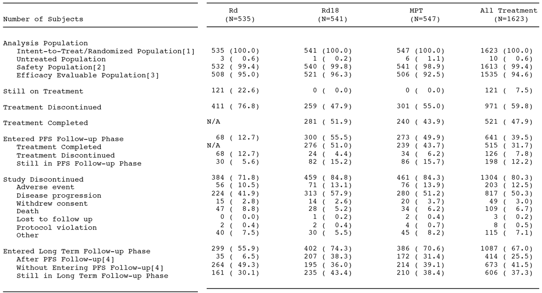

##### Major protocol deviations

The frequency of patients with major protocol violations resulting in study discontinuation was low in each of the three treatment arms (0.4% [n=2] in the Rd arm, 0.4% [n=2] in the Rd18 arm, and 0.7% [n=4] in the MPT arm). At least one protocol violation (ITT population) was reported in 31.4% of patients in the Rd arm (n=168), 31.2% of patients in the Rd18 arm (n=169) and 38.2% of patients in the MPT arm (n=209). In general, the pattern of protocol violations was similar in the three treatment arms (see Table 86, page 203). It is considered that the protocol violations reported in this study are unlikely to have invalidated the efficacy analyses.

##### Baseline data

* The majority of patients in the study were elderly, with a median age of 73 years (range: 40, 92 years), with 65.1% (n=1056) being aged ≤ 75 years and 34.9% (n=567) being aged > 75 years. Of the total population, only 5.7% (n=92) of patients were aged < 65 years. The distribution between the sexes were relatively equal with 52.6% (n=854) of patients being male and 47.4% (n=769) being female. The patients were predominantly White or Caucasian (89.0% [n=1445]) and the majority or patients were enrolled at European sites (68.6% [n=1113]). The baseline patient characteristics were well balanced across the three treatment arms.
* In general, patients in the study had advanced disease. Of the total study population, 40.6% of patients had ISS Stage III, 9.1% had severe renal insufficiency (CrCl < 30 mL/min), 71.2% had a history of bone disease, and 13.5% had radiation for MM prior to treatment in the study. About a third (33.5%) of patients had cytogenetic profiles associated with adverse risk (t[4;14], t[14;16], del[13q] or monosomy 13, del[17p], or 1q gain). Overall, the three treatments arms were well balanced with regard to demographic and disease-related characteristics.
* Nearly all patients in the study had a prior medical history and concomitant diseases (99.4% [1003/1613]), which is not unexpected in an elderly patient population. Selected prior medical histories and concomitant diseases occurring in ≥ 5% of all patients were hypertension (59.8%), anaemia (57.5%), back pain (32.2%), bone pain (22.6%), hypercholesterolaemia (17.6%), prior history of invasive malignancy (10.4%), type 2 diabetes mellitus (7.6%), gastro-oesophageal reflux disease, and diabetes mellitus (6.5%). Of the total patient population, 29.3% had a history of cardiac disorders, including atrial fibrillation (7.7%), coronary artery disease (4.1%), and myocardial infarction (4.0%). Other important comorbidities were deep vein thrombosis (1.5%), pulmonary embolism (1.8%), and cerebrovascular accident (2.6%). A significant number of the patient had a prior history of cataracts (5.2%). In general, the three treatment arms were well-balanced with respect to medical history and concomitant diseases.
* All patients used at least one concomitant medication during the study (100% [n=1613]). The percentage of patients who received heparin as concomitant medication was notably higher in Rd arm (8.5%) compared to either the Rd18 arm (3.1%) or the MPT arm (3.1%). Concomitant use of warfarin was also higher in the Rd arm (6.0%) compared to the Rd18 arm (2.8%) and the MPT arm (3.1%). The use of platelet aggregation inhibitors was similar across the three treatment arms, with acetylsalicylic acid being used in approximately 58% to 59% of patients in each of the three treatment arms. A greater proportion of patients in the MPT arm (34.8%) received treatment with granulocyte colony-stimulating factors compared to the Rd (17.3%) or the Rd18 (17.2%) arms. The percentage of patients who received erythropoiesis-stimulating factors was similar in the (29.7%), Rd18 (27.8%), and MPT (29.9%) arms. The use of antithrombotic and anti-infective agents was similar across the three treatment arms. Frequencies of reported concomitant medication need to be considered in the context of prolonged treatment duration in the Rd arm as compared to the Rd18 and MPT arms.
* Of the total patient population, 66.6% had at least one concomitant medical procedure (including surgery), and the percentage was higher in the Rd arm (61.5%) compared to either the Rd18 arm (52.0%) or the MPT arm (50.5%). The most common concomitant medical procedures (including surgery) reported in ≥ 2% of patients were packed red blood cell transfusion (21.6%), transfusion (10.7%), cataract operation (5.9%), radiotherapy (4.3%), tooth extraction (4.0%), compression stocking application (3.4%), and platelet transfusion 2.4%).

##### Results for the primary efficacy outcome

In the pre-specified primary analysis of the PFS in the ITT population, the results showed that the risk of disease progression or death was 28% lower in patients in the Rd arm compared to the MPT arm (HR=0.72 [95% CI: 0.61, 0.85]; p=0.00006, unstratified log-rank test) (see Table 18).

Table 18: Study MM-020 - Progression-free survival time by IRAC review based on IMWG criteria (unstratified); all subjects in the ITT population data cutoff 24 May 2013.

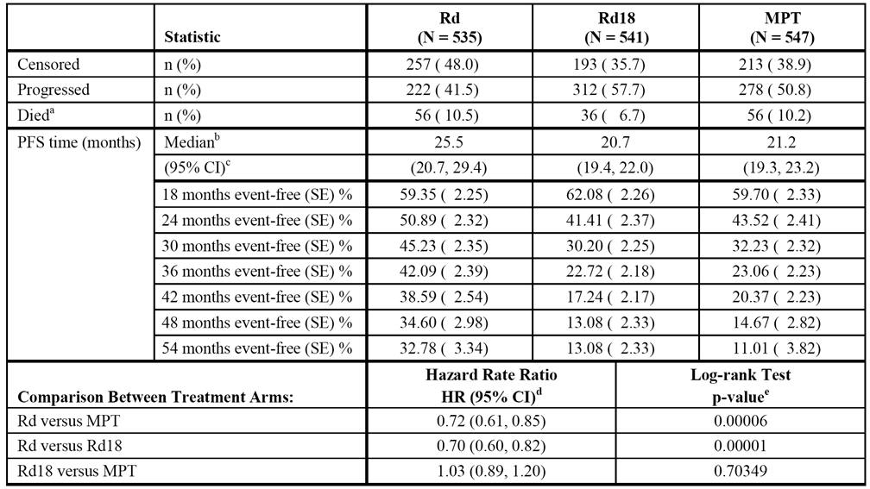

a = Includes subjects who died on study (i.e., during active treatment and PFS follow-up phases).

b = The median is based on the KM estimate.

c = 95% CI about the median progression-free survival time.

d = Based on stratified Cox proportional hazards model comparing the hazard functions associated with treatment groups.

e = The p-value is based on the unstratified log-rank test.

The assessment of progression (IRAC review/IMWG criteria) in all treatments combined was predominantly based on M-protein increase using serum protein electrophoresis (61.2% [497/812]), followed by urine protein electrophoresis (27.0% [219/812]), lytic lesion (6.8% [55/812]), plasmacytoma (2.5% [20/812]), hypercalcaemia (1.8% [15/812]), and bone marrow aspirate (0.7% [6/812]).

In the PFS analysis (IRAC review/IMWG criteria), the majority of patients were censored because they were still ongoing in the study and had not progressed or died. The percentage of patients censored for this reason was approximately 2-fold greater in the Rd arm than in the Rd18 or MPT arms (27.7% vs 13.9% vs 14.1%, respectively).

The results of the pre-specified secondary analysis (stratified log-rank test) of the PFS (IRAC review/IMWG criteria) showed a 27% reduction in the risk of disease progression or death for patients treated with Rd compared to patients treated with MPT (HR=0.73 [95% CI: 0.62, 0.86]; p=0.00014, stratified log-rank test). The results for the stratified and unstratified analyses of the PFS (IRAC review/IMWG criteria) were almost identical.

The PFS analysis by investigator assessment based on IMWG criteria showed a 26% reduction in the risk of disease or death in patients in the Rd arm compared to the MPT arm (HR=0.74 [95% CI: 0.63, 0.87]; p=0.0002, unstratified log-rank test). The PFS results for investigator and IRAC assessments, based on IMWG criteria, were consistent.

The results of the PFS analysis by investigator assessment were based on IMWG criteria. There was a 90.6% (781/862) agreement in PD between the IRAC assessment and the investigator assessment.

The results of the PFS sensitivity analysis based on IRAC assessment using EMA guidelines for censoring showed a 21% reduction in the risk of disease or death in patients in the Rd arm compared to the MPT arm (HR=0.79 [95% CI: 0.68, 0.92]; p=0.0021, unstratified log-rank test). In this analysis, all progressions and deaths are considered as events, regardless of whether they occurred after starting another AMT or after 2 or missed scheduled assessments. The results for PFS in the sensitivity analysis based on IRAC assessment using EMA guidelines for censoring were consistent with the results for PFS based on the primary analysis.

Statistical methods based on interval censoring were undertaken as a sensitivity analysis to account for the different cycle lengths (and therefore different assessment frequencies) between the Rd arm and the Rd18 arm (assessment at 4-weeks per cycle) versus the MPT arm (assessment at 6-weeks per cycle).6,7 The results using these methods were consistent with the results for the primary PFS analysis: Rd vs MPT, p=0.00002; Rd vs Rd18, p<0.00001; Rd18 vs MPT, p=0.57139. The KM estimates for the three treatment arms based on interval censoring have been examined and are consistent with the KM estimates for the treatment arms based on the primary analysis.

The data were also analysed using a Cox-proportional multivariate model of PFS, based on IRAC review, in the Rd and the MPT arms. In addition to treatment effect, other prognostic factors included in the model were cytogenetic risk, age, ECOG score, CrCL, LDH level, and ISS stage. The results showed that, after correcting for other prognostic factors, there was still a 25% reduction in the risk of disease progression or death in patients in the Rd arm compared to patients in the MPT arm (HR=0.7519 [95% CI: 0.6393, 0.8842]; p=0.00057). The analysis identified the following factors to be independent predictive factors for a PFS advantage: treatment with Rd until disease progression; non-adverse cytogenetic risk profile compared to adverse cytogenetic risk profile; ECOG PS score of 0 compared to scores of 1 or 2; CrCl ≥ 80 mL/min compared to < 30 mL/min; LDH < 200 U/L; and ISS Stage I or II vs Stage III.

In the subgroup analysis, a PFS benefit in favour of the Rd arm relative to the MPT arm was observed in most subgroups, including age (≤ 75 years vs > 75 years), sex, race (White or Caucasian vs Asian), ISS stage, creatinine clearance, baseline albumin level, ECOG performance status, and cytogenetic profile category.

*Comments: The superiority boundary for the final PFS analysis (p=0.0478; 2-sided nominal value) was calculated based on the number of PFS events (Rd [n=278] vs MPT [n=334]) with O’Brien-Fleming type alpha spending. The median duration of follow-up for all patients (n=1623) was 30.3 months (range: 0.0, 56.7 months), and the median duration of follow-up for all surviving patients (n=1042) was 37.0 months (range: 0.1, 56.7 months).*

*The results for the pre-specified primary analysis of the PFS (IRAC review/IMWG criteria) in the ITT population showed a 28% reduction in the risk of disease progression or death for patients in the Rd arm compared to the MPT arm (HR=0.72 [95% CI: 0.61, 0.85]; p=0.00006, unstratified log-rank test). The percentage of patients with a PFS event was lower in the Rd arm compared to the MPT arm (52.0% [278/535] vs 61.1% [334/547], respectively). The difference in PFS between the Rd and MPT arms was driven by the smaller percentage of patients in the Rd arm experiencing disease progression compared to the MPT arm (41.5% vs 50.8%, respectively), with the proportion of on-study deaths being similar in the two treatment arms (10.5% vs 10.2%, respectively).*

*The median time to PFS events (based on KM analysis) was 4.3 months longer in the Rd arm (25.5 months [95%CI: 20.7, 29.4 months]) than in the MPT arm (21.2 months [95% CI: 19.3, 23.2 months]). The increase in median PFS of 4.3 months reflects a 20% improvement in the Rd arm relative to the MPT arm, which is lower than the percentage improvement considered by the sponsor to be clinically relevant (25%). The KM estimates showed that PFS began to separate in favour of Rd compared to MPT at about 18 months and continued to diverge through to 54 months. At 3 years, 42% of patients in the Rd arm and 23% of patients in the MPT arm remained event-free, and at 4 years, 35% of patients in Rd arm and 15% of patients in MPT arm remained event-free.*

*The PFS comparison between the Rd18 and MPT arms, was not statistically significant (HR=1.03 [95% CI: 0.89, 1.20]; p=0.70349 unstratified log-rank test]). However, the reduction in risk of disease progression or death was 30% lower in the Rd arm compared to the Rd18 arm (HR = 0.70 [95% CI: 0.60, 0.82]; p=0.00001 unstratified log-rank test), and KM estimates showed that PFS began to separate in favour of the Rd arm compared to the Rd18 arm at about 18 months and continued to diverge through to 54 months.*

*The results of the pre-specified primary (unstratified) and secondary (stratified) analyses of the PFS (IRAC review/IMWG criteria) were consistent. The results of sensitivity analyses, including PFS according to both EMA censoring guidelines and interval censoring, were consistent with the PFS results of the pre-specified primary analysis. In addition, a multivariate analysis showed that, after correcting for other prognostic factors, the risk of experiencing a PFS event remained significantly lower in patients in the Rd arm compared to the MPT arm.*

##### Results for other efficacy outcomes

###### Secondary efficacy endpoints

In this CER, review of the key secondary efficacy endpoint results focuses on the primary comparison of interest (i.e., Rd vs MPT), based on the pre-specified analysis defined in the SAP.

Overall Survival (OS) - secondary efficacy endpoint

The CSR included the results for the preliminary OS analysis comparing the Rd and the MPT treatment arms. The results for this analysis did not cross the pre-specified Pocock superiority boundary of p<0.0096 (i.e., the null hypothesis of no superiority between the two treatment arms was not rejected). The sponsor stated that the results of the interim OS analysis were "included to support other efficacy endpoints and the overall clinical benefit of treatment".

The preliminary OS analysis was based on all data available at the time of the interim analysis, including the survival data from the active treatment phase, PFS follow-up phase, and the long-term follow-up phase. The SAP specified that OS was to be compared between treatment arms using the unstratified log-rank test. The HR for the preliminary OS comparison between Rd and the MPT arm was 0.78 (95% CI: 0.64, 0.96), nominal p=0.01685, unstratified log-rank test. The HR for the OS translates into a 22% reduction in the risk of death in the Rd arm compared to the MPT arm. The mean OS time (based on KM estimates) was 55.1 months (95% CI: 55.1, not evaluable) in the Rd arm and 48.2 months (95% CI: 44.3, not evaluable) in the MPT arm. The estimated 3-year survival rates were 70% in the Rd arm and 62% in the MPT arm. The KM plots run parallel in the Rd and MPT treatment arms. The results of the ad hoc OS analysis using the stratified log-rank test are similar to the results using the unstratified log-rank test.

*Comment: The final OS might be difficult to interpret due to patients with PD or without PD (but with toxicity) being potentially switched to other anti-myeloma treatments. At the time of the data cutoff for the interim OS analysis, 43.2% of patients in the Rd arm had initiated 2nd-line AMT compared to 56.5% of patients in the MPT arm.*

Time to treatment failure (TTF) - secondary efficacy endpoint

TTF was calculated as the time between randomisation and discontinuation of study treatment for any reason, including disease progression (IRAC review/IMWG criteria), treatment toxicity, start of another AMT, and death. The SAP specified that TTF was to be compared between treatment arms using the unstratified log-rank test. The risk of discontinuing the study for any reason was 23% lower in the Rd arm than in the MPT arm (HR=0.77 [95% CI: 0.68, 0.88); p=0.00012, unstratified log-rank). The median time to overall TTF was 2.8 months longer in the Rd arm compared to the MPT arm (16.9 vs 14.1 months, respectively). Examination of the KM plots for the Rd and MPT treatment arms show them beginning to separate at about 18 months in favour of Rd.

Myeloma response rate

The primary analysis of the response rate (IRAC review/IMWG criteria) was defined as the overall response rate (ORR), and was calculated as the number of confirmed responders (at least a PR that was maintained for at least 6 weeks) divided by the number of subjects in the ITT population. The ORR, together with the relative proportions in each response category based on the IMWG criteria were examined (i.e., complete response [CR], very good partial response [VGPR], partial response [PR], stable disease [SD], and PD). Confirmed responses documented after patients received any other AMT were not counted as responses, but these patients were included in the denominator. Comparisons of ORR between treatment arms (2x2 table) were performed using a 2-sided Fisher’s exact test with α = 5%, together with 95% CIs. The distribution of patients over the 5 response categories (excluding the "Response not Evaluable" category) were compared between treatment arms using the Wilcoxon rank sum test (1 = CR, 2 = VGPR, 3 = PR, 4 = SD, 5 = PD).

The ORR (CR+VGPR+PR) was 75.1% (402/535) in the Rd arm and 62.3% (341/547) in the MPT arm (p< 0.00001, Fisher's exact test; odds ratio = 1.83 (95% CI: 1.41, 2.37). The CR was notably higher in the Rd arm than in the MPT arm (15.1% vs 9.3%, respectively), as was the VGPR (28.4% vs 18.8%, respectively), while the PR was similar in the two treatment arms (31.6% vs 34.2%, respectively).

Duration of response - secondary efficacy endpoint

Duration of myeloma response was defined as the time from when the response criteria for CR or VGPR or PR were first achieved to when the response criteria for PD were met, or until the subject died from any cause, whichever occurred first. The protocol specified that the duration of the response was to be analysed using the same method as used for the PFS.

The median duration of myeloma response was longer for patients in the Rd arm (35.0 months [95% CI: 27.9, 43.4]) compared to patients in the MPT arm (22.3 months [95% CI: 20.2, 24.9]): HR=0.63 (95% CI: 0.51, 0.76); p<0.00001, unstratified log-rank test. Based on the KM estimates, 39% of patients in Rd arm had responses lasting at least 4 years compared with 11% of patients in the MPT arm.

Time to (first) response - secondary efficacy endpoint

The time to myeloma response was defined as the time from randomisation to the time the response criteria for CR or VGPR or PR were first met, by IRAC assessment using IMWG criteria. Subjects who were non-responders were excluded from this analysis. The SAP specified that time to response was to be compared between treatment arms using the Wilcoxon rank sum test, with patients with the longest time to response having the highest rank. The median time to first response was shorter in the Rd arm (1.8 months [range: 0.7, 22.2 months]) than in the MPT arm (2.8 months [range: 1.3, 49.7]), p<0.0001). The sponsor notes that the information from this analysis should be interpreted with caution, due to biases resulting from the asymmetry in scheduling of assessments between the two treatment arms early in the study.

Time to second-line AMT - secondary efficacy end point

Time to second-line AMT was defined as time from randomisation to the start of another non-protocol AMT. The SAP stated that the same method used for the PFS was to be used to analyze the endpoint. The median time to second-line AMT was notably longer in the Rd arm than in the MPT arm (39.1 months vs 26.7 months, respectively). The risk of requiring second-line AMT treatment was 34% lower in the Rd arm than in the MPT arm (HR=0.66 [95% CI: 0.56, 0.78]; p<0.00001, unstratified log-rank test. The probability of not having required second-line AMT at 3 years was 52% in the Rd arm compared with 37% in the MPT arm.

PFS2 (exploratory endpoint) - post hoc analysis

During the preparation of the final CSR, a new guidance document (Guideline on the evaluation of cancer products in man [EMA/CHMP/205/95/Rev.4]) was released by the EMA, and adopted on 13 December 2012. This guidance document introduced the efficacy variable, progression-free survival on next-line therapy (PFS2), defined as "time from randomisation to objective tumour progression on next-line treatment or death from any cause. In some cases, time on next line therapy may be used for proxy PFS". The EMA guidance notes that "it is expected that the tumour's drug resistance profile is affected by therapy. This might be of relevance for the activity of next-line therapies… The consequences of progression on maintenance therapy, signifying resistance at least to the maintenance regimen, might thus differ from progression off therapy. In principle, this applies to all comparisons i.e. the degree of cross resistance as regards next-line therapy might differ between experiment and control regimens". The EMA Guideline was approved by the TGA on 1 April 2014.

In accordance with this guidance, the sponsor added PFS2 (before database lock) to the SAP as an exploratory endpoint. In this analysis, a second objective PD, or death from any cause, or the start of the 3rd-line treatment, whichever comes first, are considered events. Based on this analysis, the risk of a PFS2 event was 22% lower in the Rd arm compared to the MPT arm (HR = 0.78 [0.66, 0.93]; p=0.00508, unstratified log-rank test), with the median time to PFS2 being 42.9 months in the Rd arm and 36.3 months in the MPT arm. Slightly lower percentages of subjects in the Rd arm compared to the MPT arm had PD after starting 2nd-line AMT (13.5% vs 15%, respectively), died (23.6% vs 25.8%, respectively), or started 3rd-line AMT (8.4% vs 11.5%, respectively).

Quality of life (QoL) endpoints - collected up to 18 months

* The analysis of the single-domains of the EORTC QLQ-C30 (i.e., insomnia, constipation, diarrhoea) corresponded with the AEs reported for the treatment arms. The data showed that patients in the MPT arm reported significant improvements in insomnia (due to thalidomide) from baseline, while patients in the Rd arm reported no significant change from baseline. Constipation worsened in all subjects from baseline, and was worst for patients in the MPT arm (due to thalidomide), but quickly improved and was not statistically significant from baseline for the Rd arm after the third month. Improvement in constipation did not occur in the MPT arm until Month 12. In contrast, diarrhoea worsened from baseline for patients in the Rd arm (due to lenalidomide), but remained static for patients in the MPT arm. The analysis of dyspnoea did not show any statistical significance difference between the Rd and MPT treatment arms.
* The plots of mean change from baseline over time by treatment arm for each of the 7 pre-selected quality of life domains from three separate instruments have been examined (i.e., EORTC QLQ-C30 global health status, physical functioning, fatigue, and pain; EORTC QLQ-MY20 disease symptoms and side effects of treatment; and EQ-5D health utility). Comparisons showed that for 6 of the 7 preselected domains there was a statistically significant QoL improvement from baseline across all three treatment arms at most of the post-baseline assessment visits. For these 6 preselected domains the plots were similar for the three treatment arms, with the observed differences being unlikely to be clinically significant. The exception was the side effects domain of the QLY-MY20 for the MPT arm, which showed a significant QoL worsening across all assessment visits compared to both the Rd and Rd18 arms.
* In order to assess QoL at PD, an analysis comparing best on-study scores versus scores at baseline and scores at PD versus best on-study scores was performed for subjects who had PD during study follow-up. For all 7 preselected QoL domains (same domains as those described in above paragraph) across the three treatment arms, a statistically significant (p<0.0001) improvement was observed for best on-study score versus score at baseline. For the assessment of best on-study score versus score at PD, a statistically significant (p< 0.0001) deterioration was observed for all of the selected QoL domains across all treatment arms for scores at PD compared to best on-study scores. Unsurprisingly, the results of this analysis suggest that QoL is improved and generally maintained while subjects are progression free, but QoL deteriorates when disease progression occurs.

#### Supportive studies

##### Study MM-015 - sponsor designated supportive study

###### Design, objectives, location, dates

Study MM-015 is a Phase 3, multinational, multicentre, randomised, placebo-controlled, double-blind, 3-arm, parallel-group study in subjects aged ≥ 65 years with newly diagnosed multiple myeloma (NDMM) who were not candidates for stem cell transplantation. Subjects were stratified at randomisation by age (≤ 75 years vs > 75 years) and stage according to the International Staging System (ISS; Stages I or II vs Stage III). The results of the study have been published.[4]

The study sponsor is Celgene (Switzerland). It is being conducted at 82 sites in Europe (70 sites), Australia (8 sites), and Israel (4 sites). The first patient was randomised on 1 February 2007 and the last patient on 19 September 2008. The date of data cutoff for the CSR was 30 April 2013. The release date for the report was 30 October 2013. The sponsor states that study was conducted in compliance with the ethical principles of GCP, according to the relevant ICH guideline.

The primary objective was to determine the efficacy of melphalan, prednisone and lenalidomide (MPR) in combination compared to melphalan, prednisone, and placebo in combination (MPp) in subjects with NDMM who are 65 years of age or older. The protocol-planned primary endpoint was PFS. The secondary objective was to assess the safety of MPR compared to MPp in subjects in subjects with NDMM who are 65 years of age or older.

The original study design consisted of three phases:

* a double-blind treatment phase (induction + maintenance therapy periods);
* an open-label extension phase (OLEP); and
* a follow-up phase.

However, the study was unblinded on 11 May 2010, resulting in the design being changed from that time forward. After unblinding, the induction and maintenance periods were not considered “blinded,” and consequently the “double-blind treatment phase” was generally referred to in the CSR as the “treatment period” (induction + maintenance periods).

Treatment period (consisting of induction and maintenance periods):

Subjects who met all eligibility criteria were randomised (1:1:1) to one of three treatment arms using a validated IVRS:

* MPR+R arm: consisting of induction therapy with melphalan, prednisone, and lenalidomide (MPR) for up to 9 cycles, followed by maintenance therapy with single-agent lenalidomide (R);
* MPR+p arm: Consisting of melphalan, prednisone, and lenalidomide (MPR) for up to 9 cycles, followed by maintenance therapy with placebo (p);
* MPp+p arm: Consisting of melphalan, prednisone, and placebo (MPp) for up to 9 cycles, followed by maintenance therapy with placebo (p);
* Dose modification (interruptions and reductions) guidelines were pre-specified for each study drug in the event of toxicity. Each subject continued in the treatment period until: (i) PD occurred; or (ii) lenalidomide/placebo therapy was discontinued permanently for any reason. All subjects were to be followed for at least 5 years from randomisation or until death.

**Induction period:**

* Induction therapy included up to 9 cycles of MPR or MPp, with each cycle being 28 weeks in duration. In the MPR+R and MPR+p arms, the starting dose of lenalidomide was 10 mg QD on days 1-21 of each 28-day cycle. In subjects in all three treatment arms, the starting doses of melphalan and prednisone were 0.18 mg/kg and 2 mg/kg, respectively, with both treatments being given on days 1-4 of each 28-day cycle.
* All subjects were to receive anti-thrombotic therapy with low dose aspirin (75-100 mg daily), or other anti-thrombotic therapy if aspirin was contraindicated. All subjects were allowed to receive bisphosphonate therapy and haematopoietic growth factors (the use of myeloid growth factors was encouraged when the ANC was < 1.0 x 109/L).
* Subjects who completed 9 induction cycles proceeded to maintenance therapy starting at cycle 10. Subjects who were unable to complete 9 induction cycles, despite dose modification, could also proceed to maintenance therapy. Subjects who developed PD during induction discontinued from double-blind treatment, and the treatment arm was unblinded. If an investigator assessed a subject with PD during induction, the subject had the option to enter the OLEP. Subjects who experienced PD and chose not to enter the OLEP entered the follow-up phase.

**Maintenance period:**

* Maintenance therapy started at Cycle 10, and remained ongoing for a small number of subjects as of the 30 April 2013 data cutoff date. Up to the time of unblinding (11 May 2010), subjects in the MPR+R arm received single-agent lenalidomide 10 mg QD on Days 1 through 21 of each 28-day cycle, and subjects in the MPR+p and MPp+p treatment arms received placebo QD on Days 1 through 21 of each 28-day cycle. Subjects in maintenance therapy at the time of unblinding continued with lenalidomide treatment (MPR+R arm) or discontinued placebo and were followed in an observation phase (MPR+p and MPp+p arms) until PD
* Subjects with a prior history of DVT or pulmonary embolism continued to receive antithrombotic therapy during maintenance therapy. Other subjects could continue to receive the same antithrombotic therapy that had been administered during the induction therapy period, at the discretion of the treating physician. All subjects were allowed to receive bisphosphonate therapy and haematopoietic growth factors as per the induction period.
* Each subject was to continue maintenance therapy until: (1) PD occurred; or (2) lenalidomide or placebo therapy was discontinued permanently for any reason; or (3) all subjects had been followed for at least 5 years from randomisation or had died. Subsequent to protocol unblinding (and as specified in protocol Amendment 3), subjects in the MPR+p and MPp+p arms were to stop placebo therapy. If an investigator assessed a subject with PD during the maintenance therapy period, the subject was discontinued and the treatment arm was unblinded. All subjects in the three treatment arms who experienced PD had the option to enter the open-label extension phase (OLEP). Subjects who discontinued maintenance therapy for reasons other than PD, and subjects who experienced PD and elected not to enter the OLEP, entered the follow-up phase.

**Open-label extension phase (OLEP):**

* Subjects who developed PD during the induction or maintenance periods decided whether or not to enter the OLEP within 28 days (4 weeks) of disease progression.
* Subjects in the MPR+R arm who experienced PD during induction or maintenance period also received lenalidomide 25 mg QD on days 1-21 of every 28-day cycle, with or without high-dose dexamethasone unless a dose reduction of single-agent lenalidomide had occurred during the maintenance period. These subjects could enter the OLEP, but had to add high-dose dexamethasone to their current dose of lenalidomide.
* Subjects who received lenalidomide in combination with high-dose dexamethasone were to receive oral low-dose aspirin (75-100 mg daily) as prophylactic anti-thrombotic treatment, or other anti-thrombotic treatment if aspirin was contraindicated. All subjects were allowed to receive bisphosphonate therapy and haematopoietic growth factors as per the induction and maintenance periods.
* Each subject could receive therapy in the OLEP until: (1) PD occurred; or (2) lenalidomide (with or without high-dose dexamethasone) was discontinued permanently for any reason; or (3) all subjects had been followed in this study for at least 5 years from randomization or had died. Subjects who discontinued from the OLEP entered the follow-up phase.

**Follow-up phase:**

* Subjects in the follow-up phase were followed for OS and subsequent AMT until all subjects had been followed for at least 5 years from randomisation or had died. In addition, beginning with protocol Amendment 4, all subjects were followed to determine if a diagnosis of a secondary primary malignancy (SPM) had occurred (including those subjects who had died since randomisation).

**Other aspects of the study design:**

* An independent Central Adjudication Committee (CAC), which comprised three haematologists/oncologists, conducted a blinded review of the relevant data for each subject and determined response. The CAC response assessments served as the basis for the primary efficacy analysis up to the date of unblinding of the study on 11 May 2010. After unblinding, subject data were no longer collected for review by the CAC, with the responsibility for review of the data switching to individual investigators.
* An Independent Data Monitoring Committee (IDMC) reviewed the safety data on an ongoing basis at scheduled intervals and the efficacy data at the interim analyses to assess the benefit-risk ratio of the treatments.

*Comment: The lenalidomide regimen used in this supportive study is one of the regimens being proposed for the treatment of NDMM in adult patients, the other being the lenalidomide regimen used in the pivotal study (MM-020). The sponsor provided a justification for the proposed lenalidomide regimen used in study MM-015 based on a review the published literature. Of note, the regimen is listed as one of a number of upfront regimens in the Australian publication "Multiple Myeloma Clinical Practice Guideline", and one of the preferred regimens for primary therapy in non-transplant candidates in the NCCN Guidelines Version 2.2015, However, the ESMO clinical practice guidelines state that the triplet combination of MPR "cannot be considered to be standard of care" in elderly patients (non-transplant settings) as in Palumbo et al. (2012) it "was not superior" to the doublet combination of MP. The sponsor stated that at the time the study was planned, MP was selected as the control treatment because it was considered standard therapy for older subjects with NDMM. The sponsor notes that "[v]arious dosing regimens of MP have been studied over the past 30 years; however there is no evidence to support the superiority of any one MP dosing regimen". The control arm of doublet MP selected for this study is considered to be acceptable. This doublet regimen had "long been the treatment of choice" for patients older that 65 years who are not candidates for stem-cell transplantation, but the introduction of thalidomide or bortezomib in combination with MP has resulted in these triplet regimens becoming the standard of care in many centres for these patients.*

###### Exclusion and exclusion criteria

The study included patients aged 65 years and older with symptomatic, newly diagnosed MM. The inclusion and exclusion have been examined and are consistent with those for the pivotal study MM-020. In particular, the same MM diagnostic criteria and measurable disease criteria were used for the two studies. In study MM-015, patients were required to have Karnofsky performance status ≥ 60% (i.e., at worse, requires occasional assistance, but is able to care for most personal needs).

Efficacy variables and outcomes

The primary efficacy endpoint was progression-free survival (PFS). For the primary analysis of PFS, progression and date of progression were determined based on the CAC blinded review (until the date of study unblinding) of all the myeloma response assessment data using the Bladé criteria. The censoring rules for analysis of PFS were the same as those used in the pivotal study (MM-020), and were based on the FDA guidance document (May 2007). After study unblinding, response and date of PD as assessed by investigators were used for continued PFS analysis.

The secondary efficacy endpoints included: time to progression; response rate; time to response; duration of response; time to next AMT; overall survival; and QoL. Other efficacy endpoints included performance status (Karnofsky scale); exploratory assessment based on cytogenetic abnormalities; exploratory biomarker studies; and PFS on next line therapy (PFS2), which was adopted as an endpoint by the EMA in the Guideline on the evaluation of cancer products in man (EMA/CHMP/205/95/Rev.4) during the preparation of the CSR.

Randomisation and blinding methods

An independently stratified randomisation list, generated before the study was initiated, randomised patients in a 1:1:1 ratio to MPR+R, MPR+p, or MPp+p. Patients who were eligible and had previously been screened into the study via centralized IVRS were stratified at randomisation according to age (≤ 75 vs > 75 years) and ISS stage (I/II vs III). Designated research personnel at the study sites were assigned unique access code envelopes, which authorised them to call the IVRS to randomise subjects into the study.

The investigator, subject, and Celgene personnel responsible for the conduct of the study were blinded as to each patient's treatment assignments (lenalidomide or placebo) during participation in the treatment period. The treatment assignment for each patients who discontinued the treatment period was unblinded by the investigator to guide future therapy. Sites completed all the assessments and CRFs before they unblinded the subjects from the double-blind treatment. Treatment with melphalan and prednisone was not blinded, with all patients in the study receiving these two drugs plus blinded lenalidomide or placebo. The first study site unblinding occurred on 11 May 2010, following the IDMC recommendation after the positive interim analysis results favouring treatment with lenalidomide compared to placebo, and the approval of Ethic Committees for study sites.

###### Statistical methods and sample size

Efficacy analysis populations

Three populations were defined for the efficacy analysis: (1) the intent-to-treat (ITT) population, which included all subjects who were randomised, irrespective of whether or not they received study treatment; (2) the efficacy evaluable (EE) population, which included all ITT subjects who met eligibility criteria, had measurable disease at baseline, received at least 1 dose of the study treatment, and had at least 1 valid post-baseline myeloma response assessment; and (3) the per protocol (PP) population which included all subjects in the ITT population who met the eligibility criteria, had measurable disease at baseline, received at least one dose of the study treatment, had at least one valid post-baseline myeloma response assessment, and did not have any major protocol violation. The primary efficacy analysis, and the other efficacy analyses were performed on the ITT population, unless otherwise specified. Selective efficacy analyses (e.g., PFS, OS, ORR) were performed using the EE and the PP populations.

Interim analyses

The study design included 2 pre-planned interim analyses undertaken according to the statistical analysis plan (SAP); the first and second interim analyses were planned at 50% and 70% information, respectively, for the primary endpoint of 296 PFS events. At the designated data cutoff date for the first interim analysis at 50% information for the primary endpoint of 296 PFS events (15 April 2009), 169 PFS events across all three treatment arms had occurred. Following review of the data, the IDMC recommended release of the data to Celgene, based on the results having surpassed the planned O’Brien-Fleming boundary for superiority with regard to the primary endpoint analysis comparing PFS in the MPR+R and MPp+p arms. However, Celgene decided not to unblind the study at the site level until after the time of the second interim analysis at 70% information for PFS in order to gain more mature data. The second interim analysis (1 December 2009) occurred after 206 PFS events had been identified by CAC review and 217 PFS events had been identified by investigator review. Results of the second interim analysis for the primary analysis of PFS demonstrated that the O’Brien-Fleming boundary for superiority continued to be surpassed in favour of the MPR+R arm. Therefore, Celgene decided to unblind the study. The official date of unblinding was 11 May 2010, at which time-point point 229 events had occurred as assessed by CAC review.

Primary efficacy endpoint (PFS) analysis

PFS in the CSR was reported from two cutoff dates: the date of unblinding (11 May 2010) and the most recent update (30 April 2013). The analysis of PFS at the date of unblinding used assessments made by blinded CAC review. However, after unblinding the CAC review ceased and the PFS analysis per the 30 April 2013 data cutoff date was according to investigator assessment.

For the primary analysis, the comparison of PFS between the MPR+R and MPp+p arm used the unstratified log-rank test, with an overall 2-sided significance level of 5%. This 5% was spread over 3 analyses (2 interim analyses and 1 final analysis) by an O’Brien-Fleming alpha spending function. To account for the stratified randomisation, a log-rank test stratified by the two strata used in the randomisation (age and ISS score) was performed as a secondary analysis for PFS. The FDA specified that the primary analysis of the time-to-event endpoints should be undertaken using a stratified log-rank test. However, the results of all time-to-event endpoints evaluated in this CER will focus on the unstratified log-rank test, as this was the primary method pre-specified in the SAP. It is noted that the SCE and the Clinical Overview primarily report the time-to-event results based on the stratified log-rank test.

Other efficacy endpoints

The statistical methods used to analyze the other efficacy are consistent with those used in the pivotal study MM-020. No statistical adjustment was made for multiplicity of the secondary efficacy endpoint variables.

Sample size

The primary analysis for the study was to compare PFS between the MPR+R and MPp+p arms. For the primary efficacy variable, a 50% improvement in median TTP from 15 months in the MPp+p arm to 22.5 months in the MPR+R arm was considered to be clinically relevant and was the target difference. The sponsor stated that the assumptions were supported by previously published data, and the assumptions on which the calculations were based were provided and are considered to be acceptable. Full information necessary for a log-rank test to have 80% power to detect the targeted treatment effect would be achieved when 197 patients from the MPR+R and MPp+p arms had progressed or died (approximately 296 events from the three arms).

The final OS analysis is to be performed after all subjects have been in the study for at least 5 years, or have died or been lost to follow-up before 5 years. Based on prior clinical experience, median survival in the MPR+R arm was estimated to be 54 months, while in the MPp+p arm median survival was estimated to be 36 months. If the survival distribution was exponential, then for 150 subjects in each treatment arm, a total of 182 deaths would be expected in the two arms at 5 years. In a test of survival curves reflective of a 50% improvement in median OS, a log-rank test at the 0.025 one-sided level performed when there were 182 deaths in the two arms (a total of 273 deaths across all arms) would have power of 78%.

###### Participant flow

Of the 606 patients screened for this study, 147 were excluded at screening, with the reasons being laboratory values not met (45 subjects), diagnostic criteria for measurable MM not met (30 subjects), other eligibility criteria not met (30 subjects), subject withdrawal of consent (14 subjects), and other reasons (28 subjects). The planned enrollment was 450 patients randomised in a 1:1:1 ratio to the MPR+R, MPR+p, or MPp+p arms. A total of 459 patients were enrolled in the study, with 152 being randomised to the MPR+R arm, 153 to the MPR+p arm, and 154 to the MPp+p arm.

The disposition of patients in the induction and maintenance periods in the ITT population up to the data cutoff of 30 April 2014 is summarised. The percentage of patients completing 9 cycles in the induction period was 58.6% (89/152) in the MPR+R arm, 60.1% (92/153) in the MPR+p arm, and 66.9% (103/154) in the MPp+p arm. Most patients who received 9 cycles of treatment in the induction therapy period proceeded into the maintenance therapy period rather than discontinuing treatment: 85 out of 89 (95.5%) in MPR+R arm, 86 out of 92 (93.5%) in the MPR+p arm, and 100 out of 103 (97.1%) in the MPp+p arm. The primary reasons for discontinuation during the induction period (i.e., < 9 cycles) in the three treatment arms were AEs (6.5% to 15.1%) and PD (8.6% to 12.3%).

Disposition of patients in the double-blind treatment period (induction and maintenance) up to unblinding on 11 May 2011 in the ITT population is summarised below in Table 19. There were more patients ongoing in the MPR+R arm (29.6%) than in the MPR+p and MPp+p arms (15.7% and 11.7%, respectively). All of the ongoing patients had completed induction and were in the maintenance period at the time of unblinding. Of the patients in the MPR+R arm, 70.4% had discontinued treatment in the double-blind treatment phase, compared to 84.3% in the MPR+p arm and 88.3% in the MPp+p arm. In all three arms, the primary reason for discontinuation of treatment in the double-blind treatment phase was PD, and the proportion of patients discontinuing due to PD was higher in the MPR+p (52.3%) and MPp+p (64.9%) arms than in the MPR+R arm (31.6%). In the two lenalidomide arms, the percentage of patients who discontinued treatment due to AEs was 19.7% in the MPR+R arm and 17.6% in the MPR+p arm, compared to 9.1% in the MPp+p arm. Discontinuation of treatment in the double-blind treatment phase due to withdrawal of consent was similar across the treatment arms.

Table 19: MM-015 - Disposition in patients in the treatment period (induction and maintenance) up to unblinding (11 May 2010); ITT population.

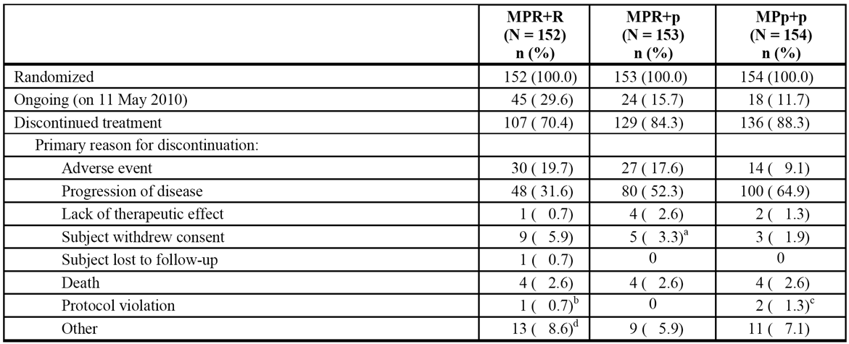

a = Includes 1 subject who never received any study drug and who discontinued due to withdrawal of consent.

b = Includes 1 subject who never received any study drug and who discontinued due to a protocol violation (randomised based on screening results from a local laboratory and central laboratory results obtained later showed absolute ANC that met exclusion criteria).

c = Includes 1 subject who never received any study drug and who discontinued due to a protocol violation (study procedures performed before signing informed consent form).

d = Includes 1 subject who did not receive any study drug and who discontinued due to “other” reason (subject did not meet inclusion criteria and was randomized by mistake).

###### Major protocol violations/deviations

As of the 30 Apr 2013 cutoff, major protocol violations noted in the study in patients in the ITT population were grouped into 6 categories as summarised by treatment arm in Table 20.

Table 20: MM-015 - Major protocol violations in the ITT population as of 30 April 2013.

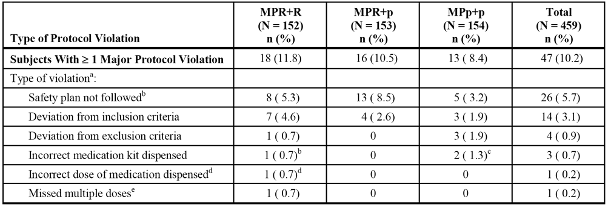

a = Each subject could have had more than 1 violation.

b = Included: Subjects started next cycle with (or without) lab abnormalities which should have required a delay in cycle start (n = 14); No on-site documentation that the Pregnancy Risk Management Plan was followed at Sites 141 and 142 (n = 10); subject continued dosing at Cycle 32 with lab abnormalities which should have required a dose interruption and GCSF therapy initiated (n = 1); and SAE Report concerning SPM was not sent to Celgene within required timeframe (n = 1).

c = One subject was resupplied with the incorrect medication kit at Cycle 25.

d = One subject was resupplied with the incorrect medication kit at Cycle 18; one subject was resupplied with the incorrect medication kit at Cycle 27.

e = One subject missed 17 doses of the study drug at the start of the study due to “organizational difficulties.”

*Comment: The percentage of patients with major protocol violations was greater in the two lenalidomide containing arms (MPR+R and MPR+p) than in the MPp+p arm. However, major protocol violations were reported in < 12.0% of patients in each of the three treatment arms. It is considered that the differences in major protocol violations across the three treatment arms are unlikely to have significantly affected the validity of the efficacy assessment.*

###### Baseline data

* The baseline demographic characteristics of the ITT population are summarised. The median age was similar across the three treatment arms (71-72 years) and the patients ranged from 65 to 91 years. The majority of the patients in the total population were aged from 65 to ≤ 75 years (75.3%), were evenly distributed between the sexes (48.7%, male; 51.3%, female), and were nearly all White (98.1%).
* The baseline disease characteristics in the ITT population are summarised. In the total patient population, ISS disease stage was divided evenly between patients with ISS I/II and ISS III (49.4% vs 50.6%, respectively), and CrCl was divided evenly between patients with CrCl ≥ 60 and < 60 mL/min (50.0% vs 49.4%, respectively). More patients in the MPR+R arm had a lower baseline Karnofsky performance status than in the MPp+p arm (p < 0.1, by pooled t-test). No other clinically meaningful differences in demographic and disease-related characteristics for subjects in the ITT population were observed across the three treatment arms.
* Nearly all patients (≥ 98%) in the three treatment arms had at least one condition included in their medical history. In general, no clinically significant differences in medical histories were noted across the three treatment arms. The majority of the patients had a history of musculoskeletal and connective tissue disorders (73.0% of subjects [e.g., osteoporosis, back pain, bone pain, and osteoarthritis]), vascular disorders (65.7% of subjects [e.g., hypertension]), and blood and lymphatic system disorders (65.3% of subjects; [e.g., anaemia]). Cardiac disorders were recorded in (31.4%) of patients, the most common of which included myocardial ischaemia (8.4%) and atrial fibrillation (5.7%). Few patients had a history of VTE: e.g., DVT (1.5%), pulmonary embolism (1.3%), thrombophlebitis (0.9%), or venous thrombosis (< 0.2%). A total of 31/455 patients (6.8%) had a history of prior invasive malignancy that had been inactive for ≥ 3 years prior to screening, with the exception of 1 patient who had prostate cancer diagnosed 1 year and 9 months prior to entering the study.
* Prior medications had been used in the majority of patients in the three treatment arms (84.9% to 89/3%), with the most commonly used prior medications being bisphosphonates (27.3% to 36.2%), platelet aggregation inhibitors (excluding heparin) (25.9% to 41.2%; nearly all acetylsalicylic), proton pump inhibitors (22.0% to 30.7%), ACE inhibitors (plain) (18.4% to 25.3%), and selective beta blockers (17.1% to 22.0%).
* Concomitant medications were received by nearly all patients in the three treatment arms (98.7% to 100%). The most commonly used concomitant medications in the three treatment arms were platelet aggregation inhibitors, excluding heparin, (60.8% to 69.1%), with the most commonly used agent being acetylsalicylic acid (57.5% to 67.8%). GCSFs were used notably less frequently in the MPp+p arm (31.2%), than in both the lenalidomide containing arms (MPR+R [67.8%] and MPR+p [58.8%]), as were proton pump inhibitors (44.4% vs 58.0% vs 48.7%, respectively), fluoroquinolones (31.4% vs 51.3% vs 46.1%), combination penicillins (14.4% vs 30.7% vs 21.2%, respectively), and heparin products (15.7% vs 22.0% vs 24.3%). In addition, packed red blood cell transfusions were used less frequently in the MPp+p arm (16.9%) than in the two lenalidomide containing arms (MPR+R [34.2%] and MPR+p [26.8%]), as were platelet transfusions (3.9% vs 8.6% vs 7.2%). The percentage of patients who used erythroid-stimulating factors was greater in the MPR+R arm (41.3%), than in both the MPR+p arm (27.6%) and the MPp+p arm (32.0%). Bisphosphonates were used in approximately 50% of patients in each of the three treatment arms (49.3% to 54.2%).
* Concomitant medical and/or surgical procedures during the study were undertaken more frequently in patients in the MPR+R arm (68.7%) than in both the MPR+p arm (55.3%), and the MPp+p arm (56.2%). The most frequently reported concomitant medical and/or surgical procedures in the total patient population (≥ 5% of patients) were packed red cell transfusion (26.2%), transfusion (14.7%) and platelet transfusion (6.6%).

###### Primary efficacy endpoint - PFS - results

The PFS results, based on CAC assessment, for the three treatment arms in the ITT population at study unblinding are summarised below in Table 21. The results for the primary analysis show that the risk of disease progression or death was 61% lower in the MPR+R arm compared to the MPp+p arm: HR=0.388 (95% CI: 0.274, 0.550); p<0.001, unstratified log-rank test. The median time to a PFS event was notably longer in the MPR+R arm than in the MPp+p arm (31.3 vs 12.9 months, respectively). The KM plots for the three treatment arms are summarised.

Table 21: MM-015 - PFS based on CAC assessment using the unstratified test for the between treatment arm comparisons in the ITT population; data cutoff date 11 May 2010 (date of unblinding).

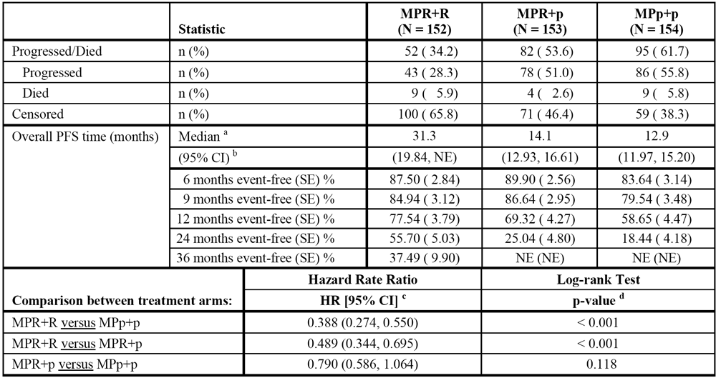

a The median is based on the Kaplan-Meier estimate.

b 95% CI about the median overall PFS time.

c Based on a proportional hazards model comparing the functions associated with indicated treatment arms.

d The p-value is based on the unstratified log-rank test of the Kaplan-Meier curve for differences between the indicated treatment arms.

Of the total number of PFS events (n=229), the majority were based on M-protein increase using central laboratory assessments (76% [n=173] by serum protein electrophoresis; 9% [n=20] by urine protein electrophoresis). Other reasons for PFS events were lytic lesions (n=4), plasmacytoma (n=3), bone marrow aspirate (n=2), new bone lesion (n=2), hypercalcaemia (n=1), hypercalcaemia/renal failure (n=1), and increased serum IgA (n=1).

The largest proportion of patients were censored because they were still ongoing at the date of data cutoff (31.3% [72/230]), followed by discontinuation of treatment due to investigator assessment of PD (21.3% [49/230]). If a patient was assessed with PD by an investigator, first-line study treatment was discontinued and further disease assessments (if any) were not be reviewed by the CAC for that patient. The proportion of patients censored for this reason was higher in the MPp+p arm (13.6% [21/154]) than in the MPR+p ([11.8% [18/153]) and the MPR+R (6.6% [10/152]) arms. Other reasons for censoring in > 10% of all patients included AEs (17.4% [40/230]) and other (10.9% [25/230). The reasons for censoring PFS based on CAC review at the date of unblinding are summarised.

The results for other PFS protocol specified methods comparing the MPR+R arm to the MPp+p arm at study unblinding are summarised below in Table 22. The methods are PFS assessed by CAC using the stratified test (pre-specified secondary analysis), PFS assessed by investigators, and PFS assessed by the CAC using the definition of PFS described in the EMA Guidelines on Haematologic Malignancies (pre-specified sensitivity analysis).

Table 22: MM-015 - PFS assessments for the comparison between the MPR+R and MPp+p treatment arms at the date of unblinding (11 May 2010) in the ITT population.

| PFS Assessment | MPR+R (n=152) | | MPp+p (n=154) | | MPR+R vs MPp+p | | |
| --- | --- | --- | --- | --- | --- | --- | --- |
| Subjects with events | Median PFS | Subjects with events | Median PFS | HR (95% CI) | p value | log-rank |
| Stratified (CAC) | 52 (34.2%) | 31.3 months | 95 (61.7%) | 12.9 months | 0.371 (0.260, 0.531) | < 0.001 | stratified |
| Investigator | 52 (34.2%) | 26.3 months | 110 (71.4%) | 13.1 months | 0.355 (0.254, 0.496) | < 0.001 | unstratified |
| EMA (CAC) | 60 (39.5%) | 34.1 months | 104 (67.5%) | 15.0 months | 0.455 (0.330, 0.627) | < 0.001 | unstratified |

PFS was explored in a subgroup analysis between the MPR+R and MPp+p arms in the ITT population (investigator assessment), based on the cutoff date of 30 April 2013 (see Figure 23, page 281). The analysis showed that in all subgroups, except patients aged > 75 years, the risk of disease progression or death was statistically significantly lower in the MPR+R arm compared to the MPp+p arm, based on the 95% CI of the hazard ratio. However, in patients aged > 75 years, while the risk of disease progression or death was 28% lower in the MPR+R arm compared to the MPp+p arm the difference was not statistically significant as the 95% CI for the hazard ratio included 1 (i.e., HR = 0.717 [95% CI: 0.387, 1.328]). PFS assessments based on investigator assessment by age (≤ 75 years and > 75 years) for comparisons between treatment arms, based on the cutoff date of 30 April 2013 are provided in Table 108, page 223.

PFS for all three treatment arms was also compared using a multivariate analysis in which the effect of each prognostic factor was assessed independently. The analysis was based on data at the data cut-off date of 30 April 2013. The final Cox-proportional hazard model on PFS included treatment-by-age interactions. In subjects aged ≤ 75 years, the comparison between MPR+R vs MPp+p statistically favoured the lenalidomide arm, while the MPR+R vs MPR+p comparison statistically significantly favoured the lenalidomide maintenance arm and the MPR+p vs MPp+p comparison statistically significantly favoured the lenalidomide arm. However, in subjects aged > 75 years, only the comparison between MPR+R vs MPp+p statistically significantly favoured the lenalidomide arm. Apart from age > 75 years, other independent prognostic factors were baseline haemoglobin, platelet, and C-reactive protein levels. The results of the multivariate analysis are summarised.

*Comment: The primary analysis of the PFS undertaken on a total of 229 events. This equates to 77.4% of 296 protocol specified PFS events that would have been required if the pre-specified superiority boundary for determination of efficacy had not been crossed at the earlier interim analysis. The primary analysis showed a PFS benefit, based on CAC assessment, for treatment with MPR+R compared to MPp+p at the date of unblinding (i.e., HR = 0.388 [95% CI: 0.274, 0.550]; p<0.001, unstratified log-rank test). The median time to PFS event was 31.3 months in the MPR+R arm and 12.9 months in the MPp+p arm, reflecting a 2.4-fold increase. This increase is notably higher than the 25% increase in median PFS time specified in the pivotal study MM-020 to be clinically meaningful. Examination of the KM plots show that the curves for MPR+R and MPp+p began to separate in favour of MPR+R at about 12 months and remained divergent through to 36 months. The primary analysis of the PFS was supported by the pre-specified secondary analysis (stratified log-rank test), the analysis based on investigator assessment, and the sensitivity analysis based on CRC assessment using the EMA definition for PFS.*

*The subgroup analysis of the PFS by investigator assessment at the data cutoff date of 30 April 2013 showed that all subgroups benefited from treatment with MPR+R compared to MPp+p, except the subgroup of patients aged > 75 years. For the MPR+R vs MPp+p, the hazard ratio was 0.717 (95% CI: 0.387, 1.328), p=0.288 (unstratified log-rank test) for subjects aged > 75 years, and 0.300 (95% CI: 0.211, 0.427), p<0.001 (unstratified log-rank test) for subjects aged ≤ 75 years. Similarly, in the multivariate analysis, subjects aged ≤ 75 achieved a superior benefit when lenalidomide was included in the regimen, while in subjects aged > 75 years the inclusion of lenalidomide in the regimen resulted in inconsistent PFS benefits. The sponsor comments that these although the results in patients aged > 75 years should be interpreted cautiously because of the small size of the study population, "frailer and older subjects (age > 75 years)... with more advanced disease and multiple comorbidities seem to benefit less from continuous treatment with lenalidomide than younger subjects."*

###### Other efficacy endpoints - results

Secondary efficacy endpoints

The results for the secondary efficacy endpoints listed below relate to the most recent data cutoff date of 30 April 2013, and reflect the unblinded assessment by investigators at this time-point.

* OS (secondary efficacy endpoint): At the most recent data cutoff date of 30 April 2013, the median follow-up time for all subjects in the study was 62.5 months, with death being reported in 53.4% (245/459) of all subjects. In the primary comparison between the MPR+R and MPp+p arms, the observed HR [MPR+R/MPp+p] was 0.948 (95% CI: 0.696, 1.292). The median OS was 55.9 months in the MPR+R arm and 53.9 months in the MPp+p arm, and the estimated 5-year OS rate was 47% in the MPR+R arm and 44% in MPp+p arm. The results indicate no significant difference in OS between the MPR+R and MPp+p arms.
* TTP (secondary efficacy endpoint): The median time to progression by investigator assessment at the data cutoff date of 30 April 2013 was notably longer in the MPR+R arm than in the MPp+p arm (29.1 vs 13.9 months, respectively): HR = 0.325 (95% CI: 0.235, 0.451); p<0.001, unstratified log-rank test. A lower percentage of subjects in the MPR+R arm experienced disease progression during the treatment period than in the MPp+p arm (38.2% versus 72.7%, respectively). The difference in the median times to progression between the two treatment arms represented a 109% improvement in the MPR+R arm relative to the MPp+p arm, which was notably higher than the 50% improvement specified in the study as being clinically relevant.
* TT next AMT (secondary efficacy endpoint): The median time to next AMT by investigator assessment at the data cutoff date of 30 April 2013 was notably longer in the MPR+R arm than in the MPp+p arm (28.0 vs 15.3 months, respectively): HR = 0.413 (95% CI: 0.312, 0.547); p<0.001, unstratified log-rank test. A lower percentage of subjects in the MPR+R arm received AMT during the treatment period than in the MPp+p arm (55.9% vs 83.8%, respectively).
* TTR (secondary efficacy endpoint): The median time to first response (i.e., at least PR first met) by investigator assessment at the data cutoff date of 30 April 2013 was shorter in the MPR+R arm than in the MPp+p arm: 2.8 months (range: 1.1, 34.6 months) for 120 responders vs 3.7 months (range 1.8, 19.6 months) for 84 responders; p=0.014, Wilcoxon rank-sum test.
* DOR (secondary efficacy endpoint): The median duration of response based on investigator assessment at 30 April 2013 was longer in the MPR+R arm than in the MPp+p arm (26.5 vs 12.0 months): HR = 0.370 (95% CI: 0.259, 0.529); p<0.001, unstratified log-rank test.
* Response rate: The overall response rate (CR+PR) based on investigator assessment at the data cutoff date of 30 April 2013 was 78.9% (120/152) in the MPR+R arm and 54.5% (84/154) in the MPp+p arm; p < 0.001, Fisher's exact test. The odds of achieving at least a PR in subjects treated with MPR+R was 3.1 times greater than for subjects treated with MPp+p (ORR = 3.13 [95% CI: 1.89, 5.17]).
* PFS2 (exploratory efficacy endpoint): In this study, PFS2 was analysed as time from randomisation to start of 3rd-line therapy or death, whichever occurred first. The exploratory next-on line PFS2 analysis showed a notably prolonged time in the MPR+R arm compared to the MPp+p arm. As of the 30 April 2013 data cutoff date, 63.8% (97/152) of subjects in MPR+R arm had PFS2 events compared to 78.6% (121/154) of subjects in MPp+p arm. The observed HR of 0.701 (95% CI: 0.536, 0.916) with an unstratified log-rank test p-value = 0.009 indicates a 30% reduction in the risk of death or starting third-line AMT in the MPR+R arm compared to the MPp+p arm, and translates into a 10.9 month improvement in median PFS2 from 28.8 months to 39.7 months.

Secondary efficacy endpoints - QOL assessments

The QoL assessments (secondary efficacy endpoint) showed similar improvements in subjects in the MPR+R and MPp+p arms during the treatment period. Six QoL domains were pre-specified for analysis based on the perceived clinical relevance of each of these domains for patients in this trial (e.g., EORTC QLQ-C30: Global Health Status, Physical Functioning, Pain, and Fatigue; EORTC QLQ-MY20: Disease Symptoms and Side Effects of Treatment). In general, compliance with the assessments was similar among the three treatment arms and at most time points was approximately 80% or above. Collection of QoL data continued beyond cycle 19, although the data were not presented beyond cycle 19 for most summaries due to the small and less balanced sample sizes after this time-point. Overall, examination of the plots over time from Cycle 4 through Cycle 19 were generally similar for the MPR+R and MPp+p arms for change from baseline in global health status, side effects, pain, physical functioning, fatigue, and disease symptoms. The mixed model repeated measures analyses for the EORTC QLQ-C30 and QLQ-MY20 scales did not show any statistically significant differences for each of the three treatment arms.

Landmark analysis (pre-specified in the SAP as an exploratory analysis)

For the PFS primary endpoint, an additional analysis was performed to compare the MPR+R and MPR+p arms in the subgroup of patients who completed the induction therapy for up to 9 cycles and then proceeded to maintenance therapy. This comparison was performed to assess the effect of using lenalidomide during maintenance therapy. For this exploratory landmark analysis, the PFS calculation started from the beginning of the maintenance therapy period. This analysis recognized that for the MPR+R and the MPR+p arms, the treatment regimen received for induction was identical, therefore, the portion of the induction therapy was removed from the analysis. Patients who were randomised to these two arms, but discontinued during the induction therapy were also removed from this analysis. The unstratified log-rank test was used for the comparison between the two treatment arms. The baseline demographic and disease characteristics were generally comparable for those patients who entered the maintenance therapy period.

The analysis was based on investigator review at the data cutoff date of 30 April 2013. The analysis showed that a greater PFS benefit was achieved in patients who received maintenance treatment with lenalidomide compared to patients who received placebo. The risk of disease progression or death in the maintenance period was reduced by 61% in patients receiving lenalidomide arm (MPR+R) compared to placebo arm (MPR+p): HR = 0.394 (95% CI: 0.275, 0.564); p<0.001, unstratified log-rank test. The improvement in median PFS time in the maintenance period between the MPR+R arm and the MPR+p arm was 15 months (21.4 vs 6.4 months, respectively). The 3 and 4 year event-free estimates for the MPR+R arm were 37% and 32%, compared with 10% and 9% for the MPR+p arm, respectively. The results of the analysis are summarised.

###### ECOG E4A03 - Sponsor designated supportive study

Design, objectives, dates, locations

The primary objective of this Phase 3, USA (multicentre), randomised, open-label (non-inferiority) study was to compare the safety and efficacy of lenalidomide plus standard-dose (high-dose) dexamethasone (len/D) to lenalidomide plus low-dose dexamethasone (len/d) administered over 4 cycles to patients with newly diagnosed multiple myeloma.

The rationale given for undertaking the study was the need to develop novel therapies (e.g., lenalidomide plus high- or low-dose dexamethasone) in patients with newly diagnosed MM as alternatives to the induction regimens being used at the time of the study. The standard-dose (high-dose) of dexamethasone used in the study was the dose approved in the USA and Europe at the time of the study for use in combination with lenalidomide for the treatment of patients with MM who have received at least one prior therapy. The study has been published.13

The primary efficacy endpoint was the response rate at the end of the first 4 treatment cycles. After 4 cycles, patients had one of four treatment options: (1) patients who achieved complete response (CR) or partial response (PR) could receive standard treatments for MM, which may include ASCT; (2) patients who achieved CR or PR in the len/D arm could switch to len/d and continue treatment until progression while patients who achieved CR or PR in the len/d arm could continue the same len/d treatment until progression; (3) patients with disease progression were discontinued; or (4) patients who progressed and achieved minimal response or no response during the first 4 cycles could register to receive thalidomide treatment.

This study was a National Cancer Institute (NCI) sponsored study, which was conducted by the Eastern Cooperative Oncology Group (ECOG) at a total of 138 sites in the USA. Data were provided by ECOG to Celgene Corporation (Summit, New Jersey), and Celgene completed the review of the data. A Statistical Analysis Plan (SAP), which outlined the Celgene statistical analyses in addition to the protocol-planned analyses, was written and approved prior to the final database transfer. An Independent Response Assessment Committee (IRAC), comprising experts experienced in the treatment of patients with multiple myeloma, conducted a blinded review of the data for each patient and determined the response. The response assessments of the IRAC served as the basis for the primary analysis of the data summarised in the CSR.

The first patient was enrolled on 26 October 2004 and the data cutoff date for the primary analysis was 26 March 2007, with the data cutoff date for extended follow-up of survival being 1 July 2007. The release date for the CSR was 4 June 2009 and the study was reported to be ongoing at that date. The planned accrual was 412 patients to the len/D and len/d arms (First Phase), and 270 patients to an anticoagulation substudy. Accrual to the anticoagulation substudy started after accrual to the len/D and len/d arms was completed. However, accrual to the anticoagulation substudy was suspended on 27 March 2007 at the recommendation of the DMC after preliminary results of the first phase of the study suggested improved survival in the len/d arm compared to the len/D arm. The anti-coagulation substudy was officially terminated on 1 June 2007. The study data were released on 26 March 2007 after 445 patients had been enrolled in the First Phase of the study and 7 patients in the anticoagulation substudy. No patients were enrolled in the study subsequent to the date of data release. Patients in the len/D arm were allowed to continue treatment with len/d.

Treatment

The study comprised a First Phase (which was the main focus of the CSR), and an Expansion Phase substudy (referred to in the CSR as the Anticoagulant Substudy). In the First Phase of the study, eligible patients were randomised 1:1 to one of the two treatment arms: (1) len/D = lenalidomide 25 mg QD, days 1-21 every 28 days plus standard (high-dose) dexamethasone 40 mg QD on days 1-4, 9-12, and 17-20 every 28 days; or (2) len/d = lenalidomide 25 mg QD, days 1-21 every 28 days plus low-dose dexamethasone 40 mg QD on days 1, 8, 15, and 22 every 28 days. After Protocol Amendment #3, both treatment arms also included mandatory anticoagulation prophylaxis with aspirin 325 mg QD on days 1-28 of each 28-day cycle or alternative treatment with either low molecular weight heparin or warfarin. In the Expansion Phase, which was designed evaluate the optimum prophylaxis to prevent thromboembolic events, len/D plus aspirin was to be compared with len/D plus warfarin. In addition to the two treatment arms, all patients were also offered standard supportive care for myeloma, including monthly bisphosphonates, and prophylaxis against dexamethasone related peptic ulcer and infection. All patients were to be followed for 7 years post-treatment from study entry (including those who discontinued early). Follow-up procedures were to be performed every 3 months if a patient was < 2 years from study entry, every 6 months if the patient was 2 to 5 years from study entry, and every 12 months if the patient was 6 to 7 years from study entry.

Inclusion and exclusion criteria

The First Phase included patients diagnosed with symptomatic MM within the past 90 days, without prior systemic therapy for MM with the exception of bisphosphonates. Confirmation of the diagnosis required bone marrow plasmacytosis with ≥ 10% plasma cells or sheets of plasma cells or biopsy proven plasmacytoma obtained within 4 weeks prior to randomisation and measurable levels of M-protein (≥ 1 g/dL on SPEP obtained within the 4 weeks prior to randomisation or ≥ 200 mg of monoclonal light chain on a 24-hour UPEP obtained within 4 weeks prior to randomisation). In addition, patients were required to have ECOG performance status of 0, 1, or 2.

Efficacy endpoints and statistical methods

The protocol-specified primary efficacy endpoint was overall response rate (ORR) during the first 4 cycles. The sponsor stated that a 4 cycle induction period was a standard timeframe to prepare patients for stem cell transplantation. Celgene also included additional efficacy endpoint analyses that were not protocol-planned, but were considered by the sponsor to be acceptable endpoints for assessing efficacy in oncology studies. These additional efficacy endpoints were, overall response rate during treatment, time to response, duration of response, time to progression, PFS, and OS. The details of the analyses were written in a formal SAP, which was finalised prior to Celgene receiving the final database transfer from ECOG.

The study was a non-inferiority trial. The First Phase of the trial was designed to compare the response rates between the len/D and len/d arms. The sponsor stated that, although a ≤ 10% difference is the usual standard for non-inferiority, a ≤ 15% difference of non-inferiority was chosen for this trial for three reasons. First, in prior trials dexamethasone has been considered to be equivalent to a triplet regimen of vancomycin, adriamycin, and dexamethasone (VAD), eventhough the response rate with dexamethasone was 15% lower than VAD. Second, response rate differences in the range of 15% have not affected survival in previous trials. Third, use of a ≤ 10% difference would have resulted in a significantly larger sample size and prohibited timely completion of the trial.

The ORR at the end of the first 4 cycles of treatment was compared between the two treatment arms using a 2-sided Fisher's exact test with α=5%. The relative proportions in each response category were analysed using the Wilcoxon rank sum test. The ITT population was used as the primary efficacy population.

The sample size was designed to have more than 95% power to reject the null hypothesis of equal response rate at a one-sided 10% significance level when the actual response rates through 4 cycles were at 70% and 55% for len/D and len/d arms, respectively. A total of 412 patients were planned to be randomised in order to obtain 196 patients per arm assuming a 5% ineligibility rate. The high type I error rate (10%) was chosen due to less concern about erroneously determining a significantly different response rate (favourable or unfavourable), with much more interest in determining if there was a significant inferiority in response (5% type II error rate).

The CSR included two assessments of ORR: (1) based on best response assessments by the Independent Review Assessment Committee (IRAC) using modified European Group for Bone Marrow Transplantation (EMBT)/ Bladé criteria, which includes a near complete response (nCR) category; and (2) based on the protocol-specified myeloma response determined by an adjudication panel using standard EMBT/Bladé criteria, which do not include the nCR category.

The primary analyses summarised in the submitted CSR were based on the IRAC review using modified EMBT/Bladé criteria. It was stated that the modified EBMT/Bladé criteria were used because these criteria (1) allow for more detailed and stringent definitions of response categories, (2) provide for a more accurate identification of disease progression, and (3) allow a nCR to be distinguished from a CR or PR. Patients with a nCR are those who have an immunofixation-positive response (i.e., their immunofixation result is positive while their M-protein levels are not detectable by protein electrophoresis, their bone disease is stable, and their serum calcium level is normal). The sponsor stated that specific categories of CR, with varying degrees of stringency allow for greater precision in the definition of CR, enable comparison of the efficacy of various treatments, including novel agents, and permit more accurate detection and monitoring of relapse. It was stated that IRAC assessments were performed to reduce bias and present an "internationally recognized method of assessment."

Patient disposition

The planned enrollment to the First Phase of this study was 412 patients randomised in a 1:1 ratio to either the len/D arm or len/d arm. A total of 445 patients were actually enrolled in the First Phase of the study as of 26 March 2007, the date of data release. Of the 445 patients, 222 were randomised to the len/d arm, and 223 were randomised to the len/D arm. At the date of data release, the percentage of patients who had discontinued treatment was lower in the len/d arm than in the len/D arm (74.8% [166/122] vs 84.8% [189/223], respectively). The percentage of patients who discontinued due to AEs was also lower in the len/d arm compared to the len/D arm (14.0% [31/222] vs 22.9% [51/223], respectively). Patient disposition in both treatment arms up to the time of data release of 26 March 2007, and up to the date of the extended follow-up of 1 July 2008 are summarised.

The percentage of randomised patients completing 4 cycles was 81.1% (181/223) in the len/D arm and 89.6% (199/222) in the len/d arm. Of the patients discontinuing at or after 4 cycles, 46 in the len/D arm went on to stem cell transplantation (20.6% of randomised patients) compared to 52 in the len/d arm (23.4% of randomised patients). The disposition of patients in the first phase of the study up to date release of 26 March 2007 is summarised.

Baseline patient characteristics

In general, the baseline disease characteristics of the two treatment arms were similar. The mean ± SD age of the patients in len/D arm (n=223) was 64.6 ± 11.21 years (range: 36, 88 years), and 64.3 ± 9.82 years in the len/d arm (n=222) (range: 35, 86 years). The majority of patients in both treatment arms were male (59% in the len/D arm, 55% in the len/da arm), and the majority of patients in both treatment arms were white (c.a. 85%), with most of the remaining patients being black. The mean ± SD time from first pathological diagnosis was 0.2 ± 0.86 years in the len/D arm (range: 0.0, 7.7 years) and 0.1 ± 0.31 years in the len/D arm (range: 0.0, 2.1 years). ISS stage in the len/D vs len/d arms, respectively, was 41.7% vs 48.6% (I), 31.4% vs 25.2% (II), and 24.2% vs 25.2% (III). The performance status (PS) scores of the majority of patients in both treatment arms were 0 or 1 (c.a. 91% in both treatment arms). The baseline demographics and disease characteristics of the patient population are summarised. Prior medical history data, specific prior and concomitant medication names were not included in the clinical database in this study. Treatment compliance was not formally analysed.

Results

**Myeloma response rate (primary efficacy endpoint):**

As of the date of date release (26 March 2007), the mean duration of therapy for the first 4 cycles was comparable between treatment arms (15.4 weeks [median, 16.1 weeks] in the len/d arm, and 14.9 weeks [median, 16.1 weeks] in the len/D arm). Overall, there was a higher proportion of patients who completed 4 cycles with an unchanged study drug regimen in the len/d arm (lenalidomide: 77.5%; 172/222; and low-dose dexamethasone: 81.1%; 180/222) compared to the len/D arm (lenalidomide: 68.2%; 152/223; and standard-dose dexamethasone: 56.5%; 126/223).

The myeloma response rate during the first 4 cycles, based on IRAC review modified EBMT/Bladé criteria at the date of data release, are summarised below in Table 23. The overall response rate (ORR = CR+nCR+PR) in the first 4 cycles was significantly lower in the len/d arm than in the len/D arm: 64.4% vs 77.1%, respectively, p=0.0035, Fisher’s exact test. The difference between the treatment arms in the ORR in the first 4 cycles was primarily driven by the difference in the nCR rates. The odds ratio was 1.86 (95% CI: 1.23, 2.82) in favour of len/D. The results for the myeloma response rate based on the protocol adjudication panel assessment using standard EMBT/Bladé criteria were consistent with the corresponding results based on IRAC assessment using modified EMBT/Bladé criteria.

Table 23: E4A03 - Myeloma response rate during the first 4 cycles, based on best response assessments by IRAC up to data release date of 26 March 2007; ITT population.

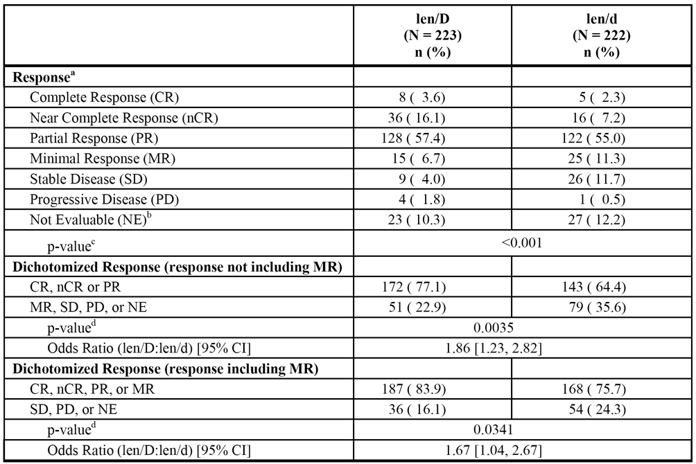

CI = confidence interval; CR = complete response; d = low-dose dexamethasone; D = standard-dose dexamethasone; nCR = near complete response; ITT = intent to treat; len = lenalidomide; MR = minimal response; NE = not evaluable; PD = progressive disease; PR = partial response; SD = stable disease.

Note: Response in this table is based on the review of all myeloma assessment data using modified EBMT criteria.

a Response is the best assessment of response during the first 4 cycles of treatment.

b Including patients who did not have adequate data for response assessment at baseline and/or post-baseline prior to the use of any non-protocol anti-myeloma therapy.

c Probability from Wilcoxon rank sum test; p-value calculation excludes the category “Response Not Evaluable (NE).”

d Probability from Fisher’s exact test.

In younger patients (≤ 65 years), those treated with len/D had a higher ORR (CR+nCR+PR) than those treated with len/d (83.7% [87/104] vs 59.3% [64/108], respectively; p=0.001, Fisher's exact test). However, in older patients (> 65 years), the difference in the ORR (CR+nCR+PR) between the len/D and len/d arms was not significant (71.4% [85/119] vs 69.2% [79/114]; p=0.7748, Fisher's exact test).

*Comment: The results showed that ORR (CR+nCR+PR) at the end of 4 treatment cycles was significantly higher in the len/D arm than in the len/d arm (based on best response assessments by the IRAC). The study defined an absolute difference in the overall response rate between the two treatment arms of ≤ 15% as being the non-inferiority margin. An absolute difference of 15% converts into an odds ratio (len/D:len/d) of 1.91. The observed odds ratio (len/D:len/d) for the overall response rate was 1.85 (95% CI: 1.23, 2.82), with the 95% CI enclosing the non-inferiority value of 1.91. Therefore it can be concluded that len/d is not non-inferior to len/D, and that len/D is superior to len/d.*

**Progression-free survival**

Progression-free survival (PFS) was calculated as the weeks between randomisation and documented PD as determined by IRAC review of myeloma response, or death, whichever occurred first. At the date of data release (26 March 2007), the difference in PFS between the two treatment arms was not significant: HR (len/D: len/d) = 1.321 (95% CI: 0.916, 1.904); p = 0.1350, unstratified log rank test. Median time to PFS event was not reached in the len/d arm, and was 84.1 weeks (19.5 months) in the len/D arm. The HR indicates that the risk of experiencing a PFS event was 32% higher in the len/D arm relative to the len/d arm. A lower proportion of patients in the len/d arm (23.0% [51/222]) had progressed or died compared to the len/D arm (29.6% [66/223]). In addition, the percentage of patients who had not progressed or died at 6-months (26 weeks), 1-year (52 weeks), and 1.5-year (78 weeks) was higher in the len/d arm (87.25%, 68.97%, and 58.31%, respectively) compared to the len/D arm (82.80%, 60.99%, and 51.04%, respectively).

As of the date of data release, PFS was not significantly different between treatment arms for patients aged ≤ 65 years (p = 0.8614, unstratified log rank test; hazard ratio for len/D:len/d = 1.054; CI [95% CI: 0.583, 1.907]), or for patients aged > 65 years (p = 0.0875, unstratified log rank test; hazard ratio for len/D:len/d = 1.501; CI [95% CI: 0.939, 2.399]).

Overall survival

Overall survival (OS) was defined as the number of weeks between randomisation and death (regardless of cause). As of the date of data release (26 March 2007), 17 of the 222 patients (7.7%) in len/d arm and 43 of the 223 patients (19.3%) in the len/D arm had died. Median OS had not been reached in either treatment arm. Based on the unstratified log rank test, OS was significantly longer in the len/d arm than in the len/D arm (p = 0.0003). The 6-month (26 weeks), 1-year (52 weeks), 1.5-year (78 weeks), and 2-year (104 weeks) survival rates were 97.75%, 95.46%, 91.28%, and 89.45%, respectively for the len/d arm, and 93.27%, 87.68%, 80.94%, and 68.23%, respectively for the len/D arm. Based on the hazard ratio, the patients in the len/D arm were approximately 2.7 times more likely to die compared to patients in the len/d arm (i.e., HR = 2.681 [95% CI: 1.528, 4.706]). The KM plots of OS are provided in Figure 26, page 283.

Both younger (≤ 65 years) and older (> 65 years) patients who received len/d treatment had an overall survival advantage compared to those who received len/D treatment (HR [len/D:len/d] = 2.622 [95% CI: 0.923, 7.445], p=0.0600, unstratified log-rank test and vs HR [len/D:len/d] = 2.679 [95% CI: 1.3751, 5.233], p=0.0027, unstratified log-rank test; respectively).

###### SWOG S0232 - Sponsor designated supportive study

The primary objective of this Phase 3, single-country (USA), multicentre, double-blind parallel-group study was to evaluate the effects of lenalidomide plus high-dose dexamethasone (len/D) compared to placebo plus high-dose dexamethasone (pbo/D) on progression-free survival (PFS) in patients with previously untreated MM who were not immediately undergoing ASCT. In order to maintain balance between the 2 treatment arms in the allocation of patients with differing prognoses for PFS (the primary endpoint), randomisation was stratified by disease stage using the International Staging System (ISS) (Stage I vs Stage III vs Stage III) and Zubrod performance status (0 and 1 vs 2 and 3). Data from this study have been published in abstract form,11 and as brief report.12

The study included a double-blind induction phase followed by a double-blind maintenance phase. In the induction phase (3 x 35-Day Cycles), patients received lenalidomide 25 mg QD or placebo on days 1-28 plus dexamethasone 40 mg QD on days 1-4, 9-12, and 17-20 every 35 days for 3 cycles. In the maintenance phase (28-Day Cycles), patients received lenalidomide 25 mg QD or placebo on days 1-21 plus dexamethasone 40 mg QD on days 1-4 and 15-18 every 28 days. In the maintenance phase, patients who achieved a partial response (PR), complete response (CR) or maintained stable disease (SD) continued treatment until disease progression occurred or until the patient discontinued treatment for another reason.

The study included patients aged ≥ 18 years with a diagnosis of previously untreated MM, no immediate plans to undergo ASCT, and measurable disease, defined as a serum M-protein level of ≥ 1.0 g/dL (≥ 10.0 g/L) as measured by serum protein electrophoresis or immune electrophoresis, a urinary M protein level of ≥ 200 mg/24 hours (≥ 0.2 g/24 hours), or both within 28 days before registration into the study. In addition, patients were required to have a Zubrod performance status of 0 to 3 and adequate bone marrow, liver, and renal function.

The primary efficacy endpoint was PFS, calculated as the time (weeks) between study registration (which is the same as randomisation) and documented PD or death, which ever occurred first. PD was determined by an Independent Response Assessment Committee (IRAC), blinded to treatment allocation, using modified Bladé/EBMT myeloma response criteria. The PFS was compared between treatment arms using an unstratified log-rank test, and the ITT population was the primary efficacy population. The KM method was used to estimate the survival distribution function for each treatment arm. The study included the standard range of secondary efficacy endpoints typically used in oncological clinical studies, including OS. The study was powered (83%) to detect a 33% increase in median PFS, using a 1-sided test with an 0.025 significance level. The total sample size was estimated to be 500 patients (250 in each study arm).

The study was undertaken in 41 centres in the USA. It was initiated on 15 October 2004 (first patient enrolled) and planned to include 500 patients. However, at the recommendation of the independent Data and Safety Monitoring Committee (DSMC), accrual to the study was stopped on 02 April 2007 after preliminary results from study ECOG E4A03 suggested a survival advantage for lenalidomide plus low-dose dexamethasone compared to lenalidomide plus high-dose dexamethasone as initial therapy for patients with newly diagnosed MM. On 3 May 2007, the DSMC determined that the appropriateness of both treatment arms (i.e., lenalidomide plus high-dose dexamethasone and placebo plus high-dose dexamethasone) was in question and, therefore, that it was "no longer feasible to conduct the study". The study was unblinded on 11 May 2007. The release date of the CSR was 12 August 2009, and 198 patients had been enrolled into the study up until this time point.

The results for PFS (the primary efficacy endpoint) based on data collected up to the date of unblinding are summarised below in Table 24, and show a statistically significant PFS benefit for patients in the len/D arm compared to the pbo/D arm.

Table 24: SWOG S0231 - PFS based on IRAC review of myeloma response up to study unblinding on 11 May 2007; ITT.

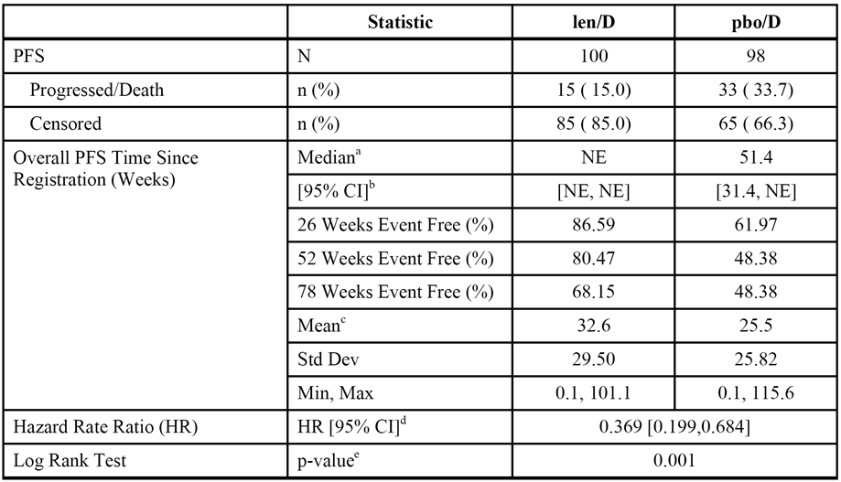

a The median is based on the Kaplan-Meier estimate.

b The 95% CI about the median survival time.

c The mean is the univariate statistic without adjusting for censoring.

d The hazard rate ratio is based on a proportional hazards model comparing the hazard functions associated with the treatment arms (len/D:pbo/D).

e The p-value was based on the unstratified log rank test of Kaplan-Meier curve differences between treatment arms.

The results for the OS (a secondary efficacy endpoint), defined as the number of weeks between randomisation and death, up to study unblinding showed a survival benefit for len/D over pbo/D. Death had been reported in 8.0% (8/100) of patients in the len/D arm and in 18.4% (18/98) of patients in the pbo/D arm. The 6-month (26 weeks), 1-year (52 weeks), 1.5-year (78 weeks), and 2-year (104 weeks) survival rates were 96.0%, 94.6%, 89.9%, and 89.9%, respectively, for the len/D arm and 91.4%, 87.5%, 78.7%, and 66.7%, respectively, for the pbo/D arm. The hazard rate ratio (len/D:pbo/D) was 0.418 (95% CI: 0.182, 0.962); p=0.0342 unstratified log-rank test. However, the median duration of OS could not be determined in either arm as too few deaths had occurred at the date of study unblinding.

##### Study IFM 2005-02 - Sponsor designated supportive study.

###### Design, objectives, locations, dates

The primary objective of this Phase 3, multinational (France, Belgium, Switzerland), multicentre (78 centres), randomised, double-blind, placebo-controlled study was to evaluate the efficacy of lenalidomide in extending post-transplantation progression-free survival (PFS). Patient accrual occurred between 12 June 2006 and 29 August 2008. The date of the submitted CSR (termed principal analysis) was 12 December 2012, and the cutoff date for the submitted data was 7 July 2010 (date of study unblinding), with an update for overall survival as of 5 October 2011. The study was expected to continue until 2015. The study was sponsored by the University Hospital of Toulouse (CHU Toulouse) in scientific partnership with the Intergroupe Francophone du Myélome (IFM [Francophone Myeloma Intergroup]). The study has been published.[5]

On 5 January 2010, the Data Monitoring Committee (DMC) undertook pre-specified review of the efficacy data based on an interim analysis of 60% (i.e., 180/300) of the investigator assessed PFS events (data cutoff date 4 September 2009). The results showed a significant difference in the primary endpoint (PFS) between the two treatment arms in favour of lenalidomide. Based on this analysis, the DMC recommended the study be unblinded, and treatment in the placebo arm be discontinued (without cross-over to the lenalidomide arm before disease progression). Patients in the placebo arm who were discontinued from study treatment as a result of this recommendation were to continue to undergo the same monthly and 3-monthly assessments described for patients under maintenance treatment, until disease progression, withdrawal of consent, loss to follow-up or initiation of new anti-cancer treatment.

In January 2011, following a safety report showing an increased incidence of second primary malignancies (SMPs) in the lenalidomide arm, the DMC recommended the immediate discontinuation of maintenance treatment with lenalidomide (Protocol Amendment #9, 21 March 2011). Patients who were discontinued from study treatment as a result of this recommendation were to continue to undergo the same monthly and 3-monthly assessments for maintenance treatment, until disease progression, withdrawal of consent, loss to follow-up or initiation of new anti-cancer treatment. This amendment was implemented after the cutoff date for PFS analysis (7 July 2010). Additional survival data were presented in the submitted report, based on a second cut-off date of 5 October 2011.

###### Inclusion and exclusion criteria

The study included patients with MM aged 18 to 65 years who had received initial treatment with induction chemotherapy and ASCT within the previous 6 months, and had not relapsed in the interval since ASCT. The intention was to include patients with a response to ASCT of very good partial response (VGPR) or better. For patients who did not achieve VGPR, investigators were encouraged to perform a second ASCT prior to study entry. Prior to initial treatment with induction chemotherapy and ASCT all patients had been newly diagnosed with MM and had not received previous treatment for the disease. Information concerning the induction and transplantation procedures was collected retrospectively.

###### Treatment

Patients were stratified at randomisation according to three parameters: (1) beta2 microglobulin level at diagnosis (≤ 3 mg/L versus > 3 mg/L); (2) presence/absence of deletion in chromosome 13 (del13) at diagnosis, if screening for deletion in chromosome 13 at diagnosis was unsuccessful, it was considered as negative for the stratification; and (3) response to the last ASCT (CR/VGPR versus PR/SD). Patients who met all eligibility criteria were randomised (1:1) to one of two treatment arms: lenalidomide (n=307) - 2 cycles of consolidation treatment with lenalidomide 25 mg QD days 1-21 of a 28-day cycle, followed by single-agent lenalidomide 10 mg QD maintenance therapy for 28 days per 28-day cycle (increasing to lenalidomide 15 mg QD after 3 months if tolerated); or placebo (n=307) - 2 cycles of consolidation treatment with lenalidomide 25 mg QD from day 1-21 of a 28-day cycle, followed by single-agent placebo maintenance therapy. Lenalidomide dosage could be adjusted during the course of treatment based on polyneutrophil and platelet counts. No specific instructions regarding dose re-escalations were described in the study protocol. Patients were to be evaluated at baseline and then once every 28 days. Disease responses were evaluated by investigators every 3 months, according to IMWG criteria

###### Efficacy endpoints and statistical methods

The primary efficacy endpoint was progression free survival (PFS) assessed by the Independent Review Committee (IRC) based on IMWG response criteria and calculated for all patients in the ITT population (i.e., all randomised, irrespective of treatment) from the date of randomisation to the date of progression or death (whatever the cause). The IRC consisted of two physicians, with expertise and experience in the management of MM, who did not otherwise participate in the study. All responses were initially evaluated by the local investigators. Progressive disease was evaluated based on measurements of serum and urine M-protein by immunochemistry, cell percentage of bone marrow plasma every three months in case of complete response, or skeletal X-rays / MRI. A final review of response was conducted by the IRC, which was used for analysis of the primary endpoint. The secondary efficacy variables were standard for oncological studies, and included overall survival (OS).

For the primary analysis, the comparison of PFS between the placebo arm and the lenalidomide arm used an unstratified log rank test; the overall two-sided significance level was 5% spread over 2 analyses (1 interim analysis at 60% and 1 final analysis) by an O’Brien-Fleming alpha spending function. To account for stratified randomisation, a log-rank test stratified by the eight strata used in the randomisation was also performed for PFS. A Cox regression model was performed to estimate the crude Hazard ratio (HR) and adjusted HR on prognostic variables (beta2 microglobulin at diagnosis, del13, post-transplantation response). For the primary efficacy variable (PFS), a 42% improvement in median time to progression, from 37.5% at 4 years for placebo to 50% at 4 years for lenalidomide was to be considered clinically relevant. Approximately 614 patients would provide 85% power to detect the difference in two survivorship functions with a hazard rate ratio of 1.42 (placebo arm versus lenalidomide arm) using a one-sided log-rank test with overall significance level of 0.025 (adjusted for one interim analysis) with a final alpha equal to 2.4%. Full information necessary for a log-rank test to have 85% power would be achieved when approximately 300 patients had progressed or died (PFS).

###### Patient characteristics

Overall, 614 patients (57% men, 43% women), aged 23-68 years (median 58 years), mostly with a WHO PS of 0 (65%) or 1 (33.7%), were randomised and analysed in the ITT population (n=307 lenalidomide arm, n=307 placebo arm). Patient characteristics and disease history (including prognostic factors) were mostly well balanced between the two treatment arms. In the total patient population, 76.4% of patients had Durie-Salmon stage III disease (with comparable proportions in the lenalidomide [78.5%] and the placebo [74.3%] arms); 8.2% of patients had Durie-Salmon grade B disease, with a higher number in the lenalidomide arm than the placebo arm (11.1% and 5.2%, respectively; p=0.008 [chi-square]). Adverse cytogenetics (t[4;14] or del17p) were seen in more patients in the lenalidomide arm (20.4%) than in the placebo arm (11.5%; p=0.006, chi-square). Stratification factors were well balanced between the two treatment arms, with 45.9% of the total population having a beta2 microglobulin level ≤ 3 mg/L at diagnosis, 37.6% having chromosome 13 del13+ at diagnosis, and 70.8% of patients with a CR or VGPR to their most recent ASCT.

The majority of treated patients received concomitant medication during the study period, and examination the distribution of medication types revealed no unexpected findings. Anti-thrombotic agents were used by more patients in the lenalidomide arm (30.0%) than in the placebo arm (24.8%), with platelet aggregation inhibitors (excluding heparin) the most frequently used in both arms. The protocol did not mandate the use of anti-thrombotic agents. According to the protocol, the use of hematopoietic growth factors was encouraged for patients with neutropenia of Grade ≥3, but use of these treatments was only reported in a total of 38 patients (10.4% in the lenalidomide arm, 2.0% in the placebo arm). Bisphosphonate use was also reported in more patients in the lenalidomide arm (16.3%) than in the placebo arm (11.7%). Proton pump inhibitors were used by a comparable number of patients in the lenalidomide arm (20.2%) and the placebo arm (17.6%).

###### Results

Progression-free survival (primary efficacy endpoint)

The primary efficacy analysis of PFS (IRC assessment/IMWG response criteria) was based on the unblinded data at the cutoff date of 7 July 2010. At this date, there was a significant PFS benefit in favour of lenalidomide (n=307) compared to placebo (n=307) in the ITT population: HR = 0.50 (95% CI: 0.39, 0.65); p<0.001, unstratified log-rank test. This represents a 50% reduction in the risk of progression or death in the lenalidomide arm compared to the placebo arm. Median PFS was 41.0 months in the lenalidomide arm compared to 23.1 months in the placebo arm, representing a 17.9 month improvement in median PFS. PFS in the ITT population was based on 264 events overall (i.e., 88% of the 300 events on which the study was powered). In the lenalidomide arm, 33.9% (104/307) of patients experienced PFS events (progressed n=99, died n=5), compared to 52.1% (160/307) of patients in the placebo arm (progressed n=158, died n=2). The three year PFS event-free estimate rate was 35.2% for the placebo arm compared to 59.4% for the lenalidomide arm. The KM plots for PFS began to separate at about 12 weeks after treatment initiation and continued to diverge over the course of the analysis.

Overall survival (secondary efficacy endpoint)

The principal analysis of OS was based on the unblinded data at the cutoff date of 7 July 2010. At this date, the median follow-up for OS was 31.5 months in the placebo arm, and 31.2 months in the lenalidomide arm. OS analysis was based on 41 events in the placebo arm (13.4%) and 51 events in the lenalidomide arm (16.6%). At the cut-off date, the median OS had not been reached in either treatment arm. Of note, OS favoured placebo over lenalidomide, but the difference was not statistically significant: HR = 1.26 (95% CI: 0.84, 1.90); p=0.2690, unstratified log-rank test.

Other secondary efficacy time to event endpoints

The following secondary efficacy endpoints are based on IRC assessment using IMWG criteria, unless otherwise stated, and all time to event variables were based on KM estimates. The median PFS from the date of diagnosis was 33.4 months in the placebo arm and 50.4 months in the lenalidomide arm (HR=0.50 [95% CI: 0.39, 0.64]; p<0.0001, stratified log-rank test). The median time-to-progression (TTP), was 23.3 months in the placebo arm and 41.3 months in the lenalidomide arm (HR=0.49 [95% CI: 0.38, 0.63]; p<0.0001, stratified log-rank test). The median response duration for responders (patients who achieved at least a PR), was 23.1 months in the placebo arm and 41.8 months in the lenalidomide arm (HR=0.51 [95% CI: 0.39, 0.65]; p<0.0001, unstratified log-rank test).

Response rate secondary efficacy endpoints

The overall response rate (ORR = CR/VGPR + PR) following maintenance treatment was 95.1% (289/304) in the placebo arm and 98.7% (297/301) in the lenalidomide arm, based on best response assessed by the IRC. The CR/VGPR response rate was higher in the lenalidomide arm than in the placebo arm (84.1% [253/301] vs 73.0% [222/304]).

##### CALGB 100104

###### Design, objectives, locations, dates

The primary objective of this Phase 3, multicentre (47 sites in the USA), randomised, double-blind, placebo-controlled study was to determine if maintenance therapy with lenalidomide would prolong the time to disease progression after ASCT in patients with MM. The first patient was registered on 14 April 2005 and the last patient was registered on 2 July 2009. The efficacy analysis was undertaken on 17 December 2009 following unblinding of the data. The CSR was released on 4 January 2013. The study was sponsored by the Cancer and Leukemia Group B (CALGB), a USA national oncology cooperative group, supported by a grant from the USA National Cancer Institute (NCI).

After meeting eligibility criteria and providing informed consent, patients were registered then underwent ASCT (within 4 to 6 weeks of registration). Following ASCT, patients were restaged, and randomisation to one of the two treatment arms took place between 90 and 100 days after transplantation, with maintenance therapy beginning 100 to 110 days after transplantation. Patients were followed throughout the duration of maintenance therapy, and after completion of treatment they were followed until death.

The first pre-specified interim analysis was reviewed by the Data Safety Monitoring Board (DSMB) in June 2009. After reviewing the results of the interim analysis, the DSMB requested an updated analysis. The updated analysis included 28% of the expected number of TTP events (progression or death) at a data cutoff date of 9 September 2009. The DSMB found that the study demonstrated a significantly longer TTP following ASCT for those patients receiving lenalidomide than for those receiving placebo. This led to unblinding and release of the study results on 17 December 2009. No further patients were randomised after that date. Those patients who were in the lenalidomide arm continued on maintenance therapy with the drug as planned until disease progression. Those patients in the placebo arm who stopped treatment with placebo were given the opportunity to start treatment with lenalidomide.

###### Inclusion and exclusion criteria

In order to be included in the study, patients were required to fulfil all the following criteria: (1) 18 to ≤ 70 years of age; (2) active MM requiring treatment (Durie-Salmon stage ≥ 1) and stable disease or responsive to at least 2 months of any induction therapy; (3) peripheral blood stem cell collection of ≥ 2 x 106 CD34+ cells/kg (body weight) and preferably 5 x 106 cells/kg (body weight), stem cells could be collected at any time prior to transplant, peripheral blood stem cell collection occurred before or after registration; (4) ECOG PS 0-1; (5) diffusion capacity of the lung for carbon monoxide (DLCO) greater than 50% predicted with no symptomatic pulmonary disease; (5) left ventricular ejection fraction of at least 40% by multigated acquisition scan (MUGA) or echocardiogram. Exclusion criteria included prior therapy for MM, including lenalidomide and thalidomide, for a duration of more than 12 months, more than 12 months from initiation of induction therapy, and prior progression after initial therapy.

###### Treatment

All patients in the study underwent ASCT, which was required to have been initiated within 4 to 6 weeks of patient registration. The ASCT procedure is summarised. Following completion of ASCT, bisphosphonate therapy was recommended and prophylactic aspirin, LMWH or warfarin was given for patients with a high risk of developing DVT/PE or arterial thromboses during maintenance therapy unless such medication was contraindicated.

Disease restaging occurred between 90 and 100 days after ASCT and prior to randomisation, which occurred between 90 and 100 days after ASCT with initiation of maintenance therapy beginning between 100 and 110 days after ASCT. Patients were eligible for randomisation to maintenance therapy if full recovery from the transplant had occurred, there was no evidence of worsening disease, and organ function was adequate. The pre-specified criteria required in order to proceed to maintenance following ASCT are summarised. Patients were randomised 1:1 to one of the two study treatments, in accordance with a computer randomisation program. Randomisation was stratified by baseline β2 microglobulin level (≥ 2.5 mg/L vs < 2.5 mg/L), prior therapy with thalidomide (yes vs no), and prior therapy with lenalidomide (yes vs no).

The starting dose of lenalidomide was 10 mg/day for 3 months. The dose could be increased to 15 mg/day after 3 months of initial therapy in those patients who did not show cumulative myelosuppression. It was anticipated that a dose higher than 15 mg would not be tolerable on a long-term basis following ASCT. The study was also provided for the 10 mg dose to be reduced to 5 mg/day or to 5 mg/day for 3 weeks out of 4 weeks if the higher dose was poorly tolerated. The dose could be modified due haematological toxicity, based on pre-specified ANC and platelet levels, both within and beyond the first 3 months of treatment and re-escalated beyond 3 months based on recovery of haematological parameters. Dose modifications were also pre-specified for neurological toxicity, cardiac toxicity, renal toxicity, other non-haematological toxicity (depending on NCI-CTC Grade), and venous thromboembolism (pending adequate anticoagulation). Treatment was continued until disease progression.

###### Efficacy endpoints and statistical methods

Efficacy was assessed by tumour measurements, bone marrow aspirations and biopsy, cytogenetics, specialty immunochemistry evaluations, and skeletal survey for MM. All registered patients were included as the Enrolled Population. All randomised patients were included in the ITT population. All patients who received at least 1 dose of study drug (lenalidomide or placebo) were included in the Safety Population.

The primary efficacy endpoint was time-to-progression (TTP), defined as time from the day of the transplant (Day 0) to the date of documented progression of disease or death for any cause. Relapse events were not considered as events in the TTP analysis since patients who relapsed were allowed to continue treatment until the criteria for disease progression were met. Because progression events included death due to any cause, the TTP is considered to be the same as PFS. Progression and date of progression were based on investigator assessment of response using Bladé and IMWG criteria. The response assessments were reviewed by the study chair. For all patients not demonstrating disease progression, response status was evaluated at 90 to 100 days following the ASCT, every 3 months until 4 years post-transplant, and every 6 months from year 4 to 5 post-transplant.

The statistical analysis was based on testing the hypothesis that the lenalidomide arm would be superior to the placebo arm with respect to the primary efficacy endpoint of TTP. TTP from Day 0 of transplant was analysed using the Kaplan-Meier (KM) method in the ITT population. Median time to progression with 95% CIs was estimated for each treatment arm. The hazard ratio of lenalidomide over placebo was calculated using an unstratified proportional hazard model, and an unstratified log-rank test was used to compare the two KM curves. The TTP was also evaluated using a stratified proportional hazard model as a sensitivity analysis. A randomised permuted block procedure was employed to address the stratification factors for randomisation, and all treatment was administered double-blind up until the date of unblinding. TTP starting from the date of randomisation was analysed in the same way as TTP starting from the day of transplant (Day 0).

Other efficacy criteria specified in the SAP included the rates for "various types of responses at pre-randomisation, 3 months and 12 months". These other various efficacy endpoints were referred to as secondary endpoints in the CSR. Best response recorded during the maintenance phase of the study was summarised for each treatment group for the ITT population. A Cochran-Mantel Haenszel (CMH) test was used to compare treatment difference in rates of “CR or PR”. Overall survival (OS) was specified in the CSR as a secondary endpoint and was analysed using the same methods as those used for the TTP.

The sample size was based on assumptions relating to the TTP response in the two treatment arms. It was hypothesised that the median TTP was 2 years (24 months) for the control arm and 2.8 years (33.6 months) for the treatment arm. This corresponds to a null hypothesis in which the hazard ratio (lenalidomide over placebo) = 1, and an alternate hypothesis in which the hazard ratio (lenalidomide over placebo) = 1.4. In the original design, it was planned to randomise 462 patients over a period of 33 months. It was anticipated that this would require about 544 patients to be registered over this period to account for a drop-out rate of 15%. Under an equal allocation randomisation scheme (i.e., 231 patients randomised to each arm) and a planned follow-up period of 30 months, the study had a power of at least 90% to detect a significant difference in TTP between the two treatment arms using a one-sided log-rank test with α = 0.05. Furthermore, given that it was assumed that 15% of registered patients would not be randomised, this design was expected to provide at least 309 events.

###### Patient characteristics

Of the 460 randomised patients, 250 were males (54.3%) and 210 were females (45.7%) The majority of patients were white (n=345, 75.0%), and most of the other patients were black or African American (n=84, 18.3%). The median age was 58 years (range: 29 to 70 years), and most patients were in the 40 to 64 years age range (n=365; 79.3%). All patients had an ECOG performance status of 0 or 1, as required by the protocol, while the ECOG performance status assessments were missing for 4 patients. The demographic characteristic were comparable between the two treatment arms.

As regards the stratification factors, there were 126 (27.4%) patients with β2 microglobulin levels ≥ 2.5 mg/mL (n=62, 27.1%, in the placebo arm; n=64, 27.7%, in the lenalidomide arm), 190 (41.3%) patients with thalidomide induction therapy (n=94, 41.0%, in the placebo arm; n=96, 41.6%, in the lenalidomide arm), and 166 (36.1%) patients with lenalidomide induction therapy (n=82, 35.8%, in the placebo arm; n=84, 36.4%, in the lenalidomide arm).

The baseline disease characteristics were comparable between the two treatment arms. The pre-randomisation response rate (CR [includes SCR] + PR [includes VGPR]) to ASCT was 71.4% in the lenalidomide arm (25.1%, n=58, CR; 46.3%, n=107, PR) and 75.5% in the placebo arm (28.8%, n=66, CR; 46.7%, n=107, PR). Most patients in the two treatment arms at baseline had either Durie-Salmon Stage 3 (55.9%, n=128, in the placebo arm; 48.5%, n=112, in the lenalidomide arm), or Durie-Salmon Stage 2 (25.8%, n=59, in the placebo arm; 30.7%, n=71, in the lenalidomide arm).

Prior induction therapies included those received between diagnosis and the start of the preparative regimen prior to ASCT. The prior therapies in the combined treatment group were dexamethasone (n=382; 83.0%), liposomal doxorubicin (n=214; 46.5%), thalidomide (n=209, 45.4%), and bortezomib (n=200, 43.5%), lenalidomide (n=155, 33.7%), adriamycin (5.4%, n=25), and vincristine (5.2%, n=24).

###### Patient disposition

A total of 568 patients were registered between 14 April 2005 and 2 July 2009, 529 (93.1%) underwent transplantation and 460 (81.0%) were randomised and included in the ITT population. There were 108 (19.0%) patients not randomised and who terminated the study early, with the most common reasons being: "other" (20 patients, 18.5%); refusal of protocol treatment but consented to be followed (19 patients; 17.6%); treatment never started (19 patients; 17.6%); and disease progression or relapse (14 patients, 13.0%).

Of the 460 patients included in the ITT population, 231 were randomised to lenalidomide and 229 to placebo. At the date of data cut-off (17 December 2009), there were 243 (52.8%) patients still receiving treatment, 133 (57.6%) in the lenalidomide arm and 110 (48.0%) in the placebo arm. There were 217 (47.2%) patients who were off-treatment, 98 (42.4%) in the lenalidomide arm and 119 (52.0%) in the placebo arm. In the lenalidomide arm, the most common reasons for patients going off-treatment were AEs (n=27, 11.7%), disease progression or relapse (n=26 11.3%), refusal of protocol treatment but consented to be followed (n=24; 10.4%), and other reasons (n=7, 3.0%). Other reasons included hip fracture, blood dyscrasia, physician decision, other medical condition, and relapse (n=1 each), and rash (n=2). In the placebo arm, the most common reasons for patients going off-treatment were disease progression or relapse (n=88; 38.4%), refusal of protocol treatment while consenting to be followed (n=10; 4.4%), and other reasons (n=8; 3.5%). Other reasons included hypothyroidism, muscular cramps, lost to follow-up, non-compliance, clinical progression not specified in the protocol, patient did not complete any visits, and being unblinded (n=2).

At the date of unblinding (17 December 2009), 118 patients (51.1%) in the lenalidomide arm continued lenalidomide therapy and 81 patients (35.4%) in the placebo arm crossed over to lenalidomide. As of 17 December 2009, 202 patients in the placebo arm were still alive (88.2%) compared to 218 (94.4%) patients in the lenalidomide arm. A total of 37 (8.0%) patients had died, 24 (10.5%) in the placebo arm and 13 (5.6%) in the lenalidomide arm. Three (3) placebo treated patients (0.7%) were lost to follow-up.

###### Efficacy results

Time to progression (TTP) - primary efficacy endpoint

TTP from transplant in the ITT population was the primary analysis, and was based on the data at the cutoff date of 17 December 2009. There were 145 PD or death events in the total population (99 [43.2%] in the placebo arm and 46 [19.9%] in the lenalidomide arm). The median overall follow-up time was 13.5 months (range: 2.9 to 52.9 months); median 12.6 months (range: 3.0, 52.9) in the placebo arm and median 15.4 months (range: 2.9, 51.6 months) in the lenalidomide arm. The median TTP was 37.2 months (95% CI: not calculable) in the lenalidomide arm and 22.2 months (95% CI: 18.40, 28.93 months) in the placebo arm. The HR was 0.38 (95% CI: 0.27, 0.54) with p < 0.001 (unstratified log-rank test), indicating a 62% reduction in the risk of disease progression or death in the lenalidomide arm. The tabulated summary of results is presented. The KM plots started to separate in favour of lenalidomide at approximately 8 months and continued to diverge through the remainder of the observation period.

Analyses of the TTP by β2 stratification levels showed statistically significant differences in favour of the lenalidomide group in both patients with normal β2 levels (HR = 0.38 [95% CI: 0.25, 0.58]; p<0.001, log-rank test) and patients with elevated with β2 levels (HR = 0.38 [95%: 0.21, 0.71]; p=0.002, log-rank test).

Analyses of the TTP by thalidomide induction stratification levels showed statistically significant differences in favour of the lenalidomide group in both patients who received thalidomide induction (HR = 0.53 [95% CI: 0.33, 0.86]; p = 0.009, log-rank test) and patients who did not receive thalidomide induction (HR = 0.23 [95% CI: 0.13, 0.40]; p < 0.001, log-rank test).

Analyses of the TTP by the lenalidomide induction stratification levels showed statistically significant differences in favour of the lenalidomide group in both patients who received lenalidomide induction (HR = 0.17 [95% CI: 0.07, 0.41]; p<0.001, log-rank test) and patients who did not receive lenalidomide induction (HR = 0.47 [95% CI: 0.32, 0.70]; p<0.001, log-rank test).

Overall survival (OS) - secondary efficacy endpoint

The primary analysis of OS was measured from the first day of transplant (Day 0) to the day of death due to any cause. Median OS from transplant had not been reached at the data cutoff date (17 December 2007). There were 13 (5.6%) deaths in the lenalidomide group and 24 (10.5%) deaths in the placebo group. The OS difference between the two treatment arms marginally statistically significantly favoured the lenalidomide arm compared to the placebo arm, based on the log-rank test (p = 0.049), but the hazard ratio for the comparison was not statistically significant (HR=0.51 [95% CI: 0.26, 1.01]). Median overall follow-up time for OS was 18.9 months (range: 3.2 to 55.9 months).

Best response rates (CR+PR)

The best response was defined as the best response recorded during the maintenance phase (time from randomisation to the last maintenance dose plus 30 days). The difference between lenalidomide and placebo in best myeloma response rate (CR+PR) at 17 December 2007 was not statistically significant: 79.7% (184/231) vs 77.7% (178/229), respectively, p=0.577, Wilcoxon rank-sum test. The CR rate was 44.2% in the lenalidomide arm and 43.7% in the placebo arm, while the respective PR rates were 35.5% and 34.1%. The best myeloma response rates (CR+PR) were similar pre-randomisation (71.4%) lenalidomide vs 75.5% placebo), at 3 months (37.7% lenalidomide vs 36.7% placebo with response assessment missing or not done for 50.7% and 49.8% in the 2 groups, respectively), and at 12 months (57.1% lenalidomide vs 63.9% placebo, with response assessment missing or not done for 23.0% and 17.0% in the 2 groups, respectively).

### Evaluator's conclusions on clinical efficacy

#### Patients with NDMM who are not eligible for ASCT

The submission included one pivotal Phase 3 study in patients aged ≥ 18 years with NDMM who were not candidates for ASCT transplant (MM-020), and one supportive Phase 3 study in patients aged ≥ 65 years with NDMM who were not eligible for ASCT transplant (MM-015).

##### Pivotal study (MM-020)

In the randomised, open-label, pivotal Phase 3 study (MM-020), the primary comparison was between the doublet combination of lenalidomide and dexamethasone (Rd) and the triplet combination of melphalan, prednisone and thalidomide (MPT). The Rd arm was continued until disease progression or loss of tolerability to the treatment regimen, while the MPT arm consisted of 12 x 42-day cycles. Both treatment regimens could be modified during administration based on toxicity (i.e., temporary dose interruptions and/or dose reductions). Nearly all patients in the pivotal study were aged ≥ 65 years (i.e., 94.3% [1531/1623]), and the median age of the total patient population was 73 years (range: 40, 92 years).

The sponsor states that MPT was selected as the control regimen because this combination given for 12 x 42-day cycles was considered to be a standard therapy for older patients with NDMM, and had demonstrated an OS benefit in published studies. MPT is an NCCN preferred regimen for the treatment of patients with NDMM who are not candidates for ASCT. The sponsor drew attention to the fact that the combination of melphalan, prednisone, and bortezomib (MPV) for the treatment of patients with previously untreated MM had not been approved in the USA at the time the study was initiated. Overall, the MPT regimen is considered to be an appropriate control treatment.

The pre-specified primary efficacy analysis showed that progression-free survival (PFS) (IRAC assessment/IMWG criteria) was significantly longer in the Rd arm (n=535) than in the MPT arm (n=547), with the respective median PFS times being 25.5 months and 21.2 months. The risk of disease progression or death was 28% lower in patients in the Rd arm compared to the MPT arm (HR=0.72 [95% CI: 0.61, 0.85]; p=0.00006, unstratified log-rank test).

In the pivotal study, OS was a pre-specified secondary efficacy endpoint and a preliminary analysis of this endpoint was provided in the pivotal study. The preliminary analysis of OS (Rd [n=535] vs MPT [n=547]) did not cross the pre-specified Pocock superiority boundary of p<0.0096 (i.e., the null hypothesis of no superiority for the pairwise comparison between the two treatment arms was not rejected). However, the sponsor stated that the results of the interim OS analysis were "included to support other efficacy endpoints and the overall clinical benefit of treatment". The HR for the preliminary OS comparison between the Rd and MPT arms was 0.78 (95% CI: 0.64, 0.96), nominal p=0.01685, unstratified log-rank test, representing a 22% reduction in death in the Rd arm compared to the MPT arm. The median OS time (based on KM estimates) was 55.1 months (95% CI: 55.1, not evaluable) in the Rd arm and 48.2 months in the MPT arm (95% CI: 44.3, not evaluable). The final OS analysis planned for the pivotal study might be difficult to interpret due to patients being switched to other anti-myeloma treatments prior to death. At the time of the data cutoff for the interim OS analysis, 43.2% of patients in the Rd arm had initiated 2nd-line anti-myeloma treatment compared to 56.5% of patients in the MPT arm.

The pivotal study included a number of other pre-specified secondary efficacy endpoints, and the results of the endpoint analyses consistently favoured the Rd arm compared to the MPT arm (i.e., time-to-treatment failure, overall response rate, duration of response, time to first response and time to second-line anti-myeloma treatment). Quality of life assessments over 18 months treatment showed statistically significant improvements from baseline in the various examined parameters in both the Rd and MPT arms.

##### Supportive study (MM-015)

In the supportive study (MM-015) in patients aged ≥ 65 years, the primary comparison of interest was between induction with combination melphalan, prednisone and lenalidomide followed by maintenance with single-agent lenalidomide (MPR+R arm), and induction with combination melphalan, prednisone and placebo followed by maintenance with single-agent placebo (MPp+p arm). In both treatments arms, the treatment period included an induction period consisting of 9 cycles (MPR or MPp) followed by a maintenance period consisting of single-agent lenalidomide (MPR+R arm) or single-agent placebo (MPp+p arm) continued until disease progression or loss of tolerability.

The primary efficacy endpoint was PFS, and the primary analysis of PFS (CAC assessment/ Bladé criteria) was undertaken in the ITT population as of the date of data unblinding (11 May 2010). The MPR+R arm (n=152) demonstrated a notably superior PFS benefit compared to the MPp+p arm (n=154). The median time to a PFS event was significantly longer in the MPR+R arm compared to the MPp+p arm (31.3 vs 12.9 months, respectively). The risk of disease progression or death was 61% lower in the MPR+R arm compared to the MPp+p arm (HR=0.388 [95% CI: 0.274, 0.550]; p<0.001, unstratified log-rank test).

OS was a secondary efficacy endpoint, and the CSR included an analysis of this endpoint based on all deaths as of the data cutoff date of 30 April 2013. The analysis showed that treatment with the MPR+R regimen (n=152) did not confer an overall survival benefit over treatment with the MPp+p regimen (n=154), with the observed HR [MPR+R/MPp+p] being 0.948 (95% CI: 0.696, 1.292). The median OS was 55.9 months for patients in the MPR+R arm and 53.9 months for patients in the MPp+p arm, and the estimated 5-year OS rate was 47% for patients in the MPR+R arm and 44% for patients in the MPp+p arm.

Other secondary efficacy endpoints as of the data cutoff point of 30 April 2013 were based on investigator unblinded assessment and consistently favoured the MPR+R arm compared to the MPp+p arm (i.e., time-to-progression, time to next anti-myeloma treatment, time to first response, duration of response, and overall response rate).

#### Patients with NDMM who are eligible for ASCT

The submission included 2 studies designated by the sponsor as supportive in patients with NDMM who were eligible for ASCT (ECOG E4A03 and SWOG S03232). In SWOG, combination lenalidomide and high-dose dexamethasone (n=100) was being compared to combination placebo and high-dose dexamethasone (n=98) as maintenance treatment in patients with NDMM who were not immediately undergoing ASCT. However, SWOG S03232 can not be considered to be supportive as the study was discontinued prematurely following preliminary data from ECOG E4A03 showing a decreased survival benefit with combination lenalidomide and high-dose dexamethasone compared to combination lenalidomide and low-dose dexamethasone. Therefore, only the efficacy data from study ECOG A4A03 relating to the combination lenalidomide and low-dose dexamethasone regimen are considered to be relevant for the treatment of patients with NDMM who are eligible for ASCT.

In ECOG E4A03, combination lenalidomide and high-dose dexamethasone (len/D [n=223]) was compared to combination lenalidomide and low-dose dexamethasone (len/d [n=222]) in patients with NDMM eligible for ASCT. Neither lenalidomide regimen used in ECOG E4A03 was approved for induction in patients with NDMM eligible for ASCT. The primary efficacy endpoint was the overall response rate (ORR), based on IRAC assessment, at the end of 4 cycles. The ORR (CR+nCR+PR) at the end of 4 cycles was significantly higher in the len/D arm than in the len/d arm (77.1% vs 64.4%; Fisher's exact test, p=0.0035). The odds ratio (len/D:len/d) was 1.86 (95% CI: 1.23, 2.82), demonstrating that len/d was not non-inferior to len/D based on pre-specified non-inferiority criteria (i.e., odds ratio of 1.91). There was no statistically significant difference between the two treatment arms in PFS (HR [len/D:len/D] = 1.321 (95% CI: 0.916, 1.904); p = 0.1350).

Recruitment to the len/D arm of study ECOG E4A03 was terminated prematurely on the recommendation of the DMC when preliminary results suggested a superior overall survival benefit for patients in the len/d arm compared to the len/D arm. As of the date of data release (26 March 2007), death had been reported in 17 of the 222 patients (7.7%) in len/d arm and 43 of the 223 patients (19.3%) in the len/D arm. Median OS had not been reached in either treatment arm, but based on the unstratified log-rank test OS was significantly longer in the len/d arm than in the len/D arm (p=0.0003). In addition, the risk of death in the len/D arm was approximately 2.7 times greater than in the len/d arm (i.e., HR = 2.681 [95% CI: 1.528, 4.706]).

Overall, the data from study ECOG E4A03 do not support a len/D regimen (4 cycles) for induction in patients with NDMM eligible for ASCT, due to the lower overall survival in patients treated with this regimen compared to len/d. The len/d regimen appears to be used for the induction in patients proceeding to ASCT in many centres, and the NCCN Guidelines Version 2.2015 for MM list the combination as a preferred regimen for primary therapy for transplant candidates. However, it is considered that before len/d regimen can be recommended for approval for induction therapy in ASCT eligible patients with NDMM, it should be compared with a currently approved regimen for this indication (e.g., a bortezomib based regimen).

#### Maintenance therapy for patients with NDMM who have undergone successful ASCT

The study included 2 supportive Phase 3 studies evaluating lenalidomide for maintenance therapy in patients with NDMM who had undergone ASCT (IFM 2005-02 and CALGB 100104). However, IFM 2005-02 was discontinued prematurely, following a safety report showing an increased risk of second primary malignancy in the lenalidomide arm compared to the placebo arm. Therefore, there are significant concerns relating to the benefit-risk balance of the lenalidomide regimen used in IFM 2005-02.

In IFM 2005-02, the primary analysis of the PFS at the date of study unblinding showed a significant benefit in favour of single-agent lenalidomide (2 consolidation cycles, followed by maintenance therapy) (n=307) compared to placebo (n=307) in patients with NDMM who had undergone previous successful ASCT (HR = 0.50 (95% CI: 0.39, 0.65); p<0.001, unstratified log-rank test). The HR represents a 50% reduction in the risk of progression or death in the lenalidomide arm compared to the placebo arm. Median PFS was 41.0 months in the lenalidomide arm compared to 23.1 months in the placebo arm, representing a 17.9 month improvement in median PFS.

In IFM 2005-02, OS was a secondary efficacy endpoint and the median OS time had not been reached in either treatment arm at the data of study unblinding. As of the date of unblinding, OS favoured placebo over lenalidomide, but the difference was not statistically significant (HR = 1.26 [95% CI: 0.84, 1.90]; p=0.2690, unstratified log-rank test). The OS analysis was based on 41 deaths in the placebo arm (13.4%) and 51 deaths in the lenalidomide arm (16.6%). The analyses of the other secondary efficacy endpoints statistically significantly favoured lenalidomide compared to placebo (i.e., PFS from date of diagnosis, TTP, DOR, ORR). The preliminary OS analysis showing a trend towards an inferior overall survival benefit in the lenalidomide arm compared to the placebo arm is a matter of concern, particularly as the study was stopped prematurely because of an increased risk of SPM in the lenalidomide arm compared to the placebo arm.

In CALGB 100104, the primary efficacy analysis showed that lenalidomide (n=231) maintenance therapy significantly increased TTP following ASCT compared to placebo (n=229), with median TTP being 37.2 and 22.2 months, respectively (HR=0.38 (95% CI: 0.27 0.54); p < 0.001, unstratified log-rank test). The primary endpoint was met and the DSMB recommended that patients in the placebo arm switch to lenalidomide maintenance therapy. The median overall follow-up time for OS was 18.9 months (range: 3.2 to 55.9 months), and the median duration of OS had not been reached in either the lenalidomide or the placebo arm at the time of study unblinding. There had been more deaths in the placebo arm compared to the lenalidomide arm at the time of the analysis (24 [10.5%] vs 13 [5.6%], respectively). The difference in the risk of death favoured lenalidomide relative to placebo (p=0.049, long-rank test), with a HR of 0.51 (95% CI: 0.26, 1.01). The significance of the statistical difference between the two treatment arms is considered to be equivocal, given that it is marginally significant for the unstratified log-rank test and not significant for the HR analysis.

Overall, the efficacy data from CALGB 100104 demonstrate superior efficacy for lenalidomide compared to placebo for maintenance therapy in patients with NDMM who are not eligible for ASCT.

## Clinical safety

### Overview of the safety data

#### Safety data relating to the extension of indication

The submission included an Integrated Summary of Safety (ISS) located in the submission. The ISS included data from 9 different studies (6 studies of NDMM and 3 studies of relapsed/refractory RRMM), including 4650 subjects (2992 exposed to lenalidomide and 1658 to a non-lenalidomide comparator or placebo during the study period). The studies included four Phase 3 Celgene-sponsored studies (MM-020, MM-015, MM-009, MM-010), four Phase 3 studies sponsored by cooperative groups (CALGB 100104, IFM 2005-02, ECOG E4A03, SWOG S0232), and one additional Celgene-sponsored Phase 2 single-arm study conducted in China (MM-021). The overview of the clinical studies included in the ISS is provided in Figure 28, page 284.

The studies included in the ISS varied widely in design, including differences in lenalidomide treatment regimen (e.g., as monotherapy, in combination with dexamethasone, or in combination with melphalan and prednisone), subject population, choice of control, treatment duration, dose level, and data collection methods. Due to these differences, the ISS adopted a strategy of combining side-by-side presentations along with the pooling of certain treatment arms within and across studies in ways that that the sponsor considered to be meaningful. However, as the sponsor noted, caution must be taken when reviewing the safety data from such side-by-side comparisons as the significant methodological differences between the studies can affect the overall frequency of AEs.

In view or the uncertainties relating to interpretation of the safety data from the pooled data analyses presented in the ISS, the evaluation of safety in this CER centres on separate assessments of the safety data from each of the studies designated by the sponsor as being pivotal or supportive. This approach results in a certain amount of repetition in the CER relating to the safety data, but provides for a more valid method for meaningful benefit-risk balance analyses to be made for the treatment regimens in the patient populations in each study.

The submission also included a comprehensive summary document updating data relating to Second Primary Malignancy (SPM) reported with lenalidomide in Celgene sponsored NDMM studies, investigator initiated NDMM trials, post-marketing reports, and literature. The pivotal study (MM-020) was a particular focus of the SPM document. The SPM data for the individual studies in patients with NDMM summarised in the document (MM-020, MM-015, IFM 2005-05, and CALGB 100104) have been reviewed and the results discussed in the relevant sections of the text of this CER.

### Safety data relating to the extension of indication

#### Pivotal study (MM-020)

##### Exposure

MM-020 is the sponsor designated pivotal Phase 3 study in patients with NDMM who are not eligible for ASCT. The median age of the total population was 73 years (range: 40, 92), with 94.3% of the total population (1531/1623) being aged ≥ 65 years and 34.9% (567/1623) being aged > 75 years. The safety analyses included data on a total of 1613 patients in the three treatment arms who received at least one dose of any study drug (the safety population): i.e., Rd (n=532); Rd18 (n=540); and MPT (n=541). The safety evaluation reported in the CSR included all safety data as of the cutoff date of 24 May 2013. Unless otherwise stated, AEs presented in the CSR occurring during the active treatment phase were treatment-emergent AEs, defined as any AEs occurring or worsening in intensity on or after the first treatment of any study drug, and within 28 days after the last dose of the last study drug. Safety data for the follow-up period (including AEs that occurred > 28 days after last dose of study drug during the PFS follow-up phase and long-term follow-up phase) were also presented in the CSR.

The person-years of exposure was 921 in the Rd arm, 587 in the Rd18 arm and 549 in the MPT arm. The median duration of treatment was 80.2 weeks (range: 0.7, 246.7 weeks) in the Rd arm, 72.0 weeks (range: 0.9, 102.6 weeks) in the Rd18 arm, and 67.1 weeks (range: 0.2, 110.0 weeks) in the MPT arm (i.e., shorter than the target treatment duration of 72 weeks). At 2 years, 39.1% (n=208) of patients in Rd arm were still on treatment, while all subjects in the Rd18 arm and all but 2 subjects in MPT arm had discontinued. At 3 years, 18.4% (n=98) of patients in the Rd arm were still on treatment.

The dosing information for each of the three treatment arms is summarised. The Rd arm (which is the particular arm of interest as regards the submission) was received by 532 patients, with median cumulative doses of 6,300 mg of lenalidomide (range: 50 to 31,500 mg) and 1,680 mg of dexamethasone (range: 20 to 8,640 mg) and median dose intensity of 100.7 mg/week (range: 10.4 to 147.1 mg) and 21.9 mg/week (range: 1.2 to 52.5 mg), respectively.

In MM-020, in the Rd arm 43.6 % (232/532) of patients required at least one lenalidomide dose reduction and 38.0% (202/532) of patients required at least one dexamethasone dose reduction. The percentage of patients in the Rd and Rd18 treatment arms requiring at least one lenalidomide dose reduction (43.6% and 32.4%, respectively) was lower than the percentage of patients requiring at least one melphalan or thalidomide dose reduction in the MPT treatment arm (63.3% and 48.7%, respectively). The median time to first lenalidomide dose reduction in the Rd and Rd18 treatment arms (16.1 and 14.3 weeks, respectively) was longer than the median time to first melphalan and thalidomide dose reductions in the MPT arm (12.1 and 13.6 weeks, respectively).

##### Adverse events

###### Overview of adverse events

Almost all subjects (> 99%) in each of the three treatment arms experienced at least one AE during active treatment. The maximum duration of treatment allowed in the Rd18 and MPT arms was the same (i.e., 72 weeks) and defined by the pre-specified number of cycles, while the maximum duration of treatment in the Rd arm was governed by time to disease progression or drug intolerance. Therefore, the difference in treatment duration between the Rd arm and the Rd18/MPT arms should be taken into account when comparing AEs across the three treatment arms unadjusted for the duration of exposure.

When comparing the Rd18 arm with the MPT arm the frequency of AEs across all categories was comparable or lower in the Rd18 arm, with the exception of SAEs, which occurred in 57.0% of patients in the Rd18 arm compared to 49.9% of patients in the MPT arm. In the MPT arm, 27.0% of patients had an AE leading to thalidomide withdrawal while in the Rd and Rd18 arms 20.5% and 17.2% of patients, respectively, had an AE leading to lenalidomide withdrawal. The high-level overview of AEs reported in the three treatment arms is summarised below in Table 25.

Table 25: MM-020 - Overview of treatment-emergent AEs; safety population.

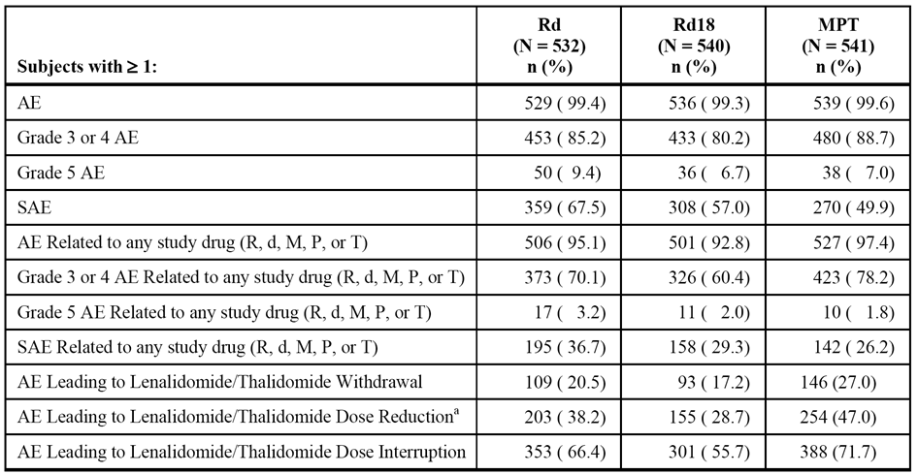

AE = adverse event; d = low-dose dexamethasone; M = melphalan; NCI CTCAE = National Cancer Institute Common Terminology Criteria for Adverse Events; P = prednisone; R = lenalidomide; SAE = serious adverse event; T = thalidomide. Note: All AEs were graded using NCI CTCAE Version 3.0. Data cutoff date = 24 May 2013. a = Dose reduction includes reduction with or without interruption.

###### AEs by SOC

AEs by System Organ Class (SOC) reported in ≥ 2% of patients in any treatment arm are summarised. AEs by SOC reported in ≥ 50% of patients in the Rd arm (vs Rd18 and MPT arms) were: general disorders and administration site conditions (82.1% vs 79.6% vs 78.0%); gastrointestinal disorders (81.6% vs 76.1% vs 76.2%); musculoskeletal and connective tissue disorders (76.7% vs 68.0% vs 57.5%); infections and infestations (74.8% vs 69.8% vs 56.4%); nervous system disorders (69.7% vs 61.7% vs 79.3%); blood and lymphatic disorders (65.0% vs 60.2% vs 78.2%); respiratory, thoracic, and mediastinal disorders (57.5% vs 48.0% vs 45.5%); metabolism and nutrition disorders (56.0% vs 50.7% vs 35.5%); and skin and subcutaneous tissue disorders (53.6% vs 51.5% vs 40.1%).

###### AEs by preferred term - irrespective of causality

AEs reported in ≥ 10% of patients in any treatment arm are summarised. The most commonly reported AEs (≥ 20% of patients) in the Rd arm (vs Rd18 and MPT arms) are summarised below in Table 26.

Table 26: MM-020 - AEs reported in ≥ 20% of patients in the Rd arm by decreasing order of frequency compared to the Rd18 and MPT arms; safety population.

| AE preferred term | Rd (n=532) | Rd18 (n=540) | MPT (n=541) |
| --- | --- | --- | --- |
| Diarrhoea | 45.5% | 38.5% | 16.5% |
| Anaemia | 43.8% | 35.7% | 42.3% |
| Constipation | 43.0% | 39.3% | 52.7% |
| Neutropenia | 35.0% | 33.0% | 60.6% |
| Back pain | 32.0% | 26.9% | 21.4% |
| Nausea | 28.6% | 23.7% | 30.5% |
| Peripheral oedema | 39.7% | 31.3% | 39.7% |
| Fatigue | 32.5% | 32.8% | 28.5% |
| Asthenia | 28.2% | 22.8% | 22.9% |
| Insomnia | 27.6% | 23.5% | 9.8% |
| Decreased appetite | 23.1% | 21.3% | 13.3% |
| Cough | 22.7% | 17.4% | 12.6% |
| Dyspnoea | 22.0% | 16.5% | 20.9% |
| Pyrexia | 21.4% | 18.9% | 14.0% |
| Rash | 21.4% | 24.3% | 17.2% |
| Muscle spasms | 20.5% | 18.9% | 11.3% |
| Peripheral sensory neuropathy | 20.5% | 17.0% | 35.3% |

Note: If the same AE was reported multiple times within a given preferred term, only one event with the worst severity was counted per subject.

AEs reported in ≥ 5% more patients in the Rd18 arm than in the MPT arm, in decreasing order of frequency in the Rd18 arm, were diarrhoea (38.5% vs 16.5%), back pain (26.9% vs 21.4%), insomnia (23.5% vs 9.8%), rash (24.3% vs 17.2%), muscle spasms (18.9% vs 11.3%), decreased appetite (21.3% vs 13.3%), weight decreased (14.4% vs 8.9%), pneumonia (12.6% vs 7.4%), and hyperglycaemia (9.6% vs 3.5%).

AEs reported in ≥ 5% more patients in the MPT arm than in the Rd18 arm, in decreasing order of frequency in the MPT arm were neutropenia (60.6% vs 33.0%), constipation (52.7% vs 39.3%), anaemia (42.3% vs 35.7%), peripheral oedema (39.7% vs 31.3%), peripheral sensory neuropathy (35.3% vs 17.0%), nausea (30.5% vs 23.7%), thrombocytopenia (25.0% vs 18.0%), dizziness (21.1% vs 13.0%), vomiting (20.1% vs 12.6%), paraesthesia (19.0% vs 13.7%), leukopenia (17.4% vs 11.1%), and lymphopenia (13.1% vs 8.0%).

In general, AEs were reported more frequently in patients in the Rd arm than in patients in the Rd18. Of particular note, cataract was reported twice as frequently in patients in the Rd arm than in patients in the Rd18 arm (13.7% vs 5.7%).

###### Drug-related AEs

Drug-related AEs were reported in 95.1% (506/531) of patients in the Rd arm, 92.8% (501/504) of patients in the Rd18 arm and 97.4% (527/541) of patients in the MPT arm. The most commonly reported drug-related AEs in the Rd arm occurring in ≥ 20% of patients were neutropenia (31.8%), constipation (23.7%), anaemia (23.7%), diarrhoea (22.4%), and fatigue (21.6%). Drug-related AEs reported in ≥ 5% of patients in any of the three treatment arms by individual study drug and regimen are summarised. The most commonly reported drug-related AEs (≥ 10% of patients) in the Rd arm (vs Rd18 and MPT arms) are summarised below in Table 27.

Table 27: Study MM-020 - Drug-related AEs reported in ≥ 10% of patients in the Rd arm by decreasing order of frequency compared to the Rd18 and MPT arms; safety population.

| AE preferred term | Rd (n=532) | Rd18 (n=540) | MPT (n=541) |
| --- | --- | --- | --- |
| Neutropenia | 31.8% | 30.6% | 59.0% |
| Constipation | 23.7% | 24.6% | 41.8% |
| Anaemia | 23.7% | 22.0% | 23.5% |
| Diarrhoea | 22.4% | 16.9% | 4.1% |
| Fatigue | 21.6% | 24.3% | 20.0% |
| Peripheral oedema | 19.7% | 17.6% | 21.3% |
| Insomnia | 18.2% | 16.3% | 4.3% |
| Peripheral sensory neuropathy | 16.5% | 14.3% | 33.6% |
| Thrombocytopenia | 16.2% | 13.9% | 20.9% |
| Asthenia | 14.7% | 13.0% | 12.9% |
| Rash | 14.3% | 16.1% | 12.6% |
| Muscle spasms | 12.8% | 12.0% | 6.7% |
| Paraesthesia | 10.9% | 8.3% | 15.7% |
| Leukopenia | 10.5% | 9.4% | 15,2% |
| Nausea | 10.2% | 8.7% | 18.7% |
| Tremor | 10.0% | 9.8% | 13.7% |

Note: If the same AE was reported multiple times within a given preferred term, only one event with the worst severity was counted per subject.

Drug-related AEs reported in ≥ 5% more patients in the Rd18 arm than in the MPT arm, in decreasing order of frequency in the Rd18 arm, were diarrhoea (16.9% vs 4.1%), insomnia (16.3% vs 4.3%), muscle spasms (12.0% vs 6.7%), and hyperglycaemia (8.1% vs 3.0%).

Drug-related AEs reported in ≥ 5% more patients in the MPT arm than in the Rd18 arm, in decreasing order of frequency in the MPT arm were neutropenia (59.0% vs 30.6%), constipation (41.8% vs 24.6%), peripheral sensory neuropathy (33.6% vs 14.3%), thrombocytopenia (20.9% vs 13.9%), nausea (18.7% vs 8.7%), paraesthesia (15.7% vs 8.3%), dizziness (13.3% vs 4.6%), vomiting (9.4% vs 3.7%), leukopenia (15.2% vs 9.4%), lymphopenia (10.9% vs 5.6%), peripheral neuropathy (10.5% vs 3.9%), and somnolence (8.1% vs 0.9%).

Drug-related AEs were generally reported more frequently in patients in the Rd arm than in the Rd18 arm. However, certain drug-related AEs such as constipation, neutropenia, peripheral sensory neuropathy, rash, and infections were reported at similar frequencies in patients in the Rd and Rd18 arms, possibly indicating that increased exposure does not necessarily increase risk of these events. However, drug-related cataract was reported in more than twice as many patients in the Rd arm than in the Rd18 arm (2.8% vs 0.4%).

###### Drug-related AEs by severity

The severity of AEs was categorised by NCI CTCAE severity grade criteria. The majority of drug-related AEs reported in the study were rated Grade 3 or 4 in severity. Drug-related Grade 3 or 4 AEs were reported in 70.1% (373/532) patients in the Rd arm, 60.4% (326/540) of patients in the Rd18 arm, and 78.2% (423/541) of patients in the MPT arm. Drug-related Grade 3 or 4 AEs reported in ≥ 5% of patients in the Rd arm were neutropenia (26.3%), anaemia (9.2%), thrombocytopenia (6.8%), fatigue (5.6%), rash (5.8%), and deep vein thrombosis (5.3%). The most commonly reported drug-related Grade 3 or 4 AEs (≥ 2% of patients) in the Rd arm (vs Rd18 and MPT arms) are summarised below in Table 28.

Table 28: MM-020 - Drug-related Grade 3 or 4 AEs reported in ≥ 2% of patients in the Rd arm by decreasing order of frequency compared to the Rd18 and MPT arms; safety population.

|  |  |  |  |
| --- | --- | --- | --- |
| AE preferred term | Rd (n=532)  (R or d) | Rd18 (n=540)  (R or d) | MPT (n=541)  (M or P or T) |
| Patients with ≥ 1 AE | 70.1% | 60.4% | 78.2% |
| Neutropenia | 26.3% | 24.8% | 43.3% |
| Anaemia | 9.2% | 8.1% | 10.4% |
| Fatigue | 5.6% | 7.4% | 5.4% |
| Thrombocytopenia | 6.8% | 6.1% | 7.9% |
| Rash | 5.8% | 4.8% | 5.0% |
| Deep vein thrombosis | 5.3% | 3.5% | 2.6% |
| Asthenia | 4.5% | 4.4% | 4.3% |
| Leukopenia | 4.3% | 5.0% | 8.9% |
| Lymphopenia | 4.3% | 2.0% | 5.9% |
| Pneumonia | 4.3% | 4.1% | 2.6% |
| Hyperglycaemia | 4.1% | 3.5% | 1.5% |
| Pulmonary embolism | 3.8% | 3.0% | 3.1% |
| Cataract | 3.0% | 1.5% | 0.4% |
| Diarrhoea | 2.6% | 2.0% | 0.4% |
| Oedema peripheral | 2.4% | 1.1% | 2.2% |
| Neuropathy peripheral | 2.3% | 0.9% | 3.7% |

Note: If the same AE was reported multiple times within a given preferred term, only one event with the worst severity was counted per subject.

Drug-related Grade 3 or 4 AEs reported in ≥ 5% more patients in the MPT arm compared to the Rd18 arm were neutropenia (43.3% vs 24.8%), due to the melphalan component, and peripheral sensory neuropathy (9.4% vs 0.4%), due to the thalidomide component. There were no drug related Grade 3 or 4 AEs reported in ≥ 5% more patients in the Rd18 arm compared to the MPT arm.

###### Safety in special subgroups

Age - AEs irrespective of causality

The CSR included a safety analysis comparing patients aged ≤ 75 years and patients aged ≥ 75 years. The high-level overview of AEs by age group in the three treatment arms are summarised below in Table 29.

Table 29: Study MM-020 - Overview of adverse events by dose stratum.

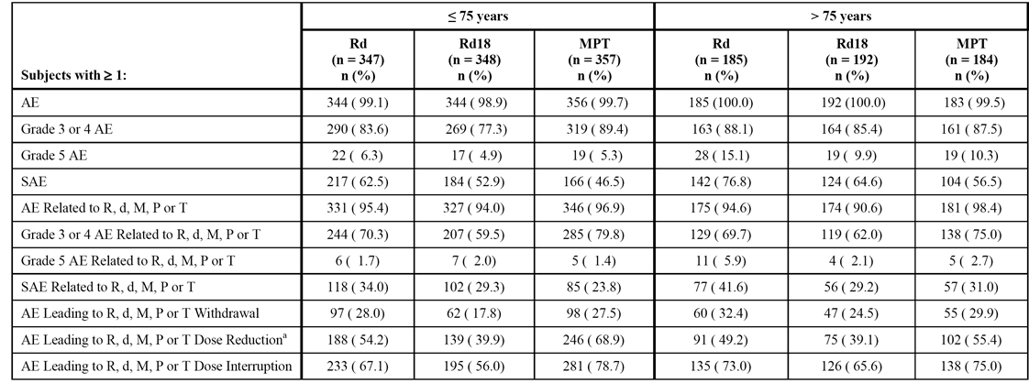

a = dose reduction includes reduction without interruption.

In the Rd arm, AEs were reported in nearly all patients aged ≤ 75 years and > 75 years (99.1% vs 100%, respectively). Most AE categories in the Rd arm occurred more frequently in patients aged > 75 years than in patients ages ≤ 75 years. In the Rd arm, Grade 3 or 4 AEs reported in ≥ 2% more patients in the > 75 year group (n=185) compared to the ≤ 75 years group (n=347) in descending order of frequency in the older age group were back pain (9.7% vs 5.5%), fatigue (9.2% vs 6.3%), hypocalcaemia (6.5% vs 3.2%), general physical health deterioration (5.4% vs 1.7%), congestive cardiac failure (3.2% vs 0.6%), fall (2.7% vs 0%), and lung infection (2.2% vs 0%). In the Rd arm, Grade 3 or 4 AEs reported in ≥ 2% more patients in the ≤ 75 years group (n=347) compared to the > 75 year group (n=185) in descending order of frequency in the younger age group were cataract (7.2% vs 3.2%), deep vein thrombosis (6.6% vs 3.2%), and hyperglycaemia (6.1% vs 3.8%).

Renal function - AEs irrespective of causality

The high-level overview of AEs by renal function in each of the three treatment arms is summarised. In general, in the Rd arm the frequency of all AE categories increased with increasing renal impairment. The most commonly reported Grade 3 or 4 AEs (≥ 10% of patients) occurring in at least one of the groups based on CrCl in the Rd arm (< 30 mL/min [n=45] vs ≥ 30 to < 50 mL/min [n=124] vs ≥ 50 to < 80 mL/min [n=24] vs ≥ 80 mL/min [n=123]) were: anaemia (24.4% vs 21.0% vs 17.5% vs 14.6%); neutropenia (24.4% vs 29.0% vs 31.3% vs 21.1%); thrombocytopenia (8.9% vs 7.3% vs 10.0% vs 5.7%); general physical healthy deterioration (11.1% vs 3.2% vs 2.5% vs 0.8%); pneumonia (8.9% vs 3.2% vs 10.0% vs 8.9%); renal failure acute (11.1% vs 8.1% vs 0.8% vs 0.8%); blood creatinine increased (11.1% vs 1.6% vs 0.4% vs 0%); and rash (20.0% vs 6.5% vs 4.6% vs 4.1%).

Sex

The comparison of safety between male and female patients focuses on the Rd arm. The high-level overview shows that the only AE categories in the Rd arm in which the difference between the sexes was ≥ 5% of patients were at "least one Grade 5 AE" (higher in males [11.9%] than females [6.3%]), and at "least one drug related SAE" (higher in males [39.9%] than in females [32.6%]). The high-level overview is summarised below in Table 30.

Table 30: MM-020 - Overview of adverse events in male and female patients in the Rd arm.

|  |  |  |
| --- | --- | --- |
| Event | Male (n=293) | Female (n=239) |
| At least one AE | 99.7% (n=292) | 99.2% (n=237) |
| At least one Grade 3 or 4 AE | 86.0% (n=252) | 84.1% (n=201) |
| At least one Grade 5 AE | 11.9% (n=35) | 6.3% (n=15) |
| At least one serious AE | 69.6% (n=204) | 64.9% (n=155) |
| At least one drug-related AE | 95.6% (n=280) | 94.6% (n=226) |
| At least one drug-related Grade 3 or 4 AE | 72.0% (n=211) | 67.8% (n=162) |
| At least one drug-related Grade 5 AE | 3.8% (n=11) | 2.5% (n=6) |
| At least one drug-related SAE | 39.9% (n=117) | 32.6% (n=78) |
| At least one AE leading to withdrawal | 30.4% (n=89) | 28.5% (n=129) |
| At least one AE leading to dose reduction | 51.2% (n=150) | 54.0% (n=129) |
| At least one AE leading to dose interruption | 69.6% (n=204) | 68.6% (n=164) |

In the Rd arm, Grade 3 or 4 SAEs (irrespective of causality) were reported in 86.0% of males and 84.1% of females. Grade 3 or 4 AEs by SOC reported with a difference of ≥ 5% of patients between the sexes in the Rd arm were: Infections and Infestations reported more frequently in males (33.1%) than in females (23.8%); Musculoskeletal and Connective Tissue Disorders reported more frequently in males (21.5%) than in females (16.3%); and Investigations reported more frequently in females (11.7%) than in females (6.5%). There were no sex-related differences occurring in ≥ 5% of patients for any Grade 3 or 4 AEs (preferred term).

Race

In study MM-020, the majority of patients were White or Caucasian (89.0%, n=1436), with most of the remaining patients being Asian (7.8%, n=126). The CSR included a safety comparison between these two populations, but comment was provided that caution should be exercised when comparing the two populations due to the "relatively limited number of subjects in the Asian group". It is considered that the marked imbalance in the number of patients between the two populations precludes meaningful comparison of the safety profiles.

##### Death and serious adverse events (SAEs)

###### Deaths

Overview

The overview of deaths occurring during active treatment and follow up is provided. The incidence of total deaths in the three treatment arms was 32.1% (171/532) in the Rd arm, 35.6% (192/540) in the Rd18 arm and 38.4% (208/541) in the MPT arm. Death from MM was reported in 11.5%, 15.6% and 16.3% of patients in the Rd, Rd18, and MPT arms, respectively. Death from other malignancy was reported in 1.1% to 1.9% of patients across the three treatment arms. Deaths in the active treatment phase (i.e., death between first dose date and last dose date + 28 days) occurred more frequently in the Rd arm (9.6% [51/532]) than in the Rd18 arm (6.9% [37/540]) and the MPT arm (7.0% [38/541]). The higher incidence of deaths in the active treatment phase in the Rd arm compared to the other two arms is due to the higher incidence of death from "other cause". The duration of the active treatment phase was notably longer in the Rd arm compared to the other two treatment arms, which might account for the higher incidence of death in this phase in this arm compared to the two other treatment arms. It is noted that the incidence of death in the active treatment phase in the Rd18 and MPT arms was similar (6.9% vs 7.0%, respectively). Deaths > 28 days after the last dose were lower in the Rd arm (22.6% [120/532]) than in the Rd18 arm (28.7% [155/540]) and the MPT arm (31.4% [170/541]).

The primary causes of death during the entire study (active treatment and follow-up phases) are summarised below in Table 31. Deaths from MM were notably lower in the Rd and Rd18 arms than in the MPT arm. Deaths due to Infection and infestations (SOC) occurred more frequently in the Rd arm than in the Rd18 arm, and more frequently in the MPT arm than in the Rd18 arm. Death due to Cardiac disorders (SOC) occurred more frequently in both the Rd and Rd18 arms than in the MPT arm.

Table 31: Study MM-020 - Primary causes during the entire study; safety population.

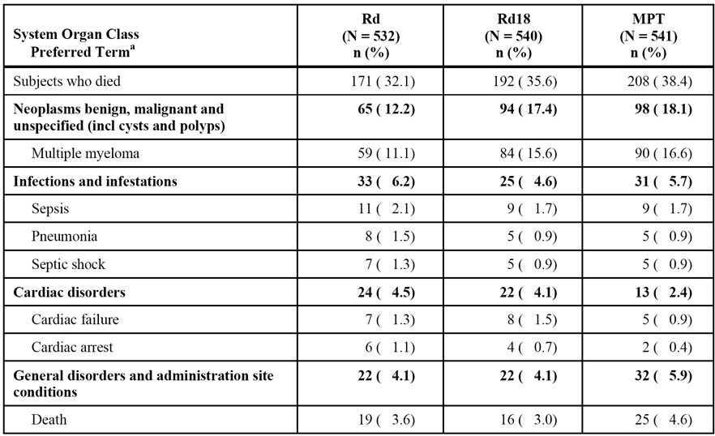

The primary causes of death during the active treatment phase are summarised. The majority of preferred term AEs reported as the primary cause of death were reported in < 1% of patients in any of the three treatment arm, with the exceptions being sepsis (1.1% in the Rd arm), death (1.3% in the Rd arm), and multiple myeloma (1.7% in the MPT arm). There was a higher incidence of death due to MM in the MPT arm (1.7%) than in the Rd (0.6%) and Rd18 arms (0.7%).

Infections were the most common cause of death during the active treatment phase, with almost all of the deaths due to infection resulting from bacterial infections. There was a higher incidence of death due to Infections and infestations (SOC) in the Rd arm (3.8%) arm compared to the Rd18 (2.0%) and MPT (1.8%) arms, predominantly due to the higher incidences of sepsis, septic shock, and pneumonia.

There was a higher incidence of Cardiac disorders (SOC) in both the Rd (1.9%) and the Rd18 (1.7%) arms than in the MPT arm (0.7%) in the active treatment phase, resulting predominantly from the higher incidence of AEs of cardiac arrest, cardiac failure, and myocardial infarction. In the active treatment phase, 23 patients died due to cardiac causes (10 [1.9%] in Rd arm, 9 [1.7%] in the Rd18 arm, and 4 [0.7%] in the MPT arm). Each of the 23 patients dying due to cardiac disorders had a history of cardiac disease and/or comorbidities or conditions associated with increased risk of cardiovascular disease (e.g., overweight/obesity, hypertension, hypercholesterolemia, diabetes), and 21 of the 23 patients were > 70 years of age. Most (n=14) of the 23 patients who died due to cardiac causes during the active treatment phase died within the first 6 months of treatment.

###### Other serious adverse events (irrespective of causality)

SAEs (irrespective of causality) were reported more frequently in patients in the Rd arm (67.5% [359/532]), than in the Rd18 (57.0% [308/540]) and the MPT (49.9% [270/541]) arms. SAEs reported in ≥ 2% of patients in the Rd arm in descending order of frequency were pneumonia (9.8%), anaemia (4.5%), pulmonary embolism (3.8%), acute renal failure (3.8%), back pain (3.6%), deep vein thrombosis (3.6%), pyrexia (3.4%), atrial fibrillation (3.4%), sepsis (2.8%), dyspnoea (2.6%), squamous cell carcinoma of the skin (2.6%), general physical health deterioration (2.4%), and bronchitis (2.3%).

SAEs were generally reported at a higher frequency in the Rd arm than in the Rd18 and MPT arms. SAEs reported in ≥ 1% more patients in the Rd arm compared to the Rd18 arm included bronchitis, pulmonary embolism, dyspnoea, atrial fibrillation, pyrexia, asthenia, anaemia, squamous cell carcinoma of the skin, basal cell carcinoma, and deep vein thrombosis. SAEs reported in ≥ 1% more patients in the Rd18 arm than in the MPT arm were pneumonia, upper respiratory tract infection, and acute renal failure. SAEs reported in ≥ 1% more patients in the MPT arm than in the Rd18 arm were anaemia and febrile neutropenia. SAEs reported in at least 1% of patients in any treatment arm are summarised.

##### Other significant adverse events

###### Permanent discontinuation due to adverse events

Permanent discontinuation due to AEs (irrespective of causality) were reported in 29.5% (157/532) of patients in the Rd arm, 20.2% (109/540) patients in the Rd18 arm, and 28.3% (153/541) of patients in the MPT arm (see Table 125, page 241). AEs resulting in permanent treatment discontinuation reported in ≥ 1% of patients in the Rd arm were pulmonary embolism (1.5%) and neutropenia (1.1%).

The only AE resulting in permanent treatment discontinuation in ≥ 1% more patients in the Rd18 arm compared to the MPT arm was general health deterioration (2.0% vs 0.2%). AEs resulting in permanent treatment discontinuation in ≥ 1% more patients in the MPT arm compared to the Rd18 arm were peripheral sensory neuropathy (6.8% vs 0.2%), neutropenia (2.0% vs 0.4%), peripheral neuropathy (1.1% vs 0%), and paraesthesia (1.1% vs 0%).

###### Adverse events resulting in dose interruption

AEs (irrespective of causality) resulting in dose interruption were reported more frequently in patients in the MPT arm (77.4% [419/541]) than in the Rd (69.2% [368/532]) and Rd18 (59.4% [321/540]) arms (see Table 126, page 241). AEs resulting in dose interruption reported in ≥ 2% of patients in the Rd arm were neutropenia (21.8%), pneumonia (7.9%), rash (6.6%), anaemia (5.5%), thrombocytopenia (5.8%), and fatigue (3.8%).

There were no AEs resulting in dose interruption in ≥ 5% more patients in the Rd18 arm compared to the MPT arm. AEs resulting in dose interruption in ≥ 5% more patients in the MPT arm compared to the Rd18 arm were neutropenia (48.1% vs 12.0%), thrombocytopenia (9.8% vs 3.0%), and peripheral sensory neuropathy (8.9% vs 0.2%).

###### Adverse events resulting in dose reduction

AEs (irrespective of causality) leading to dose reduction were reported more frequently in patients in the MPT arm (64.3% [348/541]) than in the Rd (52.4% [279/532]) and Rd18 (39.6% [214/540]) arms (see Table 127, page 242). AEs leading to dose reduction reported in ≥ 2% of patients in the Rd arm in descending order of frequency were neutropenia (7.5%), rash (4.5%), fatigue (4.3%), asthenia (3.9%), diarrhoea (3.2%), hyperglycaemia (3.0%), peripheral oedema (2.6%), thrombocytopenia (2.6%), peripheral neuropathy (2.4%), and anaemia (2.3%), and renal failure (2.1%).

There were no AEs leading to dose reduction in ≥ 2% more patients in the Rd18 arm compared to the MPT arm. AEs leading to dose reduction in ≥ 2% more patients in the MPT arm compared to the Rd18 arm were neutropenia (32.2% vs 5.6%), peripheral sensory neuropathy (10.4% vs 0.6%), thrombocytopenia (5.7% vs 1.7%), constipation (4.8% vs 0.4%), peripheral neuropathy (4.3% vs 1.1%), paraesthesia (3.0% vs 0%), and tremor (2.6% vs 0.4%).

##### Selected adverse events for known risks of lenalidomide (and thalidomide)

###### Neutropenia - selected adverse event

Preferred terms listed in MedDRA Version 15.1 high-level term (HLT) for neutropenias and the preferred terms (PTs) of neutrophil count decreased and neutrophil percentage decreased were collectively referred to as “neutropenia". Neutropenia (all Grade AEs) occurred more frequently in the MPT arm (62.5%) than in the Rd (35.7%) and Rd18 (33.5%) arms, as did Grade 3 or 4 AEs (46.6% vs 28.6% vs 27.2%, respectively) and SAEs (3.9% vs 3.0% vs 2.2%, respectively). Febrile neutropenia occurred in < 3% of patients in each treatment arm, while neutropenic sepsis occurred in less than 0.6% of patients in each treatment arm. Neutropenia Grade ≥ 3 occurring with a concurrent infection was reported in similar proportion of patients in each of the three treatment arms (10.9% in the Rd arm, 9.8% in the Rd18 arm, and 10.4% in the MPT arm). The incidence rate (per 100 person years) for the selected AE of "neutropenia" was highest in the MPT arm (64.13) than in both the Rd18 arm (33.92) and the Rd arm (21.39). The selected AEs of neutropenia are summarised.

###### Infection - selected adverse event

Preferred terms listed within the MedDRA Version 15.1 SOC of Infections and Infestations were collectively referred to as “infection.” Infection (all Grade AEs) occurred more frequently in the Rd arm (75.0%) and the Rd18 arm (70.0%) than in the MPT arm (56.4%), as did Grade 3 or 4 AEs (28.9% vs 21.9% vs 17.2%, respectively) and SAEs (30.6% vs 23.9% vs 16.5%). Infections (all Grade AEs) reported in ≥ 5% of patients in the Rd arm in decreasing order of frequency were bronchitis (16.9%), nasopharyngitis (15.0%), urinary tract infection (14.3%), upper respiratory tract infection (13.0%), pneumonia (12.4%), respiratory tract infection (6.6%), influenza (6.2%), gastroenteritis (6.0%), lower respiratory tract infection (5.5%), and rhinitis (5.5%). AEs (all Grade AEs) of infections reported in ≥ 3% more patients in the Rd18 compared to the MPR arm were pneumonia (12.6% vs 7.4%), urinary tract infection (11.7% vs 7.6%), bronchitis (10.9% vs 7.9%), nasopharyngitis (10.0% vs 6.1%), and upper respiratory tract infection (9.8% vs 5.7%). There were no infections reported in ≥ 3% more patients in the MPT arm compared to the Rd18 arm. Infections reported in ≥ 3% of patients in any treatment arm are summarised.

The incidence rate (per 100 person years) for the selected AE of "infections" was higher in the Rd (110.98) and the Rd18 (130.38) arms than in the MPT arm (93.10). Across all 3 treatment arms, the incidence rate for infections was highest during the first 6 months of treatment, and decreased in subsequent 6-month intervals. In this study, 5.0% (20/398), 3.7% (14/377), and 3.6% (11/305) of patients with infections (SOC) in the Rd, Rd18, and MPT arm, respectively, experienced an infection (SOC) leading to death (i.e., Grade 5 AE).

###### Thrombocytopenia - selected adverse event

Preferred terms listed within the MedDRA Version 15.1 SMQ narrow scope of haematopoietic thrombocytopenia were collectively referred to as “thrombocytopenia.” Thrombocytopenia (all Grade AEs) occurred more frequently in the MPT arm (25.3%) than in the Rd or Rd18 arms (19.5% vs 18.7%, respectively), as did Grade 3 or 4 AEs (11.3% vs 8.3% vs 11.3%, respectively) and SAEs (1.8% vs 1.1% vs 0.9%). The incidence rate (per 100 person years) for thrombocytopenia was higher in the MPT arm (25.14) than in the Rd arm (11.29) and the Rd18 arm (17.55).

###### Bleeding - selected adverse event

Preferred terms listed within the MedDRA Version 15.1 SMQ broad scope of haemorrhage terms (excluding laboratory terms), were collectively referred to as “bleeding.” Bleeding (all Grade AEs) was reported more commonly in the Rd arm than in the Rd18 and MPT arms (25.6% vs 21.5% vs 16.1%, respectively), as were Grade 3 or 4 AEs (3.0% vs 2.0% vs 2.6%) and SAEs (3.2% vs 2.0% vs 1.8%, respectively). Bleedings (all Grade AEs) reported in ≥ 2% of patients in the Rd arm were contusion (6.2%), epistaxis (6.0%), haematoma (3.6%), rectal haemorrhage (2.6%), and haematuria (2.3%). The only bleeding reported in ≥ 2% more patients in the Rd18 arm than in the MPT arm was epistaxis (5.7% vs 3.1%). There were no bleedings reported in ≥ 2% more patients in the MPT arm than in the Rd18 arm. The incidence rate (per 100 person-years) of bleeding was higher in the Rd18 arm than in both the Rd and MPT arms (25.39 vs 20.63 vs 19.13). The selected AE of bleeding reported in ≥ 1% of patients in any of the three treatment arms is summarised.

###### Peripheral neuropathy - selected adverse events

Preferred terms listed within the MedDRA Version 15.1 SMQ narrow scope of peripheral neuropathy were collectively referred to as “peripheral neuropathy.” Peripheral neuropathy (all Grade AEs) occurred notably more frequently in the MPT arm than in the Rd and Rd18 arms (48.1% vs 29.5% vs 22.8%, respectively), as did Grade 3 or 4 events (15.2% vs 2.6% vs 4.7%, respectively), while SAEs occurred infrequently in the three treatment arms (0.6% vs 0.4% vs 0%, respectively). Events reported in ≥ 5% more patients in the MPT arm than in the Rd18 arm were peripheral sensory neuropathy (35.3% vs 17.0%) and neuropathy peripheral (11.5% vs 4.1%). No peripheral neuropathies were reported in ≥ 5% more patients in the Rd18 arm than in the MPT arm. The incidence (per 100 person-years) of peripheral neuropathy was more than 2-fold higher in the MPT arm compared to the Rd and Rd18 arms (55.57 vs 20.85 vs 24.54, respectively).

###### Arterial thromboembolic events (ATEs) - selected adverse events

Preferred terms listed within the MedDRA Version 15.1 SMQ narrow scope for embolic and thrombotic events, arterial, were collectively referred to as “arterial thromboembolic events (ATE).” ATEs (all Grade AEs) were reported in 4.7%, 1.1% and 2.2% of patients in the Rd, Rd18, and MPT arms, respectively. The incidence rate (per 100 person-years) for ATEs was higher in the Rd arm than in the Rd18 and MPT arms (3.04 vs 1.02 vs 2.19). The most commonly reported ATEs across all treatment arms were myocardial infarction (cardiac disorders SOC) and transient ischaemic attack (nervous system disorders SOC) (0.7% each in the combined Rd/Rd18 treatment arms). The AE of myocardial infarction was reported in 1.5% , 0.4% and 0.4% of patients in the Rd, Rd18 and MPT arms, respectively. The AE of transient ischaemic attack was reported in 0.9%, 0.4% and 0.9% of patients in the Rd, Rd18, and MPT arms, respectively. The reported frequency of CVA was low across the three treatment arms (0.6%), with CVA (PT) AEs being reported in 0.8%, 0.6% and 0.6% of patients in the Rd, Rd18, and MPT arms, respectively.

###### Cardiac arrhythmias - selected adverse events

Preferred terms listed within the MedDRA Version 15.1 SMQ broad scope of cardiac arrhythmias (except for the sub-SMQ of congenital and neonatal arrhythmias) were collectively referred to as “cardiac arrhythmias.” Cardiac arrhythmias (all Grade AEs) were reported more commonly in the Rd arm compared to the Rd18 and MPT arms (25.0% vs 17.4% vs 22.7%), with Grade 3 or 4 AEs being reported in 7.7%, 5.6%, and 7.9%, of patients respectively, and SAEs being reported in 8.5%, 6.5%, and 5.9% of patients, respectively. The most commonly reported cardiac arrhythmia AE in the Rd arm was atrial fibrillation (7.0%). There were no cardiac arrhythmias reported in ≥ 2% more patients in the Rd18 than in the MPT arm. Cardiac arrhythmias reported in ≥ 2% more patients in the MPT than in the Rd18 arm were bradycardia (4.6% vs 2.0%), and syncope (5.0% vs 3.1%). There were no fatal cardiac arrhythmias reported in the three treatment arms during active treatment. The incidence rate (per 100 person-years) for cardiac arrhythmia was higher in the MPT arm than in the Rd and Rd18 arms (28.79 vs 19.98 vs 21.30).

###### Cardiac failure - selected adverse events

Preferred terms listed within the MedDRA Version 15.1 SMQ narrow scope of cardiac failure were collectively referred to as “cardiac failure.” Cardiac failure (all Grade AEs) was reported more commonly in the Rd arm than in the Rd18 and MPT arms (8.8% vs 5.2% vs 5.0%), as were Grade 3 or 4 AEs (5.1% vs 3.0% vs 3.1%, respectively) and SAEs (4.9% vs 3.9% vs 3.1%, respectively). Events reported in ≥ 2% of patients in the Rd arm were cardiac failure (3.2%), pulmonary oedema (2.8%) and cardiac failure congestive (2.6%). No cardiac failure event was reported in ≥ 2% more patients in the Rd18 arm compared to the MPT arm or in the MPT arm compared to the Rd18 arm. The incidence rates (per 100 person-years) for cardiac failure events were similar in the Rd, Rd18 and MPT arms (6.19 vs 5.62 vs 6.19). Cardiac failure events were reported more commonly in the first 6 months of treatment in each of the three treatment arms, than in the subsequent 6 month intervals.

###### Myocardial infarction/ischaemic heart disease - selected adverse events

Preferred terms listed within the MedDRA Version 15.1 SMQs broad scope of myocardial infarction and other ischaemic heart disease were collectively referred to as “ischaemic heart disease". Myocardial infarction/ischaemic heart disease (MI/IHD) (all Grade AE) events were reported more frequently in the Rd arm than in the Rd18 and MPT arms (8.1% vs 3.1% vs 3.1%, respectively), as were Grade 3 or 4 AEs (4.7% vs 1.5% vs 1.8%, respectively) and SAEs (5.6% vs 1.1% vs 1.8%, respectively). MI/IHD events reported in ≥ 1% of patients in the Rd arm were angina pectoris (3.2%), MI (1.5%), acute MI (1.1%) and coronary artery disease (1.1%). No MI/IHD events were reported in the Rd18 and MI arms with a frequency difference of ≥ 2% more patients. The incidence rate (per 100 person-years) of MI/IHD was greater in the Rd arm than in the Rd18 and MPT arms (6.52 vs 2.90 vs 4.19). During the first 6 months of treatment, the incidence rate (per 100 person-years) of MI/IHD was notably higher in the Rd arm than in Rd18 and MPT arms (13.93 vs 3.31 vs 4.75), and the incidence rate in the Rd arm in the subsequent 6 month intervals was much lower. The high incidence rate observed in the first 6 months of treatment in patients in the Rd arm is unexplained, but may be due to chance. The DMC reviewed and monitored the occurrences of cardiac events during the course of the study, and noted that there was no evidence for concern about the total number of cardiac events, the number of ≥ Grade 3 cardiac events or the distribution of cardiac events across the 3 treatment arms.

###### Renal failure - selected adverse events

Preferred terms listed within the MedDRA Version 15.1 SMQ narrow scope of acute renal failure, the preferred terms listed within the MedDRA Version 15.1 HLT of renal failure and impairment, and the MedDRA Version 15.1 preferred terms of blood creatinine increased, blood urea increased, and blood urea nitrogen/creatinine ratio increased were collectively referred to as “renal failure.” Renal failure (all Grade AEs) was reported more frequently in the both the Rd and Rd18 arms than in the MPT arm (17.7% vs 14.6% vs 11.3%), as were Grade 3 or 4 AEs (7.5% vs 6.7% vs 6.3%) and SAEs (7.1% vs 7.0% vs 5.4%). Renal failure events reported in ≥ 1% of patients in the Rd arm were blood creatinine increased (6.6%), renal failure (5.3%), renal failure acute (4.3%), renal impairment (2.8%), and renal failure chronic (1.3%). The only renal failure event reported in ≥ 2% more patients in the Rd18 than in the MPT arm was renal failure (6.1% vs 4.1%). No renal failure events were reported in ≥ 2% more patients in the MPT arm than in the Rd18 arm. The incidence rate (per 100 person-years) for renal failure (all) was similar in the Rd and MPT arms (12.60 and 13.85, respectively), and lower in both of these arms compared to the Rd18 arm (15.85).

###### Diarrhoea and constipation - selected adverse events

Preferred terms listed within the MedDRA Version 15.1 HLT of diarrhoea (excluding infective) were collectively referred to as “diarrhoea.” For the constipation search, the MedDRA Version 15.1 PT of constipation was used. Diarrhoea (all Grade AEs) was reported notably more frequently in the Rd and Rd18 arms than in the MPT arm (45.5% vs 38.5% vs 16.5%). The incidence rate (per 100 person-years) of diarrhoea was notably higher in the Rd and Rd18 arms than in the MPT arm (26.28 vs 35.5 vs 16.22, respectively). Constipation (all Grade AEs) was reported more frequently in the MPT arm than in the Rd and Rd18 arms (52.7% vs 43.0% vs 39.3%, respectively). The incidence rate (per 100 person-years) of constipation was notably higher in the MPT arm than in the Rd and Rd18 arms (51.93 vs 24.87 vs 36.13, respectively).

###### Cutaneous reactions - selected adverse events

Preferred terms listed within the MedDRA Version 15.1 SMQ broad scope for severe cutaneous adverse reactions were collectively referred to as “cutaneous reactions." Preferred terms listed within the MedDRA Version 15.1 HLT of urticarias were collectively referred to as “urticaria." Preferred terms listed within the MedDRA Version 15.1 HLT of rashes, eruptions, and exanthems, as well as the PT of drug rash with eosinophilia and systemic symptoms, were collectively referred to as “rash.” Cutaneous reactions (all Grade AEs) were reported more frequently in the Rd and Rd18 arms than in the MPT arm (29.9% vs 33.0% vs 22.6%, respectively), as were Grade 3 or 4 AEs (7.7% vs 7.2% vs 5.7%, respectively) and SAEs (1.5% vs 2.2% vs 0.6%, respectively). Cutaneous reactions reported in ≥ 2% of patients in the Rd arm were rash (21.4%), mouth ulceration (2.8%), stomatitis (2.6%), and conjunctivitis (2.4%). The only cutaneous reactions reported in ≥ 2% more patients in the Rd18 arm than in the MPT arm was rash (24.3% vs 17.2%). There were no cutaneous reactions reported in ≥ 2% more patients in the MPT arm than in the Rd18 arm. The incidence rate (per 100 person-years) of cutaneous reactions was higher in the Rd18 arm than in the Rd and MPT arms (35.45 vs 20.52 vs 25.87, respectively).

###### Cataracts - selected adverse events

Preferred terms listed within the MedDRA Version 15.1 HLT for cataract conditions include the following PTs: atopic cataract, cataract, cataract cortical, cataract diabetic, cataract nuclear, cataract subcapsular, lens discoloration, lenticular opacities, radiation cataract, and toxic cataract. The search criteria for cataracts exclude the following PTs: cataract congenital, cataract operation complication, and cataract traumatic. Cataract (all Grade AEs) was reported notably more frequently in the Rd and Rd18 arms than in the MPT arm (15.8% vs 6.1% vs 1.3%), as were Grade 3 or 4 AEs (7.3% vs 2.8% vs 0.7%), while SAEs were reported in 0.8% of patients in the Rd arm, 0% of patients in the Rd18 and 0.2% of patients in the MPT arm. The incidence rate (per 100 person years) of cataract was notably higher in the Rd and Rd18 arms than in the MPT arm (9.23 vs 5.79 vs 1.28, respectively).

###### Venous thromboembolic events (VTE) - selected adverse events

Preferred terms listed within the MedDRA Version 15.1 SMQ narrow scope for embolic and thrombotic events, venous, were collectively referred to as “venous thromboembolic events (VTE).” VTE (all Grade AEs) were reported more frequently in the Rd and Rd18 arms than in the MPT arm (14.1% vs 11.5% vs 7.9%), as were Grade 3 or 4 AEs (8.6% vs 6.1% vs 5.5%), while SAES were reported in 7.0% vs 4.3% vs 4.8% of patients, respectively. VTE reported in ≥ 2% of patients in the Rd arm were DVT (10.2%) and PE (3.9%). The only VTE reported in ≥ 2% more patients in the Rd18 arm than in the MPT arm was DVT (6.7% vs 3.7%). There were no VTE reported in ≥ 2% more patients in the MPT arm than in the Rd18 arm. The incidence rates (per 100 person years) of VTE were 10.10, 12.10 and 9.47 in the Rd, Rd18 and MPT treatment arms, respectively.

###### Hepatic disorders - selected adverse events

Preferred terms listed within the MedDRA Version 15.1 SMQ of drug-related hepatic disorders were collectively referred to as “hepatic disorders” and included sub-SMQs of cholestasis and jaundice of hepatic origin; drug-related hepatic disorders-severe events only (sub-SMQs of hepatic failure, fibrosis and cirrhosis and other liver damage-related conditions, hepatitis noninfectious, liver neoplasms benign [including cysts and polyps], liver neoplasms malignant and unspecified); liver-related investigations, signs and symptoms; and liver-related coagulation and bleeding disturbances were collectively referred to as “hepatic disorders.” Hepatic disorders (all Grade AEs) were reported more frequently in the Rd and Rd18 arms than in the MPT arm (8.8% vs 7.6% vs 5.9%, respectively). Hepatic disorders reported in ≥ 1% of patients in the Rd arm were hypoalbuminaemia (2.6%), GGT increased (1.7%), AST increased (1.7%), and blood alkaline phosphatase increased (1.1%). The incidence rate (per 100 person-years) of hepatic disorders was higher in the Rd18 arm than in the Rd and MPT arms (13.98 vs 8.36 vs 8.93, respectively). The hepatic disorders occurred more frequently during the first 6 months of treatment than at later time intervals across all three treatment arms.

###### Hypersensitivity

Preferred terms listed within the MedDRA Version 15.1 SMQ narrow scope of angioedema (minus the PTs of urticaria, urticaria cholinergic, urticaria chronic and urticaria papular; covered separately) were collectively referred to as “angioedema". Preferred terms listed in MedDRA Version 15.1 of drug hypersensitivity, hypersensitivity, multiple allergies, reaction to drug excipients, serum sickness, Type I hypersensitivity, Type II hypersensitivity, Type III immune complex mediated reaction and Type IV hypersensitivity reaction, and PTs within the HLT of anaphylactic responses were collectively referred to as “hypersensitivity.” Hypersensitivity (all Grade AEs) was reported in 6.2%, 5.0% and 4.4% of patients in the Rd, Rd18 and MPT arms, respectively. The only hypersensitivity event reported in ≥ 2% of patients in the Rd arm was face oedema (2.1%). There was 1 case of anaphylactic shock related to an injection of local anaesthetic reported in the Rd arm. The incidence rates (per 100 person-years) for hypersensitivity were 3.58, 4.77 and 4.92, respectively, in the Rd, Rd18 and MPT arms, respectively.

###### Interstitial lung disease - selected adverse event

Preferred terms within the MedDRA Version 15.1 SMQ narrow scope of interstitial lung diseases (excluding pulmonary radiation injury, radiation alveolitis, radiation fibrosis lung, radiation pneumonitis, respiratory syncytial virus bronchiolitis, and transfusion-related acute lung injury) and additional preferred terms of organizing pneumonia and pulmonary eosinophilia were collectively referred to as “interstitial lung disease." Interstitial lung disease was reported rarely in this study (0.8% [n=4] in the Rd arm, 0.4% [n=2] in the Rd18 arm and 0.6% [n=3] in the MPT arm). The incidence rates (per 100 person-years) for interstitial lung disease were 0.43, 0.34 and 0.55 in the Rd, Rd18 and MPT arms, respectively.

###### Tumour lysis syndrome

The MedDRA Version 15.1 preferred term of tumor lysis syndrome is referred to as “tumour lysis syndrome." The only case of tumour lysis syndrome (Grade 3 AE) was reported in the Rd arm.

##### Secondary Primary Malignancy (SPM)

The submission included data in the SPM document relating to the incidence of SPM in study MM-020 up until the cutoff date of 24 May 2013, and these data were also included in the CSR. As of the cutoff date of 24 May 2013, the median follow-up time for surviving subjects in the safety population was 37.0 months. The summary data at the cutoff date of 24 May 2013 for subjects who experienced at least one SPM are provided below in Table 28. The results showed that the frequency of patients with SPMs was similar in all three treatment arms (7.0%, Rd; 8.1%, Rd18; and 8.7%, MPT).

Table 32: Study MM-020 - Primary causes during the entire study; safety population.

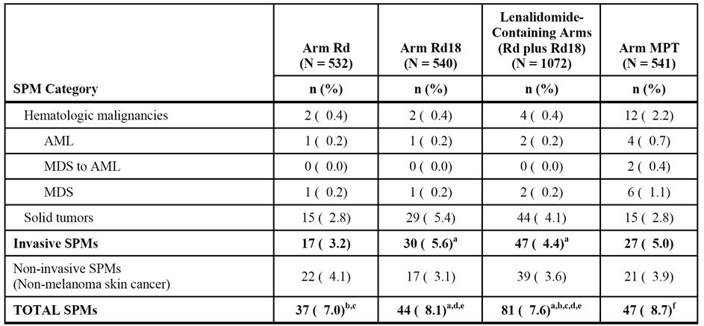

Notes: (1) currently, there have been no reports of SPMs with a B-cell malignancy histology; (2) total includes the number of subjects with at least one SPM. Subjects who experienced more than one SPM (e.g., 2 types of SPMs) or more than one episode of an SPM are counted once in each SPM category and once in the total. a = subject [information redacted] (Rd18) had a haematologic SPM (AML), a solid tumour (malignant melanoma), and non-melanoma skin cancers. This subject is counted only once in the invasive SPMs and the total. b = subject [information redacted] (Rd) had a haematologic malignancy (MDS) and a non-melanoma skin cancer. This subject is counted only once in the total. c = subject [information redacted] (Rd) had a solid tumour (bladder transitional cell carcinoma) and a non-melanoma skin cancer. This subject is counted only once in the total. d = subject [information redacted] (Rd18) had a solid tumour (prostate cancer) and a non-melanoma skin cancer. This subject is counted only once in the total. e = subject [information redacted] (Rd18) had a solid tumour (superficial spreading melanoma stage unspecified) and non-melanoma skin cancers. This subject is counted only once in the total. f = subject [information redacted] (MPT) had a solid tumour (sebaceous carcinoma) and non-melanoma skin cancers. This subject is counted only once in the total.

The incidence data adjusted for duration of exposure (i.e., 100 person-years) are summarised below in Table 33.

Table 33: MM-020 - Incidence rates (per 100 person-years of exposure) for SPM; safety population.

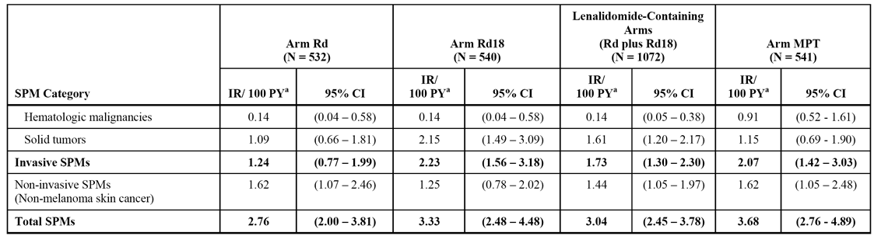

The median times to SPM onset in the treatment arms are summarised below in Table 34.

Table 34: Study MM-020 - Median time to onset of SPM in the treatment arms; safety population.

|  |  |  |  |  |
| --- | --- | --- | --- | --- |
|  | Rd (n=532) | Rd18 (n=540) | Rd + Rd18 (n=1072) | MPT (n=541) |
| All SPMs (months) | 22.5 (range: 1.2, 55.9) | 14.2 (range: 0.0, 45.6) | 18.9 (range: 0.0, 52.9) | 23.2 (range: 0.5, 42.8) |
| Invasive SPM (months) | 24.1 (range: 10.8, 49.4) | 15.4 (range: 3.3, 38.4) | 18.9 (range: 3.3, 49.4) | 21.3 (range: 0.5, 40.0) |
| Haem SPM (months) | 31.4 (range: 29.3, 33.6) | 23.3 (range: 5.6, 41.0) | 31.4 (range: 5.6, 41.0) | 23.2 (range: 14.3, 36.3) |
| Solid Tumours (months) | 22.5 (range: 10.8, 49.4) | 15.6 (range: 3.3, 38.4) | 18.6 (range: 3.3, 49.4) | 16.9 (range: 0.5, 40.0) |
| Non-invasive SPM (months) | 22.7 (1.2, 55.9) | 14.6 (range: 0.0, 45.6) | 19.7 (range: 0.0, 52.9) | 23.6 (range: 8.3, 42.8) |

The outcomes of the patients with SPMs are summarised below in Table 35. Of the 128 patients who experienced an SPM, 88 were alive at the date of data cutoff (27 subjects in the Rd arm, 32 subjects in the Rd18 arm, and 29 subjects in the MPT arm), and 40 had died (10 subjects in the Rd arm, 12 subjects in the Rd18 arm, and 18 subjects in the MPT arm).

Table 35: MM-020 - Summary of outcomes of SPM at data cutoff of 24 May 2013; safety population.

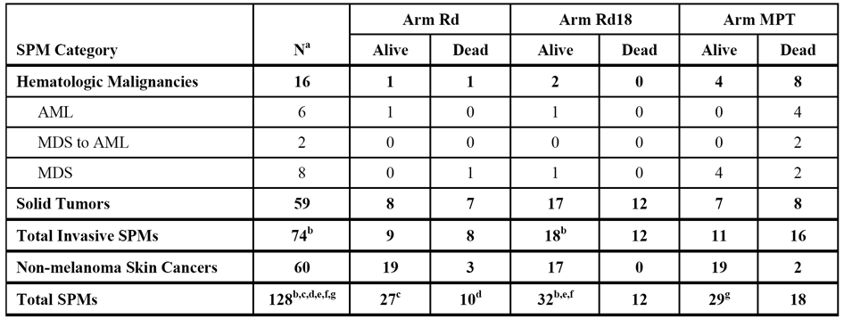

Notes: a = Number of subjects with an SPM; b = Subject [information redacted] (Rd18) had a haematologic SPM (AML), a solid tumor (malignant melanoma), and non-melanoma skin cancers. This subject is counted only once in the invasive SPMs and the total; c = Subject [information redacted] (Rd) had a solid tumor (bladder transitional cell carcinoma) and a non-melanoma skin cancer. This subject is counted only once in the total; d = Subject [information redacted] (Rd) had a hematologic malignancy (MDS) and a non-melanoma skin cancer. This subject is counted only once in the total; e = Subject [information redacted] (Rd18) had a solid tumour (prostate cancer) and a non-melanoma skin cancer. This subject is counted only once in the total; f = Subject [information redacted] (Arm Rd18) had a solid tumor (superficial spreading melanoma stage unspecified) and non-melanoma skin cancers. This subject is counted only once in the total; g = Subject [information redacted] (MPT) had a solid tumour (sebaceous carcinoma) and non-melanoma skin cancers. This subject is counted only once in the total.

Sequential cumulative incidence rate curves for both the Rd plus Rd18 arms and the MPT arm showed that incidence rates of invasive SPMs over a follow-up period ranging from 24 months to 60 months was < 2 per 100 person-years and did not increase over time.

The cumulative incidence curves using the KM method for time to onset of haematological SPM showed that the HR ([Rd+Rd18]/[MPT]) was 0.157 (95% CI: 0.051, 0.486), p<0.001 (log-rank, 2 sided), indicating that the risk of experiencing a haematological SPM was significantly higher in the MPT arm than in the combined Rd/Rd18 arms. Furthermore, the median time to onset of haematological SPM was notably longer in the combined Rd/Rd18 arms than in the MPT arm (31.4 vs 23.2 months, respectively). The haematological SPMs in the three treatment arms were AML and MDS.

The cumulative incidence curves using the KM for time to onset of solid tumour SPM showed that the HR ([Rd+Rd18]/[MPT]) was 1.409 (95% CI: 0.784, 2.533), p=0.249 (log-rank, 2-sided), indicating no statistically significant difference in the risk between the two treatment arms. The median time to onset of solid tumours was comparable in the combined Rd/Rd18 arms and the MPT arm (18.6 vs 16.9 months, respectively).

The cumulative incidence curves using the KM for time to onset of invasive SPM showed that the HR ([Rd+Rd18]/[MPT]) was 0.831 (95% CI: 0.518, 1.335), p=0.443 (log-rank, 2-sided), indicating no statistically significant risk between the two treatment arms. The median time to onset of invasive SPM was comparable in the Rd/Rd18 arms and the MPT arms (18.9 vs 21.3 months, respectively).

A competing risk analysis based on Gray’s method was performed to examine the cumulative incidence of invasive SPMs as well as haematologic and solid tumor SPMs over time with death as the competing risk using the data cutoff date of 24 May 2013.14 There was a statistically significant difference between the cumulative incidence of haematologic SPMs between the combined Rd/Rd18 arms and the MPT arm (p=0.0004), with the cumulative incidence being greater in the MPT arm than in the combined Rd/Rd18 arms. This result was consistent with that observed for the cumulative incidence curves using the KM method for time to onset of haematological malignancies (p<0.001). There were no statistically significant differences observed between the cumulative incidences of both solid tumor and invasive SPMs for the combined Rd plus Rd18 arms and the MPT arm using competing risk analysis (p = 0.1881 and p = 0.5706, respectively). These results were consistent with those observed for the cumulative incidence curves using the KM method for time to onset of solid tumours (p=0.249) and time to onset of invasive SPMs (p=0.443).

##### Long-term tolerability with prolonged lenalidomide exposure

To assess the tolerability of prolonged administration of lenalidomide, the CSR included a summary of AEs by time of onset for those patients in the Rd arm who received treatment for > 18 months. In addition, the CSR included incidence rates (per 100 person-years) for selected AEs summarised by 6-month intervals up to 60 months to assess early vs late onset AEs.

The data showed that AEs generally occurred most frequently during the first 6 months of treatment. In the Rd arm, the frequency of patients with at least one AE in consecutive 6-month time-intervals were 98.9% (268/271) 0-6 months, 95.6% (259/271) 6-12 months, 93.0% (252/271) 12-18 months, 91.1% (247/271) 18-24 months, 87.0% (181/208) 24-30 months, and 74.2% (121/163) 30-36 months. The frequencies of the following AEs notably decreased (> 2-fold and at least 5% absolute difference) after the first 6 months of treatment in patients in the Rd arm: fatigue, constipation, nausea, dyspepsia, muscle spasms, dizziness, tremor, dysgeusia, lymphopenia, dyspnoea, rash, insomnia, and weight decreased. Upper respiratory infection, thrombocytopenia, cataract, and fall were among the AEs for which frequencies of onset were not highest during the first 6 months. However, with the exception of cataract, frequencies of onset for these AEs were stable throughout the 36 months analysed and generally higher during the first 18 months than during the second 18 months. The frequency of onset for cataracts increased with treatment duration, with frequency of onset being 0.7% during the first 6 months, 2.6% during 6 to 12 months, 4.8% during 12 to 18 months, 7.7% during 18 to 24 months, 9.6% during 24 to 30 months, and 2.5% during 30 to 36 months. This observation is consistent with the association of cataracts with long-term use of dexamethasone. No other notable trends were observed regarding the onset of AEs over time in the Rd arm.

In general, the frequency of onset of Grade 3 or 4 AEs in patients in the Rd arm appeared to be evenly distributed throughout the 36 months analysed. The frequencies of patients with at least one Grade 3 or 4 AE in the 6-month time intervals were 54.6% (148/271) 0-6 months, 38.4% (104/271) 6-12 months, 40.2% (109/271) 12-18 months, 45.4% (123/271) 18-24 months, 38.9% (81/208) 24-30 months, and 29.4% (48/163) 30-36 months. However, the number of reports for individual AEs (preferred term) in each 6-month onset period were low, making trends difficult to identify. Neutropenia and anaemia were the only Grade 3 or 4 AEs reported in ≥ 10% of patients during the overall study period in the Rd arm, and both of these Grade 3 or 4 AEs were reported most frequently during the first 6 months of treatment, after which the frequencies of onset decreased and remained stable.

The use of selected concomitant therapies remained relatively stable over time, with frequencies in the first (0-6 month) and last (30-36 month) time intervals being 100% and 97.5%, respectively for anti-thrombotics, 62.4% and 47.9%, respectively, for anti-infectives, 20.7% and 16.6% for erythropoietin stimulating agents, and 10.7% and 4.9%, respectively, for granulocyte-colony stimulating factors. The sponsor states that the stable use of selected concomitant medications over time was consistent with the stable frequencies over time of the AEs which treatment was aimed to prevent (i.e., DVT/PE, infections, anaemia, neutropenia).

Overall, Rd was reasonably well tolerated long-term, with toxicity being manageable by temporary dose interruption and dose reduction allowing treatment to continue through 36 months.

##### Clinical laboratory tests

###### Overview

Clinical laboratory evaluations included haematology, serum chemistry, creatinine clearance, thyroid function, and urinalysis, and were performed at baseline and at scheduled intervals throughout the study. Central rather than local laboratory data were used to analyse clinical laboratory values.

###### Haematology

In the active treatment phase, a higher proportion of patients in the MPT arm compared to the R18 arm had shifts from baseline normal, Grade 1, or Grade 2 to post-baseline Grade 3 values in ANC (182/525 [34.6%] vs 119/529 [22.5%]) and platelets (43/524 [8.2%] vs 26/534 [4.7%]), and to a less extent in haemoglobin (68/501 [13.6%] vs 59/517 [11.4%]). In addition, a higher proportion of subjects in the MPT arm than in the Rd18 arm had shifts from baseline, normal, Grade 1, 2, or 3 to post-baseline Grade 4 values in ANC (77/526 [14.6%] vs 41/534 [7.7%]) and platelets (14/526 [2.7%] vs 7/535 [1.3%]), but not in haemoglobin (17/523 [3.3%] vs 17/533 [3.2%]). The proportion of patients in the Rd and Rd18 arms who had shifts to a most extreme post-baseline value was generally similar for the selected haematology parameters of ANC, platelets and haemoglobin.

###### Chemistry

In the active treatment phase, shifts to a most extreme post-baseline value in the serum chemistry parameters were most frequently observed for glucose, inorganic phosphorous, and uric acid in all treatment arms. In these shifts to a worst grade, both serum-low and serum-high values for glucose were captured, while only serum-low values for phosphate and serum-high values for uric acid were captured.

In the active treatment phase, the proportion of patients with shifts from baseline normal, Grade 1, or Grade 2 to post-baseline Grade 3 was higher in the Rd18 arm than in the MPT arm for both glucose (28/501 [5.6%] vs 10/488 [2.0%]) and inorganic phosphorous (32/498 [6.4%] vs 9/483 [1.9%]) parameters, but not for uric acid (31/406 [7.6%] vs 29/392 [7.4%]). A higher proportion of patients in the Rd arm compared to the Rd18 arm had shifts from normal, Grade 1, or Grade 2 to Grade 3 values in glucose (43/495 [8.7%] vs 28/501 [5.6%]) and inorganic phosphorus (52/490 [10.6%] vs 32/498 [6.4%), while a similar proportion of subjects in the Rd and Rd18 arms reported shifts from normal, Grade 1, or Grade 2 to Grade 3 values in uric acid (28/406 [6.9%] vs 31/406 [7.6%]). Few subjects had shifts from normal, Grade 1, 2, or 3 to Grade 4 values in selected chemistry parameters, apart from shifts in uric acid (21/461 [4.6%] in the Rd arm, 16/476 [3.4%] in the Rd18 arm, and 13/453 [2.9%] in the MPT arm).

Shifts in serum creatinine from normal, Grade 1, or Grade 2 to Grade 3 values were similar across all three arms (5/501 [1.0%] in the Rd18 arm, 5/485 [1.0%] in the MPT arm, and 6/492 [1.2%] in the Rd arm). No patients in the Rd18 or MPT arms had shifts from baseline to post-baseline for Grade 4 serum creatinine levels, while in the Rd arm one patient had a shift from Grade 1 baseline value to Grade 4 post-baseline and one patient had a shift from Grade 3 baseline to Grade 4 post-baseline.

###### Laboratory abnormalities reported as AEs.

Clinically significant laboratory abnormalities could also be reported as AEs based on local laboratory data. Hypokalemia, hyperglycaemia, and hypocalcaemia were the relevant SOC Metabolism and Nutrition Disorders reported in at least 10% of patients in any treatment arm (Rd vs Rd18 vs MPT): i.e., hypokalaemia (17.1% vs 11.5% vs 7.0%); hyperglycaemia (11.7% vs 9.6% vs 3.5%); and hypocalcaemia (10.7% vs 10.4% vs 5.7%). Cases of Grade 3/4 hyperglycaemia, as metabolic AEs, were more frequently reported in the Rd and Rd18 arms than in the MPT arm (5.3% vs 4.3% vs 1.7%, respectively).

##### Vital signs

* In the majority of patients in the three treatment arms, vital signs remained at normal levels throughout the course of the study. There were no clinically meaningful differences among the three treatment arms in changes in vital signs during the course of the study. In addition, no clinically meaningful differences were observed in mean weight at any time during the study.
* In the three treatment arms, no clinically significant changes in ECG findings were observed over the course of the study for the majority of patients for whom baseline and post-baseline results were available. The percentage of patients with baseline to most extreme post-baseline category change was similar across the three treatment arms for each of the examined changes (see Table 36, below).

Table 36: MM-020 - Shifts from baseline to most extreme post-baseline categories in ECG findings during the active treatment phase in patients with baseline and post-baseline data; safety population.

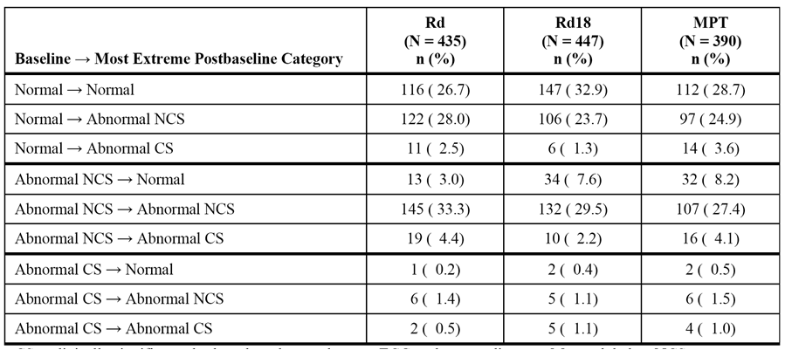

CS = clinically significant; d = low-dose dexamethasone; ECG = electrocardiogram; M = melphalan; NCS = not clinically significant; P = prednisone; R = lenalidomide; T = thalidomide. N = Total number of subjects in each treatment group with baseline and post-baseline ECG data. This number is the denominator for calculating percentages of subjects with the respective grade shift. Data cutoff date = 24 May 2014.

#### Supportive study - MM-015

##### Exposure

Study MM-015 provided safety data relating to the treatment of patients aged ≥ 65 years with NDMM who are not eligible for ASCT. The proposed lenalidomide dosage regimen of interest comprised induction therapy with combination melphalan, prednisone, and lenalidomide for up to 9 cycles followed by maintenance therapy with single-agent lenalidomide until disease progression or toxicity (i.e., MPR+R arm). This regimen was compared to induction therapy with MPR for up to 9 cycles followed by maintenance therapy with placebo (MPR+p arm), and with MP plus placebo for up to 9 cycles followed by maintenance therapy with placebo (i.e., MPp+p arm).

Following study unblinding on 11 May 2010, placebo treatment was stopped for all randomized subjects in the MPR+p and MPp+p arms, while subjects in MPR+R arm could continue lenalidomide maintenance as open-label therapy. As of the 30 April 2013 data cutoff date, the median treatment duration in the MPR+R arm was 62.6 weeks (range: 3.4, 297.0 week), which was longer than in both the MPR+p arm (53.0 weeks [range: 2.0, 162.7]) and the MPp+p arm (53.0 weeks [range: 1.0, 160.3]). The proportion of subjects who had more than 104 weeks of treatment was higher in the MPR+R arm (32.0%; 48/150) than in both the MPR+p arm (13.8%; 21/152) and the MPp+p arm (13.1%; 20/153).

In the induction period, the safety population included 150, 152, and 153 patients, respectively, in the MPR+R, MPR+p, and MPp+p arms. The median duration of treatment was similar for the 3 treatment arms: 36.1, 36.8, and 36.0 weeks in the MPR+R, MPR+p, and MPp+p arms, respectively, and a median number of 9 cycles were administered in each treatment arm. The median cumulative dose of lenalidomide was 78% (1470/1890 mg) and 80% (1850/1890 mg) of the planned dose in the two lenalidomide arms (i.e., MPR+R and MPR+p respectively), compared to 98% (1850/1890 mg) of the placebo dose in the MPp+p arm. The median dose intensity of lenalidomide was lower in the MPR+R and MPR+p arms (6.5 and 6.1 mg/day) than the median dose intensity of placebo in the MPp+p arm (7.3 mg/day). Likewise, the median relative dose intensity of placebo in the MPp+p arm (0.97) was higher than that of lenalidomide in the MPR+R and MPR+p arms (0.86 and 0.81, respectively).

In the maintenance period, the safety population included 88, 94, and 102 patients in the MPR+R, MPR+p, and MPp+p arms, respectively. The median duration of treatment was notably longer in the MPR+R arm (82.4 weeks) compared to the MPR+p arm (27.8 weeks) and the MPp+p arm (31.3 weeks), as was the median number of cycles administered (17.5, 7.0, and 8.0, respectively). The median cumulative dose of lenalidomide was 3146.3 mg in the MPR+R arm, and the median cumulative dose of placebo was 1,325.0 mg in the MPR+p arm and 1,670.0 mg in the MPp+p arm. The median dose intensity was 6.6 mg/day of lenalidomide in the MPR+R arm, 7.3 mg/day of placebo in the MPR+p arm, and 7.5 mg/day of placebo in the MPp+p arm, which is consistent with the anticipated lenalidomide dose intensity of 7.5 mg/day for the treatment regimen (i.e., days 1-21 per 28-day cycle). The median relative dose intensity was 0.88 for lenalidomide in the MPR+R arm, and 0.97 and 1.00 for placebo in the MPR+p and MPp+p arms, respectively.

##### Adverse events

###### Overview of adverse events

Induction period

During the induction period, treatment-emergent AEs were defined as any AEs occurring or worsening in intensity on or after the first treatment of any study drug, and within 30 days after the last dose of the last study drug. In some sections of the CSR describing AEs during the induction therapy period, the report discussed the AE data for the lenalidomide containing arms (i.e., MPR+R plus MPR+p) together since these 2 treatment arms received the same triplet induction treatment regimen. The high-level overview of AEs in the induction period are summarised below in Table 37.

Table 37: MM-015 - Overview of AEs reported during induction therapy (up to 9 cycles); safety population.

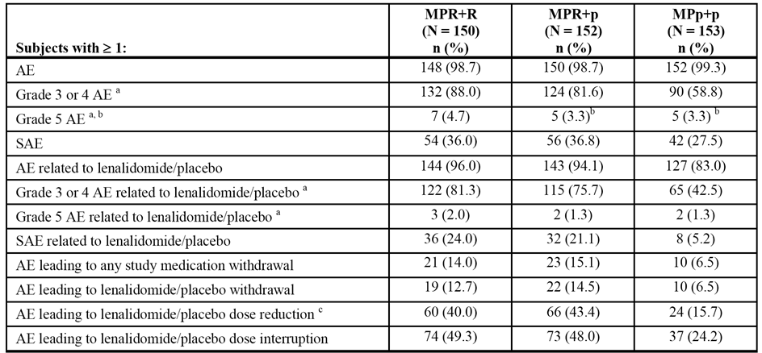

a = All AEs were graded using NCI CTCAE Version 3.0; b = Four subjects in the MPR+p arm and 6 subjects in the MPp+p arm died during the induction therapy period. One subject in the MPR+p arm had a Grade 5 AE of MM reported during the induction therapy period, but the death occurred post-treatment. The cause of death for 1 subject in the MPp+p arm was unknown, and thus no Grade 5 AE was reported for this subject; c = Includes reduction with or without interruption.

*Comment: In each of the 3 treatment arms, AEs were reported in > 98% of patients. Of note, Grade 3 or 4 AEs were reported notably more frequently in both the MPR+R and MPR+p arms than in the MPp+p arm, suggesting an association with lenalidomide. Overall, the high-level data suggest that induction therapy (up to 9 cycles) was better tolerated by patients treated with the regimen not containing lenalidomide (MPp) than patients treated with the regimens containing lenalidomide (MPR+R and MPR+p).*

Maintenance period

During the maintenance period, AEs were reported when they occurred, regardless of when dosing ended. Consequently, AEs with an onset date in the maintenance period were included in the data summaries, even if the onset date occurred > 30 days after the last dose of study drug. The high-level overview of AEs reported during the maintenance period are summarised below in Table 38.

Table 38: MM-015 - Overview of AEs reported during maintenance therapy; safety population.

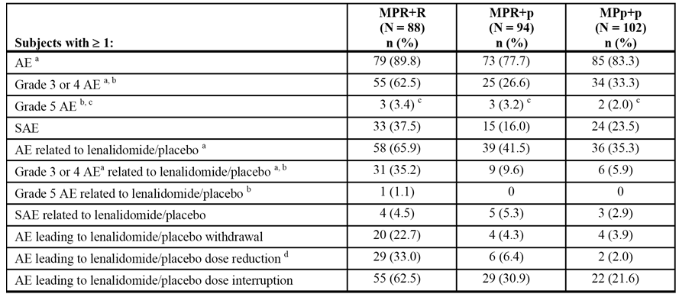

a = Includes all AEs that had a start date on or after the date of the first dose in the maintenance therapy period or that worsened in intensity during the maintenance therapy period; b = All AEs were graded using NCI CTCAE Version 3.0; c = Four subjects (1 x in MPR+R, 2 x in MPR+p, and 1 x in MPp+p) died > 30 days after the last dose of study drug and thus are included in the summary tables for Grade 5 AEs but not the summary tables for deaths during the maintenance therapy period; d = Includes reduction with or without interruption.

*Comment: For patients in the MPR+p and MPp+p arms, the maintenance period ended at the time of unblinding, while the maintenance period continued after unblinding for patients in the MPR+R arm. Therefore, the duration of lenalidomide maintenance was almost 3 times as long as the duration of placebo maintenance. During the maintenance period, AEs (new occurrence or worsening intensity) were reported for a large proportion of subjects in all three treatment arms: 89.8% in the MPR+R arm; 77.7% in the MPR+p arm; and 83.3% in the MPp+p arm. The proportion of patients with Grade 3 or 4 AEs (new occurrence or worsening intensity) was notably higher in the MPR+R arm than in both the MPR+p and the MPp+p arms (62.5% vs 26.6% vs 33.3%, respectively). In general, most high-level AE categories occurred more frequently in the patients who received lenalidomide maintenance than in patients who received placebo maintenance.*

###### Commonly occurring adverse events (irrespective of causality)

Induction period

At least one AE during the induction period was reported in ≥ 98.5% of patients in each of the three treatment arms. AEs reported with a frequency of ≥ 10% in the induction period are summarised. AEs reported in ≥ 10% of patients in both the MPR+R and MPR+p arms, respectively, in the induction period were: neutropenia (79.3%, 78.9%); thrombocytopenia (68.0%, 66.4%); anaemia (66.7%, 62.5%); leukopenia (33.3%, 38.2%); constipation (32.7%, 25.7%); fatigue (28.0%, 34.9%); bone pain (25.3%, 23.7%); diarrhoea (24.0%, 21.7%); nausea (23.3%, 26.3%); pyrexia (22.7%, 23.0%); peripheral oedema (20.7%, 23.7%); asthenia (20.0%, 13.2%); rash (18.0%, 27.6%); cough (16.7%, 13.8%); anorexia (13.3%, 23.0%); vomiting (12.7%, 11.8%); dyspnoea (12.7%, 11.8%); nasopharyngitis (12.0% vs 11.0%); muscle spasms (10.7%, 11.2%); and insomnia (10.0%, 11.2%).

AEs reported in ≥ 10% of patients in the MPR+R arm and in ≥ 5% more patients than in the MPp+p arm were: neutropenia (79.3% vs 50.3%); thrombocytopenia (68.0% vs 41.2%); anaemia (66.7% vs 50.3%); constipation (32.7% vs 23.5%); pyrexia (22.7% vs 17.6%); peripheral oedema (20.7% vs 15.7%); asthenia (20.0% vs 13.1%); rash (18.0% vs 7.8%); cough (16.7% vs 11.1%); muscle spasms (10.7% vs 3.9%); and hypokalaemia (11.3% vs 2.6%).

AEs reported in ≥ 10% of patients in the MPR+p arm and in ≥ 5% more patients than in the MPp+p arm were: neutropenia (78.9% vs 50.3%); thrombocytopenia (66.4% vs 41.2%); anaemia (62.5% vs 50.3%); pyrexia (23.0% vs 17.6%); peripheral oedema (23.7% vs 15.7%); anorexia (23.0% vs 14.4%); rash (27.6% vs 7.8%); muscle spasms (11.2% vs 3.9%); and hypokalaemia (7.2% vs 2.6%).

AEs reported in ≥ 10% of patients in the MPp+p arm and in ≥ 5% more patients in this arm than in both the MPR+R and the MPR+p arms were nausea (33.1% vs 23.3% vs 26.3%, respectively) and back pain (17.6% vs 9.3% vs 9.9%, respectively).

Maintenance period

At least one AE (new or worsening) during the maintenance period was reported in 89.8%, 77.7%, and 83.3% of patients in the MPR+R, MPR+p and MPp+p arms, respectively. AEs reported in ≥ 10% of patients in any of the three treatment arms are summarised.

Nearly all AEs (new or worsening) reported in ≥ 10% of patients in the MPR+R arm occurred in ≥ 5% more patients than in the MPR+p arm. AEs specifically meeting these criteria were: bone pain; back pain; musculoskeletal pain; nasopharyngitis; upper-respiratory tract infection; bronchitis; diarrhoea; fatigue; anaemia; thrombocytopenia; and neutropenia.

Nearly all AEs (new or worsening) reported in ≥ 10% of patients in the MPR+R arm occurred in ≥ 5% more patients than in the MPp+p arm. AEs specifically meeting these criteria were: musculoskeletal pain; nasopharyngitis; upper respiratory tract infection; bronchitis; fatigue; anaemia; thrombocytopaenia; neutropenia; and cough

No AEs (new or worsening) were reported in ≥ 10% of patients in the MPR+p arm and in ≥ 5% more patients than in the MPR+R arm. No AEs (new or worsening) were reported in ≥ 10% of patients in the MPp+p arm and in ≥ 5% more patients than in the MPR+R arm.

###### Commonly occurring adverse events (related to lenalidomide/placebo)

Induction period

AEs related to treatment with lenalidomide or placebo during the induction period were reported in 96.0%, 94.1% and 83.0% of patients in the MPR+R, MPR+p, and MPp+p arms, respectively. AEs reported to be related to lenalidomide or placebo in at least 10% of patients in any treatment arm in the induction period are summarised.

AEs related to treatment with lenalidomide reported in ≥ 20% of subjects in both the MPR+R and MPR+p arms vs placebo in the MPp+p arm, respectively, in the induction period were: neutropenia (78.0% vs 76.3% vs 46.4%); thrombocytopenia (64.7% vs 61.8% vs 39.2%); anaemia (58.0% vs 52.0% vs 38.6%); leukopenia (33.3% vs 35.5% vs 30.1%); 17.6%); and fatigue (22.0% vs 22.4% vs 19.6%).

AEs related to treatment with lenalidomide reported in ≥ 10% of patients in either the MPR+R or MPR+p arms and occurring in ≥ 5% more patients in both arms compared to AEs related to placebo in the MPp+p arm were: neutropenia; thrombocytopenia; anaemia; and rash;

There were no AEs related to treatment with placebo reported in ≥ 10% of patients in the MPp+p arm occurring in ≥ 5% more patients compared to AEs related to lenalidomide reported in either the MPR+R or the MPp+p arm.

Maintenance period

AEs (new occurrence or worsening) related to lenalidomide or placebo during the maintenance period was reported in 65.9%, 41.5%, and 35.3% of patients in the MPR+R, MPR+p and MPp+p arms, respectively. AEs (new occurrence or worsening) related to lenalidomide or placebo reported during the maintenance period reported in at least 2% of subjects are summarised.

AEs (new occurrence or worsening) related to lenalidomide reported in ≥ 10% of patients in the MPR+R arm in the maintenance period were: anaemia (15.9%); fatigue (13.6%); diarrhoea (12.5%); and neutropenia (11.4%). No AEs (new occurrence or worsening) related to placebo were reported in ≥ 10% of patients in the MPR+p or MPp+p arms during the maintenance period.

###### Grade 3 or 4 adverse events (irrespective of causality)

Induction period

Grade 3 or 4 AEs in the induction period were reported in 88.0%, 81.6%, and 58.8% of patients in the MPR+R, MPR+p, and MPp+p arms, respectively. Grade 3 or 4 AEs reported during the induction period in at least 2% of patients in any treatment arm are summarised.

Grade 3 or 4 AEs in the induction period reported in ≥ 5% of subjects in both the MPR+R and MPR+p arms vs the MPp+p arm, respectively, were: neutropenia (70.0% vs 65.8% vs 30.5%); thrombocytopenia (36.7% vs 40.1% vs 12.4%); anaemia (24.0% vs 47.0% vs 13.7%); and leukopenia (24.0% vs 27.0% vs 13.7%).

Grade 3 or 4 AEs reported in ≥ 2% of patients in both the MPR+R and MPR+ arms and in ≥ 2% more patients in both arms than in the MPp+p arm were: neutropenia; thrombocytopaenia; anaemia; leukopenia; febrile neutropenia; hypokalaemia; and rash.

Maintenance period

Grade 3 or 4 AEs (new occurrence or worsening intensity) in the maintenance period were reported in 62.5%, 26.5%, and 33.3% of patients in the MPR+R, MPR+p, and MPp+p arms, respectively. Grade 3 or 4 AEs reported during the induction period in 2 or more patients in any treatment arm are summarised.

Grade 3 or 4 AEs (new occurrence or worsening intensity) reported in ≥ 5% of patients in the MPR+R arm during the maintenance period vs the MPR+p and the MPp+p arms, respectively, were: anaemia (23.9% vs 5.3% vs 7.8%); thrombocytopenia (9.1% vs 3.2% vs 2.0%); and neutropenia (6.8% vs 0% vs 1.0%). Other Grade 3 or 4 AEs (new occurrence or worsening intensity) reported in ≥ 2% of patients in the MPR+R arm and more frequently than in both the MPR+p and the MPp+p arms were: granulocytopenia; hypokalaemia; diarrhoea; fatigue; appendicitis; acute myeloid leukaemia; myelodysplastic syndrome; deep vein thrombosis; and cholestasis.

###### Grade 3 or 4 adverse events (drug-related)

Induction period

Grade 3 or 4 AEs related to lenalidomide or placebo in the induction period were reported in 81.3%, 75.7% and 42.5% of patients in the MPR+R, MPR+p, and MPp+p arms, respectively.

Grade 3 or Grade 4 AEs reported in ≥ 5% of patients in both the MPR+R and MPR+p arms during the induction period vs the MPp+p arm, respectively, were: neutropenia (68.7% vs 63.2% vs 29.4%); thrombocytopenia (34.7% vs 38.8% vs 12.4%); leukopenia (24.0% vs 26.3% vs 13.1%); and anaemia (18.0% vs 21.1% vs 7.8%).

Drug-related Grade 3 or 4 AEs reported in ≥ 2% of patients in both the MPR+R and MPR+ arms and in ≥ 2% more patients in both arms than in the MPp+p arm were: neutropenia; thrombocytopenia; leukopenia; anaemia; febrile neutropenia; and rash.

Maintenance period

Grade 3 or 4 AEs (new occurrence or worsening intensity) related to treatment with lenalidomide or placebo in the maintenance period were reported in 35.2%, 9.6%, and 5.9% of patients in the MPR+R, MPR+p, and MPp+p arms, respectively.

Grade 3 or 4 AEs (new occurrence or worsening intensity) related to lenalidomide or placebo reported in ≥ 5% of patients in the MPR+R arm during the maintenance period vs the MPR+p and the MPp+p arms, respectively, were: anaemia (6.8% vs 1.1% vs 1.0%); thrombocytopenia (6.8% vs 2.1% vs 0%); neutropenia (6.8% vs 0% vs 0%); and granulocytopenia (3.4% vs 0% vs 0%). Other Grade 3 or 4 AEs (new occurrence or worsening intensity) related to lenalidomide or placebo reported in ≥ 2% of patients in the MPR+R arm and more frequently than in both the MPR+p and the MPp+p arms were diarrhoea and fatigue.

###### Adverse events in special populations

Age

The high-level AE profiles for patients grouped according to age (≤ 75 years vs > 75 years) in the induction and maintenance periods are summarised.

**Induction period**

During the induction period, the frequencies of all AE categories were consistently higher in patients aged > 75 years compared to patients aged ≤ 75 years across all three treatment arms. The overall AE profiles of the lenalidomide induction regimens (MPR+R and MPR+p) were notably inferior than the non-lenalidomide induction regimen (MPp+p) in both the age groups. Furthermore, the overall AE profiles of the two lenalidomide induction regimens (MPR+R and MPR+p) were notably inferior in the > 75 years age group than in the ≤ 75 years age group, particular with regard to SAEs, Grade 3 or 4 AEs, AEs leading to any study medication withdrawal or to lenalidomide or placebo withdrawal, and lenalidomide or placebo dose reductions.

**Maintenance period**

Meaningful interpretation of the effect of age on the AE profiles of the three treatment arms in the maintenance period is limited due to the relatively small number of patients aged ≥ 75 years receiving maintenance therapy.

Sex

The most frequent AEs reported in men and women in all three treatment arms during the induction period were (respectively) neutropenia, thrombocytopenia, anaemia, and leukopenia, with higher percentages being reported in women than on men across all three treatment arms. A similar trend was also observed for Grade 3 or 4 AEs for neutropenia, thrombocytopenia, anaemia, leukopenia and febrile neutropenia and for SAEs.

Of note, in the induction period DVT was reported in a higher percentage of men than women in the MPR+p arm (8.5% vs 2.9%), while pulmonary embolism was reported by a higher percentage of women than men in the MPR+R arm (3.8% vs 0%). A similar trend was observed for Grade 3 or 4 AEs and serious DVT and pulmonary embolism. Overall, pneumonia was reported more frequently in men (5.7%, 9.8%, and 10.7% in the MPR+R, MPR+p, and MPp+p arms, respectively) than in women (3.8%, 5.7%, and 5.1% in the MPR+R, MPR+p, and MPp+p arms, respectively), while diarrhoea was reported more frequently in women (27.1% to 36.3% in the three treatment arms) than in men (10.0% to 17.1% in the three treatment arms).

The sponsor comments that, in general, the results for all Grade AEs, Grade 3 or 4 AEs, and SAEs in men and women in any of the three treatment arms observed in the induction period were similar to those observed in the induction and maintenance periods combined.

##### Death and serious adverse events (SAEs)

###### Death

A summary of deaths occurring in the study are summarised below in Table 39. In general, the overall profile for deaths occurring in the study was similar for the three treatment arms.

Table 39: MM-015 - Overview of patients who died in the study; safety population.

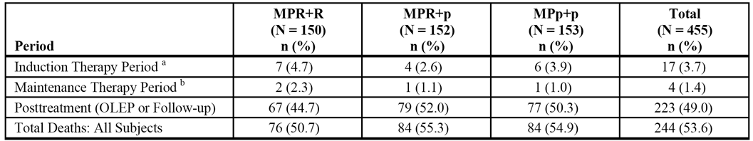

Notes: a = The cause of death for 1 subject in Arm MPp+p was unknown, and thus no Grade 5 AE was reported for this subject; b = Four subjects died > 30 days after the last dose of study drug thus are included in the summary tables for Grade 5 AEs, but not the summary tables for deaths. The percentages are based on the number of subjects who entered the maintenance therapy period. One Subject (MPp+p) died shortly after randomisation and did not take study drug is not included in this summary. Data cutoff date = 30 April 2013.

The primary causes of death in the induction period are summarised. The most commonly reported primary causes of death were Cardiac Disorders SOC, reported in 2.7% (4/150) of patients in the MPR+R arm, 0% (0/152) of patients in the MPR+p arm and 0.7% (1/153]) of patients in the MPp+p arm. The only AE (PT) reported as a primary cause of death in ≥ 2 patients in the three treatment arms was cardiogenic shock, which was reported in 2 (1.3%) patients in the MPR+R arm, 1 (0.7%) patient in the MPp+p arm and no patients in the MPR+p arm. Of the 17 patients who died during the induction period, 10 were in the > 75 year age group and 7 were in the ≥ 75 year age group.

The investigator considered that 7 of the 17 deaths during the induction period were related to treatment with lenalidomide or placebo. Grade 5 AEs suspected to be related to treatment with lenalidomide or placebo included: in the combined lenalidomide arms (MPR+R and MPR+p) - cardiogenic shock (1 x patient), infection and septic shock (1 x patient), pneumonia (2 x patients), and pulmonary embolism (1 x patient); in the MPp+p arm - lower respiratory tract infection (1 x patient), and cardiogenic shock (1 x patient). Of the 7 patients for whom Grade 5 AEs were suspected to be related to treatment with lenalidomide or placebo, 5 patients were aged > 75 years.

There were 4 (1.4%) deaths in the maintenance period. The primary cause of death for the 2 patients who had received placebo was MM (i.e., PD), and for the 2 patients who had received lenalidomide (MPR+R arm), the primary causes of death were subarachnoid haemorrhage and cardiovascular insufficiency (1 patient each). The subject who died due to subarachnoid hemorrhage received DVT prophylaxis (acetylsalicylic acid) starting on Day 70 and ongoing at the time of death. None of the Grade 5 AEs associated with these deaths was suspected to be related to lenalidomide or placebo. Three (3) of the 4 deaths in the maintenance period were in patients aged > 75 years.

Death due to cardiac causes were reported in 5 patients in the induction period (4 in the MPR+R arm, 1 in the MPp+p arm, none in the MPR+p arm), and 1 patient in the maintenance period (MPR+R arm). All 6 patients who died to cardiac causes had significant histories of cardiac disease and/or multiple clinically significant co-morbidities, including infections and neutropenia. Four (4) of the 6 patients were aged > 75 years.

##### Other serious adverse events (SAEs)

###### SAEs (irrespective of causality)

Induction period

In the induction period, 36.0%, 36.8%, and 27.5% of patients in the MPR+R, MPR+p, and MPR+p arms, respectively, reported at least one SAE. In general, low frequencies (≤ 2%) for individual SAEs (PTs) were reported in each of the three treatment arms. SAEs reported during the induction period in ≥ 2 patients in any of the three treatment arms are summarised.

SAEs reported in ≥ 2% of patients in either the MPR+R or MPR+p arms vs the MPp+p arm, respectively, were: neutropenia (4.0% vs 2.6% vs 0.7%); anaemia (3.3% vs 4.6% vs 1.3%); pneumonia (2.7% vs 5.3% vs 5.2%); sepsis (0.7% vs 2.0% vs 0.7%); febrile neutropenia (6.0% vs 1.3% vs 0%); thrombocytopenia (0.7% vs 2.0% vs 0.7%); pyrexia (4.0% vs 1.3% vs 2.6%); fatigue (2.7% vs 0.7% vs 0.7%); atrial fibrillation (0.7% vs 2.0% vs 2.0%); constipation (1.3% vs 2.0% vs 0.7%); nausea (2.0% vs 1.3% vs 1.3%); vomiting (2.0% vs 0.7% vs 2.0%); diarrhoea (2.0% vs 0.7% vs 0.7%); dyspnoea (1.3% vs 2.0% vs 0.7%); deep vein thrombosis (0% vs 3.3% vs 0%); and renal failure (0% vs 2.0% vs 0.7%). SAEs reported in ≥ 2% of patients in either the MPR+R or MPR+P arm and in more patients in both lenalidomide treatment arms than in the MPp+p arm were: neutropenia; anaemia; pneumonia; febrile neutropenia; constipation; and dyspnoea.

Maintenance period

In the maintenance period, SAEs were reported in 37.5%, 16.0%, and 23.5% of patients in the MPR+R, MPR+p and MPp+p arms, respectively. SAEs reported in ≥ 2% of patients in the MPR+R vs the MPR+p and MPp+p arms were: acute myeloid leukaemia (4.5% vs 1.1% vs 0%); myelodysplastic syndrome (2.3% vs 0% vs 0%); appendicitis (2.3% vs 0% vs 0%); sinusitis (2.3% vs 0% vs 0%); bone pain (2.3% vs 0% vs 2.9%); pyrexia (2.3% vs 0% vs 2.9%); inguinal hernia (2.3% vs 0% 0%); thrombocytopenia (2.3% vs 1.1% vs 0%); and cholestasis (2.3% vs 0% vs 0%). SAEs reported in ≥ 2% of patients in the MPR+R arm and more frequently than in the both MPR+p and MPp+p arms were: acute myeloid leukaemia; myelodysplastic syndrome; appendicitis; sinusitis; inguinal hernia; thrombocytopenia; and cholestasis.

###### SAEs (related to lenalidomide/placebo)

Induction period

In the induction period, SAEs related to lenalidomide or placebo were reported in 24.0%, 21.1% and 5.2% of patients in the MPR+R, MPR+p and MPp+p arms, respectively. SAEs related to lenalidomide or placebo reported in ≥ 2% of patients in either the MPR+R or MPR+p arms vs the MPp+p arm, respectively, were: anaemia (2.7% vs 3.3% vs 0%); febrile neutropenia (4.7% vs 1.3% vs 0%); neutropenia (2.7% vs 1.3% vs 0.7%); pneumonia (2.0% vs 3.9% vs 1.3%); fatigue (2.0% vs 0.7% vs 0%); pyrexia (2.7% vs 0% vs 0.7%); and deep vein thrombosis (0% vs 2.6% vs 0%). SAEs related to lenalidomide or placebo were reported in ≥ 2% of patients in either the MPR+R or MPR+P arm and in more patients in both lenalidomide treatment arms than in the MPp+p arm were: anaemia; febrile neutropenia; neutropenia; pneumonia; and fatigue.

Maintenance period

Of the 72 patients with reported SAEs during the maintenance period, 12 patients had SAEs reported to be related to treatment with lenalidomide or placebo: 4 (4.5%) in the MPR+R arm; 5 (5.3%) in the MPR+p arm; and 3 (2.9%) in the MPp+p arm. No individual lenalidomide or placebo related SAE (PT) was reported in more than one patient in any of the three treatment arms. The only SAEs (PT) reported in ≥ 2 patients in the three treatment arms combined were: acute myeloid leukaemia in 2 patients (1 x MPR+R arm; 1 x MPR+p arm); and deep vein thrombosis in 2 patients (1 x MPR+R arm; 1 x MPR+p arm).

##### Other significant adverse events

###### AEs resulting in permanent discontinuation of lenalidomide or placebo

Induction period

AEs resulting in permanent discontinuation of lenalidomide or placebo during the induction period were reported more frequently in patients in the MPR+R and MPR+p arms (12.7% and 14.5%, respectively) than in the MPp+p arm (6.5%). AEs in the SOC of blood and lymphatic system disorders, particularly thrombocytopenia and neutropenia, were the major causes of permanent treatment discontinuation in the MPR+R and MPp+p arms (see Table 40, below).

Table 40: MM-015 - Adverse events leading discontinuation of lenalidomide or placebo during induction therapy in 2 or more patients; safety population.

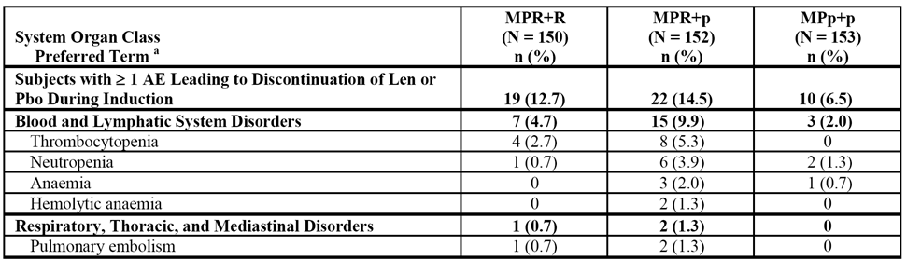

Notes: a = System organ classes and preferred terms were coded using the MedDRA Version 10. If multiple AEs were reported within a given preferred term, only 1 event was counted per subject. Data cutoff date = 30 April 2013.

Maintenance period

AEs resulting in discontinuation in the maintenance period due to lenalidomide or placebo arms occurred more frequently in patients in the MPR+R arm (22.7%) than in patients in the MPR+p and MPp+p arms (4.3% vs 3.9%, respectively). The most frequently reported AEs (≥ 2% of patients) resulting in discontinuation of lenalidomide or placebo in the maintenance period in the MPR+R, MPR+p and MPp+p arms, respectively, were: acute myeloid leukaemia (4.5% vs 0% vs 0%); diarrhoea (3.4% vs 0% vs 0%); and neutropenia (2.3% vs 0% vs 0%). The only other AE resulting in discontinuation in the maintenance period in ≥ 2 patients was renal failure (2 [2.0%] patients in the MPp+p arm; no patients in the MPR+R or MPR+p arms).

###### Adverse events resulting in temporary dose interruption

Induction period

AEs leading to temporary dose interruption of lenalidomide or placebo in the induction period occurred more frequently in the MPR+R and MPR+p arms (76.0% vs 77.0%, respectively) than in the MPp+p arm (49.0%). AEs leading to dose interruptions of lenalidomide reported in ≥ 10% of patients in both the MPR+R and MPR+p arms (vs placebo in the MPp+ arm), respectively, were: neutropenia (55.3% vs 47.4% vs 19.6%); thrombocytopenia (40.7% vs 38.8% vs 20.9%); and anaemia (16.0% vs 15.1% vs 7.8%). AEs leading to dose interruption of lenalidomide or placebo during the induction period in ≥ 2% of patient in any of the three treatment arms are summarised.

Maintenance period

AEs leading to temporary dose interruption of lenalidomide or placebo in the maintenance period occurred more frequently in the MPR+R arm (63.6%) than in the MPR+p and MPp+p arms (31.9% vs 22.5%). AEs leading to dose interruptions of lenalidomide reported in ≥ 10% of patients in the MPR+R arm (vs placebo in the MPR+p and MPp+p arms), respectively, were: neutropenia (31.8% vs 2.1% vs 4.9%); and thrombocytopenia (13.6% vs 6.4% vs 0%). AEs leading to dose interruption of lenalidomide or placebo during the maintenance period reported in 2 or more patients in any of the three treatment arms are summarised.

###### Adverse events resulting in dose reduction

Induction period

AEs leading to dose reduction of lenalidomide or placebo in the maintenance period occurred more frequently in the MPR+R and MPR+p arms (40.0% vs 43.4%, respectively) than in the MPp+p arm (15.7%). AEs leading to dose reductions of lenalidomide in the induction period reported in ≥ 10% of patients in both the MPR+R and MPR+p arms (vs placebo in the MPp+ arm), respectively, were: neutropenia (21.3% vs 18.4% vs 7.2%); and thrombocytopenia (18.7% vs 19.7% vs 9/2%). AEs leading to dose interruption of lenalidomide or placebo during the induction period in ≥ 2% of patient in any of the three treatment arms are summarised**.**

Maintenance period

AEs leading to dose reduction of lenalidomide or placebo in the maintenance period occurred more frequently in the MPR+R arm (33.0%) than in the MPR+P or MPR+p arms (6.4% vs 2.0%, respectively). AEs leading to dose reduction of lenalidomide or placebo in 2 or more subjects in the MPR+R, MPR+p or MPp+p arms, respectively, in descending order of frequency in the MPR+R arm, were: neutropenia (11.4% vs 0% vs 1.0%); thrombocytopenia (5.7% vs 0% vs 0%); anaemia (3.4% vs 3.2% vs 0%); fatigue (3.4% vs 1.1% vs 1.0%); granulocytopenia (2.3% vs 0% vs 0%); and rash (2.3% vs 0% vs 0%).

##### Selected adverse events during the induction or maintenance periods

###### Neutropenia and infection

The MedDRA Version 10 preferred terms listed within the high-level term (HLT) for neutropenias plus the preferred terms of neutrophil count decreased and neutrophil percentage decreased were collectively referred to as “neutropenia.” Preferred terms listed within the MedDRA Version 10 SOC of infections and infestations (excluding the PTs of T-cell lymphoma and T-cell type acute leukemia) were collectively referred to as “infection.” Neutropenia in the induction or maintenance periods occurred notably more frequently in the MPR+R and MPR+P arms than in the MPp+p arm, while infections occurred with similar frequencies across the three treatment arms (see Table 41, below).

Table 41: MM-015 - Selected AEs of neutropenia and infection in the induction or maintenance periods.

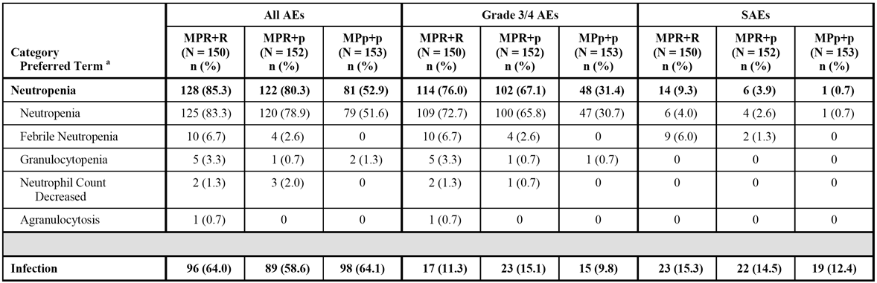

Notes: a = Categories and preferred terms are coded using MedDRA Version 10. If multiple AEs were reported within a given preferred term, only 1 event with the worst grade was counted per subject. Data cutoff date = 30 April 2013.

###### Thrombocytopenia

Preferred terms listed within the MedDRA Version 10 SMQ for thrombocytopenia were collectively referred to as “thrombocytopenia.” Thrombocytopenia in the induction and maintenance periods occurred notably more frequently in the MPR+R and MPR+p arms than in the MPp+p arm (see Table 42, below).

Table 42: MM-015 - Selected AE of thrombocytopenia in the induction or maintenance periods.

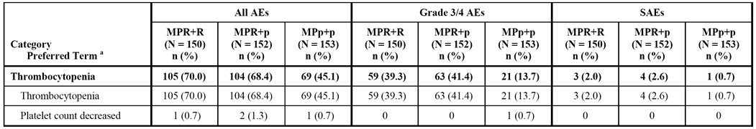

Notes: a = Categories and preferred terms are coded using MedDRA Version 10. If multiple AEs were reported within a given preferred term, only 1 event with the worst grade was counted per subject. Data cutoff date = 30 April 2013.

###### Diarrhoea and constipation

Preferred terms listed within the MedDRA Version 10 HLT of diarrhoea (excluding infective) were collectively referred to as “diarrhoea.” The MedDRA Version 10 preferred term of constipation was collectively referred to as “constipation.” Diarrhoea in the induction and maintenance periods occurred more commonly in the MPR+R arm than in the MPR+P and MPp+ arms (33.3% vs 24.3% vs 25.5%, respectively), as did constipation (34.0% vs 27.6% vs 24.8%, respectively).

###### Rash, severe cutaneous reactions (Steven Johnson Syndrome [SJS] and toxic epidermal necrolysis [TEN]), and urticaria

Preferred terms listed within the MedDRA Version 10 HLT of rash, eruptions and exanthems not elsewhere classified, were collectively referred to as “rash.” Preferred terms listed within the MedDRA Version 10 severe cutaneous adverse reactions SMQ (narrow scope), as well as the preferred term of acute febrile neutrophilic dermatitis, were collectively referred to as “severe cutaneous reactions.” Preferred terms listed within the MedDRA Version 10 HLT of urticarias were collectively referred to as “urticaria.” In the induction or maintenance periods, rash occurred notably more frequently in the MPR+R and MPR+p arms than in the MPp+p arm (see Table 43, below). There were no cases of SJS or TEN reported in the study.

Table 43: MM-015 - Selected AEs of rash, severe cutaneous reactions, and urticaria in the induction or maintenance periods.

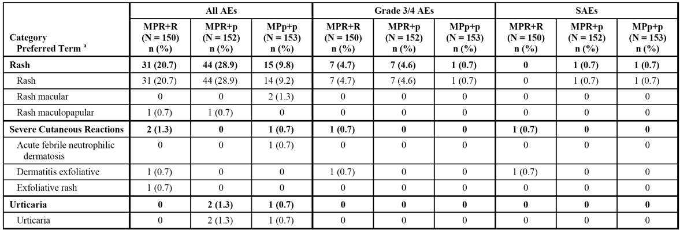

Notes: a = Categories and preferred terms are coded using MedDRA Version 10. If multiple AEs were reported within a given preferred term, only 1 event with the worst grade was counted per subject. Data cutoff date = 30 April 2013.

###### Peripheral neuropathy

Preferred terms listed within the MedDRA Version 10 SMQ for peripheral neuropathy (narrow scope) were collectively referred to as “peripheral neuropathy.” In the induction or maintenance periods, peripheral neuropathy occurred more frequently in patients in the MPR+R and MPR+p arms than in the MPp+p arm (see Table 44, below).

Table 44: MM-015: Selected AE of peripheral neuropathy in the induction or maintenance periods.

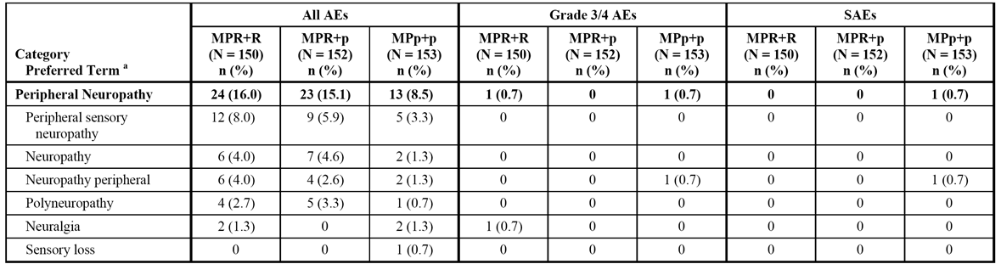

Notes: a = Categories and preferred terms are coded using MedDRA Version 10. If multiple AEs were reported within a given preferred term, only 1 event with the worst grade was counted per subject. Data cutoff date = 30 April 2013.

###### Renal failure

Preferred terms listed within the MedDRA Version 10 SMQ of acute renal failure (narrow scope), the preferred terms listed within the MedDRA Version 10 HLT of renal failure and impairment, and the MedDRA Version 10 preferred terms of blood creatinine increased, blood urea increased, and blood urea nitrogen/creatinine ratio increased, were collectively referred to as “renal failure.” In the induction or maintenance periods, renal failure was more frequently associated with the MPp+p regimen rather than the lenalidomide containing regimens (see Table 45, below).

Table 45: MM-015 - Selected AE of renal failure in the induction or maintenance periods.

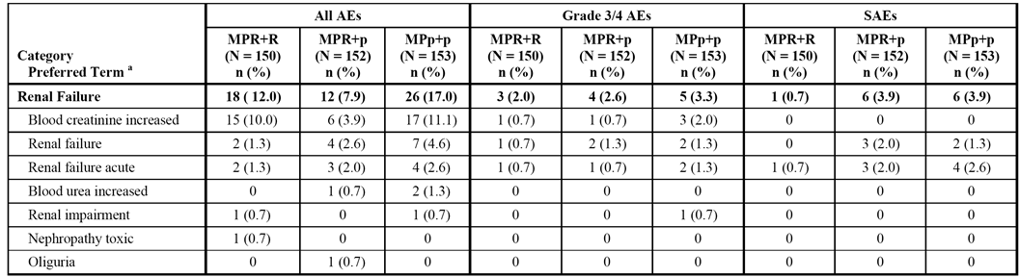

Notes: a = Categories and preferred terms are coded using MedDRA Version 10. If multiple AEs were reported within a given preferred term, only 1 event with the worst grade was counted per subject. Data cutoff date = 30 April 2013.

###### Hepatic disorders

Preferred terms listed within the MedDRA Version 10 SMQ of “possible drug-related hepatic disorders” (comprehensive search, which includes all applicable sub-SMQs) were collectively referred to as “hepatic disorders.” In the induction or maintenance periods, selected hepatic disorders were reported more frequently in the MPR+R and MPR+p arms than in the MPp+p arm (see Table 46, below).

Table 46: Study MM-015 - Selected AE of hepatic disorders in the induction or maintenance periods.

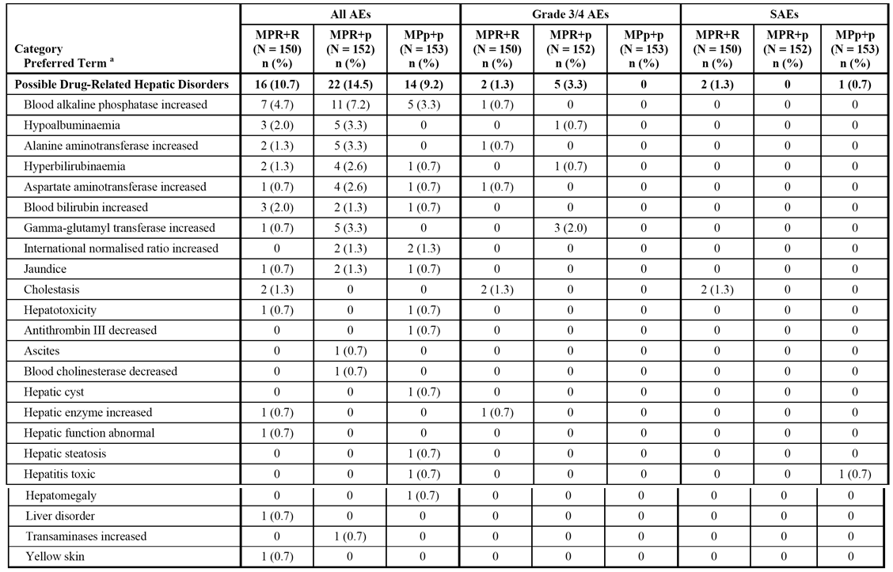

Notes: a = Categories and preferred terms are coded using MedDRA Version 10. If multiple AEs were reported within a given preferred term, only 1 event with the worst grade was counted per subject. Data cutoff date = 30 April 2013.

###### Venous thromboembolic events

Preferred terms listed within the MedDRA Version 10 SMQ for embolic and thrombotic events, venous (narrow scope), were collectively referred to as “VTE events.” In the induction or maintenance periods, VTE events occurred notably more frequently in the MPR+R and MPR+p arms than in the MPp+p arm (see Table 47, below).

Table 47: MM-015 - Selected AE venous thromboembolic events in the induction or maintenance periods; safety population.

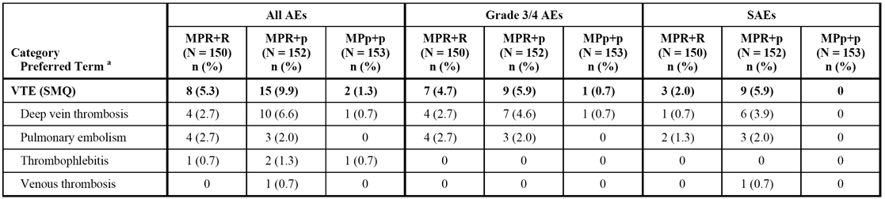

Notes: a = Categories and preferred terms are coded using MedDRA Version 10. If multiple AEs were reported within a given preferred term, only 1 event with the worst grade was counted per subject. Data cutoff date = 30 April 2013.

###### Cardiac events

In the induction and maintenance periods, cardiac arrhythmias (excluding atrial fibrillation) occurred more commonly in the MPR+R and MPR+p arms than in the MPp+p arm as did cardiac failure, while atrial fibrillation occurred marginally more frequently in the MPp+p arm than in the MPR+R and MPR+p arms (see Table 48, below).

Table 48: MM-015 - Selected AEs of cardiac disorders in the induction or maintenance periods; safety population.

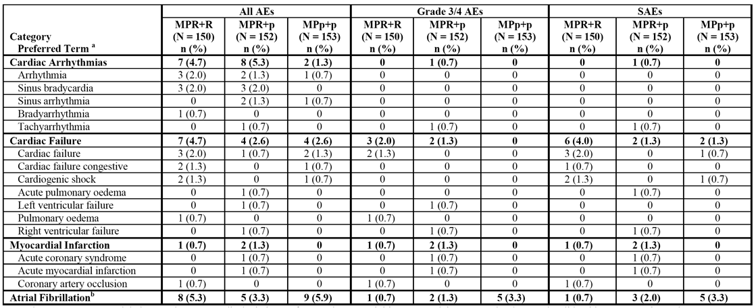

Notes: a = Categories and preferred terms are coded using MedDRA Version 10. If multiple AEs were reported within a given preferred term, only 1 event with the worst grade was counted per subject. Data cutoff date = 30 April 2013.

###### Hypersensitivity and angioedema

In the induction and maintenance periods, 1 SAE each of hypersensitivity and angioedema were reported in the MPR+R arm. The SAE of hypersensitivity (Grade 3) was considered not to be related to lenalidomide but was considered to be related to filgrastim. The SAE of angioedema (face oedema Grade 3) was considered to be related to lenalidomide, but the causality assessment was confounded by the concomitant use of ciprofloxacin at the time of the event.

###### Tumour lysis syndrome

One newly occurring Grade 3/4 event of tumour lysis syndrome (not rated as a SAE) was reported in the maintenance period in the MPR+p arm (i.e., while the patient was receiving placebo).

###### Pneumonitis

Pneumonitis was reported in 1 patient in the MPp+p arm during the induction and maintenance periods, and in the open-label extension phase. The events were Grade 1 or 2 in severity and were not considered to be treatment-related.

##### Second Primary Malignancy

The CSR included a review of the incidence of SPM up until the cutoff date of 30 April 2013. This review was also provided in the SPM summary document. As of the data cutoff date of 30 April 2013, the median follow-up time for surviving patients was 62.5 months (range: 26.2, 73.8 months). The summary data at the cutoff date of 30 April 2013 for patients who experienced at least one SPM are provided below in Table 49.

Table 49: MM-015 - SPM summary in patients at the data cutoff date of 30 April 2013; safety population.

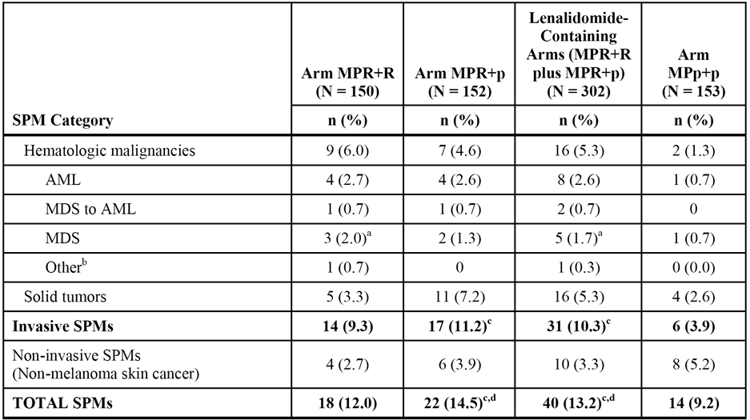

Notes: (a) includes 1 case of chronic myelomonocytic leukemia; (b) other haematologic malignancy includes 1 subject (MPR+R) with T-cell type acute leukemia; (c) 1 (MPR+p) had both a haematologic SPM (AML) and a solid tumor SPM (prostate cancer); this subject is counted only once in the invasive SPM category and total; (d) 1 subject(MPR+p) had both a solid tumour SPM (metastatic squamous cell carcinoma) and a non-melanoma skin cancer; this subject is counted only once in the total. There have been no reports of B-cell malignancies during Study MM-015. The total SPM numbers include subjects with at least 1 SPM. Subjects who experienced more than 1 SPM or more than 1 episode of an SPM are counted once in each SPM category and once in the total.

The incidence data adjusted for duration of exposure (i.e., 100 person-years) are summarised below in Table 50.

Table 50: MM-015 - SPM summary in patients at the data cutoff date of 30 April 2013; safety population.

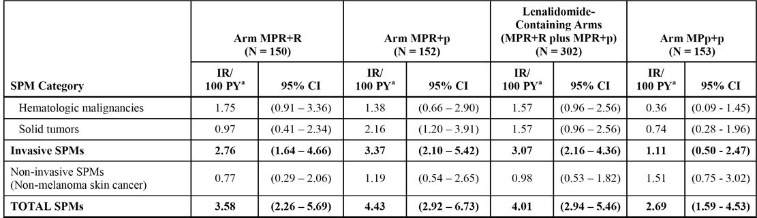

Note: a = Person-year is the time in years from first dose date to the date of last follow-up for subjects without an SPM, and the time from the first dose date to the onset date of the first SPM for subjects with an SPM.

The median time to onset of SPM in each of the three treatment arms is summarised below in Table 51.

Table 51: MM-015 - Median time to onset of SPM in the treatment arms; safety population.

|  | MPR+R (n=150) | MPR+p (n=152) | MPp+p (n=153) | MPR+R/MPR+p (n=302) |
| --- | --- | --- | --- | --- |
| All SPMs (months) | 38.4 (range: 6.9, 65.9) | 36.7 (range: 6.9, 67.4) | 35.1 (range: 2.4, 65.9) | 38.4 (range: 6.9, 67.4) |
| Invasive SPM (months) | 34.2 (range: 6.9, 50.2) | 40.3 (range: 7.4, 67.4) | 24.7 (range: 2.4, 65.9) | 36.7 (range: 6.9. 67.4) |
| Haem SPM (months) | 31.7 (range: 16.9, 50.2) | 23.7 (range: 17.8, 57.3) | 33.0 (range: 19.8, 46.3) | 30.9 (range: 16.9, 57.3) |
| Solid Tumours (months) | 30.7 (range: 6.9, 42.5) | 51.3 (range: 7,4, 67.4) | 24.7 (range: 2.4, 65.9) | 41.4 (range: 6.9, 67.4) |
| Non-invasive SPM (months) | 45.5 (range: 41.0, 65.9) | 37.0 (range: 6.9, 58.5) | 36.8 (range: 3.4, 48.0) | 42.3 (range: 6.9, 65.9) |

The outcome (alive or dead) of patients with SPM up to the data cutoff date in each of the three treatment arms is summarised below in Table 52.

Table 52: MM-015 - Summary of outcome (alive or dead) at the data cutoff date of 30 April 2013; safety population.

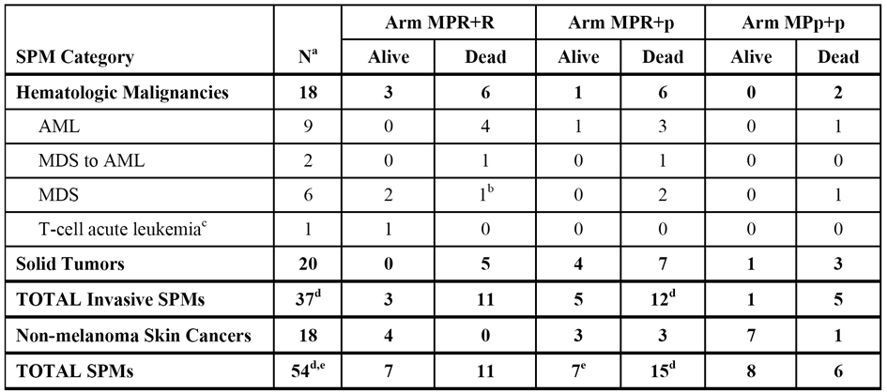

Notes: a = Number of subjects with an SPM; b = 1 subject (MPR+R) had chronic myelomonocytic leukemia which was counted in the MDS category; c = T-cell acute leukemia is the MedDRA preferred term for T-cell acute lymphocytic leukemia; d = 1 subject (MPR+p) had both a haematologic SPM (AML) and a solid tumor SPM (prostate cancer), and is counted only once in the total invasive and the total SPM categories; e = 1 subject (MPR+p) had both a solid tumor SPM (metastatic squamous cell carcinoma) and a non-melanoma skin cancer, and is counted only once in the total SPM category.

The cumulative incidence rate of invasive SPMs for the combined MPR+R/MPR+p arms increased gradually over the first 42 months of follow-up to approximately 2.5 per 100 person-years, and has been stable over a follow-up period of from 42 to 78 months. The cumulative incidence rate of invasive SPMs for the MPp+p arm has remained stable at approximately 1 per 100 person-years over a follow-up period of 36 to 78 months.

Based on KM methods, the cumulative incidence rate curves of patients with all invasive SPMs (haematologic malignancies plus solid tumours) showed that the risk of an event was significantly greater in the combined MPR+R/MPR+p arms (31 events) than in the MPp+p arm (6 events): HR = 2.88 (95% CI: 1.024, 6.927); p=0.013, log-rank test, 2-sided. Based on KM methods, the cumulative incidence rate curves of patients with haematologic SPMs showed that the risk was significantly greater in the combined MPR+R/MPR+p arms (16 events) than in the MPp+p arm (2 events): HR = 4.336 (95% CI: 0.977, 18.857), p=0.033, log-rank test, 2-sided. Based on KM methods, the cumulative incidence rate curves of patients with solid tumours showed that the risk was greater in the combined MPR+R/MPR+p arms (16 events) than in the MPp+p arm (4 events), but the difference between the two arms was not statistically significant: HR = 2.276 (95% CI: 0.759, 6.822); p=0.131, log-rank test, 2-sided.

In a competing risk analysis based on Gray's method,14 there was a statistically significant difference between the cumulative incidence of both haematologic and invasive SPMs for the combined MPR+R/MPR+p arms and the MPp+p arm (p=0.0340 and p=0.0128, respectively). There was no statistically significant difference observed between the cumulative incidence of solid tumour SPMs for the combined MPR+R/MPR+p arms and the MPp+p arm (p=0.1375).

Overall, the data show that the risk of developing haematologic and invasive SPMs (all) was greater in patients in the combined lenalidomide MPR+R/MPR+p arms than patients in the MPp+p arm, while the risk of developing solid tumour SPMs did not significantly differ between the combined MPR+R/MPR+p arms and the MPp+p arm. Univariate and multivariate Cox regression analyses identified prior history of invasive malignancy as a statistically significant prognostic risk factor (unrelated to treatment) for the occurrence of haematologic and invasive SPMs. In addition, male gender was identified as a statistically significant prognostic risk factor (unrelated to treatment) for the occurrence of invasive SPMs. No prognostic risk factor (unrelated to treatment) was identified for the occurrence of solid tumor SPMs. There were no predictive risk factors (related to treatment) for the development of hematologic, solid tumor, or invasive SPMs were identified.

##### Clinical laboratory tests

###### Overview

Central laboratory data were entered into the clinical database and summarised for the induction therapy period and the maintenance therapy period. Although investigators may have used local laboratory values to assess AEs, local laboratory data were not included in the analyses of clinical laboratory data. The clinical laboratory evaluations for the open-label extension period were not summarised in the CSR. No laboratory values were collected post-treatment.

###### Haematology

Induction period

Consistent with the reporting of Grade 3 or 4 hematologic AEs during the induction period, higher proportions of patients in the MPR+R and MPR+p arms than in the MPp+p arm had shifts from baseline values of normal, Grade 1, or Grade 2 AEs to a most extreme post-baseline value of Grade 3 haemoglobin (34/147 [23.1%] vs 30/148 [20.3%] vs 15/147 [10.2%], respectively), platelet count (33/146 [22.6%] vs 46/151 [30.5%] vs 10/147 [6.8%], respectively), and ANC (55/144 [38.2%] vs 56/150 [37.3%] vs 35/146 [24.0%]). Similarly, there were higher proportions of patients in the MPR+R and MPR+p arms than in the MPp+p arm with shifts from baseline values of normal, Grade 1, 2, or 3 AEs to a most extreme post-baseline value of Grade 4 haemoglobin (3/147 [2.0%] vs 6/151 [4.0%] vs 0/147 [0%], respectively), platelet count (15/146 [10.3%] vs 18/151 [11.9%] vs 4/147 [2.7%], respectively), and ANC (48/145 [33.1%] vs 40/151 [26.5%] vs 11/147 [7.5%], respectively).

Maintenance period

Consistent with the reporting of Grade 3 or 4 haematologic AEs during the maintenance period, higher proportions of patients in the MPR+R arm than in the MPR+p and MPp+p arms had shifts of the last laboratory evaluation in the induction period to a most extreme post-baseline value of Grade 3 haemoglobin (7/85 [8.2%] vs 5/91 [5.5%] vs 1/102 [1.0%], respectively) and Grade 3 ANC (25/77 [32.5%] vs 6/80 [7.5%] vs 4/97 [4.1%]). Only 5 patients had shifts to Grade 3 platelet count (2/81 [2.5%] in the MPR+R arm, 2/89 [2.2%] in the MPR+p arm, and 1/101 [1.0%] in the MPp+p arm). Similarly, there were higher proportions of patients in the MPR+R arm than in MPR+p and MPp+p arms with shifts of the last laboratory evaluation in the induction period to a most extreme post-baseline of Grade 4 platelet count (6/86 [7.0%] vs 3/92 [3.3% vs 0/102 [0%], respectively) and Grade 4 ANC (13/85 [15.3%] vs 0/93 [0%] vs 0/102 [0%], respectively). There were only 2 patients with shifts to Grade 4 haemoglobin (1 in the MPR+p arm and 1 in the MPp+p arm).

###### Clinical chemistry

Induction period

During the induction therapy period, with the exception of glucose and inorganic phosphorous, fewer than 4 patients in any treatment arm had shifts from baseline values of normal, Grade 1, or Grade 2 AEs to a worst post-baseline value of Grade 3 AE for clinical chemistry parameters. For glucose, the number of patients with shifts from baseline values of normal, Grade 1, or Grade 2 AEs to a worst post-baseline value of Grade 3 AE was 4/141 (2.8%) in the MPR+R arm, 6/146 (4.1%) in the MPR+p arm and 5/146 (3.4%) in the MPp+p arm. For inorganic phosphorous, the number of patients with shifts from baseline values of normal, Grade 1, or Grade 2 AEs to a worst post-baseline value of Grade 3 AE was 11/138 (8.0%) in the MPR+R arm, 9/146 (6.2%) in the MPR+p arm and 8/144 (5.6%) in the MPp+p arm. Shifts from baseline values of normal, Grade 1, 2, or 3 AEs to a worst post-baseline value of Grade 4 AEs were observed only for uric acid (2/138 [1.4%] in the MPR+R arm, 2/143 [1.4%] MPR+p, and 3/143 [2.1%] MPp+p arm), and total bilirubin (1/148 [0.7%] MPR+p).

Maintenance period

Fewer than 3 patients in any treatment arm had shifts from the last laboratory evaluation in the induction period of normal, Grade 1, or Grade 2 AE to a most extreme value of Grade 3 AE during the maintenance period for clinical chemistry parameters, except for glucose (3/87 [3.4%] MPR+R, 3/94 [3.2%] MPR+p, and 3/101 [3.0%] MPp+p), inorganic phosphorus (8/87 [9.2%] MPR+R, 1/93 [1.1%] MPR+p, and 5/99 [5.1%] MPp+p), and potassium (3/88 [3.4%] in the MPR+R arm only). In addition, there were fewer than 2 patients in any treatment arm with shifts from the last laboratory evaluation in the induction period of normal, Grade 1, 2, or 3 AEs to a most extreme value of Grade 4 AE during the maintenance period for clinical chemistry parameters, except for uric acid (5/88 [5.7%] MPR+R, 3/94 [3.2%] MPR+p, and 5/102 [4.9%] MPp+p) and potassium (2/102 [2.0%] in the MPp+p arm only).

###### Urinalysis

Only 1 patient in the MPp+p arm had a shift in urine protein levels from Grade 2 AE at baseline to a Grade 3 AE as the most extreme value during the induction period. None of the patients in the MPR+R or MPR+p arms had Grade 3 or 4 AE shifts in urine protein values, and there were no Grade 4 AE shifts reported by patients in MPp+p arm during the induction therapy period. None of the patients in the MPR+R, MPR+p, or MPp+p arms had Grade 3 or 4 AE shifts in urine protein values from the last laboratory value in the induction period to the most extreme value during the maintenance period

##### Vital signs and ECG changes

Vital signs (blood pressure, pulse, temperature) in the majority of patients in the three treatment arms remained at normal values during the maintenance and induction periods. There were no clinically meaningful differences across the three treatment arms in the proportion of patients with abnormal vital signs in the induction or maintenance periods.

The majority of subjects in the three treatment arms with both baseline and post-baseline ECG results had no change in their ECG evaluations during the induction period. The percentages of patients who had worsening in ECG from baseline to post-baseline in the induction period (e.g., normal to abnormal not clinically significant, and abnormal not clinically significant to clinically significant) were comparable in all three treatment arms. ECG results in the maintenance period were similar to those observed in the induction period.

##### Adverse events reported during the open-label extension phase (OLEP)

###### Adverse events - all and Grade 3 or 4

Of the 154 patients in the OLEP (safety population), 74 (21 from the MPR+R arm and 53 from the MPR+p arm) had previously received lenalidomide during the treatment period, while 80 patients from the MPp+p arm received lenalidomide for the first time. The median treatment duration in the OLEP was longest in the MPp+p arm (273.0 days), followed by the MPR+p arm (209.0 days), and the MPR+R arm (189.0 days). The median relative dose intensity was comparable across all 3 treatment arms (0.87 MPR+R; 0.87 MPR+p; and 0.92 MPp+p).

In the OLEP, at least one AE was experienced by 100% (21/21) of patients in the MPR+R arm, 94.3% (50/53) of patients in the MPR+p arm, and 97.5% (78/80) of patients in the MPp+p arm. AEs reported in ≥ 20% of patients in each of the three treatment arms were neutropenia, anaemia, thrombocytopenia, leukopenia, and fatigue. AEs reported in ≥ 10% of patients in any of the treatment arms are summarised.

In the OLEP, at least one Grade 3 or 4 AE was experienced by 76.2% (16/21) of patients in the MPR+R arm, 75.5% (40/53) of patients in the MPR+p arm, and 90.0% (72/80) of patients in the MPp+p arm. Grade 3 or 4 AEs reported in ≥ 10% of patients in each of the three treatment arms were neutropenia, anaemia, and thrombocytopenia.

###### Deaths

Of the 154 patients who entered the OLEP, 14 (9.1%) died within 30 days of last treatment: 2 (9.5%) in the MPR+R arm; 9 (17.0%) in the MPR+p arm; and 3 (3.8%) in MPp+p arm. There were 3 deaths due to cardiac failure (1 x MPR+R; 2 x MPR+p) and 1 death due to sudden cardiac death (1 x MPR+p). None of the Grade 5 AEs associated with these deaths was considered by the investigator to be related to lenalidomide, and all 4 patients had progressive disease at the time of death.

###### Serious adverse events

A total of 67 patients (43.5%) experienced at least one SAE during the OLEP: 8 (38.1%) in the MPR+R arm; 20 (37.7%) in the MPR+p arm; and 39 (48.8%) in the MPp+p arm.

The following thromboembolic SAEs were observed in the OLEP: DVT, venous thrombosis, pulmonary embolism, transient ischemic attack, cerebral ischemia, ischaemic stroke, and myocardial infarction (1 patient [1.3%] each in MPp+p arm). Serious infections were also observed more frequently in the MPp+p arm (13 patients [16.3%]) than in the MPR+R and MPR+p arms (1 patient [4.8%] and 2 patients [3.8%], respectively).

Serious cardiac disorders were reported in 7 patients during the OLEP: 3 patients with cardiac failure (1 [4.8%] in the MPR+R arm, 2 [2.5%] in the MPR+p arm); 2 patients with atrial fibrillation (1 [1.9%] in the MPR+p arm, 1 [1.3%] in the MPp+p arm); and 1 patient (1.3%) each had bradycardia and myocardial infarction in the MPp+p arm.

###### Other significant adverse events

A total of 24 patients (15.6%) experienced at least one AE leading to lenalidomide discontinuation during the OLEP: 2 (9.5%) in the MPR+R arm; 9 (17.0%) in the MPR+p arm; and 13 (16.3%) in the MPp+p arm. A total of 41 subjects (26.6%) experienced at least one AE leading to lenalidomide dose reduction during the OLEP: 8 (38.1%) in the MPR+R arm; 14 (26.4%) in the MPR+p arm; and 19 (23.8%) in the MPp+p arm.

##### Long-term tolerability to lenalidomide exposure

To assess the tolerability of prolonged administration of lenalidomide, Grade 3 or 4 AEs occurring during the induction and maintenance periods were summarised by onset date for the 48 patients in the MPR+R arm with a treatment duration of 24 months. Grade 3 or 4 AEs occurring in 2 or more patients overall in the 48 patients with 24 months of treatment are summarised. In general, Grade 3 or 4 AEs occurred more frequently in the first 12 months of treatment, which represents the 9 month induction period and the first 3 months of the maintenance period. In particular, the frequencies of Grade 3 or 4 haematologic AEs of neutropenia, thrombocytopenia, leukopenia, and anemia with onset during the 0-6 months and 6-12 months periods were highest, and decreased considerably after 12 months. Onset of febrile neutropenia (8.3%) was reported only during the first 6 months of treatment. Likewise, Grade 3 or 4 fatigue decreased after the first 6 months. No other notable trends were observed in the onset of Grade 3 or 4 AEs over time.

#### Supportive study CALGB 100104

##### Exposure

This Phase 3, randomised, double-blind supportive study was to designed assess the efficacy and safety of lenalidomide compared to placebo in prolonging time to disease progression following successful ASCT transplant in patients with NDMM aged ≥ 18 years to < 70 years. Patients randomised to lenalidomide were treated with 10 mg QD for the first three months, after which the dose could be increased to 15 mg QD.

The media duration of exposure in patients in the safety set was 43.6 weeks (range: 4, 207 weeks) in the placebo arm (n=212), with a total patient exposure of 215.7 patient-years, and 39.4 weeks (range: 1, 196 weeks) in the lenalidomide arm (n=219), with a total patient exposure of 224.7 patient years. In the lenalidomide arm, the median time to first dose reduction was 73.5 days (range: 2, 1111 days), the median cumulative dose was 2620.0 mg (range: 90, 18900 mg), the dose intensity on study was 9.9 mg/day (range: 3, 15 mg/day), and the median relative dose intensity was 1.0 (range: 0, 2).

##### Adverse events

###### Overview

General safety was assessed through physical examination, vital signs, drug toxicity assessments, standard clinical laboratory evaluations, recording of AEs, and ECOG performance status. The Common Terminology Criteria for Adverse Events (CTCAE) version 3.0 for was used for reporting purposes as was the Medical Dictionary for Regulatory Activities (MedDRA) terms, version 6.0. Sites were requested to enter MedDRA codes on a form pre-printed with 8 AEs, and the data were submitted every 3 months until 1 year post-transplant and then every 6 months until 5 years post-transplant. Data on second primary malignancies (SPM) began being formally collected in January 2011 and were not included in the CSR report, but were provided in the SPM summary document provided.

*Comment: Recording of AEs in this study was unusual as the protocol-specified that recording should begin in the maintenance period following ASCT, but before randomisation to lenalidomide or placebo. The protocol stated "CALGB 100104 is conducted under a CTEP-held IND for lenalidomide. Therefore, the reporting requirements for investigational agents..... apply for all enrolled patients during maintenance therapy." In addition, the form on which AE data were collected had a check list of expected AEs with MedDRA code and CTCAE term (i.e., ANC, platelets, febrile neutropenia, weight gain, rash, diarrhea, bilirubin, pneumonitis/pulmonary infiltrates). These categories of expected AEs also combined AE preferred terms and laboratory abnormalities. In addition, the form collected information on infectious disease, with the primary causative agents and primary sites being printed without MedDRA codes or CTCAE terms. Furthermore, it was possible to include the term "not available" in summary AE tables, resulting in the NCI-CTC category being captured but not the AE preferred term event.*

###### Overall summary of adverse events

The high-level overview of AEs is provided below in Table 53. As expected, the incidence of all categories of AEs was higher in the lenalidomide arm than in the placebo arm.

Table 53: CALGB 100104 - Overall summary of adverse events; safety population.

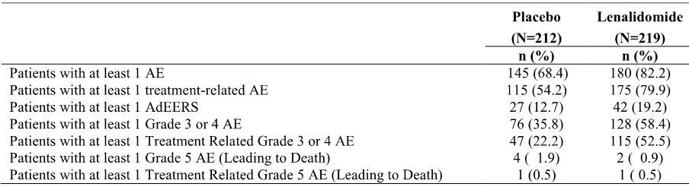

AdEERS = Adverse Event Expedited Reporting System; AE = adverse event Notes: Percentages of patients are based on the number of patients in each treatment group in the Safety Population.  A treatment-related AE is one whose relationship to lenalidomide/placebo is noted as possibly, probably, or definitely.

###### Commonly reported adverse events

Irrespective of causality

AEs were reported in 82.2% (180/219) of patients in the lenalidomide arm and 68.4% (145/212) of patients in the placebo arm. The most commonly reported AEs (≥ 10% of patients) in the lenalidomide arm (vs placebo) in descending order of frequency were: neutrophil count (63.9% vs 25.5%); platelet count decreased (53.0% vs 24.5%); diarrhoea NOS (33.8% vs 16.5%); dermatitis exfoliative (24.7% vs 13.7%); fatigue (13.2% vs 12.3%); leukopenia (11.0% vs 3.3%); haemoglobin (10.5% vs 5.7%); and blood bilirubin increased (10.0% vs 5.7%).

AEs (all grades) reported in ≥ 2% more patients in the lenalidomide arm than in the placebo arm were: neutrophil count (63.9% vs 25.5%); platelet count decreased (53.0% vs 24.5%); diarrhoea NOS (33.8% vs 16.5%); dermatitis exfoliative (24.7% vs 13.7%); fatigue (13.2% vs 12.3%); leukopenia (11.0% vs 3.3%); haemoglobin (10.5% vs 5.7%); blood bilirubin increased (10.0% vs 5.7%); nausea (6.4% vs 3.8%); lymphopenia (6.4% vs 3.3%); febrile neutropenia (5.5% vs 1.4%); pneumonia (5.0% vs 1.9%); pyrexia (5.0% vs 2.4%); ALT increased (4.1% vs 0.5%); and AST increased (3.7% vs 0.9%). Of note, pre-printed CTC term, rash, was coded per MedDRA v6.0 to Dermatitis Exfoliative NOS (MedDRA code 10012457). AEs by NCI-CTC category and preferred term reported in at least 2% of patients in the lenalidomide arm in the safety population are summarised.

Treatment-related (investigator specified possibly, probably, definitely)

AE profiles for treatment-related events and for events irrespective of causality were comparable in the lenalidomide and placebo arms, with most of the AEs reported in the study being considered by investigators to be treatment-related. In the lenalidomide arm, treatment-related AEs were reported in 79.9% (175/219) of patients compared to 54.2% (115/212) of patients in the placebo arm. The most frequently reported treatment-related AEs in the lenalidomide arm (≥ 5% of patients) vs placebo, in descending order of frequency, were: neutrophil count (61.6% vs 22.2%); platelet count decreased (51.6% vs 20.3%); diarrhoea NOS (28.3% vs 10.8%); dermatitis exfoliative NOS (21.9% vs 10.4%); leukopenia NOS (11.0% vs 2.8%); haemoglobin (10.5% vs 3.3%); fatigue (10.5% vs 8.0%); peripheral sensory neuropathy (8.2% vs 8.5%); blood bilirubin increased (6.4% vs 2.4%); nausea (5.9% vs 2.4%); febrile neutropenia (5.5% vs 0.9%); and lymphopenia (5.5% vs 2.8%).

###### Grade 3 or 4 adverse events

Irrespective of causality

Grade 3 or 4 AEs were reported in 58.4% (128/219) of patients in the lenalidomide arm and 35.8% (76/212) of patients in the placebo arm. The most common Grade 3 or 4 AEs in the lenalidomide arm (≥ 5% of patients) vs placebo, in descending order of frequency were: neutrophil count (40.2% [88/219] vs 9.0% [19/212]); platelet count decreased (12.8% [28/219] vs 4.2% [9/212]); leukopenia NOS (8.7% [19/219] vs 1.4% [3/212]); infection not available, PT not provided (5.5% [12/219] vs 6.6% [14/212]); febrile neutropenia (5.5% [12/219] vs 1.4% [3/212]), fatigue (5.5% [12/219] vs 3.3% [7/212]); lymphopenia (5.5% [12/219] vs 1.4% [3/212]); and diarrhoea NOS (5.0% [11/219] vs 1.9% [4/219]).

Treatment-related (investigator specified possibly, probably, definitely)

In general, the treatment-related Grade 3 or 4 AE profiles of lenalidomide and placebo were comparable to the corresponding Grade 3 or 4 AE profile irrespective of causality, with most of the Grade 3 or 4 AEs reported in the study being considered by investigators to be treatment-related. The most frequently reported Grade 3 or 4 treatment-related AEs in the lenalidomide arm (≥ 5% of patients) vs placebo were: neutrophil count (39.7% vs 7.1%); platelet count decreased (11.4% vs 2.8%); leukopenia NOS (8.7% vs 0.9%); febrile neutropenia (5.5% vs 0.9%); fatigue (5.0% vs 2.8%); and lymphopenia (5.0% vs 0.9%).

###### Infectious complications

There were 92 (42.0%) patients in the lenalidomide arm and 83 (39.2%) patients in the placebo arm who had infectious complications. The most common infectious complication was upper respiratory tract infection where the causative agent was not determined (lenalidomide 25 patients [11.4%] vs placebo 29 patients [13.7%]). Viral upper respiratory tract infections occurred in 12 lenalidomide patients (5.5%) and 9 placebo patients (4.2%). Varicella zoster occurred in 3 (1.4%) lenalidomide patients and 10 (4.7%) placebo patients.

###### Second primary malignancies

SPMs reported in CALGB 100104, up to the cutoff date of 2 May 2013, were summarised in the SPM document provided. In the SPM analysis, the median follow-up of surviving patients in the safety population was 46.7 months. Up to the cutoff date of 2 May 2013, a total of 50 (11.5%) of the 436 patients in the study had experienced at least 1 SPM. The frequency of patients reporting at least 1 SPM was higher in the lenalidomide arm compared to the placebo arm (14.5% [n=32] vs 8.3% [n=18], respectively). Overall, the incidence of SPMs was 4.02 events/100 person-years (95% CI: 2.85, 5.69) in the lenalidomide arm, and 2.44 events/100 patient-years (95% CI: 1.53, 3.87) in the placebo arm.

Invasive SPMs (haematologic malignancies plus solid tumours) occurred more frequently in patients in the lenalidomide arm compared to the placebo arm (11.8% [n=26] vs 6.0% [n=13], respectively). Of the 17 patients with invasive haematologic SPMs (including AML, MDS, and B-cell malignancies), 13 (5.9%) were in the lenalidomide arm and 4 (1.9%) were in the placebo arm. Of the 22 patients with invasive solid tumour SPMs, 13 (5.9%) were in the lenalidomide arm and 9 (4.2%) were in the placebo arm. The frequency rates of patients with SPM are summarised. The cumulative incidence rates (per 100 person-years) for invasive SPMs in the lenalidomide arm have not significantly increased over time.

The median time to onset of an invasive SPM was longer in placebo arm (32.7 months) than in the lenalidomide arm (28.0 months). The median time to onset of a haematologic SPM was notably longer in the placebo arm (45.9 months) than in the lenalidomide arm (32.5 months). The median time to onset of a solid tumour SPM was 23.3 months in the lenalidomide arm and 29.8 months in the placebo arm. Six (6) solid tumor SPMs were diagnosed within the first year following the start of treatment with the study drug (5 in the lenalidomide arm, 1 in the placebo arm).

The KM cumulative incidence curves showed no significant difference in the risk of experiencing an invasive SPM in the lenalidomide arm compared to the placebo arm (p=0.074, log-rank test, 2-sided). The HR (lenalidomide/placebo) for invasive SPMs was 1.819 (95% CI: 0.943, 3.542). The KM cumulative curves showed that the risk of experiencing a haematologic SPM was significantly greater in the lenalidomide arm compared to the placebo arm (p=0.048, log-rank test, 2-sided). The HR (lenalidomide/placebo) for haematologic SPMs was 2.941 (95% CI: 0.959, 9.026). The KM cumulative incidence curves showed no significant difference in the risk of experiencing a solid tumour SPM in the lenalidomide arm compared to the placebo arm (p=0.576, log-rank test, 2-sided). The HR (lenalidomide/placebo) for solid tumour SPMs was 1.274 (95% CI: 0.544, 2.985).

The competing risk analyses for SPMs based on Gray’s method using the data cutoff date of 02 May 2013 was performed to examine the cumulative incidence of invasive SPMs over time with death as the competing risk.14 There were statistically significant differences between the cumulative incidences of both invasive haematologic and invasive SPMs for the lenalidomide arm vs the placebo arm (p = 0.0264 and p = 0.0332, respectively). There was no statistically significant difference observed between the cumulative incidence of solid tumour SPMs for the lenalidomide arm vs the placebo arm (p = 0.4470). The results indicate that patients who received lenalidomide were more likely to have invasive SPMs, in particular, haematologic SPMs, than subjects receiving placebo.

Univariate and multivariate Cox regression analyses identified baseline absolute neutrophil count < 1.5 x 109 cells/L as a significant prognostic risk factor (not related to treatment) for the occurrence of haematologic SPMs. No prognostic risk factors (not related to treatment) were identified for solid tumour or invasive SPMs. No predictive risk factors (related to treatment) for haematologic, solid tumour, or invasive SPMs were identified. However, the study did not capture information regarding prior history of invasive malignancy.

##### Death and other serious adverse events (SAEs)

###### Death

In the safety population, there were 12 deaths (5.5%) in the lenalidomide arm compared with 22 deaths (10.4%) in the placebo arm. In each arm, most deaths were due to MM (protocol-related disease) (lenalidomide 7 patients [3.2%) vs placebo 16 patients [7.5%]). In the placebo arm, the cause of death was missing for one patient who died on 26 April 2009 after last dose on 11 December 2008. In the lenalidomide arm, 2 deaths were reported to be associated with AEs (both due to infection, 1 of which was considered to be treatment-related), and in the placebo arm 4 deaths were reported to be associated with AEs (2 due to disease progression, 1 due to AV-block considered to be treatment-related, and 1 due to acute respiratory tract infection).

###### Other serious adverse events (SAEs)

The National Cancer Institute (NCI) Adverse Event Expedited Reporting System AdEERS was utilized to report AEs (i.e., SAEs) in an expedited manner during this study. In the lenalidomide arm, there were 42 (19.2%) patients with AdEERS events compared to 27 (12.7%) patients in the placebo arm. The most frequently (≥ 1% of patients) occurring AdEERS events reported in the lenalidomide arm (vs the placebo arm) were: infection with normal ANC or Grade 1 or 2 neutrophils (6.8% vs 3.8%); infection, documented clinically or microbiologically, with Grade 3 or 4 neutrophils = ANC <1.0 x 109/L (4.6% vs 0.5%); neutrophils/granulocytes (ANC/AGC) (2.3% vs placebo 0.5%); febrile neutropenia (1.8% vs 0.5%); fever (1.4% vs 0.9%); and infection other, PT not available (1.4% vs 0.5%); pain (1.4% vs 2.4%). All other AdEERS events reported in the lenalidomide group occurred in ≤ 2 patients.

##### Treatment discontinuation due to adverse events

There were 27 (11.7%) patients in the lenalidomide arm and 3 (1.3%) patients in the placebo arm who discontinued treatment due to AEs. Information on the type of AEs resulting in treatment discontinuation was not collected in the study. There was no information on AEs resulting in temporary treatment interruption or dose reductions.

##### Laboratory tests

Laboratory tests for haematological and clinical chemistry parameters were incomplete. Changes over time were not available for all haematology parameters because values were missing either at baseline (e.g., ANC, haemoglobin, lymphocytes) or during the study (e.g., lymphocytes). Similarly, changes over time were not available for all biochemistry parameters. No shift tables were presented for haematological and clinical chemistry parameters, and no information was presented on the proportion of patients with values falling outside of clinically meaningful levels. Overall, the limited laboratory data provided for the haematological parameters showed that abnormalities (primarily leucopenia, neutropenia and thrombocytopenia) occurred more frequently in patients treated with lenalidomide than in patients treated with placebo.

##### Vital signs and ECG changes

Vital signs and physical examination findings were required by the protocol but were not collected. There were no data on ECG changes over the course of the study.

#### Supportive study ECOG E4A03

##### Background

Study E4A03 assessed the safety of lenalidomide (25 mg per day, days 1-21 every 28 days) in combination with high-dose dexamethasone (40 mg/day on days 1-4, 9-12, and 17-20 every 28 days) or low-dose dexamethasone (40 mg/day on days 1, 8, 15, and 22 every 28 days) administered for 4 treatment cycles in patients with NDMM. The study rationale was to explore new treatment options for induction in NDMM patients proceeding to ASCT. The study was initiated on 26 October 2004 and officially terminated on 1 June 2007 after the results of a preliminary analysis showed that survival in the lenalidomide/low-dose dexamethasone arm (len/d) was superior to that in the lenalidomide/high-dose dexamethasone arm (len/D).

The sponsor comments that, although the AE profile of len/D in the study was consistent with the known safety profile of the combination, the frequencies of some AEs were higher than had previously been reported. The sponsor speculates that this may be attributable to the manner in which the AE data were collected (i.e., solicited via a checklist with selected pre-printed AE terms rather than open-ended questioning). The sponsor states that "it is generally accepted that obtaining adverse event information with checklists (i.e., via solicited methods) yields a higher incidence of reported adverse events than the more passive approach in which observed adverse events are recorded or spontaneously reported."

##### Exposure

Drug exposure data were summarised for the first 4 cycles only. The sponsor considers that a 4 cycle regimen was acceptable for induction prior to ASCT. As of the data cutoff date of 26 March 2007, the median duration of treatment was 28.1 weeks in the len/d arm and 18.6 weeks in the len/D arm, The mean average daily dose of lenalidomide was the same in both treatment arms (23.6 mg/day), while the mean average daily dose of dexamethasone was comparable in the len/D and len/d arms (36.6 vs 38.6 mg/day). The mean cumulative dose of lenalidomide was higher in the len/d arm than in the len/D arm (1806.7 vs 1747.4 mg). The mean lenalidomide dose intensity was similar for the len/D and len/d arms (116.7 vs 117.4 mg/week), while the mean dexamethasone dose intensity was higher in the len/D arm than in the len/d arm (103.4 vs 37.2 mg/week).

Of the 222 patients who started the len/D regimen, 22.5% (50/222) were no longer being treated with high-dose dexamethasone at week 4. In contrast, of the 220 patients who started the len/d regimen, 9.5% (21/220) were no longer being treated with low-dose dexamethasone at week 4. Furthermore, modification of the dexamethasone dose was required more frequently in patients in the len/D arm compared to the len/d arm (57.2% [127/222] vs 33.6% [74/220]). Overall, the data showed that the len/D regimen was not as well tolerated as the len/d regimen over the first 4 treatment cycles.

##### Adverse events

###### Overview

In order to ensure completeness in the presentation of the AE data, Celgene merged the expedited AEs reported by AdEERS in the safety database with the routine AEs in the clinical database. Merging the AE data, in conjunction with the difference in data collection methods and coding between the clinical and safety databases, was stated by Celgene to result in an over reporting of AEs across some preferred terms. In addition, Celgene collapsed selected preferred terms in order to accurately present the frequency of AE of special interest and to eliminate the duplication of reporting these events (i.e., counted 1 preferred term at the highest severity grade per patient from the merged safety dataset for the specified event terms of special interest). The high-level overview of AEs reported up to 26 March 2007 are summarised below in Table 54.

Table 54: E4A03 - Overview of high-level adverse events up to 26 March 2007; safety population.

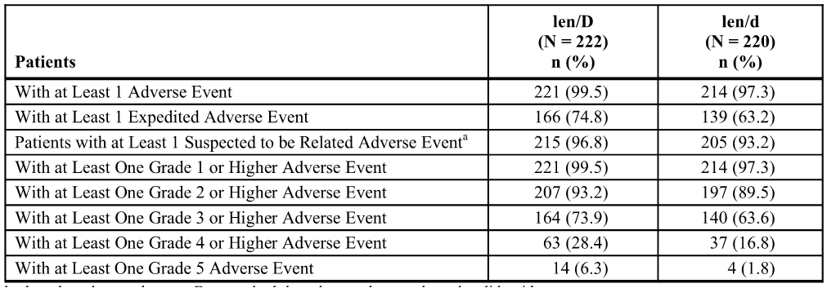

Note: The adverse events in this table include both routine and expedited adverse events from the merged clinical and safety databases. a = Events suspected by the investigator to be related to the study drug.

###### Commonly occurring adverse events (all grades)

Adverse events (irrespective of causality)

Nearly all patients in both treatment arms experienced at least one treatment-emergent AE in the first 4 treatment cycles (99.5%, len/D vs 97.3%, len/d). AEs (PT) reported in ≥ 10% of patients in the len/d arm (vs the len/D arm) in descending order of frequency were: fatigue (70.9% vs 76.1%); back pain (45.0% vs 47.7%); insomnia (43.6% vs 38.7%); peripheral oedema (41.8% vs 51.8%); constipation (47.7% vs 44.6%); peripheral sensory neuropathy (39.5% vs 42.3%); rash (35.0% vs 23.0%); dyspnoea (34.1% vs 40.1%); depression (28.6% vs 31.1%); diarrhoea (28.2% vs 23.4%); nausea (26.4% vs 31.5%); muscular weakness (21.4% vs 38.7%); vision blurred (20.5% vs 21.6%); tremor (20.0% vs 26.1%); pruritus (17.7% vs 9.9%); dizziness (17.7% vs 26.6%); pyrexia (15.0% vs 19.4%); pain in extremity (13.6% vs 10.8%); cough (13.6% vs 14.9%); thrombosis (13.2% vs 24.3%); bone pain (12.7% vs 15.8%); headache (12.7% vs 13.5%); arthralgia (12.7% vs 12.2%); upper respiratory tract infection (12.3% vs 10.8%); anorexia (10.9% vs 18.0%); vomiting (10.9% vs 11.7%); dyspepsia (10.5% vs 12.2%); and hypocalcaemia (10.5% vs 14.4%).

Of the treatment-emergent AEs reported in ≥ 10% of patients in either treatment arm, the following events were reported less frequently (≥ 5% difference) in patients in the len/d arm than in the len/D arm: fatigue; oedema peripheral; dyspnoea; nausea; muscular weakness; tremor, dizziness; thrombosis; anorexia; deep vein thrombosis; weight increased; confusional state; and hyponatraemia. Rash and pruritus were the only AEs reported more frequently (≥ 5% difference) in patients in the len/d arm than in patients in the len/D arm.

*Comment: Most treatment-emergent AEs reported in ≥ 10% more patients in either of the two treatment arms occurred more frequently in the len/D arm than in the len/d arm. In the first 4 treatment cycles, blood and lymphatic system disorders (SOC) were reported in 13.5% of patients in the len/D arm and 12.7% of patients in the len/d arm, with the only preferred term AE reported in ≥ 5% of patients in either treatment arm being lymphopenia (6.3% vs 3.2%, respectively).*

Drug-related adverse events

Drug-related treatment-emergent AEs were reported in 96.8% of patients in the len/D arm and 93.2% of patients in the len/d arm. The general pattern of drug-related AEs was consistent with the general pattern of AEs irrespective of causality. Of the drug-related AEs reported by ≥ 5% of patients in either treatment arm, the following were reported less frequently (difference of ≥ 2%) in patients in the len/d arm than in the len/D arm: fatigue; oedema peripheral; peripheral sensory neuropathy; depression; tremor; dyspnoea, vision blurred; muscular weakness; thrombosis, dizziness; back pain; deep vein thrombosis; dyspepsia; weight increased; anorexia; dysgeusia; hypocalcaemia; pyrexia; pneumonia; weight decreased; confusional state; myalgia; pulmonary embolism; lymphopenia; anxiety; dehydration; hypokalaemia; and hyponatraemia. Constipation, insomnia, rash, diarrhoea, and pruritus were the only treatment-related AEs reported more frequently (difference of ≥ 2%) in patients in the len/d arm compared to the len/D arm.

*Comment: Treatment-related blood and lymphatic system disorders (SOC) were reported in 9.9% of patients in the len/D arm and 11.4% of patients in the len/d arm, with the only preferred term AE being reported in ≥ 5% of patients in either treatment arm being lymphopenia (5.4% vs 3.2%, respectively).*

###### Grade 3/4 adverse events

At least one Grade 3/4 AE was reported in 73.4% of patients in the len/D arm and 63.6% of patients in the len/d arm. For Grade 3/4 AEs reported in ≥ 2% of patients in the len/D arm, all events occurred with Grade 3 severity more frequently than Grade 4 severity with the exception of myocardial ischaemia (1.4% vs 1.8%, respectively) and pulmonary embolism (0% vs 6.8%, respectively). All Grade 3/4 AEs reported in ≥ 2% of patients in the len/d arm occurred with Grade 3 severity more frequently than Grade 4 severity, with the exception of haemoglobin decreased (0.5% vs 0.9%, respectively) and pulmonary embolism (0% vs 3.6%, respectively).

Grade 3/4 AEs reported in ≥ 2% of patients in the len/d arm (vs the len/D arm) in descending order of frequency were: fatigue (12.3% vs 18.9%); thrombosis (12.3% vs 23.0%); back pain (8.2% vs 11.3%); deep vein thrombosis (7.7% vs 15.8%); hyperglycaemia (6.4% vs 9.0%); hypocalcaemia (5.9% vs 8.1%); pneumonia (5.0% vs 7.7%); dyspnoea (5.0% vs 9.9%); rash (5.0% vs 2.3%); muscular weakness (4.1% vs 13.1%); pulmonary embolism (3.6% vs 6.8%); pneumonitis (3.6% vs 5.9%); neutrophil count decreased (3.6% vs 3.2%); hypokalaemia (3.2% vs 8.1%); hyponatraemia (2.7% vs 11.3%); cellulitis (2.7% vs 2.7%); peripheral sensory neuropathy (2.7% vs 1.4%); diarrhoea (2.7% vs 2.7%); nausea (2.7% vs 2.3%); depression (2.7% vs 4.1%); dehydration (2.3% vs 6.8%); hypertension (2.3% vs 0.9%); blood glucose increased (2.3% vs 4.1%); and platelet count decreased (2.3% vs 2.2%).

Of the grade 3/4 AEs reported in ≥ 2% of patients in either treatment arm, the following events were reported less frequently (i.e., ≥ 2% difference) in the len/d arm than in the len/D arm: myocardial ischaemia (0.9% vs 3.2%); atrial fibrillation (0% vs 2.3%); fatigue (12.3% vs 18.9%); oedema peripheral (1.8% vs 7.2%); catheter thrombosis (0.5% vs 2.7%); pneumonia (5.0% vs 7.7%); sepsis (1.4% vs 4.5%); infection (0.9% vs 3.2%); haemoglobin decreased (1.4% vs 4.5%); alanine aminotransferase increased (0.9% vs 3.2%); hyponatraemia (2.7% vs 11.3%); hyperglycaemia (6.4% vs 9.0%); hypocalcaemia (5.9% vs 8.1%); hypokalaemia (3.2% vs 8.1%); dehydration (2.3% vs 6.8%); anorexia (1.4% vs 5.0%); muscular weakness (4.1% vs 13.1%); back pain (8.2% vs 11.3%); bone pain (1.8% vs 4.1%); dyspnoea (5.0% vs 9.9%); pulmonary embolism (3.6% vs 6.8%); pneumonitis (3.6% vs 5.9%); thrombosis (12.3% vs 23.0%); deep vein thrombosis (7.7% vs 15.8%); and large intestine perforation (0% vs 2.7%).

Of the grade 3/4 AEs that were reported in ≥ 2% of the patients in either treatment arm, rash was the only event that was reported with a higher frequency (i.e., ≥ 2% difference) in the len/d arm compared to the len/D arm (5.0% vs 2.3%).

*Comment: Grade 3/4 blood and lymphatic disorders (SOC) were reported in 6.8% of patients in the len/d arm and 5.9% of patients in the len/D arm, and the only preferred term Grade 3/4 AE reported in ≥ 2% of patients in either treatment arm was lymphopenia (1.4% vs 2.3%, respectively).*

##### Death and other expedited adverse events

As of 26 March 2007, the overall incidence of death was notably lower in the len/d arm (6.8% [15/220]) than in the len/D arm (19.3% [43/223]). The incidence of on-study deaths (i.e., within 30 days after the last dose of study drug) was notably lower in the len/d arm (1.8% [4/220]) than in the len/D arm (4.5% [10/223]). In the len/D arm, 9 of the 10 on-treatment deaths occurred within 120 days of registration in the study and within 30 days of last dose of study drug (i.e., during the first 120 days), while in the len/d arm only 1 of the 4 on-treatment deaths occurred in this time period (i.e., “early deaths”).

During the extended follow-up period through to 1 July 2008, there were 11 additional deaths in the len/D arm and 31 additional deaths in the len/d arm, with all of these deaths occurring in the post-treatment period (i.e., > 30 days after the last dose of study drug). The overall incidence of death during this extended follow-up remained lower in the len/d arm (20.9% [46/220]) than in the len/D arm (24.2% [54/223]).

The median duration of follow-up in all patients in the 1 July 2008 and 26 March 2007 analyses were 123.3 weeks (range 0.7, 183.0) and 72.3 weeks (range 0.7, 113.0), respectively. In both the 26 March 2007 and the 1 July 2008 analyses, the median duration of follow-up was longer in the len/d arm than in the len/D arm (77.0 vs 64.1 weeks, and 126.9 vs 120.1 weeks, respectively). The causes of death by treatment arm at the two time points are summarised below in Table 55.

Table 55: E4A03 - Causes of death; modified safety population.*

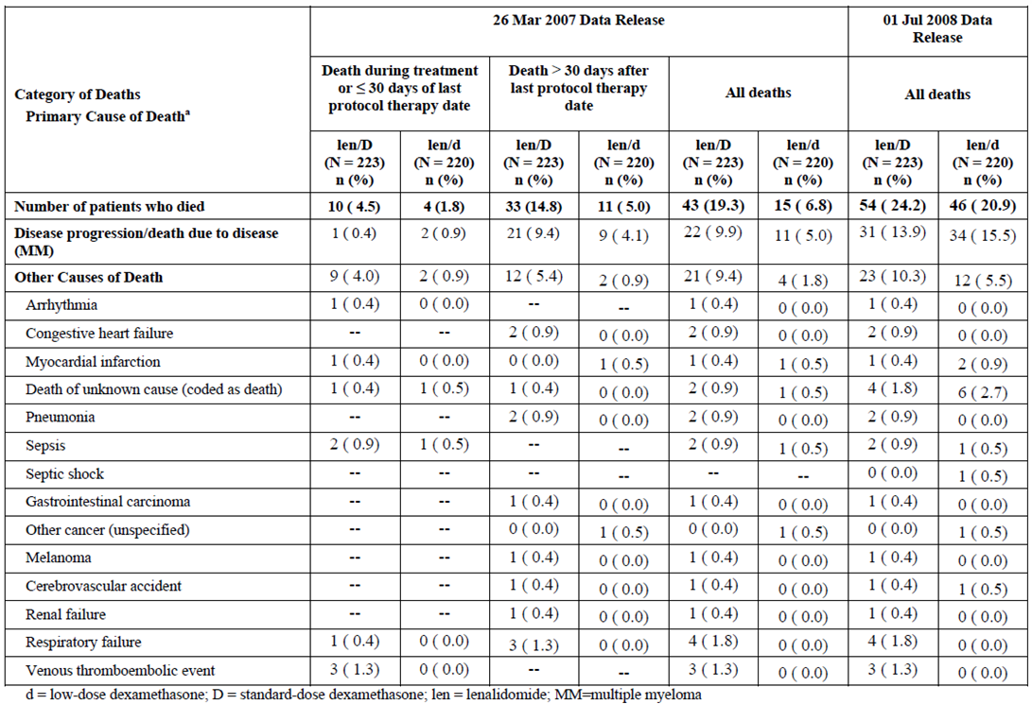

Note: * The modified safety population excluded 2 patients (both in the len/d arm) who were registered but never recorded as receiving the study drug, and included 1 patient in the len/D who appeared to have received at least some doses of the study drug based on ADEERS data who was excluded from the safety database but included in the modified safety population for the death analyses.

##### Expedited adverse events

###### Expedited adverse events irrespective of causality

The CSR included a summary of expedited AEs reported by AdEERS (i.e., SAEs). At least one expedited AE was reported in 74.8% (166/222) of patients in the len/D arm and 63.2% (139/220) of patients in the len/d arm. Expedited AEs reported in ≥ 2% of patients in the len/d arm (vs the len/D arm) in decreasing order of frequency were: hypocalcaemia (10.0% vs 12.2%); deep vein thrombosis (8.6% vs 16.7%); back pain (7.3% vs 9.0%); hyperglycaemia (6.4% vs 9.9%); peripheral sensory neuropathy (5.5% vs 2.7%); pneumonia (5.5% vs 9.9%); diarrhoea (4.5% vs 4.5%); muscle weakness (3.6% vs 12.2%); depression (3.6% vs 4.5%); pulmonary embolism (3.6% vs 7.7%); rash (3.6% vs 1.8%); oedema peripheral (3.2% vs 3.6%); alanine aminotransferase increased (3.2% vs 4.1%); neutrophil decreased (3.2% vs 3.6%); hyponatraemia (2.7% vs 11.7%); hypokalaemia (2.7% vs 7.7%); dehydration (2.7% vs 7.2%); hyperbilirubinaemia (2.7% vs 0.9%); cellulitis (2.7% vs 2.3%); blood creatinine increased (2.3% vs 4.1%); platelet count decreased (2.3% vs 4.1%); aspartate aminotransferase increased (2.3% vs 3.2%); tremor (2.3% vs 4.5%); dizziness (2.3% vs 4.1%); renal failure (2.3% vs 1.4%); pneumonitis (2.3% vs 2.3%); and hypotension (2.3% vs 1.8%).

*Comment: In general, expedited AEs reported in ≥ 2 patients in either treatment arm up to 26 March 2007 were reported more frequently in the len/D arm than in the len/d arm. Expedited AEs reported in ≥ 10% of patients in either treatment arm (len/D vs len/d) in descending order of frequency in the len/D arm were: fatigue (18.5% vs 12.7%); deep vein thrombosis (16.7% vs 8.6%); hypocalcaemia (12.2% vs 10.0%); muscular weakness (12.2% vs 3.6%); hyponatraemia (11.7% vs 2.7%); and dyspnoea (10.4% vs 10.0%). Expedited blood and lymphatic system disorders (SOC) were reported more frequently in the len/d arm than in the len/D arm (5.0% vs 3.2%), with preferred term AEs reported in ≥ 2 patients in either treatment arm, respectively, being anaemia (1.8%, n=4 vs 0.9%, n=2), febrile neutropenia (1.4%, n=3 vs 0.5%, n=1), and thrombocytopenia (1.4%, n=4 vs 0.5%, n=1).*

###### Drug-related expedited adverse events

Drug-related expedited AEs were reported in 64.0% (142/222) of patients in the len/D arm and 49.1% (108/220) of patients in the len/d arm. In general, the profile of drug-related expedited AEs was similar to the profile of expedited AEs irrespective of causality.

*Comment: Drug-related expedited AEs in the SOC of blood and lymphatic system disorders, were reported more frequently in patients in the len/d arm than in patients in the len/D arm (4.1% [9/220] vs 2.7% [6/222]), with anaemia, febrile neutropenia, neutropenia, and thrombocytopenia all being reported more frequently in the len/d arm than in the len/D arm.*

##### Other significant adverse events

###### Discontinuations due to adverse events

As of 26 March 2007, discontinuations due to a AEs were reported more frequently in the len/D arm than in the len/d arm (22.9% [51/223] vs 14.0% [51/223]). Individual AEs leading to discontinuation were not collected.

###### Dose modifications due to adverse events

Lenalidomide dose modifications due to AEs were reported more frequently in patients in the len/D arm than in patients in the len/d arm (51.4% vs 41.4%), as were dexamethasone dose modifications due to AEs (57.2% vs 33.6%).

In the len/d arm, the dose of lenalidomide was modified at least once because of AEs in 41.4% of patients (91/220), and low-dose dexamethasone was modified at least once because of AEs in 33.6% of patients (74/220). The primary AEs (reported in ≥ 5% of patients) leading to modification of the lenalidomide dose were rash (10.0%), and medication error (5.5%), while the primary AE leading to modification of low-dose dexamethasone was medication error (6.8%).

In the len/D arm, the dose of lenalidomide was modified at least once because of AEs in 51.4% of patients (114/222), and high-dose dexamethasone was modified at least once because of AEs in 57.2% of patients (127/222 patients). The primary AEs (reported in ≥ 5% of patients) leading to modification of the lenalidomide dose were medication error (10.8%), deep vein thrombosis (6.8%), and hospitalisation (5.0%), while the primary AEs leading to modification of high-dose dexamethasone were medication error (10.4%) and muscular weakness (7.7%).

##### Adverse events of special interest

To accurately capture the frequency of AEs of special interest and to eliminate possible duplication of reporting, Celgene collapsed selected preferred terms for the following events: VTE and other thromboembolic events; neuropathy; rash, gastrointestinal disorders; and infections. Atrial fibrillation and tremor were also events of special interest. AEs of special interest up to 26 March 2007 are summarised below in Table 56.

Table 56: E4A03 - Adverse events of special interest up to 26 March 2007.

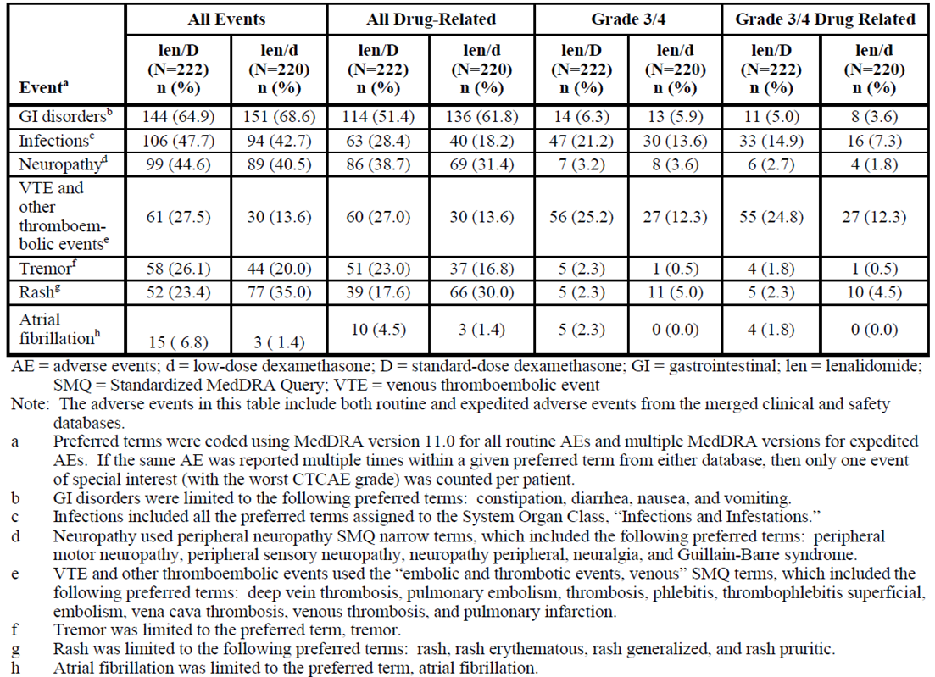

* The most commonly reported **VTE and other thromboembolic events** (len/D vs len/d) were thrombosis (24.3% vs 13.2%), deep vein thrombosis (16.7% vs 8.6%) and pulmonary embolism (7.7% vs 3.6%). The most commonly reported Grade 3/4 VTE and other thromboembolic events (len/D vs len/d) were thrombosis (23.0% vs 12.3%), deep vein thrombosis (15.8% vs 7.7%), and pulmonary embolism (6.8% vs 3.6%).
* Atrial fibrillation was the most frequently reported **cardiac disorder**, and was reported more commonly in the len/D arm than in the len/d arm (6.8% vs 1.4%). None of the patients in the len/d arm reported Grade 4 atrial fibrillation, while 2 (0.9%) patients in the len/D arm experienced drug-related Grade 4 atrial fibrillation. Myocardial ischaemia (all events) was also reported more frequently in the len/D arm than in the len/d arm (4.1% vs 1.8%), as was Grade 3/4 myocardial ischaemia (3.2% vs 0.9%). In addition, myocardial infarction (all events) was reported more frequently in the len/D arm than in the len/d arm (1.4% vs 0%), as was Grade 3/4 myocardial infarction (0.5% vs 0%). The primary cause of death during treatment and within 30 days of the last dose of study drug was arrhythmia or myocardial infarction for 2 patients in the len/D arm. No patients in the len/d arm reported a primary cause of death due to myocardial infarction or arrhythmia.
* **Infections** were reported in a high, but comparable percentage of patients in both the len/D and len/d arms (47.7% vs 42.7%). Infections occurring in ≥ 5% of patients in both arms (len/D vs len/d) were: upper respiratory tract infection (10.8% vs 12.3%); pneumonia (13.1% vs 8.6%); cellulitis (6.3% vs 6.8%); urinary tract infection (4.5% vs 6.4%); sinusitis (5.9% vs 4.5%); infection (5.9% vs 2.3%); and sepsis (5.4% vs 2.3%). The majority of infections were Grade 2 or 3 in both treatment arms. The following Grade 4 infections were reported in the len/d arm: pneumonia, sinusitis, sepsis, cystitis, bacteraemia, kidney infection, and urosepsis in one patient each (0.5%). The following Grade 4 infections were reported in the len/D arm: sepsis (0.9%; 2/222), and pneumonia, infection, urinary tract infection, Clostridium difficile colitis, urosepsis, clostridial infection, encephalitic infection, and septic shock in 1 patient each (0.5%). Sepsis was the primary cause of death during treatment and within 30 days of the last dose of study drug for 2 patients in the len/D arm and 1 patient in the len/d arm
* No severe cutaneous reactions such as SJS or TEN were reported in either treatment arm.

##### Laboratory tests

###### Haematology

Haematology laboratory data were available for granulocytes, haemoglobin, platelets, and white blood cells. Based on the worst on-treatment value, the proportions of patients who had shifts from baseline values to a worst post-baseline value of Grade 3 or 4 were comparable for the two treatment arms (see Table 57, below).

Table 57: EA403 - Shifts from baseline to Grade 3 or 4 worst post-baseline values in haematology parameters up to 26 March 2007; safety population - patients with both baseline and post-baseline measurements.

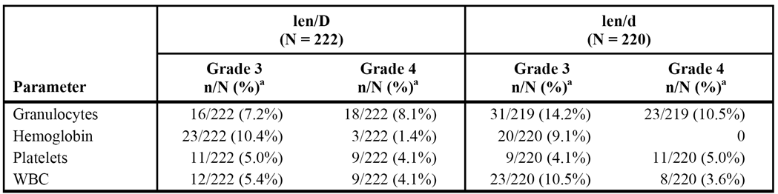

###### Clinical chemistry

No clinically meaningful differences were observed between the two treatment arms in the proportion of patients who had shifts to worst post-baseline values of Grade 3 or 4 events in serum chemistry parameters (see Table 58, below).

Table 58: EA403 - Shifts from baseline to Grade 3 or 4 worst post-baseline values in clinical chemistry parameters up to 26 March 2007; safety population - patients with both baseline and post-baseline measurements.

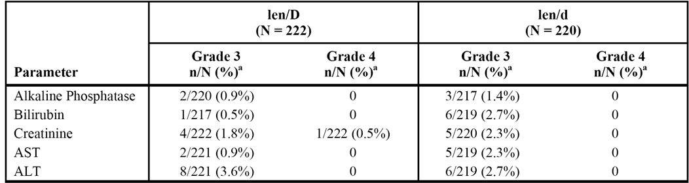

Note: NCI CTCAE version 3.0 was used.

*Comment: Laboratory abnormalities were reported as AEs (PT) for a relatively low percentage of patients in both treatment arms, and few were reported as Grade 4 events. Furthermore, since start and stop dates of individual preferred term AEs were not collected, it is unknown if the preferred term AE had an associated abnormal laboratory value. Therefore, the relationship of these values and the time course of the abnormalities with the AE data can not be assessed.*

##### Vital signs

With the exception of weight, vital signs and physical examination findings data were not collected on the CRF, and were not included in the clinical database. Therefore, vital signs and physical examination findings were not summarised. Mean changes in weight were small in both treatment arms over 32 treatment cycles, and no consistent patterns were apparent.

##### Special groups

No obvious trends relating to age, gender, or race were observed in patients in special groups for treatment-emergent AEs (all) or for Grade 3/4 AEs. However, patients in the len/d arm had a more favorable safety profile than those in the len/D arm within each special group.

#### Supportive study IFM 2005-02

##### Background

IFM 2005-02 was designed to investigate the efficacy and safety of lenalidomide for consolidation and maintenance therapy compared to placebo after ASCT in patients aged ≤ 65 years with NDMM. The lenalidomide treatment regimen consisted of 25 mg QD on days 1-21 per 28-day cycle for 2 initial consolidation cycles, followed by 10 mg QD daily for 28 days per 28-day cycle for 3 months increasing to 15 mg QD for 28 days per 28-day cycle (based on tolerability).

The study was unblinded in January 2010 after preliminary analysis showed a significant difference in PFS favouring patients in the lenalidomide arm. Treatment in the placebo arm was discontinued following unblinding, and patients were not crossed-over to lenalidomide but continued the planned assessments during the maintenance period until disease progression, loss to follow-up or initiation of new anti-cancer treatment. However, in January 2011 the DMC recommended immediate discontinuation of lenalidomide maintenance treatment after analysis of the safety data showed an increased incidence of second primary malignancies (SPMs) in patients in the lenalidomide arm compared to the placebo arm. Patients who discontinued lenalidomide maintenance treatment as a result of this recommendation continued to undergo the planned assessments until disease progression, withdrawal of consent, loss to follow-up or initiation of new anti-cancer treatment.

Based on the higher incidence of SPMs in the lenalidomide arm compared to placebo, it is considered that the safety of the lenalidomide regimen used in this study for consolidation and maintenance treatment following successful ASCT in patients aged ≤ 65 years with NDMM has not been adequately established. Treatment-emergent AEs in both treatment arms for the overall study period in the treated population are summarised below, and this is followed by a review of the SPM data.

##### Overview of adverse events

The high-level overview of TEAEs reported during the overall treatment period (including up to 30 days following the last dose of study treatment) is presented below in Table 55.

Table 59: IFM 2005-02 - High-level summary of treatment-related adverse events for the overall study period excluding observations that occurred after 7 August 2010; treated population.

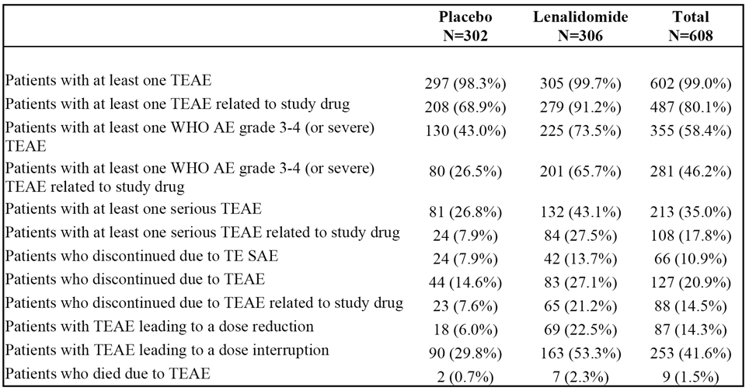

Note: A subject with multiple occurrences of an AE is counted only once in the AE category. AEs were analysed 30 days following the last dose of study medication.

##### Second primary malignancies (SPMs)

Thirty-seven (37) patients (6.0%) presented a total of 42 invasive SPMs (haematologic and solid tumours combined) before the cut-off date of 5 October 2011, with 26 patients (8.5%) in the lenalidomide arm experiencing 30 SPMS, and 11 patients (3.6%) in the placebo arm experiencing 12 SPMS.

The incidence rate of invasive SPMs was 2.25/100 patient-years in the lenalidomide arm (23 patients [7.5%]), and 0.78/100 patient-years in the placebo arm (8 patients [0.78%]). The incidence rate of haematologic SPMs was 1.27/100 patient years in the lenalidomide arm (13 patients [4.2%]) and 0.49/100 person-years in the placebo arm (5 [1.6%] patients). The incidence rate of solid tumour SPMs was 0.98/100 patient-years in the lenalidomide arm (10 [3.3%] patients) and 0.29/100 patient-years in the placebo arm (3 [1.0%] patients).

The KM analysis of time-to-SPM (5 October 2011) showed that patients in the lenalidomide arm had a 2.4-fold increased risk of experiencing an invasive SPM compared to patients in the placebo arm: HR = 2.40 (95% CI: 1.18, 4.85); p=0.0121, unstratified log-rank test. The KM analysis was based on 11 (3.6%) events in the placebo arm and 26 (8.5%) events in the lenalidomide arm. The median time to first invasive SPM event had not been reached in either treatment arm. The KM plots began to separate in favour of placebo at about 36 weeks following start of treatment and continued to diverge through to about 240 weeks. The time-to-first SPM analysis at the 5 October 2011 cutoff date is summarised and the KM plots are provided. Multivariate Cox analysis showed that male gender, age > 55 years at diagnosis, ISS stage 3 disease at diagnosis, and maintenance treatment with lenalidomide were associated with an increased relative risk of SPM.

The submission included an SPM summary document updating the number of cases of invasive SPM cases reported in IFM 2005-02 up to 7 May 2013. As of that date, a total of 53 (8.7%) of the 608 patients in the study had experienced at least one SPM. There was a higher frequency of SPMs in patients in the lenalidomide arm compared to the placebo arm (11.1% [n=34], 2.76/100 patient-years vs 6.3% [n=19], 1.48/100-patient years, respectively). The frequency of invasive SPMs was higher in patients in the lenalidomide arm compared to the placebo arm (8.8% [n=27] of patients, incidence rate 2.17/100 patient-years vs 5.3% [n=16] of patients, 1.24/100 patient years, respectively). The increased frequency of invasive SPMs in patients in the lenalidomide arm compared to the placebo arm was primarily due to the increased frequency of haematologic SPMs, which were reported in 5.2% (n=16) of patients in the lenalidomide arm (incidence rate 1.27/100 patient-years) and 2.0% (n=6) of patients in the placebo arm (incidence rate 0.46/100 patient-years). The cumulative incidence rate (per 100 person-years) for invasive SPMs in the lenalidomide arm did not significantly increase over time.

The median time to diagnosis of an invasive SPM was longer in the placebo arm than in the lenalidomide arm (44.3 months [range: 3.6, 59.4 months] vs 29.7 [range: months]), as were the median times to diagnosis of both haematologic SPMs (41.6 months [range: 3.6, 59.4 months] vs 31.9 months [range: 9.7, 69.2 months]) and solid tumour SPMs (46.5 months [range: 14.3, 57.3 months] vs 28.2 months [range: 3.7, 58.2 months]). However, the median time to diagnosis of non-melanoma skin cancer was longer in the lenalidomide arm compared to the placebo arm (43.7 months vs 23.1 months).

As of the 7 May 2013, the KM cumulative incidence curves showed no significant difference in the risk of experiencing an invasive SPM in the lenalidomide arm compared to the placebo arm (p=0.063, log-rank test, 2-sided). The HR (lenalidomide over placebo) for invasive SPMs was 1.783 (95% CI: 0.960, 3.309). The KM cumulative incidence curves of patients with haematologic SPMs were significantly different in the lenalidomide and placebo arms (p = 0.026, 2-sided log-rank test), and showed that the risk of a haematologic SPM occurring in the lenalidomide arm was greater than the risk in the placebo arm. The HR (lenalidomide/placebo) for haematologic SPMs was 2.778 (95% CI: 1.087, 7.101). The KM cumulative incidence curves showed no significant difference in the risk of experiencing a solid tumour SPM in the lenalidomide arm compared to the placebo arm (p=0.605, log-rank test, 2-sided). The HR (lenalidomide over placebo) for solid tumour SPMs was 1.274 (95% CI: 0.539, 2.887).

The competing risk analyses for SPMs based on Gray’s method as of 7 May 2013 were performed to examine the cumulative incidence of invasive SPMs over time with death as the competing risk.[6] There was a statistically significant difference between the cumulative incidence of haematologic SPMs for the lenalidomide arm compared to the placebo arm (p = 0.0311). This indicates that subjects who received lenalidomide were more likely to have hematologic SPMs than subjects receiving placebo. There were no statistically significant differences observed between the cumulative incidences of both solid tumour and invasive SPMs for the lenalidomide arm versus the placebo arm (p = 0.6461 and p = 0.0752, respectively).

Univariate and multivariate Cox regression analyses in the updated data identified ISS stage III and prior dexamethasone, cyclophosphamide, etoposide, and cisplatin (DCEP) therapy as statistically significant prognostic risk factors (unrelated to treatment) for the occurrence of haematologic SPMs. Older age (> 55 years) was identified as a significant prognostic risk factor (unrelated to treatment) for the development of solid tumour SPMs. Gender, older age, ISS stage III, BMI ≥ 25 mg/m2, and prior DCEP treatment were all identified as significant prognostic risk factors (not related to treatment) for invasive SPMs. No predictive risk factors (related to treatment) for the development of haematologic or solid tumor SPMs were identified. Female gender was identified as a predictive risk factor (related to treatment) for invasive SPMs, with females treated with lenalidomide being at an increased risk for invasive SPMs. The study excluded subjects with a prior history of invasive malignancy.

#### Supportive study SWOG S0232

SWOG S0232 was designed to compare the efficacy and safety of lenalidomide in combination with high-dose dexamethasone with placebo plus high-dose dexamethasone in patients with NDMM not immediately undergoing ASCT. This study was discontinued prematurely following preliminary data from study ECOG EA403 showed an increased incidence of death in patients treated with a lenalidomide plus high-dose dexamethasone regimen.

### Evaluator's overall conclusions on clinical safety

#### Patients with NDMM not eligible for ASCT

##### Study MM-020 - patients aged ≥ 18 years with NDMM who are not eligible for ASCT

* In general, the pivotal safety data for lenalidomide in combination with dexamethasone (Rd and Rd18 arms) for the treatment of patients with NDMM not eligible for ASCT are consistent with the known safety data for lenalidomide in combination with dexamethasone for the treatment of patients with MM whose disease has progressed after one therapy (that is, the approved indication). Overall, it is considered that the pivotal study adequately supports the Rd regimen for the treatment of patients aged ≥ 18 years who are not eligible for ASCT. However, it should be noted that patients in the pivotal study with NDMM not eligible for ASCT were predominantly aged ≥ 65 years.
* In Study MM-020, a total of 1613 patients with median age 73 years (range: 40, 92 years) with NDMM not eligible for ASCT were treated with one of three regimens (Rd [n = 532], Rd18 [n = 540] or MPT [n = 541]). The total person-years of exposure was 921 in the Rd arm, 587 in the Rd18 arm and 549 in the MPT arm. The median duration of treatment was 80.2 weeks (range: 0.7, 246.7 weeks) in the Rd arm, 72.0 weeks (range: 0.9, 102.6 weeks) in the Rd18 arm (that is, met target treatment of 72 weeks), and 67.1 weeks (range: 0.2, 110.0 weeks) in the MPT arm (that is, shorter than target treatment duration of 72 weeks). By 2 years, 39.1% (n = 208) of patients in the Rd arm were still on treatment, while all patients in the Rd18 arm and all but 2 patients in the MPT arm had discontinued. By 3 years, 18.4% (n = 98) of patients in the Rd arm were still on treatment.
* Nearly all patients experienced at least one AE (irrespective of causality), with the frequencies being 99.4%, 99.3% and 99.6% in the Rd, Rd18, and MPT arms, respectively. The majority of AEs reported in the study were considered to be related to the study drug, with at least one drug related AE being reported in 95.1%, 92.8% and 97.4% of patients in the Rd, Rd18, and MPT arms, respectively. The majority of AEs in both treatment arms were managed with dose interruptions and/or dose reductions rather than permanent treatment discontinuation.
* The most commonly reported AEs (Preferred Terms [PT]) occurring with an incidence of ≥ 20% in the Rd arm were diarrhoea (45.5%), anaemia (43.8%), constipation (43.0%), neutropenia (35.0%), back pain (32.0%), nausea (28.6%), peripheral oedema (39.7%), fatigue (32.5%), asthenia (28.2%), insomnia (27.6%), decreased appetite (23.1%), cough (22.7%), dyspnoea (22.0%), pyrexia (21.4%), rash (21.4%), muscle spasms (20.5%), and peripheral sensory neuropathy (20.5%). In general, AEs (PT) were reported more frequently in the Rd arm than in the Rd18, which is most likely to be due to the longer exposure to treatment in the Rd arm compared to the Rd18 arm. Of particular note, cataract was reported twice as frequently in the Rd arm than in the Rd18 arm (13.7% versus 5.7%).
* AEs (PT) reported in ≥ 5% more patients in the Rd18 arm than in the MPT arm, in decreasing order of frequency in the Rd18 arm, were diarrhoea (38.5% versus 16.5%), back pain (26.9% versus 21.4%), insomnia (23.5% versus 9.8%), rash (24.3% versus 17.2%), muscle spasms (18.9% versus 11.3%), decreased appetite (21.3% versus 13.3%), weight decreased (14.4% versus 8.9%), pneumonia (12.6% versus 7.4%), and hyperglycaemia (9.6% versus 3.5%).
* AEs (PT) reported in ≥ 5% more patients in the MPT arm than in the Rd18 arm, in decreasing order of frequency in the MPT arm were neutropenia (60.6% versus 33.0%), constipation (52.7% versus 39.3%), anaemia (42.3% versus 35.7%), peripheral oedema (39.7% versus 31.3%), peripheral sensory neuropathy (35.3% versus 17.0%), nausea (30.5% versus 23.7%), thrombocytopenia (25.0% vs 18.0%), dizziness (21.1% versus 13.0%), vomiting (20.1% versus 12.6%), paraesthesia (19.0% versus 13.7%), leukopenia (17.4% vs 11.1%), and lymphopenia (13.1% versus 8.0%).
* Grade 3 or 4 AEs (irrespective of causality) were reported in 85.2% of patients in the Rd arm, 80.2% of patients in the Rd18 arm, and 88.7% of patients in the MPT, and most of these were drug related. Drug related Grade 3 or 4 AEs were reported in 70.1% of patients in the Rd arm, 60.4% of patients in the Rd18 arm and 78.2% of patients in the MPT arm. Drug related Grade 3 or 4 AEs reported in ≥ 5% of patients in the Rd arm were neutropenia (26.3%), anaemia (9.2%), thrombocytopenia (6.8%), fatigue (5.6%), rash (5.8%), and deep vein thrombosis (5.3%). Drug related Grade 3 or 4 AEs reported in ≥ 5% more patients in the MPT arm compared to the Rd18 arm were neutropenia (43.3% versus 24.8%), due to the melphalan component, and peripheral sensory neuropathy (9.4% versus 0.4%), due to the thalidomide component. There were no drug related Grade 3 or 4 AEs reported in ≥ 5% more patients in the Rd18 arm compared to the MPT arm.
* Deaths reported in the active treatment period occurred more frequently in the Rd arm (9.6%) than in the Rd18 (6.9%) and the MPT (7.0%) arms. The majority of deaths in the treatment period occurred for reasons other than MM or complications from this disease. The incidence of total deaths reported in the study (that is, active treatment combined with follow-up period) was lower in the Rd arm (32.1%) than in the Rd18 (35.6%) and the MPT (38.4%) arms. The most common cause of death during the entire study in each of the three treatment arms was MM, followed by AEs related to infection (for example, sepsis, pneumonia, septic shock). Death due to cardiac disorders (primarily cardiac failure and arrest) were reported more frequently in the Rd (4.5%) and Rd18 (4.1%) arms than in the MPT arm (2.4%). The reason for the increased frequency of death due to cardiac disorders in the Rd arms is unknown, but the sponsor speculates that it might be due to chance.
* SAEs (irrespective of causality) were reported more frequently in patients in the Rd arm (67.5% [359/532]), than in the Rd18 (57.0% [308/540]) and the MPT (49.9% [270/541]) arms SAEs reported in ≥ 2% of patients in the Rd arm in descending order of frequency were pneumonia (9.8%), anaemia (4.5%), pulmonary embolism (3.8%), acute renal failure (3.8%), back pain (3.6%), deep vein thrombosis (3.6%), pyrexia (3.4%), atrial fibrillation (3.4%), sepsis (2.8%), dyspnoea (2.6%), squamous cell carcinoma of the skin (2.6%), general physical health deterioration (2.4%), and bronchitis (2.3%). SAEs reported in ≥ 1% more patients in the Rd arm compared to the Rd18 arm included bronchitis, pulmonary embolism, dyspnoea, atrial fibrillation, pyrexia, asthenia, anaemia, squamous cell carcinoma of the skin, basal cell carcinoma, and deep vein thrombosis. SAEs reported in ≥ 1% more patients in the Rd18 arm than in the MPT arm were pneumonia, upper respiratory tract infection, and acute renal failure. SAEs reported in ≥ 1% more patients in the MPT arm than in the Rd18 arm were anaemia and febrile neutropenia.
* Permanent discontinuations due to AEs were reported in 29.5% of patients in the Rd arm, 20.2% of patients in the Rd18 arm, and 28.3% of patients in the MPT arm. AEs resulting in permanent treatment discontinuation reported in ≥ 1% of patients in the Rd arm were pulmonary embolism (1.5%) and neutropenia (1.1%). Discontinuations due to AEs were reported more frequently in the MPT arm than in the Rd18 arm. AEs resulting in permanent treatment discontinuation in ≥ 1% more patients in the MPT arm compared to the Rd18 arm were peripheral sensory neuropathy (6.8% versus 0.2%), neutropenia (2.0% versus 0.4%), peripheral neuropathy (1.1% versus 0%), and paraesthesia (1.1% versus 0%). The only AE resulting in permanent treatment discontinuation in ≥ 1% more patients in the Rd18 arm compared to the MPT arm was general health deterioration (2.0% versus 0.2%).
* AEs resulting in dose interruption were reported more frequently in patients in the MPT arm (77.4%) than in the Rd (69.2%) and Rd18 (59.4%) arms. AEs resulting in dose interruption reported in ≥ 2% of patients in the Rd arm were neutropenia (21.8%), pneumonia (7.9%), rash (6.6%), anaemia (5.5%), thrombocytopenia (5.8%), and fatigue (3.8%). There were no AEs resulting in dose interruption in ≥ 5% more patients in the Rd18 arm compared to the MPT arm. AEs resulting in dose interruption in ≥ 5% more patients in the MPT arm compared to the Rd18 arm were neutropenia (48.1% versus 12.0%), thrombocytopenia (9.8% versus 3.0%), and peripheral sensory neuropathy (8.9% versus 0.2%).
* AEs resulting in dose reduction were reported more frequently in patients in the MPT arm (64.3%) than in the Rd (52.4%) and Rd18 (39.6%) arms. AEs leading to dose reduction reported in ≥ 2% of patients in the Rd arm in descending order of frequency were neutropenia (7.5%), rash (4.5%), fatigue (4.3%), asthenia (3.9%), diarrhoea (3.2%), hyperglycaemia (3.0%), peripheral oedema (2.6%), thrombocytopenia (2.6%), peripheral neuropathy (2.4%), anaemia (2.3%), and renal failure (2.1%). There were no AEs leading to dose reduction in ≥ 2% more patients in the Rd18 arm compared to the MPT arm. AEs leading to dose reduction in ≥ 2% more patients in the MPT arm compared to the Rd18 arm were neutropenia (32.2% versus 5.6%), peripheral sensory neuropathy (10.4% versus 0.6%), thrombocytopenia (5.7% versus 1.7%), constipation (4.8% versus 0.4%), peripheral neuropathy (4.3% versus 1.1%), paraesthesia (3.0% versus 0%), and tremor (2.6% versus 0.4%).
* The safety data included an assessment of selected AEs, known to be associated with lenalidomide and/or thalidomide, based generally on a wider range of preferred terms meeting the criteria (for example, MedDRA version 15.1 HLT, SMQ broad and narrow scope) than the single preferred term for the event. The assessment of the selected AEs included incidence rates per 100 person-years calculated to account for the difference in exposure duration across the three treatment arms. Of note, the incidence rates (per 100 person-years) were higher in the MPT arm than in both the Rd and Rd18 arms for neutropenia, thrombocytopenia, peripheral neuropathy, cardiac arrhythmia, constipation, hypersensitivity, and interstitial lung disease. In particular, the incidence rate of peripheral neuropathy was more than 2 fold higher in the MPT arm than in both the Rd and Rd18 arms. The incidence rates (per 100 person-years) were higher in both the Rd and Rd18 arms than the MPT arm for infections, bleeding events, diarrhoea, cataracts, and venous thromboembolic events.
* The incidence of second primary malignancies (SPMs) was extensively investigated in the pivotal study (see Table 60, below).

Table 60: MM-020 - Incidence rates (per 100 person-years of exposure) for SPM; safety population.

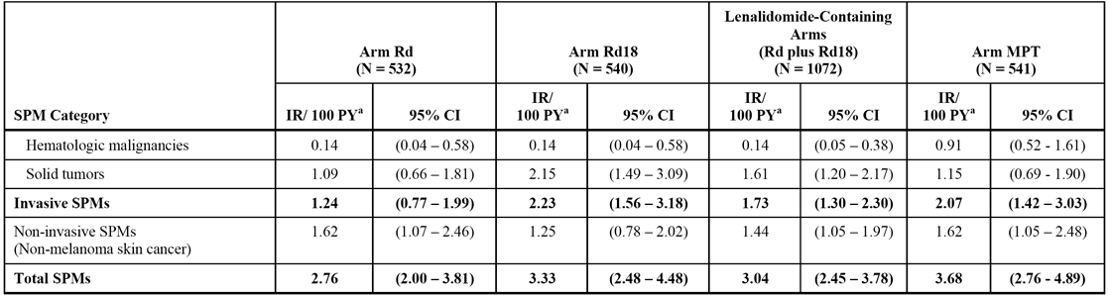

The data collected up to 24 May 2013 showed that the incidence rate (per 100 person years) for invasive SPMs (haematologic combined with solid tumours) was higher in the MPT arm than in the Rd/Rd18 combined arms (2.07 versus 1.73). Of the invasive SPMs, the incidence rate (per 100 person-years) for haematologic malignancies was higher in the MPT arm than in the Rd/Rd18 combined arms (0.91 versus 0.14), and higher for solid tumours in the Rd/Rd18 combined arm than in the MPT arm (1.61 versus 1.15). The increased incidence of haematologic SPMs in the MPT compared to the Rd/Rd18 combined arms was statistically significant, based on both the comparison between cumulative incidence curves using KM methods and a competing risk analysis of cumulative incidence using Gray’s method.14 No statistically significant differences between the MPT arm and the Rd/Rd18 combined arms were observed for solid tumours or for invasive SPMs.

* In the active treatment phase, a higher proportion of patients in the MPT arm than in the Rd18 arm shifted from baseline normal, Grade 1 or Grade 2 AEs to both post baseline Grade 3 and Grade 4 AEs for both ANC and platelets. In the active treatment period, a higher proportion of patients in the Rd18 arm than in the MPT arm shifted from baseline normal, Grade 1 or Grade 2 AEs to post baseline Grade 3 AE for both glucose and inorganic phosphorous. There were no other notable differences between the Rd18 and MPT arms in the active treatment period relating to shifts in haematological or clinical chemistry parameters. There were no notable differences across the treatment arms in vital signs or ECG changes.

##### Study MM-015: patients aged ≥ 65 years with NDMM who are not eligible for ASCT

* Study MM-015 assessed the safety of lenalidomide combined with melphalan/prednisone to the safety of melphalan/prednisone in patients aged ≥ 65 years with NDMM who were not eligible for AuSCT. The results showed the lenalidomide plus melphalan/prednisone regimen was significantly more toxic than placebo plus melphalan/prednisone regimen, raising significant concerns about the safety of the regimen in an elderly patient population with NDMM not eligible for AuSCT. Furthermore, the toxicity of the lenalidomide plus melphalan/prednisone regimen was more marked in patients aged > 75 years than in patients aged ≥ 65 to ≤ 75 years.
* In MM-015, patients were randomised to one of three treatment arms (induction plus maintenance) consisting of MPR+R (n = 150), MPR+p (n = 152) or MPp+p (n = 153), with patients being stratified at randomisation by age (≤ 75 years versus > 75 years) and disease stage (ISS I/II versus III). In the induction period, which consisted of 9 x 28-day cycles, lenalidomide was initiated at a dose of 10 mg QD on days 1 through 21 with the starting dose of melphalan being 0.18 mg/kg on days 1 through 4 and the starting dose of prednisone being 2 mg/kg on days 1 through 4. The dose of each drug could be adjusted, based on pre-defined criteria tolerability criteria. In the maintenance period, patients in the MPR+R arm continued treatment with single agent lenalidomide (10 mg QD on days 1-21 of every 28 day cycle) while patients in the MPR+p and MPp+p arms continued treatment with single agent placebo. The double blind treatment phase of the study included the induction and maintenance periods, and the maintenance period was followed an open label extension phase.

###### Induction period (AEs [all] and Grade 3 or 4 AEs)

* During the induction period, the median treatment duration and median number of treatment cycles were consistent for the three treatment arms, being 36.1 weeks (9 cycles), 36.8 weeks (9 cycles), and 36.0 weeks (9 cycles), respectively, in the MPR+R, MPR+p, and MPp+p arms. The median cumulative dose of lenalidomide was 78% and 80% of the planned dose in the MPR+R and MPR+p arms, respectively, compared to 98% of the planned placebo dose in the MPp+p arm. The median dose intensity of lenalidomide was lower in the MPR+R and MPR+p arms (6.5 mg/day and 6.1 mg/day, respectively) than the comparative dose of placebo in the MPp+p arm (7.3 mg/day). Similarly, the median relative dose intensity of placebo in the MPp+p arm (0.97) was higher than that of lenalidomide in the MPR+R and MPR+p arms (0.86 and 0.81, respectively).
* In the induction period, haematological toxicities of neutropenia, thrombocytopenia, and anaemia occurred notably more frequently in the MPR+R and MPR+p arms than in the MPp+p arm, while non haematological toxicities of pyrexia, peripheral oedema, rash, muscle spasms, and hypokalaemia also occurred more frequently in the lenalidomide containing arms.
* In the induction period, at least one AE was experienced by ≥ 98.5% of patients in each of the three treatment arms. The most commonly reported AEs in the induction period in patients in the lenalidomide arms (MPR+R, MPR+p, respectively) were: neutropenia (79.3%, 78.9%); thrombocytopenia (68.0%, 66.4%); anaemia (66.7%, 62.5%); leukopenia (33.3%, 38.2%); constipation (32.7%, 25.7%); fatigue (28.0%, 34.9%); bone pain (25.3%, 23.7%); diarrhoea (24.0%, 21.7%); nausea (23.3%, 26.3%); pyrexia (22.7%, 23.0%); peripheral oedema (20.7%, 23.7%); asthenia (20.0%, 13.2%); rash (18.0%, 27.6%); cough (16.7%, 13.8%); anorexia (13.3%, 23.0%); vomiting (12.7%, 11.8%); dyspnoea (12.7%, 11.8%); nasopharyngitis (12.0% vs 11.0%); muscle spasms (10.7%, 11.2%); and insomnia (10.0%, 11.2%).
* In the induction period, AEs reported in ≥ 10% patients in the MPR+R arm and in ≥ 5% more patients than in the MPp+p arm were: neutropenia (79.3% versus 50.3%); thrombocytopenia (68.0% versus 41.2%); anaemia (66.7% versus 50.3%); constipation (32.7% versus 23.5%); pyrexia (22.7% versus 17.6%); peripheral oedema (20.7% versus 15.7%); asthenia (20.0% versus 13.1%); rash (18.0% versus 7.8%); cough (16.7% versus 11.1%); muscle spasms (10.7% versus 3.9%); and hypokalaemia (11.3% versus 2.6%).
* In the induction period, AEs reported in ≥ 10% patients in the MPR+p arm and in ≥ 5% more patients than in the MPp+p arm were: neutropenia (78.9% versus 50.3%); thrombocytopenia (66.4% versus 41.2%); anaemia (62.5% versus 50.3%); pyrexia (23.0% versus 17.6%); peripheral oedema (23.7% versus 15.7%); anorexia (23.0% versus 14.4%); rash (27.6% versus 7.8%); muscle spasms (11.2% versus 3.9%); and hypokalaemia (7.2% versus 2.6%).
* In addition, Grade 3 or 4 AEs were reported more frequently in the induction period in the MPR+R and MPR+p arms (88.0% and 81.6%, respectively) than in the MPp+p arm (58.8%). Haematological Grade 3 or 4 AEs of neutropenia, thrombocytopenia, anaemia and leukopenia were all reported notably more commonly in the MPR+R and MPR+p arms than in the MPp+p arm. Grade 3 or 4 AEs reported in ≥ 2% patients in both the MPR+R and MPR+p arms and in ≥ 2% more patients than in the MPp+p arm were: neutropenia (70.0% vs 65.8% versus 30.5%); thrombocytopenia (36.7% versus 40.1% versus 12.4%); anaemia (24.0% versus 47.0% versus 13.7%); leukopenia (24.0% versus 27.0% versus 13.7%); febrile neutropenia (6.7% versus 2.6% versus 0%); rash (4.0% versus 4.6% versus 0.7%); and hypokalaemia (3.3% versus 3.3% versus 0.7%).
* AEs (all grades) considered by investigators to be related to lenalidomide or placebo in the induction period were reported in 96.0%, 94.1% and 83.0% of patients, respectively, in the MPR+R, MPR+p and MPp+p arms. Grade 3 or 4 AEs considered by investigators to be related to lenalidomide or placebo in the induction period were reported in 81.3%, 75.7% and 42.5% of patients, respectively, in the MPR+R, MPR+p and MPp+p arms.

###### Maintenance period (AEs [all] and Grade 3 or 4 AEs)

* The number of patients in the maintenance period was smaller than the number of patients in the induction period for each of the three treatment arms: 88 in the MPR+R arm; 94 in the MPp+p arm; and 102 in the MPp+p arm. The median treatment duration in the maintenance period was notably longer in the MPR+R arm than in both the MPR+p and the MPp+p arms (82.4 vs 27.8 vs 31.3 weeks, respectively), as was the median number of treatment cycles (17.5 vs 7.0 vs 8.0, respectively). The median cumulative dose of lenalidomide was approximately 3146 mg in the MPR+R arm, compared to the median cumulative dose of placebo of approximately 1325 mg in the MPR+p arm and 1670 mg in the MPp+p arm. The median dose intensity of lenalidomide was 6.6 mg/day in the MPR+R arm, with the median dose intensity of placebo of 7.3 mg/day in the MPR+p arm and 7.5 mg/day in MPp+p arm. The median relative dose intensity was 0.88 for lenalidomide in the MPR+R arm, and 0.97 and 1.00 for placebo in the MPR+p and MPp+p arms, respectively.
* The duration of lenalidomide maintenance treatment was almost three times as long as placebo maintenance treatment at the date the study was unblinded. AEs reported as occurring in the placebo arms (MPR+P; MPp+p) for the maintenance period included those events occurring during the observation phase after unblinding. In addition, during the maintenance period, AEs were reported when they occurred, regardless of when dosing ended. Consequently, AEs with an onset date > 30 days after the last dose of study drug were reported as occurring in the maintenance period. These factors make the comparative AE data for lenalidomide and placebo reported in the maintenance period difficult to interpret.
* In the maintenance period, AEs (new or worsening) occurred more frequently in patients treated with lenalidomide in the MPR+R arm (89.8% [79/88]) than in the MPR+R arm [77.7% [73/94] and the MPR+p arm (83.3% [85/102]). Nearly all AEs (new or worsening) reported in ≥ 10% of patients in the MPR+R arm occurred in ≥ 5% more patients than in both the MPR+p and MPR+p arms. AEs meeting these criteria for the MPR+R vs MPR+p comparison were bone pain; back pain; musculoskeletal pain; nasopharyngitis; upper-respiratory tract infection; bronchitis; diarrhoea; fatigue; anaemia; thrombocytopenia; and neutropenia. AEs meeting these criteria for the comparison between MPR+R and MPp+p were: musculoskeletal pain; nasopharyngitis; upper respiratory tract infection; bronchitis; fatigue; anaemia; thrombocytopenia; neutropenia; and cough. No AEs (new or worsening) were reported in ≥ 10% of patients in the MPR+p or MPR+p arms and in ≥ 5% more patients than in the MPR+R arm.
* In the maintenance period, Grade 3 or 4 AEs (new or worsening) were reported approximately twice as frequently in patients receiving lenalidomide compared to patients receiving placebo. Grade 3 or 4 AEs (new occurrence or worsening intensity) in the maintenance period were reported in 62.5%, 26.5%, and 33.3% of patients in the MPR+R, MPR+p, and MPp+p arms, respectively. Grade 3 or 4 AEs (new occurrence or worsening intensity) reported in ≥ 5% of patients in the MPR+R arm during the maintenance period versus the MPR+p and MPp+p arms, respectively, were: anaemia (23.9% versus 5.3% versus 7.8%); thrombocytopenia (9.1% versus 3.2% versus 2.0%); and neutropenia (6.8% versus 0% versus 1.0%). Other Grade 3 or 4 AEs (new occurrence or worsening intensity) reported in ≥ 2% of patients in the MPR+R arm and more frequently than in both the MPR+p and the MPp+p arms were: granulocytopenia; hypokalaemia; diarrhoea; fatigue; appendicitis; acute myeloid leukaemia; myelodysplastic syndrome; deep vein thrombosis; and cholestasis.
* AEs (all grades), new or worsening, considered by investigators to be related to lenalidomide or placebo in the maintenance period were reported in 65.9%, 41.5% and 35.3% of patients, respectively, in the MPR+R, MPR+p and MPp+p arms. Grade 3 or 4 AEs, new or worsening, considered by investigators to be related to lenalidomide or placebo in the maintenance period were reported in 35.2%, 9.6% and 5.9% of patients, respectively, in the MPR+R, MPR+p and MPp+p arms.

###### Deaths

* Death during the study was reported in a similar proportion of patients in the MPR+R, MPR+p and MPp+p arms (50.7% [76/150] versus 55.3% [84/152] versus 54.9% [84/153], respectively), with the majority of deaths in the three treatment arms being reported post-treatment in the OLEP or follow-up phase ( 44.7% versus 52.0% versus 50.3%, respectively)
* In the induction period, death was reported in 4.7% [7/150], 2.6% [4/152] and 3.9% [6/153] of patients in the MPR+R, MPR+p and MPp+p arms, respectively. The most commonly reported primary causes of death in the induction period were Cardiac Disorders SOC, reported in 2.7% (4/150), 0% (0/152) and 0.7% (1/153) of patients in the MPR+R, MPR+p and MPp+p arms, respectively. The only AE (PT) reported as a primary cause of death in ≥ 2 patients in the three treatment arms was cardiogenic shock, which was reported in 2 (1.3%) patients in the MPR+R arm, 1 (0.7%) patient in the in the MPp+p arm and no patients in the MPR+p arm. All 5 patients dying due to cardiac disorders in the induction period had a significant history of pre-existing cardiac disease and/or significant co-morbidities including neutropenia or infection.
* The investigators considered that 7 of 17 deaths reported in the induction period were related to treatment with lenalidomide or placebo. Grade 5 AEs suspected to be related to treatment with lenalidomide or placebo included: in the combined lenalidomide arms (MPR+R and MPR+p) - cardiogenic shock (1 x patient), infection and septic shock (1 x patient), pneumonia (2 x patients), and pulmonary embolism (1 x patient); and in the MPp+p arm - lower respiratory tract infection (1 x patient), and cardiogenic shock (1 x patient).
* In the maintenance period, death was reported in 2.3% (2/150), 1.1% (1/152) and 1.0% (1/153) patients in the MPR+R, MPR+p and MPp+p arms, respectively. There was 1 death due to a cardiac disorder in the maintenance period (MPR+R treatment arm). None of the deaths reported in the maintenance period were considered by investigators to be related to treatment with lenalidomide or placebo.

###### Other serious adverse events (SAEs)

* In the induction period, 36.0%, 36.8%, and 27.5% of patients in the MPR+R, MPR+p, and MPR+p arms, respectively, reported at least one SAE. SAEs reported in ≥ 2% of patients in either the MPR+R or MPR+P arm and in more patients in both treatment arms than in the MPp+p arm, respectively, were: neutropenia (4.0% vs 2.6% versus 0.7%); anaemia (3.3% versus 4.6% versus 1.3%); febrile neutropenia (6.0% versus 1.3% versus 0%); constipation (1.3% versus 2.0% versus 0.7%); dyspnoea (1.3% versus 2.0% versus 0.7%). SAEs considered by investigators to be related to lenalidomide or placebo were reported in 24.0%, 21.2% and 5.2% of patients in the MPR+R, MPR+R and MPp+p arms, respectively.
* In the maintenance period, 37.5%, 16.0% and 23.5% of patients in the MPR+R, MPR+p, and MPR+p arms, respectively, reported at least one SAE. SAEs reported in ≥ 2% of patients in the MPR+R arm and more frequently than in the both the MPR+p and MPp+p arms, respectively, were: acute myeloid leukaemia (4.5% versus 1.1% versus 0%); myelodysplastic syndrome (2.3% versus 0% versus 0%); appendicitis (2.3% versus 0% versus 0%); sinusitis (2.3% versus 0% versus 0%); inguinal hernia (2.3% versus 0% 0%); thrombocytopenia (2.3% versus 1.1% versus 0%); and cholestasis (2.3% versus 0% versus 0%). SAEs considered by investigators to be related to lenalidomide or placebo were reported in 4.5%, 5.3% and 2.9% of patients in the MPR+R, MPR+R and MPp+p arms, respectively.

###### AEs resulting in permanent discontinuation, temporary dose interruption, or dose reduction

* In the induction period, AEs leading to permanent treatment discontinuation of lenalidomide or placebo were reported in 12.0%, 15.1% and 6.5% of patients in the MPR+R, MPR+p and MPp+p arms, respectively. AEs leading to permanent treatment discontinuation reported in ≥ 2 patients in the MPR+R, MPR+p of MPp+p arms, respectively, were: thrombocytopenia (2.7% versus 5.3% versus 0%); neutropenia (0.7% versus 3.9% versus 1.3%); anaemia (0% versus 2.0% versus 0.7%); haemolytic anaemia (0% versus 1.3% versus 0%); and pulmonary embolism (0.7% versus 1.3% versus 0%).
* In the induction period, AEs leading to temporary dose interruption of lenalidomide or placebo were reported in 76.0%, 77.0%, and 49.0% of patients in the MPR+R, MPR+p, and MPp+p arms, respectively. AEs leading to dose interruptions of lenalidomide reported in ≥ 10% of patients in both the MPR+R and MPR+p arms (versus placebo in the MPp+ arm), respectively, were: neutropenia (55.3% versus 47.4% versus 19.6%); thrombocytopenia (40.7% versus 38.8% versus 20.9%); and anaemia (16.0% versus 15.1% versus 7.8%).
* In the induction period, AEs leading to dose reductions of lenalidomide or placebo were reported in 40.0%, 43.4% and 15.7% of patients in the MPR+R, MPR+p and MPp+p arms, respectively. AEs leading to dose reductions of lenalidomide reported in ≥ 10% of patients in both the MPR+R and MPR+p arms (vs placebo in the MPp+ arm), respectively, were: neutropenia (21.3% versus 18.4% versus 7.2%); and thrombocytopenia (18.7% versus 19.7% versus 9.2%).
* In the maintenance period, AEs leading to permanent treatment discontinuation of lenalidomide or placebo were reported in 27.0%, 4.3% and 3.9% of patients in the MPR+R, MPR+p and MPp+p arms, respectively. The most frequently reported AEs (≥ 2% of patients) resulting in discontinuation of lenalidomide or placebo in the maintenance period in the MPR+R, MPR+p and MPp+p arms, respectively, were: acute myeloid leukemia (4.5% versus 0% vs 0%); diarrhoea (3.4% versus 0% versus 0%); and neutropenia (2.3% versus 0% versus 0%). The only other AE resulting in discontinuation in the maintenance period in ≥ 2 patients was renal failure (2 [2.0%] patients in the MPp+p arm; no patients in the MPR+R or MPR+p arms).
* In the maintenance period, AEs leading to temporary dose interruption of lenalidomide or placebo were reported in 63.6%, 31.9% and 22.5% of patients in the MPR+R, MPR+p, and MPp+p arms, respectively. AEs leading to dose interruption of lenalidomide reported in ≥ 10% of patients in the MPR+R arm (vs placebo in the MPR+p and MPp+p arms), respectively, were: neutropenia (31.8% vs 2.1% vs 4.9%); and thrombocytopenia (13.6% vs 6.4% vs 0%).
* In the maintenance period, AEs leading to dose reductions of lenalidomide or placebo were reported in 33.0%, 6.4% and 2.0% of patients in the MPR+R, MPR+p and MPp+p arms, respectively. AEs leading to dose reduction of lenalidomide or placebo in 2 or more patients in the MPR+R, MPR+p or MPp+p arms, respectively, in descending order of frequency in the MPR+R arm, were: neutropenia (11.4% versus 0% versus 1.0%); thrombocytopenia (5.7% versus 0% versus 0%); anaemia (3.4% versus 3.2% versus 0%); fatigue (3.4% versus 1.1% versus 1.0%); granulocytopenia (2.3% versus 0% versus 0%); and rash (2.3% versus 0% versus 0%).

##### Selected AEs occurring in the induction and maintenance periods (combined)

* Neutropenia and infection: Neutropenia was reported more frequently in the MPR+R and MPR+p arms than in the MPp+p arm (85.3% versus 89.3% versus 52.9%, respectively), while infections were reported in a similar proportion of patients in each of the three treatment arms (64.0% versus 58.6% versus 64.1%, respectively). Grade 3 or 4 neutropenia was reported more frequently in the MPR+R and MPR+p arms than in the MPp+p arm (76.0% versus 67.1% versus 31.4%, respectively. Grade 3 or 4 infections were reported more frequently in the MPR+R and MPR+p arms than in the MPp+p arm (11.3% versus 15.1% versus 9.8%, respectively). Of note, febrile neutropenia occurred only in the lenalidomide treatment arms. The long term tolerability data in patients who continued lenalidomide for 24 months showed that Grade 3 or 4 febrile neutropenia was reported only during the first 6 months of treatment.
* Thrombocytopenia: Thrombocytopenia was reported more frequently in the MPR+R and MPR+p arms than in the MPp+p arm (70.0% versus 68.4% versus 45.1%, respectively). Similarly, Grade 3 or 4 thrombocytopenia was reported more frequently in the MPR+R and MPR+p arms (39.3% versus 41.4%) than in the MPp+p arm (13.7%). In the assessment of the long-term tolerability of lenalidomide with prolonged exposure in patients in the MPR+R arm, the onset of Grade 3 or 4 thrombocytopenia was noted only during the first 12 months of treatment among patients who continued treatment for 24 months.
* Diarrhoea and constipation: Diarrhoea was reported more frequently in the MPR+R arm (33.3%) than in the MPR+p or MPp+p arms (24.3% versus 25.5%, respectively). Grade 3 or 4 diarrhoea was reported in 5.3%, 1.3%, and 0% of patients in the MPR+R, MPR+p and MPp+p arms, respectively. Constipation was reported more frequently in the MPR+R arm (34.0%) than in the MPR+p or MPp+p arms (27.6% versus 24.8%, respectively). Grade 3 or 4 constipation was reported in 1.3%, 0.7% and 1.3% of patients the MPR+R, MPR+p and MPp+p arms, respectively.
* Rash, severe cutaneous reactions and urticaria: Rash and related terms were reported more frequently in the MPR+R and MPR+p arms (20.7% versus 28.9%, respectively) than in the MPp+p arm (9.8%). Grade 3 or 4 rash and related terms were reported in 4.7%, 4.6% and 0.7% of patients in the MPR+R, MPR+p and MPp+p arms, respectively. Severe cutaneous reactions were reported infrequently in the MPR+R, MPR+p and MPp+p arms (1.3% vs 0% vs 0.7%), with only one Grade 3 or 4 severe cutaneous event being reported in the MPR+R arm. No cases of SJS or TEN were reported in the study. Urticaria was also reported infrequently in the MPR+R, MPR+p and MPp+p arms (0% versus 1.3% versus 0.7%, respectively), and no Grade 3 or 4 urticaria was reported.
* Peripheral neuropathy: Peripheral neuropathy was reported more frequently in the MPR+R and MPR+p arms (16.0% versus 15.1%, respectively) than in the MPp+p arm (8.5%). There were only 2 Grade 3 or 4 peripheral neuropathy events (1 x neuralgia [PT] in the MPR+R arm and 1 x peripheral neuropathy [PT] in the MPp+p arm)
* Renal failure: Renal failure was reported more frequently in the MPp+p arm (17.0%) than in the MPR+R and MPR+p arms (12.0% versus 7.9%, respectively). Grade 3 or 4 renal failure was reported in 2.0%, 2.6% and 3.3% of patients in the MPR+R, MPR+p, and MPp+p arms, respectively.
* Hepatic disorders: Hepatic disorders were reported in 10.7%, 14.5% and 9.2% of the MPR+R, MPR+p and MPp+p arms, respectively. Grade 3 or 4 hepatic disorders were reported infrequently and occurred in 1.3%, 3.3% and 0% of patients in the MPR+R, MPR+p and MPp+p arms, respectively.
* Venous thromboembolic events (VTE): VTE (primarily DVT and PE) were reported more notably more frequently in the MPR+R and MPR+p arms (5.3% versus 9.9%) than in the MPp+p arm (1.3%), as were Grade 3 or 4 VTE (4.7% versus 5.9% versus 0.7%, respectively).
* Cardiac arrhythmias: Cardiac arrhythmias (excluding atrial fibrillation), were reported more frequently in the MPR+R and MPR+p arms (4.7% versus 5.3%, respectively) than in the MPp+p arm (1.3%), with the most frequently reported event in the two lenalidomide containing arms being bradycardia. The only Grade 3 or 4 occurrence of cardiac arrhythmia in the three treatment arms was tachyarrhythmia in 1 patient in the MPR+p arm. Atrial fibrillation (AF) was reported in 5.3%, 3.3% and 5.9% of patients in the MPR+R, MPR+p and MPp+p arms, respectively, with Grade 3 or 4 AF being reported in 0.7%, 1.3% and 3.3% of patients in the three treatment arms, respectively.
* Cardiac failure: Cardiac failure was reported in 4.7%, 2.6% and 2.6% of patients in the MPR+R, MPR+p and MPp+p arms, respectively, with Grade 3 or 4 cardiac failure being reported in 2.0%, 1.3% and 0% of patients in the three treatment arms, respectively. Myocardial infarction was reported in 0.7%, 1.3%, and 0% of patients in the MPR+R, MPR+p and MPp+p arms, respectively, with Grade 3 or 4 AEs myocardial infarction being reported in the same proportion of patients in the three treatment arms.
* Other selected AEs: SAEs of angioedema (Grade 3 face oedema, related to treatment, confounded by concomitant ciprofloxacin) and hypersensitivity (Grade 3 AE, considered to be related to filgrastim) were each reported once in the MPR+R arm. One Grade 3 or 4 event of tumour lysis syndrome was reported in the MPp+p arm in the maintenance period while the patient was taking placebo. Pneumonitis (Grade 1 or 2 events) was reported three times in 1 patient in the MPp+p arm.

##### Second Primary Malignancy (SPM)

As of the data cutoff date of 30 April 2013, the risk of developing both invasive SPMs (haematologic and solid tumours combined) and haematologic SPMs was statistically significantly greater in patients in the combined lenalidomide MPR+R/MPR+p arms compared to the MPp+p arm, while there was no statistically significant difference in the risk of developing solid tumour SPMs between the combined lenalidomide MPR+R/MPR+p arms and the MPp+p arm.

###### Long-term tolerability to lenalidomide exposure

* The CSR included a descriptive summary of Grade 3 or 4 AEs reported in patients treated with lenalidomide (n = 48) by date of onset over the first 24 months of treatment. In general, Grade 3 or 4 AEs occurred more frequently in the first 12 months of treatment, which represents the 9 month induction period followed by the first 3 months of the maintenance period. In particular, the onset of Grade 3 or 4 haematologic AEs of neutropenia, thrombocytopenia, leukopenia, and anemia occurred most frequently in the first 12 months of treatment, after which the frequency of onset of these events decreased considerably. Onset of Grade 3 or 4 febrile neutropenia (8.3%) was reported only during the first 6 months of treatment. Likewise, the onset of Grade 3 or 4 episodes of fatigue peaked during the first 6 months of treatment. No other notable trends were observed regarding the onset of Grade 3 or 4 AEs over time.

###### Other safety issues

* Abnormalities in haematology laboratory tests observed in the induction and maintenance periods reflected the increased risk of haematologic preferred term AEs (neutropenia, thrombocytopenia, anaemia) reported in the lenalidomide containing arms (MPR+R, MPR+p) compared to the MPp+p arm. Abnormalities in clinical chemistry laboratory tests showed clinically meaningful shifts in glucose and inorganic phosphorous in the three treatment arms. However, there were no significant differences in clinical chemistry abnormalities across the three treatment arms. There were no clinically meaningful differences across the three treatment arms over the course of the study in vital signs or ECG changes.

#### Induction therapy in patients eligible for ASCT

##### Study ECOG E4A03

* The submission included one supportive study designed to investigate the feasibility of using lenalidomide combined with dexamethasone for induction in patients with NDMM who were eligible for ASCT (study ECOG E4A03). The study showed that lenalidomide administered in combination with low-dose dexamethasone over 4 cycles demonstrated a substantially more favourable safety profile compared to lenalidomide in combination with high-dose dexamethasone over 4 cycles.
* The study was terminated prematurely after preliminary data showed a notably greater incidence of death in patients in the len/D arm compared to the len/d arm. As of the data cutoff date of 26 March 2006 the overall incidence of death was lower in the len/d arm than in len/D arm (6.8% [15/220] vs 19.3% [43/223]). Furthermore, the incidence of on-study deaths (i.e., within 30 days after the last dose of study drug) was lower in the len/d arm than in the len/D arm (1.8% [4/220 vs 4.5% [10/223). In the len/D arm, 9 of the 10 on-treatment deaths occurred within 120 days of registration in the study and within 30 days of last dose of study drug, while in the len/d arm only 1 of the 4 on-treatment deaths occurred in this time period (that is, “early deaths”). Following extended follow-up as of 1 July 2008, the difference in the incidence of death between the two treatment arms narrowed, but remained higher in the len/D arm than the len/d arm (24.2% [54/223] vs 20.9% [46/220]).
* Despite the longer duration of treatment in the len/d arm compared to the len/D arm, the overall proportion of patients with AEs was notably lower than in the len/d arm. The sponsor comments that, although the AE profile of lenalidomide in combination with dexamethasone in the study was consistent with the known AE profile for the combination, the frequencies of some individual AEs were higher than have been previously reported with this regimen.
* The len/d combination used in this study is that being proposed by the sponsor for all patients with newly diagnosed MM, but with therapy continuing until disease progression or intolerance. The sponsor has not proposed a specific four, 28 day cycle len/d induction regimen for patients for whom ASCT has been planned. The safety data for the len/d regimen used in ECOG E4A03 provides some support for the Rd regimen used in the pivotal Study MM-020. However, comparison between the safety profiles of the len/d arm used in Study ECOG E4A03 and the Rd regimen used in Study MM-020 should be interpreted cautiously due to the substantially longer treatment duration of the regimen used in study MM-020, the different methods of collection of the safety data and the difference in the patient populations (that is, AuSCT eligible versus not eligible).

#### Induction and maintenance therapy in patients with NDMM not immediately undergoing AuSCT

##### SWOG S0232

SWOG S0232 was designed to compare the efficacy and safety of lenalidomide in combination with high-dose dexamethasone to placebo plus high-dose dexamethasone in patients with NDMM not immediately undergoing ASCT. This study was discontinued prematurely when preliminary data from study ECOG EA403 showed an increased incidence of death in patients treated with a lenalidomide plus high dose dexamethasone regimen. It is considered that the safety of the lenalidomide plus high dose dexamethasone induction/maintenance regimen used in SWOG S0232 for the treatment of patients with NDMM not immediately undergoing ASCT has not been adequately demonstrated.

#### Maintenance therapy following successful ASCT

##### CALGB 100104

* In CALGB 100104, safety data were collected in patients aged ≥ 18 years to < 70 with NDMM who had undergone successful ASCT and subsequently received maintenance treatment with lenalidomide (n = 219) or placebo (n = 212). Overall, it is considered that the safety data in this study does not adequately support the safety of lenalidomide when used as maintenance treatment following a successful ASCT. The sponsor comments that: “[a]lthough the AE event profile of lenalidomide in this study is consistent with the known AE profile of lenalidomide, the frequencies of some individual AEs is higher than has previously been reported. The higher frequencies of individual AEs may be attributable to the manner in which the AE data were collected (solicited via a checklist with selected preprinted AE terms versus open ended questioning), as it is generally accepted that obtaining AE information with checklists (that is, versus via solicited methods) yields a higher incidence of reported AEs than the more passive approach in which observed AEs are recorded or spontaneously reported.”
* In CALGB 100104, 82% of patients treated with lenalidomide experienced at least one AE compared to 68.4% of patients treated with placebo. AEs (all grades) irrespective of causality that were reported in ≥ 2% more patients in the lenalidomide arm than in the placebo arm were: neutrophil count decreased (63.9% versus 25.5%); platelet count decreased (53.0% versus 24.5%); diarrhoea NOS (33.8% versus 16.5%); dermatitis exfoliative (24.7% versus 13.7%); fatigue (13.2% versus 12.3%); leukopenia (11.0% versus 3.3%); haemoglobin decreased (10.5% versus 5.7%); blood bilirubin increased (10.0% versus 5.7%); nausea (6.4% versus 3.8%); lymphopenia (6.4% versus 3.3%); febrile neutropenia (5.5% versus 1.4%); pneumonia (5.0% versus 1.9%); pyrexia (5.0% versus 2.4%); ALT increased (4.1% versus 0.5%); and AST increased (3.7% versus 0.9%).
* Grade 3 or 4 AEs (irrespective of causality) were reported in 58.4% of patients in the lenalidomide arm and 35.8% of patients in the placebo arm. The most common Grade 3 or 4 AEs in the lenalidomide arm (≥ 5% of patients) versus placebo, in descending order of frequency were: neutrophil count decreased (40.2% versus 9.0%); platelet count decreased (12.8% versus 4.2%); leukopenia NOS (8.7% versus 1.4%); infection not available, PT not provided (5.5% versus 6.6%); febrile neutropenia (5.5% versus 1.4%), fatigue (5.5% versus 3.3%); lymphopenia (5.5% versus 1.4%); and diarrhoea NOS (5.0% versus 1.9%).
* In the safety population, there were 12 deaths (5.5%) in the lenalidomide arm compared to 22 deaths (10.4%) in the placebo arm. In each arm, most deaths were due to MM (protocol-related disease) (lenalidomide 7 patients [3.2%) versus placebo 16 patients [7.5%]). Other SAEs were reported more frequently in the lenalidomide arm than in the placebo arm (19.2% vs 12.7%, respectively). The most frequently (≥ 1% of patients) occurring SAEs in the lenalidomide arm (vs the placebo arm) were: infection with normal ANC or Grade 1 or 2 neutrophils (6.8% vs 3.8%); infection, documented clinically or microbiologically, with Grade 3 or 4 neutrophils = ANC <1.0 x 109/L (4.6% vs 0.5%); neutrophils/granulocytes (ANC/AGC) (2.3% versus placebo 0.5%); febrile neutropenia (1.8% versus 0.5%); fever (1.4% versus 0.9%); and infection other, PT not available (1.4% versus 0.5%); pain (1.4% versus 2.4%). All other SAEs reported in the lenalidomide group occurred in ≤ 2 patients.
* Discontinuations due to AEs were reported notably more frequently in the lenalidomide arm than in the placebo arm (11.7% versus 1.3%). There were no data on the specific AEs resulting in treatment discontinuation, and nor were there data on the AEs resulting in treatment interruption or dose modifications. The absence of comprehensive data on treatment discontinuations, treatment interruption and dose modifications due to AEs in the treatment arms is considered to be a significant deficiency in the safety data. In addition, there were no comprehensive data for changes in laboratory parameters (haematology, clinical chemistry) over the course of the study and this is considered to be another significant deficiency in the safety data.
* The SPM data for patients in the study reported in the SPM document showed that the cumulative incidence of both invasive haematologic SPMs and of invasive SPMs (haematologic combined with solid tumour) was significantly higher in the lenalidomide arm than in the placebo arm (p = 0.0264 and p = 0.0332, respectively). This is a matter of concern, particularly given the high frequency rate for all AEs observed in this study. There was no statistically significant difference observed between the cumulative incidence of solid tumour SPMs in the lenalidomide placebo arms (p = 0.4470).

##### Study IFM 2005-02

IFM 2005-02 was designed to investigate the efficacy and safety of lenalidomide consolidation and maintenance therapy compared to placebo after AuSCT in patients aged ≤ 65 years with NDMM. The study was terminated in January 2011 after a preliminary analysis showed a greater incidence of SPMs in the lenalidomide arm compared to the placebo arm. Updated data as of 7 May 2013 showed that the risk of experiencing a haematologic SPM was significantly greater in the lenalidomide arm compared to the placebo arm. In addition, as of 7 May 2013, the risks of experiencing a second invasive SPM or a second solid tumour SPM were both greater in the lenalidomide arm compared to the placebo arm, but the risk difference between the two arms for both SPMs was not statistically significant. The high level comparison for the various AEs categories showed that the percentage of patients in the lenalidomide arm experiencing AEs was consistently greater than the percentage of patients in the placebo arm. Overall, it is considered that the safety of the lenalidomide used in this study for treatment of the patient population has not been adequately demonstrated.

#### Post marketing data

The ISS included a brief summary of the most recent Periodic Safety Update Report (PSUR) submitted to the FDA on 5 March 2014 covering the reporting period 27 December 2012 through 26 December 2013. The summary noted that the safety profile of lenalidomide is well characterised and remains consistent with the data submitted at the time of the original marketing authorisation (International Birth Date 27 December 2005). The review concluded that:

*the overall benefit/risk profile of lenalidomide in the approved indications remains positive in light of the clinical benefit gained by subjects treated with lenalidomide, even after consideration of the possible impact of SPM. Based on the well-established safety profile and the efficacy shown, the benefit-risk ratio remains favorable for lenalidomide in the approved indications.*

The summary of the PSUR provided in the ISS was repeated in the Summary of Clinical Safety.

## First round benefit-risk assessment

### First round assessment of benefits

#### NDMM in patients not eligible for AuSCT

The benefits of treatment with lenalidomide in patients with NDMM who are not eligible for AuSCT have been satisfactorily demonstrated in one pivotal study (MM-020) and one supportive study (MM-015). In both MM-020 and MM-015, the primary benefit of treatment with lenalidomide regimens included a significantly longer median time to a PFS event (disease progression or death) and a reduced risk of experiencing a PFS event (predominantly disease progression) compared to treatment with non lenalidomide regimens. However, in neither study did the preliminary OS analyses show a superior overall survival benefit for patients treated with lenalidomide regimens compare to patients treated with non lenalidomide regimens.

In the pivotal study (MM-020), the majority of patients were aged ≥ 65 years with a median age of 73 years (range: 40, 92 years). In the supportive study (MM-015), all patients were aged ≥ 65 years with a median age across the three treatment arms of 71 years (range: 65, 91 years). Therefore, the patient population in the two studies is predominantly aged ≥ 65 years and can be considered to be representative of elderly patients in an Australian population with NDMM not eligible for AuSCT for whom lenalidomide might be a treatment option. Although the number of patients in the pivotal study (MM-020) aged < 65 years was limited (n = 92, 5.7%), there is no reason to assume that the benefits of treatment observed in this study for all patients would not extend to patients aged < 65 years.

In the pivotal study (MM-020), the pre specified primary analysis showed that the risk of a PFS event was 28% lower in the Rd arm (n = 535) than in the MPT arm (n = 547) (HR = 0.72 [95% CI: 0.61, 0.85]; p = 0.00006, unstratified log-rank test), with the median time to progression or death being 4.3 months longer in the Rd arm than in the MPT arm (25.5 versus 21.2 months).

The preliminary analysis of OS (a pre specified secondary efficacy endpoint) between the Rd arm (n = 535) and the MPT arm (n = 547) in the pivotal study (MM-020) did not cross the pre specified Pocock superiority boundary of p<0.0096 (that is, the null hypothesis of no superiority between the two treatment arms was not rejected). The HR for the OS comparison between the Rd and MPT arms was 0.78 (95% CI: 0.64, 0.96), p = 0.01685, unstratified log-rank test, with the median OS time being 55.1 months in the Rd arm and 48.2 months in the MPT arm. The preliminary OS analysis shows a trend towards a greater overall survival benefit in patients treated with Rd compared with patients treated with MPT.

The pivotal study (MM-020) included a number of other pre specified secondary efficacy endpoints, and the results of these endpoints consistently favoured the Rd arm compared to the MPT arm (that is, time-to-treatment failure, overall response rate, duration of response, time to first response and time to second line anti myeloma treatment). Quality of life assessments over 18 months treatment showed statistically significant improvements from baseline in the various examined parameters in both the Rd and MPT arms.

In the supportive study (MM-015), the pre specified primary analysis (PFS) at the time of unblinding (11 May 2010) showed that the risk of a PFS event was 61% lower in the MPR+R arm (n = 152) than in the MPp+p arm (n = 154) (HR = 0.388 [95% CI: 0.274, 0.550]; p<0.001, unstratified log-rank test), with the median time to progression or death being significantly longer in the MPR+R arm than in the MPp+p arm (31.3 versus 12.9 months).

OS was a secondary efficacy endpoint in the supportive study (MM-015). As of 30 April 2013, OS analysis showed that treatment with the MPR+R regimen (n = 152) did not confer an overall survival benefit over treatment with the MPp+p regimen (n = 154), with the observed HR [MPR+R/MPp+p] being 0.948 (95% CI: 0.696, 1.292). The median OS was 55.9 months for patients in the MPR+R arm and 53.9 months for patients in the MPp+p arm, and the estimated 5 year OS rate was 47% for patients in the MPR+R arm and 44% for patients in the MPp+p arm.

In the supportive study (MM-020), other secondary efficacy endpoint analyses as 30 April 2013 also consistently favoured the MPR+R arm over the MPp+p arm (that is, TTP, TT next ATM, TTR, DOR, response rate), as did the exploratory efficacy endpoint analyses (PFS2; landmark analysis in patients completing 9 induction cycles and preceding to maintenance therapy). QoL (secondary efficacy endpoints) showed similar improvements in the MPR+R and MPp+p arms during the treatment period.

#### NDMM in patients eligible for AuSCT

The submission included two studies (designated by the sponsor as supportive) in patients with NDMM eligible for AuSCT (ECOG E4A03 and SWOG S0232). In SWOG S0232, **a lenalidomide plus high dose dexamethasone** induction and maintenance regimen in patients with NDMM eligible for, but not immediately proceeding to, AuSCT was compared to **placebo plus high dose dexamethasone**. The study was discontinued prematurely when preliminary data from ECOG E4A03 showed an overall survival benefit for the **lenalidomide low dose-dexamethasone regimen** compared to the **lenalidomide high-dose dexamethasone regimen** used in that study. Therefore, only the efficacy data from ECOG E4A03 for the **lenalidomide plus low dose dexamethasone regimen** are considered to be directly relevant to the submission.

In ECOG A4A03, two potential regimens were compared for induction (4 treatment cycles) in patients with NDMM eligible for AuSCT (len/D [n=233] versus len/d [n = 222]). It should be noted that neither of these two regimens are currently approved in Australia for induction in patients with NDMM eligible for AuSCT. The primary efficacy endpoint was the overall response rate (ORR), based on IRAC assessment, at the end of 4 cycles. The ORR (CR+nCR+PR) at the end of 4 cycles was significantly higher in the len/D arm than in the len/d arm (77.1% versus 64.4%; p = 0.0035, Fisher's exact test). The odds ratio (len/D:len/d) was 1.86 (95% CI: 1.23, 2.82), demonstrating that len/d was not non-inferior to len/D based on pre specified non inferiority criteria (that is, odds ratio of 1.91). There was no statistically significant difference between the two treatment arms in PFS (HR [len/D:len/D] = 1.321 (95% CI: 0.916, 1.904); p = 0.1350).

Recruitment to the len/D arm of study ECOG E4A03 was terminated prematurely when preliminary results suggested a superior overall survival benefit for patients in the len/d arm compared to the len/D arm. As of the date of data release (26 March 2007), death had been reported in 17 of the 222 patients (7.7%) in len/d arm and 43 of the 223 patients (19.3%) in the len/D arm. Median OS had not been reached in either treatment arm, but based on the unstratified log-rank test OS was significantly longer in the len/d arm than in the len/D arm (p = 0.0003). In addition, the risk of death in the len/D arm was approximately 2.7 times greater than in the len/d arm (that is, HR = 2.681 [95% CI: 1.528, 4.706]).

The efficacy data from study ECOG E4A03 do not support a len/D regimen (4 cycles) for induction in patients with NDMM eligible for AuSCT, due to lower overall survival in patients treated with this regimen compared to len/d. While the len/d regimen might be a suitable for induction in patients with NDMM eligible for AuSCT, it is considered that the benefits of the regimen need to be confirmed in a study comparing it with an approved treatment for this indication (for example, a bortezomib based regimen).

#### Maintenance therapy in NDMM patients following successful AuSCT

The submission include two studies (designated as supportive) assessing the benefits of lenalidomide maintenance therapy in patients with NDMM who had undergone successful AuSCT (IFM 2005-02 and CALGB 100104). The results showed that there was significant increases in time to progression in patients in the lenalidomide arm compared to patients in the placebo arm in both IFM 2005-02 and CALGB 100104. In neither study was median OS reached in either treatment arm. In IFM-2005, there was a non-statistically significant trend for a greater overall survival benefit in the placebo arm compared to the lenalidomide arm at the time of study unblinding, while in the CALGB 100104 there was an equivocal statistically significant greater overall survival benefit in the lenalidomide arm compared to the placebo arm.

In IFM 2005-02, the primary analysis of the PFS at the date of study unblinding showed a significant benefit in favour of single agent lenalidomide (2 consolidation cycles, followed by maintenance therapy) compared to placebo (2 consolidation cycles with lenalidomide, followed by placebo maintenance therapy) in patients with NDMM who had undergone previous successful AuSCT (HR = 0.50 (95% CI: 0.39, 0.65); p<0.001, unstratified log-rank test). The HR represents a 50% reduction in the risk of progression or death in the lenalidomide arm compared to the placebo arm. Median PFS was 41.0 months in the lenalidomide arm compared to 23.1 months in the placebo arm, representing a 17.9 month improvement in median PFS.

In IFM 2005-02, OS was a secondary efficacy endpoint and the median OS time had not been reached in either treatment arm at the data of study unblinding. However, in the analysis at the date of unblinding OS favoured placebo over lenalidomide, but the difference was not statistically significant (HR = 1.26 [95% CI: 0.84, 1.90]; p = 0.2690, unstratified log-rank test). The OS analysis was based on 41 deaths in the placebo arm (13.4%) and 51 deaths in the lenalidomide arm (16.6%). While the results of the OS analysis are preliminary, they raise concerns about the safety of the lenalidomide regimen used in this study, particularly as the study was discontinued prematurely due to the increased risk of SPM in the lenalidomide arm compared to placebo. The analyses of the other secondary efficacy endpoints statistically significantly favoured lenalidomide compared to placebo (that is, PFS from date of diagnosis, TTP, DOR, ORR).

In CALGB 100104, the primary efficacy analysis showed that lenalidomide maintenance therapy significantly increased TTP following successful AuSCT compared to placebo, with median TTP being 37.2 and 22.2 months, respectively (HR = 0.38 [95% CI: 0.27 0.54]; p < 0.001, unstratified log-rank test). The primary endpoint was met and the DSMB recommended that patients in the placebo arm switch to lenalidomide maintenance therapy. The median overall follow-up time for OS was 18.9 months (range: 3.2 to 55.9 months), and median OS had not been reached in either the lenalidomide or the placebo arm at the time of study unblinding. There had been more deaths in the placebo arm compared to the lenalidomide arm at the time of the analysis (24 [10.5%] versus 13 [5.6%], respectively). The difference in the risk of death favoured lenalidomide relative to placebo (p = 0.049, long-rank test), with a HR of 0.51 (95% CI: 0.26, 1.01). There was no statistically significant difference between the two treatment arms in the best myeloma response rate (CR+PR) between the two treatment arms.

### First round assessment of risks

#### NDMM in patients not eligible for ASCT not eligible patients

##### Overview

The risks of lenalidomide for the treatment of patients with NDMM not eligible for AuSCT were assessed in one pivotal study (MM-020) and one supportive study (MM-015). In the pivotal study (MM-020), the safety profile of the Rd treatment regimen was similar to the known safety profile of lenalidomide used in combination with dexamethasone in patients with relapsed MM. In general, the safety profiles of both the Rd and MPT regimens used in the pivotal study (MM-020) were acceptable in the population studied, but the Rd arm was better tolerated than the MPT arm. However, the safety profile of the triplet regimen of lenalidomide, melphalan and prednisone in patients aged ≥ 65 used in the induction phase of the treatment period in the supportive study (MM-015) was notably inferior to the safety profile of the doublet regimen of melphalan and prednisone. Furthermore, the safety profile of single agent lenalidomide in the maintenance phase of the treatment period in the supportive study (MM-015) following induction with MPR was notably inferior to the safety profile of placebo following induction with MPp.

##### Study MM-020 (Pivotal)

In MM-020, a total of 1613 patients with median age 73 years (range: 40, 92 years) with NDMM not eligible for AuSCT were treated with one of three regimens (Rd [n = 532], Rd18 [n = 540] or MPT [n = 541]). Nearly all patients in the study experienced at least one AE (irrespective of causality), with the frequencies being 99.4%, 99.3% and 99.6% in the Rd, Rd18, and MPT arms, respectively. The majority of AEs reported in the study were considered to be related to the study drug, with at least one drug related AE being reported in 95.1%, 92.8% and 97.4% of patients in the Rd, Rd18, and MPT arms, respectively.

In MM-020, the major risks of treatment with Rd related to neutropenia, anaemia, and thrombocytopenia. However, the risks of haematological AEs and peripheral neuropathy were notably greater in patients treated with MPT compared to Rd. The majority of AEs in both treatment arms were managed with dose interruptions and/or dose reductions rather than permanent treatment discontinuation, but the risks of dose interruption and/or dose reduction resulting from AEs were higher in patients in the MPT arm compared to the Rd arm. The risks of treatment with Rd were greater in patients aged > 75 years compared to patients aged ≤ 75 years.

In MM-020, the most commonly reported AEs (PT) occurring with an incidence of ≥ 20% in the Rd arm were diarrhoea (45.5%), anaemia (43.8%), constipation (43.0%), neutropenia (35.0%), back pain (32.0%), nausea (28.6%), peripheral oedema (39.7%), fatigue (32.5%), asthenia (28.2%), insomnia (27.6%), decreased appetite (23.1%), cough (22.7%), dyspnoea (22.0%), pyrexia (21.4%), rash (21.4%), muscle spasms (20.5%), and peripheral sensory neuropathy (20.5%). In general, AEs (PT) were reported more frequently in the Rd arm than in the Rd18, most likely to be due to longer exposure to treatment in the Rd arm compared to the Rd18 arm. Of particular note, cataract was reported twice as frequently in the Rd arm than in the Rd18 arm (13.7% versus 5.7%).

In MM-020, the risk profile differed between the Rd18 arm and the MPT arm, with the risks of blood related abnormalities (that is, neutropenia, thrombocytopenia, leukopenia, lymphopenia) and peripheral neuropathy being notably greater in the MPT arm than in the Rd18 arm. AEs reported in ≥ 5% more patients in the Rd18 arm than in the MPT arm, in decreasing order of frequency in the Rd18 arm, were diarrhoea (38.5% versus 16.5%), back pain (26.9% versus 21.4%), insomnia (23.5% versus 9.8%), rash (24.3% versus 17.2%), muscle spasms (18.9% versus 11.3%), decreased appetite (21.3% versus 13.3%), weight decreased (14.4% versus 8.9%), pneumonia (12.6% versus 7.4%), and hyperglycaemia (9.6% versus 3.5%). AEs (PT) reported in≥ 5% more patients in the MPT arm than in the Rd18 arm, in decreasing order of frequency in the MPT arm were neutropenia (60.6% versus 33.0%), constipation (52.7% versus 39.3%), anaemia (42.3% versus 35.7%), peripheral oedema (39.7% versus 31.3%), peripheral sensory neuropathy (35.3% versus 17.0%), nausea (30.5% versus 23.7%), thrombocytopenia (25.0% versus 18.0%), dizziness (21.1% versus 13.0%), vomiting (20.1% versus 12.6%), paraesthesia (19.0% versus 13.7%), leukopenia (17.4% versus 11.1%), and lymphopenia (13.1% versus 8.0%).

In MM-020, the risk of patients experiencing drug related Grade 3 or 4 AEs was greater in the MPT arm than in both the Rd and Rd18 arms (70.1% versus 60.4% versus 78.2%, respectively). Drug related Grade 3 or 4 AEs reported in ≥ 5% of patients in the Rd arm were neutropenia (26.3%), anaemia (9.2%), thrombocytopenia (6.8%), fatigue (5.6%), rash (5.8%), and deep vein thrombosis (5.3%). Drug related Grade 3 or 4 AEs reported in ≥ 5% more patients in the MPT arm compared to the Rd18 arm were neutropenia (43.3% versus 24.8%) and peripheral sensory neuropathy (9.4% versus 0.4%). There were no drug related Grade 3 or 4 AEs reported in ≥ 5% more patients in the Rd18 arm compared to the MPT arm.

In MM-020, deaths reported in the active treatment phase occurred more frequently in the Rd arm (9.6%) than in the Rd18 arm (6.9%) and the MPT arm (7.0%). The most common cause of death during the entire study in each of the three treatment arms was MM, followed by AEs related to infection (for example, sepsis, pneumonia, septic shock). Death due to cardiac disorders (primarily cardiac failure and arrest) were reported more frequently in the Rd (4.5%) and Rd18 (4.1%) arms than in the MPT arm (2.4%). The reason for the increased frequency of death due to cardiac disorders in the Rd arms is unknown, but the sponsor speculates that it might be due to chance.

In MM-020, SAEs were reported notably more frequently in patients in the Rd arm than in the Rd18 and MPT arms (67.5% versus 57.0% versus 49.9%). SAEs reported in ≥ 2% of patients in the Rd arm in descending order of frequency were pneumonia (9.8%), anaemia (4.5%), pulmonary embolism (3.8%), acute renal failure (3.8%), back pain (3.6%), deep vein thrombosis (3.6%), pyrexia (3.4%), atrial fibrillation (3.4%), sepsis (2.8%), dyspnoea (2.6%), squamous cell carcinoma of the skin (2.6%), general physical health deterioration (2.4%), and bronchitis (2.3%). SAEs reported in ≥ 1% more patients in the Rd arm than in the Rd18 arm included bronchitis, pulmonary embolism, dyspnoea, atrial fibrillation, pyrexia, asthenia, anaemia, squamous cell carcinoma of the skin, basal cell carcinoma, and deep vein thrombosis. SAEs reported in ≥ 1% more patients in the Rd18 arm than in the MPT arm were pneumonia, upper respiratory tract infection, and acute renal failure. SAEs reported in ≥ 1% more patients in the MPT arm than in the Rd18 arm were anaemia and febrile neutropenia.

In MM-020, the risk of patients permanently discontinuing treatment was similar in the Rd and MPT arms, and lower in the Rd18 arm than both of these arms (29.5% versus 28.3% versus 20.2%, respectively). AEs resulting in permanent treatment discontinuation reported in ≥ 1% of patients in the Rd arm were pulmonary embolism (1.5%) and neutropenia (1.1%). AEs resulting in permanent treatment discontinuation in ≥ 1% more patients in the MPT arm compared to the Rd18 arm were peripheral sensory neuropathy (6.8% versus 0.2%), neutropenia (2.0% versus 0.4%), peripheral neuropathy (1.1% versus 0%), and paraesthesia (1.1% versus 0%). The only AE resulting in permanent treatment discontinuation in ≥ 1% more patients in the Rd18 arm compared to the MPT arm was general health deterioration (2.0% versus 0.2%).

In MM-020, the risk of patients temporarily interrupting their dose due to AEs was greater in the MPT arm than in the Rd and Rd18 arms (77.4% versus 69.2% versus 59.4%, respectively). AEs resulting in dose interruption reported in ≥ 2% of patients in the Rd arm were neutropenia (21.8%), pneumonia (7.9%), rash (6.6%), anaemia (5.5%), thrombocytopenia (5.8%), and fatigue (3.8%). There were no AEs resulting in dose interruption in ≥ 5% more patients in the Rd18 arm compared to the MPT arm. AEs resulting in dose interruption in ≥ 5% more patients in the MPT arm compared to the Rd18 arm were neutropenia (48.1% versus 12.0%), thrombocytopenia (9.8% versus 3.0%), and peripheral sensory neuropathy (8.9% versus 0.2%).

In MM-020, the risk of patients reducing their dose because of AEs was greater in the MPT arm than in the Rd and Rd18 arms (64.3% versus 52.4% versus 39.6%). AEs leading to dose reduction reported in ≥ 2% of patients in the Rd arm in descending order of frequency were neutropenia (7.5%), rash (4.5%), fatigue (4.3%), asthenia (3.9%), diarrhoea (3.2%), hyperglycaemia (3.0%), peripheral oedema (2.6%), thrombocytopenia (2.6%), peripheral neuropathy (2.4%), anaemia (2.3%), and renal failure (2.1%). There were no AEs leading to dose reduction in ≥ 2% more patients in the Rd18 arm compared to the MPT arm. AEs leading to dose reduction in ≥ 2% more patients in the MPT arm compared to the Rd18 arm were neutropenia (32.2% versus 5.6%), peripheral sensory neuropathy (10.4% versus 0.6%), thrombocytopenia (5.7% versus 1.7%), constipation (4.8% versus 0.4%), peripheral neuropathy (4.3% versus 1.1%), paraesthesia (3.0% versus 0%), and tremor (2.6% versus 0.4%).

In MM-020, there was no increased risk of SPMs in the Rd arm compared to the MPT, while the risk of haematologic SPMs was significantly greater in patients treated with MPT compared to Rd. There were no increased risks of hepatic or renal disorders in patients treated with Rd compared to MPT, while there was a small increased risk of cardiac disorders in patients treated with Rd compared to MPT.

In MM020, in the active treatment phase, a higher proportion of patients in the MPT arm than in the Rd18 arm had shifts from baseline normal, Grade 1 or Grade 2 AEs to post baseline Grade 3 and Grade 4 AEs in the haematological laboratory parameters of ANC and platelets. In the active treatment phase, a higher proportion of patients in the Rd18 arm than in the MPT arm had shifts from baseline normal, Grade 1 or Grade 2 AEs to post baseline Grade 3 AE in the clinical chemistry laboratory parameters of glucose and inorganic phosphorous. There were no other notable differences between the Rd18 and MPT arms in the active treatment phase relating to shifts in haematological or clinical chemistry laboratory parameters. There were no notable differences across the three treatment arms in either vital sign or ECG changes.

##### Study MM-015 (supportive)

In MM-015, the total number of patients with NDMM not eligible for AuSCT in the safety population was 455, and the median age of these patients was 71 years (range: 65, 91 years). The study consisted of an induction period consisting of 9 treatment cycles in each treatment arm, followed by a maintenance period continuing until disease progression or toxicity.

###### Induction period (9 cycles)

The safety population in the three treatment arms in the induction period consisted of 150, 152, and 153 patients in the MPR+R, MPR+p, and MPp+p arms, respectively. Median treatment duration and median number of cycles were 36.1 weeks (9.0 cycles), 36.8 weeks (9.0 cycles), and 36.0 weeks (9 cycles) in the MPR+R, MPR+p, and MPp+p arms, respectively. The treatment duration in the induction period was similar in each of the three treatment arms, allowing meaningful comparison of the risks of each treatment in this period to be made.

Haematological toxicities of neutropenia, thrombocytopenia, and anaemia occurred notably more frequently in the two lenalidomide treatment arms (MPR+R, MPR+p) compared to the control arm of combination melphalan, prednisone and placebo (MPp+p), while non haematological toxicities of pyrexia, peripheral oedema, rash, muscle spasms, and hypokalaemia also occurred more frequently in the lenalidomide arms than in the control arm.

At least one AE was reported in ≥ 98.5% of patients in each of the three treatment arms. The most commonly reported AEs in the induction period in patients in the two lenalidomide arms (MPR+R, MPR+p, respectively) were: neutropenia (79.3%, 78.9%); thrombocytopenia (68.0%, 66.4%); anaemia (66.7%, 62.5%); leukopenia (33.3%, 38.2%); constipation (32.7%, 25.7%); fatigue (28.0%, 34.9%); bone pain (25.3%, 23.7%); diarrhoea (24.0%, 21.7%); nausea (23.3%, 26.3%); pyrexia (22.7%, 23.0%); peripheral oedema (20.7%, 23.7%); asthenia (20.0%, 13.2%); rash (18.0%, 27.6%); cough (16.7%, 13.8%); anorexia (13.3%, 23.0%); vomiting (12.7%, 11.8%); dyspnoea (12.7%, 11.8%); nasopharyngitis (12.0%, 11.0%); muscle spasms (10.7%, 11.2%); and insomnia (10.0%, 11.2%).

AEs reported in ≥ 10% more patients in the MPR+R arm and in ≥ 5% more patients than in the MPp+p arm were: neutropenia (79.3% versus 50.3%); thrombocytopenia (68.0% versus 41.2%); anaemia (66.7% versus 50.3%); constipation (32.7% versus 23.5%); pyrexia (22.7% versus 17.6%); peripheral oedema (20.7% versus 15.7%); asthenia (20.0% versus 13.1%); rash (18.0% versus 7.8%); cough (16.7% versus 11.1%); muscle spasms (10.7% versus 3.9%); and hypokalaemia (11.3% versus 2.6%).

AEs reported in ≥ 10% more patients in the MPR+p arm and in ≥ 5% more patients than in the MPp+p arm were: neutropenia (78.9% versus 50.3%); thrombocytopenia (66.4% versus 41.2%); anaemia (62.5% versus 50.3%); pyrexia (23.0% versus 17.6%); peripheral oedema (23.7% versus 15.7%); anorexia (23.0% versus 14.4%); rash (27.6% versus 7.8%); muscle spasms (11.2% versus 3.9%); and hypokalaemia (7.2% versus 2.6%).

In addition, Grade 3 or 4 AEs were reported more frequently in the MPR+R and MPR+p arms (88.0% and 81.6%, respectively) than in the MPp+p arm (58.8%). Haematological Grade 3 or 4 AEs of neutropenia, thrombocytopenia, anaemia and leukopenia were all reported notably more frequently in patients in the two lenalidomide arms (MPR+R, MPR+p) than in the control arm (MPp+p). Grade 3 or 4 AEs reported in ≥ 2% patients in both the MPR+R and MPR+p arms and in ≥ 2% more patients than in the MPp+p arm were: neutropenia (70.0% versus 65.8% versus 30.5%); thrombocytopenia (36.7% versus 40.1% versus 12.4%); anaemia (24.0% versus 47.0% versus 13.7%); leukopenia (24.0% versus 27.0% versus 13.7%); febrile neutropenia (6.7% versus 2.6% versus 0%); rash (4.0% versus 4.6% versus 0.7%); and hypokalaemia (3.3% versus 3.3% versus 0.7%).

SAEs were reported notably more frequently in patients in the two lenalidomide arms (MPR+R, MPR+p) arms than in the control arm (MPp+p): 30.6%, 36.8% and 27.5%, respectively. SAEs reported in ≥ 2% of patients in either the MPR+R or MPR+P arm and in more patients in both of these treatment arms than in the MPp+p arm, respectively, were: neutropenia (4.0% versus 2.6% versus 0.7%); anaemia (3.3% versus 4.6% versus 1.3%); febrile neutropenia (6.0% versus 1.3% versus 0%); constipation (1.3% versus 2.0% versus 0.7%); dyspnoea (1.3% versus 2.0% versus 0.7%). SAEs considered by investigators to be related to lenalidomide or placebo were reported in 24.0%, 21.2% and 5.2% of patients in the MPR+R, MPR+R and MPp+p arms, respectively.

AEs resulting in permanent treatment discontinuation of lenalidomide or placebo were reported approximately 2-fold more frequently in patients in the lenalidomide arms (MPR+R, MPR+p) than in the placebo arm (MPp+p) (12.0%, 15.1% and 6.5%, respectively). AEs leading to permanent treatment discontinuation reported in ≥ 2 patients in the MPR+R, MPR+p or MPp+p arms, respectively, were: thrombocytopenia (2.7% versus 5.3% versus 0%); neutropenia (0.7% versus 3.9% versus 1.3%); anaemia (0% versus 2.0% versus 0.7%); haemolytic anaemia (0% versus 1.3% versus 0%); and pulmonary embolism (0.7% versus 1.3% versus 0%).

AEs resulting in temporary dose interruption of lenalidomide or placebo were reported notably more frequently in patients in the MPR+R and MPR+p arms than in the MPp+p arm (76.0%, 77.0%, and 49.0%, respectively). AEs leading to dose interruptions of lenalidomide reported in ≥ 10% of patients in both the MPR+R and MPR+p arms (versus placebo in the MPp+p arm), respectively, were: neutropenia (55.3% versus 47.4% versus 19.6%); thrombocytopenia (40.7% versus 38.8% versus 20.9%); and anaemia (16.0% versus 15.1% versus 7.8%).

AEs leading to dose reductions of lenalidomide or placebo were reported notably more frequently in patients in the MPR+R and MPR+p arms than in the MPp+p arm (40.0%, 43.4% and 15.7%, respectively). AEs leading to dose reductions of lenalidomide reported in ≥ 10% of patients in both the MPR+R and MPR+p arms (versus placebo in the MPp+ arm), respectively, were: neutropenia (21.3% versus 18.4% versus 7.2%); and thrombocytopenia (18.7% versus 19.7% versus 9.2%).

###### Maintenance period

The number of patients in the maintenance period was smaller in each of the three treatment arms than in the induction period: that is, 88, 94, and 102 in the MPR+R, MPR+p and MPp+p arms, respectively. In addition, the median treatment duration in the maintenance period was notably longer in the MPR+R arm than in both the MPR+p and the MPp+p arms (82.4 versus 27.8 versus 31.3 weeks, respectively), as was the median number of treatment cycles (17.5 versus 7.0 versus 8.0, respectively).

During the maintenance, AEs (new occurrence or worsening intensity) were reported in the majority of patients in all three treatment arms (that is, 89.8%, 77.7% and 83.3% in the MPR+R, MPR+p and MPp+p arms, respectively). The proportion of patients who received lenalidomide as maintenance and who had Grade 3 or 4 AEs (new occurrence or worsening intensity) was approximately 2-fold higher than in patients who received placebo (that is, 62.5%, 33.3 and 26.6% in the MPR+R, MPR+p and MPp+p arms, respectively). The risks of permanently discontinuing treatment, temporarily reducing the dose, and interrupting treatment due to AEs were all notably greater in patients treated with lenalidomide than in patients treated with placebo.

The main risks of treatment with lenalidomide relative to placebo during the maintenance period related to haematological toxicities of neutropenia, anaemia, thrombocytopenia, leukopenia, and granulocytopenia and non haematological toxicities of diarrhoea, rash and fatigue.

###### Selected AEs reported in the induction and maintenance periods

The following selected AEs were reported notably more frequently in the two lenalidomide arms (MPR+R, MPp+p) than in the control arm (MPp+p): neutropenia (all Grades and Grade 3 or 4); thrombocytopenia (all Grades and Grade 3 or 4); VTE (all Grades and Grade 3 or 4), primarily DVT and PE; peripheral neuropathy (all Grades); hepatic disorders (all Grades); cardiac arrhythmias, excluding atrial fibrillation (all Grades); infections (Grade 3 or 4); diarrhoea (Grade 3 or 4); and rash and related terms (all grades and Grade 3 and 4 events).

###### SPMs

The analysis of SPMs, as of the cutoff date of 30 April 2013, showed that the risks of developing haematologic SPMs and invasive SPMs (haematologic and solid tumours) were statistically significantly greater in patients in the combined lenalidomide MPR+R/MPR+p arms than in patients in the MPp+p arm, while there was no statistically significant difference in the risk of developing solid tumour SPMs between the combined lenalidomide MPR+R/MPR+p arms and the MPp+p arm.

###### Long-term tolerability to lenalidomide exposure

In general, Grade 3 or 4 AEs occurred more frequently in patients during the first 12 months of treatment with lenalidomide, which represents the 9 month induction period with the triplet regimen of lenalidomide, melphalan and prednisone and the first 3 months of maintenance therapy with single-agent lenalidomide. In particular, the frequencies of Grade 3 or 4 haematological AEs of neutropenia, thrombocytopenia, leukopenia, and anemia with onset during the first 6 months of treatment higher than the second 6 months of treatment, and decreased considerably after the first 12 months on treatment. Onset of Grade 3 or 4 febrile neutropenia (8.3%) was reported only during the first 6 months of treatment. Likewise, Grade 3 or 4 fatigue decreased after the first 6 months of treatment. No other notable trends were observed relating to the onset of Grade 3 or 4 AEs over time.

###### Death

During the study, death was reported in a similar proportion of patients in the MPR+R, MPR+p and MPp+p arms (50.7% versus 55.3% versus 54.9%, respectively), with the majority of deaths in the three treatment arms being reported post treatment (OLEP or follow-up).

In the induction period, death was reported in 4.7% (7/150), 2.6% (4/152) and 3.9% (6/153) of patients in the MPR+R, MPR+p and MPp+p arms, respectively. The most commonly reported primary causes of death in the induction period were Cardiac Disorders SOC, reported in 2.7% (4/150), 0% (0/152) and 0.7% (1/153) of patients in the MPR+R, MPR+p and MPp+p arms, respectively. The only AE (PT) reported as a primary cause of death in ≥ 2 patients in the three treatment arms was cardiogenic shock, which was reported in 2 (1.3%) patients in the MPR+R arm, 1 (0.7%) patient in the in the MPp+p arm and no patients in the MPR+p arm. All 5 patients dying due to cardiac disorders in the induction period had a significant history of pre existing cardiac disease and/or significant co-morbidities including neutropenia or infection. The investigator considered that 7 of the 17 deaths reported in the induction period were related to treatment with lenalidomide or placebo. Grade 5 AEs suspected to be related to treatment with lenalidomide or placebo included: in the combined lenalidomide arms (MPR+R and MPR+p): cardiogenic shock (1 x patient), infection and septic shock (1 x patient), pneumonia (2 x patients), and pulmonary embolism (1 x patient); and in the MPp+p arm: lower respiratory tract infection (1 x patient), and cardiogenic shock (1 x patient).

In the maintenance period, death was reported in 2.3% (2/150), 1.1% (1/152) and 1.0% (1/153) patients in the MPR+R, MPR+p and MPp+p arms, respectively. There was 1 death due to a cardiac disorder in the maintenance period (MPR+R treatment arm). None of the deaths reported in the maintenance period were considered by investigators to be related to treatment with lenalidomide or placebo.

###### Other risks

Consistent with the reporting of Grade 3 or 4 hematological AEs during the induction therapy period, shifts from lower baseline values to a most extreme post baseline value of Grade 3 and/or 4 in haemoglobin concentration, platelet count, and ANC were observed more frequently in the lenalidomide arms (MPR+R, MPR+p) than in the control arm (MPp+p). During the induction period shifts in clinical chemistry parameters were comparable in the three treatment arms. Consistent with the reporting of Grade 3 or 4 haematological AEs during the maintenance period, shifts from lower baseline values to a most extreme post baseline value of Grade 3 and/or 4 in haemoglobin concentration, platelet, and ANC were observed more frequently in the lenalidomide containing arms (MPR+R, MPR+p) than in the control arm (MPp+p). There were only a small number of patients in the three treatment arms with shifts in clinical chemistry parameters from lower baseline values to a most extreme post-baseline value of Grade 3 and/or 4. There were no significant differences between the three treatment arms as regards vital sign changes or ECG changes.

##### NDMM patients eligible for AuSCT

The submission included one supportive study exploring combination lenalidomide and dexamethasone induction regimens (4 cycles) for potential use in patients with NDMM eligible for AuSCT [ECOG E4A03]. However, the study was stopped prematurely because the preliminary results showed improved survival for combination lenalidomide and low-dose dexamethasone (len/d) compared to combination lenalidomide and high-dose dexamethasone (len/D). Furthermore, the len/d regimen demonstrated a more favourable safety profile compared to the len/D regimen. Despite the longer duration of treatment in the len/d arm, the overall proportion of patients with adverse events was substantially lower than in the len/D arm along with overall lower toxicity, both by frequency and severity grades of the reported adverse events. In addition, permanent treatment discontinuations and dose modifications due to AEs were reported more frequently in patients treated with len/D compared to len/d.

The sponsor notes that, although the adverse event profile of lenalidomide with dexamethasone in ECOG E4A03 is consistent with the known adverse event profile of the combination, the frequencies of some individual adverse events are higher than has previously been reported. The sponsor comments that this might be a function of the methodology employed to collect the safety data in this study. However, the safety data from this study highlight the importance of using lenalidomide in combination with low dose dexamethasone in patients with NDMM rather than lenalidomide in combination with high dose dexamethasone.

##### Maintenance therapy following successful AuSCT

###### CALGB-100104

In CALGB-100104, maintenance therapy with lenalidomide (n = 219) was compared to placebo (n = 212) in patients with NDMM who had undergone successful AuSCT. The lenalidomide regimen consisted of 10 mg QD (daily) for three months increasing to 15 mg QD (daily) until disease progression or intolerance. The sponsor comments that the AE profile of lenalidomide in this study was consistent with the known AE profile of the drug, but the frequencies of some individual AEs was higher than previously reported. The sponsor notes that this might be due to the fact that AEs were collected using active solicited methods rather than passive unsolicited methods which collect spontaneous reports.

The major risk of treatment with the lenalidomide regimen used in this study in this patient population was the occurrence of a second primary malignancy (SPM). Invasive SPMs (haematologic and solid tumours combined) occurred more frequently in patients in the lenalidomide arm compared to the placebo arm (11.8% [n = 26] versus 6.0% [n = 13], respectively). Of the 17 patients with invasive haematological SPMs, 13 (5.9%) were in the lenalidomide arm and 4 (1.9%) were in the placebo arm. Of the 22 patients with invasive solid tumour SPMs, 13 (5.9%) were in the lenalidomide arm and 9 (4.2%) were in the placebo arm. The median time to onset of invasive SPMs, invasive haematologic SPMs, and solid tumour SPMs was shorter in the lenalidomide arm compared to the placebo arm. The two cumulative incidence analyses (KM method and Gray's method) both showed that the risk of experiencing an invasive haematologic SPM was significantly higher in the lenalidomide arm than in the placebo arm. In addition, the risk of experiencing an invasive SPM was significantly higher in the lenalidomide arm compared to placebo when tested using competing risk analysis (Gray's method), but not when using the KM method. There was no significant difference between the two treatment arms in the risk of experiencing a sold tumour SPM (KM method and Gray's method).

The study showed that patients treated with lenalidomide had a high incidence (≥ 10% of patients) of neutropenia, thrombocytopenia, diarrhoea, exfoliative dermatitis (rash), fatigue, leukopenia, haemoglobin concentration reduced and blood bilirubin increased. AEs (all grades) reported in ≥ 2% more patients in the lenalidomide arm than in the placebo arm were: neutropenia (63.9% versus 25.5%); thrombocytopenia (53.0% versus 24.5%); diarrhoea (33.8% versus 16.5%); rash (24.7% versus 13.7%); fatigue (13.2% versus 12.3%); leukopenia (11.0% versus 3.3%); haemoglobin concentration reduced (10.5% versus 5.7%); blood bilirubin increased (10.0% versus 5.7%); nausea (6.4% versus 3.8%); lymphopenia (6.4% versus 3.3%); febrile neutropenia (5.5% versus 1.4%); pneumonia (5.0% versus 1.9%); pyrexia (5.0% versus 2.4%); ALT increased (4.1% versus 0.5%); and AST increased (3.7% versus 0.9%).

Grade 3 or 4 AEs (irrespective of causality) were reported in 58.4% of patients in the lenalidomide arm and 35.8% of patients in the placebo arm. The most common Grade 3 or 4 AEs in the lenalidomide arm (≥ 5% of patients) versus placebo, in descending order of frequency were: neutropenia (40.2% versus 9.0%); thrombocytopenia (12.8% versus 4.2%); leukopenia (8.7% versus 1.4%); infection (5.5% versus 6.6%); febrile neutropenia (5.5% versus 1.4%); fatigue (5.5% versus 3.3%); lymphopenia (5.5% versus 1.4%); and diarrhoea (5.0% versus 1.9%).

There were 12 deaths (5.5%) in the lenalidomide arm and 22 deaths (10.4%) in the placebo arm, and most deaths in both arms were due to MM. SAEs were reported more frequently in patients in the lenalidomide arm compared to the placebo arm (19.2% versus 12.7%). The most frequently (≥ 1% of patients) occurring SAEs reported in patients in the lenalidomide arm (versus the placebo arm) were: infection with normal ANC or Grade 1 or 2 neutrophils (6.8% versus 3.8%); infection, documented clinically or microbiologically, with Grade 3 or 4 neutrophils = ANC <1.0 x 109/L (4.6% versus 0.5%); neutrophils/granulocytes (ANC/AGC) (2.3% versus placebo 0.5%); febrile neutropenia (1.8% versus 0.5%); fever (1.4% versus 0.9%); and infection other, PT not available (1.4% versus 0.5%); pain (1.4% versus 2.4%). All other SAEs reported in the lenalidomide arm occurred in ≤ 2 patients.

Permanents treatment discontinuations due to AEs were reported notably more frequently in patients in the lenalidomide arm than in the placebo arm (11.7% versus 1.3%). No data were collected on temporary treatment interruptions or dose reductions resulting from AEs. Limited data were collected on shifts in haematological and clinical laboratory parameters. There were no data on changes in either vital signs or ECG results.

### First round assessment of benefit-risk balance

#### Patients with NDMM not eligible for AuSCT

##### Combination lenalidomide and dexamethasone

The benefit-risk balance for the treatment of patients with NDMM not eligible for AuSCT with lenalidomide 25 mg QD on days 1-21 with dexamethasone 40 mg QD on days 1, 8, 15, and 22 of repeated 28 day cycles is considered to be favourable. Continuous treatment with this regimen can continue until disease progression or intolerance develops.

The primary analysis of the PFS data from the pivotal study (MM-020) indicates that the benefits of treatment with Rd regimen are superior those for the MPT regimen, with a longer median time to disease progression or death and a lower risk of these events occurring over the course of the study. The interim OS analysis suggests that the Rd regimen provided an overall survival benefit relative to the MPT regimen, but this result should be interpreted cautiously as the pre specified superiority boundary was not crossed (that is, interim analysis failed to show overall survival in the Rd arm was statistically significantly superior to overall survival in the MPT arm). In general, the risks of the Rd regimen in patients with NDMM not eligible for AuSCT are consistent with the known risks of lenalidomide in combination with dexamethasone in patients with relapsed or resistance MM.

In the pivotal study (MM-020), the benefit-risk balance of the Rd regimen was demonstrated in the total patient population aged from 40 to 92 years (median age 73 years). However, the risks of treatment were higher in patients aged > 75 years compared to patients age ≤ 75 years. Nevertheless, the benefit-risk balance is considered to be acceptable in patients aged > 75 years and ≥ 75 years. There were no data in the pivotal study in patients aged < 40 years. However, it is considered reasonable to infer from the results of the study that the benefit-risk balance will remain favourable in adult patients younger than 40 years.

##### Combination with melphalan and prednisone followed by maintenance monotherapy

The benefit-risk balance for the treatment of patients with NDMM not eligible for AuSCT with lenalidomide 10 mg QD on days 1-21 combined with melphalan 0.18 mg/kg and prednisone 2 mg/kg on days 1-4 of repeated 28-day cycles for up to 9 cycles, followed by lenalidomide 10 mg QD on days 1-21 of repeated 28-day cycles is problematic. The efficacy and safety of the regimen in patients aged ≥ 65 years was tested in supportive Study MM-015. The toxicity of the regimen was notably greater in patients aged > 75 years compared to patients aged ≤ 75 years. There were no data in the submission in patients aged < 65 years.

In MM-015, the median time to disease progression or death (i.e., PFS events) was significantly increased in the lenalidomide arm (MPR+R) compared to the control arm (MPp+p), while the risk of experiencing a PFS event during the course of the study was significantly lower in patients treated with MPR+R than in patients treated with MPp+p. However, there was no significant difference in overall survival between the two treatment regimens. Overall, the data showed that treatment with MPR+R resulted in greater patient benefits than treatment with MPp+p (that is, PFS, TTP, TT next ATM, TTR, DOR, and ORR).

The greater benefits of treatment with MPR+R compared to MPp+p are considered to be offset by the significantly greater risks of treatment with the lenalidomide regimen compared with the control regimen. Haematological toxicities of neutropenia, thrombocytopenia, and anaemia all occurred notably more frequently in the two lenalidomide treatment arms (MPR+R, MPR+p) compared to the control arm (MPp+p), as did non-haematological toxicities of pyrexia, peripheral oedema, rash, muscle spasms, and hypokalaemia. Furthermore, permanent treatment discontinuation, temporary dose interruption, and dose reductions due to AEs all occurred notably more frequently in the two lenalidomide arms (MPR+R, MPR+p) than in the control arm (MPp+p). In addition, the risks of developing haematologic SPMs and invasive SPMs (haematologic and solid tumours combined) were significantly greater in the combined lenalidomide arms (MPR+R/MPR+p) compared to the control arm (MPp+p).

Overall, it is considered that the benefit-risk balance of the MPR+R regimen used in study MM-015 is unfavourable due to the significant risks associated with the regimen outweighing the significant PFS benefits.

#### Patients with NDMM eligible for AuSCT

The submission included one supportive study in patients with NDMM eligible for AuSCT that compared combination lenalidomide and low dose dexamethasone (len/d) with combination lenalidomide and high dose dexamethasone (len/D). The benefits of treatment were assessed following 4 cycles and showed that the len/D arm was superior to the len/d arm as regards the primary efficacy endpoint of ORR (CR+nCR+PR). However, the study was stopped prematurely as preliminary data (26 March 2007) showed that death was reported notably more frequently in the len/D arm than in the len/d arm. Over the extended follow-up period through 1 July 2008, the difference in the incidence of death between the two treatment arms narrowed but still favoured the len/d relative to the len/D treatment arm. In addition, the overall safety profiles for the two treatment regimens notably favoured len/d compared to len/d. It is considered that the benefit-risk balance favours len/d over len/D, due to the significantly better safety profile with the len/d regimen and is unfavourable for the len/D arm. The benefit-risk balance demonstrates the importance of using a len/d regimen in patients with NDMM.

#### Maintenance treatment following successful AuSCT

There were no pivotal studies assessing the benefits and risks of lenalidomide for maintenance treatment in patients with NDMM following successful AuSCT. However, there were two supportive studies in this patient group (CALGB 100104 and IFM 2005-05). In both studies, it is considered that the benefit-risk benefit was unfavourable due to an increased risk of invasive second primary malignancy (particularly haematologic SPMs) occurring in patients treated with lenalidomide.

In CALGB 100104, the benefits of maintenance treatment in delaying time to progression following successful AuSCT in patients aged ≥ 18 to < 70 years were greater in the lenalidomide arm (10 mg QD for three months followed by 15 mg QD) than in the placebo arm. Median overall survival from both transplant and randomisation was not reached in either treatment arm, although there was a statistically significant equivocal OS benefit in the lenalidomide arm compared to the placebo arm. There was a significantly increased risk of invasive SPM (haematologic combined with solid tumours) in the lenalidomide arm compared to the placebo arm. The frequencies of AEs known to be associated with lenalidomide were high (that is, neutropenia, thrombocytopenia, anaemia, leukopenia, diarrhoea, rash), and the sponsor speculated that this might be due to the method employed to collect AE data (that is, actively solicited). The risk of permanent discontinuation due to AEs was notably greater in the lenalidomide arm than in the placebo arm, and there were no data on temporary dose interruptions of reductions in dose due to AEs. Overall, it is considered that benefit-risk balance of the lenalidomide regimen used in this study to maintain response following successful is unfavourable.

In IFM 2005-02, the risk of disease progression or death (PFS events) was significantly lower in patients in the lenalidomide arm compared to the placebo arm, with the median time to PFS from randomisation being 177.7 weeks and 100.1 weeks, respectively. The median overall survival had not been reached in either treatment arm at 7 July 2010, and the preliminary analysis at this time point showed a non-significant survival benefit in favour of placebo compared to lenalidomide (HR = 1.26 [95% CI: 0.84. 1.90); p = 0.2690, unstratified log-rank test.

IFM 2005-02 was immediately stopped when preliminary data showed an increased risk of second primary malignancy (SPM) in the lenalidomide arm compared to the placebo arm. The data at 5 October 2011 showed that the incidence rate for patients with at least one SPM (all) was 2.25 / 100 person-years in the lenalidomide arm (23 [7.5%] patients) and 0.78 /100 person-years in the placebo arm (8 [2.6%] patients). The updated data at 7 May 2013 showed that the incidence rate of patients with SPMs (all) was 2.76/100 person-years in the lenalidomide arm (34 [11.1%] patients) and 1.48/100 person-years in the placebo arm (19 [6.3%] patients). In the updated data, the median time to onset of an invasive tumour (haematologic and solid tumours combined) was shorter in the lenalidomide arm than in the placebo arm (29.7 versus 44.3 months), as were the median times to onset of both haematologic SPMs (31.9 versus 41.6 months, respectively) and solid tumour SPMs (28.2 versus 46.5 months, respectively). In the updated date, the cumulative incidence curves (KM method) for haematologic SPMs were significantly higher in the lenalidomide arm than in the placebo arm, but not for solid tumour SPMs or invasive SPMs (all).

The SPM document provided in the submission pooled data from studies IFM-002 (data cutoff 7 May 2013) and CALGB-100104 (data cutoff 2 May 2013). The KM curves of the cumulative incidences of patients with invasive SPMs (haematologic and solid tumours combined) showed that the risk of an event occurring was significantly greater in patients in the pooled lenalidomide arm than in the pooled placebo arm (HR = 1.815 [95% CI: 1.154, 2.845]; log-rank p = 0.009 (2-sided); 53 events versus 29 events, respectively). The KM curves of the cumulative incidences of patients with haematologic SPMs (B-cell malignancies, AML/AMD) showed that the risk of an event occurring was significantly greater in patients in the pooled lenalidomide arm than patients in the pooled placebo arm (HR: 2.860 [95% CI: 1.394, 5.869]; log-rank p = 0.003 (2-sided); 29 versus 10 events, respectively). There was no significant difference between the pooled lenalidomide and pooled placebo arms in the KM curves of the cumulative incidences of solid tumours (HR = 1.275 [95% CI: 0.702, 2.317]; log-rank p = 0.424 (2-sided); 25 versus 19 events, respectively).

## First round recommendation regarding authorisation

### Recommendation relating to the proposed extension of indication

* It is recommended that the sponsor’s submission to extend the indications of Revlimid to include the treatment of MM be rejected.
* However, it is recommended that an indication for Revlimid in combination with dexamethasone be approved for “the treatment of patients with NDMM who are not eligible for stem cell transplantation.”
* It is recommended that the following lenalidomide dosage regimen be approved for the treatment of patients with NDMM who not eligible for stem cell transplantation: lenalidomide 25 mg QD on days 1-21 of repeated 28 day cycles with dexamethasone 40 mg QD on days 1, 8, 15, and 22 of repeated 28 day cycles.
* It is recommended that the following lenalidomide dosage regimen be rejected for the treatment of patients with NDMM who are not eligible for stem cell transplantation: lenalidomide 10 mg QD on days 1-21 combined with melphalan 0.18 mg/kg and prednisone 2 mg/kg on days 1-4 of repeated 28 day cycles for up to 9 cycles, followed by lenalidomide 10 mg QD on days 1-21 of repeated 28 day cycles.

The reasons for the recommendations are as follows;

* The submission included one, large, pivotal Phase III study (MM-020) supporting an extension of indication to patients with NDMM who were not eligible for stem cell transplantation. It is considered that this study satisfactorily demonstrated the efficacy and safety of lenalidomide 25 mg QD on days 1-21 of repeated 28 day cycles with dexamethasone 40 mg QD on days 1, 8, 15, and 22 of repeated 28 day cycles for the recommended extension of indication.
* The submission included one supportive Phase III study (MM-015) in patients with NDMM who were not eligible for stem cell transplantation. In this study, the following treatment regimen was tested: lenalidomide 10 mg QD on days 1-21 combined with melphalan 0.18 mg/kg and prednisone 2 mg/kg on days 1-4 of repeated 28 day cycles for up to 9 cycles, followed by lenalidomide 10 mg QD on days 1-21 of repeated 28 day cycles. It is considered that the efficacy, but not the safety, of this regimen has been satisfactorily demonstrated for the studied patient population. The benefit-risk balance of the lenalidomide regimen is considered to be unfavourable. While the benefits of the lenalidomide regimen (MPR+R) are considered to be greater than the benefits of the control combination melphalan and prednisone regimen (MPp+p), the risks of the lenalidomide regimen are considered to be significantly greater than the risks of the control regimen.
* In MM-015, haematological toxicities of neutropenia, thrombocytopenia, and anaemia occurred notably more frequently in the two lenalidomide treatment arms (MPR+R, MPR+p) compared to the control arm (MPp+p), as did non-haematological toxicities of pyrexia, peripheral oedema, rash, muscle spasms, and hypokalaemia. Furthermore, permanent treatment discontinuation, temporary dose interruption, and dose reductions due to AEs all occurred notably more frequently in the two lenalidomide arms (MPR+R, MPR+p) than in the control arm (MPp+p). In addition, the risks of haematologic and invasive SPMs (haematologic and solid tumours combined) were significantly greater in the combined lenalidomide arms (MPR+R, MPR+p) compared to the control arm (MPp+p).
* There was no pivotal study in patients with NDMM eligible for AuSCT. There was one supportive study in this patient group, which explored the feasibility of combination lenalidomide and dexamethasone dosing regimens as induction therapy (4 cycles) (ECOG E4A03). The benefit-risk balance for the two regimens in this study demonstrated that the combined lenalidomide and low dose dexamethasone regimen was superior to the combined lenalidomide and high dose dexamethasone regimen due to a more favourable safety profile. The results of the study support the use of combination lenalidomide and low dose dexamethasone regimens rather than combination lenalidomide and high dose dexamethasone regimens for the treatment of patients with NDMM. However, there was no pivotal study in the submission comparing combination lenalidomide and low dose dexamethasone (or any other lenalidomide regimen) with an approved control group for induction in patients with NDMM eligible for AuSCT. In the absence of such a pivotal study, extension of the indication of Revlimid to include induction therapy in patients with NDMM eligible for AuSCT is not recommended.
* The benefit-risk balance is considered to be unfavourable in the two supportive studies designed to assess the effect of lenalidomide in delaying time to progression in patients with NDMM following successful AuSCT (CALGB 100104, IFM 2005-05). In both of these studies, the risk of invasive second primary malignancy (particularly haematologic SPMs) occurring in patients treated with lenalidomide is considered to outweigh the benefits of treatment with the drug. There were no pivotal studies in this patient group.

### Other recommendations relating to the submission

* There are no clinical objections to the application to add three new lenalidomide capsule strengths to the ARTG (Revlimid 2.5 mg, 7.5 mg and 20 mg).
* Unless otherwise specified in this CER, there are no clinical objections to the sponsor's proposed amendments and additions to the PI.

## Clinical questions

### Pharmacokinetics

1. What is the relationship between the formulation of the lenalidomide 5 mg capsule used in the two bioequivalence studies (CC-5013-BE-005 and CC-5013-CP-010) and the formulation of the lenalidomide 5 mg capsule registered in Australia?
2. It is stated in the PI (Absorption) that “co-administration with a high fat and high calorie meal in healthy volunteers reduces the extent of absorption, resulting in an approximately 20% decrease in the .... AUC and 50% decreased in ... Cmax in plasma”. However, data in study 1398/142 showed that the LS mean AUCinf was 3% higher in healthy male subjects in the fed state (n = 5) compared to the fasted state (n = 6), while the Cmax was 39% lower in the fed compared to the fasted state. The sponsor should explain the apparent discrepancy between the PI statement and the data in study 1398/142. Furthermore, please explain why study 1398/142 was included in the submission, particularly as the study report was dated more than 14 years ago.
3. Please explain why study report 1398/180 (multiple dose bioavailability) was included in the submission, particularly as the study report was dated more than 14 years ago and the current PI already includes a statement indicating that multiple dosing does not cause marked drug accumulation.

### Pharmacodynamics

None

### Efficacy

None

### Safety

None

## Second round evaluation

### Overview

The sponsor provided a comprehensive response to the questions raised in the first round clinical evaluation report and updated OS data from Study MM-020. In addition, the sponsor provided comments on issues raised in the first round clinical evaluation report relating to the strength of the evidence from the studies provided to support the broad all inclusive indication being sought for Revlimid for the treatment of MM.

### Sponsor's response to clinical questions

#### Pharmacokinetics

##### Question 1

What is the relationship between the formulation of the lenalidomide 5 mg capsule used in the two bioequivalence studies (CC-5013-BE-005 and CC-5013-CP-010) and the formulation of the lenalidomide 5 mg capsule registered in Australia?

###### Celgene response

The formulation for the 5 mg capsule used in the above-mentioned bioequivalence studies is the same as the formulation registered in Australia.

###### Evaluator's comment

The sponsor's response is satisfactory

##### Questions 2 and 3

It is stated in the PI (Absorption) that "co-administration with a high-fat and high-calorie meal in healthy volunteers reduces the extent of absorption, resulting in an approximately 20% decrease in the .... AUC and 50% decreased in ... Cmax in plasma". However, data in study 1398/142 showed that the LS mean AUCinf was 3% higher in healthy male subjects in the fed state (n=5) compared to the fasted state (n=6), while the Cmax was 39% lower in the fed compared to the fasted state. The sponsor should explain the apparent discrepancy between the PI statement and the data in study 1398/142. Furthermore, please explain why study 1398/142 was included in the submission, particularly as the study report was dated more than 14 years ago.

###### Celgene response

The food effect arm in Study 1398/142 was a pilot study using a capsule formulation (50 mg capsule) not intended to be marketed at a supratherapeutic dose (200 mg) with a limited number of subjects (n = 5). Results from this study were inadequate to establish the food effect at therapeutic doses (≤ 25 mg). The description of food effect in the product information (PI) was based on the results from the definitive food effect study, CC-5013-PK-009 (hereafter PK-009), previously submitted to the TGA in June 2009. This was a postmarketing commitment to the TGA, and the study was designed with consideration of the comments from the Australian Pharmaceutical Subcommittee (PSC) on the results from the food effect arm of Study 1398/142. In Study PK-009, the food effect was evaluated using the commercial formulation (25 mg) at the maximum approved therapeutic dose, and the study also included more subjects (n = 17 for statistical comparison). Celgene believes the results from the definitive food effect study (PK-009) override the earlier data (13987/142). Regarding this application, Study 1398/142 was submitted for the sake of completeness. However, Study PK-009 should be referred to as the basis for the food effect description in the PI.

###### Evaluator's comment

The sponsor's response is satisfactory. The sponsor's response indicates that study 1398/180 was submitted for completeness and acknowledges that the data from this study were inadequate to establish a food effect. The sponsor's comments relating to the previously submitted definitive food effect study have been noted.

### Sponsor's response to first round clinical evaluation report

#### Overseas regulatory history

##### Celgene response

The sponsor indicated that "whilst the evaluator acknowledges the Positive Opinion of the European Union (EU) application by the Committee for Medicinal Products for Human Use (CHMP) on 18 Dec 2014, the evaluator’s comment does not include reference to approval of a similar application by the United States (US) Food and Drug Administration (FDA) on 18 Feb 2015. Notification of this approval was submitted to the TGA via email on 19 Feb 2015 and acknowledged by the TGA.

##### Evaluator's comment

The US regulatory data became available after the first round clinical evaluation report had been completed and submitted to the TGA. It is noted that the indication approved in the US by the FDA is as follows:

* REVLIMID (lenalidomide) in combination with dexamethasone (dex) is indicated for the treatment of patients with multiple myeloma (MM).

The indication approved by the FDA does not alter the substance of the first round clinical evaluation report. The indication being sought by the FDA at the time the first round clinical evaluation report was completed is identical to the one that was subsequently approved by that regulatory agency.

#### Studies submitted in support of the proposed amended indication - Section 7.1

The sponsor draws attention to the following statement in the first round clinical evaluation report: Based on the criteria of separate and distinct indications, with each indication being supported by at least one pivotal study, it is considered that the data provided in the submission support only an extension of indication to patients with NDMM who are not eligible for ASCT.

##### Celgene response

Although Studies IFM 2005-02 and CALGB 100104 were not designated as pivotal in this application, both studies were controlled, Phase 3 studies demonstrating consistent progression-free survival (PFS) benefit, with one trial showing an overall survival (OS) benefit (McCarthy 2012) and the other no detrimental OS (Attal 2012). In Study CALGB 100104, OS benefit was seen despite crossover. Indeed, the results of Study CALGB 100104 led to a change in the National Comprehensive Cancer Network (NCCN) guidelines - Revlimid maintenance therapy is now designated as a “Category 1” recommendation for transplant-eligible (TE) patients with multiple myeloma; that is, “based upon high-level evidence, there is uniform NCCN consensus that the intervention is appropriate” (NCCN Guidelines 2013).

In addition, the results from Studies ECOG E4A03 and SWOG S0232 demonstrate consistent PFS benefit in the induction setting for TE patients (ECOG E4A03 Clinical Study Report [CSR] and SWOG S0232 CSR). For Study ECOG E4A03, the 1-year OS rate was 96% (95% confidence interval [CI] = 0.94 to 0.99) in the Rd (lenalidomide and low-dose dexamethasone) group compared with 87% (95% CI = 0.82 to 0.92) in the RD (lenalidomide and standard-dose dexamethasone) group (p < 0.001) (Rajkumar 2010). For Study SWOG S0232, the hazard ratio [HR] was 0.42 (p = 0.034) at study unblinding (11 May 2007) and 0.83 (p = 0.544) at the data cutoff date for extended follow-up (23 Oct 2008) (SWOG S0232 CSR).

Therefore, Celgene respectfully proposes that the weight of evidence from all of these studies supports a discussion on the benefit-risk of Revlimid maintenance use in the TE NDMM setting, and that designation of the trials as pivotal or otherwise should not preclude their inclusion in such an assessment to support a broad MM indication.

##### Evaluator's comment

The sponsor's response included no new information relating to lenalidomide for maintenance treatment following successful ASCT, or for lenalidomide induction in patients with NDMM eligible for stem cell transplant. No pivotal studies have been provided supporting these indications. In the context of this regulatory submission, the absence of pivotal studies designed specifically to assess separate indications for lenalidomide in different patient populations is considered to be a significant deficiency in the provided data. The opinions expressed in the first round clinical evaluation report relating to studies CALGB 100104, IFM 2005-05, ECOG E4A03, and SWOG S0232 remain unchanged.

#### Results for other efficacy outcomes

The sponsor draws attention to the following statement in the first round clinical evaluation report: *The results of the ad hoc OS analysis using the stratified log-rank test are similar to the results using the unstratified log-rank test*.

##### Celgene response

Celgene assumes that the ad hoc OS referred to in the statement above relates to the updated OS analysis submitted to the TGA via email on 06 Feb 2015. This updated OS analysis was from a later data cutoff date (03 Mar 2014) and was requested by the European Medicines Agency (EMA) during evaluation of the application in the EU. The outcomes from this updated OS data were incorporated into the assessments made by the EMA and US FDA, and this analysis was conducted in accordance with methodology agreed with the Regulators.

To ensure the TGA was sufficiently informed about the submissions in the US and the EU, and was evaluating OS information equivalent to that submitted to these major Regulators, the updated OS analysis was provided to the TGA via email on 6 Feb 2015 (Attachment 1) as annotated excerpts to Clinical Overview and Summary of Clinical Efficacy (SCE). Celgene agreed to a 1-month mutual clock stop, as proposed by the TGA, to review the updated information. In the updated SCE, the updated OS results are provided with unstratified log-rank test results (as specified in the Statistical Analysis Plan [SAP] for= the study), and not stratified results as noted by the evaluator (note: the results based on the stratified tests were requested by US FDA during the pre-supplemental New Drug).

Application (pre-sNDA) meeting and therefore included in the SCE). Furthermore, the results from this later analysis (data cutoff date = 3 Mar 2014) show an increased OS benefit (HR = 0.75, p = 0.002) compared with the preliminary analysis (data cutoff date = 24 May 2013) (HR = 0.78, p = 0.017). Furthermore, the evaluator’s provides information only regarding the preliminary OS information (data cutoff date = 24 May 2013), and not the updated OS analysis as the evaluator’s statement seems to suggest. In summary, assessment of the updated OS analysis does not appear to be covered in the evaluation report [NB: this is correct as the evaluator has not previously seen the OS data provided with sponsor's s31 Response]. Celgene requests that this information should be noted considering a mutual clock stop was agreed with the TGA for evaluation of this information.

##### Evaluator's comment

The first round clinical evaluation report was completed and submitted to the TGA prior to the date of the email referred to by the sponsor in the s31 Response, and the data referred to by the sponsor have not been previously seen by the evaluator. The data provided in Table 96, page 197 [now page 211] of the first round clinical evaluation report refer to the **stratified** overall survival analysis from study MM-020 (source, CSR MM-020). In this analysis, the stratified hazard ratio (95% CI) for Rd versus MPT was 0.78 (0.64, 0.96), p=0.01839 stratified log-rank test. The data in this analysis are based on the data cutoff date of 24 May 2013. The stratified OS analysis was termed ad hoc as it was not specified in the SAP.

The sponsor's s31 Response included updated information relating to OS at the data cutoff date of 3 March 2014. The results for the data cutoff date of 3 March 2014 showed a 25% improvement in OS in the Rd group relative to the MPT group compared to a 22% improvement in OS for the data cutoff date of 24 May 2013 data. The updated OS data strengthen the positive conclusions expressed in the first round clinical evaluation for the Rd regimen compared the MPT regimen for the treatment of patients with NDMM not eligible for stem cell transplantation. The unstratified OS analyses from the 24 March 2013 and 3 March 2014 data cutoff dates from study MM-020 are summarised below in Table 61. The Kaplan-Meier plots of OS provided for the two data cutoff dates are provided below in Figure 5.

Table 61: Study MM-020 - Overall survival (unstratified analysis) as of 24 May 2013 and 3 March 2014 cutoff dates; ITT population.

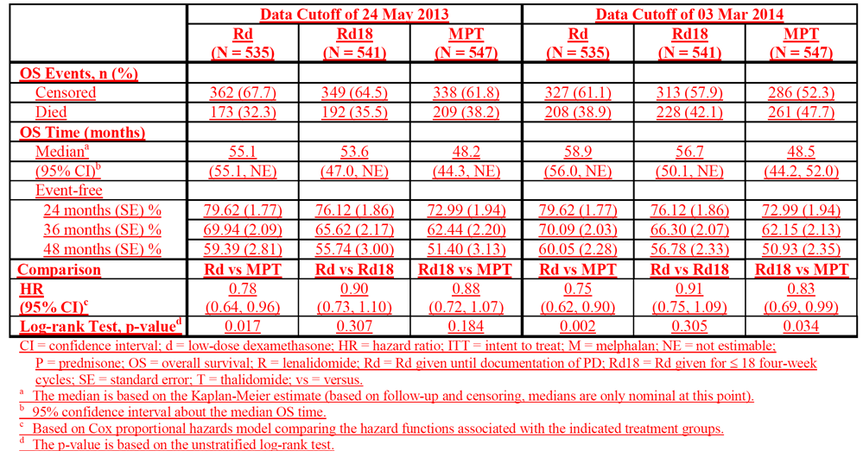

Figure 5. CP-010 - Mean ± SD plasma lenalidomide concentrations; left panel linear scale, right panel semi-log scale.

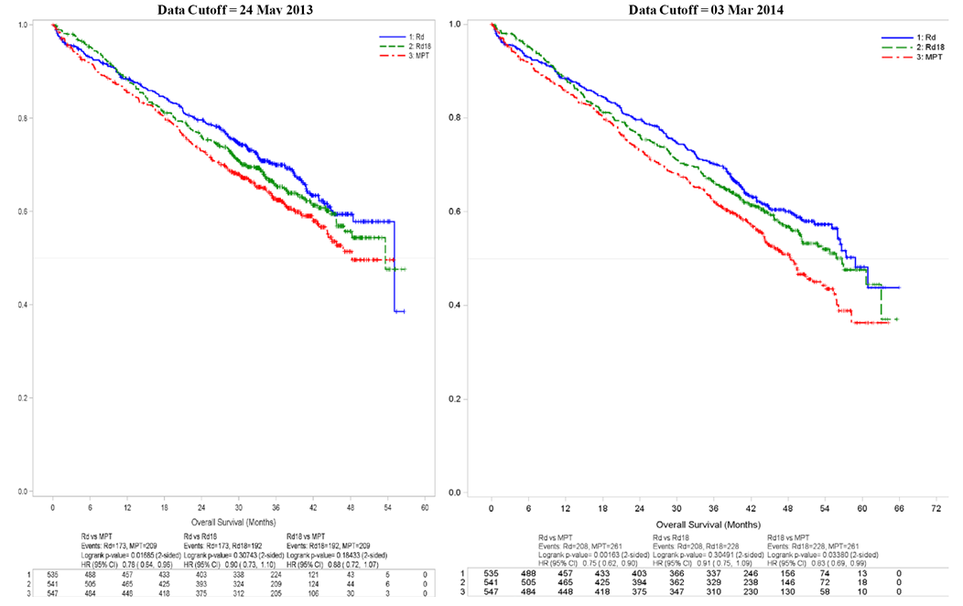

CI = confidence interval; d = low-dose dexamethasone; HR = hazard ratio; ITT = intent to treat; M = melphalan; P = prednisone; R = lenalidomide; Rd = Rd given until documentation of progressive disease; Rd18 = Rd given for ≤ 18 four-week cycles; T = thalidomide; vs = versus.

#### First round assessment of benefits

The sponsor draws attention to the following statement in the first round clinical evaluation report: However, in neither study did the preliminary OS analyses show a superior overall survival benefit for patients treated with lenalidomide regimens compare to patients treated with non-lenalidomide regimens.

##### Celgene response

Whilst it is acknowledged that the primary OS analyses for both Studies MM-020 and MM-015 were not statistically significant, the treatment outcomes in both studies were better than in the comparator arms. Study MM-015 was not powered for OS. In Study MM-020, greatly improved OS benefit, especially with updated data, indicate a positive OS trend (i.e., HR < 1) which demonstrates the treatment is not detrimental.

The results from Study MM-020 showed an OS advantage at the preplanned interim analysis and improved OS with the EMA-requested updated analysis. Furthermore, the evaluator’s statement does not appear to consider the updated OS data submitted for Study MM-020 (data cutoff date = 03 Mar 2014), which indicates a 25% risk reduction of death in favour of Arm Rd versus Arm MPT (HR = 0.75, p = 0.002) reflecting further improvement from the previous analysis with the data cutoff date of 24 May 2013 (HR = 0.78, p = 0.017) (MM-020 CSR). Notably, the 99% CI for the HR is 0.59 to 0.95 at the 03 Mar 2014 data cutoff date. The updated OS results continue to show a clinically meaningful advantage for Rd treatment over the triple MPT treatment.

Study MM-015 was not powered to detect OS between treatment arms, and all subjects were allowed to receive lenalidomide (± dexamethasone) upon PD in the open-label extension phase (MM-015 CSR). The comparison of OS is therefore confounded and difficult to interpret. With the planned sample size of 150 subjects per treatment arm, the study could only detect a 50% or greater improvement in median OS (from an assumed median of 36 months for Arm MPp+p to a median of 54 months for Arm MPR+R – with 78% power) (MM-015 CSR). Further assessment on Study MM-015 is provided below.

##### Evaluator's comment

Other than the reference to the updated OS data from study MM-020, no new data have been provided in the sponsor's response. Comments relating to the updated OS from study MM-020 have been provided above. In the first round clinical evaluation report, approval of lenalidomide in combination with dexamethasone for the treatment of patients with NDMM not eligible for ASCT was recommended based on the results of study MM-020. This positive recommendation relating to the Rd regimen is strengthened by the update OS data from study MM-020. In the first round clinical evaluation report it was stated that the benefits of treatment with the MPR+R regimen in patients with NDMM not eligible for ASCT observed in study MM-015 were greater than the benefits of treatment with MPp+p regimen, but this was offset by the significantly greater risks of treatment with the regimen containing lenalidomide compared to regimen not containing lenalidomide. This opinion remains unchanged.

#### First-round assessment of benefit-risk balance - study MM-015

The sponsor draws attention to the following statement in the first round clinical evaluation report:

*Overall, it is considered that the benefit-risk balance of the MPR+R regimen used in study MM-015 is unfavourable due to the significant risks associated with the regimen outweighing the significant PFS benefits.*

##### Celgene response

Based on the MM-015 study design, which also included an open-label extension phase with lenalidomide upon PD as second-line therapy in subjects who had not received prior lenalidomide, a statistically significant improvement in OS was not expected. The EU CHMP acknowledged in their scientific advice for the study that OS in this study may be confounded by next-line therapy.

Considering all potential factors, the imbalance in active salvage therapy between the treatment arms (MM-015 CSR) is likely the most relevant reason and confounder for the observed discrepancy between PFS and OS results. A lower proportion of all subjects in Arm MPR+R (55.9%) started any salvage antimyeloma therapy compared with 83.8% of subjects in Arm MPp+p. Per the study design, the crossover from placebo in first line (Arm MPp+p) was very high in that 72.1% of all second-line therapy received was lenalidomide based (MM-015 CSR), which is in line with its current approved use.

Furthermore, the limited tolerability of the triple-drug MPR induction regimen in subjects > 75 years of age and those with International Staging System (ISS) Stage III disease, impaired renal function, and low performance status (PS) as well as subsequent therapy may have impacted the poorer than expected OS outcome in Study MM-015. This reduced tolerance was associated with higher rates of discontinuations, adverse events (AEs), and serious adverse events (SAEs).

Nonetheless, the MPR+R regimen is an effective first-line treatment for TNE newly diagnosed multiple myeloma (NDMM) patients, as demonstrated by the following:

* MPR+R extended PFS in a statistically significant and clinically meaningful manner compared with MP (melphalan and prednisone).
* The treatment advantage in first line seems to be well maintained after second-line therapy (PFS2), indicating that lenalidomide maintenance does not negatively affect the activity of next-line therapy. It is noteworthy that PFS2 is a recently introduced measure in EU guidance that the TGA has adopted. The PFS2 analysis was significantly positive (HR = 0.7 and p = 0.009 for MPR+R versus MPp+p), providing assurance that there is a benefit of MPR+R treatment even though the study was confounded in demonstrating a significant OS advantage (MM-015 CSR).
* Despite the confounding factors and considering that the study was not powered to demonstrate a statistically significant OS benefit, a HR < 1 in favour of Arm MPR+R indicates that the treatment was not detrimental. Furthermore, the OS HR in the MPR+R versus MPp+p comparison has been in favour.

It should be noted that the risk of low tolerance of the MPR regimen in elderly patients and those with higher tumour load and more comorbidities is addressed through a warning in the EU Summary of Product Characteristics (SmPC) for the prescriber to carefully assess patients’ ability to tolerate lenalidomide in combination with MP. This approach was accepted by the EMA as part of the CHMP approval of the EU application in December 2014.

If patient selection by the treating physician is guided according to an appropriate warning in the product information (PI), MPR+R is a highly effective regimen and should be considered as an option as first-line treatment for transplant-noneligible (TNE) NDMM patients.

The magnitude of benefit compared with the risk observed with MPR versus MP induction does not have a benefit/risk profile suitable for an induction indication alone. However, the benefit/risk assessment becomes more favourable in the MPR+R versus MPp+p comparison when considering the subgroup of subjects who start maintenance and who resemble most closely the patients whom a prescriber should consider for the triple MPR induction therapy. The results of this comparison suggest that the largest benefit may be derived from lenalidomide maintenance in this population.

The highly positive benefit/risk of lenalidomide maintenance is highlighted in the comparison of MPR+R versus MPR+p: lenalidomide maintenance improves and sustains the disease response and remarkably prolongs the PFS, which is maintained after second-line therapy (as demonstrated by the positive PFS2 analysis [HR = 0.7 and p = 0.009 for MPR+R versus MPp+p]) (MM-015 CSR). Long-term treatment with 10 mg lenalidomide is well tolerated as demonstrated by a low rate of discontinuation due to AEs, and a lower rate of SAEs than observed in the induction therapy period, resulting in a clinically manageable safety profile. This is further supported by the finding that the frequency of second primary malignancies (SPMs) is not increased with longer duration of treatment. Therefore, the benefit/risk of lenalidomide maintenance (after MPR induction) is positive, with an improvement in OS of ~ 10 months for subjects who started maintenance.

Considering the information above, an indication of lenalidomide as maintenance following induction could have a highly favourable benefit/risk profile in the TNE NDMM setting, and should be considered as an option as first-line treatment for TNE NDMM patients.

##### Evaluator's comments

The sponsor's response is noted. Despite the sponsor's comments, it is still considered that the benefit-risk balance for lenalidomide maintenance after induction with MRP in patients with NDMM not eligible for ASCT remains unfavourable. The greater benefits of the MPR+p regimen compared to the MPp+p regimen are acknowledged, but concern remains about the inferior safety profile of the lenalidomide regimen compared to the control regimen for first-line treatment in the proposed patient group.

#### First-round assessment of benefit-risk balance - studies CALGB and IFM 2005-05

The sponsor draws attention to the following statement in the first round clinical evaluation report:

*There were no pivotal studies assessing the benefits and risks of lenalidomide for maintenance treatment in patients with NDMM following successful ASCT. However, there were two supportive studies in this patient group (CALGB 100104 and IFM 2005-05). In both studies, it is considered that the benefit-risk benefit was unfavourable due to an increased risk of invasive second primary malignancy (particularly haematologic SPMs) occurring in patients treated with lenalidomide.*

##### Celgene response

The results of the analyses of Studies IFM 2005-02 and CALGB 100104 showed that subjects treated with lenalidomide following high-dose melphalan (HDM) / autologous stem-cell transplant (ASCT) had a higher frequency of invasive SPMs (hematologic plus solid tumor SPMs) than those treated with placebo. Notably, in both studies, the cumulative incidence rate curves over time up to the current data cutoff dates indicate that the incidence rates for invasive SPMs in the lenalidomide arms in both studies have remained stable over time (SPM Document). Additionally, no significant predictive (related to treatment) risk factor was identified in the analyses based on pooled data for Studies IFM 2005-02 and CALGB 100104.

Despite the risk of SPMs, results of Studies IFM 2005-02 and CALGB 100104 demonstrated a highly significant PFS (primary efficacy endpoint) advantage for subjects who received lenalidomide maintenance therapy compared with placebo, with a significant OS benefit observed in Study CALGB 100104. The continuous use of lenalidomide as maintenance treatment was not associated with a detrimental effect on OS in Study IFM 2005-02. Collectively, these results demonstrate value of lenalidomide maintenance as an option for prescribers post-transplant in an area where current options have failed to demonstrate significant advantage for patients and where an unmet clinical need is evident.

##### Evaluator's comment

The sponsor's response includes no new data. The conclusions relating to studies CALGB and IFM 2005-05 remain unchanged from those provided in the first round clinical evaluation report.

## Second round benefit-risk assessment

### Second round assessment of benefits

Following consideration of the sponsor’s Section 31 Response to the first round clinical questions and the first round clinical evaluation report the second round assessment of benefits remains essentially unchanged from that provided in the first round. The only difference between the two assessments relates to a marginally greater improvement in OS benefit with Rd relative to MPT in patients with NDMM not eligible for stem cell transplantation (Study MM-020) based on the second round assessment compared to the first round assessment (25% versus 22%, respectively).

### Second round assessment of risks

Following consideration of the sponsor’s Section 31 Response to the first round clinical questions and the first round clinical evaluation report the second round assessment of risks remains unchanged from that provided in the first round.

### Second round assessment of benefit-risk balance

Following consideration of the sponsor’s Section 31 Response to the first round clinical questions and the first round clinical evaluation report the second round assessment of the benefit-risk balance remains unchanged from that provided in the first round.

## Second round recommendation regarding authorisation

Following consideration of the sponsor’s Section 31 Response to the first round clinical questions and the first round clinical evaluation report the second round recommendations regarding authorisation remain unchanged from those provided in the first round. The reasons for the recommendations remain unchanged from those provided in the first round.

It should be noted that **approval is recommended** for Revlimid in combination with dexamethasone for the treatment of patients with NDMM who are not eligible for stem-cell transplantation. It is recommended that the following lenalidomide dosage regimen be approved for this indication:

*Lenalidomide 25 mg QD on days 1-21 of repeated 28 day cycles with dexamethasone 40 mg QD on days 1, 8, 15, and 22 of repeated 28 day cycles.*

## References

1. Australian Institute of Health and Welfare & Australasian Association of Cancer Registries 2012. Cancer in Australia: an overview, 2012. Cancer series no. 74. Cat. no. CAN 70. Canberra: AIHW.
2. Multiple Myeloma Clinical Practice Guideline: co-ordinated by Dr H. Quach and Professor M. Prince on behalf of the Medical Scientific Advisory Group (MSAG) to the Myeloma Foundation of Australia (MFA). V.2 December 2012.
3. Moreau P, San Miguel J, Ludwig H et al. Multiple myeloma: ESMO Clinical Practice Guidelines for diagnoses, treatment and follow-up. Annals of Oncology. 24 (Supplement 6): vi133–vi137, 2013.
4. Kumar SJ, Mikhael JR, Buadi FK et al. Management of newly diagnosed symptomatic multiple myeloma: updated Mayo stratification of myeloma and risk-adapted therapy (mSMART) consensus guidelines. Mayo Clin Proc 84 (12): 1905-1110, 2009.
5. Food and Drug Administration. Guidance for Industry: Clinical Trial Endpoints for the Approval of Cancer Drugs and Biologics (May 2007).
6. Zhao Q, Sun J. Generalized log-rank test for mixed interval-censored failure time data. Stat Med. 23:1621-1629, 2004.
7. Sun J, Zhao Q, Zhao X. Generalized log-rank test for interval-censored failure time data. Scand J of Stat. 32:49-57, 2005.
8. Palumbo A, Hajek R, Delforge M et al. Continuous lenalidomide treatment for newly diagnosed multiple myeloma. N Engl J Med. 366: 1759-1766, 2012.
9. NCCN Guidelines Version 2.2015 Multiple Myeloma
10. Attal M, Lauwers-Cances V, Marit G et al. Lenalidomide maintenance after stem-cell transplantation for multiple myeloma. N Engl J Med. 366:1782-91, 2012
11. Zonder JA, Crowley J, Hussein MA, et al. Superiority of lenalidomide (Len) plus high-dose dexamethasone (HD) compared to HD alone as treatment of newly-diagnosed multiple myeloma(NDMM): results of the randomized, double-blinded, placebo-controlled SWOG Trial S0232 [abstract]. Blood. (11);110:77, 2007
12. Zonder JA, Crowley J, Hussein MA, et al. Lenalidomide and high-dose dexamethasone compared with dexamethasone as initial therapy for multiple myeloma: a randomized Southwest Oncology Group trial (S0232). Blood. 116(26):5838-5841, 2010.
13. Rajkumar SV, Jacobus S, Callander NS, et al. Lenalidomide plus high-dose dexamethasone versus lenalidomide plus low-dose dexamethasone as initial therapy for newly diagnosed multiple myeloma: an open-label randomized controlled trial. Lancet Oncol. 11(1):29-37, 2010
14. Gray RJ. A class of K-sample tests for comparing the cumulative incidence of a competing risk. Ann Stat. 16:1141-54, 1988.
15. Facon T, Mary JY, Hulin C, et al. Melphalan and prednisone plus thalidomide versus melphalan and prednisone alone or reduced-intensity autologous stem cell transplantation in elderly patients with multiple myeloma (IFM 99-06): a randomised trial. Lancet. 370(9594):1209-1218, 2007
16. Hulin C, Virion J, Leleu X, et al. Comparison of melphalan-prednisone-thalidomide (MPT) to melphalan-prednisone (MP) in patients 75 years of age or older with untreated multiple myeloma (MM). Preliminary results of the randomized, double-blind, placebo-controlled IFM 01-01 trial [abstract]. J Clin Oncol. 25(suppl):441s (abstract 8001), 2007.
17. Rajkumar SV, Jacobus S, Callander N, et al. Phase III trial of lenalidomide plus high dose dexamethasone versus lenalidomide plus low-dose dexamethasone in newly diagnosed multiple myeloma (E4A03): a trial coordinated by the Eastern Cooperative Oncology Group [abstract]. Presented at the American Society of Clinical Oncology 43rd Annual Meeting; 1 to 5 Jun 2007; Chicago, IL. Abstract LBA8025.

|  |
| --- |
| Therapeutic Goods Administration |
| PO Box 100 Woden ACT 2606 Australia  Email: [info@tga.gov.au](mailto:info@tga.gov.au) Phone: 1800 020 653 Fax: 02 6232 8605  [**https://www.tga.gov.au**](https://www.tga.gov.au) |

1. Facon T, et al. (2007) Melphalan and prednisone plus thalidomide versus melphalan and prednisone alone or reduced-intensity autologous stem cell transplantation in elderly patients with multiple myeloma (IFM 99-06): a randomised trial. *Lancet* 370: 1209-1218; Hulin C, et al. (2007) Comparison of melphalan-prednisone-thalidomide (MPT) to melphalan-prednisone (MP) in patients 75 years of age or older with untreated multiple myeloma (MM). Preliminary results of the randomized, double-blind, placebo-controlled IFM 01-01 trial [abstract]. *J Clin Oncol.* 25(suppl): 441s (abstract 8001); Rajkumar SV, et al. (2007) Phase III trial of lenalidomide plus high dose dexamethasone versus lenalidomide plus low-dose dexamethasone in newly diagnosed multiple myeloma (E4A03): a trial coordinated by the Eastern Cooperative Oncology Group [abstract]. Presented at the American Society of Clinical Oncology 43rd Annual Meeting; 1 to 5 Jun 2007; Chicago, IL. Abstract LBA8025.
2. Facon T, et al. (2007) Melphalan and prednisone plus thalidomide versus melphalan and prednisone alone or reduced-intensity autologous stem cell transplantation in elderly patients with multiple myeloma (IFM 99-06): a randomised trial. *Lancet* 370: 1209-1218; Hulin C, et al. (2007) Comparison of melphalan-prednisone-thalidomide (MPT) to melphalan-prednisone (MP) in patients 75 years of age or older with untreated multiple myeloma (MM). Preliminary results of the randomized, double-blind, placebo-controlled IFM 01-01 trial [abstract]. *J Clin Oncol.* 25(suppl): 441s (abstract 8001).
3. Food and Drug Administration. Guidance for Industry: Clinical Trial Endpoints for the Approval of Cancer Drugs and Biologics (May 2007).
4. Palumbo A, Hajek R, Delforge M et al. Continuous lenalidomide treatment for newly diagnosed multiple myeloma. N Engl J Med. 366: 1759-1766, 2012.
5. Attal M, Lauwers-Cances V, Marit G et al. Lenalidomide maintenance after stem-cell transplantation for multiple myeloma. N Engl J Med. 366:1782-91, 2012.
6. Gray RJ. A class of K-sample tests for comparing the cumulative incidence of a competing risk. Ann Stat. 16:1141-54, 1988.