|  |
| --- |
| **May 2019** |

|  |
| --- |
| Australian Public Assessment Report for Lenalidomide |
| Proprietary Product Name: Revlimid |
| Sponsor: Celgene Pty Ltd |

About the Therapeutic Goods Administration (TGA)

* The Therapeutic Goods Administration (TGA) is part of the Australian Government Department of Health and is responsible for regulating medicines and medical devices.
* The TGA administers the *Therapeutic Goods Act 1989* (the Act), applying a risk management approach designed to ensure therapeutic goods supplied in Australia meet acceptable standards of quality, safety and efficacy (performance) when necessary.
* The work of the TGA is based on applying scientific and clinical expertise to decision-making, to ensure that the benefits to consumers outweigh any risks associated with the use of medicines and medical devices.
* The TGA relies on the public, healthcare professionals and industry to report problems with medicines or medical devices. TGA investigates reports received by it to determine any necessary regulatory action.
* To report a problem with a medicine or medical device, please see the information on the TGA website <<https://www.tga.gov.au>>.

About AusPARs

* An Australian Public Assessment Report (AusPAR) provides information about the evaluation of a prescription medicine and the considerations that led the TGA to approve or not approve a prescription medicine submission.
* AusPARs are prepared and published by the TGA.
* An AusPAR is prepared for submissions that relate to new chemical entities, generic medicines, major variations and extensions of indications.
* An AusPAR is a static document; it provides information that relates to a submission at a particular point in time.
* A new AusPAR will be developed to reflect changes to indications and/or major variations to a prescription medicine subject to evaluation by the TGA.

Copyright

© Commonwealth of Australia 2019  
This work is copyright. You may reproduce the whole or part of this work in unaltered form for your own personal use or, if you are part of an organisation, for internal use within your organisation, but only if you or your organisation do not use the reproduction for any commercial purpose and retain this copyright notice and all disclaimer notices as part of that reproduction. Apart from rights to use as permitted by the *Copyright Act 1968* or allowed by this copyright notice, all other rights are reserved and you are not allowed to reproduce the whole or any part of this work in any way (electronic or otherwise) without first being given specific written permission from the Commonwealth to do so. Requests and inquiries concerning reproduction and rights are to be sent to the TGA Copyright Officer, Therapeutic Goods Administration, PO Box 100, Woden ACT 2606 or emailed to <[tga.copyright@tga.gov.au](mailto:tga.copyright@tga.gov.au)>.

Contents

Common abbreviations 4

I. Introduction to product submission 7

Submission details 7

Product background 7

Regulatory status 8

Product Information 9

II. Registration time line 9

III. Quality findings 10

IV. Nonclinical findings 10

V. Clinical findings 10

Introduction 10

Pharmacokinetics 13

Pharmacodynamics 13

Dosage selection for the pivotal studies 13

Efficacy 14

Safety 15

First round benefit-risk assessment 20

Clinical questions 20

Second round evaluation 22

Second round benefit-risk assessment 24

Second round recommendation regarding authorisation 24

VI. Pharmacovigilance findings 24

Risk management plan 24

VII. Overall conclusion and risk/benefit assessment 29

Quality 29

Nonclinical 30

Clinical 30

Risk management plan 31

Risk-benefit analysis 32

Outcome 33

Attachment 1. Product Information 33

## Common abbreviations

|  |  |
| --- | --- |
| Abbreviation | Meaning |
| AE | Adverse event |
| ALKP | Alkaline phosphatase |
| ALT | Alanine transaminase |
| ALC | Absolute lymphocyte count |
| ANC | Absolute neutrophil count |
| AST | Aspartate transaminase |
| BIL | Bilirubin |
| CI | Confidence interval |
| CMI | Consumer Medicines Information |
| CR | Complete Response |
| CrCl | Creatinine clearance |
| CT | X-Ray computed tomography |
| CTCAE | Common terminology criteria for adverse events |
| DCR | Disease control rate |
| DLT | Dose limiting toxicity |
| DoR | Duration of response |
| ECG | Electrocardiograph |
| ECOG | Eastern Cooperative Oncology Group |
| EMA | European Medicines Agency |
| EORTC | European Organisation for Research and Treatment of Cancer |
| FAS | Full analysis set |
| FDA | Food and Drug Administration |
| GCP | Good clinical practice |
| HR | Hazard ratio |
| ICH | International Conference on Harmonisation |
| ITT | Intention to treat |
| IV | Intravenous |
| IWRC | International Workshop Response Criteria |
| L | Litre(s) |
| LDH | Lactate dehydrogenase |
| LFTs | Liver function tests |
| MCL | Mantle cell lymphoma |
| MEDRA | Medical dictionary for regulatory activities |
| MIPI | MCL International Prognostic Index |
| MRI | Magnetic Resonance Imaging |
| MTD | Maximum Tolerated Dose |
| NCI | National Cancer Institute |
| NHL | Non-Hodgkin’s Lymphoma |
| OD | Once daily |
| ORR | Overall response rate |
| OS | Overall Survival |
| PD | Pharmacodynamics |
| PFS | Progression free survival |
| PI | Product Information |
| PK | Pharmacokinetics |
| PR | Partial Response |
| QoL | Quality of Life |
| R/R | Relapsed and/or refractory |
| SAE | Serious Adverse Event |
| SD | Stable Disease |
| TGA | Therapeutic Goods Administration |
| TTP | Time to Progression |

## I. Introduction to product submission

### Submission details

|  |  |
| --- | --- |
| *Type of submission:* | Extension of indications |
| *Decision*: | Approved |
| *Date of decision:* | 7 March 2016 |
| *Date of entry onto ARTG:* | 16 March 2016 |
| *ARTG number(s):* | 132510, 132514, 132515, 132516, 229850, 229851 and 229852 |
| *Black Triangle Scheme* | No |
| *Active ingredient:* | Lenalidomide |
| *Product name:* | Revlimid |
| *Sponsor’s name and address:* | Celgene Pty Ltd  Level 15, 60 City Road, Southbank, VIC 3006 |
| *Dose form:* | Hard capsule |
| *Strengths:* | 2.5 mg, 5 mg, 7.5 mg, 10 mg, 15 mg 20 mg and 25 mg |
| *Container:* | Blister pack |
| *Pack size:* | 21 |
| *Approved therapeutic use:* | *Revlimid is indicated for the treatment of patients with relapsed and/or refractory mantle cell lymphoma.* |
| *Route of administration:* | Oral (PO) |
| *Dosage:* | The recommended starting dose of lenalidomide is 25 mg orally once daily on Days 1-21 of repeating 28-day cycles. Treatment should be continued until disease progression or unacceptable toxicity. Dosing is continued or modified based upon clinical and laboratory findings (see PI Attachment 1). Recommended close adjustments for MCL patients are found in PI (Attachment 1). |

### Product background

This AusPAR describes the application by the sponsor to extend the registration of Revlimid (lenalidomide) 2.5 mg, 5 mg, 7.5 mg, 10 mg, 15 mg 20 mg and 25 mg hard capsules to include the following indication:

*For the treatment of patients with relapsed and/or refractory mantle cell lymphoma.*

Lenalidomide is an antineoplastic agent with a pleiotropic mechanism of action that includes immunomodulatory and anti-angiogenic effects.

Revlimid is currently approved for the following indications:

* *In combination with dexamethasone, for the treatment of multiple myeloma patients whose disease has progressed after one therapy;*
* *For the treatment of patients with transfusion-dependent anaemia due to low- or intermediate-1 risk myelodysplastic syndromes associated with a deletion 5q cytogenetic abnormality with or without additional cytogenetic abnormalities.*

The current dosage regimen for Revlimid in Australia is as follows:

*Previously treated multiple myeloma*

*The recommended starting dose of lenalidomide is 25 mg orally once daily on days 1‑21 of repeated 28 day cycles. The recommended dose of dexamethasone is 40 mg orally once daily on days 1-4, 9-12, and 17-20 of each 28 day cycle for the first 4 cycles of therapy and then 40 mg once daily on days 1-4 every 28 days.*

*Myelodysplastic syndromes*

*The recommended starting dose of lenalidomide is 10 mg given orally once a day on Days 1 to 21 of repeating 28 day treatment cycles. Dosing is continued or modified based upon clinical and laboratory findings*

The sponsor has proposed the following dosage regimen:

*The dosage regimen for MCL is 25 mg once daily on Days 1-21 of a 28 day cycle. In the event of toxicity, stepwise dose reductions are recommended to as low as 5 mg every other day. It is proposed that treatment continue until disease progression or unacceptable toxicity occurs.*

The proposed lenalidomide dosage regimen is essentially the same as that registered for use in multiple myeloma, except that the lowest recommended dose in multiple myeloma is 5 mg every day.

For the existing and proposed indication, the PI states:

*Treatment should be continued until disease progression or unacceptable toxicity.*

The following dosage forms and strengths are currently registered: capsules containing 5, 10, 15 and 25 mg. During this submission the sponsor proposed three additional strengths; 2.5 mg 7.5 mg and 20 mg.

### Regulatory status

The drug was initially registered by the TGA for use in multiple myeloma in 2007. The myelodysplastic syndrome indication was approved in 2010.

Lenalidomide was designated as an orphan drug for the treatment of patients with mantle cell lymphoma in January 2015 in Australia (in June 2009 in the United States (US) and October 2011 in the European Union (EU)).

Lenalidomide has been approved for use in MCL by the US Food and Drug Administratin (FDA) and the European Medicines Agency (EMA), albeit with varied wording of the indication.

The FDA approved the following indication on the 5 June 2013. The indication approved in the USA was different to that being proposed in Australia:

*‘... for the treatment of patients with mantle cell lymphoma (MCL) whose disease has relapsed or progressed after two prior therapies, one of which included bortezomib.’*

The USA approval has been based on the results of a Phase II, single arm open label study (Study MCL-001).

The current application to the TGA is based mainly on a Phase II randomised controlled trial (Study MCL-002). In addition, bortezomib is not currently registered in Australia for the treatment of MCL.

In regard to the wording of the FDA indication for MCL, bortezomib was not approved for use in MCL in Australia when the current dossier was submitted, thus it is considered appropriate for the Australian indication to omit specific reference to it. Furthermore, bortezomib is indicated for use in patients with previously untreated MCL in combination with rituximab, cyclophosphamide, doxorubicin and prednisolone (noting the absence of a specific MCL indication for rituximab).

A similar application to extend the indication for Revlimid was approved in the EU on 8 July 2016. The indication is as follows:

*Revlimid as monotherapy is indicated for the treatment of adult patients with relapsed or refractory mantle cell lymphoma.*

The EU approval has been based on the results of Study MCL-002, a Phase II randomised, open label, active controlled study.

The current application to the TGA is based mainly on the same Phase II trial (Study MCL‑002).

Agents that have received approval specifically for the second line treatment of MCL in Australia are temsirolimus and ibrutinib. For patients with MCL who are ineligible for autologous stem cell transplantation, bendamustine is approved for use in Australia.

### Product Information

The Product Information (PI) approved with the submission which is described in this AusPAR can be found as Attachment 1. For the most recent PI, please refer to the TGA website at <<https://www.tga.gov.au/product-information-pi>>.

## II. Registration time line

The following table (Table 1) captures the key steps and dates for this application and which are detailed and discussed in this AusPAR and Attachment 2.

Table 1: Registration timeline for PM-2015-00772-1-4

|  |  |
| --- | --- |
| Description | Date |
| Submission dossier accepted and first round evaluation commenced | 1 June 2015 |
| First round evaluation completed | 30 October 2015 |
| Sponsor provides responses on questions raised in first round evaluation | 5 December 2015 |
| Second round evaluation completed | 4 February 2016 |
| Delegate’s Overall benefit-risk assessment and request for Advisory Committee advice | 23 February 2016 |
| Sponsor’s pre-Advisory Committee response | Not applicable. |
| Advisory Committee meeting | Not applicable. |
| Registration decision (Outcome) | 7 March 2016 |
| Completion of administrative activities and registration on ARTG | 16 March 2016 |
| Number of working days from submission dossier acceptance to registration decision* | 159 |

*Statutory timeframe for standard applications is 255 working days

## III. Quality findings

There was no requirement for a quality evaluation in a submission of this type.

## IV. Nonclinical findings

There was no requirement for a nonclinical evaluation in a submission of this type.

## V. Clinical findings

A summary of the clinical findings is presented in this section.

### Introduction

#### Clinical rationale

Mantle cell lymphoma (MCL), a form of non-Hodgkin’s lymphoma (NHL), is a malignancy of mature (peripheral) B-lymphocytes. It represents about 5 to 10% of all NHL cases. The median age at onset is 68 years and the disease is twice as common in males as in females. MCL usually presents with late stage disease with widespread lymphadenopathy, bone marrow involvement and splenomegaly. Involvement of the gastrointestinal tract is also common. Common symptoms include fevers, night sweats and weight loss (referred to as ‘B symptoms’) as well as anorexia and fatigue. The disease is usually staged using the Ann Arbor staging system (see Table 2 below).

Table 2: Ann Arbor staging system for lymphoma

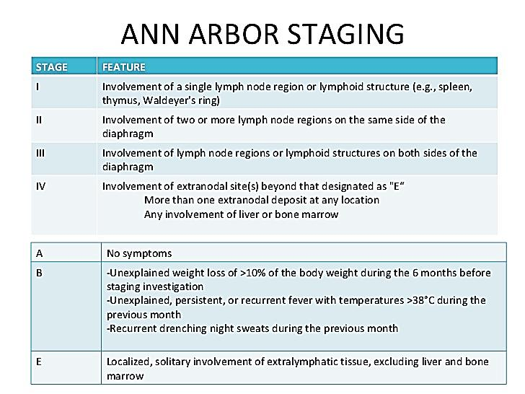Prognosis is classified using the MCL International Prognostic Index (MIPI) scores (see Table 3 below). Another prognostic indicator is the Ki-67 index. Ki-67 is a protein associated with cellular proliferation.. It is an indicator of how fast cells mature and is expressed in a range of 10% to 90%. The lower the percentage, the lower the speed of maturity is and the more indolent the disease.

Table 3: MCL International Prognostic Index (MIPI) score

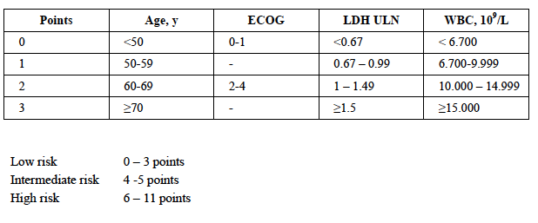

The disease is characterised by a high degree of genomic instability.[1],[2],[3] The majority of MCL cases are associated with a chromosomal translocation, t (11,14) (q13, q32) that results in overexpression of cyclin-D1. This translocation is usually accompanied by other genetic alterations that affect the cell cycle, survival pathways and response to deoxyribonucleic acid (DNA) damage. The existence of MCL as a distinct form of NHL was only formalised in 1994.[4]

Clinically, MCL usually presents an aggressive lymphoma, with short-lived responses to treatment and frequent relapses. No clear standard therapy has been established. First line therapy usually depends on patient age and fitness. In younger fit patients, induction with intensive combination chemotherapy and consolidation with high dose therapy and autologous stem cell rescue may be used. After disease relapse, allogeneic stem cell transplantation may be appropriate for younger subjects. Otherwise, a wide variety of agents have been recommended for second-line therapy including bendamustine, bortezomib, cladribine and fludarabine with cyclophosphamide.[5],[6] In Australia, agents that have received approval specifically for the second-line treatment of MCL are temsirolimus and ibrutinib. For patients with MCL who are ineligible for autologous stem cell transplantation, bendamustine is approved for use in Australia.

Despite the variety of agents recommended, the natural history of the disease is one of repeated disease relapse. The sponsor’s rationale for developing lenalidomide for relapsed/refractory MCL is that a high, unmet medical need for effective treatments remains, especially for elderly subjects and subjects with multiple relapses. Lenalidomide is an agent from a different drug class to existing agents, providing an alternative treatment option.

#### Formulation development

This submission is largely reliant on the results of a Phase II randomised controlled trial (Study MCL-002). This study used 5, 10, 20, and 25 mg Revlimid capsules. However it was not stated whether the formulations of these capsules were identical to those of the products currently marketed in Australia.

#### Guidance

The following EU guidelines, which have been adopted by the TGA, are considered relevant to the current application:

* Guideline on the evaluation of anticancer medicinal products in man;[7]
* Appendix 1 to the guideline on the evaluation of anticancer medicinal products in man; (methodological consideration for using progression-free survival or disease-free survival in confirmatory trials);[8]
* Points to consider on application with: 1. Meta-analyses; 2. One pivotal study.[9]

Compliance with these guidelines will be considered where appropriate in this review.

#### Contents of the clinical dossier

The submission contained the following clinical information:

* One pivotal Phase II, randomised controlled trial in subjects with relapsed or refractory MCL (Study MCL-002);
* one supportive Phase II single arm study in subjects with relapsed or refractory MCL (Study MCL-001);
* two supportive Phase II single arm studies in subjects with relapsed or refractory NHL (Studies NHL-002 and NHL-003). A proportion of subjects in these studies had MCL; and
* literature references.

The clinical submission also included a summary of a Phase III randomised placebo controlled trial of lenalidomide as maintenance therapy after first-line combination chemotherapy in subjects with MCL. This trial was abandoned after new data became available establishing that a placebo arm was no longer appropriate. Only 9 subjects were enrolled. This study has not been evaluated.

#### Paediatric data

The submission did not include paediatric data. The sponsor obtained a waiver from the EMA on the grounds that the drug is likely to be ineffective or unsafe in part or all of the paediatric population. No further information was provided. Lenalidomide had been designated as an orphan drug in the USA for the treatment of mantle cell lymphoma. The FDA does not require paediatric data for orphan drugs.

Mantle cell lymphoma is a disease of adults. The absence of paediatric data for this application is acceptable.

#### Good clinical practice

For all the clinical studies included in this submission, the study reports included an assurance that they were conducted in adherence to Good Clinical Practice (GCP), as denoted in the International Conference on Harmonisation (ICH) E6;[10] requirements for GCP and in accordance with the ethical principles outlined in the Declaration of Helsinki.

### Pharmacokinetics

No new pharmacokinetic data were presented in the submission.

### Pharmacodynamics

No new pharmacodynamic data were presented in the submission.

### Dosage selection for the pivotal studies

The maximum tolerated dose of lenalidomide was previously established to be 25 mg in multiple myeloma patients. This dose was found to be active in relapsed and/or refractory (R/R) MCL in three Phase II studies (Studies NHL-002, NHL-003 and MCL-001). Based on these findings, the same dose schedule was selected for use in the pivotal study.

### Efficacy

#### Studies providing efficacy data

The following studies provided efficacy data:

* Pivotal efficacy study: Study MCL-002
* Other efficacy studies:
  + Study MCL-001
  + Study NHL-002
  + Study NHL-003.

#### Evaluator’s conclusions on efficacy

The pivotal study (Study MCL-002) was well designed and executed. Although described as a Phase II study it had many design features normally associated with a Phase III oncology trial. The study demonstrated a statistically significant benefit in terms of progressive free survival (PFS), which is an acceptable primary endpoint according to the relevant EMA guideline adopted by the TGA. The design of the pivotal study would have been improved if temsirolimus had been used as the comparator. However, the investigator’s choice of therapy has previously been accepted as a comparator in relapsed and/or refractory (R/R) MCL by the TGA.

Lenalidomide was associated with a 37% reduction in the risk of a PFS event. Median PFS was prolonged by 3.5 months and the probability of being alive and free of disease progression at 12 months was almost doubled. The magnitude of the PFS benefit is considered clinically significant.

The drug was not associated with a survival benefit. However, crossover of 47% of control subjects to the lenalidomide arm after disease progression may have confounded the overall survival (OS) analysis. There was no suggestion of an adverse effect of lenalidomide on OS. There were no clinically significant differences in quality of life between the lenalidomide arm and the control arm.

The findings of the pivotal study were supported by the results of three single arm Phase II studies, which all showed that lenalidomide was an active agent in MCL with response rates between 28% and 53%. Complete responses (CR) were achieved in a proportion of subjects in all these studies. The responses were durable with the median duration of response being > 12 months in all studies.

Overall, the evidence to support the efficacy of lenalidomide in R/R MCL is considered adequate.

By way of comparison, the pivotal study supporting registration of temsirolimus was associated with a 56% reduction in the risk of a PFS event, when compared with investigator’s choice of therapy. However, prolongation of median survival was comparable to that obtained with lenalidomide (4.8 months with temsirolimus versus 1.9 months with control).[11],[12] Cross-trial comparison of response rates suggests that lenalidomide has at least comparable activity to temsirolimus in R/R MCL (overall response rate (ORR) 40.0% with lenalidomide versus 22.7% with temsirolimus). The ORR obtained with ibrutinib was higher (67.6%).[13]

### Safety

#### Studies providing safety data

The following studies provided evaluable safety data:

##### Pivotal efficacy study (Study MCL-002)

Study MCL-002 was the only study in the submission with a control arm, to allow a comparative assessment of safety. The following safety data were collected:

* General adverse events (AE) were assessed on Days 1, 2 4, 8 and 15 of Cycle 1, on Days 1 and 15 of Cycles 2 to 4, and then on Day 1 of every subsequent cycle. AEs were graded using the National Cancer Institute Common Terminology Criteria for Adverse Events (NCI CTCAE) Version 3.0 and were coded to System Organ Class (SOC) and preferred terms (PT) using the Medical Dictionary for Regulatory Activities (MedDRA).
* The following were AEs of particular interest (‘Selected AEs’): neutropaenia, infection, thrombocytopaenia, bleeding, cardiac arrhythmias, cardiac failure, ischaemic heart disease (including myocardial infarction), venous thromboembolism (VTE) events, arterial thromboembolism (ATE) events, mixed thromboembolic events, renal failure, peripheral neuropathy, diarrhoea, constipation, cutaneous reactions, hypersensitivity and angioedema, hepatic disorders, tumour lysis syndrome (TLS), tumour flare reaction (TFR), teratogenicity, interstitial lung disease and second primary malignancies (SPM).
* Laboratory tests were performed at screening/baseline, on Days 1, 2 4, 8 and 15 of Cycle 1, on Days 1 and 15 of Cycles 2 to 4, on Day 1 of every subsequent cycle and at treatment discontinuation. Tests conducted were:
  + Haematology: red blood cell (RBC) count, haemoglobin, haematocrit, mean corpuscular volume (MCV), white blood cell count (WBC) count with differential, absolute neutrophil count (ANC), absolute lymphocyte count (ALC), and platelet count.
  + Serum chemistry: total protein, albumin, calcium, phosphorous, glucose, uric acid, total bilirubin, alkaline phosphatase, aspartate aminotransferase (AST), alanine aminotransferase (ALT), sodium, potassium, blood urea nitrogen, creatinine, and lactate dehydrogenase (LDH).
* Vital signs (weight, blood pressure, temperature, and pulse) were recorded at screening/baseline, on Day 1 of every cycle and at treatment discontinuation.

##### Non-pivotal efficacy studies

The three Phase II single arm studies also provided safety data. Safety data collected were similar to those collected in the pivotal study. Monitoring of thyroid function was included in Studies NHL-002 and NHL-003.

#### Patient exposure

A total of 373 MCL subjects were treated with lenalidomide in the submitted studies; 167 in the pivotal study and 206 in the three single arm studies. In the pivotal study, 83 subjects received treatment (investigator’s choice) in the control arm.

Duration of exposure is summarised in Table 4. In the pivotal study the average duration of treatment in the lenalidomide arm was approximately double that of the control arm. Duration of treatment with lenalidomide was also longer in the pivotal study than in the single-arm studies (mean 46.6 versus 35.5 weeks). Mean relative dose intensity for lenalidomide was 80 to 90%.

Table 4: Exposure to treatment

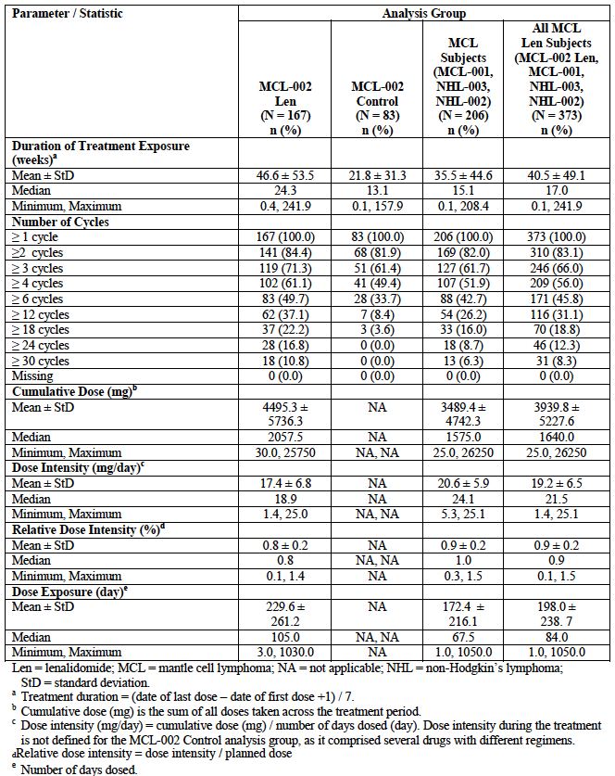

Dose reductions and interruptions occurred more commonly with lenalidomide than with control treatment in the pivotal study (see Table 5).

Table 5: Dose reductions and interruptions

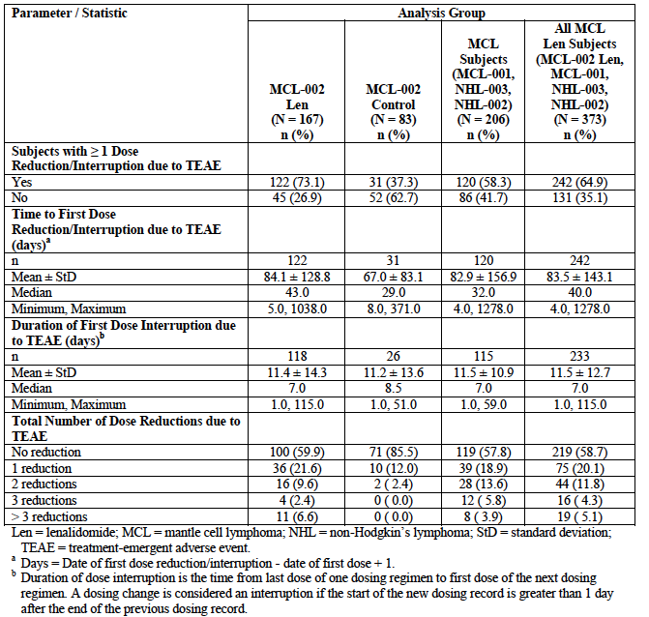

#### Safety issues with the potential for major regulatory impact

##### Liver toxicity

As noted above, lenalidomide is associated with hepatotoxicity. The incidence of Grade 3 or 4 abnormalities of liver function tests was low in the studies in this submission.

##### Haematological toxicity

Lenalidomide is also associated with haematological toxicity. As shown in Table 6; Grade 3 or 4 cytopaenias were common.

Table 6: Study MCL-002 laboratory tests; shifts in haematology parameters from Baseline Grade 0, 1 or 2 to post-Baseline Grade 3 or 4 abnormalities (normalised values) in the safety population

Study MCL-002 Laboratory tests Haematology
Shifts in haematology parameters from Baseline Grade 0, 1 or 2 to post Baseline Grade 3 or 4 abnormalities (normalised values) Safety population


##### Serious skin reactions

Serious skin reactions are known to occur with lenalidomide. The current PI indicates that cases of Stevens-Johnson syndrome and toxic epidermal necrolysis (TEN) have been reported from post-marketing experience. Among the 373 MCL subjects treated with lenalidomide in the studies included in this submission, there were 4 subjects who reported a total of five serious skin AEs (drug reaction, exfoliative dermatitis, rash, macular rash and ‘skin toxicity’).

##### Cardiovascular safety

Lenalidomide is associated with serious cardiovascular toxicity, including venous and arterial thromboembolism. As shown in Table 7, such events occurred more commonly in the lenalidomide arm of the pivotal study than in the control arm.

Table 7: Adverse events of special interest; Selected AEs

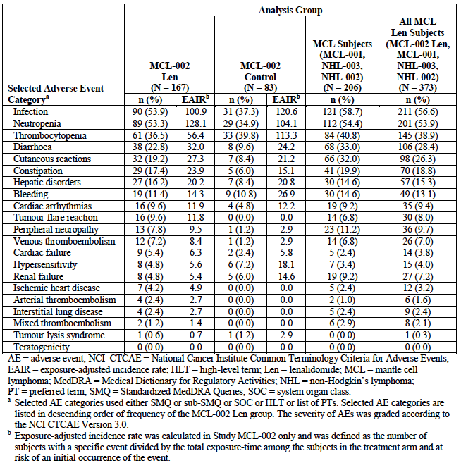

##### Unwanted immunological events

Hypersensitivity and angioedema events were more common in the control arm in the pivotal study (7.2% versus 4.8%). There were no cases of serious hypersensitivity or anaphylaxis among lenalidomide treated subjects in the submitted studies.

#### Other safety issues

##### Safety in special populations

In the Summary of Clinical Safety the sponsor included various analyses of AE incidence in various subgroups. These showed that there were small increases in the incidence of Grade 3 or 4 AEs in subjects with moderate renal impairment compared to subjects with normal renal function, in subjects aged > 65 years compared to subjects aged < 65 years and in females compared to males

#### Post marketing data

There were no post-marketing data included in clinical part of the submission.

#### Evaluator’s conclusions on safety

The safety profile of lenalidomide in MCL subjects was consistent with that previously observed in patients with multiple myeloma and myelodysplastic syndromes. No new safety signals were identified. Compared to the single-agent regimens used as comparators in the pivotal study, lenalidomide was associated with a higher incidence of adverse events, Grade 3 or 4 adverse events and serious adverse events. However, the proportion of subjects having to permanently discontinue treatment due to an AE was not increased, suggesting that lenalidomide toxicity can be adequately managed with dose delays and dose reductions.

Compared to control treatments, lenalidomide was associated with a small increase in on-treatment deaths that were not due to disease progression. However, during follow-up such deaths were more common in the control arm.

The safety profile of lenalidomide observed in the three single arm studies was consistent with that observed in the pivotal study.

### First round benefit-risk assessment

#### First round assessment of benefits

The benefits of lenalidomide for the treatment of relapsed or refractory MCL are:

* A significant reduction in the risk of a PFS event (disease progression or death) when compared to single agent chemotherapy. Median PFS is prolonged by approximately 3.5 months and the chance of being free of a PFS event at 12 months is almost doubled.

#### First round assessment of risks

The risks of lenalidomide for the treatment of relapsed or refractory MCL are:

* An increased incidence of AEs, Grade 3 or 4 AEs and serious AEs (compared to single agent chemotherapy). The AEs observed in MCL subjects treated with lenalidomide were similar in type to those previously observed in other indications. The AEs appear manageable with dose interruptions.

#### First round assessment of benefit-risk balance

The benefit-risk balance of lenalidomide in relapsed or refractory MCL is considered favourable.

#### First round recommendation regarding authorisation

The clinical evaluator recommended that the application be approved.

### Clinical questions

#### General

*Please provide an assurance that the capsule formulations used in study MCL-002 were identical to those currently marketed in Australia.*

#### Efficacy

*Table 4 in the study report for Study MCL-002 cites a number of references to support the choice of comparator agents. These references are summarised in the following table (Table 8):*

Table 8: References submitted in support of the choice of comparator agents

|  |  |  |
| --- | --- | --- |
| Regimen | Reference | Comments |
| Chlorambucil | Rai (2000);[14] | Study in patients with *chronic lymphocytic leukaemia*. Comparison of fludarabine versus chlorambucil |
| Ardeshna (2003);[15] | Study in patients with asymptomatic advanced stage low-grade NHL. *No MCL subjects included.* Comparison of chlorambucil versus observation. |
| Rituximab | Ghielmini 2000;[16] | Single arm study of rituximab monotherapy in subjects with follicular or mantle cell lymphoma. MCL subjects were either previously untreated (n=9) or R/R (n=33). Response rate in MCL overall was *22%.* |
| Cytarabine | Kantarjian (1983);[17] | Single arm study in subjects with refractory NHL. Study pre-dates the classification of MCL as a distinct clinical entity (1994). *Unlikely to have included any MCL subjects.* |
| Gemcitabine | Dumontet (2001);[18] | Single arm study in 33 subjects with R/R low grade NHL. 11 MCL patients were included. Response rate in MCL was *30%.* |
| Fludarabine IV | Decaudin (1998);[19] | Single arm study in 15 subjects with MCL. 2 subjects were previously untreated. ORR was *33%.* |
| Zinzani [20] | Randomised study of fludarabine alone versus fludarabine + idarubicin in subjects with *newly diagnosed* indolent NHL or MCL. 11 MCL subjects received fludarabine alone. ORR was 72%. |
| Fludarabine PO | Tobinai (2006); | Single arm study in subjects with relapsed indolent NHL or MCL. Only 6 MCL subjects included. ORR in these subjects was 17%. |

*A number of these studies were not conducted in subjects with MCL. Others included subjects with previously untreated MCL, and all the studies enrolled only small numbers of subjects with R/R MCL. Overall the evidence cited to support the use of these agents for the treatment of R/R MCL is poor. Are there any other studies that support the use of these comparator regimens in the treatment of R/R MCL?*

*The comparator regimens were chosen on the advice of a scientific steering committee. Please provide details of the membership/expertise of this committee.*

### Second round evaluation

The second round evaluation summarises the sponsor’s responses to the clinical questions (listed above) and the evaluator’s comments on the sponsor’s responses.

#### General

1. ***Please provide an assurance that the capsule formulations used in study MCL-002 were identical to those currently marketed in Australia.***

###### Sponsor response

The sponsor confirms that the capsule formulations used in Study MCL-002 were identical to those currently marketed in Australia.

###### Evaluator comment

The absence of a difference in formulations is noted.

#### Efficacy

1. ***Table 4 in the study report for MCL-002 cites a number of references to support the choice of comparator agents. These references are summarised in Table 8* (see above)*.***

***A number of these studies were not conducted in subjects with MCL. Others included subjects with previously untreated MCL, and all the studies enrolled only small numbers of subjects with R/R MCL. Overall the evidence cited to support the use of these agents for the treatment of R/R MCL is poor. Are there any other studies that support the use of these comparator regimens in the treatment of R/R MCL?***

###### Sponsor response

The studies cited in the table (names *Overview of Dosage of Investigator’s Choice Drugs*) of the Study MCL-002 clinical study report, as well as in the clinical study protocol of Study MCL-002 were primarily included as references for the recommended dosing for each of the agents included in the control arm rather than as references for the activity of these agents as monotherapy in patients with relapsed or refractory mantle cell lymphoma (R/R MCL).

Importantly, the selection of single agents for the best investigator’s choice (BIC) in the control arm of Study MCL-002 was based on both the published clinical treatment guidelines at the time,[21] and the advice of the Study MCL-002 Scientific Steering Committee (SSC).

At the time Study MCL-002 was designed (2008), primarily from an EU perspective, and initiated (May 2009), there were no approved treatments for R/R MCL in the EU. Therefore, agents for the control arm of Study MCL-002 were selected to reflect standard clinical practice in Europe at the time of study design. To prevent excessive heterogeneity in the control arm and to allow for a meaningful comparison with lenalidomide, the list of compounds was restricted to the 5 single agents that were most widely used and available in Europe at the time.

Rituximab, gemcitabine, fludarabine, chlorambucil and cytarabine had previously demonstrated clinical activity in a variety of B-cell lymphomas including R/R MCL, as outlined below:

* Rituximab single agent therapy resulted in an ORR of 27% in patients with R/R MCL.[22] Furthermore, rituximab monotherapy is a commonly used therapy in patients with significant comorbidities due to its good tolerability.[23]
* Gemcitabine single-agent therapy demonstrated an ORR of 30% in patients with R/R MCL (2 CR and 1 partial response [PR] in 10 R/R MCL patients).[24]
* Fludarabine single-agent therapy has shown an ORR of 72% in patients with R/R MCL (27% CR, 45% PR).[25]
* Chlorambucil is used as single-agent therapy in R/R MCL patients.[26]
* Cytarabine single agent therapy in R/R non-Hodgkin’s lymphoma (NHL) resulted in an ORR of 29% and a significantly prolonged survival in responders.[27]

In addition, rituximab, gemcitabine, fludarabine, chlorambucil, and cytarabine had been used as comparators in other studies in R/R MCL.[28] The sponsor is not aware of other clinical trials evaluating the single agent clinical activity of the 5 substances.

In Study MCL-002, an exploratory ad hoc analysis of efficacy (PFS) of the different drugs within the control arm was performed (see Table 9).

Table 9: Summary of PFS by individual investigator’s choice drug ITT population Central review

Summary of PFS by individual investigator’s choice drug ITT population Central review

In summary, rituximab, gemcitabine, fludarabine, chlorambucil, and cytarabine were selected as clinically relevant single agent choices for the control arm of Study MCL-002 based on both clinical treatment guidelines and the advice of the SSC. Importantly, all comparator agents had previously shown clinical activity in a variety of B-cell lymphomas including R/R MCL and also within Study MCL-002. The BIC comparator arm of Study MCL-002 therefore allows for a valid and clinically meaningful comparison with lenalidomide, adding to the certainty of demonstration of lenalidomide benefit.

###### Evaluator comment

The explanation as to the method of determining the suitability of comparators against lenalidomide is satisfactory.

1. ***The comparator regimens were chosen on the advice of a scientific steering committee. Please provide details of the membership/expertise of this committee.***

###### Sponsor response

The Study MCL-002 Scientific Steering Committee (SSC) was composed of 3 internationally recognised experts in the field of mantle cell lymphoma, who participated as investigators in Study MCL-002 and had prior experience serving on other SSCs or as principal investigators. The composition of the Study MCL-002 SSC is described in the SSC Charter, which and the CVs of the SSC Chairperson and members were provided.

###### Evaluator comment

The membership and expertise of the steering group is noted.

### Second round benefit-risk assessment

No changes to the first round benefit-risk assessment were identified following the response to the round one questions.

### Second round recommendation regarding authorisation

It is recommended that the application be approved. The wording of the indication:

*Revlimid is indicated for the treatment of patients with relapsed and/or refractory mantle cell lymphoma.*

## VI. Pharmacovigilance findings

### Risk management plan

The Risk Management Plan (RMP) evaluator considered the following documents submitted by the sponsor:

* EU RMP version 25 (dated 17 October 2014, data lock point (DLP) 26 December 2013) with an Australian Specific Annex version 2.0 (dated 30 April 2015)
* EU RMP version 27 (dated 18 August 2015, DLP 26 December 2014) with an Australian Specific Annex version 4.0 (dated 3 December 2015). No updated RMP documents submitted with the sponsor’s response.

#### Summary of RMP evaluation[29]

The following table summarises the recommendation made by the RMP evaluator in the first round RMP evaluation, the sponsor’s response (or summary of the response) to the recommendations and the evaluator’s comments on the sponsor’s response.

Table 10: Evaluation of sponsors response to evaluation of the RMP

|  |  |  |
| --- | --- | --- |
| Recommendation in RMP evaluation report | Sponsor’s response (or summary of the response) | RMP evaluator’s comment |
| 1. Safety considerations may be raised by the nonclinical and clinical evaluators. It is important to ensure that the information provided in response to these includes a consideration of the relevance for the Risk Management Plan, and any specific information needed to address this issue in the RMP. For any safety considerations so raised, the sponsor should provide information that is relevant and necessary to address the issue in the RMP. | There have been no safety considerations raised at this time by the clinical evaluator that impact the Risk Management Plan (RMP). | This is acceptable from an RMP perspective. |
| 1. Previously the sponsor advised the TGA that the EU Pharmacovigilance Risk Assessment Committee (PRAC) requested that 2 distinct MDS PASSes be conducted; a prospective MDS disease registry and a retrospective Revlimid Drug Utilisation Study. This has been reflected in an update to the EU RMP but not the ASA. This discrepancy should be corrected. | *The Australian Specific Annex (ASA) has been updated to reflect that 2 distinct myelodysplastic syndromes (MDS) post-authorisation safety studies (PASSes) are being conducted in the EU. A copy of the updated ASA was provided.* | This is acceptable from an RMP perspective. |
| 1. Given the milestones for the revised pooled analysis activity investigating VTE have passed the sponsor should provide an update of the outcome of this activity in your response. | *The final report on the pooled analysis of Revlimid clinical trial data to determine the incidence of venous thromboembolism (VTE) and arterial thromboembolism (ATE) in patients with multiple myeloma was submitted to the United States Food and Drug Administration (US FDA) on 31 March 2014. Based on this analysis, minor label amendments were proposed to the Revlimid US package insert (PI) and approved by the FDA in September 2014. The Revlimid Australian product information was also updated in September 2014 to add new precautionary text on myocardial infarction and update the existing precaution on venous and arterial thromboembolism.*  *The changes to the Australian and US PI analyses and proposals for the US PI do not have any impact on the safety concern and are consistent with the information presented in the RMP and the routine and additional risk minimisation measures remain the same.* | This is acceptable from an RMP perspective.  The sponsor is reminded to update the RMP documentation whenever required to ensure it reflects milestone dates and activity status. |
| 1. The sponsor should ensure that the status of each activity is clearly reflected in the EU RMP and the ASA eg ongoing, planned, etc. | *The status of additional pharmacovigilance activities in the EU RMP is provided in Section 5. The ASA has been updated to better reflect the status of each additional pharmacovigilance activity. A copy of the updated ASA was provided.* | This is acceptable from an RMP perspective. |
| 1. As outlined in the previous lenalidomide RMP evaluation, Table 2 of the ASA contains numerous incorrect references to sections of the draft PI. These errors should be corrected in a revision to the ASA. | *Table 2 of the ASA has been updated to ensure correct referencing to the PI. A copy of the updated ASA was provided.* | This is acceptable from an RMP perspective. |
| 1. The risk minimisation plan sections 3.1 and 3.2 of the ASA contains information on the additional pharmacovigilance activities (PASSes/Registries) which are more appropriate for and should be re-located to the pharmacovigilance section 2.2 of the ASA. The ASA should be revised accordingly and to reflect the information regarding these activities in the updated EU RMP (see Recommendation 2, above). | *Information on the additional pharmacovigilance activities has been updated and re-located to the pharmacovigilance section of the ASA. A copy of the updated ASA was provided.* | This is acceptable from an RMP perspective. |
| 1. It is noted that the sponsor committed to a number of updates to the ASA as part of the evaluation of RMP documentation associated with a previous submission. It is expected that the ASA is revised accordingly and included in response for this submission, also including any revisions resulting from this evaluation. | *The ASA has been amended to include all updates committed to in a previous submission. A copy of the updated ASA was provided.* | This is acceptable from an RMP perspective. |
| 1. As outlined in the RMP guidance (dated 4 May 2015) on the TGA website the ASA should include a risk minimisation activities table detailing all planned risk minimisation measures in the Australian context and the EU-RMP context. This table should include a comparison of the actual content and wording of the EU Summary of Product Characteristics (SmPC) and the proposed Australian PI and Consumer Medicines Information (CMI) for all of the specified ongoing safety concerns and missing information to identify and provide reasons for any observed differences; particularly where it appears the EU SmPC is more restrictive. | *Table 2 in the ASA has been replaced with a table comparing the risk minimisation information in the EU-RMP context and the Australian context. A copy of the updated ASA was provided.* | This is acceptable from an RMP perspective. |
| 1. The sponsor should amend the i-access materials as necessary to incorporate information on the new indication. | *The sponsor that the i-access materials will be reviewed and updated as required reflecting relevant information from all approved indications.* | This is acceptable from an RMP perspective. When the materials are revised they should be attached to the ASA and submitted to the TGA. |
| 1. The sponsor has previously confirmed that the implementation of the educational program, as part of the risk minimisation plan is ongoing. As also recommended for a previous submission the educational materials should be amended as appropriate to reflect the changes sought in this application including information on risks specific to Mantle Cell Lymphoma. | *The sponsor advises that the educational materials will be reviewed and updated as required to reflect relevant information from all approved indications.* | This is acceptable from an RMP perspective. When the materials are revised they should be attached to the ASA and submitted to the TGA. |
| 1. For completeness, a description of the educational materials should also be included in the risk minimisation section of the ASA. This should include what types of educational materials are used (patient management guide, patient/carer information, apps etc.), and information on how the educational materials are distributed and how their effectiveness is assessed. | *Information on educational materials has been added to the risk minimization section of the ASA. A copy of the updated ASA was provided.* | This is acceptable from an RMP perspective. |

##### New and outstanding recommendations from second round evaluation

###### Issues in relation to the RMP

There are no outstanding issues in relation to the RMP for this submission.

If this application is approved the sponsor has committed to revising the educational programme and i-access materials as necessary.[30] Once revised, these should be attached to the ASA and submitted to the TGA.

##### Advice from the Advisory Committee on the Safety of Medicines (ACSOM)

ACSOM advice was not sought for this submission.

##### Comments on the safety specification of the RMP

From the clinical evaluation report:

*The important identified risks and important potential risks listed in the Risk Management Plan are considered appropriate.*

##### Key changes to the updated RMP

EU RMP version 25 (dated 17 October 2014, DLP 26 December 2013) with an Australian Specific Annex version 2.0 (dated 30 April 2015 has been superseded by:

EU RMP version 27 (dated 18 August 2015, DLP 26 December 2014) with an Australian Specific Annex version 4.0 (dated 3 December 2015)

Key changes from the version evaluated in the first round to that of the second round evaluation are summarised below:

Table 11: Summary of key changes between EU RMP v25/ASAv2 and EU RMP v27/ASA v4

|  |  |
| --- | --- |
|  | Key change |
| Safety specification | Nil significant material changes observed |
| Pharmacovigilance activities | Nil significant material changes observed |
| Risk minimisation activities | Nil significant material changes observed |
| ASA | * Added information to reflect newly approved indication (newly diagnosed multiple myeloma) * Updated details of nominated person * Added information on additional pharmacovigilance activities in response to evaluation report * Added information on educational materials to risk minimisation plan section * Replaced table 2 with a risk minimisation table comparing activities in Australia to the EU * Added new appendix with educational materials |

The evaluator has no objection to the above changes and recommends to the Delegate that the updated version is implemented (see below)

#### Proposed wording for conditions of registration

##### RMP

Any changes to which the sponsor agreed become part of the risk management system, whether they are included in the currently available version of the RMP document, or not included, inadvertently or otherwise. The suggested wording is:

*Implement EU RMP version 27 (dated 18 August 2015, DLP 26 December 2014) with an Australian Specific Annex version 4.0 (dated 3 December 2015) and any future updates as a condition of registration.*

## VII. Overall conclusion and risk/benefit assessment

The submission was summarised in the following Delegate’s overview and recommendations:

### Quality

There was no requirement for a quality evaluation in a submission of this type.

### Nonclinical

There was no requirement for a nonclinical evaluation in a submission of this type.

### Clinical

The clinical evaluator recommended registration of lenalidomide for the indication:

*Revlimid is indicated for the treatment of patients with relapsed and/or refractory mantle cell lymphoma.*

#### Pharmacology

No new data were presented for evaluation.

#### Efficacy

##### Pivotal study (StudyMCL-002)

This Phase II study was a randomised controlled, open label trial comparing lenalidomide monotherapy versus investigator choice of single agent in patients with relapsed or refractory MCL, with PFS as the primary outcome measure. Patients who were candidates for further intensive chemotherapy or eligible for stem-cell transplant were excluded.

Crossover from control to lenalidomide arm was permitted following disease progression.

Baseline demographics were generally balanced between treatment arms; baseline disease characteristics were similar and differences across categories were not consistently in favour of one arm over the other.

The primary outcome of the study demonstrated a benefit from treatment with lenalidomide on PFS; stratified HR = 0.63; 95% CI: 0.43 – 0.90; p = 0.012. The difference in duration of PFS was 3.5 months.

The probability of survival at one year was increased in the lenalidomide arm (41%) as compared to the control arm (21%).

No definitive conclusions of the effect of lenalidomide when compared against the individual regimen chosen for the control arm could be ascertained due to small patient populations for each therapy.

###### Secondary outcomes

Among the control arm, 47% crossed over to lenalidomide following disease progression. No difference in OS was observed between treatment arms; HR 0.89 (95% CI 0.62, 1.28), p = 0.519.

ORR was statistically significantly higher in the lenalidomide arm (40.0% versus 10.7%). CR was only seen in the lenalidomide arm (4.7%).

Median time to progression was 9.1 months for the lenalidomide arm as compared to 5.7 months for controls. Similarly time to treatment failure was longer for those receiving lenalidomide (5.6 months) as compared to controls (4.1 months).

The outcomes of duration of response and duration of stable disease were no different between the treatment arms.

Supportive evidence of efficacy was observed from three single arm Phase II studies, with no deterioration in quality of life associated with lenalidomide use.

#### Safety

Safety was assessed for a total of 373 patients with MCL across the four submitted studies.

There were no dedicated studies of the safety of lenalidomide in comparison with alternative therapies.

##### Pivotal study

The duration of exposure was longer in the lenalidomide arm (24.3 months) in comparison to control (13.1 months).

The incidence of AEs was higher in the lenalidomide arm that the heterogeneous group of control therapies (95.2% versus 83.1%). The incidence of AEs standardised to duration of exposure were not presented in the clinical evaluation report.

The incidence of Grade 3 or 4 AEs were also higher in the lenalidomide arm, notwithstanding the increased duration of exposure. The most commonly occurring treatment related AEs in the lenalidomide arm were consistent with those already known: neutropaenia and febrile neutropaenia; diarrhoea, constipation and abdominal pain; skin toxicities; fatigue/asthenia and pulmonary embolism.

Among patients that crossed over to lenalidomide, the incidence of treatment related AEs was 76.9%.

##### Deaths

Noting the absence of OS observed in the pivotal study, there were 128 deaths among the 250 patients among the safety population:

* In the lenalidomide group there were 83 deaths (49.7%); 15 during treatment and 68 during follow-up.
* In the control treatment only group there were 22 deaths (50.0%); 2 during treatment and 20 during follow-up.
* In the control/lenalidomide crossover group there were 23 deaths (59.0%); 2 during crossover lenalidomide treatment and 21 during subsequent follow-up.

Causes of death other than those related to MCL included events related to thromboembolism which is a risk already reported.

Among all studies, deaths due to treatment toxicity were uncommon.

The proportion of patients discontinuing therapy was similar between treatment arms in the pivotal study. For those receiving lenalidomide, the reasons for discontinuation were due to adverse events already known.

Adverse events of special interest and adverse laboratory parameter changes observed in the current studies were consistent with the known profile of lenalidomide.

No new safety signals were identified during the course of the studies in patients with MCL.

### Risk management plan

The RMP evaluation was satisfactorily concluded after two rounds of evaluation.

The Delegate concurs with the wording of the proposed condition of registration:

*Implement EU RMP version 27 (dated 18 August 2015, DLP 26 December 2014) with an Australian Specific Annex version 4.0 (dated 3 December 2015) and any future updates as a condition of registration.*

### Risk-benefit analysis

#### Delegate’s considerations

##### Efficacy

The totality of the evidence presented in the dossier is supportive to extend the registered indications of lenalidomide to include treatment of patients with relapsed/refractory MCL.

In comparison, the registration of ibrutinib for patients with relapsed MCL (including patients previously treated with lenalidomide) was based on a single arm Phase II study in 111 patients, which reported an ORR of 67.6%, CR of 20.7% and duration of response of 17.5 months, however, PFS was not reported for this study.

##### Safety

The risks associated with lenalidomide in studies of patients with MCL are consistent with those for the currently registered indications.

For clarity, the *Adverse Event* section of the PI has been amended to report the events seen in patients with MCL (Studies MCL-002 and MCL-001) separate from the profile in existing indications. However, owing to the commonality of adverse drug reactions between indications, these have been presented in a single table.

No post-marketing data was presented in the current submission.

#### Request for ACM advice

Advice was not requested by the Delegate.

#### Proposed action

The Delegate proposed to approve the submission to extend the indications of lenalidomide.

##### Conditions of registration

As per the RMP section (see above).

#### Response from sponsor

Not applicable.

#### Advisory Committee Considerations[31]

The Delegate did not refer this application to the Advisory Committee onMedicines (ACM) for advice.

### Outcome

Based on a review of quality, safety and efficacy, TGA approved the registration of Revlimid (Lenalidomide) 5, 10, 15 and 25 mg capsule hard for oral administration for the new indications:

*Revlimid is indicated for the treatment of patients with relapsed and/or refractory mantle cell lymphoma.*

#### Specific conditions of registration applying to these goods

* The Revlimid EU-Risk Management Plan (RMP), version 27, (dated 18 August 2015, DLP 26 December 2014), with an Australian Specific Annex 4.0 (dated 3 December 2015), and any subsequent revisions, as agreed with the TGA will be implemented in Australia.

## Attachment 1. Product Information

The PI for Revlimid approved with the submission which is described in this AusPAR is at Attachment 1. For the most recent PI, please refer to the TGA website at <<https://www.tga.gov.au/product-information-pi>>.

|  |
| --- |
| Therapeutic Goods Administration |
| PO Box 100 Woden ACT 2606 Australia  Email: [info@tga.gov.au](mailto:info@tga.gov.au) Phone: 1800 020 653 Fax: 02 6232 8605  [**https://www.tga.gov.au**](https://www.tga.gov.au) |

1. Rajabi B and Sweetenham JW. Mantle cell lymphoma: observation to transplantation. *Ther Adv Hematol* 2015; 6: 37– 48
2. Wang Y and Ma S. Risk Factors for Etiology and Prognosis of Mantle Cell Lymphoma. *Expert Rev Hematol.* 2014; 7: 233–243
3. Saba N and Wiestner A. Do Mantle Cell Lymphomas have an “Achilles Heel”? *Curr Opin Hematol* 2014; 21: 350–357.
4. Armitage JO, et al. Mantle Cell Lymphoma. In: Text Atlas of Lymphomas. Revised edition. London: Martin Duntz Ltd, 2002, pp 61-67.
5. National Comprehensive Care Network (NCCN). NCCN Clinical Practice Guidelines in Oncology – Non-Hodgkin’s Lymphomas. Version 2.2015 (2015). Available from: <http://www.nccn.org/professionals/physician_gls/f_guidelines.asp#site>
6. Dreyling M, et al. Newly diagnosed and relapsed mantle cell lymphoma: ESMO Clinical Practice Guidelines for diagnosis, treatment and follow-up*. Annals of Oncology*. 2014; 25 (Suppl 3): iii83–iii92.
7. European Medicines Agency. Guideline on the evaluation of anticancer medicinal products in man. EMA/CHMP/205/95/Rev.4; (2012).
8. European Medicines Agency. Appendix 1 to the guideline on the evaluation of anticancer medicinal products in man. Methodological consideration for using progression-free survival (PFS) or disease-free survival (DFS) in confirmatory trials. EMA/CHMP/27994/2008/Rev.1; (2012).
9. European Medicines Agency. Points to consider on application with 1. Meta-analyses; 2. One pivotal study; CPMP/EWP/2330/99 (2001).
10. Guideline for Good Clinical Practice ICH E6
11. Therapeutic Goods Administration. Temsirolimus product information. Available from: <https://www.ebs.tga.gov.au/ebs/picmi/picmirepository.nsf/PICMI?OpenForm&t=pi&q=temsirolimus>
12. Hess G, et al. Phase III Study to Evaluate Temsirolimus Compared With Investigator’s Choice Therapy for the Treatment of Relapsed or Refractory Mantle Cell Lymphoma. *J Clin Oncol* 2009; 27: 3822-3829
13. Therapeutic Goods Administration. Ibrutinib product information. Available from: <https://www.ebs.tga.gov.au/ebs/picmi/picmirepository.nsf/PICMI?OpenForm&t=pi&q=ibrutinib>
14. Rai KR, et al. Fludarabine compared with chlorambucil as primary therapy for chronic lymphocytic leukemia. *N Engl J Med* 2000; 343: 1750-1757.
15. Ardeshna KM, et al. Long-term effect of a watch and wait policy versus immediate systemic treatment for asymptomatic advanced-stage non-Hodgkin lymphoma: a randomised controlled trial. *Lancet.* 2003; 362: 516-22.
16. Ghielmini M, et al. The effect of Rituximab on patients with follicular and mantle-cell lymphoma. Swiss Group for Clinical Cancer Research (SAKK). *Ann Oncol.* 2000; 11 Suppl 1: 123-126.
17. Kantarjian H, et al. High-dose cytosine arabinoside in non-Hodgkin’s lymphoma. *J Clin Oncol* 1983; 1: 689-694.
18. Dumontet C, et al. Gemcitabine as a single agent in the treatment of relapsed or refractory low-grade non-Hodgkin’s lymphoma. *Br J Haematol* 2001; 113: 772-778.
19. Decaudin D, et al. (1998). Phase II trial of fludarabine monophosphate in patients with mantle-cell lymphomas. *J Clin Oncol*. 1998; 16: 579-83
20. Zinzani PL, et al. Randomized trial of fludarabine versus fludarabine and idarubicin as frontline treatment in patients with indolent or mantle-cell lymphoma. *J Clin Oncol.* 2000;18:773-779.
21. Dreyling M, et al; European MCL Network. Current treatment standards and future strategies in mantle cell lymphoma. *Ann Oncol* 2008a; Suppl 4:iv41-4.
22. Ghielmini M et al (2005). Effect of single-agent rituximab given at the standard schedule or as prolonged treatment in patients with mantle cell lymphoma: A study of the Swiss group for clinical cancer research (SAKK). *J Clinical Oncology* 2005; 23: 705-711.
23. Doorduijn JK and Kluin-Nelemans HC, 2013. Management of mantle cell lymphoma in the elderly patient. *Clinical interventions in ageing* 2013; 8: 1229-1236.
24. Dumontet C et al (2002). Gemcitabine as a single agent in the treatment of relapsed or refractory low‐grade non‐Hodgkin's lymphoma. *BJH* 2002; 113: 772-778
25. Zinzani PL, et al. Fludarabine: an active agent in the treatment of previously-treated and untreated low-grade non-Hodgkin’s lymphoma. *Ann Oncol* 1993; 4: 575-578.
26. [Rai KR](https://www.ncbi.nlm.nih.gov/pubmed/?term=Rai%20KR%5BAuthor%5D&cauthor=true&cauthor_uid=11114313) et al (2000). Fludarabine compared with chlorambucil as primary therapy for chronic lymphocytic leukemia. [*N Engl J Med.*](https://www.ncbi.nlm.nih.gov/pubmed/11114313) 2000; 14;343: 1750-1757
27. Kantarjian H et al.High-dose cytosine arabinoside in non-Hodgkin’s lymphoma*. J Clin Oncol* 1983;1:689-694.
28. Hess G, et al. Phase III study to evaluate temsirolimus compared with investigator’s choice therapy for the treatment of relapsed or refractory mantle cell lymphoma. *J Clin Oncol* 2009; 27: 3822-3829.
29. *Routine risk minimisation* activities may be limited to ensuring that suitable warnings are included in the product information or by careful use of labelling and packaging.

    *Routine pharmacovigilance* practices involve the following activities:

    All suspected adverse reactions that are reported to the personnel of the company are collected and collated in an accessible manner;

    Reporting to regulatory authorities;

    Continuous monitoring of the safety profiles of approved products including signal detection and updating of labeling;

    Submission of PSURs;

    Meeting other local regulatory agency requirements.
30. i-access is the online library catalogue of Vision Australia.
31. The ACM provides independent medical and scientific advice to the Minister for Health and the Therapeutic Goods Administration (TGA) on issues relating to the safety, quality and efficacy of medicines supplied in Australia including issues relating to pre-market and post-market functions for medicines.

    The Committee is established under Regulation 35 of the Therapeutic Goods Regulations 1990. Members are appointed by the Minister. The ACM was established in January 2017 replacing Advisory Committee on Prescription Medicines (ACPM) which was formed in January 2010. ACM encompass pre and post-market advice for medicines, following the consolidation of the previous functions of the Advisory Committee on Prescription Medicines (ACPM), the Advisory Committee on the Safety of Medicines (ACSOM) and the Advisory Committee on Non-Prescription Medicines (ACNM). Membership comprises of professionals with specific scientific, medical or clinical expertise, as well as appropriate consumer health issues relating to medicines.