First round CER: June 2015
Second round CER: September 2015

AusPAR Attachment 2

Extract from the Clinical Evaluation Report for lenvatinib mesilate
  - Proprietary Product Name: Lenvima
  - Sponsor: Eisai Australia Pty Ltd

About the Therapeutic Goods Administration (TGA)
- The Therapeutic Goods Administration (TGA) is part of the Australian Government Department of Health, and is responsible for regulating medicines and medical devices.
- The TGA administers the Therapeutic Goods Act 1989 (the Act), applying a risk management approach designed to ensure therapeutic goods supplied in Australia meet acceptable standards of quality, safety and efficacy (performance), when necessary.
- The work of the TGA is based on applying scientific and clinical expertise to decision-making, to ensure that the benefits to consumers outweigh any risks associated with the use of medicines and medical devices.
- The TGA relies on the public, healthcare professionals and industry to report problems with medicines or medical devices. TGA investigates reports received by it to determine any necessary regulatory action.
- To report a problem with a medicine or medical device, please see the information on the TGA website <https://www.tga.gov.au>.
About the Extract from the Clinical Evaluation Report
- This document provides a more detailed evaluation of the clinical findings, extracted from the Clinical Evaluation Report (CER) prepared by the TGA. This extract does not include sections from the CER regarding product documentation or post market activities.
- The words [Information redacted], where they appear in this document, indicate that confidential information has been deleted.
- For the most recent Product Information (PI), please refer to the TGA website <https://www.tga.gov.au/product-information-pi>.
Copyright
© Commonwealth of Australia 2016
This work is copyright. You may reproduce the whole or part of this work in unaltered form for your own personal use or, if you are part of an organisation, for internal use within your organisation, but only if you or your organisation do not use the reproduction for any commercial purpose and retain this copyright notice and all disclaimer notices as part of that reproduction. Apart from rights to use as permitted by the Copyright Act 1968 or allowed by this copyright notice, all other rights are reserved and you are not allowed to reproduce the whole or any part of this work in any way (electronic or otherwise) without first being given specific written permission from the Commonwealth to do so. Requests and inquiries concerning reproduction and rights are to be sent to the TGA Copyright Officer, Therapeutic Goods Administration, PO Box 100, Woden ACT 2606 or emailed to <tga.copyright@tga.gov.au>.

Contents
List of abbreviations 5
1. Introduction 8
2. Clinical rationale 8
3. Contents of the clinical dossier 8
3.1. Scope of the clinical dossier 8
3.2. Paediatric data 9
3.3. Good clinical practice 10
4. Pharmacokinetics 10
4.1. Studies providing pharmacokinetic data 10
4.2. Summary of pharmacokinetics 13
4.3. Evaluator’s conclusions on pharmacokinetics 20
5. Pharmacodynamics 20
5.1. Studies providing pharmacodynamic data 20
5.2. Summary of pharmacodynamics 22
5.3. Evaluator’s conclusions on pharmacodynamics 24
6. Dosage selection for the pivotal studies 24
7. Clinical efficacy 25
7.1. Studies providing efficacy data 25
7.2. Pivotal efficacy study: Study E7080 G000-303 25
7.3. Evaluator’s conclusions on efficacy 42
8. Clinical safety 42
8.1. Studies providing safety data 42
8.2. Patient exposure 43
8.3. Adverse events 45
8.4. Laboratory tests 51
8.5. Post marketing data 55
8.6. Evaluator’s conclusions on safety 55
9. First round benefit-risk assessment 55
9.1. First round assessment of benefits 55
9.2. First round assessment of risks 55
9.3. First round assessment of benefit-risk balance 56
10. First round recommendation regarding authorisation 56
11. Clinical questions 56
11.1. Additional expert input 56
11.2. Clinical questions 56
12. Second round evaluation of clinical data 57
12.1. Overall comment 57
12.2. Product Information (PI) 57
12.3. Evaluation 57
13. Second round benefit-risk assessment 61
13.1. Second round assessment of benefits 61
13.2. Second round assessment of risks 62
13.3. Second round assessment of benefit-risk balance 62
14. Second round recommendation regarding authorisation 62
15. References 62

List of abbreviations
Abbreviation | Meaning
131I | radioiodine
AE | adverse event
ALB | albumin
ALP | alkaline phosphatase
ALT | alanine aminotransferase
ANC | absolute neutrophil count
AO | aldehyde oxidase
AST | aspartate aminotransferase
ATC | Anatomical Therapeutic Chemical
AUC | area under the curve
BA | bioavailability
BILI | total bilirubin (serum concentration)
BMI | body mass index
BOR | best overall response
BSA | body surface area
CI | confidence interval
CL | clearance
Cmax | maximum concentration
CR | complete response
CRF | case report form
DOR | duration of response
DTC | differentiated thyroid cancer
E7080 | Lenvatinib / Lenvima
ECG | electrocardiogram
ECOG | Eastern Cooperative Oncology Group
EORTC | European Organization Research on the Treatment of Cancer
FTC | Follicular thyroid cancer
FDA | Food and Drug Administration
GCP | Good Clinical Practice
GGT | gamma-glutamyl transpeptidase
GLP | Good Laboratory Practice
HR | hazard ratio
ICH | International Committee on Harmonisation
IEC | Independent Ethics Committee
IRB | Institutional Review Board
IRC | independent review committee
ITT | intent-to-treat
IVRS | Interactive Voice Response System
LC/MS/MS | liquid chromatography/mass spectrometry/mass spectrometry
MedDRA | Medical Dictionary for Regulatory Activities
MRI | magnetic resonance imaging
MTC | medullary thyroid cancer
MTD | maximum tolerated dose
NONMEM | Nonlinear Mixed Effects Model
ORR | objective response rate
OS | overall survival
PD | pharmacodynamic(s)
PFS | progression free survival
PI | principal investigator
PK | pharmacokinetic(s)
PP | per protocol
QTc | interval from beginning of QRS complex to end of the T wave; QT corrected
RTK | receptor tyrosine kinase
RECIST | response evaluation criteria in solid tumors
RPFST | rank preserving structural failure time
RR-DTC | radioiodine-resistant differentiated thyroid cancer
SAE | serious adverse event
SGOT | serum glutamic-oxaloacetic transaminase
SOC | system organ class
t1/2 | terminal elimination half-life
TEAE | treatment-emergent adverse event
TEAV | treatment-emergent abnormal laboratory values
Tmax | time of maximum observed plasma concentration
ULN | upper limit of normal
VAS | visual analog scale
Vd | volume of distribution
VEGF | Vascular endothelial growth factor
VEGFR | Vascular endothelial growth factor receptor
Vss | volume of distribution at steady state

Introduction
This is an application to register a new clinical entity, lenvatanib mesilate, the salt form present in the capsules and used to deliver the active drug moiety, lenvatinib.
Commerical Eyes Pty Ltd is the appointed agent for Eisai Australia Pty Ltd for this application.

Clinical rationale
DTC arises from follicular epithelial cells and are generally grouped into 2 cancer types, papillary thyroid cancers and follicular thyroid cancers. Differentiated thyroid cancer is usually asymptomatic for long period and commonly presented as a solitary thyroid nodule. The current treatment of choice for primary DTC is surgery, usually then followed by 131-I ablation and thyroxine therapy. Approximately 1/3 of metastatic thyroid cancers lose functional ability to concentrate iodine and radioiodine treatment may not be as effective. Once RR, DTC exhibits a more aggressive behaviour. The European Society of Medical Oncology and the National Comprehensive Cancer Network Oncology Guidelines 2013 recommend that patients with the RR-DTC move to treatment with anti angiogenic TKIs in clinical trials.
Elevated levels of VEGF have been noted in thyroid tumours. The intensity of VEGF expression has been correlated with a higher risk of metastasis and shorter disease free survival in patients with papillary thyroid cancer; however, its precise role in the pathophysiology is not clear. The preclinical summary notes that the antitumor activity of lenvatinib in combination with other anticancer agents in several xenograft models was greater than that of lenvatinib or the other agents alone. Therefore, lenvatinib is also being developed as an anticancer therapy for use as in combination with other anticancer agents for the treatment of malignancies including thyroid cancer.
Lenvatinib is an oral, multiple TKIs that inhibits the kinase activities of VEGF receptors in addition to other pro angiogenic and oncogenic pathway related TKIs.
Comment: The rationale is reasonable. However although the intensity of VEGF expression has been correlated with survival, whether inhibiting a kinase that is involved in this pathway improves survival, or is a correlation is unclear.

Contents of the clinical dossier

Scope of the clinical dossier
The clinical dosser documented a full clinical development program of pharmacology, efficacy and safety studies. The submission contained the following clinical information:
- Literature references
- A single pivotal efficacy study, E7080 G000-303. This was a placebo controlled, Phase III study in subjects with RR‐DTC.
- Phase II studies. There were 2 open label studies submitted: E7080-J081-208 (A Phase II study in thyroid cancer) and E7080-G000-201 (A Phase II, Multicentre, Open label, Single Arm Trial to Evaluate the Safety and Efficacy of Oral E7080 in Medullary and Iodine-131 Refractory, Unresectable Differentiated Thyroid Cancers, Stratified by Histology). Thus, these included subjects with RR-DTC as well as other forms of advanced thyroid cancer (that is, anaplastic or medullary thyroid cancer).
- Studies in other indications, used for the safety analysis only:
  - Study 701 An Open-Label, Multicentre, Randomised, Phase Ib/II Study of E7080 in Combination With Carboplatin + Gemcitabine Versus Carboplatin + Gemcitabine Alone as Second Line Therapy in Patients With Platinum-Sensitive Recurrent Ovarian Cancer by CA125.
  - Study 702 An Open Label, Multicentre, Randomized, Phase Ib/II Study of E7080 (Lenvatinib) in Combination with Dacarbazine versus Dacarbazine Alone as First Line Therapy in Patients with Stage IV Melanoma
  - Study 703: Safety Report for A Phase II, Randomised, Double Blind, Placebo Controlled Study of Oral E7080 in Addition to Best Supportive Care (BSC) versus BSC Alone in Patients with Locally Advanced or Metastatic Non Squamous Non Small Cell Lung Cancer Who Have Failed at Least Two Systemic Anticancer Regimens.
  - Study G000-203: An Open Label, Three Cohort, Phase II Study of E7080 in Subjects With Recurrent Malignant Glioma
  - Study G000-204: An Open Label, Single-Arm, Multicentre Phase II Study of E7080 [Lenvatinib] in Subjects with Advanced Endometrial Cancer and Disease Progression Following First Line Chemotherapy
  - Study G000-205: Safety report only. An Open Label, Multicentre Phase Ib/II Study of E7080 Alone, and in Combination With Everolimus in Subjects With Unresectable Advanced or Metastatic Renal Cell Carcinoma Following One Prior VEGF-Targeted Treatment
  - Study G000-206: Safety Report only. An Open Label, 2 Cohort, Multicentre, Phase II Study of E7080 (Lenvatinib) in Previously Treated Subjects With Unresectable Stage III or Stage IV Melanoma
  - Study G000-209: Safety Report only. A Multicentre, Open Label Phase II Study of the Safety and Activity of Lenvatinib (E7080) in Subjects With KIF5B-RET Positive Adenocarcinoma of the Lung
  - Study G000-304. A Multicentre, Randomised, Open Label, Phase III Trial to Compare the Efficacy and Safety of Lenvatinib (E7080) Versus Sorafenib in First Line Treatment of Subjects With Unresectable Hepatocellular Carcinoma.
  - E7080-J081-110. A Phase I Dose Escalation Study of E7080 in Combination with Carboplatin and Paclitaxel in Patients with Stage IIIB or IV Non Small Cell Lung Cancer
  - E7080-J081-202: Safety Progress Report. Phase I/II Study of E7080 in Patients With Advanced Hepatocellular Carcinoma (HCC).
- Integrated Safety summary
- Integrated Efficacy (pivotal study 303)

Paediatric data
The submission did not submit data to support use in a paediatric population however a Paediatric Investigation Plan (PIP) is agreed in Europe. The date a study is requested to be reported as part of the PIP is June 2018. The sponsor has a waiver from having to submit a Paediatric Assessment in the US. As lenvatinib has been granted orphan drug designation in the US for treatment of follicular, medullary, anaplastic, and metastatic or locally advanced papillary thyroid cancer, the sponsor states it is exempt from the Paediatric Research Equity Act requirements.
Comment: the sponsor did not specify if there was an unmet need for a treatment in this group. As there is no current data, this drug should not be used in paediatric patients and stated in the PI and CMI until data on efficacy and safety in this group becomes available.

Good clinical practice
The clinical studies in the submission complied with CPMP/ICH/135/95 Note for Guidance on Good Clinical Practice (as annotated with TGA comments), including appropriate ethical standards.
Specifically, the pivotal study (303) was conducted in accordance with standard operating procedures (SOPs) of the sponsor or designee to Good Clinical Practice (GCP) guidelines as required by the following:
- Principles of the World Medical Association Declaration of Helsinki, 2008;
- ICH E6 Guideline for GCP (CPMP/ICH/135/95) of the European Agency for the Evaluation of Medicinal Products, Committee for Proprietary Medicinal Products, International Conference on Harmonisation of Pharmaceuticals for Human Use;
- Title 21 of the United States Code of Federal Regulations (US 21 CFR) regarding clinical studies, including Part 50 and Part 56 concerning informed subject consent and IRB regulations and applicable sections of US 21 CFR Part 312;
- European Good Clinical Practice Directive 2005/28/EC and Clinical Trial Directive 2001/20/EC for studies conducted within any EU country. All suspected unexpected serious adverse reactions (SUSARs) were reported, as required, to the Competent Authorities of all involved EU member states;
- Article 14, Paragraph 3, and Article 80-2 of the Pharmaceutical Affairs Law (Law No. 145, 1960) for studies conducted in Japan, in addition to Japan’s GCP.

Pharmacokinetics

Studies providing pharmacokinetic data
Table 1 shows the studies relating to each pharmacokinetic topic.
Table 1. Submitted pharmacokinetic studies.
PK topic | Subtopic | Study ID | *
PK in healthy adults | General PK
PK in healthy adults | Single dose
PK in healthy adults | Bioequivalence † | E7080-A001-008  Open label, randomised, 2 period, 2 sequence crossover study to evaluate BE of 2 oral capsule formulations: both were bioequivalent to the reference formulation. | *
PK in healthy adults |  | E7080-A001-001  Comparative bioavailability study of a 10 mg new formulation (capsule) and a 10 mg old formulation (tablet) of lenvatinib in healthy subjects.  Mean total exposure from capsule was approximately 10% less than that of the tablet. Mean Cmax was approximately 14% lower and mean t1/2 and median Tmax values were comparable between the capsule and tablet. | *
PK in healthy adults | Multi dose
PK in healthy adults | Food effect | E7080-A001-003  Open-label, randomised, 2 way crossover bioavailability study to evaluate the effect of food on the PK of lenvatinib. Total lenvatinib exposure (AUC_{0-∞}) for the fed group was ~ 6% greater than that of the fasted group. Cmax for the fed group was variable and 4.5% lower than that of the fasted group. The study was unpowered, the 90% CIs for AUC_{0-∞} and AUC_{0-t} were within the 80-125% CI BE range. | *
PK in healthy adults | Drug interaction, healthy volunteers | E7080-A001-004  A single centre, randomised, crossover PK study in healthy volunteers to assess the influence of simultaneous CYP3A4 and P-gp inhibition on lenvatinib PK following single dose oral 5 mg ketoconazole increases AUC (15-19%) but no change in t1/2, Tmax | *
PK in healthy adults |  | E7080-A001-007  A single centre, sequential design, PK study to assess the influence of CYP3A4 induction with multiple doses of rifampin, unbound lenvatinib exposure was reduced about 9% and about 18% for total lenvatinib. | *
PK in special population | Target population (cancer)
PK in special population | Multi dose | E7080-E044-101 | *
PK in special population |  | E7080-A001-102 | *
PK in special population |  | E7080-J081-103
PK in special population |  | E7080-J081-105 | *
PK in special population |  | E7080-E044-104  Mass balance study of 14C Lenvatinib | *
PK in special population | Lung cancer | E7080-J081-110  Phase I dose escalation study of lenvatinib with carboplatin and paclitaxel in Stage IIIB or IV non small cell lung cancer after multiple doses of lenvatinib; PK was not significantly affected by the coadministration
PK in special population | Hepatic Impairment | E7080-A001-006 | *
PK in special population | Renal Impairment | E7080-A001-005 | *
PK in special population | Food effect | E7080-A001-003
PK in special population |  | E7080-E044-101  Open label Phase I dose escalation study in subject with resistant and refractory solid tumours or lymphomas; a pilot food effect investigation was initiated once the MTD had been established and at least 12 subjects across both study sites were asked to participate | *
Genetic/ gender related PK | Males versus females | Not undertaken (gender modelled in population model)
PK interactions |  | Under drug interactions above
PK interactions | Target population
* Indicates the primary aim of the study.
None of the pharmacokinetic studies had deficiencies that excluded their results from consideration. However, some of the studies included subjects with a variety of tumours including brain, skin, endometrial and haematological malignancies where the clinical pharmacokinetics may to be different.

Summary of pharmacokinetics
The information in the following summary is derived from conventional pharmacokinetic studies unless otherwise stated.

Physicochemical characteristics of the active substance
Lenvatinib mesilate is a white powder that is sparingly soluble in acetic acid and slightly soluble in water, N,N-dimethylformamide, methanol, N-methylpyrrolidone, and pyridine. It is very slightly soluble in 1,3-dimethyl-2-imidazolidinone and practically insoluble in acetonitrile, dehydrated ethanol, 1-propanol, 2-propanol, 1-octanol and isopropyl acetate. In aqueous solutions, lenvatinib mesilate is very slightly soluble in 0.1 mol/L HCL and practically insoluble in Britton-Robinson buffer, pH 3-11. The dissociation constant (pKa) is 5.05; Partition constant (log P(o/w)) 3.30; Melting range 221 to 224 °C with decomposition. It is non-hygroscopic. Three anhydrous crystal forms have been identified.

Pharmacokinetics in healthy subjects
Data from 8 studies were used to characterise the PK of lenvatinib. These included studies investigating the effect of increasing doses, renal or hepatic impairment, food, formulation, crystal structure of the active pharmaceutical ingredient, activation of the human pregnane X receptor (PXR) (with multiple doses of rifampin), inhibition of P-gp (single-dose rifampin), simultaneous CYP3A4 and P-gp inhibition (with multiple doses of ketoconazole), coadministration with temozolomide (TMZ) as well as carboplatin and paclitaxel on lenvatinib PK parameters (these were summarized only). A QT study was performed (summarised in Pharmacodynamics).
The doses in the PK studies ranged from either 0.1 mg to 24 mg twice daily (BID) or 0.2 mg to 32 mg once daily (QD). Studies were conducted in male and female healthy subjects, individuals of different racial origin (White/Caucasian, Black/African American, Hispanic/Latino, Asian, North American Indian or Alaska Native, Native Hawaiian or other Pacific Islander) and in subjects with solid tumors or lymphomas.
Summaries and pharmacokinetic results were provided. These studies were fully evaluated for safety including issues with drug interactions; dose-concentration data was considered in the recommendations on the pharmacokinetics section in the Product Information.

Absorption

Sites and mechanisms of absorption
E7080-G000-201 was a Phase 2, multicentre, open-label, single-arm study that studied lenvatinib administered orally 10 mg tablet BID, 24 mg QD in 58 subjects in the DTC cohort and 59 subjects in the MTC cohort dosed 24 mg QD. Lenvatinib absorption after oral administration was well described by first order absorption with a rate constant of 1.34 h-1 and zero order absorption duration of 0.60 h. There was lag in absorption of 0.15 h.
E7080-E044-101 was an open label Phase I dose escalation study in subject with resistant and refractory solid tumours or lymphomas. A pilot food effect investigation was initiated once the MTD had been established and at least 12 subjects across both study sites were asked to participate.
AUC(0-24) was equivalent in the fed and fasted groups .
Overall, lenvatinib is absorbed after oral administration with Tmax typically observed from 1 to 4 hours postdose. Food does not affect the extent of absorption, but slows the rate of absorption delaying peak plasma concentrations by 2 hours in healthy people. It did not show an effect on exposure that is likely to be clinically significant.
Agents that modify gastric pH do not have a significant effect on the absorption of lenvatinib.

Bioavailability
The application proposes to register 2 strengths of Lenvima hard capsules, 4mg and 10mg. Lenvima was formulated as a tablet in strengths of 0.1mg, 1mg, 4mg, and 10mg. Capsule strengths were later developed as 1mg, 4mg, and 10mg strength.
A bioavailability study comparing the 4-mg to the 10-mg capsule was not done although 4mg has a similar dissolution profile as 10-mg capsule. Additionally, in E7080-E044-101 proportional increases in lenvatinib exposure (based on dose normalised AUC(0-24) and Cmax) following single doses and at steady-state are seen over the 0.2-mg to 32-mg QD dose range (and the 0.1- to 12-mg BID dose range (E7080- A001-102)- these studies were not evaluated in this submission.
The 4-mg strength capsule is proportionally similar in its active and inactive ingredients to the 10-mg strength.

Absolute bioavailability
An absolute bioavailability study was not required by either the US FDA or EMA.
In addition, the Sponsor provides the following justification for not including an absolute bioavailability study.
According to USP 34, lenvatinib mesilate is very slightly soluble in 0.1M HCl and practically insoluble in pH 3, 5, 7, 9, and 11 solutions, thus it was challenging to formulate an intravenous preparation for human administration, thus absolute bioavailability study was not conducted. However, a mass balance study was undertaken to determine the metabolism and elimination of [14C]lenvatinib in an oral solution form (Study E7080-E044-104). Following oral administration of the solution containing [14C]lenvatinib, the median Tmax of radioactivity and lenvatinib in blood and plasma were 1.5 hours (14C in blood and plasma) and 2.0 hours (lenvatinib in blood and plasma). It has also shown high oral bioavailability in dogs (70.4%) and monkeys (78.4%).
Comment: A request for waiver of the need for an absolute bioavailability study for the 4mg capsule appears clinically reasonable.

Bioequivalence of clinical trial and market formulations
The application proposes to register 2 strengths of Lenvima hard capsules, 4mg and 10mg. Lenvima was initially formulated as a tablet in strengths of 0.1mg, 1mg, 4mg and 10mg. However, due to potential risks with the tablet a capsule form was developed as 1mg, 4mg and 10mg strength.
Bioequivalence studies include the following:
- Comparative bioequivalence between the 10mg tablet and the 10mg capsule
- Comparative bioequivalence of different polymorphs of lenvatinib in the 10mg capsule
- Food effect studies with both the 1mg, 4mg and 10mg tablets and the 10mg capsules
- A mass balance study with a 24 mg oral solution.
The excipients and manufacturing process for the 4mg capsule are identical to those used for the 10mg capsule; the dissolution profiles of the two capsules using dissolution media (E7080-A0001- 008 A Randomized, Three-treatment, Three-period, Six-sequence Crossover, Single-center, Bioequivalence Study to Evaluate the Impact of Varying Crystalline Polymorph Forms for the Commercial Oral Capsule Formulation of 10-mg Lenvatinib in Healthy Volunteers), the PK characteristics, and the solubility of the active ingredient are similar.
Overall, the conditions of TGA adopted EU Guideline CPMP/EWP/QWP/1401/98 Rev. 1/Corr ‘Guideline on the Investigation of Bioequivalence’, in particular Section 4.1.6 – General Biowaiver Criteria, have been met.

Distribution

Volume of distribution
In vitro binding of lenvatinib to human plasma proteins was high and ranged from 98% to 99% (0.3 – 30 μg/mL, mesilate). This binding was mainly to albumin with minor binding to α1-acid glycoprotein and γ-globulin. In vitro, the lenvatinib blood-to-plasma concentration ratio ranged from 0.589 to 0.608 (0.1 - 10 μg/mL, mesilate).

Metabolism

Interconversion between enantiomers
Lenvatinib mesilate is not chiral and has no enantiomer or diastereomer.

Sites of metabolism and mechanisms / enzyme systems involved
Lenvatinib is a substrate for P-gp and breast cancer resistance protein (BCRP, also known as ABCG2). Lenvatinib is not a substrate for OAT1, OAT3, OATP1B1, OATP1B3, OCT1, OCT2, or the Bile Salt Export Pump (ABCB11). In vitro, cytochrome P450 3A4 was the predominant (>80%) cytochrome isoform involved in the P450- mediated metabolism of lenvatinib. In vivo, an inducer (rifampin) and inhibitor (ketoconazole) of CYP 3A4 had a minimal effect on lenvatinib exposure.
In human liver microsomes, the demethylated form of lenvatinib (M2) was identified as the main metabolite. M2’ and M3’, the major metabolites in human faeces, were formed from M2 and lenvatinib, respectively, by aldehyde oxidase.
Data from a human mass balance study (E7080-E044-104) show that plasma samples collected up to 24 hours after radioactive administration showed that lenvatinib constituted 97% of the radioactivity in plasma radiochromatograms while the M2 metabolite accounted for an additional 2.5%. Based on AUC0-∞, lenvatinib accounted for 60% and 64% of the total radioactivity in plasma and blood, respectively.
This study also shows that lenvatinib is extensively metabolised in humans. The main metabolic pathways in humans were identified as oxidation by aldehyde oxidase, demethylation via CYP3A4, glutathione conjugation with elimination of the O-aryl group (chlorbenzyl moiety), and combinations of these pathways followed by further biotransformations (eg, glucuronidation, hydrolysis of the glutathione moiety, degradation of the cysteine moiety, and intramolecular rearrangement of the cysteinylglycine and cysteine conjugates with subsequent dimerisation). These in vivo metabolic routes confirm the data provided in the in vitro studies using human biomaterials.
Lenvatinib has extensive metabolism, the effect of selected drug-metabolising enzyme phenotypes on lenvatinib clearance was investigated using data derived from the Affymetrix drug-metabolising enzyme and transporter (DMET Plus) microarray genotyping platform. None of the phenotypes for CYP3A5, CYP1A2, CYP2A6, or CYP2C19 had a significant impact on lenvatinib clearance.
Comment: Drugs that are substrates of BCRP have a risk of interactions (and high concentrations) when a BCRP inhibitor is co-administered.

Protein binding
Lenvatinib plasma protein binding has previously been assessed in vitro using human plasma and ultrafiltration, the results of which indicate that plasma protein binding is high (range 97.9–98.6 %), is concentration independent over the range of 0.3–30 μg/mL and that lenvatinib primarily bound to albumin.

Non-renal clearance
The mass balance study showed that lenvatinib is metabolized in both liver and kidney, and it is primarily excreted directly in bile. In this radiolabelled human mass balance study examining total lenvatinib (parent + metabolites), ~64 % of the radioactivity was recovered in the faeces and ~25 % in urine, with only 2.5 % of the administered parent lenvatinib dose recovered intact.

Metabolites identified in humans

Active metabolites
In human liver microsomes, the demethylated metabolite of lenvatinib (M2) was identified as the major metabolite. Cytochrome P450 (CYP) 3A4 was the predominant (>80 %) CYP isoform involved in the CYP-mediated metabolism of lenvatinib. Lenvatinib does not appear to induce or inhibit CYPs. In addition, lenvatinib is also a substrate for the multidrug resistance 1 (MDR1) transport protein (P-glycoprotein [P-gp]) and weakly inhibits MDR1 transport.
Since lenvatinib appears to metabolize >25 % via CYP3A4 based on an in vitro metabolic study and also appears to be a P-gp substrate, E7080-A001-007 evaluated the influence of P-gp inhibition (single-dose rifampicin) and simultaneous CYP3A4/P-gp induction (multiple-dose rifampicin) on lenvatinib pharmacokinetics.

Excretion

Routes and mechanisms of excretion
The mass balance/administration study of radiolabelled lenvatinib to 6 patients with solid tumours (Study E7080-E044-104) showed that approximately two-thirds and one-fourth of the radiolabel were eliminated in the faeces and urine, respectively. The M2 metabolite was the predominant analyte in excreta (~5% of the dose) with the parent lenvatinib the second largest (~2.5%). Plasma concentrations decline bi-exponentially with the mean terminal exponential half-life of parent being around 28 hours.

Mass balance studies
Data from a human mass balance/excretion study (Study E7080-E044-104) identified the main metabolic pathways in humans as oxidation by aldehyde oxidase, demethylation via CYP3A4, glutathione conjugation with elimination of the O-aryl group (chlorbenzyl moiety), and combinations of these pathways followed by further biotransformations (e.g. glucuronidation, hydrolysis of the glutathione moiety, degradation of the cysteine moiety, and intramolecular rearrangement of the cysteinylglycine and cysteine conjugates with subsequent dimerisation). Metabolism is a significant clearance route.

Renal clearance
In the study E7080-A001-005 the pharmacokinetics of lenvatinib following a single 24-mg dose were evaluated in 6 subjects each with mild, moderate, or severe (but not end stage) renal impairment, and compared with 8 healthy, demographically matched subjects showed marked differences in exposure. Specifically, AUC0-∞, unbound estimates for subjects with mild, moderate, or severe renal impairment were 54%, 129%, and 184%, respectively, compared with normal subjects. Additionally, a linear equation was fit to the creatinine clearance vs. AUC0-∞, unbound data and with severe renal impairment were predicted to have a 2.4-fold increase in exposure, consistent with the actual PK data. Refer Section 18.1.

Intra- and inter-individual variability of pharmacokinetics
Population pharmacokinetic studies showed significant inter-individual variability in CL/F and area under the curve.

Pharmacokinetics in the target population
In single and multiple dosing, both area under the plasma concentration vs. time curve (AUC) and maximum plasma concentration (Cmax) of total (protein bound + unbound) lenvatinib increased proportionally with dose. For doses ranging from 12 to 32 mg once daily, the mean accumulation index based on AUC ranged from 0.96 to 1.28.
Overall there were several PK studies undertaken in the cancer population (glioma, malignant glioma, melanoma, NSCLC and endometrial cancer) and in the thyroid cancer population. There were several population PK analyses undertaken combining the PK data in the target population - two were in thyroid cancer. The non-thyroid reports were reviewed for safety issues and PK variability.

Non-thyroid
1. An Analysis to Assess the Effect of Drug Metabolizing Enzyme Phenotypes on Lenvatinib (E7080) Exposure on Pooled Clinical Study Data, in glioma (POPULATION ANALYSIS REPORT CPMS-E7080-003R-v1).
2. Population Pharmacokinetic and Pharmacokinetic /Pharmacodynamic Analysis of Lenvatinib Safety and Efficacy in Subjects With Recurrent Malignant Glioma (Study E7080-G000-203),
3. Population Pharmacokinetic and Pharmacokinetic/Pharmacodynamic Analyses of Lenvatinib Safety and Efficacy in Previously Treated Subjects with Unresectable Stage III or IV Melanoma (Study E7080-G000-206),
4. Population Pharmacokinetic and Pharmacokinetic/Pharmacodynamic Analyses of Lenvatinib Safety and Efficacy in Subjects with Advanced Endometrial Cancer and Disease Progression Following First-Line Chemotherapy. (Study E7080-G000-204).

Thyroid population reports
1. population pharmacokinetic and Pharmacokinetic/Pharmacodynamic Analyses of Lenvatinib Safety, Biomarker and Efficacy in Subjects with Medullary and Iodine-131 Refractory, Unresectable Differentiated Thyroid Cancers, Stratified by Histology (Study E7080-G000-201). MODELING AND SIMULATION ANALYSIS REPORT CPMS-E7080-002R-v1.
2. Population Pharmacokinetic Analysis of Lenvatinib (Pooled Data) and Pharmacokinetic/ Pharmacodynamic Analyses of Lenvatinib Efficacy, Biomarker (Study E7080-G000-303) and Safety (Studies E7080-G000-201, E7080-G000-303, E7080-J081-208) in Subjects with Iodine-131 Refractory, Unresectable Differentiated Thyroid Cancer. POPULATION ANALYSIS REPORT CPMS-E7080-007R-v1.

Study E7080-002R-v1
Overall, the population PK analysis suggested that lenvatinib PK could be described by a two-compartment model and is relatively dose-independent across the range studied in the trials. PK parameters show wide interpersonal variability (in clearance and AUC) and but relatively similar exposure across tumour populations studied in the individual studies. The effect of body weight but not gender or age on lenvatinib PK was noted.
In Study E7080-G000-201 the lenvatinib Tumor Growth Inhibition Model showed that a reduction in tumor size (the sum of the longest diameter for target lesions) is correlated to lenvatinib exposure. There were no patient or disease covariates that significantly affected the relationship of exposure to tumour size such as weight, ECOG, age, gender, year since first diagnosis, DTC or MTC tumor type, previous anti-VEGF therapy, previous cancer therapy sVEGFR-2 (variable), KRAS, NRAS, VHL and/or BRAF for DTC subjects and RET, PIK3CA and/or VHL for MTC subjects. Small numbers in the biomarker group are noted.
However, although exposure had an effect on tumour size, for DTC neither the steady-state lenvatinib AUC based on staring dose of 24 mg nor average daily dose nor dose at time of progression were predictors of PFS or response. Response was predicted by smaller tumour size however. But with MTC, higher AUC was associated with longer PFS. Other predictors of longer PFS were previous cancer therapy naïve subjects, subjects with ECOG performance status of 0 compared to 1 or 2 and previous history of thyroidectomy.
Lenvatinib exposure is significantly correlated with an increased BP and with proteinuria. It is also associated with changes in vascular biomarkers such as PGF, SDF1-α, Ang2 and sVEGFR-2.
In the population PK Study E7080-007R-v1, the PK of lenvatinib is described by a 3-compartment model and is linear with dose. CL/F and measures of exposure (AUC, Cmin) of lenvatinib show moderate to high variability. PK parameters of lenvatinib are similar in subjects with different tumor types and have a 15% lower clearance than healthy subjects. Liver function markers (albumin <30g/L and alkaline phosphatase > ULN) have a statistically significant effect on lenvatinib CL/F. The effect of body weight, is statistically significant, but small.
Concomitant administration of CYP3A4 inducers (rifampicin) and inhibitors (ketoconazole) each have statistically significant effects on lenvatinib CL/F.
In the lenvatinib Tumor Growth Inhibition Model (Study 303), a reduction in tumor size is correlated to lenvatinib exposure and lenvatinib exposure dependent kill rate decreases with the increase in baseline tumor size.
In Study 303, for DTC, PFS in lenvatinib treated subjects was not related to exposure although baseline characteristics ECOG PS, baseline tumor size, M-stage, papillary histology, and low body weight were poor prognostic factors for PFS. Treatment emergent hypertension is associated with a longer PFS. Higher reduction in tumor size at week 8 is associated with longer PFS. Lenvatinib exposure significantly increases the probability of an individual experiencing hypertension and proteinuria, weight loss and fatigue. However treatment emergent hypertension is associated with a longer PFS. Higher lenvatinib exposure leads to earlier dose reductions.
Comment: Concomitant administration of CYP3A4 inducers and inhibitors each have statistically significant effects on lenvatinib CL/F. The clinical relevance of this is unclear however if exposure is related to tumour size and response (which appears the case for MTC) then this is likely to be clinically significant. Exposure is apparently related to the side effect of hypertension.

Pharmacokinetics in other special populations

Pharmacokinetics in subjects with impaired hepatic function
In Study E7080-A001-006 subjects with varying degrees of hepatic function were examined.

Pharmacokinetics in subjects with impaired renal function
In Study E7080-A001-005 subjects with impaired renal function were included.

Pharmacokinetics according to age
There was no specific age data apart from that simulated and modelled in the population pharmacokinetics model. In that model, which consisted of data from the Phase II E7080-G000-201 and the 3 Phase I studies, weight (37.8 – 178 kg) had an effect on clearance and volume parameters, but did not explain any inter-individual variability on CL/F. Thus the effect of weight on lenvatinib exposure is not considered to be of clinical relevance.

Pharmacokinetics related to genetic factors

In vitro
Lenvatinib exhibited a potent inhibitory effect on CYP2C8 and induced a time-dependent inhibition of CYP3A, but little or no inhibitory effect on 8 other common CYPs in human liver microsomes. In human liver microsomes, lenvatinib inhibited UGT1A1 and UGT1A4; however, minimal to no inhibition of UGT1A6, UGT1A9, and UGT2B7 by lenvatinib was observed. In vitro, little or no inhibition of drug transporters was observed and all IC50 values for CYPs, UGTs, AO, and transporters were more than 1 μmol/L. In human hepatocytes, lenvatinib showed minimal or no induction potency on CYPs, UGTs, and P-gp up to 3.0 μmol/L. These results also suggest that the possibility of clinical drug-drug interactions of lenvatinib via CYP3A and P-gp or as a result of inhibition of CYP2C8 or CYP3A by lenvatinib would also be low.

Human
In the Phase II studies, numbers were stated as being too small for pharmacogenetic analysis. Lenvatinib is a substrate of P-gp. Drug interaction studies with CYP3A4 inhibitor and inducer was covered in the summary of the population PK Study E7080-007R-v1 study and 4.2.5.
Comment: the in vitro data suggests clinical drug-drug interaction as a result of the inhibition of these drug metabolizing enzymes and drug transporters in liver and kidney by lenvatinib is low however Lenvatinib is a substrate for a major drug transporter.

Pharmacokinetics in other special populations
There was no paediatric, lactation or pregnancy data. Obesity pharmacokinetics were simulated via the use of weight as a covariate and modelled in the population reports.

Pharmacokinetic interactions

Pharmacokinetic interactions demonstrated in human studies
Lenvatinib is a substrate of P-glycoprotein (P-gp) and thus pharmacokinetic interactions are considered likely.
There were two human studies assessing the effect of pharmacokinetic interactions.
One was E7080-A001-004, a PK study in healthy volunteers. This was a single center, randomized, crossover PK study to assess the influence of simultaneous CYP3A4 and P-gp inhibition on lenvatinib PK following single dose oral administration of 5 mg ketaconazole to healthy volunteers increases systemic exposure to lenvatinib by 15-19%, no change observed in t1/2 or tmax.
The second was E7080-A001-007, a single center, sequential design. Following administration of multiple doses of rifampin, unbound lenvatinib exposure was reduced about 9% and about 18% for total lenvatinib.
Comment: Inhibition or induction of P450 CYP3A4 has an effect on drug concentrations. A change in concentrations of up to 20% is likely to be clinically relevant at the 24mg once daily dosage, based on the toxicity profile seen in the dose-ranging studies.

Clinical implications of in vitro findings
Pharmacology study summaries suggest that pharmacokinetic interactions, particularly with CYP3A4 inducers and inhibitors are likely. This is borne out in the clinical pharmacology studies.

Evaluator’s conclusions on pharmacokinetics
Levatinib is orally absorbed and does not have a significant extent of absorption interaction with drugs that modify gastric pH nor with a standard food intake. Food affects the rate of absorption however. Levatinib has relatively linear PK between doses of 3.2 to 32 mg QD (once daily), the range that includes the dose in the indication. It has elimination mediated predominantly by cytochrome P450 (CYP) 3A, aldehyde oxidase (AO) and nonenzymatic processes in humans. Urinary and fecal elimination of lenvatinib are minor pathways in humans,
Both ketoconazole (P-gp and CYP3A inhibitor) and rifampicin (a P-gp and CYP3A inducer) had a small impact on lenvatinib PK. There are no major circulating metabolites. In human plasma, lenvatinib accounted for approximately 97% of extracted radioactivity on average across all time points.
Severe renal impairment increases exposure by nearly two fold and severe hepatic impairment increases exposure by 2.7 fold (unbound). No significant ethnic differences were found in lenvatinib PK, although most patients were Caucasian. There were minimal pharmacokinetic differences between sexes and across the age range in lenvatinib exposure.
Subjects with body weight <60 kg had 36% higher exposure compared with subjects >60 kg.
Apparent total clearance following oral administration was 15% higher in healthy subjects and was comparable among DTC, medullary thyroid cancer (MTC) and other tumor types.
Overall, the significant pharmacokinetic issues are around the likely CYP3A4 and Pgp interactions, the increased exposure in renal and hepatic disease and the limitations of extrapolating data from the healthy volunteers to the DTC patients.

Pharmacodynamics

Studies providing pharmacodynamic data
Table 2 shows the studies relating to each pharmacodynamic topic and the location of each study summary.
Table 2. Submitted pharmacodynamic studies.
PD Topic | Subtopic | Study ID | Summary  page
Primary Pharmacology | Effect on tumour size, relationship of exposure to outcome | E7080-G000-201 | Clinical studies
Primary Pharmacology | Effect on size on MRI | E7080-J081-103 | NFE
Primary Pharmacology | This study was predominantly a bioavailability study, a PD endpoint length or tumour on DCE-MRI was also measured. | E7080-A001-102
Secondary Pharmacology | Effect on QTc | E7080-A001-002
Secondary Pharmacology | Cancer biomarkers | E7080-J081-105 | NFE - Mean changes in VEGF from baseline at Day 8 and Day 15 of Cycle 1 were 253.43% and 365.39%.
Secondary Pharmacology | Cancer biomarkers | E7080-E044-101 | 6 and added to Summary of the Phase II study E7080-G000-201 to enrich it.
Population PD and PK-PD analyses | Healthy subjects
Population PD and PK-PD analyses | Target population – relationship of exposure to response | E7080-E044-101 | 8 (clear relationship between exposure and hypertension and proteinuria)
PD endpoints in the Phase I E7080-J081-103 were surrogates in a different indication, the PK data form this study was added to the thyroid cancer population PK study.
E7080-a001-002 was a double blind study in healthy volunteers to assess the effect of E7080 on the QTc interval.
Study E7080-E044-101 included both PK data and PD biomarkers. These were identified and the biological effects of E7080 explored.
In Study E7080-A001-102, which was predominantly a bioavailability study, a PD endpoint DCE-MRI was also measured. Decreases in median Ktrans of tumour lesion (L/min) from baseline to 48 h post baseline were observed for all treatment cohorts.
Study E7080-J081-105 undertook exploratory PD studies and noted the plasma VEGF level tended to increase in subjects at Days 8 and 15 of Cycle 1. Mean changes in VEGF from baseline at Day 8 and Day 15 of Cycle 1 were 253.43% and 365.39%, respectively. In other PD biomarkers, there were no relevant differences.
E7050-G000-901: An Open Label, Multicentre Phase Ib/II Study of E7050 in Combination With E7080 in Subjects With Advanced Solid Tumors (Dose Escalation) and in Subjects With Recurrent Glioblastoma or Unresectable Stage III or Stage IV Melanoma After Prior Systemic Therapy (Expansion Cohort and Phase II). This was excluded from the PD analysis as it was a study in a different disease; however, it did have a safety data, but this was not evaluable in the submission.
Table 3 lists pharmacodynamic results that were excluded from consideration due to study deficiencies.
Table 3. Pharmacodynamic results excluded from consideration.
Study ID | PD results excluded
Study e7080-J081-103 | Effect on VEGF, SDF1α and thrombopoietin (increased at doses of 13 mg BID).
Study e7080-E044-101 | Effect on PD biomarkers (exploratory)
Study e7080-J081-105 | Effect on VEGF and other cancer biomarkers (exploratory PD)

Summary of pharmacodynamics
The information in the following summary is derived from conventional pharmacodynamic studies in humans unless otherwise stated.

Mechanism of action

Inhibition of kinases
In vitro kinase-inhibition profiling studies demonstrated that lenvatinib selectively inhibited cell-free tyrosine kinase activities of VEGF receptors (VEGFR1-3) with inhibition constant (Ki) values of approximately 1 nmol/L. Lenvatinib also inhibited FGFR1-4, PDGFRα, KIT, and RET with half-maximal inhibitory concentration (IC50) values below 100 nmol/L.
In cell-based assays, lenvatinib inhibited VEGF-driven VEGFR2 phosphorylation, proliferation, and tube formation in a human umbilical vein endothelial cell model with IC50 values of 0.25, 3.4, and 2.1 nmol/L, respectively, indicating that lenvatinib exhibits antiangiogenic activity in vitro.

Pharmacodynamic effects

Primary pharmacodynamic effects – concentration- efficacy relationship

Effect of lenvatinib exposure on efficacy parameters
In Study 101, subjects received lenvatinib doses of 0.2 mg to 32 mg once daily. There was a trend in dose-response with respect to partial response (PR) and progressive disease with subjects in the higher dose cohorts having better tumor responses. 5 of 7 PRs occurred at 25 or 32 mg QD. In a population PK/PD analysis of 2 of the Phase 1 dose-escalation studies (Studies 101 and 102), PFS and response (PR and durable stable disease) appeared to be significantly increased with higher lenvatinib exposure (based on Cmax and AUC0-24 at steady state).
In the pivotal study 303, however, Kaplan-Meier and Cox regression analyses demonstrated that lenvatinib-treated subjects had similar PFS rates across the AUC range of 1410 to 10,700 ng•h/mL, based on a starting dose of 24 mg. A similar analysis conducted with AUC based on dose intensity (mg/day) also showed no direct relationship with PFS, nor was a direct relationship between lenvatinib exposure (AUC_{steady-state}) and the secondary endpoints, ORR and OS, seen. Although PFS in lenvatinib-treated subjects in Study 303 was not related to exposure in the range of exposures achieved, reduction in tumor size was correlated to lenvatinib exposure and a higher reduction in tumor size at Week 8 was associated with longer PFS (CPMS-E7080-007R-v1).
Higher ECOG PS score, low body weight, large baseline tumor size, and having papillary histology compared with follicular histology had poorer prognosis for PFS in subjects with DTC.
The subjects’ ECOG PS, sex, and baseline tumor size significantly affected the relationship between reduction rate in tumor size and exposure, with the reduction rate in tumor size due to lenvatinib lower for subjects with ECOG PS scores >0, females, and larger baseline tumor size. However, body weight, race, age, and previous anti-VEGF therapy did not affect tumor growth rate or lenvatinib-driven tumor shrinkage rate in this model (CPMS-E7080-007R-v1).
Comment: The relationship between PFS/OS and exposure is complicated. It is likely that exposure is related to tumour size, and a reduction in tumour size at week 8 is associated with a longer PFS. However there were a number of confounders in this relation.

Secondary pharmacodynamic effects

Effects on tumor biomarkers
In the pivotal study, data for 3 biomarkers (Tie-2, Angiopoietin-2, and VEGFA) were analysed. In the lenvatinib group, Tie-2 and Angipoietin-2 levels decreased from baseline in a concentration-dependent manner (based on lenvatinib trough concentration) compared with the placebo group. Levels of VEGFA increased from baseline in the lenvatinib arm compared with placebo. The maximum effect for these changes occurred at a lenvatinib trough concentration of approximately 100 ng/mL.

Hypertension and efficacy of lenvatinib
In an exploratory analysis in Study 303, higher lenvatinib exposure was associated with an increased incidence of Grade 2 or higher treatment-emergent hypertension. Treatment-emergent hypertension was associated with greater tumor shrinkage, higher response measures, and longer median PFS and OS.

Time course of pharmacodynamic effects
The time course from dose to exposure was provided. The time course of dose or exposure to effect on gene activity or tumour shrinkage was not provided but from literature provided on other similar drugs, is expected to be days. Lu et al. estimated this time as 8 weeks onward in a simulated PKPD model of a similar VEGF inhibitor in thyroid cancer.

Relationship between drug concentration and pharmacodynamic effects
Although PFS in lenvatinib-treated subjects in Study 303 was not related to exposure in the range of exposures achieved, reduction in tumor size was correlated to lenvatinib exposure. A higher reduction in tumor size at Week 8 was associated with longer PFS (CPMS-E7080-007R-v1).

Genetic-, gender- and age-related differences in pharmacodynamic response
Nil actual data was presented on this area.

Pharmacodynamic interactions
Nil actual data was presented on this area.

Evaluator’s conclusions on pharmacodynamics
There are a number of reports with PD endpoint. Most of these were exploratory.
Exposure is likely to be related to both a reduction in tumour size (although there are a number of confounders, and exposure is also related to the risk of hypertension. The relationship of exposure to outcomes appears to be mediated via a reduction in tumour size.

Dosage selection for the pivotal studies
The maximum tolerated dose (MTD) was determined to be 25 mg once daily as doses higher than this had a higher rate of associated higher adverse events (AEs) (hypertension and proteinuria). However, it was also noted that an increasing reduction in tumour growth was seen up to 32 mg dose.
Three Phase I studies (E7080-E044-101; E7080-J081-103; and E7080-A001-102) were conducted to determine the MTD of lenvatinib and the optimal frequency of administration. These studies examined escalating doses of lenvatinib administered QD or BID using continuous and interrupted dosing schedules. In Study E7080-E044-101, escalating doses of lenvatinib from 0.2 to 32 mg were given QD in continuous 28 day cycles to 82 subjects with advanced solid tumours. In Study E7080‐E044-101, the MTD was determined to be 25 mg QD. Study E7080-A001-102 (monotherapy portion) was a dose escalation study (0.1 to 3.2 mg BID 7 days on/7 days off followed by 3.2 to 12 mg BID continuously) conducted in 77 subjects with solid tumours or resistant/refractory lymphomas. Study E7080-J081-103 was a dose escalation study (0.5 to 20 mg BID) in which 27 subjects with advanced solid tumours who were treated with lenvatinib BID in a 2 week on/1 week off schedule. In Study E7080-J081- 103, the MTD was determined to be 13 mg BID.
In Study E7080-E044-101, although there was a trend towards a dose-response relationship with respect to partial response and progressive disease, there was also a clear relationship between dose and the probability of developing hypertension and proteinuria. Proteinuria was the dose limiting toxicity, and the MTD of lenvatinib was determined to be 25 mg QD because as the dose of lenvatinib increased, the number of subjects requiring a dose reduction did.
The relationship of hypertension to efficacy is discussed in the submission and the sponsor provided an abstract reference which suggests there is a correlation between diastolic hypertension and response for another angiogenesis inhibitor, axitinib.
Although 25 mg once daily was subsequently chosen for the pivotal study, it was acknowledged that maintaining that dosage for long term administration of lenvatinib could be challenging, as dose reductions were required in 54% of subjects. Dose reductions were required for 11% of the subjects with hypertension and for 17% of the subjects with proteinuria.
The starting dose of 25 mg QD was supported however by the population PK/PD analysis of the results from the combined 3 Phase I studies which included E7080‐E044-101 (and also E7080-J081-103; and E7080-A001-102). The PK/PD analyses indicated that PFS was better with higher lenvatinib exposure and that other factors including ECOG PS, schedule effect, and development of hypertension or proteinuria were not significant factors. Analyses of response (Partial Response [PR] or durable Stable Disease [SD]) also showed that the probability of achieving a PR or durable SD significantly increased with an increase in Cmax, AUC_{0-24h}, and Cmin at steady state and that the dosing schedule (BID versus QD) was not correlated with response. Therefore, it was recommended that the daily dose in future clinical trials be administered QD rather than BID to allow for higher lenvatinib Cmax at steady state. To simplify drug administration, a dosage of 24 mg once daily (two 10 mg capsules + one 4 mg capsule) was selected for continued lenvatinib development.
Following completion of the Phase I trials, the Phase II study E7080-G000-201 was conducted in 117 subjects, 58 subjects with RR-DTC. Lenvatinib dosage was 24 mg QD (2 subjects received 10 mg BID prior to a protocol amendment). The ORR was 50% for RR-DTC subjects, and median PFS was 12.6 months (follow up time of 14 months). There was no comparison group. No direct relationship between lenvatinib exposure (AUC at steady state) and response was detected. Reduction in tumour size was indeed found to be correlated to lenvatinib exposure in this Phase II study.
Based on these results, the current study was conducted using a lenvatinib dosage of 24 mg QD given continuously in 28 day cycles using an algorithm of dose interruptions/reductions and concomitant medications to manage lenvatinib toxicity.
During the conduct of the study, the data monitoring committee (DMC) recommended in February 2013 that the dosage of lenvatinib be reduced to 20 mg QD for subjects entering the OOL Lenvatinib Treatment Period due to frequent dose reductions observed with the 24 mg QD regimen. This change was made in Protocol Amendment 4 (dose reduction was implemented on 16 February 2013). Pursuant to Protocol Amendment 5, the starting dosage of lenvatinib returned to 24 mg QD.
Comment: The dose chosen for the single pivotal study is appropriate. The ability to reduce the dose as needed for toxicity is noted

Clinical efficacy

Studies providing efficacy data
Efficacy in the proposed indication is supported by a single pivotal, placebo controlled, Phase III study in subjects with RR-DTC (E7080 G000-303) and 2 open label Phase II studies (E7080-G000-201 and E7080-J081-208) including subjects with RR-DTC as well as other forms of advanced thyroid cancer.

Pivotal efficacy study: Study E7080 G000-303
Title: “A multicenter, randomized, double-blind, placebo-controlled, phase 3 trial of lenvatinib (E7080) in 131I-refractory differentiated thyroid cancer.”
The pivotal study E7080 G000-303 was a multicentre, randomised, double-blind, placebo controlled study to compare the progression free survival (PFS) of subjects with 131I-refractory differentiated thyroid cancer with radiographic evidence of disease progression within the prior 12 months treated with lenvatinib vs. placebo. 261 subjects were treated with lenvatinib and 131 subjects with placebo. The randomisation phase was the blinded study treatment phase. Subjects receiving placebo during randomisation phase could be treated with lenvatinib in the optional open label (OOL) lenvatinib treatment period.
The OOL was to further assess safety; an exploratory objective of the overall study and to allow subjects who received placebo during the randomized phase to receive potentially beneficial treatment with lenvatinib.
The primary and secondary objectives discussed below refer to the randomised part of the trial. Safety data from the exploratory OOL will be summarised in the Safety section.

Study design, objectives, locations and dates

Design
E7080-G000-303 was a Phase III multicenter, randomized, double-blind, placebo-controlled study.

Objectives
The primary objective was to compare the progression-free survival of subjects with 131I-refractory differentiated thyroid cancer (RR-DTC) and who had had radiographic evidence of disease progression within the prior 12 months (confirmed by independent imaging review [IIR]).

Secondary
- To compare overall response rate (ORR) (complete and partial responses [CR and PR]) of subjects treated with lenvatinib versus placebo
- To compare overall survival (OS) of subjects treated with lenvatinib versus placebo
- To compare safety and tolerability of lenvatinib versus placebo
- To assess the pharmacokinetic (PK) profile of lenvatinib in subjects with RR-DTC

Exploratory
- To compare disease control rate (CR, PR, or stable disease (SD), clinical benefit rate (CR, PR + durable SD), and durable SD (duration of SD ≥23 weeks) of subjects treated with lenvatinib versus placebo
- To assess safety and efficacy of lenvatinib administered in the Optional Open Label (OOL) Lenvatinib Treatment Period
- To identify and validate blood and tumor biomarkers that correlate with efficacy-related endpoints of this study
- To identify and validate DNA-sequence variants in genes influencing lenvatinib absorption, distribution, metabolism, excretion.
Locations: Multicentre: 117 sites in the European Union (EU), North America, Asia Pacific, Japan, and Latin America
Dates: 05 Aug 2011 to 15 Nov 2013 (date of data cutoff for the primary analysis)

Inclusion and exclusion criteria
Subjects who received 0 or 1 prior VEGF/VEGFR-targeted therapy were eligible for enrolment.

Diagnosis and main criteria for inclusion
- Males or females age ≥18 years at the time of informed consent
- Histologically or cytologically confirmed diagnosis of one of the following DTC subtypes: Papillary thyroid cancer (PTC) or follicular thyroid cancer (FTC)
- Measurable disease according to Response Evaluation Criteria in Solid Tumors, version 1.1 (RECIST 1.1) and confirmed by central radiographic review
- 131I-refractory/resistant disease
- Evidence of disease progression within 12 months prior to signing informed consent (+1 month screening window)
- Prior treatment with 0 or 1 VEGF or VEGFR-targeted therapy
- Adequate renal, liver, bone marrow, and blood coagulation function, as defined in the protocol.

Main criteria for exclusion
- Anaplastic or medullary carcinoma of the thyroid
- 2 or more prior VEGF/ VEGFR-targeted therapies
- Received any anticancer treatment within 21 days or any investigational agent within 30 days prior to the first dose of study drug.

Study treatments
Subjects were randomly assigned in a 2:1 ratio to receive lenvatinib 24 mg (two 10-mg capsules and one 4-mg capsule) or matching placebo, administered continuously as once daily oral dosing. A treatment cycle was defined as 28 consecutive days. Randomisation was stratified by geographic region (Europe, North America, and Other), age group (≤65 or >65 years), and prior VEGF/VEGFR-targeted therapy (0 or 1).
Subjects took blinded study drug once daily until confirmed disease progression (by IIR), development of unacceptable toxicity, or withdrawal of consent.
Comment: treatment choice of placebo is reasonable.

Efficacy variables and outcomes
The main efficacy variables were: progression-free survival (PFS), comparison of overall response rate (ORR), complete and partial responses (CR, PR) of subjects treated with lenvatinib versus placebo, overall survival (OS), comparative safety PK profile and tolerability of lenvatinib versus placebo.
Tumor assessments using RECIST 1.1 were performed during the pre-randomisation Phase and then every 8 weeks from the date of randomisation and every 12 weeks in the Extension Phase. Copies of tumor assessment scans were sent to an imaging core lab for Independent Eligibility Confirmation, as well as IIR - the basis for the primary analysis. Subjects were required to have independent confirmation of disease progression before discontinuing treatment and having the option of entering the OOL Lenvatinib Treatment Period if they had been randomized to placebo. Investigator- determined response assessments were performed at each assessment time point.
Subjects who discontinued treatment without disease progression in the Randomisation Phase continued to undergo tumor assessments every 8 weeks in the Randomisation Phase, until disease progression was documented or another anticancer therapy was initiated.

Pharmacokinetic assessments
Blood samples for determination of plasma concentration versus time profiles of lenvatinib were collected from all subjects during the Randomisation Phase.

Pharmacodynamic, pharmacogenomic, and other biomarker assessments
Blood samples were collected during the Randomisation Phase for biomarker discovery and validation to identify blood or tumor biomarkers that might be important for predicting subject response to lenvatinib. Pharmacokinetic/pharmacodynamic relationships (dose and/or exposure effect relationships) were explored for effects of lenvatinib on tumor response (PR, CR, SD) and PFS (based on RECIST 1.1), OS, AEs/dose reductions and the interrelationships.
Archived, fixed tumor tissue was collected (if available) for identification of possible somatic gene mutations as was planned assessments for gene-expression profiling, proteomics, or immunohistochemical assays, depending on the amount of tumor tissue available for analysis. Planned analyses were limited to correlations relevant to DTC and clinical outcomes related to treatment with lenvatinib.

Safety
Safety was assessed by the monitoring and recording of all adverse events (AEs) and serious adverse events (SAEs); regular monitoring of hematology, clinical chemistry, and urine values; physical examinations; and regular measurement of vital signs, electrocardiograms (ECG), and echocardiograms.

Randomisation and blinding methods

Blinding
During the Randomisation Phase, the subject and all personnel were blinded to the treatment codes. Randomisation data were kept strictly confidential and filed securely until unblinding.

Randomisation
Subjects were randomly assigned in a 2:1 ratio to receive lenvatinib or placebo, stratified by geographic region (Europe, North America, and Other), prior VEGF/VEGFR-targeted therapy (0 or 1), and age (≤65 years or >65 years).
The randomisation scheme was reviewed and approved by an independent statistician and locked after approval. Randomisation was performed centrally by an interactive voice and web response system (IxRS) vendor. The study site assigned each potential subject a screening number and contacted the IxRS to register. At randomisation (Visit 2), this became the randomisation number if the subject was randomized. At every subsequent dose change, the investigator or a designee contacted the IxRS to obtain dispensing instructions and register the subject’s visit.

Analysis populations
- Full Analysis Set (Intent-to-Treat Analysis Set) included all randomised subjects. This was the primary analysis set for efficacy endpoints.
- Per Protocol Analysis Set included those subjects who were randomised and received at least 1 dose of the assigned study drug and had no major protocol deviations. The population included those who had both baseline and at least 1 post-baseline tumor assessment or those who died within 125 days after randomisation in the absence of post-baseline tumor assessment. This was the secondary analysis set for all tumor response related efficacy endpoints.
- Safety Analysis Set included all subjects who received any amount of the study drug or placebo in the Randomisation Phase. This was the analysis set for all safety evaluations.

Sample size
Approximately 360 subjects were planned, based on the ability to detect an HR of 0.5714 (75% improvement in PFS), with 90% power at a 2-sided Type 1 error rate of 0.01 and an enrollment rate of approximately 20 subjects per month.
A total of approximately 214 PFS events (progression, or deaths in the case of no progression) were required for the final analysis of the primary endpoint PFS. The 214 PFS events were estimated to occur approximately 29 months (18 months, enrollment period; 11 months, follow-up period) after the start of the Randomisation Phase.

Statistical methods

Statistical methods for the primary efficacy endpoint
- Progression-free survival, defined as the time from the date of randomisation to the date of first documentation of disease progression or death (whichever occurred first) as determined by blinded IIR conducted by the imaging core laboratory using RECIST 1.1
The null hypothesis of no difference in the PFS between lenvatinib versus placebo was tested using the stratified log-rank test with 2-sided alpha level of 0.01 stratified by region (Europe, North America, Other), age group (≤65, >65years), and prior VEGF/VEGFR therapy (0, 1). This was the primary test for PFS, which was performed when the target number of 214 events (progression or deaths prior to disease progression) occurred. The calculation of PFS as the primary analysis was based on disease progression as determined by tumor assessments performed by IIR. The unstratified log-rank test was performed as supportive.
A Cox proportional hazards model was used to estimate the hazard ratio (HR) of lenvatinib versus placebo for PFS and its 95% and 99% confidence intervals (CIs) (stratified by region, age, and prior VEGF/VEGF-targeted therapy). The median and quartiles for PFS and the PFS rates at 6, 12, 18, and 24 months were calculated using the Kaplan-Meier (K-M) product-limit estimates for each treatment arm, and presented with 2-sided 95% CIs.

Statistical methods for the secondary efficacy endpoints
- Objective response rate, defined as the proportion of subjects who had best overall response (BOR) of CR or PR as determined by blinded IIR using RECIST 1.1
- Overall survival measured from the date of randomisation until date of death from any cause.

Exploratory efficacy endpoints
- Disease control rate, defined as the proportion of subjects who had BOR of CR, PR, or SD. Stable disease had to be achieved ≥7 weeks after administration of the first dose of study drug to be considered BOR. For the OOL Lenvatinib Treatment Period, stable disease had to be achieved ≥7 weeks after Cycle 1 Day 1 to be considered BOR.
- Clinical benefit rate, defined as the proportion of subjects who had BOR of CR, PR, or durable SD (duration ≥23 weeks).
- Durable SD rate, defined as the proportion of subjects with duration of SD ≥23 weeks.
For the secondary endpoint of ORR, the difference between lenvatinib versus placebo was tested using the Cochran-Mantel-Haenszel (CMH) test at a 2-sided significance level of 0.05, stratified by region, age, and prior VEGF/VEGFR therapy. To correct a potential bias from placebo patients crossing over to lenvatinib post progression in the OOL, the rank preserving structural failure time (RPSFT) model was used to estimate OS curves (including OS rates at 12, 18, and 24 months). The adjusted K-M curves for the placebo arm with adjusted HR and 95% CI were estimated. Overall survival curves were also estimated using the K-M method and compared between treatment arms using the stratified log-rank test.
Descriptive statistics for vital sign parameters (sitting systolic and diastolic BP, sitting heart rate, RR, temperature, weight) and changes from baseline were presented by visit for all visits with data for at least 10% of subjects in lenvatinib arm. Vital signs were listed by subject and visit. Summary statistics were generated for laboratory variables.
Comment: the need for the RTPSFT to re-estimate the survival curves is unclear.

Participant flow
Subject disposition in Randomisation Phase is shown in Figure 1.
Figure 1. Subject disposition in Randomisation Phase.
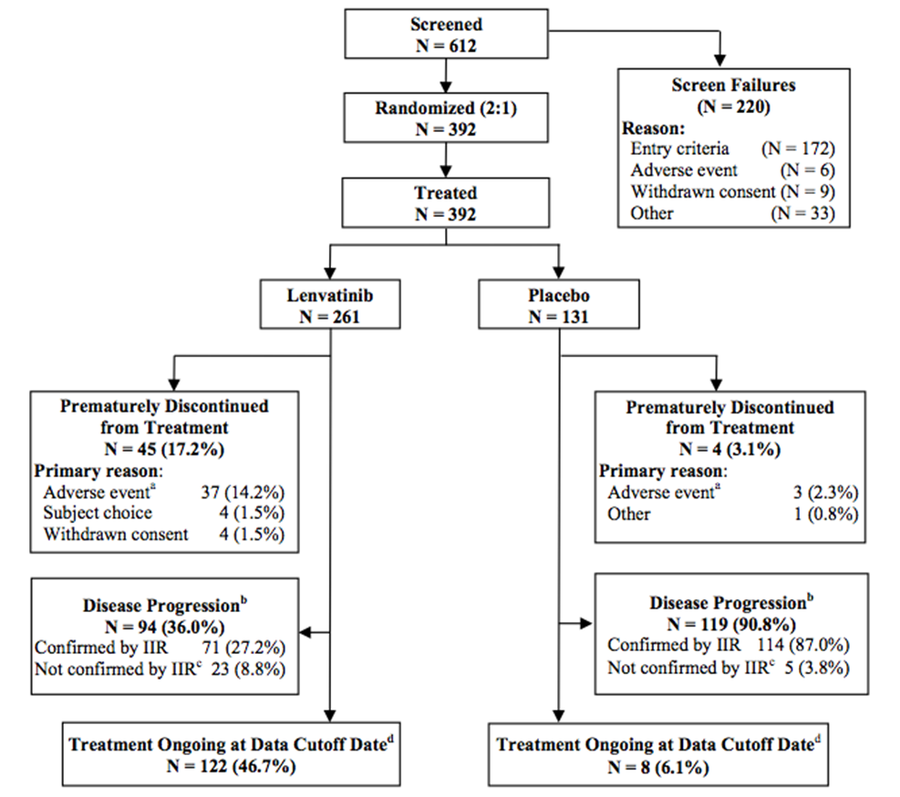
Table 4 shows subject disposition - End of Study Status Full Analysis Set.
Table 4. Subject Disposition - End of Study Status Full Analysis Set
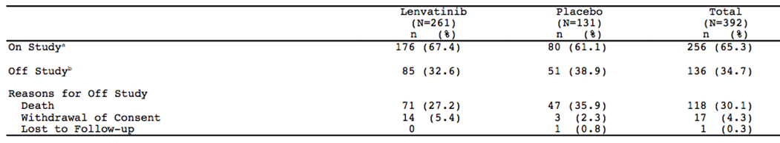

Major protocol violations/deviations
Overall, major protocol deviations were reported for 4 (1.5%) subjects in the lenvatinib arm and 4 (3.1%) subjects in the placebo arm. One subject in the lenvatinib arm had 2 major protocol deviations. The protocol deviations during this study were not considered to have affected the evaluation of efficacy or safety, particularly since the primary efficacy analysis was based on the Full Analysis Set and the safety evaluation was based on all available safety results.
Comment: Although there were blue hyperlinks, (e.g. subject data listings to examine reasons for violations/deviation), these hyperlinks were not functional. That the protocol deviations did not affect the study evaluation is likely to be reasonable.

Baseline data
Demographic and baseline characteristics – Full Analysis Set are shown in Table 5.
Table 5. Demographic and Baseline Characteristics – Full Analysis Set.
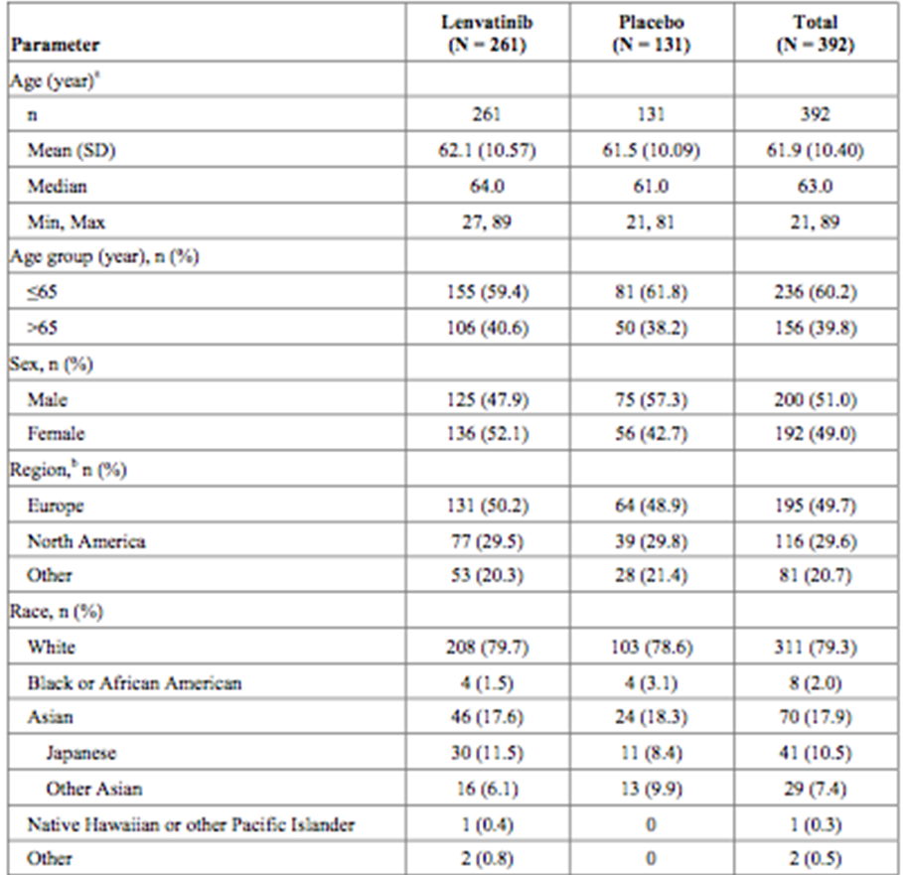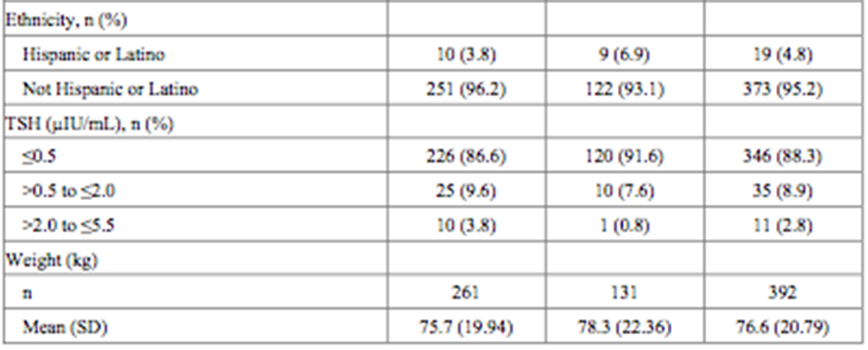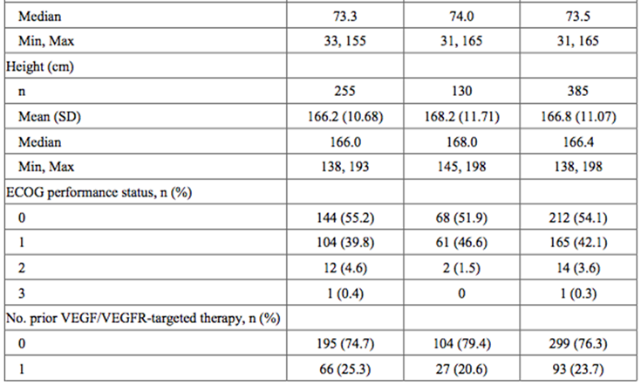

Results for the primary efficacy outcome
The null hypothesis of no difference in the PFS between lenvatinib versus placebo was tested using the stratified log-rank test with 2-sided alpha level of 0.01 stratified by region (Europe, North America, Other), age group (≤65, >65years), and prior VEGF/VEGFR therapy (0, 1). This was the primary test for PFS, which was performed when the target number of 214 events (progression or deaths prior to disease progression) occurred. The calculation of PFS as the primary analysis was based on disease progression as determined by tumor assessments performed by IIR. The unstratified log-rank test performed as supportive.
The Cox proportional hazards model was used to estimate the hazard ratio (HR) of lenvatinib versus placebo for PFS and its 95% and 99% confidence intervals (CIs) (stratified by region, age, and prior VEGF/VEGF-targeted therapy). The median and quartiles for PFS and the PFS rates at 6, 12, 18, and 24 months were calculated using the Kaplan-Meier (K-M) product-limit estimates for each treatment arm, and presented with 2-sided 95% CIs.
For the secondary endpoint of ORR, the difference between lenvatinib versus placebo was tested using the Cochran-Mantel-Haenszel (CMH) test at a 2-sided significance level of 0.05, stratified by region, age, and prior VEGF/VEGFR therapy.
Figure 2. Kaplan-Meier Plot of Progression-Free Survival by Previous VEGF Targeted Therapy - Independent Review: Full Analysis Set.
a) no prior VEGF therapy
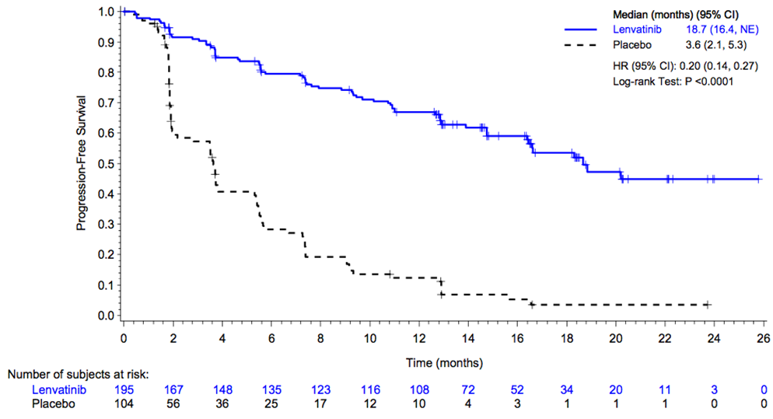
b) 1 prior VEGF therapy
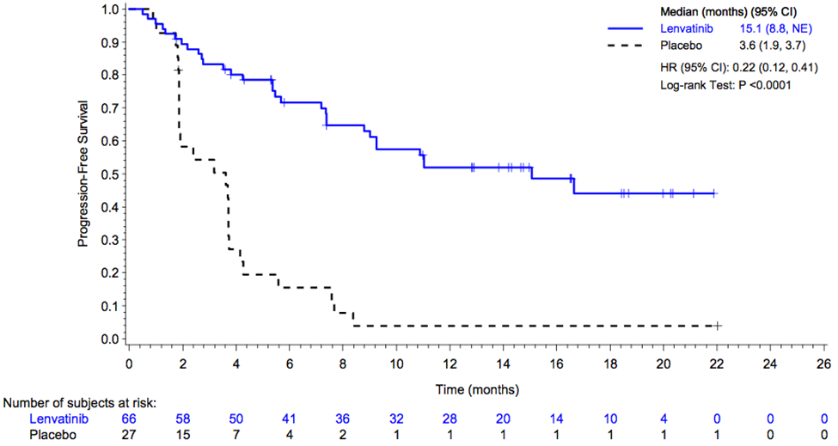

Results for other efficacy outcomes

Overall response rate (ORR) (complete and partial responses [CR and PR]) of subjects treated with lenvatinib versus placebo
Forest plot of Odds Ratio of Objective Response - Independent Review Full Analysis Set is shown in Figure 3.
Figure 3. Forest Plot of Odds Ratio of Objective Response - Independent Review Full Analysis Set.
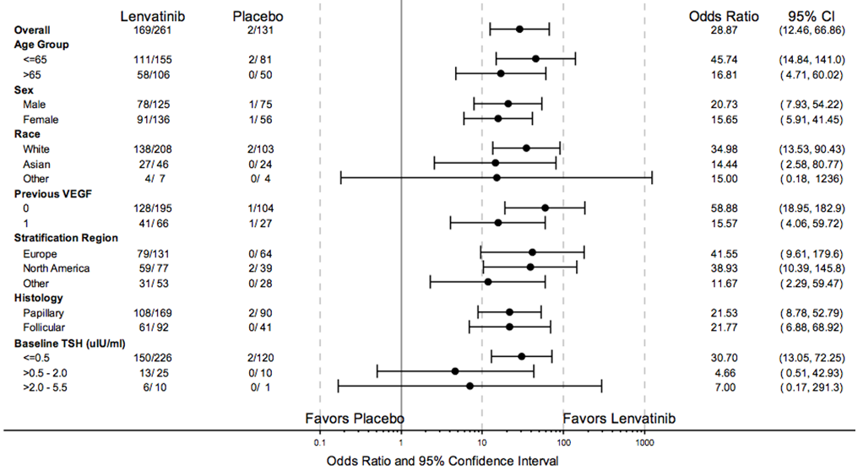

Overall survival (OS) of subjects treated with lenvatinib versus placebo
The overall survival was not statistically significant between the two groups (unadjusted, full analysis set).
Table 6. Overall survival (OS) of subjects treated with lenvatinib versus placebo.
The RPSFT model was used to estimate OS curves.
Table 7. Overall survival (OS) - Adjusted with RPSFT Model Full Analysis Set.
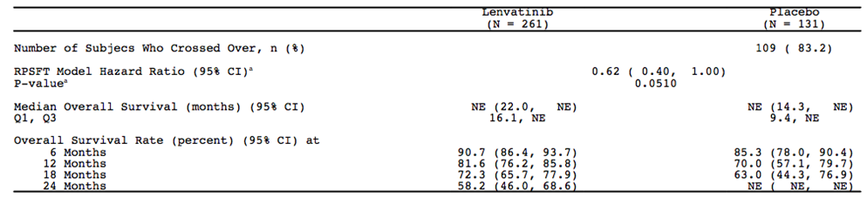
Figure 4. Kaplan-Meier Plot of Overall Survival Adjusted RPSFT Model Full Analysis Set.
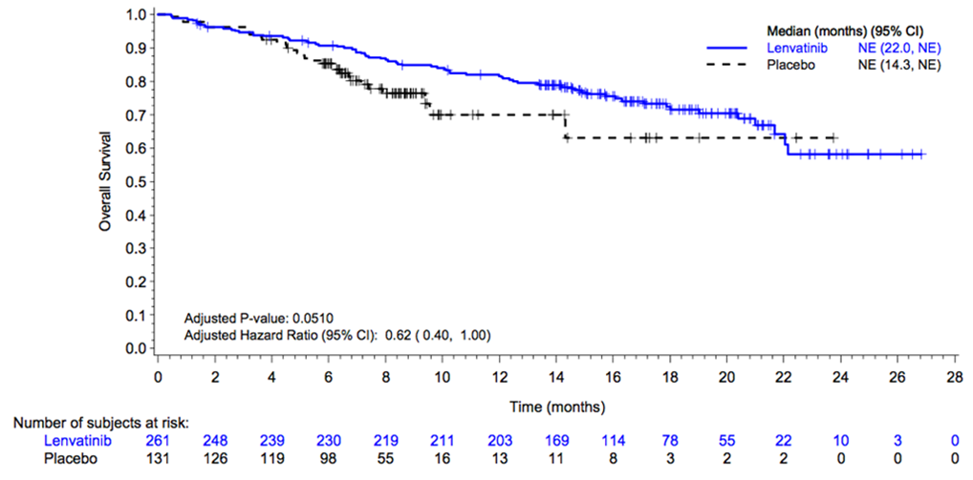

To assess the pharmacokinetic (PK) profile of lenvatinib in subjects with RR-DTC
Pharmacokinetic samples were collected from all subjects and analysed using the population approach. A total of 12 samples per subject were obtained predose. Plasma concentrations of lenvatinib were analysed using data from all the subjects in the PK Analysis Set and pooled with data from other studies for the population PK analysis (CPMS-E7080-007R-v1).
The exposure of lenvatinib showed moderate to high variability (CV = 38.3%). Based on the 24-mg starting dose, AUC ranged between 1410 and 10700 ng•h/mL with a median of 3490ng•h/mL. Lenvatinib apparent clearance (CL/F) was statistically significantly affected by body weight, CYP3A4 inducers (30% higher), CYP3A4 inhibitors (7.8% lower), and the liver biomarkers albumin (6.3% higher for albumin <30 g/L) and alkaline phosphatase (ALP) (11.7% higher with ALP > upper limit of normal [ULN]) and 15% lower in cancer patients compared to healthy subjects. None of the other covariates tested (gender, race, age, ALT, AST, bilirubin, common terminology criteria (CTC) grades, National Cancer Institute (NCI) liver function criteria or renal function (CRCL & CTC grade) was found to affect CL/F.
Within the lenvatinib arm, the primary efficacy endpoint of PFS was not related to exposure in the range. In the Cox regression analysis, the baseline factors histology, baseline tumor size, ECOG performance status, and body weight were significant predictors of PFS in the lenvatinib arm.
Reduction in tumor size was related to lenvatinib exposure. Patient ECOG performance status, sex, and baseline tumor significantly affect this relationship. Body weight, race, age, and previous anti-VEGF therapy did not affect tumor growth rate or lenvatinib-driven tumor kill rate. The exposure response relationship for safety (time to first dose reduction, hypertension, proteinuria, weight loss, and fatigue) showed that lenvatinib exposure significantly increased the probability of these events. Levels of VEGF increased and Tie-2 and angiopoietin-2 decreased post lenvatinib treatment. The change from baseline was correlated with lenvatinib trough levels for all the 3 circulating cytokine and angiogenic factors biomarkers.
There was insufficient data for analysing the effect of CYP3A4 phenotypes on exposure.

To compare safety and tolerability of lenvatinib versus placebo.
This is covered below in ‘Safety’ section.
Comment: the study was positive for the primary endpoint PFS. It was not positive for OS. The pharmacokinetic analysis showed significant inter-patient variability and statistical effects of age, CYP3A4 inducers (30% higher), CYP3A4 inhibitors (7.8% lower), albumin, alkaline phosphatase (11.7% higher with ALP > upper limit of normal [ULN]) and cancer vs. a non cancer population.

Phase II studies

E7080-G000-201
E7080-G000-201 was a Phase 2, multicentre, open-label, single-arm study that examined tolerability and pharmacokinetics of lenvatinib administered orally 10 mg tablet BID, 24 mg QD in 58 subjects in a DTC cohort (2 dosed 10 mg BID and 56 dosed 24 mg QD) and 59 subjects in a MTC cohort dosed 24 mg QD. It showed that lenvatinib absorption after oral administration was best described by first order absorption with a rate constant of 1.34 h-1 and a zero order absorption duration of 0.60 h. There was lag in absorption of 0.15 h. 2 subjects were treated with 10 mg lenvatinib and 115 subjects treated with 24 mg, the recommended dose in the indication. Plasma concentrations of lenvatinib were analysed using data from all the subjects in the Safety Population. Due to the sparse PK sampling in this study, the data were pooled with rich data from 3 Phase 1 studies previously discussed in the clinical pharmacology section (E7080-E044-101, E7080-A001-102, and E7080-J081-103). This enabled PK model development and covariate analysis.

Pooled data
In the pooled data including E7080-G000-201 (CPMS-E7080-002R-v1), the apparent clearance and exposure of lenvatinib among subjects in this study showed moderate to high variability. Using the 24 mg starting dose, for the DTC cohort, the steady-state individual predicted AUCs ranged from 1610 to 6960 ng∙h/mL with a median of 3840 ng∙h/mL. For the MTC cohort, the steady-state AUC ranged from 1040 to 6840 ng∙h/mL, with a median of 3350 ng∙h/mL.
In the analysis, race was not tested as a covariate as the majority of the population was Caucasian.
Likewise, the effect of CYP3A4 and CYP2C19 inhibitors and inducers was not tested as the numbers of subjects taking these were less than 10% of the population. Age (22 – 85 years) did not influence lenvatinib exposure; weight showed a statistically significant effect, but did not explain any inter-individual variability on CL/F. Liver function markers (albumin, bilirubin, alkaline phosphatase, alanine transaminase, and aspartate transaminase) were tested as covariates on CL/F. Only alkaline phosphatase showed statistically significant effect on CL/F, however it only explained 1.5% of IIV. Hence this effect was not included in final PK model. Creatinine clearance did not influence lenvatinib CL/F.
The effect of tumor type (DTC, MTC, Melanoma, Other) was also tested. Lenvatinib CL/F for MTC subjects was slightly higher compared to DTC resulting in slightly lower mean lenvatinib exposure (3450 vs. 3880 ng•h/mL). This effect (MTC tumor type) however explained only 0.5% variability in lenvatinib CL/F. The PK of lenvatinib was best described by a two compartment model with elimination from central compartment. The population mean value for lenvatinib apparent clearance was estimated to be 6.49 L/h and was independent of dose and time. Lenvatinib absorption after oral administration was best described by first order absorption with a rate constant of 1.34 h-1 and a zero order absorption duration of 0.60 h. There was lag in absorption of 0.15 h. Apparent volumes of distribution of central and peripheral compartment were estimated to be 64.2 L and 24.9 L respectively. The half-life (median: 27 h) of lenvatinib in Study E7080-G000-201 was similar to that observed in phase I results. The steady state exposure increased proportionally with dose indicating linear pharmacokinetics and was comparable among different studies.

Results of Lenvatinib Tumor Growth Inhibition Model (Study 201 only).
Reduction in tumor size (the sum of the longest diameter for target lesions) correlated with lenvatinib exposure, with the total dose between two tumor assessments best describing the longitudinal tumor size data. None of the patient factors (weight, ECOG, age, gender, year since first diagnosis) or disease factors (DTC or MTC tumor type, previous anti- VEGF therapy, previous cancer therapy) were significant covariates of lenvatinib effect on tumor size. Also, none of the circulating chemokine and angiogenic factor baseline values were predictors for the effect of lenvatinib on tumor size. The analysis suggests that sVEGFR-2 is potentially a predictor of lenvatinib-related tumor size reduction, but additional data are required to further characterize the relationship. With mutation data available from only a limited number of subjects, the influence of KRAS, NRAS, VHL and/or BRAF for DTC subjects and RET, PIK3CA and/or VHL for MTC subjects on the effect of lenvatinib on tumor size could not be detected
Comment: the population model showed there was an approximately 5 fold variability in AUC.
Differences in race, genotype, age and numbers of the extremes of weight were unable to explain the variability in Cl/F, likely to be due to small numbers, especially in the severe renal and liver dysfunction groups. This data is in contrast to the PK studies using patient collected data in renal and liver disease.

E7080-J081-208
This was a Phase 2 Study of E7080 in subjects with advanced thyroid cancer. It had not been completed at the time of the submission. This clinical study report presented data through a data cutoff date of 15 Sep 2013.
Dates: 03 Sep 2012 (date of first subject’s signed informed consent) to 15 Sep 2013 (date of data cutoff). Enrolment begun after the completion of the Phase III study 303.

Primary objective
To evaluate the safety of once daily oral administration of lenvatinib (E7080) in subjects with advanced thyroid cancer (including differentiated thyroid cancer [DTC], medullary thyroid cancer [MTC], and anaplastic thyroid cancer [ATC])

Secondary objectives
- To evaluate the efficacy of lenvatinib using
  - Progression-free survival (PFS)
  - Overall survival (OS)
  - Best overall response (BOR)
  - Objective response rate (ORR: the proportion of complete response [CR] + partial response [PR])
  - Disease control rate (DCR: the proportion of CR+PR+ stable disease [SD])
  - Clinical benefit rate (CBR: the proportion of CR+PR+ durable SD [dSD])
- To evaluate the pharmacokinetics (PK) of lenvatinib

Exploratory objective
To identify and validate DNA-sequence gene mutations influencing absorption, distribution, metabolism, and excretion (ADME) of lenvatinib

Design
Phase II, multicentre, nonrandomized, open- label with dosage of 24mg (capsules) QD. 36 were enrolled 36 and 35 treated.
The enrolment of DTC subjects started only after the recruitment of the multicentre, randomised, double-blind, placebo-controlled, Phase 3 study for radioiodine (131I) refractory DTC (E7080-G000-303) was completed.
The study consisted of 3 phases: a Pretreatment Phase, a Treatment Phase, and a Follow-up Phase.
The Pretreatment Phase included the processes of informed consent, screening, enrolment, and baseline assessments. The Treatment Phase started from the study drug administration on Day 1 of Cycle 1 and continued until a subject met one or more of the “Discontinuation Criteria for Individual Subject.” The safety assessment and tumor assessment were performed periodically during the study period. For DTC and MTC subjects, tumor assessments were performed every 8 weeks from Day 1 of Cycle 1. For ATC subjects, tumor assessments were performed at 4, 8, 12, and 16 weeks from Day 1 of Cycle 1, and every 8 weeks subsequently.
Survival was followed up during the Follow-up Phase. After treatment discontinuation, all subjects were followed up every 12 weeks (DTC and MTC) and every 4 weeks (ATC) unless subjects withdrew their consent or the sponsor decided to discontinue the follow-up.

Inclusion/exclusion criteria

Inclusion and exclusion criteria
Advanced thyroid cancer (DTC, MTC, or ATC)

Inclusion criteria for DTC only
- Histologically or cytologically confirmed diagnosis of DTC
- Had evidence of disease progression according to Response Evaluation Criteria in Solid Tumors (RECIST) 1.1 within 12 months before informed consent, using computerized tomography (CT) or magnetic resonance imaging (MRI)
- Had measurable lesion meeting the following criteria:
  - At least one lesion of ≥1.0 cm in the long axis for a non-lymph node or ≥1.5 cm in the short axis diameter for a lymph node that was sequentially measurable according to RECIST 1.1 using CT or MRI
  - Lesions previously treated with external beam radiotherapy or locoregional therapy such as radiofrequency ablation had to show radiographic evidence of disease progression (according to RECIST 1.1) to be deemed a target lesion
- Had been receiving thyroxine suppression therapy (thyroid stimulating hormone [TSH] was ≤5.50 mcu/mL)
- Had been confirmed as 131I-refractory or resistant defined by at least one of the following criteria:
  - One or more measurable lesions with no iodine uptake detected by radioiodine scanning
  - One or more measurable lesions that had progressed by RECIST 1.1 within 12 months of 131I therapy, despite demonstration of 131I uptake at the time of that treatment by pre- or post-treatment scanning
  - Cumulative activity of 131I of >600 mCi or 22 gigabecquerel (GBq)

For MTC only
- Histologically or cytologically confirmed diagnosis of MTC Met at least one of the following criteria
  - Evidence of disease progression according to RECIST 1.1 within 12 months before informed consent, using CT or MRI
  - Clinical progressive disease (with clinical symptom or elevated tumor marker) in the opinion of the investigator
- Had evaluable target lesion or non-target lesion according to RECIST 1.1

For ATC only
- Histologically or cytologically confirmed diagnosis of ATC 10. Had evaluable target lesion according to RECIST 1.1 11. Had agreed to hospitalization in Cycle 1 (4 weeks) 12. Expected to survive for 8 weeks or longer after the first dose of study drug

For all subtypes
- Radical surgery was not applicable
- Had adequate organ function meeting the following criteria
- Renal function: Systolic pressure ≤140 mmHg and diastolic pressure ≤90 mmHg with or without antihypertensive medications and no change in antihypertensive medications within 1 week before study entry (additional antihypertensive therapy was allowable if using antihypertensive agents).
- Aged 20 years or older when informed consent was obtained
- Eastern Cooperative Oncology Group (ECOG) performance status was 0 to 2
- Females must not have been lactating or pregnant at Screening or Baseline (as documented by a negative beta-human chorionic gonadotropin [β-hCG] test with a minimum sensitivity of 25 IU/L or equivalent units of β-hCG). A separate baseline assessment was required if a negative screening pregnancy test was obtained more than 72 hours before the first dose of study drug.
- All females were considered to be of childbearing potential unless they were postmenopausal (amenorrheic for at least 12 consecutive months, regardless of age group or other cause) or sterilized surgically (ie. bilateral tubal ligation, total hysterectomy, or bilateral oophorectomy, all with surgery at least 1 month before the first dose of study drug).
- Females of childbearing potential must not have had unprotected sexual intercourse within 30 days before study entry and were required to agree to use a medically appropriate method of contraception throughout the entire study period and for 30 days after study drug discontinuation. If currently abstinent, the subject was required to agree to use a method as described above if she became sexually active during the study period and for 30 days after study drug discontinuation. Females of childbearing potential who were using hormonal contraceptives had to be on a stable dose of the same hormonal contraceptive product for at least 4 weeks before dosing and were required to continue to use the same contraceptive during the study and for 30 days after study drug discontinuation.
- Male subjects were required to have a successful vasectomy (confirmed azoospermia) or they and their female partners were required to meet the criteria above (ie, not of childbearing potential or practicing medically appropriate contraception throughout the study period and for 30 days after study drug discontinuation).
- Voluntarily agreed to provide written informed consent and the willingness and ability to comply with all aspects of the protocol

Exclusion criteria (for all subtypes)
- Had a complication or history of the following disease(s)
  - Concomitant brain metastasis (except for metastasis if previously treated and clinically stable for at least 1 month before screening)
  - Concomitant systemic infection requiring medical treatment
  - Medical history of clinically significant cardiovascular impairment: congestive heart failure greater than New York Heart Association (NYHA) Class II, unstable angina pectoris, myocardial infarction or stroke within 6 months before of the first dose of study drug, or cardiac arrhythmia requiring medical treatment
  - QT interval corrected for heart rate (QTc) greater than 480 ms (Fridericia’s method)
  - Active hemoptysis (bright red of a half or more of teaspoon) within 3 weeks before enrolment
  - Bleeding or thrombotic disorders or use of anticoagulants such as warfarin or similar drugs requiring INR monitoring (low molecular weight heparin was allowed)
  - ≥2+ proteinuria on urine dipstick testing underwent 24 h urine collection for quantitative assessment of proteinuria. Subjects with urine protein ≥1 g/24 h were ineligible
  - Gastrointestinal malabsorption or any other condition in the opinion of the investigator or subinvestigator that might affect the absorption of lenvatinib
  - Major surgery within 3 weeks before enrolment
  - Effusion requiring drainage
- Previously treated with lenvatinib
- Had received any anticancer treatment such as radiotherapy, chemotherapy, or immunotherapy (except for TSH suppression therapy) within 21 days or any other investigational agent within 30 days before the first dose of lenvatinib (but not applicable to ATC subjects)
- Had not recovered from toxicities as a result of prior anticancer therapy to ≤ Grade 1, according to Common Terminology Criteria for Adverse Events (CTCAE) v4.0 (except for alopecia and infertility)
- Scheduled for surgery during the study
- Any medical or other condition that, in the opinion of the investigator or subinvestigator, would preclude participation in a clinical study
- Known intolerance to any of the study drug (or any of its excipients)
- Currently participating in another clinical study
- Active malignancy within 24 months of the start of study drug administration (except for thyroid cancer, definitively treated melanoma in situ, basal or squamous cell carcinoma of the skin, or carcinoma in situ of the cervix).
Comment: it is noted that inclusion was not based on symptomatic progression, rather it was a radiological or functional imaging measurement. Patients with brain metastases in particular had to be asymptomatic.

Datasets
- Safety Analysis Set included all subjects who received at least one dose of the study drug and had at least one post baseline safety evaluation.
- Full Analysis Set included all subjects who received at least one dose of the study drug.
- PK Analysis Set included all subjects who received at least one dose of the study drug and had at least one drug concentration data.
Tumor assessment was performed by the investigator using RECIST 1.1.
- PFS: Defined as the time from the date of first dose to the date of first documentation of disease progression or death from any cause (whichever occurred first).
- OS: Defined as the time from the date of first dose to the date of death from any cause. If death was not observed for a subject, the survival time was censored at the date the subject was last known alive or the data cutoff date (whichever occurred first).
- BOR: The best response observed between the time of first dose and the study completion, assessed by either of CR, PR, SD (≥7 weeks for DTC and MTC, ≥3 weeks for ATC), progressive disease (PD), or not evaluable (NE). The CR and PR were determined only when these responses met each criterion even after 28 days from the time observed.
- ORR: Proportion of subjects who had BOR of CR or PR DCR: Proportion of subjects who had BOR of CR, PR, or SD
- CBR: Proportion of subjects who had BOR of CR, PR, or dSD (SD lasting ≥23 weeks for DTC and MTC, ≥11 weeks for ATC)

Efficacy analysis
All efficacy analyses conducted were based on the Full Analysis Set. PFS and OS were summarized by the Kaplan-Meier method using median time with 95% confidence interval (CI), minimum, and maximum by histologic stratum and overall. ORR, DCR, and CBR based on the investigator assessment were provided with corresponding exact 95% CI by histologic stratum and overall. BOR was summarized by histologic stratum and overall. Graphical displays of % shrinkage of tumour size, and of calcitonin over time were provided for each subject.

Pharmacokinetic analysis
The PK Analysis Set was used to examine actual and dose normalized plasma concentrations.

Pharmacogenomic analysis
Details of analyses to be performed to identify and validate DNA-sequence variants in genetic mutations influencing lenvatinib PK were described in a separate analysis plan.

Subject disposition/analysis sets
A total of 36 subjects entered into the study (22 with DTC, 5 with MTC, and 9 with ATC). 1 subject with MTC started the study drug administration after the date of data cutoff (15 Sep 2013), 35 subjects who received at least one dose of study drug are included in this report. Of the 35 subjects, 25 were still receiving study drug, 9 had discontinued study drug due to disease progression, and 1 had discontinued study drug due to subject choice. All of the 35 subjects were included in the Full Analysis Set, Safety Analysis Set, and PK Analysis Set.

Efficacy
- At the time of data cutoff, the efficacy could be assessed in 21 subjects with DTC, in 4 subjects with MTC, and in 9 subjects with ATC; the majority of subjects were ongoing.
- All evaluable subjects experienced tumor shrinkage after initiation of lenvatinib.
- The ORR (CR+PR) based on the investigator assessment was 47.6% in DTC subjects, 25.0% in MTC subjects, and 33.3% in ATC subjects.
- In DTC subjects, 10 subjects (47.6%) had a BOR of PR and 11 subjects (52.4%) had a BOR of SD. In MTC subjects, 1 subject (25.0%) had a BOR of PR and 3 subjects (75.0%) had a BOR of SD. In ATC subjects, 3 subjects (33.3%) had a BOR of PR, 5 subjects (55.6%) had a BOR of SD, and 1 subject (11.1%) had a BOR of PD. One subject with ATC had a BOR of PD based on non-target lesions.
- The DCR (CR+PR+SD) was 100.0% in both DTC and MTC subjects and 88.9% in ATC subjects.
- Clinical benefit was evaluated in 14 subjects with DTC, in 3 subjects with MTC, and in 8 subjects with ATC. The CBR (CR+PR+dSD) was 78.6% in DTC subjects, 100.0% in MTC subjects, and 75.0% in ATC subjects.
- The median PFS in DTC subjects had not been reached at time of data cut-off. The median PFS was 6.5 months (95% CI: 5.6, 7.3) in MTC subjects and 5.5 months (95% CI: 1.4, –) in ATC subjects. In all histologic subtypes, the median OS had not been reached yet.
Comment: In the pooled data PK analysis, the apparent clearance and exposure of lenvatinib among subjects in this study showed high variability. Based on the 24 mg starting dose, for the DTC cohort, the steady-state individual predicted AUCs ranged more than 4 fold. For the MTC cohort, the steady-state AUC had a nearly 7 fold range.

Evaluator’s conclusions on efficacy
The submission complies with TGA guidance. The single pivotal trial is noted. The primary endpoint of the pivotal study was achieved. There was a significant difference in lenvatinib versus placebo in PFS. Overall, survival was not significantly different however.
Study design was appropriate.
PFS is a relevant clinical endpoint. The EMA CHMP guidelines were also used as a reference for discussion on appropriateness of the choice of PFS in the pivotal study.
The lack of apparent relationship between PFS and OS is noted.
In the first of the two Phase II studies, the pooled data showed there was very wide variability in AUC. Statistical effects of weight were seen, no differences were noted in age and gender however numbers were small for each stratum.
In the second Phase II study, at the time of data cutoff all evaluable subjects experienced tumour shrinkage after the initiation of lenvatinib treatment. The median PFS in DTC subjects had not yet been reached. The median PFS was 6.5 months (95% CI: 5.6, 7.3) in MTC subjects and 5.5 months (95% CI: 1.4, –) in Anatomical Therapeutic Chemical (ATC) subjects. In all histologic subtypes, the median OS had not yet been reached.
The dose range chosen is reasonable, with the algorithm used in the clinical trial to reduce dose to toxicity.
The clinical studies are reasonably applicable to the predominantly Caucasian, middle age and lack of comorbidity patients; however, the data does not support generalisability to the elderly and children. The findings of the simulated model data and population PK analysis are noted.
Long term efficacy data, especially in the context of a short term drug in a potentially chronic condition is unknown.

Clinical safety

Studies providing safety data
The safety profile is provided by the 3 clinical studies: 452 subjects with RR-DTC and MTC. A total of 7 additional studies provided safety data: 656 subjects in total received lenvatinib.
All subjects had at least one treatment emergent adverse event (TEAE), with profiles seen with other VEGF inhibitors.

Pivotal efficacy study
In the pivotal efficacy study (303), the following safety data were collected: TEAEs, clinical laboratory test results, vital signs, 12 lead electrocardiogram (ECG) results, and left ventricular ejection fraction (LVEF). The AE verbatim descriptions were classified into standardized medical terminology using the Medical Dictionary for Regulatory Activities (MedDRA) (Version 16.0). AEs were coded to the MedDRA primary system organ class (SOC) and preferred term (PT). Progression of malignant disease was not recorded as an AE in this study.
AEs of particular interest, based on safety data from lenvatinib clinical and pharmacovigilance databases were closely monitored during the study. These were hypertension, proteinuria, GI events, fatigue, decreased weight, haemorrhagic events, GI perforation and fistula formation events, arterial, venous, and mixed vessel thromboembolic events, pancreatic events, renal events.
After database lock, the following events were identified as clinically significant: hypertension proteinuria, atrial and venous thromboembolic events, renal failure/impairment, liver injury/failure, and posterior reversible encephalopathy syndrome (PRES). These events are referred to as clinically significant AEs in this clinical study report.
Laboratory tests were summarised by visit for all visits with data for at least 10% of subjects in lenvatinib arm and by worst post baseline visit.
Descriptive statistics for vital sign parameters (sitting systolic and diastolic BP, sitting heart rate, RR, temperature, weight) and changes from baseline were presented by visit for all visits with data for at least 10% of subjects in lenvatinib arm.
There was no pivotal study that assessed safety as a primary outcome.

Patient exposure
The lenvatinib clinical development program (which includes a variety of other cancers) consists of 2 Phase III studies, 18 Phase I/Ib/2 studies in subjects with various cancers, 6 Phase I studies in healthy volunteers, and 1 study each in subjects with renal or hepatic impairment. The safety pooled analyses were based on data from subjects in studies that:
- included subjects with cancer who received lenvatinib continuously as monotherapy
- had a completed primary analysis, and
- had a completed Clinical Study Report: 101, 102 (monotherapy cohort/continuous dosing), 104, 105, 201, 203 (lenvatinib treated/monotherapy cohort), 204, 206, 208, and 303.
Selected safety data have been included for the following studies in healthy subjects, including those that also enrolled subjects with renal or hepatic impairment: E7080-A001-001, E7080-A001-002, E7080-A001-003, E7080-A001-004, E7080-A001-005, E7080-A001-006, E7080-A001-007, and E7080-A001-008.
Patient exposure data includes all studies up to 15 September 2013 for all studies for which study participation was ongoing except the pivotal Study 303 which was 15 Mar 2014.
The main analyses of safety are based on the following 4 analysis sets for the pooled studies, with emphasis on the studies in subjects with DTC.
- DTC Randomised Safety Set which includes placebo treated (n = 131) and lenvatinib treated (n = 261) subjects from the randomised portion only of Study 303.
- DTC Non randomised Safety Set (n = 191), which includes subjects with the proposed indication of DTC from Studies 201 and 208, as well as subjects from the optional open label (OOL) portion of Study 303. All subjects included in this Safety Set received lenvatinib treatment only.
- All DTC Lenvatinib Safety Set (n = 452), which includes all lenvatinib treated subjects from Studies 201, 208, and 303 (both the randomised and the OOL portions of the study).
- Non DTC Monotherapy Safety Set (n = 656), which includes all subjects who received single agent lenvatinib in studies conducted in subjects with cancer, excluding DTC: Studies 101, 102 (monotherapy cohort only/continuous dosing), 104, 105, 201 (MTC subjects only), 203, 204, 206, and 208 (MTC and ATC subjects only).
Individual Studies: Selected safety data (that is, exposure to study drug and TEAEs) were provided for the studies in healthy subjects (Studies 001, 002, 003, 004, 007, and 008) as well as for those that also enrolled subjects with renal impairment (Study 005) or hepatic impairment (Study 006). For the ongoing studies that had not yet reached the protocol specified primary analysis as of 15 September 2013, safety progress reports only are provided. These include the following studies: 202, 205, 304, and 703.
Table 8. Number of lenvatinib treated subjects by development phase and indication – All Safety Sets.
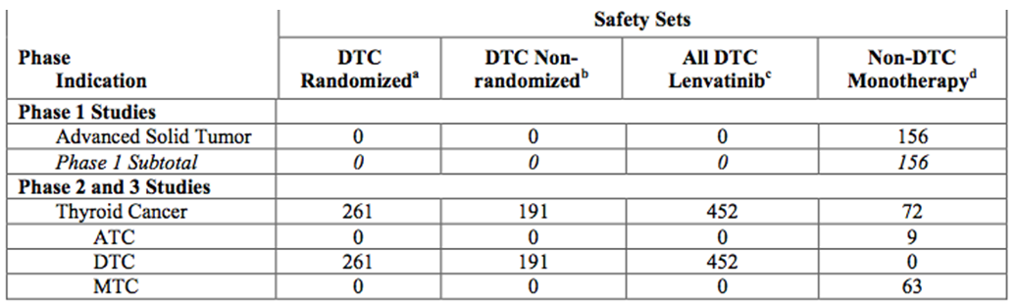
At the time of data cut off, the median duration of treatment with lenvatinib was 11.1 months in the ‘All DTC Lenvatinib Safety Set’ and 3.5 months in the Non DTC Monotherapy Safety Set. In the DTC Randomised Safety Set, the median duration of treatment was 16.1 months in the lenvatinib arm and 3.9 months in the placebo arm.
Table 9. Summary of study drug exposure – All Safety Sets.

Adverse events

All adverse events (irrespective of relationship to study treatment)
In this Study safety was a primary endpoint with safety analyses performed on the Safety Analysis Set. Secondary assessments were performed for each subtype of DTC, MTC, or ATC. The number and percentage of subjects with treatment-emergent AEs (TEAEs) and SAEs were calculated and summarised by system organ class (SOC), preferred term (PT), CTCAE v4.0 grade, and causal relationship to the study treatment. Clinical laboratory values and vital signs were summarised using descriptive statistics. The number and percentage of subjects with treatment-emergent markedly abnormal laboratory values (TEMAVs) were summarized by scheduled visit and overall. A laboratory value was considered markedly abnormal if the result worsened to Grade 2 or higher from baseline. QT and QT interval corrected for heart rate using Fridericia’s formula (QTcF) values, and changes from baseline were summarized at each scheduled visit.
In the Safety Analysis Set, all of 35 subjects (100.0%) experienced at least one TEAE reported as treatment-related by the investigator.
The most frequently reported TEAE was hypertension (85.7%, 30/35 subjects), followed by palmar- plantar erythrodysaesthesia syndrome (74.3%, 26/35 subjects), fatigue (71.4%, 25/35 subjects), decreased appetite (68.6%, 24/35 subjects), proteinuria and stomatitis (51.4%, 18/35 subjects each), diarrhoea (42.9%, 15/35 subjects), and nausea (40.0%, 14/35 subjects). The most frequently reported treatment- related TEAE was hypertension (85.7%, 30/35 subjects), followed by palmar-plantar erythrodysaesthesia syndrome (71.4%, 25/35 subjects), fatigue (68.6%, 24/35 subjects), decreased appetite (62.9%, 22/35 subjects), proteinuria and stomatitis (51.4%, 18/35 subjects each), and diarrhoea (42.9%, 15/35 subjects).
Twenty-six of 35 subjects (74.3%) had at least one CTCAE Grade 3 or 4 TEAE. Grade 3 or 4 TEAEs occurred in 16 subjects (72.7%) with DTC, in 4 subjects (100.0%) with MTC, and in 6 subjects (66.7%) with ATC. The most frequently reported Grade 3 or 4 TEAE was hypertension (42.9%, 15 subjects), followed by diarrhoea (11.4%, 4 subjects). Three subjects experienced at least one Grade 4 TEAE (hypocalcaemia, hyponatraemia, and thrombocytopenia). Grade 4 TEAEs were resolved with treatment or study drug dose reduction except for hypocalcaemia which was reported as ongoing at the time of data cutoff (15 Sep 2013).
Death, during the study treatment or within 30 days of the last dose of study drug occurred in 1 subject who died of disease progression.
Fourteen subjects (40.0%) experienced 21 SAEs. SAEs that occurred in more than one subject were decreased appetite (4 subjects) and nausea (2 subjects). Both of these plus cholecystitis, diarrhoea, fatigue, gastric ulcer, gastroenteritis, lung infection, malignant pleural effusion, pneumonia, respiratory tract infection, and sepsis (1 event each) were reported as treatment- related by the investigator.
No subjects required study drug withdrawal due to TEAEs but almost all -thirty-four subjects (97.1%) reported TEAEs leading to study drug dose reduction. The most frequently reported TEAE leading to study drug dose reduction was fatigue (37.1%, 13 subjects), followed by decreased appetite, hypertension, and palmar-plantar erythrodysaesthesia syndrome (22.9%, 8 subjects each).
Fifteen subjects (42.9%) reported TEAEs leading to study drug interruption. The most frequently reported TEAE leading to study drug interruption was palmar-plantar erythrodysaesthesia syndrome (11.4%, 4 subjects), followed by decreased appetite and fatigue (8.6%, 3 subjects each).
The most frequently observed TEMAV was urine protein (markedly high; 45.7%, 16 subjects), followed by triglycerides (markedly high; 31.4%, 11 subjects), and cholesterol (markedly high; 28.6%, 10 subjects).
Thirty subjects (85.7%) experienced hypertension as a TEAE. All events of hypertension were Grade 2 or Grade 3 and led to study drug dose reduction in 8 subjects.
TEAEs related to ECG abnormalities occurred in 2 subjects (sinus tachycardia, electrocardiogram QT prolonged). No subject reported a QTcF prolongation of >480 ms or an increase from baseline of >60 ms. Four subjects (1 with MTC and 3 with ATC) had a QTcF prolongation of 450 to 480 ms. Four subjects (1 each with DTC and MTC, and 2 with ATC) had an increase from baseline in QTcF of 30 to 60 ms.
No clinically important changes were observed in ECOG performance status.

Treatment related adverse events (adverse drug reactions)
These are shown in the tables below.
Table 10. Overview of Treatment Emergent Adverse Events – All Safety Sets.
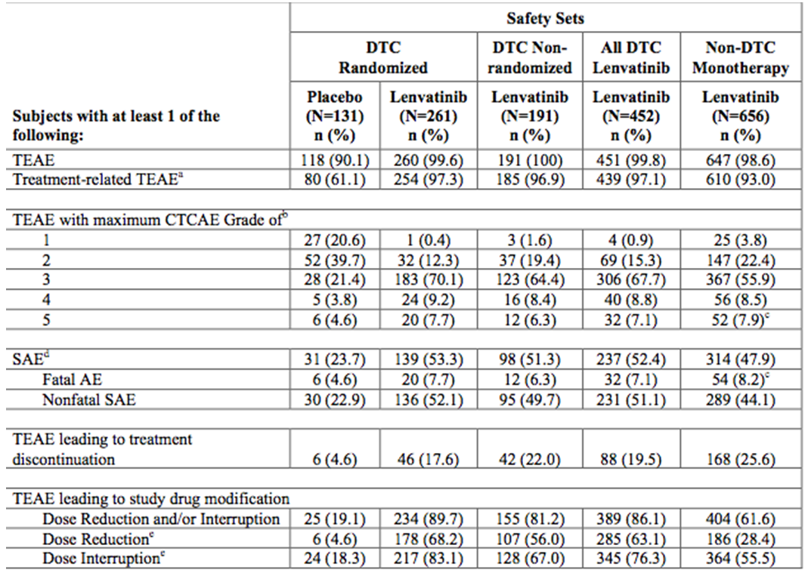
In the DTC Randomised Safety Set, the most frequently reported TEAEs occurring in at least 30% of lenvatinib- treated subjects and at an incidence at least 5% higher than that for placebo were hypertension (69.3% in the lenvatinib arm, 15.3% in the placebo arm); diarrhoea (67.4%, 16.8%); decreased appetite (54.4%, 18.3%); weight decreased (51.3%, 14.5%); nausea (46.7%, 25.2%); fatigue (42.5%, 24.4%); headache (38.3%, 11.5%); stomatitis (36.8%, 6.9%); vomiting (35.6%, 14.5%); proteinuria (33.7%, 3.1%); PPE (32.2%, 0.8%); and dysphonia (31.4%, 5.3%). The most frequently reported Grade 3 or 4 TEAEs occurring in at least 5% of lenvatinib-treated subjects and at an incidence at least 2% higher than that for placebo were hypertension (42.9% in the lenvatinib arm, 3.8% in the placebo arm); weight decreased (13.4%, 0.8%); proteinuria (10.7%, 0%); diarrhoea (9.2%, 0%); decreased appetite (6.9%, 0.8%); asthenia (6.1%, 2.3%); and hypocalcemia (5.0%, 0%).
Table 11. Treatment Emergent Adverse Events of CTCAE Grade 3 or 4 that occurred in 2% or more of subjects in the supportive safety sets (DTC Nonrandomised, All DTC Lenvatinib, and Non-DTC Monotherapy).
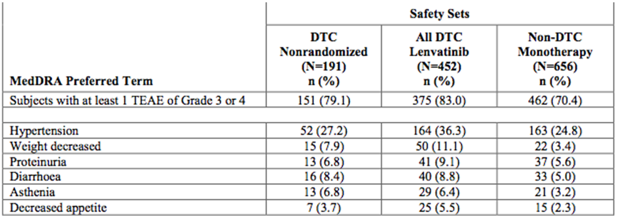

Investigator nominated - TEAE
Almost all lenvatinib-treated subjects (93.0% to 97.3%) and 61.1% of placebo-treated subjects had at least 1 TEAE that was reported by the investigator to be treatment related. For the DTC Randomised Safety Set, the most frequently reported treatment-related TEAEs occurring in at least 30% of lenvatinib-treated subjects were hypertension, diarrhoea, decreased appetite, weight decreased, nausea, fatigue, stomatitis, proteinuria, and PPE. A similar pattern for lenvatinib was observed in the All DTC Lenvatinib and Non-DTC Monotherapy Safety Sets, although most events occurred at a higher or similar incidence in the All DTC Lenvatinib Safety Set relative to the Non-DTC Monotherapy Safety Set, while hypothyroidism occurred at a higher incidence in the Non-DTC Monotherapy Safety Set than in the All DTC Lenvatinib Safety Set.
Table 12. Treatment Emergent Adverse Events that were reported by the investigator to be treatment related and that occurred in 20% or more of subjects – All Safety Sets.
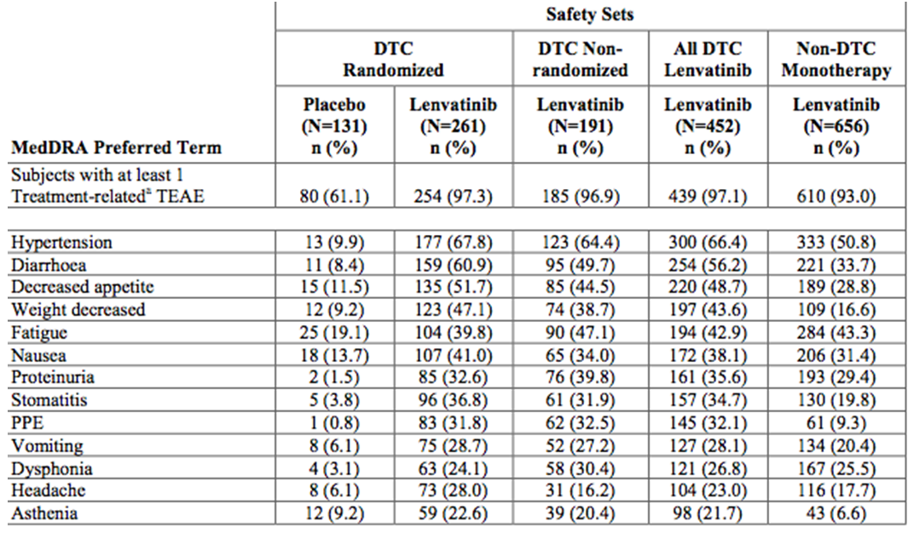

Deaths and other serious adverse events
These are shown in the tables below.
Table 13. Serious AEs that occurred in 2% or more of subjects – All Safety Sets.
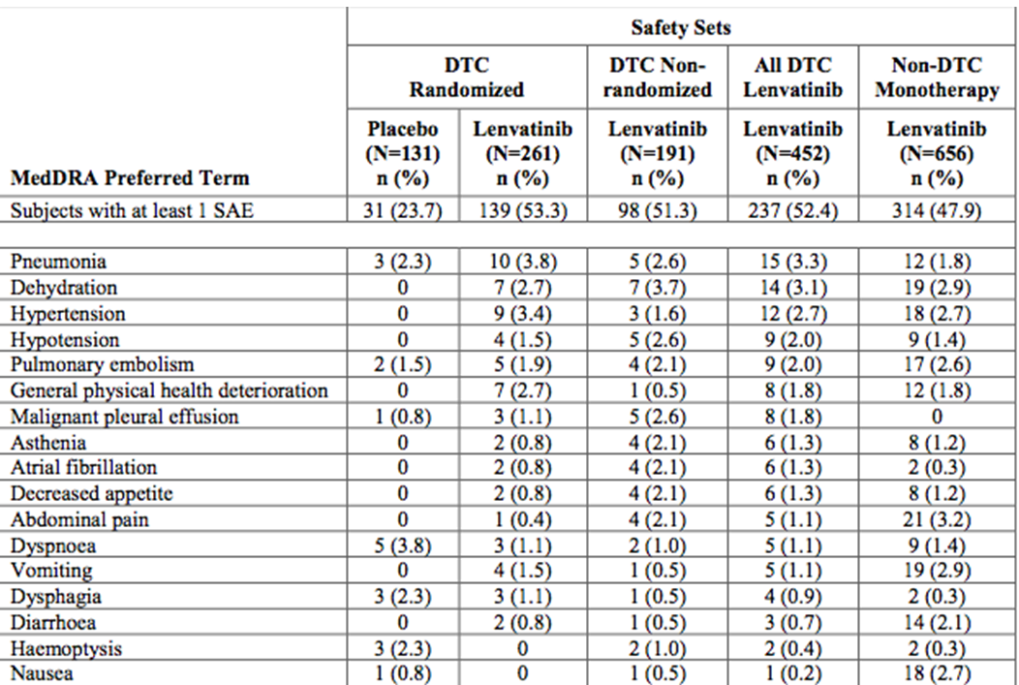
Table 14. Serious AEs reported by the investigator as treatment related that occurred in 1% or more of subjects – All Safety Sets.
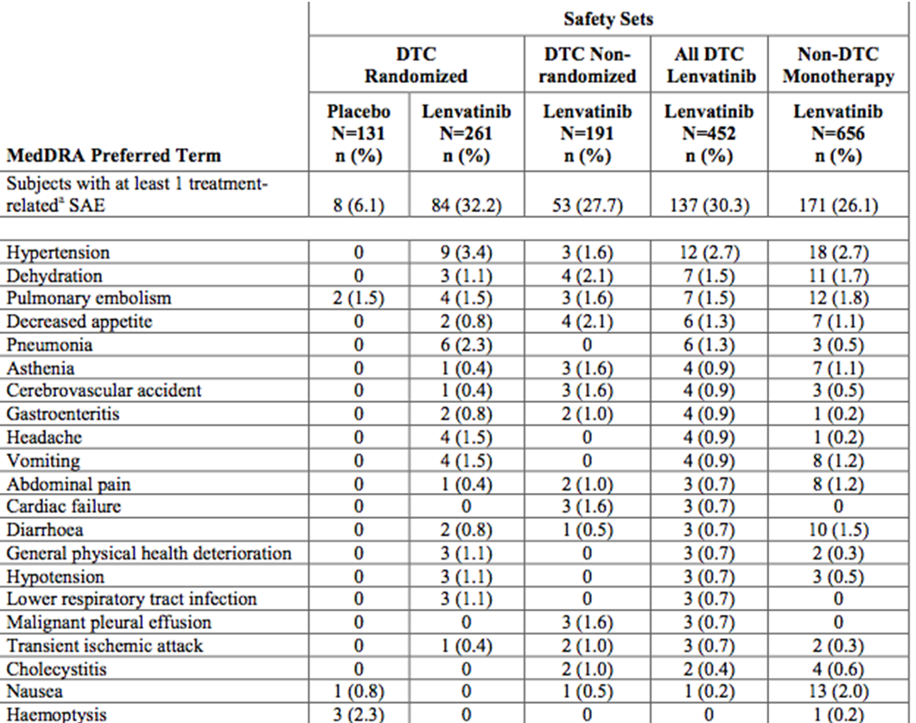
Table 15. AEs leading to death that were reported by the investigator as treatment related – All Safety Sets.
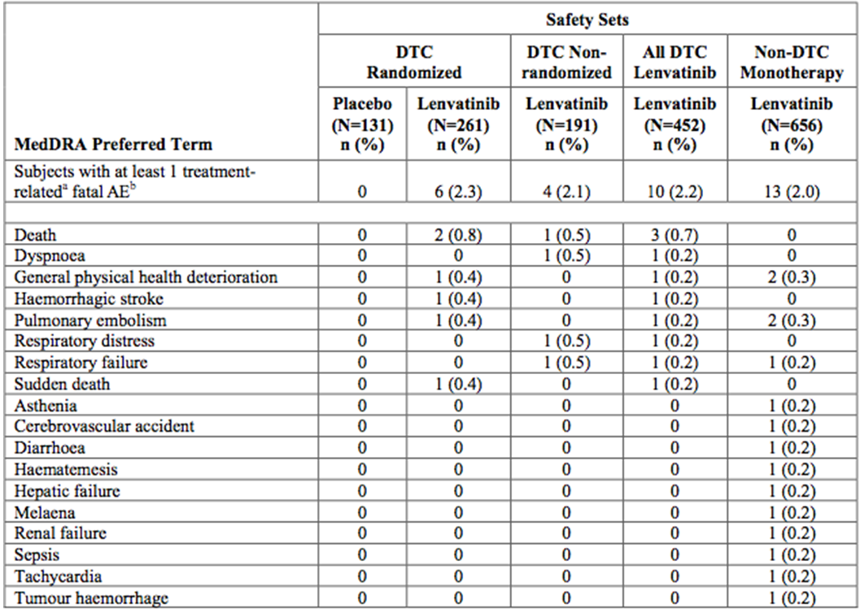

Discontinuation due to adverse events
These are shown in the tables below.
Table 16. Subject disposition and reasons for discontinuation – All Safety Sets.
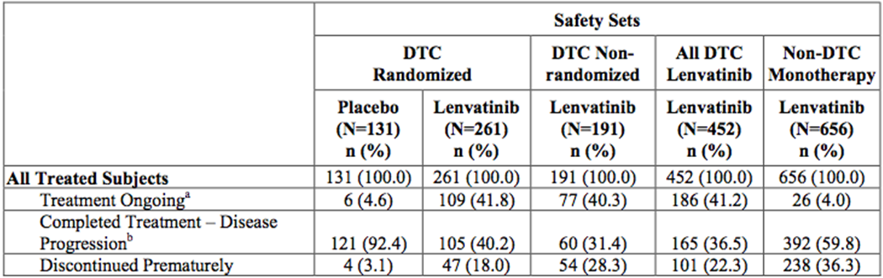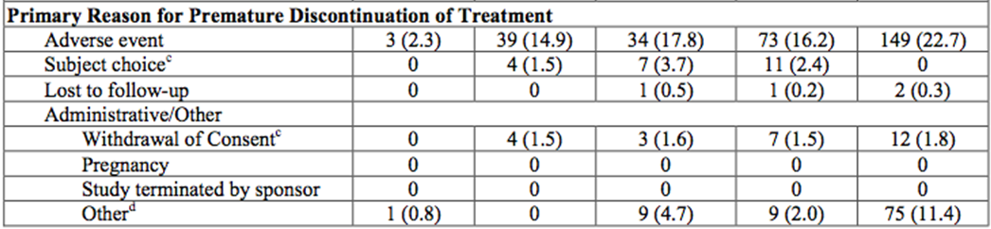

Laboratory tests

Liver function
A search of the databases for the DTC Randomized, DTC Nonrandomized, and All DTC Lenvatinib Safety Sets identified 4 subjects who met the screening laboratory criteria for possible Hy’s Law cases. The Sponsor notes that on thorough evaluation, all subjects had medical conditions that accounted for the laboratory findings; therefore, they did not meet Hy’s Law’s criteria:
2 subjects had liver metastases, 1 subject had a biliary tract infection, and 1 subject had choledocholithiasis.
Table 17. Number and percentage of subjects with worst post baseline value of Grade 3 or 4 for selected non hematologic laboratory parameters (including renal and liver) - All Safety Sets.
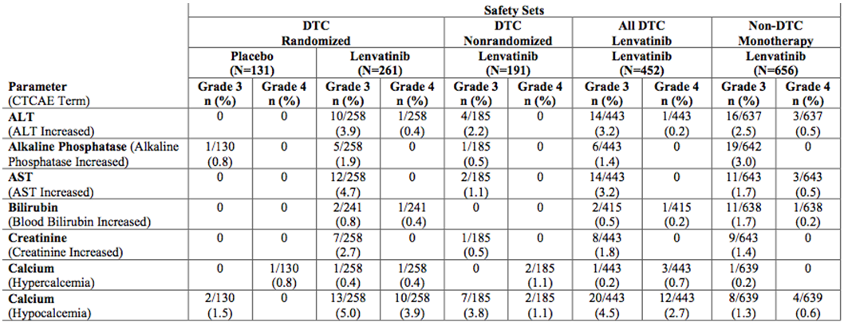

Other clinical chemistry

Calcium
In the DTC Randomised Safety Set, 1.5% of subjects in the placebo arm had Grade 3 hypocalcemia. Grade 3 or 4 hypocalcemia values were reported in 8.9% (23/258) of lenvatinib-treated subjects in the DTC Randomized Safety Set, 4.9% (9/185) of those in the DTC Nonrandomized Safety Set, 7.2% (32/443) of those in the All DTC Lenvatinib Safety Set, and 1.9% (12/639) of those in the Non-DTC Monotherapy Safety Set. Blood calcium increased was an SAE in 1 (0.2%) subject and 0 subjects in the All DTC Lenvatinib and Non-DTC Monotherapy Safety Sets, respectively. Hypercalcemia was an SAE in 3 (0.7%) subjects and 1 (0.2%) subject, respectively.

Lipase/amylase
Grade 3 or 4 lipase increased occurred in 10 (4.0%) lenvatinib-treated subjects and 1 (0.8%) placebo-treated subject in the DTC Randomised Safety Set, and Grade 3 or 4 serum amylase increased occurred in 10 (4.0%) lenvatinib-treated subjects and in 3 (2.3%) placebo-treated subjects. Grade 3 or 4 lipase increased occurred in 2 (1.9%) subjects in the DTC Nonrandomized Safety Set, 12 (3.4%) subjects in the All DTC Lenvatinib Safety Set and 25 (6.9%) subjects in the Non-DTC Monotherapy Safety Set Grade 3 or 4 serum amylase increased occurred in 5 (3.9%), 15 (4.0%), and 9 (2.4%) subjects, respectively..
Amylase increased and lipase increased were reported as a TEAE in lenvatinib-treated subjects (2.3% and 3.8%) and placebo-treated subjects (1.5% and 2.3%) in the DTC Randomized Safety Set. Amylase increased occurred in 1.0%, 1.8%, and 1.7% of subjects and lipase increased in 1.6%, 2.9%, and 3.2% of subjects in the DTC Nonrandomized All DTC Lenvatinib and Non-DTC Monotherapy Safety Sets, respectively. Elevations of amylase and lipase in the absence of acute pancreatitis have previously been reported in subjects receiving TKIs.

Thyroid stimulating hormone
During treatment, TSH values remained ≤0.5 μIU/mL for 79.4% of subjects in the placebo arm but only for 37.2% of subjects in the lenvatinib arm of the DTC Randomized Safety Set; similar results were observed for the lenvatinib-treated subjects in the other 2 DTC Safety Sets (33.5% and 35.8%). Among lenvatinib- treated subjects, TSH concentration increased to >2.0 – 5.5 μIU/mL in 11.9% to 13.1% of subjects across the 3 DTC Safety Sets, and to >5.5 μIU/mL in 27.7% to 29.5% of subjects.

Haematology

Pivotal studies

Hemoglobin
In the DTC Randomized Safety Set, the median haemoglobin concentration reduced in the levatinib arm. The results for subjects in other Safety Sets were similar to those for lenvatinib-treated subjects in the DTC Randomized Safety Set.

Platelets
In the DTC Randomized Safety Set, median platelet counts decreased from Baseline and remained decreased throughout treatment.
In the All DTC Lenvatinib Safety Set, the most commonly occurring Grade 3 or 4 abnormality was decreased platelet counts. Grade 3 abnormalities (i.e. platelet counts of 25.0 to <50.0 × 109/L) occurred in 11 (2.5%) subjects.
In the DTC Randomized Safety Set, TEAEs of thrombocytopenia occurred in 23 (8.8%) subjects in the lenvatinib arm and 3 (2.3%) subjects in the placebo arm and TEAEs of platelet count decreased occurred in 17 (6.5%) and 0 subjects, respectively. Grade 3 TEAEs occurred in 5 subjects, all in the lenvatinib arm. Thrombocytopenia and platelet count decreased were each an SAE in 1 (0.4%) subject in the lenvatinib arm.

Vital signs
The only vital sign difference of note was hypertension in lenvatinib which is discussed in 8.4.7.

ECG

Pivotal studies
In the DTC Randomized Safety Set, a higher incidence of TEAEs for QTc prolongation was reported in the lenvatinib arm (8.8%) than the placebo arm (1.5%) which persisted when adjusted by treatment duration (0.13 vs. 0.03 episodes/SY, respectively). A higher incidence of QTc prolongation per SMQ was reported in the All DTC Lenvatinib Safety Set (7.5%) than in the Non-DTC Monotherapy Safety Set (1.5%).
A higher percentage of subjects in both the All DTC Lenvatinib and the Non-DTC Monotherapy Safety Sets had AEs reported as QTc prolongation that led to dose interruption (1.3% and 0.5%, respectively) than to dose reduction (0.4% and 0.2%, respectively). One subject in the All DTC Lenvatinib Safety Set discontinued treatment due to QTc prolongation per SMQ. In the DTC Randomized Safety Set, the median time to first onset of QTc prolongation per SMQ was 16.1 weeks in the lenvatinib arm and 48.1 weeks in the placebo arm.
Study 002 (covered in Section 4) suggested that lenvatinib does not exert a clinically relevant effect on QTcF, however this study was undertaken in healthy volunteers. QTc prolongation has been observed with other VEGF/VEGFR-targeted therapies.
Comment: there does appear to be an association of QT prolongation with the administration of lenvatinib.

Hypertension
Treatment-emergent AEs for hypertension per SMQ have been reported 5 times more by lenvatinib-treated subjects than by placebo-treated subjects in the DTC Randomized Safety Set. In the DTC Randomized Safety Set, the median time to first onset of hypertensive events was 2.3 weeks in the lenvatinib arm and 6.1 weeks in the placebo arm.

Proteinuria
Proteinuria was experienced by 30.8% to 36.9% of lenvatinib-treated subjects across all Safety Sets, and in 3.1% of placebo-treated subjects. Approximately 10% of lenvatinib-treated subjects in the DTC Randomized Safety Set had a Grade 3 event. One subject, in the Non-DTC Monotherapy Safety Set, had a TEAE of proteinuria that was reported as Grade 4.

Posterior reversible encephalopathy syndrome
Posterior reversible encephalopathy syndrome (PRES) is a known TEAE (affecting <1% of subjects) associated with VEGF/VEGFR-targeted therapies. As of the cutoff date, there were 3 TEAEs for PRES per SGQ (all of which were PRES) in lenvatinib-treated subjects and none in placebo-treated subjects.

Thromboembolic events
There were 4 deaths due to AEs for venous thromboembolic events per SGQ in lenvatinib-treated subjects and none in placebo-treated subjects. These were all due to pulmonary embolism, 2 each in the All DTC Lenvatinib and the Non-DTC Monotherapy Safety Sets.

Renal events
These are shown in the table below.
Table 18. Serious AEs for renal events per SMQ Analysis – DTC Randomized, All DTC Lenvatinib, and Non-DTC Monotherapy Safety Sets.
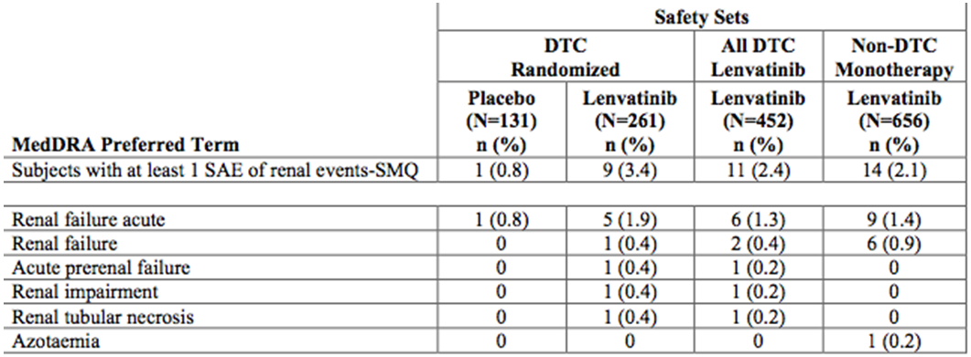
7/258 (2.7%) in the lenvatinib group cf. 0 in placebo in the pivotal study had worsened creatinine (Grade 3).

Liver events
These are shown in the table below.
Table 19. Serious AEs for liver events per SGQ Analysis – DTC Randomized, All DTC Lenvatinib, and Non-DTC Monotherapy Safety Sets.
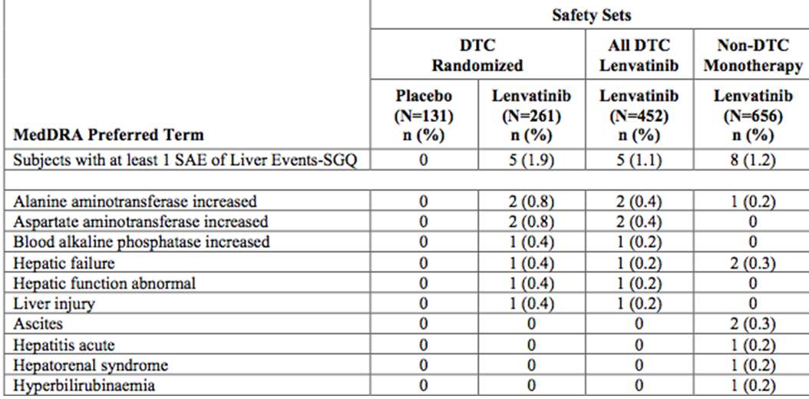

GI perforation and fistula formation
These are shown in the table below.
Table 20. GI perforation and fistula formation.
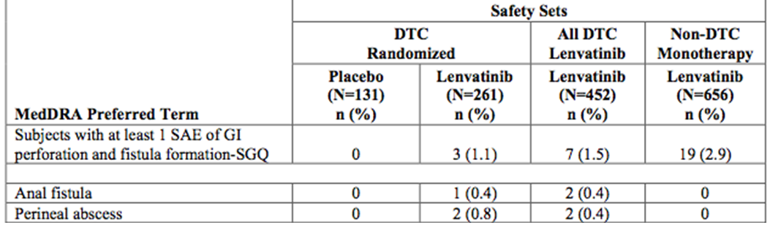

Palmer-plantar erythrodysesthesia syndrome (PPE)
In the DTC Randomized Safety Set, PPE occurred in 33.7% of lenvatinib-treated subjects compared with 0.8% of placebo- treated subjects. The majority of events were Grade 1 or 2, although 3% of subjects in the All DTC Lenvatinib Safety Set had Grade 3 PPE. However, there were no SAEs for PPE in either Safety Set. Three subjects, all in the Non-DTC Monotherapy Safety Set, discontinued treatment for PPE. In the DTC Randomized Safety Set, the median time to first onset of PPE per SGQ was 5.9 weeks in the lenvatinib arm and 20.3 weeks in the placebo arm. The incidence of PPE peaked early and then slowly declined over time and 12.16.3.1.

Haemorrhage
There were a total of 13 haemorrhagic events, but 6 were not reported as being related to study drug. Dose was reduced in 39% of the subjects and 50% of the events occurred concurrently with disease progression, in some cases at the site of haemorrhage and in others due to progression in other target lesions. There was no difference between lenvatinib-treated and placebo-treated subjects in the DTC Randomized Safety Set for the rate of TEAEs (0.55 vs. 0.54 episodes/SY), the incidence of SAEs (3.4% vs. 3.8%), and the incidence of TEAEs leading to premature discontinuation of treatment (1.1% vs. 1.5%), and the incidence of TEAEs leading to dose interruption (3.4% vs. 3.8%) for haemorrhage.

Hypocalcaemia
Treatment-emergent hypocalcemia per SGQ was reported for 12.6%, 11.7%, and 4.6% of lenvatinib-treated subjects in the DTC Randomized, All DTC Lenvatinib, and Non-DTC Monotherapy Safety Sets; there were no events in the placebo arm.

Reduced ejection fraction
Adjusted for treatment duration, the incidence of decreased EF was similar for lenvatinib-treated subjects across all Safety Sets (0.03 to 0.05 episodes/SY), but slightly higher than for placebo-treated subjects (0.01 episodes/SY). The majority of events were Grade 1 or 2, and 4 subjects, all in the Non-DTC Monotherapy Safety Set, had a serious event. For 6 subjects, study drug was interrupted and for 4 subjects dose was reduced due to these events. Two of the events led to treatment discontinuation.

Safety in special populations
AE analyses by age suggest that subjects ≥75 years of age tend to have a similar incidence of overall TEAEs (any grade), but a trend toward a higher incidence of severe TEAEs and SAEs compared with subjects <75 years of age.
AE analyses by sex suggest that female subjects tended to have a greater incidence of hypertension, headache, nausea, PPE, stomatitis, and vomiting compared with male subjects receiving lenvatinib. No obvious differences were noted in the relative incidence of severe TEAEs, SAEs, or CSEs between the two sexes, although female subjects tended to have a higher incidence of TEAEs, SAEs, and CSEs of hypertension compared with male subjects.

Post marketing data
Not applicable.

Evaluator’s conclusions on safety
Lenvatinib was associated with significant rates of hypertension, proteinuria, arterial thromboembolic events, renal events, liver events, GI perforation and fistula formation, QTc prolongation, decreased ejection fraction, hypocalcemia, haemorrhage, and presumed perihematomal edema (PPE). The majority of these events were mild to moderate and did not result in discontinuation of treatment. These AEs are consistent with published data for other TKIs and VEGF/VEGFR targeted therapies.
There were no unexpected adverse events.

First round benefit-risk assessment

First round assessment of benefits
The benefits of lenvatinib in the proposed usage are:
- Significantly improved PFS.
- Trend towards improved OS.

First round assessment of risks
The risks of lenvatanib in the proposed usage are:
- Unknown clinical need (does asymptomatic disease need treatment).
- Large incidence of serious AEs.
- Survival benefit unclear.
- Significant interpatient variability in Cmax, AUC0-t, and AUC0-∞;
- Likely significant CYP3A4 and Pgp interactions,
- The increased exposure in hepatic disease and patients of small body size
- The AUC0-∞ of the unbound lenvatanib for subjects with mild, moderate, and severe renal impairment were significantly elevated compared to that for normal subjects.

First round assessment of benefit-risk balance
The benefit-risk balance of lenvatanib, given the proposed usage, could be favourable for a population with no other treatments: PFS is statistically significantly lengthened. However, the clinical need for this treatment in an asymptomatic group is not clear, notwithstanding the high incidence of potentially life threatening toxicities.

First round recommendation regarding authorisation
Approval in the targeted population of RR-DTC.

Clinical questions

Additional expert input
- In the pivotal trial the choice of the rank preserving structural failure time (RPSFT) models to re-estimate the survival curves was unclear; and the upper limit of the CI was bordering on 1. The sponsor was requested to consider instead using a marginal structural model based on inverse probability of censoring weighting analysis as this may display CI that cross 1.

Clinical questions
Responses to questions in some areas needed to be considered to understand the significance of the achievement of primary outcome significance noted in the clinical trial:
- Firstly, whether placebo was an appropriate comparator in this single pivotal study an understanding of the current comparative treatments in Australia for this group is required and if known, the comparative efficacy (to placebo) of those treatments;
- Why was placebo chosen as the comparator;
- The clinical significance of the PFS;
- The plasma concentrations of a number of blood parameters measured in the exploratory marker are interesting but several appear inconsistent in their magnitude or direction of change of concentration. The sponsor was requested to provide evidence of the clinical relevance of those parameters in PFS, OS or Quality of Life (QoL);
- The inclusion criteria for the pivotal clinical trial did not include patients who were symptomatic. It is important to clarify if these patients (who clearly have imaging progression) need treatment, specifically as these drugs have significant side effects. The sponsor was requested to advise on the clinical need for this group; and
- Was there any QoL data collected in this study and, if so, the sponsor be requested to provide it.

Second round evaluation of clinical data

Overall comment
The sponsor is to be thanked for addressing the clinical evaluators concerned and summarising it in a table for each of final checking. The in-text tables and figures are also helpful.

Product Information (PI)
The requested changes have been made.

Evaluation

Question
- In the pivotal trial the choice of the rank preserving structural failure time (RPSFT) models to re-estimate the survival curves was unclear; and the upper limit of the CI was bordering on 1. The sponsor was requested to consider instead using a marginal structural model based on inverse probability of censoring weighting analysis as this may display CI that cross 1.

Sponsor response
As part of the study design for Study 303, placebo-treated subjects had the option to cross over to optional open label (OOL) lenvatinib treatment at the time that disease progression (PD) was confirmed by Independent Imaging Review (IIR). Over 80% of placebo treated subjects (83.2%, 109/131) received lenvatinib after radiologically confirmed PD at the time of the primary analysis for PFS. Therefore, the determination of the treatment effect on OS per the intent-to-treat (ITT) analysis was confounded by the cross over. In order to estimate the true treatment effect of lenvatinib on OS, it was necessary to adjust for the confounding effects of the cross over; the RPSFT was used.

Evaluator response
This was accepted and noted that it is slightly more sophisticated at addressing the huge bias that occurs on crossover than censoring on crossover or excluding subjects from analysis. However there are still some residual concerns when a large number (that is, almost all) crossed over. In any case the use of this RPSFT was reasonable; it is the interpretation of the comparison of those who crossed over (and at different times) with outcomes, and the comparison with those who were originally allocated to receive it that remains uncertain – a common problem with many cancer trials. Some discussion occurs later suggesting that those who crossed over (the OOL) appeared to have worse survival that those who received drug earlier, however on progression the tumour is already more advanced than it would have been if lenvatinib was given originally. Thus the interpretation of this is confounded.

Question
Responses to questions in some areas needed to be considered to understand the significance of the achievement of primary outcome significance noted in the clinical trial:
- Firstly, whether placebo was an appropriate comparator in this single pivotal study an understanding of the current comparative treatments in Australia for this group is required and if known, the comparative efficacy (to placebo) of those treatments;
- Why was placebo chosen as the comparator.

Sponsor response
According to ICH Topic E10, Choice of Control Group in Clinical Trials, when a new treatment is tested for a condition for which no effective treatment is known, placebo is considered acceptable as the control group. Such was the case at the time Study E7080-G000-303 (SELECT) was designed, the first subject being enrolled in August 2011. At that time, there were no standard nor approved therapies for 131-I refractory differentiated thyroid cancer (RR-DTC). Sorafenib, another TKI, was approved for the treatment of RR-DTC in November 2013 in the US after Study 303 had completed enrolment and reached the required number of events for the primary analysis of efficacy (15 November 2013).

Evaluator response
This response was assessed as reasonable, however there are therapies that were currently sometimes used for this condition (non targeted chemotherapy) and were registered in Australia (cisplatin, doxorubicin, radiotherapy - EBRT); however, it is accepted that the evidence base for these therapies is not strong.
In response to the agency’s request to understand the current comparative treatments in the EU and Australia, upon completion of Study 303, the sponsor conducted an ad hoc, indirect comparison of the SELECT (lenvatinib) and DECISION (sorafenib) Phase III studies. Indirect comparison was difficult as baseline characteristics of the two studies were different, and there were significantly different placebo responses. Therefore, they are not really amenable to an indirect comparison however both statistically significantly improved PFS.

Question
- The clinical significance of the PFS.

Sponsor response
Study E7080-G000-303 was designed in accordance with the FDA guidance and CHMP guidelines concerning clinical trial endpoints for cancer drugs and biologics. The use of PFS as a primary endpoint to establish clinical benefit and to support registration is generally considered acceptable when the magnitude of effect on PFS is expected to be large, when post progression survival may be long, when OS may be prolonged and confounded by post study anticancer therapy. Furthermore, when no approved therapies are available for the disease in question, the lack of effective treatment options presents an urgent need for timely evaluation of promising new treatment approaches. All of these conditions applied to Study 303; thus, PFS was selected as the primary endpoint.

Evaluator response
The evaluator contends that the sponsor did not appear to show that either post progression or OS are likely to be prolonged and also, as there was no other available therapy for this disease that there would have been no confounding by additional therapy. Thus, the case for using PFS in this condition as the primary endpoint had still not been made. Further, if PFS was chosen as a primary endpoint, the clinical relevance of that should have been made clear; its relationship to QoL, OS, etcetera. As such, the evaluator was still unsure of the clinical relevance of a small increase in PFS in this group in the pivotal study.
However, it was accepted that this choice of endpoints was confirmed from FDA, EMA and Japan’s Pharmaceuticals and Medical Devices Agency (PMDA). It was noted that lenvatinib prolonged median PFS by 14.7 months (18.3 versus 3.6 months for lenvatinib and placebo, respectively).
In conclusion, the evaluator was not convinced the justification for the primary endpoint being PFS in the absence of the meaning to the patient of that endpoint and not clearly meeting the justification in the guidelines for the choice of that endpoint. The results of Study 303 did show a significant improvement in PFS with lenvatinib compared with placebo in subjects with RR-DTC. It was also acknowledged that this is a patient population with few treatment options and a currently unmet medical need. The sponsor contends that the need could be better defined – is the goal of treatment OS? PFS with an improved QoL? This needs to be very clear if PFS is chosen in as a surrogate.

Question
- The plasma concentrations of a number of blood parameters measured in the exploratory marker are interesting but several appear inconsistent in their magnitude or direction of change of concentration. The sponsor was requested to provide evidence of the clinical relevance of those parameters in PFS, OS or Quality of Life (QoL);

Sponsor response
In Study E7080-G000-303, the sponsor analysed 4 blood serum biomarkers: VEGF, Ang2, sTie2 and FGF23, along with the tumour marker thyroglobulin (Tg).

Evaluator response
It is acknowledged and accepted that these were exploratory only and are therefore unable to be used as prognostic indicators nor surrogates or response to therapy.

Question
- The inclusion criteria for the pivotal clinical trial did not include patients who were symptomatic. It is important to clarify if these patients (who clearly have imaging progression) need treatment, specifically as these drugs have significant side effects. The sponsor was requested to advise on the clinical need for this group;

Sponsor response
Study 303 allowed participation of subjects with an ECOG PS of 0, 1 or 2 (inclusion criterion no. 8). Ultimately, 46% of subjects enrolled in the study were mildly (ECOG PS 1) or moderately (ECOG PS 2) symptomatic as follows: Lenvatinib arm: ECOG PS 1, n = 104 (39.8%); ECOG PS 2, n=12 (4.6%) and placebo arm: ECOG PS 1, n = 61 (46.6%); ECOG PS 2, n = 2 (1.5%). The Study 303 protocol required that all enrolled subjects show evidence of radiographic disease progression (PD) within 12 months prior to signing informed consent, according to RECIST 1.1 assessed and confirmed by central radiographic review of CT and/or MRI scans (inclusion criterion no. 3). The window for PD was determined following consultation with key opinion leaders in the field who indicated that PD within a 12 month period defined a patient population at considerable risk and warranted initiation of treatment, as opposed to a “watch and wait” approach. Of note, Study 303 was not designed to determine statistically significant differences in individual subgroups. Furthermore, the analyses for ECOG PS are subject to significant bias. It is well known in oncology studies that patients with better ECOG PS at baseline respond better and have longer PFS and OS to anticancer therapies. Therefore, these results should be interpreted with great caution.
Overall, the benefit/risk profile of lenvatinib was similar between subjects with a baseline ECOG PS score of 0 (asymptomatic) and those in subjects with an ECOG PS score of ≥1 (symptomatic). In Study 303, lenvatinib treated subjects with ECOG PS score of 0 had higher exposure, longer duration of treatment and higher cumulative dose across safety sets; however, the same trend was observed in the placebo group in the DTC Randomised safety set. The median duration of treatment with lenvatinib was numerically longer in subjects with a baseline ECOG PS score of 0 than in subjects with an ECOG PS score of ≥1 (17.8 months versus 9.7 months [min, max: 0.2, 30.4], respectively); however, both ECOG PS subgroup categories in the lenvatinib arm had median durations of treatment approximately 3 times longer than did their respective placebo groups (5.9 months [min, max: 0.6, 27.7] and 3.0 months [min, max: 0.3, 20.6] for placebo treated subjects with a baseline ECOG PS score of 0 and ≥1, respectively).This shows that the severity of the subjects’ underlying disease rather than lenvatinib treatment is most likely accountable for the differences in exposure noted. These results also suggest that a “watch and wait” approach may actually represent a disadvantage for patients.

Evaluator response
The evaluator is not convinced at all that the results suggest a watch and wait approach may represent a disadvantage, rather than those with ECOG 1 have better prognosis than higher ECOG scores, entirely consistent with cancer biology. The OS data also remains unclear to the evaluator, that is, did early treatment improve survival or were those patients with ECOG = 0 at Study initiation represent a group with more indolent disease. This still remains unclear.

Sponsor response

PFS
In subjects with an ECOG PS of 0, median PFS was not reached (Q1, 16.6 months) in the lenvatinib arm (n = 144), compared with 3.8 months in the placebo arm (n = 68) (P <0.0001; HR of 0.15 [95% CI: 0.10, 0.24]) as of the data cutoff for the primary efficacy analysis (15 Nov 2013). In subjects with an ECOG PS of ≥1, median PFS was 11.0 months (95% CI: 7.4, 18.7) in the lenvatinib arm (n = 117) compared with 2.4 months in the placebo arm (n = 63) (P<0.0001; HR of 0.29 [95% CI: 0.19, 0.44]).

Safety
The incidence of TEAEs was almost identical in lenvatinib treated subjects with a baseline ECOG PS score of 0 compared with those who had a baseline ECOG PS score ≥1, whereas in the placebo arm, the incidence of TEAEs was numerically higher in subjects with an ECOG PS score ≥1 than in those who had an ECOG PS score of 0. This suggests that any differences in AE profile in the DTC Randomised safety set are biased due to the inferior performance status and severity of the subjects’ underlying disease rather than an effect of lenvatinib. It also shows that waiting for patients to become symptomatic may potentially result in inferior outcome or higher AE rates.

Evaluator response
The evaluator contends these analyses do not suggest a differential activity or a different risk-benefit assessment for lenvatinib dependent upon the subject’s baseline ECOG PS.

Sponsor response
The benefit of early initiation of treatment as opposed to a “watch and wait” approach could have been further demonstrated by an additional analysis of efficacy in the placebo-treated subjects who crossed over to lenvatinib treatment. In Study 303, 109 of the 131 subjects (83%) crossed over from the placebo arm and received lenvatinib in the OOL lenvatinib treatment period. Consequently, these patients were further advanced in the course of their disease, since they had experienced 2 sequential, confirmed disease progressions (by IIR): the first before randomisation (at the time of study entry) and the second during treatment with placebo in the Randomized Phase.

Evaluator response
The sponsor also agrees this analysis would have been biased therefore there is no PFS or OS data that suggests that there is a benefit of using the therapy earlier in the disease.

Sponsor response
As of the cutoff date of 15 Nov 2013, median PFS for this second PD (from the start of OOL lenvatinib treatment), as determined by investigator assessments, was 10.1 months (95% CI: 8.3, NE) for all subjects in the OOL Lenvatinib Treatment period. This was lower than the PFS seen with lenvatinib treated subjects (18.3 months) in the Randomised Phase, but higher than the PFS of placebo treated subjects (3.6 months) in the Randomised Phase. These results suggest that subjects who received lenvatinib earlier in their course of disease had a better outcome. Again, however, the results need to be interpreted with caution as this treatment group in the OOL lenvatinib period was not randomized.

Evaluator response
In summary, the results of these exploratory analyses do not suggest that patients who receive lenvatinib earlier in their disease course have a better treatment outcome as the data is subject to both selection and patient characteristics biased and this endpoint was not pre-planned.
Subjects with an ECOG PS score of 0 (asymptomatic) appeared to have a better outcome overall; however, an ECOG of 0 suggests these are better prognosis patients than those who are already symptomatic. The evaluator is not convinced that anything can be read into this in terms of when the therapy should be used.

Question
- Was there any QoL data collected in this study and, if so, the sponsor be requested to provide it.

Sponsor response
There was no thyroid specific QoL instrument available at the time Study 303 was designed. Therefore, patient reported endpoints to evaluate the impact of treatment on QoL were not collected during the conduct of Study 303.

Evaluator response
The response was accepted; however, it means that the actual clinical relevance of the PFS remains unclear. Although it seems plausible that it ought to be correlated with improved QoL, the requirement to have therapy and the risk of AEs during this period means that the assumption may not be plausible. In any case, there is no evidence to suggest the PFS is associated with improved QoL nor another clinically plausible benefit.

Second round benefit-risk assessment

Second round assessment of benefits
After consideration of the responses to clinical questions, the benefits of Lenvima in the proposed usage have been reassessed. Although not the requested indication, the potential PFS benefits of a therapy available for RR-DTC with symptomatic progressive disease unresponsive to other therapies could be clinically relevant.

Second round assessment of risks
No new clinical information was submitted in response to questions. Accordingly, the risks of Lenvima are unchanged from those identified in the first round.

Second round assessment of benefit-risk balance
The benefit-risk balance of Lenvima, given the proposed usage, is favourable.
The evaluator continues to believe benefit-risk balance of lenvatanib, given the proposed usage, could be favourable for a population with no other treatments: PFS is statistically significantly lengthened. However the clinical need for this treatment in an asymptomatic group is not clear, notwithstanding the high incidence of potentially life threatening toxicities and the lack of clinical evidence to assess the relative risk-benefit of this therapy in terms of QoL.

Second round recommendation regarding authorisation
As the evidence for early versus late use is not made, and the medicine has significant toxicities, it is recommended to change the indication to:
Lenvima is indicated for the treatment of patients with progressive, symptomatic radioactive iodine refractory differentiated thyroid cancer in whom other treatment options have failed.
The PI and Consumer Medicines Information (CMI) need to be clear that the treatment improved PFS, although QoL may not be improved, and that the OS was no better than placebo.

References
1. Boss, D., H. Glen, and J. Beijnen, A phase I study of E7080, a multitargeted tyrosine kinase inhibitor, in patients with advanced solid tumours. British Journal of Cancer, 2012. 106(10): p. 1598-1604.
2. Lu, J.-F., Population pharmacokinetic/pharmacodynamic modeling for the time course of tumor shrinkage by motesanib in thyroid cancer patients. Cancer Chemother Pharmacol, 2010. Cancer Chemother Pharmacol (1151-8).

Therapeutic Goods Administration
PO Box 100 Woden ACT 2606 Australia
Email: info@tga.gov.au Phone: 1800 020 653 Fax: 02 6232 8605
https://www.tga.gov.au

“Note for Guidance on Good Clinical Practice (CPMP/ICH/135/95)”, July 2000.
International Conference on Harmonisation, “E6(R1): Guideline for good clinical practice”, 10 June 1996.
Kelly RJ, Rixe O. Axitinib-a selective inhibitor of the vascular endothelial growth factor (VEGF) receptor. Target Oncol. 4: 297-305 (2009).
European Medicines Agency, “Appendix 1 to the guideline on the evaluation of anticancer medicinal products in man: Methodological consideration for using progression-free survival (PFS) or disease-free survival (DFS) in confirmatory trials (EMA/CHMP/27994/2008)”, 5 December 2011.
European Medicines Agency, “ICH Topic E 10 Choice of Control Group in Clinical Trials (CPMP/ICH/364/96)”, January 2001.

