First round CER: August 2015
Second round CER: February 2016

AusPAR Attachment 2

Extract from the Clinical Evaluation Report for lesinurad
  - Proprietary Product Name: Zurampic
  - Sponsor: AstraZeneca Pty Ltd

About the Therapeutic Goods Administration (TGA)
- The Therapeutic Goods Administration (TGA) is part of the Australian Government Department of Health, and is responsible for regulating medicines and medical devices.
- The TGA administers the Therapeutic Goods Act 1989 (the Act), applying a risk management approach designed to ensure therapeutic goods supplied in Australia meet acceptable standards of quality, safety and efficacy (performance), when necessary.
- The work of the TGA is based on applying scientific and clinical expertise to decision-making, to ensure that the benefits to consumers outweigh any risks associated with the use of medicines and medical devices.
- The TGA relies on the public, healthcare professionals and industry to report problems with medicines or medical devices. TGA investigates reports received by it to determine any necessary regulatory action.
- To report a problem with a medicine or medical device, please see the information on the TGA website <https://www.tga.gov.au>.
About the Extract from the Clinical Evaluation Report
- This document provides a more detailed evaluation of the clinical findings, extracted from the Clinical Evaluation Report (CER) prepared by the TGA. This extract does not include sections from the CER regarding product documentation or post market activities.
- The words [Information redacted], where they appear in this document, indicate that confidential information has been deleted.
- For the most recent Product Information (PI), please refer to the TGA website <https://www.tga.gov.au/product-information-pi>.
Copyright
© Commonwealth of Australia 2016
This work is copyright. You may reproduce the whole or part of this work in unaltered form for your own personal use or, if you are part of an organisation, for internal use within your organisation, but only if you or your organisation do not use the reproduction for any commercial purpose and retain this copyright notice and all disclaimer notices as part of that reproduction. Apart from rights to use as permitted by the Copyright Act 1968 or allowed by this copyright notice, all other rights are reserved and you are not allowed to reproduce the whole or any part of this work in any way (electronic or otherwise) without first being given specific written permission from the Commonwealth to do so. Requests and inquiries concerning reproduction and rights are to be sent to the TGA Copyright Officer, Therapeutic Goods Administration, PO Box 100, Woden ACT 2606 or emailed to <tga.copyright@tga.gov.au>.

Contents
List of abbreviations 5
1. Introduction 8
2. Clinical rationale 8
3. Contents of the clinical dossier 9
3.1. Scope of the clinical dossier 9
3.2. Paediatric data 9
3.3. Good clinical practice 9
3.4. Guidance 9
4. Pharmacokinetics 10
4.1. Studies providing pharmacokinetic data 10
4.2. Summary of pharmacokinetics 12
4.3. Evaluator’s overall conclusions on pharmacokinetics 19
5. Pharmacodynamics 19
5.1. Studies providing pharmacodynamic data 19
5.2. Summary of pharmacodynamics 20
5.3. Evaluator’s conclusions on pharmacodynamics 20
6. Dosage selection for the pivotal studies 20
7. Clinical efficacy 21
7.1. Pivotal efficacy studies 21
7.2. Other efficacy studies 41
7.3. Analyses performed across trials (pooled & meta analyses) 45
7.4. Evaluator’s conclusions on clinical efficacy 45
8. Clinical safety 46
8.1. Studies providing safety data 46
8.2. Patient exposure 47
8.3. Adverse events 48
8.4. Laboratory tests 56
8.5. Safety issues of special interest 59
8.6. Post marketing data 66
8.7. Safety issues with the potential for major regulatory impact 66
8.8. Evaluator’s conclusions on safety 66
9. First round benefit-risk assessment 67
9.1. First round assessment of benefits 67
9.2. First round assessment of risks 67
9.3. First round assessment of benefit-risk balance 67
10. First round recommendation regarding authorisation 68
11. Clinical questions 68
12. Second round evaluation of clinical data 68
13. References 68

List of abbreviations
Abbreviation | Meaning
AE | Adverse Event
ALKP | Alkaline Phosphatase
ALT | Alanine Transaminase
ARA | American Rheumatism Association
ARTG | Australian Register of Therapeutic Goods
AST | Aspartate Transaminase
AUC | Area under the curve
BD | Twice daily
CEAC | Cardiovascular Endpoints Adjudication Committee
CI | Confidence interval
CL | Clearance
Cmax | Maximum concentration
CMH | Cochran-Mantel Haenszel
CMI | Consumer Medicines Information
CPK | Creatine kinase
CrCl | Creatinine clearance
CV | Coefficient of variation
DILI | Drug-induced liver injury
ECG | Electrocardiograph
eGFR | Estimated glomerular filtration rate
EMA | European Medicines Agency
FDA | Food and Drug Administration
FN | Formulation number
GCP | Good Clinical Practice
HAQ-DI | Health Assessment Questionnaire-Disability Index
ICH | International Conference on Harmonisation
IV | Intravenous
LC/MS/MS | Liquid chromatography-mass spectrometry
LDH | Lactate dehydrogenase
LFTs | Liver function tests
MACE | Major adverse cardiovascular events
MedDRA | Medical dictionary for regulatory activities
NSAID | Non-steroidal anti-inflammatory drug
OD | Once daily
PCS | Physical component scale
PD | Pharmacodynamics
PGA | Patient Global Assessment
PI | Product Information
PK | Pharmacokinetics
PO | Per oral
PRO | Patient reported outcomes
PY | Patient years
QoL | Quality of Life
RMP | Risk management plan
SAE | Serious Adverse Event
SDS | Sheehan Disability Scale
SF-36 | Short Form-36
sd | Single dose
sUA | Serum uric acid
Tmax | Time of maximum concentration
TQSM | Treatment Satisfaction Question for Medication
URAT1 | Uric acid transporter 1
Vss | Volume of distribution at steady state
XO | Xanthine oxidase

Introduction
This is a full submission to register a new chemical entity.
Lesinurad is a uricosuric agent. It is an inhibitor of uric acid transporter 1 (URAT1), which is a transporter protein located on the luminal membrane of the proximal tubule of the kidney. URAT1 is responsible for most of the renal reabsorption of urate from the urine.
The proposed indication is:
...for the treatment of hyperuricaemia associated with gout in combination with a xanthine oxidase inhibitor.
The submission proposes registration of only one dosage form/strength – a 200 mg immediate release tablet.
The proposed dosage regimen is one 200 mg tablet taken once daily in the morning with food and water.

Clinical rationale
Uric acid is the end product of purine metabolism in man. It is produced in the liver through conversion of xanthine by the enzyme XO. Urate is poorly soluble and excessive accumulation in the body (hyperuricaemia) results in precipitation of urate crystals in tissues, typically in joints (gout).
Current treatments for the long-term prevention of hyperuricaemia/gout include XO inhibitors (allopurinol or febuxostat) and the uricosuric agent probenecid. XO inhibition results in decreased production of urate. Probenecid is also thought to act through inhibition of urate reabsorption via URAT1 in the proximal tubule, resulting in increased urate excretion.
The clinical rationale given by the sponsor is that combination of lesinurad with an XO inhibitor will result in both increased excretion and decreased production of urate, and will therefore enable a greater proportion of patients to achieve disease control, when compared to XO inhibitor monotherapy.
Comment: The clinical rationale for lesinurad does not represent a novel approach to the treatment of hyperuricaemia with gout. Existing uricosuric agents such as probenecid have the same mechanism of action (URAT1 inhibition). Current clinical guidelines recommend the combined use of a uricosuric agent and an XO inhibitor in subjects who cannot be managed with an XO inhibitor alone.
Lesinurad was discovered as a metabolite of another agent, RDEA806, a non-nucleoside reverse transcriptase inhibitor (NNRTI) of HIV-1. Treatment with RDEA806 was noted to be associated with reductions in serum urate concentrations.

Contents of the clinical dossier

Scope of the clinical dossier
The submission contained the following clinical information:
- 32 clinical pharmacology studies, including 30 that provided predominantly pharmacokinetic data and 2 that provided predominantly pharmacodynamic data.
- 1 report analysing the effects of CYP2C9 polymorphism across various studies.
- 1 population pharmacokinetic analysis.
- 1 population PK/PD analysis.
- 1 population PK/safety analysis.
- 3 pivotal phase III efficacy/safety studies (301, 302 and 304).
- 2 Phase III open extension studies (306 and 307).
- 2 Phase II studies (202 and 203).
- 1 Phase III efficacy/safety study (303) that examined lesinurad monotherapy, an indication that is not being proposed with this application.
- 1 Phase III open extension study of lesinurad monotherapy (305).
- An Integrated Analysis of Efficacy and an Integrated Analysis of Safety, which contained tabulations of data to supplement those in the Summary of Clinical Efficacy and Summary of Clinical Safety.
- 2 reports analysing safety issues (renal toxicity and cardiovascular toxicity);
- Literature references.

Paediatric data
The submission did not include paediatric data. The sponsor had obtained a waiver from the EMA on the grounds that the drug is “likely to be unsafe in this patient population”. According to the sponsor, the FDA had also agreed in principle that a full waiver was appropriate. Further details of these waivers were not provided.

Good clinical practice
All study reports included in the submission contained an assurance that each trial was conducted in accordance with the relevant articles of the Declaration of Helsinki and International Conference on Harmonisation Good Clinical Practice (ICH GCP) consolidated guidelines.

Guidance
The following EMA guidelines, which have been adopted by the TGA, are considered relevant to the current evaluation:
- Guideline on pharmacokinetic studies in man;
- Note for guidance on the evaluation of the pharmacokinetics of medicinal products in patients with impaired renal function;
- Guideline on the evaluation of the pharmacokinetics of medicinal products in patients with impaired hepatic function;
- Guideline on the investigation of drug interactions;
- Guideline on the clinical evaluation of QT/QTc interval prolongation and proarrhythmic potential for non-antiarrhythmic drugs.
Compliance with these guidelines will be considered in the relevant sections of this report.

Pharmacokinetics

Studies providing pharmacokinetic data
Table 1 shows the studies relating to each pharmacokinetic topic and the location of each study summary.

Table 1. Submitted pharmacokinetic studies.
PK topic | Subtopic | Study ID
PK in healthy adults | General PK - Single dose | RDEA594-101
 | - Multi-dose | RDEA594-102
 | - Mass balance | RDEA594-112
 | - Absolute bioavailability | RDEA594-131
 | Bioequivalence† - Single dose | RDEA594-109
 |  | RDEA594-129
 |  | RDEA594-132
 | Food effect | RDEA594-121
PK in special populations | Hepatic impairment | RDEA594-118
 | Renal impairment | RDEA594-104  RDEA594-120
 | Japanese subjects | RDEA594-125
Genetic/gender-related PK | Males vs. females | RDEA594-117
 | CYP 2C9 polymorphism | SR13-015
PK interactions | Allopurinol/colchicine | RDEA594-110
 | Febuxostat | RDEA594-105
 | Febuxostat/colchicine | RDEA594-111
 | Naproxen/indomethacin | RDEA594-126
 | Sildenafil | RDEA594-108
 | Atorvastatin | RDEA594-113
 | Amlodipine | RDEA594-114
 | Fluconazole and rifampicin | RDEA594-122
 | Tolbutamide | RDEA594-115
 | Warfarin | RDEA594-123
 | Repaglinide | RDEA594-116
 | Frusemide and metformin | RDEA594-128
 | Ranitidine | RDEA594-127
 | Antacids | RDEA594-130
Population PK and PK/PD analyses | Population PK | n/a
 | Population PK/PD for serum urate | n/a
 | Population PK/PD for serum creatinine | n/a
† Bioequivalence of different formulations.
None of the pharmacokinetic studies had deficiencies that excluded their results from consideration.
A number of other PK studies were included in the submission, but have not been reviewed in this report as they were not considered relevant. Three Phase 1 comparative bioavailability studies compared the initial immediate capsule formulations (FN01 or FN07) with experimental formulations (various extended release formulations, a gastro-retentive formulation and an alternative tablet formulation). None of these experimental formulations were studied further and hence the data from these studies are not considered relevant to the current application. The sponsor closed another Phase 2 study due to slow enrolment.
The studies that were submitted but not reviewed in this report are listed in Table 2.

Table 2. Pharmacokinetic studies not reviewed in this report.
Study ID | Subtopic(s) | Reason
RDEA594-103 | Comparative Bioavailability (in healthy volunteers) | Comparison of early 50 mg immediate release capsule formulation (FN01) with various extended release tablet formulations that were not developed further.
RDEA594-106 | Comparative Bioavailability (in healthy volunteers) | Comparison of early 50 mg immediate release capsule formulation (FN01) with a gastro-retentive tablet formulation that was not developed further.
RDEA594-107 | Comparative Bioavailability (in healthy volunteers) | Comparison of early 100 mg immediate release capsule formulation (FN07) with an alternative (sodium salt) tablet formulation that was not developed further.
RDEA594-204 | PK in renal impairment; Interaction with allopurinol and colchicine (in subjects with gout) | Study closed due to slow enrolment. Only 4 of a planned 24 subjects enrolled. 3 of the 4 subjects received the wrong dose.

Summary of pharmacokinetics
The information in the following summary is derived from conventional pharmacokinetic studies unless otherwise stated.

Physicochemical characteristics of the active substance
The following information is derived from the sponsor’s summaries.
Lesinurad is a weak carboxylic acid with a pKa of 3.2. It has a molecular weight of 404.3 grams per mole, with a molecular formula of C₁₇H₁₄BrN₃O₂S. It has low solubility at gastric pH but high solubility at intestinal pH (5.3 to 7.5). It is considered to have high permeability. It has no chiral centres.

Pharmacokinetics in healthy subjects

Absorption

Sites and mechanisms of absorption
There were no clinical data examining sites or mechanisms of absorption. As absolute bioavailability is estimated to be 100% (see below), absorption is therefore complete. Typical T_{max} values after a single dose were 1.0 – 2.0 hours suggesting rapid absorption.

Bioavailability

Absolute bioavailability
Absolute bioavailability was estimated to be 100%.

Bioequivalence of clinical trial and market formulations
Bioequivalence between the Phase 2 capsule formulation (FN07) and the 400 mg phase 3 formulation (FN22) was established in a single dose study in healthy volunteers (Study RDEA594-109).
Comment: No formal statistical analyses were presented comparing the phase 2 formulation with the other phase 3 formulations (200 mg and 600 mg), or comparing the three phase 3 formulations with each other. However, the three phase 3 formulations appear to be direct scales and therefore bioequivalence between them can presumably be justified on pharmaceutical chemistry grounds.
The submission also included two bioequivalence studies comparing lesinurad tablets manufactured at the proposed commercial site (AstraZeneca AB in Sweden) to lesinurad tablets manufactured at the Phase 3 manufacturing site (Metrics in the USA). These studies demonstrated bioequivalence between the two products.

Influence of food
Co-administration of the phase 3, 400 mg formulation (FN22) with a high fat, high calorie meal resulted in an approximate 18% reduction in C_{max}. However food had no significant effect on AUC. T_{max} was delayed by 0.5 hours.
In another study in Japanese subjects, food decreased AUC values by approximately 10-17%. However, this study only had small numbers of subjects (n=6 at each dose level).
Comment: Lesinurad was administered with food in all the phase 3 studies. In the draft PI the sponsor recommends administration with food.

Dose proportionality
In a study of ascending single doses, C_{max} and AUC increased in an approximately dose proportional manner over the 5-200 mg dose range in the fasted state. However, increases in AUC appeared to be greater than dose-proportional over the 100-600 mg dose range in the fed state.
In a study of ascending multiple doses, that used an extended release capsule formulation, PK were dose proportional over the 200 – 600 mg range.
In another study, AUC and C_{max} increased in a dose-proportional manner up to 1200 mg. At 1600 mg, the increase in AUC was more than dose-proportional.

Comment: The sponsor proposes a fixed dose of 200 mg daily for all subjects. Any non-linearity in PK is therefore unlikely to have any clinical consequences.

Bioavailability during multiple-dosing
There was no evidence of accumulation with repeated once daily dosing.

Effect of administration timing
There were no clinical data on the effect of varying the time of administration. In all studies lesinurad was administered in the morning.
Comment: It is generally recommended that uricosuric agents should be taken in the morning, as theoretically there is an increased risk of urolithiasis if they are taken in the evening.

Distribution

Volume of distribution
Following IV administration of lesinurad, estimated volume of distribution of steady state was 20.3 L.

Plasma protein binding
According to the sponsor’s summary of clinical pharmacology, preclinical data demonstrated that lesinurad is highly protein bound (approximately 98.0%) when incubated with human plasma at concentrations from 1 to 50 μM. It was primarily bound to albumin.

Erythrocyte distribution
Following oral administration of a dose of ^{[14C]} lesinurad, mean plasma-to-blood ratios of radioactivity AUC and Cmax were approximately 1.8, indicating that radioactivity did not partition extensively into red blood cells.

Metabolism
Lesinurad has an absolute bioavailability of 100%. Following oral administration, only approximately 30% of the dose was recovered unchanged in the urine, indicating that the drug is predominantly cleared through metabolism.

Sites of metabolism and mechanisms / enzyme systems involved
According to the sponsor’s summary of clinical pharmacology, preclinical data demonstrated that biotransformation of lesinurad was primarily mediated through CYP2C9 with minimal contribution from CYP1A1, CYP2C19, and CYP3A.

Clearance
Following IV administration of lesinurad, estimated total clearance was 5.98 L/h.

Metabolites identified in humans
Eight metabolites were identified in humans. These are illustrated in Figure 1. According to the sponsor’s nonclinical summary, the metabolites (M2, M3, M4, and M6) were not active.
Figure 1. Metabolic profile of lesinurad.
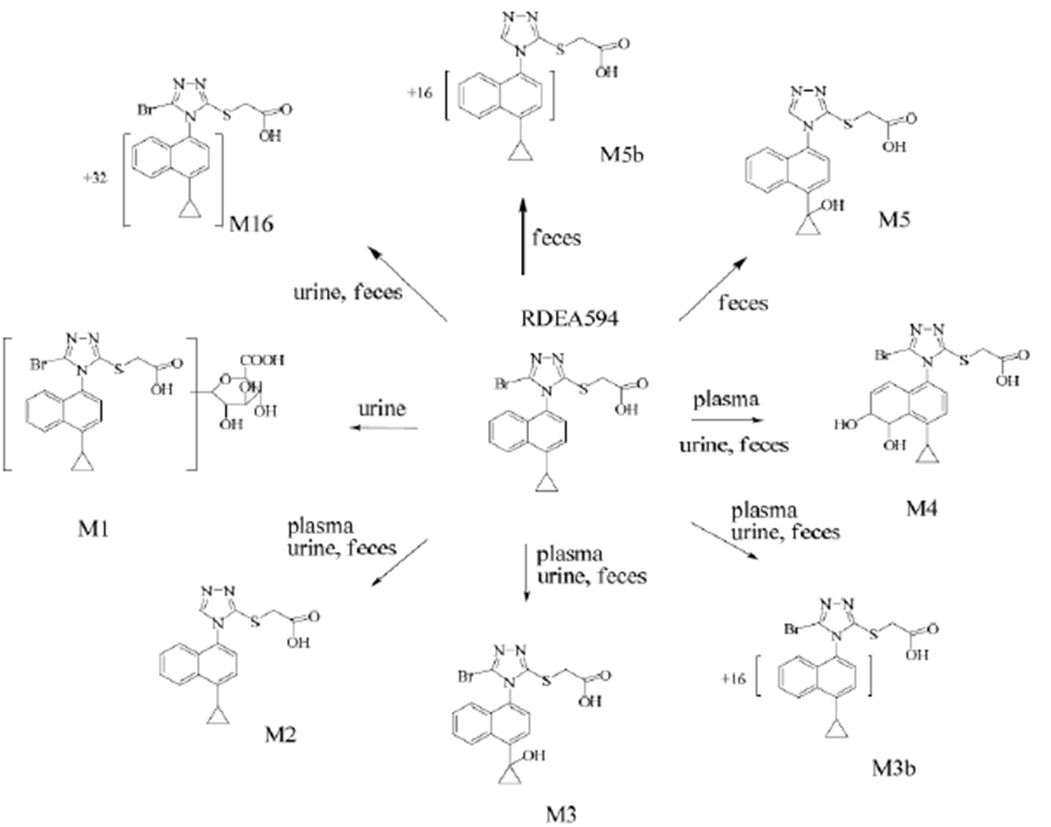

Pharmacokinetics of metabolites
Following administration of a dose of ^{[14C]} lesinurad, unchanged lesinurad accounted for 61.8% of the AUC of radioactivity in plasma in the first 24 h, and 46.3% of radioactivity AUC_{0-∞}. At 3 hours, unchanged lesinurad accounted for 93% of radioactivity in plasma. Small amounts of M3 (2.2%) and M4 (2.0%) and trace amounts of M2 and M3b were also detected. Metabolite profiling of plasma samples collected at later time points was not conducted due to low levels of radioactivity at those time points. The metabolites present in plasma at > 3 hours were therefore not characterised. The M4 metabolite had a half-life of approximately 6 hours.
The major metabolite excreted in urine and faeces was the M4 metabolite (~21% of the administered dose), followed by the M3 metabolite (~ 12%).

Consequences of genetic polymorphism
Two subjects classified as CYP2C9 poor metabolisers had increases in lesinurad plasma AUC (111% and 79% respectively) and an increased amount of lesinurad excreted unchanged in the urine (271% and 124% increases, respectively).

Excretion

Routes and mechanisms of excretion
Following administration of a dose of ^{[14C]} lesinurad, 63.4% of the dose was recovered in the urine and 33.5% in the faeces.

Renal clearance
As indicated above, approximately 30% of a dose of lesinurad is excreted unchanged in the urine. Estimates of renal clearance of lesinurad were generally 30-40 mL/min. Lesinurad is 98% protein bound and hence estimated renal clearance due to glomerular filtration would only be 2.5 mL/min. It was therefore concluded that the kidney actively secretes lesinurad.

Intra- and inter-individual variability of pharmacokinetics
No analyses of PK variability were presented. In the population PK analysis, the co-efficient of variation for clearance was 63%, which the sponsor considered to indicate a moderate degree of variability.

Pharmacokinetics in the target population
The population PK analysis indicated that clearance was approximately 18% lower in subjects with gout than in individuals without gout.

Pharmacokinetics in other special populations

Pharmacokinetics in subjects with impaired hepatic function
Mild hepatic impairment (Child-Pugh A) was associated with small increases in lesinurad AUC (~7%) and C_{max} (~11%). Moderate hepatic impairment was associated with a greater increase in AUC (~33%) and a small increase in C_{max} (~8%) (Figure 2). The effect of severe impairment has not been studied.
Figure 2. Effects of renal and hepatic impairment on lesinurad PK.
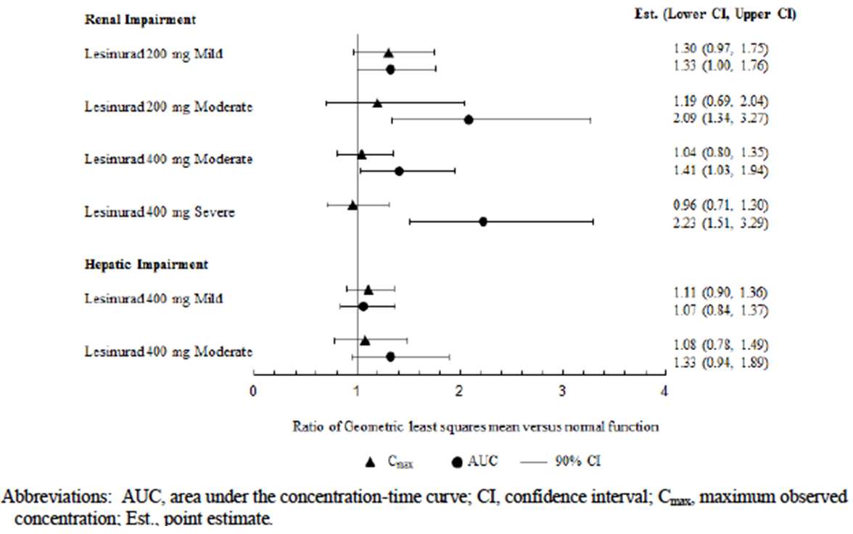
In the population PK analysis baseline LFTs were not significant covariates for lesinurad PK.

Pharmacokinetics in subjects with impaired renal function
The sponsor conducted two studies in otherwise healthy subjects with renal impairment – RDEA594-104 and RDEA594-120:
- In subjects with mild impairment (CrCL 60 to 89 mL/min/1.73 m²), AUC was increased by 33%;
- In subjects with moderate impairment, the two studies gave somewhat conflicting results. In Study -104 (CrCL 30 to 59 mL/min/1.73 m²), AUC was increased by 109%, whereas in Study -120 (CrCL 30 to < 60 mL/min/1.73 m²) AUC was increased by only 41%.
- In subjects with severe renal impairment (CrCL 15 to < 30 mL/min/1.73 m²), AUC was increased by 123%.
These effects are summarised in Figure 2.
In the population PK analysis, reduced creatinine clearance was associated with increased systemic exposure to lesinurad. The model predicted that for subjects with mild (CrCl=75 mL/min), moderate (CrCl=45 mL/min) and severe (CrCl= 22 mL/min) renal impairment, lesinurad clearance would be reduced by 21%, 24% and 40% compared to subjects with normal renal function (CrCl= 105 mL/min). Estimated increases in lesinurad exposure would be approximately 12%, 31% and 65% in patients with mild, moderate, and severe renal impairment, respectively, compared with patients with normal renal function.
Comment: The draft PI states that no dose reduction is necessary in mild or moderate renal impairment, and that there are insufficient data in subjects with severe renal impairment. Based on the two PK studies it may have been appropriate to recommend a 50% dosage reduction in subjects with moderate or severe impairment, especially as lesinurad is nephrotoxic (see section 8 below). However it appears that the proposed tablets are not scored and that therefore a recommendation for dosage reduction would not be practical.

Pharmacokinetics according to age
There were no dedicated PK studies on the effect of age on lesinurad PK. In the population PK analysis, age was not a significant covariate for lesinurad PK.

Pharmacokinetics related to gender
After correction for differences in bodyweight, there were no notable differences in lesinurad PK between genders. In the population PK analysis, gender was not a significant covariate for lesinurad PK.

Pharmacokinetics related to race
In the population PK analysis, race was not a significant covariate for lesinurad PK.

Pharmacokinetic interactions

Pharmacokinetic interactions demonstrated in human studies

Effects of other drugs on lesinurad PK

CYP2C9 inhibitors
Co-administration of the CYP2C9 inhibitor fluconazole increased lesinurad AUC by 56% and C_{max} by 38%. These findings are consistent with inhibition of lesinurad metabolism via CYP2C9.

CYP2C9 inducers
Co-administration of CYP2C9 inducer rifampicin decreased lesinurad AUC by 38% and Cmax by 24%. These findings are again consistent with induction of lesinurad metabolism via CYP2C9.

Drugs that alter gastric pH
- The H₂-receptor antagonist ranitidine had no significant effect on lesinurad AUC. Lesinurad C_{max} was increased by 20%.
- Study RDEA594-130 examined the effect of two antacid preparations on lesinurad PK - Tums® (containing calcium carbonate), and Mintox® (containing aluminium hydroxide, magnesium hydroxide and simethicone). The antacids had no clinically significant effect on the plasma AUC of lesinurad. Administration of antacid resulted in small decreases in lesinurad C_{max}.
- An earlier study (RDEA594-121) had suggested that systemic exposure to lesinurad was reduced by approximately 30-40% when co-administered with such antacids.
Comment: Study -121 was conducted in fasting patients, whereas study -130 was conducted in fed subjects. This may explain the conflicting findings. The draft PI recommends that lesinurad be administered with food and therefore study -130 is probably more relevant.

Other gout drugs
- Co-administration of allopurinol had no significant effect on the PK of lesinurad;
- The PK of lesinurad were not affected by co-administration of febuxostat;
- Neither naproxen nor indomethacin had a clinically significant effect on the AUC of lesinurad.

Effects of lesinurad on PK of other drugs

CYP2C9 substrates
- Single or multiple doses of lesinurad had no significant effect on the AUC for tolbutamide;
- Lesinurad had no significant effect on the single dose PK of S-warfarin.

CYP2C8 substrates
Multiple doses of lesinurad had no significant effect on the AUC for repaglinide.

CYP3A4 substrates
Lesinurad was shown to produce a mild induction of CYP3A4 in the following clinical studies:
- Lesinurad increased the ratio of 6-beta hydroxycortisol to free cortisol recovered in urine over a 24-hour period;
- Co-administration of lesinurad reduced systemic exposure to sildenafil by up to 72%;
- Co-administration of lesinurad with colchicine resulted in a 25-35% reduction in colchicine AUC in one study and a 15-35% reduction in another study.
- Co-administration of lesinurad resulted in a small (~20%) decrease in the AUC of R-warfarin;
- Systemic exposure to atorvastatin was decreased by up to 27% with multiple dosing of lesinurad;
- Co-administration of lesinurad resulted in reductions in amlodipine AUC and C_{max} of approximately 40%.

OATP-1B1 substrates
Systemic exposures to atorvastatin, a substrate for organic anion transporting polypeptide 1B1 (OATP1B1), were not altered by co-administration of a single dose of lesinurad.

OCT1 substrates
A single dose of lesinurad had no significant effect on the single dose PK of metformin, a substrate for the hepatic transporter organic cation transporter 1 (OCT1).

OAT1/3 substrates
A single dose of lesinurad had no effect on the renal clearance of frusemide, a substrate for the renal transporters organic anion transporter (OAT) 1 and OAT3 (OAT1/3).
Comment: Probenecid, another uricosuric agent marketed in Australia, is known to inhibit OAT1/3, with resulting drug interactions.

Other gout drugs
- Co-administration of lesinurad with allopurinol had no effect on the AUC of allopurinol, but resulted in a 25-35% reduction in the AUC of its active metabolite, oxypurinol AUC;
- Co-administration of the proposed dose of 200 mg lesinurad had no significant effect on febuxostat PK. However, administration of higher doses was associated with increases in febuxostat AUC of up to 31%;
- Lesinurad had no significant effect on the PK of naproxen;
- Lesinurad significantly increased systemic exposure to indomethacin by ~30%.
Comment: Lesinurad will be used in combination with either allopurinol or febuxostat. The interaction studies suggest that lesinurad has the potential to decrease the efficacy of allopurinol. However, the combination of lesinurad and allopurinol was superior to allopurinol alone in the efficacy studies (see below). The interaction data also suggest that lesinurad doses > 200 mg may increase any toxicities produced by febuxostat.

Clinical implications of in vitro findings
The following preclinical study was included in the submission:
- SR10-037. This in-vitro study investigated the effect of nine drugs (ibuprofen, verapamil, nitrendipine, captopril, bezafibrate, warfarin, allopurinol, oxypurinol, or febuxostat) on lesinurad protein binding. It was reported that no effects were observed. Similarly, lesinurad had no effects on protein binding of ibuprofen, verapamil, nitrendipine, warfarin, allopurinol, or oxypurinol. The implications of this study are that interactions due to changes in protein binding are unlikely.

Evaluator’s overall conclusions on pharmacokinetics
The pharmacokinetics of lesinurad have been adequately defined. The submitted studies generally complied with the relevant EMA guidelines adopted by the TGA. Issues of potential concern are the following:
- Use of lesinurad in subjects with pre-existing moderate or severe renal impairment. On the available PK evidence it is possible that these subjects will have approximately twice the systemic exposure to lesinurad as other subjects. Lesinurad itself is nephrotoxic. If lesinurad dose reduction is not practical, it may be appropriate to avoid use of the drug altogether in these subjects.
- The effect of severe hepatic impairment on the PK of lesinurad has not been defined.
- Lesinurad causes mild induction of CYP3A4. This may be clinically significant in subjects receiving CYP3A4 substrates that have a narrow therapeutic window.
- Lesinurad results in some increased systemic exposure to indomethacin, a drug that is likely to be used in subjects with gout. Although the clinical consequences of this interaction are unclear it would be appropriate to at least describe it in the PI.

Pharmacodynamics

Studies providing pharmacodynamic data
Table 7 shows the studies relating to each pharmacodynamic topic.
Table 7. Pharmacokinetic studies not reviewed in this report.
PD Topic | Subtopic | Study ID | *
Primary Pharmacology | Effect on serum urate
 | - gout subjects | RDEA594-201 | *
 | - healthy volunteers | Various PK studies
 | Effect on urinary urate
 | - gout subjects | RDEA594-201
 | - healthy volunteers | Various PK studies
Secondary Pharmacology | Effect on ECG/QT interval | RDEA594-117 | *
* Indicates the primary aim of the study.
None of the pharmacodynamic studies had deficiencies that excluded their results from consideration.

Summary of pharmacodynamics
The information in the following summary is derived from conventional pharmacodynamic studies in humans unless otherwise stated.

Pharmacodynamic effects

Primary pharmacodynamic effects
In gout subjects, treatment with lesinurad for 14 days was associated with greater percentage reductions in serum uric acid concentrations compared to placebo treatment. A greater proportion of patients achieved a serum urate concentration of < 6.0 mg/dL. Lesinurad treatment was also associated with increased urinary excretion of uric acid compared with placebo or allopurinol treatment.
In healthy volunteers, lesinurad treatment was associated with reductions in serum urate levels and increased excretion of urate in the urine. These reductions were dose dependant.

Secondary pharmacodynamic effects
Lesinurad treatment was not associated with significant QT prolongation or other ECG effects.

Time course of pharmacodynamic effects
After single doses of lesinurad, the maximum reduction in serum urate levels occurred within 6 hours of dosing. Duration of the effect depended on dose, with serum urate concentrations remaining suppressed post-dose for up to 12 hours at the 100 mg dose level to beyond 24 hours at the 600 mg dose level. Peak urinary excretion of urate occurred within the 0-6 hour period post-dose.
After multiple dosing, maximum reductions in serum urate occurred by day 6.

Relationship between drug concentration and pharmacodynamic effects
In a population PK/PD analysis, serum uric acid levels were related to average plasma concentrations of lesinurad, at least for doses up to 200 mg daily.

Evaluator’s conclusions on pharmacodynamics
The PD data are consistent with the stated mechanism of action for lesinurad. The data do not raise any specific issues of concern.

Dosage selection for the pivotal studies
In Study 101, doses below 200 mg did not have a sustained effect on serum urate. Doses of 200, 400 and 600 mg were studied in gout patients in Phase I study and Phase II studies. Doses of 600 mg were only marginally more effective than 400 mg. Therefore, doses of 200 and 400 mg were chosen for the pivotal studies.

Clinical efficacy

Pivotal efficacy studies

Studies RDEA594-301 (CLEAR 1) and RDEA594-302 (CLEAR 2)

Study design, objectives, locations and dates
The studies were both randomised, double blind, placebo-controlled trials with three parallel groups. Subjects were randomised to receive lesinurad (200 or 400 mg) or placebo once daily for 12 months in combination with a stable dose of allopurinol. A study schema is shown in Figure 3.
Figure 3. Studies 301 and 302 - Study schema.
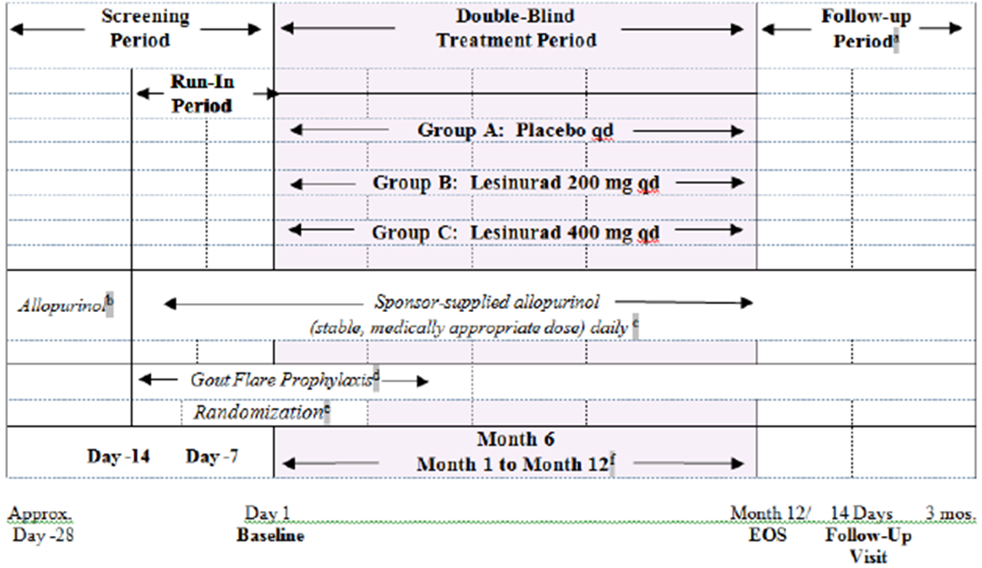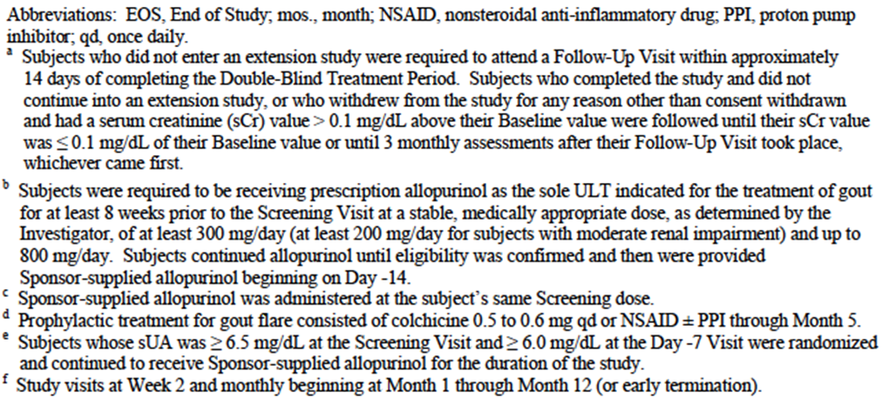
The primary objective was to determine the efficacy of lesinurad by Month 6 when used in combination with allopurinol compared to allopurinol monotherapy.
The secondary objectives were to:
- Determine the efficacy of lesinurad by Month 12 when used in combination with allopurinol compared to allopurinol monotherapy;
- Determine the safety of lesinurad over 6 months and 12 months when used in combination with allopurinol;
- Investigate by a population analysis approach the influence of intrinsic factors (age, sex, race, body weight, renal function, concomitant medication use) on oral clearance of lesinurad;
- Determine the effect of lesinurad when used in combination with allopurinol on Health Related Quality of Life and physical function.
Study 301 was conducted at 181 sites in the USA between February 2012 and July 2014. The study report was dated 20 November 2014. Study 302 was conducted at 185 sites in 12 countries (USA, Canada, Spain, France, Belgium, Germany, Poland, Switzerland, the Ukraine, South Africa, Australia, and New Zealand) between December 2011 and July 2014. The study report was dated 21 November 2014.

Inclusion and exclusion criteria
Subjects included in the trial had to meet the American Rheumatism Association (ARA) criteria for the diagnosis of gout and have a serum uric acid level of ≥ 357 μmol/L (6.0 mg/dL) at the Day -7 Visit, despite a stable dose of allopurinol of at least 300 mg per day for at least 8 weeks.
Subjects with severe renal impairment (creatinine clearance < 30 mL/min) were excluded, as were those with a recent history of cardiovascular disease.

Study treatments
Subjects were randomised to receive one of the following three treatments:
- Lesinurad 200 mg once daily;
- Lesinurad 400 mg once daily;
- Placebo once daily.
All doses were taken in the morning with food and 1 cup of water. Subjects were instructed to drink 2 liters of liquid a day and to remain well hydrated. Lesinurad was supplied as 200 and 400 mg tablets (FN21 and FN22). Randomised blinded treatment was continued for 12 months. Subjects who completed 12 months treatment could enroll in an open-label extension study (study 306) in which all subjects received lesinurad.
All subjects were to continue allopurinol at their previous dose. The dose was not altered during the course of the study unless safety issues arose. All subjects also received prophylaxis for gout flares with colchicine, starting on day -14. The dose was either 0.5 or 0.6 mg OD, depending on available tablet sizes. NSAIDs could be prescribed in those subjects intolerant to colchicine. Prophylaxis was continued until the end of Month 5.

Efficacy variables and outcomes
The main efficacy variables were:
- Serum uric acid (sUA) concentrations;
- The occurrence of acute gout flares;
- Change in size of gouty tophi;
- Patient-Reported Outcomes:
  - The Health Assessment Questionnaire-Disability Index (HAQ-DI);
  - The Short Form-36 (SF-36);
  - The Treatment Satisfaction Question for Medication (TSQM) Total Score;
  - The Sheehan Disability Scale (SDS);
  - The Patient Global Assessment (PGA) of Disease Activity.
The primary efficacy outcome was the proportion of subjects with an sUA level < 6.0 mg/dL (<360 μmol/L) by Month 6.
Key secondary efficacy outcomes were:
- Mean rate of gout flares requiring treatment for the 6-month period from the end of Month 6 to the end of Month 12.
- The proportion of subjects with ≥ 1 target tophus at baseline who experience complete resolution of at least 1 target tophus by Month 12.
Other secondary efficacy outcomes listed in the protocol were:
- Proportion of subjects whose sUA level is < 6.0 mg/dL, < 5.0 mg/dL and < 4.0 mg/dL at each visit.
- Absolute and percent change from baseline in sUA levels at each visit.
- The proportion of subjects requiring treatment for a gout flare at monthly intervals between Month 6 and Month 12.
- Mean percent change from baseline in the sum of the areas for all target tophi at each visit.
- The proportion of subjects with an improvement from baseline in the HAQ-DI of at least 0.25 at Month 12.
- Mean change from baseline to Month 12 in the physical component scale (PCS) of the SF-36.
- The TQSM total score.
- Mean change from baseline in the SDS.
- Mean change from baseline in PGA of Disease Activity.
The choice of sUA < 6.0 mg/dL (<360 μmol/L) at 6 months as the primary endpoint was made after consultation with the FDA and EMA. This target is also consistent with current clinical practice guidelines for the management of gout.
After commencing blinded treatment subjects were reviewed in the clinic at week 2 and then every month. sUA concentrations were assessed at monthly intervals by a central laboratory. Gout flares were recorded in a patient diary. Flares were defined as subject-reported gout flares that required the use of prescribed or over-the-counter colchicine, analgesics, and/or anti-inflammatory medication. Target tophi were those on the hands/wrists and feet/ankles as these were considered most amenable to accurate measurement. Up to five of these, ≥ 5 mm and ≤ 20 mm in the longest diameter, were selected. These were measured using digital caliper measurement and photographs at baseline and at 3, 6, 9 and 12 months. PROs were assessed at baseline and at 3, 6, 9 and 12 months. TQSM was assessed at 12 months only.

Randomisation and blinding methods
Subjects were randomised (1:1:1) to their double-blind treatment via an Interactive Voice/Web Response System (IVRS/IWRS).
Randomization was to be stratified by the following factors:
- Renal function at Day -7 (eCrCl ≥ 60 mL/min versus < 60 mL/min calculated by the Cockcroft-Gault formula using ideal bodyweight);
- Tophus status during screening (presence of ≥ 1 tophus [did not have to be a measurable tophus] versus absence of tophi).
The three treatments were blinded through the use of matched placebo dummies. All subjects received two tablets daily – e.g. the lesinurad 200 mg group received an active 200 mg tablet and a matched placebo for the 400 mg tablet.

Analysis populations
The Intention-to-treat (ITT) population included all randomised subjects who received at least one dose of randomised medication. This was the primary population for the analysis of efficacy. The Per-protocol population included all subjects in the ITT population who adhered to the study protocol. Subjects were excluded from this population if they violated specific eligibility criteria or significantly deviated from the study plan. This population was used for sensitivity analyses. The Safety Population included all subjects who received at least 1 dose of randomised study medication. It was used for analyses of safety data.

Sample size
The sample size was based on the key secondary endpoint of mean rate of gout flares requiring treatment between Month 6 and Month 12. It was assumed that the mean rate of flares in the placebo group would be 1.0 with a standard deviation of 2.0. A 50% reduction in the incidence of gout flares was considered to be clinically meaningful. It was calculated that a sample size of 200 per treatment arm would provide 80% power at an alpha = 0.025 (two-sided). The alpha level of 0.025 was used based on a Bonferroni correction because there were 3 treatments in the study and two comparisons.
A sample size of 600 subjects would also provide greater than 90% power to detect a difference in response rates (response = sUA< 6.0 mg/dL) if the placebo plus allopurinol group has a 30% response rate and the lesinurad plus allopurinol treatment groups have response rates as low as 48%, adjusting for multiplicity with alpha = 0.025 (two-sided) for each test.

Statistical methods
The difference in sUA response rates between placebo and each lesinurad group was tested using the Cochran-Mantel Haenszel (CMH) test statistic, stratifying by Day -7 renal function and tophus status during screening. To account for multiple comparisons, each of the 2 treatment comparisons with placebo were tested at the alpha = 0.025 level.
If both doses were shown to be significantly superior to placebo, the key secondary outcomes were to be tested in hierarchical order at an alpha level of 0.05. The rates of gout flares requiring treatment were compared using a negative binomial model. The difference in tophus resolution rates on the subset of subjects with measurable tophi at baseline between placebo and each lesinurad group was tested using the CMH test statistic.

Participant flow
In study 301, total of 603 subjects were randomised and received study medication.
In study 302, total of 610 subjects were randomised and received study medication.

Major protocol violations/deviations
In study 301, the proportion of subjects with protocol violations leading to exclusion from the per protocol population was 7.5% in the placebo arm, 9.0% in the 200 mg arm and 12.9% in the 400 mg arm. The most common violation in all groups was inadequate compliance with randomised medication.
In study 302, the proportion of subjects with protocol violations leading to exclusion from the per protocol population was 5.8% in the placebo arm, 10.8% in the 200 mg arm and 9.5% in the 400 mg arm. Again, the most common violation in all groups was inadequate compliance with randomised medication.

Baseline data
In both studies, the study population was predominantly white and male. In both studies, gout was longstanding (median duration of approximately 10 years). Only a minority of subjects had tophi suitable for evaluation as target tophi (9.0% in study 301 and 15.9% in study 302). Median sUA concentrations at baseline were 6.80 mg/dL (~ 410 μmol/L).
All subjects in study 302 were required to be on a stable dose of allopurinol for at least 10 weeks prior to randomisation. Use of other urate-lowering treatments (ULTs) prior to the screening visit was low. Most subjects were receiving 300 mg per day of allopurinol and were prescribed colchicine as flare prophylaxis.
Comment: In both studies the three treatment arms were well balanced with respect to baseline characteristics.
The study report presented tabulations of other baseline characteristics (height, weight, waist circumference, BMI, employment status, tobacco use, history of alcoholism, comorbidities and prior medications). Treatment groups were reasonably well balanced with respect to these parameters.

Results for the primary efficacy outcome
Results for the primary efficacy endpoint in the two trials are summarised in Table 51.
Table 8. Studies 301 and 302 - Primary efficacy outcome.
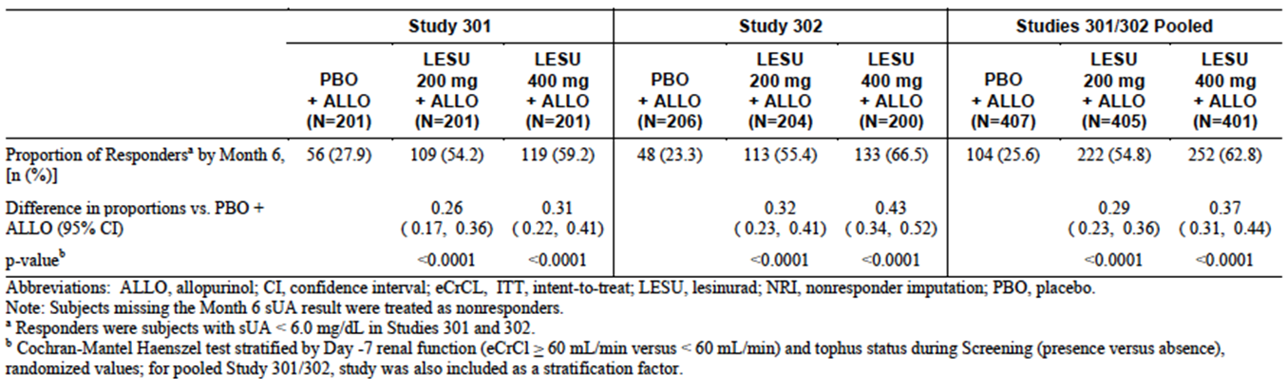
In study 301, the proportion of subjects who achieved a sUA of < 6mg/dL (360 μmol/L) was increased from 27.9% in the placebo group to 54.2% in the 200 mg group and 59.2% in the 400 mg group. The differences between lesinurad and placebo were statistically significant for both doses (p<0.0001).
In study 302, the proportion of subjects who achieved a sUA of < 6mg/dL (360 μmol/L) was increased from 23.3% in the placebo group to 55.4% in the 200 mg group and 66.5% in the 400 mg group. The differences between lesinurad and placebo were statistically significant for both doses (p<0.0001).
Comment: Results were consistent between the two studies. The efficacy benefit obtained is clinically meaningful with an additional 25-30% of subjects achieving control of hyperuricaemia with the proposed 200 mg dose.
For both studies, the sponsor conducted a number of sensitivity analyses, including one using the per-protocol population. The results of all these analyses were consistent with the primary analysis.

Subgroup analyses
Analyses of subgroups demonstrated that the efficacy benefit was consistent across a number of pre-defined subgroups. Results for the 200 mg dose vs. placebo are summarised in Figure 4. There was no apparent benefit for lesinurad over placebo in females, however the numbers of female subjects in the trials was small. For the comparison of the 400 mg dose vs. placebo, a significant efficacy benefit in females was demonstrated.
Figure 4. Studies 301 and 302 - Primary efficacy outcome – Subgroup analyses.
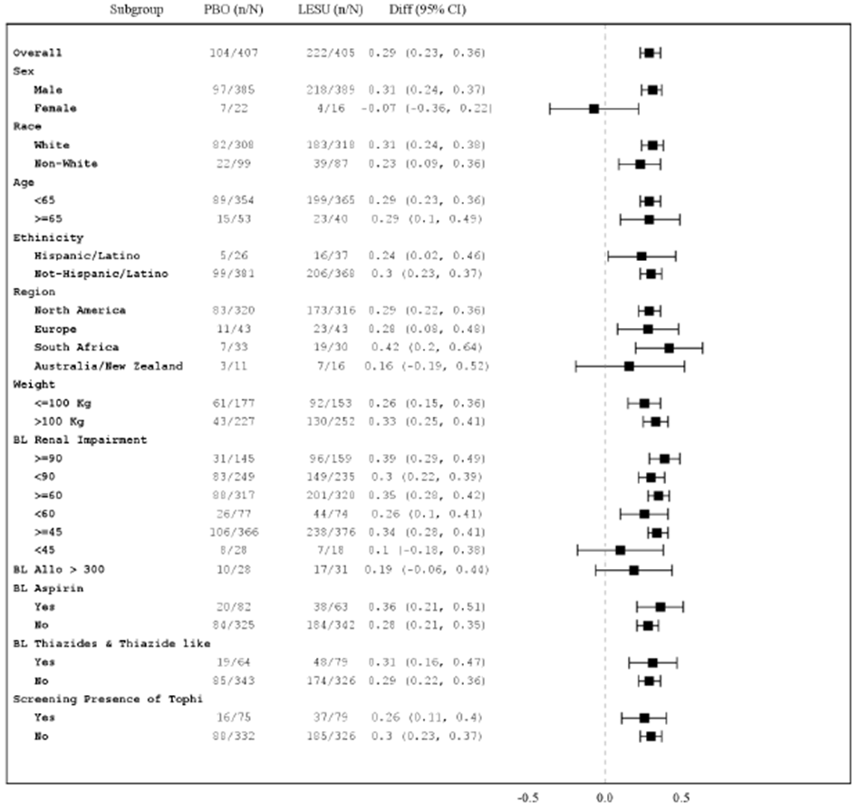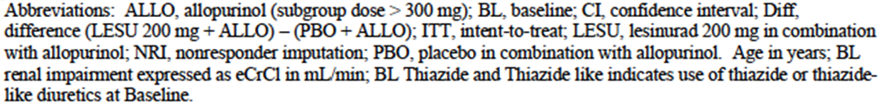
Comment: The subgroup analyses demonstrated efficacy for subjects with mild or moderate renal impairment (subjects with severe impairment were excluded from the study). Probenecid is generally considered to be ineffective in subjects with moderate renal impairment.

Results for other efficacy outcomes

Key secondary outcomes

Rate of gout flares (from end of Month 6 to the end of Month 12)
No significant benefit was demonstrated for lesinurad in either study.
Comment: The rate of gout flares was low in all study groups (<1 per subject over the six-month period).

Complete resolution of at least 1 target tophus
No significant benefit was demonstrated for lesinurad in either study. In study 301 a significantly greater proportion of subjects in the placebo group achieved a complete resolution compared to the 200 mg group (29.4% vs. 0%; p=0.0183).

Other secondary outcomes

Proportion of subjects with sUA level is < 6.0 mg/dL, < 5.0 mg/dL and < 4.0 mg/dL at each visit
- In both studies, for the cut-off points of < 6 mg/dL and 5 mg/dL, lesinurad (at both 200 and 400 mg) was significantly more effective than placebo (p<0.0001 for all comparisons) at all months (months 1, 2, 3, 4, 5, 6, 8, 10 and 12).
- In both studies, for the cut-off point of < 4 mg/dL, lesinurad (at both 200 and 400 mg) was significantly more effective than placebo at all months (p<0.01 for all comparisons at the 200 mg dose, p<0.0001 for all comparisons at the 400 mg dose).
- For the cut-off point of < 3 mg/dL:
  - In study 301, lesinurad (at 400 mg) was significantly more effective than placebo at all months (p<0.05 for all comparisons). However, the 200 mg dose was no more effective than placebo (p>0.05 for all comparisons).
  - In study 302, lesinurad (at both 200 and 400 mg) was significantly more effective than placebo at all months (p<0.01 for all comparisons at the 200 mg dose, p<0.0001 for all comparisons at the 400 mg dose).
The results for these endpoints for study 301, for the 6- and 12-month time points, are shown in Figure 5.
Figure 5. Study 301 – Proportion of subjects with sUA < 6, < 5, <4 and < 3 mg/dL.
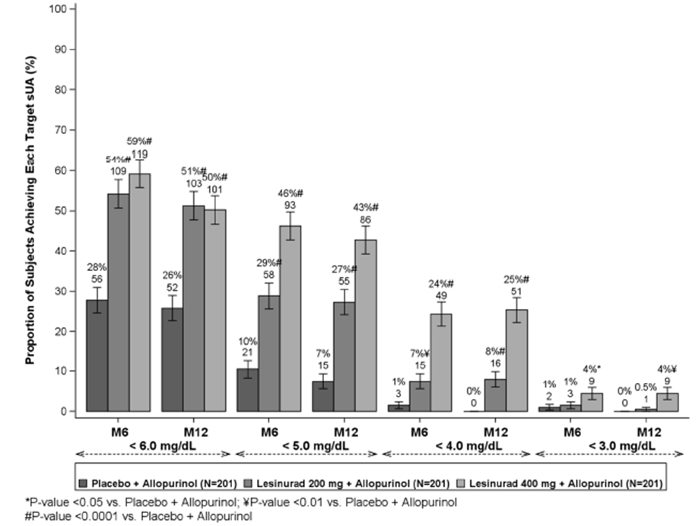
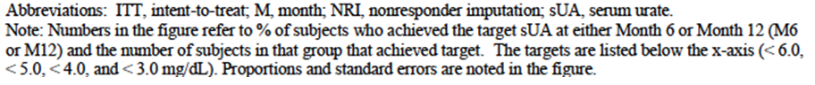

Absolute and percent change from baseline in sUA levels at each visit
For study 301, changes in mean sUA concentrations are illustrated in Figure 6, and percentage changes from baseline in Figure 7.
Figure 6. Study 301 - Mean sUA levels.
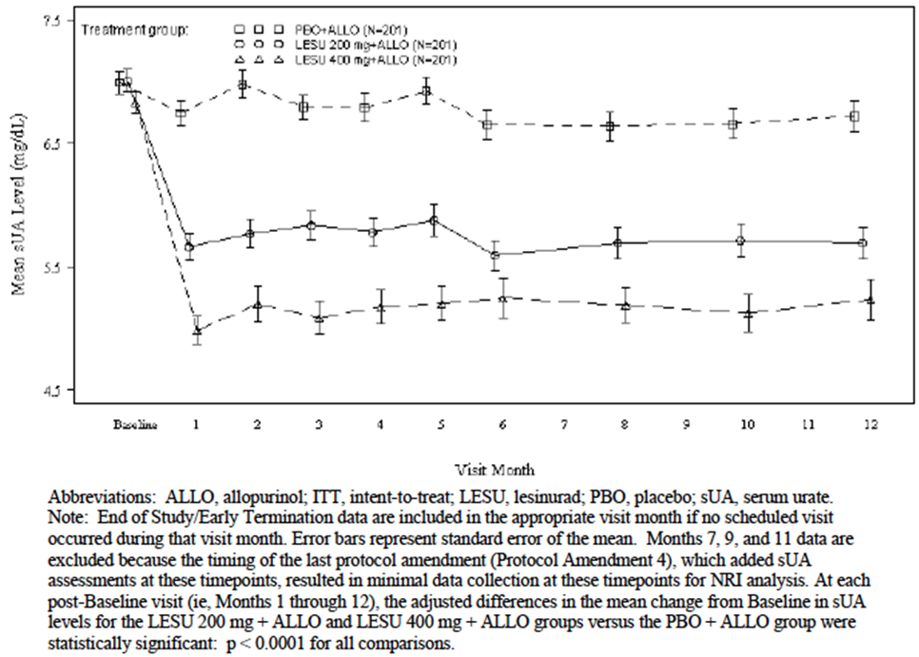
Figure 7. Study 301 – Percent change in sUA levels.
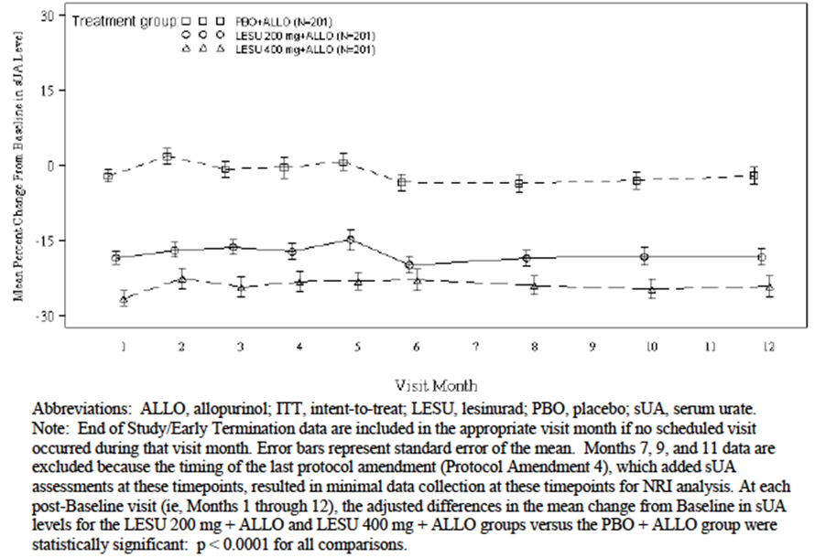
For study 302, changes in mean sUA concentrations are illustrated in Figure 8 and percentage changes from baseline in Figure 9.
Figure 8. Study 302 - Mean sUA levels.
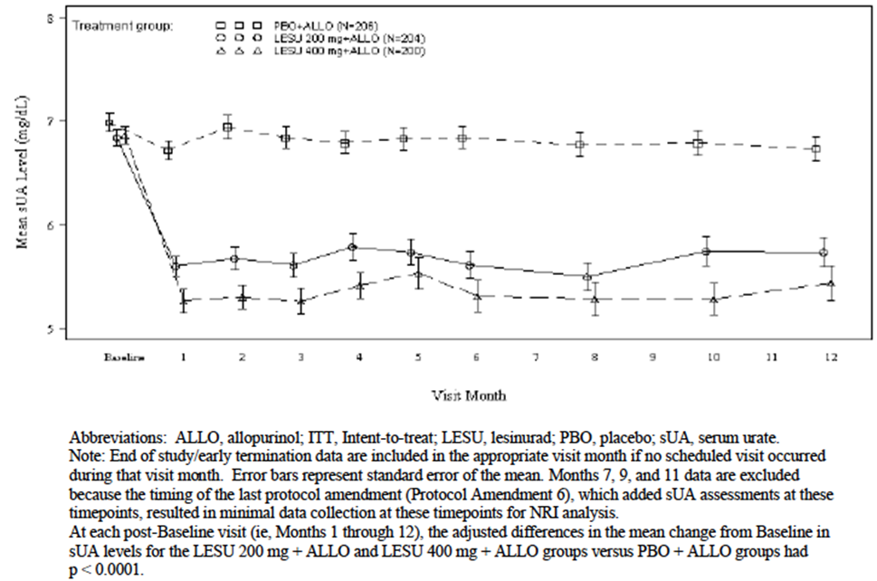
Figure 9. Study 301 – Percent change in sUA levels.
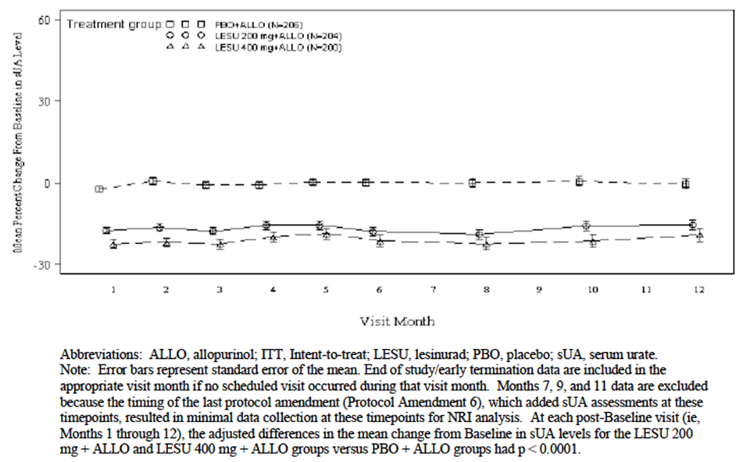
Absolute reductions in mean sUA were generally around 1.3 – 2.0 mg/dL for the lesinurad groups, with greater reductions in the 400 mg group. Percentage reductions were approximately 15-20% with lesinurad. Reductions were achieved by Month 1 and sustained over the 12 months of randomised treatment. There was minimal change in sUA concentrations with placebo treatment.

Proportion of subjects requiring treatment for a gout flare at monthly intervals (Months 6 to 12)
In both studies there were no consistent differences between treatment groups.

Mean percent change from baseline in the sum of the areas for all target tophi at each visit
In both studies, there were no significant differences between treatment groups in the percentage change from baseline in the total area of tophi, at any time point (baseline and months 3, 6, 9 and 12).
Comment: There was no consistent pattern in the magnitude of the reductions, although in study 302, there was a general trend for increasing reductions over time, in all three treatment groups. Maximum reductions were approximately 30%.

HAQ-DI
The possible range for HAQ-DI scores is from 0 to 3. Higher scores indicate greater disability.
- In study 301, the mean (SD) HAQ-DI scores at baseline were: 0.513 (0.591) for 200 mg, 0.528 (0.576) for 400 mg, and 0.519 (0.594) for placebo, respectively. These values indicate a low level of disability at baseline. The proportions of subjects with an improvement from baseline in the HAQ-DI of at least 0.25 points (at Month 12) were 30.0% (200 mg), 28.5% (400 mg), and 34.7% (placebo). Differences between lesinurad and placebo were not statistically significant.
- In study 302, the mean (SD) HAQ-DI scores at baseline were: 0.553 (0.611) for 200 mg, 0.528 (0.566) for 400 mg, and 0.504 (0.567) for placebo, respectively. These values again indicate a low level of disability at baseline. The proportions of subjects with an improvement from baseline in the HAQ-DI of at least 0.25 points (at Month 12) were 29.7% (200 mg), 38.4% (400 mg), and 39.3% (placebo). Differences between lesinurad and placebo were not statistically significant.

SF-36 – Physical Component Score
In both studies there were small improvements (2-3 points) in the SF-36 PCS at 12 months, in all treatment groups. Differences between lesinurad and placebo were not statistically significant.

TQSM
The possible range for HAQ-DI scores is from 0 to 100. Higher scores indicate greater satisfaction with treatment.
- In study 301, mean (SD) scores at 12 months were 70.67 (23.52) for placebo, 69.33 (24.61) for 200 mg and 63.57 (24.79) for 400 mg.
- In study 302, mean (SD) scores at 12 months were 69.88 (22.30) for placebo, 67.78 (25.45) for 200 mg and 69.05 (25.36) for 400 mg.
Differences between arms were not tested statistically.

The Sheehan Disability Scale (SDS)
The possible range of scores on the SDS total score is from 0 to 30 with higher scores indicating greater impairment.
- In study 301, mean scores at baseline ranged 6.3 to 6.4 across the three treatment groups, indicating low levels of impairment. At 12 months there were small improvements in all groups (-1.6 to -2.0 points). Differences between lesinurad and placebo were not statistically significant.
- In study 302, mean scores at baseline ranged 6.0 to 6.7 across the three treatment groups, again indicating low levels of impairment. At 12 months there were small improvements in all groups (-1.4 to -2.7 points). Differences between lesinurad and placebo were not statistically significant.

The Patient Global Assessment (PGA) of Disease Activity
Possible scores for PGA range between 0 and 100 with higher scores indicating greater disease activity.
- In study 301, mean scores at baseline ranged from 32.0 to 34.6 across the three treatment groups. The scores decreased in all groups. At month 12, the mean decrease was greater in the placebo group compared to the 200 mg group (-16.2 vs. -8.7; p=0.0115). There was no significant difference between 400 mg (-12.3 points) and placebo.
- In study 302, mean scores at baseline ranged from 33.6 to 37.0 across the three treatment groups. The scores decreased in all groups. At month 12, the mean decreases were 14.4 (placebo), 13.3 (200 mg) and 9.7 (400 mg). Differences between lesinurad and placebo were not statistically significant.

Study RDEA594 – 304 (CRYSTAL)

Study design, objectives, locations and dates
Study 304 was a randomised, double blind, placebo-controlled trial with three parallel groups. Subjects were randomised to receive lesinurad (200 or 400 mg) or placebo once daily for 12 months in combination with febuxostat. A study schema is shown in Figure 10.
Figure 10. Study 304 – Study schema.
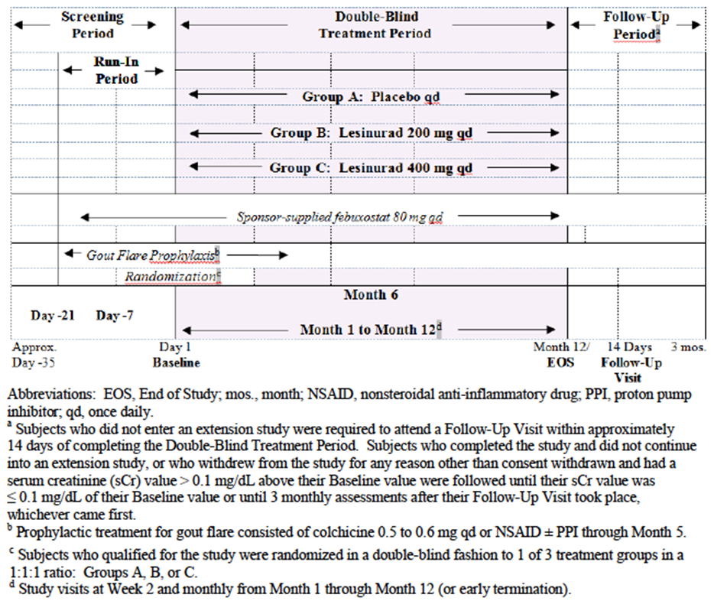
The primary objective was to determine the efficacy of lesinurad by Month 6 when used in combination with febuxostat compared to febuxostat monotherapy.
The secondary objectives were to:
- Determine the efficacy of lesinurad by Month 12 when used in combination with febuxostat compared to febuxostat monotherapy;
- Determine the safety of lesinurad over 6 months and 12 months when used in combination with febuxostat;
- Investigate by a population analysis approach the influence of intrinsic factors (age, sex, race, body weight, renal function, concomitant medication use) on oral clearance of lesinurad;
- Determine the effect of lesinurad when used in combination with febuxostat on Health Related Quality of Life and physical function.
Study 304 was conducted at 141 sites in 6 countries (US, Canada, Poland, Switzerland, Australia, and New Zealand) between February 2012 and April 2014. The study report was dated 17 November 2014.

Inclusion and exclusion criteria
Inclusion criteria are listed.
Comment: In this study all subjects were required to have gouty tophi (criterion 8) and there was no requirement for a minimum number of gout flares in the preceding 12 months. Otherwise inclusion criteria were similar to those used in studies 301 and 302. Exclusion criteria were essentially the same as those applied in studies 301 and 302.

Study treatments
Subjects were randomised to receive one of the following three treatments:
- Lesinurad 200 mg once daily;
- Lesinurad 400 mg once daily;
- Placebo once daily.
All doses were taken in the morning with food and 1 cup of water. Subjects were instructed to drink 2 liters of liquid a day and to remain well hydrated. Lesinurad was supplied as 200 and 400 mg tablets (FN21 and FN22). Randomised blinded treatment was continued for 12 months, and subjects who completed 12 months treatment could enroll in an open-label extension study (study 307) in which all subjects received lesinurad.
All subjects were treated with sponsor-supplied febuxostat 80 mg OD, commencing 21 days prior to commencement of randomised treatment. The dose was not altered during the course of the study unless safety issues arose. All subjects also received prophylaxis for gout flares with colchicine, starting on day -21. The dose was either 0.5 or 0.6 mg OD, depending on available tablet sizes. NSAIDs could be prescribed in those subjects intolerant to colchicine. Prophylaxis was continued until the end of Month 5.
Comment: The approved dose of febuxostat in Australia is 40 to 80 mg daily.

Efficacy variables and outcomes
The main efficacy variables were:
- Serum uric acid (sUA) concentrations;
- The occurrence of acute gout flares;
- Change in size of gouty tophi;
- Patient-Reported Outcomes:
  - The Health Assessment Questionnaire-Disability Index (HAQ-DI);
  - The Short Form-36 (SF-36);
  - The Treatment Satisfaction Question for Medication (TSQM) Total Score;
  - The Sheehan Disability Scale (SDS);
  - The Patient Global Assessment (PGA) of Disease Activity.
The primary efficacy outcome was the proportion of subjects with a sUA level < 5.0 mg/dL (<300 μmol/L) by Month 6.
Comment: The treatment target of < 5.0 mg/dL (<300 μmol/L) is consistent with current clinical practice guidelines for the management of severe/tophaceous gout.
Key secondary efficacy outcomes were:
- Proportion of subjects who experience complete resolution of at least 1 target tophus by Month 12.
- Proportion of subjects with a best tophus response on at least 1 target tophus of complete or partial resolution by Month 12.
- The proportion of subjects with an improvement from baseline in the HAQ-DI of at least 0.25 at Month 12.
Other secondary efficacy outcomes listed in the protocol were:
- Proportion of subjects whose sUA level is < 6.0 mg/dL, < 5.0 mg/dL and < 4.0 mg/dL at each visit.
- Absolute and percent change from baseline in sUA levels at each visit.
- Mean percent change from baseline in the sum of the areas for all target tophi at each visit.
- Mean rate of gout flares requiring treatment for the 6-month period from the end of Month 6 to the end of Month 12.
- The proportion of subjects requiring treatment for a gout flare at monthly intervals between Month 6 and Month 12.
- Mean change from baseline to Month 12 in the physical component scale (PCS) of the SF-36.
- The TQSM total score.
- Mean change from baseline in the SDS.
- Mean change from baseline in PGA of Disease Activity.

Randomisation and blinding methods
Subjects were randomised (1:1:1) to their double-blind treatment via an Interactive Voice/Web Response System (IVRS/IWRS).
Randomization was to be stratified by the following factors:
- Renal function at Day -7 (eCrCl ≥ 60 mL/min versus < 60 mL/min calculated by the Cockcroft-Gault formula using ideal bodyweight);
- Day -7 sUA status (sUA ≥ 6.0 versus < 6.0 mg/dL).
The three treatments were blinded through the use of matched placebo dummies. All subjects received two tablets daily – e.g. the lesinurad 200 mg group received an active 200 mg tablet and a matched placebo for the 400 mg tablet.

Analysis populations
The Intention-to-treat (ITT) population included all randomised subjects who received at least one dose of randomised medication. This was the primary population for the analysis of efficacy. The Per-protocol population included all subjects in the ITT population who adhered to the study protocol. Subjects were excluded from this population if they violated specific eligibility criteria or significantly deviated from the study plan. This population was used for sensitivity analyses. The Safety Population included all subjects who received at least 1 dose of randomised study medication. It was used for analyses of safety data.

Sample size
Based on previous studies it was assumed that the proportion of subjects with sUA < 5.0 mg/dL after 6 months of treatment would be 40% or less in the placebo group and 65% or higher in the lesinurad groups. With a power of approximately 90% and alfa = 0.025 (two-sided) it was calculated that a total of 105 subjects per treatment group would be required. It was therefore planned to randomise a total of 315 subjects.

Statistical methods
The differences in sUA response rates between the placebo and each lesinurad treatment group were tested using the CMH test statistic, stratifying by Day -7 renal function and Day -7 sUA status. To account for multiple comparisons, each of the 2 treatment comparisons with placebo were tested at the alpha = 0.025 level. Analyses of the key secondary endpoints used similar methods.

Participant flow
A total of 324 subjects were randomised and received study medication.

Major protocol violations/deviations
The proportion of subjects with protocol violations leading to exclusion from the per protocol population was 2.8 % in the placebo arm, 3.8% in the 200 mg arm and 9.2% in the 400 mg arm. The most common violation was inadequate compliance with randomised medication, which was more common in the lesinurad arms (0.9% with placebo, 2.8% with 200 mg and 7.3% with 400 mg).
Comment: Inclusion of these subjects in the ITT analysis would if anything bias the efficacy results against lesinurad.

Baseline data
As in studies 301 and 302, the study population was predominantly male and white. Median age was 54 years.
Mean sUA at screening for the whole population was 8.71 mg/dL. At baseline, after 21 days of febuxostat, this had fallen to 5.27 mg/dL. Compared with studies 301 and 302, subjects in this study had been diagnosed with gout for a longer time (mean = 14.7 years).

Results for the primary efficacy outcome
The results for the primary efficacy outcome are summarised in Table 9.
Table 9. Study 304 - Primary efficacy outcome.
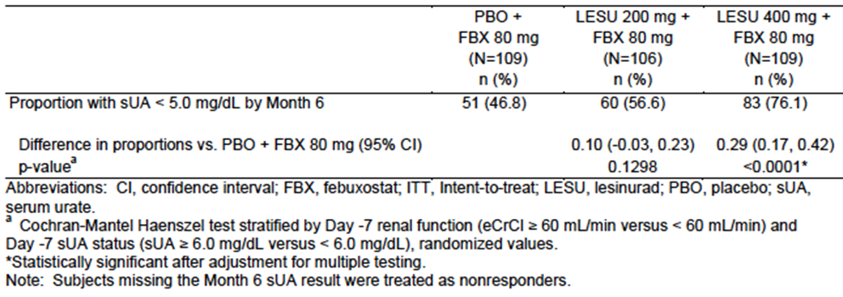
The proportion of subjects who achieved a sUA of < 5 mg/dL (300 μmol/L) was 46.8% in the placebo group, 56.6% in the 200 mg group and 76.1% in the 400 mg group. The difference between lesinurad and placebo was statistically significant for the 400 mg dose (p<0.0001), but not for the 200 mg dose (p=0.1298).
A number of sensitivity analyses were conducted.
- In the primary analysis, subjects with a missing 6-month sUA result were treated as non-responders. Using a last observation carried forward (LOCF) method for these subjects, the proportion of subjects who achieved a sUA of < 5 mg/dL (300 μmol/L) was 50.9% in the placebo group, 64.1% in the 200 mg group and 83.0% in the 400 mg group. The difference between lesinurad and placebo was statistically significant for the 400 mg dose (p<0.0001), but not for the 200 mg dose (p=0.0377).
- The proportion of subjects who achieved a sUA of < 5 mg/dL (300 μmol/L) at each of Months 4, 5 and 6 was 33.0% in the placebo group, 51.9% in the 200 mg group and 64.2% in the 400 mg group. The difference between lesinurad and placebo was statistically significant for both the 400 mg dose (p<0.0001), and for the 200 mg dose (p=0.0034).
- Using the per-protocol population, the proportion of subjects who achieved a sUA of < 5 mg/dL (300 μmol/L) was 48.1% in the placebo group, 58.8% in the 200 mg group and 80.8% in the 400 mg group. The difference between lesinurad and placebo was statistically significant for the 400 mg dose (p<0.0001), but not for the 200 mg dose (p=0.1001).

Subgroup analyses
Results of subgroup analyses for the 200 mg dose vs. placebo are summarised in Figure 11. Although there was a trend for greater efficacy with lesinurad in most subgroups, the differences were generally not significant. In contrast to studies 301 and 302, lesinurad appeared more effective in females than in males. However, there were very few female subjects enrolled.
Figure 11. Study 304 - Primary efficacy outcome – Subgroup analyses.
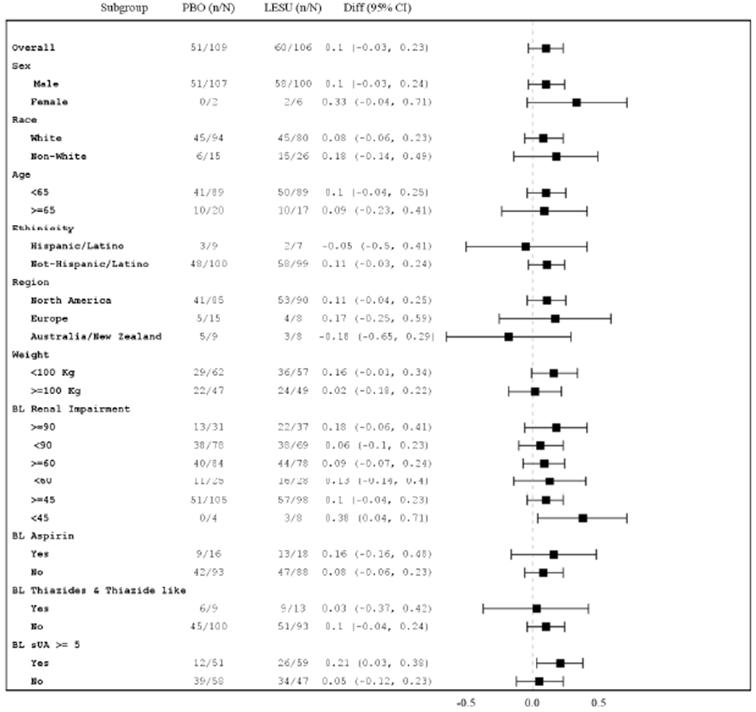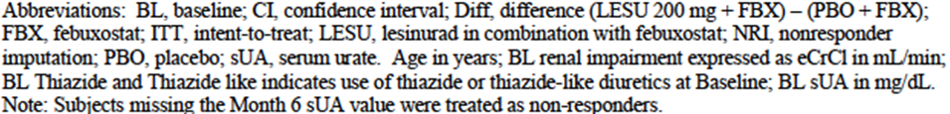

Results for other efficacy outcomes

Key secondary outcomes

Proportion of subjects with complete resolution of at least 1 target tophus by Month 12
Results for this endpoint are summarised in Table 10. The proportion of subjects who achieved complete resolution of at least 1 tophus was 21.1% in the placebo group, 25.5% in the 200 mg group and 30.3% in the 400 mg group. The differences between lesinurad and placebo were not statistically significant.
Table 10. Study 304 – Complete resolution of at least one target tophus by Month 12.
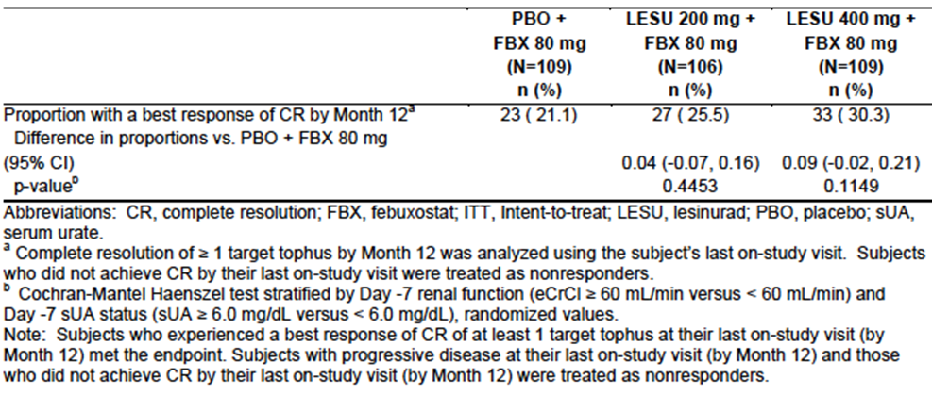

Proportion of subjects with complete or partial resolution of at least 1 target tophus by Month 12
The proportion of subjects who achieved complete or partial resolution of at least 1 tophus was 50.5% in the placebo group, 56.6% in the 200 mg group and 58.7% in the 400 mg group. The differences between lesinurad and placebo were not statistically significant.

Proportion of subjects with an improvement in the HAQ-DI of at least 0.25 at Month 12
The proportion of subjects who achieved an improvement of 0.25 points on the HAQ-DI score at 12 months was 52.5% in the placebo group, 44.2% in the 200 mg group and 33.3% in the 400 mg group. The difference between lesinurad 200 mg and placebo was not statistically significant. The difference between lesinurad 400 mg and placebo was statistically significant, in favour of placebo (p=0.0210).

Other secondary outcomes

Proportion of subjects whose sUA level is < 6.0 mg/dL, < 5.0 mg/dL and < 4.0 mg/dL at each visit
- For the cut-off point of < 6.0 mg/dL, a high proportion of subjects in the placebo group achieved this outcome at each visit (e.g. at Month 1, 70.6% of placebo-treated subjects had a sUA < 6 mg/dL). There were no significant differences between the lesinurad 200 mg and placebo groups at most study visits. Lesinurad 400 mg was significantly more effective than placebo on this endpoint up to month 6, but not at later time points.
- For the cut-off point of < 5.0 mg/dL, lesinurad (at 400 mg) was significantly more effective than placebo at all months (p<0.01 for all comparisons). The 200 mg dose was more effective than placebo (p<0.05) at all time points except at Month 6.
Comment: The proportion of subjects with sUA < 5.0 mg/dL over time is illustrated in Figure 12. The primary endpoint of this study was the proportion of subjects with sUA < 5.0 mg/dL at Month 6. As shown in the figure this was the only time point at which efficacy of the 200 mg dose was not significantly greater than that of placebo. Therefore, although the study failed to meet its primary endpoint for the 200 mg dose, it would still be reasonable to conclude that the 200 mg dose is significantly more effective than placebo in reducing sUA levels to a target of <5.0 mg/dL.
Figure 12. Study 304 – Proportion of subjects with sUA < 5.0 mg/dL at each study visit.
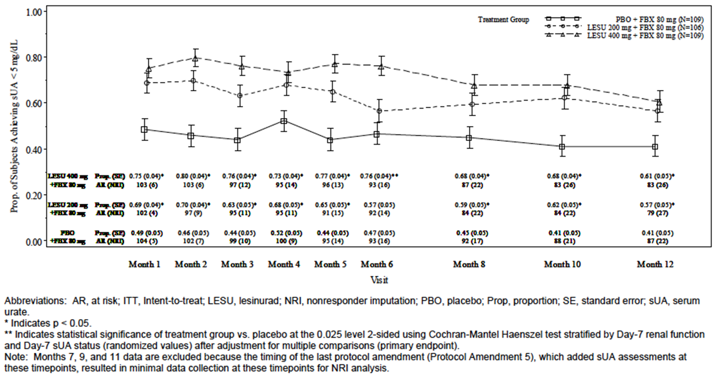
- For the cut-off points of < 4 mg/dL and < 3 mg/dL, lesinurad (at both 200 and 400 mg) was significantly more effective than placebo at all months (p<0.0001 for all comparisons).

Absolute and percent change from baseline in sUA levels at each visit.
Changes in mean sUA concentrations are illustrated in Figure 13 and percentage changes from baseline in Figure 14.
Figure 13. Study 304 - Mean sUA levels.
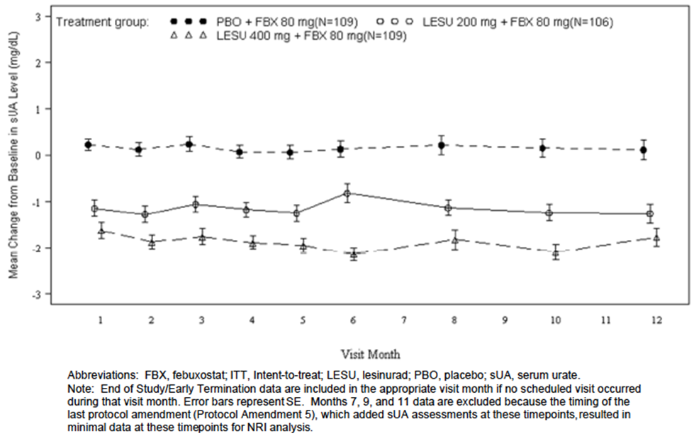
Figure 14. Study 304 – Percent change in sUA levels.
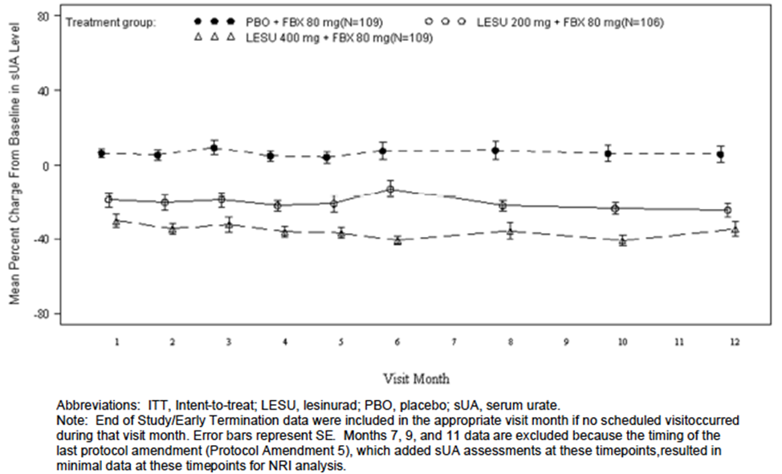
Absolute reductions in mean sUA were generally around 1.0 – 2.0 mg/dL for the lesinurad groups, with greater reductions in the 400 mg group. Percentage reductions were approximately 20-40% with lesinurad. Reductions were achieved by Month 1 and sustained over the 12 months of randomised treatment. There was minimal change in sUA concentrations with placebo treatment.

Mean percent change from baseline in the sum of the areas for all target tophi at each visit
At each time point, the percent decrease in area was greater in the lesinurad groups than in the placebo group. By Month 12, the differences were statistically significant for both lesinurad doses.

Mean rate of gout flares requiring treatment - end of Month 6 to the end of Month 12
There was a reduction in flare rate in the 400 mg dose group compared with placebo, of borderline statistical significance (p=0.0401). No benefit was observed for the proposed 200 mg dose.

Proportion of subjects requiring treatment for a gout flare at monthly intervals between Month 6 and Month 12
Results for this endpoint are illustrated. There were no notable differences between treatment groups.

Mean change from baseline to Month 12 in the physical component scale (PCS) of the SF-36
In both studies there were small improvements (3-4.5 points) in the SF-36 PCS at 12 months, in all treatment groups. Differences between lesinurad and placebo were not statistically significant.

The TQSM total score
Mean (SD) scores at 12 months were 73.54 (22.94) for placebo, 68.29 (23.39) for 200 mg and 74.10 (25.14) for 400 mg. Differences between arms were not tested statistically.

Mean change from baseline in the SDS
Mean global scores at baseline ranged from 7.9 to 8.5 across the three treatment groups, indicating low levels of impairment. At 12 months there were improvements in all groups. The difference between lesinurad 200 mg and placebo was not statistically significant. The difference between lesinurad 400 mg and placebo was statistically significant (p=0.0094) in favour of lesinurad.

Mean change from baseline in PGA of Disease Activity
Mean scores at baseline ranged from 36.2 to 42.4 across the three treatment groups. The scores decreased in all groups. At month 12, the mean decreases were 15.2 (placebo), 9.4 (200 mg) and 18.4 (400 mg). The difference between lesinurad 200 mg and placebo was not statistically significant, whereas the difference between lesinurad 400 mg and placebo was statistically significant (p=0.0330).

Other efficacy studies

Phase 3 studies

Study RDEA594-303
Study 303 was a randomised, double blind, placebo-controlled trial with two parallel groups. The primary objective was to examine the efficacy of lesinurad monotherapy compared to placebo. The trial enrolled gout subjects who had a history of intolerance to, or a contraindication for, either allopurinol or febuxostat. Subjects were also to have a sUA level of ≥ 6.5 mg/dL at screening. Subjects were randomised (1:1) to receive either lesinurad 400 mg OD or placebo for 6 months. The primary endpoint was the proportion of subjects with a sUA level < 6.0 mg/dL (360 μmol/L) at Month 6.
A total of 214 subjects were randomised and received treatment, 107 in each group. Results for the primary endpoint are shown in Table 11. Lesinurad 400 mg was significantly more effective than placebo. The proportion of subjects with a sUA level < 6.0 mg/dL at Month 6 was 29.9% with lesinurad and 1.9% with placebo (p<0.0001).
Table 11. Study 303 – Primary efficacy outcome.
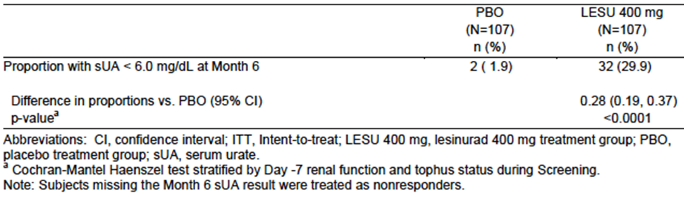
Subjects completing study 303 could enrol in an extension study (Study 305) in which all subjects received lesinurad 400 mg OD for up to 18 months. Efficacy was maintained over this period.
Comment: The efficacy findings of this study are not relevant to the current application. This study examined monotherapy, whereas the application only seeks approval for use in combination with a xanthine oxidase inhibitor. The 400 mg dose used is also higher than that proposed for registration.

Study RDEA594-306
Study 306 was an extension study for those subjects who had completed study 301 or 302. Subjects who had received lesinurad 200 mg or 400 mg in the pivotal studies were maintained on the same dose. Subjects who had received placebo in the pivotal studies were randomised (1:1) to receive either lesinurad 200 mg or lesinurad 400 mg. All subjects continued to receive allopurinol. The first subject enrolled in February 2013 and the study was ongoing at the time of data cut-off (June 2014) for the study report, at which time a total of 714 subjects had been enrolled. The study report was an interim report and no efficacy data were presented.

Study RDEA594-307
Study 307 was an extension study for those subjects who had completed study 304. Subjects who had received lesinurad 200 mg or 400 mg in the pivotal studies were maintained on the same dose. Subjects who had received placebo in the pivotal studies were randomised (1:1) to receive either lesinurad 200 mg or lesinurad 400 mg. All subjects continued to receive febuxostat. The first subject enrolled in March 2013 and the study was ongoing at the time of data cut-off (June 2014) for the study report, at which time a total of 196 subjects had been enrolled. The study report was an interim report and no efficacy data were presented.

Phase 2 studies
Prior to the Phase 3 studies, the sponsor conducted three Phase 2 studies. The first of these was RDEA594-201, which was described as a Phase 2a, pilot pharmacodynamic study. The remaining Phase 2 studies are reviewed in this section.

Study RDEA594-202
This was a Phase 2, randomised double-blind placebo controlled, dose-response study with four parallel groups. The primary objective was to compare the proportion of subjects whose sUA level was < 6.0 mg/dL after 4 weeks of treatment. It was conducted at 30 centres in Europe and North America in 2009-10.
The trial enrolled gout subjects with sUA ≥ 8.0 mg/dL (after a 2-week washout of any existing ULTs). Subjects were randomised (1:1:1:1) to one of four treatment groups:
- Lesinurad 200 mg OD for 28 days;
- Lesinurad 200 mg OD for 7 days, then 400 mg for 21 days;
- Lesinurad 200 mg OD for 7 days, then 400 mg for 7 days; then 600 mg for 14 days;
- Placebo.
Lesinurad was supplied as 100 mg immediate release capsules (FN07). Subjects were not permitted to take concurrent xanthine oxidase inhibitors (i.e. allopurinol or febuxostat). All subjects were treated with colchicine prophylaxis beginning 7-14 days prior to randomised treatment, and continuing for 1 week afterwards.
A total of 123 subjects were enrolled and treated – 31 in group 1, 33 in group 2, 32 in group 3 and 27 in group 4. 108 subjects completed the study. The four groups were reasonably well balanced with respect to balance characteristics.
Results for the primary endpoint are summarised in Table 12. Lesinurad monotherapy (at 400 or 600 mg per day) was superior to placebo in reducing sUA levels to < 6.0 mg/dL. The 200 mg dose was no more effective than placebo.
Table 12. Study 202 – Primary efficacy outcome.
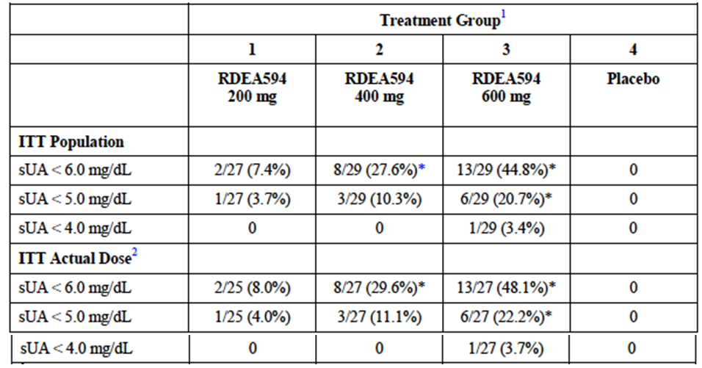
On completion of the study, 50 subjects entered an open-label extension phase, in which all subjects were treated with lesinurad 200-600 mg daily for up to 68 weeks. The sUA response (<6.0 mg/dL) was maintained in the majority of subjects who received 400 or 600 mg.

Study RDEA594-203
This trial was a Phase 2, randomised double-blind placebo controlled study. The primary objective was to assess the percent reduction from baseline in sUA levels following 4 weeks of continuous treatment with lesinurad in combination with allopurinol compared to allopurinol alone (the placebo group) in patients with documented inadequate response with standard doses of allopurinol. The study was conducted at 53 centres in 7 countries in Europe and North America between 2009 and 2011.
The trial enrolled gout subjects who had been receiving allopurinol as sole ULT for at least 6 weeks, at a dose between 200 and 600 mg per day, without an adequate response (i.e. sUA remained > 6.0 mg/dL at screening).
There were several cohorts in the study. Within each cohort subjects were randomised (2:1) to receive lesinurad or placebo. The lesinurad dose for each cohort was as follows:
- Cohorts 1A, 1B, 4: Lesinurad 200 mg OD for 28 days;
- Cohort 2: Lesinurad 200 mg OD for 7 days, then 400 mg OD for 21 days;
- Cohort 3: Lesinurad 200 mg OD for 7 days, then 400 mg for 7 days; then 600 mg for 14 days.
All subjects continued treatment with allopurinol 200-600 mg per day, and were also treated with colchicine prophylaxis beginning 14 days prior to randomised treatment, and continuing for 1 week afterwards.
A total of 208 subjects were enrolled and treated, as follows:
- 20 (13 lesinurad, 7 placebo) in Cohort 1A (200 mg)
- 20 (14 lesinurad, 6 placebo) in Cohort 1B (200 mg)
- 65 (42 lesinurad, 23 placebo) in Cohort 2 (400 mg)
- 75 (48 lesinurad, 27 placebo) in Cohort 3 (600 mg)
- 28 (19 lesinurad, 9 placebo) in Cohort 4 (200 mg)
The various treatment groups were reasonably well balanced with respect to baseline factors.
The results for the primary efficacy outcome are summarised in Table 13. For all lesinurad dosages, the per cent reduction from baseline in sUA levels was significantly greater than placebo. Reductions were dose related.
Table 13. Study 203 – Primary efficacy outcome.
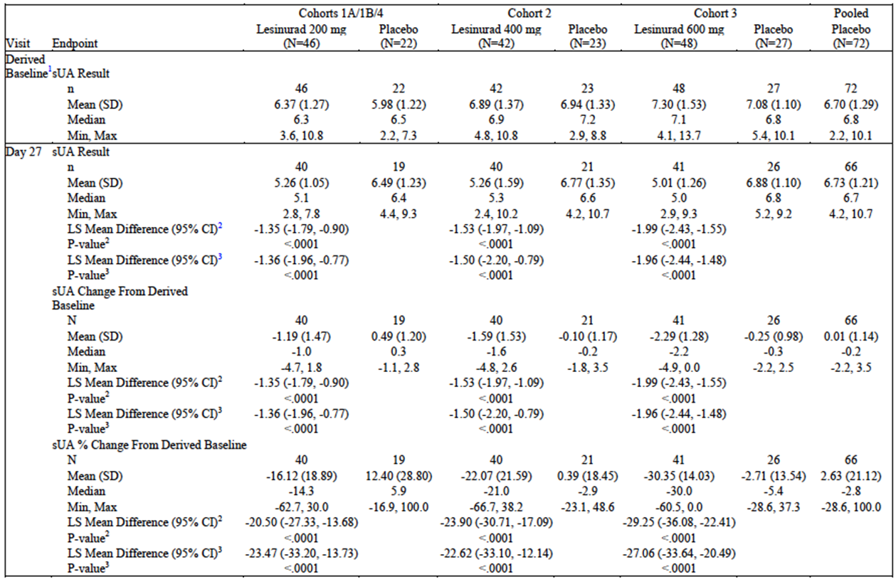
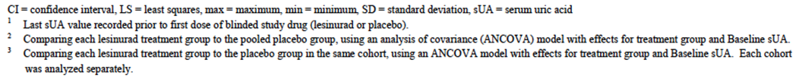

Double-blind extension phase
Subjects who completed study 203 could enter a double-blind extension period. All subjects in the double-blind extension period continued allopurinol at the same dose level as during the core study (200 to 600 mg OD) and received the same study medication (lesinurad or placebo) as in the core study. All subjects began treatment with lesinurad at 200 mg OD or matching placebo. Subjects then had the dose of lesinurad or matching placebo adjusted to 400 mg OD and to 600 mg OD based on sUA levels. Colchicine prophylaxis was used up to week 20. The extension study continued for up to 44 weeks.
A total of 126 subjects entered the extension phase and received treatment – 78 in the lesinurad group and 48 in the placebo group.
Results in terms of per cent reduction in sUA are illustrated in Figure 15. Reductions in sUA concentrations achieved with lesinurad were greater than those achieved with placebo, and were maintained over the period of the study. Differences between treatments were no subjected to statistical testing.
Figure 15. Study 203 (Double-blind extension phase) – Percent reduction in sUA.
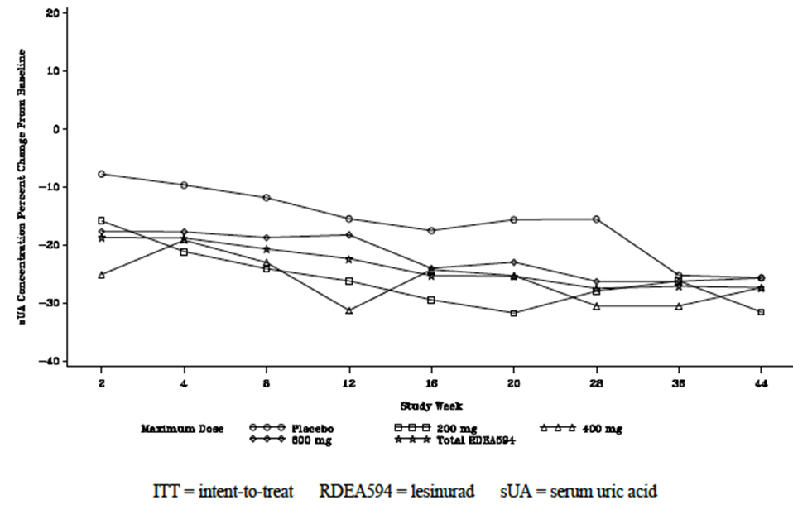

Open-label extension phase
Subjects who completed the double-blind extension phase could enter an open-label extension phase. Subjects previously treated with placebo (i.e. allopurinol alone) were commenced on lesinurad 200 mg if the sUA was > 6.0 mg/dL at any time. Treatment could continue indefinitely. All subjects continued to receive allopurinol.
A total of 87 subjects entered the study. 54 subjects continued with lesinurad, 25 subjects commenced lesinurad after previously receiving allopurinol alone and 8 subjects remained on allopurinol alone.
sUA concentrations were lower in subjects receiving lesinurad than those receiving allopurinol alone. Mean reductions in sUA concentrations were maintained over the duration of the study (up to 30 months).

Analyses performed across trials (pooled & meta analyses)
Pooled analyses of efficacy data from studies 301 and 302 have been presented above where appropriate. Otherwise there were no pooled analyses or meta-analyses presented in the submission.

Evaluator’s conclusions on clinical efficacy
The three pivotal studies were well designed and executed. They have demonstrated that, when used in combination with a XO inhibitor (allopurinol of febuxostat), lesinurad is significantly better than placebo in lowering sUA concentrations to target levels of < 5 mg/dL (300 μmol/L) or < 6 mg/dL (360 μmol/L). These findings were supported by a phase 2 study (study 203).
The magnitude of the demonstrated efficacy benefit is considered to be clinically significant as control of hyperuricaemia is achieved in an additional 25-30% of subjects with the proposed 200 mg dose used in combination with allopurinol. When used in combination with febuxostat the figure was approximately 20%.
In Study 304, there was some evidence that lesinurad may result in a significant reduction in the total surface area of gouty tophi. However none of the studies demonstrated an advantage in terms of complete resolution of individual tophi. There were also no benefits demonstrated in terms of reduction in the occurrence of gout flares and no meaningful benefits were demonstrated for lesinurad on a variety of patient reported outcomes.
Evidence for the efficacy of lesinurad is therefore largely based on reductions in sUA concentrations. This is a surrogate endpoint for efficacy. There do not appear to be any current EMA or FDA guidance documents relating to appropriate endpoints for gout/hyperuricaemia clinical trials. However, it is noted that the TGA approval for febuxostat appears to have been based on reductions in sUA concentrations.
The effect on sUA concentrations was sustained over the 12 month period studied in the pivotal studies, and the open label extension of Study 203 suggested that efficacy is sustained for even longer periods. Long term efficacy has therefore been satisfactorily demonstrated.
In Studies 301 and 302, efficacy was demonstrated in most subgroups examined, including subjects with mild to moderate renal impairment. Although there was a trend towards reduced efficacy in females in these studies, there was a trend towards increased efficacy in females in Study 304. These inconsistent findings are probably due to the small numbers of females enrolled in all the pivotal studies.
The only comparator used in the efficacy studies was placebo. There are no efficacy (or PD) data to establish that lesinurad has an efficacy advantage over probenecid.
Overall, the evidence to support the efficacy of lesinurad for the proposed indication is considered adequate.

Clinical safety

Studies providing safety data
The following studies provided evaluable safety data:

Pivotal efficacy studies
In the pivotal efficacy studies, the following safety data were collected:
- General adverse events (AEs) were assessed at each study visit. Severity of AEs was graded using Rheumatology Common Toxicity Criteria (RCTC), Version 2.0. Serious AEs (SAEs) were defined. All AEs were classified as not related, unlikely to be related or possibly related to study medication. AEs were reported using the Medical Dictionary for Regulatory Activities (MedDRA) terminology.
- AEs of particular interest were renal AEs and cardiovascular AEs.
- Laboratory tests were generally performed at monthly intervals. Tests performed included the following:
  - Haematology: Haematocrit (Hct), haemoglobin (Hgb), mean corpuscular haemoglobin (MCH), mean corpuscular haemoglobin concentration (MCHC), mean corpuscular volume (MCV), platelet count, red blood cell (RBC) count, and white blood cell (WBC) count with differential.
  - Biochemistry: Albumin, alkaline phosphatase, ALT, AST, amylase, urea, calcium, carbon dioxide, chloride, creatinine, CK, C-reactive protein (CRP), GGT, glucose, lactate dehydrogenase (LDH), phosphate, potassium, sodium, total bilirubin, direct bilirubin, total cholesterol, total protein and triglycerides.
  - Urinalysis: Appearance, bilirubin, colour, glucose, ketones, microscopic examination of sediment, nitrite, occult blood, pH, protein, specific gravity, and urobilinogen.
- 12 lead ECGs were collected at baseline, Month 6 and Month 12.
- Vital signs (temperature, systolic and diastolic blood pressure, pulse rate, and respiratory rate) were measured at each study visit.
- Physical examination was performed at baseline and at Month 12.

Pivotal studies that assessed safety as a primary outcome
There were no pivotal studies that assessed safety as a primary outcome.

Dose response and non-pivotal efficacy studies
The dose response and non-pivotal efficacy studies provided safety data. In general, safety monitoring was similar to that undertaken in the pivotal studies.

Patient exposure
A total of 2,586 unique individuals were exposed to lesinurad in the submitted studies.
A total of 1,799 unique gout subjects were exposed to lesinurad in the phase 2 and phase 3 studies. Of these, total of 1,224 subjects were exposed for approximately 6 months (at least 24 weeks), and 919 were exposed for approximately 1 year (at least 48 weeks).
Exposure to lesinurad and placebo is summarised in Table 14 below.
Table 14. Exposure to lesinurad and placebo in clinical studies.
Study type/Indication | Controlled studies |  | Uncontrolledstudies | Total  Lesinurad
 | Lesinurad | Placebo | Lesinurad
Clinical pharmacology
- Phase I studies | - | - | - | 687
- Special populations | - | - | - | 100
Gout
Combination with XO inhibitor
- Studies 301, 302, 304 | 1021 | 516 | - | 1021
- Study 306 | - | - | 715⁽¹⁾ | 715⁽¹⁾
- Study 307 | - | - | 196⁽¹⁾ | 196⁽¹⁾
- Study 203 (core period) | 136 | 72 | - | 136
- Study 203 (DB extension) | 78 | 48 | - | 78⁽¹⁾
- Study 203 (open extension) | - | - | 79 | 79⁽¹⁾
Monotherapy
- Study 303 | 107 | 107 | - | 107
- Study 305 | - | - | 143⁽¹⁾ | 143⁽¹⁾
- Study 202 (core period) | 96 | 27 | - | 96
- Study 202 (open extension) | - | - | 50⁽¹⁾ | 50⁽¹⁾
Total gout subjects |  |  |  | 1799⁽²⁾
TOTAL | 1438 | 770 | 1183 | 2586⁽²⁾
⁽¹⁾ A proportion of these subjects had also received lesinurad in the preceding controlled study.
⁽²⁾ Unique subjects

Adverse events
An overall summary of the incidence of AEs in the pivotal studies 301, 302 and 304 is shown in Table 15.
Table 15. Studies 301, 302 and 304 – Overall summary of AEs.
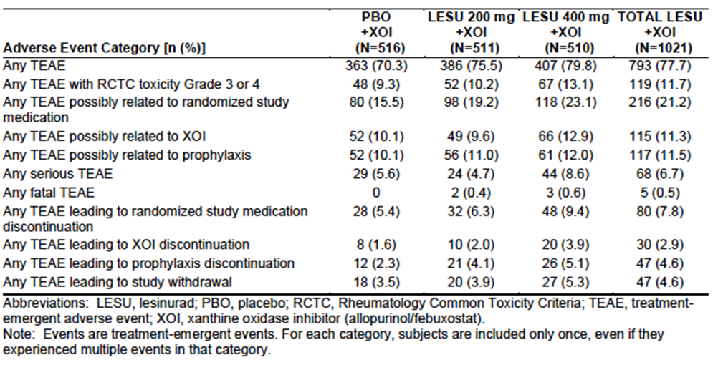

All adverse events (irrespective of relationship to study treatment)

Pivotal studies (301, 302 and 304)
The overall incidence of any AE was 77.7% with lesinurad and 70.3% with placebo. Common AEs (those occurring with an incidence of ≥ 2% in either lesinurad group) are summarised in Table 16.
Comment: Creatinine increases were reported more frequently as AEs (6.1% with lesinurad vs. 2.3% with placebo). The incidence was dose related (4.3% at 200 mg vs. 7.8% at 400 mg). Blood urea increases were also more commonly reported with lesinurad (1.4% vs. 0.6%). Headache, dizziness and hypertension were also slightly more common with lesinurad.
Table 16. Studies 301, 302 and 304 – Common AEs (incidence ≥ 2%).
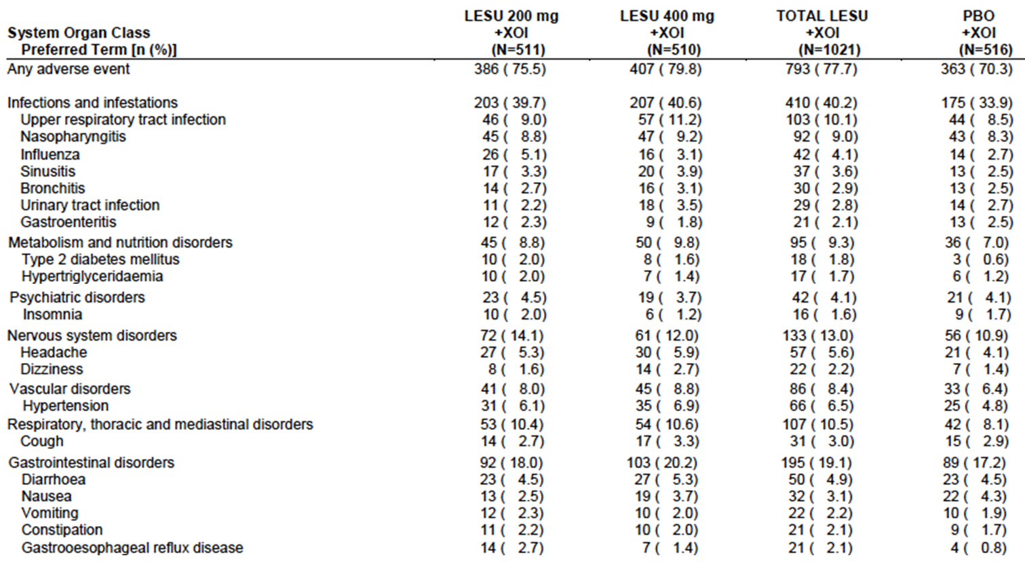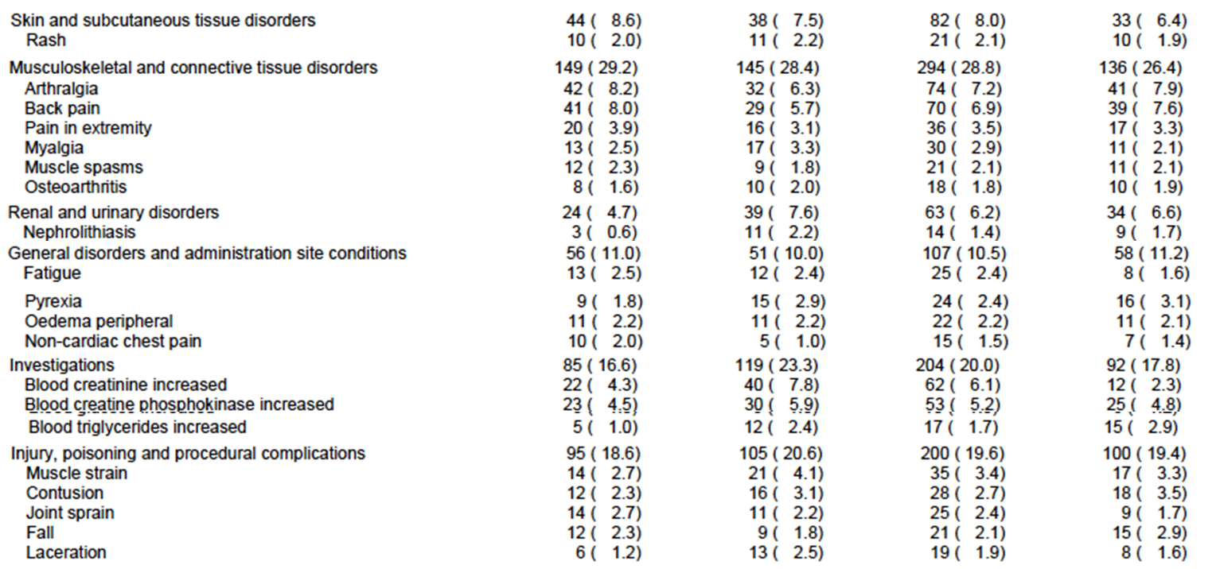
Most of the AEs were rated as mild or moderate in severity (Table 17).
Table 17. Studies 301, 302 and 304 – AEs by severity.
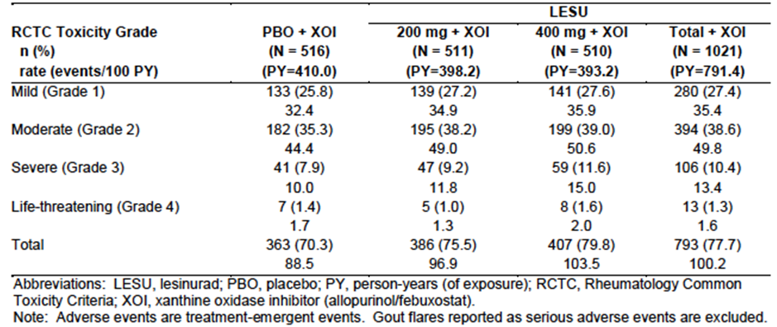

Other studies

Studies 306 and 307
The sponsor presented exposure-adjusted incidence rates for AEs reported over the period of the pivotal core and the long-term extension studies combined. Common AEs and their incidence rates were comparable to those seen in the pivotal studies.

Study 203 (Core and double-blind extension)
The type and frequency of AEs observed in this study were comparable to those seen in the pivotal studies. AEs that were more frequent with lesinurad treatment included the following (numbers are subjects with the event per 100 patient years [100PY]):
- Upper respiratory infection – 11.5 for all lesinurad doses combined vs. 7.3 for placebo;
- Type 2 diabetes – 10.1 vs. 2.4;
- Hypertension – 11.5 vs. 2.4;
- Creatinine increased – 11.5 vs. 7.3.
The event incidence rate for any AE was 119.3 subjects/100PY for lesinurad vs. 109.9 subjects/100PY for placebo.

Study 303 (Phase 3 monotherapy study)
The overall incidence of any AE was 77.6% with lesinurad and 65.4% with placebo. AEs occurring more commonly in the lesinurad group are summarised in Table 18.
Comment: Renal toxicity was a notable observation in the lesinurad group with reports of renal impairment/failure and an incidence of increased creatinine of 8.4%.
Table 18. Study 303 – Common AEs (incidence higher than placebo by at least 2).
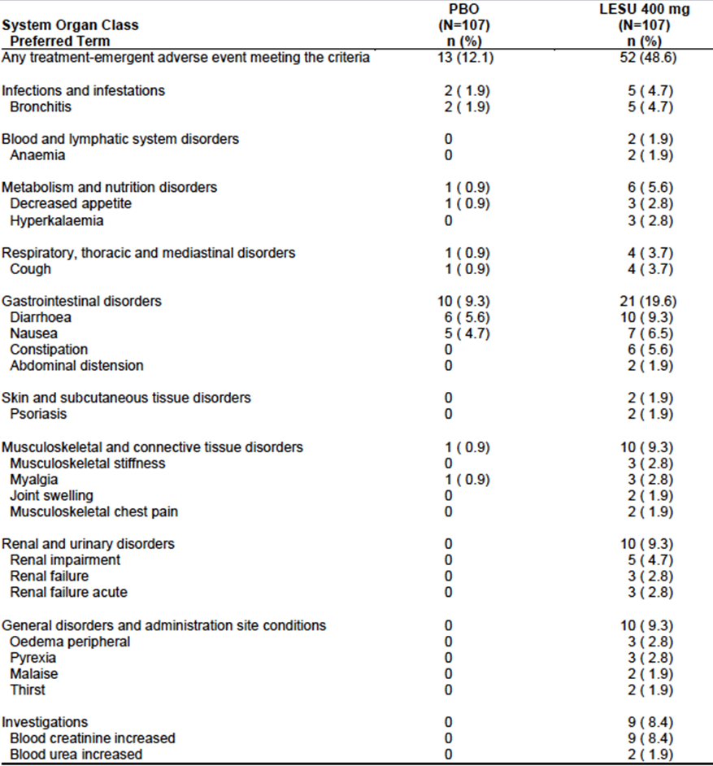

Treatment-related adverse events (adverse drug reactions)

Pivotal studies (301, 302 and 304)
The overall incidence of any AE possibly related to randomised study medication was 21.2% with lesinurad and 15.5% with placebo. The incidence of individual AE terms was low in all groups – generally < 1%. The only AEs that occurred with an incidence > 1% and were more common with lesinurad are shown in Table 19.
Table 19. AEs that occurred with an incidence > 1% and were more common with lesinurad.
 | Lesinurad  200 mg | Lesinurad  400 mg | Lesinurad  All | Placebo
N | 511 | 510 | 1021 | 516
Headache | 1.0 | 2.0 | 1.5 | 0.2
Diarrhoea | 0.8 | 1.4 | 1.1 | 0.4
Blood creatinine increased | 3.1 | 5.7 | 4.4 | 1.7
Blood CPK increased | 2.0 | 2.7 | 2.4 | 1.6
Renal impairment (0.3% vs. 0%), renal failure (0.8% vs. 0.2%) and acute renal failure (0.2% vs. 0%) were also more common with lesinurad.

Other studies

Studies 306 and 307
Exposure-adjusted incidence rates, for AEs reported over the period of the pivotal core and the long-term extension studies combined, were comparable to incidence rates observed in the core studies. The pattern of AEs was also comparable to that observed in the pivotal studies.

Study 203 (Core and double-blind extension)
The incidence event rate for any possibly related AE was 41.7 subjects/100PY for lesinurad vs. 43.9 subjects/100PY for placebo. AE incidence event rates that were higher with lesinurad included the following:
- Blood creatinine increased – 8.6 subjects vs. 2.4 subjects/100PY.

Study 303 (Phase 3 monotherapy study)
The overall incidence of any possibly related AE was 29.9% with lesinurad and 10.3% with placebo. Renal events were notably more frequent in the lesinurad group.

Deaths and other serious adverse events

Deaths
There were a total of 13 deaths in the lesinurad clinical development program. These are listed in Table 20.
- During the four randomised placebo controlled phase 3 trials there were a total of six deaths (1 in study 301; 2 in study 302; 2 in study 304; and 1 in study 303). Another death occurred in the placebo controlled double blind extension phase of study 203. All these deaths occurred in the lesinurad arms of the studies. There were no deaths during placebo treatment.
Comment: In the pivotal combination studies (301/302/304), and in study 203, there were 2 patients randomised to lesinurad for every 1 patient randomised to placebo. In the phase 3 monotherapy study subjects were randomised 1:1. If the deaths were unrelated to randomised treatment, 4 deaths would have been expected in subjects receiving placebo. This raises a concern that lesinurad toxicity may be responsible for the imbalance.
- Another five deaths occurred in the phase 3 long-term extension studies (3 in study 306; 1 in study 307; and 1 in study 305). All subjects in these studies were receiving lesinurad.
- The remaining death, a case of suicide, occurred in a clinical pharmacology study (study 118).
- As shown in Table 20, most of the deaths were due to cardiovascular or cerebrovascular events.
Table 20. Deaths in the lesinurad clinical trials.
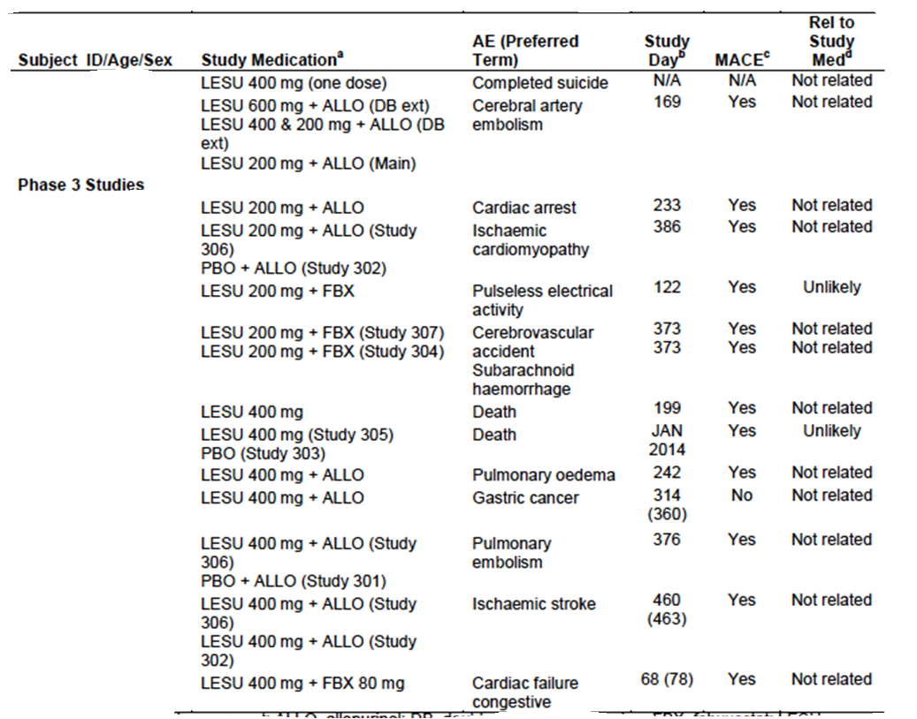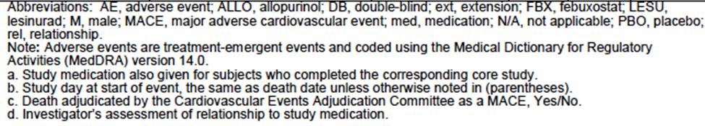

Serious AEs (SAEs)

Pivotal studies (301, 302 and 304)
The overall incidence of any SAE was 6.7% with lesinurad and 5.6% with placebo. SAEs occurring in more than 1 lesinurad-treated subject are summarised in Table 21. Serious cardiac AEs were notably more common with lesinurad (2.4% vs. 0.4%).
Table 21. Studies 301, 302 and 304 – Serious AEs (incidence with lesinurad > n=1).
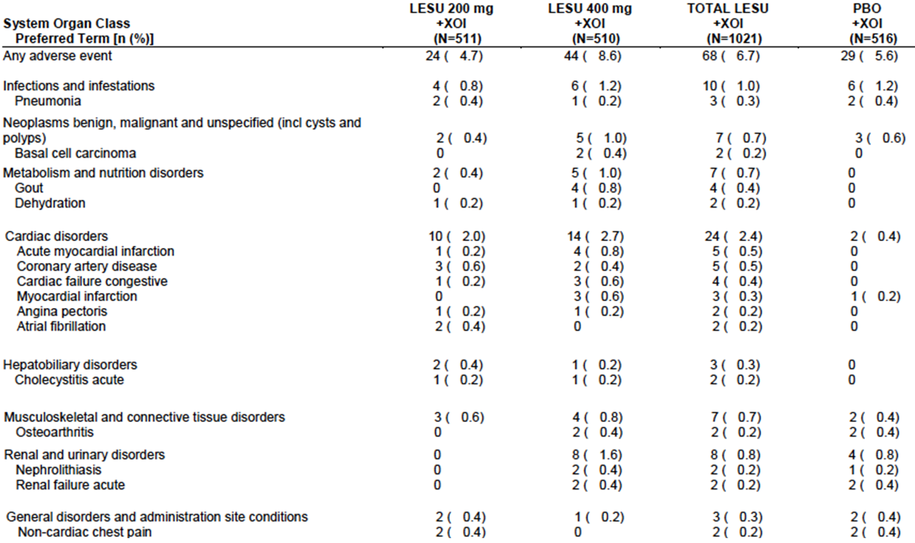

Other studies

Studies 306 and 307
Exposure-adjusted incidence rates, for SAEs reported over the period of the pivotal core and the long-term extension studies combined, were comparable to incidence rates observed in the core studies. For all lesinurad doses, 8.6 subjects experienced an SAE per 100 person-years. The rate was 7.1 for the 200 mg dose and 10.1 for the 400 mg dose. The pattern of SAEs was comparable to that observed in the pivotal studies. Cardiac SAEs were again the most common (2.6 subjects per 100 person-years).

Study 203 (Core and double-blind extension)
The incidence event rate for any SAE was 4.3 subjects/100PY for lesinurad vs. 2.4 subjects/100PY for placebo. No SAE occurred in more than 1 subject. In the lesinurad groups, there was one SAE of cerebral artery aneurysm and one of angina pectoris. There were no cardiovascular or cerebrovascular SAEs reported with placebo.

Study 303 (Phase 3 monotherapy study)
The overall incidence of SAEs was 8.4% with lesinurad and 3.7% with placebo. SAEs are summarised in Table 22. Renal events were again notably more frequent in the lesinurad group. There was no increase in incidence of cardiovascular or cerebrovascular SAEs with lesinurad.
Table 22. Study 303 – Serious AEs.
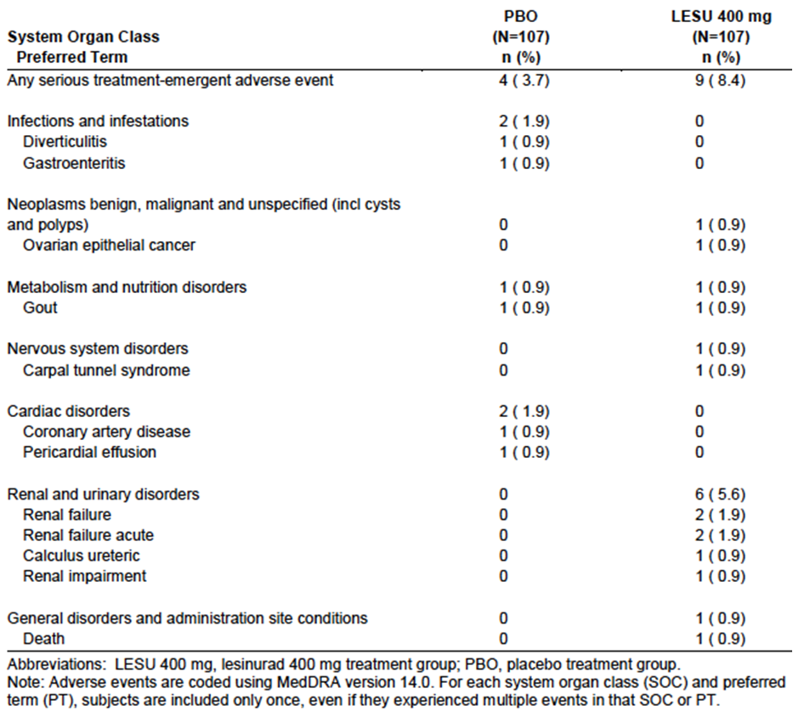

Discontinuation due to adverse events

Pivotal studies (301, 302 and 304)
The overall incidence of AEs leading to discontinuation of randomised study medication was 7.8% with lesinurad and 5.4% with placebo. AEs leading to discontinuation that occurred in more than 1 lesinurad-treated subject are summarised in Table 23. Renal impairment leading to discontinuation was notably more common with lesinurad. Cardiac AEs leading to discontinuation occurred in 0.6% of subjects with lesinurad and 0.4% of subjects with placebo.
Table 23. Studies 301, 302 and 304 –AEs leading to discontinuation (incidence with lesinurad > n=1).
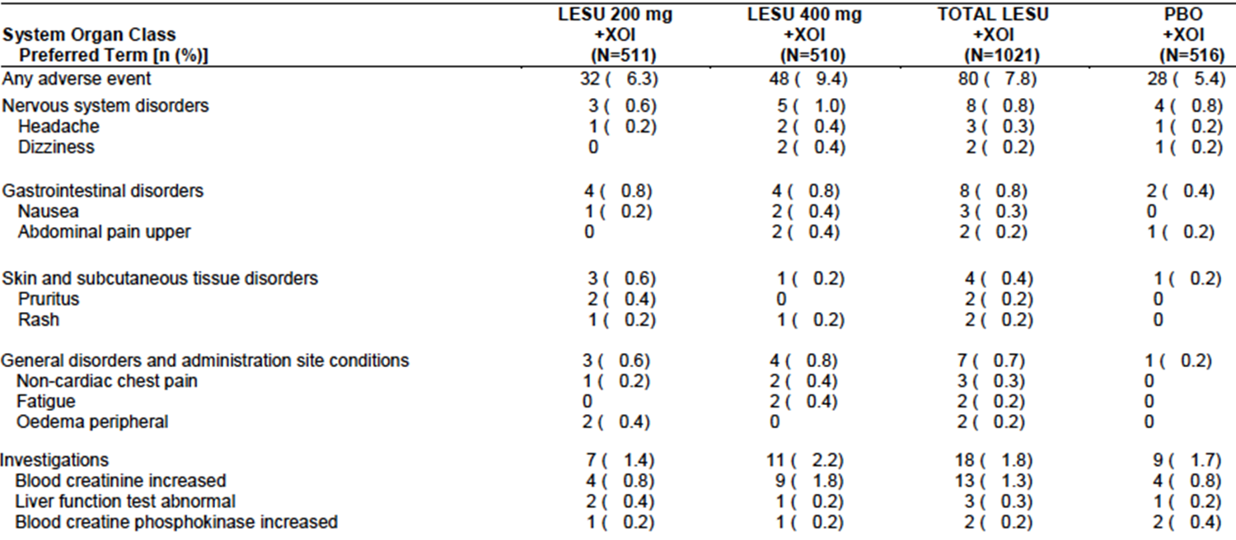

Other studies

Studies 306 and 307
Exposure-adjusted incidence rates, for AEs leading to discontinuation, reported over the period of the pivotal core and the long-term extension studies combined, were comparable to incidence rates observed in the core studies. For all lesinurad doses, 8.8 subjects experienced an AE leading to discontinuation per 100 person-years. The rate was 7.5 for the 200 mg dose and 10.1 for the 400 mg dose. The pattern of AEs leading to discontinuation was comparable to that observed in the pivotal studies.

Study 203 (Core and double-blind extension)
The incidence event rate for any AE leading to discontinuation was 11.5 subjects/100PY for lesinurad vs. 7.3 subjects/100PY for placebo. Increased creatinine leading to discontinuation occurred in 2 lesinurad-treated subjects (2.9%) and 1 placebo-treated subject (2.4%). Otherwise no AE led to discontinuation in more than 1 subject. In the lesinurad groups, there was only one cardiac AE that led to discontinuation (atrial fibrillation). There were no cardiovascular or cerebrovascular AEs leading to discontinuation in the placebo groups.

Study 303 (Phase 3 monotherapy study)
The overall incidence of AEs leading to discontinuation was 18.7% with lesinurad and 5.6% with placebo. Renal events were again notably more frequent in the lesinurad group. There was no increase in incidence of cardiovascular or cerebrovascular AEs leading to discontinuation with lesinurad.

Laboratory tests

Liver function

Pivotal studies (301, 302 and 304)
There was no increased incidence of abnormal LFTs with lesinurad treatment. There were no cases that met Hy’s law criteria for severe drug-induced liver injury.
An analysis of hepatic adverse events using a Standardised MedDRA Query (SMQ) demonstrated a comparable incidence in the three treatment groups – 5.6% with placebo, 4.7% with 200 mg and 3.7% with 400 mg.

Other studies

Studies 306 and 307
There was no discernable increase in the incidence of LFT abnormalities with ongoing long-term treatment in these studies. There were no cases that met Hy’s law criteria.

Study 203 (Core and double-blind extension)
The incidences of abnormal ALT and AST values were comparable in the lesinurad and placebo treatment groups. There were no cases that met Hy’s law criteria.

Study 303 (Phase 3 monotherapy study)
The incidences of abnormal ALT and AST values were comparable in the lesinurad and placebo treatment groups. Grade 3 or 4 abnormalities were rare. There were no cases that met Hy’s law criteria.

Kidney function
Renal toxicity was a safety issue of special interest. The sponsor prepared a specific report on renal safety issues, including laboratory testing of renal function.

Creatine kinase

Pivotal studies (301, 302 and 304)
Abnormalities of creatine kinase (CPK) occurred with comparable frequency in the three treatment arms. The incidence of CPK elevations > 5x ULN was 3.3% with 200 mg, 3.1% with 400 mg and 4.1% with placebo.

Other studies

Studies 306 and 307
There was no notable increase in the incidence of CPK elevations with ongoing long-term treatment in these studies.

Study 203 (Core and double-blind extension)
There were no notable differences in the incidence of CPK elevations.

Study 303 (Phase 3 monotherapy study)
Abnormalities of CPK occurred with comparable frequency in the lesinurad and placebo treatment arms.
Comment: Isolated cases of elevated CPK/rhabdomyolysis were observed in the clinical pharmacology studies. The above laboratory data indicate that lesinurad is not associated with an increased risk of muscle toxicity compared to placebo.

Lipids

Pivotal studies (301, 302 and 304)
Mean percent change from baseline to last visit for cholesterol and triglycerides were small (generally < 5%) and comparable in the three treatment groups.

Other studies

Studies 306 and 307
There was no notable increase in the incidence of lipid elevations with ongoing long-term treatment in these studies.

Study 203 (Core and double-blind extension)
There were no notable differences in the incidence of lipid elevations between lesinurad and placebo groups.

Study 303 (Phase 3 monotherapy study)
Lipid elevations occurred with comparable frequency in the lesinurad and placebo treatment arms.

Other clinical chemistry

Pivotal studies (301, 302 and 304)
Abnormalities of calcium, glucose, potassium and sodium occurred with comparable frequency in the three treatment arms.

Other studies

Studies 306 and 307
There was no notable increase in the incidence of electrolyte abnormalities with ongoing long-term treatment in these studies.

Study 203 (Core and double-blind extension)
There were no notable differences in the incidence of abnormalities on testing the following: albumin, amylase, lipase, calcium, glucose, magnesium, phosphate, sodium and potassium Grade 3 or 4 abnormalities were rare.

Study 303 (Phase 3 monotherapy study)
Abnormalities of calcium, glucose, potassium and sodium occurred with comparable frequency in the lesinurad and placebo treatment arms.

Haematology

Pivotal studies (301, 302 and 304)
Grade 3 or 4 abnormalities in haematology parameters occurred infrequently, and with a comparable incidence in the lesinurad and placebo groups.

Other studies

Studies 306 and 307
There were no notable increases in the incidence of grade 3 or 4 abnormalities in haematology parameters among subjects who continued treatment with lesinurad in these studies.

Study 203 (Core and double-blind extension)
Abnormalities in haematology parameters occurred infrequently, and with a comparable incidence in the lesinurad and placebo groups.

Study 303 (Phase 3 monotherapy study)
Abnormalities in haemoglobin were more frequent in the lesinurad arm (grade 3: 11.2% vs. 1.9%; grade 4: 3.7% vs. 1.9%). Similar differences were noted for haematocrit and red cell count. There were no differences between lesinurad and placebo groups for white cells or platelets.

Electrocardiograph

Pivotal studies (301, 302 and 304)
In the pivotal studies the incidence of ECG abnormalities reported as AEs was not increased with lesinurad.

Other studies

Studies 306 and 307
ECG monitoring was not performed in the extension studies.

Study 203 (Core and double-blind extension)
The incidence of ECG-associated AEs was low and comparable between the lesinurad and placebo groups (0.7% versus 1.4% respectively).

Study 303 (Phase 3 monotherapy study)
No ECG-associated AEs were reported.

Vital signs

Pivotal studies (301, 302 and 304)
Clinically significant abnormalities in vital signs occurred with comparable frequency in the three treatment arms.

Other studies
There were no indications of an effect of lesinurad on vital signs in the other studies.

Safety issues of special interest

Renal safety

Renal-related AEs
The sponsor analysed the incidence of “renal-related AEs” using a list of MedDRA preferred terms suggestive of a decline in renal function. Results for the pivotal studies are shown in Table 24. There was an increased incidence of such events in the 400 mg dose group compared to placebo (11.8% vs. 4.5%). The incidence in the 200 mg dose group was slightly increased compared to placebo (5.7% vs. 4.5%), due to an increased incidence of serum creatinine and blood urea elevations. Reports of ‘renal failure’ or ‘renal impairment’ were not increased in the 200 mg dose arm compared to placebo. There was no notable difference in incidence between the allopurinol studies (301 and 302) and the febuxostat study (304).
Table 24. Studies 301, 302 and 304 – Renal-related AEs.
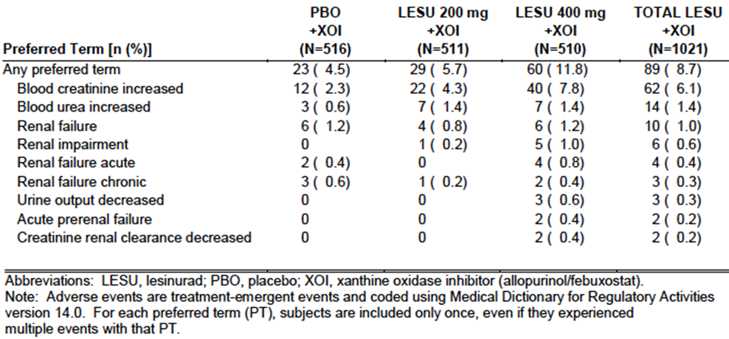
In the long-term extension studies (306 and 307) there was no evidence of an increasing incidence of renal-related AEs with increasing duration of lesinurad treatment.
In the core and double blind extension phases of study 203 the incidence of renal-related AEs was 4.2% for placebo, 1.5% for 200 mg, 4.8% for 400 mg and 4.5% for 600 mg.
In the phase 3 monotherapy study (303), the incidence of renal-related AEs was markedly higher in the lesinurad group than in the placebo group (17.8% vs. 0% [Table 25]).
Table 25. Study 303 - Renal-related AEs.
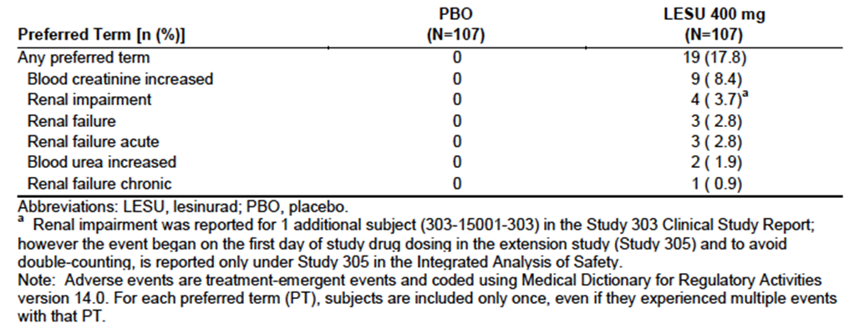

Serious renal-related AEs
Serious renal-related AEs that occurred in the pivotal studies are listed in Table 26. Incidence was comparable in the placebo and 200 mg groups.
Table 26. Studies 301, 302 and 304 – Renal-related serious AEs.
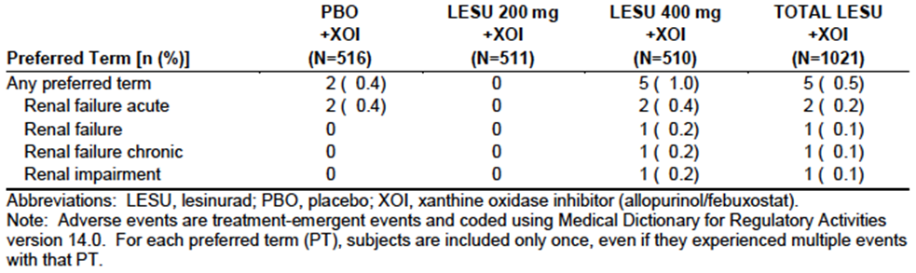
In the long-term extension studies (306 and 307), 4 subjects on 200 mg, and a further 4 subjects on 400 mg, developed renal impairment/failure. There were no serious renal-related AEs in study 203. In the phase 3 monotherapy study the incidence of serious renal-related AEs was 0% with placebo and 4.7% with lesinurad.

Kidney stone AEs
The sponsor analysed the incidence of renal calculi using another list of MedDRA preferred terms. In the pivotal studies, the risk of such events was not increased with the 200 mg lesinurad dose.
In the long-term extension studies (306 and 307) there was no evidence of an increasing incidence of kidney stones with increasing duration of lesinurad treatment. There was no increased incidence of kidney stone AEs in study 203. In the phase 3 monotherapy study the incidence of kidney stone AEs was 0% for placebo and 0.9% for lesinurad.

Serum creatinine
Serum creatinine elevations ≥ 1.5 x Baseline, ≥ 2.0 x Baseline, and ≥ 3.0 x Baseline were analysed. In the pivotal studies, such elevations were more frequent with lesinurad than with placebo and more common with the 400 mg dose compared to the 200 mg dose. Most of the elevation resolved within 84 days (3 months).
Figure 16 shows the cumulative incidence of serum creatinine elevations (≥ 2.0 x baseline) in the three pivotal studies and their long-term extension studies (306 and 307). The cumulative incidence rose with increasing duration of treatment.
Figure 16. Studies 301, 302, 304, 306 and 307 – Cumulative incidence of serum creatinine ≥ 2.0 x baseline.
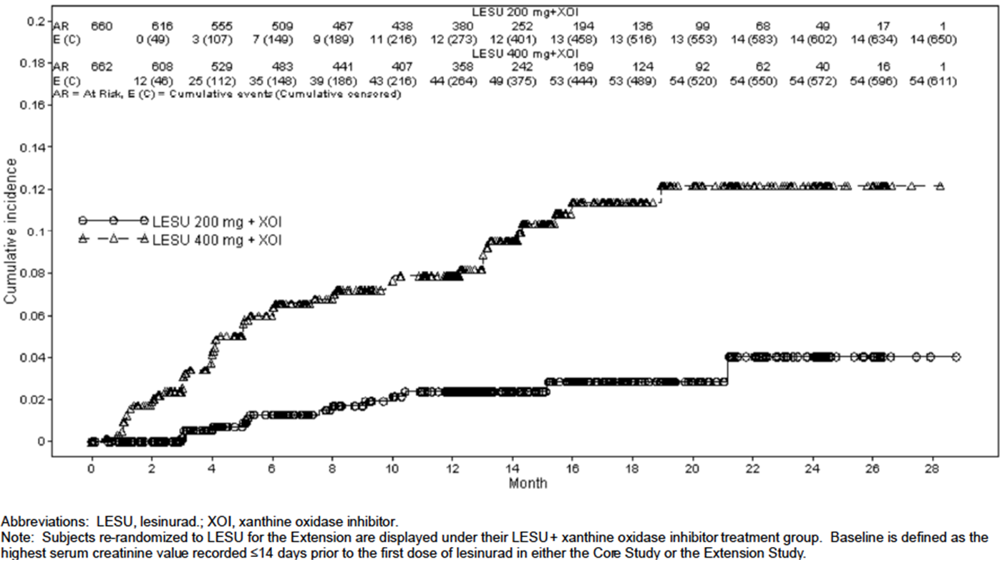
In study 203 the incidence of serum creatinine elevations (≥ 1.5 x Baseline) was higher for subjects who received any dose of lesinurad (13.2%) than for subjects who received placebo (2.8%).
In study 303, elevations in serum creatinine were again more common in the lesinurad group (Table 27).
Table 27. Study 303– Serum creatinine elevations.
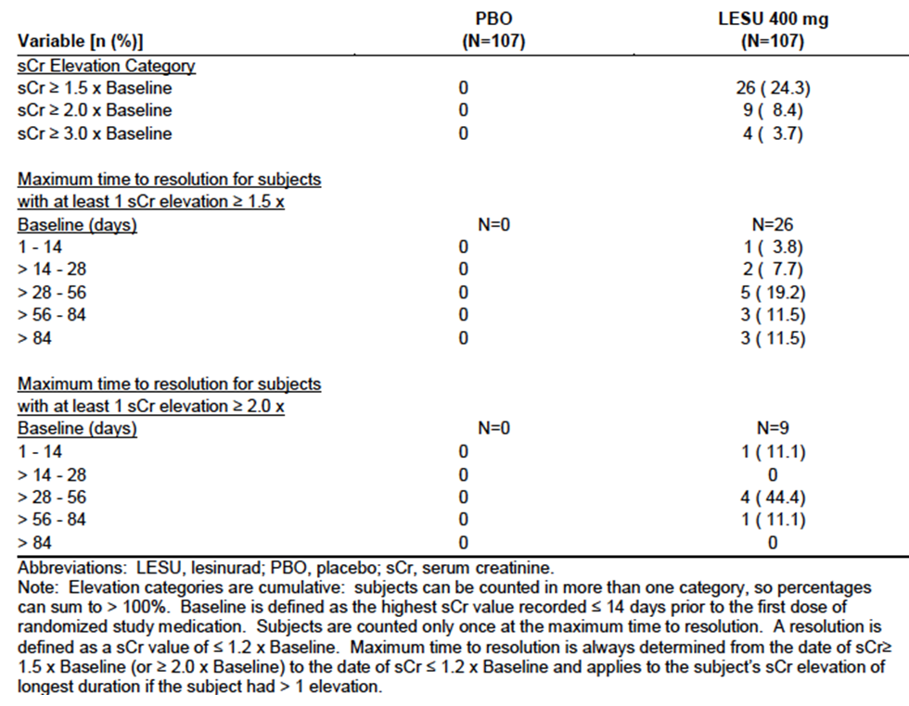

Blood urea nitrogen
Changes in BUN were consistent with those described for serum creatinine.
Comment: Renal toxicity was more common with the 400 mg dose compared to the 200 mg dose in the pivotal studies. For this reason the sponsor has elected to pursue registration of the 200 mg dose only. The sponsor is also not seeking approval for lesinurad monotherapy due to the increased level of renal toxicity seen in study 303.

Cardiovascular safety
According to the sponsor, in preclinical safety pharmacology studies, lesinurad demonstrated no potential for cardiovascular adverse effects at relevant human exposures.
A thorough QT interval study demonstrated that lesinurad did not cause QT interval prolongation and had no other significant effects on ECG.

Cardiovascular AEs

Pivotal studies
At baseline, a high proportion of subjects (78%) had cardiovascular co-morbidities or a history of cardiovascular disease (Table 28). It should be noted that subjects with a recent history of significant cardiovascular events were excluded from these studies.
Table 28. Studies 301, 302 and 304 – Cardiovascular comorbidities at baseline.
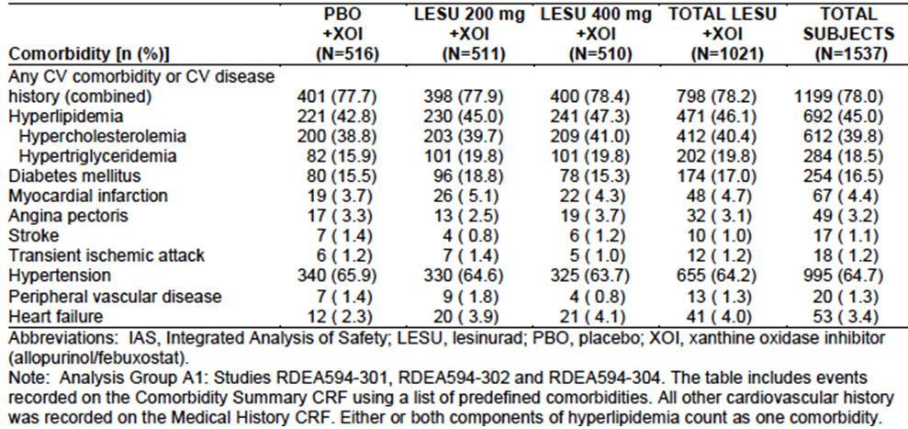
Comparing the placebo group with the 200 mg group, there was no increase in cardiac AEs, and a small increase in the incidence of vascular AEs (8.0% vs. 6.4%). The increase was largely due to more reports of hypertension as an AE (6.1% vs. 4.8%).
There was a slight increase in the incidence of cardiac SAEs with lesinurad (2.0% with 200 mg vs. 0.4% with placebo). The incidence of cardiovascular AEs leading to discontinuation was comparable in the three treatment arms (0.4% with placebo, 0.6% in both lesinurad groups).

Studies 306 and 307
For the total period of the pivotal core and extension studies, the exposure-adjusted incidence rate for cardiac AEs in subjects who received 200 mg was 3.8 subjects per 100PY. For vascular AEs it was 8.5 subjects per 100PY. These rates are comparable to those seen during the 1-year core studies, suggesting that the incidence rate does not increase with increasing exposure.

Study 203 (Core and double-blind extension)
There were 3 cardiac events – 1 angina (serious), 1 atrial fibrillation and 1 palpitations - among lesinurad-treated subjects (incidence rate = 4.3 subjects per 100PY). There were no cardiac events among placebo-treated subjects. For vascular events, there were 9 events (12.9 subjects per 100PY) with lesinurad compared to 1 event (2.4 subjects per 100PY) with placebo. All the vascular AEs were reports of hypertension. There was also one case of fatal cerebral artery embolism, which was classified as a neurological event.

Study 303 (Phase 3 monotherapy study)
The incidence of cardiac disorders was lower in the lesinurad group (1.9%) than the placebo group (2.8%). This was also true for serious cardiac AEs (0% vs. 1.9%). The incidence of vascular disorders was also lower in the lesinurad group (6.5%) than the placebo group (8.4%). There were no serious vascular AEs.

Cardiovascular deaths
As shown in Table 20, 11 of the 13 deaths in the lesinurad clinical development program were cardiovascular in nature. The occurrence of these 11 deaths by treatment is summarised in Table 29. A total of 6 cardiovascular deaths occurred in placebo-controlled studies. All of these deaths occurred with lesinurad and none with placebo. If the cardiovascular deaths were unrelated to lesinurad, a total of 3-4 cardiovascular deaths would have been expected among placebo-treated subjects.
Table 29. Studies 301, 302 and 304 – Cardiovascular deaths.
 | Placebo | Lesinurad  200 mg | Lesinurad  400 mg | Lesinurad  Total
Placebo-controlled studies
Combination treatment
301 | 0 | 1 | 0 | 1
302 | 0 | 0 | 1 | 1
304 | 0 | 1 | 1 | 2
203 | 0 | 0 | 1* | 1
Monotherapy
303 | 0 | NA | 1 | 1
TOTALS | 0 | 2 | 4 | 6
Other studies
Combination treatment
306 | NA | 1 | 2 | 3
307 | NA | 1 | 0 | 1
Monotherapy
305 | NA | NA | 1 | 1
TOTALS | NA | 2 | 3 | 5
* The subject who died in study 203 received doses between 200 – 600 mg OD. At the time of death, the patient was receiving 600 mg OD.
Only two of the cardiovascular deaths in the placebo-controlled trials occurred with the proposed 200 mg dose.

Major Adverse Cardiovascular Events (MACE)
Prior to the commencement of the phase 3 studies the sponsor established an independent Cardiovascular Endpoints Adjudication Committee (CEAC). All deaths and potential cardiovascular events identified were adjudicated by the CEAC, and if considered to be cardiovascular in cause, were classified as Major Adverse Cardiovascular Events (MACE) or non-MACE.

Pivotal studies
There was no apparent difference in the incidence of MACE events between the lesinurad 200 mg and placebo groups (0.8% vs. 0.6%). The incidence was higher in the 400 mg group was higher (1.6%) due to an excess number of non-fatal myocardial infarctions.

Study 203 (Core and double-blind extension)
One lesinurad-treated subject experienced a MACE event (fatal cerebral embolism). There were no MACE events among placebo-treated subjects.

Study 303 (Phase 3 monotherapy study)
One lesinurad-treated subject experienced a MACE event (death from unknown cause). There were no MACE events among placebo-treated subjects.

Hypertension

Pivotal studies
In the pivotal studies, hypertension was reported as an AE more commonly in the lesinurad groups (6.1% and 6.9%) than in the placebo group (4.8%). The sponsor performed a Standardised MedDRA Query (SMQ) for hypertension-type AEs. The incidence of such events was comparable in the placebo and 200 mg groups. As noted above, the incidence of clinically significant changes in blood pressure was comparable between the three treatment groups.

Studies 306 and 307
For the total period of the pivotal core and extension studies, the exposure-adjusted incidence rate for hypertension in subjects who received 200 mg was 6.2 subjects per 100PY. This rate is comparable to that seen during the 1-year core studies (6.1), suggesting that the incidence rate does not increase with increasing exposure.

Study 203 (Core and double-blind extension)
The exposure-adjusted incidence rate for hypertension in subjects who received lesinurad was 11.5 subjects per 100PY. For subjects who received placebo it was 2.4.

Study 303 (Phase 3 monotherapy study)
The incidence of hypertension reported as an AE was lower in the lesinurad group (5.6%) than in the placebo group (8.4%)

Study ALLO-401
In support of the safety of lesinurad the sponsor conducted a Phase 4, open-label, uncontrolled, multicentre study of allopurinol monotherapy. The primary objective was to evaluate the safety of the drug. The inclusion and exclusion criteria were essentially the same as those used for studies 301, 302 and 304. All subjects received allopurinol at a dose of at least 200 mg/day and the study duration was 6 months.
A total of 1735 subjects were enrolled. The study employed the same CEAC that was used for the pivotal studies. The exposure adjusted incidence rates (subjects per 100 patient years of exposure) for MACE events in this study and in the pivotal studies are shown in Table 30.
Table 30. Exposure adjusted incidence rates (subjects per 100 patient years of exposure) for MACE events.
Study | Treatment | MACE rate (95% CI)
301/302/304 | XO inhibitor + lesinurad 200 mg | 0.96 (0.36 – 2.57)
301/302/304 | XO inhibitor + lesinurad 400 mg | 1.94 (0.97 – 3.87)
301/302/304 | XO inhibitor + lesinurad (all) | 1.45 (0.82 - 2.55)
301/302/304 | XO inhibitor + placebo | 0.71 (0.23 – 2.21)
ALLO-401 | Allopurinol | 1.42 (0.68 – 2.62)
Comment: The sponsor argues that the observed MACE rate for lesinurad-treated subjects in the pivotal studies was virtually identical to the rate observed with allopurinol alone in ALLO-401, implying that lesinurad had no effect. However, the MACE rate in ALLO-401 was double the MACE rate with placebo treatment in the pivotal studies. Within-study comparisons of lesinurad against placebo are more reliable than such cross-study comparisons. ALLO-401 is therefore not considered to provide any useful safety information.

Post marketing data
There were no post marketing safety data included in the submission.

Safety issues with the potential for major regulatory impact

Liver toxicity
Laboratory testing of liver function did not provide any evidence of hepatotoxicity due to lesinurad. In particular, there were no cases that met Hy’s law criteria.

Haematological toxicity
Laboratory monitoring of haematology parameters did not suggest that lesinurad is associated with haematological toxicity. There were no reports of pancytopaenia or aplastic anaemia.

Serious skin reactions
There were no serious skin reactions observed with lesinurad.

Unwanted immunological events
There were no serious hypersensitivity reactions reported with lesinurad.

Evaluator’s conclusions on safety
The safety data clearly indicate that lesinurad treatment is associated with renal toxicity, with the most common manifestation being an elevation in serum creatinine. Renal toxicity was more common with the 400 mg dose than the 200 mg dose, and was more common with lesinurad monotherapy than with use of the drug in combination with a XO inhibitor. In most subjects the toxicity was reversible. At the 200 mg dose lesinurad was not associated with an increased incidence of urolithiasis.
Cardiovascular safety was a safety issue of special interest. In the Phase III, placebo controlled studies there were no increases in the incidence of overall cardiac or vascular AEs (apart from hypertension) among subjects treated with lesinurad. There was also no increase in the incidence of adjudicated cardiovascular events. However, there were small increases in the incidence of serious cardiac AEs and cardiovascular deaths. Furthermore, the 400 mg dose was associated with an increase in the incidence of major adverse cardiovascular events (MACE), most notably non-fatal myocardial infarction.
However, on balance it is considered that the available data do not establish that lesinurad treatment will be associated with an increased risk of cardiovascular toxicity. The observed differences between the placebo and lesinurad groups were small and may have been a chance finding. Although the incidence of serious cardiac AEs was increased in the pivotal studies (301, 302 and 304) the Phase III monotherapy study (303), which used a 400 mg dose, did not suggest an increased risk. The proposed 200 mg dose was also not associated with an increased incidence of MACE events. It is recommended that the issue of cardiovascular toxicity should be the subject of ongoing pharmacovigilance in the post-market setting.
The pivotal Phase III studies suggest that lesinurad may also be associated with a small increased incidence of the following AEs compared to placebo:
- Hypertension;
- Headache and dizziness;
- Fatigue.
The subgroup analyses indicated that use of NSAIDs for flare prophylaxis was not associated with any increase in lesinurad renal toxicity, compared to use of colchicine. Colchicine is not considered to be nephrotoxic, and concomitant use of NSAIDs and lesinurad should therefore be safe. However, an interaction study demonstrated increase systemic exposure to indomethacin with lesinurad treatment. This interaction should be described in the PI, as both indomethacin and lesinurad are potentially nephrotoxic, and in some subjects it may be prudent to use an alternative NSAID (for example, naproxen).
The subgroup analyses also suggested that the safety of lesinurad is acceptable in subjects with pre-existing mild or moderate renal impairment. However, subjects with severe renal impairment were excluded from the pivotal studies.

First round benefit-risk assessment

First round assessment of benefits
The benefits of lesinurad in the proposed usage are:
- Clinically significant reductions in serum urate concentrations;
- There was also some evidence that lesinurad is effective in reducing the size of gouty tophi, with prolonged treatment.

First round assessment of risks
The risks of lesinurad in the proposed usage are:
- Renal toxicity, most commonly presenting as an increase in serum creatinine concentrations.
- A possible small increase in the incidence of some other AEs (for example, hypertension, headache, fatigue).
There were some inconsistent signals of a small increased risk of cardiovascular toxicity.
Use of a 400 mg dose of lesinurad was associated with a greater risk of renal toxicity than the proposed 200 mg dose.

First round assessment of benefit-risk balance
The efficacy benefits produced by lesinurad are clinically significant with an additional 20-30% of subjects being able to reach recommended serum urate target levels, when the drug is added to a XO inhibitor. These benefits are sustained with long term treatment.
Renal toxicity is the major risk associated with the drug. In most subjects renal toxicity was reversible. At the proposed 200 mg dose, in combination with a XO inhibitor, the incidence of reports of ‘renal failure’ or ‘renal impairment’ was not increased compared to placebo.
Overall, the benefit-risk balance of lesinurad, given the proposed usage, is considered favourable.

First round recommendation regarding authorisation
It is recommended that the application be approved. The indication proposed by the sponsor is considered acceptable.

Clinical questions
None

Second round evaluation of clinical data
The benefit risk assessment is unchanged from that from the first round. The recommendation regarding authorisation is also unchanged.

References
- Bobulescu IA and Moe OW. Renal Transport of Uric Acid: Evolving Concepts and Uncertainties. Adv Chronic Kidney Dis. 2012; 19(6): 358–371.
- Bach MH and Simkin PA. Uricosuric drugs: the once and future therapy for hyperuricaemia? Curr Opin Rheumatol. 2014; 26(2): 169-75.
- Khanna D, Fitzgerald JD, Khanna PP et al. 2012 American College of Rheumatology guidelines for management of gout. Part 1: systematic nonpharmacologic and pharmacologic therapeutic approaches to hyperuricemia. Arthritis Care Res. 2012; 64 (10): 1431-46.
- Richette P, Doherty M, Pascual E et al. Updated EULAR Evidence-Based Recommendations for the Management of Gout. Ann Rheum Dis 2014; 73 (Suppl 2): 783
- European Medicines Agency. Pharmacokinetic studies in man. 1987. Available from: https://www.tga.gov.au/clinical-efficacy-and-safety-guidelines#clinical
- European Medicines Agency. Note for Guidance on the Evaluation of the Pharmacokinetics of Medicinal Products in Patients with Impaired Renal Function (CHMP/EWP/225/02); 2004. Available from: https://www.tga.gov.au/clinical-efficacy-and-safety-guidelines#clinical
- European Medicines Agency. Guideline on the evaluation of the pharmacokinetics of medicinal products in patients with impaired hepatic function (CPMP/EWP/2339/02). 2005. Available from: https://www.tga.gov.au/clinical-efficacy-and-safety-guidelines#clinical
- European Medicines Agency. Guideline on the Investigation of Drug Interactions (CPMP/EWP/560/95/Rev. 1 Corr.) 2012. Available from: https://www.tga.gov.au/clinical-efficacy-and-safety-guidelines#clinical
- European Medicines Agency. Note for Guidance on Clinical Evaluation of QT/QTc Interval Prolongation and Proarrhythmic Potential for Non-Antiarrhythmic Drugs (CHMP/ICH/2/04); 2005. Available from: https://www.tga.gov.au/clinical-efficacy-and-safety-guidelines#clinical
- TGA. Australian Public Assessment Report for Febuxostat. 2015. Available from: http://www.tga.gov.au/auspar/auspar-febuxostat-fbx

Therapeutic Goods Administration
PO Box 100 Woden ACT 2606 Australia
Email: info@tga.gov.au Phone: 1800 020 653 Fax: 02 6232 8605
https://www.tga.gov.au

Bobulescu IA, Moe OW. Renal Transport of Uric Acid: Evolving Concepts and Uncertainties. Adv Chronic Kidney Dis. 19: 358–371 (2012).
Bach MH, Simkin PA. Uricosuric drugs: the once and future therapy for hyperuricaemia? Curr Opin Rheumatol. 26: 169-75 (2014).
Khanna D, et al. American College of Rheumatology guidelines for management of gout. Part 1: systematic nonpharmacologic and pharmacologic therapeutic approaches to hyperuricemia. Arthritis Care Res. 64: 1431-46 (2012); Richette P, et al. Updated EULAR Evidence-Based Recommendations for the Management of Gout. Ann Rheum Dis. 73 (Suppl 2): 783 (2014).
European Medicines Agency, “Pharmacokinetic studies in man (Directive 75/318/EEC)”, February 1987.
European Medicines Agency, “Note for guidance on the evaluation of the pharmacokinetics of medicinal products in patients with impaired renal function (CHMP/EWP/225/02)”; 23 June 2004.
European Medicines Agency, “Guideline on the evaluation of the pharmacokinetics of medicinal products in patients with impaired hepatic function (CPMP/EWP/2339/02)”, 17 February 2005.
European Medicines Agency, “Guideline on the investigation of drug interactions (CPMP/EWP/560/95/Rev. 1 Corr. 2)”, 21 June 2012.
European Medicines Agency, “Guideline on the clinical evaluation of QT/QTc interval prolongation and proarrhythmic potential for non-antiarrhythmic drugs (CHMP/ICH/2/04)”, November 2005.
Khanna D, et al. American College of Rheumatology guidelines for management of gout. Part 1: systematic nonpharmacologic and pharmacologic therapeutic approaches to hyperuricemia. Arthritis Care Res. 64: 1431-46 (2012); Richette P, et al. Updated EULAR Evidence-Based Recommendations for the Management of Gout. Ann Rheum Dis. 73 (Suppl 2): 783 (2014).
Khanna D, et al. American College of Rheumatology guidelines for management of gout. Part 1: systematic nonpharmacologic and pharmacologic therapeutic approaches to hyperuricemia. Arthritis Care Res. 64: 1431-46 (2012); Richette P, et al. Updated EULAR Evidence-Based Recommendations for the Management of Gout. Ann Rheum Dis. 73 (Suppl 2): 783 (2014).
Febuxostat AusPAR, 2015.

