March 2017

AusPAR Attachment 2

Extract from the Clinical Evaluation Report for Leuprorelin
  - Proprietary Product Name: Eligard
  - Sponsor: Mundipharma Pty Ltd

About the Therapeutic Goods Administration (TGA)
- The Therapeutic Goods Administration (TGA) is part of the Australian Government Department of Health, and is responsible for regulating medicines and medical devices.
- The TGA administers the Therapeutic Goods Act 1989 (the Act), applying a risk management approach designed to ensure therapeutic goods supplied in Australia meet acceptable standards of quality, safety and efficacy (performance), when necessary.
- The work of the TGA is based on applying scientific and clinical expertise to decision-making, to ensure that the benefits to consumers outweigh any risks associated with the use of medicines and medical devices.
- The TGA relies on the public, healthcare professionals and industry to report problems with medicines or medical devices. TGA investigates reports received by it to determine any necessary regulatory action.
- To report a problem with a medicine or medical device, please see the information on the TGA website <https://www.tga.gov.au>.
About the Extract from the Clinical Evaluation Report
- This document provides a more detailed evaluation of the clinical findings, extracted from the Clinical Evaluation Report (CER) prepared by the TGA. This extract does not include sections from the CER regarding product documentation or post market activities.
- The words [Information redacted], where they appear in this document, indicate that confidential information has been deleted.
- For the most recent Product Information (PI), please refer to the TGA website <https://www.tga.gov.au/product-information-pi>.
Copyright
© Commonwealth of Australia 2018
This work is copyright. You may reproduce the whole or part of this work in unaltered form for your own personal use or, if you are part of an organisation, for internal use within your organisation, but only if you or your organisation do not use the reproduction for any commercial purpose and retain this copyright notice and all disclaimer notices as part of that reproduction. Apart from rights to use as permitted by the Copyright Act 1968 or allowed by this copyright notice, all other rights are reserved and you are not allowed to reproduce the whole or any part of this work in any way (electronic or otherwise) without first being given specific written permission from the Commonwealth to do so. Requests and inquiries concerning reproduction and rights are to be sent to the TGA Copyright Officer, Therapeutic Goods Administration, PO Box 100, Woden ACT 2606 or emailed to <tga.copyright@tga.gov.au>.

Contents
List of abbreviations 4
1. Introduction 5
2. Background 5
3. Contents of the clinical dossier 6
4. Pharmacokinetics 8
5. Pharmacodynamics 8
6. Dosage selection for the pivotal studies 8
7. Clinical efficacy 8
7.1. Pivotal and supportive studies 9
7.2. Studies with low level of evidence 37
7.3. Other data 46
7.4. Efficacy outcomes across studies 50
7.5. Evaluator’s conclusions on efficacy 55
8. Clinical safety 56
8.1. Overview of safety data 56
8.2. Patient exposure 57
8.3. Adverse events reporting 58
8.4. Other safety considerations 81
8.5. Post-marketing experience 82
8.6. Evaluator’s conclusions on safety 84
9. First round benefit-risk assessment 86
10. First round recommendation regarding authorisation 89
10.1. Conclusions 89
10.2. Recommendations 89

List of abbreviations
Abbreviation | Meaning
ACM | Advisory Committee on Medicines
ADT | Androgen deprivation therapy
ASTRO | American Society for Therapeutic Radiology and Oncology
CCDS | Company Core Data Sheet
CTCAE | Common Terminology Criteria for Adverse Events
DRE | Digital rectal examination
DVH | Dose-volume histogram
EBRT | External beam radiotherapy
EUS | Endorectal ultrasound
HRPC | Hormone-refractory prostate cancer
LENT / SOMA score | Late Effects Normal Tissue Task Force-Subjective, Objective, Management, Analytic scale
LBS | Literature Based Submission
MRT | Intensity-modulated radiotherapy
NCCN | National Comprehensive Cancer Network
NHT | Neoadjuvant hormonal treatment
OS | Overall Survival
PBRER | Periodic Benefit Risk Evaluation Report
PFS | Progression free survival
PS | Performance status (Karnofsky)
PCSM | Prostate-cancer-specific mortality
PCSS | Prostate-cancer symptom scale
SRR | Safety-related request
TAB | Total androgen blockade

Introduction
AUST R 97449 Eligard leuprorelin acetate 7.5 mg;
AUST R 97450 Eligard leuprorelin acetate 22.5 mg;
AUST R 97451 Eligard leuprorelin acetate 30 mg; and
AUST R 101581 Eligard leuprorelin acetate 45 mg modified release injection syringes.
Leuprorelin acetate is a synthetic nonapeptide analogue of naturally occurring gonadotropin releasing hormone (GnRH) that, when given continuously, inhibits pituitary gonadotropin secretion and suppresses testicular steroidogenesis.
Subsequently, leuprorelin reduces the level of testosterone, thus suppressing testosterone-dependent tumour growth. The analogue possesses greater potency than the natural hormone.
Eligard is formulated as a modified release injection. It is a sterile polymeric matrix formulation, which consists of leuprorelin acetate combined with a drug delivery system known as Atrigel depot technology.

Background
The submission targets hormone-dependent prostate cancer patients whose tumours are classified as high-risk localised and locally advanced, and for whom treatment with androgen deprivation therapy (ADT), in particular with leuprorelin in combination with radiotherapy is being proposed.
The rationale for such treatment approach is outlined in the ‘Clinical Overview’:
The standard treatment methods for localised tumours are surgery and radiation. The role of neoadjuvant hormonal treatment (NHT) based on LHRH agonist and antiandrogen treatment has recently emerged as an important adjunct for the treatment of localised disease, based on the hypothesis that it reduces size of prostatic tumours in relation to the normal tissue structures and therefore minimises the volume of normal tissue exposed to high dose RT and potentially enhancing efficacy while reducing the risk of long term treatment related morbidity. (see also Stone 1999)
It is of note that the proposed indication for Eligard does not restrict leuprorelin treatment to the neoadjuvant settings.
‘High-risk’ prostate cancer is variably defined in the literature, as discussed by the sponsor:
Classification systems often used in Australia (Duchesne publication), New Zealand (Ministry of Health guideline) and USA (National Comprehensive Cancer Network practice guidelines) provide a useful summary on which to base the categorisation process generally applied to current practice.
While there remains a degree of inconsistency in the cut off values of the parameters used to classify prostate cancer as high risk, there is agreement that histological grading, Gleason score and PSA plasma concentrations should be the measures utilised in any risk categorisation of prostate cancer.
The ranking criteria used by Duchesne, the New Zealand Ministry of Health guideline, and the NCCN guidelines are listed below. They are relevant to the selection of studies included in this summary.
Duchesne defines high risk as:
- T3 histological grading of glandular components of prostate biopsy; or Gleason score 8-10, or PSA > 20 ng/mL
The New Zealand guideline defines high risk as:
- T > 3 or 2, or Gleason score > 8, or PSA > 20 ng/mL; or
- T2b, or Gleason 7, or PSA 10 - 20 ng/mL
The NCCN guideline; defines high risk as:
- T3a, or Gleason score 8 - 10, or PSA > 20 ng/mL
For the purposes of this overview, high-risk localised and locally advanced prostate cancer is considered to be present in a male with either a PSA ≥ 20 ng/mL, a Gleason score of ≥ 8, or a primary tumour within or just beyond (ie prostatic capsule) the prostate gland (T2 or T3a).
The absence of nodule involvement (N0) or metastasis (M0) as defined in the NCCN guideline, may also be considered as other diagnostic features consistent with a high risk classification.
Any published study recruiting patients consistent with the T grading, Gleason score or PSA criteria was deemed to include high risk patients and therefore included in the application.
Evaluator: The US NCCN Guidelines (2016) provide the most comprehensive evidence, as well as the consensus statement on current approaches to treatment of prostate cancer.
Of note, the NCCN defines the ‘locally advanced’ prostate cancer, as very high risk: T3b-T4; primary Gleason pattern 5 or; > 4 cores with Gleason score 8 - 10. The NCCN guidelines Panel recognised that heterogeneity exists within each risk group.
Furthermore, the NCCN states that the Androgen Deprivation Therapy (ADT) can be accomplished using bilateral orchiectomy (surgical castration), or GnRH agonist or antagonist (medical castration, which are equally effective.³

Contents of the clinical dossier
The applicant has prepared a LBS to support the proposed indication. Eligard has been approved in several countries, including Australia, for the palliative treatment of advanced prostate cancer for greater than 10 years. This application therefore meets the requirements of the TGA Guideline for a LBS.
The TGA-approved search strategy does not include nonclinical studies due to the wealth of bridging data available from the literature. No additional nonclinical studies would be required, and therefore only a justification is provided.
There are no other changes proposed for the approved Australian PI, other than those detailed in this application. That is, the pre-existing indications, dosage form and regimen, route of administration, and formulation remain unchanged.
The sponsor provided the following additional administrative information:
- 2 minor variations (a Self-Assessable Request/ Minor Editorial Changes to the PI, and a safety related request (SRR)) for the Eligard products.
- Many of the PI changes submitted are the same changes proposed in the PI submitted during pre-submission. The PI in this application has been annotated where a change has already been submitted during these minor variations.
- The periodic benefit-risk evaluation report (PBRER) provided in this application is for the period: 21 July 2014 - 20 May 2015. As a result, TGA might expect lodgement of further relevant data:
  - Tolmar is expecting the next PBRER, and subsequent Company Core Data Sheet update, to be available around October 2016. As a result, there may be safety updates to the PI at the appropriate milestone.
The sponsor submitted SmPC for Eligard from the EU, and the PI document of another LHRH agonist registered in Australia; goserelin (Zoladex). An evaluation report for Eligard from the EU has also been submitted dated 28 August 2014; however, this report is based on different dataset.
- The literature search identified 3 literature reports which support the safety and efficacy; 5 literature reports supporting the efficacy; and 5 reports supporting the safety of leuprorelin acetate injections in the extension of indication sought in this application.
The submission included:
- 2 pivotal studies (NHMRC level 2 evidence) of efficacy and safety (Mottet 2012, Widmark 2009) and 1 study of efficacy with similar hierarchy of evidence (Solberg 2013) in which participants received leuprorelin at half of the dose currently registered, with the duration of leuprorelin treatment ranging from 3 months to 3 years.
- The rest of the studies included represented lower level of evidence (NHMRC level III or IV).
- All studies included in the dossier were open-label studies. Only the efficacy/safety study by Mottet 2012 utilised leuprorelin treatment for any substantial length of time (3 years) in neoadjuvant and adjuvant setting. The rest of the studies, including those labelled ‘level II evidence’ used nonsteroidal antiandrogen (i.e. flutamide) long term, following leuprorelin given in neoadjuvant setting to curative radiotherapy.
- 2 safety studies with ‘level II evidence’ were the extensions of the original Widmark 2009 trial and the comments on leuprorelin dosage and long term antiandrogen use equally apply here.
- The sponsor summarised the safety data:
Safety data provided in this application has been collected from 2313 patients who have received leuprorelin acetate in doses ranging from 3.75 mg per month to 22.5 mg every 3 months, administered as SC or IM for between 3 months - 18 years.
Active comparators to leuprorelin have not been used in the studies. The treatments included curative radiotherapy administered with or without androgen deprivation therapy; that in many instances involved long-term nonsteroidal antiandrogen, not leuprorelin or other GnRH agonist. A total of 9 of these studies compared the combination to leuprorelin or radiotherapy alone.

Pharmacokinetics
No new data presented

Pharmacodynamics
No new data presented

Dosage selection for the pivotal studies
No new data presented

Clinical efficacy
Background: ‘This application is designed to test the hypothesis that combined ADT and radiotherapy improves efficacy and may also reduce the risk of long term morbidity, and confirm the role of this treatment as optimal treatment.
These objectives will be addressed by a range of controlled and observational published studies assessing the efficacy and/or safety of combining ADT with external beam radiotherapy or implant brachytherapy in patients with high risk localised and locally advanced prostate cancer.’
The applicant has prepared a LBS to support the proposed indication and dosage for this new indication.
The proposed search strategy for the LBS has been revised by TGA Information Research and Resources Services and has been found appropriate & acceptable to the TGA, with the following comments provided for the sponsor:
- The searches focused on randomised and controlled trials, other clinical studies and guidelines on leuprorelin in combination with radiotherapy in the treatment of prostate cancer in humans. The searches did not specifically address safety and adverse reaction aspects.
- The searches did not specifically cover ‘localised’ or ‘locally advanced hormone dependent’, but it should be captured within the broad search term ‘prostate cancer’.
The following inclusion and exclusion criteria were used to select papers relevant to this application:
- Include studies (RCTs in the first instance) investigating the use of leuprorelin, or other GnRH agonists, in treatment of high-risk localised and locally advanced hormone dependent prostate cancer in combination with radiotherapy.
- Include studies utilising appropriate diagnostic criteria and relevant clinical efficacy endpoints.
- Include studies that are of sufficient duration to allow efficacy and safety assessment.
- Include reference check for systematic reviews and meta-analyses to ensure all relevant publications have been identified in the main search.
- Exclude studies investigating the use of leuprorelin alone.
- Exclude studies investigating the use of leuprorelin in palliative treatment of advanced prostate cancer.
- Exclude studies investigating the use of leuprorelin in distant metastases.
The sponsor categorised all studies according to the 1999 NHMRC level of evidence criteria.
The sponsor provided an appraisal of safety and efficacy data included in this application, in particular whether the information is of sufficient scientific rigour to support the proposed additional indication, and to what extent the data represents the target population and method of administration relevant to the extension of indication proposed in this application.
Note, the order of the individual studies is based on the objectives of the individual reports, rather than on quality of evidence.
- The literature search strategy identified 3 literature reports which support the safety and efficacy; 5 literature reports relating to efficacy; and 5 reports supporting the safety of leuprorelin acetate injections in the extension of indication sought in this application.
The sponsor commented further on the studies:
Of the identified studies, 4 were supplementary analyses using patients originally recruited into the clinical trial described in Widmark 2009.
The report by Solberg 2011 provided 4 year follow up post treatment prostate biopsy data gathered from patients recruited at 11/47 centres participating in the Widmark trial. Thus, this study provided additional long term efficacy data relevant to the overall therapeutic benefit of combined ADT and radiotherapy.
Reports by Berg 2009 provided 5 year follow up health related quality of life (HRQoL) and sex hormone data from one participating centre; Fransson 2009, provided 4 year follow up QoL data from the entire Widmark patient cohort; and Lund 2013, provided 5 year follow up data for QoL as well as anorectal symptoms, physiological and anatomical changes, which all contribute additional safety data relevant to the overall risk benefit assessment of the proposed indication.

Pivotal and supportive studies

Pivotal studies (NHMRC level II of evidence)

Study by Mottet 2012 (NHMRC level II)
Prospective, multicentre, open-label, randomised, efficacy and safety study comparing 3 year androgen deprivation therapy (ADT) + radiotherapy (RT) with ADT alone in locally advanced prostate cancer patients (n = 264).
Sponsor: This study therefore meets the requirements of level II evidence according to the NHMRC 1999 guide.
Evaluator: NHMRC level II for ‘Intervention evidence’ necessitates a randomized controlled trial.

Design
Open, randomized, controlled, Phase III superiority trial; the study was conducted in 40 centres in France (239 patients) and Tunisia (25 patients). (Enrolment: March 2000 - December 2003)
Sponsor: All authors received funding from Laboratories Takeda for an advisory/research role. Laboratories Takeda also provided financial support for the running, monitoring and statistical analysis of the study. Lupron (leuprorelin) is a Takeda product. This source of potential bias was fully declared.
The study did not provide any information regarding ethics approval of the study nor the method of randomisation used. However, written informed consent prior to enrolment was obtained. Blinding of patients is assumed impossible due to the administration of RT. The authors did not mention whether the investigators were blinded, however it is assumed that they were not blinded, and may have been impossible to blind, due to the type of follow-up assessments conducted, including the assessment of radiation toxicity.

Patient enrolment, characteristics and disposition
Inclusion criteria: Patients with histologically confirmed, locally advanced (T3-4, N0), or pathologic (p) T3 prostate adenocarcinoma without documented nodes or metastases. Required: no prior treatment for prostate cancer, < 80 years of age, Karnofsky performance status ≥ 70%, life expectancy ≥ 7 years, and adequate haematological and hepatic function.
Flowchart of participants shown in Figure 1.
Figure 1: Flow of participants.
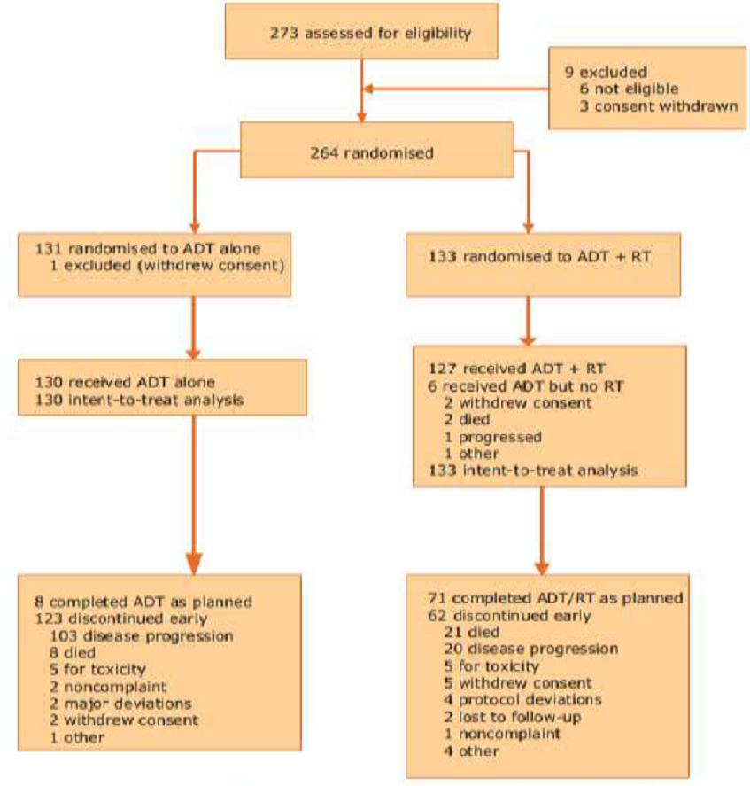
No statistical differences between arms in baseline characteristics were identified; the 2 groups were well balanced with regard to age, performance status, TNM staging, Gleason score, and baseline PSA; 10 ADT-alone patients and 14 in the combined group had pelvic lymphadenectomy, with 1 in each arm identified as pN1 (pathologically classified as regional lymph node metastasis).
A total of 33 patients in the ADT group received RT after progression.
Sponsor: This study did include some patients (≈ 7% in each arm) classified as T3 or pT4, however they had no node involvement. ‘The selection criteria used in this study are therefore consistent with the generally accepted criteria defining high risk disease.
Evaluator: A relatively small number of patients in each group had Gleason score of 8 - 10 (16.8% in ADT group, 24.1% in ADT + RT); and over 1/3 of patients had baseline PSA < 20 ng/mL (38% vs. 35%, respectively).
The sponsor did not interpret the disproportionately different discontinuation rates between the arms. Overall, there was a significant drop out in this study; in the ADT arm 123 patients discontinued early (8 patients completed ADT as planned); whereas in the combination arm 62 patients discontinued prematurely and 71 patients completed ADT/RT as planned.

Intervention
• Patients were randomised to leuprorelin (11.25 mg SC depot injection every 3 months for 3 years); (n = 133), or leuprorelin + RT; (n = 131).
Flutamide (750 mg oral daily) was administered during the 1st month of ADT treatment; ADT could be resumed during follow up.
External beam radiation therapy (EBRT) was initiated within 3 months of randomisation; the total prescribed central dose to the target volume was 70 Gy during 1996 - 2000, and thereafter 74 Gy.
6 patients in the combined group received ADT but discontinued before receiving RT; leaving 127 patients who received combined therapy.
The median duration of radiotherapy was 55 days (range: 48 - 85). ADT was administered as planned until progression for all patients. The median duration for hormone therapy for the ADT group was 2.5 years (range: 0.3 - 3.6) and 3.0 years (range 0.3 - 3.5) for the combined group.
Sponsor: The dosage of leuprorelin used in this study is half of what is currently registered for Eligard 22.5 mg (every 3 months), nevertheless the efficacy and safety outcomes obtained in this study remain important contributors to the overall risk benefit assessment of combination therapy due to the overall quality of study design and range of relevant outcome measures evaluated.

Monitoring
Pre-treatment evaluations of the patients were performed including medical history, physical examination, FBC, biochemistry, PSA, performance status (PS) and a complete radiologic assessment. Follow up was performed 1 month after the end of RT (combined arm only), and every 6 months for 5 years. Thereafter, follow-up was by assessing annual progression and survival.
Follow-up assessments included digital rectal examination (DRE) and serum PSA. Other tests included transrectal ultrasound, CT and bone scans (if clinical/biological progression), radiation toxicity (acute - RTOG scale, late - LENT/SOMA score). AEs were recorded throughout.

Endpoints
The aim of the study was to assess the possible benefits of the combined treatment on Progression Free Survival (PFS).
The primary endpoint was 5 Year PFS biochemical or clinical; defined as the interval between randomisation and disease progression, or death from any cause.
Two definitions of biochemical progression were evaluated:
- According to standard practices at the time of study initiation, the 1997 American Society for Therapeutic Radiology and Oncology (ASTRO) guidelines were used. These defined progression as an increase in PSA after nadir on 2 consecutive measurements, with a minimum interval of 3 months between 2 determinations.
- Following revision in 2005, the ASTRO-Phoenix definition was employed, requiring an increase of ≥ 2 ng/ml above the PSA nadir. An additional analysis of the primary end point was performed using the revised criteria.
Locoregional clinical progression was defined as > 50% increase in prostate volume compared with the lowest value by ultrasound; the appearance of a new palpable prostate lesion in the event of previous complete clinical normalisation; and identification of new regional lymph nodes by CT scan.
Metastatic progression was defined by CT or bone scan.
The secondary endpoints were disease-specific and overall survival (OS), time to locoregional recurrence, time to distant metastases, tolerance and AEs.

Statistical methods
The sample size (n = 256) was calculated based on the primary end point using a difference of at least 15% (HR: 0.456) in the percentage of PFS between the 2 strategies on a unilateral log-rank test with a probability of 5% and 80% power.
The percentage of PFS in the combined treatment arm was estimated at 85%. The null hypothesis is assumed to be no difference in PFS between the treatment groups.
Analyses were performed in the ITT population, defined as all randomised patients receiving at least 1 dose of study treatment (excluding flutamide) who completed at least 1 post-baseline visit. Multivariate analyses were performed using a Cox model with a 5% threshold from univariate analysis. Kaplan-Meier estimates were used to calculate time-related parameters. Cumulative incidence was also determined. Follow-up data were collected until July 22, 2009.

Primary efficacy results
ADT alone was administered to 130 patients and combined therapy to 133 (ITT analysis).
Kaplan-Meier estimates demonstrated a significantly lower rate of patients censored for PFS at 5 years with combined therapy than with ADT alone, for both the initial ASTRO and the ASTRO-Phoenix definitions.
- PFS: With a median follow-up of 67 months, censored 5-Year PFS was 60.9% for combined therapy vs. 8.5% with ADT alone (ASTRO; p < 0.0001), and 64.7% vs. 15.4%, respectively, for Phoenix (p < 0.0011) (Figure 2).
- The cumulative incidence as per the same definitions is shown in Figure 3.
Figure 2: Mottet 2012 KM plots.
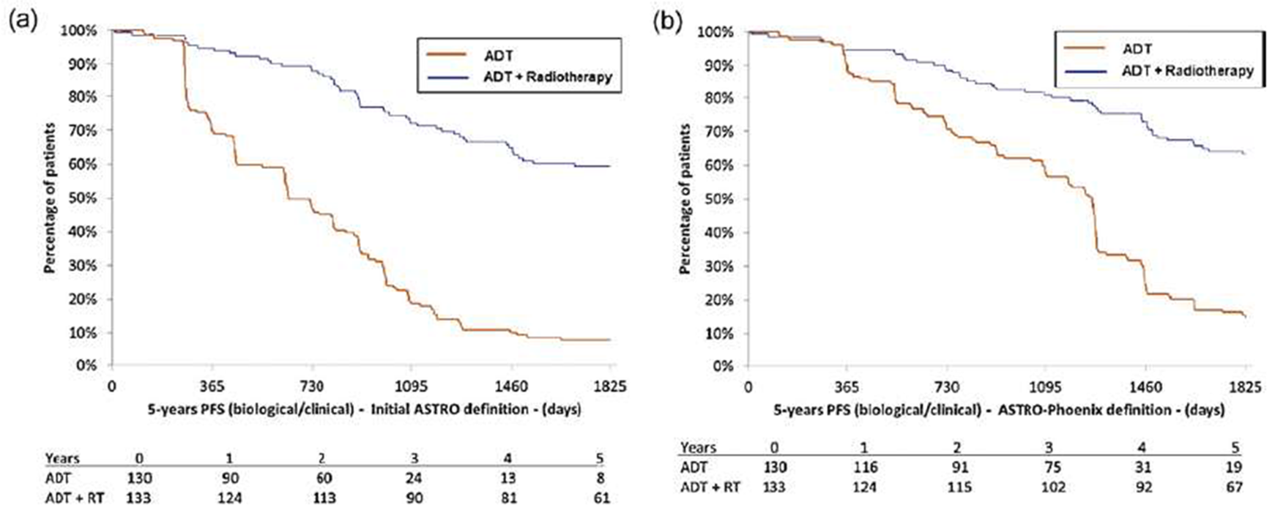
Figure 3: Mottet 2012 KM plots.
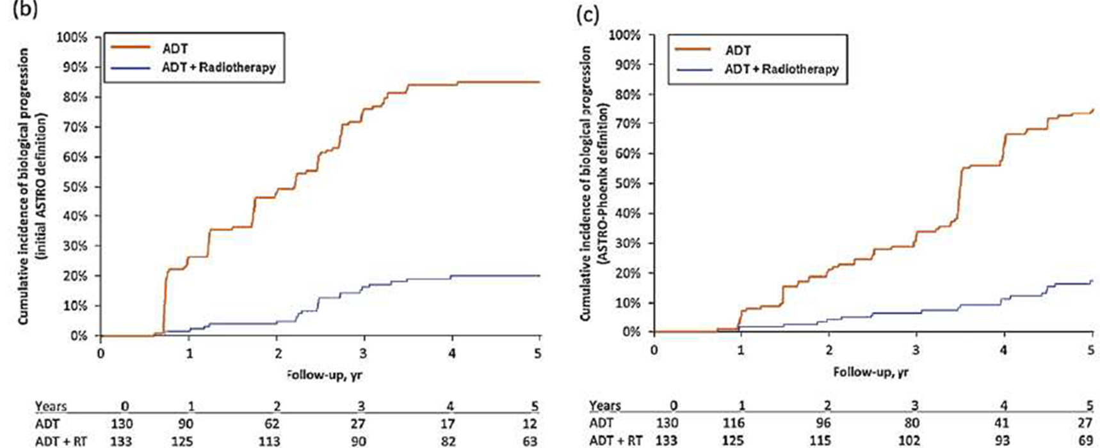
Clinical progression was reported in 43 patients (33.1%) treated with ADT alone and in 13 patients (9.8%) treated with combined therapy.
- After a median follow-up of 67 month (5.6 years), PSA progression according to the initial ASTRO definition occurred in 102 patients (78.5%) treated with ADT and 23 patients (17.3%) with combined therapy.
Similar results were reported with the ASTRO-Phoenix definition, with 89 (68.5%) patients progressing vs. 19 (14.3%), respectively.

Other efficacy results
- After a median follow-up of 67 months, 55 patients had died; 24 (18.5%) treated with ADT alone and 31 (23.3%) with combined treatment; and 8 patients (4 in each arm) were lost to follow-up. No patients underwent radical prostatectomy. A total of 9 patients in the ADT group and 5 in the combined group had a palliative trans-urethral resection.
Authors: The benefits in PFS with combined therapy in the current study did not translate into a survival advantage at 5 years.
- Locoregional progression was reported in 9.8% of ADT + RT patients vs. 29.2% with ADT alone (p < 0.0001); and metastatic progression in 3.0% vs. 10.8%, respectively (p < 0.018).
- Cox analysis showed that combined therapy strongly favoured a reduced likelihood of locoregional progression with an HR of 3.6 (95% CI: 1.9 - 6.8; p < 0.0001). Median time to locoregional progression had not been reached.
- A significant difference in metastasis-free survival was reported, with 4 patients developing distant metastases with combined therapy (3.0%) vs. 14 patients (10.8%) with ADT alone (p = 0.018).
Figure 4: Mottet 2012 KM plots.
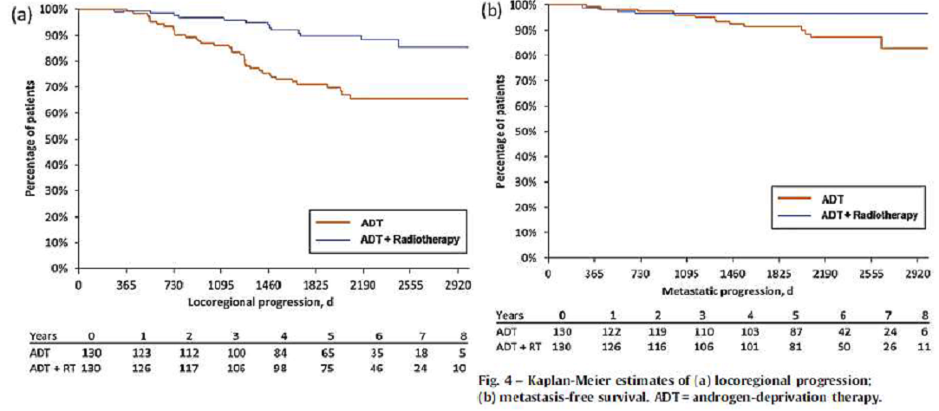
Comments: Addition of radiation to ADT led to a significant improvement in 5-yr locoregional control and metastases-free progression, and the data suggest that PFS benefit is due to locoregional control.
- OS was 71.4% with combined therapy vs. 71.5% with ADT alone; disease-specific survival was 93.2% vs. 86.2%.
Comments: A median OS estimate had not been reached in either treatment arm at the time of analysis (67-month follow-up), and Kaplan-Meier estimates of mortality did not show a difference in overall survival rates between the 2 treatment arms: 71.4% and 71.5% for combined or ADT alone.
At 67 months, disease-specific mortality was also not significantly different between treatment groups; 9 patients receiving ADT + RT and 18 receiving ADT alone died due to their prostate cancer, giving survival incidences of 93.2% vs. 86.2% (p = 0.0586).
A statistically significant interaction between treatment and baseline PSA value was reported, with the risk of progression (ASTRO-Phoenix) 5.2 times higher (95% CI: 3. 1- 9.0; p = 0.04) when baseline PSA was between 20 - 50 ng/ml; and 10.1 times higher (95% CI: 5.0 - 20.5; p < 0.001) when PSA values were ≥ 50 ng/ml for the ADT-alone group.
Figure 5: Mottet 2012 KM plot.
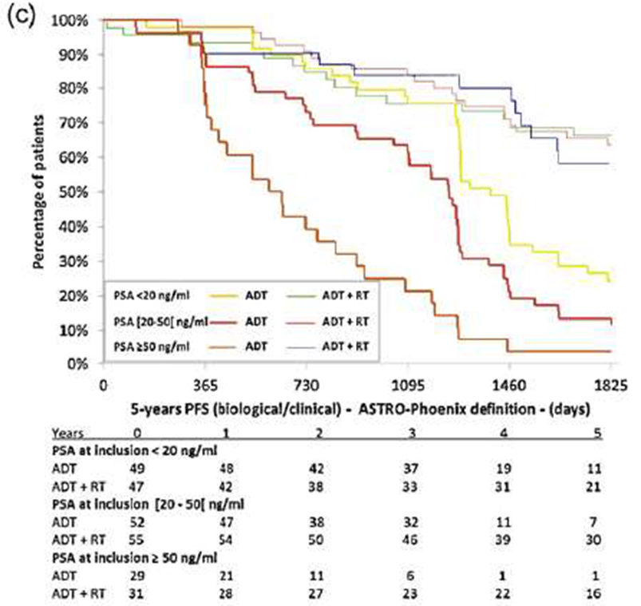
The lack of routine lymphadenectomy in the current study would suggest that a reasonable proportion of patients were at risk of nodal invasion. Given the clear PFS benefit reported here, it is likely that these patients could benefit from combined therapy.
The use of radiotherapy to treat the 24 patients progressing after ADT alone may have had an impact on the survival outcome. Metastases and locoregional recurrence may have been under-estimated due to the absence of systematic imaging evaluations at predefined time points.
The RT regimen implemented could be considered outdated based on current treatment practices and might not reflect more specific therapeutic approaches. Limitations included also the relatively small population and a relatively short follow-up period.
The authors concluded that combined therapy strongly favoured improved PFS, locoregional control, and metastasis-free survival. Longer follow-up is needed to assess the potential survival impact.
Sponsor: The authors noted that limitations of the study included the use of a relatively small population, and the need for a longer follow-up in order to more completely evaluate any potential differences between treatments according to longer term outcome measures such as median OS and mortality due to cancer progression.
Overall however, the trial was well designed, primary and secondary outcomes predefined and the results appropriately analysed. This study produces a sound base to assess the risk benefit of combined ADT and RT treatment in the target population.
Evaluator: This pivotal study used half of the leuprorelin dose currently registered, that was however, administered over reasonable length of time that aligns with the current guidelines (3 years); total androgen blockade was given during the first month.

Study by Widmark 2009 (NHMRC level II)
Open label, randomised, multicentre study assessing the effect of radiotherapy in locally advanced prostate cancer patients (n = 875) by comparing endocrine therapy with and without RT, followed by castration on progression.
Sponsor: This study therefore meets the requirements of level II evidence according to the NHMRC 1999 guide.

Design
Open, randomized, controlled, Phase III trial; patients were recruited from 47 centres in Norway, Sweden and Denmark. (Enrolment: February 1996 - December, 2002) Patients were centrally randomised; and stratified according to study centre, T stage, and WHO Grade.
Sponsor: Ethics approval for the study was granted by the Medical Faculty Ethnical Committee at Umea University. All patients provided written informed consent. This study was registered as an international standard randomised controlled trial, number ISRCTN01534787.
Four authors received lecture fees from four different pharmaceutical companies, while the other authors declared no conflict of interest. The sponsor of the study, Scandinavian Prostate Cancer Group, received unrestricted grants from Schering-Plough and Abbott Scandinavia.
Funding has also been provided from the Nordic Cancer Union, Swedish Cancer Society, Norwegian Cancer Society, Lions Cancer Foundation, and Umea University. However, neither the sponsor nor grant providers had any role in the study design, analysis or report preparation which may bias the study outcome.
Four of the other studies summarised in this review, Solberg 2011, Berg 2009, Fransson 2009 and Lund 2013, are also based on results provided by this study cohort. Solberg 2011 further evaluated efficacy while the others evaluated long term follow up data relevant to the safety aspects of combination therapy.

Patient enrolment, characteristics and disposition
Inclusion criteria: histologically-proven prostate cancer in men < 76 years, good PS, life expectancy > 10 years; and clinical category T1b - T2, G2 - G3 (system unrelated to Gleason, grading malignant cell differentiation); or T3 (TNM-classification 1992); any WHO Grade 1 - 3; PSA ≤ 70 ng/mL; no evidence of metastases as determined by bone scanning and pulmonary radiography.
Patients with PSA ≥ 11 ng/mL had a pelvic lymph node dissection; patients with nodal disease were not eligible for the trial.
Sponsor: The inclusion criteria used in this study are therefore consistent with the patient population targeted by this application (high risk and locally advanced prostate cancer).
Of the 880 patients randomised, 875 met the inclusion criteria. A total of 439 patients received endocrine treatment only and 436 patients received endocrine treatment + RT.
Baseline demographics and clinical characteristics were balanced between the groups.
Sponsor: A majority of patients had tumour stage T3 at baseline; 347 (79%) vs. 335 (76.8%); which represents high risk prostate cancer patient group targeted in this application. While ≈ 22% of patients had seminal vesicle involvement, all patients were classified N0 and M0.
Another indicator of high risk prostate cancer is a PSA level ≥ 20 ng/mL, present in 177 (40.3%) of the endocrine group and 172 (39.4%) combined therapy patients.
However the authors did not evaluate the overlap between patients who had a tumour stage of T3 and/or PSA level > 20 ng/mL. Broadly, this population is considered applicable to the patient group in this application.

Intervention
All patients received total androgen blockade (TAB) consisting of leuprorelin (Procren depot) 3.75 mg a month or 11.25 mg every 3 months for 3 months together with flutamide (antiandrogen) 250 mg x3/day.
Sponsor: The dosage of leuprorelin (Procren) used in this study is half of what is currently registered in Australia for Eligard 7.5 mg (once a month) or 22.5 mg (every 3 months).
This study therefore is additionally useful in providing some insight into the likely dose-response to leuprorelin in this indication.
After 3 months of TAB, patients continued using flutamide until progression or death, and patients in the endocrine + RT group received standard 3D conformal radiotherapy to the prostate and the seminal vesicle.
A standard 3D conformal radiotherapy technique was applied with a prescribed central dose (of 50 Gy) to the prostate and the seminal vesicles. A sequential boost of at least 20 Gy was added to the prostate, which received a total dose of minimum 70 Gy.
6 patients in the endocrine alone group received later palliative RT due to local progression; 80% of all patients received breast irradiation to prevent gynecomastia.
Flutamide dose reduction occurred in 35 (8%) and 58 (13.3%) of patients in the endocrine group; and endocrine + RT group, respectively; and flutamide was changed to bicalutamide in 77 (17.5%) and 88 (20.2%) patients, respectively.
On disease progression, as determined by a PSA increase of ≥ 2 ng/mL above nadir, patients received additional treatment to achieve TAB; this included an LnRH agonist and an oral antiandrogen.
After the first publication of the SPCG-6 data in 2002, the addition of leuprorelin was allowed before clinical progress when the PSA level was > 10 μg/mL. (No information available on how many patients subsequently continued on leuprorelin, but enrolment closed in December 2002).
Antiandrogen therapy: The study was designed in 1995 and the choice of antiandrogen was based on preliminary reports on outcome comparable to that after castration. The use of non-steroidal antiandrogen therapy in M0 patients has been well established in clinical routine in Europe and is considered an alternative to castration according to the European Association of Urology guidelines.
Evaluator: Widmark et al. reported a significant improvement in OS with combined ADT and radiotherapy compared with ADT alone at 10 yr. Patients included in the study had less advanced disease and received hormonal treatment with flutamide as monotherapy, a therapeutic approach not widely used elsewhere.

Monitoring
Follow-up concluded on Feb 22, 2008, or on the date of death. Completeness of PSA follow-up was 95% and 94% for the endocrine and endocrine + RT group, respectively. Follow-up on survival status was also performed with data linked to the population registries.
Clinical examination and assessment of PSA, LFT, and FBC was done every 3 months for the 1st year and every 6 months thereafter. Additionally, at each visit AEs, assessed by the treating physician, were recorded according to a modified scale of the Radiation Therapy Oncology Group (RTOG).
Sponsor: The study was not blinded, so the Physicians assessing patients were aware of the group allocation.

Endpoints
The primary objective was to explore if RT in addition to endocrine therapy would improve cancer-specific survival at 7 Years compared to endocrine therapy alone.
The primary endpoint was prostate-cancer-specific mortality (PCSM), defined as the time from randomisation to death from prostate cancer, or death from another cause with prostate cancer as a significantly contributing factor. Deaths from other causes were treated as censoring events.
Secondary endpoints were PSA (disease) recurrence (defined according to 2006 ASTRO definition: increase in PSA on 2 consecutive measurements of at least 2 ng/mL above nadir with at least 1 month between them); overall mortality, and QoL (as per EORTC QLQ-C30 questionnaire).
This study reports on QoL information obtained at baseline and 4 Years after the start of treatment.

Statistical methods
The initial sample size aim was expanded from 660 to 880 patients, following a blinded analysis of 716 enrolled patients by an Independent Data Safety Monitoring Committee to achieve a total of 198 prostate cancer deaths after 7 years of follow-up. The sample size was calculated to provide a statistical power of 80% to detect an increased cause-specific survival of 10% after 7 years of follow up in the endocrine + RT group, compared with 65% in the endocrine group.
In February, 2008, after a median follow-up of 7.6 years, the total number of prostate cancer deaths was 116. Another blinded analysis was performed, as the cancer-specific survival in the complete cohort was higher than expected. The IDMC concluded that the study had more than adequate power to detect an increased cancer-specific survival of 10% and recommended breaking the randomisation code.
All analyses were pre-specified with an ITT approach. No IA was done. To acknowledge the presence of competing risks, the cumulative incidence was calculated for each endpoint.
The Gray’s test was used to test the hypothesis that there was no difference between the treatment groups. Differences in cumulative incidence (with 95% CIs) and relative risks (with 95% CIs) were used as measures of effect for each endpoint. The relative risks were estimated using the Cox proportional-hazards model.
Effect modification was tested by a Cox proportional-hazards model, which included an interaction term between subgroup category and treatment group. Subgroups assessed for effect modification were age at diagnosis, PSA level at diagnosis, and T stage.
Comparisons of QoL scores within and between treatments groups were done with the Wilcoxon rank-sum and signed-rank test, respectively. Differences between categorical variables were assessed by the χ2 test. All reported p values are based on 2-sided hypothesis with a p value < 0.05 considered to indicate statistical significance.

Primary efficacy results
After a median follow-up of 7.6 Years, 79 (18%) men in the endocrine alone group and 37 (4.5%) men in the endocrine + RT group had died of prostate cancer. Of the 116 men that were classified as dead from prostate cancer, 28 (20 and 8, respectively) were classified as dead from other causes but with prostate cancer substantially involved.
- The cumulative PSCR (at 7 Years) was reported as 9.9% (7.1 - 12.8) in the endocrine group and 6.3% (3.9 - 8.6) in the endocrine + RT group (difference 3.7%; 0.0 - 7.4%).
The cumulative incidence of main endpoints of the study (disease-specific and overall mortality and PSA recurrence at 7 and 10 Years) are presented.

Table 1: Widmark 2009: cumulative incidence of main endpoints and corresponding relative risks.
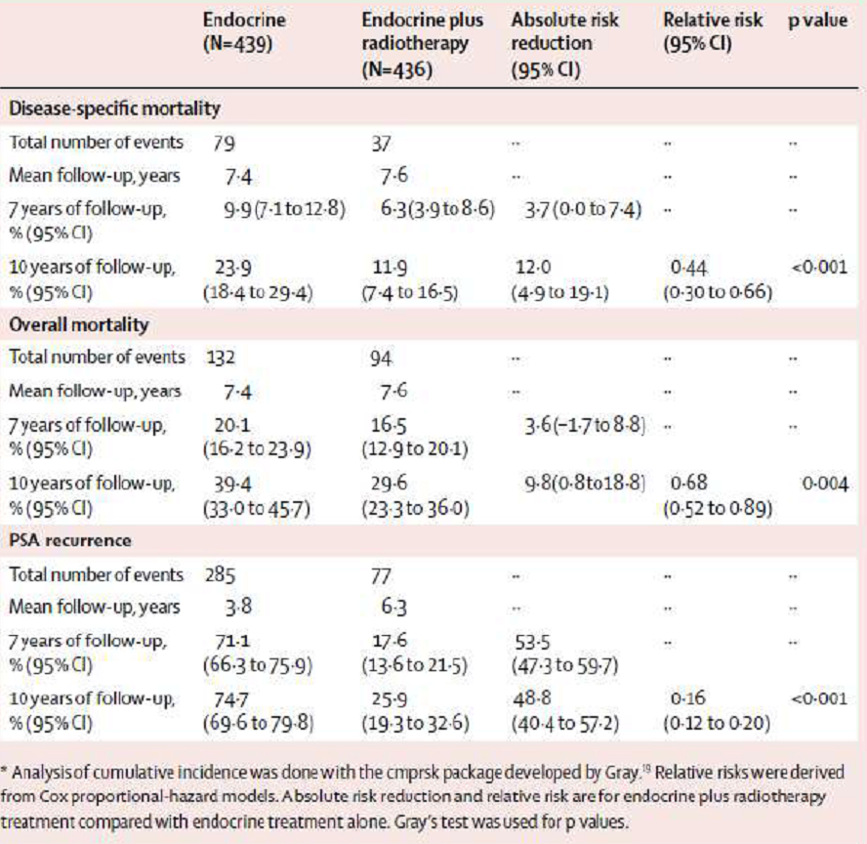
Figure 6: Widmark 2009 plots.
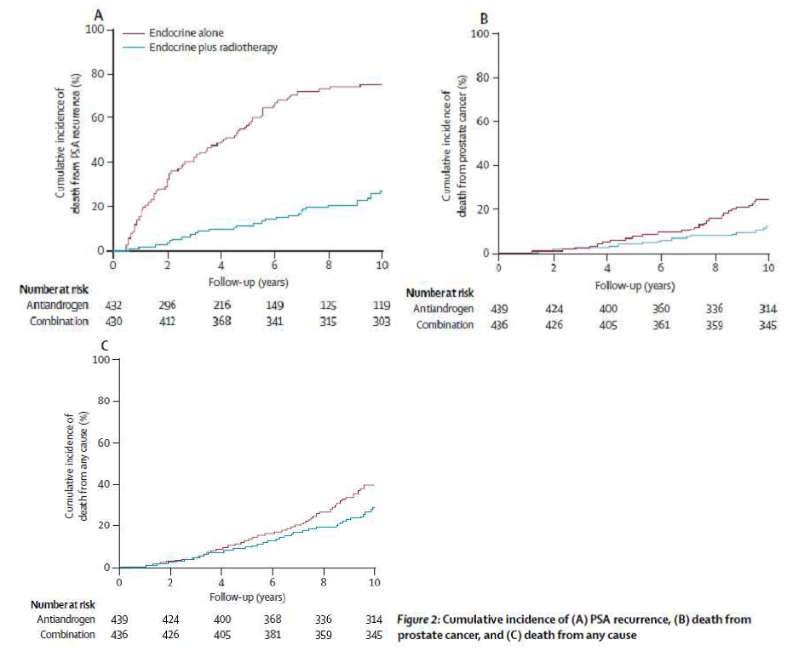
The number of deaths and their cause at the median follow-up time of 7.6 years (range: 0.2 - 11.9 years); i.e. at breaking of the randomization are summarised in a table below.

Table 2: Deaths.
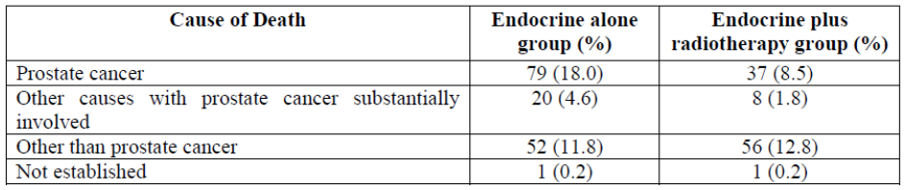

Other efficacy results
At 10 Years, the cumulative incidence for cancer-specific mortality increased to 23.9% in the endocrine group and to 11.9% in the combination group with a significant difference between groups (difference 12.0%; 95% CI: 4.9 - 19.1%).
The relative risk of cancer-specific death was 0.44 (0.30 - 0.66, p < 0·0001) in favour of the endocrine + RT treatment group.
At 10 Years, the cumulative incidence for overall mortality was 39.4% in the endocrine group and 29.6% in the combination group (difference of 9.8%, 0.8 - 18.8%), for a relative risk of 0.68 (0.52 - 0.89).
As for cancer-specific mortality, overall mortality was higher in the endocrine group than in the endocrine + RT group.
RT treatment yielded an absolute improvement of 3.6% (95% CI: -1.7 to 8.8%) at 7 Years and 9.8% (0.8 - 18.8%) at 10 Years. The relative risk of overall death was 0.68 (0.52 - 0.89, p = 0·004) in favour of the endocrine + RT treatment group.
PSA recurrence revealed strikingly higher rates in the endocrine group than in the endocrine + RT group.
At 7 and 10 Years, the cumulative incidence of PSA recurrence was 71.1% (95% CI: 66.3 -75.9%) and 74.7% (69.6 - 79·8%) in the endocrine group, and 17.6% (13.6 - 21.5%) and 25.9% (19.3 -32.6%) in the endocrine + RT plus group. The relative risk of PSA recurrence was 0.16 (0.12 - 0.20, p < 0·0001) in favour of the endocrine + RT group.
Cumulative incidence at 10 Years for PSA recurrence was substantially higher in men in the endocrine group (74.7% vs. 25.9%, difference of 48.8%, p < 0.0001; HR 0.16; 0.12 - 0.20).
No significant effect modification of the combined treatment according to T stage, PSA level at diagnosis, or age at inclusion was observed for any of the endpoints.
Subgroup analysis stratified by T stage, PSA level, and inclusion age uniformly revealed decreased 10-Year cumulative incidence of prostate-cancer-specific mortality in the combination group. In particular, this decrease was evident in patients with T1b-T2 tumours, where the mean absolute risk reduction was 16.0% (95% CI: 3.7- 28.2).
Figure 7: Widmark 2009 absolute risk reduction.
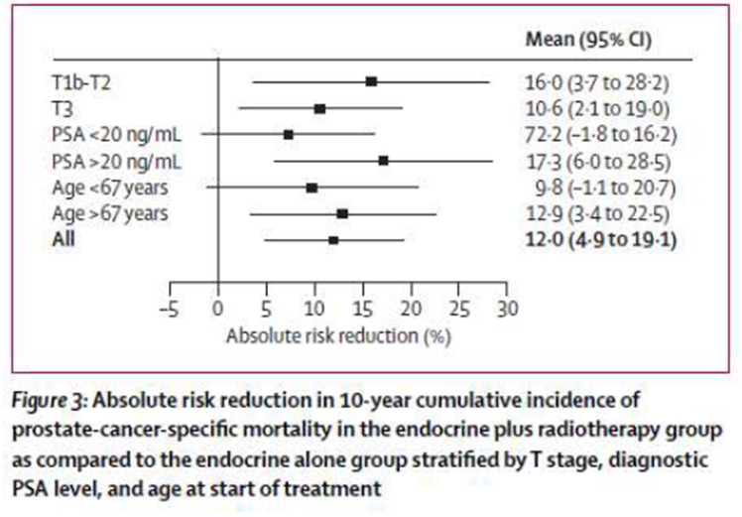
Sponsor: For T3 tumours, the mean absolute risk reduction was 10.6% (95% CI: 2.1 - 19.0). For PSA > 20 ng/mL, the mean absolute risk reduction was 17.3% (95% CI: 6.0 - 28.5).
Authors: The present study indicates a significant superiority of the endocrine + RT treatment compared with endocrine treatment alone in patients with locally advanced prostate cancer. The endocrine + RT treatment resulted in a substantial reduction in prostate cancer mortality.
This significant difference, which at 10 Years reached 12%, also translated into improved difference in OS (9.8%) in non-metastatic prostate cancer patients with locally advanced tumours or tumours that are prostate-confined but with aggressive histology. Note: the maximum absolute benefit was for low grade tumours.
A total of 37 patients in the endocrine + RT group died from prostate cancer compared with 79 patients in the endocrine alone group.
The authors’ postulate that the documented survival benefit, for high risk patients, depends on the duration of the hormonal treatment, and that for short or intermediate duration studies (< 3 years), survival prolongation has only been so far reported in subgroups.
They also suggest that using anti-androgens might be a way to avoid cardio-metabolic and other problems associated with surgical/medical castration. There is a wide local variation in approach to hormonal treatment of prostate cancer patients.
In the current study, the endocrine treatment was 3 months of total androgen blockade (LHRH analogue + antiandrogen) followed by non-steroidal antiandrogens. Castration treatment (TAB) was then reinstituted on PSA progression.
In the present study, we see no separation of survival curves until 4 years after randomisation, indicating the time taken for patients with locally advanced prostate cancer to develop hormone refractory disease. A further separation was seen after 7 years. We know of no comparative studies that have assessed radiation combined with antiandrogens or LHRH-agonists vs. such endocrine treatment alone.
At the start of the present study, the standard radiation dose to the prostate was 70 Gy. With the invention of intensity-modulated and image-guided radiotherapy, radiation doses of 78 Gy or higher are possible, and randomised studies have shown that biochemical relapse-free survival improves with high radiation doses.
In the present study, the survival at 10 Years increased from 60.6% to 70.4% in favour of the endocrine + RT treatment, and the improvement was achieved without excess long-term toxicity. These results clarify the importance of local radiotherapy treatment in high-risk patients with prostate cancer.
Conclusions: In patients with locally advanced or high-risk local prostate cancer, addition of local radiotherapy to endocrine treatment halved the 10-year prostate-cancer-specific mortality, and substantially decreased overall mortality with fully acceptable risk of side-effects compared with endocrine treatment alone. In the light of these data, endocrine treatment plus radiotherapy should be the new standard.
The quality of life and adverse effect profile is also acceptable.
Sponsor: Overall, the trial was very well designed, conducted and analysed, with the conclusions well supported by the results.
The limitations of the trial were relatively minor, and unlikely to significantly impact on the outcome of the study. For example, the study was not blinded however this is due to the nature of the therapy administered in the treatment arms.
While the sponsor of this study and some authors received funding from pharmaceutical companies, this source of potential bias was fully declared. The overall quality of the study indicates that this affiliation did not influence the study outcomes.
The authors conclude that in patients with locally advanced or high-risk local prostate cancer, addition of local radiotherapy to endocrine treatment halved the 10-year PCSM, and substantially decreased overall mortality compared with endocrine treatment alone.
Evaluator: The duration of treatment with leuprorelin in this study was 3 months only; administered at half of the currently recommended dose (given as TAB). This was followed by antiandrogen therapy long term. This pivotal study therefore explores the issue of ‘hormonal therapy’ in general, administered in neoadjuvant/adjuvant setting, rather than specific LHRH-agonist.
The sponsor does not raise the implications of antiandrogens being used long term in this study, and how these findings could be extrapolated to leuprorelin, when discussing the long-term outcomes.

Study by Solberg 2011 * (NHMRC level II)
This prospective sub-study to the Scandinavian Prostate Cancer Group-7 (SPCG-7) study by Widmark 2009 evaluated the incidence and clinical implications of residual prostate cancer in post-treatment prostate biopsy specimens.
* Studies marked with asterisk indicate supplementary or follow up studies using some or the entire patient cohort originally recruited to the Widmark RCT.
Background: In locally advanced prostate cancer, antiandrogen monotherapy is equally efficient to LHRH agonist therapy, and survival is improved if RT is combined with endocrine therapy. The SPCG-7 trial initiated in 1995 explored the role of EBRT in locally advanced prostate cancer, comparing endocrine therapy vs. endocrine + RT.
Variations in serum PSA levels that may be misinterpreted as treatment failure (PSA bouncing) are commonly observed the first 2 years of follow-up in patients successfully treated with RT. Whereas a PSA recurrence does not distinguish between local and distant failure, biopsy-verified residual prostate cancer enhances the risk of PSA recurrence, metastatic disease, and prostate cancer mortality.
Sponsor: This study therefore meets the requirements of level II evidence according to the NHMRC 1999 guide, in accordance with Widmark 2009. Details of the SPCG-7 study have been provided in Widmark 2009, including the randomisation protocol.
This study provides further insight into the comparative efficacy between endocrine alone therapy and endocrine plus radiotherapy in patients with locally advanced prostate cancer.

Design
This is a prospective, supplementary efficacy analysis of a subgroup of 120 patients recruited initially into Widmark 2009 study who underwent post-treatment prostate biopsy.
A total of 11/47 hospitals contributing to SPCG-7 study participated; the duration of study was 3 months. Biopsy specimens were obtained from 120/875 men in the SPCG-7 study; and performed at median of 45 months follow-up.
Sponsor: All patients provided their written informed consent. Design and treatment were defined in abstract, but not assessments. Authors reported no conflict of interest.

Patient enrolment, characteristics and disposition
The study included all consecutive patients at 11/47 hospitals at ≈ 30 - 42 months of follow-up.
Of the 120/875 (29%) original patients with post-treatment prostate biopsy; 63 (52.5%) patients were in the endocrine alone group and 57 (47.5%) in the combined group. All patients completed neoadjuvant TAB.
There were no statistically significant differences in clinical baseline characteristics between the total SPCG-7 study population and the 120 patients in the biopsy study. Except for age, there were no significant differences in baseline characteristics between therapy groups in the biopsy study.
Sponsor: Similar to the complete SPCG-7 study, patients with T3 tumours form the majority of the study population, which are representative of high risk prostate cancer patients, and therefore applicable to this application.

Intervention
Endocrine therapy (3 months of neoadjuvant TAB) + RT (n = 57); or Endocrine alone (n = 63); both arms followed by antiandrogen continuously.
(One patient, initially allocated to endocrine therapy alone, had curative RT 38 months before biopsy; his results are included in the combined group.)
In case of PSA recurrence only, no change of treatment was recommended. Local progression was optionally treated with medical or surgical castration, TURP or palliative radiotherapy. If metastases were diagnosed, castration was added, and discontinuation of the antiandrogen was recommended.
Evaluator: As per Widmark study, the dosage of leuprorelin was half of what is currently registered in Australia, given for 3 months; followed by nonsteroidal antiandrogen.

Monitoring
Clinical assessments and PSA were performed every 3 months for the 1st Year, then 6 monthly until death or February 2008. Biopsies were performed in patients with WHO performance status 01, unless contraindicated. Histological examinations were done by 2 pathologists with no knowledge of the clinical data or original histopathologic reports.
Median follow-up time for survival was 101.5 months (range: 54 - 140 months), and 97 months (range: 10 - 134) for other clinical events. Biopsies were obtained at a median follow-up of 3.7 years.

Endpoints
The primary aim was to evaluate the incidence of residual prostate cancer in patients treated with either endocrine therapy alone, or combined endocrine + RT in the SPCG-7 study.
The secondary objective was to assess the clinical implications of residual cancer; PSA recurrence, local progression, distant recurrence, clinical recurrence and mortality.

• Statistical methods
Categorical variables were compared using the chi-square or Fisher’s exact tests. Continuous variables were compared using the Student’s t test. If the distribution was not normal, the Mann-Whitney U test was applied.
The association between residual cancer and therapy group, and baseline prostate cancer risk factors (serum PSA, WHO Grade III, clinical stage T3, and seminal vesicle tumour involvement) was assessed in univariable analysis. Variables with a p value ≤ 0.1 were evaluated simultaneously in a logistic regression model.
OR with a 95% CI was used as effect measure. The association between clinical events and residual cancer was assessed using the log-rank test. Kaplan-Meier curves of freedom from PSA recurrence probability were estimated in patients with and without residual cancer. Furthermore, the influence of therapy group and baseline prostate cancer risk factors on clinical events was assessed in univariable analysis.
Variables with a p value ≤ 0.1 were analysed simultaneously with the biopsy result using a Cox proportional-hazards model. HR with a 95% CI was used as effect measure. A 2-sided p value < 0.05 was considered statistically significant. No sample size calculation was provided in this side study.

Primary efficacy results
A median of 8 biopsy cores (range: 2 - 10) were taken at a median of 45 months (range: 30 - 97 months) follow-up. Biopsy specimens from 117 patients (62 patients in endocrine group and 55 patients in combined therapy group) were available for histologic evaluation.
In 63 patients receiving endocrine treatment only and 57 patients receiving combined treatment, residual cancer was found in 66.1% (n = 41) and 21.8% (n = 12), respectively (p < 0.0001).
The majority of positive biopsy specimens in the endocrine group and all in the combined therapy group contained poorly differentiated (Gleason score ≥ 8) cancer.
There was no significant difference in baseline prostate cancer risk factors in patients with and without residual cancer.
In logistic regression analysis, significant predictors of residual prostate cancer were as follows: endocrine therapy alone [OR 7.49 (3.18 - 17.7), p < 0.0001]; and baseline PSA [OR 1.03 (1.00 -1.07), p = 0.044].

Other efficacy results
The incidence of clinical events are summarised in Table 3.

Table 3: Solberg 2011 study.
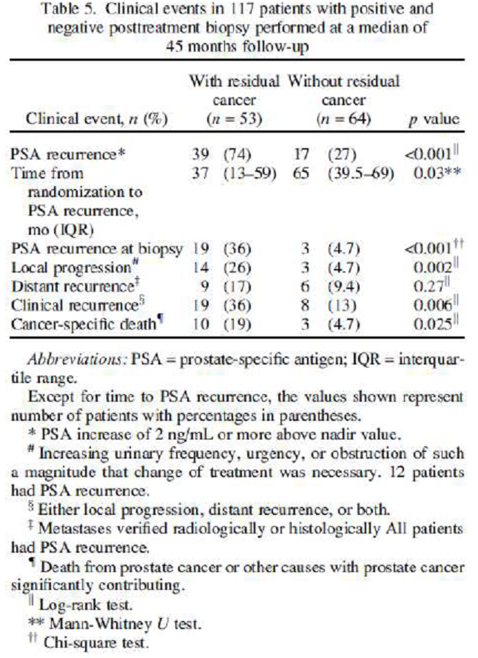
The 48% incidence (n = 56) of PSA recurrence observed in this study was not significantly different from the 41% (n = 362) incidence in the total SPCG-7 study population.
In Cox regression analysis, factors significantly associated with PSA recurrence were as follows: residual cancer, HR 2.69, p = 0.002; endocrine therapy alone, HR 3.45, p < 0.0005; and baseline serum PSA level, HR 1.02, p = 0.014.
Local progression was found in 3 patients without residual cancer, of whom all had PSA progression and 1 later had metastasis. Although Cox regression analysis showed no statistically significant association between residual cancer and local progression, a ‘significant’ association with endocrine therapy alone was found: HR 11.6 (1.38 - 97.2), p = 0.024.
All patients with distant recurrence had PSA recurrence, among which 5 patients also had local progression. Although patients with residual cancer had more frequent distant recurrence (17% vs. 9.4%), the difference was not statistically significant.
In patients with residual cancer (n = 63), clinical recurrence was more common than in patients without residual tumour (p = 0.006). However, in Cox regression analysis, only endocrine therapy alone was significantly associated with clinical recurrence: HR 3.86 (1.30 - 11.5), p = 0.015.
Mortality At the cut-off point of follow-up, 26 patients had died. Whereas 13 patients died of other causes than prostate cancer, the incidence of cancer-specific death was 11% (n = 13), compared with 13% (n = 362) in the total SPCG-7 study population (p = 0.5).
Of patients with residual cancer, 5 died of prostate cancer and 5 died of other causes with prostate cancer significantly contributing. The corresponding figures in patients without residual cancer were 2 patients and 1 patient, respectively.
Cancer-specific deaths 10 (19%) vs. 3 (4.7%); p = 0.025.
Comments: The principal finding in this study was that patients receiving endocrine therapy alone had a three times higher incidence of local residual prostate cancer than did patients receiving combined therapy.
Although cancer-specific death occurred more frequently (p = 0.025) in patients with residual cancer, no significant association was found when residual tumour and therapy group were evaluated simultaneously in Cox regression analysis.
Residual prostate cancer was significantly associated with serum PSA recurrence, local tumour progression, clinical recurrence, and cancer-specific death in univariable analysis. Residual cancer was predictive of PSA recurrence in multivariable analysis.
Residual cancer was significantly associated with PSA recurrence and the proportions mimicked almost exactly the final 10-year figures on PSA recurrence in the treatment arms of the SPCG-7 trial.
The biopsy-verified local control rate in the combined therapy group was 78%. In contrast, biopsy-verified local control was achieved in only 33% of patients treated with endocrine therapy alone in the present study.
Although radiotherapy constitutes an essential therapeutic element, this finding illustrates the additive effect of endocrine therapy. The 70-Gy radiation dose used in this study was suboptimal. A suboptimal number of patients were examined with biopsy; the inclusion rate was 29%.
Most likely, post-treatment biopsies would be required in a substantially larger cohort to explore the influence of residual cancer on distant metastases and survival with sufficient statistical power.
Even though prostate cancer risk factors were well balanced in the study population, intergroup comparisons should be interpreted with caution because a low inclusion rate may yield a selection bias.
Conclusions: Radiotherapy combined with hormones improved local tumour control in comparison with endocrine therapy alone.
Although study patients with residual cancer had earlier PSA recurrence than did patients with negative biopsy specimens, residual cancer had no influence on other clinical endpoints in multivariable analysis.
Nevertheless, a survival benefit in favour of combined therapy was clearly demonstrated in the SPCG-7 trial, and the patients in the present study constitute a subset of the SPCG-7 study population with similar baseline prostate cancer risk factors and clinical outcome.
Sponsor: The authors noted possible limitations of this study, including overestimation of remaining and biologically active cancer, Gleason scores possibly being artificially upgraded, underestimation of the amount of residual cancer (though false negatives were avoided by blinding the pathologists), small sample size (29% of the SPCG-7 study population) and timing of the post-treatment biopsy.
The authors concluded that the possible limitations are unlikely to affect the general conclusions.

Supportive studies

Study by Nguyen 2013 (NHMRC level III-2)
A retrospective analysis reporting on the long-term outcomes of high-risk prostate cancer patients (n = 741) treated with low or high dose EBRT with or without ADT at a single tertiary institution.

Design
An interrupted time series study with a control group. The retrospective analysis was based on 741 men diagnosed with high risk prostate cancer who received RT at Department of Radiation Oncology at the University of Texas during 1987 - 2004.
Sponsor: This study therefore meets the requirements of level III-2 evidence according to the NHMRC 1999 guide.
Evaluator: Level III-2 NHMRC hierarchy of evidence for assessment of an ‘Intervention’ requires: a comparative study with concurrent controls, non-randomized experimental trial, cohort study, case-control study, or interrupted time series with a control group.
Sponsor: The RT techniques used and ADT administered therefore reflected the standard of care at the institution at any particular time during this period. These standards allowed the patient cohort to be divided into the 4 sub-categories according to whether ADT was used or not used with RT, and whether or not high dose RT was used in the analysis.
This study was supported in part by Cancer Center Support (core) grant CA016672 to the University of Texas MD Anderson Cancer Center. No conflicts of interest were disclosed by the authors. Design and treatments were defined in the abstract, but not the assessments. The report makes no mention of ethical review of the study or the patient informed consent process, concluding that the informed consent and randomization method were not relevant for this type of study.

Patient enrolment, characteristics and disposition
The median patient age at diagnosis was 68.2 years (range: 47 - 87), the median PSA level before treatment 15.6 ng/mL (range: 1- 323 ng/mL), and the median radiation dose received 70 Gy (range: 60-79.3 Gy). The median follow-up time for all patients was 8.3 years (range, 0.13 - 20 years).
Sponsor: This 741 men included in this analysis had high-risk prostate cancer (clinical classification ≥ T3, Gleason score ≥ 8, or PSA level ≥ 20 ng/mL, no metastasis) treated with external beam radiotherapy at a single tertiary institution from 1987 through 2004. This population is consistent with the generally accepted definition of high risk outlined earlier in this summary.
Evaluator: This retrospective analysis combines a very heterogeneous group of patients. Very significant percentage of patients had tumour stage T1-T2; i.e. 40% of patients treated with ADT + low dose RT, and 52% of patients with ADT + high dose RT. See table above.
The patients’ characteristics also varied widely between the arms, as there was no randomization to start with, and the treatment was obviously chosen to meet patients’ needs at the time of the original diagnosis.

Intervention
Patients were assigned to 1 of 4 treatment groups for the analysis:
- No ADT with < 75.6 Gy (low dose IMRT); (n = 375)
- No ADT with ≥ 75.6 Gy (high dose IMRT); (n = 71)
- ADT with < 75.6 Gy IMRT; (n = 173)
- ADT with ≥ 75.6 Gy IMRT; (n = 122).
The ADT in this study involved either medical castration with IM leuprolide acetate injections with or without bicalutamide, or bilateral orchiectomy. All ADT was administered for at least 2 years; no patient received less than 2 years of this therapy.
Of the 741 patients, 295 men had received ADT which started 2 - 3 months before radiotherapy and continued for a median duration of 2.9 years (range: 2 - 18 years), and the median follow-up time was 8.3 years. The radiation dose ranged from 60 - 79.3 Gy (median: 70 Gy).
Evaluator: The androgen deprivation therapy in this historical study involved various therapies. No indication is provided on the number of patients receiving leuprorelin (subgroup of interest to this application), and the dose/formulation of leuprorelin is unspecified. Hence the value of the study in support of leuprorelin specifically is weak.
EBRT involved high/low dose intensity-modulated radiotherapy (IMRT).
Sponsor: At the time of this analysis, the institutional standard for treating high-risk prostate cancer was 2 years of ADT combined with external beam radiotherapy to a dose of at least 75.6 Gy. At other times, RT was a conventional 4-field technique, moving to 8 coplanar-field intensity modulated RT to reflect the evolution in best practice techniques.
Similarly, ADT was not standard practice early in the study period. Based on information provided in the report, the dose of leuprolide and bicalutamide is also likely to reflect standard care.

Monitoring
The method and frequency of monitoring not clearly described in the paper.

Endpoints
The paper does not differentiate between primary and secondary endpoints.
The outcomes analysed were biochemical failure, clinical failure, and prostate cancer-specific disease-free survival and death.
Biochemical failure was defined as PSA levels > 2 ng/mL over the nadir level, and local failure was defined as clinically palpable disease or biopsy-proven recurrence. Clinical failure included local, nodal, or distant failure or combinations thereof.
Prostate cancer-specific disease-free survival was defined as survival without evidence of prostate cancer. Death from prostate cancer was considered an event, and patients were censored at the time of last follow-up or death from another cause.
All endpoints were measured from the day of completion of the radiotherapy.

Statistical methods
Outcomes were analysed according to use of ADT (or not) and radiation dose delivered (low or high). The log-rank test was used to analyse differences between treatment groups. A Cox proportional hazards model was used for multivariate analysis.

Efficacy results
In this study, we found statistically significant benefits in OS, PSA disease-free survival, freedom from clinical failure, and fewer local failures when men with high-risk prostate cancer who were treated with ADT in combination with high-dose radiotherapy.
The 5 and 10 Year actuarial OS rates were significantly better for men treated with the higher radiation dose (no ADT plus ≥ 75.6 Gy, 87.3% and 72.0%, respectively; and ADT plus ≥ 75.6 Gy, 92.3% and 72%, respectively); p = 0.0035.
The corresponding 5- and 10-Year biochemical failure-free survival rates were significantly better for patients treated with both ADT and higher radiation dose (82% and 77%; p <.0001).
The biochemical disease-free survival rates at 5 and 10 Years after radiation were significantly different according to the use of ADT or not, and higher-dose vs. lower dose radiation: both rates were highest for those patients given both ADT and high-dose radiation.
Figure 8: PSA DFS.
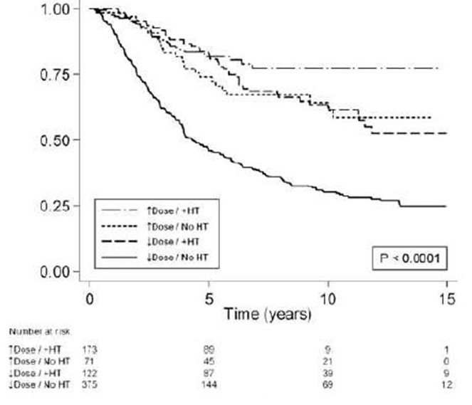
At 5 Years, men who had not received ADT and had received radiation dose < 75.6 Gy had higher clinical local failure rates than those given ADT and radiation dose ≥ 75.6 Gy (24.2% vs. 0%; p < 0.0001). The 10-Year symptomatic local failure rate was only 2% for all patients.
5-Year rates ranged from a low of 45.9% (no ADT + low-dose radiation) to 82.0% (ADT + high-dose radiation); and 10-Year rates ranged from 30.1% (no ADT + low-dose radiation) to 61.4% (no ADT + high-dose radiation); p < 0.0001.
The use of ADT and high-dose radiation resulted in decreased clinical failure rates at 5 Years (p < 0.0001).
Figure 9: Clinical failure.
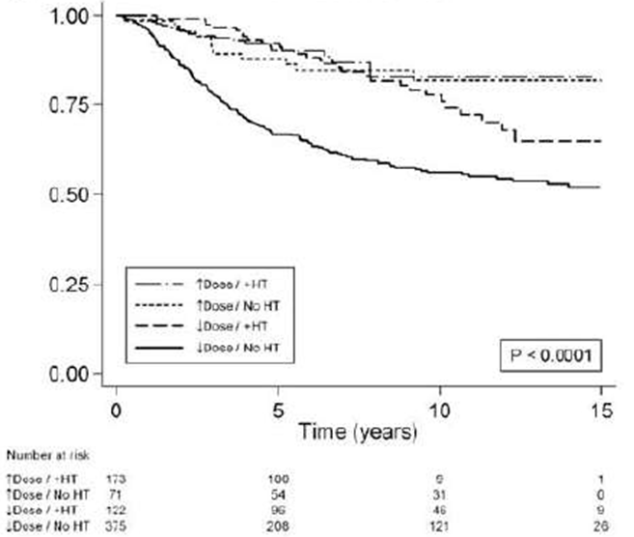
There were statistically significant associations between the treatment received and local failure (p < 0.0001); but not for nodal failure (p = 0.632); or distant metastasis (p = 0.081).
Among those patients who experienced local failure, subsequent related symptoms affecting their QoL (urinary obstruction/retention, hydronephrosis, acute renal failure) occurred in 6.2% of patients at 10 Years.
The common symptomatic local failures were reported as bladder/urinary retention (2.7%), urinary frequency/obstructive symptoms (2.3%), incontinence/increased nocturia (0.4%), and hydronephrosis (0.8%) at long-term follow-up.
No patient treated with ADT and high-dose radiation developed symptomatic local recurrence.
Authors: In this study, we found statistically significant benefits in OS, PSA disease-free survival, freedom from clinical failure, and fewer local failures when men with high-risk prostate cancer who were treated with ADT in combination with high-dose radiotherapy.
The shorter median follow-up time for this group (5.5 years) reflects the relatively recent institutional practice of dose escalation for patients with localized prostate cancer. Due to the inherent limitations in our comparison to the other 3 treatment groups, we only reported our 5-year outcome for this group.
Prostate cancer-specific deaths were uncommon in any group within 5 years of date of treatment, and at 10 years only 5.5% of patients treated even without ADT and high-dose radiation had died of prostate cancer.
However, after 5 years, there was a trend toward a difference between the ADT and high-dose group and the low-dose groups.
Figure 10: Nguyen 2013.
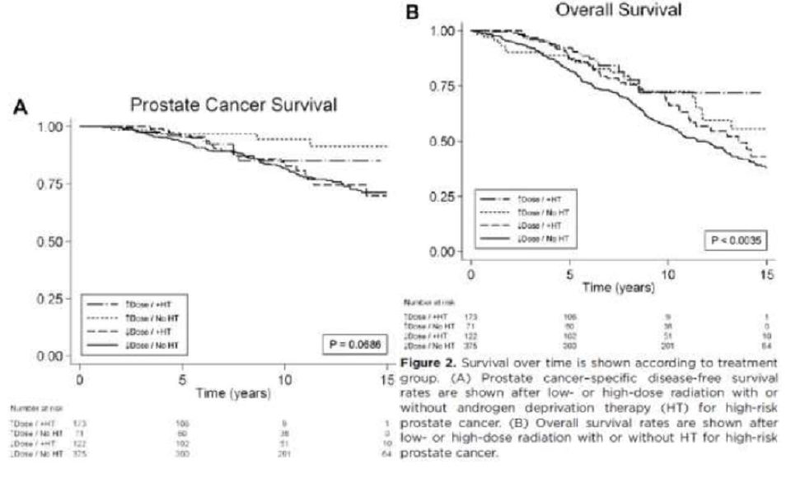
Authors: We observed a trend toward but not a significant difference in prostate cancer-specific survival between the treatment arms. Few patients died of prostate cancer at 5 years and 10 years after radiation; the number of prostate cancer deaths were too few to likely power a statistical difference between treatment arms.
Although outcome for men in the no ADT and high-dose group seemed to be at least as good as that in the ADT and high-dose group, the former group was small (71 patients) and had more favourable tumour characteristics.
• The use of ADT + high-dose radiation had a considerable positive effect on OS as well at 5 Years after treatment, with OS rates of 92% at 5 Years, compared with 82% for the low-dose and no ADT group, and the projected 10-Year difference would be 72% vs. 57%.
The cause of death for men with high-risk prostate cancer according to treatment group are summarised in Table 4.

Table 4: Cause of death in each treatment group.
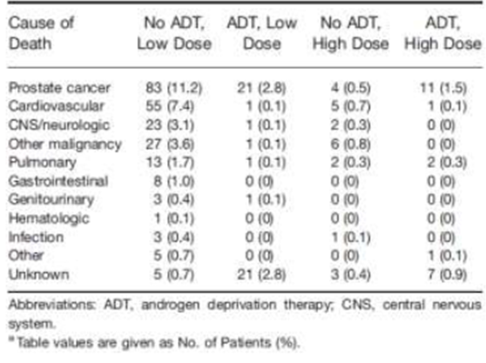
Authors: Our experience demonstrated that use of long-term (≥ 2 years) ADT in combination with radiation doses in excess of 75.6 Gy produced significant improvements in biochemical, clinical, and survival outcomes compared with previous eras; specifically, local failure rates were low and associated symptoms were uncommon.
Contrary to lingering historical perceptions, treatment of high-risk prostate cancer with modern, high-dose, external beam radiotherapy and ADT can produce better biochemical, clinical, and survival outcomes over those from previous eras. Specifically, symptomatic local failure is uncommon, and few men die of prostate cancer even 10 or more years after treatment.
Sponsor: Despite the obvious limitations associated with this retrospective study, the results reflect the comparative risks and benefits observed in a clinical practice administering treatment to high risk prostate cancer patients using best practice techniques, which evolved over the time of the study period, and clearly supports the overall benefits of ADT combined with high dose RT.

Study by Stone 2000 (NHMRC level III-2)
Retrospective study comparing the effect of neoadjuvant hormonal therapy with leuprolide and flutamide on prostatic biopsy findings in patients (n = 296) receiving trans-perineal prostate brachytherapy.

Design
Interrupted time series study with a control group from a single center in US conducted nearly 2 decades ago.
Sponsor: Thus the study outcomes may be compared according to whether patients received, or did not receive NHT. The study can therefore be classified as an interrupted time series study with a control group. This study therefore meets the requirements of level III-2 evidence according to the NHMRC 1999 guide.
Neither ethics approval nor patient consent were discussed by the authors of this study. Informed consent and randomization method were not relevant for this type of study. Design and treatments were defined in the abstract, but not the assessments.

Patient enrolment, characteristics and disposition
Inclusion criteria were not stated clearly for this study; however the sponsor made the following deductions: Gleason score ≤ 6, stage T1C - T2b, PSA ≤ 20 ng/mL, and no metastases.
A total of 296 patients received ¹²⁵I and ¹⁰³Pd seed implant and had post-treatment biopsies.
Patients were staged by DRE, routine blood chemistry studies, and transrectal ultrasonography (prostate volume). Patients were divided into high-risk and low-risk categories on the basis of PSA, stage, and Gleason score. Seminal vesicle biopsy was included, when indicated, in the original work-up.
Of the 296 patients, most had PSA ≤ 10 ng/ml, Gleason score ≤ 6, and had clinical stage ≤ T 2a. There were 117 low risk patients (PSA ≤ 10, Gleason ≤ 6, and stage ≤ T 2a); high risk patients were determined as ‘all others’.
Sponsor: The risk classification used in this study (stage ≥ T2b, PSA ≥ 10, Gleason score ≥ 7) differs from the current classification (stage ≥ T2C-3, PSA ≥ 20, Gleason score ≥ 8).
However, reasonable numbers of patients had screening results such as Gleason scores ≥ 7 or PSA > 20 which reflects the target population in this application.
Overlaps in characteristics were not discussed by the authors.
Evaluator: High risk patients were few; ‘PSA >10 - 20’ was recorded for 63 (21.3%) of patients, and PSA > 20 for 28 (9.5%) of patients; Gleason score ≥ 7 in 55 (19%) of patients.

Intervention
Altogether, 206 patients (70%) received a ¹²⁵1 implant, and 115 (39%) received NHT (leuprolide acetate and flutamide).
NHT: leuprolide injections (dose unspecified) + flutamide 750 mg/day orally; all given 3 months prior to RT and 3 months after the implant.
Brachytherapy (¹²⁵I and ¹⁰³Pd seed implant) 3 months after endocrine therapy.
Patients received a ¹²⁵I implant if they had a Gleason score ≤ 6; stage T1C - T2b and PSA ≤ 20 ng/mL. Prior to 1995, hormonal therapy was not used with seed implants; 115 patients fell into this category. From 1995 onwards, patients with Gleason score ≥ 7 all received ¹⁰³Pd seed implants regardless of clinical stage or PSA level.
Patients with PSA > 10 ng/mL, stage T2b, Gleason ≥ 7, or prostate volume > 50 cm³ were treated with leuprolide (leuprorelin) acetate (dose unspecified) and flutamide.
Sponsor: This population is therefore consistent with the application’s target population. As the period over which the analysis was conducted included the period when hormonal therapy was not used in conjunction with seed implantation, some patients were not treated with NHT.
Although the leuprorelin dose was not specified, it is reasonable to assume that the dose used at the time would be similar to dose recommendation at the time.

Monitoring
Routine transrectal US-guided needle biopsy was performed 2 years after treatment.
Patients were routinely followed by PSA and DRE every 6 months. Patients with PSA > 10 ng/mL had bone scans performed; positive scan excluded patients from implantation. Patients who presented with a PSA > 10 ng/mL or stage T2b disease had seminal vesicle biopsies performed, and were excluded if the results were positive.

Endpoints
The objectives of the study were to report on the effects of hormonal therapy and its potential role in brachytherapy by examining its impact on biopsy findings. The study discusses evidence of local residual prostate cancer in biopsy samples obtained at 2 Years.

Statistical methods
Differences in proportions were tested using the Pearson chi-square test.

Efficacy results
Of the 296 patients, 30 (10%) had positive post-implant prostate biopsies.
Biopsies were positive in 4/115 (3.5%) vs. 26/181 (14%) of those who received or had not received NHT, respectively (p = 0.002).
When patients were separated into low risk (PSA ≤ 10 ng/mL, stage ST2a, and Gleason score ≤ 6) and high risk (all others), it was seen that low-risk patients did not benefit from NHT (3.8% vs. 7.7% positive biopsy rate; p = 0.5) whereas high-risk patients did (3.4% vs. 21.1%; p = 0.003).
Comments: The current study demonstrates the advantages of using NHT in higher-risk patients. Overall, the positive biopsy rate was 3.5% for those receiving NHT compared with 14% for patients treated with implant alone (p = 0.002).
The differences remained highly significant for those patients with high stage, PSA, and Gleason score. The most striking difference was seen when patients were grouped into low- and high-risk categories.
Whereas there was no advantage in adding NHT for patients with PSA ≤ 10 mg/mL, Gleason ≤ 6, and stage ≤ T 2a, patients with higher-risk features did benefit. In such patients, the positive biopsy rate was 3% with NHT vs. 21% without it.
The biopsy results according to the clinical stage and NHT use are shown.
Figure 11: Stone 2000: biopsy results by clinical stage and NHT use.
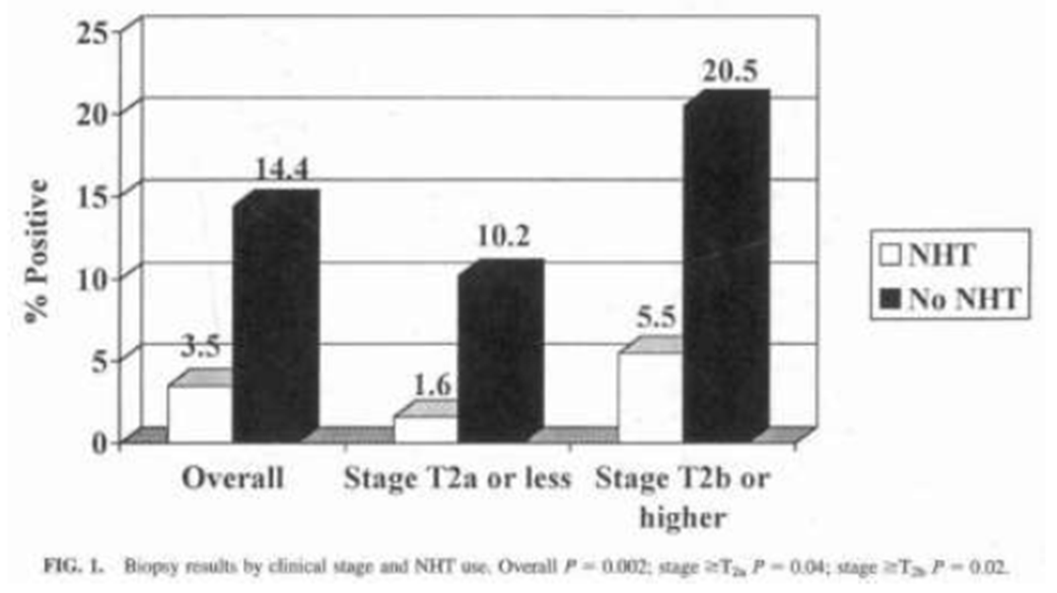
The difference was greater in the higher-stage lesions, where 20.5% (15/73) patients implanted without the benefit of NHT compared to 5.5% (3/54) of those given NHT had positive biopsies (p = 0.02).
The biopsy results according to the Gleason score are shown.
Figure 12: Stone 2000: biopsy results by Gleason score and NHT use.
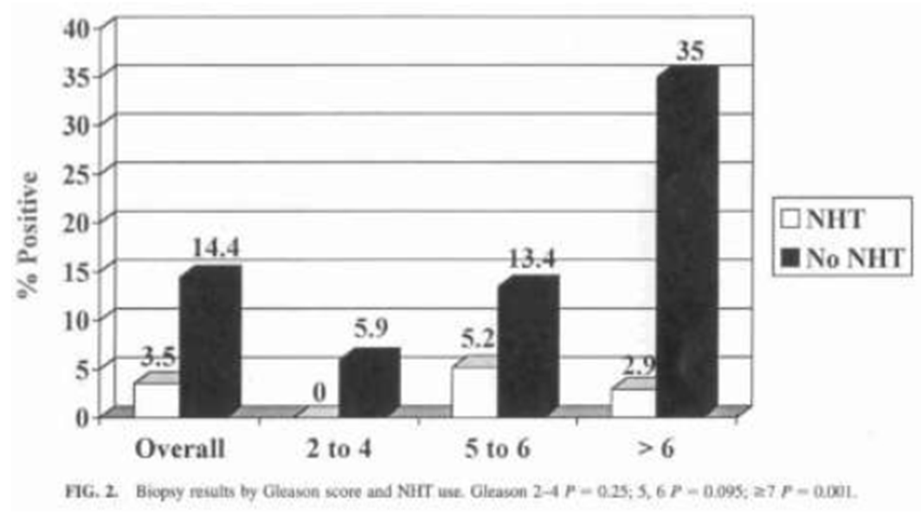
Patients with Gleason ≥ 7 had significant benefit from NHT. Positive biopsies were found in 3% of those receiving NHT compared 35% of the men treated with implant alone (p = 0.001).
Similar benefits associated with NHT administration in patients with PSA > 20 ng/mL were also seen. There was no significant benefit from NHT in patients with PSA ≤ 10 ng/mL (4% positive biopsies with NHT vs. 12%; p = 0.08).
The biopsy results according to risk category are shown.
Figure 13: Stone 2000: biopsy results by risk category and NHT use.
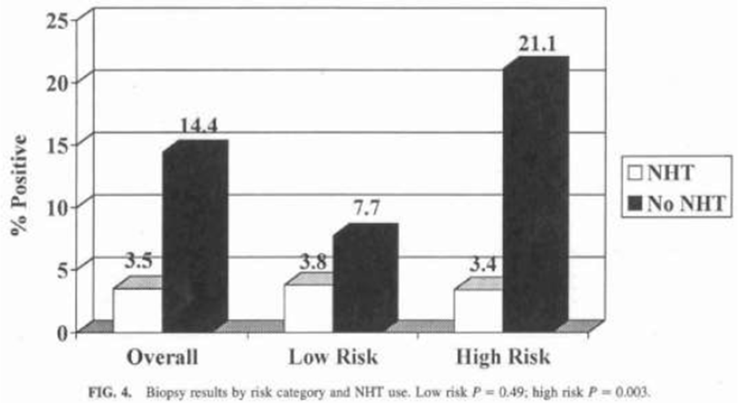
Low-risk patients did not benefit significantly from NHT (4% vs. 8%; p = 0.5), whereas high-risk patients did (3% vs. 21%; p = 0.003).
Conclusion: Prostate brachytherapy yields high negative biopsy rates (90%) 2 years after treatment.
Neoadjuvant hormonal therapy can improve the local control rates (as determined by biopsy) in patients undergoing ¹²⁵I or ¹⁰³Pd seed implantation. These results are most significant for patients who present with PSA > 10 ng/mL, stage ≥ T2b diseases, or Gleason score ≥ 7 (high-risk status).
The positive biopsy rate was decreased from 23% to 3% by the addition of NHT. However, the majority of patients treated with ¹⁰³Pd were at high risk, which may account for the high positive biopsy rate with implant alone.
Sponsor: The authors conclude that transrectal ultrasound-guided prostate brachytherapy results in high local control rates, as demonstrated by a 90% negative post-implant prostate biopsy rate. Patients who present with high PSA or Gleason score or advanced clinical stage will have better local control if treated with NHT in combination with brachytherapy.

Studies with low level of evidence

Study by Heymann 2007 (NHMRC level IV)
Prospective study evaluating the toxicity and efficacy of individualised neoadjuvant ADT ‘administered to maximal response’, followed by EBRT with continued ADT for a total of 9 months for clinically localised prostate cancer.
Background: Animal models demonstrated that delivering RT after maximal response to ADT is superior to delivering RT on the day ADT is given.
Design
Prospective, uncontrolled, open-label, non-randomized, Phase II study from a single center, conducted in patients (n = 123) with biopsy proven prostate cancer.
From July 1997 - September 2002, 123 patients attending the Columbia University Medical Center (CUMC) were enrolled into the study.
Sponsor: The study was uncontrolled and non-randomised. This study therefore meets the requirements of level IV evidence according to the NHMRC 1999 guide.
Evaluator: Level IV NHMRC hierarchy of evidence for assessment of an ‘Intervention’ requires a case series with either post-test or pre-test/post-test outcomes.
Sponsor: The Institutional Review Board at CUMC approved the study. All CUMC patients meeting eligibility criteria were offered enrolment in the study and written informed consent was obtained. Design and treatments were defined in the abstract, but not the assessments. Randomization method was not relevant for this type of study. One of the authors received research funds from TAP Pharmaceuticals, sponsor of luprolide. This source of potential bias was fully declared.

Patient enrolment, characteristics and disposition
Inclusion criteria: Patients with biopsy-proven prostate adenocarcinoma, serum PSA > 4 ng/mL or a Gleason score ≥ 8 and no metastases. Patients with serum PSA > 50 ng/mL (n = 18) were required to undergo pelvic lymphadenectomy.
Evaluator: The study enrolled very heterogeneous group of patients; a significant number of participants had locally more advanced disease, i.e. 51% of patients had T2b-T4 stage disease at baseline; whereas 53% had Gleason score 8 - 10; the remaining recorded lower Gleason scores.
Sponsor: For the purposes of this overview, high-risk localised and locally advanced prostate cancer is considered to be present in a male with either a PSA ≥ 20 ng/mL, a Gleason score of ≥ 8, or a primary tumour within or just beyond (i.e. prostatic capsule) the prostate gland (T2 or T3a).
The authors grouped the patients by clinical stage, Gleason score (GS), baseline PSA and risk group. A majority of the patients 102 (83%) were classified as high risk and therefore applicable to this application for high risk, locally advanced prostate cancer.
Patients were further categorised as low, intermediate or high risk, however the definition of these groups were not discussed by the authors. However the authors did provide a tabulation of relevant primary tumour, Gleason scores and PSA concentrations recorded in the patient cohort.
While there was a proportion of patients graded T4, the study cohort was with the patient population targeted by this application (high risk and locally advanced prostate cancer).

Intervention
Luprolide IM 7.5 mg monthly or 22.5 mg every 3 months for 9 months + flutamide 250 mg orally TDS for 9 months + individualized EBRT. The neoadjuvant phase was restricted to no more than 6 months.
A total of 123 patients received 9 months of flutamide + luprolide combined with EBRT.
EBRT: Conformal or intensity modulated RT, after maximal response to androgen therapy (median 4.7 months) to a dose of 70.2 Gy. From February 2003, the target total dose of radiation per patient was raised to 75.6 Gy.
Starting at initiation of ADT, tumours were monitored monthly by DRE and serum PSA until they reached maximal response by both methods of assessment, at which time patients began RT.
Indications to begin EBRT (% rates) were: undetectable PSA (28%), PSA unchanged next month (46%), PSA rising next month (10%), 6 months of ADT (14%), and other (2%).
Protocol adherence: 1 patient received goserelin acetate instead of luprolide acetate; 6 (5%) did not receive flutamide at study entry; 13 (10%) discontinued flutamide. 1 patient did not receive radiation; 1 discontinued radiation after receiving only 5.4 Gy; 5 other noncompliant doses were given due to miscellaneous factors.
Sponsor: The dose of luprolide in this study is equivalent to one currently registered in Australia.

Monitoring
Median follow-up time from initiation of treatment was 45 months (range: 0 - 81 months).
Protocol efficacy was determined post-therapy by determination of serum PSA, DRE, imaging (if serum PSA were rising), biopsy, and mortality. Although biopsies were required by the protocol 18 months after completion of treatment, few were performed because of reluctance.
Consequently, treatment failure determinations were based on serum PSA or DRE in most cases. In addition, because failure to recover testosterone after ADT may effectively prolong the therapeutic effects of AD, serum testosterone concentrations were determined.
Patients were assessed 1 month after completion of RT, at completion of ADT, then every 3 months during the first 2 years, every 6 months through the 5 Year, and then annually for the remainder of the patient’s life.

Endpoints
The primary endpoint was biochemical disease-free survival (BDFS) at 5 years. Failure of BDFS was defined as serum PSA > 1.5 ng/mL, increasing on 2 consecutive measurements separated by at least 3 months. Death from any cause subsequent to 2 consecutive measurements demonstrating rising PSA was also considered a failure of BDFS.
The secondary endpoint was clinical disease-free survival (CDFS). Failure of CDFS was failure of local tumour control (by prostate biopsy or DRE), failure of metastasis-free survival, and re-initiation of therapy.
Another secondary end point was OS (death as a result of any cause).
Cause-specific survival, with failure defined as either death during treatment for cancer recurrence or recurrence resulting in death.
Freedom from hormone-refractory prostate cancer (HRPC) was additionally considered. Failure of HRPC-free survival was defined for patients receiving ADT as 3 consecutive rises in serum PSA, progressive metastases on imaging, or initiation of new treatment.

Statistical methods
All data were analysed according to the ITT principle. The null hypothesis is assumed to be no difference in PFS between the treatment groups. All time-related end points were estimated by the Kaplan-Meier method with the log-rank statistic and the Bonferonni adjustment used to test for differences and correct for multiple comparisons, respectively. The multivariate prognostic factor analysis used the Cox proportional hazards regression model.

Primary efficacy results
The 5 Year outcomes: BDFS was 63% ± 7%.
Predictors of failure: Patients with baseline serum PSA > 30 ng/mL were significantly more likely to have a failure of BDFS at 5 Years (54% ± 13%) than were those with baseline serum PSA ≤ 30 ng/mL (30% ± 7%; p = 0.045).
Similarly, patients who began RT after 6 months were significantly more likely to have a failure of BDFS at 5 Years (82% ± 15%) than were patients who began RT with an undetectable (33% ± 12%), nadir (29% ± 8%), or rising (18% ± 11%) serum PSA (pooled comparison; p = 0.002).
Pair-wise comparisons of the 6-month group with the undetectable (p = 0.005) and nadir (p = 0.001) serum PSA groups were also significant, even after Bonferonni adjustment (required significance of p = 0.0083).
Comparison with the rising serum PSA group was significant by standard criteria (p = 0.043), but not after Bonferonni adjustment. (Strictly, p value of 0.043 is not significant.)
Clinical stage, GS, risk group, race, age, serum PSA at initiation of RT, and complete response to DRE at initiation of RT failed to predict for biochemical failure.
On multivariate analysis, only indication to begin RT independently predicted BDFS.

Other efficacy results
• CDFS, 75% ± 5%; cancer-specific survival, 99% ± 1%; and OS 89% ± 3%.
Predictors of failure: Patients initiating RT after 6 months of ADT had significantly lower biochemical and clinical DFS. Those patients whose testosterone recovered to normal after completion of ADT had a significantly superior survival rate. Of those patients potent before treatment, 65% remained so at last follow-up.
Patients with tumours of GS > 7 were significantly more likely to have a failure of CDFS at 5 Years
(40% ± 9%) than were patients with tumours of GS 7 (19% ± 8%) or < 7 (0%; p = 0.024).
Patients who began RT after 6 months were significantly more likely to have a failure of CDFS at 5 Years (75% ± 15%) than were patients who began RT with an undetectable (27% ± 10%), nadir (15% ± 6%), or rising (0%) serum PSA (pooled comparison; p = 0.001).
Pairwise comparisons of the 6-month group with the nadir (p = 0.001) and rising (p = 0.008) serum.
PSA groups were also significant, even after Bonferonni adjustment.
Comparison with the undetectable serum PSA group was significant by standard criteria (p = 0.043), but not after Bonferonni adjustment.
Clinical stage, risk group, race, age, baseline serum PSA, serum PSA at initiation of RT, and complete response to DRE at initiation of RT failed to predict for clinical failure. Multivariate analysis demonstrated that both GS and indication to begin RT independently predicted CDFS.
Further analysis of the group beginning RT after 6 months of ADT was performed. There were no significant differences in age, race, clinical stage, GS, or risk group between this subgroup at study entry and the other response groups (PSA undetectable, nadir, and rising).
There were also no significant differences in serum PSA at study entry, immediately before RT, or at 3 months after initiation of ADT.
Furthermore, patients who initiated RT after 3 months of ADT were not more likely to have a failure of any study end point at 5 Years compared with those who reached maximal response within 3 months.
Serum testosterone concentration returned to normal (≥ 270 ng/dL) in 69% of patients (n = 85).
Median time to recovery was 9 months (range: 0 - 54 months).
Pre-treatment serum testosterone concentrations were determined in 86 patients. Serum testosterone returned to its baseline concentration after completion of AD in 37% (n = 32) of those patients.
Median time to recovery was 11 months (range: 0 - 52 months).
Authors: Interestingly, patients who recovered serum testosterone to normal levels after completion of ADT were not more likely to have a failure of BDFS or CDFS at 5 Years compared with those who did not recover serum testosterone to normal levels (BDFS, 40% ± 7% vs. 26% ± 14%, p = 0.176; CDFS, 25% ± 6% vs. 25% ± 12%, p = 0.840).
Patients who recovered serum testosterone to normal levels after completion of ADT were significantly more likely to survive for 5 years (95% ± 3%) than were those who did not recover serum testosterone to normal levels (70% ± 10%; p = 0.001).
Clinical stage, GS, risk group, race, age, serum PSA at study entry, serum PSA at initiation of RT, reason for initiation of RT, and complete response to DRE at initiation of RT failed to predict for overall mortality.
Because of the small numbers of deaths, cause-of-death analysis was limited, but there was no statistically significant difference in cause of death between those who did and did not recover serum testosterone to normal levels.
Authors: Of note in the study is the relatively high rate of preservation of sexual potency after completion of ADT.
A striking result obtained after analysis of patient outcomes was the high prevalence of biochemical and clinical failure among patients who initiated RT without first reaching maximal response (ie, after 6 months). These patients might represent a subset of the population requiring more aggressive treatment than administered in this study.
The finding of an improved survival in those patients whose testosterone recovered compared with those whose testosterone remained suppressed is surprising. These findings suggest that testosterone recovery may be beneficial to overall health without having deleterious effects on prostate cancer control, and further support the notion of limiting the length of time ADT is administered to the minimum necessary.
In summary, the results of this study provide evidence that individualisation of neoadjuvant ADT to maximal response followed by RT with continued ADT for a total of 9 months can safely be used to treat patients with intermediate- to high-risk clinically localized prostate cancer and preserve potency in many patients. Additional studies are needed to determine the optimal combination of ADT and RT in this patient population.
Sponsor: While this study is a phase II, uncontrolled trial it does provide important information regarding likely predicators of success following combined AD and RT therapy, as well as an extensive evaluation of the therapeutic outcomes and adverse consequences of this therapy and therefore is relevant to the overall assessment of the risk benefit evaluation of this therapy and the optimal therapeutic approach to combination AD and RT treatment.

Study by Stone 1999 (NHMRC level IV)
Observational case series that analysed the effects of NHT on prostate volume (PV) prior to radioactive seed implantation, and the PSA and post-implant biopsy outcomes of high-risk patients (n = 145).
Background: Historically, patients who present with locally more advanced disease do not appear to do well with brachytherapy. The rationale for using NHT was to reduce the positive margin in patients with disease of high clinical stage prior to targeted RT.

Design
Uncontrolled, observational case series assessing the efficacy of hormonal therapy in prostate cancer patients from a single centre in US, conducted over 2 decades ago.
Sponsor: This study therefore meets the requirements of level IV evidence according to the NHMRC 1999 guide.
Neither ethics approval nor patient consent were discussed by the authors of this study. Design and treatments were defined in the abstract, but not the assessments. Informed consent and randomization method was not relevant for this type of study.

Patient enrolment, characteristics and disposition
From 1990 - 1997, over 800 patients with localised prostate cancer received brachytherapy; of these, 145 (18%) also received NHT at Mount Sinai Medical Centre, New York.
Study included patients with localised prostate cancer, high risk, or a prostate volume > 50 mL, and no nodes. All patients had biopsy-proven prostate cancer and were evaluated by Gleason score, PSA, clinical stage and bone and CT scans.
The clinical characteristics of the 145 patients are provided.
Of the 145 patients treated, 46% had a PSA > 10 ng/mL (range: 1.9 - 57 ng/mL; mean 12.2 ng/mL), 35% had Gleason score ≥ 7, and 55% had stage ≥ T2b disease. The mean PV was 30.5 mL (range: 11.5 - 93 mL).
Of these, 28 (19%) received NHT because of a pre-implant PV > 50 cc, and 117 patients received NHT because they had a PSA > 10 ng/mL, Gleason score ≥ 7, or clinical stage ≥ T 2b.
Patients who presented with a PSA > 10 ng/mL, Gleason score ≥ 7, or clinical stage ≥ T2b were considered to be high risk and underwent seminal vesicle biopsy and were excluded if results were positive. Patients with PSA > 20 ng/mL, Gleason score ≥ 8, or clinical stage T2c or T3 underwent laparoscopic pelvic lymph node dissection and were excluded if positive.
Sponsor: Patients were considered to be high risk if they had PSA > 10 ng/mL, Gleason ≥ 7 and or ≥ stage T2b. The study population therefore reflects the target population for this application.
The risk classification used in this study (stage ≥ T2b, PSA ≥ 10, Gleason score ≥ 7) differs from the current classification (stage ≥ T2C-3, PSA ≥ 20, Gleason score ≥ 8). However, the some of the results in this study can still be applicable to this application, such as the results for stage ≥ T2C, Gleason scores ≥ 7 or PSA > 20.
Evaluator: PSA > 20 ng/mL was recorded in 13% of patients at baseline, GS 8 - 10 in 10% of patients, and 19% had T2c disease.

Intervention
Leuprolide injections (dose unspecified) and flutamide 250 mg orally TDS; together for 3 months prior to implant and 3 months after implant + brachytherapy (¹²⁵I and ¹⁰³Pd seed implant) 3 months after endocrine therapy.
Permanent ¹²⁵I and ¹⁰³Pd seed implantation that delivered a radioactive dose of up to 115 Gy or 160 Gy, respectively.
Sponsor: Although the leuprorelin dose was not specified, it is reasonable to assume that the dose used at the time would be similar to dose recommendation at the time.
Evaluator: ADT (TAB) was administered in the study in the neoadjuvant and adjuvant setting.

Monitoring
Study lasted 4 years. Assessments were done at 3 and 6 months, and 6-monthly thereafter; biopsy at 2 Years. Patients were followed for a minimum of 1 year (range: 1.0 - 6.4; mean 2.2 years).

Endpoints
Outcome measures used to assess the efficacy of treatment were prostate volume (PV), freedom from PSA failure (biochemical failure: defined as 2 consecutive PSA increases of > 1.0 ng/mL) and prostate biopsy results.
Ultrasound-guided transrectal biopsy (8 cores) was performed 2 years after implantation in patients providing consent (n = 62).

Statistical methods
Changes to PV and PSA were analysed in this study. Biochemical failure actuarial curves were generated using Kaplan- Meier method. Differences in actuarial rates were calculated using the log-rank test.
- Efficacy results
PV was measured in 106 patients; the mean volume decreased from 50.4 mL to 31 mL. The mean PV reduction was 35% (range: 2% - 62%).
Patients with a pre-NHT volume of about 40 mL (large prostate, n = 56) had a greater mean reduction, 41% vs. 29% for patients with pre-NHT values < 40 mL (small prostate, n = 50); p < 0.05.
Comments: Patients with larger glands will benefit most when NHT is used for cytoreduction. In patients with small glands, excessive shrinkage was not seen.
Patients with high-risk features- Gleason score ≥ 7, PSA > 10 ng/mL, or clinical stage ≥ T2b- had the same rate of freedom from PSA failure as did lower-risk patient.
The 4 Year actuarial rate of freedom from PSA failure was 85%. There was no difference in the rates of freedom from PSA failure for those with initial Gleason score of 2 - 4 (96%), 5 - 6 (78%), 7 (80%), or 8 - 9 (83%); p = 0.5.
Control rates (freedom from PSA failure) were 85% for those with PSA ≤ 10 ng/mL, 82% for patients with PSA 10 - 20 ng/mL, and 88% for patients with PSA > 20 ng/mL (p = 0.8).
There was a trend to decreased control rates with high risk disease (98% for T1 - T2a vs. 68% for T2C), however the differences were not statistically significant (p = 0.12).
The control rates for the 28 low risk patients with enlarged prostate glands were compared with those in the 117 with high risk features and no significant differences were found (100% vs. 82%; p = 0. 1).
Authors: This study also demonstrated a favourable rate of freedom from PSA failure. At 4 Years, 85% of the patients were free of rising serum PSA > 1 ng/mL. High-risk patient did as well as low-risk patients when NHT was used.
There are several possible explanations for these results. All of the highest-risk patients (PSA > 20 ng/mL, Gleason score > 7, or stage > T2b) underwent surgical staging with seminal vesicle biopsy and laparoscopic pelvic lymph node dissection, and patients with positive seminal vesicles or nodes were excluded from treatment.
Thus, the population is similar to a surgically staged group in that most patients with extra-prostatic disease were excluded. The implication is that those patients with high-risk features mostly had large intra-prostatic tumour volume, high-grade disease, or minimal capsular penetration, and these patients appear to benefit from the cytoreductive properties of NHT.
There were 62 patients who agreed to prostate biopsies 2 years after implantation, and 60 (97%) were negative for tumour, which is supportive of long-term disease-free survival.
Summary: Hormonal therapy plus prostate brachytherapy has several benefits over brachytherapy alone in certain patients. Patients who present with large glands will experience a substantial volume reduction with NHT, and high-risk patients will have significant improvement in the likelihood of local control and freedom from PSA failure.
This trial shows that NHT can reduce PV an average of 35% prior to seed implantation with the greatest reduction found in patients with larger prostates (41%). Hormonal therapy also appears to improve biochemical (PSA) control and local control (prostate biopsy) in patients with high-risk disease, yielding results similar to those in men with low risk prostate cancer.
Patients with larger glands will benefit most when NHT is used for volume reduction. In patients with small glands, excessive shrinkage will not be seen, and the creation of a gland too small for implantation can be avoided.
Sponsor: Notwithstanding the limitations associated with uncontrolled observational studies, the conclusions of the authors that neoadjuvant hormonal therapy plus prostate brachytherapy has several benefits over brachytherapy alone in certain patients remain relevant to this application.
The study demonstrated that patients who present with large glands will experience a substantial volume reduction with NHT, and high-risk patients will have significant improvement in the likelihood of local control (prostate biopsy) and freedom from PSA failure, yielding results similar to those in men with low risk prostate cancer, which supports the hypothesis that NHT reduces size of prostatic tumours in relation to the normal tissue structures and therefore minimises the volume of normal tissue exposed to high dose RT and potentially enhancing efficacy while reducing the risk of long term treatment related morbidity.

Study by Zelefsky 1997 (NHMRC level IV)
Uncontrolled case series that prospectively assessed the impact of NHT given prior to RT (3D CRT) based on the size of prostatic tumours in relation to normal tissue structures, and the response to treatment including late toxicity in patients with localised prostate cancer.
Background: In addition to improving the geometry of bulky tumours prior to RT, androgen ablation has been used in the neoadjuvant setting with the intent of improving the outcome of therapy for advanced-stage disease. It is theoretically possible that if there has been volume reduction, radiation doses that are able to eradicate microscopic cancer cells may be sufficient to address disease that may have been beyond the capsule at that time.

Design
Prospective, uncontrolled case series study conducted at a single center in US some three decades ago.
From January 1987 - December 1995, 214 patients were treated with NHT prior to 3D-CRT for clinically localised prostate cancer at the Department of Radiation Oncology at the Memorial Sloan-Kettering Cancer Centre, New York.
Sponsor: This study therefore meets the requirements of level IV evidence according to the NHMRC 1999 guide.
Design and treatments were defined in the abstract, but not the assessments. Informed consent and randomization method was not relevant for this type of study.

Patient enrolment, characteristics and disposition
Baseline characteristics: The median age of participants was 69 years (range: 51 - 84 years); the median PSA was 12.7 ng/mL (range: 3 - 560 ng/mL). The study gives only tumour stage and Gleason scores.
Sponsor: The study is considered applicable to this application as a majority of the study patients can be categorised as high-risk patients, T2c (21%) and T3 tumours (42%) or Gleason scores ≥ 8 (26.6%).

Intervention
Leuprolide 7.5 mg IM monthly 3 months before RT until last day of treatment together with flutamide 250 mg orally TDS followed by 3D CRT.
3-dimensional conformal RT (3D CRT); conventional fractionation with the median total dose delivered of 70.2 Gy. 12/45 patients (27%) received 75.6 Gy and 9 (20%) received 81 Gy as part of an ongoing phase I-II dose-escalation study.
Sponsor: The leuprolide dose is equivalent to the one proposed in this application.

Monitoring
The median follow-up time was 15 months (range: 5 - 56 months).

Endpoints
The objective of this study was to determine the impact of NHT prior to 3D-CRT on the reduction of volume of normal tissue strictures exposed to high doses of RT, thus improving the RT treatment plan, and to evaluate the overall late toxicity and response to treatment among patients treated with this approach.
The cumulative dose-volume histograms (DVH) were calculated for target organs as well as the rectal and bladder walls and small bowel for a subgroup of patients.
Patients were characterised as responders if NHT resulted in volume reduction of normal tissue structure exposed to high RT doses into the ‘acceptable’, tolerable levels as defined in the study.
The incidences of late toxicity and outcome parameters were evaluated in the entire 214 patient cohort who received NHT. Outcome parameters, included PSA-relapse free survival, local-relapse-free survival, and distant metastases-free survival.
Late-treatment complications were graded according to the morbidity grading system of the Radiation Therapy Oncology Group (RTOG). PSA relapse was defined as 2 successive PSA elevations above the post-treatment nadir level.

Statistical methods
Of the 214 patients, 45 were prospectively evaluated with detailed DVH analyses to determine the extent of change of the geometry.
Sponsor: The authors did not explain the rationale of this small sample size, nor did they provide the patients’ characteristics for this sub-group.
Time-adjusted rates of the appearance of late complications, OS, and PSA-relapse free survival were calculated using Kaplan-Meier method. Differences between time-adjusted incidence rates were evaluated using the Mantel log-rank test for censored data. Covariates that affect the time-adjusted incidence of PSA relapse were examined using the stepwise Cox proportional hazards regression model.

Efficacy results

Effect of NHT on volume of normal tissues receiving high doses (n = 45)
In the 45 patients prospectively evaluated, the median target-volume reduction after administration of NHT was 68 mL, representing a 27% reduction in the size of the target volume. A total of 17 patients (39%) had a target-volume reduction of ≥ 30% and 2 (4%) had no demonstrable change after NHT.

Outcomes with NHT (n = 214)
The 3 Year actuarial survival and disease-free survival rates were 93%, and 83%, respectively.
The 3 Year actuarial local-control rate was 94%, and the 3 Year distant-metastases-free survival rate was 87%. The 3 Year PSA-relapse-free survival in this group of patients was 64%.
Pre-treatment PSA (≤ 20 ng/mL vs. > 20 ng/mL) was the most significant independent variable identified in the Cox regression analysis that affected the risk of a PSA relapse.
Among patients with baseline PSA levels > 20 ng/mL, the incidence of PSA relapse at 3 Years was 55%, compared to 25% for patients with baseline PSA levels ≤ 20 ng/mL (p < 0.0001).
Authors: On the relatively poor results for patients with pre-treatment PSA levels > 20 ng/mL, even in combination with NHT: In our experience with patients with PSA > 20 ng/mL, the PSA-relapse-free survival at 3 years for patients treated with NHT plus 3D-CRT was only 45%.
It is possible that for patients with poor prognostic features, a short course of androgen ablation may not be sufficient to significantly improve the outcome. In these high-risk patients, longer courses of androgen ablative therapy (in the neoadjuvant or adjuvant setting) or effective systemic therapies may be needed to improve survival.

Late complications (n = 214)
Of the 214 patients treated, no Grade 3 or 4 toxicity was observed, with a median follow-up of 15 months after 3D-CRT. The 3-Year actuarial Grade 2 late GI and GU toxicity rates were 6% and 18%, respectively.
Summary: These results confirm our previously reported findings that the unfavourable geometry associated with bulky prostatic disease can be improved with effective hormonal cytoreduction, and that curative radiotherapy doses can be delivered after such hormonal therapy to the prostate and seminal vesicles, while respecting the tolerance of the surrounding normal tissues.
Sponsor: The authors conclude that NHT effectively reduces the volume of normal tissue exposed to high radiation doses in the majority of treated patients and decreases the potential morbidity of therapy.

Other data

Practice guidelines and published reviews
The sponsor presented 3 national/international publications in support of the proposed extension of indications.

Published paper from the Australian Family Physician 2011
Sponsor: In a review of Australian treatment options for localised prostate cancer, Duchesne provides an evidence-based recommendation that combined ADT and radiotherapy should be given to patients with high and high/intermediate risk of occult metastasis at initial presentation, as it results in a survival benefit.
This paper from the Australian Family Physician 2011 provides an overview of the various methods of treatment for localised prostate cancer aimed at General Practitioners. It contains short a paragraph dedicated to androgen deprivation therapy.
It does not provide recommendations, or state the hierarchy of evidence to support each treatment options. The paper refers to LHRH agonists in general, but does not mention specifically leuprorelin:
A number of randomised trials have shown a survival benefit to men with high and high-intermediate risk of occult metastasis at initial presentation when androgen deprivation therapy is used in combination with radiation therapy. This is achieved using a potentially reversible luteinising hormone releasing hormone (LHRH) agonist.
The optimal duration of treatment is still under investigation, but is likely to be between 6 months and several years depending on the risk grouping.
No benefit has been shown in combination with surgery, probably because surgical series have tended to include lower risk patients.
The references to support the above statements are based on 2 papers; one from 2005 (RCT), and another from 2009. The author of the paper is stated to hold the position of Director of Radiation Oncology & Cancer Imaging at Peter MacCallum Cancer Centre and the Adjunct Professor, University of Melbourne and Monash University.
In summary, the paper provides general overview aimed at General Practitioners on different modalities of treatment for localised prostate cancer. The paper represents ‘Category IV’ level of evidence (expert opinion) according to WHO (but not NHMRC) criteria; as such adds to the background information.

The New Zealand Ministry of Health recommendations from the Prostate Cancer Taskforce
Sponsor: Similarly, the New Zealand Ministry of Health recommendations from the Prostate Cancer Taskforce advise that high risk patients should receive ADT prior to, during and after external beam radiotherapy (EBRT).
The publication discusses the ‘Diagnosis and Management of Prostate Cancer in New Zealand Men’ and provides recommendations from the Prostate Cancer Taskforce 2012. The publication is country-specific with strong focus on primary care and cultural needs of Maori and Pacific men.
The document includes an overview of the treatment modalities; adding to the background information.
In localised and locally advanced prostate cancer, several randomised phase III trials have established the indications for the combination of external irradiation and androgen deprivation treatment (ADT). These trials have been conducted by radiation therapy scientific societies such as the Radiation Therapy Oncology Group, the European Organisation for Research and Treatment of Cancer, and the Trans-Tasman Radiation Oncology Group.
Consensus guidelines for definitive external beam were published by the Australian and New Zealand Faculty of Radiation Oncology Genito-Urinary Group in 2010. Treatment should be IMRT (including intensity modulated arc therapy) with daily image guidance (IGRT) with gold seed fiducial markers or other methods such as cone beam CT, ultrasound based systems and implantable transponders.
The recommended dose is ≥ 74 Gy for those in the low risk group. Dose escalation in intermediate and high risk groups improves relapse-free survival and > 74 Gy and preferably 78 Gy is recommended in these patients, particularly if they are not receiving neo-adjuvant androgen deprivation.
Patients with bulky, high-volume and locally advanced (Stage ≥ T2b) cancers are recommended to have six months of neo-adjuvant androgen deprivation therapy which improves local control and reduces the chance of future metastatic recurrence. Patients at high risk of occult metastatic disease should consider ongoing adjuvant androgen deprivation for up to three years depending on risk and tolerance.
Transperineal permanent brachytherapy is a safe and effective technique. Low dose rate (LDR) brachytherapy (seed implantation) is most suitable for patients with good urinary function, a prostate size of less than 50 - 60 cm3 and low risk cancer. Patients with large prostates may be suitable for implantation after a three-month period of androgen deprivation if this has reduced prostate size sufficiently.
External beam and temporary high dose rate (HDR) brachytherapy is a combined treatment that delivers higher dose than EBRT alone. It is most suitable for ‘unfavourable’ intermediate risk patients with > 50% positive biopsies, Gleason 3 + 4 = 7, extensive perineural invasion and locally advanced bulky cancers. Patients with locally advanced disease and high risk disease should consider neo-adjuvant and adjuvant androgen deprivation, as for external beam radiation therapy.
The benefits of neo-adjuvant treatment have not been as clearly established as for external beam alone.
In bulky, unfavourable, intermediate risk and locally advanced prostate cancer (T3-4 N0 M0), neoadjuvant and concomitant androgen derivation treatment in conjunction with external beam radiation therapy improves overall survival. EBRT should start five months after commencing ADT.
Optimal duration for ADT is uncertain but in those at high risk of occult metastatic disease, a longer duration may add further benefit and can be considered for up to a total of 2 - 3 years, especially if well tolerated.
In high risk patients (PSA > 20, or GS > 8, or T > 3 or 2: PSA 10 - 20 or T2b, or GS 7), long-term ADT prior to, during and after EBRT is recommended as it increases overall survival. EBRT should start five months after beginning ADT. Optimal duration for ADT is uncertain but can be considered for up to 3 years if tolerated well.
In locally advanced and high risk prostate cancer, dose escalation > 74 Gy and up to 78 Gy in 2 Gy/fraction is preferred and improves local control and biochemical relapse-free survival whether or not neo-adjuvant ADT is used. Combined short course EBRT (45 - 50 Gy at 1.8 to 2 Gy/fraction) and brachytherapy (eg, temporary high dose rate prostate implant) is a well-established alternative option for dose escalation.
In contrast to EBRT alone, the role of neo-adjuvant ADT is not well-established with combined EBRT and brachytherapy, and brachytherapy without ADT can be considered in men who want to avoid ADT.

The US National Comprehensive Cancer Network (NCCN) Clinical Practice Guidelines 2016
Sponsor: Finally, the US National Comprehensive Cancer Network (NCCN) Clinical Practice Guidelines for prostate cancer recommend as a treatment option, combined ADT for up to 3 years and either EBRT or brachytherapy in patients categories in the high risk group.
This NCCN 2016 document is the most comprehensive and authoritative guideline from the learned societies. An algorithm depicting proposed treatment of high and very high risk prostate cancer is presented. All recommendations are category 2A, unless otherwise indicated.
Primary External Beam Radiation Therapy For patients with intermediate and high-risk disease, doses up to 81.0 Gy provide improved PSA-assessed disease control.
Patients with high-risk and very high-risk cancers should receive neoadjuvant/concomitant/-adjuvant ADT for a total of 2 to 3 y if comorbidities allow (Category 1). Pelvic lymph node irradiation can be considered.
Primary brachytherapy Patients with high risk cancers are generally considered poor candidates for permanent brachytherapy alone.
Patients with high-risk cancers may be treated with combination of EBRT (40 - 50 Gy) and LDR brachytherapy ± 2 to 3 y neoadjuvant/concomitant/adjuvant ADT.
Neoadjuvant ADT may be used to shrink the prostate to an acceptable size; however, prostate size may not decline in some men. Potential toxicity of ADT must be balanced against the potential benefit of target reduction.
HD brachytherapy is a newer approach that provides a boost dose in addition to EBRT for patients with high risk of recurrence. Combining EBRT (40 - 50 Gy) and HDR brachytherapy allows dose escalation while minimizing acute or late toxicity in patients with high-risk localized or locally advanced cancer.
ADT for clinically localised disease ADT should not be used as monotherapy in clinically localized prostate cancer. Neoadjuvant ADT is strongly discouraged outside a clinical trial. Giving ADT before, during, and/or after radiation prolongs survival in selected radiation-managed patients.
Studies of short-term (4 - 6 mo) and long term (2 - 3 y) neoadjuvant ADT all have used complete androgen blockade. Whether the addition of an antiandrogen is necessary requires further study.
Many of the side effects of continuous ADT are cumulative over time on ADT.
Optimal ADT LHTH agonist or antagonist (medical castration) and bilateral orchiectomy (surgical castration) are equally effective.
Combined androgen blockade provides modest to no benefit over castration alone in patients with metastatic disease. Antiandrogen monotherapy appears to be less effective than medical or surgical castration and is not recommended.
ADT has a variety of adverse effects including hot flushes, loss of libido and erectile dysfunction, shrinkage of penis and testicles, loss of muscle mass and strength, fatigue, depression, hair loss, osteoporosis, greater incidence of clinical fractures, obesity, insulin resistance, alteration in lipids, and greater risk for diabetes and cardiovascular disease.
Rising PSA should not be used as the sole criteria for progression.
Radiation therapy RT techniques have evolved to allow higher doses of radiation to be administered safely; 3D-CRT uses computer software to integrate CT images of patient’s anatomy in the treatment position, which allows higher cumulative doses to be delivered with lower risk of late effects. The second generation CD technique, intensity modulated radiation therapy (IMRT) significantly reduces the risk of GI toxicities.
Freedom from biochemical or clinical failure was higher in the group randomized to 78 Gy compared to 70 Gy (78% vs. 59%; p = 0.004). The difference was even greater with patients with diagnostic PSA >10 ng/m; (78% vs. 39%; p = 0.001).
In the light of these findings, the conventional 70 Gy dose is no longer considered adequate.
Addition of ADT (2 or 3 years) to brachytherapy and EBRT is common in patients at high risk of recurrence. The outcome of trimodality treatment is excellent, with 9-year progression-free survival and disease-free survival reaching 87% and 91%, respectively. However, it remains unclear whether the ADT component contributes to outcome improvement.
ADT for high-risk and very high-risk patients ADT combined with RT is an effective treatment for patients with high risk or very high risk. Increasing evidence favours long-term over short-term neoadjuvant/concurrent/adjuvant ADT for high risk patients.
Intermittent vs. continuous ADT (non-metastatic) If ADT is going to be administered at all, intermittent ADT is a reasonable option based on inferiority in the NCIC PR-7 trial. However, those with Gleason score ≥ 8 should consider continuous over intermittent because of 14 month difference in median survival favouring the continuous arm.

Efficacy outcomes across studies
The sponsor presented a critical analysis of the submitted papers together with the justification for the extension of indications for leuprolide to high-risk localized and locally advanced hormone-dependent prostate cancer patients treated in combination with radiotherapy.
The primary objective of clinical efficacy for this LBS was to demonstrate that combined ADT + RT improves management of high risk prostate cancer and results in a reduction of long term morbidity and mortality.
A total of 13 published reports describing clinical trials or studies that have evaluated the efficacy and/or safety of depot leuprorelin administered in combination with RT in patients with high risk localised prostate cancer have been included in this application.
Out of these, 3 literature reports assessed the efficacy and safety; 5 reports related to the efficacy; and 5 were submitted in support of safety.
Radiation was delivered by EBRT and/or brachytherapy according to the standard practices at the time the study was conducted. Leuprorelin was administered as NHT, often together with an antiandrogen such as flutamide, prior to commencement of RT.
The dose and method of administration of ADT was also influenced by the standard of care relevant at the time of the studies.
3 out of 8 studies evaluating the efficacy were very well designed RCT and therefore met the level II evidence criteria of NHMRC 1999. (Mottet 2012, Widmark 2009, Solberg 2011)
These 3 studies were all adequately powered and analysed according to ITT. Relevant outcome measures were predefined and appropriately analysed. All studies compared the efficacy and safety of neoadjuvant ADT (NHT) with and without EBRT.
However the dose of leuprorelin used in these studies was only half the currently recommended dose in Australia. While this is unlikely to negatively impact on the efficacy outcomes observed in these studies, the safety profile reported may underestimate the market incidence.
3 studies assessed both the safety and efficacy of leuprorelin; 2 of these trials were very well designed RCT which assessed the impact of combined leuprorelin and EBRT in patients with grades of prostate cancer reasonably consistent with the indication proposed in this application (Mottet 2012, Widmark 2009, Heymann 2007).
Both these RCTs used PFS or death as the efficacy outcome measures at 5 or 10 Years post treatment. Safety was evaluated using AE reports. One study also assessed QoL, which includes some single component AE parameters in the scoring tool.
However, both studies used NHT at only half the dose currently recommended for leuprorelin. (Mottet 2012, Widmark 2009) One study extends leuprorelin administration for 3 years from the date of diagnosis (Mottet 2012).
All studies recruited patients who essentially met the criteria for ‘high risk’ outlined in this overview.
Mottet 2012 included a small but unspecified percentage classified as T4 (invasion of adjacent structures other than the seminal vesicle), however no patient was classified as N1 (regional lymph node metastasis).
Widmark 2009 included ≈ 25% patients with seminal vesicle involvement, which technically classifies these patients as T3b, which potentially makes these patients of slightly higher risk than the target population, although this fact is unlikely to significantly impact on the overall results obtained in this pivotal study.
There were fewer subjects with seminal vesicle involvement in the Solberg subanalysis (≈ 20%).
All studies used a highly relevant efficacy outcome measures as the primary variable such as PFS, prostate cancer specific mortality and positive biopsy results respectively, assessed up to 10 Years after initial treatment.

Outcomes
These studies demonstrated a highly significant reduction in the risk of cancer progression, an improvement in locoregional control, metastasis free survival and absolute risk reduction in mortality in patients receiving combined ADT and RT, compared to those patients receiving ADT only.
After a median 67 month follow up, Mottet estimated that 68.5% of patients treated with ADT alone progressed, compared to 14.3% of patients treated with combined therapy.
Kaplan-Meier estimates demonstrated a significantly lower rate of patients censored for PFS at 5 years with combined therapy than with ADT alone (64.7% vs. 15.4% for the ASTRO-Phoenix definition; p < 0.0011).
Cox analysis showed that combined therapy also strongly favoured a reduced likelihood of locoregional progression with an HR of 3.6 (95% CI, 1.9 - 6.8; p < 0.0001).
A significant difference in metastasis free-survival was reported, with 4 patients developing distant metastasis with combined therapy (3%) and 14 patients (10.8%) in the NHT alone (p = 0.018).
The sponsor omits to comment that the benefit in PFS did not translate into a survival advantage at 5 Years.
The study by Solberg 2011 evaluated long term efficacy as determined by prostate biopsy results, in a subset of patients originally recruited into the Widmark 2009 study. This well-designed subset study obtained post-treatment biopsy specimens, at a median 45 months after treatment. The dose of NHT was however, only half the currently recommended dose.
In the Solberg study, post-treatment prostate biopsy was performed in 120/875 (29%) of patients; with 63 (52.5%) patients in the ADT alone group and 57 (47.5%) in the combined group.
There were no statistically significant differences in clinical baseline characteristics between the total Widmark study population and the 120 patients in the biopsy study, and except for age, there were no significant differences in baseline characteristics between therapy groups in the biopsy study.
Solberg found that patients receiving endocrine therapy only had 3 times higher incidence of local residual prostate cancer compared to those that received combined therapy (p < 0.001).
In logistic regression analysis, significant predictors of residual prostate cancer were as follows: ADT alone [OR 7.49 (3.18 - 17.7); p < 0.0001] and baseline PSA [OR 1.03 (1.00 -1.07), p = 0.044].
The remaining safety and efficacy study was an uncontrolled, non-randomised prospective study which reported on the impact of NHT leuprorelin and EBRT on disease free survival 10 years post treatment (Heymann 2007).
The primary efficacy endpoint was biochemical disease free survival. Safety was assessed by the range, intensity and duration of AEs recorded by interview or laboratory testing.
The dose of leuprorelin administered IM was 7.5 mg monthly or 22.5 mg every 3 months, which is consistent with current recommendations.
The study reported 5 Year outcomes, not 10 Year outcomes; the BDFS at Year 5, in this uncontrolled study, was 63% ± 7%.
Nguyen 2013 (efficacy study only) reported actuarial 10 Year OS rates, but this was an interrupted time series with a control group.
The other 5 efficacy studies consisted of 2 interrupted time series studies with control (Level III-2 evidence) (Nguyen 2013, Stone 2000), and 3 uncontrolled case series (Level IV evidence). (Heymann 2007, Stone 1999 and Zelefsky 1997).
Categorisation of cancer grading in these patients is either fully, or very consistent with the target indication of this application.
Nguyen 2013 and Stone 2000 were the efficacy only studies that were classified as interrupted time series studies with a control group.
In both cases the control arm(s) were based on historical best practice, which resulted in different patterns of use of both NHT and RT; radiation intensity varying according to time when the individual patient received treatment.
Both studies treated high risk patients, categorised on the histological, Gleason score or PSA rates consistent with the definitions outlined (by the sponsor). Efficacy was measured using disease free survival, biochemical failure or death, or residual cancer on biopsy, which is consistent with the outcome measures used in the 3 RCT outlined earlier.
Both Nguyen and Stone 2000 recruited patients into their studies who were diagnosed with prostate cancer gradings fully consistent with the classification of ‘high risk’ applied in this overview.
In both studies, a NHT comparator arm was available to evaluate the efficacy of RT with and without NHT due to changes in best practice management of prostate cancer, which occurred at the institutions over the time course of each study. Both these studies were therefore able to compare the efficacy of RT with or with NHT.
In both studies, at some time during the study period, NHT was not a standard of care, which resulted in a cohort of patients who either did, or did not receive NHT with RT.
Nguyen compared not only the impact of adding NHT to RT, but also the impact of NHT in combination with either low or high dose EBRT. Stone 2000 compared the efficacy of brachytherapy with or without NHT.
While neither study specified the dose of NHT used, it is reasonable to assume that licenced doses were used as each study was performed based on current best practice, which is likely to extent to ADT dosing.
The primary efficacy variables assessed in each study are clinically relevant and consistent with the 3 pivotal studies described earlier.
Nguyen evaluated biochemical disease free survival, prostate cancer specific survival and clinical and local failure rates 5 and 10 years post treatment. Stone 2000 assessed the proportion of positive biopsy results 2 years after treatment.
Nguyen found that NHT + high dose RT produced highly significant improvements in all outcomes, which were greater than any other treatment regimen examined in this study.
At 5 Years, 82% of patients treated with NHT and high dose RT reminded alive with no disease, compared to 45.9% of those patients treated with no NHT and low dose RT (p < 0.0001).
Insufficient patients had died with prostate disease at 10 Years in the NHT high dose RT group to allow a similar comparison.
Stone 2000 found that 3% of ‘high risk’ patients treated with NHT + RT had positive biopsies compared to 35% of patients treated with brachytherapy only (p = 0.001).
The numbers refer to the subgroup of patients with Gleason score ≥ 7.
While the design of these studies increases the uncertainty associated with interpreting the results, nevertheless the fact that the studies were based on best practice protocols, in a clinical practice setting, using clinical relevant longer term endpoints relevant to the objectives of this application.
These results provide important supportive data, adding to the findings of the pivotal RCT, upon which to consider the likely practical outcomes of therapy.
The 3 uncontrolled, observational studies included in this summary represent lower levels of evidence, which increase the risk of bias or confounders unrelated to the interventions, influencing the outcomes of these studies (Heymann 2007, Stone 1999, Zelefsky 1997).
However they remain relevant to the overall assessment of the efficacy of combined NHT and RT due to the fact that all studies evaluated NHT plus EBRT or brachytherapy, using NHT doses currently recommended in Australia and using outcome measures which are clinically relevant to the long term management of high risk prostate cancer. They also provided analyses of diagnostic features likely to influence long term efficacy of this treatment.
The patient cohort recruited by both Heymann and Stone 1999 was consistent with the ‘high risk’ criteria. Zelefsky recruited a substantial proportion of patients meeting the ‘high risk’ definition (83%), although a proportion of patients did have lower grade disease, which may result in an artificially high response rate.
As with the better designed pivotal and supportive studies previously outlined in this report, Heymann used disease free survival measured over a median 45 month follow up period as the primary efficacy endpoint, with clinical disease free survival as a secondary endpoint.
The study is also relevant to the overall assessment of the risk benefit of combined NHT and RT, because the dose of NHT was individually tailored to individual maximal response, as monitored by DRE and PSA plasma concentrations.
While this study was uncontrolled, the authors were able to demonstrate, through a tabular comparison of results from other studies using combined NHT and RT, that 5 Year survival rates in their cohort (63%) was similar to the best results observed in other studies.
The study demonstrated that patients with a baseline PSA plasma concentration > 30 ng/mL or a Gleason score of > 7 were significantly more likely to have a failure biochemical or clinical survival at 5 Years than those with PSA ≤ 30 ng/mL (54 ± 13% vs. 30 ± 7%; p = 0.045) or Gleason score ≤ 7 (40 ± 9% vs. 19 ± 8%; p = 0.024).
The studies by both Stone 1999 and Zelefsky 1997, while of lower quality, are relevant to this application in that the authors aimed to evaluate the effect of NHT on prostate volume prior to brachytherapy, and exposure of normal tissue to RT.
These studies are based on the hypothesis that NHT may reduce the size of prostatic tumours in relation to the normal tissue structures and therefore the volume of normal tissue exposed to high dose RT is minimised, potentially enhancing efficacy while reducing the risk of long term treatment related morbidity.
These studies therefore provide important mechanistic information relating to combination therapy.
In the study by Stone 1999, PV was measured before NHT and at the end of 3 month treatment period, prior to RT. Mean PV reduction was 35% overall, across the entire treatment group, but much larger in patients with large prostate glands; 41% (mean reduction 40 mL).
Stone also found no difference in failure of disease control according to the pre-treatment Gleason scores or pre-treatment PSA concentrations recorded.
Similarly, Zelefsky evaluated the extent to which NHT could reduce the size of the prostate tumour prior to RT, and the effect it may have on any reduction in the volume of normal tissue exposed to radiation. They also evaluated whether T stage, Gleason score or PSA influenced PSA relapse free survival. The change in geometry of bulky prostate tumours in relation to normal tissue structures (rectum, bladder and small bowel) was assessed before and after 3 months of NHT.
The median reduction in volume of normal tissue exposed to RT ranged from 18% for rectum tissue to 100% for small bowel before and after NHT.
Pre-treatment PSA plasma concentrations (≤ 20 ng/mL vs. > 20 ng/ml) was the most significant (p < 0.001) variable identified in the Cox regression analysis that affected risk of a PSA relapse.
Both studies provide good evidence to support the potential risk benefit of combined NHT and RT in higher risk patients.
The remaining two efficacy only studies were observational; however the design of both permitted a reasonably unbiased assessment of the effect of NHT on prostate volume or prostate tumour size, prior to the commencement of RT (Stone 1999, Zalefsky 1997).
These studies therefore provide important information on the potential ability of NHT prior to RT to more effectively target radiation to the tumour and away from normal tissue structures, which is a key rationale underpinning combination therapy of this type.
One study used the standard dose of leuprorelin, while the other did not mention the dose, but the study design suggests it would most likely be consistent with the licenced recommendation.
Taken together, these studies provide a sound data base upon which an evaluation of the efficacy of leuprorelin, in combination with RT, in patients with high-risk locally advanced and localised hormone-dependent prostate cancer, may be performed.
The duration of the studies providing efficacy data ranged from 15 months to 10 years, which allows an assessment of both short and long term effectiveness of treatment.
While the doses of leuprorelin used in these studies was not always consistent with current recommendations, with a number of studies using half recommended doses, several reasonably well-designed studies used recommended dosage regimens and so adequately compensated for this potential deficiency.
The leuprorelin treatment was used prior to the administration of RT in all studies, usually for three months prior to irradiation. In some studies, ADT was also continued during RT treatment.
The categorisation of the prostate cancers was not always performed using the currently accepted criteria, although in all cases sufficient details were provided to enable an assessment of whether the patient population was broadly consistent with ‘high-risk locally advanced and localised hormone-dependent prostate cancer’.
It is reasonable to conclude that the study populations included in this application satisfy the diagnostic requirements of the targeted indication. Four of the studies used to evaluate efficacy used disease free or progression free survival or death as the primary outcome measure.
Two studies used the results of a prostate biopsy to assess longer term efficacy. The remaining studies used prostate volume or tumour size as the efficacy variable. This consistency in outcome assessment provides reassurance that any potential efficacy improvements are less likely to be the result of chance.

Evaluator’s conclusions on efficacy
The following is the summary of efficacy presented by the sponsor:
- The addition of NHT to RT results in a highly significant reduction in the risk of cancer progression, an improvement in locoregional control, metastasis free survival and absolute risk reduction in mortality.
Evaluator: The addition of RT to 3 years of ADT significantly reduces the risk of progression and improves locoregional control and metastasis-free survival in patients with locally advanced prostate cancer, however, longer follow-up is needed to assess the potential survival impact.
The benefit in PFS did not translate into a survival advantage at 5 Years (Mottet 2012; NHMRC level II).
- NHT plus high dose RT produced highly significant improvements in biochemical disease free survival, prostate cancer specific survival and clinical & local failure rates over 5 and 10 year follow up.
Evaluator: The long-term ADT (≥ 2 years) in combination with high-dose external beam radiation therapy produced significant improvements in biochemical, clinical, and survival outcomes, and local failure rates were low and associated symptoms were uncommon (Nguyen 2013; NHMRC level III).
- At 5 Years, 82% (74 - 87%) of patients treated with NHT and high dose RT reminded alive with no disease, compared to 45.9% (41 - 51%) of those patients treated with no NHT and low dose RT (Nguyen 2013; NHMRC level III).
- Patients receiving endocrine therapy only, had a 3 times higher incidence of local residual prostate cancer after treatment compared to those that received combined therapy.
Evaluator: Solberg found that patients receiving endocrine therapy only, had a three times higher incidence of local residual prostate cancer compared to those that received combined therapy (p < 0.001) (Solberg 2011; NHMRC level II).
- Endocrine therapy alone is a significant predictor of residual prostate cancer.
Evaluator: In logistic regression analysis, significant predictors of residual prostate cancer were as follows: endocrine therapy alone (OR 7.49 (3.18 - 17.7), p < 0.0001) and baseline PSA (OR 1.03 (1.00 - 1.07), p = 0.044) (Solberg 2011; NHMRC level II).
- Mean prostate volume (PV) reduction observed following 3 months of NHT was 35% (50.4 - 31 mL) overall, but much larger in patients with large prostate glands (mean reduction 40 mL, 41%) (Stone 1999; NHMRC level IV).
- The change in geometry of bulky prostate tumours in relation to normal tissue structures before and after 3 months of NHT, prior to RT, ranged from 18% for rectum tissue to 100% for small bowel (Zelefsky 1997; NHMRC level IV).
- Addition of ADT (2 or 3 years) to brachytherapy and EBRT is common in patients at high risk of recurrence. The outcome of trimodality treatment is excellent, with 9-year progression-free survival and disease-free survival reaching 87% and 91%, respectively. However, it remains unclear whether the ADT component contributes to outcome improvement.
Sponsor: The studies included in this application therefore adequately demonstrate that combined ADT and radiotherapy improves the management of high risk locally advanced and localised prostate cancer and reduces the risk of long term morbidity and mortality.
Evaluator: The highest level of evidence for efficacy data in this submission is represented by NHMRC level II of evidence.
This evaluator concludes that the presented data demonstrates that combined ADT plus RT improves the management of high risk locally advanced and localised prostate cancer, albeit at risk of increased morbidity. The data on mortality comes from studies with lower level of evidence.
The above statement relating to ADT in general could be extrapolated to leuprorelin, an LHRH agonist that was consistently administered in the neoadjuvant setting in 8 of the efficacy studies.
- Optimal ADT: LHTH agonist or antagonist (medical castration) and bilateral orchiectomy (surgical castration) are equally effective.
Evaluator: The 2 pivotal studies in this submission used half of the recommended dose that is currently registered for leuprorelin, the fact that might have influenced efficacy, as well as the outdated radiotherapy regimens. Other deficiencies in the design of the outdated studies and the heterogeneous populations studied are addressed in relevant sections of this report.
The evaluator considers that it is appropriate not to specify within the indications if leuprorelin is to be used in neoadjuvant, or adjuvant setting, or concomitantly with radiotherapy. The prescriber would in such instances refer most likely to the current guidelines.
In conclusion, the evaluator is of the opinion that the presented efficacy data is sufficient to support the proposed extension of indication for Eligard. The statements for the Clinical Trials and the Adverse Effects sections need to be presented by the sponsor to reflect on the imperfections of data and the risks of the combination therapy.
The totality of presented data, including international guidelines and awareness of the current treatment practices, weighed heavily on this evaluator’s conclusions.

Clinical safety

Overview of safety data
Background: ‘The primary objective of the clinical safety component is to demonstrate that ADT when combined with RT has a risk profile appropriate to the therapeutic benefits achieved in high risk locally advanced and localised prostate cancer patients, and that acute and late toxicity is in line with that expected for either ADT or RT.’
Safety data are presented in 8 published reports submitted with this application; 2 of these reports are well designed RCT, and 1 an uncontrolled Phase II study, that have also been included (Mottet 2012, Widmark 2009, Heyman 2007).
Evaluator: Mottet 2012 and Widmark 2009 - NHMRC level II evidence; Heyman 2007 - level IV evidence.
Studies by Mottet and Widmark used half of the leuprorelin dose currently registered, for 3 years and 3 months, respectively. Widmark and the subsequent studies employed long term nonsteroidal antiandrogen, given until progression or death.
The 5 other studies include 2 RCT, which provide safety data based on the follow up of all or a subgroup of patients recruited originally to the study by Widmark 2009. A further follow up study based on a Widmark cohort, but using a non-randomised aged matched healthy subject comparator arm is also included as a well-designed, pseudo-randomised trial. (Fransson 2009, Lund 2013, and Berg 2009)
The remaining 2 reports include 1 interrupted time series with a control group (III-2), and 1 uncontrolled observational study (IV) (Kohutek 2016, Pervez 2010).
Evaluator: Kohutek 2016 - level III evidence; Pervez 2010 - level IV evidence. Both studies report on leuprorelin used according to current dosing recommendations.
Overall 5 of the 8 studies submitted to support the safety evaluation of NHT and RT are categorised as RCT or pseudo-randomised trials. Although these studies were designed and powered based on a primary efficacy variable, or as follow up studies of such a trial, they provide also good quality evidence relating to the safety profile of this combined therapy, due to the carefully planned and designed methods used to record possible ADE or experiences.
The 5 RCTs and the retrospective analysis used an active control, leuprorelin and an antiandrogen (ADT) (flutamide or bicalutamide), compared to ADT and RT. The 2 uncontrolled studies did not have a comparator arm and have been included in the safety summary as they provide important safety information regarding the combination of ADT and RT.
In all safety studies radiation was delivered by external beam radiotherapy (EBRT) and/or brachytherapy according to the standard practices at the time the study was conducted.
Leuprorelin was administered as NHT, often together with an antiandrogen such as flutamide, prior to commencement of RT. The doses of leuprorelin, duration of administration, timing in association with RT, prostate cancer categorisation and the efficacy and safety outcomes assessed in each individual report are provided.
The dose of ADT may also have been determined by best practice standards at the time of the study.
The dose of leuprorelin used in the Mottet study was consistent with the recommended dose regimen in Australia, however the dose of leuprorelin used in Widmark and related studies was only half that currently recommended. This may result in a more favourable safety profile being established in these studies, although as they all compared combined NHT and RT to NHT alone, the potential impact can be assessed.
Evaluator: The above statement is incorrect. The 2 pivotal studies for this application (Mottet 2012 and Widmark 2009 including the resulting sub-studies) used half of the recommended dose of leuprorelin).
All these studies recruited patients generally consistent with a ‘high risk’ prostate cancer diagnosis.
Mottet 2012 included a small but unspecified percentage classified as T4, however no patient was classified as N1. Widmark 2009, and the follow up studies utilising the original patient cohort or subset thereof (Fransson, Berg and Lund) included around 20 - 25% patients with seminal vesicle involvement, which technically classifies these patients as T3b, meaning that these patients in a slightly higher risk category compared to the target population.
It is considered unlikely however that this fact will significantly impact on the safety assessment of this treatment.

Patient exposure
Safety data provided in this application has been collected from 2313 patients who have received leuprorelin acetate in doses ranging from 3.75 mg per month to 22.5 mg every 3 months, administered as SC or IM for between 3 months - 18 years.

Adverse events reporting
Safety information is provided as patient reported or Physician prompted AEs, incidence of cardiovascular AEs post treatment, physiological and anatomical changes to the anorectal area, plasma sex hormone concentrations and QoL.
Some single symptom components of the QoL scales also provide relevant safety information as they also document possible ADEs. These data provide a comprehensive base upon which the safety and risk benefit analysis of combined NHT and RT can be made.

Level II evidence efficacy/safety or safety studies

Study by Mottet⁵ at al. 2012

Design
This pivotal, open label, randomized, prospective, efficacy and safety study compared 3 years of ADT combined with radiotherapy to ADT alone in patients with locally advanced prostate cancer.
Of the 264 patients, 131 were randomised to leuprorelin (11.25 mg SC depot injection every 3 months) for 3 years; while 133 were randomised to leuprorelin for 3 years + RT (EBRT). Flutamide (750 mg oral daily) was administered during Month 1.
The safety data from the study are based on half of the dose of leuprorelin currently registered.

Safety objectives and monitoring
The secondary endpoints included tolerance and AEs; however AEs were not provided as a line listing.
The study compared the incidence of AEs throughout the duration of the trial and reported the number of patients who had died, including those who had died from prostate cancer after a median 67 month follow up.
Acute radiation toxicity was evaluated at the end of radiotherapy and after 6 month according to the RTOG scale.

Safety outcomes
Note: the table of AEs summarises the number of reports of AEs, not the number of patients who experienced AEs.

Table 5: Mottet 2012 AEs.
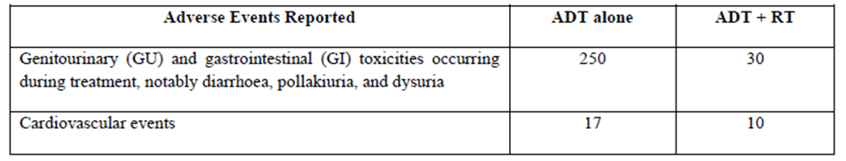
Genitourinary (GU) and gastrointestinal (GI) toxicities occurring during treatment, notably diarrhoea, pollakiuria, and dysuria, were more common with combined therapy than with ADT alone (250 vs. 30 reports).
Cardiovascular AEs occurred at a similar rate in the 2 treatment arms (17 and 10, respectively).
After a median follow-up of 67 months, 24 patients (18.5%) treated with ADT alone and 31 (23.3%) with ADT + RT had died.
Authors: The benefits in PFS with combined therapy in the current study did not translate into a survival advantage at 5 yr.
A total of 10 combined therapy patients (8%) and 3 ADT alone patients (2%) had reported SAEs (unspecified) related to the treatment; 4 of these patients died, all in the combined therapy group, and the authors noted that no death was directly related to the treatment.
Of the 127 patients who received radiotherapy, acute toxicity (per RTOG scale) reported at the end of radiation therapy was mostly Grade 2. Four months later, acute toxicity associated with RT persisted at a similar intensity in ≈ half of the patients.

Table 6: Mottet 2012 acute RT toxicity.
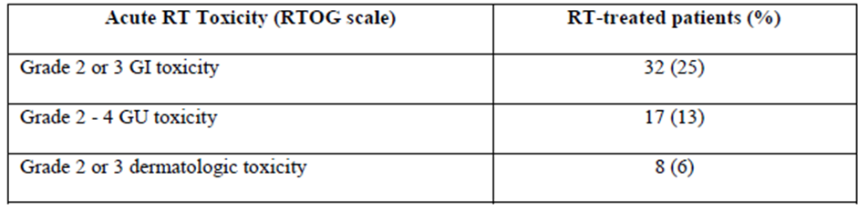
At 6 months, the Grade 2 - 4 toxicities reported included the bladder/urethra (29% ADT + RT arm vs. 18% ADT alone), rectum (14% vs. 2%), and small intestine/colon (13% vs. 3%), and decreased gradually during follow-up, with bladder/urethra persisting longer than other toxicities.
Sponsor: It is assumed that the ADT alone patients assessed for acute toxicity were the ADT-alone patients who received RT following disease progression.
Discontinuations due to toxicity were the same in each treatment group (5 patients).
Sponsor: Combined therapy strongly favoured improved progression-free survival, locoregional control, and metastasis-free survival. It may be concluded from these results that while patients treated with ADT alone had a lower incidence of adverse events; efficacy in this group was significantly lower than with the combined therapy.
The overall risk benefit assessment therefore strongly favours the combination of ADT and RT. This conclusion is supported by the evidence.
Evaluator: A trend towards slightly higher mortality in the combination therapy arm is noted in this RCT (23.3% vs. 18.5%). The SAEs (unspecified) related to the treatment were also higher in the combination arm; 4 of these patients died, all in the combined therapy group.
The above findings from a pivotal trial that has been quite recently published are of a concern, particularly as half of the registered dose of leuprorelin was administered, and the duration of exposure to leuprorelin was consistent with the current recommendations (ADT for 2 - 3 years).

Study by Widmark⁶ at al. 2009

Design
Open label, randomised, Phase III study assessing the effects of radiotherapy in patients with locally advanced/aggressive prostate tumours, by comparing the hormonal therapy with and without RT.
Of the 875 patients in the study, 439 patients received ‘endocrine alone’ and 436 patients received ‘endocrine’ + RT.
Sponsor: The extrapolation of safety data may be limited due to the low dosage; however safety data generated will still provide relevant insight to the type the adverse events expected in the endocrine plus radiotherapy combination.
Three of the other studies summarised in this review, Berg 2009, Fransson 2009 and Lund 2013, are also based on results provided by patients recruited to this study cohort and provide a more detailed analysis of safety and QoL.
Evaluator: This pivotal study employed half of the leuprorelin dosage of that currently registered for Eligard 22.5 mg, given as TAB for 3 months; this was followed per protocol with an anti-androgen (flutamide 250 mg TDS) until progression or death.
The long-term safety data from this and related studies are more suited for assessment of long term toxicity of antiandrogen administration. It is impossible to separate the AEs due to LHRH agonist (leuprorelin) administered in the neoadjuvant setting for 3 months from those of the subsequent antiandrogen. The study was clearly designed with focus on long-term antiandrogen therapy.
Recent reports suggest that the risk of cardiometabolic problems with long-term castration deprivation therapy could counteract the benefits of hormonal therapy, although this has also been questioned. Using antiandrogens might be a way to avoid these difficulties and could reduce risk of osteoporosis, flush, and impotence.

Safety objectives and monitoring
Safety was assessed using doctor-assessed moderate and severe side-effects at 5-Year follow-up and QoL questionnaire completed by patients at the 4-Year follow up.
Clinical examination and assessment of PSA, LFT, and FBC was performed every 3 months for the 1st year and every 6 months thereafter. Additionally, at each visit AEs, assessed by the treating Physician, were recorded according to a modified RTOG scale.
The secondary objectives included QoL assessments; many of the single symptom components of the QoL instrument reflected adverse experiences and are considered to be ADEs (i.e. pain, diarrhoea, appetite loss).
QoL was assessed using the European Organization for Research and Treatment of Cancer (EORTC) QLQ-C30 questionnaire. The questionnaires were filled out at baseline, and at 3 and 6 months and at 1, 2, 4, 8, and 10 years after start of treatment.
Sponsor: AEs were reported by the treating doctor, but the method used to identify the event was not provided in the report.

Safety outcomes
Doctor-assessed moderate and severe side-effects at 5-Year follow-up compared with baseline are reported. Significantly more patients in the endocrine + RT group had urinary incontinence, urgency, urethral stricture, and erectile dysfunction. The difference in intestinal symptoms was not significant (p = 0.075). A total of 18 SAEs were reported: diarrhoea (4), liver toxicity (6), photosensitivity (4), interstitial fibrosis of the lung (1), thrombocytopenia (1), DVT (1), and urinary retention due to carcino-sarcoma of prostate (1). Events were evenly distributed between the 2 groups (11 in endocrine group, and 7 in the combined group).
Sponsor: The authors did not identify which of these serious adverse events belonged to which treatment group. The authors also did not provide a line listing of adverse events and only provided tabulated summary safety data.
This paper reported on the QoL recorded at baseline and 4 years after start of treatment.
At the 4-Year follow-up, 85% (n = 340) men in the endocrine group and 89% (n = 359) in the combined group returned the QoL questionnaire.
Sponsor: These results are relevant to the safety assessment as some of the components of the questionnaire represent an adverse event.
No significant difference in global health and QoL score was seen 4 Years post-treatment. Social function was the only function scale, whereas diarrhoea was the only symptom that differed substantially between the two groups at 4 Years.
Moderate or severe diarrhoea at 4 Years were reported by 9.5% of patients in the endocrine only group, compared to 11.6% in the endocrine + RT group (p = 0.003).
Emotional function was ‘significantly’ improved at the 4-Year follow-up (mean 85) compared with the baseline assessment (mean 82) in the endocrine + RT group (p = 0.006).
Dyspnoea and fatigue were the only symptoms on the QLQ-C30 questionnaire that increased significantly between baseline and 4-Year follow-up in both groups. The most pronounced change was seen in dyspnoea, where the absolute increase was 21% in the endocrine group and 24% in the combined group.
Sponsor: This study showed a small but significant increase of moderate to severe late effects related to urinary and sexual function; however both treatment arms demonstrated similar change over time. Patient acceptability was high (over 85%), and the side-effects of adding radiotherapy are acceptable in comparison to the survival gain achieved.
The only significant difference between the treatment groups as measured by QoL functionality parameters was social function. No significant difference in global health and QoL score was seen 4 years post treatment. No substantial difference was observed in doctor-assessed ADEs, or single symptom components of the QoL instrument.
The authors conclude that the quality of life and adverse effect profile were acceptable and therefore suggest that endocrine treatment plus radiotherapy should be the new standard of care for these patients.
The author’s conclusion that the ADEs associated with adding RT to endocrine are acceptable in comparison to the survival gains observed in the study is supported by the evidence provided in this report.
Fransson, Lund and Berg are all follow up studies based on the patient cohort recruited into the Widmark RCT. They consequently can be used to compare longer term outcomes in patients receiving either endocrine plus RT or endocrine treatment only.
The nature of the QoL questionnaires used in each study included single symptom assessment which represent an adverse experience, and are therefore relevant to the safety assessment.
Evaluator: The sponsor does not differentiate between long term LHRH analogue administration (leuprorelin) and long-term antiandrogen.

Study by Fransson at al. 2009

Design
This is a prospective analysis of the QoL data obtained from the Scandinavian Prostate Cancer Group-7 (SPCG-7) study (Widmark 2009), obtained up to 4 years after initial randomisation.
Background: Androgen treatment for prostate cancer can adversely affect functional domains of QoL. We aimed to assess QoL in men with locally advanced prostate cancer in an open-label phase III randomised comparison between lifelong endocrine treatment with and without radiotherapy.
The safety study prospectively evaluated late toxicity, specifically the potential effects of the addition of RT to endocrine treatment on urinary, bowel and sexual functions, and QoL through self-reporting by the 2 treatment groups up to 4 years after randomisation, using the full patient cohort initially recruited into the SPCG-7 study.
Authors: The main strengths of this study are the randomised design, prospective patient-reported outcomes with pre-treatment registration of symptoms and quality of life, and large sample size. The response to questionnaires was also high (over 85%).
Sponsor: The SPCG-7/SFUO-3 study (Widmark 2009) meets the requirements of level II evidence according to the NHMRC 1999 guide. Details of this study have been provided in Widmark 2009, including randomisation protocol.
Two of the authors received lecture fees from 3 different pharmaceutical companies, while the other authors declared no conflicts of interest. The sponsors had no role in study design, data collection, data analysis, data interpretation, or writing of the report.

Patient enrolment, characteristics and disposition
Authors obtained QoL information from 872/875 (99%) eligible men with locally advanced prostate cancer (T3; 78%) who were randomly assigned (between 1996 - 2002), to 3 months of TAB followed by continuous antiandrogen treatment (n = 439); or the same hormonal treatment + curative RT 3 months after randomisation (n = 436).
Of 699 patients who completed the questionnaires at 4-Year follow-up, 22 (3%) had treatment modification from antiandrogen to LHRH; 17 (5%) of 340 patients in the endocrine group and 8 (2%) of 359 in the combination group.

Safety objectives and monitoring
QoL was a pre-defined secondary outcome in Widmark study. This paper, reports on QoL and disease-specific urinary, bowel, and sexual-function symptoms from baseline to 4 Years after randomisation.
Patients were followed up with 2 self-assessment questionnaires, that were completed at baseline; 3 months after the start of castration or RT; at the end of RT; and planned thereafter at 6 months, and 1, 2, 4, 8, and 10 Years after the start of treatment.
Urinary, bowel symptoms and sexual function were assessed with the validated prostate-cancer symptom scale (PCSS) self-assessment questionnaire (formerly QUFW94).
The questionnaire uses a modified linear analogue scale, with numerical values from 0 - 10. A change of 1.0 - 2.0 is thought to be moderate, and a change > 2.0 is perceived as a large change in the symptom.
The QLQ-C30 (version 2) by the European Organisation for Research and Treatment of Cancer (EORTC) was used to assess QoL.
QLQ-C30 includes 30 questions organised into 5 functional subscales (physical, role, emotional, cognitive, and social) and 3 symptom scales (nausea or vomiting, pain, and fatigue). It also includes a global health or QoL scale and 6 single additional symptom items (constipation, diarrhoea, loss of appetite, sleep disturbance, dyspnoea, and financial effect); 3 symptom scales are also included for nausea and vomiting, pain, and fatigue.
Sponsor: As most of the individual components of the QoL instrument represent an adverse experience for the patient, the results are relevant to the assessment of the safety of combined NRT and RT.
Evaluator: This study includes 4 years of antiandrogen therapy (flutamide 250 mg TDS), not LHRH agonist therapy; the sponsor does not comment how this aspect of the study design influences the interpretation of the results.

Statistical methods
All analyses were done by ITT; only patients with completed QoL data were analysed. Differences between categorical variables were assessed with χ2 tests. Symptom scores were reported as mean values. The authors also dichotomised symptom scores and performed a logistic regression analysis to estimate odds ratios and 95% CIs.
QoL scores were reported as mean values, and comparisons were made within groups with the Wilcoxon signed-rank tests and between treatments with rank-sum tests. All reported p values, based on 2-sided hypothesis, and CIs are unadjusted for multiple testing. To adjust for multiple comparisons a Bonferonni correction was applied.
In total, 36 different symptoms or functions were assessed through the 2 instruments; however, complete independence between these 36 tests is unlikely. Therefore, the authors assumed that the complete set of analysis corresponds to 21 independent tests (number of symptoms assessed through the PCSS instrument) giving a Bonferonni corrected p value of 0.0024 as being significant at the 5% level throughout the study.

Safety outcomes (at 4 Years)
Of 699 patients who completed the questionnaires at 4-Year follow-up, 22 (3%) had treatment modification from antiandrogen to LHRH; with 17/340 (5%) patients in the endocrine group and 8/359 (2%) in the combined group.
The changes in symptoms reported over time for both treatment arms are depicted in Figure 14.
Figure 14: Fransson 2009: changes in symptoms.
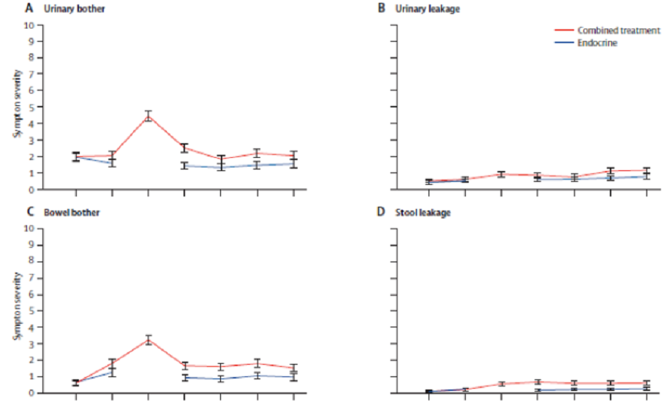
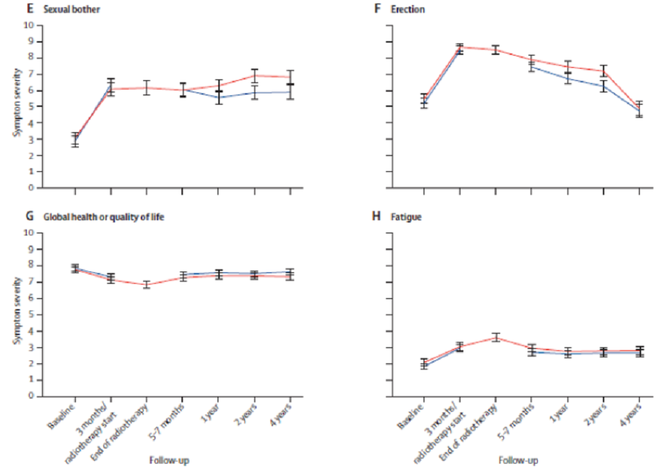
Moderate to severe urinary bother was recorded in 64 (18%) patients on combined therapy vs. 39 (12%) on endocrine therapy (p = 0·005).
Comments: Overall bother was the only item of all urinary symptoms where a small clinically significant difference (0.5 and 1.0) was recorded between the 2 treatments at 4-Year follow-up. This difference was due to the decrease in bother in the endocrine-only group.
Urinary leakage in the endocrine + RT group was the only urinary symptom that showed a clinically significant change between baseline and 4 Years.
More men assigned to combined treatment reported moderate or severe bother of urinary symptoms and regular use of protective aids for urinary leakage at 4 Years than did those assigned endocrine-only treatment.
Bowel symptoms also increased between baseline and 4 Years, especially in men assigned combined treatment.
Overall bother from all bowel symptoms: 37 (11%) vs. 23 (7%), respectively (p = 0·022).
Comments: The combination treatment increased the risk of late rectal toxicity (non-significant).
More men in the combined-treatment group were also using protection for rectal leakage (p = 0.046; data not shown). Radiotherapy has a well-known risk of disturbances of bowel dysfunction. Flutamide causes more rectal problems than do other antiandrogens (ie, bicalutamide).
Overall bother from sexual function was high in both groups at 4 Years. Erectile dysfunction: 281 (85%) vs. 227 (72%), respectively (p = 0.0002).
Sponsor: Combined therapy patients reported more overall bother from sexual function than did those on endocrine only. Despite almost half of the men in both groups being unable to achieve erection sufficient for intercourse at baseline, the ability to achieve an erection sufficient for intercourse declined more among patients on combined treatment than among those on endocrine alone.
Baseline QoL scores and single symptoms were much the same in the 2 groups except on emotional and cognitive function, which were better in patients receiving endocrine-only treatment. Social function decreased in patients receiving combined therapy at 4 Years.
Comparisons between baseline and 4 Years in QoL scores and single component symptoms: the most significant difference in symptoms between each treatment group was seen in the bowel symptom domain. Diarrhoea was the only symptom on the EORTC QLQC30 questionnaire that differed between the 2 groups at 4 Years; 9% of men assigned to endocrine-only treatment and 11% in the combined-treatment group reported moderate or severe diarrhoea at 4 Years (p = 0·003).
About 20% of patients in both groups reported significantly increased fatigue between baseline and 3 months or the starting of radiotherapy, and fatigue seemed to last up to 4 years.
Authors: This long-term effect on fatigue merits further assessment as use of antiandrogens increases, especially because fatigue did not improve with endocrine-only treatment. Age may also affect fatigue.
Cardiovascular SAEs: Important metabolic changes that might occur in association with castration were not an end point of this study and cannot be estimated accurately. Androgen deprivation therapy is associated with an increased risk of cardiovascular events. Seven patients (5 in endocrine only and 4 in the combined group) developed serious adverse cardiovascular events. Since the same endocrine treatment was given to the two groups, the cardiovascular events and metabolic changes should be equally distributed, but these outcomes were not investigated.
A total of 7 serious adverse cardiovascular events were reported within 4 years by 5/340 (1%) patients in the endocrine only and 3/359 (< 1%) patients in the combined group.
Conclusions: Although addition of radiotherapy to endocrine treatment significantly increased some treatment related symptoms, none were serious.
A missing case analysis showed no difference in age, global health, or QoL between responders and non-responders. Androgen deprivation therapy is associated with an increased risk of cardiovascular events.
The radiation dose of 70 Gy, which was standard dose in 1996 when the study began, might now be outdated. Clinically significant differences in radiotherapy-induced symptoms between treatment groups were expected, but they were also small.
Given the substantial survival benefit of combined treatment, the increase of symptoms seems acceptable and has little extra effect on QoL after 4 years compared with endocrine treatment alone.

Study by Lund at al. 2013

Design
This supplementary safety study to the Scandinavian Prostate Cancer Group-7 study (Widmark 2009) evaluated late effects related to rectum and anus in patients originally randomised to hormonal therapy vs. combination therapy.
At 5 Year follow-up the study reported QoL, anorectal symptoms and anorectal physiology and anatomy in a subset of patients (n = 103) recruited at one of the centres in Norway, which participated in the randomised, controlled trial originally reported by Widmark 2009.
Background: The SPCG-7/SFUO-3 study demonstrated that RT in addition to HT reduced 10-Year cancer specific mortality from 23% to 11%. EBRT can induce late side effects in a number of cancer diagnoses. Hence, a trade-off between treatment efficacy and late side effects has to be made.
Sponsor: This follow up study therefore also meets the requirements of level II evidence according to the NHMRC 1999 guide, in accordance with Widmark 2009. Details of the SPCG-7 study have been provided in Widmark 2009, including randomisation protocol. Ethics approval was granted by the regional ethical committee. The study was supported by The Norwegian Cancer Society and The Norwegian Medical Association. None of the sponsors participated in the study design, or in data collection, analysis and interpretation, or in preparation of manuscript.
Patient enrolment, characteristics and disposition
Of the 880 patients included in the SPCG-7 study, 178 patients were randomised at St Olavs Hospital, Trondheim as separate strata; 17 patients died after an observation time of at least 3 years. Of the 161 patients invited to participate in the sub-study, 103 patients provided consent.
A total of 50 patients received combined therapy and 53 patients received to endocrine alone.
Intervention: This study added 5 years of anti-androgen treatment following the initial TAB for 3 months ± RT.
The baseline characteristics were similar in both treatment groups; 2 patients, initially randomised to endocrine group, received RT as salvage therapy and were therefore moved to the combined therapy group.
Sponsor: However, assuming that only 2 patients out of 50 received salvage therapy, the results of the remaining 48 combined therapy patients are relevant, even though the authors discussed the results according to treatment group and not indication. Similar to the complete SPCG-7 study, patients with T3 tumours form the majority of the study population, which are representative of high risk prostate cancer patients, and therefore applicable to this application.

Safety objectives and monitoring
The hypothesis of this study was that the number and magnitude of late anorectal side effects is more pronounced in patient’s in the combined group than patients treated by endocrine therapy alone.
Three types of outcome measures were assessed in the Lund 2013 follow up:
- 1. Patient Related Outcomes were measure by the EORTC QLQ-C30 and QUFW-94 questionnaires.
- 2. Physician’s grading of anorectal symptoms measured by the Late Effects Normal Tissue Subjective/Objective Management Analytic (LENT/SOMA) score.
This score was obtained by a semi-structured interview and a rectoscopy performed by the primary author only.
- 3. Anorectal physiology and anal anatomy were measured by manometry and endoanal ultrasound (EUS).
The sub-study also evaluated the cancer-specific and overall mortality of the patient cohort, and compared the results to the complete population initially recruited into the Widmark 2009 study.
Sponsor: As with other studies in this application, many of the individual components used to construct a QoL score represent adverse experiences, and therefore are useful to the overall safety assessment of the therapy. This study adds to the information already provided by the SPCG-7 trial, as doctor’s evaluation of anorectal symptoms and anorectal manometry has been added as outcomes.

Statistical methods
All EORTC QLQ-C30 data were transformed linearly into a 0 - 100 scale. The QUFW94 data were scored using only the 10 single items (0 - 10 on rating scale), as they have been previously scored in another related study (Fransson 2009). Furthermore, a function/bother scale was analysed, composed of the mean of 5 single items (GI problems in general, stool frequency in 24 hours, stool leakage, excessive gas and limitation in daily activity caused by GI problems).
For evaluation of differences between treatments groups, mean scores with 95% CI were calculated, and statistical significance was evaluated by the Mann-Whitney U tests for non-parametric samples (2-tailed significance levels).
Differences > 10 in the linearly transformed QLQ-C30 scores were considered clinically significant, whereas for QUFW94 scores a difference of ≥ 1.0 was considered clinically significant.
The LENT/SOMA scores were calculated in 2 manners; the highest single item score was defined as the total LENT/SOMA score; the mean LENT/SOMA score was also calculated. Differences in means between treatment groups were tested by t-test for independent samples, using 2-tailed significance levels.
The means of anorectal manometry and EUS data with CI’s were calculated. Rectal compliance was calculated by subtracting the volume needed to give the patients a 1st feel of pressure from the volume needed to incite an urge to defecate. Mean scores with 95% CI’s are presented, as well as statistical significance evaluated by t-test for independent samples.
Overall and prostate cancer specific survival rates at 7 Years were calculated by the same approach as presented by Widmark 2009, in order to ensure the validity of the sub-sample results presented here. The randomization data were checked against the internal radiotherapy registry in order to control for any treatment cross over.

Safety outcomes
At 5 Years after cancer treatment, there were significantly higher symptom burdens in several QUFW94 single items in the group of patients treated by radiotherapy.
Patients treated by RT had reduced rectal compliance compared to patients treated by hormonal therapy alone (43 mL vs. 64 mL, p < 0.001).
The reduction in mortality and the patient-reported symptoms were similar in the SPCG-7 trial and this study.
Sponsor: The results of HRQoL analyses are provided as mean scores only and no AE line listing was provided for this study. However relevant individual symptom scales and items were listed in this table according to treatment received, with an appropriate statistical evaluation of the difference in each item provided. The response rate for this questionnaire was 90% in the combined therapy group and 96% in the by endocrine only group (difference was not statistically significant).
No significant difference was found for any of the symptom scales or single items measured by the EORTC instrument. The combined therapy group reported more symptoms from their rectum and anus assessed by the QUFW94, in that statistical and clinical significant differences between groups were found.
Higher incidence in stool frequency, stool leakage, the need to plan toilet visits and mucus and blood was found in the NHT + RT arm in the QUFW94 instrument. For diarrhoea, the combined therapy patients displayed higher mean score of 22 vs. 14 in the endocrine group (difference NS).
Sponsor: Despite the reports of significantly higher anorectal symptom burdens by the combined therapy patients, they reported overall HRQoL that was similar to the endocrine alone patients. No significant difference in any individual symptom scales or item was observed between the different treatment arms. There was a significant difference in stool frequency, planning of toilet visits and limitation in daily activities in the patient group treated with NRT + RT.
The LENT/SOMA score was obtained for all patients. Grading of the rectal mucosa was obtained in 24 of the combined therapy patients and 30 in the endocrine group; significant differences between groups were demonstrated.
Mean LENT/SOMA score was 0.15 for combined therapy patients vs. 0.03 for hormone only patients (p < 0.001).
The mean score for the Physician’s grading of anorectal symptoms in the NHT + RT treatment arm was 0.15 (95% CI 0.12 - 0.16) and 0.03 (0.02 - 0.04) in the NHT alone arm. While this difference was significant (p < 0.001), the overall values were low.
Combined therapy patients had reduced rectal compliance compared to patients treated with hormone only (43 mL vs 64 mL, p < 0.001).
Recto-anal manometry demonstrated a significant difference in 3/6 parameters assessed between the NHT + RT and NHT alone group. The volumes of air producing the 1st feel of pressure, urge to defecate and rectal compliance were all significantly lower in the NHT + RT group.
The thickness of the external and the internal anal sphincters remained unchanged during squeeze as evaluated by EUS. There were no detectable differences in sphincters’ thicknesses between treatment groups.
Authors: These added outcomes (doctor’s evaluation of anorectal symptoms and manometry) demonstrated larger differences between patient groups than the patient reported symptoms presented previously. Furthermore, the anorectal manometry results presented here are a matter of concern; might the 50% reduction in rectal compliance indicate a potential severe increase in anorectal symptoms as time from treatment increases?
Sponsor: The authors conclude that the addition of 3D CT based radiotherapy at a total dose of 70 Gy to hormonal therapy for locally advanced prostate cancer results in some deterioration of anorectal function.
The thickness of the anal sphincters did not differ between treatment groups, as evaluated by endoanal ultrasound. The authors proposed that one might conclude that the increased stool leakage reflected the decrease in rectal compliance rather than a diminished sphincter function. This view is supported by the anal manometry results, as neither resting pressure nor squeeze pressure were affected by radiotherapy.
At 7 Years follow up, prostate cancer specific mortality rates were 4% in the RT + HT group and 7% amongst the patients treated by HT alone.
Overall mortality rates were 5% and 10%, respectively. The differences between groups in 7 and 10 year cancer specific and overall survival rates were similar in the present trial as compared to the results of the SPCG-7 trial, supporting the validity of the present sub group study.
Authors: The present study offer the most comprehensive insight to late radiotherapy induced rectal toxicity. This trial provides evidence that patients with locally advanced prostate cancer had significantly increased recto-anal late side effects when treated by RT + HT compared to HT alone.
The irradiated patients had more recto-anal symptoms evaluated by self-administered questionnaires; higher toxicity grades measured by LENT/SOMA and impaired physiological rectal function measured by manometry as compared to the patients treated by HT alone. The rectal compliance and the volumes needed to give the patients a 1st feel of pressure and urge to defecate differed significantly between the 2 treatment groups.
Most likely radiotherapy induces rectal fibrosis and consequently a less flexible rectal wall, reducing the patients’ ability to store stools, RT may affect the rectal nerves may reduce rectal sensations.
The study protocol for this trial was designed in 1995. RT planning and delivery was consequently not directly comparable to modern RT (IMRT, IGRT, VMAT). Furthermore, recent dose limits recommended to reduce the risk of anorectal side effects were obviously not taken into consideration. The results need to be interpreted in this context.
Although the irradiated patients reported significantly higher anorectal symptom burdens in the present study, they reported overall HRQoL that was similar to what was found in the patients treated by HT alone as well as by previously reported normal populations.
In conclusion, the present study provides evidence that addition of 3-D CT based radiotherapy to a total dose of 70 Gy to hormonal therapy for locally advanced prostate cancer implies deterioration of anorectal function. There is a need for longer follow up to fully evaluate the balance between a survival benefit and the negative effects of radiotherapy related side effects.
Sponsor: The differences in some adverse outcomes observed in patients receiving the combined NRT and RT therapy should however be assess in light of the differences in efficacy. At 7 years follow up, prostate cancer specific mortality rates were 4% in the combined therapy group and 7% in the endocrine alone group. Overall mortality rates were 5% and 10%, respectively.
The results of the SPCG-7/SFUO-3 trial demonstrated a reduction in cumulative overall mortality from 39% to 30% at 10 years and a moderate increase in anorectal symptoms when adding radiotherapy to endocrine therapy.
The reduction in mortality and the patient-reported symptoms were similar in the SPCG-7 trial and the present study. The risk benefit profile of combined NRT and RT is therefore favourable and supportive of the proposed extension of indication.
The baseline characteristics of the patients indicate that the treatment arms were well balanced, also after treatment cross-over of two patients. The differences between groups in 7 and 10 year cancer specific and overall survival rates were similar in the present trial as compared to the results of the SPCG-7 trial, supporting the validity of the present sub-group study.

Other studies

Study by Berg at al. 2009 (NHMR level III-1)

Design
Another supplementary, safety study based on subset of the Scandinavian Prostate Cancer Group-7 (Widmark 2009) that evaluated HRQoL and hormonal changes in men (n = 86) with non-metastatic prostate cancer, who had used nonsteroidal antiandrogen continuously for 5 years, adjuvant to RT ‘within the frames of a randomized trial’.
Background: Comparison of HRQoL between cancer patients and the general population provides insight into the total load of cancer-related morbidity and is of importance for the counselling of patients.
Low serum androgen concentration because of age- or treatment-related hypogonadism is associated with decreased HRQoL within physical, mental, emotional, social and sexual function domains. These domains may also be affected by androgen receptor blockade in the presence of normal serum testosterone.
This cross-sectional study involved subset of patients from a single centre (Norwegian Radium Hospital) participating in the original SPCG-7 trial, and who received NHT + RT, that compared self-reported HRQoL of this group with non-randomly selected, age-matched men, as well as investigated longitudinal changes in serum hormone concentrations.
Sponsor: Due to the non-randomised method used to select both the patient cohort and NORM comparator population, this sub-study meets the requirements of level III-1 evidence according to the NHMRC 1999 guide.
Details of the SPCG-7 study have been provided in Widmark 2009, including randomisation protocol. This sub-study was approved by the regional committee for medical ethics, the protocol review committee of NRH and the Norwegian Data Inspectorate. Written informed consent was obtained from all the participants. The authors did not make a declaration of conflicts of interest.
As the treatment protocol required the long-term use of antiandrogens, it became the main focus of this side study. However, as these patients were also treated with leuprorelin and RT at the beginning of the study, this side study provided insight into the long-term safety of the combination therapy (leuprorelin + antiandrogen + RT) for high-risk, locally advanced prostate cancer.

Patient enrolment, characteristics and disposition
At the scheduled 5 Year post-RT visit, non-metastatic patients, who were still using antiandrogen as their only anti-cancer agent, were asked to complete a questionnaire. Of the 125 men, 89 were eligible for the study; 86 (97%) responded and were included in the analyses.
Intervention: Patients received nonsteroidal antiandrogen continuously for 5 years adjuvant to definitive RT and 3 months of TAB (Widmark study).
The dose to the target volume was 70 Gy in 56 patients and 74 Gy in 30 patients, depending on the year of treatment. During follow-up time, the type of antiandrogen had been changed from flutamide to bicalutamide in 30% of the patients.
For the purpose of this study, biopsies that originally were scored according to the WHO grading system were reviewed for Gleason score. Before treatment, 90% of the patients had cT3 tumours, 9 patients with cT1-2 tumours originally graded as moderately or poorly differentiated (WHO) had been regraded; 4 of these had Gleason score 6; 4 had GS 7; and 1 had GS 8.
The median age of participants at the time of the survey was 71 years (range: 56 - 79). Median PSA was 15.0 mg/L (range: 2.4 - 69). At the 5-Year follow-up, 85% had PSA < 0.2 mg/L and 1 had PSA > 2 mg/L. Except for 1 asymptomatic patient with a suspected local relapse, DRE did not show any local tumour progression. None of the included patients had overt metastatic lesions.
Patient and NORM samples were similar regarding paired relation and level of education (data not shown).
Sponsor: A majority of these patients had a tumour stage of T3 (77, 90%), which is one of the classification criteria for high risk prostate cancer.

Safety objectives and monitoring
The primary aim of the study was to assess self-reported HRQoL among 86 prostate cancer patients without distant metastases 5 years after definitive RT combined with ongoing antiandrogen treatment, comparing the findings to those obtained in cancer-free, age-matched men from the general population (NORM).
The secondary aims were to investigate longitudinal changes in serum sex hormone concentrations after such a long follow-up, and to explore correlations between sex hormone concentrations and HRQoL.
The patients were regularly followed up by their local urologists. At the scheduled 5 Year post-RT visit at the NRH, DRE, bone scan and blood tests, including sex hormones testosterone, oestradiol, SHBG, LH, and FSH were performed.
The questionnaires were completed at a median 5.1 years (range: 4.4 - 5.9 years) after the start of treatment.
The study compared the physical, mental and sexual well-being of patients treated with NHT + RT for high risk prostate cancer to aged matched healthy men using a variety of specific QoL and related questionnaires:
- Short Form-36 (SF-36): Consists of 8 multi-item HRQoL domains that again are grouped into the physical component summary (PCS) and the mental component summary (MCS).
- Hospital Anxiety and Depression Scale (HADS): Consists of 14 items scored by 4-point Likert scales (0 - 3); 7 items add up to the Depression score and 7 to the Anxiety score.
- Fatigue Questionnaire (FQ): Measures mental (4 items) and physical (7 items) features of fatigue by 4-point Likert scales (0 - 3).
- Brief Male Sexual Function Inventory (BSFI): Measures sexual drive (2 items), erections (3 items), ejaculation (2 items), sexual problem assessment (3 items) and overall sexual satisfaction (1 item) by 5-point Likert scales (0 - 4).
Missing responses were replaced by the mean of the completed scale items if at least half of the items were filled in. Otherwise, the scale score was considered as missing.
Sponsor: This study therefore provides information relevant to the assessment of the absolute rather than relative safety profile of NHT and RT.

Statistical methods
Using public data lists, the NRH collected several samples of normative data from the general population for comparison with cancer patients. Based on these NORM samples, age-matched control cohorts were obtained.
Standard descriptive statistical analyses were performed. Continuous variables were compared by parametric or nonparametric tests as appropriate. Categorical variables were compared by χ2 tests. Significant findings on continuous variables and on 2x2 contingency tables were calculated as Cohen’s effect size. Values ≥ 0.40 were considered as clinically significant.
The internal consistency of scales was examined using Cronbach’s coefficient α. Spearman’s P was calculated for correlation analyses between HRQoL scores and sex hormone concentrations. The level of statistical significance was defined as P < 0.05 and all tests were 2-sided.
Safety outcomes
Compared with NORM, patients scored statistically (p < 0.05) and clinically (effect size ≥ 0.4) lower on sexual domains, and statistically (p < 0.05) lower on physical function and vitality.
Estimated free testosterone and measured serum oestradiol had increased from baseline in most patients, but did not correlate with HRQoL outcomes 5 years after the start of treatment.
The self-reported outcomes among the study patients compared with ‘NORM’ are presented in Table 7.

Table 7: Berg 2009: self-reported outcomes.
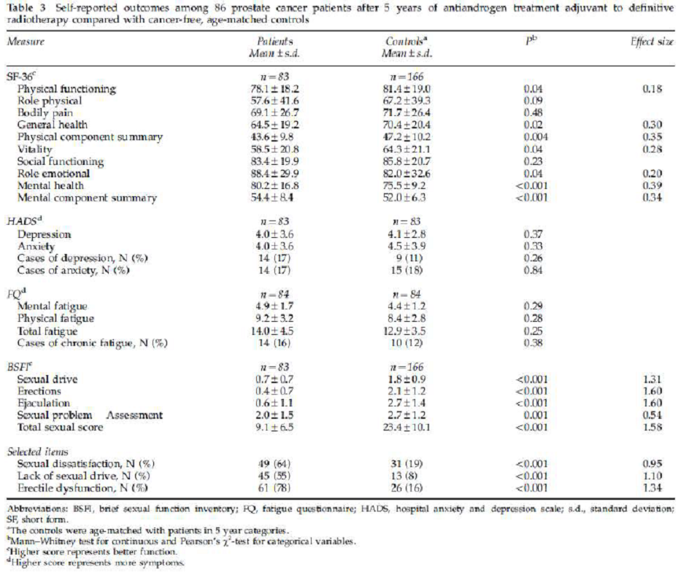
Patients had lower scores on the SF-36 domains of physical functioning, general health and vitality compared with NORM. In contrast, patients had better outcomes in role emotional functioning and mental health. Further, the SF-36 PCS was higher in NORM, whereas the opposite was found for the MCS.
Although these differences were statistically significant, the effect sizes did not reach the level of clinical significance (> 0.4).
All sexual domains were scored significantly lower in patients compared with NORM, and all these differences were clinically significant. Significantly more patients than NORM reported sexual dissatisfaction, lack of sexual drive and ED. No significant differences were found in anxiety, depression or fatigue.
Plasma concentrations of testosterone, SHBG, oestradiol, LH and FSH increased significantly from baseline, as well as free testosterone.
Estimated free testosterone and measured serum oestradiol had increased from baseline in most patients, but did not correlate with HRQoL outcomes 5 years after the start of treatment.
Scatter plots showing longitudinal serum changes in sex hormones after 5 years are shown in Figure 15.
Figure 15: Berg 2009 longitudinal serum changes in sex hormones after 5 years.
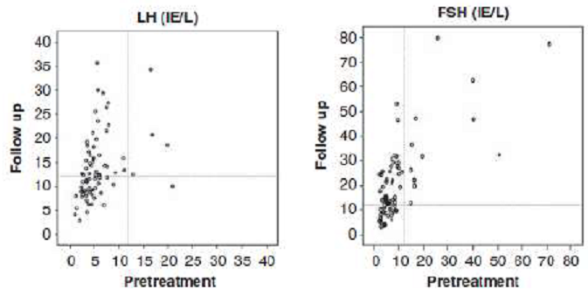
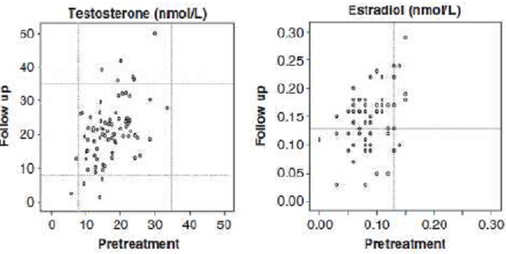
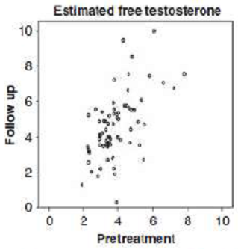
Authors: Compared with NORM, the prostate cancer survivors in this study had statistically and clinically significant impairment of all sexual functions. More patients than controls reported sexual dissatisfaction, lack of sexual drive and ED. None of the HRQoL domains were significantly correlated with EFT, oestradiol, FSH or LH 5 years after treatment. These results show that long-term antiandrogen treatment, even when administered alone, is associated with severe impairment of sexual function. Our findings may be somewhat provocative to the opinion that sexual function is maintained during AA treatment and is at least better than during medical castration.
The sexual function reported was probably confounded by radiotoxicity; however it was not possible to estimate the magnitude of RT as a confounding factor as there was no control group that received RT monotherapy in this study.
Some of the limitations of this study identified by the authors included:
- A cross-sectional design with lack of baseline HRQoL data.
- All patients had pelvic high-dose irradiation with its risk of decreased sexual function, and therefore isolated effects of antiandrogens on sexual function could not be assessed.
- The study did not cover those who were withdrawn from antiandrogen treatment before 5 years.
- The response rates for NORM were about 35%. Possible selection bias with a lack of representation in both patients and NORM.
- A small sample size, with risk of statistical type II error, and different types of antiandrogen treatment may have influenced the results.
- However, the study had a long observation period, 97% response rate among patients, and used validated questionnaires and longitudinal measures of sex hormones.
The authors conclude that prostate cancer patients receiving both high-dose pelvic RT and long term antiandrogen should be informed about the considerably long-term risk of impaired sexual function and possible risk of reduced physical function and vitality. Further studies into the possible long-term cardiovascular toxicity due to increased serum oestradiol concentration associated with antiandrogens may be required.

Study by Heymann¹¹ at al. 2007 (NHMR level IV)

Design
Prospective, uncontrolled, non-randomized Phase II efficacy and safety study of prostate cancer patients who received a total of 9 months of TAB (leuprorelin + flutamide) combined with RT.
Individualised neoadjuvant ADT was ‘administered to maximal response’ to clinically localised prostate cancer patients, followed by EBRT with continued ADT for a total of 9 months for clinically localised prostate cancer.
Sponsor: The study by Heymann is uncontrolled and therefore the safety data provided in this study relates to combined NHT and RT use only. It is not possible to differentiate whether individual ADEs resulted primarily from RT or NHT treatment.
The study does however provide useful information on the type and intensity of ADEs likely to be experienced by patients receiving combined NHT and conformal or intensity-modulated RT.

Patient enrolment, characteristics and disposition
A total of 123 patients were enrolled in this study (July 1997 - September 2002).
Patients received leuprorelin 7.5 mg monthly or 22.5 mg every 3 months for 9 months + flutamide 250 mg orally TDS for 9 months combined with RT.

Safety objectives and monitoring
AEs were assessed during and after treatment by patient interview or laboratory measurement. All AEs (except dysuria) were graded according to the National Cancer Institute’s Common Terminology Criteria (CTC). Dysuria was evaluated based on RTOG toxicity system.
Acute AEs (associated with GU and GI systems) were those occurring during RT and within 6 months of completion of RT; chronic AEs were those occurring > 6 months after completion of RT.

Safety outcomes
The majority of patients experienced erectile dysfunction during treatment. At study entry, 69% of patients had some loss of potency (erectile dysfunction Grades 0 - 2); during treatment only 16% maintained some potency. Many patients recovered potency after treatment.
Of the 85 patients with some potency at baseline, 65% (n = 55; 45% of total) had some potency at last follow-up. Median time to recovery of potency was 10 months (range: 0 - 57 months). Age, race, and return to normal of serum testosterone concentration failed to predict for return of potency.
Most toxicities were mild, and patients often recovered quickly; 5% of patients experienced Grade 3 toxicity except for anaemia and acute urinary frequency/urgency; 90% of patients with Grade 3 anaemia recovered, with a median recovery time < 1 month.
A total of 24 (20%) patients discontinued flutamide due to elevated LFTs (n = 18) or diarrhoea (n = 6), as required by the protocol.
The study evaluates the toxicity and efficacy of ADT + RT employed in a novel way. Of note is the relatively high rate of preservation of sexual potency after completion of ADT.
Sponsor: The authors conclude that this study provides evidence that individualisation of neoadjuvant AD to maximal response followed by RT with continued AD for a total of 9 months can safely be used to treat patients with intermediate- to high-risk clinically localized prostate cancer and preserve potency in many patients.

Study by Kohutek at al. 2016 (NHMR level III-2)

Design
Retrospective safety analysis investigating the impact of ADT on the incidence of cardiovascular events (CE) in prostate cancer patients treated with RT.
Background: ADT used in conjunction with RT improves disease-specific and OS in patients with locally advanced prostate cancer, yet concerns have been raised regarding its potentially harmful effects on cardiovascular health.
Prospective studies have shown that ADT increases fat mass and serum lipid levels, while also promoting insulin resistance, and several population-based observational studies have suggested that such metabolic changes may translate into an increased risk for cardiac mortality. Despite this evidence, controversy remains regarding the risks posed by ADT.
Consecutive patients treated with EBRT, brachytherapy, or a combination of both, for stages T1-T3 prostate cancer at Memorial Sloan Kettering Cancer Center between 1988 and 2008 were eligible for this study. Patients were treated with RT + ADT (n = 991), or RT alone (n = 1220).
Design: Interrupted time series with a control group from a single center in US spanning 2 decades and published in 2016.
Sponsor: Thus the study design is consistent with an interrupted time series with a control group (Level III-2 evidence according to the NHMRC 1999 guide). While the design of this study increases the uncertainty around the outcomes, it does provide useful information regarding both physiological, demographic and treatment related predictors of poor cardiovascular outcomes in patients treated with combined ADT and RT or RT only, which further informs the risk benefit considerations of this therapy. The effects of ADT were explored in both primary and definitive radiotherapy, and the adjuvant or salvage settings. The authors also constructed a nomogram to quantify a patient’s risk of cardiovascular morbidity after RT. For the purpose of this application, salvage therapy is not relevant and will not be discussed detail. No details of ethical review of the study or patient informed consent were provided in the report. No relevant financial interests were reported by the authors.

Intervention
Radiotherapy involved EBRT or brachytherapy or combination of both.
Leuprolide 7.5 mg depot injection was given during the 1st month, then 3-monthly as 22.5 mg depot injections; ADT was continued for a median of 6.1 months (range: 0.9 - 149 months).
ADT at the time of RT consisted of a GRH agonist (typically leuprolide) preceded by the administration of a nonsteroidal antiandrogen (typically bicalutamide, 50 mg daily) by 3 - 5 days.
Sponsor: There were 345 men (15.6%) who had documented histories of a prior CE b leuprolide (leuprorelin), given 3 - 5 days before a nonsteroidal antiandrogen (typically bicalutamide, 50 mg daily), which was discontinued after 30 days.

Patient enrolment, characteristics and disposition
A total of 2211 patients with localized prostate cancer treated with RT had adequate follow-up of at least 5 years and were included in the analysis.
Eligible patients had biopsy-proven adenocarcinoma classified according to the Gleason grading system. Risk was assessed on the basis of T grading, Gleason score or PSA according to NCCN guidelines.
The median patient age was 68 years (range: 42 to 93 years). There were 711 (32.2%), 922 (41.7%), and 578 (26.1%) men classified as having low-, intermediate-, or high-risk prostate cancer, respectively.
Sponsor: Almost a third of the study population have high-risk prostate cancer, which are applicable to this application, but care must be taken when interpreting some of the results as they were not reported according to the risk category. (≈ a quarter of patients had high risk cancer.)
Of the 2211 patients, 991 (44.8%) had received ADT at the time of RT, including 205 (20.7%) low-risk; 390 (39.4%) intermediate-risk; and 396 (39.9%) with high-risk prostate cancer.
Of men with high-risk prostate cancer who did not receive ADT, nearly all were treated prior to 1995, when the benefits of ADT use were not as well established.

Safety objectives and monitoring
In this large, retrospective study, we sought to investigate the association between ADT use and cardiovascular morbidity in a well-annotated database of patients with long-term follow-up after RT. We construct a nomogram to quantify a patient’s risk of cardiovascular morbidity after RT.
Patients were followed for a minimum of 5 years after RT, with a median follow-up of 9.3 years (range: 5.0 - 23.1 years). In general, patients were evaluated every 3 - 6 months for the first 5 years and yearly thereafter.
At each visit, comorbidities and interim CEs were recorded. CEs including MI, stroke, TIA, and coronary revascularization in the form of percutaneous coronary intervention or CABG were combined to create a composite endpoint.

Statistical methods
Actuarial incidence curves for CE were created using the Kaplan-Meier method and were compared using the log-rank test. Patients were censored when detailed follow-up including medical comorbidity assessment was discontinued. HRs and 95% CIs for CE were calculated using a Cox proportional hazards model.
Clinical factors considered included age, smoking status, NCCN risk group, RT modality, pre-existing comorbidities including HT, hyperlipidaemia, DM, and prior CEs, as well as the use of ADT at the time of RT or salvage.
Cut-points for age (median) and smoking status (20 pack-years) were determined a priori. Multivariate models were constructed for CE to adjust for imbalances in clinical characteristics. Two-sided P values < 0.05 were considered statistically significant. A nomogram was constructed to predict the 10-year risk of CE ‘post-RT’.
Sponsor: The patient cohort included low, intermediate, and high risk patients (26.1%), which introduced a non-qualifiable uncertainty in regard to the likely difference in outcome in high risk patients alone. Because the study was conducted over a significant time period, the incidence of CE could be compared in patients who received or did not receive ADT, according to evolving best practice.

Safety outcomes
During the follow-up period, 355 men (16.1%) experienced 431 CEs. These were most commonly coronary revascularization events (n = 250), but also included MI (n = 89), stroke, (n = 54), and TIA (n = 38).
The median time from RT to any CE was 5.2 years for revascularization, 5.7 years for MI, 7.6 years for stroke, and 7.8 years for TIA. The median time from RT to 1st CE was 5.6 years (range: 0.1 - 20.1 years).
The 10-year incidence of post-RT CE was significantly greater among patients receiving ADT at the time of RT (19.6%, 95% CI: 17.0% - 22.6%) compared with patients treated with RT alone (14.3%, 95% CI: 12.2% -16.7%, p = 0.005). These results were not differentiated according to risk.
On multivariate analysis, both ADT at the time of RT (p = 0.007) and the time of salvage (p = 0.0004) were associated with increased CE risk, as were advanced age (p = 0.02), smoking (p = 0.0007), history of diabetes (p = 00007), and history of CE before RT (p < .0001).
A nomogram using patient age, smoking status, history of pre-RT CE, history of diabetes, and ADT use at the time of RT predicted the rate of 10-year CE with a C-index of 0.81 (95% CI: 0.72 - 0.88).
A nomogram is provided that incorporates information on ADT use at the time of RT, patient age, smoking status, history of DM, and history of pre-RT CE. It can be used as an additional tool to predict a patient’s 10-year risk of CE.
The C-index (probability of concordance between predicted and observed response) of the nomogram was calculated to be 0.81 (95% CI: 0.72 - 0.88).
Using this nomogram, the addition of ADT to treatment of an elderly patient without other risk factors would increase the 10-year risk of CE from ≈ 12% to 16%.
In a similar patient with a history of pre-RT CE and DM, ADT would increase this risk from ≈ 36% to 46%, indicating a larger change in absolute risk. This emphasises the need to consider patient comorbidities when making clinical decisions regarding ADT use.
In an effort to identify a subgroup of patients most susceptible to the cardiovascular effects of ADT, tests for interaction were performed between ADT use at the time of RT and factors reflecting patient comorbidity, which did not reach significance for either patient age (p = 0.82), or history of pre-RT CE (p = 0.40).
In this study of 2211 men with localized prostate cancer treated with RT, a short course of ADT was associated with a long-term increased risk of cardiovascular morbidity, including CABG, percutaneous coronary intervention, MI, stroke, and TIA.
ADT administered for a median of 6.1 months was associated with a 5.3% absolute increased risk of cardiovascular morbidity at 10 years. This corresponded to a 34% increased relative risk of post-RT CEs.
While these findings are consistent with a recent American Heart Association consensus statement that ADT may be associated with an increased incidence of CEs, there have been conflicting data regarding the effect of ADT on cardiovascular risk.
Although we found no evidence to support a difference in the relative risk of ADT among patients with and without comorbidities, the increase in absolute risk posed by ADT is still greatest in patients with a history of cardiovascular disease.
Using a well-annotated database with long-term follow-up, this study provides important detailed information regarding the long-term risk of ADT on cardiovascular morbidity when administered at the time of RT or at the time of salvage.
Observational studies have provided valuable insight into the effects of ADT on cardiovascular morbidity, yet they have also yielded conflicting results. While observational studies provide large patient cohorts for study, they are particularly susceptible to bias from inconsistent coding and inconsistent or limited patient follow-up.
While this study is also retrospective in nature, its lack of reliance on registry data allowed to capture detailed and accurate information regarding patient comorbidities at the time of RT. The extended follow up of patient population also provided an opportunity to study the long-term impact of ADT use on nonfatal CEs, which often develop years after treatment.
In summary, this large single-institution analysis of patients treated with EBRT and brachytherapy revealed an association between ADT use and an increased risk of cardiovascular morbidity, both among men receiving ADT at the time of RT and those receiving generally longer courses of salvage ADT at the time of recurrence.
While ADT is often an essential part of prostate cancer treatment, the study suggests that efforts to mitigate cardiovascular risk are important to consider in all men receiving prostate RT and ADT.
The increase in absolute risk posed by the use of ADT is still greatest in patients with a history of cardiovascular disease due to their higher baseline risk.
While the study demonstrated a 5.3% absolute increase in cardiovascular events in patients receiving ADT, the benefits of ADT use outweigh the risks in high-risk patients. The study had a sufficiently long follow-up time which likely allowed for manifestations of more ADT-induced CEs in patients without pre-existing cardiovascular disease.
Some of the limitations of this study include:
- Observational studies, which are susceptible to bias from inconsistent coding and inconsistent or limited patient follow-up;
- Assessing the risk of non-fatal CEs only and cardiovascular (CV) mortality was not studied, which could affect the ability to identify a subgroup of patients at increased CV risk from ADT.

Study by Pervez at al. 2010 (NHMR level IV)

Design
Prospective, uncontrolled safety study evaluating acute toxicity resulting from RT dose escalation and hypofractionation using intensity-modulated RT (IMRT) treatment combined with androgen suppression in high-risk prostate cancer patients (n = 60).
Background: The increase in (radiation) toxicity to organs may be partially overcome by using 3-dimensional conformal radiotherapy (3D-CRT), intensity-modulated RT (IMRT), or a concomitant boost approach; increasing the fraction size (i.e. hypofractionation) would provide a differential advantage between rectal toxicity and prostate tumour control. This trial tests this hypothesis.
Design: Single arm, prospective, uncontrolled, Phase II study from a single center in Canada (April 2005 - March 2007). This article reports the observed acute toxicity at 3 months.
Sponsor: This study therefore meets the requirements of level IV evidence according to the NHMRC 1999 guide. This study was approved by the Alberta Cancer Board Research Ethics committee and written informed consent were obtained from all patients. No conflicts of interest were reported.
Intervention: RT administered in escalating doses using hypofractionated intensity-modulated radiation, combined with ADT (NHT and 6 months concomitant).
RT included 68 Gy in 25 fractions over 5 weeks to the prostate and proximal seminal vesicles. The pelvic lymph nodes and distal seminal vesicles concurrently received 45 Gy in 25 fractions.
Neoadjuvant leuprolide (leuprorelin) acetate 22.5 mg administered S/C every 3 months for up to 6 months, followed by concurrent hormonal therapy during RT, and continuing after RT for 2 - 3 years. The protocol allowed a variable time to start ADT in relation to RT.
A total of 52 patients began neoadjuvant ADT, 3 patients started ADT concomitantly, 3 patients started adjuvantly, and 2 patients declined ADT. Neoadjuvant ADT was begun at an average of 66 days prior to RT (range: 13 - 189 days). Note, the paper does not mention any antiandrogen use, including short-term to prevent the flare reactions.
The dose of leuprorelin in this study is equivalent to one currently registered in Australia.
Sponsor: Due to the limitations in the design of this study, it provides absolute rather than relative information regarding the type and incidence of adverse events likely to be observed in patients receiving combined therapy. It provides additional supportive safety data relevant to the combined administration of leuprorelin and RT.

Patient enrolment, characteristics and disposition
A total of 60 patients were enrolled in the study.
Inclusion criteria: Patients with newly diagnosed high-risk prostate cancer (cT3/4 N0 M0 and/or Gleason score of 8, 9, or 10 and/or pre-treatment PSA ≥ 20 ng/ml, or a combination of Gleason score of 7 and PSA ≥ 15). No previous prostatectomy or RT.
Sponsor: The majority of patients met the high risk criteria, although there were some patients in the T1, PSA < 20 ng/mL and Gleason < 8 categories. The population studied in this report therefore closely reflects the high risk population targeted in this application.

Safety objectives and monitoring
The primary endpoint was to assess the intensity of acute and late GI toxicity occurring during, and 3 months after RT.
GU toxicity was also reported in the study. Acute toxicity scores were recorded weekly during RT and at 3 months post-RT, using RTOG acute toxicity scales. All patients completed RT and follow up for 3 months.

Statistical methods
The GI and GU toxicity scores were ordinal, and therefore correlation of the toxicity with other parameters was tested by using the ordinal Kendal Tau-b test of correlation. A univariate test of the toxicity score and other parameters was conducted, and a p value of < 0.10 was considered statistically significant.

Safety outcomes
The maximum acute toxicity scores using RTOG and CTCAE scores are provided in Table 8 while the acute toxicity scores at 3 months after RT are provided in Table 9.

Table 8: Pervez 2010 acute toxicity scores.
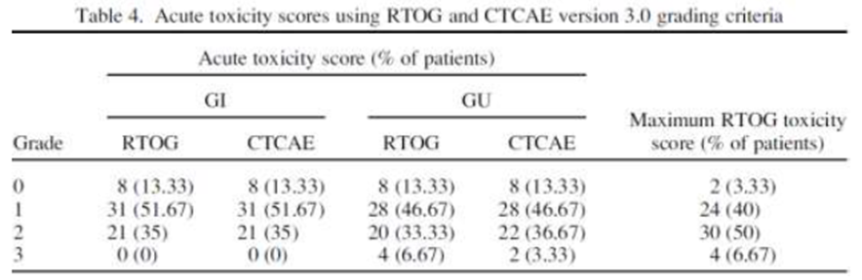

Table 9: Pervez 2010 max. acute toxicity scores.
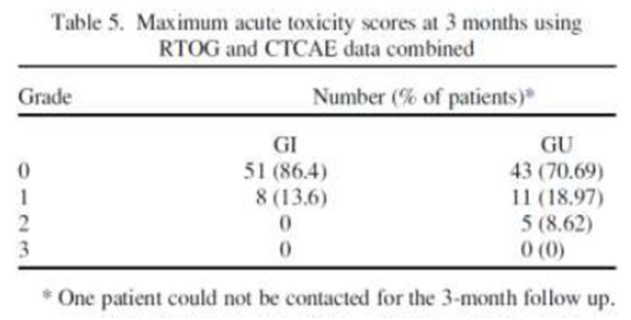
The majority of patients reported zero scores for acute GI (86.4%) and GU (70.7%) toxicity.
During RT, no patients had Grade ≥ 3 GI toxicity scores and there were no patients with Grade 4 toxicity. Acute toxicity settled quickly after patients finished RT, with no patients having toxicity scores of Grade ≥ 3 for GU and Grade ≥ 2 for GI.
Authors: This study demonstrates that it is possible to deliver hypofractionated and dose-escalated RT to the prostate while treating the pelvic nodes with a standard dose in the setting of AST, with an acceptable acute toxicity rate. The acute toxicity recorded was transient, with only 5 patients having persistent Grade 2 or higher toxicity by 3 months follow up. Longer follow up for outcome and late toxicity is required.
Sponsor: Even though this is an uncontrolled phase II study of short duration, it does provide insight into the safety of fixed dose leuprolide administered for an extended period of time with combination varying doses of radiotherapy, which applicable to this application.
The authors conclude that dose escalation using a hypofractionated schedule to the prostate with concurrent pelvic lymph node RT and long-term androgen suppression therapy is well tolerated acutely. Longer follow up for outcome and late toxicity is required.

Other safety data

Study by Nguyen ⁹ at al. 2013
This retrospective analysis of 741 men with high risk prostate cancer was classified as an efficacy study and included the control group. The authors provided some comments related to safety.
The ADT involved either medical castration with IM leuprolide acetate injections, with or without bicalutamide, or bilateral orchiectomy. ADT was started 2 - 3 months before the initiation of RT (dose and technique varied over time) and continued for a median of 2.9 years. All ADT was administered for at least 2 years; no patient received < 2 years of this therapy.

Safety outcomes
Among those patients who experienced local failure, subsequent related symptoms affecting their QoL (urinary obstruction/retention, hydronephrosis, ARF) occurred in 6.2% of patients at 10 Years.
The common symptomatic local failures were reported as bladder/urinary retention (2.7%), urinary frequency/obstructive symptoms (2.3%), incontinence/increased nocturia (0.4%), and hydro-nephrosis (0.8%) at long-term follow-up.
No patient treated with ADT and high-dose radiation developed symptomatic local recurrence.

Other safety considerations

Need for RMP
Sponsor: No RMP is required, as the safety profile is not expected to be significantly different for this extension of indication. There has been a long history of accepted use, and is proposed to be used in the same patient population in combination with radiotherapy rather than a medicine.
This use is already widely evident from published journal papers.
This is comparable to the alternative LHRH agonist Zoladex IMPLANT (goserelin 10.8 mg, as acetate) implant syringe which also has indications for combination use with radiotherapy.
Zoladex PI (indications):
Prostate cancer
Palliative treatment of metastatic (M+) or locally advanced prostate cancer where suitable for hormonal manipulation.
Adjuvant and neoadjuvant therapy in combination with radiotherapy for the management of locally advanced prostate cancer in men suitable for hormonal manipulation.

Nonclinical data
The application to register the additional indication, combining leuprorelin with radiotherapy, is supported by 13 published studies providing appropriate clinical data assessing the impact on the established safety and/or efficacy profile of the combination therapy in over 2300 high risk prostate cancer patients. Duration of exposure to leuprorelin in these studies has been up to 18 years.
Nine of these studies compare the combination to leuprorelin or radiotherapy alone. In addition, both local and international best practice guidelines and treatment reviews acknowledge the role of combined androgen deprivation therapy (ADT) and radiotherapy in high risk patients.
Furthermore, goserelin, another GnRH agonist, has been registered in Australia for over 20 years and has had a similar indication approved in Australia; adjuvant and neo-adjuvant therapy in combination with radiotherapy for the management of locally advanced prostate cancer in men suitable for hormonal manipulation.
Consequently it was not considered necessary to include specific non clinical search terms in the literature search strategy, given the weight of clinical evidence supporting the safety profile of the combination therapy, severity of the indication, and age of the target population.

Post-marketing experience
The application includes current PBRER which provides additional safety data obtained worldwide for the period of 21 July 2014 - 20 July 2015.
The PBRER is based on adverse events (ADEs) reported from relevant clinical trials and post-marketing sources from the 87 countries in which leuprorelin acetate is registered. There were no withdrawals for any regulatory/marketing authorisation in any country during the reporting period.
The Company Core Data Sheet (CCDS) of May 2014 is the reference safety information (RSI) in effect at the beginning of this reporting period.
There were no changes to the RSI during the reporting period; however there are proposed changes in progress to align this document with SmPC and USPI amendments noted below.
In summary, these changes are the inclusion of wording on the effect of androgen deprivation therapy in general, on prolongation of the QT interval, and on the potential for lack of efficacy to be observed if Eligard is not correctly reconstituted.
The PRAC also recommended changes to the Special Warning, Interaction and Undesirable effects sections of the Eligard SmPC as a consequence of a potential association between the use of medicinal products used for androgen deprivation therapy and QT interval prolongation, due to low testosterone levels.
Both recommendations were based on consideration of EudraVigilance data, post marketing reports and literature cases.
A cumulative review of all cases concerning medication errors was performed by Tolmar, including a root cause analysis. The reports of lack of efficacy due to medication error, specifically handling errors associated with improper storage, preparation, reconstitution, and/or administration of the product, were analysed.
Up to the cut-off date of 7 May 2015, a total of 1,483 cases worldwide were retrieved. Of these cases, 1,208 cases of handling errors were identified; most of these cases (99 %) were spontaneous reports and ≈ 87 % of these cases were reported from Europe; few cases (2 %) were reported as serious.
The most frequently reported root causes for the handling error were: syringe issues in which leakage was reported (476 cases), issues with the grey stopper including stopper left and difficulty removing the stopper (311 cases), and needle issues including connection problems or breakage (102 cases), and mixing issues (67 cases).
Consequently, the following regulatory actions were taken by the European licence holder:
- Lack of efficacy statement in SmPC
- Additional instructions for health professionals in the SmPC
- Direct healthcare professional communication and training measures.
Sponsor: The importance of correct reconstitution and administration of Eligard to the delivery of efficacious treatment will be reinforced to Australian prescribers and other relevant health care professionals (HCP) through the provision of the inclusion of an additional instructional leaflet in the product carton, separate to the PI. In addition, the Australian sponsor will provide demonstration kits which company representatives will use to assist in the training of HCP in the appropriate administration of the product. An instructional video will also be provided on the company’s website.
A similar audit of the Tolmar safety data base found no cases of QT prolongation or torsades de pointes reported with the use of leuprorelin acetate in the global safety data base up to the time of the PRAC recommendation.
However, the SmPC and USPI have however been updated to include QT prolongation in ‘Special warnings and precautions’. A similar safety change was recommended by FDA. An appropriate precaution is also included in the Australian PI.
During the period of the PBRER, the following safety concerns have been subject to ongoing pharmacovigilance activities:

Important identified risks
- Osteoporosis
- Flare effect including ureteric obstruction and spinal cord compression
- Diabetes/changes in glucose tolerance
- Pituitary apoplexy
- Medication errors
Apart from medication errors, there was no new information received during the reporting period for identified or potential risks.

Important potential risk
- Cardiovascular diseases

Missing information
- Use in patients with renal impairment
- Use in patients with hepatic impairment
- Use in children

Summary of post-marketing data
The PBRER concluded that the adverse event profile of leuprorelin acetate has been well established in both clinical studies and in post marketing experience. The product has not been withdrawn or suspended for a safety reason in any country. The safety data remains in accordance with the previous cumulative experience and with the current RSI (CCDS). The content of the report does not change the current positive benefit risk assessment of ELIGARD in its various presentation forms.
The report represents information based on 238,874 patient years of exposure, and consists of 31 serious ADEs collected from clinical trials and 2,415 ADEs from post marketing sources.
This report therefore adds significant support to the assessment of the safety and risk benefit profile of this medicine.
The CCDS which was in effect at the start of this reporting period included both the palliative treatment indication currently registered in Australia, as well as the extension of indication proposed in this application.
The PBRER therefore provides additional information relevant to both the safety and risk benefit of Eligard when used in the extension of indication proposed in this application.
Apart from lack of efficacy due to the wrong administration technique, there was no new information relevant to these important identified or potential risks detected during the current reporting period.
The conclusion provided in Benefit-Risk Analysis Evaluation section of the PBRER adequately reflects the impact of the information provided in this report on the risk benefit profile of Eligard.
The overall appraisal of the benefit risk profile for ELIGARD remains favourable for the approved indication and population (including the proposed extension of indication for Australia).
Review of safety data from worldwide sources during the period covered by the PBRER revealed no new clinically significant safety signals that warrant an immediate change to the reference safety information (RSI).
All known AEs with leuprorelin acetate are listed in the current CCDS and there are no new risks identified other than those currently listed in the CCDS of ELIGARD dated 20 May 2014.
The proposed Australian PI reflects the information contained in the CCDS.

Evaluator’s conclusions on safety
Safety data has been extracted from the 8 published clinical reports submitted with this application, 3 of which were also included in the efficacy section.
The 8 studies used to provide safety data associated with combined ADT and RT included 4 RCTs; 1 pseudo-randomised CT; 1 interrupted time series with control study, and 2 uncontrolled observational studies.
Design of the studies: The dosage and population exposure in these studies is considered closely reflective of the target dosage and population proposed in this application. While any safety evaluation based on published literature is necessarily limited by the design of the study and the methods used to present safety material, the strengths of the studies submitted, such as the consistency of the treated patient populations, leuprorelin dosing schedules used and the wide range of outcomes used in evaluation of safety, ensure that this safety information provides valuable additional material to estimate the potential safety implications of the use of leuprorelin in combination with radiotherapy for the treatment of high-risk localised and locally advanced prostate cancer.
Two of the reports are individual well-designed pivotal RCT which evaluate the efficacy and safety of the use of ADT + RT with ADT alone in locally advanced prostate cancer patients. Three of the reports are supplementary follow up reports based on sub-sets or the entire cohort studied in one of the pivotal RCTs, which provide additional insights into the safety and risk-benefit of the proposed combination therapy.
Two uncontrolled studies evaluating the toxicities of ADT in combination with RT were included in the evaluation. Of which, one study assessed the administration of ADT to maximal response prior to RT + ADT, while the other assessed the administration of ADT followed by dose escalation and hypofractionation of intensity-modulated RT in combination with ADT.
A further retrospective analysis investigated the impact of ADT on the incidence of cardiovascular events in prostate cancer patients treated with RT.
The risk classification of prostate cancer in patients recruited into these studies have varied over time, due to the evolving nature of medical research and treatment, however overall the populations exposure to the combination therapy is generally consistent with the current histological, symptomatic and PSA based classification of high risk prostate cancer.
The overall safety population therefore included a high proportion of patients who could be considered to have high-risk locally advanced and localised prostate cancer.
The randomised and pseudo randomised CTs used doses of leuprorelin at half the licenced dose, however all other studies either administered, or were assumed to administer, the recommended dose. The patient cohorts were consistent with the targeted patient population.
Safety was assessed using AEs reported or obtained during patient interview. Relevant safety information was also provided from QoL assessments, depression and anxiety scores and fatigue, including from the evaluation of individual symptoms used to consolidate these functional domain scores, which were indicative of adverse treatment outcomes.
Information was provided by Physician grading of anorectal symptoms, urinary, upper and lower GI and sexual function and anorectal physiology and anatomy.
The change in plasma concentrations of sex hormones was also studied. An assessment of cardiovascular events associated with combination therapy was also provided in an observational study.
Overall, these studies provide an appropriate foundation upon which an assessment of the risk benefit profile of leuprorelin and RT can be made in patients with high-risk localised and locally advanced hormone-dependent prostate cancer.
NHT effectively reduces the volume of normal tissue exposed to high radiation doses in the majority of treated patients and decreases the potential morbidity of therapy.
In patients with locally advanced or high-risk local prostate cancer, the addition of local radiotherapy to endocrine treatment significantly reduces long term PCSM, the risk of progression and improves locoregional control and metastasis-free survival and substantially decreases overall mortality compared with endocrine treatment alone.
Conclusions: Although addition of radiotherapy to endocrine treatment significantly increased some treatment-related symptoms, the overall risk benefit assessment strongly favours the combination of ADT and RT.
While patients treated with ADT alone generally had a lower incidence of adverse effects, the combination of ADT and RT has generally not resulted in excess toxicity.
Evaluator: Addition of ADT in the form of leuprorelin acetate to RT unequivocally results in increased range of acute and late toxicities, a fact that that needs to be reflected in the PI of Eligard (currently missing from the document).
Of particular relevance are conclusions from 2 safety studies:
- Berg 2009: Prostate cancer patients receiving both high-dose pelvic RT and long term antiandrogen should be informed about the considerably long-term risk of impaired sexual function and possible risk of reduced physical function and vitality. Further studies into the possible long-term cardiovascular toxicity due to increased serum oestradiol concentration associated with antiandrogens may be required.
- Kohutek 2016: This large single-institution analysis of patients treated with EBRT and brachytherapy revealed an association between ADT use and an increased risk of cardiovascular morbidity, both among men receiving ADT at the time of RT and those receiving generally longer courses of salvage ADT at the time of recurrence.
While ADT is often an essential part of prostate cancer treatment, the study suggests that efforts to mitigate cardiovascular risk are important to consider in all men receiving prostate RT and ADT.
The safety data from the pivotal studies is suboptimal, as the studies were not powered for safety, and utilised smaller leuprorelin dose than currently registered. The use of long-term anti-androgen complicated the risk assessment.
The long-term usage of LHRH agonists, leuprorelin included, and the presented post-market data provide reassurance that the safety profile of Eligard is reasonably known by now.

First round benefit-risk assessment
Sponsor: The primary objective of the clinical safety component is to demonstrate that ADT when combined with RT has a risk profile appropriate to the therapeutic benefits achieved in high risk locally advanced and localised prostate cancer patients, and that acute and late toxicity is in line with that expected for either ADT or RT.
The application is intended to extend the indication for leuprorelin acetate within the pre-existing approved target patient population, using the same formulation and dosage recommendations already registered for Eligard.
The application to register the additional indication, combining leuprorelin with radiotherapy, is supported by 13 published studies providing appropriate clinical data assessing the impact on the established safety and/or efficacy profile of the combination therapy in over 2300 high risk prostate cancer patients. Duration of exposure to leuprorelin in these studies has been up to 18 years; 9 of these studies compare the combination to leuprorelin or radiotherapy alone.
In addition, both local and international best practice guidelines and treatment reviews acknowledge the role of combined androgen deprivation therapy (ADT) and radiotherapy in high risk patients.
Furthermore, goserelin, another GnRH agonist, has been registered in Australia for over 20 years and has had a similar indication approved in Australia; adjuvant and neo-adjuvant therapy in combination with radiotherapy for the management of locally advanced prostate cancer in men suitable for hormonal manipulation.
In addition, this application includes extensive additional clinical trial evidence confirming the established risk benefit profile of this product.
The published reports of RCT and other studies submitted in this application to support the efficacy and/or safety of leuprorelin acetate in combination with RT to treat high risk prostate cancer patients demonstrates that this treatment has a favourable risk benefit profile and may be approved for the proposed extension of indication:
Treatment of high-risk localised and locally advanced hormone-dependent prostate cancer in combination with radiotherapy
Evidence provided in this application has demonstrated that combined ADT with leuprorelin and radiotherapy:
- Results in a highly significant reduction in the risk of cancer progression, an improvement in locoregional control, metastasis free survival and absolute risk reduction in mortality compared to NHT alone.
- Provides a highly significant improvement in biochemical disease free survival, prostate cancer specific survival and clinical and local failure rates over 5 and 10 Year follow up compared to NHT alone.
- Results in 82% (74 - 87%) of patients treated with NHT and high dose RT remaining alive with no disease, compared to 45.9% (41 - 51%) of those patients treated with no NHT and low dose RT.
- Results in patients so treated demonstrating a three times lower incidence of local residual prostate cancer compared to those that receiving NHT alone.
- Results in mean prostate volume (PV) reductions of 35% (50.4 - 31mL) following 3 months of NHT prior to RT.
- Produces a change in geometry of bulky prostate tumours in relation to normal tissue structures before and after 3 months of NHT, prior to RT, resulting in lower volumes of rectal, bowel and small intestine tissue being exposure to radiation.
- Offset against the significant enhancement in efficacy, and as expected, the addition of leuprorelin based ADT has a clinically relevant impact on the overall safety profile of this treatment regimen.
- Combined NHT and RT produce a small but significant increase in moderate to severe late effects related to urinary and sexual function compared to NHT alone.
- Generally the incidence, but not the severity, of individual ADEs reported in the GI, GU and sexual function domains is greater in patients receiving combined NHT and RT treatment compared to NHT alone.
- When assessed by Physician symptom scoring and manography, patients treated with NHT and RT demonstrate some deterioration of anorectal function.
- While patients treated with NHT and RT generally had slightly lower physical health ratings, emotional and mental health was either equivalent to or slightly better than the aged matched controls when measured using validated QoL and related questionnaires.
- The 10-Year incidence of post-RT cardiovascular events was significantly greater among patients receiving ADT at the time of RT compared with patients treated with RT alone.
The following risk benefit conclusions can be drawn from these data:
- Individual studies submitted in this application indicate that ADT in combination with RT has superior efficacy compared to RT alone or ADT alone especially with respect to progression free survival, biochemical survival and/or overall survival.
- While patients treated with ADT alone generally had a lower incidence of adverse effects, the combination of ADT and RT has generally not resulted in excess toxicity.
- Overall, the QoL of patients receiving ADT and RT is similar to those patients receiving ADT alone.
- The PBRER does not change the current positive benefit risk assessment of leuprorelin acetate in its various presentation forms.
- The overall risk benefit assessment therefore strongly favours the combination of ADT and RT in patients with high risk locally advanced and localised prostate cancer. This conclusion is supported by the evidence provided in this application.
Evaluator: The evaluator concurs with the general risk-benefit assessment as presented by the sponsor in this application. The presented data demonstrates that combined ADT plus RT improves the management of high risk locally advanced and localised prostate cancer, albeit at risk of increased morbidity. See efficacy conclusions in this report.
The addition of leuprorelin based ADT to curative radiotherapy has a significant and clinically relevant impact on the overall safety profile that needs to be adequately presented in the PI.
The data included in this dossier is not all leuprorelin-specific, but extrapolated from other therapeutic approaches encompassing the ADT as a whole.
This approach is considered acceptable by this evaluator based on decades long use of ADT in clinical practice in this setting, including the use of LHRH agonists, and the obvious scarcity of the more specific data.
Prostate cancer, including the localised advanced hormone-dependent cancer is a heterogeneous disease, the fact obviously reflected in the populations studied in the papers. It is also a condition with clinically entrenched and time sanctioned therapies. All this is reflected in the scarcity of high quality, modern RCTs evaluating the evolving therapeutic approaches.
The evaluator is comfortable with the approach taken by the sponsor and the overall data presented to support the proposed of extension of indication for Eligard. The following has been recently written about the various therapies for localised prostate cancer:
Introducing the topic of comparative effectiveness for prostate cancer treatments with a reminder of the disease's heterogeneity risks tautology. However, the profound variation both in this cancer's biology and its clinical course is increasingly widely recognized, while management alternatives for clinically localized prostate cancer have exploded. Available options now include active surveillance, multiple surgical approaches to prostatectomy, various forms of external-beam and interstitial radiation, and a growing list of energy ablative technologies. Each treatment option has its own efficacy rate as well as its own set of complications, side effects and financial costs.
Difficulties comparing these options, together with the high prevalence of the disease, led the Institute of Medicine to include localised prostate cancer among the top 25 priority conditions for future comparative effectiveness research.
The sheer volume of possible treatment options, with their individual risks and benefits, can be confusing for patients and clinicians to research, understand and explain.
Further to an ongoing research on various treatment modalities for localized prostate cancer, a novel grading system, composed of Grade Groups 1-5, was lately developed intended to replace the time-honoured Gleason score. This is likely to be reflected in all modern clinical trials.
The system was first developed in 2013 at the Johns Hopkins Hospital and subsequently validated in a large multi-institutional and multimodal study, and presented at the 2014 International Society of Urological Pathology meeting. The system was accepted both by participating pathologists as well as urologists, oncologists, and radiation therapists.

First round recommendation regarding authorisation

Conclusions
The sponsor submitted an application to register additional indication for Eligard (leuprorelin acetate) products for the:
Treatment of high-risk localised and locally advanced hormone-dependent prostate cancer in combination with radiotherapy
The sponsor has prepared LBS to support the proposed indication; with focus on LHRH agonist leuprorelin acetate; however, the high quality evidence relating specifically to leuprorelin is lacking.
The evaluator is of the opinion that the presented efficacy data is sufficient to support the proposed in this submission extension of indication for Eligard.
In arriving at this conclusion, the evaluator considered data related specifically to leuprorelin acetate, as well as data extrapolated from other therapeutic approaches encompassing the ADT as a whole.
On assessing the overall risk/benefit for leuprorelin, the presented data demonstrates that combined ADT plus RT improves the management of high risk locally advanced and localised prostate cancer, albeit at risk of increased morbidity.
Therefore, the statements for the Clinical Trials and the Adverse Effects sections need to be included in the PI document to reflect on the imperfections of data and the risks of the combination therapy.

Recommendations
The evaluator recommends the approval of this submission from Tolmar Australia Pty Ltd to extend indication for Eligard (leuprorelin acetate) products for the:
Treatment of high-risk localised and locally advanced hormone-dependent prostate cancer in combination with radiotherapy
The approval of this submission is conditional upon the sponsor addressing the recommendations relating to the changes to the PI.

Therapeutic Goods Administration
PO Box 100 Woden ACT 2606 Australia
Email: info@tga.gov.au Phone: 1800 020 653 Fax: 02 6232 8605
https://www.tga.gov.au

At the time of the submission of the application the sponsor was Tolmar Australia Pty Ltd
Stone NN, Stock RG. Neoadjuvant Hormonal Therapy Improves the Outcomes of Patients Undergoing Radioactive Seed Implantation for Localized Prostate Cancer. Mol Urol. 1999;3(3):239-244
Duchesne G. Localised prostate cancer. Australian Family Physician 2011; 40: 769 - 771.
T2 (confined to the prostate but with a positive surgical margin); T3 (with histologic extension beyond the prostatic capsule).
Prostate cancer taskforce. 2012. Diagnosis and management of prostate cancer in New Zealand men: recommendations from the prostate cancer taskforce. Wellington: Ministry of Health 2013.
National Comprehensive Cancer Network Clinical Practice Guidelines in Oncology (NCCN Guidelines) Prostate Cancer Version 1.2016
Mottet N, Peneau M, Mazeron JJ et al. “Addition of Radiotherapy to Long-Term Androgen Deprivation in Locally Advanced Prostate Cancer: An Open Randomised Phase 3 Trial.” European Urology 2012; 62: 213-219
Widmark A, Klepp O, Solberg A et al. “Endocrine treatment, with or without radiotherapy, in locally advanced prostate cancer (SPCG-7/SFUO-3): an open randomised phase III trial.” Lancet 2009; 373: 301-8
Three-dimensional (3D) conformal radiation therapy is a technique where the beams of radiation used in treatment are shaped to match the tumour. Previously, radiation treatment matched the height and width of the tumour, meaning that healthy tissue was exposed to the beams.
Solberg A, Haugen OA, Viset T et al. “Residual Prostate Cancer in Patients Treated with Endocrine Therapy with or without Radical Radiotherapy: A Side Study of the SPCG-7 Randomized Trial.” Int. J. Radiation Oncology Biol. Phys. 2011; 80 (1): 55-61
Nguyen QN, et al. Long-Term Outcomes for Men With High-Risk Prostate Cancer Treated Definitively With External Beam Radiotherapy With or Without Androgen Deprivation. Cancer 2013; 119: 3265-71.
Stone NN, Stock RG and Unger P. “Effects of Neoadjuvant Hormonal Therapy on Prostate Biopsy Results after ¹²⁵I and ¹⁰³Pd Seed Implantation.” Mol Urol 2000; 4 (3): 163-170
Heymann JJ, Benson MC, O’Toole KM et al. “Phase II Study of Neoadjuvant Androgen Deprivation Followed by External-Beam Radiotherapy With 9 Months of Androgen Deprivation for Intermediate- to High-Risk Localized Prostate Cancer.” J Clin Oncol 2012; 25: 77-84
Definition different to ASTRO 1997 guidelines that was based on data from data obtained from clinical studies involving patients treated with radiotherapy alone.
Stone NN and Stock RG. “Neoadjuvant Hormonal Therapy Improves the Outcomes of Patients Undergoing Radioactive Seed Implantation for Localised Prostate Cancer.” Mol Urol 1999; 3(3): 239-244
Zelefsky MJ and Harrison A. “Neoadjuvant Androgen Ablation Prior to Radiotherapy for Prostate Cancer: Reducing the Potential Morbidity of Therapy.” Urology 1997; 49(Suppl 3A): 38-45
Canadian, randomized Phase III trial in non-metastatic patients (n = 1386) experiencing biochemical failure after radiation therapy assigned to intermittent ADT or continuous ADT.
Fransson P, Lund JA, Damber JE et al. “Quality of life in patients with locally advanced prostate cancer given endocrine treatment with or without radiotherapy: 4-year follow-up of SPCG-7/SFUO-3, an open-label, randomised, phase III trial.” Lancet Oncol 2009; 10: 370-80
Lund JA, Wibe A, Widmark A et al. “Late Effects to the Rectum and Anus in Prostate Cancer Patients Randomized to Hormonal Therapy Versus Hormonal Therapy Plus Radiotherapy.” Journal of GHR 2013 October 21; 2(10): 827-832
Berg A, Dahl AA, Bruland OS et al. “Definitive radiotherapy with adjuvant long-term antiandrogen treatment for locally advanced prostate cancer: health-related quality of life and hormonal changes.” Prostate Cancer and Prostatic Diseases 2009; 12: 269-276
Kohutek ZA, Weg ES, Pei X et al. “Long-term Impact of Androgen deprivation Therapy on Cardiovascular Morbidity After Radiotherapy for Clinically Localized Prostate Cancer.’ Urology 2016; 87: 146-152
Pervez N, Small C, MacKenzie M et al. “Acute Toxicity in High-Risk Prostate Cancer Patients Treated with Androgen suppression and Hypofractionated Intensity-Modulated Radiotherapy. Int. J. Radiation Oncology Biol. Phys. 2010; 76(1): 57-64
Sponsor correspondence with the TGA’s RMP Coordinator, dated 27 June 2016
Lavery HJ, Cooperberg MR. Clinically localized prostate cancer in 2017: A review of comparative effectiveness. Urol Oncol. 2017 Feb;35(2):40-41.

