Date of CER: October 2014

AusPAR Attachment 2

Extract from the Clinical Evaluation Report for liraglutide
  - Proprietary Product Name: Saxenda
  - Sponsor: Novo Nordisk Pharmaceuticals Pty Ltd

About the Therapeutic Goods Administration (TGA)
- The Therapeutic Goods Administration (TGA) is part of the Australian Government Department of Health, and is responsible for regulating medicines and medical devices.
- The TGA administers the Therapeutic Goods Act 1989 (the Act), applying a risk management approach designed to ensure therapeutic goods supplied in Australia meet acceptable standards of quality, safety and efficacy (performance), when necessary.
- The work of the TGA is based on applying scientific and clinical expertise to decision-making, to ensure that the benefits to consumers outweigh any risks associated with the use of medicines and medical devices.
- The TGA relies on the public, healthcare professionals and industry to report problems with medicines or medical devices. TGA investigates reports received by it to determine any necessary regulatory action.
- To report a problem with a medicine or medical device, please see the information on the TGA website <https://www.tga.gov.au>.
About the Extract from the Clinical Evaluation Report
- This document provides a more detailed evaluation of the clinical findings, extracted from the Clinical Evaluation Report (CER) prepared by the TGA. This extract does not include sections from the CER regarding product documentation or post market activities.
- The words [Information redacted], where they appear in this document, indicate that confidential information has been deleted.
- For the most recent Product Information (PI), please refer to the TGA website <https://www.tga.gov.au/product-information-pi>.
Copyright
© Commonwealth of Australia 2016
This work is copyright. You may reproduce the whole or part of this work in unaltered form for your own personal use or, if you are part of an organisation, for internal use within your organisation, but only if you or your organisation do not use the reproduction for any commercial purpose and retain this copyright notice and all disclaimer notices as part of that reproduction. Apart from rights to use as permitted by the Copyright Act 1968 or allowed by this copyright notice, all other rights are reserved and you are not allowed to reproduce the whole or any part of this work in any way (electronic or otherwise) without first being given specific written permission from the Commonwealth to do so. Requests and inquiries concerning reproduction and rights are to be sent to the TGA Copyright Officer, Therapeutic Goods Administration, PO Box 100, Woden ACT 2606 or emailed to <tga.copyright@tga.gov.au>.

Contents
List of abbreviations 5
1. Introduction 7
2. Clinical rationale 7
3. Contents of the clinical dossier 7
3.1. Scope of the clinical dossier 7
3.2. Paediatric data 9
3.3. Good clinical practice 9
4. Pharmacokinetics 9
4.1. Studies providing pharmacokinetic data 9
4.2. Summary of pharmacokinetics 11
4.3. Evaluator’s conclusions on pharmacokinetics 15
5. Pharmacodynamics 16
5.1. Studies providing pharmacodynamic data 16
5.2. Summary of pharmacodynamics 16
5.3. Evaluator’s conclusions on pharmacodynamics 17
6. Dosage selection for the pivotal studies 17
7. Clinical efficacy 18
7.1. Studies providing efficacy data 18
7.2. Pivotal efficacy studies 19
7.3. Other efficacy studies 30
7.4. Analyses performed across trials (pooled & meta analyses) 39
7.5. Evaluator’s conclusions on efficacy 44
8. Clinical safety 47
8.1. Studies providing safety data 47
8.2. Pivotal studies that assessed safety as a primary outcome 53
8.3. Patient exposure 56
8.4. Adverse events 56
8.5. Laboratory tests 60
8.6. Safety issues with the potential for major regulatory impact 61
8.7. Other safety issues 63
8.8. Evaluator’s conclusions on safety 63
9. First round benefit-risk assessment 63
9.1. First round assessment of benefits 63
9.2. First round assessment of risks 64
9.3. First round assessment of benefit-risk balance 64
10. First round recommendation regarding authorisation 64
11. Clinical questions 65
11.1. Pharmacokinetics 65
11.2. Pharmacodynamics 65
11.3. Efficacy 65
11.4. Safety 65

List of abbreviations
Abbreviation | Meaning
ADR | Adverse drug reaction
ATC code | Anatomic Therapeutic Chemical code
CI | Confidence interval
CCDS | Company Core Data Sheet
EMA | European Medicines Agency
Ph.Eur. | European Pharmacopoeia
FAS | Full Analysis Set
GCP | Good Clinical Practice
GMP | Good Manufacturing Practice
ICH | International Conference on Harmonisation
INN | International Non-Proprietary Name
i.v. | intravenous
LDLc | Low density lipoprotein
LOCF | Last Observation Carried Forward
MedDRA | Medical dictionary for regulatory affairs
MRP | Mutual Recognition Procedure
OGTT | Oral Glucose Tolerance Test
OSA | Obstructive Sleep Apnoea
PSUR | Periodic Safety Update Report
PYE | Patient Years of Exposure
RCT | Randomised controlled trial
RMP | Risk Management Plan
SAS | Safety Analysis Set
sc | Subcutaneous
SPC | Summary of Product Characteristics
SOC | System organ class
SU | Sulfonylurea
T2DM | Type 2 Diabetes Mellitus

Introduction
This is an application to support an extension of indications of the registered Victoza (liraglutide (rys)), for a new good. This good is named Saxenda (liraglutide (rys)).

Clinical rationale
In the clinical trial development programme for Victoza, it was noted that patients developed nausea and weight loss, with an apparent dose response profile. As obesity is a large and increasing public health issue, the development of this drug as a weight loss agent was pursued.

Contents of the clinical dossier

Scope of the clinical dossier
The submission contained information from studies previously conducted/evaluated but with data relevant to this application, as well as four new Phase III trials submitted in support of this new indication.
These are:
- SCALE Obesity and pre-diabetes (NN8022-1839): one year double blind weight loss trial, conducted in 3731 subjects with BMI ≥30 kg/m², or ≥27 kg/m² with dyslipidaemia and or/hypertension.
- SCALE Diabetes (NN8022-1922): one year double blind weight loss trial conducted in 846 subjects with BMI ≥27 kg/m² and with an established diagnosis of T2DM.
- SCALE Sleep apnoea (NN8022-3970): a six month double blind trial conducted in 359 subjects with BMI ≥30 kg/m² and moderate or severe obstructive sleep apnoea
- SCALE Maintenance (NN8022-1923): a one year double blind weight loss and weight maintenance trial conducted in 422 subjects with BMI ≥30 kg/m², or ≥27 kg/m² with dyspipidaemia and/or hypertension. Subjects achieving ≥5% weight loss during the 4-12 week run in period on low calorie diet were randomised to treatment.
The submission contained the following clinical information:
- 4 pivotal efficacy studies (Phase III) outlined above (1839, 1922, 3970, 1923)
- 1 clinical pharmacology study (NN8022-3630) providing pharmacokinetic (PK) and pharmacodynamic (PD) data (35 day study in healthy obese using the 1.8 and the 3 mg dose of liraglutide). This study was referred to in evaluation to understand the pharmacokinetics with the higher dose in an obese population. The pharmacokinetic dynamic relationship and the toxicity data.
- Two population pharmacokinetic analyses: predominantly using data from trials 1839 and 1922. These were used to simulate exposure in special populations and groups not included in the clinical trials.
- One dose finding study (NN8022-1807): liraglutide 1.2, 1.8, 2.4, or 3 mg, dose escalated in weekly steps of 0.6 mg and orlistat: ter in die (TID) per os (PO) doses of 120 mg. This study had previously been evaluated but new extension (observational) data was used from this study to examine weight rebound and toxicity.
- Other efficacy/safety studies: extension of NN2211-1573 in T2DM with lower doses of liraglutide than requested in this Application (1.2 and 1.8 mg – updated study report); NN2211-1700 including extension (also T2DM extension with doses of 0.9 mg liraglutide), NN2211-1701 including extension (also T2DM and also lower doses than in application – up to 0.9 mg in combination with sulfonylurea); NN2211-1796 (also T2DM and with liraglutide doses up to 1.8 mg); NN2211-1797 extension (also T2DM and with liraglutide doses up to 1.8 mg); NN2211-1799 (also T2DM with liraglutide 1.8 mg); NN2211-1860 (with extension – also T2DM and liraglutide 1.2 or 1.8 mg); NN2211-3924 (T2DM with liraglutide 0.9 mg); NN2211-3925 (T2DM and liraglutide 0.9 mg); NN9535-1821 (T2DM and liraglutide 1.2 or 1.8 mg versus semaglutide + metformin); NN1250-3948 T2DM and liragutide 1.2 mg daily); NN9068-3697 (T2DM and liraglutide 1.8 mg); NN9068-3697 T2DM and liraglutide 1.8 mg); NN9068-3912 T2DM and liraglutide 1.8 mg). These studies whilst with the extension provided safety data out to a year (56 weeks [+ 104 weeks of extension in Study NN2211-1573]) did not provide efficacy or safety data either in the population requested in this Application, nor undertaken with the dose requested in this application. However, the data was able to be referred to for examination of safety, specifically the following three study reports.
  - Study report for NN2211-1573: Extension 3 Year Data Liraglutide Effect and Action in Diabetes (LEAD 3): Effect on Glycaemic Control of Liraglutide versus Glimepiride in Type 2 Diabetes. This report covers the 52 week double blind period and the 52 week open label extension plus an additional 52 week open label extension for the 1 year double blind plus 6 month open label extension originally assessed in the Victoza submission.
  - Study report NN2211-1797 Extension 2 Liraglutide Effect and Action in Diabetes: LEAD-6 Effect on Glycaemic Control of Liraglutide or Exenatide Added to Metformin, Sulphonylurea, or a Combination of Both in Subjects with Type 2 Diabetes. A 26 week randomised, open label, active comparator, two armed, parallel group, multicentre, multinational trial with a 14 week non randomised extension period followed by an additional 38 week non randomised extension period. Study reports for the original 26 week randomised period had previously been assessed in Victoza; the data in this application includes new report data from a further 28 week extension.
  - Study report NN2211-1860 Extension 2 The Effect of Liraglutide Compared to Sitagliptin, Both in Combination with Metformin in Subjects with Type 2 Diabetes. A 26 Week, Randomised, Open label, Active Comparator, Three Armed, Parallel Group, Multicentre, Multinational Trial With a 52 Week Extension. This Clinical Trial Report covers the main and the 52 Week extension (corresponding to 78 Weeks of Treatment) previously assessed in liraglutide (Victoza).
  - Reports of Post Marketing Experience: specifically the PSUR/PBRER liraglutide (1 July 2012 - 30 June 2013) which was submitted to TGA on 29 August 2013 as routine post approval PSUR commitment to liraglutide new biological entity application. This was reviewed in the safety part of this application.
    - Integrated summary efficacy and safety data from the weight management pivotal trials including 1922 was provided. This enabled confirmatory testing of specific pre specified secondary endpoints to confirm the results seen in the individual trials and was summarised.
    - Literature review (predominantly included literature and guidelines of use of liraglutide in the T2DM area) was used for general information on clinical use and experience of this therapy.

Paediatric data
The submission did not include paediatric data.
Novo Nordisk has an agreed Paediatric Investigation Plan (PIP) in Europe with 2 waivers: 0-2 and 2-6 years. Novo Nordisk has also submitted the PSP (Paediatric Study Plan) to the FDA as part of the new drug application. To date, no feedback has been received on this PSP.

Good clinical practice
Good Manufacturing Practice clearance for overseas manufacturing sites was provided. Good Clinical Practice was required and obtained by ethics committees for the clinical trial programme (detailed at the end of each study report).

Pharmacokinetics

Studies providing pharmacokinetic data
Study NN8022-3630 provided PK and PD data with 35 day study in healthy obese using both the 1.8 and the 3 mg dose of liraglutide.
Previous pharmacokinetic data has already been evaluated in the 2008 submission for Victoza. Table 1 shows the studies relating to each pharmacokinetic topic and the location of each study summary.

Table 1. Submitted pharmacokinetic studies.
PK topic | Subtopic | Study ID
PK in healthy adults | General PK - Single dose | Previously evaluated
PK in healthy adults | - Multi dose
PK in healthy adults | Bioequivalence † - Single dose | Previously evaluated
PK in healthy adults | - Multi dose
PK in healthy adults | Food effect
PK in special populations | Target population § - Single dose | NN8022-3630
PK in special populations | - Multi dose
PK in special populations | Hepatic impairment | Simulated data using concentration data from 1839, 1807 and 1922
PK in special populations | Renal impairment
PK in special populations | Neonates/infants/children/adolescents
PK in special populations | Elderly
Genetic/gender related PK | Males versus females
PK interactions |  | Drug interaction work previously submitted with 1.8 mg. As trial 3630 showed a delayed gastric emptying and effects on AUC with the 3 mg dose, extrapolation were made by the evaluator of possible clinically relevant interactions
Population PK analyses | Healthy subjects
Population PK analyses | Target population | Data from 1839, 1807 and 1922
Population PK analyses | Other
† Bioequivalence of different formulations.
§ Subjects who would be eligible to receive the drug if approved for the proposed indication.
None of the pharmacokinetic studies had deficiencies that excluded their results from consideration.

Summary of pharmacokinetics
Trial 1807 has shown that there is a dose-concentration-response relationship with liraglutide which includes doses up to 3 mg. There are likely to be drug interactions with many of the commonly used drugs and the 3 mg dosage due to delayed gastric emptying and therefore absorption, however new PK data to investigate this was not provided.

Pharmacokinetics in healthy subjects

Absorption
Liraglutide is absorbed in the gut, hence the likely altered PK when gut absorption is delayed. Gut absorption is also affected by obesity and fat in the viscera; therefore PK in non-obese populations may be significantly different.
The average absorption of liraglutide following subcutaneous administration reaches a maximum concentration approximately 11 hours post dosing. The average plasma steady state concentration of 3 mg liraglutide reached approximately 31 nmol/L in obese (BMI 30-40 kg/m2) subjects following administration of Saxenda. Liraglutide exposure increased proportionally with dose (data from Trial 3630).

Bioavailability
The Sponsor suggests that as the liraglutide formulation used in the trials conducted in the weight management clinical development programme for this indication is both the same as that intended for the market and is identical to the currently registered and marketed commercial formulation of Victoza then standard pharmacokinetic work around bioavailability and bioequivalence is not needed.

Distribution

Volume of distribution
The mean apparent volume of distribution after subcutaneous administration is 20-25 L (for a person weighing approximately 100 kg). The mean volume of distribution after intravenous administration of liraglutide is 0.07 L/kg. Liraglutide is >98% bound to plasma protein.

Plasma protein binding
Liraglutide is more than 98% protein bound.

Metabolism
Liraglutide is endogenously metabolised without a specific organ as major route of elimination.

Sites of metabolism and mechanisms / enzyme systems involved
During the 24 hours following administration of a single [3H]-liraglutide dose to healthy subjects, the major component in plasma was parent liraglutide. Although two minor plasma metabolites were detected, they were only < 9 % and < 5% of total plasma radioactivity exposure.

Excretion

Routes and mechanisms of excretion
Parent liraglutide was not detected in urine or faeces after a [3H]-liraglutide dose. Only a minor part of the administered radioactivity was excreted as liraglutide metabolites in urine or faeces (6% and 5%, respectively). The urine and faeces radioactivity was mainly excreted during the first 6-8 days, and corresponded to three minor metabolites. The mean clearance following subcutaneous administration of a single dose of Saxenda (3 mg liraglutide) is approximately 0.9-1.4 L/h with an elimination half-life of approximately 13 hours.

Intra- and inter-individual variability of pharmacokinetics
Data was not specifically provided on this but the pharmacokinetic study (Trial 3630) showed a wide SD for each of the plasma concentration measurements in the 1.8 and 3 mg groups. This would be consistent with a drug that delays gut emptying in a population with different degrees of visceral gut fat. Further as Trial 3630 was undertaken in relatively controlled conditions, the variability in the real world is likely to be greater as people vary the composition and the timing of their diet and drug ingestion.

Pharmacokinetics in the target population
This section was evaluated using pharmacokinetic summary data, which was predominantly based on earlier pharmacokinetic data (for the T2DM submissions) of doses up to 1.8mg. Data on the 3 mg dose was derived from the simulation modelling and the pharmacokinetic data from the 35 day PK/PD Study NN8022-3630. Data from this study shows that the mean plasma concentration−time profile for liraglutide 3 mg in obese subjects was similar to liraglutide 1.8 mg in obese, healthy and in subjects with T2DM, albeit with proportionally higher exposures in the 3 mg arm. No clinically relevant differences were observed for plasma clearance or the apparent volume of distribution for liraglutide 3 mg and 1.8 mg.

Pharmacokinetics in other special populations – simulated using Pop PK
Pharmacokinetic data from two of the pivotal trials NN8022-1839 (overweight and obese subjects without diabetes) and NN8022-1922 (overweight and obese subjects with type 2 diabetes) plus data from the extension of the phase 2 trial in obese subjects without diabetes (NN8022-1807) was analysed using population pharmacokinetic modeling. In the absence of trial data in special groups, this combined data was used to simulate effects of different covariates on liraglutide concentrations. The covariates included age group (<70 years or ≥70 years), sex, race (White, Black or African American, Asian, other (not Indigenous Australian)), ethnicity (Hispanic or Latino, non- Hispanic or Latino), baseline body weight, liraglutide dose (3.0 mg, 1.8 mg) and baseline glycaemic status (normoglycaemic, pre-diabetes, T2DM).
Overall, sex and body weight were the main covariates for liraglutide exposure. Exposure decreased with increasing body weight and was 24% lower in males than in females, refer to forest plot below.

Figure 1. Covariate analysis expressed as steady state dose normalised liraglutide exposure (AUC0-24h/dose) relative to a non Hispanic or latino, white, female subject below 70 years of age of 100 kg body weight dosed with 3.0 mg liraglutide.
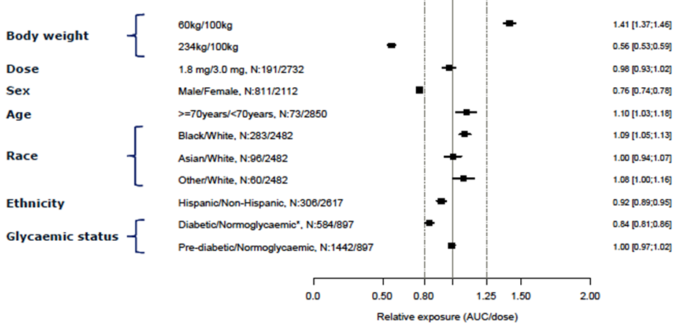
It can be seen that age, race, ethnicity, glycaemic status and dose were found not to be important covariates for dose-adjusted exposure. There was also no clear evidence of altered liraglutide exposure from reduced creatinine clearance (corresponding to mild renal impairment) nor from slightly elevated values of ALT, AST and bilirubin.

Pharmacokinetics in subjects with impaired hepatic function
The modelling study above appeared to show no significant effect on exposure in obese people with mild elevation in liver transaminases and bilirubin. However it is likely that with the obesity in these patients and the mild transaminitis that these patients have predominantly a fatty liver rather than impaired hepatic function. The PI states that liraglutide exposure is proportionally reduced as liver failure progresses however the source of this data was unable to be located.

Pharmacokinetics in subjects with impaired renal function
In the non-obese population, liraglutide exposure was reduced in patients with renal impairment compared to individuals without – this is stated in the proposed PI. Here liraglutide exposure was lowered by 33%, 14%, 27% and 28%, respectively, in patients with mild (creatinine clearance, CrCl 50-80 mL/min), moderate (CrCl 30-50 mL/min), and severe (CrCl <30 mL/min) renal impairment and in end-stage renal disease requiring dialysis.
The modeling study above showed that in obese people there was no change in exposure with mild renal impairment. Thus no dose adjustment is likely to be required in this group. However due to limited experience in population group with moderate severe renal impairment is recommended that liraglutide 3 mg not be used. This should be added to the proposed label text.

Pharmacokinetics according to age and gender
Although it is stated in the PI that no adjustment is needed for age, data showing the effects on PK of a high dose such as the 3 mg Saxenda in obese elderly have not been presented. Saxenda has not been studied in paediatric patients. However the modeling analysis did not show clinically relevant effects of age group, race, ethnicity on exposure.
The population pharmacokinetic analyses showed that liraglutide exposure was 24% lower in males than in females with the same body weight. Liraglutide exposure decreased with increasing body weight. Inclusion of covariates in the model explained approximately half of the between-subject variance of the clearance rate and thus exposure, with body weight and sex accounting for a considerable proportion of that variance.

Pregnancy and Lactation
Liraglutide has not been systematically studied in pregnant or lactating women. Nor is there information on the excretion of liraglutide in human milk nor effects on babies who have been breast fed. However in the analysis of the observational data for women who conceived during one of the studies, there were no congenital abnormalities in the babies born of women who had been exposed to liraglutide; the proportion of births of healthy children in the weight management population was similar between treatment groups in the completed trials (15 with liraglutide [48.4%] and 6 with placebo [40.0%]).
Although there was no PK data collected from pregnant or lactating women, liraglutide has been shown to be teratogenic in rats at or above 0.9 times the human systemic exposures resulting from maximum recommended human dose of 3 mg/day based on plasma AUC. In rabbits, liraglutide decreased fetal weight and dose-dependently increased the incidence of total major fetal abnormalities at all doses, yielding estimated systemic exposures less than the human exposure at the maximum recommended human dose of 3 mg/day at all doses, based on plasma AUC. Decreased maternal food consumption and reduced body weight gain was observed in the dosing period for both rats and rabbits. Recommendations to cease liraglutide in pregnancy have been appropriately noted in the PI.

Pharmacokinetics related to genetic factors
There was no data apart from the modelling data above to support a comment here.

Pharmacokinetics in ethnic groups
It is stated that no dosage adjustment is required based on ethnicity because in the PK modeling study ethnicity had no clinically relevant effect on the pharmacokinetics. However the type of ethnic group were not specified; but from the analysis of the baseline characteristics from the pivotal trials the modeling data was derived from there were no Indigenous Australians.

Pharmacokinetic interactions

Pharmacokinetic interactions demonstrated in human studies
The reported incidence of human PK interactions related to cytochrome P450 (CYP) and plasma protein binding with liraglutide with the 1.8mg dose to date low. Although it is proposed that the likelihood of interactions with the 3 mg is thus potentially low also, due to the PK processes of liraglutide, the delay of gastric emptying with liraglutide (which is greater in the 3 mg than in the 1.8mg) may influence absorption of concomitantly administered oral medicinal products.
Specific drug-drug interaction studies have been performed with 1.8 mg liraglutide but not 3 mg dose. In trial 3630, the effect on rate of gastric emptying between the two doses was compared. Gastric emptying was equivalent between liraglutide 1.8 mg and 3 mg over 5 hours, however the AUC of the 3 mg was 24% less than the 1.8mg liraglutide at 60 mins. This could affect absorption of some drugs, however these studies have not been undertaken. Some patients treated with liraglutide reported at least one episode of severe diarrhea which is known to affect the absorption of concomitant oral medicinal products.
Specific drugs:
- Paracetamol - Liraglutide reduced the Cmax of concomitant paracetamol by 31% and delayed the median T_{max} for 15 min but AUC was unchanged
- Atorvastatin - Atorvastatin Cmax was decreased by 38% and median tmax was delayed from 1 h to 3 h with liraglutide.
- Griseofulvin - Liraglutide did not change the overall exposure of griseofulvin following administration of a single dose of griseofulvin 500 mg. Griseofulvin Cmax increased by 37% while median T_{max} did not change. However griseofluvin has complex pharmacokinetics and the therapeutic course is often 6 months.
- Digoxin – A single dose administration of digoxin 1 mg with liraglutide resulted in a reduction of digoxin AUC by 16%; Cmax decreased by 31%. Digoxin median T_{max} was delayed from 1 h to 1.5 h. No dose adjustment of digoxin is required based on these results.
- Lisinopril - A single dose administration of lisinopril 20 mg with liraglutide resulted in a reduction of lisinopril AUC by 15%; Cmax decreased by 27%. Lisinopril median T_{max} was delayed from 6 h to 8 h with liraglutide.
- Oral contraceptives - Liraglutide lowered ethinylestradiol and levonorgestrel Cmax by 12% and 13%, respectively, following administration of a single dose of an oral contraceptive product. T_{max} was delayed by 1.5 h with liraglutide for both compounds. Although it is stated that there was no clinically relevant effect on the overall exposure of either ethinylestradiol or levonorgestrel a reduction in Cmax of 12-13% could have effects on low dose oral contraceptive exposures, especially in obese women; the target of this application.
- Warfarin and other coumarin derivatives - No interaction study has been performed.
With the increased delay in absorption with the 3 mg dose it is thus possible that clinically significant drug interactions will occur.

Evaluator’s conclusions on pharmacokinetics
The sponsor states that as the liraglutide formulation used in the trials conducted in the weight management clinical development programme for this indication is both the same as that intended for the market and is identical to the currently registered and marketed commercial formulation of Victoza so standard pharmacokinetic work around bioavailability and bioequivalence is not needed for Saxenda.
However, the PK for many drugs alters as the dose increases, due to saturable processes and competitive binding. Further as this drug has a known effect on absorption, known to affect exposure, pharmacokinetic knowledge of all drugs being used with liraglutide as well as monitoring should be undertaken. This is particularly pertinent in obese patients who often have at least one other comorbidity. Importantly, PK is often complex in an obese population (much of the data above is drug interactions of a smaller dose and in a more healthy population) and has different effects on different drugs depending on their own PK and physicochemical properties. The fact there is a 24% lower AUC with liraglutide 3 mg versus 1.8 mg in 3630 study when taken over 60 mins is a case in point. Therefore, the lack of PK data for this higher dosage in this complex population is an issue of potential clinical concern.
It is noted that sex and body weight were the main covariates for liraglutide exposure in the modelling study so PK data of the 3 mg dose in these groups would be helpful. Although there was no observed effect on teratogenicity in the observational studies, teratogenicity has been observed in animals with less exposure than that expected (from the modelling studies) in people taking the 3 mg dose and is appropriately reflected in the PI. There are changes to the PI recommended from the lack of knowledge about the PK in the higher dose and in the obese population.

Pharmacodynamics

Studies providing pharmacodynamic data
Study NN8022-3630 provided PK and PD data with 35 day study in healthy obese using both the 1.8 and the 3 mg dose of liraglutide. Table 2 shows the studies relating to each pharmacodynamic topic and the location of each study summary.
Table 2. Submitted pharmacokinetic studies.
PD Topic | Subtopic | Study ID
Primary Pharmacology | Effect on weight loss and mechanism | NN8022-3630

Summary of pharmacodynamics
The information in the following summary is derived from conventional pharmacodynamic studies in humans unless otherwise stated, and from earlier studies with liraglutide or drugs from this class (submitted with 2008 submission).

Mechanism of action
Glucagon-Like Peptide-1 (GLP-1) is a physiological regulator of appetite and calorie intake. GLP-1 receptor (GLP-1R) is present in several areas of the brain involved in appetite regulation. Liraglutide (the active component of Saxenda) is an acylated human GLP-1R agonist that binds to and activates the receptor. It has 97% amino acid sequence homology to endogenous human GLP-1. It is stable against metabolic degradation and has a plasma half-life of 13 hours after subcutaneous administration, unlike the very short half-life of endogenous GLP-1, due to its stability against proteases. This enables once daily administration.
In animal studies, peripheral administration of liraglutide led to uptake in specific brain regions where it increased important satiety and decreased key hunger signals. It also reduced body weight and lowered fasting and postprandial glucose. The latter appeared to occur by effects on gastric emptying, insulin secretion, glucagon secretion and beta-cell function in a glucose-dependent manner. The mechanism of weight loss had not been so well delineated however, so the pharmacodynamic characteristics of liraglutide 3 mg, including the mechanism for the weight lowering effects, were evaluated in a trial (3630). This study showed liraglutide 3 mg increased post-prandial satiety and fullness ratings following the breakfast meal, and reduced ratings of hunger and prospective food consumption compared to placebo. It also caused nausea. The appetite sensations translated into a decrease in caloric intake of about 16% during a subsequent ad libitum lunch meal. Mean 24-hour energy expenditure was lower with both liraglutide doses compared to placebo - the reductions are likely to have been partly explained by a decrease in body weight. Based on these findings, the weight loss observed with liraglutide is likely to be caused by its effects on reducing appetite and thus caloric intake. Respiratory chamber recordings indicated an overall relative shift in substrate oxidation towards more fat and less carbohydrate oxidation with liraglutide.

Pharmacodynamic effects

Primary pharmacodynamic effects
The primary pharmacodynamic effect with this drug is a reduction in HbA1c, and this is how it has been marketed since registration (2008 submission). However, long term, there is weight loss – this was noted in the diabetes trials. In the pivotal studies discussed in this application, in overweight and obese patients liraglutide in conjunction with reduced calorie intake and increased physical activity, statistically significantly lowered body weight.
The weight loss effect of liraglutide is likely to be mediated by reduced gastric emptying regulation of appetite and calorie intake. The effects of liraglutide on glucose homeostatis are also due to these dynamics, however there is an additional effect on pancreatic alpha and beta-cells to reduce plasma glucose concentrations.

Time course of pharmacodynamic effects
The effect on blood glucose is within minutes to hours of eating. The effects on weight loss are seen in weeks to months.

Relationship between drug concentration and pharmacodynamic effects
There was a simulated relationship between exposure and weight loss seen in the modelling study, and a relationship between dose and weight loss was seen in 1807 and 1922 studies.

Genetic-, gender- and age-related differences in pharmacodynamic response
These differences were seen in the pharmacodynamic response however these are likely to have been mediated via altered concentrations (above). It should be noted though that although an exposure-response relationship was seen across all subgroups, it began to flatten off at the highest exposure achieved with liraglutide 3 mg. However the relationship is not linear as females experienced greater exposure than men but overall had more weight loss compared to males at comparable exposures.

Pharmacodynamic interactions
Nil reported.

Evaluator’s conclusions on pharmacodynamics
Pharmacodynamic data previously submitted (in the 2008 and 2012 submissions) clearly demonstrate an effect of liraglutide (at lower doses) on HbA1c. Effects on weight loss are also seen in these T2DM studies and discussed further in the clinical section.

Dosage selection for the pivotal studies
The dose for the pivotal studies was chosen based on data from trial 1807, the Phase II dose finding trial, evaluated previously but included also in the submission with open label extension data (Table 3). It included liraglutide doses of 1.2, 1.8, 2.4 and 3 mg. Trial 1922 (included in the evaluated pivotal studies, undertaken in subjects with T2DM), included both the 1.8 and 3 mg doses. The dose related efficacy and non-dose related (apart from gastrointestinal) safety results obtained in this trial suggested that liraglutide 3 mg dose was the optimal clinical dose compared to 1.8 mg in weight management for overweight or obese subjects with T2DM.
Table 3. Dosage selection for the pivotal studies.
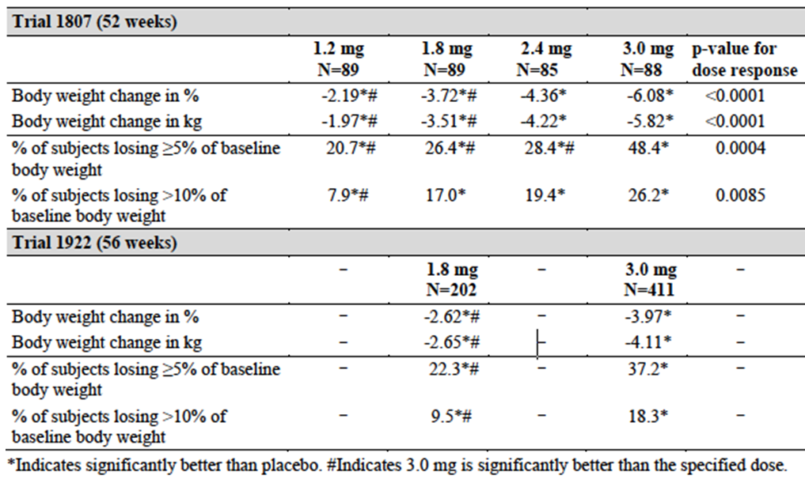
It can be seen that there is a clear dose-response relationship with maximal weight loss being seen in the 3 mg dose. 1807 had an open label extension period which provided observational data up to 104 weeks of treatment.
As well as a dose response relationship for weight loss, in both trials 1807 and 1922, liraglutide 3 mg also had the most beneficial effects on a wide range of secondary endpoints. These include glycaemic control parameters, blood pressure, fasting lipids, cardiovascular biomarkers and quality of life.
In addition, an exposure response relationship was also seen across all subgroups which began to flatten off at the highest exposure achieved with liraglutide 3 mg.

Clinical efficacy

Studies providing efficacy data
Overall, safety and efficacy were studied in four randomised, double blind placebo controlled trials with the liraglutide 3 mg, Saxenda. In these studies doses ranging from 1.2, 1.8, 2.4 and 3 mg were used. The studies spanned 32-56 weeks (including a 4 weeks dose escalation period) and included 5358 patients.
The studies were:
- The SCALE Obesity and Pre diabetes (NN8022-1839): this examined one year weight management trial in 3731overweight patients with at least one comorbid condition, or obese adult patient, with or without pre-diabetes. The dose used here was 3 mg.
- Scale diabetes (NN8022-1922): one year weight management trial in 846 obese or overweight patients with T2DM. The dose used here was the 1.8 and 3 mg doses.
- SCALE Sleep Apnoea (NN8022-3970): six months weight management trial in 359 obese patients with moderate or severe obstructive sleep apnoea. The dose used here was 3 mg.
- SCALE Maintenance (NN8022-1923): one year additional weight loss in 422 overweight people, with at least one comorbid condition, or obese patients after initial >5% weight loss on low caloric diet. This trial assessed the ability of Saxenda to maintain prior weight loss induced by diet and exercise alone and to examine if additional weight loss could be achieved, as a secondary objective. The dose used here was 3 mg.
The development programme for weight loss efficacy (as opposed to diabetes efficacy) includes one clinical pharmacology trial (trial 3630), one phase 2 trial (trial 1807 plus extension) and four phase 3 trials (trials 1839, 1922, 3970 and 1923). The trial population includes more than 5500 obese or overweight subjects with one or more comorbidities such as pre-diabetes/T2DM, hypertension, dyslipidaemia or OSA.
The Phase III trials were all randomised, double-blinded and placebo-controlled.

Pivotal efficacy studies
There are four pivotal studies submitted(1922 1839, 3970 and 1923). These are evaluated in this section. Trials 1839, 3970 and 1923 and a non pivotal study (1807) were conducted in obese or overweight subjects without T2DM. Trial 1922 was conducted in subjects with T2DM. 1807 was a Phase II study. Trial 1839 stratified subjects according to whether or not they had pre-diabetes at screening (according to ADA 2010 criteria). Trial 3970 was conducted in obese subjects with moderate or severe OSA. Trial 1923 was a weight loss and weight maintenance trial conducted in subjects who had achieved ≥5% weight loss during a pre-randomisation 4-12 week run-in period on a low-calorie diet (1200–1400 kcal).

Study NN8022-1839

Study design, objectives, locations and dates
Effect of liraglutide on body weight in non-diabetic obese subjects or overweight subjects with comorbidities: randomised, double-blind, placebo controlled parallel group, multi-centre, multinational trial with stratification of subjects to either 56 or 160 weeks of treatment based on pre-diabetes status at randomisation.
This was a 12 month (56 week) double-blind RCT conducted from June 2010-March 2013 in 3,731 overweight (BMI 27-29.9 kg/m2) patients with either at least one comorbid condition such as treated or untreated dyslipidemia or hypertension, or obese adult patients (BMI greater than or equal to 30 kg/m2). Men and women were included. After the 56 weeks there was a 12-week re-randomised treatment period.
It was conducted at 191 sites in 27 countries: Australia: 4; Austria: 3, Belgium: 2, Brazil: 5, Canada: 11, Denmark: 3, Finland: 3, France: 5, Germany: 8, Hong Kong: 1, Hungary: 2, India: 8, Ireland: 1, Israel: 7, Italy: 7, Mexico: 4, the Netherlands: 5, Norway: 3, Poland: 5, Russian Federation: 7, Serbia: 2, South Africa: 3, Spain:6, Switzerland: 5, Turkey: 4, United Kingdom: 8, United States: 69.
There were several main objectives in the study:
- To establish the efficacy of liraglutide 3 mg compared with liraglutide placebo in inducing and maintaining weight loss over 56 weeks.
- To investigate the efficacy of liraglutide 3 mg in delaying the onset of type 2 diabetes in obese subjects with pre-diabetes and in overweight subjects with pre-diabetes and treated or untreated comorbid dyslipidaemia and/or hypertension.
Secondary objectives were:
- To investigate the long-term efficacy of liraglutide 3 mg versus liraglutide placebo on cardiovascular (CV) risk markers such as blood pressure, lipids, glucose parameters, urinary-albumin-to-creatinine-ratio (UACR), as well as effects on quality of life, patient reported outcomes (PRO) and binge eating scale (BES) ratings.
Safety objective:
- To evaluate the safety and tolerability of liraglutide 3 mg

Inclusion and exclusion criteria
Main inclusion criteria: Obtained informed consent, subjects without type 2 diabetes, male or female, age 18 years or above, obesity (BMI ≥30.0 kg/m2) or overweight (BMI ≥27.0 kg/m2) with treated or untreated comorbid dyslipidaemia and/or hypertension, stable body weight (less than 5 kg self-reported change during the previous 3 months), preceding failed dietary effort.
Main exclusion criteria: Diagnosis of type 1 or type 2 diabetes, HbA1c ≥ 6.5% (screening visit 1) or FPG ≥ 7.0 mmol/L (screening visit 2) or 2 hour post-challenge PG ≥ 11.1 mmol/L (screening visit 2), previous surgical treatment for obesity, uncontrolled hypertension (SBP ≥ 160 mmHg and/or DBP ≥ 100 mmHg), history (family or personal) of multiple endocrine neoplasia type 2 (MEN2), familial medullary thyroid carcinoma (FMTC), non-familial medullary thyroid carcinoma, chronic pancreatitis or idiopathic acute pancreatitis, screening calcitonin ≥ 50 ng/L, history of major depressive disorder or suicide attempt/suicidal behaviour, and obesity induced drug treatment.
Main withdrawal criteria: Withdrawal from the trial at will, target treatment dose not tolerated, pregnancy or intent to become pregnant, initiation of insulin, GLP-1 RA or DPP-4 inhibitor, diagnosis of acute pancreatitis, PHQ-9 score ≥ 10 or suicidal behaviour or suicidal ideation type 4 or type 5 on any Columbia suicidality severity rating scale (C-SSRS) assessment (if not manageable in trial, at discretion of investigator in collaboration with mental health professional), calcitonin ≥ 50 ng/L (France only).

Study treatments
Liraglutide was available in a concentration of 6.0 mg/mL, was supplied in 3 mL FlexPen® and administered once daily by subcutaneous (s.c.) injections either in the abdomen, thigh or upper arm. Injections could be done at any time of the day. However, it was preferable that liraglutide 3 mg was injected during the same overall time period on a day to day basis.
Liraglutide placebo was supplied in 3 mL FlexPen® and administered by once daily s.c. injections as above.
(This administration was the same as for liraglutide in all of the pivotal studies).

Efficacy variables and outcomes
The main efficacy variables were:
- Change in body weight from baseline (%, kg)
- Proportion of subjects achieving ≥5% reduction of baseline body weight (5% responders)
- Proportion of subjects achieving >10% reduction of baseline body weight (10% responders)
- Effects of drug cessation on appetite and body weight
The primary efficacy outcome was change in body weight.
Other efficacy outcomes included:
Body measurements (weight, height and waist circumference), fasting glucose related parameters, OGTT (PG, insulin, C-peptide), UACR, diabetes and pre-diabetes status and classification, vital signs (blood pressure and pulse), CV biomarkers, fasting lipid profile (total cholesterol, low density lipoproteins [LDL], high density lipoproteins [HDL], very low density lipoproteins [VLDL], triglycerides and free fatty acids [FFA]), patient reported outcomes (PRO), concomitant medication (anti-hypertensive drugs, lipid lowering drugs and oral anti-diabetic drugs), positive predictive value of Finnish type 2 diabetes (FINDRISC).

Randomisation and blinding methods
Patients were randomised in a 2:1 ratio to either Saxenda 3 mg or placebo; Saxenda N = 2487, Placebo N = 1244. Patients were stratified based on pre-diabetes status (yes or no) at randomisation. Those classified as having pre-diabetes at baseline were randomised to 160 weeks of treatment (followed by a 12-week off drug/placebo observational follow-up period), and those subjects classified as not having pre-diabetes were randomised to 56 weeks of treatment (followed by a 12-week re-randomised treatment period and a 2−week follow-up period). The 12-week re-randomised treatment period (week 56–68) maintained blinding– the period was to assess possible withdrawal and rebound effects. In this part of the study patients without pre-diabetes treated with liraglutide 3.0 mg were re-randomised in a 1:1 manner to either continue treatment with liraglutide 3.0 mg or to switch to placebo. This gave a liraglutide/liraglutide group of 351 subjects) and a placebo (liraglutide/placebo group, 350 subjects). The placebo group continued on placebo (304 subjects), and diet and exercise continued for all groups.
The first 56 weeks of the trial included all subjects (both with and without pre-diabetes) and consisted of 2 screening visits (visit 1 and 2, up to 2 weeks before randomisation), a 4-week dose escalation period and a 52-week maintenance period. The re-randomised period, from week 56 to 68, was applicable for subjects without pre-diabetes only and after which there was a 2-week observational follow-up period.
Subjects and investigator were blinded to treatment allocation during the entire trial (160 weeks plus the 12-week off-drug follow-up period), whereas the Sponsor was blinded to treatment allocation in the main and re-randomised part of the trial only until database lock at week 70.

Analysis populations
The following analysis sets were defined in the protocol and statistical analysis plan (SAP), prior to un-blinding, and in accordance with ICH E9:
- Full Analysis Set (FAS): All randomised subjects exposed to at least one dose of the trial product and with at least one post-baseline measurement of any efficacy endpoint. Subjects in the FAS were analysed according to randomised treatment. 69 randomised subjects were excluded from FAS.
- Safety Analysis Set (SAS): All randomised subjects who had been exposed to at least one dose of trial product. Subjects in the SAS were analysed “as treated”. 8 subjects were excluded from the SAS.
Overall, 4992 people were screened, 1261 were screen failures. There were 3662 in the FAS and 3723 in the SAS (all patients who had received one dose of study drug).
Numbers and patient flow are given in the trial report and are complete.

Sample size
A total of 3600 subjects, including a minimum of 1000 subjects with pre-diabetes were planned to be enrolled in the trial. In total 3731 subjects were enrolled.

Statistical methods
The efficacy evaluation in all trials was based on a population (FAS), defined as all randomised subjects exposed to at least one dose of trial product and with at least one post-baseline assessment of body weight, or of any efficacy endpoint. An analysis of covariance (ANCOVA) model was used to analyse mean changes for continuous endpoints. Categorical changes for dichotomous endpoints were analysed using a logistic regression model, which included the same fixed effects and covariates as for the respective ANCOVA analysis. Weighted least square means are used for reporting data in the trial.
Specifically, the trial had more than 90% power to detect a difference between liraglutide 3 mg and liraglutide placebo in the proportion of subjects with a weight loss greater than 10%. All statistical tests were two-sided at a 5% significance level based on the FAS, using the last observation carried forward (LOCF): missing values were imputed using last observation carried forward. An ANCOVA model with treatment (liraglutide 3 mg, placebo), country, BMI stratification factor, pre-diabetes status at screening, an interaction between BMI strata and pre-diabetes status at screening and gender as fixed factors, and baseline fasting body weight (at week 0) as covariate (based on the FAS with LOCF) was used for all data not log transformed. A logistic regression model with treatment (liraglutide 3 mg, placebo), country, BMI stratification factor, prediabetes status at screening, an interaction between BMI strata and pre-diabetes status at screening and gender as fixed factors, and baseline fasting body weight (week 0) as covariate (based on the FAS with LOCF) was used for all log transformed data. The tests of superiority of liraglutide 3 mg to placebo for each of the primary endpoints were performed in a hierarchical manner.
These statistical methods were used for all of the pivotal trials.

Participant flow
Of the 3731 randomised, 2487 were in the liraglutide (L) and 1244 placebo (P) groups. Of the 3723 exposed, the numbers were 2481(L) and 1242 (P) respectively; of the 2590 completers at W 56 were 1789(L) and 801 (P); withdrawn at w56 were 698 (L) and 443 (P); adverse event withdrawals total 246 (L) and 47 (P); entered re-randomisation period 701 (L) and 304 (P). There were 2437 (L) and 1225 (P) in the FAS and 2481 (L) and 1242 (P) in the SAS.

Major protocol violations/deviations
There were a number of protocol deviations (PDs) highlighted in the study report. As with the other pivotal trials in this submission, PDs were evaluated by the international trial manager (ITM) and classified as important or not important according to pre-defined criteria approved by the study group. If needed, the ITM consulted the study group for advice on individual PDs. Important deviations were considered those related to violation of GCP, those that could potentially affect the outcome of the trial by influencing key efficacy and safety parameters, and those that could potentially influence the safety of the subjects. Listings of all important PDs reported in relation to this trial are included including PDs at subject level the data sorted by subject ID, trial site and country.
The data was dealt with appropriately in the FAS and SAS.

Baseline data
The mean age was 45 (range 18-78), 79% were women. Mean baseline body weight was 106.2 kg and mean BMI was 38.3 kg/m2. Baseline data in general and specifically in terms of body size and cardiometabolic parameters was similar.

Results for the primary efficacy outcome
Weight loss at one year in SCALE-Obesity and Pre-diabetes is presented below. There was numerically more (-8.4kg) weight loss in the Saxenda (liraglutide 3 mg) arm compared to placebo (-2.8kg) at week 56. Thus the Saxenda arm on average lost 5.6kg more than placebo, 5.2% of total body weight.
Some patients on Saxenda achieved no body weight loss, but for the 63.5% of Saxenda group achieving ≥5%, weight loss was -11.7 % at week 56. This compares to the 26.6% of placebo treated patients achieving ≥5% weight loss who on average lost -10.0%. The effect on weight loss was similar in patients with and without pre-diabetes at baseline. Patients with pre-diabetes treated with Saxenda had a change from baseline in body weight of -8.6 kg compared to -2.8 kg for patients randomised to placebo (from a baseline of 107.6 kg and 107.9 kg, respectively). Patients without pre-diabetes treated with Saxenda had a change from baseline in body weight of -8.1 kg compared to -2.9 kg for patients randomised to placebo (from a baseline of 104.0 kg and 103.6 kg, respectively).
Table 4. Results for the primary efficacy outcome.
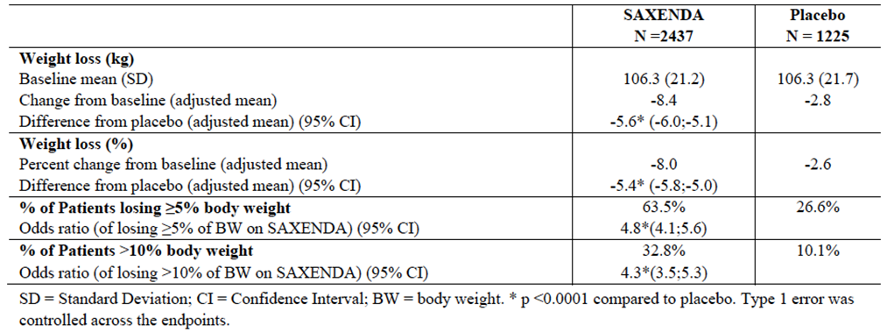

Re-randomised treatment period – from week 56 to 68
This period was to examine maintenance of weight loss if continuing on liragutide, and rebound phenomena when ceasing the therapy. Subjects who switched from liraglutide to placebo in trial 1839 regained a mean 2.91% (2.63 kg) of body weight compared to 0.69% (0.61 kg) in those who continued on liraglutide, although it remained numerically greater than that achieved with diet and exercise alone after 56 weeks i.e. in the original placebo group. A similar pattern was observed with waist circumference. Mean FPG returned to levels similar to those in the placebo group more rapidly, within 2 weeks in subjects who switched from liraglutide to placebo.

Results for other efficacy outcomes

Effect on cardiometabolic parameters and anthropometry
Changes in HbA1c, fasting plasma glucose, blood pressure, heart rate, and lipids when treated with Saxenda are shown below. There were statistically significant changes in all the major cardio-metabolic parameters in patients with pre-diabetes treated with Saxenda compared to placebo. The systolic blood pressure target of 2.8 mmHg relative reduction is likely to be clinically significant. The change in HbA1c of 0.2% is not clinically significant.
Table 5. Effect on cardiometabolic parameters and anthropometry.
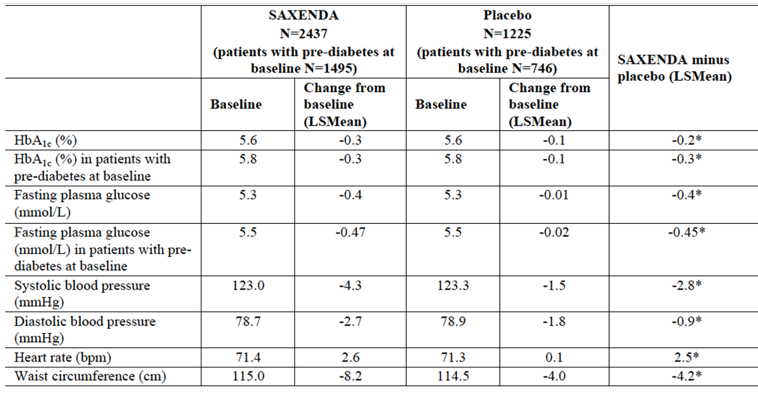
* = statistically significant difference to placebo
Changes to lipid profiles are presented as % change from baseline. Thus in Table 6 , there is a 2.3% reduction in total cholesterol in the Saxenda group compared to placebo which equates to a 0.115mmol/L change; i.e. a reduction of cholesterol from 5mmol/L to 4.885mmol/L or LDLc reduction of 0.0696 from 2.9 to 2.8304mmol/L.
Table 6. Changes to lipid profiles.
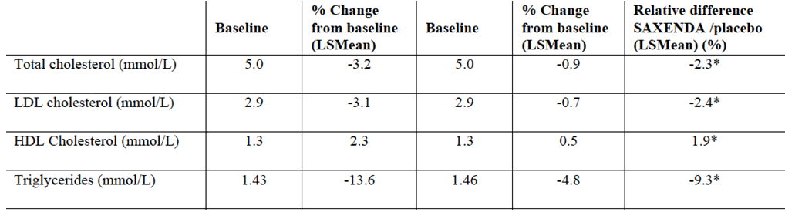

Study NN8022-1922
SCALE-Diabetes: Weight management in obese and overweight patients with type 2 diabetes mellitus
Effect of liraglutide on body weight in overweight or obese subjects with type 2 diabetes - A 56 week randomised, double-blind, placebo-controlled, three armed parallel group, multi-centre, multinational trial with a 12 week observational follow-up period

Study design, objectives, locations and dates
SCALE-Diabetes was a one-year (56 week) trial that enrolled 846 patients who were overweight (BMI 27 -29.9 kg/m2) or obese (BMI greater than or equal to 30 kg/m2) with type 2 diabetes. It was a Phase IIIIa study running from June 2011 to Jan 2013. The trial was conducted at 126 sites in 9 countries: France, Germany, Israel, South Africa, Spain, Sweden, Turkey, United Kingdom and the United States. It compared once daily administration of 3 mg and 1.8 mg of liraglutide with liraglutide placebo in overweight or obese subjects with type 2 diabetes. The total duration of the trial from screening to follow up was 70 weeks per subject including the 56 week treatment duration.

Inclusion and exclusion criteria
Patients were included if they were overweight (BMI 27-29.9 kg/m2) or obese (BMI greater than or equal to 30 kg/m2) with type 2 diabetes; if they had an HbA1c of 7-10% and treated with metformin, a sulfonylurea or a glitazone as single agent or in any combination.

Inclusion Criteria
- Type 2 diabetes and treated with either diet and exercise alone, metformin, SU, glitazone as single agent therapy or any combination of the previously mentioned compounds (metformin+SU, metformin+glitazone, SU+glitazone, metformin+SU+glitazone)
- Glycosylated haemoglobin (HbA1c) 7.0-10.0% (both inclusive)
- Body Mass Index (BMI) of ≥27.0 kg/m2
- Stable body weight
- Preceding failed dietary effort

Exclusion Criteria
- Treatment with glucagon-like peptide-1 (GLP-1) receptor agonists, dipeptidyl peptidase-4 (DPP-4) inhibitors or insulin within the last 3 months
- Known proliferative retinopathy or maculopathy
- History of acute or chronic pancreatitis
- Obesity induced by drug treatment
- Use of approved weight lowering pharmacotherapy
- Previous surgical treatment of obesity
- History of major depressive disorder or suicide attempt
- Systolic blood pressure of 160 mmHg or above and/or diastolic blood pressure of 100 mmHg or above
- Screening calcitonin of 50 ng/L or above
- Familial or personal history of multiple endocrine neoplasia type 2 (MEN2) or familial medullary thyroid carcinoma(FMTC)
- Personal history of non-familial medullary thyroid carcinoma

Study treatments
Saxenda: Liraglutide 6.0 mg/mL, 3 mL FlexPen® for subcutaneous (s.c.) injection.
Placebo: Placebo 3 mL FlexPen® for s.c. injection.

Efficacy variables and outcomes
Primary objective:
- To investigate the efficacy of liraglutide compared to placebo in inducing and maintaining weight loss in overweight or obese subjects with type 2 diabetes after 56 weeks.
Secondary objectives:
To compare liraglutide and liraglutide placebo regarding the effect on:
- Parameters of glycaemic control
- Waist circumference
- Cardiovascular risk factors
- Attaining treatment targets of risk factors for subjects with type 2 diabetes
- Patient reported outcomes
- Weight maintenance in the 12-week observational follow-up period
- As with all the pivotal trials the safety objective was to evaluate the safety and tolerability of liraglutide.

Randomisation and blinding methods
The trial consisted of a screening visit (visit 1, up to 2 weeks before randomisation), a 2- to 4-week dose escalation period, a 52-54 weeks maintenance period and a 12-week observational follow-up period after the last treatment.
Patients were randomised in a 2:1 manner to receive either Saxenda or placebo as an add-on to their background diabetes treatment. Appropriate blinding was undertaken.

Analysis populations
Full analysis set (FAS) – All randomised subjects exposed to at least one dose of the trial product and with at least one post-baseline assessment of any efficacy endpoint. Subjects in the FAS were analysed according to randomised treatment.
Safety analysis set (SAS) – All randomised subjects who have been exposed to at least one dose of trial product. Subjects in the SAS were analysed “as treated”.
The efficacy evaluation was based on the FAS. An analysis of covariance (ANCOVA) model was used to analyse mean changes for continuous endpoints. Categorical changes for dichotomous endpoints were analysed using a logistic regression model, which included the same fixed effects and covariates as for the ANCOVA analysis. In order to make valid comparisons across the trials, the results for all the individual trials are presented using the same type of weighted least square means as used in this trials.
Confirmatory testing of specific pre-specified secondary endpoints was done on pooled data from all of the pivotal trials including 1922 to confirm the results seen in the individual trials. A statistical analysis plan was pre-specified for the confirmatory testing of the secondary endpoints and multiplicity was controlled by a strict hierarchical testing order.
For weight measurements, fasting plasma glucose (FPG) and triglycerides, the last post-baseline fasting measurement was used. In order to account for subjects withdrawn prematurely, careful evaluation of the robustness of the primary LOCF analyses is required. All the statistical analyses in the efficacy evaluation were performed using last observation carried forward (LOCF) imputation for missing data, as pre-specified in the trial protocol (robustness of this demonstrated via sensitivity analyses is discussed).

Sample size
A sample size of 400 subjects randomised to liraglutide 3 mg, 200 subjects randomised to liraglutide 1.8 mg and 200 subjects randomised to placebo was chosen (total of 800 subjects; 846 actually enrolled). The power for the primary endpoint weight change was calculated based on a two sided t-test with a significance level of 5%. The power with regards to the 3 co-primary separate endpoints was calculated based on a two-sided chi-square test. The sample size was calculated to provide power for the primary efficacy endpoint of weight change, the proportion of subjects with a weight loss of at least 5% and the proportion of subjects with a weight loss more than 10%.

Statistical methods
The continuous primary endpoint, body weight loss, was analysed as change in fasting body weight from week 0 to week 56 and compared between liraglutide and placebo using an analysis of covariance (ANCOVA) model with treatment (liraglutide 3 mg, liraglutide 1.8 mg, placebo), country, HbA1c stratification factor, background treatment stratification factor, interaction between stratification factors and gender as fixed effects and with baseline body weight (at week 0) as a covariate. For categorical primary endpoints, a logistic regression model with treatment (liraglutide 3 mg, liraglutide 1.8 mg, placebo), country, HbA1c, background treatment, interaction between stratification factors and gender as fixed effects and with baseline fasting body weight (at week 0) as a covariate, was used to compare the proportion of subjects who lost at least 5% (or more than 10%) of their baseline fasting body weight at week 56 in the three groups. The tests of equality between liraglutide 3 mg and placebo for each of the endpoints were conducted in a hierarchical manner in the order in which the endpoints discussed above are presented.
Continuous secondary endpoints were analysed and presented similarly to the primary analysis of weight change. Baseline values were included as covariates in the analyses of the corresponding response variables. Categorical secondary endpoints were analysed and presented similarly to the primary analysis of proportion of subjects losing at least 5% of baseline body weight. Continuous baseline values were included as covariates in the analyses of the corresponding response variables.
All analyses and tabulations regarding safety endpoints were done using the SAS. AEs were summarised by treatment emergent (weeks 0-58), follow-up period (weeks 56-68). Due to the definition of treatment-emergent (14 days after last dose), AEs with an onset during weeks 56-58 were included in both periods. The proportion of subjects with AEs, and the rate of AEs were compared between the treatment arms and discussed using descriptive data (no formal statistic analyses were performed).

Participant flow
For the FAS, 1361 subjects were screened, and 515 were screening failures. There were 846 randomised 423 (3 mg) 211 (1.8mg) and 212 (placebo). There were 844 exposed; 422 (3 mg L) 210 (1.8mgL) 212 (P). At week 68 there were 599 completers 310 (3 mg L) 154 (1.8mg L) and 135 (placebo); withdrawn at w68 14 (3 mg L) 10 (1.8mg L) and 5 (placebo).

Major protocol violations/deviations
A total of 926 important deviations were identified prior to database lock, comprising 810 subject-level, 109 site-level, 1 country-level and 6 trial-level deviations. In addition, 3 important protocol deviations (1 each at the trial level, site level, and subject level, respectively) were identified after database lock. The protocol deviations were first evaluated by the International Trial Manager (ITM) and classified as important or not important according to pre-defined criteria approved by the study group. If needed, the ITM consulted the study group for advice on individual protocol deviations. Important protocol deviations were those that were related to trial inclusion or exclusion criteria, conduct of the trial, subject management or subject assessment. Itemised protocol violations were documented in the report, and were handled appropriately in the statistical analysis. Major deviations at subject level summarised below.
Table 7. Summary of important protocol deviations and subject level*.
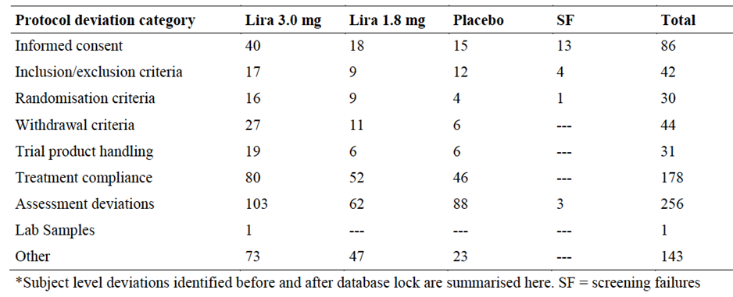

Baseline data
The mean age was 55 year (range 18-82); 50% were women. Mean baseline body weight was 105.9 kg and mean BMI was 37.1 kg/m2. Baseline data was similar between groups.

Results for the primary efficacy outcome
Primary efficacy endpoints:
- Change from baseline in body weight (fasting body weight) at 56 weeks
- Proportion of subjects losing at least 5% of baseline body weight at 56 weeks
- Proportion of subjects losing more than 10% of baseline body weight at 56 weeks
Table 8. Results for the primary efficacy outcome.
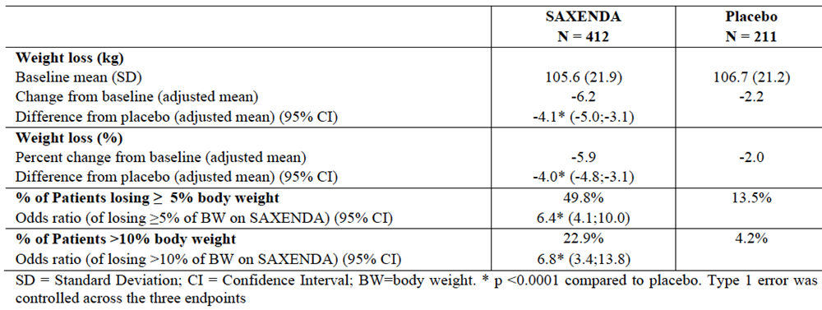
It can be seen the difference between placebo and Saxenda after 1 year of trial, taking into account percentage change was a relative difference of 4% weight loss (95% CI 3.1, 4.8).

Results for other efficacy outcomes
There were a large number of secondary endpoints collected - Parameters of glycaemic control; proportion of subjects with change in concomitant medication from baseline to week 56 in: anti-hypertensives, lipid lowering agents, and oral antidiabetic drugs, waist circumference, cardiovascular risk factors, PRO assessed by Impact of Weight on Quality of Life – Lite (IWQoL-Lite) questionnaire and Diabetes Treatment Satisfaction Questionnaire status version (DTSQs).

Effect on cardiometabolic parameters and anthropometry in patients with type 2 diabetes
Changes in HbA1c, fasting plasma glucose, blood pressure, heart rate, and lipids in the two groups are shown below. 69.2% of obese patients with type 2 diabetes mellitus treated with Saxenda achieved a HbA1c<7% (ADA) target compared to 27.2% for placebo. 56.5% of obese patients with type 2 diabetes mellitus treated with Saxenda achieved a HbA1c ≤6.5% (IDF) target compared to 15.0% for placebo. There was a clinically significant reduction in HbA1c in the Saxenda group (0.9mmol/L) and clinically relevant reduction in systolic blood pressure.
Table 9. Mean changes in glycaemic and cardiometabolic parameters after one year in the SCALE-diabetes study.
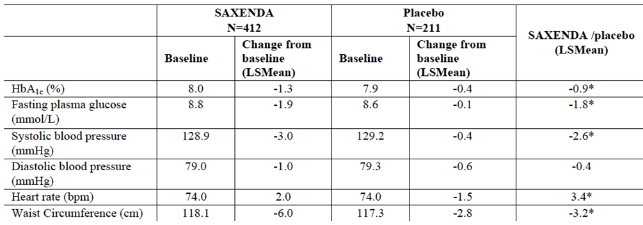
* statistically significant vs. placebo (p<0.05)
Changes to lipid profiles are presented as % change from baseline. Thus a 2.2% reduction in LDLc reduces the LDLc at baselines from 2.2 mmol/L by 0.048mmol/L to 2.152mmol/L.
Table 10. Changes to lipid profiles are presented as % change from baseline.
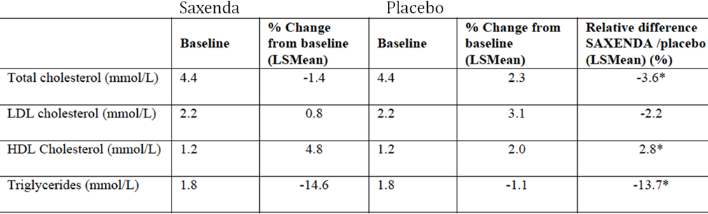
* statistically significant vs. placebo (p<0.05)
An observational off-treatment period also occurred to examine any rebound phenomenon. The follow-up showed similar results to 1829 whereby on stopping liraglutide there is body weight gain. This is best demonstrated in Figure 2.

Figure 2. Change in fasting body weight.
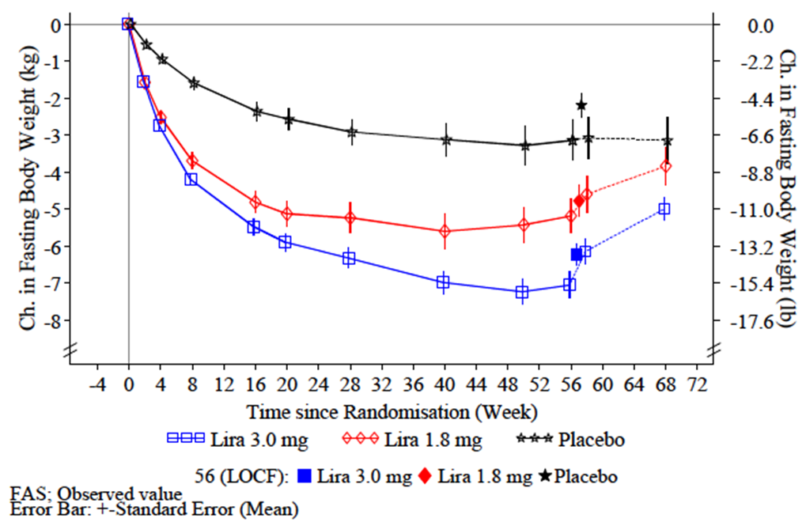
For other secondary endpoints, higher scores were seen with both the PRO tools ie the iWQoL and the DTSQ instruments. Specifically, for IWQoL-Lite, liraglutide 3 mg treatment resulted in a higher (better) total score (estimated treatment difference: 2.75, p=0.0136), and higher score in ‘physical function’ (estimated treatment difference 4.92, p=0.0006) at week 56 compared with placebo. No differences were observed between liraglutide 1.8 mg and placebo in any IWQoL-Lite domains, nor DTSQ. For liraglutide 3 mg, treatment was associated with a higher total DTSQ score (estimated treatment difference: 1.44, p=0.0066) compared with placebo.

Other efficacy studies

SCALE (NN8022-3970)

Study design, objectives, locations and dates
Sleep Apnoea: Weight management in obese patients with moderate or severe obstructive sleep apnoea (OSA)
Effect of Liraglutide in Obese Subjects with Moderate or Severe Obstructive Sleep Apnoea - A 32 week randomised, double-blind, placebo-controlled, parallel group, multi-centre and multinational trial. This was a randomised, multi-centre, multi-national, double-blind, placebo-controlled, parallel-group trial six-month trial (June 2012-June 2013) that enrolled 359 obese with moderate or severe OSA with 3 mg liraglutide. The trial duration was 36 weeks and consisted of a 2-week screening period, randomisation followed by a 4-week dose escalation period, a 28-week maintenance period and 2-week follow-up. The trial was conducted at 40 sites in the US and Canada.

Inclusion and exclusion criteria
Inclusion: Obese (BMI greater than or equal to 30 kg/m2) with moderate or severe obstructive sleep apnoea (OSA) and unable or unwilling to use continuous positive airway pressure treatment.
Specifically:
- Age 18−64 years (both inclusive)
- Body mass index (BMI) ≥30 kg/m2
- Stable weight (less than 5% self-reported change during the previous 3 months)
- Diagnosis of moderate or severe OSA
- Unwilling or unable to use CPAP (or other positive airway pressure) treatment
- Ability and willingness to comply with all protocol procedures
There were a large number of exclusion criteria:
- Treatment with (GLP-1) receptor agonists, dipeptidyl peptidase-4 inhibitors or insulin within the last 3 months prior to screening
- Diagnosis of type 1 or type 2 diabetes per judgement of the Investigator
- Glycosylated haemoglobin (HbA1c) ≥6.5%
- Significant craniofacial abnormalities that may be causing OSA
- Respiratory and neuromuscular diseases that could interfere with the results of the trial
- Use of central stimulants, hypnotics, mirtazepine, opioids, trazodone within the 3 months prior to screening
- Obesity induced by drug treatment
- Treatment with other weight loss drugs within the last 3 month
- Previous surgical treatment for obesity
- Screening calcitonin ≥50 ng/L
- Familial or personal history of: multiple endocrine neoplasia type 2 or familial medullary thyroid carcinoma (MTC)
- Personal history of non-familial MTC
- History of acute or chronic pancreatitis
- History of major depressive disorder (within 2 years prior to screening), other severe psychiatric disorders or suicidal behaviour
- Systolic blood pressure ≥160 mmHg and/or diastolic blood pressure ≥100 mmHg at screening
Withdrawal criteria included:
Pregnancy or intention of becoming pregnant, suspicion of acute pancreatitis, patient health questionnaire score (PHQ- 9) ≥ 10 or any suicidal behaviour or any suicidal ideation of type 4 or 5 on any Columbia Suicidality Severity Rating Scale (C-SSRS) assessment, with the subject’s psychiatric disorder not being able to be adequately treated (at the discretion of the Investigator and in agreement with the mental health professional).

Study treatments
Liraglutide 6.0 mg/mL, 3 mL FlexPen® 3 mg daily for subcutaneous (s.c.) injection.
A fixed maintenance 3 mg dose of liraglutide was used in this trial, although dose escalation started at 0.6 mg, and increased by 0.6 mg increments every 7 days until the target dose (3 mg) was reached.
Placebo was liraglutide placebo, 3 mL FlexPen® for s.c. injection.

Efficacy variables and outcomes
Primary objective:
- To investigate if treatment with liraglutide 3 mg reduces severity of OSA (assessed by apnoea-hypopnoea index [AHI]) compared to placebo both in combination with lifestyle intervention in obese subjects with moderate or severe OSA.
Secondary objectives:
- To compare the efficacy on weight and other body measurements, glycaemic control, cardiovascular risk and patient reported outcomes (Epworth Sleepiness Scale [ESS], Short Form Health Survey [SF-36], Functional outcomes of sleep questionnaire [FOSQ]) after 32 weeks of treatment
- To evaluate safety and tolerability of liraglutide 3 mg in obese subjects with OSA.
Other secondary outcomes included:
- Change in body weight from baseline (%, kg)
- Proportion of subjects achieving ≥5% reduction of baseline body weight (5% responders)
- Proportion of subjects achieving >10% reduction of baseline body weight (10% responders)

Randomisation and blinding methods
Subjects were randomised in a 1:1 manner to receive Saxenda (liraglutide) 3 mg or placebo.

Analysis populations
As per other studies in this Application. In summary, the efficacy evaluation was based on a FAS population, defined as all randomised subjects exposed to at least one dose of Saxenda and with at least one post-baseline assessment of body weight, or of any efficacy endpoint for this trial. SAS included any subject who had received a treatment.

Sample size
A total of 308 subjects were planned for enrolment and 359 subjects were actually enrolled.

Statistical methods
An analysis of covariance (ANCOVA) model was used to analyse mean changes for continuous endpoints in the trials. Categorical changes for dichotomous endpoints were analysed using a logistic regression model, which included the same fixed effects and covariates as for the ANCOVA. The results are presented using the same type of weighted least square means as used in the trial.
All the statistical analyses in the efficacy evaluation were performed using LOCF imputation for missing data, as prespecified in the trial protocols. For weight measurements, fasting plasma glucose (FPG) and triglycerides, the last post-baseline fasting measurement was used.
In order to account for subjects withdrawn prematurely, robustness of the primary LOCF analyses was undertaking sensitivity analyses of different methods for handling missing data (prespecified for the primary endpoints).

Participant flow
Patient flow was similar between the two groups, liraglitide and placebo (L and P). There were 813 screened and 454 failures. 180 were randomised to L and 179 to P with a 134 completed (L) and 142 (P). There were 46 (L) and 37 (P) withdrawn. There were 22 AEs in the L group as compared 6 in the P.

Major protocol violations/deviations
There were no important protocol deviations at trial level were identified in this trial and there were no protocol deviations at country level identified. A total of 25 important protocol deviations at trial site level and 127 at subject level were identified – the most frequently reported protocol deviations at subject level were ‘informed consent’, ‘assessment deviations’, ‘treatment compliance’ and ‘inclusion/exclusion criteria’. The most frequently reported protocol deviations at trial site level were related to the categories ‘informed consent’ and ‘assessment deviations’. One major violation was a patient with a history of severe mental illness who was randomised inappropriately.

Baseline data
The mean age was 49 years (range 22-64); 28% were women. Mean baseline body weight was 117.6 kg and mean BMI was 39.1 kg/m2. Baseline data was matched between the groups.

Results for the primary efficacy outcome
Table 11 provides the results for the weight loss at six months in SCALE-Sleep Apnoea. After 6 months, statistically significantly more weight loss in occurred in obese patients with moderate or severe OSA in the Saxenda arm. Overall, this equated to a 4.2% weight loss, after adjusting for baseline status and placebo change.
Table 11. Results for the primary efficacy outcome.
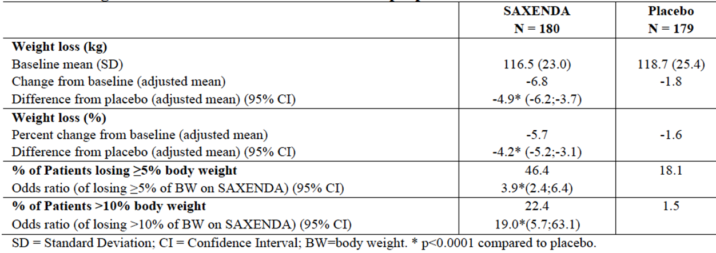
At 6 months, mean change in body weight from baseline for the 46.4% of Saxenda treated patients achieving ≥5% weight loss was -10.7% compared to -8.4% for the baseline 18.1% of placebo group achieving ≥5% weight loss.

Results for other efficacy outcomes

Apnoea-hypopnoea Index (AHI)
Shown in Table 12.
Table 12. AHI.
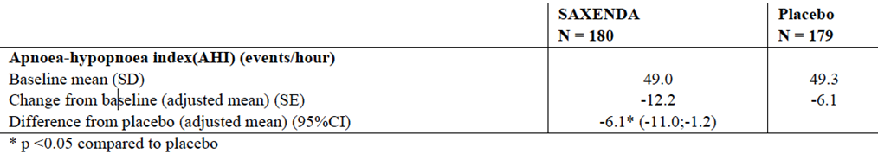
There is a statistically significant difference in AHI between Saxenda and placebo but the clinical significance of this reduction (from 49 events/hour to 43 events/hour) is not discussed.

Glycaemic and cardiometabolic parameters
Changes in HbA1c, fasting plasma glucose, blood pressure, heart rate, and lipids are shown in the following Table ( * = p< 0.05 in Saxenda compared to placebo group). There is a 0.2% reduction in HbA1c compared to placebo and a 4mmHg reduction in systolic blood pressure compared to placebo, in the Saxenda treated group.
Table 13. Glycaemic and cardiometabolic parameters.
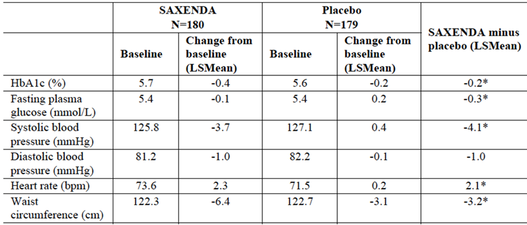
* = statistically significant (p<0.05) compared to placebo

Lipid parameters
There is a reduction of LDL cholesterol of 4.2% compared to placebo, from a baseline of 2.9mmol/L. This results in an overall reduction of 0.1218mmol/L – i.e. from 2.9 to 2.77mmol/L.
Table 14. Lipid parameters.
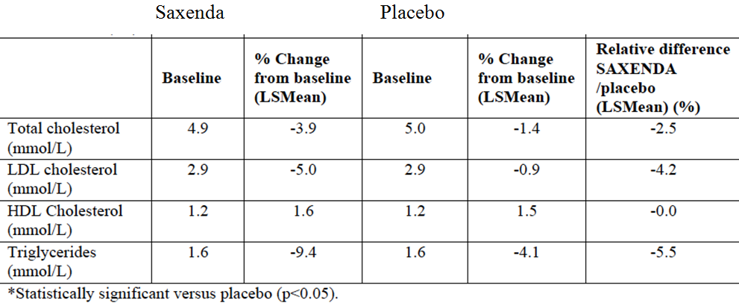
Secondary endpoints related to patient reported outcomes:
- For SF-36, liraglutide 3 mg treatment was only associated with a statistically significantly greater improvement in “general health” compared with placebo after 32 weeks (1.56, p=0.0360), i.e. no statistically significant differences were observed for the other domains or the overall physical and mental scores.
- For ESS, there was no difference between the liraglutide 3 mg and placebo arms.
- For FOSQ, liraglutide 3 mg treatment was associated with a statistically significant improvement in “activity level” compared with placebo after 32 weeks (0.10, p= 0.0150). No statistically significant differences were observed for the other domains or the total score.
The clinical relevance of a change in 1.6 in SF36 or 0.1 in FOSQ was not clear.

SCALE-Maintenance (NN8022-1923)
Weight loss in obese and overweight patients with at least one comorbid condition

Study design, objectives, locations and dates
Effect of liraglutide on long-term weight maintenance and additional weight loss induced by a 4 to 12 week low calorie diet in obese subjects; A 56 week randomised, double-blind, placebo controlled, parallel group, multi-centre trial with a 12 week follow-up period.
This trial comparing the effect of liraglutide 3 mg vs. placebo, on maintaining run-in weight loss of 5% after 56 weeks in obese subjects without diabetes (SCALE-Maintenance), was undertaken in 26 US and 10 Canadian sites. It enrolled 422 patients from Oct 2008 to Sept 2010 who were overweight and had at least one comorbid condition.

Inclusion and exclusion criteria
Inclusion: patients who were overweight (BMI 27-29.9 kg/m2) and had at least one comorbid condition, such as treated or untreated dyslipidaemia or hypertension, or obese (BMI greater than or equal to 30 kg/m2).
Patients needed to have stable body weight during the previous 3 months, age more than18 years, and previously undergone dietary weight loss and not able to maintain reduced weight.
Exclusion: Clinically significant disease which could interfere with the safety of the trial participants or with the results of the trial, diagnosis of type 1 or type 2 diabetes, FPG >126 mg/dL (7 mmol/L) at Visit 2, previous treatment with GLP-1 receptor agonists within the last 3 months, TSH outside of the range of 0.4- 6.0 mIU/L at Visit 1, history of pancreatitis, obesity induced by other endocrinologic disorders; within the 3 months prior to Visit 1 a history of treatment with medications that may cause significant weight gain, participation in an organized diet reduction programme, using drugs known to induce weight loss, participation in a clinical trial of weight control; previous surgical treatment for obesity; history of major depressive disorder or a PHQ-9 score >-15 within the last 2 years, history of other severe psychiatric disorders, diagnosis of an eating disorder, a lifetime history of a suicide attempt or history of any suicidal behavior within the past month before entry into the trial; surgery scheduled for the trial duration period, except for minor surgical procedures; impaired liver function, impaired renal function, clinically significant active cardiovascular disease, uncontrolled treated/untreated hypertension, cancer, known or suspected allergy to trial product or related products.
Criteria for withdrawal for the randomized treatment period: withdrawal of consent, drug treatment not tolerated, development of type 1 or type 2 diabetes or acute pancreatitis, pregnancy, failure to complete dose-escalation from 0.6 mg/day liraglutide to 3 mg/day liraglutide between Visits 14 – 18.

Study treatments
Active product was liraglutide 6.0 mg/mL for sc injection, administered daily (3 mg, although the initial dose of was 0.6 mg/day, escalating weekly over 5 weeks to 1.2, 1.8, 2.4 and finally
3 mg/day). Matching liraglutide placebo was used in the other arm.

Efficacy variables and outcomes
The primary efficacy outcome was to compare the efficacy of liraglutide 3 mg versus placebo in maintaining run-in weight loss (>5% achieved in a 4 to 12 week low calorie run-in period) over 56 weeks in obese subjects and overweight subjects with co-morbidities.

Secondary Efficacy Objectives
To assess and compare the effect of liraglutide 3 mg versus placebo on:
- Weight parameters including reaching and maintaining weight loss targets, prevention of weight regain and weight maintenance after drug cessation
- Cardiovascular (CV) risk markers: blood pressure, fasting lipid profile, waist circumference, body mass index (BMI), metabolic syndrome and CV biomarkers
- Parameters of glycaemic control (haemoglobin A1c (HbA1c), Fasting Plasma Glucose (FPG), fasting insulin and Homeostasis Model Assessment (HOMA).

Randomisation and blinding methods
Patients were first treated with a low calorie diet (total energy intake 1200-1400 kcal/day [approximately 5000 – 5850 kJ/day]) in the run-in period lasting up to 12 weeks. Patients who lost at least 5% of screening body weight after 4 weeks and up to 12 weeks during the run-in were randomised in a 1:1 manner to receive either liraglutide 3 mg (Saxenda) or placebo for 56 weeks. Subjects who did not lose 5% of baseline (screening) body weight were considered run-in failures and were withdrawn from further study.
The 56 week period was then followed by a re-randomised period for the subjects without pre-diabetes only (1:1 manner to either continue treatment with liraglutide 3.0 mg or to switch to placebo).
At the time of randomisation subjects were stratified according to co-morbidity status, i.e., presence or absence of treated or untreated hypertension or dyslipidaemia. Randomised subjects were instructed by a nutritionist to follow a standard energy-restricted diet (500 kcal deficit) and received exercise counselling throughout the trial.

Sample size
420 obese patients without T2DM needed to be randomised to ensure appropriate power of the primary efficacy outcome; 422 met the inclusion/exclusion criteria.

Statistical methods
Three population data sets are described in the study report; the FAS and Per Protocol (PP), both of which were used for efficacy endpoints analyses, and the SAS which was used for the safety analysis. Similarly to the other liraglutide studies submitted in this Application, all statistical tests carried out were two-sided and conducted at a 5% significance level. For all efficacy evaluations, only observations on drug (defined as last injection taken the day before or on the day of the visit) were included in the analysis unless otherwise specified.
The Statistical Analysis Plan and changes to the Statistical Analysis Plan used standard methodologies for investigation and interpretation of efficacy and safety outcomes.

Participant flow
There were a total of 675 subjects screened, 551 who entered the dietary run-in, and 422 subjects who were randomised to the trial. There were a total of 253 screening failures; of these 124 did not enter dietary run-in due to non-fulfilment/fulfilment of inclusion/exclusion criteria (104), withdrawal of consent (13), lost to follow-up (3) or Other reasons (4). There were 129 dietary run-in failures due to withdrawal of consent by 28 subjects, 16 subjects lost to follow-up, 17 withdrawals for other reasons, 8 for meeting exclusionary criteria and 60 for inability to lose 5% body weight in the allotted time.
Of the 422 subjects randomised, all were exposed to treatment: 210 to placebo and 212 to liraglutide 3 mg. All 422 exposed subjects were included in the SAS.
A total of 305 exposed subjects completed the trial to end of treatment at Week 56. There were 117 withdrawals (27.7 % of randomised subjects) in total, 64 (30.5%) in the placebo group, 53 (25.0%) in the liraglutide 3 mg group.
By the end of the additional 12-week observational follow-up period (Week 68) the total number of withdrawals was 128.During the follow-up period there were no additional withdrawals due to AEs, ineffective therapy or subjects meeting withdrawal criteria. There were 2 additional withdrawals due to non-compliance (one in each arm), and 9 more categorized as due to other reasons (5 in the liraglutide 3 mg group and 4 in the placebo group). Withdrawals during the treatment period due to AEs were equal in each treatment group (n = 18). The most common reason in each treatment arm for withdrawals was AEs or that withdrawal criteria were met.

Major protocol violations/deviations
There were a number of important protocol deviations that may have affected outcomes, or which indicated potential safety issues. However their data was appropriately excluded from the FAS or PP analysis and included in the safety analysis when needed.

Baseline data
The mean age was 46 (range 18-73); 81% were women. Mean baseline body weight was 99.6 kg and mean BMI was 35.6 kg/m2. Baseline data was otherwise matched.

Results for the primary efficacy outcome
During the three-month low calorie diet prior run in period patients achieved an average weight loss of 6.0%, (6.3 kg). The Table below shows that after randomisation, an additional weight loss of 6.1% (5.7 kg) occurred in the Saxenda group compared to weight loss of 0.1% (0.2 kg) for placebo. A statistically significant greater number of patients randomised to Saxenda than placebo achieved ≥5% and >10% weight loss by year one. Mean change in body weight from baseline for the Saxenda treated patients achieving ≥5% weight loss at one year was 11.9% compared to the 9.95% reduction in placebo treated patients.
Table 15. Results for the primary efficacy outcome.
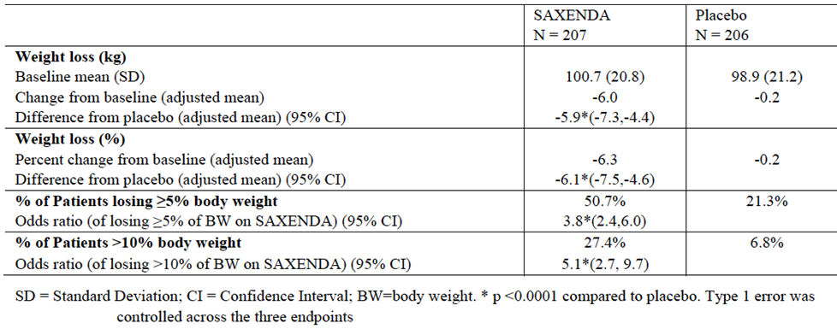

Results for other efficacy outcomes

Glycaemic and cardiometabolic parameters
Changes in HbA1c, fasting plasma glucose, blood pressure, heart rate, and lipids are shown in the following table.
Table 16. Glycaemic and cardiometabolic parameters.
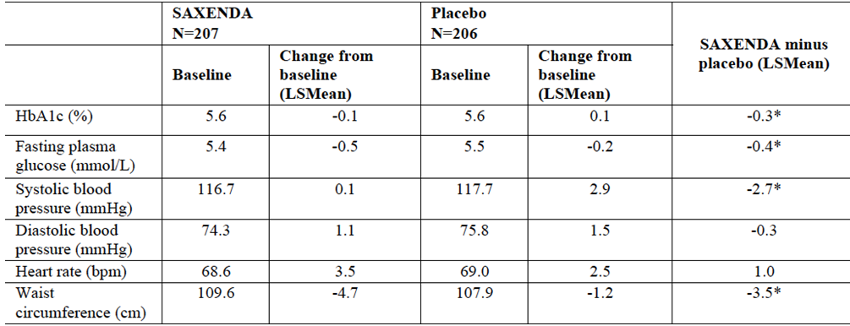
* = statistically significant (p<0.05) compared to placebo

Lipid parameters
There is a reduction of LDL cholesterol of 3.3% compared to placebo, from a baseline of 2.5mmol/L. This gives a reduction of 0.08mmol/L i.e. reduces LDLc from 3.3 to 3.22 mmol/L.
Table 17. Lipid parameters.
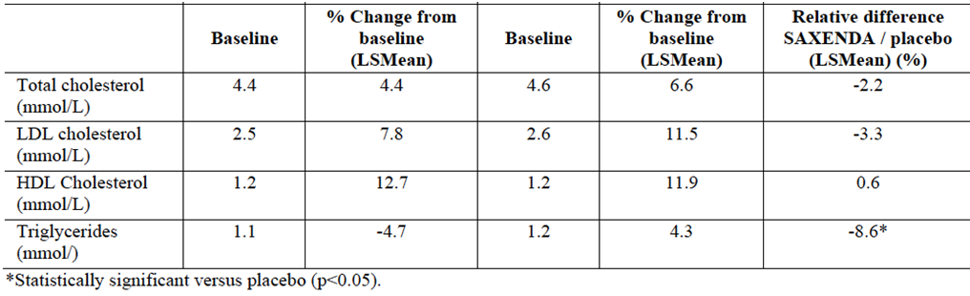
The follow-up showed similar weight loss results to 1829 in that form Week 56, the liraglutide group regained weight and at the end of the 68 week trial had only lost 3.83 kg (4.23 kg more than the placebo group, <5% of body weight).
Table 18. Change in fasting body weight (kg) from week 0 to 68 – descriptive statistics.
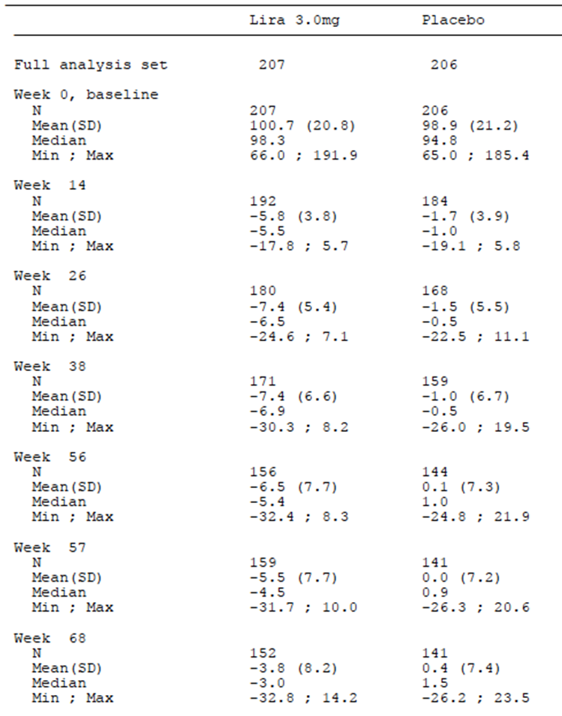

Analyses performed across trials (pooled & meta analyses)
There were no meta-analyses undertaken but there were some descriptive and pooled efficacy subgroup analyses on endpoints relevant to this application (i.e. patients achieving weight loss >/= 5% in first four months - ‘early responder sub group’) and some not directly relevant to this application (fasting insulin, cholesterol and blood pressure changes). This was undertaken on pooled data from the 4 pivotal studies and the 1807 Phase II efficacy study.

≥5% weight loss
The submission calculates that in the SCALE-obesity and pre-diabetes and SCALE-Diabetes studies combined, 65.0% of the Saxenda group achieved ≥5% weight loss after four months. Overall mean change from baseline in body weight was <5%; - for the ‘early responders’ it was -11.2 % after one year (excluded the non-early responders); however when adjusting for response in the placebo group which was around 2% in the total group (early responders and overall responders) the comparative value is likely to be around 10%.
Change from baseline in body weight for the phase 3 trials 1839, 1922, 3970 and 1923 is summarised below. Treatment with liraglutide 3.0 mg, as adjunct to diet and exercise, led to a mean weight loss from baseline of 5.7 -9.2% (6.0-8.8 kg) depending on the trial, compared to 0.2 to 3.1% (0.2–3.0 kg) in placebo group. Placebo-subtracted mean weight loss with liraglutide ranged from 4.0 to 6.1% (4.1-5.8 kg) across trials.

Figure 3. Trial results, relative change in weight.
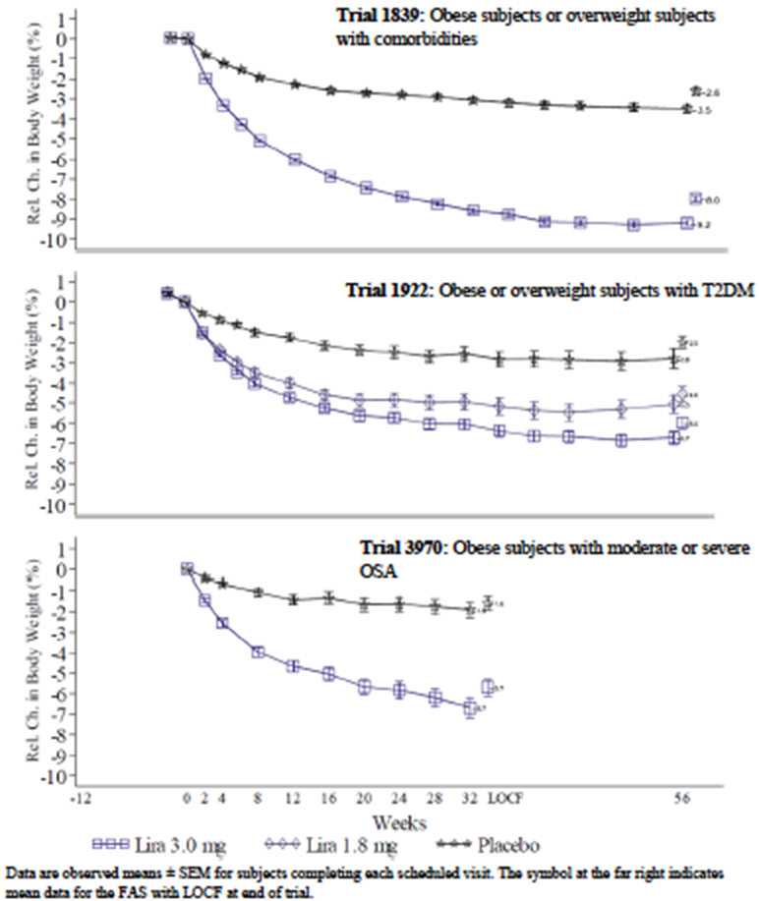
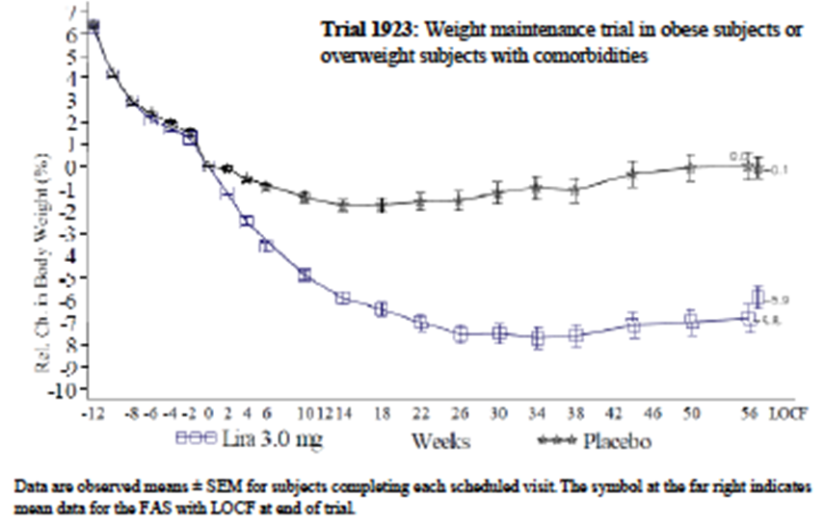
This figure (taken from 1807 extension study) shows the plateauing out of weight loss in patients who continue on liraglutide for 104 weeks. It can be seen that 3 mg has the most profound weight loss, but that by week 32 the curves have flattened. Note that on week 53 the placebo group was able to switch to active treatment.
Figure 4. Mean change in body weight.
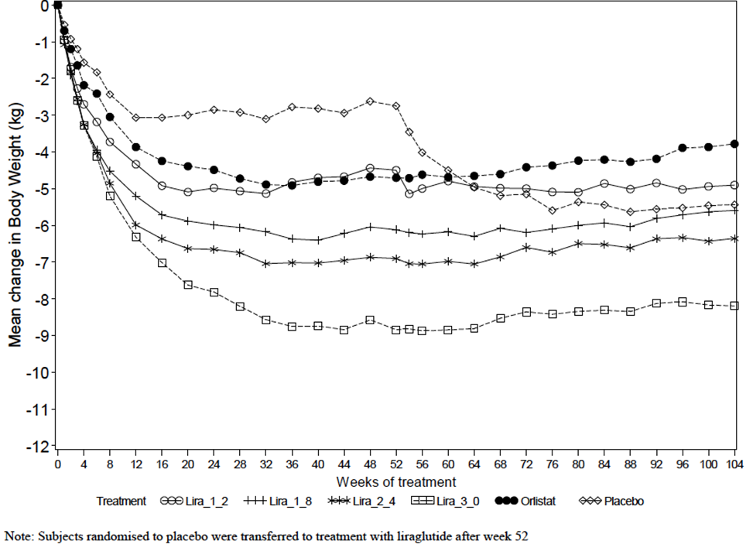
Table 19. Mean change in body weight.
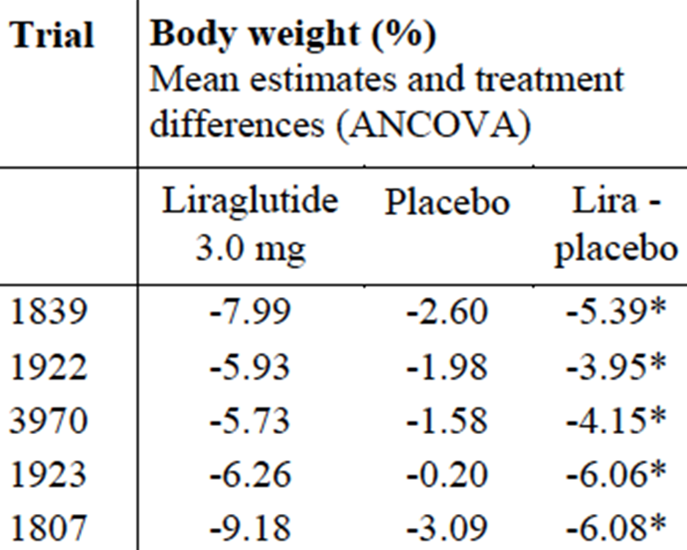
*p<0.0001. End of treatment is 56 weeks for trials 1839, 1922 and 1923, 32 weeks for trial 3970, and 52 weeks for trial 1807.
Table 20. Mean change in body weight.
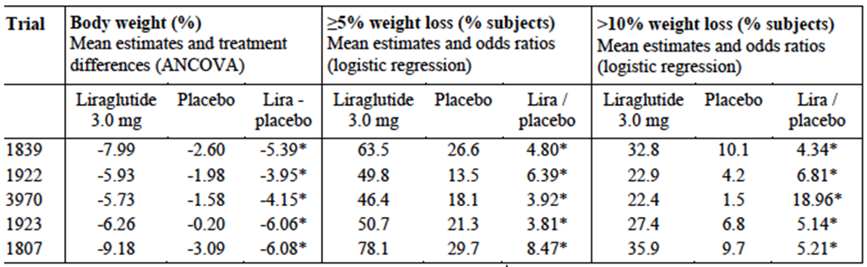*p<0.0001. End of treatment is 56 weeks for trials 1839, 1922 and 1923, 32 weeks for trial 3970, and 52 weeks for trial 1807.

Responders and non-responders
There is clearly a group of people who respond (and respond very quickly i.e. within 4 months) and those who do not. Similarly in the placebo group, there are people who responded early and significantly to diet and exercise alone. This is evidenced in study 1923 where only patients who had responded to a low calorie diet were then randomised, and these people had further weight loss.
The following Table shows the mean change from baseline in efficacy parameters for 5% responders vs. non-responders – estimated mean estimates for all 5 trials pooled.
Table 21. Mean change from baseline in efficacy parameters for 5% responders vs. non-responders – estimated mean estimates for all 5 trials pooled.
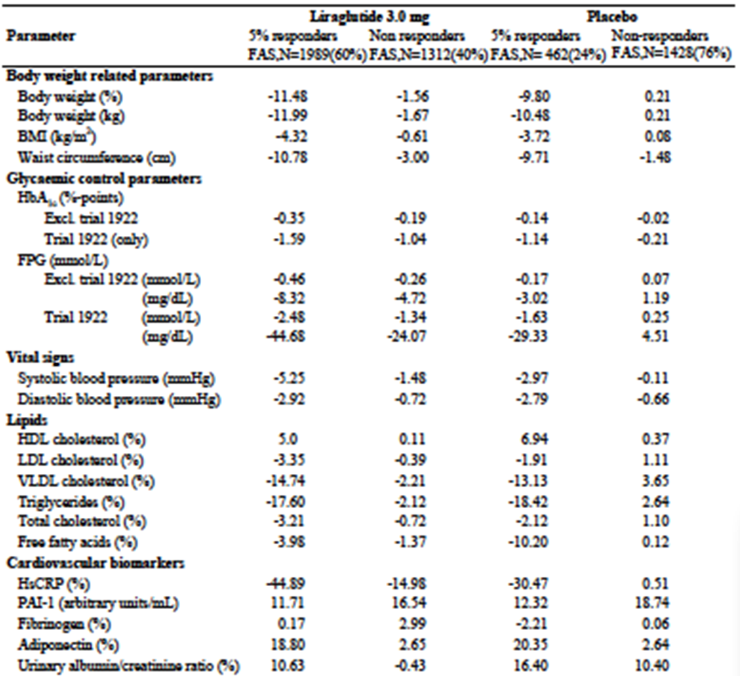
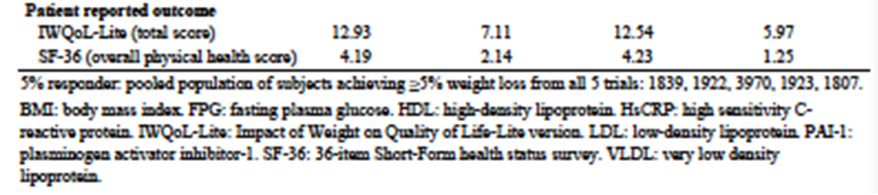

Secondary endpoints
Secondary endpoints are shown as treated in a hierarchical manner.
Table 22. Secondary endpoints.
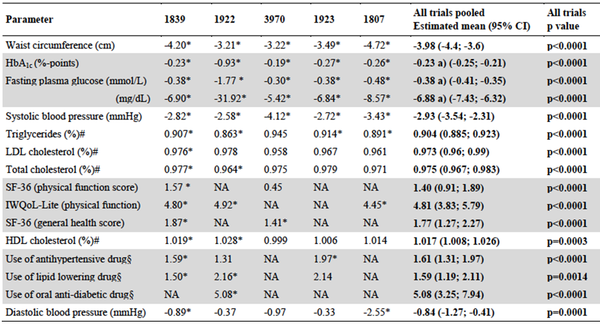

Patient Reported outcomes
Statistically significant improvements in the total score for the IWQoL-Lite were observed with liraglutide 3.0 mg compared with placebo in all the trials in which this questionnaire was used; significant improvements in the SF-36 overall physical and mental health scores were also seen with liraglutide vs. placebo in trial 1839, with a similar positive trend in trial 3970. The clinical relevance of these findings is not clear.
Table 23. Patient Reported outcomes.
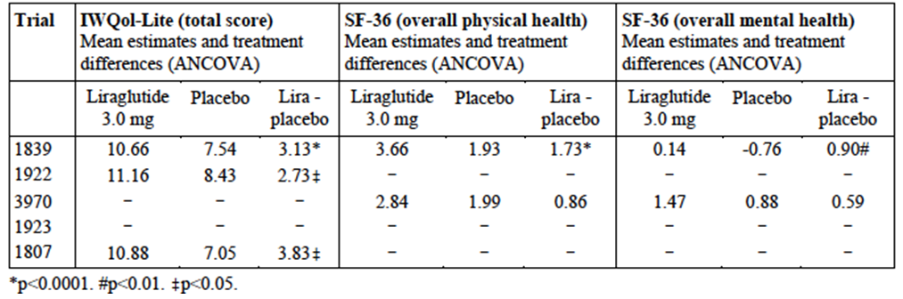

Evaluator’s conclusions on efficacy
In each of the four Phase III randomised control trials there is evidence of a statistically significant weight loss difference between placebo and Saxenda, maintained out to one year. In the pooled analysis, weight loss is around 4.0-6.1% of total body weight (compared to placebo after adjustment for baseline). The clinical relevance of the statistically significant percentage is not discussed, although the EMA guideline states:
Demonstration of a clinically significant degree of weight loss of at least 10% of baseline weight, which is also at least 5% greater than that associated with placebo, is considered to be a valid primary efficacy criterion in clinical trials evaluating new anti-obesity drugs.
This criterion was not met for 2 of the 5 studies (3.95% (1922), 4.15% (3970) and just met for three others (-5.39% (1839), 6.06% (19223) and 6.08% (1807).
The guideline also states:
Measurements using accepted methods selected and justified by the applicant should demonstrate that weight loss is associated with appropriate loss of body fat … Methods such as waist circumference measurement, waist to hip ratio, magnetic resonance imaging and computer tomography may be used to assess abdominal fat content.
Waist circumference was reported in the studies (see below).
The guideline also states:
Long-term studies are required to demonstrate treatment associated benefits and risks and are particularly useful in documenting any changes in or loss of drug effect. Since the physiological response to dieting and reduced food intake can suggest a reduction in drug effect, it is important to remember that drug effect can be continuing despite a reduction in the rate of weight loss and may even be manifest as a failure to regain weight lost. At present, trials documenting the effect of treatment for at least one year are required but an applicant intending to demonstrate the effect of weight loss on morbidity and mortality would require a longer prospective study.
In all studies there was a plateau with no clinically relevant further weight gain after the initial 3-4 month weight loss. In the studies where rebound was examined, patients were regaining lost weight – based on the trend it could be presumed that this group would return back to baseline, although it is noted that at the time of end of the relatively short study follow-up the weight had not returned to baseline.
It was noted that Saxenda had positive statistically significant effects on BMI and waist circumference in all 4 Phase III and the Phase II 1870 trial (Table 24). It also reduced neck circumference in the OSA trial 3970.
Table 24. Effects on BMI and waist circumference.
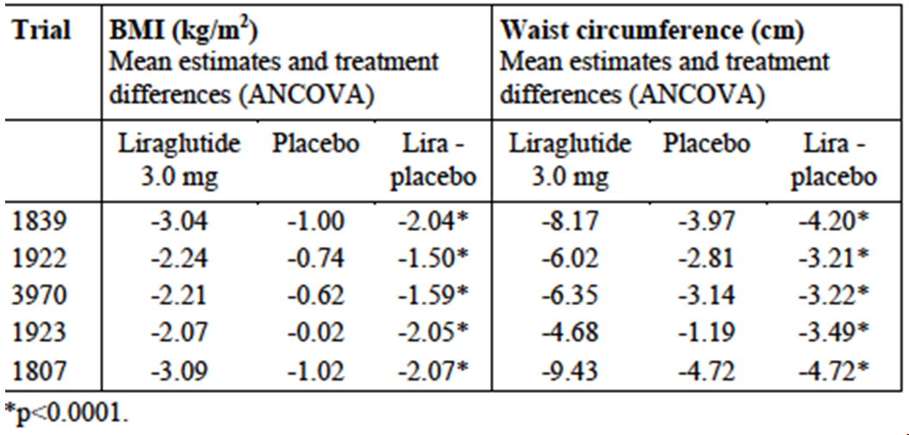
The clinical significance of a reduction in BMI or waist circumference of 3.2-4.7 cm was not discussed, although this was noted to be an important endpoint in the EMA guidance. The Guidance recommended these endpoints as weight loss is important for the effects it has on clinical outcomes, such as myocardial infarction and metabolic syndrome. Some of these clinical outcomes were included as secondary or safety outcomes in this Application but the relationship for the effects of this drug on those outcomes were not made clearly. As it is presented in this application, weight loss appears to be discussed as a surrogate biomarker.
Examining the graphs of the weight loss in the trial individually and the pooled data, one can see a relatively quick weight loss with Saxenda in the first 12 weeks. After 24 weeks there is no apparent weight loss in either placebo or Saxenda groups. This suggests that the 4-6% weight loss does not continue (data presented in SCALE-Maintenance suggests some of the weight loss may be maintained if Saxenda is continued but not if discontinued). Long term data and follow-up for people on the drug and those who stopped as recommended in the current 2007 guideline is warranted. At present the optimum duration of treatment is unknown. To date all studies suggest an immediate cessation of treatment effect as soon as treatment is stopped. Long term therapy for obesity is, therefore, likely to be required to show that weight loss can be achieved and maintained. Long term studies are required to demonstrate treatment associated benefits and risks and will be particularly useful in documenting any changes in or loss of drug effect. Since the physiological response to dieting and reduced food intake can suggest a reduction in drug effect, it is important to remember that drug effect can be continuing despite a reduction in the rate of weight loss and may even be manifest as a failure to regain weight lost.
At present, trials documenting the effect of treatment for at least one year are required but an applicant intending to demonstrate the effect of weight loss on morbidity and mortality would require a longer prospective study.
The information around the mechanism also requires discussion. Does this drug cause weight loss by inducing nausea? Were the patients developing adverse events those who had the greatest weight loss. Does the mechanism that causes nausea and early satiety lose its effectiveness in time?
Of further interest is that in some studies only 1/3 subjects had 10% or greater weight loss, in some studies a quarter to half of patient taking Saxenda had difficulty even reaching a 5% weight loss. The proportion of 5% responders in the Saxenda group at the end of the trials was only 35%. Even in the placebo arm there was a response rate in this 5% weight loss group of 14-30%. The proportion achieving at least 10% weight loss was 22 -36% in the liraglutide compared with 2-10% in the placebo group. Does the sponsor have a method of predicting who will get benefit as there is a large number of people who will be treated for no benefit, yet exposed to potential toxicity?
Differential responders are also evidenced in the 10% weight loss group. Similarly the mechanism of ‘early response’ was not discussed and whether this is a mechanism for identifying patients who are likely to benefit (as seen in SCALE-Maintenance). For example, the submission calculates that in the SCALE-obesity and pre-diabetes and SCALE-Diabetes studies combined, 65.0% of the Saxenda group achieved ≥5% weight loss after four months. Yet overall mean change from baseline in body weight was <5%; for the ‘early responders’ it was -11.2 % after one year (excluded the non-early responders); however, when adjusting for response in the placebo group which was around 2% in the total group (early responders and overall responders) the value is likely to be less than 10%.
It is noted than in the obese people with T2DM (1922 study) there is a statistical and clinically significant lowering of glycated haemoglobin. A clinically significant reduction is not seen in non diabetic patients, therefore the relevance for the indication which is obesity is not clear.
There is a 2-3 mmHg reduction in systolic blood pressure with Saxenda in all trials.
In patients with sleep apnoea, there is a statistically different difference between Saxenda and placebo in number of events per h; but the clinical significance of a reduction from 49 events/h to 43 events/h is not discussed.
There is statistical significance is some of the PRO although their clinical significance is not discussed. For example, liraglutide 3 mg (but not the 1.8 mg) treatment resulted in a higher (better) total score (estimated treatment difference: 2.75, p = 0.0136 in the IWQoL-Lite), and higher score in ‘physical function’ (estimated treatment difference 4.92, p = 0.0006) at Week 56 compared with placebo. For the Diabetes Treatment Satisfaction Questionnaire (DTSQ), liraglutide 3 mg but not 1.8 mg treatment was associated with a higher total score (estimated treatment difference: 1.44, p = 0.0066) compared with placebo.

Clinical safety

Studies providing safety data
As well as summary data from studies submitted for earlier applications and their extension data, which was provided in the submission, the following new studies provided evaluable safety data on the proposed indication.
The four pivotal randomised controlled trials of Saxenda versus placebo were as follows:
- SCALE Obesity and pre-diabetes (NN8022-1839) one year double blind weight loss trial, conducted in 3731 subjects with BMI ≥30 kg/m², or ≥27 kg/m² with dyslipidaemia and or/hypertension.
- SCALE Diabetes (NN8022-1922): one year double blind weight loss trial conducted in 846 subjects with BMI ≥27 kg/m² and with an established diagnosis of T2DM.
- SCALE Sleep Apnoea (NN8022-3970): a six month double blind trial conducted in 359 subjects with BMI ≥30 kg/m² and moderate or severe obstructive sleep apnoea.
- SCALE Maintenance (NN8022-1923): a one year double blind weight loss and weight maintenance trial conducted in 422 subjects with BMI ≥30 kg/m², or ≥27 kg/m² with dyslipidaemia and/or hypertension. Only subjects achieving ≥5% weight loss during the 4-12 week run-in period on low calorie diet were randomised to treatment.

Pivotal efficacy studies
- The pivotal Study 1922 provided data on comparable toxicity across the 1.8 and 3 mg dose.
- The pivotal Study 1839, 1923 and 3970 provided comparative safety data
In these pivotal efficacy studies, the following safety data were collected:
- General adverse events (AEs) were assessed by self report and direct questioning at study visits. AEs of particular interest, including hypoglycaemia, pancreatitis and events of the gastrointestinal system, were assessed at each visit. Hypoglycaemia was assessed based on self reported symptoms by patients and not confirmed by blood glucose measurements in patients without T2DM.
- Laboratory tests, including full blood examination, thyroid and liver and renal tests, were performed at study visits as documented in the protocol.
- Electrocardiograms and physical examinations were also undertaken.
All four pivotal studies clearly documented the safety parameters collected and any protocol violations that resulted. The overall summary data is provided below, and apart from 1839, SOC are not specifically reported if there was no differences between the liraglutide and placebo study groups.

TRIAL 1839
The following safety variables were assessed: Physical examination (CV system, respiratory system, abdomen, central and peripheral nervous system, musculoskeletal system and the thyroid gland), pulse, electrocardiogram (ECG), adverse events (AEs) (including pre-defined medical events of special interest), amylase, lipase and calcitonin, anti-liraglutide antibodies, mental health assessed by PRO.

Overall adverse event profile in the main period (week 0 to 56)
- One death with liraglutide 3 mg (cardiovascular death) and 2 deaths with placebo (1 non cardiovascular death and 1 death categorised as unknown).
- The AE rate per 100 PYE was higher with liraglutide 3 mg (627.8 events) than with placebo (489.9 events), caused by more gastrointestinal events with liraglutide 3 mg. Most of the AEs were mild in severity and judged as unlikely related to trial products by the investigator.
- The most frequent AE was ‘nausea’, with a rate of 63.9 and 20.9 events per 100 PYE with liraglutide 3 mg and placebo, respectively. Other frequent AEs were ‘diarrhoea’, constipation’ and ‘nasopharyngitis’.
- 1.9 SAE per 100 PYE with liraglutide 3 mg and 0.9 events per 100 PYE with placebo were possibly or probably related to trial product; the most frequent ones being events of ‘pancreatitis acute’, ‘cholelithiasis’ and ‘cholecystitis acute’ in the liraglutide 3 mg treatment group.
- A higher proportion of subjects with liraglutide 3 mg (9.6%) than with placebo (3.8%) withdrew from the trial due to AEs, primarily due to gastrointestinal events.

Effect on safety of liraglutide 3.0 mg cessation (the re-randomised period, week 56 to 68)
No specific types of AEs related to a potential withdrawal or rebound effect were identified during the re-randomisation period.

Medical events of special interest
- No differences of clinical significance regarding CV events, including major adverse cardiovascular events (MACE) and cardiac arrhythmias were observed; ‘tachycardia’ was reported at higher event rates with liraglutide 3 mg than with placebo; 0.6 and 0.1 events per 100 PYE, respectively. Most ‘tachycardia’ events were non-serious.
- Based on enzyme increase, abdominal pain and/or pancreatic imaging, a total of 11 events were confirmed as pancreatitis: 7 events with liraglutide 3 mg, 1 with placebo, 1 with liraglutide/placebo and 2 non-treatment emergent events after treatment with liraglutide 3 mg. All events resolved upon withdrawal of trial drug.
- The comparative event rates of ‘amylase increased’ and ‘lipase increased’ in the main period were higher with liraglutide 3 mg; amylase: 1.3 and 0.5 events per 100 PYE, respectively, lipase: 5.7 and 2.1 events per 100 PYE, respectively.
- The comparative event rate of acute gallstone disease was higher with liraglutide 3 mg than with placebo in the main period; 3.1 and 1.4 events per 100 PYE, respectively. This difference was due to more events of ‘cholelithiasis’ and‘cholecystitis’ with liraglutide 3 mg.
- No comparative increase in frequency or rate of neoplasm events observed with liraglutide 3 mg
- The number of EAC confirmed thyroid disease events was 4 confirmed events with liraglutide 3 mg (3 events of ‘thyroid cancer’ and 1 non treatment emergent event of ‘autoimmune thyroiditis’).
- Liraglutide 3 mg was not associated with any increased risk of elevated calcitonin
- Rates for events potentially related to acute renal failure were similar
- Injection site reactions and allergic reactions were identified through two separate MedDRA searches. The event rates of injection site reactions in the main period were 22.4 and 14.9 events per 100 PYE with liraglutide 3 mg and placebo, respectively.
- No clinically relevant differences on any assessments of mental health were observed between treatments during the main period using the mental health questionnaires PHQ-9 and C-SSRS.
- The rate of medication errors was low and the same with liraglutide 3 mg and placebo; 0.8 events per 100 PYE with both treatments. 3 of the 5 overdose (overclicking) events resulted in gastrointestinal AEs.

Hypoglycaemia
- No events of hypoglycaemia were reported as serious or severe according to the ADA definition.
- The proportion of subjects reporting spontaneous events of hypoglycaemia was similar.

Pulse
An increase in pulse was observed with liraglutide 3 mg (mean increase of 2.54 beats/min over placebo), - statistically significant compared to placebo and reversed within 2 weeks upon trial drug cessation.

Clinical laboratory evaluation
- Liver enzymes, (primarily ALAT and to a lesser extent ASAT) and alkaline phosphatase, were improved with liraglutide 3.0 mg, compared to placebo. No other clinically relevant changes in biochemistry or haematology were observed.
- A mean increase from baseline to week 56 in lipase was observed with liraglutide 3 mg (11.95 U/L), a decrease was seen with placebo (-0.19 U/L)(12U/L difference). Mean concentrations were reversed to baseline levels after 12 weeks after liraglutide ceased. A similar, but less pronounced, effect was observed for amylase.

Physical examination, ECG and pregnancies
- No clinically relevant treatment differences in physical examination or ECG were observed.
- 39 subjects became pregnant during the main trial and re-randomisation period. The pregnancies were equally distributed between treatments. However, 10 of the 39 pregnancies resulted in spontaneous abortion (8 with liraglutide 3 mg and 2 with placebo).

Antibodies
- At week 58, the development of anti-liraglutide antibodies less than 3% (17 subjects) had developed anti-liraglutide specific antibodies; less than 1% cross-reacted with native GLP-1 and less than 1% had in vitro neutralising effect to liraglutide. At the follow up visit (week 70), 3 of the 13 subjects switched from liraglutide 3 mg to placebo were still anti-liraglutide antibody positive.
- Pancreatitis and gallbladder disease were reported more frequently with liraglutide 3 mg than with placebo.

TRIAL 1922

Safety endpoints
- Physical examination (cardiovascular system, respiratory system, abdomen, central and peripheral nervous system, musculo-skeletal system and the thyroid gland)
- Hypoglycaemic episodes
- Electrocardiogram (ECG)
- Adverse events (AEs)
- Haematology and biochemistry including amylase, lipase and calcitonin
- Vital signs
- Formation of anti-liraglutide antibodies
- Mental health assessed by Columbia Suicidality Severity Rating Scale (C-SSRS) and Patient Health Questionnaire (PHQ-9)
- Binge eating scale (BES)

Overall adverse event profile
- One CV death was reported during the follow-up period, 44 days after the subject had completed treatment with liraglutide 1.8 mg.
- The proportion of subjects reporting AEs and the rate of AEs was higher with liraglutide, mainly due to GI events (3 mg: 65.2%, 224 events per 100 PYE; 1.8 mg: 56.2%, 148 events per 100 PYE; placebo: 39.2%, 83 events per 100 PYE).
- The most frequent AEs (reported by ≥5% of subjects) with liraglutide were reported within the SOCs of GI disorders (e.g. nausea, diarrhoea, constipation, and vomiting) and metabolism and nutritional disorders (e.g. hypoglycaemia).
- The comparative proportion of subjects with SAEs was higher with liraglutide whereas the rate of SAEs was similar across treatments (3 mg: 8.8%, 13 events per 100 PYE; 1.8 mg: 8.6%, 12 events per 100 PYE; placebo: 6.1%, 11 events per 100 PYE).
- AE withdrawal was more frequent with liraglutide 3 mg (9.2%) and 1.8 mg (8.5%) than with placebo (3.3%). The AEs leading to withdrawal with liraglutide were GI AEs.
- Hypoglycaemic episodes were more frequently reported with liraglutide than with placebo - the proportion of subjects with episodes and rates were 23.0% / 87 events per 100 PYE for liraglutide 3 mg, 22.4% / 95 events per 100 PYE for liraglutide 1.8 mg compared to 12.7% / 31 events per 100 PYE for placebo. A total of 8 severe treatment emergent hypoglycaemic episodes were reported, 5 events by 3 subjects (0.7%) with liraglutide 3.0 mg, and 3 events were reported by 2 subjects (1.0%) with liraglutide 1.8 mg; all subjects were taking SU as background diabetes medication. All events were non-serious and all subjects recovered. No dose relation for hypoglycaemic events was evident for liraglutide.

Medical events of special interest
- More subjects on liraglutide reported AEs related to cardiac arrhythmia compared to placebo (3 mg: 3.8%; 1.8 mg: 4.8%; placebo: 1.4%), primarily driven by more non-serious mild events of tachycardia in the liraglutide groups
- Increase in serum amylase during the first 4 weeks of treatment with liraglutide compared with placebo.
- Serum lipase activity increased during liraglutide treatment compared with placebo, primarily during the first 4 weeks of treatment, but returned to baseline levels after treatment stop. AE rates of ‘lipase increased’ were higher in the liraglutide groups (15, 14, and 9 events per 100 PYE for liraglutide 3.0 mg, 1.8 mg, and placebo, respectively).
- More events of gallbladder related diseases (primarily cholecystitis and cholecystitis acute) were reported with liraglutide (2, 2, and 1 events per 100 PYE for liraglutide 3.0 mg, 1.8 mg, and placebo, respectively).
- One in the liraglutide 3 mg group was found to have a benign follicular adenoma and malignant micropapillary carcinoma.
- The proportion of subjects reporting AEs of psychiatric disorders and the rate of psychiatric disorders were higher in the 2 liraglutide groups (3.0 mg: 11.4%, 14 events per 100 PYE; 1.8 mg: 11.9%, 15 events per 100 PYE) vs 6.1%, 8 events per 100 PYE in placebo. This was primarily driven by more subjects reporting insomnia (11 events in 11 subjects [2.6%] with liraglutide 3.0 mg, 8 events in 8 subjects [3.8%] with liraglutide 1.8 mg, and 2 events in 2 subjects [0.9%] with placebo) and depression (6 events in 6 subjects [1.4%] with liraglutide 3.0 mg, 6 events in 6 subjects [2.9%] with liraglutide 1.8 mg, and 2 events in 2 subjects [0.9%] with placebo) with liraglutide compared to placebo.

Pulse
A mean increase in pulse was observed with both liraglutide 3 mg and liraglutide 1.8 mg (estimated treatment differences vs. placebo of 3.40 beats/min and 3.70 beats/min after 56 weeks for liraglutide 3.0 mg and liraglutide 1.8 mg, respectively). The increase in pulse after 56 weeks of treatment with liraglutide 3.0 mg and liraglutide 1.8 mg was statistically significant compared to placebo but was reversed within 2 weeks upon trial drug cessation. No subjects withdrew from the trial due to pulse increase.

TRIAL 3970
- Trial withdrawal due to AEs was more frequent with liraglutide 3 mg (12.2%) than with placebo (3.4%). The most common AEs leading to withdrawal with liraglutide 3 mg were GI AEs (5.7 %). Withdrawal of consent was the most frequent reason for withdrawal in the placebo group (11.2%).
- The proportion of subjects reporting AEs and the rate of AEs were higher with liraglutide 3 mg (80.1%, 705.8 AEs per 100 PYE) than with placebo (69.3%, 423.0 AEs per 100 PYE).
- The SAE rate was 15.6 events per 100 PYE with liraglutide 3 mg and 9.4 per 100 PYE with placebo.
- The most frequent AEs (reported by ≥5% of subjects) were within the SOCs of GI disorders, infections and infestations and nervous system disorders (51.1%, 189.9 events per 100 PYE with liraglutide) than with placebo (19.0%, 47.9 events per 100 PYE).

Medical events of special interest:
- No evidence of increased risk with liraglutide 3 mg treatment was observed for the following events: pancreatitis, neoplasms, thyroid disease, elevated calcitonin, acute gall stone disease, acute renal failure, immune complex disease, injection site reactions, medication errors, suspected transmission of infectious agent and severe hypoglycaemic episodes
- More events of elevated amylase and lipase, allergic reactions, psychiatric disorders and cardiovascular events (mainly cardiac arrhythmias) were reported with liraglutide 3 mg than with placebo. Medical evaluation of the reported events did not identify any new safety issues for liraglutide 3 mg treatment.

TRIAL 1923
Secondary safety endpoints of the 1923 trial were:
- Physical examination
- 12- lead ECG with rhythm strip
- Laboratory tests: Haematology, Biochemistry (including calcitonin, amylase and lipase)
- Formation of liraglutide antibodies
- Adverse events (AE)
- Mental health assessed by the Columbia Suicidality Severity Rating Scale (C-SSRS) and Patient HealthQuestionnaire-9 (PHQ-9
- The rate of AEs was higher with liraglutide 3 mg (91.5% corresponding to 707.1 events per 100 PYE) (88.6% corresponding to 578 events per 100 PYE), mainly driven by GI events (liraglutide 3 mg: 73.2 %, 254.5 events per 100 PYE; placebo: 45.2%, 98 events per 100 PYE).
- The most frequent AEs (reported by ≥ 5% of subjects) with liraglutide 3 mg were reported within the SOC of GI disorders and included nausea, constipation, diarrhoea, and vomiting which was reported by 47.6%, 26.9%, 17.9% and 16.5% of liraglutide 3 mg treated subjects respectively.

Medical events of special interest
- one thyroid cancer in the liraglutide group
- Twelve treatment emergent thyroid disease events as identified by the predefined MedDRA search were reported in 11 subjects (5.2%) treated with liraglutide 3 mg compared to 4 events in 4 subjects (1.9%) treated with placebo - driven by more events of ‘blood calcitonin increased’ reported with liraglutide 3 mg than with placebo
- Nine treatment emergent medication error events were identified by the predefined MedDRA search in 8 subjects (3.8%) in the liraglutide 3 mg arm, compared with 4 events in 4 subjects (1.9%) in the placebo arm.

Clinical laboratory evaluation
- Seven subjects developed antibodies to liraglutide after 56 weeks. Four of the 7 subjects were also positive (in vitro) for cross-reactive (to GLP-1) and neutralising antibodies (to liraglutide). None of the subjects reported AEs related to allergic reactions.

Physical examination, ECG and pregnancies
- Four pregnancies occurred, 2 in each treatment arm - 1 miscarriage, 1 elective abortion to due social circumstance.

Dose-response and non-pivotal efficacy studies
The dose-response and non-pivotal efficacy studies providing safety data was predominantly Study 1807 which provided data on dose-response (dose-toxicity).

Other studies evaluable for safety only
For the purposes of this evaluation, although the individual trial safety data has been provided, the interpretation and summary of the safety data will be discussed primarily and descriptively on pooled data up to 56 weeks from the placebo-controlled clinical trials in the weight management programme (trials 1807, 1839, 1922, 3970 and 1923: the weight management pool), as these trials represent the intended target patient population, include a randomised comparator group, and comprise the majority of the overall exposure to liraglutide 3 mg. This approach was suggested by the Sponsor and after assessing different methods for evaluating and presenting the data it is judged appropriate considering the small numbers of some events and the relative consistency between the studies and the AEs reported in the studies and the presence of a comparator group.
In both the weight management pool and the supplementary AE pools, AE data for lower doses of liraglutide (1.2, 1.8 and 2.4 mg in trial 1807; 1.8 mg in trial 1922) are included in a ‘total liraglutide’ group. AE data from the orlistat group of trial 1807 are included in the ‘total comparator’ group in the Supplementary AE pool - this makes comparison with placebo slightly difficult however.
Overall, the proportion of subjects reporting AEs, as well as the event rate, was higher with liraglutide 3 mg (91.6%, 681.2 events per 100 PYE) than with placebo (83.6%, 507.1 events per 100 PYE. In addition, more subject withdrawals due to AEs occurred with liraglutide 3 mg (9.8% subjects) than with placebo (4.3%), mainly driven by gastrointestinal disorders with liraglutide. The main AE was nausea which affected over 40% of patients, other GI symptoms were also commonly reported. In addition, decreased appetite, fatigue, dizziness and dysgeusia (altered taste perception) occurred more frequently with liraglutide than placebo. AEs reported by at least 5% of subjects in either treatment group are shown.
Figure 5. AEs reported by at least 5% of subjects in either treatment group.
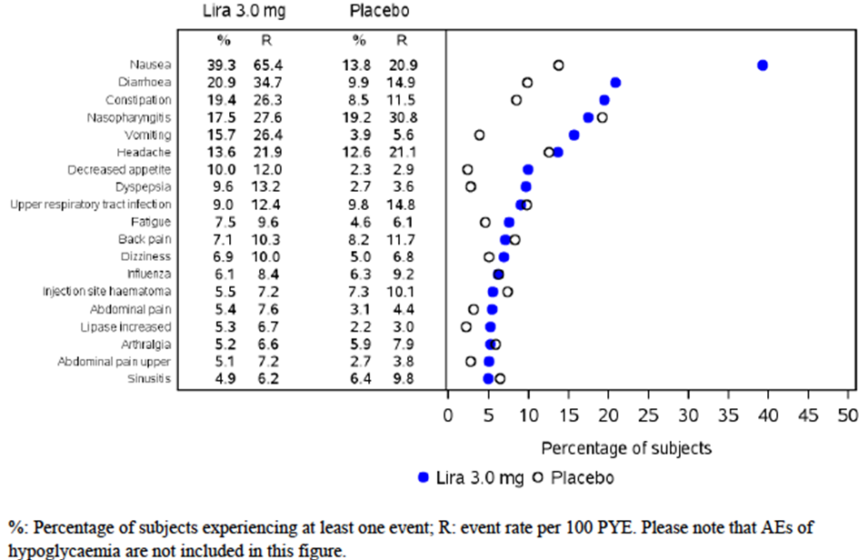

Pivotal studies that assessed safety as a primary outcome

Study 1807 (Extension)

Study design, objectives, locations and dates
Primary Objective of the Extension (Week 21-104) was to evaluate the long term safety and tolerability of liraglutide.

Inclusion and exclusion criteria
Patients previously enrolled in the 20 week 1807 study were invited to participate in an 84 week extension. The 20-week study was a randomised, double-blind, placebo-controlled, six-armed parallel-group, multi-centre, multinational trial including a parallel open-label orlistat comparator arm with an 84-week extension period. Obese subjects without type 2 diabetes were selected as the trial population.

Study treatments
All in the open label extension were on the 3 mg liraglutide dose.
Following the completion of the 20 week trial, ie 20–52 weeks, subjects and investigators remained blinded to liraglutide/placebo treatment but the sponsor was unblinded; after 52 weeks, all were unblinded. The extension period initially consisted of a further 32-week maintenance period on the medication to which the subjects were randomised (Visits 13a to 20) followed by up to 4 weeks of unblinded dose escalation (Visits 20 to 22), 48 weeks of open-label treatment (Visits 23-34) and a post-trial follow-up visit (Visit 35). After Visit 20 (52 weeks), all subjects treated with liraglutide or placebo in the main trial and extension period were initially treated with liraglutide 2.4 mg in the open-label extension period, but were all gradually changed to treatment with liraglutide 3 mg. Subjects treated with orlistat in the main trial continued unchanged during the extension period.

Safety variables and outcomes
Adverse events
- Clinical laboratory tests (haematology, biochemistry and liraglutide antibodies)
- Physical examination
- Vital signs
- ECG

Randomisation and blinding methods
All participants from the original trial were offered open label liraglutide 3 mg.

Analysis populations
All of the safety endpoints, except calcitonin, were evaluated descriptively and no formal statistics were applied. For analyses of calcitonin levels, a repeated measures analysis after 52-weeks and a logistic regression testing after 104 weeks were applied.

Sample size
There were 564 patient data sets for evaluation in the safety analysis set; 98 in placebo, 95 in liraglutide 1.2mg, 90 in the 1.8mg liraglutide, 93 in the 2.4mg, 93 in the 3 mg and 95 originally assigned in the orlistat group.

Statistical methods
Descriptive statistics applied to the safety data.

Participant flow
The trial methodology is explained above, with the completion of the 20 week 1807 study and then extension for a further 84 weeks in an open label fashion.

Major protocol violations/deviations
A list containing unblinded subject data (n=22) was sent to three trial sites by mistake possibly unblinding investigators at the three trial sites. However a sub-analysis of efficacy data at weeks 52 and 104 was performed, excluding subjects from the unblinded sites. Exclusion of data from the sites had no effect on the overall results with respect to the primary efficacy endpoint, body weight. Therefore the data from the unblinded sites were included in the overall analysis.
Important protocol deviations at country level, all pertaining laboratory samples, occurred at four sites. At three sites the freezer temperature log for the freezer used to store laboratory samples was not kept as described in the protocol. At one site adiponectin was cancelled for seven subjects. Important protocol deviations at subject level included inclusion, compliance and informed consent issues. In total, 24 subjects were appropriately excluded from the PP analysis set.

Baseline data
Groups were matched at baseline.

Results for the primary safety outcome
After 52 weeks, all subjects randomised to liraglutide or placebo were switched to treatment with liraglutide. Although the proportion of subjects reporting TEAEs was evenly distributed between the treatment groups, the proportion of subjects with severe TEAEs was higher in subjects randomised to treatment with liraglutide (12.2% to 18.3%) than subjects randomised to placebo (11.2%) and orlistat (10.5%) with no relation to dose. Also the proportion of subjects reporting SAEs were higher in subjects randomised to treatment with liraglutide (7.5% to 11.1%) than in subjects randomised to placebo (6.1%) and orlistat (6.3%). Overall, between 8 to13 subjects (8.4% to14%) randomised to liraglutide treatment, 6 subjects (6.1%) randomised to placebo and 3 subjects (3.2%) randomised to orlistat withdrew from the trial due to AEs. Of these, 2 subjects withdrew during the titration to the optimal dose in the extension and 9 subjects withdrew during the open-label extension period (all 11 subjects were treated with liraglutide). No subjects treated with orlistat withdrew due to TEAEs during the extension.
The most commonly reported TEAEs across all groups were within the system organ classes of gastrointestinal disorders (mainly nausea in subjects randomised to liraglutide and placebo, and diarrhoea in subjects randomised to orlistat), infections and infestations (mainly nasopharyngitis), musculoskeletal and connective tissue disorders (mainly back pain) and nervous system disorders (mainly headache). TEAEs with a possible or probable relation to trial drug subjects randomised to liraglutide and placebo and diarrhoea in subjects randomised to orlistat.
Below is a summary table of TEAEs by system organ class and preferred term for the entire 1807 trial (including the Extension)
Table 25. TEAEs reported by >5% subjects by SOC and PT, possibly or probably related to treatment (week 0-104) – Safety Analysis Set.
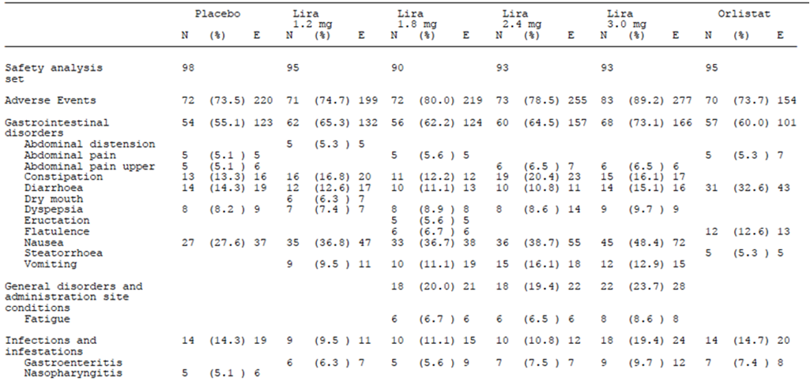
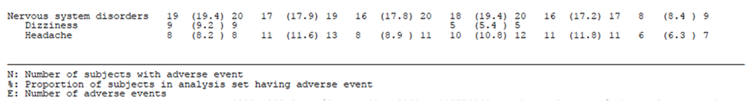

Patient exposure
Shown in Table 26.
Table 26. Summary of duration of exposure (days) by randomised treatment – Safety Analysis Set.
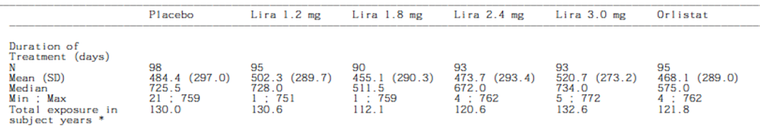

Adverse events
Due to concerns with the GLP-1 class, specific adverse event types were given attention in this study. The AEs included cardiovascular disorders, psychiatric disorders, hypoglycaemia, acute gallstone disease, neoplasms and pregnancy. Additional safety observations relevant to the GLP1R class (acute pancreatitis and elevated pancreatic enzymes, C-cell pathology and calcitonin elevation, altered renal function, heart rate increase, immunogenicity events, injection site reactions) were defined as ‘medical events of special interest’. Certain event types including deaths, select cardiovascular disorders, pancreatitis, neoplasms and thyroid disorders requiring thyroidectomy were subject to prospective external blinded assessment by independent medical experts in trials 1839, 1922 and 3970. In trial 1923, these event types were adjudicated post hoc, as were any potential MACEs and any deaths in trial 1807, the phase 2 dose-finding trial.

All adverse events (irrespective of relationship to study treatment)
The data in this submission consisted of data of exposure to Saxenda in four randomised, double-blind, placebo controlled, multicentre Phase 3 clinical trials, one of 32-weeks duration and three of 56-weeks duration, and one Phase 2 supportive trial in 469 adult patients. The safety evaluation were based on the safety analysis set, which included subjects receiving at least one dose of liraglutide or comparators for all of the studies. The evaluation of blood pressure and cardiometabolic parameters is based on the FAS when considering mean change from baseline, as these parameters were defined as an efficacy parameter.
Overall, gastrointestinal reactions were the most frequently reported adverse reactions with Saxenda: nausea, vomiting, diarrhoea and constipation reported by > 10% and in some trials over 50% of subjects. For example, in 1807, nausea alone was reported by half of the participants on the 3 mg dose.
In clinical trials, 9.8% of patients treated with Saxenda prematurely discontinued treatment due to adverse reactions, compared with 4.3% of placebo-treated patients.
Adverse reactions reported in greater than or equal to 1% of Saxenda treated patients and more frequently than in placebo patients are shown in the Table below.
Table 27. All AEs.
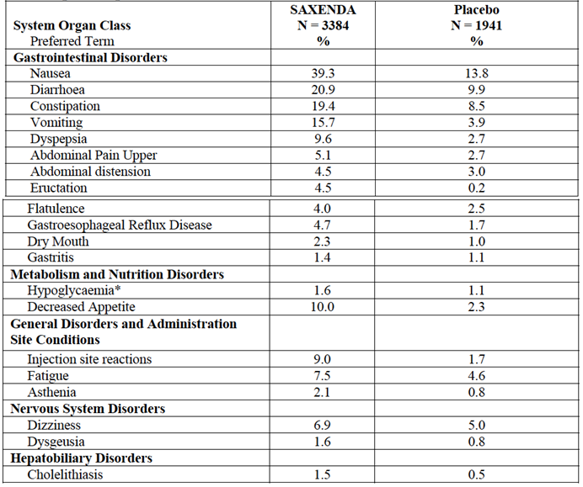

In subjects without T2DM
There were three sources of hypoglycaemia AEs in subjects without T2DM:
- spontaneously reported, i.e., AEs occurring outside visits to the clinic
- AEs registered by site personnel during visits to the clinic where FPG was assessed (FPG visits, scheduled approximately once-monthly). Values ≤3.9 mmol/L (70 mg/dL) were reported as AEs, irrespective of symptoms.
- AEs registered during a visit to the clinic where an OGTT was performed.
No severe hypoglycaemic events were reported in obese or overweight subjects without T2DM. The proportion of subjects reporting AEs of hypoglycaemia outside the fasting FPG and OGTT visits was low, both with liraglutide 3 mg (1.6% of subjects) and placebo (1.1% of subjects). None of the spontaneously reported hypoglycaemia AEs were SAEs.
In trials 1839, 1922 and 3970, severe hypoglycaemic episodes qualified as a Medical Event of Special Interest, and required an additional form to be completed. In trials 1807 and 1923, severe hypoglycaemic episodes (defined in the trial protocols as ‘major hypoglycaemic episodes’) were to be reported as SAEs.
Table 28. AEs of hypoglycaemia in subjects without T2DM (without the 1922 T2DM study).
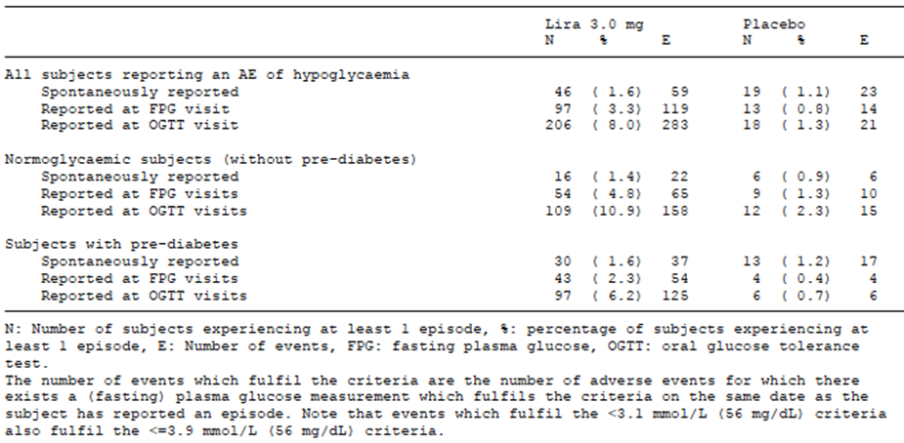

In subjects with T2DM
Subjects with T2DM had blood glucose meters and hypoglycaemia diaries, and hypoglycaemic episodes in these subjects were further categorised according to the ADA and Novo Nordisk definitions of hypoglycaemia. Severe hypoglycaemia was reported by 0.7% of liraglutide 3 mg subjects (3 subjects with 5 events, 13 events per 1000 PYE) and 1.0% of subjects treated with liraglutide 1.8 mg (2 subjects with 3 events, 16 events per 1000 PYE) all of whom were concomitantly treated with sulfonylureas (SU).
Table 29. Hypoglycaemia by sulfonylurea (SU) use.
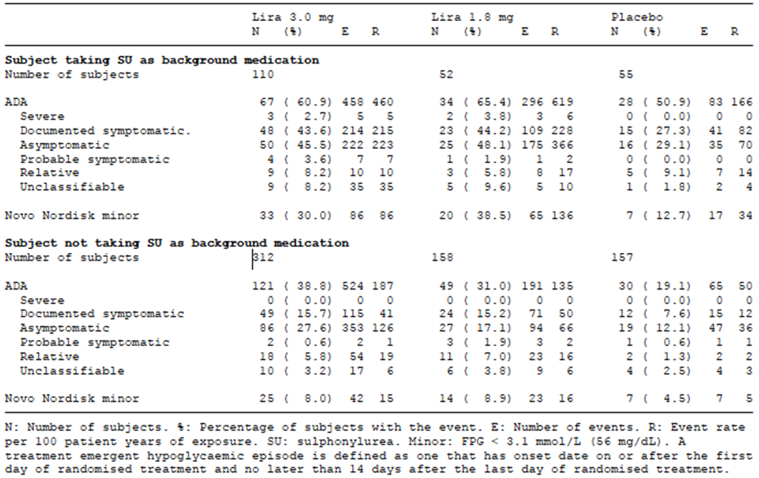
None of the events were reported as a SAE, and the subjects recovered and continued unchanged on treatment. Non-severe hypoglycaemic episodes (all ADA sub-categories and Novo Nordisk minor category) were reported more frequently in subjects with T2DM treated with liraglutide than with placebo, with no differences between liraglutide 3 mg and 1.8 mg doses. Subjects taking SUs were more likely (3–4 times) to experience a hypoglycaemic episode in any category compared with subjects not taking SUs. Likewise, in subjects on a metformin background treatment, the incidence of hypoglycaemia was 5 events per 100 PYE with liraglutide 1.8 mg and 6 events per 100 PYE with placebo, as compared to 15 events per 100 PYE with liraglutide 3 mg and 5 events per 100 PYE in trial 1922, in the sub-population treated with predominantly metformin mono-therapy at baseline.

Neoplasm
Although obesity itself is associated with a large increase in obesity tunours, and that of thyroid
C-cell tumours and skin fibrosarcomas , were found in the nonclinical safety studies with liraglutide, a treatment-related increase in any of the obesity-associated cancer in the weight pool studies was not seen.
In the real practice world scenario, liraglutide (at doses up to 1.8 mg) has not been associated with increased incidence of cancer in more than 1,500,000 patient years of clinical use or based on pharmacoepidemiology and case series registry data. The proportion of subjects in the weight management trials with neoplasms confirmed by the external EAC and the corresponding event rates were similar with liraglutide 3 mg (1.9%, 2.3 events per 100 PYE) and placebo (1.5%, 2.2 events per 100 PYE), as were the distribution and type of neoplasm. Specific focus has been on breast, pancreas, colorectal, thyroid and skin cancers with liraglutide. Although the raw incidence of these have been greater in the liraglutide arm, causality is difficult to ascertain and routine pharmacovigilance should be undertaken to mandate this reporting.

Psychiatry
The overall proportion of subjects reporting events was comparable between groups (liraglutide 3 mg: 10.8%, 15.5 events per 100 PYE; placebo: 10.1%, 15.4 events per 100 PYE), as was the proportion reporting SAEs (0.1% in both groups). However severe mental health issues was an exclusion for the trials. Most of the events were mild or moderate in severity, and few led to subject withdrawal. The most frequently reported events were insomnia, anxiety and depression. Of the 3, insomnia appeared to be more common with liraglutide 3.0 mg (2.4% vs. 1.7% for placebo). Half of the events occurred within the first 3 months, after which the rate was similar to placebo.
The mean patient health questionnaire 9 (PHQ-9) total scores for depression were comparable between liraglutide 3 mg and placebo during treatment.

Deaths and other serious adverse events
A total of 6 deaths were reported in completed and ongoing clinical trials (4 during the main treatment periods, 1 during follow-up and 1 in ongoing trials) in the liraglutide weight management clinical development programme: 3 in liraglutide-treated subjects and 3 in placebo-treated subjects. The 3 cases in subjects receiving liraglutide were confirmed as cardiovascular deaths by external event committee adjudication: 2 with liraglutide 3.0 mg in trial 1839 and 1 with liraglutide 1.8 mg during follow-up in trial 1922. In the placebo group, 2 of the 3 cases were also adjudicated to be cardiovascular deaths, and 1 event reported as cardiorespiratory arrest was adjudicated to be a non-cardiovascular death.
Overall, the proportion of subjects with fatal events in completed trials was <0.1% with liraglutide 3 mg (1 subject during the main treatment period) and 0.2% with placebo (3 subjects during the main treatment period).

SAEs
In the weight management pool, the proportion and rate of subjects reporting SAEs was higher in the liraglutide 3 mg group (6.3%, 9.3 events per 100 PYE) than in the placebo
group (4.6%, 7.1 events per 100 PYE). At system organ class level, only hepatobiliary disorders were reported more frequently with liraglutide 3 mg than with placebo – predominantly ‘cholelithiasis’ and ‘cholecystitis acute’. A clear dose response relationship among subjects exposed to liraglutide doses 1.2, 1.8, 2.4 and 3.0 mg was unable to ascertained, possibly because there were small numbers.
In the weight management pool, the proportion of subjects withdrawing from the trial due to AEs was higher with liraglutide 3 mg (9.8%) than with placebo (4.3%) and the corresponding withdrawal rate was also higher (16.8 vs. 7.2 events per 100 PYE). The higher proportion of AE withdrawals with liraglutide was mainly attributable to the greater number of withdrawals related to gastrointestinal disorders in (e.g., nausea, vomiting, diarrhoea). A subject without T2DM was withdrawn at week 2 of treatment (liraglutide 3 mg) due to spontaneously reported AEs of hypoglycaemia and an AE of hypoglycaemia reported at FPG visit (non-SAE).

Laboratory tests
In the weight management trials, mean values for haematology, biochemistry and urine analysis parameters showed minor fluctuations within the reference ranges with no clinically relevant differences between liraglutide 3 mg and placebo.

Liver function

Pivotal studies
No specific differences between the groups.

Kidney function
There was no increase in renal impairment in Saxenda compared to placebo using MedRA terms. Specifically In the weight management pool, ‘acute renal failure’ events identified by the MedDRA search were infrequent with both liraglutide 3.0 mg (0.5%, 0.8 events per 100 PYE) and placebo (0.4%, 0.6 events per 100 PYE).

Other clinical chemistry

Pancreatitis
A small number of pancreatitis cases have been reported in clinical trials with GLP-1 receptor agonists (including liraglutide) and dipeptidyl peptidase-4 (DPP-IV) inhibitors in patients with T2DM. In the weight management trials, external EAC confirmed events of acute pancreatitis occurred in a greater number with liraglutide compared to placebo: treatment-emergent events were reported by 7(0.2%) of subjects (0.2 events per 100 PYE) with liraglutide 3 mg versus 1 (<0.1%) of subjects (<0.1 events per 100 PYE) with placebo during the main treatment periods.

Cholecystitis
In the weight management pool, the proportion of subjects reporting acute gallstone disease events was higher with liraglutide 3 mg (2.3%) than with placebo (0.9%) - mainly driven by cholelithiasis and cholecystitis (‘cholelithiasis’: 1.5% vs. 0.5%; ‘cholecystitis acute’: 0.4% vs. <0.1%; ‘cholecystitis’: 0.2% vs. <0.1%, respectively, for liraglutide 3 mg vs. placebo). There was more gallbladder disorder SAEs with liraglutide 3 mg than with placebo. Although the majority of events occurred in women, who lost more weight, and in those with larger weight loss (gallbladder disease more common in people undergoing rapid weight loss), Nevertheless, an increased incidence of gallbladder-related events was consistently observed across weight-loss categories, indicating that other factors than weight loss may be involved. No other factors were identified as predictive for the development of acute gallstone disease events. There was no clear evidence of a dose-response or an exposure-response relationship based on trials in the weight management programme.

Haematology
Nil of note

Electrocardiograph
A non-dose dependent increase in resting pulse of 2–3 beats/min, with simultaneous reduction in systolic blood pressure, has been observed with liraglutide, as well as with all other GLP-1 receptor agonists. Recent human data demonstrates that GLP-1 receptor is present on myocytes of the sino-atrial node in humans. A persistent pulse increase defined as an increase at ≥2 consecutive visits of resting pulse >20 beats/min or ≥100 beats/min, occurred in 4.9% vs. 1.7% of subjects and 0.9% vs. 0.3% of subjects, with liraglutide 3 mg and placebo, respectively.
There was no evidence of prolongation of the ECG QT interval with liraglutide exposure. However, a non-dose-dependent delay of the PR-interval has been observed in healthy subjects treated with liraglutide at doses up to 1.8 mg (QTc trial NN2211-1644). The clinical significance of this observation is currently unknown but considered low based on the results presented below.

Pancreatitis
In the weight management trials, external EAC confirmed events of acute pancreatitis occurred in greater number with liraglutide compared to placebo: treatment-emergent events were reported by 7 (0.2%) of subjects (0.2 events per 100 PYE) with liraglutide 3.0 mg versus 1 (<0.1%) of subjects (<0.1 events per 100 PYE) with placebo during the main treatment periods. There was no indication of an exposure-response relationship for acute pancreatitis, as assessed by comparison of liraglutide plasma exposure in subjects with and without confirmed events of acute pancreatitis in the weight management programme. Likewise, there was no indication of a dose-response relationship, with a similar incidence of acute pancreatitis/pancreatitis in subjects with T2DM at lower doses of liraglutide in the Supplementary AE pool II (0.09%, 0.12 events per 100 PYE vs. 0.05%, 0.05 events per 100 PYE for total liraglutide vs. total comparator). All GLP-1 based therapies already carry warnings concerning pancreatitis.

Safety issues with the potential for major regulatory impact

Liver toxicity
A mean increase from baseline to end of study was seen in lipase and amylase in the liraglutide arm 3 mg whereas a decrease was seen with placebo. Mean concentrations were reversed to baseline levels after 12 weeks without liraglutide 3 mg supporting this AE being related to drug exposure.

Haematological toxicity
Nil

Serious skin reactions
Nil. Skin irritation from the sc injections were reported in all trials but these were not serious (liraglutide 3 mg (13.9%, 22.9 events per 100 PYE) vs. placebo (10.5%, 15.7 events per 100 PYE)).

Cardiovascular safety
Retrospective meta-analyses of MACEs across clinical development programmes with GLP-1 receptor agonists in a different population to this indication (ieT2DM), which include randomised trials of at least 24 weeks duration did not indicate an increased cardiovascular risk with this class, to date. There are ongoing cardiovascular outcome trials (including with liraglutide in T2DM) which will help understand the long-term CV risk of GLP-1 receptor agonists.
In the weight management pool, the proportion of subjects with events identified by the medical dictionary for regulatory activities (MedDRA) search for cardiovascular events was similar with liraglutide 3 mg (8.7%, 12.3 events per 100 PYE) and placebo (9.2%, 13.8 events per 100 PYE).
Tachycardia was reported by statistically significantly more subjects on liraglutide 3 mg than on placebo (0.6% on liraglutide 3 mg vs. 0.1% on placebo). One AE with tachycardia was reported as a SAE. The estimated treatment difference (2.5 beats/min) between liraglutide 3 mg and placebo at end-of-treatment in the weight management pool was statistically significant (p<0.0001, ANCOVA). The proportion of subjects with MACE confirmed by the external event adjudication committee (defined as a composite of non-fatal myocardial infarction, non-fatal stroke and cardiovascular death) and the rate of events was lower with liraglutide 3 mg (0.1%, 0.2 events per 100 PYE) than with placebo (0.5%, 0.6 events per 100 PYE) and consistent across the 3 components of the composite endpoint. There were no trends for higher pulse or pulse increases in subjects with events as compared to those without MACE, or between treatment groups.
Increased resting pulse has been detected as well as with other GLP-1 receptor agonists.
Table 30. Confirmed MACE in the weight management pool.
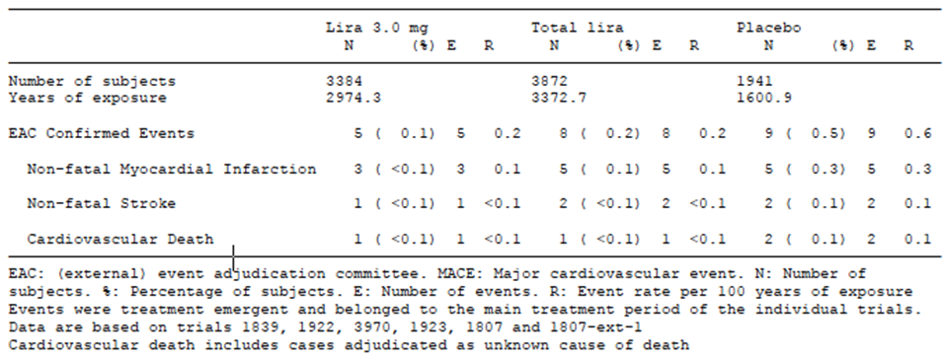

Unwanted immunological events
Liraglutide is a protein-based drug and therefore has the potential to cause immunogenic reactions. It has 97% homology to endogenous GLP-1 so there has been concern regarding cross reactivity to native GLP1R. Cases of anaphylactic reactions with additional symptoms such as hypotension, palpitations, dyspnoea and oedema have been reported with marketed use of liraglutide in T2DM
Overall, the frequency and rate of ‘allergic reactions’, as defined by the MedDRA search, reported with liraglutide 3 mg (2.0%, 2.5 events per 100 PYE) were comparable to those in the placebo group (2.4%, 3.5 events per 100 PYE). The most frequently reported immunological events were asthma and urticaria and most were of moderate severity.
Overall, up to 3% developed anti-liraglutide antibodies in the phase 2 and 3 weight management trials. With liraglutide 3 mg, neutralising antibodies were found in 1.1% of subjects and cross-reacting antibodies in 0.5%. In 1839, at week 58, less than 3% (17 subjects) had developed anti-liraglutide specific antibodies; less than 1% cross-reacted with native GLP-1 and less than 1% had in vitro neutralising effect to liraglutide. However at the follow up visit (week 70), 3 of the 13 subjects switched from liraglutide 3 mg to placebo were still anti-liraglutide antibody positive.
Three cases of anaphylactic reactions were reported in subjects treated with liraglutide 3 mg (2 SAEs), two during the main treatment period and one during the second year of trial 1807. There were no anaphylactic reactions in the placebo groups.

Other safety issues

Safety related to drug-drug interactions and other interactions
Due to the delayed gastric emptying and potentially clinically relevant changes in pharmacokinetic parameters between the 1.8 and 3 mg dose, drug interactions are possible. When starting liraglutide, monitoring including therapeutic dug monitoring when indicated should be considered.

Evaluator’s conclusions on safety
Liraglutide has been in clinical use in Australia for 5 years, at a dose of 1.8 mg as compared to the 3 mg requested in this application and PSUR data to date has not revealed any new signals. However, this is a drug that binds almost 24 h to stimulate a receptor and because obesity is a chronic problem may be taken long term. Therefore, long term pharmacovigilance data is paramount.
Apart from gastrointestinal (GI) events which were reported in an increasing amount to the 1.8 mg dose (up to 50% had nausea in one study); overall, a dose response relationship was not able to be ascertained for other safety events.
The clinical significance of a pulse rate increase of 2-3 beats/minute was not discussed however there are agents registered in Australia to lower heart rate based on translational evidence showing that higher heart rates are associated with higher death rates. Results of multiple ongoing cardiovascular outcome trials (including LEADER with liraglutide in T2DM) will help clarify the long term CV risk of liraglutide. The CV trial data is awaited from studies currently underway and observation for thyroid disease, hepato-biliary disease, thyroid cancers and hypoglycaemia continues.
There were a number of AEs seen in the liraglutide 3 mg group in this application that occurred at a higher rate than the placebo group. These include pancreatitis and gallbladder disease. Amylase and lipase concentrations were consistently elevated across the trials in the liraglutide 3 mg arm; this resolved on drug cessation supporting the drug-event relationship.
The risk of hypoglyacemia was reported in the liraglutide group even in the non T2DM group. A total of 8 severe treatment emergent hypoglycaemic episodes were reported, 5 events by 3 subjects (0.7%) with liraglutide 3 mg, and 3 events were reported by 2 subjects (1.0%) with liraglutide 1.8 mg; all subjects were taking sulfonylurea (SU) as background diabetes medication.
Safety was not examined in groups excluded from partaking in the study but whom may be eligible to take the drug if marketed, depending in the listing. 93% of the exposure was in subjects in the age group 18 to 65 years. Similarly, few subjects with renal impairment were included in the trials.
A total of 10 of the 39 pregnancies that occurred in the trials resulted in spontaneous abortion (8 with 3 mg liraglutide and 2 with placebo).

First round benefit-risk assessment

First round assessment of benefits
The benefits of Saxenda in the proposed usage are:
- For some patients there was a reduction in body weight around 5% which was seen early and maintained whilst still taking the therapy. Some subjects achieved up to 10% body weight reduction.
- This reduction was short term, however the weight loss was maintained for the duration of the studies.
- There was a mild but clinically significant reduction in systolic blood pressure.

First round assessment of risks
The risks of Saxenda in the proposed usage are:
- Population group need to be taking a reduced calorie diet and on an exercise plan to achieve benefits seen in the trial.
- If they do this and take Saxenda than some will lose 5-10% of body weight, but many will not.
- All will be exposed to the risk of toxicity, which is predominantly symptomatic (for example, gastrointestinal side effects) but can also be serious (hypoglycaemia, immunogeneticity, pancreatitis).
- Long term data is lacking: side effects are possible for all users but also rebound weight gain is likely (see in the studies of cross over and observational data)

First round assessment of benefit-risk balance
The benefit-risk balance of Saxenda, given the proposed usage, is unfavourable.
The data meets the 2007 EMA criteria for weight loss for 3 of the 5 studies. The weight loss is maintained short term but no further weight loss occurs. Stopping the drug appears to cause weight regain.

First round recommendation regarding authorisation
Saxenda gives a small, clinically relevant weight loss in some patients who are concomitantly on a lifestyle weight loss programme. It is difficult to predict which patients will benefit but all need to be on a diet and exercise programme; this will be difficult to manage in the population outside the clinical trial, and also long term. Therefore, the efficacy in the real world setting is likely to be reduced from the relatively short term clinical trial findings. There are side effects with the treatment (mainly GI) and long term safety data from chronic stimulation of the GLP-1R is unknown, especially from this 3 mg dose.
Further, after an initial weight loss, continual treatment in the manner seen in the trial (90% compliance) is required to maintain the weight loss. Stopping the therapy, and even without stopping in some patients, weight was regained.
The sponsor does not attempt to translate the short term and small weight loss benefit to clinically meaningful outcomes such as reduction in myocardial infarctions.

Clinical questions

Pharmacokinetics
Nil required. Ideally, some real concentration and AUC data relating those to efficacy and toxicity would have been helpful (in addition to the simulated data). This is because some of the patients with the greatest weight loss had lower BMI and were female. It is also important because there was more weight loss in the 3 mg than in the other doses. Therefore, it is possible that side effects are concentration related also, or maybe related also to other phenotypic factors.

Pharmacodynamics
Nil required.

Efficacy
- What is the clinical relevance of the change in the AHI in the SCALE-Apnoea study?
- What is the clinical relevance of a change in the IQQoL-Lie (of 2.73-3.8) and SF 36 for overall physical health (0.86-1.73) and mental health of 0.59-0.9?
- What is the clinical significance of the change in metabolic parameters, that is, changes in LDLc, HbA1C and systolic blood pressure?
- In Study 1923, please confirm if the re-randomised lirgalutide patients were included in the original assignment group for the 68 week analysis; if not, and as the majority of weight loss occurs in the first 3-4 months of liraglutide treatment, then the original placebo group may have confounded the benefit of the liraglutide treatment seen in Weeks 56-68.
- In the pooled summary, please confirm for the early responders what the overall comparative weight loss is (that is, in the liraglutide early responders minus the placebo early responders); for the ‘early responders’ in liraglutide group, it was -11.2 % without comparison to placebo group.
- Please comment on the effect of dropouts/loss to follow up/discontinuations (~20% across the four Phase III studies) on adding additional uncertainty to the results.
- Please comment on concerns about weight gain on discontinuation and advice to prescribers and patients about duration of treatment.
- Please comment on advice to prescribers and patients about when to stop liraglutide, if there is no initial weight loss.

Safety
Please comment on safety concerns around:
- increased resting pulse rate
- cholecystitis
- pancreatitis
- neoplasms

Therapeutic Goods Administration
PO Box 100 Woden ACT 2606 Australia
Email: info@tga.gov.au Phone: 1800 020 653 Fax: 02 6232 8605
https://www.tga.gov.au

European Medicines Agency, Committee for Medicinal Products for Human Use (CHMP), “Guideline on clinical evaluation of medicinal products used in weight control (CPMP/EWP/281/96 Rev.1),” 15 November 2007.
European Medicines Agency, Committee for Medicinal Products for Human Use (CHMP), “Guideline on clinical evaluation of medicinal products used in weight control (CPMP/EWP/281/96 Rev.1),” 15 November 2007.

