|  |
| --- |
| **Date of First Round CER: 23 October 2012 Date of Second Round CER: 29 March 2013** |

|  |
| --- |
| AusPAR Attachment 2 |
| Extract from the Clinical Evaluation Report for Lisdexamfetamine dimesilate |
| Proprietary Product Name: Vyvanse |
| Sponsor: Shire Australia Pty Limited |

About the Therapeutic Goods Administration (TGA)

* The Therapeutic Goods Administration (TGA) is part of the Australian Government Department of Health, and is responsible for regulating medicines and medical devices.
* The TGA administers the *Therapeutic Goods Act 1989* (the Act), applying a risk management approach designed to ensure therapeutic goods supplied in Australia meet acceptable standards of quality, safety and efficacy (performance), when necessary.
* The work of the TGA is based on applying scientific and clinical expertise to decision-making, to ensure that the benefits to consumers outweigh any risks associated with the use of medicines and medical devices.
* The TGA relies on the public, healthcare professionals and industry to report problems with medicines or medical devices. TGA investigates reports received by it to determine any necessary regulatory action.
* To report a problem with a medicine or medical device, please see the information on the TGA website <<http://www.tga.gov.au>>.

About the Extract from the Clinical Evaluation Report

* This document provides a more detailed evaluation of the clinical findings, extracted from the Clinical Evaluation Report (CER) prepared by the TGA. This extract does not include sections from the CER regarding product documentation or post market activities.
* The words [Information redacted], where they appear in this document, indicate that confidential information has been deleted.
* For the most recent Product Information (PI), please refer to the TGA website <<http://www.tga.gov.au/hp/information-medicines-pi.htm>>.

Copyright

© Commonwealth of Australia 2013  
This work is copyright. You may reproduce the whole or part of this work in unaltered form for your own personal use or, if you are part of an organisation, for internal use within your organisation, but only if you or your organisation do not use the reproduction for any commercial purpose and retain this copyright notice and all disclaimer notices as part of that reproduction. Apart from rights to use as permitted by the *Copyright Act 1968* or allowed by this copyright notice, all other rights are reserved and you are not allowed to reproduce the whole or any part of this work in any way (electronic or otherwise) without first being given specific written permission from the Commonwealth to do so. Requests and inquiries concerning reproduction and rights are to be sent to the TGA Copyright Officer, Therapeutic Goods Administration, PO Box 100, Woden ACT 2606 or emailed to <[tga.copyright@tga.gov.au](mailto:tga.copyright@tga.gov.au)>.

Contents

List of abbreviations 5

1. Introduction 9

2. Clinical rationale 9

2.1. Formulation 9

3. Contents of the clinical dossier 9

3.1. Scope of the clinical dossier 9

3.2. Paediatric data 10

3.3. Good clinical practice 10

4. Pharmacokinetics 10

4.1. Studies providing pharmacokinetic data 10

4.2. Summary of pharmacokinetics 11

4.3. Evaluator’s overall conclusions on pharmacokinetics 15

5. Pharmacodynamics 15

5.1. Studies providing pharmacodynamic data 15

5.2. Summary of pharmacodynamics 15

5.3. Evaluator’s overall conclusions on pharmacodynamics 17

6. Dosage selection for the pivotal studies 17

7. Clinical efficacy 17

7.1. Efficacy in subjects with ADHD 17

8. Clinical safety 49

8.1. Studies providing evaluable safety data 49

8.2. Pivotal studies that assessed safety as a primary outcome 49

8.3. Patient exposure 49

8.4. Adverse events 51

8.5. Laboratory tests 55

8.6. Post-marketing experience 60

8.7. Evaluator’s overall conclusions on clinical safety 60

9. First round benefit-risk assessment 61

9.1. First round assessment of benefits 61

9.2. First round assessment of risks 62

9.3. First round assessment of benefit-risk balance 62

10. First round recommendation regarding authorisation 62

11. Clinical questions 63

11.1. Pharmacokinetics 63

11.2. Pharmacodynamics 63

11.3. Efficacy 63

11.4. Safety 63

12. Second round evaluation of clinical data submitted in response to questions 63

12.1. Pharmacokinetics of LDX in subjects with hepatic failure 63

12.2. Pharmacokinetics of LDX in subjects with chronic renal failure 64

12.3. Pharmacokinetic profile of LDX in children aged less than 6 years 64

12.4. Plasma protein binding of LDX 64

12.5. Modelling strategies of the PK/PD profile of LDX 64

12.6. Efficacy of LDX in comparison with methylphenidate and/or atomoxetine 64

12.7. Efficacy data for children aged less than 6 years 65

12.8. Effect of prior treatment for ADHD on response 65

12.9. Effect of baseline disease severity on response 65

12.10. Measures the Sponsor will use to monitor long term cardiovascular risks 66

12.11. Measures the Sponsor will use to monitor the risks of QT prolongation and arrhythmia 66

12.12. Proportion of subjects with ≥30% and/or ≥50% reduction ADHD-RS or ADHD-RS-IV 66

12.13. Optimised doses used in the Phase 2-4 studies 66

12.14. LDX concentrations in fatal overdose 66

13. Second round benefit-risk assessment 67

13.1. Second round assessment of benefits 67

13.2. Second round assessment of risks 67

13.3. Second round assessment of benefit-risk balance 67

14. Second round recommendation regarding authorisation 67

15. Appendices 68

15.1. Appendix 1: CDR Battery of Tests 68

15.2. Appendix 2: ADHD Rating Scale 69

15.3. Appendix 3: Conners Parent Rating Scale – Revised (S) 70

Appendix 4: Clinical Global Impression 71

15.4. Appendix 5: Sample SKAMP Rating Scale 72

## List of abbreviations

| Abbreviation | Meaning |
| --- | --- |
| AAQoL | Adult ADHD Quality of Life |
| ACSD | Adult ADHD Clinical Diagnostic Scale |
| ADHD | Attention-Deficit/Hyperactivity Disorder |
| ADHD-RS | Attention-Deficit/Hyperactivity Disorder Rating Scale |
| AE | Adverse Event |
| AIM-A | Adult ADHD Impact Module |
| ALT | Alanine aminotransferase |
| AMSES | Adult ADHD Medications Smoothness of Effect Scale |
| APQ | Alabama Parenting Questionnaire |
| AST | Aspartate aminotransferase |
| APQ-PR | Alabama Parenting Questionnaire-Preschool Revision |
| AUC | Area under the plasma concentration time curve |
| AUC0-∞ | Area under the plasma concentration time curve from Time 0 to infinity |
| AWE | Adult Workplace Environment |
| BADDS | Brown Attention-Deficit Disorder Scale |
| BMI | Body Mass Index |
| BPRS-C | Brief Psychiatric Rating Scale for Children (characterization of psychopathology) |
| BRIEF-A | Behavior Rating Inventory of Executive Function – Adult Version |
| CAARS-S:S | Connors Adult Attention-Deficit/Hyperactivity Disorder Rating Scale Self Report: Short Version |
| C-CASA | Columbia Classification Algorithm for Suicidal Assessment |
| CDR | Cognitive Drug Research |
| CGI-I | Clinical Global Impression of Improvement |
| CGI-S | Clinical Global Impression of Severity |
| CHIP-CE:P | Child Health and Illness Profile, Child Edition: Parent Report Form |
| CI | Confidence Interval |
| CL | Clearance |
| CL/F | Apparent clearance |
| Cmax | Maximum plasma concentration |
| CPRS-R | Conners’ Parent Rating Scale – Revised |
| CRC | Clinical Research Center |
| CRF | Case Report Form |
| C-SSRS | Columbia-Suicide Severity Rating Scale |
| DAE | Discontinuation due to adverse event |
| *d-*amphet | Dextroamphetamine |
| DBP | Diastolic blood pressure |
| DRQO | Drug Rating Questionnaire – Observer |
| DRQS | Drug Rating Questionnaire – Subjects |
| DSM-IV-T | Diagnostic and Statistical Manual of Mental Disorders Fourth Edition – Text Revision |
| ECG | Electrocardiogram |
| EESC | Expression and Emotion Scale for Children |
| FAS | Full analysis set |
| FOCP | Females of Chil*d-*bearing Potential |
| GCP | Good Clinical Practice |
| HCG | Human Chorionic Gonadotropin |
| HUI-2 | Health Utilities Index – Mark 2 |
| ICC | InteliSite Companion Capsule |
| ICH | International Conference on Harmonisation |
| IEC | Independent Ethics Committee |
| IQ | intelligence quotient |
| IRB | Institutional Review Board |
| IUD | Intrauterine Device |
| ITT | Intention to treat |
| KBIT | Kaufman Brief Intelligence Test |
| LDX | Lisdexamfetamine dimesilate (VYVANSE) |
| LS | Least Squares |
| PERMP | Permanent Product Measure of Performance (math test) |
| MADRS | Montgomery-Ǻsberg Depression Rating Scale |
| MAS-IR | Mixed Amphetamine Salts – Immediate Release |
| MedDRA | Medical Dictionary for Regulatory Activities |
| MIC | Marital Impact Checklist |
| ms | millisecond |
| msec | millisecond |
| MSI-R | Marital Satisfaction Inventory – Revised |
| MSQ | Medication Satisfaction Questionnaire |
| NRP104 | lisdexamfetamine |
| OTC | Over-the-Counter |
| PCI | Potentially clinically important |
| PGA | Parent Global Assessment |
| PSQI | Pittsburgh Sleep Quality Index |
| SAE | Serious Adverse Event |
| SANS | Scale for the Assessment of Negative Symptoms |
| SBP | Systolic blood pressure |
| SD | Standard Deviation |
| SE | Standard Error |
| SKAMP | Swanson, Kotkin, Agler, M.Flynn and Pelham rating scale |
| SPD489 | lisdexamfetamine |
| TEAE | Treatment-emergent Adverse Event |
| Tmax | Time to maximum plasma concentration |
| ULN | Upper limit of normal |
| V | Volume of distribution |
| V/F | Apparent volume of distribution |
| WFIRS-P | Weiss Functional Impairment Rating Scale – Parent |
| YQOL-R | Youth Quality of Life Instrument - Research Version |

## Introduction

Lisdexamfetamine is a centrally acting sympathomimetic. It is a prodrug of dexamphetamine, which is a central nervous system stimulant. The lisdexamfetamine parent compound does not bind to the sites responsible for the reuptake of noradrenaline and dopamine *in vitro* and is not thought to contribute to the pharmacological effects. After oral administration, lisdexamfetamine is rapidly absorbed from the gastrointestinal tract and hydrolysed primarily in whole blood to *d-*amphetamine, which is thought to be responsible for all of the drug’s activity. Amphetamines are non-catecholamine sympathomimetic amines with CNS stimulant activity. The mode of therapeutic action of amphetamine in Attention Deficit Hyperactivity Disorder (ADHD) is not fully established. However it is thought to be due to its ability to block the reuptake of noradrenaline and dopamine into the presynaptic neuron and increase the release of these monoamines into the extraneuronal space.

The proposed indication is:

*Vyvanse is indicated for the treatment of Attention Deficit Hyperactivity Disorder (ADHD) in:*

* *Children*
* *Adolescents*
* *Adults*

## Clinical rationale

ADHD is a common condition in childhood and has a significant burden through interference with regular daily activities and with socialisation. Lisdexamfetamine is proposed to have PK properties similar to a controlled release formulation. The advantage of such properties is that of once daily dosing with improved compliance and decreased stigmatisation.

### Formulation

The formulation proposed for marketing is that used in the Pivotal studies.

## Contents of the clinical dossier

### Scope of the clinical dossier

The submission contained the following clinical information:

* Module 5
  + 15 clinical pharmacology studies, including 13 that provided pharmacokinetic data and a further two that provided pharmacodynamic data.
  + No population pharmacokinetic analyses.
  + Nine pivotal efficacy/safety studies.
  + Four other efficacy/safety studies.
  + Three integrated summaries
* Module 1
  + Application letter, application form, draft Australian PI and CMI, FDA-approved product label, and Canadian Product Information
* Module 2
  + Clinical Overview, Summary of Clinical Efficacy, Summary of Clinical Safety and literature references.

### Paediatric data

The submission included paediatric pharmacokinetic, efficacy and safety data for children aged ≥6 years.

### Good clinical practice

All the Clinical Studies were stated to have conformed to Good Clinical Practice. The study reports were consistent with the studies conforming to Good Clinical Practice.

## Pharmacokinetics

### Studies providing pharmacokinetic data

Table 1. Submitted pharmacokinetic studies.

| PK topic | Subtopic | Study ID | Primary aim of the study. |
| --- | --- | --- | --- |
| PK in healthy adults | General PK Single dose  Multi-dose | Study SPD489-111 | Sites of absorption |
| Study NRP104-106 | Mass balance |
| Study SPD489-109 | Dose proportionality |
| Study NRP104-104 | Steady state PK |
| Bioequivalence† - Single dose | Study NRP104-101 | Bioequivalence |
| Food effect | Study NRP104.102 | Bioavailability |
|  | Children | Study NRP104-103 | PK in children |
| Elderly | Study SPD489-116 | PK in elderly |
| PK interactions | PRILOSEC (omeprazole) | Study SPD489-113 | Drug interaction |
| Venlafaxine | Study SPD489-117 | Drug interaction |
| Guanfacine | Study SPD503-115 | Drug interaction |

Table 2 lists pharmacokinetic results that were excluded from consideration due to study deficiencies.

Table 2. Pharmacokinetic results excluded from consideration.

|  |  |  |
| --- | --- | --- |
| Study ID | Subtopic(s) | PK results excluded |
| Study SPD489-118 | PK in obese subjects | Incomplete data |
| Study SPD489-112 | Receptor occupancy study | Incomplete data |

### Summary of pharmacokinetics

The information in the following summary is derived from conventional pharmacokinetic studies unless otherwise stated.

#### Pharmacokinetics in healthy subjects

##### Absorption

###### Sites and mechanisms of absorption

Study NRP104.102: mean Tmax for *d-*amphetamine was slightly earlier with solution (3.33 hours) compared with fasted (3.78 hours) and fed (4.72 hours). In Study SPD489-111 intranasal absorption was rapid and had the highest bioavailability (AUC). With intestinal delivery, the greatest absorption was at the distal small bowel. However, conversion to *d-*amphetamine was greater with oral delivery than with intra-nasal. Exposure to *d-*amphetamine was greatest with distal small bowel delivery. There was little LDX absorbed from the ascending colon.

##### Bioavailability

###### Absolute bioavailability

Absolute bioavailability data were not provided in the submission.

###### Bioavailability relative to an oral solution

For *d-*amphetamine the ratio of AUC0-t solution to capsule (fasted) was 101.27% (94.14% to 108.94%). For parent compound (lisdexamfetamine) the ratio of AUC0-t for solution to capsule (fasted) was 93.87% (81.96% to 107.52%) (Study NRP104.102).

###### Bioequivalence of clinical trial and market formulations

The clinical trial and marketed formulations were identical.

###### Bioequivalence of different dosage forms and strengths

The 30 mg, 50 mg and 70 mg formulations were bioequivalent when dose normalised.

###### Bioequivalence to relevant registered products

In Study NRP104-101, Tmax for *d-*amphetamine was shorter for LDX 25 mg and 75 mg than for either Dexedrine or Adderall[1] (mean (SD) 3.10 (0.88) hours, 3.90 (0.99) hours, 5.80 (1.40) hours, and 5.71 (2.41) hours respectively).

In Study NRP104-101, the Cmax for *d-*amphetamine was higher for lisdexamfetamine 75 mg and 25 mg than for Dexedrine (log transformed, dose-normalised ratio [90% CI] LDX/Dexedrine 147.95 [128.49 to 170.36] % for 75 mg and 148.56 [135.72 to 162.61] % for 25 mg). The AUC0‑last for *d-*amphetamine was bioequivalent for lisdexamfetamine 75 mg and 25 mg and for Dexedrine (log transformed, dose-normalised ratio [90% CI] LDX/Dexedrine 104.20 [91.06 to 119.23] % for 75 mg and 98.74 [88.64 to 109.98] % for 25 mg). The Cmax and AUC0-last for *d-*amphetamine were bioequivalent for lisdexamfetamine 75 mg compared with Adderall XR (log transformed, dose-normalised ratio [90% CI] LDX/Dexedrine 100.87 [94.19 to 108.03] % and 88.18 [82.98 to 93.71] % respectively).

###### Influence of food

Study NRP104.102: for *d-*amphetamine the ratio of AUC0-t for fasted/fed was 97.51% (90.65% to 104.90%) and for solution to fasted was 101.27% (94.14% to 108.94%). For parent compound (lisdexamfetamine) the ratio of AUC0-t for fasted/fed was 93.60% (81.73% to 107.21%) and for solution to fasted was 93.87% (81.96% to 107.52%).

###### Dose proportionality

Study SPD489-109: the PK of *d-*amphetamine following dosing with LDX was dose proportional up to the LDX 200 mg dose. The PK of LDX was not dose proportional because there was increasing dose-normalised Cmax with increasing dose, but there appeared to be dose-proportionality for AUC0-∞. (Table 3).

Table 3. Study SPD489-109. PK parameters for *d*-amphetamine.

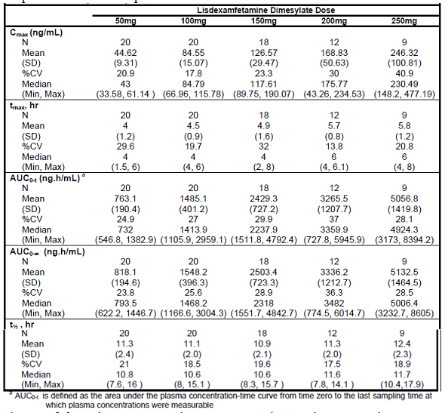

In Study NRP104-103 in a population of children aged 6 to 12 years, for AUC0-∞ bioequivalence was demonstrated for *d-*amphetamine exposure using the 50 mg dose as the reference: dose-normalised mean (90% CI) ratio 93.28 (87.36 to 99.60) for the 30 mg dose and 101.62 (95.34 to 108.31) for the 70 mg dose. For Cmax bioequivalence was demonstrated for *d-*amphetamine exposure using the 50 mg dose as the reference: dose normalised mean (90% CI) ratio 95.25 (90.56 to 100.17) for the 30 mg dose and 102.36 (97.46 to 107.51) for the 70 mg dose.

###### Bioavailability during multiple-dosing

Data for bioavailability for multiple dosing were not provided in the submission.[2]

##### Distribution

###### Volume of distribution

Mean (SD) V/F for lisdexamfetamine was around 1200 L. (Study NRP104-101). Mean (SD) V/F for *d-*amphetamine following LDX was 15.58 (2.52) L/kg (Study SPD503-115).

###### Plasma protein binding

Plasma protein binding data were not provided in the submission.

##### Metabolism

###### Interconversion between enantiomers

There did not appear to be conversion of *d-*amphetamine to *l*-amphetamine. This would not be expected to be any different to that for currently marketed *d-*amphetamine containing drugs.

###### Sites of metabolism and mechanisms / enzyme systems involved

LDX appears to be hydrolysed primarily by peptidase(s) associated with red blood cells to the amino acid l-lysine and pharmacologically active *d-*amphetamine. The proposed metabolic pathways are summarized in the submission.

###### Clearance

Overall, 96.4% of an orally administered dose was recovered in urine and <0.30% in faeces (Study NRP104-106). Over 48 hours, 79.4% of the orally administered dose was recovered in urine: 2.2% as LDX, 41.5% as amphetamine, 24.8% as hippuric acid, 2.2% as benzoic acid and 8.9% as other metabolites.

###### Metabolites identified in humans

* Active metabolites

LDX is inactive, and is metabolised to the active metabolite *d-*amphetamine. LDX itself is inactive.

* Other metabolites

In Study NRP104-106, 96.4% of an orally administered dose was recovered in urine and <0.30% in faeces. Over 48 hours, 79.4% of the orally administered dose was recovered in urine: 2.2% as LDX, 41.5% as amphetamine, 24.8% as hippuric acid, 2.2% as benzoic acid and 8.9% as other metabolites.

###### Pharmacokinetics of metabolites

For the 70 mg once daily dose there was no evidence of accumulation: mean (SD) *d-*amphetamine Ctrough was 20.6 (11.8) ng/mL on Day 5 and 18.2 (10.7) ng/mL on Day 8 (Study NRP104-104). The mean (SD) steady state value for Tmax was 3.68 (1.42) hours, for Cmax was 90.1 (29.6) ng/mL, t½ was 10.08 (2.76) hours and AUC0-24 was 1113 (396.8) ng.hour/mL.

###### Consequences of genetic polymorphism

CYP2D6 phenotype did not appear to influence the PK of LDX.

##### Excretion

###### Routes and mechanisms of excretion

Excretion was primarily as urinary metabolites.

###### Mass balance studies

In Study NRP104-106, 96.4% of an orally administered dose was recovered in urine and <0.30% in faeces. Over 48 hours, 79.4% of the orally administered dose was recovered in urine: 2.2% as LDX, 41.5% as amphetamine, 24.8% as hippuric acid, 2.2% as benzoic acid and 8.9% as other metabolites.

###### Renal clearance

As above, 2.2% of an orally administered dose of LDX was recovered unchanged in the urine.

##### Intra- and inter-individual variability of pharmacokinetics

There is little inter-individual variability in PK.

#### Pharmacokinetics in the target population

The PK in the target population would be similar to that in healthy individuals. The clinical trials included healthy individuals that would be similar to those in the PK studies.

#### Pharmacokinetics in other special populations

##### Pharmacokinetics in subjects with impaired hepatic function

There were no data regarding PK in subjects with impaired hepatic function in the submission.

##### Pharmacokinetics in subjects with impaired renal function

There were no data regarding PK in subjects with impaired renal function in the submission.

##### Pharmacokinetics according to age

In Study SPD489-116, there was a reduction in *d-*amphetamine clearance in elderly subjects with increasing age, but this would not be sufficient to require dose modification on the basis of PK alone. In females, mean (SD) *d-*amphetamine CL/F was 0.71 (0.12) L/hr/kg in the ≥55 to 64 years group, 0.74 (0.13) L/hr/kg in the ≥65 to 74 years group and 0.57 (0.09) L/hr/kg in the ≥75 years group. In males, mean (SD) *d-*amphetamine CL/F was 0.75 (0.15) L/hr/kg in the ≥55 to 64 years group, 0.64 (0.12) L/hr/kg in the ≥65 to 74 years group and 0.56 (0.14) L/hr/kg in the ≥75 years group.

##### Pharmacokinetics related to genetic factors

CYP2D6 polymorphisms did not appear to influence PK.

#### Pharmacokinetic interactions

##### Pharmacokinetic interactions demonstrated in human studies

There was no effect on the PK of either LDX or *d-*amphetamine with co-administration of the PPI PRILOSEC (omperazole) (Study SPD489-113).

The PK of LDX and *d-*amphetamine were not altered by co-administration of venlafaxine, but the AUC of venlafaxine was increased by 10% and that of its major metabolite O-desmethylvenlafaxine was decreased by 17% by co-administration with LDX. In Study SPD489-117, for *d-*amphetamine the ratio (90% CI) LDX/LDX+venlafaxine was 0.95 (0.806 to 1.121) for AUC0-last and 0.967 (0.621 to 1.139) for Cmax. For venlafaxine the ratio (90% CI) venlafaxine/LDX+venlafaxine was 1.129 (0.88 to 1.45) for AUC0-last and 1.103 (0.881 to 1.38) for Cmax. For O-desmethylvenlafaxine the ratio (90% CI) venlafaxine/LDX+venlafaxine was 0.826 (0.713 to 0.956) for AUC0-last and 0.907 (0.777 to 1.058) for Cmax. This was taken to indicate that LDX is a weak inhibitor of CYP2D6.

Guanfacine had no significant effect upon the PK of *d-*amphetamine (from LDX). In Study SPD503-115 for *d-*amphetamine the ratio (90% CI) LDX/LDX+guanfacine was 1.02 (0.983 to 1.06) for AUC0-last and 0.993 (0.967 to 1.019) for Cmax. LDX did not increase overall exposure (AUC) to guanfacine but did increase Cmax by around 20%. In Study SPD503-115 for guanfacine the ratio (90% CI) guanfacine /LDX+ guanfacine was 1.068 (0.981 to 1.162) for AUC0-last and 1.187 (1.066 to 1.321) for Cmax.

### Evaluator’s overall conclusions on pharmacokinetics

The PK of LDX in healthy volunteers has been well characterised. LDX is well absorbed orally and the bioavailability is not affected by food. The bioavailability of the solubilised capsules is similar to that of intact capsules. There do not appear to be any significant interactions. There appears to be little intra-individual or inter-individual variability in LDX disposition.

However, in subjects with hepatic or renal impairment, the PK of LDX have not been fully investigated.

## Pharmacodynamics

### Studies providing pharmacodynamic data

There were three studies that provided PD data. Study SPD-113 was discussed in Section 4. Study SPD489-115 was reported as a PD study. Study NRP104-201 was presented by the Sponsor as a Pivotal study, but the data appeared to be PD rather than efficacy data.

### Summary of pharmacodynamics

#### Mechanism of action

LDX itself is pharmacologically inactive. The pharmacological actions of LDX are mediated by *d-*amphetamine which acts by blocking reuptake of noradrenaline and dopamine.

#### Pharmacodynamic effects

##### Primary pharmacodynamic effects

In Study SPD489-113, an exploratory PD analysis was performed using Question 2 from the Drug Rating Questionnaire – Subject (DRQ-S): “How much do you like the effects you are feeling now?” [Study SPD-113 was discussed in Section 4.]

Study SPD489-115 was a single centre, three period crossover study enrolling adult male and female subjects between the ages of 18-55 years who had been diagnosed with ADHD to evaluate the sensitivity and responsiveness of a standardised, validated, computer-based, battery of neuropsychometric tests in adults with ADHD using the Power of Attention score. The study was conducted at a single centre in the US from January to March 2010. The subjects were administered the CDR battery (Appendix 1), CAARS-S:S, the Trail making test, The Stroop task, the modified AMSES. The individual CDR test results (Appendix 1) can be combined into composite scores to reflect five domains identified previously by factor analysis:

* Power of Attention (the summation of the speed scores from three individual tests of attention: Simple Reaction Time, Choice Reaction Time, and Digit Vigilance Speed)
* Continuity of Attention (Accuracy on the Choice Reaction Time, as well as the percentage of correct targets detected and the number of false positive responses on the Digit Vigilance Task reflect the ability to sustain attention without distraction)
* Quality of Working Memory
* Quality of Episodic Secondary Memory
* Speed of Memory

The study treatments were:

* LDX (VYVANSE) 50 mg capsule
* Mixed amphetamine salts, immediate release, 20 mg tablet
* Placebo (for both active treatments)

Each treatment was administered daily for 7 days with no washout period. The study included adult male and female subjects between the ages of 18-55 years who had been diagnosed with ADHD. There were 18 subjects: eleven (61.1%) male, seven (38.9%) female, with an age range of 18 to 53 years. There was an improvement in Power of Attention score, maximal at 5 hours, with no associated deterioration in the Continuity of Attention score. There was no significant difference between groups in CAARS-S:S. There was no significant difference between LDX and placebo for the Trail making test. For the Congruent Completion Time component of the Stroop test there was a small but statistically significant improvement in the LDX group compared with placebo at Hour 4 (least square mean [95% CI] 4.66 [0.80 to 8.51]); but there was no difference at Hour 14, or in the Incongruent Completion Time. There was no significant difference between the groups in the modified AMSES.

Study NRP104-201 was a multicentre, Phase 2, randomised, double blind, three treatment (comparator and placebo controlled) and three-period crossover study conducted in a school laboratory environment to evaluate efficacy and safety of LDX in the treatment of children with ADHD. The study was conducted at four sites in the US from September to December 2004. The study included children aged 6 to 12 years with ADHD as defined by the DSM-IV-TR; combined or hyperactive impulsive subtypes, and who were on stable regimen of stimulants for at least one month in the last six months and showed adequate response to stimulants without unacceptable side effects. The study treatments were:

* LDX 30 mg, 50 mg, or 70 mg
* Adderall XR (1x10 mg, 2x10 mg, or 3x10 mg)
* Placebo

Total treatment duration was for 3 weeks (one week with each of the three treatments) following a 3-week open label dose titration with Adderall XR in the range 10 mg to 30 mg. The equivalent dose of LDX was 30 mg to 10 mg Adderall XR, 50 mg to 20 mg and 70 mg to 30 mg. The efficacy outcome measures were: SKAMP and PERMP measured throughout a treatment assessment day. Hypothesis testing was conducted using a mixed effects model of ANOVA. A total of 52 subjects were included in the study, 50 completed and two withdrew, one due to AE: viral gastroenteritis. There were 31 (62%) males, 19 (38%) females, and the age range was 6 to 12 years. Ten (19%) subjects were titrated to Adderall XR 10 mg, 17 (33%) to 20 mg and 25 (50%) to 30 mg. For the primary efficacy endpoint, SKAMP deportment, the LS mean (SE) was 0.8 (0.1) for LDX, 0.8 (0.1) for Adderall XR, and 1.7 (0.1) for placebo. The LS mean (95% CI) difference to placebo was -0.9 (-1.1 to -0.7) for LDX, and -0.9 (-1.1 to -0.7) for Adderall XR. The primary efficacy outcome was supported by the secondary efficacy outcome measures:

* SKAMP inattention: The LS mean (95% CI) difference to placebo was -0.6 (-0.7 to -0.5) for LDX, and -0.5 (-0.7 to -0.4) for Adderall XR
* PERMP Attempted: The LS mean (95% CI) difference to placebo was 45.1 (34.8 to 55.5) for LDX, and 45.5 (35.2 to 55.8) for Adderall XR
* PERMP Correct: The LS mean (95% CI) difference to placebo was 45.5 (35.3 to 55.3) for LDX, and 45.3 (35.3 to 55.3) for Adderall XR
* CGI improvement: The LS mean (95% CI) difference to placebo was -2.0 (-2.4 to -1.5) for LDX, and -1.8 (-2.3 to -1.3) for Adderall XR

For SKAMP deportment there was a significant difference between LDX and placebo from 2 hours post-dose through to 13 hours post-dose, with peak effect at 6 hours post-dose. Adderall-XR resulted in a similar effect profile, with more smoothing of effect over time.

##### Secondary pharmacodynamic effects

Study SPD489-115 there was an increase in mean SDP of 5 mmHg at 3 hours post dose, a mean increase in pulse of 7 bpm at 5 hours post-dose, and an increase in DBP of 2.5 mmHg at 3 hours post-dose.

PK/PD modelling studies were not presented in the submission. This would appear to be a lost opportunity to explore the time course of action of LDX.

### Evaluator’s overall conclusions on pharmacodynamics

The PD data indicate similar time course of action for LDX and controlled release *d-*amphetamine. These effects were on improvement of symptoms of ADHD. There were also effects on the cardiovascular system with an increase in pulse rate, SBP and DBP.

## Dosage selection for the pivotal studies

The dose selection for the pivotal studies was supported by the PK and PD studies discussed in Section 4 and Section 5.

## Clinical efficacy

### Efficacy in subjects with ADHD

#### Pivotal efficacy studies in comparison with placebo

Summaries of the pivotal efficacy studies in comparison with placebo are shown in the following Tables:

* Table 4 (Study NRP104-301)
* Table 5 (Study NRP104-303)
* Table 6 (Study SPD489-305)
* Table 7 (Study SPD489-311)
* Table 8 (Study SPD489-316)
* Table 9 (Study SPD489-325)
* Table 10 (Study SPD489-326)
* Table 11 (Study SPD489-401)
* Table 12 (Study SPD489-403)

Table 4. Summary of Study NRP104-301.

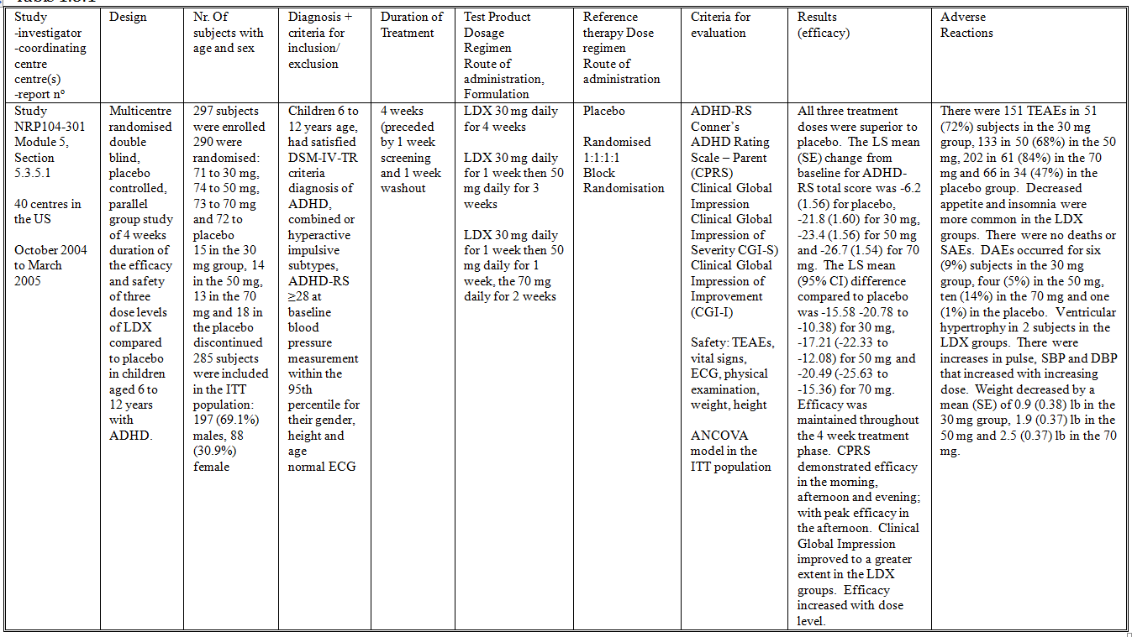

Table 5. Summary of Study NRP104-303.

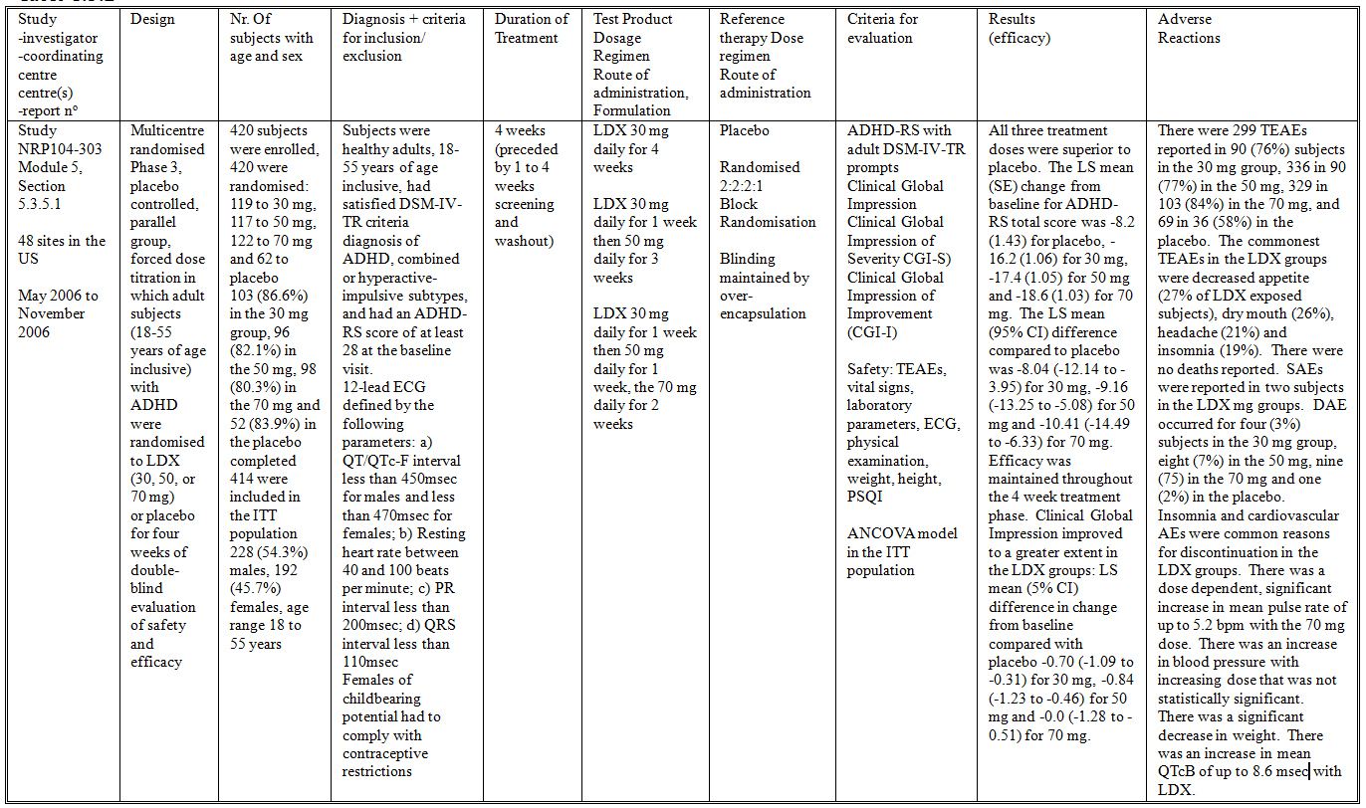

Table 6. Summary of Study SPD489-305.

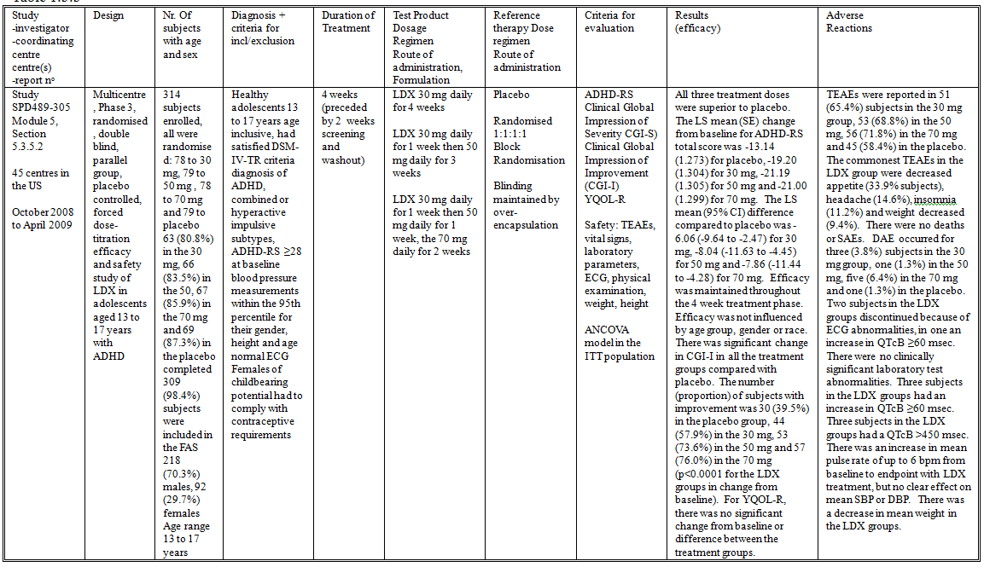

Table 7. Summary of Study SPD489-311.

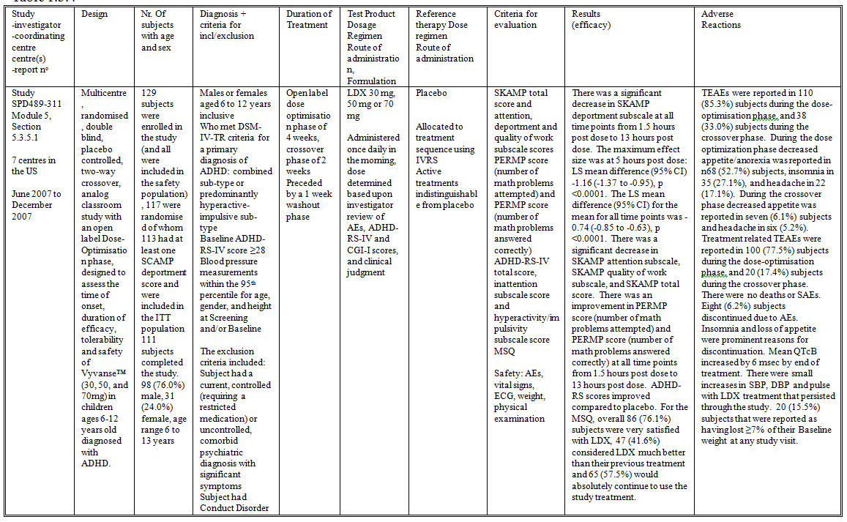

Table 8. Summary of Study SPD489-316.

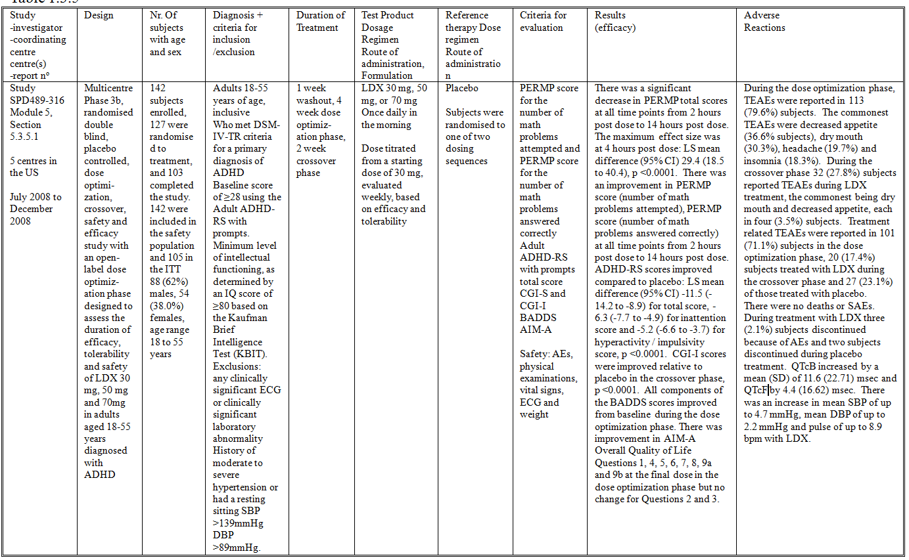

Table 9. Summary of Study SPD489-325.

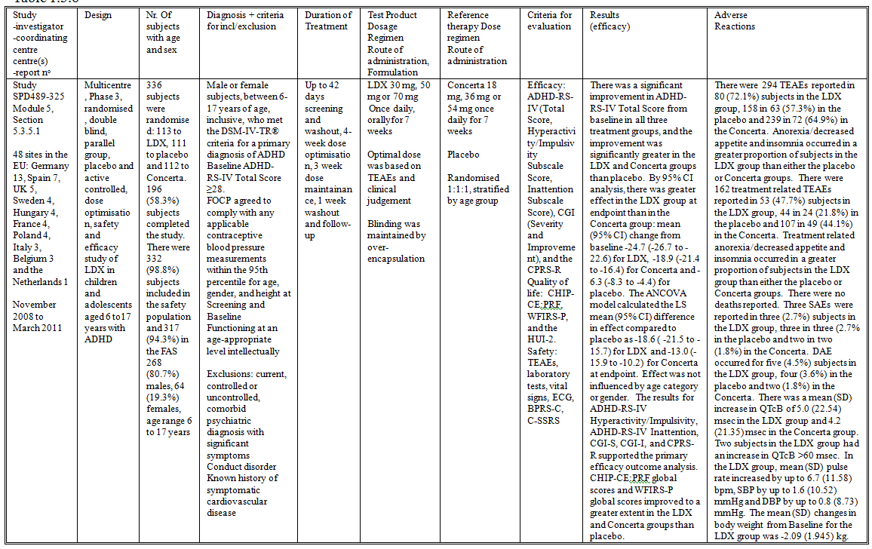

Table 10. Summary of Study SPD489-326.

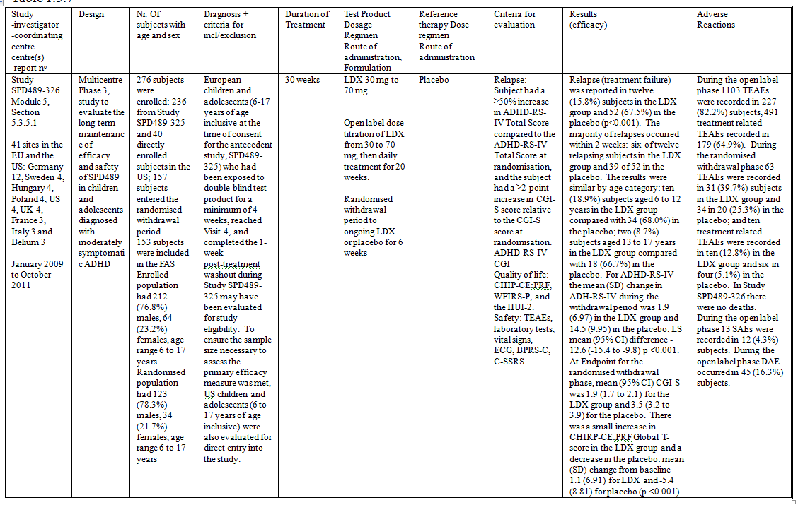

Table 11. Summary of Study SPD489-401.

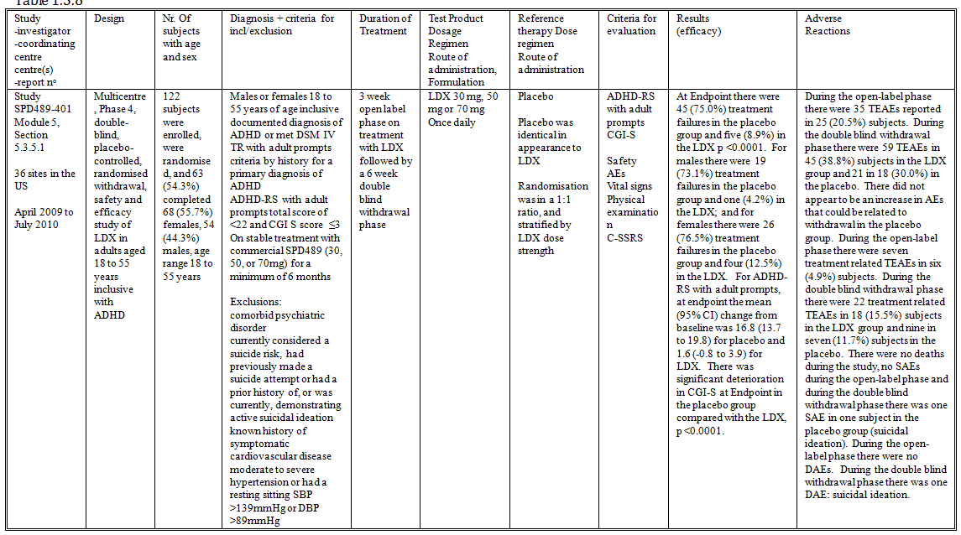

Table 12. Summary of Study SPD489-403.

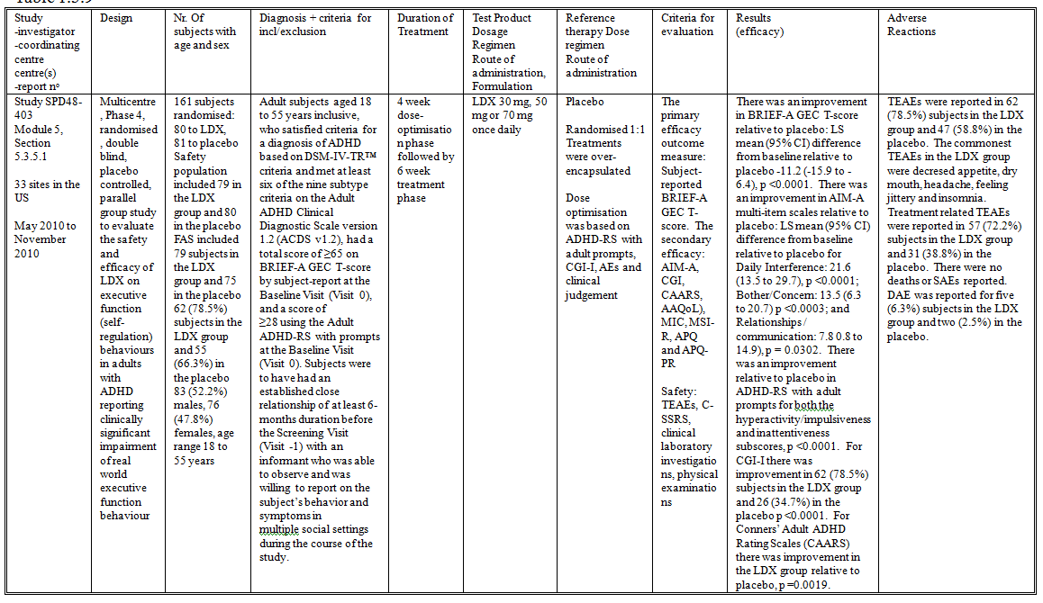

##### Study NRP104-301

###### Study design, objectives, locations and dates

Study NRP104-301 (Table 4) was a multicentre, randomised, double blind, placebo controlled, parallel group study of 4 weeks duration of the efficacy and safety of three dose levels of LDX compared to placebo in children aged 6 to 12 years with ADHD. The study was conducted at 40 centres in the US from October 2004 to March 2005.

###### Inclusion and exclusion criteria

The study included children 6 to 12 years age, who had satisfied DSM-IV-TR criteria diagnosis of ADHD, combined or hyperactive impulsive subtypes, ADHD-RS [total score] ≥28 at baseline; with blood pressure measurements within the 95th percentile for their gender, height and age; and with normal ECGs.

###### Study treatments

The study treatments were:

* LDX 30 mg daily for 4 weeks
* LDX 30 mg daily for 1 week then 50 mg daily for 3 weeks
* LDX 30 mg daily for 1 week then 50 mg daily for 1 week, the 70 mg daily for 2 weeks
* Placebo

Treatment duration was 4 weeks (preceded by 1 week screening and 1 week washout).

###### Efficacy variables and outcomes

The primary efficacy outcome measure was the ADHD-RS [total score] (Appendix 2). The secondary efficacy outcome measures were:

* Conner’s ADHD Rating Scale – Parent (CPRS) (Appendix 3)
* Clinical Global Impression (Appendix 4)

The safety outcome measures were: TEAEs, vital signs, ECG, physical examination, weight, and height. The schedule of study visits is displayed.

###### Randomisation and blinding methods

Subjects were randomised 1:1:1:1 using block randomisation. The study was double blind.

###### Analysis populations

The ITT population included all randomised subjects who had both baseline and at least one post-randomisation primary efficacy measurement (i.e., ADHD-RS total score) available.

###### Sample size

The sample size calculation used effect sizes from previous studies of amphetamine treatment in children with ADHD which disclosed effect sizes of greater than 0.50. Assuming the same effect size for LDX, 64 subjects were required in each treatment arm to detect a difference in effect size of at least 0.50 between an active arm and placebo for a power of greater than 80% at the level of 0.05 (two-sided) using a two-sample t-test. This calculated a sample size of 256 subjects.

###### Statistical methods

Hypothesis tests were performed using ANCOVA models in the ITT population. Missing data were imputed using the scale-specific median score.

###### Participant flow

A total of 297 subjects were enrolled and 290 were randomised to treatment: 71 to 30 mg, 74 to 50 mg, 73 to 70 mg and 72 to placebo. Fifteen subjects in the 30 mg group, 14 in the 50 mg, 13 in the 70 mg and 18 in the placebo discontinued. A total of 285 subjects were included in the ITT population. Subject disposition is summarised in the CSR.

###### Baseline data

In the ITT population there were 197 (69.1%) males, 88 (30.9%) females, and the age range was 6 to 12 years. There was a higher proportion of subjects in the younger age group in the placebo group.

###### Results for the primary efficacy outcome

All three treatment doses were superior to placebo. The LS mean (SE) change from baseline for ADHD-RS total score was -6.2 (1.56) for placebo, -21.8 (1.60) for 30 mg, -23.4 (1.56) for 50 mg and -26.7 (1.54) for 70 mg. The LS mean (95% CI) difference compared to placebo was -15.58 (‑20.78 to -10.38) for 30 mg, -17.21 (-22.33 to -12.08) for 50 mg and -20.49 (-25.63 to -15.36) for 70 mg. Efficacy was maintained throughout the 4 week treatment phase. Efficacy was demonstrated for both the inattention sub-scale and the hyperactivity subscale.

###### Results for other efficacy outcomes

* CPRS demonstrated efficacy in the morning, afternoon and evening; with peak efficacy in the afternoon: LS mean (5% CI) difference in change from baseline compared with placebo -8.84 (-12.55 to -5.13) for 30 mg, -12.46 (-16.15 to -8.77) for 50 mg and -12.90 (-16.55 to -9.25) for 70 mg.
* Clinical Global Impression improved to a greater extent in the LDX groups: LS mean (5% CI) difference in change from baseline compared with placebo -1.43 (-1.89 to -0.97) for 30 mg, -1.55 (-2.00 to -1.10) for 50 mg and -1.78 (-2.23 to -1.33) for 70 mg.

Efficacy increased with dose level. There was no difference in efficacy by gender or age group.

##### Study NRP104-303

###### Study design, objectives, locations and dates

Study NRP104-303 (Table 5) was a multicentre, randomised, Phase 3, placebo controlled, parallel group, forced dose titration in which adult subjects (18-55 years of age inclusive) with ADHD were randomised to LDX (30, 50, or 70 mg) or placebo for four weeks of double-blind evaluation of safety and efficacy. The study was conducted at 48 sites in the US from May 2006 to November 2006.

###### Inclusion and exclusion criteria

The study included:

* Adults, 18-55 years of age inclusive
* Satisfied the DSM-IV-TR criteria diagnosis of ADHD, combined or hyperactive-impulsive subtypes
* ADHD-RS [total] score ≥28 at the baseline visit
* 12-lead ECG defined by the following parameters:
  + QT/QTc-F interval less than 450msec for males and less than 470msec for females
  + Resting heart rate between 40 and 100 beats per minute
  + PR interval less than 200msec
  + QRS interval less than 110msec
* Females of childbearing potential had to comply with contraceptive restrictions

###### Study treatments

The study treatments were:

* LDX 30 mg daily for 4 weeks
* LDX 30 mg daily for 1 week then 50 mg daily for 3 weeks
* LDX 30 mg daily for 1 week then 50 mg daily for 1 week, the 70 mg daily for 2 weeks
* Placebo

Treatment duration was for 4 weeks (preceded by 1 to 4 weeks screening and washout).

###### Efficacy variables and outcomes

The primary efficacy outcome measure was the change from baseline in ADHD-RS [total score] with adult DSM-IV-TR prompts. The secondary efficacy outcome measures were:

* Clinical Global Impression of Severity CGI-S)
* Clinical Global Impression of Improvement (CGI-I)

The safety outcome measures were: TEAEs, vital signs, laboratory parameters, ECG, physical examination, weight, height, PSQI. The schedule of study visits is summarized in the CSR.

###### Randomisation and blinding methods

Subjects were block randomised in the ratio 2:2:2:1 to 30 mg:50 mg:70 mg: placebo. Blinding was maintained by over-encapsulation of the study treatments.

###### Analysis populations

The ITT population included all subjects who were randomised to treatment and had both the baseline and at least one post-randomisation primary efficacy measurement.

###### Sample size

The sample size calculation used an effect size of 0.38, as seen in previous studies of LDX in children, and calculated that 110 subjects per treatment group would provide 80% power to test the comparisons of LDX 70 mg versus 30 mg in ADHD-RS [total] scores, and 55 subjects in the placebo group would provide a power of over 95% for detecting a difference in effect size of 1.0 between a LDX group versus placebo in ADHD-RS [total] scores. The study planned to randomise 385 subjects.

###### Statistical methods

Hypothesis tests were preformed using ANCOVA models in the ITT population. Missing data were imputed using the scale-specific mean score

###### Participant flow

A total of 420 subjects were enrolled and all were randomised to treatment: 119 to 30 mg, 117 to 50 mg, 122 to 70 mg and 62 to placebo. Of these subjects, 103 (86.6%) in the 30 mg group, 96 (82.1%) in the 50 mg, 98 (80.3%) in the 70 mg and 52 (83.9%) in the placebo completed the study. There were 414 subjects included in the ITT population. Subject disposition is summarised in the CSR.

###### Baseline data

The study included 228 (54.3%) males, 192 (45.7%) females, and the age range was 18 to 55 years. The study groups were similar in demographic characteristics, but CGI severity was lesser in the placebo group.

###### Results for the primary efficacy outcome

All three treatment doses were superior to placebo. The LS mean (SE) change from baseline for ADHD-RS total score was -8.2 (1.43) for placebo, -16.2 (1.06) for 30 mg, -17.4 (1.05) for 50 mg and -18.6 (1.03) for 70 mg. The LS mean (95% CI) difference compared to placebo was -8.04 (‑12.14 to -3.95) for 30 mg, -9.16 (-13.25 to -5.08) for 50 mg and -10.41 (-14.49 to -6.33) for 70 mg. Efficacy was maintained throughout the 4 week treatment phase.

###### Results for other efficacy outcomes

Clinical Global Impression improved to a greater extent in the LDX groups: LS mean (95% CI) difference in change from baseline compared with placebo -0.70 (-1.09 to -0.31) for 30 mg, -0.84 (-1.23 to -0.46) for 50 mg and -0.9 (-1.28 to -0.51) for 70 mg. An increase in efficacy with dose could only be demonstrated in the comparison between the 30 mg and 70 mg dose levels at Week 4. There was no difference in efficacy by gender. The effect size was lesser in the 40 to 55 year age group. There was similar effect size for White and Non-White subjects.

##### Study SPD489-305

###### Study design, objectives, locations and dates

Study SPD489-305 (Table 6) was a multicentre, Phase 3, randomised, double blind, parallel group, placebo controlled, forced dose-titration efficacy and safety study of LDX in adolescents aged 13 to 17 years with ADHD. The study was conducted at 45 centres in the US from October 2008 to April 2009.

###### Inclusion and exclusion criteria

The study included:

* Adolescents 13 to 17 years age inclusive
* Who had satisfied DSM-IV-TR criteria diagnosis of ADHD
* ADHD-RS [total score] ≥28 at baseline
* Blood pressure measurements within the 95th percentile for their gender, height and age
* Normal ECG
* Females of childbearing potential had to comply with contraceptive requirements

###### Study treatments

The study treatments were:

* LDX 30 mg daily for 4 weeks
* LDX 30 mg daily for 1 week then 50 mg daily for 3 weeks
* LDX 30 mg daily for 1 week then 50 mg daily for 1 week, the 70 mg daily for 2 weeks
* Placebo

Treatment duration was for 4 weeks (preceded by 1 to 4 weeks screening and washout).

###### Efficacy variables and outcomes

The primary efficacy outcome measure was the change from baseline in ADHD-RS [total score]. The secondary efficacy outcome measures were:

* Clinical Global Impression of Improvement (CGI-I)
* YQOL-R

The safety outcome measures were: TEAEs, vital signs, laboratory parameters, ECG, physical examination, weight, height. The schedule of study visits is summarized in the CSR.

###### Randomisation and blinding methods

Subjects were block randomised in the ratio 1:1:1:1. Blinding was maintained by over-encapsulation of the study treatments.

###### Analysis populations

The FAS included all subjects who took at least one randomised dose of study medication during this study and had a valid Baseline and at least one post-baseline follow-up assessment of the primary outcome measure.

###### Sample size

The sample size calculation assumed an effect size of at least 0.55 for the comparison between a LDX dose group and placebo, and calculated that a total of 71 subjects per treatment group was required for 90% power at the significance level of 0.05 (two-sided) using a two-sample t-test with equal allocation to treatment groups. Hence, a final sample size of 300 subjects was determined to allow 5% of subjects dropping out prior to a post-baseline ADHD-RS-IV measurement.

###### Statistical methods

Hypothesis tests were preformed using ANCOVA models in the FAS. The last available measurement was taken as the end of study measurement.

###### Participant flow

A total of 314 subjects were enrolled in the study and all were randomised: 78 to 30 mg, 79 to 50 mg, 78 to 70 mg and 79 to placebo. Of these subjects, 63 (80.8%) in the 30 mg group, 66 (83.5%) in the 50 mg, 67 (85.9%) in the 70 mg and 69 (87.3%) in the placebo completed. There were 309 (98.4%) subjects included in the FAS.

###### Major protocol violations/deviations

Major protocol deviations were reported in 35 (15.0%) subjects, the most common being failure to meet washout specifications in 21 (9.0%) subjects.

###### Baseline data

There were 218 (70.3%) males, 92 (29.7%) females and the age range was 13 to 17 years. The study groups were similar for baseline demographic variables, except for a higher proportion of females in the 70 mg group. The treatment groups were similar in baseline severity scores.

###### Results for the primary efficacy outcome

All three treatment doses were superior to placebo. The LS mean (SE) change from baseline for ADHD-RS total score was -13.14 (1.273) for placebo, -19.20 (1.304) for 30 mg, -21.19 (1.305) for 50 mg and -21.00 (1.299) for 70 mg. The LS mean (95% CI) difference compared to placebo was -6.06 (-9.64 to -2.47) for 30 mg, -8.04 (-11.63 to -4.45) for 50 mg and -7.86 (-11.44 to -4.28) for 70 mg. Efficacy was maintained throughout the 4 week treatment phase. Efficacy was not influenced by age group, gender or race.

###### Results for other efficacy outcomes

There was significant change in CGI-I in all the treatment groups compared with placebo. The number (proportion) of subjects with improvement was 30 (39.5%) in the placebo group, 44 (57.9%) in the 30 mg, 53 (73.6%) in the 50 mg and 57 (76.0%) in the 70 mg (p<0.0001 for the LDX groups in change from baseline. However, even 76.0% of subjects having improvement may fall short of parents and treating professional’s expectations of treatment. CGI-I was not influenced by gender.

For YQOL-R, there was no significant change from baseline or difference between the treatment groups.

##### Study SPD489-311

###### Study design, objectives, locations and dates

Study SPD489-311 (Table 7) was a multicentre, randomised, double blind, placebo controlled, two-way crossover, analog classroom study with an open label dose-optimisation phase, designed to assess the time of onset, duration of efficacy, tolerability and safety of LDX (Vyvanse) 30 mg, 50 mg, and 70mg in children ages 6-12 years old diagnosed with ADHD. The study was conducted at seven centres in the US from June 2007 to December 2007.

###### Inclusion and exclusion criteria

The study included:

* Males or females aged 6 to 12 years inclusive
* Who met DSM-IV-TR criteria for a primary diagnosis of ADHD: combined sub-type or predominantly hyperactive-impulsive sub-type
* Baseline ADHD-RS-IV score ≥28
* Blood pressure measurements within the 95th percentile for age, gender, and height at Screening and/or Baseline

The exclusion criteria included:

* Subject had a current, controlled (requiring a restricted medication) or uncontrolled, comorbid psychiatric diagnosis with significant symptoms
* Subject had Conduct Disorder

###### Study treatments

The study treatments were:

* LDX 30 mg, 50 mg or 70 mg
* Placebo

Treatments were administered once daily in the morning, and the study dose was determined based upon investigator review of AEs, ADHD-RS-IV and CGI-I scores, and clinical judgment.

###### Efficacy variables and outcomes

The primary efficacy outcome measure was the SKAMP total score and attention, deportment and quality of work subscale scores (Appendix 5). The secondary efficacy outcome measures were:

* PERMP score (number of math problems attempted) and PERMP score (number of math problems answered correctly)
* ADHD-RS-IV total score, inattention subscale score and hyperactivity/impulsivity subscale score
* MSQ

The safety outcome measures were: AEs, vital signs, ECG, weight, and physical examination. The schedule of study visits is summarized in the CSR.

###### Randomisation and blinding methods

Subjects were allocated to treatment sequence using IVRS. Active treatments were indistinguishable from placebo.

###### Analysis populations

The ITT population included all subjects who were randomised and had at least one SKAMP deportment score available after randomisation.

###### Sample size

From previous studies, the median response 1 to 3 hours post dose (0.50 units) was used as the effect size, and the previously SD of 0.9491 was used.[3] The sample size calculation determined that 48 subjects in each sequence for a total of 96 subjects completing the study would be required to give a power of 95% at a two-sided significance level of 0.05. Estimating a 25% drop-out rate, the final sample size was 128 subjects.

###### Statistical methods

Hypothesis tests were performed using a linear mixed model that included sequence, period, and treatment group as fixed effects and subject-within-sequence as a random effect.

###### Participant flow

A total of 129 subjects were enrolled in the study (and all were included in the safety population), and 117 were randomised of whom 113 had at least one SCAMP deportment score and were included in the ITT population. There were 111 subjects that completed the study. Subject disposition is summarised in the CSR.

###### Baseline data

There were 98 (76.0%) males, 31 (24.0%) females, and the age range was 6 to 13 years. The dose groups (30 mg, 50 mg and 70 mg) were similar in demographic characteristics and disease severity.

###### Results for the primary efficacy outcome

There was a significant decrease in SKAMP deportment subscale at all time points from 1.5 hours post dose to 13 hours post dose. The maximum effect size was at 5 hours post dose: LS mean difference (95% CI) -1.16 (-1.37 to -0.95), p <0.0001. The LS mean difference (95% CI) for the mean for all time points was -0.74 (-0.85 to -0.63), p <0.0001.

###### Results for other efficacy outcomes

* There was a significant decrease in SKAMP attention subscale at all time points from 1.5 hours post dose to 13 hours post dose. The maximum effect size was at 5 hours post dose: LS mean difference (95% CI) -0.87 (-1.06 to -0.68), p <0.0001.
* There was a significant decrease in SKAMP quality of work subscale at all time points from 2.5 hours post dose to 13 hours post dose. The maximum effect size was at 7.5 hours post dose: LS mean difference (95% CI) -1.06 (-1.30 to -0.82), p <0.0001.
* There was a significant decrease in SKAMP total score at all time points from 1.5 hours post dose to 13 hours post dose. The maximum effect size was at 5 hours post dose: LS mean difference (95% CI) -1.10 (-1.25 to -0.95), p <0.0001.
* There was an improvement in PERMP score (number of math problems attempted) at all time points from 1.5 hours post dose to 13 hours post dose. The maximum effect size was at 7.5 hours post dose: LS mean difference (95% CI) 42.71 (35.34 to 50.08), p <0.0001.
* There was an improvement in PERMP score (number of math problems answered correctly) at all time points from 1.5 hours post dose to 13 hours post dose. The maximum effect size was at 7.5 hours post dose: LS mean difference (95% CI) 42.55 (35.31 to 49.79), p <0.0001.
* ADHD-RS scores improved compared to placebo: LS mean difference (95% CI) -17.1 (-20.41 to -13.78) for total score, -8.33 (-9.96 to -6.71) for inattention score and -8.76 (-10.52 to -7.00) for hyperactivity / impulsivity score, p <0.0001). There was an improvement in ADHD-RS scores for all dose levels during the dose optimization phase.
* For the MSQ, overall 86 (76.1%) subjects were very satisfied with LDX, 47 (41.6%) considered LDX much better than their previous treatment and 65 (57.5%) would absolutely continue to use the study treatment.

##### Study SPD489-316

###### Study design, objectives, locations and dates

Study SPD489-316 (Table 8) was a multicentre, Phase 3b, randomised, double blind, placebo controlled, dose optimization, crossover, safety and efficacy study with an open-label dose optimisation phase designed to assess the duration of efficacy, tolerability and safety of LDX 30 mg, 50 mg and 70mg in adults aged 18-55 years diagnosed with ADHD. The study was conducted at five centres in the US from July 2008 to December 2008.

###### Inclusion and exclusion criteria

The study included:

* Adults 18-55 years of age, inclusive
* Who met DSM-IV-TR criteria for a primary diagnosis of ADHD
* Baseline score of ≥28 using the Adult ADHD-RS with prompts
* Minimum level of intellectual functioning, as determined by an IQ score of ≥80 based on the Kaufman Brief Intelligence Test (KBIT)

The exclusion criteria included:

* Any clinically significant ECG or clinically significant laboratory abnormality
* History of moderate to severe hypertension or had a resting sitting SBP >139mmHg DBP >89mmHg

###### Study treatments

The study treatments were:

* LDX 30 mg, 50 mg, or 70 mg
* Placebo

Treatments were administered once daily in the morning. There was a 1 week washout period, a 4 week dose optimisation phase, and a 2 week crossover phase. Dose was titrated from a starting dose of 30 mg, evaluated weekly, and adjusted based on efficacy and tolerability.

###### Efficacy variables and outcomes

The primary efficacy outcome measure was the change in PERMP total score. Secondary efficacy outcome measures were:

* PERMP score for the number of math problems attempted
* PERMP score for the number of math problems answered correctly
* Adult ADHD-RS with prompts total score
* CGI-S and CGI-I
* BADDS
* AIM-A

The safety outcome measures were: AEs, physical examinations, vital signs, ECG and weight. The schedule of study visits is displayed in the CSR.

###### Randomisation and blinding methods

Subjects were randomised to one of two dosing sequences. The two treatments were indistinguishable in appearance.

###### Analysis populations

The ITT population included all subjects who are randomised and have at least one post-dose primary efficacy assessment (i.e., having PERMP Total score at Visit 5) after randomisation.

###### Sample size

The sample size calculation was based on the post-dose average of the PERMP Total scores, a power of 90%, SE of 0.49, and a level of significance of 0.05. Anticipating a 15% dropout rate, the final sample size was 106 subjects.

###### Statistical methods

Hypothesis tests were performed using LS mean (95% CI) for the difference between active treatment and placebo, calculated using ANOVA models.

###### Participant flow

A total of 142 subjects were enrolled in the study, 127 were randomised to treatment, and 103 completed the study. There were 142 subjects included in the safety population and 105 in the ITT. Subject disposition is summarised in the CSR.

###### Baseline data

There were 88 (62%) males, 54 (38.0%) females, and the age range was 18 to 55 years. The three dose groups were similar in demographic characteristics, except that mean weight increased with dose level.

###### Results for the primary efficacy outcome

There was a significant increase in PERMP total scores at all time points from 2 hours post dose to 14 hours post dose. The maximum effect size was at 4 hours post dose: LS mean difference (95% CI) 29.4 (18.5 to 40.4), p <0.0001.

###### Results for other efficacy outcomes

* There was an improvement in PERMP score (number of math problems attempted) at all time points from 2 hours post dose to 14 hours post dose. The maximum effect size was at 4 hours post dose: LS mean difference (95% CI) 15.1 (9.7 to 20.5), p <0.0001
* There was an improvement in PERMP score (number of math problems answered correctly) at all time points from 2 hours post dose to 14 hours post dose. The maximum effect size was at 4 hours post dose: LS mean difference (95% CI) 14.3 (8.8 to 19.9), p <0.0001.
* ADHD-RS scores improved compared to placebo: LS mean difference (95% CI) -11.5 (-14.2 to -8.9) for total score, -6.3 (-7.7 to -4.9) for inattention score and -5.2 (-6.6 to -3.7) for hyperactivity / impulsivity score, p <0.0001. There was an improvement in ADHD-RS scores for all dose levels during the dose optimization phase.
* CGI-I scores were improved relative to placebo in the crossover phase, p <0.0001.
* All components of the BADDS scores improved from baseline during the dose optimization phase.
* There was improvement in AIM-A Overall Quality of Life Questions 1, 4, 5, 6, 7, 8, 9a and 9b at the final dose in the dose optimization phase but no change for Questions 2 and 3.
* For the MSQ, overall 79 (55.6%) subjects were very satisfied with LDX, 22 (27.8%) considered LDX much better than their previous treatment and 77 (54.2%) would absolutely continue to use the study treatment.

##### Study SPD489-325

###### Study design, objectives, locations and dates

Study SPD489-325 (Table 9) was a multicentre, Phase 3, randomised, double blind, parallel group, placebo and active controlled, dose optimisation, safety and efficacy study of LDX in children and adolescents aged 6 to17 years with ADHD. The study was conducted at 48 sites in the EU from November 2008 to March 2011.

###### Inclusion and exclusion criteria

The study included

* Male or female subjects, between 6-17 years of age, inclusive, who met the DSM-IV-TR criteria for a primary diagnosis of ADHD
* Baseline ADHD-RS-IV Total Score ≥28.
* FOCP agreed to comply with any applicable contraceptive
* Blood pressure measurements within the 95th percentile for age, gender, and height at Screening and Baseline
* Functioning at an age-appropriate level intellectually

The exclusion criteria included:

* Current, controlled or uncontrolled, comorbid psychiatric diagnosis with significant symptoms
* Conduct disorder
* Known history of symptomatic cardiovascular disease

###### Study treatments

The study treatments were:

* LDX 30 mg, 50 mg or 70 mg
* Concerta 18 mg, 36 mg or 54 mg
* Placebo

Treatments were administered orally, once daily for 7 weeks. The optimal dose was determined for each subject during the first 4 weeks guided by TEAEs and clinical judgement.

###### Efficacy variables and outcomes

The primary efficacy outcome measure was change from baseline in ADHD-RS-IV Total Score. The secondary efficacy outcome measures were:

* ADHD-RS-IV Hyperactivity/Impulsivity Subscale Score and Inattention Subscale Score
* CGI (Severity and Improvement)
* CPRS-R

Quality of life measures were:

* CHIP-CE:PRF
* WFIRS-P
* HUI-2

The safety outcome measures were TEAEs, laboratory tests, vital signs, ECG, BPRS-C and C-SSRS. The schedule of study visits is summarised in the CSR.

###### Randomisation and blinding methods

Subjects were randomised in the ration 1:1:1, stratified by age group. Blinding was maintained by over-encapsulation.

###### Analysis populations

The FAS included all subjects who were randomised and who took at least one dose of investigational product.

###### Sample size

The sample size calculation was based upon the primary efficacy measurement (change from Baseline in ADHD-RS-IV Total Score at Endpoint) and was determined for the comparison between LDX and placebo. Using an effect size of at least 0.45 between LDX and placebo, 90% power and a significance level of 0.05 a total of 210 subjects (105 in each group) would be required. Assuming a 5% drop-out rate, the final sample size was 222 subjects.

###### Statistical methods

Missing data were handled using LOCF. Hypothesis tests were performed using ANCOVA models for the change from Baseline, including treatment, country, and age groups as fixed effects and Baseline value as a covariate.

###### Participant flow

A total of 336 subjects were randomised: 113 to LDX, 111 to placebo and 112 to Concerta. Of these, 196 (58.3%) subjects completed the study. There were 332 (98.8%) subjects included in the safety population and 317 (94.3%) in the FAS.

###### Major protocol violations/deviations

There were protocol deviations for 105 (31.6%) subjects, the most common being violation of inclusion/exclusion criteria in 84 (25.3%) subjects.

###### Baseline data

There were 268 (80.7%) males, 64 (19.3%) females, and the age range was 6 to 17 years. The treatment groups were similar in baseline demographic characteristics and in disease severity.

###### Results for the primary efficacy outcome

There was a significant improvement in ADHD-RS-IV Total Score from baseline in all three treatment groups, and the improvement was significantly greater in the LDX and Concerta groups than placebo. By 95% CI analysis, there was greater effect in the LDX group at endpoint than in the Concerta group: mean (95% CI) change from baseline -24.7 (-26.7 to -22.6) for LDX, ‑18.9 (-21.4 to -16.4) for Concerta and -6.3 (-8.3 to -4.4) for placebo. The ANCOVA model calculated the LS mean (95% CI) difference in effect compared to placebo as -18.6 (-21.5 to -15.7) for LDX and -13.0 (-15.9 to -10.2) for Concerta at endpoint. Effect was not influenced by age category or gender.

###### Results for other efficacy outcomes

The results for the secondary efficacy outcome measure were:

* For ADHD-RS-IV Hyperactivity/Impulsivity Subscale Score the ANCOVA model calculated the LS mean (95% CI) difference in effect compared to placebo as -8.5 ( -10.2 to -6.8) for LDX and -5.9 (-7.6 to -4.2) for Concerta at endpoint (p <0.0001). The effect was consistent throughout the treatment period.
* For ADHD-RS-IV Inattention Subscale Score the ANCOVA model calculated the LS mean (95% CI) difference in effect compared to placebo as -10.2 ( -12.1 to -8.3) for LDX and ‑7.3 (-9.2 to -5.4) for Concerta at endpoint (p <0.0001). The effect was consistent throughout the treatment period.
* CGI Severity improved from baseline to endpoint relative to placebo for both the LDX and Concerta groups (p <0.001).
* CGI Improvement improved from baseline to endpoint relative to placebo for both the LDX and Concerta groups (p <0.001).
* CPRS-R improved from baseline to a greater extent in the LDX and Concerta groups: mean (SD) change from baseline -24 (17.76) for LDX, -5.0 (13.33) for placebo, and -19.1 (20.48) for Concerta.
* CHIP-CE:PRF global scores improved to a greater extent in the LDX (p <0.001) and Concerta (p <0.009) groups than placebo.
* WFIRS-P global scores improved to a greater extent in the LDX (p <0.031) and Concerta (p <0.022) groups than placebo.
* There was no significant difference between the treatment groups in HUI-2.

##### Study SPD489-326

###### Study design, objectives, locations and dates

Study SPD489-326 (Table 10) was a multicentre Phase 3, study to evaluate the long-term maintenance of efficacy and safety of SPD489 in children and adolescents diagnosed with moderately symptomatic ADHD. The study was conducted at 41 sites in the EU and the US from January 2009 to October 2011. The subjects recruited from the European sites had followed on from Study SPD489-325.

###### Inclusion and exclusion criteria

The study included European children and adolescents (6-17 years of age inclusive at the time of consent for the antecedent study, SPD489-325) who had been exposed to double-blind test product for a minimum of 4 weeks, reached Visit 4, and completed the 1-week post-treatment washout during Study SPD489-325. In addition, in order to ensure the sample size necessary to assess the primary efficacy measure was met, US children and adolescents (6 to 17 years of age inclusive) were also evaluated for direct entry into the study using inclusion and exclusion criteria similar to those for Study SPD48-325.

###### Study treatments

The study treatments were:

* LDX 30 mg, 50 mg or 70 mg
* Placebo

The treatment duration was for 30 weeks. There was an open label dose titration of LDX from 30 to 70 mg, then daily treatment for 20 weeks. This was followed by a randomised withdrawal period (to ongoing LDX or placebo) for 6 weeks.

###### Efficacy variables and outcomes

The primary efficacy outcome measure was relapse, defined as: the subject had a ≥50% increase in ADHD-RS-IV Total Score compared to the ADHD-RS-IV Total Score at randomisation, and the subject had a ≥2-point increase in CGI-S score relative to the CGI-S score at randomisation. Secondary efficacy outcome measures were:

* ADHD-RS-IV
* CGI

Quality of life measures were:

* CHIP-CE:PRF
* WFIRS-P
* HUI-2

The safety outcome measures were: TEAEs, laboratory tests, vital signs, ECG, BPRS-C, C-SSRS. The schedule of study visits is summarized in the CSR.

###### Randomisation and blinding methods

Subjects were randomised at the end of the open label phase. Randomisation was stratified by country. The study treatments were identical in appearance.

###### Analysis populations

The FAS included all subjects who were randomised and received at least one dose of investigational product during the Randomised Withdrawal Period.

###### Sample size

The sample size calculation was based on the primary efficacy outcome measure (relapse). Relapse rates of 20% and 50% were anticipated for LDX and placebo groups respectively, and in order to achieve 90% power at a level of significance of 0.05 (2-sided) using a chi-square test with equal allocation to treatment groups, 104 subjects (52 subjects in each group) was required.

###### Statistical methods

Hypothesis tests were performed using a Cochran-Mantel-Haenszel test stratified by country. Missing data were imputed using LOCF.

###### Participant flow

A total of 276 subjects were enrolled: 236 from Study SPD489-325 and 40 directly enrolled subjects in the US; 157 subjects entered the randomised withdrawal period. There were 153 subjects included in the FAS.

###### Major protocol violations/deviations

Major protocol deviations were reported in 147 (53.3%) subjects in the open label population, the most common being violation of inclusion/exclusion criteria in 127 (46.0%) subjects. Three subjects from one site were excluded from analysis because of “lack of medical coverage” at the site.

###### Baseline data

The enrolled population included 212 (76.8%) males, 64 (23.2%) females, and the age range was 6 to 17 years (at enrolment). The randomised population included 123 (78.3%) males, 34 (21.7%) females, and the age range was 6 to 17 years (at enrolment). The treatment withdrawal groups were similar in demographic characteristics and baseline disease severity.

###### Results for the primary efficacy outcome

Relapse (treatment failure) was reported in twelve (15.8%) subjects in the LDX group and 52 (67.5%) in the placebo (p<0.001). The majority of relapses occurred within 2 weeks: six of twelve relapsing subjects in the LDX group and 39 of 52 in the placebo. The results were similar by age category: ten (18.9%) subjects aged 6 to 12 years in the LDX group compared with 34 (68.0%) in the placebo; two (8.7%) subjects aged 13 to 17 years in the LDX group compared with 18 (66.7%) in the placebo.

###### Results for other efficacy outcomes

* For ADHD-RS-IV: The overall mean (SD) decreases from Baseline in ADHD-RS-IV Total Score at end of dose-optimisation for extension (European) and directly enrolled (US) subjects were -25.6 (10.55) and -25.0 (13.05), respectively. Overall mean (SD) decreases from Baseline at Endpoint for extension (European) and directly enrolled (US) subjects were -26.5 (11.05) and -27.2 (13.29). The mean (SD) change in ADH-RS-IV during the withdrawal period was 1.9 (6.97) in the LDX group and 14.5 (9.95) in the placebo; LS mean (95% CI) difference -12.6 (-15.4 to -9.8) p <0.001.
* For CGI-S and CGI-I there were improvements from Baseline during the open label phase (Tables 7.1.1.7.6 and 7.1.1.7.7). At Endpoint for the randomised withdrawal phase, mean (95% CI) CGI-S was 1.9 (1.7 to 2.1) for the LDX group and 3.5 (3.2 to 3.9) for the placebo.
* There was a small increase in CHIP-CE:PRF Global T-score in the LDX group and a decrease in the placebo: mean (SD) change from baseline 1.1 (6.91) for LDX and -5.4 (8.81) for placebo (p <0.001).
* There was no change in mean WFIRS-P Global Scores in the LDX group and a small increase in the placebo: mean (SD) change from baseline 0.0 (0.186) for LDX and 0.20 (0.224) for placebo (p <0.001).
* HUI-2 Multi-attribute Utility Function Scores deceased to a greater extent in the placebo group: mean (SD) change from baseline -0.005 (0.772) for LDX and -0.046 (0.1098) for placebo (p = 0.018).

##### Study SPD489-401

###### Study design, objectives, locations and dates

Study SPD489-401 (Table 11) was a multicentre, Phase 4, double-blind, placebo-controlled, randomised withdrawal, safety and efficacy study of LDX in adults aged 18 to 55 years inclusive with ADHD. The study was conducted at 36 sites in the US from April 2009 to July 2010.

###### Inclusion and exclusion criteria

The study included:

* Males or females, 18 to 55 years of age inclusive
* With documented diagnosis of ADHD or met DSM IV TR with adult prompts criteria by history for a primary diagnosis of ADHD
* ADHD-RS with adult prompts total score of <22 and CGI S score ≤3
* On stable treatment with commercial LDX (30 mg, 50 mg, or 70mg) for a minimum of 6 months

The exclusion criteria included:

* Comorbid psychiatric disorder
* Currently considered a suicide risk, had previously made a suicide attempt or had a prior history of, or was currently, demonstrating active suicidal ideation

Known history of symptomatic cardiovascular disease

* Moderate to severe hypertension or had a resting sitting SBP >139mmHg or DBP >89mmHg

###### Study treatments

The study treatments were:

* LDX 30 mg, 50 mg or 70 mg
* Placebo

Treatments were administered orally, once daily. There was a 3 week open label phase on treatment with LDX followed by a 6 week double blind withdrawal phase.

###### Efficacy variables and outcomes

The primary efficacy outcome measure was treatment failure, defined as a ≥50% increase (worsening) in the ADHD-RS with adult prompts total score and a ≥2 point increase (worsening) in CGI-S score at any double-blind visit. Subjects who withdrew without providing efficacy data were classified as treatment failures. Secondary efficacy outcome measures were:

* ADHD-RS with adult prompts
* CGI-S

The safety outcome measures were: AEs, vital signs, physical examination, and C-SSRS. The schedule of study visits is summarised in the CSR.

###### Randomisation and blinding methods

Randomisation was in a 1:1 ratio, and stratified by LDX dose strength. Placebo was identical in appearance to LDX.

###### Analysis populations

The Safety Population included all subjects who entered the open-label treatment phase of the study and took at least one dose of investigational product. The FAS included all subjects who were randomised and received at least one dose of investigational product.

###### Sample size

The sample size calculation was performed for the primary efficacy outcome measure. Based on a 30 percentage point difference between treatment failure proportions of 20% and 50% in the LDX and placebo groups, respectively, at 90% power and a significance level of 0.05 (two-sided) using a Chi-Square test with equal allocation to treatment groups, 116 subjects would be required. Assuming 80% of subjects enrolled would be eligible for randomisation into the double-blind randomised withdrawal phase, the final sample size calculation was 145 enrolled subjects.

###### Statistical methods

Hypothesis tests were performed using the Chi squared statistic.

###### Participant flow

A total of 122 subjects were enrolled, 116 were randomised, and 63 (54.3%) completed the study. There were 56 subjects randomised to LDX and 60 to placebo.

###### Baseline data

The enrolled population included 68 (55.7%) females and 54 (44.3%) males; and the age range was 18 to 55 years. The dosing groups were similar in demographic characteristics.

###### Results for the primary efficacy outcome

There was superior efficacy demonstrated for LDX. At Endpoint there were 45 (75.0%) treatment failures in the placebo group and five (8.9%) in the LDX p <0.0001. For males there were 19 (73.1%) treatment failures in the placebo group and one (4.2%) in the LDX; and for females there were 26 (76.5%) treatment failures in the placebo group and four (12.5%) in the LDX.

###### Results for other efficacy outcomes

* For ADHD-RS with adult prompts, at endpoint there was significant deterioration in the placebo group compared with LDX. The mean (95% CI) change from baseline was 16.8 (13.7 to 19.8) for placebo and 1.6 (-0.8 to 3.9) for LDX.
* There was significant deterioration in CGI-S at Endpoint in the placebo group compared with the LDX, p <0.0001.
* The MSQ was also administered to the study subjects. There was a higher level of satisfaction with LDX than with placebo.

##### Study SPD489-403

###### Study design, objectives, locations and dates

Study SPD489-403 (Table 12) was a multicentre, Phase 4, randomised, double blind, placebo controlled, parallel group study to evaluate the safety and efficacy of LDX on executive function (self-regulation) behaviours in adults with ADHD reporting clinically significant impairment of real world executive function behaviour. The study was conducted at 33 sites in the US from May 2010 to November 2010.

###### Inclusion and exclusion criteria

The study included

* Adult subjects aged 18 to 55 years inclusive
* Who satisfied criteria for a diagnosis of ADHD based on DSM-IV-TR criteria and met at least six of the nine subtype criteria on the Adult ADHD Clinical Diagnostic Scale version 1.2 (ACDS v1.2)
* A total score of ≥65 on BRIEF-A GEC T-score by subject-report at the Baseline Visit (Visit 0), and a score of ≥28 using the Adult ADHD-RS with prompts at the Baseline Visit
* Subjects were to have had an established close relationship of at least 6-months duration before the Screening Visit with an informant who was able to observe and was willing to report on the subject’s behaviour and symptoms in multiple social settings during the course of the study

###### Study treatments

The study treatments were:

* LDX 30 mg, 50 mg or 70 mg once daily
* Placebo

Treatments were administered once daily. There was a 4 week dose-optimisation phase followed by 6 week treatment phase. Dose optimisation was based on ADHD-RS with adult prompts, CGI-I, AEs and clinical judgement.

###### Efficacy variables and outcomes

The primary efficacy outcome measure was the Subject-reported BRIEF-A GEC T-score. The secondary efficacy outcome measures were:

* Subject-reported Adult ADHD Impact Module (AIM-A),
* Clinical Global Impressions (CGI),
* Conners’ Adult ADHD Rating Scales (CAARS)
* Adult ADHD Quality of Life (AAQoL)
* Marital Impact Checklist (MIC)
* Marital Satisfaction Inventory – Revised (MSI-R)
* Alabama Parenting Questionnaire (APQ)
* Alabama Parenting Questionnaire-Preschool Revision (APQ-PR).

The safety outcome measures were: TEAEs, C-SSRS, clinical laboratory investigations, and physical examinations. The schedule of study visits is displayed in the CSR.

###### Randomisation and blinding methods

Subjects were randomised 1:1. Treatments were over-encapsulated and were identical in appearance and weight to placebo.

###### Analysis populations

The FAS included all subjects who took one dose of investigational product in the double blind evaluation phase and had one post baseline primary efficacy assessment. The safety population included all subjects who took at least one dose of investigational product in the double blind evaluation phase.

###### Sample size

The sample size calculation assumed a treatment effect size of 0.56 for the comparison between LDX and placebo, and used a power of 80% and a level of significance of 0.05 to determine that 52 subjects were required in each treatment group. This was increased to 80 in each group to account for dropouts.

###### Statistical methods

Hypothesis tests were performed using an ANCOVA model.

###### Participant flow

There were 161 subjects enrolled in the study and randomised: 80 to LDX, and 81 to placebo. The safety population included 79 in the LDX group and 80 in the placebo. The FAS included 79 subjects in the LDX group and 75 in the placebo. A total of 62 (78.5%) subjects in the LDX group and 55 (66.3%) in the placebo completed the study.

###### Baseline data

There were 83 (52.2%) males, 76 (47.8%) females, and the age range was 18 to 55 years. The treatment groups were similar in demographic characteristics and in baseline disease characteristics (Tables 7.1.1.9.3 and 7.1.1.9.4). Prior ADHD medication had been received by 34 (43.0%) subjects in the LDX group and 40 (50.0%) in the placebo. During the study 57 (72.2%) subjects in the LDX group and 55 (68.8%) in the placebo received concomitant medications.

###### Results for the primary efficacy outcome

There was an improvement in BRIEF-A GEC T-score relative to placebo: LS mean (95% CI) difference from baseline relative to placebo -11.2 (-15.9 to -6.4), p <0.0001. There was no effect for gender.

###### Results for other efficacy outcomes

* There was an improvement in AIM-A multi-item scales relative to placebo: LS mean (95% CI) difference from baseline relative to placebo:
  + Impact of Symptoms: Daily Interference: 21.6 (13.5 to 29.7), p <0.0001
  + Impact of Symptoms: Bother/Concern: 13.5 (6.3 to 20.7) p <0.0003
  + Impact of Symptoms: Relationships/communication: 7.8 0.8 to 14.9), p = 0.0302
* There was an improvement relative to placebo in ADHD-RS with adult prompts for both the hyperactivity/impulsiveness and inattentiveness subscores, p <0.0001
* For CGI-I there was improvement in 62 (78.5%) subjects in the LDX group and 26 (34.7%) in the placebo p <0.0001
* For Conners’ Adult ADHD Rating Scales (CAARS) there was improvement in the LDX group relative to placebo: LS mean (95% CI) difference from baseline relative to placebo -5.5 (-9.0 to -2.1), p =0.0019.
* For Adult ADHD Quality of Life (AAQoL) there was improvement in the LDX group relative to placebo for most of the subscales. LS mean (95% CI) difference from baseline relative to placebo
  + Life productivity: 21.0 (8.4 to 33.6), p = 0.0016
  + Psychological health: 12.1 (1.6 to 22.5), p = 0.0242
  + Relationships: 7.3 (-3.4 to 18.0), p = 0.1752
  + Total score: 14.7 (5.9 to 23.6), p = 0.0015
* MIC and MSI-R were only answered by those subjects that were married. There were no significant differences between the groups reported.
* APQ and APQ-PR were only answered by those subjects with children aged 6 to 7 years and 3 to 5 years respectively. There were no significant differences between the groups reported.

#### Other efficacy studies

Summaries of other efficacy studies are shown in the Table 13 (Studies NRP104-302 and NRP104-304) and Table 14 (Studies SPD489-306 and SPD489-310):

Table 13. Summary of Studies NRP104-302 and NRP104-304.

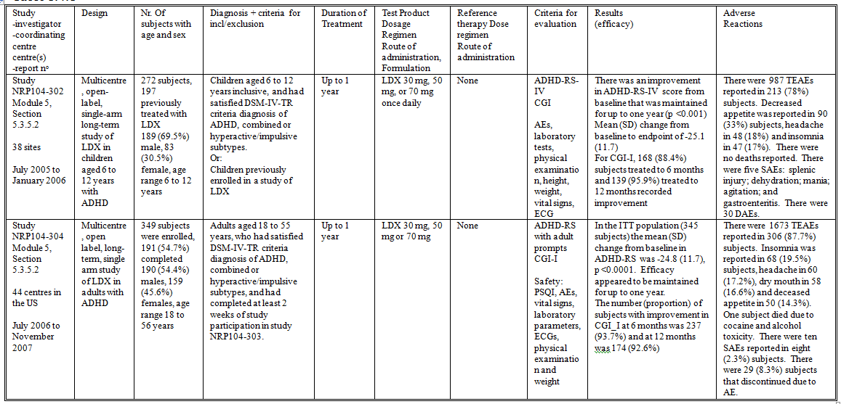

Table 14. Summary of Studies SPD489-306 and SPD489-310.

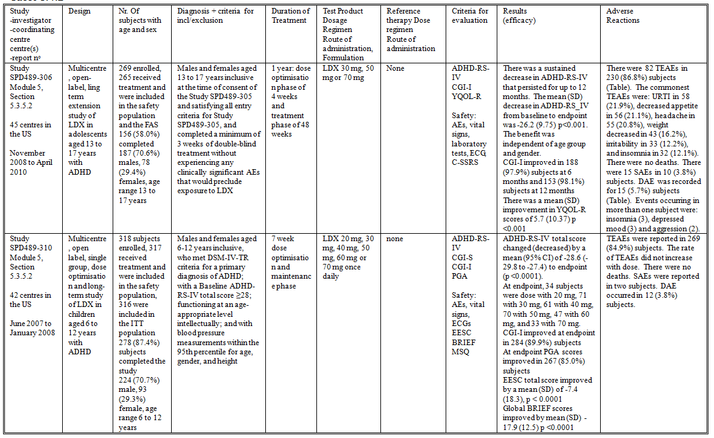

##### Study NRP104-302

Study NRP104-302 was a multicentre, open-label, single-arm long-term study of LDX in children aged 6 to 12 years with ADHD (Table 13). The study was conducted at 38 sites in the US from July 2005 to January 2006. The study included children aged 6 to 12 years inclusive, who had satisfied DSM-IV-TR criteria diagnosis of ADHD, combined or hyperactive/impulsive subtypes; or alternatively children previously enrolled in a study of LDX. The study treatment was LDX 30 mg, 50 mg, or 70 mg once daily for up to 1 year. The efficacy outcome measures were: ADHD-RS-IV and CGI. The safety outcome measures were AEs, laboratory tests, physical examination, height, weight, vital signs, and ECGs. The study included 272 subjects, 197 previously treated with LDX; 189 (69.5%) males, 83 (30.5%) females, with an age range 6 to 12 years. There was an improvement in ADHD-RS-IV score from baseline that was maintained for up to one year (p <0.001). Mean (SD) change in ADHD-RS-IV from baseline to endpoint was -25.1 (11.7). For CGI-I, 168 (88.4%) subjects treated to 6 months and 139 (95.9%) treated to 12 months recorded improvement.

##### Study NRP104-304

Study NRP104-304 (Table 13) was a multicentre, open label, long-term, single arm study of LDX in adults with ADHD. The study was conducted at 44 centres in the US from July 2006 to November 2007. The study included adults aged 18 to 55 years, who had satisfied DSM-IV-TR criteria diagnosis of ADHD, combined or hyperactive/impulsive subtypes, and had completed at least 2 weeks of study participation in study NRP104-303. The study treatment was LDX 30 mg, 50 mg or 70 mg (dose-optimised) for up to 1 year. The efficacy outcome measures were ADHD-RS with adult prompts and CGI-I. The safety outcome measures were: PSQI, AEs, vital signs, laboratory parameters, ECGs, physical examination and weight. A total of 349 subjects were enrolled and 191 (54.7%) completed. There were 190 (54.4%) males, 159 (45.6%) females, and the age range was 18 to 56 years. In the ITT population (345 subjects) the mean (SD) change from baseline in ADHD-RS was -24.8 (11.7), p <0.0001. Efficacy appeared to be maintained for up to one year. The number (proportion) of subjects with improvement in CGI-I at 6 months was 237 (93.7%) and at 12 months was 174 (92.6%).

##### Study SPD489-306

Study SPD489-306 (Table 14) was a multicentre, open-label, long term extension study of LDX in adolescents aged 13 to 17 years with ADHD. The study was conducted at 45 centres in the US from November 2008 to April 2010. The study included males and females aged 13 to 17 years inclusive at the time of consent of the Study SPD489-305 and satisfying all entry criteria for Study SPD489-305, and completed a minimum of 3 weeks of double blind treatment without experiencing any clinically significant AEs that would preclude exposure to further LDX. The study treatment was LDX 30 mg, 50 mg or 70 mg once daily for 1 year; including a dose optimisation phase of 4 weeks and treatment phase of 48 weeks. The efficacy outcome measures were: ADHD-RS-IV, CGI-I, and YQOL-R. The safety outcome measures were: AEs, vital signs, laboratory tests, ECG, and C-SSRS. There were 269 subjects enrolled in the study, of whom 265 received treatment and were included in the safety population and the FAS. A total of 156 (58.0%) subjects completed the study. There were 187 (70.6%) males, 78 (29.4%) females, and the age range was 13 to 17 years. There was a sustained decrease in ADHD-RS-IV that persisted for up to 12 months. The mean (SD) decrease in ADHD-RS-IV from baseline to endpoint was -26.2 (9.75) p<0.001. The benefit was independent of age group and gender. CGI-I improved in 188 (97.9%) subjects at 6 months and 153 (98.1%) subjects at 12 months. There was a mean (SD) improvement in YQOL-R scores of 5.7 (10.37) p <0.001.

##### Study SPD489-310

Study SPD489-310 (Table 14) was a multicentre, open label, single group, dose optimisation and treatment study of LDX in children aged 6 to 12 years with ADHD. The study was conducted at 42 centres in the US from June 2007 to January 2008. The study included males and females aged 6-12 years inclusive; who met DSM-IV-TR criteria for a primary diagnosis of ADHD; with a Baseline ADHD-RS-IV total score ≥28; functioning at an age-appropriate level intellectually; and with blood pressure measurements within the 95th percentile for age, gender, and height. The study treatments were: LDX 20 mg, 30 mg, 40 mg, 50 mg, 60 mg or 70 mg once daily. There was a 7 week dose optimisation and maintenance phase, with titration of dose commencing at the 20 mg level and increased by 10 mg each week up to 70 mg. The study outcome measures were: ADHD-RS-IV, CGI-S, CGI-I, and PGA. The safety outcome measures were: AEs, vital signs, ECGs, EESC, BRIEF, and MSQ. There were 318 subjects enrolled in the study, 317 received treatment and were included in the safety population, and 316 were included in the ITT population. A total of 278 (87.4%) subjects completed the study. There were 224 (70.7%) males, 93 (29.3%) females, and the age range was 6 to 12 years. ADHD-RS-IV total score changed (decreased) by a mean (95% CI) of -28.6 (-29.8 to -27.4) to endpoint (p <0.0001). At endpoint, 34 subjects were dosed with 20 mg, 71 with 30 mg, 61 with 40 mg, 70 with 50 mg, 47 with 60 mg, and 33 with 70 mg. CGI-I improved at endpoint in 284 (89.9%) subjects. At endpoint PGA scores improved in 267 (85.0%) subjects. EESC total score improved by a mean (SD) of -7.4 (18.3), p < 0.0001. Global BRIEF scores improved by mean (SD) -17.9 (12.5) p <0.0001.

#### Analyses performed across trials (pooled analyses and meta-analyses)

Pooled efficacy analyses were not provided in the submission.

#### Evaluator’s conclusions on clinical efficacy for ADHD

In children with ADHD aged 6 to 12 years LDX was demonstrated to be superior to placebo. Although there was no statistically significant difference between the treatment levels, in Study NRP104-301 there was increased benefit for the 70 mg dose in comparison with the 30 mg and 50 mg. The LS mean (95% CI) difference compared to placebo was -15.58 (-20.78 to -10.38) for 30 mg, -17.21 (-22.33 to -12.08) for 50 mg and -20.49 (-25.63 to -15.36) for 70 mg. Study SPD489-311 demonstrated clinically and statistically significant increases in performance in a classroom setting for up to 13 hours post dose.

In adults with ADHD aged 18 to 55 years LDX was demonstrated to be superior to placebo. Even when subjects were titrated to optimal dose there still appeared to be increasing benefit with increasing dose, although the differences between dose levels were not statistically significant. In Study NRP104-303 for ADHD-RS the LS mean (95% CI) difference compared to placebo was -8.04 (-12.14 to -3.95) for 30 mg, -9.16 (-13.25 to -5.08) for 50 mg and -10.41 (‑14.49 to -6.33) for 70 mg. Study SPD489-316 demonstrated benefit for up to 14 hours post-dose. Study SPD48-403 demonstrated clinically significant improvements in performance in a workplace setting.

In adolescents with ADHD aged 13 to 17 years LDX was demonstrated to be superior to placebo. When the subjects were titrated to optimal dose there was no clinically significant difference in effect between the 50 mg and 70 mg dose level. In Study SPD489-305 for ADHD-RS total score the LS mean (95% CI) difference compared to placebo was -6.06 (-9.64 to -2.47) for 30 mg, -8.04 (-11.63 to -4.45) for 50 mg and -7.86 (-11.44 to -4.28) for 70 mg.

In children and adolescents aged 6 to 17 years there was comparable efficacy between LDX and Concerta. In Study SPD489-325 for ADHD-RS total score by 95% CI analysis, there was greater effect in the LDX group at endpoint than in the Concerta group: mean (95% CI) change from baseline -24.7 (-26.7 to -22.6) for LDX, -18.9 (-21.4 to -16.4) for Concerta and -6.3 (-8.3 to -4.4) for placebo. However, it is not clear that the dose levels chosen for Concerta were comparable to those for LDX.[4]

Following 6 months of treatment in children and adolescents, withdrawal of treatment resulted in relapse in 67% of subjects (Study SPD489-326). However, there did not appear to be rebound or withdrawal effects. Similarly in adults, following withdrawal of treatment there was relapse in 75% of subjects (Study SPD489-401). There did not appear to be rebound or withdrawal effects.

In all of the efficacy studies the results of the secondary efficacy outcome measures supported the results of the primary efficacy outcome measures. The efficacy results were not influenced by gender, age group or race.

The follow-on studies in children, adolescents and adults all supported the maintenance of efficacy for up to 12 months.

Subjects with prior cardiovascular disease, ECG abnormalities or hypertension were excluded from the clinical studies.

The outcome measures were appropriate and explored different aspects of ADHD. Hence clinically relevant endpoints were explored in the development program. Blinding to study treatment was appropriate in all the clinical studies. The hypothesis tests were all performed using appropriate statistical procedures.

However, comparator controlled studies were not performed. Although LDX would be expected to have comparable efficacy to *d-*amphetamine, a non-inferiority comparison with methylphenidate would be useful for clinicians.

## Clinical safety

### Studies providing evaluable safety data

The following studies provided evaluable safety data:

#### Pivotal efficacy studies

In the pivotal efficacy studies, the following safety data were collected:

* TEAEs, SAEs and DAEs
* AEs of particular interest, including ECGs and vital signs (pulse rate, SBP, DBP and weight)
* Laboratory tests

#### Other studies

The clinical pharmacology studies also addressed vital signs and ECGs.

### Pivotal studies that assessed safety as a primary outcome

There were no pivotal studies that addressed safety as a primary outcome.

### Patient exposure

As stated in the Risk Management Plan, 340 subjects were exposed to LDX in the Phase I studies. In the Phase 2, 3, and 4 studies a total of 1941 subjects have been exposed to LDX in 13 studies enrolling subjects with ADHD (including 852 children, 337 adolescents, and 752 adults exposed to at least one dose of LDX). In the Summary of Clinical Safety, it states that 512 subjects have been treated for more than one year in clinical studies (Table 15).

Table 15. Investigational Product Exposure in Phase II-IV Studies.

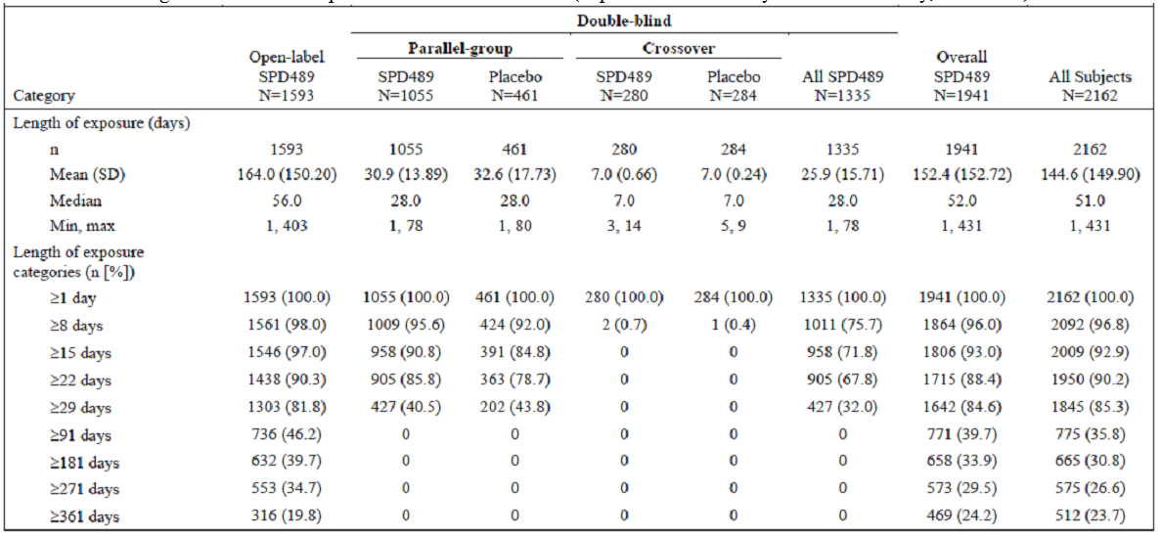

The safety database included 279 subjects treated in Phase 1 studies and 1941 subjects treated with LDX in Phase 2, 3 and 4 studies. In the Phase 1 studies there were 177 (63.4%) males and 102 (36.6%) females and the age range was 6 to 84 years. There were 18 subjects aged 6 to 12 years. In the Phase 2, 3 and 4 studies there were 1248 (64.3%) males, 693 (35.7%) males and the age range was 6 to 55 years. There were 852 subjects aged 6 to 12 years, 337 aged 13 to 17 years and 752 aged 18 to 55 years.

There were 665 subjects exposed to LDX for ≥181 days and 512 for ≥360 days. There were 198 children aged 6 to 12 years exposed for ≥181 days and 148 for ≥360 days. There were 197 adolescents aged 13 to 17 years exposed for ≥181 days and 164 for ≥360 days. There were 270 adults aged 18 to 55 years exposed for ≥181 days and 200 for ≥360 days.

#### Patient exposure in pivotal and follow-on studies

* In Study NRP104-201 there were 50 subjects exposed to LDX 30 mg to 70 mg for 7 days.
* In Study NRP104-301 a total of 218 subjects aged 6 to 12 years were exposed to LDX, of whom 181 were exposed for 4 weeks.
* In Study NRP104-303 there were 119 adult subjects exposed to 30 mg (104 for ≥28 days), 117 to 50 mg (8 for ≥28 days), and 122 to 70 mg (8 for ≥28 days).
* In Study SPD489-305 there were 86 subjects exposed to 30 mg only, with 64 exposed for more than 21 days, 75 exposed to 50 mg, with 68 exposed for more than 14 days, and 72 exposed to 70 mg with 69 exposed for more than 7 days.
* In Study SPD489-311 there were 120 subjects exposed to LDX 30 mg to 70 mg, 76 of whom were exposed for >4 weeks.
* In Study SPD489-316 a total of 142 adult subjects were exposed to 30 mg to 70 mg LDX, with 97 subjects exposed for more than 4 weeks.
* In Study SPD489-325 there were 111 subjects exposed to LDX, 82 of whom were exposed for more than 6 weeks.
* In Study SPD489-326 there were 276 children and adolescents exposed to LDX, with 183 exposed for ≥169 days, and three subjects exposed for ≥365 days.
* In Study SPD489-401 there were 122 adult subjects exposed to LDX, 118 of whom were exposed for 3 weeks or more, and 50 were exposed for 7 weeks or more.
* In Study SPD48-403 there were 79 subjects exposed to LDX, with 64 exposed for more than 8 weeks.
* In Study NRP104-302 there were 272 subjects exposed to LDX: all 272 to 30 mg, 225 to 50 mg and 133 to 70 mg. Of these subjects, 146 were exposed for ≥49 weeks.
* In Study NRP104-304 there were 349 subjects exposed to LDX, 261 (74.8%) subjects for ≥6 months and 195 for ≥49 weeks.
* In Study SPD489-306 there were 265 subjects exposed to LDX, of whom 189 were exposed for ≥181 days and 149 for ≥360 days.
* In Study SPD489-310 there were 317 children aged 6 to 12 years treated with LDX, 292 subjects were treated for ≥7 weeks.

### Adverse events

#### All adverse events (irrespective of relationship to study treatment)

##### Pivotal studies

In Study NRP104-301 there were 151 TEAEs in 51 (72%) subjects in the 30 mg group, 133 in 50 (68%) in the 50 mg, 202 in 61 (84%) in the 70 mg and 66 in 34 (47%) in the placebo group. Decreased appetite and insomnia were more common in the LDX groups.

In Study NRP104-303 there were 299 TEAEs reported in 90 (76%) subjects in the 30 mg group, 336 in 90 (77%) in the 50 mg, 329 in 103 (84%) in the 70 mg, and 69 in 36 (58%) in the placebo. The commonest TEAEs in the LDX groups were decreased appetite (27% of LDX exposed subjects), dry mouth (26%), headache (21%) and insomnia (19%).

In Study SPD489-305, TEAEs were reported in 51 (65.4%) subjects in the 30 mg group, 53 (68.8%) in the 50 mg, 56 (71.8%) in the 70 mg and 45 (58.4%) in the placebo. The commonest TEAEs in the LDX group were decreased appetite (33.9% subjects), headache (14.6%), insomnia (11.2%) and weight decreased (9.4%).

In Study SPD489-311, TEAEs were reported in 110 (85.3%) subjects during the dose-optimisation phase, and 38 (33.0%) subjects during the crossover phase. During the dose optimization phase decreased appetite/anorexia was reported in 68 (52.7%) subjects, insomnia in 35 (27.1%), and headache in 22 (17.1%). During the crossover phase decreased appetite was reported in seven (6.1%) subjects and headache in six (5.2%).

In Study SPD489-316 during the dose optimization phase, TEAEs were reported in 113 (79.6%) subjects. The commonest TEAEs were decreased appetite (36.6% subjects), dry mouth (30.3%), headache (19.7%) and insomnia (18.3%). During the crossover phase 32 (27.8%) subjects reported TEAEs during LDX treatment, the commonest being dry mouth and decreased appetite, each in four (3.5%) subjects.

In Study SPD489-325, there were 294 TEAEs reported in 80 (72.1%) subjects in the LDX group, 158 in 63 (57.3%) in the placebo and 239 in 72 (64.9%) in the Concerta. Anorexia/decreased appetite and insomnia occurred in a greater proportion of subjects in the LDX group than either the placebo or Concerta groups.

In Study SPD489-326, during the open label phase 1103 TEAEs were recorded in 227 (82.2%) subjects. The commonest TEAEs during this period were: decreased appetite, headache and decreased weight. During the randomised withdrawal phase 63 TEAEs were recorded in 31 (39.7%) subjects in the LDX group and 34 in 20 (25.3%) in the placebo. There did not appear to be TEAEs that could be attributed to withdrawal in the placebo group.

In Study SPD489-401 during the open-label phase there were 35 TEAEs reported in 25 (20.5%) subjects. During the double blind withdrawal phase there were 59 TEAEs in 45 (38.8%) subjects in the LDX group and 21 in 18 (30.0%) in the placebo. There did not appear to be an increase in AEs that could be related to withdrawal in the placebo group.

In Study SPD48-403, TEAEs were reported in 62 (78.5%) subjects in the LDX group and 47 (58.8%) in the placebo. The commonest TEAEs in the LDX group were decreased appetite, dry mouth, headache, feeling jittery and insomnia.

##### Other studies

In Study SPD489-109 TEAEs were reported in two (10.0%) of 20 subjects at the 50mg dose, ten (50.0%) of 20 subjects at the 100mg dose, eleven (61.1%) of 18 subjects at the 150mg dose, seven (58.3%) of twelve subjects at the 200mg dose, and four (44.4%) of nine subjects at the 250 mg dose. There were significant increases in pulse rate (around 50 bpm) and systolic blood pressure (up to 40 mmHg) above the 50 mg dose level. There were no deaths, SAEs or DAEs.

In Study NRP104-103, in a population of children aged 6 to 12 years, 17 (94%) subjects reported TEAEs and the frequency of subjects with TEAEs increased with dose: eight (44%) with 30 mg, ten (59%) with 50 mg and 15 (88%) with 70 mg. The most frequent TEAEs were: anorexia, 14 (78%) subjects, abdominal pain, four (22%), blood pressure increase, four (22%), somnolence, four (22%), headache, three (17%), insomnia, two (11%) and mood altered, two (11%). There were no deaths or SAEs.

In Study NRP104-201 a total of 89 TEAEs were reported in 29 (56%) subjects; 37 were reported during the double blind phase. Eight (16%) subjects reported TEAEs during treatment with LDX: decreased appetite in three, anorexia in two and insomnia in four.

In Study NRP104-302, there were 987 TEAEs reported in 213 (78%) subjects. Decreased appetite was reported in 90 (33%) subjects, headache in 48 (18%) and insomnia in 47 (17%).

In Study NRP104-304 there were 1673 TEAEs reported in 306 (87.7%) subjects. Insomnia was reported in 68 (19.5%) subjects, headache in 60 (17.2%), dry mouth in 58 (16.6%) and decreased appetite in 50 (14.3%).

In Study SPD489-306 there were 82 TEAEs in 230 (86.8%) subjects. The commonest TEAEs were: URTI in 58 (21.9%), decreased appetite in 56 (21.1%), headache in 55 (20.8%), weight decreased in 43 (16.2%), irritability in 33 (12.2%), and insomnia in 32 (12.1%).

In Study SPD489-310, TEAEs were reported in 269 (84.9%) subjects. The rate of TEAEs did not increase with dose.

##### Integrated safety database

In Phase 1 studies 178 (63.8%) subjects reported TEAEs. Headache, anorexia and dry mouth were reported in ≥10% of subjects.

In Phase 2, 3 and 4 studies 1592 (82.0%) subjects treated with LDX reported TEAEs. Decreased appetite, insomnia, headache, dry mouth, irritability, weight decreased and URTI were reported in ≥10% subjects.

##### Data from studies for other indications

Study SPD489-203 was a placebo controlled, 8 week study of antidepressant effect of LDX used as augmentation. The primary efficacy outcome measure (MADRS) did not demonstrate statistically significant benefit. A total of 88 subjects were treated with LDX. TEAEs were reported in 53 (60.2%) subjects in the LDX group and 42 (49.4%) in the placebo. The commonest TEAEs were: dry mouth (11.4% subjects) and headache (11.4%). There were no deaths or SAEs.

Study SPD489-204 was a placebo controlled study of LDX in subjects with schizophrenia. There were 92 subjects treated with LDX. There was an improvement in SANS score from baseline, p <0.0001. During the open label phase, 56 (60.9%) subjects reported TEAEs and there were three SAEs. During the double blind phase eleven (32.4%) subjects reported TEAEs and there were two SAEs in the LDX group and one in the placebo. The commonest TEAEs were headache (14.1% subjects), insomnia (10.9%) and decreased appetite (10.9%). There were no deaths. Three of the SAEs were exacerbation of schizophrenia, one was hallucinations/ depression, one was dyspepsia and one was chest pain.

Study SPD489-205 was a randomised placebo controlled study of LDX in major depressive disorder. There were 71 subjects treated with LDX for up to 9 weeks. There was an improvement in BRIEF-A GEC T-scores in these subjects (LS mean [95% CI] change from baseline relative to placebo -8.0 [-12.7 to -3.3] p = 0.0009). There was also a small improvement in MADRS total score (LS mean [95% CI] change from baseline relative to placebo -1.9 [-3.7 to 0.0] p = 0.0465). TEAEs were reported in 56 (78.9%) subjects in the LDX group and 53 (73.6%) in the placebo. There were no deaths. SAEs were reported in two (2.8%) subjects in the LDX group (loss of consciousness; suicidal ideation) and four (5.6%) in the placebo. The commonest TEAEs in the LDX group were decreased appetite (22.5% subjects), headache (22.5%), dry mouth (15.5%), and insomnia (14.1%).

Study SPD489-207 was a randomised, double blind, placebo controlled study of LDX 20 mg, 50 mg or 70 mg) in subjects with acute sleep deprivation. There were 81 subjects treated with a single dose of LDX. LDX resulted in increased wakefulness relative to placebo, p <0.0001. TEAEs were reported in 16 (19.8%) subjects in the LDX group. No single TEAE occurred in more than 10% of subjects. There were no deaths or SAEs.

Study protocols were provided for Study SPD489-119 (Schizophrenia), Study SPD489-208 (binge eating disorder), Study SPD489-209 (major depressive disorder), Study SPD489-322 (major depressive disorder), and Study SPD-323 (major depressive disorder).

#### Treatment-related adverse events (adverse drug reactions)

##### Pivotal studies

In Study SPD489-311, treatment related TEAEs were reported in 100 (77.5%) subjects during the dose-optimisation phase, and 20 (17.4%) subjects during the crossover phase. During the dose optimization phase, the commonest treatment related TEAEs were: decreased appetite (47.3% subjects), insomnia (25.6%), irritability (16.3%) and headache (14.0%). During the crossover phase, decreased appetite was reported in seven (6.1%) subjects, headache in four (3.5%) and insomnia in four (3.5%).

In Study SPD489-316 treatment related TEAEs were reported in 101 (71.1%) subjects in the dose optimization phase, 20 (17.4%) subjects treated with LDX during the crossover phase and 27 (23.1%) of those treated with placebo.

In Study SPD489-325, there were 162 treatment related TEAEs reported in 53 (47.7%) subjects in the LDX group, 44 in 24 (21.8%) in the placebo and 107 in 49 (44.1%) in the Concerta. Treatment related anorexia/decreased appetite and insomnia occurred in a greater proportion of subjects in the LDX group than either the placebo or Concerta groups.

In Study SPD489-401, during the open-label phase there were seven treatment related TEAEs in six (4.9%) subjects. During the double blind withdrawal phase there were 22 treatment related TEAEs in 18 (15.5%) subjects in the LDX group and nine in seven (11.7%) subjects in the placebo. The only events that occurred in more than one subject in either group were: headache, two (3.6%) subjects in the LDX group and three (5.0%) in the placebo, and insomnia: three (5.4%) subjects in the LDX group and one (1.7%) in the placebo.

In Study SPD48-403, treatment related TEAEs were reported in 57 (72.2%) subjects in the LDX group and 31 (38.8%) in the placebo. The commonest treatment related TEAEs in the LDX group were dry mouth, decreased appetite, headache and insomnia.

##### Other studies

In Study NRP104-302, there were 519 treatment related TEAEs.

In Study NRP104-304 there were 754 treatment related TEAEs reported in 245 (70.2%) subjects.

In Study SPD489-306 there were 410 treatment related TEAEs in 169 (63.8%) subjects.

In Study SPD489-310, treatment related TEAEs were reported in 243 (76.7%) subjects. The commonest TEAEs related to treatment were: decreased appetite, irritability, insomnia and partial insomnia.

#### Deaths and other serious adverse events

##### Pivotal studies

In Study NRP104-301 there were no deaths or SAEs.

In Study NRP104-303 there were no deaths reported. SAEs were reported in one subject in the 30 mg group (leg injury from motor vehicle accident) and one in the 70 mg group (post operative leg pain).

In Study SPD489-305, there were no deaths or SAEs.

In Study SPD489-311 there were no deaths or SAEs

In Study SPD489-316 there were no deaths or SAEs

In Study SPD489-325, there were no deaths reported. Three SAEs were reported in three (2.7%) subjects in the LDX group, three in three (2.7% in the placebo and two in two (1.8%) in the Concerta. There was no clear pattern to the SAEs.

In Study SPD489-326 there were no deaths reported. In Study SPD489-326, during the open label phase 13 SAEs were recorded in 12 (4.3%) subjects. During the randomised withdrawal phase one subject in the placebo group reported a SAE: worsening ADHD.

In Study SPD489-401, there were no deaths during the study, no SAEs during the open-label phase and during the double blind withdrawal phase there was one SAE in one subject in the placebo group (suicidal ideation).

In Study SPD48-403, there were no deaths or SAEs reported.

##### Other studies

In Study NRP104-201 there were no deaths or SAEs

In Study NRP104-302 there were no deaths reported. There were five SAEs: splenic injury; dehydration; mania; agitation; and gastroenteritis.

In Study NRP104-304 one subject died due to cocaine and alcohol toxicity. There were ten SAEs reported in eight (2.3%) subjects.

In Study SPD489-306 there were no deaths. There were 15 SAEs in ten (3.8%) subjects.

In Study SPD489-310 there were no deaths. SAEs were reported in two subjects: syncope; sinus pauses/sinus arrest.

#### Discontinuation due to adverse events

##### Pivotal studies

In Study NRP104-301 DAEs occurred for six (9%) subjects in the 30 mg group, four (5%) in the 50 mg, ten (14%) in the 70 mg and one (1%) in the placebo. Ventricular hypertrophy (diagnosed by QRS voltage criteria) was the reason for discontinuation in two subjects in the LDX groups.

In Study NRP104-303, DAE occurred for four (3%) subjects in the 30 mg group, eight (7%) in the 50 mg, nine (75) in the 70 mg and one (2%) in the placebo. Insomnia and cardiovascular AEs were common reasons for discontinuation in the LDX groups.

In Study SPD489-305, DAE occurred for three (3.8%) subjects in the 30 mg group, one (1.3%) in the 50 mg, five (6.4%) in the 70 mg and one (1.3%) in the placebo. Two subjects in the LDX groups discontinued because of ECG abnormalities, in one an increase in QTcB ≥60 msec.

In Study SPD489-311, eight (6.2%) subjects discontinued due to AEs. Insomnia and loss of appetite were prominent reasons for discontinuation.

In Study SPD489-316 during treatment with LDX three (2.1%) subjects discontinued because of AEs (increased blood pressure; increased heart rate and blood pressure; cardiac arrhythmia) and two subjects discontinued during placebo treatment (viral infection; gastroenteritis).

In Study SPD489-325, DAE occurred for five (4.5%) subjects in the LDX group, four (3.6%) in the placebo and two (1.8%) in the Concerta.

In Study SPD489-326, during the open label phase DAE occurred in 45 (16.3%) subjects. The commonest AE leading to discontinuation were insomnia, eight subjects, decreased appetite, four, depressed mood, four, headache, four, and anorexia, three. During the randomised withdrawal phase DAE occurred for one subject in the placebo group.

In Study SPD489-401, during the open-label phase there were no DAEs. During the double blind withdrawal phase there was one DAE in the placebo group: suicidal ideation.

In Study SPD48-403, DAE was reported for five (6.3%) subjects in the LDX group and two (2.5%) in the placebo.

##### Other studies

In Study NRP104-201 there was one DAE: gastroenteritis.

In Study NRP104-302, there were 30 DAEs.

In Study NRP104-304 there were 29 (8.3%) subjects that discontinued due to AE. The AEs leading to discontinuation included insomnia and agitation/mania.

In Study SPD489-306 DAE was recorded for 15 (5.7%) subjects. Events occurring in more than one subject were: insomnia, three subjects, depressed mood, three, and aggression, two.

In Study SPD489-310, DAE occurred in 12 (3.8%) subjects: common causes being irritability and emotional lability.

### Laboratory tests

#### Liver function

##### Pivotal studies

In Study NRP104-301 ALT was elevated in two subjects in the 30 mg group, two in the 50 mg, five in the 70 mg and two in the placebo.

In Study NRP104-303 there were no clinically significant changes in mean laboratory parameters, and the shift tables for laboratory parameters were similar for the LDX groups and placebo.

In Study SPD489-305, there were no clinically significant laboratory test abnormalities.

In Study SPD489-311 and Study SPD489-316, routine post baseline laboratory tests were not performed.

In Study SPD489-325, one subject in each of the LDX and Concerta groups was reported with elevated ALT.

In Study SPD489-326 there were no clinically significant abnormalities in AST or ALT.

In Study SPD489-401, clinical laboratory tests were obtained only at screening.

In Study SPD48-403, one subject at Day 50 had elevated ALT to 118 U/L; AST to 379 U/L and LDH to 657 U/L. Another subject had elevated AST to 144 U/L at Day 49.

##### Other studies

In Studies NRP104-302 and NRP104-304 there were no subjects with abnormally high AST or ALT.

In Study SPD489-306 two subjects had elevation of AST and ALT >2xULN.

#### Kidney function

There were no signals for renal toxicity.

#### Other clinical chemistry

In Study SPD489-325, one subject in the LDX group was reported with elevated TSH.

#### Haematology

##### Pivotal studies

In Study NRP104-301 low WCC was reported for six subjects in the 30 mg group, three in the 50 mg, five in the 70 mg and eight in the placebo.

#### Electrocardiograph

##### Pivotal studies

In Study NRP104-301 there were increases in mean QTcB that were maximal at the 70 mg dose level: 4.7 msec.

In Study NRP104-303 there was an increase in mean QTcB of up to 8.6 msec with LDX. There was also an increase in mean pulse rate. One subject in the 30 mg group and one in the 70 mg had an increase in QTcB ≥60 msec.

In Study SPD489-305 three subjects in the LDX groups had an increase in QTcB ≥60 msec. Three subjects in the LDX groups had a QTcB >450 msec.

In Study SPD489-311 mean QTcB increased by 6 msec by end of treatment. No subject had QTcB or QTcF >450 msec.

In Study SPD489-316 QTcB increased by a mean (SD) of 11.6 (22.71) msec and QTcF by 4.4 (16.62) msec.

In Study SPD489-325, at Endpoint there was a mean (SD) increase in QTcB of 5.0 (22.54) msec in the LDX group and 4.2 (21.35) msec in the Concerta group. Two subjects in the LDX group had an increase in QTcB >60 msec. There was a mean (SD) increase in QTcF of 0.3 (15.55) msec in the LDX group and 0.2 (15.85) msec in the Concerta group.

In Study SPD489-326 in the open label phase there was an increase from baseline to endpoint in mean (SD) QTcB of 5.1 (19.34) msec, but a small decrease in QTcF of 1.1 (14.84) msec. No subject had an increase in either QTcF or QTcB of ≥60 msec.

In Studies SPD489-401 and SPD489-403, ECGs were obtained only at screening.

##### Other studies

In Study NRP104-201 at 5 and 10.5 hours post dose, QT interval was greater than that of placebo by approximately 7-14 ms and 5-10 ms, respectively, for LDX and Adderall XR; and, at 2.5 and 10.5 hours post dose, QTc (Fridericia) interval was greater than that of placebo by approximately 6-8 ms and 5 ms, respectively, for LDX and Adderall XR. However, the change from baseline in either QT interval or QTc (Fridericia or Bazett) interval was not ≥60 ms in any subject.

In Study NRP104-302 there was a mean (SD) increase in QTcF of 1.4 (15.5) msec and in QTcB of 4.2 (19.3) msec. Two subjects had an increase in QTcB of ≥60 msec, but there were no corresponding increases in QTcF.

In Study NRP104-304 QTcF increased by a mean (SD) of 6.2 (18.1) msec and QTcB by 9.7 (21.0) msec. One subject had an increase in QTcF ≥60 msec, and three subjects had an increase in QTcB ≥60 msec.

In Study SPD489-306 there was a mean (SD) increase from baseline to endpoint in QTcF of 1.8 (17.19) msec and QTcB of 6.4 (22.03) msec. Four (1.6%) subjects had an increase in QTcB of ≥60 msec and one (0.4%) had an increase in QTcF of ≥60 msec.

In Study SPD489-310, QTcB increased by a mean (SD) of 2.2 (17.5) msec and QTcF decreased by -0.1 (14.4).

#### Vital signs

##### Pivotal studies

In Study NRP104-301 there were increases in pulse, SBP and DBP that increased with increasing dose.

In Study NRP104-303 there was a dose dependent, significant increase in mean pulse rate of up to 5.2 bpm with the 70 mg dose. There was an increase in blood pressure with increasing dose that was not statistically significant.

In Study SPD489-305 there was an increase in mean pulse rate of up to 6 bpm from baseline to endpoint with LDX treatment, but no clear effect on mean SBP or DBP. There were three subjects who had a SBP ≥130 mmHg with an increase ≥10 mmHg from Baseline on 2 consecutive visits including Endpoint.

In Study SPD489-311 there were small increases in SBP, DBP and pulse with LDX treatment that persisted through the study.

In Study SPD489-316 there was an increase in mean SBP of up to 4.7 mmHg, mean DBP of up to 2.2 mmHg and pulse of up to 8.9 bpm with LDX.

In Study SPD489-325, in the LDX group, mean (SD) pulse rate increased by up to 6.7 (11.58) bpm, SBP by up to 1.6 (10.52) mmHg and DBP by up to 0.8 (8.73) mmHg. In the Concerta group, mean (SD) pulse rate increased by up to 4.5 (12.20) bpm, SBP by up to 3.1 (10.06) mmHg and DBP by up to 2.5 (9.78) mmHg.

In Study SPD489-326, in the open-label phase from baseline to endpoint there was a mean (SD) increase in pulse rate of 5.9 (12.61) bpm, in SBP of 1.6 (10.31) mmHg and in DBP of 2.3 (10.13) mmHg.

In Study SPD489-401, there were no clinically significant changes in mean values for vital signs during the withdrawal phase.

In Study SPD48-403, there were no significant changes in mean values for pulse, SBP and DBP relative to placebo.

In Study NRP104-201 compared with placebo, DBP was 4.6 mmHg greater at 2.5 hours post-dose and 4.7 mmHg at 5 hours; and pulse rate was 6.7 bpm greater at 2.5 hours

In Study NRP104-302 there was a mean (SD) increase from baseline in pulse rate of 1.4 (13.7) bpm, SBP of 0.7 (10.0) mmHg, and DBP of 0.6 (8.3) mmHg.

In Study NRP104-304 mean (SD) pulse rate increased by 3.2 (11.6) bpm, SBP by 3.1 (10.7) mmHg and DBP by 1.3 (7.6) mmHg.

In Study SPD489-306 pulse rate increased from baseline to endpoint by a mean (SD) of 6.3 (12.74) bpm, SBP by 2.3(10.53) mmHg, and DBP by 2.5 (8.37) mmHg.

In Study SPD489-310, from baseline to Week 7 mean (SD) pulse rate increased by 3.5 (12.7) bpm, SBP by 0.9 (10.1) mmHg and DBP by 1.8 (9.3) mmHg.

##### Weight loss

In Study NRP104-301 weight decreased by a mean (SE) of 0.9 (0.38) lb (0.41 [0.17] kg) in the 30 mg group, 1.9 (0.37) lb (0.8 [0.17] kg) in the 50 mg and 2.5 (0.37) lb (1.13 [0.17] kg) in the 70 mg.

In Study NRP104-303 there was a significant mean (SD) decrease in weight of 2.8 (0.46) lb (1.27 [0.21] kg) in the 30 mg group, 3.1 (0.45) lb (1.41 [0.20] kg) in the 50 mg group and 4.3 (0.45) lb (1.95 [0.20] kg) in the 70 mg group (p <0.0001 compared to placebo).

In Study SPD489-305 weight changed by a mean (SD) of -1.23 (1.260) kg in the 30 mg group, -1.92 (1.786) kg in the 50 mg, -2.26 (1.575) kg in the 70 mg, and 0.90 (1.348) kg in the placebo.

In Study SPD489-311, there were 20 (15.5%) subjects that were reported as having lost ≥7% of their Baseline weight at any study visit.

In Study SPD489-316 there was a mean (SD) decrease in weight of 2.90 (3.319) lb (1.32 [1.50] kg) in the 30 mg dose group, 3.99 (4.556) lb (1.81 [2.07] kg) in the 50 mg and 5.51 (5.299) lb (2.50 [2.40] kg) in the 70 mg.

In Study SPD489-325, at Endpoint, mean (SD) changes in body weight from Baseline for the LDX, placebo, and Concerta groups were -2.09 (1.945) kg, 0.74 (1.031 ) kg, and -1.26 (1.443) kg, respectively.

In Study SPD489-326 during the open label phase there was a mean (SD) decrease in weight of 2.24 (3.866) kg.

In Study SPD489-401, there was no significant change in mean weight in the LDX groups, but in the placebo group there was a mean (SD) increase of 0.9 (2.02) kg.

In Study SPD48-403, in the LDX group there was a mean (SD) weight loss of 3.06 (2.792) kg.

In Study NRP104-304 weight loss was greatest at 9 months at a mean (SD) of 6.7 (10.8) lb (3.04 [4.90] kg).

In Study SPD489-306 there was a mean (SD) weight loss of 1.0 (5.26) kg. There was no change in mean z-score for height.

In Study SPD489-310 to endpoint (up to 7 weeks) there was a mean (SD) decrease in weight of 3.4 (4.0) lb (1.54 [1.81] kg).

##### Sleep quality

In Study NRP104-303 there was no significant difference between the groups in PSQI.

In Study NRP104-304, mean (SD) PSQI total score was 6.5 (3.2) at baseline and 5.1 (2.9) at endpoint, representing a statistically significant deterioration, p <0.0001.

#### Suicidal Ideation

##### Pivotal studies

In Study SPD489-325, there was a mean (SD) change in BPRS-C from Baseline to Endpoint of -9.15 (11.264) in the LDX group, -2.59 (7.436) in the placebo and -9.71 (6.936) in the Concerta. A decrease in BPRS-C would indicate a decrease in psychopathology. By the C-SSRS, one subject in the LDX group had suicidal ideation at visit one but there was no on-treatment suicidal ideation. There were no suicide attempts during the study.

In Study SPD48-403, in response to the C-SSRS one subject in the placebo group reported a ‘wish to be dead’ at Visit 10/ET.

##### Other studies

In Study SPD489-306 the C-SSRS did not detect any treatment emergent (or worsening) suicidal ideation.

##### Pooled analyses

A C-CASA analysis of the ADHD safety database was provided. Potential suicide- or self-harm-related treatment-emergent events were identified using a computerised text-string search of verbatim and preferred terms (AEs coded using MedDRA version 11.1) in the database, which contained events for 25 studies and was locked as of 29 Apr 2011. Four subjects were identified who experienced five events related to suicidal ideation but one subject was not receiving LDX at the time of the event. Overall, no suicidal behaviours, including completed suicides, suicide attempts (including actual attempts, interrupted attempts, or aborted attempts), or preparatory acts or behaviours were identified in the integrated AE database for LDX.

#### Abuse potential

An integrated report of abuse potential was provided. The report, based on the results of Studies NRP104-A02 and NRP104-A03, concluded that LDX has less abuse potential that *d-*amphetamine because of the delayed appearance of *d-*amphetamine produced from LDX. The Sponsor concluded that “SPD489 does not exceed the abuse potential of other presently approved Schedule 8 stimulants in Australia (Controlled Drugs), which include methylphenidate and dexamphetamine”.

There were three study reports provided that investigated abuse potential. Study NRP104-A01 was a single dose escalation study that was performed to determine the doses to be used in subsequent investigations of abuse potential. Doses of 30 mg to 150 mg LDX were concluded to be safe and well tolerated in 12 subjects with history of stimulant abuse.

Study NRP104-A02 investigated doses of 25 mg and 50 mg LDX administered intravenously, in comparison with *d-*amphetamine (10 mg and 20 mg) and placebo, in 12 subjects with a history of stimulant abuse. The primary outcome measures were DRQS and DRQO. For the question “Do you like the drug effect you are feeling now? (Liking – Subject)” the LS mean (SE) maximum change from baseline was 2.1 (1.3) for LDX, 5.6 (1.3) for *d-*amphetamine and 0.0 (1.3) for placebo. For the question “Does the subject like the drug? (Liking – Observer)” the LS mean (SE) maximum change from baseline was 0.7 (0.8) for LDX, 3.9 (0.8) for *d-*amphetamine and 0.4 (0.8) for placebo. This indicates some intravenous abuse potential for LDX, but less than for *d-*amphetamine.

Study NRP104-A03 investigated doses of 50 mg, 100 mg and 150 mg LDX administered orally, in comparison with *d-*amphetamine 40 mg, diethylpropion sulphate 200 mg and placebo, in 36 subjects with a history of stimulant abuse. Based on DRQS liking score, the liking score for LDX increased with dose, and at the 150 mg dose level was similar, if not greater than that for the *d-*amphetamine 40 mg dose.

### Post-marketing experience

#### Post-marketing data

Post-marketing data were provided for the time interval 23rd February 2007 to 22nd February 2011.[5] The estimated patient exposure during this time period was 1.5 million person-years. There were 1,846 reports during that time: 1842 spontaneous reports, one literature based and three from health authorities. There were 289 serious reports. There were 12 deaths, five of which were sudden and potentially cardiac, corresponding to a reporting rate of 0.33 per 100,000 patient years. There were two reports of angina pectoris and one of cardiac ischaemia. There were three reports of cardiomyopathy. There were 20 reports of syncope. There were two reports of growth retardation. There were two reports of Stevens-Johnson Syndrome. There were two reports of renal failure (one in the setting of overdose; one with nephrolithiasis).

### Evaluator’s overall conclusions on clinical safety

The safety data were a little disjointed because LDX appears to have been developed by two different pharmaceutical companies. The study procedures change during the development program. As a result there were different reporting templates for the two companies and the data were presented differently.

TEAEs were relatively common in the LDX treatment groups. The commonest TEAEs were decreased appetite/ anorexia, weight loss, dry mouth, headache, insomnia, feeling jittery and irritability. The treatment related TEAEs were similar in pattern.

There was one death reported during the development program. This death could be attributed to substance abuse. It is not clear whether co-ingestion of LDX contributed to the death.

SAEs were uncommon and did not appear to be life-threatening.

DAEs were also uncommon but were mainly attributable to the side effect profile of LDX.

Laboratory test abnormalities were uncommon and did not occur at a rate higher than expected for the study population.

ECG abnormalities (prolongation of QTcB) were common. However there was not an increase in the rate of sudden unexplained death in the study population, or in the post-marketing data. The elevation in QTcB may be an artefact because of the increase in heart rate with *d-*amphetamine. However, this does represent a signal that will require ongoing post-marketing surveillance.

Mild elevations in pulse rate, SBP and DBP occurred with LDX and persisted with long-term treatment. This could increase the long-term risk of cardiovascular disease. This also requires ongoing post-marketing surveillance.

LDX is associated with weight loss and anorexia.

LDX is not associated with an increase in suicidal ideation or behaviours.

LDX has less potential for intravenous abuse than *d-*amphetamine but similar abuse potential when taken by the oral route.

## First round benefit-risk assessment

### First round assessment of benefits

In children with ADHD aged 6 to 12 years LDX was demonstrated to be superior to placebo. Although there was no statistically significant difference between the treatment levels, in Study NRP104-301 there was increased benefit for the 70 mg dose in comparison with the 30 mg and 50 mg. The LS mean (95% CI) difference compared to placebo was -15.58 (-20.78 to -10.38) for 30 mg, -17.21 (-22.33 to -12.08) for 50 mg and -20.49 (-25.63 to -15.36) for 70 mg. Study SPD489-311 demonstrated clinically and statistically significant increases in performance in a classroom setting for up to 13 hours post dose.

In adults with ADHD aged 18 to 55 years LDX was demonstrated to be superior to placebo. Even when subjects were titrated to optimal dose there still appeared to be increasing benefit with increasing dose, although the differences between dose levels were not statistically significant. In Study NRP104-303 for ADHD-RS the LS mean (95% CI) difference compared to placebo was -8.04 (-12.14 to -3.95) for 30 mg, -9.16 (-13.25 to -5.08) for 50 mg and -10.41 (-14.49 to -6.33) for 70 mg. Study SPD489-316 demonstrated benefit for up to 14 hours post-dose. Study SPD48-403 demonstrated clinically significant improvements in performance in a workplace setting.

In adolescents with ADHD aged 13 to 17 years LDX was demonstrated to be superior to placebo. When the subjects were titrated to optimal dose there was no clinically significant difference in effect between the 50 mg and 70 mg dose level. In Study SPD489-305 for ADHD-RS total score the LS mean (95% CI) difference compared to placebo was -6.06 (-9.64 to -2.47) for 30 mg, -8.04 (-11.63 to -4.45) for 50 mg and -7.86 (-11.44 to -4.28) for 70 mg.

In children and adolescents aged 6 to 17 years there was comparable efficacy between LDX and Concerta. In Study SPD489-325 for ADHD-RS total score by 95% CI analysis, there was greater effect in the LDX group at endpoint than in the Concerta group: mean (95% CI) change from baseline -24.7 (-26.7 to -22.6) for LDX, -18.9 (-21.4 to -16.4) for Concerta and -6.3 (-8.3 to -4.4) for placebo. However, it is not clear that the dose levels chosen for Concerta were comparable to those for LDX.[6]

Following 6 months of treatment in children and adolescents, withdrawal of treatment resulted in relapse in 67% of subjects (Study SPD489-326). However, there did not appear to be rebound or withdrawal effects. Similarly in adults, following withdrawal of treatment there was relapse in 75% of subjects (Study SPD489-401). There did not appear to be rebound or withdrawal effects.

In all of the efficacy studies the results of the secondary efficacy outcome measures supported the results of the primary efficacy outcome measures. The efficacy results were not influenced by gender, age group or race.

The follow-on studies in children, adolescents and adults all supported the maintenance of efficacy for up to 12 months.

Subjects with prior cardiovascular disease, ECG abnormalities or hypertension were excluded from the clinical studies.

The outcome measures were appropriate and explored different aspects of ADHD. Hence clinically relevant endpoints were explored in the development program. Blinding to study treatment was appropriate in all the clinical studies. The hypothesis tests were all performed using appropriate statistical procedures.

However, comparator controlled studies were not performed. Although LDX would be expected to have comparable efficacy to *d-*amphetamine, a non-inferiority comparison with methylphenidate would be useful for clinicians.

### First round assessment of risks

Minor adverse effects are common with LDX but serious adverse events are uncommon. TEAEs were relatively common in the LDX treatment groups. The commonest TEAEs were decreased appetite/ anorexia, weight loss, dry mouth, headache, insomnia, feeling jittery and irritability. The treatment related TEAEs were similar in pattern.

There was one death reported during the development program. This death could be attributed to substance abuse. It is not clear whether co-ingestion of LDX contributed to the death.

SAEs were uncommon and did not appear to be life-threatening.

DAEs were also uncommon but were mainly attributable to the side effect profile of LDX.

Laboratory test abnormalities were uncommon and did not occur at a rate higher than expected for the study population.

ECG abnormalities (prolongation of QTcB) were common. However there was not an increase in the rate of sudden unexplained death in the study population, or in the post-marketing data. The elevation in QTcB may be an artefact because of the increase in heart rate with *d-*amphetamine. However, this does represent a signal that will require ongoing post-marketing surveillance.

Mild elevations in pulse rate, SBP and DBP occurred with LDX and persisted with long-term treatment. This could increase the long-term risk of cardiovascular disease. This also requires ongoing post-marketing surveillance.

LDX is associated with weight loss and anorexia.

LDX is not associated with an increase in suicidal ideation or behaviours.

LDX has less potential for intravenous abuse than *d-*amphetamine but similar abuse potential when taken by the oral route.

A potential risk is the use of LDX in children aged <6 years. LDX could be used in a soluble form in this population and would act in lieu of a slow release formulation of alternative psychostimulants. Given this risk, the indication should be reworded to clarify the age groups that LDX has been investigated in.

The Canadian dosage is limited to 60 mg per day. The argument in the Canadian PI is that there was no difference in efficacy between doses >30 mg per day. However, as most of the studies involved dose-optimisation the Canadian approach is difficult to support. In addition, although not statistically significant, there did appear to be increasing efficacy with doses up to 70 mg/day.

### First round assessment of benefit-risk balance

The benefit-risk balance of LDX, given the proposed usage, is favourable.

## First round recommendation regarding authorisation

The proposed indication:

*Vyvanse is indicated for the treatment of Attention Deficit Hyperactivity Disorder (ADHD) in:*

* *Children*
* *Adolescents*
* *Adults*

Should not be approved because it does not clarify the age groups investigated in the clinical development program of LDX.

The following alternative indication could be considered for approval:

*Vyvanse is indicated for the treatment of Attention Deficit Hyperactivity Disorder (ADHD) in:*

* *Children (aged 6 years and older)*
* *Adolescents*
* *Adults (up to and including 55 years age)*

## Clinical questions

### Pharmacokinetics

Are the pharmacokinetics of LDX altered in subjects with hepatic failure?

Are the pharmacokinetics of LDX altered in subjects with chronic renal failure?

What is the PK profile of LDX in children aged less than 6 years?

What is the plasma protein binding of LDX?

### Pharmacodynamics

What data does the Sponsor have with regard to the PK/PD profile of LDX using modelling strategies?

### Efficacy

What is the efficacy of LDX in comparison with methylphenidate and/or atomoxetine?

Does the Sponsor have any efficacy data for children aged less than 6 years?

### Safety

What measures will the Sponsor use to monitor long term cardiovascular risks?

What measures will the Sponsor use to monitor the risks of QT prolongation and arrhythmia?

## Second round evaluation of clinical data submitted in response to questions

### Pharmacokinetics of LDX in subjects with hepatic failure

The Sponsor has responded that there are no identifiable data for LDX in subjects with hepatic failure. In the opinion of the Evaluator, given the known PK and metabolism of LDX and amphetamine it is unlikely the hepatic failure would alter the PK of LDX. However, PK in hepatic failure is important missing information and should be included in the RMP. The Sponsor has included a statement in the *Precautions* section of the PI. However, consideration should be given to making hepatic failure a contraindication.

### Pharmacokinetics of LDX in subjects with chronic renal failure

The Sponsor has responded that there are no identifiable data for LDX in subjects with chronic renal failure. In the opinion of the Evaluator, given that the fraction of a dose excreted as LDX is 2.2% and as *d-*amphetamine is 41.5%, dose modification would not normally be advised in renal failure. However, PK in renal failure is important missing information and should be included in the RMP. The Sponsor has included a statement in the *Precautions* section of the PI. However, consideration should be given to making renal failure a contraindication.

### Pharmacokinetic profile of LDX in children aged less than 6 years

The Sponsor has responded that formal PK studies have not been conducted in children aged less than 6 years. The Sponsor has performed PK modelling and provided a plot of simulated plasma concentration vs time data for single doses in the range 5 mg to 30 mg. However, it is not possible to evaluate the validity of the modelling and simulation because insufficient detail is provided.

### Plasma protein binding of LDX

The Sponsor does not have data for the protein binding of LDX. Hence the known PK profile of LDX is incomplete. In-vitro data would be adequate for determining this parameter and would be relatively inexpensive for the Sponsor to obtain.

The Sponsor states the protein binding of *d-*amphetamine to be 20%. This information should be included in the PI.

### Modelling strategies of the PK/PD profile of LDX

The Sponsor is in the process of performing a population PKPD analysis of LDX in subjects with ADHD.

The Sponsor has provided a concentration effect plot for *d-*amphetamine and PERMP. The Sponsor has also provided a table of EC50 values, which the Evaluator assumes refers to the EC50 for *d-*amphetamine although the title of the table refers to SPD489. The SEs of the estimates are quite small given the spread of the data in the plot. The units of concentration are stated to be ng/mL in the text. Neither the S31 response nor the references provided discuss the methods used to perform the PKPD analysis. Hence the data is not evaluable.

The Sponsor also provided a plot of simulated plasma concentration vs time for children. Unfortunately a predicted response vs time plot was not provided.

At this time it appears that the population PKPD analysis is not available. However, the Sponsor should be encouraged to submit the final report to the TGA when it is available.

### Efficacy of LDX in comparison with methylphenidate and/or atomoxetine

#### Efficacy in comparison with methylphenidate

The Sponsor has provided efficacy data for LDX in comparison with methylphenidate from one study which was evaluated in Section 7.1.1.6. As stated in Section 7.1.4: “In children and adolescents aged 6 to 17 years there was comparable efficacy between LDX and Concerta. In Study SPD489-325 for ADHD-RS total score by 95% CI analysis, there was greater effect in the LDX group at endpoint than in the Concerta group: mean (95% CI) change from baseline -24.7 (‑26.7 to -22.6) for LDX, -18.9 (-21.4 to -16.4) for Concerta and -6.3 (-8.3 to -4.4) for placebo. However, it is not clear that the dose levels chosen for Concerta were comparable to those for LDX.”[7]

#### Efficacy in comparison with atomoxetine

The Sponsor has performed one study of the efficacy of LDX in comparison with atomoxetine. A synopsis of the study was provided by the Sponsor in the S31 Response. Study SPD489-317 was a double-blind, randomised, active controlled, parallel-group study that examined the time to response associated with LDX compared to atomoxetine hydrochloride in children and adolescents, male or female, aged 6-17 years with moderately symptomatic ADHD (according to DSM-IV-TR criteria for a primary diagnosis of ADHD based on a detailed psychiatric evaluation) who previously had demonstrated an inadequate response to methylphenidate treatment. The study treatments were:

* LDX given orally at doses of 30, 50, or 70 mg once daily
* Atomoxetine given orally at doses of 10, 18, 25, 40, or 60 mg once daily
* Placebo

Treatment duration was 9 weeks.

The primary efficacy outcome measure was time to first response based on CGI-I which was, median (95% CI) 12.0 (8.0 to 16.0) days for LDX and 21.0 (15.0 to 23.0) for atomoxetine, p=0.001. At Visit 9, the proportions of responders in the LDX and atomoxetine groups were 81.7% and 63.6%, respectively (p=0.001); the least square mean changes from baseline for were -26.1 and -19.7, respectively (p <0.001); ADHD-RS-IV Response (25% reduction) occurred in 90.5% and 76.7% respectively (p = 0.003); and CGI-S response in 92.3% and 79.7% respectively (p = 0.005). The mean (SD) weight change was -1.30 (1.806) kg in the LDX group and -0.15 (1.434) kg in the atomoxetine.

These data are supportive of superior efficacy for LDX in comparison with atomoxetine but were not presented as a full report and could not be evaluated in detail.

### Efficacy data for children aged less than 6 years

The Sponsor does not have efficacy data for children aged <6 years.

### Effect of prior treatment for ADHD on response

The Sponsor provided summaries of the change in ADHD-RS from baseline by age category. Response was similar for subjects with or without prior treatment.

### Effect of baseline disease severity on response

The Sponsor has provided summary tables of response by baseline severity by age grouping. In each of these comparisons there was greater response with greater disease severity. However, there was clinically and statistically significant benefit for all of the severity categories.

### Measures the Sponsor will use to monitor long term cardiovascular risks

The Sponsor intends to monitor long term cardiovascular risk with:

* Routine pharmacovigilance including use of questionnaire to collect additional information on cases reported spontaneously during postmarketing surveillance
* An ongoing 2 year open-label safety study of LDX (SPD489-404) enrolling children and adolescents with ADHD

### Measures the Sponsor will use to monitor the risks of QT prolongation and arrhythmia

The Sponsor states that it “has no specific plans to monitor the risk of QT prolongation and arrhythmias because a formal evaluation of QT prolongation and arrhythmias reported with SPD489 concluded that these events are not adverse drug reactions associated with SPD489 treatment”.

However the Sponsor will evaluate the risk using routine pharmacovigilance.

### Proportion of subjects with ≥30% and/or ≥50% reduction ADHD-RS or ADHD-RS-IV

The proportion of subjects in each treatment group with ≥30% reduction from baseline in ADHD-RS or ADHD-RS-IV (the primary efficacy parameter) at end of double-blind treatment was 23.6% for placebo and 77.5% for LDX in Study NRP104.301; 51.9% for placebo and 75.1% for LDX in Study SPD489-305; 22.6% for placebo, 68.2% for Concerta and 87.3% for LDX in Study SPD489-325; and 35.5% for placebo and 63.4% for LDX in Study NRP104.303.

The proportion of subjects in each treatment group with ≥50% reduction from baseline in ADHD-RS or ADHD-RS-IV (the primary efficacy parameter) at end of double-blind treatment was 12.5% for placebo and 61.5% for LDX in Study NRP104.301; 33.8% for placebo and 55.4% for LDX in Study SPD489-305; 13.2% for placebo, 49.5% for Concerta and 65.4% for LDX in Study SPD489-325; and 12.9% for placebo and 40.2% for LDX in Study NRP104.303.

### Optimised doses used in the Phase 2-4 studies

The final median daily optimised dose of LDX administered in the Phase 2-4 double-blind studies that included optimised dosing of LDX was: 50 mg for the 6 to 12 years age group; ranged from 50 mg to 70 mg for the 13 to 17 years age group; and was 50 mg for the 18 to 55 year age group. The final mean daily optimised dose of LDX administered in the Phase 2-4 double-blind studies that included optimised dosing of LDX ranged from 44.3 mg to 50.5 mg for the 6 to 12 years age group; from 53.5 mg to 58.8 mg for the 13 to 17 years age group; and from 52.3 mg to 56.8 mg for the 18 to 55 year age group.

### LDX concentrations in fatal overdose

There were no reports of lisdexamfetamine in the blood in post-mortem toxicology reports for either of the two subjects that died during the development program due to drug overdose. However, the Sponsor considers it unlikely that an assay was performed for LDX for either of the two subjects. One of the subjects had a negative drug screen for amphetamine. The other subject had methamphetamine level of 3.8 mg/L and an amphetamine level of 0.18 mg/L. The Sponsor considers that this is consistent with the levels of methamphetamine and its major metabolite (amphetamine) observed in instances of methamphetamine overdose in the absence of amphetamine co-administration.

## Second round benefit-risk assessment

### Second round assessment of benefits

After consideration of the responses to clinical questions, the benefits of LDX in the proposed usage are unchanged from those identified in Section 9.1.

### Second round assessment of risks

After consideration of the responses to clinical questions, the benefits of LDX in the proposed usage are unchanged from those identified in Section 9.2

### Second round assessment of benefit-risk balance

The benefit-risk balance of LDX, given the proposed usage, is favourable.

## Second round recommendation regarding authorisation

The proposed indication:

*Vyvanse is indicated for the treatment of Attention Deficit Hyperactivity Disorder (ADHD) in:*

* *Children*
* *Adolescents*
* *Adults*

Should not be approved because it does not clarify the age groups investigated in the clinical development program of LDX.

The following alternative indication could be considered for approval:

*Vyvanse is indicated for the treatment of Attention Deficit Hyperactivity Disorder (ADHD) in:*

* *Children (aged 6 years and older)*
* *Adolescents*
* *Adults (up to and including 55 years age)*

## Appendices

### Appendix 1: CDR Battery of Tests

* Simple Reaction Time - the subject was instructed to press the 'YES' response button as quickly as possible every time the word 'YES' was presented on the screen. Fifty (50) stimuli were presented at a varying inter-stimulus interval.
* Choice Reaction Time - either the word 'NO' or the word 'YES' was presented on the screen and the subject was instructed to press the corresponding button as quickly as possible. There were 50 trials for which each stimulus word was chosen randomly with equal probability and at a varying inter-stimulus interval.
* Digit Vigilance - a target digit was randomly selected and constantly displayed to the right of the screen. A series of digits was then presented in the center of the screen at the rate of 150 per minute and the subject was required to press the 'YES' button as quickly as possible every time the digit in the series matches the target digit. There were 45 targets in the series. The task lasted for 3 minutes.
* Word Recognition - the original words plus 15 distracter words were presented 1 at a time in a randomized order. For each word, the subject indicated whether or not it was from the original list of words; pressing the 'YES' or 'NO' button as quickly as possible.
* Immediate Word Recall - a list of 15 words was presented on the screen at the rate of 1 every 2 seconds for the subject to remember. The subject was then given 1 minute to recall as many of the words as possible.
* Delayed Word Recall - the subject was again given 1 minute to recall as many of the words from the original word presentation as possible.
* Picture Recognition - the original pictures plus 20 distracter pictures were presented 1 at a time in a randomized order. For each picture, the subject indicated whether or not it was from the original series; pressing the 'YES' or 'NO' button as quickly as possible.
* Picture Presentation - a series of 20 pictures was presented on the screen at the rate of 1 every 3 seconds for the subject to remember.
* Spatial Working Memory - a picture of a house was presented on the screen with 4 of its 9 windows lit. The subject had to memorize the position of the lit windows. For each of the 36 subsequent presentations of the house, the subject was required to decide whether or not the 1 window that was lit was also lit in the original presentation. The subject responded by pressing the ·YES' or 'NO' buttons as quickly as possible.
* Numeric Working Memory - a series of 5 digits was presented for the subject to hold in memory. This was followed by a series of 30 probe digits. For each of these digits, the subject indicated whether or not it was from the original series: pressing the 'YES' or 'NO' response button as quickly as possible.

### Appendix 2: ADHD Rating Scale

Please circle the number which best describes the subject’s behaviour last week.

|  |  |  |  |  |  |
| --- | --- | --- | --- | --- | --- |
| No. | Items | None | Mild | Moderate | Severe |
| 1 | Fails to give close attention to details or makes careless mistakes in school work | 0 | 1 | 2 | 3 |
| 2 | Fidgets with hands or feet or squirms in seat | 0 | 1 | 2 | 3 |
| 3 | Has difficulty sustaining attention in tasks or play activities | 0 | 1 | 2 | 3 |
| 4 | Leaves seat in classroom or in other situations in which remaining seated is expected | 0 | 1 | 2 | 3 |
| 5 | Does not seem to listen when spoken to directly | 0 | 1 | 2 | 3 |
| 6 | Runs about or climbs excessively in situations in which it inappropriate | 0 | 1 | 2 | 3 |
| 7 | Does not follow through on instructions and fails to finish work | 0 | 1 | 2 | 3 |
| 8 | Has difficulty playing or engaging in leisure activities quietly | 0 | 1 | 2 | 3 |
| 9 | Has difficulty organizing tasks and activities | 0 | 1 | 2 | 3 |
| 10 | Is “on the go”· or acts as if “driven by a motor” | 0 | 1 | 2 | 3 |
| 11 | Avoids tasks (e.g. schoolwork, homework) that require sustained mental effort | 0 | 1 | 2 | 3 |
| 12 | Talks excessively | 0 | 1 | 2 | 3 |
| 13 | Loses things necessary for tasks or activities | 0 | 1 | 2 | 3 |
| 14 | Blurts out answers before questions have been completed | 0 | 1 | 2 | 3 |
| 15 | Is easily distracted | 0 | 1 | 2 | 3 |
| 16 | Has difficulty awaiting turn | 0 | 1 | 2 | 3 |
| 17 | Is forgetful in daily activities | 0 | 1 | 2 | 3 |
| 18 | Interrupts or intrudes on others | 0 | 1 | 2 | 3 |

### Appendix 3: Conners Parent Rating Scale – Revised (S)

Appendix 3: Conners Parent Rating Scale – Revised (S)

### Appendix 4: Clinical Global Impression

#### INSTRUCTIONS:

Complete Item 1 SEVERITY OF ILLNESS at post-washout visits (Visits 2 thru 6); marking '0' if not assessed.

Complete Item 2 GLOBAL IMPROVEMENT at post-randomization visits (Visits 3 thru 6); marking '0' if not assessed.

**1. SEVERITY OF ILLNESS**

Considering your total clinical experience with this particular population, how mentally ill is the subject at this time?

0 = Not assessed

1 = Normal, not at all ill

2 = Borderline mentally ill

3 = Mildly ill

4 = Moderately ill

5 = Markedly ill

6 = Severely ill

7 = Among the most extremely ill subjects

**2. GLOBAL IMPROVEMENT**

Rate total improvement whether or not, in your judgment, it is due entirely to drug treatment. Compared to his or her condition prior to the start of study medication, how much has the subject changed?

0 = Not assessed

1 = Very much improved

2 = Much improved

3 = Minimally improved

4 = No change

5 = Minimally worse

6 = Much worse

7 = Very much worse

### Appendix 5: Sample SKAMP Rating Scale

Appendix 5. Sample SKAMP Rating Scale

1. Sponsor clarification: The comparator products investigated in Study NRP104-101 were Dexedrine Spansules and Adderall XR, which are extended release forms of Dexedrine and Adderall (dexamphetamine and mixed amphetamine salts), respectively.
2. Sponsor clarification: The dossier included two multiple dose studies: Study NRP104-104: a 7-day pharmacokinetic study and Study SPD489-117: an interaction study with Effexor XR whereby Vyvanse was given for 15 days prior to the introduction of Effexor XR.
3. Sponsor clarification: the effect size for Study SPD489-311 was estimated from previous studies where there was a difference of 0.50 units in the SKAMP Deportment scores between placebo and treated group, and SD of 0.9491.
4. Sponsor clarification: The Concerta arm was included as a reference arm – for assay sensitivity – rather than to demonstrate superiority or non-inferiority; therefore a comparison between the two products was not an objective of the study. However, the study employed the approved dosage regimen for Concerta in Europe where the study was carried out. This is also in line with the approved dosage regimen for children and adolescents in Australia, ie 18–54 mg per day.
5. Sponsor clarification: The dossier also includes PSURs (No 8 & 9) covering the period 23 February 2012 to 22 February 2012).
6. Sponsor clarification: The Concerta arm was included as a reference arm – for assay sensitivity – rather than to demonstrate superiority or non-inferiority; therefore a comparison between the two products was not an objective of the study. However, the study employed the approved dosage regimen for Concerta in Europe where the study was carried out. This is also in line with the approved dosage regimen for children and adolescents in Australia, ie 18–54 mg per day.
7. Sponsor clarification: The Concerta arm was included as a reference arm – for assay sensitivity – rather than to demonstrate superiority or non-inferiority; therefore a comparison between the two products was not an objective of the study. However, the study employed the approved dosage regimen for Concerta in Europe where the study was carried out. This is also in line with the approved dosage regimen for children and adolescents in Australia, ie 18–54 mg per day.