October 2013

Australian Public Assessment Report for Lisdexamfetamine dimesilate
  - Proprietary Product Name: Vyvanse
  - Sponsor: Shire Australia Pty Limited

About the Therapeutic Goods Administration (TGA)
- The Therapeutic Goods Administration (TGA) is part of the Australian Government Department of Health, and is responsible for regulating medicines and medical devices.
- The TGA administers the Therapeutic Goods Act 1989 (the Act), applying a risk management approach designed to ensure therapeutic goods supplied in Australia meet acceptable standards of quality, safety and efficacy (performance), when necessary.
- The work of the TGA is based on applying scientific and clinical expertise to decision-making, to ensure that the benefits to consumers outweigh any risks associated with the use of medicines and medical devices.
- The TGA relies on the public, healthcare professionals and industry to report problems with medicines or medical devices. TGA investigates reports received by it to determine any necessary regulatory action.
- To report a problem with a medicine or medical device, please see the information on the TGA website <http://www.tga.gov.au>.
About AusPARs
- An Australian Public Assessment Record (AusPAR) provides information about the evaluation of a prescription medicine and the considerations that led the TGA to approve or not approve a prescription medicine submission.
- AusPARs are prepared and published by the TGA.
- An AusPAR is prepared for submissions that relate to new chemical entities, generic medicines, major variations, and extensions of indications.
- An AusPAR is a static document, in that it will provide information that relates to a submission at a particular point in time.
- A new AusPAR will be developed to reflect changes to indications and/or major variations to a prescription medicine subject to evaluation by the TGA.
Copyright
© Commonwealth of Australia 2013
This work is copyright. You may reproduce the whole or part of this work in unaltered form for your own personal use or, if you are part of an organisation, for internal use within your organisation, but only if you or your organisation do not use the reproduction for any commercial purpose and retain this copyright notice and all disclaimer notices as part of that reproduction. Apart from rights to use as permitted by the Copyright Act 1968 or allowed by this copyright notice, all other rights are reserved and you are not allowed to reproduce the whole or any part of this work in any way (electronic or otherwise) without first being given specific written permission from the Commonwealth to do so. Requests and inquiries concerning reproduction and rights are to be sent to the TGA Copyright Officer, Therapeutic Goods Administration, PO Box 100, Woden ACT 2606 or emailed to <tga.copyright@tga.gov.au>.

Contents
I. Introduction to product submission 5
Submission details 5
Product background 6
Regulatory status 6
Product Information 7
II. Quality findings 7
Drug substance (active ingredient) 7
Drug product 7
Biopharmaceutics 8
Advisory committee considerations 10
Quality summary and conclusions 11
III. Nonclinical findings 11
Introduction 11
Pharmacology 12
Pharmacokinetics 17
Toxicology 22
Nonclinical summary and conclusions 29
IV. Clinical findings 31
Introduction 31
Pharmacokinetics 32
Pharmacodynamics 33
Efficacy 34
Studies providing efficacy data 34
Safety 47
First round benefit-risk assessment 49
Second round evaluation of clinical data submitted in response to questions 51
Second round benefit-risk assessment 55
V. Pharmacovigilance findings 56
Risk management plan 56
VI. Overall conclusion and risk/benefit assessment 63
Quality 65
Nonclinical 65
Clinical 65
Risk management plan 71
Risk-benefit analysis 72
Outcome 84
Attachment 1. Product Information 84
Attachment 2. Extract from the Clinical Evaluation Report 85

I. Introduction to product submission

Submission details
Type of Submission: | New Chemical Entity
Decision: | Approved
Date of Decision: | 15 July 2013

Active ingredient: | Lisdexamfetamine dimesilate
Product Name: | Vyvanse
Sponsor’s Name and Address: | Shire Australia Pty Limited  Level 6, 123 Epping Road  North Ryde NSW 2113
Dose form: | Capsule
Strengths: | 30 mg, 50 mg and 70 mg
Container: | Bottle
Pack sizes: | 30
Approved Therapeutic use: | Vyvanse is indicated for the treatment of Attention Deficit Hyperactivity Disorder (ADHD). Treatment should be commenced by a specialist.  A diagnosis of Attention Deficit Hyperactivity Disorder (ADHD) implies the presence of hyperactive-impulsive or inattentive symptoms that caused impairment and were present before 12 years of age.  Need for comprehensive treatment programme: Vyvanse is indicated as an integral part of a total treatment program for ADHD that may include other measures (psychological, educational and social) for patients with this syndrome. Stimulants are not intended for use in the patients who exhibits symptoms secondary to environmental factors and/or other primary psychiatric disorders, including psychosis. Appropriate educational placement is essential and psychosocial intervention is often helpful. When remedial measures alone are insufficient, the decision to prescribe stimulant medication will depend upon the physician’s assessment of the chronicity and severity of the patients symptoms.  Long term use: The physician who elects to use Vyvanse for extended periods should periodically re-evaluate the long term usefulness of the drug for the individual patient.
Route of administration: | Oral
Dosage (abbreviated): | In patients who are either starting treatment for the first time or switching from another medication, 30 mg once daily in the morning is the recommended starting dose. If the decision is made to increase the dose beyond 30 mg/day, daily dosage may be adjusted in increments of 20 mg in intervals no more frequently than weekly. The maximum recommended dose is 70 mg/day; doses greater than 70 mg/day of Vyvanse have not been studied. Vyvanse has not been studied in children under 6 years of age. The effectiveness of Vyvanse has not been studied in adults over 55 years of age.
ARTG Numbers: | 199226, 199227, 199228

Product background
Lisdexamfetamine is a centrally acting sympathomimetic. It is a prodrug of dexamphetamine which is a central nervous system (CNS) stimulant. The lisdexamfetamine parent compound does not bind to the sites responsible for the reuptake of noradrenaline and dopamine in vitro and is not thought to contribute to the pharmacological effects. After oral administration, lisdexamfetamine is rapidly absorbed from the gastrointestinal tract and hydrolysed primarily in whole blood to d-amphetamine, which is thought to be responsible for all of the drug’s activity.
Amphetamines are non-catecholamine sympathomimetic amines with CNS stimulant activity. The mode of therapeutic action of amphetamine in Attention Deficit Hyperactivity Disorder (ADHD) is not fully established. However it is thought to be due to its ability to block the reuptake of noradrenaline and dopamine into the presynaptic neuron and increase the release of these monoamines into the extraneuronal space.
This AusPAR describes the application by Shire Australia Pty Limited (the sponsor) to register lisdexamfetamine for the following indication:
Vyvanse is indicated for the treatment of Attention Deficit Hyperactivity Disorder (ADHD) in:
- Children
- Adolescents
- Adults

Regulatory status
The product received initial registration of the Australian Register of Therapeutic Goods (ARTG) on 22 July 2013.
At the time this application was considered by the TGA a similar application had been approved in the European Union (1 February 2013), USA (2007-2010, depending on age group), Canada (2009-2010, depending on age group) and Brazil, and was under consideration in Mexico and Switzerland.

Product Information
The approved Product Information (PI) current at the time this AusPAR was prepared can be found as Attachment 1.

II. Quality findings

Drug substance (active ingredient)
Lisdexamfetamine dimesilate (LDX; structure depicted below) has 2 chiral centres, one of which is associated with the (2S)-configuration in the lysine group and the other with the (1S) configuration of dexamphetamine.
Figure 1. Structure of lisdexamfetamine dimesilate
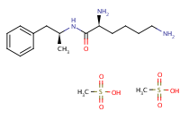
Three enantiotropically related crystalline forms of 1S-dexamphetamine dimesilate were described.
The Biopharmaceutics Classification System (BCS) Class of the drug substance was not identified; however, the solubility and permeability2 are consistent with BCS Class 3.
The literature states that the drug has a solubility of 792 mg/mL in water. No pKa was reported. The predicted values are 15.89 and 10.21. The partition coefficient in octanol/water was 1/58; LogP was reported as -1.76 (literature value: 1.06).
Synthesis of the active pharmaceutical ingredient (API) will be performed by two companies. Adequate evidence was provided of the equivalence of the quality of the API from these sites, and of finished products manufactured from API from either site.
The absence of controls over the particle size distribution was accepted in view of the relatively high aqueous solubility of the drug substance.
The limit applied in the API specification to each of the impurities found in the drug substance is consistent with ICH guidelines for finished products with a maximum recommended daily dose of ≤ 2 g/day.

Drug product
The drug products are Size 3 hard gelatine capsules, each containing LDX 30 mg, 50 mg or 70 mg (equivalent to 8.9 mg, 14.8 mg and 20.8 mg of dexamphetamine base, respectively). The philosophy in the choice of an immediate release capsule dosage form over other alternatives was not discussed. However, the original concept behind the finished product has changed somewhat with the discovery that LDX is metabolised by blood, and not in the liver or during absorption as believed during development. Lisdexamfetamine dimesilate has no stimulant activity in the prodrug state but releases dexamphetamine upon cleavage of the lactam linkage.
The 30 mg capsule is a Size 3, hard gelatine capsule with white opaque body and pink opaque lid, printed “S489” and “30mg” with black ink. The 50 mg capsule is a Size 3, hard gelatine capsule with white opaque body and blue opaque lid, printed “S489” and “50mg” with black ink. The 70 mg capsule is a Size 3, hard gelatine capsule with blue opaque body and pink opaque cap, printed “S489” and “70mg” with black ink. All 3 capsule strengths will be marketed in high density polyethylene (HDPE) bottles with child resistant closures, in pack sizes of 30. The 50 mg and 70 mg strengths are direct scales, but not the 30 mg capsule. The drug substance nominally comprises 16% weight/weight (w/w) of the 30 mg capsule contents, and 40% w/w of the 50 mg and 70 mg capsule contents. No overage is employed.
The dissolution test method conditions for this product were limited by the high aqueous solubility of the drug substance over the physiological pH range. The chosen method was shown to be discriminatory.
The potential for abuse of the finished products was adequately investigated.
A shelf life of 30 months stored below 25°C has been allocated to the capsules packaged in the HDPE bottles with the child resistant closures proposed for Australia. The limits proposed for the identified impurities controlled in the finished product specifications are consistent with, or tighter than ICH guidelines.

Biopharmaceutics
Lisdexamfetamine dimesilate is a prodrug of dexamphetamine: lisdexamfetamine dimesilate is rapidly hydrolysed to dexamphetamine along with l-lysine upon exposure to blood. For this reason, and because the absolute bioavailability of dexamphetamine is well established, the absence of an absolute bioavailability study was not pursued.
Study SPD489-111 determined the pharmacokinetics (PK), safety and tolerability of LDX administered either as a single oral dose (Regimen A), as a single intranasal dose (Regimen B) or delivered by Intelsite Companion Capsule (ICC) to one of 3 regions in the gastrointestinal tract (Regimens C, D and E). The study included 5 Dosing periods: 2 during Phase I (two-period, two sequence crossover) and 3 during Phase II (three-period, six sequence crossover). Treatments C, D and E outcomes were not reviewed by the evaluator. Other results are not presented here as intranasal delivery is not proposed.
Study NRP104-102 assessed the relative oral bioavailability of dexamphetamine and lisdexamfetamine from LDX (1x70 mg capsule) administered either with food or in solution, compared to an intact capsule under fasted state. The following outcomes were obtained:
Table 1. Relative oral bioavailability from LDX (1x70 mg capsule): dexamphetamine.
Treatment (N = 18 unless otherwise stated) | Cmax  ng/mL | AUC0-t  ng.hr/mL | AUC0-∞  ng.hr/mL
A: Fasted | 69.28 ± 14.34 | 1019.7 ± 319.8 | 1109.4 ± 314.2
B: Fed | 65.25 ± 13.36 | 972.0 ± 228.3 | 1038.4 ± 238.6
C: Solution | 68.38 ± 14.58 | 1007.1 ± 223.6 | 1073.9 ± 220.9
Statistical analysis: | ratio (%) | ratio (%) | ratio (%)
B vs A Estimate: | 94.3% | 97.5% | 95.9%
90% CI | 0.899 – 0.989 | 0.907 – 1.049 | 0.907 – 1.014
C vs A Estimate: | 98.6% | 101.3% | 99.4%
90% CI | 0.941 – 1.033 | 0.941 – 1.089 | 0.940 – 1.051
The report concluded that the area under the concentration-time curve over time zero to infinity (AUC_{0-∞}), the maximum concentration (C_{max}), AUC_{0-t} and the half life (t_{½}) of dexamfetamine are not significantly different following administration of the 70 mg capsule under three different conditions (p >0.05), and that treatment under fed conditions and in solution are bioequivalent to the treatment under fasting conditions.
The PK parameters AUC and C_{max} of dexamphetamine (and intact lisdexamfetamine; see below) were also summarised descriptively for sub-groups of men versus women with and without dose normalisation to mg/kg and are summarised below. Because of the 3 dosing conditions used in this study, the PK measure was averaged across the three treatments for each subject.
Table 2. PK parameters for d-amphetamine with and without dose normalisation to mg/kg for sub-groups (PK population).
The report concluded that systemic exposure to dexamphetamine was about the same in both men and women for AUC parameters and was about 30% higher in women (n=9) than in men (n=9) for C_{max} due to the higher dose administered to women on a mg/kg body weight basis. When the exposure parameters (AUC and C_{max}) were normalised by body weight to mg/kg, the difference in C_{max} diminished.
The following outcomes were obtained for intact lisdexamfetamine:
Table 3. Relative oral bioavailability from LDX (1x70 mg capsule): lisdexamfetamine.
Treatment | C_{max}  ng/mL | AUC_{0-t}  ng.hr/mL | AUC_{0-∞}  ng.hr/mL
A: Fasted | 47.99 ± 23.82 | 59.48 ± 28.45 | 66.86 ± 23.61
B: Fed | 26.24 ± 11.89 | 53.68 ± 17.723 | 58.81 ± 15.26
C: Solution | 45.62 ± 16.96 | 53.07 ± 16.56 | 55.10 ± 16.97
Statistical analysis: | ratio (%) | ratio (%) | ratio (%)
B vs A Estimate: | 55.8% | 93.6% | 86.7%
90% CI | 0.468 – 0.666 | 0.814 – 1.077 | 0.760 – 0.988
C vs A Estimate: | 101.2% | 93.9% | 85.5%
90% CI | 0.848 – 1.207 | 0.816 – 1.080 | 0.755 – 0.969
The report concluded that for intact lisdexamfetamine, treatments under fed conditions and in solution are not bioequivalent to the treatment under fasting conditions. In a similar sub-group analysis conducted for dexamphetamine (above), systemic exposure was about 30-40% higher in women than in men. When the exposure parameters (AUC and C_{max}) were normalised by body weight to mg/kg these differences diminished.
Study NRP104-101 compared the rate and extent of absorption and oral bioavailability of dexamphetamine and lisdexamfetamine following administration of either one or three LDX 25 mg capsules with that from two marketed reference products Adderall XR 35 mg (Shire USA) and Dexedrine 30 mg (GlaxoSmithKline), under fasting conditions.
The report found that although the oral bioavailability characteristics of the proposed LDX capsules and Dexedrine are not significantly different with regard to dexamphetamine, the two products cannot be considered bioequivalent due to differences in peak amphetamine exposure. However, overall systemic exposure and peak exposure to total amphetamine are comparable after 75 mg LDX and Adderall XR.
Study NRP104-103 was a dose proportionality study in 18 fasting children aged 6–12 years with ADHD, in which each subject ultimately received each of 3 treatments; viz., 1 x 30 mg LDX capsule, 1 x 50 mg capsule and 1 x 70 mg capsule. The dose-normalised outcomes are reproduced below.
Table 4. PK parameters following 1 x 30 mg LDX capsule, 1 x 50 mg capsule and 1 x 70 mg capsule in children (Study NRP104-103).
The study concluded (in respect of dexamphetamine) that, when dose-normalised to 50 mg, the 90% confidence intervals (CI) of ratios of geometric means of 30 mg versus 50 mg and 70 mg versus 50 mg fell within the recommended 80.00% to 125.00% limits of average bioequivalence for AUC_{0-∞}, AUC_{0-t} and C_{max}, with the exception that the 90% CI of AUC_{0-t} for 30 mg versus 50 mg (that is, 79.12% to 92.74%) were just outside of the limits. These findings suggest that for the PK population dexamphetamine concentrations arising from LDX were dose proportional in the range of 30 mg to 70 mg.
For intact LDX, the analysis of variance (ANOVA) also disclosed highly significant differences in mean AUC_{0-∞}, AUC_{0-t} and C_{max} among the doses (p<0.0001) but not for t½.
The evaluator has accepted the company’s justifications for the absence of an absolute bioavailability study and for not using a chiral bioanalytical method in conjunction with the above biopharmaceutic studies.

Evaluators conclusions on quality and biopharmaceutics
A number of questions were raised with the sponsor concerning the quality and biopharmaceutics data. Details of these are beyond the scope of the AusPAR.

Advisory committee considerations
The quality and biopharmaceutical aspects of this application were referred for advice to the 150th meeting of the Pharmaceutical Subcommittee (PSC) of the Advisory Committee on Prescription Medicines (ACPM). The outcomes were as follows:
- The PSC endorsed all the questions raised by the TGA in relation to the pharmaceutic and biopharmaceutic aspects of the submission by Shire Australia Pty Ltd to register Vyvanse hard capsules containing 30 mg, 50 mg and 70 mg of lisdexamfetamine dimesilate.
- In addition, the PSC agreed that the sponsor should be asked to:
  - Address the major discrepancy in the reported partition coefficient values for the drug substance
  - Explain why the dissolution of the drug product is less than 100% in water.
  - Provide an explanation for the high variability in individual pharmacokinetic profiles [for lisdexamfetamine]
- Address certain aspects of the PI [details of these are beyond the scope of the AusPAR]
There was no requirement for this submission to be reviewed again by the PSC before it is presented for consideration by the ACPM.

Quality summary and conclusions
The sponsor has addressed all matters raised by the TGA and PSC. Satisfactory responses were provided. Provided the PI is revised to accurately reflect the company’s responses, there is no objection to registration from a quality and biopharmaceutics perspective.

Quality recommendation
Approval is recommended from a quality and biopharmaceutics perspective.

III. Nonclinical findings

Introduction

Overall quality of the nonclinical dossier
Amphetamine, the active moiety of lisdexamfetamine (LDX = abbreviation for the dimesilate or LDX base in the nonclinical report), has been used clinically since the 1930s and there is substantial existing information relating to its pharmacology, PK and toxicology. Dexamphetamine tablets are a registered product in Australia (albeit ‘grandfathered’) for narcolepsy and hyperkinetic behaviour disorders in children. Therefore, it is appropriate that the sponsor conducted an abridged program of nonclinical studies focusing on identifying any characteristics of the prodrug that are not related to d-amphetamine. Many of the studies included a concurrent investigation of d-amphetamine sulfate (DAS) to enable a direct comparison of the effects of the prodrug and the active moiety.
A number of studies investigating Adderall were submitted to provide detailed back-up information on the effects of amphetamines. These studies as well as the mouse and rat carcinogenicity studies on d,l-amphetamine sulfate conducted by the USA National Toxicology Program (NTP) have been evaluated in full. The Adderall studies included a cytochrome P450 (CYP) enzyme inhibition study, a mouse micronucleus study, rat fertility, embryofetal development and pre- and post-natal studies, rabbit embryofetal development studies, and repeat dose toxicity studies in neonatal and juvenile rats.
Pivotal toxicity and safety pharmacology studies conducted on LDX were compliant with principles of good laboratory practice (GLP). The majority of submitted studies were conducted and presented, although in a few studies there was ambiguity with regard to the compounds and doses administered (such as whether doses referred to LDX salt, LDX base or d-amphetamine base). Since the different studies varied in the expression of doses and concentrations, the following conversion factors have been used: LDX salt (x 0.578 to its base and x 0.296 to d-amphetamine base) and DAS (x 0.735 to d-amphetamine base).

Pharmacology

Primary pharmacology
LDX per se appears to be pharmacologically inactive. Thus, it lacked affinity for the dopamine (DA) and noradrenaline (NA) transporters (DAT and NET, respectively) (study V01386M-SPD) that mediate the actions of the active moiety, d-amphetamine. LDX was tested at concentrations up to 10⁻⁵ M (33 fold the maximum concentration (C_{max}) in children at the maximum recommended dose (MRHD) (79.8 ng/mL, mean of 2 studies). Further, it was not detected in the brain (see ‘Distribution’ below).
LDX also lacked any significant affinity for 60 other receptors, ion channels and transporters tested in a NovaScreen. Thus, LDX must by hydrolysed in vivo to d-amphetamine to achieve its therapeutic efficacy. The hydrolysis of LDX also releases l-lysine which is an essential amino acid. The amount of lysine released is low (approximately 22.5 mg/day at the MRHD of 70 mg LDX compared with the daily requirement of 30 mg/kg [World Health Organization recommendation], that is, 1.5% of the daily requirement of a 50 kg person).
The active moiety, d-amphetamine, is a well-known sympathomimetic psychostimulant. Amphetamine, together with methylphenidate and atomoxetine, are (globally) the main drugs currently used to treat ADHD. Heal et al. (2008, 2009) have reviewed the in vitro and in vivo pharmacology of amphetamine, methylphenidate and atomoxetine. All exert their therapeutic effects by increasing the synaptic concentrations of the central catecholamines, DA and NA. The main action of d- and l-amphetamine is as DA and NA releasing agents, while methylphenidate is a stimulant reuptake inhibitor and atomoxetine is a classic (non-stimulant) reuptake inhibitor.
The main therapeutic action of amphetamine is release in the brain of DA, NA and (to a lesser extent) serotonin (5-HT). Thus, amphetamine enantiomers are competitive substrates for both NET and DAT and are transported into the presynaptic terminal where they displace catecholamines which are released into the synaptic cleft (Floor and Meng, 1996).
Amphetamine also delays the clearance of DA and NA from the synapse by inhibiting reuptake (by competing with the endogenous catecholamines for transfer into presynaptic terminals via NET and DAT). They also inhibit the catabolism of the catecholamines by monoamine oxidase (MAO) (Miller et al., 1980; Robinson, 1985). Amphetamine has a mechanism independent of neuronal firing rate.
The in vitro and in vivo characteristics of amphetamine, methylphenidate and atomoxetine are summarised in Heal et al. (2009).
Whilst d-amphetamine and methylphenidate are both categorised as stimulants, there are distinct differences in their mechanisms of action, including 5-HT being a target of d-amphetamine, but not methylphenidate, and methylphenidate but not d-amphetamine being firing-dependent.
Although d-amphetamine is highly effective in treating ADHD its powerful stimulant properties make it liable to recreational use (Heal et al., 2009, 2011). The concept behind the development of LDX was to achieve an increased therapeutic window with a greater separation between efficacy and unwanted psychostimulant effects compared with once-daily amphetamine or methylphenidate.
In study R3851-SPD489, orally administered LDX in male rats was shown to significantly increase extracellular DA concentrations in the prefrontal cortex and the striatum and NA concentrations in the prefrontal cortex (NA was not measured in the striatum). LDX also significantly increased concentrations of 5-HT in the striatum and, to a lesser extent, the prefrontal cortex but effects on 5-HT were less marked than those on DA and NA. Doses tested were at or below clinically relevant doses (extrapolation from PK data for male rats from study R01378M-SPD489 gives an expected AUC of 1348 ng.h/mL for d-amphetamine at the high dose of 4.5 mg/kg in study R3851-SPD489, similar to the human value of 1453 ng.h/mL in adults or 1742 ng.h/mL in children (mean of 2 studies)). In contrast, methylphenidate, also at clinically relevant doses, increased concentrations of NA and DA only but had minimal effects on 5-HT. These data are consistent with the literature data for amphetamine.
Increases in striatal extracellular DA concentrations correlated with plasma d-amphetamine concentrations following the intraperitoneal (IP) administration in rats of both LDX and d-amphetamine salt (probably DAS), as did locomotor activity (study R01878M-SPD489). d-Amphetamine time to reach maximum concentration (T_{max}) was later and C_{max} was lower following the administration of LDX than following the administration of an equimolar dose of d-amphetamine salt. Thus, LDX elicited increases in striatal extraneuronal DA concentrations that were of smaller maximal size and later in onset but more sustained than those elicited by d-amphetamine salt. LDX also elicited a lower peak of locomotor activity than d-amphetamine salt, and the peak was later in onset, consistent with a more even delivery of d-amphetamine into the systemic circulation. Thus, at equivalent doses of d-amphetamine base, LDX was less behaviourally stimulatory than d-amphetamine salt. Another study (V013987-SPD489) investigated locomotor activity after oral (oral) administration of LDX and DAS. The results were consistent with those from study R01878M-SPD489 in that peak activity count was later after administration LDX than DAS. However, in this study it is not clear why higher peak activity was observed for LDX than for DAS.
LDX was administered by the IP route in study R01878M-SPD489 because of technical problems with the oral route in rats fitted with the Culex instrument, although an oral study (R3851-SPD489) was conducted later. Limited data were provided comparing the PK of LDX and DAS after oral (n=1) and IP administration of LDX (n=5) at 5 mg/kg d-amphetamine base. The PK profiles for d-amphetamine were similar after oral and IP administration of LDX, although C_{max} of LDX was considerably lower after oral compared with IP administration.
In study R3851-SPD489, in male rats given various doses of oral LDX, significant increases in extracellular levels of NA and DA in the prefrontal cortex and of DA in the striatum were observed at doses (expressed as d-amphetamine base) that did not significantly increase locomotor activity. Thus, LDX doses which did not affect locomotor activity (0.5 mg/kg) or resulted in small, non-significant increases (1.5 mg/kg) elicited respective increases in prefrontal cortex NA concentrations of up to 205% and 206% (of baseline) and DA concentrations of up to 82% and 154%, and respective increases in striatal DA concentrations of up to 56% and 144% (striatal NA concentrations not measured). There were also significant increases in 5-HT in the striatum at 1.5 mg/kg (up to 168% of baseline). The substantial increases in brain NA and DA concentrations in the absence of substantial increases in locomotor activity suggest that LDX will have some separation between its therapeutic effects and potential adverse stimulatory effects. The C_{max} of d-amphetamine expected clinically (90 ng/mL in adults and 144 ng/mL in children (mean of 2 studies)) lies below that expected at the dose of 4.5 mg/kg (233 ng/mL extrapolated from data for male rats from study R01378M-SPD489) which elicited a significant increase in locomotor activity in rats.
LDX also elicited reductions in the DA metabolite, 3,4-dihydroxyphenylacetic acid (DOPAC), in the striatum and prefrontal cortex, possibly reflecting reductions in DA turnover and/or dopaminergic neuronal firing rate, but these were not significant at 0.5 or 1.5 mg/kg. Concentrations of homovanillic acid (HVA), a further metabolite of DA, were also reduced in the striatum, but there were no changes in HVA in the prefrontal cortex.
In a juvenile rat model of impulsivity of relevance to ADHD, LDX in a clinically relevant oral dose range (see above calculations) of 4 and 16 mg/kg (1.18 and 4.7 mg/kg d-amphetamine base) and 3 mg/kg DAS (2.2 mg/kg d-amphetamine base) significantly reduced impulsivity tested 1 h post dose. By 24 h post dose, impulsivity was not affected as might be expected from kinetic data.

Secondary pharmacodynamics and safety pharmacology

Secondary pharmacodynamics
As noted above, LDX at 10^{-5 M} (about 33 fold the C_{max} in children at the MRHD) showed little or no binding to a wide range of receptors, ion channels, enzymes, allosteric binding sites and transporters in an in vivo NovaScreen.
In several studies, oral administered LDX over a range of dose levels (2-32 mg salt/kg) was tested in murine models of antidepressant activity (behavioural despair test), anxiolytic activity (light/dark box test) and stimulant or sedative activity (activity metre test), with drug administered oral 1-1.5 h prior to the test. LDX (often at several dose levels) was also given concomitantly with oral doses of various other drugs, mostly antidepressants (escitalopram, venlafaxine, sertraline, duloxetine and fluoxetine, bupropion and guanfacine). The other test drugs were given at various dose levels around the minimally effective range. In some (but not all) studies, LDX showed antidepressant activity, mainly at 32 mg/kg. LDX showed only weak anxiolytic activity at 32 mg/kg, but not at lower doses (1-16 mg/kg). These doses are above the clinically relevant dose, so LDX would not be expected to have antidepressant or anxiolytic activity in patients. Some combinations of LDX and the other test drugs showed significant differences compared to both individual drugs alone. It can be concluded that at certain doses, LDX may augment the antidepressant efficacy of escitalopram, sertraline and bupropion, but not venlafaxine, fluoxetine or duloxetine.
When given concomitantly with escitalopram, venlafaxine and guanfacine, of which only escitalopram (8 mg/kg) showed anxiolytic activity when administered alone, there was no clear evidence that the combinations with LDX had anxiolytic activity.
LDX and DAS were consistently found to reduce food intake and body weights, both after single and repeated doses in the secondary pharmacology studies designed to investigate this effect in detail as well as in many of the single and repeat dose toxicity studies, particularly after the initial dose and at the higher dose levels. Over the (clinically relevant) dose range 0.5–5 mg/kg oral (d-amphetamine base; single dose), LDX and DAS dose-dependently reduced food and water intake in male rats over 0-6 h post dose (study R2259M-SPD489). The effects tended to mirror the plasma PK profile of d-amphetamine concentrations after the administration of both drugs, with DAS having more marked effects than LDX over the earlier time periods. DAS also had a slightly more marked cumulative effect over the 6 h (50% effective dose (ED₅₀) 2.35 mg/kg for DAS and 2.72 mg/kg for LDX). Effects on body weight over the 24 h post dose were also more marked for DAS than for LDX. In another study (R2517M-SPD489) investigating the ‘behavioural satiety sequence’ in male rats offered wet mash for 2 h starting 2 h after dosing, food intake was significantly reduced at the highest doses tested (by 55%, 3.95 mg/kg LDX; by 57%, 3.56 mg/kg DAS (oral doses expressed as d-amphetamine base)). Satiety sequence assessment generally revealed decreases in feeding, grooming behaviour and resting, and increases in locomotor activity following administration of both drugs. Appetite suppression and weight loss are well known clinical effects of stimulant medications (from the sponsor’s Clinical Overview).
In a 28 day study (R2847M-SPD489) in dietary-induced obese female rats, LDX over the range 1.6-6 mg/kg/day (d-amphetamine base, given twice daily) also dose-dependently reduced food intake, mainly during the first week, with ‘satiety sequence’ assessment results being similar to those described above. There were significant reductions in leptin, but no changes in insulin, cholesterol or non-esterified fatty acids. Body weight loss was due to a loss of fat, with protein (g/rat) unaffected. These changes in humans may be beneficial rather than adverse, provided effects on body weight are not excessive.

Dependence potential
Six studies were undertaken to investigate the potential for LDX to induce dependence. One study was an examination of clinical signs at the high doses in the 4 week rat and dog and 26 week rat repeat dose toxicity studies, particularly focusing on those observed following the cessation of dosing. The clinical signs observed following withdrawal of treatment were not indicative of signs of physical dependence. The remaining 5 studies (3 in rhesus monkeys and 2 in rats) utilised drug discrimination models which evaluated whether the subjective effects of test compounds are likely to make them have the potential for abuse in humans.
As expected given its metabolism to d-amphetamine, LDX showed partial to full d-amphetamine-like discriminative stimulus effects in both monkeys and rats trained to discriminate d-amphetamine from saline. Doses were clinically relevant (although no PK data for LDX are available for the rhesus monkey. The highest intragastric dose tested, 10 mg salt/kg, corresponds to about 2.6 fold the MRHD based on a mg/m² calculation (120 mg/m² for the monkey (using a conversion factor of 12) and 46.2 mg/m² for a 50 kg person)). In monkeys, LDX was estimated to be about 4.6 fold less potent on a molar basis than DAS (ED₅₀ values 1.73 and 0.15 mg salt/kg, respectively; a ratio of 4.6 (0.51/0.11) calculated on d-amphetamine base), while in rats, it was estimated to be 3 fold less stimulant than d-amphetamine, assuming that both drugs were tested at their true T_{max}.
In monkeys trained to discriminate subcutaneous (SC) flumazenil (given after diazepam) or midazolam from vehicle, LDX, at doses up to 1 or 5.6 mg salt/kg in the respective studies, did not substitute for the midazolam or flumazenil, suggesting that LDX does not act at benzodiazepine receptors. In monkeys trained to self administer cocaine, intravenous (IV) LDX had dose-related reinforcing effects at 0.03 and 0.1 mg salt/kg but was without effect at 0.01 mg/kg. In contrast, IV LDX was not found to be reinforcing at clinically relevant doses (up to 1 mg d-amphetamine base/kg) in male rats trained to self administer cocaine. DAS was not tested in these studies.
In summary, the nonclinical investigation of dependence potential suggest that LDX has a lower potential for inducing dependence than DAS, as might be expected from differences in the PK profiles for the two drugs.

Safety pharmacology
Safety pharmacology studies included cardiovascular assessment in open-chested, anaesthetised dogs, respiratory assessment in anaesthetised guinea pigs and investigation of the effects of LDX on cloned human Ether-à-go-go Related Gene (hERG) currents. Although a CNS study was not conducted, effects on behaviour were well described in other studies, particularly the toxicity studies. When both compounds were investigated, the clinical signs observed following administration of LDX were similar to those following administration of DAS. The effects of d-amphetamine on the CNS have been published (Moscardo et al., 2007, Irwin’s screen in rats and mice; Himmel, 2008, comparison of CNS effects in juvenile and adult rats; Gauvin and Baird, 2008, functional observation battery in rhesus monkeys; and Tontodonati et al., 2007, neurobehavioural assessment in dogs).
Although DAS had a weak inhibitory effect on hERG current (concentration causing 25% inhibition (IC₂₅) 31 µg/mL), LDX had no effect when tested at approximately 50 µg LDX base/mL (about >600 fold expected C_{max} concentrations of LDX at the MRHD in children (79.8 ng/mL)). Cardiovascular effects of IV LDX in the dog mirrored those of DAS (most notably, increases in blood pressure (BP), heart rate (HR), left ventricular pressure (LVP) and change in pressure over time (dP/dt, a measure of contractility) but at approximately equimolar doses these effects were less marked and occurred later, as might be expected from the kinetic profiles of d-amphetamine following administration of the two compounds IV. The changes observed might be expected in patients since doses used in this study would be expected to result in plasma d-amphetamine C_{max} concentrations similar to or less than those at the MRHD in patients (clinical C_{max} 90 ng/mL in adults and 144 ng/mL in children; high dose of 5 mg LDX base/kg (8.65 mg salt/kg) in dog study would give a C_{max} of about 41 ng/mL extrapolating from a C_{max} of 33 ng/mL for an IV dose of 7 mg salt/kg (study no. D01282-SPD489)). This is an expected result as stimulants are known to increase BP and HR (from the sponsor’s Clinical Overview and PI for dexamphetamine tablets). Electrocardiograms (ECGs) revealed sinus tachycardia at the high dose in this study, as was also seen with a similar dose of DAS. There were no effects of treatment on ECGs in the 4 week dog study or the 26 week juvenile dog study.
In the respiratory study in guinea pigs, DAS was not concurrently examined, but LDX at 1, 5 and 7.5 mg/kg IV (as LDX base) elicited small but significant increases in respiratory rate (up to 45%) and minute volume (up to 51%) at all doses. The guinea pig doses correspond to 12, 61 and 91 mg/m² (using a conversion factor of 7) which cover the human value 46 mg/m² in a 50 kg person but these calculations do not take account of oral bioavailability in humans and different hydrolysis for IV compared with oral routes. An increase in respiratory rate is a known effect of amphetamines, although it was not a common adverse event in clinical trials (Clinical Overview).
In the two in vivo safety pharmacology studies with IV administration the peak effects were delayed rather than immediate which is consistent with delayed release of d-amphetamine from LDX.

Pharmacokinetics

Absorption
The intestinal permeability of LDX and its carrier-mediated transport was investigated in a number of studies including an intestinal perfusion model in rats and in vitro studies using human epithelial colorectal adenocarcinoma cells (Caco-2 cells). In vitro studies using Chinese hamster ovary (CHO) cells expressing peptide transporters were also conducted given that LDX has a peptide bond.
In the single pass intestinal perfusion model, the rate of disappearance of LDX from the perfusate in each intestinal segment was too small to measure. d-Amphetamine was observed in the perfusate at different concentrations in the different intestinal segments, suggesting that some LDX was converted to d-amphetamine by surface intestinal enzymes before LDX was absorbed. It was also observed that there were some differences in activity of these enzymes between intestinal segments. The much higher concentrations of LDX or d-amphetamine in plasma after perfusion of the duodenum, jejunum and ileum compared with the colon is consistent with peptide transporter 1 (PEPT1) playing a role in intestinal transport of LDX or d-amphetamine as PEPT1 is highly expressed in the brush border of the former segments in the rat, but not the colon (Rubio-Aliaga and Daniel, 2008).
LDX was hydrolysed by Caco-2 cells, since after addition of LDX to the apical chamber, both LDX and d-amphetamine were found in the basolateral chamber. In Caco-2 cells, LDX appeared to be actively transported by peptide transporters, as glycylsarcosine (a typical substrate for peptide transporters) inhibited the transport of LDX or d-amphetamine across the Caco-2 cells. Further, the apparent permeability of LDX and d-amphetamine across the Caco-2 cells decreased with increasing concentrations of LDX over the range 0.01 to 1 mM suggesting saturation of LDX transport. The transport of LDX was increased when Caco-2 cells were incubated with glycylsarcosine to induce PEPT1. However, LDX transport was not quantitatively sufficient for detection by patch clamping in Xenopus laevis oocytes transfected with human PEPT1 or rabbit PEPT2, and LDX only interacted with human PEPT1 (the transporter active on the apical membrane of enterocytes and important in the intestinal absorption of drugs) and PEPT2 (which is mainly active on the apical membranes of the proximal tubule and the choroid plexus epithelial cells and plays a role in renal reabsorption and lowering CNS penetration of drugs) expressed in CHO cells at relatively high concentrations (50% inhibitory concentration (IC₅₀) 4.1 mM and 246 µM, respectively). In conclusion, evidence was provided that LDX is transported by PEPT1 and PEPT2 although only at relatively high concentrations (although these might be achieved in the small intestine after an oral dose of LDX).
The PK profile of LDX and d-amphetamine is consistent with the characteristics of a prodrug that is converted to a pharmacologically active moiety by a rate-limited enzymatic degradation. Thus, in rats, d-amphetamine T_{max} was later (about 1.5-3 h compared with 0.25-1.5 h) and C_{max} values were lower after the oral administration of LDX than after the administration of an equivalent molar dose of DAS at doses up to 6 mg d-amphetamine base/kg (study R01378M-SPD489). Toxicokinetic data for the repeat dose rat and dog toxicity studies showed similar trends, although the reduction in C_{max} was more apparent in the single dose study than in the repeat dose studies, probably because of a larger number of samples at early time points in the former. These trends were also apparent in rats in primary pharmacology study R01878M-SPD489 after IP administration, in study R01378M-SPD489 after IV administration in rats, and in study D01282-SPD489 after IV administration in dogs. Further, the T_{max} of d-amphetamine was delayed at high oral doses of LDX in rats (study R01378M-SPD489) and a similar trend was seen in the toxicokinetic data for the 1 and 4 week rat and the 4 week dog repeat dose studies.
AUC values of d-amphetamine following oral administration of LDX were comparable to those following administration of DAS, at least at doses up to 6 mg d-amphetamine base/kg (study R01378M-SPD489; and toxicokinetic data for 4 and 26 week rat and 4 week dog studies). In the single dose study, at higher doses of DAS (12 and 60 mg/kg), there appeared to be saturation of d-amphetamine clearance as AUC values increased supra-proportionally with dose. In contrast, AUC values for d-amphetamine following administration of LDX increased dose proportionally and this was also generally observed in the repeat dose toxicity studies (in both rats and dogs), although there was some evidence of supra-proportionality in rats at doses ≥80 mg salt/kg/day. These results suggest that the gradual release of d-amphetamine following hydrolysis of LDX avoids the higher concentrations of d-amphetamine at which clearance is saturated.
In summary, the rate-limited hydrolysis of LDX to d-amphetamine limits the rapid release of a d-amphetamine bolus as occurs following oral administration of DAS or mixed amphetamine salts.
Plasma LDX concentrations following oral administration of LDX in rats did not show a linear increase with dose in a number of studies, with a trend for supra-proportional increases with dose, probably reflecting saturation of the hydrolysis step, although in study R01378M-SPD489 there was a sub-proportional increase at the highest dose tested which may reflect saturation of absorption. At the doses used in dogs, the relationship was broadly dose proportional.
Conversion of LDX to its components, d-amphetamine and l-lysine, appeared to be due to the hydrolytic activity of red blood cells (RBCs). Thus, LDX was rapidly converted to d-amphetamine in rat blood (study V01258M-SPD489) and human blood (study V01257M-SPD489), with RBCs being the hydrolytically active fraction of human blood (study V01553-SPD489), showing hydrolytic activity even at low haematocrits (study V01624M-SPD489). Human and rat liver hepatocytes lacked hydrolytic activity (study V01373M-SPD489). The data from study R01259M-SPD489 in which d-amphetamine/LDX AUC ratios were greater in systemic plasma (3.4) than portal plasma (0.9), and estimated high hepatic extraction ratio of LDX (0.90) after oral administration of LDX in the rat, suggest that some conversion occurs in the liver, although this may reflect conversion of LDX to d-amphetamine in portal and liver blood, probably resulting in an overestimation of hepatic extraction of LDX. The AUC ratio of d-amphetamine:LDX after oral administration of LDX was higher than after IV administration of an equivalent dose (study R01378M-SPD489 in rats (5.5 compared with 0.1) and study D01377-SPD489 in dogs (2.3 compared with 0.7)). These ratios for the oral and IV routes were broadly consistent with those for other studies (study R01374M-SPD489 and D01282-SPD489 and the repeat dose toxicity studies). There was no evidence for hydrolysis in simulated gastric or intestinal fluid (study V01625M-SPD489), but evidence for substantial hydrolysis by gut mucosal cells (studies V01442M-SPD489, V01623M-SPD489, R01443M-SPD489). Collectively, these data suggest hydrolysis of LDX by the gut mucosal cells and the RBCs in the portal system, but not by hepatocytes.
LDX was extensively and rapidly absorbed (see ‘Excretion’ below) after oral administration in the rat. T_{max} was 0.17 (first sampling time) to 1.5 h at doses up to 40 mg/kg in rats and 0.5-1 h in dogs (values from pharmacokinetic studies, similar values in repeat dose studies). Clearance was rapid, and half life was short in both species, as LDX was relatively rapidly converted to d-amphetamine (in rats: t_{1/2} of LDX about 1 h; in dogs: t_{1/2} of LDX <1 h). The half life in humans was similar (<1-2 h), although T_{max} for d-amphetamine tended to be slightly later in humans (3-7 h) than in the laboratory animal species (see above). An exact value for clearance could not be calculated in rats because of insufficient PK data, but clearance was estimated as 2.09 L/h/kg in dogs. Volume of distribution was moderate in the dog (0.7 L/kg, approximating total body water), but again could not be calculated in rats.
Accumulation with repeated dosing was not observed in dogs (either adults or juveniles) for either d-amphetamine or LDX. In adult rats, there was a trend for AUC values to increase with time for both d-amphetamine and LDX in the 4 week and 6 month studies, but it was not marked. In contrast, in juvenile rats, AUC values for both d-amphetamine and LDX clearly decreased over time which suggests some changes in absorption and/or metabolism with maturation.
Sex differences were not observed in dogs, but in (mainly adult) rats, AUC values for both d-amphetamine and LDX were generally higher in females than in males.
There were quite marked interspecies differences in the AUC ratio of d-amphetamine to LDX for humans, rats, dogs and rabbits, presumably reflecting differences in the rates and extent of hydrolysis of the amide bond in LDX, as well as differences in the rates and extent of metabolic conversion of d-amphetamine to its metabolites. Mean ratios of d-amphetamine/LDX AUCs for 3 human studies was about 19.4, compared with about 5.7 for 4 week and 6 month rat studies, about 2.6 for the 4 week dog study, and about 1.3 for the rabbit embryofetal development study.
Some studies were conducted using the intranasal route as this route was investigated as a potential route in humans. They are not discussed here because this route is not a proposed clinical route in the current submission.

Distribution
Plasma protein binding and standard distribution studies were not conducted, which is acceptable given the nature of the drug. The distribution of d-amphetamine into the brain was studied after oral administration of LDX and DAS (each at 1.5 and 5 mg/kg d-amphetamine base). This was an appropriate focus. LDX was not detected in brain at either dose. In contrast, brain or serum ratios of d-amphetamine were about 6 after both doses of each compound. Peak d-amphetamine concentrations in the brain were observed at 1 h post dose (first sampling time), coincident with peak serum concentrations.

Metabolism
In order to determine which tissues and enzymes might be involved in its metabolism, LDX was incubated in vitro (1-4 h) with various tissues and enzymes, and LDX and d-amphetamine were then measured. These studies were valuable in revealing the site in the body of LDX hydrolysis and some of the results have already been discussed above.
LDX was found to be stable in incubations with rat and human plasma, pancreas homogenates and hepatocytes, human liver microsomes, simulated gastric and intestinal fluids, human colon contents, trypsin, dipeptidyl peptidase IV, cathepsin G and elastase, and showed minimal degradation in incubations with human peripheral blood mononuclear cells and polymorphonuclear cells, and rat and human small intestinal homogenates. Hydrolysis observed in rat and human liver and kidney homogenates was probably due to the presence of blood, while hydrolysis observed in rat caecal contents was probably bacterial.
In vivo metabolism studies were conducted in rats (R01375M-SPD489) and humans (NRP104.106), but metabolism was not characterised in dogs (the other species used in the repeat dose toxicity studies). The investigation in a single laboratory animal species is acceptable, given the information available in the literature on the metabolism of amphetamine, and also in light of its limited target organ toxicity. In both rats and humans, LDX was rapidly and extensively metabolised to amphetamine and amphetamine-derived metabolites. In rats, LDX was below the quantitation limit (BLQ) in plasma by 1 h following oral administration and by 3 h following IV administration, while in humans it was BLQ by 4 h in 5 of 6 subjects and by 8 h in the remaining subject. In rats, unchanged drug accounted for only 4.8% of urinary (0-24 h) radioactivity and was not detected in faeces, while in humans, it accounted for only 2.2% of the dose in the 0-48 h urine sample. These results suggest extensive hydrolysis of LDX in both humans and rats.
As expected, LDX was hydrolysed to release d-amphetamine in both humans and rats. Other than d-amphetamine, M2 (a hydroxylated metabolite of LDX) was the only metabolite directly derived from LDX and was observed in rat, but apparently not in human, matrices. However, even in rats, it was a minor metabolite, being only observed in plasma following IV administration, and accounting for <1% of radioactivity in urine after oral administration.
It is known from the literature (Green et al., 1986) that there are species differences in the metabolism of amphetamine, and the table below (source: National Toxicology Program Center for the Evaluation of Risks to Human Reproduction monograph, NIH Publication No. 05-4474, entitled ‘NTP-CERHR Monograph on the Potential Human Reproductive and Developmental Effects of Amphetamines’) tabulates some differences in urinary metabolites between species.
Table 5. Comparison of amphetamine metabolites in various species.
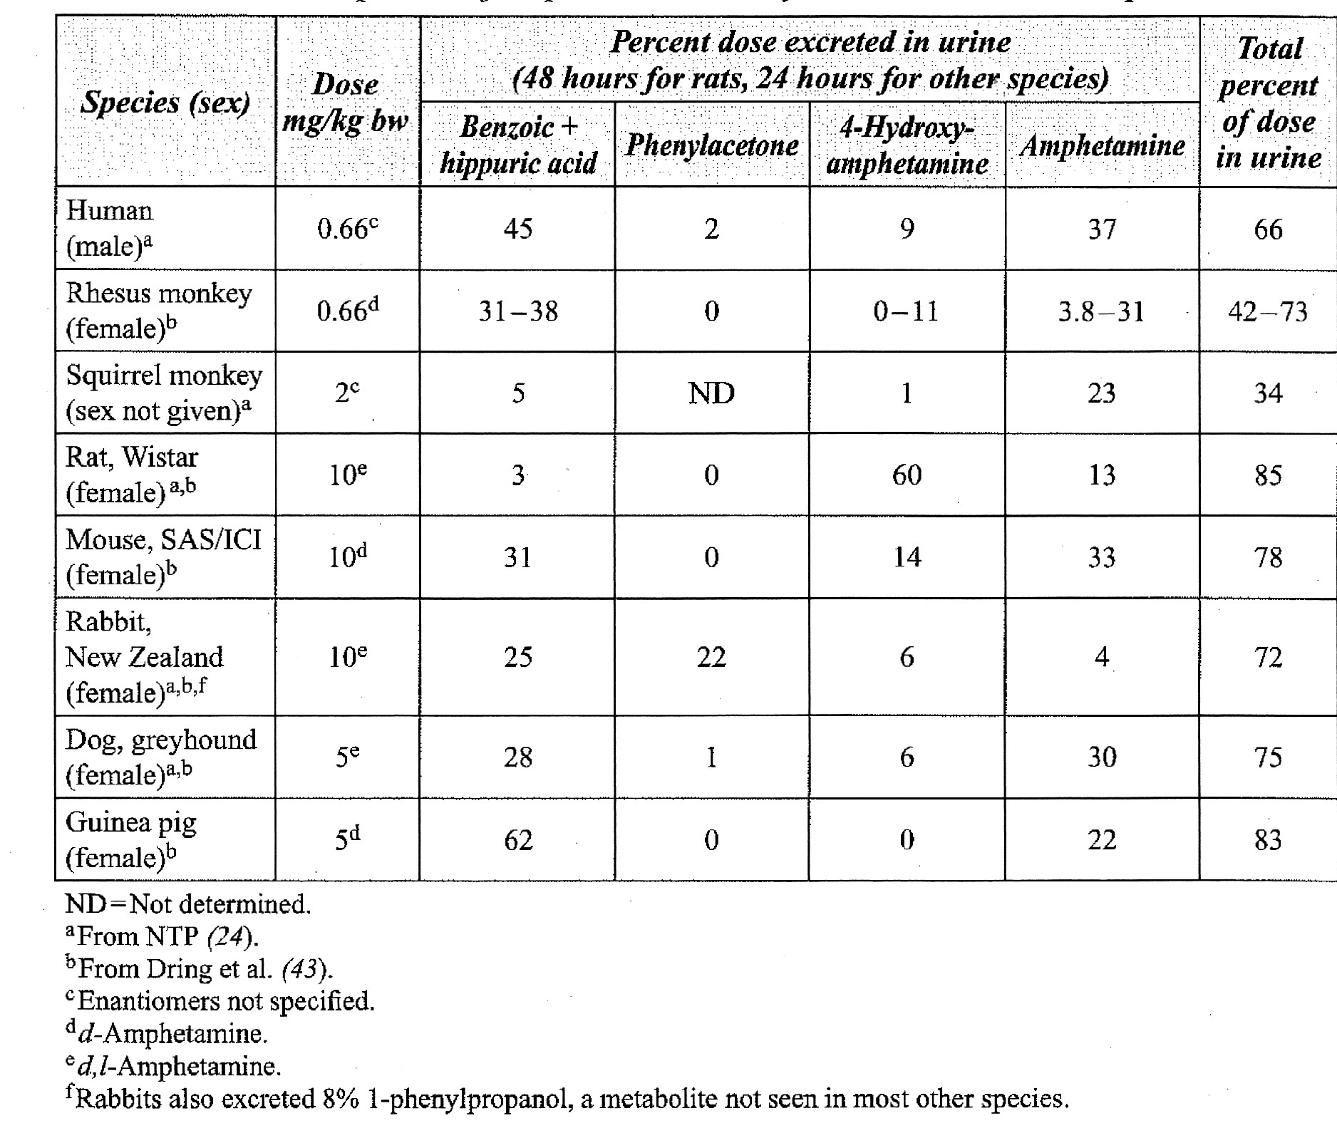
Data from the submitted studies revealed both qualitative and quantitative differences in metabolites between rats and humans, due to differences in amphetamine metabolism between the two species. Consequently, the proposed metabolic pathways in rats and humans show some notable differences. Amide hydrolysis of LDX was obviously common to both species, but in rats, a more extensive range of amphetamine metabolites was observed than in humans. Aromatic hydroxylation of amphetamine predominates in rats and deamination predominates in humans. Glucuronidation is a significant metabolic process in rats but not in humans, and a number of minor metabolites in rats are acetylation products, but this does not appear to be the case in humans. Thus, in human urine (0-48 h), the predominant metabolites were d-amphetamine and hippuric acid (accounting for approximately 40% and 25% of the administered dose, respectively) and there were 2 other minor metabolites (benzoic acid and an unidentified metabolite); both hippuric acid and benzoic acid are products of deamination. In contrast, in rat urine, there were 14 metabolites after oral administration, with a glucuronide conjugate of 4-hydroxy-d-amphetamine (a p-hydroxylation product), followed by d-amphetamine being the major metabolites (accounting for 29.8% and 13.6% of 0-24 h urinary radioactivity, respectively). Hippuric acid was detected in rat urine but accounted for only 2.1% of 0-24 h urinary radioactivity. Benzoic acid was not observed in any matrix in rats. Norephedrine, a human metabolite, was detected in rats but was not quantified in any matrix.
The dominant circulating metabolite in humans was d-amphetamine, while in rats the dominant circulating metabolites were d-amphetamine and M3, a glucuronide of a 4-hydroxy-d-amphetamine, with M3 being the major circulating metabolite at ≥3 h post oral administration. d-Amphetamine and M3 together accounted for a large proportion of metabolites in rat plasma at >0.5 h after oral administration and at >1 h after IV administration.
Given that the bond in LDX between d-amphetamine and lysine is an amide bond, CYP enzymes would not be involved in its hydrolysis. In contrast, amphetamines undergo extensive hepatic metabolism largely by the P450 system (in particular, CYP3A4 and 2D6 (Meyer et al., 2009)).

Excretion
In both humans and rats, the predominant route of excretion after oral administration of ¹⁴C-LDX was urine, which is consistent with the known major route of excretion of amphetamines. In humans, 96.4% of the administered dose was recovered in 0-120 h urine and less than 0.3% in 0-120 h faeces. In rats, 77.2% of the administered dose was recovered in 0-168 h urine in males and 86.9% in females, while faeces accounted for 11.1% of the dose in males and about 4.7% in females. Elimination of radioactivity was rapid, with 82% excreted within 48 h in rats.
Biliary excretion over 48 h in bile duct cannulated rats was estimated at 18.3% and 7.2% of the oral dose in males and females, respectively. Biliary excretion was comparable to faecal excretion in intact rats which suggests that faecal excretion was largely due to biliary excretion rather than unabsorbed drug.

Pharmacokinetic drug interactions
Together, two CYP enzyme inhibition studies investigating LDX covered the major CYP isozymes. One study (V01371M-SPD489), using concentrations up to 100 µM, investigated direct inhibition of CYP1A2, 2A6, 2B6, 2C9, 2C19 and 2D6, and direct, time- and metabolism-dependent inhibition of CYP3A4, while the second study (V4308M-SPD489), using concentrations up to 50 µM, investigated direct, time-dependent and metabolism-dependent inhibition of CYP2C8. These concentrations of LDX are well above maximum plasma concentrations expected clinically (about 330 fold and 165 fold, respectively, the C_{max} of LDX in children at the MRHD) and minimal CYP enzyme inhibition was observed (≤13% in the first study and <10% in the second study).
LDX would be expected to be stable in the presence of human liver microsomes (study V01373M-SPD489). Study V4308M-SPD489 investigated potential for direct inhibition of CYP2C8 by d-amphetamine (at concentrations up to 50 µM) as well as by LDX and a third study (V00635-SLI3831) investigated direct inhibition of CYP2A1, 2C9, 2C19, 2D6 and CYP3A4/5 by d-, l- and d,l-amphetamine at concentrations up to 20 µM (for d-amphetamine). d-Amphetamine showed no inhibition in study V4308M-SPD489 and minimal (<11%) inhibition in study V00635-SLI3831. The 20 µM concentration of d-amphetamine is nearly 20 fold the C_{max} in children at the MRHD.
LDX, at concentrations up to 100 µM, was also examined for interactions with a range of human and rat membrane transporter proteins (organic anion transporters (OATs), organic anion-transporting polypeptide (OATPs), organic cation transporters (OCTs) and sodium-taurocholate cotransporting polypeptide (NCTPs)) stably expressed in CHO and cultured kidney MDCKII cells. It showed only weak inhibition (28-40%) of human OATP2B1, OCT1 and OCT3 transporters.
LDX and d-amphetamine were not investigated for interactions with P-glycoprotein, but results of a study in wild-type and p-glycoprotein knockout mice (Zhu et al., 2006) suggested that d-amphetamine was not a P-glycoprotein substrate or inhibitor. The potential for hepatic enzyme induction was not investigated.
The above studies taken together do not indicate any major potential for LDX to have drug interactions in clinical use.

Toxicology

Acute toxicity
Acute toxicity studies were conducted in rats and dogs and were of an exploratory nature rather than of the standard design. This is acceptable given the bridging nature of the nonclinical investigations. All studies included both sexes.
The study in rats used the clinical route (oral), with doses up to 1000 mg/kg (salt). Clinical signs were recorded but not body weights. The study observation period was only 7 days. Necropsy was only conducted on the rat that died during the observation period. Acute toxicity was low, with the maximum non-lethal dose being 100 mg/kg. One of 3 females at 1000 mg/kg died and necropsy findings included distended stomach and intestines and enlarged adrenal gland. One of 3 males at 1000 mg/kg was sacrificed due to skin lesions (whether these were due to self mutilation was not noted).
Two studies in dogs were conducted: a dose escalation study up to 24 mg salt/kg oral IV (with emesis being dose limiting) and a comparison study of LDX and DAS at a single IV dose level (7 and 3 mg salt/kg, respectively, approximately 2.1 mg d-amphetamine base/kg in both cases). There were no deaths in either study. There were no gross pathology findings in the first study; necropsy was not conducted in the second. Clinical signs observed in these studies were consistent with effects of d-amphetamine and were similar to those seen in the repeat dose studies (discussed below).
The LDX mouse micronucleus test also included an oral dose range finding study with a 3 day observation period at oral doses up to 2000 mg salt/kg. The maximum non-lethal dose was 200 mg/kg in females, but was not determined in males because of deaths at the lowest dose tested (200 mg/kg). Hyperactivity was observed at all doses.
The maximum non-lethal oral dose of LDX was about 100-200 mg salt/kg in rats and mice. This suggests LDX has a lower lethality than d-amphetamine since in published studies oral dose of DAS of 55 mg/kg (rats) and 24 mg/kg (mice) were lethal to 50% of the study group (Behrendt and Deininger, 1963). The difference in lethal potency between LDX and d-amphetamine may be due to the slower rate of release of d-amphetamine from LDX or saturation of LDX absorption, particularly at high doses.

Repeat-dose toxicity

Adults
In adult animals, repeat dose toxicity studies with LDX of up to 6 months duration were conducted in rats and of up to 4 weeks in dogs. The pivotal studies were GLP compliant and used the oral (clinical) route with once daily dosing, except for a 2 week intranasal study in dogs. Although the studies submitted did not conform to requirements specified in ICH guidelines for a new chemical entity, this is acceptable given the bridging nature of the nonclinical dataset.
There were no treatment-related mortalities in dogs, while mortalities in rats were largely indirect (associated with self mutilation/hyperactivity). Clinical signs were observed in almost all toxicity studies (single dose, repeat dose, mouse carcinogenicity and reproductive toxicity) in all species tested and in both sexes. Clinical signs were broadly consistent with effects that could be ascribed to the release of d-amphetamine and are considered exaggerated pharmacological effects. The main clinical sign, increased activity, was seen in all dose groups in all repeat dose toxicity studies in both rats and dogs. Other clinical signs in rats included excessive salivation (observed in all dose groups in the 26 week study), piloerection and behavioural changes (jumping and licking). In the 1 and 4 week studies at the higher doses, self mutilation was observed and was of sufficient severity to warrant euthanising some animals, particularly females. Except for self mutilation, similar findings were observed in the d-amphetamine/DAS groups that were included in the 4 and 26 week studies (at equimolar doses). Self mutilation was, however, observed with Adderall in the rat reproductive toxicity studies (fertility, embryofetal development and pre- and postnatal development studies). In dogs, other clinical signs included increased salivation, behavioural changes (restlessness, excessive licking, pacing in cage, head shaking circling, facing the back of the cage, and decreased activity (predose)), abnormal gait and stance, panting, emesis, soft stool, dry mouth, ocular discharge, vessels over the sclera and squinting of the eyes. Similar findings were observed in the DAS group that was included in the 4 week study.
Decreased body weight gain, and at higher doses, body weight loss, were consistent findings in both rats and dogs (both sexes), being observed in all repeat dose studies, and were dose limiting. Decreased body weight gain was associated with reductions in food consumption in some, but not all, instances, with hyperactivity likely contributing. In the 26 week rat study, significant decreases in body weight gain were observed at the low dose (20 mg salt/kg/day; exposure ratio (ER) 1.2/2.3 and 6/9 (males/females) for d-amphetamine and LDX, respectively), while in the 4 week dog study, they were observed at the mid dose (6 mg salt/kg/day; ER 0.9 and 7 for d-amphetamine and LDX, respectively). The anorectic effect of amphetamines is well known clinically and has already been discussed (see ‘Secondary pharmacodynamics’ above).
There were no changes in haematological or clinical chemistry parameters that were considered of toxicological significance in either rats or dogs. There were no treatment-related changes in organ weights or gross or histopathological findings in either rats or dogs. No effect of treatment was evident in ophthalmological examinations or urinalysis.
Ricaurte et al. (2005) conducted studies in baboons (n=3) and squirrel monkeys (n=4) that suggested that amphetamine, at clinically relevant concentrations, can damage dopaminergic nerve endings. A 3:1 mixture of d- and l-isomers was given orally twice daily for 4 weeks (self administered to the baboons or by gavage to the monkeys) at escalating doses that achieved plasma concentrations of 168 ng/mL in the baboons (another set of 3 animals) and 125 ng/mL in the monkeys at the end of the dosing period. These amphetamine concentrations are similar to the d-amphetamine C_{max} expected clinically at the MRHD of LDX (90 ng/mL in adults and 144 ng/mL in children). Two to 4 weeks after cessation of treatment, the baboons showed significant reductions in striatal DA concentration, density of DAT sites, amount of DAT protein and the number of type 2 vesicular monoamine transport (VMAT) sites, and about 2 weeks after cessation of treatment, the monkeys showed significant reductions in striatal DA concentration and the VMAT sites, although the reduction in density of DAT sites was not significant. While the repeat dose toxicity studies did not reveal toxicity to the CNS, and endpoints beyond the standard endpoints were investigated in the pivotal juvenile rat study, examinations did not extend to the level of detail (dopaminergic neurotoxic changes) as those of the Ricaurte et al. (2005) paper. The clinical relevance of the findings by Ricaurte et al. (2005) is unclear.

Juvenile animals
Studies on LDX were conducted in juvenile rats (8 weeks duration) and dogs (26 weeks duration), with both studies preceded by dose range-finding studies. Additionally, in rats, an 8 week study was conducted with Adderall (also preceded by a dose range-finding study). Rats were neonates (7 days of age) at the start of the study, and dogs were 10 weeks of age. The pivotal studies were GLP compliant, used the oral (clinical) route, used appropriate dose levels and were well conducted. The endpoints investigated were extensive and appropriate, focusing on physical, neurological and reproductive development. Thus, in addition to standard endpoints, the juvenile studies in both rats and dogs included indicators of physical development (crown-rump length in rats, and length and height in dogs), developmental indicators (vaginal opening and preputial separation in rats), and behaviour and neurological development (including functional observation battery in both species, and a neurological examination in dogs). Effects on reproductive development and function included a second generation assessment in rats, and hormone measurements and examination of sperm in dogs. Additionally, in rats, endpoints included learning (water maze).
As in adult animals, the main effects were reductions in body weight gain and clinical signs (exaggerated pharmacological activity), observed in both rats and dogs. An increase in time to vaginal opening in rats is consistent with a delay in maturity associated with reductions in body weight. Given the known effect of this drug class on growth, significant reductions in crown rump length in rats were not unexpected (significant reductions consistently observed at the high dose (ER 2.2 for d-amphetamine and 5 for LDX), but also observed in males at the low dose (ER 0.2 for d-amphetamine and 0.3 for LDX)). Reductions in height and length in dogs were not significant (ERs up to 1.5 for d-amphetamine and 23 for LDX). Other endpoints were not affected. As in adults, there did not appear to be any target organ effects, although it is not clear whether the low incidence of bladder hyperplasia in mid dose and high dose rats was treatment-related or incidental. A similar finding was not observed in any other studies, including the juvenile dog study and the carcinogenicity studies with d,l-amphetamine sulfate in rats or mice. Immunological evaluations were not included, but the immune system is not known to be affected by the amphetamines. Overall, results in juvenile animals were similar to those in adult animals.

Relative exposure
Human reference values for healthy adults (18-55 years of age) are from clinical Study NPR104.104 (AUC values for d-amphetamine and LDX of 1453 and 61.1 ng/mL, respectively) and for children (aged 6-12 years) are from clinical Study NPR104.103 (AUC values for d-amphetamine and LDX of 2157 and 108.9 ng/mL, respectively). Values for human adults have been used for calculation of ERs from the adult animal studies and values for children have been used for calculation of ERs from the juvenile animal studies. Exposure ratios for d-amphetamine tended to be quite low, but doses in the animal studies were limited by clinical signs and body weight loss/reductions in body weight gain. Acceptable or high ERs for LDX were achieved. Exposure ratios achieved for DAS were similar to those achieved for LDX at the equimolar doses, in both rats and dogs.

Genotoxicity
An acceptable set of genotoxicity studies with LDX was submitted (bacterial reverse mutation, mammalian cell mutation and mouse micronucleus studies). The studies were GLP compliant, adequately conducted and used adequate concentrations or doses. There was no evidence of genotoxic potential of LDX as the results of all the studies were negative. In these studies with LDX, it is not expected that the metabolic activation system (S9 mix) would have converted LDX to d-amphetamine and l-lysine. However, in vitro studies conducted on dl-amphetamine sulfate by the NTP were largely negative and a mouse micronucleus study conducted with Adderall was also negative.
Table 6. Relative exposure in repeat-dose toxicity studies following oral administration of LDX (doses refer to the salt)
Species | Study duration (sampling time) | Dose  (mg/kg/day) | AUC_{0–24 h}  (ng∙h/mL) | Exposure ratio#
Rat (SD)  Adult | d-amphetamine
Rat (SD)  Adult | 4 weeks  (week 4 data) | 20 | 882/1232* | 0.6/0.8
Rat (SD)  Adult | 4 weeks  (week 4 data) | 40 | 2023/2818* | 1.4/1.9
Rat (SD)  Adult | 4 weeks  (week 4 data) | 80 | 6327/9174* | 4/6
Rat (SD)  Adult | 4 weeks  (week 4 data) | DAS 16 | 1784/2619* | 1.2/1.8
Rat (SD)  Adult | LDX
Rat (SD)  Adult | 4 weeks  (week 4 data) | 20 | 169/200* | 2.8/3.3
Rat (SD)  Adult | 4 weeks  (week 4 data) | 40 | 403/400* | 7/7
Rat (SD)  Adult | 4 weeks  (week 4 data) | 80 | 1045/1362* | 17/22
Rat (SD)  Adult | d-amphetamine
Rat (SD)  Adult | 6 months  (6 month data) | 20 | 1790/3370* | 1.2/2.3
Rat (SD)  Adult | 6 months  (6 month data) | 40 | 4000/6520* | 2.8/4.5
Rat (SD)  Adult | 6 months  (6 month data) | DAS 8 | 2400/3490* | 1.7/2.4
Rat (SD)  Adult | 6 months  (6 month data) | DAS 16 | 4780/6540* | 3.3/4.5
Rat (SD)  Adult | LDX
Rat (SD)  Adult | 6 months  (6 month data) | 20 | 384/575* | 6/9
Rat (SD)  Adult | 6 months  (6 month data) | 40 | 789/1330* | 13/22
Dog (Beagle)  Adult | d-amphetamine
Dog (Beagle)  Adult | 4 weeks  (week 4 data) | 3 | 664 | 0.5
Dog (Beagle)  Adult | 4 weeks  (week 4 data) | 6 | 1275 | 0.9
Dog (Beagle)  Adult | 4 weeks  (week 4 data) | 12 | 2167 | 1.5
Dog (Beagle)  Adult | 4 weeks  (week 4 data) | DAS 2.4 | 1219 | 0.8
Dog (Beagle)  Adult | LDX
Dog (Beagle)  Adult | 4 weeks  (week 4 data) | 3 | 240 | 4
Dog (Beagle)  Adult | 4 weeks  (week 4 data) | 6 | 432 | 7
Dog (Beagle)  Adult | 4 weeks  (week 4 data) | 12 | 1073 | 18
Rat (SD)  Juvenile | d-amphetamine
Rat (SD)  Juvenile | 8 weeks  (data are means for PPD 7 and PPD 63) | 4 | 402 | 0.2
Rat (SD)  Juvenile | 8 weeks  (data are means for PPD 7 and PPD 63) | 10 | 1021 | 0.5
Rat (SD)  Juvenile | 8 weeks  (data are means for PPD 7 and PPD 63) | 40 | 4638 | 2.2
Rat (SD)  Juvenile | LDX
Rat (SD)  Juvenile | 8 weeks  (data are means for PPD 7 and PPD 63) | 4 | 29 | 0.3
Rat (SD)  Juvenile | 8 weeks  (data are means for PPD 7 and PPD 63) | 10 | 126 | 1.2
Rat (SD)  Juvenile | 8 weeks  (data are means for PPD 7 and PPD 63) | 40 | 597 | 5
Dog (Beagle)  Juvenile | d-amphetamine
Dog (Beagle)  Juvenile | 6 months  (6 month data) | 2 | 445♦ | 0.2
Dog (Beagle)  Juvenile | 6 months  (6 month data) | 5 | 1151♦ | 0.5
Dog (Beagle)  Juvenile | 6 months  (6 month data) | 12 | 3202♦ | 1.5
Dog (Beagle)  Juvenile | LDX
Dog (Beagle)  Juvenile | 6 months  (6 month data) | 2 | 324♦ | 3.0
Dog (Beagle)  Juvenile | 6 months  (6 month data) | 5 | 1042♦ | 10
Dog (Beagle)  Juvenile | 6 months  (6 month data) | 12 | 2507♦ | 23
Human  (adult) | d-amphetamine
Human  (adult) | steady state$ | [70 mg] | 1453♦ | NA
Human  (adult) | LDX
Human  (adult) | steady state$ | [70 mg] | 61.1♦ | NA
Human  (child) | d-amphetamine
Human  (child) | single dose | [70 mg] | 2157♦ | NA
Human  (child) | LDX
Human  (child) | single dose | [70 mg] | 108.9♦ | NA
# = animal:human plasma AUC; * male/female (data for juvenile rats and for dogs are means for males and females as there were no notable sex differences); $ day 7 data; ♦ AUC0-∞; NA = not applicable

Carcinogenicity
Carcinogenicity studies with LDX were not conducted. This is acceptable given the bridging nature of the dossier, and the evidence that LDX is rapidly converted to d-amphetamine and the naturally-occurring amino acid, l-lysine.
NTP carcinogenicity studies with dl-amphetamine sulfate given via the diet were submitted and evaluated. There was no evidence for carcinogenic potential of dl-amphetamine in either rats (at estimated doses of 1.0 and 5.1 mg/kg/day) or mice (at estimated doses of 3.8 and 31.6 mg/kg/day in males and 3.0 and 18.5 mg/kg/day in females) (all doses expressed as the salt). Estimates of ERs can be calculated as follows: the daily human dose of 70 mg for a 50 kg person corresponds to 1.4 mg/kg or 46.2 mg/m² (or 13.7 mg d-amphetamine base/m²). Daily doses in the rat of 1.0 and 5.1 mg/kg correspond to 4.4 and 22.5 mg amphetamine base/m² and daily doses in the mouse of 3.4 and 31.6/18.5 (males/females) correspond to 7.5 and 69.7/40.8 mg amphetamine base/m². These values give ER estimates of 0.3 and 1.6 in the rat and 0.5 and 5/3 (males/females) in the mouse, which are relatively low.
The 6 month rat toxicity study included an investigation of hepatocyte nuclei immunolabelled with anti-Ki-67 antibodies, a marker for cellular proliferation, and results were negative.

Reproductive toxicity
Reproductive toxicity studies on LDX were by the oral (clinical) route and included embryofetal development studies in rats and rabbits, the latter being preceded by a dose range finding study in non-pregnant animals. Fertility and pre- and postnatal development studies on LDX were not conducted. However, the dataset included a full set of reproductive toxicity studies (embryofetal development studies in rats and rabbits and fertility and pre- and postnatal development studies in rats) on Adderall, with the fertility study and rabbit embryofetal development study being preceded by dose range finding studies in non-pregnant animals. This set of studies is considered acceptable given the abridged nature of the submission.
The embryofetal development studies on LDX were GLP compliant, adequately conducted and used appropriate dose levels. In the rat study, clinical signs and effects on body weight were similar to those observed in rats in the repeat dose toxicity studies. There were no significant effects on litter parameters and no evidence of teratogenicity, and the high dose (40 mg salt/kg/day; ERs for d-amphetamine and LDX were 5 and 12, respectively) was considered the no observed adverse effect level (NOAEL) for embryofetal toxicity. In the rabbit study, clinical signs consistent with exaggerated pharmacological effects were observed at all doses, and body weight was reduced at the HD, although not significantly. There were no significant effects on litter parameters and no evidence of teratogenicity, and the high dose (120 mg salt/kg/day; respective ERs for d-amphetamine and LDX were 2.3 and 40) was considered the NOAEL for embryofetal toxicity. Similar results were obtained in embryofetal development studies (rats and rabbits) with Adderall as with LDX (no effects on litter parameters and no evidence of teratogenicity up to the maximum doses tested). Clinical signs consistent with exaggerated pharmacological effects and, in rats only, reductions in body weight gain, were observed in all the reproductive toxicity studies with Adderall. Although the doses used in the studies with LDX were not teratogenic, it would appear that very high doses of amphetamine in mice can have teratogenic effects (Nora et al., 1965, 1968).
In the fertility study with Adderall, reproductive parameters including oestrus cycling, fertility and litter parameters were not affected by treatment at doses up to 20 mg total amphetamine base/kg/day. This gives an ER (for amphetamine; based on AUC for adults) of 4 in males and 6 in females, suggesting an acceptable margin of safety for effects on fertility.
In the pre- and postnatal development study with Adderall, there were clear effects of maternal treatment on F₁ offspring due to exposure via milk and/or in utero, with nursing behaviour of the dams possibly also contributing. Although no laboratory animal data on excretion of d-amphetamine in milk were submitted, amphetamines (racemic mixture) are known to be present in milk at higher concentrations than in maternal plasma at least in humans (Steiner et al, 1984). Pup viability, at birth, in early lactation (post partum day (PPD) 1-4) and in later lactation (PPD 4-21) was reduced, as were pup body weight gains over the lactation period, and in males, in the postlactation period. Observed delays in developmental indices (times to eye opening, pinna unfolding, preputial separation and vaginal opening, hair growth and development of surface righting reflex) were likely to have been associated with the reduction in body weights of the pups. Increased locomotor activity was observed in pups on PPD 22 but not at week 5 postweaning. Reproductive performance of the F₁ generation was reduced (reductions in implantations and pups delivered/F₁ dam). A NOAEL for effects on pup development was not established, as effects were observed at the low dose (2 mg total base/kg/day oral). ER (for amphetamine; based on AUC for adults) at this dose was 0.5. Although the data refer to Adderall rather than LDX, these results suggest the potential for adverse effects on offspring following maternal LDX administration during pregnancy and lactation, due to the release of d-amphetamine.
In the NTP-CERHR Monograph on the Potential Human Reproductive and Developmental Effects of Amphetamines (NIH Publication No. 05-4474), it was concluded that ‘there is some concern for developmental effects, specifically for potential neurobehavioural alterations, from prenatal amphetamine exposure in humans both in therapeutic and non-therapeutic settings.’ A substantial number of literature publications in which rats were exposed to amphetamine in utero were reviewed. As expected, the quality of the studies was variable, and the endpoints measured and the experimental conditions differed, in particular the days of gestation over which dams were dosed, with dosing only over gestation day (GD) 12-15 in a number of studies, but over a longer period in other studies, for example, from GD 7 to delivery, or in one study, throughout gestation. The majority of studies tested doses in the range 0.5 to 3 mg salt/kg/day SC. Results were variable, but altered locomotor activity was a consistent finding. Generally, there were no marked or consistent effects on developmental endpoints or learning. When neonates were dosed (several studies), there were notable effects in open field tests, including stereotyped behaviour. These results are not unexpected given the pharmacological activity of amphetamine. Rapidly developing systems tend to be sensitive to exposure to drugs and the monoaminergic systems and pituitary-adrenal systems are developing during later gestation and the early neonatal period.
Exposure ratios for LDX achieved in the embryofetal development studies in rats and rabbits, 12 and 40, respectively, were acceptable or high. The ER achieved for d-amphetamine in rats, 5, was also acceptable, but that achieved in rabbits, 2.3, was low. Doses in the reproductive toxicity studies were limited by exaggerated pharmacological effects and maternal reductions in body weight gains. No data on placental transfer were submitted but amphetamines are known to cross the placenta (Middaugh, 1989).
Table 7. Relative exposures in reproductive toxicity studies.
Species; drug | Study  (sample days) | Dose  (mg/kg/day)* | AUC_{0–24 h}  (ng∙h/mL) | Exposure ratio#
Rat  (SD);  LDX | Embryofetal development  (GD 17) | d-amphetamine
Rat  (SD);  LDX | Embryofetal development  (GD 17) | 10 | 1540 | 1.1
Rat  (SD);  LDX | Embryofetal development  (GD 17) | 20 | 3380 | 2.3
Rat  (SD);  LDX | Embryofetal development  (GD 17) | 40 | 7890 | 5
Rat  (SD);  LDX | Embryofetal development  (GD 17) | LDX
Rat  (SD);  LDX | Embryofetal development  (GD 17) | 10 | 94.2 | 1.5
Rat  (SD);  LDX | Embryofetal development  (GD 17) | 20 | 235 | 4
Rat  (SD);  LDX | Embryofetal development  (GD 17) | 40 | 731 | 12
Rabbit (NZW);  LDX | Embryofetal development  (GD 20) | d-amphetamine
Rabbit (NZW);  LDX | Embryofetal development  (GD 20) | 30 | 770 | 0.5
Rabbit (NZW);  LDX | Embryofetal development  (GD 20) | 60 | 1430 | 1.0
Rabbit (NZW);  LDX | Embryofetal development  (GD 20) | 120 | 3300 | 2.3
Rabbit (NZW);  LDX | Embryofetal development  (GD 20) | LDX
Rabbit (NZW);  LDX | Embryofetal development  (GD 20) | 30 | 590 | 10
Rabbit (NZW);  LDX | Embryofetal development  (GD 20) | 60 | 1170 | 19
Rabbit (NZW);  LDX | Embryofetal development  (GD 20) | 120 | 2470 | 40
Rat  (SD);  Adderall | Fertility and early embryonic development (1 week prior to pairing) | Amphetamine
Rat  (SD);  Adderall |  | 2 | 216/555^ | 0.1/0.4
Rat  (SD);  Adderall |  | 6 | 1187/1599^ | 0.8/1.1
Rat  (SD);  Adderall |  | 20 | 5689/8506^ | 4/6
Rat  (SD);  Adderall | Embryofetal development  (GD 17) | Amphetamine
Rat  (SD);  Adderall | Embryofetal development  (GD 17) | 1 | 455 | 0.3
Rat  (SD);  Adderall | Embryofetal development  (GD 17) | 3 | 1566 | 1.1
Rabbit (NZW);  Adderall | Embryofetal development  (GD 19) | Amphetamine
Rabbit (NZW);  Adderall | Embryofetal development  (GD 19) | 2 | 89.9 | 0.1
Rabbit (NZW);  Adderall | Embryofetal development  (GD 19) | 6 | 377 | 0.3
Rabbit (NZW);  Adderall | Embryofetal development  (GD 19) | 16 | 1464 | 1.0
Rabbit (NZW);  Adderall | Embryofetal development  (GD 19) | 20 | 2578 | 1.8
Rat  (SD);  Adderall | Pre-/postnatal development  (mean GD 6 and PPD 20) | Amphetamine
Rat  (SD);  Adderall | Pre-/postnatal development  (mean GD 6 and PPD 20) | 2 | 674 | 0.5
Rat  (SD);  Adderall | Pre-/postnatal development  (mean GD 6 and PPD 20) | 6 | 2173 | 1.5
Rat  (SD);  Adderall | Pre-/postnatal development  (mean GD 6 and PPD 20) | 10 | 4247 | 2.9
Human$  (adult) | d-amphetamine^^
Human$  (adult) | steady state | [70 mg] | 1453** | NA
Human$  (adult) | LDX@
Human$  (adult) | steady state | [70 mg] | 61.1 | NA
# = animal:human plasma AUC0–24 h; * doses of LDX refer to the salt, doses of Adderall refer to total d-amphetamine base; ^ males/females; ^^ study NRP104.104 conducted in healthy adults aged 18-55 years; $ day 7 data; ** AUC0-∞; NA = not applicable

Impurities
Related substances do not exceed the ICH thresholds, and two impurities with genotoxic potential have been controlled in the drug substance to levels below the Threshold of Toxicological Concern.

Nonclinical summary and conclusions
- Shire Australia Pty Ltd has applied to register a new chemical entity, LDX (Vyvanse) which is a prodrug of d-amphetamine covalently linked to l-lysine by an amide bond. Vyvanse is proposed for the treatment of ADHD in adults, adolescents and children. The maximum recommended dose is 70 mg/day.
- Since amphetamine is a well-characterised medicine, an abridged program of nonclinical studies was conducted focusing on identifying any characteristics of the prodrug that are not related to d-amphetamine. This is appropriate and an adequate set of studies was submitted, with all pivotal studies being GLP compliant.
- LDX appears to be pharmacologically inactive and lacks affinity for the dopamine and noradrenaline transporters that mediate the actions of d-amphetamine, as well as for a range of other receptors, transporters and ion channels. The active moiety, d-amphetamine, is a well-known sympathomimetic psychostimulant, and its primary pharmacology, both in vitro and in vivo, has been reviewed and compared with methylphenidate and atomoxetine, two other medicines used to treat ADHD (Heal et al., 2008, 2009).
- The plasma PK profile of d-amphetamine after administration of LDX characteristically showed a lower C_{max} and a delayed T_{max} compared with the profile after an equimolar dose of DAS. AUCs were broadly similar for the two drugs except at high doses when AUCs following DAS were higher. Comparisons of pharmacological responses (primary, secondary and safety) following administration of LDX and DAS generally reflected this difference in pharmacokinetic profile, with peak activity being later and of lower magnitude after administration of LDX.
- In primary pharmacology studies, LDX was shown to increase extracellular levels of DA, NA and to a lesser extent, 5-HT, in the brain. There was some separation between doses that elicited these increases in neurotransmitters and doses eliciting a stimulatory effect (increased locomotor activity), suggesting that LDX will have some separation between its therapeutic effects and its potential adverse stimulatory effects.
- LDX had no effect on hERG currents at concentrations well above C_{max} values expected at the maximum recommended dose. In vivo cardiovascular and respiratory studies showed the known effects of amphetamine in increasing BP, HR and respiratory rate at clinically relevant doses (the former two were observed in clinical trials). Secondary pharmacology studies revealed the expected decreases in food consumption and associated reductions in body weight gain, with effects being less severe following administration of LDX compared to DAS. Dependence studies also provided some evidence that LDX might have a lower potential for inducing dependence than DAS.
- Evidence was provided that PEPT1 may play a role in the intestinal absorption of LDX. LDX was rapidly absorbed after oral administration (rat, dog, human). It appears to be hydrolysed by a rate-limited enzymatic degradation to d-amphetamine and l-lysine mainly by peptidases in red blood cells (rat and human). Tissue distribution was only examined for brain (rat); LDX was not detected in the brain.
- The rat was the only laboratory animal species in which plasma, urinary and faecal metabolites of LDX were investigated. The only metabolite, other than d-amphetamine, that was derived directly from LDX was a minor hydroxylated metabolite, detected in the rat but not in humans. The metabolism of amphetamine shows some interspecies differences, for example, aromatic hydroxylation predominates in rats and deamination predominates in humans, and glucuronidation is a significant metabolic process in rats but not in humans. Apart from d-amphetamine, the dominant circulating metabolites also differed between rats and humans. Urine was the major route of excretion in both rats and humans accounting for 77-87% of the administered dose in rats and 96% in humans.
- At concentrations considerably exceeding those expected clinically at the maximum recommended dose, LDX and d-amphetamine only minimally inhibited the major CYP isozymes and LDX only minimally inhibited a range of rat and human transporter proteins.
- Acute toxicity studies in rats and dogs were exploratory in nature, but revealed a lower acute toxicity of LDX compared with DAS.
- Maximum doses in repeat-dose toxicity studies (both in adult and juvenile rats and dogs) were limited by body weight losses or reductions in body weight gains and clinical signs. Clinical signs were considered to reflect exaggerated pharmacological effects and included increased activity and behavioural changes. No target organ toxicity was revealed. In juvenile animals, growth (crown-rump length) was significantly reduced in rats at clinically relevant doses (this is a known class effect), but reductions in height and length in dogs were not significant; there were no effects on development (including reproductive function). Animal:human ERs achieved for LDX were acceptable. In the pivotal studies, ERs were up to 13/22 (males/females) in adult rats (6 months), 18 in adult dogs (4 weeks), 5 in juvenile rats (8 weeks) and 23 in juvenile dogs (26 weeks). Corresponding ERs achieved for d-amphetamine were 3.3/4.5 (adult rats, males/females), 1.5 (adult dogs), 2.2 (juvenile rats) and 1.5 (juvenile dogs).
- An acceptable set of genotoxicity studies with LDX was submitted (bacterial reverse mutation, mammalian cell mutation and mouse micronucleus studies). Results of all the studies were negative. It is not expected that the S9 mix would have converted LDX to d-amphetamine and l-lysine but in vitro studies conducted on dl-amphetamine sulfate by the US National Toxicology Program (NTP) were largely negative and a mouse micronucleus study conducted with Adderall (a mixture of amphetamine salts with a 3:1 ratio of d- and l-isomers) was negative. Carcinogenicity studies with LDX were not conducted. Dietary carcinogenicity studies (by the NTP) in rats and mice with dl-amphetamine sulfate were negative, but exposures calculated on a body surface area basis were relatively low (up to 1.6 in rats and 5/3 (males/females) in mice.
- Embryofetal development studies with LDX in rats and rabbits at doses achieving respective ERs of up to 5 and 2.3 for d-amphetamine, and 12 and 40 for LDX, did not reveal any embryofetotoxic or teratogenic effects. Embryofetal development studies with Adderall in rats and rabbits also yielded negative results (ERs achieved for d-amphetamine were up to 1.1 and 1.8, respectively). No adverse effects on fertility or early embryonic development were observed in a study with Adderall (ERs achieved for d-amphetamine were up to 4 and 6 in males and females, respectively). A pre- and postnatal development study with Adderall revealed adverse effects on the F₁ generation which included reduced viability at birth and during lactation, reduced body weight gain, delayed development, increased locomotor activity (PPD 22), and reduced reproductive performance. Effects were observed at the low dose at which ER for d-amphetamine was 0.5.

Nonclinical recommendation
The submission included an adequate set of nonclinical studies which formed an abridged program focusing on identifying any characteristics of the prodrug that are not related to d-amphetamine.
There are no nonclinical objections to registration.
Recommendations regarding revisions to nonclinical statements in the draft PI are beyond the scope of the AusPAR.

IV. Clinical findings
A summary of the clinical findings is presented in this section. Further details of these clinical findings can be found in Attachment 2.

Introduction

Clinical rationale
Attention deficit hyperactivity disorder is a common condition in childhood and has a significant burden through interference with regular daily activities and with socialisation. Lisdexamfetamine is proposed to have PK properties similar to a controlled release formulation. The advantage of such properties is that of once daily dosing with improved compliance and decreased stigmatisation.

Contents of the clinical dossier
The submission contained the following clinical information:
- 15 clinical pharmacology studies, including 13 that provided PK data and a further two that provided pharmacodynamic (PD) data.
- No population PK analyses.
- Nine pivotal efficacy/safety studies.
- Four other efficacy/safety studies.
- Three integrated summaries
Clinical Overview, Summary of Clinical Efficacy, Summary of Clinical Safety and literature references were also provided.

Paediatric data
The submission included paediatric PK, efficacy and safety data for children aged ≥6 years.

Good clinical practice
All the clinical studies were stated to have conformed to Good Clinical Practice (GCP). The study reports were consistent with the studies conforming to GCP.

Pharmacokinetics

Studies providing pharmacokinetic data
Table 8. Submitted pharmacokinetic studies.
PK topic | Subtopic | Study ID | Primary aim of the study
PK in healthy adults | General PK Single dose  Multi-dose | Study SPD489-111 | Sites of absorption
PK in healthy adults | General PK Single dose  Multi-dose | Study NRP104-106 | Mass balance
PK in healthy adults | General PK Single dose  Multi-dose | Study SPD489-109 | Dose proportionality
PK in healthy adults | General PK Single dose  Multi-dose | Study NRP104-104 | Steady state PK
PK in healthy adults | Bioequivalence† - Single dose | Study NRP104-101 | Bioequivalence
PK in healthy adults | Food effect | Study NRP104.102 | Bioavailability
 | Children | Study NRP104-103 | PK in children
 | Elderly | Study SPD489-116 | PK in elderly
PK interactions | PRILOSEC (omeprazole) | Study SPD489-113 | Drug interaction
PK interactions | Venlafaxine | Study SPD489-117 | Drug interaction
PK interactions | Guanfacine | Study SPD503-115 | Drug interaction
Table 9 lists PK results that were excluded from consideration due to study deficiencies.
Table 9. Pharmacokinetic results excluded from consideration.
Study ID | Subtopic(s) | PK results excluded
Study SPD489-118 | PK in obese subjects | Incomplete data
Study SPD489-112 | Receptor occupancy study | Incomplete data

Summary of pharmacokinetics
The PK of d-amphetamine following dosing with LDX was dose proportional up to the LDX 200 mg dose. The PK of LDX was not dose proportional because there was increasing dose-normalised C_{max} with increasing dose, but there appeared to be dose-proportionality for AUC_{0-∞}. A summary of the data from Study SPD489-109 is shown below (Table 10).
Table 10. Study SPD489-109. PK parameters for d-amphetamine.
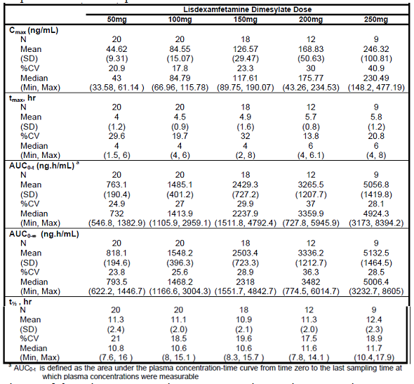
Mean volume of distribution for lisdexamfetamine was around 1200 L; and for d-amphetamine following LDX it was 15.58 L/kg. Plasma protein binding data were not provided in the submission.
There did not appear to be conversion of d-amphetamine to l-amphetamine. This would not be expected to be any different to that for currently marketed d-amphetamine containing drugs.
LDX appears to be hydrolysed primarily by peptidase(s) associated with red blood cells to the amino acid l-lysine and pharmacologically active d-amphetamine.
Overall, 96.4% of an orally administered dose was recovered in urine and <0.30% in faeces. Over 48 hours, 79.4% of the orally administered dose was recovered in urine: 2.2% as LDX, 41.5% as amphetamine, 24.8% as hippuric acid, 2.2% as benzoic acid and 8.9% as other metabolites.

Evaluator’s overall conclusions on pharmacokinetics
The PK of LDX in healthy volunteers has been well characterised. LDX is well absorbed orally and the bioavailability is not affected by food. The bioavailability of the solubilised capsules is similar to that of intact capsules. There do not appear to be any significant interactions. There appears to be little intra-individual or inter-individual variability in LDX disposition. However, in subjects with hepatic or renal impairment, the PK of LDX have not been fully investigated.

Pharmacodynamics

Studies providing pharmacodynamic data
There were three studies that provided PD data. Study SPD-113, Study SPD489-115 and Study NRP104-201, which was presented by the sponsor as a pivotal study, but the data appeared to be PD rather than efficacy data.

Evaluator’s overall conclusions on pharmacodynamics
The PD data indicate similar time course of action for LDX and controlled release d-amphetamine. These effects were on improvement of symptoms of ADHD. There were also effects on the cardiovascular system with an increase in pulse rate, systolic blood pressure (SBP) and diastolic blood pressure (DBP).

Efficacy

Dosage selection for the pivotal studies
The dose selection for the pivotal studies was supported by the PK and PD studies

Studies providing efficacy data
Summaries of the 9 pivotal efficacy studies in comparison with placebo are shown in the following Tables:
- Table 11 (Study NRP104-301)
- Table 12 (Study NRP104-303)
- Table 13 (Study SPD489-305)
- Table 14 (Study SPD489-311)
- Table 15 (Study SPD489-316)
- Table 16 (Study SPD489-325)
- Table 17 (Study SPD489-326)
- Table 18 (Study SPD489-401)
- Table 19 (Study SPD489-403)
Summaries of the 4 other efficacy studies are shown in the Table 20 (Studies NRP104-302 and NRP104-304) and Table 21 (Studies SPD489-306 and SPD489-310).
Table 11. Summary of Study NRP104-301.
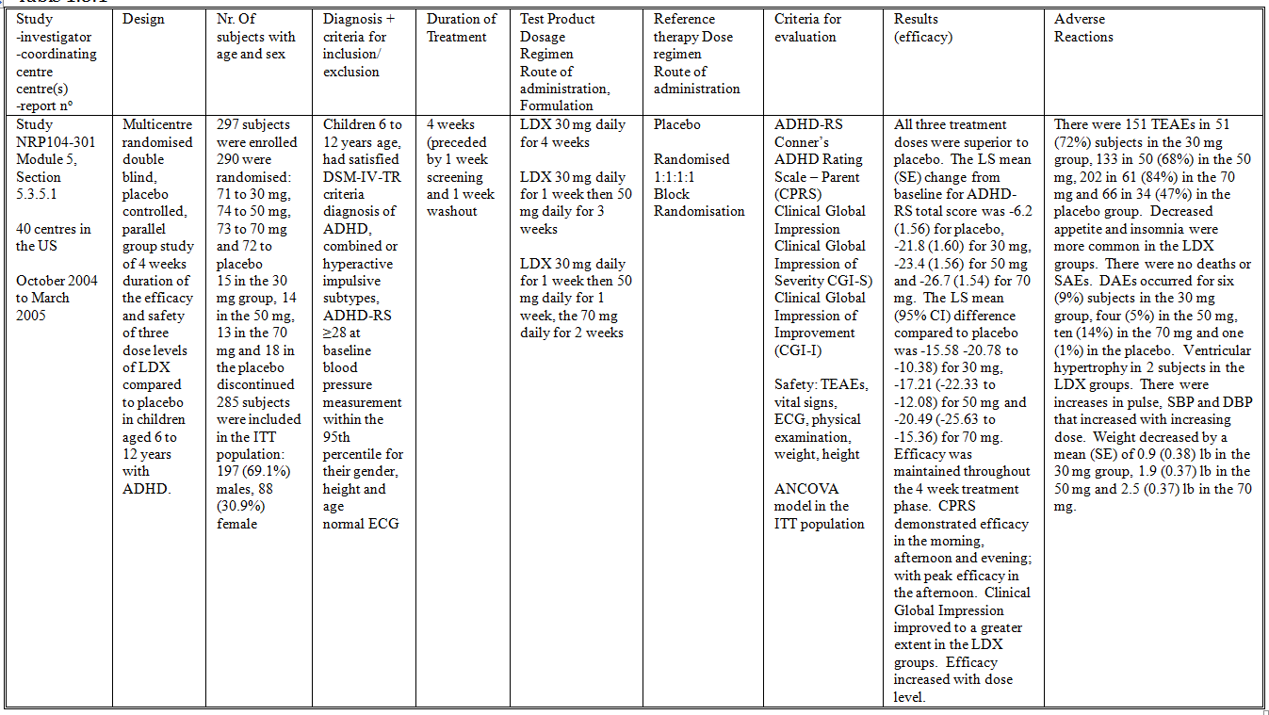
Table 12. Summary of Study NRP104-303.
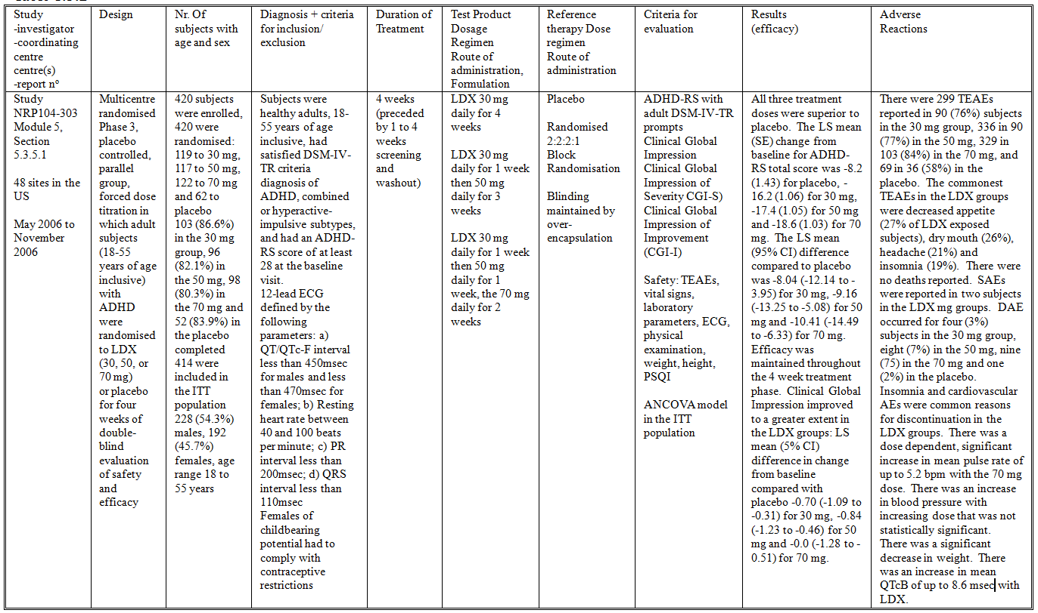
Table 13. Summary of Study SPD489-305.
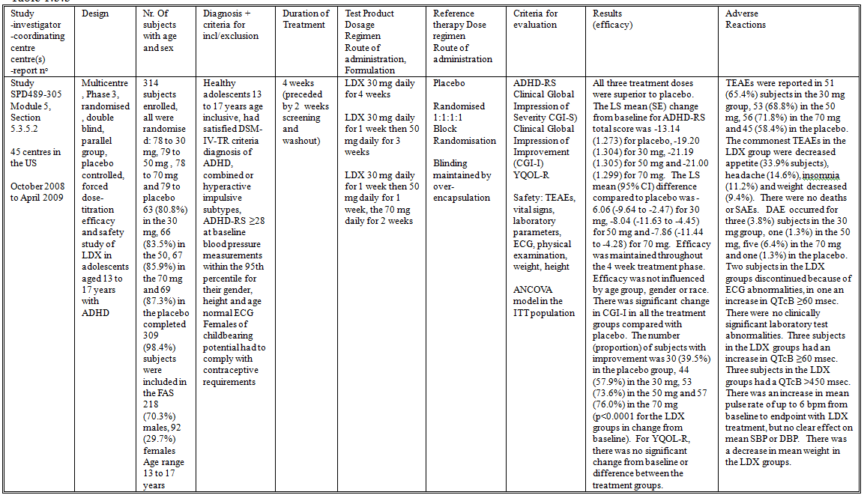
Table 14. Summary of Study SPD489-311.
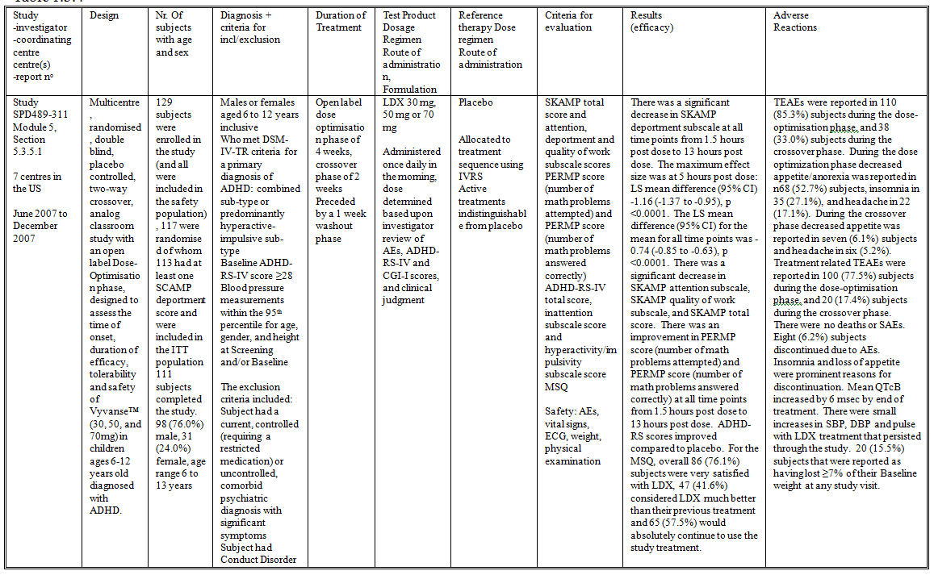
Table 15. Summary of Study SPD489-316.
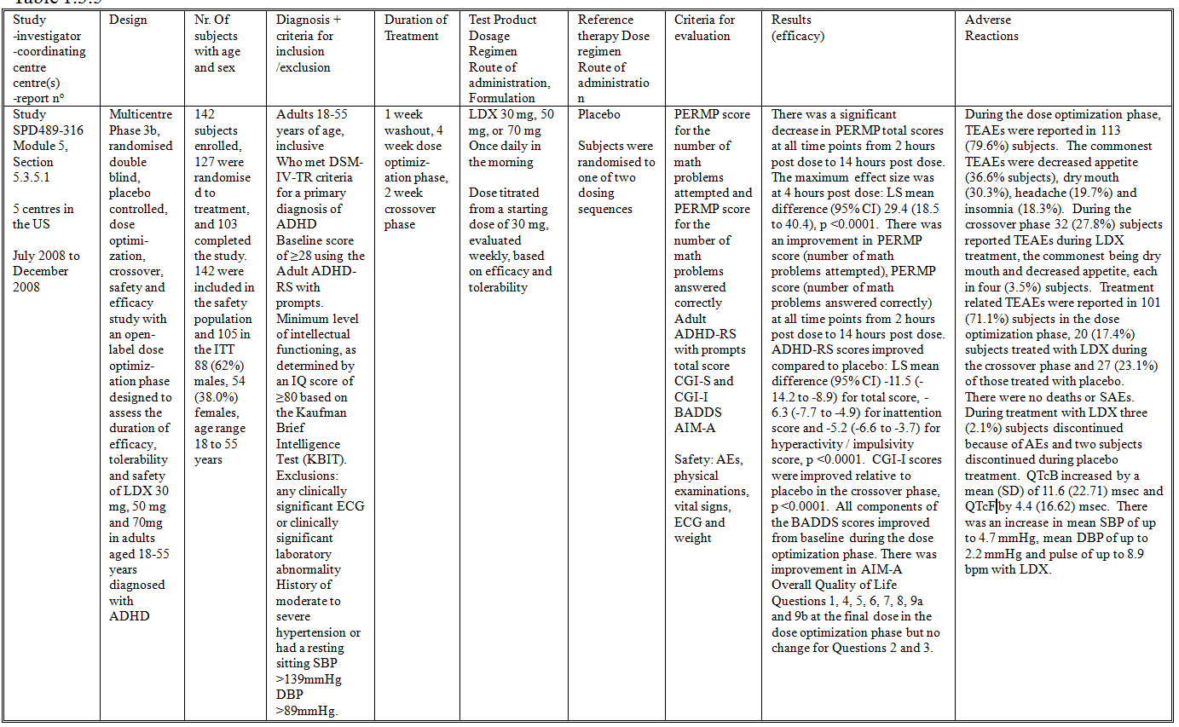
Table 16. Summary of Study SPD489-325.
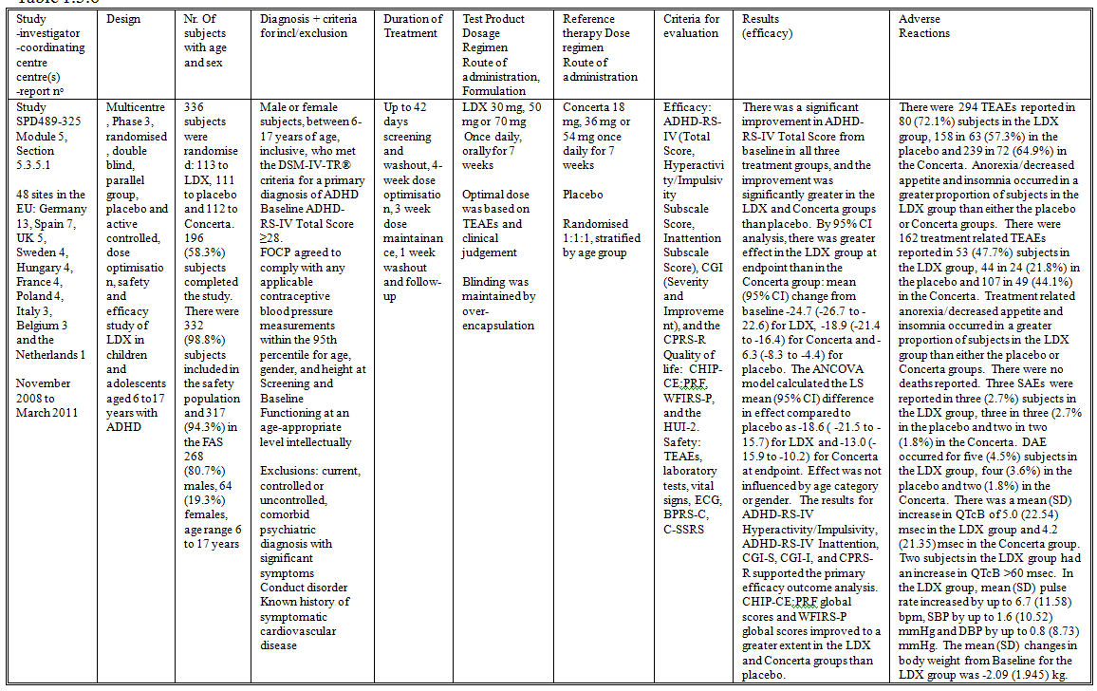
Table 17. Summary of Study SPD489-326.
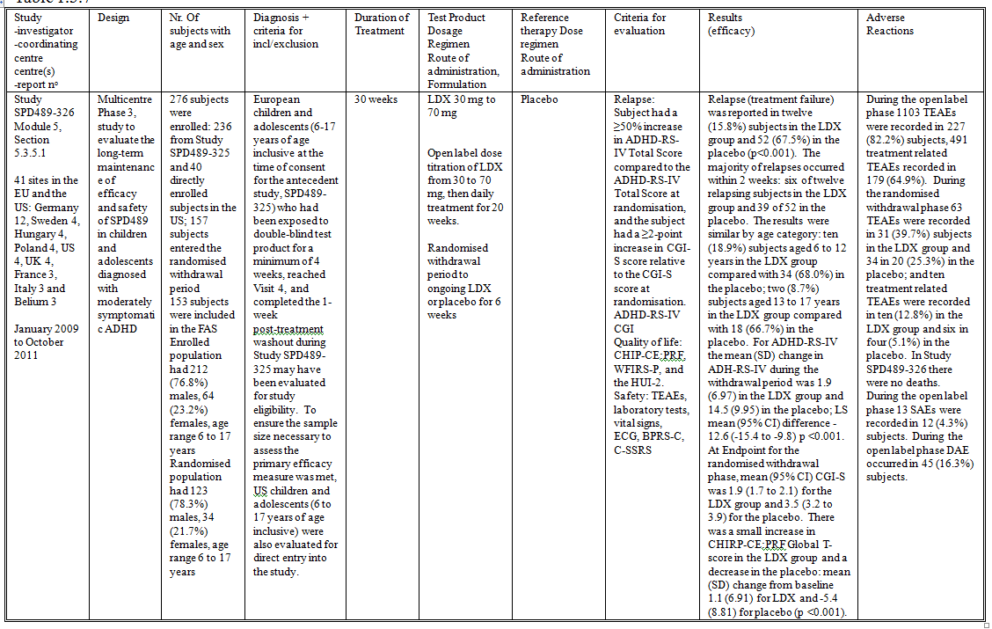
Table 18. Summary of Study SPD489-401.
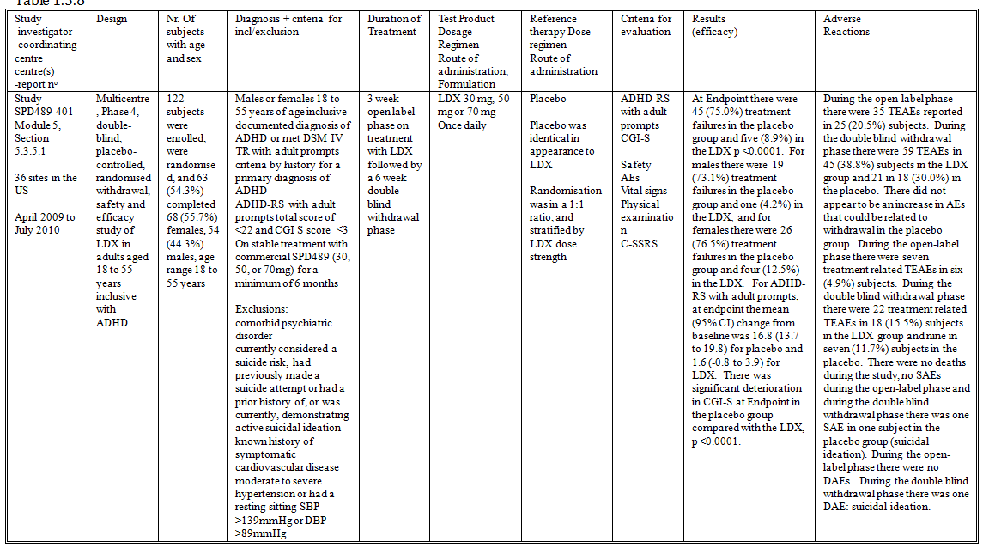
Table 19. Summary of Study SPD489-403.
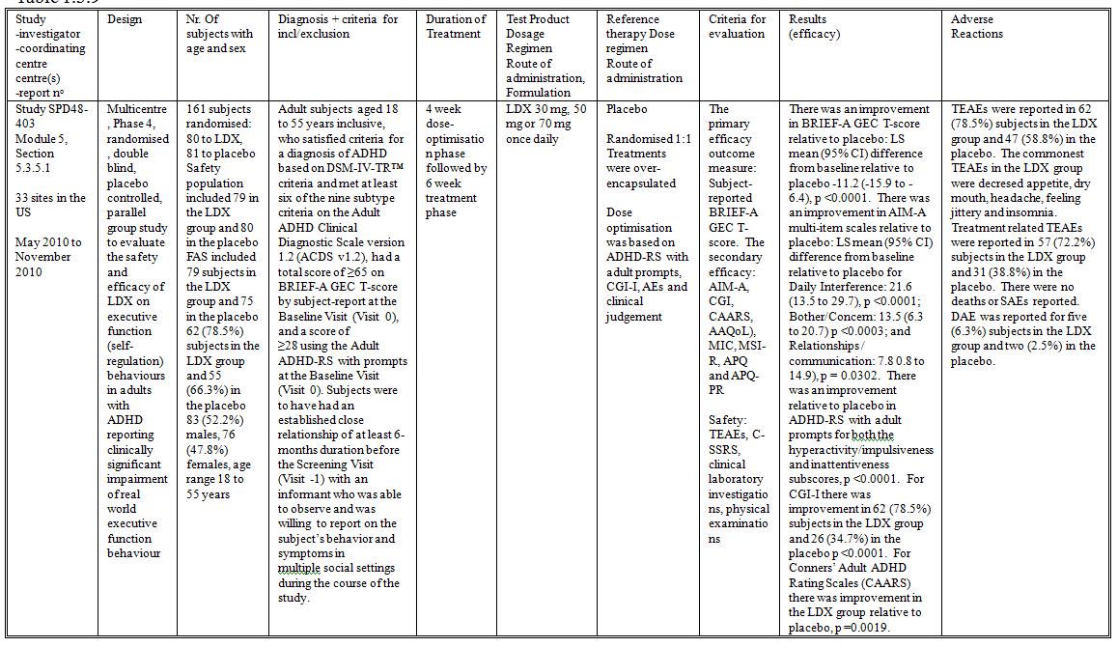

Table 20. Summary of Studies NRP104-302 and NRP104-304.
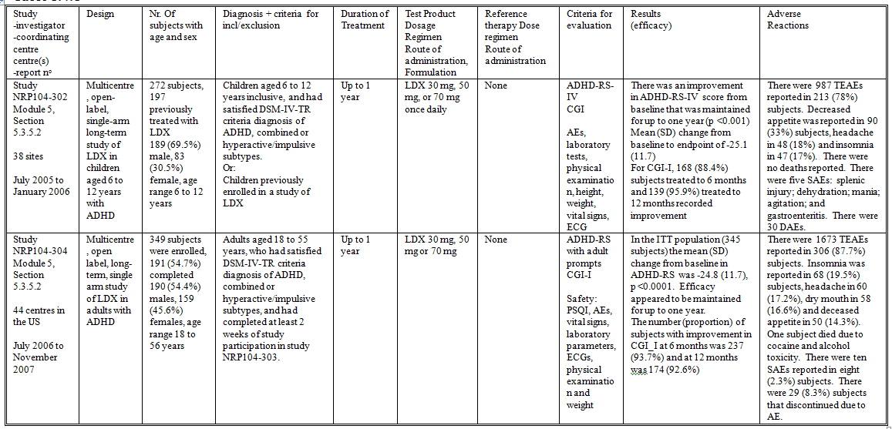
Table 21. Summary of Studies SPD489-306 and SPD489-310.
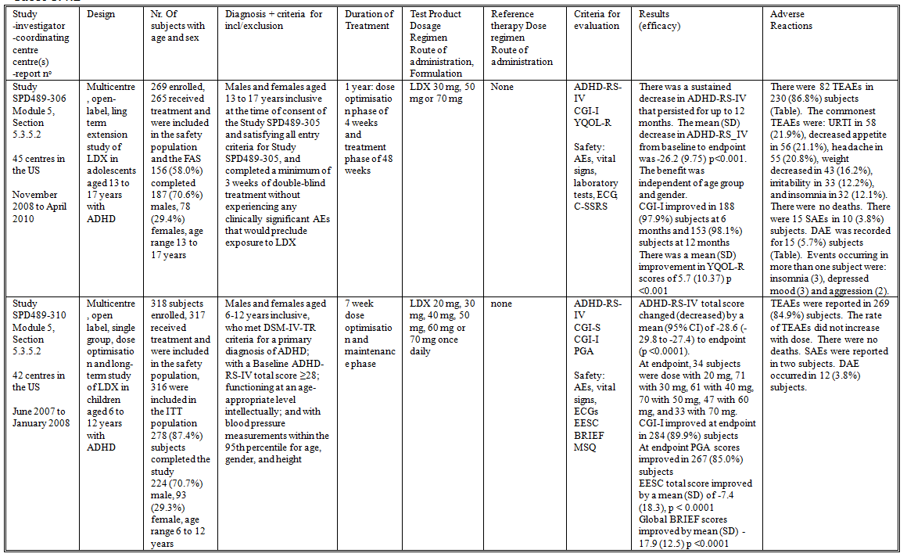

Evaluator’s conclusions on clinical efficacy for ADHD
In children with ADHD aged 6 to 12 years LDX was demonstrated to be superior to placebo. Although there was no statistically significant difference between the treatment levels, in Study NRP104-301 there was increased benefit for the 70 mg dose in comparison with the 30 mg and 50 mg. The least squares (LS) mean (95% CI) difference compared to placebo was -15.58 (-20.78 to -10.38) for 30 mg, -17.21 (-22.33 to -12.08) for 50 mg and -20.49 (-25.63 to -15.36) for 70 mg. Study SPD489-311 demonstrated clinically and statistically significant increases in performance in a classroom setting for up to 13 hours post dose.
In adults with ADHD aged 18 to 55 years LDX was demonstrated to be superior to placebo. Even when subjects were titrated to optimal dose there still appeared to be increasing benefit with increasing dose, although the differences between dose levels were not statistically significant. In Study NRP104-303 for ADHD-rating scale (ADHD-RS) the LS mean (95% CI) difference compared to placebo was -8.04 (-12.14 to -3.95) for 30 mg, -9.16 (-13.25 to -5.08) for 50 mg and -10.41 (-14.49 to -6.33) for 70 mg. Study SPD489-316 demonstrated benefit for up to 14 hours post-dose. Study SPD48-403 demonstrated clinically significant improvements in performance in a workplace setting.
In adolescents with ADHD aged 13 to 17 years LDX was demonstrated to be superior to placebo. When the subjects were titrated to optimal dose there was no clinically significant difference in effect between the 50 mg and 70 mg dose level. In Study SPD489-305 for ADHD-RS total score the LS mean (95% CI) difference compared to placebo was -6.06 (-9.64 to -2.47) for 30 mg, -8.04 (-11.63 to -4.45) for 50 mg and -7.86 (-11.44 to -4.28) for 70 mg.
In children and adolescents aged 6 to 17 years there was comparable efficacy between LDX and Concerta (methylphenidate). In Study SPD489-325 for ADHD-RS total score by 95% CI analysis, there was greater effect in the LDX group at endpoint than in the Concerta group: mean (95% CI) change from baseline -24.7 (-26.7 to -22.6) for LDX, -18.9 (-21.4 to -16.4) for Concerta and -6.3 (-8.3 to -4.4) for placebo. However, it is not clear that the dose levels chosen for Concerta were comparable to those for LDX.
Following 6 months of treatment in children and adolescents, withdrawal of treatment resulted in relapse in 67% of subjects (Study SPD489-326). However, there did not appear to be rebound or withdrawal effects. Similarly in adults, following withdrawal of treatment there was relapse in 75% of subjects (Study SPD489-401). There did not appear to be rebound or withdrawal effects.
In all of the efficacy studies the results of the secondary efficacy outcome measures supported the results of the primary efficacy outcome measures. The efficacy results were not influenced by gender, age group or race.
The follow-on studies in children, adolescents and adults all supported the maintenance of efficacy for up to 12 months.
Subjects with prior cardiovascular disease, ECG abnormalities or hypertension were excluded from the clinical studies.
The outcome measures were appropriate and explored different aspects of ADHD. Hence clinically relevant endpoints were explored in the development program. Blinding to study treatment was appropriate in all the clinical studies. The hypothesis tests were all performed using appropriate statistical procedures.
However, comparator controlled studies were not performed. Although LDX would be expected to have comparable efficacy to d-amphetamine, a non-inferiority comparison with methylphenidate would be useful for clinicians.

Safety

Studies providing evaluable safety data
The following studies provided evaluable safety data:

Pivotal efficacy studies
In the pivotal efficacy studies, the following safety data were collected:
- Treatment emergent adverse events (TEAEs), serious adverse events (SAEs) and discontinuation due to adverse events (DAEs)
- Adverse events of particular interest, including ECGs and vital signs (pulse rate, SBP, DBP and weight)
- Laboratory tests

Other studies
The clinical pharmacology studies also addressed vital signs and ECGs.
Post-marketing data were provided for the time interval 23rd February 2007 to 22nd February 2011. The estimated patient exposure during this time period was 1.5 million person-years.

Patient exposure
As stated in the Risk Management Plan, 340 subjects were exposed to LDX in the Phase I studies. In the Phase II, III, and IV studies a total of 1941 subjects have been exposed to LDX in 13 studies enrolling subjects with ADHD (including 852 children, 337 adolescents, and 752 adults exposed to at least one dose of LDX). In the sponsor’s Summary of Clinical Safety, it states that 512 subjects have been treated for more than one year in clinical studies (Table 22).
Table 22. Investigational Product Exposure in Phase II-IV Studies.
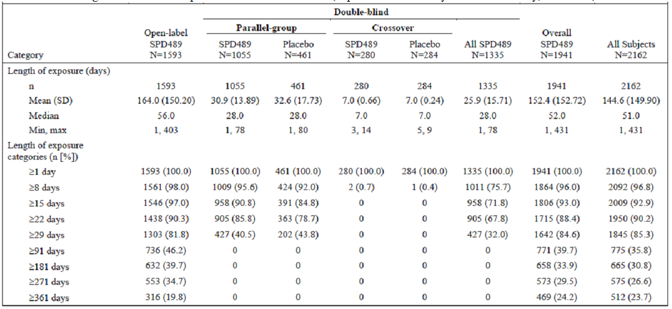

Summary of safety
See section 8 in Attachment 2 of this AusPAR.
From the integrated safety database: in Phase II, III and IV studies 1592 (82.0%) subjects treated with LDX reported TEAEs (Table 23).
Table 23. Investigational Product Exposure in Phase II-IV Studies.
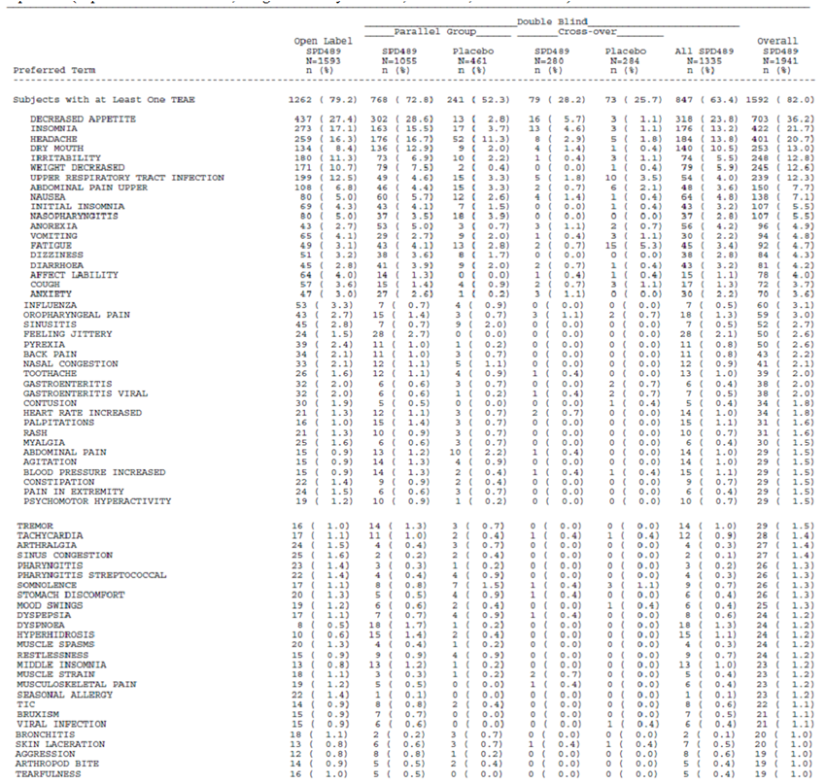

Evaluator’s overall conclusions on clinical safety
- The safety data were a little disjointed because LDX appears to have been developed by two different pharmaceutical companies. The study procedures change during the development program. As a result there were different reporting templates for the two companies and the data were presented differently.
- TEAEs were relatively common in the LDX treatment groups. The commonest TEAEs were decreased appetite/ anorexia, weight loss, dry mouth, headache, insomnia, feeling jittery and irritability. The treatment related TEAEs were similar in pattern.
- There was one death reported during the development program. This death could be attributed to substance abuse. It is not clear whether co-ingestion of LDX contributed to the death.
- SAEs were uncommon and did not appear to be life-threatening.
- DAEs were also uncommon but were mainly attributable to the side effect profile of LDX.
- Laboratory test abnormalities were uncommon and did not occur at a rate higher than expected for the study population.
- ECG abnormalities (prolongation of QTcB) were common. However there was not an increase in the rate of sudden unexplained death in the study population, or in the post-marketing data. The elevation in QTcB may be an artefact because of the increase in heart rate with d-amphetamine. However, this does represent a signal that will require ongoing post-marketing surveillance.
- Mild elevations in pulse rate, SBP and DBP occurred with LDX and persisted with long-term treatment. This could increase the long-term risk of cardiovascular disease. This also requires ongoing post-marketing surveillance.
- LDX is associated with weight loss and anorexia.
- LDX is not associated with an increase in suicidal ideation or behaviours.
- LDX has less potential for intravenous abuse than d-amphetamine but similar abuse potential when taken by the oral route.

First round benefit-risk assessment

First round assessment of benefits
In children with ADHD aged 6 to 12 years LDX was demonstrated to be superior to placebo. Although there was no statistically significant difference between the treatment levels, in Study NRP104-301 there was increased benefit for the 70 mg dose in comparison with the 30 mg and 50 mg. The LS mean (95% CI) difference compared to placebo was -15.58 (-20.78 to -10.38) for 30 mg, -17.21 (-22.33 to -12.08) for 50 mg and -20.49 (-25.63 to -15.36) for 70 mg. Study SPD489-311 demonstrated clinically and statistically significant increases in performance in a classroom setting for up to 13 hours post dose.
In adults with ADHD aged 18 to 55 years LDX was demonstrated to be superior to placebo. Even when subjects were titrated to optimal dose there still appeared to be increasing benefit with increasing dose, although the differences between dose levels were not statistically significant. In Study NRP104-303 for ADHD-RS the LS mean (95% CI) difference compared to placebo was -8.04 (-12.14 to -3.95) for 30 mg, -9.16 (-13.25 to -5.08) for 50 mg and -10.41 (-14.49 to -6.33) for 70 mg. Study SPD489-316 demonstrated benefit for up to 14 hours post-dose. Study SPD48-403 demonstrated clinically significant improvements in performance in a workplace setting.
In adolescents with ADHD aged 13 to 17 years LDX was demonstrated to be superior to placebo. When the subjects were titrated to optimal dose there was no clinically significant difference in effect between the 50 mg and 70 mg dose level. In Study SPD489-305 for ADHD-RS total score the LS mean (95% CI) difference compared to placebo was -6.06 (-9.64 to -2.47) for 30 mg, -8.04 (-11.63 to -4.45) for 50 mg and -7.86 (-11.44 to -4.28) for 70 mg.
In children and adolescents aged 6 to 17 years there was comparable efficacy between LDX and Concerta. In Study SPD489-325 for ADHD-RS total score by 95% CI analysis, there was greater effect in the LDX group at endpoint than in the Concerta group: mean (95% CI) change from baseline -24.7 (-26.7 to -22.6) for LDX, -18.9 (-21.4 to -16.4) for Concerta and -6.3 (-8.3 to -4.4) for placebo. However, it is not clear that the dose levels chosen for Concerta were comparable to those for LDX.
Following 6 months of treatment in children and adolescents, withdrawal of treatment resulted in relapse in 67% of subjects (Study SPD489-326). However, there did not appear to be rebound or withdrawal effects. Similarly in adults, following withdrawal of treatment there was relapse in 75% of subjects (Study SPD489-401). There did not appear to be rebound or withdrawal effects.
In all of the efficacy studies the results of the secondary efficacy outcome measures supported the results of the primary efficacy outcome measures. The efficacy results were not influenced by gender, age group or race.
The follow-on studies in children, adolescents and adults all supported the maintenance of efficacy for up to 12 months.
Subjects with prior cardiovascular disease, ECG abnormalities of hypertension were excluded from the clinical studies.
The outcome measures were appropriate and explored different aspects of ADHD. Hence clinically relevant endpoints were explored in the development program. Blinding to study treatment was appropriate in all the clinical studies. The hypothesis tests were all performed using appropriate statistical procedures.
However, comparator controlled studies were not performed. Although LDX would be expected to have comparable efficacy to d-amphetamine, a non-inferiority comparison with methylphenidate would be useful for clinicians.

First round assessment of risks
Minor adverse effects are common with LDX but serious adverse events are uncommon. TEAEs were relatively common in the LDX treatment groups. The commonest TEAEs were decreased appetite/ anorexia, weight loss, dry mouth, headache, insomnia, feeling jittery and irritability. The treatment related TEAEs were similar in pattern.
There was one death reported during the development program. This death could be attributed to substance abuse. It is not clear whether co-ingestion of LDX contributed to the death.
SAEs were uncommon and did not appear to be life-threatening.
DAEs were also uncommon but were mainly attributable to the side effect profile of LDX.
Laboratory test abnormalities were uncommon and did not occur at a rate higher than expected for the study population.
ECG abnormalities (prolongation of QTcB) were common. However there was not an increase in the rate of sudden unexplained death in the study population, or in the post-marketing data. The elevation in QTcB may be an artefact because of the increase in heart rate with d-amphetamine. However, this does represent a signal that will require ongoing post-marketing surveillance.
Mild elevations in pulse rate, SBP and DBP occurred with LDX and persisted with long-term treatment. This could increase the long-term risk of cardiovascular disease. This also requires ongoing post-marketing surveillance.
LDX is associated with weight loss and anorexia.
LDX is not associated with an increase in suicidal ideation or behaviours.
LDX has less potential for intravenous abuse than d-amphetamine but similar abuse potential when taken by the oral route.
A potential risk is the use of LDX in children aged <6 years. LDX could be used in a soluble form in this population and would act in lieu of a slow release formulation of alternative psychostimulants. Given this risk, the indication should be reworded to clarify the age groups that LDX has been investigated in.
The Canadian dosage is limited to 60 mg per day. The argument in the Canadian PI is that there was no difference in efficacy between doses >30 mg per day. However, as most of the studies involved dose-optimisation the Canadian approach is difficult to support. In addition, although not statistically significant, there did appear to be increasing efficacy with doses up to 70 mg/day.

First round assessment of benefit-risk balance
The benefit-risk balance of LDX, given the proposed usage, is favourable.

First round recommendation regarding authorisation
The proposed indication:
Vyvanse is indicated for the treatment of Attention Deficit Hyperactivity Disorder (ADHD) in:
- Children
- Adolescents
- Adults
should not be approved because it does not clarify the age groups investigated in the clinical development program of LDX.
The following alternative indication could be considered for approval:
Vyvanse is indicated for the treatment of Attention Deficit Hyperactivity Disorder (ADHD) in:
- Children (aged 6 years and older)
- Adolescents
- Adults (up to and including 55 years age)

Second round evaluation of clinical data submitted in response to questions

List of questions

Pharmacokinetics
- Are the PK of LDX altered in subjects with hepatic failure?
- Are the PK of LDX altered in subjects with chronic renal failure?
- What is the PK profile of LDX in children aged less than 6 years?
- What is the plasma protein binding of LDX?

Pharmacodynamics
- What data does the sponsor have with regard to the PK/PD profile of LDX using modelling strategies?

Efficacy
- What is the efficacy of LDX in comparison with methylphenidate and/or atomoxetine?
- Does the sponsor have any efficacy data for children aged less than 6 years?

Safety
- What measures will the sponsor use to monitor long term cardiovascular risks?
- What measures will the sponsor use to monitor the risks of QT prolongation and arrhythmia?

Additional efficacy questions
- What is the proportion of subjects in each treatment group with at least a 30% and/ or at least a 50% reduction from baseline in ADHD-RS or ADHD-RS-IV (the primary efficacy parameter) at end of double-blind treatment in each of the following studies: NRP104.301, SPD489-305, SPD489-325 and NRP104.303.
- What was the final mean and median daily doses of LDX administered in the Phase II–IV double-blind studies that included optimised dosing of LDX (that is, studies NRP104-201; SPD489-311; SPD489-325; SPD489-326; SPD489-316; and SPD489-403).
- Was lisdexamfetamine present in the blood of the 2 adult subjects who died due to drug overdose?

Evaluation of responses

Pharmacokinetics of LDX in subjects with hepatic failure
The sponsor has responded that there are no identifiable data for LDX in subjects with hepatic failure. In the opinion of the Evaluator, given the known PK and metabolism of LDX and amphetamine it is unlikely the hepatic failure would alter the PK of LDX. However, PK in hepatic failure is important missing information and should be included in the RMP. The sponsor has included a statement in the Precautions section of the PI. However, consideration should be given to making hepatic failure a contraindication.

Pharmacokinetics of LDX in subjects with chronic renal failure
The sponsor has responded that there are no identifiable data for LDX in subjects with chronic renal failure. In the opinion of the Evaluator, given that the fraction of a dose excreted as LDX is 2.2% and as d-amphetamine is 41.5%, dose modification would not normally be advised in renal failure. However, PK in renal failure is important missing information and should be included in the RMP. The sponsor has included a statement in the Precautions section of the PI. However, consideration should be given to making renal failure a contraindication.

Pharmacokinetic profile of LDX in children aged less than 6 years
The sponsor has responded that formal PK studies have not been conducted in children aged less than 6 years. The sponsor has performed PK modelling and provided a plot of simulated plasma concentration versus time data for single doses in the range 5 mg to 30 mg. However, it is not possible to evaluate the validity of the modelling and simulation because insufficient detail is provided.

Plasma protein binding of LDX
The sponsor does not have data for the protein binding of LDX. Hence the known PK profile of LDX is incomplete. In vitro data would be adequate for determining this parameter and would be relatively inexpensive for the sponsor to obtain.
The sponsor states the protein binding of d-amphetamine to be 20%. This information should be included in the PI.

Modelling strategies of the PK/PD profile of LDX
The sponsor is in the process of performing a population PKPD analysis of LDX in subjects with ADHD.
At this time it appears that the population PKPD analysis is not available. However, the sponsor should be encouraged to submit the final report to the TGA when it is available.

Efficacy of LDX in comparison with methylphenidate
The sponsor has provided efficacy data for LDX in comparison with methylphenidate from Study SPD489-325 (see section 7.1.1.6 of Attachment 2 of this AusPAR). With regards to these data, the evaluator commented: “In children and adolescents aged 6 to 17 years there was comparable efficacy between LDX and Concerta. In Study SPD489-325 for ADHD-RS total score by 95% CI analysis, there was greater effect in the LDX group at endpoint than in the Concerta group: mean (95% CI) change from baseline -24.7 (-26.7 to -22.6) for LDX, -18.9 (-21.4 to -16.4) for Concerta and -6.3 (-8.3 to -4.4) for placebo. However, it is not clear that the dose levels chosen for Concerta were comparable to those for LDX.”

Efficacy of LDX in comparison with atomoxetine
The sponsor has performed one study of the efficacy of LDX in comparison with atomoxetine. A synopsis of the study was provided by the sponsor in response to this question.
Study SPD489-317 was a double-blind, randomised, active controlled, parallel-group study that examined the time to response associated with LDX compared to atomoxetine hydrochloride in children and adolescents, male or female, aged 6-17 years with moderately symptomatic ADHD (according to DSM-IV-TR criteria for a primary diagnosis of ADHD based on a detailed psychiatric evaluation) who previously had demonstrated an inadequate response to methylphenidate treatment. The study treatments were:
- LDX given orally at doses of 30, 50, or 70 mg once daily
- Atomoxetine given orally at doses of 10, 18, 25, 40, or 60 mg once daily
- Placebo
Treatment duration was 9 weeks.
The primary efficacy outcome measure was time to first response based on Clinical Global Impression of Improvement (CGI-I) which was, median (95% CI) 12.0 (8.0 to 16.0) days for LDX and 21.0 (15.0 to 23.0) for atomoxetine, p=0.001. At Visit 9, the proportions of responders in the LDX and atomoxetine groups were 81.7% and 63.6%, respectively (p=0.001); the LS mean changes from baseline for were -26.1 and -19.7, respectively (p <0.001); ADHD-RS-IV Response (25% reduction) occurred in 90.5% and 76.7% respectively (p = 0.003); and CGI-S response in 92.3% and 79.7% respectively (p = 0.005). The mean (SD) weight change was -1.30 (1.806) kg in the LDX group and -0.15 (1.434) kg in the atomoxetine.
These data are supportive of superior efficacy for LDX in comparison with atomoxetine but were not presented as a full report and could not be evaluated in detail.

Efficacy data for children aged less than 6 years
The sponsor does not have efficacy data for children aged <6 years.

Effect of prior treatment for ADHD on response
The sponsor provided summaries of the change in ADHD-RS from baseline by age category. Response was similar for subjects with or without prior treatment.

Effect of baseline disease severity on response
The sponsor has provided summary tables of response by baseline severity by age grouping. In each of these comparisons there was greater response with greater disease severity. However, there was clinically and statistically significant benefit for all of the severity categories.

Measures the sponsor will use to monitor long term cardiovascular risks
The sponsor intends to monitor long term cardiovascular risk with:
- Routine pharmacovigilance including use of questionnaire to collect additional information on cases reported spontaneously during postmarketing surveillance
- An ongoing 2 year open-label safety study of LDX (SPD489-404) enrolling children and adolescents with ADHD

Measures the sponsor will use to monitor the risks of QT prolongation and arrhythmia
The sponsor states that it “has no specific plans to monitor the risk of QT prolongation and arrhythmias because a formal evaluation of QT prolongation and arrhythmias reported with SPD489 concluded that these events are not adverse drug reactions associated with SPD489 treatment”.
However the sponsor will evaluate the risk using routine pharmacovigilance.

Proportion of subjects with ≥30% and/or ≥50% reduction ADHD-RS or ADHD-RS-IV
The proportion of subjects in each treatment group with ≥30% reduction from baseline in ADHD-RS or ADHD-RS-IV (the primary efficacy parameter) at end of double-blind treatment was 23.6% for placebo and 77.5% for LDX in Study NRP104.301; 51.9% for placebo and 75.1% for LDX in Study SPD489-305; 22.6% for placebo, 68.2% for Concerta and 87.3% for LDX in Study SPD489-325; and 35.5% for placebo and 63.4% for LDX in Study NRP104.303.
The proportion of subjects in each treatment group with ≥50% reduction from baseline in ADHD-RS or ADHD-RS-IV (the primary efficacy parameter) at end of double-blind treatment was 12.5% for placebo and 61.5% for LDX in Study NRP104.301; 33.8% for placebo and 55.4% for LDX in Study SPD489-305; 13.2% for placebo, 49.5% for Concerta and 65.4% for LDX in Study SPD489-325; and 12.9% for placebo and 40.2% for LDX in Study NRP104.303.

Optimised doses used in the phase II-IV studies
The final median daily optimised dose of LDX administered in the Phase II-IV double-blind studies that included optimised dosing of LDX was: 50 mg for the 6 to 12 years age group; ranged from 50 mg to 70 mg for the 13 to 17 years age group; and was 50 mg for the 18 to 55 year age group. The final mean daily optimised dose of LDX administered in the Phase II-IV double-blind studies that included optimised dosing of LDX ranged from 44.3 mg to 50.5 mg for the 6 to 12 years age group; from 53.5 mg to 58.8 mg for the 13 to 17 years age group; and from 52.3 mg to 56.8 mg for the 18 to 55 year age group.

LDX concentrations in fatal overdose
There were no reports of lisdexamfetamine in the blood in post-mortem toxicology reports for either of the two subjects that died during the development program due to drug overdose. However, the sponsor considers it unlikely that an assay was performed for LDX for either of the two subjects. One of the subjects had a negative drug screen for amphetamine. The other subject had methamphetamine level of 3.8 mg/L and an amphetamine level of 0.18 mg/L. The sponsor considers that this is consistent with the levels of methamphetamine and its major metabolite (amphetamine) observed in instances of methamphetamine overdose in the absence of amphetamine co-administration.

Second round benefit-risk assessment

Second round assessment of benefits
After consideration of the responses to clinical questions, the benefits of LDX in the proposed usage are unchanged from those identified in the First round assessment of benefits (above).

Second round assessment of risks
After consideration of the responses to clinical questions, the benefits of LDX in the proposed usage are unchanged from those identified in First round assessment of risks (above).

Second round assessment of benefit-risk balance
The benefit-risk balance of LDX, given the proposed usage, is favourable.

Second round recommendation regarding authorisation
The proposed indication:
Vyvanse is indicated for the treatment of Attention Deficit Hyperactivity Disorder (ADHD) in:
- Children
- Adolescents
- Adults
should not be approved because it does not clarify the age groups investigated in the clinical development program of LDX.
The following alternative indication could be considered for approval:
Vyvanse is indicated for the treatment of Attention Deficit Hyperactivity Disorder (ADHD) in:
- Children (aged 6 years and older)
- Adolescents
- Adults (up to and including 55 years age)

V. Pharmacovigilance findings

Risk management plan
The sponsor submitted a Risk Management Plan (AU-RMP Version 1.0 (dated 14/06/2012, DLP 29/04/2011) which was reviewed by the TGA’s Office of Product Review (OPR). A summary of the RMP is shown in Table 24.
Table 24. Summary of the Risk Management Plan.
Safety concern | Proposed pharmacovigilance activities (routine and additional) | Proposed risk minimisation activities (routine and additional)
Cardiomyopathy | Routine pharmacovigilance | Cardiac pre-screening and monitoring stipulation in the PI. Listed as an ADR in the proposed PI. Web-based Educational tool for prescribers
Growth retardation and Developmental delay | Routine pharmacovigilance SPD 489-404 | Growth monitoring stipulation in the PI. Decreased appetite and weight decreased are listed as ADRs in the proposed PI. Web-based Educational tool for prescribers
Intentional drug misuse and Drug abuse | Routine pharmacovigilance | Drug abuse and misuse warning in the proposed PI. Web-based Educational tool for prescribers
Diversion | Routine pharmacovigilance and supply chain monitoring | Diversion warning in the proposed PI. Web-based Educational tool for prescribers
Ischaemic cardiac events | Routine pharmacovigilance | Cardiac pre-screening and monitoring stipulation in the proposed PI. Existing cardiac disease Contraindication. Web-based Educational tool for prescribers
Sudden death | Routine pharmacovigilance | Cardiac prescreening stipulation in the PI. Existing cardiac disease Contraindication in the proposed PI. Sudden death Warning in the PI. Web-based Educational tool for prescribers
Syncope | Routine pharmacovigilance | Exertional chest pain, unexplained syncope, or other symptoms suggestive of cardiac disease warning in the proposed PI. Web-based Educational tool for prescribers
Cerebrovascular disorders (Ischemic and Hemorrhagic stroke) | Routine pharmacovigilance | Cardiac pre-screening and monitoring stipulation in the proposed PI. Existing cardiac disease Contraindication. Web-based Educational tool for prescribers.
Long-term safety (cardiovascular, cerebrovascular, and psychiatric effects) | Routine pharmacovigilance SPD 489-404 | The proposed PI states the following: “The clinician who elects to use VYVANSE for extended periods should periodically re-evaluate the long-term usefulness of the drug for the individual patient.”
Safety in pregnant women | Routine pharmacovigilance and use of pregnancy report form | The proposed PI states the following: “VYVANSE should be used during pregnancy only if the potential benefit justifies the potential risk to the foetus.”
Off-label use | Routine pharmacovigilance Drug utilisation study | Off-label use in children and the elderly is addressed in the proposed PI. Web-based Educational tool for prescribers
The following table (Table 25) summarises the OPR’s evaluation of the RMP, the sponsor’s responses to issues raised by the OPR and the second round OPR evaluation of the sponsor’s responses.

Table 25. Reconciliation of issues outlined in the RMP report.
Recommendation in RMP evaluation report | Sponsor’s response (or summary of the response) | OPR evaluator’s comment
Safety considerations may be raised by the nonclinical and clinical evaluators through the consolidated section 31 request and/or the Nonclinical and Clinical Evaluation Reports respectively. It is important to ensure that the information provided in response to these includes a consideration of the relevance for the RMP, and any specific information needed to address this issue in the RMP. For any safety considerations so raised, please provide information that is relevant and necessary to address the issue in the RMP. | ‘The Marketing Authorisation Holder (MAH) has concluded that the Risk Management Plan does not require revision based on the responses to consolidated questions from nonclinical and clinical evaluation.’
The sponsor should submit a protocol for their proposed drug utilisation study. Furthermore, the sponsor should add intentional drug misuse and diversion to the assigned safety concerns of the drug utilisation study and redesign the study accordingly. Additionally, the drug utilisation study should not be restricted to children and the elderly. It is crucial to include the whole target population of the drug to obtain representative results concerning off-label use, intentional drug misuse and diversion. | The sponsor states that the protocol will be made available to the TGA by the end of March 2013.  The sponsor states that ‘an extension of the current study proposal to cover intentional drug misuse and diversion is not technically feasible nor scientifically valid.’ Furthermore, the sponsor states that post-marketing data from the US is available to assess drug misuse and diversion.  ‘Although the DUS is listed as a planned pharmacovigilance activity for the safety concern of “off-label” use in children and elderly in the RMP, the intent of the DUS is to monitor drug utilisation data of LDX in Australia post launch in all patients who will be prescribed the product.’ | This is considered acceptable.  The sponsor’s response in regard to the extension of the proposed drug utilisation study is valid and acceptable. In order to assess drug misuse and diversion the sponsor should either conduct a post authorisation surveillance study, or make the results of such a study available to the TGA.  This is considered acceptable.
The sponsor is proposing supply chain monitoring to prevent the potential misuse for illegal purposes. The sponsor should also employ the systematic return of unused products to contribute to this goal. It is recommended the sponsor outline how they propose facilitating supply chain monitoring and the systematic return of unused products. | In their response, the sponsor has outlined supply chain monitoring and the systematic return of unused products.  The sponsor states that the Return of Unused Medicines (RUM) project is an existing vehicle for systematic return of unused products. Furthermore the sponsor states that ‘[w]e agree that proper return of unused product to a pharmacy should be encouraged and therefore we would be prepared to include suitable wording (including the website details for RUM) under the Disposal section of the Consumer Medicine Information (CMI). In addition, we would be prepared to expand the After Taking Vyvanse section to give further advice on proper storage at home.’ | This is considered acceptable.
In order to minimise the potential for medication errors, off-label use, and misuse, it is recommended the sponsor undertake an education program on lisdexamfetamine dimesilate targeted at health professionals (especially psychiatrists, general practitioners and mental health nurses) without promoting Vyvanse specifically. This education program should be conducted by an accredited CME provider. Education material targeted at prescribers should also be produced and distributed. Furthermore, the sponsor should evaluate the abovementioned education program and distribution of educational material for effectiveness. | The sponsor is proposing a web-based toolkit for prescribers, available at <http://www.lisdexamfetamine-guide.com.au> | Throughout the evaluation process (during the Round 1 assessment and during the Round 2 advice process) the OPR evaluator was either unable to access the website or unable to log on with the supplied username and password. A website can serve as an adjunct to health professional education, but as a standalone product, may not provide the necessary depth, especially considering that the sponsor has been unable to provide the evaluator with access over a rather extended evaluation period. As a consequence, in regard to an education program, the recommendation remains unchanged.
Tick boxes on the outer packaging for each dose taken should be utilised to minimise over- or underdosing. A child proof lid should be added to the bottle to prevent access of the drug to small children. Furthermore, package inserts of the proposed CMI should be provided as well. | a) Vyvanse capsules will be packed in HDPE bottles without an outer carton; therefore it is not possible to add tick boxes to the packaging.  b) Shire confirms that a child proof lid has already been added to the bottle.  c) Shire is planning to have the CMI available electronically in compliance with Sub-Regulation 9A(2) of the Therapeutic Goods Regulations 1990. It is unclear why provision of the CMI as a package insert is more important / beneficial for Vyvanse compared to any other prescription medicine if the legislation allows alternate means for supplying the document. In addition, the lack of an outer carton makes inclusion of a package insert difficult. | a) The sponsor should supply this medicine with an outer carton to provide tick-boxes on the packaging.  b) This is considered acceptable.  c) The legislation provides a minimum common standard for medicines in general. Given the nature of this medicine, additional risk minimisation activities are necessary to enable safe use of the drug. As stated above, the sponsor should supply this medicine with an outer carton which will enable inclusion of the CMI as a package insert.
It is recommended to the Delegate that the draft product information document be revised as follows:  In the ‘Precautions’ section, the PI should state that amphetamine-dependent mothers are more likely to deliver prematurely and that the risk of low neonatal birth weight is increased (or a statement to that effect). | ‘Shire has no objection to adding the requested statement to the ‘Precautions’ section of the PI if so requested by the Delegate.’ | This is considered acceptable.
In the ‘Precautions’ section, the PI should state that the long-term efficacy of lisdexamfetamine dimesilate has not been established in the paediatric population (or a statement to that effect). | The sponsor states that ‘Shire does not consider it appropriate to add a precaution to state that the long-term efficacy of SPD489 (lisdexamfetamine dimesylate) has not been established in the paediatric population.’  The sponsor referred to the following studies to support their claim: SPD489-326, NRP104.302 SPD489-306 | To qualify as a long term study, the study duration needs to be 12 months or longer. SPD489-326 does not fulfil this requirement, as its study period was only 33 weeks. NRP104.302 and SPD489-306 have a duration of up to 12 months, and it would appear that not the whole study population was exposed for the entire period.  The sponsor has not completed a study in the paediatric population beyond 12 months. Furthermore, the OMA clinical evaluation report states that ‘[m]ild elevations in pulse rate, SBP and DBP occurred with LDX and persisted with long-term treatment. This could increase the long-term risk of cardiovascular disease. This also requires ongoing post-marketing surveillance.’ It is recommended to the Delegate that the above information be reflected in the proposed PI to inform prescribers adequately.  It is noted that the sponsor is conducting a 2-year paediatric study (SPD489-404). Once meaningful results from this study are available, the statement can be re-evaluated.
In the ‘Adverse Effects’ section, stroke, myocardial infarction, sudden death, hypertension, and growth suppression should be included in the table provided. These adverse events are already mentioned in the proposed PI in the ‘Precautions’ section, but should be repeated in the table shown in the ‘Adverse Events’ section for the purpose of completeness. | ‘As noted above stroke, myocardial infarction, sudden death, hypertension, and growth suppression are listed in the Precautions sections as adverse events that have been reported or associated with amphetamines. The adverse drug reaction section of the PI contains adverse drug reactions that have been determined by the MAH to have sufficient evidence to be an adverse drug reaction with lisdexamfetamine. To date the MAH does not consider stroke, myocardial infarction, sudden death, hypertension and growth retardation as adverse drug reactions related to LDX.’ | This is considered acceptable.

Summary of recommendations to the Delegate

Additional ongoing safety concerns
The sponsor should include hypertension as a important identified risk, QT prolongation as an important potential risk, and hepatic failure and chronic renal failure as important missing information.

Post authorisation surveillance study
In order to assess drug misuse and diversion the sponsor should either conduct a post authorisation surveillance study, or make the results of such a study available to the TGA.

Education program and evaluation
In regard to an education program: In order to minimise the potential for medication errors, off-label use, and misuse, it is recommended the sponsor undertake an education program on LDX targeted at health professionals (especially psychiatrists, general practitioners and mental health nurses) without promoting Vyvanse specifically. This education program should be conducted by an accredited Continuing Medical Education (CME) provider. Education material targeted at prescribers should also be produced and distributed. Furthermore, the sponsor should evaluate the abovementioned education program and distribution of educational material for effectiveness.

Outer carton with tick-boxes and CMI insert
The sponsor should supply this medicine with an outer carton to provide tick-boxes on the packaging and to enable inclusion of the CMI as a package insert.

Recommended PI changes
These are beyond the scope of the AusPAR

Recommended conditions of registration
- Implement AU-RMP Version 1.0 (dated 14/06/2012, DLP 29/04/2011), and any future updates.
- Provide Periodic Safety Update Reports (PSUR) in accordance with current regulatory requirements.

VI. Overall conclusion and risk/benefit assessment
The submission was summarised in the following Delegate’s overview and recommendations:

Background
Vyvanse is proposed for the treatment of ADHD in:
- children
- adolescents
- adults
Lisdexamfetamine dimesilate is a prodrug containing l-lysine and dexamphetamine covalently linked by an amide bond. Lisdexamfetamine itself is pharmacologically inactive and rapidly converted to dexamphetamine and l-lysine (elimination t_{½} <1 hour). The sponsor claims that LDX has PK properties similar to a controlled release formulation of dexamphetamine.
Dexamphetamine is approved for treatment of narcolepsy and hyperkinetic behaviour disorders in children. Other approved treatments for ADHD are methylphenidate and atomoxetine. Both these actives are indicated for use in children from 6 years and in adults. Amphetamines are non-catecholamine sympathomimetic amines with CNS stimulant activity. The mode of therapeutic action of amphetamine in ADHD is not fully established, however it is thought to be due to its ability to block the reuptake of noradrenaline and dopamine into the presynaptic neuron and increase the release of these monoamines into the extraneuronal space.
With this submission the sponsor proposes extending approved use of dexamphetamine, as the active component of LDX, to adults with ADHD. The proposed product would allow once daily dosing rather than the twice daily dosing currently recommended for children and adolescents taking dexamphetamine to treat hyperkinetic behaviour disorders/ADHD.
Dexamphetamine is approved for adults and children with narcolepsy with doses up to 60 mg daily, this is approximately 3 times the dexamphetamine exposure that would occur with the maximum proposed daily dose of LDX. Dexamphetamine is also indicated for treatment of hyperkinetic behaviour disorders in children aged from 3 years. The recommended maximum total daily dose of dexamphetamine in children aged from 3 years is 40 mg. Dexamphetamine has been available in Australia since prior to commencement of the ARTG in 1991.
There is no TGA-adopted guideline on the clinical investigation of medicinal products for the treatment of ADHD however the EMA has a document available. The document includes the following information and recommendations regarding assessment of new products:
- ADHD, is a well defined disorder with core features of inattention, hyperactivity, and impulsivity, but also impairment in executive functions. Treatment is directed towards improvement of attention and reduction of hyperactivity/impulsivity in order to be able to focus on tasks and performance.
- Co-morbidity is high in ADHD. Only 30% of cases are pure ADHD. The most apparent co-morbid conditions are Oppositional Defiant Disorder and Conduct Disorder.
- The age for inclusion in studies should cover the range from 6 to 18 years of age, and children and adolescents should be separated or stratified.
- Efficacy should be assessed by rating scales. For ADHD many symptom rating scales are available, the most prominent being the Connors’ Rating Scales, and the ADHD Symptoms Rating Scale (ADHD-SRS).
- Two primary endpoints should be stipulated reflecting the symptomatic and the functional domain. Improvement should be documented as a difference between baseline and post-treatment score.
- In order to allow an estimate of clinical relevance the proportion of responders should be presented. For this, appropriate cut-off-points on validated rating scales should be defined and justified. The use of the same rating scale for inclusion, efficacy and responder definition is recommended.
- The duration of the studies should be at least 6 weeks on stable dose, dependent on the mode of action of the drug.
- The test product should be compared with both placebo and an active comparator, using a three- or multi-arm design.
- Because of the chronic course of ADHD, in addition to the short-term trials, demonstration of long-term efficacy has to be established in at least one well-designed study. This might be done by prolonging the time of double blind or by a randomised withdrawal design. In the latter design, all patients receive active treatment. Responders to treatment are subsequently randomised to continue the investigational drug or to placebo. Patients are followed by at least 6 months for maintenance of effect.

Quality
Subject to submission of a current Good Manufacturing Practice (GMP) clearance letter for a manufacturing site and to PI revisions, there are no objections to registration from a quality and biopharmaceutics perspective.

Nonclinical
There were no objections to approval on nonclinical grounds. The nonclinical evaluator noted that lisdexamfetamine appears to be pharmacologically inactive and lacks affinity for the dopamine and noradrenaline transporters that mediate the actions of d-amphetamine, as well as for a range of other receptors/transporters/ion channels. The active moiety, d-amphetamine, is a well-known sympathomimetic psychostimulant. An abridged program of nonclinical studies was conducted focusing on identifying any characteristics of the prodrug that are not related to d-amphetamine. The evaluator considered this was appropriate and an adequate set of studies was submitted.
Maximum doses in repeat-dose toxicity studies (both in adult and juvenile rats and dogs) were limited by body weight losses/reductions in body weight gains and clinical signs. Clinical signs were considered to reflect exaggerated pharmacological effects and included increased activity and behavioural changes. No target organ toxicity was revealed. An acceptable set of genotoxicity studies with LDX was submitted and these studies were negative. No embryofetotoxic or teratogenic effects were demonstrated. Fertility and pre- and postnatal development studies were not conducted on LDX but studies on amphetamine revealed no effects on fertility, although adverse effects on the F₁ generation were observed in the pre- and postnatal development study.

Clinical

Pharmacology
There was no absolute bioavailability study. Lisdexamfetamine is absorbed then hydrolysed to dexamphetamine by red blood cells. The mean T_{max} for dexamphetamine after oral administration of LDX was approximately 3.5 h. There was little variation in PK between individuals. The 30 mg, 50 mg and 70 mg capsules were dose proportional with respect to dexamphetamine AUC and C_{max} however the PK of lisdexamfetamine was not dose-proportional, with dose-proportioned C_{max} increasing with increasing dose. Food did not significantly influence the AUC of either dexamphetamine or lisdexamfetamine however the T_{max} for dexamphetamine was delayed by approximately 1 h. On multiple daily dosing steady state was achieved by Day 5. Systemic exposure (AUC) to dexamphetamine was approximately the same for males and females given the same dosing however when C_{max} was normalised using body weight (mg/kg), C_{max} was approximately 12% higher for males compared to females.
Mean volume of distribution (Vd) of lisdexamfetamine is approximately 1200 L and mean Vd for dexamphetamine was 15.58 L/kg. The t½ for dexamphetamine following oral administration of LDX was approximately 8.75 h. Overall 96.4% of an orally administered dose was recovered in urine and <0.30% in faeces. Over 48 h, 79.4% of the orally administered dose was recovered in urine: 2.2% as lisdexamfetamine, 41.5% as amphetamine, 24.8% as hippuric acid, 2.2% as benzoic acid and 8.9% as other metabolites. With multiple dosing the mean steady-state value for dexamphetamine T_{max} was 3.68 hours and the mean t_{½} was 10.08 h.
A comparative study in which the exposure to dexamphetamine from Vyvanse was compared to the exposure resulting from Adderall (extended release formulation of mixed amphetamine salts) and Dexedrine (dexamphetamine sustained release capsules) is described in section 4.2.2.2.5 of the Clinical Evaluation Report (see Attachment 2 of this AusPAR). Neither of the comparator products are registered in Australia. It was notable that the T_{max} for dexamphetamine from Vyvanse was somewhat shorter than the T_{max} from Adderall or Dexedrine. The sponsor has estimated that 30 mg LDX corresponds to 8.9 mg dexamphetamine, 50 mg corresponds to 14.8 mg dexamphetamine and 70 mg to 20.8 mg dexamphetamine.
Interaction studies examined the effect of LDX with omeprazole, venlafaxine and guanfacine, a selective alpha2A-adrenergic receptor agonist indicated for the treatment of ADHD in the USA but not registered in Australia. None of these products significantly altered the PK of lisdexamfetamine or dexamphetamine, however lisdexamfetamine may be a weak inhibitor of CYP2D6 because the AUC of venlafaxine increased by approximately 10% with co-administration of LDX.
There were no studies in subjects with reduced hepatic or renal function. No large differences in AUC were noted in a limited examination of PK in healthy elderly subjects however there was a general trend towards higher AUC with increasing age. Females also had higher AUC than males given the same dose. There was no direct comparison of PK between adults and children but it is anticipated that children given the same dose as adults would have higher AUCs.
Neuropsychiatric testing of adults with ADHD was performed in Study SPD489-115. This was an exploratory study to evaluate the sensitivity and responsiveness of a standardised, validated, computer-based, battery of neuropsychometric tests in adults with ADHD using the Power of Attention score (Cognitive Drug Research (CDR) System for Attention). The CDR battery consists of a series of computer-controlled tasks that take about 20 minutes to perform. The Power of Attention score (primary outcome measure) reflects the ability to focus attention, and is calculated as the sum of the speed scores from 3 attention tests (Simple Reaction Time, Choice Reaction Time, and Digit Vigilance Speed) that are part of the CDR battery. A reduction in Power of Attention score indicates improvement. The CDR battery was assessed at -0.5 h (pre-dose) and at 1, 2, 3, 4, 5, 8, 12, 14, and 16 h post-dose at baseline, on Day 1, and on Day 7 of each treatment period.
Study SPD489-115 was a randomised, double-blind crossover study in 18 subjects given LDX 50 mg daily, mixed amphetamine salts IR 20 mg daily, or placebo in sequence daily for 7 days per treatment. Both active treatments improved attention however the clinical significance of the changes is unclear. Another Phase II crossover study in children compared LDX with Adderall XR (mixed amphetamine salts) and placebo and demonstrated an effect of both actives on attention parameters in 52 children aged 6 to 12 years with ADHD. In both these studies increases in systolic and diastolic blood pressure and heart rate were observed. These studies served as the basis for dose selection for the pivotal safety and efficacy studies.

Efficacy
Efficacy was assessed in 14 Phase II-IV studies. Ten of these were either placebo or placebo and active controlled (6 in children/ adolescents and 4 in adults). Adderall and Oros methylphenidate (Concerta) were active controls in two separate short-term studies conducted in children and/ or adolescents. There were no active controls in the studies conducted in adults. The controlled phases of these studies were from 4 to 7 weeks. Four studies had open-label longer term exposure with a randomised withdrawal design used in separate studies in children and adolescents and in adults.
Different efficacy measures were used as the primary efficacy measure across the study program. The ADHD-RS was the primary efficacy measure in the largest short term studies in each age group: children [Study 301]; children and adolescents [Study 325]; adolescents [Study 305] and adults aged to 55 years [Study 303]. The CGI-I was also measured in the majority of studies. Two crossover studies in children used the Swanson, Kotkin, Agler, M. Flynn and Pelham rating scale (SKAMP) Deportment Rating Scale (SKAMP-DS) as a primary efficacy measure and the crossover study in adults used the Permanent Product Measure of Performance (math test) (PERMP) Total Score. All 10 of the controlled studies demonstrated superiority of LDX over placebo for their primary efficacy analysis. No integrated efficacy analyses were presented. This is accepted due to differences between studies in design, primary efficacy variables, and titration regimens.
The entry criteria in the child or adolescent and the adult studies were consistent with the criteria used in studies of other ADHD stimulant treatments. Subjects were excluded from study if they had a co-morbid psychiatric diagnosis with significant symptoms (such as severe Axis II or Axis I disorders).
In 4 of the 6 controlled studies in children/adolescents subjects with concurrent Conduct Disorders (CD) were not eligible for enrolment, though Oppositional Defiant Disorder (ODD) was not an exclusion criterion. Unless criteria for an exclusionary DSM-IV diagnosis were met, subjects with concurrent emotional, behavioural, or learning difficulties were not excluded. Subjects were functioning at an age-appropriate level intellectually, as determined by the investigator, in all studies.
A positive urine drug screen or history of drug abuse was generally an exclusion criterion in the studies in adults. A minimum weight was required in all 4 controlled studies conducted in adults. Subjects with a history of tic disorders, seizures, or cardiovascular disease or concurrent illnesses or medications that may have confounded the interpretation of study data (for example, comorbid psychiatric diagnoses; conduct disorder; use of concurrent medications affecting the CNS, blood pressure or heart rate; abnormal thyroid function) were excluded from study.
The 10 double-blind studies are described in section 7.1.1 of the Attached CER (see Attachment 2 of this AusPAR). There were “forced dose” studies conducted in each of the age groups: Study 301 for children; Study 305 for adolescents and Study 303 for adults. While Studies 301 and 303 showed a consistent dose-response, this was not seen in Study 305 where at the final assessment adolescents given 50 mg daily did better than those given 70 mg daily. Studies 301 and Study 305 had a double-blind treatment period after completion of dose titration of only 1 week so only results at the last double-blind assessment are attributable to the final doses given in these studies.
Dose-optimisation was used in the remaining double-blind studies. Study 325 was conducted in a mixed population of children and adolescents. It had a 3 week period of double-blind treatment after completion of dose titration. Stratified results for children 6 to 12 years and adolescents 13 to 17 years showed superiority of LDX over placebo in each of these subgroups. The mean differences from placebo in mean change from baseline ADHD-RS at the last efficacy assessment was -18.6 in Study 325 for adolescents and children combined.
Study 303 was the largest short term controlled study in adults. In this multicentre study conducted in the US, 420 adults aged 18-55 years diagnosed with ADHD were randomised to LDX (30, 50, and 70 mg) or placebo and treated for 4 weeks to evaluate efficacy and safety. Following a 1 week washout period, subjects were randomised in a 2:2:2:1 ratio to receive LDX 30, 50, or 70mg/day or placebo, respectively. A 3 week, double-blind, stepwise, forced dose-titration phase was followed by a 1 week maintenance phase. Subjects who were underweight, morbidly obese, hypertensive, or had a history of hypertension or any cardiac condition that could affect cardiac performance were excluded from study. Baseline mean ADHD-RS IV scores ranged from 39.4 to 41.0 across the 3 treatment groups. At the last efficacy assessment the mean change from baseline in ADHD-RS IV score was -8.2 for placebo, -16.2 for LDX 30 mg, -17.4 for LDX 50 mg and -18.6 for LDX 70 mg. Thus the differences from placebo for the primary efficacy measure were -8, -9.2 and -10.4 for LDX 30 mg, 50 mg and 70 mg respectively.
The only double-blind study in unselected adults to have a 6 week period of assessment of efficacy using the proposed dose regimen was Study 403. This study was smaller than Study 303 with 142 subjects randomised. The primary efficacy measure was the Brief-A GEC T score. The CGI-S and ADHD-RS were secondary efficacy measures. On the CGI-S, at baseline, all subjects were rated at least moderately ill. At Endpoint, the observed percentages of subjects who were “improved” (that is, rated “very much improved” or “much improved” on the CGI-I) were 78.5% for the LDX group compared with 34.7% for the placebo group.
Symptoms of ADHD as measured by the ADHD-RS with Adult Prompts were significantly improved for subjects receiving LDX compared to placebo. At Week 10 (last study visit), the LS mean change from baseline in the ADHD-RS with Adult Prompts Total Score was -21.4 for subjects receiving LDX compared to -10.3 for subjects receiving placebo; (p<0.0001).
The difference from placebo in mean change from baseline to endpoint in ADHD-RS total score was generally smaller in the studies in adults than in children or adolescents. For children the differences were: 13.7 to 19.32 across dose groups in study 301; 17.1 in Study 311; and 17.4 in Study 325. For adolescents the differences were: 20.6 for adolescents in Study 325 and from 6 to 8.4 across dose groups in Study 305. For adults the differences were from 8 to 10.4 in Study 303; and 10.3 in Study 403.
Two studies identified by the sponsor as maintenance studies were performed. In Study 326 children and adolescents aged from 6 to 17 years received LDX or placebo. Treatment duration was for 30 weeks. There was open-label dose titration of LDX from 30 to 70 mg, then daily treatment for 20 weeks. This was followed by a randomised withdrawal period (to ongoing LDX or placebo) for 6 weeks. The primary efficacy outcome measure was relapse, defined as: the subject had a ≥50% increase in ADHD-RS-IV Total Score compared to the ADHD-RS-IV Total Score at randomisation, and the subject had a ≥2-point increase in CGI-S score relative to the CGI-S score at randomisation.
A total of 276 subjects were enrolled and entered the open-label period. Of these 157 (56.9%) entered the randomised withdrawal period and 76 subjects completed the randomised withdrawal period. A total of 110 (39.9%) subjects withdrew during the open-label period. The most common reason for early discontinuation was AE (44 subjects, 15.9%), followed by refusal of further participation (22 subjects, 8.0%) and lack of efficacy (21 subjects, 7.6%). Relapse (treatment failure) was reported in 12 (15.8%) subjects in the LDX group and 52 (67.5%) in the placebo (p<0.001). The majority of relapses occurred within 2 weeks: six of 12 relapsing subjects in the LDX group and 39 of 52 in the placebo. The results were similar by age category: ten (18.9%) subjects aged 6 to 12 years in the LDX group compared with 34 (68.0%) in the placebo; two (8.7%) subjects aged 13 to 17 years in the LDX group compared with 18 (66.7%) in the placebo.
A randomised withdrawal study was also conducted in adults. Study 401 was conducted in the USA where LDX had a marketing authorisation. That study enrolled subjects who had received at least 6 months treatment with commercial LDX at doses of 30, 50 or 70mg/day and had shown a response to treatment. Subjects entered a 3 week open-label treatment phase of LDX and received the same dose as their commercial supply. Subjects who maintained a treatment response at Week 3 were randomised to LDX (at their current dose) or placebo during a 6 week double-blind randomised withdrawal phase.
The primary efficacy variable was the occurrence of treatment failure during the double-blind randomised withdrawal phase. Treatment failure was defined as ≥50% increase (worsening) in the ADHD-RS with Adult Prompts Total Score, and a ≥2 point increase (worsening) in CGI-S score at any visit during the double-blind period (Visits 4, 5, 6, 7, 8, or 9) relative to scores at randomisation.
A total of 123 subjects were enrolled and 116 randomised: 6 subjects received LDX 30 mg; 23 subjects received 50 mg; 27 subjects received 70 mg; and 60 subjects received placebo. Of the 116 randomised subjects, 63 (54.3%) completed the study (>80 % of subjects given LDX and 21.7% of subjects given placebo. Reaching relapse criteria was the primary reason for discontinuation for 8.9% of subjects given LDX and 75.0% of subjects given placebo (p<0.0001). Most treatment failures occurred within the first 14 days of randomised withdrawal.
The table below summarises ADHD-RS total scores at endpoint for the all treated population in major studies in each age group. The 30% and 50% response rates refer to 30% and 50% reductions in total ADHD-RS scores from baseline.
Table 26. Study 401. ADHD-RS total scores at endpoint.
 | 30% response rate |  | 50% response rate
 | Placebo (%) | Vyvanse (%) | Placebo (%) | Vyvanse (%)
Study 301  Children 6–12 years | 23.6 | 77.5* | 12.5 | 61.5*
Study 305  Adolescents 13–17 years | 51.9 | 75.1* | 33.8 | 55.4*
Study 303  Adults 18–55 years | 35.5 | 63.4* | 12.9 | 40.2*
*p<0.001 for difference Vyvanse versus placebo in response rate. Note: Vyvanse results are for all doses combined

Safety
Safety data were available from 14 Phase II-IV and 15 Phase I studies. Ten of the 14 Phase II-IV studies were short-term (10 weeks or less). A total of 1941 subjects with ADHD participated in the Phase II-IV clinical studies and took at least 1 dose of LDX, including 852 children, 337 adolescents, and 752 adults with 658 subjects receiving LDX for at least 6 months and 469 for at least 1 year (133 children, 162 adolescents and 174 adults).
Adverse events of special interest considered by the sponsor were: cardiovascular, psychiatric (including suicidality), neurological syndromes, growth and development, and sexual dysfunction and events related to drug abuse or misuse.
Two deaths occurred on study. Lisdexamfetamine was not present in the blood of either subject. A 22 year old male was on a dose of 50 mg lisdexamfetamine daily when he had an apparent seizure and died. At autopsy high levels of cocaine and alcohol were detected in his blood.
The other death was of a 30 year old male enrolled in a Phase II study to assess use of LDX in treatment of binge eating. Prior to enrolment this man denied any prior illicit drug use and drug screens performed prior to initiating treatment with the investigational product were negative. On 23 Sep 2011, the subject was taken by ambulance to an emergency department where he was pronounced dead later that day. The post-mortem toxicology report revealed an amphetamine level of 0.18 mg/L and a methamphetamine level of 3.8 mg/L and the reported cause of death was toxic effects of methamphetamine and amphetamine. Based on additional information obtained following the subject’s death, it was determined that the subject had a prior history of methamphetamine and gamma-hydroxybutyrate abuse and had been attending a drug rehabilitation program. The subject was noted to have been “clean” for approximately 6 months. Both of these deaths were considered by the investigators as unrelated to treatment with LDX.
In the Phase II-IV studies the most commonly reported TEAEs were those typically associated with stimulant therapy, including decreased appetite (36.2%), insomnia (21.7%), headache, dry mouth, irritability, upper abdominal pain, and weight decrease. Decreased appetite was more frequently reported in children (41.7%) and adolescents (38.9%) than in adults (28.9%).
Evidence for the long-term safety of LDX comes from the three 1 year, open-label studies (1 each in children [302], adolescents [306], and adults [304]) and from the 26 week, open-label treatment period of Study 326.
In completed long-term studies decreases in weight reached a maximum after approximately 4-5 months of treatment (means of -1.7kg in children, -2.7kg in adolescents and -4.2kg in adults), after which these mean decreases gradually became smaller. Analysis of mean z-scores for weight showed that LDX-treated children and adolescents, on average, generally remained at or above the mean weight for an age- and sex-matched general population. Six LDX-treated subjects (0.3%) including 5 children and 1 adolescent discontinued study participation due to weight decrease. Four of these 6 discontinuations occurred during long-term studies and 26/526 (5%) children and adolescents in long-term studies experienced reductions from their weight at baseline that resulted in them falling below the 5th percentile body mass index (BMI) at the end of study.
For children, mean changes in systolic and diastolic blood pressure for subjects given LDX were in the order of +0.1 to +2.1 mmHg and +0.4 to +1.3 mmHg respectively across the double-blind, placebo-controlled studies. There were also small mean increases in heart rate of +2 to +6 beats per minute (bpm) in subjects given LDX in those studies. Somewhat larger increases in BP and HR were seen for adolescents and adults. Lisdexamfetamine was not associated with significant QT changes. Changes in blood pressure and heart rate of a similar magnitude were seen in adolescents and adults. Mean changes in heart rate, systolic and diastolic blood pressure were generally dose-dependent and persisted with longer term treatment. Prolongation of QTcB was reported however Bazett’s formula is not appropriate where there are heart rate increases. During open-label treatment mean changes in QTcF ranged from -1 to +6msec. There was no obvious trend over time in these mean changes.
The integrated AE database for LDX was examined to retrospectively identify potential suicide or self-harm-related events (SREs) according to the Columbia Classification Algorithm for Suicidal Assessments (C-CASA) analysis. Potential suicide or self-harm-related treatment-emergent events were identified using a computerised text-string search of verbatim and preferred terms (AEs coded using Medical Dictionary for Regulatory Activities (MedDRA) version 11.1) in the database, which contained events for 25 studies and was locked as of 29 April 2011. Overall no suicidal behaviours (Codes 1-3), including completed suicides, suicide attempts (including actual attempts, interrupted attempts, or aborted attempts) or preparatory acts or behaviours were identified in the integrated AE database for LDX. Four subjects experienced events of suicidal ideation (Code 4) with 3 of these receiving LDX at the time of the event.
In the 14 completed Phase II-IV studies there were no serious cases of mood disturbance, dyskinesia, tic, Tourette’s syndrome or flat/blunted/restricted affect. No subject reported a seizure or other epilepsy-related TEAE. One LDX-treated subject in a Phase II-IV clinical study experienced an event of mania. There were no reports of any event coded to psychosis.
Erectile dysfunction was reported in 2.5% of all LDX-treated adults. Decreased libido was reported in 1.7% of the adult males and 1.4% of the adult females given LDX.
Three studies examined abuse potential (Studies NRP104.A01, NRP104.A02, and NRP104.A03) and abuse potential is discussed in the CER (see Attachment 2 of this AusPAR). As with other stimulant medications there is abuse, misuse and criminal diversion potential associated with LDX.

Clinical evaluator’s recommendation
The clinical evaluator has recommended that the proposed indication of
the treatment of Attention Deficit Hyperactivity Disorder (ADHD) in:
- Children
- Adolescents
- Adults
should not be approved because it does not clarify the age groups investigated in the clinical development program of LDX.
The evaluator recommended the following alternative indication could be considered for approval:
Vyvanse is indicated for the treatment of Attention Deficit Hyperactivity Disorder (ADHD) in:
- Children (aged 6 years and older)
- Adolescents
- Adults (up to and including 55 years age)

Risk management plan
At the time this Overview was prepared, the Risk Management Plan (RMP) had not been agreed and negotiation was ongoing. The RMP evaluator has recommended that AU-RMP Version 1.0 (dated 14/06/2012, DLP 29/04/2011), and any future updates be included as a condition of registration.
In addition to routine pharmacovigilance activities, the sponsor is planning a physicians guide to prescribing (Educational Tools) and Checklists for actions before prescribing and for patients continuing on treatment by prescribers. These are planned to be delivered though a website. The sponsor is proposing supply chain monitoring to prevent the potential misuse for illegal purposes.
The RMP evaluator recommended the following additional measures:
- In addition to supply chain monitoring, the sponsor should also employ the systematic return of unused products. The sponsor should outline how they propose facilitating supply chain monitoring and the systematic return of unused products.
- To minimise the potential for medication errors, off-label use, and misuse, the sponsor undertake an education program on LDX targeted at health professionals (especially psychiatrists, general practitioners and mental health nurses) without promoting Vyvanse specifically. This education program should be conducted by an accredited CME provider. Education material targeted at prescribers should also be produced and distributed. Furthermore, the sponsor should evaluate the abovementioned education program and distribution of educational material for effectiveness.
- Tick boxes on the outer packaging for each dose taken should be utilised to minimise over- or under-dosing. A child proof lid should be added to the bottle to prevent access of the drug to small children. The CMI should be included as a package insert.
It is notable that within the USA LDX is a controlled release substance with a RMP in place. One of the goals of that plan is to minimise misuse, abuse, and diversion commonly associated with scheduled stimulant medications, and specifically as it relates to LDX.
The objectives of the LDX RMP in the USA are:
- To ensure proper use
- To detect potential signals of nonmedical use (misuse and abuse) and diversion
- To detect potential regional issues and track trends
- To provide a basis for potential rational and targeted interventions
The risk communication tools implemented in the USA at the time of marketing authorisation were a medication guide, supplementary educational materials, and sales representative training. The risk assessment activities initiated at or before marketing authorisation to support the surveillance-related objectives were pharmacovigilance, supply chain monitoring, tollfree number, Internet monitoring, news/media monitoring, and federal survey monitoring. Progress on the US RMP to date indicates the initiatives in the USA appear to be adequate in managing misuse there.

Risk-benefit analysis

Delegate considerations
In the sponsor’s clinical overview for this submission it was claimed that the unique mechanism of activation of LDX appears to prevent the rapid release of a bolus of dexamphetamine as would be observed following oral or intravenous administration of an immediate-release (IR) formulation of dexamphetamine or mixed amphetamine salts. Though the PK of dexamphetamine from Vyvanse was compared to products available in the USA there was no comparison of PK with the immediate-release dexamphetamine registered in Australia. It is not possible to determine dose equivalence or the release profile for this product with the dexamphetamine registered in Australia. It is notable however that Vyvanse did not demonstrate a slower release profile for dexamphetamine than controlled release products containing amphetamine salts or dexamphetamine available in the USA.
The same dose regimen has been proposed for children aged from 6 years and adults. For a given dose, exposure to dexamphetamine is higher with lower body weight, female gender (probably due to lower body weight) and with increasing age over 55 years.
Efficacy was measured primarily using the ADHD-RS in the larger studies. This rating scale was also used in assessment of efficacy of atomoxetine and methylphenidate. A minimum ADHD-RS entry score of 28 was needed for entry in the efficacy/ safety studies. This correlates with a definite diagnosis of ADHD in the mild to moderate range. Mean scores were generally around 40 at baseline. The proposed dose titration and maintenance dose regimen was consistent with the regimens used in the larger studies of LDX.
Subjects who were significantly over or underweight, with hypertension or with a history of hypertension, or with cardiac abnormalities were generally excluded from enrolment in the clinical trial program, though specific criteria varied across studies. Clinically significant efficacy was demonstrated in short term studies and appears to be larger in children and adolescents than in adults. The difference from placebo in change in mean ADHD-RS scores from baseline to last efficacy assessment was generally smaller in adults than in children and adolescents at around 25% of the baseline score compared with closer to 50% of the baseline score for younger subjects.
The duration of assessment of efficacy in double-blind controlled studies has been over a considerably briefer period than is recommended in the EMA guideline however a clinically and statistically significant improvement in measures of ADHD severity with use of LDX was demonstrated in all the controlled studies.
Maintenance of efficacy has also not been assessed as thoroughly as recommended in the EMA guideline. There were 2 randomised withdrawal studies to assess maintenance of efficacy: Study 326 in children and adolescents and Study 401 in adults. These studies enrolled an enriched population of subjects who had been taking LDX for at least 6 months and then assessed their response to withdrawal of drug over a 6 week period. The study in children and adolescents had a 20 week stabilisation period but the study in adults had only a 3 week stabilisation period prior to randomised withdrawal so it was not clear that the adult subjects response to treatment was stable at enrolment. It is not possible to estimate the number needed to treat (NNT) of adults with ADHD who commence LDX and receive a long term clinically significant response from the submitted studies. This is a major short-coming in this submission. Dexamphetamine is not approved for adults with ADHD.
Study 326, the randomised withdrawal study in children and adolescents, had a discontinuation rate of approximately 40% during the 20 week open label phase. This occurred in subjects who had a history of taking LDX for ADHD prior to enrolment, suggesting a significant proportion of children and adolescents with ADHD who are commenced on LDX will not benefit significantly from treatment. However, the majority of subjects who continue treatment quickly relapsed when it was withdrawn, suggesting those who continue to take the drug continue to benefit from it.
The major efficacy observations are:
- Cross-study comparisons of short term efficacy and safety studies suggest that children and adolescents have a larger benefit from treatment than adults but that statistically and clinically significant benefit was achieved in all age groups.
- The only active controlled studies were in children and adolescents so it is not possible to estimate the efficacy of lisdexamfetamine in adults relative to registered treatments.
- The median and mean dose information in Study 401 suggests that around 50% of adults will require the maximum dose of 70 mg daily.
A major safety issue with dexamphetamine and methylphenidate is that they are addictive and have associated risks of abuse, misuse and criminal diversion. These risks also apply to LDX. In addition suicidality and cardiovascular adverse effects have been of major concern with stimulant medications, particularly it has not been clear if there is an increased risk of cardiovascular adverse events associated with long term use in adults. Subjects with cardiovascular risk factors were generally excluded from the studies of LDX.
The Australian Drug Evaluation Committee (the predecessor of the ACPM) at its 247th meeting in August 2006 gave consideration to adding a Black Box Warning statement concerning cardiovascular disease and sudden death for all medicines used to treat ADHD. The ADEC considered the data concerning cardiovascular adverse events and sudden death were inconclusive and therefore the PI documents do not require a "black-boxed" warning relating to cardiovascular adverse events and sudden death. The Committee supported the inclusion of warnings in the PI documents relating to the use of these drugs in patients with cardiovascular disease including cardiac structural abnormalities. In these patients the risk/benefit ratio should be assessed by a cardiologist before treatment is initiated. The ADEC also supported the inclusion of warnings in the PI documents relating to psychiatric adverse events including suicidality.
Although not specifically addressed in the clinical evaluation report, the sponsor included 4 reports of recently published epidemiological studies examining serious cardiovascular outcomes in children, adolescents or adults taking stimulant medication. Those studies reported no evidence of significantly increased risk of adverse cardiovascular outcomes however individuals with high cardiovascular risk are generally not commenced on stimulant medication so there may be a healthy-user bias in these types of studies. This was apparent in one report where there appeared to be a protective effect on cardiovascular risk from use of stimulant medication in young and middle-aged adults.
The long-term effects of small increases in blood pressure and heart rate have only been examined in observational studies in which individuals at high risk of adverse cardiovascular outcomes have been excluded from treatment. The absolute effect on cardiovascular outcomes from long-term use is thus unknown for all stimulant medications.
The deaths of 2 study subjects, while considered unrelated to study drug are also of concern because these deaths were due to illicit drug overdoses. This suggests LDX will be sought out by individuals with drug dependency issues. In the USA the requirements of the RMP are somewhat different to those proposed for Australia. While misuse is apparently adequately managed in the USA under that regimen there is no reassurance that the less stringent requirements so far proposed will adequately manage the risk of misuse and abuse. Negotiation of the content of the Australian RMP was ongoing at this time and it is anticipated the final requirements will be similar to those implemented in the USA.

Proposed action
The Delegate proposed several revisions to the PI and CMI. Details of these are beyond the scope of the AusPAR.
Other proposed actions were not stated.

Request for ACPM advice
The Delegate proposed to seek general advice from the ACPM on pharmacology, efficacy and safety issues that have become apparent from review of the submission. In addition the Delegate requested the ACPM provide specific advice on the following:
- There were 2 deaths in the clinical trial program. Both were in adult subjects and were due to substance abuse. Does the Committee consider that the proposed prescribing restrictions are sufficient to reduce the proportion of subjects with substance abuse receiving LDX?
- Does the Committee consider it appropriate to recommend LDX not be given to individuals with BMI <18 and that it be withdrawn should BMI fall below 20?
- Does the Committee consider the proposed statements in the draft PI provide sufficient information on the potential cardiovascular risks associated with LDX use?
- Given the reduced efficacy of LDX in adults compared with children and adolescents, the lack of assessment of efficacy in adults aged >55 years, and the higher likelihood of cardiovascular disease, including asymptomatic cardiovascular disease is it appropriate to exclude adults aged over 55 years in the indications for Vyvanse?

Response from sponsor

Introduction
Attention-deficit/hyperactivity disorder (ADHD) is a neurobehavioural disorder characterised by a pattern of developmentally inappropriate inattentiveness, impulsivity, and hyperactivity resulting in clinically significant impairment in social, academic, and occupational functioning (DSM-IV-TR). For patients suffering from this chronic disorder, the impact remains substantial over the patient’s lifetime. During childhood, the impact of ADHD on the patient and their family is more severe even than asthma (Escobar, 2005). Further, approximately 50% of children with ADHD will continue to struggle with ADHD symptoms into adulthood (Kessler, 2005, 2006, and Barkley 2002). Adults with ADHD are burdened with less educational achievement, lower occupational levels, and lower socioeconomic status than predicted based on IQ (Barkley, 2002). In addition, they have a greater risk of unwanted pregnancy, smoking, alcoholism, substance use disorders, and overt criminality (Harpin, 2005).
Stimulants such as dexamphetamine and methylphenidate are widely recognised as the treatment of choice for ADHD (Geissler and Lesch, 2011). A once-daily (long-acting) dosing regimen is optimal, since products with a shorter duration of action must be taken at school or work place increasing the potential for non-compliance and diversion. Shorter-acting stimulants may also have an increased propensity for abuse because they deliver the immediate “rush” associated with increased drug liking (Kaye, 2012). In Australia, the first long-acting methylphenidate formulation (Ritalin LA) was approved in 2002. However, even though there is a medical need for an alternative to long-acting methylphenidate, no corresponding long-acting amphetamine formulation is available.
Vyvanse (LDX) is a new chemical entity with a pharmacokinetic profile that supports once-daily administration. Lisdexamfetamine itself is pharmacologically inactive (a prodrug). It is hydrolysed by peptidase(s) associated with red blood cells to dexamphetamine (and the naturally occurring amino acid l-lysine). This unique mechanism of activation appears to prevent the rapid release of a bolus of dexamphetamine, even following intravenous administration (Study NRP104.A02). Vyvanse does not exceed the abuse potential of other presently approved Schedule 8 stimulants. Marketing surveillance data from the US indicates real-world nonmedical use (misuse and abuse) and diversion of Vyvanse is similar to that of extended-release formulations of methylphenidate (Cassidy et al., 2012, Sembower et al., 2013).

Sponsor position on the specific requests to ACPM
Question 1: There were 2 deaths in the clinical trial program. Both were in adult subjects and were due to substance abuse. Does the Committee consider that the proposed prescribing restrictions are sufficient to reduce the proportion of subjects with substance abuse receiving LDX?
As acknowledged by the Delegate, these two deaths were “considered unrelated to study drug”. The sponsor considers the boxed warning and precautions in the PI are adequate to give guidance regarding use in ADHD patients with a history of drug abuse. The potential for abuse, misuse, or diversion should be considered prior to prescribing based on a thorough assessment of the patient. Further, patients should be monitored for diversion, misuse, and abuse. The sponsor will put in place a comprehensive RMP including education for prescribers and other healthcare professionals (see section on RMP below) and has initiated discussions with the National Prescribing Service to ensure Vyvanse is prescribed according to quality use of medicines (QUM) principles. In addition, the scheduling of lisdexamfetamine in Schedule 8 will require prescribers to be vigilant and prescribe responsibly. There are also additional State regulations for stimulants such as the requirement for only suitable specialists (such as psychiatrists and paediatricians) to be able to initiate treatment. Vyvanse does not exceed the abuse potential of other presently approved Schedule 8 stimulants as presented in the abuse liability assessment report provided in the marketing application. This report reviewed data from tampering studies, nonclinical studies, human abuse liability studies, and US post-marketing surveillance studies. Moreover, the nonclinical studies suggest that in molar equivalent doses, Vyvanse has a lower abuse potential compared to immediate-release dexamphetamine and immediate-release methylphenidate. Human abuse liability studies show that in molar equivalent doses, Vyvanse is associated with a lower drug liking effects compared to immediate-release dexamphetamine. Postmarketing surveillance data from the US indicate that real-world nonmedical use (misuse and abuse) and diversion of Vyvanse is similar to that of extended-release formulations of methylphenidate.
Question 2: Does the Committee consider it appropriate to recommend LDX not be given to individuals with BMI <18 and that it be withdrawn should BMI fall below 20?
The sponsor would like to highlight an absolute lower limit for BMI (<18.5) was used to exclude subjects only in adult Study NRP104.303; and that weight-related exclusion criteria were employed in the other pivotal clinical studies. The sponsor notes that based on the BMI criteria in the Delegate’s question, approx 90% of all males and females aged 6 years old and 50% of all males and females aged 12 would be ineligible for treatment with Vyvanse based on the [US] Centre for Disease Control (CDC) BMI-for-age percentiles.
The sponsor acknowledges that in ADHD patients who are appreciably underweight prior to treatment, there may be a concern regarding weight loss as stimulants have been associated with a slowing of weight gain and a reduction in attained height. However the sponsor does not consider it appropriate to restrict access to Vyvanse or to withdraw access to Vyvanse based on absolute BMI criteria. The physician should consider the patient’s height and weight in the context of age and sex growth normals, and this is discussed within the PI. Patients who are not growing or gaining weight as expected may need to have their treatment interrupted; however this should be based on the physician’s clinical judgement rather than on an absolute BMI indicator.
In the Vyvanse ADHD Clinical Development Program, clinically concerning decreases in weight occurred infrequently and were readily managed by physicians. A BMI shift table (baseline to endpoint is presented in Table 26). Few subjects in the normal BMI category at baseline (9/436 [2.1%] in double-blind studies and 14/526 [2.7%] in open-label studies) shifted to the underweight category (BMI percentile<5%) at endpoint. For subjects who started in the underweight category, 8/20 subjects shifted to a normal category in double-blind studies; and 14/26 subjects shifted to a normal category in open-label studies. Overall, of the 1941 subjects in the Phase II-IV integrated clinical safety database, 245 (12.6%) reported an adverse event of weight decreased, with only 6 subjects (0.3%) discontinuing due to weight decreased.
Table 27. Change from Baseline to Endpoint in BMI for Children and Adolescents in Phase II-IV Studies - Shift Table Analysis.
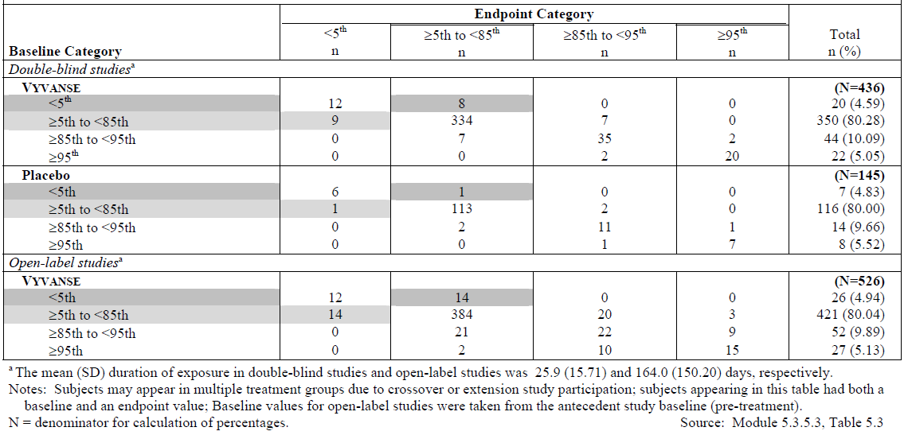
Question 3: Does the Committee consider the proposed statements in the draft PI provide sufficient information on the potential cardiovascular risks associated with LDX use?
The level of post-marketing exposure to Vyvanse in ADHD patients is substantial. As of 22 Feb 2013 the estimated worldwide patient exposure to Vyvanse was more than 3 million patient years of treatment. For these patients receiving Vyvanse, no signal indicating long-term cardiovascular effects measurably higher than background rate has been detected. These post-marketing data are consistent with the results from the nonclinical hERG study (no cardiovascular signal for Vyvanse) and results from Vyvanse clinical studies. There were no cases of sudden death, myocardial infarction, torsades de pointes or other serious arrhythmias reported in any age group in any Vyvanse Phase II-IV studies included in the submission. In addition, the sponsor has summarised all recent publications in regards to long term cardiovascular and cerebrovascular effects with stimulant therapy. The studies did not demonstrate an increased cardiovascular risk in patients exposed to ADHD stimulant medications including amphetamine based drugs. In their retrospective, population-based cohort study including 150,359 adults treated with ADHD drugs, Habel et al. concluded that “Among young and middle-aged adults, current or new use of ADHD medications, compared with non use or remote use, was not associated with an increased risk of serious cardiovascular events”.
The sponsor considers that the PI provides a sufficient amount of information to advise physicians who are considering prescribing Vyvanse in the context of potential cardiovascular risks and cardiovascular history. The text is comparable to the cardiovascular information for methylphenidate and amphetamine containing products currently available in Australia. Patients who are at high risk for developing cardiovascular adverse reactions to a stimulant are contraindicated from taking Vyvanse.
In the Precautions sections, the type of cardiovascular events that have occurred in adults and children taking stimulants are described, and cardiovascular diseases which place patients at increased vulnerability to sympathomimetic effects of stimulants are described in detail. The Precautions section also guides the physician about pre-treatment assessment of potential patients and ongoing monitoring once the patient is receiving Vyvanse. Additionally, sudden death, ischaemic cardiac events and cardiomyopathy are potential risks in the RMP and are continuously monitored to determine if there is any change to the risk.
Question 4: Given the reduced efficacy of LDX in adults compared with children and adolescents, the lack of assessment of efficacy in adults aged >55 years, and the higher likelihood of cardiovascular disease, including asymptomatic cardiovascular disease is it appropriate to exclude adults aged over 55 years in the indications for Vyvanse?
Clinically meaningful, statistically significant efficacy has been demonstrated for the adult population, and the sponsor notes that in regions where Vyvanse is currently marketed, specifying an age ceiling of 55 years for the indication has not been considered necessary. Consistent with the PI of other ADHD medications, it should be noted that the Vyvanse PI already includes the following statement: “Safety and efficacy has not been established in patients over 55 years”.
While patients >55 years of age were not included in pivotal clinical trials, the implementation of the Delegate’s recommendation would mean stopping patients from receiving therapy when they transition from 54 to 55 years of age. The sponsor considers it more reasonable to allow the treating physician to make a clinical judgement on the appropriateness of continuing Vyvanse. The recommended restriction is currently not in the approved indication for other ADHD medications; however, as with other PIs, the Vyvanse PI already includes the following precaution: “Safety and efficacy has not been established in patients over 55 years”.

Risk management plan
The sponsor clarified that FDA did not mandate a RMP or Risk Evaluation Mitigation Strategy (REMS) for Vyvanse as a condition of approval in the US in 2007. Shire volunteered to implement a RMP to monitor the real-world prevalence of nonmedical use (abuse and misuse) and diversion of Vyvanse with the objective of identifying any signals or trends that differed from other marketed prescription stimulants.
As of October 2012, all commitments made in the voluntary RMP were completed. In October 2012, the FDA was notified that Shire planned to discontinue the RMP because US surveillance data did not identify any trends suggesting increased nonmedical use or diversion of Vyvanse compared to other stimulants. Two postmarketing studies have been published subsequent to the marketing application (Cassidy et al., 2012, Sembower et al., 2013). No geographic trends were detected. Despite a continuing increase in US sales of Vyvanse, nonmedical use/diversion has remained low without an upward trend. Where data allow a comparison between Concerta and Vyvanse, rates of nonmedical use/diversion are comparable and very low for both products.
The US surveillance data provides valuable insight into real-world experience, and the sponsor considers that the above findings will be applicable to other regions including Australia. These findings indicate that Vyvanse will not become a product of concern from the perspective of nonmedical use and diversion.
The Delegate indicated the RMP is still to be negotiated with the sponsor. The sponsor is committed to work with the TGA; however, duplication of previous efforts such as post-marketing surveys should be avoided unless there is supported rationale for possible differences between Australian and US populations. In addition, the Delegate has repeated a recommendation for the facilitation of systematic returns of unused product even though the RMP evaluator previously accepted the sponsor’s proposed action to include additional instructions in the CMI as a suitable alternative. The proposed Australian RMP is comprehensive. Excluding the completed surveillance, the proposed actions in comparison to those in Europe and the US are presented in the table below.
Table 28. RMP proposed actions.
Currently proposed | US | Europe | Australia | Accepted TGA recommendation
Patient Medication guide or equivalent | √ | √ | √
Prescribers information | √ | √ | √
Supply chain monitoring | √ | √ | √
Pharmacovigilance monitoring | √ | √ | √
Drug utilisation study |  | √ | √
Prescribers educational tool via website |  | √ | √
Printed CMI in pack |  |  |  | √
Check boxes on carton |  |  |  | √
Return instructions in CMI |  |  |  | √

Place in therapy
The recently published Clinical Practice Points (National Health and Medical Research Council (NHMRC) 2012) and preceding Draft Australian Guidelines on Attention Deficit Hyperactivity Disorder (ADHD) (NHMRC/Royal Australian College of Physicians (RACP) 2009) recommend both dexamphetamine and methylphenidate for the 1st line treatment of ADHD as part of a management plan tailored to the individual. The comparative benefits of both medications have been demonstrated in a number of reviews and meta analyses that considered evidence related to safety as well as efficacy (Faraone, 2010, Arnold 2000). As noted above, long-acting stimulants have important advantages over short-acting products. For those patients who respond well to dexamphetamine, and particularly for those who achieve a better response with dexamphetamine compared to methylphenidate (Arnold 2000), availability of a long-acting dexamphetamine product is currently an unmet medical need. Vyvanse will be the first once daily amphetamine product.
The Delegate’s Overview includes a number of references to dexamphetamine not being approved for adults with ADHD; however, Medicare data (10% Pharmaceutical Benefits Scheme (PBS) sample, provided by Prospection Pty Ltd) clearly indicate a significant number of adults are prescribed dexamphetamine on the PBS (Table 29). This is not surprising considering the recommendations for treatment of adult ADHD in the abovementioned draft NHMRC guidelines as well as by the Royal Australian and New Zealand College of Psychiatrists. Vyvanse would be a medically more desirable alternative to off-label prescribing of immediate-release dexamphetamine. The need for such an alternative is illustrated by the number of Australian compounding pharmacies which advertise sustained-release dexamphetamine preparations and their endorsement by Government (for example, Northern Territory and NSW Departments of Health) and hospitals (for example Brisbane Mater Hospital – Child Development Network). As these preparations are unregulated, safety and efficacy may not be reliable; and the risk of dose dumping cannot be excluded (Vu et al., 2009, Fois et al., 2009).
Table 29. Number of adults* (age ≥ 18 years) prescribed stimulants on PBS.
* The columns represent annual figures, except for 2012 (which is MAT as of Nov 2012); Source: 10% PBS sample (Prospection Pty Ltd)

Sponsor’s comments on the Delegate’s proposed revisions to the PI
These are beyond the scope of the AusPAR.

Sponsor’s comments on the Delegate’s discussion presented within the Delegate overview
The sponsor does not agree with the following statements included in the Delegate’s Overview:
“Maintenance of efficacy has also not been assessed as thoroughly as recommended in the draft guideline….The study in children and adolescents had a 20 week stabilisation period but the study in adults had only a 3 week stabilisation period prior to randomised withdrawal so it was not clear that the adult subjects response to treatment was stable at enrolment. It is not possible to estimate the NNT of adults with ADHD who commence LDX and receive a long term clinically significant response from the submitted studies. This is a major short-coming in this submission.”
“Study 326, the randomised withdrawal study in children and adolescents, had a discontinuation rate of 40% during the 20- week open label phase. This occurred in subjects who had a history of taking LDX for ADHD prior to enrolment, suggesting a significant proportion of children and adolescents with ADHD who are commenced on LDX will not benefit significantly from treatment. However, the majority of subjects who continue treatment quickly relapsed when it was withdrawn, suggesting that those who continue to take the drug continue to benefit from it.”
With respect to establishing a stable response to Vyvanse treatment prior to randomised withdrawal in the adult study: both of the long-term maintenance of efficacy studies (SPD489-401 and SPD489-326) adequately met the principles of the guideline, since both studies required subjects to demonstrate long-term, stable efficacy and tolerability prior to the randomised withdrawal period. In adult Study SPD489-401, at least 6 months of exposure to Vyvanse was required at study entry. This was documented by prescription records, prescribing physician notes, or pharmacy records that established a durable record of efficacy and tolerability. An ongoing adequate response to Vyvanse was again demonstrated at the end of the 3 week stabilisation period. For these adult subjects with a documented history of at least 6 months of exposure to Vyvanse at study entry, continued treatment with Vyvanse was associated with maintenance of efficacy as demonstrated by the statistically significant lower proportion of treatment failure at endpoint among subjects receiving Vyvanse compared to placebo (<9% versus 75%, respectively) in the randomised withdrawal period.
With respect to the relationship between the discontinuation rate and efficacy results in Study SPD489-326: overall, of the 110 (39.9%) subjects who discontinued during the 26 week open-label period, a total of 21 (7.6%) subjects discontinued due to lack of efficacy. Overall discontinuation rates were similar regardless of treatment in the 7 week antecedent study (Vyvanse 30 [38.5%]; placebo 26 [34.7%], or Concerta 35 [42.2%]).
The benefit associated with Vyvanse therapy for the treatment of ADHD is soon realised after initiation of treatment, and it is clear from the results of both Study SPD489-401 and SPD489-326 that continued treatment is associated with maintenance of efficacy. In SPD489-326, for children and adolescents treated with Vyvanse for at least 26 weeks, continued treatment with Vyvanse was associated with maintenance of efficacy as demonstrated by the statistically significant lower proportion of treatment failure at endpoint among subjects receiving Vyvanse compared to placebo (16% versus 68%, respectively) was observed at the end of the randomised withdrawal period. The sponsor disagrees that it can be suggested that a significant proportion of children and adolescents with ADHD who are commenced on Vyvanse will not benefit significantly from treatment.

Conclusion
Patients who suffer with ADHD are severely impacted by this chronic disorder; beginning in childhood with learning and social difficulties, and ongoing into adulthood where many patients will continue to be burdened with less educational achievement, lower occupational levels and lower socioeconomic status than their peers. Stimulants such as dexamphetamine and methylphenidate are widely recognised as the treatment of choice for ADHD. Recently, long-acting formulations of methylphenidate have been launched in Australia which may offer lower abuse potential as well as reducing the need to be taken at school or work place thus reducing the potential for non-compliance and diversion.
The studies included in the clinical development program for Vyvanse employed a variety of designs and assessments that reported on symptoms, functional outcomes, and health-related quality of life, and they explored the impact of Vyvanse treatment on ADHD across the age range (children, adolescents, and adults). Efficacy was demonstrated using a variety of validated, subjective and objective measures that were assessed over a range of time intervals (throughout a treatment day, weekly, monthly and up to 1 year). Vyvanse administered as a once daily dose was well tolerated by children, adolescents, and adults. The development program for Vyvanse demonstrated a positive benefit-risk balance that supports its use as an efficacious and safe treatment for ADHD.

Advisory committee considerations
The Advisory Committee on Prescription Medicines (ACPM), having considered the evaluations and the Delegate’s overview, as well as the sponsor’s response to these documents, advised the following:
The ACPM, taking into account the submitted evidence of efficacy, safety and quality, considered Vyvanse (containing lisdexamfetamine dimesilate) to have an overall positive benefit–risk profile for the indication;
Vyvanse is indicated for the treatment of Attention Deficit Hyperactivity Disorder (ADHD) in
- Children aged 6 to 12 years;
- Adolescents aged 13 to 17 years
The ACPM advised the lack of longer term safety and maintenance of efficacy data in adults with the added but unquantified cardiovascular risk and increased likelihood of diversion and abuse created an unfavourable benefit-risk balance at this time.

Proposed conditions of registration:
The ACPM advised on the inclusion of the following conditions of registration:
- Subject to satisfactory negotiation of the Risk Management Plan for Australia,
- Negotiation of Product Information and Consumer Medicines Information to the satisfaction of the TGA.

Proposed PI/CMI amendments:
The ACPM agreed with the Delegate to the proposed amendments to the PI and Consumer CMI and specifically advised on the inclusion of the following:
- A statement in the Clinical Trials section of the PI and relevant sections of the CMI on the exclusion from trials of subjects with cardiovascular disease.
- A statement in the Precautions section of the PI and relevant sections of the CMI on cerebro-cardio vascular risk.
- Statements in the Clinical Trials and Precautions sections of the PI and relevant sections of the CMI on the exclusion of subjects with low body weight and the need for serious consideration of such patients for this treatment and / or the need for regular monitoring.
The ACPM advised that the implementation by the sponsor of the recommendations outlined above to the satisfaction of the TGA, in addition to the evidence of efficacy and safety provided would support the safe and effective use of these products.

Delegate’s post-ACPM considerations
To address whether maintenance has been adequately demonstrated in adults the Delegate referred to the following EMA guideline, which was adopted by the EMA in February 2011. While not formally adopted by the TGA at the time, this guideline provides some criteria against which to consider the evidence for use of lisdexamfetamine in adults.
- EMEA/CHMP/EWP/431734/2008 Guideline on the clinical investigation of medicinal products for the treatment of attention deficit hyperactivity disorder (ADHD)
Section 6.2.2 of the above document was noted in particular.
The requirement for 6 months blinded treatment to assess long term efficacy was met in Study 326 where children and adolescents received blinded treatment for 20 weeks after an open-label dose titration period. Randomised withdrawal then proceeded. There is no requirement to additionally demonstrate long term efficacy in adults. The remaining issue is whether the randomised withdrawal design adequately assessed time to relapse of symptoms and function.
Maintenance of effect in adults was examined in Study 401 conducted in the US. This was a multicentre, Phase IV, double-blind, placebo-controlled, randomised withdrawal, safety and efficacy study of LDX in adults aged 18 to 55 years inclusive with ADHD.
Subjects who had received at least 6 months treatment with commercial LDX at doses of 30, 50 or 70 mg/day and had shown a response to treatment were enrolled. Subjects entered a 3-week open-label treatment phase of LDX and received the same dose as their commercial supply. Subjects who maintained a treatment response at Week 3 [that is, subjects having mean baseline ADHD-RS with adult prompts total scores that indicated their ADHD was controlled] were randomised to LDX at their current dose or placebo during a 6-week double-blind randomised withdrawal phase. Assessments of treatment effect were conducted weekly during the double-blind period.
The primary efficacy outcome measure compared the proportion of treatment failures accrued by subjects receiving LDX against placebo at endpoint as measured over 9 weeks. Treatment failure was defined as a ≥ 50% increase (worsening) in the ADHD-RS with adult prompts total score and a ≥2 point increase (worsening) in CGI-S score at any double-blind visit. Secondary efficacy outcome measures were ADHD-RS with adult prompts and CGI-S.
At the endpoint assessment, that is, last assessment prior to withdrawal or endpoint of study, the mean (SD) ADHD-RS with adult prompts total score was 12.1 (9.96), a change of 1.6 (8.63) from baseline for subjects continuing LDX and 27.4 (12.39), a change of 16.8 (11.80) for subjects given placebo. At the first visit after LDX withdrawal 26/56 (43.3%) of subjects given placebo met the criteria for treatment failure. Of 32 subjects in the placebo group who continued with blinded treatment to the second week a further 10 (31.3%) were removed on meeting the treatment failure criteria.
From the above description it can be seen that immediate amphetamine withdrawal effects were not a significant reason for withdrawal for placebo subjects in Study 401. Subjects continued on study until meeting formal treatment failure criteria which are consistent with a recurrence of the signs and symptoms of ADHD in an adult.
Subjects enrolled in Study 401 had received 6 months of treatment with LDX. Subjects commencing randomised treatment had mean baseline ADHD-RS with adult prompts total scores that indicated their ADHD was controlled. On removal of LDX treatment failure generally occurred within 2 weeks. Thus time to symptom relapse, the recommended principal outcome for randomised withdrawal studies to assess maintenance of effect of treatments for ADHD, has been adequately determined by Study 401. The extent of relapse has also been identified.
For subjects enrolled in Study 401, the ADHD-RS with adult prompts total scores prior to commencement of their 6 months pre-study treatment were not available. Thus it is not known whether these subjects are representative of the typical adult ADHD patient. Clearly they were subjects who had responded well to treatment with LDX. Because subjects were withdrawn after meeting treatment failure criteria it is not known whether their ADHD symptoms would continue to deteriorate or would improve if they remained untreated. While this would be of interest it is not essential that it be known for maintenance of effect to have been demonstrated.
The additional factors noted by the ACPM with respect to the use of LDX in adults are not factors which would of themselves cause the benefit-risk balance for LDX to be unfavourable for adults. These factors can be appropriately described in the PI and CMI.

Outcome
Based on a review of quality, safety and efficacy, TGA approved the registration of Vyvanse capsules containing lisdexamfetamine dimesilate 30, 50 and 70 mg indicated for:
Vyvanse is indicated for the treatment of Attention Deficit Hyperactivity Disorder (ADHD). Treatment should be commenced by a specialist.
A diagnosis of Attention Deficit Hyperactivity Disorder (ADHD) implies the presence of hyperactive-impulsive or inattentive symptoms that caused impairment and were present before 12 years of age.
Need for comprehensive treatment programme: Vyvanse is indicated as an integral part of a total treatment program for ADHD that may include other measures (psychological, educational and social) for patients with this syndrome. Stimulants are not intended for use in the patients who exhibits symptoms secondary to environmental factors and/or other primary psychiatric disorders, including psychosis. Appropriate educational placement is essential and psychosocial intervention is often helpful. When remedial measures alone are insufficient, the decision to prescribe stimulant medication will depend upon the physician’s assessment of the chronicity and severity of the patients symptoms.
Long term use: the physician who elects to use Vyvanse for extended periods should periodically re-evaluate the long term usefulness of the drug for the individual patient.

Specific conditions of registration applying to these therapeutic goods
- The Vyvanse (lisdexamfetamine dimesilate) Risk Management Plan (RMP), Version 1.0 (dated 14/06/2012, DLP 29/04/2011), included with submission PM-2012-01494-3-1, and any subsequent revisions, as agreed with the TGA will be implemented in Australia.

Attachment 1. Product Information
The Product Information approved at the time this AusPAR was published is at Attachment 1. For the most recent Product Information please refer to the TGA website at <http://www.tga.gov.au/hp/information-medicines-pi.htm>.

Attachment 2. Extract from the Clinical Evaluation Report

‘Lisdexamfetamine’, ‘amphetamine’ and ‘dexamphetamine’ are Australian Approved Names.
<http://www.drugbank.ca/drugs/DB01255>
CPMP/ICH/2737/99 Note for Guidance on Impurities in New Drug Substances (Revision)
CPMP/ICH/2738/99 Note for Guidance on Impurities in New Drug Products (Revision)
A product registered in the USA which is a 1:1:1:1 mixture of amphetamine aspartate, amphetamine sulfate, DAS and d-amphetamine saccharate (and a 3:1 mixture of d- and l-isomers).
containing dextroamphetamine
‘grandfathered’ products have been available in Australia since prior to commencement of the ARTG in 1991
A product registered in the USA which is a 1:1:1:1 mixture of amphetamine aspartate, amphetamine sulfate, DAS and d-amphetamine saccharate (and a 3:1 mixture of d- and l-isomers).
Heal, D.J. et al. New perspectives from microdialysis studies in freely-moving, spontaneously hypertensive rats on the pharmacology of drugs for the treatment of ADHD. Pharmacol. Biochem. Behavior 2008:90;184-197.
Heal, D.J. et al. The neuropharmacology of ADHD drug in vivo: insights on efficacy and safety. Neuropharmacol 2009:57; 608-618.
Floor, E. and Meng, L. Amphetamine releases dopamine from synaptic vesicles by dual mechanisms. Neurosci. Lett. 1996:215; 53-56.
Miller, H.H, Shore, P.A. and Clarke D.E. In vivo monoamine oxidase inhibition by D-amphetamine. Biochem. Pharmacol. 1980:29;1347-1354.
Robinson, J.B. Stereoselectivity and isozyme selectivity of monoamine oxidase inhibitors. Enantiomers of amphetamine, n-methylamphetamine and deprenyl. Biochem. Pharmacol. 1985:34;4105-4108.
Heal, D. et al. The 5-HT₆ receptor as a target for developing novel antiobesity drugs. Internat. Review Neurobiol. 2011:96;73-109.
Moscardo, E. et al. An optimised methodology for the neurobehavioural assessment in rodents. J. Pharmacol. Toxicol. Methods 2007:56;239-255.
Himmel, H.M. Safety pharmacology assessment of central nervous system function in juvenile and adult rats: effects of pharmacological reference compounds. J. Pharmacol. Toxicol. Methods 2008:58;129-146.
Gauvin, D.V. and Baird, T.J. A functional observational battery in non-human primates for regulatory-required neurobehavioural assessments. J. Pharmacol. Toxicol. Methods 2008:58; 8-93.
Tontodonati, M. et al. A canine model used to simultaneously assess potential neurobehavioural and cardiovascular effects of candidate drugs. J. Pharmacol. Toxicol. Methods 2007:56;265-275.
Rubio-Aliaga, I and Daniel, H. Peptide transporters and their roles in physiological processes and drug disposition. Xenobiotica 2008:38;1022-1042.
Green, C.E., LeValley, S.E. and Tyson, C.A. Comparison of amphetamine metabolism using isolated hepatocytes from five species including human. J. Pharmacol. Exp. Ther. 1986:237, 931-6.
Meyer, M.R., Peters, F.T., Maurer, H.H. The role of human hepatic cytochrome P450 isozymes in the metabolism of racemic 3,4-methylenedioxyethylamphetamine and its single enantiomers. Drug Metab. Dispos. 2009:37;1152-1156.
Zhu, H.-J. et al. The role of the polymorphic efflux transporter p-glycoprotein on the brain accumulation of d-methylphenidate and d-amphetamine. Drug Metab. Dispos. 2006:34;1116-1121.
Behrendt, W.A. and Deininger, R. Zur pharmakolgie des 2-phenyl-3-methyl-butylamin-(3), einer substanz mit anorexigener. Wirkung Arzneimittelforschung 1963:13;711. (cited by the US NTP Technical Report on the Toxicology and Carcinogenesis Studies of dl-Amphetaminine Sulfate).
Ricaurte, G.A. et al. Amphetamine treatment similar to that used in the treatment of adult attention-deficit/hyperactivity disorder damages dopaminergic nerve endings in the striatum of adult nonhuman primates. J. Pharmacol. Exper. Therapeutics 2005:315, 91-98.
Nora, J.J., Trasler, D.G. and Fraser, F.C. Malformations in mice induced by dexamphetamine sulfate. Lancet 1965:2;1021-1022.
Nora, J.J., Sommerville, R.J. and Fraser, F.C. Homologies for congenital heart diseases: Murine models, influenced by dextroamphetamine. Teratol. 1968:1;413-416.
The F1 generation is the generation resulting immediately from a cross of the first set of parents
Steiner, E., Villen, T., Hallberg, M. and Rane, A. Amphetamine secretion in breast milk. Eur. J. of Clin. Pharmacol. 1984:27;123-124.
Middaugh, L.D. Prenatal amphetamine effects on behavior: possible mediation by brain monoamines. Ann. NY Acad. Sci. 1989:562;308-18.
QT interval is a measure of the time between the start of the Q wave and the end of the T wave in the heart's electrical cycle. A lengthened QT interval is a biomarker for ventricular tachyarrhythmias like torsades de pointes and a risk factor for sudden death. QTcB is QT interval corrected using Bazett’s formula.
Sponsor clarification: abuse potential investigations in Study NRP104-A03 showed that the Drug Rating Questionnaire – Subjects score was statistically significantly lower with LDX 50 and 100 mg compared with the score for d-amphetamine 40 mg, but there was no statistically significant difference in scores for LDX 150 mg and d-amphetamine 40 mg. The maximum recommended daily dose of LDX is 70 mg.
Sponsor clarification: abuse potential investigations in Study NRP104-A03 showed that the Drug Rating Questionnaire – Subjects score was statistically significantly lower with LDX 50 and 100 mg compared with the score for d-amphetamine 40 mg, but there was no statistically significant difference in scores for LDX 150 mg and d-amphetamine 40 mg. The maximum recommended daily dose of LDX is 70 mg.
Diagnostic and Statistical Manual of Mental Disorders 5 Text Revision
EMEA/CHMP/EWP/431734/2008. Guideline on the clinical investigation of medicinal products for the treatment of attention deficit hyperactivity disorder (ADHD). 22 July 2010
QT interval calculated using Fridericia's formula
A boxed warning is a succinct warning statement printed at the start of the approved product information, designed to alert prescribers to an important safety issue with a medicine.
Escobar R et al. Worse quality of life for children with newly diagnosed attention-deficit/hyperactivity disorder, compared with asthmatic and healthy children. Pediatrics; 2005:116(3): e364-9.
Kessler RC et al. Patterns and predictors of attention-deficit/hyperactivity disorder persistence into adulthood: results from the national comorbidity survey replication. Biol psychiatry, 2005:57(11), 1442–51.
Kessler RC et al. The prevalence and correlates of adult ADHD in the United States: Results from the National Comorbidity Survey Replication. Am J Psychiatry, 2006:163(4), 716–723.
Barkley R. Major life activity and health outcomes associated with attention-deficit/hyperactivity disorder. J Clin Psychiat; 2002:83(suppl 12): 10-15.
Harpin VA. The effect of ADHD on the life of an individual, their family, and community from preschool to adult life. Arch Dis Child; 2005:90 Suppl 1.
Geissler J, Lesch KP. A lifetime of attention-deficit/hyperactivity disorder: diagnostic challenges, treatment and neurobiological mechanisms. Expert Rev Neurother 2011:11;1467–1484.
Kaye S, Darke S. The diversion and misuse of pharmaceutical stimulants: what do we know and why should we care? Addiction, 2012:107;467–477.
Cassidy TA et al. Nonmedical Use and Diversion of ADHD Stimulants Among U.S. Adults Ages 18-49: A National Internet Survey. Journal of Attention Disorders December 26 2012.
Sembower MA, Ertischek MD, Buchholtz C. Surveillance of Diversion and Non-Medical Use of Extended-Release Prescription Amphetamine and Oral Methylphenidate in the United States. Journal of Addictive Diseases 2013:32;26-38.
Schedule 8 of the The Standard for the Uniform Scheduling of Medicines and Poisons (SUSMP) is defined as: Controlled Drug – Substances which should be available for use but require restriction of manufacture, supply, distribution, possession and use to reduce abuse, misuse and physical or psychological dependence.
Habel LA, Cooper WO, Sox CM, et al. ADHD medications and risk of serious cardiovascular events in young and middle-aged adults. JAMA 2011:306(24):2673-83.
Cassidy TA, Varughese S, Russo L et al. Nonmedical Use and Diversion of ADHD Stimulants Among U.S. Adults Ages 18-49: A National Internet Survey. Journal of Attention Disorders December 26 2012.
Sembower MA, Ertischek MD, Buchholtz C. Surveillance of Diversion and Non-Medical Use of Extended-Release Prescription Amphetamine and Oral Methylphenidate in the United States. Journal of Addictive Diseases 2013:32: 26-38.
NHMRC Clinical Practice Points on the diagnosis, assessment and management of Attention Deficit Hyperactivity disorder in children and adolescents. Commonwealth of Australia (2012).
NHMRC/RACP Australian Guidelines on Attention Deficit Hyperactivity Disorder (ADHD) – Draft. Commonwealth of Australia (June 2009)
Faraone SV, Buitelaar J. Comparing the efficacy of stimulants for ADHD in children and adolescents using meta-analysis. Eur Child Adolesc Psychiatry 2010:19:353–364.
Arnold LE. Methyiphenidate versus amphetamine: Comparative review. Journal of Attention Disorders 2000:3: 200-211.
To support this statement, the sponsor provided advertisements from 6 pharmacies (mainly in NSW) advertising the compounding manufacture of slow release forms of dexamphetamine
To support these claims, the sponsor’s provided: Poisons control fact sheet No. 301 Information for patients on S8 medicines, from the Northern Territory Government website, and in particular the statement: pharmacist can dispense psychostimulant medicines to you according to your doctor’s prescription. Psychostimulant prescriptions are valid for SIX months, but only one month’s worth of medication can be dispensed at any one time (special arrangements are in place for patients who need dexamphetamine compounded into a sustained release form). The interval between supplies must be written on each prescription;. a fact sheet on Attention Deficit Hyperactivity Disorder (ADHD) - Frequently Asked Questions from the NSW Health Government website (http://www0.health.nsw.gov.au/csqg/ps/adhd/faqs.asp), and in particular the statement: Slow release dexamphetamine preparations may be compounded by individual chemists, but their effectiveness has not been evaluated by scientific studies.
Leaflet on dexamphetamine, in particular the statement: “The duration of action for Dexamphetamine varies from child to child. Usually it begins working about half an hour after taking the medication, and lasts for about 4 hours. If necessary, the medication can be compound into sustained-release capsules so that the duration of action lasts across the school day.”
Vu N, Kupiec TC, Raj V. Compounding Slow-Release Pharmaceuticals. International Journal of Pharmaceutical Compounding 2009:13: 144-145.
Fois RA, Mewes BT, McLachlan AJ. Compounded medicines and ‘off label’ prescribing; A case for more guidance. Australian Family Physician 2009:38; 1/2: 16-20.

