|  |
| --- |
| **First round report: 10 November 2016**  **Second round report: 3 March 2017** |

|  |
| --- |
| AusPAR Attachment 2 |
| Extract from the Clinical Evaluation Report for Lisdexamfetamine dimesilate |
| Proprietary Product Name: Vyvanse |
| Sponsor: Shire Australia Pty Ltd |

About the Therapeutic Goods Administration (TGA)

* The Therapeutic Goods Administration (TGA) is part of the Australian Government Department of Health, and is responsible for regulating medicines and medical devices.
* The TGA administers the *Therapeutic Goods Act 1989* (the Act), applying a risk management approach designed to ensure therapeutic goods supplied in Australia meet acceptable standards of quality, safety and efficacy (performance), when necessary.
* The work of the TGA is based on applying scientific and clinical expertise to decision-making, to ensure that the benefits to consumers outweigh any risks associated with the use of medicines and medical devices.
* The TGA relies on the public, healthcare professionals and industry to report problems with medicines or medical devices. TGA investigates reports received by it to determine any necessary regulatory action.
* To report a problem with a medicine or medical device, please see the information on the TGA website < <https://www.tga.gov.au>>.

About the Extract from the Clinical Evaluation Report

* This document provides a more detailed evaluation of the clinical findings, extracted from the Clinical Evaluation Report (CER) prepared by the TGA. This extract does not include sections from the CER regarding product documentation or post market activities.
* The words [Information redacted], where they appear in this document, indicate that confidential information has been deleted.
* For the most recent Product Information (PI), please refer to the TGA website < <https://www.tga.gov.au/product-information-pi>>.

Copyright

© Commonwealth of Australia 2018  
This work is copyright. You may reproduce the whole or part of this work in unaltered form for your own personal use or, if you are part of an organisation, for internal use within your organisation, but only if you or your organisation do not use the reproduction for any commercial purpose and retain this copyright notice and all disclaimer notices as part of that reproduction. Apart from rights to use as permitted by the *Copyright Act 1968* or allowed by this copyright notice, all other rights are reserved and you are not allowed to reproduce the whole or any part of this work in any way (electronic or otherwise) without first being given specific written permission from the Commonwealth to do so. Requests and inquiries concerning reproduction and rights are to be sent to the TGA Copyright Officer, Therapeutic Goods Administration, PO Box 100, Woden ACT 2606 or emailed to < [tga.copyright@tga.gov.au](mailto:tga.copyright@tga.gov.au)> .

Contents

List of abbreviations 5

1. Introduction 8

1.1. Drug class and therapeutic indication 8

1.2. Dosage forms and strengths 8

1.3. Dosage and administration 9

1.4. Proposed changes to the product documentation 9

2. Clinical rationale 9

2.1. Information on the condition being treated 9

2.2. Current treatment options 10

2.3. Clinical rationale 10

3. Contents of the clinical dossier 11

3.1. Scope of the clinical dossier 11

3.2. Paediatric data 11

3.3. Good clinical practice 11

3.4. Evaluator’s commentary on the clinical dossier 11

4. Pharmacokinetics 12

4.1. Studies providing pharmacokinetic information 12

4.2. Summary of pharmacokinetics 12

4.3. Pharmacokinetics in special populations 13

4.4. Pharmacokinetic interactions 14

4.5. Evaluator’s overall conclusions on pharmacokinetics 14

5. Pharmacodynamics 14

5.1. Studies providing pharmacodynamic information 14

5.2. Summary of pharmacodynamics 14

5.3. The following has been extracted from the approved PI: 14

5.4. Evaluator’s overall conclusions on pharmacodynamics 15

6. Dosage selection for the pivotal studies 15

6.1. Pharmacokinetics and pharmacodynamics: dose finding studies 15

6.2. Phase II dose finding studies 15

6.3. Phase III pivotal studies investigating more than one dose regimen 15

6.4. Evaluator’s conclusions on dose finding for the pivotal studies 15

7. Clinical efficacy 16

7.1. Studies providing evaluable efficacy data 16

7.2. Pivotal or main efficacy studies 16

7.3. Other efficacy studies 31

7.4. Analyses performed across trials: pooled and meta analyses 40

7.5. Evaluator’s conclusions on clinical efficacy 40

7.6. Other efficacy studies; ADHD 41

8. Clinical safety 47

8.1. Studies providing evaluable safety data 47

8.2. Studies that assessed safety as the sole primary outcome 48

8.3. Patient exposure 48

8.4. Adverse events 50

8.5. Evaluation of issues with possible regulatory impact 59

8.6. Other safety issues 68

8.7. Post marketing experience 70

8.8. Evaluator’s overall conclusions on clinical safety 70

9. First round benefit-risk assessment 73

9.1. First round assessment of benefits 73

9.2. First round assessment of risks 74

9.3. First round assessment of benefit-risk balance 75

10. First round recommendation regarding authorisation 76

11. Clinical questions 77

11.1. Pharmacokinetics 77

11.2. Pharmacodynamics 77

11.3. Efficacy 77

11.4. Safety 78

12. Second round evaluation of clinical data submitted in response to questions 78

12.1. Efficacy 78

12.2. Safety 82

13. Second round benefit-risk assessment 85

13.1. Second round assessment of benefits 85

13.2. Second round assessment of risks 85

13.3. Second round assessment of benefit-risk balance 85

14. Second round recommendation regarding authorisation 86

15. References 87

## List of abbreviations

|  |  |
| --- | --- |
| **Abbreviation** | **Meaning** |
| ACSA | Amphetamine Cessation Symptom Assessment |
| ADHD | Attention deficit hyperactivity disorder |
| AE | Adverse event |
| AESI | Adverse event of special interest |
| ALT | Alanine transaminase |
| AST | Aspartate transaminase |
| BED | Binge eating disorder |
| BES | Binge eating scale |
| BMI | Body mass index |
| bpm | Beats per minute |
| CANTAB | Cambridge Neuropsychological Test Automated Battery |
| CFR | Code of Federal Regulations |
| CGI-I | Clinical Global Impressions – Global Improvement |
| CGI-S | Clinical Global Impressions – Severity of Illness |
| CI | Confidence interval |
| CNS | Central nervous system |
| CSR | Clinical study report |
| C-SSRS | Columbia-Suicide Severity Rating Scale |
| DA | Dopamine |
| DSM-IV-TR | Diagnostic and Statistical Manual of Mental Disorders Fourth Edition –Text Revision |
| DSM-5 | Diagnostic and Statistical Manual of Mental Disorders Fifth Edition |
| ECG | Electrocardiogram |
| EDE-Q | Eating Disorder Examination-Questionnaire |
| EQ-5D-5L | EuroQol 5 dimension 5 level questionnaire |
| ET | Early termination |
| EU | European Union |
| FAS | Full analysis set |
| HbA1c | Haemoglobin A1c |
| ICD | International Classification of Diseases |
| ICH | International Conference on Harmonisation |
| ISE | Integrated Summary of Efficacy |
| IWRS | Interactive web-based response system |
| LS | Least squares |
| MADRS | Montgomery-Asberg Depression Rating Scale |
| MedDRA | Medical Dictionary for Regulatory Activities |
| MMRM | Mixed-effects model for repeated measures |
| msec | Millisecond |
| NE | Norepinephrine |
| OROS MPH | Osmotic controlled oral release delivery system methylphenidate |
| PD | Pharmacodynamics |
| PK | Pharmacokinetics |
| PRUQ-BE | Patient resource utilisation questionnaire for binge eating |
| QTcB | QT interval corrected according to Bazett’s formula |
| QTcF | QTc interval corrected according to Fridericia’s formula |
| RBBB | Right bundle branch block |
| SAE | Serious adverse event |
| SAP | Statistical analysis plan |
| SCID-I | Structured Clinical Interview for DSM Axis I disorders |
| SD | Standard deviation |
| SDS | Sheehan Disability Scale |
| SE | Standard error |
| sec | Second |
| SEM | Standard error of the mean |
| SPD489 | Lisdexamfetamine |
| SVT | Supraventricular tachycardia |
| TC | Total cholesterol |
| TG | Triglyceride |
| UK | United Kingdom |
| URTI | Upper respiratory tract infection |
| US | United States |
| vs. | Versus |
| Y-BOCS | Yale-Brown Obsessive Compulsive Scale |
| Y-BOCS-BE | Yale-Brown Obsessive Compulsive Scale Modified for Binge Eating |

## Introduction

This is a submission to extend the indication of Vyvanse (lisdexamfetamine dimesilate) capsules. There are also proposed changes to the Clinical Trials and Adverse Effects sections of the Product Information (PI).

### Drug class and therapeutic indication

Lisdexamfetamine (drug development name: SPD489) is a pharmacologically inactive prodrug of dexamfetamine, which is a central nervous system stimulant.

The approved product information states that: ‘After oral administration, lisdexamfetamine is rapidly absorbed from the gastrointestinal tract and hydrolysed primarily in whole blood to dexamfetamine, which is responsible for the drug’s activity. Amphetamines are non-catecholamine sympathomimetic amines with CNS stimulant activity. The mode of therapeutic action of amphetamine in attention deficit hyperactivity disorder (ADHD) is not fully established, however it is thought to be due to its ability to block the reuptake of noradrenaline and dopamine into the presynaptic neuron and increase the release of these monoamines into the extraneuronal space.’

Lisdexamfetamine (Vyvanse) is currently indicated for the treatment of attention deficit hyperactivity disorder (ADHD). The approved indication is:

*Vyvanse is indicated for the treatment of Attention Deficit Hyperactivity Disorder (ADHD). Treatment should be commenced by a specialist.*

*A diagnosis of Attention Deficit Hyperactivity Disorder (ADHD) implies the presence of hyperactive-impulsive or inattentive symptoms that caused impairment and were present before 12 years of age.*

*Need for comprehensive treatment programme: Vyvanse is indicated as an integral part of a total treatment program for ADHD that may include other measures (psychological, educational and social) for patients with this syndrome. Stimulants are not intended for use in the patient who exhibits symptoms secondary to environmental factors and/or other primary psychiatric disorders, including psychosis. Appropriate educational placement is essential and psychosocial intervention is often helpful. When remedial measures alone are insufficient, the decision to prescribe stimulant medication will depend upon the physician’s assessment of the chronicity and severity of the patient’s symptoms.*

*Long term use: The physician who elects to use Vyvanse for extended periods should periodically re-evaluate the long-term usefulness of the drug for the individual patient.*

The submission proposes a new indication to treat binge eating disorder (BED). The proposed indication is:

*Vyvanse is indicated for the treatment of BED in adults.*

### Dosage forms and strengths

Vyvanse is presented in capsules containing 30 mg, 50 mg, and 70 mg of lisdexamfetamine dimesilate.

The capsule strengths are different colours: 30 mg capsule has a white opaque body and pink opaque cap, printed ‘S489’ and ‘30 mg’ in black ink; the 50 mg capsule has a white opaque body and blue opaque cap, printed ‘S489’ and ‘50 mg’ in black ink; and the 70 mg capsule has a blue opaque body and pink opaque cap, printed ‘S489’ and ‘70 mg’ in black ink.

No new dosages forms or strengths are proposed.

### Dosage and administration

For treatment of ADHD the approved dosage is as follows:

In patients who are either starting treatment for the first time or switching from another medication, 30 mg once daily in the morning is the recommended starting dose. If the decision is made to increase the dose beyond 30 mg/day, daily dosage may be adjusted in increments of 20 mg in intervals no more frequently than weekly. The maximum recommended dose is 70 mg/day; doses greater than 70 mg/day of Vyvanse have not been studied. Vyvanse has not been studied in children under 6 years of age. The effectiveness of Vyvanse has not been studied in adults over 55 years of age. Due to reduced clearance in patients with severe renal insufficiency (GFR 15 to < 30 mL/min/1.73 m2) the maximum dose should not exceed 50 mg/day. Further dosage reduction should be considered in patients undergoing dialysis.

The proposed dosage of BED is as follows:

The recommended starting titration dose is 30 mg/day to be adjusted in increments of 20 mg at approximately weekly intervals to achieve the recommended target dose of 50 or 70 mg/day. Dose titration should be guided by clinical outcome to an optimal dose, with a maximum dose of 70 mg/day.

### Proposed changes to the product documentation

There are a number of proposed changes to the production documentation. These include:

* Additional data in the Clinical Trial section on adolescents aged 13 to 17 years with ADHD.
* Changes in the Clinical Trial section on children and adolescents aged from 6 to 17 years with ADHD.
* New clinical data on BED.
* The new indication in BED.
* An additional precaution on the lack of data in children under 18 years of age with BED.
* Changes to the Adverse Effects section that states subjects met the DSM-IV criteria for ADHD. There are also additional data in this section relating to weight change.
* Changes to the Adverse Effects section to include data on subjects with BED.
* Change to the data in the Post-Marketing Experience section.
* New dosage recommendations for BED.

## Clinical rationale

### Information on the condition being treated

Binge eating disorder (BED) is defined according to DSM-5 as recurring episodes of eating significantly more food in a short period of time (for example 2 hours) than most people would eat under similar circumstances, with episodes marked by feelings of lack of control. The disorder is associated with marked distress and occurs on average at least once a week over three months. The condition also tends to have a long term remitting and relapsing course. Unlike those with bulimia nervosa or anorexia nervosa, people with BED will not regularly try to make up for the eating with compensatory behaviours such as vomiting or excessive exercise. This results in people with BED often being overweight or obese.

BED was approved for inclusion in the DMS-5 as its own category of eating disorder, while in DMS-IV it was not a recognised disorder (though it was described in the appendix) and was diagnosable using the category of ‘Eating disorder not otherwise specified’.

There are notable differences between BED and the common problem of overeating. BED is much less common, more severe and is associated with psychological problems. The long term effects of BED relate to the comorbidities of excess weight (for example, hypertension, coronary artery disease, diabetes, arthritis and obstructive sleep apnoea) as well as psychiatric comorbidities such as depression, anxiety and substance abuse.

### Current treatment options

The current treatment goals are multifaceted and aimed at reducing the following: binge eating episodes; excessive weight if overweight; excessive concerns with body image; and psychiatric comorbidity. The standard first line therapy is psychotherapy (such as cognitive behaviour therapy) and a meta-analysis of 6 randomised trials reported a large positive effect of this therapy (Vocks et al., (2010)). Other therapy options are self-help treatment and behavioural weight loss treatment and these are often combined with psychotherapy.

Pharmacotherapy is generally recommended only as second line therapy as it is regarded as less effective than psychotherapy. There is, however, a lack of head to head comparisons of pharmacotherapy and psychotherapy and there may be a place for pharmacotherapy in patients who decline, or do not have access to, psychotherapy.

Medications which have been assessed in the treatment of BED include selective serotonin reuptake inhibitors (SSRIs) (for example citalopram, fluoxetine, sertraline, fluvoxamine), antiepileptics (for example toprimate, zonisamide) and medications used for ADHD (for example atomoxetine and the proposed lisdexamfetamine).

In Australia, there are currently no products approved for the treatment of BED. Lisdexamfetamine was approved by the FDA in 2015 for treatment of moderate to severe BED and is the only medication approved for treatment of the condition.

### Clinical rationale

The sponsor states in the Clinical Overview that:

*'SPD489 is thought to treat the symptoms of ADHD through a mechanism of action that is presumed to be related to the blockade of DA and NE reuptake, which has the effect of increasing the availability of both of these neurotransmitters. Amelioration of dopaminergic and noradrenergic hypofunction may play a similar therapeutic role in BED. Data suggests that agents that facilitate DA and/or NE neurotransmission may reduce pathological overeating (for example binge eating) in both animals and humans.’*

It then goes on to state that:

*‘Stimulants such as SPD489 might relieve binge eating in BED by stabilizing a deficient DA reward system via blockade of DA reuptake. Norepinephrine blockade also appears to be a potentially effective therapy for eating disorders. The selective NE reuptake inhibitor atomoxetine has been shown to reduce binge eating and body weight in 1 placebo controlled study of BED in adults (McElroy et al., (2008)).’*

## Contents of the clinical dossier

### Scope of the clinical dossier

The dossier contained five clinical studies relating to the clinical development of lisdexamfetamine (SPD489) in BED, as well as four clinical studies in ADHD. No new pharmacology data were submitted.

The five studies for the BED indication were:

* Study SPD489-208; a Phase II, dose finding study.
* Studies SPD489-343 and SPD489-344; Phase III, efficacy and safety studies with the same design.
* Study SPD489-345; an open label, 52 week extension study.
* Study SPD489-346; a randomised, controlled withdrawal study.

There were four clinical studies in ADHD:

* Study SPD489-325; evaluation of a morning dose of SPD489.
* Study SPD489-404; an open label, 2 year safety study of SPD489 in children and adolescents 6 to 17 years.
* Study SPD489-405; a comparison with osmotic controlled release oral delivery system methylphenidate (OROS-MPH) in adolescents (dose optimised).
* SPD489-406; a comparison with OROS-MPH in adolescents (forced titration).

A Clinical Overview for BED; a Clinical Overview for the ADHD additional data; a Summary of Clinical Efficacy in BED; a Summary of Clinical Safety in BED; a list of literature references; and study synopses were also included.

### Paediatric data

All studies in BED were conducted in adults 18 to 55 years of age.

The included studies in ADHD were conducted in children aged 6 to 17 years.

### Good clinical practice

The sponsor stated in the clinical overviews that all studies were conducted in accordance with ICH GCP guidelines as well as local regulatory and ethical requirements.

### Evaluator’s commentary on the clinical dossier

The dossier contains two Clinical Overviews, one relating to the new indication of BED and one relating to changes to the product document due to the completion of three clinical studies in ADHD (Studies SPD489-404, SPD489-405 and SPD489-406).

The ADHD studies were submitted to support proposed changes to the PI. Study SPD489-325 was included due to a minor PI change relating to its data and it is assumed this study has previously been evaluated. Studies SPD489-405 and 406 were Phase IV studies in adolescents and data have been included in the PI regarding the effect versus the active comparator (OROS MPH). Study SPD489-404 was a long term study and the PI has included adverse effects data from this study relating to growth suppression in the paediatric ADHD population.

The scope of the clinical studies in BED was sufficient to undertake an evaluation in this new indication. The dossier was well presented.

## Pharmacokinetics

### Studies providing pharmacokinetic information

There were no PK studies submitted in the dossier.

### Summary of pharmacokinetics

The information included has been taken from the approved PI.

Pharmacokinetic studies of dexamfetamine after oral administration of lisdexamfetamine dimesilate have been conducted in healthy adult subjects and paediatric (6 to 12 years) patients with ADHD.

#### Physicochemical characteristics of the active substance

Vyvanse (lisdexamfetamine dimesilate) was developed as a capsule for once a day oral administration. The chemical designation for lisdexamfetamine dimesilate is (2S)-2,6-diamino-N-[(1S)-1-methyl-2-phenylethyl] hexanamide dimethanesulfonate. Lisdexamfetamine dimesilate is a white to off-white powder that is highly soluble in water. Lisdexamfetamine dimesilate has a 2-octanol/water partition coefficient (logP) of -1.76; pKa1 of 10.5 / pKa2 of 7.7; and pH of 4.1 when dissolved in water.

#### Pharmacokinetics

In 18 paediatric patients (6 to 12 years) with ADHD, the Tmax of dexamfetamine was approximately 3.5 hours following single-dose oral administration of lisdexamfetamine dimesilate; either 30 mg, 50 mg, or 70 mg after an 8 hour overnight fast. The Tmax of lisdexamfetamine dimesilate was approximately 1 hour. Linear pharmacokinetics of dexamfetamine after single dose oral administration of lisdexamfetamine dimesilate was established over the dose range of 30 mg to 70 mg in children aged 6 to 12 years and over the dose range of 50 mg to 250 mg in adults. Dextroamphetamine pharmacokinetic parameters following administration of lisdexamfetamine in adults exhibited low inter-subject (< 25%) and intra-subject (< 8%) variability. Safety and efficacy have not been studied above the maximum recommended dose of 70 mg.

#### Absorption

After oral administration, lisdexamfetamine is rapidly absorbed from the gastrointestinal tract, thought to be mediated by the high capacity PEPT1 transporter.

#### Bioavailability

Food (a high fat meal or soft food such as yogurt) or orange juice, do not affect the observed AUC and Cmax of dexamfetamine in healthy adults after single-dose oral administration of 70 mg of Vyvanse capsules. Food prolongs Tmax by approximately 1 hour (from 3.8 hours at fasted state to 4.7 hours after a high fat meal or to 4.2 hrs after soft food such as yogurt).

After an 8 hour fast, the AUC for dexamfetamine following oral administration of lisdexamfetamine dimesilate in solution and as intact capsules were equivalent.

Weight/Dose normalised AUC and Cmax for dexamfetamine were 22% and 12% lower, respectively, in adult females than in males on Day 7 following a 70 mg/day dose of lisdexamfetamine for 7 days. Weight/Dose normalised AUC and Cmax values were the same in girls and boys following single doses of 30 to 70 mg.

#### Distribution

There is no accumulation of dexamfetamine AUC at steady state in healthy adults and no accumulation of lisdexamfetamine dimesilate after once daily dosing for 7 consecutive days.

#### Metabolism

Lisdexamfetamine is converted to dexamfetamine and L-lysine, not by cytochrome P450 enzymes metabolism, but by metabolism in blood primarily due to the hydrolytic activity of red blood cells. Red blood cells have a high capacity for metabolism of lisdexamfetamine as in vitro data demonstrated substantial hydrolysis occurs even at low hematocrit levels.

Amphetamine is reported to be oxidised at the 4 position of the benzene ring to form 4‑hydroxyamphetamine, or on the side chain α or β carbons to form alpha‑hydroxyamphetamine or norephedrine, respectively. Norephedrine and 4-hydroxy-amphetamine are both active and each is subsequently oxidised to form 4-hydroxy-norephedrine. Alpha-hydroxy-amphetamine undergoes deamination to form phenylacetone, which ultimately forms benzoic acid and its glucuronide and the glycine conjugate hippuric acid. Although the enzymes involved in amphetamine metabolism have not been clearly defined, CYP2D6 is known to be involved with formation of 4-hydroxy-amphetamine.

#### Excretion

Following the oral administration of a 70 mg dose of radiolabelled lisdexamfetamine dimesilate to 6 healthy subjects, approximately 96% of the oral dose radioactivity was recovered in the urine and only 0.3% recovered in the faeces over a period of 120 hours. Of the radioactivity recovered in the urine 42% of the dose was related to amphetamine, 25% to hippuric acid, and 2% to intact lisdexamfetamine. Plasma concentrations of unconverted lisdexamfetamine are low and transient, generally becoming non-quantifiable by 8 hours after administration. The plasma elimination half-life of lisdexamfetamine typically averaged less than one hour in studies of lisdexamfetamine dimesilate in volunteers.

### Pharmacokinetics in special populations

#### Pharmacokinetics in subjects with impaired renal function

In a pharmacokinetic study of lisdexamfetamine in subjects with normal and impaired renal function d-amphetamine clearance was reduced from 0.7 L/hr/kg in normal subjects to 0.4L/hr/kg in subjects with severe renal impairment (GFR 15 to < 30 mL/min/1.73 m2). See PRECAUTIONS. In subjects with ESRD requiring dialysis mean d-amphetamine clearance was reduced to 0.3 L/hr/kg both pre- and post-dialysis. Dialysis did not significantly affect the clearance of d-amphetamine.

#### Pharmacokinetics according to age

The pharmacokinetics of dexamfetamine is similar in paediatric (aged 6 to 12) and adolescent (aged 13 to 17) ADHD patients, and healthy adult volunteers. Any differences in kinetics seen after oral administration are a result of differences in mg/kg dosing. Following administration of lisdexamfetamine dimesilate in a study of 47 subjects aged 55 years of age or older, amphetamine clearance was approximately 0.7 L/h/kg for subjects 55 to 74 years of age and 0.55 L/h/kg for subjects ≥ 75 years of age. This is slightly reduced compared to younger adults (approximately 1 L/h/kg for subjects 18 to 45 years of age).

### Pharmacokinetic interactions

Lisdexamfetamine dimesilate was not an in vitro inhibitor of the major human CYP450 isoforms (CYP1A2, CYP2A6, CYP2B6, CYP2C8, CYP2C9, CYP2C19, CYP2D6, and CYP3A4) in human hepatic microsomal suspensions, nor was it an in vitro inducer of CYP1A2, CYP2B6 or CYP3A4/5 in cultured fresh human hepatocytes. Lisdexamfetamine dimesilate was not an in vitro substrate for P-gp in MDCKII cells nor an in vitro inhibitor of P-gp in Caco-2 cells and is therefore unlikely to be involved in clinical interactions with drugs transported by the P-gp pump.

In an in vivo human study, the co-administration of a single dose of lisdexamfetamine dimesilate did not result in any clinically meaningful effect on the pharmacokinetics of single doses of drugs metabolized by CYP1A2, CYP2D6, CYP2C19, or CYP3A.

Ascorbic acid and other agents or conditions that acidify urine increase urinary excretion and decrease half-life of amphetamine. Sodium bicarbonate and other agents or conditions that alkalinise urine decrease urinary excretion and extend the half-life of amphetamine.

Concomitant use of MAOIs and CNS stimulants can cause hypertensive crisis. Severe outcomes including death may occur.

Serotonin syndrome can occur in association with the use of amphetamines such as Vyvanse, when given in conjunction with serotonergic drugs, including selective serotonin reuptake inhibitors (SSRIs) and serotonin and noradrenaline reuptake inhibitors (SNRIs). It has also been reported in association with overdose of amphetamines, including Vyvanse.

Amphetamines may decrease the effectiveness of antihypertensive medications.

Chlorpromazine, haloperidol and lithium carbonate may all reduce the effectiveness of amphetamines.

### Evaluator’s overall conclusions on pharmacokinetics

No new PK data were submitted.

There is reduced amphetamine clearance in patients with severe renal impairment.

Drug interactions due to effects on hepatic enzymes are not anticipated.

The PK in adults has been established and the data are sufficient for application to the BED population.

## Pharmacodynamics

### Studies providing pharmacodynamic information

There were no PD studies submitted in the dossier.

### Summary of pharmacodynamics

### The following has been extracted from the approved PI:

‘After oral administration, lisdexamfetamine is rapidly absorbed from the gastrointestinal tract and hydrolysed primarily in whole blood to dexamfetamine, which is responsible for the drug’s activity. Amphetamines are non-catecholamine sympathomimetic amines with CNS stimulant activity. The mode of therapeutic action of amphetamine in Attention Deficit Hyperactivity Disorder (ADHD) is not fully established, however it is thought to be due to its ability to block the reuptake of noradrenaline and dopamine into the presynaptic neuron and increase the release of these monoamines into the extraneuronal space. The parent drug, lisdexamfetamine, does not bind to the sites responsible for the reuptake of noradrenaline and dopamine in vitro.’

The sponsor states in the Clinical Overview that:

‘Amelioration of dopaminergic and noradrenergic hypofunction may play a similar therapeutic role in BED. Data suggests that agents that facilitate DA and/or NE neurotransmission may reduce pathological overeating (for example, binge eating) in both animals and humans.’

### Evaluator’s overall conclusions on pharmacodynamics

There are no new PD data.

The pharmacodynamic mechanism leading to the effect of SPD489 on BED is uncertain.

## Dosage selection for the pivotal studies

### Pharmacokinetics and pharmacodynamics: dose finding studies

No data submitted.

### Phase II dose finding studies

Study SPD489-208 was a Phase II, multicentre, randomised, double blind, placebo controlled forced dose titration study in 260 adults with moderate to severe BED. The study is discussed in Section 7. Subjects were randomised to placebo, 30 mg, 50 mg or 70 mg of SPD489 once daily in a 1:1:1:1 ratio. The primary efficacy endpoint was the log transformed number of binge days per week after 11 weeks of treatment. The LS mean change from Baseline to Week 11 in the log transformed number of binge days per week was -1.23, -1.24, -1.49, and -1.57 in the placebo, 30 mg, 50 mg and 70 mg SPD489 groups, respectively. The comparison of active to placebo was statistically significant for the 50 mg and 70 mg groups (p < 0.008) but not for the 30 mg dose (p = 0.88). These data were supported by sensitivity analyses and secondary endpoints.

**Comment:** It was not clear why log transformed data were used for analysis of the number of binge days per week in this study, particularly as in the Phase III studies this was not done. A question has been raised on this.

The above data excluded 11 subjects from Site 015. These were removed after the CSR was completed due to ‘reasons unrelated to the study’. A query has been raised regarding this.

### Phase III pivotal studies investigating more than one dose regimen

Not applicable.

### Evaluator’s conclusions on dose finding for the pivotal studies

The dossier included one dose finding study which assessed doses of 30 mg, 50 mg and 70 mg once daily. The higher doses of 50 mg and 70 mg demonstrated a significant difference to placebo on the chosen endpoint of log transformed number of binge days per week. There was no significant improvement over placebo for 30 mg dose. There was a suggestion of a dose response however no interdose comparisons were undertaken. The sponsor chose 30 mg as a titration dose for the Phase III studies with 50 mg and 70 mg as the target doses. This is acceptable and is the same as the approved dosage range for ADHD.

## Clinical efficacy

### Studies providing evaluable efficacy data

There were 5 clinical studies in the dossier relating to the BED indication. Studies SPD489-343 and SPD489-344 were pivotal, Phase III, efficacy and safety studies and had identical design. Study SPD489-208 was a Phase II dose finding study. These three studies had treatment durations of 11 to 12 weeks. Study SPD489-345 was a one year safety and tolerability extension study for subjects who had completed Studies 343, 344 or 208. There were minimal efficacy data in this study. Study SPD489-346 was a randomised, controlled withdrawal study and provided data on efficacy maintenance and relapse risk.

### Pivotal or main efficacy studies

#### Studies SPD489-343 and SPD489-344

As Studies SPD489-343 and SPD489-344 were identical in design, objectives and methodology, they have been discussed together in this section.

##### Study design, objectives, locations and dates

The studies were Phase III, randomised, placebo controlled, double blind, parallel group, dose optimisation studies which evaluated the efficacy and safety of SPD489 in adults (18 to 55 years) with moderate to severe BED.

Study SPD489-343 was conducted between November 2012 and September 2013 at 50 sites in the US, Sweden, Spain and Germany and Study SPD489-344 was conducted at the same time at 41 sites in the US and 2 in Germany.

**Comment:** The sponsor has been asked to discuss how independence of the two studies was achieved and maintained.

The primary objective was to demonstrate efficacy compared to placebo at Visit 8 (11 to 12 weeks treatment) as measured by the number of binge eating days per week. The key secondary objectives included the effect on Clinical Global Impression of Improvement (CGI-I) scale, cessation binge eating over 28 days prior to Visit 8, body weight, Yale-Brown Obsessive Compulsive Scale Modified for Binge Eating (Y-BOCS-BE) total score and fasting triglyceride (TG) levels. Some further secondary endpoints included effect on total cholesterol (TC), HbA1c levels and the number of binge episodes per week.

After a 2 to 4 week screening period, eligible subjects were randomised. There was a 4 week dose optimisation period, an 8 week dose maintenance period, and a one week follow up after study drug cessation (Figure 1).

Figure 1: Study SPD489-343. Study design schematic

Figure 1: Study SPD489-343. Study Design Schematic
After a 2 to 4 week screening period, eligible subjects were randomised. There was a 4 week dose optimisation period, an 8 week dose maintenance period, and a one week follow up after study drug cessation

##### Inclusion and exclusion criteria

The study included adults 18 to 55 years meeting the DSM-IV-TR criteria for BED[1]. Other inclusion criteria were: BED diagnosis confirmed on eating disorder module of the Structured Clinical Interview (SCID-I) for DSM-IV-TR and the Eating Disorder Examination Questionnaire (EDE-Q); at least 3 binge eating days per week for 14 days prior to Baseline visit; Clinical Global Impressions Severity (CGI-S) score ≥ 4; BMI ≥ 18 and ≤ 45 kg/m2; and negative pregnancy test for women. Appropriate contraception was required during the study and for 30 days after the last dose of study treatment.

Exclusion criteria were: diagnosis of bulimia nervosa or anorexia nervosa (as defined by the SCID-I eating disorders module); receiving psychotherapy or weight loss support which began within 3 months of screening (therapy started ≥ 3 months prior to screening could continue if no changes to frequency or nature occurred during the study); use of psychostimulants within 6 months; comorbid Axis I or II psychiatric disorder on prohibited medication or uncontrolled; history of psychosis, mania, hypomania, dementia or ADHD; symptomatic manifestations that contraindicated SPD489 treatment or interfered with assessments; Montgomery-Asberg Depression Rating Scale (MADRS) total score ≥ 18; suicide risk or previous suicide attempt; acute or chronic illness or disability which could interfere with the study assessments; history of seizures, tic disorder, serious neurological disease, head trauma, dementia, cerebrovascular disease, Parkinson’s or intracranial lesion; symptomatic or significant cardiovascular disease; family history of sudden cardiac death or ventricular arrhythmia; clinically significant ECG or laboratory test; abnormal thyroid function; initiation of lipid-lowering medication within 3 months; moderate to severe hypertension; SBP > 139 mmHg or DBP > 89 mmHg; substance abuse within 6 months or at any time for amphetamine, cocaine or other stimulants; positive drug screen; glaucoma; use of medication with CNS effect within 7 days; prior surgery for weight loss; and pregnant or breast feeding women.

##### Study treatments

SPD489 was supplied in capsules of 30 mg, 50 mg and 70 mg. Matching placebo capsules were used. One capsule was taken orally, once daily in the morning.

During the 4 week dose optimisation period, subjects commenced on SPD489 30 mg per day and after one week were titrated to 50 mg per day. A further increase to 70 mg per day was allowed at the end of Week 2 or 3 if indicated and treatment tolerated. One down titration to 50 mg was allowed during the optimisation period. The optimised dose was fixed during the 8 week dose maintenance period.

Prohibited treatments included psychoactive medications and over-the-counter weight loss therapies.

##### Efficacy variables and outcomes

Subjects reported binge eating in a daily paper diary and this was reviewed with the investigator at each visit. The primary efficacy endpoint was the change from Baseline to Visit 8 in the number of binge eating days per week (Week 11 to 12). Baseline was the weekly average of the number of binge days per week for the 14 days prior to the baseline visit (Visit 0).

Comment: It is not clear if the number of binge eating days per week were collected over one week or averaged over 2 weeks at the end of the study. This has been questioned.

Key secondary variables and endpoints included:

* Clinical Global Impressions (CGI) rating scales which assessed the severity (CGI-S) and improvement (CGI-I) of a subject’s condition on a 7 point scale.
* Four week cessation of binge eating which was defined as no binge episodes for the 28 days prior to last study visit.
* Body weight (change from Baseline).
* Yale-Brown Obsessive Compulsive Scale Binge Eating (Y-BOCS-BE) modified version[2] which measures obsessiveness and compulsiveness of binge eating.
* Triglyceride (TG) levels (change from Baseline).

Other assessments included: total cholesterol; HbA1c; Eating Inventory which is a self-reported 51 item questionnaire which covers cognitive restraint, disinhibition and hunger; the Binge Eating Scale (BES) which is a 16 item self-reported questionnaire assessing control over eating behaviour; Frontal Systems Behaviour Scale (self-rated scale); quality of life (EQ-5D-5L); functional impairment using the Sheehan Disability Scale (SDS); and health outcomes (PRUQ-BED).

##### Randomisation and blinding methods

Subjects were randomised in a 1:1 ratio to SPD489 or placebo via an IWRS. Placebo capsules were identical to active treatment.

##### Analysis populations

The Full Analysis Set (FAS) was defined as all subjects who took at least one dose of study medication and who had one post-baseline primary efficacy assessment (that is number of binge days per week calculated for at least 1 week).

The Completer Set was defined as all subjects in FAS who completed the double blind treatment phase and Week 12 assessments.

##### Sample size

Using data from Study SPD489-208, an effect size of 0.4 was assumed for the difference between SPD489 and placebo in the change from Baseline in number of binge days per week. With 133 competed subjects per group, and a 2-sided significance level of 5%, the study had a power of 90% to detect this difference. Allowing for 25% dropout rate, 178 subjects per group were required.

##### Statistical methods

The FAS was used for the primary efficacy endpoint analysis. Least squares (LS) means were calculated on the number of binge days per week and a mixed model for repeated measures (MMRM) was used for the analysis of the difference in the change from Baseline in the 2 treatment groups.

For secondary endpoints, the CGI-I was dichotomised to; ‘improved’ (‘very much’ or ‘much’) or ‘not improved’ (all other categories) and analysed using a Chi-square test. The 4 week cessation of binge eating was also analysed using a Chi-square test. Change in body weight and the Y‑BOCS-BE total score were analysed using the MMRM.

Hierarchical testing was used to control for multiplicity. The order was: change from Baseline in the number of binge eating days per week; CGI-I score dichotomised; proportion of subjects with 4 week binge eating cessation; percent change from Baseline in body weight; change from Baseline in Y-BOCS-BE total score; change from Baseline in TG; change from Baseline in total cholesterol (TC); then change from Baseline in HbA1c.

Both studies had the same single protocol amendment which was implemented prior to subject enrolment and would not have impacted on result validity.

##### Participant flow

In Study SPD489-343, there were 642 subjects screened with 383 randomised of whom 89% were enrolled at US sites. The FAS included 184 (96.3%) and 190 (99.0%) subjects in the placebo and SPD489 groups, respectively. There were 9 subjects not included in the FAS due to not being dosed (n = 4) or not having post-baseline diary data (n = 5). The Completer set included 157 (82.2%) and 158 (82.3%) in the placebo and SPD489 groups, respectively (see Figure 2, below). The main reasons for premature discontinuation was subject withdrawal (7.3% versus 6.3%) and adverse event (2.6% versus 6.3%) (placebo versus SPD489) (see Table 1, below).

**Comment:** It is noted in the FDA review, but not in the clinical study report, that there were concerns at Site 066 of this study where 21 subjects were enrolled (‘signs of investigational drug tampering during the conduct of another trial’). The sponsor has been asked to comment on this and whether it had any impact on the final results.

Figure 2: Study SPD489-343. Subject disposition diagram

Figure 2: Study SPD489-343. Subject Disposition Diagram
The FAS included 184 (96.3%) and 190 (99.0%) subjects in the placebo and SPD489 groups, respectively. There were 9 subjects not included in the FAS due to not being dosed (n = 4) or not having post-baseline diary data (n = 5). The Completer set included 157 (82.2%) and 158 (82.3%) in the placebo and SPD489 groups, respectively (Figure 2). The main reasons for premature discontinuation was subject withdrawal (7.3% versus 6.3%) and adverse event (2.6% versus 6.3%) (Placebo versus SPD489)

Table 1: Study SPD489-343. Subject disposition (Screened Set)

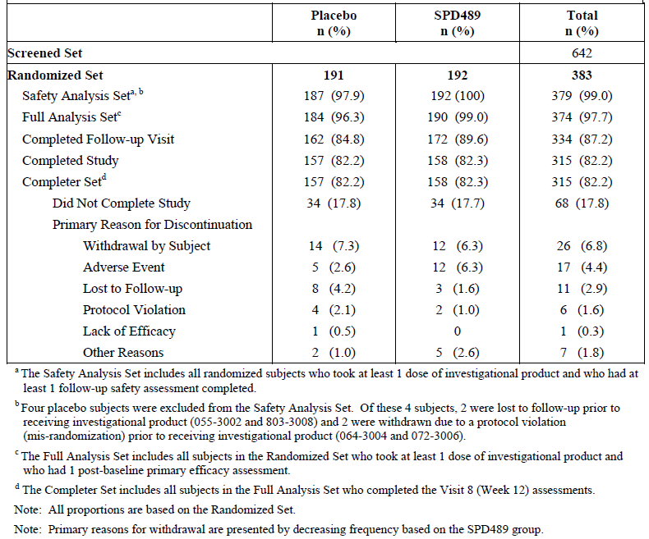

In SPD489-344, there were 700 subjects screened and 390 randomised (195 per group). The majority of subjects were in the US (n = 370) with only 20 (5%) in Germany. The FAS included 350 subjects (89.7%) with 176 and 174 in the placebo and SPD489 groups, respectively. The Completer set included 142 (72.8%) and 145 (74.4%) in the respective groups (Figure 3). The main reasons, in the placebo and SPD489 groups, for premature discontinuation were lost to follow up (9.2% versus 7.7%), subject withdrawal (3.6% versus 6.7%) and adverse event (2.6% versus 3.6%) (Table 2).

Figure 3: SPD489-344. Subject disposition diagram

Figure 3: SPD489-344. Subject Disposition Diagram
The FAS included 350 subjects (89.7%) with 176 and 174 in the placebo and SPD489 groups, respectively. The Completer set included 142 (72.8%) and 145 (74.4%) in the respective groups (Figure 3). The main reasons, in the placebo and SPD489 groups, for premature discontinuation were lost to follow up (9.2% versus 7.7%), subject withdrawal (3.6% versus 6.7%) and adverse event (2.6% versus 3.6%)

Table 2: SPD489-344. Subject disposition (screened set)

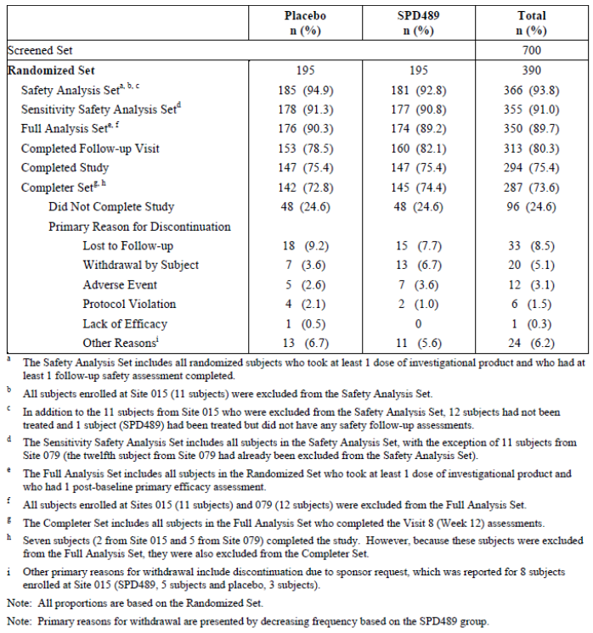

In Study SPD489-344, 23 subjects at 2 sites were removed from analyses. There were 11 subjects at Site 015 who were excluded due to ‘reasons unrelated to the study’ and 12 subjects from Site 079 who were excluded due to ‘findings that were considered by [the sponsor] to be significant’. The findings at Site 079 related to non-adherence to GCP requirements. Data from this site were included in the safety analysis.

**Comment:** The sponsor has been asked to clarify these issues further and comment on any differences in the primary endpoint results when the data from these sites were analysed.

Subject loss in Study 344 was relatively high, although the study power would be maintained as the numbers completing (142 and 145 in the respective groups) was just above the sample size requirement of 133 per group.

##### Major protocol violations/deviations

###### SPD489-343

Treatment compliance of 80 to 120% was reported in all the placebo subjects and 97.9% of the SPD489 subjects. The rate of at least one protocol violation was 11.2% and 10.4% of the placebo and SPD489 groups, respectively. Most related to the inclusion (5.0%) or exclusion criteria (3.7%). There were 9 subjects in each group who did not have at least 3 binge eating days per week.

###### SPD489-344

Treatment compliance was high (> 98%). The protocol violation rate was slightly higher than Study 343 (16.8% versus 15.5% in the placebo and SPD489 groups, respectively). Most again related to inclusion (11.7% with 23 subjects not having at least 3 binge days per week although all were at least 2 per week) or exclusion criteria (4.1%).

##### Baseline data

###### SPD489-343

Groups were relatively well matched on baseline demographic characteristics. In SPD489-343, the mean age was 38.1 years, 86.5% were female, 77.6% White and the mean BMI was 33.5 kg/m2. Baseline disease characteristics were balanced (Table 3). The mean number of binge days per week was 4.59 and 4.78 in the placebo and active groups, respectively. The mean baseline MADRS total score was 4.2 and 3.9 in the placebo and SPD489 groups, respectively (Table 3). All subjects were reported to have BED with more patients having moderate severity (placebo versus SPD489: 69% versus 72%) than severe (31% versus 28%). Data from the SCID-I eating disorder module found that there were 2 subjects with anorexia nervosa (1 placebo subject in remission and 1 SPD489 subject with a past history) and 6 with bulimia nervosa (4 placebo and 2 SPD489 with all either in remission or reported as prior history). Most subjects (> 97%) had never had psychotherapy for BED and only 7 had received pharmacotherapy for BED at any point during their life. Concomitant medication use was frequent (74.9%) and was predominantly ibuprofen (23.2%), multivitamins (15.3%) and paracetamol (11.3%).

Table 3: Study SPD489-343. Summary of other baseline characteristics (Safety Analysis Set)

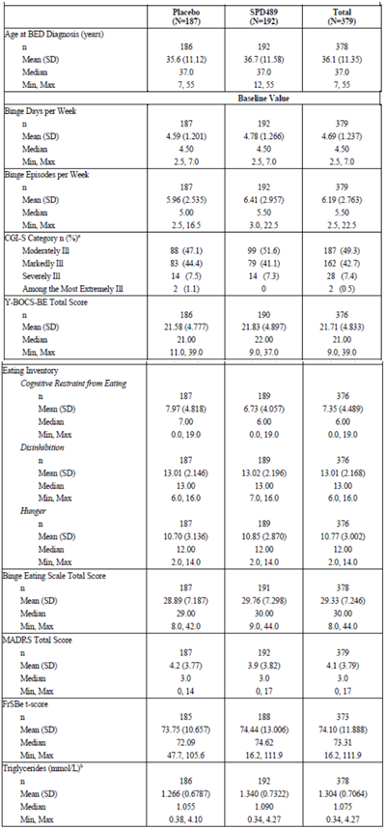

###### SPD489-344

Characteristics in this study were also relatively well matched between groups. The mean age was 37.9 years, 85% were female and 73% White with a mean BMI of 33.5 kg/m2. The mean baseline number of binge days per week was 4.85 and 4.66 in the placebo and SPD489 groups, respectively. The mean MADRS total score was 3.4. As with Study 343; BED was more likely to be moderate (76.2% versus 74.6%) than severe (23.8% versus 25.4%). There were 3 subjects with a prior history of anorexia or bulimia nervosa. Only 2 subjects (both in the placebo group) had received prior psychotherapy and 2 subjects (one in each group) who were receiving current psychotherapy. Four subjects had received prior pharmacotherapy for BED. Concomitant medication use was similar to Study 343.

##### Results for the primary efficacy outcome

###### SPD489-343

From a mean baseline of 4.78 and 4.59 binge days per week in the SPD489 and placebo groups, respectively, at Weeks 11 to 12 of treatment the LS mean decrease was -3.87 and -2.51 days. The LS mean difference of -1.35 days (95% CI: -1.7,-1.0) was statistically significant (p < 0.001). A separation of effect between SPD489 and placebo was seen from Week 1 and was relatively constant over the treatment period of 12 weeks (Figure 4). Results were supported by sensitivity analyses. Analyses of subgroups of region (US and non-US), gender, age (< 40 and ≥ 40 years) and race (White and non-White) found a lower effect in males and non-Whites (Figure 5).

**Comment:** The numbers in the subgroups of males, non-US, non-White were relatively small so it is not possible to draw conclusions.

Figure 4: SPD489-343. LS Mean (SEM) change from Baseline in number of binge days per week over time presented by treatment group (full analysis set)

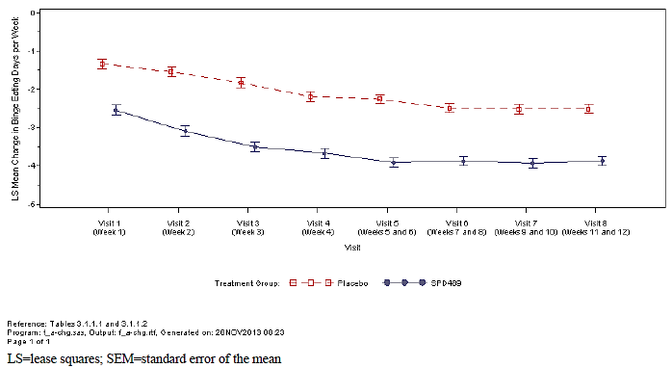

Figure 5: SPD489-343. LS Mean Difference (+95% CI) in change from Baseline at Visit 8 (Weeks 11 and 12) in number of binge days per week presented by subgroup (full analysis set)

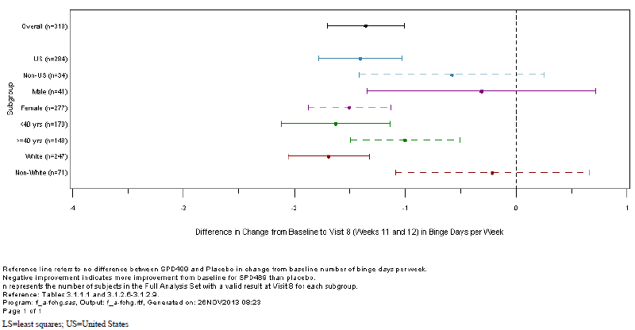

###### SPD489-344

From a baseline of 4.66 and 4.82 binge days per week in the SPD489 and placebo groups, respectively, the LS mean decrease to Week 11 to 12 was -3.92 and -2.26, respectively. The LS mean difference of -1.66 (95% CI: -2.04, -1.28) was significant (p < 0.001) (Table 4). As with Study 343, there was a separation of effect from Week 1 and this remained relatively constant from Weeks 3 to study end (Figure 6). Sensitivity analyses were supportive of the primary analysis. Subgroup analysis found consistent results apart from the non-US sites (Germany) where no treatment effect was seen (Figure 7).

**Comment:** Although the numbers were small (n = 16), the sponsor has been asked to comment on possible reasons that no effect was seen in the German subjects.

Table 4: SPD489-344. Mean change from Baseline at Visit 8 (Weeks 11 and 12) in number of binge days per week presented by treatment group (full analysis set)

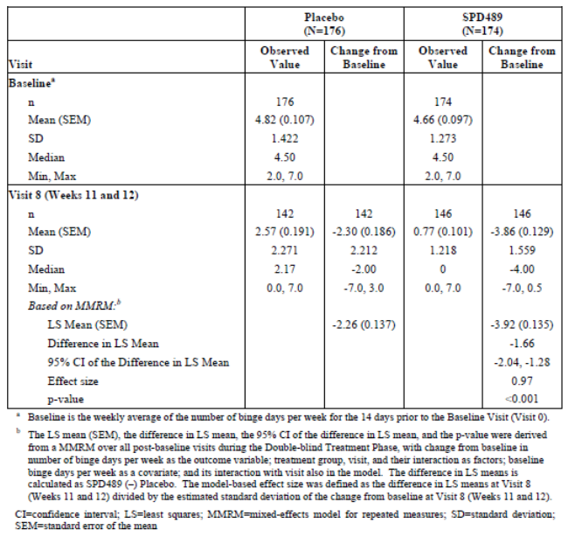

Figure 6: SPD489-344. LS Mean (SEM) change from Baseline in number of binge days per week over time presented by treatment group (full analysis set)

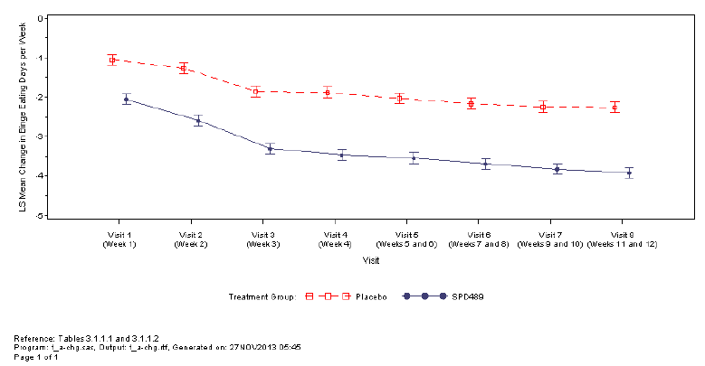

Figure 7: LS Mean Difference (±95% Confidence Intervals) in Change from Baseline at Visit 8 (Weeks 11 and 12) in Number of Binge Days per Week Presented by Subgroup (Full Analysis Set)

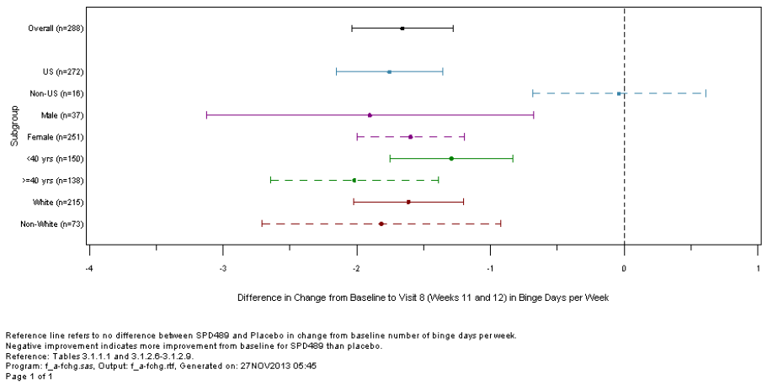

##### Results for other efficacy outcomes

###### SPD489-343

As the primary endpoint was statistically significant, the hierarchical testing procedure continued to the secondary endpoints. The secondary endpoints were all significant up to total cholesterol. Change from Baseline to Week 12 in HbA1c was not statistically significant.

The rate of subjects being improved (very much or much) on the CGI-I at Week 12 were significantly greater in the SPD489 than placebo groups (82.1% versus 47.3%, p < 0.001). The proportion of subjects with a 4 week cessation from binge eating (prior to last study visit) was greater in the SPD489 than placebo group (40.0% versus 14.1%, p < 0.001).

The LS mean percentage change from Baseline to Week 12 in body weight was -6.25% versus 0.11% in the SPD489 and placebo groups, respectively with a LS mean difference of -6.35% (95% CI: -7.17, -5.54, p < 0.001). There was also a significant (p < 0.001) reduction in favour of SPD489 in the Y-BOCS-BE Total Score (-15.7 versus -8.3).

While there was a statistically significant LS mean difference in the change from Baseline in TG levels (-0.077 versus 0.122 mmol/L, LS mean difference of -0.199) the result is of minimal clinical significance. Similarly there was a significant but clinically small LS mean difference in total cholesterol (-0.211). There was no statistically significant difference in the change from Baseline in HbA1c.

###### SPD489-344

On hierarchical testing the key secondary endpoints were all statistically significant. Total cholesterol was not significant so testing ceased at this point.

At Week 12, there was a significantly greater proportion of subjects with dichotomised CGI-I categories of ‘improved’ in the SPD489 than placebo groups (86.2% versus 42.8%, p < 0.001). The rate of 4 weeks cessation from binge eating was also higher with SPD489 (36.2% versus 13.1%, p < 0.001). After 12 weeks treatment, the mean percentage change from Baseline in body weight was -5.57% with SPD489 compared to 0.15% with placebo (p < 0.001). The LS mean percentage difference was -5.41% (95% CI: -6.4, -4.4).

The LS mean change from Baseline to Week 12 in the Y-BOCS-BE Total Score was -15.4 versus ‑7.4 in the SPD489 and placebo groups, respectively (p < 0.001). Changes in TG levels also favoured SPD489 (LS mean change from Baseline of SPD489 -0.133 versus placebo -0.06, p = 0.002). There was little alteration in mean total cholesterol levels and the difference between groups was not significant (p = 0.23).

##### Evaluator commentary

Studies SPD489-343 and 344 were identical, Phase III, pivotal efficacy studies which enrolled 383 and 390 adult subjects, respectively, with moderate to severe BED (that is at least 3 binge eating days per week and CGI-S ≥ 4). Of note, the vast majority (> 97%) of patients had no history of prior treatment with psychotherapy. In addition, the use of any prior pharmacotherapy was rare.

From an initial dose of 30 mg, the dose of SPD489 was titrated to 50 mg or 70 mg per day at the investigator discretion during the first month of treatment. The overall treatment duration was 12 weeks. This duration is relatively short for a treatment which is proposed to be used long term.

Subjects were approximately 40 years old, predominantly White and female, with a mean BMI of 33 to 34 kg/m2. The demographic pattern of BED in Australia does not appear well defined. The sponsor has been asked to comment on the applicability of the clinical trial population to the targeted one in Australia.

Mean number of binge days per week at baseline was 4.6 to 4.8. This baseline was recorded over the 14 days prior to randomisation and data were collected in a patient diary. This 14 day period at baseline is acceptable; however at study end it appears the number of binge days was collected over a one week period. The sponsor has been asked to confirm the period over which data were collected at study end, and if it was only one week rather that two to comment on whether the 7 days were sufficient given potential data variability.

The use of binge days per week rather than binge episodes per week is appropriate as it may not be possible to adequately delineate the start and end of a binge episode.

GCP non-compliance and other issues were reported in the studies with resultant data removal and reduction in subject numbers in the FAS and Completer set. Nonetheless, the overall number of analysable subjects was still within the requirements from sample size calculations. The sponsor has been asked to comment on all issues relating to study conduct for the clinical development program and the overall impact on efficacy results.

Both studies met the primary endpoint with superiority of SPD489 over placebo in the reduction in number of binge days per week. Analysis of data from the combined studies reported a least squares mean difference of -1.52 (95% CI: -1.77, -1.26).

Subgroup analysis age (< 40, ≥ 40 years), gender, race (White, non-White), ethnicity (Hispanic, non-Hispanic), region (US, non-US), BMI category (obese, non-obese) and binge eating category (moderate, severe) was undertaken on the combined dataset of the two studies and found consistent results across the subgroups, apart from in non-US subjects where the numbers were too small to draw conclusions (Figure 8). As the age cut-off was 55 years, there are no efficacy data in older adults.

Figure 8: Combined data SPD489-343 and 344. LS mean difference (95% CI) in change from Baseline at Weeks 11 and 12 in number of binge days per week presented by subgroup for the combined Phase III studies (full analysis set)

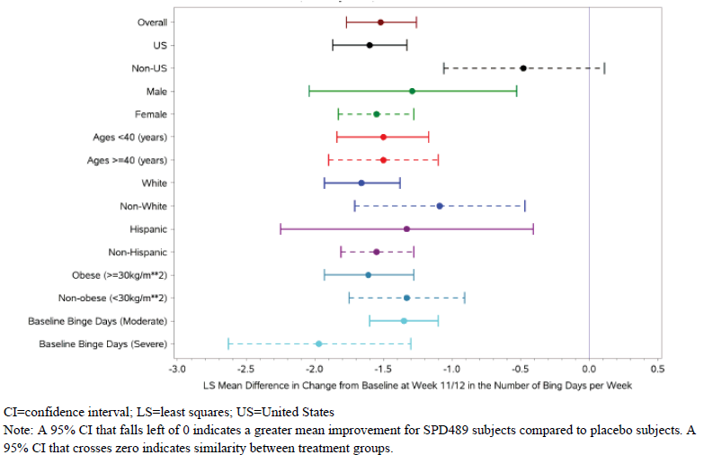

Efficacy data were supported by sensitivity analyses and key secondary endpoints (3 relating to behaviour (CGI-I, binge cessation for 4 weeks and Y-BOC-BE) and 2 medical (body weight and TG levels)). Of note clinically was the higher rate of binge eating cessation over the 28 days prior to study end (40% versus 14% and 36% versus 13% in the two studies) with about a 23% difference in favour of SPD489.

There was also a 5 to 6% decrease in body weight in SPD489 treated subjects compared to little change in the placebo treated. The sponsor has been asked to comment on the lack of weight reduction in the placebo group given there was an effect on binge eating in those treated with placebo (-2.4 binge days per week).

### Other efficacy studies

#### Study SPD489-208

##### Design and methods

Study SPD489-208 was a Phase II, randomised, double blind, parallel group, placebo controlled, forced dose titration study conducted in adults aged 18 to 55 years with BED. It was conducted in 2011-2012 at 31 sites in the US. After a 2 week screening period, subjects entered an 11 week double blind treatment phase which included a 3 week forced dose titration and an 8 week dose maintenance period. There was a one week follow up period at the end. Three doses of SPD489 were assessed (30 mg, 50 mg and 70 mg), with subjects randomised in a 1:1:1:1 ratio to these doses or placebo. Study treatment was taken once daily in the morning and patients on active treatment commenced on 30 mg per day and escalated 20 mg each week as appropriate for their assigned dose. There were no dose reductions.

Subjects met the DSM-IV-TR criteria for BED of at least moderate severity (at least 3 binge eating days per week during the 2 week screening period).

The primary efficacy endpoint was the number of binge days per week (days during with at least one binge episode occurred) as assessed by clinical interview and patient diary. A MMRM analysis was conducted on the change from Baseline in the log transformed number of binge days per week + 1. Analysis was of the FAS (all subjects who took at least one dose of study medication and had a post-baseline primary efficacy assessment). Secondary endpoints included number of binge episodes, 4 week and 1 week remission (binge episode free), CGI-S, CGI-I, Y-BOCS-BE and MADRS. Assuming an effect size of 0.6 (active versus placebo) on the primary endpoint, 45 subjects per group gave the study 80% power based on a 2-sided test with a 0.05 significance level. Allowing 30% non-completion rate, a sample of 65 per group was planned.

##### Results

There were 511 subjects screened, 271 randomised with 68 in each active dose group and 67 in the placebo group. The study completion rate was 78.6% (79.9% versus 74.6% in the SPD489 and placebo groups, respectively). The main reasons for non-completion were protocol violation and patient withdrawal. Groups were moderately well balanced on baseline characteristics. The baseline mean number of binge days per week was 4.3 in the placebo group and 4.5-4.6 in the SPD489 groups. The overall major protocol deviation rate was 16.3%. The FAS included 266 subjects (5 subjects had no diary data).

The LS mean change from Baseline in the log transformed binge days per week over the 11 week treatment period was -1.17, -1.26, -1.50, -1.58 in the placebo, 30 mg, 50 mg and 70 mg SPD489 groups, respectively. Comparison of active to placebo found a significant LS mean difference in the 50 mg and 70 mg groups but not the lowest dose group of 30 mg (Table 5). Sensitivity analyses of non-transformed data, as well as transformed data with LOCF for subjects missing Week 11 data, were performed. These found similar results favouring the higher two doses. From a mean baseline line of 4.3 to 4.6 binge days per week, the reduction in mean change from Baseline to Week 11 was -3.12, -3.56, -4.17 and -4.06 in the placebo, 30 mg, 50 mg and 70 mg groups, respectively (Table 6).

The secondary endpoints of number of binge episodes per week and binge response were supportive. The rate of subjects with a 4 week remission (no binge eating during the last 28 days on study) was 20.3%, 36.9%, 44.8% and 52.3% in the placebo, 30 mg, 50 mg and 70 mg groups, respectively.

**Comment:** The dossier included an addendum to the CSR. In this report it was stated that data from one site (015) were ‘removed from the analysis for reasons unrelated to the study’. There were 11 randomised subjects at this site. Analysis was redone excluding these subjects.

Based on these changes, the study withdrawal rate was 22.3%. The baseline characteristics were not altered and results of the primary efficacy endpoint were similar to the original analysis with significant effects over placebo for the 50 mg and 70 mg doses but not the 30 mg dose.

The sponsor has been asked to comment on why these data were removed from the analysis and if there were any other instances where data integrity was in question in the clinical development program.

Table 5: Study SPD489-208. Analysis of the change from Baseline in log transformed binge days per week using mixed-effects model for repeated measures presented by treatment group (full analysis set)

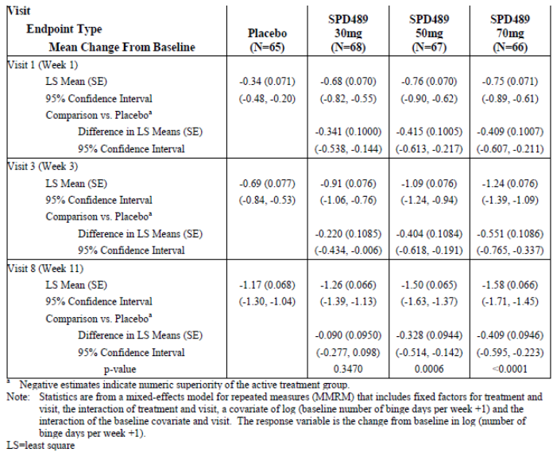

Table 6: SBD489-208. Means and mean changes from Baseline in non-transformed binge days per week over time presented by treatment group (full analysis set)

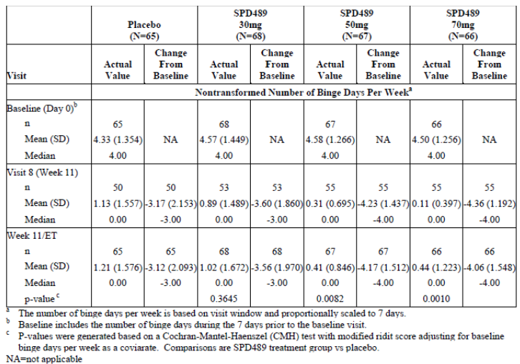

#### Study SPD489-346

##### Design and methods

Study SPD489-346 was a Phase III, multicentre, double blind, placebo controlled, randomised withdrawal study of SPD489 in adults with moderate to severe BED. It was conducted between January 2014 and April 2015 at 38 sites in the US, 6 in Germany, 2 in Sweden, 2 in Spain and 1 in Canada.

The design included a 4 week screening phase, a 12 week open label treatment phase (4 weeks dose optimisation and 8 weeks dose maintenance), a 26 week double blind treatment withdrawal phase and a 1 week follow up (Figure 9). Dose optimisation was as in Studies 343 and 344 with an initial dose of 30 mg/day and titration to the optimal dose of 50 mg or 70 mg/day. This dose was fixed during the 8 week dose maintenance period. The lowest allowed dose was 50 mg/day.

Figure 9: Study SBD489-346. Study design schematic

Figure 9: Study SBD489-346. Study Design Schematic
The design included a four week screening phase, a 12 week open label treatment phase (4 weeks dose optimisation and 8 weeks dose maintenance), a 26 week double blind treatment withdrawal phase and a 1 week follow up (Figure 9). Dose optimisation was as in Studies 343 and 344 with an initial dose of 30 mg/day and titration to the optimal dose of 50 mg or 70 mg/day. This dose was fixed during the 8 week dose maintenance period. The lowest allowed dose was 50 mg/day

The primary objective was to evaluate maintenance of efficacy based on time to relapse between SPD489 (50 mg or 70 mg) and placebo, as measured by the number of binge days[3] per week. This was assessed by clinical interview based on subject diary and CGI-S scores for subjects who responded to SPD489 by the end of the open label treatment phase.

Relapse was defined as ≥ 2 binge days each week for 2 consecutive weeks (14 days) prior to the visit and a ≥ 2 point increase in CGI-S score relative to the score at the randomised withdrawal baseline visit.

To enter open label treatment, subjects needed to have ≥ 3 binge days per week during the 14 days prior and a CGI-S score of ≥ 4. After 12 weeks treatment, those who responded were randomised (via an IWRS) in a 1:1 ratio to SPD489 (on their optimal dose) or matching placebo capsules for 26 weeks. Randomisation was stratified by region (US or non-US). Responders were defined as subjects who reported ≤ 1 binge day per week for the 4 consecutive weeks (28 days) and had a CGI-S score of ≤ 2.

Inclusion criteria were: age 18 to 55 years; BED diagnosis as per DSM-IV-TR confirmed on SCID‑I of at least moderate severity; CGI-S score ≥ 4; and BMI ≥ 18 and ≤ 40. Exclusion criteria were essentially the same as the other Phase III studies. Subjects could not have participated in another SPD489 study. Prohibited medications were also the same as the other Phase III studies.

The sample size calculations assumed a true relapse rate of 30% in the SPD489 and 50% in the placebo group (hazard ratio of 0.447) and 72 subjects per group gave the study a 90% power (α=0.05). With 20% drop out and 65% response rate from open label treatment and 20% drop out from randomised treatment prior to a relapse, 412 subjects needed to be enrolled to the open label treatment phase and 214 (107 per group) randomised.

The FAS was defined as all randomised subjects who took at least one dose of double blind treatment and who had at least one post-randomisation CGI-S assessment. The primary endpoint was the time (days) from randomisation to relapse and was analysed in the FAS using a stratified log rank test stratifying by 4 week cessation status. There were no key secondary endpoints.

##### Results

There were 639 subjects screened, 418 enrolled into the open label period and 275 (65.8%) completed this phase. The main reasons for not completing the open label phase were not meeting randomisation criteria (11.5%) and subject withdrawal (6.9%). There were 275 subjects randomised (137 and 138 in the SPD489 and placebo groups, respectively). Completion rates of this phase were higher in the SPD489 group (74.5% versus 36.2%) and the main reasons for study withdrawal were meeting relapse criteria (3.6% versus 29.0%) and ‘subject withdrawal’ (6.6% versus 18.1%) (Figure 10 and Table 7). Of the 418 enrolled subjects, 411 were included in the safety analysis set and 270 in the randomised safety analysis set. The FAS included 267 subjects (136 and 131 SPD489 and placebo, respectively).

Figure 10: Study SBD489-346. Subject disposition diagram

Figure 10: Study SBD489-346. Subject disposition diagram
639 subjects screened, 418 enrolled into the open label period and 275 (65.8%) completed this phase. The main reasons for not completing the open label phase were not meeting randomisation criteria (11.5%) and subject withdrawal (6.9%). There were 275 subjects randomised (137 and 138 in the SPD489 and placebo groups, respectively). Completion rates of this phase were higher in the SPD489 group (74.5% versus 36.2%) and the main reasons for study withdrawal were meeting relapse criteria (3.6% versus 29.0%) and “subject withdrawal” (6.6% versus 18.1%) (Figure 10 and Table 7). Of the 418 enrolled subjects, 411 were included in the safety analysis set and 270 in the randomised safety analysis set. The FAS included 267 subjects (136 and 131 SPD489 and placebo, respectively).

Table 7: Study SPD489-346. Subject disposition presented by treatment phase (screened set)

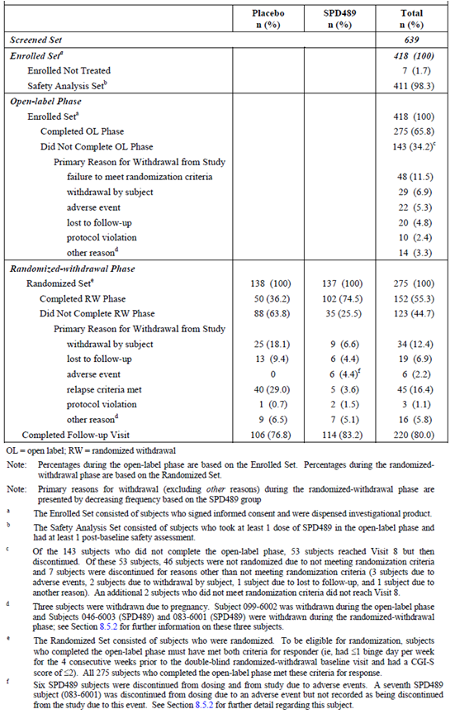

Subjects in the randomised safety set had a mean age of 38.7 years, 87.4% were female, 84.1% White and the mean BMI was 33.8 kg/m2. The groups were moderately well balanced, although there were fewer subjects with a BMI ≥ 40 in the SPD489 group (8.8% versus 22.4%). Most subjects were from North America (78.5%). At open label baseline, the mean number of binge days per week was 4.8 in both groups.

Treatment compliance (80 to 120%) during open label treatment was reported at 99.3% and > 98% during the randomised phase. The rate of protocol violations during the open label phase was 5.1% and during the randomised phase was 2.2% and 6.0% in the SPD489 and placebo groups, respectively.

Dose assignments were mistakenly provided for 80 subjects in the US by the IWRS provider. This was done when the subjects had completed treatment and had had final efficacy and safety assessments. Therefore it is not expected to impact on data quality. One study site (066) was found to have tampered with investigational product. There were 8 subjects (1.9%) enrolled (6 (2.2%) in the randomised phase) at the site which was closed and subjects discontinued. Analyses were undertaken by the sponsor excluding these subjects.

In the FAS, the rate of relapse was 3.7% (5 out of 136) and 32.1% (42 out of 131) in the SPD489 and placebo groups, respectively, and the difference in the time to relapse was statistically significant (p < 0.001). The Kaplan Meier estimate of the proportion of subjects who relapsed was 36% (95% CI: 27%, 45%) in the placebo group and 4% (95% CI: 1%, 7%) in the SPD489 group. The Kaplan Meier survival plot of time to relapse demonstrates the effect separation (Figure 11). Randomisation was stratified by 4 week cessation status (yes or no) and this factor did not have a major impact on the time to relapse (Figure 12). The majority of relapses occurred within 30 days of randomised withdrawal (60% of the SPD489 group and 62% of the placebo group).

Figure 11: SPD489-346. Kaplan-Meier survival plot of time to relapse (full analysis set)

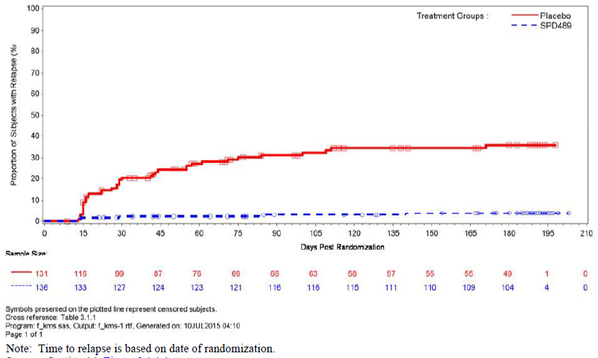

Figure 12: SPD489-346. Kaplan-Meier survival plot of time to relapse presented by 4 week cessation status (full analysis set)

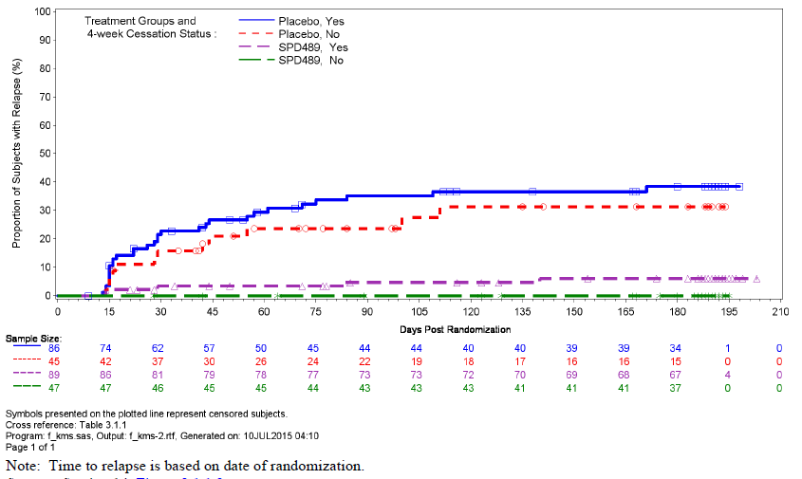

Sensitivity analysis which excluded CGI-S status from the relapse definition found relapse rates still in favour of SPD489 (5.1% versus 34.4%) and a significant effect on time to relapse (p < 0.001). Other sensitivity analyses were supportive of the primary analysis.

At the randomised withdrawal baseline, 83.8% and 74.8% of the SPD489 and placebo groups, respectively, were reported to be ‘normal, not at all ill’ on the CGI-S. At the end of the randomised withdrawal phase (Week 38/early termination), the proportion of subjects in this CGI-S category was 81.6% and 45.0% in the respective groups.

#### Study SPD489-345

##### Design and methods

Study SPD489-345 was a Phase III, open label extension study for subjects who had completed Studies 208, 343 or 344. The study was conducted at 86 sites in the US and Europe. After 2 weeks screening period, if the gap from the previous study was > 30 days, subjects entered a 52 week open label treatment phase which included an initial 4 week dose optimisation period. There was one week follow up at the study end. All subjects recommenced treatment on 30 mg/day and were force titrated to 50 mg/day after one week. Titration to 70 mg/day was allowed as indicated from Week 2. Down titration to 50 mg was allowed however subjects were discontinued if further down titration was needed. Excluded concomitant medications remained the same as the feeder studies.

The primary objective was safety and tolerability and secondary objectives included efficacy response as measured by improvement on the CGI-I scale and behavioural response on the EDE‑Q[4]. There were no sample size calculations, efficacy analyses were descriptive and were conducted on the FAS. The baseline for efficacy was the previous study baseline if entry was within 30 days, or the last value collected at or before Visit 0 if the gap was > 30 days. Three subjects from Site 015 of Study 208 were excluded from analysis due to issues previously mentioned at this site.

##### Results

There were 109 subjects rescreened with 12 screen failures. There were 604 subjects enrolled (580 in the US, 16 in Germany and 8 in Spain) with 97 who had a gap between studies of ≥ 30 days.

**Comment:** There were 815 subjects completing the three feeder studies, therefore 74% of eligible subjects continued onto the extension study.

There were 5 subjects excluded from safety analysis (one lost to follow up, one pregnant and 3 at Site 015). The completion rate was 61.1% (n = 369). The main reasons for premature discontinuation were subject withdrawal (10.8%), AE (9.1%), lost to follow up (7.9%) and ‘other’ (9.6%) which included site closures, compliance issues, and pregnancy (n = 15). Compliance between 80% and 120% was reported for all except 2 subjects and the protocol violation rate was low (2.8%). Subjects were predominantly white (77%) and female (87%) with a mean age of 39 years and a mean BMI of 33.8 kg/m2.

CGI-I results were dichotomised into ‘improved’ and ‘not improved’. At Week 4, the rate of subjects ‘improved’ was 88.5% and this was maintained over the study period with a rate of 89.9% at Week 52 (95% CI: 87.5, 92.3).

The mean EDE-Q global score at baseline was 3.34 with a mean decrease at Week 4 of -1.66 which was maintained to Week 52 with a mean decrease of -1.90 (95% CI: -2.0, -1.8).

#### Evaluator commentary: other efficacy studies

##### SPD489-208

In this Phase II study, efficacy over placebo was demonstrated for the 50 mg and 70 mg per day doses but not the 30 mg/day as measured by the number of binge days per week after 11 weeks of treatment. The primary efficacy endpoint was log transformed and the reason for this has been questioned. Findings were supported by analysis of non-log transformed data and of secondary endpoints. While there appeared to be a dose response with increasing dose, inter-dose comparisons were not made.

##### SPD489-346

In the randomised withdrawal study, the relapse definition included both the number of binge days per week (≥ 2) and an increase in the CGI-S score (≥ 2) which is clinically appropriate.

Twelve weeks is considered an adequate period of stabilisation on open label therapy prior to randomisation and is in line with the treatment period used in the two pivotal efficacy studies. The withdrawal period of 26 weeks also is considered a sufficient time to assess relapse.

In subjects who responded to SPD489 therapy after 12 weeks, the time to relapse during the 26 week randomised withdrawal period was significantly less in those treated with SPD. The relapse rate was notably lower in the SPD489 group (3.7% versus 32.1%) and data were supported by sensitivity analyses which included a relapse definition which included only binge days per week.

Interestingly, 68% of subjects on placebo did not relapse during the randomised withdrawal phase. Although approximately one third of responding subjects resumed binge eating on cessation of SPD489 (while being treated with placebo), two thirds remained free of binge eating and this rate is greater than the relapse rate difference between placebo and SPD489. While this could be a placebo effect, it is also possible that the majority of subjects may no longer require SPD489 after the initial 12 weeks of treatment.

As subjects were discontinued on relapse, and group numbers therefore vary, secondary efficacy endpoint analysis over the 26 week period is of little benefit. In addition, the study’s design is such that long term efficacy cannot be deduced.

##### SPD489-345

In this open label extension study, it was found that for subjects who remained on treatment there was maintenance of effect as measured by one clinician-rated and one subject-rated scale. However, only 74% of primary completers continued on to the extension study. This could results in some bias due to self-selection. In addition, there was a low completion rate of 61% for the 1 year treatment duration. These facts, together with the open label uncontrolled design; mean that no definitive efficacy conclusions can be drawn from this study.

### Analyses performed across trials: pooled and meta analyses

Not applicable.

### Evaluator’s conclusions on clinical efficacy

There were five clinical studies submitted with efficacy data to support the BED indication and the two pivotal trials were moderate in size included 773 subjects.

The population assessed were those with moderate to severe BED (on average 4 to 5 binge days per week) and this needs to be reflected in the indication which currently covers all BED patients.

Only adults 18 to 55 years were included in the development and this also should be reflected in labelling.

The clinical trial population were largely obese, White females in the US and the sponsor is to comment on the applicability of this to the Australian population.

The study population were on the whole naïve to any prior treatment for their BED. Given psychotherapy is the recommended initial therapy for BED, an assessment of efficacy in subjects who had failed psychotherapy would have been useful.

The primary efficacy endpoint was based on binge days rather than binge episodes and this is sensible as it could be difficult discerning the end of a binge episode and the start of another episode.

Treatment with SPD489 for 12 weeks was found to be superior to placebo in both pivotal efficacy studies with an improvement over placebo of approximately 1.5 binge days per week (95% CI: -1.8,-1.3).

Subjects with BED did have a notable placebo response with a reduction of about 2.4 days binge days per week.

Efficacy data were robust and were supported by sensitivity and secondary endpoint analyses.

The most clinically relevant data were the response rates and the 4 week cessation rate was notably higher with SPD489 than placebo (36 to 40% versus 13 to14%).

SPD489 resulted in an improvement on CGI-I as well as a reduction in body weight of 5 to 6% over 12 weeks (which did not occur on placebo despite a reduction in binge eating days).

Given the weight reduction in the SPD489 group, it is possible that the effect on BED is mediated through its appetite suppression activity.

There were several issues at sites relating to GCP and other concerns; however inclusion or exclusion of subjects from these sites produced similar results.

Efficacy was maintained over the 26 week randomised withdrawal period in those who were initial treatment responders and there was a significantly lower relapse rate in those continuing on SPD489 (4% versus 32% placebo group). Nevertheless, the majority of subjects who responded to SPD489 and then ceased active treatment after 12 weeks (placebo group) did not relapse (68%). This suggests that 12 weeks may be sufficient treatment duration for the majority of patients.

Subgroup using combined data from Studies 343 and 344 found consistent effects across the groups apart from in non-US subjects where numbers were low.

The dose of 30 mg per day was not efficacious and should only be used for dose titration in first week of treatment.

Open label data were provided for up to one year duration and while the rate of subjects who remain in the improved CGI category was high (90%), only about 60% of subjects completed the one year of therapy. The evaluator concludes that long term efficacy remains to be fully established and that there are only clear efficacy data for treatment up to 12 weeks duration.

### Other efficacy studies; ADHD

The dossier also included four clinical trials related to the ADHD indication.

#### Study SPD489-325

Study SPD489-325 was a Phase III, randomised, double blind, multicentre, parallel group, placebo and active controlled, dose optimisation safety and efficacy study of SPD489 in 336 children 6 to17 years with ADHD. The study was conducted between 2008 and 2011 in the EU. The active control was long acting methylphenidate (osmotic controlled oral release delivery system methylphenidate, OROS MPH, Concerta). Subjects were randomised in a 1:1:1 ratio to treatment with SPD489, OROS MPH or placebo and treated for 7 weeks. The study found a statistically significant greater LS mean change from Baseline to end of treatment in the ADHD-RS-IV total score when treated with SPD489 compared to placebo (LS mean difference of -18.6 (95% CI:-21.5, -15.7). Statistically significant results over placebo were also found on the CGI-I (percentage improved 78% versus 14%) and quality of life as measured by the CHIP-CE:PRF[5] Achievement Domain T-Score.

**Comment:** This study is already included in the approved PI. Further comments have been included in Section 7.6.5.

#### Study SPD489-405

##### Design and methodology

SPD489-405 was a Phase IV, randomised, double blind, multicentre, parallel group, active controlled, dose optimisation safety and efficacy study of SPD489 compared with OROS MPH with a placebo reference arm, in adolescents aged 13 to 17 years with ADHD. It was conducted between April 2012 and January 2014 at 70 sites in the USA.

After a 4 week screening and washout phase, there was an 8 week double blind evaluation phase (5 weeks of dose optimisation and 3 weeks of dose maintenance period) then a one week telephone follow up.

Subjects were randomised in a 2:2:1 ratio to SPD489, OROS MPH or placebo. Doses commenced at 30 mg/day for SPD489 and 18 mg/day for OROS MPH and were titrated weekly to 50 mg or 70 mg for SPD489 or 36, 54 or 72 mg/day for OROS MPH. Optimum dose was then maintained during the remainder of the double blind period. A double dummy design was used to maintain blind during dose optimisation.

Inclusion criteria were: male and female adolescents 13 to 17 years of age; DSM IV-TR diagnosis of ADHD and with an ADHD-RS-IV Total Score of ≥ 28; age appropriate intellectual function; weight of ≥ 79.5 pounds; and not completely satisfied with some aspect of their current ADHD therapy. Subjects were excluded if they had: a significant Axis I disorder; significant comorbid Axis II psychiatric disorder; conduct disorder: BMI < 3rd percentile or > 97th percentile; or other conditions that could increase participant risk.

The primary efficacy outcome was the comparison between the SPD489 and OROS MPH groups in the change from Baseline in the ADHD rating scale IV (ADHD-RS-IV)[6] total score at Week 8. Comparisons between treatment groups were analysed on the FAS using a linear MMRM. A sample size of 173 per active group gave the study a 90% power (α = 0.05) to detect a 0.35 difference between the SPD489 and OROS MPH groups. Allowing for a 5% drop out rate, 182 subjects per active group were required.

##### Results

There were 628 subjects screened, 464 randomised with 186, 185 and 93 in the SPD489, OROS MPH and placebo groups, respectively. The rates of study non-completion were higher in the placebo group (25.3%) than the SPD489 (15.8%) or OROS MPH groups (14.7%). Discontinuation due to an AE was higher with SPD 489 (7.6% versus 1.6% OROS MPH and 3.3% placebo).

Groups were relatively well balanced on baseline characteristics. The mean age of subjects was 14.7 years, 66% were male and 75% White. The mean baseline ADHD-RS-IV total score was 37.4.

The LS mean change from Baseline to Week 8 in the ADHD-RS-IV total score was -25.6, -23.5 and –13.4 in the SPD489, OROS MPH and placebo groups, respectively. The difference between active groups (-2.1, 95% CI: -4.3, 0.2) was not statistically significant (p = 0.072). Both active groups showed a significantly greater reduction in the ADHD-RS-IV total score over placebo (p < 0.0001) (Table 8). A lack of difference between the active treatments was also found on sensitivity analyses. Testing ceased at this point due to hierarchical testing to control for multiplicity. Similar results between the active groups were seen over the treatment duration (Figure 13). The rate of improvement on dichotomised CGI-I was around 80% in both the active groups and 35% in the placebo group.

Table 8: SPD489-405. Mean change from Baseline at Visit 8 (Week 8) in ADHD-RS-IV total score presented by treatment group (full analysis set)

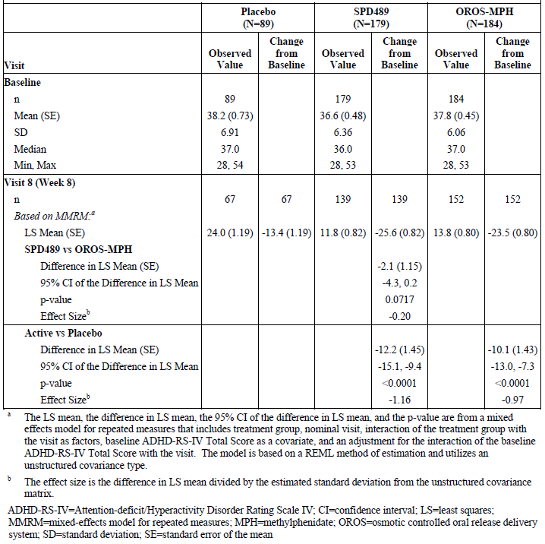

Figure 13: SPD489-405. Least Squares Mean Changes from Baseline over Time in ADHD-RS-IV total score; presented by treatment group (Full analysis set)

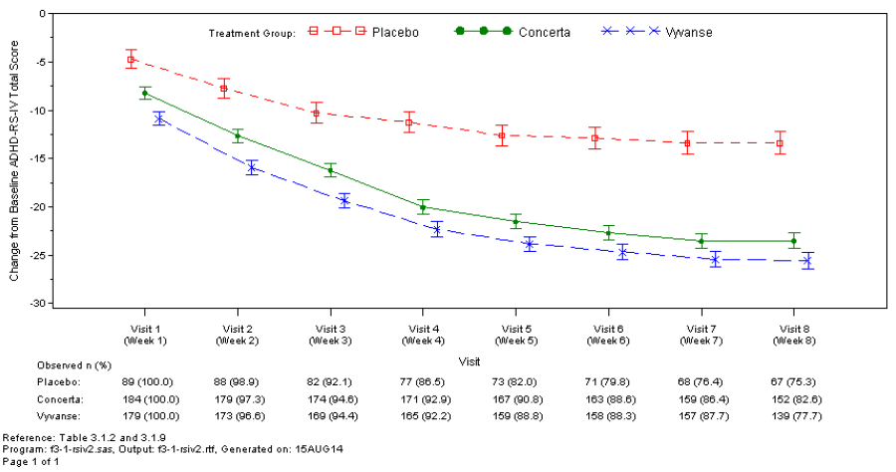

#### Study SPD489-406

##### Design and methodology

SPD489-406 was a Phase IV, randomised, double blind, multicentre, parallel group, active controlled, forced dose titration safety and efficacy study of SPD489 compared with OROS MPH (Concerta) with a placebo reference arm, in adolescents aged 13 to 17 years with ADHD. It was conducted between April 2012 and May 2014 at 77 sites in the USA, Canada and Europe.

The study differed from Study 405 as after screening there was a 4 week forced dose titration phase and a 2 week dose maintenance phase. SPD489 doses were titrated once weekly from 30 mg per day to 40 mg, to 50 mg and to 70 mg/day and OROS MPH doses were titrated once weekly from 18 mg/day to 36 mg, to 54 mg and to 72 mg/day. Subjects were maintained at the highest dose level for the 2 week dose maintenance phase. Other design and methodological aspects were similar to Study 405. The primary objective was to compare the efficacy of SPD489 70 mg with OROS MPH 72 mg with adolescents with ADHD.

##### Results

There were 778 subjects screened and 549 randomised with 219, 220 and 110 in the SPD489, OROS MPH and placebo groups, respectively. Study non-completion rates were similar between active groups (17% SPD489 versus 15% OROS MPH) and slightly higher than placebo (11.8%), the main reason was adverse events (6.9%, 6.4% and 0.9% in the SPD489, OROS MPH and placebo groups, respectively). Groups were comparable on baseline characteristics and the mean baseline ADHD-RS-IV total score was 36.9.

After 6 weeks treatment, the LS mean change from Baseline in the ADHD-RS-IV total score was ‑25.4, -22.1 and -17.0 in the SPD489, OROS MPH and placebo groups, respectively. The difference between the SPD489 and OROS MPH groups of -3.4 (95% CI: -5.4, -1.3) was statistically significant (p = 0.0013) (Table 9). Both active groups also had a significantly greater LS mean difference compared to placebo (p < 0.001) (Table 9) although the separation was not great as seen in Study 405. The LS mean change over time is shown in Figure 14.

Table 9: SPD489-406. Mean change from Baseline in Visit 6 (Week 6) in ADHD-RS-IV total score presented by treatment group (Full analysis set)

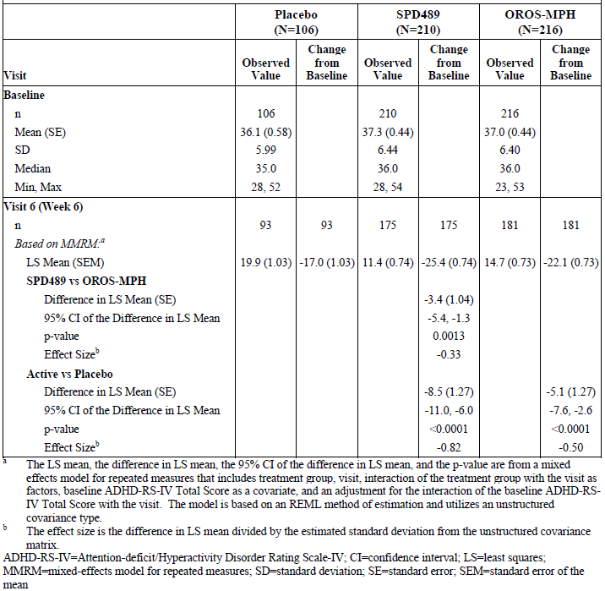

At Week 6, the rate of subjects being improved on the CGI-I was 81.4%, 71.3% and 50.0% in the SPD489, OROS MPH and placebo groups, respectively and the difference between the active groups was significant (p < 0.019).

Figure 14: SPD489-406. Least Squares Mean (+SE) of change from Baseline over time in ADHD-RS-IV total score; presented by study visit and treatment group (Full analysis set)

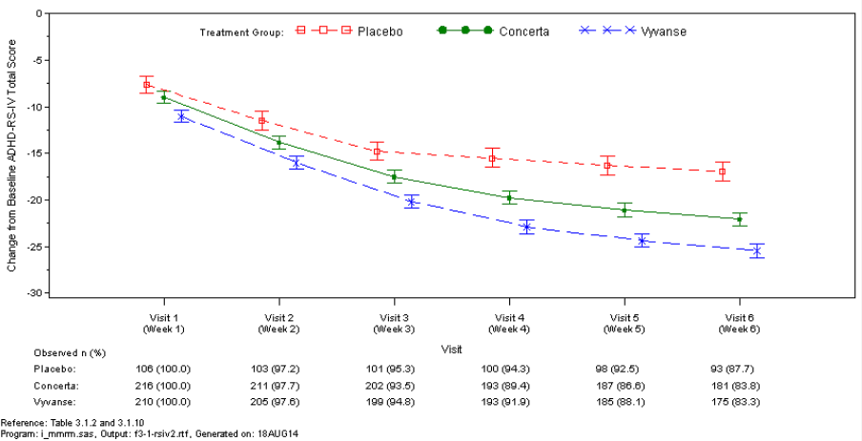

#### Study SPD489-404

##### Design and methodology

Study SPD489-404 was a Phase IV, open label, multicentre, 2 year safety study of SPD489 in children and adolescents 6 to 17 years with ADHD. It was conducted between July 2011 and September 2014 at 35 sites in Europe. The primary objective was safety. Long term efficacy was a secondary objective and was measured using the ADHD-RS-IV total score and hyperactivity/impulsivity and inattention subscale scores, as well as the CGI-S and CGI-I.

After screening and washout, there was a 4 week dose optimisation period, a 100 week maintenance period and then a 4 week safety follow up period. There were 16 visits over the 2 years. Doses of 30, 50 or 70 mg per day were given for up to 104 weeks. Subjects from Studies SPD489-317, SPD489-325 and SPD489-326 were eligible. Subjects who had not participated in an SPD489 study could also be included if they met the diagnosis of ADHD and had a baseline ADHD-RS-IV total score of ≥ 28.

###### Results

There were 348 children screened and 314 enrolled, 124 (39.5%) from previous studies and 190 new subjects. The FAS included 299 subjects (95.2%). Due to non-compliance with GCP at Site 049 during another study (SPD503-315), the subjects from this site (n = 14) were excluded from the FAS. Study completion rate was 60.8% and the most frequent reasons for premature withdrawal were subject withdrawal (13.1%), adverse events (12.4%) and ‘other’ (9.2%).

The mean subject age was 11.4 years, 79.6% were male and 98.7% White. Approximately one third were overweight or obese. The mean baseline ADHD-RS-IV total score was 41.1 and 80% of subjects had combined ADHD subtype. Most subjects (86.3%) had received previous therapy for ADHD with methylphenidate being the most frequent therapy. Study treatment compliance was reported at 96.5%. The rate of protocol violations or deviations was 27%.

From a baseline of 41.2 on the ADHD-RS-IV total score, the mean change to the last on treatment assessment (LOTA) was -25.8 (95% CI: -27.0, -24.5, p < 0.001). The reduction commenced at Week 1, continued to Week 4, then there was little change through to Week 104 (Figure 15). Results were similar when data from Site 049 were included. Results were also consistent across the subgroups analysed (age 6 to 12 and 13 to 17 years, gender and country).

Figure 15: SPD489-404. Mean change from Baseline in ADHD-RS-IV total score by visit; observed cases (FAS)

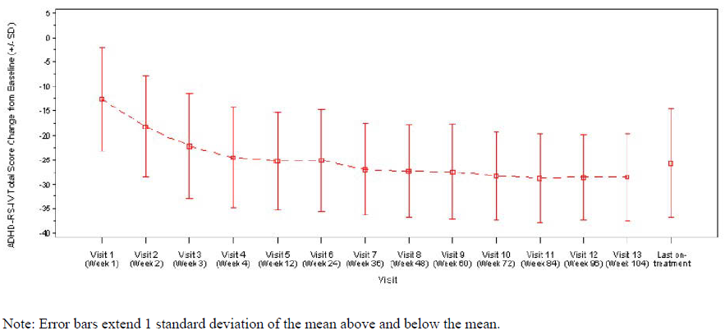

From a baseline of 19.0 on the ADHD-RS-IV hyperactivity/impulsivity subscale score, there was a mean reduction of -12.6 (95% CI: -13.4, -11.9) and for the inattention subscale the mean reduction was -13.1 (95% CI: -13.8, -12.4). At the LOTA, the rate of improvement on the CGI-I was 78% with 22% not improved. The responder rate (ADHD-RS-IV total score reduction of ≥ 50% and CGI-I of very much or much improved) to LOTA was 69.2%.

#### Evaluator commentary: other efficacy studies in ADHD

There were four studies in ADHD in the dossier which were included to support proposed labelling changes.

Two Phase IV studies compared SPD489 to OROS MPH in adolescents 13 to 17 years. One study had the dose optimised (SPD489-405) and the other had forced dose titration (SPD489-406). Efficacy was measured using the ADHD-RS-IV total score which has been used as the primary efficacy endpoint in previous studies.

In Study SPD489-405, no difference in efficacy was found between SPD489 and OROS MPH when adolescents were treated for 8 weeks (the between group difference was -2.1 (p = 0.07)). This lack of differentiation was supported by results on CGI-I.

By contrast, in the forced dose titration Study SPD489-406, SPD489 70 mg/day was found to superior to OROS MPH 72 mg/day after 6 weeks treatment with a between group difference of ‑3.4 (p = 0.001).

Despite the statistically significant result in Study 406, the evaluator queries whether the difference of 3.4 on the rating scale is of clinical relevance, particularly as the dose was force titrated to 70 mg and not optimised as would occur in clinical practice and also as it was not supported by data from the dose optimisation trial. As such, the evaluator concludes that the data do not indicate that there is a clinically important difference in efficacy between the 2 treatments in children 13 to 17 years.

The changes in the PI state there is a significant difference between treatments in Study 406 which is correct; however no numerical data have been included on the size of the difference for either Study 405 or 406. These data need to be included.

Study SPD489-404 was a 2 year open label and uncontrolled safety study of 314 children 6 to 17 years with ADHD. Long term efficacy, as measured by the change from Baseline in ADHD‑RS‑IV total score and dichotomised CGI-I, was demonstrated. Results can only be viewed as supportive due to the study’s design and the fact that only 60% of children completed 2 years treatment. No efficacy data from this study have been proposed for inclusion in the PI.

Study SPD489-325 was included in the dossier and, as this study is already included in the approved PI, the evaluator has assumed that it has been previously evaluated. The proposed PI includes some altered statements in the Clinical Trial section which relate to this study. The statements are acceptable as data are not new and relate to information already included in the approved PI Table 3.

## Clinical safety

### Studies providing evaluable safety data

#### Pivotal studies that assessed safety as the sole primary outcome

There were no pivotal safety studies.

#### Pivotal and/or main efficacy studies

For the BED indication, the pivotal studies were SPD489-343 and 344. Treatment duration was 12 weeks. Safety data in these studies included: adverse events and SAEs; vital signs (blood pressure using an automated cuff); waist circumference; weight; physical examination; clinical laboratory measurements (biochemistry, haematology, urinalysis, urine drug screens, pregnancy tests); ECGs with central reading; Columbia Suicide Severity Rating Scale (C-SSRS)[7]; and Amphetamine Cessation Symptom Assessment (ACSA).

#### Other studies

The safety data listed above (apart from the ACSA) were also collected in the short term Phase II Study SPD489-208, the placebo controlled, randomised withdrawal Study SPD489-346 and the 52 week open label extension Study SPD489-345. The ACSA was also collected in Study SPD489‑346.

Safety analysis was conducted on randomised or enrolled subjects who had received at least one dose of study medication and who had a post-baseline safety assessment. Safety data from the three short term, placebo controlled studies (208, 343 and 344) were pooled into the integrated safety database. There was also a safety pool of all five BED studies.

Of the four studies in ADHD, safety data from the new Studies SPD489-404, 405 and 406 were evaluated as some changes in relation to ADHD safety have been proposed for the PI. In the Clinical Overview, data from the ADHD Integrated Safety Database was presented due to the inclusion of data from the three new studies.

### Studies that assessed safety as the sole primary outcome

Not applicable.

### Patient exposure

#### BED

In the three short term placebo controlled studies (safety analysis set), there were 434 subjects exposed to placebo and 568 to SPD489 (all doses) with 502 exposed to doses of 50 to 70 mg per day (Table 10, below). The mean duration of exposure was 73.1 and 73.7 days in the SPD489 and placebo groups, respectively. In Study 208, the treatment duration was 11 weeks while it was 12 weeks in Studies 343 and 344. The total person-time of exposure to SPD489 was 41,652 days.

Overall, in the clinical development program for BED there were 1,244 subjects in the safety analysis set with a mean duration of exposure of 212 days and an average daily dose of 57.5 mg. There were 380 subjects with ≥ 361 days of exposure and a total person-time exposure of 263,996 days (Table 11, below).

Table 10: Number of subjects exposed to SPD489 and comparators in BED clinical studies

| Study type/ Indication | Controlled studies | | Uncontrolled studies | Total SPD489 |
| --- | --- | --- | --- | --- |
| SPD489 | Placebo | SPD489 |  |
| Clinical pharmacology | - | - | - | - |
| Dose finding (208) | 196 | 63 | - | 196 |
| Indication - BED |  |  |  |  |
| Pivotal/Main (343 and 344) | 373 | 372 | - | 373 |
| Other (346) | 136 | 134 | 411# | 411# |
| Other (345) | - | - | 604+ | 604+ |
| TOTAL | 705 | 503 | 1015 | 1244 |

#open label phase of Study SPD489-346 where 270 entered the randomised withdrawal phase. + extension study subjects who had participated in Studies 208, 343 or 344 (active SPD489 or placebo group)

Table 11: Exposure to SPD489 in BED clinical studies

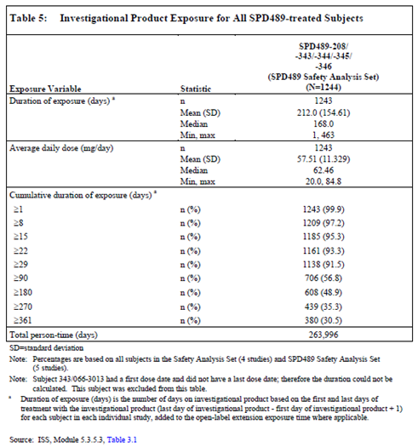

SPD489 treated subjects in the integrated safety database had mean age of 38.6 years, were predominantly female (86.5%), White (77.5%), from the US (90.7%) and had a mean BMI of 33.9 kg/m2.

#### ADHD

In the two short term controlled ADHD studies, the SPD489 exposure duration was 50.5 days and 38.5 days in Study 405 and 406, respectively. In the open label long term Study 404 (n = 314), the mean exposure duration to SPD489 was 555.3 days with 238 subjects having ≥ 12 months exposure and 96 ≥ 24 months exposure. The final SPD489 dose was 30 mg, 50 mg and 70 mg in 68, 137 and 109 subjects, respectively.

### Adverse events

#### All adverse events (irrespective of relationship to study treatment)

##### Integrated safety analyses

For all SPD489 treated subjects, the rate of any TEAE was 86.8% (Table 12). The most frequent events (≥ 5%) were dry mouth, headache, insomnia, decreased appetite, nausea, URTI, nasopharyngitis, constipation, irritability, anxiety, feeling jittery, fatigue, diarrhoea and hyperhidrosis (Table 13).

Table 12: Summary of treatment-emergent AEs for all SPD489-treated subjects

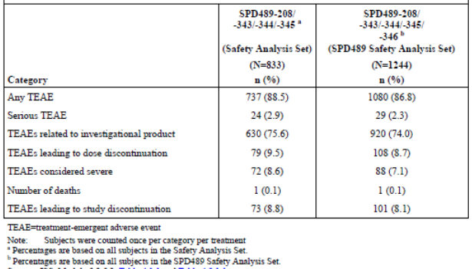

Table 13: Treatment emergent AEs occurring in ≥ 5% of all SPD489 treated subjects by preferred term (SPD489 safety analysis set)

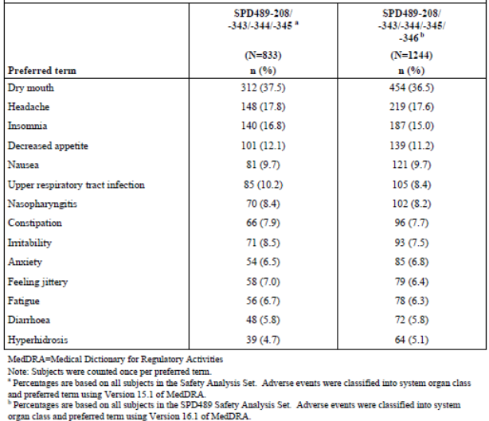

The rate of severe TEAEs was 7.1% with the most common being headache (0.5%), insomnia (0.4%), decreased appetite, dry mouth, viral gastroenteritis and irritability (all 0.3%). There were also 4 cases of severe (and also serious) cholecystitis (0.3%). Other severe TEAEs (occurring in 2 or 3 subjects each) included abdominal pain, blood creatine phosphokinase increased, fatigue, gastroenteritis, sleep disorder, URTI, anxiety, AST increased, back pain, bronchitis, ear infection, erectile dysfunction, intervertebral disc protrusion, migraine, nephrolithiasis, pain in extremity and pneumonia.

##### Pivotal and/or main efficacy studies

The rate of TEAEs in Studies 208, 343 and 344 (short term placebo controlled) was notably higher in SPD489 treated compared to placebo treated subjects (81.5% versus 55.4%) (Table 14). The most frequent SOCs involved were gastrointestinal disorders (50.1% versus 19.3%), psychiatric disorders (31.1% versus 12.2%) and nervous system disorders (24.8% versus 14.5%). The most frequent events, all of which were more common with SPD489, were dry mouth (36.4% versus 7.4%), headache (14.2% versus 9.0%), insomnia (13.7% versus 4.8%), decreased appetite (12.3% versus 3.0%) and nausea (8.3% versus 5.1%). Other frequent events that were more common with SPD489 were irritability (6.3% versus 5.3%), constipation (6.2% versus 1.4%), feeling jittery (5.3% versus 0.5%) and anxiety (5.1% versus 0.7%) (Table 15). Feeling jittery had a dose response in Study 208 (0%, 1.5%, 4.6% and 7.7% in the placebo, 30 mg, 50 mg and 70 mg SPD489 groups, respectively).

Table 14: Summary of Treatment-emergent AEs in the short-term, placebo controlled studies (Safety Analysis Set)

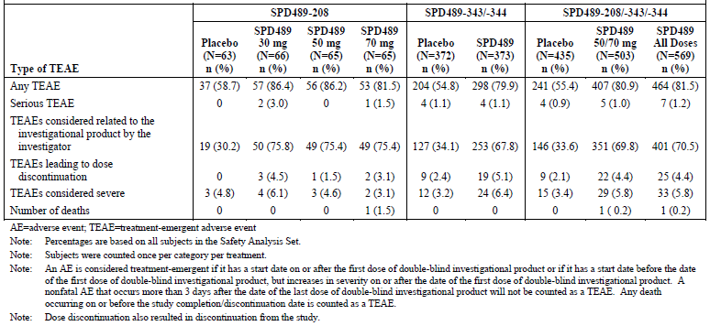

Table 15: Treatment-emergent AEs occurring in ≥ 5 of subjects in the short-term, placebo controlled studies by preferred term (safety analysis set)

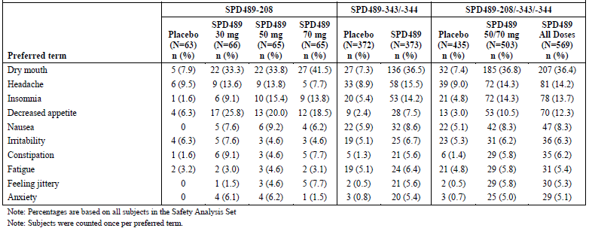

The most frequent events of dry mouth, headache, insomnia and decreased appetite tended to have onset during the first week of treatment. Apart from decreased appetite, these events tended to resolve while on treatment (Table 16).

Table 16: Treatment emergent AEs occurring in ≥ 5% of SPD489 treated subjects in the short term, placebo controlled studies by resolution status and preferred term (safety analysis set)

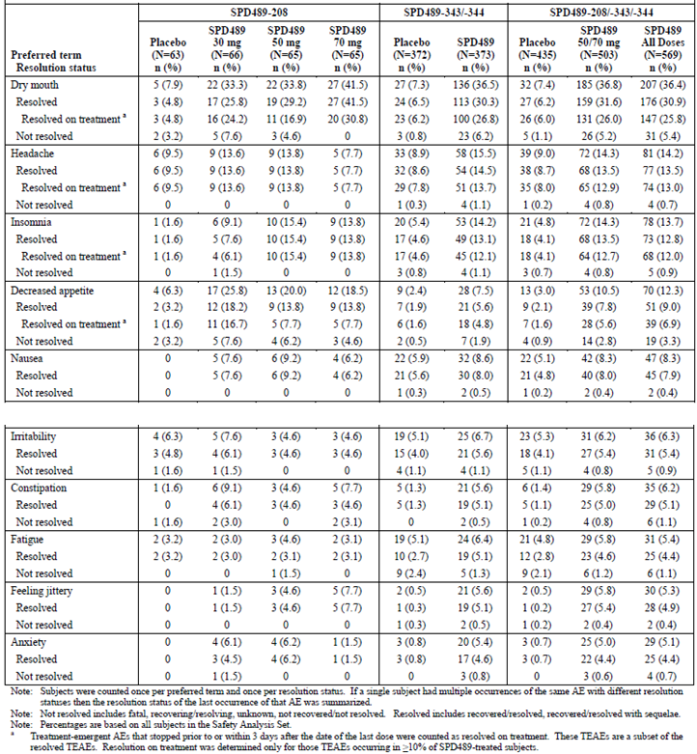

In the three short term controlled studies, the rate of severe TEAEs was 5.8% and 3.4% in the SPD489 and placebo groups, respectively. The most frequent severe TEAEs were decreased appetite, dry mouth, headache and insomnia.

##### Other studies

In the ADHD Studies 405 and 406, the rate of TEAEs in subjects treated with SPD489 was generally consistent with OROS MPH and higher than with placebo. The most frequent TEAE was decreased appetite (Study 405: 53.3%, 41.8%, 7.7% and Study 406: 31.7%, 23.3% and 10.0% in the SPD489, OROS MPH and placebo groups, respectively). Other frequent events were headache, weight decreased, insomnia, dry mouth, irritability and nausea.

In the long term ADHD study, the rate of TEAEs was 89.8% with the most frequent events being decreased appetite (54.1%), nasopharyngitis (23.2%), headache (21.7%), weight decreased (20.1%), insomnia (19.1%), initial insomnia (12.1%) and irritability (11.5%). The rate of a positive response on the C-SSRS was 2.2% and there were 2 (0.6%) suicide attempts.

#### Treatment-related adverse events (adverse drug reactions)

##### Integrated safety analyses

Treatment related TEAEs were frequent and reported in 74.0% of SPD489 treated subjects. Events included dry mouth (35.7%), insomnia (13.7%), headache (12.1%), decreased appetite (11%), irritability (6.8%), nausea (7.0%), feeling jittery (5.9%), constipation (5.2%) and anxiety (5.5).

##### Pivotal and/or main efficacy studies

The rate of treatment related TEAEs in the short term, controlled studies was 70.5% versus 33.6% in the SPD489 and placebo groups, respectively. The most frequent events were dry mouth, insomnia, decreased appetite, headache, nausea and irritability all of which were notably more frequent in SPD489 treated than in placebo treated subjects (Table 17).

Table 17: Treatment emergent AEs considered related to the investigation product by the investigator occurring in ≥ 5% of SPD489 treated subjects in the short term, placebo controlled studies (safety analysis set)

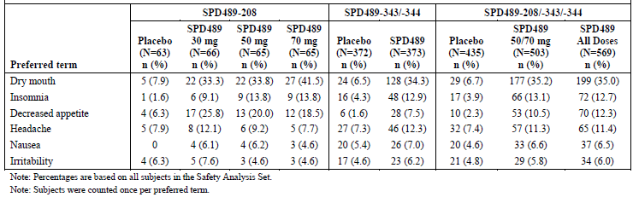

##### Other studies

In the long term ADHD study, the rate of treatment related TEAEs was high at 73.9% and the most frequent events were decreased appetite (49.4%), weight decreased (18.2%), insomnia (13.1%), initial insomnia (8.9%) and irritability (8.6%). Tic was reported in 5.1%. Most events were mild (35.7%) or moderate (42.4%) in severity, with severe TEAEs occurring in 11.8% of subjects.

#### Deaths and other serious adverse events

##### Integrated safety analyses

There was one death in Study SPD489-208. A 29 year old Asian male died due to methamphetamine and amphetamine toxicity 9 days after his last study visit. There was no reported history of prior illicit drug use however a history of abuse became apparent subsequent to his death.

There was also a 20 year old subject from SPD489-346 who became pregnant during the study. The fetus was exposed to SPD489 for approximately 41 days prior to the subject being withdrawn from the study. The infant was born at 38 weeks and died at 2 weeks of age due to a severe congenital diaphragmatic hernia. Other abnormalities included exomphalos and limb malformation.

There were 29 subjects (2.3%) with SAEs in the integrated BED safety database (Table 18). These included 4 cases of cholecystitis, 2 of syncope and 2 of pneumonia. There was also one case of supraventricular tachycardia (SVT) and acute coronary syndrome and one moderate convulsion. SAEs deemed treatment related by the investigator included syncope, convulsion, congenital abnormality, and SVT/acute coronary syndrome.

Table 18: Serious treatment emergent AEs by system organ class and preferred term (SPD489 safety analysis set)

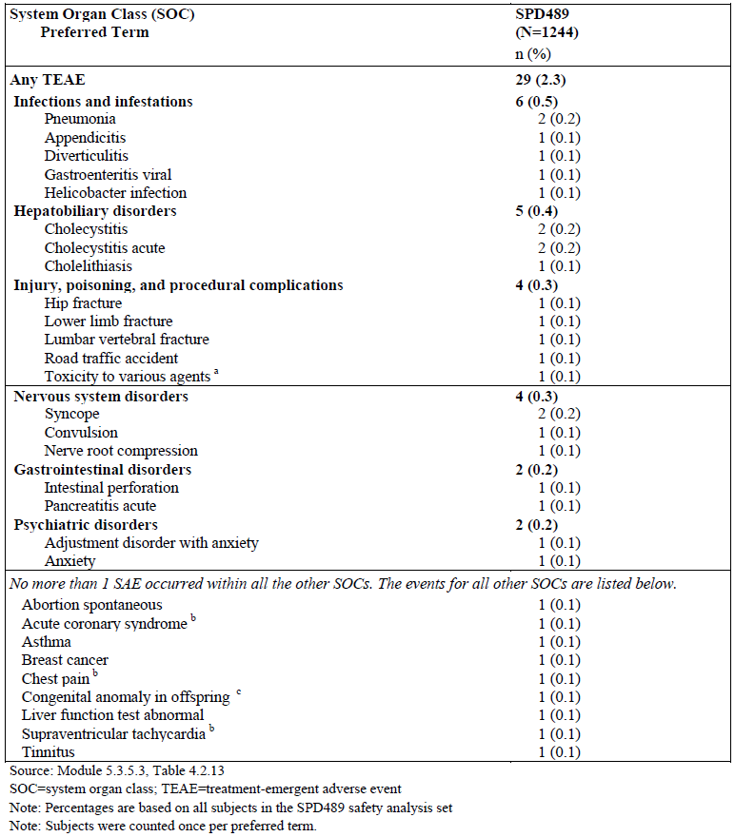

##### Pivotal and/or main efficacy studies

In the short term, controlled studies, the rate of SAEs was 1.5% (n = 7) versus 0.9% (n = 4) in the SPD489 and placebo groups, respectively. In addition to the death described above, the SAEs in subjects treated with SPD489 were 2 cases of syncope (0.4% versus 0.2% placebo) and one each of cholecystitis, pancreatitis, appendicitis and lumbar vertebral fracture (0.2% versus 0% placebo). The syncope cases had onset at Day 6 and Day 67 and both resulted in treatment withdrawal. Likewise, the cases of pancreatitis and cholecystitis also resulted in treatment withdrawal.

There were 6 SAEs in 4 subjects in the placebo group: conversion disorder, anaphylactic reaction, agitation plus anxiety, and syncope plus fibula fracture. All subjects discontinued due to the SAE. There was also a attempted suicide at 7 days post-treatment.

##### Other studies

There have been 2 other deaths reported. The first in an ADHD study (Study NRP104.304) was a 22 year old male who died following an epileptic seizure from cocaine and ethanol toxicity (no amphetamines reported). Diagnosis was from post mortem examination. Study treatment had ceased 11 days prior. The second case was during anti-depressant lead-in therapy in a study in major depressive disorder (Study SPD489-322). This subject died in a motor vehicle accident.

In the ADHD studies, there were 2 SAEs in Study SPD489-405: one suicide ideation in an SPD489 treated subject and one renal cyst in an OROS MPH-treated subject. In Study 406, there was one suicide ideation, one appendicitis and one psychosis in the SPD489, OROS MPH and placebo groups, respectively.

The rate of SAEs in the long term ADHD study was 8.9% (28 subjects with 36 SAEs). The most frequent SAE was syncope (1.9%, n = 6).

**Comment:** Syncope was required to be reported as an SAE in this study.

Two syncope cases were mild and deemed unrelated to treatment, 2 cases were moderate and unrelated, one was moderate and treatment related. The final subject had 2 episodes of syncope one of which was moderate and the other severe and resulted in treatment interruption. No syncope case resulted in treatment discontinuation. Other SAEs included 3 cases of appendicitis (1.0%) and 2 cases of pyelonephritis (0.6%). There was one SAE of severe arrhythmia which was deemed treatment related. This subject was hospitalised for a subdural haematoma and developed incomplete right bundle branch block and T wave inversion. Study treatment was discontinued. The subject was found to have a type 2 atrial septal defect.

#### Discontinuations due to adverse events

##### Integrated safety analyses

For all BED subjects treated with SPD489, the discontinuation rate was 49.0% and discontinuations due to an AE accounted for 8.7%. The most frequent SOC involved were psychiatric disorders (1.8%), nervous system disorders (1.1%), general disorders/ administration site conditions (1.0%), investigations (1.0%) and cardiac disorders (0.8%)(Table 19). The most common events were palpitations (0.3%), irritability (0.5%), increased blood pressure / increased diastolic blood pressure / hypertension (0.8%), anxiety (0.6%), insomnia (0.6%) and rash (0.3%)(Table 19).

Table 19: Treatment emergent AEs leading to dose discontinuation by system organ class and preferred term in all SPD489 treated subjects

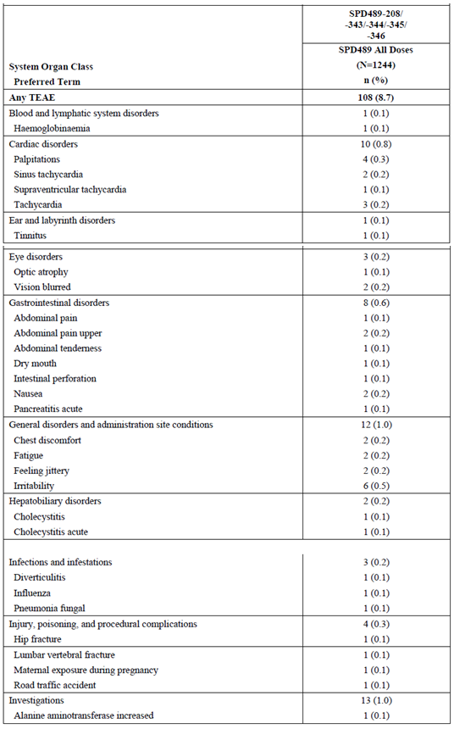

Table 19 (continued): Treatment emergent AEs leading to dose discontinuation by system organ class and preferred term in all SPD489 treated subjects

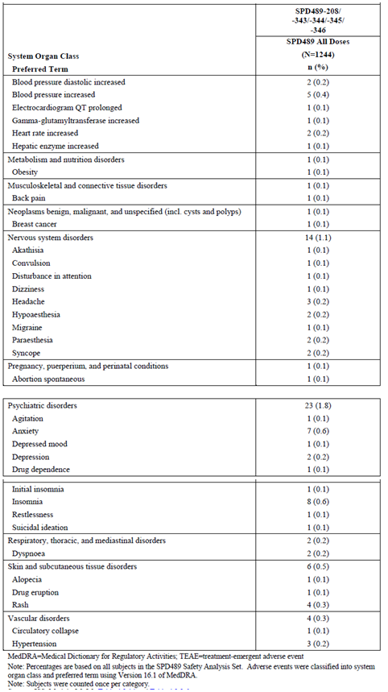

##### Pivotal and/or main efficacy studies

In the short term, placebo controlled studies, the overall discontinuation rate was 20.8% and 21.9% in the SPD489 and placebo treated subjects, respectively. The rate of discontinuation due to an AE was 4.4% and 2.1%, respectively. The events leading to premature discontinuation that occurred in 2 SPD489 treated subjects were feeling jittery, irritability and syncope (all 0.4% versus 0% in the placebo group). Other events occurred in single subjects.

##### Other studies

In the ADHD Study 405, the rate of TEAEs leading to discontinuation was higher with SPD489 than OROS MPH (7.6% versus 1.6%) and also placebo (3.3%). This trend versus OROS MPH was not as evident in Study 406 (7.3% versus 6.8% OROS MPH and 0.9% for placebo).

**Comment:** This is perhaps due to the forced titration to the maximum dose for both active drugs.

The most frequent events leading to discontinuation in the SPD489 groups were decrease appetite, suicide ideation, irritability, palpitations and dizziness.

The rate of discontinuation due to a TEAE in the long term ADHD study was 12.4% with the most common events being decreased appetite (2.2%), drug ineffective (1.9%), irritability (1.3%), depressed mood (1.3%), insomnia and tic (1.0% each). There were an additional 5 subjects who discontinued due to lack of efficacy that was not reported as a TEAE.

### Evaluation of issues with possible regulatory impact

Clinical laboratory data were pooled for the three short term, controlled BED studies only.

#### Liver function and liver toxicity

##### Pivotal and/or main efficacy studies

In the short term controlled studies, there was little change in liver function tests as measured by mean changes from Baseline to end of treatment or number of potentially clinical important (PCI) values. There was one SPD489 treated subject in Study 343 with increased GGT with onset on Day 15 and treatment was withdrawn. This subject was reported to have had an elevated GGT at the screening visit. There was one placebo treated patient with increased LFTs in Study 343. In Study 208, there were 2 SPD489 treated subjects with increased LFTs, one was the subject with methamphetamine toxicity who died.

The rates of PCI clinical chemistry results were provided and comparison between the SPD489 and placebo groups were not remarkable.

##### Other studies

In the randomised withdrawal Study 346, there were low numbers of clinical laboratory-related TEAEs (9 during open label treatment, 5 during randomised SPD489 and 3 during randomised placebo treatment) with no evident patterns and none leading to treatment withdrawal.

Laboratory findings during the open label extension Study 345 were generally unremarkable. The rate of TEAEs due to increased ALT was 0.8% and for increased AST, increased hepatic enzymes and increased GGT was 0.3% each. There was one subject with an SAE of abnormal LFT. There were also 2 discontinuations, one due to ALT increased and the other due to hepatic enzyme increased.

There was also one subject with AST/ALT > 3 x ULN with bilirubin > 2 x ULN. After placebo treatment in Study 343 she completed one year of SPD489 (50 mg/day) during Study 345. Elevated ALT, AST and BR were noted on the Week 52 visit. CPK was also elevated (34,450 U/L). Results were improving 4 days later. The sponsor reported exercise as a possible contributing factor.

#### Renal function and renal toxicity

##### Pivotal and/or main efficacy studies

In the short term controlled studies, the mean changes from Baseline in renal-related clinical chemistry or urinalysis parameters were unremarkable. The rate of PCI leukocyte esterase was higher with SPD489 (12.0% versus 6.8%) as was urinary protein (4.9% versus 2.9%).

**Comment:** The sponsor has been asked to comment on these urinalysis findings.

One subject Study 344 had a low potassium TEAE at Week 12 which resolved on repeat testing 6 days later. There were no TEAEs relating to urinalysis results.

##### Other studies

In the extension Study 345, mean changes from Baseline in renal function parameters were unremarkable.

#### Other clinical chemistry

##### Pivotal and/or main efficacy studies

Triglycerides (TG), total cholesterol (TC) and HbA1c were assessed as efficacy endpoints in Studies 343 and 344. In pooled data from these two studies, the mean baseline TG level was 1.3 mmol/L in both groups and the mean change from Baseline to end of treatment in TG level was similar between groups at -0.11 mmol/L in the SPD489 and 0.09 mmol/L in the placebo groups.

The mean baseline TC level was 5.1 and 5.0 mmol/L in the SPD489 and placebo groups, respectively and the mean change from Baseline was -0.3 and -0.1 mmol/L, respectively.

From a baseline of 5.2% to 5.3%, the mean change to end of treatment in fasting HbA1c was small at -0.01 and 0% in the SPD489 and placebo groups, respectively.

In the placebo group of Study 344, there were 2 subjects with a TEAE of increased cholesterol (high also at baseline) and one with increased CPK (resolved on repeat testing 7 days later). In Study 343, there were 2 placebo treated subjects with hypothyroidism.

##### Other studies

Findings from Study 345 were unremarkable.

#### Haematology and haematological toxicity

##### Pivotal and/or main efficacy studies

There was little change from Baseline to end of treatment in haematology parameters with no relevant difference between SPD489 and placebo groups. The rates of potentially clinically important (PCI) haematology results were ≤ 2%.

**Comment:** While there was no evident pattern between treatment groups, low numbers make interpretation difficult.

There was one TEAE of anaemia in Study 344 at Week 12 in a subject treated with SPD489 which resolved. In Study 343, there were also 2 anaemia cases in the SPD489 group and one in the placebo group. One placebo treated subject had a TEAE of leukopenia.

##### Other studies

In the long term extension study, mean changes from Baseline in haematology parameters were unremarkable. There was one subject who discontinued due to haemoglobinaemia at Day 112. The subject also had PCI low haemoglobin of 91 g/L. The event was not deemed treatment related by the investigator.

#### Vital signs and clinical examination findings

##### Pivotal and/or main efficacy studies

From the integrated data from the short term controlled trials, there was a small mean increase in SBP in the SPD489 group (about 1 mmHg) and small mean decrease in the placebo group (1 to 3 mmHg) (Figure 16). Similar findings were seen for DBP (Figure 17).

Figure 16: Mean (SD) change from Baseline in systolic blood pressure by visit for the short-term, placebo-controlled studies (safety analysis set)

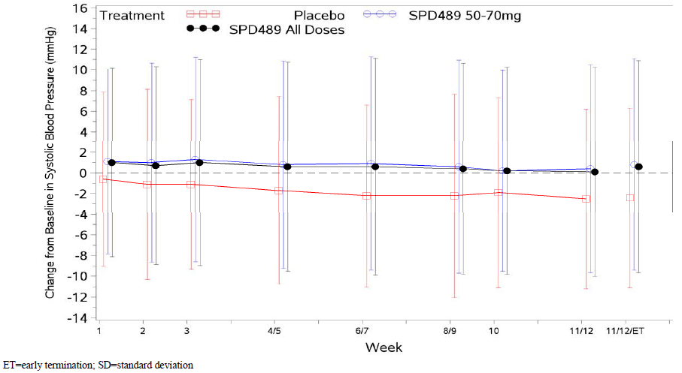

Figure 17: Mean (SD) Change from Baseline in diastolic blood pressure by visit for the short term, placebo controlled Studies (Safety Analysis Set)

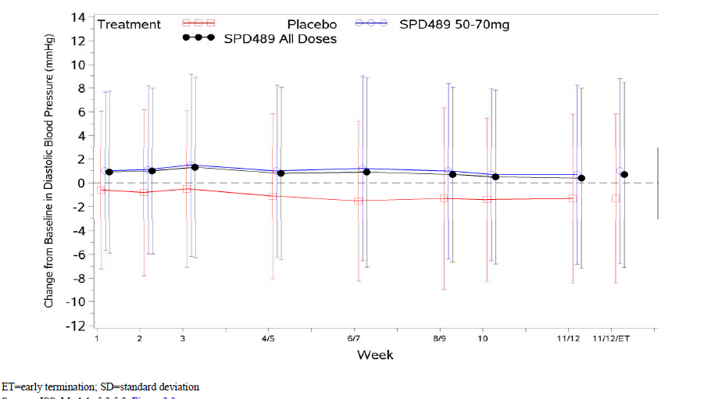

Pulse rate increased with SPD489 (mean increase of 5.0 bpm at Week 11/12) and a smaller increase was also noted in the placebo group (1 to 3 bpm) (Figure 18).

Figure 18: Mean (SD) change from Baseline in pulse rate by visit for the short term, placebo controlled studies (Safety analysis set)

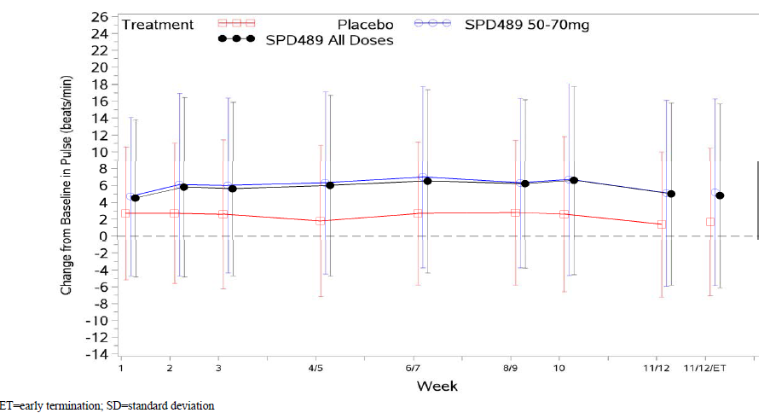

The rate of subjects with an increase in SBP of > 10 mmHg was higher with SPD489 (13 to 18% versus 7 to 11%). A similar trend was seen for an increase in DBP > 10 mmHg (8 to 12% versus 4 to 7%). PCI increases in SBP, DBP and pulse rate are shown in Table 20. A SBP of ≥ 140 mmHg and an increase of > 10 mmHg from Baseline on 2 consecutive visits was more frequent with SPD489 (1.6% versus 0.7%). A pulse rate of ≥ 110 bpm occurred in 3.4% and 0.5% of SPD489 and placebo subjects, respectively.

Table 20: Potentially clinical important vital signs values in the short term, placebo controlled studies (Safety Analysis Set)

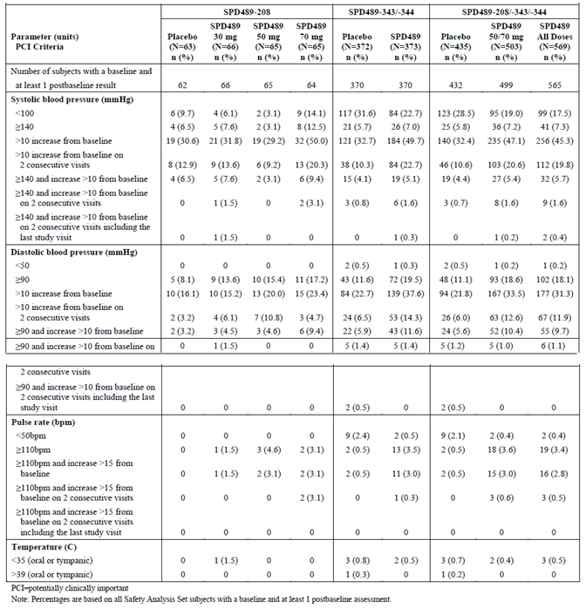

In the short term studies (11/12 weeks), SPD489 treatment resulted in a mean decrease in body weight of 5.2 kg (5.5%) while there was little change in the placebo group (Figure 19). Weight decrease of ≥ 10% occurred in 15.9% versus 0.7% of the SPD489 and placebo groups, respectively.

Figure 19: Mean (SD) change from Baseline in body weight by visit for the short term, placebo controlled studies (safety analysis set)

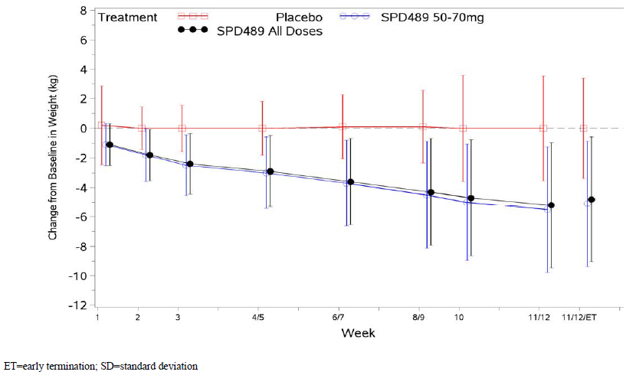

##### Other studies

Data from Study 346 were consistent with findings in the short term studies. During open label treatment, the most frequent TEAEs relating to vital signs were tachycardia (4.1%), increased BP (3.6%), increased HR (3.4%), palpitations (3.2%), hypertension (1.5%) and increased DPB (1.0%). During randomised treatment, TEAEs relating to increased heart rate or palpitations occurred in 2.9% of the SPD489 group compared to none of the placebo group. As with the short term studies, during randomised treatment there were more SPD489 than placebo treated subjects with a clinically important shift of increased BP and HR on 2 consecutive visits.

In the long term, open label extension Study 345, mean change from Baseline in BP was low (2.1 mmHg for SBP, 1.6 mmHg for DPB) and the mean increase in pulse rate was 7.4 bpm. The most frequent vital sign related TEAEs were increased BP (4.3%), increased HR (2.5%) and tachycardia (2.3%)(Table 21). The rate of subjects with SBP ≥ 140 mmHg and > 10 mmg Hg increase from Baseline on 2 consecutive visits was 3.2% and for DBP ≥ 90 mmHg with > 10 mmHg increase on 2 consecutive visits was 4.4%.

Table 21: Treatment-emergent AEs related to blood pressure, pulse rate or electrocardiogram (Safety analysis set)

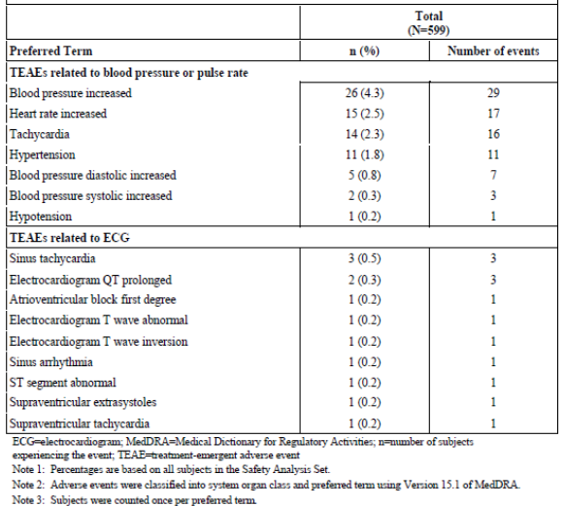

In Study 345, there was a decrease in mean body weight of approximately 8 kg by Week 32 and then mean weight stabilised (Figure 20). For the 369 subjects with data at Week 52, the mean decrease from Baseline was 8.2 kg (an 8.6% decrease). Only 1.5% of subjects had their weight decrease by ≥ 10%. The mean decrease in BMI was approximately 3 kg/m2.

Figure 20: Mean (SD) change from Baseline in body weight by visit (safety analysis set)

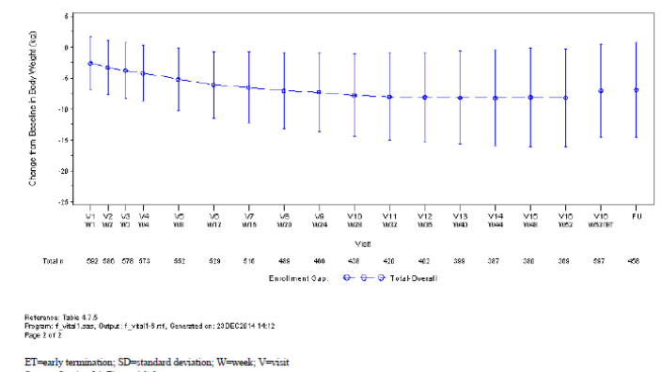

In the ADHD studies, an increase in pulse rate and in blood pressure were noted in subjects treated with SPD489. In the long term study, the mean change from Baseline to last on treatment assessment in pulse rate was 7.0 bpm, in SBP was 3.4 mmHg and in DBP was 3.2 mmHg.

In the long term ADHD study, by Week 24 there was 1.9 kg decrease in mean body weight which had returned to Baseline by Week 60 and was followed by a mean weight increase of 3.5 kg by Week 104. This change was also reflected in BMI data. At study baseline the average weight percentile for study subjects (age and sex matched to the general US population) was 65.4 and by study end at Week 104 was 48.2 indicating a slowing of growth (mean change from Baseline in the age and sex normalised weight percentile of -16.9). The rate of TEAEs of decreased weight was 20.1% with severe decreased weight reported in 2.9% and 2 subjects were withdrawn for this AE.

Physical and sexual maturation was assessed using the Tanner scale and no adverse trends were noted after up to 2 years of treatment.

The Cambridge Neuropsychological Test Automated Battery (CANTAB) was used to assess cognitive safety signals. While results indicated no adverse cognitive impact of SPD489 treatment, the lack of control groups makes result interpretation difficult.

#### Electrocardiograph findings and cardiovascular safety

##### Pivotal and/or main efficacy studies

In the short term controlled BED studies, the change from Baseline to end of treatment/Week 11 to 12 for heart rate was 3.6 and -0.5 in the SPD489 and placebo groups, respectively. The mean change from Baseline in QTcF was -1.54 and -0.73 msec, respectively. There was one SPD489 treated subject with a clinically significant ECG and 5 in the placebo group. The SPD489 treated subject had QTc prolongation (not clinically significant) and premature atrial contraction, the QTc prolongation had been reported at baseline. There was also one subject with first degree AV block who had this and ectopic atrial rhythm on an ECG at Week 12. Data on changes in QT interval were similar between active and placebo groups. Apart from the increase in heart rate, other ECG assessments were comparable between groups.

**Comment:** As stated by the sponsor, QTcF is a more appropriate measure of QT prolongation due to the impact of increased heart rate on QTcB.

In terms of cardiovascular related AEs, the rate of tachycardia AEs was higher with SPD489 (6.0% versus 1.1%), as was increase BP (4.2% versus 2.3%). Syncope related AEs (1.2% versus 0.2%) and AEs of vasculitis/Raynaud’s/paraesthesia (1.9% versus 0.5%) were also more frequent with SPD489, while the rate of angina/ischaemia related AEs was the same in both groups (0.7%).

##### Other studies

In the long term extension study, there was a mean increase in HR of 6.6 bpm and a mean decrease in QTcF of -2.6 msec. Clinically significant abnormal ECGs (QT prolongation, sinus tachycardia, non-specific T changes) were reported in 5 subjects (0.8%) and 3 of these discontinued. There were no cases of QTcF ≥ 480 msec or an increase in QTcF of ≥ 60 msec.

There was no integrated analysis of AEs of special interest in the pool of five studies. In the long term extension study, the rate of angina/ischaemia AEs was 1.7%, the rate of vasculitis /Raynaud’s/ paraesthesia was 3.5%, syncope was 0.2% (one case) and the rate of ‘other cardiovascular events’ was also 0.2% (one case of SVT).

In the open label phase of Study SPD489-346, the most frequent cardiovascular AEs of special interest were chest discomfort (1.5% and this subject discontinued), peripheral coldness (1.2%), chest pain (1.0%) and paraesthesia (1.0%). In the randomised period, the cardiovascular events in the SPD489 group were angina/ischaemia (1.5%), paraesthesia (0.7%) and syncope (0.7%). There were no cardiovascular AEs of special interest in the placebo group.

#### Psychiatric events

##### Pivotal and/or main efficacy studies

Suicidal ideation and behaviour was assessed using the C-SSRS data however data were not pooled. There were no suicide-related TEAEs in the short term studies. One placebo treated subject attempted suicide 7 days after the end of treatment. The rate of a positive response to any item on the C-SSRS was similar between the SPD489 and placebo groups in Study 343 (1.0% versus 1.8%) and in Study 343 (0.6% versus 1.1%).

Psychiatric adverse events were examined. The most frequent events were related to mood and were more common in the SPD489 group (10.2% versus 3.4%). The most frequent event in this group was insomnia. Aggression related events (8.8% versus 6.0%) were more common in the SPD489 group and the most frequent event in this group was irritability (6.3% versus 5.3%). Psychosis/hallucination/mania events were more frequent with SPD489 (2.8% versus 0.2%) with the most common event in this group being affect lability (1.1% versus 0%). None of the events in the SPD489 group were serious, although 2 led to discontinuation.

##### Other studies

There was one suicidal ideation TEAE in SPD489-345 and this subject discontinued. A positive response on the C-SSRS was reported in 1.2% of subjects.

In the open label phase of SPD489-346, the most frequent psychiatric AEs of special interest were irritability (4.6%), disturbance in attention (1.5%), initial insomnia (1.5%), depression (1.2%), and logorrhoea (1.2%). In the randomised phase, mood-related AEs were more frequent in the SPD489 group (SPD489 versus placebo: 8.1% versus 4.5%), while irritability occurred at a similar frequency (2.9% versus 3.0%).

In the long term ADHD study; there were 2 subjects with suicide ideation events (one case serious) and one subject who attempted suicide. Based on the CSSR-S there were 7 (2.2%) subjects with a positive response to suicidal ideation and behaviour items. There were 17 subjects with aggression related events. None of these were serious, however 2 led to withdrawal and 7 cases were reported as treatment related.

#### Overdose, abuse, dependence

There were 10 subjects (0.8%) treated with SPD489 who had TEAEs of overdose (intake of more than one capsule per day in double blind studies or exceeding 70 mg/day in open label studies). In 8 cases only one extra capsule was taken, in one case one extra capsule was taken on 2 days and in the last case ≤ 3 capsules were taken (precise number unknown).

**Comment:** The sponsor stated in the Summary of Clinical Safety that information concerning overdoses in the BED clinical development program has been submitted in the Abuse Dependence Liability Assessment Report in Module 5.3.5.4. This report could not be located in the dossier and a question has been raised.

There were two SPD489 treated subjects (0.2%) with a TEAE of withdrawal syndrome 1 to 2 days post treatment cessation. One reported ‘withdrawal symptoms’ and one ‘fatigue/ withdrawal symptoms’. One subject (0.1%) discontinued due to drug dependence (‘intermittent drug craving’). Withdrawal symptoms were assessed using the self-reported Amphetamine Cessation Symptom Assessment (ACSA) questionnaire in Studies 343, 344 and 346. Higher scores are associated with greater withdrawal symptom severity. In the pooled data from Studies 343 and 344, mean ACSA total scores were slightly higher in the SPD489 group than the placebo group 2 to 7 days post last dose and after this scores were comparable.

In Study 346, the ACSA scores were assessed for 7 days following last study medication dose at the end of the randomised withdrawal phase (up to 38 weeks of treatment). There was little difference in symptom scores between the SPD489 (all dose as well as 50 and 70 mg/day) and placebo groups (Figure 21).

Figure 21: Mean (± SD) ACSA total aggregate scores presented by treatment group for the 7 day period following the last dose of investigational product (Randomised Safety Analysis Set)

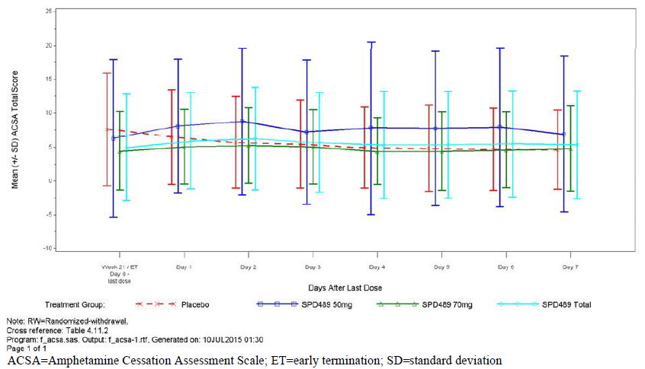

### Other safety issues

#### Safety in special populations

Safety was assessed by age group of < 40 years and ≥ 40 years and the data were generally consistent between these groups in the short term studies (Table 22). In the total SPD489 population, there was a slightly higher rate of SAEs (3.2% versus 1.6%) and discontinuations due to TEAEs (9.7% versus 6.7%) in those aged 40 years and over.

Table 22: Overall summary of treatment emergent AEs by age group in the short term, placebo controlled studies (safety analysis set)

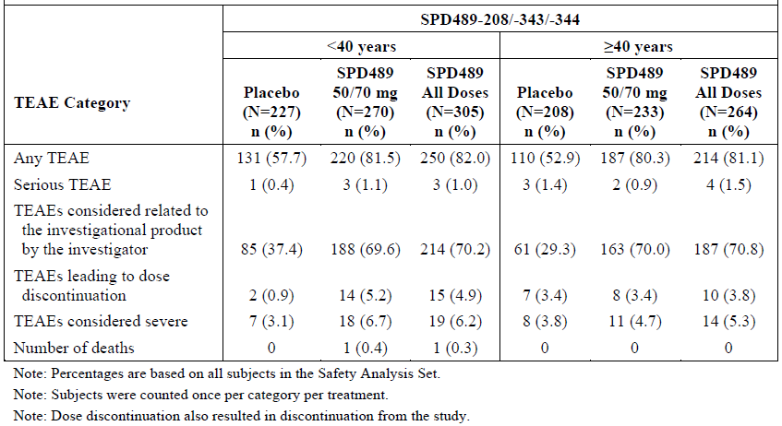

For males and females, TEAE and SAE rates were similar while TEAEs leading to discontinuation were more frequent in females (8.6% versus 4.8%).

**Comment:** Assessment by gender is hampered by the relatively small number of males (13.5%) in the clinical development program for BED.

The number of non-Whites was also relatively low (22%) making conclusive comments difficult, although findings were generally consistent with White subjects.

In the short term studies, analysis of safety data by obesity status (a BMI < 30 or ≥ 30 kg/m2) found fairly consistent results between the obese and non-obese for TEAE and SAE rates. The obese subjects did have a higher rate of severe TEAEs compared to the non-obese subjects when treated with SPD489 (6.7% versus 3.7% and 3.0-3.6% in the placebo groups).

**Comment:**  The sponsor noted that there was as slightly higher rate of treatment with 70 mg in the obese compared to non-obese subjects (65.7% versus 52.9%).

In the all SPD489 treated subjects group, the rate of severe TEAEs was 7.6% versus 5.8% in the obese and non-obese subjects. Other TEAE rates were generally consistent between obesity status groups. Palpitations were more frequent in non-obese subjects (5.2% versus 2.8%).

##### Pregnancy

In Study SPD489-346 there were 4 reported pregnancies: one with 89 days exposure and one with 188 days exposure both had unknown outcomes; one with 111 days exposure and the baby was born with congenital anomalies and died at 2 Weeks (reported as an SAE); and the last had 39 days exposure and a healthy infant was born at term.

There were 2 pregnancies in Study SPD489-343: one with 19 days exposure to placebo and a healthy infant was delivered; the other with 21 days exposure to SPD489 and resulted in a spontaneous abortion.

In the long term Study SPD489-345, there were 15 reported pregnancies. 10 subjects discontinued and in 5 cases the pregnancy was detected after study completion. The pregnancy outcomes included one spontaneous abortion, one elective abortion, 3 normal term deliveries, one pre-eclampsia and delivery at 36 weeks and for the remainder the outcome was unknown.

**Comment:** To understand the potential risk to the foetus from maternal exposure, it is recommended that clinical trial and post-marketing data on pregnancy and foetal outcome across both ADHD and BED indications are summarised.

#### Safety related to drug-drug interactions and other interactions

No new data submitted.

### Post marketing experience

It was reported that, as of 31 January 2015, the total cumulative exposure to SPD489 was 5.49 million person years for the treatment of ADHD. The Summary of Clinical Safety did not contain any further post marketing safety data. No PSURs were included in the dossier.

### Evaluator’s overall conclusions on clinical safety

#### BED

For the BED indication, which consisted of 5 clinical trials, there were 1244 subjects exposed to SPD489 with a mean duration of 212 days at an average daily dose of 57.5 mg. There were 380 subjects with ≥ 361 days of exposure and a total person-time exposure of 263,996 days. In the three short term placebo controlled studies there were 502 subjects exposed to 50 or 70 mg per day with mean duration of 73 days.

TEAEs were frequent (in the short term studies, SPD489 versus placebo: 82% versus 55%) and were generally treatment related (70.5% versus 33.6%). The most common treatment related events were dry mouth, insomnia, decreased appetite, headache, nausea and irritability.

Events tended to occur early in treatment and there was some evidence of resolution while on treatment.

Severe TEAEs occurred in 5.8% of the SPD489 compared to 3.4% in the placebo group and were most commonly decreased appetite, dry mouth, headache and insomnia.

There was one death in the BED program in a male subject 9 days after the last study visit. The cause of death was methamphetamine and amphetamine toxicity. While the substance abuse became apparent after his death, it is unclear whether there was any triggering role from the SPD489 treatment.

There was also a death of a neonate with congenital abnormalities who had been exposed to SPD489 for 41 days. There were no other congenital abnormalities reported in the other pregnancies in the program. Nonetheless, the sponsor has been asked to comment on pregnancy and foetal outcome data associated with SPD489 exposure.

While the overall rate of adverse events is high, the rate of serious adverse events was relatively low at 2.3% in the overall population. In the short term studies, the SAE rate was slightly higher with SPD489 than placebo (1.5% versus 0.9%). There were 4 SAEs of cholecystitis (0.4%). The BED population which is typically obese females would be at risk of gall bladder disease, however it is unclear whether there is an association with treatment and this should be monitored. There were also 2 SAEs of syncope (compared to one in the placebo group) both of which led to treatment discontinuation. The sponsor has been asked to comment on these 2 risks and why they are not included in the PI.

While study discontinuation rates were high (49% of the overall population and 21% in the short term studies), the reported rate of discontinuation due to an AE was lower (4.4% versus 2.1% in the SPD489 and placebo groups, respectively in the short term studies). The notable events leading to discontinuation were feeling jittery, irritability and syncope.

Laboratory findings on the whole were unremarkable and changes in lipids (TC and TG) were minimal.

Treatment with SPD489 resulted in weight loss of about 5 kg (5.5% reduction in body weight) over the 11-12 weeks and 8 kg (8.6% reduction in body weight) over 52 weeks. The weight loss stabilised by about Week 32 of treatment. Interestingly, despite a reduction in binge eating, there was little weight reduction in placebo treated subjects.

Consistent with what is known, subjects treated with SPD489 had a small increase in SBP and DBP of 1 to 3 mmHg and an increase in heart rate of 5 to 7 bpm. The ECG findings were not remarkable and the rate of CV events was low. While this is encouraging, CV risks may not have been detected due to insufficient treatment duration, inadequate sample size and careful trial population selection.

Psychiatric events were more common with SPD489 than placebo, although events, typically insomnia, irritability and affect lability, were not serious. Suicidal ideation and behaviour was infrequent and no higher than with placebo.

There was no evidence of treatment abuse in the data supplied however this does not remove the reality of this risk. A quoted report on this could not be located in the dossier and this has been queried.

Treatment withdrawal symptoms, as assessed by the ACSA questionnaire, were not a significant issue and TEAEs of withdrawal syndrome were only reported in 0.2%.

Safety data assessment by subgroups of age, obesity status, gender and race was hampered by low numbers of males and non-Whites although no major signals were evident.

No post-marketing data were supplied.

Overall, safety data in subjects with BED were generally consistent with that reported for the ADHD indication and with what is known for stimulants. Data on pregnancy, cholecystitis and syncope need further elucidation. While cardiovascular event risk and risk of treatment abuse were not evident in the clinical program, they still cannot be ruled out.

#### ADHD

Safety data subjects with ADHD aged 6 to 17 years were included in the dossier. The 2 year extension study included 314 subjects with a mean exposure duration of 555 days and 96 subjects had ≥ 24 months exposure to SPD489.

The rate of treatment related TEAEs was high at 73.9% and the most frequent events were decreased appetite (49.4%), weight decreased (18.2%), insomnia (13.1%), initial insomnia (8.9%) and irritability (8.6%). Tic was reported in 5.1%. Most events were mild (35.7%) or moderate (42.4%) in severity, with severe TEAEs occurring in 11.8% of subjects.

The SAE rate in long term study was 8.9% and the most frequent event was syncope (1.9%) which was required to be reported as an SAE. In all syncope cases treatment was continued. There was one treatment related RBBB and T wave inversion in a subject with a subdural haematoma.

Discontinuation rate due to an AE in the long term ADHD study was reasonably frequent at 12.4% and the main reasons were decreased appetite, drug ineffective, irritability, depressed mood, insomnia and tic.

The rate of a positive response on the C-SSRS was 2.2% and there were 2 (0.6%) suicide attempts. Aggression-related AEs were reported in 5.4% of subjects.

An increase in heart rate of about 7 bpm and increase in SBP and DPB of about 3 mmHg were reported.

The concern that SPD489 could decrease growth was confirmed as the average age and sex matched weight percentile declined from 65% to 48% over the 2 years of the long term study. This risk has been added to the PI.

There was no effect on sexual maturation as measured by Tanner scale. CANTAB assessment of cognitive safety did not show an adverse impact of treatment although the lack of a control group made interpretation difficult.

Following the inclusion of the three latest ADHD studies in the integrated safety database, the sponsor reported that there has been a change incidence of 13 adverse drug reaction terms. These changes are shown in Table 23.

It is unclear why tabulated data on the incidence of adverse drug reactions has not been included in the PI for ADHD (nor proposed for BED). This has been queried.

Table 23: MedDRA preferred terms with a change in incidence category or data source for determining incidence

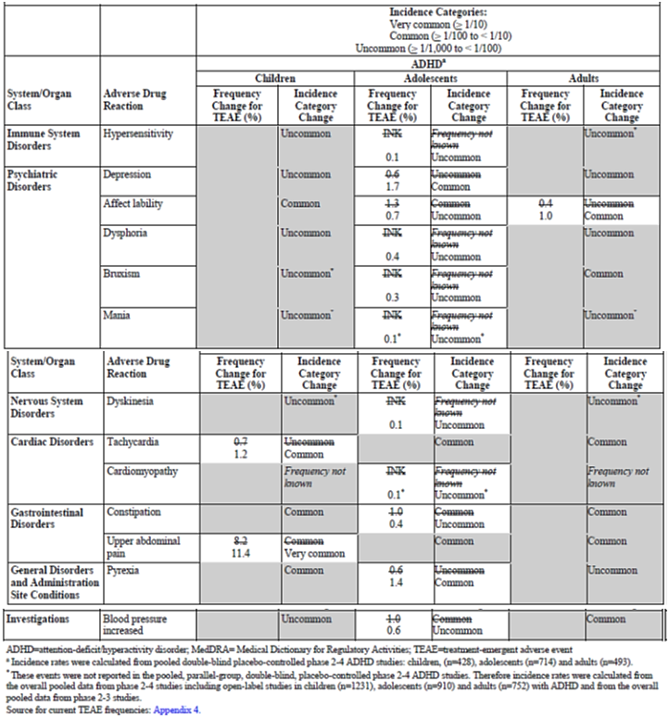

## First round benefit-risk assessment

### First round assessment of benefits

Table 24: Assessment of benefits and uncertainties

| **Indication – Binge Eating Disorder** | |
| --- | --- |
| **Benefits** | **Strengths and Uncertainties** |
| Statistically significant efficacy over placebo as measured by the number of binge eating days per week. | Superiority demonstrated in two randomised, placebo controlled trials. The placebo-corrected effect size was 1.5 binge days per week. |
| Efficacy on the primary endpoint was supported by positive effect across the secondary endpoints in both pivotal trials. | The benefit of SPD489 was confirmed on CGI-I score, proportion ceasing all binge eating for the last 4 weeks of the trial, percentage reduction in body weight, the change in the Y-BOCS-BE total score and triglyceride levels. |
| Efficacy was consistent across subgroups. | Generally consistent results from the combined Phase III study dataset on all subgroups apart from non-US subjects where numbers were small. |
| A positive response on the clinically relevant endpoint of 4 week binge eating cessation. | In the SPD489 groups, the 4 week cessation of binge eating rate was 36 to 40% compared to 13 to 14% in the placebo group with a difference of 23 to 26%. |
| Lower risk of relapse. | The randomised controlled withdrawal study found a relapse rate of 4% in those on SPD489 compared to 32% in those on placebo. |
| Safety generally in line with what is known from the ADHD population. | The safety dataset for BED was moderately large in size including 1244 subjects with mean treatment duration of 212 days. |
| Weight reduction. | In a population which is typically obese, there was a 5.5% reduction in body weight over 12 weeks treatment (compared to no change with placebo) and up to 8.6% in the one year study. Weight reduction was seen to stabilise at around Week 34 of treatment. |
| Lack of significant withdrawal symptoms. | TEAEs of withdrawal syndrome were infrequent (0.2%) and specific questionnaire data (ACSA) did not indicate a significant issue. |
| First pharmaceutical treatment option for BED in Australia. | A novel therapeutic option for patients, particularly for those who may not have access to psychotherapy. |

### First round assessment of risks

Table 25: assessment of risks and uncertainties

|  |  |
| --- | --- |
| Risks | Strengths and Uncertainties |
| Treatment-related adverse events are very frequent (for example drug mouth, insomnia, headache, decreased appetite, irritability, nausea, feeling jittery). | The rate of treatment related AEs in the short term studies was 71%. Despite the high rate, the SAE risk is moderately low (2.3%). In addition, the risk of discontinuation due to AEs was 4.4% in the short term studies and 9% in the 1 year study indicating the risks may be tolerable. |
| Increased blood pressure and heart rate | There is a well-documented increase in BP of 1-2 mmHg and an increase in heart rate of 5-7 bpm. |
| Populations where stimulant treatment is contraindicated. | As already stated in the PI, contraindicated populations include: those with symptomatic cardiovascular disease, advanced arteriosclerosis, moderate to severe hypertension, glaucoma, hyperthyroidism, phaeochromocytoma, other psychiatric disorders, agitated states, tics or Tourette’s syndrome, drug dependence and alcohol abuse. |
| No firm long term efficacy data | The efficacy was established over a 12 week treatment period. Supportive studies did not provide firm evidence of efficacy over longer treatment durations. |
| No long term safety data beyond 1 year. | Safety data in the BED population were only available to 1 year and this is a risk given the proposal that treatment could be prescribed indefinitely. |
| Cardiovascular risk. | Cardiovascular events (apart from the effects on vital signs) were not evident in the BED clinical program, however the studies were not aimed at assessing this risk. The risk has been associated with weight loss therapies and is applicable to SPD489. |
| Risk of normalising amphetamine use for appetite suppression. | Given the widespread problem in our community of overeating, the availability of SPD489 for the BED population may have an impact on normalising amphetamine use for appetite suppression and weight loss. |
| Risk of off label use for weight loss, risk of abuse and of diversion out of the clinical setting. | Off label use for weight loss is a real risk given the positive effects on weight reduction seen in the clinical trials. While treatment abuse was not seen, the clinical trial setting is very controlled. The risk of diversion has not been elucidated however, due to the nature of the drug, it is an evident possibility. |
| Growth retardation in children with ADHD | The 2 year ADHD study confirmed reduction in growth of children. |

### First round assessment of benefit-risk balance

The clinical development program for binge eating disorder produced robust efficacy results compared to placebo. The trial populations were required to have BED (DSM-IV-TR diagnosis with CGI-S ≥ 4) of at least moderate severity as defined by at least 3 binge days per week in the 2 weeks prior to randomisation. The proposed indication is for ‘adults with BED’. This is not appropriate given the population studied and treatment needs to be limited to those with moderate to severe BED.

The safety of SPD489 in the BED population was consistent with what is already known for the product and risks have been assessed through to 1 year of treatment. There is a possible risk of cholecystitis, although there are insufficient data to confirm the association. This potential risk should be monitored.

One of the main safety issues is that of the longer term cardiovascular risk. This is a concern given the history of amphetamine based weight loss products. Had the product been developed for weight loss, there would have been a requirement for a cardiovascular outcome study. This requirement was sidestepped due to the development occurring in BED. SPD489 results in a small increase in BP together with increase heart rate and the BED population is obese and cardiovascular events are feasible. While no CV risk was evident in the clinical program, the sample may have been too small, the trial duration too short and the population carefully selected. Given these issues, a number of measures need to be put in place to manage the potential CV risk. These include avoidance of the product in those with high CV risk, careful blood pressure and cardiovascular monitoring and treatment of hypertension.

The evaluator has not been shown any convincing argument for the need to continue the treatment long term. In fact, in the withdrawal study the relapse rate in the placebo group was not 100% but only 32% indicating that 68% of subjects did not relapse. While this may partly be a placebo response, there is also the possibility that the initial 12 weeks treatment had a training effect and further treatment may not be necessary.

The presented data provide sufficient evidence of efficacy over 12 weeks treatment. However, the lack of evidence for long-term efficacy and the absence of longer term cardiovascular outcome data, lead the evaluator to recommend that treatment with SPD489 in BED should be limited to a maximum duration of 12 weeks. As SPD489 is an amphetamine stimulant, there is a real risk of treatment abuse, dependency and diversion out of the clinical setting. Also, given the positive data on weight loss, there could well be off label use in this indication. There is a widespread issue of overeating and obesity in our community and coupled with this is the ever-present desire for pharmacological solutions. The availability of SPD489 for binge eating disorder poses a broader issue as it could lead to a perceived normalisation of the use of amphetamines as appetite suppressants. This public health risk is obviously difficult to quantify but deserves consideration.

The recommended first line treatment for BED is psychotherapy; however this was used in less than 3% of the pivotal efficacy population. Unfortunately, there are no efficacy data for patients who have failed psychotherapy and this is a limitation of the clinical development program. Given the risks of lisdexamfetamine treatment to the patient and the community in general, the evaluator believes that the most prudent course of action would be to limit its use to second line therapy and that it is available for first line therapy only if there is no possible access to psychotherapy.

Labelling must be very clear that the product not be used for weight loss, and it is recommended the indication includes wording such as that in the US label:

*Vyvanse is not indicated or recommended for weight loss. Use of other sympathomimetic drugs for weight loss has been associated with serious cardiovascular adverse events. The safety and effectiveness of Vyvanse for the treatment of obesity have not been established (see Warnings and Precautions (5.2)).*

There should also be very tight controls on the use of the drug and it is recommended that treatment should only be initiated and managed by specialist psychiatrists. This is similar to ADHD where the PI states that treatment should be commenced by a specialist.

In summary, lisdexamfetamine was found to be an efficacious treatment for BED with a short term safety profile that, despite high adverse reaction rates, appears tolerable. There is an evident clinical place for a product to treat BED as there are no currently approved drug therapies in Australia for the condition and patients may not all have access to recommended psychotherapy. On the other hand, there are numerous serious risks largely due to the nature of this amphetamine product. These risks include off label use for weight loss, abuse, dependency, diversion out of the clinical setting, normalising amphetamine use as an appetite suppressant, lack of firm efficacy data beyond 12 weeks and the absence of longer term cardiovascular outcome data. Given these issues, the evaluator concludes that under the proposed usage the benefit-risk balance is negative.

ADHD data were submitted to support changes to the product information. These new data showed similar efficacy between SPD489 and OROS MPH. Safety data with treatment up to 2 years duration showed a reduction in growth which has been covered adequately in the proposed PI changes.

## First round recommendation regarding authorisation

It is currently not recommended to authorise Vyvanse in the proposed indication of ‘*the treatment of BED in adults’.* The product’s risks and current data are such that there needs to be significant tightening of the indication and the safety warnings, as well as further restrictions on the product’s availability. Consideration should be given to the following recommendations:

* The indication should limit treatment to adults with moderate to severe BED.
* Treatment should be a second line therapy after failed psychotherapy. It is recommended that it is used as first line only in those who do not have access to psychotherapy. The indication should include a warning that the treatment is not for weight loss and also included the risk of serious cardiovascular adverse events associated with sympathomimetic drugs for weight loss.
* Treatment should only be initiated and managed by specialist psychiatrists.
* In the absence of further longer term efficacy, safety and cardiovascular outcome data, treatment duration should be limited to a maximum of 12 weeks.
* Changes to the PI and CMI outlined need to be addressed.
* Questions in Section 11 need to be satisfactorily addressed.

It is recommended that the changes to the PI in relation to the ADHD indication be approved subject to satisfactory responses to the comments.

## Clinical questions

### Pharmacokinetics

None.

### Pharmacodynamics

None.

### Efficacy

1. In Study SPD489-208, the primary efficacy endpoint (number of binge days per week) was log transformed for analysis while in the Phase III studies this was not done. Please discuss why this log transformation was undertaken.
2. For Study SPD489-208, the dossier included an addendum to the CSR. In this report it was stated that data from one site (015) were ‘*removed from the analysis for reasons unrelated to the study*’. Please comment on why these data were removed from the analysis and if there were any other instances where data integrity was in question in the BED clinical development program.
3. Studies SPD489-343 and 344 were identical and conducted at the same time and both largely in the US. Please discuss how independence of the two studies was achieved and maintained.
4. In Study SPD489-343, the FDA review comments on issues at Site 066 where 21 subjects were enrolled. Please comment on this and whether it had any impact on the final results of the study.
5. In Study SPD489-344, there were issues noted at Sites 015 (*reasons unrelated to the study*) and 079 (non-compliance with GCP) which led to the data from these sites being excluded from analyses. Please clarify what the issues were at Site 015 and also comment on any differences in the primary endpoint results when the data from these 2 sites were included or excluded from the efficacy analyses.
6. In Study SPD489-344, no treatment effect for the change from Baseline in number of binge days per week was seen in the German subjects (it is acknowledged that the sample size for this subgroup was small). Please comment on this finding.
7. In Studies SPD489-343 and 344, there was a reduction in number of binge days per week in the placebo group but not reduction in body weight, while body weight reduction of 5-6% was seen in the SPD489 groups. Please comment on this apparent disconnect in the data and the lack of effect on weight in the placebo group.
8. The demographic pattern of BED in Australia does not appear well defined. Please comment on the applicability of the BED clinical trial population (which was largely from the US), in relation to demographics and disease characteristics, to the targeted one in Australia.
9. At baseline, binge days per week were collected over a 2 week period, however at study end it appears the number of binge days was collected over a one week period. Please confirm the period over which primary efficacy endpoint data were collected at study end. If this period was one week, please comment on whether the 7 days were sufficient given a potential for data variability.
10. Given the relative effect on weight loss of SPD489 over placebo, it would appear efficacy in BED is likely related to the appetite suppressive effects of the product. Please discuss.
11. Are there any efficacy data in BED subjects who have failed psychotherapy? If not, is development in this group planned?

### Safety

1. In the short term controlled studies, there was little change in urinalysis results, however the rate of PCI leukocyte esterase was higher with SPD489 (12.0% versus 6.8%) as was urinary protein (4.9% versus 2.9%). Please comment on these findings.
2. It was stated in the Summary of Clinical Safety that information concerning overdoses in the BED clinical development program has been submitted in the *Abuse Dependence Liability Assessment Report*. This report could not be located in the dossier. Has this report been previously evaluated? If not, please submit it together with appropriate summary and commentary on these risks in the BED population.
3. Given the death of an infant with congenital anomalies who had been exposed to SPD489 in utero during a BED clinical trial, please provide any further data (clinical and post marketing) on pregnancies and foetal outcomes across both ADHD and BED indications.
4. There were 4 cases of cholecystitis reported in the clinical program. It is acknowledged that the BED population is typically obese females and so may be at risk of gall bladder disease; nonetheless please discuss this possible safety signal. In addition, discuss why the risk has not been included in the PI or RMP.
5. There were 2 SAEs of syncope in subjects treated with SPD489, both of which led to treatment discontinuation. Please comment on this risk and whether further information and precaution should be included in the PI and CMI.
6. Please discuss what is known about the risk of off label use of Vyvanse for weight loss, particularly since registration in the US, and how it is proposed to manage this risk.

## Second round evaluation of clinical data submitted in response to questions

### Efficacy

1. ***In Study SPD489-208, the primary efficacy endpoint (number of binge days per week) was log transformed for analysis while in the Phase III studies this was not done. Please discuss why this log transformation was undertaken.***

**Sponsor’s response:** Study SPD489-208 was a proof of concept study with exploratory endpoints. The data on number of binge days per week were analysed both log-transformed and non log-transformed with similar statistically significant results compared to placebo on both analyses for the 50 mg and 70 mg doses but not the 30 mg dose. Following results from Study 208, the primary endpoint selected for the Phase III studies was not log-transformed.

**Evaluator’s comments:** The explanation is satisfactory.

1. ***For Study SPD489-208, the dossier included an addendum to the CSR. In this report it was stated that data from one site (015) were ‘removed from the analysis for reasons unrelated to the study’. Please comment on why these data were removed from the analysis and if there were any other instances where data integrity was in question in the BED clinical development program.***

**Sponsor’s response:** The sponsor stated that in ‘2011, [the sponsor] received notice from the FDA that the principal investigator Robert Horne, MD, at Site 015 had been found to be outside the measures of GCP for reasons unrelated to the study.’ Analyses were undertaken with data from this site removed and it was concluded that this ‘did not significantly impact the data and results leading to the conclusions of the clinical trial.’

There were 4 sites with findings of non-compliance with GCP during the clinical development program listed in Table 26 below. Further information is given in response to Efficacy Question 4 below.

Table 26: Sites with GCP non-compliance during the BED clinical development program

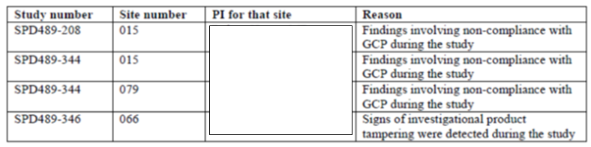

**Evaluator’s comments:** The type of GCP non-compliance was not explained. It appears the GCP non-compliance issues were limited to the sites listed in the table. Further comments are with Question 4.

1. ***Studies SPD489-343 and 344 were identical and conducted at the same time and both largely in the US. Please discuss how independence of the two studies was achieved and maintained.***

**Sponsor’s response:** Study SPD489-343 was conducted at 50 sites in the US, Germany, Sweden, and Spain, while Study SDP489-344 was carried out at 41 sites in the US and 2 sites in Germany. The 2 studies did not share any sites and subjects during the time course of the studies. These physically separating arrangements were sufficient to achieve and maintain independence for these 2 studies.

**Evaluator’s comments:** The response is satisfactory.

1. ***In Study SPD489-343, the FDA review comments on issues at Site 066 where 21 subjects were enrolled. Please comment on this and whether it had any impact on the final results of the study.***

**Sponsor’s response:** Signs of investigational product tampering were detected at Site 066 of Study SPD489-346 and the site was closed and subjects discontinued. Study SPD489-343 had been completed by this stage.

In Study 346, there were 8 subjects enrolled at Site 066 representing 1.9% of the total enrolment. At the time of closing the site, 2 subjects had already discontinued (failure to meet randomisation criteria and a protocol violation of out of range blood pressure) and 6 subjects in the randomised withdrawal phase were discontinued. None of the 6 subjects relapsed. The sponsor analysed data without the 8 subjects and found that the *primary efficacy conclusion was not impacted.* Safety data from the 8 subjects were not remarkable.

In Study SPD489-343 there were 21 subjects at Site 066. One of these subjects did not have primary efficacy data at study endpoint. Data were reanalysed removing these 20 subjects. The LS mean change from Baseline in the number of binge days per week in the SPD489 and placebo groups was -3.82 and -2.48, respectively, with a LS mean difference of -1.34 (95% CI: ‑1.70, ‑0.98, p < 0.001). The LS mean difference in the original CSR was -1.35.

**Evaluator’s comments:** Removal of the data from Site 066 in both Studies SPD489-343 and 346 did not effect results on the primary efficacy endpoint analysis for either study.

1. ***In Study SPD489-344, there were issues noted at Sites 015 (reasons unrelated to the study) and 079 (non-compliance with GCP) which led to the data from these sites being excluded from analyses. Please clarify what the issues were at Site 015 and also comment on any differences in the primary endpoint results when the data from these 2 sites were included or excluded from the efficacy analyses.***

**Sponsor’s response:** In Study SPD489-344 there were 23 subjects randomised at the 2 sites in question; 11 at Site 015 and 12 at Site 079. Site 015 was investigated externally and source data verification by the sponsor was not possible. Therefore data were excluded from the primary efficacy analysis. The sponsor stated ‘*that removing the data from this site did not significantly impact the data and conclusions leading to the result of the clinical trial.* At Site 079 the GCP non-compliance issues included *failure to follow critical study procedures set forth by the protocol for collection of efficacy data, inadequate medical oversight, improper entry of subject data, and incomplete source documentation’*. The study data were analysed including Sites 015 and 079 and the LS mean difference in the number of binge days per week was -1.68 (95% CI: ‑2.06, -1.3, p < 0.001) which was comparable to the data in the CSR which excluded these 2 sites (LS mean difference -1.66, p < 0.001).

**Evaluator’s comments:** The explanation is satisfactory and primary endpoint data are similar whether the 23 subjects are included or not in the analyses.

1. ***In Study SPD489-344, no treatment effect for the change from Baseline in number of binge days per week was seen in the German subjects (it is acknowledged that the sample size for this subgroup was small). Please comment on this finding.***

**Sponsor’s response:** The German sites were Sites 015 and 079 and of the 23 included subjects, 10 did not have binge day data during the study and 3 did not have baseline data. For the 10 remaining subjects, there was a mean change from Baseline to Week 11 to 12 in the number of binge days per week of -2.43 and -0.26 in the SPD489 and placebo groups, respectively.

**Evaluator’s comments:** Due to the issues at the German sites with data integrity, no conclusions can be drawn.

1. ***In Studies SPD489-343 and 344, there was a reduction in number of binge days per week in the placebo group but not reduction in body weight, while body weight reduction of 5-6% was seen in the SPD489 groups. Please comment on this apparent disconnect in the data and the lack of effect on weight in the placebo group.***

**Sponsor’s response:** The sponsor provided discussion the background of the BED psychiatric disorder. It was quoted that approximately 70% of the BED patients have a BMI over 30 kg/m2. (Grucza et al, 2007). It was proposed that ‘*BED may represent a reward deficiency syndrome with deficient tonic DA signalling promoting binge eating behaviour’*. An explanation on the proposed mechanism of action of SPD489 in BED was given as ‘*an increase the release of dopamine (DA) and norepinephrine (NE) into the extra neuronal space by blocking the reuptake of norepinephrine (NE) and dopamine (DA) into the pre-synaptic neuronal space’.* The decreased appetite and decreased weight are known effects of stimulants. The sponsor stated also that as results reported mean effects not all subjects on SPD489 had a decrease in weight and some placebo treated subjects did have weight decrease.

**Evaluator’s comments:** It is likely that the weight loss is due to the stimulant action of SPD489 rather than a reduction in binge eating.

1. ***The demographic pattern of BED in Australia does not appear well defined. Please comment on the applicability of the BED clinical trial population (which was largely from the US), in relation to demographics and disease characteristics, to the targeted one in Australia.***

**Sponsor’s response:** *The sponsor believes the demographic pattern of subjects included in the clinical trials supporting the registration of Vyvanse in the treatment of BED is applicable to the targeted one in Australia.* From the South Australian Health Omnibus Survey (2008/2009) it was quoted that 57% of BED patients were female with a mean age of 39.7 years (Hay 2008, Hay 2015). While in the clinical trials the proportion of females was higher (> 80%), the mean age was similar to this SA data (approximately 38 years). *The sponsor has not come across data published in the medical literature indicating the psychopathology of BED is different in the Australian population*.

**Evaluator’s comments:** As there are limited data on the Australian BED population, comparison to the clinical trial population is difficult. It is accepted that the US clinical trial data should be applicable to the Australian clinical setting.

1. ***At baseline, binge days per week were collected over a 2 week period, however at study end it appears the number of binge days was collected over a one week period. Please confirm the period over which primary efficacy endpoint data were collected at study end. If this period was one week, please comment on whether the 7 days were sufficient given a potential for data variability.***

**Sponsor’s response:** In Study SPD489-343 most subjects had binge diary data for 14 days or more at Visit 8 (Weeks 11 and 12) (79.3% and 75.2% in the SPD489 and placebo groups, respectively) (Table 26 below).

Table 26: Study SPD489-343: Distribution of complete or partial binge diary days missing at Visit 8 (Weeks 11 and 12) (Full Analysis Set)

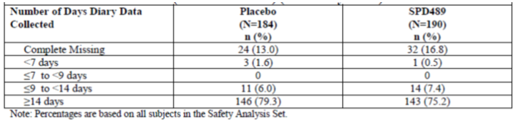

In Study SPD489-344, over 71% of subjects had binge diary data for over 14 days at Visit 8 (Table 27 below).

Table 27: Study SPD489-344: Distribution of complete or partial binge diary days missing at Visit 8 (Weeks 11 and 12) (Full Analysis Set)

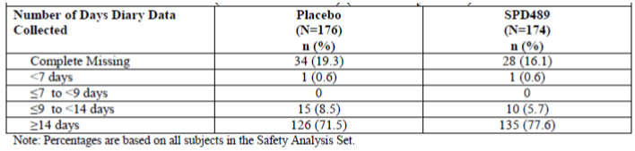

The sponsor explained that the binge days per week was defined for both Studies SDP489-343 and SDP489-344 as a weighted average, that is, binge days per week for a 2 consecutive weeks is the number of binge days multiplied by 7 and divided by the number of days in the period with diaries confirmed by the clinical interview. It was then stated that number of binge days that was collected over a 1 week period can be regarded as an imputation for partial missing data. Sensitivity analyses of the primary efficacy endpoint were conducted and found that the results were consistent.

**Evaluator’s comments:** The data provided confirmed that in the two studies 71% to 79% of subjects had binge data from at least 14 days at the final study visit.

1. ***Given the relative effect on weight loss of SPD489 over placebo, it would appear efficacy in BED is likely related to the appetite suppressive effects of the product. Please discuss.***

**Sponsor’s response:** This question was answered in the response to Question 7. Although SPD489 is not indicated for weight loss, a well-known general class effect of stimulants is to increase metabolism thereby causing weight loss as a ‘side effect’. Another well-known class aspect of stimulants is suppressive appetite effects; however, these are not thought to be significant to the mechanism of drug action in controlling binge eating disorder.

**Evaluator’s comments:** The sponsor acknowledges the increased metabolism, appetite suppression and weight loss effects of SPD489. While it is proposed that the mechanism of action in BED is not via these effects, this has not been confirmed.

1. ***Are there any efficacy data in BED subjects who have failed psychotherapy? If not, is development in this group planned?***

**Sponsor’s response:** Due to clinical trial exclusion criteria over 95% of the subjects in both treatment groups in both studies were not currently receiving or had not received past psychotherapy for BED. The sponsor stated that many patients do not respond to psychotherapy and that its availability is limited. Overall, the available information on outcomes for therapy is inadequate, and no standard therapy has been identified for the treatment of BED. In the context of the above, the sponsor has no immediate plans to investigate the efficacy of Vyvanse specifically in BED subjects who have failed psychotherapy.

It was concluded that it is well recognized that BED is a complex psychiatric disorder and that Vyvanse should be used as part of a comprehensive treatment program which usually includes psychological, educational, and social therapy.

**Evaluator’s comments:** There are no plans to examine the efficacy of the product in patients who have failed psychotherapy.

### Safety

1. ***In the short term controlled studies, there was little change in urinalysis results, however the rate of PCI leukocyte esterase was higher with SPD489 (12.0% versus 6.8%) as was urinary protein (4.9% versus 2.9%). Please comment on these findings.***

**Sponsor’s response:** The sponsor examined the pharmacovigilance database through to 9January 2017 and found 18 cases of UTI and 2 of urinary protein present. Of the UTI cases, 14 had insufficient information for causality assessment, in 3 cases the Vyvanse was continued and in one *a positive de-challenge was reported* but the case was *poorly documented*. In the 2 case of urinary protein, one was related to hydration levels and the other had insufficient information. No safety signals were identified from a review of the literature.

**Evaluator’s comments:** Urinalysis finding from the studies have not been confirmed from examination of the pharmacovigilance database although a lack of data in many of these cases makes drawing conclusions difficult. As the urinalysis findings were not associated with TEAEs, they are unlikely to be of significant clinical relevance.

1. ***It was stated in the Summary of Clinical Safety that information concerning overdoses in the BED clinical development program has been submitted in the Abuse Dependence Liability Assessment Report in Module 5.3.5.4. This report could not be located in the dossier. Has this report been previously evaluated? If not, please submit it together with appropriate summary and commentary on these risks in the BED population.***

**Sponsor’s response:** The abuse liability report, which was inadvertently omitted from 5.3.5.4. of the Australian dossier, is enclosed with this response.

The sponsor had added to Module 5, section 5.3.5.4 a reported entitled *Nonmedical use and diversion of prescription stimulants: evidence from utilization patterns and post-marketing surveillance in the United States* (December 18. 2013).

The included report was stated to supplement the Abuse Liability Assessment Report of SPD489 (dated 9 November 2011). The report collated post-marketing surveillance data on trends in real world nonmedical use and diversion of amfetamine and methylphenidate based products, including Vyvanse and Concerta. It was concluded that evidence from the proprietary data sources indicate that rates of nonmedical use and diversion of prescription stimulants among children and adolescents is lower than nonmedical use of opioids when looking at population and at a product availability based data. There was a similar finding for adults.

The report concluded that at this time, there is no evidence to suggest that LDX will alter patterns or rates of nonmedical use of prescription stimulants in Europe, or emerge as a major drug abuse problem in its own right.

A report Drug utilisation study for Vyvanse in Australia dated 26 January 2017 was also included in the dossier and the findings indicate that Vyvanse is prescribed mainly within the label, that is, to the indicated age group and without exceeding the recommended dosage.

**Evaluator’s comments:** The report included was different to the one referred to in the dossier. Data presented related to the use of Vyvanse in the ADHD population and in the US non-medical usage rates were reported to be less of an issue than that associated with opioids. There was no information on the risk of non-medical use in the BED population and this risk will need to be monitored.

1. ***Given the death of an infant with congenital anomalies who had been exposed to SPD489 in utero during a BED clinical trial, please provide any further data (clinical and post marketing) on pregnancies and foetal outcomes across both ADHD and BED indications.***

**Sponsor’s response:** A review of the literature was conducted. Findings included: an increase in ADHD medication use during pregnancy (1998 to 2013) (Louik et al 2015); no increased risk of congenital abnormalities in a large cohort study of 50,282 pregnancies of at least 5 months duration (Golub 2005, Humphreys 2007); and an association between psychostimulant use and hypertensive disorders of pregnancy (Newport 2016).

A review of the sponsor’s pharmacovigilance database identified 153 cases (50 from clinical trials and 103 spontaneous reports) with terms including exposure during pregnancy. Of the 153 cases, 53 cases had associated adverse events (25 from clinical trials and 28 from post marketing data). From the clinical trials, the case of the infant with the congenital anomalies of exomphalos, diaphragmatic hernia and limb malformation was discussed. It was proposed that the infant had a genetic syndrome rather than sequelae of a drug reaction. There were no other cases of note.

Of the 28 cases from post marketing data, there were 5 with congenital anomalies. These included: a newborn with high arched palate, congenital ankyloglossia and craniosynostosis; an unspecified congenital anomaly; polydactyly; triploidy consisting of a 69 XXY karyotype and subsequent selective abortion; and deep sacral skin dimple. There were also 4 cases of first trimester spontaneous abortions and one foetal death at Week 34 from uterine infarctions. The sponsor concluded that taking *into consideration all of the reported congenital anomalies and pregnancy related adverse events in post-marketing experience, no patterns can be identified.*

**Evaluator’s comments:** The evaluator agrees with the sponsor’s conclusion. The overall lack of safety data in pregnant women and the potential increased exposure in the BED population mean that the risk should continue to be monitored through routine pharmacovigilance.

1. ***There were 4 cases of cholecystitis reported in the clinical program. It is acknowledged that the BED population is typically obese females and so may be at risk of gall bladder disease; nonetheless please discuss this possible safety signal. In addition, discuss why the risk has not been included in the PI or RMP.***

**Sponsor’s response:** A review of the integrated clinical trial database for all SPD489 studies to a cut-off of 30 April 2014 was undertaken for TEAEs related to cholecystitis. The rates of cholecystitis were as follows: ADHD Phase II-IV studies: no cases; ADHD open label studies: 0.3%; BED Phase II-III studies: 0.2% SPD489 (no cases with placebo); BED open label studies: 0.8%; and MDD Phase II-III studies: 0.2% SPD489 and 0.1% placebo or run in medication.

Post-marketing data to 3 January 2017 identified 12 cases (9 clinical trial and 3 spontaneous reports). There was one case of acalculous cholecystitis in a 45 year old female on Vyvanse for ADHD with positive de-challenge and rechallenge data. The sponsor stated that *an updated literature review through 25 January 2017 identified no case reports of cholecystitis specifically associated with LDX exposure.*

The sponsor concluded that cholecystitis *has not been included in the PI or RMP, because, based upon an internal review conducted by the sponsor in 2014 assessing this issue, it was not considered to represent a risk for Vyvanse*.

**Evaluator’s comments:** The data presented do not indicate a significantly increased risk of cholecystitis with SDP489. However, given the BED population may be more prone to cholecystitis through factors such as age and obesity, the evaluator believes it would be prudent to monitor the risk until a larger cohort has been exposed.

1. ***There were 2 SAEs of syncope in subjects treated with SPD489, both of which led to treatment discontinuation. Please comment on this risk and whether further information and precaution should be included in the PI and CMI.***

**Sponsor’s response:** There were 3 serious events of syncope with LDX in the ADHD and BED clinical studies. The incidence of syncope in the Phase II to IV studies was 0.2% in the LDX and also in the placebo groups. In the pharmacovigilance database to January 2017, there were 138 cases (115 spontaneous and 23 from clinical trials) with 55 cases having confounding medical history or medication. A further 47 cases did not have sufficient information. Ten cases had a positive de-challenge reported. The sponsor reported a spontaneous reporting rate of 1.6 per 100,000 person years which was stated to be *lower than the population incidence rate of syncope*. It was also stated that there is a lack of a biological mechanism.

**Evaluator’s comments:** The risk of syncope is stated in the RMP under Important Potential Risks. Given the serious nature of 2 cases and that they led to treatment discontinuation, syncope should be included in the PI at a minimum in the listings of adverse drug reactions and monitored during post marketing surveillance.

1. ***Please discuss what is known about the risk of off label use of Vyvanse for weight loss, particularly since registration in the US, and how it is proposed to manage this risk.***

**Sponsor’s response:** A cumulative review was conducted of all Vyvanse cases through 25 January 2017 which included a weight loss indication. There were 32 cases identified in an approximate 7 million patient-years of exposure. It is proposed to include BED in the Drug Utilisation Study for Vyvanse in Australia to monitor off label use for weight loss. In addition, the product information will be updated to state that Vyvanse is not indicated for weight loss.

**Evaluator’s comments:** To date the risk of off label use for weight loss does not appear high, although the risk may become more apparent when the product is marketed for BED. Inclusion of BED in the utilisation study and the change to the indication are appropriate measures. The requirement for prescribing and management by specialists should also assist in countering off label use.

## Second round benefit-risk assessment

### Second round assessment of benefits

After consideration of the responses to clinical questions, the benefits of lisdexamfetamine in the proposed usage are unchanged from those identified in the First round assessment of benefits.

### Second round assessment of risks

After consideration of the responses to clinical questions, the risks of lisdexamfetamine in the proposed usage are unchanged from those identified in the First round assessment of risks.

### Second round assessment of benefit-risk balance

In response to the first round evaluation, the sponsor has altered the indication. As recommended, the indication now states that treatment should be limited to adults with moderate to severe BED. In addition, warnings that treatment is not for weight loss and the risk of serious cardiovascular events have been added. The need for a comprehensive treatment program has also been added. These are all appropriate changes.

After the first round evaluation, it was recommended that treatment with lisdexamfetamine for BED should a second line option. This was due to the inherent risks of the product to the patient and the community as well as treatment guideline recommendations. The Royal Australian and New Zealand College of Psychiatrists Clinical practice guidelines for the treatment of eating disorders (Hay P et al. 2014) clearly state that the ‘*first-line treatment for bulimia nervosa and binge eating disorder in adults is an individual psychological therapy*’. The evaluator notes that the efficacy data on lisdexamfetamine used as first line therapy from the clinical development program is positive, that head to head comparisons of pharmacotherapy and psychotherapy are lacking, and that the guidelines may have been published prior to the availability of lisdexamfetamine in the US as a treatment for BED. Nonetheless, the recommended prudent course of action is to use the product in those who have had a limited or unsuccessful response to psychotherapy or in those for whom psychotherapy options are not available. In all situations pharmacological treatment should remain just one component of therapy and this has been addressed in the revised indication. It is noted that there are some recommended changes to the proposed wording for this.

After the first round evaluation, it was also recommended to limit treatment duration to 12 weeks. The sponsor however states that treatment duration would be best left to physician discretion. The evaluator maintains, given the lack of longer term efficacy data, the positive findings after 12 weeks treatment, the lack of cardiovascular outcome data and the inherent risks of the amphetamine based product that treatment duration should still be for a maximum of 12 weeks.

The sponsor has agreed to manage and monitor the risk of off label use for weight loss by having the product available only through specialists, by including label warnings and by including BED in the Drug Utilisation Study. As BED treatment is recommended for a maximum of 12 weeks, it is appropriate for specialists to not only initiate but also manage therapy.

Other changes to the PI and CMI and questions in Section 12 have been satisfactorily addressed. The PI still needs to include the risks of peripheral vasculopathy and syncope and the RMP should monitor cholecystitis, syncope and pregnancy exposure.

As previously stated, there should be tight controls on the availability of the drug.

In summary, there are still two main issues which need to be addressed. Firstly the recommendation that treatment duration should be limited to 12 weeks. Secondly, that lisdexamfetamine use in BED should be only for those patients who have had unsatisfactory response to psychotherapy or who have limited access to psychotherapy. Pharmacological therapy should always be part of an integrated, multipronged treatment strategy. Until these issues are resolved, the evaluator concludes that, under the proposed usage, the benefit-risk balance is negative.

## Second round recommendation regarding authorisation

It is not recommended to approve Vyvanse (lisdexamfetamine) for the following revised indication:

*Binge Eating Disorder (BED):*

*Vyvanse is indicated for the treatment of moderate to severe BED in adults. Treatment should be commenced by a specialist.*

*Need for comprehensive treatment programme: Vyvanse is indicated as an integral part of a total treatment program for BED that may include other measures (nutritional, psychological, and medical) for patients with this syndrome. When remedial measures including psychotherapy are insufficient, the decision to prescribe stimulant medication will depend upon the physician’s assessment of the chronicity and severity of the patient’s symptoms.*

*Limitation of Use: Vyvanse is not indicated or recommended for weight loss. Use of other sympathomimetic drugs for weight loss has been associated with serious cardiovascular adverse events. The safety and effectiveness of Vyvanse for the treatment of obesity have not been established.*

The reasons for this are as follows:

* Due to inherent product risks and guideline recommendations that advocate psychotherapy as the first line treatment option for BED, Vyvanse treatment should be used as second line therapy after an unsatisfactory response to psychotherapy. It is recommended that it is used as first line therapy only in those who do not have access to psychotherapy.
* In the absence of further longer term efficacy, safety and cardiovascular outcome data, treatment duration for BED should be limited to a maximum of 12 weeks.
* There remain some changes to the PI and CMI which need to be addressed.

Should the sponsor implement the recommended change to the indication regarding second line use, limit the treatment duration to 12 weeks, and satisfactorily address the further comments on the draft PI and CMI (in Section 17.1 and 17.2) then Vyvanse (lisdexamfetamine) could be approved. The proposed modified indication is:

*Binge Eating Disorder (BED)*

*Vyvanse is indicated for the treatment of moderate to severe BED in adults when psychotherapy is unsuccessful or unavailable. Treatment should be commenced and managed by a specialist.*

*Need for comprehensive treatment programme: Vyvanse is indicated as one part of a total treatment program for BED that may include other measures (nutritional, psychological, and medical) for patients with this syndrome. When remedial measures including psychotherapy are insufficient, the decision to prescribe stimulant medication will depend upon the physician’s assessment of the chronicity and severity of the patient’s symptoms.*

*Limitation of Use: Vyvanse is not indicated or recommended for weight loss. Use of other sympathomimetic drugs for weight loss has been associated with serious cardiovascular adverse events. The safety and effectiveness of Vyvanse for the treatment of obesity have not been established.*

There are no changes to the recommendations relating to the ADHD indication as stated in Section 10 and changes to the PI in relation to this are satisfactory.

## References

CHMP. Clinical evaluation of medication products used in weight control. London Nov 2007. CPMP/EWP/281/96 Rev 1.

Golub M, et al (2005). NTP-CERHR expert panel report on the reproductive and developmental toxicity of amphetamine and methamphetamine. *Birth Defects Res B Dev Reprod Toxicol*; 74: 471-584

Grucza RA, et al, 2007 Prevalence and correlates of binge eating disorder in a community sample *Comprehensive Psychiatry* 2007; 48: 124-131.

Hay PJ, et al (2008). Eating disorder behaviors are increasing: Findings from 2 sequential community surveys in South Australia. *PloS ONE* 3(2):e1541.Doi:10.1371/journal.pone.0001541.

Hay P, et al (2014). Royal Australian and New Zealand College of Psychiatrists Clinical Practice Guidelines for the Treatment of Eating Disorders. *Aust NZ J Psych*. 48; 1-62

Hay P, et al Prevalence and sociodemographic correlates of DSM-5 eating disorders in the Australian population. *Journal of Eating Disorder*. 2015; 3:19

Humphreys C, et al (2007). Exposure to attention deficit hyperactivity disorder medications during pregnancy. *Can Fam Physician*; 53:1153-1155.

Louik C. et al (2015). Increasing use of ADHD medications in pregnancy. *Pharmacoepidemiol Drug Saf.* 24 :218-20.

McElroy, et al. Atomoxetine in the treatment of binge-eating disorder: a randomized placebo controlled trial. *J Clin Psychiatry*. 2007; 68: 390-398.

Newport JD, et al (2016). Prenatal psychostimulant and antidepressant exposure and risk of hypertensive disorders of pregnancy. *J Clin Psychiatry*. 77: 1538-1545.

Vocks S. et al. Meta-analysis of effectiveness of psychological and pharmacological treatments for binge eating disorder. *Int J Eat Disord*. 2010; 43: 205.

|  |
| --- |
| Therapeutic Goods Administration |
| PO Box 100 Woden ACT 2606 Australia  Email: [info@tga.gov.au](mailto:info@tga.gov.au) Phone: 1800 020 653 Fax: 02 6232 8605  [**https://www.tga.gov.au**](https://www.tga.gov.au) |

1. DSM-IV-TR criteria for diagnosis of BED:

   * Recurrent episodes of binge eating. An episode of binge eating was characterized by both of the following: eating, in a discrete period of time (e.g., within a 2-hour period) an amount of food that is definitely larger than most people would eat in a similar period of time under similar conditions, and a sense of lack of control over the eating (e.g., a feeling that one cannot stop eating or control what or how much one is eating).
   * The binge eating episodes were associated with at least 3 of the following: eating much more rapidly than normal; eating until uncomfortably full; eating large amounts of food when not feeling physically hungry; eating alone because of being embarrassed by how much one is eating; feeling disgusted with oneself, depressed, or feeling very guilty after overeating.
   * Marked distress regarding binge eating.
   * The binge eating occurred, on average, at least 2 days a week for 6 months

   The episodes of binge eating did not occur exclusively during the course of bulimia nervosa or anorexia nervosa.

   * Recurrent episodes of binge eating. An episode of binge eating was characterized by both of the following: eating, in a discrete period of time (for example, within a 2-hour period) an amount of food that is definitely larger than most people would eat in a similar period of time under similar conditions, and a sense of lack of control over the eating (for example, a feeling that one cannot stop eating or control what or how much one is eating).
   * The binge eating episodes were associated with at least 3 of the following: eating much more rapidly than normal; eating until uncomfortably full; eating large amounts of food when not feeling physically hungry; eating alone because of being embarrassed by how much one is eating; feeling disgusted with oneself, depressed, or feeling very guilty after overeating.
   * Marked distress regarding binge eating.
   * The binge eating occurred, on average, at least 2 days a week for 6 months
   * The episodes of binge eating did not occur exclusively during the course of bulimia nervosa or anorexia nervosa.

  
2. Yale-Brown Obsessive Compulsive Scale Binge Eating (Y-BOCS-BE) modified version is a clinician-rated scale with 10 items rated from 0 to 4 (extreme). A total score of 0-7 is sub-clinical; 8-15 is mild; 16-23 is moderate; 24-31 is severe; and 32-40 is extreme.
3. Binge eating days are defined as days during which at least 1 binge episode occurred.
4. The EDE-Q is a 28-item subject-rated questionnaire measuring eating pathology. It focuses on the past 28 days to assess the main behavioural (eating and purging) and attitudinal features of eating disorders. Items are rated on a 7-point scale (ranging from 0 to 6), with higher scores indicating increased pathology. There are four subscales: Restraint, Eating Concern, Weight Concern, and Shape Concern. Subscale scores are determined by calculating the sum of component item scores for a particular subscale, then dividing by the number of items in the subscale.
5. CHIP-CE:PRF is the Child Health and Illness Profile, Child Edition: Parent Report Form
6. The ADHD-RS-IV is completed by the physician and consists of 18 items scored on a 4 point scale ranging from 0 (no symptoms) to 3 (severe symptoms) with total scores ranging from 0 to 54. The 18 items may be grouped into 2 subscales: hyperactivity/impulsivity (even numbered items 2-18) and inattentiveness (odd numbered items 1-17).
7. The C-SSRS is semi-structured questionnaire administered by a clinician trained by the sponsor or designee. It assesses suicidal ideation and behaviour.