|  |
| --- |
| September 2016 |

|  |
| --- |
| Australian Public Assessment Report for lumacaftor / ivacaftor |
| Proprietary Product Name: Orkambi 200/125 |
| Sponsor: Vertex Pharmaceuticals Australia Pty Ltd |

About the Therapeutic Goods Administration (TGA)

* The Therapeutic Goods Administration (TGA) is part of the Australian Government Department of Health and is responsible for regulating medicines and medical devices.
* The TGA administers the *Therapeutic Goods Act 1989* (the Act), applying a risk management approach designed to ensure therapeutic goods supplied in Australia meet acceptable standards of quality, safety and efficacy (performance) when necessary.
* The work of the TGA is based on applying scientific and clinical expertise to decision-making, to ensure that the benefits to consumers outweigh any risks associated with the use of medicines and medical devices.
* The TGA relies on the public, healthcare professionals and industry to report problems with medicines or medical devices. TGA investigates reports received by it to determine any necessary regulatory action.
* To report a problem with a medicine or medical device, please see the information on the TGA website <<https://www.tga.gov.au>>.

About AusPARs

* An Australian Public Assessment Report (AusPAR) provides information about the evaluation of a prescription medicine and the considerations that led the TGA to approve or not approve a prescription medicine submission.
* AusPARs are prepared and published by the TGA.
* An AusPAR is prepared for submissions that relate to new chemical entities, generic medicines, major variations and extensions of indications.
* An AusPAR is a static document; it provides information that relates to a submission at a particular point in time.
* A new AusPAR will be developed to reflect changes to indications and/or major variations to a prescription medicine subject to evaluation by the TGA.

Copyright

© Commonwealth of Australia 2016  
This work is copyright. You may reproduce the whole or part of this work in unaltered form for your own personal use or, if you are part of an organisation, for internal use within your organisation, but only if you or your organisation do not use the reproduction for any commercial purpose and retain this copyright notice and all disclaimer notices as part of that reproduction. Apart from rights to use as permitted by the *Copyright Act 1968* or allowed by this copyright notice, all other rights are reserved and you are not allowed to reproduce the whole or any part of this work in any way (electronic or otherwise) without first being given specific written permission from the Commonwealth to do so. Requests and inquiries concerning reproduction and rights are to be sent to the TGA Copyright Officer, Therapeutic Goods Administration, PO Box 100, Woden ACT 2606 or emailed to <[tga.copyright@tga.gov.au](mailto:tga.copyright@tga.gov.au)>.

Contents

Common abbreviations 5

I. Introduction to product submission 9

Submission details 9

Product background 9

Regulatory status 10

Product Information 11

II. Quality findings 11

Introduction 11

Drug substance (active ingredient) 12

Drug product 12

Biopharmaceutics 12

Quality summary and conclusions 14

III. Nonclinical findings 14

Introduction 14

Pharmacology 14

Pharmacokinetics 16

Toxicology 18

Nonclinical summary and conclusions 25

IV. Clinical findings 26

Introduction 27

Pharmacokinetics 29

Pharmacodynamics 35

Dosage selection for the pivotal studies 38

Efficacy 39

Safety 45

First round benefit-risk assessment 49

First round recommendation regarding authorisation 52

Clinical questions 53

Second round evaluation of clinical data submitted in response to questions 53

Second round benefit-risk assessment 53

V. Pharmacovigilance findings 54

Risk management plan 54

VI. Overall conclusion and risk/benefit assessment 70

Quality 70

Nonclinical 70

Clinical 71

Risk management plan 86

Risk-benefit analysis 87

Outcome 90

Attachment 1. Product Information 91

Attachment 2. Extract from the Clinical Evaluation Report 91

## Common abbreviations

|  |  |
| --- | --- |
| Abbreviation | Meaning |
| AE | adverse event |
| AESI | adverse event of special interest |
| ALAG | absorption lag time |
| ALT | alanine aminotransferase |
| APTT | activated partial thromboplastin time |
| AST | aspartate aminotransferase |
| AUC | area under the concentration time curve |
| AUCτ | AUC during a dosing interval |
| AUC0-inf | AUC from the time of dosing extrapolated to infinity |
| AUC0-24h | AUC from the time of dosing to 24 hours |
| AusPAR | Australian Public Assessment Reports |
| BA | bioavailability |
| BD | twice daily |
| BMI | body mass index |
| CF | cystic fibrosis |
| CFQ-R | Cystic Fibrosis Questionnaire – Revised |
| CFTR | CF transmembrane conductance regulator |
| CHMP | Committee for Medicinal Products for Human Use (EMA) |
| CI | confidence interval |
| CL/F | clearance |
| CLss/F | apparent clearance at steady state |
| Cmax | maximum observed concentration |
| Cmin | minimum observed concentration |
| CNS | central nervous system |
| CPK or CK | Creatine phosphokinase |
| CYP | cytochrome P450 |
| D1 | zero order dose duration |
| DDI | drug-drug interaction |
| EC50 | concentration at which effect is at half the maximum |
| EC90 | Effective concentration 90% |
| ECG | electrocardiogram |
| Emax | maximum effect |
| Ebase | Model-estimated baseline sweat chloride concentration |
| EQ-5D-3L | EuroQol 3-Level |
| EU | European Union |
| F508del | CFTR gene mutation with an in-frame deletion of a phenylalanine codon corresponding to position 508 of the wild-type protein |
| FAS | full analysis set |
| FDA | Food and Drug Administration |
| FDC | fixed dose combination |
| FEF | 25% to 75% forced mid-expiratory flow rate |
| FEV1 | forced expiratory volume in 1 second |
| FEV1/FVC | forced expiratory volume (L) in 1 second over forced vital capacity |
| FVC | forced vital capacity |
| GLP | good laboratory practice |
| GLSM | geometric least squares mean |
| h | hour/s |
| HBE | human bronchial epithelial |
| HDL | high drug load |
| hERG K+ | Human ether a go go related gene (potassium ion channel) |
| HSA | human serum albumin |
| IA | interim analysis |
| IC50 | half maximal inhibitory concentration |
| ICH | International Conference on Harmonization |
| IVA | ivacaftor/Kalydeco/VX-770/VRT-813077 |
| Ka | first-order absorption rate |
| Ki | inhibition constant |
| L | litre |
| LFT | liver function test |
| LS | least squares |
| LUM | lumacaftor/VX-809 |
| M1 | hydroxymethyl-ivacaftor |
| M6 | ivacaftor carboxylate |
| MAA | Marketing Authorization Application |
| MedDRA | Medical Dictionary for Regulatory Activities |
| min | minute/s |
| MMRM | mixed-effects model for repeated measures |
| NMT | not more than |
| OATP | organic anion-transporting polypeptide |
| PD | pharmacodynamics |
| P-gp | P-glycoprotein |
| PK | pharmacokinetics |
| PO | orally |
| popPK | population pharmacokinetics |
| ppFEV1 | percent predicted forced expiratory volume in 1 second |
| PR interval | The time from the beginning of the P wave (the onset of depolarisation) to the beginning of the QRS complex |
| PT | preferred term |
| q12h | every 12 hours |
| QD | once daily |
| QTc | QT interval corrected |
| RR | Rate ratio |
| SAE | serious adverse event |
| SD | standard deviation |
| SVPC | supraventricular premature complex |
| t½ | terminal phase half-life |
| Tmax | time of the maximum concentration |
| UK | United Kingdom |
| ULN | upper limit of normal |
| US | United States |
| UV | ultra violet |
| Vc/F | central volume of distribution |
| Vd | apparent volume of distribution |
| Vertex | Vertex Pharmaceuticals Incorporated |
| Vp/F | peripheral volume of distribution |

## I. Introduction to product submission

### Submission details

|  |  |
| --- | --- |
| *Type of submission:* | New chemical entity in a fixed dose combination |
| *Decision*: | Approved |
| *Date of decision:* | 2 March 2016 |
| *Date of entry onto ARTG* | 8 March 2016 |

|  |  |
| --- | --- |
| *Active ingredients:* | lumacaftor, ivacaftor |
| *Product name:* | Orkambi 200/125 |
| *Sponsor’s name and address:* | Vertex Pharmaceuticals Australia Pty Ltd  Suite 3 Level 3 / 601 Pacific Highway  St Leonards NSW 2065 |
| *Dose form:* | Film coated tablet |
| *Strength:* | 200 mg lumacaftor, 125 mg ivacaftor |
| *Container:* | Blister pack |
| *Pack size:* | 112 tablets |
| *Approved therapeutic use:* | *Orkambi is indicated for the treatment of cystic fibrosis (CF) in patients age 12 years and older who are homozygous for the F508del mutation in the CFTR gene.* |
| *Route of administration:* | oral |
| *Dosage:* | The proposed dosage is 400 mg lumacaftor and 250 mg ivacaftor twice daily (two tablets every 12 hours). For further details regarding dosage please see the Product Information. |
| *ARTG number:* | 235759 |

### Product background

This AusPAR describes the application by Vertex Pharmaceuticals Australia Pty Ltd (the sponsor) to register Orkambi 200/125 for the following indication:

*Orkambi is indicated for the treatment of cystic fibrosis (CF) in patients age 12 years and older who are homozygous for the F508del mutation in the CFTR gene.*

Cystic Fibrosis (CF) is caused by mutations in the CF transmembrane conductance regulator (CFTR) gene that result in absent or deficient function of the CFTR protein at the cell surface. The most common mutation in people with CF, the F508del mutation disrupts the folding and domain assembly of the CFTR protein leading to reduced trafficking to the cell surface, reduced cell surface stability, and impaired chloride channel gating.[1] [2] The F508del CFTR has been described as a ‘severe ‘CFTR mutation. The F508del‑CFTR homozygote clinical phenotype is characterised by an early onset of clinical manifestations, a high incidence of pancreatic insufficiency, colonization with Pseudomonas aeruginosa, a more rapid rate of lung function decline, and shorter life expectancy. These patients demonstrate progression of disease with advancing age and have a decreased life expectancy.

Approximately 44 to 52% of total CF patients in Australia are homozygous for the F508del-CFTR mutation. Patients with CF who are homozygous for the F508del-CFTR mutation have a high unmet medical need and none of the currently approved treatments for this population treat the underlying cause of CF.

Ivacaftor (IVA, approved as Kalydeco) targets the molecular defect in the CFTR protein that is the underlying cause of CF. Ivacaftor was first approved in Australia on 9 July 2013 for the treatment of cystic fibrosis in patients aged six years and older who have a G551D mutation in the CFTR gene. The indication was extended later to patients age 6 years and older who have a G551D or other gating (class III) mutation in the CFTR. About 5% of patients with CF have these mutations.

Lumacaftor (LUM, also known as VX-809) is a CFTR corrector. LUM acts on CFTR to facilitate the cellular processing and trafficking of CFTR, allowing the protein to reach the cell surface, where it exhibits improved chloride channel function compared to uncorrected F508del-CFTR. The channel gating activity of F508del-CFTR that has been delivered to the cell surface by LUM can be potentiated by IVA to further enhance chloride transport. The combination of a CFTR corrector and potentiator is a novel approach to enhance the amount and function of the defective CFTR protein in patients with CF who have the F508del-CFTR mutation.

### Regulatory status

The product received initial registration on the Australian Register of Therapeutic Goods (ARTG) on 8 March 2016.

Vertex began the clinical development of LUM in the US in 2007 and subsequently expanded the development to include the EU, Canada, and Australia. US Fast Track (Food and Drug Administration (FDA), 17 January 2008) and Breakthrough designations (FDA, 07 December 2012) were granted to LUM. The LUM/IVA combination development program consists of 17 clinical studies: 15 completed studies and 2 ongoing studies.

At the time the TGA considered this application a similar application had been approved or was under consideration in the countries as shown in Table 1.

Table 1 Overseas Regulatory status

|  |  |
| --- | --- |
| Country | Status |
| Europe (EMA) | Approved 19 November 2105 |
| USA (FDA) | Approved 2 July 2015 |
| Canada | Under evaluation |
| Switzerland | Submitted 13 November 2015 |

#### Orphan regulatory status

Orphan designation for Orkambi was granted in September 2014.

### Product Information

The Product Information (PI) approved with the submission which is described in this AusPAR can be found as Attachment 1. For the most recent PI, please refer to the TGA website at <<https://www.tga.gov.au/product-information-pi>>.

## II. Quality findings

### Introduction

The application is to register a new chemical entity lumacaftor, which is to be used in a fixed combination tablet with an existing drug substance ivacaftor.

The proposed product is an immediate release oral film coated tablet containing lumacaftor 200 mg/ivacaftor 125 mg in a fixed combination. Ivacaftor 150 mg tablet is a registered product on the ARTG (AUST R 198654/198655) under the trade name Kalydeco.

The chemical structures of lumacaftor and ivacaftor are presented in Figure 1.

Figure 1. Chemical structures of lumacaftor and ivacaftor

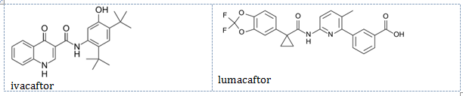

The drug substance and the drug product are not subject to USP, BP or Ph. Eur. Monographs.

### Drug substance (active ingredient)

#### Drug substance – lumacaftor

The drug substance lumacaftor (structure shown above) is an achiral, non-hygroscopic white to off white crystalline powder.

Lumacaftor is practically insoluble (< 0.1 mg/mL) in water, pH 1.0 to 8.0 buffers, and simulated intestinal fluid at room temperature and 37 °C. The company indicated that lumacaftor is likely to be a BCS Class II drug.

Multiple polymorphic forms of lumacaftor have been identified, but the drug substance which is used in this product is consistently obtained as Form I. Lumacaftor drug substance used for all toxicological and clinical studies is of Form I only.

Compatibility studies between lumacaftor and ivacaftor showed no conversion of lumacaftor polymorphic form. There was no change in the polymorphic form of lumacaftor (and ivacaftor) in the compatibility studies with other excipients.

The limits for impurities are consistent with the relevant identification and qualification thresholds in International Conference on Harmonization (ICH) Q3A and are acceptable. The quality control of the drug substance (including the drug substance specification) is acceptable.

### Drug product

The proposed product is a pink oval shaped film coated tablet with 2V125 printed in black on one side. Each tablet contains 125 mg ivacaftor and 200 mg lumacaftor as the active ingredients. The excipients used in the product are conventional pharmaceutical ingredients including hypromellose acetate succinate, sodium lauryl sulfate, microcrystalline cellulose, croscarmellose sodium, povidone and magnesium stearate. The coating agent and ink are conventional commercially available ingredients.

The product is to be packaged in blister strips of four tablets representing a one day supply (two tablets every 12 hours). Each pack of the marketed product contains four weekly cartons for 4 week treatment schedule. The proposed pack size is 112 tablets (4 carton packs of 28 tablets).

The clinical studies used batches manufactured using the process and formulation proposed for commercial manufacture. The residual solvent is controlled in the spray dried (amorphous) ivacaftor intermediate to the acceptable limit as previously assessed and approved by the TGA.

The quality of the product is controlled by acceptable specification that includes tests and limits for appearance, identification, assay, uniformity of dosage units, impurities, water content, polymorphic form of lumacaftor and ivacaftor and dissolution of the drug substances. Degradants are limited to ICH identification thresholds.

The analytical methods used to analyse the product were adequately described and validated. The stability data supplied supported a shelf life of 12 months for the unopened product (in PCTFE/PVC/AL blister) when it is stored below 30°C.

### Biopharmaceutics

No absolute bioavailability study was performed by the sponsor. Justification for not providing the absolute bioavailability study was on the basis that it was not possible to prepare a suitable intravenous formulation since both actives are practically insoluble (< 0.1 mg/mL) in aqueous solutions, that both actives are orally bioavailable, and that the pharmacokinetic characteristics of both actives have been studied throughout the clinical development of oral dosage forms.

Three bioavailability studies were provided and evaluated. The outcomes of the study are summarised below:

Table 2. Summary of bioavailability studies

|  |  |
| --- | --- |
| Study | Conclusion |
| Study VX13-809-012; Effect of food (This study was evaluated in full). | This study examined the effect of food on the pharmacokinetics of lumacaftor and ivacaftor when administered as fixed dose combination (FDC) tablets. It was concluded that both lumacaftor and ivacaftor plasma concentrations increased when administered in the fed state when compared to the fasted state. |
| Studies VX08-809-003 and VX08-809-007; Relative bioavailability of various formulations | This study concluded that;   * Administration of lumacaftor in a capsule formulation resulted in an increase in plasma concentrations when compared with a suspension formulation * Administration of lumacaftor (either 400 or 600 mg) in a high drug load tablet formulation resulted in similar plasma concentrations when compared with a reference tablet formulation * Administration of lumacaftor and ivacaftor (400/250 mg) in a FDC tablet formulation (consistent with the proposed product) resulted in similar plasma concentrations of both actives when compared with co-dosing with separate lumacaftor and ivacaftor monotherapy tablets. |
| Study VX08-809-005; Interaction between lumacaftor and ivacaftor | The study indicated that the pharmacokinetics of ivacaftor and lumacaftor were both affected when the drug substances were co-administered as a lumacaftor/ivacaftor FDC formulation.   * Ivacaftor slightly increases the rate and extent of absorption of lumacaftor. The area under the concentration time curve (AUC) results suggested that ivacaftor may enhance the rate and extent of absorption of lumacaftor and increase the accumulation of its metabolite M28 after Day 14 (when compared with Day 1 results) * There was a profound effect of lumacaftor on the pharmacokinetics of ivacaftor resulting in significant decreases in plasma concentrations of both ivacaftor (81%) and its metabolite hydroxymethyl-ivacaftor (M1) (72%) after 14 days, but no reduction in plasma concentration of metabolite ivacaftor carboxylate (M6) at Day 1. The M6 plasma concentration showed lower levels (approximately 25%) by Day 14 when co-administered with lumacaftor * Co-administration of lumacaftor and ivacaftor did not result in an increase in adverse events compared with either lumacaftor or ivacaftor alone. |

These results were brought to the attention of the Delegate so that they could consider (i) whether it is acceptable from a clinical perspective for the product to be given with food and (ii) whether the pharmacokinetics (PK) interaction between ivacaftor and lumacaftor is acceptable from a clinical perspective.

### Quality summary and conclusions

All issues raised with the chemistry and quality aspects of the submission were adequately resolved and these aspects are acceptable.

There were biopharmaceutics issues that were brought to the attention of the Delegate for consideration on the basis of three biopharmaceutics studies; that is, whether it is acceptable from a clinical perspective for the product to be given with food and whether the PK interaction between the two drug substances is acceptable.

## III. Nonclinical findings

### Introduction

Orkambi is proposed to be used for the treatment of CF in patients aged 12 years and older who are homozygous for the F508del mutation of the CFTR gene. The proposed dosing regimen involves oral administration of two tablets (each containing 200 mg lumacaftor and 125 mg ivacaftor) every 12 hours, taken with fat containing food. This yields a maximum recommended human dose of 800 mg lumacaftor and 500 mg ivacaftor per day. The dose of ivacaftor with Orkambi is higher than that approved for Kalydeco (500 mg compared to 300 mg/day).

This report covers nonclinical studies for lumacaftor, and for lumacaftor and ivacaftor in combination. Previous nonclinical evaluation reports for ivacaftor are taken into consideration.

The nonclinical dossier was of high quality, and with all pivotal safety related studies conducted according to good laboratory practice (GLP).

### Pharmacology

#### Primary pharmacology

The most common mutation in people with CF, the F508del mutation disrupts the folding and domain assembly of the CFTR, leading to reduced trafficking to the cell surface, reduced cell surface stability, and impaired chloride channel gating.1,2

Lumacaftor was shown to act as a CFTR corrector in vitro in experiments with transfected cells and bronchial epithelial cells obtained from CF patients.

In human bronchial epithelial cells from F508del-homozygous subjects, treatment with lumacaftor (48 hour exposure) increased CFTR mediated chloride secretion from a baseline of 3% of that of wild-type CFTR to 14% of wild-type CFTR, acting with an concentration at which effect is at half the maximum (EC50) of 94 nM and an EC90 of 631 nM; the mean concentration required to reach 10% of wild-type CFTR secretion was 153 nM. The sponsor compiled clinical data identifying the mean amount of mutant CFTR mediated chloride secretion in CF patients with severe, moderate and mild lung disease as < 1%, 9% and 68% that of wild-type CFTR, respectively. Accordingly, increasing mutant CFTR activity to ≥ 10% of the wild type level was suggested to improve lung function in patients with severe disease to a level associated with moderate lung disease.

Positive effects on lumacaftor on F508del-CFTR protein conformation and trafficking were demonstrated. The drug:

* increased the maturation efficiency of the protein (to 34% of wild-type; based on glycosylation profile)
* improved trafficking (exit of the protein from the endoplasmic reticulum, passage through the Golgi complex and delivery to the cell surface)
* increased cell surface stability (from a half-life of 0.5 hours untreated to 16 hours (compared with 24 hours for wild-type)), which was associated with adoption of a more native protein conformation; and
* increased the channel open probability (from a baseline of 6% of wild-type to 50%).

Consistent with an effect to change cellular processing and trafficking of CFTR, acute addition of lumacaftor did not increase F508del-CFTR mediated chloride secretion; the maximum effect of lumacaftor was obtained after approximately 24 hour treatment (that is, enough time for de novo protein synthesis, processing and trafficking). No decrease in efficacy was observed following 30 days of sustained treatment. The lumacaftor binding site was shown to be within the MSD1 (membrane spanning domain 1) of CFTR.

Increased CFTR mediated chloride secretion was observed with lumacaftor treatment in bronchial epithelial cells from F508del‑heterozygous CF patients (to < 10% of wild-type with Class I mutations (G542X/F508del; 3905InsT/F508del (suggesting very limited clinical benefit)), and to > 10% with Class III (G551D/F508del) and Class V (2789+5G-> A/F508del) mutations. The maturation of wild-type CFTR was also shown to be enhanced by lumacaftor treatment.

The addition of ivacaftor (a CFTR potentiator (increasing the fraction of time the channel is open)) was shown to further increase CFTR mediated chloride secretion in lumacaftor treated human bronchial epithelial cells from F508del-homozygous CF patients (up to 36% of wild-type), and also to further increase airway surface liquid height and cilia beat frequency.

The apparent potency of lumacaftor was markedly reduced in the presence of serum (4 fold with 20% serum), consistent with very high protein binding by the drug. Reduced efficacy was also seen with very high drug concentrations, producing a bell shaped curve (half maximal inhibitory concentration (IC50) for effects on chloride secretion, 40 µM (> 60 times the effective concentration 90% (EC90))). The drug’s predominant human circulating metabolite, M28-lumacaftor, was shown not to be pharmacologically active.

No in vivo pharmacodynamic studies were conducted due to a lack of an adequate animal disease model.

#### Secondary pharmacodynamics and safety pharmacology

The effect of lumacaftor on protein processing and trafficking was seen to be specific to CFTR. The drug had no effect on 38 other proteins (from various families).

Screening of lumacaftor against an extensive panel of receptors, enzymes, transports and ion channels revealed notable affinity only at the human thromboxane A2 receptor (Ki 2.97 µM). The drug was shown to act as a thromboxane A2 receptor antagonist in functional experiments (isolated rat aortic rings). M28-lumacaftor showed no significant binding affinity in screening assays.

Specialised safety pharmacology studies covered the central nervous system (CNS), cardiovascular, respiratory and gastrointestinal systems. Single oral administration of lumacaftor did not affect CNS or respiratory function, or GI motility/stomach emptying, in rats (≤ 1000 mg/kg). Lumacaftor did not block the Human ether a go go related gene (potassium ion) (hERG K+) channel in transfected mammalian cells (at 4.6 µM; tested up to the maximum soluble concentration). Heart rate, blood pressure and electrocardiogram (ECG) parameters were unaffected by lumacaftor in dogs (≤ 200 mg/kg orally (PO); single dose).

### Pharmacokinetics

Absorption of lumacaftor after oral administration was generally rapid in mice and dogs (plasma time of the maximum concentration (Tmax) typically 2 hours), and similar to that in humans (Tmax, 2.2 hours in CF patients at the proposed dose); slower absorption was seen in rats and rabbits (Tmax commonly 4 to 10 hours). Bioavailability in rats ranged from approximately 50 to 100% and was approximately25 to 50% in dogs. In vitro experiments with Caco‑2 cells indicated high permeability. Exposure in animals was less than dose proportional. Clearance was faster in the laboratory animal species than in humans (plasma half-lives of approximately6 to 8 hours compared with approximately26 hours for patients).

Plasma protein binding by lumacaftor was very high in humans (≥ 99.97% in definitive experiments with 14C‑lumacaftor and 99.2 to 99.4% in earlier experiments with unlabelled drug) and laboratory animal species (means of 99.3 to 99.8% at ≤ 100 µM in mouse, rat, rabbit, dog and monkey). Human serum albumin was the plasma component chiefly responsible for binding lumacaftor, with the contribution of α1‑acid glycoprotein and human gamma globulin low.

Tissue distribution of radioactivity was rapid and wide following oral administration of 14C‑lumacaftor in rats. Outside of the GI tract, highest levels of radioactivity were observed in the liver, adrenal glands, thyroid, kidney and bone marrow. Penetration of the blood: brain barrier was very low (maximum observed concentration (Cmax) in brain being approximately50 times lower than the plasma Cmax). The peak lung concentration was approximately20% that of plasma. In a study with unlabelled drug, lumacaftor was detected in the epithelial lining fluid of rats at 117 to 370 times the peak plasma concentration of unbound drug.

Metabolism of lumacaftor involved oxidation and glucuronidation. Unchanged drug was the dominant circulating species in rats, dogs and humans. The predominant human circulating metabolite, M28-lumacaftor (hydroxy-pyrrolidone-lumacaftor), was not formed in laboratory animal species. However, the plasma area under the concentration time curve (AUC) for this metabolite in patients is 8.4% of that for the parent, below the level specified in the guideline[3] for which nonclinical characterisation is warranted (> 10% of total drug related exposure). Experiments with recombinant human cytochrome P450s (CYPs) indicated roles for CYP3A4 and 2C8 in the metabolism of lumacaftor. Excretion was predominantly via the faeces in rats and humans. Biliary excretion was demonstrated in rats.

Comparisons of the pharmacokinetic profiles of lumacaftor in the laboratory animal species used in the pivotal repeat dose toxicity studies (rats and dogs) indicate that sufficient similarities exist to allow them to serve as appropriate models for the assessment of lumacaftor toxicity in humans. Due to cross species differences in metabolic profiles, the toxicity of the main human metabolite M28‑lumacaftor cannot be assessed in animals dosed with lumacaftor. While this is not necessary under the guideline4, the sponsor has conducted animal studies where M28‑lumacaftor was directly administered.

#### Pharmacokinetic drug interactions

Lumacaftor inhibited CYP2C8 with an inhibitory constant (Ki) of 2.4 µM in vitro in experiments with human liver microsomes. Based on comparison of the Ki with the mean unbound plasma Cmax in patients (0.55 µM; assuming a free fraction of no lower than 1% in accordance with the relevant guideline[4]), an in vivo interaction is considered possible. Inhibitory activity by lumacaftor was weaker against CYP2C9 (Ki, 34.7 µM), CYPs 1A2, 2A6, 2B6, 2C19 and 3A4 (IC50 values > 100 µM), and not seen against CYP2D6 or 2E1 (at up to 100 µM); no significant inhibition of this latter set of isozymes is predicted in patients. M28‑lumacaftor showed no clinically relevant CYP inhibitory activity (IC50’s > 30 µM).

Lumacaftor was shown not to be a substrate for P‑glycoprotein (P-gp) in experiments with Caco‑2 cells. The drug inhibited P-gp with an IC50 of 13.9 µM. This is well below the predicted intestinal concentration after oral administration of 400 mg lumacaftor (3,536 µM in an adult; higher in a child), and an in vivo interaction is possible. There may also be clinically significant inhibition of systemic P-gp (the margin between the IC50 and the assumed unbound plasma Cmax being 25 (compared with a 50 fold margin for excluding such an effect, as described in the relevant guideline)).

The hepatic uptake transporters organic anion-transporting polypeptide (OATP); OATP1B1 and OATP1B3 were inhibited by lumacaftor. IC50 values were 83.0 and 276 µM, respectively. These are approximately150 to 500 times higher than the assumed unbound plasma Cmax, and no clinical significance is predicted. Lumacaftor is not a substrate for either transporter.

Lumacaftor and warfarin share a high affinity binding site within human serum albumin. Plasma protein binding by warfarin was unaffected by the presence of lumacaftor (≤ 100 µM), while warfarin was shown to displace bound lumacaftor. The free fraction of lumacaftor was increased approximately2 fold at the typical therapeutic concentrations of warfarin (from 0.05% free to 0.09 to 0.10% free with warfarin at 2 to 4 µg/mL). A greater than 4 fold increase in the lumacaftor free fraction was seen with warfarin at 6 µg/mL (2.1% free).

In vitro experiments with cultured human hepatocytes showed CYP induction by lumacaftor across multiple isozymes CYP2B6, 2C9, 2C19 and 3A4/5. Lumacaftor was shown to activate the pregnane X receptor (EC50, 2.74 µM), which mediates the expression of several P450 genes including CYP3A4 and all CYP2C isozymes, certain Phase II enzymes and many ATP-binding cassette (ABC) type transporters, including P-gp. Induction of CYP1A, 2B and 3A was observed in rats treated with lumacaftor (examined in a 3 month repeat dose toxicity study).

Consistent with its major role in the metabolism of ivacaftor, induction of CYP3A4/5 by lumacaftor resulted in increased metabolism of ivacaftor (due to increased formation of ivacaftor carboxylate (M6)) in cultured human hepatocytes. In patients, induction of CYP3A4/5 by lumacaftor reduces exposure to ivacaftor. Despite the higher dose of ivacaftor in Orkambi compared with Kalydeco therapy (that is, 500 compared with 300 mg/day), the clinical steady state AUC0–24 h for ivacaftor is 75% lower with this product (7.32 compared with 29.6 µg∙h/mL). A 45% reduction in exposure is seen with respect to the summed AUC for ivacaftor and its two major metabolites (hydroxymethyl-ivacaftor (M1) and M6) (7.32 + 24.2 + 49.6 µg∙h/mL for Orkambi compared with 29.6 + 53.6 + 34.6 µg∙h/mL with Kalydeco).

### Toxicology

#### Acute toxicity

Lumacaftor displayed a low order of acute toxicity by the oral route in rodents. The maximum non-lethal dose in mice and rats was 2,000 mg/kg (the highest dose tested), yielding 7 and 16 times the plasma AUC0–24 h in patients in the respective species and approximately12 times the clinical Cmax. Body weight gain was significantly reduced in both species (in mice at ≥ 500 mg/kg and rats at 2,000 mg/kg). The highest dose produced clinical signs in rats (including lethargy, hunched appearance, anogenital stains, stains/exudate/scabs on snout, decreased faecal volume and unformed stool). No obvious treatment related gross lesions were seen in either species.

#### Repeat dose toxicity

Studies of up to 3 months duration were conducted with lumacaftor in mice, 6 months in rats and 12 months in dogs. Studies with lumacaftor and ivacaftor in combination were conducted in rats (up to 3 months) and dogs (4 weeks). All studies used daily oral dosing, which is consistent with the clinical route but not frequency of administration (twice daily (BD) in humans). The use of once daily administration in animals is not considered to impact on the validity of the studies and does allow for higher peak drug levels to be investigated. The pivotal lumacaftor and lumacaftor/ivacaftor studies in rats featured additional administration of M28-lumacaftor; a 4 week rat study with M28‑lumacaftor alone was also conducted. The duration of the pivotal studies, the species used (rats and dogs), study design and conduct were all consistent with the relevant TGA adopted guidelines.[5]

##### Relative exposure

Exposure ratios have been calculated based on animal: human plasma AUC0–24 h. Human reference values are from clinical Study 102. Animal AUC0‒24 h values are the mean of male and female data on the last sampling occasion, unless there was a difference in exposure of more than 2 fold between sexes. Relative exposure to lumacaftor was low in dogs and moderate in rodents. Very high exposure multiples were obtained for ivacaftor in the combination studies in rats and dogs. Co-administration of M28-lumacaftor (25 mg/kg/day) in the pivotal rat study yielded an exposure multiple of 28 (AUC0–24 h of 938 µg∙h/mL in rats compared with 33.3 µg∙h/mL in patients); dosing alone in a 4 week rat study yielded up to 71 times the clinical AUC (2,355 µg∙h/mL in rats at 100 mg/kg/day).

Table 3. Relative exposure in selected repeat dose toxicity and carcinogenicity studies

|  |  |  |  |  |  |  |  |  |  |
| --- | --- | --- | --- | --- | --- | --- | --- | --- | --- |
| Species | Study duration (Study no.) | Dose (mg/kg/day) | Lumacaftor | | | | | Ivacaftor | |
| **AUC0–24 h (µg∙h/mL)** | | | **Exposure ratio#** | | **AUC0–24h µg∙h/mL** | **Exposure ratio#** |
| **M** | **F** | | **M** | **F** |
| Mouse (CD‑1) | 3 months (Study VX-809-TX-015) | 250 | 1455 | | | 3.7 | | – | – |
| 500 | 1945 | | | 4.9 | | – | – |
| 1000 | 2620 | | | 6.6 | | – | – |
| 2000 | 3215 | | | 8.1 | | – | – |
| Mouse (Tg.rasH2) | 6 months  (carcinogenicity;  Study VX-809-TX-019) | 200 | 755 | | | 1.9 | | – | – |
| 500 (F) | 934 | | | 2.4 | | – | – |
| 700 (M) | 1310 | | | 3.3 | | – | – |
| 1500 (F) | 1390 | | | 3.5 | | – | – |
| 2000 (M) | 2090 | | | 5.3 | | – | – |
| Rat (SD) | 3 months  (Study VX-809-TX-007) | 250 | 2080 | | | 5.3 | | – | – |
| 500 | 3455 | | | 8.7 | | – | – |
| 1000 | 3595 | | | 9.1 | | – | – |
| 2000 | 4445 | | | 11.2 | | – | – |
| 3 months  (pivotal combination; Study VX-809-TX-013) | 500 La + 10 I | 2710 | | | 6.8 | | 43 | 5.9 |
| 500 La + 25 I | 2645 | | | 6.7 | | 128 | 17 |
| 1000 Lb + 25 I | 2775 | | | 7.0 | | 136 | 19 |
| 1000 Lb + 100 I | 2720 | | | 6.9 | | 475 | 65 |
| 6 months  (pivotal lumacaftor; Study VX-809-TX-012) | 250c | 943 | | 2150 | 2.4 | 5.4 | – | – |
| 500c | 973 | | 2500 | 2.5 | 6.3 | – | – |
| 1000c | 1300 | | 3160 | 3.3 | 8.0 | – | – |
| 2 years  (carcinogenicity; Study VX-809-TX-018) | 75 | 983 | | 1890 | 2.5 | 4.8 | – | – |
| 150 | 1560 | | 3670 | 3.9 | 9.3 | – | – |
| 1000 | 2120 | | 5040 | 5.4 | 12.7 | – | – |
| Dog (Beagle) | 4 weeks  (combination; Study VX-809-TX-010) | 300 L + 5 I | 482 | | 956 | 1.2 | 2.4 | 46 | 6.3 |
| 300 L + 15 I | 388 | | 1090 | 1.0 | 2.8 | 100 | 14 |
| 600 L + 15 I | 503 | | 976 | 1.3 | 2.5 | 113 | 15 |
| 600 L + 60 I | 316 | | 459 | 0.8 | 1.2 | 328 | 45 |
| 3 months  (Study VX-809-TX-008) | 125 | 266 | | | 0.7 | | – | – |
| 250 | 581 | | | 1.5 | | – | – |
| 500 | 915 | | | 2.3 | | – | – |
| 1000 | 1405 | | | 3.5 | | – | – |
| 12 months  (pivotal lumacaftor; Study VX-809-TX-014) | 125d | 121 | | | 0.3 | | – | – |
| 250d | 313 | | | 0.8 | | – | – |
| 500d | 472 | | | 1.2 | | – | – |
| Human (patients) | steady state  (Study 102) | (400 mg L + 250 mg I; BID) | 396 | | | – | | 7.32 | – |

# = animal: human plasma AUC0–24 h; L = lumacaftor; I = ivacaftor a = 10 mg/kg/day M28-lumacaftor also administered; b = 20 mg/kg/day M28-lumacaftor also administered; c = 25 mg/kg/day M28-lumacaftor also administered; d = steady state AUC value (calculated as cumulative mean)

##### Major toxicities — lumacaftor

No clear target organs for toxicity by lumacaftor (or M28‑lumacaftor) were identified in the repeat dose toxicity program. Notable effects comprised inhibition of body weight gain or body weight loss, gastrointestinal signs, haematological changes including mild anaemia, and clinical chemistry changes affecting nutrients and electrolytes.

Body weight gain was significantly inhibited by lumacaftor in rats and dogs in studies of up to 3 months duration; dogs also showed body weight loss. However, the pivotal studies indicated that the body weight effects did not persist with ongoing treatment, with body weight gain over 6 or 12 months unaffected. The effects on body weight were not accompanied by changes in food intake in rats, and not in dogs in most studies. Treated dogs did show an increased frequency of watery and/or unformed faeces, as well as vomiting, which may have contributed to the effects on weight. This occurred at all dose levels in the pivotal study, but was particularly prevalent at the high dose level (500 mg/kg/day; relative exposure, 1.2). These observations were less frequent in the latter stages of the 12 month study. These findings may be related to the pharmacology of lumacaftor, with CFTR involved in the regulation of water content in the GI tract, and overstimulation of CFTR (for example, because of activation of protein kinases by bacterial enterotoxins) recognised to cause diarrhoea[6] [7];[8]. These effects are considered unlikely to be clinically relevant, with lumacaftor treatment in CF patients producing increased normalisation of CFTR activity rather than overstimulation.

Mild anaemia in rats and dogs was characterised by decreases in haemoglobin, haematocrit and/or erythrocytes alone or in combination with increases in mean corpuscular haemoglobin concentration and red cell distribution width. The magnitude of changes was generally less than 15%, and values frequently remained within the normal range. In rats these effects were restricted to one individual in the high dose group that received 1000 mg/kg/day PO for 6 months in the pivotal study, but were more commonly observed in the shorter studies (seen at 150 to 600 mg/kg/day for 2 weeks and in a dose dependent manner with treatment at 250 to 2,000 mg/kg/day in a 3 month study (relative exposure ≥ 6.4)). Mild anaemia was associated with a regenerative response in rats, with concurrent increases in reticulocyte counts observed. In dogs mild anaemia was evident in male and female animals that received ≥ 250 mg/kg/day for 3 months or longer (relative exposure ≥ 0.8). The severity was marginally greater than that observed in rats but did not progress with time (erythrocyte counts and haematocrit were decreased by up to 21% in the pivotal study). Unlike rats there was no regenerative response in dogs with reticulocyte numbers reduced. In both species these haematological changes showed evidence of reversibility following the cessation of dosing.

Other haematological changes included increased platelets in rats (at ≥ 250 mg/kg/day for 3 months; relative exposure ≥ 4.1) and dogs (≥ 250 mg/kg/day for 3 or 12 months; relative exposure ≥ 0.8), with an associated decrease in activated partial thromboplastin time (APTT) reported in dogs. However these effects were not consistently dose dependent were of small magnitude and did not present at similar doses in all studies. Like the other haematological changes these effects were reversible.

Common clinical chemistry changes included decreased triglycerides, decreased glucose (rats) increased or decreased cholesterol (rat and dogs respectively), decreased total protein (albumin and/or globulin), and small alterations in electrolytes. These effects may have been secondary to effects on weight and/or related to pharmacological effects of lumacaftor in the gastrointestinal tract which could alter absorption of nutrients.

Centrilobular hepatocellular hypertrophy was observed in male rats at very high doses of lumacaftor in the 3 month study (≥ 1,000 mg/kg/day; relative exposure ≥ 9) consistent with observed enzyme induction.

##### Major toxicities — lumacaftor and ivacaftor in combination

Combination studies with lumacaftor and ivacaftor identified the stomach as a target organ in rats. In the pivotal 3 month study (which also involved co-administration of M28-lumacaftor) erosion/necrosis of the mucosa and epithelial cystic degeneration were reported at all dose levels with no clear relationship between the dose and incidence or severity. This effect is likely a local irritant effect. On a mg/kg basis, the doses of agents administered in the study are 32 to 69 times higher than in a 12 year old child (assuming 40 kg body weight). Erosion/ulceration was also observed in the glandular stomach of male rats that received ≥ 75 mg/kg/day lumacaftor alone and in those that received 25 mg/kg/day M28-lumacaftor in the carcinogenicity study. However this lesion occurred at a similar incidence and severity in female controls making it unclear whether it was a treatment related or spontaneous finding. It is possible that ivacaftor potentiates the irritant effects of lumacaftor and/or M28-lumacaftor, but clinical relevance is unlikely.

Co-treatment with ivacaftor increased the inhibition of body weight gain seen with lumacaftor in rats, but the effect in dogs was less clear. This is consistent with previous findings of suppression of body weight gain by single agent ivacaftor in rats but not dogs.

Prolongation of the PR interval and an associated increase in the incidence of supraventricular premature complex (SVPC) were reported in dogs that received 600 mg/kg/day lumacaftor in combination with 15 or 60 mg/kg/day ivacaftor. For both findings, the frequency was highest with 60 mg/kg ivacaftor. Studies with ivacaftor alone had shown an increase in the frequency of SVPC without PR prolongation, and ECG abnormalities were not reported in dogs that received up to 1000 mg/kg/day lumacaftor. Therefore, these ECG effects appear related to the combination of lumacaftor with ivacaftor. However, these effects were not considered adverse as there was no macro or microscopic cardiac lesions, and SVPC in dogs may be due to an exaggerated sinus rhythm. The plasma concentrations of ivacaftor at the time of the ECG assessment in affected dogs were approximately 4 to 13 times higher than the plasma Cmax of the drug in a patient receiving Orkambi therapy, supporting limited clinical relevance.

Histopathological findings in the pivotal rat combination study included basophilic tubules in the kidney and cardiomyopathy, which are recognised effects of ivacaftor. In dogs, there was an increase in mucinous secretions in the epithelium of the gallbladder. This effect is likely to be pharmacological in nature as CFTR is expressed in the gallbladder and expression is correlated with mucin secretion in cultured dog gallbladder cells.[9] Other findings in dogs consisted of immaturity of the male reproductive tissues and increased severity of lymphocyte depletion in the thymus, considered to be secondary to the effects on body weight/non-specific toxicity.

There were no other treatment related effects that were unique to the combined administration of lumacaftor and ivacaftor.

#### Genotoxicity

The potential genotoxicity of lumacaftor was investigated in the standard battery of tests: a bacterial reverse mutation assay, an in vitro chromosomal aberration assay (in Chinese hamster ovary cells) and the mouse bone marrow micronucleus test. The conduct of the studies was in accordance with ICH guidelines. Concentration/doses used were appropriate (up to maximum recommended levels or limited by cytotoxicity) a suitable set of S. typhimurium and E. coli strains was used in the bacterial mutagenicity assay, and the assays were appropriately validated. Negative results were returned for lumacaftor in all assays. Additional genotoxicity assays were conducted with M28‑lumacaftor with mutagenic and clastogenic activity not demonstrated for the metabolite in vitro.

#### Carcinogenicity

The carcinogenic potential of lumacaftor by investigated in a 6 month study in transgenic mice (Tg.rasH2) and a 2 year study in rats. Administration was by the clinical route (oral). The design of the studies was consistent with relevant ICH/EU guidelines.[10] [11] Appropriate dose levels were used, with the drug tested up to maximally tolerated doses. No treatment related increase in tumours was observed with lumacaftor in either species up to the highest doses tested; transgenic mice: 2000 mg/kg/day in males (relative exposure, 5), 1000 mg/kg/day in females (relative exposure, 3.5); rats: 1000 mg/kg/day in both sexes (relative exposure, approximately5 for males and 13 for females).

The rat carcinogenicity study included an additional group administered M28‑lumacaftor (25 mg/kg/day PO), with no carcinogenic activity for the metabolite evident (relative exposure, 44 for males and 64 for females).

#### Reproductive toxicity

Submitted reproductive toxicity studies for lumacaftor covered all stages (fertility, early embryonic development, embryofetal development, and pre- and postnatal development). The fertility and pre‑/postnatal development studies featured co-administration of M28‑lumacaftor; a separate embryofetal development study with the metabolite was also conducted. Numbers of animals, species selection (rats, and additionally rabbits for effects of lumacaftor on embryofetal development), dose selection, and the timing/duration of treatment were appropriate. All studies involved oral administration.

##### Relative exposure

Moderate multiples of the clinical plasma AUC for lumacaftor were obtained in the animal studies. Higher exposure multiples were achieved for M28-lumacaftor (approximately17 to 30 × in studies with co‑administration and 78 to 127 × in a separate embryofetal development study).

Table 4. Relative exposure in reproductive toxicity studies

|  |  |  |  |  |  |  |  |  |  |  |
| --- | --- | --- | --- | --- | --- | --- | --- | --- | --- | --- |
| Species | Study (Study no.) | Lumacaftor | | | | | | | | |
| **Dose (mg/kg/day)** | **AUC0–24 h (µg∙h/mL)** | | | | **Exposure ratio#** | | | |
| Rat (SD) | Fertility (Study VX-809-TX-016) | 250^ | M | 853a | F | 1520a | M | 2.2 | F | 3.8 |
| 500^ | 881a | 1860b | 2.2 | 4.7 |
| 1000^ | 1140a | 2570b | 2.9 | 6.5 |
| Embryofetal development (Study VX-809-TX-005) | 500 | 1860 | | | | 4.7 | | | |
| 1000 | 2570 | | | | 6.5 | | | |
| 2000 | 3320 | | | | 8.4 | | | |
| Pre-/postnatal development (Study VX-809-TX-017) | 250^ | 1520a | | | | 3.8 | | | |
| 500^ | 1860b | | | | 4.7 | | | |
| 1000^ | 2570b | | | | 6.5 | | | |
| Rabbit (NZW) | Embryofetal development (Study VX-809-TX-006) | 50 | 796 | | | | 2.0 | | | |
| 100 | 1200 | | | | 3.0 | | | |
| 200 | 1950 | | | | 4.9 | | | |
| Human (patients) | steady state (Study 102) | (400 mg lumacaftor + 250 mg ivacaftor; BID) | 396 | | | | – | | | |

# = animal:human plasma AUC0–24 h; ^ = 20 mg/kg/day M28‑lumacaftor also administered; a = based on toxicokinetic data obtained on day 90 in Study VX-809-TX-012; b = based on toxicokinetic data obtained on GD17 in Study VX-809-TX-005

Lumacaftor and M28-lumacaftor were shown to cross the placenta after oral administration in rats and/or rabbits; peak plasma concentrations in fetuses were 12 to 25% of the maternal plasma Cmax. Transfer of 14C‑lumacaftor derived radioactivity into milk was shown after oral dosing in lactating rats, with concentrations in milk approximately40% of that in plasma.

In rats, lumacaftor did not affect male or female fertility (≤ 1,000 mg/kg/day; relative exposure, approximately3 for males and 6.5 for females), embryofetal development (≤ 2,000 mg/kg/day; relative exposure, 8.4) or pre‑/postnatal development (≤ 1,000 mg/kg/day; relative exposure, 6.5). In the embryofetal development study in rabbits, treatment with lumacaftor at 200 mg/kg/day (relative exposure, 4.9) was associated with an increased incidence of incompletely ossified interparietals and angulated hyoid alae compared with concurrent and historical controls. The effect was slight, however, and occurred in conjunction with significant materno-toxicity (evident as body weight loss and clinical signs indicating poor condition). Abortions occurred in 4 out of 20 rabbits at this dose level late in gestation (after the completion of dosing, but considered related to treatment). The NOAEL for effects on embryofetal development in the rabbit is considered to be 100 mg/kg/day (relative exposure, 3.0); the findings though, are not considered to reflect a direct effect of lumacaftor on the developing fetus.

M28-lumacaftor had no effect on fertility or pre-/postnatal development in rats at 20 mg/kg/day (estimated relative exposure, 17 for treated male animals and 30 for females)[12]. Teratogenicity was seen with M28‑lumacaftor in rats at 800 mg/kg/day (relative exposure, 127)[13], with findings of vertebral agenesis (filamentous tail) and vertebral anomaly with or without rib anomaly that exceeded the historical control range. There was clear maternal toxicity at this dose level, with decreased maternal weight, adverse clinical signs and gastrointestinal effects including concretion of stomach contents observed. Fetal body weight was reduced. There were also dose dependent effects on ossification, but at lower doses the effects were within the historical control range. The NOAEL for embryofetal development for M28-lumacaftor is 400 mg/kg/day (relative exposure, 101).[14]

##### Pregnancy classification

The sponsor has proposed Pregnancy Category B3[15]. This is considered appropriate given the findings in the animal studies described for lumacaftor and M28‑lumacaftor above and for ivacaftor previously, and matches the existing category for ivacaftor.

#### Local tolerance and antigenicity

Local tolerance tests, conducted using in vitro systems, revealed no dermal or ocular irritation potential for lumacaftor. The drug did not act as a skin sensitiser in the mouse local lymph node assay.

#### Phototoxicity

No phototoxicity studies were conducted with lumacaftor; this is considered acceptable. The drug absorbs ultra violet (UV) light, but tissue distribution studies in rats showed no special distribution to sun exposed tissues (skin and eyes), with rapid elimination and no melanin binding.

#### Impurities

All specified impurities in the drug substance were assessed for potential mutagenicity and are considered to be non-mutagenic. The impurities are not considered to pose a notable toxicological risk to patients at the proposed limits.

#### Paediatric use

Orkambi is proposed for use in children ≥ 12 years of age (compared with ≥ 6 years for Kalydeco). No juvenile animal study with lumacaftor was submitted. This is acceptable under the applicable guideline,[16] with risks posed by use in the proposed paediatric population able to be assessed from the general toxicity studies, which were conducted with the drug in young adult animals. These showed adverse effects on growth, but did not identify developing systems as targets for lumacaftor toxicity. A previously evaluated study in very young rats revealed the development of cataracts with treatment with ivacaftor.

### Nonclinical summary and conclusions

* The nonclinical dossier included studies for lumacaftor and for lumacaftor and ivacaftor in combination, as well as previously evaluated studies for ivacaftor. The scope of studies was in accordance with the relevant guideline.6 The nonclinical dossier was of high quality and contained no major deficiencies. All pivotal safety related studies were GLP compliant.
* Lumacaftor was shown to act as a CFTR corrector in vitro in experiments with transfected cells and bronchial epithelial cells obtained from cystic fibrosis patients. It acted to improve the cellular processing and trafficking of F508del-CFTR; increasing the maturation efficiency of the protein, and facilitating its adoption of a more native protein conformation with increased cell surface stability and improved channel function; leading to increased CFTR mediated chloride secretion, which was further increased by the CFTR potentiator ivacaftor. The submitted primary pharmacology studies support the use of lumacaftor and ivacaftor in combination for the proposed indication. guideline on the need for non-clinical testing in juvenile animals on human pharmaceuticals for paediatric indications.
* Secondary pharmacodynamic studies indicated that lumacaftor is not a general protein corrector, with its effects on protein processing and trafficking found to be specific to CFTR. Thromboxane A2 receptor antagonist activity was found for the drug. Safety pharmacology studies identified no acute effects of lumacaftor on CNS, respiratory or cardiovascular function, on GI motility/ stomach emptying, or blockade of the hERG K+ channel.
* The pharmacokinetic profile of lumacaftor in animals was broadly similar to that in humans. The most notable difference was the absence of the formation of the main circulating human metabolite (M28‑lumacaftor) in laboratory animal species (addressed by additional nonclinical studies involving direct administration of M28‑lumacaftor). M28‑lumacaftor is not deemed to be a major human metabolite, though, and is not pharmacologically active.
* Plasma protein binding by lumacaftor is very high in humans (≥ 99.9% in definitive experiments) and laboratory animal species. Tissue distribution was rapid and wide after oral administration in rats; entry into brain was very low. Metabolism of lumacaftor involved oxidation and glucuronidation, but was not extensive in vitro or in vivo. Roles for CYP3A4 and 2C8 in the metabolism of lumacaftor were identified in in vitro experiments with recombinant human CYP isozymes. Excretion was predominantly via the faecal route in both rats and humans.
* In vitro studies indicated potentially clinically relevant pharmacokinetic drug interactions mediated by lumacaftor’s inhibition of CYP2C8, inhibition of P-gp, and induction of a wide range of CYPs and transporters (including P-gp) via pregnane-X-receptor activation. Induction of CYP3A4/5 by lumacaftor underlies the reduced exposure to ivacaftor seen with co-therapy.
* Lumacaftor displayed a low order of acute toxicity by the oral route in mice and rats.
* Repeat dose toxicity studies by the oral route were conducted in mice (up to 3 months), rats (up to 6 months) and dogs (up to 12 months). Combination studies were also conducted in rats (3 months; lumacaftor, ivacaftor and M28-lumacaftor) and dogs (4 weeks; lumacaftor and ivacaftor). Maximum exposures (AUC) for lumacaftor were moderate in rats and low in dogs, but were high for ivacaftor in both species. No target organs for toxicity were identified for lumacaftor. Inhibition of body weight gain, gastrointestinal signs, mild anaemia with or without regenerative response and small decreases in APTT combined with increased platelets were reported in studies with lumacaftor. Lumacaftor/ivacaftor combination studies identified the stomach as a target organ in rats (erosion, necrosis, cystic degeneration) which appeared to be an irritant effect of the very high local doses used. Previously reported effects of ivacaftor were seen in rats (nephropathy, cardiomyopathy). All effects showed evidence of reversibility.
* Lumacaftor was not genotoxic in the standard battery of tests, and not carcinogenic in a 6 month study in transgenic mice or in a 2 year study in rats.
* Treatment with lumacaftor did not impair male or female fertility, or cause adverse effects on embryofetal development or on pre-/postnatal development in rats. Abortions and a slight increase in skeletal variations were observed with lumacaftor at the highest dose level tested in rabbits, but this is considered to be secondary to maternotoxicity rather than to represent direct reproductive toxicity by lumacaftor. The animal findings for lumacaftor and previously for ivacaftor support placement in Pregnancy Category B3 as the sponsor proposes.
* The specified impurity profile is considered to be toxicologically acceptable.

There are no nonclinical objections to the registration of Orkambi for the proposed indication.

The nonclinical evaluator also made recommendations regarding the PI and RMP but these are beyond the scope of the AusPAR.

## IV. Clinical findings

A summary of the clinical findings is presented in this section. Further details of these clinical findings can be found in Attachment 2.

### Introduction

Vertex began the clinical development of LUM in the US in 2007 and subsequently expanded the development to include the EU, Canada, and Australia. US Fast Track (FDA, 17 January 2008) and Breakthrough designations (FDA, 07 December 2012) were granted to LUM. The LUM/IVA combination development program consists of 17 clinical studies: 15 completed studies and 2 ongoing studies.

#### Clinical rationale

Cystic Fibrosis is caused by mutations in the CFTR gene that result in absent or deficient function of the CFTR protein at the cell surface.[17] F508del-CFTR has been characterised as a ‘severe’ CFTR mutation, based upon the F508del-CFTR homozygote clinical phenotype [18] [19] [20] which is characterised by an early onset of clinical manifestations, a high incidence of pancreatic insufficiency, colonization with Pseudomonas aeruginosa, a more rapid rate of lung function decline, and shorter life expectancy.[21],[22] These patients demonstrate progression of disease with advancing age and have a decreased life expectancy.

Despite advances in CF treatment, the predicted median age of survival of individuals born today with CF is approximately 40 years of age (US and UK CF patient registry) while the median age at death is generally in the 20s. The focus of most pharmacologic treatments for CF is management of the downstream effects of diminished CFTR function: controlling airway infection and inflammation, mobilizing secretions to reduce airway obstruction and correcting nutritional deficits caused by pancreatic insufficiency. Relatively few of the recommended pharmacological treatments are specifically approved for CF and only one; ivacaftor (IVA; also known as VX-770; approved as Kalydeco) targets the molecular defect in the CFTR protein that is the underlying cause of CF. Kalydeco is currently indicated for treatment of CF in a subset of patients with Class III or ‘gating’ CFTR mutations, including the G551D-CFTR mutation. Given that approximately 5% of patients with CF have these mutations,[23] an approved CFTR modulator therapy is not yet available to the great majority of patients. Approximately 44 to 52% of total CF patients in US, EU, Canada (US, EU and Canada CF Registry) and Australia are homozygous for the F508del-CFTR mutation. Given that patients with CF who are homozygous for the F508del-CFTR mutation have a high unmet medical need and that none of the currently approved treatments for this population treat the underlying cause of CF, there is a substantial need to improve the treatment and outlook for these patients.

Lumacaftor (LUM; also known as VX-809) is a CFTR corrector and IVA is a CFTR potentiator. LUM acts on CFTR to facilitate the cellular processing and trafficking of CFTR, allowing the protein to reach the cell surface, where it exhibits improved chloride channel function compared to uncorrected F508del-CFTR. The channel gating activity of F508del-CFTR that has been delivered to the cell surface by LUM can be potentiated by IVA to further enhance chloride transport. The combination of a CFTR corrector and potentiator is a novel approach to enhance the amount and function of the defective CFTR protein in patients with CF who have the F508del-CFTR mutation.

In human bronchial epithelial (HBE) cells derived from homozygous F508del-CFTR donors, treatment with IVA enhanced chloride transport, while treatment with LUM resulted in an improvement in the cellular processing and trafficking of F508del-CFTR and a greater enhancement in chloride transport. Chloride transport following treatment with both IVA and LUM was further enhanced to a degree exceeding that of either IVA or LUM alone. A modest restoration of chloride secretion through the action of the combination of LUM and IVA in vitro has been shown to improve fluid regulation and ciliary beat frequency in primary cultures of HBE cells derived from donors with CF who are homozygous for the F508del-CFTR mutation. In individuals with CF, this would be expected to improve the mucociliary clearance to alleviate the cycle of mucus plugging, infection, and inflammation that leads to irreversible structural changes in the lungs for patients with CF. Consistent with nonclinical observations, Phase II studies evaluating LUM monotherapy or IVA monotherapy in subjects homozygous for the F508del-CFTR mutation did not result in clinically meaningful benefit (Studies VX09-809-102 and VX08-770-104). In contrast, LUM/IVA combination therapy was beneficial in this population, consistent with the in vitro findings. The sponsors state that this supports the hypothesis that both CFTR correction and potentiation are required for maximal benefit.

#### Contents of the clinical dossier

The submission contained the following clinical information:

* Sixteen clinical pharmacology studies, including 16 that provided pharmacokinetic data and 4 that provided pharmacodynamic data
* Four population pharmacokinetic analyses
* Two pivotal efficacy/safety studies specific for Orkambi; Studies 103 and 104
* Ongoing long term open label Study 105

This module also includes reference to the Kalydeco (ivacaftor) approved clinical information for ivacaftor alone for the treatment of CF and subsequent file updates. Some clinical studies are cross referenced to the Kalydeco application, which have been previously evaluated by TGA.

The submission also contains; Clinical Overview, Summary of Clinical Efficacy, Summary of Clinical Safety and literature references. This module includes reference to the Kalydeco (ivacaftor) approved chemistry manufacturing and controls (CMC), nonclinical and clinical information and subsequent file updates.

#### Paediatric data

The submission included paediatric pharmacokinetic /pharmacodynamic /efficacy /safety data for adolescents (aged 12 to 17 years).

**Comments:** Data in this submission did not include PK, pharmacodynamics (PD), efficacy or safety data for children aged < 12 years. However, as the proposed indication is only for children aged > 12 years, this is not a limitation of the submission. Evaluation of lumacaftor in combination with ivacaftor in children 6 to 11 years of age is ongoing and further evaluation in children less than 6 years is planned.

#### Good clinical practice

The submitted clinical studies were conducted in full compliance with the guidelines of Good Clinical Practice and of the World Medical Assembly Declaration of Helsinki.

### Pharmacokinetics

#### Studies providing pharmacokinetic data

Summaries of the pharmacokinetic studies were provided. Table 5 shows the studies relating to each pharmacokinetic topic.

Table 5. Summary of pharmacokinetic studies

|  |  |  |  |
| --- | --- | --- | --- |
| PK topic | Subtopic | Study ID |  |
| PK in healthy adults | General PK | VX07-809-001 | Safety, tolerability and PKs of single ascending and descending doses of LUM suspension in the fasted state |
| Single dose | VX08-809-004 | PKs, route and rate of elimination and total recovery of LUM and total radioactivity after a single, oral dose of 14C-LUM |
| Multi-dose | VX12-809-008 | Safety, tolerability and PK of multiple ascending doses of LUM administered for 7 days. Evaluate the effects of LUM in combination with IVA on the QT/QTc interval |
| Bioequivalence† - Single dose | VX08-809-003 | bioavailability (BA) of a capsule formulation of LUM relative to the suspension formulation |
| VX12-809-007 | Relative BA of a new tablet formulation (Form 1 HDL) of LUM compared to a reference tablet formulation of LUM (Form 1)at 2 different doses |
| Food effect | VX13-809-012 | Effect of food on the relative BA of 2 FDCs of LUM and IVA tablet |
| PK in special populations | Target population Multi dose | VX08-809-101 | Safety, tolerability and PKs of LUM in subjects with CF who are homozygous for the ΔF508-CFTR mutation |
| VX09-809-102 | Evaluate the safety, tolerability and PK when LUM is administered alone or in combination with IVA. Effect on sweat chloride |
| VX12-809-103 | PKs of LUM and its metabolite, M28 (M28-LUM), and IVA and its metabolites, M1 (M1-IVA) and M6 (M6-IVA) |
| VX12-809-104 | To investigate the PK of LUM and its metabolite, M28 (M28-LUM), and IVA and its metabolites, M1 (M1-IVA) and M6 (M6-IVA) |
| Hepatic impairment | VX13-809-010 | PK of multiple doses of LUM in combination with IVA in subjects with moderate hepatic impairment to the PK in matched healthy subjects |
| Children-adolescents | VX13-809-011 Part A | PK of multiple doses of LUM in combination with IVA in subjects 6 through 11 years of age (inclusive) with CF who are homozygous for the F508del-CFTR mutation |
| Other special populations | VX07-809-002 | LUM PKs in pancreatic insufficient subjects with CF |
| PK interactions | Ciprofloxacin, itraconazole or rifampin | VX12-809-009 | PK of LUM and IVA in the absence and presence of ciprofloxacin, itraconazole or rifampin |
| Interaction between LUM and IVA | VX08-809-005 | PKs following co-administration of IVA and LUM |
| VX10-809-006 | PKs following co-administration of IVA and LUM |
| Population PK analyses | Target population | K050 | PopPK and exposure response of LUM and IVA in subjects with cystic fibrosis |
| J178 | Characterise the population pharmacokinetics (popPK) of IVA in subjects with CF and the R117H-CFTR mutation |
| Other | K272 | Pooled Phase III VX12-809-103 and VX12-809-104 PKs and PK/PD Analyses |

* Indicates the primary aim of the study. † Bioequivalence of different formulations. § Subjects who would be eligible to receive the drug if approved for the proposed indication. HDL = high drug load

None of the pharmacokinetic studies had deficiencies that excluded their results from consideration.

#### Evaluator’s conclusions on pharmacokinetics

##### Absorption

* Following a single oral dose of either 400 mg/250 mg or 600 mg/250 mg Orkambi to healthy fed males the median LUM Tmax occurred at 4 hours following drug administration, whereas, the median Tmax of the IVA component occurred at 4.00oursh and 3.00 hours after dosing, respectively.
* The absolute bioavailability of the fixed dose combination (FDC) Orkambi is unknown.
* LUM Cmax and AUC from the time of dosing extrapolated to infinity (AUC0-inf) values were approximately 1.4 higher following oral administration of a capsule formulation compared to a suspension. The median Tmax values for the suspension and capsule formulations of 3 hours and 4 hours respectively.
* Following a 400 mg LUM/250 mg IVA dose, the fixed and free combinations of LUM/IVA were bioequivalent in regards to LUM AUC0-inf and Cmax. The median Tmax and mean terminal phase half-life (t½) of LUM were also similar with Tmax values of 4.00 hours (h) and t½ values of 26.61 h for the fixed and 26.95 h for the free combinations. For the IVA component, although the AUC0-inf was similar for both formulations, IVA Cmax for the fixed combination was 1.2 fold higher (90% confidence interval (CI): 1.09, 1.33) than for the free combination.
* Following administration of the FDC tablets at doses of 400 mg LUM/250 mg IVA and 600 mg LUM/250 mg IVA under fed conditions, the increase in LUM exposure was approximately proportional to dose, whereas, IVA exposure was comparable.
* Following administration of a single oral dose of 600 mg LUM/250 mg IVA under fed conditions, the geometric least squares mean (GLSM) (90% CI) values for LUM Cmax and AUC0-inf  were approximately 2.8 fold higher (2.45, 3.26) and 2.0 fold higher (1.70, 2.24), respectively, than in the fasted state. The IVA Cmax and AUC0-inf were approximately 5.2 fold higher (4.15, 6.48) and 3.4 fold higher (3.01, 3.83), respectively, in the fed compared to the fasted state. The median Tmax and mean t½ of LUM ranged from 3.00 h to 4.00 h and 22.7 h to 25.3 h, respectively, whereas for the IVA they ranged from 3.00 h to 3.02 h and 13.44 h to 8.18 h, respectively.
* When 400 mg LUM/250 mg IVA was administered with food, LUM and IVA exposure was 1.6 to 3.7 fold higher than in the fasted state; therefore, the FDC should be administered with food.
* In the target population, compared to the 600 mg LUM once daily (QD)/250 mg IVA every 12 hours (q12h) dose, the LUM AUC and minimum concentration in the dosing interval at steady state (Cmin) values were 1.28 fold and 1.83 fold higher, respectively, following a dose of 400 mg LUM q12h/250 mg IVA q12h, whereas, the IVA AUC and Cmin values were 33% and 24% lower following twice daily dosing with 400 mg LUM.
* No discernible differences in plasma exposures to IVA were observed following morning and evening dosing.

##### Distribution

* The mean apparent volume of distribution (Vd) (standard deviation (SD)) values for LUM and IVA in healthy subjects were 50.1 (17.4) L and 1,000 (550) L, respectively.
* In vitro studies indicated that the plasma protein binding of LUM was greater than 98% and the mean protein binding values of 14C-LUM ranged from 99.97% to 100.00% in human plasma. LUM was highly bound to human serum albumin (HSA), with > 98% binding, whereas, binding to alpha-1-acid glycoprotein and human gamma-globulin played a minor role. IVA was also highly bound (> 98%) to proteins in human plasma at all concentrations tested.
* A mass balance study indicates that LUM does not partition into human red blood cells.
* Based on the Vd values, LUM is primarily distributed within the circulatory system, whereas, IVA (Vd = 1000 L) demonstrates high tissue penetration.

##### Metabolism

* LUM is poorly metabolised in man, as the majority of 200 mg 14C-LUM dose administered was excreted unchanged from body in the faeces. It is believed that 14C‑LUM is mainly metabolised via oxidation and glucuronidation. In contrast to LUM, IVA is extensively metabolised in humans, primarily via CYP3A.
* LUM is primarily excreted via the faecal route with a clearance (CL/F) (SD) in healthy males of 1.09 (0.29) L/h.
* A major metabolite of LUM in plasma was identified as M28 and it represented a 13% of the circulating total radioactivity and the LUM/M28 AUC ratio was approximately 25%. Additional metabolites identified in plasma included O-VX-809-glucuronide-1 (M14), O-VX-809-glucuronide-2 (M16), VX-809-glucuronide-2 (M21), and O-VX-809-1 (M22); however, no other parent/metabolite ratios exceeded 5.4% and they were therefore considered minor metabolites.
* Following a single dose of the free combination the Cmax and AUC0-24h values for: M28 were 0.232 µg/mL and 3.76 µg.h/mL, respectively; M1 were 5.34 µg/mL and 87.6 µg.h/mL, respectively; and for M6 were 1.06 µg/mL and 22.0 µg.h/mL respectively. The parent/metabolite AUC ratios (SD) for M28, M1 and M6 were 0.041 (0.011), 5.14 (1.09) and 1.42(0.55) respectively. Following 14 days of dosing accumulation ratios (SD) for M28, M1 and M6 were 7.30 (1.63), 0.89 (0.27) and 3.36 (1.24), respectively. The parent/metabolite AUC ratios (SD) for M28, M1 and M6 following multiple doses were 0.154 (0.038), 8.43 (1.85) and 9.43 (5.05) respectively.

##### Excretion

* Individual faecal recoveries of administered radioactivity ranged from 81% to 93% of the administered dose (mean of 90%) and individual urinary recoveries ranged from 6.9% to 13% (mean of 8.6%) through the last collection interval following a single dose of 200 mg 14C-LUM to healthy males.
* Unchanged LUM accounted for 42% of the radioactive dose excreted in faeces, while amonohydroxylated metabolite (M22) accounted for a further 14%, through 216 h post-dose.
* Only small amounts of unchanged LUM, with a mean of 0.12% (range 0.08% to 0.15%) of the dose, were excreted in urine, whereas, the majority of the radioactivity excreted in urine was associated with M20 with a mean of 3.2% of the radioactive dose through a 120 h period.
* Following a single dose of 200 mg 14C-LUM to healthy males, most of the administered radioactivity was recovered in the first 216 h post-dose (range of 89% to 100%; mean of 96%). The overall mean recovery of radioactivity in urine and faeces samples ranged from 94% to 100% (mean of 98%) over the 480 h study period.
* Renal clearance is not likely to be an important elimination pathway for LUM in humans.

##### Intra- and inter-individual variability

The PopPK analyses provided inter-individual variability estimates on: CL/F of 0.0829 for LUM and 0.152 for IVA; central volume of distribution (Vc/F) of 0.213 for LUM and 0.255 for IVA; and peripheral volume of distribution (Vp/F) of 0.089 for LUM and 0.068 for IVA. The intra-subject variability on bioavailability was 0.139 for LUM and 0.187 for IVA.

##### Pharmacokinetics in the target population

A pooled PK analysis indicated that following dosing with the FDC proposed for commercialisation at a dose of 400 mg LUM q12h/250 mg IVA q12h, the mean LUM Ctrough increased from 0.48 µg/mL on Day 1 to 14.1 µg/mL by Day 15 of dosing and thereafter remained relatively stable. For the IVA component, although IVA Ctrough increased from Day 1 (0.042 µg/mL) to Day 15 (0.115 µg/mL) and then remained relatively stable, the magnitude of change for IVA Ctrough (approximately 2.7 fold) was considerably smaller than that seen for the LUM component (approximately 29 fold).

Following doses of 600 mg LUM QD + 250 mg IVA of the free combination LUM PKs were similar in both heterozygous and homozygous patients. By contrast for the IVA component both the Cmax AUC during a dosing interval (AUCτ) of IVA were slightly higher (approximately 1.20 and 1.1 fold, respectively) in homozygous compared to heterozygous patients, whereas, apparent clearance at steady state (CLss/F) was higher (approximately 1.35 fold) in the heterozygous group. In spite of these differences, the median Tmax and mean Cmin of IVA were similar in both groups suggesting that the differences identified in IVA PKs between homozygous and heterozygous patients are unlikely to be clinically significant.

##### PKs in target population compared to healthy subjects

A PopPK analysis indicated that following administration of LUM/IVA, LUM bioavailability was 1.81 times higher in healthy subjects and zero order dose duration (D1) was increased by a factor of 1.34, whereas, the first-order absorption rate (Ka) and the absorption lag time (ALAG) were decreased by factors of 0.663 and 0.514, respectively, in healthy subjects compared to subjects with CF. For the IVA component, bioavailability was 1.53 times higher in healthy subjects than in subject with CF (Table 6).

Table 6. Study K050. Parameter estimates from the ivacaftor Phase I/II final population pharmacokinetic model (Run 2023)

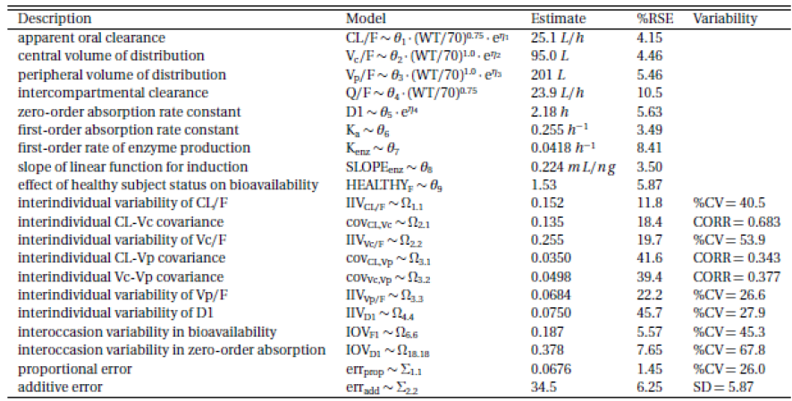

##### PKs in subjects with impaired hepatic function

Following multiple doses of LUM/IVA, LUM and IVA AUC was approximately 1.43 fold and 1.81 fold higher, respectively, and CLss/F was approximately 1.50 fold and 1.43 fold lower, respectively, in subjects with moderate hepatic impairment than in healthy subjects. Therefore, adequate precautions relating to the effects of moderate hepatic impairment on the PKs of LUM/IVA need to be provided in the PI.

##### Pharmacokinetics according to age

PopPK analysis indicated that LUM CL/F decreased with increasing age, such that the typical 12 year old has an 11% greater CL/F when compared to the reference 18 year old, and the typical 50 year old subject has a CL/F that is 24% lower than the reference 18 year old.

##### Gender, body weight

The PKs of both LUM and IVA were not affected by gender. Body weight was an important predictor of variability in LUM CL/F. For example, LUM CL/F was 39% and 131% of the reference value of 1.67 L/h for the typical 20 kg and 100 kg subject, respectively, when compared to the reference subject (70 kg). Body weight was also an important predictor of variability in IVA CL/F. IVA CL/F was 39% and 131% of the reference value of 25.1 L/h for the typical 20 kg and 100 kg subject, respectively, when compared to the reference subject (70 kg).

##### Interaction between LUM and IVA

Co-administration of 150 mg IVA q12h and 200 mg LUM QD had little effect on LUM and M28 exposure, accumulation and attainment of steady state compared to when LUM was administered alone. By contrast, following 14 days of co-administration of LUM/IVA there was a 70 to 80% reduction in IVA and M1 exposure compared to when IVA was administered alone.

When 200 mg LUM QD was co-administered with 250 mg IVA q12h for 14 days, LUM exposure decreased compared to when LUM was administered alone (GLSM ratios for Cmax by 39% and for AUC0-24h by 32%). Whereas, when IVA (250 mg q12h) was administered alone for 14 days IVA exposure increased by approximately 2.5 fold; however, following co-administration for 14 days IVA exposure decreased (0.63 fold).

###### Ciprofloxacin

Following co-administration of 200 mg LUM q12h and 250 mg IVA q12h, mean LUM AUCτ (90% CI) values were approximately 14% (79, 95) lower in the presence of ciprofloxacin, whereas, the M28-LUM concentration versus time profiles were similar in both its absence and presence. By contrast, the mean IVA AUCτ was approximately 28% (111, 148) higher in the presence of ciprofloxacin. The mean plasma concentrations for the metabolites M1 and M6 were also higher by 126 % and 112%, respectively, in the presence of ciprofloxacin.

###### CYP3A inhibitor itraconazole

LUM and M28-LUM mean plasma concentrations were similar in the absence and presence of the itraconazole, whereas, the mean IVA AUCτ was approximately 4.2 fold (3.78, 4.88) higher in its presence. The mean plasma concentration of the metabolite M1 was higher (2.4 fold) in the presence of itraconazole; however, there was no change for M6.

###### CYP3A inducer rifampin

* Rifampin had little to no effect on mean LUM AUCτ, whereas, the mean M28-LUM AUCτ was approximately 35% (132, 140) higher in the presence of rifampin. By contrast, the mean IVA AUCτ was approximately 67% (38, 49) lower in the presence of rifampin. The mean plasma concentration of M1was also lower (approximately 35%), whereas, M6 AUCτ was higher (approximately 29%) in the presence of rifampin.
* In vitro studies have established that LUM is an inducer of CYP3A, whereas, IVA is a weak inhibitor of CYP3A when given as monotherapy. The net effect of lumacaftor/ivacaftor therapy is expected to be strong CYP3A induction. In addition, both LUM and IVA have been shown to have no inhibitory effect on the inducible enzyme CYP2D6 and neither compound is a substrate for P-gp. By contrast, in vitro studies indicated that both LUM and IVA are P-gp inhibitors.

##### Limitations of the PK studies

* No studies specifically examined the bioavailability of LUM and IVA following multiple doses of the FDC formulations in healthy subjects.
* The activity of the various circulating metabolites of LUM is not clear from the information provided in the evaluation materials.
* The effect of renal impairment on the PKs of LUM and IVA has not been examined for either of the FDC tablets, the free combination or for when LUM or IVA were administered alone.

### Pharmacodynamics

#### Studies providing pharmacodynamic data

Summaries of the pharmacodynamic studies were provided. Table 7 shows the studies relating to each pharmacodynamic topic.

Note: Almost all of the studies that contain a PD component have been previously summarised; therefore, only a single study, which represented a population exposure response analysis, is included in the following table.

Table 7. Submitted pharmacodynamic studies

|  |  |  |  |
| --- | --- | --- | --- |
| PD Topic | Subtopic | Study ID | Primary aim of the study |
| Population PD and PK-PD analyses | Target population | K261 | Population exposure response analysis of sweat chloride response to treatment with LUM alone or with LUM in combination with IVA in adults with CF, homozygous for the F508del-CFTR mutation |

None of the pharmacodynamic studies had deficiencies that excluded their results from consideration.

#### Evaluator’s conclusions on pharmacodynamics

##### Mechanism of action

The combined effect of lumacaftor and ivacaftor is to increase the quantity and function ofF508del-CFTR at the cell surface, resulting in increased chloride ion transport.

##### Primary pharmacodynamic effects

###### Sweat chloride

* No PK/PD studies examined the effect of the FDC on sweat chloride in the target population.
* In patients with CF who were heterozygous for the F508del-CFTR mutation (that is; not the target population), administration of the FDC at a dose of 400 mg LUM q12h + 250 mg IVA q12h resulted in a statistically significant reduction in sweat chloride levels in subjects who received the active FDC (-11.82 mmol/L; p < 0.0001) compared to subjects who received a FDC containing the LUM component + placebo (-11.03 mmol/L; p = < 0.0001).
* In subjects who were homozygous for the F508del-CFTR mutation, dosing with 200 mg LUM QD +250 mg IVA q12h dose of the free combination, but not 200 mg LUM QD + 150 mg IVA q12h, resulted in a statistically significant decrease in adjusted mean absolute change from Day 14 at Day 21 in sweat chloride values compared to placebo (Δ = -9.626 mmol/L; 95% Cl: -14.801, -4.551; p < 0.001).
* Statistically significant within group adjusted mean absolute changes from baseline in sweat chloride levels over the entire treatment period were observed for subjects who received either 200 mg LUM QD + 250 mg IVA q12h (-12.561 mmol/L, p < 0.001) or 200 mg LUM QD + 150 g IVA q12h group (-6.741 mmol/L, p = 0.003) as a free combination. However, although the treatment difference for the 200 mg LUM QD + 250 mg IVA q12h group compared to the combined placebo group in the mean absolute change from baseline at Day 21 in sweat chloride values was statistically significant (-10.86 mmol/L, p = 0.002), the treatment difference for the subjects who were administered 200 mg LUM QD + 150 mg IVA q12h group compared to the combined placebo group was not significant (-5.04 mmol/L, p = 0.126).
* The percentage of subjects who were considered sweat chloride responders to LUM monotherapy or LUM in combination with IVA was higher in the active treatment groups compared to the monotherapy placebo group or combination placebo group.
* In a combined population of homozygous and heterozygous subjects who received a range of LUM doses (200 mg to 600 mg) in combination with 250 mg IVA q12h there were no statistically significant adjusted mean absolute changes in sweat chloride values from Day 28 at Day 56 in any active treatment group when analysed within group or in comparison to the combination placebo group.
* Population exposure response analysis of sweat chloride response to treatment identified a final structural model that consisted of an maximum effect (Emax) model, parameterised by Emax and EC50, and an additional term, Ebase, which is the model estimated sweat chloride baseline for each subject. The effect of the presence of IVA on sweat chloride response was statistically significant and was described best by a multiplicative term (E770m) applied to Emax.

###### Lung function – target population (homozygous for F508del-CFTR mutation)

* No PK/PD studies examined the effects of the FDC on lung function in the target population (homozygous subjects).
* In the target population administered the free combination (200 mg LUM QD + 150 mg IVA q12h)statistically significant decreases in adjusted mean absolute change from Day 14 at Day 21 in forced expiratory volume in 1 second (FEV1) and percent predicted FEV1 (ppFEV1) compared to placebo (Δ = 0.174 L and 4.9%, respectively).
* Following administration of 200 mg LUM QD + 250 mg IVA q12h to the target population absolute changes from Day 14 at Day 21 in FEV1 and ppFEV1 were not significantly different from placebo.
* Over the entire treatment period (from Day 1 to 21) there were no treatment differences in FEV1or ppFEV1 following administration of 200 mg LUM QD + 150 mg IVA q12h compared to placebo.
* The percentage of subjects who were considered FEV1 responders was similar in both the LUM monotherapy and the placebo monotherapy groups, whereas, following administration of LUM in combination with IVA the percentage of FEV1 responders was higher in the active treatment group than in the combination placebo group.
* Following administration of the free combination as either 600 mg LUM QD + 250 mg IVA q12h or400 mg LUM q12h + 250 mg IVA q12h, statistically significant differences in the mean relative change from Day 28 at Day 56 compared to placebo were identified. In addition, statistically significant differences in absolute change from baseline at Day 56 in FEV1 and ppFEV1 compared to placebo were identified following administration of 600 mg LUM QD + 250 mg IVA q12h.

###### Lung function – heterozygous population

Following administration of the FDC (400 mg LUM q12h + 250 mg IVA q12h) to heterozygous CF subjects there was no statistically significant least squares (LS) mean absolute or relative change from baseline at Day 56 in ppFEV1 compared to placebo.

###### Cystic fibrosis questionnaire – revised (CFQ-R)

Following treatment with LUM alone there were no clear or sustained improvements in any CFQ-R domain compared to placebo.

##### Secondary pharmacodynamic effects

###### Effects on QT interval

Following therapeutic and supra therapeutic doses of LUM/IVA, the active combination did not prolong the QTc interval to a clinically significant degree.

###### Body weight

Treatment with LUM in combination with IVA did not result in any improvement in body mass index (BMI) or weight.

##### Time course of pharmacodynamic effects

* In subjects with CF who were homozygous for the F508del-CFTR mutation, reductions from baseline in mean sweat chloride were observed as early as Day 7 following administration of 50, 100, and 200 mg LUM alone and tended to be largest in the 200 mg group. The magnitude of decreases in these 3 groups did not increase with time, and the decreases were not sustained at follow-up.
* In homozygous subjects, following co-administration with 400 mg LUM q12h/250 mg IVA q12h as a free combination, the LS mean difference of absolute change in sweat chloride from baseline was ‑2.154 and the treatment difference verses combination placebo was ‑3.78. Following administration of 400 mg LUM QD/250 mg IVA q12h these values were ‑1.04 and ‑2.67, respectively. However, none of these differences reached statistical significance with p values ranging from 0.365 to 0.664.
* When LUM was administered q12h in combination with IVA there were significant differences in both LS mean relative change from Day 28 (Δ = 8.24, p = 0.012) and treatment difference verses placebo (Δ = 10.3, p = 0.010) in ppFEV1, whereas, there was no significant difference in these measures when LUM was administered QD in combination with IVA.

##### Relationship between drug concentration and pharmacodynamic effects

###### Sweat chloride

In the target population, although, LUM AUC and Cmin values were 1.28 fold and 1.83 fold higher, respectively, following administration of 400 mg LUM q12h/250 mg IVA q12h than following 600 mg LUM QD/250 mg IVA q12h, the treatment difference for sweat chloride from Day 28 at Day 56 was lower following 400 mg LUM q12h (‑3.78) than following 600 mg LUM QD (‑4.53). It should be noted that neither of these treatment differences were statistically significant (p = 0.365 and 0.161, respectively) and given the relatively minor improvement in sweat chloride following dosing with 600 mg LUM QD (approximately 1.2 fold), any difference in sweat chloride response between the two dosing regimens is unlikely to be clinically significant.

###### Pulmonary function

Despite evidence of higher LUM AUC and Cmin values following administration of 400 mg LUM q12h/250 mg IVA q12h, the greatest improvement in lung function in the target population, based on ppFEV1, was seen in the group receiving 600 mg LUM QD/250 mg IVA q12h. No clear trends between LUM or IVA average trough concentrations versus absolute change in ppFEV1 were identified. In an analysis of ppFEV1 responders, who were defined as > 5% average relative change in ppFEV1 from Week 16 to Week 24 and non-responders as < 5% average relative change in ppFEV1 from Week 16 to Week 24 there was no clear differentiation in exposure between responders and non-responders. In addition, no differentiation in exposure between subjects with and without pulmonary exacerbation events could be identified. Nor was there a clear differentiation in exposure between subjects with and without pulmonary exacerbation hospitalisation visits. By contrast, a dose dependent decline in ppFEV1 was identified following a range of LUM doses when administered as a monotherapy, with a significant within group decline identified in the 400 mg LUM q12h group (p = 0.032). However, there were no clear trends between LUM or IVA average trough concentrations and absolute change in ppFEV1.

###### Liver function

Linear regression analysis of LUM Ctrough,ave versus absolute change in creatinine clearance by dose groups did not identify any trends between LUM pre-dose concentration and baseline creatinine clearance. In addition, no clear trends were observed between Day 15 concentrations of LUM or IVA and absolute change in alanine aminotransferase (ALT) or aspartate aminotransferase (AST).

###### Genetic, gender and age related differences in pharmacodynamic response

An exposure response analysis of LUM and IVA based on AUC0-24h identified that the linear slope of LUM effect (SLOPE809) estimate (bootstrap 95% CI) for the reference covariate effects (male, less than 24 years) was 0.00942 (0.00702, 0.0117) %/µg/mL h. For the typical subject, this translates to an absolute increase of 4.2% (3.13, 5.22) for a 400 mg q12h LUM dose and an increase of 3.32 % (2.48, 4.13) for the 600 mg QD dose. The slope of the drug effect was also affected by age with the slope decreasing with increasing age beyond 24 years.

###### Pharmacodynamic interactions

An asymptomatic, generally mild decline in FEV1 within 4 h of treatment with LUM in combination with IVA was identified. Long acting bronchodilators (indacaterol and tiotropium) largely prevented the mild decline observed in FEV1 following dosing with LUM in combination with IVA and treatment with short acting bronchodilators (albuterol and ipratropium) led to a reversal of the decline.

##### Limitations of the PD studies

* No PK/PD studies examined the effect of the FDC on sweat chloride in the target population of patients with CF who were homozygous for the F508del-CFTR mutation.
* No PK/PD studies examined the relationship between drug concentration and effect on sweat chloride following doses of the FDC in the target population.
* No PK/PD studies examined the effects of the FDC on lung function in the target population (homozygous subjects).

### Dosage selection for the pivotal studies

Lumacaftor monotherapy has been investigated in 2 clinical studies in subjects with CF (Study VX08-809-101 (Study 101) and VX09-809-102 (Study 102)).

For a more detailed description of these studies please see Attachment 2.

**Comments**: Overall, the choice of 2 dosage regimens (LUM 600 mg QD/IVA 250 mg q12h and LUM 400 mg q12h/IVA 250 mg q12h) for the Phase III studies was justified.

Figure 2. Phase III dosing regimens

Figure 2. Phase III dosing regimens
Dosing regimen 1 (LUM 600 mg qd/ IVA 250 mg q 12h); morning LUM/IVA 3 x 200/83; evening 2x IVA 125
Dosing regimen 2 (LUM 400 mg q 12h/ IVA 250 mg q 12h); morning LUM/IVA 2 x 200/125; evening LUM/IVA 2 x 200/125

IVA: ivacaftor; LUM: lumacaftor; QD: daily; q12h: every 12 hours

### Efficacy

#### Studies providing efficacy data

##### Pivotal efficacy studies

###### Study VX12-809-103

The primary objective of this pivotal Phase III, double blind, placebo controlled, parallel group study was to evaluate the efficacy of lumacaftor in combination with ivacaftor at Week 24 in 549 subjects with CF who were homozygous for the F508del-CFTR mutation. Two dosing regimens were evaluated: LUM 600 mg qd/IVA 250 mg q12h and LUM 400 mg q12h/IVA 250 mg q12h. The primary efficacy endpoint was absolute change from baseline in ppFEV1 at Week 24 (assessed as the average treatment effect at Week 16 and at Week 24), and the key secondary endpoints were relative change from baseline in ppFEV1 at Week 24 (assessed as the average treatment effect at Week 16 and at Week 24), absolute change from baseline in BMI at Week 24, absolute change from baseline in CFQ-R respiratory domain score at Week 24, response defined as ≥ 5% increase in average relative change from baseline in ppFEV1 at Week 16 and at Week 24, and number of pulmonary exacerbations through Week 24. The overall study design, treatment duration and efficacy endpoints of this well conducted Phase III study complied with Committee for Medicinal Products for Human Use (CHMP) guidelines for evaluation of medicinal products for treatment of CF.

The primary and key secondary efficacy results are summarised in Table 8.

Table 8. Primary and key secondary efficacy results

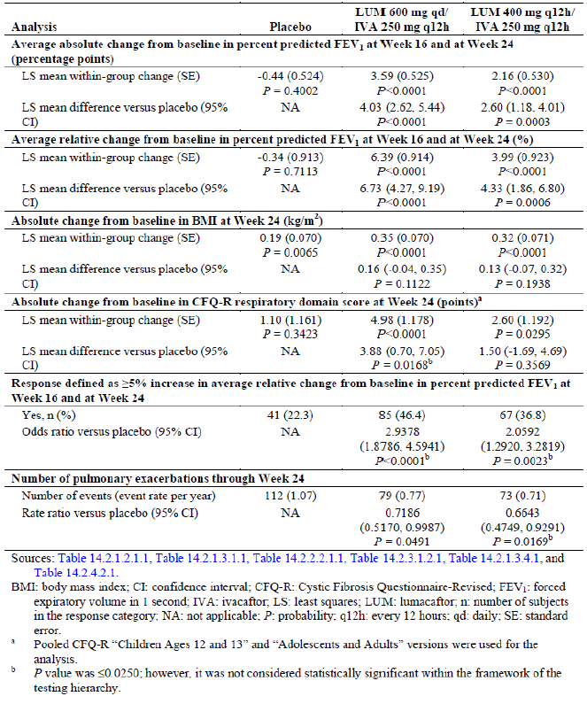

The test for treatment effect was considered statistically significant if the p value was ≤ 0.0250 and all previous tests within the testing hierarchy also met this level of significance. Based on these statistical testing procedures, the absolute change from baseline in ppFEV1 at Week 24 (assessed as the average treatment effect at Week 16 and at Week 24) and the relative change from baseline in ppFEV1 at Week 24 (assessed as the average treatment effect at Week 16 and at Week 24) were considered statistically significant within the framework of the testing hierarchy. Although, both active treatment groups showed numerical improvements over placebo in change in BMI and CFQ-R respiratory domain scores, the difference was not statistically significant.

Both active treatment groups demonstrated statistically significant treatment differences in favour of lumacaftor in combination with ivacaftor for the primary endpoint, with improvements in lung function that were consistent. The treatment effect was rapid and sustained across all visits during the treatment period. The percentage of responders (defined as > 5% increase in average relative change from baseline in ppFEV1 at Week 16 and 24) was also significantly higher in both active groups compared with placebo (46.4%, 36.8% and 22.3% in LUM 600 mg QD/ IVA 250 mg q12h, LUM 400 mg q12h/IVA 250 mg q12h and placebo groups, respectively). However, no statistically significant Improvements in measures of nutritional status (BMI and weight) were observed.

There were robust reductions in the rate of pulmonary exacerbations, including statistically significant reductions in severe pulmonary exacerbations requiring hospitalization or IV antibiotic therapy. Treatment with lumacaftor in combination with ivacaftor resulted in favourable changes in the EuroQol 3-Level (EQ-5D-3L) VAS score and some TSQM domains (effectiveness and global satisfaction domains).

Compared to the LUM 400 mg q12h/IVA 250 mg q12h group, patients in the LUM 600 mg QD/IVA 250 mg q12h showed numerically greater improvements in terms of absolute and relative change from baseline in percent predicted change in FEV1 as well as FEV1 responders; only number of pulmonary exacerbations showed greater reduction in the LUM 400 mg q12h/IVA 250 mg q12h group (Table 8). However, interpretation of these differences was difficult as the study was not powered to detect any difference between the 2 active treatment groups.

###### Study VX12-809-104

This was also a well conducted pivotal Phase III study which was identical to Study 103 described above. The primary and key secondary efficacy results are summarised in Table 9. Results were also similar to those observed in Study 103. Both active treatment groups demonstrated statistically significant treatment differences in favour of lumacaftor in combination with ivacaftor for the primary endpoint with improvements in lung function that were consistent. The treatment effect was rapid and sustained across all visits during the treatment period. Notably, there were robust reductions in the rate of pulmonary exacerbations, including statistically significant reductions in severe pulmonary exacerbations requiring IV antibiotic therapy. Furthermore, this study demonstrated statistically significant improvements in measures of nutritional status (BMI, weight, BMI z-score and weight z-score) which were not shown in Study 103. Results of all sensitivity and supportive analyses were consistent with the results of the primary analyses. For some endpoints, the treatment effect numerically favoured 1 dosing regimen versus the other. However, the study was not powered to detect statistical differences between the 2 dosing regimens.

Table 9 Study 104 Primary and key secondary efficacy results

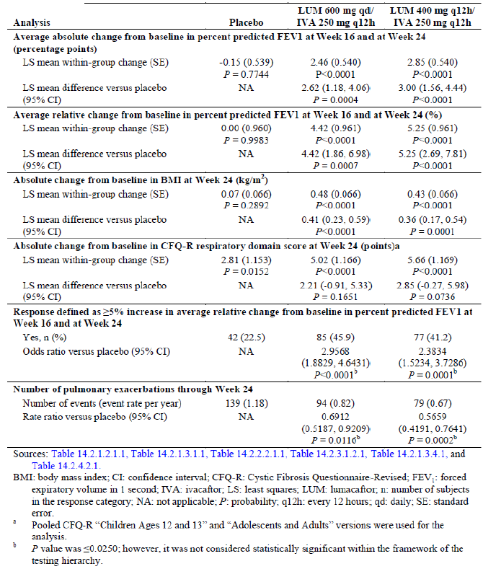

##### Other studies

* Study VX12-809-105. This was a Phase III, parallel group, multicentre, rollover study in subjects with CF who were homozygous or heterozygous for the F508del-CFTR mutation and who participated in Study 103, Study 104, or Cohort 4 of Study 102. The study consisted of 2 parts (Part A and Part B)
* Study VX-08-770-104. This study was a Phase II, randomised, double blind, placebo controlled, parallel group study (Part A) with an open label extension (Part B) of orally administered ivacaftor (VX-770) in 140 subjects aged > 12 years with CF homozygous for the F508del-CFTR mutation.

##### Analyses performed across trials (pooled analyses and meta-analyses)

Data from Studies 103 and 104 were pooled for analysis because of the similarity in the study design, population, and treatment regimens. Analysis of pooled data allowed exploration of any possible trends in subpopulations and pulmonary exacerbation endpoints.

Overall, pooled efficacy analysis from the two pivotal Studies 103 and 104 provided evidence of clinical benefits of lumacaftor and ivacaftor combination therapy in patients 12 years of age and older who are homozygous for the F508del-CFTR mutation. There were significant improvements in lung function, nutritional status and respiratory symptoms (Table 10). All treatment effects demonstrated for the primary and secondary endpoints were in addition to the benefit a subject received from standard of care medications (prior and concomitant medications taken by the majority of subjects in these studies included bronchodilators, dornase alpha, inhaled antibiotics, and inhaled hypertonic saline).

Table 10. Studies 103 and 104 Primary and Key secondary efficacy analysis full analysis set

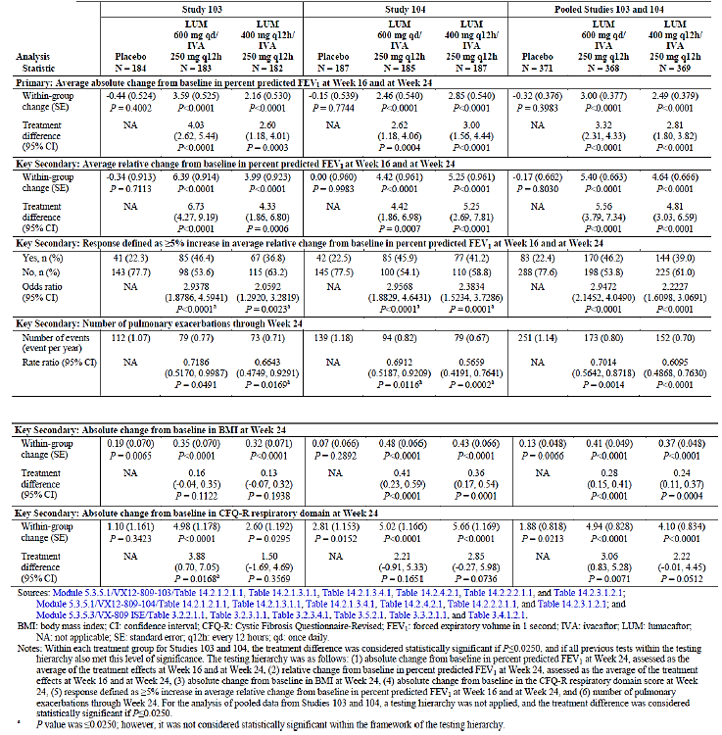

#### Evaluator’s conclusions on efficacy

Both the pivotal Phase III Studies (103 and 104) were well conducted in over 1,000 patients representative of the target patient population for which approval is being sought in this submission. The study designs[24], including the treatment duration of 24 weeks, were developed in general accordance with the CHMP Guideline on the Clinical Development of Medicinal Products for the Treatment of Cystic Fibrosis, the Guidance for Industry for Chronic Obstructive Pulmonary Disease, and precedent from other drugs approved for CF. Furthermore, efficacy endpoints were designed to evaluate lung function (FEV1), respiratory symptoms, pulmonary exacerbations, nutritional effects (weight and BMI) and sweat chloride levels.

Analysis of the primary endpoint (absolute change in ppFEV1 at Week 24, assessed as the average of the treatment effects at Week 16 and at Week 24) showed a statistically significant (p ≤ 0.0004) and consistent treatment effect in both studies for both LUM 600 mg QD/IVA 250 mg q12h (4.03 and 2.62 percentage points percentage points in Studies 103 and 104, respectively) and LUM 400 mg q12h/ IVA 250 mg q12h (2.60 and 3.00 percentage points, respectively). Statistically significant improvements in ppFEV1 were rapid in onset and sustained throughout the 24 week treatment period.

Improvements were also observed for multiple secondary endpoints:

* statistically significant improvements in relative change from baseline in ppFEV1 at Week 24
* reduction in the risk of experiencing a pulmonary exacerbation, and the frequency and duration of pulmonary exacerbations
* reduction in pulmonary exacerbations that required hospitalization or IV antibiotic therapy
* improved respiratory symptoms as measured by CFQ-R respiratory domain score
* improvements in measures of nutritional status, including BMI and weight.

The treatment effects demonstrated for the primary and secondary endpoints were in addition to the benefit a subject received from prescribed CF therapies.

Consistent treatment effects were observed in subjects with all degrees of disease severity, according to baseline ppFEV1. Subjects with baseline ppFEV1 less than 40 had improvements that were at least similar to subjects with higher baseline ppFEV1 values. Consistent treatment effects were also observed regardless of age, sex, geographic region, prior use of CF medications, and P. aeruginosa status.

For some endpoints, the treatment effect numerically favoured 1 dosing regimen versus the other. However, the pivotal studies were not powered to detect statistical differences between the 2 LUM/IVA dosing regimens. However, compared with placebo, treatment with the proposed LUM 400 mg q12h/ IVA 250 mg q12h regimen significantly decreased the risk pulmonary exacerbations by 39% (rate ratio = 0.61, p < 0.0001), reduced risk of exacerbations requiring hospitalisation by 61% (rate ratio = 0.39, p < 0.0001) and reduced exacerbations requiring treatment with intravenous antibiotics by 56% (rate ratio = 0.44, p < 0.0001).

Based on these results and the simplicity of the twice daily FDC regimen, the sponsors are seeking approval for only the lumacaftor 400 mg/ivacaftor 250 mg q12h dosing regimen administered as an FDC of 2 tablets of LUM 200 mg/IVA 125 mg every 12 hours.

The maintenance of efficacy of Orkambi was confirmed in an ad hoc efficacy analysis which was performed after 95 patients who had received Orkambi (lumacaftor 400 mg/ivacaftor 250 mg q12h) in placebo controlled Phase III Studies 103 or 104 had completed the Week 24 Visit in the rollover, long-term Study 105 (up to 48 weeks of treatment overall). However, there was no evidence of efficacy of proposed lumacaftor 400 mg/ivacaftor 250 mg q12h beyond 48 weeks. Long-term efficacy beyond 48 weeks will require confirmation from ongoing rollover, open label, 96 week Study 105 and the data should be provided for evaluation on completion of this study.

In conclusion, results from the two pivotal placebo controlled Phase III Studies (103 and 104) and a rollover Study (105) conducted in over 1,000 subjects showed that lumacaftor in combination with ivacaftor was effective in the treatment of CF, as evidenced by rapid and sustained improvements in important clinical outcomes, including FEV1, pulmonary exacerbations, and nutritional status. Thus, lumacaftor in combination with ivacaftor is expected to have broad and meaningful clinical benefit in patients 12 years of age and older who are homozygous for the F508del-CFTR mutation patients with F508del mutation is devastating and lumacaftor plus ivacaftor combination product will provide benefit to these patients over the current standard of care treatment.

### Safety

#### Studies providing safety data

Seventeen clinical studies (as of 21 July 2014) with lumacaftor monotherapy or lumacaftor in combination with ivacaftor (Figure 3) provided evaluable safety data. The core safety data were from pooled analyses of two placebo controlled Phase III studies of LUM/IVA in subjects with CF homozygous for the CFTR-F508del mutation. The supportive analysis includes pooled safety data from 9 Phase I studies (lumacaftor monotherapy and lumacaftor in combination with ivacaftor) in healthy subjects and some Phase I and II non-pooled studies.

Figure 3. Overview of studies (n = 17) and poolings in the summary of clinical safety

Figure 3. Overview of studies (n = 17) and poolings in the summary of clinical safety
Summary of clinical safety studies (17 studies) these studies are from the following
10 Phase I studies in  healthy subjects [comprised of 9 Pooled Phase I studies; (Study 001, Study 003 to Study 007, Study 009 (Cohorts 1 to 3) Study 010 (Group B) Study 012 LUM N = 287); Thourough QT Study 008 LUM N = 78; and Bronchodiolatory Study 009 (Cohort 4) Lum N = 26]
1 Phase I study in special population without CF - moderate hepatic impairment Study 010 (Group A) LUM N=12
2 Phase I Studies in subjects with CF [Pancreatic insufficiency study 002 LUM N=8 and PK age 6 to 11 Study 011 (Part A) Lum N=10
2 Phase II Studies; LUM monotherapy study 101 LUM N=72; and LUM monotherapy or LUM/IVA Study 102 Any LUM N=197
3 Phase III Studies in subjects with CF [Pooled Placebo controlled Phase III studies PBO N = 370; LUM/IVA = 738 made up of (Study 103 PBO N = 184 LUM/IVA N = 365) and Study 104 PBO N = 186 and LUM/IVA N=373) and a Phas III extentions study Study 105 Part A and Part B [Part B PBO to LUM/IVA N=60 and LUM/IVA to LUM/IVA N=55] [Part A PBO to LUM/IVA N=353 and LUM/IVA to LUM/IVA N = 674)

Notes: Figure includes the number of subjects in each study as of the snapshot date of 21 July 2014. Studies with multiple parts or cohorts (Studies 009, 010, and 105) appear more than once in this figure based on the methodology within that part of the study; however, these studies are only counted once toward the total number of studies investigating lumacaftor. Shaded boxes denote analysis pooling for safety analyses. Study 102 Cohorts 1 to 3 included subjects with CF who were heterozygous or homozygous for the F508del-CFTR mutation, and Study 102 Cohort 4 included subjects who were heterozygous for the F508del-CFTR mutation

a Study 010 is included in 2 subcategories: Pooled Phase 1 studies in healthy subjects and Phase 1 study in special population without CF.

b Study 011 has 2 parts: Part A (Phase 1 study) is included in the SCS, and Part B (Phase 3 study) was ongoing and is not included in the SCS.

c Study 102 included lumacaftor monotherapy and lumacaftor combination therapy. The number of subjects (N) who received at least 1 dose of lumacaftor, alone or in combination with ivacaftor, is provided.

d Numbers of subjects in the figure for Study 105 are provided for the All Subjects Safety Set (subjects who received at least 1 dose of study drug) of Part A or Part B Current Study Period (date of initial dose in Study 105 through the data snapshot date, 21 July 2014). Additional data are provided in the body of the SCS for the Part A Long-term Safety Set (subjects who received LUM/IVA in Study 103/104 and completed at least the Week 24 Visit in Study 105) for 116 subjects (58 subjects in the LUM 400 mg q12h/ IVA 250 mg q12h group and 58 subjects in the LUM 600 mg QD/IVA 250 mg q12h group).

#### Patient exposure

Overall 1,839 subjects received at least 1 dose of lumacaftor (alone or in combination with another study drug). There were 1,615 subjects who received lumacaftor in combination with ivacaftor (with or without a drug-drug interaction (DDI) drug) (Table 49 Attachment 2).

#### Safety issues with the potential for major regulatory impact

##### Liver toxicity

In the pooled placebo controlled studies (Studies 103/104), 5.7% of subjects had elevated transaminases or hepatobiliary disorder related adverse events (AEs) in the total LUM/IVA group compared with 5.4% of subjects in the placebo group. The overall incidence of elevated liver enzymes (> 3 × upper limit of normal (ULN)) was low and similar in the total LUM/IVA group (5.2%) and the placebo group (5.1%). Transaminase elevations of > 5 × ULN were ≤ 2% and > 8 × ULN were < 1% in both the total LUM/IVA and placebo groups. The incidence of adverse events of special interest (AESIs) of elevated transaminases continued to be low in Study 105.

In the pooled placebo controlled Phase III Studies, 7 subjects in the total LUM/IVA group had serious adverse events (SAEs) associated with elevated transaminases or hepatobiliary AEs. In 3 cases with associated clinical AEs (for example, cholestatic hepatitis, hepatitis and cholestasis, and hepatic encephalopathy) also associated with a concurrent elevation in bilirubin. Liver function tests returned to baseline or improved substantially in all 7 subjects. Underlying risk factors and alternative aetiologies complicate assessment of the SAEs, but do not exclude LUM/IVA as a potential contributory factor.

The incidence and pattern of liver function test (LFT) changes in Study 105 did not suggest any new findings compared with Studies 103/104 with exposure to LUM/IVA beyond 24 weeks. The incidence of AESIs of elevated transaminases in subjects new to active treatment in Study 105 was similar to the incidence in the pooled analysis of Studies 103/104.

The overall incidence and patterns of transaminase elevations observed in the studies is typical for patients with CF. Marked elevations of transaminases and associated SAEs are confounded by complicated medical histories and alternative aetiologies, though the role of LUM/IVA cannot be excluded.

#### Post-marketing data

No post-marketing data submitted in the current dossier.

#### Evaluator’s conclusions on safety

Overall exposure to proposed combination of lumacaftor and ivacaftor was adequate to evaluate safety in the target patient population for the proposed indication. Safety was evaluated in 17 studies with lumacaftor including 12 completed Phase I studies, 2 completed Phase II studies, 2 completed Phase III studies, and 1 ongoing Phase III study. A total of 1,839 subjects were exposed to lumacaftor: 391 subjects without CF (excluding 12 subjects with moderate hepatic impairment) and 1,436 subjects with CF. A total of 1,615 subjects were exposed to lumacaftor in combination with ivacaftor in Phase I through Phase III studies: 254 subjects without CF (excluding 12 subjects with moderate hepatic impairment) and 1,349 subjects with CF. Overall, 738 subjects received study treatment for 24 weeks (Studies 103/104) of whom 369 patients were treated with proposed dose of LUM 400 mg q12h/IVA 250 mg q12h.

In the placebo controlled Phase III studies, AEs that occurred in ≥ 1% increase incidence in the total LUM/IVA group (compared with the placebo group) and had an incidence of at least 5% in any treatment group were dyspnoea, diarrhoea, nausea, respiration abnormal, oropharyngeal pain, upper respiratory tract infection, rhinitis, flatulence, rash, rhinorrhoea, and vomiting. The placebo group had a higher incidence of pulmonary exacerbation of cystic fibrosis, cough, sputum increased, nasal congestion, and pulmonary function test decreased. The majority of AEs were mild or moderate in severity. In the placebo controlled Phase III studies, infective pulmonary exacerbation of CF, headache, and blood creatine phosphokinase (CPK) increased were the only severe (Grade 3) or life threatening (Grade 4) AE with an incidence of at least 1% in any treatment group. There were no deaths in the placebo controlled studies. The incidence of SAEs was higher in the placebo (28.6%) group compared with the total LUM/IVA group (20.1% subjects). The most common SAE (at least 5% incidence) in any treatment group was infective pulmonary exacerbation of CF. The rate of study drug discontinuation was higher in the total LUM/IVA group (4.2%) compared with the placebo group (1.6%). The most common AEs (> 2 subjects in any treatment group) that led to discontinuation of study drug were haemoptysis and blood CPK increased.

The safety profiles for the LUM 600 mg QD/IVA 250 mg q12h group and the LUM 400 mg q12h/IVA 250 mg q12h group were similar. No new safety signal was identified in the interim analysis of ongoing, long-term Study 105. The overall incidence of AEs was lower in subjects that were on active treatment in Studies 103/104 (and continued on treatment in Study 105) compared with subjects who received placebo in Studies 103/104 (and received active treatment in Study 105). The overall rate of treatment discontinuation was low (2.7%). There was 1 death due to infective pulmonary exacerbation of cystic fibrosis leading to respiratory failure in the LUM 400 mg q12h/IVA 250 mg q12h group that occurred approximately 1 year after the first dose of study drug. The event was considered not related to the study drug by the investigator.

Liver related safety concerns from the ivacaftor monotherapy program led to specific analyses to assess for potential liver toxicity. In the pooled placebo controlled studies, the incidence of elevated transaminases or hepatobiliary disorder related AEs was similar in the total LUM/IVA group compared with placebo (5.7% versus 5.4%) with similar results for incidence of elevated liver enzymes > 3 × ULN (5.2% versus 5.1%). The incidence of transaminase elevations > 5 × ULN and > 8 × ULN were ≤ 2% and < 1%, respectively, in both the total LUM/IVA and placebo groups. Seven subjects in the total LUM/IVA group had SAEs associated with elevated transaminases or hepatobiliary AEs and in 3 cases (for example, cholestatic hepatitis, hepatitis and cholestasis, and hepatic encephalopathy[25]) was also associated with a concurrent elevation in bilirubin. LFTs returned to normal or improved substantially in all 7 subjects. The incidence and pattern of LFT changes in Study 105 did not suggest any new findings compared with Studies 103/104 with exposure to LUM/IVA beyond 24 weeks. The incidence of AESIs of elevated transaminases in subjects new to active treatment in Study 105 was similar to the incidence in the pooled analysis of Studies 103/104. There was no apparent relationship between higher exposure to LUM/IVA and the occurrence of transaminase elevations in subjects exposed to LUM/IVA compared with exposure in subjects without transaminase elevations. Six of the 7 subjects with portal hypertension and/or cirrhosis in the pooled Phase III studies did not have any AEs suggesting worsening of liver function while receiving LUM/IVA. One of these 7 subjects had worsened liver function after receiving LUM/IVA, manifest as hepatic encephalopathy. The role of LUM/IVA in worsening of underlying liver function in this case cannot be excluded. Overall, marked elevations of transaminases and associated SAEs were confounded by complicated medical histories and alternative aetiologies, though the role of LUM/IVA cannot be excluded and hence adequate monitoring and management recommendations have been included in the proposed PI.

As a result of dose dependent decrease in pulmonary function observed in patients who received lumacaftor monotherapy, the sponsors performed a safety analysis grouping together respiratory related AEs. Respiratory AEs were more frequent in the total LUM/IVA group than the placebo group (LUM/IVA versus placebo: 26.3% versus 17%) particularly dyspnoea (23% versus 8%) and ‘respiration abnormal’ (10% versus 3%). The incidence of subjects with AESIs of respiratory symptoms or reactive airways was similar in the LUM 600 mg QD/IVA 250 mg q12h group (26.8%) and the LUM400 mg q12h/IVA 250 mg q12h group (25.7%). The majority of respiratory AESIs in pooled placebo controlled Phase III studies were mild or moderate in severity, with the majority of events occurring within the first week of treatment. Although the aetiology is unknown, these respiratory events are likely associated with LUM/IVA treatment. These events usually resolved within 1 to 2 weeks, and led to treatment discontinuation in only 5 subjects in the pooled placebo controlled Phase III studies (all 5 subjects were in the LUM 600 mg QD/IVA 250 mg q12h group, with no SAEs or discontinuations due to respiratory AEs in the proposed LUM 400 mg q12h/IVA 250 mg q12h group). There were no notable differences in the incidence of respiratory events in analyses by screening or baseline ppFEV1, with the exception of dyspnoea. In both the placebo group and the total LUM/IVA group, subjects with ppFEV1 < 70 at screening or ppFEV1 < 40 at baseline were approximately twice as likely to have dyspnoea compared with subjects with ppFEV1 ≥ 70 at screening and ppFEV1 ≥ 40 at baseline. For subjects new to active treatment in the long-term safety and efficacy study (Study 105), the incidence of AESI of respiratory symptoms was similar compared with the subjects receiving active treatment in the pooled placebo controlled Phase III studies, and was higher compared with subjects who continued on active treatment in Study 105. Overall, these data suggest that treatment with lumacaftor plus ivacaftor combination product can cause increased respiratory symptoms and AEs in some CF patients.

Menstrual abnormalities were also evaluated as an AESI due to observed increased metrorrhagia following treatment with lumacaftor plus ivacaftor combination product compared to placebo from early phase studies. Female patients reported more menstrual abnormalities in the lumacaftor plus ivacaftor combination product treatment arms compared to placebo (9.9% versus 1.7%) with metrorrhagia reported most commonly, These menstrual events occurred more frequently in the subset of female patients who were taking hormonal contraceptives (25.0%) compared to patients who were not taking hormonal contraceptives (3.5%). Most of these reactions were mild or moderate in severity and non-serious. Lumacaftor is a CYP3A inducer and could reduce hormonal contraceptive exposure, which could result in disruption of the menstrual cycle. There was no apparent relationship for incidence of menstrual abnormalities and lumacaftor dose in Studies 008, 103, 104, or 105.

The clinical laboratory parameters (serum chemistry, haematology, and coagulation studies) showed minor differences between the LUM 600 mg QD/IVA 250 mg q12h, LUM 400 mg q12h/IVA 250 mg q12h, and placebo groups that were not considered to be clinically meaningful. Patients with CF are chronically ill and often have associated metabolic and nutritional disorders, so minor fluctuations in chemistry parameters are common.

There were no clinically meaningful differences in any ECG parameter between the total LUM/IVA and placebo groups as measured by 12 lead standard ECGs and ambulatory ECGs.

The safety profile of LUM/IVA was similar across the different age and sex subgroups. The pattern of AEs was generally similar across the subgroups by severity of lung disease and the most common AEs within each FEV1 subgroup were common manifestations of CF. As expected, subjects with more severe disease (ppFEV1 < 40 at baseline or ppFEV1 < 70 at screening) had a higher incidence of AEs compared to other subgroups, but LUM/IVA was well tolerated even in this more severely compromised group. Safety analysis from the pooled Phase I studies and the non-pooled Phase I studies showed similar safety results to those observed in CF patients. The incidence and pattern of AEs was similar in subjects with CF who are homozygous or heterozygous for the F508del-CFTR mutation and do not suggest any genotype specific safety risks. Subjects with moderate hepatic impairment (Child-Pugh B) and severe hepatic impairment (Child-Pugh C) may have increased exposure to LUM/IVA.

Overall, the safety of the proposed combination of LUM 400 mg q12h/IVA 250 mg q12h has been adequately established for the proposed indication of treatment of CF patients who are homozygous for the F508del-CFTR mutation. The only limitation was lack of safety data beyond 48 weeks of treatment although the ongoing 96 week open label Study 105 should be able to address that on completion of the study.

### First round benefit-risk assessment

#### First round assessment of benefits

The benefits of Orkambi in the proposed usage are;

* LUM/IVA combination therapy demonstrated beneficial effects on pulmonary function, pulmonary exacerbations, patient reported outcomes, and nutritional measures (BMI and weight) in subjects 12 years of age and older with CF who are homozygous for the F508del‑CFTR mutation. These effects were observed while subjects continued on their usual prescribed therapies for CF
* While there was no clear differentiation between the 2 combination therapy regimens in other efficacy measures, treatment with the proposed LUM 400 mg q12h/ IVA 250 mg q12h regimen significantly decreased the risk for all pulmonary exacerbations by 39%, exacerbations requiring hospitalisation by 61% and exacerbations requiring treatment with intravenous antibiotics by 56%
* The treatment effects favoured LUM/IVA across all subgroups, including subjects with severely compromised lung function (who have a ppFEV1 < 40 at baseline)
* Interim results from the rollover study (Study 105) demonstrate that the effect of LUM/IVA persisted up to approximately 48 weeks and was reproducible in subjects who were previously receiving placebo
* The PK/PD analyses of sweat chloride response in Phase II suggests that the higher lumacaftor concentrations in the presence of ivacaftor for the LUM 400 mg q12h/ IVA 250 mg q12h regimen results in a greater reduction of sweat chloride and a greater improvement in CFTR function than the LUM 600 mg QD/IVA 250 mg q12h regimen
* The proposed Orkambi is manufactured as a fixed dose combination of lumacaftor/ Ivacaftor 200 mg/125 mg tablet and 2 tablets q12h (800 mg lumacaftor/500 mg ivacaftor total daily dose) is recommended for adults aged 12 years and older. The simplicity of this proposed dosing regimen minimises the potential of medication errors in terms of prescription and administration errors
* The safety profile of LUM/IVA was characterised by AEs that were most often mild to moderate in severity and the most common risks of LUM/IVA identified in the clinical and nonclinical studies are readily monitored and recognised, and may be managed without treatment discontinuation.

#### First round assessment of risks

The risks of Orkambi in the proposed usage are;

* Hepatic toxicity including elevated hepatic enzymes, although incidence was similar in LUM/IVA and placebo groups
* CF patients who received lumacaftor plus ivacaftor combination product had an increased frequency of respiratory symptoms, although there were no SAEs or discontinuations due to respiratory AEs in the proposed LUM 400 mg q12h/ IVA 250 mg q12h group
* Menstrual AEs
* LUM is a strong inducer of CYP3A and IVA is a sensitive CYP3A substrate with potential for drug-drug interactions
* Lack of adequate data on long-term efficacy and safety.

#### First round assessment of benefit-risk balance

F508del has been characterised as a ‘severe’ CFTR mutation, based upon the F508del-CFTR homozygote clinical phenotype 19,20,21 which is characterised by an early onset of clinical manifestations, a high incidence of pancreatic insufficiency, colonization with Pseudomonas aeruginosa, a more rapid rate of lung function decline and shorter life expectancy.22, 21 The patients demonstrate progression of disease with advancing age and have a decreased life expectancy. According to the Australian Cystic Fibrosis Data Registry, there were 3,156 patients with CF in 2012. Of the patients with genotype data available, 51.8% are homozygous for F508del-CFTR. Given the high unmet medical need of patients with CF who are homozygous for the F508del mutation, and considering that there is no currently approved therapy to treat the underlying cause of CF in this population, there is a substantial need to improve the treatment and outlook for patients with this mutation.

The lumacaftor and ivacaftor combination development program consists of 17 clinical studies, with 16 completed clinical studies and 1 ongoing long-term efficacy and safety study. In vitro data provided evidence that a combination of lumacaftor and ivacaftor could potentially increase CFTR mediated Cl secretion in patients with CF carrying the F508del-CFTR mutation.

The Phase II Study 102 was planned to investigate lumacaftor and ivacaftor combination therapy, as well as lumacaftor monotherapy, in subjects who are homozygous or heterozygous for the F508del-CFTR mutation. Studies 005 and 006 were carried out in healthy subjects order to understand the drug-drug interaction (DDI) between lumacaftor (a CYP3A inducer) and ivacaftor (a sensitive CYP3A substrate) and to inform selection of the dosages used in combination therapy studies. Results from Study 102 demonstrated that pharmacologic modulation of CFTR function through treatment with lumacaftor in combination with ivacaftor can result in clinical benefit in subjects with CF who are homozygous for the F508del-CFTR mutation. Several clinical pharmacology studies were also performed in healthy subjects, including a bioavailability study of additional dosage strengths, as well as evaluations of potential DDIs identified from in vitro studies.

Based on the results from Studies 101 and 102 (Cohorts 1 to 3), and in consultation with the US and EU regulatory authorities, the pivotal, placebo controlled Phase III studies (Studies 103/104) were designed to evaluate the efficacy and safety of lumacaftor in combination with ivacaftor in subjects who are homozygous for the F508del-CFTR mutation. Two dosing regimens, LUM 600 mg QD/IVA 250 mg and LUM 400 mg q12h/IVA 250 mg q12h, were studied in pivotal Phase III clinical studies in order to determine the optimal clinical dose combination of LUM/IVA for patients 12 years and older who are homozygous for the F508del-CFTR mutation.

The Phase III clinical data showed that lumacaftor plus ivacaftor fixed dose combination product has statistically significant benefit over placebo in FEV1 with a modest effect size of approximately 3%. Statistically significant improvements in ppFEV1 were rapid in onset and sustained throughout the 24 week treatment period. Improvements were also observed for multiple secondary endpoints including reductions in risk, frequency/ duration of experiencing a pulmonary exacerbation as well as reductions in pulmonary exacerbations that required hospitalization or IV antibiotic therapy. This suggests that the numerically small but statistical significant improvement in FEV1 is a meaningful clinical benefit. The proposed combination also showed improvements in measures of nutritional status (BMI and weight) and in respiratory symptoms (as measured by CFQ-R respiratory domain score). Consistent treatment effects were observed in subjects with all degrees of disease severity, according to baseline ppFEV1. Subjects with severely compromised lung function (baseline ppFEV1 < 40) had improvements that were at least similar to subjects with higher baseline ppFEV1 values. Consistent treatment effects were also observed regardless of age, sex, geographic region, prior use of CF medications, and P. aeruginosa status. The treatment effects demonstrated for the primary and secondary endpoints were in addition to the benefit a subject received from prescribed CF therapies.

While there was no clear differentiation between the 2 combination therapy regimens when ppFEV1, BMI and CFQ-R respiratory domain score were evaluated, improvements in pulmonary exacerbation related outcomes favoured the LUM 400 mg q12h/IVA 250 mg q12h regimen. Based on these results and the simplicity of the twice daily FDC regimen, the recommended dosing regimen (for which approval is being sought in this submission) is lumacaftor 400 mg q12h in combination with ivacaftor 250 mg q12h administered as an FDC of 2 tablets of LUM 200 mg/IVA 125 mg every 12 hours.

The maintenance of efficacy of Orkambi was confirmed in an interim efficacy analysis which was performed after 95 patients who had received Orkambi (lumacaftor 400 mg/ivacaftor 250 mg q12h) in placebo controlled Phase III studies 103 or 104 had completed the Week 24 Visit in the rollover, long-term Study 105 (up to 48 weeks of treatment overall). However, there was no evidence of efficacy of proposed lumacaftor 400 mg/ivacaftor 250 mg q12h beyond 48 weeks. Long-term efficacy beyond 48 weeks will require confirmation from ongoing rollover, open label, 96 week Study 105 and the data should be provided for evaluation on completion of this study.

The contribution of the individual drugs lumacaftor and ivacaftor in the combination product were obtained from the in vitro data suggesting additive benefit of the two and early clinical data suggest some additive benefit on FEV1 when ivacaftor is added to lumacaftor (Study 102). The available clinical data are not adequate to determine whether lumacaftor provides additive clinical benefit over ivacaftor alone. However, demonstration of additive clinical benefit of lumacaftor is not necessary in this specific situation. The lumacaftor plus ivacaftor combination product provides benefit over placebo (standard of care background treatment in this case). The natural course of CF patients with F508del mutation is devastating with limited treatment options. Hence, the proposed lumacaftor plus ivacaftor combination product will provide benefit to these patients over the current standard of care treatment.

Overall exposure to proposed combination of lumacaftor and ivacaftor was adequate to evaluate safety in the target patient population for the proposed indication. Treatment with lumacaftor in combination with ivacaftor was safe and well tolerated in 738 subjects who received treatment for 24 weeks (Studies 103/104) of whom 369 patients were treated with proposed dose of LUM 400 mg q12h/IVA 250 mg q12h. The safety profiles for the LUM 600 mg QD/IVA 250 mg q12h group and the proposed dose of LUM 400 mg q12h/IVA 250 mg q12h group were similar. In the long-term safety and efficacy study, no new safety signal was identified. The overall incidence of AEs was lower in subjects who continued on treatment in Study 105 compared with subjects who were new to treatment in Study 105.

The safety profile of LUM/IVA was characterised by AEs that were most often mild to moderate in severity and the most common risks of LUM/IVA identified in the clinical studies (such as elevated transaminases, liver toxicity, respiratory AEs and menstrual AEs) are readily monitored and recognised, and may be managed without treatment discontinuation. Furthermore, adequate precautions have been included in the proposed PI.

Given the broad array of clinical benefits, chronic treatment with LUM/IVA combination therapy may have potential to decrease the morbidity and mortality of patients with CF who are homozygous for the F508del mutation in the CFTR gene, although this was not specifically analysed in any of the submitted studies.

Overall, the results of the clinical development program provide adequate evidence to support the use of LUM/IVA combination therapy for the treatment of CF in patients age 12 years and older who are homozygous for the F508del mutation on the CFTR gene.

The benefit-risk balance of Orkambi, given the proposed usage, is favourable.

### First round recommendation regarding authorisation

It is recommended that marketing approval be granted for Orkambi for the proposed indication of;

*treatment of cystic fibrosis (CF) in patients aged 12 years and older who are homozygous for the F508del mutation in the CFTR gene.*

Approval is subject to incorporation of suggested changes to the proposed PI and adequate response to clinical questions.

### Clinical questions

#### Pharmacokinetics

1. The values given in the Clinical Pharmacology Summary (p99 of 135) regarding the radioactivity associated with unchanged LUM and M28-LUM were approximately 10% higher than the values given in the study report body VX08-809-004.pdf on page 63 (of 684) and Table 11.3 (p65 of 684) of the same document. Can the sponsor please clarify why these differences between the two documents exist?
2. Can the sponsor please provide information on the activity of the plasma metabolites of LUM.

#### Pharmacodynamics

No questions.

#### Efficacy

1. Long-term efficacy and safety of Orkambi was only established up to 48 weeks. Hence, on completion of the 96 week, long-term, open label Study 105, data should be presented for evaluation.

#### Safety

No questions.

### Second round evaluation of clinical data submitted in response to questions

For details of the sponsor’s responses and the evaluation of these responses please see Attachment 2 (extract of the clinical evaluation report).

### Second round benefit-risk assessment

#### Second round assessment of benefits

After consideration of the responses to clinical questions, the benefits of Orkambi in the proposed usage are unchanged from those identified in the first round assessment of benefits.

#### Second round assessment of risks

After consideration of the responses to clinical questions, the risks of Orkambi in the proposed usage are unchanged from those identified in the first round assessment of risks.

#### Second round assessment of benefit-risk balance

The benefit-risk balance of Orkambi in the proposed usage is favourable.

#### Second round recommendation regarding authorisation

It is recommended that application for marketing of Orkambi (lumacaftor 200 mg/ ivacaftor 125mg tablets) be approved for proposed indication;

*for the treatment of cystic fibrosis (CF) in patients aged 12 years and older who are homozygous for the F508del mutation in the CFTR gene.*

## V. Pharmacovigilance findings

### Risk management plan

The sponsor submitted a Risk Management Plan EU-RMP version 1.0 dated 30 October 2014 (data lock point 21 July 2014); Australian Specific Annex version 1.0 dated 20 March 2015; updated EU-RMP version 1.1 dated 18 May 2015 (data lock point 21 July 2014)) which was reviewed by the RMP evaluator.

#### Safety specification

The sponsor provided a summary of ongoing safety concerns which are shown at Table 11.

Table 11 Summary of ongoing safety concerns

|  |  |
| --- | --- |
| Ongoing safety concerns |  |
| Important identified risks | None |
| Important potential risks | * Hepatobiliary events * Concomitant use of LUM/IVA with strong CYP3A inhibitors or inducers * Concomitant use of LUM/IVA with sensitive CYP3A substrates and CYP3A substrates with narrow therapeutic index * Cataracts * Cardiac arrhythmias * Off-label used in children less than 12 years of age or in patients who are not homozygous for F508del-CFTR mutation |
| Missing information | * Use in pregnant and lactating women * Patients with ppFEV1 < 40 * Long term safety * Safety in patients with cardiac diseases * Use in patients with organ transplant * Effect of LUM/IVA on P-gp substrates |

#### Pharmacovigilance plan

Table 12 summarises the pharmacovigilance activities. The content of the table is based on the information provided in the EU-RMP and the ASA.

**Table 12. Pharmacovigilance activities**

|  | **Pharmacovigilance activities** |
| --- | --- |
| **Important potential risks** | |
| Hepatobiliary events | Routine pharmacovigilance; Study 105, study 106, study 108 |
| Concomitant use with strong CYP3A inhibitors/inducers | Routine pharmacovigilance; Study 105, study 106 |
| Concomitant use with sensitive CYP3A substrates and CYP3A substrates with a narrow therapeutic index | Routine pharmacovigilance; Study 105, study 106 |
| Cataracts | Routine pharmacovigilance; Study 105, study 106, study 770-115. |
| Cardiac arrhythmias | Routine pharmacovigilance; Study 105, study 106, study 108 |
| Off-label use in children < 12 years of age or in patients who are not homozygous for F508del-CFTR mutation | Routine pharmacovigilance; Study 108 |
| **Missing information** | |
| use in pregnant and lactating women | Routine pharmacovigilance; Study 108 |
| Patients with ppFEV1 < 40 | Routine pharmacovigilance; Study 105, study 106, study 108 |
| Long-term safety | Routine pharmacovigilance; Study 105, study 108 |
| Safety in patients with cardiac diseases | Routine pharmacovigilance; Study 105, study 106, study 108 |
| Use in patients with organ transplant | Routine pharmacovigilance; Study 108 |
| Effect on P-gp substrates | Routine pharmacovigilance |

As outlined in the ASA, all the studies included in the pharmacovigilance plan are ongoing except study 108, which is at planning stage. Protocols for ongoing studies are not evaluated as part of the submission.

Study 108 is a three year observational post-authorisation safety study to evaluate the utilisation patterns and long-term effects of Orkambi in patients with CF to be conducted in the EU and the USA using patient registries in these countries. The study data collection is expected to start in June 2016 with the final study report due in December 2018 to cover a three year period.

Study 770-115 is an ocular safety study in paediatric patients 11 years of age or younger with CF. Protocol for this study has not been submitted with the EU-RMP.

Study 105 is a Phase III rollover study from previous studies to evaluate the safety and efficacy of long-term treatment with Orkambi in patients aged 12 years and older with CF, homozygous or heterozygous for the F508del-CFTR mutation. The study duration is up to 105 weeks.

Study 106 is a Phase IIIb open label study to evaluate the effects of Orkambi in patients 12 years and older with CF and advanced lung disease, homozygous for the F508del-CFTR mutation. Protocol for this study has not been submitted with the EU-RMP.

The sponsor has advised in the ASA that study 105 is the only study mentioned above that involves Australian patients. The sponsor should clarify whether the studies conducted overseas are applicable to the Australian context and provide justification to its conclusion. Given the availability of the Australian Cystic Fibrosis Data Registry (ACFDR), the sponsor should consider adding Australia to study 108 or provide justification to why this is unnecessary.

The sponsor should provide an update on any significant safety findings from the ongoing additional pharmacovigilance activities, including study 105, study 106 and study 770-115.

#### Risk minimisation activities

The sponsor has proposed routine risk minimisation activities for all the safety concerns in the EU-RMP. No additional risk minimisation is considered necessary by the sponsor.

**Comment:** The sponsor’s plan to mitigate all the risks through routine risk minimisation is acceptable.

In regard to the proposed routine risk minimisation activities, the following recommendations are made to the Delegate on the draft Australian PI:

* Use in hepatic impairment:

Evidence on use in patients with severe hepatic impairment is lacking for both ivacaftor and lumacaftor/ivacaftor. The approved PI for ivacaftor (Kalydeco) contains the following advice on use in severe hepatic impairment: ‘The use of Kalydeco in patients with severe hepatic impairment is therefore not recommended unless the benefits outweigh the risks.’ In comparison, the PI for lumacaftor/ivacaftor (Orkambi) only advises to weigh the risks and benefits of treatment. It is recommended that the Delegate considers the adequacy of the PI on this issue.

Both the draft Australian PI and the approved US label recommend three monthly monitoring of hepatic function during the first year of treatment. The approved US label contains additional advice on patients with relevant medical history: ‘For patients with a history of ALT, AST, or bilirubin elevations, more frequent monitoring should be considered.’ It is recommended that the Delegate considers the additional advice.

* Respiratory events:

The following advice appears in the approved US label and has been added to the updated SPC submitted with the EU Day120 data: ‘Respiratory events were more common during initiation of lumacaftor/ivacaftor therapy. Additional monitoring of patients with ppFEV1 < 40 is therefore recommended during initiation of therapy’. Given that use of Orkambi in patients with ppFEV1 < 40 is missing information and dyspnoea is the most common AE experienced by patients taking Orkambi in clinical trials (14.0% in Orkambi group compared to 7.8% in placebo group, Australian PI), this advice should be added in the Australian PI.

* Use in lactation:

The EU SPC has been updated to include new advice on breast feeding: ‘risks to the suckling child cannot be excluded. A decision must be made whether to discontinue breast feeding or to discontinue/abstain from lumacaftor/ivacaftor therapy taking into account the benefit of breast feeding for the child and the benefit of therapy for the mother.’ In comparison, the Australian PI advises that ‘Orkambi should only be used during breast feeding if the potential benefit outweighs the potential risk.’ It is recommended that the Delegate considers the adequacy of advice provided by the PI in the context of findings from animal pharmacokinetic studies in the absence of evidence on humans.

Relevant parts of the draft CMI should be updated accordingly.

#### Reconciliation of issues outlined in the RMP report

‘Table 13 summarises the OPR’s first round evaluation of the RMP, the sponsor’s responses to issues raised by the OPR and the OPR’s evaluation of the sponsor’s responses.’

Table 13. Reconciliation of issues outlined in the RMP report

|  |  |  |
| --- | --- | --- |
| Recommendation in RMP evaluation report | Sponsor’s response | RMP evaluator’s comment |
| The evaluator has noted that on 2 July 2015, the US FDA granted market authorisation to Orkambi[26] The sponsor should provide an update to the market authorisation status overseas. Explanation should be provided for any decision of deferral, rejection, or withdrawal of an application. | An updated market authorization status is provided. | The sponsor’s response is satisfactory. |
| As the updated version of the EU-RMP became available, the initial EU-RMP version 1.0 was superseded. The EU-RMP version 1.1 is unlikely to be the approved EU-RMP as the evaluation in the EU is still ongoing. Nonetheless, the EU-RMP version 1.1 and the Australian Specific Annex version 1.0 are the RMP documents being evaluated for the purpose of this submission. The sponsor should submit an updated ASA to align with the EU-RMP updates. | An updated ASA (Version 2.0) has been provided to align with the EU RMP Version 1.5, which received a positive opinion from the EMA CHMP on 24 September 2015. The EU RMP Version 1.5 is provided for reference in updated 1.8.1 and 1.8.2 for the EU RMP and ASA respectively. | The evaluator has noted the updated EU-RMP and ASA. The sponsor’s response is satisfactory. |
| Both the EU-RMP and the draft PI recognise the lack of evidence in patients with severe hepatic impairment and advice is provided in the draft PI to halve the dosage in this patient population. Considering the lack of evidence, the potential use in this group, and hepatic impairment being a common complication of CF, the sponsor should add ‘patients with severe hepatic impairment’ to the ASA as ‘missing information’. | In the EU RMP Version 1.0 and ASA Version 1.0, use of Orkambi in patients with advanced liver disease, which encompasses patients with severe hepatic impairment, was proposed as an important potential risk. During the EU MAA[27] Day 120 List of Questions, the Pharmacovigilance and Risk Assessment Committee (PRAC) requested that the proposed important potential risk of ‘Use in patients with advanced liver disease’ be combined and addressed in the context of the important potential risk of ‘Hepatobiliary events’. Following this recommendation, ‘Use in patients with advanced liver disease’ was removed from EU RMP Version 1.5 as a separate important potential risk.  Vertex agrees with TGA’s assessment that experience in the use of Orkambi in patients with severe hepatic impairment is limited; however, because the EU RMP serves as the basis for the ASA and other global regions, Vertex proposes that ‘Use in patients with severe hepatic impairment’ not be listed as a separate missing information and be addressed in the context of ‘Hepatobiliary events’ to align with the EMA recommendation. Vertex will ensure that any reports involving the use of Orkambi in patients with severe hepatic impairment be carefully evaluated and discussed in the PSUR. | The sponsor’s response is acceptable. |
| ‘Pulmonary exacerbations and bacterial sputum colonisation with long-term treatment’ is listed as missing information independent of ‘long-term safety’ in the EU-RMP for ivacaftor. The sponsor should provide justification to why this is irrelevant for Orkambi or list it as missing information in the ASA. | Vertex maintains that ‘Pulmonary exacerbations’ should not be considered missing information based on the available efficacy and safety information for lumacaftor/ivacaftor (LUM/IVA) combination therapy.  In the individual study and pooled analyses for Studies VX12-809-103 (Study 103) and VX12-809-104 (Study 104), treatment with LUM/IVA resulted in statistically significant reductions in pulmonary exacerbations (event rate per 48 weeks of 0.80 and 0.70 for LUM 600 mg QD/IVA 250 mg q12h and LUM 400 mg q12h/ IVA 250 mg q12h, respectively, and 1.14 for placebo; representing 30% reduction in the LUM 600 mg QD/IVA 250 mg q12h group and 39% reduction in the LUM 400 mg q12h/IVA 250 mg q12h group) as well as pulmonary exacerbations requiring hospitalization or intravenous antibiotic therapy, through 24 weeks of treatment. This effect was observed in the context of consistent improvements in other pulmonary and extrapulmonary endpoints, such as significant improvements in ppFEV1 and improvements in measures of nutritional status BMI and weight)). The data from the second interim analysis of Study 105 demonstrate the maintenance of effect on pulmonary exacerbations in all subjects treated for 48 weeks. Results show that the annualised rate of pulmonary exacerbations remained lower through 48 weeks on active treatment than through 24 weeks on placebo. The safety specification of ‘Pulmonary exacerbations’ for ivacaftor monotherapy was based on the concern regarding the adverse drug reaction (ADR) of ‘Bacteria in sputum’ (based on a preferred term (PT) in MedDRA[28] 12.0 in use at the time) and a theoretical concern that changes in sputum might result in increased pulmonary exacerbations with long-term treatment. The first two years' analysis of the ivacaftor long-term safety study using registry data actually showed a reduction in the rate of pulmonary exacerbations in the ivacaftor cohort as compared to the comparator cohort, along with a reduction of selected pulmonary microorganisms. Similar findings were also observed in the published GOAL study.3 Overall, the available data do not support the theoretical increased risk of pulmonary exacerbations and bacterial sputum colonisation with long-term ivacaftor monotherapy treatment, and in fact the data support a reduction in both of these endpoints with extended ivacaftor treatment.  Studies 103 and 104 together comprise a much larger safety set than that of ivacaftor monotherapy at the time of MAA submission. In Studies 103 and 104, consistent with the observed reduction in pulmonary exacerbations assessed as an efficacy endpoint, the incidence of the AEs and SAEs of infective pulmonary exacerbation of CF was lower in the total LUM/IVA group (37.5% for AE, 13.0% for SAE) compared with the placebo group (49.2% for AE, 24.1% for SAE). Furthermore, ‘bacteria test positive’ (PT under which bacteria in sputum currently codes in MedDRA 18.0) had a similar incidence in the total LUM/IVA group (3.1%) compared to placebo (2.7%). Therefore, the same rationale for the inclusion of ‘Pulmonary exacerbations’ as missing information in the ivacaftor monotherapy RMP cannot be applied to that of LUM/IVA combination therapy.  Lastly, the specific aspect of the long-term effect of LUM/IVA on pulmonary exacerbations as an efficacy endpoint is planned to be assessed in the Post-Authorisation Safety Study (PASS) (Study 108) and through continued efficacy analyses in the long-term Study VX12-809-105 (Study 105).  Taken together, given the significant reduction in pulmonary exacerbations in the context of consistent improvements in other pulmonary and extrapulmonary endpoints, which were maintained for 48 weeks of treatment, and the observed significant lower incidence in AE/SAEs of pulmonary exacerbation, Vertex does not believe that pulmonary exacerbations should be considered as a safety concern of missing information for LUM/IVA combination therapy treatment. | The sponsor’s response is acceptable. |
| The evaluator has also noted the substantive advice provided for concomitant use of Orkambi with strong CYP3A inhibitors/inducers and sensitive CYP3A substrates and CYP3A substrates with a narrow therapeutic index. The sponsor should provide justification to why these are not considered ‘identified risks’ or upgrade them to ‘identified risks’ in the ASA. | Vertex maintains that these are potential risks because interactions may be avoided with appropriate dosing of Orkambi and the concomitant medication, as recommended in the PI and in the CMI.  Lumacaftor is a strong inducer of CYP3A, and, ivacaftor is a weak inhibitor of CYP3A when given as monotherapy. The net effect of lumacaftor/ivacaftor therapy is expected to be CYP3A induction. The PI and the CMI provide recommendations to inform the prescriber on potential effects of Orkambi on various CYP substrates/medications commonly used in the CF population. Whilst it is not recommended to co-administer Orkambi with sensitive CYP3A substrates and CYP3A substrates with a narrow therapeutic index, it would be at the prescriber’s discretion to manage any concomitant use and monitor the effectiveness of the medications.  Similarly, advice is provided in the PI and the CMI to inform the prescriber on the potential effect of CYP inhibitors/inducers on Orkambi. In the case of CYP3A inhibitors, specific recommendations regarding Orkambi dose adjustment is provided to avoid potential interactions.  In summary, with appropriate dosing of Orkambi and proper selection of concomitant medication according to the recommendations provided in the PI and the CMI, interactions between Orkambi and concomitantly used medications can be avoided. Thus, drug-drug interaction between Orkambi and sensitive CYP3A substrates and strong CYP3A inhibitors/inducers represents an important potential risk. | The sponsor’s response is noted. |
| The sponsor has advised in the ASA that study 105 is the only study listed in the pharmacovigilance plan that involves Australian patients. The sponsor should clarify whether the studies conducted overseas are applicable to the Australian context and provide justification to its conclusion. | Given the similarities between the indicated population in Australia compared to the US and EU, Vertex believes that data obtained in studies conducted outside of Australia are applicable to the Australian context. In addition, the safety data from the two Phase III Studies 103 and 104 were analysed by geographic regions (North America, EU, and Australia). The data demonstrated that there were no meaningful differences in the safety profile of LUM/IVA treatment among these 3 geographic regions. These analyses further support that data obtained in studies conducted outside of Australia are applicable to the Australian context. | The sponsor’s response is satisfactory. |
| Given the availability of the Australian Cystic Fibrosis Data Registry (ACFDR), the sponsor should consider adding Australia to study 108 or provide justification to why this is unnecessary. | To guide the development of the Study 108 protocol, Vertex conducted a thorough feasibility assessment resulting in the recommendation to utilise the CF patient registries in US and UK as the 2 primary data sources for the study. This recommendation was accepted by the PRAC and was based on the sample size calculations (available upon request), which concluded that a data source selected for Study 108 inclusion should have at least 2,681 exposed and 885 unexposed subjects to allow for informative comparative safety analyses (at least 80% power to detect relative risk of 2.0 or higher for endpoints with an annual frequency of 2% in the unexposed population).  The estimated number of patients eligible for Orkambi therapy in ACFDR; n approximately 828) is about 10 times lower than that in the US registry (n=8,526) and about 3.5 times lower than that in the UK registry (n approximately 3,003). The ACFDR is also more than 3 times lower than the minimum required sample size above. Such sample size is considered insufficient for informative comparative safety analyses.  Further, Vertex believes that the results of analyses using US and UK CF registries are applicable and generalizable to CF patients in Australia. Based on data reports from patient registries from Australia, USA and UK, demographics (age, sex, and race) and F508del homozygote genotype frequency are similar in the 3 countries. Moreover, annual mortality, rates of transplantation, prevalence of pancreatic insufficiency, mean BMI (BMI percentile) and ppFEV1 are generally comparable among the CF patient populations.  In conclusion, Vertex considers the US and UK registry analyses applicable and generalizable to the Australian CF patient population, and comparative analyses within ACFDR unnecessary as being not informative / having limited value added due to power limitations. | The sponsor’s response is acceptable. |
| The sponsor should provide an update on any significant safety findings from the ongoing additional pharmacovigilance activities, including study 105, study 106 and study 770-115. | Safety results to date from Studies VX12-809-105, VX14-809-106, and VX12-770-115 were consistent with the safety profiles of lumacaftor/ivacaftor and ivacaftor monotherapy from pivotal Phase III studies. No new safety concerns were identified.  Recent interim analysis reports from Study VX12-809-105 (Interim Analysis 2 (IA2)) and Study VX12-770-115 (IA 2) are provided.  Summaries of the safety results from Studies VX12-809-105, VX14-809-106, and VX12-0-115 are provided below.  Study VX12-809-105  Study 105 is an ongoing Phase III, rollover study to evaluate the safety and efficacy of long-term treatment (96 weeks) with LUM/IVA in subjects aged 12 years and older with CF, homozygous our heterozygous for the F508del-CFTR mutation. Subjects who completed Studies 103 or 104 were offered participation in Study 105. Subjects who received active study drug in Studies 103/104 continued their assigned treatment; subjects who received placebo in Studies 103/104 were randomised to receive 1 of the active dose regimens.  Study 105 IA2 was conducted after all subjects completed at least 24 weeks of LUM/IVA. Analyses were conducted based on ‘actual treatment duration,’ inclusive of the LUM/IVA treatment received in Studies 103 and 104, for the full analysis set of 1092 subjects.  As of IA2, 1015 (92.9%) subjects received at least 24 weeks of LUM/IVA, including 683 (62.5%) subjects who received at least 48 weeks of LUM/IVA. A total of 95 (9.2%) subjects discontinued treatment, most frequently for an AE (for example, respiration abnormal, dyspnoea, blood creatine phosphokinase increased, and infective pulmonary exacerbation of CF).  The most common SAEs were infective pulmonary exacerbation of CF (in 13.6% of subjects during the 0 to 24 week interval and 12.2% during the 24 to 48 week interval). All other SAEs occurred in ≤ 2% of subjects (for the 0 to 48 week interval: haemoptysis (1.8%), pneumonia (0.9%), pneumothorax and small intestinal obstruction (0.5% each), respiration abnormal, blood creatine phosphokinase increased, FEV decreased, and liver function test abnormal (0.4% each)).  There were 2 deaths, both of which were considered not related to study drug by the investigator. One subject died approximately 1 year after the first dose of LUM/IVA after an infective pulmonary exacerbation of CF leading to respiratory failure. The other subject died approximately 9 months after the first dose of LUM/IVA after an infective pulmonary exacerbation.  After IA2, one additional death occurred in a patient after 60 weeks of LUM/IVA treatment. The death was attributed to distal intestinal obstruction syndrome and was considered not related to study drug by the investigator.  Overall, the data from Study 105 were consistent with that from Studies 103 and 104.  Study VX14-809-106  Study 106 (VX14-809-106) is an ongoing Phase IIIb, open label study to evaluate LUM/IVA in subjects 12 years and older with CF and advanced lung disease, homozygous for the F508del-CFTR mutation. This study is conducted in the US and plans to enrol approximately 100 subjects and up to 200 subjects for a 24 week treatment duration.  To date, 39 subjects have received at least 1 dose of LUM/IVA for up to 24 weeks. Available SAEs data showed 12 SAEs in 10 subjects: infection pulmonary exacerbation of CF (7 SAEs), bacteraemia, cough, haemoptysis, pyrexia, and respiration abnormal (1 SAE each).  One subject died in Study 106. Subject X [information redacted] was a 33 year old male with a history of massive haemoptysis requiring arterial embolization. On Day 1, he had an SAE of respiration abnormal. By Day 2, his predicted FEV1 had decreased from 18.2% to 13.3%. Prednisone treatment did not improve his symptoms and LUM/IVA was interrupted on Day 5. On Day 8, the respiration abnormal SAE was considered resolved, and his lung function returned to baseline a week later. Eleven days after the last dose of study drug, the subject had a fatal episode of massive haemoptysis. Based on his medical history and the timing of the event, the haemoptysis was considered not related to study drug.  Because the SAE of respiration abnormal occurred in Subject X who had a baseline predicted FEV1 of 18.2%, the protocol was amended to provide additional safety precautions for subjects with low lung function. Protocol Version 3.0 was updated on 29 April 2015 to raise the lower bound of eligible ppFEV1 from not specified to 30, add Day 2 and safety assessments, add dose modification option for dealing with respiratory events, and add ongoing reviews of all available safety data. After a subsequent review of data from the first 12 subjects who have completed the Day 15 Visit, the lower bound of eligible ppFEV1 was removed.  Overall, the safety data cumulated to date in Study 106 suggest that lumacaftor/ivacaftor is well tolerated in patients with advanced lung disease.  Study VX12-770-115  Study 770-115 is an ocular safety study of ivacaftor treated paediatric patients 11 years of age or younger with CF. A total of 95 subjects were enrolled. IA2 was conducted in September 2015 with a median 37.1 months on ivacaftor treatment (range 2.5 to 61.0 months).  Cumulatively, 19 subjects had vision related AEs, including 17 subjects with cataracts, and 2 subjects with other vision related non-cataract events (for example, blurred vision and vitreous degeneration). Of the 17 subjects with cataract, 12 were diagnosed at Day 1, with 6 considered congenital in nature. The remaining 5 subjects had cataracts diagnosed after Day 1, with 1 considered congenital in nature.  None of the cataracts were visually significant, all subjects continued with ivacaftor treatment, and there was no evidence of increased prevalence of cataract with increased duration of prior ivacaftor exposure. In 3 subjects with Day 1 diagnosis of cataract, the lens was reported as normal in follow-up ophthalmological examinations (OEs). Risk factors were present in subjects with non-congenital cataract.  Additionally, there was no difference in LOCS III (Lens Opacity Classification System) scores on Day 1 among subjects with different durations of prior ivacaftor therapy, and no worsening in average LOCS III scores from Day 1 at the Months 6, 12, or 18 OEs. Similarly, there was no worsening of best corrected visual acuity from Day 1 at Month 6, 12, or 18 OEs.  While the role of ivacaftor in contributing to cataract development in subjects with non-congenital cataract reports cannot be fully excluded, their clinical characteristics did not follow any apparent pattern. In all of the subjects with non-congenital cataracts, cataract aetiology was confounded by a number of risk factors including prolonged steroid use, impaired glucose tolerance, radiation exposure, or family history of cataract. Coupled with the high background prevalence of lens opacities in CF patients, the subtlety of the ophthalmological findings with no impact on visual acuity, and, most importantly, lack of progression based on the sensitive and more objective LOCS III grading, the non-congenital lens abnormalities identified may represent background findings rather than suggest an association with ivacaftor. | The sponsor’s response is satisfactory. The evaluator has noted that ‘respiratory events’ is an important identified risk, and ‘cataract’ is an important potential risk in the updated RMP. |
| In regard to the proposed routine risk minimisation activities, the following recommendations are made to the Delegate on the draft Australian PI:  Evidence on use in patients with severe hepatic impairment is lacking for both ivacaftor and lumacaftor/ivacaftor. The approved PI for ivacaftor (Kalydeco) contains the following advice on use in severe hepatic impairment: ‘The use of Kalydeco in patients with severe hepatic impairment is therefore not recommended unless the benefits outweigh the risks.’ In comparison, the PI for lumacaftor/ivacaftor (Orkambi) only advises to weigh the risks and benefits of treatment. It is recommended that the Delegate considers the adequacy of the PI on this issue.  Both the draft Australian PI and the approved US label recommend three monthly hepatic function monitoring during the first year of treatment. The approved US label contains additional advice on patients with relevant medical history: ‘For patients with a history of ALT, AST, or bilirubin elevations, more frequent monitoring should be considered.’ It is recommended that the Delegate considers the additional advice.  The following advice appears in the approved US label and has been added to the updated SPC submitted with the EU Day 120 data: ‘Respiratory events were more common during initiation of lumacaftor/ivacaftor therapy. Additional monitoring of patients with ppFEV1 < 40 is therefore recommended during initiation of therapy’. Given that use of Orkambi in patients with ppFEV1 < 40 is missing information and dyspnoea is the most common AE experienced by patients taking Orkambi in clinical trials (14.0% in Orkambi group compared to 7.8% in placebo group, Australian PI), this advice should be added in the Australian PI.  The EU SPC has been updated to include new advice on breast feeding: ‘risks to the suckling child cannot be excluded. A decision must be made whether to discontinue breast feeding or to discontinue/abstain from lumacaftor/ivacaftor therapy taking into account the benefit of breast feeding for the child and the benefit of therapy for the mother.’ In comparison, the Australian PI advises that ‘Orkambi should only be used during breast feeding if the potential benefit outweighs the potential risk.’ It is recommended that the Delegate considers the adequacy of advice provided by the PI in the context of findings from animal pharmacokinetic studies in the absence of evidence on humans. | Please refer to the labelling response document including detailed Vertex’s responses on the PI in Annex 4. Revised PI is provided. | The evaluator has noted the updated draft PI. The recommendations on the PI remain for final determination by the Delegate. |
| Relevant parts of the draft CMI should be updated accordingly. | Please refer to the labelling response document including detailed Vertex’s responses on the Consumer Product Information in Annex 4. Revised CMI is provided. | The evaluator has noted the updated CMI. The adequacy of the content of the CMI remains for final determination by the Delegate. |

#### Summary of recommendations

##### Outstanding issues

###### Issues in relation to the RMP

The evaluator has noted the updated draft PI. The recommendations on the PI remain for final determination by the Delegate.

###### Additional recommendations

The following safety concerns have been identified during the evaluation of the clinical data from communication with the Delegate. They should be added to the ASA:

* Important identified risk: menstrual abnormalities in patients on oral contraceptives. The draft PI contains advice on this issue under ‘adverse effects’. The adequacy of the advice provided in the PI awaits final determination by the Delegate.
* Important potential risk: rhabdomyolysis. Rhabdomyolysis and raised creatine kinase (CK) were noted in the clinical trials. The EU evaluator also noted this. The sponsor has described a high rate of raised CK in the community, and lack of correlation between CK values and clinical symptoms in the clinical trials. Ongoing pharmacovigilance is required to monitor this risk.
* Missing information: long-term efficacy. Collection of post-authorisation data, including that from the ongoing studies should be used to establish evidence on this.

###### Advice from the Advisory Committee on the Safety of Medicines (ACSOM)

1. *The proposed list of safety concerns (Table 27, Attachment 1) refers to ‘long term safety’ but does not include the missing information, ‘patients with severe hepatic impairment’ and ‘pulmonary exacerbation and bacterial sputum colonisation with long-term treatment’. (These are specifically listed as safety concerns for ivacaftor).*

*Concomitant use with strong CYP3A inhibitors / inducers, and concomitant use with sensitive CYP3A substrates including those with a narrow therapeutic index are listed as potential risks rather than identified risks.*

*Can the committee comment on the adequacy of the proposed safety concern list (Table 27, Attachment 1) and in particular, whether any safety concerns related to lumacaftor should be added?*

The committee advised that the safety concern list should be amended as follows:

Patients with severe hepatic impairment had been excluded from the clinical studies. The Product Information (PI) adequately addresses the management of patients with severe hepatic impairment. Inclusion of ‘patients with severe hepatic impairment’ as missing information is not essential.

CF patients with infection/colonisation by particular organisms known to be associated with rapid decline in lung function (e.g. Mycobacterium abscessus, Burkholderia cepacia complex) had been excluded from the clinical studies to avoid confounding effects. The committee considered that this was a reasonable approach for the clinical studies. The medicine is intended to address/reverse the pathophysiology of CF lung disease and trials show clinically significant reductions in exacerbation frequency and increases in lung function. It appears to be only a theoretical safety concern that pulmonary exacerbation and bacterial sputum colonisation would be adversely affected by long-term lumacaftor/ivacaftor treatment. It would be reasonable for the PI to state that there is limited evidence in patients with very poor lung function.

Lumacaftor is a CYP3A inducer and a potential inhibitor/inducer of P-gp; ivacaftor is metabolised by CYP3A and is a potential weak inhibitor of CYP3A and CYP2C, and a weak inhibitor of P-gp. Overall, lumacaftor/ivacaftor is a strong inducer of CYP3A. Drug-drug interactions are likely to be significant, including with other medicines frequently used by CF patients such as antifungals, antibiotics and immunosuppressants. Drug-drug interactions should be considered as identified risks, especially as hepatic impairment is common in CF patients. As CF patients are now living into adulthood, the interaction with hormonal contraceptives is particularly significant.

1. *Routine pharmacovigilance is proposed for all safety concerns. The sponsor has also proposed the four studies noted above ie. Study 108, Study 770-115, Study 105 and Study 106 (Annex 6, Attachment 1).*

*Can the committee comment on the adequacy of the pharmacovigilance plan to monitor all the safety concerns?*

Overall the committee considered that the existing mechanisms for routine pharmacovigilance should be adequate to monitor the safety concerns, including missing information and off-label use.

The committee noted that the sponsor should be expected to provide to the TGA the outcomes of the four studies above, particularly if any study identifies additional safety issues.

While the relative lack of Australian participation in the trials is concerning, European and American populations are likely to be representative of the Australian population.

Ongoing studies should adequately capture information on long term use, concerns around cataracts and potentially covering other safety issues/missing information.

1. *Routine risk minimisation is proposed for all safety concerns. No additional risk minimisation has been considered necessary by the sponsor.*

*Can the committee comment on the adequacy of the risk minimisation plan to mitigate all the safety concerns?*

Routine risk minimisation with no additional risk minimisation has been proposed by the sponsor. The committee agreed with this approach.

While initiation of lumacaftor/ivacaftor treatment will be by specialists and it is routine for CF patients to be closely monitored, the effects of lumacaftor/ivacaftor on other medicines needs to be strengthened and emphasised in the Product Information.

Of Australian patients for whom genotype data are available, 52% are homozygous for the Fdel508-CFTR gene abnormality, and 34% are heterozygous for the gene. Clinical trials excluded persons with the heterozygous genotype, yet this group comprises a significant proportion of CF patients. Off-label use will occur, and off-label usage during pregnancy may be a particular problem. Additional monitoring of patients who are heterozygous for the gene would be useful to identify responders and to reduce exposure of patients who are not benefitting from the medicine.

*Other*

The ACSOM noted the importance of identifying responders to lumacaftor/ivacaftor and to establish stopping rules for the medication, as a risk minimisation strategy.

##### Key changes to the updated RMP

In their response to the TGA consolidated request for information the sponsor provided the updated EU-RMP version 1.5 dated 24 September 2015 (data lock point 21 July 2014) with Australian Specific Annex version 2.0 dated 20 October 2015. Key changes from the version evaluated at Round 1 are summarised in Table 14 below.

Table 14. Key changes to the updated RMP

| Key changes to the updated RMP | |
| --- | --- |
| Safety specification | The following safety concerns are added to the RMP:   * Important identified risk: respiratory events * Missing information: potential off-target activity of M6, interaction potential between transporters and lumacaftor and/or ivacaftor, potential environmental risk. |
| Pharmacovigilance activities | No changes |
| Risk minimisation activities | No changes |

**Comments:** The evaluator has no objection to the above changes, but the sponsor should note the additional recommendations for the ASA.

##### Suggested wording for conditions of registration

RMP: Any changes to which the sponsor agreed become part of the risk management system, whether they are included in the currently available version of the RMP document, or not included, inadvertently or otherwise.

The suggested wording is:

The EU-RMP version 1.5 dated 24 September 2015 (data lock point 21 July 2014) with Australian Specific Annex version 2.0 dated 20 October 2015, to be revised to the satisfaction of the TGA, should be implemented.

## VI. Overall conclusion and risk/benefit assessment

The submission was summarised in the following Delegate’s overview and recommendations.

### Quality

The quality evaluator was satisfied with the quality aspects of the submission.

### Nonclinical

Lumacaftor was shown to act as a CFTR corrector in in vitro experiments with transfected cells and bronchial epithelial cells from cystic fibrosis patients.

In F508del/F508del-HBE cells (HBE cells derived from people homozygous for F508del), IVA alone had minimal effect on chloride transport (a measurement of CFTR function) consistent with little to no F508del-CFTR protein at the cell surface. LUM increased chloride transport to 19% of normal, consistent with LUM directly addressing the defect caused by F508del, to increase the amount of F508del-CFTR protein at the cell surface. LUM/IVA in combination increased the chloride transport to 27% of normal.

Secondary pharmacodynamic studies indicated that lumacaftor is not a general protein corrector; its effects on protein processing and trafficking are specific to CFTR. It is antagonist for thromboxane A2 receptor. Safety pharmacology studies identified no acute effects of lumacaftor on CNS, respiratory or cardiovascular function, GI motility, stomach emptying or blockade of the hERG K+ channel.

Plasma protein binding is very high in humans and animals. Tissue distribution was rapid and wide after oral administration in rats, entry into the brain was very low. Metabolism of Lumacaftor involved oxidation and glucuronidation, but was not extensive invitro or in vivo. Roles for the CYP3A4 and CYP2C8 in the metabolism of Lumacaftor were identified in in vitro experiments with recombinant CYP isoenzymes. Excretion was predominantly via the faecal route in both rats and humans. In vitro studies indicated potentially clinically relevant pharmacokinetic drug interactions mediated by lumacaftor’s inhibition of CYP2C8, inhibition of P-gp and induction of a wide range of CYPs and transporters via pregnane X receptor activation.

Repeat dose toxicity studies were performed in mice, rats and dogs. No target organs for toxicity were observed for Lumacaftor. Lumacaftor/Ivacaftor combination identified the stomach as the target organ in rats.

There were no genotoxic or carcinogenic effects identified using the standard battery of tests.

There were no nonclinical objections to the registration of Orkambi for the proposed indication, however changes to the PI were recommended.

### Clinical

#### Formulation

Dissolution and bioavailability studies have predicted similar exposure from the FDC tablet formulation to the individual tablet formulations for Ivacaftor (slightly higher Cmax) and Lumacaftor.

#### Pharmacokinetics

The proposed dose of IVA in Orkambi is higher than that in Kalydeco as LUM causes induction of the CYP enzymes and results in reduced IVA exposure.

Following administration of an oral dose of 400 mg/250 mg Orkambi, the median Tmax for both components was at around 4 hours.

The absolute bioavailability of the LUM and IVA component is unknown due to its poor solubility and the inability to make an IV formulation. Exposure to LUM and IVA is increased in the fed state.

The mean Vd for LUM and IVA were 50.1 L and 1000 L respectively. Both LUM and IVA are tightly bound to plasma proteins. LUM does not partition into red blood cells, it is primarily distributed in the circulatory system with low tissue penetration compared to IVA.

LUM is poorly metabolised in man, the majority is excreted unchanged in the faeces (81 to 93%). The principal form of metabolism is via oxidation and glucuronidation. The main metabolite of LUM is M28, the pharmacological activity is unknown. IVA is extensively metabolised by CYP3A. The main metabolites of IVA are M1 and M6. M1 has around one sixth of the potency of IVA and is pharmacologically active.

The intra and inter subject variability in metabolism of LUM and IVA was < 20%.

There is more accumulation of LUM (29 X) than IVA (2.7 fold) after repeated dosing.

Patients with CF have lower bioavailability of both IVA and LUM than healthy subjects. LUM and IVA Cmax and AUC were lower in patients with CF than healthy volunteers. The PK values for LUM and IVA are similar in patients with CF who are heterozygous or homozygous to the F508 mutation.

CL/F increased with increasing body weight.

When IVA is given with LUM, the mean plasma/time concentration of LUM was similar to that when LUM is given alone, but there was some accumulation after repeated dosing and accumulation of the metabolite M28.

In contrast the exposure to IVA decreased (by 70 to 80%), which was thought to be due to LUM induced induction of CYP3A with co-administration of the drugs.

The administration of ciprofloxacin decreases exposure to LUM by 14% and increases the exposure to IVA by 28%.The administration of the CYP3A inhibitor itraconazole resulted in a 4 fold increase in IVA exposure but no significant change in LUM exposure. The administration of the CYP3A inducer rifampicin had little no effect on mean LUM AUC, in contrast the mean IVA AUC was 67% lower. (this is because IVA is a substrate for CYP3A but not LUM).

In vitro studies have demonstrated that LUM is an inducer of CYP3A whereas IVA is a weak inhibitor. Neither LUM nor IVA is a substrate for P-gp, however in vivo in Caco-2 cells and vitro studies with Digoxin have indicated that both LUM and IVA are P-gp inhibitors. Based on data that shows a relationship between CYP3A4 and CYP2B6, CYP2C8 induction activity, LUM is expected to be an inducer of CYP2B6 and reduce exposures of CYP2B6 substrates.

Continuous daily dosing of LUM/IVA is needed as maximal serum concentrations are required to maintain the channel opening effects. A waning of PD effect on sweat chloride begins 1 day after cessation with complete reversal after 6 days.

#### Pharmacodynamics

##### Sweat chloride

There were no PK/PD studies on the effect of the FDC product on sweat chloride in the target population of subjects with CF who were homozygous to the F508 CFTR mutation. In patients heterozygous to the F508del-CFTR mutation, the FDC at a dose of 400 mg/250 mg q12hr resulted in a statistically significant reduction (but questionable clinically significant reduction) in sweat chloride (-11.82 mmol/L) compared to those who received just LUM (-11.03 mmol/L, p < 0.0001). This compares to a decrease of around ‑50 mmol/L when IVA is given to patients with gating mutations.

In patients homozygous to F508, a free dose combination of 200 mg LUM and 250 mg IVA resulted in a significantly decreased sweat chloride (-9.626 mmol/L from Day 14 to 21, or ‑12.561mmol/L from baseline to Day 21) compared to those who received just 200 mg LUM and 150 mg IVA (-2.679 mmol/L from Day 14 to 21 or -6.741 mmol/L from baseline to Day 21).

##### Lung function

There were no studies examining the effect of the FDC on lung function in patients homozygous to the F508 mutation. In subjects with CF heterozygous to the F508-del mutation, there was no LS mean absolute change in ppFEV1 from baseline to Day 56 when analysed within group or compared to placebo.

In patients homozygous to F508-del given a free combination of 200 mg LUM QD and 150 mg IVA BD there was a within group change in FEV1 of 0.128 L, p = 0.011 (3.42%), or 0.174, p = 0.011 (4.9%) compared to placebo. In contrast, the adjusted mean absolute change from Day 14 to Day 21 for FEV1 or ppFEV1 for 200mg LUM QD with 250 mg IVA BD was not statistically significant.

Patients homozygous to F508-del given LUM 200mg to 400 mg QD had a dose dependent decrease in sweat chloride of 4.9 to 8.2, with a deterioration of lung function of up to 4.6% change in ppFEV1 which was not statistically significant.

There was also trend to greater improvement in lung function seemed with bigger doses. The percentage of subjects who were considered ppFEV1 responders to LUM and IVA was highest in the 400 mg LUM q12hr and 250 mg IVA q12hr group.

With the FDC formulation, there was no clear trend between LUM or IVA average trough concentrations versus absolute change in FEV1. There was no clear difference in exposure between subjects with and without pulmonary exacerbations. There was no significant change in liver function parameters with increasing dose.

#### Efficacy

Assessment in the treatment of CF in patients with CF aged 12 years and older who are homozygous for the F508 del mutation in the CFTR gene.

##### Study VX12-809-103

###### Study design

Randomised, double blind, placebo controlled, parallel group multicentre study. Conducted between May 2013 to April 2014.

###### Primary objective

Efficacy after 24 weeks.

Primary efficacy endpoint was absolute change from baseline in ppFEV1 at Week 24[29]

Secondary endpoints were:

* relative change from baseline in ppFEV1 at Week 2430
* absolute change from baseline in BMI
* absolute change from baseline in CFQ-R respiratory domain at Week 24
* response defined as a ≥ 5% increase in average relative change from baseline in ppFEV1
* Number of exacerbations.

###### Secondary objective

Secondary objectives were safety and PK.

###### Inclusion criteria

* Male and female> 12 years
* Sweat chloride > 60 nmol/L by pilocarpine ionotophoresis or CF causing mutations and Chronic sinopulmonary disease or gastrointestinal manifestations
* homozygous for F508 mutation
* At screening FEV1 40 to 90% predicted for normal age, sex, height
* Stable CF disease.

###### Study treatments

Screening phase; 28 days. Patients were given one of the following:

* LUM 600 mg QD IVA 250 mg BD
* LUM 400 mg QD IVA 250 mg BD
* Placebo

###### Statistics

Sample size: the sample size was determined using the absolute change in ppFEV1; treatment difference 5%, SD 8%, 10% drop out, 2 sided t-test with alpha 0.025 to address multiplicity of the 2 doses and ensure type 1 error of 0.05. A sample size of 501 (167 each treatment group) would give 99% power.

The primary analysis for the primary efficacy endpoint used a mixed effects model for repeated measures.

Exacerbations were defined using acceptable criteria. A Wilcoxon rank sum test (stratified by sex, age group at baseline and ppFEV1 at screening) was performed on the number of exacerbations from baseline to Week 24.

###### Baseline

Overall, 53.7% of subjects were male. The median age was 23 years, range 12 to 64years. 28.8% were aged 12 to 18 years; 98.2% were Caucasian.

Weight; 59kg (29 to 101 kg); BMI 20.9 mg/m2 (14.3 to 32.2).

ppFEV1; 60.40% (31 to 94). Of these 6.4% < 40; 65.6% 40 to 70, 26.6% 70 to 90.

mean FEV1; 2.172 L SD 0.62; forced vital capacity (FVC) 3.2 L SD 0.87.

71.8% were receiving dornase, 62.7% were receiving an inhaled antibiotic, 93.3% received an inhaled bronchodilator, 56.3% received inhaled hypertonic saline and 60.3% received inhaled corticosteroids.

Table 15. Medical history with an incidence of at least 15% of subjects by preferred term in any treatment group, full analysis set

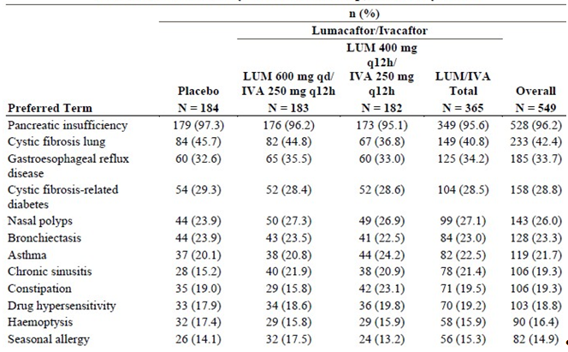

76.3% had pseudomonas, of these 51.9% were mucoid; 41.2% had staphylococcus aureus, 42.8% had positive cultures for aspergillus.

###### Primary efficacy endpoints

Table 16 Mixed effects model for repeated measures (MMRM) analysis of average absolute change from baseline in ppFEV1 at Week 16 and at Week 24, full analysis set.

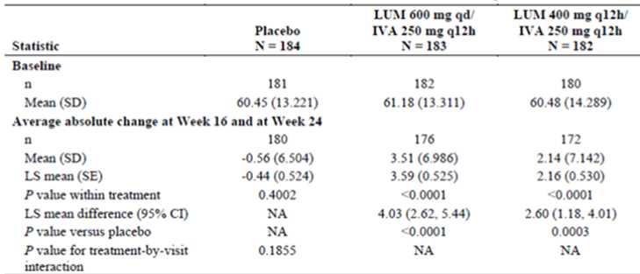

There was an improvement in ppFEV1 in both the 600 mg QD (3.5%) and 400 mg BD (2.14%) treatment groups. (These differences compare to an improvement of 10 to 12% seen with IVA in gating mutations) Treatment differences were noticed as early as Day 15.

The proportion of subjects with a 5% absolute increase in FEV1 was 15.2% placebo, 37.7% LUM 600 mg QD/250 IVA and 23.6% LUM 400 mg BD/250 IVA.

###### Secondary efficacy endpoints

Table 17. MMRM analysis of average relative change from baseline in ppFEV1 at Week 16 and at Week 24 full analysis set

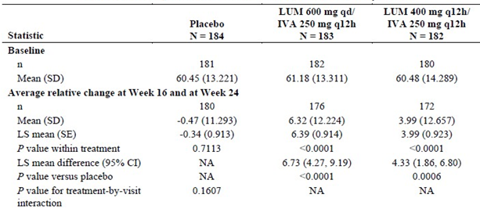

There was a non-statistically significant trend an improvement in BMI at Week 24 in the active treatment groups: the placebo 0.19 kg/m2, LUM 600 mg QD/IVA 250 mg BD 0.34 kg/m2, LUM 400 mg BD/IVA 250 mg BD 0.32 kg/m2 (This compares with 0.9 kg/m2 change with IVA in gating mutations).

There was a non-statistically significant greater improvement in the CFQ-R in the active compared to the placebo groups: placebo 1.1point, LUM 600 mg QD/IVA 250 mg BD 4.98 points, LUM 400 mg BD/IVA 250 mg BD 2.6 points.

Table 18. Response analysis of average relative change from baseline in ppFEV1 at Week 16 and at Week 24 Full analysis set

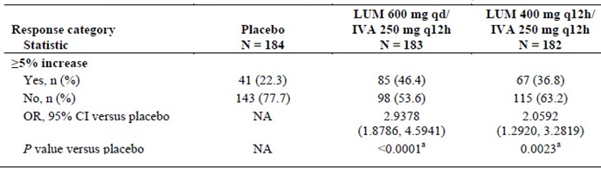

Table 19. Number of pulmonary exacerbations through Week 24 Full analysis set

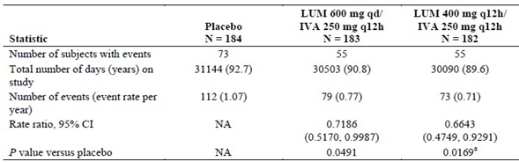

There was a significant improvement in the number of exacerbations.

Table 20. Number of exacerbations in each treatment group

|  |  |  |  |
| --- | --- | --- | --- |
|  | Placebo N=184 | LUM 600 mg QD/IVA 250 mg BD N=183 | LUM 400 mg BD/IVA 250 mg BD N=182 |
| Having at least one exacerbation | 39.7% | 30.1% | 30.2% |
| Exacerbations needing hospitalisation | 39 | 21 | 17 |

##### Study VX12-809-104

###### Study design

As per Study103.

###### Baseline characteristics

47.9% were male. Median age 24 years, range 12 to 55 years; 23.6% 12 to 18 years.

Median weight 57 kg, range 27 to 105 kg. BMI 21 kg/m2, range 14 to 35.1. BMI-z -0.4230 (‑2.857-1.470).

ppFEV1; 60.5 SD 14. 8.2% < 40; 63%40 to 70, 26.7% 70 to 90.

FEV1; 2.138L SD 0.66; FVC 3.182L SD 0.9123.

80.3% receiving dornase. 66.4% receiving inhaled antibiotics. 91.6% receiving inhaled bronchodilators. 59.9% receiving inhaled hypertonic saline. 56.2% receiving inhaled corticosteroids. 71.9% positive pseudomonas aeruginosa.

Table 21. Medical history with an incidence of at least 15% of subjects by preferred term in any treatment group, full analysis set

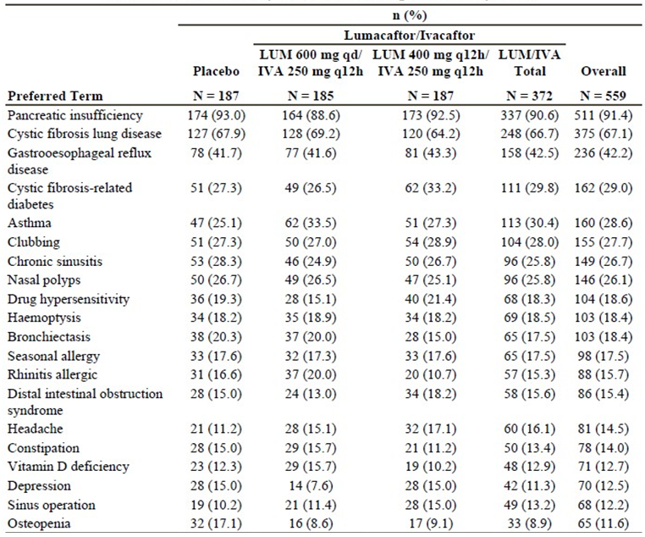

###### Primary efficacy endpoint

There was a statistically significant improvement in absolute change in ppFEV1 in both treatment arms, beginning at Week 15. A 5% improvement in ppFEV1 was seen in 12.8% of the placebo group, 30.8% of the LUM 600 mg QD/IVA 250 mg BD group and 29.9% of the LUM 400 mg BD/IVA 250 mg BD groups.

Table 22. MMRM analysis of average absolute change from baseline in ppFEV1 at Week 16 and at Week 24, full analysis set

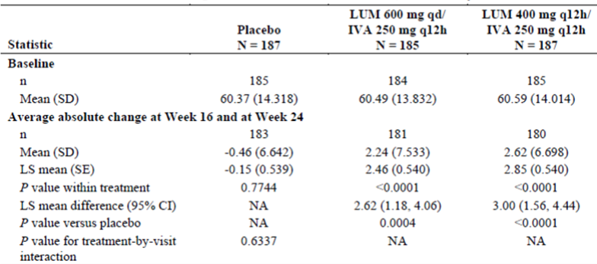

###### Secondary endpoints

Table 23. MMRM analysis of average relative change from baseline in ppFEV1 at Week 16 and at Week 24, full analysis set

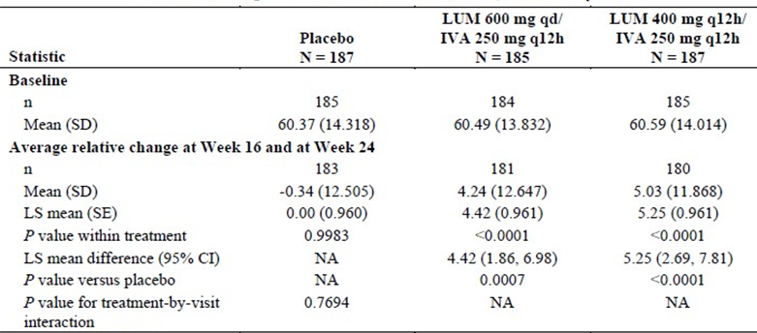

Figure 4. Absolute change from baseline in BMI (kg/m2) at each visit full analysis set

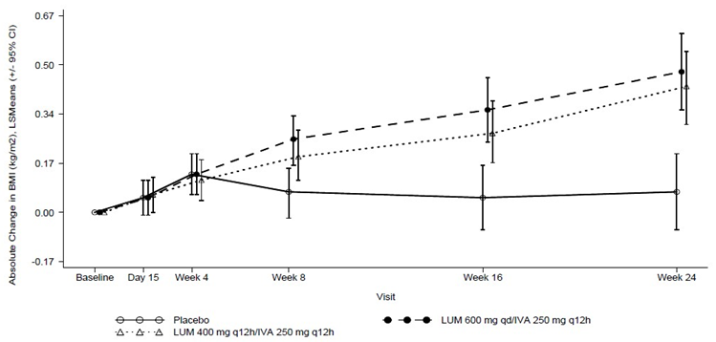

There was a significant improvement in BMI in both IVA/LUM treatment arms.

There was a significant within group change in CFQ-R in all groups, which was numerically but not statistically greater in the treatment than the placebo groups (2.81 placebo; 5.02 600 mg LUM QD/IVA 250 mg; 5.66 400 mg LUM BD/IVA 250 mg BD).

There were significantly more patients in the treatment groups who experienced a ≥ 5% average relative change from baseline in ppFEV1 (placebo 22.5%, 600 mg LUM 45.9%, 400 mg LUM 41.2%).

Table 24. Number of pulmonary exacerbations through Week 24, full analysis set

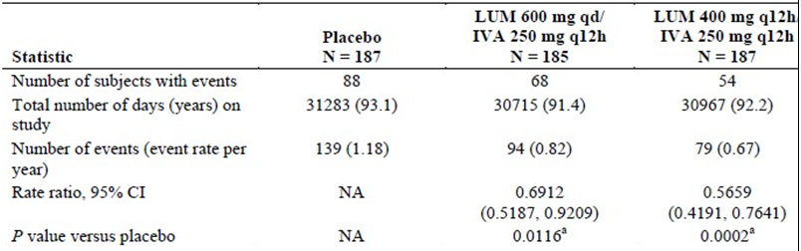

The number of patients who had at least one exacerbation was greater in the placebo (47.1%) than the treatment arms (36.8% 600 mg LUM, 28.9% 400 mg LUM). The number of pulmonary exacerbations requiring hospitalisation was also greater in the placebo arm, 28, rate ratio (RR) = 1; 600 mg LUM 32, RR 0.648; 400 mg LUM 20, RR 0.3896.

##### Study VX12-809-105

###### Study design

Phase III, parallel group, multicentre rollover subject from studies 103, 104, and 102, Cohort 4.

Part A: Studied patients homozygous for F508 from studies 103 or 104. Patients were randomised and blinded to LUM 600 mg QD/ IVA 250 mg BD or LUM 400 mg BD/ IVA 250 mg BD.

Part B: Studied patients heterozygous to F508-del who participated in cohort 4 of 102. These patients were invited to enter an open label study and receive LUM 400 mg BD/IVA 250 mg BD.

###### Primary objective

To assess long term safety and tolerability of LUM/IVA.

Efficacy endpoints included spirometry, height, weight, CFQ-R and exacerbations.

Figure 5. Study flow chart

Figure 5. Study flow chart
PART A; 1031 subjects form study 103 and 104 of which 
335 continued on 600 mg QD LUM/250 mg IVA; 341 continued on 400 mg BD LUM/ 250 mg BD IVA; 179 went from Placebo onto 600 mg LUM/ 250 mg BD IVA; 176 went from placebo onto 400 mg LUM/ 250 IVA BD ; 19 were observed. Of these > 89% completed week 16 visit rate of treatment discontiunation
PART B: CF heterozygotes 126 randomised; 115 continued of these 55 on LUM400 mg/ IVA 250 mg bd cont and 60 on placebo LUM/IVA

###### Results

Part A efficacy

Table 25. MMRM analysis of relative change form baseline in ppFEV1 at each visit Part A cumulative period, full analysis set

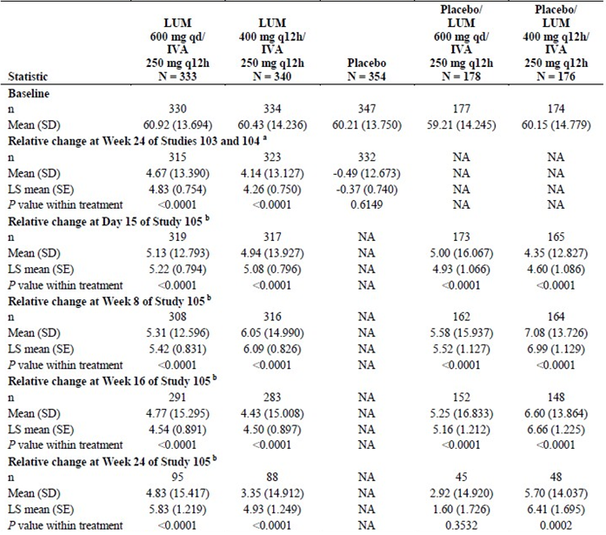

Note; baseline was start of Study 103 or 104.

In those previously treated with Orkambi, FEV1 remained stable but did not improve further after an additional 24 weeks of treatment. There was no placebo arm for this subsequent 24 weeks follow up, however it is noted that in the first 24 weeks the lung function in the placebo arm deteriorated by 0.5%.

BMI continued to increase in the second 24 weeks of treatment.

Figure 6. Absolute change form baseline in BMI at each visit, Part A cumulative period, full analysis set.

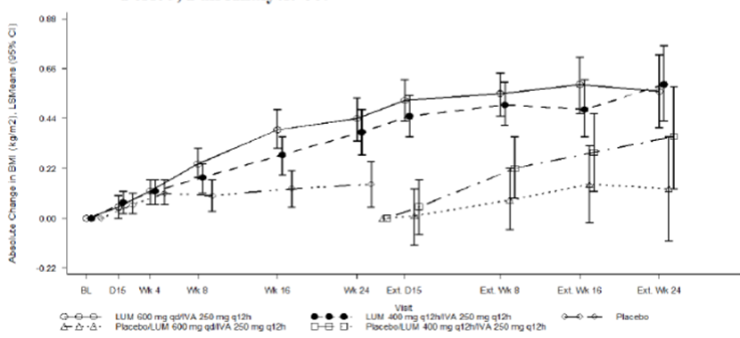

Table 26 Exacerbation data for the placebo group in studies 103/104 and all treatment groups I study 105.

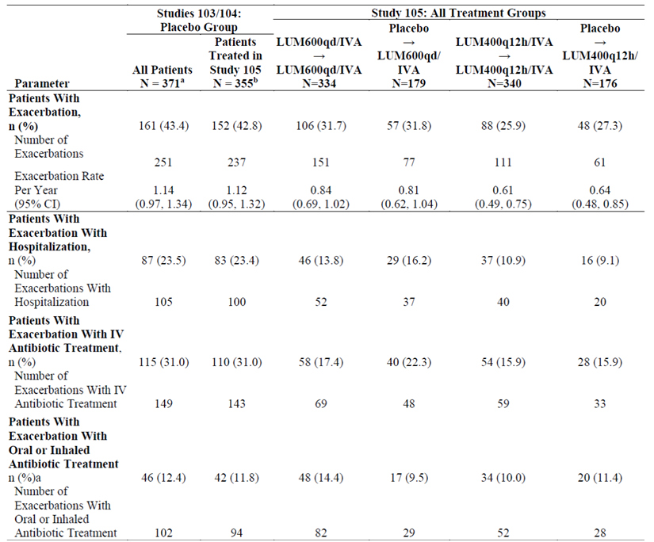

The improvements in lung function were most noticeable in those who were deteriorating at < 5% per annual at baseline.

Table 27. Study 105 efficacy results: subgroup analysis of patients with and without rapidly progressive pulmonary disease, patients who were in placebo groups in studies 103/104 and in LUM400q12h/IVA group in study 105

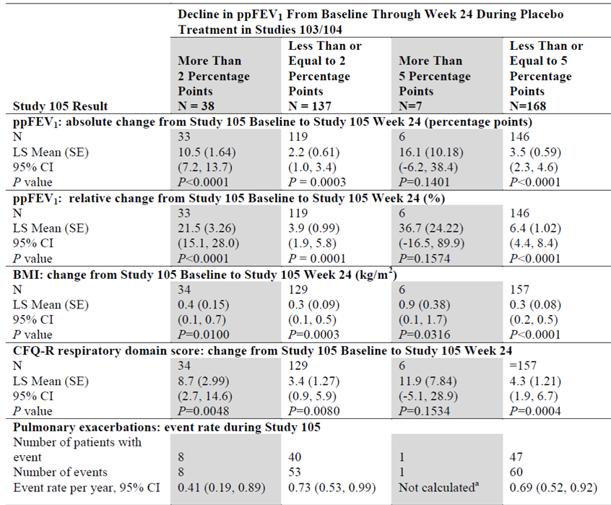

Figure 7. Kaplan-Meier Estimate of time to first pulmonary exacerbation during 24 week treatment period in study 105 and 24 week treatment period for placebo group in studies 103/104

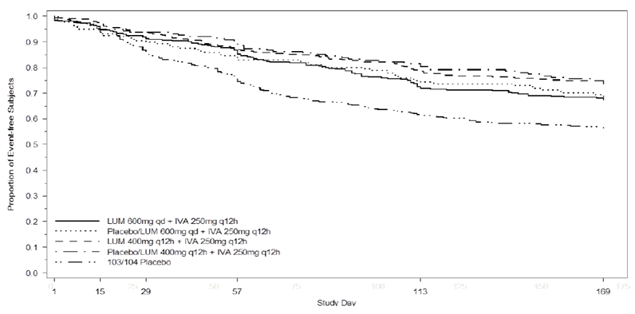

Table 28. Benefits of LUM/IVA and currently used treatment options on ppFEV1 and measures of nutritional status

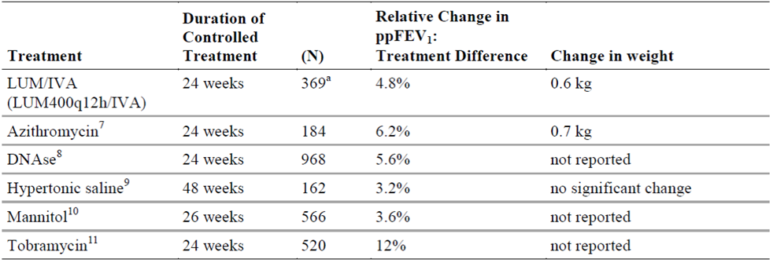

a pooled full analysis set (FAS) set for studies 103/104 included 369 patients in the LUM400q12h/IVA group

Table 29. Benefits of LUM/IVA and concurrently used maintenance treatments on pulmonary exacerbations

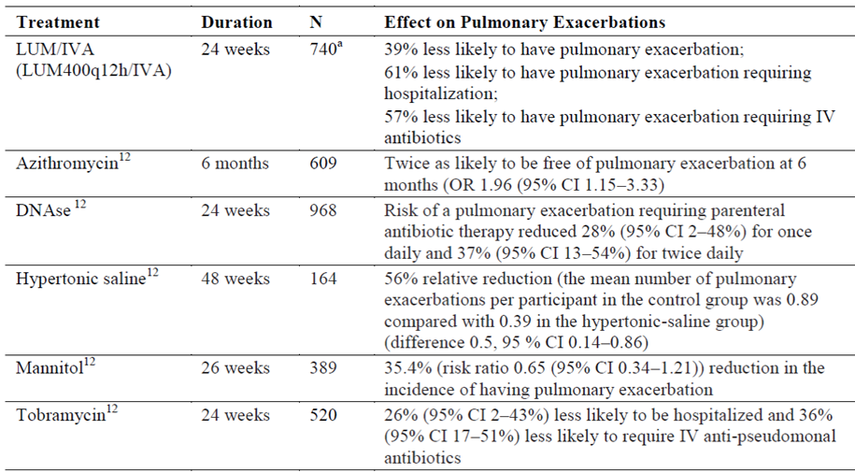

#### Rationale for the proposed dose

The sponsor has proposed a dose of LUM 400 mg/IVA 250 mg BD based on greater reduction in pulmonary exacerbations with that dose with no statistical benefits of the alternative regime on other primary or secondary endpoints, numerically greater improvements in absolute and relative ppFEV1, BMI, BMI z-score, weight, CFQ-R, and pulmonary exacerbations in patients treated with placebo/LUM 400 mg BD in study 105.

#### Safety

Overall, 1,839 subjects received at least 1 dose of LUM and 1,615 received LUM in combination with IVA.

In studies 103/104 a higher number of patients in the treatment groups discontinued (6.1%) than in the placebo groups (2.4%).

##### Adverse Events

In the pivotal studies, the incidence of AE was similar in the placebo and LUM/IVA groups. The most common AE (at least 15% incidence in any treatment group) were infective exacerbation of CF, cough, headache, increased sputum. AE with higher incidence in the LUM/IVA groups were dyspnoea (14 versus 7.8%), respiratory abnormal (9.8 versus 5.9%), flatulence (6 versus 3%) and rash (5.6 versus 1.9%), also diarrhoea, nausea, oropharyngeal pain, URTI, rhinitis, vomiting. The majority of AE were mild or moderate. The onset of AE was generally in the first 8 weeks.

In study 105, the incidence and pattern of AE was similar to that of the pivotal studies, except that there was a lower frequency of AE in subjects who received active treatment in studies 103/104. Of note there was I patient in the LUM 600 mg QD/IVA 250 mg BD who developed haemolytic anaemia.

In healthy subjects during the phase 1 studies, a similar proportion of subjects (54.9%) developed AE to the placebo group (57.9%). Diarrhoea (17.3 versus 6.4%) and cough (6.9 versus 0%) were more common in the IVA/LUM groups.

###### Treatment Emergent Adverse Events

In the pivotal studies, the incidence of TEAE was higher in the LUM/IVA groups (48%) compared to the placebo groups (34.9%).

###### Deaths and Serious Adverse Events

There were no deaths in any Phase III trials. The incidence of SAE was lower in the LUM/IVA treatment group (20%) compared to placebo (28.6%). Most SAE were related to CF for example infective exacerbation, haemoptysis, distal intestinal obstruction.

In the long term study 105, there was one death of a 24 year old female due to respiratory failure. A total of 168 (16.4%) had at least one SAE. The incidence was similar across treatment groups. The most common SAE were infective exacerbation of CF, haemoptysis, distal intestinal obstruction, small intestinal obstruction, pneumonia, CF related diabetes.

In the Phase I pooled studies, 1 subject in the LUM group developed rhabdomyolysis.

###### Discontinuation due to adverse events

A higher percentage of subjects discontinued in the total LUM/IVA group (4.2%) compared to the placebo group (1.6%). The most common AE leading to treatment discontinuation were haemoptysis and increased CK.

In the long term study 105, the most common AE leading to treatment discontinuation were dyspnoea, respiratory abnormal, infective exacerbation, increased creatine kinase (CK).

###### Laboratory tests

The incidences of elevated transaminases were similar in the treatment and placebo groups. The transaminases improved on ceasing the drug.

The incidence of blood CK increase was similar in the LUM/IVA (5.6%) and placebo (5.45%) groups. However the incidence was higher in the 400 mg BD than 600 mg QD groups. The incidence of myalgia, fatigue was similar in subjects who had SAE or AE leading to discontinuations and subjects with non-serious AE in the placebo and LUM/IVA groups. In study 105, there were 4 discontinuations due to CK increases. There were 11 patients who discontinued due to a high CK, the magnitude of which was generally < 1000 IU/L (however high values were also observed in placebo patients and treated patients who did not discontinue. In patients who discontinued LUM/IVA after a CK rise, values returned to normal in 7 and remained elevated in 4. (CPK elevation has been reported in around 2.5% of the general population). It is not clear of the treatment discontinuations due to high CK were due to more frequent monitoring in the clinical trial or a true safety signal.

In healthy subjects, LUM monotherapy was associated with a decline in ppFEV1 of 6% which was evident 4 hours after the study dose and persisted, with subtle improvements, to Day 7. As the dose of LUM increased, there was an increase in respiratory AE including throat tightness, dyspnoea, respiratory abnormal.

###### Menstrual abnormalities

In the pooled placebo controlled Phase III studies, the incidence of menstrual abnormalities was higher in the LUM/IVA group (9.9%) compared to the placebo group (1.7%). The association was higher in those receiving hormonal contraception (25%). In study 105, of the 503 female subjects 144 were using hormonal contraceptives. The incidence of menstrual abnormalities in female subjects was 8.3% in subjects using hormonal contraceptives and 1.7% in those not using hormonal contraceptives. The effect of LUM/IVA on the PK of hormonal contraceptive is not known. However, as LUM is a CYP3A inducer, it could reduce exposure to oestrogen.

###### Use in pregnancy and lactation

The effect of LUM/IVA on pregnancy in humans has not been studied. 5 pregnancies occurred during study 103/105 of these 1 was electively terminated and 4 continue. Results from embryo-foetal development reproductive toxicology studies in pregnant rats and rabbits indicated that LUM is not a teratogen.

### Risk management plan

Routine pharmacovigilance is proposed for all the safety concerns. Additional pharmacovigilance activities are proposed for all the safety concerns except missing information ‘Effect on P-gp substrates’ for which no additional pharmacovigilance is proposed. The proposed additional pharmacovigilance activities are as follows:

* Study 108 a planned post-authorisation safety study to monitor the utilisation patterns and long-term effects of Orkambi in patients with CF in the EU and the USA
* Study 770-115 an ongoing ocular safety study in paediatric patients 11 years of age or younger
* Study 105 an ongoing Phase III rollover study from previous studies to evaluate the safety and efficacy of long-term treatment in patients homozygous or heterozygous for the F508del-CFTR mutation
* Study 106 an ongoing Phase IIIb open label study to evaluate the effects of Orkambi in patients 12 years and older with CF and advanced lung disease.

From EU 180day response on major objection:

*In addition, Vertex is planning a Post Authorisation Safety Study (PASS). A 5 year observational study that includes evaluation of long term safety outcomes and long term CF disease progression, from data on LUM/IVA treatment in a CF registry setting. The PASS will evaluate CF disease progression in patients who are 12 years and older, homozygous for F508del and treated with LUM/IVA, relative to disease progression in a comparator cohort of patients aged 12 years and older who are heterozygous for F508del and with a Class I/II mutation in the second allele and who have never received LUM/IVA (Orkambi) or ivacaftor monotherapy (Kalydeco). Disease progression will be measured by changes over time in ppFEV1 and other clinical parameters (body mass index (BMI), CF related diabetes (CFRD) and distal intestinal obstruction syndrome (DIOS)). Please see the EU-RMP for further information on the context of the PASS and Module 5.3.6 for the current clinical study protocol (VX14-809-108).*

The sponsor has proposed routine risk minimization activities for all the safety concerns in the EU-RMP. No additional risk minimization is considered necessary by the sponsor. Table 30 is an updated summary of safety concerns from the EU RMP dated 24 September 2015 with ASA dated 20 October 2015.

Table 30. Summary of safety concerns from the EU RMP dated 24 September 2015 with ASA dated 20 October 2015.

|  |  |
| --- | --- |
| Updated Summary of safety concerns- from EU-RMP dated 24/9/2015 with ASA 2.0 dated 20 October 2015 | |
| Important Identified risks | Respiratory events |
| Potential Risks | Hepatobiliary events  Concomitant use of LUM/IVA with strong CYP3A inhibitors or inducers  Concomitant use of LUM/IVA with sensitive CYP3A substrates and CYP3A substrates with narrow therapeutic index  Cataracts  Cardiac arrhythmias  Off label use in children less than 12 years of age or in patients not homozygous for F508del-CFTR |
| Missing Information | Use in pregnant and lactating women  Patients with ppFEV1 < 40%  Long term safety  Safety in patients with cardiac disease  Use in patients following organ transplant  Effect on P-gp substrates  Potential off target activity of M6-ivacaftor  Interaction potential between transporters and LUM and/or IVA  Environmental risk |

### Risk-benefit analysis

#### Delegate’s considerations

The sponsor has demonstrated benefits of this FDC of IVA/LUM in patients homozygous to F508-del for the following outcomes:

1. FEV1 an improvement of around 6% after 24 weeks which is maintained up to 2 years.
2. BMI an improvement of around 0.5 which increases with long term use.
3. Risk of pulmonary exacerbations a significant reduction.

The benefits in FEV1 and BMI are not as great as those seen with IVA for gating mutations; however the benefits in terms of admissions for exacerbations are similar. There was also a numerical but not statistically significant improvement in the quality of life scores. The benefits observed were the same across subgroups of age, sex, disease severity.

The tablets were generally well tolerated. The main AEs reported were those commonly observed in patients with CF. Of note in healthy subjects an increased risk of dyspnoea and diarrhoea was observed.

The unknown/uncertain aspects of this application include

1. Long term efficacy and safety.
2. Impact on the multiple possible drug interactions.
3. Use in the context of organ transplantation.
4. Use in pregnancy.

These issues are adequately addressed in the PI and RMP.

##### Summary of issues

* Patients with the F508delta mutation represent the majority of patients with CF in Australia. Patients with the F508delta mutation have a severe phenotype. Although treatment for CF has improved with time, outcome remains poor
* Pivotal studies showed small improvements in the primary efficacy endpoints FEV1 in the first 15 days. These were maintained after 6 months but there was no subsequent improvement
* The most significant improvement was in the reduced rate of exacerbations. Other improvements were seen in BMI, relative change in FEV1, CFQ-R
* There were minimal adverse effects. In healthy people respiratory symptoms and diarrhoea were more common than placebo. There was increased menstrual bleeding in women taking oral contraceptive products.
* Potential for drug interactions:
  + In vivo and vitro studies have demonstrated that LUM is an inducer of CYP3A whereas IVA is a weak inhibitor
  + IVA is a substrate for CYP3A
  + IVA and LUM are P-gp inhibitors

Unknown:

* Long term efficacy and safety
* Impact on survival, lung transplant
* Use in children < 12 years was not addressed in this submission; studies in this population are ongoing.

#### Proposed action

The Delegate had no reason to say, at this time, that the application for Orkambi should not be approved for registration.

#### Request for ACPM advice

The committee is requested to provide advice on the following specific issues:

1. The clinical significance of the small improvement in FEV1 as a primary endpoint, and the validity of putting greater emphasis on secondary endpoints
2. The likelihood of off label use in younger children

The committee is (also) requested to provide advice on any other issues that it thinks may be relevant to a decision on whether or not to approve this application.

#### Response from sponsor

Prior to the ACPM, Vertex would like to re-emphasise the clinically significant benefit of Orkambi, based on the data from the two large pivotal Phase III clinical studies conducted in patients with CF aged 12 years and older who are homozygous for the F508 del mutation in the CFTR gene.

The mechanism of action of Orkambi is a key differentiation from currently used treatment options, which target one or more of the downstream consequences of CF (for example, infection in the lung, thickened mucous). Orkambi directly targets the underlying cause of CF (by increasing CFTR function), and thus acts at an earlier stage in the disease process and is a systemic therapy with potential for a broader array of benefits.

The benefits of Orkambi treatment were in addition to any benefits patients were receiving from their standard CF medications, which they continued receiving during lumacaftor /ivacaftor (LUM/IVA) treatment during the Phase III trials. Given that CF is a progressive, lethal disease, maximizing treatment benefits is particularly important.

No PSUR is yet available for this product. However, the sponsor would like to confirm that the small amount of post-marketing data to this point has not revealed any new safety concerns over and above what is included in the current draft PI.

Vertex Pharmaceuticals (Australia) Pty Ltd Has accepted the TGA’s Requirement to use the term ‘Orkambi 200/125’ throughout the PI/CMI, However as shown in the EU SmPC And USPI, the global trade name registered by Vertex Pharmaceuticals Worldwide is simply ‘Orkambi’.

Vertex notes the Delegate’s comment on that BMI information should be included in the PI for Trial 105.

#### Advisory committee considerations

The Advisory Committee on Prescription Medicines (ACPM), having considered the evaluations and the Delegate’s overview, as well as the sponsor’s response to these documents, advised the following:

The ACPM, taking into account the submitted evidence of efficacy, safety and quality, agreed with the Delegate and considered Orkambi 200/125 tablet containing lumacaftor 200 mg/ivacaftor 125 mg to have an overall positive benefit-risk profile for the indication:

*Orkambi is indicated for the treatment of cystic fibrosis (CF) in patients 12 years and older who are homozygous for the F508-del mutation in the CFTR gene.*

In making this recommendation the ACPM;

* noted neither active ingredient shows efficacy in this patient population on its own
* noted that the dose of ivacaftor recommended and use in the trial is higher than that recommended in other indications
* noted that Orkambi is recommended to be added to standard medications.

##### Proposed conditions of registration

The ACPM agreed with the Delegate on the proposed conditions of registration.

##### Proposed PI and CMI amendments

The ACPM agreed with the Delegate to the proposed amendments to the PI and CMI and specifically advised on the inclusion of the following:

* the statement concerning pregnancy (was considered inadequate).[30]

##### Specific advice

The ACPM advised the following in response to the Delegate’s specific questions on this submission:

1. *The clinical significance of the small improvement in FEV1 as a primary endpoint, and the validity of putting greater emphasis on secondary endpoints.*

The ACPM noted both pivotal studies met the primary endpoint and secondary lung function end points were also met. However, the Quality of Life (QoL) endpoint was not met and the BMI endpoint was not met in Study 103. Importantly, the exacerbation endpoint was met in both studies. The demonstrated benefit is modest at best, and given the lack of QoL improvement demonstrated, may not be clinically significant in some patients.

It is unclear if the modest benefit seen in the trials could be additive with other medications.

1. *The likelihood of off label use in younger children.*

A principle of CF management is early intervention which was a driving factor for newborn screening (NBS). Some clinicians may believe that greater long term benefit will derive from early use before patients develop colonisation with resistant organisms and irreversible structural changes. However, with modern CF care most children have normal respiratory function at age 12 and there unlikely to be little pressure for off label use.

The ACPM advised that implementation by the sponsor of the recommendations outlined above to the satisfaction of the TGA, in addition to the evidence of efficacy and safety provided would support the safe and effective use of this product.

### Outcome

Based on a review of quality, safety and efficacy, TGA approved the registration of Orkambi 200/125 lumacaftor/ ivacaftor 200 mg/125 mg film coated for oral administration, indicated for:

*The treatment of cystic fibrosis (CF) in patients age 12 years and older who are homozygous for the F508del mutation in the CFTR gene.*

#### Specific conditions of registration applying to these goods

1. The Orkambi (lumacaftor/ivacaftor) EU Risk Management Plan (RMP), version 1.5, dated 24 September 2015 (data lock point 21 July 2014) with Australian Specific Annex, version 2.0 dated 20 October 2015, and any subsequent revisions, as agreed with the TGA will be implemented in Australia.
2. That the final results of the long term efficacy and safety trials (including 108, 105, 106 and the PASS study), be submitted as a Category 1 application.

## Attachment 1. Product Information

The PI for Orkambi 200/125 approved with the submission which is described in this AusPAR is at Attachment 1. For the most recent PI, please refer to the TGA website at <<https://www.tga.gov.au/product-information-pi>>.

## Attachment 2. Extract from the Clinical Evaluation Report

|  |
| --- |
| Therapeutic Goods Administration |
| PO Box 100 Woden ACT 2606 Australia  Email: [info@tga.gov.au](mailto:info@tga.gov.au) Phone: 1800 020 653 Fax: 02 6232 8605  [**https://www.tga.gov.au**](https://www.tga.gov.au) |

1. Lukacs G L et al. The F508 Mutation Decreases the Stability of Cystic Fibrosis Transmembrane Conductance Regulator in the Plasma Membrane. Determination of Functional Half-Lives on Transfected Cells. J Biol Chem. 1993;268: 21592-21598.
2. Rowe S M et al Cystic fibrosis. *NEJM*. 2005; 352: 1992-2001.
3. ICH M3 (R2) Non-clinical safety studies for the conduct of human clinical trial and marketing authorisation for pharmaceuticals
4. CPMP/EWP/560/95/Rev. 1 Corr. 2 EMA Guideline on the Investigation of Drug Interactions.
5. CPMP/SWP/1042/99 Rev 1 Corr ICH guideline M3(R2) on non-clinical safety studies for the conduct of human clinical trials and marketing authorisation for pharmaceuticals; EMA guideline on repeated dose toxicity.
6. Field M and Semrad C E. Toxigenic diarrhoeas, congenital diarrhoeas, and cystic fibrosis:disorders of intestinal ion transport. *Annual Rev. Physiol*. 1993; 55: 631–655.
7. Hansen M.B. and Skadhauge E. New aspects of the pathophysiology and treatment of secretory diarrhoea. *Physiol. Res*. 1995; 44: 61–78
8. Moon C et al. Drug-induced secretory diarrhoea: A role for CFTR. *Pharmacol. Res.* 2015; 102:107–112.
9. Kuver R et al. Constitutive mucin secretion linked to CFTR expression*. Biochem. Biophys. Res. Commun*. 1994; 203: 1457–1462
10. CPMP/ICH/140/95 (ICH S1A); ICH Topic S 1 A Step 5. Note for Guidance on the need for carcinogenicity studies of pharmaceuticals
11. CPMP/SWP/2877/00 Committee for Proprietary Medicinal Products. Note for Guidance on carcinogenic potential.
12. Based on animal AUC0–24 h values of 579 and 984 µg∙h/mL (for males and females, respectively),  
    derived from Day 90 values in Study VX-809-TX-012; *cf*. a human AUC of 33.3 µg∙h/mL
13. Based on an animal AUC0–24 h value of 4240 µg∙h/mL in the study on GD17
14. Based on an animal AUC0–24 h value of 3360 µg∙h/mL in the study on GD17
15. Pregnancy category B3 is defined as Drugs which have been taken by only a limited number of pregnant women and women of childbearing age, without an increase in the frequency of malformation or other direct or indirect harmful effects on the human fetus having been observed. Studies in animals have shown evidence of an increased occurrence of fetal damage, the significance of which is considered uncertain in humans.
16. EMEA/CHMP/SWP/169215/2005. Guideline on the need for non-clinical testing in juvenile animals on human pharmaceuticals for paediatric indications.
17. Rommens JM et al. Identification of the cystic fibrosis gene: chromosome walking and jumping. *Science.* 1989; 245:1059-1065.
18. Johansen, HK et al. Severity of cystic fibrosis in patients homozygous and heterozygous for delta F508 mutation*. Lancet*. 1991;337:631-634.
19. Kerem, E et al. The relation between genotype and phenotype in cystic fibrosis-an analysis of the most common mutation (delta F508). *N Engl J Med*. 1990; 323:1517-1522
20. Mckone EF et al. *CFTR* genotype as a predictor of prognosis in cystic fibrosis. *Chest*. 2006;130:1441-1447.
21. Kerem E and Kerem B. Genotype-phenotype correlations in cystic fibrosis*. Pediatr Pulmonol.* 1996;22:387-395.
22. Guidance for development of COPD drugs, 2007
23. Illeck B et al. Defective function of the cystic fibrosis-causing missense mutation G551D is recovered by genistein. *Am J Physiol*. 1999;277:C833-839.
24. Regulatory advice on the clinical development plan and the designs for Studies 103 and 104 was sought from regulatory authorities in the US and EU.
25. The patient reporting SAE of hepatic encephalopathy (mentioned above) was a 25 year old male with a CF related liver cirrhosis, portal hypertension, splenomegaly, and thrombocytopenia. After 6 days of lumacaftor plus ivacaftor combination product treatment the patient presented to ER with disorientation. Laboratory evaluation showed elevated transaminases and increased ammonia level, but bilirubin level was not reported. The patients improved over approximately a week on in hospital treatment. Based on the available information, causality to treatment cannot be assessed, but it is possible that the treatment could have contributed to hepatic decompensation.
26. FDA approves new treatment for cystic fibrosis <http://www.fda.gov/NewsEvents/Newsroom/PressAnnouncements/ucm453565.htm>
27. Marketing Authorization Application
28. MedDRA = Medical Dictionary for Regulatory Activities
29. assessed as the average treatment effect at Week 16 and at Week 24
30. The statement regarding pregnancy was revised in line with the recommendations of the nonclinical evaluator and the Delegate prior to registration.