|  |
| --- |
| **June 2014** |

|  |
| --- |
| Australian Public Assessment Report for lurasidone hydrochloride |
| Proprietary Product Name: Latuda |
| Sponsor: Commercial Eyes Pty Ltd |

About the Therapeutic Goods Administration (TGA)

* The Therapeutic Goods Administration (TGA) is part of the Australian Government Department of Health and is responsible for regulating medicines and medical devices.
* The TGA administers the *Therapeutic Goods Act 1989* (the Act), applying a risk management approach designed to ensure therapeutic goods supplied in Australia meet acceptable standards of quality, safety and efficacy (performance), when necessary.
* The work of the TGA is based on applying scientific and clinical expertise to decision-making, to ensure that the benefits to consumers outweigh any risks associated with the use of medicines and medical devices.
* The TGA relies on the public, healthcare professionals and industry to report problems with medicines or medical devices. TGA investigates reports received by it to determine any necessary regulatory action.
* To report a problem with a medicine or medical device, please see the information on the TGA website <<http://www.tga.gov.au>>.

About AusPARs

* An Australian Public Assessment Record (AusPAR) provides information about the evaluation of a prescription medicine and the considerations that led the TGA to approve or not approve a prescription medicine submission.
* AusPARs are prepared and published by the TGA.
* An AusPAR is prepared for submissions that relate to new chemical entities, generic medicines, major variations, and extensions of indications.
* An AusPAR is a static document, in that it will provide information that relates to a submission at a particular point in time.
* A new AusPAR will be developed to reflect changes to indications and/or major variations to a prescription medicine subject to evaluation by the TGA.

Copyright

© Commonwealth of Australia 2014  
This work is copyright. You may reproduce the whole or part of this work in unaltered form for your own personal use or, if you are part of an organisation, for internal use within your organisation, but only if you or your organisation do not use the reproduction for any commercial purpose and retain this copyright notice and all disclaimer notices as part of that reproduction. Apart from rights to use as permitted by the *Copyright Act 1968* or allowed by this copyright notice, all other rights are reserved and you are not allowed to reproduce the whole or any part of this work in any way (electronic or otherwise) without first being given specific written permission from the Commonwealth to do so. Requests and inquiries concerning reproduction and rights are to be sent to the TGA Copyright Officer, Therapeutic Goods Administration, PO Box 100, Woden ACT 2606 or emailed to <[tga.copyright@tga.gov.au](mailto:tga.copyright@tga.gov.au)>.

Contents

List of abbreviations 5

I. Introduction to product submission 9

Submission details 9

Product background 9

Regulatory status 10

Product Information 10

II. Quality findings 11

Introduction 11

Drug substance (active Ingredient) 11

Drug product 12

Advisory committee considerations 13

Quality summary and conclusions 15

III. Nonclinical findings 15

Introduction 15

Pharmacology 16

Pharmacokinetics 21

Toxicology 28

Nonclinical summary and conclusions 42

IV. Clinical findings 44

Introduction 45

Pharmacokinetics 46

Pharmacodynamics 48

Dosage selection for the pivotal studies 49

Efficacy 50

Safety 53

First round benefit-risk assessment 59

First round recommendation regarding authorisation 64

Clinical questions 64

Second round evaluation of clinical data in response to questions 65

Second round benefit-risk assessment 67

Second round recommendation regarding authorisation 68

V. Pharmacovigilance findings 68

Risk management plan 68

VI. Overall conclusion and risk/benefit assessment 85

Quality 85

Nonclinical 85

Clinical 86

Risk management plan 90

Risk-benefit analysis 90

Outcome 94

Attachment 1. Product Information 94

Attachment 2. Extract from the Clinical Evaluation Report 95

## List of abbreviations

|  |  |
| --- | --- |
| Abbreviation | Meaning |
| 5-HT | 5-hydroxytryptamine (serotonin) |
| ACPM | Advisory Committee on Prescription Medicines |
| ACSOM | Advisory Committee on the Safety of Medicines |
| ACTH | adrenocorticotropic hormone |
| AE | adverse event |
| AIMS | Abnormal Involuntary Movement Scale |
| ANCOVA | analysis of covariance |
| APD50 | action potential duration at 50% repolarisation |
| APD90 | action potential duration at 90% repolarisation |
| ASA | Australian Specific Annex |
| AUC | area under the plasma concentration-time curve |
| AUCτ | area under the plasma concentration-time curve over a dosing interval for steady state |
| AUCt1-t2 | area under the plasma concentration-time curve within time span t1 to t2 |
| BAS | Barnes Akathisia Scale |
| BMD | bone mineral density |
| BMI | body mass index |
| BPRS | Brief Psychiatric Rating Scale |
| C-SSRS | Columbia Suicide Severity Rating Scale |
| Cmax | maximum plasma drug concentration |
| CHMP | Committee for Medicinal Products for Human Use |
| CGI-S | Clinical Global Impression – Severity of Illness |
| CMI | Consumer Medicines Information |
| CNS | central nervous system |
| CPRD | Clinical Practice Research Datalink |
| CVA | cerebrovascular accident |
| CYP | cytochrome P450 |
| D2 | dopamine 2 |
| DDI | drug-drug interaction |
| DEXA | dual energy X ray absorptiometry |
| DUS | Drug Utilisation Study |
| ED50 | effective dose 50% |
| EEG | electroencephalography |
| EMA | European Medicines Agency |
| EPS | extrapyramidal symptoms |
| ER | exposure ratio |
| FDA | US Food and Drug Administration |
| FGA | first generation antipsychotic |
| GCP | Good Clinical Practice |
| GD | gestational day |
| GLP | Good Laboratory Practice |
| HD | high dose |
| HR | hazard ratio |
| IC50 | inhibitory concentration 50% |
| ICH | International Conference on Harmonisation |
| ISAC | Independent Scientific Advisory Committee |
| ITT | Intent to Treat |
| IV | intravenous |
| Ki | inhibition constant |
| LD | low dose |
| LDH | lurasidone hydrochloride |
| LFT | liver function test |
| LOQ | limit of quantification |
| M1 | acetylcholine receptor |
| MACE | major cardiovascular events |
| MD | medium dose |
| MHRA | Medicines and Healthcare Products Regulatory Agency |
| MMRM | mixed model repeated measures |
| MRHD | maximum recommended human dose |
| NNT | number needed to treat |
| NOAEL | no observed adverse effect level |
| PANSS | Positive and Negative Syndrome Scale |
| PD | pharmacodynamics |
| PET | positron emission tomography |
| PI | Product Information |
| PIL | Patient Information Leaflet |
| PIP | Paediatric Investigation Plan |
| PK | pharmacokinetics |
| PO | per os |
| PSC | Pharmaceutical Subcommittee |
| QWBA | quantitative whole body autoradiography |
| QTcI | corrected QT intervals |
| SAE | serious adverse event |
| SAS | Simpson-Angus Scale |
| SGA | second generation antipsychotic |
| SmPC | Summary of Product Characteristics |
| SOC | System Organ Class |
| Tmax | time to reach maximum plasma drug concentration |
| TEAE | treatment emergent adverse event |
| TLC | thin layer chromatography |
| ULN | Upper Limit of Normal |
| UTS | up to standard |

## I. Introduction to product submission

### Submission details

|  |  |  |
| --- | --- | --- |
| *Type of submission:* | New chemical entity | |
| *Decision*: | Approved | |
| *Date of decision:* | 19 March 2014 | |
| *Active ingredient:* | Lurasidone hydrochloride |
| *Product name:* | Latuda |
| *Sponsor’s name and address:* | Commercial Eyes Pty Ltd Level 11, 500 Collins Street Melbourne VIC 3000 |
| *Dose form:* | Immediate release film coated tablets |
| *Strengths:* | 20 mg, 40 mg and 80 mg |
| *Container:* | Aluminium/Aluminium foil blister strips |
| *Pack sizes:* | 7, 10, 14, 28, 30, 56, 60, 90, 98 and 100 tablets |
| *Approved therapeutic use:* | Latuda is indicated for the treatment of adults with schizophrenia. |
| *Route of administration:* | Oral |
| *Dosage:* | Maximum recommended dose is 160 mg once daily. Latuda should be taken with food. |
| *ARTG number:* | 206654 (20 mg), 206650 (40 mg), 206651 (80 mg) |

### Product background

This AusPAR describes a submission by the sponsor, Commercial Eyes Pty Ltd, to register a new chemical entity, lurasidone hydrochloride (LDH), with the trade name Latuda. Lurasidone is an atypical antipsychotic belonging to the chemical class of benzisothiazole derivatives. It has antagonist activity on the dopamine 2 (D2) and serotonin (5-HT) 2A receptors. The proposed indication is:

*Latuda is indicated for the treatment of schizophrenia.*

Lurasidone was approved in the US in 2010 and in Canada in 2012. The approved indication in the US is *treatment of patients with schizophrenia*. The approved indication in Canada is *acute treatment of patients with schizophrenia*. In both countries there are boxed warnings relating to increased mortality in elderly patients with dementia related psychosis. In addition, due to the lack of long term controlled data in these submissions, the indication in these countries also includes that *the efficacy of Latuda for long term use, that is, for more than 6 weeks, has not been systematically evaluated in controlled studies*. In Switzerland, lurasidone is indicated for the *treatment of patients with schizophrenia*.

In July 2013, an extension to the indications for Lurasidone was approved by the US Food and Drug Administration (FDA) to include *treatment of depressive episodes associated with Bipolar I Disorder (Bipolar Depression) in adults when used alone or in combination with lithium or valproate*. An application for marketing authorisation was lodged with the European Medicines Agency (EMA) in September 2012.

As noted in *Therapeutic Guidelines: psychotropic* in patients with schizophrenia or related psychoses,[1] antipsychotic drugs diminish positive symptoms such as hallucinations, delusions and thought disorder. They also decrease symptoms of excitement, including hostility. They have limited impact on cognitive impairment, negative symptoms and mood disturbance, all of which require additional treatment. Antipsychotics are also important for preventing relapse.

A number of different terms are used to classify antipsychotic drugs. Amisulpride, aripiprazole, asenapine, clozapine, olanzapine, paliperidone, quetiapine, risperidone, sertindole and ziprasidone are referred to as second generation antipsychotics (SGAs), and chlorpromazine, flupenthixol, fluphenazine, haloperidol, pericyazine, trifluoperazine and zuclopenthixol are referred to as first generation antipsychotics (FGAs). This distinction originally related to the propensity of SGAs to cause fewer extrapyramidal adverse effects and other movement disorders than FGAs. However, this differentiation is now less important as the SGAs also have significant adverse effects (for example, cardiometabolic effects), and neither group acts as a single class of drugs. Therefore, the terminology now reflects, if anything, the length of time the drugs have been available.

### Regulatory status

The international regulatory status for Latuda at the time of the Australian submission to the TGA is shown in Table 1.

Table 1: International regulatory status for Latuda.

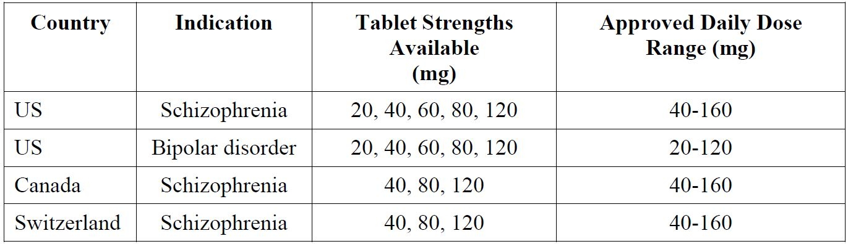

### Product Information

The approved Product Information (PI) current at the time this AusPAR was prepared can be found as Attachment 1. For the most recent PI, please refer to the TGA website at <<http://www.tga.gov.au/hp/information-medicines-pi.htm>>.

## II. Quality findings

### Introduction

The new chemical entity LDH binds with high affinity to D2 (Ki = 0.994 nM), 5-HT2A (Ki = 0.47 nM) receptors, and 5-HT7 receptors (Ki = 0.495 nM) and also with moderate affinity to alpha-2C adrenergic receptors (Ki = 10.8 nM). It is a partial agonist at 5-HT1A receptors (Ki = 6.38 nM). Its actions on histaminergic and muscarinic receptors are negligible.

The present submission seeks to register three strengths of immediate release film coated tablets containing LDH 20 mg, 40 mg and 80 mg under the trade name “Latuda”, to be administered once daily with food at a recommended starting dose of 40 mg, and a maximum dose of 160 mg. Latuda is indicated for the treatment of schizophrenia in adults. The safety and efficacy of Latuda in patients younger than 18 years has not been established.

### Drug substance (active Ingredient)

The substance (Figure 1), which is manufactured by chemical synthesis, has six chiral centres, the absolute configuration of which are defined by the chirality of two of the functionalised synthons, and were confirmed by single crystal X ray diffraction data.

Figure 1: Chemical structure of lurasidone.

Figure 1: Chemical structure of lurasidone.

Although only a single crystal form was described in the dossier and is produced under manufacturing conditions, (at least) four polymorphic forms of LDH are described in the literature (denoted Forms 1-4),[2] as well as an amorphous form.[3]

The Biopharmaceutics Classification System (BCS) Class does not appear to have been established. However, in response to a query from the FDA during its Question Based Clinical Pharmacology and Biopharmaceutics Review, the US sponsor replied that:

*BCS classification was not sought and determined. But lurasidone has very low aqueous solubility (water: 0.224 mg/mL) and the bioavailability is estimated to be about 9% to 19%, therefore Lurasidone is not expected to be BCS1.*

The pKa = 7.6, and LogP = 5.6 in octanol/water.

The solubility of LDH in water at ambient temperature is 0.224 mg/mL, with the pH of the saturated solution being 3.6. In buffers, the solubility at 20°C ± 1°C is shown in Table 2.

Table 2: Solubility of LDH and concentration multiples for four tablet strengths.

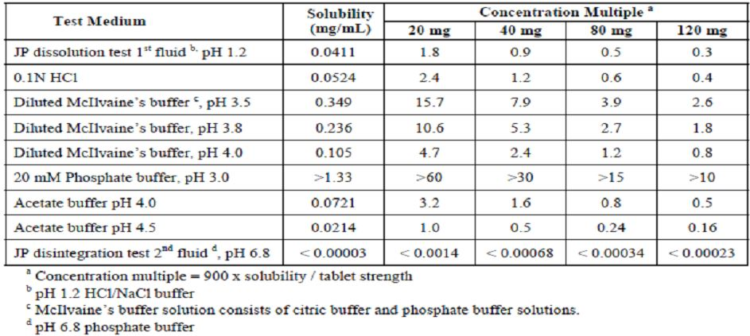

The sponsor has provided an acceptable justification for a single tier particle size limit.

The specification applied to the drug substance is satisfactory. Although a large number of potential synthetic impurities were identified by the applicant, only one (the enantiomer) is specifically controlled in the Active Pharmaceutical Ingredient (API) specification. No degradants were identified.

### Drug product

The proposed 20 mg and 40 mg tablets are white to off white, round film coated tablets, debossed with “L 20” or “L 40” (respectively). The proposed 80 mg tablet is a pale green, oval film coated tablet, similarly debossed with “L 80”.

The tablets are direct scales except for the 80 mg tablet, which also contains a small quantity of iron oxide, yellow and indigo carmine as colourants. No overage is employed.

A single packaging configuration is proposed: aluminium/aluminium blister strips, in pack sizes of 7, 10, 14, 28, 30, 56, 60, 90, 98 and 100 tablets.

A shelf life of 36 months stored below 25°C has been allocated to the tablets.

A number of biopharmaceutic studies were conducted in support of the proposed film coated tablets using either the formulation proposed for registration or a variant thereof for which bioequivalence has been established with the formulation proposed for registration. The outcomes included:

* The data from multi dose Study D1050263 indicate that the commercial formulation (DSP C, 1 x 120 mg tablet)[4] is bioequivalent to the clinical trial formulation (DSP B, 3 x 40 mg tablets) in the tested patient group under fed conditions. However, International Conference on Harmonisation (ICH) guidelines[5] indicate that multiple dose studies are generally less sensitive in detecting differences in Cmax.
* Study D1001053 (conducted in Japanese subjects) concluded that the commercial formulation (DSP C; 1 x 40 mg tablet) is bioequivalent to the lurasidone formulation used in the clinical studies (DSP B, 2 x 20 mg tablets) with respect to both Cmax and AUC0-t if administered after a low fat (≤ 20% fat energy), < 700 kcal breakfast. Median Tmax was 1.5 h for the reference formulation (DSP B) and 2 h for the test formulation (DSP C).
* Study D1050267 investigated the effect of calories and fat content on the PK of repeated dose lurasidone 120 mg tablet (DSP C, 1 x 120 mg tablet)[6] in 26 patients with schizophrenia. Food was found to have a significant effect on lurasidone exposure; mean Cmax and AUC0-48h observed under fed conditions increased by factors of 2.4-3.1 and 1.6-2.0, respectively, relative to levels observed under fasting conditions. The difference in exposure based on the caloric/fat content of the meal is not considered significant.
* Study D1001054 compared the PK parameters of the 40 mg tablet formulation proposed for registration in 12 healthy Japanese subjects under fasted and fed (700 calorie breakfast) conditions. Under fed conditions, lurasidone mean Cmax and AUC0-48h increased by a factor of ~2.4 and ~1.7, respectively, relative to levels observed under fasting conditions.
* Study D1050294 investigated the effect of calories (low versus high) and fat content medium versus high) on the PK of repeated dose lurasidone 120 mg tablet (DSP C)[7] in 16 patients with schizophrenia. Administration of the 120 mg tablet following a medium/fat breakfast containing 100 to 200 calories resulted in an smaller increase in AUCτ (1.25 fold to 1.35 fold) compared to the increase following a high fat/high calorie meal (2.09 fold).

The low aqueous solubility of the drug substance was accepted as justification for not performing an absolute bioavailability study. By estimating Fa, Fg, and FH from the clinical study data, the absolute bioavailability was calculated to be ~0.06 using the equation F = Fa x Fg x FH. Alternatively, F was estimated to be 0.18 using physiologically based pharmacokinetic (PBPK) modelling.

A justification was also provided for a biowaiver in respect of the proposed 20 mg and 80 mg tablets. Although this does not fully address all points listed in Section 4 of Appendix 15 to the ARGPM (Australian Regulatory Guidelines for Prescription Medicines), information available in the literature[8] sufficiently supplements that provided by the applicant to allow the justification to be accepted on a risk management basis.

### Advisory committee considerations

#### Application details

The Pharmaceutical Subcommittee (PSC) considered the referral for advice from the TGA in relation to the submission from Commercial Eyes Pty Ltd to register the products:

*Latuda film coated tablets containing 20 mg, 40 mg and 80 mg of a new chemical entity lurasidone (as hydrochloride).*

#### Chemistry, manufacturing and quality control

The drug substance has six chiral centres; the absolute configuration of which is defined by the chirality of two of the functionalised synthons. Four polymorphs are known to exist for the drug substance.

The drug products are film coated tablets; the different strengths are distinguished by the shape and colour. The tablets are direct scales except for the 80 mg tablet which contains a small quantity of iron oxide. All the excipients comply with relevant specifications and standards. The submitted stability data for the unopened product support the proposed shelf life of 36 months at 25°C.

The PSC advised there were a series of analyses performed by well known Pharmacometricians/Consultancy companies, which is reflected in their quality, spanning over 800 pages. These analyses culminated in a final analysis involving 11,735 samples from 1353 subjects in 20 studies spanning Phases I-III, and included a significant amount of rich data, which was further updated (twice) with additional data. The main findings was an approximate 2.15 fold higher AUC and a 1.76 fold higher Cmax for the typical subject when the dose is taken with a meal, and that this was relatively unaffected by the caloric or fat content of the meal. Similarly, CYP3A4 inhibitors result is very large increases in exposure. Linearity of PK up to 160 mg was also supported.

The PSC asked whether there were data on the binding of lurasidone; if no data was provided, a justification is required.

#### Bioavailability

Two relevant bioavailability/bioequivalence and three relevant food interaction studies were provided in support of this submission.

Study D1050263 compared the clinical trial formulation with the proposed commercial formulation in subjects with schizophrenia, schizoaffective or schizophreniform disorder. The results showed that the commercial formulation is bioequivalent under fed conditions.

Study D1001053 compared the clinical trial formulation with the proposed commercial formulation in healthy subjects. The statistical analysis of the PK parameters differed between module 2 and module 5. Individual subject PK parameters have been requested.

The results from Study D1050267 on schizophrenic patients showed that food had a significant effect on lurasidone exposure but that the caloric/fat content of the meal was not considered clinically significant.

The results from Study D1001054 on healthy subjects showed that food had a significant effect on lurasidone levels compared with the fasted state.

The results from Study D1050294 showed that medium fat meal resulted in smaller increase in levels compared to a high fat/high calorie meal.

The PSC noted the lack of absolute bioavailability and the lack of a justification for not providing such a study. The sponsor had been asked for a justification but this was unavailable for the meeting. The absence of an absolute bioavailability study may be permissible, as long as this was supported by sound justification. The sponsor has not provided such a justification at the present time.

It appears that 14C-labelled oral doses have been administered. Although from the information presented in the summaries presented to the PSC it is impossible to tell if they might provide some measure of bioavailability.

#### Population pharmacokinetics

The PSC advised that detailed population PK analysis showed liner PK. Non linearity in the different dosing might be due to the different point estimate and the limited number of subjects.

#### PSC discussion

There might be an issue with one of the proposed packaging (Al/Al).

#### Product Information (PI)

The PSC advised that the food effect demonstrated should be included in the PI.

#### PSC recommendation

The PSC resolved to recommend to the Advisory Committee on Prescription Medicines (ACPM) and the TGA that:

* The PSC endorsed all the questions raised by the TGA in relation to the quality and biopharmaceutic aspects of the submission by Commercial Eyes Pty Ltd to register Latuda film coated tablets containing 20 mg, 40 mg and 80 mg of lurasidone (as hydrochloride).
* The PSC advised that all outstanding issues should be addressed to the satisfaction of the TGA.
* There is no requirement for this submission to be reviewed again by the PSC before it is presented for consideration by the ACPM.

### Quality summary and conclusions

There are no objections in respect of Chemistry, Manufacturing, Controls and Biopharmaceutics to registration of these products.

## III. Nonclinical findings

### Introduction

The overall quality of the submitted nonclinical data was good, despite the age of some of the studies. Many of the toxicology study reports had Quality Assurance (QA) statements but lacked a Good Laboratory Practice (GLP) certification page. This was raised with the sponsor, who confirmed the GLP status of nearly all of the toxicological studies.

There were some deficiencies in the toxicokinetic data provided, most notably for pregnant animals in the embryofoetal development studies, particularly for rabbits for which there were no toxicokinetic data at all. Further, only limited serum sampling was conducted in the 13 week (main and no observed adverse effect level [NOAEL]) and 26 week oral rat studies, and hence AUC values were not calculated, although the 2 week toxicokinetic study, as well as AUC data for the rat carcinogenicity study, went some way towards rectifying this gap.

The nonclinical expert noted that 8 studies conducted by a previous development company were of insufficient quality to be submitted and were deemed to be superseded by later studies. This is considered acceptable given the comments regarding the deficiencies in these studies, as well as the broadly comprehensive package of studies that was submitted.

### Pharmacology

#### Primary pharmacology

As can be seen from Table 3, lurasidone showed high affinity for human dopaminergic D2L and serotonergic 5-HT2A and 5-HT7 receptors, moderate affinity for human 5-HT1A, adrenergic α2C and D3 receptors, and weaker affinity for human D4.4, α2A and α1A receptors. It also showed moderate/high affinity for rat D2, 5-HT2 and rat 5-HT1A receptors and weak affinity for rat α1 and α2 receptors. It showed little/no affinity for rat D1 (Ki = 262 nM), porcine 5-HT2C receptors (Ki = 415 nM), rabbit 5-HT3, guinea pig 5-HT4 receptors, human H1, human M1, rat dopamine or 5-HT uptake sites (IC50 ≥1 µM), nor did it inhibit dopamine, 5-HT or noradrenaline reuptake into rat synaptosomes (IC50 >3 µM).

Table 3: Affinity of lurasidone.

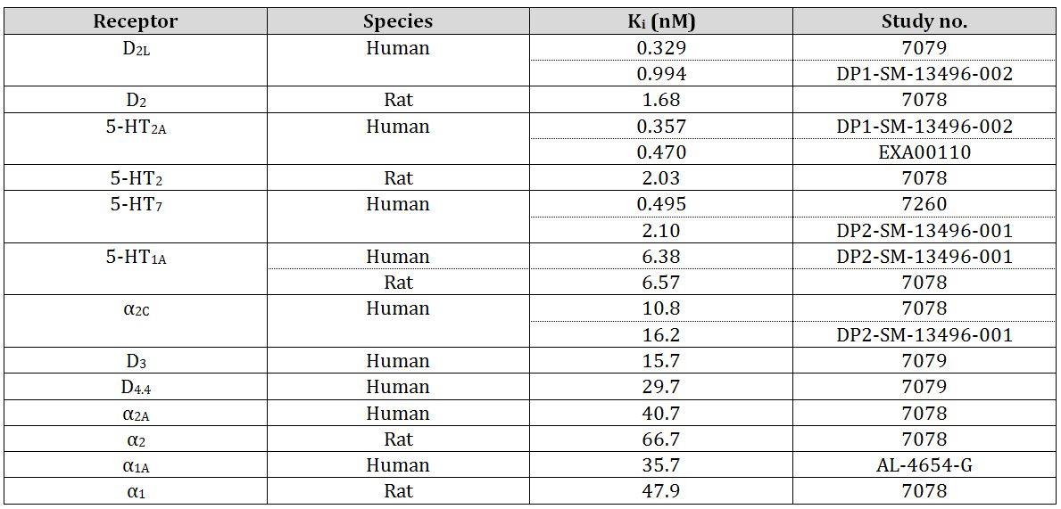

Lurasidone metabolites were also investigated for binding affinity at relevant receptors. As shown in Table 4, of the 4 major circulating human metabolites (ID-20219, ID-20220, ID-14283 and ID-14326,), ID-14283 and ID-14326 were found to have comparable affinity to parent drug at human D2L, 5-HT2A, 5-HT7, 5-HT1A and α2C receptors, while ID-20219 and ID-20220 showed no measureable affinity.

Table 4: Affinity of lurasidone and metabolites.

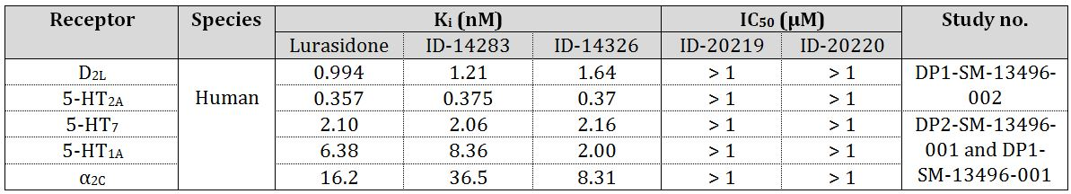

Other metabolites (ID-14323, ID-14324, ID-20221, ID-20222, ID-11614, ID-15001, ID-15002, CR-1209, CR-1218, ID-20239 and ID-20240) were also tested for affinity at rat D2L and 5-HT2A receptors. Only ID-20239 and ID-20240 showed substantial affinity at these receptors (Ki 1.46 and 2.48 nM, respectively at D2L, and 0.947 and 1.00 nM, respectively at 5-HT2A) while ID-11614 showed some affinity at 5-HT2A (Ki 49.4 nM). No data were provided on receptor occupancies *in vivo*.

Assessment of the functional activities of LDH and metabolites, ID-14283 HCl and ID-14326 HCl at human D2L and 5-HT1A receptors using the GTPγS assay, and at the 5-HT7 receptor using the cAMP assay, suggested that all 3 compounds are antagonists at human D2L and 5-HT7 receptors and partial agonists at the human 5-HT1A receptor. Functional activity at other receptors was not assessed experimentally and determination of antagonist/agonist activity was presumably based on information on other atypical antipsychotic drugs.

Plasma Cmax at the initial recommended dose of 40 mg/day was about 52.4 ng/mL. This value was calculated from a Cmax of 60.0 ng/mL (Study D1050002; Day 9; n = 5) and of 48.3 ng/mL (Study D1001017; Day 6; n = 9) (mean value adjusted for number of patients). This value is above/well above the Ki values at human D2L, 5-HT2A, 5-HT7, 5-HT1A, α2C, D3, D4.4, and α2A receptors. However, due to extensive plasma protein binding (about 99%, giving a free Cmax concentration of lurasidone of about 0.52 ng/mL), it is difficult to assess which receptors will be involved in the pharmacological action of lurasidone in patients. Although Ki values at human D2L, 5-HT2A and 5-HT7 receptors were around this value, suggesting that these receptors will always be involved, 5-HT1A, α2C and D3 receptors seem likely also to be involved, particularly at the higher doses. Dopamine D3 receptors are similar to D2 receptors.[9]

As can be seen in Table 5, in *in vivo* studies, LDH showed activity consistent with inhibition of D2 receptors. Oral ED50 values were in the range 2.3-6.3 mg/kg (1 h values) for LDH, 0.28-1.7 mg/kg for haloperidol and 0.094-1.8 mg/kg for risperidone, indicating that LDH is of lower potency than either haloperidol or risperidone at D2 receptors.

Table 5: Oral ED50 for LDH, haloperidol and risperidone: inhibition of D2 receptors.

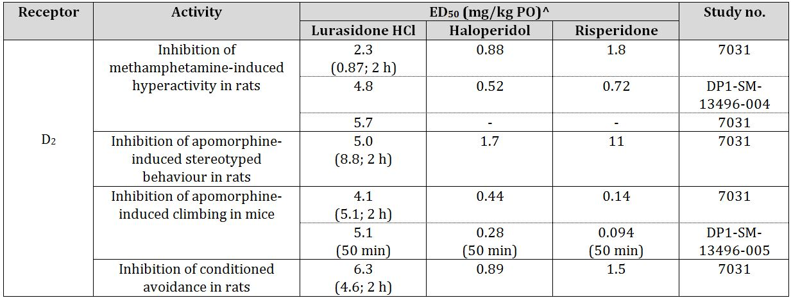

^ unless otherwise noted, data are for administration of LDH 1 h prior to administration of the compound inducing the effect or before testing

LDH also showed *in vivo* activity consistent with inhibition of 5-HT2 receptors (Table 6). Oral ED50 values were in the range 2.2-5.6 mg/kg (1 h values) for LDH, 10 to >30 mg/kg for haloperidol and 0.098 to 0.16 mg/kg for risperidone, indicating that LDH is of higher potency than haloperidol but lower potency than risperidone at 5-HT2 receptors.

Table 6: Oral ED50 for LDH, haloperidol and risperidone: inhibition of 5-HT2 receptors.

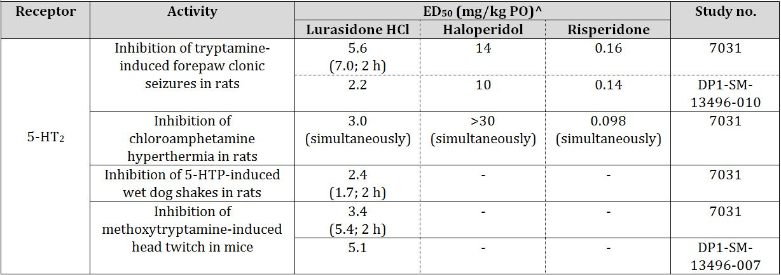

^ unless otherwise noted, data are for administration of LDH 1 h prior to administration of the compound inducing the effect

LDH enhanced 8-OH-DPAT induced hypothermia, consistent with agonist activity at the 5-HT1A receptor. Lurasidone had little/no effect on oxotremorine induced tremors in mice (ED50 >1 g/kg), a phenomenon mediated by cholinergic activity, suggesting that LDH is unlikely to elicit anticholinergic effects. It also had little/no effect on ptosis in mice or on noradrenaline induced lethality (ED50 ≥1 g/kg) which is consistent with a weak affinity for the α1 receptor (as noted below, ptosis was observed at 2 g/kg in the mouse micronucleus test and in some rat safety pharmacology and toxicity studies).

Consistent with the high binding affinity of ID-14283 and ID-14326 for the D2 receptor, these metabolites (given IV) inhibited methamphetamine induced hyperactivity in rats with ED50 values that were comparable to that for LDH.

At 3 and 10 mg/kg, LDH elicited dose dependent increases in extracellular concentrations of dopamine in the rat frontal cortex and striatum. These doses are clinically relevant, corresponding to 18 and 60 mg/m2, respectively, compared with 21 and 85 mg/m2 for the 40 and 160 mg human doses, respectively (assuming a body weight of 70 kg). While haloperidol was not investigated in the same study, it is known to have the same effect.[10] At the same doses, LDH did not alter extracellular concentrations of 5-HT in the frontal cortex, but Ichikawa and colleagues[11] have suggested that the ability to increase extracellular 5-HT levels in the rat prefrontal cortex by antipsychotic drugs is not directly related to their affinity for 5-HT2A receptors since olanzapine and MDL-100,907, both 5-HT2A receptor antagonists, did not significant affect extracellular 5-HT levels.

LDH showed activity in tests for anxiolytic activity/mood stabilising action in rats. Thus, it was active in the stress induced freezing behaviour model, Vogel’s conflict test in water-deprived rats, the conditioned defence burying test and the social interaction test. Doses that were effective were 3, 10, 3 and 1 mg/kg orally (PO), respectively, are clinically relevant (see above).

Effects on learning and memory were examined using the passive avoidance test in rats. LDH given alone, either before the test or before training, did not alter behaviour in this test, but when given before training, it did ameliorate scopolamine and MK-801 induced memory impairment. These effects may be relevant to amelioration of cognitive defects in schizophrenia. Doses that showed some effect were in the range 0.3-30 mg/kg PO, but only doses of 3 and 30 mg/kg elicited significant effects.

#### Secondary pharmacodynamics and safety pharmacology

##### Secondary pharmacodynamics studies

A screen investigating binding to a large range of receptors was not conducted. However, lurasidone was shown to have little/no affinity for histamine H1, noradrenaline (β, β1 and β2), adenosine (A1 and A2A), benzodiazepine, cholecystokinin (CCKA and CCKB), GABAA, glutamate (AMPA, kainate and NMDA), glycine, muscarinic (M1 and M2), nicotinic, opiate and sigma receptors or for calcium (L-type and N-type) or potassium channels. Weak binding to voltage gated sodium channels (Ki = 398 nM) is unlikely to be of clinical relevance. In line with the low affinities for these receptors, as well as the relatively low affinity for human α1 receptors (see *Primary pharmacology*), LDH had relatively weak or no effects on muscle contraction induced in various isolated smooth and cardiac muscle preparations (guinea pig atrial, ileal, trachea and vas deferens and rat aorta) by acetylcholine, histamine, noradrenaline, potassium chloride, or electrical stimulation. The most notable effect was inhibition of noradrenaline induced contraction of vas deferens with an IC50 of 82 nM (unlikely to be clinically relevant when protein binding is taken into consideration).

In *in vivo* studies, locomotor activity was inhibited in mice with an ED50 of 9.9 mg/kg (a clinically relevant dose) which is consistent with reduced activity being a frequently observed clinical sign in repeat dose toxicity studies. The ED50 for inhibition of motor coordination in mice (250 mg/kg; rotarod test) was not clinically relevant (9 fold maximum recommended human dose [MRHD] on a mg/m2 basis). Lurasidone did not affect muscle relaxation (traction test) or show anticonvulsive activity (maximal electroshock induced seizures) (ED50>1 g/kg).

Secondary PD studies revealed an increase in serum prolactin concentrations in rats, particularly females, after a single dose. This is a well known effect of dopamine receptor antagonists, and many of the findings in the repeat dose toxicity studies are due to this effect which is discussed further under ‘Repeat dose toxicity studies’ below. Serum concentrations of corticosterone, the main glucocorticoid in rats compared with cortisol in humans (not measured in the repeat dose studies), was also increased in rats after a single dose of 3 or 10 mg/kg (clinically relevant), and adrenocorticotropic hormone (ACTH) was increased in males at 10 mg/kg (not measured in females). Similar increases were observed with 3 mg/kg haloperidol PO. These changes are presumably associated with the role of dopamine in regulating the hypothalamic pituitary adrenal axis.

Extrapyramidal side effects are well known for antipsychotic drugs and an important aspect of drug development for this class of drugs is the minimisation of these effects. Various tests in nonclinical species are predictive of extrapyramidal side effects, particularly the induction of catalepsy in rodents. LDH had a lower propensity to induce catalepsy in rats and mice and bradykinesia in mice (ED50 >1 g/kg PO) than any of the other drugs tested (particularly haloperidol, chlorpromazine and risperidone, but also thioridazine, tiapride and clozapine). In the muscle rigidity test in rats, the dose required to elicit significant increases in retraction time of front and/or hind paws was in the order thioridazine = tiapride > LDH > clozapine > chlorpromazine > risperidone > haloperidol. As the clinical doses of these drugs vary, the following ratios were calculated:

* ED50 for catalepsy induction (rats)/ED50 for inhibition of methamphetamine induced hyperactivity
* ED50 for catalepsy induction (mice)/ED50 for inhibition of apomorphine induced climbing behaviour and
* ED50 for bradykinesia induction/ED50 for inhibition of apomorphine induced climbing behaviour.

These ratios were considerably higher for LDH (>244 to >435) than for the comparator drugs (up to 19) suggesting that LDH will have a lower propensity to induce extrapyramidal side effects in patients than these comparators. LDH induced dystonia like effects in common marmosets, as did haloperidol and risperidone. Without efficacy data in this species, it was not possible to calculate efficacy/side effect ratios, but the absolute doses at which these effects were observed were lower for haloperidol and risperidone than for LDH. Dystonia is observed in patients treated with LDH.

##### Safety pharmacology studies

Specialised safety pharmacology studies covered the core systems: CNS, cardiovascular and respiratory, with additional studies investigating renal and gastrointestinal effects. Reductions in activity and ptosis in rats have already been mentioned. Ptosis is considered attributable to the primary pharmacological activity of lurasidone (weak affinity was observed at the rat α1 receptor).

LDH, at doses up to 1000 mg/kg PO (> clinically relevant) in mice, lacked proconvulsive activity for seizures induced by subthreshold orbital electric shock. This is consistent with the negligible effect of LDH on the duration of hippocampal afterdischarge in rabbits dosed with up to 1 mg/kg IV. Cerebral blood flow and blood gas parameters were not affected in rats at LDH doses up to 1 mg/kg IV. Extrapolating from PK data for a 0.5 mg/kg IV dose (study PK001) gives a Cmax at 1 mg/kg IV dose of 424 ng/mL (~2x that expected at the MRHD).

The antipsychotics are a drug class in which some members have been shown to induce QT interval[12] prolongation in humans. In *in vitro* cardiovascular studies, LDH dose dependently inhibited the rapidly activating delayed rectifier potassium current in hERG channels expressed in HEK293 cells, with an IC50 of 108 nM. This is clinically relevant with respect to serum concentrations of total drug, being approximately the Cmax at the 40 mg dose. However, these *in vitro* studies are conducted in protein free media and the IC50 is well above the concentration of free drug that might be expected (~4.7 nM at the 160 mg dose). Two lurasidone metabolites, ID-14326 and ID-14283, were found to inhibit hERG currents but they are present in human serum at considerably lower concentrations than parent drug and their IC50 values were about 6-8 fold that of the parent drug (676 and 821 nM, respectively). LDH at high concentrations (up to 1 µM) had no effect on action potential parameters, including APD50 and APD90, in isolated guinea pig papillary muscle of the right ventricle. The nonclinical data predict that induction of prolonged QT interval in patients treated with lurasidone is unlikely.

Quantitative electrocardiogram (ECG) was conducted in two *in vivo* safety pharmacology studies in dogs (100 and 300 mg/kg PO in conscious dogs and sequential doses of 3, 10 and 30 µg/kg IV in anaesthetised dogs), and one in anaesthetised guinea pigs (up to 1 mg/kg IV). An IV study in anaesthetised dogs was also conducted with metabolite ID-11614 (up to 10 µg/kg). No significant effects of treatment were observed in any of these intravenous (IV) studies. No toxicokinetic data for lurasidone or ID-11614 were provided in the IV dog studies, but extrapolation from IV data at 0.5 mg/kg (Study PK001) suggest Cmax and AUC values below those expected clinically at the MRHD for a 30 µg/kg dose in dogs. The C5 min serum value in guinea pigs was 417 ng/mL (about 2 fold the Cmax at the MRHD). Slight prolongation of QTc (not of QT) was observed at several, but not all, time points investigated over the 24 period after dosing with 300 mg/kg PO in dogs. Cmax values of lurasidone in the oral study were 1.9 and 2.78 µg/mL at 100 and 300 mg/kg, respectively. These values were about 8 fold and 12 fold, respectively, the Cmax in humans treated with the MRHD. Overall, these data do not predict that LDH would be associated with QT prolongation in patients.

In the repeat dose toxicity studies, ECG was examined qualitatively in the 13 and 52 week monkey studies, and no effects of LDH on ECG waveforms were observed, although only low exposure ratios (ERs) were achieved in the monkey studies (<1, see below). ECG was examined quantitatively in the 2, 4 and 39 week dog studies (n = 2, 2 and 4/sex, respectively). While no effects were observed at doses up to 1000 mg/kg/day PO in the 2 week study, increases in QT interval were observed in 1 HD (300 mg/kg/day PO) male in the 4 week study, and in 1 MD (100 mg/kg/day PO) male and 2 HD (200 mg/kg/day PO) males in the 39 week study. ER at the HD in the 4 week study was 27 (11 at the MD). ERs at the MD and HD in the 39 week study were 21 and 36, respectively (9 at the LD). Ambulatory ECGs were also conducted in cardiotoxicity studies (single dose oral studies in dogs and cynomolgus monkeys with doses up to 50 mg/kg and 250 mg/kg, respectively and a 2-week study in dogs with doses up to 50 mg/kg/day PO); these doses might be expected to give ER values of about 3 in both species). No consistent effects of LDH on QTc interval were observed in any of these studies. Overall, the ECG results from the repeat dose toxicity and cardiotoxicity studies are consistent with the *in vivo* safety pharmacology data and do not predict that LDH would be associated with QT prolongation in patients.

Other cardiovascular parameters, such as blood pressure and heart rate, did not show consistent changes across species, although reductions in blood pressure were observed in a number of studies. With the exception of blood pressure, and femoral blood flow in cats, there was little investigation of haemodynamic parameters. Respiratory parameters were investigated in a number of studies (Study G007 in rats, Study 6842 in cats, rats, dogs and rabbits [respiration rate only], and Studies B000240 and PS9810 in cats). There were no marked changes that are likely to be of clinical relevance.

A renal function study in saline loaded rats using single doses of up to 100 mg/kg PO (~7 fold the MRHD on a mg/m2 basis) did not reveal an effect of LDH on renal function, but urinalysis data from the 13 and 26 week repeat dose studies in rats revealed some changes in electrolyte excretion (see ‘Repeat dose toxicity studies’). A study examining gastrointestinal function in rats (also at doses up to 100 mg/kg PO) did not reveal any effects on gastric motility, bile production, gastric secretion, or any potential to induce gastrointestinal erosion.

### Pharmacokinetics

#### Absorption

Lurasidone was rapidly absorbed, with Tmax values being about 0.5 h in mice, 1 h in rats and dogs, 1-3 h in humans and 2-5 h in cynomolgus monkeys. Oral bioavailability was low in rats, averaging 7.6% (mean of 6 estimates from 2 studies; 0.5% methylcellulose vehicle). In dogs, estimates of bioavailability varied depending on the vehicle and on feeding status (values were higher in fed than in fasted animals). Thus, in fasted animals, oral bioavailability averaged 6.0% with 0.5% methylcellulose vehicle, and 12.0% and 23.4% with dispersion type tablets and solid dispersion type tablets, respectively. Oral bioavailability averaged for the two tablet types was 17.7% in fasted animals and 31.0% in fed animals. In cynomolgus monkeys, oral bioavailability was particularly low. As in monkeys, it varied with vehicle, being lowest with the 0.5% methylcellulose vehicle, although there was no difference for the two tablet types. As in dogs, it was higher in fed than in fasted animals (1.16% versus 0.35% [0.5% methylcellulose vehicle] and 4.5% versus 1.3% [averaged for the two tablet types]). Cmax and AUC values in humans were 2-3 fold higher in the fed compared to the fasting state.

In mice, rats, dogs and cynomolgus monkeys, AUC values appeared to be broadly proportional to the dose over the dose ranges investigated in both single and repeat dose studies. In humans, the PK of lurasidone were proportional over the dose range 20-160 mg.

Clearance was rapid: 60, 17, 28 and 56 mL/min/kg in rats, dogs, cynomolgus monkeys and humans (assuming 70 kg body weight), respectively. These values broadly approximated or exceeded liver blood flow in each of the species. Plasma half life was short medium, about 3.7 h in rats, about 19 h in dogs and about 14 h in cynomolgus monkeys. In humans, plasma half life was similar to that in dogs and monkeys, at about 18 h.

In mice and rats, AUC values tended to be higher in females than males (about 2.5 fold in both species) but there were no gender differences in dogs or cynomolgus monkeys.

In mice, accumulation was observed with repeated dosing in females (~2 fold in the 13 week and carcinogenicity studies) but not males. In rats, some accumulation was observed with repeated dosing in both sexes, but overall was slightly less than 2 fold. There was no evidence of accumulation in the dog in the 4 and 39 week studies or in the cynomolgus monkey in the 52 week study.

#### Distribution

Protein binding was very high in human serum and in the serum from the nonclinical species investigated (mouse, rat, guinea pig, dog and cynomolgus monkey) and was independent of drug concentration over the range 100-1000 ng/mL in Study SMT/01 (the clinically relevant range) and 0.1-1 ng/mL in Study X9308-06. In Study SMT/01, values of serum protein binding in all species were ≥99.2%. Both studies revealed no differences between species in serum protein binding, and both showed high binding to both human serum albumin and α1 acid glycoprotein. In Study NA04101, the major human circulating active metabolites, ID-14283 and ID-14326, also displayed very high serum protein binding (≥98.8%) in serum from humans and dogs. Studies investigating *in vitro* partitioning between blood and plasma revealed that concentrations of radioactivity were higher in plasma than in red blood cells in all species investigated (mouse, rat, guinea, dog and cynomolgus monkey), with the blood/plasma ratio of radioactivity being about 0.6 for humans.

Volume of distribution was high, being about 10.3 L/kg in rats (mean of 2 rather disparate values from Studies SMO563 and PK001), 20 L/kg in dogs and 9.2 L/kg in cynomolgus monkeys, and about 45-160 L/kg in humans (assuming 70 kg body weight), presumably reflecting extensive tissue distribution and high protein binding.

Because lurasidone can be cleaved via oxidative N-dealkylation, studies involving administration of radiolabelled LDH used either drug labelled in the benzoisothiazole ring or at a carbonyl group in the norbornane ring. Tissue distribution of radioactivity was investigated after oral administration of carbonyl and/or isothiazolyl 14C-LDH to male SD and Long Evans rats and to male cynomolgus monkeys, using excised tissues and additionally, in rats, quantitative whole body autoradiography (QWBA). Female (both non pregnant and pregnant) and aged male rats were also studied.

Results were similar for both labelled compounds. They were also similar for both excised tissue and QWBA techniques, and for male and female (both pregnant and non pregnant) rats. Tissue distribution of radioactivity was rapid, with Tmax for most tissues in most studies being at the first sampling time (2 h in rats [except one study, 1 h] or 4 h in monkeys). Radioactivity was distributed to all tissues examined in both species. Organs of the gastrointestinal tract (stomach, small and large intestine and caecum) and their contents were the most highly labelled in both species, presumably reflecting the relatively large amounts of unabsorbed drug after oral administration, as well as substantial biliary excretion. Other organs associated with metabolism/excretion were also highly labelled, including the liver, kidney and urinary bladder. Lymph nodes were also consistently highly labelled in both species. Distribution to the target organ, the brain, was relatively poor, with the brain being consistently one of the less highly labelled organs in both species. Bone, eye and spinal cord (or cerebrospinal fluid), were also poorly labelled in both species (in monkeys, the retina, choroid and sclera were removed from the eye prior to analysis; retina was relatively highly labelled).

There was evidence of melanin binding, as in Long Evans rats, concentrations of radioactivity in pigmented skin were higher than those in non pigmented skin, and the same was the case for pigmented versus non pigmented hair, and concentrations of radioactivity in the eye of Long Evans rats were considerably higher than those in the eye of SD rats. There was no evidence of retention of radioactivity in any tissue/organ, with the exception of the eye in Long Evans rats in which measurable radioactivity was still present at 3 months post dosing.

Lurasidone/metabolites crossed the placenta, with foetal (whole)/maternal serum radioactivity ratios being about 0.6-0.8 at 2 h (GD12 and GD20). A substantial proportion of foetal serum radioactivity was estimated (thin layer chromatography [TLC]) to be parent drug (22-34%).

#### Metabolism

Lurasidone was extensively metabolised after oral administration. For isothiazolyl labelled drug, about 3.4-3.7% of serum AUC for radioactivity was attributed to unchanged drug in mice, rats and dogs, about 0.5% in cynomolgus monkeys. No unchanged drug was detected in urine in these nonclinical species.

The major biotransformation pathways, as shown in Figure 2, were hydroxylation at the 5 or 6 position of the norbornane skeleton giving rise to ID-14283 and ID-14326, S-oxidation of the benzoisothiazole ring giving rise to ID-14324 (the sulfoxide) and ID-14323 (the sulfone), oxidative N-dealkylation, cleaving between the piperazine ring and the cyclohexyl-methyl group giving rise to ID-20219 and ID-11614, and N-S reductive cleavage of the benzoisothiazole ring and S-methylation giving rise to M21. These pathways appeared to occur in humans as well as mice, rats, dogs and cynomolgus monkeys. A more minor route of metabolism was hydroxylation of the cyclohexyl-methyl group giving rise to M20. Combinations of two or more of these pathways gave rise to a variety of other metabolites. Examples comprising combinations of two of the major pathways are: norbornane skeleton hydroxylation and S-oxidation (ID-20221 and ID-20222), S-oxidation and N-dealkylation (ID-15001 and ID-15002), norbornane hydroxylation and N-dealkylation (ID-20220 and M4), and norbane hydroxylation, N-S reductive cleavage and S-methylation (M22). Glucuronide metabolites were also identified.

Figure 2: Major biotransformation pathways for lurasidone.

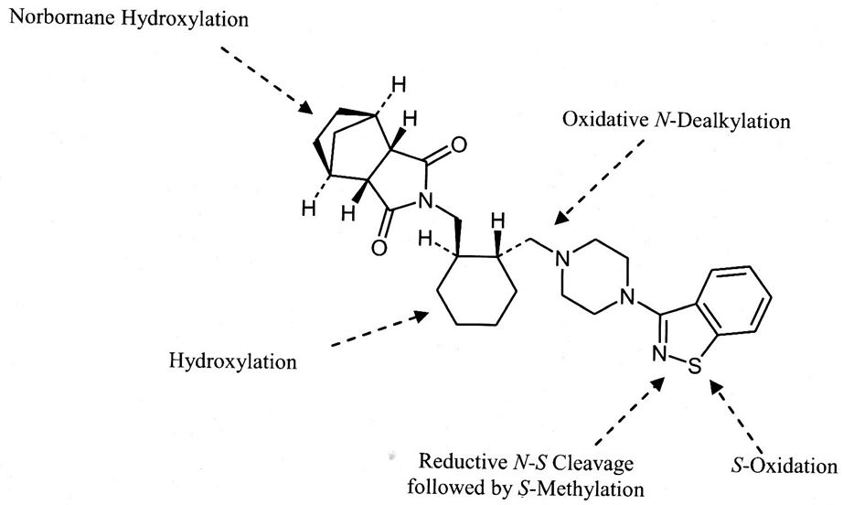

No metabolites unique to humans were identified in the *in vitro* studies with microsomes or hepatocytes. Metabolites ID-20219 and ID-20220 were reported to be the only major circulating metabolites in humans, as their exposure exceeded 10% of total radioactivity exposure after administration of 14C-carbonyl radiolabelled drug (D1050184) (Summary of Clinical Pharmacology). ID-20219, ID-20220, and the two active metabolites, ID-14283 and ID-14326, accounted for ~24%, 11%, 24% and 3%, respectively, of the administered human dose (Clinical Overview). These 4 metabolites were identified in *in vitro* incubations with microsomes from mice, rats, dogs and cynomolgus monkeys. In the pivotal metabolic profiling studies (Studies 8202272 in mice, 6645-183 in rats, 6645-185 in dogs and 6645-186 in cynomolgus monkeys), isothiazolyl labelled drug was used and therefore any metabolites formed by cleavage between the piperazine ring and cyclohexyl-methyl group and giving rise to metabolites containing the norbornane/cyclohexyl-methyl portion of the drug, such as ID-20219 and ID-20220, would not be observed. However, these metabolites were quantified in serum of rats, dogs and cynomolgus monkeys in a single dose (Study PK001) and in mice, rats and dogs in repeat dose studies (Studies G0020, G0018 and SBL-198-117, respectively). In the pivotal metabolic profiling studies, ID-14283 was identified as a circulating metabolite in all 4 nonclinical species, while ID-14326 was identified in serum of rats and dogs, but not mice or cynomolgus monkeys (in Study PK001, ID-14326 was also below the LOQ in cynomolgus monkey serum; mice were not investigated in this study).

Results of the pivotal metabolic profiling studies did not reveal any particularly dominant circulating metabolite in any of the nonclinical species. The most dominant circulating compounds were ID-11614 in mice (3.4% of serum AUC), unchanged drug in rats (3.7% of serum AUC), ID-14324 in dogs (7.3% of serum AUC) and ID-15001 in cynomolgus monkeys (3.5% of serum AUC).

All lines of evidence suggested that CYP3A4 was the main CYP isozyme involved in the metabolism of LDH. Thus, in human liver microsomes, highest correlation coefficients for the formation of most lurasidone metabolites were achieved with CYP3A4. Recombinant CYP3A4 metabolised LDH (labelled) to a series of metabolites similar to those seen in incubations with human microsomes (2 studies), while other recombinant CYP isozymes resulted in little biotransformation. It is noted that in neither of the recombinant CYP isozyme studies did CYP3A4 produce the main circulating human metabolite, ID-20219; in microsomes incubated with carbonyl labelled drug, ID-20219 comprised 6% of radioactivity (Study PK005). In response to a Section 31 question in this regard, the sponsor conceded that the *in vitro* data appeared to underestimate the formation of ID-20219 compared with the *in vivo* data, possibly due to relatively higher activities in alternative metabolic pathways under *in vivo* conditions than under the in vitro conditions. However, the animal data showed a similar *in vitro/in vivo* disparity, and the primary CYP3A4 role was confirmed in clinical drug interaction studies. Troleandomycin, paclitaxel and α-naphthoflavone, inhibitors of CYP3A4, all inhibited the metabolism of LDH, whereas furafylline (CYP1A2 inhibitor) and orphenadrine (CYP2B6 inhibitor) at relevant concentrations, did not. The metabolism of isothiazolyl and carbonyl 14C-LDH was substantially inhibited by anti CYP3A4 antibody but minimally by other anti CYP antibodies tested.

LDH was adequately tested as a potential inhibitor of CYP isozymes, with assays that included positive controls. LDH was found to be a competitive inhibitor of CYP2C19 and CYP3A4 with Ki values of 10 and 17 µM (IC50 values 33.2 and 17.2 µM), respectively (Study 6645-128). However, this inhibition is unlikely to be clinically relevant as these Ki values are >20 fold the clinical Cmax (for total drug) at the MRHD of 160 mg/day LDH. For the other CYP isozymes tested (CYP1A2, 2C9, 2D6 and 2E1), there was either no inhibition or IC50 >50 µM. Another study (PK007) additionally examined CYP2B6 and 2C8, so that all important CYP isozymes were investigated.[13] A similar IC50 value for inhibition of CYP3A4 (17 µM) was reported, but lower IC50 values for CYP2C19 and 2C9 (5.9 and 7.4 µM, respectively) were reported than in Study 6645-128. IC50 values for CYP2B6 and 2C8 were 21 and 6.3 µM, respectively. Again, there was little/no inhibition of CYP1A2, 2D6 or 2E1. The lowest IC50 value (5.9 µM) is 13 times the Cmax at the MRHD suggesting that inhibition of CYP isozymes by lurasidone is unlikely to be clinically relevant. Lurasidone metabolites, ID-20219 (major circulating human metabolite), ID-14283 and ID-11614 were also tested and only ID-14283 showed any activity (inhibition of CYP2C9 with an IC50 value of 6.3 µM), which is also unlikely to be of clinical significance, since in human serum, concentrations of this metabolite were only about 20% of those of parent drug.

LDH was adequately tested for hepatic enzyme induction potential in two *in vitro* studies in human hepatocytes and two *in vivo* studies in male rats. The in vitro studies each used primary cultures from 3 separate donors and tested concentrations of up to 10 µM (>20 fold the Cmax at the MRHD); incubations were 2 or 3 days and both studies measured both enzyme activity and mRNA levels, but hepatocyte cultures were validated only in the second study. The first *in vitro* study (Study PK008) investigated CYP3A4 only, while the second study (Study XT093011) investigated the three critical isozymes, CYP1A2, 2B6 and 3A4, which the guidelines[14] recommend should always be included. The *in vivo* studies both used doses of up to 100 mg/kg/day for 14 days (this dose gave an ER of 5), with the second study (Study 6645-126) being more comprehensively documented than the first (Study 6546). Positive controls were included in all experiments. There was no evidence of CYP isozyme induction in either of the *in vivo* studies. In the *in vitro* studies, LDH induced mRNA expression, but not activity, of CYP3A4 (and additionally of CYP1A2, investigated only in Study XT093011), but only at 10 µM and not at 3-5 µM (6-11 fold the Cmax at the MRHD). ID-20219 and ID-11614 showed minimal or no induction of CYP3A4. Overall, it can be concluded that lurasidone is not likely to induce CYP enzymes in patients given up to 160 mg/day LDH.

#### Excretion

Mass balance studies were conducted in mice, rats, dogs, cynomolgus monkeys and humans. All studies used the oral route except for one study in monkeys. In all nonclinical species except mice, studies included both intact and bile duct cannulated animals and used both isothiazolyl and carbonyl labelled drug. Results for the drugs labelled in the different positions were broadly similar, except for biliary excretion in monkeys, which was considerably higher when isothiazolyl labelled drug was administered compared with carbonyl labelled drug. This was a consistent finding and therefore presumably relates to the metabolites that are excreted in bile in this species.

Recoveries of radioactivity in urine, bile and faeces after oral administration in bile duct cannulated rats, dogs and monkeys are summarised in Table 7.

Table 7: Recoveries of radioactivity in urine, bile and faeces after oral administration of LDH.

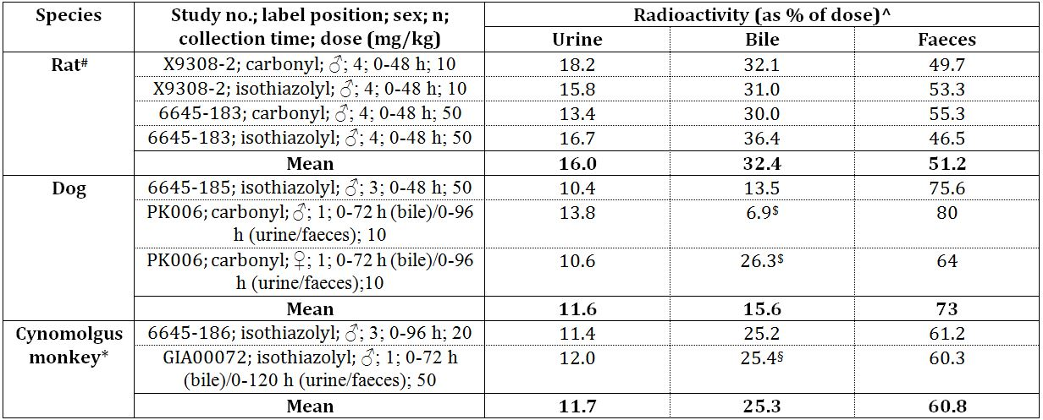

^ The values have been corrected to 100% recovery of radioactivity; # Data from Study PK006 have not been included because these data differed from the data from all the other studies which may have been due to inadequate recovery from one or more of the matrices (only results corrected for recovery were provided); $ Data are for 72 h but have been corrected using 96 h recovery as this was the only recovery data provided; § Data are for 72 h but have been corrected using 120 h recovery due to low faecal recovery at 72 h; * Data for monkeys are for the isothiazolyl labelled drug only (as noted above, considerably lower biliary excretion was observed with the carbonyl labelled drug).

The above data suggest that urinary and biliary excretion are both major routes of excretion in all nonclinical species, with the biliary route being more prominent, particularly in rats and cynomolgus monkeys. The data also indicate that at least about 48%, 27% and 37% of the dose is absorbed in rats, dogs and monkeys, respectively, which suggests that first pass metabolism, as well as poor oral absorption, is a major contributor to the low oral bioavailability of the drug.

In humans, 67.2-80.1% of the dose was recovered in faeces and 9.2-19.1% was recovered in urine, indicating a minimum of 9-19% absorption. The proportion of the dose recovered in urine was similar to that in the nonclinical species. The proportions of the dose excreted in faeces in humans that were due to unabsorbed drug and to biliary excretion are unknown, but given that biliary excretion was the major route of excretion in the nonclinical species, this might also be expected to be the case in humans.

Excretion was rapid, with a large proportion of the dose generally being excreted within 48 h in all the nonclinical species (sometimes 72 h in cynomolgus monkeys), after administration of both the isothiazolyl and carbonyl labelled drug. This is consistent with the rapid plasma clearance of the drug. Excretion was slower in humans, with 57% of radioactivity eliminated after 96 h and 79% after 216 h (Study D1050184 [single dose of 40 mg carbonyl 14C-labelled drug]).

Enterohepatic recirculation was investigated in rats by collecting bile from ‘donor’ rats after the administration of isothiazolyl 14C-labelled LDH and administering the bile intraduodenally in ‘acceptor’ rats. By assessing absorption from radioactivity in urine, bile and carcass of ‘acceptor’ rats, it was estimated that 4.2% of the dose was re-absorbed from bile, so enterohepatic recirculation was relatively limited.

#### Conclusion

The PK characteristics of lurasidone in the laboratory animal species, including those used in the pivotal repeat dose toxicity studies (rats, dogs and cynomolgus monkeys), were sufficiently similar to allow them to serve as appropriate models for the assessment of drug toxicity in humans.

#### Pharmacodynamic and pharmacokinetic drug interactions

A nonclinical study was conducted to investigate the inhibition of lurasidone metabolism by the CYP3A4 inhibitor, ketoconazole, given that lurasidone is mainly metabolised by CYP3A4. Ketoconazole inhibited lurasidone metabolism with a Ki of 37 nM (20 ng/mL). As ketoconazole plasma concentration following the recommended oral dose of 200 mg is about 3.5 µg/mL (Ketoconazole PI), concomitant administration of ketoconazole at the recommended dose with lurasidone would be expected to inhibit the metabolism of lurasidone and result in increased plasma lurasidone concentrations. (An appropriate warning statement is proposed for the PI (‘Dosage and Administration’). Cimetidine was found to inhibit lurasidone metabolism but only by 46% at 100 µg/mL. A 200 mg oral dose of cimetidine gives a blood level of 0.7 µg/mL (Cimetidine PI); therefore, the maximum recommended dose of 800 mg will give rise to a blood level of 2.8 µg/mL which will not greatly inhibit lurasidone metabolism.

Lurasidone, but not its metabolite, ID-20219 (up to 20 µM), was found to have an inhibitory effect on MDR1 (p-glycoprotein 1) mediated transport of digoxin. Cleared volume ratio was reduced from 18.4 (control) to 10.8 at 1 µM (compared with 2.0 for the positive control, verapamil), but was not affected at 0.1 µM. Given the Cmax value of lurasidone is about 0.47 µM at 160 mg/day, any inhibitory effect on MDR1 mediated transport in patients given LDH would be expected to be small.

Lurasidone and its metabolite ID-14283 showed high permeability across LLC-PK1 cells (Papp values of 22 x10-6 and 18 x10-6 cm/s, respectively). Both compounds showed similar Papp(A to B)/Papp(B to A) ratios in LLC-PK1 cells expressing human MDR1 and mouse Mdr1a as in control LLC-PK1 cells, whereas for the positive control, verapamil, this ratio was increased about 3 and 5 fold, respectively, in cells expressing human MDR1 and mouse Mdr1a. These results suggest that neither LDH nor ID-14283 is a substrate of human MDR1 or mouse Mdr1a.

The serum protein binding of lurasidone *in vitro*, despite being very high (~99%), was not altered by the presence of other test drugs (biperiden, flunitrazepam, diazepam and haloperidol) nor was the protein binding of these drugs altered by lurasidone. The drugs tested were representative of potential co-therapy drug classes: anti Parkinson, hypnotic, anxiolytic, and other antipsychotics. Lurasidone and the other test drugs were investigated at clinically relevant concentrations. At concentrations of up to 10 µg/mL (>20 fold the Cmax at the MRHD), lurasidone had little effect on the metabolism of these same drugs, while these drugs showed little inhibition of the metabolism of lurasidone at a concentration of 10 µg/mL, well in excess of clinically relevant concentrations.

A PD drug interaction study (LDH and other drugs with which it might be administered concomitantly) revealed few interactions, but a greater anti dopaminergic activity of the LDH+haloperidol combination than LDH alone (ED50 of 1.1 compared to 3.0 mg/kg PO for apomorphine induced climbing in mice) was observed, LDH potentiated the anti anxiolytic effects of diazepam (ED50 of 10 compared to 17 mg/kg PO for muscle relaxation in mice) and it slightly inhibited the antidepressive action of imipramine in the forced swimming test in rats (immobility ≥122 sec compared to 108.7 sec for imipramine alone).

Overall, lurasidone showed a low propensity for PK drug interactions, with the main interaction demonstrated to be an inhibition of metabolism with the strong CYP3A4 inhibitor, ketoconazole.

### Toxicology

#### Acute toxicity

Single dose toxicity studies were conducted in rats and cynomolgus monkeys by the oral route. The maximum non lethal dose was ≥2 g/kg PO in both species. Thus, LDH has low acute toxicity by the clinical route. Central nervous system clinical signs were observed in both species (reduced activity and ptosis in both species, and additionally, ataxia in rats and miosis and tremors in monkeys). No target organs were identified in rats. The liver appeared to be a possible target organ in cynomolgus monkeys, but only the male given 2 g/kg PO was affected (not confirmed in repeat dose studies).

#### Repeat dose toxicity

Repeat dose toxicity studies were conducted in both rodents (mice [2 and 13 weeks PO] and rats [2 weeks IV and 2, 13 and 26 weeks PO]) and non rodents (dogs [2, 4 and 39 weeks PO] and cynomolgus monkeys [2 weeks IV and 2, 13 and 52 weeks PO]). A 2 week PO study was also conducted in non pregnant NZW rabbits. The majority of studies were conducted by the clinical (oral) route with daily dosing as in the clinical situation. Studies were well designed, of adequate duration and used adequate group sizes; appropriate parameters were investigated and all studies included both sexes (except a specific study in female rats). Recovery was investigated in both the 13 week (main and NOAEL) and 26 week rat studies and the 13 week monkey study. Doses used in the repeat dose toxicity studies are considered adequate. In mice and rats, the HD chosen in the 2 week studies (1000 mg/kg/day PO in both species) was considered appropriate based on the results of the rat single dose study. There were no factors limiting the HD for the 13 week study in mice (and 500 mg/kg/day is considered appropriate), while in rats and dogs, doses were limited by reductions in body weight gain/body weight loss, particularly in males; the high doses chosen reflected this and are considered appropriate. High doses in the monkey studies were limited by clinical signs and, although they were acceptable, ERs achieved were low (<1 in the 13 and 52 week studies).

Additional lower dose 2 and 13 week studies (the former in females only) were conducted in rats, with the 13 week NOAEL study providing useful information on the NOAEL for serum prolactin increases and mammary gland changes (both sexes). An additional 2 week study in both sexes of cynomolgus monkeys was conducted as the first 2 week study was done by in one location while the 13 and 52 week studies were done in a second location; findings were broadly similar in both studies (although monkeys in the first study were more susceptible to effects on the mammary gland [see below]) and both studies concluded that a HD of <100 mg/kg/day PO should be used for the 13 week study.

Overall, the compilation of repeat dose toxicity studies was consistent with the requirements outlined in relevant guidelines.

##### Relative exposure

ERs have been calculated based on animal:human serum AUC values. Human reference values are mean values from Clinical Studies D1050160 and D1050217. ERs were acceptable/high in mice, rats and dogs, but low in cynomolgus monkeys; a reflection of the dose limiting toxicity and the low oral bioavailability of lurasidone in monkeys compared with the other species (Tables 8-13).

Table 8: Relative exposure in repeat dose toxicity and carcinogenicity studies in mice, rats and cynomolgus monkeys.

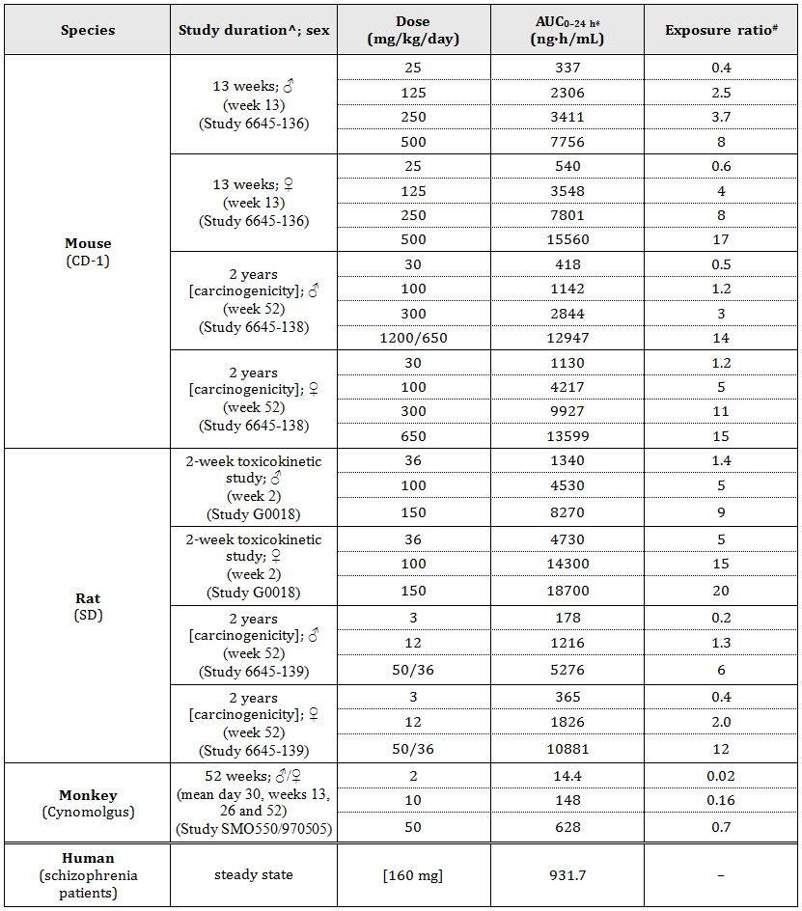

* AUC0-t for the 2 week toxicokinetic study; ^ sampling week in parentheses; # = animal:human plasma AUC0-24h

Table 9: Relative exposure in repeat dose toxicity studies in dogs.

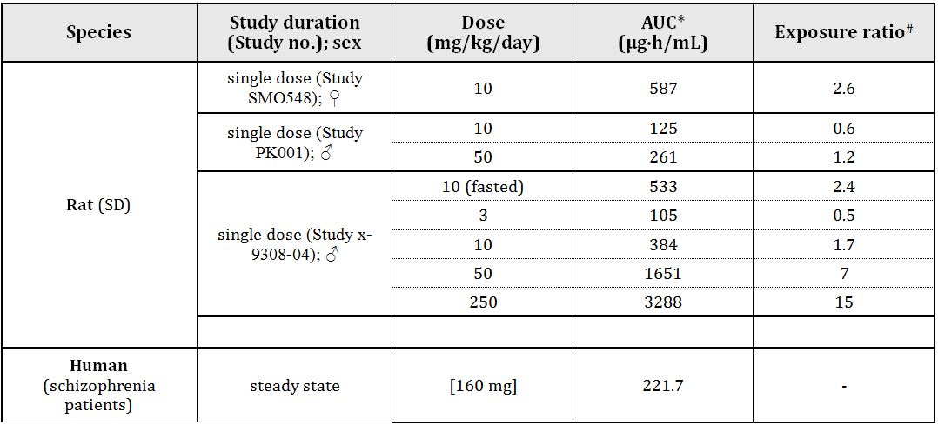

^ AUC0-24h; # = animal:human plasma AUC

Table 10: Relative exposure to metabolite ID-14283 in repeat dose toxicity studies in dogs and cynomolgus monkeys.

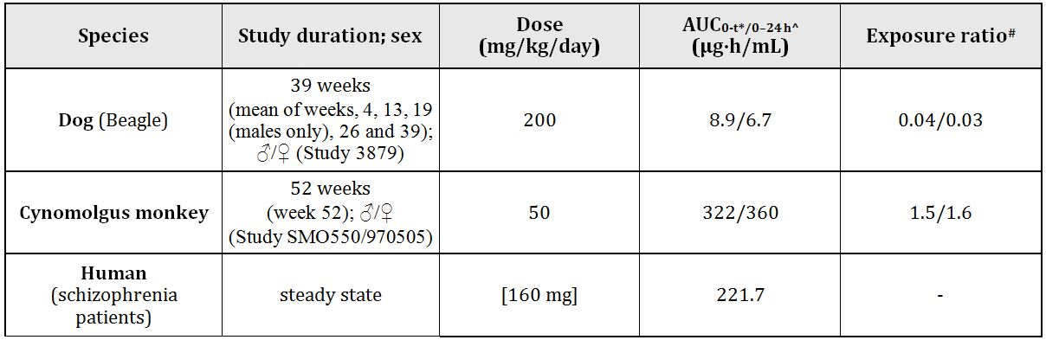

* dog; ^ cynomolgus monkey and human; # = animal: human plasma AUC

Table 11: Relative exposure to metabolite ID-14326 in repeat dose toxicity studies in dogs.

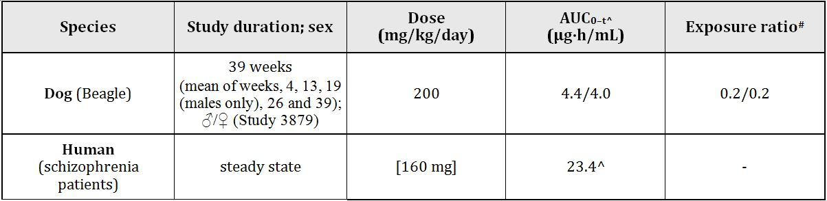

^ AUC0-24h; # = animal:human plasma AUC

Table 12: Relative exposure to metabolite ID-14283 in single dose PK studies in rats.

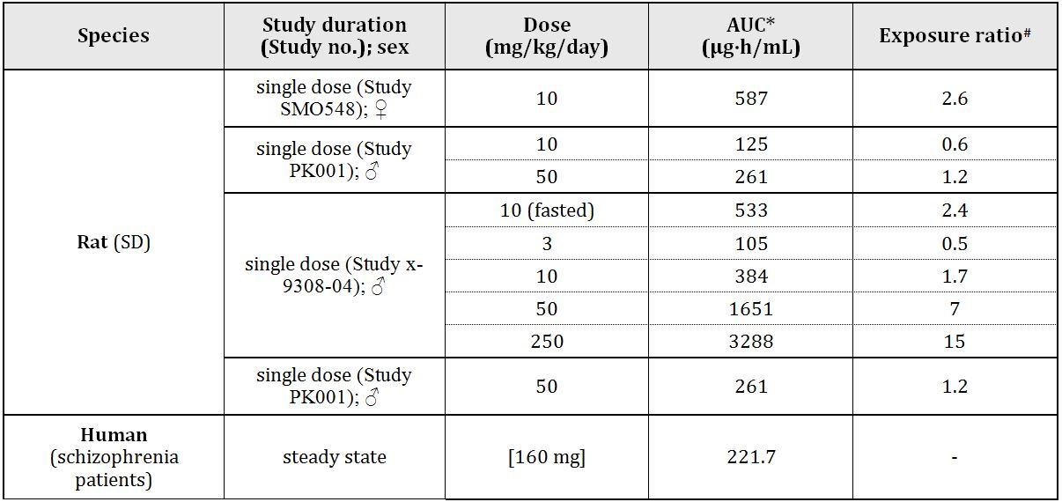

* the period of measurement varied between studies; # = animal:human plasma AUC0–24 h

Table 13: Relative exposure to metabolite ID-14326 in single dose PK studies in rats.

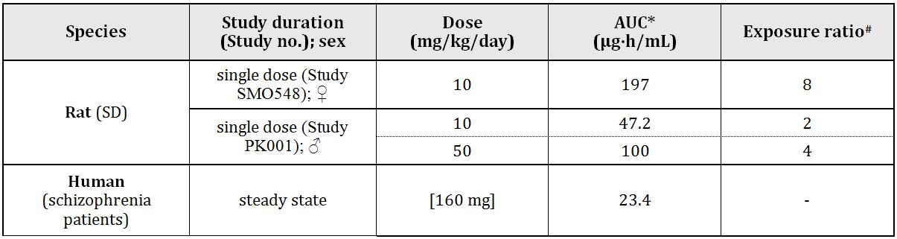

* the period of measurement varied between studies; # = animal:human plasma AUC

ERs achieved for active metabolite ID-14283 were very low at the HD in the 39 week dog study and low at the HD in the 52 week monkey study; however, extrapolation of PK data for rats suggested that ERs achieved for ID-14283 would have been quite adequate in the 26-week rat study at the HD (100 mg/kg/day). ERs achieved for active metabolite ID-14326 were low at the HD in the 39 week dog study, and there were not data for this metabolite for the 52 week monkey study; however, extrapolation of PK data for rats suggested that ERs achieved for ID-14326 would have been quite adequate at the HD in the 26 week rat study (Table 14-15).

Table 14: Relative exposure to metabolite ID-20219 in repeat dose toxicokinetic studies in rats, dogs and cynomolgus monkeys.

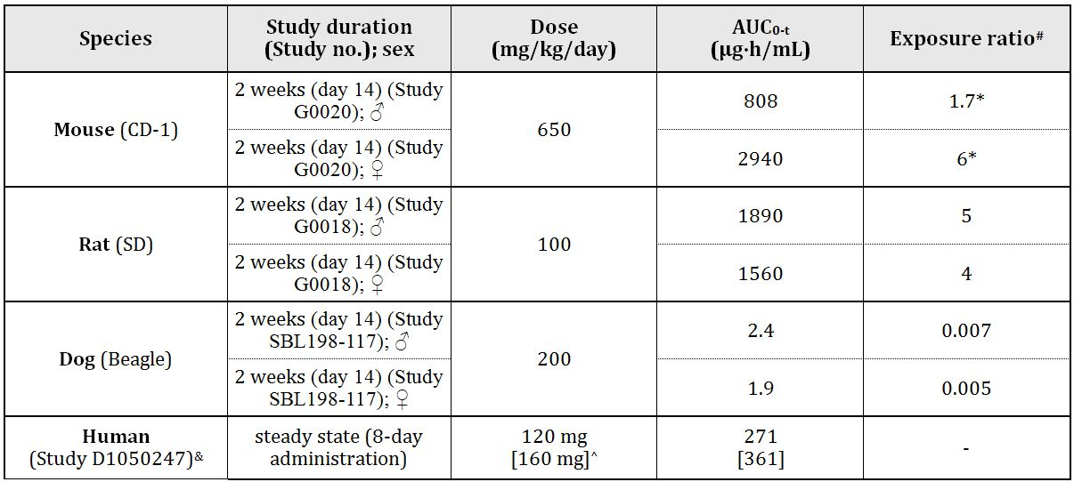

# = animal:human plasma AUC0–24h; ^ the human value was extrapolated to a dose of 160 mg, assuming linearity; * adjusted to a dose of 500 mg/kg/day; & sourced from Pharmacokinetics Written Summary.

Table 15: Relative exposure to metabolite ID-20220 in repeat dose toxicokinetic studies in rats, dogs and cynomolgus monkeys.

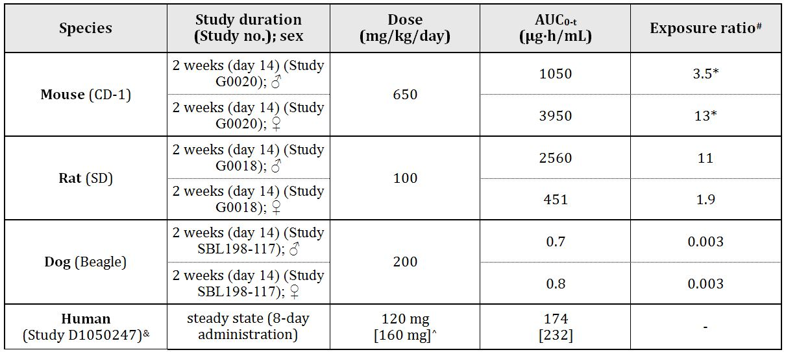

# = animal:human plasma AUC0-24h; ^ the human value was extrapolated to a dose of 160 mg, assuming linearity; * adjusted to a dose of 500 mg/kg/day; & sourced from Pharmacokinetics Written Summary.

The doses in the above table from the toxicokinetic studies correspond to the HD in the 26 week rat study (100 mg/kg/day) and 39 week dog study (200 mg/kg/day) but the ratios in the above table were adjusted down for mice in which the HD the 13 week study was 500 mg/kg/day (not 650 mg/kg/day). In the repeat dose toxicity studies, adequate/high ERs were achieved for ID-20219 and ID-20220 in mice and rats, but not in dogs where ERs were very low.

#### Major toxicities

The main effects of orally administered lurasidone were on the CNS, and as a consequence of elevated serum prolactin concentrations. Thus, the most notable CNS clinical signs observed in the repeat dose toxicity studies were hypoactivity/subdued behaviour (mice, rats, dogs and cynomolgus monkeys), tremors (mice, dogs and monkeys), catalepsy/fixed posture (rats and monkeys), ptosis (rats) and miosis (rats and dogs). Hypoactivity/subdued behaviour, in particular, was observed at low doses (at the lowest doses tested in the 13 week mouse study (25 mg/kg/day, ER 0.4-0.6), the 39 week dog study (30 mg/kg/day, ER 9) and the 52 week monkey study (2 mg/kg/day; ER 0.02) and at ≥10 mg/kg/day in rats (26-week study; ER ~1.1-1.7)). These results predict this effect in humans and somnolence is an adverse effect reported in patients. The monkey data also predict some additional effects (fixed posture, salivation and tremors).

Elevated serum prolactin concentrations are a typical nonclinical finding of antipsychotic drugs that act as antagonists at the dopamine D2 receptor. This is because prolactin secretion by the pituitary is regulated by endocrine neurons in the hypothalamus which secrete dopamine that acts on the D2 receptors of prolactin secreting cells in the anterior pituitary causing inhibition of prolactin secretion. Thus, dopamine is the predominant factor inhibiting prolactin release from the pituitary. Prolactin is involved in many different biological functions including behaviour, endocrinology, reproduction, metabolism and immunology.[15]

Serum prolactin concentrations were measured in both males and females in 7 oral studies (13 week mouse [~0.5 h post dose], 13 week rat [main and NOAEL studies; 1 and 24 h post dose], 26 week rat [1 and 24 h post dose], 39 week dog [2 h post dose] and 13 and 52-week cynomolgus monkeys [4 and/or 24 h post dose]). At the early time points, increases were observed in all studies, but increases were not dose proportional, with the exception of the 13 week NOAEL rat study (which used low doses) and the 52 week monkey study (which also used relatively low doses); concentrations increased with dose, then declined (or occasionally appeared to plateau). Prolactin concentrations at 24 h post dose had declined to control values or lower in rats. In dogs, they had declined compared to 2 h post dose values but had not returned to control values. In monkeys, 24 h were not measured. Long term measurements of prolactin, which may have been informative for the interpretation of long term toxicity including carcinogenicity, were not done.

As expected, the organs of the reproductive system were affected by the elevated prolactin levels, most notably in females: the mammary gland (all species), ovaries (rats and dogs, and to a lesser extent, mice and monkeys), uterus (mice, rats and dogs), vagina (mice, rats and dogs; and also the cervix in mice), but also in males, most notably, the mammary gland, but also the testes, prostate and epididymides in dogs.

The mammary gland was stimulated by prolactin and this was observed grossly as mammary gland development or thickening in female rats, dogs, monkeys and rabbits, and additionally, signs of lactation in dogs and monkeys. The main histological changes observed in the female mammary gland were glandular hyperplasia in mice (13 week study), rats (2, 13 [main and NOAEL] and 26 week studies), dogs (2 and 4 week studies) and monkeys (first 2 week study) and secretion/increase in secretion in rats (13 [main and NOAEL] and 26 week studies), dogs (2 and 4 week studies) and monkeys (first 2 week study), and also in mice in the carcinogenicity study. Some additional changes in dogs were ductal dilation (4 week study) and hydropic appearance of ductal epithelium, lymphoid infiltration and pigmentation (39 week study). In the male rat mammary gland, tubuloalveolar pattern was observed histologically (13 [main and NOAEL] and 26 week studies).

Effects on the ovaries were observed mainly in rats, and to a lesser extent in dogs. In the rat and dog, prolactin is luteotropic,[16] being the hormone responsible for transforming a corpus luteum of the oestrous cycle into a corpus luteum of pseudopregnancy or pregnancy, which allows progesterone secretion to be maintained. The luteotropic activity of prolactin is consistent with the observation of enlarged and/or cystic corpora lutea in the 26 week rat and 39 week dog studies. However, a more notable finding in ovaries was a reduction in the number of corpora lutea (rat 2, 13 and 26 week and carcinogenicity studies and dog 39 week study) and, in general, a tendency for ovaries to atrophy; reductions in ovary weight were observed in mice and rats (2 week studies), grossly small ovaries in rats (2 week study), dogs (39 week study) and monkeys (2 week study), while ovarian atrophy was observed histologically in the mouse carcinogenicity study. Overall, hyperprolactinaemia induced hypogonadism presumably due to a negative feedback effect on the hypothalamus which then secretes less gonadotropin releasing hormone (GnRH or LHRH), which in turn, results in lower levels of secretion of follicle stimulating hormone (FSH) and luteinising hormone (LH) by the anterior pituitary.

Oestrous cycling was investigated extensively in rats (in the 2, 13 [main and NOAEL] and 26 week oral studies). The main findings were increases in the incidence of abnormal oestrous cycles, with changes in the proportion of rats in various stages of the cycle, most notable an increase in the proportion of animals in dioestrus. These effects are presumably due to prolactin causing a decrease in GnRH. Smith and colleagues[17] reported that hyperprolactinaemia is associated with a period of pseudopregnancy, observed as persistent dioestrus in rats. Changes in oestrous cycling were also observed in mice, with a reduced incidence of prooestrus observed in the 13 week study.

Dioestrus is characterised by the activity of the corpus luteum that produces progesterone. Mucification of the vaginal epithelium observed in all the repeat dose rat toxicity studies in which histopathological examination was conducted, and also in the mouse carcinogenicity study, presumably reflected the changes in the oestrous cycle with an increase in the proportion of animals in dioestrus and the production of progesterone, although progesterone was not measured except in a secondary PD study, with no effect observed following a single dose, as might be expected. Vaginal epithelial mucification (and additionally cornification) were observed in the 2 week dog study, presumably also under the influence of progesterone. Cornification of the vaginal epithelium was also observed in the rat carcinogenicity study.

Serum oestradiol concentrations were measured after a single dose in a secondary PD study and in the 13 week rat (main and NOAEL) studies. No effect was observed after a single dose of up to 10 mg/kg PO but concentrations were reduced at all doses tested in the rat 13 week studies (≥0.03 mg/kg/day). While the reductions were often not statistically significant, they were probably biologically significant. As oestrogens are produced primarily by the ovaries, reductions in oestradiol are presumably a reflection of hypogonadism and the expected reduction in the production of FSH (no change in FSH was observed in a secondary PD study after a single dose, but FSH was not measured in the repeat dose toxicity studies).

As well as the ovaries, the uterus also tended to atrophy, which is an expected consequence of hypogonadism and decreases in circulating oestrogen. There were reductions in uterine weight in mice (2 and 13 week studies) and rats (26 week study), grossly small uterus was observed in dogs (39-week study) and uterine atrophy was observed histologically in mice (13 week study), rats (13 [main and NOAEL] and 26 week studies) and dogs (39 week study). Interestingly, in the 2 week dog study, the converse was observed, with large uterus seen grossly and hypertrophy of the uterine endometrium and tunica muscularis seen histologically. This may reflect the nonlinear changes in prolactin with increasing dose, although no serum prolactin concentration data were available for this study.

LDH treatment had some effects on bone in rats and dogs. An increase in fatty infiltration of femur bone marrow was observed in the 13 (main and NOAEL) and 26 week studies in female rats (also some incidences in sternal bone marrow in the 13 week studies), and in femur (and to a lesser extent, sternal) bone marrow in male dogs in the 39 week study. It is not clear that this change was associated with hyperprolactinaemia.

Effects of LDH treatment on bone density in the left femur were investigated in some detail in the 26 week rat study. While cortical bone density was not affected, there were changes in trabecular bone density (and hence total bone density). At the lowest dose (0.03 mg/kg/day), trabecular (and total) bone density increased at both measured sites (3 and 10 mm from the distal epiphyseal plate) (significant only for trabecular density at the 10 mm site), but at higher doses (1, 10 and 100 mg/kg/day), trabecular (and total) bone density decreased dose dependently at both measured sites. Serum osteocalcin, a bone formation hormone secreted by osteoblasts, was increased in lurasidone treated groups (at ≥1 mg/kg/day), but urinary deoxypyridinoline, a bone resorption parameter was not affected by treatment. These findings suggest enhanced bone metabolic turnover, but it seems likely that resorption was increased to a greater extent than formation, although this was not borne out in the urinary deoxypyridinoline data. A decrease in trabecular bone in the femur (and to a lesser extent, sternum) was observed in males in the 39 week dog study.

The decrease in bone density in rats reflects bone mineral loss. It is well established that hyperprolactinaemia is associated with bone mineral loss, although the mechanism is not clearly understood. The osteopenic effect of prolactin has long been explained as a secondary effect of hyperprolactinaemia induced hypogonadism and oestrogen deficiency, and consistent with this theory is the correlation of the bone density changes in the 26 week rat study with serum oestradiol levels which were increased at the 0.03 mg/kg/day dose (significant) but decreased dose dependently at the 10 and 100 mg/kg/day doses (and at the 1 mg/kg/day dose relative to the value at the 0.03 mg/kg dose but not the control). However, identification of prolactin receptors in osteoblasts suggested a possible direct action of prolactin on bone. It has been proposed that prolactin enhances bone resorption in part by increasing activation of nuclear factor κB ligand (RANKL) and decreasing expression of osteoprotegerin (OPG) proteins by osteoblasts.[18]

A clinical study (D1050237) conducted at a LDH dose of 120 mg/day apparently did not suggest increased risk of osteoporosis or decreased bone density.

Despite the role of dopamine in regulating the hypothalamic/pituitary/adrenal axis and the increased secretion of prolactin, there were few findings in the pituitary and adrenals. The most notable finding in the pituitary was enlarged pale staining cells in the pars distalis in the 52 week monkey study. There were no consistent changes in the adrenal across species.

Some effects on the male reproductive system were observed in dogs (39 week study), including seminiferous tubular atrophy in the testes, prostatic atrophy and hypospermia in the epididymides, which occurred in the absence of any changes in serum testosterone or LH levels.

There were few or no haematological changes (including blood clotting parameters). Some increases in red blood cells (RBCs), haematocrit, haemoglobin, mean corpuscular volume (MCV), mean corpuscular hemoglobin (MCH) and/or mean corpuscular hemoglobin concentration (MCHC) in rats were possibly associated with an effect of elevated prolactin levels on haematopoiesis.

Body weight gain was seen in female mice and rats over a certain oral dose range (about 25-250 mg/kg/day in mice and 0.3-30 mg/kg/day in rats), often associated with increased food consumption. Body weight gain is known to be associated with hyperprolactinaemia in female rats.[19] Dogs and monkeys did not show such increases in body weight gain in females, but the draft PI notes that weight gain has been observed with the use of atypical antipsychotics and that clinical monitoring of weight is recommended.

Increases in sodium excretion (and associated increases in chloride excretion) observed in rats in the 26 week study are likely to be indirectly due to hyperprolactinaemia which, as discussed above, results (presumably) in increased progesterone (associated with the luteotropic activity of prolactin and an increase in the proportion of animals in dioestrus) which antagonises aldosterone.

There was no evidence of any ophthalmological effects (apart from miosis) which were well investigated in 2 (PO and IV), 13 and 26 week studies in rats, 2, 4 and 39 week studies in dogs and 2 week IV and 52 week PO studies in monkeys.

All, or almost all, observed changes appeared to be attributable to hyperprolactinaemia. An increase in cytoplasmic eosinophilic inclusions in the urinary bladder epithelium observed in the 39 week dog study in both sexes at all doses may have been a direct effect of lurasidone but this change was only observed in this study and no other. In the longest repeat dose toxicity studies in each of the species (13 weeks in mice, 26 weeks in rats, 39 weeks in dogs and 52 weeks in monkeys), serum prolactin concentrations were increased in both males and females at all doses, with the exception of LD (0.03 mg/kg/day) males in the rat study. Although these increases were not always statistically significant, they were of substantial magnitude. A number of prolactin related changes were observed in these studies at the LD: in mice (25 mg/kg/day; ER 0.4 in males and 0.6 in females, respectively), mammary gland hyperplasia, changes in oestrous cycling and vaginal epithelium, uterine atrophy and increased body weight gain in females; in rats (0.03 mg/kg/day; ER ~0.03 [extrapolated from toxicokinetic data from the carcinogenicity study]), increases in serum oestradiol and in trabecular bone density in females (in males, tubuloalveolar pattern in the mammary gland was observed at MD1 [1 mg/kg/day]); in dogs (30 mg/kg/day, ER 9), lactation, mammary gland changes and small ovaries in females and prostatic atrophy in males; in monkeys, there were no hyperprolactinaemia induced changes at the LD (2 mg/kg/day, ER 0.02).

Mice and rats were highly sensitive to the effects of lurasidone induced hyperprolactinaemia because of the large magnitude of the increases in prolactin in these species compared with the much smaller increases observed in dogs and monkeys. Increases in serum prolactin were observed in clinical studies, although the Clinical Expert Report noted that ‘clinically relevant’ increases in prolactin were not observed with lurasidone treatment in the short and long term Phase II/III studies. Given this species difference, it would be reasonable to predict that the hyperprolactinaemia related changes observed in the nonclinical studies would be unlikely to present a clinical risk (see further discussion below under ‘Carcinogenicity’).

Recovery or partial recovery was observed for all changes seen in the rat 13 (main and NOAEL) and 26 week studies. There were few findings at the end of treatment in the 13 week monkey study, but serum prolactin levels had returned to control levels at the end of the recovery period and there were few clinical signs observed during the recovery period.

#### Genotoxicity

An acceptable set of genotoxicity studies compliant with relevant guidelines was submitted (a bacterial reverse mutation assay, a chromosome aberration assay in Chinese hamster lung cells *in vitro* and an *in vivo* mouse micronucleus test). All studies were adequately conducted and used appropriate concentrations/doses. Thus, the highest concentrations required to be tested were used in the bacterial reverse mutation assay (5 mg/plate), and the *in vitro* chromosome aberration assay (+S9) (5 mg/mL). In the chromosome aberration assay (-S9), cytotoxicity testing revealed that relative cell growth was ≤51% at 313 µg/mL, suggesting that the required reduction of ≥50% would have been achieved at the highest concentration tested (400 µg/mL). A dose of up to 2 g/kg in the mouse micronucleus test was appropriate; it would achieve high exposure but a dose finding study revealed that it was not associated with any deaths (consistent with the single dose toxicity data for rats). Positive controls confirmed the sensitivity of all assays, appropriate metabolic activation was used in the *in vitro* studies and the bacterial reverse mutation assay included a strain that will detect point mutations at A-T sites. Males only were used in the micronucleus test. This is considered acceptable since there was no evidence from the toxicity studies of a gender difference in toxicity, although toxicokinetic data revealed higher exposure in females than males. All studies gave negative results.

#### Carcinogenicity

Two year oral carcinogenicity studies were conducted in mice and rats in compliance with guidelines. Both studies included two vehicle control groups and 3 (rat) or 4 (mouse) dose levels. High dose selection in the mouse study was ‘aggressive’, although in line with a lack of target organ toxicity in the 13 week study beyond clinical signs of hypoactivity and changes associated with hyperprolactinaemia. Initial doses were 1200 and 650 mg/kg/day in males and females, respectively; these doses were both above the HD in the 13 week study (500 mg/kg/day) while the male dose was above the high dose in the 2 week study (1000 mg/kg/day) which was associated with reduced food intake and body weight gain. The HD in males was reduced to 650 mg/kg/day on day 410 because of a more rapid decline in survival in this group compared to controls. In rats, a high dose of 50 mg/kg/day was chosen for both males and females. This seemed an appropriate choice given that HD in the 26 week toxicity study (100 mg/kg/day) resulted in significant reductions in body weight gain and clinical signs (including catalepsy) but was without target organ toxicity (except as associated with hyperprolactinaemia). The HD of 50 mg/kg/day, however, was reduced (to 36 mg/kg/day) on day 403/404; the reason was not given, but was probably due to low body weight gains.

In female mice, there was a clear dose related increase in the incidence of pituitary adenomas (pars distalis; benign), while rats were not affected. Tumours of the mammary gland were increased in incidence in female mice and rats. The incidence of carcinomas (malignant) was increased in both species. Additionally in mice, the incidence of adenocanthomas (malignant) was also increased and there was a small increase in the incidence of carcinosarcomas (malignant). The incidence of mammary gland carcinomas was dose related in rats, whereas in mice, incidences of mammary carcinomas and adenocanthomas were not linear, with incidences declining at the highest dose. A low incidence of mammary gland carcinomas was observed in male rats, which was not clearly dose related; these increases were not significant and it is not clear whether they were incidental or could be ascribed to drug treatment. No other tumours were increased in incidence in male rats. In male mice, there were no increases in tumour incidences in any organ. The ERs achieved at the HD in male mice and rats were 14 and 6, respectively.

In mice, both the mammary gland carcinomas and the pituitary adenomas are common tumours and a cut off P value of P = 0.005 for these tumour types was therefore used. In mice, both these tumour types showed highly significant positive trends versus both control groups, while adenocanthomas showed a significant positive trend at the 0.01 level (for rare tumours) only versus control group 2. Although pairwise comparisons did not show statistical significance for the increased incidences of mammary gland carcinomas and the pituitary adenomas at the LD (30 mg/kg/day), this evaluator considers that the increases at this dose were biologically significant for both these tumour types, and therefore that no NOAEL for these tumour types has been demonstrated. For pairwise comparisons, the mammary gland adenocanthomas showed statistical significance at the LD, MD2 and HD only versus control group 2, but this evaluator considers that biologically significant increases were observed for this tumour type at the LD and therefore, again, that no NOAEL has been demonstrated. While increases in incidences of mammary gland carcinosarcomas were not statistically significant, this evaluator considers that all increases observed for this rare tumour were biologically significant (that is, at ≥MD1 [100 mg/kg/day]). The ER for females at the LD in the mouse carcinogenicity study was 1.2.

In rats, female mammary gland carcinomas showed a significant (at the 0.005 level) positive trend and a significant pairwise comparison for the HD (50/36 mg/kg/day) compared to control group 2 (but not control group 1). This evaluator considers that a biologically significant increase was observed for this tumour type at the MD (12 mg/kg/day) at which the ER was 2.0 (ER was 0.4 at the LD which is considered the NOAEL).

The mammary gland tumours in mice, but not rats, were associated with a broadly dose related increase in the incidence of mammary gland hyperplasia while the pituitary tumours in mice were associated with a dose related increase in the incidence of pituitary (pars distalis) hyperplasia. All these tumours are likely to be associated with hyperprolactinaemia and have been commonly observed with other dopamine receptor antagonist antipsychotic drugs in long term rodent carcinogenicity studies.

The significance of rodent mammary tumours to human risk assessment is hotly debated. It has been argued recently[20] that prolactin is tumorigenic to human breast tissue, whereas Gopinath and colleagues[21] had previously suggested that prolactin induced rodent mammary carcinogenesis was mechanistically species specific. The clinical and epidemiological evidence of a prolactin association with breast cancer[22] is broad and does not relate specifically to increases in breast cancer following chronic administration of antipsychotic drugs. Whilst it would appear that prolactin induced mammary tumours are not rodent specific, and exposure ratios based on plasma lurasidone concentrations suggest little margin of safety, there are likely to be substantial differences in sensitivity between humans and rodents to these carcinogenic effects (pituitary, as well as mammary), particularly relating to the magnitude of the serum prolactin increases induced, but there may also be species differences in responses to prolactin, for example, due to differences in the concentration of prolactin receptors on the mammary cancer cells. This issue, well known for this drug class, has not yet been definitively resolved and, although the clinical risk associated with the prolactin associated tumours in rodents is considered to be small, appropriate warning statements are nevertheless routinely included in the PI documents.

#### Reproductive toxicity

An adequate set of reproductive toxicity studies was submitted, all using the oral (clinical) route. The package comprised fertility studies in male and female rats, embryofoetal development studies in rats and rabbits and a pre/postnatal study in rats. All studies were appropriately designed and conducted. Group sizes were adequate, and timing and duration of treatment and parameters examined were appropriate. Doses used were appropriate, with 150 mg/kg/day being the HD for both the male and female fertility studies (appropriate based on results of the 13 week toxicity study). The pilot rat embryofoetal development study revealed that pregnant rats were more susceptible to lurasidone induced body weight loss/reduced gain than non pregnant females. Consequently, the HD selected for the rat embryofoetal development study was 25 mg/kg/day, which, although relatively conservative, was, together with the LD and MD (3 and 10 mg/kg/day), associated with small but significant decreases in body weight gain over the treatment period. Doses in the rabbit embryofoetal development study (2, 10 and 50 mg/kg/day) were appropriate; they were based on the results of the 2 week toxicity study in non pregnant rabbits in which body weight losses (not clearly dose related) were observed at doses of 50-200 mg/kg/day, but there were no mortalities, clinical signs or necropsy findings other than development of/swollen mammary glands. In the main study, the higher two doses resulted in significant, but not excessive, losses in maternal body weight over the treatment period. The doses tested in the range finding pre/postnatal study were based on the results of the embryofoetal development study, and doses selected for the main study were appropriate.

No toxicokinetic data were provided for reproductive studies. Animal/human exposure comparisons have been based on separate kinetic data and comparisons of dose based on body surface area (mg/m2). It appeared that lurasidone crossed the placenta in rats, since after administration of radiolabelled drug to pregnant females, TLC of radioactivity in foetal serum showed that 22-37% was attributable to parent drug. Excretion of lurasidone associated radioactivity in the milk of lactating rats was very high (milk:serum radioactivity ratios of about 10-11).

In rats, no adverse effects of LDH treatment on reproductive performance were observed in either the male fertility study or the embryofoetal development study and there was no evidence of teratogenicity. NOAELs were ≥150 mg/kg/day PO in the male fertility study and ≥25 mg/kg/day in the embryofoetal development study. Although animal numbers were low in the pilot embryofoetal development study, results suggested no adverse reproductive effects or teratogenic effects occurred at doses up to 100 mg/kg/day. Estimated ER in male rats at 150 mg/kg/day was 9 (according to data from the 2 week toxicokinetic study), and this HD was also 9 fold the MRHD based on body surface area. ER in female rats at 25 mg/kg/day was estimated to be 4 (non pregnant, extrapolated from data from the 2 week toxicokinetic study at 36 mg/kg/day); this dose was ~1.5 times the MRHD based on body surface area. Thus, despite the profound effects of lurasidone induced hyperprolactinaemia on the female reproductive system in rats as revealed in the repeat dose toxicity studies, administration of lurasidone over the period of organogenesis in pregnant rats at doses achieving relatively low, but acceptable exposures, was without effect. Although effects were observed on the reproductive organs in the dog, including prostatic atrophy and testicular tubular seminiferous tubule atrophy, the ERs at which these were observed were high (9-21) and therefore the effects are not considered clinically relevant.

Oestrous cycling was altered in the repeat-dose toxicity studies in rats (all studies, 2, 13 [main and NOAEL] and 26 weeks), and therefore it was not surprising to find effects of lurasidone treatment on fertility in the fertility study in female rats. In this study, oestrus was prolonged at doses ≥1.5 mg/kg/day and mating was significantly reduced at the HD (150 mg/kg/day) with 32% of females at this dose not mating after 15 days of treatment. Further, the proportion of females mating in the second week of cohabitation rather than the first week was increased at ≥1.5 mg/kg/day and fertility of the HD females that did mate was reduced (fertility index 60% compared to 82-91% for the other groups, although this was not significant). There were also some adverse effects on litter parameters at the HD (reductions in the number of corpora lutea, implantations and live foetuses/dam and in the number of ossified sacrococcygeal vertebral bodies). However, these effects on mating and fertility were reversible. This was demonstrated in 2 groups of females:

* the 7 HD females that failed to mate after 15 days cohabitation were given a 14 day recovery period and then re-mated, and
* a recovery group of HD (and control) females (n = 11) that were treated for 28 days then given a treatment free period of 14 days prior to mating.

In these 18 animals, oestrus cycling had returned to normal in 15 (83%), mating index was 100% and fertility index was 78%, slightly below the control level (91%). Estimated ER in female rats at 150 mg/kg/day (the dose at which mating and fertility indices and litter parameters were affected) was 20 (based on data from the 2 week toxicokinetic study), and this HD was 9 fold the MRHD based on body surface area. The NOAEL (fertility) was 15 mg/kg/day (approximately the MRHD based on body surface area). Estimated ER in female rats at 1.5 mg/kg/day (the dose at which oestrous cycling was affected and mating was delayed) was about 0.8 (when estimated by extrapolation from doses of 1 and 3 mg/kg/day in the rat carcinogenicity study), but only ~0.1 fold the MRHD based on body surface area. The NOEL for oestrus cycle effects was 0.1 mg/kg/day (only 0.006 fold the MRHD based on body surface area). D2 receptor blocking drugs are known to affect female reproductive performance associated with hyperprolactinaemia and alterations in oestrous cycling. For example, in female rats, ziprasidone and olanzapine impaired fertility, risperidone impaired mating and ziprasidone increased time to copulation.

In the rabbit embryofoetal development study, the only effect was a non-significant reduction in live foetuses/litter at the HD (50 mg/kg/day), associated with maternal toxicity (significant body weight loss over the treatment period). There was no evidence of a teratogenic effect. As noted above, no toxicokinetic data were provided for rabbits; calculations on a body surface area basis gave an estimated ER of 5 at 50 mg/kg/day.

No adverse effects of treatment were observed in the pre/postnatal study. Maternal toxicity was observed at the HD (10 mg/kg/day) (decreased maternal body weight gain over GD6-20). The ER at the HD was about 1.7 (based on toxicokinetic data from the rat carcinogenicity study); this dose was about half the MRHD based on body surface area.

##### Pregnancy classification

The sponsor has proposed Pregnancy Category B1.[23] The embryofoetal development studies in rats and rabbits did not reveal any adverse effects of lurasidone treatment, and a lack of teratogenic effects is consistent with this classification.

#### Local tolerance and antigenicity

Local tolerance studies were not conducted and are not required for a drug that is proposed for oral administration. Antigenicity was tested using antibody detection systems in guinea pigs including standard tests such as the active systemic anaphylaxis test, passive cutaneous anaphylaxis test, gel precipitation test and intradermal administration test. These tests were adequately conducted and the positive control compound showed the expected response. Results were negative in all tests except for a weak reaction in the intradermal administration test in animals that had been sensitised by subcutaneous (SC) administration of LDH but not by PO. It is unlikely that LDH will show antigenicity in patients.

#### Immunotoxicity

It appears that prolactin has molecular actions in the immune system, as reviewed by Yu-Lee[24] who noted that prolactin receptors are ubiquitously expressed by cells in the immune system, and that certain subpopulations of lymphocytes synthesize and secrete biologically active prolactin, suggesting that prolactin can act as an autocrine and/or paracrine factor to modulate the activities of cells of the immune system. However, there was no evidence from the repeat dose toxicity studies of changes in organs/cells of the immune system. Thus, although immunotoxic potential was not investigated in detail (no immunotoxicity study was conducted), it is not a class effect and available nonclinical data do not suggest that LDH will have immunotoxic potential in the clinic.

#### Dependence

There were no pointers for dependence from general studies, for example, no affinity was observed at opiate, GABAA or NMDA receptors and behaviour and recovery assessment within the repeat dose toxicity studies (rat and cynomolgus monkey) did not reveal any evidence of withdrawal symptoms after cessation of dosing. Specific dependence studies were conducted in rhesus monkeys and rats that involved an adequate assessment of dependence for this type of drug. These included behaviour assessment in both species, self administration of LDH in pentobarbitone dependent monkeys and suppression of barbitone withdrawal symptoms in barbitone dependent monkeys, and investigation of withdrawal symptoms in rats after giving feed spiked with either LDH or diazepam. Overall, there was no evidence for dependency potential.

#### Impurities

The maximum daily dose of LDH (160 mg/day) is ≤2 g/day, therefore the ICH qualification threshold for impurities is 0.15% (corresponding to 0.24 mg/day intake) as this is lower than 1.0 mg/day intake, and the identification threshold is 0.10%. All impurities in the drug substance are controlled at or below these thresholds.

As the MRHD of 160 mg/day lies in the range >100 mg to 2 g/day, the qualification threshold for degradation products in the medicinal product is 0.2% (corresponding to 0.32 mg/day intake) as this is lower than 3 mg/day intake. All degradation products are controlled at or below this threshold.

#### Paediatric use

LDH is not proposed for paediatric use and no specific studies in juvenile animals were submitted. The proposed PI includes a statement ‘The safety and efficacy of Latuda in children aged less than 18 years has not been established.’

#### Phototoxicity

A phototoxicity study was conducted in rats since the absorption spectra revealed that LDH absorbs in the ultraviolet range (UVA and UVB) and lurasidone/metabolites are distributed to the skin and eyes. The study was adequately conducted, with the positive control exhibiting the expected effects. The results for LDH were negative.

#### Comments on the safety specification of the risk management plan

Results and conclusions drawn from the nonclinical program for LDH detailed in the sponsor’s draft Risk Management Plan (RMP) are in general concordance with those of the nonclinical evaluator. Important identified risks that were evident from the nonclinical data were potential interaction with strong CYP3A4 inhibitors and inducers, and potential for extrapyramidal symptoms. Given that lurasidone elevates serum prolactin levels in several test species and also humans (a known effect of this class of drugs), it is recommended that the possible adverse effects of hyperprolactinaemia in patients should be considered here; this is referred to the RMP evaluator.

### Nonclinical summary and conclusions

#### Summary

* Lurasidone showed high affinity for the human D2, 5-HT2A and 5-HT7 receptors, moderate affinity for human 5-HT1A, α2C and D3 receptors, and weaker affinity for human D4.4, α2A and α1A receptors. It showed little/no affinity for human H1 or M1 receptors, or rat 5-HT uptake sites (IC50 ≥1 µM), nor did it inhibit dopamine, 5-HT or noradrenaline reuptake into rat synaptosomes (IC50 >3 µM). Functional studies revealed partial agonism at 5-HT1A receptors and antagonism at D2 and 5-HT7 receptors. *In vivo* studies in mice and rats were consistent with antagonism at the D2 and 5-HT2 receptors. At clinically relevant doses, lurasidone showed activity in tests for anxiolytic activity/mood stabilising action in rats and ameliorated scopolamine and MK-801 induced memory impairment in the passive avoidance test in rats.
* Lurasidone showed little/no binding to a limited number of receptors tested (other than dopaminergic, serotonergic and adrenergic α receptors). Inhibition of locomotor activity in mice and elevation of serum prolactin in rats were the main findings in secondary PD studies. Ratios of ED50 values in efficacy tests/ED50 values in tests predictive of extrapyramidal effects were considerably higher for lurasidone than for the comparator drugs suggesting that lurasidone will have a lower propensity to induce extrapyramidal side effects in patients.
* Lurasidone dose dependently inhibited the rapidly activating delayed rectifier potassium current in hERG channels expressed in HEK293 cells, with an IC50 of 108 nM. However, this did not translate into any notable prolongation of QT/QTc intervals in *in vivo* studies. Safety pharmacology studies did not identify any clinically relevant effects on the CNS, cardiovascular, respiratory, renal or gastrointestinal systems other than those revealed in the toxicity studies.
* The PK of lurasidone were characterised by rapid absorption in the nonclinical species and humans. Oral bioavailability depended on feeding status in dogs and cynomolgus monkeys (higher in fed than fasted). Bioavailability was estimated as 7.6% in rats, 2-36% in dogs, and 0.4-5.3% in monkeys. Lurasidone was relatively rapidly cleared and half life was short in rats (3.7 h) and medium in dogs, monkeys and humans (14-19 h). Radioactivity was rapidly and extensively distributed to tissues after oral administration of 14C-lurasidone (rats and monkeys). There was no evidence of retention of radioactivity in any organ, but there was evidence of melanin binding. Highest concentrations of radioactivity were observed in gastrointestinal tract and its contents, liver, kidney and urinary bladder, while brain had relatively low concentrations. Protein binding was very high in all species.
* Lurasidone was extensively metabolised to a large number of metabolites in humans and the nonclinical species, with major routes being hydroxylation at the 5 or 6 position of the norbornane skeleton, S-oxidation of the benzoisothiazole ring, oxidative N-dealkylation (cleaving the compound), and N-S reductive cleavage of the benzoisothiazole ring and S-methylation, or combinations of these routes. No metabolites unique to humans were identified in the *in vitro* incubations with microsomes or hepatocytes. CYP3A4 was identified as the major CYP isozyme involved in the metabolism of lurasidone. Excretion was via bile (about 32%, 16% and 25% in rats, dogs and monkeys) and urine, with the extent of urinary excretion being similar in humans (9-19%) and the nonclinical species. The nonclinical species used served as appropriate models for the assessment of drug toxicity in humans. Lurasidone/metabolites crossed the placenta in rats and there was substantial excretion of lurasidone/metabolites in rat milk. In *in vitro* studies, lurasidone showed a low potential for drug interactions (except with strong inhibitors and inducers of CYP3A4). It showed little/no clinically relevant inhibition/induction of CYP enzymes, and little activity as a human MDR1 substrate.
* Single dose toxicity studies were conducted by the oral route in rats and cynomolgus monkeys. Lurasidone showed low acute toxicity. In both species, the maximum non lethal dose was ≥ 2 g/kg PO and CNS clinical signs were observed.
* Repeat dose toxicity studies were conducted in mice (2, 13 weeks), rats (2 weeks [2 studies], 13 weeks [2 studies], 26 weeks), dogs (2, 4, 39 weeks) and cynomolgus monkeys (2 weeks [2 studies], 13, 52 weeks) by the oral route, and in rats and monkeys (2 weeks) by the IV route. Acceptable/high ERs were achieved in rodents (up to 8/17 [males/females] in the 13 week mouse study and up to about 5/15 [males/females] in the 26 week rat study), and high exposure ratios were achieved in dogs (up to 36 in the 39 week study), but only low exposure ratios were achieved in monkeys (< 1 in the 52 week study). Adequate exposure ratios for the two main circulating (non active) human metabolites, ID-20219 and ID-20220, were achieved in mice and rats, and for the active circulating human metabolites, ID-14283 and ID-14326, in rats.
* Major findings in the repeat dose toxicity studies in all species were CNS clinical signs and changes associated with hyperprolactinaemia. CNS findings included hypoactivity/subdued behaviour (predicted clinically), tremors, catalepsy/fixed posture, ptosis and miosis. The most notable changes associated with hyperprolactinaemia included mammary gland development, ovarian and uterine atrophy, alterations in oestrous cycling, vaginal epithelial mucification and a reduction in trabecular bone/bone density. There were no major organ toxicities that were considered to be a direct effect of lurasidone. (Increases in serum prolactin were observed in clinical studies – not as marked as with comparators haloperidol and risperidone – although the typical resultant adverse effects were apparently not evident).
* An adequate set of genotoxicity studies (a bacterial reverse mutation assay, a chromosome aberration assay in Chinese hamster lung cells *in vitro* and an *in vivo* mouse micronucleus test) was submitted and results of all studies were negative.
* Two year oral carcinogenicity studies were conducted in mice and rats. Increases in the incidence of pituitary adenomas and of malignant mammary gland tumours (carcinomas, adenocanthomas and carcinosarcomas) were seen in female mice. Increases in the incidence of mammary gland carcinomas were seen in female rats. These tumours are considered to be prolactin mediated, typical for the drug class, and of low clinical relevance.
* A full set of reproductive toxicity studies comprising fertility and early embryonic development studies in male and female rats, embryofoetal development studies in rats and rabbits, and pre/postnatal development studies in rats, all by the oral route, was submitted. There was no evidence of an effect on fertility in male rats at oral doses up to 150 mg/kg/day PO (ER ~9). Oestrous cycling in female rats was prolonged at ≥1.5 mg/kg/day (ER ~0.1), and at 150 mg/kg/day PO (ER 9) mating and fertility indices declined, as did corpora lutea, implantations and live foetuses/dam. These changes were reversible after a 2 week treatment free period. No adverse/teratogenic effects were observed in embryofoetal development studies in rats or rabbits or in the pre/postnatal studies in rats (respective ERs 1.5, 5 and 0.5).
* Phototoxicity, antigenicity and dependence studies all gave negative results.

#### Conclusions and recommendation

* There were no major deficiencies in the nonclinical data dossier.
* Lurasidone showed high affinity for the human D2, 5-HT2A and 5-HT7 receptors and moderate affinity for human 5-HT1A, α2C and D3 receptors. *In vivo* studies in rodents were consistent with antagonism at the D2 and 5-HT2 receptors. Lurasidone showed activity in tests for anxiolytic activity/mood stabilising action and ameliorated scopolamine and MK-801 induced memory impairment. The nonclinical data support the drug’s use for the treatment of schizophrenia.
* Secondary PD studies suggested that lurasidone may have a lower potential to induce extrapyramidal side effects than comparator drugs. Safety pharmacology studies did not reveal any clinically relevant hazards except for CNS clinical signs and the potential for hyperprolactinaemia. Lurasidone dose dependently inhibited the rapidly activating delayed rectifier potassium current in cloned hERG channels, but this did not translate into any notable prolongation of QT/QTc intervals in *in vivo* studies.
* The nonclinical species used (rats, dogs and cynomolgus monkeys) served as appropriate models for the assessment of drug toxicity in humans. Lurasidone is highly protein bound and is largely metabolised by CYP3A4.
* CNS clinical signs and hyperprolactinaemia and its consequent effects, particularly on the female reproductive system, were the main findings in the repeat dose toxicity studies. In patients, somnolence and some increase in serum prolactin have been reported.
* Lurasidone did not show genotoxic potential. Prolactin mediated pituitary and mammary gland tumours in rodents are considered a low risk to humans.
* Lurasidone had adverse effects on mating, fertility and litter parameters in female rats, but showed no adverse effects on embryofoetal development in rats or rabbits and was not teratogenic. The nonclinical data support the proposed pregnancy category of B1.
* There are no nonclinical objections to the registration of LDH for the treatment of schizophrenia in adults.

## IV. Clinical findings

A summary of the clinical findings is presented in this section. Further details of these clinical findings can be found in Attachment 2.

### Introduction

#### Clinical rationale

Schizophrenia is a severe, chronic psychiatric disorder that affects ~1% of the population throughout the world. It is known to cause a high level of disability and reduces life expectancy typically due to associated suicide. The disease is characterised by positive symptoms (delusions, hallucinations, disorganised speech, disorganised or catatonic behaviours) and negative symptoms (affective flattening, restriction in the fluency and productivity of thought and speech and in the initiation of goal directed behaviour).

Treatment options include pharmacological (antipsychotic medications) and non pharmacological (supportive) treatments. Antipsychotic agents are the mainstay of pharmacological intervention in the treatment of schizophrenia and are considered first line treatment. There is large inter individual variability in response to these drugs which are required to be taken long term and treatment is frequently a balancing act between therapeutic efficacy and adverse effects. The first generation antipsychotics (“typical” antipsychotics such as haloperidol and thioridazine) are known for causing extrapyramidal side effects (rigidity, tremor, restlessness) and may lead to tardive dyskinesia. The second generation, or “atypical”, antipsychotics generally have a lower risk of extrapyramidal side effects and tardive dyskinesia (examples are risperidone, quetiapine, aripiprazole and ziprasidone). However, they have typically been associated with higher rates of weight gain and metabolic abnormalities. QT prolongation is also reported with a number of these drugs. Schizophrenia is a condition where there is an evident medical need for effective and well tolerated treatments.

Antipsychotic agents generally all have activity via post synaptic blockade of the brain dopamine D2 receptors. Atypical antipsychotics also have activity in blocking the serotonin 5-HT2 receptor. The sponsor reported that:

*In vitro receptor binding studies revealed that lurasidone is an antagonist with high affinity at dopamine D2 receptors and the 5-hydroxytryptamine (serotonin) receptors, 5-HT2A and 5-HT7; is an antagonist with moderate affinity at human α2C adrenoceptors; is a partial agonist at serotonin 5-HT1A receptors; and is an antagonist at α2A adrenoceptors. Lurasidone exhibits little or no affinity for histamine H1 and muscarinic M1 receptors.*

Lurasidone has the drug codes of SM-13496 and MK-3756.

#### Guidance

There was no pre-submission meeting held with the TGA. The clinical development program includes efficacy and safety studies which are line with current EMA guidelines on the investigation of medical products for the treatment of schizophrenia.[25]

#### Contents of the clinical dossier

The submission contained the following clinical information:

* 31 clinical pharmacology studies, including: 4 bioavailability and bioequivalence studies; 4 healthy subject PK studies ; 3 patient PK studies; 4 intrinsic factor PK studies; 13 extrinsic factor PK studies; 2 healthy subject PD studies and 1 patient PD study.
* 4 population PK analyses.
* 21 clinical efficacy and safety studies:
  + 5 ‘pivotal’ short term, placebo controlled efficacy/safety studies (D1050006, D1050229, D1050196, D1050231, D1050233).
  + 2 other short term, placebo controlled efficacy/safety studies (D1050049, D1001002).
  + 2 Phase II, uncontrolled studies (D1001001, D1001016).
  + 3 long term, controlled studies (D1050234, D1050237 D1050254).
  + 7 uncontrolled long term clinical studies (D1050229E, D1050231E, D1001036, D1001048, D1050174, D1050199, D1050237E).
  + 2 other efficacy/safety studies (D1050289 and its extension D1050290).
* 4 clinical study protocols (D1050238, D1050307, D1001056, D1001057).
* Integrated Summary of Efficacy tables, Integrated Summary of Safety tables, data integration plan and statistical analysis plan for the Integrated Summary of Efficacy (ISE) and Integrated Summary of Safety (ISS), Council for International Organisations of Medical Sciences (CIOMS) listings in a safety appendix, 5 Periodic Safety Update Reports (PSURs) and literature references.

#### Paediatric data

The submission did not include paediatric data. A Paediatric Investigation Plan (PIP) was included in the dossier. This was approved by the EMA in July 2012. This plan covers the population from 13 to 18 years of age.

#### Good clinical practice

In all clinical study reports the sponsor stated that conduct was in accordance with Good Clinical Practice (GCP) guidelines as well as local regulatory and ethical requirements.

### Pharmacokinetics

#### Studies providing pharmacokinetic data

Table 16 shows the studies relating to each PK topic and the location of each study summary.

Table 16: Submitted PK studies.

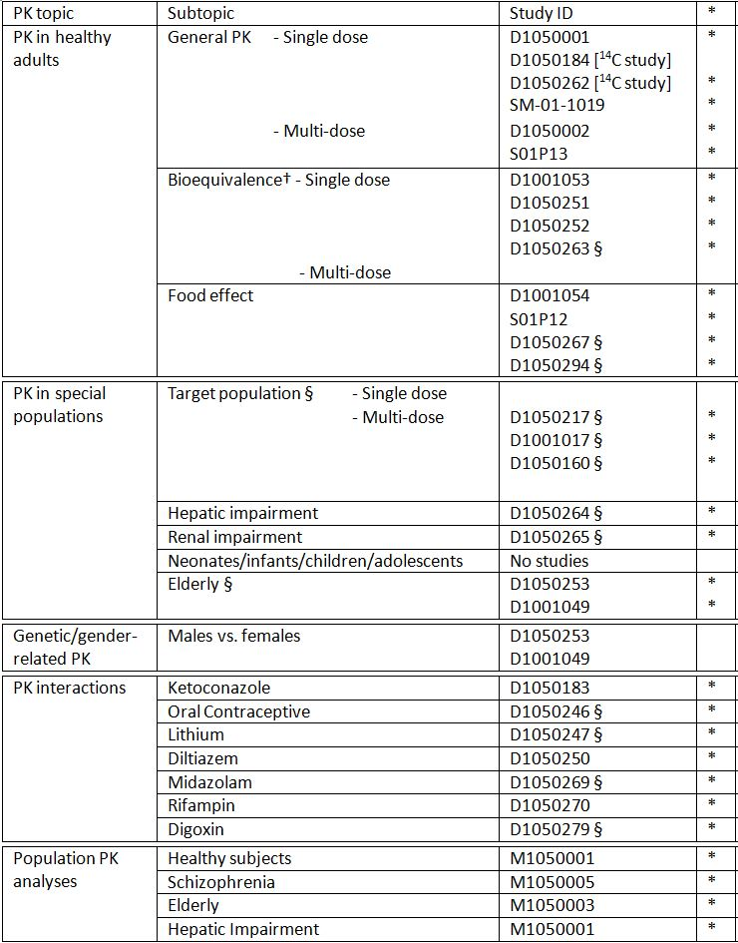

* Indicates the primary aim of the study.

† Bioequivalence of different formulations.

§ Subjects who would be eligible to receive the drug if approved for the proposed indication.

None of the PK studies had deficiencies that excluded their results from consideration.

#### Evaluator’s conclusions on pharmacokinetics

A comprehensive set of studies has established the PK parameters for lurasidone in both healthy subjects and patients with schizophrenia. Lurasidone is rapidly absorbed after oral administration with Tmax occurring at 1.3-1.8 h. At doses of 20 to 100 mg in healthy volunteers, and at doses of 120 mg to 160 mg in patients with schizophrenia, lurasidone exhibits linear PK. In the presence of a low fat meal/medium calorie meal, lurasidone Cmax increased by 2.8 fold and AUC increased by 2.3 fold (relative to a fasted state). The mean apparent volume of distribution ranges from 3220 L and 4410 L. Lurasidone is highly bound (~99%) to serum proteins. The mean terminal elimination half life of lurasidone ranged from 12.2 to 21 hours in healthy volunteers. Lurasidone’s activity is primarily due to the parent drug and, to a lesser extent, to the active metabolites ID-14283 and ID-14326 which represent 25% and 3% of the parent exposure, respectively. The major biotransformation pathways are oxidative N-dealkylation, hydroxylation of norbornane ring and S-oxidation. Approximately 90% of a radioactive dose of lurasidone was recovered with 9.2-19% in urine and 67-80% in faeces, suggesting that lurasidone is primarily eliminated via non renal pathways. Mean apparent clearance ranges from 175 L/h to 244 L/h. *In vitro* and *in vivo* data suggest that lurasidone is metabolised primarily by CYP3A4. Accordingly, PK parameters of lurasidone are affected by alterations in hepatic and renal function. Thus, in patients with severe hepatic impairment (Child-Pugh Class C), systemic exposure is increased by up to 3 fold. In patients with severe renal impairment (creatinine clearance <30mL/min), systemic exposure is increased by up to 2 fold.

Significant drug interactions are noted for co-administration with CYP3A4 inhibitors (for example, ketoconazole) and CYP3A4 inducers (for example, rifampin). There is no drug-drug interaction (DDI) study with grapefruit juice which is well recognised to interact with drugs metabolised by CYP3A4.

### Pharmacodynamics

#### Studies providing pharmacodynamic data

Table 17 shows the studies relating to each PD topic and the location of each study summary.

Table 17: Submitted PD studies.

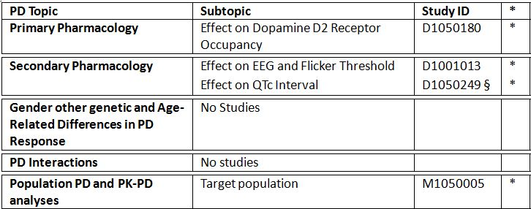

* Indicates the primary aim of the study.

§ Subjects who would be eligible to receive the drug if approved for the proposed indication.

‡ And adolescents if applicable.

None of the PD studies had deficiencies that excluded their results from consideration.

#### Evaluator’s conclusions on pharmacodynamics

The positron emission tomography (PET) study showed that lurasidone had approximately 80% occupancy of the dopamine D2 receptor between 60 and 80 mg after a single dose in volunteers. Generally, this level of occupancy has been shown to be necessary for therapeutic activity (against positive symptoms) in patients with schizophrenia for other antipsychotic agents. The proposed clinical dose therefore should ensure similar occupancy of this receptor. Occupancy of other receptors notably 5-HT2A was not addressed. The electroencephalography (EEG) and Flicker threshold study would suggest that like other antipsychotic medications lurasidone has sedative effects. The lack of an active comparator drug with known sedative properties (for example, another atypical antipsychotic or diazepam) is a weakness of this study.

The QTc trial compared the effects of lurasidone 120 mg and lurasidone 600 mg on the QT interval with ziprasidone 160 mg as an active control. It is noted that the FDA evaluation of this study suggests that the results were inconclusive due to the following reasons:

* The primary endpoint was inadequately defined. The QT study used time matched mean changes from baseline in corrected QT intervals (QTcI) (that is, ΔQTc) as the primary endpoint. The primary variable is inappropriate because it does not account for between day shifting for ECG signals, which can be pronounced with an 11 day difference between the observation day and baseline day. A time matched, baseline corrected, and placebo adjusted QTc (ΔΔQTc) should be used as the primary variable in a parallel thorough QT study. However, this variable cannot be derived from the current trial because of the absence of the placebo arm.
* Assay sensitivity was not established in the trial. The QT study used ziprasidone as active control. The results from ziprasidone arm has two limitiations: the results were described by using ΔQTc rather than ΔΔQTc and, at the tested dose level, the QTc interval change appears to be larger than the small changed defined by ICH E14 guidance.[26]

This identified weakness was not addressed in the data submitted here. Although ziprasidone is associated with QTc prolongation this may not be as reliable (even at the dose used) as the usual choice of moxifloxacin as an agent to induce a QTc change.

### Dosage selection for the pivotal studies

Study D1050180 was a PD study which aimed to determine the dopamine D2 receptor occupancy, using positron emission tomography (PET), of SM-13496 at five single doses (10 to 80 mg) in 20 healthy male subjects. The mean D2 receptor occupancy ranged from 41-43% with 10 mg, 51-55% with 20 mg, 63-68% with 40 mg, 77-84% with 60 mg dose and 73-79% with the 80 mg dose. This indicates some dose dependent receptor occupancy rates up to the 60 mg dose. The lower doses of 10 mg and 20mg were found to have low receptor occupancy.

Study D1001016 was an early Phase II, open label, uncontrolled, 8 week exploratory study of a flexible dose regimen to 20 to 80 mg per day of SM-13496 in Japanese patients with schizophrenia. It found some evidence of efficacy as measured by change from baseline in the total score on the Brief Psychiatric Rating Scale (BPRS) and Positive and Negative Syndrome Scale (PANSS).

Study D1001001 was an 8 week, uncontrolled, double blind, fixed dose, dose response study which assessed doses of 20 mg, 40 mg, and 80 mg per day in 203 Japanese adults with schizophrenia. The study found no significant differences between doses as measured by a change from baseline to completion (or discontinuation) in total BPRS and PANSS scores. Subjects in the 40 mg and 80 mg groups had significant decreases from baseline BPRS and PANSS scores, while this was not found in the 20 mg group. The rate of safety risks increased with increasing dose and the 80 mg group had a notably higher discontinuation rate than the lower doses (47.5% versus 38.8% and 30.6%).

Study D1050049 was a Phase II randomised, double blind, placebo controlled, fixed dose study of lurasidone 20 mg, 40 mg and 80 mg, with haloperidol as the active comparator. In this study the 20 mg dose was not found to be effective as measured by change from baseline in BPRS score. However, no active group including haloperidol was found to be significantly different to placebo and so the study was deemed to have failed. Consequently, no conclusions can be drawn from this study on the lack of efficacy of the 20 mg dose.

Given the low receptor occupancy in D1050180, and the lack of efficacy in D1001001, the sponsor concluded that 20 mg was subtherapeutic in treatment of schizophrenia and doses in the range of 40, 80, 120 and 160 mg were assessed in the Phase III clinical development program. In addition, due to the higher discontinuation rate with the 80 mg dose in D1001001, the sponsor concluded that the 40 mg dose was the most appropriate commencing dose.

### Efficacy

#### Evaluator’s conclusions on efficacy

The clinical development program with lurasidone included 21 trials. There were 5 short term placebo controlled trials on which the efficacy of lurasidone was based (D1050006, D5050196, D1050229, D1050231 and D1050233). In addition, there were two placebo controlled trials (D1050049 and D1001002) which were deemed “failed” as neither lurasidone (20, 40 and 80 mg in D1050049 and 40 and 80 mg in D1001002) nor the active control (haloperidol 10 mg and risperidone 4 mg) was found to significantly differ from placebo.

In the five studies, fixed doses of 40, 80, 120 and 160 mg were assessed over the 6 week period in adult patients who had a diagnosis of schizophrenia (DSM-IV) for at least a one year duration and who had a current acute exacerbation of psychotic symptoms. To be eligible subjects were required to have a minimum score on the PANSS (≥80) or BPRS (≥42) (depending on the study) with a score of ≥4 on two or more of the Positive Symptom Scale Subscores. All subjects needed a score of ≥4 on the Clinical Global Impression – Severity of Illness (CGI-S). Overall, 1795 subjects were included with 506 treated with placebo, 1046 with lurasidone, 123 with olanzapine 15 mg and 120 with quetiapine XR 600 mg. The active comparator in D1050231 and D1050233 was included to assess the study’s sensitivity. Study drug was given in the morning (except in D1050233 when it was given in the evening) with a meal or within 30 minutes of eating.

In studies D1050229, D1050231 and D1050233, the primary endpoint was change from baseline to Week 6 in the PANSS total score. This was analysed using a mixed model repeated measures (MMRM) on the Intent to Treat (ITT) population (randomised subjects who have taken ≥1 dose of study medication with baseline and ≥1 post baseline efficacy measurement). The MMRM did not use imputed data and missing values were retained as missing. Multiplicity was controlled in the analysis of the primary and key secondary variables. Studies D1050006 and D1050196 used the BPRS as the primary efficacy endpoint which was analysed using analysis of covariance (ANCOVA) in the ITT population with last observation carried forward (LOCF).

These short term trials were designed in accordance with relevant guidelines[27] with fixed doses of lurasidone, 6 week duration, an appropriate validated endpoint (PANSS total score and BPRS) and with suitable supporting efficacy parameters (CGI-S).

A summary of the primary efficacy endpoints in the five studies is presented below in Table 18.

Table 18: Summary of results for primary efficacy endpoints.

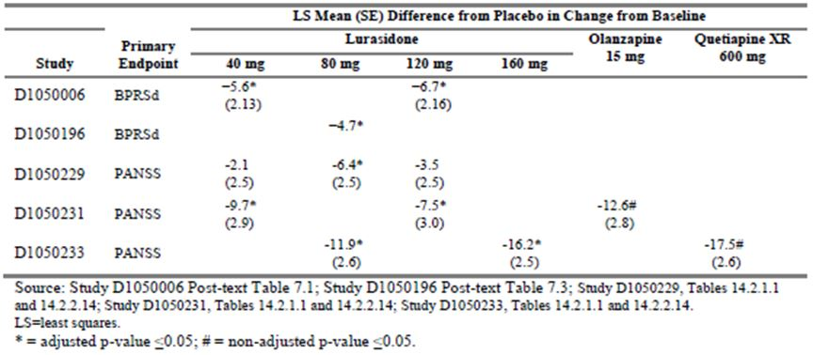

Study D1050229 assessed the efficacy of lurasidone 40 mg, 80 mg and 120 mg in 500 chronic schizophrenia patients with an acute psychotic exacerbation. Lurasidone 80 mg was found to result in a significantly greater reduction in the PANSS total score after 6 weeks treatment compared to placebo (difference of -6.4, adjusted p=0.034). This result was supported by analysis using ANCOVA with LOCF, a significant decrease in the key secondary endpoint of CGI-S at Week 6, as well as in a decrease in the PANSS positive subscore. Neither the 40 mg nor 120 mg lurasidone doses were found to have a statistically significant treatment effect on any measure, apart from 120 mg on the PANSS positive subscore. No treatment effect was found on the MADRS, PANSS negative or PANSS psychopathology subscores.

By contrast, Study D050231 assessed 478 patients and both the lurasidone 40 mg and 120 mg were found to result in a significantly greater reduction in the PANSS total score compared to placebo. This result was supported by a significant reduction in the CGI-S, improvement in PANSS positive, negative and psychopathology subscores and analysis using ANCOVA. There was no significant treatment difference on the MADRS. PANSS responder rates (using a ≥30% reduction definition) were only significant for lurasidone 40 mg. There was no evidence of dose response and no significant differences found between the 40 and 120 mg doses. Assay sensitivity was confirmed by positive responses with the olanzapine group.

In D1050233, which assessed 488 subjects, both lurasidone 80 mg and 160 mg per day were found to be statistically superior to placebo in reducing the PANSS total score after 6 weeks of treatment. The treatment difference was -11.9 (95% CI: -16.9, -6.9 adjusted p <0.001) for lurasidone 80 mg and -16.2 (95% CI: -21.2, -11.2, adjusted p<0.001) for lurasidone 160 mg. A separation of effect was evident from Day 4 through to Week 6. Results were robust, being supported by the ANCOVA analysis and the Per Protocol (PP) population analysis. Superiority of effect was also demonstrated on the CGI-S, the MADRS, PANSS subscores and PANSS responder rates (≥30% improvement). A positive effect with quetiapine confirmed assay sensitivity. While the effect with lurasidone 160 mg was numerically greater, there were no significant differences found between the doses on the PANSS or CGI-S scores.

In D1050196, a Phase II study in 180 subjects, a significantly better response was found with lurasidone 80 mg over placebo as measured by a change from baseline in the BPRS score in the ITT population with LOCF. Results were supported by analysis of secondary efficacy endpoints including PANSS total score and subscores and CGI-S.

In D1050006, a smaller Phase II study (n = 149), lurasidone 40 mg and 120 mg doses had a significant separation from placebo on the BPRS; however, only the 120 mg dose had a significant improvement on the secondary endpoint of PANSS total score. This study was noted to have a very high discontinuation rate of (59-70%) which was higher than the 30-40% seen in the three previously discussed trials. In addition, there was a reported high rate of concomitant antipsychotic use. Given these factors and the small sample size in each group (15-20 subjects), the evaluator does not agree with the sponsor that this study provides “pivotal” efficacy data for the 40 mg or 120 mg doses.

Subgroup analysis on pooled data found that treatment effect was consistent across males and females, race and geographic region (North America and rest of world). There were too few subjects aged over 55 years to draw conclusions for the older population.

There was no clear dose response in the individual trials and pooled data from the 5 short term study comparing doses on PANSS total score and CGI-S score found that only the 160 mg dose was significantly better than the lower doses. The rate of discontinuation due to insufficient clinical response also showed no dose related trend between 40mg and 160 mg although there was a notably higher rate in the 20 mg group. Evidence from PD studies on receptor occupancy and an early dose response study also support the conclusion that 20 mg is subtherapeutic.

There were 2 long term, active controlled studies (D1050234, D1050237) which provided the main long term efficacy data. Both studies found comparable efficacy to the active controls on PANSS total score and CGI-S scores. The probability of relapse over 12 months was non inferior to quetiaine XR but non inferiority to risperidone was not demonstrated.

D1050234 was a 12 month extension study of D1050233 in 292 subjects and assessed the non inferiority of lurasidone compared to quetiapine XR on the time to relapse. The proportion who relapsed was 21% and 27% in the lurasidone and quetiapine groups, respectively and lurasidone was found to be non inferior to quetiapine with a HR of 0.73 (95% CI: 0.41, 1.29) which was within the non inferiority margin of 1.93. Efficacy was maintained over the 12 months and in general comparable to quetiapine. The mean modal dose of lurasidone was 128 mg and of quetiapine was 638 mg.

Study D1050237 was a randomised controlled 12 month safety study in 629 subjects with stable chronic schizophrenia or schizoaffective disorder. It compared lurasidone to risperidone and assessed relapse and efficacy as secondary endpoints. The proportion of subjects who relapsed was 20% and 16% in the lurasidone and risperidone groups, respectively, with a hazard ratio (HR) of 1.31 (95% CI: 0.87, 1.97, p = 0.194) which did not meet the non inferiority criteria of 1.6. The relapse rates were lower than estimated (50% lurasidone and 35% risperidone) and this may have affected results. There was, however, no significant treatment difference on change in total PANSS or CGI-S scores.

There were 7 long term uncontrolled studies – D1050229Ext, D1050231Ext, D1001036, D1001048, D1050174, D1050199 and D1050237Ext – which found in general that efficacy was maintained although the studies were subject to high withdrawal rates.

Efficacy of lurasidone when switched from another antipsychotic was assessed in a 6 week, open label, uncontrolled Study 240 subjects with stable but symptomatic schizophrenia or schizoaffective disorder (D1050289 and its extension D1050290). Dose was initiated at 40 or 80 mg. The overall study discontinuation rate was 17.5% and the treatment failure rate was low at 7.9% with a median time to failure of 21 days (95% CI: 7, 25) among the 19 subjects who failed the treatment of lurasidone. Those that did not titrate to 80 mg at Week 2 appeared to have a higher rate of failure due to exacerbation of underlying disease.

Study D1050254 was an early phase exploratory safety study of 120 mg compared to ziprasidone 160 mg over a 3 week treatment period in chronic stable schizophrenics. The study was not found to provide robust efficacy data.

Overall, efficacy has been demonstrated for the four doses, 40 mg, 80 mg, 120 mg and 160 mg. The 80 mg dose had had its efficacy replicated, the 40 mg and 120 mg doses have shown efficacy in two of three studies although one of these studies was noted to have methodological issues. The 160 mg dose has only had efficacy confirmed in one trial. Lurasidone shows not evident dose response in terms of efficacy and there were no significant benefits in terms of enhanced efficacy with higher over lower doses, apart from 160 mg. The 20 mg dose shows evidence of being subtherapeutic.

### Safety

#### Studies providing safety data

The summary of clinical safety covered data from 52 clinical trials which included 5607 subjects with schizophrenia (3473 treated with lurasidone, 724 treated with placebo and 1410 treated with other medications). Study duration ranged from 3 weeks to 22 months and evaluated doses of lurasidone from 20 to 160 mg/day.

Data were pooled in the following groups:

* P23STC: Short term Phase II/III double blind placebo controlled studies (D1050006, D1050196, D1050229, D1050231, D1030233, D1001002, D1050049). These 7 studies included 1508 subjects treated with lurasidone, 708 with placebo, and 378 with the comparators.
* P23LTC: Long term, 52 week, Phase III, double blind, active controlled studies (D1050234, D1050237). These included 624 subjects treated with lurasidone and 284 with active comparators.
* P23AU: Uncontrolled Phase II/III studies (D1001061, D1001001, D1001036, D1001048, D1001017, D1050174, D1050199, D1050229E, D1050231E, D1050237E, D1050289, D1050290). These included 1071 subjects treated with lurasidone.
* P23STO: Other Phase II/III studies (D1050254) which included 150 subjects treated with lurasidone and 151 treated with ziprasidone.
* P23ALL: The above 4 groups of Phase II/III studies combined. These included 3202 lurasidone treated subjects.
* P1NON: Phase I non schizophrenia (21 studies, 371 lurasidone treated subjects).
* P1SCH: Phase I schizophrenia (9 studies, 300 lurasidone treated subjects).

In the short term placebo controlled efficacy studies, the following safety data were collected: adverse event (AE) monitoring, physical examination, blood pressure, body weight, body mass index (BMI), 12 lead ECG, laboratory safety studies including prolactin, the Barnes Akathisia Scale (BAS),[28] the Abnormal Involuntary Movement Scale (AIMS)[29] and the Simpson-Angus Scale (SAS).[30]

The other Phase II/III studies provided data on AEs, clinical chemistry and haematology, physical examination and vital signs, ECGs, the BAS, and the AIMS.

Study D1050237 assessed safety as a primary outcome. Study D1050254 also assessed safety as the primary endpoint.

AEs were reported as treatment emergent AEs (TEAEs) which were defined as AEs (newly occurring or an exacerbation of pre existing conditions) with a start date on or after the date of the first dose of study medication through seven days after study medication discontinuation.

Laboratory tests included clinical chemistry, prolactin, fasting lipids, fasting glucose, haematology and urinalysis.

AEs of particular interest included extrapyramidal symptoms (EPS), metabolic events (effects on glucose, lipids), neurological events (for example, somnolence, dystonia) and hypersensitivity events. Preferred terms were clustered to capture these events. EPS events included akathisia, bradykinesia, cog wheel rigidity, drooling, dystonia, extrapyramidal disorder, hypokinesia, muscle rigidity, oculogyric crisis, oromandibular dystonia, parkinsonism, psychomotor retardation, restlessness, tongue spasm, torticollis, tremor and trismus.

Metabolic events included blood glucose increased, blood triglycerides increased, diabetes mellitus, glucose tolerance impaired, glycosuria, glucose urine present, HbA1c increased, hyperglycemia, hyperlipidemia, hypertriglyceridemia, metabolic syndrome, impaired fasting glucose, type 2 diabetes mellitus and weight increased.

All cases of confirmed bone fracture regardless of seriousness were reported as serious AEs (SAEs). If possible a dual energy X ray absorptiometry (DEXA) scan was performed together with urine and blood collection for vitamin D, C-telopeptide, N-telopeptide, osteocalcin and bone alkaline phosphatise (ALP).

The Columbia Suicide Severity Rating Scale (C-SSRS) was assessed in the short term, double blind, placebo controlled study (D1050233), in the long term controlled study (D1050237) and in recent studies in the P23ALL study grouping (D1050229E, D1050231E, D1050234, D1050237E, D1050289, and D1050290).

Opthalmological examination including fundoscopy and biomicroscopy was conducted in study D1050006 and D1050237.

Measures of bone turnover were assessed for all subjects in Studies D1050049, D1050174, D1050196, D1050199, D1050237, D1050237E, D1001001, and D1001036.

#### Patient exposure

The P23STC studies included 1508 subjects who received lurasidone with a mean exposure of 31.7 days (SD 14.4 days). The P23LTC studies included 624 subjects who received lurasidone with a mean (SD) exposure of 216.4 (14.54) days. Most subjects in this grouping received lurasidone 40 mg (43.8%) or 80 mg (36.1%). In P23ALL, the mean exposure duration to lurasidone was 138 days (range: 1 to 729 days), median exposure was 45 days and 471 subjects had ≥364 days exposure. Total exposure was 1212 patient years.

There were 671 subjects exposed to lurasidone in the Phase I studies. Single doses ranged from 0.1 mg to 100 mg and repeated doses up to 600 mg per day for <1 week. The mean duration of exposure to lurasidone in non schizophrenia subjects was 2.4 days and in schizophrenia subjects was 12.4 days.

In the P23STC studies, the mean age of subjects receiving lurasidone was 40 years with 89% aged under 55 years and only 29 subjects aged 65 years or older. Most subjects were male (71%) and 38% were White, 30% Black/African American and 28% Asian. Demographics were similar in the long term controlled population.

#### Safety issues with the potential for major regulatory impact

##### Cardiovascular safety

###### QT prolongation

In the P23STC population, the rate of QTcB prolongation (male QTc >450 msec, female QTc >470 msec) was 3.9% and 3.5% in the lurasidone and placebo groups, respectively. The rate of QTcB prolongation was 4.5%, 5.8%, 4.6% and 6.2% in the haloperidol, olanzapine, quetiapine XR, risperidone groups, respectively. The rate of QTcF prolongation was 1.0% and 0.3% in the lurasidone and placebo groups and 1.5%, 0%, 0%, and 4.6% in the four active groups, respectively.

In the P23LTC population, the rate of QTcB prolongation with flexible dosing was 6.2%, 13.9%, 4.6% in the lurasidone, risperidone and quetiapine XR groups, respectively. In the P23ALL population, the overall rate of QTcB and QTcF prolongation was 6.0% and 1.3%.

A subgroup of subjects with increased cardiovascular risk was identified by the investigator (age ≥55 years, CV disease or prior MI). In this group in P23STC, the rate of QTcB prolongation was 10.4% and 7.7% and QTcF prolongation was 5.2% and 0% in the lurasidone and placebo groups, respectively. In the P23LTC population, this group had a rate of QTcB prolongation of 10.0%, 33.3% and 22.2% in the lurasidone, risperidone and quetiapine XR groups, respectively.

A thorough QT study (D1050249) with lurasidone 120 mg and 600 mg per day over 11 days was conducted in 73 patients with schizophrenia or schizoaffective disorder. None of the subjects in the lurasidone groups had an absolute QTc above 450 msec or change from baseline of >60 msec; however, administration of lurasidone at a therapeutic dose of 120 mg prolonged the heart rate corrected QT intervals with a mean change from baseline of 9.4 msec with the maximum upper bound of the two-sided 90% CI ΔQTcI of 14.7 msec at 2 h post dose. Supratherapeutic dose of lurasidone 600 mg (titrated regimen) prolonged the QTc intervals, but to a lesser extent than the therapeutic dose, with a mean change from baseline of 5.8 msec and the upper bound of the two sided 90% CI ΔQTcI was 11.5 msec at 4 h post dose. The study did not have a placebo group and due to intersubject variability the findings are not conclusive and concentration QTc response modelling was undertaken. The model demonstrated a small dose response but did not find that the doses of 120 mg or 600 mg were associated with QTc prolongation as the upper bound of the 90% CI was <10 msec.

The sponsor also submitted an “Expert summary review of the effect of lurasidone on cardiac repolarisation” in the Summary of Clinical Efficacy which concluded that:

*Lurasidone is devoid of any clinically relevant effect on QTc interval.*

In the P23ALL population (1212 patient years exposure), the following clinical cardiovascular events occurred: syncope (0.2%, n = 8), loss of consciousness (<0.1%), complex partial seizures (<0.1%), convulsion (0.2%), sudden death (0.1%, n = 3) and ventricular extrasystoles (0.2%, n = 6). No clinically meaningful increases in the QTc duration were reported with these cases. There were no reported cases of ventricular tachycardia, fibrillation, flutter or torsades de pointes. Post marketing data provided did not reveal any signals relating to QT prolongation.

In terms of major cardiovascular events (MACE) in P23ALL, there was one (<0.1%) myocardial infarction, 3 (<0.1%) atrioventricular block first degree, 1 (<0.1%) atrioventricular block, 1 (<0.1%) bundle branch block, and 1 (<0.1%) reported left bundle branch block. There were 3 cases (<0.1%) of stroke, one cerebrovascular haematoma and 2 pulmonary embolisms (one was “possible” and was fatal, the other was associated with chest trauma). In the P23STC population, orthostatic hypotension occurred in 0.3% of lurasidone subjects compared to 1.6% of the olanzapine and 2.5% of the quetiapine XR group. The rate in P23ALL was 0.3%.

#### Post marketing data

Lurasidone was launched in the US in February 2011 and in Canada in September 2012. The Summary of Clinical Safety summarised post marketing data to the cutoff date of 30 June 2012. Five individual PSURs were also included covering the period from January 2011 to April 2012. As of 30 June 2012, the estimated exposure was 386,900 patients representing 32,241 person years. There have been 1505 serious and non serious adverse drug reactions reported in 723 patients. Most were in the psychiatric, nervous system, gastrointestinal and general disorders System Organ Class (SOC). The most frequently reported reactions were nausea, akathisia, insomnia, rash and anxiety. There were 194 serious reactions with the most frequent being suicidal ideation (n = 9), convulsion (n = 9), death (n = 7), auditory hallucination (n = 6) and psychotic disorder (n = 6).

There 6 serious and 151 non serious reports of extrapyramidal symptoms. The 6 serious cases were: 3 akathisia, 2 dystonia and 1 oromandibular dystonia. The most frequent non serious cases were akathisia, tremor, restlessness and dystonia. There were no reported cases of drug interactions. There were 4 serious and 14 non serious reports of angioedema and related symptoms. There were 16 serious and 81 non serious reports of neuroleptic malignant syndrome and related terms. There was one serious and 35 non serious reports of tardive dyskinesia and related symptoms.

There were 38 pregnancies recorded of which 26 have no outcome data and 2 delivered healthy babies. In the 10 other cases, 7 were non serious and the outcome was not reported. There were 3 serious cases: one spontaneous abortion at 6 weeks, one spontaneous abortion at unknown gestation and one exacerbation of schizoaffective disorder.

There were 8 reports of overdoses, 7 were intentional (2 of which were fatal) and in one case the patient was prescribed 360 mg per day. There were 2 bone fractures, one associated with an attempted suicide and the other following a fall.

There were 12 reported deaths. The cause was unknown in 6 cases, there were 3 suicides, one homicide, one an unspecified infection and one “ill with anaemia”.

#### Evaluator’s conclusions on safety

The safety data for lurasidone was derived from 52 clinical trials which included 5607 subjects with schizophrenia (3473 treated with lurasidone, 724 treated with placebo, and 1410 treated with other medications). Study duration ranged from 3 weeks to 22 months and evaluated doses of lurasidone from 20 mg to 160 mg/day. There were 471 subjects who had ≥364 days exposure and the total exposure was 1212 patient years.

The main data pools were:

* P23STC: Short term Phase II/III double blind placebo controlled studies (D1050006, D1050196, D1050229, D1050231, D1030233, D1001002, D1050049) which included 1508 subjects treated with lurasidone, 708 with placebo and 378 with comparators. The mean exposure duration was 31.7 days.
* P23LTC: Long term, 52 week, Phase III double blind active controlled studies (D1050234, D1050237) which included 624 subjects treated with lurasidone, 85 with quetiapine and 199 with risperidone. Dosing was flexible and the mean exposure duration was 216 days.
* P23ALL: All Phase II/III studies combined (controlled and uncontrolled) which included 3202 subjects treated with lurasidone with a mean exposure duration of 138 days.

There were 19 reported deaths in the clinical development program with 13 (0.4%) in subjects treated with lurasidone that were treatment emergent. The rate of death was 1.07 per 100 patient years. There were 5 suicides, 1 thermal burn, 1 road traffic accident, 1 septic shock with respiratory failure, and 5 cardiovascular deaths. These latter deaths were: coronary artery occlusion and diffuse ventricular interstitial fibrosis; sudden death due to presumed pulmonary embolism or myocardial infarction; presumed cardiac arrhythmia due to hypoplastic right coronary artery and cardiomegaly; sudden death due to presumed acute cardiac failure; and sudden death due to brainstem and pericardial haemorrhage. There was no consistent pattern to these deaths. There were 2 deaths on comparators: bronchopneumonia in an olanzapine treated, and cardiac arrest in a ziprasidone treated subject.

In the short term studies, the rate of SAEs (4.6%) was comparable to placebo and active comparators (5.6% and 2.5-4.9%) apart from haloperidol which had a slightly higher rate (6.9%). While there did not appear to be a dose response in the rate of SAEs, the highest rate was with the 120 mg dose (6.2% compared to 3.2-5.6% with the other doses). In the long term controlled population, the rate of SAEs was comparable to risperidone (10.6% versus 10.1%) and less than quetiapine XR (20%). The most frequent SAEs in the long term population were psychotic disorder (3%), schizophrenia (2.1%), suicidal ideation (0.3%), agitation (0.3%), anxiety (0.3%), parkinsonism (0.3%), fall (0.5%) and rib fracture (0.3%).

The rate of discontinuation of study medication due to TEAEs was similar to the active comparators in the short term studies (9.5% versus 9.3-11.1%) except for quetiapine XR which had a lower rate (3.4%). The highest rate of TEAE related discontinuation was in the lurasidone 120 mg dose (13.7%) compared to 6.6-9.9% in the 40, 80 or 160 mg dose. In the long term studies, the discontinuation rate was comparable to quetiapine and risperiodone (18.4% versus 22.4% and 16.1%). The most frequent events leading to discontinuation were schizophrenia, psychotic disorder, akasthisia, dystonia, agitation, anxiety, insomnia, dyskinesia, somnolence, nausea and vomiting.

The adverse event profile was as would be expected with this class of drug. The most frequent TEAEs were headache, akathisia, nausea, insomnia, somnolence, sedation, vomiting, schizophrenia, agitation, anxiety and constipation. A dose response relationship was seen with akathisia and somnolence. Most events were mild or moderate with 7.7% of events in the short term studies deemed severe in nature.

The rate of EPS TEAEs with lurasidone was high (25% in the short term studies), greater than quetiapine (7.6%), similar to olanzepine (23%) and risperidone (28%) and less than haloperidol (54%). This was also reflected in the long term studies with similar rates to risperidone (25% versus 23%). The akathisia rate in the short term studies (12.9%) was greater than with olanzapine (7.4%) and quetiapine XR (1.7%), lower than with haloperidol (19.4%) and similar to risperidone (13.8%). In the long term studies, akathisia was the most frequent TEAE with higher rates than with quetiapine or risperidone (13.6% versus 2.4%, 8.0%).

In the P23ALL population, the rate of tardive dyskinesia was 0.3% and there was one case (<0.1%) of neuroleptic malignant syndrome. There were 5 reported convulsions (0.2%) in the P23ALL population and one complex partial seizure (<0.1%).

The risk of hypersensitivity reactions was present with one case (<0.1%) of serious angioedema, one rash and one pruritus, all of which led to treatment discontinuation.

The notable change in laboratory data was an increase in prolactin, particularly with the higher lurasidone doses of 120 and 160 mg and there appeared to be a dose response in the shift from normal/low to high prolactin levels. In the short term studies, the rate of markedly abnormal prolactin (≥5x ULN) was 2.7% with lurasidone which was comparable to haloperidol (4.8%), higher than olanzepine and quetiapine (0%) and notably lower than risperidone (29.7%). In P23ALL, the rate of TEAEs of elevated prolactin or abnormal prolactin was 3.1% and <0.1%, respectively. TEAEs of galactorrhoea, amenorrhoea and erectile dysfunction occurred in <0.1%, 0.3% and 0.3% of lurasidone subjects, respectively. There were no cases of gynaecomastia reported.

The rate of bone fractures was 0.7% in P23ALL, there was one reported case of osteopaenia (<0.1%) and none of osteoporosis. There were no notable changes on markers of bone turnover. Bone density DXA scans were performed in one study and in 97 lurasidone subjects there was no notable mean change in BMD after 12 months treatment.

Changes in liver function, and in particular increased transaminases, were in line with placebo and there were no cases of elevated liver function tests (LFTs) meeting Hy’s Law criteria.

Renal function showed a dose dependent effect on increased creatinine in the short term studies, particularly with the 120 and 160 mg doses. In the long term controlled studies, the rate of markedly abnormal creatinine was 0.2% with lurasidone with no cases reported with risperidone or quetiapine. Shifts from normal/low to high creatinine occurred in 5.2%, 2.4% and 4.3% of the lurasidone, risperidone and quetiapine groups, respectively. There were 2 cases of renal failure (<0.1%) in P23ALL.

The rate of markedly abnormal CK was similar between lurasidone, placebo and the active comparators haloperiodol and olanzepine. There were 2 reported TEAEs of rhabdomyolysis, one mild, one severe, both leading to discontinuation.

There were no notable effects on lipids, glucose or haematological parameters. Urinalysis was unremarkable. Metabolic TEAEs occurred at a lower rate than olanzepine (3.2% versus 24.6%) primarily due to the higher rate of increased weight with olanzepine.

Vital signs indicated some orthostatic changes with a rate of orthostatic hypotension in the short term trials of 1.5% which was slightly higher than placebo (0.7%), olanzepine (0.8%) and quetiapine (0.9%).

Weight change was much less marked with lurasidone than with olanzepine or quetiapine. The mean weight change in P23STC was 0.43 kg compared to 4.15 kg with olanzapine, 2.09 kg with quetiapine and 0.2 kg with risperidone. In the long term studies, the mean weight change was -0.64kg and in P23ALL, increased weight was reported as a TEAE in 4.2% of lurasidone subjects.

Movement disorders were assessed using three rating scales. Shift in the Simpson-Angus rating scale was similar to olanzepine and less than with haloperidol. The Barnes Akathisia rating scale showed a dose related increase to 120 mg, and the rate of worsening on this scale was higher than seen with olanzepine and quetiapine but less than haloperidol. The AIMS showed change from normal to abnormal in line with placebo and less than haloperidol in the short term and an overall rate of worsening of 2.2% in the P23ALL population.

Opthalmological assessment was undertaken in a subgroup of D1050237 and in this limited dataset (~110 lurasidone treated subjects) there were no notable safety signals.

In the short term studies the rate of QTcB increase was similar to placebo (3.9% versus 3.5%) and less than risperidone (6.2%) and in the P23LCT population the rate of QTcB prolongation was (6.2%) was again less than risperidone and in line with quetiapine (4.6%). A thorough QT study, which assessed doses of 120 mg and 600 mg, found that both doses prolonged the heart rate QTcI with the upper bound of the 90% CI at 14.7 msec and 11.5 msec, respectively. The study did not have a placebo group and due to intersubject variability the findings are not conclusive. Concentration QTc response modelling found a small dose response but no significant QTc prolongation with either dose as the upper bound of the 90% CI was <10 msec. There were no events in the clinical program considered related to QT prolongation.

Post marketing data was provided for the period of February 2011 to June 2012 in North America and in the estimated 32,241 person years exposure there have been 1505 adverse drug reactions reported in 723 patients. The profile of events was in line with the safety database and no new signals were evident.

There are very limited data in pregnant women and due to the potential for developmental toxicity from nonclinical studies lurasidone should not be used in pregnancy or lactation. The safety of lurasidone was similar between males and females and across racial groups of White, Black and Other. There were too few subjects over 65 years to be able to draw conclusions on safety in the elderly population. Subjects with renal, hepatic or cardiac impairment were excluded from the clinical trials. There were also no safety subgroup analyses in such subjects so the potential risks in these groups are not able to be qualified.

Due to the CYP3A4 metabolism of lurasidone it is contraindicated with strong inhibitors or inducers of CYP3A4 and a lower dose recommended in the presence of moderate inhibitors.

There were no cases of withdrawal syndrome in the Phase II/III clinical program although this was not specifically assessed.

Overall, the safety profile of lurasidone was in line with other atypical antipsychotics and appears comparable to risperidone.

### First round benefit-risk assessment

#### First round assessment of benefits

The benefits of lurasidone in the proposed usage are:

* The efficacy in treatment of acute schizophrenia which was superior to placebo and demonstrated in 5 short term (6 week) controlled studies. This efficacy was comparable to active controls (olanzepine and quetiapine XR) although this was not formally assessed.
* Efficacy was demonstrated for the doses of 40 mg, 80 mg, 120 mg and 160 mg once daily. The 80 mg dose had the efficacy replicated however efficacy of the 160 mg dose was only demonstrated in one study and the study in which the efficacy was replicated for the 40 mg and 120 mg doses had methodological issues and the third study with these doses was negative.
* Long term maintenance efficacy was demonstrated in one long term controlled study where lurasidone was found to be non inferior to quetiapine XR in the time to relapse. A second long term controlled study did not, however, find that lurasidone was non inferior to risperidone in time to relapse.
* Subjects were able to switch to lurasidone from other anti-psychotics with a low treatment failure rate at 6 weeks.
* There were less metabolic effects of hyperglycaemia, increased weight and increased lipids compared to other atypical antipsychotics.
* There were no evident effects on haematological parameters.
* A safety profile in line with what is known for atypical antipsychotics.

#### First round assessment of risks

The risks of lurasidone in the proposed usage are:

* No consistent dose response across doses of 40 to 120 mg per day.
* Extrapyramidal symptoms, akathisia, parkinsonism, and dystonia, were present with a lower frequency than haloperidol but higher than some other atypical antipsychotics (for example, quetiapine XR).
* Neuroleptic malignant syndrome.
* Tardive dyskinesia.
* Angiooedema and hypersensitivity reactions.
* Hyperprolactinaemia. There was however no evident risks of resultant effects such as galactorrhoea, amenorrhoea, erectile dysfunction, gynaecomastia reported, or effects on bone metabolism with fractures, osteoporosis or osteopaenia.
* A modest increase in creatinine was noted particularly with the highest lurasidone doses although there was no evident risk of renal insufficiency or renal impairment. Patients with renal impairment were excluded from the clinical trials and are at risk of increased exposure. The safety risks in this population have not been elucidated.
* Somnolence and the resultant risks with impairment of judgement and motor skills and in using machinery.
* Interaction with strong CYP3A4 inhibitors and inducers.
* Low levels of QT prolongation was found in the thorough QT trial with higher doses of 120 mg and 600 mg, although this prolongation was not supported by exposure response modelling nor clinical signals in the Phase II and III program.
* Orthostatic hypotension and, as patients with cardiac impairment were excluded from trials, the risks in this population are not established.
* Patients with hepatic impairment are at risk of increased exposure and as they were excluded from the trials the risk has not been established in this population.
* Possible effects on the eye, although there were no signals in the subjects where ophthalmological assessments were undertaken.
* Possibility of withdrawal effects. This was not seen in development program although it was not specifically assessed.
* Missing data on the elderly (≥ 65 years), pregnant or lactating women, and children or adolescents.
* Dementia-related psychosis is a reported risk with atypical anti psychotics. Elderly with dementia were excluded from the trials.
* Suicide attempt in patients with schizophrenia and the risk of overdose with the medication.

#### First round assessment of benefit-risk balance

Over the development program of lurasidone, sponsorship has altered and there have been a number of formulations changes. The clinical efficacy and safety studies were conducted with Group B formulation and bioequivalence was demonstrated to the commercial formulation (Group C) for the 40 mg and 120 mg tablets. Based on similar dissolution profiles and linear PK, bioequivalence is assumed for the other dose strengths of 20 mg and 80 mg.

The clinical trials in the lurasidone development program were designed in line with current guidelines[31] and relevant methodological points were: use of validated appropriate rating scales which cover a broad range of symptoms (BPRS in 2 studies and PANSS total score in 3 studies); use of CGI-S as a key secondary endpoint; use of fixed dose, parallel group design, placebo control and assay sensitivity with active controls; and an appropriate study duration of 6 weeks for a short term trial. The sponsor did however frequently use response rates defined as a ≥20% improvement in PANSS total score. This level is not felt to be a sufficient response to be clinically meaningful and ≥30% is preferred.[32]

The efficacy of lurasidone in treatment of acute psychosis was on the whole demonstrated in the short term trials with separation from placebo on the PANSS total score and CGI-S. In addition, responder rates on PANSS total score were reported from 48% to 67% using the ≥20% improvement definition and, where available, from 47% to 63% using ≥30% improvement. Treatment effect was noted to be variable. There were two trials (one of 40 and 80 mg lurasidone with risperidone as the active control and the other of 20, 40 and 80 mg lurasidone with haloperidol as the active control) which failed to show any product separating significantly from placebo. One of these trials had a high discontinuation rate and some imbalances between groups. Apart from this, the reasons for these failures were not evident and a question has been raised. Efficacy was most consistently demonstrated with the 80 mg dose as positive data were seen in three trials. Efficacy of 160 mg was only demonstrated in one trial and efficacy of the 40 mg and 120 mg doses was demonstrated in one trial, replicated in a second trial with methodological issues and failed to separate from placebo in a third trial.

Efficacy was demonstrated in one long term controlled trial where treatment with lurasidone was found to be non inferior to quetiapine XR in time to relapse. By contrast, in the second long term controlled trials non inferiority on time to relapse was not found when compared to risperidone. This finding in the latter trial may have, in part, been a result of lower than predicted relapse rates. For maintenance therapy, subjects were required to have either successfully completed the 6 week short term study or have been clinically stable prior to entry. This needs to be reflected in the Clinical Trial section of the draft PI.

As noted by the sponsor, current data on the demographics of the Australian schizophrenic population are not available. A recent large survey of people living with psychotic illness, of which 47.0% had schizophrenia and 17.5% schizoaffective disorder, found that the highest prevalence was in males aged 25-34 years and then in those aged 35-44 and 45-54 years.[33] Two thirds of the population surveyed had illness onset before the age of 25 and 61.5% had experienced multiple episodes. The most common symptoms were delusions and hallucinations. One quarter (24.0%) of people with psychosis were at high risk of cardiovascular disease, 30.1% had asthma and 20.5% diabetes. Almost half (45.1%) of the people with psychotic illness were obese. Smoking, alcohol and drug abuse were frequent. There are similarities between this profile and the population studied in the lurasidone program in terms of age, gender and disease characteristics. Nonetheless, the notable risk of cardiovascular disease in the Australian population with psychotic illness has not been covered in the development program due to the exclusion of subjects with clinically significant cardiovascular disease and, in some trials, of unstable diabetics.

In terms of cardiovascular safety, there was a low level of QT prolongation in the thorough QT trial with 120 and 600 mg doses although this prolongation was not supported by exposure response modelling nor any clinical signals in the Phase II and III program. It is still recommended that an appropriate precaution is included in the PI. This should state that lurasidone should not be used with other drugs which may prolong the QT interval, in patients with cardiac arrhythmias, or in patients who may be at risk of torsades de pointes or sudden death when given QTc interval prolonging drugs (for example, congenital prolongation of the QT interval).

Given the population with psychotic illness are reported to have a high cardiovascular risk, it was encouraging that there were less metabolic effects than some other atypical antipsychotics as well as less weight gain. There was a risk of orthostatic hypotension and this risk has been included in the precautions together with a statement that lurasidone should be used with caution in patients with cardiovascular disease. The evaluator recommends however that the precaution in this latter group should be more prominent and given a distinct entry.

The proposed indication is “treatment of schizophrenia”. The evaluator agrees that there are sufficient efficacy data to cover both acute and maintenance therapy so the broad indication is acceptable. As the development program was limited to an adult population this should be included in the indication, that is, treatment of adults with schizophrenia.

Across doses of 40 to 120 mg per day, no consistent dose response on efficacy parameters was demonstrated. In pooled analyses, only the 160 mg dose was found to be significant better than the lower doses, and in head-to-head comparison in individual trials there was no differentiation between doses. Given the clinical imperative to use the lowest possible effective dose with acceptable tolerability, it is not clear to the evaluator when the 120 mg dose would be used over a lower dose and in what situations a treating psychiatrist would titrate. The recommended starting dose is 40 mg and it is expected that the majority of patients will be treated with the 40 and 80 mg doses. Nonetheless, the sponsor needs to provide further justification of the benefit of the higher over lower doses and detail the situations in which up titration should be undertaken. This also needs to be covered in the PI.

The sponsor is not proposing to register the 120 mg tablet. Due to a potential benefit of increased compliance with one tablet over two or three, should the 120 mg dose be approved, the evaluator would recommend that this strength tablet be available.

The safety database of lurasidone was sufficient as the Phase II and III studies included 3202 subjects treated with lurasidone, with 1212 patient years exposure and 471 subjects had ≥364 days of exposure. Overall, the safety profile was as would be expected from an atypical antipsychotic. The adverse effect rates were notably higher than placebo, though in line with the other agents depending on which parameters were being compared. Post-marketing data from an estimated 32,000 patient years exposure, did not reveal any new safety signals. Of the 13 (0.4%) treatment emergent deaths in lurasidone treated subjects, 5 were adjudicated as cardiovascular and the three classed as “sudden death” had probable alternative causes. Overall there was no particular pattern evident for the deaths.

Discontinuation rates in schizophrenia trials are known to be relative high, however the discontinuation rate due to adverse events was acceptable (9.5% in the short term studies) and comparable to other atypical antipsychotics assessed. The main reasons were schizophrenia and akathisia, dystonia and agitation. Extrapyramidal symptoms (such as akathisia, parkinsonism and dystonia) were found to be dose related (highest rate with 120 mg) and occurred at a lower frequency than haloperidol but higher than some other atypical antipsychotics (for example, quetiapine XR). It is important that the dose related effects on EPS and use the lowest possible dose are adequately covered in the PI. Risks of neuroleptic malignant syndrome and tardive dyskinesia were also present and have been detailed in the PI.

The risk of hyperprolactinaemia is known with this class of drug and, while seen with lurasidone, resultant adverse effects such as amenorrhoea and gynaecomastia, or effects on bone metabolism were not evident. The level of hyperprolactinaemia was less than with haloperiodol and risperidone.

A modest increase in creatinine particularly with the higher doses was noted in the clinical trials. This did not appear to result in an increased risk of renal impairment or renal failure. Patients with renal impairment were found to have higher exposure to lurasidone and the sponsor is proposing a lower starting dose of 20 mg in those with moderate to severe impairment and maximum dose of 80 mg. Given the 2 fold increase in lurasidone exposure in patients with severe renal impairment, this dose reduction is acceptable. The population of moderate or severe renal impairment were excluded from the development program and consequently, the safety profile in this group has not been elucidated. Given the proposal to treat this population further safety data on this group would be useful to assess benefit-risk balance and the population should also be monitored through the risk management system.

Similarly, mild, moderate and severe hepatic impairment increases the lurasidone exposure 1.5, 1.7 and 3.0 fold, respectively and patients with clinically significant liver disease were not studied in the development program. The proposed dosage reduction in patients with hepatic impairment (20 mg starting dose and 80 mg maximum dose in moderate impairment and 40 mg in severe impairment) is acceptable. As with renal impairment, subgroup analysis of safety data in patients with hepatic impairment should be presented in order to assess the risk-benefit and the population monitored in the risk management system.

The possibility of a suicide attempt is inherent in patients with schizophrenia. Prescriptions should be written for the smallest quantity of tablets, consistent with good patient management, in order to reduce the risk of overdose. This has been adequately covered in the PI. The risk of angiooedema and hypersensitivity reactions was low and has been covered in the Adverse Effects section of the PI. Significant drug interactions were noted for co-administration with CYP3A4 inhibitors (for example, ketoconazole) and CYP3A4 inducers (for example, rifampin) and these risks have been covered in the draft PI with contraindications with strong inhibitors or inducers and lower dosage with moderate inhibitors. The risk of concomitant grapefruit juice has not been included in the PI or CMI and this needs to be addressed by the sponsor.

The Adverse Effects data in the PI currently covers only adverse reactions and this needs to be amended, in line with TGA guidelines, to include all AEs.

Safety and efficacy data in the elderly (≥ 65 years), pregnant or lactating women, and children or adolescents are lacking. These issues need to be adequately covered in the PI. The possibility of withdrawal effects were not seen however this risk was not specifically assessed and should be monitored in the RMP.

There were several precautions which were not present in the draft PI and, despite the low risk seen with lurasidone, the evaluator believes they should be still listed in this section with appropriate, relevant data. These include: the risk of cerebrovascular adverse reactions in the elderly with dementia (as opposed to mortality in this group which has been included); QT prolongation and cardiovascular disease; weight gain; hyperglycaemia and diabetes; dyslipidaemia; body temperature regulation; and dysphagia.

In summary, the efficacy of lurasidone has been demonstrated at doses of 40, 80, 120 and 160 mg per day with a safety profile consistent with what is known for atypical antipsychotics and as such the evaluator finds the benefit-risk balance of lurasidone is favourable in the usage of “treatment of adults with schizophrenia”. The commencing dose of 40 mg is accepted as the lowest effective dose. The lack of dose response on efficacy parameters and lack of differentiation between doses, except for the highest dose of 160 mg, means that there is no clear evidence as to when the dose should be titrated. As with efficacy, safety risks did not always demonstrate a dose-response (notable exceptions were akathisia and somnolence). Nonetheless, the 120 mg dose did have overall a worse safety profile than the lower doses. This concern needs further explanation from the Sponsor together with a discussion on dose adjustment in the product information. Should the 120 mg dose be approved, in order to potentially aid with compliance, the evaluator recommends marketing of the 120 mg tablet.

### First round recommendation regarding authorisation

As further information on dosage titration is required, the evaluator recommends that this be reviewed prior to any decision on authorisation. In addition, clinical questions in next section together with comments on the PI and CMI need to be addressed. At this stage, subject to satisfactory responses, the lower doses of 20 mg, 40 mg and 80 mg are approvable in the indication of “treatment of adults with schizophrenia”.

### Clinical questions

#### Additional expert input

None.

#### Clinical questions

##### Pharmacokinetics

None.

##### Pharmacodynamics

None.

##### Efficacy

Q1. There were two short term studies in the clinical development program which failed (D1050049 and D1001002). Can the sponsor provide any clarity as to why this occurred? If so, discuss the factors.

Q2. There was no consistent dose response across doses of 40 to 120 mg per day demonstrated with lurasidone. In pooled analyses, the 160 mg dose was found to be significant over the lower doses, however in head-to-head comparisons in individual trials there were no significant differences between doses of 40 mg and 120 mg. In addition, the safety profile of the 120 mg dose was in general worse than the lower doses. Given the clinical imperative to use the lowest possible effective dose with acceptable tolerability, it is not clear to the evaluator when the 120 mg dose would be used over a lower dose and in what situations a treating doctor would titrate. Provide further justification of the benefit of the higher over lower doses, when they should be used and detail the situations in which up titration should be undertaken. This information would also need to be reflected in the *Dosage and Administration* section of the draft PI.

##### Safety

Q3. Mild, moderate and severe hepatic impairment increases the lurasidone exposure 1.5, 1.7 and 3.0 fold, respectively. Impaired hepatic function was an exclusion criterion in the clinical trials. No subgroup analysis of safety data in subjects with hepatic impairment was undertaken. What was the number of subjects with hepatic impairment in the pooled safety population? Is it sufficient to undertake a subgroup analysis? If so, provide an analysis of safety parameters in this subgroup, with comparisons to the population with normal hepatic function, so that the benefit-risk may be assessed in this patient population.

Q4. Mild, moderate and severe renal impairment alters the lurasidone exposure 1.5, 1.9 and 2.0 fold, respectively. As in the previous question, provide a summary of this population that is present in the pooled safety database and, if sufficient in number, summarise the safety in this subgroup compared to the population with normal renal function.

### Second round evaluation of clinical data in response to questions

The sponsor submitted a response to the first round of evaluation dated 7 October 2013. The response was compiled by Dainippon Sumitomo Pharma and Sunovion Pharmaceuticals Inc. The response also included literature references, proposed revised PI and CMI and revised Australian Specific Annex (ASA) to the EU RMP. The questions and the responses are summarised below.

#### Q1. Failed studies

*There were two short term studies in the clinical development program which failed (D1050049 and D1001002). Can the sponsor provide any clarity as to why this occurred? If so, discuss the factors.*

##### Sponsor response

Efficacy was demonstrated in 5 controlled trials. Two studies found no assay sensitivity and so clinical inferences or conclusions cannot be made regarding efficacy of lurasidone. The sponsor cannot provide any clarity as to why these studies failed.

##### Evaluator comments

No comments.

#### **Q2. Dose rationale**

*There was no consistent dose response across doses of 40 to 120 mg per day demonstrated with lurasidone. In pooled analyses, the 160 mg dose was found to be significant over the lower doses, however in head-to-head comparisons in individual trials there were no significant differences between doses of 40 mg and 120 mg. In addition, the safety profile of the 120 mg dose was in general worse than the lower doses. Given the clinical imperative to use the lowest possible effective dose with acceptable tolerability, it is not clear to the evaluator when the 120 mg dose would be used over a lower dose and in what situations a treating doctor would titrate. Provide further justification of the benefit of the higher over lower doses, when they should be used and detail the situations in which up titration should be undertaken. This information would also need to be reflected in the Dosage and Administration section of the draft PI.*

##### Sponsor response

The sponsor agreed that there did not appear to be a consistent dose response and stated:

*Results of these analyses for both PANSS and CGI-S consistently showed superior efficacy of the 160 mg dose group compared to the 40, 80 and 120 mg dose groups (95% confidence interval [CI] did not include 0). Pairwise comparisons for PANSS Total and CGI-S score change indicated no significant efficacy differences between the 40, 80 and 120 mg dose groups.*

A responder analysis was provided (based on ≥20% improvement from baseline in PANSS total score or BPRS score) for the 5 main studies. This showed the proportion of responders with 80 mg and 160 mg from study D1050233 was 65% and 79%, respectively. The sponsor claims this is a clinically relevant difference.

Further commentary was made on D2 receptor occupancy and that the target of 65-75% peak blockade is achieved with doses of 40 mg and higher.

Safety risks were acknowledged:

*The results of the development program also support the safety and tolerability of lurasidone at 40, 80, 120 and 160 mg/day. However, there is evidence for a dose-relationship for certain adverse events, particularly akathisia and somnolence. In addition, higher overall discontinuation rates were observed in pooled short term studies at 120 mg/day compared to lower doses. Taken together, these results suggest that the initial and target daily dose of lurasidone should be 40 mg or 80 mg. Lurasidone dose may be increased up to 160 mg/day, based on clinical judgment including the severity of presenting symptoms, treatment response and tolerability, which will vary among patients.*

The sponsor concludes that:

*The availability of a wide effective dose range for lurasidone (40-160 mg/day) for the treatment of schizophrenia will substantially aid prescribers by permitting flexibility of dosing when making treatment decisions for individual patients.*

The sponsor agreed with the evaluator to alter the Dosage and Administration section of the PI with the following wording:

*The efficacy of Latuda has been established at doses of 40, 80, 120 and 160 mg/day. The recommended starting dose is 40 mg once daily. Initial dose titration is not required. Latuda is effective in a dose range of 40 mg per day to 160 mg once daily.* ***Patients should be treated with the lowest effective dose that provides optimal clinical response and tolerability, which is expected to be 40 mg or 80 mg once daily for most patients. In the 6 week controlled trials, there was no suggestion of added benefit with the 120 mg/day dose compared to 40 and 80 mg/day. In the pooled analyses, added benefit occurred at 160 mg/day compared to lower doses. Doses above 80 mg may be considered for certain patients based on individual clinical judgement.*** *The maximum recommended dose is 160 mg/day. Latuda should be taken with food.*

##### Evaluator comments

The evaluator believes the benefit-risk balance of the 120 mg and 160 mg doses is marginal but acknowledges that a small group of patients may achieve a clinical response with the higher dose. It is noted again that 20% improvement in PANSS total score is lower than the CHMP recommended 30% to be classed as clinically relevant improvement. Nonetheless, the evaluator finds that the revised wording on dosage adequately explains the situation with the higher two doses and is acceptable.

#### Q3. Hepatic impairment

*Mild, moderate and severe hepatic impairment increases the lurasidone exposure 1.5, 1.7 and 3.0 fold, respectively. Impaired hepatic function was an exclusion criterion in the clinical trials. No subgroup analysis of safety data in subjects with hepatic impairment was undertaken. What was the number of subjects with hepatic impairment in the pooled safety population? Is it sufficient to undertake a subgroup analysis? If so, provide an analysis of safety parameters in this subgroup, with comparisons to the population with normal hepatic function, so that the benefit-risk may be assessed in this patient population.*

##### Sponsor response

The sponsor discussed Study D1050264 a single dose (20 mg) PK study in 21 subjects with moderate hepatic impairment. The sponsor stated that:

*No dose adjustment for Latuda is required in patients with mild hepatic impairment. Dose adjustment is recommended in moderate (creatinine clearance: 30 to <50 mL/min) and severe hepatic impairment (creatinine clearance: <30 mL/min) patients. The recommended starting dose is 20 mg. The dose in moderate hepatic impairment patients should not exceed 80 mg and the dose in severe hepatic impairment patients should not exceed 40 mg once daily.*

##### Evaluator comments

The sponsor did not answer the question regarding the number of subjects in the pooled safety population with hepatic impairment or provide any subgroup analyses in this population. (Typographical errors regarding definitions of hepatic impairment were noted.)

Labelling is adequate regarding the need for dose reduction in patients with moderate and severe hepatic impairment. A statement should be included in the PI that there are limited clinical data in patients with hepatic impairment. Given the lack of clinical data, safety in this population must be also be monitored in the risk management system.

#### Q4. Renal impairment

*Mild, moderate and severe renal impairment alters the lurasidone exposure 1.5, 1.9 and 2.0 fold, respectively. As in the previous question, provide a summary of this population that is present in the pooled safety database and, if sufficient in number, summarise the safety in this subgroup compared to the population with normal renal function.*

##### Sponsor response

The sponsor discussed Study D1050265 a single dose (40 mg) PK study in 27 subjects with mild, moderate and severe renal impairment. The sponsor stated that:

*Minimal effect on lurasidone exposure in subjects with renal impairment was observed after administration of a single dose of lurasidone 40 mg. No dose adjustment for lurasidone is required in patients with mild renal impairment. In patients with moderate or severe renal impairment (creatinine clearance: <50 ml/min), the recommended starting dose is 20 mg and the maximum dose should not exceed 80 mg once daily.*

##### Evaluator comments

The sponsor did not provide a safety summary for the population with renal impairment from pooled safety data. Labelling on dose reduction in the group is satisfactory. A statement should be included in the PI that there are limited clinical data in patients with renal impairment. As with hepatic impairment, safety in patients with renal impairment should be monitored.

### Second round benefit-risk assessment

#### Second round assessment of benefits

The benefits of lurasidone in the proposed usage remain unchanged from the first round evaluation.

#### Second round assessment of risks

The risks of lurasidone in the proposed usage remain unchanged from the first round evaluation.

#### Second round assessment of benefit-risk balance

At the end of the first round evaluation the main outstanding issue with lurasidone was the lack of dose response in terms of efficacy and a potentially poorer safety profile with the higher doses. This led to a question on the benefit-risk balance for the higher doses. The sponsor agreed with the evaluator’s conclusions on this but argued that there are still patients who may derive a clinical benefit with the higher doses of 120 and 160 mg. In light of this, revised labelling was proposed to inform prescribers of these facts:

*Patients should be treated with the lowest effective dose that provides optimal clinical response and tolerability, which is expected to be 40 mg or 80 mg once daily for most patients. In the 6 week controlled trials, there was no suggestion of added benefit with the 120 mg/day dose compared to 40 and 80 mg/day. In the pooled analyses, added benefit occurred at 160 mg/day compared to lower doses. Doses above 80 mg may be considered for certain patients based on individual clinical judgement.*

This statement adequately covers the issues and concerns associated with dose titration and the higher doses of 120 and 160 mg per day. Given these additional warnings, the evaluator finds that the benefit-risk balance of lurasidone 20, 40, 80, 120 and 160 mg per day is favourable in the indication of “treatment of adults with schizophrenia”.

### Second round recommendation regarding authorisation

The evaluator recommends authorisation of lurasidone for the “treatment of adults with schizophrenia” subject to all changes to the PI and CMI being satisfactorily addressed.

## V. Pharmacovigilance findings

### Risk management plan

The sponsor submitted a Risk Management Plan (EU-RMP Version 1.0 dated 31 August 2012, with an ASA dated March 2013) which was reviewed by the TGA’s Office of Product Review (OPR).

#### Safety specification

The sponsor provided a summary of ongoing safety concerns which are shown at Table 19.

Table 19: Ongoing safety concerns for Latuda.

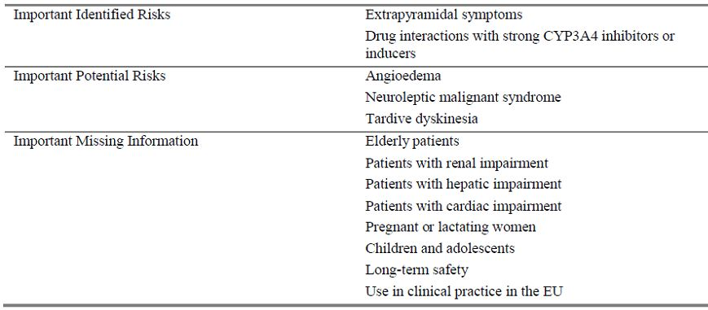

##### OPR reviewer comment

Notwithstanding the evaluation of the nonclinical and clinical aspects of the Safety Specification, this is not acceptable as a complete list of ongoing safety concerns.

Currently, clinical data investigating the tolerability and safety profile of lurasidone have been limited to short-term studies and minimal comparative studies.[34] In light of this, it is important to include the well characterised consequences of drugs that block the D2 receptor in the list of ongoing safety concerns. Although some studies have not shown significant signals for certain safety concerns for lurasidone, such as weight gain and QTc prolongation,[35] additional studies including long term trials are required before this can be appropriately removed from the list of ongoing safety concerns for lurasidone.

The safety concerns listed below should be further elucidated through appropriate pharmacovigilance and risk minimisation activities, unless the sponsor can provide compelling justification for their exclusion:

* Somnolence:
  + In Study P23STC, the number (%) of lurasidone treated subjects who experienced somnolence was 17.0% compared to 7.1% of placebo subjects. In P23LTC, 10.1% of lurasidone treated subjects experienced somnolence compared to 4.7% subjects on quetiapine.
  + Sanford[36] reports somnolence as one of the most frequently occurring AEs in the 6 week placebo controlled trials with lurasidone.
  + This is a well characterised pharmacological class effect.
* Hyperprolactinaemia and AEs related to hyperprolactinaemia (for example, reproductive system abnormalities, decreased bone mineralisation)
  + Potkin and colleagues[37] showed that there was a higher incidence of “marked” elevations in prolactin in lurasidone treated patients (27%) compared to those on ziprasidone (16%). This finding was also reflected in the results of a meta analysis by Leucht and colleagues.[38]
  + Owen[39] notes that raised prolactin levels in short term studies were dose dependent and greater in females.
* QTc Prolongation
  + This is an important safety concern that must be considered with all antipsychotic medications. While studies to date have shown lurasidone may have a low signal for QTc prolongation,[40] further study is required to elucidate this risk. It is also noted that QTc prolongation is not included by the sponsor in the list of pharmacological class effects in the EU RMP. This should be amended.
* Third trimester exposure during pregnancy and risk to neonates
* Suicidal behaviour
* Leukopaenia, neutropenia, agranulocytosis
* Temperature dysregulation
* Dyslipidaemia
* Weight gain
* Orthostatic hypotension
* Hyperglycaemia/diabetes mellitus
* Venous thromboembolism

It is also recommended that the following be added to the ongoing safety concerns:

* Dysphagia:
  + There is a known link between antipsychotic drug therapy and dysphagia, especially in the elderly, with subsequent aspiration pneumonia a major cause of morbidity and mortality in this group.[41] In light of the 2011 Survey of High Impact Psychosis (SHIP) Australian study showing that elderly patients may constitute a substantial portion of the proposed lurasidone treatment population in Australia, this risk should be included in the ongoing safety concerns and discussed appropriately in the PI.[42]
  + The FDA approved Product Label states:

*Esophageal dysmotility and aspiration have been associated with antipsychotic drug use. Aspiration pneumonia is a common cause of morbidity and mortality in elderly patients, in particular those with advanced Alzheimer’s dementia. Latuda and other antipsychotic drugs should be used cautiously in patients at risk for aspiration pneumonia.*

* Elderly patients with dementia related psychosis:
  + It is noted that “elderly patients” is listed as important missing information in Table 19. However, the following issues regarding elderly patients with dementia related psychosis should also be specifically listed in the ongoing safety concerns:
    - There are known serious adverse outcomes in this group of patients, including cerebrovascular accident (CVA) and increased mortality.
    - This is a known class effect with second generation antipsychotics and not adequately addressed in the lurasidone clinical development program due to the exclusion of this patient group. (See below for recommendations in regards to appropriate risk minimisation for this ongoing safety concern.)
* Malignancy:
  + Malignancy should be included as important missing information. In animal studies there has been increased incidence of proliferative and/or neoplastic changes in the mammary and pituitary glands of rodents (EU RMP). The relevance of this increased incidence of prolactin mediated tumours in terms of human risk is unknown.

#### Pharmacovigilance plan

##### Proposed pharmacovigilance activities

The sponsor proposes routine pharmacovigilance activities for important identified risks, important potential risks and missing information (Table 19). Furthermore, additional activities are planned for some risks, with 4 ongoing studies and 1 proposed study. These are summarised in Table 20 utilising information from the EU-RMP and Australian ASA.

Table 19: Summary of safety concerns and planned pharmacovigilance actions.

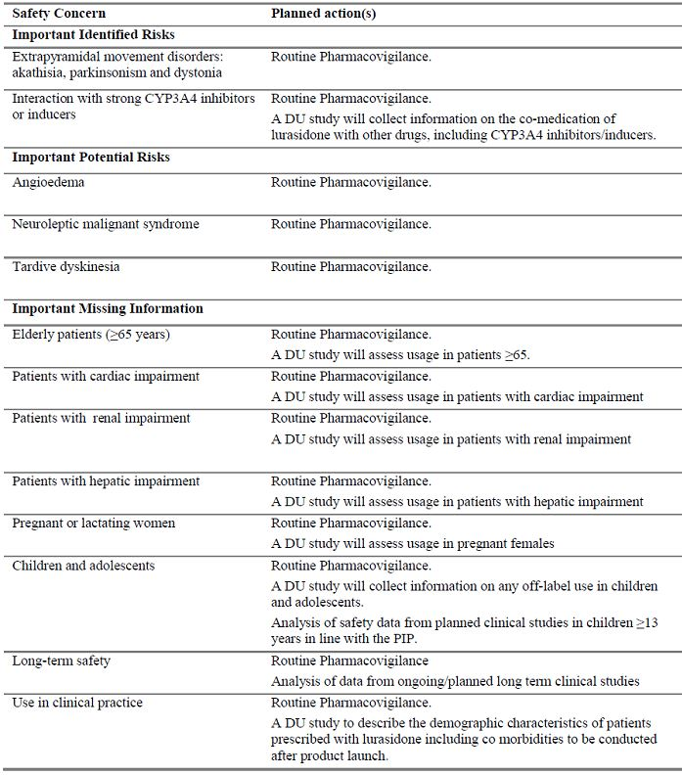

Table 20: OPR reviewer’s summary regarding additional pharmacovigilance activities planned by the sponsor for certain safety concerns.

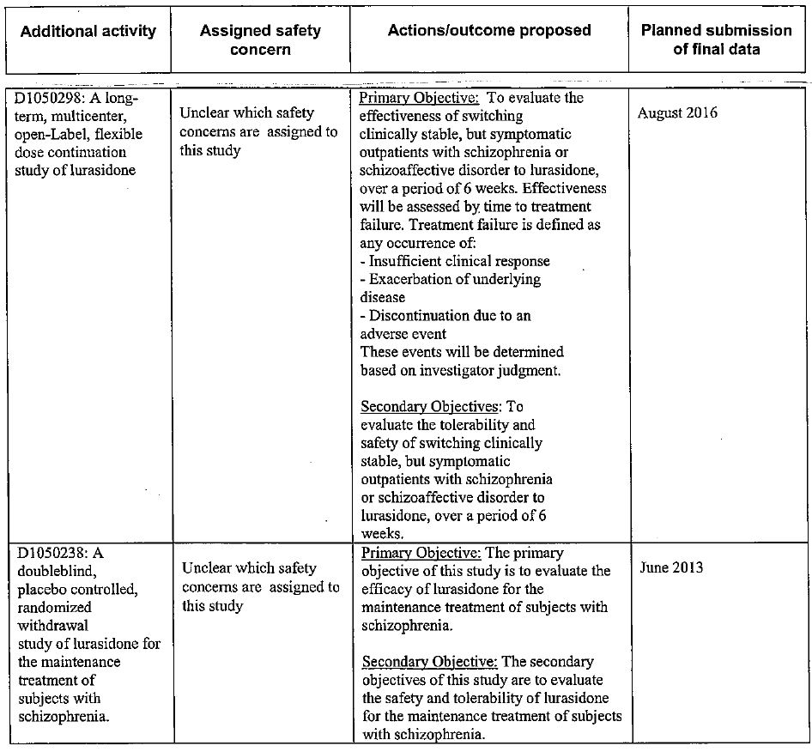

In the ASA, the sponsor states:

*The additional risk minimisation activities, Drug Utilisation Studies and paediatric studies, proposed in the EU-RMP will not be conducted in Australia.*

###### Drug Utilisation Study Overview (Draft protocol dated 12 September 2012)

The Drug Utilisation Study (DUS) is proposed to enrol 1000 patients. Eligible patients will be aged > 18 years, registered with a general practice participating in the Clinical Practice Research Datalink (CPRD), who received a first time prescription for lurasidone in primary care on or after the active marketing launch date. This can be either as a monotherapy or in a combination therapy with another antipsychotic drug. Patients will be excluded who:

* Have less than 12 months of computerised data prior to the index date; date of start of computerised records will be the latter of the patient’s date of registration with the practice or the practice’s “up to standard” (UTS) date (date the practice is deemed to have reached an acceptable standard of data recording);
* Not considered as “acceptable” according to CPRD’s data quality criteria;
* Who receive a lurasidone prescription after the 1000th eligible patient has been enrolled into the study;
* Who have an index date prior to the UTS date.

Outcomes of the study are: demographics, comorbidity and comedication characteristics, potential indication for lurasidone, and patterns of onset of index lurasidone therapy.

The data source proposed is the CPRD. This is a large UK based primary care database with an estimated 4 million active patients from 649 general practices. It is a subdivision of the Medicines and Healthcare Products Regulatory Agency (MHRA). This database has been previously used to investigate mental health and pharmaceutical therapies.

The milestones for this study include the Independent Scientific Advisory Committee (ISAC) approval. This is expected to be completed two months prior to the active marketing date of lurasidone. Data collection on the CPRD will commence six months after active marketing in the UK. Submission of patient enrolment updates to the Pharmacovigilance Risk Assessment Committee is proposed to occur at 6 month intervals. The study data collection period will cease 12 months after the date of enrolment of 1000th eligible patient. The final report is expected two months after this time (draft protocol dated 12 September 2012).

##### OPR reviewer’s comments in regard to the pharmacovigilance plan (PP) and the appropriateness of milestones

The details/protocols for ongoing and completed studies have not been reviewed as part of this RMP evaluation. The sponsor has listed one planned study named the DUS. If this application is approved, the final study report for D1050238 will be expected with the first PSUR.

###### Drug utilisation study

The draft protocol for the proposed DUS (ASA Appendix C) presents a number of internal inconsistencies and does not adequately address the ongoing safety concerns that are assigned to this study. Issues include:

* The following ongoing safety concerns are assigned to this study (see EU-RMP). However, in the study draft protocol dated 5 September 2012, they are not listed as a variable that will be coded/investigated in the study:
  + Lurasidone use in renal impairment;
  + Lurasidone use in pregnancy and lactation.
* The ongoing safety concern of lurasidone use in “children and adolescents” is assigned to the study, however according to the draft study protocol dated 5 September 2012, patients aged under 18 years will be excluded from the study.
* The study size of 1000 patients has not been adequately calculated as suitable for the “detailed description of drug utilisation and patient characterisation by the variables of interest”. There is no scientific basis for the size given, with the sponsor stating that “detailed sample size calculations will not be carried out”.
* The study is likely to capture more stable and treatment responsive schizophrenia patients. As stated in the draft protocol, antipsychotic therapies initiated by a specialist will be missed. Furthermore, the study may only follow a narrow group of patients with similar demographic and socioeconomic backgrounds. This is due to the study excluding patients with less than 12 months of computerised data prior to commencing lurasidone, and will miss those who are unable to access a regular general practitioner (GP). Overall, while the study aim of investigating lurasidone prescribing in primary care may be met, it is not an adequate model to investigate many of the ongoing safety concerns assigned to this study.
* The data collection model of the study is limited and not adequate to investigate safety concerns. For example, only diagnoses for which the patient consulted a GP are captured in the CPRD. This leads to major misclassification of patients, especially when specific safety concerns to be investigated in this study may not be a presenting complaint.
* As stated in the draft protocol, the results of this study can only be generalised to new initiators of lurasidone therapy in UK primary care and not to other healthcare settings and populations.
* It is also noted that the draft protocol is dated 5 September 2012 and updates may have been made since this time. If an updated version of this protocol is available, it should be submitted to the TGA for review.
* Lurasidone has not yet been approved in the EU; however, the DUS study relies upon use of the UK primary care database. If the application is not approved in the EU, the sponsor should clarify if an alternate study will be proposed.

Due to the above issues, the TGA will be seeking advice from the Advisory Committee on the Safety of Medicines (ACSOM) regarding the adequacy of this study protocol, the need for an alternative study plan if the application is rejected in the EU, and if an Australian specific study or registry should be undertaken. This will ensure that adequate activities are undertaken to investigate the ongoing safety concerns within the Australian population (see ACSOM questions below). Any draft study protocols should be submitted to the TGA for review.

###### Paediatric studies

In the EU-RMP, a comment is made in regards to a study to investigate the safety of lurasidone in children:

*Analysis of safety data from planned clinical studies in children aged >13 years in line with the PIP.*

These studies are not listed in the EU-RMP and no study protocol has been submitted. It is noted that these studies were deferred by the US FDA as discussed in approval letter 200603 dated 28 October 2010. This letter states that final study protocols should have been submitted by October 2011 for Study 1701-1 and 30 March 2013 for Study 1701-2. It is recommended that details of these studies and draft protocols be submitted to the TGA for review.

###### Ongoing studies

It is recommended that all study reports and updates that are submitted to the EU or US also be submitted simultaneously to Australia.

###### General comments regarding proposed Australian pharmacovigilance

* The Australian ASA Section 2 relating to the pharmacovigilance practices does not adequately clarify the ongoing safety concerns for Australia and the proposed routine and additional pharmacovigilance strategies. For example, it is unclear which ongoing safety concerns are addressed by each study.
* Section 3.1 of the ASA lists the DUS and “Paediatric studies” as additional risk minimisation activities. These, however, are additional pharmacovigilance activities. This section of the ASA should be amended accordingly.
* The sponsor states:

*The designated local sponsor or agent has in place a routine pharmacovigilance system that will allow compliance with TGA Australian Requirements and Recommendations for Pharmacovigilance Responsibilities of Sponsors of Medicines, and specifically compliance to Section 2.3 (Information that must be reported) and Section 2.4 (Reporting timeframes) as stated in. Acting as an affiliate of DSP the assigned local sponsor’s routine pharmacovigilance system will be sufficient to address and monitor the local safety profile for lurasidone.*

The above “designated local sponsor or agent” has not been specified. The sponsor should clarify the details of the pharmacovigilance representative in Australia.

#### Risk minimisation activities

##### Sponsor’s conclusion in regard to the need for risk minimisation activities

The sponsor states “Routine risk management activity will be providing instructions to the healthcare provider and the patient in the Summary of Product Characteristics (SmPC) and the Patient Information Leaflet (PIL), respectively. No additional risk minimisation activities are considered necessary for lurasidone.” This is summarised in Table 21.

Table 21: Summary of planned risk minimisation activities proposed by the sponsor.

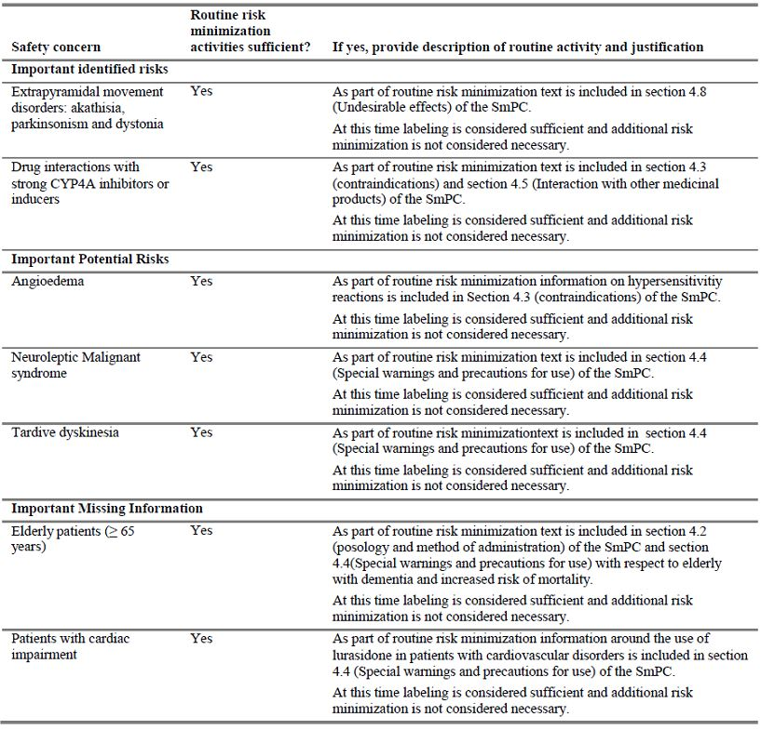

Table 21 (continued): Summary of planned risk minimisation activities proposed by the sponsor.

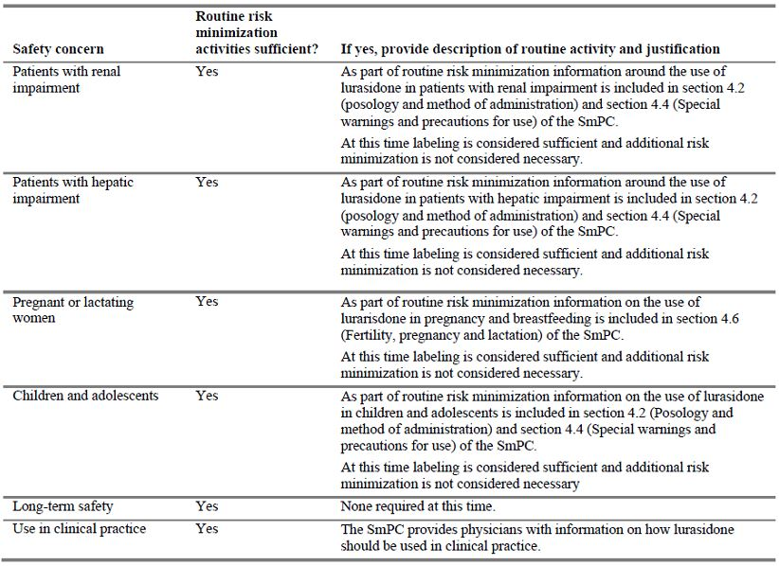

In the ASA, the sponsor states that “all of the concerns identified in the EU-RMP are relevant for patients in Australia. The routine risk minimisation activities proposed in the EU-RMP will be implemented in Australia”.

##### OPR reviewer comment

The sponsor’s conclusion regarding the appropriateness of routine risk minimisation activities for the listed ongoing safety concerns is acceptable, except in regards to:

* “Long-term safety”: The sponsor has listed that routine risk minimisation activities are sufficient for this important area of missing information, however the justification states “none is required at this time”. There are appropriate statements within the US Product Label; however no statement is made in the draft Australian PI (see below for recommendations regarding “long-term safety”).

##### Potential for medication errors

The sponsor discusses that the potential for medication errors is low, with post approval reporting in the US showing no patterns or trends suggesting a potential signal for medication errors.

The potential for rule based errors, action based errors and memory based errors is not significantly dissimilar to other atypical antipsychotics.

##### Potential for overdose

The potential for overdose, including intentional overdose is discussed to a satisfactory standard in the EU-RMP. The sponsor’s conclusions are appropriate, with the risk of overdose of lurasidone not significantly dissimilar to tablets in the same class.

In the proposed Australian product information, overdosage, and its management have been discussed to a satisfactory standard.

As stated in the RMP and the PI, prescriptions for lurasidone should be written for the smallest quantity of tablets consistent with good patient management in order to reduce the risk of overdose.

##### Potential for misuse for illegal purposes

The EU-RMP states:

*Lurasidone has not been systematically studied in humans for its potential for abuse or physical dependence or its ability to induce tolerance. While clinical studies with lurasidone did not reveal any tendency for drug seeking behaviour, these observations were not systematic and it is not possible to predict the extent to which a CNS active drug will be misused, diverted and/or abused once it is marketed. Patients should be evaluated carefully for a history of drug abuse, and such patients should be observed carefully for signs of lurasidone misuse or abuse (for example, development of tolerance, drug seeking behaviour, increases in dose).*

The proposed Australian PI does not adequately discuss the potential for misuse for illegal purposes. There is no mention the importance of evaluating patients for a history of drug abuse and observing for signs of misuse or abuse. This is also important in regards to monitoring patients for co-morbid drug abuse.[43] The US FDA approved product label discusses this issue adequately. See below for recommendations regarding a similar statement for the proposed Australian PI.

##### Potential for off label use

There is significant potential for off label use of lurasidone, particularly in bipolar disorder:

*In the US, it is estimated that lurasidone is prescribed for schizophrenia/ schizophrenia spectrum disorders in 78% of prescriptions. Off label uses include (SDI coding) bipolar affective NOS (not otherwise specified) (8.0%), infantile autism (3.6%), bipolar affective mixed (3.6%), bipolar affect depression (2.4%), other adjust reaction (2.0%), and alcohol dependency NEC (not elsewhere classified)/NOS (1.6%).*

It is also noted that the US FDA has identified issues with promotional activities directed towards off label use of lurasidone in bipolar disorder (letter dated 14 December 2011).

The sponsor plans to further elucidate off label use through the DUS (see section 8). Furthermore, the sponsor states that Lurasidone is under development for bipolar disorder with 5 ongoing clinical studies.

Prior to the release of clinical data regarding appropriate dosing and safety profile of lurasidone in bipolar disorder, the potential for off label use for this indication is of concern. See below for recommendations regarding a statement in the product information stating the lack of published safety data in this group.

##### Potential for off label paediatric use

The sponsor states that the potential for off label paediatric use is unknown. There are appropriate statements in the proposed Australian PI regarding the lack of safety and efficacy data.

#### Summary of recommendations: Round 1 assessment

The OPR provides these recommendations in the context that the submitted RMP is supportive to the application; the implementation of a RMP satisfactory to the TGA is imposed as a condition of registration; the submitted EU-RMP is applicable without modification in Australia unless so qualified; and the draft PI and consumer medicine information documents should **not** be revised until the Delegate’s Overview has been received:

##### Further safety considerations

* Safety considerations may be raised by the nonclinical and clinical evaluators through the consolidated Section 31 request and/or the nonclinical and clinical evaluation reports, respectively. It is important to ensure that the information provided in response to these include a consideration of the relevance for the RMP, and any specific information needed to address this issue in the RMP. For any safety considerations so raised, the sponsor should provide information that is relevant and necessary to address the issue in the RMP.

Unless the sponsor can provide compelling justification against any of the following recommendations, the following should be considered.

##### Recommendations concerning the sponsors ongoing safety concerns

The following risks should be added to the list of ongoing safety concerns:

* Somnolence
* Hyperprolactinaemia
* Suicidal behaviour
* Leukopaenia, neutropenia, agranulocytosis
* Temperature dysregulation
* AEs related to hyperprolactinaemia (for example, reproductive system abnormalities, decreased bone mineralisation)
* Dyslipidaemia
* Weight gain
* Orthostatic hypotension
* Hyperglycaemia/diabetes mellitus
* Venous thromboembolism
* Third trimester exposure during pregnancy and risk to neonates
* QTc Prolongation
* Dysphagia
* Elderly patients with dementia related psychosis:
* Cerebrovascular adverse reactions, including stroke in elderly patients with dementia related psychosis
* Malignancy

##### Recommendations concerning the sponsor’s proposed pharmacovigilance plan

* If this application is approved, the final study report for D1050238 will be expected with the first PSUR.
* A number of issues require clarification in regards to the draft protocol for the proposed DUS:
  + The following ongoing safety concerns are assigned to this study (see EU-RMP). However, in the study draft protocol dated 5 September 2012, they are not listed as a variable that will be coded/investigated in the study:
    - Lurasidone use in renal impairment
    - Lurasidone use in pregnancy and lactation
  + The ongoing safety concern of lurasidone use in children and adolescents is assigned to the study, however according to the draft study protocol dated 5 September 2012, patients aged under 18 years at index will be excluded from the study.
* Due to the issues listed, the TGA will be seeking advice from the ACSOM regarding the adequacy of this study protocol, the need for an alternative study plan if the application is rejected in the EU, and if an Australian specific study or registry should be undertaken.
* The ASA lists the DUS and “Paediatric studies” as additional risk minimisation activities. However, these are additional pharmacovigilance activities. This section of the ASA should be amended accordingly.
* The Australian RMP relating to the pharmacovigilance practices does not adequately clarify the ongoing safety concerns for Australia and the proposed routine and additional pharmacovigilance strategies. For example, it is unclear which ongoing safety concerns are addressed by each study.
* It is recommended that all study reports and updates that are submitted to the EU or US also be submitted simultaneously to Australia.
* The “designated local sponsor or agent” mentioned in the ASA has not been specified. The sponsor should clarify the details of this sponsor/agent.

#### Reconciliation of issues outlined in the RMP report

Reconciliation of issues outlined in the RMP report is as follows.

##### Recommendation in the RMP evaluation report

The following risks should be added to the list of ongoing safety concerns:

* Somnolence
* Suicidal behaviour
* Leukopaenia, neutropenia, agranulocytosis
* Temperature dysregulation
* Hyperprolactinaemia and AEs related to hyperprolactinaemia (for example, reprodutive system abnormalities, decreased bone mineralisation)
* Dyslipidaemia
* Weight gain
* Orthostatic hypotention
* Hyperglycaemia/diabetes mellitus
* Venous thromboembolism
* Third trimester exposure during pregnancy and risk to neonates
* QTc Prolongation
* Dysphagia
* Elderly patients with dementia related psychosis
* Cerebrovascular adverse reactions, including stroke in elderly patients with dementia related psychosis
* Malignancy

##### Sponsor’s response

The EU-RMP is currently under review by the EMA, and was updated as of the 15 May 2013 in response to the Day 120 List of Questions. The Day 180 List of Outstanding Issues (LoOIs) was received on July 11 2013. The EU-RMP is currently being updated according to the LoOIs.

Based on the Day 120 List of Questions, the EU-RMP was updated to include following risks as “important potential risks” and added to the list of ongoing safety concerns in EU-RMP.

* Third trimester exposure during pregnancy and risk to neonates
* Elderly patients with dementia related psychosis
* Cerebrovascular adverse reactions, including stroke in elderly patients with dementia related psychosis

In addition to the risks noted above, the following risks have been included in the EU-RMP as potential risks in “Important Pharmacological Class Effects”, (with the exception of dysphagia) and these risks will be included in the list of ongoing safety concerns in the ASA.

* Somnolence
* Suicidal behaviour
* Leukopaenia, neutropenia, agranulocytosis
* Temperature dysregulation
* Hyperprolactinaemia and AEs related to hyperprolactinaemia (for example, reprodutive system abnormalities, decreased bone mineralisation)
* Dyslipidaemia
* Weight gain
* Orthostatic hypotention
* Hyperglycaemia/diabetes mellitus
* Venous thromboembolism
* Dysphagia

##### OPR evaluator’s comment

The sponsor has amended the list of ongoing safety concerns to include all risks, aside from QTc prolongation and malignancy.

These risks are discussed in detail below. The evaluator acknowledges the sponsor’s comments regarding the evidence of QTc Prolongation and malignancy with lurasidone treatment. However, these remain important potential risks that should be specifically reported on through the PSUR process. This view is supported by the ACSOM.

For all other additional risks, the sponsor should ensure that appropriate pharmacovigilance and risk minimisation activities are also applied for these risks. In light of the clinical and nonclinical evaluator’s comments below, additional pharmacovigilance should be applied for the risk of hyperprolactinaemia. Furthermore, the wording in the Australian PI should be strengthened regarding this risk (see clinical and nonclinical evaluators reports).

##### Recommendation in the RMP evaluation report

QTc Prolongation: This is an important safety concern that must be considered with all antipsychotic medications. While studies to date have shown lurasidone may have a low signal for QTc prolongation,[44] further study is required to elucidate this risk. It is also noted that QTc prolongation is not included by the sponsor in the list of pharmacological class effects in the EU-RMP. This should be amended.

##### Sponsor’s response

The potential of lurasidone to induce QTc prolongation was evaluated in a Thorough QT study(Study D1050249) with an external expert review (Annex 12 of the EU-RMP) integrated the nonclinical and clinical data, including the results of the Thorough QT study, to define the effect of lurasidone on cardiac repolarisation.

The following conclusions can be drawn regarding the potential of lurasidone to prolong the QT interval based on the nonclinical and clinical data:

* Nonclinical human ether-à-go-go–related gene (hERG) data indicate safety margins in excess of 120 at clinical concentrations attained at steady state by daily doses of 160 mg;
* A thorough QT study in patients with schizophrenia or schizoaffective disorder, using ziprasidone as the active control, revealed that ΔQTc interval corrected using the individualised method (QTcI) values for 120 mg and 600 mg daily dose for 11 days were 9.4 ms (90% upper bound 14.7) and 5.8 ms (90% upper bound 11.5), respectively. Based on concentration-QTcI response analysis, increases in QTcI interval predicted are 0.4 ms (upper bound 1.4) at a dose of 120 mg (fixed) and 1.3 ms (upper bound 5.1) at 600 mg (titrated) dose;
* Clinical trials data have not indicated clinically relevant increases in QT interval corrected for heart rate (QTc). A total of 2/257 (0.8%) schizophrenia patients in Phase I clinical studies and 0/973 patients in 5 major Phase II/III clinical trials developed a QTc interval corrected using Fridericia’s method (QTcF) in excess of 500 ms;
* Post marketing data, have not indicated a risk of QT interval prolongation.

In summary, in light of the data derived from both a dedicated thorough QT study and data from the clinical trial program, it is concluded that there is no suspected association of QT prolongation with lurasidone exposure, and therefore it is not considered appropriate to add this as an ongoing safety concern.

##### OPR evaluator’s comment

The evaluator acknowledges the sponsor’s comments regarding the evidence of QTc prolongation and lurasidone therapy. However, this remains an important potential risk that should be included in the list of ongoing safety concerns and investigated through PSURs. Furthermore, the clinical evaluator discusses this evidence in detail and recommends routine risk minimisation be applied for this risk (suggested PI precaution).

The ACSOM committee also supported this recommendation.

##### Recommendation in the RMP evaluation report

Malignancy should be included as important missing information. In animal studies there has been increased incidence of proliferative and/or neoplastic changes in the mammary and pituitary glands of rodents (EU-RMP). The relevance of this increased incidence of prolactin mediated tumours in terms of human risk is unknown.

##### Sponsor’s response

Although a signal was observed for lurasidone and prolactin dependent tumours in nonclinical studies, the increase in mammary and pituitary gland tumours due to increased secretion of prolactin is considered to be a rodent specific finding for the broad class of antipsychotics that antagonise D2.

No prolactin dependent tumours have been observed in clinical studies of up to 22 months duration. Prolactin levels were generally lower with lurasidone than with other antipsychotics. The SmPCs in EU and the PIs in Australia for all other second generation antipsychotics mention hyperprolactinaemia; however, none include prolactin dependent tumours as a risk.

As of 31 December 2012, which is the data cutoff date for post marketing patient exposure, approximately 312,300 patients were exposed to lurasidone in the United States, and 607 patients were exposed to lurasidone in Canada.

A search in the post marketing safety database (cutoff date 31 December 2012) of AEs categorised in the Neoplasms benign, malignant and unspecified (including cysts and polyps) SOC and the Endocrine disorders SOC were reviewed. No reports relating to pituitary tumours or mammary gland tumours were identified.

Based on the balance of nonclinical, clinical and post marketing data, it is concluded that that effects on prolactin dependent tumours should not be included as an ongoing safety concern.

##### OPR evaluator’s comment

This is acceptable.

##### Recommendation in the RMP evaluation report

Study D1050238: If this application is approved, the final study report for D1050238 will be expected with the first PSUR.

##### Sponsor’s response

If the application is approved, the final study report for D1050238 will be included in the first PSUR.

##### OPR evaluator’s comment

This is acceptable.

##### Recommendation in the RMP evaluation report

In regard to routine minimisation activities, the Delegate may wish to revise the proposed Australian PI as follows:

* A statement should be added regarding the risk of venous thromboembolism.
* A statement should be added regarding the known class effect of Dysphagia to the effect of:

*Esophageal dysmotility and aspiration associated with antipsychotic drug use. Aspiration pneumonia is a common cause of morbidity and mortality in elderly patients, in particular those with advanced Alzheimer’s dementia. Latuda and other antipsychotic drugs should be used cautiously in patients at risk for aspiration pneumonia.*

* In regards to elderly patients with dementia related psychosis, the wording should be strengthened and a statement should be added to the effect of:

*Elderly patients treated with antipsychotics have shown a higher incidence of cerebrovascular adverse reactions (CVAs and transient ischemic attacks), including fatalities, compared to placebo treated subjects. Latuda is not approved for the treatment of patients with dementia related psychosis.*

A boxed warning should also be considered for this risk.

* A statement should be added regarding the importance of evaluating patients for a history of drug abuse and observing for signs of misuse or abuse. This is also important in regards to monitoring patients for co-morbid drug abuse.[45] This is discussed in the US FDA approved patients information (US patient information).
* A statement should be added to the effect of:

*Lurasidone is not indicated in the treatment of bipolar disorder.*

* Statements regarding the lack of data for the long term use of lurasidone should be added, to the effect of:

*The safety and effectiveness of Latuda for long term use has not been established.*

Also discussed in the US PI.

##### Sponsor’s response

It is acknowledged that the Delegate may wish to revise the proposed Australian PI as noted in the Evaluation of a RMP for Latuda. We understand that the draft PI and CMI documents should not be revised until the Delegate’s Overview is received.

##### OPR evaluator’s comment

This is acceptable.

It is important to note that the ACSOM committee supported each of these suggested PI changes.

Many of these recommendations are also supported by the clinical evaluator.

#### Summary of recommendations: Round 2 assessment

##### Outstanding issues

###### Issues in relation to the RMP

* The sponsor is expected to submit an updated EU-RMP for review.
* The evaluator acknowledges the sponsor’s comments regarding the evidence of QTc prolongation and lurasidone therapy. However, this remains an important potential risk that should be included in the list of ongoing safety concerns and investigated through PSURs. The ACSOM committee also supports this view. Furthermore, the TGA clinical evaluator discusses this evidence in detail and recommends routine risk minimisation be applied for this risk (suggested PI precaution).
* The sponsor has agreed to include many additional risks in the list of ongoing safety concerns, including hyperprolactinaemia. The sponsor should ensure that appropriate pharmacovigilance and risk minimisation activities are also applied to these risks. In light of the clinical and nonclinical evaluator’s comments below, additional pharmacovigilance should be applied for the risk of hyperprolactinaemia. Furthermore, the wording in the Australian PI should be strengthened regarding this risk (see clinical and nonclinical evaluators comments below). The ACSOM also supports this recommendation.
* The sponsor has proposed some amendments to the pharmacovigilance plan that appear acceptable; however, the following advice from the ACSOM should be noted:

*The ACSOM committee also advised that if the registration of lurasidone was delayed or rejected in the EU, the sponsor should be required to undertake a study in Australia and that study should collect adequate safety information.*

* The OPR evaluator would also like to draw the Delegate’s attention to the following comment from the ACSOM:

*ACSOM advised that the kinetics of lurasidone resulted in a low and variable bioavailability and that this was unfavourable. In particular, the effect of drug interactions was wide ranging, for example, ketoconazole, a strong inhibitor of CYP3A4, increased exposure 9 fold. ACSOM advised that overall, there were concerns about the safety margin and that additional data on the safety of lurasidone in overdose was needed, in particular, information on the effects on QT prolongation.*

##### Comments on the safety specification of the RMP

###### Clinical evaluation report - first round

The clinical evaluator makes the following statement regarding the safety specification of the RMP:

*The Safety Specification in the draft RMP Version 1.0 dated 31 August 2012 with ASA is not entirely satisfactory. In addition to the identified risks, the evaluator recommends that the following risks should also be monitored: hyperprolactinaemia and possible consequences (such as galactorrhea, amenorrhea, gynecomastia and decreased bone density); renal impairment (due to the signal of increased creatinine and safety risks with, increased exposure); orthostatic hypotension; effects on the eye (due to the preclinical finding of retention in melanin containing tissues of the eye); and possible withdrawal symptoms. Risks should also be monitored in the populations in which there were limited or no clinical data (elderly, pregnant women and patients with cardiac, renal impairment and hepatic impairment).*

###### Nonclinical evaluation report

The nonclinical evaluator makes the following statement regarding the safety specification of the RMP:

*Results and conclusions drawn from the nonclinical program for LDH detailed in the sponsor’s draft RMP are in general concordance with those of the nonclinical evaluator. Important identified risks that were evident from the nonclinical data were potential interaction with strong CYP3A4 inhibitors and inducers, and potential for extrapyramidal symptoms. Given that lurasidone elevates serum prolactin levels in several test species and also humans (a known effect of this class of drugs), it is recommended that the possible adverse effects of hyperprolactinaemia in patients should be considered here; this is referred to the RMP evaluator.*

##### Suggested wording for conditions of registration

###### RMP

The sponsor has made the following statement regarding the RMP:

*The EU-RMP is currently under review by the European Medicines Agency, and was updated as of the 15 May 2013 in response to the Day 120 List of Questions. The Day 180 List of Outstanding Issues (LoOIs) was received on July 11 2013. The EU-RMP is currently being updated according to the LoOIs.*

This updated RMP should be submitted to the TGA when available.

###### PSUR

The Office of Medicines Authorisation (OMA) is to provide new wording.

## VI. Overall conclusion and risk/benefit assessment

The submission was summarised in the following Delegate’s overview and recommendations:

### Quality

There are no objections in respect of Chemistry, Manufacturing, Controls and Biopharmaceutics to registration of these products.

The specification applied to the drug substance is satisfactory. Although a large number of potential synthetic impurities were identified by the applicant, only one (the enantiomer) is specifically controlled in the API specification. No degradants were identified.

The low aqueous solubility of the drug substance was accepted as justification for not performing an absolute bioavailability study. By estimating Fa, Fg, and FH from the clinical study data, the absolute bioavailability was calculated to be ~0.06 using the equation F = Fa x Fg x FH. Alternatively, F was estimated to be 0.18 using physiologically based pharmacokinetic (PBPK) modelling.

Lurasidone was considered by the PSC at its 154th meeting in November 2013. The minutes relating to Lurasidone will be provided to the committee.

### Nonclinical

There are no nonclinical objections to the registration of LDH for the treatment of schizophrenia in adults.

Lurasidone showed high affinity for the human D2, 5-HT2A and 5-HT7 receptors, moderate affinity for human 5-HT1A, α2C and D3 receptors, and weaker affinity for human D4.4, α2A and α1A receptors. It showed little/no affinity for human H1 or M1 receptors, or rat 5-HT uptake sites (IC50 ≥1 µM), nor did it inhibit dopamine, 5-HT or noradrenaline reuptake into rat synaptosomes (IC50 >3 µM). Functional studies revealed partial agonism at 5-HT1A receptors and antagonism at D2 and 5-HT7 receptors. *In vivo* studies in mice and rats were consistent with antagonism at the D2 and 5-HT2 receptors. At clinically relevant doses, lurasidone showed activity in tests for anxiolytic activity/mood stabilising action in rats and ameliorated scopolamine and MK-801 induced memory impairment in the passive avoidance test in rats.

CNS clinical signs and hyperprolactinaemia and its consequent effects, particularly on the female reproductive system, were the main findings in the repeat dose toxicity studies.

Secondary PD studies suggested that lurasidone may have a lower potential to induce extrapyramidal side effects than comparator drugs.

Safety pharmacology studies did not reveal any clinically relevant hazards except for CNS clinical signs and the potential for hyperprolactinaemia. Lurasidone dose dependently inhibited the rapidly activating delayed rectifier potassium current in cloned hERG channels, but this did not translate into any notable prolongation of QT/QTc intervals in *in vivo* studies.

The nonclinical data support the proposed pregnancy category of B1.

### Clinical

#### Pharmacology

Lurasidone is a benzisothiazole derivative. No absolute bioavailability study was performed however after a single postprandial dose total excretion of 14C-lurasidone recovered in urine and faeces combined was 86.2-89.3 %, with 67.2-80.1% recovered in faeces and 9.19-19.1% recovered in urine, suggesting that ~20% of the administered total radioactivity was absorbed after oral administration. Mean Tmax after a single dose is ~1.5 h. After multiple dose administration Tmax was ~3 h.

The PK is dose proportional in the 10-160 mg dose range. Inter subject variability (%CV) for Cmax and AUCτ were assessed after multiple dose administration in healthy subjects and subjects with schizophrenia. In healthy subjects, it was 30% to 46% for Cmax and 32 to 35% for AUC0τ. In subjects with schizophrenia, it was 33% to 54% for Cmax and 36% to 63% for AUC0τ. A higher inter subject variability was observed for AUC0τ in subjects with schizophrenia. Food increased bioavailability with mean Cmax increasing 1.65-2.09 fold and mean AUC increasing 1.81-3.05 fold across doses in 3 food effect studies where various fed conditions were provided. The population PK analysis concluded that lurasidone is associated with 3.0 fold increase in mean Cmax and 2.2 fold increase in mean AUC0-24h in the presence of food. Lurasidone exposure was not affected when the meal size was increased from 350 to 1000 calories, and was independent of meal fat content.

Lurasidone is ~99% protein bound. The mean apparent volume of distribution ranged from 3220-4410 L. Mean apparent clearance ranged from 175-244 L/h. Following administration of 40 mg of Latuda, the mean (%CV) elimination half life was 18 (7) h. Lurasidone has two active metabolites, ID-14283 and ID-14326. Binding of the active metabolites is similar to that of lurasidone. Lurasidone’s activity is primarily due to the parent drug with the active metabolites.

ID-14283 and ID-14326 represent 25% and 3% of the parent exposure, respectively. The major biotransformation pathways are oxidative N-dealkylation, hydroxylation of norbornane ring and S-oxidation. Lurasidone is primarily eliminated via non renal pathways. In patients with severe hepatic impairment (Child-Pugh Class C), systemic exposure is increased by up to 3 fold.

In patients with severe renal impairment (creatinine clearance <30mL/min), systemic exposure is increased by up to 2 fold. Cmax increased by 40%, 92%, and 54% in mild, moderate, and severe renal impairments, respectively, compared to matched normal renal patients AUC increased by 53%, 91%, and 103% in mild, moderate, and severe renal impairments, respectively, compared to matched normal renal patients.

Co-administration of strong inhibitors of CYP3A4 leads to large increases in the AUC and Cmax for lurasidone (~9 fold when given with ketoconazole) and large reductions in AUC and Cmax when given with a strong inducer (~6 fold with rifampicin). The sponsor has proposed contraindicating co-administration with strong CYP3A4 inducers and inhibitors.

Lurasidone has high affinity for human D2L, 5-HT1A, 5-HT2A, 5-HT7 and α2C receptors. *In vitro* functional activity studies conducted with lurasidone and its metabolites ID-14283, and ID-14326 suggest that these molecules are partial agonists for human 5-HT1A receptors and potent antagonists for human D2L and 5-HT7 receptors. A thorough QT study was conducted using ziprasidone as the active control. The maximum mean (upper one sided, 95% CI) increase in baseline adjusted QTc intervals based on individual correction method (QTcI) was 7.5 (11.7) ms and 4.6 (9.5) ms, for the 120 mg and 600 mg dose groups, respectively, observed at 2 to 4 h after dosing.

#### Efficacy

The clinical evaluator has considered 5 short term Studies 0229, 0231, 0233, 0006 and 0196 and their extension studies to be pivotal. The 5 short term studies were randomised and placebo controlled. Studies 0231 and 0233 also had an active control (olanzapine 15 mg daily and quetiapine XR 600 mg daily), respectively. There were also 2 failed studies that had an active control (Studies 0049 and 1002).

Studies 0229, 0231 and 0233 had the same major design features. There was a 14 day screening period during which psychotropic medication was tapered and the subjects entered a 3 to 7 day hospitalised single blind, placebo washout period. Subjects remained hospitalised during randomised treatment for at least 21 days and, if meeting discharge criteria, could continue the next 3 weeks of treatment as an outpatient.

The major inclusion were: adult; DSMM-IV criteria for a primary diagnosis of schizophrenia; illness duration of >1 year; acute exacerbation of psychotic symptoms (no longer than 2 months) and marked deterioration of function from baseline (by history), or hospitalised for the purpose of treating an acute psychotic exacerbation for ≤2 consecutive weeks immediately before screening; and PANSS total score ≥80 at screening and baseline. Patients with a history of resistance to neuroleptic treatment were excluded from the studies.

Studies 0006 and 0196 were Phase II studies conducted in 2001 and 2004, respectively. Subjects were hospitalised with schizophrenia. The study design included a screening period of up to 14 days, followed by an inpatient single blind washout period of 3-7 days, and then a 6 week double blind treatment phase.

A pooled analysis of results of the 5 pivotal studies was performed. A total of 1795 subjects were included in the randomised population with 506 receiving placebo, 123 olanzapine, and 120 quetiapine XR and remaining subjects receiving lurasidone at doses from 40mg to 160 mg. Across studies from 68-75% of subjects were male. Mean age was 38-39 years. There were 31-66% of subjects located in North America. Only 4 subjects were aged over 65 years. Most subjects had paranoid type schizophrenia (87-89%) with between 9% and 11% having undifferentiated type. The pooled baseline PANSS total score was in the range 95.7 to 97.5 and CGI-S score 4.9 to 5.0. These scores are consistent with subjects being markedly ill.

Statistically significant efficacy for lurasidone 80 mg was demonstrated in 3 studies (0196, 0229 and 0231) and for luriasidone 160 mg in one study, while the 40 mg and 120 mg doses only separated from placebo in one of two studies (0231). The response on CGI-S score change showed a similar pattern. In the pooled analysis the difference from placebo in mean change from baseline to Week 6 in PANSS total score was -8.4 for lurasidone 40 mg, -9.6 for 80 mg, -8.8 for 120 mg, and -14.9 for 160 mg. No dose response was apparent between doses from 40 to 120 mg.

Subgroup analyses were performed to explore differences in efficacy associated with race, gender, severity of illness at baseline and geographic region. No statistically significant differences were found, however mean reductions from baseline in PANSS total scores were generally smaller for both placebo and lurasidone groups in the North American geographic area compared with other areas.

Using data from Studies 0229, 0231 and 0233, an analysis of subjects with a ≥30% reduction from baseline PANSS score was performed. These data were not pooled. The placebo response rate was around 35% across the 3 studies and the response rates for lurasidone 40 mg, 80 mg, and 120 mg were all around 50%, giving a 15% difference in response rates from placebo and a number needed to treat (NNT) of 6.7. Of the pivotal studies only Study 0233 assessed efficacy of the 160 mg dose. The responder rate for 160 mg lurasidone was 63%, a NNT of ~3.6. Statistical significance of difference in response rates for each dose was not demonstrated in each study though there was a clear trend towards higher response rates with lurasidone compared with placebo in those studies in which statistical significance was not reached. Dose response was not apparent within the 40 to 120 mg dose range for either mean difference in PANSS total score or response rate.

A placebo controlled long term efficacy study was not submitted. Study 0234, an extension of Study 0233, provided a long term efficacy comparison with quetiapine XR. This double blind study compared flexibly dosed lurasidone (40 to 160 mg daily) with flexibly dosed quetiapine XR (200 to 600 mg daily) for up to 12 months in subjects with schizophrenia who had shown a clinical response in Study 0233. Clinical response was defined as a CGI-S score ≤ 4 and at least a 20% decrease (improvement) in PANSS total score from Baseline. The primary efficacy endpoint was the time to relapse of psychotic symptoms. Relapse was defined as the occurrence of any of:

* Worsening of ≥30% PANSS total score from D1050233 day 42 and CGI-S ≥3;
* Re-hospitalisation for worsening of psychosis;
* Emergence of suicidal ideation, homicidal ideation, and/or risk of harm to self or others.

This was a non inferiority study with lurasidone to be declared as effective as quetiapine XR in preventing relapse if the upper bound of a two sided 95% confidence limit for the HR of lurasidone versus quetiapine XR is no greater than a non inferiority margin of 1.93. This margin was selected based on survival curves of a meta analysis for relapse prevention.[46] In that meta analysis the relapse rates of second generation antipsychotics and placebo were 19% and 49%, respectively. In order to preserve at least 50% of the relapse prevention of second generation antipsychotics compared with placebo based on the 30% treatment difference in this meta analysis, a non inferiority margin of 15%, with the assumption of 35% for lurasidone and 20% for quetiapine XR, for Study 0234 was selected. This 15% non inferiority margin corresponded to a 1.93 HR comparing lurasidone with quetiapine XR.

A total of 292 subjects entered the extension study and 140 (48%) completed 12 months treatment. Completion rates were 52% with lurasidone and 39% with quetiapine. The main reasons for premature discontinuation were consent withdrawal (20% lurasidone versus 22% quetiapine), insufficient clinical response or worsening of existing condition (11% versus 22%), other AEs (5 versus 4%) and loss to follow up (6% versus 11%). The mean daily dose for lurasidone was 125.5 mg and for quetiapine XR was 629.6 mg. Relapses were reported in 21% of subjects given lurasidone and in 27% given quetiapine XR. The probability of relapse by month 12 was 23.7% and 33.6%, respectively. The relapse HR of lurasidone versus quetiapine XR was 0.728 (95% CI: 0.41, 1.29).

The other active comparator study that assessed long term efficacy was Study 0237. That study included subjects with schizophrenia or schizoaffective disorder. The remaining long term efficacy data were from open, uncontrolled studies.

#### Safety

The summary of clinical safety covered data from 52 clinical trials which included 5607 subjects with schizophrenia (3473 treated with lurasidone, 724 treated with placebo and 1410 treated with other medications). Study duration ranged from 3 weeks to 22 months and evaluated doses of lurasidone from 20 to 160 mg/day. A long term comparative safety and tolerability study comparing lurasidone with risperidone was also performed.

Pooled safety data from the short term double blind studies is discussed in the clinical evaluation report. The most common TEAEs (frequency of ≥5%) in these studies for any dose of lurasidone compared with placebo were: headache (14.5% versus 15.0%), akathisia (12.9% versus 3.0%), nausea (10.1% versus 5.2%), insomnia (9.9% versus 8.5%), somnolence (8.6% versus 3.4%), sedation (8.5% versus 3.8%), vomiting (8.0% versus 6.2%), schizophrenia (6.8% versus 7.9%), dyspepsia (6.2% versus 4.8%), agitation (5.2% versus 3.8%), anxiety (5.1% versus 4.1%), and constipation (5.0% versus 6.1%). The rate of akathisia in lurasidone treated subjects (12.9%) was greater than with placebo (3.0%), olanzapine (7.4%), and quetiapine XR (1.7%), but lower than with haloperidol (19.4%) and similar to risperidone (13.8%). Parkinsonism was reported in 4.2% of lurasidone treated subjects compared with 0.4% for the placebo group, 0% for the haloperidol, 5.7% for the olanzapine, 3.4% for the quetiapine XR, and 0% for the risperidone group. The rate of EPS TEAEs was 24.7% in the lurasidone group compared to 9.2% in the placebo group and 54.2%, 23.0%, 7.6% and 27.7% in the haloperidol, olanzapine, quetiapine and risperidone groups, respectively.

The rate of the metabolic cluster TEAEs was 3.2% with lurasidone and 2.5% with placebo with a higher rate with olanzapine (24.6%) mainly due to increased weight (20.5%). The rate of hypersensitivity TEAEs was similar between lurasidone and placebo (4.3% versus 4.0%). In the lurasidone and placebo groups, the rate of combined dystonia terms was 4.2% versus 0.8%, combined parkinsonism terms was 10.1% versus 5.4% and combined somnolence terms was 17.0% versus 7.1%.

In the long term studies, the most frequent treatment related events were akathisia (13.3%), nausea (10.4%) and somnolence (10.1%).

Across the clinical trial safety population, there were 13 treatment emergent lurasidone deaths (0.41%), 5 were due to suicide, 2 to accidents (thermal burns and road traffic accident), 1 was septic shock with respiratory failure, and 5 due to cardiovascular events. The rate of death was 1.07 per 100 patient years. In the total safety population there were 11 cases (0.3%) of tardive dykinesia in lurasidone treated subjects, and 2 cases (<0.1%) of neuroleptic malignant syndrome (one related to risperidone and one related to lurasidone).

Effects on hepatic and renal function were generally similar to those of comparators. Dose related increases in prolactin were seen with lurasidone. These increases were generally less than was seen with haloperidol and risperidone and more than was seen with olanzapine and quetiapine. In the short term studies the proportion of subjects with markedly low (≥7% decrease) weight change was similar to placebo (3.1% versus 3.9%) and the proportion with markedly high (≥7% increase) weight change was slightly higher with lurasidone than placebo (5.4% versus 4.3%). In the Phase II long term controlled studies, for subjects who had normal BMI status at baseline (18.5-<25.0), the rate of ≥7% increase at month 12 was 12.4%, 34.5% and 5.6% and to study endpoint (LOCF) was 9.6%, 17.7% and 8.3% of the lurasidone, risperidone and quetiapine XR groups, respectively. For those who were overweight at baseline (BMI 25.0 to <30.0), the rate of ≥7% increase in BMI at study endpoint was 6.3%, 14.1% and 9.5%, in the three respective groups. The data demonstrate a lower rate of weight gain with lurasidone compared to risperidone and similar rates to quetiapine.

Five convulsions (0.2%) and one case of hypersensitivity (<0.1%) were reported in the total treatment population.

### Risk management plan

The European RMP was being updated as part of the evaluation process for marketing authorisation in the EU. The sponsor has been requested to also submit the updated EU-RMP when it is available. Negotiations for the Australian RMP are ongoing.

This submission was discussed by the ACSOM who advised that the kinetics of lurasidone resulted in a low and variable bioavailability and that this was unfavourable. In particular, the effect of drug interactions was wide ranging, for example, ketoconazole, a strong inhibitor of CYP3A4, increased exposure 9 fold. ACSOM advised that overall, there were concerns about the safety margin and that additional data on the safety of lurasidone in overdose was needed, in particular, information on the effects on QT prolongation. However, as noted in the clinical evaluation report, QT prolongation associated with lurasidone was relatively modest compared with other atypical antipsychotic medications and did not increase with increasing dose.

The RMP evaluator noted that the sponsor amended the list of ongoing safety concerns to include all requested additional risks except for QT prolongation and risk of malignancy.

These issues have not been resolved. The sponsor responded to the concerns regarding QT prolongation with their position summarised in the RMP evaluation. In relation to the risk of malignancy, the sponsor has responded to the RMP evaluator’s concerns stating that although a signal was observed for lurasidone and prolactin dependent tumours in nonclinical studies, the increase in mammary and pituitary gland tumours due to increased secretion of prolactin is considered to be a rodent specific finding for the broad class of antipsychotics that antagonise D2.

The sponsor also pointed out that no prolactin dependent tumours were observed in clinical studies of up to 22 months duration. Prolactin levels were generally lower with lurasidone than with other antipsychotics. Furthermore, the SmPCs in EU and the PIs in Australia for all other second generation antipsychotics mention hyperprolactinaemia; however, none include prolactin dependent tumours as a risk.

### Risk-benefit analysis

#### Delegate’s considerations

The pharmacology of lurasidone has been well explored. A major concern with lurasidone is the wide variation in exposure for a given dose. This is due to its low bioavailability and predominant CYP3A4 metabolism. The sponsor has proposed fairly extensive dose amendments for patients with impaired renal or hepatic function and for concomitant use with CYP3A4 inducers and inhibitors to minimise variations in exposure. Dose is also proposed to be adjusted according to response within quite a wide range however there may be more difficulty titrating to an effective dose with lurasidone than with alternative antipsychotic agents with less variable PK.

Lurasidone should be taken once daily, ideally with food because this markedly increases bioavailability. A withdrawal syndrome does not appear to be clinically significant. Dosage adjustment has been proposed by the sponsor for patients with moderate or severe renal or hepatic impairment. These adjustments appear reasonable based on the wide dose range proposed and extent of change in Cmax and AUC expected in individuals with moderate or severe renal or hepatic impairment. The ACPM’s advice is requested on the use of lurasidone in patients with severe hepatic or renal impairment, particularly given the variable PK and possible concomitant use of medications that inhibit the metabolism of lurasidone by these patients.

Lurasidone may be given with other medicines affecting the CYP450 system other than strong inhibitors or inducers of CYP 3A4 and it does not alter the QT interval to a clinically significant extent. Reassuringly, the QT interval did not increase with increasing doses (up to 600 mg) of lurasidone. The Delegate does not consider QT prolongation is a significant safety issue with lurasidone.

Efficacy of lurasidone in the treatment of acute schizophrenia has been demonstrated for the dose range proposed. However, no clear dose response was demonstrated within the dose range 40 mg to 120 mg daily. There was an increase in response for the 160 mg daily dose compared with the lower doses however that dose was given in only one of the pivotal studies and only to 120 subjects. However, the mean dose in the long term study was 125.5 mg suggesting that some patients considered to require higher doses and given the variable PK, the Delegate considers it acceptable to allow lurasidone doses of up to 160 mg daily.

Long term efficacy has been assessed, though not against placebo. One double blind study compared efficacy of lurasidone using the proposed dose regimen with flexibly dosed quetiapine XR over 12 months. The results suggest lurasidone is at least as effective as quetiapine XR in subjects with an initial response to treatment when both are administered flexibly within their respective dose ranges. Of particular note, the mean quetiapine XR dose (629.6 mg) given in this study was higher than the maximum dose proposed in the protocol, though within the approved dose recommendations.

Lurasidone has a similar spectrum of adverse effects as other atypical anti psychotics. It was associated with relatively less weight gain, and more nausea, dyspepsia than the atypical antipsychotic medications with which it was compared. Less effect on QT interval is a significant benefit over most other atypical antipsychotic medications. The rate of extrapyramidal symptoms was higher than with quetiapine, similar to olanzapine and risperidone and lower than with haloperidol. A comprehensive assessment of the effect of lurasidone on metabolic syndrome and bone density on long term exposure has not been performed. Lurasidone is associated with a dose related increase in prolactin, suggesting it may also have a long term dose related effect on bone density. The lowest dose possible should be used, particularly given the lack of demonstrated dose response for all but the highest dose studied in the proposed dose range.

#### Summary of issues

A major concern with lurasidone is the wide variation in exposure for a given dose. This is due to its low bioavailability and predominant CYP3A4 metabolism. The sponsor has proposed fairly extensive dose amendments for patients with impaired renal or hepatic function and for concomitant use with CYP3A4 inducers and inhibitors to minimise variations in exposure.

In addition, dose will be adjusted according to response within quite a wide range.

A broad and succinct indication is being sought. This departs from the previous practice of specifying acute and chronic use within the indication. Additionally, it is not proposed to restrict the indication to adults only, though only adults were enrolled in the clinical trials.

#### Proposed action

The Delegate has no reason to say, at this time, that the application for Latuda should not be approved for registration.

#### Request for ACPM advice

The committee is requested to provide advice on the following specific issues:

1. Lurasidone has quite variable kinetics with potential for large changes in bioavailability when given with other medications and in relation to food. The sponsor has proposed a 50% reduction in the maximum daily dose for: patients with moderate to severe renal impairment; patients with moderate hepatic impairment; and patients taking concomitant moderate CYP3A4 inhibitors. A 75% dose reduction has been proposed for patients with severe hepatic impairment and use with strong CYP3A4 inhibitors is proposed to be contraindicated.

The ACPM’s advice on whether these proposed dose reductions are desirable and/or appropriate is requested. Does the committee consider the PI should recommend an alternative treatment in patients with severe renal or hepatic impairment?

2. The sponsor has not proposed to separately include acute treatment, prevention of relapse or maintenance treatment in the indication, but rather to indicate schizophrenia only. The indications for other atypical antipsychotic medications generally specify acute and/or maintenance treatment. The committee’s advice on whether a general schizophrenia indication is appropriate is requested.

3. Does the committee consider the indication should specify adults?

The committee is (also) requested to provide advice on any other issues that it thinks may be relevant to a decision on whether or not to approve this application.

#### Response from sponsor

On 23 December 2013, the TGA provided copies of the evaluation reports and the Delegate’s proposed action plan to the sponsor regarding the lurasidone marketing authorisation application, submitted on 8 March 2013. The documents were provided to allow Dainippon Sumitomo Pharma Co., Ltd. (DSP) and Sunovion Pharmaceuticals Inc. (Sunovion) to provide comments on the evaluations and proposed actions.

DSP and Sunovion have no further comment on the evaluations provided by the TGA regarding the marketing authorisation for lurasidone.

#### Advisory committee considerations

The ACPM, taking into account the submitted evidence of efficacy, safety and quality, agreed with the Delegate and considered Latuda film coated tablet containing 20 mg, 40 mg and 80 mg of lurasidone hydrochloride to have an overall positive benefit-risk profile for the indication:

*Latuda is indicated for the treatment in adults of acute schizophrenia.*

In making this recommendation, the ACPM:

* advised the indication should be restricted to adults only since only adults were enrolled in the trials submitted studies had been undertaken only in adults
* Dose range 40-80 mg/day on the basis of the PET study which showed that there was 80-85% receptor occupancy at this dosage, with maximum of 120 mg.

##### Proposed conditions of registration

The ACPM agreed with the Delegate on the proposed conditions of registration.

##### Proposed Product Information (PI)/Consumer Medicine Information (CMI) amendments

The ACPM agreed with the delegate to the proposed amendments to the Product Information (PI) and Consumer Medicine Information (CMI) and specifically advised on the inclusion of the following:

* A statement in the *Dosage and Administration* and *Contraindications* sections of the PI and relevant sections of the CMI to ensure lurasidone is not used in patients with severe renal or hepatic impairment.
* A statement in the *Dosage and Administration* section of the PI and relevant sections of the CMI to reference to the impact of food on dosing.
* A statement in the *Dosage and Administration* section of the PI and relevant sections of the CMI stating that dosage should start with 40 mg with a target between 40-80 mg.
* A statement in the *Dosage and Administration* and *Contraindications* sections of the PI and relevant sections of the CMI with limitations to exclude severe renal or hepatic impairment
* A statement in the *Dosage and Administration* and *Contraindications* sections of the PI and relevant sections of the CMI to exclude use with powerful CYP 3A4 inhibitors.
* The Australian standard terminology for Chronic Kidney Disease stages should be included in the PI when referring to degrees of renal impairment.

##### Specific advice

1. *Lurasidone has quite variable kinetics with potential for large changes in bioavailability when given with other medications and in relation to food. The sponsor has proposed a 50% reduction in the maximum daily dose for: patients with moderate to severe renal impairment; patients with moderate hepatic impairment; and patients taking concomitant moderate CYP3A4 inhibitors. A 75% dose reduction has been proposed for patients with severe hepatic impairment and use with strong CYP3A4 inhibitors is proposed to be contraindicated. The committee’s advice on whether these proposed dose reductions are desirable and/or appropriate is requested. Does the committee consider the PI should recommend an alternative treatment in patients with severe renal or hepatic impairment?*
   * The evidence for safety in patients with severe hepatic and renal impairment is limited and the variability demonstrated in the PK of lurasidone mean that safety margins are very uncertain and the ACPM was of the view that lurasidone should be contraindicated in these populations. The dose reductions suggested by the sponsor for moderate impairment were considered suitable with monitoring. The PI should reflect the lack of safety data in patients with severe renal or hepatic impairment and the difficulties of using this with CYP3A4 inhibitors, including the marked increase (up to 7 fold) in drug levels when used with CYP3A4 inhibitors. The PI should also advise on the effect of food.
   * The ACPM was of the view that alternative treatments in patients with severe renal or hepatic impairment should be left to the clinician.
2. *The sponsor has not proposed to separately include acute treatment, prevention of relapse or maintenance treatment in the indication, but rather to indicate schizophrenia only. The indications for other atypical antipsychotic medications generally specify acute and/or maintenance treatment. The committee’s advice on whether a general schizophrenia indication is appropriate is requested.*
   * The ACPM advised that the evidence in support of safety and efficacy for treatment of acute schizophrenia was adequate; however, the non inferiority study provided was considered insufficient to support long term safety and efficacy in the treatment of schizophrenia. A second 12 month study also did not demonstrate non inferiority to risperidone. The committee felt that neither efficacy nor safety had been demonstrated to date in longer term studies.
3. Does the committee consider the indication should specify adults?
   * There is no evidence of efficacy and safety in paediatric or geriatric populations. Adults should be specified until data is forthcoming, ages 18-65 years.
   * The ACPM advised that the implementation by the sponsor of the recommendations outlined above to the satisfaction of the TGA, in addition to the evidence of efficacy and safety provided would support the safe and effective use of these products.
   * The ACPM taking into account the submitted evidence of pharmaceutical efficacy, safety and quality considered this product to have a negative benefit-risk profile for the long term use of lurasidone.
   * In making this recommendation, the ACPM:
     + Noted the long term risks are poorly defined with limited data for a maximum of 12 months
     + Noted the long term risks are not sufficiently identified.
     + Noted the investigation of QT prolongation did not provide evidence of an effect but that 5 deaths from cardiac events were reported.
     + Expressed concern that the place of this product in clinical practice is problematic without good long term data, given the nature of the illness. Since the incidence of relapse/recurrence is high in this disease it is important to know more about long term effects of treatment.
     + Was of the view that the clinical use of this agent is limited given that it is common practice to continue an effective antipsychotic used in the acute phase of the illness in the long term management of a given patient and this is not practical with this agent as the long term safety and efficacy remain uncertain.

### Outcome

Based on a review of quality, safety and efficacy, TGA approved the registration of Latuda (lurasidone hydrochloride) 20 mg, 40 mg and 80 mg film-coated tablets indicated for:

*Latuda is indicated for the treatment of adults with schizophrenia.*

#### Specific conditions of registration applying to these goods

* Any changes to the RMP that were agreed to by the sponsor become part of the RMP, whether they are included in the currently available version of the RMP document, or not included, inadvertently or otherwise.
* The implementation of the EU-RMP Version 1.0 dated 31 August 2012, with Australian Specific Annex (dated October 2013), and any future updates as agreed with the OPR at the TGA is a condition of registration.

## Attachment 1. Product Information

The Product Information approved for main Latuda at the time this AusPAR was published is at Attachment 1. For the most recent Product Information please refer to the TGA website at <<http://www.tga.gov.au/hp/information-medicines-pi.htm>>.

## Attachment 2. Extract from the Clinical Evaluation Report

|  |
| --- |
| Therapeutic Goods Administration |
| PO Box 100 Woden ACT 2606 Australia  Email: [info@tga.gov.au](mailto:info@tga.gov.au) Phone: 1800 020 653 Fax: 02 6232 8605  [**http://www.tga.gov.au**](http://www.tga.gov.au) |

1. Psychotropic Expert Group. Therapeutic guidelines: psychotropic. Version 7. Melbourne: Therapeutic Guidelines Limited; 2013.
2. Jayachandra SB, et al. Patent WO 2012107890 A2.
3. Marom E, Rubnov S. Patent WO/2012/063246.
4. Not proposed for the Australian market.
5. European Medicines Agency, “Committee for Medicinal Products for Human Use (CHMP): Guidance on the Investigation of Bioequivalence (CPMP/EWP/QWP/1401/98 Rev. 1)”, 20 January 2010.
6. Not proposed for the Australian market.
7. Not proposed for the Australian market.
8. Meyer JM, Loebel AD, Schweizer E. (2009) Lurasidone: a new drug in development for schizophrenia. *Expert Opin Investig Drugs* 18: 1715-26; Citrome L. (2011) Lurasidone for schizophrenia: a review of the efficacy and safety profile for this newly approved second-generation antipsychotic. *Int J Clin Pract.* 65: 189-210.
9. Levant B. (1997) The D3 dopamine receptor: Neurobiology and potential clinical relevance. *Pharmacol Rev.* 49: 231-252.
10. Bean AJ, Roth RH. (1991) Effects of haloperidol administration on in vivo extracellular dopamine in striatum and prefrontal cortex after partial dopamine lesions. *Brain Res.* 549: 155-158.
11. Ichikawa J, et al. (1998) Effect of antipsychotic drugs on extracellular serotonin levels in rat medial prefrontal cortex and nucleus accumbens. *Eur J Pharmacol.* 351: 163-171.
12. In cardiology, the QT interval is a measure of the time between the start of the Q wave and the end of the T wave in the heart’s electrical cycle.
13. European Medicines Agency, “Committee for Human Medicinal Products (CHMP): Guideline on the Investigation of Drug Interactions (CPMP/EWP/560/95/Rev. 1)”, 21 June 2012.
14. European Medicines Agency, “Committee for Human Medicinal Products (CHMP): Guideline on the Investigation of Drug Interactions (CPMP/EWP/560/95/Rev. 1)”, 21 June 2012.
15. Woodman DD. (1997) Laboratory animal endocrinology. Chichester UK: John Wiley & Sons; Yen SSC, Jaffe RB. (1999) Prolactin in human reproduction. In: Yen SSC, Jaffe RB, Barbieri RI, eds. Reproductive endocrinology, 4th ed., Philadelphia: WB Saunders Co., p. 257-283.
16. Smith MS. (1980) Role of prolactin in regulating gonadotropin secretion and gonad function in female rats. *Fed Proc.* 39: 2571-2576; Onclin K, et al. (1993) Luteotrophic action of prolactin in dogs and the effects of a dopamine agonist, cabergoline. *J Reprod Fertil.* 47: 403-409.
17. Smith MS. (1980) Role of prolactin in regulating gonadotropin secretion and gonad function in female rats. *Fed Proc.* 39: 2571-2576.
18. Seriwatanachai D, et al. (2008) Prolactin directly enhances bone turnover by raising osteoblast-expressed receptor activator of nuclear factor κB ligand/osteoprotegerin ratio. *Bone* 42: 535-546.
19. Moore BJ, et al. (1986) Hyperprolactinemia stimulates food intake in the female rat. *Brain Res. Bull.* 17: 563-569.
20. Harvey PW. (2005) Human relevance of rodent prolactin-induced non-genotoxic mammary carcinogenesis: prolactin involvement in human breast cancer and significance of toxicology risk assessments. *J Appl Toxicol.* 25: 179-183; Harvey PW, et al. (2006) Hyperprolactinemia as an adverse effect in rodents and regulatory and clinical toxicology: role in breast and prostate cancer. *Hum Exp Toxicol.* 25: 395-404; Hargreaves A, Harleman J. (2011) Preclinical risk assessment of drug-induced hypo- and hyperprolactinemia. *J Appl Toxicol.* 31: 599-607; Harvey PW. (2012) Hypothesis Prolactin is tumorigenic to human breast: dispelling the myth that prolactin-induced mammary tumors are rodent-specific. *J Appl Toxicol.* 32: 1-9.
21. Gopinath C. (1995) The predictive value of pathological findings in animal toxicity studies. *J Toxicol Path.* 8: 89-100; Gopinath C. (1999) Comparative endocrine carcinogenesis. In Endocrine and Hormonal Toxicology, Harvey PW, Rush KC and Cockburn A. (eds.) Wiley, Chichester.
22. Harvey PW. (2012) Hypothesis Prolactin is tumorigenic to human breast: dispelling the myth that prolactin-induced mammary tumors are rodent-specific. *J Appl Toxicol.* 32: 1-9.
23. TGA pregnancy category B1: Drugs which have been taken by only a limited number of pregnant women and women of childbearing age, without an increase in the frequency of malformation or other direct or indirect harmful effects on the human foetus having been observed. Studies in animals have not shown evidence of an increased occurrence of foetal damage.
24. Yu-Lee LY. (1997) Molecular actions of prolactin in the immune system. *Proc Soc Exp Biol Med.* 215: 35-52.
25. European Medicines Agency, “Committee for Medicinal Products for Human Use (CHMP): Guideline on clinical investigation of medicinal products, including depot preparations in the treatment of schizophrenia (EMA/CHMP/40072/2010 Rev. 1)”, 20 September 2012.
26. US Food and Drug Administration, “Guidance for Industry: E14 Clinical Evaluation of QT/QTc Interval Prolongation and Proarrhythmic Potential for Non-Antiarrhythmic Drugs”, October 2005.
27. European Medicines Agency, “Committee for Medicinal Products for Human Use (CHMP): Guideline on clinical investigation of medicinal products, including depot preparations in the treatment of schizophrenia (EMA/CHMP/40072/2010 Rev. 1)”, 20 September 2012.
28. The BAS is a rating scale for drug-induced akathisia that incorporates diagnostic criteria for pseudoakathisia, and mild, moderate, and severe akathisia. The scale comprises items for rating the observable restless movements that characterise the condition, the subjective awareness of restlessness, and any distress associated with the akathisia (each on a 0 to 3 point scale from normal to severe). In addition, there is a global severity for akathisia rated on a 0 to 5 point scale (absent to severe akathisia).
29. The AIMS is a valid and reliable method of screening for tardive dyskinesia and measures facial, oral, extremities, and trunk movements as well as the subject's awareness of abnormal movements. The AIMS contains 10 items rated on a 0 (none) to 4 (severe) scale. There are an additional 2 items on dental status that are answered yes or no.
30. The SAS is a 10 item scale that rates gait, arm and head dropping, shoulder shaking, elbow and wrist rigidity, leg pendulousness, glabellar tap reflex, tremor, and salivation on a 5 point scale ranging from 0 (normal) to 4 (extreme symptoms).
31. European Medicines Agency, “Committee for Medicinal Products for Human Use (CHMP): Guideline on clinical investigation of medicinal products, including depot preparations in the treatment of schizophrenia (EMA/CHMP/40072/2010 Rev. 1)”, 20 September 2012.
32. European Medicines Agency, “Committee for Medicinal Products for Human Use (CHMP): Guideline on clinical investigation of medicinal products, including depot preparations in the treatment of schizophrenia (EMA/CHMP/40072/2010 Rev. 1)”, 20 September 2012.
33. Morgan VA, et al. (2011) People living with psychotic illness 2010. Report of the second Australian national survey. Commonwealth of Australia Department of Health and Ageing: Canberra.
34. Caccia S, et al. (2012) Critical appraisal of lurasidone in the management of schizophrenia. *Neuropsychiatr Dis Treat.* 8: 155-168.
35. Caccia S, et al. (2012) Critical appraisal of lurasidone in the management of schizophrenia. *Neuropsychiatr Dis Treat.* 8: 155-168; Leucht S, et al. (2013) Comparative efficacy and tolerability of 15 antipsychotic drugs in schizophrenia: a multiple-treatments meta-analysis. *Lancet* 382: 951-962; Citrome L. (2012) Lurasidone in schizophrenia: new information about dosage and place in therapy. *Adv Ther.* 29: 815-825; Potkin SG, et al. (2011) Double-blind comparison of the safety and efficacy of lurasidone and ziprasidone in clinically stable outpatients with schizophrenia or schizoaffective disorder. *Schizophr Res.* 132: 101-107.
36. Sanford M. (2012) Lurasidone in the treatment of schizophrenia. *CNS Drugs* 27: 67-80.
37. Potkin SG, et al. (2011) Double-blind comparison of the safety and efficacy of lurasidone and ziprasidone in clinically stable outpatients with schizophrenia or schizoaffective disorder. *Schizophr Res.* 132: 101-107.
38. Leucht S, et al. (2013) Comparative efficacy and tolerability of 15 antipsychotic drugs in schizophrenia: a multiple-treatments meta-analysis. *Lancet* 382: 951-962.
39. Owen RT. (2011) Lurasidone: a new treatment option for schizophrenia. *Drugs Today (Barc).* 47: 807-816.
40. Leucht S, et al. (2013) Comparative efficacy and tolerability of 15 antipsychotic drugs in schizophrenia: a multiple-treatments meta-analysis. *Lancet* 382: 951-962.
41. Stewart JT. (2003) Dysphagia associated with risperidone therapy. *Dysphagia* 18: 274-275; Knol W, et al. (2008) Antipsychotic drug use and risk of pneumonia in elderly people. *J Am Geriatr Soc.* 56: 661-666.
42. Morgan VA, et al. (2011) People living with psychotic illness 2010. Report of the second Australian national survey. Commonwealth of Australia Department of Health and Ageing: Canberra; Morgan VA, et al. (2012) People living with psychotic illness in 2010: the second Australian national survey of psychosis. *Aust N Z J Psychiatry* 46: 735-752.
43. Samaha AN. (2014) Can antipsychotic treatment contribute to drug addiction in schizophrenia? *Prog Neuropsychopharmacol Biol Psychiatry.* 52: 9-16.
44. Leucht S, et al. (2013) Comparative efficacy and tolerability of 15 antipsychotic drugs in schizophrenia: a multiple-treatments meta-analysis. *Lancet* 382: 951-962.
45. Samaha AN. (2014) Can antipsychotic treatment contribute to drug addiction in schizophrenia? *Prog Neuropsychopharmacol Biol Psychiatry.* 52: 9-16.
46. Leucht S, et al. (2013) Comparative efficacy and tolerability of 15 antipsychotic drugs in schizophrenia: a multiple-treatments meta-analysis. *Lancet* 382: 951-962.