|  |
| --- |
| **First round: June 2013**  **Second round: September 2013** |

|  |
| --- |
| AusPAR Attachment 2 |
| Extract from the Clinical Evaluation Report for macitentan |
| Proprietary Product Name: Opsumit |
| Sponsor: Actelion Pharmaceuticals Australia Pty Ltd |

About the Therapeutic Goods Administration (TGA)

* The Therapeutic Goods Administration (TGA) is part of the Australian Government Department of Health, and is responsible for regulating medicines and medical devices.
* The TGA administers the *Therapeutic Goods Act 1989* (the Act), applying a risk management approach designed to ensure therapeutic goods supplied in Australia meet acceptable standards of quality, safety and efficacy (performance), when necessary.
* The work of the TGA is based on applying scientific and clinical expertise to decision-making, to ensure that the benefits to consumers outweigh any risks associated with the use of medicines and medical devices.
* The TGA relies on the public, healthcare professionals and industry to report problems with medicines or medical devices. TGA investigates reports received by it to determine any necessary regulatory action.
* To report a problem with a medicine or medical device, please see the information on the TGA website <<http://www.tga.gov.au>>.

About the Extract from the Clinical Evaluation Report

* This document provides a more detailed evaluation of the clinical findings, extracted from the Clinical Evaluation Report (CER) prepared by the TGA. This extract does not include sections from the CER regarding product documentation or post market activities.
* The words [Information redacted], where they appear in this document, indicate that confidential information has been deleted.
* For the most recent Product Information (PI), please refer to the TGA website <<http://www.tga.gov.au/hp/information-medicines-pi.htm>>.

Copyright

© Commonwealth of Australia 2014  
This work is copyright. You may reproduce the whole or part of this work in unaltered form for your own personal use or, if you are part of an organisation, for internal use within your organisation, but only if you or your organisation do not use the reproduction for any commercial purpose and retain this copyright notice and all disclaimer notices as part of that reproduction. Apart from rights to use as permitted by the *Copyright Act 1968* or allowed by this copyright notice, all other rights are reserved and you are not allowed to reproduce the whole or any part of this work in any way (electronic or otherwise) without first being given specific written permission from the Commonwealth to do so. Requests and inquiries concerning reproduction and rights are to be sent to the TGA Copyright Officer, Therapeutic Goods Administration, PO Box 100, Woden ACT 2606 or emailed to <[tga.copyright@tga.gov.au](mailto:tga.copyright@tga.gov.au)>.

Contents

List of abbreviations 5

1. Clinical rationale 6

2. Contents of the clinical dossier 7

2.1. Scope of the clinical dossier 7

2.2. Paediatric data 8

2.1. Good clinical practice 8

3. Pharmacokinetics 8

3.1. Studies providing pharmacokinetic data 8

3.2. Summary of pharmacokinetics 10

3.3. Physicochemical characteristics of the active substance 10

3.4. Pharmacokinetics in the target population 17

3.5. Pharmacokinetics in other special populations 18

3.6. Pharmacokinetic interactions 27

3.7. Evaluator’s overall conclusions on pharmacokinetics 35

4. Pharmacodynamics 36

4.1. Studies providing pharmacodynamic data 36

4.2. Summary of pharmacodynamics 37

4.3. Evaluator’s overall conclusions on pharmacodynamics 41

5. Dosage selection for the pivotal studies 41

6. Clinical efficacy 44

6.1. Proposed indication 44

6.2. Other efficacy studies 78

7. Clinical safety 91

7.1. Studies providing evaluable safety data 91

7.2. Pivotal studies that assessed safety as a primary outcome 95

7.3. Patient exposure 95

7.4. Adverse events 97

7.5. Laboratory tests 111

7.6. Post-marketing experience 138

7.7. Safety issues with the potential for major regulatory impact 138

7.8. Other safety issues 140

7.9. Evaluator’s overall conclusions on clinical safety 149

8. First round benefit-risk assessment 151

8.1. First round assessment of benefits 151

9. First round assessment of risks 155

9.1. First round assessment of benefit-risk balance 155

10. First round recommendation regarding authorisation 157

11. Clinical questions 157

11.1. Efficacy 157

11.2. Safety 158

12. Second round evaluation of clinical data submitted in response to questions 158

Efficacy question 1: 158

Efficacy question 2: 158

Safety question 1: 159

RMP question: 159

13. Second round benefit-risk assessment 159

13.1. Second round assessment of benefits 159

13.2. Second round assessment of risks 159

13.3. Second round assessment of benefit-risk balance 159

14. Second round recommendation regarding authorisation 160

15. References 160

## List of abbreviations

| Abbreviation | Meaning |
| --- | --- |
| ACT-064992 | macitentan |
| ALT | Alanine transaminase |
| AST | Aspartate transaminase |
| AUC0-t | Area under plasma concentration-time curve from zero to time t of the last measured concentration above the limit of quantification |
| AUC0-∞ | Area under plasma concentration-time curve from zero to infinity |
| bd | Twice daily |
| BP | Blood pressure |
| bpm | Beats per minute |
| CI | Confidence interval |
| CL | Confidence limit |
| CRF | Clinical report form |
| CSR | Clinical Study Report |
| DBP | Diastolic blood pressure |
| DDI | Drug-drug interaction |
| EOS | End-of-study |
| EOT | End-of-treatment |
| EU | European Union |
| e.g. | Exempli gratia; for example |
| FDA | Food and Drug Administration |
| GCP | Good Clinical Practice |
| HR | Heart rate |
| IPF | idiopathic pulmonary fibrosis |
| IVRS | interactive voice response system |
| L | Litre |
| m | metre |
| MAD | multiple-ascending-dose |
| mg | Milligram |
| mL | Millilitre |
| ms | millisecond |
| PAH | Pulmonary arterial hypertension |
| PD | Pharmacodynamics |
| PK | Pharmacokinetics |
| PR | Pulse rate |
| qd | Once daily |
| SAD | single-ascending-dose |
| SBP | Systolic blood pressure |
| SD | Standard Deviation |
| SE | Standard Error |
| SOC | System Organ Class |
| t1/2 | Half-life associated with the terminal slope |
| TGA | Therapeutic Goods Administration |
| ULN | Upper limit normal |
| US | United States |

## Clinical rationale

Pulmonary arterial hypertension (PAH) is characterised by vasculopathy and remodelling of the pulmonary circulation resulting in narrowing of the arterial lumen and impaired vasodilation. This leads to an increase in pulmonary arterial pressure and pulmonary vascular resistance, which limits the ability of the right ventricle to pump blood through the lungs and thus causing shortness of breath, and eventually resulting in right heart failure and death. According to the sponsor, the pathophysiology of PAH is not fully understood, but is thought to involve abnormal interactions between endothelial and smooth muscle cells, leading to vasoconstriction, vascular smooth muscle cell proliferation, vascular endothelial proliferation, and in-situ thrombosis. Mediators of these pathological changes include an up-regulated endothelin-1 (ET-1) system, defective prostacyclin synthase activity, and abnormalities of the nitric oxide pathway. Current pharmacological therapies for PAH are therefore targeted towards these three mediator pathways: endothelin receptor antagonists (ERA) which inhibit the effects of elevated ET-1 levels and thus reducing vasoconstriction, smooth muscle cell proliferation and pulmonary vessel fibrosis; prostacyclin analogs which relax and reduce proliferation of vascular smooth muscle cells; and phosphodiesterase type 5 (PDE-5) inhibitors which potentiate the anti-platelet, anti-proliferative, and vasodilatory effects of nitric oxide.

According to the sponsor, medications currently approved for the treatment of PAH have mainly shown benefits in terms of symptom relief, which were evaluated mostly as improvement in exercise capacity in relatively short-term, placebo-controlled studies in selected populations. Long-term clinical outcome (morbidity and mortality) had not been investigated as primary endpoints in controlled trials beyond three to six months of treatment. The sponsor was therefore of the opinion that there was an unmet medical need in the availability of a pharmacological agent with demonstrated benefit for long-term clinical outcome (morbidity and mortality) in patients with PAH. In addition, the sponsor was of the opinion that macitentan could have potentially better efficacy and safety characteristics compared to currently approved ERAs, in view of its high affinity and sustained occupancy of endothelin receptors, and pharmacokinetic characteristics consistent with once-daily dosing.

Comments: The clinical rationale is sound. The currently approved ERAs for the treatment of PAH in Australia are bosentan and ambrisentan. Bosentan has a recommended dosing regimen of 125 mg twice daily per oral, and is approved for the indications for ‘the treatment of:

* idiopathic pulmonary arterial hypertension
* familial pulmonary arterial hypertension
* pulmonary arterial hypertension associated with scleroderma or
* pulmonary arterial hypertension associated with congenital systemic to pulmonary shunts including Eisenmenger’s physiology in patients with WHO functional Class II, III or IV symptoms’[1]

Ambrisentan has a dosing regimen of 5 mg once daily per oral, and is approved for the indications for ‘the treatment of:

* idiopathic pulmonary arterial hypertension (PAH),
* pulmonary arterial hypertension associated with connective tissue disease (PAH-CTD), in patients with WHO functional class II, III or IV symptoms’[2]

The primary endpoint of the registration Phase III trials for bosentan as well as for ambrisentan, as described in their respective Australian Product Information (PI), was change from baseline in the six-minute walk distance at 12 weeks (that is, a measure of improvement in exercise capacity).

## Contents of the clinical dossier

### Scope of the clinical dossier

The submission contained the following clinical information:

* 14 clinical pharmacology studies, including 12 that provided pharmacokinetic (PK) data and two that provided pharmacodynamic (PD) data.
* one population PK analysis (sub-study of Study AC-055-302).
* one pivotal efficacy/safety study (SERAPHIN study [AC-055-302]).
* one dose-finding study (Study AC-055-201)
* one other efficacy/safety study (MUSIC study [AC-055B201]).

In this evaluation report, Study AC-055-302 (conducted in a PAH patient population) will be evaluated as the pivotal efficacy/safety study, and Study AC-055-201 (conducted in essential hypertension patient population) as a dose-finding study. As per instructions in the TGA’s ‘statement of requirements’, Study AC-055B201 will be evaluated for safety only.

### Paediatric data

The submission included paediatric efficacy/safety data, as this application is for the use of macitentan in patients aged 12 years and older. Paediatric efficacy/safety data is only available for the pivotal study (AC-055-302) which enrolled subjects aged 12 years and above. All other clinical studies submitted in this application did not include any paediatric data.

### Good clinical practice

The clinical studies reviewed in this evaluation were in compliance with CPMP/ICH/135/95 Note for Guidance on Good Clinical Practice.

## Pharmacokinetics

### Studies providing pharmacokinetic data

Table 1 (below) shows the studies relating to each pharmacokinetic topic and the location of each study summary.

Table 1: Submitted pharmacokinetic studies.

| PK topic | Subtopic | Study ID | Primary Aim of the Study |
| --- | --- | --- | --- |
| **PK in healthy adults** | General PK- Single dose | AC-055-101 | To evaluate the tolerability and safety, and PK and PD of single ascending doses of macitentan (0.2, 1, 5, 25, 100, 300, or 600 mg capsule) |
|  | AC-055-109 | To evaluate the tolerability and safety, and relative PK properties of macitentan in Japanese versus Caucasian healthy subjects after single-dose treatment (10 mg tablet) |
|  | AC-055-104 | To investigate the rate and routes of excretion of macitentan, and the mass balance in urine and faeces, the PK of total radioactivity in blood and plasma, the PK of macitentan and its metabolites in plasma, and to identify and quantify the macitentan metabolites in plasma, urine, and faeces, with a single oral dose of 10 mg 14C-labeled macitentan capsule |
| - Multi-dose | AC-055-102 | To evaluate the tolerability and safety, and PK and PD of multiple ascending doses of macitentan (1, 3, 10, or 30 mg capsule qd for 10 days) |
| Bioequivalence † - Single dose | AC-055-108 | To evaluate the PK properties, and the tolerability and safety of the  10 mg tablet and 10 mg capsule formulations of macitentan after single-dose treatment |
| Food effect | AC-055-103 | To evaluate the effect of food on the PK of single dose of macitentan 10 mg capsule |
| **PK in special populations** | Hepatic impairment | AC-055-110 | To assess the effect of mild, moderate, or severe hepatic  impairment due to liver cirrhosis on the PK of macitentan and its metabolites, following a single oral dose of macitentan 10 mg tablet |
| Renal impairment | AC-055-112 | To evaluate the PK properties of a single oral dose of macitentan (10 mg tablet) in subjects with severely impaired renal function compared to matched healthy subjects |
| **PK interactions** | Warfarin | AC-055-105 | To evaluate the effect of multiple-dose treatment with macitentan on the PK and PD of a single dose of warfarin |
| Sildenafil | AC-055-106 | To evaluate the effect of macitentan on the PK of sildenafil and its desmethyl metabolite at steady state, and to evaluate the effect of sildenafil on the PK of macitentan and its metabolite, ACT-132577, at steady state |
| Ketoconazole | AC-055-107 | To evaluate the influence of concomitant ketoconazole on the PK of macitentan and its metabolite, ACT-132577 |
| Cyclosporin A, Rifampicin | AC-055-111 | To evaluate the effect of multiple-dose treatment with cyclosporin A on the PK of multiple-dose macitentan and its metabolites (Part A), and to evaluate the effect of multiple-dose treatment with rifampicin on the PK of multiple-dose macitentan and its metabolites (Part B) |
| **Population PK analyses** | Target population | AC-055-302 PK/PD | To characterise the relationship between macitentan exposure and different cardiac haemodynamic parameters, the 6-minute walk distance, and other efficacy and safety endpoints |

† Bioequivalence of different formulations.

qd = once daily

### Summary of pharmacokinetics

The information in the following summary is derived from conventional PK studies unless otherwise stated. In the PK studies, concentrations of macitentan and its active metabolite, ACT-132577, in human plasma were determined using a validated liquid chromatography coupled to tandem mass spectrometry method (LC-MS/MS). According to the sponsor, the assay was linear in the concentration range 1–2000 ng/mL and the limit of quantification (LOQ) was 1.0 ng/mL for both analytes. In the validation process, the coefficients of variation in the intra-day batch were ≤ 9.9% for macitentan and ≤ 13.1% for ACT-132577. The inter-day coefficients of variation were ≤ 9.2% for macitentan and ≤ 10.4% for ACT-132577, whereas inaccuracies in the intra-day and inter-day runs were within −3.2% to 5.0% for macitentan and −1.8% to 5.5% for ACT-132577.

### Physicochemical characteristics of the active substance

Macitentan has a molecular formula of C19H20Br2N6O4S, and a molecular weight of 588.27 g/mol. It is achiral. Its physical form is of white crystalline powder. It has a dissociation constant (pKa) of 6.2, and its solubility at room temperature in water is < 0.1 mg/100 mL. It is not hygroscopic, and is stable in solid state after 6 months of storage at 40 °C, 75% relative humidity, and 36 months at 30 °C, 65% relative humidity.

#### Pharmacokinetics in healthy subjects

##### Absorption

###### Sites and mechanisms of absorption

Macitentan is orally active and is absorbed in the intestine after oral administration. The PK profile of macitentan was characterised by relatively slow absorption, with Tmax of about eight hours after drug administration, and an apparent elimination half-life (t1/2) of approximately 16 hours. The active metabolite ACT-132577 was formed slowly (Tmax of 24 hours post-dose in multiple-dosing) and eliminated with a t1/2 of approximately 48 hours.

After multiple dosing, steady-state conditions of macitentan and ACT-132577 were obtained after three and seven days (Study AC-055-102). The AUC0-24 and Cmax of macitentan were dose-proportional over the tested dose range (1 to 30 mg once daily).The accumulation of macitentan was approximately 1.4 to 1.7-fold whereas that of ACT-132577 was about 8.5-fold.

##### Bioavailability

###### Absolute bioavailability

The sponsor had stated that as macitentan has very low solubility (≤ 1 μg/mL) and poor stability in aqueous media at physiological pH, attempts to develop an intravenous (IV) formulation for human use had failed despite exploration of several potential solvent systems. Instead, the bioavailability of macitentan was simulated using a physiologically-based PK (PBPK) computer model[3]. According to the sponsor, the performance of this model was validated by comparing predicted and observed plasma concentration time-courses from a clinical drug-drug interaction (DDI) study with ketoconazole, where it was found that the predicted plasma concentration-time profiles matched the observed profiles. The PBPK model estimated the oral bioavailability of macitentan to be 74% (95% confidence interval [CI]: 72-77%). This finding was in line with the bioavailability data in dogs (oral bioavailability in dogs was found to be 80%).

###### Bioavailability relative to an oral solution or micronised suspension

The sponsor had stated that the technical feasibility and stability of an oral solution of macitentan had been investigated, but that the low solubility of macitentan in various aqueous media at physiological pH (not more than 1 μg/mL) had made it challenging to achieve an oral solution. In addition, the macitentan active substance is sensitive to hydrolysis of the sulfamide group, which leads to poor stability in liquid state. The sponsor had investigated additional two potential solvent systems on a laboratory scale but these more complex aqueous formulations were deemed unsatisfactory. The sponsor had concluded that none of the systems investigated were suitable for developing an oral solution due to issues with solubility and/or stability, and that the development of such an oral solution formulation was not feasible due to the physicochemical characteristics of the compound.

###### Bioequivalence of clinical trial and market formulations

Two formulations of macitentan were used in clinical studies, a capsule formulation (0.3 mg, 1 mg, 3 mg, 10 mg, and 100 mg) for early clinical development and a film-coated tablet formulation (3 mg and 10 mg), which was used in a number of later Phase I studies, in the Phase II study in IPF patients (Study AC-055B201), and in the pivotal Phase III study in PAH patients (Study AC-055-302). Results of a clinical biocomparison study (Study AC-055-108) showed that the PK profile of the film-coated tablet formulation was similar to the capsule formulation after a single 10 mg dose. The median tmax and mean t1/2 values of both macitentan parent drug and its active metabolite (ACT-132577) were similar for both formulations, as were the exposure (AUC0-∞ and AUC0-t) to macitentan parent drug and ACT-132577 (Tables 2 and 3). The sponsor had confirmed that this film-coated tablet formulation used in the pivotal Phase III study (Study AC-055-302) was identical to the to-be-marketed formulation.

Table 2: Summary statistics of the PK parameters of macitentan (ACT-064992) and its metabolite, ACT-132577, in healthy subjects (n = 11) after a single 10 mg dose of macitentan as tablet (A) or capsule formulation (B), Study AC-055-108

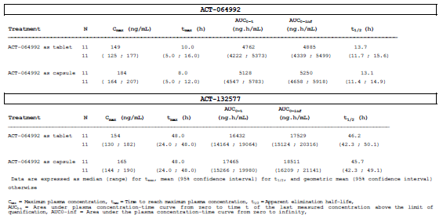

Table 3: Ratio of geometric means (point estimates and 90% CIs) of Cmax, AUC0-t, and AUC0-∞ for macitentan (ACT-064992) and ACT-132577 after administration of single dose of 10 mg macitentan as tablet (A) or capsule (B), Study AC-055-108

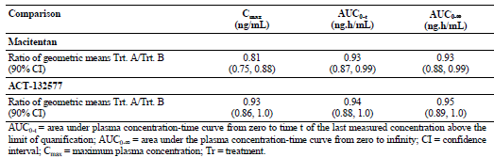

###### Bioequivalence of different dosage forms and strengths

Only one dose strength of macitentan is being proposed for registration (10 mg), and hence no comparative bioequivalence studies between multiple tablet strengths have been performed.

###### Influence of food

The effect of the presence or absence of food on the PK of macitentan and its active metabolite, ACT-132577, was investigated in Study AC-055-103. Results showed that the exposures (AUC0-t, and AUC0-∞) of macitentan and ACT-132577 were comparable when macitentan was administered in the fasted and in the fed states (Tables 4 and 5). In the pivotal Phase III clinical study (Study AC-055-302), macitentan was administered irrespective of food intake.

Table 4: Descriptive statistics of the PK parameters of macitentan (ACT -064992) and its metabolite, ACT-132577, in healthy subjects in the presence or absence of food (n=10), Study AC-055-103

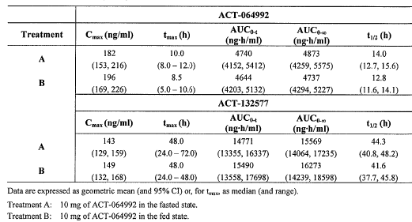

Table 5: Point estimates and confidence intervals (90%) of the geometric mean ratios of Cmax, AUC0-t, AUC0-∞, values of macitentan (ACT-064992) and ACT-132577 after administration of 10 mg in the fasted state or with food, Study AC-055-103

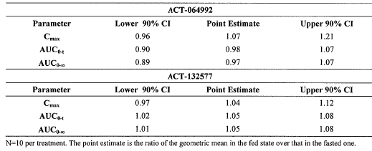

###### Dose proportionality

Both Cmax and AUC0-24 of the macitentan parent drug were dose-proportional over the tested dose range of 1 to 30 mg once daily (Figure 1). Formal statistical analyses on dose-proportionality using power model showed that Cmax and AUC0-24 increased dose-proportionally (β = 0.97 [95% CIs: 0.88–1.06] and 0.97 [95% CIs: 0.88–1.07], for Cmax and AUC0-24).

Figure 1: Dose-normalised individual values for AUC0-24 and Cmax of ACT-064992 on Day 10 and results from linear regression, Study AC-055-102

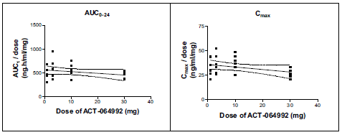

###### Bioavailability during multiple-dosing

After multiple dosing (1, 3, 10, or 30 mg once daily for 10 days; Study AC-055-102) steady-state conditions of macitentan and ACT-132577 were obtained after 3 days and 7 days. The accumulation of macitentan was small (approximately 1.4 to 1.7-fold) whereas that of ACT-132577 was about 8.5-fold.

###### Volume of distribution

The sponsor had stated that following oral administration to healthy subjects, a one-compartment model with a lag time and first order input and elimination, adequately described the steady-state plasma concentration versus time data of macitentan and ACT-132577. This model indicated an apparent volume of distribution (Vss/F) of approximately 50 L and 40 L for macitentan and ACT-132577.

###### Plasma protein binding

Macitentan and its circulating metabolites are highly bound (≥ 99%) to plasma proteins in humans. Plasma protein binding of macitentan was investigated in Studies AC-055-110 (hepatic impairment study) and AC-055-112 (renal impairment study). Results in the hepatic impairment study (AC-055-110) showed that macitentan and its active metabolite, ACT-132577, were highly bound to circulating proteins with a maximum unbound fraction of 0.26% at eight hours post-dose and 1.09% at 48 hours post-dose (that is, around their respective Cmax). No reduction in plasma protein binding was observed for macitentan and ACT-132577 in subjects with mild, moderate, or severe hepatic impairment compared to healthy subjects. The inactive metabolite ACT-373898 was also highly bound to circulating proteins (97.6% bound), but it was also found that the proportion of unbound ACT-373898 increased with the severity of hepatic impairment. The sponsor did not consider this correlation to be clinically relevant, because of the low concentration of ACT-373898 and its lack of activity on the endothelin receptor.

Results in the renal impairment study (AC-055-112) also showed that macitentan, ACT-132577, and ACT-373898 were highly bound to circulating proteins. The unbound fraction of macitentan was comparable between subjects with severe renal function impairment (SRFI) and healthy subjects (0.13% versus 0.10%). The unbound fractions of ACT-132577 and ACT-373898 were higher in subjects with SRFI, than in healthy subjects (ACT-132577: 0.68% versus 0.57%; ACT-373898: 1.82% versus 1.50%). The sponsor had considered these differences to be modest and therefore not clinically relevant.

###### Erythrocyte distribution

In the human ADME study (AC-055-104), concentrations of total radioactivity in plasma were greater compared to whole blood (Cmax, AUC0-t and AUC0-∞ of total radioactivity in plasma were about 80%, 96% and 105% greater than in whole blood), which indicated that macitentan and its metabolites bind poorly to or penetrate poorly into erythrocytes. Maximum concentrations of total radioactivity in plasma and whole blood were observed at approximately 12 hours post-dose (geometric mean Cmax: 235 ng equivalent/mL) and 14 hours post-dose (geometric mean Cmax: 131 ng equivalent/mL).

##### Metabolism

###### Sites of metabolism and mechanisms / enzyme systems involved

In Study AC-055-104 in which six healthy subjects received a single oral 10 mg dose of 14C-labeled macitentan, metabolic profiling showed three, four and five entities were identified in plasma, urine, and faeces. Based on this, the sponsor had provided a proposed metabolic pathway of macitentan (Figure 2), that macitentan undergoes two major metabolic reactions: oxidative depropylation and oxidative cleavage. It was postulated that macitentan undergoes oxidative depropylation to form the active metabolite ACT-132577. This reaction had been found in vitro studies to be mediated by the cytochrome P450 system, mainly CYP3A4 with a minor contribution of CYP2C19. ACT-132577 then undergoes conjugation with glucose to form M706u, which is eliminated in urine. M706u was not present in faeces, and the sponsor had hypothesised that it could possibly be cleaved back to ACT-132577 in the gastrointestinal tract, probably by bacteria present in gut flora. It was postulated that macitentan also undergoes oxidative cleavage (oxidation of the ether side chain) to form the carboxyl acid derivative, ACT-373898 (inactive metabolite), which in turn undergoes hydrolysis to form M323u. Both ACT-373898 and M323u were present in both urine and faeces and constituted the major radio-labelled products in urine. ACT-373898 was also present in plasma. In addition to these 2 major metabolic reactions, it was postulated that both macitentan parent drug (ACT-064992) and ACT-132577 (oxidative depropylation metabolic product) could be hydrolysed to the aminopyrimidine ACT-080803, which was found in both urine and faeces, and was the major radio-labelled product present in faeces. Both ACT-064992 and ACT-132577 were also present in faeces, and the sponsor was of the opinion that the ACT-064992 present in faeces was likely the non-absorbed drug material.

Figure 2: Proposed metabolic pathways of macitentan, Study AC-055-104

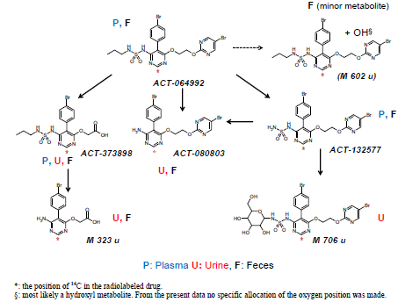

###### Non-renal clearance

With regards to biliary excretion, the sponsor had reported that in an *in-vitro* metabolism study using human hepatocytes, only the active metabolite ACT-132577 was conjugated and not the parent drug. However, in the human ADME study (AC-055-104), 16.9% of the radioactivity recovered in the faeces was the macitentan parent drug, although the contribution of unabsorbed drug to this proportion was not known. In this study, a number of metabolites, including ACT-132577, were also recovered in the faeces, indicating the occurrence of biliary excretion for these metabolites.

With regards to enterohepatic recirculation, the individual plasma concentration-time profiles for macitentan parent drug and ACT-132577 from the single-ascending-dose (SAD) and multiple-ascending-dose (MAD) studies (Studies AC-055-101 and AC-055-102) showed no evidence of secondary peaks, suggesting that the contribution of enterohepatic recycling to macitentan parent drug and ACT-132577 exposure was negligible.

#### Excretion

##### Routes and mechanisms of excretion

In the radiolabel mass balance study (AC-055-104), renal excretion of macitentan metabolites was shown to be the most important route of elimination. Overall mean (standard deviation [SD]) cumulative recovery of radioactivity was 73.6% (6.2%) of the administered dose, with 49.7% (3.9%) cumulative recovery from urine, compared to 23.9% (4.8%) from faeces, suggesting that urine represented a more important elimination route for macitentan than faeces.

Results suggested that macitentan was extensively metabolised before excretion. Neither unchanged macitentan parent drug nor the active metabolite ACT-132577 was recovered from urine (Table 6). In faeces, 16.9% of the recovered radioactivity was unchanged macitentan. The relative contribution of unabsorbed drug and of biliary excretion to this proportion was not known. In faeces, 14.0% of the recovered radioactivity was unchanged ACT-132577, suggesting the occurrence of biliary excretion for this active metabolite. The inactive metabolite ACT-373898 was the major radio-labelled product present in urine, accounting for 23.0% of the recovered radioactivity in urine. ACT-080803, the hydrolysis product of macitentan and ACT-132577, was the major radio-labelled product present in faeces, accounting for 37.7% of the recovered radioactivity in faeces.

Table 6: Total recovery and distribution of radioactive components in faeces and urine (n = 6), Study AC-055-104

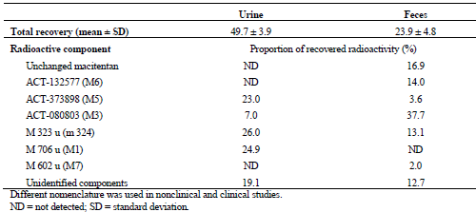

#### Intra- and inter-individual variability of pharmacokinetics

The sponsor had reported that when comparing the exposure expressed as AUCτ (the area under the plasma concentration-time curve during a dose interval) in steady-state conditions in the Phase I studies, coefficient of variability (CV%) ranged from 24-30% for macitentan and 15–23% for ACT-132577, indicating a relatively low inter-subject variability.

In PAH patients in Study AC-055-302PK/PD (population PK analysis study), a higher inter-subject variability in exposure was observed (CV% of 55% and 40% for macitentan and ACT-132577). However, this was based on trough plasma concentration (Ctrough)[4] data taken at Month 6, instead of AUCτ.

### Pharmacokinetics in the target population

A population PK/PD modelling analysis **(**Study AC-055-302 PK/PD) was done as a sub-study of the pivotal Phase III study AC-055-302. Results showed that macitentan trough plasma concentrations (used as a surrogate for exposure) for both the 3 mg and 10 mg dose groups were higher than those observed in healthy subjects in Study AC-055-102 (3 mg dose: 1.6 to 1.9 times higher; 10 mg dose: 1.6 to 2.3 times higher) (Table 7)**.** ACT-132577 plasma concentrations in the 3 mg dose group in the Study AC-055-302 PK/PD were 1.2 to 1.5 times higher than those observed in healthy subjects, and those in the 10 mg dose group were about 1.5 times higher than those observed in healthy subjects.

Table 7: Summary statistics of macitentan and ACT-132577 trough plasma concentrations (ng/mL), Study AC-055-302 PK/PD and Study AC-055-102

|  |  |  |  |  |  |  |
| --- | --- | --- | --- | --- | --- | --- |
| Study AC-055-302 PK/PD | | | | | | |
| 1. macitentan | | | | | | |
| Visit | Dose (mg) | n | mean | SD | CV% | median |
| Month 6 | 3 | 49 | 92.14 | 52.59 | 57.08 | 89.00 |
|  | 10 | 41 | 291.45 | 155.23 | 53.26 | 276.00 |
| EOT | 3 | 10 | 76.41 | 61.41 | 80.36 | 60.95 |
|  | 10 | 154 | 208.24 | 138.68 | 66.60 | 200.00 |
| 1. ACT-132577 | | | | | | |
| Visit | Dose (mg) | n | mean | SD | CV% | median |
| Month 6 | 3 | 49 | 252.99 | 103.81 | 41.03 | 251.00 |
|  | 10 | 41 | 837.37 | 328.18 | 39.19 | 822.00 |
| EOT | 3 | 142 | 309.56 | 175.31 | 56.63 | 294.00 |
|  | 10 | 154 | 842.57 | 413.11 | 49.03 | 857.50 |
| CV% = coefficient of variation in percent; EOT = end of treatment; SD = standard deviation | | | | | | |

|  |  |  |  |  |  |
| --- | --- | --- | --- | --- | --- |
| Study AC-055-102 (Day 3; steady-state) | | | | | |
| 1. macitentan | | | | | |
| Dose macitentan | n | mean | SD | min | max |
| 3 mg | 6 | 47.4 | 10.8 | 34.6 | 67.2 |
| 10 mg | 6 | 129 | 35.3 | 80.6 | 186 |
| 1. ACT-132577 | | | | | |
| Dose macitentan | n | mean | SD | min | max |
| 3 mg | 6 | 207 | 69.6 | 143 | 324 |
| 10 mg | 6 | 549 | 175 | 330 | 845 |
| SD = standard deviation | | | | | |

### Pharmacokinetics in other special populations

#### Pharmacokinetics in subjects with impaired hepatic function

Study AC-055-110 compared the PK of macitentan and its metabolites in healthy subjects and in subjects with mild (Child-Pugh grade A), moderate (Child-Pugh grade B), or severe (Child-Pugh grade C) hepatic impairment, following a single oral dose of macitentan 10 mg tablet. Results showed that absorption of macitentan parent drug appeared to be slower in subjects with hepatic impairment (median tmax of eight to 10 hours) compared to in healthy subjects (median tmax of 5.5 hours). AUC0-∞ and Cmax of macitentan parent drug and its metabolites, ACT-132577 (active) and ACT-373898 (inactive), were lower in all three groups of subjects with hepatic impairment compared to healthy subjects (Table 8).

Table 8: Summary of PK parameters of macitentan, ACT-132577, and ACT-373898, Per-protocol set, Study AC-055-110

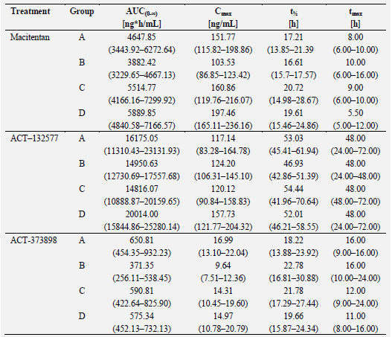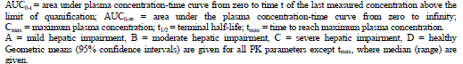

For macitentan parent drug, AUC0-∞ in the mild, moderate and severely hepatic impaired groups was 79%, 66% and 94%, that of the healthy group, while Cmax was 77%, 52% and 81%, that of the healthy group. For ACT-132577, AUC0-∞ was 81%, 75% and 74% that of the healthy group, while Cmax was 74%, 79% and 76% that of the healthy group. The differences in the PK parameters of macitentan parent drug and its metabolites, ACT-132577 and ACT-373898, between the groups with hepatic impairment and the healthy subject group were explored using geometric mean ratios (point estimates and their 90% CIs) of t½, Cmax, AUC0-t, and AUC0-∞, and results were mostly outside of the equivalence range (Table 9).

Table 9: Geometric ratios of PK parameters of macitentan, ACT-132577, and ACT-373898, Per-protocol set, Study AC-055-110

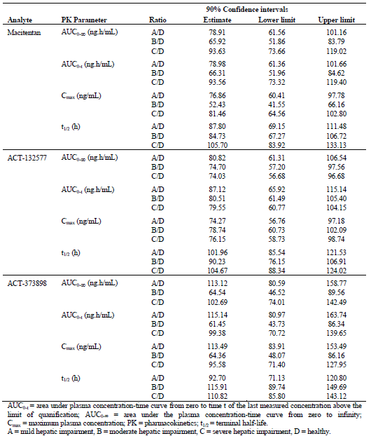

However, there was no particular trend noted in these PK parameters with increasing severity of hepatic impairment. Overall, the lower AUC0-∞ and Cmax of macitentan and its metabolites in subjects with hepatic impairment compared to healthy subjects were not considered by the sponsor to be of a magnitude that would warrant dose adjustments in subjects with hepatic impairment.

Comments: Study design of Study AC-055-110 was consistent with the TGA-adopted EMA guidelines on the evaluation of the pharmacokinetics of medicinal products in patients with impaired hepatic function[5]. This guideline acknowledged that ‘specific dosing recommendations may not always be possible’ but had recommended that factors to be considered should include PK/PD relationship regarding efficacy and safety. The sponsor had stated that their conclusion regarding dosing recommendations in hepatic impairment took into account the haemodynamic efficacy results (in terms of reduction in systemic blood pressure [BP]) with 3 and 10 mg macitentan in the PK/PD analysis of Study AC-055-201 (proof-of-concept, dose finding study), and the differences in PK parameters after multiple doses of 3 and 10 mg macitentan reported in the MAD study AC-055-102. Evaluation of the results of these studies showed that the proposed dosing recommendation with regards to hepatic impairment was reasonable.

Results of Study AC-055-201 showed that the drop in trough sitting diastolic blood pressure (SiDBP; primary endpoint) in response to macitentan appeared to be dose-dependent (Table 10 and Figure 3). For macitentan 10 mg, the reduction from baseline in trough SiDBP was statistically significant compared to placebo (mean change from baseline of -11.8 mmHg versus -7.9 mmHg, p=0.0089). Statistical significance was not reached for the 3 mg dose (mean change from baseline of -10.8 mmHg versus -7.9 mmHg with placebo, p=0.0555) but this dose produced an effect on BP reduction that was considered by the sponsor to be clinically relevant. Results of the MAD study AC-055-102 showed that at steady state, the AUC0-24 of macitentan parent drug with 3 mg dose was 32% that of 10 mg dose (1722 versus 5400 ng.h/mL; that is, about 3-fold lower), while Cmax was 29% that of 10 mg dose (106 versus 371 ng/mL; that is, about 3.5-fold lower) (Table 11). At steady state, the AUC0-24 of the active metabolite ACT-132577 with 3 mg dose was 32% that of 10 mg dose (5048 versus 15541 ng.h/mL; that is, about 3-fold lower), while Cmax was 31% that of 10 mg dose (247 versus 802 ng/mL; that is, about 3-fold lower). Results of Study AC-055-110 showed that across the hepatic impairment groups, AUC0-∞ of macitentan parent drug after single dose of 10 mg was 1.1 to 1.5-fold lower compared to the healthy group, while Cmax was 1.2 to 1.9 fold lower. AUC0-∞ of ACT-132577 after single dose of 10 mg was 1.2 to 1.4-fold lower in the hepatic impairment groups compared to the healthy group, while Cmax was 1.3 to 1.4-fold lower. The differences in PK parameters after multiple doses of 3 and 10 mg macitentan reported in the MAD study were greater than those observed between healthy and hepatically impaired subjects with macitentan 10 mg. Taken together with the results of Study AC-055-201, it is thus reasonable to expect that there would be no significant impact on efficacy with the degree of reduced exposure observed in the hepatic impairment groups. In addition, there was no particular trend observed of a greater reduction in exposure or Cmax with increasing severity of hepatic impairment.

Evaluation of safety results in Study AC-055-110 did not show any trend of increasing incidence of adverse events (AEs) with increased severity of hepatic impairment, although this had been of less concern in view of results showing reduced rather than increased exposure in the presence of hepatic impairment.

Table 10: Change in sitting diastolic blood pressure from baseline to end of Period II in the Per-protocol analysis set, Study AC-055-201

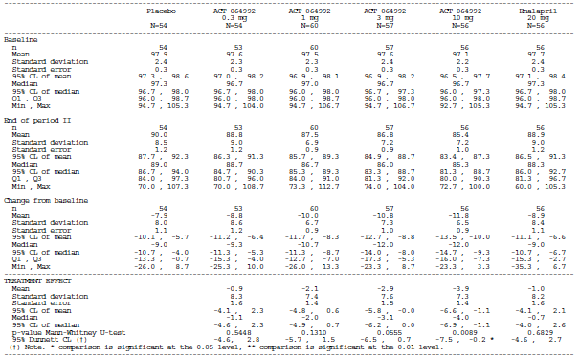

Figure 3: Change in sitting diastolic blood pressure from baseline to end of Period II (Placebo-corrected), Study AC-055-201

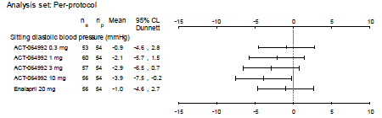

Table 11: Plasma PK parameters of macitentan (ACT- 064992) in healthy subjects after administration of multiple doses of macitentan once daily for 10 days, Study AC-055-102

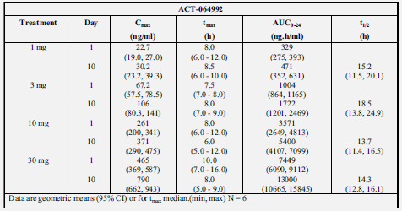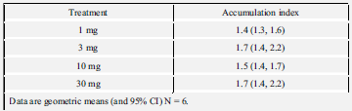

#### Pharmacokinetics in subjects with impaired renal function

Study AC-055-112 compared the PK of macitentan and its metabolites in healthy subjects (baseline median [range] creatinine clearance of 98.7 mL/min [89.9-107.4]) and that in subjects with severe renal function impairment (SRFI) (baseline median [range] creatinine clearance of 23.8 mL/min [16.1-29.0]). Results showed that absorption of macitentan parent drug appeared to be comparable between healthy subjects and subjects with SRFI (median tmax of 7.0 and 6.5 hours) (Table 12).

Table 12: Plasma PK variables of macitentan, ACT-132577 and ACT-373898 in healthy subjects and subjects with SRFI after administration of a single dose of 10 mg macitentan, Per-protocol set, Study AC-055-112

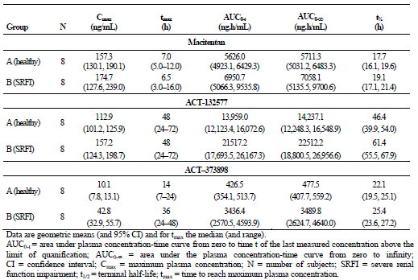

AUC0-∞ and Cmax of macitentan parent drug and its active metabolite, ACT-132577, were higher in subjects with SRFI compared to healthy subjects (AUC0-∞: 24% and 58% higher for macitentan and ACT-132577; Cmax: 11% and 39% higher). The elimination of macitentan parent drug and ACT-132577 was characterised by a longer t½ in subjects with SRFI compared to healthy subjects (8% and 32% longer). Geometric mean ratios of t½, Cmax, AUC0-t, and AUC0-∞ showed that for macitentan parent drug, although the point estimates of the geometric mean ratios of these PK parameters were within the equivalence range (0.8-1.25), their upper 90% CI limits were outside the upper limit of this equivalence range (Table 13).

Table 13: Ratio of Cmax, AUC0-t, AUC0-∞, t½ and difference in tmax for macitentan, ACT-132577 and ACT-373898 between healthy subjects and SRFI subjects, Per-protocol set, Study AC-055-112

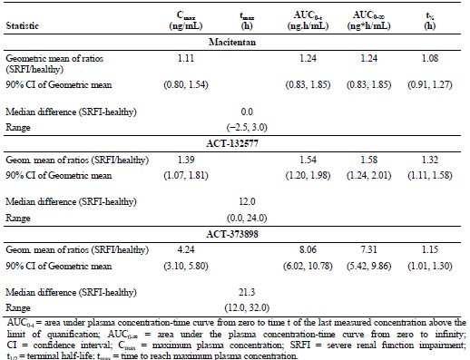

For ACT-132577, the point estimates of the geometric mean ratios of these PK parameters and their upper 90% CI limits were all outside the upper limit of the bioequivalence range. A more marked difference in the PK of the pharmacologically inactive metabolite ACT-373898 was noted between healthy subjects and subjects with SRFI, with a 7-fold and 4-fold increase in AUC0-∞ and Cmax of ACT-373898 in subjects with SRFI compared to healthy subjects. For ACT-373898, the point estimates of the geometric mean ratios of PK parameters (t½, Cmax, AUC0-t, and AUC0-∞) and their upper 90% CI limits were all outside the upper limit of the bioequivalence range. Overall, the higher AUC0-∞ and Cmax of macitentan and ACT-132577 in SRFI subjects compared to healthy subjects were not considered by the sponsor to be of a magnitude that would warrant dose reduction in subjects with SRFI. The marked increases in AUC0-∞ and Cmax of ACT-373898 in SRFI subjects compared to healthy subjects were not considered by the sponsor to be clinically relevant as ACT-373898 was not active on endothelin receptors.

Comments: Study design of Study AC-055-112 was consistent with the TGA-adopted EMA guidelines on the evaluation of the pharmacokinetics of medicinal products in patients with impaired renal function[6]. In this study, only subjects with severe renal impairment were compared to healthy subjects. Subjects with mild and moderate impairment were not investigated. This is not inconsistent with the EMA guidelines, which stated that a reduced study design (that is, study design comparing healthy subjects and subjects with severe renal impairment) ‘may be applicable, for example if the applicant wants to confirm that the pharmacokinetics is not altered to a clinically relevant extent’. The sponsor had stated that their conclusion regarding dosing recommendations in renal impairment took into account the results in the SAD Study (AC-055-101). The exposure to macitentan parent drug and the active metabolite, ACT-132577, in subjects with SRFI was below that with the highest-tolerated dose of macitentan (300 mg) reported in the SAD Study.

The proposed dosing recommendation with regards to renal impairment is reasonable. Overall, the results in Study AC-055-112 showed that severe renal impairment has an effect on the PK of macitentan (upper 90% CI limits of the geometric ratios of the PK parameters for macitentan parent drug and ACT-132577 were outside the upper limit of the bioequivalence range of 1.25), but the effect was not clinically relevant with regards to safety risk. Evaluation of the results of Studies AC-055-101 and AC-055-112 showed that AUC0-∞ of macitentan parent drug was 7058.1 ng.h/mL in SRFI subjects (after single dose of 10 mg macitentan), compared to 103007 ng.h/mL with single dose of 300 mg macitentan (highest-tolerated dose) in healthy subjects in Study AC-055-101 (Table 14).

Table 14: Plasma PK parameters of macitentan (ACT- 064992) in healthy subjects after administration of a single dose of 0.2, 1, 5, 25, 100, 300, or 600 mg of macitentan, Study AC-055-101

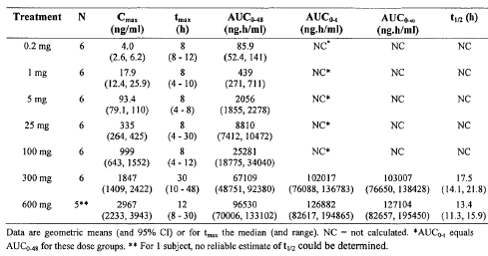

Insufficient number of blood samples had been taken in the elimination phase to allow for calculation of AUC0-∞ of macitentan parent drug in the 0.2 to 100 mg dose groups in Study AC-055-101. Cmax of macitentan parent drug was 174.7 ng/mL in SRFI subjects, corresponding to that between macitentan 5 mg and 25 mg in healthy subjects in Study AC-055-101 (Cmax of macitentan parent drug in healthy subjects in Study AC-055-101 was 1847, 999, 335, and 93.4 ng/mL with macitentan 300 mg, 100 mg, 25 mg and 5 mg). AUC0-∞ of ACT-132577 was 22512.2 ng.h/mL in SRFI subjects, compared to 330549 ng.h/mL with single dose of 300 mg macitentan in healthy subjects in Study AC-055-101 (Table 14). Insufficient number of blood samples had been taken in the elimination phase to allow for calculation of AUC0-∞ of ACT-132577 in the 0.2 to 100 mg dose groups in Study AC-055-101. Cmax of ACT-132577 was 157.2 ng/mL in SRFI subjects, corresponding to that between macitentan 5 mg and 25 mg in healthy subjects in Study AC-055-101 (Cmax of ACT-132577 in healthy subjects in Study AC-055-101 was 2585, 931, 304 and 84.1 ng/mL with macitentan 300 mg, 100 mg, 25 mg and 5 mg). In Study AC-055-101, safety results showed that doses up to and including 300 mg macitentan were well-tolerated. In particular, there was no effect on standing and supine blood pressures up to and including a dose of 300 mg.

Safety results in Study AC-055-112 showed that macitentan 10 mg single dose was well tolerated in both SRFI subjects and healthy subjects despite the increased exposure in SRFI subjects. Although decreases in systolic and diastolic blood pressures (SBP and DBP) were more pronounced in subjects with SRFI than in healthy subjects (median maximum decreases from baseline in SBP: -22.0 mmHg versus -3.0mmHg; DBP: -7.5 mmHg versus -3.5 mmHg), these changes in blood pressure were not reported as clinically relevant by the investigator, and were not reported as AEs. In addition, it was observed that the largest decrease in SBP and in DBP occurred in subjects who had higher blood pressures (SBP ≥ 140 mmHg; DBP > 80 mmHg) before study drug administration, and that at baseline, median values for SBP and DBP were higher in subjects with SRFI when compared to healthy subjects (SBP: 146 mmHg versus 117 mmHg; DBP: 81.5 mmHg versus 71.0 mmHg). It is noted by the evaluator that the need for monitoring of blood pressures in patients with SRFI has been included as a precaution in the proposed PI, stating that ‘Patients with severe renal impairment may experience blood pressure reduction at treatment initiation and monitoring should be considered’. The evaluator is of the opinion that the proposed non-requirement for dose reduction in SRFI patients together with inclusion of this precaution in the proposed PI is acceptable.

#### Pharmacokinetics according to race/ethnicity

Study AC-055-109 compared the PK of macitentan and its metabolite, ACT-132577, in Japanese versus Caucasian healthy subjects after a single-dose treatment of macitentan 10 mg tablet. Results showed that the plasma concentration-time profiles in Caucasians and Japanese subjects were similar, but exposure (AUC0-∞) to macitentan and ACT-132577 was approximately 15% lower inJapanese subjects when compared to Caucasian subjects. The geometric mean ratios (Japanese versus Caucasian) and their 90% CIs for Cmax of both macitentan and ACT-132577 were within the equivalence limits of 0.8 to 1.25, while the lower limit of the confidence interval for AUC0-∞ was 0.71 for macitentan and 0.73 for ACT-132577 (that is, below the lower equivalence limit of 0.8). Overall, this lower AUC0-∞ of macitentan and its metabolite in Japanese subjects compared to Caucasian subjects was not considered by the sponsor to be clinically relevant or of a magnitude that would warrant dose adjustments in Japanese subjects.

Comments: The dosing recommendation that no dose adjustments are required in Japanese subjects is reasonable. Results of Study AC-055-109 showed that ethnicity (Japanese versus Caucasian) had no effect on Cmax of macitentan and ACT-132577 (geometric mean ratios and their 90% CIs for Cmax were within the equivalence limits of 0.8 to 1.25). Although there were lower exposures to macitentan and ACT-132577 in Japanese subjects compared to Caucasians, as per the reasoning behind the recommendation for no dosing adjustments for subjects with hepatic impairment despite reduced exposures being observed in these subjects compared to healthy subjects the differences in PK parameters after multiple doses of 3 and 10 mg macitentan reported in the MAD study (Study AC-055-102) were greater than those observed between Japanese and Caucasian subjects with single dose of macitentan 10 mg. Results of Study AC-055-201 showed that for macitentan 10 mg, the reduction from baseline in SiDBP (primary PD endpoint) was statistically significant compared to placebo. Although statistical significance was not reached for the 3 mg dose, this dose produced an effect on BP reduction that was considered by the sponsor to be clinically relevant. It is thus reasonable to expect that there would be no significant impact on efficacy with the degree of reduced exposure observed in the Japanese subjects.

### Pharmacokinetic interactions

#### Pharmacokinetic interactions demonstrated in human studies

##### Warfarin

A DDI study with macitentan and warfarin (AC-055-105) was performed to investigate the effect of macitentan on the PK and PD of warfarin, as warfarin can potentially interact with a wide range of drugs due to its metabolism by a range of CYPs (predominantly 1A2 and 2C9, with a smaller contribution of CYP3A4)[7]. In addition, warfarin also has a narrow therapeutic index and is often given to patients with PAH to reduce the risk of thrombosis and embolism. In addition, both warfarin and macitentan are highly plasma protein bound and concomitant administration could lead to displacement.

Overall, results showed that the PK and PD of warfarin were not affected by concomitant macitentan, and study treatments were well tolerated when warfarin was administered alone or with macitentan. PK parameters for S-warfarin and R-warfarin were comparable when warfarin was administered alone or with macitentan. The geometric mean ratios and 90% CI for Cmax and AUC0-∞ for S-warfarin and R-warfarin were within the bioequivalence range of 0.80 to 1.25. The median tmax, mean AUC0-t and t½ values of S-warfarin and R-warfarin were also comparable when warfarin was administered alone or with macitentan. PD parameters for warfarin (in terms of INR and Factor VII) were also generally comparable when warfarin was administered alone or with macitentan. For both INR and Factor VII, median tmax, mean baseline, and maximum concentration were similar when warfarin was administered alone or with macitentan (Table 15).

Table 15: Summary of parameters of INR and Factor VII, Study AC-055-105

1. INR

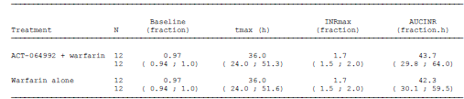

1. Factor VII

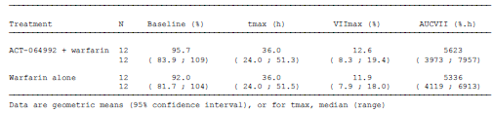

AUCINR and AUCVII were also similar with and without macitentan, although the upper 90% (CI) for AUCINR was just outside the upper limit for bioequivalence of 1.25 (ratio of geometric means of AUCINR [macitentan and warfarin/warfarin only] of 1.03; 90% CI of 0.84 to 1.26). Overall, study treatments were well tolerated when warfarin was administered alone or with macitentan. The sponsor had concluded that based on the study results, no dose adjustment of macitentan is necessary for concomitant treatment of macitentan and warfarin.

Comments: Based on the study results, the sponsor’s conclusion is reasonable.

##### Sildenafil

A DDI study with macitentan and sildenafil (AC-055-106) was performed to evaluate effect of macitentan on the PK of sildenafil and vice versa. Sildenafil is approved for use in the treatment of PAH and, therefore, may potentially be co-administered with macitentan in clinical practice. The mutual interactions between macitentan and sildenafil were investigated because sildenafil is a CYP3A4 substrate. In vitro studies had shown that macitentan and ACT-132577 acted as microsomal enzyme inducers but at high concentrations/exposures that were not relevant to the free drug concentrations achieved during therapeutic use. Other in vitro studies were reported to show that neither macitentan nor ACT-132577 had shown inhibitory effects in a standard battery of human P450 enzymes at concentrations that would be achieved in therapeutic use. Sildenafil could also potentially have an effect on the PK of macitentan due to competition for CYP3A4 or other mechanism[8].

Overall, results showed that the PK parameters of macitentan parent drug were not affected by concomitant administration with sildenafil, while those of the active metabolite ACT-132577 were lower in the presence of sildenafil compared to without concomitant sildenafil. The PK parameters of sildenafil parent drug were higher in the presence of macitentan compared to without concomitant macitentan, while those of the metabolite, N-desmethyl sildenafil, were unaffected.

PK parameters for macitentan parent drug were comparable when administered alone or with sildenafil, with the geometric mean ratios for Cmax and AUCτ for macitentan close to 1.0 and their respective 90% CI within the bioequivalence range of 0.80 to 1.25 (Tables 16 and 17).

Table 16: Plasma PK variables of macitentan (ACT-064992) and ACT-132577 in the presence or absence of sildenafil, Study AC-055-106

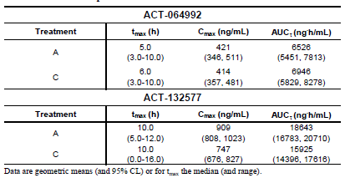

Table 17: Geometric mean ratios and 90% CIs of Cmax and AUCτ values of macitentan and ACT-132577 in the presence or absence of sildenafil (N = 12), Study AC-055-106

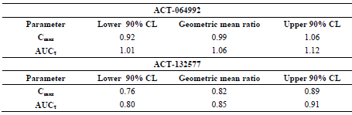

Both Cmax and AUCτ for the metabolite ACT-132577 were lower in the presence of sildenafil compared to without concomitant sildenafil (Cmax: geometric mean ratio [90% CI] of 0.82 [0.76, 0.89]; AUCτ: geometric mean ratio [90% CI] of 0.85 [0.80, 0.91]). No effect of sildenafil on the tmax of macitentan or its metabolite was detected.

PK parameters of Cmax and AUCτ for sildenafil were higher in the presence of macitentan compared to without concomitant macitentan (Cmax: geometric mean ratio [90% CI] of 1.26 [1.07, 1.48]; AUCτ: geometric mean ratio [90% CI] of 1.15 [0.94, 1.41]) (Tables 18 and 19)**.** Plasma pharmacokinetic variables of sildenafil and N-desmethyl sildenafil in the presence or absence of macitentan, Study AC-055-106.

Table 18: Plasma pharmacokinetic variables of sildenafil and N-desmethyl sildenafil in the presence or absence of macitentan, Study AC-055-106

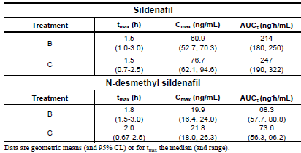

Table 19: Geometric mean ratios and confidence intervals (90%) of Cmax and AUCτ values of sildenafil and N-desmethyl sildenafil in the presence or absence of macitentan, Study AC-055-106

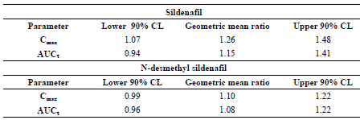

PK parameters for N-desmethyl sildenafil were comparable when sildenafil was administered alone or with macitentan, with the geometric mean ratios for Cmax and AUCτ close to 1.0 and their respective 90% CI within the bioequivalence range of 0.80 to 1.25. No effect of macitentan on the tmax of sildenafil or its metabolite was detected.

Overall, study treatments were well tolerated when macitentan and sildenafil were each administered alone or concomitantly. Although more AEs occurred during the combined treatment (25 AEs were reported by 12 subjects [100%]) than when macitentan and sildenafil were each administered alone (macitentan alone: 10 AEs reported by 7 [68.3%] subjects; sildenafil alone: five AEs reported by three [25.0%] subjects); headache (reported by 10 out of the 12 subjects) was the most common AE during the combined treatment which was consistent with the AE profile elicited in other Phase I studies. In addition, all AEs were of mild to moderate severity, all resolved without sequelae and there were no SAEs or deaths. Although there was a more pronounced decrease from baseline in diastolic blood pressure observed during the combined treatment compared to each treatment alone (maximum median decrease in DBP of 15.5mmHg versus 8.0 to 9.5 mmHg), these decreases in DBP were not reported as AEs or considered clinically relevant by the investigators.

Overall, the sponsor considered the decreases in Cmax and AUCτ for ACT-132577 (metabolite of macitentan) in the presence of sildenafil, and the increases in Cmax and AUCτ of sildenafil parent drug in the presence of macitentan, to be modest and not clinically relevant, and that no dose adjustment of either compound would be necessary during concomitant treatment with macitentan and sildenafil. In addition, it was concluded that the lack of interaction with sildenafil indicated that no clinically relevant pharmacokinetic interactions between macitentan and other CYP3A4 substrates (such as hormonal contraceptives) would be expected to occur.

Comments: Based on the study results, the sponsor’s conclusions are reasonable.

##### Ketoconazole

A DDI study with macitentan and ketoconazole (Study AC-055-107) was performed, as in vitro data showed that macitentan is primarily metabolised by CYP3A4 and ketoconazole is a potent inhibitor of this enzyme. Overall, results were consistent with macitentan being primarily metabolised by CYP3A4. When concomitantly administered with a potent CYP3A4 inhibitor (ketoconazole), macitentan was metabolised to ACT-132577 more slowly, resulting in an approximately 2-fold decrease in Cmax and a shift of tmax from 48 hours to 72 hours for ACT-132577. Exposure to ACT-132577 (AUC0-∞) was decreased by 26% during combined treatment. The geometric mean ratios (macitentan + ketoconazole/ macitentan only) of Cmax and AUC0-∞ of ACT-132577 were 0.49 and 0.74 with 90% confidence intervals of 0.43 to 0.56 and 0.66 to 0.84.

With regards to macitentan parent drug, when administered concomitantly with ketoconazole, there was an increase in the PK parameters of Cmax (28% increase), tmax (12 hours versus nine hours), and t½ (28.5 hours versus 14.1 hours) of macitentan (ACT-064992) compared to when macitentan was administered alone, resulting in an approximately 2-fold increase in exposure in terms of AUC0-∞ (Table 20).

Table 20: Summary of PK variables of macitentan (ACT-064992) and ACT-132577 in the presence or absence of ketoconazole, Study AC-055-107

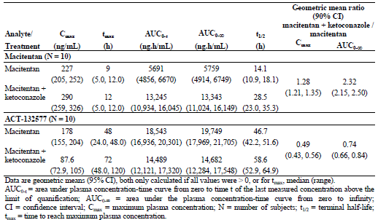

The geometric mean ratios (macitentan + ketoconazole/ macitentan only) of Cmax and AUC0-∞ were 1.28 and 2.32 with 90% confidence intervals of 1.21 to 1.35 and 2.15 to 2.50. However, safety results showed that study treatments were well tolerated when administered alone or with ketoconazole.

The sponsor was of the opinion that the 2-fold increase in exposure to macitentan parent drug and the 26% decrease in exposure to ACT-132577 were not clinically relevant, and concluded that macitentan may be administered concomitantly with CYP3A4 inhibitors without need for dose adjustments.

Comments: Based on the study results, the sponsor’s conclusion is reasonable. The increased AUC0-∞ of macitentan parent drug with concomitant ketoconazole (geometric mean 13343 ng.h/mL [95% CI: 11024 to 16149]) was about 8-fold lower than the AUC0-∞ of the highest tolerated dose (300 mg macitentan) observed in the SAD study (AC-055-101) (geometric mean 103007 ng.h/mL [95% CI: 76650 to 138428]), and was comparable to the exposure measured at steady-state (AUC0-24) of the highest dose tested in the MAD study (AC-055-102) of 30 mg macitentan (geometric mean 13000 ng.h/mL [95% CI: 10665 to 15845]), which was well-tolerated. Safety results showed that study treatments were well tolerated when administered alone or with ketoconazole.

With regards to potential reduced efficacy due to 2-fold decrease in Cmax of ACT-132577 and 26% decrease in exposure to ACT-132577 (AUC0-∞) during combined treatment with ketoconazole, as per the reasoning behind the recommendation for no dosing adjustments for subjects with hepatic impairment despite reduced exposures being observed in these subjects compared to healthy subjects, the differences in PK parameters of ACT-132577 after multiple doses of 3 and 10 mg macitentan reported in the MAD study (Study AC-055-102; about 3-fold reduction in Cmax and in AUC0-24 of ACT-132577) were greater than those observed between macitentan + ketoconazole treatment and macitentan alone. Results of Study AC-055-201 showed that for macitentan 10 mg, the reduction from baseline in SiDBP (primary PD endpoint) was statistically significant compared to placebo. Although statistical significance was not reached for the 3 mg dose, this dose produced an effect on BP reduction that was considered by the sponsor to be clinically relevant. It is thus reasonable to expect that there would be no significant impact on efficacy with the degree of reduced exposure observed with co-administration with ketoconazole.

##### Cyclosporin A and Rifampicin

A DDI study evaluating the effects of cyclosporine A (Part A) and of rifampicin (Part B) on the PK of macitentan and its metabolites ACT-132577 and ACT-373898 (Study AC-055-111) was performed. Cyclosporine A is an inhibitor of CYP3A4 and of the uptake transporters, organic anion transporting polypeptide (OATP) 1B1 and OATP1B3 while rifampicin is a potent inducer of CYP3A4. In vitro data showed that macitentan is primarily metabolised by CYP3A4. In addition, clinically significant interactions with cyclosporine had been reported for other ERAs, such as bosentan, at the level of OATP.

When macitentan was administered concomitantly with cyclosporine compared to macitentan alone, geometric means of AUCτ for macitentan and its inactive metabolite ACT-373898 were 10% and 7% higher, while those of Ctrough were 38% and 12% higher (Table 21).

Table 21: Summary of geometric means of AUCτ and Ctrough values of macitentan, ACT-132577 and ACT-373898 at steady-state in the presence or absence of cyclosporine A, Study AC-055-111 Part A

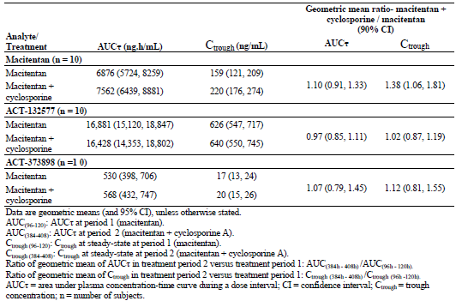

The effect of cyclosporine A on the geometric means of AUCτ and Ctrough of the active metabolite ACT-132577 was small (3% and 2% lower with concomitant administration). Overall, the sponsor considered that the co-administration of cyclosporine did not change the exposure to macitentan and its metabolites to a clinically relevant extent, and concluded that macitentan may be administered concomitantly with cyclosporine A without need for dose adjustments.

When macitentan was administered concomitantly with rifampicin compared to macitentan alone, geometric means of AUCτ for macitentan and its inactive metabolite ACT-373898 were 79% and 64% lower, while those of Ctrough were 93% and 86% lower (Table 22 ).

Table 22: Summary of geometric means of AUCτ and Ctr values of macitentan, ACT-132577 and ACT-373898 in the presence or absence of rifampicin, Study AC-055-111 Part B

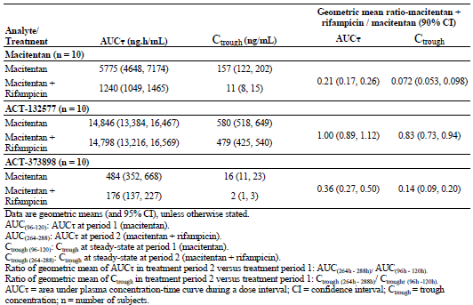

For the active metabolite, ACT-132577, geometric means of AUCτ in the presence and absence of rifampicin were comparable. The effect of rifampicin on the geometric means of Ctrough of the active metabolite ACT-132577 was smaller compared to that for macitentan and ACT-373898 (17% lower with concomitant administration with rifampicin compared to macitentan alone). The sponsor had concluded that the co-administration of rifampicin decreased the exposure to macitentan and ACT-373898 significantly, but did not change the exposure to the active metabolite, ACT-132577 to a clinically relevant extent, and that reduced efficacy of macitentan in the presence of rifampicin should be considered.

Safety results showed that macitentan was well tolerated when administered alone or with cyclosporine A or rifampicin. The sponsor concluded that based on the study results, macitentan may be administered concomitantly with cyclosporine A without need for dose adjustments, but that reduced efficacy of macitentan in the presence of rifampicin should be considered.

Comments: Based on the study results, the sponsor’s conclusion is reasonable.

##### Clinical implications of in vitro findings

According to the sponsor, the DDI potential with macitentan was evaluated in vitro with respect to CYP inhibition, CYP induction, and interactions with transport proteins. The in vitro studies were reported to show that macitentan was a CYP3A4 substrate, while the importance of CYP2C19 for macitentan metabolism was considered to be minimal. With respect to potential CYP inhibition, in vitro studies were reported to show that neither macitentan nor ACT-132577 showed inhibitory effects in a standard battery of human P450 enzymes, at concentrations that would be achieved in therapeutic use. With respect to potential CYP induction, the sponsor had reported that results in the in vitro studies showed that macitentan and ACT-132577 acted as microsomal enzyme inducers, activating the human pregnane X receptor (PXR), and triggering concentration-dependent increases in CYP3A4 mRNA and enzyme activity in human hepatocytes, but that these findings were observed at high concentrations/exposures that were not relevant to the free drug concentrations achieved during therapeutic use. Neither compound induced CYP2C9 nor CYP1A2 expression, and neither was expected to interact with organic anion-transporting polypeptides (OATP1B1 and OATP1B3) at clinically relevant concentrations. In-vitro studies were reported to show that macitentan was neither a substrate, nor an inhibitor of the multi-drug resistance protein (P-gp, MDR-1). The sponsor had judged that on the basis of the in-vitro data the potential of either macitentan or ACT-132577 to elicit DDI with concomitantly administered CYP substrates at therapeutic concentrations was considered low.

Comments: Based on these reported in vitro findings, the selection of the DDI studies investigating potential DDI with warfarin (commonly administered to PAH patients, and metabolised by a range of CYPs), sildenafil (CYP3A4 substrate and approved for treatment of PAH), ketoconazole (potent inhibitor of CYP3A4), cyclosporine A (inhibitor of CYP3A4 and of the uptake transporters) and rifampicin (potent inducer of CYP3A4) were appropriate. It is also noted that in the MAD study (AC-055-102) macitentan had no effect on the urinary 6β-hydroxycortisol/cortisol excretion ratio, a marker of CYP3A4 induction.

### Evaluator’s overall conclusions on pharmacokinetics

Overall, the PK data is adequate with respect to evaluation of this application. ACT-064992 is an orally active, non-peptide, dual endothelin ETA and ETB receptor antagonist (ERA). Tmax was found to be about eight hours after drug administration, and apparent elimination half-life (t1/2) of approximately 16 hours. Macitentan parent drug was metabolised to its active metabolite ACT-132577, a reaction which had been found in vitro studies to be mediated by the cytochrome P450 system, mainly CYP3A4 with a minor contribution of CYP2C19. ACT-132577 was found to be formed slowly, with a Tmax of 24 hours post-dose in multiple-dosing, and was eliminated with a t1/2 of approximately 48 hours. After multiple dosing, steady-state conditions of macitentan and ACT-132577 were obtained after three days and seven days. The exposures of macitentan and ACT-132577 were comparable when macitentan was administered in the fasted or in the fed states. Macitentan and its circulating metabolites were found to be highly bound (≥ 99%) to plasma proteins in humans. Macitentan was found to be extensively metabolised before excretion, and no unchanged macitentan parent drug or the active metabolite ACT-132577 was recovered from urine in a radiolabel mass balance study. Renal excretion of macitentan metabolites was found to be the most important route of elimination. Overall, the PK results are consistent with a once-a-day dosing regimen.

A population PK/PD modelling analysis (Study AC-055-302 PK/PD) on the target study population showed that macitentan trough plasma concentrations (used as a surrogate for exposure) for both the 3 mg and 10 mg dose groups were higher than those observed in healthy subjects in Study AC-055-102 (3 mg dose: 1.6 to 1.9 times higher; 10 mg dose: 1.6 to 2.3 times higher). ACT-132577 plasma concentrations were also higher in Study AC-055-302 PK/PD than those observed in healthy subjects (3 mg dose: 1.2 to 1.5 times higher; 10 mg dose: 1.5 times higher).

Analyses of the PK of macitentan and its metabolites in healthy subjects and in subjects with mild, moderate and severe hepatic impairment, showed that AUC0-∞ and Cmax of macitentan parent drug and its active metabolite, ACT-132577, were lower in all three groups of subjects with hepatic impairment compared to healthy subjects. For macitentan parent drug, AUC0-∞ in the hepatic impaired groups was 66% to 94% that of the healthy group, while Cmax was 52% to 81% that of the healthy group. For ACT-132577, AUC0-∞ was 74% to 81% that of the healthy group, while Cmax was 74% to 79% that of the healthy group. There was no particular trend noted in these PK parameters with increasing severity of hepatic impairment. Overall, these lower AUC0-∞ and Cmax of macitentan and its metabolite in subjects with hepatic impairment compared to healthy subjects were not considered to be of a magnitude that would warrant dose adjustments in subjects with hepatic impairment.

Analyses of the PK of macitentan and its metabolites in healthy subjects and in subjects with severe renal function impairment (SRFI) showed that AUC0-∞ and Cmax of macitentan parent drug and its active metabolite, ACT-132577, were higher in subjects with SRFI compared to healthy subjects (AUC0-∞: 24% and 58% higher for macitentan and ACT-132577; Cmax: 11% and 39% higher). Overall, these higher AUC0-∞ and Cmax of macitentan and ACT-132577 in SRFI subjects compared to healthy subjects were not considered to be of a magnitude that would warrant dose reduction in subjects with SRFI.

DDI studies investigating potential DDI of macitentan with warfarin (commonly administered to PAH patients, and metabolised by a range of CYPs), sildenafil (CYP3A4 substrate and approved for treatment of PAH), ketoconazole (potent inhibitor of CYP3A4), cyclosporine A (inhibitor of CYP3A4 and of the uptake transporters) and rifampicin (potent inducer of CYP3A4) were conducted. Results showed that there was no clinically relevant DDI with warfarin, sildenafil, ketoconazole and cyclosporine. Co-administration of rifampicin with macitentan decreased the exposure to macitentan parent drug significantly (geometric means of AUCτ and Ctrough were 79% and 93% lower) but did not change the exposure to the active metabolite, ACT-132577 to a clinically relevant extent, leading to the conclusion that reduced efficacy of macitentan in the presence of rifampicin should be considered.

In the current application, absolute bioavailability studies as well as studies to establish that the proposed formulation is optimal (for example, a study on bioavailability relative to an oral solution of the drug) have not been submitted. As previously described, the sponsor had provided the reasons for these omissions. The sponsor had stated that as macitentan has very low solubility (≤ 1 μg/mL) and poor stability in aqueous media at physiological pH, attempts to develop an intravenous formulation for human use had failed despite exploration of several potential solvent systems. Hence, in lieu of absolute bioavailability studies, the bioavailability of macitentan was simulated using a physiologically-based PK computer model. This justification for the lack of absolute bioavailability studies is considered by the evaluator to be reasonable. With regards to the lack of a study on bioavailability relative to an oral solution of the drug, the sponsor had stated that the technical feasibility and stability of an oral solution of macitentan had been investigated, but that the low solubility of macitentan in various aqueous media at physiological pH had made it challenging to achieve an oral solution. None of the systems investigated were found to be suitable for developing an oral solution due to issues with solubility and/or stability, leading the sponsor to conclude that the development of an oral solution formulation was not feasible due to the physicochemical characteristics of the compound. This justification for the lack of a study on bioavailability relative to an oral solution of the drug is considered by the evaluator to be reasonable.

The PK information in the PI is satisfactory.

## Pharmacodynamics

### Studies providing pharmacodynamic data

Table 23 (below) shows the studies relating to each pharmacodynamic (PD) topic.

Table 23: Submitted pharmacodynamic studies.

| PD Topic | Subtopic | Study ID | Primary Aim of the Study |
| --- | --- | --- | --- |
| Secondary Pharmacology | Effect on sperm concentration | AC-055-113 | To demonstrate that treatment with macitentan 10 mg tablet once daily over 12 weeks does not lead to a clinically relevant decrease in sperm concentration, and to investigate the effect of macitentan on sperm quality and on serum concentrations of hormones of the HPA and HPG axes, in healthy male subjects |
| Effect on cardiac repolarisation  (thorough QT study) | AC-055-114 | To demonstrate that macitentan does not have an effect on cardiac repolarisation exceeding the threshold of regulatory concern, as measured by the QTc interval after repeated administration of oral daily doses of 10 mg and 30 mg tablets. |
| Population PD and PK-PD analyses | Target population | AC-055-302 PK/PD | To characterise the relationship between macitentan exposure and different cardiac haemodynamic parameters, the 6-minute walk distance, and other efficacy and safety endpoints |

In the conduct of study AC-055-113, an error in treatment allocation resulted in most subjects not receiving the randomised treatment for the entire 12-week treatment period. This has affected the robustness of the study results, and the results in this study were to be considered exploratory. None of the other PD studies had deficiencies that excluded their results from consideration.

Although Studies AC-055-113 and AC-055-114 were submitted under the label of human PD studies, both studies involved safety endpoints. Hence, in this evaluation report, the results of Studies AC-055-113 and AC-055-114 will be evaluated in the Safety Section.

### Summary of pharmacodynamics

The information in the following summary is derived from conventional PD studies in humans unless otherwise stated.

#### Mechanism of action

Macitentan is an orally active, dual endothelin A (ETA) and endothelin B (ETB) receptor antagonist. In vitro studies were reported to show that macitentan selectively inhibited the binding of endothelin-1 (ET-1) to ETA and ETB receptors as well as the effects mediated by these receptors in functional assays. According to the sponsor, in functional assays in isolated organs, macitentan showed characteristics of a competitive antagonist with an ETA/ETB inhibitory potency ratio of 50:1, while the metabolite ACT-132577 was also a dual ET-receptor antagonist with an ETA/ETB inhibitory potency ratio of 16:1. The receptor dissociation kinetics of macitentan were studied in human pulmonary artery smooth muscle cells and they were reported to be different from those of the currently-approved ERAs bosentan and ambrisentan, showing that the receptor dissociation half-life of macitentan in the presence of ET-1 stimulation was 17 minutes, compared with 70 and 40 seconds for bosentan and ambrisentan, thus suggesting that macitentan was a slow off-set competitive antagonist. According to the sponsor, in animal models of pulmonary hypertension, macitentan selectively decreased mean pulmonary arterial pressure without affecting systemic blood pressure, prevented pulmonary arterial hypertrophy and right ventricular remodelling, and significantly increased survival.

#### Pharmacodynamic effects

##### Primary pharmacodynamic effects

Binding of an ERA to endothelin receptors causes an increase in plasma ET-1 levels, and ET-1 levels can therefore be used as a marker of pharmacological effect and potency on the endothelin receptor. In the SAD study (AC-055-101), PD analyses showed that macitentan increased ET-1 concentration at doses 25 mg and above. In the MAD study (AC-055-102), PD analyses showed that at steady-state, there was a dose-dependent increase in plasma ET-1 concentrations from 1 to 10 mg, with no further increase beyond the 10 mg once daily dose, indicating full receptor blockade at this dose level.

##### Secondary pharmacodynamic effects

Through the inhibitory effect on ET-1 receptors, ERAs can decrease systemic blood pressure, which can be used as a biomarker of receptor occupancy and ET-1 inhibition. In the proof-of-concept, dose-finding study (AC-055-201), results showed a dose-related effect of macitentan on the primary endpoint of change from baseline to Week 8 in sitting diastolic blood pressure (SiDBP), which was statistically significant versus placebo for macitentan 10 mg once daily dose (mean change from baseline of -11.8 mmHg versus -7.9 mmHg, p=0.0089), but not for macitentan 3 mg once daily dose. The relationship between macitentan/ACT-132577 concentrations and change from baseline in SiDBP was explored and the results indicated that the 10 mg dose appeared to be close to the plateau of the pharmacological effect.

In Study 302PK/PD, PD endpoints of haemodynamic parameters were analysed, and results are summarised in Table 24. Results showed that the observed treatment effect of reduction in pulmonary vascular resistance (PVR) after six months of treatment with macitentan 3 mg and 10 mg was 30% and 36.5%.

Table 24:Treatment effect of macitentan (median changes versus placebo) on haemodynamic variables from baseline to Month 6, All-randomised set, subjects participating in the PK/PD sub-study, Study AC-055-302 PK/PD

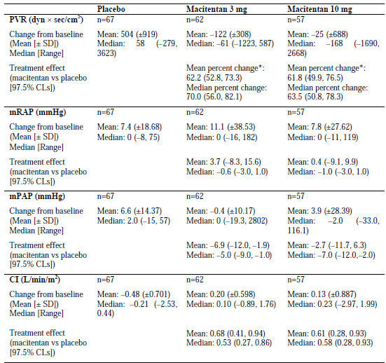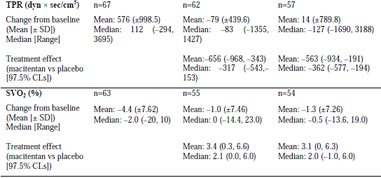Table 24 description: * Mean percent change over placebo = ratio of geometric means x 100

#### Time course of pharmacodynamic effects

In Study AC-055-201, exploratory analyses of the absolute change from baseline in SiDBP for the four, eight and 10-week cohorts showed that the treatment effect of macitentan on the primary endpoint was reached at 4 weeks and then sustained until Week 8 (Figure 4).

Figure 4: Absolute change from baseline by cohorts (mean ±95% CI), SiDBP, (i) Week 4 cohort (ii) Week 8 cohort (iii) Week 10 cohort, Safety set, Study AC-055-201

(i) Week 4 cohort

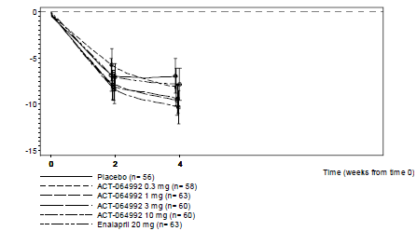

(ii) Week 8 cohort

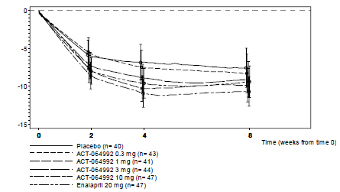

(iii) Week 10 cohort

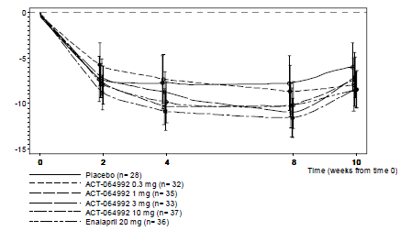

#### Relationship between drug concentration and pharmacodynamic effects

The relationship between exposure and efficacy was characterised using the data from the pivotal Phase III study AC-055-302. Trough plasma samples were collected at Month 6 in a PK/PD sub-study population and at end-of-treatment visit in all subjects. A population PK/PD modelling analysis was done as a Sub-study (AC-055-302 PK/PD), with the objectives of characterising the PK/PD relationship between macitentan exposure and different cardiac haemodynamic parameters, the 6-minute walk distance (6MWD), and other efficacy and safety endpoints.

In terms of the PK/PD relationship between macitentan and haemodynamic parameters, the relationship of macitentan Ctrough[9] with pulmonary vascular resistance (PVR), cardiac index (CI), mean pulmonary artery pressure (mPAP), and total pulmonary resistance (TPR) at Month 6 were explored using log-linear models, and showed that increasing macitentan concentrations were associated with a reduction in PVR, mPAP, and TPR and an increase in CI. No relationship could be established for mean right atrial pressure (mRAP) and mixed venous oxygen saturation (SvO2).

With regards to the PK/PD relationship between macitentan and 6MWD, the relationship could also be described by log-linear models, and increasing macitentan concentrations were associated with an increase in 6MWD. For the PK/PD relationship between macitentan and the primary efficacy endpoint (time from start of treatment to first morbidity/mortality event), macitentan concentrations appeared to be a significant covariate in the Cox proportional-hazards regression model. Increasing macitentan concentrations were associated with longer time from baseline to morbidity/mortality event.

### Evaluator’s overall conclusions on pharmacodynamics

Overall, the PD data is adequate with respect to evaluation of this application. The SAD and MAD Studies showed PD effect at the ET receptor level. After multiple dosing, at steady-state, there was a dose-dependent increase in plasma ET-1 concentrations from 1 to 10 mg, with no further increase beyond the 10 mg once daily dose, indicating full receptor blockade at this dose level. PD effect on systemic blood pressure was investigated in Study AC-055-201, and results showed a dose-related decrease in SiDBP from baseline to Week 8, and the decrease which was statistically significant versus placebo for macitentan 10 mg once daily dose, but not for macitentan 3 mg once daily dose. Analysis of the relationship between macitentan/ACT-132577 concentrations and change from baseline in SiDBP indicated that the 10 mg dose appeared to be close to the plateau of the pharmacological effect.

## Dosage selection for the pivotal studies

No dedicated dose-finding study was conducted in patients with PAH. The sponsor had stated that their strategy was to employ PD data on ET-1 levels and haemodynamic efficacy data on blood pressure reduction in patients with mild to moderate essential hypertension to determine the dose range to be tested in the Phase III study in patients with PAH. Through the inhibitory effect on ET-1 receptors, ERAs lead to an increase in plasma ET-1 levels and a decrease in systemic blood pressure, both of which can hence be used as biomarkers of pharmacological effect. The sponsor had stated that their strategy was based on the assumption that a dose shown to be efficacious in systemic hypertension would also be haemodynamically effective in PAH, as was previously observed with the ERA bosentan.

In the MAD Study (AC-055-102) in healthy subjects, a dose-dependent increase in ET-1 levels was observed from 1 to 10 mg of macitentan, with no further increase beyond the 10 mg once daily dose (Figure 5) suggesting that this dose provided maximum inhibition of the ET receptor and was thus a likely ceiling for cardiovascular effects related to ET-receptor antagonism. In addition, a statistically significant difference in ET-1 levels compared to the placebo group was observed in the 10 mg and 30 mg dose groups but not in the 3 mg or 1 mg dose groups.

Figure 5: Effect of macitentan (ACT- 064992) on plasma ET-1 concentrations on Day 10, Study AC-055-102

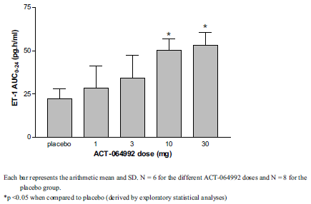

These results were supported by the results of Study AC-055-201 in patients with essential hypertension, where only a marginal effect on ET-1 concentration was observed in the 0.3 and 1 mg macitentan dose groups, while a more marked effect on ET-1 was observed in the 3 and 10 mg macitentan dose groups (Figure 6).

Figure 6: Plasma ET-1 concentrations (pg/mL) (mean and SD) at Weeks 4 and 8, Study AC-055-201

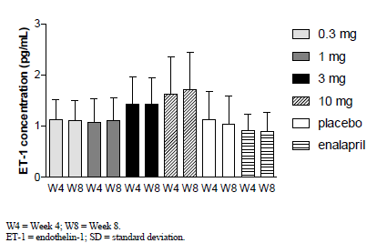

In terms of the effect of macitentan on systemic BP as a biomarker of pharmacological effect, in Study AC-055-201, the reduction in trough SiDBP from baseline was statistically significant when compared to placebo only for macitentan 10 mg, but not for 3 mg, 1 mg or 0.3 mg, although the mean reduction in trough SiDBP from baseline observed in the 3 mg dose group was considered clinically relevant (Table 25 and Figure 7).

Table 25: Change in sitting diastolic blood pressure from baseline to end of Period II in the Per-protocol analysis set, Study AC-055-201



Figure 7: Change in sitting diastolic blood pressure from baseline to end of Period II (Placebo-corrected), Study AC-055-201



Similar results were observed in the endpoint of change from baseline to Week 8 in mean trough SiSBP, with statistically significant reduction from baseline in trough SiSBP compared to placebo only in the macitentan 10 mg dose. In addition, PK/PD analysis results of study AC-055-201 showed that macitentan 10 mg appeared to be at or near the plateau of maximal haemodynamic efficacy (Figure 8).

Figure 8: PK/PD analysis: Change in SiDBP (mmHg) (mean ± SEM) versus Cfree combined (ng/mL)[10] (mean ± SEM) at Week 8 including predicted data, Study AC-055-201

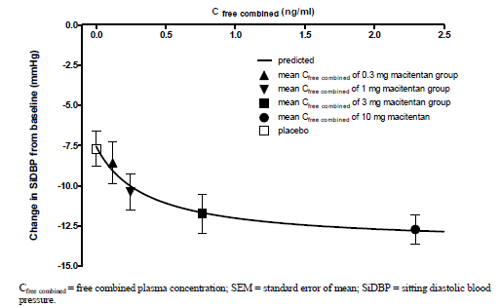

Based on these results, the sponsor had decided to use 10 mg once daily as the dose to be tested in the pivotal Phase III study in PAH. In addition, a lower dose of 3 mg once daily was also tested in the pivotal Phase III study in PAH, as 3 mg dose was considered to correspond to the lowest dose showing any signal of relevant hemodynamic efficacy in the study in subjects with essential hypertension.

Comments: The rationale for the dose selection for the pivotal Phase III trial is sound.

## Clinical efficacy

### Proposed indication

#### Pivotal efficacy studies

##### Study SERAPHIN (AC-055-302)

###### Study design, objectives, locations and dates

For the proposed indication of long-term treatment of pulmonary arterial hypertension (PAH) in patients of WHO Functional Class II to IV.

AC-055-302 was a multi-centre, randomised, double-blind, placebo-controlled, parallel-group, event-driven, Phase III study evaluating the effects of macitentan on morbidity and mortality in subjects with symptomatic PAH. Subjects were randomised in a 1:1:1 ratio to one of three treatment groups (3 mg macitentan, 10 mg macitentan or matching placebo). The study included a screening period (up to 28 days) followed by a treatment period from randomisation to the end-of-treatment (EOT) visit. End-of-study (EOS) occurred when the target of 285 events confirmed by the Clinical Event Committee (CEC) was expected to have been achieved. The EOT visit either coincided with the EOS visit for subjects who were still on study treatment or occurred earlier in cases of premature discontinuation of study drug. Subjects who prematurely discontinued double-blind study treatment due to clinical worsening of PAH and obtained written approval from the sponsor, and subjects who completed the study as scheduled, could enter the open-label extension study, SERAPHIN OL. For subjects who had opted not to participate or who were not eligible to participate in SERAPHIN OL, a 28-day safety follow-up after EOT was performed. A schema of the study design is presented in Figure 9. The clinical study report (CSR) submitted for this application presents only the results for the double-blind phase.

Figure 9: Study design, Study AC-055-302

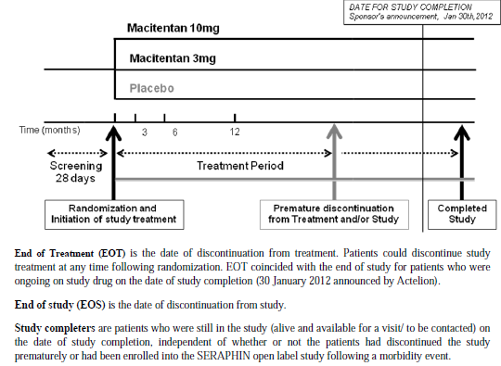

The primary objective of the study was to demonstrate that either dose of macitentan (3 mg or 10 mg) reduced the risk of morbidity and mortality in subjects with symptomatic PAH. The secondary objectives of the study were to demonstrate that either dose of macitentan improved exercise capacity or WHO functional class (FC), or reduced the risk of death due to PAH or hospitalisation for PAH up to EOT in subjects with symptomatic PAH, to demonstrate that either dose of macitentan reduced the risk of death of all causes up to EOT and up to EOS, and to evaluate the safety and tolerability of macitentan in subjects with symptomatic PAH.

This was a multi-centre study where subjects were enrolled in a total of 158 centres in 39 countries across Africa, Australia, Asia, Europe, Latin America, and North America. The study start and end dates were 25 May 2008 and15 March 2012.

###### Inclusion and exclusion criteria

Subjects enrolled in this study were males or females[11] aged 12 years or older at study entry, with a confirmed diagnosis of symptomatic PAH in modified WHO FC II to IV[12]. The PAH aetiology was required to be within groups 1.1 to 1.3 of the Venice classification (that is, idiopathic PAH, familial PAH, or PAH related to collagen vascular disease, to simple congenital systemic-to-pulmonary shunts [at least one year post surgical repair], to HIV infection, or to drugs and toxins). PAH diagnosis also had to be confirmed by haemodynamic evaluation showing all of following: mean pulmonary artery pressure (mPAP) > 25 mmHg; pulmonary capillary wedge pressure (PCWP) or left ventricular end diastolic pressure (LVEDP) ≤15 mmHg; and pulmonary vascular resistance (PVR) at rest ≥ 320 dyn × sec/cm5. Subjects were required to have a six-minute walk distance (6MWD) ≥ 50 m at screening and randomisation. Subjects with moderate to severe obstructive lung disease or restrictive lung disease, moderate to severe hepatic impairment, estimated creatinine clearance < 30 mL/min, systolic blood pressure < 100 mmHg, or serum aspartate aminotransferase (AST) and/or alanine aminotransferase (ALT) > 1.5 times the upper limit of normal (ULN) were excluded. A full list of inclusion and exclusion criteria is presented below.

Inclusion and exclusion criteria, study AC-055-302

**Inclusion criteria**

Eligible patients were required to have met all of the following inclusion criteria before treatment initiation:

* Signed informed consent prior to any study-mandated procedure
* Symptomatic PAH in modified WHO FC II to IV
* PAH belonging to Groups 1.1 to 1.3 of the Venice classification:
  + Idiopathic
  + Familial
  + Related to:
    - Collagen vascular disease
    - Simple (atrial septal defect, ventricular septal defect, patent ductus arteriosus) congenital systemic-to-pulmonary shunts at least 1 year post-surgical repair
    - HIV infection
    - Drugs and toxins
* PAH diagnosis confirmed by haemodynamic evaluation performed prior to randomisation and showing all the following:
  + Mean pulmonary artery pressure (mPAP) > 25 mmHg
  + Pulmonary capillary wedge pressure (PCWP) or left ventricular end diastolic pressure (LVEDP) ≤ 15 mmHg
  + PVR at rest ≥ 320 dyn x sec/cm5
* 6MWD ≥ 50 m at screening and randomisation

The 6MWTs performed at screening and randomisation were required to satisfy the following criteria:

* + 6MWD was required to be ≥ 50 m or the patient was not to be included in the study
  + The second 6MWD (6MWD#2 at randomisation) was required to be ≥ 50 m and within 10% of 6MWD#1 (at screening) or a third test was required (6MWD#3).
  + 6MWD#3 (at randomisation) was required to be ≥ 50 m and within 10% of 6MWD#2 or the patient was not to be included in the study.
* Men or women ≥ 12 years of age:

Women of childbearing potential* were allowed to participate in the study if they had a negative serum pre-treatment pregnancy test and consistently and correctly use (from screening and up to 28 days after discontinuation of study treatment) a reliable method of contraception with a Pearl index of less than 1% (oral hormonal contraceptive, implant, vaginal hormone ring, intrauterine system, or tubal ligation only in combination with condom), were sexually abstinent, or had a vasectomised partner.

*A woman was considered to have childbearing potential unless she met at least one of the following criteria:

* + Previous bilateral salpingo-oophorectomy or hysterectomy
  + Premature ovarian failure confirmed by a specialist gynaecologist
  + Pre-pubescence, XY genotype, Turner syndrome, uterine agenesis
  + Age > 50 years and not treated with any kind of hormone replacement therapy for at least 2 years prior to screening, with amenorrhoea for at least 24 consecutive months prior to screening, and a serum follicle stimulating hormone level of > 40 IU/L if the investigator had insufficient evidence that the woman was postmenopausal.

**Exclusion criteria**

Eligible patients were required to have met none of the following exclusion criteria at treatment initiation:

* PAH associated with portal hypertension thyroid disorders, glycogen storage disease, Gaucher’s disease, hereditary haemorrhagic telangiectasia, haemoglobinopathies. Myeloproliferative disorders or splenectomy
* PAH associated with non-corrected simple congenital systemic-to-pulmonary shunts and, combined and complex systemic-to-pulmonary shunts, corrected or non-corrected
* PAH associated with significant venous or capillary involvement (PCWP) > 15 mmHg), know pulmonary veno-occlusive disease and pulmonary capillary haemangiomatosis
* Persistant pulmonary hypertension of the newborn
* Pulmonary hypertension belonging to Groups 2 to 5 of the Venice classification
* Moderate to severe obstructive lung disease: forced expiratory volume in 1 second/forced vital capacity (FEV1 /FVC) < 70% and FEV1 < 65% of predicted value after bronchodilator administration
* Moderate to severe hepatic impairment, for example, Child-Pugh Class B or C
* Estimated creatinine clearance < 30 mL/min
* Serum aspartate aminotransferase (AST) and/or alanine aminotransferase (ALT) > 1.5 time the upper limit of normal
* Haemoglobin < 75% of the lower limit of the normal range
* Systolic blood pressure < 100 mmHg
* Acute or chronic impairment (other than dyspnoea), limiting the ability to comply with the study requirements
* Pregnant or breast-feeding
* Known concomitant life-threatening disease with a life expectancy < 12 months
* Body weight < 40 kg
* Any condition that prevented compliance with the protocol or adherence to therapy
* Recently started (< 8 weeks prior to randomisation) or planned cardio-pulmonary rehabilitation programme based on exercise
* Treatment with ERAs within 3 months prior to randomisation
* Systemic treatment within 4 weeks prior to randomisation with immunosuppressants: calcineurin or mTOR inhibitors (for example, cyclosporine A and tacrolimus, everolimus, sirolimus)
* Treatment with CYP3A inducers within 4 weeks prior to randomisation
* Known hypersensitivity to drugs of the same class as the study drug, or any or their excipients
* Planned treatment or treatment with another investigational drug within 1 months prior to randomisation

Comments: The inclusion and exclusion criteria were in line with recommendations on the study population in the TGA-adopted EMA guidelines on the clinical investigation of medicinal products for the treatment of pulmonary arterial hypertension. The restriction to women with non-childbearing potential or of childbearing potential with minimal risk of becoming pregnant is consistent with the fact that teratogenicity is a known class-effect of ERAs. The sponsor had provided the rationale for including subjects in WHO FC II as being to investigate the occurrence of clinical events in a population with less advanced disease, but who are likely to experience disease progression if left untreated. This rationale is sound.

The PAH aetiological classification used in this study was that of the Venice classification which arose from the third World Symposium on PAH in 2003. Subsequently, during the fourth World Symposium on PAH held in 2008 in Dana Point, California, a modified classification system was adopted[13]. This modified Dana Point classification was a re-organisation of the Venice classification to improve clarity. The aetiologies of PAH that were included in the study are appropriate and allowed evaluation of the intended target patient population.

###### Study treatments

The study treatments were macitentan 3 mg (film-coated tablet), macitentan 10 mg (film-coated tablet), or matching placebo, administered per oral once daily in the morning. The study drugs were taken without regard to food.

Concomitant treatments for PAH with oral phosphodiesterase inhibitors (e.g. sildenafil), oral or inhaled prostanoids (e.g. beraprost, iloprost), calcium channel blockers, or L-arginine were allowed provided that the dose had been stable for at least three months prior to randomisation. Any change of dose of these medications or introduction of a new treatment for PAH in the absence of documented worsening of PAH was strongly discouraged during the study period. If an additional PAH-specific therapy was started without a protocol-defined morbidity event, study drug was not to be discontinued (unless the additional therapy was an ERA), and subjects were followed up to EOS according to the visit and assessment schedule. Concomitant treatment with oral diuretics was allowed, provided the patient had been on stable dose for at least onemonth prior to randomisation.

Prohibited concomitant medications included other ERAs (for example, bosentan and ambrisentan) unless they were initiated for clinical worsening of PAH and after study drug discontinuation, intravenous or subcutaneous prostanoids (for example, epoprostenol, treprostinil) unless they were initiated for a morbidity event, specific immunosuppressants (calcineurin or mTOR inhibitors; e.g. cyclosporine A and tacrolimus, everolimus, sirolimus), and CYP3A inducers (carbamazepine, rifampin, rifabutin and St John’s wort)

Comments: The study dose selection is appropriate, and has been previously discussed. The approved or prohibited concomitant medications were in line with the TGA-adopted EMA guidelines on the clinical investigation of medicinal products for the treatment of pulmonary arterial hypertension, and consistent with the known pharmacokinetics and potential DDI of macitentan. The study design involving a placebo control is appropriate and consistent with the recommendation of the above-mentioned TGA-adopted EMA guidelines.

###### Efficacy variables and outcomes

The primary efficacy endpoint was the time from start of treatment to the first morbidity or mortality event up to EOT. Morbidity or mortality outcome events were defined as death or onset of a treatment-emergent adverse event (TEAE) with a fatal outcome occurring within four weeks of study treatment discontinuation, atrial septostomy or hospitalisation for atrial septostomy, lung transplantation or hospitalisation for lung transplantation, initiation of intravenous (IV) or subcutaneous (SC) prostanoids (for example, epoprostenol, treprostinil) or hospitalisation for initiation of IV or SC prostanoids, or other worsening of PAH. The study protocol definition of worsening of PAH is presented in Table 27. The events for the analysis of the primary endpoint were reviewed in a blinded manner and adjudicated by a Clinical Event Committee (CEC).

Definition of morbidity and mortality outcome events for study primary efficacy endpoint, Study AC-055-302

* Death, or onset or a treatment-emergent AE with a fatal outcome occurring within 4 weeks of study treatment discontinuation, or
* Atrial septostomy or hospitalisation for atrial septostomy, or
* Lung transplantation or hospitalisation for lung transplantation, or
* Initiation of intravenous (IV) or subcutaneous (SC) prostanoids (for example, epoprostenol, treprostinil) or hospitalisation for initiation of IV or SC protanoids, or
* Other worsening of PAH

Other worsening of PAH was defined by the combined occurrence in a patient of all the following three events:

* + At least 15% decrease in the 6MWD from baseline, confirmed by two 6MWTs, performed on separate days, within 2 weeks of each other.

AND

* + Worsening of PAH symptoms that included at least one of the following:
    - Increase in WHO FC, or no change in patients in WHO Class IV at baseline
    - Appearance or worsening of signs/symptoms of right heart failure that did not respond to optimised oral diuretic therapy.

AND

* + Need for new treatment(s) for PAH that included the following:
    - Oral or inhaled prostanoids (for example, iloprost)
    - Oral phosphodiesterase inhibitors (for example, sildenafil)
    - ERAs (for example, bosentan, ambrisentan) only after discontinuation of the study treatment
    - Intravenous diuretics

Secondary efficacy endpoints included the change in the 6MWD from baseline to Month 6, the proportion of subjects with improvement in the WHO FC from baseline to Month 6, time to death due to PAH or hospitalisation for PAH up to EOT[14], time to death of all causes up to EOT[15], and time to death of all causes up to EOS.

Other exploratory endpoints included changes in 6MWD, Borg dyspnoea index and WHO FC from baseline to all assessed time-points[16], achievement and/or maintenance of a 6MWD ≥ 380 m at all assessed time-points, change from baseline to all visits in Quality of Life (QoL; assessed by the SF-36 questionnaire for subjects ≥ 14 years of age at randomisation), change in N-terminal pro-B type natriuretic peptide (NT-pro-BNP; a biomarker predicting right ventricular overload) from baseline to Month 6, and time to death due to PAH up to EOS. An additional exploratory endpoint of time to death due to PAH up to EOT was added and analysed post-hoc. This endpoint excluded the component of hospitalisation due to PAH from the secondary endpoint of time to death due to PAH or hospitalisation due to PAH.

Pharmacoeconomic endpoints were the number per year of all-cause and PAH-related hospitalisations from baseline up to EOT, the number per year of in-patient hospital days for all causes and PAH-related causes from baseline up to EOT.

Comments: Overall, the primary and secondary endpoints of this study are appropriate and consistent with the TGA-adopted EMA guidelines on the clinical investigation of medicinal products for the treatment of pulmonary arterial hypertension, which recommended as primary efficacy endpoints time to clinical worsening and/or improvement in exercise capacity. The guidelines recommended that evaluation of efficacy should include endpoints of all-cause mortality, PAH-related morbidity (for example, PAH-related hospitalisation or deterioration in functional class), clinical symptoms (in terms of improvement in WHO/NYHA functional class) or exercise capacity (in terms of the six-minute walk test [6MWT]). Overall, the study primary endpoint allowed evaluation of all-cause mortality and PAH-related morbidity, while the study secondary endpoints of change from baseline in 6MWD and the WHO FC allowed evaluation of the effect of macitentan on exercise capacity and clinical symptoms. The definition of worsening PAH that included a decrease of at least 15% in the 6MWD from baseline confirmed by two 6MWTs performed on separate days was also in line with the abovementioned guidelines.

###### Randomisation and blinding methods

Subjects were randomised in a 1:1:1 ratio to receive blinded macitentan 3 mg, macitentan 10 mg or matching placebo using a centralised randomisation system via Interactive Voice Response (IVR) or Interactive Web Response (IWR). Randomisation was stratified by centre. This study was conducted in a double-blind fashion. The two dose strengths of macitentan and placebo had matching presentations. The investigator and study staff, the subjects, study monitors, and sponsor employees and contractors remained blinded to study drug allocation until the database closure on 26 April 2012.

###### Analysis populations

Four main analysis sets were defined in the study. The all-randomised set included all randomised subjects, irrespective of whether or not they had received study drug. The all-treated set included all randomised subjects who had received study drug at least once. The per-protocol set included all subjects from the all-treated set who did not deviate from the protocol in a way that might affect the evaluation of the effect of the study drug on the primary endpoint. The PK/PD analysis set included all subjects who participated in the PK/PD sub-study, received double-blind treatment for at least 150 days, for whom a PK blood sample at trough was taken within 48 hours after the last study drug intake, and who had an evaluable PK sample at Month 6. This analysis set was used for the PK/PD sub-study (Study AC-055-302 PK/PD).

An overview of the usage of the different analysis datasets is presented in Table 28.

Table 28: Overview of the usage of the different analysis datasets, Study AC-055-302

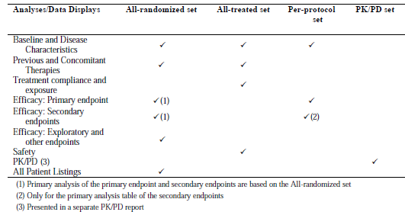

Analyses on the primary and secondary efficacy endpoints were performed on the all-randomised set. Safety analyses were performed on the all-treated set. Sensitivity analysis on the primary endpoint was performed on the per-protocol set. Additional sensitivity analyses on the primary endpoint was also performed in a sub-set of subjects identified as having ‘consistent’ or ‘typical’ PAH based on the review of their baseline data by the Steering Committee (SC) expert medical reviewers. For this analysis, two medical experts from the SC reviewed patient baseline characteristics and classified the subjects into one of three categories: typical PAH (PAH patients with no co-morbidity that might introduce a doubt on the aetiology of PAH), consistent PAH (PAH patients not falling in either typical or atypical categories), or atypical PAH (PAH patients with traits that could suggest that the patients belong to other aetiologies of PAH or no PAH).

Comments: The definitions of the analysis populations and the efficacy analyses on the all-randomised set are in keeping with the TGA-adopted ICH E 9 Statistical Principles for Clinical Trials, and with the intent-to-treat principle of efficacy analyses.

###### Sample size

The initial planned sample size for this study was 525 subjects (that is, 175 subjects in each of the three treatment groups). The study aimed to detect a hazard ratio of 0.5472 for macitentan versus placebo for the time to the first morbidity or mortality event in at least one macitentan dose group. It was estimated that a total of 285 events were needed to detect this difference with a nominal type-I error of 0.005 (two-sided) for each dose group of macitentan and 90% power using the logrank test. This target number of events was expected to be observed within a maximum of 4.1 years, based on the assumptions that the yearly event rate in the placebo group was 35% (hazard rate of 0.4308), the event rate reduction due to active treatment was 40% (hazard ratio of 0.5472), the censoring rate was 5% (drop-out hazard rate 0.0513) in all treatment arms (subjects were to be censored at the time of treatment discontinuation plus one week), and that 525 subjects (200 per year) were enrolled over a period of 2.65 years.

A planned blinded sample size re-estimation was performed three months before the end of expected recruitment, when the sponsor assessed the blinded overall morbidity or mortality event rate to be 19.6% (that is, below the initial estimated overall event rate of 25.6%), leading to a revised expected hazard rate of 0.28 in the placebo group. Based on these results, the number of subjects required to achieve the target of 285 events was increased from 525 to 699 in order to maintain the planned study duration. With the amended sample size calculation, the target number of events (that is, 285) was expected to be observed within a maximum of 4.5 years, based on the assumptions that the yearly event rate in the placebo group was 24.8% (hazard rate of 0.2847), the event rate reduction due to active treatment was 41.8% (hazard ratio of 0.5472), the censoring rate was 5% (drop-out hazard rate 0.0513) in all treatment arms, and that 699 subjects (200 per year) were enrolled over a period of 3.5 years.

###### Statistical methods

The null hypothesis was that, independently for each dose group of macitentan (3 mg and 10 mg) there was no difference between macitentan and placebo for the risk of first occurrence of a morbidity or mortality event up to EOT (the primary efficacy endpoint). The study would be considered ‘conclusive’ at a global significance level of 0.01 (two-sided) (Table 29).

Table 29: Criteria for interpretation of a ‘positive’ or ‘conclusive’ study based on observed p-values for primary and secondary endpoints, Study AC-055-302

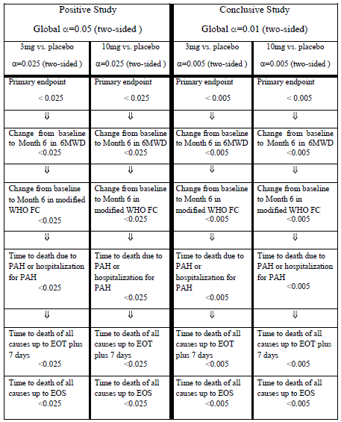

- The endpoint of ‘time to death due to PAH or hospitalisation due to PAH’ refers to the secondary endpoint of ‘time to death due to PAH or hospitalisation due to PAH up to EOT’, which has been defined in Section 7.1.1.1.4 of this report. This endpoint included all deaths due to PAH (as adjudicated by the CEC) up to EOT + 7 days, or onset of a TEAE within EOT + 7 days with a fatal outcome due to PAH within 28 days of EOT, or hospitalisation for PAH up to EOT + 7 days.

- The endpoint of ‘time to death of all causes up to EOT plus 7 days’ refers to the secondary endpoint of ‘time to death of all causes up to EOT’ which has been defined in Section 7.1.1.1.4 of this report. This endpoint included deaths of all causes up to EOT + 7 days or onset of a TEAE within EOT + 7 days with a fatal outcome within 28 days of EOT

To keep the study-wise type-I error to this two-sided 0.01 ‘conclusive’ level in the presence of multiple tests, each comparison of active macitentan dose versus placebo was tested at a nominal type-I error level of 0.005 (two-sided) using the Bonferroni’s approach to adjustment for multiplicity, with testing starting from the primary endpoint. The study would still be declared ‘positive’ at a global significance level of 0.05 (two-sided). For this ‘positive’ level of statistical significance, the comparison of each active macitentan dose versus placebo will be tested at a nominal type-I error level of 0.025 (two-sided) according to the Bonferroni’s approach.

The secondary endpoints were analysed hierarchically for each dose group in the following sequence: 6MWD (Wilcoxon rank sum test), WHO FC (Fisher’s exact test), time to death due to PAH or hospitalisation due to PAH up to EOT (logrank test), time to death of all causes up to EOT (logrank test), and time to death of all causes up to EOS (logrank test). Statistical significance was to be claimed only if the pre-defined nominal significance level (p < α/2) had been reached for the primary endpoint for the same dose group, and the pre-defined nominal significance level (p < α/2) had been reached for all the previous endpoints in the sequence for the same dose group (where α = 0.01 [two-sided] for a conclusive study, and α = 0.05 [two-sided] for a positive study) (Table 29). No confirmatory claims could be based on variables that had a rank lower than or equal to that variable whose null hypothesis had been the first that could not be rejected.

Efficacy endpoints were analysed using the all-randomised set (that is, all randomised subjects irrespective of whether or not they had received study drug). The logrank test with no adjustment for covariates was used to compare the treatment effect of macitentan versus placebo for the primary endpoint. The treatment effect was estimated using Cox’s proportional hazard model. All time to event variables were estimated using the Kaplan-Meier method. Subjects who prematurely discontinued study treatment without a morbidity or mortality event were censored at the time of study treatment discontinuation plus seven days. Subjects without an event at EOS (declared by the sponsor on 30 January 2012) were censored for the primary endpoint at their last visit in the study.

Exploratory subgroup analyses were done for the primary efficacy endpoint to explore the consistency of treatment effect across different subgroups. The subgroups were PAH therapy(ies) at baseline (not receiving versus receiving concomitant PAH therapy[ies] at baseline), gender (male versus female), race (White, Asian or Others), PAH aetiology at baseline (idiopathic, familial, HIV infection, drugs and toxins versus collagen vascular disease versus congenital shunts), and geographical regions (North-America, Western Europe/Israel, Eastern Europe/Turkey, Asia, or Latin America).

In addition, robustness of the primary endpoint results over different baseline characteristics was explored. For this analysis, subjects were classified according to age (< 18, 18 to 64 and > 64 years) and baseline disease characteristics (WHO FC I–II versus III–IV, and 6MWD > versus ≤ 380 m). In addition, pre- versus post-sample size increase for the study (that is, randomisation date before or on versus after 3 July 2009 [the date study sites were informed of the protocol amendment regarding sample size increase]) was considered in this robustness assessment.

Comments: In describing the statistical methods in the body of the CSR, the sponsor had presented a table (Table 30) in which the information presented is inconsistent with the description of the statistical methods given in the CSR.

Table 30: Criteria for interpretation of a ‘positive’ or ‘conclusive’ study based on observed p-values for primary and secondary endpoints, Study AC-055-302 (accuracy of the information in this Table has been questioned by the evaluator)

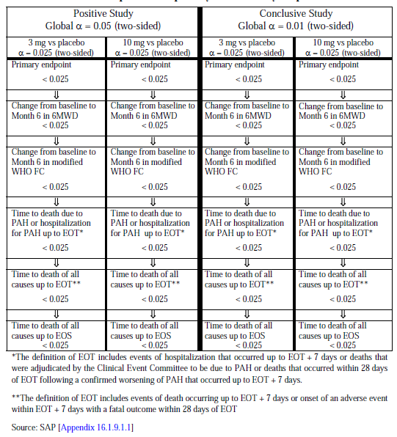

The source of this table was traced, leading the evaluator to a table in the Statistical Analysis Plan (SAP) which is different from the table presented in the body of the CSR but consistent with the statistical methods described in the CSR. This table in the SAP is presented in Table 29 of this report. The evaluator assumed that there is a typographical error in the table in the CSR, but this will be clarified with the sponsor as a clinical question in this report.

###### Participant flow

Overall, a total of 955 subjects were screened from 158 centres in 39 countries, and out of these, 742 subjects from 151 centres in 39 countries were randomised in a 1:1:1 ratio to the macitentan 3 mg (n = 250), macitentan 10 mg (n = 242) and placebo groups (n = 250) groups (see Figure 10). A total of 590 subjects (79.5%) completed the study as planned.

Figure 10: Participant flow

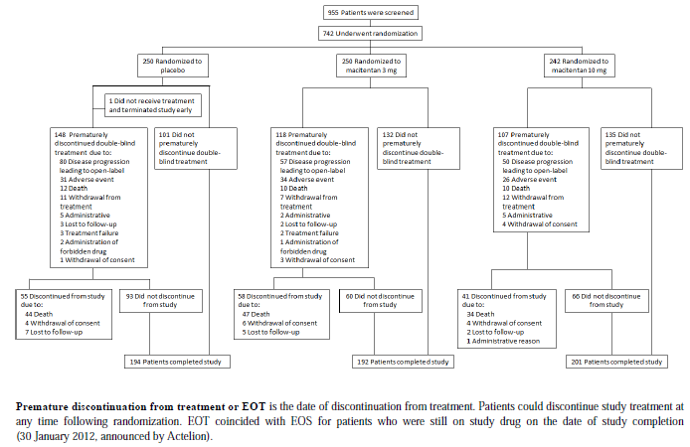Figure 10: Participant flow

The proportion of subjects who prematurely discontinued the study was comparable across treatment groups (22.0% [55/250], 22.4% [56/250] and 16.9% [41/242] in the placebo, macitentan 3 mg and10 mg groups) (Table 31). Death was the main reason for premature discontinuation of study in all three groups (17.6% [44/250], 18.8% [47/250] and 14.0% [34/242]).

Table 31: Summary of reasons for premature discontinuation from the study, All-randomised set, Study AC-055-302

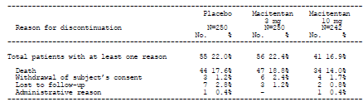Table 31: Summary of reasons for premature discontinuation from the study, All-randomised set, Study AC-055-302

ICF: Informed consent form

A summary of the analysis population datasets is presented in Table 32. In each analysis set, the distribution of subjects across the treatments groups was comparable.

Table 32: Overview of analysis sets, Study AC-055-302

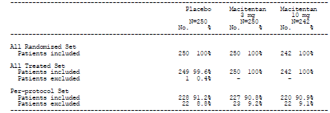

###### Major protocol violations/deviations

Incidence of major protocol violations is presented in Table 33. Overall, the proportion of subjects with major protocol violations was similar across treatment groups (8.8% [22/250], 9.2% [23/250] and 9.1% [22/242] in the placebo, macitentan 3 mg and10 mg groups).

Table 33: Summary of major protocol violations leading to exclusion from analysis sets, All-randomised set, Study AC-055-302

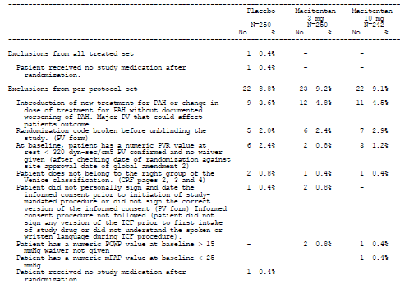

###### Baseline data

The baseline demographic characteristics were comparable among treatment groups (Table 34).

Table 34: Summary of patient demographics, All-randomised set, Study AC-055-302

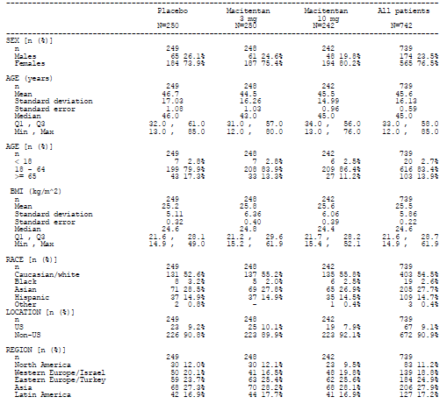

The majority of subjects in each treatment group were female (73.9% [184/249], 75.4% [187/248], and 80.2% [194/242] in the placebo, macitentan 3 mg and10 mg groups) and White (52.6% [131/249], 55.2% [137/248], and 55.8% [135/242]). The mean (Standard Deviation [SD]) age was 46.7 (17.03), 44.5 (16.26), and 45.5 (14.99) years. The median age was 46.0, 43.0 and 45.0. Baseline body mass index (BMI) was also similar among treatment groups (mean [SD] BMI of 25.2 [5.11], 25.8 [6.36], and 25.6 [6.06] kg/m2).

The baseline disease characteristics were also comparable among treatment groups (Table 35).

Table 35: Summary of baseline disease characteristics, All-randomised set, Study AC-055-302

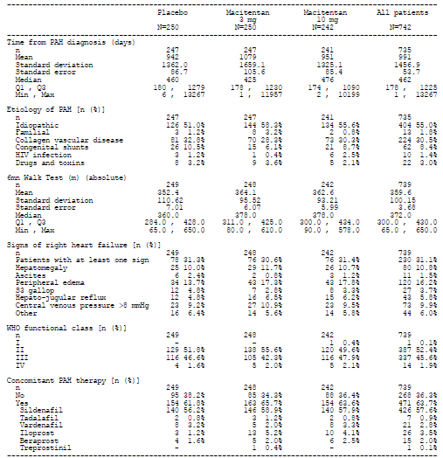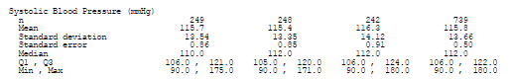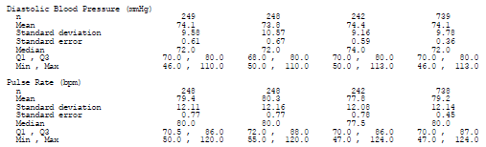

Overall, the mean (SD) time from PAH diagnosis to randomisation in the study population was 991 (1456.9) days (that is, 2.7 years). Idiopathic PAH was the most common aetiology (55.0%) followed byPAH due to collagen vascular disease (30.5%) and PAH due to congenital shunts (8.4%). Familial PAH, PAH due to HIV infection, and PAH due to drugs and toxins each represented 3% or less of aetiology of PAH in the overall study population. Baseline mean (SD) 6MWD was approximately 359.6 (100.15) metres. The majority of subjects were in WHO FC II (52.4%) and III (45.6%) with only 1.9% (14/739) in WHO FC IV. The majority of subjects (63.7%) had concomitant PAH therapy at baseline, of which sildenafil was the commonest concomitant PAH therapy, taken by 57.6% of subjects.Baseline blood pressure and pulse rate were also comparable across treatment groups. Overall mean (SD) SBP, DBP and pulse rate were 115.8 (13.66) mmHg, 74.1 (9.78) mmHg and 79.2 (12.14) beats per minute (bpm). Baseline pulmonary haemodynamic characteristics were comparable among treatment groups (Table 36).

Table 36: Summary of haemodynamic baseline characteristics, All-randomised Set, Study AC-055-302

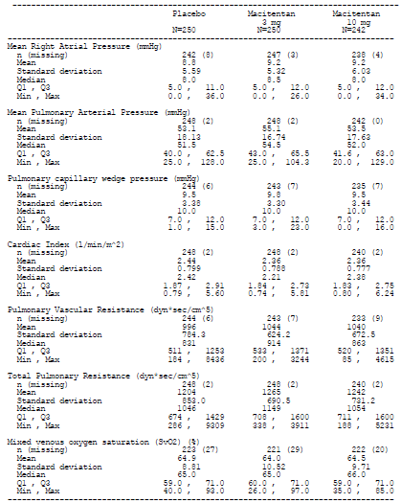

Comments: Overall, the baseline demographic and disease characteristics were comparable among treatment groups, and were generally representative of the target patient population. Epidemiologic data had suggested that the worldwide prevalence of PAH may be up to 15 per million, with a prevalence of idiopathic PAH of about six per million (that is, accounting for about 40% of PAH)[17],[18]. Idiopathic PAH is about two times as common in women as in men, and with a mean age at diagnosis of about 37 years, although onset of symptoms can occur at any age.

The sample size of adolescent subjects (12 to < 18 years old) was very small (N=20; placebo:n=7, macitentan 3 mg: n=7, macitentan 10 mg: n=6), as was the group of subjects with WHO FC IV (N=14; placebo:n=4, macitentan 3 mg: n=5, macitentan 10 mg: n=5). This may impact the evaluation of efficacy and safety in these subgroups of subjects.

###### Results for the primary efficacy outcome

A confirmed primary endpoint morbidity or mortality event was reported for 95 subjects (38.0%) and 76 subjects (31.4%) in the macitentan 3 mg and 10 mg groups compared with 116 subjects (46.4%) in the placebo group (Table 37).

Table 37: Summary of causes of primary endpoint events (CEC-confirmed), All-randomised set, Study AC-055-302

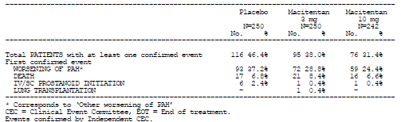

In the time-to-event analysis, the hazard ratio versus placebo for the occurrence of a morbidity or mortality event in the macitentan 3 mg group was 0.704 (97.5% confidence limits [CLs]: 0.516, 0.960, p = 0.0108), while that in the macitentan 10 mg dose group was 0.547 (97.5% CLs 0.392, 0.762, p < 0.0001) (Table 38).

Table 38: Kaplan-Meier estimate of the first confirmed morbidity or mortality event up to EOT + 7 days (CEC), All-randomised set, Study AC-055-302

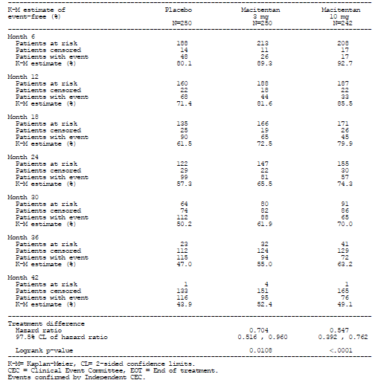

This gives relative risk reductions for the occurrence of a morbidity or mortality event of 30% and 45% with macitentan 3 mg and10 mg, compared to placebo. The treatment effect with the 10 mg dose met the pre-specified significance criteria for a ‘conclusive study’ (that is, p<0.005). The treatment effect with the 3 mg dose did not meet the pre-specified significance criteria for a ‘conclusive study’, but satisfied that for a ‘positive study’ (that is, p<0.025).

The Kaplan-Meier curves of the first morbidity or mortality event in the all-randomised set are presented in Figure11.

Figure 11: Kaplan-Meier curves of the first confirmed morbidity or mortality event up to EOT + 7 days, All-randomised set (Kaplan-Meier estimate), Study AC-055-302

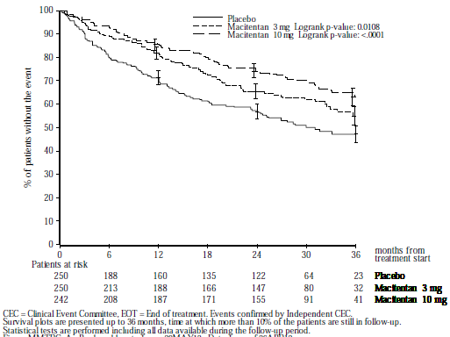

The curves showed that the treatment effect of the two macitentan doses on the primary endpoint appeared to be established early, with the separation in the curves between the macitentan groups and the placebo group observed by Month 6, and was sustained for the duration of the study.

###### Results for other efficacy outcomes

Other analyses on the primary efficacy endpoint

Analysis of primary efficacy endpoint in the per-protocol set.

The results of the analysis of the primary endpoint in the per-protocol set were consistent with those in the all-randomised set. The hazard ratio versus placebo for the occurrence of a morbidity or mortality event in the macitentan 3 mg group was 0.657 (97.5% CLs: 0.476, 0.908, p = 0.0033), while that in the macitentan 10 mg dose group was 0.524 (97.5% CLs: 0.371, 0.739, p < 0.0001). As with the analysis in the all-randomised set, the onset of the treatment effect of the 2 macitentan doses on the primary endpoint was early and was sustained for the duration of the study (Figure 12).

Figure 12: Kaplan-Meier curves of the first confirmed morbidity or mortality event up to EOT + 7 days (CEC) (Kaplan-Meier estimate), Per-protocol set, Study AC-055-302

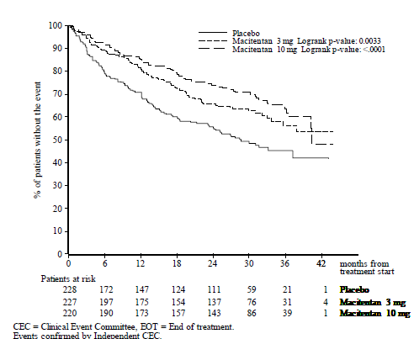

Components of the primary efficacy endpoint.

In the all-randomised set, the commonest first-reported morbidity or mortality event in all treatment groups was ‘Other worsening of PAH’ (37.2% [93/250], 28.8% [72/250] and 24.4% [59/242] in the placebo, macitentan 3 mg and10 mg groups), followed by ‘Death’ (6.8% [17/250], 8.4% [21/250], and 6.6% [16/242] (Table 37). The results in the per-protocol set were consistent with those in the all-randomised set.

Sensitivity and competing risks analyses.

The sensitivity analyses of the primary endpoint yielded results consistent with those of the main analysis (Table 39).

Table 39: Results of sensitivity analyses on the primary endpoint, All-randomised set, Study AC-055-302

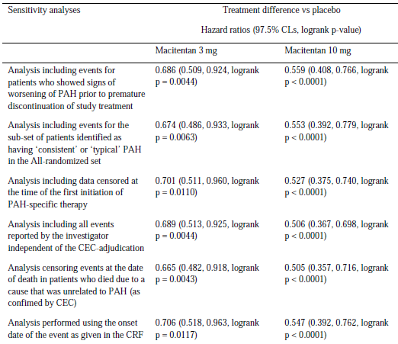

The sponsor also performed a competing risks analysis with morbidity considered as the main event and mortality as the competing risk to explore the treatment effect on the morbidity component of the primary endpoint. Results showed that subjects in the macitentan groups showed a lower risk of disease worsening than subjects in the placebo group (p = 0.0047 for macitentan 3 mg; p < 0.0001 for macitentan 10 mg), but no statistically significant difference was observed between the macitentan and placebo groups for the risk of death (p = 0.59 for macitentan 3 mg; p = 0.79 for macitentan 10 mg) (Table 40 and Figure 13).

Table 40: Competing risks analysis: first confirmed morbidity or mortality event up to EOT + 7 days, All-randomised set, Study AC-055-302

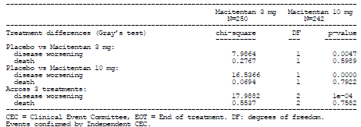

Figure 13: Cumulative incidence functions for the first confirmed morbidity or mortality event up to EOT + 7 days, All-randomised set, Study AC-055-30

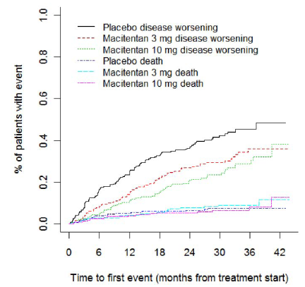

Interpretation of these results needs to take into consideration the relatively lower incidence of mortality across all treatment groups, as compared to incidence of morbidity (Table 37).

Analysis of the number-needed-to-treat.

Analysis of the number-needed-to-treat (NNT) in all subjects who were treated with macitentan 10 mg showed an NNT of 6.1 (95% CLs: 4.48, 10.80) at two years, suggesting that six patients needed to be treated for 2 years to prevent one morbidity or mortality event (Table 41).

Table 41: Number-needed-to-treat to prevent one additional event for confirmed morbidity or mortality up to EOT + 7 days in patients treated with macitentan 10 mg, irrespective of the use of background PAH therapy at baseline, All-randomised set, Study AC-055-302

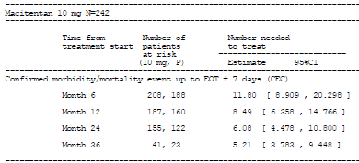Table 41: Number-needed-to-treat to prevent one additional event for confirmed morbidity or mortality up to EOT + 7 days in patients treated with macitentan 10 mg, irrespective of the use of background PAH therapy at baseline, All-randomised set, Study AC-055-302

Analysis of the NNT in the subgroup of subjects in the macitentan 10 mg group who were also receiving other PAH treatment at baseline showed an NNT of 7.9 (95% CLs: 5.0, 29.6) at two years (Table 42).

Table 42: Number-needed-to-treat to prevent one additional event for confirmed morbidity or mortality up to EOT + 7 days (CEC) in patients treated with macitentan 10 mg, and who were receiving background PAH therapy at baseline, All-randomised set, Study AC-055-302

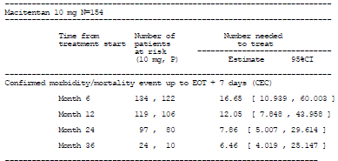Table 42: Number-needed-to-treat to prevent one additional event for confirmed morbidity or mortality up to EOT + 7 days (CEC) in patients treated with macitentan 10 mg, and who were receiving background PAH therapy at baseline, All-randomised set, Study AC-055-302

Subgroup and robustness analyses.

Analyses of the occurrence of a first morbidity or mortality event in the macitentan groups across the subgroups of gender, race, PAH therapy at baseline, PAH aetiology at baseline, and geographical region yielded results that were generally consistent with those in the overall study population (Figure 14).

Figure 14: Exploratory subgroup analysis of the primary endpoint (hazard ratio and 95% CLs), macitentan 3 mg vs. placebo and macitentan 10 mg vs. placebo, All-randomised set, Study AC-055-302

(i) macitentan 3 mg vs placebo

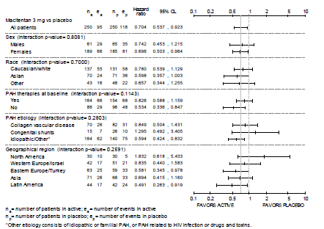

(ii) macitentan 10 mg vs placebo

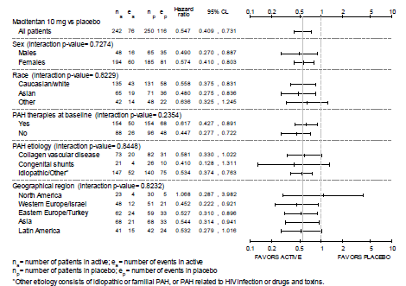

The p-values for the interaction test did not show heterogeneity of the treatment effect (macitentan versus placebo) across the subgroups. In particular, analyses comparing the subgroup of subjects with concomitant PAH therapy at baseline versus those without showed a consistent treatment effect versus placebo across both subgroups only with the 10 mg macitentan dose, while the treatment effect versus placebo of the 3 mg dose was less pronounced in subjects with concomitant PAH therapy at baseline compared to those without (hazard ratios versus placebo for macitentan 10 mg: 0.62 [95% CLs: 0.43, 0.89] and 0.45 [95% CLs: 0.28, 0.72] in those with and without concomitant PAH therapy at baseline, hazard ratios versus placebo for macitentan 3 mg: 0.83 [95% CLs: 0.59, 1.16] and 0.53 [95% CLs: 0.34, 0.85]).

The analysis of the robustness of the primary endpoint by demographic characteristics (age < 18 versus 18 to 64 versus > 64 years), baseline disease characteristics (WHO FC I–II versus III–IV, and 6MWD > versus ≤ 380 m) and pre- versus post-sample size increase for the study, yielded results which were generally consistent with those in the overall study population, but was less so with macitentan 3 mg than with macitentan 10 mg (Figure 15).

Figure 15: Primary endpoint (hazard ratio and 95% CLs) by baseline disease and demographic characteristics- robustness analysis, macitentan 3 mg vs. placebo and macitentan 10 mg vs. placebo, All-randomised set, Study AC-055-302

(i) macitentan 3 mg vs placebo

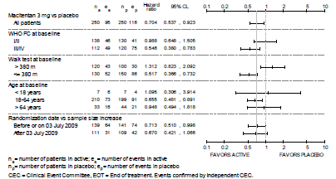

(ii) macitentan 10 mg vs placebo

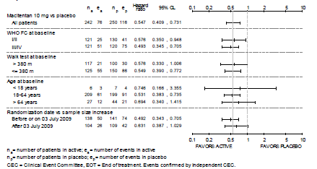

In particular, analyses comparing the subgroup of subjects with WHO FC I/II at baseline versus those with WHO FC III/IV at baseline showed a consistent treatment effect versus placebo across both subgroups only with the 10 mg macitentan dose, while the treatment effect versus placebo of the 3 mg dose was less pronounced in subjects with baseline WHO FC I/II compared to those with baseline WHO FC III/IV (hazard ratios versus placebo for macitentan 10 mg: 0.58 [95% CLs: 0.35, 0.95] and 0.49 [95% CLs: 0.35, 0.71] in those with baseline WHO FC I/II and baseline WHO FC III/IV; hazard ratios versus placebo for macitentan 3 mg: 0.99 [95% CLs: 0.65, 1.51] and 0.55 [95% CLs: 0.38, 0.78]).

###### Secondary efficacy endpoints

After six months of treatment, the placebo-corrected mean change (SD) from baseline in 6MWD was 16.8 m (96.95) in the macitentan 3 mg group and 22.0 m (92.58) in the macitentan 10 mg group. The placebo-corrected median change from baseline in 6MWD was 14.0 m (97.5% CLs: 2.0, 27.0; p = 0.0122) in the macitentan 3 mg group and 15.0 m (97.5% CLs: 2.0, 28.0; p = 0.0078) in the macitentan 10 mg group (Table 43).

Table 43: Change from baseline in 6-minute walk distance to Month 6, All-randomised set, Study AC-055-302

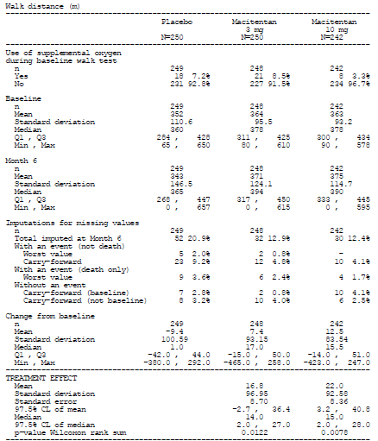

Analyses in the per-protocol set yielded similar results. The results of an analysis of covariance (ANCOVA) model adjusted for baseline 6MWD values, baseline WHO FC, and concomitant PAH therapy at baseline are presented in Table 44**.**

Table 44: Least squares mean changes in 6MWD from baseline to Month 6 (ANCOVA model), All-randomised set, Study AC-055-302

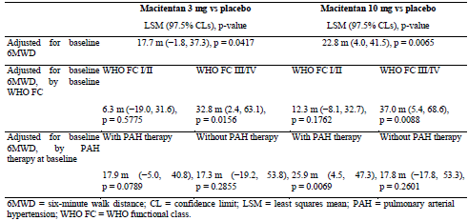

Results showed that there was a statistically significant treatment effect on change from baseline to Month 6 in 6MWD with macitentan 3mg and 10mg in subjects who were in WHO FC III or IV at baseline, and with macitentan 10 mg in subjects who were on concomitant PAH therapy at baseline.

Improvements in WHO FC from baseline to Month 6 were reported for 19.8% and 22.3% of subjects in the macitentan 3 mg and 10 mg groups, compared with 12.9% of subjects in the placebo group (Table 45).

Table 45: Improvements in WHO functional class: change from baseline to Month 6, All randomised set, Study AC-055-302

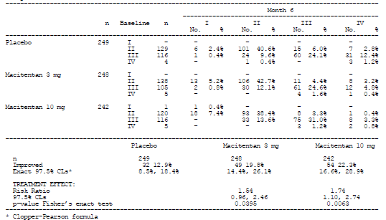

The relative risk ratio versus placebo in the macitentan 3 mg group was 1.54 (97.5% CLs: 0.96, 2.46; p = 0.0395), and that in the macitentan 10 mg group was 1.74 (97.5% CLs: 1.10, 2.74; p = 0.0063), indicating that there was a 54% and 74% higher chance relative to placebo of WHO FC improvement for subjects on the macitentan 3 mg and 10 mg.

Death-related secondary endpoints (that is, time to death due to PAH or hospitalisation for PAH up to EOT, time to death of all causes up to EOT, and time to death of all causes up to EOS) are presented in Table 46.

Table 46: Results of the death-related endpoints, All-randomised set, Study AC-055-302

Table 46: Results of the death-related endpoints, All-randomised set, Study AC-055-302

Secondary death-related endpoints

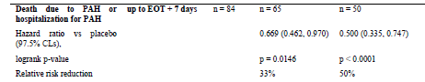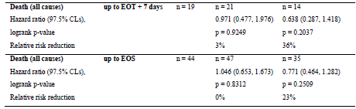

Exploratory death-related endpoints

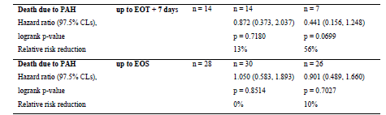Table 46: Results of the death-related endpoints, All-randomised set, Study AC-055-302  cont

Results showed a relative risk reduction versus placebo in death due to PAH or hospitalisation for PAH up to EOT of 33% with macitentan 3 mg (hazard ratio: 0.669; 97.5% CLs: 0.462, 0.970; p = 0.0146), and of 50% with macitentan 10 mg (hazard ratio: 0.500; 97.5% CLs: 0.335, 0.747; p < 0.0001). There were no or minimal relative risk reductions versus placebo in death of all causes up to EOT and in death of all causes up to EOS for macitentan 3 mg (hazard ratios of 0.971 [p=0.9249] and 1.046 [p=0.8312]). With macitentan 10 mg, there were observed relative risk reductions versus placebo of 36% for the endpoint of death of all causes up to EOT, and of 23% for the endpoint of death of all causes up to EOS, but these were not statistically significant (hazard ratios of 0.638 [p=0.2037] and 0.771 [p=0.2509]).

###### Exploratory endpoints

A repeated measures analysis for the change in 6MWD from baseline to the individual study visits was performed using mixed model techniques[19] to estimate the adjusted overall treatment effect and treatment effect at each visit. The estimated treatment effect over 12 months compared to placebo was 21.5 m (95% CLs: 10.0, 33.0; p = 0.0003) for macitentan 3 mg, and 25.4 m (95% CLs: 13.8, 37.0; p < 0.0001) for macitentan 10 mg (Table 47, Figure 16). The analysis also showed a lack of a significant treatment by visit interaction (p = 0.4746), suggesting that the magnitude of the treatment effect of macitentan (versus placebo) did not vary over time up to Month 12.

Table 47: Repeated measures analysis of the change from baseline in walk distance (m), All randomised set, Study AC-055-302

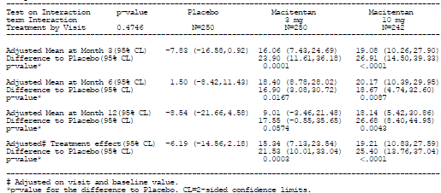

Figure 16: Change from baseline in 6MWD at all visits up to Month 12, All-randomised set, Study AC-055-302

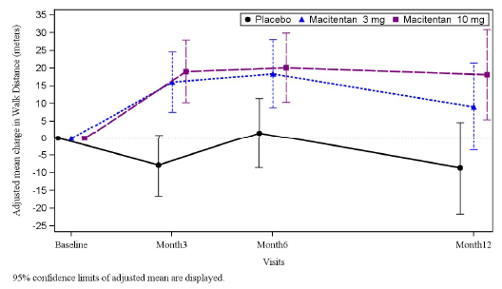

Estimation of the proportion of subjects with improvements or maintenance in 6MWD (that is, 6MWD ≥ 380 m at a visit from a baseline value < 380 m or ≥ 380 m) showed greater proportions of such subjects in the macitentan 10 mg group compared to placebo group (that is, odds ratio [macitentan versus placebo] > 1) at all assessed timepoints up to Month 24 (Table 48). The odds ratios (macitentan versus placebo) in the macitentan 3 mg group were also all > one up to Month 24, except at Month 18, when the proportion of subjects with improvements or maintenance in 6MWD was 62.1% in both the macitentan 3 mg and the placebo groups (odds ratio of 0.997). However, at Month 30, there were a higher proportion of subjects in the placebo group with improvements or maintenance in 6MWD compared to either macitentan groups (70.1%, 65.6% and 66.4% in the placebo, macitentan 3 mg, and macitentan 10 mg groups).

Table 48: Improvement or maintenance in 6MWD ≥ 380 m across the study visits, All-randomised set, Study AC-055-302

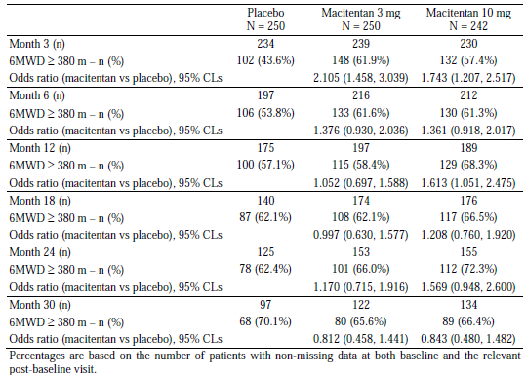

Analyses of the proportion of subjects with improvements in WHO FC from baseline showed that at all visits, there was a greater proportion of subjects in the macitentan groups who had improvements in WHO FC compared to the placebo group, and a greater proportion in the macitentan 10mg group compared to the 3mg group (Table 49).

Table 49: Repeated measures analysis of the change from baseline in walk distance (m), All randomised set, Study AC-055-302

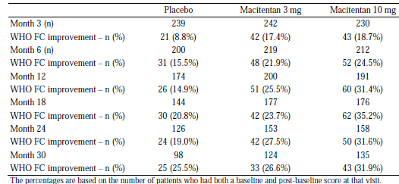

The placebo-corrected mean change (SD) in Borg dyspnoea index[20] from baseline to Month 6 was –0.7 (2.25) in the macitentan 3 mg group and –0.5 (2.06) in the macitentan 10 mg group. A repeated measures analysis for the change in Borg dyspnoea index from baseline to the individual visits was performed using mixed model techniques[21] to estimate the adjusted overall treatment effect and treatment effect at each visit. The estimated treatment effect over 12 months compared to placebo was -0.47 (95% CLs: – 0.72, – 0.22; p = 0.0002) for macitentan 3 mg, and -0.38 (95% CLs: –0.63, – 0.13; p = 0.0029) for macitentan 10 mg. The analysis also showed a lack of a significant treatment by visit interaction (p = 0.3212), suggesting that the magnitude of the treatment effect of macitentan (versus placebo) did not vary over time up to Month 12.

Analysis of NT-pro-BNP (a biomarker predicting right ventricular overload) showed that the placebo-corrected median change in NT-pro-BNP from baseline to Month 6 was –130 fmol/mL (97.5% CLs –202, –65) in the macitentan 3 mg group and –160 fmol/mL (97.5% CLs –235, –95) in the macitentan 10 mg group.

Change from baseline in Quality of Life (QoL) was assessed by the SF-36 questionnaire for subjects ≥ 14 years of age at randomisation. A higher score for the individual domains and summary component scores indicated a better condition of the subject. Results showed that there was a statistically significant mean change from baseline to Month 6, across all domains with the exception of the general health perception domain (Figure 17 and Figure 18).

Figure 17: Change in SF-36 health domains and component summary scores (norm-based scores) from baseline to Month 6, All-randomised set, Study AC-055-302

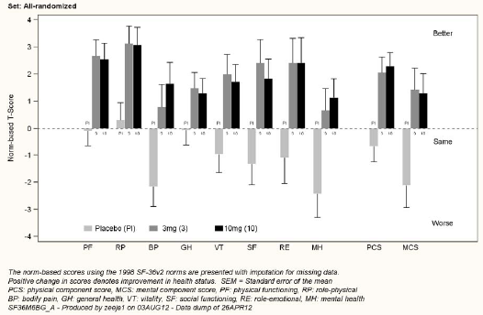

Figure 18: Change in SF-36 indexes (norm-based) to Month 6, All-randomised Set, Study AC-055-302

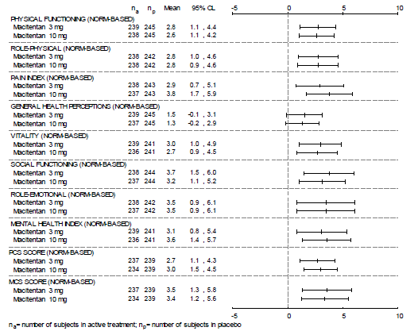

The mean treatment effects compared to placebo on the mean change from baseline to Month 6 in the scores of the individual domains of physical functioning, role physical, pain index, vitality, social functioning, role emotional, mental health index, physical and mental component summary scores was in the range of 2.6 to 3.8 in both the macitentan 3 mg and 10 mg groups. In particular, the mean treatment effects compared to placebo for the physical and mental component summary scores were 2.7 (97.5% CLs: 0.9, 4.6) and 3.5 (97.5% CLs: 1.0, 6.1), for macitentan 3 mg, and those for macitentan 10 mg were 3.0 (97.5% CLs: 1.3, 4.7) and 3.4 (97.5% CLs: 0.9, 5.9). The mean treatment effects compared to placebo on the mean change from baseline to Month 6 in the score of ‘general health perceptions’ was 1.5 (97.5% CLs: –0.3, 3.4) in the macitentan 3 mg group and 1.3 (97.5% CLs: –0.4, 3.1) in the macitentan 10 mg group. Forest plots of the changes in SF-36 indexes from baseline to Month 6 showed consistent treatment effects of macitentan (both doses) across the individual domains.

Death due to PAH up to EOS was recorded for 30 (12.0%) and 26 (10.7%) subjects in the macitentan 3 mg and 10 mg groups compared to 28 subjects (11.2%) in the placebo group. The hazard ratio versus placebo for the occurrence of death due to PAH up to EOS was 1.050 (97.5% CLs: 0.583, 1.893; p = 0.8514) in the macitentan 3 mg group and 0.901 (97.5% CLs: 0.489, 1.660; p = 0.7027) in the macitentan 10 mg group (Table 46). A post-hoc competing risks analysis was performed to assess the treatment effect on time to death due to PAH in which death related to other causes was considered as a competing event. Results showed that there were no statistically significant differences between macitentan and placebo groups for the risk of death due to PAH (p = 0.86 for macitentan 3 mg, p = 0.74 for macitentan 10 mg) or death due to other causes (p = 0.89 for macitentan 3 mg, p = 0.15 for macitentan 10 mg) (Table 50).

Table 50: Time to death due to PAH or competing events up to EOS – competing risks analysis, All-randomised set, Study AC-055-302

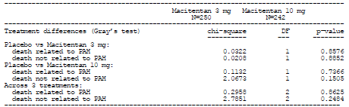  
Table 50: Time to death due to PAH or competing events up to EOS – competing risks analysis, All-randomised set, Study AC-055-302

Death due to PAH up to EOT (post-hoc analysis) was recorded for 14 (5.6%) and 7 (2.9%) subjects in the macitentan 3 mg and 10 mg groups, compared to 14 (5.6%) subjects in the placebo group. The hazard ratio versus placebo for the occurrence of death due to PAH up to EOT was 0.872 (97.5% CLs: 0.373, 2.037; p = 0.7180) in the macitentan 3 mg group and 0.441 (97.5% CLs: 0.156, 1.248; p = 0.0699) in the macitentan 10 mg group (Table 46). In order to better characterise the components of the secondary endpoint of time to death due to PAH or hospitalisation for PAH up to EOT, a post-hoc competing risks analysis was performed taking into account the death component of the endpoint and including as competing events ‘Death not due to PAH’ and ‘Disease worsening leading to EOT’. The treatment effect on the risk of death due to PAH showed a p-value of 0.73 for macitentan 3 mg versus placebo, and a p-value of 0.08 for macitentan 10 mg versus placebo. There were no statistically significant differences between macitentan and placebo groups for the risk of death not due to PAH (p = 0.37 macitentan 3 mg, p = 0.57 macitentan 10 mg) and for the risk of a disease worsening leading to EOT (p = 0.67 macitentan 3 mg, p = 0.37 macitentan 10 mg) (Table 51).

Table 51: Death due to PAH or competing events up to EOT + 7 days – competing risks analysis, All-randomised set, Study AC-055-302

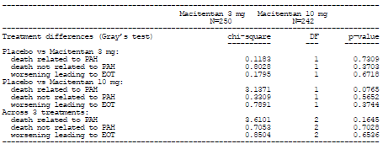  
Table 51: Death due to PAH or competing events up to EOT + 7 days – competing risks analysis, All-randomised set, Study AC-055-302

Analyses of pharmacoeconomic endpoints showed that treatment with macitentan reduced the number of hospitalisation days per year and the number of hospitalisations per year, compared to placebo. The mean number of all-cause hospitalisation days per year was 7.5 days and 5.7 days in the macitentan 3 mg and 10 mg groups, compared to 12.2 days in the placebo group. The mean number of PAH-related hospitalisation days per year was 4.0 days and 3.8 days in the macitentan 3 mg and 10 mg groups, compared to 8.3 days in the placebo group. The mean number of all-cause hospitalisations per year was 0.6 and 0.5 in the macitentan 3 mg and 10 mg groups, compared to 1.0 in the placebo group. The mean number of PAH-related hospitalisations per year was 0.3 in both the macitentan 3 mg and 10 mg groups, compared to 0.7 in the placebo group.

### Other efficacy studies

#### Study AC-055-201

Study AC-055-201 was a double-blind, randomised, placebo- and active-controlled study to evaluate the efficacy, safety and tolerability of macitentan in subjects with mild to moderate essential hypertension. The primary objective was to evaluate the effect of a once-daily oral regimen of four doses of macitentan (0.3 mg, 1 mg, 3 mg and 10 mg) on sitting diastolic blood pressure (SiDBP) at trough after eight weeks of treatment. Secondary objectives were to evaluate the effect of a once-daily oral regimen of the four doses of macitentan on control/response rate on SiDBP, and on sitting systolic blood pressure (SiSBP) at trough at eight weeks and its control/response rate, as well as to evaluate the safety and tolerability of macitentan. This was a multi-centre (17 centres in Israel and five centres in Serbia), double-blind, randomised, placebo- and active-controlled, parallel group, dose-ranging study. The study design included three consecutive periods: a single-blind placebo run-in wash-out period of two to four weeks (Period I), a double-blind treatment period of eight weeks (Period II), and a 28-day safety follow-up period (28-d FU Period) starting after study drug discontinuation. The total study duration was 14 to 16 weeks per subject (including the 28-d FU Period). During Period II, eligible subjects were randomised in a 1:1:1:1:1:1 manner into one of six parallel treatment groups (one placebo group, one enalapril 20 mg group [trial internal control], or one of the four macitentan dose groups [0.3 mg, 1 mg, 3 mg,10 mg]).

Study entry criteria were male or female subjects over 18 years of age with mild to moderate essential hypertension (defined as Grade 1 or 2 of 1999 WHO classification[22]). Women of childbearing potential were excluded but postmenopausal or surgically sterile were women allowed. Subjects should not have any contraindication to stopping anti-hypertensive treatment. Subjects with mean SiDBP between 95 and 110 mmHg and at least 80% compliance (by pill counting) at Visit 3 during Period I (that is, one week before start of Period II) were eligible for entry into Period II. The main study exclusion criteria were severe (mean SiSBP ≥ 180 mmHg), secondary or unstable hypertension, prior myocardial infarction, uncontrolled diabetes, unstable angina, evidence of hepatic or renal disease, or any required treatments that might affect blood pressure.

Study treatments were macitentan 0.3 mg, 1 mg, 3 mg, or 10 mg, enalapril 20 mg, or placebo, all to be administered orally once daily in the morning for eight weeks during Period II. In addition, placebo was administered to all subjects orally once daily in the morning for two to four weeks during Period I. Study drugs were provided as indistinguishable capsules. Enalapril 20 mg tablets were over-encapsulated to keep the treatment assignment blinded. The primary efficacy endpoint was the change from baseline to Week 8 of Period II in mean trough (that is, 24 hours post-dose) SiDBP. Secondary efficacy endpoints were control and response rate at Week 8 in trough SiDBP[23], change from baseline to Week 8 in mean trough SiSBP, and control rate and response rate at Week 8 in trough SiSBP[24]. The baseline parameters were assessed at the start of Period II before randomisation (that is, at 22 to 26 hours after the last Period I study drug intake, and before Period II study drug intake). PK/PD analyses included trough concentrations of macitentan parent drug (ACT-064992) and its metabolite, ACT-132577, in plasma at Weeks 4 and 8 of Period II and trough ET-1 concentrations in plasma at Weeks 4 and 8 of Period II. During period II, blood pressure was measured at Weeks 2, 4 and 8 in a sitting position before the morning drug intake, 22 to 26 hours post previous dose (Table 52).

Table 52: Visit and assessment schedule, Study AC-055-201

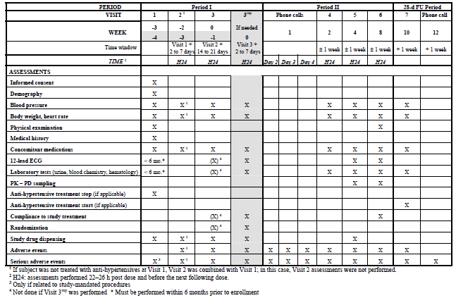

Planned sample size was 407 subjects to be enrolled into Period I. It was planned that out of these, 346 subjects would be randomised in Period II. Overall, 466 subjects were enrolled in Period I. Eighty-seven subjects did not meet inclusion criteria for Period II and the remaining eligible 379 subjects were randomised to placebo (n = 62), one of four doses of macitentan (0.3 mg: n = 63; 1 mg: n = 66; 3 mg: n = 61; 10 mg: n = 62), or enalapril (n = 65). The study was terminated prior to completion based on the sponsor’s decision on 16 April 2006, and as a result, 173 (45.6%) subjects did not complete the planned eight week-treatment of Period II. Hence, 206 subjects completed the study: 29 in the placebo group (46.8%; 29/62), 34 (54.0%; 34/63), 33 (50.0%; 33/66), 34 (57.4%; 35/61), and 34 (62.9%; 39/62) in the macitentan 0.3 mg, 1 mg, 3 mg and 10 mg groups and 34 (55.4%; 36/65) in the enalapril group (Figure 19). On 10 April 2006, as a safety evaluation, the sponsor decided to break the blind for five subjects who had liver enzyme elevations > three times ULN. All five subjects were found to be receiving macitentan of doses 0.3 to 10 mg. The sponsor decided to stop this study in order to avoid continued exposure to potential risks without providing sufficient or expected benefits to subjects. All participating study centres were notified on 16 April 2006 to prematurely discontinue all subjects, and to schedule the end-of-study visits. The last subject on study treatment discontinued on 2 May 2006, and the last visit was on 24 May 2006. The five subjects in question were not excluded from any analysis set as the breaking of the code in each case had happened after the primary endpoint assessment. The study treatment remained blinded for all subjects but these five until database lock (18 July 2006).

Figure 19: Disposition of subjects, Study AC-055-201

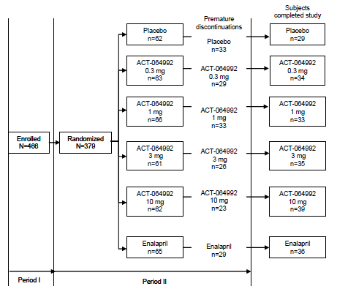

An overview of the study analysis sets is presented in Table 53.

Table 53: Overview of analysis sets, Study AC-055-201

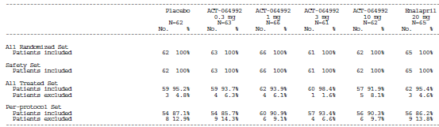

The all-randomised set included all randomised subjects, irrespective of whether or not they had received study drug. The safety analysis set included all randomised subjects, who had received study drug at least once and with at least one safety post-baseline assessment. The all-treated set included all randomised subjects, who had received Period II study drug, and had a baseline and a post-baseline value for the primary efficacy parameter. The per-protocol set comprised of all subjects in the all-treated set, who were evaluable[25], had ≥ 75% compliance, and who did not violate the protocol in a way that might affect the evaluation of the primary endpoint.The per-protocol set was used for the main analyses of the primary, secondary and exploratory efficacy endpoints. The all-randomised set and all-treated set were used for supportive analyses of the primary efficacy endpoint. The safety set was used for the safety analysis. For the primary endpoint analysis, in the case of a missing value at Visit 6 (that is, Week 8), the last available value assessed ≥ Week 2 of Period II, was carried forward.

Baseline demographic characteristics were comparable among treatment groups (Table 54).

Table 54: Summary of patient demographics by treatment groups, Safety Set, Study AC-055-201

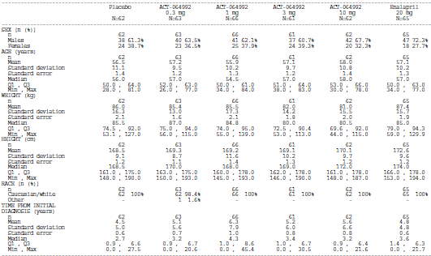 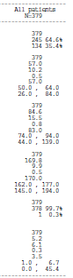

Overall, the majority of subjects were male (64.6%; 245/379) and Caucasian (99.7%; 378/379). The overall mean (SD) age was 57.0 (10.2) years and the mean (SD) time from initial diagnosis was 5.2 (6.2) years. Baseline mean SiDBP and SiSBP showed a study population with mild hypertension (overall mean [SD] baseline SiDBP and SiSBP of 97.6 (2.5) mmHg and 151.5 (11.0) mmHg).

Analysis of the primary efficacy endpoint showed that baseline SiDBP values were comparable across treatment groups. In the placebo group, there was a mean (SD) change from baseline to Week 8 of - 7.9 (8.0) mmHg. The mean placebo-corrected treatment effect of macitentan 0.3 mg, 1 mg, 3 mg and 10 mg and of enalapril 20 mg is presented in Table 55 and Figure 20.

Table 55: Change in sitting diastolic blood pressure from baseline to end of Period II in the Per-protocol analysis set, Study AC-055-201



Figure 20: Change in sitting diastolic blood pressure from baseline to end of Period II (Placebo-corrected), Study AC-055-201



The response to macitentan appeared to be dose-dependent. In the macitentan 10 mg group, the reduction in trough SiDBP from baseline was statistically significant compared to placebo (mean change from baseline of -11.8 mmHg versus -7.9 mmHg, p=0.0089). Statistical significance was not reached for the 3 mg dose (mean change from baseline of -10.8 mmHg versus -7.9 mmHg with placebo, p=0.0555) but this dose produced an effect on BP reduction that was considered by the sponsor to be clinically relevant. Statistical significance was also not reached for the other macitentan doses (0.3 mg and 1 mg). Although comparison between macitentan and enalapril was not planned for this study, it is noted that the point estimates of the mean reduction in trough SiDBP from baseline of the two highest doses of macitentan were greater compared to that of enalapril (-10.8 mmHg, -11.8 mmHg and -8.9 mmHg for macitentan 3 mg, macitentan10 mg, and enalapril 20 mg).

Supportive analyses of the primary efficacy endpoint in the all-treated set and all-randomised set yielded similar results, with statistically significant reduction from baseline in trough SiDBP compared to placebo for the macitentan 10 mg dose (mean reduction from baseline of -12.0 mmHg versus -7.7 mmHg in placebo, p= 0.0040, in both the all-treated set and all-randomised set), but not in the other macitentan doses. For macitentan 3mg dose, the mean reduction from baseline in trough SiDBP in both the all-treated set and all-randomised set was -11.1 mmHg (compared to -7.7 mmHg with placebo, p= 0.0287).

Analysis of the secondary endpoint of change from baseline to Week 8 in mean trough SiSBP showed similar results, with statistically significant reduction from baseline in trough SiSBP compared to placebo only for the macitentan 10 mg dose (-15.6 mmHg versus -11.3 mmHg, p= 0.0286) (Table 56).

Table 56: Change in sitting systolic blood pressure from baseline to end of Period II in the Per-protocol analysis set, Study AC-055-201

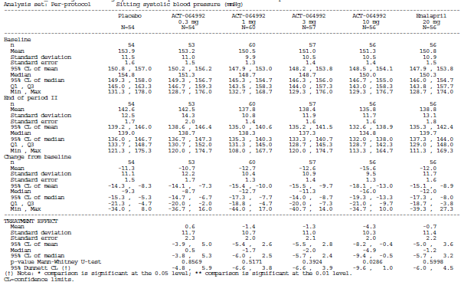

Analysis of the secondary endpoint of control and response rate at Week 8 in trough SiDBP (Table 57) showed that the proportion of subjects with mean SiDBP controlled (defined as < 90 mmHg) increased with increasing macitentan doses, and the difference from placebo was statistically significant for macitentan 10 mg dose (73.2% versus 53.7% with placebo, p=0.0471).

Table 57: Sitting diastolic blood pressure: control and response rates at end of Period II, Study AC-055-201

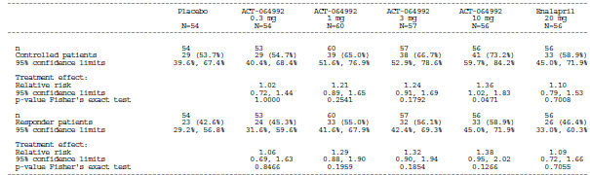

The proportion of responders (defined as subjects with change from baseline in mean SiDBP ≥ -10 mmHg) also increased with increasing macitentan doses, but the differences from placebo were not found to be statistically significant for all macitentan dose groups. Analysis of the secondary endpoint of control and response rate at Week 8 in trough SiSBP (Table 58) showed similar results, with the proportion of subjects with mean SiSBP controlled (defined as < 140 mmHg) and that of responders (defined as subjects with change from baseline in mean SiSBP ≥ -20 mmHg) generally increasing with increasing macitentan doses, but the differences from placebo were not found to be statistically significant for all macitentan dose groups.

Table 58: Sitting systolic blood pressure: control and response rates at end of period II, Study AC-055-201

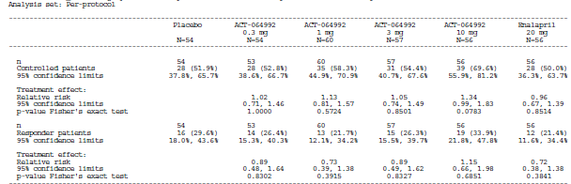

Exploratory analyses of the absolute change from baseline in SiDBP for the four, eight, and 10-week cohorts showed that the treatment effect of macitentan on the primary endpoint was reached at four weeks and then sustained until Week 8 (Figure 21) Exploratory analyses of the absolute change from baseline in SiSBP for these cohorts showed similar results.

Figure 21: Absolute change from baseline by cohorts (mean ±95% CI), SiDBP, (i) Week 4 cohort (ii) Week 8 cohort (iii) Week 10 cohort, Safety set, Study AC-055-201

(i) Week 4 cohort



(ii) Week 8 cohort



(iii) Week 10 cohort



PK analysis showed that exposure in terms of Ctrough to both macitentan parent drug (ACT-064992) and ACT-132557 appeared to be dose proportional over the dose range tested (Figure 22).

Figure 22: Arithmetic mean plasma concentration (SD) measured at trough of macitentan (ACT-064992) and ACT-132577 by visit and treatment, Study AC-055-201

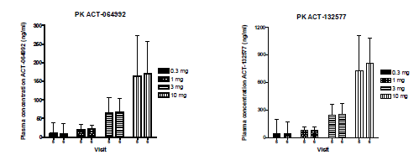

Visit 5= Week 4; Visit 6= Week 8

PD showed that there appeared to be a small effect on ET-1 concentration in the 0.3 and 1 mg macitentan dose groups, while a more marked effect on ET-1 was observed in the 3 and 10 mg macitentan dose groups (Figure 23).

Figure 23: Plasma ET-1 concentrations (pg/mL) (mean and SD) at Weeks 4 and 8, Study AC-055-201



The relationship between macitentan and ACT-132577 concentrations and the primary efficacy endpoint (that is, the change from baseline in SiDBP, measured at trough at Week 8) was explored and showed that macitentan10 mg dose appeared to be close to the plateau of the pharmacological effect (Figure 24).

Figure 24: PK/PD analysis: Change in SiDBP (mmHg) (mean ± SEM) versus Cfree combined (ng/mL)[26] (mean ± SEM) at Week 8 including predicted data, Study AC-055-201



Comment: The early termination due to potential safety concerns was appropriate, given that this was a proof-of-concept, dose-finding study conducted in patients with essential hypertension, which was not the targeted therapeutic indication for macitentan. This was justified considering the risk to study subjects of further exposure and potential safety issues in continuing on a study drug that was not meant to treat their hypertension. However, due to the early termination, only approximately half of the randomised subjects (54.4%; 206/379) completed the eight-week randomised treatment. In analysing the primary efficacy endpoint, in the case of a missing value at Week 8, the last available value assessed ≥ Week 2 of Period II, was carried forward. Analyses of the primary efficacy endpoint showed that there was statistically significantly greater reduction in trough SiDBP from baseline to Week 8 compared to placebo only for the macitentan 10 mg group (mean change from baseline of -11.8 mmHg versus -7.9 mmHg, p=0.0089), but not for the other doses, in the per-protocol, all-randomised, as well as the all-treated sets. However, due to the early termination and the imputation method, this result was in effect an assessment of reduction in trough SiDBP from baseline to a post-baseline timepoint that ranged from Week 2 to Week 8. The sponsor did not provide a breakdown of the relative proportion of subjects who had provided the data at the Week 2, Week 4 and Week 8 timepoints. It was noted that exploratory analyses of the absolute change from baseline in SiDBP for the four, eight, and 10-week cohorts were performed, and results showed that the treatment effect of macitentan on the primary endpoint was reached at four weeks and then sustained until Week 8. However, the sponsor did not provide an explanation of how the four, eight, and 10-week cohorts were defined in the statistical methods section of the CSR. These will be raised as clinical questions.

#### Analyses performed across trials (pooled analyses and meta-analyses)

Not applicable.

#### Evaluator’s conclusions

Overall, the study design, study inclusion and exclusion criteria, and study endpoints of the pivotal Phase III Study (AC-055-302) were appropriate and in line with the recommendations of the TGA-adopted EMA guidelines on the clinical investigation of medicinal products for the treatment of pulmonary arterial hypertension. The study primary endpoint allowed evaluation of all-cause mortality and PAH-related morbidity, while the study secondary endpoints of change from baseline in 6MWD and the WHO FC allowed evaluation of the effect of macitentan on exercise capacity and clinical symptoms. Baseline demographic and disease characteristics were comparable among treatment groups, and were generally consistent with the target patient population. The majority of subjects (63.7%) had concomitant PAH therapy at baseline, of which sildenafil was the commonest, taken by 57.6% of the overall study population. The commonest type of concomitant PAH therapy was PDE-5 inhibitors, taken by 61% of the overall study population. It was noted, however, that the sample size of adolescent subjects (12 to < 18 years old) was very small (N=20) as was the group of subjects with baseline WHO FC IV (N=14).

Analysis of the primary efficacy endpoint (that is, time to first morbidity or mortality event up to EOT) showed that the hazard ratio versus placebo for the first occurrence of a morbidity or mortality event was 0.704 (p = 0.0108) with the macitentan 3 mg, and 0.547 (p < 0.0001) with macitentan 10 mg. This gives relative risk reductions for the occurrence of a morbidity or mortality event of 30% and 45% with macitentan 3 mg and10 mg compared to placebo. The treatment effect with the 10 mg dose met the pre-specified significance criteria for a ‘conclusive study’ (that is, p<0.005). The treatment effect with the 3 mg dose did not meet the pre-specified significance criteria for a ‘conclusive study’, but satisfied that for a ‘positive study’ (that is, p<0.025). The Kaplan-Meier curves of the first morbidity or mortality event showed that the treatment effect of the two macitentan doses on the primary endpoint appeared to be established early, with the separation in the curves between the macitentan groups and the placebo group observed by Month 6, and was sustained for the duration of the study. Analysis of the primary endpoint in the per-protocol set and other sensitivity analyses of the primary endpoint (based on variation of the endpoint definition and/or population analysed) yielded results consistent with those of the main analysis in the all-randomised set.

Subgroup analyses of the primary endpoint across subgroups of gender (male versus female), race (White versus Asian versus Others), concomitant PAH therapy at baseline (yes versus no), PAH aetiology at baseline (idiopathic, familial, HIV infection, drugs and toxins versus collagen vascular disease versus congenital shunts), geographical region (North-America versus Western Europe/Israel versus Eastern Europe/Turkey versus Asia versus Latin America), age (< 18 versus18 to 64 versus > 64 years), baseline WHO FC (WHO FC I–II versus III–IV) and baseline 6MWD (6MWD > versus ≤ 380 m) yielded results that were generally consistent with those in the overall study population, but was less so with macitentan 3 mg than with macitentan 10 mg, in particular in subgroups that included subjects with or without background PAH therapy, and baseline WHO FC I/II versus III/IV (Table 59, Figures 14 and 15). The p-values for the interaction test did not show heterogeneity of the treatment effect (macitentan versus placebo) across the subgroups.

Table 59: Results of primary analysis and subgroup analysis of WHO FC and PAH therapy at baseline, Study AC-055-302

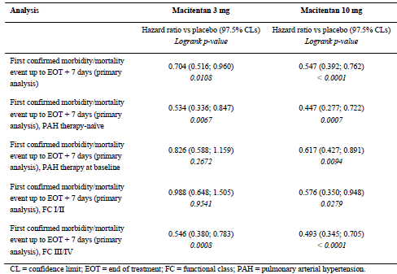

Overall, the proportion of subjects with a confirmed primary endpoint morbidity or mortality event (that is, composite endpoint) was 38.0% and 31.4% in the macitentan 3 mg and 10 mg groups, compared with 46.4% in the placebo group. Analysis of the components of the primary endpoints showed that the commonest first-reported morbidity or mortality event in all treatment groups was ‘Other worsening of PAH’ (28.8% and 24.4 % in the macitentan 3 mg and10 mg groups, versus 37.2% in the placebo group), followed by ‘Death’ (that is, all-cause deaths; 8.4% and 6.6% versus 6.8%). Competing risks analysis to explore the treatment effect on the morbidity component of the primary endpoint showed that subjects in the macitentan groups had a statistically significantly lower risk of disease worsening than subjects in the placebo group (p = 0.0047 for macitentan 3 mg; p < 0.0001 for macitentan 10 mg), but no statistically significant difference was observed between the macitentan and placebo groups for the risk of death (p = 0.59 for macitentan 3 mg; p = 0.79 for macitentan 10 mg). However, interpretation of these results needs to take into consideration the relatively lower incidence of mortality across all treatment groups, as compared to incidence of morbidity.

Analysis of the secondary endpoint of time to death due to PAH or hospitalisation for PAH up to EOT showed a relative risk reduction versus placebo in this endpoint of 33% with macitentan 3 mg (hazard ratio: 0.669; p = 0.0146), and of 50% with macitentan 10 mg (hazard ratio: 0.500; p < 0.0001). Due to the hierarchical method of statistical analysis presented in Figure 25 and as the endpoint of change from baseline in WHO FC yielded a p-value > 0.025 for macitentan 3mg (described below), no confirmatory claims could therefore be made for the treatment effect observed for macitentan 3mg for this endpoint of time to death due to PAH or hospitalisation for PAH up to EOT.

Figure 25: Kaplan-Meier curves of the first confirmed morbidity or mortality event up to EOT + 7 days (CEC) (Kaplan-Meier estimate), Per-protocol set, Study AC-055-302



As the endpoints of change from baseline in 6MWD and in WHO FC both yielded a p-values > 0.005 but < 0.025 for macitentan 10mg (described below), the treatment effect with the 10 mg dose for this endpoint of time to death due to PAH or hospitalisation for PAH up to EOT could only be considered to satisfy the significance criterion for a ‘positive study’, but not a ‘conclusive study’.

Analyses of other death-related secondary and exploratory endpoints (time to death of all causes up to EOT, time to death of all causes up to EOS, time to death due to PAH up to EOT [post-hoc analysis], and time to death due to PAH up to EOS) showed that there were no statistically significant difference in relative risk reductions of these mortality endpoints in both macitentan dose groups (3mg and 10mg) compared to placebo (Table 46). However, the study was not powered for these endpoints.

Analyses of the effect of macitentan on exercise capacity in terms of the 6MWD showed that after six months of treatment, the placebo-corrected mean change (SD) from baseline in 6MWD was 16.8 m (96.95) and 22.0 m (92.58) in the macitentan 3mg and10 mg groups. The placebo-corrected median change from baseline to Month 6 in 6MWD was 14.0 m (p = 0.0122) and 15.0 m (p = 0.0078) in the macitentan 3mg and10 mg groups. The treatment effect with both the 3 mg and 10mg doses did not meet the pre-specified significance criteria for a ‘conclusive study’ (that is, p<0.005), but satisfied that for a ‘positive study’ (that is, p<0.025). A repeated measures analysis for the change in 6MWD from baseline suggested that the treatment effect of macitentan (versus placebo) on the 6MWD was sustained over time up to Month 12. The estimated treatment effect over 12 months compared to placebo was 21.5 m (p = 0.0003) and 25.4 m (p < 0.0001) for macitentan 3 mg and10 mg. The odds ratio versus placebo for achievement or maintenance of 6MWD ≥ 380 m, remained > one up to Month 24 for macitentan 3mg and10mg (except at Month 18 for macitentan 3 mg, where the odds ratio was 0.997). The results of an ANCOVA Model adjusted for baseline 6MWD values, baseline WHO FC, and concomitant PAH therapy at baseline showed that there was a statistically significant treatment effect on change from baseline to Month 6 in 6MWD with macitentan 3mg and 10mg in subjects who were in WHO FC III or IV at baseline, and with macitentan 10 mg in subjects who were on concomitant PAH therapy at baseline.

Analyses of the effect of macitentan on symptom relief in terms of improvements in WHO FC from baseline to Month 6 showed that there was a 54% and 74% higher chance relative to placebo of WHO FC improvement at Month 6 for subjects on the macitentan 3 mg and 10 mg, (p=0.0395 and p= 0.0063). The treatment effect with the 10 mg dose did not meet the pre-specified significance criteria for a ‘conclusive study’ (that is, p<0.005), but satisfied that for a ‘positive study’ (that is, p<0.025). The treatment effect with the 3 mg dose did not meet either pre-specified significance criterion. At all visits up to Month 30, there was a greater proportion of subjects in the macitentan groups who had improvements in WHO FC compared to the placebo group, and a greater proportion in the macitentan 10 mg group compared to the 3mg group. Analyses of the effect of macitentan on symptom relief in terms of change in Borg dyspnoea index from baseline showed that the estimated treatment effect over 12 months compared to placebo was -0.47 (p = 0.0002) for macitentan 3 mg, and -0.38 (p = 0.0029) for macitentan 10 mg.

Analyses of the effect of macitentan on quality of life showed that there was a statistically significant mean change from baseline (improvement) to Month 6, across all SF-36 questionnaire domains with the exception of the general health perception domain, for both macitentan doses. Analyses of pharmacoeconomic endpoints showed that compared to placebo, treatment with macitentan reduced the number of hospitalisation days per year (mean all-cause hospitalisation days per year: 7.5 and 5.7 days with macitentan 3 mg and 10 mg, versus 12.2 days with placebo; mean PAH-related hospitalisation days per year: 4.0 and 3.8 days, versus 8.3 days) and the number of hospitalisations per year (mean number of all-cause hospitalisations per year: 0.6 and 0.5, versus 1.0; mean number of PAH-related hospitalisations per year: 0.3 and 0.3 versus 0.7).

Although two doses of macitentan were tested in this pivotal Phase III study, the recommended dose for the proposed indication for treatment of PAH was 10mg once daily. The efficacy results supported this dose selection. With regards to the primary efficacy endpoint, there was a greater reduction in the risk of occurrence of a morbidity or mortality event with macitentan 10 mg dose (45% risk reduction compared to placebo), compared with the 3 mg dose (30% risk reduction compared to placebo), and associated with a higher degree of statistical significance. In addition, only macitentan 10 mg showed a consistent treatment effect across subgroups of subjects with versus without background PAH therapy, and those with baseline WHO FC I/II versus III/IV. Although results for death-related endpoints showed no statistically significant difference between placebo and both macitentan doses, analysis of the secondary endpoint of time to death due to PAH or hospitalisation for PAH up to EOT showed a relative risk reduction versus placebo in this endpoint of 50% with macitentan 10 mg, with a level of statistical significance considered as a ‘positive study’ although not a ‘conclusive study’. Although there was a relative risk reduction versus placebo in this endpoint of 33% with macitentan 3 mg, the level of statistical significance was such that no confirmatory claims could be made for this treatment effect (that is, it is to be considered descriptive). Analyses of the effect of macitentan on exercise capacity and symptom relief also yielded results showing greater effect for the 10mg dose compared to the 3mg dose (placebo-corrected mean change [SD] from baseline in 6MWD: 22.0 m [92.58] versus 16.8 m [96.95]; WHO FC improvement at Month 6: 74% [p=0.0063] versus 54% [p=0.0395; that is, not statistically significant] higher chance relative to placebo of WHO FC improvement at Month 6).

## Clinical safety

### Studies providing evaluable safety data

The following studies provided evaluable safety data:

#### Pivotal efficacy study (Study AC-055-302)

In the pivotal efficacy study, the following safety data were collected:

* General adverse events (AEs)

The occurrence of AEs was checked at every visit throughout the study. All AEs occurring up to 28 days after EOT were reported in the CRF.

* AEs of particular interest

In this study, AEs that had been reported with other ERAs were explored as AEs of special interest. These included groupings of ‘liver disorders and abnormal liver function’, ‘haemoglobin decrease’, ‘oedema’ and ‘hypotension’. The preferred terms (PT) in these groupings were pre-specified prior to unblinding[27].

* Laboratory tests included haematology, and serum chemistry and liver function tests (including aminotransferases [ALT and AST], alkaline phosphatase [ALP], total bilirubin [TBIL] and direct bilirubin [DBIL], creatinine, urea, glucose, sodium, potassium and albumin). With the exception of ALT and AST, all haematology and clinical chemistry variables were measured at screening, Month 3, Month 6 and every six months until the EOT/event visit (Table 60). ALT and AST were measured at screening and at monthly intervals after initiation of study treatment until at least 28 days after the EOT. If ALT and AST elevations exceeded three times ULN, a repeat confirmatory measurement was to be performed along with measurements of TBIL, DBIL and ALP. If confirmed, treatment was to be interrupted and ALT, AST, bilirubin and ALP were to be monitored every week after study drug interruption until the values returned to pre-treatment levels. Re-introduction of study treatment could be considered only if the potential benefits of treatment with study treatment outweighed the potential risks and when liver aminotransferase values were within the pre-treatment levels. In addition, the interruptions were required to be of less than four weeks’ duration. Interruptions lasting for a longer period led to permanent discontinuation of study drug. The levels of ALT and AST had to be checked within three days after re-introduction, and at Week 2, and thereafter at monthly intervals. In addition, study drug was required to be permanently discontinued if ALT and/or AST > three times ULN and associated with clinical symptoms of liver injury (such as nausea, vomiting, fever, abdominal pain, jaundice, unusual lethargy or fatigue, flu-like syndrome), ALT and/or AST > three times ULN and TBIL ≥ two times ULN, or ALT and /or AST > eight times ULN. In women of childbearing potential, serum pregnancy tests were to be performed monthly from screening up to at least 28 days after EOT.
* Other safety variables included vital signs (blood pressure [BP] and pulse rate), 12-lead electrocardiogram (ECG) and body weight measurements. Vital signs and body weight were recorded at screening, randomisation, Month 3, Month 6, every 6 months thereafter, and at the EOT/event visit (Table 60). A standard 12-lead ECG was performed at screening, Month 6, and EOT/event visit.

Table 60: Schedule of assessments, Study AC-055-302

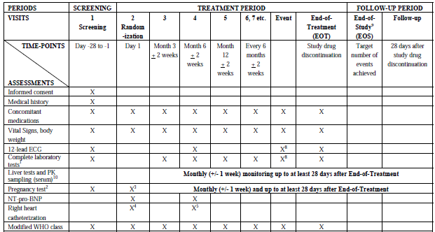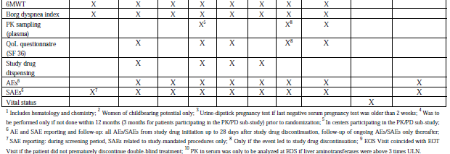

#### Pivotal studies that assessed safety as a primary outcome

Not applicable.

#### Dose-response and non-pivotal efficacy studies

The dose-response and non-pivotal efficacy studies provided safety data, as follows:

* Study AC-055-201 provided data on adverse events, vital signs, body weight and physical examination findings reported as AEs, routine laboratory evaluations, and 12-lead ECG assessments.

The study design included three consecutive periods: a single-blind placebo run-in wash-out period of two to four weeks (Period I), a double-blind treatment period of eight weeks (Period II), and a 28-day safety follow-up period (28-d FU Period) starting after study drug discontinuation. In this study, treatment-emergent AEs (TEAEs) were defined as an event whose starting date was during Period II and up to 14 days after last dose (that is, up to two weeks after study drug discontinuation). Treatment-emergent SAEs (TESAEs) were defined as an event whose starting date was during Period II and up to four weeks after study drug discontinuation. Any worsening, increased intensity or seriousness of an AE which started during Period I, was considered as a new treatment-emergent AE in Period II.

Adverse events occurring in Period I (defined as those with onset occurring before the day of study treatment start of Period II) were analysed in an additional safety set defined in a protocol amendment to include subjects who were not randomised. Safety results occurring in Period I were presented in the CSR and were evaluated for this report, and no safety concerns were triggered. In view of this and that this non-pivotal dose-finding study was conducted in a study population with essential hypertension, for which the sponsor was not seeking approval in this submission, and of which safety results were considered supportive, this evaluation report will summarise only treatment emergent safety events for this study (that is, safety events for the double-blind period II).

* Study AC-055B201 (MUSIC) provided data on adverse events, vital signs, body weight and physical examination findings reported as AEs, routine laboratory evaluations, and 12-lead ECG assessments.

As per instructions in the TGA’s ‘statement of requirements’, Study AC-055B201 will be evaluated for safety only, and hence the study design has not been previously described. This will be summarised here. Study AC-055B201 was a multi-centre (48 centres in 12 countries) double-blind, randomised, placebo-controlled, parallel-group, Phase II study to evaluate the efficacy, safety, and tolerability of macitentan in subjects with idiopathic pulmonary fibrosis (IPF). The primary objective was to demonstrate that macitentan positively affects the forced vital capacity (FVC) compared with placebo in subjects with IPF. Secondary objectives were to evaluate the effect of macitentan on the time to disease worsening or death in subjects with IPF and to evaluate the safety and tolerability of macitentan in this patient population. The study included a screening period of up to 28 days followed by a double-blind treatment phase that was further divided into two periods: Period 1 (fixed duration) was from randomisation up to the primary endpoint evaluation (Month 12, or earlier in case of premature discontinuation of study drug); Period 2 (variable duration) was from the primary endpoint evaluation visit up to the End-of-Study (EOS). EOS was to be declared by the sponsor once the last randomised subject had successfully completed Period 1 (that is, did not prematurely discontinue treatment). Prior to EOS, all subjects who had already successfully completed Period 1 were maintained on double-blind treatment during Period 2 until overall EOS was declared. All subjects were to have a 28-day post-treatment safety follow-up visit.

Eligible subjects were males or females aged 18 years or older at study entry, with a confirmed diagnosis of IPF within three years prior to randomisation based on the American Thoracic Society (ATS) and the European Respiratory Society (ERS) consensus criteria, and confirmed with surgical lung biopsy (SLB). Subjects were randomised in a 2:1 ratio to receive either macitentan 10 mg or matching placebo, once daily, per oral, irrespective of food intake. The primary efficacy endpoint was the change in FVC from baseline to End-of-Period 1 (EOP1). The secondary efficacy endpoint was the time to occurrence of disease worsening or death (all causes) up to EOS. A total of 178 subjects were randomised in a 2:1 ratio to the macitentan (n = 119) and placebo groups (n = 59). A total of 23 subjects (12.9%) discontinued the study prematurely (15.1% [18/119] in macitentan group; 8.5% [5/59] in placebo group), and hence 155 subjects (87.1%) completed the study. All 178 subjects were analysed for efficacy and safety. The baseline demographic characteristics were comparable between treatment groups (Table 61). The majority of subjects in each treatment group were male (62.7% [37/59] and 70.6% [84/119] in the placebo and macitentan 10 mg groups) and Caucasian (96.6% [57/59] and 95.8% [114/119]). The mean (SD) age was 64.5 (6.32) and 65.1 (7.85) years. The median age was 64.0 and 66.0 years. Baseline BMI were also similar between treatment groups (mean [SD] BMI of 30.7 [5.23] and 30.5 [4.36]).

Table 61: Summary of patient demographics, All-randomised set, Study AC-055B201

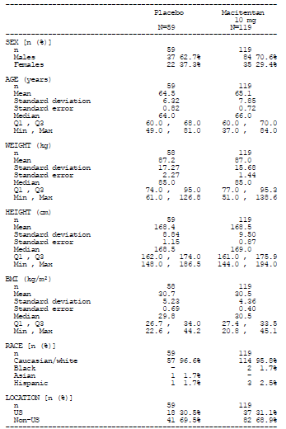

#### Other studies evaluable for safety only

Not applicable.

#### Clinical pharmacology studies

In the 14 completed Phase I clinical pharmacology studies (AC-055-101 to AC-055-114) safety assessments in these clinical pharmacology studies included AEs, vital signs, clinical laboratory tests and ECGs. In addition, Study AC-055-113 investigated the effect of macitentan on sperm concentration, and Study AC-055-114 was a thorough QT study and provided data on the effect of macitentan on cardiac repolarisation.

### Pivotal studies that assessed safety as a primary outcome

Not applicable.

### Patient exposure

In the pivotal efficacy/safety Study (AC-055-302), a total of 492 subjects received macitentan and 249 received placebo. The mean (SD) duration of treatment was 99.5 (50.82) weeks, 103.9 (52.44) weeks and 85.3 (53.65) weeks in the macitentan 3 mg, 10 mg, and the placebo groups (Table 62).

Table 62: Summary of treatment duration, All-treated set, Study AC-055-302

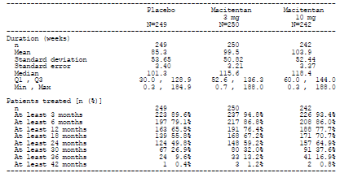

The median duration of treatment was 115.6, 118.4 and 101.3 weeks. The percentage of subjects with exposure to study treatment for at least 1 year was 76.4%, 77.7% and 65.5%, while that for at least 2 years was 59.2%, 64.9% and 49.8%.

In Study AC-055-201 (essential hypertension study population), a total of 252 subjects received macitentan, 62 received placebo, and 65 received enalapril. The mean (SD) duration of treatment was 43.7 (16.8), 41.7 (17.7), 46.1 (15.3), 46.8 (16.9), 40.5 (17.8) and 44.6 (16.7) days in the macitentan 0.3 mg, 1 mg, 3 mg, 10 mg, placebo and enalapril groups (Table 63).

Table 63: Summary of treatment duration, Safety set, Study AC-055-201

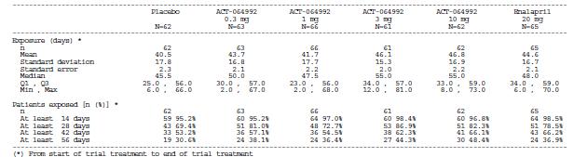

The median duration of treatment was 50.0, 47.5, 55.0, 55.0, 45.5 and 48.0 days. The percentage of subjects with exposure to study treatment of at least 28 days was 81.0%, 72.7%, 86.9%, 82.3%, 69.4%, and 78.5%.

In Study AC-055B201 (IPF study population), a total of 119 subjects received macitentan 10 mg and 59 received placebo. The mean (SD) duration of treatment was 14.3 (4.84) and 15.4 (3.95) months in the macitentan 10 mg and the placebo groups (Table 64).

Table 64: Summary of adverse events leading to permanent discontinuation of study treatment by frequency, All-treated set, Study AC-055B201

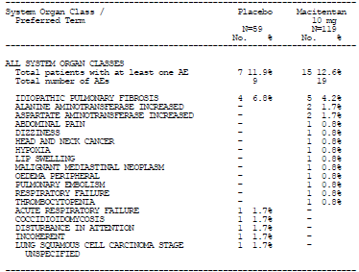

The median duration of treatment was 14.5 and 15.0 months. The percentage of subjects with exposure to study treatment for at least one year was 76.5% and 81.4%.

In the 14 completed Phase I clinical pharmacology studies (AC-055-101 to AC-055-114), a total of 356 subjects (324 healthy subjects, 24 subjects with hepatic impairment, and eight subjects with severe renal impairment) were exposed to macitentan (Table 65). Of the 356 subjects, 149 were exposed to single doses of macitentan and 207 received multiple doses of macitentan.

Table 65: Exposure in the clinical pharmacology studies, macitentan

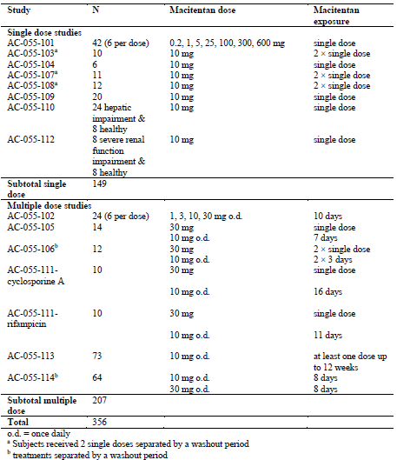

Comments: Overall, the study drug exposure is adequate to assess the safety profile of macitentan.

### Adverse events

#### All adverse events (irrespective of relationship to study treatment)

##### Pivotal study

The percentages of subjects with any AEs were comparable among treatment groups (96.4% [240/249], 96.0% [240/250], and 94.6% [229/242] in the placebo, macitentan 3 mg, and 10 mg groups) (Table 66).

Table 66: Overview of adverse events during treatment period and up to 28 days after treatment discontinuation, All-treated set, Study AC-055-302

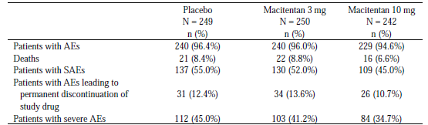

AEs that occurred in ≥3% of subjects in any macitentan group are presented in Table 67**.**

Table 67: Summary of AEs during treatment period and up to 28 days after treatment discontinuation with incidence of at least 3% in any macitentan group, displayed by frequency, All-treated set, Study AC-055-302

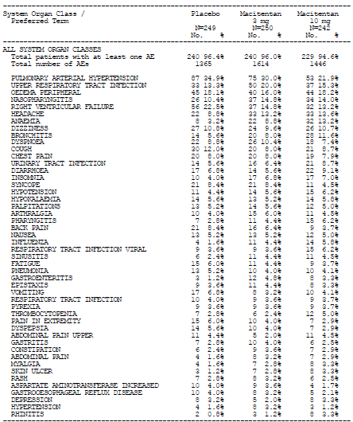

The most commonly reported AEs in the macitentan 3 mg and 10 mg groups were pulmonary arterial hypertension[28] (34.9%, 30.0% and 21.9% in the placebo, macitentan 3 mg, and macitentan 10 mg groups), upper respiratory tract infection (13.3%, 20.0% and 15.3%), and oedema peripheral (18.1%, 16.0% and 18.2%).

##### Other studies

###### Study AC-055-201

The percentages of subjects with any TEAEs were comparable among treatment groups (20.0% to 34.9%) (Table 68). There was no obvious trend of dose-related increased incidence of TEAEs with macitentan. Overall, the most commonly reported TEAE was headache (12.9% [8/62], 19.0% [12/63], 10.6% [7/66], 3.3% [2/61], 8.1% [5/62] and 6.2% [4/65] in the placebo, macitentan 0.3 mg, 1 mg, 3 mg, and 10 mg, and enalapril groups).

Table 68: Summary of TEAEs (including unrelated) occurring from the start up to 14 calendar days after the end of study treatment by frequency, Safety set, Study AC-055-201

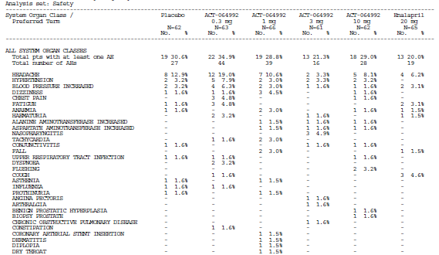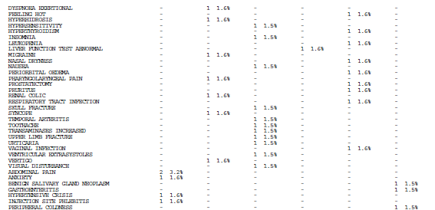Table 68: Summary of TEAEs (including unrelated) occurring from the start up to 14 calendar days after the end of study treatment by frequency, Safety set, Study AC-055-201 cont

###### Study AC-055B201

The percentages of subjects with any AEs were comparable between treatment groups (98.3% [58/59] and 97.5% [116/119] in the placebo and macitentan groups) (Table 69). The most commonly reported AE in the macitentan group was worsening of IPF (25.4% [15/59] and 21.0% [25/119] in the placebo and macitentan groups), and dyspnoea (15.3% [9/59] and 20.2% [24/119]).

Table 69: Summary of AEs occurring during treatment period and up to 28 days after treatment discontinuation with overall incidence of at least 5% by frequency, All-treated set, Study AC-055B201

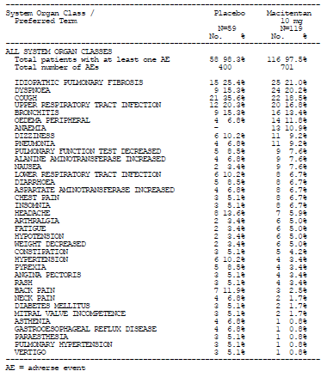

###### Clinical pharmacology studies

Across the 14 completed clinical pharmacology studies conducted in healthy subjects, the most frequently reported AE on macitentan was headache. In the placebo-controlled SAD Study (AC-055-101) and MAD Study (Study AC-055-102), headache was reported for 23.8% (10/42) and 41.7% (10/24) of macitentan-treated subjects, versus 21.4% (3/14) and 37.5% (3/8) of placebo-treated subjects. In the MAD Study, the incidence of headache across the macitentan doses were 50.0% (3/6), 0.0%, 50.0% (3/6) and 66.7% (4/6) for macitentan 1 mg, 3 mg, 10 mg and 30 mg. In the TQT study (Study AC-055-114), headache was reported at incidences of 42.2% (27/64) at the macitentan 30 mg dose, 22.2% (14/63) at the 10 mg dose and 10.9% (7/64) with placebo.

#### Treatment-related adverse events (adverse drug reactions)

##### Pivotal study

The incidences of any treatment-related AEs were comparable among treatment groups (20.1% [50/249], 20.0% [50/250], and 23.1% [56/242] in the placebo, macitentan 3 mg, and 10 mg groups). Treatment-related AEs are presented in Table 70**.** The most commonly reported treatment-related AEs by preferred term in the macitentan 3 mg group were headache (2.8%, 4.0% and 5.0% in the placebo, macitentan 3 mg, and 10 mg groups), followed by oedema peripheral (2.8%, 2.4% and 2.5%). The most commonly reported treatment-related AEs by preferred term in the macitentan 10 mg group were headache, followed by anaemia (0.4%, 1.6% and 3.7%).

Table 70: Summary of patients with treatment-related AEs occurring from treatment start up to 28 days from EOT by SOC and by PT, All-treated Set, Study AC-055-302

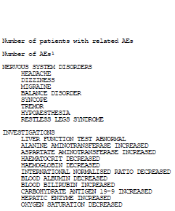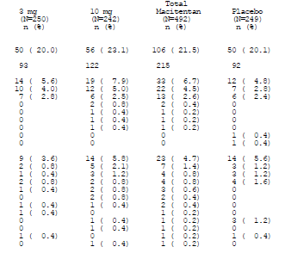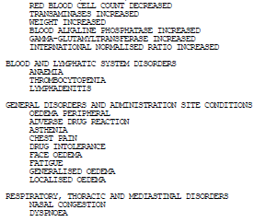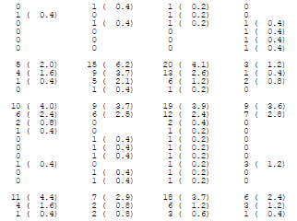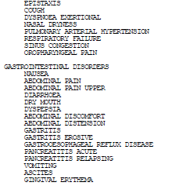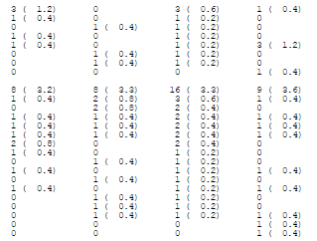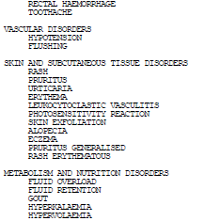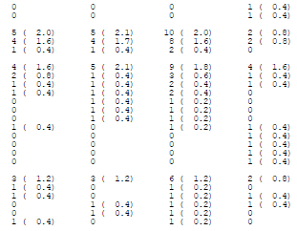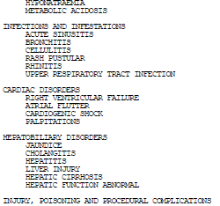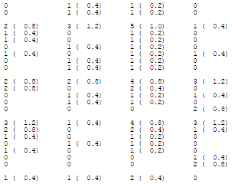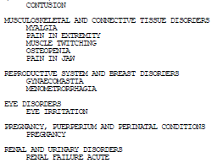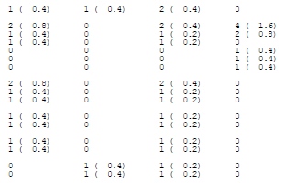Table 70: Summary of patients with treatment-related AEs occurring from treatment start up to 28 days from EOT by SOC and by PT, All-treated Set, Study AC-055-302

##### Other studies

###### Study AC-055-201

The percentages of subjects with any treatment-related TEAEs were 8.1% (5/62), 0.0% (0/63), 10.6% (7/66), 0.0% (0/61), 6.5% (4/62) and 4.6% (3/65) in the placebo, macitentan 0.3 mg, 1 mg, 3 mg, and 10 mg, and enalapril groups (Table 71). There was no obvious trend of dose-related increased incidence of treatment-related TEAEs with macitentan. Overall, the most commonly reported treatment-related TEAE was headache (4.8% [3/62], 0.0% [0/63], 1.5% [1/66], 0.0% [0/61], 1.6% [1/62] and 0.0% [0/65] in the placebo, macitentan 0.3 mg, 1 mg, 3 mg, and 10 mg, and enalapril groups).

Table 71: Summary of treatment-related TEAEs occurring from the start up to 14 calendar days after the end of study treatment by frequency, Study AC-055-201

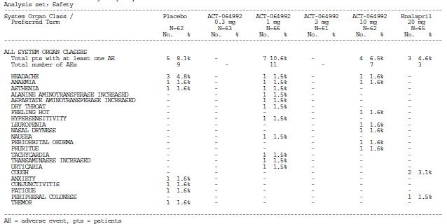

###### Study AC-055B201

The incidences of any treatment-related AEs were comparable between treatment groups (27.1% [16/59] and 30.3% [36/119] in the placebo and macitentan groups). The most commonly reported treatment-related AEs by preferred term in the macitentan group were oedema peripheral (1.7% [1/59] and 5.0% [6/119] in the placebo and macitentan groups), ALT increased (3.4% [2/59] and 4.2% [5/119]) and AST increased (3.4% [2/59] and 4.2% [5/119]).

#### Deaths and other serious adverse events

##### Pivotal study

The incidences of deaths were comparable between the macitentan 3 mg and the placebo groups, but lower in the macitentan 10 mg group (8.4% [21/249], 8.8% [22/250], and 6.6% [16/242] in the placebo, macitentan 3 mg, and 10 mg groups) (Table 72). The most commonly reported cause of death in the macitentan 3 mg group was pulmonary arterial hypertension (1.2%, 2.4% and 0.8% in the placebo, macitentan 3 mg, and 10 mg groups). The most commonly reported cause of death in the macitentan 10 mg group was right ventricular failure (2.4%, 1.6% and 2.5%).

Table 72: Summary of all death cases occurring during treatment period and up to 28 days after treatment discontinuation, All-treated set, Study AC-055-302

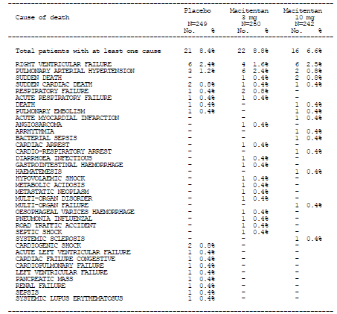

The incidences of SAEs were comparable between the macitentan 3 mg and the placebo groups, but lower in the macitentan 10 mg group (55.0% [137/249], 52.0% [130/250], and 45.0% [109/242] in the placebo, macitentan 3 mg, and 10 mg groups) (Table 73). The most commonly reported SAEs in the macitentan 3 mg and 10 mg groups were pulmonary arterial hypertension (22.5%, 19.2% and 13.2% in the placebo, macitentan 3 mg, and 10 mg groups), and right ventricular failure (16.1%, 8.4% and 9.5%).

Table 73: Summary of SAEs during treatment period and up to 28 days after treatment discontinuation (at least 2 patients in any macitentan group), displayed by frequency, All-treated set, Study AC-055-302

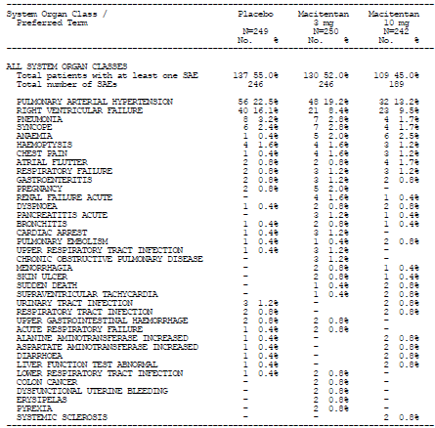

##### Other studies

###### Study AC-055-201

No deaths occurred in this study, including Periods I, II and the 28-day follow-up period. The percentages of subjects with any TESAEs were comparable among treatment groups (1.6% to 4.6%) (Table 74) There was no obvious trend of dose-related increased incidence of TESAEs with macitentan. No TESAE by preferred term were reported by more than one subject each.

Table 74: Summary of TESAEs (including unrelated) occurring from the start up to 14 calendar days after the end of study treatment by frequency, Study AC-055-201

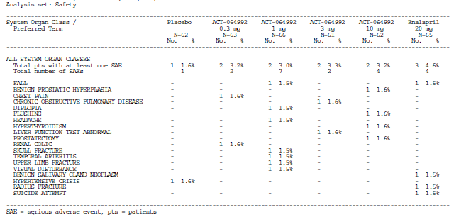

###### Study AC-055B201

The incidences of deaths were comparable between treatment groups (6.8% [4/59] and 7.6% [9/119] in the placebo and macitentan groups) (Table 75). The most commonly reported cause of death in the macitentan group was respiratory failure (1.7% [1/59] and 2.5% [3/119] in the placebo and macitentan groups).

Table 75: Summary of all-cause deaths occurring during treatment period and up to 28 days after treatment discontinuation, All-treated set, Study AC-055B201

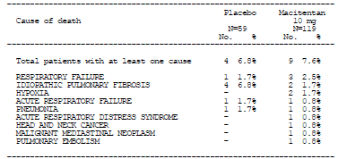

The incidences of SAEs were comparable between treatment groups (33.9% [20/59] and 31.1% [37/119] in the placebo and macitentan groups) (Table 76). The most commonly reported SAEs in the macitentan group were worsening IPF (10.2% [6/59] and 8.4% [10/119] in the placebo and macitentan groups) and pneumonia (3.4% [2/59] and 5.0% [6/119]).

Table 76: Summary of SAEs for at least one patient in the macitentan group, during treatment period and up to 28 days after treatment discontinuation by frequency, All-treated set, Study AC-055B201

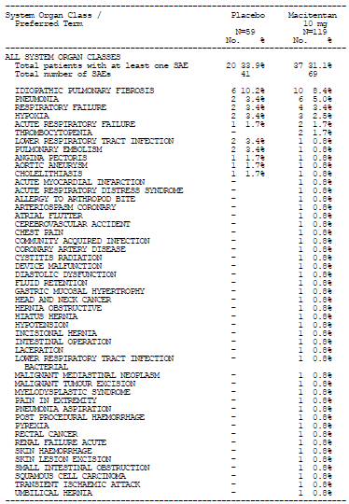

##### Clinical pharmacology studies

No deaths were reported in any of the 14 clinical pharmacology studies. No SAEs were reported during macitentan treatment in these clinical pharmacology studies.

#### Discontinuation due to adverse events

##### Pivotal study

The incidences of AEs leading to permanent discontinuation of study drug were comparable among treatment groups (12.4% [31/249], 13.6% [34/250], and 10.7% [26/242] in the placebo, macitentan 3 mg, and 10 mg groups) (Table 77). The most commonly reported AEs leading to permanent discontinuation of study drug in the macitentan 3 mg and 10 mg groups were pulmonary arterial hypertension (4.0%, 2.4% and 1.7% in the placebo, macitentan 3 mg, and10 mg groups), and right ventricular failure (2.4%, 1.2% and 1.7%).

Table 77: Summary of adverse events (including unrelated) leading to permanent discontinuation of study drug, by frequency, All-treated set, Study AC-055-302

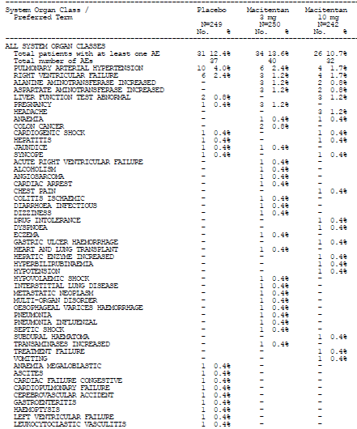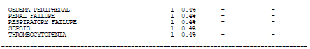

##### Other studies

###### Study AC-055-201

The proportion of subjects with TEAEs leading to study discontinuation was higher in the placebo group (12.9%; 8/62) and the low-dose (0.3 mg and 1 mg) macitentan groups (7.9% [5/63] and 10.6% [7/66]) compared with the macitentan 3 mg and 10 mg, and the enalapril groups (1.6% [1/61], 3.2% [2/62] and 3.1% [2/65]) (Table 78). There was no obvious trend of dose-related increased incidence of TEAEs leading to study discontinuation with macitentan. Overall, the most commonly reported TEAEs leading to study discontinuation were hypertension (3.2% [2/62], 3.2% [2/63], 1.5% [1/66], 0.0% [0/61], 1.6% [1/62] and 0.0% [0/65] in the placebo, macitentan 0.3 mg, 1 mg, 3 mg, and 10 mg, and enalapril groups), and headache (4.8% [3/62], 1.6% [1/63], 1.5% [1/66], 0.0% [0/61], 0.0% [0/62] and 0.0% [0/65]).

Table 78: Summary of adverse events leading to study drug discontinuation during Period II, by frequency, Study AC-055-201

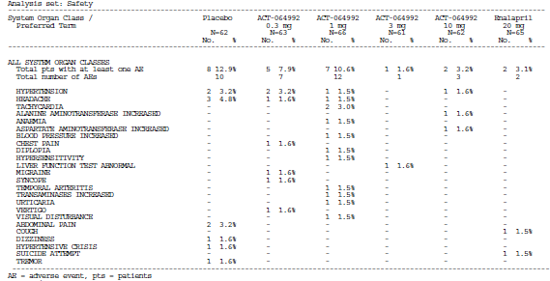

###### Study AC-055B201

The incidences of AEs leading to permanent discontinuation of study drug were comparable between treatment groups (11.9% [7/59] and 12.6% [15/119] in the placebo and macitentan groups) (Table 79). The most commonly reported AE leading to permanent discontinuation of study drug in the macitentan group was worsening IPF (6.8% [4/59] and 4.2% [5/119] in the placebo and macitentan groups).

Table 79: Summary of adverse events leading to permanent discontinuation of study treatment by frequency, All-treated set, Study AC-055B201



##### Clinical pharmacology studies

AEs leading to discontinuation of study treatment were reported in two clinical pharmacology studies: a DDI study with ketoconazole (AC-055-107) and the testicular safety study (AC-055-113). In the DDI study with ketoconazole, one subject discontinued study treatment due to AEs of increased AST, ALT, and GGT which occurred during treatment with ketoconazole (18 days) and 13 days after a single dose of macitentan 10 mg. In the testicular safety study, five subjects (one on macitentan and four on placebo) had teratospermia reported as AEs and were discontinued from the study as per protocol.

### Laboratory tests

#### Liver function

##### Pivotal study

Median change in ALT and AST from baseline up to 28 days after treatment discontinuation was small in all treatment groups (median change from baseline in ALT of -1, -1 and 1 U/L in the macitentan 3 mg, 10 mg and placebo groups median change from baseline in AST of -1, -1 and 1 U/L) (Table 80).

Table 80: Change in ALT and AST from baseline up to 28 days after treatment discontinuation, All-treated set, Study AC-055-302

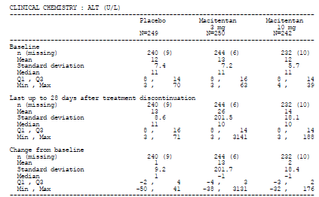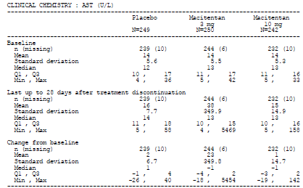

The proportion of subjects with marked elevations in ALT, AST, total bilirubin (defined as values > two times ULN and an increase of at least 50% from baseline) and ALP (defined as values > 190 U/L [normal range defined as 0-100 U/L] and an increase of at least 50% from baseline) in the macitentan groups was comparable with or lower than that in the placebo group (Table 81)**.**

Table 81: Incidence of marked abnormalities in liver function test variables up to 28 days after treatment discontinuation, All-treated set, Study AC-055-302

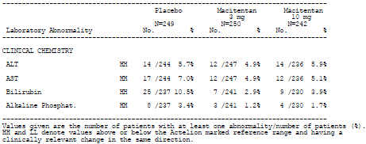

Marked elevations in ALT, AST, and total bilirubin were defined as values > 2 × ULN and an increase of at least 50% from baseline. Marked elevation in ALP was defined as value > 190 U/L (normal range defined as 0-100 U/L) and an increase of at least 50% from baseline.

The proportion of subjects with ALT or AST elevations > three times ULN was comparable between the macitentan groups and the placebo group (3.6% [9/247], 3.4% [8/236] and 4.5% [11/244] in the macitentan 3 mg,10 mg and placebo groups), as was that of subjects with ALT or AST elevations > three times ULN and TBIL > two times ULN, irrespective of temporal relationship (2.1% [5/241], 1.7% [4/230] and 1.7% [4/237]) (Table 82)**.**

Table 82: Incidence of pre-defined treatment-emergent laboratory abnormalities up to 28 days after treatment discontinuation, All-treated set, Study AC-055-302

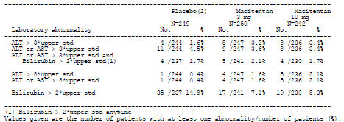

The proportion of subjects who had ALT or AST > eight times ULN was higher in the macitentan groups compared to the placebo group (1.6% [4/247], 2.1% [5/236] and 0.4% [1/244] in the macitentan 3 mg,10 mg and placebo groups). However the low incidence of these abnormal laboratory values make interpretation difficult.

Kaplan-Meier analyses for occurrence of ALT or AST elevation > three times ULN showed that the hazard ratio versus placebo for the occurrence of an ALT or AST elevation > three times ULN was 0.720 (95% CLs: 0.298, 1.738) for macitentan 3 mg and 0.635 (95% CLs: 0.255, 1.583) for macitentan 10 mg.

In the macitentan 3 mg and placebo groups, all occurrences of ALT or AST elevation > three times ULN normalised (that is, returned to within their respective reference ranges) after treatment discontinuation by a median time of 9.0 and 18.0 days (Table 83). In the macitentan 10 mg group, the abnormal values normalised for five out of the eight subjects. Two of the remaining three subjects died due to right ventricular failure and hence normalisation of the values could not be established, while the third subject had values that were slightly above normal range (ALT: 1.2 times ULN; AST: 1.3 times ULN) at EOT.

Table 83: Recovery of abnormal liver tests (ALT/AST > 3 × ULN), All-treated set, Study AC-055-302

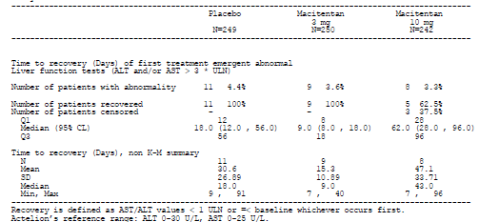

##### Other studies

###### Study AC-055-201

Median and mean changes in ALT and AST from baseline up to end of treatment plus 28 days were small in all treatment groups (median change from baseline in ALT of -1 to 0 U/L across the treatment groups; median change from baseline in AST of -1 to1 U/L) (Table 84).

Table 84: Change in ALT and AST from baseline up to end of treatment plus 28 days, Safety set, Study AC-055-201

(i) ALT

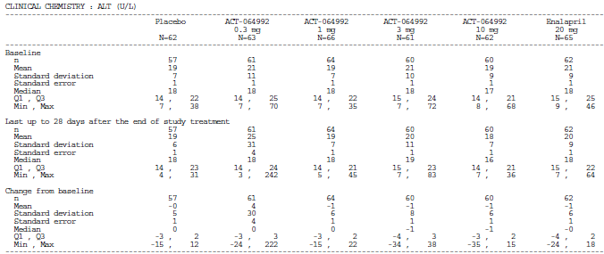

(ii) AST

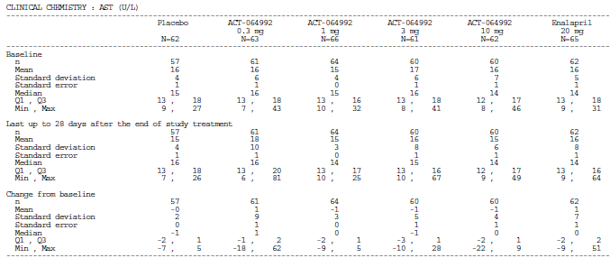

The proportion of subjects with marked elevations in ALT and AST (defined as values > two times ULN and an increase of at least 50% from baseline) were low and comparable across treatment groups (Table 85).

Table 85: Incidence of marked elevations in ALT and AST up to 28 days after the end of study treatment, Safety Set, Study AC-055-201

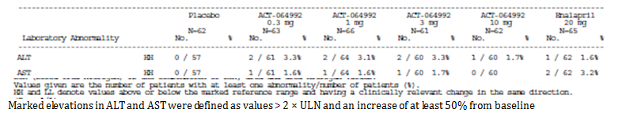

The proportion of subjects with ALT or AST elevation > three times ULN up to 28 days after the end of study treatment was also low across treatment groups, but was noted to occur only in the macitentan groups (1, 2, 1 and 1 subject in the macitentan 0.3 mg, 1 mg, 3 mg and 10 mg groups) (Table 86). As previously described, these five cases were unblinded during the course of the study and led to premature termination of the study.

Table 86: Incidence of special marked ALT and AST abnormalities up to 28 days after the end of study treatment, Safety Set, Study AC-055-201

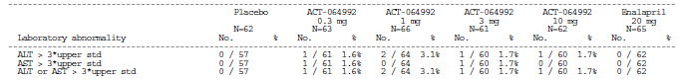

The sponsor performed additional post-hoc analysis of increased ALT or AST laboratory values above the upper limit of normal (that is, > one times ULN) in subjects with normal values at baseline (that is, ≤ one times ULN) in order to detect any trends associated with study drug. Results suggested that there could be a dose-dependent association with elevations in ALT or AST with the use of macitentan (relative risk versus placebo of having ALT or AST > one times ULN with both ALT and AST ≤ one times ULN at baseline was 1.43, 1.79, 2.69 and 2.69 for macitentan 0.3 mg, 1 mg, 3 mg and 10 mg, compared to 0.94 for enalapril 20 mg) (Figure 26).

Figure 26: Incidence of special laboratory abnormalities up to 28 days after the end of study treatment, Safety Set, Study AC-055-201

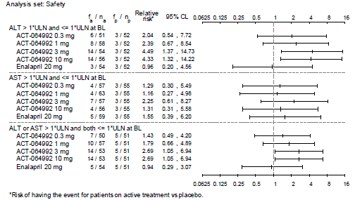

###### Study AC-055B201

Median and mean changes in ALT and AST from baseline up to 28 days after treatment discontinuation were small in both treatment groups (median change from baseline in ALT and in AST of -1 to 0 U/L across the treatment groups) (Table 87).

Table 87: Change in ALT and AST from baseline up to 28 days after treatment discontinuation, All-treated set, Study AC-055B201

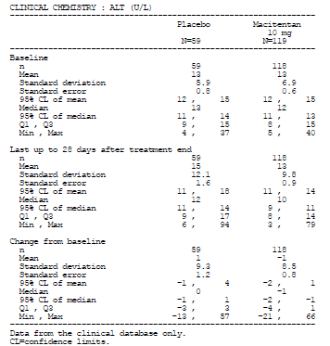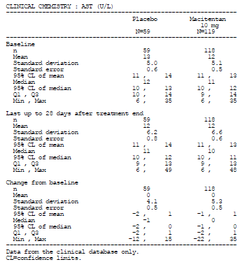

The proportion of subjects with marked elevations in ALT and AST (defined as values > two times ULN and an increase of at least 50% from baseline) was low in both treatment groups, but higher in the macitentan group compared to the placebo group (ALT: 5.9% [7/118] with macitentan versus 3.4% [2/59] with placebo; AST: 3.4% [4/118] versus 1.7% [1/59]) (Table 88).

Table 88: Incidence of marked abnormalities in ALT and AST during treatment period and up to 28 days after treatment discontinuation, All-treated set, Study AC-055B201

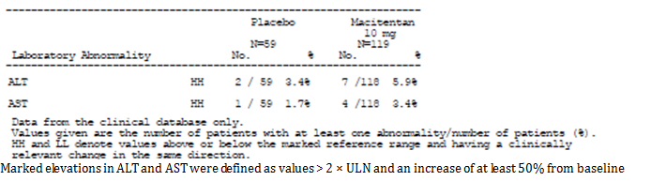

The proportion of subjects with ALT or AST elevation > three times ULN up to 28 days after the end of study treatment was low and comparable between the treatment groups (3.4% [4/118] and 5.1% [3/59] in the macitentan and placebo groups) (Table 89).

Table 89: Incidence of pre-defined treatment-emergent laboratory abnormalities up to 28 days after treatment discontinuation, All-treated set, Study AC-055B201

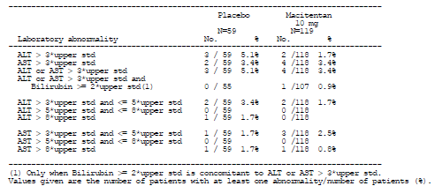

The Kaplan-Meier estimates for the event rate of elevations in ALT or AST > three times ULN at Months 4 and 8 were 1.7% in the macitentan group versus 0% in the placebo group, and at Month 12 was 2.7% versus 0%. However, at Month 16, the estimate was 3.7% in the macitentan group versus 7.0% in the placebo group, and remained the same at Months 20, 24 and 28 (Figure 27).

Figure 27: Time to first appearance of ALT or AST > 3× ULN up to 28 days after treatment discontinuation, including ARGUS cases, All-treated set, Study AC-055B201

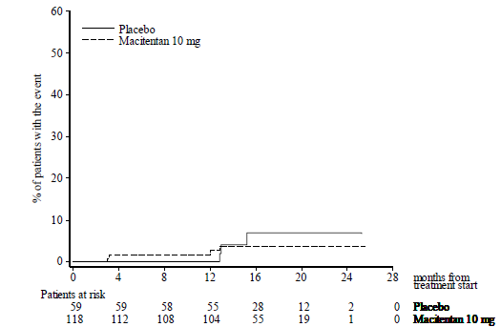

##### Clinical pharmacology studies

In clinical pharmacology studies in healthy subjects, there were three cases of asymptomatic increases in liver aminotransferases (ALT and/or AST) to > three times ULN, one each in Studies AC-055-102 (MAD study), AC-055-106 (DDI study with sildenafil) and AC-055-107 (DDI study with ketoconazole). In Study AC-055-102, one subject treated with macitentan 30 mg had an increase in ALT to 3.1 times ULN. The elevations resolved spontaneously within two weeks. In Study AC-055-106, one subject with elevated liver transaminases > three times ULN, was observed, and was reported as an AE. This subject was treated with macitentan + sildenafil in Period 1 and macitentan alone in Period 2. The elevated liver transaminases > three times ULN (AST of 4.5 times ULN and ALT of 1.6 times ULN) was observed pre-treatment in the 3rd Period (sildenafil alone), occurring within 28 days of first administration of macitentan and 10 days after the last administration of macitentan. It was judged to be likely due to administration of macitentan. The event improved within two weeks after observation. In Study AC-055-107, one subject had increases in AST (1.6 times ULN), ALT (4.0 times ULN) and GGT (2.7 times ULN) during treatment with ketoconazole (18 days) and 13 days after a single dose of macitentan 10 mg. These were reported as AEs and resulted in discontinuation of study treatment. The AEs resolved without sequelae.

In addition, in Study AC-055-110 (conducted in subjects with hepatic impairment), one subject with mild impairment of hepatic function (baseline ALT 4.1 times ULN, AST 3.9 times ULN and GGT 1.9 times ULN) had clinically significant increases in ALT (8.1 times ULN), AST (7.3 times ULN) and GGT (3.3 times ULN) at EOS. The increases in liver enzymes were reported as AEs and were considered by the investigator to be study drug-related.

#### Kidney function and other clinical chemistry

##### Pivotal study

The proportion of subjects with marked abnormalities in serum creatinine, sodium and potassium levels was low and comparable across all treatment groups (Table 90)**.** Evaluation of other clinical chemistry variables and changes from baseline did not trigger any safety concerns.

Table 90: Incidence of marked laboratory clinical chemistry abnormalities during treatment period and up to 28 days after treatment discontinuation (combined central and local laboratory data), All-treated set, Study AC-055-302

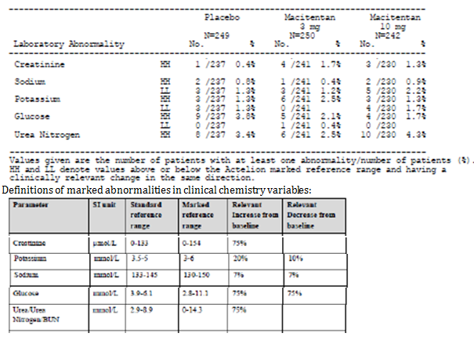

##### Other studies

###### Study AC-055-201

No subject in any treatment groups had marked elevation of serum creatinine (defined as values > 154 μmol/L and an increase of at least 75% from baseline). Evaluation of other clinical chemistry variables did not trigger any safety concerns.

###### Study AC-055B201

No subject in either treatment groups had marked elevation of serum creatinine (defined as values > 154 μmol/L and an increase of at least 75% from baseline). Evaluation of other clinical chemistry variables did not trigger any safety concerns.

##### Clinical pharmacology studies

Evaluation of creatinine and other clinical chemistry variables in the clinical pharmacology studies did not trigger any safety concerns.

#### Haematology

##### Pivotal study

The mean change in haemoglobin from baseline by visit is presented in Figure 28 and showed that decreases in haemoglobin in the macitentan groups occurred within the first three months of starting study treatment, reached a minimum at around Month 3, and thereafter stabilised.

Figure 28: Mean change in haemoglobin from baseline by visit (observed data), All-treated set, Study AC-055-302

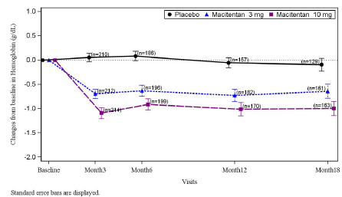

Mean (SD) change in haemoglobin from baseline up to EOT + 28 days was -0.7 (2.02) and -1.1 (2.21) g/dL in the macitentan 3 mg and 10 mg groups, compared to -0.1 (1.67) g/dL in the placebo group (Table 91).

Table 91: Change in haemoglobin from baseline up to 28 days after treatment discontinuation, All-treated set, Study AC-055-302

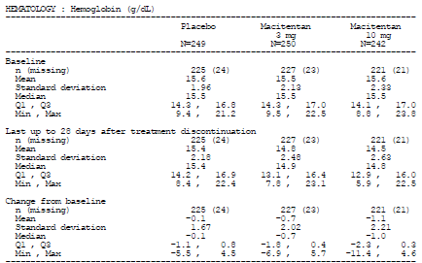

A repeated measures analysis for the change in haemoglobin values from baseline showed the lack of a statistically significant treatment by visit interaction (p = 0.6973), suggesting that the magnitude of the treatment effect of macitentan (versus placebo) did not vary over time up to Month 12. The estimated treatment effect over 12 months compared to placebo was –0.71 g/dL (95% CLs: –0.95, –0.48) (p < 0.0001) for macitentan 3 mg and –1.07 g/dL (95% CLs: –1.31, –0.84) (p < 0.0001) for macitentan 10 mg.

The proportion of subjects with marked haemoglobin decreases (defined as haemoglobin < 11 g/dL and a decrease of at least 15% from baseline) was higher in the macitentan groups (7.9% [19/241] and 13.9% [32/230] in the macitentan 3 mg and10 mg groups) than in the placebo group (3.8% [9/237]) (Table 92).

Table 92: Incidence of marked haematology abnormalities up to 28 days after treatment discontinuation, All-treated set, Study AC-055-302

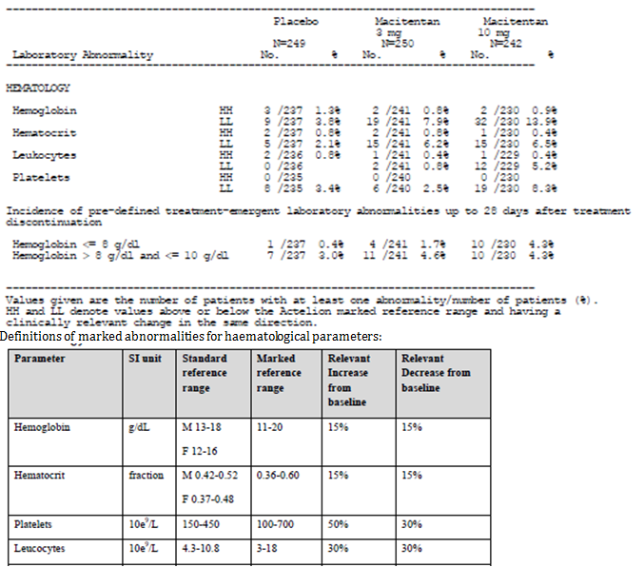

The proportion of subjects with decreases in haemoglobin values to between > 8 g/dL and ≤10 g/dL at some point during the study period up to 28 days after treatment discontinuation was also higher in the macitentan groups (4.6% [11/241] and 4.3% [10/230] in the macitentan 3 mg and10 mg groups) than in the placebo group (3.0% [7/237]), as was the proportion of subjects with decreases in haemoglobin values to ≤ 8 g/dL (1.7% [4/241] and 4.3% [10/230] in the macitentan 3 mg and10 mg groups compared with 0.4% [1/237] in the placebo group.

Mean decrease in haematocrit from baseline was small in all treatment groups (mean [SD] change from baseline of -0.02 [0.046], -0.03 [0.050] and 0.00 [0.042] in the macitentan 3 mg,10 mg and placebo groups), although the proportion of subjects with marked decreases in haematocrit (defined as haematocrit < 0.36 and a decrease of at least 15% from baseline) was higher in the macitentan groups (6.2% [15/241] and 6.5% [15/230] in the macitentan 3 mg and10 mg groups) than in the placebo group (2.1% [5/237]) (Table 92).

Mean decrease in leukocytes and in platelets from baseline was small in all treatment groups (mean [SD] change from baseline in leucocytes of -0.9 [2.78], -0.7 [2.27] and 0.0 [2.57] x 109/L in the macitentan 3 mg, 10 mg and placebo groups; mean [SD] change from baseline in platelets of -16 [50.7], -17 [57.4] and -11 [52.2] x 109/L). The proportion of subjects with marked decreases in leucocytes and in platelet counts were comparable between the macitentan 3 mg and placebo groups, but higher in the macitentan 10 mg group compared to placebo. Marked decreases in leukocytes (defined as values < 3 × 109/L and a decrease of at least 30% from baseline) were reported for 0.8% (2/241) and 5.2% (12/229) of subjects in the macitentan 3 mg and 10 mg groups compared with 0.0% in the placebo group. Marked decreases in platelet counts (defined as values < 100 × 109/L and a decrease of at least 30% from baseline) were reported for 2.5% (6/240) and 8.3% (19/230) of subjects in the macitentan 3 mg and 10 mg groups compared with 3.4% (8/235) in the placebo group.

##### Other studies

###### Study AC-055-201

Mean changes in haemoglobin from baseline up to end of treatment plus 28 days were small and comparable across treatment groups (-0.3 to 0.0 g/dL across treatment groups) (Table 93).

Table 93: Mean (SD) change in haemoglobin from baseline, Safety Set, Study AC-055-201

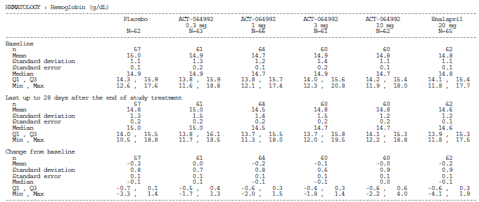

Analysis of mean changes in haemoglobin from baseline over time showed a possible dose-related decrease in haemoglobin from baseline with macitentan until Week 8, with haemoglobin values returning towards baseline level and to values comparable to those of the placebo group by Week 10 (Figure 29).

Figure 29: Laboratory time course - up to 10 weeks: Haemoglobin; Study AC-055-201

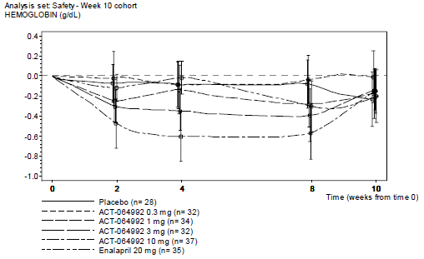

There was only one subject in the study (in placebo group) who had marked decrease in haemoglobin (defined as haemoglobin concentration < 11 g/dL and a decrease of at least 15% from baseline); no subjects in the macitentan group had marked decrease in haemoglobin. Evaluation of other haematological variables did not trigger any safety concerns.

###### Study AC-055B201

Mean changes in haemoglobin from baseline up to 28 days after treatment discontinuation were small in both treatment groups (mean [SD] change from baseline of -0.7 [1.15] with macitentan versus -0.2 [0.91] g/dL with placebo) (Table 94).

Table 94: Change in haemoglobin from baseline up to 28 days after treatment discontinuation, All-treated set, Study AC-055B201

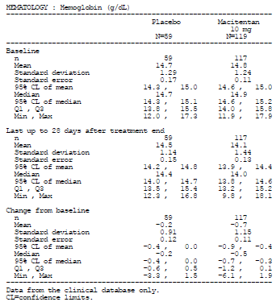

Analysis of mean changes in haemoglobin from baseline over time showed that decreases in haemoglobin in the macitentan group occurred within the first four months of starting study treatment, and thereafter stabilised (Figure 30).

Figure 30: Haemoglobin: change from baseline to the specified timepoints by cohorts (mean ± 95% CL), Month 12/Week 48 cohort, All-treated set, Study AC-055B201

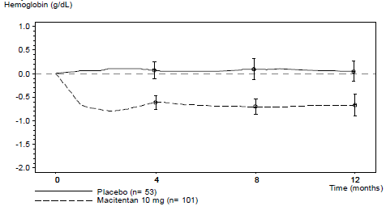

The proportion of subjects with marked haemoglobin decreases (defined as haemoglobin < 11 g/dL and a decrease of at least 15% from baseline) was higher in the macitentan group (5.9%; 7/118) than in the placebo group (1.7%; 1/59). The one subject in the placebo group with marked haemoglobin decrease had haemoglobin levels remaining above 10 g/dL. All seven subjects in the macitentan group with marked haemoglobin decrease had decreases in haemoglobin levels to a value of ≤ 10 g/dL at some point up to 28 days after treatment discontinuation, although none had decreases down to ≤ 8 g/dL. In five of these seven subjects, an AE of anaemia was concurrently reported. Haemoglobin values returned to the levels measured at baseline by EOT/EOS for all but two subjects, one of whom died due to pulmonary embolism. The remaining subject had a minimum haemoglobin value during the study of 9.8 g/dL, which increased to 11.4 g/dL 31 days after EOT/EOS. Evaluation of other haematological variables did not trigger any safety concerns.

##### Clinical pharmacology studies

Evaluation of haematological variables in the clinical pharmacology studies did not trigger any safety concerns.

#### Vital signs

##### Pivotal study

Mean changes in vital signs (SBP, DBP, pulse rate and body weight) from baseline up to 28 days after treatment discontinuation were small and generally comparable across treatment groups (Table 95).

Table 95: Systolic and diastolic blood pressures, pulse rate and body weight: change from baseline up to 28 days after treatment discontinuation, condensed version, All-treated set, Study AC-055-302

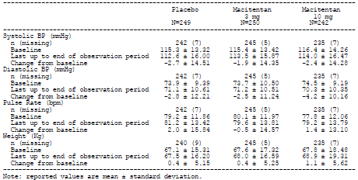

Repeated measures analysis of the change from baseline in DBP showed that the estimated treatment effect over 12 months compared to placebo was –0.46 mmHg (95% CLs: –1.71, 0.79) (p = 0.4698) for macitentan 3 mg and –0.64 mmHg (95% CLs: –1.90, 0.62) (p = 0.3206) for macitentan 10 mg (Table 96).

Table 96: Repeated measures analysis of the change from baseline in diastolic blood pressures (mmHg), All-treated set, Study AC-055-302

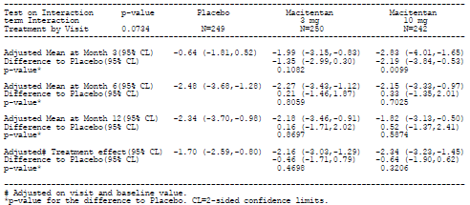

Repeated measures analysis of the change from baseline in SBP showed that the estimated treatment effect over 12 months compared to placebo was 0.16 mmHg (95% CLs: –1.62 , 1.93) (p = 0.8637) for macitentan 3 mg and 0.10 mmHg (95% CLs: –1.69, 1.89) (p = 0.9138) for macitentan 10 mg (Table 97).

Table 97: Repeated measures analysis of the change from baseline in systolic blood pressures (mmHg), All-treated set, Study AC-055-302

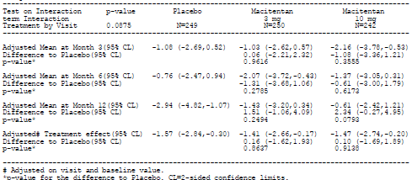

##### Other studies

###### Study AC-055-201

Mean changes in vital signs (SBP, DBP, pulse rate and body weight) from baseline up to 28 days after the end of study treatment were generally comparable across treatment groups (Table 98)**.** There was no obvious trend of dose-dependent changes in vital signs with macitentan.

Table 98: Change from baseline up to 28 days after the end of study treatment in vital signs, Safety set, Study AC-055-201

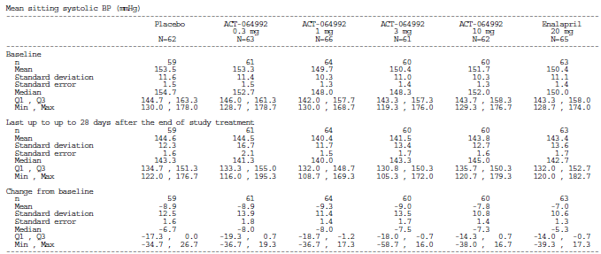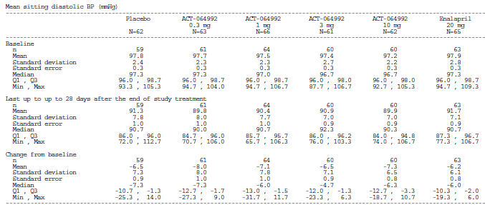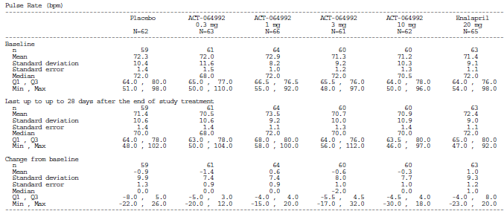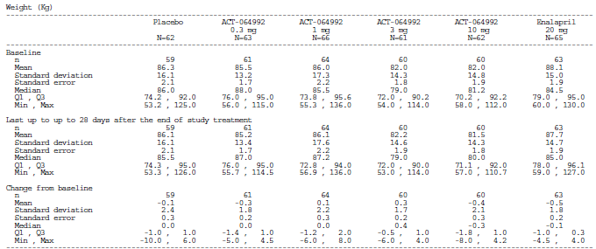

###### Study AC-055B201

Mean changes in vital signs (SBP, DBP, pulse rate and body weight) from baseline to the last value up to 28 days after treatment discontinuation were small in both treatment groups (Table 99)**.** Mean (SD) change from baseline in SBP was -8 (18.5) mmHg in the macitentan group, compared with 0 (15.0) mmHg in the placebo group. Mean (SD) change from baseline in DBP was -6 (10.9) mmHg in the macitentan group, compared with -2 (10.3) mmHg in the placebo group.

Table 99: Vital signs: mean change from baseline to the last value up to 28 days after treatment discontinuation, All-treated set, Study AC-055B201

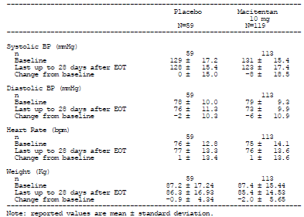

#### Clinical pharmacology studies

Evaluation of vital signs in the clinical pharmacology studies did not trigger any safety concerns.

#### Electrocardiograph

##### Pivotal study

Analyses of the mean changes from baseline in the ECG variables did not raise any particular safety concerns (Table 100)**.**

Table 100: ECG variables: change from baseline up to 28 days after treatment discontinuation, All-treated set, Study AC-055-302

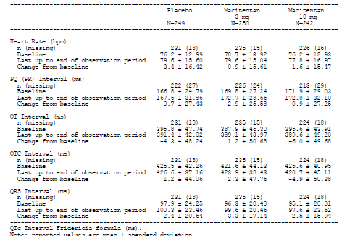

The post-hoc analysis of the proportion of subjects with QTcF prolongation (maximum QTcF of > 450 ms, > 480 ms or > 500 ms; maximum increase from baseline of > 30 ms or > 60 ms) showed results that were generally comparable across the treatment groups (Table 101).

Table 101: Incidence of QTc prolongations (Fridericia’s formula) up to 28 days after treatment discontinuation, All-treated set, Study AC-055-302

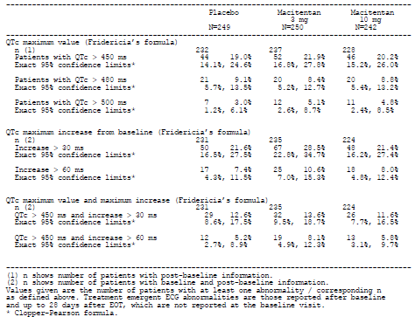

The overall proportion of subjects with treatment-emergent ECG abnormalities was comparable among treatment groups (55.2% [138/250], 45.0% [109/242] and 13.8% [134/249] in the macitentan 3 mg, 10 mg group, and placebo groups (Table 102).

Table 102: Summary of treatment-emergent ECG abnormalities by frequency, All-treated set, Study AC-055-302

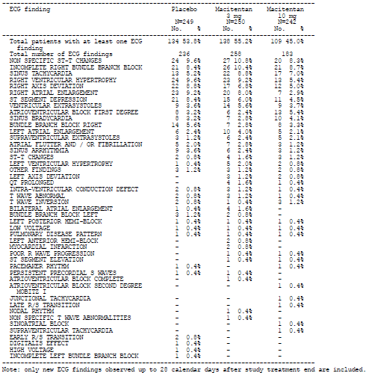

The most commonly reported ECG abnormalities in the macitentan groups were non-specific ST-T changes (10.8% [27/250], 8.3% [20/242] and 9.6% [24/249] in the macitentan 3 mg , 10 mg group, and placebo groups), and incomplete right bundle branch block (10.4% [26/250], 8,7% [21/242] and 8.4% [21/249]). No subjects discontinued study treatment as a result of ECG abnormalities.

##### Other studies

###### Study AC-055-201

Analyses of the mean changes from baseline in the ECG variables did not raise any particular safety concerns. Analysis of the incidence of treatment-emergent ECG abnormalities did not reveal any trend of dose-dependent increased incidence of ECG abnormalities with macitentan (Table 103).

Table 103: Summary of treatment-emergent ECG findings, Safety set, Study AC-055-201

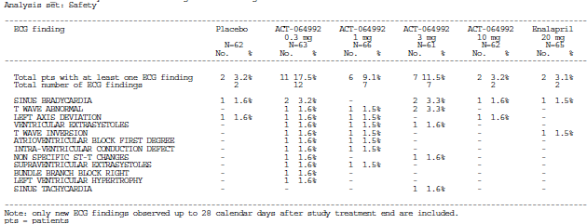

###### Study AC-055B201

Analyses of the mean changes from baseline in the ECG variables did not raise any particular safety concerns. Analysis of the incidence of treatment-emergent ECG abnormalities showed that the proportion of subjects with treatment-emergent ECG abnormalities was comparable between the 2 treatment groups (35.3% [42/119] with macitentan versus 40.7% [24/59] with placebo) (Table 104)**.** The most commonly reported ECG abnormality in both groups was bradycardia (12.6% [15/119] with macitentan versus 10.2% [6/59] with placebo).

Table 104: Summary of treatment-emergent ECG abnormalities by frequency, All-treated set, Study AC-055B201

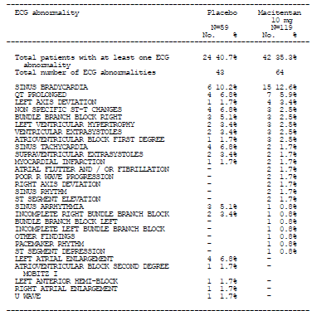

##### Clinical pharmacology studies

Evaluation of ECG variables in the clinical pharmacology studies did not trigger any safety concerns.

###### Study AC-055-114 (thorough QT study)

Results of this study yielded a negative Thorough QT (TQT) study. In this TQT study, the primary endpoint was the baseline-adjusted, placebo-corrected QTcF (ΔΔQTcF) at each time point on Day 8.

The analysis of variance (ANOVA) of the ∆∆QTcF showed that the upper bound of the 90% two sided CI was below 10ms at each time point of assessment for both macitentan 10 and 30 mg (maximum least square mean [LSM] estimates of ΔΔQTcF of 7.6 and 7.3 ms with macitentan 10 and 30 mg). Similar findings were observed for arithmetic mean ∆∆ QTcF values and their 90% CI for both doses of macitentan, showing all values below the 10ms threshold. The lower bounds of the 90% 2-sided CIs of the LSM estimates of QTcF after administration of 400 mg moxifloxacin (positive control) on Day 8 were always > 5ms thus demonstrating assay sensitivity.

The categorical analyses of QT interval showed no prolongations > 500 ms or changes from baseline > 60 ms. Single occurrences of QT prolongation > 450 ms and changes from baseline > 30 ms were randomly distributed across all treatment groups, including placebo. In addition, no PK/ΔΔQTcF relationship was found in the PK/PD relationship analyses, which showed that the relationships between plasma concentrations, Cmax, and AUCτ of macitentan or its metabolite (ACT-132577) and ∆∆QTcF were characterised by a near zero linear regression slope.

#### Sperm concentration

##### Study AC-055-113

This testicular safety study was conducted as, according to the sponsor, nonclinical studies showed that macitentan and other ERAs had effects on the histology and function of the testis in animals. In this testicular safety study conducted in healthy male subjects, an error in treatment allocation affected the robustness of the study results and hence all analyses results in this study were considered exploratory in nature. Analysis of the change in sperm concentration from baseline to Week 12 between subjects who received only macitentan (10 mg once daily; n = 14) and those who received only placebo (n = 11) during the 12-week treatment period, yielded a geometric mean ratio (macitentan versus placebo) of 0.724 (90% CI: 0.47, 1.12; p= 0.2173), corresponding to a 28% mean reduction in sperm concentration with macitentan. According to the sponsor, the acceptable mean reduction range for no clinically relevant treatment effect was 30%. The associated lower 90% CI of 0.47 suggested that a greater than 50% reduction in sperm concentration from baseline was unlikely. The sponsor had not indicated any references to support the clinical relevance threshold of 30% reduction in sperm concentration. This will be brought up as a clinical question.

At the 12-week follow-up visit, the arithmetic mean change from baseline in sperm concentration was similar for subjects who received only macitentan and those who received only placebo during the 12-week treatment period (mean [SD] change from baseline of −5.6 [31.3] and −5.5 [21.2] × 106/mL).

#### Pregnancies

##### Pivotal study

A total of seven pregnancies (five on macitentan 3 mg, two on placebo) occurred during the study. Of the five subjects in the macitentan 3 mg group, one had a therapeutic abortion and one had a spontaneous abortion, which was assessed by the investigator as unrelated to study treatment. Both subjects subsequently restarted macitentan treatment. Another subject had an abortion scheduled, but died due to worsening of PAH before the scheduled date. The remaining two macitentan-treated subjects permanently discontinued treatment and continued the pregnancy. Both women gave birth prematurely, one at 32 weeks’ gestation and the other at 24 weeks’ gestation. One of the babies (born at 32 weeks) had no neonatal abnormalities. The other baby died three days after birth from persistent hypotension due to extreme prematurity. No obvious dysmorphism was noted and the prenatal screening at Week 18 had shown no anomaly. The death was reported as unrelated to study treatment. Both placebo-treated subjects had therapeutic abortions. One subject subsequently restarted study treatment and the other permanently discontinued treatment.

The sponsor did not report any no other incidences of pregnancies in the other completed clinical studies in the clinical development program of macitentan in this submission.

#### AEs of special interest

##### Pivotal study

Adverse events of special interest are summarised in Table 105)**.**

Table 105: Adverse events of special interest up to EOT + 28 days, All-treated set, Study AC-055-302

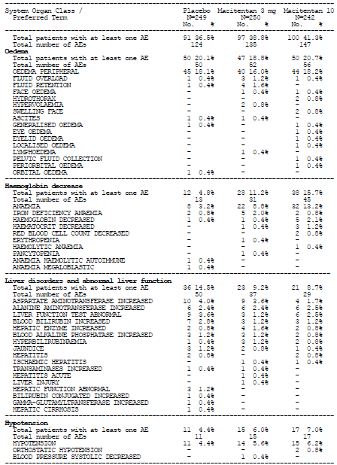

The relative risk of occurrence of AEs of special interest (macitentan versus placebo) is presented in Figure 31.

Figure 31: Graphical display for incidence of AEs of special interest- relative risk and 95% CLs, All-treated set, Study AC-055-302

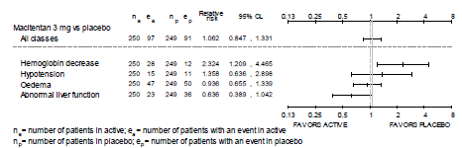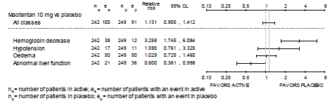

The incidence of oedema-related AEs was comparable between the macitentan groups and the placebo group (20.1% [50/249], 18.8% [47/250], and 20.7% [50/242] in the placebo, macitentan 3 mg, and 10 mg groups). The observed risk of occurrence of oedema-related AEs was comparable between the macitentan groups and the placebo group (relative risk ratio of 0.936 for macitentan 3 mg versus placebo, and 1.029 for macitentan 10 mg versus placebo). The hazard ratio versus placebo for the occurrence of the first oedema-related AEs was 0.846 (95% CLs: 0.568, 1.260) for macitentan 3 mg and 0.929 (95% CLs: 0.627, 1.375) for macitentan 10 mg. Subgroup analyses showed that across the pre-defined subgroups of sex, race, PAH therapy at baseline, PAH aetiology, and geographical region, the risk of occurrence of an oedema-related AE was generally consistent with that in the total population (Figure 32).

Figure 32: Graphical display for the first edema-related adverse event – hazard ratio and 95% CLs, All-treated set, Study AC-055-302

(i) Macitentan 3mg vs. placebo

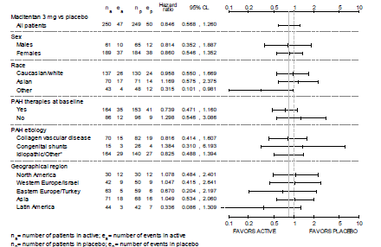

(ii) Macitentan 10mg vs. placebo

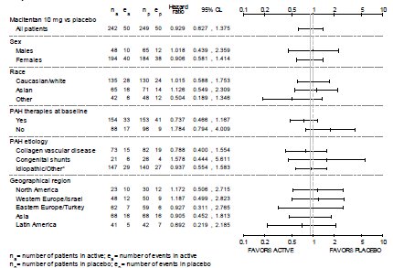

The incidence of AEs associated with decreased haemoglobin was higher in the macitentan groups (11.2% [28/250] and 15.7% [38/242] in the macitentan 3 mg and10 mg groups) than in the placebo group (4.8% [12/249]). The observed risk of occurrence of decreased haemoglobin -related AEs was higher in the macitentan groups compared to the placebo group (relative risk ratio of 2.324 for macitentan 3 mg versus placebo, and 3.258 for macitentan 10 mg versus placebo). The hazard ratio versus placebo for the occurrence of the first haemoglobin decrease-related AE was 2.112 (95% CLs: 1.074, 4.154) for macitentan 3 mg and 2.865 (95% CLs: 1.496, 5.486) for macitentan 10 mg. Subgroup analyses showed that across the pre-defined subgroups of sex, race, PAH therapy at baseline, PAH aetiology, and geographical region, the risk of occurrence of an haemoglobin decrease-related AE was generally consistent with that in the total population (Figure 33).

Figure 33: Graphical display for the first hemoglobin decrease-related adverse event – hazard ratio and 95% CLs, subgroup analyses, All-treated set, Study AC-055-302

(i) Macitentan 3mg vs. placebo

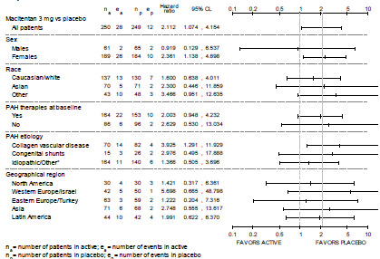

(ii) Macitentan 10mg vs. placebo

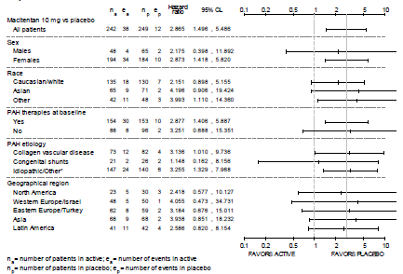

The incidence of hypotension-related AEs was higher in the macitentan groups (6.0% [15/250] and 7.0% [17/242] in the macitentan 3 mg and10 mg groups) than in the placebo group (4.4% [11/249]). The observed risk of occurrence of hypotension-related AEs was higher in the macitentan groups compared to the placebo group (relative risk ratio of 1.358 for macitentan 3 mg versus placebo, and 1.590 for macitentan 10 mg versus placebo). The hazard ratio versus placebo for the occurrence of the first hypotension-related AE was 1.255 (95% CLs: 0.576, 2.733) for macitentan 3 mg and 1.452 (95% CLs: 0.679, 3.102) for macitentan 10 mg. Subgroup analyses showed that across the pre-defined subgroups of sex, race, PAH therapy at baseline, PAH aetiology, and geographical region, the risk of occurrence of an hypotension-related AE was generally consistent with that in the total population (Figure 34).

Figure 34: Graphical display for the first hypotension adverse event – hazard ratio and 95% CLs, subgroup analyses, All-treated set, Study AC-055-302

(i) Macitentan 3mg vs. placebo

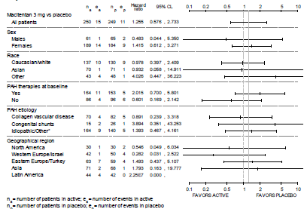

(ii) Macitentan 10mg vs. placebo

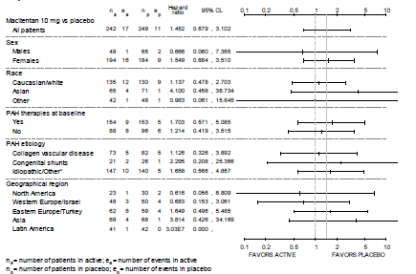

The incidence of AEs of liver disorders and abnormal liver function was lower in the macitentan groups (9.2% [23/250] and 8.7% [21/242] in the macitentan 3 mg and10 mg groups) compared to the placebo group (14.5% [36/249]). The observed risk of occurrence of AEs associated with liver disorders and abnormal liver function was lower in the macitentan groups compared to the placebo group (relative risk ratio of 0.636 for macitentan 3 mg versus placebo, and 0.600 for macitentan 10 mg versus placebo). The hazard ratio versus placebo for the occurrence of the first abnormal liver function-related AE was 0.546 (95% CLs: 0.323, 0.921) for the macitentan 3 mg group and 0.484 (95% CLs: 0.282, 0.830) for the macitentan 10 mg group. Subgroup analyses showed that across the pre-defined subgroups of sex, race, PAH therapy at baseline, PAH aetiology, and geographical region, the risk of occurrence of AEs of liver disorders and abnormal liver function was generally consistent with that in the total population (Figure 35).

Figure 35: Graphical display for the first abnormal liver function-related adverse event – hazard ratio and 95% CLs, subgroup analyses, All-treated set, Study AC-055-302

(i) Macitentan 3mg vs. placebo

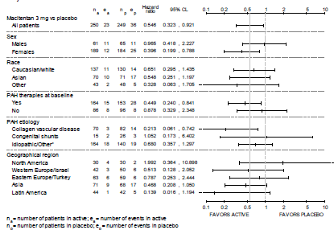

(ii) Macitentan 10mg vs. placebo

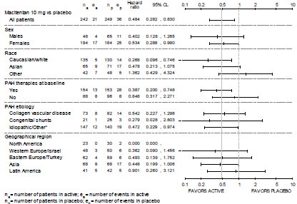

### Post-marketing experience

Not applicable.

### Safety issues with the potential for major regulatory impact

#### Liver toxicity

Increases in liver transaminases are known adverse drug reactions associated with ERAs such as bosentan and ambrisentan. Evaluation of liver transaminases in the dose-finding study for macitentan (Study AC-055-201; conducted in subjects with essential hypertension) showed that although the proportion of subjects with ALT or AST elevations > three times ULN up to 28 days after the end of study treatment was low across treatment groups, they occurred only in the macitentan groups (1, 2, 1 and 1 subject in the macitentan 0.3 mg, 1 mg, 3 mg and 10 mg groups), and not in the placebo or enalapril groups. Additional post-hoc analysis of increased ALT or AST laboratory values above the upper limit of normal (that is, > one times ULN) in subjects with normal values at baseline yielded results suggesting that there could be a dose-dependent association with elevations in ALT or AST with the use of macitentan (relative risk versus placebo of having ALT or AST > one times ULN with both ALT and AST ≤ one times ULN at baseline was 1.43, 1.79, 2.69 and 2.69 for macitentan 0.3 mg, 1 mg, 3 mg and 10 mg compared to 0.94 for enalapril 20 mg). However, it was noted that the relative risk ratios were comparable for macitentan 3 mg and 10 mg, the doses of macitentan that were tested in the pivotal Phase III study.

Evaluation of liver transaminases in the pivotal Study (AC-055-302) showed that median changes in ALT and AST from baseline up to 28 days after treatment discontinuation was small in all treatment groups (-1 to 1 U/L). The proportion of subjects with marked elevations in ALT or AST, (defined as values > two times ULN and an increase of at least 50% from baseline) were comparable between the macitentan groups and the placebo group, as was that of subjects with ALT or AST elevations > three times ULN. The proportion of subjects who had ALT or AST > eight times ULN was higher in the macitentan groups compared to the placebo group (1.6% [4/247], 2.1% [5/236] and 0.4% [1/244] in the macitentan 3 mg,10 mg and placebo groups), but the low incidence of these abnormal laboratory values makes interpretation difficult. Kaplan-Meier analyses for occurrence of ALT or AST elevation > three times ULN showed that the hazard ratio versus placebo for the occurrence of an ALT or AST elevation > three times ULN was 0.720 (95% CLs: 0.298, 1.738) for macitentan 3 mg and 0.635 (95% CLs: 0.255, 1.583) for macitentan 10 mg, suggesting that there was a reduced risk for occurrence of ALT or AST elevation > three times ULN with macitentan 3 mg and 10 mg compared to with placebo.

Analysis of AEs of special interest in terms of AEs associated with liver disorders and abnormal liver function yielded results consistent with the above findings. The incidence of these AEs was lower in the macitentan groups (9.2% and 8.7% with macitentan 3 mg and10 mg) compared to the placebo group (14.5%), as was the observed risk of occurrence of AEs associated with liver disorders and abnormal liver function (relative risk ratio versus placebo of 0.636 and 0.600 for macitentan 3 mg and 10 mg). The hazard ratio versus placebo for the occurrence of the first abnormal liver function-related AE was 0.546 (95% CLs: 0.323, 0.921) for the macitentan 3 mg group and 0.484 (95% CLs: 0.282, 0.830) for the macitentan 10 mg group.

Evaluation of liver transaminases in the Study AC-055B201 (conducted in subjects with IPF) yielded results that were generally consistent with those in the pivotal study and did not trigger additional safety concerns. In this study, Kaplan-Meier estimates for the event rate of elevations in ALT or AST > three times ULN over time showed that although these were higher in the macitentan group (10 mg) compared to the placebo group at Months 4 and 8 (1.7% in the macitentan group versus 0% in the placebo group), and at Month 12 (2.7% versus 0%), they were lower in the macitentan group by Month 16 (3.7% in the macitentan group versus 7.0% in the placebo group), and remained so at Months 20, 24 and 28.

#### Haematological toxicity

Decreases in haemoglobin concentrations are known adverse drug reactions associated with ERAs such as bosentan and ambrisentan. Evaluation of mean change in haemoglobin from baseline over time in the pivotal Study (AC-055-302) showed that decreases in haemoglobin in the macitentan groups occurred within the first three months of starting study treatment, reached a minimum at around Month 3, and thereafter stabilised. Mean (SD) change in haemoglobin from baseline up to EOT + 28 days was -0.7 (2.02) g/dL and -1.1 (2.21) g/dL in the macitentan 3 mg and 10 mg groups, compared to -0.1 (1.67) g/dL in the placebo group. The estimated treatment effect over 12 months compared to placebo was –0.71 g/dL (95% CLs: –0.95, –0.48) (p < 0.0001) for macitentan 3 mg and –1.07 g/dL (95% CLs: –1.31, –0.84) (p < 0.0001) for macitentan 10 mg.

The proportion of subjects with marked haemoglobin decreases (defined as haemoglobin < 11 g/dL and a decrease of at least 15% from baseline) was higher in the macitentan groups (7.9% and 13.9% in the macitentan 3 mg and10 mg groups) than in the placebo group (3.8%), as was the proportion of subjects with decreases in haemoglobin values to between > 8 g/dL and ≤10 g/dL at some point during the study period up to 28 days after treatment discontinuation (4.6% and 4.3% in the macitentan 3 mg and10 mg groups versus 3.0% in the placebo group), and the proportion of subjects with decreases in haemoglobin values to ≤ 8 g/dL (1.7% and 4.3% in the macitentan 3 mg and10 mg groups versus 0.4% in the placebo group).

Analysis of the incidence of AEs associated with decreased haemoglobin showed that the incidence was higher in the macitentan groups (11.2% and 15.7% in the macitentan 3 mg and10 mg groups) than in the placebo group (4.8%). The observed risk of occurrence of decreased haemoglobin -related AEs was higher in the macitentan groups compared to the placebo group (relative risk ratio versus placebo of 2.324 and 3.258 for macitentan 3 mg and10 mg). The hazard ratio versus placebo for the occurrence of the first haemoglobin decrease-related AE was 2.112 (95% CLs: 1.074, 4.154) for macitentan 3 mg and 2.865 (95% CLs: 1.496, 5.486) for macitentan 10 mg.

Evaluation of mean change in haemoglobin from baseline over time in the dose-finding study for macitentan (Study AC-055-201) yielded similar results. Mean changes in haemoglobin from baseline up to end of treatment plus 28 days were small and comparable across treatment groups (-0.3 to 0.0 g/dL across treatment groups). No subjects in the macitentan group had marked decrease in haemoglobin (compared to 1 in the placebo group). Analysis of mean changes in haemoglobin from baseline over time showed a possible dose-related decrease in haemoglobin from baseline with macitentan until Week 8, with haemoglobin values returning towards baseline level and to values comparable to those of the placebo group by Week 10.

Evaluation of mean change in haemoglobin from baseline in the Study AC-055B201 (conducted in subjects with IPF) yielded similar results. Mean changes in haemoglobin from baseline up to 28 days after treatment discontinuation were small in both treatment groups (mean [SD] change from baseline of -0.7 [1.15] with macitentan versus -0.2 [0.91] g/dL with placebo). Analysis of mean changes in haemoglobin from baseline over time showed that decreases in haemoglobin in the macitentan group occurred within the first four months of starting study treatment, and thereafter stabilised. The proportion of subjects with marked haemoglobin decreases (defined as haemoglobin < 11 g/dL and a decrease of at least 15% from baseline) was higher in the macitentan group (5.9%; 7/118) than in the placebo group (1.7%; 1/59). The one subject in the placebo group with marked haemoglobin decrease had haemoglobin levels remaining above 10 g/dL. All seven subjects in the macitentan group with marked haemoglobin decrease had decreases in haemoglobin levels to a value of ≤ 10 g/dL at some point up to 28 days after treatment discontinuation, although none had decreases down to ≤ 8 g/dL.

#### Hypotension

Hypotension is a known adverse drug reaction associated with ERAs such as bosentan and ambrisentan. Evaluation of blood pressure in the pivotal Study (AC-055-302) showed that mean changes in blood pressure from baseline up to 28 days after treatment discontinuation were small and generally comparable across treatment groups. Repeated measures analysis of the change from baseline in DBP showed that the estimated treatment effect over 12 months compared to placebo was –0.46 mmHg (95% CLs: –1.71 , 0.79) (p = 0.4698) for macitentan 3 mg and –0.64 mmHg (95% CLs: –1.90, 0.62) (p = 0.3206) for macitentan 10 mg. Repeated measures analysis of the change from baseline in SBP showed that the estimated treatment effect over 12 months compared to placebo was 0.16 mmHg (95% CLs: –1.62 , 1.93) (p = 0.8637) for macitentan 3 mg and 0.10 mmHg (95% CLs: –1.69, 1.89) (p = 0.9138) for macitentan 10 mg.

Evaluation of blood pressure in the dose-finding study for macitentan (Study AC-055-201) yielded similar results. Mean changes in blood pressure from baseline up to 28 days after the end of study treatment were generally comparable across treatment groups, and there was no obvious trend of dose-dependent changes in blood pressure with macitentan.

Evaluation of blood pressure in the Study AC-055B201 (conducted in subjects with IPF) also yielded similar results. Mean changes in SBP and DBP from baseline to the last value up to 28 days after treatment discontinuation were small in both treatment groups. Mean (SD) change from baseline in SBP was -8 (18.5) mmHg in the macitentan group, compared with 0 (15.0) mmHg in the placebo group. Mean (SD) change from baseline in DBP was -6 (10.9) mmHg in the macitentan group, compared with -2 (10.3) mmHg in the placebo group.

### Other safety issues

#### Safety in special populations

In the pivotal study, subgroup analysis of incidence of AEs by age (< 18 years, 18 to 64 years and ≥ 64 years) showed that the sample size of subjects < 18 years of age was very small (n=20; seven, six and seven subjects in the macitentan 3 mg, 10 mg and placebo groups). Results were generally consistent with that of the overall study population (Table 106). Subgroup analysis of incidence of AEs by gender, WHO FC at baseline and PAH aetiology also yielded results consistent with that of the overall study population.

Table 106: Incidences of AEs in overall populations and selected subgroups, Study AC-055-302

| Overall study population | | | | |
| --- | --- | --- | --- | --- |
|  | **Macitentan 3mg**  **N=250** | **Macitentan 10mg**  **N=242** | **Total Macitentan**  **N=492** | **Placebo**  **N=249** |
| Number of subjects with at least 1 AE (%) | 240 (96.0%) | 229 (94.6%) | 469 (95.3%) | 240 (96.4%) |
| **Most commonly reported AE (by PT) in combined macitentan group** | | | | |
| * pulmonary arterial hypertension, n (%) | 75 (30.0%) | 53 (21.9%) | 128 (26.0%) | 87 (34.9%) |
| * URTI, n (%) | 50 (20.0%) | 37 (15.3%) | 87 (17.7%) | 33 (13.3%) |
| **Subgroup by age** | | | | |
| **Age < 18 years** | **Macitentan 3mg**  **N=7** | **Macitentan 10mg**  **N=6** | **Total Macitentan**  **N=13** | **Placebo**  **N=7** |
| Number of subjects with at least 1 AE (%) | 7 (100.0%) | 6 (100.0%) | 13 (100.0%) | 7 (100.0%) |
| **Most commonly reported AE (by PT) in combined macitentan group** | | | | |
| * pulmonary arterial hypertension, n (%) | 4 (57.1%) | 1 (16.7%) | 5 (38.5%) | 4 (57.1%) |
| * right ventricular failure, n (%) | 3 (42.9%) | 1 (16.7%) | 4 (30.8%) | 0 |
| **Age 18 to 64 years** | **Macitentan 3mg**  **N=210** | **Macitentan 10mg**  **N=209** | **Total Macitentan**  **N=419** | **Placebo**  **N=198** |
| Number of subjects with at least 1 AE (%) | 200 (95.2%) | 196 (93.8%) | 396 (94.5%) | 189 (95.5%) |
| **Most commonly reported AE (by PT) in combined macitentan group** | | | | |
| * pulmonary arterial hypertension, n (%) | 57 (27.1%) | 43 (20.6%) | 100 (23.9%) | 68 (34.3%) |
| * URTI, n (%) | 44 (21.0%) | 33 (15.8%) | 77 (18.4%) | 29 (14.6%) |
| **Age ≥ 65 years** | **Macitentan 3mg**  **N=33** | **Macitentan 10mg**  **N=27** | **Total Macitentan**  **N=60** | **Placebo**  **N=44** |
| Number of subjects with at least 1 AE (%) | 33 (100.0%) | 27 (100.0%) | 60 (100.0%) | 44 (100.0%) |
| **Most commonly reported AE (by PT) in combined macitentan group** | | | | |
| * pulmonary arterial hypertension, n (%) | 14 (42.4%) | 9 (33.3%) | 23 (38.3%) | 15 (34.1%) |
| * oedema peripheral, n (%) | 10 (30.3%) | 7 (25.9%) | 17 (28.3%) | 8 (18.2%) |
| **Subgroup by gender** | | | | |
| **Males** | **Macitentan 3mg**  **N=61** | **Macitentan 10mg**  **N=48** | **Total Macitentan**  **N=109** | **Placebo**  **N=65** |
| Number of subjects with at least 1 AE (%) | 57 (93.4%) | 48 (100.0%) | 105 (96.3%) | 61 (93.8%) |
| **Most commonly reported AE (by PT) in combined macitentan group** | | | | |
| * pulmonary arterial hypertension, n (%) | 19 (31.1%) | 11 (22.9%) | 30 (27.5%) | 26 (40.0%) |
| * right ventricular failure, n (%) | 11 (18.0%) | 8 (16.7%) | 19 (17.4%) | 16 (24.6%) |
| **Females** | **Macitentan 3mg**  **N=189** | **Macitentan 10mg**  **N=194** | **Total Macitentan**  **N=383** | **Placebo**  **N=184** |
| Number of subjects with at least 1 AE (%) | 183 (96.8%) | 181 (93.3%) | 364 (95.0%) | 179 (97.3%) |
| **Most commonly reported AE (by PT) in combined macitentan group** | | | | |
| * pulmonary arterial hypertension, n (%) | 56 (29.6%) | 42 (21.6%) | 98 (25.6%) | 61 (33.2%) |
| * urti, n (%) | 40 (21.2%) | 33 (17.0%) | 73 (19.1%) | 28 (15.2%) |
| **Subgroup by WHO FC at baseline** | | | | |
| **Baseline WHO FC I or II** | **Macitentan 3mg**  **N=138** | **Macitentan 10mg**  **N=121** | **Total Macitentan**  **N=259** | **Placebo**  **N=130** |
| Number of subjects with at least 1 AE (%) | 131 (94.9%) | 117 (96.7%) | 248 (95.8%) | 123 (94.6%) |
| **Most commonly reported AE (by PT) in combined macitentan group** | | | | |
| * pulmonary arterial hypertension, n (%) | 35 (25.4%) | 20 (16.5%) | 55 (21.2%) | 31 (23.8%) |
| * urti, n (%) | 33 (23.9%) | 22 (18.2%) | 55 (21.2%) | 19 (14.6%) |
| **Baseline WHO FC III or IV** | **Macitentan 3mg**  **N=112** | **Macitentan 10mg**  **N=121** | **Total Macitentan**  **N=233** | **Placebo**  **N=119** |
| Number of subjects with at least 1 AE (%) | 109 (97.3%) | 112 (92.6%) | 221 (94.8%) | 117 (98.3%) |
| **Most commonly reported AE (by PT) in combined macitentan group** | | | | |
| * pulmonary arterial hypertension, n (%) | 40 (35.7%) | 33 (27.3%) | 73 (31.3%) | 56 (47.1%) |
| * oedema peripheral, n (%) | 24 (21.4%) | 17 (14.0%) | 41 (17.6%) | 26 (21.8%) |
| **Subgroup by PAH aetiology** | | | | |
| **PAH aetiology: collagen vascular disease** | **Macitentan 3mg**  **N= 70** | **Macitentan 10mg**  **N=73** | **Total Macitentan**  **N=143** | **Placebo**  **N=82** |
| Number of subjects with at least 1 AE (%) | 68 (97.1%) | 71 (97.3%) | 139 (97.2%) | 80 (97.6%) |
| **Most commonly reported AE (by PT) in combined macitentan group** | | | | |
| * urti, n (%) | 18 (25.7%) | 17 (23.3%) | 35 (24.5%) | 11 (13.4%) |
| * pulmonary arterial hypertension, n (%) | 22 (31.4%) | 11 (15.1%) | 33 (23.1%) | 19 (23.2%) |
| **PAH aetiology: Congenital shunts** | **Macitentan 3mg**  **N=15** | **Macitentan 10mg**  **N=21** | **Total Macitentan**  **N=36** | **Placebo**  **N=26** |
| Number of subjects with at least 1 AE (%) | 15 (100.0%) | 20 (95.2%) | 35 (97.2%) | 25 (96.2%) |
| **Most commonly reported AE (by PT) in combined macitentan group** | | | | |
| * oedema peripheral, n (%) | 3 (20.0%) | 6 (28.6%) | 9 (25.0%) | 4 (15.4%) |
| * nasopharyngitis, n (%) | 1 (6.7%) | 7 (33.3%) | 8 (22.2%) | 3 (11.5%) |
| **PAH aetiology: Idiopathic/Other** | **Macitentan 3mg**  **N=164** | **Macitentan 10mg**  **N=147** | **Total Macitentan**  **N=311** | **Placebo**  **N=140** |
| Number of subjects with at least 1 AE (%) | 156 (95.1%) | 138 (93.9%) | 294 (94.5%) | 135 (96.4%) |
| **Most commonly reported AE (by PT) in combined macitentan group** | | | | |
| * pulmonary arterial hypertension, n (%) | 52 (31.7%) | 39 (26.5%) | 91 (29.3%) | 62 (44.3%) |
| * oedema peripheral, n (%) | 25 (15.2%) | 24 (16.3%) | 49 (15.8%) | 22 (15.7%) |
| **Subgroup by concomitant PAH treatment at baseline (yes vs. no)** | | | | |
| **Concomitant PAH treatment at baseline: yes** | **Macitentan 3mg**  **N= 164** | **Macitentan 10mg**  **N=154** | **Total Macitentan**  **N=318** | **Placebo**  **N=153** |
| Number of subjects with at least 1 AE (%) | 157 (95.7%) | 144 (93.5%) | 301 (94.7%) | 149 (97.4%) |
| **Most commonly reported AE (by PT) in combined macitentan group** | | | | |
| * pulmonary arterial hypertension, n (%) | 52 (31.7%) | 35 (22.7%) | 87 (27.4%) | 57 (37.3%) |
| * oedema peripheral, n (%) | 29 (17.7%) | 30 (19.5%) | 59 (18.6%) | 36 (23.5%) |
| **Concomitant PAH treatment at baseline: no** | **Macitentan 3mg**  **N= 86** | **Macitentan 10mg**  **N=88** | **Total Macitentan**  **N=174** | **Placebo**  **N=96** |
| Number of subjects with at least 1 AE (%) | 83 (96.5%) | 85 (96.6%) | 168 (96.6%) | 91 (94.8%) |
| **Most commonly reported AE (by PT) in combined macitentan group** | | | | |
| * pulmonary arterial hypertension, n (%) | 23 (26.7%) | 18 (20.5%) | 41 (23.6%) | 30 (31.3%) |
| * nasopharyngitis, n (%) | 15 (17.4%) | 17 (19.3%) | 32 (18.4%) | 10 (10.4%) |

PT: preferred term

URTI: upper respiratory tract infection

PK study in subjects with mild, moderate and severe hepatic impairment (Study AC-055-110) showed that exposures (AUC0-∞) to macitentan and its active metabolite (ACT-132577) were lower in the subjects with hepatic impairment compared to healthy subjects (macitentan parent drug: AUC0-∞ in hepatic impairment subjects was 66% to 94% that in healthy subjects; ACT-132577: AUC0-∞ in hepatic impairment subjects was 74% to 81% that in healthy subjects). Safety results did not show any trend of increasing incidence of AEs with increased severity of hepatic impairment (incidence of AEs of 37.5% [3/8], 25.0% [2/8], 25.0% [2/8] and 12.5% [1/8] in the mild, moderate, and severe hepatic impairment and healthy groups), although the small sample size did not allow definitive safety conclusion. No AEs of severe intensity, SAEs or deaths were reported. There was no AE leading to study discontinuation. Evaluation of vital signs, ECG and clinical laboratory variables did not raise any increased safety concerns for macitentan for this group of patients with hepatic impairment.

PK study in subjects with severe renal impairment (that is, mean creatinine clearance of 15–29 mL/min) (Study AC-055-112) showed that exposures (AUC0-∞) to macitentan and its active metabolite (ACT-132577) were higher in the subjects with severe renal impairment compared to healthy subjects (24% and 58% higher for macitentan parent drug and ACT-132577). However, safety results did not show any increased incidence of AEs with severe renal impairment (incidence of AEs of 0.0% [0/8] and 25.0% [2/8] in the severe renal impairment and healthy groups), although the small sample size did not allow definitive safety conclusion. No AEs of severe intensity, SAEs or deaths were reported. There was no AE leading to study discontinuation. Evaluation of ECG and clinical laboratory variables did not raise any increased safety concerns for macitentan for this group of patients with severe renal impairment. Decreases in systolic and diastolic blood pressures (SBP and DBP) were more pronounced in subjects with SRFI than in healthy subjects (median maximum decreases from baseline in SBP: -22.0 mmHg versus -3.0mmHg; DBP: -7.5 mmHg versus -3.5 mmHg). However, these changes in blood pressures were not associated with changes in pulse rate, and were not reported as clinically relevant by the investigator. In addition, the maximum decreases in SBP and DBP was observed in both healthy and SRFI subjects to occur approximately 48 hours after study drug administration, and thereafter returned to baseline levels. It was also noted that the largest decrease in SBP and in DBP occurred in subjects who had higher blood pressures (SBP ≥ 140 mmHg; DBP > 80 mmHg) before study drug administration, and that at baseline, median values for SBP and DBP were higher in subjects with SRFI when compared to healthy subjects (SBP: 146 mmHg versus 117 mmHg; DBP: 81.5 mmHg versus 71.0 mmHg). It is noted that the need for monitoring of blood pressures in patients with SRFI has been included as a precaution in the proposed PI, stating that ‘Patients with severe renal impairment may experience blood pressure reduction at treatment initiation and monitoring should be considered’.

#### Safety related to drug-drug interactions and other interactions

Subgroup analysis of incidence of AEs by concomitant PAH therapy at baseline (yes versus no) yielded results consistent with that of the overall study population (Table 106 and Table 107 below).

Table 105: Baseline PAH therapy subgroups: Summary of AEs during treatment period and up to 28 days after treatment discontinuation with incidence of at least 5% in combined macitentan group, displayed by frequency and by preferred term, All-treated set, Study AC-055-302

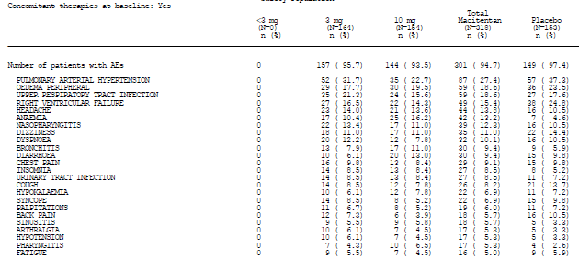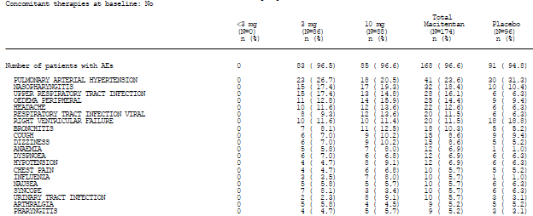

PK study investigating food effect on PK of macitentan in healthy subjects (Study AC-055-103) showed similar incidence of AEs during the fasted (0.20%; 2/10) and the fed period (0.20%; 2/10) although the small sample size did not allow definitive safety conclusion. No AEs of severe intensity and no SAEs or deaths were reported. There were no adverse events that led to discontinuation of study treatment. Evaluation of vital signs, ECG and clinical laboratory variables did not raise any increased safety concerns for macitentan taken in the fasted or fed state.

Safety results in DDI Phase I studies investigating DDI with warfarin (Study AC-055-105), sildenafil (Study AC-055-106), ketoconazole (Study AC-055-107), and cyclosporine and rifampicin (Study AC-055-111) did not raise any particular safety concerns, although the small sample sizes did not allow definitive safety conclusions. The incidences of AEs were generally higher with concomitant administration of macitentan with the respective interacting drug, compared to macitentan alone (Table 108).

Table 108: Incidences of AEs in DDI studies of macitentan

|  |  |  |  |
| --- | --- | --- | --- |
| **Study AC-055-105** | **Macitentan + warfarin**  **N=14** | **Warfarin alone**  **N=14** |  |
| Number of subjects with at least 1 AE (%) | 6 (42.9%) | 3 (23.1%) |  |
| Overall most frequently reported AE (by PT)   * headache | 5 (35.7%) | 2 (15.4%) |  |
| **Study AC-055-106** | **Macitentan + sildenafil**  **N=12** | **macitentan alone**  **N=12** | **Sildenafil alone**  **N=12** |
| Number of subjects with at least 1 AE (%) | 12 (100.0%) | 7 (58.3%) | 3 (25.0%) |
| Overall most frequently reported AE (by PT)   * headache | 10 (83.3%) | 1 (8.3%) | 1 (8.3%) |
| **Study AC-055-107** | **Macitentan + ketoconazole**  **N=11** | **macitentan alone**  **N=10** |  |
| Number of subjects with at least 1 AE (%) | 6 (54.5%) | 3 (30.0 %) |  |
| Overall most frequently reported AE (by PT)   * headache | 4 (36.4%) | 0 (0.0%) |  |
| **Study AC-055-111 Part A** | **Macitentan + cyclosporine**  **N=10** | **macitentan alone**  **N=10** |  |
| Number of subjects with at least 1 AE (%) | 6 (60.0%) | 3 (30.0 %) |  |
| Overall most frequently reported AE (by PT)   * nasopharyngitis | 1 (10.0%) | 2 (20.0%) |  |
| **Study AC-055-111 Part B** | **Macitentan + rifampicin**  **N=10** | **macitentan alone**  **N=10** |  |
| Number of subjects with at least 1 AE (%) | 2 (20.0%) | 6 (60.0 %) |  |
| Overall most frequently reported AE (by PT)   * headache | 2 (20.0%) | 5 (50.0%) |  |

No AEs of severe intensity and no SAEs or deaths were reported in any of these studies except one SAE of acute appendicitis leading to hospitalisation in Study AC-055-107, which was not considered related to study treatment. There were no adverse events that led to discontinuation of study treatment in any of these studies. No clinically significant abnormalities in clinical laboratory, vital signs, ECG parameters or physical examination were detected in any of these studies except for one case each in Studies AC-055-106 and AC-055-107 of liver aminotransferases (ALT and/or AST) to > three times ULN.

### Evaluator’s overall conclusions on clinical safety

Overall, safety results in the pivotal Phase III Study (AC-055-302) did not raise any major safety concerns. The incidences of all-causality AEs, treatment-related AEs, deaths, SAEs, and AEs leading to permanent discontinuation of study drug were comparable between the macitentan groups and the placebo group. The most commonly reported treatment-related AEs by preferred term in the macitentan groups were headache (2.8%, 4.0% and 5.0% in the placebo, macitentan 3 mg, and 10 mg groups), oedema peripheral (2.8%, 2.4% and 2.5%), and anaemia (0.4%, 1.6% and 3.7%).

Safety results in Studies AC-055-201 and AC-055B201 and the completed clinical pharmacology studies were generally consistent with those of the pivotal study. Safety results in Study AC-055-201 also showed that there was no obvious trend of increased incidences of TEAEs, treatment-related TEAEs, TESAEs, or TEAEs leading to study discontinuation with increasing doses of macitentan.

Known adverse drug reactions associated with ERAs include peripheral oedema, increases in liver transaminases, decreases in systemic blood pressure and decreases in haemoglobin concentrations. Analyses of these adverse events of special interest in Study AC-055-302 showed that there was no obvious increased risk of occurrence of oedema-related AEs with the macitentan groups (3mg and 10mg) compared to the placebo group (relative risk ratio of 0.94 for macitentan 3 mg versus placebo, and 1.03 for macitentan 10 mg versus placebo). The observed risk of occurrence of AEs associated with liver disorders and abnormal liver function was lower in the macitentan groups compared to the placebo group (relative risk ratio of 0.64 for macitentan 3 mg versus placebo, and 0.60 for macitentan 10 mg versus placebo), while that for occurrence of hypotension-related AEs was slightly higher in the macitentan groups compared to the placebo group (relative risk ratio versus placebo of 1.36 and 1.59 for macitentan 3 mg and 10 mg), and that for the occurrence of decreased haemoglobin -related AEs was 2- to 3-fold higher in the macitentan groups compared to the placebo group (relative risk ratio versus placebo of 2.32 and 3.26 for macitentan 3 mg and 10 mg).

Analyses of laboratory parameters of liver transaminases in the pivotal Study (AC-055-302) yielded results consistent with the above findings, showing that the proportion of subjects with marked elevations in ALT or AST, (defined as values > two times ULN and an increase of at least 50% from baseline) were comparable between the macitentan groups and the placebo group, as was that of subjects with ALT or AST elevations > three times ULN. Kaplan-Meier analyses showed that there was a reduced risk for occurrence of ALT or AST elevation > three times ULN with macitentan 3 mg and 10 mg compared to with placebo (hazard ratio versus placebo for the occurrence of an ALT or AST elevation > three times ULN was 0.720 and 0.635 for macitentan 3 mg and 10 mg).

Analyses of haemoglobin levels in the pivotal Study (AC-055-302) also yielded results consistent with findings of the analyses on AEs of special interest, showing that use of macitentan was associated with a decrease in haemoglobin concentration. The proportion of subjects with marked haemoglobin decreases (defined as haemoglobin < 11 g/dL and a decrease of at least 15% from baseline) was higher in the macitentan groups than in the placebo group (7.9% and 13.9% in the macitentan 3 mg and10 mg groups versus 3.8% with placebo), as was the proportion of subjects with decreases in haemoglobin values to between > 8 g/dL and ≤10 g/dL at some point during the study period up to 28 days after treatment discontinuation (4.6% and 4.3% versus 3.0%), and the proportion of subjects with decreases in haemoglobin values to ≤ 8 g/dL (1.7% and 4.3% versus 0.4%). However, the proportion of subjects with these marked decreases in haemoglobin was relatively small, and this adverse drug effect is monitorable by routine laboratory assessments. In addition, analyses of the mean change in haemoglobin from baseline over time showed that these decreases in haemoglobin in the macitentan groups occurred within the first three months of starting study treatment, reached a minimum at around Month 3, and thereafter stabilised. The overall estimated treatment effect over 12 months compared to placebo was small for both macitentan dose groups (–0.71 g/dL [95% CLs: –0.95, –0.48; p < 0.0001] for macitentan 3 mg and –1.07 g/dL [95% CLs: –1.31, –0.84; p < 0.0001] for macitentan 10 mg). Analyses of the mean change in haemoglobin from baseline over time in Studies AC-055-201 and AC-055B201 yielded similar results. Analyses in Study AC-055-201 showed a decrease in haemoglobin from baseline with macitentan until Week 8, and then with haemoglobin values returning towards baseline level and to values comparable to those of the placebo group by Week 10. Analyses in Study AC-055B201 showed that decreases in haemoglobin in the macitentan group occurred within the first four months of starting study treatment, and thereafter stabilised.

Analyses of blood pressure readings in the pivotal Study (AC-055-302) yielded results consistent with findings of the analyses on AEs of special interest, showing that mean changes in blood pressure from baseline up to 28 days after treatment discontinuation were small and generally comparable across treatment groups (mean change from baseline in SBP of -1.9 and -2.4 mmHg with macitentan 3mg and 10mg versus -2.7 mmHg with placebo; mean change from baseline in DBP of -2.5 and -4.2 mmHg versus -2.8 mmHg). Repeated measures analysis of the change from baseline in SBP showed that the estimated treatment effect over 12 months compared to placebo was small for both dose groups and showed a relative increase rather than decrease in blood pressures (0.16 mmHg [95% CLs: –1.62, 1.93; p = 0.8637] for macitentan 3 mg, and 0.10 mmHg [95% CLs: –1.69, 1.89; p = 0.9138] for macitentan 10 mg).

Analyses of the use of macitentan in subjects with hepatic impairment did not raise any increased safety concerns for macitentan in this group of patient population, but the sample size was small. Analyses of the use of macitentan in subjects with severe renal impairment also did not raise any increased safety concerns for macitentan in this group of patient population, except that there were more pronounced decreases in blood pressures in these subjects with severe renal impairment compared to healthy subjects (median maximum decreases from baseline in SBP: -22.0 mmHg versus -3.0mmHg; DBP: -7.5 mmHg versus -3.5 mmHg). However, these changes in blood pressures were not associated with changes in pulse rate, and were not reported as clinically relevant by the investigator, and this is an adverse effect that is monitorable by routine blood pressure measurements. The need for monitoring of blood pressures in patients with SRFI has been included as a precaution in the proposed PI, stating that ‘Patients with severe renal impairment may experience blood pressure reduction at treatment initiation and monitoring should be considered’.

With regards to the proposed therapeutic dose of macitentan 10 mg, safety results did not raise any particular concerns with macitentan 10 mg. Overall, the incidences of all-causality AEs, treatment-related AEs, deaths, SAEs, and AEs leading to permanent discontinuation of study drug were comparable between the macitentan dose groups. Although there was a higher risk for occurrence of hypotension-related AEs with macitentan 10 mg compared to 3mg (relative risk ratio versus placebo of 1.36 and 1.59 for macitentan 3 mg and 10 mg), and a higher risk for the occurrence of decreased haemoglobin-related AEs with macitentan 10 mg compared to 3mg (relative risk ratio versus placebo of 2.32 and 3.26 for macitentan 3 mg and 10 mg), evaluation of haemoglobin concentrations and blood pressure measurements in the pivotal studies did not raise significant safety concerns, as discussed in the preceding paragraphs.

## First round benefit-risk assessment

### First round assessment of benefits

The benefits of macitentan in the proposed usage are:

* Treatment of PAH in terms of potential benefits in reducing morbidity/mortality and in symptom relief.

As previously discussed, the proposed therapeutic dose of 10 mg macitentan is appropriate. Hence in the discussion of the benefit-risk assessment, only reference to the macitentan 10 mg dose will be made.

Efficacy results in the pivotal Study (AC-055-302) showed that there was a statistically significant relative risk reduction of 45% (p < 0.0001) with macitentan 10 mg compared to placebo for the occurrence of a morbidity or mortality event (primary endpoint). There was also a statistically significant relative risk reduction of 50% (p < 0.0001) with macitentan 10 mg compared to placebo for the occurrence of death due to PAH or hospitalisation for PAH.

However, further analyses suggested that these observed effects were largely due to risk reduction of morbidity rather than mortality. Competing risks analysis to explore the treatment effect on the morbidity component of the primary endpoint showed that subjects on macitentan 10mg had a statistically significantly lower risk of disease worsening than subjects on placebo (p < 0.0001), but no statistically significant difference was observed between the macitentan and placebo groups for the risk of death (p = 0.79). Analyses of other death-related secondary and exploratory endpoints (time to death of all causes up to EOT, time to death of all causes up to EOS, time to death due to PAH up to EOT, and time to death due to PAH up to EOS) also suggested that macitentan does not increase survival, all yielding results showing that there was no statistically significant difference in relative risk reductions of these mortality endpoints with macitentan 10mg compared to placebo. However, it is noted that the study was not powered for these mortality endpoints.

Analyses of the effect of macitentan on symptom relief in terms of improvements in 6MWD, WHO FC, quality of life, number of hospitalisation days per year (all-cause and PAH-related) and number of hospitalisations per year (all-cause and PAH-related) were all supportive of the beneficial effect of macitentan 10 mg on symptom relief in patients with PAH. Analyses of the effect of macitentan on exercise capacity in terms of the 6MWD showed that after six months of treatment, the placebo-corrected mean (SD) and median change from baseline in 6MWD was 22.0 m (92.58) and 15.0 m with macitentan10 mg (p = 0.0078). A repeated measures analysis for the change in 6MWD from baseline suggested that this treatment effect of macitentan was sustained over time up to Month 12, and the estimated treatment effect over 12 months compared to placebo was 25.4 m (p < 0.0001) with macitentan10 mg. Analyses of the effect of macitentan on symptom relief in terms of improvements in WHO FC from baseline to Month 6 showed that there was a 74% higher chance with macitentan10 mg compared to placebo of WHO FC improvement at Month 6 (p= 0.0063). Analyses of the effect of macitentan 10 mg on quality of life showed that there was a statistically significant mean change from baseline (improvement) to Month 6, across all SF-36 questionnaire domains with the exception of the general health perception domain. Analyses of pharmacoeconomic endpoints showed that compared to placebo, treatment with macitentan reduced the number of hospitalisation days per year (mean all-cause hospitalisation days per year: 5.7 days with macitentan 10 mg versus 12.2 days with placebo; mean PAH-related hospitalisation days per year: 3.8 days versus 8.3 days) and the number of hospitalisations per year (mean number of all-cause hospitalisations per year: 0.5 versus 1.0 with placebo; mean number of PAH-related hospitalisations per year: 0.3 versus 0.7).

Currently-approved pharmacological treatments for PAH in Australia included ERAs (bosentan, ambrisentan), prostacyclin analogs (epoprostenol, iloprost, treprostinil), and phosphodiesterase type 5 (PDE-5) inhibitors (sildenafil, tadalafil) (Table 109).

Table 109: Currently-approved pharmacological treatments for PAH in Australia

|  | Mode of administration and dosing frequency | Indications (according to currently approved Australian PI) | Approved for use in paediatric population (< 18 years old)? |
| --- | --- | --- | --- |
| Endothelin receptor antagonists | | | |
| Bosentan | Per oral  125mg (1 tablet) twice daily (maintenance dose) | ‘the treatment of   * idiopathic pulmonary arterial hypertension * familial pulmonary arterial hypertension * pulmonary arterial hypertension associated with scleroderma or * pulmonary arterial hypertension associated with congenital systemic to pulmonary shunts including Eisenmenger’s physiology   in patients with WHO functional Class II, III or IV symptoms’ | Yes (≥ 3 years old) |
| Ambrisentan | Per oral  5 mg (1 tablet) once daily | ‘the treatment of:   * idiopathic pulmonary arterial hypertension (PAH), * pulmonary arterial hypertension associated with connective tissue disease (PAH-CTD),   in patients with WHO functional class II, III or IV symptoms’ | No |
| Prostacyclin analogs | | | |
| epoprostenol | Intravenous infusion | ‘the long-term treatment, via continuous intravenous infusion, in New York Heart Association functional class III or class IV patients with:   * Idiopathic pulmonary arterial hypertension * Familial pulmonary arterial hypertension * Pulmonary arterial hypertension associated with the scleroderma spectrum of diseases’ | No |
| Iloprost | Inhalational  Administered 6 to 9 times per day | ‘Treatment of patients with primary pulmonary hypertension or secondary pulmonary hypertension due to connective tissue disease or drug-induced, in moderate or severe stages of the disease. In addition, treatment of moderate or severe secondary pulmonary hypertension due to chronic pulmonary thromboembolism, where surgery is not possible.’ | No |
| Treprostinil | Continuous subcutaneous infusion | ‘ for the treatment of pulmonary arterial hypertension in patients with NYHA class III-IV to diminish symptoms associated with exercise’ | ≥ 16 years old |
| PDE-5 inhibitors | | | |
| Sildenafil | Per oral and intravenous formulations  Per oral: 20mg (1 tablet) three times a day | Per oral formulation:  ‘the treatment of patients with pulmonary arterial hypertension classified as WHO functional classes II and III, to improve exercise capacity. Efficacy has been shown in primary pulmonary hypertension and pulmonary hypertension associated with connective tissue disease.’  Intravenous formulation:  ‘the treatment of adult patients with pulmonary arterial hypertension who are currently prescribed oral REVATIO and who are temporarily unable to take oral therapy, but are otherwise clinically and haemodynamically stable.’ | No |
| Tadalafil | Per oral  40mg (2 tablets of 20mg each) once daily | ‘in adults for the treatment of pulmonary arterial hypertension (PAH) classified as WHO functional class II and III, to improve exercise capacity. Efficacy has been shown in idiopathic PAH (IPAH) and in PAH related to collagen vascular disease.’ | No |

Revatio: proprietary name for sildenafil in Australia

PI: Product Information

In terms of posology and ease of administration, only ambrisentan has a comparable dosing regimen of per oral 1 tablet once daily. Hence, the proposed dosing regimen of macitentan of 10 mg (1 tablet) once daily can offer some benefit in terms of ease of administration. A look at the effect of the currently approved ERAs (bosentan and ambrisentan) on 6MWD showed that the reported placebo-corrected treatment effects were variable, ranging from 31m to 76m. As reported in the Australian PI of bosentan, two randomised, double-blind, multicentre, placebo-controlled trials had been conducted (Studies 352 and 351), where Study 352 included 213 PAH patients, and compared two doses of bosentan (125 mg twice daily and 250 mg twice daily) with placebo, while Study 351 included 32 PAH patients, and compared bosentan 125 mg twice daily with placebo. Study subjects were of WHO FC III and IV at baseline, and had PAH of the following aetiology: primary pulmonary hypertension (that is, idiopathic PAH) (72%), PAH secondary to scleroderma or other connective tissue diseases (21%), or PAH secondary to autoimmune disease (7%). The mean placebo-corrected treatment effect on 6MWD for bosentan 125 mg twice daily (the recommended therapeutic dose) at four months (Study 352) was 35m, while that at three months (Study 351) was 76m. With ambrisentan, the currently-approved Australian PI reported that two randomised, double-blind, multi-centre, placebo-controlled, Phase III studies had been conducted (ARIES-1 and 2), where ARIES-1 included 201 patients and compared ambrisentan 5 mg and 10 mg once daily with placebo, and ARIES-2 included 192 patients and compared ambrisentan 2.5 mg and 5 mg once daily with placebo. Study subjects were of WHO FC II (38.4%), III (55.0%) and IV (5%) at baseline, and the majority had Idiopathic PAH (64%) and PAH associated with connective tissue disease (32%). The mean placebo-corrected treatment effect on 6MWD for ambrisentan 5mg once daily (the recommended therapeutic dose) at Week 12 was 30.6m in ARIES-1 and 59.4m in ARIES-2.

## First round assessment of risks

The risks of macitentan in the proposed usage are:

* Decrease in haemoglobin
* Hypotension

Safety analyses in the pivotal Study (AC-055-302) showed that the risk for occurrence of decreased haemoglobin -related AEs was 3.3 times higher with macitentan 10 mg compared to with placebo, and that for the occurrence of hypotension-related AEs was 1.6 times higher with macitentan 10 mg compared to with placebo.

Analyses of haemoglobin levels in the pivotal Study (AC-055-302) showed that the proportion of subjects with marked haemoglobin decreases (defined as haemoglobin < 11 g/dL and a decrease of at least 15% from baseline) was higher in the macitentan 10 mg group than in the placebo group (13.9% versus 3.8% with placebo), as was the proportion of subjects with decreases in haemoglobin values to between > 8 g/dL and ≤10 g/dL at some point during the study period (4.3% versus 3.0%), and the proportion of subjects with decreases in haemoglobin values to ≤ 8 g/dL (4.3% versus 0.4%). However, the proportion of subjects with these marked decreases in haemoglobin was relatively small, and this adverse drug effect is monitorable by routine laboratory assessments. In addition, analyses of the mean change in haemoglobin from baseline over time showed that these decreases in haemoglobin occurred within the first three months of starting study treatment, reached a minimum at around Month 3, and thereafter stabilised. The overall estimated treatment effect over 12 months compared to placebo was small (–1.07 g/dL [95% CLs: –1.31, –0.84; p < 0.0001]). Analyses of the mean change in haemoglobin from baseline over time in Studies AC-055-201 and AC-055B201 yielded similar results.

Analyses of blood pressure readings in the pivotal Study (AC-055-302) showed that mean changes in blood pressure from baseline up to 28 days after treatment discontinuation were small and comparable between macitentan 10 mg and placebo (mean change from baseline in SBP of -2.4 mmHg with macitentan 10mg versus -2.7 mmHg with placebo; mean change from baseline in DBP of -4.2 mmHg versus -2.8 mmHg). Repeated measures analysis of the change from baseline in SBP showed that the estimated treatment effect of macitentan 10 mg over 12 months compared to placebo was small and showed a relative increase rather than decrease in blood pressures (0.10 mmHg [95% CLs: –1.69, 1.89; p = 0.9138]). Safety results of Study AC-055-112, which studied the effect of macitentan 10 mg in patients with severe renal impairment, showed that there were more pronounced decreases in blood pressures in these subjects with severe renal impairment compared to healthy subjects (median maximum decreases from baseline in SBP: -22 mmHg versus -3.0mmHg; DBP: -7.5 mmHg versus -3.5 mmHg). However, these changes in blood pressures were not reported as clinically relevant by the investigator, and this is an adverse effect that is monitorable by routine blood pressure measurements.

### First round assessment of benefit-risk balance

The benefit-risk balance of macitentan, given the proposed usage, is favourable.

Efficacy results showed relative risk reduction for occurrence of combined mortality or morbidity events as well as effect on symptomatic relief in terms of improvements in 6MWD, WHO FC, quality of life, number of hospitalisation days per year (all-cause and PAH-related) and number of hospitalisations per year (all-cause and PAH-related). Although analyses in the pivotal study on mortality endpoints suggested that the use of macitentan 10 mg did not improve survival, the study had not been powered for survival analyses. Safety results raised concerns only with respect to decreases in haemoglobin and to decreases in systemic blood pressure especially in patients with severe renal impairment. However, the decreases in haemoglobin appeared to occur in the first three months of administration and thereafter stabilised. It is also an adverse effect that is monitorable by routine laboratory assessments. With macitentan 10 mg, there were more pronounced decreases in blood pressures in subjects with severe renal impairment compared to healthy subjects, but this is an adverse effect that is monitorable by routine blood pressure measurements.

The proposed indication for macitentan, as stated in the proposed PI, is ‘for the long-term treatment of pulmonary arterial hypertension (PAH) in patients of WHO Functional Class II to IV to reduce morbidity and mortality. Opsumit is effective when used as monotherapy or in combination with phosphodiesterase-5 inhibitors or inhaled prostanoids’. The proposed indication for use in PAH patients of WHO FC ranging from II to IV is appropriate. Although the majority of subjects in the pivotal study were of WHO FC II (52.4%) and III (45.6%), with only 1.9% (14/739) in WHO FC IV, this reflects the composition of the target patient population in clinical practice. Subgroup analyses of the efficacy and safety endpoints in this small group of patients with baseline WHO FC IV would not have been viable in view of the very small sample size. The sponsor had performed subgroup analyses based on subgroups of baseline WHO FC I or II versus III or IV, and efficacy and safety results were generally consistent with that of the overall study population (Figure 15**,** Table 106).

With regards to use of macitentan alone or as add-on therapy to PDE-5 inhibitors and prostanoids, the efficacy and safety results of the pivotal study showed that results in the subgroup of subjects with or without concomitant PAH therapy were consistent with those of the overall population. In this study 64% of subjects had concomitant PAH therapy at baseline, the majority of which were PDE-5 inhibitors (taken by 61.3% of overall study subjects [sildenafil 57.6%, tadalafil 0.9%, vardenafil 2.8%]), and the remaining were prostanoids (taken by 5.6% of overall study subjects [iloprost 3.5%, beraprost 2.0%, treprostinil 0.1%][29]). Subgroup analyses of the primary efficacy endpoint showed a consistent treatment effect versus placebo across both subgroups (with and without concomitant PAH therapy at baseline) with the 10 mg macitentan dose (hazard ratios versus placebo of 0.547 [97.5% CLs 0.392, 0.762], 0.62 [95% CLs: 0.43, 0.89] and 0.45 [95% CLs: 0.28, 0.72] in the overall study population, and in subgroups with and without concomitant PAH therapy at baseline). Subgroup analysis of safety results by concomitant PAH therapy at baseline (yes versus no) yielded results consistent with that of the overall study population.

With regards to use in paediatric population, the sample size of adolescent subjects (12 to < 18 years old) in the pivotal study was very small (N=20). Subgroup analyses by age group of the primary efficacy endpoint and of safety data yielded results which were generally consistent with those in the overall study population (Figure 15**,** Table 106), although the small sample size makes robust conclusions on the efficacy and safety of macitentan in this group of adolescent subjects difficult. A look through the currently-approved pharmacological treatments for PAH in Australia (Table 109) showed that only bosentan and treprostinil (restricted to age ≥ 16 years) are approved for use in paediatric patients, with a per oral twice daily maintenance dosing regimen for bosentan, and subcutaneous infusion posology for treprostinil. The evaluator does not have the information for the basis of approval in paediatric population for bosentan, but the Australian PI for bosentan stated that one open-label non-controlled study has been conducted in 19 paediatric patients with PAH. Given that no major safety issues have been observed in the paediatric subjects in the pivotal study for macitentan, it is considered that the use of macitentan in paediatric PAH patients aged 12 and above can be approved, but that the limited experience in paediatric patients should be clearly stated in the PI. In addition, it is noted that the lower limit of the weight range of subjects in the pivotal study was 36.8kg. Hence, it is recommended that a criterion of body weight ≥ 40kg be stated in the PI in addition to the age criterion of ≥ 12 years.

## First round recommendation regarding authorisation

It is recommended that the application for the registration of macitentan for the long-term treatment of pulmonary arterial hypertension in patients of WHO Functional Class II to IV be approved. This is subject to a satisfactory response from the sponsor in reply to the TGA’s request for further information.

## Clinical questions

### Efficacy

1. Please clarify regarding the information presented in Table 7 on page 83 of the CSR for study AC-055-302 being inconsistent with the description of the statistical methods given in Section 9.7.2 of the CSR.

Rationale for question:

As described in Section 6.1.1.1.8 (and included in this document as Table 29) in describing the statistical methods for Study AC-055-302 in Section 9.7.2 on pages 81 to 82 of body of CSR, the sponsor had presented a table (‘Table 7’, on page 83 of the CSR) in which the information presented is inconsistent with the description of the statistical methods given in Section 9.7.2 of the CSR.The source of this table was traced, leading the evaluator to a table in the Statistical Analysis Plan (SAP) (‘Table 7’, page 50 of the SAP found in appendix 16.1.9.1.1) which is different from the table presented in the body of the CSR but consistent with the statistical methods described in Section 9.7.2 of the body of the CSR. This table in the SAP is presented in Table 29 of this CER extract. The evaluator assumed that there was a typographical error in the table on page 83 of the body of the CSR, but this needs to be clarified with the sponsor.

1. Please provide a breakdown of the relative proportion of subjects who had provided primary efficacy endpoint data at the Week 2, Week 4 and Week 8 timepoints in Study AC-055-201, as well as an explanation of how the four, eight and 10-week cohorts were defined in this study.

Rationale for question:

As stated in Section 6.1.2.1, it is noted that due to the early termination of Study AC-055-201, only approximately half of the randomised subjects (54.4%; 206/379) completed the eight week randomised treatment. In analysing the primary efficacy endpoint, in the case of a missing value at Week 8, the last available value assessed ≥ Week 2 of Period II, was carried forward. Analyses of the primary efficacy endpoint showed that there was statistically significantly greater reduction in trough SiDBP from baseline to Week 8 compared to placebo for the macitentan 10 mg group (mean change from baseline of -11.8 mmHg versus -7.9 mmHg, p=0.0089). However, due to the early termination and the imputation method, this result was in effect an assessment of reduction in trough SiDBP from baseline to a post-baseline timepoint that ranged from Week 2 to Week 8. The sponsor did not provide a breakdown of the relative proportions of subjects who had provided this data at the Week 2, Week 4 and Week 8 timepoints.

It was noted that exploratory analyses of the absolute change from baseline in SiDBP for the four; eight and 10-week cohorts were performed, and results showed that the treatment effect of macitentan on the primary endpoint was reached at four weeks and then sustained until Week 8. However, the sponsor did not provide an explanation of how the four, eight and 10-week cohorts were defined in the statistical methods section of the CSR.

### Safety

1. Please provide references to support the clinical relevance threshold of 30% reduction in sperm concentration indicated in Study AC-055-113

Rationale for question:

As stated in Section 7.5.6.1.1, in Study AC-055-113, analysis of the change in sperm concentration from baseline to Week 12 between subjects who received only macitentan (10 mg once daily; n = 14) and those who received only placebo (n = 11) during the 12-week treatment period, yielded a geometric mean ratio (macitentan versus placebo) of 0.724 (90% CI: 0.47, 1.12; p= 0.2173), corresponding to a 28% mean reduction in sperm concentration with macitentan. According to the sponsor, the acceptable mean reduction range for no clinically relevant treatment effect was 30%. However, the sponsor had not indicated any references to support the clinical relevance threshold of 30% reduction in sperm concentration.

## Second round evaluation of clinical data submitted in response to questions

Overall, the sponsor has adequately addressed all the questions posed in the first round of evaluation. In this section on the evaluation of the sponsor’s responses to the questions posed in the first round of evaluation, each question will be re-stated for ease of reference, followed by the evaluation.

### Efficacy question 1:

*Please clarify regarding the information presented in Table 7 on page 83 of the CSR for study AC-055-302 being inconsistent with the description of the statistical methods given in Section 9.7.2 of the CSR.*

The sponsor confirmed that there was a typographical error in the above-mentioned table, and that the two-sided nominal type-I error level used for each comparison of active dose versus placebo to keep the study-wise type-I error to a two-sided 0.01 ‘conclusive’ level of statistical testing was erroneously indicated as 0.025, when it should have been 0.005 as pre-specified in the Statistical Analysis Plan. The sponsor had issued an Addendum to the AC-055-302 CSR to correct this discrepancy.

As the first round of evaluation was based on the assumption that there was a typographical error in the above-mentioned table, the sponsor’s response to this question has not resulted in any changes to the conclusions of the first round of evaluation.

### Efficacy question 2:

*Please provide a breakdown of the relative proportions of subjects who had provided primary efficacy endpoint data at the Week 2, Week 4 and Week 8 timepoints in Study AC-055-201, as well as an explanation of how the four, eight and 10-week cohorts were defined in this study.*

The sponsor provided a breakdown of the relative proportions of subjects who had provided primary efficacy endpoint data at the Week 2 (Visit 4), Week 4 (Visit 5) and Week 8 (Visit 6) timepoints in Study AC-055-201, showing that overall, Visit 6 measurements for the primary endpoint analysis were used for 75.4% of the patients (75.9%, 79.6%, 66.7%, 78.9%, 78.6% and 73.2% in the placebo, macitentan 0.3mg, 1mg, 3mg, and 10mg, and enalapril 20mg groups), while Visit 4 and Visit 5 measurements were used for 9.8% and 14.5% of the patients.

The sponsor also provided explanation that for the cohort analyses, each cohort consisted of patients for whom the values at all timepoints in the relevant time window (four, eight and 10 weeks) could be derived by means of a first degree Lagrange interpolation. The interpolated endpoint value was to be on treatment period and up to 28 days after the end of the study treatment. Patients with their last assessment before the relevant timepoint but within an acceptability window of ± one week were assigned to the cohort, after applying a carry-forward in order to have values up to the exact scheduled timepoint.

### Safety question 1:

*Please provide references to support the clinical relevance threshold of 30% reduction in sperm concentration indicated in Study AC-055-113.*

In its response, the sponsor acknowledged that although sperm concentration, morphology, and motility are useful tools to evaluate infertility, the correlation between values outside the (wide) normal range and fertility is not strong. According to the sponsor, the selection of the 30% threshold was based on a study performed by Amory et al., in which the effect of dutasteride and finasteride on semen parameters and serum hormones in healthy men was evaluated[30]. In this study a clinically significant difference of 30% in sperm concentration was used, which was derived from human studies of male fertility and effectiveness of hormonal contraceptives, using impairment of fertility as standard. The sponsor provided further support for the selection of the 30% threshold, stating that the same threshold had been used in a clinical study in which the possible effects of bosentan on testicular function were studied in patients with PAH (Clinical Study Report AC-052-402, Submission No. PM-2010-01202-3-3, May 2010).

### RMP question:

There were additional responses by the sponsor to questions posed by the risk management plan (RMP) evaluator. It is recommended that the sponsor’s responses to these questions be directed to the RMP evaluator.

## Second round benefit-risk assessment

### Second round assessment of benefits

After consideration of the responses to clinical questions, the benefits of macitentan in the proposed usage are unchanged from those identified in Section 8.1.

### Second round assessment of risks

After consideration of the responses to clinical questions, the risks of macitentan in the proposed usage are unchanged from those identified in Section 8.2.

### Second round assessment of benefit-risk balance

The benefit-risk balance of macitentan, given the proposed usage, is favourable.

## Second round recommendation regarding authorisation

It is recommended that the application for the registration of macitentan for the long-term treatment of pulmonary arterial hypertension in patients of WHO Functional Class II to IV be approved.

## References

1. American heart association, ACCF/AHA 2009 Expert Consensus Document on Pulmonary Hypertension. Circulation, 119:2250-2294
2. European Medicines Agency, Guidelines on the evaluation of the pharmacokinetics of medicinal products in patients with impaired renal function, June 2004
3. European Medicines Agency. 2009. Concept paper on the need for the development of a paediatric addendum to the CHMP guideline on the clinical investigation of medicinal products for the treatment of Pulmonary Arterial Hypertension
4. European Medicines Agency. Guidelines on the clinical investigation of medicinal products for the treatment of Pulmonary Arterial Hypertension. October 2009
5. European Medicines Agency. Guidelines on the evaluation of the pharmacokinetics of medicinal products in patients with impaired hepatic function. February 2005
6. European Society of Cardiology. 2009. Guidelines for the diagnosis and treatment of pulmonary. European Heart Journal, 30, 2493–2537
7. Farber HW, Loscalzo J. 2004. Pulmonary Arterial Hypertension. New England Journal of Medicine, 351:1655-65
8. Food and Drug Administration. 2005. E14 Clinical evaluation of QT/QTc interval prolongation and proarrhythmic potential for non-antiarrhythmic drugs
9. <<http://circ.ahajournals.org/content/119/16/2250.full.pdf>> (accessed 20th April 2013)
10. <<http://www.escardio.org/guidelines-surveys/esc-guidelines/guidelinesdocuments/guidelines-ph-ft.pdf>> (accessed 20th April 2013)
11. <<http://www.fda.gov/downloads/RegulatoryInformation/Guidances/ucm129357.pdf>> (accessed 20th April 2013)
12. <<http://www.temple.edu/imreports/Reading/Pulm%20-%20PHT.pdf>> (accessed 20th April 2013)
13. Note for guidance on the evaluation of the pharmacokinetics of medicinal products in patients with impaired renal function CHMP/EWP/225/02 (accessed 20th April 2013)
14. Guideline on the evaluation of the pharmacokinetics of medicinal products in patients with impaired hepatic function CPMP/EWP/2339/02 (accessed 20th April 2013)
15. Guideline on the clinical investigations of medicinal products for the treatment of pulmonary arterial hypertension EMEA/CHMP/EWP/356954/2008 (accessed 20th April 2013)
16. Concept paper on the need for the development of a paediatric addendum to the CHMP guideline on the clinical investigations of medicinal products for the treatment of pulmonary arterial hypertension EMEA/CHMP/EWP/644261/2008 (accessed 20th April 2013)

|  |
| --- |
| Therapeutic Goods Administration |
| PO Box 100 Woden ACT 2606 Australia  Email: [info@tga.gov.au](mailto:info@tga.gov.au) Phone: 1800 020 653 Fax: 02 6232 8605  [**http://www.tga.gov.au**](http://www.tga.gov.au) |

1. Australian PI for Bosentan, April 2011
2. Australian PI for Ambrisentan, October 2012
3. Simcyp Population-Based ADME Simulator (v. 11)
4. The sponsor had stated that data from the MAD study AC-055-102 showed that there was a linear correlation between steady-state Ctrough and exposure (AUC0-24) for macitentan and ACT-132577 (r2 = 0.79 and 0.96 for macitentan and ACT-132577) and it was thus considered reasonable to use Ctrough as surrogate for the macitentan and ACT-132577 exposure for the PK/PD analysis in study AC-055-302PK/PD.
5. European Medicines Agency. Guidelines on the evaluation of the pharmacokinetics of medicinal products in patients with impaired hepatic function. February 2005
6. European Medicines Agency,Guidelines on the evaluation of the pharmacokinetics of medicinal products in patients with impaired renal function, June 2004
7. The S-enantiomer of warfarin is primarily metabolised by CYP2C9, and less by CYP2C19 and CYP3A4, while the R-enantiomer is mainly metabolised by CYP1A2, with a smaller contribution of CYP3A4.
8. The sponsor had reported that the metabolism of macitentan to its active metabolite ACT-132577 had been found *in-vitro* studies to be mediated by the cytochrome P450 system, mainly CYP3A4 with a minor contribution of CYP2C19
9. The sponsor had stated that data from the MAD study AC-055-102 showed that there was a linear correlation between steady-state Ctrough and exposure (AUC0-24) for macitentan and ACT-132577, thus allowing for the use of Ctrough as surrogate for the macitentan and ACT-132577 exposure for the PK/PD analysis in study AC-055-302.
10. In order to account for the contribution of ACT-132577 to the effect on SiDBP, a concentration parameter for the combined unbound fraction (Cfree combined) was derived from the Ctrough concentrations of macitentan and ACT-132577 using the formula: C free combined = (0.4/100) * C trough macitentan + (0.5/100) * 0.2 C trough ACT-132577. This formula assumed that the free fractions of macitentan and ACT-132577, as determined in vitro, were 0.4% and 0.5%, and that ACT-132577 was approximately 8-fold less potent in vitro than macitentan on ETA and 2-fold less potent on ETB
11. Women had to be considered as not having childbearing potential (defined as women with previous bilateral salpingo-oophorectomy or hysterectomy; who had premature ovarian failure confirmed by a specialist gynaecologist; who were pre-pubescence or had XY genotype, Turner syndrome, or uterine agenesis; or who were post-menopausal [age > 50 years and not treated with any kind of hormone replacement therapy for at least 2 years prior to screening, with amenorrhoea for at least 24 consecutive months prior to screening, and a serum follicle stimulating hormone level of > 40 IU/L if the investigator had insufficient evidence that the woman was postmenopausal]). Women of childbearing potential were allowed to participate in the study if they had a negative serum pre-treatment pregnancy test and consistently and correctly used (from screening and up to 28 days after discontinuation of study treatment) a reliable method of contraception with a Pearl index of less than 1% (oral hormonal contraceptive, implant, vaginal hormone ring, intrauterine system, or tubal ligation only in combination with condom), were sexually abstinent, or had a vasectomised partner.
12. WHO functional classification of PAH-Class I: Without resulting limitation of physical activity. Ordinary physical activity does not cause undue dyspnoea or fatigue, chest pain, or near syncope; Class II: Slight limitation of physical activity. Comfortable at rest. Ordinary physical activity causes undue dyspnoea or fatigue, chest pain, or near syncope; Class III: Marked limitation of physical activity. Comfortable at rest. Less than ordinary activity causes undue dyspnoea or fatigue, chest pain, or near syncope; Class IV: Inability to carry out any physical activity without symptoms. Manifest signs of right-heart failure. Dyspnoea and/or fatigue may even be present at rest. Discomfort is increased by any physical activity.
13. European Society of Cardiology, Guidelines for the diagnosis and treatment of pulmonary. *European Heart Journal*, 30, 2493–2537, 2009
14. The definition of EOT in this endpoint included death due to PAH (as adjudicated by the CEC) up to EOT + 7 days, or onset of a TEAE within EOT + 7 days with a fatal outcome due to PAH within 28 days of EOT, or hospitalisation for PAH up to EOT + 7 days
15. The definition of EOT in this endpoint included death of all causes up to EOT + 7 days or onset of a TEAE within EOT + 7 days with a fatal outcome within 28 days of EOT
16. 6MWD, Borg dyspnoea index and WHO FC were assessed at baseline and at Month 3, Month 6 and every 6 months until the EOT/event visit
17. American Heart Association, ACCF/AHA 2009 Expert Consensus Document on Pulmonary Hypertension. Circulation, 119:2250-2294
18. Farber HW, Loscalzo J,2004. Pulmonary Arterial Hypertension. New England Journal of Medicine,351:1655-65.
19. The dependent variable of the model was the change from baseline. Visits (up to Month 12), treatment, treatment by visit interaction and baseline value were included as fixed effects in the model.
20. A decrease in Borg dyspnoea index indicates an improvement.
21. The dependent variable of the model was the change from baseline. Visits (up to Month 12), treatment, treatment by visit interaction and baseline value were included as fixed effects in the model.
22. WHO classification: Grade 1 (SBP 140-159 mmHg; DBP 90-99 mmHg); Grade 2 (SBP 160-179 mmHg; DBP 100-109 mmHg); Grade 3 (SBP ≥ 180 mmHg; DBP ≥ 110 mmHg)
23. Subjects were categorised as controlled if mean SiDBP < 90 mmHg, as responder if the change from baseline in mean SiDBP ≥ -10 mmHg
24. Subjects were categorised as controlled if mean SiSBP < 140 mmHg, as responder if the change from baseline in mean SiSBP ≥ -20 mmHg
25. defined as subjects with at least one assessment of the primary parameter performed ≥ Week 2 of Period II
26. In order to account for the contribution of ACT-132577 to the effect on SiDBP, a concentration parameter for the combined unbound fraction (Cfree combined) was derived from the Ctrough concentrations of macitentan and ACT-132577 using the formula: C free combined = (0.4/100) * C trough macitentan + (0.5/100) * 0.2 C trough ACT-132577. This formula assumed that the free fractions of macitentan and ACT-132577, as determined in vitro, were 0.4% and 0.5% and that ACT-132577 was approximately 8-fold less potent in vitro than macitentan on ETA and 2-fold less potent on ETB
27. For the grouping of ‘liver disorders and abnormal liver function’, PTs from the overall AE list were included in this grouping if they appeared in the standardised MedDRA queries (SMQ) of ‘drug-related hepatic disorders’. PTs included in this grouping were alanine aminotransferase (ALT) increased, aspartate aminotransferase (AST) increased, bilirubin conjugated increased, blood alkaline phosphatase (ALP) increased, blood bilirubin increased, gamma-glutamyltransferase (GGT) increased, hepatic cirrhosis, hepatic enzyme increased, hepatic function abnormal, hepatitis, hepatitis acute, hyperbilirubinaemia, ischaemic hepatitis, jaundice, liver function test abnormal, liver injury, and transaminases increased. For the grouping of ‘haemoglobin decrease’, PTs from the overall AE list were included in this grouping if they appeared in the SMQs of ‘haematopoietic erythropenia’ and ‘haematopoietic cytopenias affecting more than one type of blood cell’. PTs included in this grouping were anaemia, anaemia haemolytic autoimmune, anaemia megaloblastic, erythropenia, haematocrit decreased, haemoglobin decreased, haemolytic anaemia, iron deficiency anaemia, pancytopenia, and red blood cell count decreased. For the grouping of ‘oedema’, PTs from the overall AE list were included in this grouping if they appeared in the SMQ of ‘haemodynamic oedema, effusions and fluid overload’. PTs included in this grouping were eye oedema, eyelid oedema, face oedema, fluid overload, fluid retention, generalised oedema, localised oedema, oedema, oedema peripheral, orbital oedema, periorbital oedema, swelling face, ascites, hypervolaemia, hydrothorax, lymphoedema, and pelvic fluid collection. For the grouping of ‘hypotension’, no SMQ for hypotension was available in MedDRA version 14.0 according to the sponsor. PTs included in this grouping were blood pressure systolic decreased, hypotension, and orthostatic hypotension.
28. Events indicative of worsening of PAH were reported as the preferred term of ‘pulmonary arterial hypertension’
29. Beraprost is not currently approved for use in Australia. Vardenafil is marketed in Australia, but is not currently approved for the indication of treatment of PAH.
30. Amory JK et al., The effect of 5alpha-reductase inhibition with dutasteride and finasteride on semen parameters and serum hormones in healthy men. *J Clin Endocrinol Metab,* 92:1659-65, 2007.