**PRODUCT INFORMATION**

**OPSUMIT™ (macitentan)**

**10 mg film coated tablet**

OPSUMIT® may cause birth defects and is contraindicated in pregnancy.

See CONTRAINDICATIONS and PRECAUTIONS.

# NAME OF THE MEDICINE

Active: macitentan

OPSUMIT is the brand name for macitentan and is a dual ETA and ETB endothelin receptor antagonist. The chemical name of macitentan is *N*-[5-(4-Bromophenyl)-6-[2-[(5-bromo-2-pyrimidinyl)oxy]ethoxy]-4-pyrimidinyl]-*N*'-propylsulfamide.

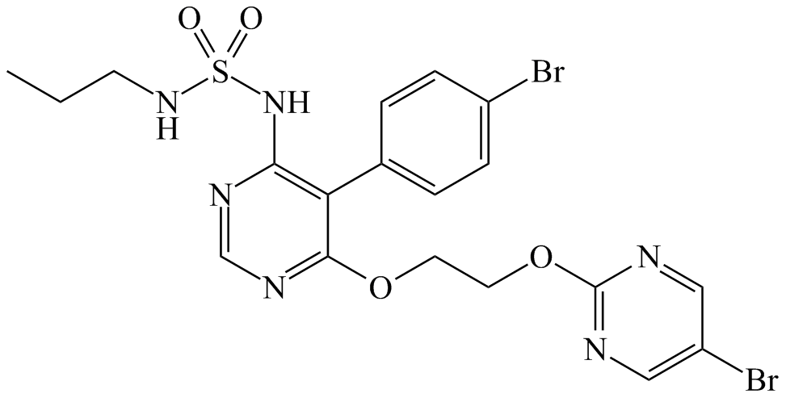

The molecular formula: C19H20Br2N6O4S,

Relative molecular mass: 588.3 g/mol, the molecule is achiral.

CAS-No.: 441798-33-0.

# DESCRIPTION

Macitentan is a white to off-white crystalline powder that is insoluble in water and slightly soluble in ethanol (approx 2 mg/mL). In the solid state macitentan is very stable, is not hygroscopic, and is not light sensitive. The melting temperature of macitentan is 135 °C, Partition coefficient (1-octanol / aqueous phosphate buffer, pH 7.4): log D = 2.9 and ionization constant pKa is 6.2.

OPSUMIT is available as a 10 mg film-coated tablet for once daily oral administration. The tablets include the following inactive ingredients: lactose, magnesium stearate, microcrystalline cellulose, polysorbate 80, povidone, and sodium starch glycollate type A. The tablets are film-coated with a coating material containing polyvinyl alcohol, lecithin, purified talc, titanium dioxide, and xanthan gum. Each white, round, biconvex film-coated tablet, debossed with “10” on one side, contains 10 mg of macitentan.

# PHARMACOLOGY

# Mechanism of Action

Endothelin (ET)-1 and its receptors (ETA and ETB) mediate a variety of effects such as vasoconstriction, fibrosis, proliferation, hypertrophy, and inflammation. In disease conditions such as pulmonary arterial hypertension (PAH), the local ET system is upregulated and is involved in vascular hypertrophy and in organ damage.

Macitentan is an orally active, dual ETA and ETB receptor antagonist that prevents the binding of ET-1 to its receptors. Macitentan displays high affinity for and sustained occupancy of the ET receptors in human pulmonary arterial smooth muscle cells and has physicochemical properties favouring penetration into lung tissue, particularly in disease conditions.

In animal models of pulmonary hypertension, macitentan selectively decreased mean pulmonary arterial pressure without affecting systemic blood pressure, prevented pulmonary arterial hypertrophy and right ventricular remodeling, and significantly increased survival.

# Pharmacodynamics

*Cardiac Electrophysiology*: In a randomized, placebo-controlled four-way crossover study with a positive control in healthy subjects, repeated doses of macitentan 10 and 30 mg (3 times the recommended dosage) had no significant effect on the QTc interval.

# Pharmacokinetics

The pharmacokinetics of macitentan and its active metabolite have mainly been documented in healthy subjects. Exposure to macitentan in patients with PAH was approximately 2-fold greater than in healthy subjects. The exposure to the active metabolite in patients was only slightly higher (approximately 1.5-fold) than in healthy subjects. The pharmacokinetics of macitentan in PAH patients were not influenced by the severity of the disease.

After repeated administration, the pharmacokinetics of macitentan are dose-proportional up to and including 30 mg.

**Absorption**

Maximum plasma concentrations of macitentan are achieved about 8 hours after administration. The absolute bioavailability after oral administration is not known. Thereafter, plasma concentrations of macitentan and its active metabolite decrease slowly, with an apparent elimination half-life of approximately 16 hours and 48 hours, respectively.

In healthy subjects, the exposure to macitentan and its active metabolite is unchanged in the presence of food and, therefore, macitentan may be taken with or without food.

**Distribution**

Macitentan and its active metabolite are highly bound to plasma proteins (> 99%), primarily to albumin and to a lesser extent to alpha-1-acid glycoprotein. The apparent volumes of distribution (Vss/F) of macitentan and its active metabolite were about 50 L and 40 L, respectively, in healthy subjects.

**Biotransformation**

Macitentan primarily undergoes oxidative depropylation of the sulfamide to form the pharmacologically active metabolite. This reaction is dependent on the cytochrome P450 system, mainly CYP3A4 with a minor contribution of CYP2C19. The active metabolite circulates in human plasma and may contribute to the overall pharmacological effect.

**Elimination**

Macitentan is only excreted after extensive metabolism. The major excretion route is via urine, accounting for about 50% of the dose.

**Special populations**

There is no clinically relevant effect of age, sex or ethnic origin on the pharmacokinetics of macitentan and its active metabolite.

*Renal impairment:* Exposure to macitentan and its active metabolite was increased by 1.3- and 1.6-fold, respectively, in patients with severe renal impairment..

*Hepatic impairment:* Exposure to macitentan was decreased by 21%, 34%, and 6% and for the active metabolite by 20%, 25%, and 25% in subjects with mild, moderate or severe hepatic impairment, respectively.

# CLINICAL TRIALS

***Efficacy in Patients with Pulmonary Arterial Hypertension***

A multicentre, double-blind, placebo-controlled, parallel-group, event-driven, Phase 3 outcome study (AC-055-302/SERAPHIN) was conducted in 742 patients with symptomatic PAH, who were randomised to three treatment groups (placebo [N=250], 3 mg [N=250] or 10 mg [N=242] of macitentan once daily), to assess the long-term effect on morbidity or mortality. At baseline, the majority of enrolled patients (64%) were treated with a stable dose of specific therapy for PAH, either oral phosphodiesterase inhibitors (61%) and/or inhaled/oral prostanoids (6%). The primary study endpoint was the time to first occurrence of a morbidity or mortality event, up to end of treatment (EOT), defined as death, or atrial septostomy, or lung transplantation, or initiation of intravenous (i.v.) or subcutaneous (s.c.) prostanoids, or other worsening of PAH. Other worsening of PAH was defined as the presence of all of the three following components: a sustained decrease in 6‑minute walk distance (6MWD) of at least 15% from baseline; worsening of PAH symptoms (worsening of WHO Functional Class [FC] or right heart failure); and need for new treatment for PAH. All events were confirmed by an independent adjudication committee, blinded to treatment allocation.

The median treatment duration was 101, 116, and 118 weeks in the placebo, macitentan 3 mg, and 10 mg group, respectively, up to a maximum of 188 weeks on macitentan.

Efficacy was evaluated up to the end of double-blind treatment (EOT). The EOT either coincided with end of study (EOS) for patients who completed the study as scheduled or occurred earlier in case of premature discontinuation of study drug. For those patients who stopped treatment prior to EOS, PAH therapy, including macitentan, may have been initiated. All patients were followed up to EOS for vital status. The ascertainment rate for vital status at the EOS was greater than 95%.

The mean age of all patients was 46 years (range 12–85 years of age) with the majority of subjects being Caucasian (55%) and female (77%). Approximately 52%, 46%, and 2% of patients were in WHO FC II, III, and IV, respectively. Patients with WHO Functional Class I were excluded from the study.

Idiopathic or heritable PAH was the most common aetiology in the study population (57%), followed by PAH due to connective tissue disorders (31%), PAH associated with congenital heart disease with shunts (8%), and PAH associated with other aetiologies (drugs and toxins [3%] and HIV [1%]).

**Outcome endpoints**

Treatment with OPSUMIT 10 mg resulted in a 45% reduction (HR 0.55, 97.5% CI 0.39‑0.76; logrank p<0.0001) in the occurrence of the primary endpoint up to end of double-blind treatment compared to placebo (Figure 1 and Table 1). The beneficial effect of OPSUMIT 10 mg was primarily attributable to a reduction in clinical worsening events (deterioration in 6MWD and worsening of PAH symptoms and need for additional PAH treatment). The treatment effect was established early and sustained for a median duration of 2 years.

Figure 1 Kaplan-Meier estimates of the risk of first morbidity/mortality event in SERAPHIN

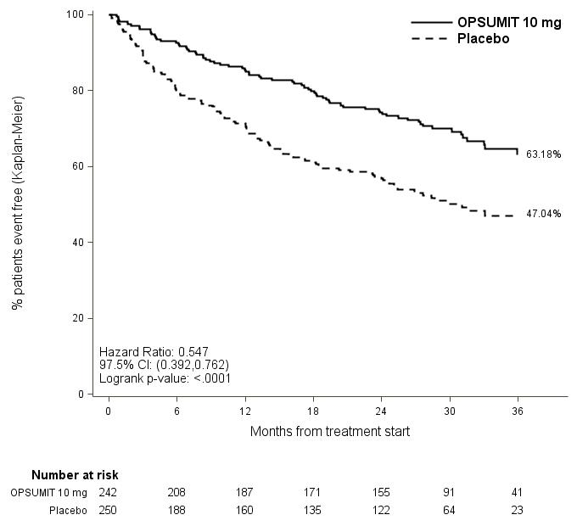

**Table 1 Summary of Primary Endpoint Events**

|  |  |  |  |  |  |  |  |
| --- | --- | --- | --- | --- | --- | --- | --- |
|  | **Placebo**  **N = 250**  **n (%)** | **OPSUMIT 10 mg**  **N = 242**  **n (%)** | **Treatment Comparison:**  **OPSUMIT 10 mg vs Placebo** | | | | |
| **Relative Risk Reduction**  **(97.5% CI)** | | **HR**  **(97.5% CI)** | | **Log rank p-value** |
| **Patients with a primary endpoint event** | 116  (46.4) | 76  (31.4) | 45%  (24%; 61%) | | 0.55  (0.39; 0.76) | | < 0.0001 |
| **Component as first event§** |  |  |  |  | |  |  |
| **Death** | 17 (6.8) | 16 (6.6) |  |  | |  |  |
| **Worsening PAH** | 93 (37.2) | 59 (24.4) |  |  | |  |  |
| **i.v./s.c. Prostanoid** | 6 (2.4) | 1 (0.4) |  |  | |  |  |
| **§** Due to competing risks,HR and p-values are not provided for the component events; No patients experienced an event of lung transplantation or atrial septostomy in the placebo or OPSUMIT 10 mg treatment groups. | | | | | | | |

Subgroup analyses were performed to examine their influence on outcome as shown in Figure 2. Consistent efficacy of OPSUMIT 10 mg on the primary endpoint was seen across subgroups of age, sex, race, etiology, by monotherapy or in combination with another PAH therapy, baseline 6MWD, and baseline WHO FC.

Figure 2 Subgroup analysis of the SERAPHIN study

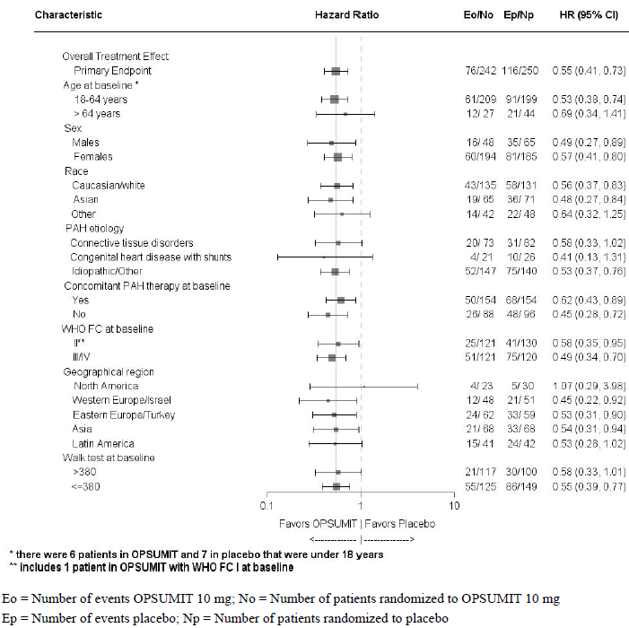

The SERAPHIN study was not powered to assess the effect on mortality. Treatment with OPSUMIT 10 mg resulted in a statistically non-significant 36% relative risk reduction (HR 0.64, 97.5% CI 0.29-1.42; logrank p=0.2037) in the occurrence of death of all causes up to EOT regardless of prior worsening. The number of deaths of all causes up to EOS on macitentan 10 mg was 35 versus 44 on placebo (HR 0.77; 97.5% CI: 0.46 to 1.28; logrank p=0.2509).

The risk of PAH-related death or hospitalisation for PAH up to the end of double-blind treatment was reduced by 50% in patients receiving macitentan 10 mg (50 events) (HR 0.50; 97.5% CI 0.34–0.75; logrank p < 0.0001) compared to placebo (84 events) [Figure 3 and Table 2].

Figure 3 Kaplan-Meier estimates of risk of death due to PAH or hospitalization for PAH in SERAPHIN

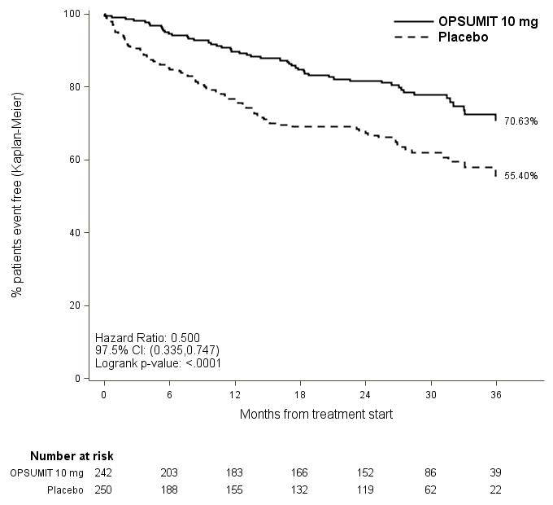

**Table 2 Summary of Death due to PAH and Hospitalisation due to PAH**

|  |  |  |
| --- | --- | --- |
|  | **Placebo**  **(N=250)**  **n (%)** | **OPSUMIT 10 mg**  **(N=242)**  **n (%)** |
| Death due to PAH or hospitalisation for PAH | 84 (33.6) | 50 (20.7) |
| Component as first event  Death due to PAH  Hospitalisation for PAH | 5 (2.0)  79 (31.6) | 5 (2.1)  45 (18.6) |

**Symptomatic endpoints**

Exercise capacity was evaluated as a secondary endpoint. Treatment with macitentan 10 mg at Month 6 resulted in a placebo-corrected mean increase in Six Minute Walk Distance (6MWD) of 22 meters (97.5% CI 3–41). Evaluation of 6MWD by functional class resulted in a placebo-corrected mean increase from baseline to Month 6 in FC III/IV patients of 37 metres (97.5% CI 5–69) and in FC I/II of 12 metres (97.5% CI −8–33). The increase in 6MWD achieved with macitentan was maintained for the duration of the study.

Treatment with macitentan 10 mg led to a 74% higher chance of WHO FC improvement relative to placebo (risk ratio 1.74; 97.5% CI 1.10–2.74). Treatment with macitentan 10 mg led to an improvement of at least one WHO FC at Month 6 in 22% of patients compared to 13% of patients treated with placebo.

Macitentan 10 mg improved quality of life assessed by the SF-36 questionnaire.

**Hemodynamic endpoints**

Hemodynamic parameters were assessed in a subset of patients (placebo, N = 67, macitentan 10 mg, N = 57) after 6 months of treatment. Patients treated with macitentan 10 mg achieved a median reduction of 36.5% (CI 21.7–49.2%) in pulmonary vascular resistance and an increase of 0.58 L/min/m2 (CI 0.28–0.93 L/min/m2) in cardiac index compared to placebo.

# INDICATIONS

OPSUMIT, as monotherapy or in combination with approved PAH treatments (phosphodiesterase-5 inhibitors or inhaled prostanoids), is indicated for the treatment of:

* idiopathic pulmonary arterial hypertension
* heritable pulmonary arterial hypertension
* pulmonary arterial hypertension associated with connective tissue disease
* pulmonary arterial hypertension associated with congenital heart disease with repaired shunts

in patients with WHO Functional class II, III or IV symptoms.

# CONTRAINDICATIONS

OPSUMIT is contraindicated in:

* Women who are or may become pregnant (See Boxed Warning and Use in pregnancy).
* Women of child-bearing potential who are not using reliable contraception (See Use in Women of child-bearing potential). Women must not become pregnant for at least 3 months after stopping treatment with OPSUMIT.
* Hypersensitivity to the active substance or to any of the excipients listed in DESCRIPTION.
* Patients with severe hepatic impairment (with or without cirrhosis) (See PRECAUTIONS).
* Patients with baseline values of hepatic aminotransferases (aspartate aminotransferase [AST] and/or alanine aminotransferase [ALT]) greater than 3 times the Upper Limit of Normal (ULN) (See PRECAUTIONS).

# PRECAUTIONS

Macitentan has only been studied in a limited number of patients with WHO functional class IV symptoms.

Macitentan has only been studied in a limited number of patients with PAH due to HIV, drugs or toxins.

The efficacy and safety of macitentan when co-administered with epoprostenol has not been specifically studied in controlled clinical trials.

**Liver function**

Hepatic enzyme elevations, and in some cases serious hepatic events, potentially related to therapy have been observed with endothelin receptor antagonists (ERAs).

The incidence of aminotransferase elevations (ALT/AST) > 3 × ULN was 3.4% on macitentan 10 mg and 4.5% on placebo in a double-blind study in patients with PAH. The incidence of elevations in ALT > 3 × ULN were 3.4% on macitentan 10 mg and 1.6% on placebo (see ADVERSE EFFECTS). The incidence of ALT > 8 × ULN were 2.1% on macitentan 10 mg and 0.4% on placebo.

Opsumit is not to be initiated in patients with severe hepatic impairment or elevated aminotransferases (> 3 × ULN) (see CONTRAINDICATIONS) and is not recommended in patients with moderate hepatic impairment. Liver enzyme tests should be obtained prior to initiation of macitentan and monthly monitoring of aminotransferases during treatment with macitentan is recommended. Patients should be monitored for signs of hepatic injury.

If clinically relevant aminotransferase elevations occur, or if elevations are accompanied by an increase in bilirubin >2 × ULN, or by clinical symptoms of hepatic injury (e.g. jaundice), macitentan treatment should be discontinued. Re-initiation of macitentan may be considered following the return of hepatic enzyme levels to within the normal range in patients who have not experienced clinical symptoms of hepatic injury and following the advice of a liver specialist.

Caution should be exercised when OPSUMIT is used concomitantly with medicinal products known to be associated with hepatic injury as the additive effects of OPSUMIT with these agents are not known.

**Haematological Changes**

Decreases in haemoglobin concentration and haematocrit have occurred following administration of other ERAs and were observed in clinical studies with OPSUMIT (see ADVERSE EFFECTS).

In placebo-controlled studies, macitentan-related decreases in haemoglobin concentration were not progressive, stabilised after the first 4-12 weeks of treatment andremained stable during chronic treatment. Cases of anaemia requiring blood cell transfusion have been reported with OPSUMIT and other ERAs. Initiation of OPSUMIT is not recommended in patients with clinically significant anaemia. It is recommended that haemoglobin concentrations be measured prior to initiation of treatment and tests repeated during treatment as clinically indicated.

**Patients with renal impairment**

Patients with renal impairment may run a higher risk of experiencing hypotension and anaemia during treatment with macitentan. Therefore, monitoring of blood pressure and haemoglobin should be considered. There is no clinical experience with the use of OPSUMIT in patients with severe renal impairment. Caution is recommended in this population. There is no experience with the use of OPSUMIT in patients undergoing dialysis, therefore OPSUMIT is not recommended in this population.

**Fluid retention**

Oedema or fluid retention has been observed with ERAs and may also be a clinical consequence of PAH. OPSUMIT 10 mg was not associated with increased incidences of treatment-emergent oedema or fluid retention in a long-term placebo-controlled trial [see ADVERSE EFFECTS].

If clinically significant fluid retention develops during therapy with OPSUMIT, with or without associated weight gain, further evaluation should be undertaken to determine the cause, such as underlying heart failure, and the possible need for specific treatment should be considered.

**Pulmonary veno-occlusive disease**

Cases of pulmonary oedema have been reported with vasodilators (mainly prostacyclins) when used in patients with pulmonary veno-occlusive disease. Consequently, if signs of pulmonary oedema occur when OPSUMIT is administered in patients with PAH, the possibility of pulmonary veno-occlusive disease should be considered. Discontinuation of OPSUMIT should be considered in patients with treatment-related pulmonary veno-occlusive disease.

**Use in Patients with pre-existing hypotension**

Hypotension has been associated with the use of ERAs. Caution should be exercised when initiating macitentan in patients with pre-existing hypotension and blood pressure in such patients should be monitored closely.

**Use in the Elderly**

Of the total number of subjects in the clinical study of OPSUMIT for PAH, 14% were 65 and over. No overall differences in safety or effectiveness were observed between these subjects and younger subjects. Limited data are available in those >75 years of age, therefore caution is recommended.

**Paediatric population**

The safety and efficacy of OPSUMIT in children below the age of 12 years have not yet been established. There is no data available on the effects of macitentan on growth and development in paediatric patients. There is limited clinical experience in paediatric patients aged 12 and above (see DOSAGE and ADMINISTRATION).

**Genotoxicity**

Macitentan was not genotoxic in a standard battery of in vitro and in vivo assays.

**Carcinogenicity**

Studies of 2 years duration did not reveal a carcinogenic potential at exposures 18-fold and 140-fold the human exposure in rats and mice, respectively.

**Effects on Fertility**

**Male fertility**

Reversible testicular tubular dilatation was observed in chronic toxicity studies at exposures greater than 7‑fold and 23‑fold the human exposure in rats and dogs, respectively. After 2 years of treatment, tubular atrophy was seen in rats at 4-fold the human exposure. The clinical relevance of this finding cannot be excluded. Macitentan did not affect male or female fertility in rats at exposures ranging from approximately 18- to 44-fold the human exposure, respectively. In a 26-week study in male rats treated with macitentan, there was no effect on sperm count or motility but there was a dose-dependent increase in the incidence of morphologically abnormal sperm at or above 7-fold the human exposure. No testicular findings were noted in mice after treatment up to 2 years.

Exploratory study results in healthy subjects with 12 weeks of treatment duration showed that 10 mg macitentan was associated with a 28% mean reduction in sperm concentration which is not considered clinically relevant. Changes in sperm morphology and motility were within the range of the variability of the measurements.

### **Use in pregnancy (Category X)**

Due to a high mortality risk to both mother and foetus, pregnancy is considered contraindicated in PAH.

Teratogenicity is a class effect of endothelin receptor antagonists.

There are no data on the use of macitentan in pregnant women. OPSUMIT is contraindicated during pregnancy and in women of childbearing potential who are not using reliable contraception. If OPSUMIT is used during pregnancy, or if the patient becomes pregnant while taking OPSUMIT, advise the patient of the potential harm to the foetus.

Macitentan was teratogenic in rabbits and rats at all doses tested. In both rabbits and rats, there were cardiovascular and mandibular arch fusion abnormalities. Administration of macitentan to female rats from late pregnancy through lactation caused reduced pup survival and impairment of the male fertility of the offspring at all dose levels tested.

**Use in women of child-bearing potential**

In females of child bearing potential, pregnancy should be excluded before the start of treatment with macitentan and prevented thereafter by the use of two reliable methods of contraception. If necessary, patients should discuss with their doctor or gynaecologist which methods would be most suitable for them. . Given the teratogenic nature of the drug, women should not become pregnant for 3 months after discontinuation of OPSUMIT. Monthly pregnancy tests during treatment with OPSUMIT are recommended to allow the early detection of pregnancy.

It is not known whether macitentan is present in semen. It is therefore not known whether there is the potential for foetal harm (teratogenicity) resulting from transfer of macitentan via semen.

**Use in Lactation**

It is not known whether OPSUMIT is excreted into human breast milk. In rats, OPSUMIT and its metabolites were excreted into milk during lactation. Breast-feeding is not recommended during treatment with OPSUMIT. A risk to newborns/infants cannot be excluded.

**INTERACTIONS WITH OTHER MEDICINES**

***In vitro* studies**

The metabolism of macitentan to its active metabolite is catalysed by CYP3A4 and to a minor extent by CYP2C19.

Macitentan and its active metabolite do not have relevant inhibitory or inducing effects on CYP enzymes.

Macitentan is neither a substrate nor an inhibitor of the multi-drug resistance protein (P‑gp, MDR-1). Macitentan and its active metabolite are neither substrates nor inhibitors of the organic anion transporting polypeptides (OATP1B1 and OATP1B3) at clinically relevant concentrations.

At clinically relevant concentrations, macitentan and its active metabolite do not interact with proteins involved in hepatic bile salt transport, i.e., the bile salt export pump (BSEP) and the sodium-dependent taurocholate co-transporting polypeptide (NTCP).

***In vivo* studies**

*Warfarin:* Macitentan given as multiple doses of 10 mg once daily had no effect on exposure to S‑warfarin (CYP2C9 substrate) or R-warfarin (CYP3A4 substrate) after a single dose of 25 mg warfarin. The pharmacodynamic effect of warfarin on International Normalized Ratio (INR) was not affected by macitentan. The pharmacokinetics of macitentan and its active metabolite were not affected by warfarin.

*Sildenafil:* At steady-state, the exposure to sildenafil 20 mg t.i.d. was increased by 15% during concomitant administration of macitentan 10 mg once daily. Sildenafil, a CYP3A4 substrate, did not affect the pharmacokinetics of macitentan, while there was a 15% reduction in the exposure to the active metabolite of macitentan. These changes are not considered clinically relevant. In a placebo-controlled trial in patients with PAH, the efficacy and safety of macitentan in combination with sildenafil were demonstrated.

*Strong CYP3A4 inhibitors:* In the presence of ketoconazole 400 mg once daily, a strong CYP3A4 inhibitor, exposure to macitentan increased approximately 2-fold. The predicted increase was approximately 3-fold in the presence of ketoconazole 200 mg twice daily using physiologically based pharmacokinetic (PBPK) modelling. Exposure to the active metabolite of macitentan was reduced by 26%. Caution should be exercised when macitentan is administered concomitantly with strong CYP3A4 inhibitors (e.g., itraconazole, ketoconazole, voriconazole, clarithromycin, ritonavir, and saquinavir).

*HIV drugs*: Effects of other strong CYP3A4 inhibitors such as ritonavir on macitentan were not studied, but are likely to result in an increase in macitentan exposure at steady state similar to that seen with ketoconazole

*Cyclosporine A:* Concomitant treatment with cyclosporine A 100 mg b.i.d., a combined CYP3A4 and OATP inhibitor, did not alter the steady-state exposure to macitentan and its active metabolite to a clinically relevant extent.

*Strong CYP3A4 inducers:* Concomitant treatment with rifampicin 600 mg daily, a potent inducer of CYP3A4, reduced the steady-state exposure to macitentan by 79% but did not affect the exposure to the active metabolite. Reduced efficacy of macitentan in the presence of a potent inducer of CYP3A4 such as rifampicin should be considered. The combination of macitentan with strong CYP3A4 inducers (e.g., rifampicin, St. John’s wort, carbamazepine, and phenytoin) should be avoided.

*Hormonal contraceptives:* Macitentan does not affect the exposure to CYP3A4 substrates. No reduced efficacy of hormonal contraceptives is expected.

# ADVERSE EFFECTS

**Experience from clinical studies**

The safety of macitentan has been evaluated in a long-term placebo-controlled trial of 742 patients with symptomatic PAH. The mean treatment duration was 103.9 weeks in the macitentan 10 mg group, and 85.3 weeks in the placebo group. The majority of adverse events were mild to moderate in intensity. The most commonly reported adverse events were nasopharyngitis (14.0% vs 10.4%), headache (13.6% vs 8.8%) and anaemia (13.2% vs 3.2%) (Table 3).

Table 4 presents adverse reactions occurring in macitentan-treated subjects at an incidence < 3 % and with a placebo-corrected difference ≥ 1 % (during treatment and up to 28 days after treatment discontinuation). Adverse reactions are listed by system organ class and frequency category, using the convention: common (≥ 1/100 and < 1/10). Within each frequency group, adverse reactions are presented in order of decreasing seriousness.

Frequency determination does not account for other factors including varying study duration, pre-existing conditions, and baseline patient characteristics.

**Table 3 Adverse events occurring in ≥ 3 % of macitentan-treated subjects and at a greater incidence than placebo (during treatment and up to 28 days after treatment discontinuation)**

|  |  |  |  |  |
| --- | --- | --- | --- | --- |
| **System Organ Class /**  **Preferred Term** | **Placebo**  **N=249** | | **Macitentan**  **10 mg**  **N=242** | |
| No. | % | No. | % |
| Blood and lymphatic system disorders |  |  |  |  |
| Anaemia | 8 | 3.2% | 32 | 13.2% |
| Thrombocytopenia | 7 | 2.8% | 12 | 5.0% |
| Gastrointestinal disorders |  |  |  |  |
| Diarrhoea | 17 | 6.8% | 22 | 9.1% |
| Abdominal pain upper | 11 | 4.4% | 11 | 4.5% |
| General disorders and administration site conditions |  |  |  |  |
| Oedema peripheral | 45 | 18.1% | 44 | 18.2% |
| Pyrexia | 9 | 3.6% | 9 | 3.7% |
| Infections and infestations |  |  |  |  |
| Upper respiratory tract infection | 33 | 13.3% | 37 | 15.3% |
| Nasopharyngitis | 26 | 10.4% | 34 | 14.0% |
| Bronchitis | 14 | 5.6% | 28 | 11.6% |
| Urinary tract infection | 14 | 5.6% | 21 | 8.7% |
| Respiratory tract infection viral | 9 | 3.6% | 15 | 6.2% |
| Pharyngitis | 7 | 2.8% | 15 | 6.2% |
| Influenza | 4 | 1.6% | 14 | 5.8% |
| Sinusitis | 6 | 2.4% | 11 | 4.5% |
| Gastroenteritis | 3 | 1.2% | 8 | 3.3% |
| Rhinitis | 2 | 0.8% | 8 | 3.3% |
| Metabolism and nutrition disorders |  |  |  |  |
| Hypokalaemia | 14 | 5.6% | 14 | 5.8% |
| Musculoskeletal and connective tissue disorders |  |  |  |  |
| Arthralgia | 10 | 4.0% | 11 | 4.5% |
| Myalgia | 4 | 1.6% | 8 | 3.3% |
| Nervous system disorders |  |  |  |  |
| Headache | 22 | 8.8% | 33 | 13.6% |
| Psychiatric disorders |  |  |  |  |
| Insomnia | 10 | 4.0% | 17 | 7.0% |
| Depression | 8 | 3.2% | 8 | 3.3% |
| Skin and subcutaneous tissue disorders |  |  |  |  |
| Skin ulcer | 3 | 1.2% | 8 | 3.3% |
| Vascular disorders |  |  |  |  |
| Hypotension | 11 | 4.4% | 15 | 6.2% |

**Table 4 Adverse reactions occurring in macitentan-treated subjects at an incidence < 3 % and with a placebo-corrected difference ≥ 1 % (during treatment and up to 28 days after treatment discontinuation)**

|  |  |
| --- | --- |
| **System Organ Class** | **Common  ≥ 1/100 and < 1/10)** |
| Eye disorders | Conjunctivitis |
| Gastrointestinal disorders | Abdominal pain, Irritable bowel syndrome, Haemorrhoids |
| Hepatobiliary disorders | Cholelithiasis |
| Infections and infestations | Lower respiratory tract infection, Gastroenteritis viral, Tracheitis, Tonsillitis |
| Investigations | Haemoglobin decreased, Haematocrit decreased, Blood urea increased |
| Metabolism and nutrition disorders | Hyperkalaemia |
| Musculoskeletal and connective tissue disorders | Systemic sclerosis, Costochondritis |
| Nervous system disorders | Migraine |
| Reproductive system and breast disorders | Metrorrhagia, Menorrhagia, Ovarian cyst, Gynaecomastia |
| Respiratory, thoracic and mediastinal disorders | Rhinorrhoea, Productive cough, Bronchial hyperreactivity |
| Skin and subcutaneous tissue disorders | Pruritus, Eczema, Urticaria |
| Vascular disorders | Flushing |

**Laboratory abnormalities**

*Liver aminotransferases*

The incidence of elevated aminotransferases in the study of OPSUMIT in PAH is shown in Tables 5 and 6.

**Table 5 Incidence of Elevated Aminotransferases (ALT/AST) in the SERAPHIN Study**

|  | OPSUMIT 10 mg  (N=242) | Placebo  (N=249) |
| --- | --- | --- |
| >3 x ULN | 3.4% | 4.5% |
| >5 x ULN | 2.5% | 2% |
| >8 x ULN | 2.1% | 0.4% |

**Table 6 Incidence of Elevated ALT in the SERAPHIN Study**

|  | OPSUMIT 10 mg  (N=242) | Placebo  (N=249) |
| --- | --- | --- |
| >3 x ULN | 3.4% | 1.6% |
| >5 x ULN | 2.5% | 1.2% |
| >8 x ULN | 2.1% | 0.4% |

In a double-blind study in patients with PAH, discontinuations for hepatic adverse events were 3.3% in the OPSUMIT 10 mg group vs. 1.6% for placebo.

*Haemoglobin*

In a double-blind study in patients with PAH, macitentan 10 mg was associated with a mean decrease in haemoglobin versus placebo of 10 g/L. A decrease from baseline in haemoglobin concentration to below 100 g/L was reported in 8.7% of patients treated with macitentan 10 mg and 3.4% of placebo-treated patients.

*White blood cells*

In a double-blind study in patients with PAH, macitentan 10 mg was associated with a decrease in mean leucocyte count from baseline of 0.7 × 109/L versus no change in placebo-treated patients.

*Platelets*

In a double-blind study in patients with PAH, macitentan 10 mg was associated with a decrease in mean platelet count of 17 × 109/L, versus a mean decrease of 11 × 109/L in placebo-treated patients.

# DOSAGE AND ADMINISTRATION

Treatment with OPSUMIT should only be initiated and monitored by a physician experienced in the treatment of PAH.

**Dosage**

OPSUMIT is to be taken orally at a dose of 10 mg once daily, with or without food. The film-coated tablets are not breakable and are to be swallowed whole, with water. Doses higher than 10 mg daily have not been studied and are not recommended.

**Dosage adjustment in elderly patients**

No dose adjustment is required in patients over the age of 65 years.

**Dosage adjustment in patients with hepatic impairment**

Based on pharmacokinetic data, no dose adjustment is required in patients with mild or moderate hepatic impairment. There is no clinical experience with the use of OPSUMIT in PAH patients with moderate or severe hepatic impairment.

OPSUMIT is contraindicated in patients with severe hepatic impairment, or clinically significant elevated hepatic aminotransferases (greater than 3 times the Upper Limit of Normal (> 3 × ULN); see CONTRAINDICATIONS.

**Dosage adjustment in patients with renal impairment**

Based on PK data, no dose adjustment is required in patients with renal impairment. There is no clinical experience with the use of OPSUMIT in PAH patients with severe renal impairment. The use of OPSUMIT is not recommended in patients undergoing dialysis.

**Dosage adjustment in paediatric population**

There is limited clinical experience in paediatric patients aged 12 and above therefore caution is advised; the recommended dose is 10 mg once daily in patients aged 12 and above and with body weight > 40kg. The safety and efficacy of OPSUMIT in children below the age of 12 years have not yet been established.

# OVERDOSAGE

Macitentan has been administered as a single dose of up to and including 600 mg to healthy subjects. Adverse events of headache, nausea, and vomiting were observed. In the event of an overdose, standard supportive measures must be taken, as required. Due to the high degree of protein binding of macitentan, dialysis is unlikely to be effective.

Contact the Poisons Information Centre on 13 11 26 for advice on management of overdose.

# PRESENTATION AND STORAGE CONDITIONS

Blisters: PVC/PE/PVdC/Aluminium foil blisters in cartons containing 3 x 10 mg macitentan film-coated tablets, starter pack, AUST R 205624

Blisters: PVC/PE/PVdC/Aluminium foil blisters in cartons 6 x 10 mg macitentan film-coated tablets, starter pack, AUST R 205624

Blisters: PVC/PE/PVdC/Aluminium foil blisters in cartons containing 9 x 10 mg macitentan film-coated tablets, starter pack, AUST R 205624

Blisters: PVC/PE/PVdC/Aluminium foil blisters in cartons containing 30 x 10 mg macitentan film-coated tablets, AUST R 205624

Bottle: White high-density polyethylene bottles in cartons containing 30 x 10 mg macitentan film-coated tablets, AUST R 205427

Store OPSUMIT below 30˚C, protect from moisture.

# NAME AND ADDRESS OF THE SPONSOR

Actelion Pharmaceuticals Australia Pty Limited

Suite 6,13B Narabang Way

Belrose NSW 2085

**POISON SCHEDULE OF THE MEDICINE**

Prescription Only Medicine (S4)

### **DATE OF FIRST INCLUSION IN THE AUSTRALIAN REGISTER OF THERAPEUTIC GOODS:** 5 February 2014.