30 October 2016

AusPAR Attachment 2

Extract from the Clinical Evaluation Report for Records -Meningococcal group B vaccine
  - Proprietary Product Name: Trumenba
  - Sponsor: Pfizer Australia Pty Ltd

About the Therapeutic Goods Administration (TGA)
- The Therapeutic Goods Administration (TGA) is part of the Australian Government Department of Health, and is responsible for regulating medicines and medical devices.
- The TGA administers the Therapeutic Goods Act 1989 (the Act), applying a risk management approach designed to ensure therapeutic goods supplied in Australia meet acceptable standards of quality, safety and efficacy (performance), when necessary.
- The work of the TGA is based on applying scientific and clinical expertise to decision-making, to ensure that the benefits to consumers outweigh any risks associated with the use of medicines and medical devices.
- The TGA relies on the public, healthcare professionals and industry to report problems with medicines or medical devices. TGA investigates reports received by it to determine any necessary regulatory action.
- To report a problem with a medicine or medical device, please see the information on the TGA website <https://www.tga.gov.au>.
About the Extract from the Clinical Evaluation Report
- This document provides a more detailed evaluation of the clinical findings, extracted from the Clinical Evaluation Report (CER) prepared by the TGA. This extract does not include sections from the CER regarding product documentation or post market activities.
- The words [Information redacted], where they appear in this document, indicate that confidential information has been deleted.
- For the most recent Product Information (PI), please refer to the TGA website <https://www.tga.gov.au/product-information-pi>.
Copyright
© Commonwealth of Australia 2018
This work is copyright. You may reproduce the whole or part of this work in unaltered form for your own personal use or, if you are part of an organisation, for internal use within your organisation, but only if you or your organisation do not use the reproduction for any commercial purpose and retain this copyright notice and all disclaimer notices as part of that reproduction. Apart from rights to use as permitted by the Copyright Act 1968 or allowed by this copyright notice, all other rights are reserved and you are not allowed to reproduce the whole or any part of this work in any way (electronic or otherwise) without first being given specific written permission from the Commonwealth to do so. Requests and inquiries concerning reproduction and rights are to be sent to the TGA Copyright Officer, Therapeutic Goods Administration, PO Box 100, Woden ACT 2606 or emailed to < tga.copyright@tga.gov.au>.

Contents
List of abbreviations 5
1. Introduction 10
1.1. Submission type 10
1.2. Drug class and therapeutic indication 10
1.3. Dosage forms and strengths 10
1.4. Dosage and administration 10
1.5. Information on the condition being treated 10
1.6. Current treatment options and clinical rationale 10
2. Clinical rationale 11
3. Contents of the clinical dossier 11
3.1. Scope of the clinical dossier 11
3.2. Paediatric data 11
3.3. Good clinical practice 11
4. Pharmacokinetics 12
5. Pharmacodynamics 12
6. Dosage selection for the pivotal studies 12
6.1. Evaluator’s conclusions on dose finding for the pivotal studies 13
7. Clinical efficacy 13
7.1. Pivotal or main efficacy studies 14
7.2. Other efficacy studies 37
7.3. Analyses performed across trials: pooled and meta-analyses 47
7.4. Evaluator’s conclusions on clinical efficacy 48
8. Clinical safety 50
8.1. Studies providing evaluable safety data 50
8.2. Studies that assessed safety as the sole primary outcome 50
8.3. Patient exposure 51
8.4. Adverse events 52
8.5. Evaluation of issues with possible regulatory impact 66
8.6. Other safety issues 67
8.7. Post marketing experience 67
8.8. Evaluator’s overall conclusions on clinical safety 68
9. First round benefit-risk assessment 69
9.1. First round assessment of benefits 69
9.2. First round assessment of risks 70
9.3. First round assessment of benefit-risk balance 71
10. First round recommendation regarding authorisation 71
11. Clinical questions 71
12. References 71

List of abbreviations
Abbreviation | Meaning
1/dil 4 | reciprocal of dilution
Ab | antibody
CMenB | Multicomponent meningococcal serogroup B vaccine
ABC | Active Bacterial Core
ACIP | Advisory Committee on Immunization Practices
Adacel | tetanus, low-dose diphtheria, and low-dose acellular pertussis vaccine (Tdap)
AE | adverse event
AlPO4 | aluminum phosphate
ANSM | Agence Nationale de Sécurité du Medicament
Anti-TPO | anti-thyroid peroxidase
ASO | antistreptolysin O
Aus | Australia
BLA | Biologic License Application
CBER | Center for Biologics Evaluation and Research
CC | clonal complex type
CDC | Centers for Disease Control and Prevention
CFR | Code of Federal Regulation
CHMP | Committee for Medicinal Products for Human Use
CI | confidence interval
cLIA | competitive Luminex immunoassay
CRM197 | cross-reactive material-197
CSR | clinical study report
dTAP | low-dose diphtheria, tetanus, and low-dose acellular pertussis vaccine
e-diary | electronic diary
EEA | European Economic Area
EU | European Union
FDA | Food and Drug Administration
factor H | binding protein (referring to the bacterial lipoprotein expressed on surface of N meningitidis)
Gardasil | human papilloma virus vaccine (HPV)
GCP | Good Clinical Practice
GMR | geometric mean ratio
GMT | geometric mean titre
HAV | hepatitis A virus vaccine
Havrix | hepatitis A virus vaccine (HAV)
HPV | human papilloma virus vaccine
hSBA | serum bactericidal assay using human complement
ICD | informed consent document
ICH | International Conference on Harmonisation
IgA | Immunoglobulin A
IgG | Immunoglobulin G
IMD | invasive meningococcal disease
IPV | inactivated poliomyelitis virus vaccine
ISE | integrated summary of efficacy
ISS | integrated summary of safety
iTT | intent-to-treat
LAL | Limulus amoebocyte lysate assay
LCI | lower bound confidence interval
LLOQ | lower limit of quantitation
LOD | limit of detection
LOS | lipooligosaccharide
LP2086 | lipoprotein (referring to the recombinant fHBP or fHBP vaccine antigen)
LXA | Luminex assay
MAA | marketing authorization application
MAC | membrane attack complex
MAE | medically attended adverse event
MCC | meningococcal serogroup C conjugate
MCV4 | quadrivalent meningococcal polysaccharide conjugate vaccine
MedDRA | Medical Dictionary for Regulatory Activities
Menactra | meningococcal (Groups A, C, Y, and W-135) polysaccharide diphtheria toxoid conjugate vaccine (MCV4)
MenACWY-CRM197 | Menveo, tetravalent meningococcal conjugate vaccine
MenAfriVac | meningococcal A conjugate vaccine
Menomune | tetravalent meningococcal polysaccharide vaccine
Menveo | tetravalent meningococcal conjugate vaccine, MenACWY-CRM197
MeNZB | meningococcal serogroup B outer membrane vesicle vaccine
mITT | modified intent-to-treat
MLST | multi-locus sequence type
MnB | Neisseria meningitidis serogroup B
MnC | Neisseria meningitidis serogroup C
MPSV4 | meningococcal polysaccharide vaccine
MRI | magnetic resonance imaging
NA | not applicable
NaCl | sodium chloride
NCA | National Competent Authority
NDCMCs | newly diagnosed chronic medical conditions
Nimenrix | meningococcal tetravalent (A,C,Y,W) tetanus toxoid conjugate vaccine
OMV | outer membrane vesicle
PDCO | Paediatric Committee
PDUFA | Prescription Drug User Fee Act
PIP | Pediatric Investigation Plan
Por A | porin A
Por B | porin B
PPV | positive predictive value
PS80 | polysorbate 80
PT | preferred term
RCDC | reverse cumulative distribution curve
Repevax | low-dose diphtheria, tetanus, acellular pertussis, and inactivated poliomyelitis virus vaccine (dTaP/IPV)
rLP2086 | recombinant lipoprotein 2086
RR | respiratory rate
RPT | rabbit pyrogenicity test
rSBA | serum bactericidal assay using baby rabbit serum as complement source
SAE | serious adverse event
SAP | statistical analysis plan
SBA | serum bactericidal assay
SCE | summary of clinical efficacy
SCS | summary of clinical safety
sCSR | supplemental clinical study report
SD | standard deviation
SOC | System organ class
SUSAR | suspected unexpected serious adverse reaction
Tdap | tetanus, low-dose diphtheria, and low-dose acellular pertussis vaccine
TSH | thyroid stimulating hormone
UK | United Kingdom
URTI | upper respiratory tract infection
US | United States
WHO | World Health Organization

Introduction

Submission type
This is a submission to register a new chemical (biological) entity.

Drug class and therapeutic indication
This is a vaccine. The proposed indication is individuals 10 years and older for active immunisation to prevent invasive meningococcal disease caused by Neisseria meningitidis serogroup B.

Dosage forms and strengths
MnB bivalent rLP2086 drug product is a sterile liquid suspension composed of rLP2086 subfamily A and B proteins formulated at 120 μg/mL/subfamily in 10 mM histidine buffer, pH 6.0, 150 mM sodium chloride (NaCl) with 0.5 mg/mL aluminum as aluminum phosphate (AlPO4) supplied in prefilled syringes.

Dosage and administration
The primary vaccination schedule consists of 2 doses (0.5 ml each) administered at 0 and 6 months. The schedule for individuals at increased risk of invasive meningococcal disease is 2 doses (0.5 ml each) administered at least 1 month apart, followed by a third dose at least 4 months after the second dose.
The proposed shelf life and storage condition for Trumenba is 3 years when stored at 2 to 8°C in a glass prefilled syringe.

Information on the condition being treated
Neisseria meningitidis serogroup B (MnB) is a significant cause of serious endemic meningococcal disease worldwide and can epidemiologically manifest as prolonged outbreaks or as sudden, unpredictable outbreaks. MnB disease is often devastating with sudden onset, fast progression and may result in permanent significant clinical long-term sequelae (neurological impairment, hearing loss, renal failure, and/or skin, digit and limb loss) in those that survive. Neisseria meningitidis serogroup B (MnB) is a significant cause of serious endemic meningococcal disease worldwide and can epidemiologically manifest as prolonged outbreaks or as sudden, unpredictable outbreaks.

Current treatment options and clinical rationale
The main treatment option is antibiotics for meningococcal infection. It still however has a significant mortality and morbidity associated with it despite even early antibiotic therapy. There is one licensed MnB vaccine currently available in Australia (and many other countries). This is now routinely being offered to groups ‘at risk’ for outbreaks in many countries (such as the USA).

Clinical rationale
MnB is now a vaccine preventable disease. There is already one MnB vaccine registered and available in Australia. A recombinant, multicomponent MnB vaccine (4CMenB) was included on the Australian Register of Therapeutic Goods on 14 August 2013. Availability of vaccine supply is an important consideration during endemic use or for outbreak control. Sufficient supply avoids potential vaccine shortages and thus, from a public health perspective, availability of more than one supplier of broadly protective MnB vaccines is important.

Contents of the clinical dossier

Scope of the clinical dossier
This application includes data from 15,294 subjects who received at least one dose of bivalent rLP2086, administered either as a single agent or given concomitantly with a licensed vaccine; 6486 subjects in Europe received at least 1 dose of bivalent rLP2086. These participants were enrolled in one of the following 11 studies included in this dossier:
- Two Phase III immunogenicity and safety studies using 4 primary and 10 secondary MnB test strains; Studies B1971009 and B1971016.
- One Phase III study assessing safety only; Study B1971014.
- Five Phase II immunogenicity and safety studies:
  - One Phase II study that examines various 2 and 3 dose schedules and supports the 2 dose (0, 6 months) posology for routine vaccination; Study B1971012.
  - Three Phase II concomitant vaccine Studies B1971010 (Repevax), B1971011 (Gardasil), and B1971015 (Menactra and Adacel)).
  - One Phase II study in laboratory workers; Study B1971042.
- 3 early Studies B1971003, B1971004, and B1971005-Stage 1 and Stage 2 (Stage 2 tested persistence of immune response up to 48 months after the last vaccination using the 4 primary test strains. During Stage 2 testing, response for Stage 1 time points was also measured using the 4 primary test strains)).
The clinical module includes reports for all the above studies. It also contains:
- Case report forms with safety data.
- Safety integrated analysis report, immunogenicity integrated analysis report.
- Literature references.
The dossier also included a Clinical Overview, Summaries of Clinical Pharmacology, Clinical Immunogenicity and Clinical Safety and literature references.

Paediatric data
Seven of the studies submitted in this application include paediatric data including one of the pivotal immunogenicity studies and the Phase III safety study.

Good clinical practice
All clinical studies evaluating the MnB rLP2086 vaccine comply with the Quality Standards of the International Conference on Harmonisation (ICH) guidelines¹, the Food and Drug Administration (FDA) guidelines for Good Clinical Practice (GCP),² EU Directive 2001/20/EC³ and the EMA guidelines on clinical evaluation of new vaccines clinical study reports in the submission state the studies complied with CPMP/ICH/135/95 Note for Guidance on Good Clinical Practice.⁴

Pharmacokinetics
Not applicable.

Pharmacodynamics
In accordance with the EMA ‘Guideline on Clinical Evaluation of New Vaccines’, the pharmacodynamic profile for the Trumenba vaccine was defined by its immunogenicity profile.

Dosage selection for the pivotal studies
Study B1971003 was a Phase I/II, single arm, open label study that recruited a total of 60 Australian adult subjects (aged 18 to ≤ 40 years) who received the final formulation of 120 μg of bivalent rLP2086 given on a 0, 1, 6 month schedule. This population was chosen to establish the appropriate dose in adults before a clinical trial in adolescents could be designed. This study was also designed for serological assay development. An exploratory objective of this study was to assess the immunogenicity of the 120 µg dose formulation of bivalent rLP2086 as measured by hSBA and/or levels of antibody specific to LP2086 antigens.
Functional antibody responses using hSBA were performed with the following MnB test strains: PMB1745 (A05), which expresses an fHBP variant homologous to one of bivalent rLP2086 antigens, rLP2086-A05, and PMB17 (B02), which expresses an fHBP variant that is heterologous to the other vaccine antigen, rLP2086-B01. Safety was evaluated based on local reactions and systemic events occurring within 7 days after each vaccination and recorded by the subject in an e-diary. AEs, SAEs, NDCMCs, were collected at protocol specified time periods.
Study B1971004 was a Phase I study conducted in the US in which 48 subjects (aged 18 to ≤ 40 years) were randomised to an open label, parallel group clinical trial with 3 bivalent rLP2086 dose groups (60 µg, 120 µg, or 200 µg) and a control group. The subjects in the bivalent rLP2086 groups received the final vaccine formulation using a 0, 2, 6 month schedule. The study control group received Tdap vaccine (Adacel) at Month 0 and saline at subsequent injection visits. This trial is the only study in the program with routine assessment of clinical pathology laboratory assays. Immunogenicity of 60, 120, and 200 µg doses of bivalent rLP2086 was assessed by immunoglobulin G (IgG) titres that were elicited by bivalent rLP2086. Safety was evaluated as described for Study B1971003.
Study B1971005 is a Phase II, randomised, single blind, placebo controlled dose selection study that enrolled 539 European or Australian subjects aged 11 to ≤ 18 years who received bivalent rLP2086 using a 0, 2, 6 month schedule. The control group received saline at each vaccination visit.
Stage 1: Subjects were randomised to 60 µg, 120 µg, or 200 µg bivalent rLP2086, or saline groups and safety and immunogenicity were compared across dosing groups to determine the final vaccine dose (120 µg) that would be used in all subsequent studies. Functional antibody responses, expressed as interpolated hSBA titres, were determined using qualified hSBAs with 2 of the 4 primary MnB test strains, PMB2001 (A56) and PMB2707 (B44) and additional MnB test strains PMB3302 (A04), PMB1745 (A05), PMB17 (B02), and PMB1256 (B03). Stage 1 (Vaccination phase) was completed prior to agreement on the Phase III test strains and endpoints, and hence the Phase III endpoints initially were not available for Stage 1 of this study. However, during Stage 2 of Study B1971005, hSBA testing was performed using samples collected at some Stage 1 time points, and results are included in the across study analyses. Safety in Stage 1 was evaluated as described for other Phase II studies.
Stage 2 (persistence of immune response): The persistence stage of the study was designed to evaluate the duration of the MnB-specific immune responses for up to 4 years after the third vaccination with bivalent rLP2086. Only Stage 1 subjects who received bivalent rLP2086 at the dose levels selected for the second stage of the study (120 µg and 200 µg), and saline control recipients, were invited to continue in Stage 2, which was open label. The results for Stage 2 included immunogenicity data from a study visit conducted at 6 months and 1 week after the third vaccination with bivalent rLP2086 during Stage. Immunogenicity of bivalent rLP2086 was measured by validated hSBAs with the 4 primary MnB test strains PMB80 (A22), PMB2001 (A56), PMB2948 (B24), and PMB2707 (B44) using blood samples collected at 6 months + 1 week, and 12, 24, and 48 months after Dose 3. Stage 2 persistence testing using the validated hSBAs and 4 primary test strains was also performed on samples collected at Stage 1 time points (pre immunisation and 1 month post dose 3). In the safety evaluation for Stage 2, SAEs were reported for 7 days following each blood draw, from Visit 8 onward.

Evaluator’s conclusions on dose finding for the pivotal studies
The dose finding studies are satisfactory.

Clinical efficacy
The following studies contributed to the immunogenicity data:
Early studies;
- A Phase I Study (B1971004) and a Phase I/II Study (B1971003) were conducted in subjects 18 to 40 years of age.
- A Phase II proof of concept and dose selection Study (B1971005-Stage 1) was conducted in subjects 11 to 18 years of age where the final dose level of 120 μg of bivalent rLP2086 was chosen for all subsequent studies.
- Study B1971005 (Stage 2) also evaluated immunogenicity of bivalent rLP2086 for up to 48 months after the last dose. As part of the Stage 2 evaluation of bactericidal antibody persistence, hSBAs with the 4 primary MnB test strains were performed with sera from essentially all Stage 2 subjects and a subset of sera from Stage 1 subjects (limited serum availability from Stage 1 subjects).
Phase II studies;
- Phase II study evaluating various 2 and 3 dose vaccination schedules
  - Study B1971012 was conducted in adolescents 11 to < 19 years of age to assess the immunogenicity and safety of rLP2086 when administered in two different 3 dose regimens (0, 1, 6 month or 0. 2, 6 month schedule) and in three different 2 dose regimens (0, 2 month, 0, 4 month, or 0, 6 month schedules).
- Phase II concomitant vaccine studies
  - After the final dose level of 120 μg of bivalent rLP2086 was established, Phase II concomitant vaccine administration Studies (B1971010; concomitant with Repevax, B1971011; concomitant with Gardasil, and B1971015; concomitant with Menactrac and Adacel) were initiated in subjects 10 to 18 years of age.
- Phase II study in laboratory workers, Study B1971042 was initiated in laboratory workers 18 to 65 years of age.
Phase III studies
After the safety and immunogenicity of bivalent rLP2086 was established, three Phase III studies were conducted: B1971009, a lot consistency immunogenicity and safety study in adolescents 10 to 18 years old; B1971016, an immunogenicity and safety study in young adults 18 to 25 years old; and B1971014, a large scale safety study in adolescents and young adults 10 to 25 years old in which immunogenicity was not evaluated.

Pivotal or main efficacy studies

Study B1971009
Study B1971009 was a Phase III, randomised; active controlled, observer blinded, multicentre trial in which subjects aged 10 to < 19 years received 1 of 3 lots of the bivalent rLP2086 or the active control HAV vaccine /saline. The study assessed the safety, tolerability, immunogenicity, and lot consistency of 3 lots of 120 µg bivalent rLP2086 administered on a 0, 2, and 6 month schedule.

Study design, objectives, locations and dates
This study was conducted at 82 sites in Canada, the United States, Czech Republic, Finland, Germany, Italy, Poland, and the United Kingdom. It was conducted between April 2013-2015. Subjects were randomly assigned to receive 1 of 3 lots of bivalent rLP2086 or the active control/saline. Subjects had vaccination visits at Months 0, 2, and 6 and blood draw visits at Months 0, 3, and 7.
The primary objective was to assess the immune response as measured by serum bactericidal assay using human complement (hSBA) performed with 4 primary N meningitidis serogroup B (MnB) test strains, 2 expressing an LP2086 subfamily A protein and 2 expressing an LP2086 subfamily B protein, measured 1 month after the third vaccination with bivalent rLP2086. The co-primary objective was to demonstrate that the immune responses induced by 3 lots of bivalent rLP2086 are equivalent as measured by hSBA performed with 2 primary MnB test strains, 1 expressing an LP2086 subfamily A protein and 1 expressing an LP2086 subfamily B protein, 1 month after the third vaccination with bivalent rLP2086. The primary safety objective was to evaluate the safety profile of bivalent rLP2086 compared to a control (hepatitis A virus (HAV) vaccine/saline), as measured by local reactions, systemic events, adverse events (AEs), serious adverse events (SAEs), newly diagnosed chronic medical conditions (NDCMCs), medically attended AEs (MAEs), and immediate AEs.

Inclusion and exclusion criteria

Inclusion criteria
Subjects were eligible to participate in the study if they met all of the following inclusion criteria:
- Evidence of a personally signed and dated Informed Consent Document. Parent/legally authorised representative and/or subjects who were willing and able to comply with scheduled visits, laboratory tests, and other study procedures.
- Male or female subject aged ≥ 10 and < 19 years at the time of enrolment.
- Available for the entire study period and could be reached by telephone.
- Healthy subject as determined by medical history, physical examination, and judgment of the investigator.
- Male and female subjects of childbearing potential must have agreed to use a highly effective method of contraception throughout the study.
- Negative urine pregnancy test for all female subjects.

Exclusion Criteria
Subjects presenting with any of the following were not to be included in the study:
- Previous vaccination with any meningococcal serogroup B vaccine.
- A previous anaphylactic reaction to any vaccine or vaccine related component.
- Subjects who had received prior HAV vaccination.
- Contraindication to vaccination with any HAV vaccine.
- Subjects who were scheduled to receive 1 or more doses of a human papillomavirus (HPV) vaccine as part of a 3 dose series during the period between Visit 1 and 28 days after the second vaccination.
- Subjects who were receiving any allergen immunotherapy with a non licensed product or receiving allergen immunotherapy with a licensed product and were not on stable maintenance doses.
- Bleeding diathesis or condition associated with prolonged bleeding time that would contraindicate intramuscular injection.
- A known or suspected defect of the immune system that would prevent an immune response to the vaccine, such as subjects with congenital or acquired defects in B cell function, those receiving chronic systemic (oral, intravenous, or intramuscular) corticosteroid therapy, or those receiving immunosuppressive therapy. Subjects in the US with terminal complement deficiency were excluded from participation in this study.
- History of microbiologically proven disease caused by N meningitidis or Neisseria gonorrhoeae.
- Significant neurological disorder or history of seizure (excluding simple febrile seizure).
- Receipt of any blood products, including immunoglobulin within 6 months before the first study vaccination.
- Current chronic use of systemic antibiotics.
- Current participation in another investigational study. Participation in purely observational studies was acceptable.
- Received any investigational vaccines, drugs, or devices within 28 days before administration of the first study vaccination.
- Any neuroinflammatory or autoimmune condition, including, but not limited to, transverse myelitis, uveitis, optic neuritis, and multiple sclerosis.
- Other severe acute or chronic medical or psychiatric condition or laboratory abnormality that may increase the risk associated with study participation or investigational product administration or may interfere with the interpretation of study results and, in the judgment of the investigator, would have made the subject inappropriate for entry into this study.
- Subjects who were investigational site staff members or relatives of those site staff members, or subjects who were sponsor employees directly involved in the conduct of the trial.
- Subject was pregnant or breastfeeding.

Study treatments
Vaccines Administered: Subjects in Groups 1, 2, and 3 received 1 dose (0.5 mL) of bivalent rLP2086 (Lots 1, 2, or 3, respectively) at each of the 3 vaccination visits (Visits 1, 2, and 4); subjects in Group 4 received 1 dose (0.5 mL or 1.0 mL, depending on country-specific guidelines) of HAV vaccine at Visit 1, 1 dose (0.5 mL) of saline at Visit 2, and 1 dose (0.5 mL or 1.0 mL, depending on country-specific guidelines) of HAV vaccine at Visit 4, according to the study design.
Investigational product was administered by intramuscular injection into the upper deltoid muscle of the arm.

Immunogenicity variables and outcomes
The first primary objective of this study was to assess the immune response as measured by hSBA performed with 4 primary MnB test strains, 2 expressing a LP2086 subfamily A protein (PMB80 (A22) and PMB2001 (A56)) and 2 expressing a LP2086 subfamily B protein (PMB2948 (B24) and PMB2707 (B44)), measured 1 month after the third vaccination with bivalent rLP2086. The 5 co-primary endpoints for this objective were the proportion of subjects in Group 1 achieving at least a 4 fold rise in hSBA titre for each of the 4 primary MnB test strains and the proportion of subjects achieving a composite response at 1 month after the third vaccination with bivalent rLP2086.
The second primary objective (lot consistency) was to demonstrate that the immune responses induced by 3 lots of bivalent rLP2086 were equivalent as measured by hSBA with 2 primary MnB test strains, 1 expressing an LP2086 subfamily A protein and 1 expressing an LP2086 subfamily B protein, 1 month after the third vaccination with bivalent rLP2086. The primary endpoints for the lot consistency objective were hSBA GMTs for each of the 2 primary MnB test strains PMB80 (A22) and PMB2948 (B24), at 1 month after the third vaccination with bivalent rLP2086 for subjects in Groups 1, 2, and 3.
Secondary objectives:
- To describe the immune response as measured by hSBA performed with 10 secondary MnB test strains expressing LP2086 subfamily A or B proteins, measured 1 month after the third vaccination with bivalent rLP2086.
- To describe the immune response as measured by hSBA performed with 4 primary MnB test strains, 2 expressing a LP2086 subfamily A protein and 2 expressing a LP2086 subfamily B protein, measured 1 month after the second vaccination with bivalent rLP2086.

Randomisation and blinding methods
Subjects were electronically randomised into 1 of 4 groups in a 5:2:2:3 ratio (Lot 1:Lot 2:Lot 3:HAV vaccine/saline). Randomisation was stratified by geographic region. Regional stratification ensured sufficient population representation.
This was an observer blinded study, and only the study staff dispensing and administering the vaccine were unblinded. All other study personnel, including the principal investigator, subject, and the sponsor, were blinded. In particular, the individuals who evaluated subject safety and the subjects were blinded.

Analysis populations
The evaluable immunogenicity population was the primary analysis population for immunogenicity data.

Sample size
The planned sample size was approximately 1800 subjects from US investigative sites, 1440 subjects from European investigative sites, and 360 subjects from additional regions were to be enrolled.

Statistical methods
The primary analysis for the primary immunogenicity objective at 1 month after the third vaccination with bivalent rLP2086 was based on the evaluable immunogenicity population for the 5 co-primary endpoints (composite hSBA response and 4 fold increase from Baseline for each of the 4 primary MnB test strains) in Group 1. The 95% confidence intervals (CIs) were presented along with the response rate. The study objectives were achieved if the lower bounds of the 95% CIs at Visit 5 were greater than the thresholds specified for each of the 5 co-primary endpoints among subjects in Group 1. The statistical methodology for the primary outcome was based on the use of the two-sided 95% Confidence Interval (CI). The first primary objective would be achieved if the lower bound of the 95% CI at one month after the third vaccination was greater than the threshold specified in Table 1 for each of the 5 co-primary endpoints among subjects in Group 1. The sponsor and regulatory authorities had agreed upon the success criteria (lower bound of the 95% CI for the response rate) for the 5 co-primary endpoints based on exploratory post dose 3 immunogenicity data from the adolescent Study B1971012.
The lot consistency objective would be achieved if the 2-sided 95% CIs on the hSBA GMT ratio (that is, geometric mean ratio (GMR)) between any 2 of the 3 lots for both PMB80 (A22) and PMB2948 (B24) were within the interval (0.5, 2.0) 1 month after Vaccination 3, after the primary immunogenicity objective was achieved.

Table 1: Primary immunogenicity analysis; subjects achieving ≥ 4 fold rise in hSBA titre and composite response at 1 month after Vaccination 3 for primary strains; evaluable immunogenicity population (Study B1971009)
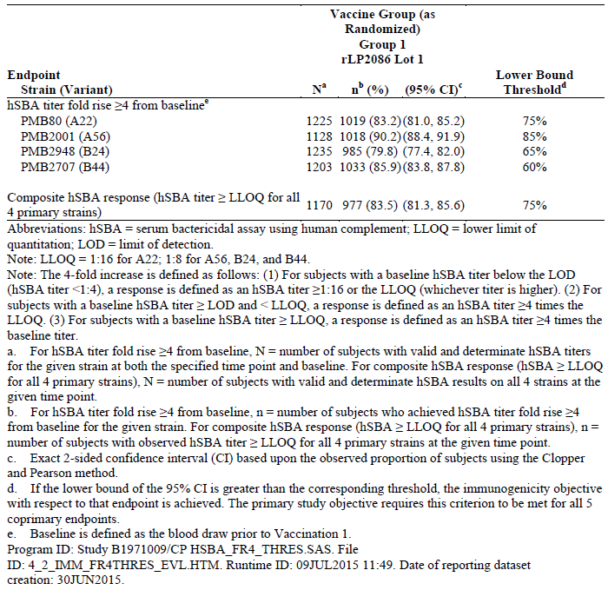

Participant flow
A total of 3596 subjects were randomised in this study. Of the subjects randomised, 1509 subjects were in Group 1 (bivalent rLP2086 Lot 1), 600 subjects were in Group 2 (bivalent rLP2086 Lot 2), 589 subjects were in Group 3 (bivalent rLP2086 Lot 3), and 898 subjects were in Group 4 (HAV vaccine/saline). Six (6) subjects (1 in Group 1, 2 in Group 2, 2 in Group 3, and 1 in Group 4) were randomised but withdrew from the study before vaccination. A total of 3226 (89.7%) subjects completed the study (Group 1: n = 1353, 89.7%; Group 2: n = 537, 89.5%; Group 3: n = 521, 88.5%; and Group 4, n = 815, 90.8%.

Major protocol violations/deviations
A total of 99.8% of randomised subjects received vaccines at Vaccination 1. The proportions of randomised subjects that received vaccines within the protocol specified visit window requirement for Vaccination 2 and Vaccination 3 were 93.7% and 87.5%, respectively. The range of the proportion of subjects at Vaccination 2 with vaccinations before the pre-specified window was 0.1% to 0.5% and at Vaccination 3 was 0.3% to 0.7%. The range of the percentage of subjects at Vaccination 2 with vaccinations after the pre-specified window was 0.5% to 2.1% and for Vaccination 3 was 2.8% to 4.0%. Subjects were not excluded from the evaluable immunogenicity populations due to vaccination window violations.

Baseline data
Among 3,590 vaccinated subjects, 1,850 (51.5%) were male and 1,740 (48.5%) were female. The majority of subjects were White. The number and percent of subjects in each racial group were as follows: White, n = 3134, 87.3%; Black, n = 292, 8.1%; other, n = 148 (4.1%); Asian, n = 16 (0.4%). The mean age at vaccination was 13.9 years (SD 2.6), with ages of study subjects ranging from 10 years to 19 years. Percentages by sex and race/ethnicity and mean age at vaccination were similar in each study group.
A total of 3059 (85.1%) subjects were included in the evaluable immunogenicity population (Group 1, n = 1279, 84.8%; Group 2, n = 519, 86.5%; Group 3, n = 493, 83.7%; Group 4, n = 768, 85.5%).

Results for the primary efficacy outcome
For the evaluable immunogenicity population, the proportion of subjects achieving a ≥ 4 fold rise in hSBA titre in Group 1 was as follows: 83.2% (95% CI: 81.0, 85.2) for PMB80 (A22); 90.2% (95% CI: 88.4, 91.9) for PMB2001 (A56); 79.8% (95% CI: 77.4, 82.0) for PMB2948 (B24); 85.9% (95% CI: 83.8, 87.8) for PMB2707 (B44); and 83.5% (95% CI: 81.3, 85.6) for the composite hSBA response. The lower limit of the 2-sided 95% CI was greater than the corresponding pre-specified lower bound threshold for each of the 4 primary MnB strains and for the composite response; thus, the first primary objective (immunogenicity) was met (Table 1).
For the lot to lot consistency outcome, for PMB80 (A22), the GMRs (95% CIs) were as follows: 1.03 (0.93, 1.14) for Lot 1 to Lot 2; 1.02 (0.92, 1.13) for Lot 1 to Lot 3; and 0.99 (0.88, 1.12) for Lot 2 to Lot 3. For PMB2948 (B24), the GMRs (95% CIs) were: 0.95 (0.85, 1.06) for Lot 1 to Lot 2; 0.95 (0.86, 1.06) for Lot 1 to Lot 3; and 1.00 (0.88, 1.14) for Lot 2 to Lot 3 (Table 2).
The 95% CI for all pairwise GMRs between lots were within the interval (0.5, 2.0), for both test strains PMB80 (A22) and PMB2948 (B24). Therefore, the lot consistency objective was met.

Table 2: Primary lot consistency analysis; comparison of hSBA GMTs 1 month after Vaccination 3 for primary strains; evaluable immunogenicity population (Study B1971009)
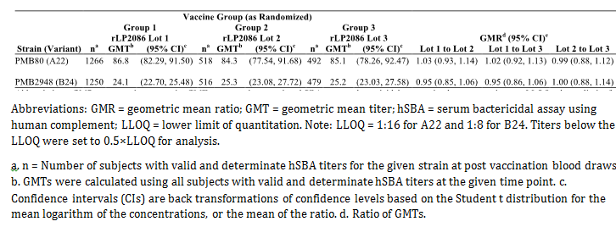

Results for other immunogenicity outcomes

hSBA ≥ 4 fold rise and composite response
The proportion of subjects in Group 1 achieving an hSBA titre fold rise ≥ 4 from Baseline to 1 month after Vaccination 2 was: 73.8% for PMB80 (A22), 84.8% for PMB2001 (A56), 56.2% for PMB2948 (B24), and 55.9% for PMB2707 (B44).
The proportion of subjects in Group 1 achieving an hSBA titre fold rise ≥ 4 from Baseline to 1 month after Vaccination 3 was 83.2% for PMB80 (A22), 90.2% for PMB2001 (A56), 79.8% for PMB2948 (B24), and 85.9% for PMB2707 (B44).
hSBA responses for PMB80 (A22) and for PMB2948 (B24) in Groups 2 and 3 were numerically similar to those of Group 1 after Vaccination 2 and Vaccination 3. PMB2001 (A56) and PMB2707 (B44) were not assessed for Groups 2 and 3. The proportion of subjects with a composite response at Baseline for Group 1 was 1.1%, which was similar to the control group (2.0%; Group 4). In Group 1, the proportion of subjects achieving a composite response 1 month after the second and third vaccinations was 54.1% and 83.5%, respectively.
The proportions of subjects in the control group (Group 4) who achieved composite responses 1 month after the second and third vaccinations were 2.9% and 2.8%, respectively.

hSBA titres ≥ LLOQ
The proportions of subjects with hSBA titres ≥ LLOQ in Groups 1, 2 and 3 increased substantially from Baseline to 1 month after Vaccination 2 with an additional increase 1 month after Vaccination 3. After Vaccination 2 the proportion of responders in Group 1 with titres at ≥ LLOQ was as follows: 94.3% for PMB80 (A22); 99.1% for PMB2001 (A56); 66.4% for PMB2948 (B24); and 64.0% for PMB2707 (B44). Results for PMB80 (A22) and PMB2948 (B24) in Groups 2 and 3 were numerically similar to those of Group 1. The proportion of responders in Group 1 one month after Vaccination 3 was 97.8% for PMB80 (A22); 99.5% for PMB2001 (A56); 87.1% for PMB2948 (B24); and 89.3% for PMB2707 (B44). Results for PMB80 (A22) and PMB2948 (B24) in Groups 2 and 3 were numerically similar to those of Group 1.
The responses in Group 4 (HAV/Saline) did not change (from Baseline) over time.

Defined levels of hSBA titres
One month after Vaccination 2, the proportions of subjects in Group 1 with an hSBA titre ≥ 1:4 were 94.9% for PMB80 (A22), 99.1% for PMB2001 (A56), 69.2% for PMB2948 (B24), and 66.7% for PMB2707 (B44).
One month after Vaccination 3, the proportions of responders in Group 1 with an hSBA titre ≥ 1:4 were 97.9% for PMB80 (A22), 99.5% for PMB2001 (A56), 88.9% for PMB2948 (B24), and 90.4% for PMB2707 (B44). Results for PMB80 (A22) and PMB2948 (B24) in Groups 2 and 3 were numerically similar to those of Group 1.
The responses in Group 4 (HAV/Saline) did not change (from Baseline) over time for each primary test strain.

hSBA GMTs
The hSBA GMTs in Group 1 at 1 month after Vaccination 2 were 50.4 for PMB80 (A22), 131.2 for PMB2001 (A56), 14.3 for PMB2948 (B24), and 17.1 for PMB2707 (B44). The hSBA GMTs in Group 1 at 1 month after Vaccination 3 were 86.8 for PMB80 (A22), 222.5 for PMB2001 (A56), 24.1 for PMB2948 (B24), and 50.9 for PMB2707 (B44).
The hSBA GMTs for the 4 primary test strains increased substantially from Baseline in Group 1 and for PMB80 (A22) and PMB2948 (B24) in Group 2 and Group 3 at 1 month after Vaccination 2 and Vaccination 3; hSBA GMTs also increased from Vaccination 2 to after Vaccination 3 for Groups 1, 2, and 3. hSBA GMTs in each group were notably higher when compared to hSBA GMTs in Group 4 (HAV/Saline) at both time points.

Reverse cumulative distribution curves for the primary MnB test strains
The reverse cumulative distribution curves (RCDCs) showing the distribution of hSBA titres for PMB80 (A22), PMB2001 (A56), PMB2948 (B24), and PMB2707 (B44) by study group are presented in Figures 1-4 for Groups 1, 2, 3, and 4 at all sampling time points for the evaluable immunogenicity population. The RCDCs showed that a substantially high proportion of subjects achieved the LLOQ for each of the 4 test strains after Vaccination 2 and an even higher proportion of subjects achieved hSBA titres ≥ LOQ after Vaccination 3. The curves were similar for Groups 1, 2, and 3. Titres were below the LLOQ for a large majority of subjects in the control group (Group 4).
Figure 1: Reverse cumulative distribution curves, PMB80 (A22), evaluable immunogenicity population; Study B1971009
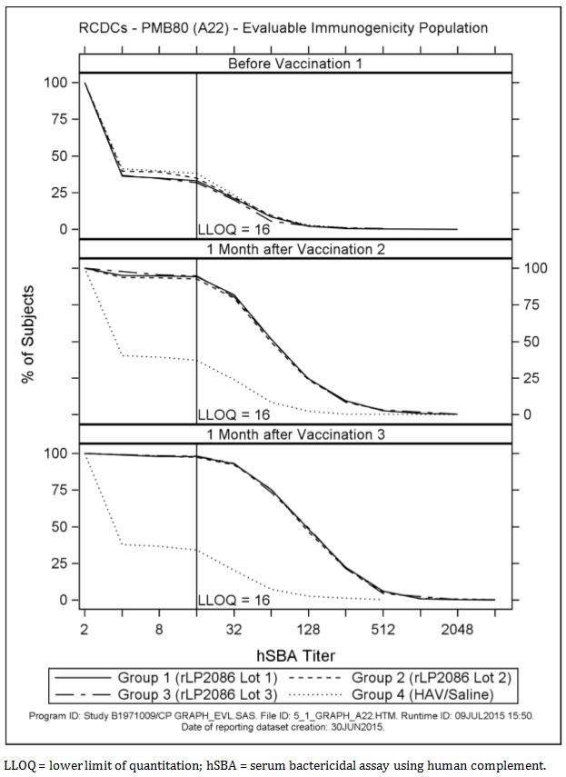
Figure 2: Reverse cumulative distribution curves, PMB2001 (A56), evaluable immunogenicity population; Study B1971009
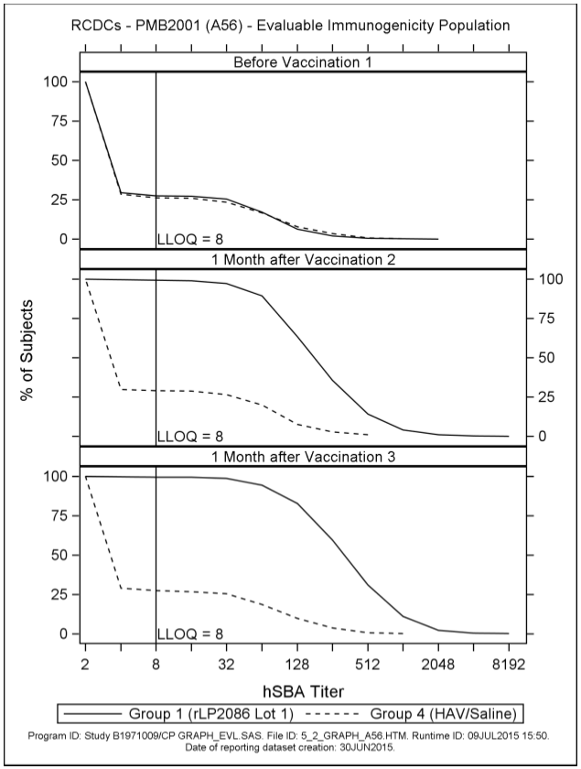
Figure 3: Reverse cumulative distribution curves, PMB2948 (B24), evaluable immunogenicity population; Study B1971009
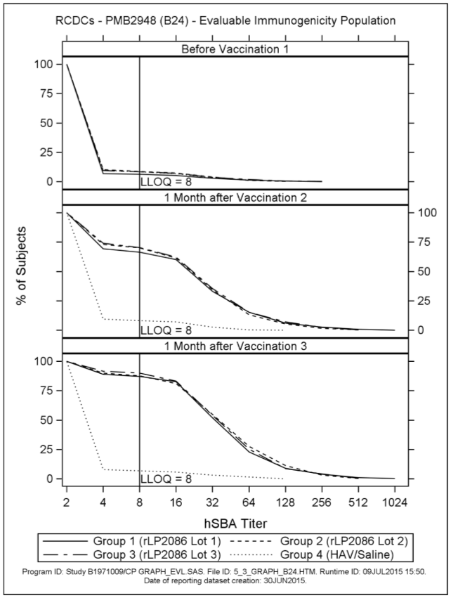
Figure 4: Reverse cumulative distribution curves, PMB2707 (B44), evaluable immunogenicity population; Study B1971009
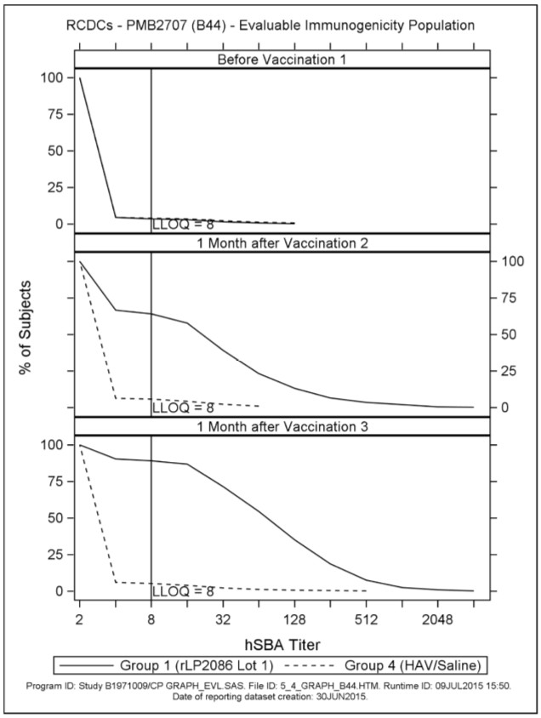

hSBA response to 10 secondary test strains: hSBA titres ≥ LLOQ for the 10 secondary MnB test strains
The proportion of subjects with an hSBA titre ≥ LLOQ rose substantially from Baseline to 1 month after Vaccination 3 for both fHBP subfamily A and subfamily B variant expressing strains. Among fHBP subfamily A variant expressing strains, for 4 of these strains, ≥ 92.7% of subjects achieved hSBA titres ≥ LLOQ: (98.6% for PMB3175 (A29); 95.7% for PMB3010 (A06); 92.7% for PMB1989 (A19); and 96.4% for PMB3040 (A07)). For PMB824 (A12) and for PMB1672 (A15), the proportion achieving a titre ≥ LLOQ was 75.1% and 87.2%, respectively.
Among fHBP subfamily B variant expressing strains the proportion of subjects in Group 1 with an hSBA titre ≥ LLOQ 1 month after Vaccination 3 was 92.5 % for PMB1256 (B03); 86.2% for PMB866 (B09); 98.2% for PMB431 (B15); and 81.7% for PMB648 (B16).
Among fHBP subfamily A variant expressing strains, ≥ 84.0% of subjects in Group 1 achieved hSBA titres ≥ LLOQ 1 month after Vaccination 2 for 4 of these strains (100% for PMB3175 (A29), 84.0% for PMB3010 (A06), 84.5% for PMB1989 (A19) and 93.8% for PMB3040 (A07)). For PMB824 (A12) and for PMB1672 (A15), the proportion achieving a titre ≥ LLOQ was 67.4% and 65.6%, respectively.
Among fHBP subfamily B variant expressing strains, the proportion of subjects in Group 1 (LP2086 Lot 1) with an hSBA titre ≥ LLOQ 1 month after Vaccination 2 was 61.1% for PMB1256 (B03), 76.3% for PMB866 (B09), 96.8% for PMB431 (B15), and 61.6% for PMB648 (B16).
Among fHBP subfamily A variant expressing strains, the proportion of subjects in Group 1 who achieved an hSBA titre ≥ 1:4 was ≥ 93.8% at 1 month after Vaccination 3 in the evaluable immunogenicity population for 4 test strains (98.6% for PMB3175 (A29), 96.1% for PMB3010 (A06), 93.8% for PMB1989 (A19), and 96.4% for PMB3040 (A07)). For PMB824 (A12) the proportion achieving a titre ≥ 1:4 was 77.6% and for PMB1672 (A15) was 87.2%.
Among fHBP subfamily B variant expressing strains, the proportion of subjects in Group 1 who achieved an hSBA titre ≥ 1:4 at 1 month after Vaccination 3 in the evaluable immunogenicity population was 92.5% for PMB1256 (B03), 86.6% for PMB866 (B09), 98.2% for PMB431 (B15), and 82.7% for PMB648 (B16).
A secondary endpoint was the hSBA GMTs in Group 1 for each of the 10 secondary MnB test strains at Baseline and 1 month after the third vaccination with bivalent rLP2086. The GMTs at Baseline were generally low. GMTs increased substantially after Vaccination 3 for both fHBP subfamily A and subfamily B variant expressing strains. Among fHBP subfamily A variant expressing strains, the hSBA GMTs 1 month after Vaccination 3 were 93.5 for PMB3175 (A29), 78.6 for PMB3010 (A06), 57.6 for PMB1989 (A19), 63.5 for PMB3040 (A07), 22.3 for PMB824 (A12), and 31.0 for PMB1672 (A15) for the evaluable immunogenicity population.
Among fHBP subfamily B variant expressing strains the hSBA GMT 1 month after Vaccination 3 in Group 1 were 51.7 for PMB1256 (B03), 22.9 for PMB866 (B09), 47.7 for PMB431 (B15), and 22.1 for PMB648 (B16) in the evaluable immunogenicity population.

Study B1971016
Study B1971016 was a Phase III, randomised, placebo controlled, observer blinded, multicentre trial to assess the safety, tolerability, and immunogenicity of bivalent rLP2086 vaccine when administered as a 3 dose regimen in healthy young adults aged ≥ 18 to < 26 years. It was conducted at 53 sites in Canada, Denmark, Finland, Poland, Spain, and the United States of America (USA) between May 2013 and February 2015.

Study design, objectives, locations and dates
Approximately 3,300 subjects were to be randomly assigned to 1 of 2 groups in a 3:1 ratio (Group 1: Group 2). Group 1 received bivalent rLP2086 at Month 0 (Day 1) followed by subsequent vaccinations at Months 2 and 6. Group 2 received a saline injection at Month 0, Month 2, and Month 6. Subjects had vaccination visits at Months 0, 2, and 6 and blood draw visits at Months 0, 3, and 7.
The primary immunogenicity objective of this study was to assess the immune response as measured by serum bactericidal assay using human complement (hSBA) performed with 4 primary N. meningitidis serogroup B (MnB) test strains, 2 expressing a lipoprotein 2086 (LP2086) subfamily A protein and 2 expressing an LP2086 subfamily B protein, measured 1 month after the third vaccination with N. meningitidis serogroup B bivalent recombinant lipoprotein 2086 vaccine (bivalent rLP2086). The primary safety objective of this study was to evaluate the safety profile of bivalent rLP2086 compared to a control (saline), as measured by local reactions, systemic events, adverse events (AEs), serious adverse events (SAEs), newly diagnosed chronic medical conditions (NDCMCs), medically attended AEs (MAEs), and immediate AEs.

Inclusion and exclusion criteria

Inclusion criteria
Subjects were eligible to participate in the study if they met all of the following inclusion criteria:
- Evidence of a personally signed and dated Informed Consent Document. Parent/legally authorised representative and/or subjects who were willing and able to comply with scheduled visits, laboratory tests, and other study procedures.
- Male or female subject aged ≥ 18 and < 26 years at the time of enrolment.
- Available for the entire study period and could be reached by telephone.
- Healthy subject as determined by medical history, physical examination, and judgment of the investigator.
- Male and female subjects of childbearing potential must have agreed to use a highly effective method of contraception throughout the study.
- Negative urine pregnancy test for all female subjects.

Exclusion criteria
Subjects presenting with any of the following were not to be included in the study:
- Previous vaccination with any meningococcal serogroup B vaccine.
- A previous anaphylactic reaction to any vaccine or vaccine related component.
- Subjects who had received prior HAV vaccination.
- Contraindication to vaccination with any HAV vaccine.
- Subjects who were scheduled to receive 1 or more doses of a human papillomavirus (HPV) vaccine as part of a 3 dose series during the period between Visit 1 and 28 days after the second vaccination.
- Subjects who were receiving any allergen immunotherapy with a non licensed product or receiving allergen immunotherapy with a licensed product and were not on stable maintenance doses.
- Bleeding diathesis or condition associated with prolonged bleeding time that would contraindicate intramuscular injection.
- A known or suspected defect of the immune system that would prevent an immune response to the vaccine, such as subjects with congenital or acquired defects in B cell function, those receiving chronic systemic (oral, intravenous, or intramuscular) corticosteroid therapy, or those receiving immunosuppressive therapy. Subjects in the US with terminal complement deficiency were excluded from participation in this study.
- History of microbiologically proven disease caused by N meningitidis or N. gonorrhoeae.
- Significant neurological disorder or history of seizure (excluding simple febrile seizure).
- Receipt of any blood products, including immunoglobulin within 6 months before the first study vaccination.
- Current chronic use of systemic antibiotics.
- Current participation in another investigational study. Participation in purely observational studies was acceptable.
- Received any investigational vaccines, drugs, or devices within 28 days before administration of the first study vaccination.
- Any neuroinflammatory or autoimmune condition, including, but not limited to, transverse myelitis, uveitis, optic neuritis, and multiple sclerosis.
- Other severe acute or chronic medical or psychiatric condition or laboratory abnormality that may increase the risk associated with study participation or investigational product administration or may interfere with the interpretation of study results and, in the judgment of the investigator, would have made the subject inappropriate for entry into this study.
- Subjects who were investigational site staff members or relatives of those site staff members, or subjects who were sponsor employees directly involved in the conduct of the trial.
- Subject was pregnant or breastfeeding.

Study treatments
Group 1 received 120 µg of the bivalent rLP2086 at Months 0, 2, and 6. Group 2 received saline (control) at Months 0, 2, and 6.

Efficacy variables and outcomes
The primary objective of this study was to assess the immune response as measured by serum bactericidal assay using human complement (hSBA) performed with 4 primary N. meningitidis serogroup B (MnB) test strains, 2 expressing a lipoprotein 2086 (LP2086) subfamily A protein and 2 expressing an LP2086 subfamily B protein, measured 1 month after the third vaccination with N. meningitidis serogroup B bivalent recombinant lipoprotein 2086 vaccine (bivalent rLP2086). The primary safety objective of this study was to evaluate the safety profile of bivalent rLP2086 compared to a control. Five co primary endpoints were defined for the primary immunogenicity objective based upon results for hSBAs performed with each of the following 4 primary test strains for Group 1 subjects: PMB80 (A22), PMB2001 (A56), PMB2948 (B24), and PMB2707 (B44).
One of the 5 co primary endpoints was the composite endpoint defined as the proportion of subjects with an hSBA titre ≥ LLOQ for all primary MnB test strains combined, 1 month after the third vaccination with bivalent rLP2086.
Four co-primary endpoints were defined as the proportion of subjects achieving at least a 4 fold increase in hSBA titre from Baseline to 1 month after the third vaccination with bivalent rLP2086 for each of the 4 primary MnB test strains using the following definition:
- For subjects with a Baseline hSBA titre below the limit of detection (LOD) or an hSBA titre of < 1:4, a 4 fold response was defined as hSBA titre of ≥ 1:16 or the LLOQ (whichever titre was higher).
- For subjects with a Baseline hSBA titre of ≥ LOD (that is, hSBA titre of ≥ 1:4) and < LLOQ, a 4 fold response was defined as an hSBA titre of ≥ 4 times the LLOQ.
- For subjects with a Baseline hSBA titre of ≥ LLOQ, a 4 fold response was defined as an hSBA titre of ≥ 4 times the Baseline titre.
The secondary objectives of this study were as follows:
- To describe the immune response as measured by hSBA performed with 10 secondary MnB test strains expressing LP2086 subfamily A or B proteins measured 1 month after the third vaccination with bivalent rLP2086.
- To describe the immune response as measured by hSBA performed with 4 primary MnB test strains, 2 expressing an LP2086 subfamily A protein and 2 expressing an LP2086 subfamily B protein, measured 1 month after the second vaccination with bivalent rLP2086.

Randomisation and blinding methods
Subjects 18 to < 26 years of age were electronically randomised to one of the two groups in a 3:1 ratio (Group 1: Group 2). Subject randomisation was stratified according to geographic region.

Analysis populations
A total of 2305 (69.8%) subjects were included in the evaluable immunogenicity population (Group 1 (rLP2086), n = 1723, 69.5% of randomised subjects; Group 2 (saline), n = 582, 70.6% of randomised subjects.

Sample size
The planned sample sizes of approximately 1668 subjects from US investigational sites, 1,336 subjects from European investigational sites, and 296 subjects from additional regions (Canada) were to be enrolled.

Statistical methods
The statistical methodology for the primary outcome was based on the use of the two-sided 95% Confidence Interval (CI). The primary objective would be achieved if the lower bound of the 95% CI at one month after the third vaccination was greater than the threshold specified above. The study objective would be achieved if the lower bounds of the 95% CIs at 1 month after Vaccination 3 were greater than the threshold specified for each of the 5 co-primary endpoints among subjects in Group 1 (Table 3). The success criteria in this young adult study (B1971016) were slightly different from the criteria used in the adolescent Study B1971009 to account for the older age of subjects in the B1971016 population. The sponsor and regulatory authorities agreed upon the success criteria (lower bound of the 95% CI for the response rate) for the 5 co-primary endpoints based on exploratory post dose 3 immunogenicity data from young adults in Study B1971003 and in 18 year old subjects in Studies B1971005 and B1971012.

Table 3: Primary immunogenicity analysis; subjects achieving ≥ 4 fold rise in hSBA titre and composite response at 1 month after Vaccination 3 for primary strains; evaluable immunogenicity population (Study B1971016)
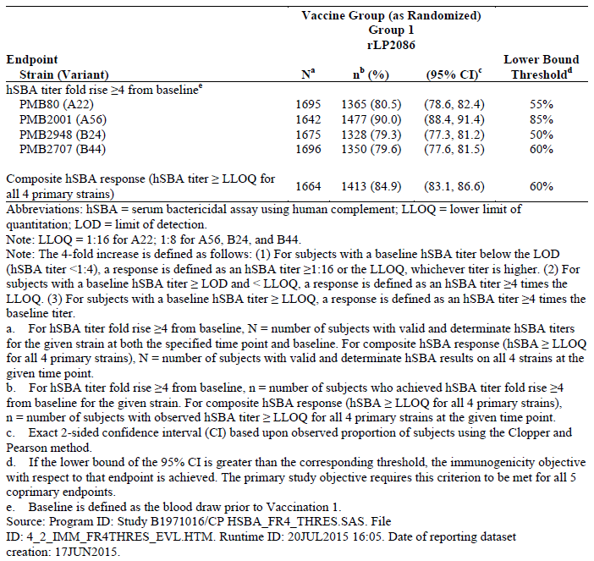

Participant flow
A total of 3,304 subjects were randomised in this study. Of the subjects randomised, 2480 subjects were included in Group 1 (bivalent rLP2086), and 824 subjects were included in Group 2 (saline control). Of the 3304 randomised subjects, 2474 (74.88%) subjects completed the vaccination phase of the study: 3293 (99.67%) subjects received Vaccination 1; 2902 (87.83%) subjects received Vaccination 2; and 2538 (76.82%) subjects received Vaccination 3. A total of 2770 (83.84%) subjects completed the 6 month follow-up telephone contact, and 2419 (73.21%) subjects completed the study.

Major protocol violations/deviations
A total of 234 (7.1%) subjects were withdrawn during the 2 dose series follow-up phase for the following reasons: 82 (2.5%) subjects were lost to follow-up, 79 (2.4%) subjects were no longer willing to participate in the study, 14 (0.4%) subjects withdrew consent, 12 (0.4%) subjects no longer met eligibility criteria, 19 (0.6%) subjects were withdrawn due to pregnancy, 13 (0.4%) subjects were withdrawn due to other reasons, 10 (0.3%) subjects were withdrawn due to AEs, and 5 (0.2%) subjects were withdrawn due to protocol violations. The vaccine groups were comparable with respect to reasons for withdrawal during the 2-dose series follow-up phase.

Baseline data
Among 3293 vaccinated subjects, 1,359 (41.27%) were male and 1,934 (58.73%) were female. The majority of subjects were White. The number and percent of subjects in each racial group were as follows: White, n = 2507 (76.13%); Black, n = 684 (20.77%); Asian, n = 51 (1.55%); and other, n = 51 (1.55%). The mean age at vaccination was 21.48 years (SD 2.15), with ages of study subjects ranging from 18 years to 25 years. Percentages by sex and race/ethnicity and mean age at vaccination were similar in each study group.

Results for the primary immunogenicity outcome

hSBA ≥ 4 fold rise and composite response after Vaccination 3
The primary objective of this study was to assess the immune response as measured by hSBA performed with 4 primary MnB test strains, 2 expressing fHBP subfamily A protein (PMB80 (A22) and PMB2001 (A56)) and 2 expressing fHBP subfamily B protein (PMB2948 (B24) and PMB2707 (B44)), measured 1 month after the third vaccination with bivalent rLP2086 in the evaluable immunogenicity population.
The 5 co-primary endpoints for this objective were the proportion of subjects in Group 1 achieving at least a 4 fold increase from Baseline in hSBA titre for each of the 4 primary MnB test strains and the proportion of subjects achieving a composite response at 1 month after the third vaccination with bivalent rLP2086.
For the evaluable immunogenicity population in Group 1, the proportion of subjects achieving a ≥ 4 fold increase in hSBA titre from Baseline for each of the 4 primary test strains after 3 doses of 120 µg bivalent rLP2086 was as follows: 80.5% (95% CI: 78.6, 82.4) for PMB80 (A22); 90.0% (95% CI: 88.4, 91.4) for PMB2001 (A56); 79.3% (95% CI: 77.3, 81.2) for PMB2948 (B24); 79.6% (95% CI: 77.6, 81.5) for PMB2707 (B44); and 84.9% (95% CI: 83.1, 86.6) for the composite hSBA response (that is, hSBA titre ≥ LLOQ for all 4 primary strains). The lower limit of the 2-sided 95% CI was greater than the corresponding pre-specified lower bound threshold for each of the 4 primary MnB strains and for the composite response; thus, the primary objective was met (Table 3).

Results for other immunogenicity outcomes

hSBA ≥ 4 fold rise and composite response
The proportion of subjects in Group 1 who achieved at least a 4 fold rise in hSBA titre from Baseline to 1 month after Vaccination 2 was 66.9% for PMB80 (A22), 85.9% for PMB2001 (A56), 67.9% for PMB2948 (B24), and 55.5% for PMB2707 (B44). After Vaccination 3, the corresponding rates for the primary MnB test strains in Group 1 were: 80.5% for PMB80 (A22), 90.0% for PMB2001 (A56), 79.3% for PMB2948 (B24), and 79.6% for PMB2707 (B44). These proportions were substantially higher in Group 1 than in the control group (Group 2) after both the second and third vaccinations.
The proportion of subjects with a composite hSBA response at Baseline for Group 1 (7.3%) was similar to that in Group 2 (6.1%). In Group 1, the proportions of subjects achieving a composite hSBA response 1 month after the second and third vaccinations were 64.5% and 84.9% of subjects, respectively. In Group 2 (control), 7.5% of the subjects achieved a composite response at each post-vaccination time point.

hSBA Titres ≥ LLOQ
After Vaccination 2 the proportion of responders in Group 1 with hSBA titres ≥ LLOQ was: 84.7% for PMB80 (A22), 97.4% for PMB2001 (A56), 86.5% for PMB2948 (B24), and 68.3% for PMB2707 (B44) in Group 1. The proportion of responders at ≥ LLOQ 1 month after Vaccination 3 was: 93.5% for PMB80 (A22), 99.4% for PMB2001 (A56), 95.1% for PMB2948 (B24), and 87.4% for PMB2707 (B44) in Group 1.
In the saline control group, approximately one-third of these young adult subjects had hSBA titres ≥ LLOQ for 3 of the 4 primary test strains (PMB80 (A22), PMB2001 (A56), PMB2948 (B24)) after Vaccinations 2 and 3; for the other primary strain, PMB2707 (B44), the proportion of responders was low, that is, 12.5% after Vaccination 2 and 11.4% after Vaccination 3. The hSBA titres in the control group were similar to Baseline titres in Group 1.

Defined levels of hSBA titres
The proportions of subjects in Group 1 achieving an hSBA titre ≥ 1:4 at 1 month after Vaccination 2 were: 86.2% for strain PMB80 (A22); 97.8% for PMB2001 (A56); 87.2% for strain PMB2948 (B24); and 71.5 for PMB2707 (B44). One month after Vaccination 3, the proportions of responders in Group 1 with hSBA titres ≥ 1:4 were: 94.3% for strain PMB80 (A22); 99.4% for PMB2001 (A56); 95.8% for strain PMB2948 (B24); and 89.7% for PMB2707 (B44).
The proportions of subjects with hSBA titres ≥ 1:4 for the 4 primary strains were consistent at all time points in the control group, with approximately 30% to 40% of subjects achieving this threshold for PMB80 (A22); PMB2001 (A56); and PMB2948 (B24) and 14% to 16% for PMB2702 (B44); these results were similar to those in Group 1 at Baseline for each test strain.

hSBA GMTs
The hSBA GMTs at 1 month after Vaccination 2 were 49.0 for PMB80 (A22), 114.3 for PMB2001 (A56), 35.8 for PMB2948 (B24), and 22.6 for PMB2707 (B44) in Group 1. One month after Vaccination 3, hSBA GMTs were 74.3 for PMB80 (A22), 176.7 for PMB2001 (A56), 49.5 for PMB2948 (B24), and 47.6 for PMB2707 (B44) in Group 1. The hSBA GMTs for the 4 primary strains were notably higher in Group 1 than in Group 2 saline recipients at both 1, month after Vaccination 2 and 1 month after Vaccination 3. In Group 1, hSBA GMTs for the 4 primary test strains rose substantially from Baseline to after the second and third vaccinations and increased from post Vaccination 2 to post Vaccination 3.

Reverse cumulative distribution curves for the primary MnB test strains
The reverse cumulative distribution curves (RCDCs) showing the distribution of hSBA titres for PMB80 (A22), PMB2001 (A56), PMB2948 (B24), and PMB2707 (B44) for Groups 1 and 2 are presented in Figures 5-8 before vaccination and 1 month after Vaccination 3 for the evaluable immunogenicity population. The RCDCs showed that a high proportion of subjects achieved the LLOQ for each of the 4 test strains after Vaccination 3. Titres were generally below the LLOQ for the majority of subjects in the control group (Group 2).
Figure 5: Reverse cumulative distribution curves, PMB80 (A22), evaluable immunogenicity population; Study B1971016
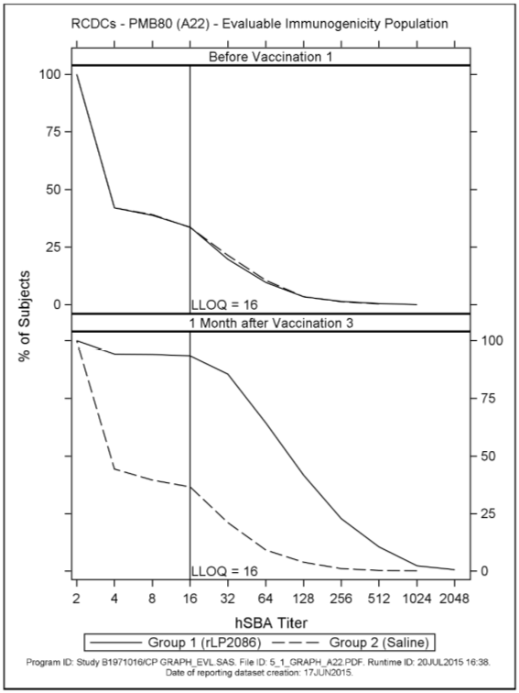
Figure 6: Reverse cumulative distribution curves, PMB2001 (A56), evaluable immunogenicity population; Study B1971016
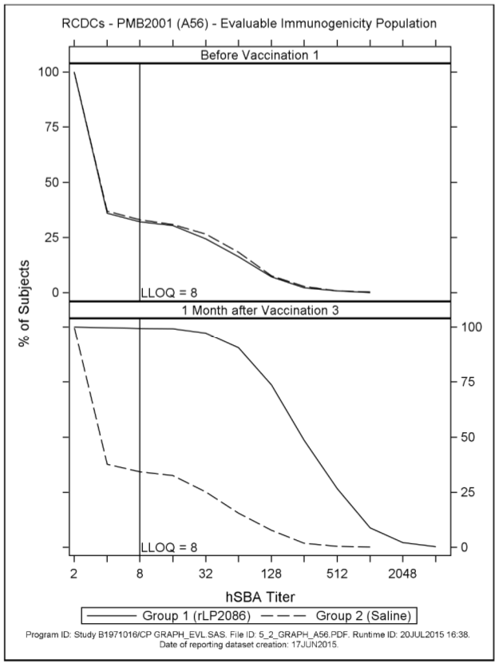
Figure 7: Reverse cumulative distribution curves, PMB2948 (B24), evaluable immunogenicity population; Study B1971016
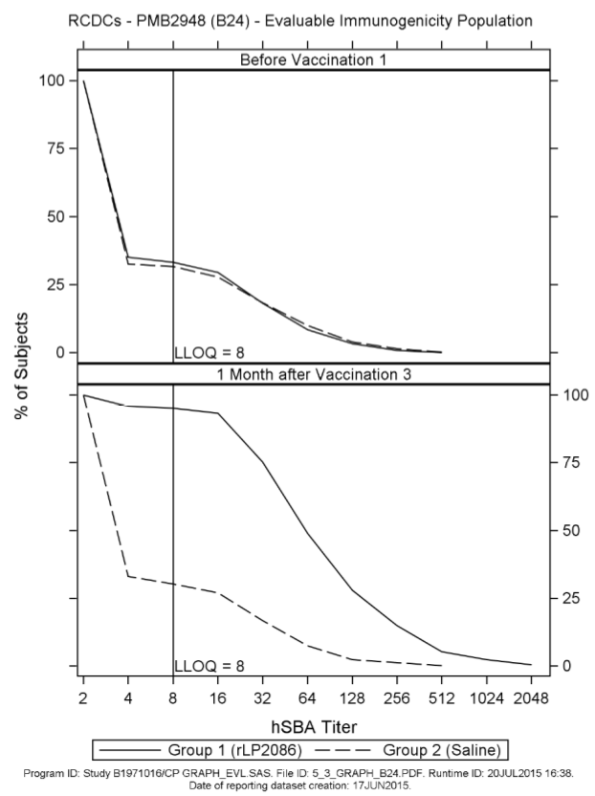
Figure 8: Reverse cumulative distribution curves, PMB2707 (B44), evaluable immunogenicity population; Study B1971016
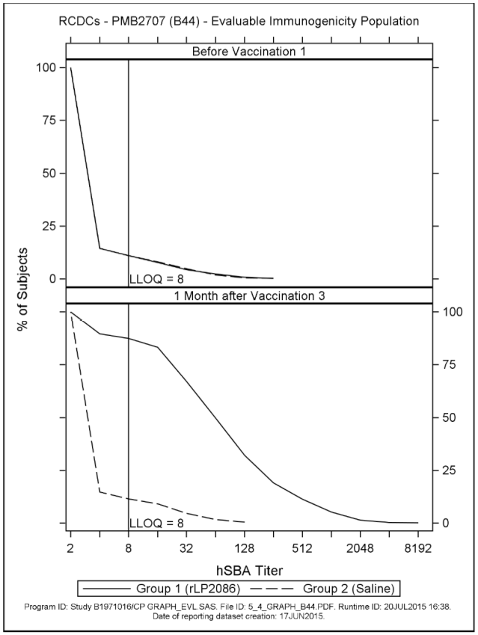

hSBA titres ≥ LLOQ for the ten secondary MnB test strains
Among fHBP subgroup A variant expressing strains, the proportion of subjects with an hSBA titre ≥ LLOQ rose substantially from Baseline to 1 month after Vaccination 3; for 5 of these strains ≥ 91.8% of subjects achieved hSBA titres ≥ LLOQ (99.3% for PMB3175 (A29), 92.0% for PMB3010 (A06), 95.7% for PMB3040 (A07), 91.8% for PMB1672 (A15), and 95.8% for PMB1989 (A19)). For PMB824 (A12) the proportion achieving a titre ≥ LLOQ was 71.3. Among fHBP subgroup B variant expressing strains the proportion of subjects in Group 1 with an hSBA titre ≥ LLOQ 1 month after Vaccination 3 was 86.4% for PMB1256 (B03), 77.0% for PMB866 (B09), 96.7% for PMB431 (B15), and 78.0% for PMB648 (B16).

Defined levels of hSBA titres for the ten secondary MnB test strains
Among fHBP subfamily A variant expressing strains, after Vaccination 3 the proportion of subjects who achieved an hSBA titre ≥ 1:4was ≥ 91.8% for 5 test strains (99.3% for PMB3175 (A29), 92.4% for PMB3010 (A06), 95.7% for PMB3040 (A07), 91.8% for PMB1672 (A15), and 96.1% for PMB1989 (A19)). For PMB824 (A12) the proportion of subjects achieving a titre ≥ 1:4 was 73.8%. Among fHBP subfamily B variant expressing strains, the proportion of subjects in Group 1 with an hSBA titre ≥ 1:4 at one month after Vaccination 3 was 86.8% for PMB1256 (B03).

Other efficacy studies

Study B1971012
This was a Phase II randomised single study evaluating various 2 and 3 dose schedules using primary MnB test strains. 1,713 subjects, between 11 and 18 years of age, were randomly assigned to receive 120 µg of bivalent rLP2086 in 5 groups in a 3:3:3:2:1 ratio (Group 1 (0, 1, 6 month schedule), Group 2 (0, 2, 6 month schedule), Group 3 (0, 6 month schedule), Group 4 (0, 2 month schedule), and Group 5 (2, 6 month schedule, same as 0, 4 month schedule)) (Table 4).

Table 4: Dosing schedule in Study B1971012
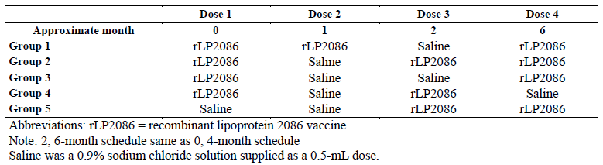
The co-primary objectives were to assess the immune response as measured by hSBA performed with the 4 primary MnB test strains measured 1 month after Dose 3 with bivalent rLP2086, among the two 3 dose schedule groups (0, 1, 6 month schedule (Group 1) and 0, 2, 6 month schedule (Group 2)). The primary endpoint for the co-primary objective was the proportion of subjects with hSBA responses ≥ LLOQ for each of the 4 primary MnB test strains in the evaluable immunogenicity population. The co-primary immunogenicity objectives were achieved if the 97.5% LCI for the response rate was greater than 50% for each of the 4 primary MnB test strains for either 3 dose regimen. The LLOQ for each strain was 1:8 for the primary analysis. A post-hoc analysis was performed using an LLOQ = 1:16 for the strains expressing fHBP variant A22 to address feedback from CBER indicating that the higher LLOQ should be used for the analysis. Results of the analysis with an LLOQ = 1:16 for A22 are presented in this document.
The evaluable immunogenicity population (per-protocol) included 365 subjects in Group 1, 360 subjects in Group 2, 371 subjects in Group 3, 241 subjects in Group 4, and 113 subjects in Group 5.

Results
With the final LLOQ of 1:16 for the hSBA with PMB80 (A22), the proportions of Group 1 subjects in the evaluable immunogenicity population achieving an hSBA titre ≥ LLOQ after 3 doses of bivalent rLP2086 on the 0, 1, 6 month schedule were: 91.4% for PMB80 (A22), 99.4% for PMB2001 (A56), 89.0% for PMB2948 (B24), and 88.5% for PMB2707 (B44) (Table 5).

Table 5: Proportion of subjects achieving hSBA titre ≥ LLOQ for each primary MnB test strain at 1 month after the last bivalent rLP2086 dose; evaluable immunogenicity population (Study B1971012)
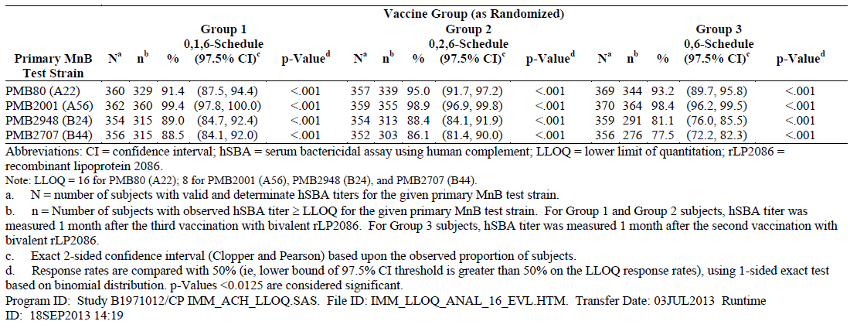
The corresponding values in Group 1 at 1 month after 2 doses (0, 1) of the vaccine were: 62.3% for PMB80 (A22), 89.1% for PMB2001 (A56), 50.6% for PMB2948 (B24), and 35.4% for PMB2707 (B44).
In Group 2, at 1 month after 3 doses of bivalent rLP2086 given at 0, 2, 6 months, the proportion of subjects with hSBA titres ≥ LLOQ were: 95.0% for PMB80 (A22), 98.9% for PMB2001 (A56), 88.4% for PMB2948 (B24), and 86.1% for PMB2707 (B44) (Table 5). At 1 month after 2 doses of bivalent rLP2086 (0, 2 months), the corresponding proportions of subjects were 88.1%, 97.9%, 70.3%, and 61.9%. In Groups 1 and 2 the 97.5% LCI for the proportion of subjects achieving hSBA titres ≥ LLOQ was greater than 50% with use of each primary test strain, and thus the study met the co-primary objectives.
For subjects in Group 1 (0, 1, 6 months) and Group 2 (0, 2, 6 months), hSBA, response 1 month after the first dose of bivalent rLP2086 was not determined. However, hSBA response at this time point was determined for subjects in Group 5 (2 dose schedule, 0, 4 months (same as 2, 6 months)); the proportions of subjects achieving an hSBA titre ≥ LLOQ 1 month after 1 dose of bivalent rLP2086 were 55.9% for PMB80 (A22), 67.6% for PMB2001 (A56), 56.9% for PMB2948 (B24), and 23.8% for PMB2707 (B44). This is the only instance in the development program where the immune response after 1 dose of bivalent rLP2086 was determined.
The secondary objective was to assess the immune response as measured by hSBA performed with the 4 primary MnB test strains measured 1 month after Dose 2 among Group 3 subjects (0, 6 month schedule). In Group 3 (0, 6 month schedule), the hypothesis testing endpoint for the secondary objective was the proportion of subjects achieving an hSBA titre ≥ LLOQ for each of the 4 primary test strains measured 1 month after the second dose of bivalent rLP2086. This objective was achieved if the p-values were < 0.0125 for the hSBA response rate for each of the 4 primary MnB test strains in Group 3.
The proportion of subjects with an hSBA titre ≥ LLOQ after 2 doses of bivalent rLP2086 administered on a 0, 6 month schedule (Group 3) was 93.2% for PMB80 (A22), 98.4% for PMB2001 (A56), 81.1% for PMB2948 (B24), and 77.5% for PMB2707 (B44). These observed point estimates in Group 3 were similar to those of Group 1 (0, 1, 6 month schedule) and Group 2 (0, 2, 6 month schedule). This objective was achieved as all p-values for the hSBA response rates for each of the 4 primary MnB test strains in Group 3 were < 0.0125 (Table 5).
The same analysis was performed for Group 4 (0, 2 month schedule) and Group 5 (0, 4 month schedule); the proportions of subjects with an hSBA titre ≥ LLOQ at 1 month after the second dose of bivalent rLP2086 for the 4 primary test strains were as follows for Group 4 and Group 5, respectively: 90.8% and 91.0% for PMB80 (A22); 100.0% and 99.1% for PMB2001 (A56); 73.0% and 69.1% for PMB2948 (B24); and 70.1% and 73.0% for PMB2707 (B44). The proportion of responders at ≥ LLOQ was higher in Group 3 subjects who received 2 doses of bivalent rLP2086 on a 0, 6 month schedule than in Group 4 or Group 5 subjects receiving vaccinations on a 0, 2 month or 0, 4 month schedule, respectively. The proportions of responders were higher after 2 doses spaced 6 months apart in Group 3 than after the second vaccination in Group 1 (0, 1 month schedule) and Group 2 (0, 2 month schedule).
An additional secondary endpoint was the proportion of subjects with defined hSBA antibody titres at ≥ 1:4 For each primary test strain, response rates for hSBA titres of ≥ 1:4 at 1 month after 2 doses of bivalent rLP2086 in the 0, 6 month group (Group 3) were: 94.0% for PMB80 (A22), 98.9% for PMB2001 (A56), 83.0% for PMB2948 (B24), and 78.9% for PMB2707 (B44).
The proportions of responders achieving a hSBA titre ≥ 1:4 one month after 2 doses in Group 4 (0, 2 month schedule) and Group 5 (0, 4 month schedule), respectively, were: 90.8% and 91.9% for PMB80 (A22); 100.0% and 99.1% for PMB2001 (A56); 75.5% and 70.9% for PMB2948 (B24); and 73.5% and 73.0% for PMB2707 (B44).
Comparison among the 2-dose groups showed that in subjects randomised to the 0, 6 month schedule in Group 3 the proportions of responders for each test strain were similar or higher than in other 2 dose groups (Groups 4 (0, 2 months) and Group 5 (0, 4 months),). Also, for each of the 4 primary test strains, hSBA GMTs were higher in Group 3 (0, 6 months) than in Group 4 (0, 2 month schedule) or Group 5 (0, 4 month schedule). Group 3 hSBA GMTs were also higher than hSBA GMTs in Groups 1 and 2 after 2 doses of bivalent rLP2086.
Analysis of ≥ 4 fold rise in hSBA titre from Baseline and composite response showed that when bivalent rLP2086 is given on a 0, 6 month schedule, responses are higher than when the vaccine is given at 0 and 1 month and 0 and 2 months. As shown in Table 6, the percentages of subjects achieving a composite hSBA response were lower for the 0, 1 month and 0, 2 month regimens, 51% (95% CI: 43.8, 58.3) and 56.8% (95% CI: 52.5, 61.0), respectively, compared with the response of 73.5% (95% CI: 68.5, 78.1) achieved by those receiving bivalent rLP2086 at 0 and 6 months. These data demonstrate that responses achieved after 2 doses of bivalent rLP2086 vaccine are highest when the interval between the first and second dose is 6 months (Table 7) and are comparable to responses elicited by 3 dose regimens administered at 0, 1, 6 or 0, 2, 6 months (Table 7).

Table 6: Percentage of subjects achieving ≥ 4 fold rise in hSBA titre and composite response using the 0 and 1 month and 0 and 2 month schedules compared to the 0 and 6 month schedule; evaluable population (Study B1971012)
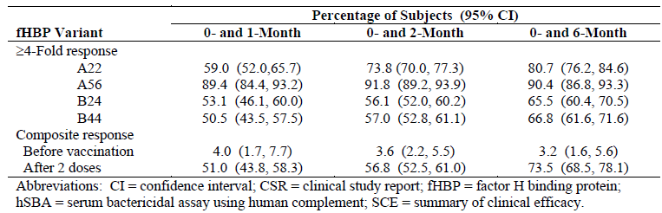

Table 7: Percentage of subjects achieving ≥4 fold rise in hSBA titre and composite response using 0, 1, and 6 month and 0, 2, and 6 month schedules compared to the 0 and 6 month schedule; evaluable population (Study B1971012)
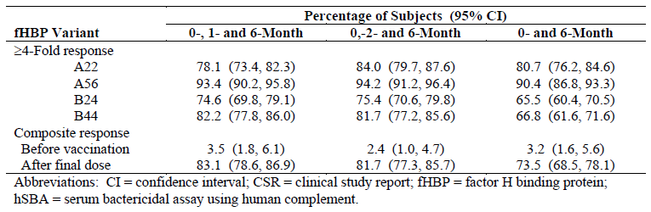

Study B1971010
Study B1971010 was a Phase II, randomised, placebo controlled, single blind multicenter study in which 749 subjects were randomly assigned to 1 of 2 groups in a 1:1 ratio. Group 1 received 3 doses of bivalent rLP2086 using a 0, 2, 6 month schedule and 1 dose of Repevax (a combined low-dose diphtheria, tetanus, acellular pertussis, and inactivated poliomyelitis virus vaccine, dTaP-IPV) given concomitantly with the first dose of bivalent rLP2086; Group 2 received saline + Repevax for the first dose and saline for Doses 2 and 3 on a 0, 2, 6 month schedule.
The primary objective was to demonstrate that the immune response induced by Repevax given with bivalent rLP2086 was non inferior to the immune response induced by Repevax alone when measured 1 month after Dose 1. The immune responses to all components of Repevax were assessed. Non inferiority was to be declared if the 2-sided 95% LCI for the difference (bivalent rLP2086 / dTaP-IPV (Group 1) – dTaP-IPV Group 2)) was greater than -0.10 (-10%) for all of the 9 antigens in the dTaP-IPV vaccine. The primary endpoint was the proportion of subjects achieving the prespecified level of antibodies to each concomitant vaccine antigen, and the difference (Group 1 - Group 2) in proportions, with corresponding 95% exact CIs for the concomitant vaccine evaluable immunogenicity population (per-protocol).
For assessment of the Repevax antigens, the concomitant vaccine evaluable immunogenicity population (per-protocol) included 337 subjects in Group 1 (bivalent rLP2086 + Repevax) and 348 subjects in Group 2 (saline + Repevax). For hSBA assessment, 307 subjects in Group 1 and 330 subjects in Group 2 were included in the post-Vaccination 3 evaluable immunogenicity population.

Results

Primary objective
The proportion of subjects achieving the pre-specified level of antibodies to concomitant vaccine antigens (threshold for response) 1 month after the Repevax dose was similar in the bivalent rLP2086 + Repevax group and the Repevax alone group for concomitant vaccine antigens: diphtheria toxoid (99.4% in each group), tetanus toxoid (100% in each group), pertussis toxoid (94.7% and 96.0%, respectively), pertussis filamentous hemagglutinin (100% in each group), pertussis pertactin (100% in each group), pertussis fimbrial agglutinogens types 2 + 3 (97.6% and 98.9%, respectively), poliovirus type 1 (100% in each group), poliovirus Type 2 (100% in each group), and poliovirus Type 3.
Non inferiority was achieved. The lower bound of the 2-sided 95% CI for the difference in proportion of responders between bivalent rLP2086 + Repevax group (Group 1) and the Repevax alone group (Group 2), 1 month after the Repevax dose was greater than -0.10 (-10%) for the 9 antigens in Repevax (that is, the lowest lower bound of the 95% CI on the proportion difference was -4.7% (pertussis toxoid).

Secondary objectives

Proportion of subjects achieving hSBA titre ≥ LLOQ
The proportions of subjects in the bivalent rLP2086 + Repevax group achieving an hSBA titre ≥ LLOQ at 1 month after Dose 3 were 95.6% for PMB80 (A22), 100% for PMB2001 (A56), 96.8% for PMB2948 (B24), and 81.5% for PMB2707 (B44). At 1 month after Dose 2, the corresponding proportions of subjects were 81.8%, 97.3%, 81.0%, and 55.5%.

Study B1971011
This was a Phase II, randomised, active controlled, observer blinded, multicenter study in which 2,499 US subjects, 11 to < 18 years old, were randomly assigned (in a 2:2:1 ratio) to 1 of 3 groups: Group 1 received bivalent rLP2086 + Gardasil (HPV vaccine), Group 2 received bivalent rLP2086 + saline, and Group 3 received saline + Gardasil. All vaccinations were administered using a 0, 2, 6 month schedule.
This study had 2 co-primary objectives. The first co-primary objective was to demonstrate that the immune response (based on GMT) induced by Gardasil given with bivalent rLP2086 (Group 1) was non-inferior to the immune response induced by Gardasil alone (Group 3), as measured 1 month after the third vaccination with Gardasil in both groups. The immune response to each of the 4 antigens in Gardasil was assessed.
The second co-primary objective was to demonstrate that the immune response (based on GMT) induced by bivalent rLP2086 given with Gardasil (Group 1) was non-inferior to the immune response induced by bivalent rLP2086 alone (Group 2) as measured by hSBA performed with 2 primary MnB test strains, when measured 1 month after the third vaccination with bivalent rLP2086 in both groups. The 2 primary MnB test strains used for this second co-primary objective were PMB80 (A22) and PMB2948 (B24).
Non-inferiority of both Gardasil and bivalent rLP2086 were to be achieved when the 2-sided 95% LCI for the geometric mean ratios (GMRs) were greater than 0.67 for each of the 4 HPV antigens (Group 1/Group 3) and each of the 2 primary MnB test strains (Group 1/Group 2) among the evaluable immunogenicity population.
For the evaluable population, immunogenicity/efficacy data were available from 812 subjects in the rLP2086 group (Group 2) and another 814 in the rLP2086 + Gardasil group (Group 1).

Results

Primary objective
The GMTs elicited by the 4 HPV antigens at 1 month after Dose 3 with Gardasil for Group 1 and Group 3 were: HPV-6 (451.8 and 550.3, respectively), HPV-11 (892.9 and 1084.3, respectively), HPV-16 (3695.4 and 4763.4, respectively), and HPV-18 (744.0 and 1047.4, respectively). The GMRs between Group 1 and Group 3, 1 month after Dose 3 with Gardasil were 0.82 for HPV-6 (95% CI: 0.72, 0.94), 0.82 for HPV-11 (95% CI: 0.74, 0.91), 0.78 for HPV-16 (95% CI: 0.68, 0.88), and 0.71 for HPV-18 (95% CI: 0.62, 0.81). The 2-sided 95% LCIs for the anti-HPV GMRs (Group 1 compared with Group 3) were 0.72 for HPV-6, 0.74 for HPV-11, 0.68 for HPV-16, and 0.62 for HPV-18. The 1.5 fold non-inferiority criterion of 0.67 (the 2-sided 95% LCI of the GMR) was met for all HPV antigens except for HPV-18, which was marginally missed with a 95% LCI of 0.62.
The hSBA GMTs to the 2 primary MnB test strains at 1 month after Dose 3 with bivalent rLP2086 for Group 1 and Group 2 were: PMB80 (A22) (53.3 and 57.8, respectively) and PMB2948 (B24) (25.8 and 28.0, respectively). The GMRs between bivalent rLP2086 + Gardasil group and bivalent rLP2086 + saline group, 1 month after Dose 3 with bivalent rLP2086 were 0.92 for PMB80 (A22) (95% CI: 0.85, 1.00) and 0.92 for PMB2948 (B24) (95% CI: 0.84, 1.01). The 2-sided 95% LCIs for the hSBA GMRs (Group 1 compared with Group 2) were 0.85 for PMB80 (A22) and 0.84 for PMB2948 (B24), which are both greater than the non-inferiority criterion of 0.67, and therefore met the non-inferiority margin of 1.5 fold (Table 8).

Table 8: Comparison of geometric mean titres at 1 month after Vaccination 3; evaluable immunogenicity population; Study B1971011
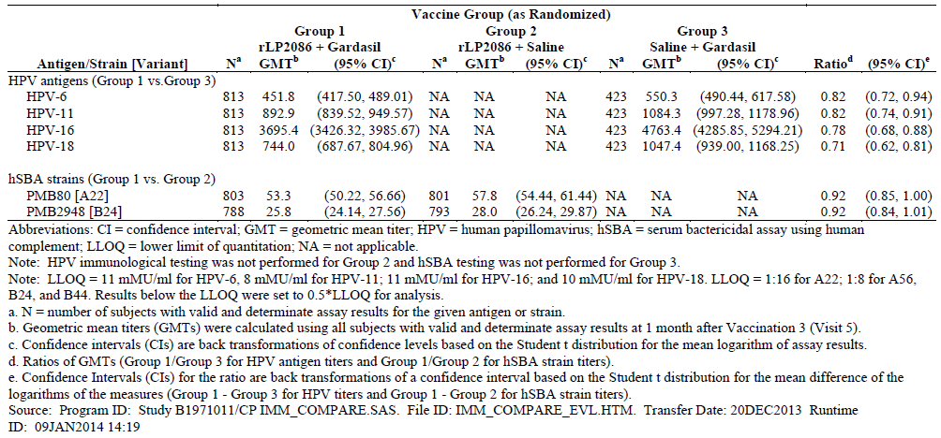

Secondary objectives

HPV Seroconversion rates
One month after Dose 3 with Gardasil, 99% of subjects seroconverted to all 4 HPV antigens in both, the saline + Gardasil and the rLP2086 + Gardasil groups

Proportion of subjects achieving hSBA titre ≥ LLOQ
The proportions of subjects in Group 1 (rLP2086 + Gardasil) achieving an hSBA titre ≥ LLOQ at 1 month after Dose 3 were 94.0% for PMB80 (A22), 98.9% for PMB2001 (A56), 90.5% for PMB2948 (B24), and 82.7% for PMB2707 (B44). The corresponding proportions in Group 2 (rLP2086 + saline) were 96.3%, 99.4%, 92.6%, and 85.7%. At 1 month after Dose 2, the corresponding proportions of subjects in Group 1 were 83.0%, 97.5%, 70.6%, and 54.5%.
The proportion of subjects achieving an hSBA titre of ≥ 1:4 (correlate of protection) and other defined titres was consistent with the proportion of responders observed in Groups 1 and 2 of Study B1971012 and in subjects receiving bivalent rLP2086 in Phase III Studies B1971009 and B1971016.

hSBA geometric mean titres (GMTs)
The hSBA GMTs for each of the 4 primary MnB test strains and the corresponding CIs for the For Group 1 (bivalent rLP2086 + Gardasil), hSBA GMTs at 1 month after Dose 3 were; 53.3 for PMB80 (A22), 117.2 for PMB2001 (A56), 25.8 for PMB2948 (B24), and 27.2 for PMB2707 (B44). The corresponding GMTs in Group 2 (rLP2086 + saline) were 57.8, 128.2, 28.0, and 31.9. At 1 month after Dose 2, the corresponding hSBA GMTs in Group 1 were 31.9, 70.6, 15.0, and 11.1, and in Group 2 were 33.7, 76.3, 16.3, and 11.9.

Study B1971015
This was a Phase II, randomised, active controlled, observer blinded multicenter study to assess the safety, tolerability, and immunogenicity of MCV4 vaccine (Menactra), Tdap vaccine (Adacel), and bivalent rLP2086 when administered concomitantly in healthy subjects aged 10 to < 13 years. A total of 2648 subjects were randomly assigned to 1 of 3 groups in a 1:1:1 ratio (Group 1: bivalent rLP2086 at 0, 2, 6 months, MCV4 and Tdap at 0 months; Group 2: MCV4 and Tdap at 0 months, saline at 0, 2, 6 months; Group 3: bivalent rLP2086 at a 0, 2, 6 months, MCV4 and Tdap at 7 months).
The first co-primary objective was to demonstrate that the immune response induced by MCV4 vaccine and Tdap vaccine given with bivalent rLP2086 (Group 1) was non-inferior to the immune response induced by MCV4 and Tdap vaccines alone (Group 2) when measured 1 month after the first vaccination in both groups. The immune response to all antigens in MCV4 and Tdap vaccines were assessed. The endpoints for the first co-primary objective were the GMTs or GMCs to each of the 10 antigenic components in the marketed vaccines at 1 month after the first vaccination, among subjects in Groups 1 and 2.
The second co-primary objective was to demonstrate that the immune response induced by bivalent rLP2086, as measured by hSBA performed with 2 primary MnB strains (PMB80 (A22) and PMB2948 (B24)) when given with MCV4 and Tdap vaccines (Group 1), was non-inferior to the immune response induced by bivalent rLP2086 alone (Group 3), at 1 month after the third vaccination. The endpoint for the second co-primary objective was the evaluation of the hSBA GMT for each of the 2 primary strains (PMB80 (A22) and PMB2948 (B24)) measured 1 month after the third dose of bivalent rLP2086, in Group 1 (MCV4+ Tdap+ bivalent rLP2086) and Group 3 (saline+ saline+ bivalent rLP2086).
Two (2) evaluable immunogenicity populations were defined: the post Vaccination 1 evaluable immunogenicity population for the assessment of non-inferiority of MCV4+ Tdap+ bivalent rLP2086 (Group 1) compared to MCV4+ Tdap+ saline (Group 2), and the post Vaccination 3 evaluable immunogenicity population for the assessment of non-inferiority of MCV4+ Tdap+ bivalent rLP2086 (Group 1) compared to saline+ saline+ bivalent rLP2086 (Group 3). In the post Vaccination 1 evaluable immunogenicity population, 1560 (88.3%) subjects (779 (87.7%) of subjects in Group 1 and 781 (89.0%) of subjects in Group 2) were included. In the post Vaccination 3 evaluable immunogenicity population, 1362 (76.9%) subjects (683 (76.9%) in Group 1 and 679 (77.0%) in Group 3) were included.

Results

Primary objectives
The criterion for the non-inferiority margin of 1.5 fold, which corresponds to a value of 0.67 for the lower limit of the 2-sided 95% CI of the GMR, was met for all MCV4 and Tdap antigens (ranging from 0.88 to 1.02).
Response to bivalent rLP2086: The criterion for the non-inferiority margin of 1. -fold, which corresponds to a value of 0.67 for the lower limit of the 2-sided 95% CI of the GMR, was met for both strains. The lower limits of the 2-sided 95% CIs for the hSBA GMRs for Group 1 compared to Group 3 were 0.84 for PMB80 (A22) and 0.82 for PMB2948 (B24). Thus, the primary objectives for the study were met.

Secondary objectives

Comparison of MCV4/Tdap sero-response rates (Group 1 versus Group 2)
The sero response rates for the 6 Tdap antigens at 1 month after Dose 1 for Group 1 (MCV4+ Tdap+ bivalent rLP2086) and Group 2 (MCV4+ Tdap+ saline) ranged from 68.1% to 98.6% and for the 4 MCV4 antigens ranged from 85.4% to 97.2%. The estimated seroresponse rate differences between the 2 groups ranged from -4.6% to 0.3% for the 6 Tdap and 4 MCV4 antigens, with the 95% LCI of the rate difference ≥ -9.1% (that is, all greater than -10.

Comparison of hSBA Titre 4 Fold Rise (Group 1 versus Group 3)
In Group 1 (MCV4+ Tdap+ bivalent rLP2086) and Group 3 (saline+ saline+ bivalent rLP2086), 84.0% and 88.7% of subjects exhibited a ≥ 4 fold rise in hSBA titre from Baseline to 1 month after Dose 3 for test strain PMB80 (A22), and 85.7% and 87.7% for test strain PMB2948 (B24), respectively (Table 9). The estimated differences of 4 fold response rate were small (< 5.0%) between the 2 groups, with the 95% LCI for the difference of -8.4% (PMB80 (A22)) and -5.7% (PMB2948 (B24)).

Table 9: Comparison of subjects achieving hSBA titre fold rise ≥ 4 from Baseline to 1 month after Vaccination 3; Post Vaccination 3; evaluable immunogenicity population; Study B1971015
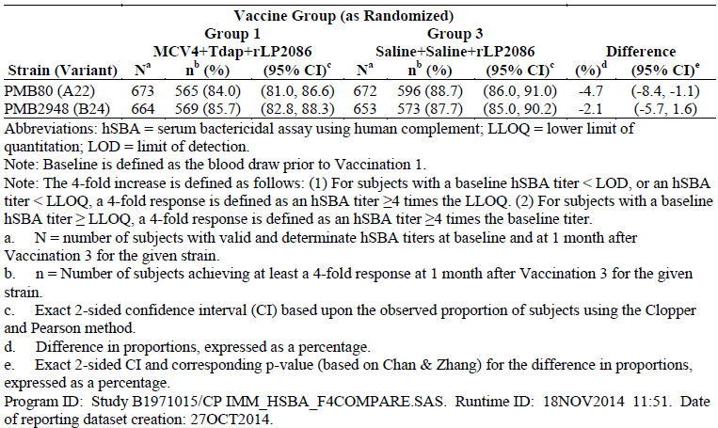

Proportion of subjects achieving hSBA titre ≥ LLOQ
For Group 3 (saline+ saline+ bivalent rLP2086) at 1 month after Dose 2 and Dose 3, the proportions of subjects achieving an hSBA titre ≥ LLOQ were 68.0% and 91.4%, respectively, for PMB80 (A22) and 66.0% and 92.7%, respectively, for PMB2948 (B24).
In Group 1 (MCV4+ Tdap+ bivalent rLP2086), 1 month after Dose 2 and Dose 3, the proportions of subjects achieving an hSBA titre ≥ LLOQ were 68.0% and 87.5%, respectively, for PMB80 (A22) and 62.3% and 90.0%, respectively, for PMB2948 (B24).

Proportion of subjects achieving defined levels of hSBA Titres
The proportions of subjects in Group 1 (MCV4+ Tdap+ bivalent rLP2086) and Group 3 (saline+ saline+ bivalent rLP2086) with hSBA titres of ≥ 1:4, the accepted correlate of protection, were consistent with those observed in subjects receiving bivalent rLP2086 in Phase III Studies B1971009 and B1971016.

Study B1971042
Study B1971042 was a Phase II, single-arm, open label, descriptive study of bivalent rLP2086 in laboratory workers 18 to ≤ 65 years of age. The study assessed the safety, tolerability, and immunogenicity of 120 µg bivalent rLP2086 administered on a 0, 2, 6 month schedule. The objective of the study was to describe the immune response as measured by hSBA performed with 4 primary MnB test strains measured 1 month after the third dose of bivalent rLP2086.
A total of 13 enrolled subjects, aged 24 to 62 years, were included in this study. Five subjects were ≤ 40 years and 8 subjects were >40 years of age. Of the 13 subjects vaccinated, 6 subjects were included in the evaluable immunogenicity population (per-protocol).
At 1 month after Dose 3, 6 of 6 subjects had an hSBA titre ≥ LLOQ for PMB80 (A22) and PMB2948 (B24), 5 of 5 subjects had an hSBA titre ≥ LLOQ for PMB2001 (A56), and 3 of 6 subjects had an hSBA titre ≥ LLOQ for PMB2707 (B44).
When Phase III primary endpoints were assessed, 5 of 6 subjects achieved an hSBA titre fold rise ≥ 4 from Baseline to 1 month after Dose 3 for PMB80 (A22), 5 of 5 subjects for PMB2001 (A56), 4 of 6 subjects for PMB2948 (B24), and 3 of 6 subjects for PMB2707 (B44). Three (3) of 5 subjects achieved a composite hSBA response (hSBA ≥ LLOQ for all 4 primary strains combined.
While the number of subjects is limited, these data in an older population demonstrate that a protective immune response can be elicited after 3 doses of bivalent rLP2086 in adults, as measured by a 4 fold rise in hSBA titres from Baseline and composite response as well as the proportion of subjects with hSBA titres ≥ LLOQ.
The following 3 studies are early immunogenicity studies.

Study B1971003
Study B1971003 was a Phase I/II open label study, in which 60 subjects (18 to 40 years of age) received 120 µg of bivalent rLP2086 on a 0, 1, 6 month schedule.
This study was designed for serological assay development. An exploratory objective of this study was to assess the immunogenicity of 120 µg of bivalent rLP2086 as measured by hSBA and/or levels of antibody specific to antigens in bivalent rLP2086. Functional antibody responses using hSBA were performed with the following MnB test strains: PMB1745 (A05), which expresses an fHBP variant homologous to one of bivalent rLP2086 antigens, rLP2086-A05, and PMB17 (B02), which expresses an fHBP variant that is heterologous to the other vaccine antigen, rLP2086-B01. The immune response data were determined using a qualified hSBA, and results were reported as interpolated titres.
Sixty subjects (mITT population) were included in the immunogenicity analyses.
The proportions of subjects with hSBA titres ≥ 1:4 for MnB test strains PMB1745 (A05) and PMB17 (B02) were 74.5% and 69.6% after Dose 2, respectively, and 94.3% and 94.1% after Dose 3, respectively.

Study B1971004
Study B1971004 was a Phase I, single center, randomised, open label, active and placebo controlled parallel group study in healthy adults. A total of 48 subjects (18 to 40 years of age) received bivalent rLP2086 at either 60 µg, 120 µg, or 200 µg dose levels or the control regimen (Tdap/saline) on a 0, 2, 6 month schedule.
The immunogenicity objective of this study was to assess the immunogenicity of the 3 dose levels of bivalent rLP2086 as determined by serum IgG binding antibody titres elicited by bivalent rLP2086. The mITT population (n = 48) was used for the immunogenicity analyses.
Increases in IgG GMTs relative to predose levels were observed for each of the vaccine antigens after administration of bivalent rLP2086 at the 60 µg, 120 µg, or 200 µg dose levels, with a tendency toward higher IgG GMTs with each subsequent dose

Study B1971005
Study B1971005 was a randomised, single blind, placebo controlled, Phase II trial of the safety, immunogenicity, and tolerability of bivalent rLP2086 at doses of 60 µg, 120 µg, or 200 µg (using a 0, 2, 6 month schedule) in healthy adolescents 11 to 18 years old. The study was conducted in 2 stages. Stage 1 was designed to assess the safety and immunogenicity of bivalent rLP2086 and to provide the basis for the dose level selection. Stage 2 of the study was exploratory and was designed to evaluate the duration of the MnB-specific immune responses for up to 4 years after the third vaccination.

Stage 1
Immunogenicity endpoints were evaluated for 60 µg, 120 µg, and 200 µg of bivalent rLP2086 in hSBAs obtained with 2 of the 4 primary MnB test strains, PMB2001 (A56) and PMB2707 (B44), and additional MnB test strains PMB3302 (A04), PMB1745 (A05), PMB17 (B02), and PMB1256 (B03). The primary endpoint was the proportion of subjects achieving a 4 fold rise in hSBA titre from Baseline (pre-dose 1) after Dose 2 and Dose 3 for the MnB test strains, PMB1745 (A05) and PMB17 (B02), for the mITT Population. The mITT population was the primary analysis population and included the following: control (n = 119); 60 µg (n = 22); 120 µg (n = 195); and 200 µg (n = 192).
Primary strain PMB2001 (A56): The proportions of subjects with ≥ 4 fold rise in hSBA titres from Baseline were > 89% after Dose 2 and ≥ 90% after Dose 3 at all dose levels.
Primary strain PMB2707 (B44): the proportions of subjects with ≥ 4 fold rise in hSBA titres from Baseline were 61.9%, 60.7%, and 64.8% after Dose 2, which increased to 76.2%, 86.4%, and 84.4% after Dose 3 at the 60 µg, 120 µg, and 200 µg dose levels, respectively.
PMB3302 (A04): the proportions of subjects with ≥ 4 fold rise in hSBA titres from Baseline were 92.9%, 89.0%, and 79.1% after Dose 2, and 91.7%, 93.6%, and 93.5% after Dose 3 at the 60 µg, 120 µg, and 200 µg dose levels, respectively.
PMB1745 (A05): the proportions of subjects with ≥ 4 fold rise in hSBA titres from Baseline were 88.9%, 83.5%, and 87.7% after Dose 2, and increased to 89.5%, 92.8%, and 94.0% after Dose 3 at the 60 µg, 120 µg, and 200 µg dose levels, respectively.
PMB17 (B02): the proportions of subjects with ≥ 4 fold rise in hSBA titres from Baseline were 71.4%, 59.5%, and 59.6% after Dose 2, and increased to 81.0%, 86.6%, and 84.8% after Dose 3 at the 60 µg, 120 µg, and 200 µg dose levels, respectively.
PMB1256 (B03): the proportions of subjects with ≥ 4 fold rise in hSBA titres from Baseline were 21.1%, 32.3%, and 29.2% after Dose 2, and increased to 53.3%, 74.7%, and 66.3% after Dose 3 at the 60 µg, 120 µg, and 200 µg dose levels, respectively.
The proportions of subjects achieving a 4 fold rise in hSBA titre from Baseline increased as the dose level of bivalent rLP2086 increased from 60 µg to 120 µg. However, no increase in the proportions of responders was observed as the dose level increased from 120 µg to 200 µg. Hence, from an immunogenicity perspective, 120 µg was chosen as the appropriate dose for adolescent subjects.

Stage 2
Persistence of Immune Response in Study B1971005-Stage 2
Stage 2 of Study B1971005 evaluated the duration of the MnB-specific immune responses for up to 4 years (48 months) after Dose 3 with bivalent rLP2086. Subjects who completed Stage 1 and received bivalent rLP2086 at the dose levels 120 µg, 200 µg, or saline control recipients, were enrolled into Stage 2 of the study, which was open label.
The results for Stage 2 include immunogenicity data starting from a study visit conducted at 6 months and 1 week after the third vaccination with bivalent rLP2086 during Stage 1 (that is‘6 months + 1 week’). Immunogenicity of bivalent rLP2086 was measured by validated hSBAs with the 4 primary MnB test strains PMB80 (A22), PMB2001 (A56), PMB2948 (B24), and PMB2707 (B44) using blood samples collected at 6 months + 1 week, and 12, 24, and 48 months after Dose 3. Stage 2 persistence testing using the validated hSBAs and 4 primary test strains was also performed on samples collected at Stage 1 time points (pre-vaccination and 1 month after Dose 3).
Of the 511 subjects who completed Stage 1 of B1971005, 401 subjects were enrolled in Stage 2 and were included in the intent to treat (ITT) population. Of these subjects, 170 subjects were in the 120 µg group, 151 subjects were in the 200 µg group, and 80 subjects were in the control group. The number of subjects who completed Stage 2 was as follows: 141 (82.9%) subjects in the 120 µg group, 128 (84.8%) subjects in the 200 µg group, and 69 (86.3%) subjects in the control group. A total of 63 (15.7%) subjects withdrew during Stage 2.
The demographic characteristics were similar between the 120 µg group, the 200 µg group, and the control group. Overall, 45.6% of subjects were male and 54.4% were female. The majority of the subjects were White (98.0%) and non-Hispanic/non-Latino (99.8%). The mean age (+ /- standard deviation) at informed consent (at entry to Stage 2) was 15.2 (+ /-2.07).
In the control group, for each primary MnB test strain, the proportions of subjects with hSBA titres ≥ LLOQ were similar at the various time points (no substantial change from Baseline).
In the 120 µg group, for each primary MnB test strain, a substantial increase from Baseline in proportions of subjects achieving hSBA titres ≥ LLOQ was observed at 1 month after Dose 3. Thereafter the proportions of subjects with hSBA titres ≥ LLOQ declined over an approximate 6 to 12 month period after Dose 3, depending on strain, and then generally remained stable through 48 months after Dose 3. For PMB80 (A22), PMB2001 (A56) and PMB2948 (B24), hSBA titres ≥ LLOQ ranged from 51.1% to 68.8% from 12 months through 48 months after Dose 3. For PMB2707 (B44), proportions of subjects with hSBA titres ≥ LLOQ were 20.4% to 29.2% from 12 months through 48 months after Dose 3. In the control group, for each primary MnB test strain, the proportions of subjects achieving defined hSBA titres remained approximately the same from predose (Baseline) through 48 months after Dose 3. In the 120 µg group, for each primary MnB test strain, a substantial increase from Baseline was observed in proportions of subjects achieving defined hSBA titres at 1 month after Dose 3. Thereafter, the proportions of subjects achieving an hSBA titre ≥ 1:4, that is, the accepted correlate of protection, declined over approximately a 6 to 12 month period after Dose 3, depending on strain, and then generally remained elevated (compared to Baseline) through 48 months after Dose 3.
In the control group, the hSBA GMT for each strain remained approximately the same throughout the 48 month period; whereas, in the 120 µg groups, the hSBA GMTs increased substantially from Baseline at 1 month after Dose 3. Thereafter, hSBA GMTs declined over approximately a 6 to 12 month period, depending on strain, and then generally remained stable through 48 months after Dose 3.
IgG GMTs in the control group were similar at each time point throughout the 48 months. In the 120 µg group, the IgG GMTs increased substantially from Baseline at 1 month after Dose 3. Thereafter, hSBA GMTs declined over approximately a 6 to 12 month period, depending on strain, and then generally remained stable through 48 months after Dose 3. IgG GMTs remained notably higher at each time point over the 48 months compared to GMTs in the control group. These results were consistent with the hSBA GMT analysis.

Evaluator commentary: other immunogenicity studies
The other efficacy studies, particularly the Phase II efficacy studies were well carried out and met their objectives (licensing in the US was based on these studies). They showed that vaccination with two doses spaced over a 6 month period was efficacious and also that co-administration with other vaccines (Gardasil, Adacel, Menactra, dTaP/IPV (Repevax)) did not affect immunogenicity.

Analyses performed across trials: pooled and meta-analyses
A total of 10,232 subjects in the 7 studies included in the integrated immunogenicity analyses, were randomised to receive bivalent rLP2086 (120 µg dose) on a 0, 2, and 6 month schedule; of these, 8,026 subjects were included in the evaluable immunogenicity population, and 10,187 subjects were included in the modified intent to treat (mITT) population. At EU sites, a total of 3,475 subjects were randomised; of these, 2,983 (85.8%) subjects were included in the evaluable immunogenicity population, and 3,465 (99.7%) were included in the mITT population. Except for age, the demographic characteristics were similar among these 7 studies.
Analyses of the association between the primary strains and secondary strains were conducted in both Phase III studies. Of all the measures of primary and secondary strain associations, the positive predictive value (PPV) was considered the most clinically relevant and reliable.
In Study B1971009: For subfamily A strains, the PPVs ranged from 64.4% to 100% at 1 month after the second vaccination and from 75.6% to 99.6% at 1 month after the third vaccination. When the analysis was restricted to those who were negative to primary and secondary strains before Vaccination 1, the PPVs ranged from 44.9% to 100.0% at 1 month after the second vaccination and from 69.6% to 100.0% at 1 month after the third vaccination.
For subfamily B strains, the PPVs ranged from 78.9% to 100.0% at 1 month after the second vaccination and from 85.5% to 99.6% at 1 month after the third vaccination. When the analysis was restricted to those who were negative to primary and secondary strains before Vaccination 1, the PPVs ranged from 75.0% to 100% at 1 month after the second vaccination and from 84.7% to 99.4% at 1 month after the third vaccination. The PPV analysis, supported by additional primary-secondary strain association analyses, suggests that the observed immune responses to the primary strains are indicative of broad protection against diverse MnB disease causing strains that express other fHBP sequences.
The hSBA GMTs for the 10 secondary MnB test strains were low at Baseline and increased substantially after Vaccination 3. Among fHBP subfamily A variant expressing strains, hSBA GMT at Baseline and 1 month after the third vaccination, respectively, were: 7.1 and 96.3 for PMB3175 (A29); 10.3 and 69.9 for PMB3010 (A06); 13.9 and 60.4 for PMB3040 (A07); 8.4 and 20.6 for PMB824 (A12); 8.0 and 43.1 for PMB1672 (A15), and 12.1 and 87.3 for PMB1989 (A19).
In Study B1971016: The PPVs of primary strain responses for secondary strain responses within the same subfamily, given a response ≥ LLOQ for a primary strain, were high. For subfamily A strains, the PPVs ranged from 61.6% to 100% at 1 month after the second vaccination and from 72.2% to 100% at 1 month after the third vaccination. When the analysis was restricted to those who were negative to primary and secondary strains before Vaccination 1, the PPVs for A strains ranged from 46.9% to 100% at 1 month after the second vaccination (and from 64.9% to 100% at 1 month after the third vaccination. The PPVs for subfamily B strains ranged from 70.0% to 100% 1 month after Vaccination 2 and from 80.5% to 98.8% at 1 month after Vaccination 3. In subjects who were negative to primary and secondary strains at Baseline, the PPVs for B strains ranged from 44.1% to 100% at 1 month after the second vaccination and from 71.2% to 98.5% at 1 month after the third vaccination.

Evaluator’s conclusions on clinical efficacy
In the major study evaluating several 2 and 3 dose schedules, Study B1971012, the data show that the benefit of bivalent rLP2086 is substantial and is dependent on the vaccine administration schedule. Close administration of the first 2 doses is associated with a lower response than observed with administration of the 2 doses at the greater interval of 6 months where the response is not substantially different from that after 3 doses. This supports the dosing premise that when the risk of disease is low, as it is for endemic disease, vaccination with bivalent rLP2086 administered on a 0, 6 month schedule will provide a protective immune response for a high proportion of vaccinees. During an epidemic, or for those at high risk of disease for biological reasons (for example, due to asplenia or complement deficiency), rapid induction of a protective immune response can be achieved with the first 2 doses given 1 to 2 months apart, and the third dose given at least 4 months later to maximise protection. The vaccine is given in both the 2 and 3 dose schedules in the USA.
The primary immunogenicity objective common to both Phase III studies, to assess the immune response as measured by hSBA performed with 4 primary MnB test strains (PMB80 (A22), PM62001 (A56)), PMB2948 (624), and PM62707 (644)), was achieved. The lower limit of the 2-sided 95% Cl for the proportion of subjects in Group 1 (receiving bivalent rLP2086) with a ≥ 4 fold rise in hSBA titre for each of the 4 primary MnB test strains at 1 month after Vaccination 3 and for the composite hSBA response was greater than the corresponding pre-specified lower bound threshold set for each study.
The co-primary objective of Study B1971009 showed equivalence of bivalent rLP2086 in the 3 lots from the manufacturing process. The 95% Cl for all 3 pairwise GMR comparisons between lots of bivalent rLP2086 (Lot 1: Lot 2, Lot 2: Lot 3, Lot 1: Lot 3) were within the interval (0.5, 2.0} required to demonstrate equivalence for both test strains PMB80 (A22) and PM62948 (B24). These results support the conclusion that bivalent rLP2086 from 3 lots of the final manufacturing process induces consistent hSBA immune responses to both MnB test strains; hence, the lot consistency objective was also achieved.
In both Phase III studies a high proportion of subjects achieved an hSBA titre ≥ LLOQ (that is, hSBA titre equal to 1:8 or 1:16, depending on the strain), and a substantial increase was observed in hSBA GMTs for each the 4 primary test strains, after 2 or 3 doses of bivalent rLP2086 in the evaluable immunogenicity population. In Study B1971009, for example, the proportion of subjects in vaccine Group 1 with hSBA titres ≥ LLOQ ranged from 64.0% to 99.1% after Vaccination 2 and from 87.1% to 99.5% after Vaccination 3. The hSBA GMTs in Group 1 increased substantially from Baseline after the second vaccination and rose again after the third vaccination; hSBA GMTs after Dose 2 and Dose 3, respectively, were 50.4 and 86.8 for PM680 (A22), 131.2 and 222.5 for PM62001(A56),14.3 and 24.1 for PMB2948 (624), and 17.1 and 50.9 for PM62707 (644). A similar pattern was observed in young adults in Study B1971016.
A secondary objective common to both Phase III studies was to describe the immune response as measured by hSBA performed with 10 secondary MnB test strains expressing rLP2086 subfamily A or B proteins, measured 1 month after the third vaccination with bivalent rLP2086 in the evaluable immunogenicity population and after the second vaccination in the post- Vaccination 2 evaluable immunogenicity population (that is, including subjects receiving 2 doses of bivalent rLP2086, irrespective of receipt of a third dose}. The majority of subjects in each study achieved hSBA titres ≥ LLOQ and robust GMTs after the second and third vaccinations with bivalent rLP2086 for all secondary MnB test strains, demonstrating a pattern of response similar to that observed for the 4 primary test strains. In Study B1971009, the proportion of subjects in Group 1 with hSBA titres ≥ LLOQ ranged from 61.1% to 100.0% after Vaccination 2 and 75.1% to 98.6% after Vaccination 3; hSBA GMTs for the 10 secondary test strains were substantially higher than Baseline titres after the second and third vaccinations. The results for the 10 secondary strains in Study B1971016 were comparable to those of Study B1971009.
Analyses of the association between the primary strain and the secondary strain responses in both Phase III studies showed that, within the same fHBP subfamily, positive correlations were observed between the primary strain hSBA responses and secondary strain hSBA responses at 1 month after Vaccination 3. The positive predictive value (PPV) analyses, the most reliable and clinically relevant of the analyses of primary-secondary strain associations, were conducted to determine whether immune responses to the primary strains (responses defined as hSBA titres ≥ the assays' LLOQs) were predictive of a more general response to MnB strains. Primary strain responses proved to be highly predictive of secondary strain responses within the same subfamily, at 1 month after both the second and third vaccinations, based on the PPV analysis. For subfamily A strains, PPVs in Study B1971009 ranged from 64.4% to 100.0% after Vaccination 2 and from 75.6% to 99.6% after Vaccination 3. For subfamily B strains, the PPVs ranged from 78.9% to 100.0% after Vaccination 2 and from 85.5% to 99.6% after Vaccination 3. Results were similar for each strain in Study B1971016.
The predictive power of the primary strain responses was also present among subjects negative in hSBAs with primary and secondary strains at Baseline, indicating that Baseline hSBA positivity did not influence the magnitude of the PPVs. Thus, the PPV analysis, supported by results of the correlation and concordance analyses, provides assurance that the observed immune responses to the primary strains are indicative of broad protection against diverse MnB disease causing strains.
In three Phase II Studies, B1971010, B1971011, and B1971015, the immunogenicity of bivalent rLP2086 has been shown to be unchanged by concomitant administration of other vaccines (dTap-IPV, HPV4, or Tdap and MCV4 respectively); similarly, the immune responses to the concomitant vaccines were unaffected in a clinically meaningful way when administered with bivalent rLP2086.

Clinical safety

Studies providing evaluable safety data

Pivotal studies that assessed safety as the sole primary outcome
Study B1971014 is a Phase III study conducted in children that assessed safety as the sole primary outcome and is described below.

Pivotal and/or main studies assessing safety and tolerability
The primary data supporting the safety and tolerability of bivalent rLP2086 are from subjects in the program's 8 randomised controlled Studies (B1971004, B1971005, B1971009, B1971010, B1971011, B1971014, B1971015 and B1971016). Additional data are from subjects in the 3 uncontrolled Studies {B1971003, B1971012, and B1971042. The overall safety dataset comprises a total of 15,294 subjects who received at least 1 vaccination of bivalent rLP2086 at any dose level and using any dosing schedule; among these, 15,053 received bivalent rLP2086 at the 120 μg dose level using any schedule.
Safety was assessed on the basis of information regarding solicited local and systemic events (known as “reactogenicity”) as well as unsolicited adverse events. In the core safety dataset (comprising data from the 8 controlled Studies: B1971004, B1971005, B1971009, B1971010, B1971011, B1971014, B1971015 and B1971016), local reactions and systemic events, in general, were reported in a higher proportion of subjects receiving 120 μg of bivalent rLP2086 as compared with saline control.

Other studies assessing safety and tolerability

Studies with evaluable safety data: dose finding and pharmacology
As described above, the results of these are included in the core dataset.

Studies that assessed safety as the sole primary outcome

Study B1971014
This was a Phase III, randomised, active controlled, observer blinded, multicentre trial conducted in Australia, Chile, the EU and US, assessing the safety and tolerability of bivalent rLP2086 in healthy subjects age 10 to < 26 years. Subjects were randomised in a 2:1 ratio (bivalent rLP2086:control) to receive 120 µg bivalent rLP2086 at 0, 2, and 6 months or control vaccine (HAV at 0 and 6 months, saline at 2 months). It was conducted between November 2012 and September 2014 in 79 sites in Australia, Chile, Czech Republic, Denmark, Estonia, Finland, Germany, Lithuania, Poland, Spain, Sweden, and the United States.
Primary Objectives: To evaluate the safety of bivalent rLP2086 compared to a control (HAV vaccine/saline), as assessed by serious adverse events (SAEs) and medically attended AEs.
Secondary Objectives: To evaluate the safety profile of bivalent rLP2086 compared to a control (hepatitis A virus (HAV) vaccine/saline), as measured by adverse events (AEs), SAEs, newly diagnosed chronic medical conditions, medically attended AEs, and immediate AEs.
Subject enrolment was stratified according to age. Approximately 3,300 subjects: ≥ 10 to < 19 years old and approximately 2,400 subjects: ≥ 19 to < 26 years old were to be enrolled. Age stratification ensured representation in both adolescent and adult populations.
Safety data related to the primary and secondary endpoints were summarised with the number and percentage of subjects experiencing at least 1 event and the number of events. In addition, 95% confidence intervals (CI) were calculated (based on the Clopper and Pearson method) for the primary and secondary endpoints for each group. Fisher’s exact test was used to compare the proportions between Group 1 and Group 2 and p values were presented along with the primary and secondary endpoints. Then summary statistics using mean (standard deviation), median, and range were descriptively tabulated for the total days by each group. The incidence rates of SAEs and medically attended AEs and 95% exact Poisson CI were summarised for each group.
A total of 5,704 subjects received at least 1 dose of study vaccine in this study and were included in the safety population; 3796 subjects received bivalent rLP2086 and 1,908 subjects received control vaccine. Overall, 48.2% of subjects were male; 88.3% were White and 8.5% were Black; the mean age was 17.4 years; 57.9% of subjects were 10 to < 19 years of age and 42.1% were 19 to < 26 years of age. Results are discussed below.

Patient exposure
In this application includes data from 15,294 subjects who received at least one dose of bivalent rLP2086, administered either as a single agent or given concomitantly with a licensed vaccine. Data are also presented for 5509 subjects in control groups who received either saline alone, licensed vaccine alone, or saline and a licensed vaccine. These participants were enrolled in one of the following 11 studies (Table 10):
- Two Phase III immunogenicity and safety studies using 4 primary and 10 secondary MnB test strains (Studies B1971009 and B1971016).
- One Phase III study assessing safety only (Study B1971014).
- Five Phase II immunogenicity and safety studies.
  - One Phase II study that examines various 2 and 3 dose schedules and supports the 2 dose (0, 6 months) posology for routine vaccination (Study B1971012).
  - Three Phase II concomitant vaccine Studies B1971010 (Repevax), B1971011 (Gardasil), and B1971015 (Menactra and Adacel).
  - One Phase II study in laboratory workers (Study B1971042).
- 3 early Studies B1971003, B1971004, and B1971005; Stage 1 and Stage 2.
- In a breakdown according to age, These 11 studies included:
  - 6 studies in adolescents (age range, 10 to < 19 years): Studies B1971005, B1971009, B1971010, B1971011, B1971012 and B1971015.
  - 4 studies in adults (≥ 18 years): Studies B1971003, B1971004, B1971016, B1971042.
  - 1 study in adolescents and young adults (10 to < 26 years) (B1971014).

Table10: Number (%) of vaccinated subjects by study; subjects who received at least 1 dose of bivalent rLP2086 final formulation (120 μg dose level) or control on a 0, 2, and 6 month schedule; Core Studies
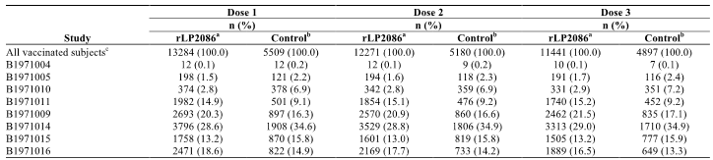

Adverse events

All adverse events (irrespective of relationship to study treatment)

Integrated safety analyses
The core safety dataset includes subjects receiving 120 µg bivalent rLP2086 on a 0, 2, and 6 month schedule or control vaccine in the 8 randomised controlled safety studies as shown in Table 11. In this group, similar percentages of subjects in the 120 µg bivalent rLP2086 group and the control group reported AEs during the vaccination phase (42.68% versus 41.68%, respectively), within 30 days after any vaccination (30.95% versus 28.37%), and within 30 days after Dose 1 or Dose 2 (25.46% versus 22.91%, Table 11). During the vaccination phase, the frequency of AE reports were similar in the bivalent rLP2086 group and the control group for severe AEs (3.25% versus 2.89%) and immediate AEs (1.64% versus 1.28%), while a higher proportion of subjects in the 120 µg bivalent rLP2086 group than in the control group reported related AEs (11.37% versus 6.10%) The proportions of subjects who reported AEs that led to discontinuation from the study were low in both groups (1.05% versus 0.51%).

Table 11: Summary of AEs during the vaccination phase – subjects who received at least 1 dose of bivalent rLP2086 final formulation (120 μg dose level) on a 0, 2, and 6 month schedule; core studies pooled
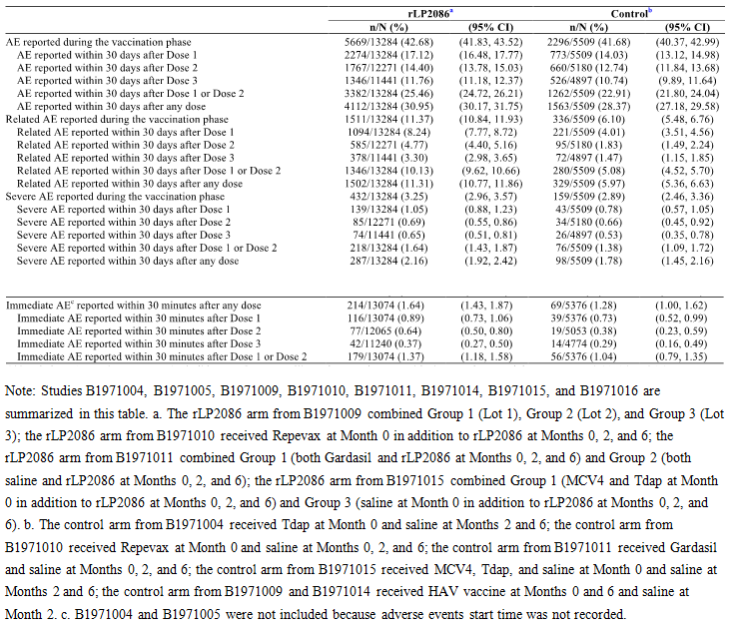
When reactogenicity events are excluded from the summary of AEs for the core dataset, the percentages of subjects reporting any AE during the vaccination phase in the bivalent rLP2086 group and the control group were 37.64% and 39.19%, respectively. Also when reactogenicity events were excluded, the frequency of related AEs was 3.37% for the bivalent rLP2086 group and 1.87% for the control group. For both vaccine groups, the reduction in the frequency of related AEs resulting from the exclusion of reactogenicity events suggests that most AEs considered related to study vaccine were reactogenicity events.
In the Phase III Studies B1971009, B1971014, and B1971016, non serious medically attended AEs were reported at similar frequencies in the bivalent rLP2086 group and the control group during the vaccination phase (23.33% versus 23.82%) and throughout the study (28.06% and 28.87%), as well as during the period before Dose 3 (20.84% versus 21.17%) and after Dose 3 (15.59% versus 16.09%). In the core safety dataset, the percentages of subjects reporting NDCMCs throughout the study were low and similar in both vaccine groups (< 1.03%). In the core dataset, confirmed autoimmune conditions were reported for 0.14% of subjects (18/13,284) in the 120 µg bivalent rLP2086 group and for 0.11% of subjects (6/5509) in the control group; the risk difference was 0.03% (95% confidence interval (CI): -0.11%, 0.13%) demonstrating no difference between the 2 groups for autoimmune conditions . Confirmed neuroinflammatory conditions were reported for 0.06% of subjects (8/13,284) who received 120 µg bivalent rLP2086 and for 0.07% of subjects (4/5509) who received control vaccine; the risk difference was -0.01% (95% CI, -0.13%, 0.06%), demonstrating no difference between the 2 groups for neuroinflammatory conditions.

Main/pivotal studies that assessed safety as the sole primary outcome

Study B1971014
Medically attended AEs were reported by similar proportions of subjects in the rLP2086 group and the control group. Most medically attended AEs reported by subjects in both groups were mild or moderate in severity. The proportion of subjects reporting AEs during the vaccination phase was higher among subjects receiving bivalent rLP2086 (51.08%) than among those receiving control vaccine (42.51%). The difference between the groups is due to the higher frequency of reactogenicity AEs reported in the bivalent rLP2086 group. When reactogenicity events were excluded, the proportions of subjects reporting AEs during the vaccination phase were similar in the 2 vaccine groups. When the predefined reactogenicity terms were excluded, AEs assessed as related to investigational product remained higher in the bivalent rLP2086 group than in the control group. This difference was associated with a higher proportion of subjects in the bivalent rLP2086 group than in the control group who reported nausea (1.16% versus 0.42%, respectively), pain in extremity (1.21% versus 0.52%), injection site warmth (0.32% versus 0%), and pain (0.26% versus 0%) during the vaccination phase.
The proportion of subjects reporting immediate AEs was similar between the 2 vaccine groups after Dose 1 and Dose 3; after Dose 2 (when control subjects received saline) the frequency of immediate AEs was higher among those receiving bivalent rLP2086 than in the control group. No notable differences in the proportions of subjects reporting NDCMCs, autoimmune conditions, or neuroinflammatory conditions were observed between the vaccine groups.
Similar proportions of subjects in both groups completed the vaccination schedule, which supports the conclusion that the differences in the proportions of subjects reporting AEs between groups were not clinically meaningful. NDCMCs throughout the study were reported in 1.40% of subjects in the rLP2086 group and 1.52% of subjects in the control group. Throughout the study autoimmune conditions were reported by 5 (0.13% ) subjects in the rLP2086 group (1 subject each with alopecia areata, autoimmune thyroiditis, and Basedow’s disease, and 2 subjects with psoriasis,) and 2 (0.10%) subjects in the control group (both with type 1 diabetes mellitus) who had a known autoimmune condition at study entry and was inadvertently enrolled. These were diverse and unlikely to be related.
Neuroinflammatory conditions were reported by 2 (0.05%) subjects (1 subject with multiple sclerosis, 1 subject with VIIth nerve paralysis) in the rLP2086 group and 3 (0.16%) subjects in the control group (2 subjects with multiple sclerosis, 1 subject with VIIth nerve paralysis) throughout the study. No notable differences in the proportions of subjects reporting newly diagnosed chronic medical conditions, autoimmune conditions, or neuroinflammatory conditions were observed between the rLP2086 group and the control group.

Pivotal and/or main studies assessing safety and tolerability

Study B1971009
A total of 3,590 subjects received at least 1 dose of study vaccine and were included in the safety population. During the vaccination phase, unsolicited AEs were reported at similar frequency in the bivalent rLP2086 group (40.74%) and the control group (43.70%). Most of the events were mild or moderate in severity. AEs during the vaccination phase assessed as related to investigational product were reported for 1.93% of subjects receiving bivalent rLP2086 and for 1.78% of subjects receiving control vaccine. Immediate AEs reported within 30 minutes after any dose were reported for ≤ 0.4% of subjects in either group. The proportion of subjects reporting MAEs at any time during the study was similar in the bivalent rLP2086 group (32.38%) and the control group (35.56%).
NDCMCs throughout the study were reported for 0.56% of subjects receiving bivalent rLP2086 and for 1.11% of subjects receiving control vaccine. The most frequently observed NDCMCs were in the SOC of psychiatric disorders (0.15%) for the combined bivalent rLP2086 group and in respiratory, thoracic and mediastinal disorders (0.33%) for the HAV/saline group. The overall occurrence of NDCMCs was infrequent across the groups and similar between the two groups. Autoimmune conditions were reported for 1 subject (0.04%) in the bivalent rLP2086 group and 2 subjects (0.22%) in the control group, while neuroinflammatory conditions were reported for 4 subjects (0.15%) receiving bivalent rLP2086 and 1 subject (0.11%) receiving control vaccine. Detailed history revealed evidence of pre-existing symptoms or a known autoimmune condition for 2 of the 3 autoimmune condition cases in the combined bivalent rLP2086 group) and evidence of pre-existing symptoms was reported in 1 of the 5 subjects who reported a neuroinflammatory condition.

Study B1971016
A total of 3,293 subjects received at least 1 dose of study vaccine and were included in the safety population: 2,471 received bivalent rLP2086 and 822 received control vaccine. During the vaccination phase, the proportions of subjects reporting at least 1 AE was similar between the 2 vaccine groups. Most of the events were mild or moderate in severity; and the frequencies of severe AEs were similar in the 2 vaccine groups. The most frequently observed AEs were in the SOC infections and infestations.
Throughout the study, there were no notable differences between the vaccine groups in the proportions of subjects reporting NDCMCs or autoimmune diseases or neuroinflammatory conditions. NDCMCs were reported in a total of 10 (0.40%) subjects in the rLP2086 group and 2 (0.24%) subjects in the saline group. The overall occurrence of NDCMCs was infrequent across both vaccine groups. Throughout the study, autoimmune conditions were reported by 2 (0.08%) subjects in the rLP2086 group and 1 (0.12%) subject in the saline group. Of the 2 autoimmune conditions reported in Group 1 (celiac disease and psoriasis), they were not considered related to the investigational product by the investigator.
A neuroinflammatory condition (VIIth nerve paralysis) was reported by 1 subject (0.04%) in the rLP2086 group, while none of the subjects in the saline group reported neuroinflammatory conditions throughout the study. The subject in Group 1 was diagnosed with moderate VIIth nerve paralysis on Day 76 after Vaccination 2. This subject did not report VIIth nerve paralysis following Vaccination 1. The subject had no reported medical history. The VIIth nerve paralysis was judged as related to the bivalent rLP2086 by the investigator, and resolved after treatment. The subject was withdrawn from the study due to this event.

Other studies assessing safety and tolerability

Study B1971004
For unsolicited AEs, the nature and frequency of events reported were generally consistent with illnesses typically expected in a healthy population of this age. There was no difference in the proportion of subjects reporting unsolicited AEs. Unsolicited AEs were reported by 11 of 12 (91.7%) subjects in each of the bivalent rLP2086 groups (the 60 µg group, the 120 µg group, and the 200 µg group), and by 11 of 12 subjects (91.7%) in the control group. One subject withdrew from the study because of mild gastritis (reported 173 days after Dose 2 of rLP2086 120 µg). No SAEs or deaths occurred during the course of this study.
For this study, laboratory abnormalities were reported as AEs. However, none were considered related to the rLP2086 vaccine, and there were no sequelae to any reported AEs. There were numerous laboratory abnormalities across all groups, including the control group. However, there was no pattern of laboratory abnormalities associated with increasing rLP2086 vaccine dose level or upon repeat vaccinations. Most laboratory abnormalities that occurred during the study were mild, were intermittent, and resolved by the end of the study. During the conduct of this study, no subjects reported NDCMCs or AEs considered autoimmune or neuroinflammatory in nature.

Study B1971005
Unsolicited AEs were reported by 18 (81.8%) subjects in the 60 µg bivalent rLP2086 group, 77 (38.9%) subjects in the 120 µg bivalent rLP2086 group, 92 (47.2%) in the 200 µg bivalent rLP2086 group, and 54 (44.6%) in the placebo group. Across all groups, the nature and frequency of AEs reported were consistent with illnesses typically expected in a healthy adolescent population. Few subjects reported AEs considered related to the study vaccine. No subject died during the study. No neuroinflammatory or autoimmune conditions were reported in this study.

Stage 2
Of the 401 subjects who were enrolled in Stage 2, 170 subjects were in the 120 µg group, 151 subjects were in the 200 µg group, and 80 subjects were in the control group. During Stage 2, when only SAEs, newly diagnosed chronic medical conditions (NDCMCs), and neuroinflammatory and autoimmune conditions were reported, relatively few subjects reported AEs that met these criteria, and none of the AEs reported during Stage 2 were considered related to the investigational product by the investigator.

Study B1971010
For unsolicited AEs, the proportion of subjects reporting AEs was generally similar between Group 1 (bivalent rLP2086 + Repevax) and Group 2 (Repevax + Saline). The nature and frequency of events reported were consistent with illnesses typically expected in an adolescent population, with the majority of reported related AEs reflecting reactogenicity. No subjects were diagnosed with neuroinflammatory conditions in this study.

Study B1971011
No significant difference was noted in the incidence of AEs by SOC between groups. Overall, the proportion of subjects reporting an AE, SAEs, and AEs that led to study withdrawal was generally similar between Group 1 (bivalent rLP2086 + Gardasil), Group 2 (bivalent rLP2086 + saline), and Group 3 (saline + Gardasil). One subject was diagnosed with a neuroinflammatory condition. This subject, who received rLP2086 + saline (Group 2), experienced IgA nephropathy 1 day following initial vaccination. Given this timing, the nature of the disease pathophysiology, and the time required for autoantibody development, it was thought to be unrelated to study drug.

Study B1971012
For unsolicited AEs overall, AEs were reported in similar proportions across all groups. The nature and frequency of events reported were consistent with illnesses typically expected in an adolescent population. The percentage of subjects reporting AEs or SAEs within 30 days after injection of bivalent rLP2086 or saline was similar. A limited number of AEs were assessed as related to bivalent rLP2086, ranging from 3.8% to 6.1% across the 5 groups with the majority of related AEs reported being of reactogenicity nature. NDCMCs were reported in 8 subjects but were assessed as unrelated. No subjects were diagnosed with neuroinflammatory conditions.

Study B1971015
No clinically meaningful difference was noted in the incidence of AEs by system organ class (SOC) between groups. Thirteen subjects reported NDCMCs during the study. No NDCMC was assessed as related to study vaccine, except for Raynaud’s syndrome (assessed as a possible precursor to an autoimmune condition). The condition was considered an AE and was assessed by the investigator as related to the study vaccination given the proximity of the start of symptoms to study vaccination. This report of Raynaud’s disease did not change the overall safety profile for bivalent rLP2086, given the prevalence of Raynaud’s phenomenon (18%) in females in the second decade of life. No subjects were diagnosed with neuroinflammatory conditions.

Treatment related adverse events

Integrated safety analyses
Adverse events that were assessed as related to rLP2086 by the investigator were reported by a higher percentage of subjects in the 120 µg bivalent rLP2086 group compared with the control group (11.37% versus 6.10%) as summarised in Table 11. Related AEs were most frequently observed in the SOC of general disorders and administration site conditions, which were reported by 9.58% of subjects in the 120 µg bivalent rLP2086 group and 4.50% of subjects in the control group. The most frequently reported related AE in this SOC, injection site pain, was reported by a higher proportion of subjects in the 120 µg bivalent rLP2086 group (6.59%) than in the control group (3.30%). Other related AEs in this SOC corresponded to local reaction terms (for example, injection site erythema, injection site swelling) or systemic event terms (for example, pyrexia, fatigue, chills) and were, in general, reported by a higher percentage of subjects in the 120 µg bivalent rLP2086 group than in the control group. In the nervous system SOC, the related AE of headache was reported by a higher proportion of subjects in the 120 µg bivalent rLP2086 group compared with the control group (1.63% versus 0.78%). When reactogenicity events were excluded, the frequency of related AEs was 3.37% in the 120 µg bivalent rLP2086 group and 1.87% in the control group. Thus, the majority of events considered related to study vaccine were reactogenicity events.

Solicited local events (adverse drug reactions)
Pain at the injection site (Excluding Study B1971014; data not collected in diaries): The proportion of subjects reporting pain at the injection site within 7 days after any dose was greater among subjects receiving 120 µg bivalent rLP2086 (89.6% to 98.1%, across studies) than among those receiving control vaccine (18.2% to 64.8%). Within each vaccine group, the proportions of subjects reporting pain at the injection site were similar across the 3 doses, and there were no trends toward increasing or decreasing frequency with successive doses. In both vaccine groups, pain at the injection site was most often reported as mild or moderate in intensity. Across studies, for the 120 µg bivalent rLP2086 groups versus the control groups, respectively, mild pain after any dose was reported for 22.3% to 43.4% versus 16.2% to 46.1% of subjects; and moderate pain was reported for 45.5% to 63.0% versus 1.7% to 17.5% of subjects. Across studies, severe pain was reported for 3.0% to 15.1% of subjects receiving 120 µg bivalent rLP2086 and for 0.0% to 2.4% of subjects who received control vaccine. No differences among age groups in rates of pain were observed.
Redness (Excluding Study B1971014): In the 6 controlled studies discussed the frequency of redness occurring within 7 days after any dose was higher among subjects receiving 120 µg bivalent rLP2086 (22.0% to 40.0% across studies) than among those receiving control vaccine (0.0% to 8.1%). Similar results were observed for the frequency of redness after either Dose 1 or Dose 2 (17.8% to 34.2% for 120 µg bivalent rLP2086 and 0.0% to 6.4% for control vaccine). In each vaccine group, there were no trends toward increasing or decreasing frequency of redness with successive doses. Redness reported after any dose of 120 µg bivalent rLP2086 was most often mild (7.2% to 17.7% of subjects, across studies) or moderate (10.1% to 16.8%) in severity; and after any dose of control vaccine, redness was most often mild (0.0% to 5.9%), with moderate redness reported for 0.0% to 2.6% of subjects across studies. Severe redness was reported for 2.5% to 5.6% of subjects after 120 µg bivalent rLP2086 and for 0.0% to 0.2% of subjects receiving control vaccine. Across studies, the median duration of redness was generally 2.0 days for subjects receiving 120 µg bivalent rLP2086 and 1.0 to 2.0 days for control vaccine.
Swelling (Excluding Study B1971014): The frequency of swelling after any dose was higher after 120 µg bivalent rLP2086 (25.1% to 40.7%, across studies) than after control vaccine (0.0% to 12.2%). Results for the frequency of swelling after Dose 1 or Dose 2 were similar (21.0% to 35.8% after 120 µg bivalent rLP2086 and 0.0% to 10.5% after control vaccine). Within each vaccine group, the proportion of subjects reporting swelling was similar across each of the 3 doses, with no trends toward increasing or decreasing frequency with successive doses. Swelling after any dose was mostly mild or moderate in severity, both among subjects receiving 120 µg bivalent rLP2086 (5.1% to 20.4% mild, 11.3% to 27.8% moderate) and among those receiving control vaccine (0.0% to 8.6% mild, 0.0% to 4.8% moderate). Severe swelling after any dose was reported for 0.5% to 2.2% of subjects after 120 µg bivalent rLP2086 and for ≤ 0.1% after control vaccine. Across studies, the median duration of swelling was between 1.0 and 3.0 days (most often 2 days) for subjects receiving 120 μg bivalent rLP2086 and 1 to 2 days for control vaccine.
Large Local Reactions: Studies B1971016 and B1971009 specifically measured large local reactions to better characterise the size, duration, and clinical course of redness and swelling. Large local reactions of redness and/or swelling occurred in less than 2% of subjects who received bivalent rLP2086 and appeared to have a slightly longer duration than smaller local reactions. Large local reactions occurred more frequently after administration of bivalent rLP2086 than after control vaccine.
Local reactogenicity events (injection site pain, injection site redness (erythema) and injection site swelling (induration)) have been determined to be adverse reactions (that is causally associated) of rLP2086.

Solicited systemic events (adverse drug reactions)
In all core studies (excluding Studies B1971004 and B1971014), after any dose of 120 µg bivalent rLP2086, the most frequently reported systemic events were fatigue and headache. Both of these systemic events were reported more frequently after 120 µg bivalent rLP2086 than after control vaccine. In the rLP2086 groups versus the control groups, respectively, the proportion of subjects reporting fatigue after any dose ranged from 60.6% to 85.0% versus 41.7% to 79.6%; and the proportion reporting headache ranged from 59.1% to 83.9% versus 48.3 to 74.3%. For both fatigue and headache, in both the rLP2086 and control groups, reporting rates were highest after Dose 1, with lower rates observed after Dose 2 and Dose 3. Most reports of fatigue and headache were mild or moderate. After any dose, severe fatigue was reported for 1.5% to 6.6% of subjects after rLP2086 versus 0.0% to 4.0% of subjects after control vaccine; and rates for severe headache were 1.3% to 5.6% versus 0.0% to 2.9%, respectively. Administration of concomitant vaccines with rLP2086 did not substantially increase reporting rates for fatigue and headache.
The next most frequently reported systemic event after any dose was muscle pain. As was observed for fatigue and headache, muscle pain was reported more frequently after 120 μg bivalent rLP2086 (34.3% to 61.8%) than after control vaccine (18.3% to 52.4%), was observed more frequently after Dose 1 than after Dose 2 or Dose 3, and was most often reported as mild or moderate, with severe muscle pain reported for 5.2% of subjects after any dose of 120 µg bivalent rLP2086. Administration of concomitant vaccines in Studies B1971011 and B1971015 did not substantially increase the frequency of muscle pain observed after 120 µg bivalent rLP2086.
Fever (≥ 38 °C) was also reported more frequently among subjects receiving 120 µg bivalent rLP2086 (4.4% to 17.4%) than among those receiving control vaccine (1.7% to 9.0%). In the 120 µg bivalent rLP2086 group, the frequency of fever was consistently higher after Dose 1 than after Dose 2 or Dose 3. In both the bivalent rLP2086 and control vaccine groups, fever was most often mild (38 °C to < 38.5 °C) or moderate (38.5 °C to < 39 °C); severe fever (39.0 °C to 40.0 °C) was reported for 0.2% to 2.7% of subjects after any dose of 120 µg bivalent rLP2086 and for 0.4% to 1.7% of subjects after control vaccine. Fever >40.0 °C was reported for 1 subject (0.1%) in Study B1971015 after Dose 1 of 120 µg bivalent rLP2086+ MCV4+ Tdap (subject was withdrawn from the study as a result), for 1 subject (0.1%) in Study B1971016 after Dose 3 of 120 µg bivalent rLP2086, and for 1 subject (0.1%) in Study B1971009 after Dose 3 of control vaccine (HAV). Each of these 3 cases resolved after one day. Increases in the severity of fever with potentiation were reported for 3/2,388 subjects (0.13%) who received 120 µg bivalent rLP2086 in Study B1971009; no subjects who received control vaccine experienced increases in the severity of fever with potentiation. Results from Studies B1971011 and B1971015 suggest that the frequency of fever (≥ 38 °C) was not substantially affected by the administration of concomitant vaccines with rLP2086 relative to rates observed with rLP2086 alone. In Study B1971011, the frequency of fever reported after any dose of rLP2086+ Gardasil (11.5%) was similar to the frequency after any dose of rLP2086 alone (8.1%); and in Study B1971015, the frequency of fever was similar after Dose 1 of rLP2086+ MCV4+ Tdap (13.2%) and after rLP2086 alone (11.6%). In Study B1971010, the frequency of fever was higher after Dose 1 of bivalent rLP2086+ Repevax (12.1%) than after Dose 1 of Repevax alone (5.3%) alone.
Chills and joint pain were reported more frequently after any dose of 120 µg bivalent rLP2086 than after control vaccine: chills, 20.7% to 55.8% versus 13.3% to 44.4% of subjects, respectively; and joint pain, 22.7% to 37.7% versus 14.2% to 30.7% of subjects, respectively. The systemic events reported least often were diarrhoea and vomiting with similar frequencies in the 120 µg bivalent rLP2086. Diarrhoea was reported for up to 25.7% of subjects receiving 120 µg bivalent rLP2086 and up to 25.2% receiving control vaccine, while vomiting was reported for up to 15.0% of subjects after 120 µg bivalent rLP2086 and 11.1% after control vaccine. Overall, for most types of systemic events, the median duration in both the bivalent rLP2086 groups and the control groups generally was 1.0 to 2.0 days.
Systemic reactogenicity events (headache, vomiting, diarrhoea, nausea, muscle pain (myalgia), joint pain (arthralgia), fever ≥38° C (pyrexia), chills, fatigue) have been determined to be adverse reactions (that is, causally associated) of rLP2086.

Main/pivotal studies that assessed safety as the sole primary outcome

Study B1971014
Overall, the percentage of AEs reported during the vaccination phase was higher in Group 1 compared to Group 2. Subjects in Group 1 reported more reactogenicity AEs than subjects in Group 2 during the vaccination phase. Reactogenicity AEs were defined as any AE with an onset within 7 days after vaccination and matched a predefined preferred term list. A higher proportion of subjects in Group 1 than in Group 2 reported immediate AEs within 30 minutes after Vaccination 1 or Vaccination 2 (1.55% and 0.89%, respectively). This difference is likely because subjects in Group 2 received a saline injection at Vaccination 2. Most reactions in both groups were mild. When the predefined reactogenicity terms were excluded, AEs assessed as related to investigational product remained higher in Group 1 than Group 2. This difference was associated with a higher proportion of subjects in Group 1 than Group 2 who reported nausea (1.16% and 0.42%, respectively), pain in extremity (1.21% and 0.52%, respectively), injection site warmth (0.32% and 0%, respectively), and pain (0.26% and 0%, respectively) during the vaccination phase.

Pivotal and/or main studies assessing safety and tolerability

Study B1971009
The proportion of subjects who reported local reactions after any dose was higher in the combined bivalent rLP2086 group than in the control group for pain at the injection site (92.6% versus 58.8%), redness (24.1% versus 2.4%), and swelling (27.4% versus 2.9%). Most local reactions reported were mild or moderate in severity. The frequency of local reactions did not increase with each subsequent dose, and the majority of the subjects who reported severe local reactions returned for subsequent vaccinations. Overall, few subjects reported large reactions (> 21 calliper units) of redness or swelling and the median duration of these reactions was 2.0 to 3.5 days. Five subjects in the combined bivalent rLP2086 group withdrew from the study because of local reactions following Vaccination 1; 1 subject in the combined bivalent rLP2086 group withdrew from the study because of injection site pruritus following Vaccination 2.
The proportion of subjects reporting systemic events was higher in the combined bivalent rLP2086 group compared to the proportion in the HAV/saline group; the events were generally mild or moderate in severity. Headache and fatigue were the most commonly reported systemic events in both groups. One subject in the combined bivalent rLP2086 group withdrew from the study because of chills following Vaccination 2. The frequency of systemic events did not increase with subsequent doses for either vaccine group.

Study B1971016
Related AEs were reported more frequently among subjects receiving bivalent rLP2086 than among those receiving control vaccine (control vaccine was saline). This difference between the 2 groups was due to a higher frequency of reactogenicity events (that is, AEs corresponding to local reaction or systemic event terms) considered related to study vaccine in the bivalent rLP2086 group. Immediate AEs were reported at similar frequencies in the 2 vaccine groups.
The frequency of local reactions was higher after bivalent rLP2086 than after control vaccine. Pain at the injection site was the most commonly reported local reaction. Most local reactions reported were mild or moderate in severity. The frequency of local reactions did not increase with subsequent dosing and the majority of the subjects who reported severe local reactions returned for subsequent vaccinations. Overall, few subjects with redness or swelling reported large reactions (> 21 calliper units) of redness (51 of 537 subjects (9.50%) in Group 1, 1 of 8 subjects (12.50%) in Group 2) or swelling (16 of 612 subjects (2.61%) in Group 1, 1 of 8 subjects (12.50%) in Group 2). The median duration of these large reactions was 2 to 4 days. A low number of subjects (2 subjects in Group 1 and 1 subject in Group 2) withdrew from the study because of local reactions.
The proportions of subjects reporting systemic events were higher among subjects receiving bivalent rLP2086 than among those receiving control vaccine. The incidence of systemic events did not increase with subsequent dosing for either of the groups. Systemic events were generally mild or moderate in severity, and severe systemic events were relatively infrequent. Headache and fatigue were the most frequently reported systemic events in both groups. Few subjects withdrew from the study because of systemic events (3 subjects in the bivalent rLP2086 group and 1 subject in the control group).

Other studies assessing safety and tolerability

Study B1971004
A higher proportion of subjects receiving rLP2086 reported local reactions at the injection site compared to subjects receiving Adacel injection at Dose 1 and to subjects receiving saline at Doses 2 and 3. Pain at injection site was the most frequently reported local reaction. Most subjects in each group reported either mild or moderate local reactions, with median durations of 1.0 to 2.5 days for subjects in the 60 µg bivalent rLP2086 group, 1.5 to 3.5 days for subjects in the 120 µg bivalent rLP2086 group, and 1 to 4.5 days for subjects in the 200 µg bivalent rLP2086 group. No subjects withdrew from the study because of local reactions.
The frequency of systemic events was generally higher in the rLP2086 groups compared to the control group. Fatigue, headache, and muscle pain were the most commonly reported systemic events. Most systemic events were mild or moderate in severity, with median durations of 1.0 to 11.0 days for subjects in the 60 µg bivalent rLP2086 group, 1 to 4.5 days for subjects in the 120 µg bivalent rLP2086 group, and 1 to 6 days for subjects in the 200 µg bivalent rLP2086 group. In the bivalent rLP2086 groups, where the vaccine was administered alone at each dose, the incidence of systemic events was generally similar to the initial vaccination at subsequent intervals. No subjects withdrew from the study because of systemic events.

Study B1971005
Most local reactions in the study were mild or moderate in severity, with median durations of 1.0 to 4.5 days. Pain at the injection site was the most commonly reported local reaction. Neither the frequency nor the severity of events increased with repeated dosing. Local reactions were more commonly reported in the 200 µg bivalent rLP2086 group compared to the 60 µg bivalent rLP2086 group and the 120 µg bivalent rLP2086 group. Three subjects in the 200 µg bivalent rLP2086 group experienced local reactions and withdrew consent.
The frequencies of fever and systemic events were generally higher in the rLP2086 groups compared to the placebo group. Systemic events were more commonly reported in 200 µg bivalent rLP2086 group compared to the 60 µg bivalent rLP2086 group and the 120 µg bivalent rLP2086 group. The most common systemic events were headache, fatigue, and muscle pain. Most subjects had systemic events that were mild or moderate in severity, with median durations of 1.0 to 6.0 days. No subjects reported fever > 40 °C after each dose, and < 1% had reported fever > 39 °C. There was a trend toward either similar or lower incidences of systemic events with subsequent vaccinations for both the 120 µg bivalent rLP2086 group and the saline control group. One subject in the 120 µg of bivalent rLP2086 group withdrew due a systemic event (headache).

Study B1971010
A higher proportion of subjects receiving bivalent rLP2086 reported local reactions at the injection site when compared to subjects receiving saline. Most local reactions reported were mild or moderate in severity and with a median duration of 2.0 to 3.0 days. Pain at the injection site was the most commonly reported local reaction and was reported in a higher proportion of subjects in Group 1 compared to Group 2. Only 1 subject receiving rLP2086 withdrew from the study because of local reactions.
At Dose 1, when bivalent rLP2086 was administered concomitantly with Repevax to subjects in Group 1, the proportion of subjects reporting fever in this group was higher than the proportion of subjects experiencing fever after receiving Repevax with saline (Group 2) (12.1% versus 5.3%). For all other systemic events the incidence was generally similar in Group 1 compared to Group 2. Headache and fatigue were the most commonly reported systemic events after Dose 1. The majority of systemic events were mild or moderate with a median duration of 1.0 to 4.0 days. Fever > 40.0 °C was not reported after Dose 1 for either group. After Dose 1, only 3 subjects from Group 1 withdrew from the study because of systemic events.
At Doses 2 and 3, when bivalent rLP2086 (Group 1) and saline (Group 2) were administered alone, the proportion of subjects reporting fever was slightly higher in Group 1 (bivalent rLP2086) compared to Group 2 (saline) (4.7% versus 1.7% after Dose 2 and 4.3% versus 2.6% after Dose 3). For other systemic events the incidence was generally higher in Group 1 compared to Group 2. Headache and fatigue were the most commonly reported systemic events after Doses 2 and 3. The majority of systemic events were mild or moderate with a median duration of 1.0 to 4.0 days. Fever > 40.0 °C was not reported after Doses 2 and 3 for either group. Rates of other severe systemic events were low (< 2% of subjects) and comparable between the 120 µg bivalent rLP2086 group and the saline control group. After Doses 2 and 3, no subjects withdrew from the study because of systemic events.

Study B1971011
Local reactions at the injection site were reported more frequently following administration of bivalent rLP2086 (97.6% and 96.9% of subjects, respectively, in Group 1 and Group 2) than following administration of saline (56.7% subjects in Group 3 at the saline injection site). Pain at the injection site was the most commonly reported local reaction. Local reactogenicity did not increase with subsequent dosing. Most local reactions reported were mild or moderate in severity and transient. A low number of subjects (5 in Group 1, 5 in Group 2, and 1 in Group 3) withdrew from the study because of local reactions following Dose 1 or 2.
The groups receiving bivalent rLP2086 had more mild to moderate systemic reactogenicity and a slightly higher rate of severe systemic events than the group that received Gardasil and saline. The systemic event profile for subjects who received co administration of bivalent rLP2086 + Gardasil was similar to subjects who received bivalent rLP2086 + saline. Fatigue and headache were the most commonly reported systemic events across all vaccinations and across all groups. Systemic events in all 3 groups were generally mild and moderate in severity. The mean duration, 1.0 to 3.8 days, and onset of systemic events were similar across the groups.

Study B1971012
For local reactions, a higher proportion of subjects reported any local reaction after any vaccination at the bivalent rLP2086 injection site when compared to subjects receiving saline. The majority of local reactions following bivalent rLP2086 were mild or moderate in severity with median durations of 2.0 to 3.0 days. Pain was the most common local reaction reported. Four (4) subjects withdrew due to pain at the injection site: 1 of 426 subjects (0.2%) in Group 1, 1 of 414 subjects (0.2%) in Group 3, and 2 of 277 subjects (0.7%) in Group 4. There were no clinically meaningful differences between the 0, 6 month regimen and any of the other 2 or 3 dose regimens.
The proportion of subjects reporting systemic events was generally similar following bivalent rLP2086 and saline injections, with some exceptions. Headache, fatigue, muscle pain, joint pain, and chills following an injection showed higher rates at 2 or more injections in the subjects receiving bivalent rLP2086 compared to saline, however the relative difference in the rates was small, suggesting that the rates were not clinically meaningful. Headache and fatigue were the most commonly reported systemic events reported by subjects after receiving bivalent rLP2086 or saline. Most systemic events were mild or moderate in severity, with median durations of 1.0 to 3.5 days. There was 1 report of a temperature > 40.0 °C, which occurred after Injection 4.

Study B1971042
The most common local reaction reported was pain at the injection site, reported by 100% of subjects after each dose. Most cases of local reactions after each dose were mild or moderate in severity with median durations of 1.0 to 3.0 days. There were no cases of potentiation (that is, worsening of reactions with increasing doses) for any local reaction, and no subjects withdrew due to a local reaction.
Systemic events were reported by 7 of 13 subjects (53.8%) across any vaccination. The most common systemic events reported were fatigue and muscle pain. Systemic events were generally mild or moderate in severity. The median duration of systemic events ranged from 1.0to 4.0 days after each vaccination. There were no cases of potentiation for any systemic event and no subjects withdrew due to a systemic event.

Study B1971015
In the 2 groups receiving bivalent rLP2086, local reactions were evaluated for the bivalent rLP2086 injection site only and were compared with local reactions at the saline injection site for the control group. Subjects who received bivalent rLP2086 had more local reactogenicity than subjects who received saline. Pain at the injection site was the most commonly reported local reaction. Local reactogenicity did not increase with subsequent dosing. Most local reactions reported were mild or moderate in severity and transient. A low number of subjects (6 in Group 1, 0 in Group 2, and 2 in Group 3) withdrew from the study because of local reactions following Vaccination 1 or 2.
Systemic events in all 3 groups were generally mild and moderate in severity. The groups receiving bivalent rLP2086 had more mild to moderate systemic events and a slightly higher rate of severe systemic events than the group that received MCV4+ Tdap and saline. The systemic event profile was similar between the 2 groups receiving bivalent rLP2086, but subjects receiving MCV4+ Tdap+ bivalent rLP2086 demonstrated a slightly higher incidence of systemic events, compared to subjects who received saline+ saline+ bivalent rLP2086. The incidence of systemic events did not increase with subsequent dosing for any of the groups. Fatigue and headache were the most commonly reported systemic events across all vaccinations and across all groups. The mean durations and onset day of systemic events were similar across the groups.

Deaths and other serious adverse events

Integrated safety analyses
In the 8 controlled studies, the percentages of subjects experiencing SAEs was similar in the 120 µg bivalent rLP2086 group and the control group during the vaccination phase (1.15% versus 1.34%, respectively) and throughout the studies (1.60% versus 1.92%), as well as during the period before Dose 3 (0.98% versus 1.25%) and after Dose 3 (0.74% versus 0.86%), (Table 12). SAEs considered related to study vaccine were reported for 5 subjects (0.04%) who received 120 µg bivalent rLP2086 and for 2 subjects (0.04%) who received control vaccine.
Among the 13,284 subjects who received 120 µg bivalent rLP2086, 5 subjects (0.04%) died, while there were no deaths among the 5,509 subjects who received control vaccine. Among the subjects who died, 3 died as a result of road traffic accidents (2 were passengers, 1 was the driver), 1 subject died due to a gunshot wound (not self-inflicted), and 1 subject committed suicide. None of the deaths were considered related to study vaccine.

Table12: Summary of AEs and SAEs; subjects who received at least 1 dose of bivalent rLP2086 final formulation (120 μg dose level) on a 0, 2, and 6 month schedule; core studies pooled
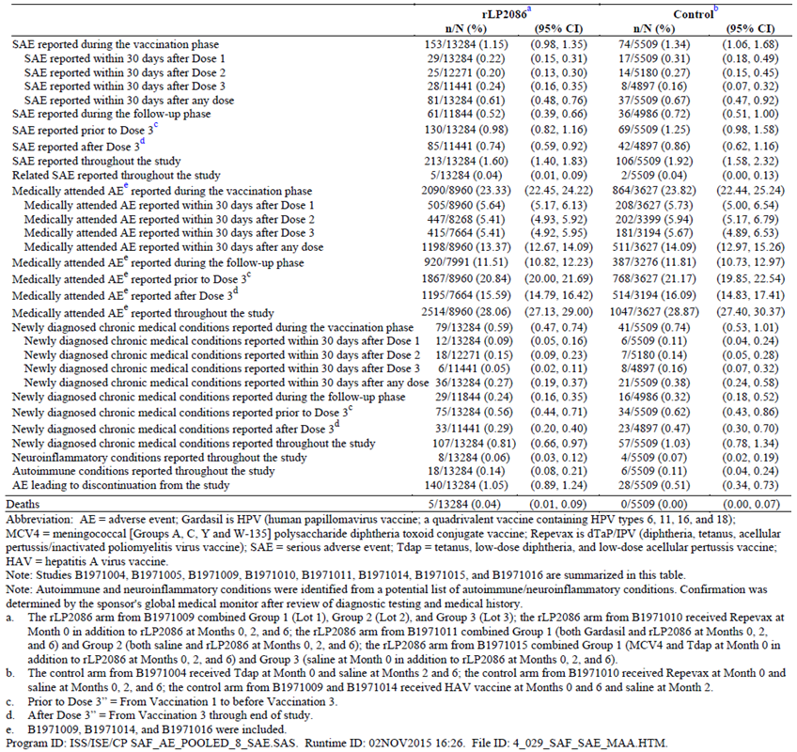
MCV4 = meningococcal (Groups A, C, Y and W-135) polysaccharide diphtheria toxoid conjugate vaccine; Repevax is dTaP/IPV (diphtheria, tetanus, acellular pertussis/inactivated poliomyelitis virus vaccine); SAE = serious adverse event; Tdap = tetanus, low-dose diphtheria, and low-dose acellular pertussis vaccine; HAV = hepatitis A virus vaccine. Note: Studies B1971004, B1971005, B1971009, B1971010, B1971011, B1971014, B1971015, and B1971016 are summarised in this table. Note: Autoimmune and neuroinflammatory conditions were identified from a potential list of autoimmune/neuroinflammatory conditions. Confirmation was determined by the sponsor's global medical monitor after review of diagnostic testing and medical history.

Main/pivotal studies that assessed safety as the sole primary outcome

Study B1971014
The proportion of subjects reporting SAEs throughout the study was lower among subjects receiving bivalent rLP2086 (1.55%) than among those receiving HAV/saline control (2.52%). A sensitivity analysis revealed that the proportion of subjects reporting at least 1 SAE remained higher in the control group compared the bivalent rLP2086 group when an outcome was imputed for subjects with incomplete follow-up AE data. The most common SAEs reported by both groups throughout the study were in the SOC of infections and infestations. Related SAEs were reported by 2 subjects (0.05%) in the bivalent rLP2086 group and by 2 subjects (0.10%) in the control group throughout the study. One subject died during the study (unrelated).

Pivotal and/or main studies assessing safety and tolerability

Study B1971009
No subjects died in the study. SAEs were reported for 51 subjects (1.89%) receiving bivalent rLP2086 and for 22 subjects (2.45%) receiving control vaccine. Few subjects were withdrawn from the study due to adverse events: 22 (0.82%) in the bivalent rLP2086 group and 3 (0.33%) in the control group. Among subjects receiving bivalent rLP2086, the AEs most often leading to withdrawal from the study were injection site pain (4 subjects) and asthma (2 subjects).

Study B1971016
SAEs occurring at any time during the study were reported for 1.34% of subjects in each vaccine group. SAEs considered related to study vaccine were reported for 3 subjects (0.12%) in the bivalent rLP2086 group and for no subjects in the control group. Three (3) subjects in Group 1 died during the study. None of the deaths were considered related to the study vaccine by the investigator.

Other studies assessing safety and tolerability

Study B1971010
In Study B1971010 1 subject in Group 1 died in a road traffic accident and the death was considered not related to vaccination. A total of 21 subjects (3.2% in Group 1 versus 2.4% in Group 2) reported SAEs throughout the study. None of the SAEs were considered to be related to the vaccination.

Study B1971011
In Study B1971011 the proportion of subjects reporting SAEs was 1.2%, 1.6%, and 0.8% in Groups 1, 2, and 3, respectively. No subjects died during the course of this study. None of the SAEs was considered to be related to the vaccination and none led to discontinuation of the study drug.

Study B1971012
Two subjects (in Group 2) reported SAEs considered to be related to bivalent rLP2086 administration. One (1) subject reported vertigo, chills, and headache after receiving Dose 3 of bivalent rLP2086 on the same day; 1 subject reported pyrexia and vomiting the day after receiving Dose 1 of bivalent rLP2086. Nineteen subjects were withdrawn from the study because of AEs; 9 of the events were considered by the investigator to be related to study vaccination. No subject died during the study.

Study B1971015
Severe systemic events were relatively infrequent. Two subjects (1 each in Group 1 and Group 3) withdrew from the study because of headache; 2 subjects (2 in Group 1) withdrew from the study because of pyrexia; 1 subject in Group 3 withdrew from the study because of arthralgia; 1 subject in Group 1 withdrew from the study because of fatigue.
Overall, the proportions of subjects reporting AEs, SAEs, and AEs that led to study withdrawal were generally similar between Group 1 (42.9%, 1.7%, and 1.4%, respectively), Group 2 (42.6%, 1.7%, and 0.6%), and Group 3 (46.2%, 1.3%, and 0.7%). A higher proportion of subjects reported related AEs in the groups that received rLP2086 compared to the control group. The most common related AEs were local reactions. No subjects died during the course of this study. A total of 15 (1.7%) subjects in Group 1, 9 (1%) subjects in Group 2, and 11 (1.3%) subjects in Group 3 reported SAEs. None of the SAEs were considered to be related to the vaccination. Similar proportions of subjects were withdrawn from the study because of AEs in Group 1 (12 subjects, 1.4%), Group 2 (5 subjects, 0.6%), and Group 3 (6 subjects, 0.7%).

Discontinuations due to adverse events

Withdrawal due to local reactions
Among the 13,284 subjects who received 120 µg bivalent rLP2086 in the 8 controlled studies, 46 subjects (0.35%) were withdrawn from the studies due to local reactions; and among the 5509 subjects who received control vaccine in these studies, 2 subjects (0.04%) were withdrawn due to local reactions. Some of these subjects were withdrawn because of more than 1 local reaction type and some were withdrawn because of both local reactions and systemic events.

Withdrawal due to systemic events
Overall, in the core safety dataset, systemic events resulted in withdrawal of 31 subjects (0.23%) who received 120 µg bivalent rLP2086 and 2 subjects (0.04%) who received control vaccine. Among subjects receiving 120 µg bivalent rLP2086, the systemic events most frequently leading to withdrawal from study participation were headache (17 subjects, 0.13%) and pyrexia (11 subjects, 0.08%). Among subjects who received control vaccine, 1 subject was withdrawn from the study due to chills and 1 subject was withdrawn due to headache, fatigue, pyrexia, chills, myalgia, and arthralgia.

Evaluation of issues with possible regulatory impact
The following issues were considered not applicable:
- Liver function and liver toxicity
- Renal function and renal toxicity
- Other clinical chemistry
- Haematology and haematological toxicity
- Other laboratory tests
- Electrocardiograph findings and cardiovascular safety
- Vital signs and clinical examination findings.

Immunogenicity and immunological events
Among the 8 controlled studies, potential autoimmune conditions among subjects who received 120 μg bivalent rLP2086 on a 0, 2, 6 month schedule were observed in 0.36% (48 of 13,284 vaccinated subjects) compared to 0.34% in controls (19 of the 5,509 subjects). Similarly, the proportion of subjects who reported potential neuroinflammatory conditions was 0.10% (13 of 13,284 subjects) for subjects who were vaccinated with 120 μg bivalent rLP2086 on a 0, 2, 6 month schedule compared to 0.11% (6 of 5,509 subjects) among controls.
Confirmed autoimmune conditions were reported in 0.14% (18 of 13,284 subjects, 95% CI: 0.08%, 0.21%) of subjects receiving 120 μg bivalent rLP2086 on a 0, 2, 6 month schedule compared with 0.11% (6 of 5509 subjects, 95% CI: 0.04%, 0.24%) of subjects receiving control vaccine. The difference in proportions between the vaccine groups was 0.03% (95% CI: -0.11%, 0.13%, p = 0.642), supporting the conclusion that there was no significant difference between the 120 µg bivalent rLP2086 group and the control group in the rate of autoimmune disease.

Serious skin reactions
Not applicable.

Other safety parameters

Integrated safety analyses
In the core safety dataset, confirmed neuroinflammatory conditions were reported in 0.06% (8 of 13,284 subjects, 95% CI: 0.03%, 0.12%) of subjects receiving 120 μg bivalent rLP2086 compared with 0.07% (4 of 5,509 subjects, 95% CI: 0.02%, 0.19%) of subjects receiving control vaccine. The difference in proportions between vaccine groups was -0.01% (95% CI: -0.13, 0.06, p = 0.760), supporting the conclusion that there was no significant difference between the 120 µg bivalent rLP2086 group and the control group in the rate of neuroinflammatory conditions. The most commonly reported neuroinflammatory condition in this dataset was VIIth nerve paralysis (8 of 12 subjects with neuroinflammatory conditions). Six of the cases were reported as Bell’s palsy, 1 event was reported as right peripheral facial paralysis, and 1 event was reported as infranuclear facial nerve paralysis. Six of these occurred in patients who received rLP2086 and 3 of these were assessed by the investigator as likely to be related to vaccine.

Other safety issues

Safety in special populations
Although pregnancy was an exclusion criterion at enrolment, across all 11 studies, a total of 172 subjects became pregnant during the studies or had partners who became pregnant during the studies: among the 15,294 subjects who received bivalent rLP2086, pregnancies were reported for 127 subjects (0.83%) (124 subjects who received 120 µg and 3 subjects who received 200 µg); and among the 5,509 subjects who received control vaccine, pregnancies were reported for 45 subjects (0.82%). Information regarding pregnancy outcome was available for 121 of the 172 pregnancies (70.3%). Among the 121 pregnancies with known outcomes, live births were documented for 81 subjects (66.9%), most of which were full term. Fetal loss was reported for 40 (33.1%) of the 121 cases with known outcomes; 21 (52.5%) were elective terminations and 17 (42.5%) were spontaneous abortions. The remainder of foetal loss cases were therapeutic abortion (1 subject who received control vaccine) and stillbirth (1 subject who received bivalent rLP2086). Most pregnancies were distal to study vaccination. Among the 94 pregnancies with an estimated conception date, 67 (71.3%) were distal and 27 (28.7%) were proximal to vaccination. In the core safety dataset, outcome information was available for 116/164 pregnancies. Outcome rates were similar between the bivalent rLP2086 and control groups. Among 85 pregnancies reported in the bivalent rLP2086 group, fetal loss occurred in 26 (30.6%) and live births occurred in 59 (69.4%); in the control group, among the 31 pregnancies reported, fetal loss occurred 12 (38.7%) and live births occurred in 19 (61.3%). In the bivalent rLP2086 group, among the 59 births, 51 (86.4%) were full term and 8 (13.6%) were premature births; and in the control group, all 19 births (100.0%) were full term.

Safety related to drug-drug interactions and other interactions
Three Phase II studies evaluated concomitant vaccination (Studies B1971010, B1971011 and B1971015) given with bivalent rLP2086. Study B1971010 provides data on concomitant use with Repevax (dTaP IPV) in adolescents aged 11 to < 19 years and Study B1971011 presents concomitant use data with Gardasil (HPV vaccine) in subjects aged 11 to < 18 years. Another Phase II study, Study B1971015, provides Tdap (Adacel) and MCV4 (Menactra) concomitant use data with bivalent rLP2086 in the adolescent population (aged 10 to < 13 years). These are discussed above. There was no increase in AEs, SAEs or ADRs.

Post marketing experience
Bivalent rLP2086 (Trumenba) vaccine was approved in the United States on 29 October 2014 and launched on 17 November 2014. The total estimated unit distribution in the United States for bivalent rLP2086 vaccine from launch through 31 October 2015 is approximately 159,320 doses. The safety database contains cases of Adverse Events (AEs) spontaneously reported, cases reported by the health authorities, cases published in the medical literature, cases from marketing programs sponsored by the Applicant, non-interventional studies, and cases of serious adverse events reported from clinical studies, regardless of causality. Cumulatively, a total of 190 cases (597 AEs) were received from spontaneous sources through the cut-off date of 31 October 2015. Of these, 122 cases were medically confirmed. The most frequently reported AEs (> 4% of reports), regardless of SOC, were as follows: headache, vaccination site pain, pyrexia, chills, pain, fatigue, pain in extremity, nausea, erythema, dizziness, vomiting, malaise, joint range of motion decreased, myalgia, inappropriate schedule of drug administration, vaccination site rash, vaccination site swelling, incomplete course of vaccination, and vaccination site erythema.
Analysis of the reported events did not show any new significant safety findings and the most frequently reported adverse events are consistent with clinical study observations for reactogenicity.

Evaluator’s overall conclusions on clinical safety
Local reactions (pain at injection site, redness) and acute systemic events (headache, myalgia, fatigue, fever) were common. Most local reactions and systemic events were mild or moderate in severity and resolved within 1 to 3 days after vaccination. Pain at the injection site was the most frequently reported local reaction, but 0.30% of subjects withdrew from the core studies due to injection site pain. Fatigue, headache, and muscle pain were the most frequently reported systemic events in the 120 μg bivalent rLP2086 group and in the control groups. Fever > 40.0 °C was reported for only 2 subjects who received 120 μg bivalent rLP2086 and for 1 subject who received control vaccine in the core studies. Potentiation (worsening of reactions with increasing doses) of reactogenicity events was not observed with subsequent bivalent rLP2086 doses. The types of unsolicited AEs reported were generally illnesses and conditions common or expected among healthy individuals of similar age in the general population. Safety data in the overall safety dataset (the core safety dataset plus from the 3 uncontrolled studies: Studies B1971003, B1971012 and B1971042) were consistent with results observed in the core studies.
In addition, the observed frequencies of AEs were generally similar in the group receiving rLP2086 with a concomitant vaccine compared with those in the groups receiving rLP2086 alone or the other vaccine(s) alone.
Analysis of the rates of autoimmune diseases and neuroinflammatory conditions reported among all clinical trials demonstrated a low incidence of autoimmune and neuroinflammatory conditions overall. In addition, among the 8 studies where a control group was available, no significant differences were observed in the proportions of subjects with autoimmune diseases or neuroinflammatory conditions between subjects receiving 120 μg bivalent rLP2086 compared to control. Safety was also evaluated 4 years after vaccination with 3 doses of bivalent rLP2086, and no additional safety signal was detected.
Based on the safety data summarised in this application, bivalent rLP2086 vaccine appears to be safe and well tolerated in the requested population and the ADRs fairly predictable.

First round benefit-risk assessment

First round assessment of benefits

Table 13: First round assessment of benefits
Indication
Benefits | Strengths and Uncertainties
Vaccination with bivalent rLP2086 is being proposed for the prevention of invasive disease caused by N meningitidis serogroup B in individuals aged 10 years and older based on immunogenicity and safety results from Phase II and Phase III studies conducted in this population.  The evaluation of immune response to bivalent rLP2086 in these studies includes measurement of vaccine elicited hSBA responses, the recognised surrogate of meningococcal vaccine efficacy.  The hSBA responses to the 10 secondary strains fully support the immunogenicity conclusion from the hSBA responses seen with the 4 primary MnB test strains. Overall, robust response rates were observed for the 14 MnB test strains, based on the proportion of subjects achieving hSBA titres ≥ LLOQ 1 month after Vaccinations 2 and 3. In each case, the assay LLOQs were hSBA titres equal to either 1:8 or 1:16, which is more stringent than the recognised correlate of protection (hSBA titre ≥ 1:4).  In addition to direct coverage measured in the clinical development program using representative disease causing strains, bivalent rLP2086 can provide protection against MnB strains expressing new fHBP variants that have caused recent outbreaks.  The evaluation of broad protection also can be assessed by additional statistical analyses of responses to primary and secondary test strains. A post-hoc analysis was conducted to assess whether an immune response to one of the 4 primary MnB test strains predicts an immune response to any one of the 10 secondary test strains. This was expressed as the positive predictive value (PPV). The PPV was defined as proportion of subjects who respond to the secondary strain (hSBA titre ≥ LLOQ for secondary strain) among the total number of primary strain responders (hSBA titre ≥ LLOQ for the primary strain that expresses an fHBP variant from the same subfamily). These analyses showed that if a subject responded to a primary subfamily A strain, there was a high probability that the subject also responded to a secondary MnB test strain expressing a subfamily A fHBP after the second and third doses of vaccine (range 64.4% to 100% and 75.6% to 99.6%, respectively). The same held true for subfamily B. Importantly, the positive predictive values were similar whether a subject received 2 or 3 doses of bivalent rLP20786.  Data from 3 of the Phase II studies have shown that the robust immunogenicity of bivalent rLP2086 is not impacted by concomitant administration with other vaccines. In Studies, B1971010, B1971011, and B1971015, the immune responses to bivalent rLP2086 remained unchanged by concomitant administration of Repevax, Gardasil, or Tdap and MCV4, respectively; similarly, the concomitant vaccines were unaffected in a clinically meaningful way when administered with bivalent rLP2086. In all 3 studies, the non inferiority criteria were met, and primary objectives achieved, for each MnB test strain and each concomitant vaccine antigen, except for HPV-18 (non-inferiority missed by a small margin).  Immune responses elicited by bivalent rLP2086 were generally consistent across age groups and reached protective hSBA levels in adults, as well as adolescents. | As approximately 200 fHBP sequences have been identified, it was necessary to design an approach to measure breadth of coverage across these sequences using the accepted correlate for efficacy.  Bacterial test strains for hSBAs that expressed fHBP sequences that were heterologous to the vaccine sequences and represented fHBP diversity were selected to test immunogenicity, providing a reflection of the ability of bivalent rLP2086 to induce a protective response against meningococcal strains expressing fHBP. Thus, the Phase III endpoints were designed to be biologically relevant and capable of establishing whether vaccine elicited responses could confer broad protection against MnB strains.  Four endpoints demonstrate the vaccine elicited 4 fold hSBA response to each of the 4 primary MnB test strains, and the fifth is a ‘composite’ endpoint to assess the proportion of study subjects with hSBA responses to all 4 primary MnB test strains combined.  The fHBP variants expressed by the 4 primary and 10 secondary MnB test strains represent all 6 major fHBP phylogenetic subgroups, and approximately 77% and 83% of disease-causing MnB isolates in Europe and the US, respectively.  To supplement the immunogenicity data obtained with use of the 4 primary MnB test strains, and to confirm the broad coverage of MnB isolates elicited by bivalent rLP2086, 10 secondary MnB SBA test strains were selected and developed in qualified hSBAs to evaluate immune responses in serum from subsets of adolescent or young adult subjects vaccinated with bivalent rLP2086 (Study B1971009 and B1971016, respectively). The group of 10 secondary test strains express fHBP variants that are representative of prevalent fHBP variants expressed in disease-causing isolates in Europe, and are different from the variants expressed by the primary test strains and heterologous to the vaccine antigens.

First round assessment of risks

Table 14: First round assessment of risks
Risks | Strengths and Uncertainties
The major risks of vaccination are AEs, ADRs, SADRs related to the vaccine.  The overall safety dataset, which includes a total of 15,294 subjects who received at least 1 vaccination of bivalent rLP2086 at any dose level and using any dosing schedule; among these, 15,053 received bivalent rLP2086 at the 120 µg dose level using any schedule.  Most local reactions and systemic events were mild or moderate in severity and resolved within 1 to 3 days after vaccination. Pain at the injection site was the most frequently reported local reaction, but 0.30% of subjects withdrew from the core studies due to injection site pain in the core studies. Fatigue, headache, and muscle pain were the most frequently reported systemic events in the 120 µg bivalent rLP2086 group and in the control groups. Fever > 40.0 °C was reported for only 2 subjects who received 120 µg bivalent rLP2086 and for 1 subject who received control vaccine in the core studies. Potentiation (worsening of reactions with increasing doses) of reactogenicity events was not observed with subsequent bivalent rLP2086 doses. The types of unsolicited AEs reported were generally illnesses and conditions common or expected among healthy individuals of similar age in the general population. | Review and analysis of the rates of autoimmune diseases and neuroinflammatory conditions reported among 11 clinical trials included in this submission demonstrated a low incidence of autoimmune and neuroinflammatory conditions overall. In addition, among the 8 studies where a control group was available, no significant differences were observed in the proportions of subjects with autoimmune diseases or neuroinflammatory conditions between subjects receiving 120 µg bivalent rLP2086 compared to control.  Safety was also evaluated up to 4 years after vaccination with 3 doses of bivalent rLP2086, and no additional safety signal was detected.

First round assessment of benefit-risk balance
The benefit-risk balance of bivalent rLP2086 is favorable for individuals receiving the vaccine on a routine 2 dose schedule (0, 6 months), or on a 3 dose schedule (2 doses given at least 1 month apart, followed by a third dose at least 4 months after the second dose) for individuals at increased risk of meningococcal disease.

First round recommendation regarding authorisation
The evaluator recommended registration for the the active immunisation of individuals 10 years and older, to prevent invasive meningococcal disease caused by Neisseria meningitidis serogroup B.

Clinical questions
There were no clinical questions with regard to clinical information. Questions raised in regard to the PI are beyond the scope of the AusPAR.

References
- http://www.ich.org/products/guidelines/efficacy/article/efficacy-guidelines.html
- http://www.fda.gov/ScienceResearch/SpecialTopics/RunningClinicalTrials/
- http://ec.europa.eu/health/human-use/clinical-trials/directive/index_en.htm
- https://www.tga.gov.au/sites/default/files/ich13595an.pdf

Therapeutic Goods Administration
PO Box 100 Woden ACT 2606 Australia
Email: info@tga.gov.au Phone: 1800 020 653 Fax: 02 6232 8605
https://www.tga.gov.au

Clarification; In Study 1015 the subjects were only 10 to 13 years of age.
Composite endpoint defined as the proportion of subjects achieving an hSBA titre ≥ lower limit of quantitation (LLOQ) for all 4 primary MnB test strains combined, 1 month after the third vaccination with bivalent rLP2086.
The composite endpoint was defined as the proportion of subjects with an hSBA titre ≥ LLOQ for all primary MnB test strains combined, 1 month after the third vaccination with bivalent rLP2086.
The PPV was defined as proportion of subjects who respond to the secondary strain (hSBA titre ≥ LLOQ for secondary strain) among the total number of primary strain responders (hSBA titre ≥ LLOQ for the primary strain that expresses an fHBP variant from the same subfamily).
The PPV analyses were performed to predict the likelihood of responding to a secondary strain in the same subfamily as the primary strain for which a response was elicited. For example for all subjects who responded to a subfamily B primary strain, the PPV analyses assessed the % of individuals that also responded to a specific subfamily B secondary strain

