|  |
| --- |
| **December 2013** |

|  |
| --- |
| Australian Public Assessment Report for Meningococcal (groups A, C, W-135, Y) polysaccharide tetanus toxoid conjugate vaccine |
| Proprietary Product Name: Nimenrix |
| Sponsor: GlaxoSmithKline Australia Pty Ltd |

About the Therapeutic Goods Administration (TGA)

* The Therapeutic Goods Administration (TGA) is part of the Australian Government Department of Health, and is responsible for regulating medicines and medical devices.
* The TGA administers the *Therapeutic Goods Act 1989* (the Act), applying a risk management approach designed to ensure therapeutic goods supplied in Australia meet acceptable standards of quality, safety and efficacy (performance), when necessary.
* The work of the TGA is based on applying scientific and clinical expertise to decision-making, to ensure that the benefits to consumers outweigh any risks associated with the use of medicines and medical devices.
* The TGA relies on the public, healthcare professionals and industry to report problems with medicines or medical devices. TGA investigates reports received by it to determine any necessary regulatory action.
* To report a problem with a medicine or medical device, please see the information on the TGA website <<http://www.tga.gov.au>>.

About AusPARs

* An Australian Public Assessment Record (AusPAR) provides information about the evaluation of a prescription medicine and the considerations that led the TGA to approve or not approve a prescription medicine submission.
* AusPARs are prepared and published by the TGA.
* An AusPAR is prepared for submissions that relate to new chemical entities, generic medicines, major variations, and extensions of indications.
* An AusPAR is a static document, in that it will provide information that relates to a submission at a particular point in time.
* A new AusPAR will be developed to reflect changes to indications and/or major variations to a prescription medicine subject to evaluation by the TGA.

Copyright

© Commonwealth of Australia 2013  
This work is copyright. You may reproduce the whole or part of this work in unaltered form for your own personal use or, if you are part of an organisation, for internal use within your organisation, but only if you or your organisation do not use the reproduction for any commercial purpose and retain this copyright notice and all disclaimer notices as part of that reproduction. Apart from rights to use as permitted by the *Copyright Act 1968* or allowed by this copyright notice, all other rights are reserved and you are not allowed to reproduce the whole or any part of this work in any way (electronic or otherwise) without first being given specific written permission from the Commonwealth to do so. Requests and inquiries concerning reproduction and rights are to be sent to the TGA Copyright Officer, Therapeutic Goods Administration, PO Box 100, Woden ACT 2606 or emailed to <[tga.copyright@tga.gov.au](mailto:tga.copyright@tga.gov.au)>.

Contents

I. Introduction to product submission 4

Submission details 4

Product background 5

Regulatory status 5

Product Information 5

II. Quality findings 5

Drug substance (active ingredient) 5

Drug product 7

Biopharmaceutics 7

Advisory committee considerations 8

Quality summary and conclusions 8

III. Nonclinical findings 9

Introduction 9

Pharmacology 9

Pharmacokinetics 10

Toxicology 10

Nonclinical summary and conclusions 12

IV. Clinical findings 13

Introduction 13

Pharmacokinetics 15

Pharmacodynamics 15

Dosage selection for the pivotal studies 18

Efficacy 18

Safety 38

First round benefit-risk assessment 42

First round recommendation regarding authorisation 42

List of questions 42

V. Pharmacovigilance findings 43

Risk management plan 43

VI. Overall conclusion and risk/benefit assessment 46

Quality 46

Nonclinical 47

Clinical 47

Risk management plan 56

Risk-benefit analysis 57

Outcome 63

Attachment 1. Product Information 63

Attachment 2. Extract from the Clinical Evaluation Report 63

## I. Introduction to product submission

### Submission details

|  |  |
| --- | --- |
| *Type of submission:* | New Chemical Entity |
| *Decision*: | Approved |
| *Date of decision:* | 22 August 2013 |
| *Active ingredients:* | Purified capsular polysaccharides of *Neisseria meningitidis* types A, C, W-135 and Y, each conjugated to tetanus toxoid carrier protein |
| *Product name:* | Nimenrix |
| *Sponsor’s name and address:* | GlaxoSmithKline Australia Pty Ltd Level 4, 436 Johnston Street Abbotsford VIC 3067 |
| *Dose form:* | Powder (vaccine) and diluent |
| *Strengths:* | Meningococcal polysaccharide Group A: 5 µg  Meningococcal polysaccharide Group C: 5 µg Meningococcal polysaccharide Group W-135: 5 µg Meningococcal polysaccharide Group Y: 5 µg Tetanus toxoid: 44 µg |
| *Containers:* | Vial (vaccine) and prefilled syringe (diluent); Vial (vaccine) and ampoule (diluent) |
| *Pack sizes:* | 1 and 10 |
| *Approved therapeutic use:* | Nimenrix is indicated for active immunisation of individuals from the age of 12 months through 55 years against invasive meningococcal diseases caused by *Neisseria meningitidis* serogroups A, C, W-135 and Y. |
| *Route of administration:* | Intramuscular injection |
| *Dosage (abbreviated):* | Primary vaccination: 0.5 mL of reconstituted vaccine. Booster vaccination: Nimenrix may be given in subjects who have previously been vaccinated with a plain polysaccharide meningococcal vaccine. The need for a booster dose in subjects primed with Nimenrix has not been established. |
| *ARTG numbers:* | 199471, 199472 |

### Product background

*Neisseria meningitidis* (meningococcus), a gram-negative diplococcus bacterium, is the most common cause of bacterial meningitis worldwide with approximately 1.2 million cases per year and 135,000 deaths. The organism has generated meningitis epidemic outbreaks. Other serious sequelae include extra-central nervous system disease including sepsis due to meningococcemia with associated renal failure, shock syndromes and impaired blood supply to vital organs and the periphery. Morbidity from the disease can be devastating.

This AusPAR describes the application by GlaxoSmithKline (GSK) Australia Pty Ltd (the sponsor) to register a new meningococcal vaccine, Nimenrix, for the following indication:

*active immunisation against invasive meningococcal disease caused by Neisseria meningitidis serogroups A, C, W-135 and Y in individuals 1-55 years of age.*

Nimenrix is a quadrivalent vaccine composed of purified capsular polysaccharides of *Neisseria meningitidis (N. meningitidis*)serogroups A, C, W-135 and Y, each conjugated to tetanus toxoid (TT) carrier protein. The vaccine (also called MenACWY-TT in this AusPAR) is to be administered intramuscularly (IM) as a single 0.5 mL dose for primary vaccination in all age groups. It is also proposed for booster vaccination (one 0.5 mL IM dose) in subjects who have previously been vaccinated with a plain (that is, non-conjugated) polysaccharide meningococcal vaccine. This application does not seek approval of Nimenrix as a booster in those primed with Nimenrix or another conjugated meningococcal vaccine.

### Regulatory status

The product received initial registration on the Australian Register of Therapeutic Goods (ARTG) on 29th August 2013.

At the time this application was considered by the TGA, a similar application had been approved in the European Union (April 2012), Canada (March 2013), Chile (December 2012) and Kuwait (June 2013) and was under consideration in 27 additional countries.

### Product Information

The approved Product Information (PI) current at the time this AusPAR was prepared can be found as Attachment 1.

## II. Quality findings

### Drug substance (active ingredient)

The proposed vaccine consists of purified capsular polysaccharides (PS) of *N. meningitidis* types A, C, W-135 and Y, each conjugated to tetanus toxoid (TT).

The purified capsular PS of *N. meningitidis* groups A and C (MenA and MenC, respectively) are each coupled to TT carrier protein by use of an adipic acid dihydrazide (AH) spacer molecule. The purified capsular PS of *N. meningitidis* groups W-135 and Y (MenW and MenY, respectively) are coupled directly to TT carrier protein without the need of a spacer molecule.

The capsular PS antigen components of the drug substances are the same as those in the registered meningococcal A, C, W-135 and Y conjugate vaccines Menveo and Menactra. However, the carrier protein components in Menveo and Menactra differ from each other and from Nimenrix.

#### Manufacture

There are three distinct steps in the production of the drug substances:

* Production of bulk meningococcal PS
* Production of TT
* Conjugation of PS to TT

The manufacturing processes of bulk Men PS (MenA, MenC, MenW, MenY) are identical to those used for a registered meningococcal vaccine. The manufacturing process of TT bulk is identical to the one described for 2 other registered vaccines and complies with World Health Organization (WHO) and European Pharmacopoeial (Ph. Eur) requirements.

The manufacturing processes of Men-TT conjugates are similar to those used for another registered vaccine. The process for production of the MenPS-TT conjugates MenA(AH)TT and MenC(AH)-TT consists of 5 main steps. The process is similar for the other two conjugates except for the omission of the spacer addition steps.

Cell banking processes are satisfactory. All viral/prion safety issues have been addressed, including use of animal-derived excipients, supplements in the fermentation process and in cell banking.

Each drug substance is a high molecular weight conjugate made of a purified TT and a PS (derivatised in the case of polysaccharide A and polysaccharide C). The conjugates are immunogenic in mice and in humans.

#### Specifications

The same set of nine tests is applied to all four Men-TT conjugates. Some specifications differ between the conjugates and the method for determining total and free PS content is also different for different conjugates. Appropriate test methodology and validation data have been submitted in support of the test procedures.

Specifications applied to the PS-TT active ingredient have been established using information from the testing of development batches and good manufacturing principles (GMP) batches. The limits proposed in the WHO guideline *Recommendations for the production and control of meningococcal A conjugate vaccines* (WHO/BS/06.2041) and the Ph. Eur. guideline for Meningococcal group C conjugate vaccine (Ph. Eur 2112) were also taken into consideration.

Specifications are to be applied to the PS-TT conjugate bulks: purified MenA(AH)-TT bulks, purified MenC(AH)-TT bulks, purified MenW-TT bulks and purified MenY-TT bulks.

Stability data have been generated under real time conditions to characterise the stability profiles of the drug substances (conjugates) and to establish a shelf life for each one. The submitted real time data support the above proposed storage periods.

### Drug product

#### Formulation

Nimenrix is a non-adsorbed freeze-dried preparation presented as monodose vials to be reconstituted with a diluent (saline solution). The diluent is presented in glass ampoules or in glass syringes, both as monodoses. The final reconstituted vaccine is preservative free.

The lyophilised single dose Nimenrix final container is a 3 mL glass vial. Vials are closed with bromobutyl rubber closures suitable for lyophilisation and aluminium flip-off caps, identical to the container closure system used for all GSK Biologicals vial presentations for lyophilised vaccines.

The diluent drug product (to be supplied in either syringe or ampoule) is a 0.9% sodium chloride solution. Sodium chloride and water for injections comply with relevant Ph. Eur monographs. Both presentations will be supplied in packs of 1s and 10s.

#### Manufacture

The vaccine drug product is manufactured by the aseptic mixing of sterile solutions of buffer with water for injection and the subsequent aseptic addition and mixing of appropriate amount of MenA(AH)-TT, MenC(AH)-TT, MenW-TT and MenY-TT conjugate bulks. The final bulk is aseptically filled into vials and subsequently lyophilised. After lyophilisation the vials are stoppered and capped. The 0.9% NaCl diluent is terminally sterilised after filling into ampoules or syringes.

#### Specifications

The proposed specifications control identity, potency, purity, dose delivery and other physical, chemical and microbiological properties relevant to the clinical use of the product. Currently, there is no official guidance (such as a Pharmacopoeial monograph) for a combined tetravalent meningococcal conjugate vaccine. However, the following guidelines for monovalent meningococcal conjugate vaccines have been taken into consideration in setting the specifications:

* WHO guideline *Recommendations for the production and control of meningococcal C conjugate vaccines* (Adopted 2001, TRS 924)
* Ph. Eur monograph for *Meningococcal group C conjugate vaccine* (Ph.Eur.2112),
* WHO guideline *Recommendations to assure the quality, safety and efficacy of group A meningococcal conjugate vaccines* (WHO BS/06.2041).

Stability data have been generated under stressed and real time conditions to characterise the stability profile of the product.

A shelf life of 36 months at +2° to +8°C is proposed for Nimenrix final container lyophilised vaccine. The Product Information recommends that the vaccine should be stored in the carton to protect from light. Data generated in the stability program support the proposed shelf-life. Stability of the NaCl diluent (may be refrigerated or stored at ambient temperatures, but must not be frozen) is established.

### Biopharmaceutics

Biopharmaceutic data are not required for this product because it is a vaccine.

### Advisory committee considerations

The application was considered at the 150th meeting of the Pharmaceutical subcommittee (PSC) of the Advisory Committee on Prescription Medicines (ACPM) and the following recommendation was made:

1. The PSC endorsed all the questions raised by the TGA in relation to the quality and pharmaceutic aspects of the submission.
2. The PSC reiterated its objection of the sponsor’s continued use of sterile formulation and sterile handling for their sterile products instead of using the accepted principle of a final sterile filtration into the filling tank.
3. The PSC advised that the sponsor’s practise of using previously accepted registration practices as precedence for subsequent submissions was unacceptable. The TGA should perhaps make a final sterile filtration a condition of registration as this constitutes a generally accepted good manufacturing practice that enhances the concept of Quality Assurance.

There was no requirement for this submission to be reviewed again by the PSC before it is presented for consideration by the ACPM.

The company responded to points 2 and 3 of the recommendation. The response is considered to be a satisfactory justification. Other matters raised with the sponsor have also been resolved. There are no outstanding quality (Module 3) issues.

### Quality summary and conclusions

The administrative, product usage, chemical, pharmaceutical, microbiological data submitted in support of this application have been evaluated in accordance with the Australian legislation, pharmacopoeial standards and relevant technical guidelines adopted by the TGA. Evaluation of the quality aspects included evaluation of genetic development, manufacturing characterisation and stability, endotoxin safety viral/transmissible spongiform encephalopathy safety, container safety, sterility and labelling.

There are no outstanding quality (Module 3) issues. The Module 3 evaluators recommend that:

* Nimenrix meningococcal (Groups A, C, Y, W-135) polysaccharide tetanus toxoid conjugate vaccine injection vial plus diluent syringe

and

* Nimenrix meningococcal (Groups A, C, Y, W-135) polysaccharide tetanus toxoid conjugate vaccine injection vial plus diluent ampoule

should be approved.

If approved, conditions of registration[1] must include conditions regarding batch release testing and certified product details.

## III. Nonclinical findings

### Introduction

In support of this application, the sponsor has submitted 2 volumes for nonclinical (Module 4) data consisting of the following studies:

* Primary pharmacology: 9 studies (4 in mice; 5 in rabbits);
* Safety pharmacology: 1 study (in rats);
* Single dose toxicity/local tolerance: 1 study (in rabbits);
* Repeat dose toxicity: 1 study (in rabbits);
* Reproductive and developmental toxicity: 1 study (in rats);
* Other toxicity: 5 studies (2 in rats; 1 in guinea pigs; 1 in bacterial strains; 1 in cell lines).

The Module 4 package submitted by the sponsor has provided adequate information to support the application for the registration of a new vaccine. The nonclinical studies were in general accordance with the WHO[2] and European Medicines Agency (EMA) guidelines.[3]

### Pharmacology

#### Primary pharmacology

There is currently a lack of animal models of infection with *Neisseria*, a human pathogen. As a consequence of the relatively low incidence of the disease and tendency for outbreaks to occur sporadically, efficacy cannot be accessed directly in clinical trials, therefore, serum bactericidal activity and immunogenicity studies in mice and rabbits using meningococcal conjugates, as well as the final combined MenACWY-TT, were used as surrogates of efficacy.

Appropriate group sizes of animals (mice and rabbits) were used for each study submitted. The route of administration for the mice was subcutaneous (SC), with the rabbits administered the dose IM which was the suggested clinical route of administration. The mice were administered one tenth of the human dose and the rabbits administered the full human dose. The immunogenicity studies were conducted in both mice and rabbits using meningococcal conjugates (PS conjugated to TT), as well as the final combined MenACWY-TT formulation.

In mice, the conjugates and candidate vaccine significantly induced the production of bactericidal antibodies against capsular PS of serogroups A, C, W-135 and Y in comparison to plain (non conjugated) PS. The addition of an AH spacer to the MenA and MenC PS before conjugation to TT increased the immunogenicity to these conjugates compared to conjugates without spacer. The addition of AH spacer to MenA and MenC had no impact on the immunogenicity of MenW and MenY conjugates in the final MenACWY‑TT vaccine formulation. It was stated (sponsor’s nonclinical overview) that the mouse studies were the basis for the selection of different formulations for clinical studies.

#### Secondary pharmacology

There were no secondary pharmacodynamic studies submitted, consistent with the EMA guidelines for vaccines.

##### Safety pharmacology

The safety pharmacology of MenACWY-TT candidate vaccine was evaluated in anaesthetised male rats. The vaccine was administered in 220 g rats (0.1 mL/injection; 0.4545 mL/kg) both via intravenous (IV) and IM routes at doses approximately 63‑fold higher than the intended clinical dose relative to body weight based on a 70 kg adult human (0.5 mL/injection; 0.0071 mL/kg) and about 9-fold higher for 12 month old human infant weighing 10 kg (0.5 mL/injection; 0.05 mL/kg). Various parameters were recorded throughout the study and found that the MenACWY-TT candidate vaccine produced no biologically significant effects on the cardiovascular and respiratory parameters recorded.

### Pharmacokinetics

No data. Not required.

### Toxicology

#### Single dose toxicity: adult rabbits

A single dose toxicity study was submitted investigating the effect of MenACWY-TT candidate vaccine on local reactogenicity in adult rabbits. The vaccine was administered IM, which is the suggested clinical route of administration, with treatments equivalent to the full human dose (0.5 mL/injection; 0.2272 mL/kg based on a 2.2 kg rabbit). The doses administered to rabbits for this study were approximately 32‑fold higher than the intended clinical dose relative to body weight based on a 70 kg adult human (0.5 mL/injection; 0.0071 mL/kg) and about 4.5-fold higher than for a 12 month old human infant weighing 10 kg (0.5 mL/injection; 0.05 mL/kg). A minimum number of animals per sex per group (3 animals) for each treatment were used for this study, which is a satisfactory number for the intended investigation. Results showed no treatment related clinical signs, body weight changes or local reactions at the injection site. Therefore, there was no acute or local toxicity of the candidate vaccine via the clinical route.

#### Repeat dose toxicity: adult rabbits

The sponsor submitted a Good Laboratory Practice (GLP)-compliant repeat dose toxicity study examining the local and general toxicity and reactogenicity of the MenACWY-TT candidate vaccine following 5 fortnightly injections in adult rabbits. Animals were injected IM, which is the intended clinical route of administration, with the full human dose (0.5 mL/injection; 0.2174 mL/kg based on a 2.3 kg rabbit). The doses for this study were approximately 30‑fold higher than the intended clinical dose relative to body weight based on a 70 kg adult human (0.5 mL/injection; 0.0071 mL/kg) and about 4.3-fold higher than that for 12 month old human infant weighing 10 kg (0.5 mL/injection; 0.05 mL/kg).

The study used an adequate number of animals (5 per sex per treatment group) and was of sufficient duration with animals sacrificed either 3 or 28 days after the 5th vaccine dose. Clinical observations were recorded (injection site examined 3, 24 and 48 h after dose administration) and compared to the control group. The study was in accordance with the relevant WHO and EMA guidelines.

Very slight to slight inflammation was revealed at the injection site after microscopic examination post 5th dose but was found to be reversible after 28 days post‑dose. Study results found no distinct treatment-related changes in general and local clinical signs, ophthalmology, body weight, food intake, rectal body temperature, haematology, blood chemistry and organ weights.

Overall, the study showed that 5 fortnightly IM doses of MenACWY-TT candidate vaccine with a 28 day observation period produced only very slight to slight inflammation at the injection site that was reversible after 28 days.

#### Reproductive toxicity

Since Nimenrix is proposed to be used for the active immunisation of individuals from the age of 12 months through to 55 years against meningococcal disease, a reproductive toxicity study was submitted that examine the effects of the final MenACWY‑TT vaccine formulation on immune responses in pregnant female rats, female fertility, embryo-fetal development, and pre- and post-natal development. Appropriate group sizes of animals (48 female rats per treatment group) were used for the study. Female Wistar rats were inoculated IM pre-mating, throughout gestation and lactation with either MenACWY‑TT (200 µL dose) or saline, with half the females from each treatment group sacrificed on gestation day (GD) 21 and necropsied. The remainder of the females were allowed to litter and raise pups until weaning prior to sacrifice and examination. The study complied with EMA *Note for Guidance on Preclinical Pharmacological and Toxicological Testing of Vaccines* (CPMP/SWP/465/95). The dams and their offspring were exposed to circulating anti-capsular PS of *N. meningitidis* serogroup C antibodies during gestation and lactation. There were no observed treatment-related effects from MenACWY‑TT candidate vaccine administration on maternal parameters or pre- and post-natal development in rats.

##### Pregnancy classification

The proposed use in Pregnancy Category B2[4] is considered appropriate for this product. There was only one reproductive and developmental animal study submitted but the EMA guidelines do not specifically require two species for developmental toxicity studies for vaccines. The data from this single study showed no evidence of an increased occurrence of fetal damage.

#### Paediatric use

The vaccine is proposed for use in children from 12 months of age however no toxicity studies were conducted in infant animals. In the single dose toxicity study, in both male and female adult rabbits, the vaccine was administered IM with treatments equivalent to the full human dose (0.5 mL/injection; 0.2272 mL/kg based on a 2.2 kg rabbit). This dosage was about 4.5-fold higher than for a 12 month old human infant weighing 10 kg (0.5 mL/injection; 0.05 mL/kg). The repeat dose toxicity study administered the full human IM dose (0.5 ml/injection; 0.2174 mL/kg based on a 2.3 kg rabbit) which is approximately 4.3-fold higher than for a 12 month old infant. The dose multiple in both studies was sufficient, 4.3 to 4.5-fold higher in rabbits, to cover the toxicological effects in a 12 month old human infant.

#### Other toxicity studies: residuals

Results from submitted nonclinical studies indicate that levels of two specific residuals in the final vaccine formulation present no toxicological hazard to vaccinated subjects.

#### Comments on the safety specification of the risk management plan

There have been no nonclinical safety concerns that have been identified in the assessment of MenACWY‑TT vaccine. The nonclinical Safety Specification of the Risk Management Plan was generally consistent with those of the nonclinical evaluator.

### Nonclinical summary and conclusions

* The nonclinical data submitted by the sponsor included immunogenicity studies conducted in mice and rabbits using meningococcal conjugates, with and without spacer, as well as the final MenACWY-TT formulation. The nonclinical studies submitted led to the selection of the dose of PS and conjugation methodologies of the MenACWY-TT vaccine for clinical use.
* In primary pharmacology studies the route of administration for mice was SC (one tenth of the human dose) and IM for rabbits (the clinical route of administration and the full human dose was administered).
* Efficacy was not tested directly due to the lack of animal models of infection for *Neisseria*, a human-specific pathogen. Therefore, bactericidal activity was used as a surrogate. Immunogenicity studies in mice and rabbits using meningococcal conjugates, as well as the final combined MenACWY-TT formulation significantly induced the production of bactericidal antibodies against capsular PS of serogroups A, C, W-135 and Y in comparison to non‑conjugated PS. The results suggest that meningococcal conjugate vaccines change the nature of the immune response to the capsular PS from T-cell independent to T-cell dependent memory response and therefore increase the immunogenicity of the vaccine.
* The addition of the AH spacer to the MenA and MenC PS before their conjugation to TT increased the immunogenicity of these conjugates compared to conjugates without spacer. The addition of AH spacer to MenA and MenC conjugates had no impact on the immunogenicity of MenW and MenY conjugates in the final MenACWY‑TT vaccine formulation.
* Safety pharmacology was evaluated in anaesthetised male rats (IV and IM routes) at doses approximately 63‑fold higher than the intended clinical dose relative to body weight. Results found that the MenACWY-TT candidate vaccine at the high dose used produced no biologically significant effects on the cardiovascular and respiratory parameters recorded.
* A single dose toxicity study evaluated local reactogenicity in rabbits administered IM, with treatments equivalent to the full human dose. The study found no treatment related clinical signs, body weight or local reaction at the injection site.
* Repeat dose toxicity study examined local and general toxicity and reactogenicity of the MenACWY-TT candidate vaccine following 5 IM fortnightly injections equivalent to the intended, full human dose (0.5 mL per injection containing 5 µg each of PS type MenA‑TT (with AH spacer), MenC‑TT (with AH spacer), MenW‑135‑TT and MenY‑TT) in rabbits with animals sacrificed either 3 or 28 days after the 5th vaccine dose

No distinct treatment-related changes were found in general and local clinical signs, ophthalmology, body weight, food intake, rectal body temperature, haematology, blood chemistry and organ weights. Very slight to slight inflammation at the injection site was observed but cleared 28 days after the final dose.

* A reproductive toxicity study examined the effects of the final MenACWY‑TT vaccine formulation (full human dose) administered IM on immune responses in pregnant female rats, fertility, embryo-fetal development and pre- and post-natal development. Female Wistar rats were inoculated pre-mating, throughout gestation and lactation, with half the females from each treatment group sacrificed on GD21 and the remainder allowed to litter and raise pups until weaning prior to sacrifice and examination.

The dams and their offspring were exposed to circulating anti-PSC antibodies during gestation and lactation. No treatment-related effects from MenACWY‑TT candidate vaccine administration was observed on maternal parameters orpre- and post-natal development.

* The sponsor also submitted multiple studies investigating the effects of residual substances in the proposed MenACWY‑TT vaccine. The results from these nonclinical studies indicate that the substances present no hazard to vaccinated subjects.

#### Recommendation

There are no nonclinical objections to registration.

Recommended revisions to nonclinical statements in the proposed PI are beyond the scope of the AusPAR.

## IV. Clinical findings

A summary of the clinical findings is presented in this section. Further details of these clinical findings can be found in Attachment 2.

### Introduction

Polysaccharide vaccines have been available for serogroups A, C, W-135 and Y for many years; however, these have poorer immunogenicity in terms of inducing adequate (for protection) and sustained immunity (immune memory) for protection against disease particularly in young children. Conjugate vaccines can overcome some of these limitations. Effective conjugate vaccines have been successful in preventing meningitis and other invasive bacterial infections caused by encapsulated bacteria such as *Haemophilus influenzae* type b (Hib) and *Streptococcus pneumoniae*.

Nimenrix, a quadrivalent meningococcal ACWY-TT conjugate vaccine, is composed of purified capsular PS of *N. meningitidis* A, C, W and Y, with each serogroup conjugated to the TT. The proposed indication for the MenACWY-TT vaccine is *active immunisation against invasive meningococcal disease caused by N. meningitidis serogroups A, C, W-135 and Y in individuals 1-55 years of age.* The vaccine is to be administered intramuscularly (IM) as a one-dose vaccination schedule in all age groups.

Nimenrix is proposed for primary vaccination and as a booster vaccination in subjects who have previously been vaccinated with a plain (that is, non conjugate) PS meningococcal vaccine. This application does not seek approval of Nimenrix as a booster in those primed with Nimenrix or another conjugate meningococcal vaccine.

#### Scope of the clinical dossier

The clinical dossier documented a full clinical development programme in all age groups for planned use of this vaccine, in terms of pharmacology, efficacy (immune persistence) and safety. The individual studies are summarised below:

##### Phase II studies providing data for the selection of MenACWY-TT vaccine formulation (N=2)

* Study MenACWY-TT-012 in adolescents (Denmark)
* Study MenACWY-TT-013 in toddlers and children (Austria, Germany)

##### Phase II studies in adolescents and adults (N=1)

* Study MenACWY-TT-015 in adolescents and adults (The Philippines, Saudi Arabia)

##### Phase II studies in children, adolescents and adults (N=2)

* Study MenACWY-TT-052 in children, adolescents and adults (US)
* Study MenACWY-TT-071 in children, adolescents and adults (US, Canada)

##### Phase II studies in toddlers and children (N=2)

* Study MenACWY-TT-027 in toddlers and children (Finland)
* Study MenACWY-TT-055 in toddlers (US)

##### Phase II persistence studies in adolescents and adults (N=6)

* Study MenACWY-TT-016 EXT-015 Y1& Y2 in adolescents and adults (Philippines, Saudi Arabia)
* Study MenACWY-TT-024 EXT-012 M18 & M30 & M42 in adolescents and adults (Denmark)
* Study MenACWY-TT-059 EXT-052 Y1 in adolescents and adults (US)

##### Phase II persistence studies in toddlers and children (N=5)

* Study MenACWY-TT-014 BST-013 in toddlers and children (Austria, Germany)
* Study MenACWY-TT-028 EXT-027 Y1 & Y2 & Y3 in toddlers and children (Finland)
* Study MenACWY-TT-062 EXT 055 Y1 in toddlers (US).

##### Phase III efficacy vaccination studies: Studies providing efficacy and safety data for adolescents and adults (N=4)

* Study MenACWY-TT-035 (Lebanon, the Philippines)
* Study MenACWY-TT-036 (India, the Philippines, Taiwan)
* Study MenACWY-TT-037 (Denmark, Sweden)
* Study MenACWY-TT-093 (The Philippines, Thailand, Panama)

##### Phase III efficacy vaccination studies: Studies providing efficacy and safety data for children (N=2)

* Study MenACWY-TT-038 (India, Lebanon, the Philippines, Saudi Arabia)
* Study MenACWY-TT-081 (France, Germany)

##### Phase III efficacy vaccination studies: Studies providing efficacy and safety data for toddlers (N=3)

* Study MenACWY-TT-039 (Finland)
* Study MenACWY-TT-040 (Austria, Germany, Greece)
* Study MenACWY-TT-080 (Mexico, Taiwan)

##### Phase III persistence studies (N=2)

* Study MenACWY-TT-043 EXT- 036 Y2 in adolescents (India and the Philippines)
* Study MenACWY-TT-048 EXT-039 Y2 in toddlers (Finland)

##### Booster study in those already primed with a prior plain meningococcal vaccine (N=1):

* Study MenACWY-TT-021 (Lebanon):

##### Supportive study:

* Study 10PN-PD-DIT-014 (Czech Republic)

In addition, the dossier included an *Integrated Summary of Efficacy (immunogenicity), Integrated Summary of Safety; Clinical Overview, Summary of Clinical Efficacy, Summary of Clinical Safety* and literature references.

#### Paediatric data

The submission included paediatric pharmacodynamic/efficacy (immune persistence)/safety data, including safety data pertaining to the administration of this vaccine concurrently with other childhood vaccines both conjugate and non-conjugate, live-attenuated and killed (toxoid components).

#### Good clinical practice

All studies described in this application were carried out by experienced investigators and conducted in accordance with good clinical practice (GCP) guidelines. The protocols complied with the 1996 version of the Declaration of Helsinki and with the GCP guidelines in use at the study outset. Each study was reviewed and approved by an ethical review committee (ERC). However, GCP deficiencies in the informed consent (IC) process and the review of diary card data were identified at one site in study MenACWY-TT-036 (Centre 36963, located in the Philippines; enrolled 392 of 1025 participants). The result of a supplementary analysis show that the safety/immunogenicity conclusions are consistent with the results from the total study population and as such deviations from International Conference on Harmonisation (ICH)-GCP at this site do not invalidate the study conclusions generated in MenACWY-TT-036.

### Pharmacokinetics

As noted in the WHO *Guidelines on Nonclinical Evaluation of Vaccines and EMEA/CPMP Note for Guidance on Preclinical Pharmacological and Toxicological testing of Vaccines (CPMP/SWP/465/95)*, pharmacokinetic (PK) testing is not required for final vaccine formulations.

### Pharmacodynamics

#### Studies providing pharmacodynamics data

Phase II studies providing pharmacodynamic (PD) and safety data for MenACWY-TT and longer term follow-up of the latter (immune persistence) in the relevant age groups for the Phase III programme for Nimenrix are presented. None of the PD studies had deficiencies that excluded their results from consideration. All were included in this application.

##### Mechanism of action

Polysaccharide vaccines illicit a T-cell independent immune response and while this has been successful in prevention of Meningoccus (Men) group A and C including epidemic control (Artenstein[5]; Wahdan 1973[6] and 1977[7];Bosmans[8]; Soriano[9]) immunity is relatively short-lived as these vaccines do not induce immunological memory in any age group. Moreover, immune response to capsular organisms is impaired in young children <2 years (Leach[10]; MacDonald[11]; Granoff, 2005[12] and 2009[13]).

Vaccines against the PS-encapsulated bacteria *Hameophilus influenzae* type B (Hib) and *Streptococcus pneumoniae* have been successfully developed through chemical conjugation of the PS to a protein carrier. The net effect is conversion of the immune response to a T-cell independent anti-PS antibody response to a T-cell dependent response. Children <2 years can mount T-cell dependent immune responses to pathogens and this includes T-cell memory such that there is a strong anamnestic (memory) response to boosting with vaccine and (it is assumed), actual challenge with the organism. The other advantage of the currently licensed conjugate vaccines (Hib and pneumococcus) is reduction in asymptomatic carriage of these respective bacteria, thereby reducing potential transmission to protecting unvaccinated individuals (Mohle-Boetani[14]; O’Brien[15]). While this could be anticipated for meningococcal conjugate vaccines, the data in this regard is yet to be provided (Trotter 2007[16] and 2009[17]).

#### Summary of PD studies

None of the studies in this application were powered (sufficient numbers, sufficient duration) to explore actual efficacy of the vaccine in protecting against meningococcal disease. Hence the efficacy of the vaccine is confined to surrogate markers, that is, the serum bactericidal antibody (SBA) response. The data justifying the thresholds for these SBA (either using rabbit or human complement) endpoints align with WHO 2011 guidelines[18] for licensure of meningococcal vaccines.

##### Phase II study in adolescents and adults

Study MenACWY-TT-015 demonstrated the non-inferiority of single dose MenACWY-TT IM with respect to immunity (at one month post vaccination) to MenA,-C, -W-135 and –Y, compared to the PS meningococcal vaccine Mencevax ACWY in the age group 11-55 years.

##### Phase II studies in children, adolescents and adults

Study MenACWY-TT-052 demonstrated equivalent immunogenicity of MenACWY-TT (in children aged 10-<11 years; adolescents/young adults 11-25 years) to the conjugate (with diphtheria toxoid) quadrivalent meningococcal vaccine Menactra (in 11-25 years of age) defined by titres ≥1:8 using human SBA (hSBA) measured one month post vaccination.

Exploratory analyses on the difference in immune response between MenACWY-TT and Menactra showed that the percentages of subjects with hSBA titres ≥4 and ≥8 were significantly higher in the MenACWY-TT group compared to the Menactra group for serogroups A, W-135 and Y and similar in both groups for serogroup C. The hSBA geometric mean titers (GMTs) were higher for the four serogroups in the MenACWY-TT group compared to the Menactra group. A vaccine response noted in 77.9% and 66.7% of subjects for MenA, 78.3% and 66.5% of subjects for MenC, 69.6% and 44.6% for MenW-135 and 59.8% and 36.3% for MenY in the MenACWY-TT and Menactra groups, respectively. The MenACWY-TT group had a statistically significantly higher hSBA vaccine response for all serogroups versus Menactra.

Study MenACWY-TT-071 demonstrated the immunological non-inferiority of MenACWY-TT (Lot A: Commercial) versus Menactra one month after vaccination using hSBA titres in adolescents/young adults 11-25 years.

##### Phase II studies in toddlers and children

Study MenACWY-TT-027 demonstrated the non-inferiority of MenACWY-TT versus the conjugate Men-C vaccine Meningitec for MenC in terms of rabbit SBA (rSBA) MenC titres ≥8 in children aged 1-<2 years old. MenACWY-TT was immunologically non-inferior to Mencevax ACWY reference vaccine in terms of the response to all 4 Men serogroups in 2-10 year olds. MenACWY-TT induced immunoprotective titres for all serogroups in those <2 years.

Study MenACWY-TT-055 explored immunogenicity/safety of one dose MenACWYTT at 12 months old versus 2 doses of MenACWY-TT at 9 and 12 months of age. Both doses were immunogenic. In an exploratory evaluation the percentage with hSBA titres ≥1:8 and hSBA GMTs was significantly higher in those receiving prime-boost for all Men serogroups.

Study MenACWY-TT-014, MenACWY-TT-013 extension, evaluated induction of immunological memory following one-fifth of a dose of Mencevax ACWY (a plain PS meningococcal vaccine) 15 months after priming with one of 4 formulations of MenACWY-TT candidate vaccine or Meningitec (MenC-conjugate control vaccine) when aged 12-14 months. Increases in rSBA GMTs for each of the four meningococcal serogroups were observed one month post boost in MenACWY-TT vacinees. Increases in rSBA GMTs were also observed in subjects primed with the MenC-conjugate control vaccine Meningitec for MenC.

Details of the PD studies are in the Extract from the Clinical evaluation Report (CER) at Attachment 2 of this AusPAR.

#### Evaluator’s overall conclusion on pharmacodynamics

A robust series of PD studies with immunogenicity and safety data provided in studies using appropriate comparator meningococcal vaccines (including conjugate formulations) in toddlers, adolescents and adults (≤ 55 years old). These data supported the Phase III programme using the 3rd generation formulation of this quadrivalent conjugate meningococcal vaccine.

### Dosage selection for the pivotal studies

The selected dose was 0.5 mL (after dilution) IM for age groups 1-55 years, containing the antigen and excipient components as proposed for registration.

### Efficacy

#### Studies providing efficacy data

Summaries of the Phase III efficacy studies in adolescents/adults (Table 1), children (Table 2) and toddlers (Table 3) are provided below. In addition, 2 Phase III persistence studies (MenACWY-TT-043 EXT- 036 Y2, in adolescents and Study MenACWY-TT-048 EXT-039 Y2 in toddlers) and the priming Study MenACWY-TT-021 were provided.

Table 1. Phase III studies in adolescents/adults

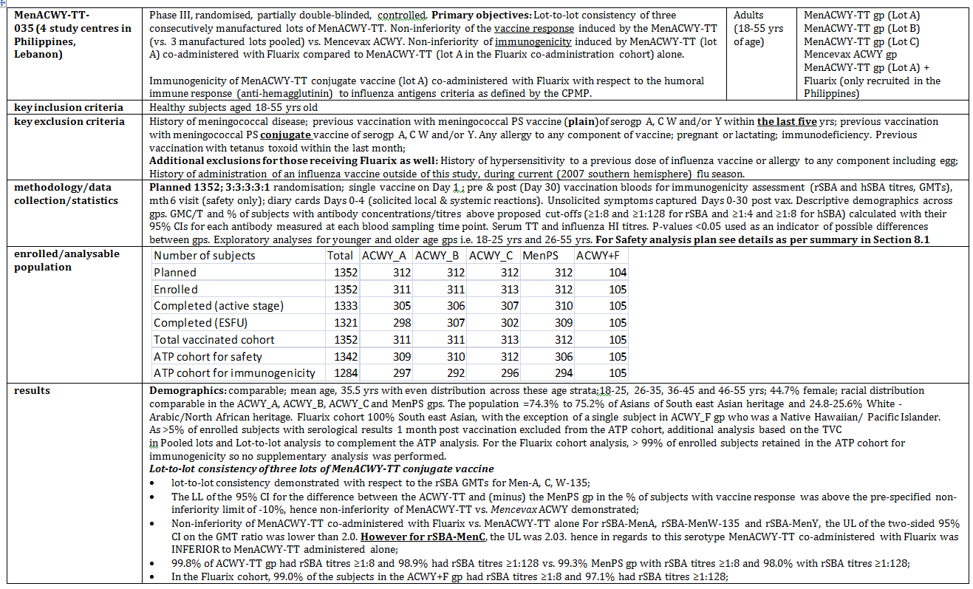

Table 1 continued. Phase III studies in adolescents/adults

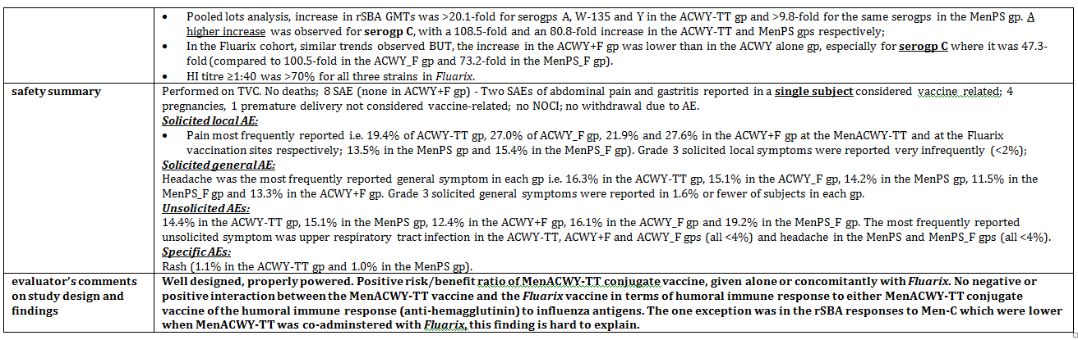

Table 1 continued. Phase III studies in adolescents/adults

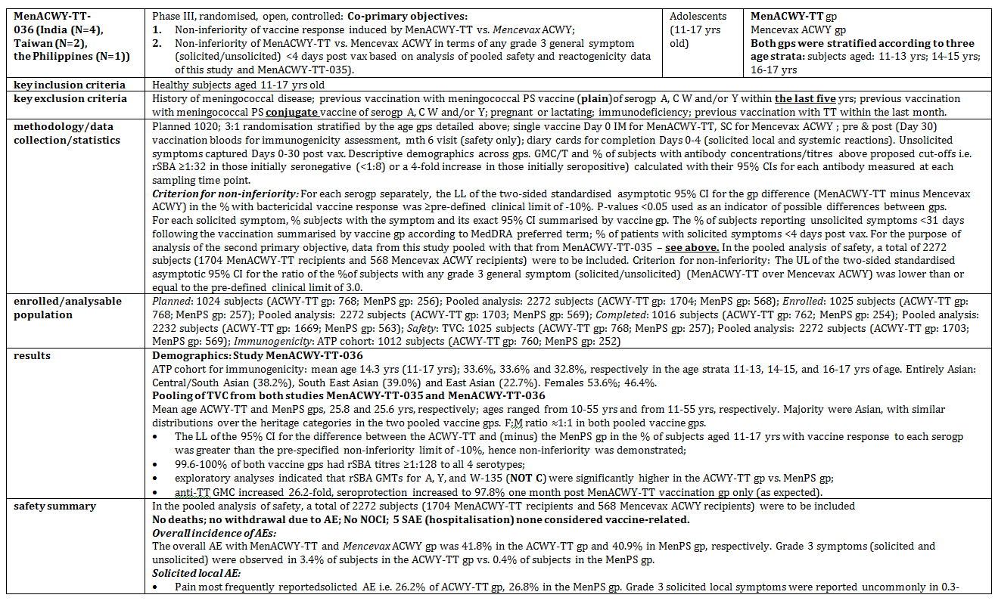

Table 1 continued. Phase III studies in adolescents/adults

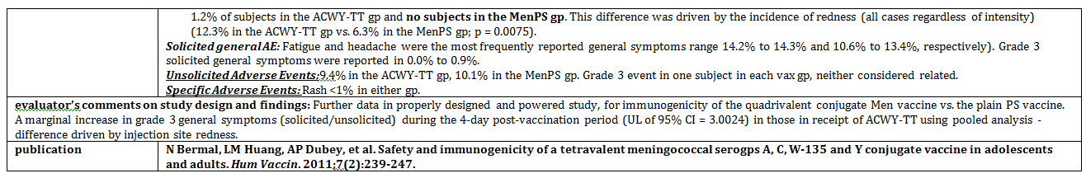

Table 1 continued. Phase III studies in adolescents/adults

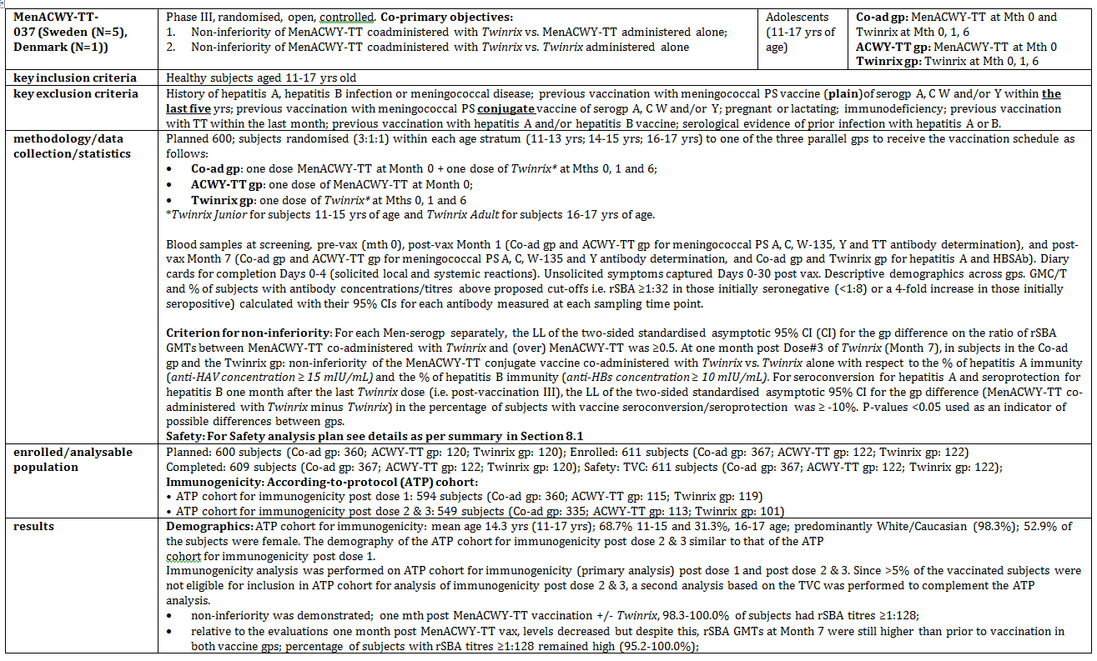

Table 1 continued. Phase III studies in adolescents/adults

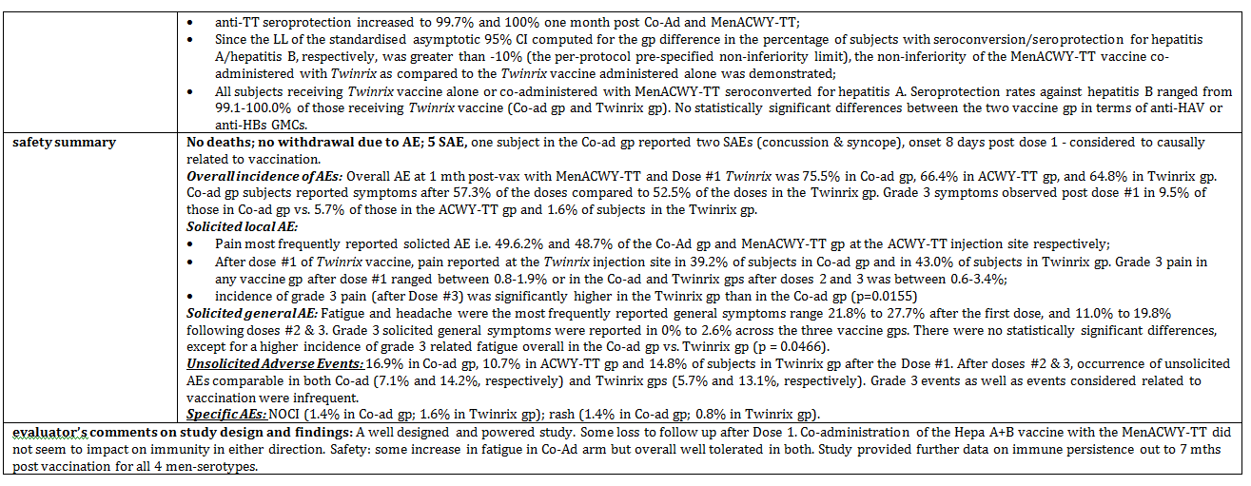

Table 1 continued. Phase III studies in adolescents/adults

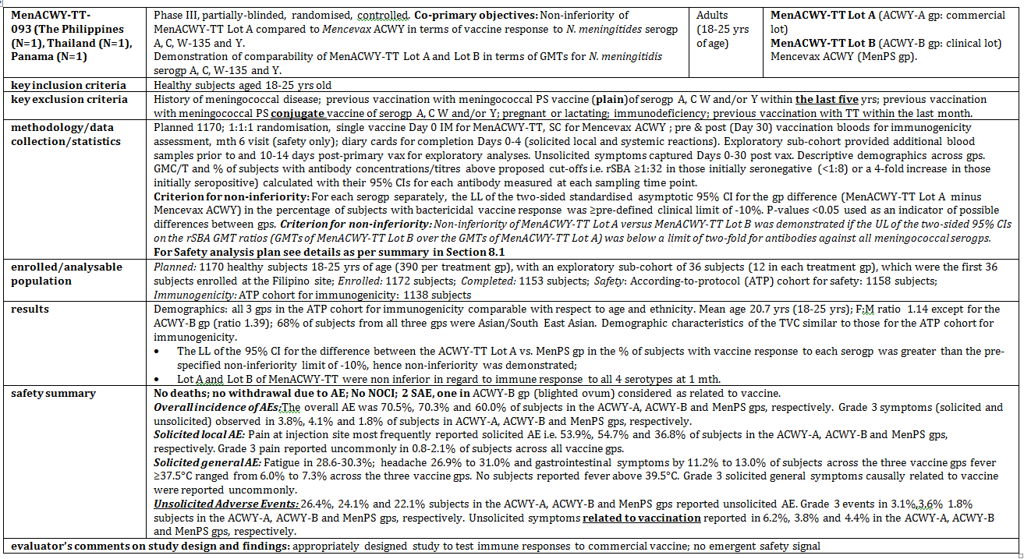

Table 2. Phase III efficacy studies in children

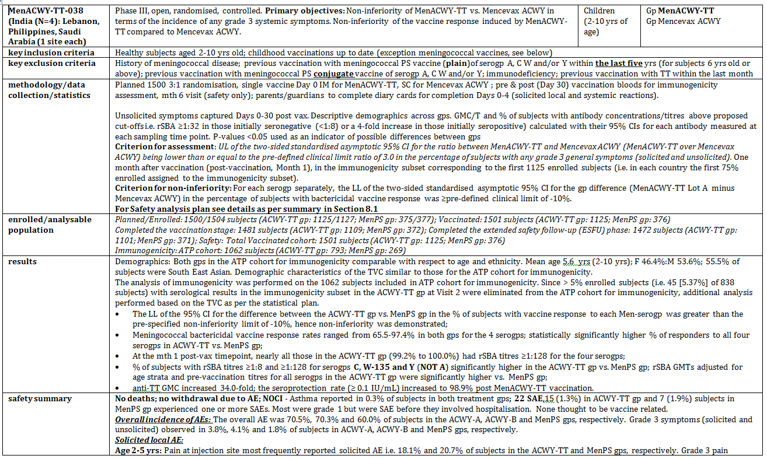

Table 2 continued. Phase III efficacy studies in children

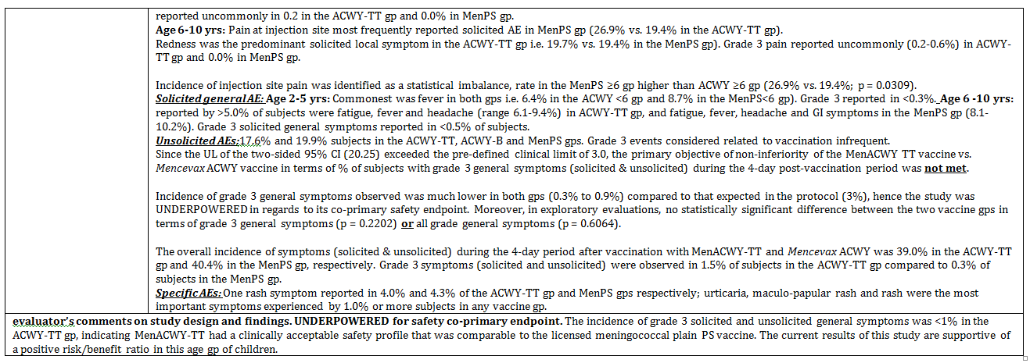

Table 2 continued. Phase III efficacy studies in children

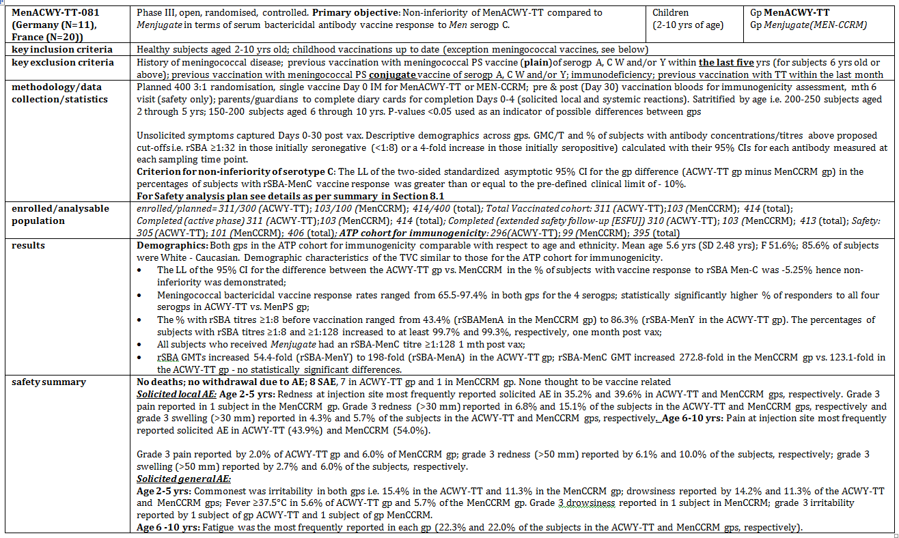

Table 2 continued. Phase III efficacy studies in children

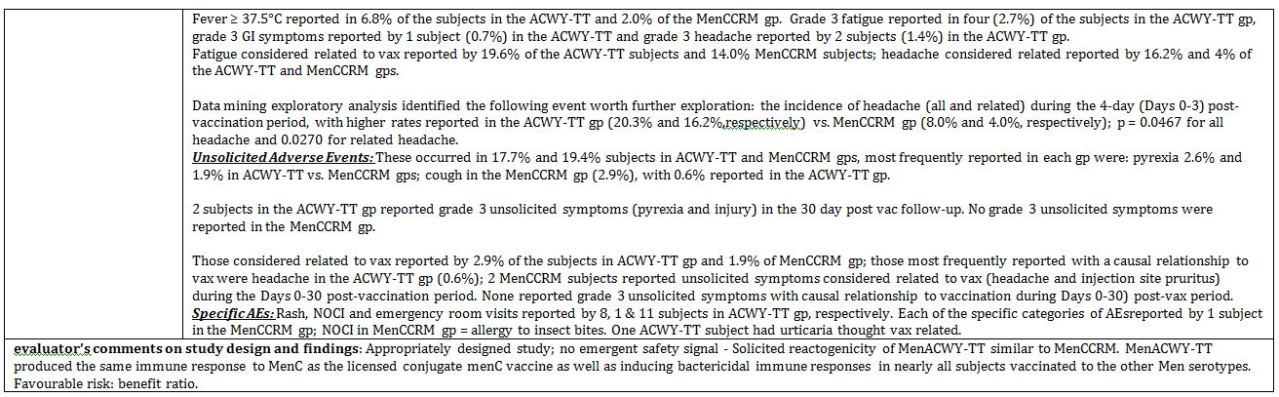

Table 3. Phase III efficacy studies in toddlers

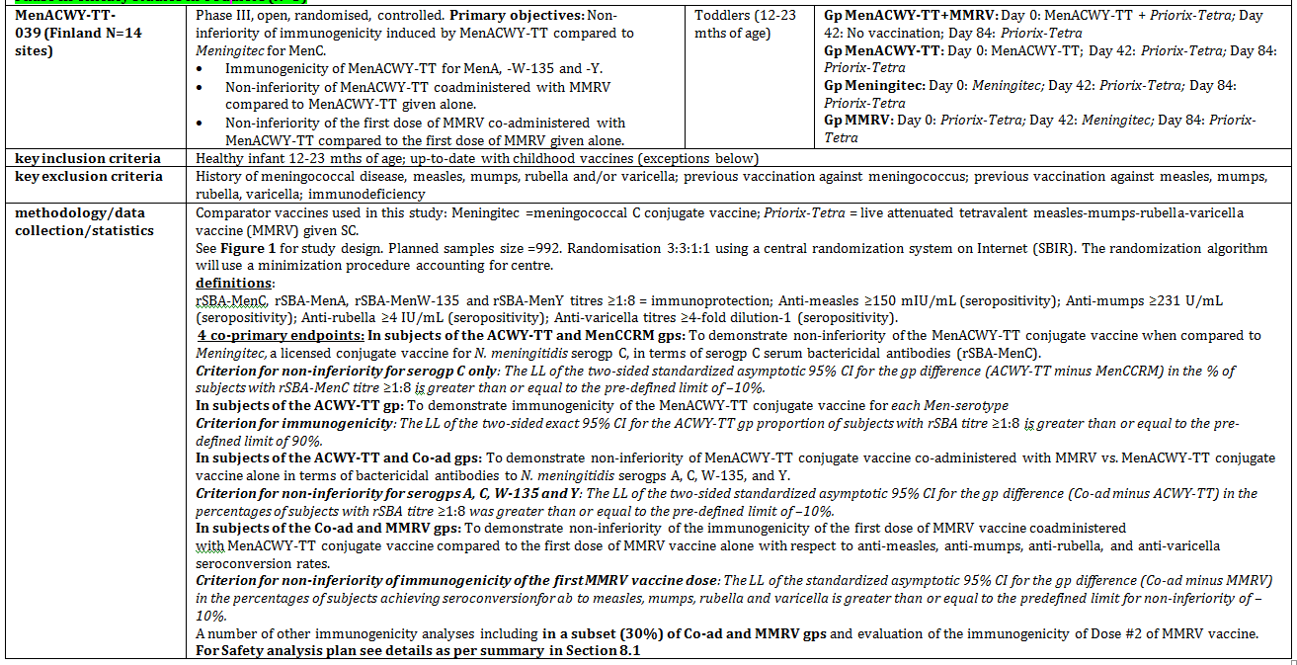

Table 3 continued. Phase III efficacy studies in toddlers

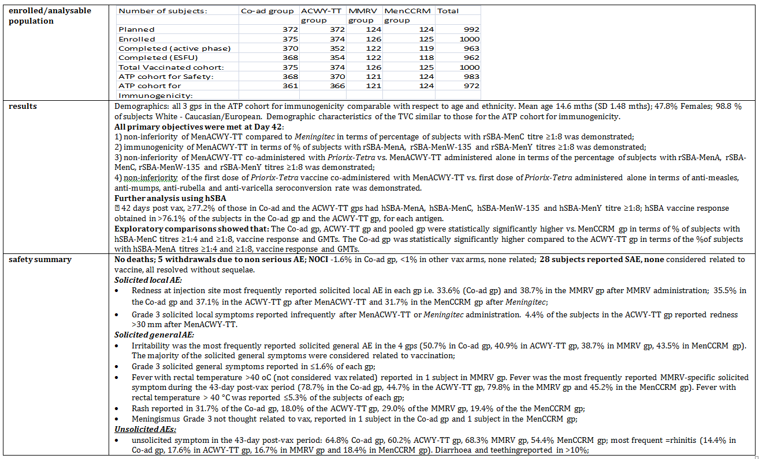

Table 3 continued. Phase III efficacy studies in toddlers

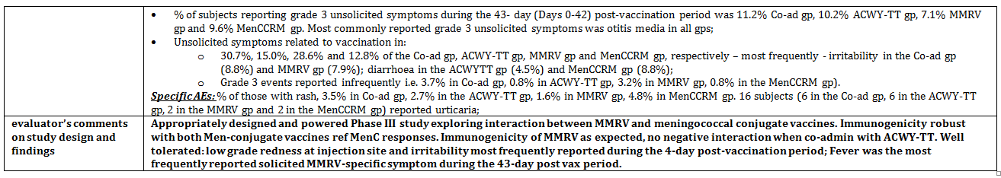

Table 3 continued. Phase III efficacy studies in toddlers

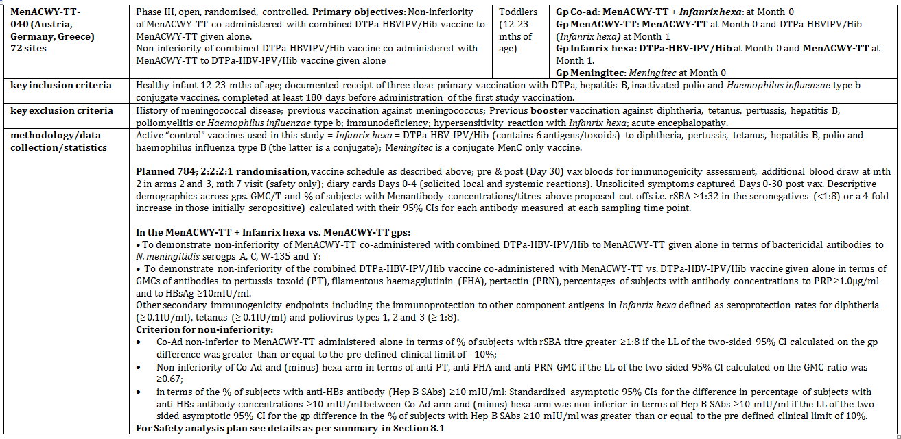

Table 3 continued. Phase III efficacy studies in toddlers

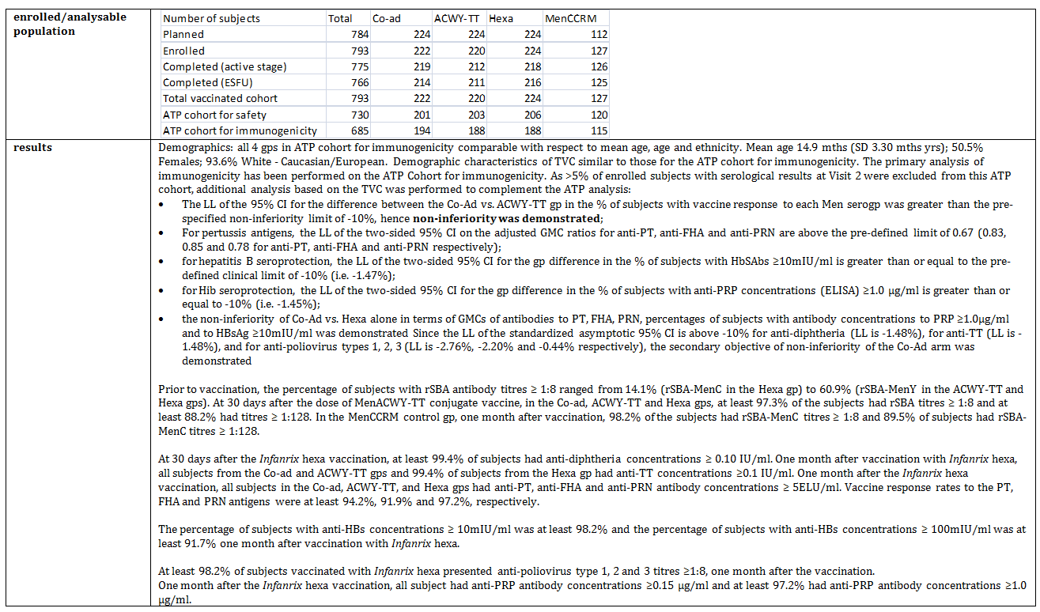

Table 3 continued. Phase III efficacy studies in toddlers

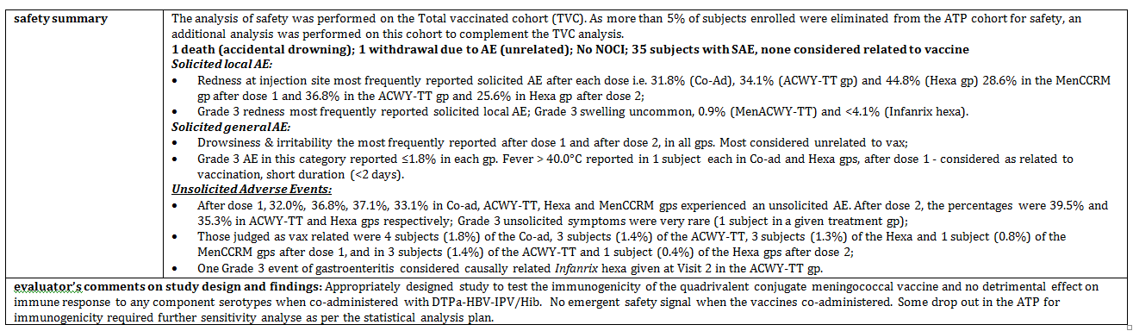

Table 3 continued. Phase III efficacy studies in toddlers

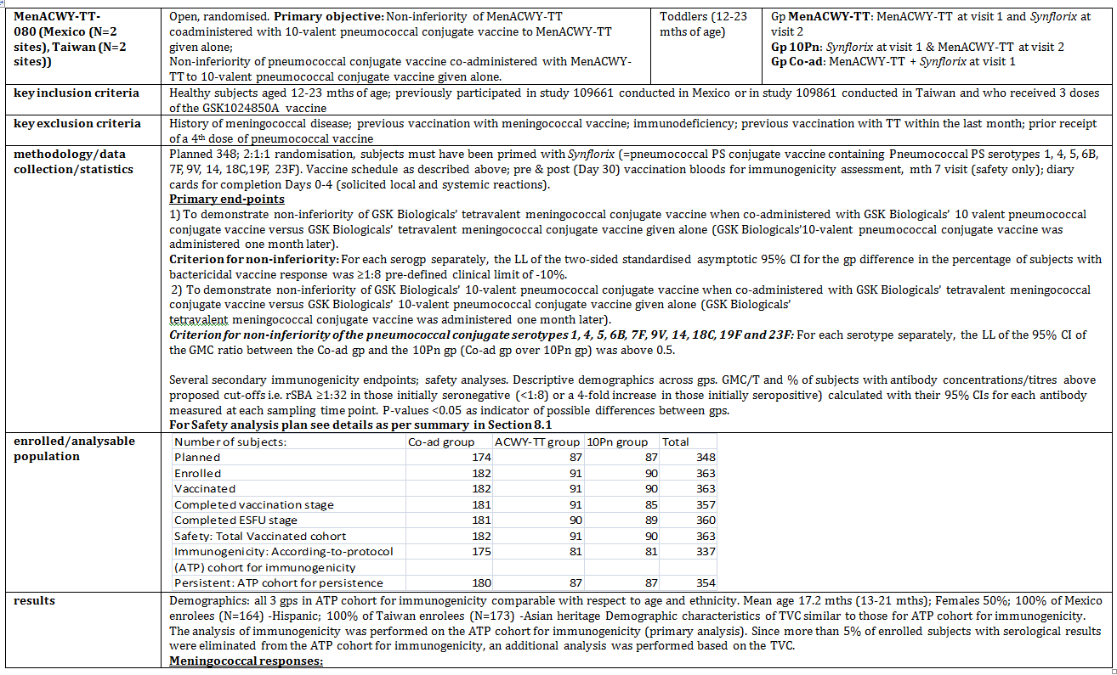

Table 3 continued. Phase III efficacy studies in toddlers

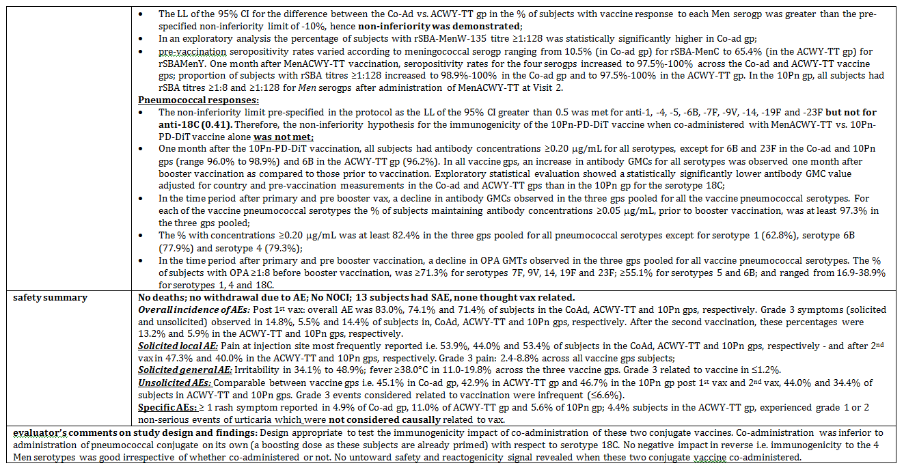

#### Evaluator’s conclusions on clinical efficacy: protective efficacy

Immunogenicity studies conducted in subjects ≥ 12 months of age demonstrate that one IM dose of MenACWY-TT vaccine induces responses similar to or higher than licensed meningococcal vaccines. MenACWY-TT induces immunological memory against the four Men serogroups even in toddlers 12-14 months of age, historically an age group that is not responsive or is poorly responsive to meningococcal PS vaccines.

Follow-up studies demonstrate immune persistence similar to or higher than that elicited by licensed meningococcal vaccines (Meningitec and Mencevax ACWY) using the GSK rSBA assay. Even in the youngest age group, hSBA MenC GMTs were higher compared to all age strata in the Meningitec group.

Although the hSBA GMTs for serogroups A, W-135, and Y trended lower for the younger age group, percentages of subjects with SBA titres ≥8, GMTs and vaccine responses reported for the three serogroups following a single dose of MenACWY-TT were higher or very close to those reported in an older age group (6 to <11 years) with Mencevax ACWY.

Although SBA titres trended higher at persistence time-points for the older age groups in toddlers, there is limited precision in the point estimates because of the small persistence subsets at these persistence time-points and most 95% confidence intervals (CIs) overlap for the MenACWY-TT group.

In terms of boosting with MenACWY-TT in prior recipients of a plain PS vaccine, GMTs are lower for MenA and to a lesser extent for the other serogroups, but there is induction of strong responses (3.9-30.1-fold increase of GMTs for all serogroups) without any worrisome safety signal.

These data support both proposed indications of the MenACWY-TT vaccine, that is, first, active immunisation against invasive meningococcal disease caused by *N. meningitidis* serogroups A, C, W-135 and Y in individuals 1- 55 years of age. The vaccine is to be administered IM as a one-dose vaccination schedule. The second proposed indication is as a booster vaccination in subjects who have previously been vaccinated with a plain (that is, non conjugate) PS meningococcal vaccine.

### Safety

#### Studies providing evaluable safety data

All the Phase II and Phase III studies provided safety data. Solicited and unsolicited safety information was gathered. Local adverse events (AEs) solicited were: pain, redness and swelling at the injection site (IS). General AEs solicited were: drowsiness, fever (≥ 37.5°C oral/axillary or ≥38°C rectal), irritability/fussiness, and loss of appetite in subjects < 6 years, and fatigue, fever (≥37.5°C oral/axillary), gastrointestinal symptoms (nausea, abdominal pain, vomiting, and diarrhoea), and headache in subjects ≥ 6 years old. Diary cards were completed for Days 0-3 and/or Days 0-7 post vaccination (in Studies MenACWY-TT 012, -013, -052 and -055); in children/toddlers these were completed by the parent or guardian.

Unsolicited AEs were collected Day 0-30 post vaccination. Intensity of solicited local and general AEs was assessed by the investigator according to a standard intensity scale and these were comparable across most of the studies.

Adverse events, serious adverse events (SAEs) and New Onset Chronic Illness (NOCI) were collected at 6 months post the last vaccination visit (by phone interview) or at a later date in persistence studies.

#### Overall extent of exposure

Of the completed studies, 9366 subjects aged 1-55 years have been vaccinated with one dose of MenACWY-TT vaccine. A total 189 subjects in MenACWY-TT-055 (2-dose group) received 2 doses of MenACWY-TT.

The pooled analysis included data from 10,400 subjects vaccinated with MenACWY-TT or a comparator vaccine at first study visit. Of these 10,400 subjects, 8108 were vaccinated with MenACWY-TT, 1617 with Mencevax ACWY, 375 with Meningitec, 103 with Menjugate and 197 with Menactra.

#### Summary of selected findings.

Details of the safety analyses and outcomes are found in the CER extract at Attachment 2 of this AusPAR.

The following Tables provide summary data on solicited AEs reported in the first 4 day period after vaccination in the Total Vaccinated Cohort (TVC), according to age group.

Table 4. Pooled analysis percentage of 12-23 month old group reporting solicited AE during the 4-day (Days 0-3) post vaccination period of the TVC

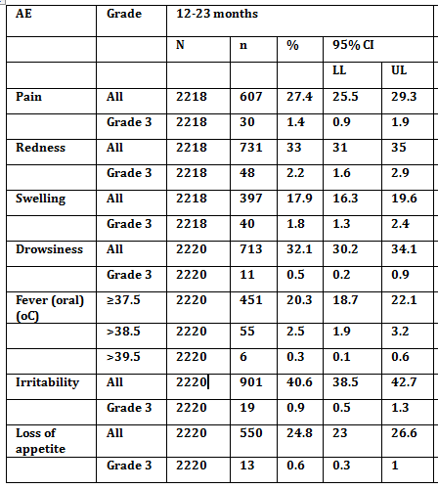

N = total number investigated; n (%) = number (% of total number) reporting AE; CI = confidence interval; LL = lower limit of the 95% CI; UL = upper limit of the 95% CI.

Table 5. Pooled analysis percentage of 2-5 year old group reporting solicited AE during the 4-day (Days 0-3) post vaccination period of the TVC

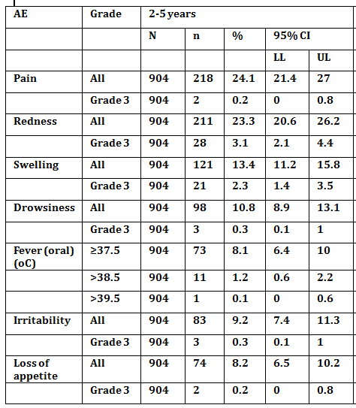

N = total number investigated; n (%) = number (% of total number) reporting AE; CI = confidence interval; LL = lower limit of the 95% CI; UL = upper limit of the 95% CI.

Table 6. Pooled analysis percentage of 6-17 year old group reporting solicited AE during the 4-day (Days 0-3) post vaccination period of the TVC

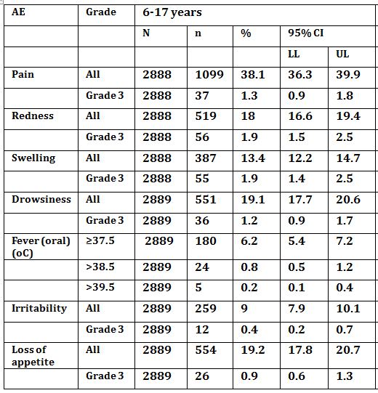

N = total number investigated; n (%) = number (% of total number) reporting AE; CI = confidence interval; LL = lower limit of the 95% CI; UL = upper limit of the 95% CI.

Table 7. Pooled analysis percentage of ≥ 18 years old group reporting solicited AE during the 4-day (Days 0-3) post vaccination period of the TVC

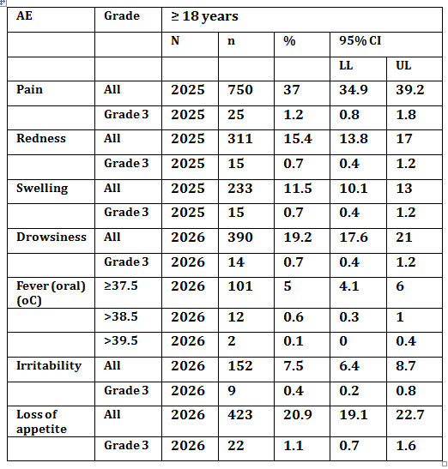

N = total number investigated; n (%) = number (% of total number) reporting AE; CI = confidence interval; LL = lower limit of the 95% CI; UL = upper limit of the 95% CI.

##### Serious adverse events

From 8108 MenACWY-TT vaccinated subjects, 29 (0.4%) reported ≥ 1 SAE within the 31 days post vaccination. In regards to age groups differences, 0.8% of <2 year olds, 0.3% of 2-5 year olds, 0.2% of 11-17 year olds and 0.2% of ≥18 year olds had one or more SAE. No SAEs were reported in the 6 to 10 year olds. None of the SAEs reported in those under 2 and those aged 2-5 years were considered vaccine related. In the 11-17 years age group, two SAEs (concussion and syncope), reported by one subject 8 days after vaccination with MenACWY-TT and Twinrix vaccines in study MenACWY-TT-037, were considered vaccine related. In the ≥18 year age group, three SAEs were considered vaccine related (abdominal pain and gastritis reported by one subject 5 days after vaccination with MenACWY-TT in Study MenACWY-TT-035; a SAE of blighted ovum reported by one subject 29 days after vaccination with MenACWY-TT in Study MenACWY-TT-093).

Of the SAEs not considered related (in 8108 subjects vaccinated with MenACWY-TT), two subjects reported nervous system disorder SAEs (one case of febrile convulsion in < 2 years age group and one case of syncope in 11-17 years age group). Data mining analysis in MenACWY-TT and Meningitec groups did not identify any differences between groups for any SAE reported, except bronchitis which was higher in the Meningitec (0.8%) versus MenACWY-TT group (0.0%) (P-value = 0.027). No SAEs were reported in Mencevax ACWY controlled studies (MenACWY-TT-027 and -038) in the 6-10 years age group during the 31 day post-vaccination period. Data mining analysis did not identify any differences between MenACWY-TT and Mencevax ACWY for SAEs. No SAEs were reported within the 31 day post vaccination period in ≥18 year olds in the MenACWYTT or Menactra group of this study.

For SAEs reported during the 31 day (Days 0-30) post-vaccination period in Study MenACWY-TT 021(booster study): One SAE (tendon rupture, occurring in one subject in the primed group 22 days after vaccination) was not considered vaccine related. For SAEs reported during the 31 day (Days 0-30) post-vaccination period in Study MenACWY-TT-071: 3 SAEs were reported: one subject in MenACWY-TT lot-A group reported one SAE (asthma) and one subject in the Menactra group reported two SAEs (jaw fracture and post-procedural haematoma), none of which was considered vaccine related.

*Serious AEs reported retrospectively in immunogenicity persistence studies (Studies MenACWY-TT-014,-016,-017,-024,-025,-026,-028, -029, -030,- 043Y2, -048Y2, -059Y1, -062Y1):* These are SAEs occurring between completion of vaccination studies and the start of the respective persistence studies. From 185 subjects who returned for immunogenicity persistence Study 014, four subjects experienced ≥ 1 SAE, one of which was mastoiditis reported by 1 subject from the MenACWY-TT (3-5 year) group. None were considered vaccination related. All resolved without sequelae. In persistence Studies MenACWY-TT-016, -017, -024, -025, -026, -028, -029, -030, - 043Y2, -048Y2, -059Y1 and -062Y1 only SAEs considered vaccination were reportable and none were.

Regarding New Onset Chronic Illness (NOCI) reported in the extended safety follow-up period of 6 months: Data mining analysis in MenACWY-TT and control groups did not identify any NOCIs requiring further exploration.

#### Evaluator’s overall conclusions on clinical safety

The evaluator considered Nimenrix had a favourable safety profile in all age groups studied.

### First round benefit-risk assessment

#### First round assessment of benefits

The benefits of MenACWY-TT in the proposed usage are:

* Equivalent if not higher levels of protective immunogenicity to all 4 meningococcal serogroups (A,C, W-135, Y) including in the younger age group (< 2 years) who tend to mount poorer and less persistent immune responses to PS meningococcal vaccines;
* Potential protection from invasive meningococcal disease;
* Boosting of immune responses to all 4 meningococcal serogroups in those primed with a PS vaccine, which might protect better against invasive meningococcal disease.

#### First round assessment of risks

The risks of MenACWY-TT in the proposed usage are relatively small in terms of solicited local and general AEs and unsolicited AEs. Moreover, these are equivalent to licensed comparator meningococcal vaccines.

#### First round assessment of benefit-risk balance

The benefit-risk balance of MenACWY-TT, given the proposed usage, is favourable.

### First round recommendation regarding authorisation

The evaluator recommended the authorisation of this product for the indications sought in this application.

### List of questions

None

## V. Pharmacovigilance findings

### Risk management plan

The sponsor submitted a Risk Management Plan (RMP; MENACWY-TT Vaccine EU-RMP (version 1, dated 15 February 2012, data lock point 15 September 2010)) which was reviewed by the TGA’s Office of Product Review (OPR).

#### Safety specification

The sponsor provided a summary of Ongoing safety Concerns which are shown at Table 8.

Table 8. Summary of Ongoing safety Concerns

| Important identified risks | None |
| --- | --- |
| Important potential risks | Guillain-Barré Syndrome  Purpura  Vasculitis  Acute Disseminated Encephalomyelitis (ADEM)  Brachial Neuritis  Anaphylaxis  Change in meningococcal epidemiology/serogroup replacement  Lack of efficacy  Administration of MenACWY-TT vaccine via the intravascular, intradermal or subcutaneous route.  Administration of MenACWY-TT vaccine to patients with thrombocytopenia or any coagulation disorder with a risk of haemorrhage.  Extensive limb swelling/severe injection site reactions |
| Important missing information | Use in immunocompromised and immunodeficient (including asplenic) patients  Use in patients with chronic diseases  Use during pregnancy and lactation  Long term persistence of the vaccine response and need for a booster dose |

#### Pharmacovigilance plan

The pharmacovigilance activities proposed by the sponsor in the EU-RMP and/or Australia Specific Annex (ASA) are summarised in the table below:

Table 9. Proposed pharmacovigilance activities

| Safety concern | Pharmacovigilance activities |
| --- | --- |
| Important potential risks | |
| Guillain-Barré Syndrome | Routine pharmacovigilance  Targeted follow-up questionnaire |
| Purpura | Routine pharmacovigilance  Targeted follow-up questionnaire |
| Vasculitis | Routine pharmacovigilance |
| ADEM | Routine pharmacovigilance |
| Brachial neuritis | Routine pharmacovigilance |
| Anaphylaxis | Routine pharmacovigilance |
| Change in meningococcal epidemiology/serogroup replacement | The sponsor will evaluate working with individual countries with established infection control agencies to obtain serogroup distribution data when certain criteria are met. |
| Lack of efficacy | Routine pharmacovigilance  Targeted follow-up questionnaire  The sponsor will evaluate working with individual countries with established infection control agencies to obtain serogroup distribution data when certain criteria are met. |
| Administration of MenACWY-TT vaccine via the intravascular, intradermal or subcutaneous route | Routine pharmacovigilance |
| Administration of MenACWY-TT vaccine to patients with thrombocytopenia or any coagulation disorder with a risk of haemorrhage | Routine pharmacovigilance |
| Extensive limb swelling/severe injection site reactions | Routine pharmacovigilance |
| Important missing information | |
| Use in immunocompromised and immunodeficient (including asplenic) patients | Routine pharmacovigilance  Study MenACWY-TT084 |
| Use in patients with chronic disease | Routine pharmacovigilance |
| Use during pregnancy and lactation | Routine pharmacovigilance |
| Long term persistence of the vaccine response and need for a booster dose | Numerous ongoing persistence studies |

The use of routine pharmacovigilance only to manage most of the safety concerns is considered adequate. This was supported by the Advisory Committee on the Safety of Medicines (ACSOM) when they considered the MenACWY-TT vaccine RMP.

Targeted questionnaires are proposed to augment routine pharmacovigilance for the important potential risks ‘Guillain-Barré Syndrome’, ‘Purpura’ and ‘Lack of Efficacy’. These have been provided and are acceptable.

For the important missing information ‘Use in immunecompromised and immunodeficient (including asplenic) patients’ study 084 is planned to evaluate the immunogenicity of 1 and 2 doses of the vaccine administered to at risk subjects (asplenic children or children with complement deficiencies) compared to age-matched healthy subjects. From a RMP standpoint this study is acceptable.

A suite of ongoing persistence studies are described in the RMP for important missing information ‘Long term persistence of the vaccine response and need for a booster dose’. This is acceptable.

The pharmacovigilance plan is consistent with that approved in the EU and the evaluator has no objection to the proposed activities.

#### Risk minimisation activities

The sponsor has concluded that routine risk minimisation (that is, product labelling) is sufficient to manage the risks associated with MenACWY-TT vaccine except for some risks where no risk minimisation is proposed.

Routine risk minimisation (product labelling) is proposed for the following risks:

* Important potential risks: ‘Anaphylaxis’, ‘Lack of efficacy’, ‘Administration of MenACWY-TT vaccine via the intravascular, intradermal or subcutaneous route’ and ‘Administration of MenACWY-TT vaccine to patients with thrombocytopaenia or any coagulation disorder with a risk of haemorrhage’
* Important missing information: ‘Use in immunocompromised and immunodeficient (including asplenic) patients’ and ‘Use during pregnancy and lactation’.

No risk minimisation is proposed for the other risks. No additional risk minimisation activities are proposed.

##### OPR reviewer comment:

The proposed use of routine risk minimisation is acceptable. This was supported by ACSOM when they considered the MenACWY-TT vaccine RMP.

The need for a booster dose for this vaccine has not been established and is subject to ongoing study (see *Summary of recommendations* below).

In regard to the proposed routine risk minimisation activities, the draft PI document is considered satisfactory.

In regard to the proposed routine risk minimisation activities, the draft Consumer Medicine Information (CMI) is considered satisfactory.

#### Summary of recommendations

The OPR provides these recommendations in the context that the submitted RMP is supportive to the application; the implementation of the MenACWY-TT Vaccine EU-RMP (version 1, dated 15 February 2012, data lock point 15 September 2010) + Australian-specific Annex (undated) is imposed as a condition of registration; and the submitted EU-RMP is applicable without modification in Australia unless so qualified;

* As risk minimisation for the important missing information ‘long term persistence of the vaccine response and need for a booster dose’ the sponsor should confirm how they plan to notify prescribers and therefore patients if it is determined that a booster dose is needed in the future. Such consideration should be included in an amendment to the risk minimisation section of the ASA.[19]

## VI. Overall conclusion and risk/benefit assessment

The submission was summarised in the following Delegate’s overview and recommendations:

#### Background

The sponsor (GSK) has submitted an application seeking the registration of Nimenrix, a quadrivalent meningococcal ACWY-TT conjugate vaccine (MenACWY-TT). This new vaccine is a powder and solvent for solution for IM injection.

The proposed Indication is as follows:

*Nimenrix is indicated for active immunisation of individuals from the age of 12 months through 55 years against invasive meningococcal diseases caused by Neisseria meningitidis serogroups A, C, W-135 and Y.*

The proposed *Dosage and Administration* is as follows:

*Primary vaccination:*

*A single 0.5 mL dose of the reconstituted vaccine is used for immunisation.*

*Booster vaccination:*

*Nimenrix may be given as a booster dose in subjects who have previously been vaccinated with a plain polysaccharide meningococcal vaccine.*

*The need for a booster dose in subjects primed with Nimenrix has not been established.*

*Nimenrix should be used in accordance with available official recommendations.*

It is noted that this application does not seek approval of Nimenrix as a booster in those primed with Nimenrix or another conjugate meningococcal vaccine.

### Quality

The administrative, product usage, chemical, pharmaceutical, microbiological data submitted in support of this application have been evaluated in accordance with the Australian legislation, pharmacopoeial standards and relevant technical guidelines adopted by the TGA. The application was considered at the 150th PSC meeting.

There are no outstanding Module 3 issues, and the Module 3 evaluator recommends approval of the vaccine.

### Nonclinical

The nonclinical evaluator identified no major deficiencies in the studies submitted in Module 4, with the results from nonclinical studies leading to the selection of the dose of PS and conjugation methodologies of the MenACWY-TT vaccine for clinical use.

The studies submitted for primary pharmacology were conducted in 2 animal species (mice and rabbits), administered via SC and IM using one tenth and the full human dose respectively. Immunogenicity studies used PS that were T‑cell independent antigens, PS conjugates, which are T-cell dependent antigens, as well as the final vaccine formulation. The studies submitted support the proposed indication for Nimenrix.

Efficacy was not tested directly due to the lack of animal models of infection for *Neisseria*, a human-specific pathogen. Safety pharmacology data found no biologically significant effects on the cardiovascular and respiratory parameters recorded. No clinically relevant hazards were identified. No treatment related clinical signs, body weight changes or local reaction were observed after single dose administration at the injection site. A repeat dose study administering 5 IM fortnightly injections, equivalent to the full human dose (0.5 mL per injection containing 5 µg each of each PS type MenA‑TT (with AH spacer), MenC‑TT (with AH spacer), MenW‑135‑TT and MenY‑TT), found no distinct treatment-related changes in general and local clinical signs, ophthalmology, body weight, food intake, rectal body temperature, haematology, blood chemistry and organ weights in rabbits.

No treatment-related effects of the vaccine were observed on female rat fertility, maternal toxicity, pre- and post-natal development. Male fertility was not studied. Therefore, the proposed Pregnancy Category (B2) is acceptable.

The presence of two specific residual substances in the final vaccine formulation for clinical use presents no toxicological hazard to vaccinated subjects.

There are no nonclinical objections to registration. The evaluator recommended a few amendments to the Product Information document.

### Clinical

#### Clinical efficacy/immunogenicity

The submitted clinical studies evaluated the safety and immunogenicity of the candidate vaccine in various age groups and when administered with other routine childhood vaccines. Table 10 below lists the primary immunisation studies and Table 12 lists the immune persistence studies.

Table 10. Primary immunisation studies to support the safety and immunogenicity of Nimenrix

Table 10. Primary immunisation studies to support the safety and immunogenicity of Nimenrix

Clinical efficacy outcomes were not assessed in these submitted studies. The primary outcomes were immunogenicity endpoints measured by SBA assay based on the US Center for Disease Control and Prevention (CDC) protocol and using baby rabbit serum (rSBA) as the source of complement. The thresholds for the SBA titres are shown in Table 11 and align with WHO 2011 guidelines[20] for licensure of meningococcal vaccines.

Table 11. Protective thresholds for SBA titres against MenA, -C, -W-135, -Y

|  | rabbit SBA (rSBA) | | human SBA (hSBA) | |
| --- | --- | --- | --- | --- |
| age group | Seronegative  (rSBA < 8  pre–vaccination) | Seropositive  (rSBA ≥ 8  pre– vaccination) | Seronegative  (hSBA titre < 4  pre-vaccination) | Seropositive  (hSBA titre ≥ 4)  pre-vaccination) |
| ≥ 2 years of age | Post vaccination  rSBA titres ≥ 32 | 4-fold increase in rSBA from pre- to post-vaccination) | Post vaccination  hSBA titres ≥ 8 | 4-fold increase in hSBA from pre- to post-vaccination) |
| < 2 years of age | rSBA titre ≥ 8 | N/A | N/A | N/A |

The GSK rSBA assays for the 4 serogroups were validated according to the ICH guidelines. The GSK rSBA-MenC assay was successfully bridged with the rSBA assays and a titre of 8 was shown to correlate with meningococcal C conjugate vaccine effectiveness. Consequently, the rSBA has been used as a primary immunological assay in the Nimenrix clinical development plan. The lack of consensus regarding the choice of human or baby rabbit complement for SBA assays has led to testing by GSK using hSBA assays to further characterise the immune responses to Nimenrix.

All studies were randomised, except persistence studies and the booster study (Study-021). Lot-to-lot consistency (in Study-035) was evaluated in a double-blind manner as were the different formulations of the vaccine tested in Studies -012 and -013. Due to the route of administration (IM for Nimenrix and SC for Mencevax ACWY), subjects were not blinded in other studies, and also blinding was not possible due to additional vaccine(s) in the Nimenrix arm. Because of formulation difference (for example, Menactra is a liquid vaccine and Nimenrix a lyophilised vaccine), Study-052 was single blind and Study-071 was observer blind. All other studies were “open” becauseof different administration routes, schedules or vaccine presentation, or because the same vaccine was given to all.

For all studies, the primary immunogenicity analyses were conducted in the according-to-protocol (ATP) cohort. The rSBA titres for the 4 serogroups were assessed in all studies. In some studies, testing was limited to a random subset of subjects according to pre-specified serology plan. The size of the subset was defined in order to provide an adequate and representative sample of the immune status of the studied population.

##### Dose selection studies

Study 012 and Study 013 are dose ranging studies in which the immunogenicity and safety of different formulations and dosages of the candidate vaccine (MenACWY-TT) was assessed in toddlers, children and adolescents. Based on the results, the candidate vaccine for further development was a formulation containing 5 μg of each PS and using an AH spacer molecule between the PS and the carrier for MenA and MenC conjugates.

##### Imunogenicity comparisons to the registered vaccines

The immunogenicity of Nimenrix was compared to a number of licensed meningococcal vaccines including Meningitec, Menjugate and Mencevax ACWY. These studies were conducted in different age groups.

###### Comparison to monovalent meningococcal C conjugate vaccines

* In toddlers (12-23 months of age)

Study-039 evaluated the immune response to vaccination with either Nimenrix or Meningitec (a licensed meningococcal C conjugate vaccine) in toddlers. The study demonstrated the noninferiority of Nimenrix versus Meningitec in that the percentage of subjects with rSBA ≥ 8 for serogroup C, as the lower limit (LL) of the 95% confidence interval (CI) for the between group difference, was above the pre-defined margin of -10%. The second co-primary objective of this study was to demonstrate immunogenicity of Nimenrix for serogroups A, W-135, and Y. As the LL of the 95% CI for the percentage of subjects with rSBA ≥ 8 (for serogroups A, W135 and Y) was above the pre-defined success criterion of 90%, the immunogenicity of Nimenrix for these 3 serogroups was confirmed.

* In children 2-10 years old

Study-081 was conducted in children 2-10 years of age. The primary objective was to demonstrate noninferiority of Nimenrix versus Menjugate in terms of rSBA-MenC vaccine response. As the LL of the 95% CI for the between group difference in the percentage of subjects with rSBA-MenC response was above the pre-defined non-inferiority margin (-10%), Nimenrix is considered immunologically non-inferior to Menjugate for the MenC response.

###### Comparison to Mencevax ACWY in different age groups

Mencevax ACWY is a quadrivalent plain meningococcal PS vaccine (ACWY-PS). The immunogenicity comparison between Nimenrix and Mencevax ACWY for the 4 serogroups was assessed in different age groups in a number of studies: Study 038 in subjects 2 to 10 years of age, Study 036 in those 11-17 years of age, Study 035 in those 18-55 years of age, and Study 093 in subjects 18-25 years of age. In all these studies, the LL of the 95% CIs for the difference between groups in the percentage of subjects with rSBA response was above the non-inferiority limit (-10%) for all 4 serogroups. The immunogenicity non-inferiority of Nimenrix versus Mencevax ACWY for the 4 serogroups was demonstrated.

As there are no comparator vaccines containing antigens to serogroups A, W-135 and Y for toddlers, the immune response to these 3 serogroups induced by Nimenrix in toddlers were compared to the responses elicited by Mencevax ACWY in older children (that is, aged 2 to < 11 years of age with rSBA; 6 to < 11 years of age with hSBA). In Study-027, rSBA GMT and vaccine responses elicited by Nimenrix in toddlers were comparable to the responses induced by Mencevax ACWY in children 2 to <11 years of age. Although hSBA GMTs were lower for the younger age group, the percentage of subjects with immunoprotective titres and vaccine response following Nimenrix were higher than or close to those reported in older children (6 to <11 years) vaccinated with Mencevax ACWY in Study-027.

Study-093 included a powered secondary objective assessing the comparability of Nimenrix Lot A and Mencevax ACWY in terms of rSBA GMT ratios for all 4 serogroups. At 1 month post-vaccination, non-inferiority was demonstrated as the upper limit of the 95% CIs on the rSBA GMT ratios (Mencevax ACWY /Nimenrix Lot A) was below the limit of 2-fold for all 4 serogroups.

Study-015 was conducted in subjects 11-55 years old. The study demonstrated that at one month post vaccination, the immune response elicited by Nimenrix is non-inferior to Mencevax ACWY for all 4 serogroups.

###### Comparison to Menactra (a quadrivalent conjugate vaccine)

Study-071 was conducted in subjects 10-25 years of age. The primary objective was to show the noninferiority of Nimenrix (Lot A) versus Menactra. The primary endpoint was the percentage of subjects with hSBA vaccine response. The noninferiority was demonstrated, as for each serogroup, the LL of the 95% CI for the difference between groups was greater than -10%.

Study-052 was conducted in subjects 11-25 years of age. The study compared the immunogenicity of Nimenrix versus Menactra.One month post-vaccination, the percentage of subjects with hSBA ≥ 4 against serogroups A, C, W-135 and Y were 83.0%, 96.1%, 92.1% and 95.2%, respectively in the Nimenrix group and 70.7%, 98.8%, 78.5% and 81.8%, respectively in the Menactra group. Exploratory analyses showed that the percentage of subjects with hSBA ≥ 4 and ≥ 8 was significantly higher in the Nimenrix group then in Menactra group for serogroups A, W-135 and Y and similar in both groups for serogroup C. The hSBA GMTs were also higher for the 4 serogroups in the Nimenrix group than in the Menactra group.

##### Prime-boost study (Study-021)

Study-021 evaluated the immunogenicity of Nimenrix given 30-42 months after the previous prime-vaccination with Mencevax ACWY in subjects aged 2–30 years (who participated in a previous study, Mencevax ACWY-004). One month post vaccination, seropositivity rates for the 4 serogroups increased to 100% in both the MPS group (subjects who were primed with Mencevax ACWY) and the noMPS group (subjects who were not primed with Mencevax ACWY). The proportion with rSBA ≥ 128 increased to 97.0-100% in the MPS group and 100% in the noMPS group. Exploratory analysis did not reveal significant differences between groups in the percentage of subjects with rSBA ≥ 8 and ≥ 128. Vaccine response rates were 41.1-83.0% in the MPS group and 76.9-97.3% in the noMPS group for the 4 serogroups. The vaccine response in the MPS group was significantly lower than in the noMPS group for all serogroups. This lower response was not surprising since pre-vaccination titres were already high due to prior Mencevax ACWY vaccination in that group. Nevertheless, all initially seronegative subjects in the MPS group responded to the vaccine, except one subject for serogroup C.

In both groups, the rSBA GMTs increased from pre- to 1 month post-vaccination for all serogroups. The rSBA GMTs adjusted for age strata for all serogroups were significantly lower in those who had prior Mencevax ACWY vaccination. The rSBA GMTs one month post-vaccination with Nimenrix were higher than one month post-vaccination with Mencevax ACWY (post-MPS time point) for serogroups W-135 and Y, similar for MenC and lower for MenA. These results confirm the relative hyporesponsiveness previously reported after a primary dose of meningococcal PS vaccine followed by conjugate vaccine. However, the high rSBA GMT achieved for all serogroups in the MPS group after the Nimenrix vaccination suggest that if sustained immunity against meningococcal serogroups is required in subjects previously vaccinated with plain PS meningococcal vaccine, the administration of Nimenrix is considered safe and immunogenic.

##### One dose versus two dose regimen

Study-055 explored the safety and immunogenicity of one dose of Nimenrix at 12 months old versus 2 doses of Nimenrix at 9 and 12 months of age. The primary objective of immunogenicity of Nimenrix administered on a 2-dose schedule (at 9 and 12 months of age) was reached, as the LL of the 95% CI for the percentage of subjects with hSBA titers ≥ 1:8 post-dose 2 was above the pre-specified limit of 90% for hSBA-MenC (LL is 97.3%), and 80% for hSBA-MenA, W-135 and Y (LL is 81.9%, 96.2% and 96.2% respectively). In an exploratory evaluation, the percentage of subjects with hSBA ≥ 1:8 was significantly higher in those receiving prime-boost for all serogroups. There was no safety or tolerability cost to the two dose strategy.

##### Immune persistence studies

The persistence of the immune response elicited by Nimenrix was evaluated 12 to 42 months after vaccination in subjects aged 12 months to 55 years. The persistence studies are presented in the table below.

Table 12. Persistence/boostability studies to support the safety and immunogenicity of Nimenrix

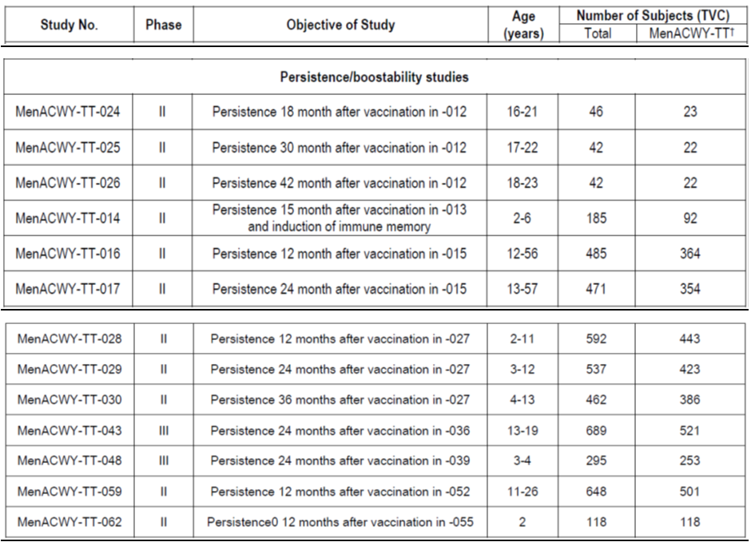

* In children primed at 12-23 months of age

*Using rSBA titres:* Persistence of the immune response in subjects primed at age 12-23 months was assessed in a number of studies (Study 014, 028, 029, 030, 048, and 062). The percentage of subjects with rSBA ≥ 8 post-vaccination with Nimenrix at 12, 15, 24 and 36 months remained high for all serogroups (≥ 94.7% for serogroups A, W-135 and Y, and ≥ 87.4% for serogroup C). The rSBA GMTs decreased between 1 month post-vaccination and the persistence time points but remained higher than prior to vaccination for the 4 serogroups.

In studies including Meningitec as a control, the percentage of subjects with MenC rSBA ≥ 8 at the persistence time points were significantly higher in subjects vaccinated with Nimenrix than in those vaccinated with Meningitec except in Study -030. In Study 014, there were increases in GMTs for the 4 serogroups at 1 month post-boosting with one fifth dose of Mencevax ACWY (plain ACWY vaccine) irrespective of which vaccine they were primed with, and for serogroups A, W and Y, the GMTs were significantly higher in the Nimenrix primed group versus the control group, indicating the induction of immune memory by the primary vaccination with Nimenrix.

*Using hSBA titres:* 12-36 months post-vaccination with Nimenrix, the percentage of subjects with hSBA-MenA ≥ 4 and ≥ 8 were low at 21.8-25.1% and 5.6-23.0%, respectively. In contrast, hSBA-MenC ≥ 4 and ≥ 8 ranged from 87.5-96.3% in Nimenrix recipients and 52.6-75.8% in Meningitec recipients. The percentage of subjects with hSBA-MenC ≥ 4 and ≥ 8 and GMTs were higher in the Nimenrix groups versus Meningitec groups except in Study -030 at month 36. The percentage of subjects with hSBA MenW-135 ≥ 4 and ≥ 8 ranged from 79.9-100% at 12 to 36 months post-vaccination with Nimenrix. Similarly, the percentage with hSBA MenY ≥ 4 and ≥ 8 ranged from 73.6% to 96.2%. Paradoxically, in Study-027, hSBA to MenW-135 and MenY were higher at month 12 post vaccination and fell in subsequent visits. Overall, the data suggest that age at vaccination in the second year of life does not generally impact the percentage of subjects with SBA ≥ 8 at persistence time-points and the persistence in terms of percentage of subjects with SBA titres above cut-off and GMTs was higher in the Nimenrix group than in the MenC control group.

* In children /adolescents vaccinated between 2 and 17 years old

*Using rSBA titres:* For subjects primed at 2-10 years of age, persistence of immune response was evaluated at different time points post-vaccination in Studies -14,-028, -029 and -030. For subjects primed at 11-17 years of age, persistence was evaluated 12 and 24 months after vaccination in Studies -016/-017 and 24 months after vaccination in Study ‑043.

In all persistence studies and in both age strata the percentage of subjects with rSBA ≥ 8 post-vaccination with Nimenrix at the persistence time points remained high for all serogroups (≥ 98.6%). The rSBA GMTs decreased between 1 month post vaccination and the persistence time points but remained higher than prior to vaccination for all 4 serogroups. Exploratory analyses to compare immune persistence after Nimenrix and Mencevax ACWY showed that rSBA GMTs for all 4 serogroups were higher with Nimenrix 15 and 24 months post vaccination in subjects vaccinated at 2-10 years of age (-014 and-029). In -043 (subjects vaccinated at 11-17 years of age), 24 months after vaccination, the rSBA GMTs for MenA, W-135 and Y were higher in Nimenrix versus Mencevax ACWY recipients, but rSBA GMTs for MenC were lower in Nimenrix recipients.

* In children 2-10 years of age

*Using hSBA titres:* In studies with children 12-15 months post-vaccination with Nimenrix, the percentage with hSBA-MenA ≥ 4 and ≥ 8 were low, ranging from 16.3 -31.0%. The percentage with hSBA-MenA ≥ 4 and ≥ 8 following Mencevax ACWY were also low at 0.0 to 11.4%. The percentage with hSBA MenC ≥ 4 and ≥ 8 was 94.3-98.2% for the Nimenrix group and 32.3-77.3% for the Mencevax ACWY group. The percentage with hSBA-MenW-135 ≥ 4 and ≥ 8 at 12-15 months post vaccination with Nimenrix ranged from 95.8-100% and were higher compared to Mencevax ACWY (12.9-37.3%). Similarly, the percentage with hSBA-MenY ≥ 4 and ≥ 8 at 12-15 months post vaccination with Nimenrix and Mencevax ACWY ranged from 90.6-100% and 33.3-63.2%, respectively. Increases in hSBA for W-135 and Y GMTs were observed 12-15 months post Nimenrix vaccination in studies conducted in children.

* In adolescents and adults

*Using rSBA titres:* the immune persistence was evaluated in adults at different time points in a number of studies (Studies 016, 017, 024, 025 and 026). In these studies, the percentage with rSBA ≥ 8 post-vaccination with Nimenrix remained high for all serogroups (≥ 99.2%) at the persistence time points. The rSBA GMTs decreased between 1 month post vaccination and the persistence time points but remained higher than prior to vaccination for all 4 serogroups. Exploratory analyses showed that at year 2, rSBA for -A, ‑W and -Y GMTs were significantly higher in the Nimenrix group versus the Mencevax ACWY group (Study-015). Forty-two months after primary vaccination, Nimenrix recipients had significantly higher GMTs versus Mencevax ACWY recipients for serogroup W-135 in Study-026 (persistence part of Study-012).

*Using hSBA titres:* Study-025/-026 evaluated immune persistence 30 and 42 months respectively after vaccination of 17 to 22 year olds with Nimenrix or Mencevax ACWY. At 42 months post-vaccination with Nimenrix, hSBA ≥ 4 and 8 persisted in ≥ 88.9% of subjects for serogroups C, W and Y. For serogroup A, persistence was lower in the Nimenrix group (61.1% and 50.0% hSBA ≥ 4 and ≥ 8 respectively); hSBA ≥ 4 and 8 persisted in ≥ 81.3% of Mencevax ACWY recipients for all 4 serogroups. Note the sample size was small in Study-025/026 (n = 22 for Nimenrix recipients).

Twelve month persistence data in 11-25 year olds given Nimenrix or Menactra (Study-059) revealed that hSBA for serogroup C, W, and Y ranging from 94.9%-98.5% for Nimenrix recipients versus 73.3%-86.7% for Menactra recipients respectively. This difference was statistically significant. For serogroup A, the immune persistence was lower (hSBA ≥ 8 in 29.1% of the Nimenrix recipients and 31.3% of the Menactra recipients); this represented a considerable titre decline in both groups since one month post vaccination levels. This contrasts with some of the paradoxical increases in serogroup W titres (Nimenrix) seen at one year.

##### Co-administration with other vaccines

Several studies explored the potential interaction of co-administered vaccines: DTPa-HBV-IPV/Hib (Infanrix Hexa, vaccine against diphtheria, tetanus, pertussis, hepatitis B, polio and haemophilus influenza type B), MMRV (Priorix Tetra, against measles, mumps, rubella and varicella), 10-valent pneumococcal conjugate vaccine (Synflorix) in toddlers < 2 years of age, hepatitis A-hepatitis B combined vaccine (Twinrix) in adolescents; seasonal influenza vaccine (Fluarix) in adults.

###### Hepatitis A/B combined vaccine (Twinrix) in adolescents 11-17 years

This was explored in Study 037. There was no evidence of differences in immune response in either direction in terms of immunoprotection to each Men serogroup or serological response to Hep A and B post dose 1 and seven months after vaccination when vaccines co-administered.

###### Seasonal influenza vaccine in adults 18 to 55 years of age

This was explored in Study-035. There was no evidence of differences in immune response in either direction in terms of immunoprotection to each Men serogroup or serological response to trivalent influenza vaccine one month post vaccination when vaccines co-administered.

###### DTPa-HBV-IPV/Hib in toddlers: Infanrix Hexa, Priorix Tetra and Synflorix

Immunogenicity of Nimenrix co-administered with or administered one month after DTPa-HBV-IPV/Hib or administered one month before DTPa-HBV-IPV/Hib was explored in Study-040. There was no evidence of clinically significant impact on immune response in either direction to each serogroup or serological response to the component antigens of Infanrix Hexa vaccine if co-administered or administered sequentially.

Co-administration with Priorix Tetra (MMRV) was explored in Study-039. There was no evidence of clinically significant impact on immune response in either direction in terms of immunoprotection to each Men serogroup or serological response to MMRV vaccine if co-administered. However, in an exploratory analysis anti-rubella geometric mean concentration (GMC) was statistically significantly lower in the co-administered group (43.1 IU/mL) compared to the MMRV group (53.2 IU/mL) but still considered protective.

Co-administration with Synflorix was explored in Study-080: there was no evidence of negative impact on immune response to each Men serogroup but immune response to pneumococcal antigen serogroup18C was lower than expected. Since 100% of subjects in co-administration group had anti-18C concentrations ≥ 0.2 μg/mL, and 98.2% in the co-administration group had OPA-18C titres ≥ 8, the difference in GMCs and GMTs is of questionable clinical relevance.

#### Clinical safety

Of the completed studies, 9366 subjects aged 1-55 years have been vaccinated with one dose of Nimenrix. The pooled analysis included data from 10,400 subjects vaccinated with Nimenrix or a comparator vaccine at first study visit. Of these 10,400 subjects, 8108 were vaccinated with Nimenrix, 1617 with Mencevax ACWY, 375 with Meningitec, 103 with Menjugate and 197 with Menactra.

The safety and reactogenicity of Nimenrix in comparison to other registered meningococcal vaccines and when co-administered with a number of childhood vaccines were discussed in detail in the CER (see Attachment 2 of this AusPAR). Higher rates of local reactions were observed with Nimenrix than with Mencevax ACWY and Meningitec but there appears to be no important difference when compared to Menjugate. Rates of local reactions were also higher for those who received Nimenrix after prior Mencevax ACWY.

The rates of systemic symptoms were numerically higher in subjects vaccinated with Nimenrix versus those vaccinated with Meningitec and Menjugate but there was generally not much difference in the rate of systemic reactions when compared to Mencevax ACWY. The numbers with high fever were small but there was a higher rate of high fever in the Nimenrix group and this was also observed in the comparisons to Mencevax ACWY except in adults.

The frequency of headache, fatigue and fever considered related to vaccination was higher in those who had prior exposure to Mencevax ACWY before Nimenrix. Nimenrix also appears to have slightly higher rates of unsolicited AEs when compared to licensed meningococcal C conjugate vaccines. In the youngest age group, the rate of unsolicited AEs with Nimenrix is higher than that with Mencevax ACWY. The unsolicited AEs were very scattered in nature and the differences in rates for AEs considered related to vaccine may have been affected by the open-label study designs.

The SAEs did not show any important imbalances between treatment groups. There are few AEs reported under the term of hypersensitivity and there were also reports of AEs that might represent allergic reactions.

There were no deaths reported during the 31-day post-vaccination in any studies. During 6-month extended follow-up, 1 infant died of accidental drowning. From the 8108 Nimenrix vaccinated subjects, 29 (0.4%) reported SAEs within 31 days post vaccination. None of the SAEs reported in those under 2years and in the 2-5 year age group were considered vaccine related. In the 11-17 years age group, two SAEs (concussion and syncope) reported by 1 subject 8 days post-vaccination with Nimenrix and Twinrix vaccines (Study-037)were considered vaccine related. In the ≥ 18 year age group, 3 SAEs were considered vaccine related: abdominal pain and gastritis reported by 1 subject 5 days post-vaccination with Nimenrix (Study-035); and a SAE of blighted ovum reported by 1 subject 29 days post-vaccination with Nimenrix in Study-093.

Of 8108 subjects vaccinated with Nimenrix at the first study visit in the completed studies, only one subject withdrew because of a SAE (not related to vaccination), and 5 subjects withdrew due to non-serious AEs: one of these 5 was considered possibly related to vaccination, that is, grade 3 headache which began 2 days after vaccination, lasted in total 4 days and resolved without sequelae.

Pregnancy was an exclusion criteria for participation, however a total of 38 pregnancies were reported during follow up. There was no deleterious safety signal in these very small numbers.

The safety of Nimenrix when administered concomitantly with Infanrix Hexa, MMRV, Twinrix, Flurarix and Synflorix was evaluated in a number of studies.

Co-administration with MMRV (Priorix Tetra) was assessed in Study-039. There appears to be no impact on reactogenicity at either injection site. The rates of drowsiness and irritability were higher in the co-administration (co-ad) group versus the Priorix Tetra alone group. Fever and rash between days 5 and 12 post-vaccination were likely to be attributable to Priorix Tetra and were more frequently reported in the co-ad and Priorix Tetra groups than in the Nimenrix alone group.

Co-administration with DTPa-HBV-IPV/Hib was assessed in Study-040. Nimenrix co-administered with Infanrix Hexa had a similar safety profile compared to Infanrix Hexa alone except for injection site redness and/or swelling which were less frequently reported in the co-ad group. There were increases in reported rates of general solicited symptoms in the co-ad group compared to Nimenrix alone.

Co-administration with Synflorix (10-valent pneumococcal vaccine) was evaluated in Study-080. Across all vaccine groups (co-ad or Nimenrix and Synflorix administered alone), pain and irritability were most commonly solicited AEs; grade 3 AEs were uncommon. The rate of fever was around 11.0-19.8% across the 3 vaccine groups.

Co-administration with hepatitis A and B vaccine was assessed in Study-037. The solicited reactogenicity data and other observed AEs did not reveal any safety concern with Nimenrix or Twinrix vaccines, either alone or in combination. Co-administration with either Fluarix in adults or Twinrix at various ages does not seem to be accompanied by higher reactogenicity.

Overall, Nimenrix is more reactogenic than licensed meningococcal C conjugate vaccines, and for some types of symptoms, Nimenrix is more reactogenic than Mercevax. Nevertheless, the data did not reveal any significant safety concern that might preclude approval. In all age groups the most frequently observed local AEs post Nimenrix vaccination were pain, redness and swelling. The rates of some AEs were higher in those who had previously received ACWY-PS vaccine. There are currently no data on the safety of booster doses.

#### Clinical evaluator’s recommendation

The evaluator is of the view that the submitted data support the proposed use of Nimenrix: *for active immunisation against invasive meningococcal disease caused by N. meningitidis serogroups A, C, W-135 and Y in individuals* 1- 55 years of age. The vaccine is to be administered IM as a one-dose schedule. The other proposed use of Nimenrix is as a booster vaccination in subjects who have previously been vaccinated with a plain (that is, non conjugate) PS meningococcal vaccine.

### Risk management plan

The submitted RMP has been evaluated by the OPR evaluator. The evaluator considers that the proposed use of routine risk minimisation is acceptable. The evaluator noted that the need for a booster dose for this vaccine has not been established and a number of persistence studies are planned or ongoing to address this issue. The sponsor was asked to confirm how they will plan to notify prescribers and patients if it is determined that a booster dose is needed in the future and to include such consideration in an amendment to the risk minimisation section of the ASA.[21]

#### Advice from the Advisory Committee on the Safety of Medicines

The ACSOM advised that the proposed routine pharmacovigilance is sufficient to monitor ongoing concerns for Nimenrix. The committee noted the relatively low prevalence of serogroup A, C, W135 and Y disease in Australia and that the uptake of Nimerix is not anticipated to be high. The committee advised that the main safety concern with Nimerix was that it appeared to be more reactogenic than other meningococcal C conjugate vaccines.

There were a number of important potential risks associated with Nimenrix, however, ACSOM advised that many of these were theoretical risks and that the proposed pharmacovigilance activities would detect these events. The committee commented that if additional pharmacovigilance activities were considered necessary, the sponsor could undertake studies using methods such as linkage of healthcare databases and that such studies would be helpful to assess risks for rare potential AEs such as Guillain-Barré syndrome, however the committee could not see a reason to mandate such studies, particularly in the Australian context and with the anticipated usage.

The committee advised that the proposed PI is sufficient as the sole risk minimisation activity provided it is read and used appropriately. The committee noted that the precautions in the PI are sufficiently clear and contain adequate information to elicit specialist attention in risk groups (such as immune compromised or asplenic patients). The committee advised that immunisation providers should be encouraged to read the PI and to communicate the information to individuals before any vaccine is administered.

ACSOM advised that at present there is no evidence to support the inclusion of statements in the PI regarding any of the potential risks for which no risk minimisation is proposed. The committee noted that there was some evidence of injection site reactions, potentially associated with the TT carrier protein. However, the committee was not aware of any specific evidence about an elevated risk of injection site reactions for this vaccine and therefore advised that additional statements in the PI regarding this risk were not warranted.

The committee noted that there is no specific evidence to suggest that Nimenrix is associated with the potential risks of acute disseminated encephalomyelitis, vasculitis, purpura and Guillain-Barré syndrome. If a statement regarding these potential risks were to be included in the PI, ACSOM advised that it should reflect that these events have been associated with similar vaccines and are a theoretical risk with Nimenrix.

### Risk-benefit analysis

#### Delegate considerations

The current registered meningococcal vaccines (including plain PS and conjugate vaccines) against serogroups A, W-135 and Y in Australia are indicated for people older than 2 years of age. No suitable vaccines against serogroup A, W-135 or Y are available for toddlers aged 12-23 months. It is known that for this age group, the plain PS meningococcal vaccines do not elicit a T-cell dependent immune response, do not primes the immune system, and may predispose to impaired immune responses to subsequent doses of plain or conjugated PS meningococcal vaccines.

The efficacy of Nimenrix was inferred by demonstrating non-inferiority of bactericidal antibody responses to the licensed vaccines in subjects from 12 months of age. The vaccine response was assessed using a standard and validated SBA assay using rabbit complement. Confirmation of the vaccine response was obtained with further rSBA testing at another facility and hSBA data. The submitted data also shows that Nimenrix primes the immune system even in toddlers aged 12-15 months: the responses in toddlers to a challenge dose of plain PS (Study 014) suggest that Nimenrix is able to induce a T-cell-dependent immune memory against the four serogroups in this age group. In subjects who previously received unconjugated ACWY vaccine, Nimenrix elicits acceptable immune responses, although GMTs measured with rSBA were lower in subjects who had prior vaccination with unconjugated ACWY vaccine than in subjects who had not had any prior vaccination with meningococcal vaccine in the preceding 10 years (Study 021).

The experience with meningococcal C vaccines indicates the need to maintain a minimum titre of circulating bactericidal activity for continued protection. It remains unclear whether the same minimum titres would apply for all four meningococcal serogroups. At this stage, it is also not known how long the protective antibody levels will persist and whether and/or when booster doses may be needed. The sponsor has provided some antibody persistence data and has planned further studies assessing the persistence of the immune responses.

Although the submitted studies show that Nimenrix is immunogenic and primes the immune system even in toddlers aged 12-15 months, the confirmation of vaccine effect in toddlers in the intermediate and longer term will need to be further assessed. It is understood that the sponsor has plans to conduct studies exploring alternative immunisation schedules in this age group, evaluating antibodies persistence following a 1 or a 2 dose schedule and assessing the safety and immunogenicity of a booster dose.

In Nimenrix vaccinated subjects, there was a more rapid waning of hSBA against serogroup A than other serogroups (as measured at 12 months post-dose onwards). The clinical relevance of this finding is unknown. It is noted that this observation have been included in the PI.

Changes to the initially proposed PI have been recommended by various evaluation areas and additional changes are proposed by the Delegate. Details of these are beyond the scope of the AusPAR.

#### Proposed action

Based on the review of the submitted data, the Delegate proposes to approve the registration of Nimenrix for the indication below:

*Nimenrix is indicated for active immunization of individuals from 12 months to 55 years of age against invasive meningococcal diseases caused by Neisseria meningitidis serogroups A, C, W-135 and Y.*

and *Dosage and Administration* as follows:

*Primary vaccination: A single 0.5 mL dose of the reconstituted vaccine is used for immunisation.*

*Booster vaccination: Nimenrix may be given as a booster dose in subjects who have previously been vaccinated with a plain polysaccharide meningococcal vaccine.*

*The need for a booster dose in subjects primed with Nimenrix has not been established.*

*Nimenrix should be used in accordance with available official recommendations.*

The final decision would be made post-ACPM taking into account the discussion and the advice from the ACPM meeting.

If this application is approved, the implementation of the MenACWY-TT Vaccine EU-RMP (version 1, dated 15 February 2012, data lock point 15 September 2010) plus Australian-specific Annex (undated) will be imposed as a condition of registration; and the submitted EU-RMP is applicable without modification in Australia unless so qualified.

#### Request for ACPM advice

The Delegate proposed to seek general advice on this application from the ACPM and to request discussion of the following specific issues:

* the overall benefits / risks balance of Nimenrix vaccination for active immunisation in individuals from 12 months to 55 years against invasive meningococcal diseases caused by *Neisseria meningitidis* serogroups A, C, W-135 and Y.
* the use of Nimenrix as a booster dose in subjects who have previously been vaccinated with a plain PS meningococcal vaccine.
* any other issues that the committee thinks may be relevant to a decision on whether or not to approve this application.

#### Response from sponsor

##### Summary

The company agrees to accept the TGA Delegates recommendation to approve Nimenrix for registration for the indication proposed below:

*Nimenrix is indicated for active immunisation of individuals from 12 months to 55 years of age against invasive meningococcal diseases caused by Neisseria meningitidis serogroups A, C, W-135 and Y.*

And for the *Dosage and Administration* proposed below:

*Primary vaccination: A single 0.5 ml dose of the reconstituted vaccine is used for immunisation.*

*Booster vaccination: Nimenrix may be given as a booster dose in subjects who have previously been vaccinated with a plain PS meningococcal vaccine. The need for a booster dose in subjects primed with Nimenrix has not been established. Nimenrix should be used in accordance with available official recommendations.*

The company agrees to implement the MenACWY-TT Vaccine EU-RMP (version 2, dated 7 January 2013, data lock point 19 October 2012) plus Australian-specific Annex (undated) and any future updates as agreed with the TGA.

##### Response to Delegates request for advice from ACPM

* *overall benefits / risks balance of Nimenrix vaccination for active immunisation in individuals from 12 months to 55 years against invasive meningococcal diseases caused by Neisseria meningitidis serogroups A, C, W- 135 and Y.*

*Neisseria meningitidis* (meningococcus) is the most common cause of bacterial meningitis in children and young adults with approximately 1.2 million cases per year and an estimated 135,000 deaths (WHO, 2001[22]). Thirteen meningococcal serogroups are currently recognised, based on the immunochemistry of the capsular PS (Branham, 1953[23]). Serogroups A, B, C, W-135, Y, and more recently X are the most common causes of invasive meningococcal disease worldwide. The dominant serogroups causing disease varies by region as the epidemiology of meningococcal disease is dynamic and the relative importance of the different serogroups changes with time. Invasive meningococcal disease is often rapidly fulminant. As a consequence, the disease is so rapidly progressive that antibiotics do not often have time to be effective. Vaccination has been considered as the most effective way of controlling disease.

The risk of meningococcal disease is inversely related to age with 49% of cases occurring in children two years and younger in the United States and in children of four years and younger in Europe (Anderson, 1998[24]). Children younger than five years of age continued to experience the highest rates of invasive meningococcal disease (IMD; 5.95 per 100,000 population), followed by those aged 15–24 years (1.22 per 100,000). However, older children, adolescents and adults are more often affected during outbreaks and epidemics. Asplenic persons, individuals with complement deficiencies and people living in close proximity to others (such as college or university students and military recruits) have an increased risk of developing meningococcal disease (Van Deuren, 2000[25]).

In Australia, although not all serogroups are prevalent, travellers coming back from endemic regions may subsequently spread the disease to close contacts, indicating that although the predominant serogroups vary with geographical region, in this global area outbreaks of any serogroup have the potential for rapid spread.

Australian National surveillance data from 2010 indicated that 214 cases of meningococcal disease were recorded. The vast majority of laboratory-confirmed cases of meningococcal disease in Australia were of serogroup B (78%). Disease due to serogroup C, W135 and Y represented 7.5%, 4.2% and 3.3%, respectively, and no cases of serogroup A disease were reported. A small percentage of cases were not typeable.

In Australia, routine MenC vaccination was implemented on the National Immunisation Program in 2003 for the 12 month immunisation encounter. Routine vaccination with MenACWY vaccines (PS and conjugate) is currently not recommended. There are however recommendations issued by the National Health and Medical Research Council (NHMRC) for the use of MenACWY PS vaccines in the following situations Canberra: Australian Government. 2008[26]):

* people who intend travelling to parts of the world where epidemics of group A, W-135 or Y disease are frequent;
* close contacts, above 2 years of age, of cases of serogroup A, W-135 or Y meningococcal disease;
* control of outbreaks caused by serogroup A, W-135 or Y;
* laboratory personnel who frequently handle Neisseria meningitides;
* those above 2 years of age with inherited defects of properdin or complement, or functional or anatomical asplenia; and
* pilgrims attending the annual Hajj (Saudi Arabian authorities require a valid certificate of vaccination as a condition to enter the country).

Although meningococcal ACWY PS vaccines have been effective in prevention of group C disease and in controlling group A epidemics during mass campaigns in Africa, these vaccines offer only a relatively short-lived immunity and do not affect carriage rates or interrupt transmission of infection within a community. Furthermore, immune hypo‑responsiveness is observed after repeated vaccination with serogroup C PS vaccine. Finally, PS vaccines are poorly immunogenic in children less than 2 years of age, and do not induce immunological memory in people of any age.

Conjugate vaccines can overcome limitations such as the inability to elicit immune memory against the capsule of the pathogen and hypo‑responsiveness following repeated doses of vaccine when sustained protection is needed. Effective conjugate vaccines have been successful in preventing meningitis and other invasive bacterial infections: the chemical conjugation of the PS to a protein carrier converts the T-cell independent response into a T-cell dependent anti-PS antibody response. The T-cell dependent response elicited by conjugate vaccines can occur in children less than 2 years of age and results in a strong anamnestic (memory).

All conjugate vaccines designed to protect against invasive diseases caused by encapsulated bacteria such as *Haemophilus influenza* type b, *Streptococcus pneumonia* and serogroup C *Neisseria meningitidis* have successfully addressed the limitations of the plain capsular PS-based vaccines.

The data provided in support of registration of Nimenrix demonstrate that Nimenrix has the typical features of the immune responses induced by conjugate vaccines, as concluded by the TGA Delegate and TGA clinical evaluator.

In Australia, there is no suitable vaccine against serogroups A, W-135 or Y registered for toddlers aged 12-23 months. Therefore, Nimenrix with the supported Indication for use in all age groups from 1 year of age to 55 years of age has the potential to address the limitations of the existing quadrivalent PS meningococcal vaccines and allows the immunisation of young children in Australia.

Vaccine efficacy for Nimenrix was inferred by demonstrating non-inferiority of bactericidal antibody responses to the licensed vaccines in subjects as of 12 months of age. The vaccine response was assessed using a standard and validated serum bactericidal assay using rabbit complement. Confirmation of the vaccine response was obtained with further rSBA testing at another facility and hSBA data generated by the sponsor. These methods comply with the WHO 2011 guidelines for registration of meningococcal vaccines, and as adopted by TGA.

The safety data collected from over 7,000 subjects during the clinical programme provide strong evidence that Nimenrix is well tolerated and can be safely co-administered with vaccines routinely used in the different age groups in which the Indication is sought.

In addition, the vaccine can be administered to subjects who were previously administered a dose of plain PS meningococcal vaccine, which is of interest for people either living in or travelling to endemic area.

Therefore, Nimenrix is proposed for the active immunisation of individuals aged 12 months to 55 years of age against invasive meningococcal disease caused by *N. meningitidis* serogroups A, C, Y and W-135. Nimenrix offers protection to individuals at increased risk of meningococcal diseases (including travellers, overseas workers, military recruits and personnel) and also provides the opportunity of protecting adolescents (the age group with the highest carriage rates for *N. meningitides*) and children of 12 months and above, with a broadening of the serogroup coverage in countries in which MenC conjugate vaccination is implemented for children or adolescents.

* *the use of Nimenrix as a booster dose in subjects who have previously been vaccinated with a plain PS meningococcal vaccine.*

The sponsor acknowledges that the term “as a booster dose” suggests that the administration of Nimenrix in subjects previously vaccinated with plain PS meningococcal vaccine represents a booster dose. However, the immune response following plain PS vaccination is not considered boostable given the T-cell independent nature of the immune response to a plain PS vaccine.

Therefore, the sponsor proposes to rephrase the sentence in the Dosage and Administration section of the PI as follows: *“Nimenrix may be given in subjects who have previously been vaccinated with a plain PS meningococcal vaccines.”*

##### Risk management plan

The sponsor notes the comments from the OPR relating to the RMP and would like to provide the following clarifications.

The Delegate notes that: *“As risk minimisation for the important missing information ‘long term persistence of the vaccine response and need for a booster dose’ the sponsor should confirm how they plan to notify prescribers and therefore patients if it is determined that a booster dose is needed in the future. Such consideration should be included in an amendment to the risk minimisation section of the ASA.”*

The sponsor clarified that it does commit to notify prescribers as appropriate, as soon as additional long term persistence data and the need for a booster dose becomes available and is approved by the TGA for inclusion in the PI. The manner of informing prescribers can take various forms. GSK would assess at that time the best way to communicate the information.

If this proposal is acceptable to the RMP evaluator, GSK proposes to amend the ASA to the RMP such that this commitment would be stated therein.[27]

##### Conclusion

The sponsor has agreed to the Delegates recommendations to approve the proposed registration of Nimenrix.

The PI has been updated to include the text as suggested by the evaluator.[28]

#### Advisory committee considerations

The Advisory Committee on Prescription Medicines (ACPM), having considered the evaluations and the Delegate’s overview, as well as the sponsor’s response to these documents, advised the following:

The ACPM, taking into account the submitted evidence of efficacy, safety and quality, agreed with the Delegate and considered Nimenrix powder for injection containing the new biological entity meningococcal PS (5 µg each of serogroups A, C, W-135 and Y) conjugated to a total of 44 µg TT to have an overall positive benefit–risk profile for the indication as proposed by the sponsor;

*Nimenrix is indicated for active immunisation of individuals from the age of 12 months through 55 years against invasive meningococcal diseases caused by Neisseria meningitidis serogroups A, C, W-135 and Y*

##### Proposed conditions of registration:

The ACPM agreed with the Delegate on the proposed conditions of registration.

##### Proposed PI and CMI amendments:

The ACPM agreed with the Delegate to the proposed amendments to the PI and CMI.

The ACPM advised that the implementation by the sponsor of the recommendations outlined above to the satisfaction of the TGA, in addition to the evidence of efficacy and safety provided would support the safe and effective use of this product.

### Outcome

Based on a review of quality, safety and efficacy, TGA approved the registration of Nimenrix meningococcal (Groups A, C, W-135, Y) polysaccharide tetanus toxoid conjugate vaccine, injection vial and diluent ampoule or diluent prefilled syringe, indicated for:

*Nimenrix is indicated for active immunisation of individuals from the age of 12 months through 55 years against invasive meningococcal diseases caused by Neisseria meningitidis serogroups A, C, W-135 and Y.*

##### Specific conditions applying to these therapeutic goods

* The Nimenrix Meningococcal (Groups A, C, W-135, Y) Polysaccharide Tetanus Toxoid Conjugate Vaccine Risk Management Plan EU-RMP (Version I, dated 15 February 2012, data lock point 15 September 2010 +/- Australian-Specific Annex (AsA Version 3.0, August 2013) and any future updates, included with submission PM-2012-01958-3-2, and any subsequent revisions, as agreed with the TGA will be implemented in Australia.
* Batch release testing by the TGA Office of Laboratories and Scientific Services.[29]

## Attachment 1. Product Information

The Product Information approved at the time this AusPAR was published is at Attachment 1. For the most recent Product Information please refer to the TGA website at <<http://www.tga.gov.au/hp/information-medicines-pi.htm>>.

## Attachment 2. Extract from the Clinical Evaluation Report

1. Specific details of recommended conditions of registration are beyond the scope of the AusPAR.
2. WHO *Guidelines on Nonclinical Evaluation of Vaccines*
3. EMEA/CPMP *Note for Guidance on Preclinical Pharmacological and Toxicological testing for Vaccines* (CPMP/SWP/465/95)
4. Use in pregnancy Category B2 is defined as: *Drugs which have been taken by only a limited number of pregnant women and women of childbearing age, without an increase in the frequency of malformation or other direct or indirect harmful effects on the human fetus having been observed.*

   *Studies in animals are inadequate or may be lacking, but available data show no evidence of an increased occurrence of fetal damage.*
5. Artenstein MS, Gold R, Zimmerly JG et al. Prevention of meningococcal disease by group C PS vaccine. *N Engl J Med*. 1970; 282: 417-420.
6. Wahdan MH, Sallam SA, Hassan MN, et al. A controlled field trial of a serogroup A meningococcal PS vaccine. *Bull World Health Organ*. 1973; 48: 667-673.
7. Wahdan MH, Sallam SA, Hassan MN, *et al*. A second controlled field trial of a serogroup A meningococcal PS vaccine in Alexandria. *Bull World Health Organ*. 1977; 55: 645-651.
8. Bosmans E, Vimont-Vicary P, Andre FE et al. Protective efficacy of a bivalent (A+C) meningococcal vaccine during a cerebrospinal meningitis epidemic in Rwanda. *Ann oc Belg Med Trop*. 1980; 60:297-306.
9. Soriano-Gabarro M, Toé L, Tiendrebeogo S *et al*. Effectiveness of a trivalent serogroup A/C/W135 meningococcal PS vaccine in Burkina Faso, 2003. *Vaccine.* 2007;25S:A92-A96.
10. Leach A, Twumasi PA, Kumah S *et al*. Induction of immunologic memory in Gambian children by vaccination in infancy with agroup A plus group C meningococcal PS-protein conjugate vaccine. *J Infect Dis*. 1997; 175: 200-204.
11. MacDonald NE, Halperin SA, Law BJ *et al*. Induction of immunologic memory by conjugate vs plain meningococcal C PS vaccine in toddlers: a randomized controlled trial. *JAMA*. 1998; 280: 1685-1689.
12. Granoff DM, Morgan A, Welsch JA. Immunogenicity of an investigational quadrivalent Neisseria meningitidis- diphtheria toxoid conjugate vaccine in 2-year old children. *Vaccine* 2005; 23: 4307-4314.
13. Granoff DM. Relative importance of complement-mediated bactericidal and opsonic activity for protection against meningococcal disease. *Vaccine.* 2009; 27 Suppl 2:B117-25.
14. Mohle-Boetani JC, Ajello G, Breneman E, *et al*. Carriage of Haemophilus influenzae type b in children after widespread vaccination with conjugate Haemophilus influenzae type b vaccines. *Pediatr Infect. Dis J*. 1993; 12: 589-593
15. O’Brien KL, Millar E, Zell M, Bronsdon *et al*. Effect of pneumococcal conjugate vaccine on nasopharyngeal colonization among immunized and unimmunized children. *J. Infect. Dis*. 2007; 196: 1211-1220.
16. Trotter CL, Ramsay ME. Vaccination against meningococcal disease in Europe: review and recommendations for the use of conjugate vaccines. *FEMS Microbiol Rev.* 2007; 31:101-107.
17. Trotter CL, Maiden MCJ. Meningococal vaccines and herd immunity: lessons learned from serogroup C conjugate vaccine programs. *Expert Rev. Vaccines.* 2009; 8(7); 851-861.
18. World Health Organization (WHO). Meningococcal vaccines: WHO position paper, November 2011. *Wkly. Epidemiol. Rec.* 2011; 86:521-540.
19. The sponsor provided information on this point that was accepted by the OPR prior to a final decision being made on this application.
20. World Health Organization (WHO). Meningococcal vaccines: WHO position paper, November 2001. *Wkly. Epidemiol. Rec.* 2011; 86:521-540.
21. The sponsor provided information on this point that was accepted by the OPR prior to a final decision being made on this application.
22. World Health Organization (WHO). Epidemics of meningococcal disease, African meningitis. *Wkly Epidemiol Rec.* 2001; 37: 281-288.
23. Branham SE. Serological relationships among meningococci. *Bact Rev* 1953;17:175-188.
24. Anderson MS, Glode MP, Smith AL. Meningococcal disease. *In*: Feigin RD, Cherry JD, editor. Textbook of Pediatric Infectious Diseases. Philadelphia, PA:WB Saunders, 1998:1143-1156.
25. Van Deuren M, Brandtzaeg P and vander Meer J. Update on meningococcal disease with emphasis on pathogenesis and clinical management. *Clin Microbiol Rev.*2000;13(1):144-166.
26. Meningococcal Disease, Section 3.12. *In*: Jelfs J, Macartney K, editors. The Australian Immunisation Handbook. 9th ed. Canberra: Australian Government; 2008. p. 213-222.
27. RMP evaluator response: *It is acceptable to the TGA if the sponsor commits to notifying prescribers and the TGA as soon as the additional long term persistence data and the need for a booster dose become available. Please add this commitment to the Australian Specific Annex as proposed.*
28. Details of revisions to product literature including the PI are beyond the scope of the AusPAR.
29. Specific details of these conditions and of other conditions of registration for therapeutic goods are beyond the scope of the AusPAR.