Date of first round CER: 7 February 2013
Date of second round CER: 9 April 2013

AusPAR Attachment 2

Extract from the Clinical Evaluation Report for mirabegron
  - Proprietary Product Name: Betmiga
  - Sponsor: Astellas Pharma Australia Pty Ltd

About the Therapeutic Goods Administration (TGA)
- The Therapeutic Goods Administration (TGA) is part of the Australian Government Department of Health, and is responsible for regulating medicines and medical devices.
- The TGA administers the Therapeutic Goods Act 1989 (the Act), applying a risk management approach designed to ensure therapeutic goods supplied in Australia meet acceptable standards of quality, safety and efficacy (performance), when necessary.
- The work of the TGA is based on applying scientific and clinical expertise to decision-making, to ensure that the benefits to consumers outweigh any risks associated with the use of medicines and medical devices.
- The TGA relies on the public, healthcare professionals and industry to report problems with medicines or medical devices. TGA investigates reports received by it to determine any necessary regulatory action.
- To report a problem with a medicine or medical device, please see the information on the TGA website <http://www.tga.gov.au>.
About the Extract from the Clinical Evaluation Report
- This document provides a more detailed evaluation of the clinical findings, extracted from the Clinical Evaluation Report (CER) prepared by the TGA. This extract does not include sections from the CER regarding product documentation or post market activities.
- The words [Information redacted], where they appear in this document, indicate that confidential information has been deleted.
- For the most recent Product Information (PI), please refer to the TGA website <http://www.tga.gov.au/hp/information-medicines-pi.htm>.
Copyright
© Commonwealth of Australia 2014
This work is copyright. You may reproduce the whole or part of this work in unaltered form for your own personal use or, if you are part of an organisation, for internal use within your organisation, but only if you or your organisation do not use the reproduction for any commercial purpose and retain this copyright notice and all disclaimer notices as part of that reproduction. Apart from rights to use as permitted by the Copyright Act 1968 or allowed by this copyright notice, all other rights are reserved and you are not allowed to reproduce the whole or any part of this work in any way (electronic or otherwise) without first being given specific written permission from the Commonwealth to do so. Requests and inquiries concerning reproduction and rights are to be sent to the TGA Copyright Officer, Therapeutic Goods Administration, PO Box 100, Woden ACT 2606 or emailed to <tga.copyright@tga.gov.au>.

Contents
List of abbreviations 4
1. Introduction 7
2. Clinical rationale 8
2.1. Guidance 9
3. Contents of the clinical dossier 10
3.1. Scope of the clinical dossier 10
3.2. Paediatric data 12
3.3. Good clinical practice 12
4. Pharmacokinetics 12
4.1. Studies providing pharmacokinetic data 12
4.2. Summary of pharmacokinetics 14
4.3. Evaluator’s overall conclusions on pharmacokinetics 26
5. Pharmacodynamics 26
5.1. Primary pharmacodynamic studies 26
5.2. Primary pharmacodynamic modelling 26
5.3. Secondary pharmacodynamic studies 28
6. Dosage selection for the pivotal studies 28
7. Clinical efficacy 29
7.1. Pivotal efficacy studies 29
7.2. Supportive efficacy studies 67
7.3. Analyses performed across trials 91
7.4. Evaluator’s conclusions on clinical efficacy 101
8. Clinical safety 102
8.1. Studies providing evaluable safety data 102
8.2. Patient exposure 105
8.3. Adverse events 108
8.4. Laboratory tests 124
8.5. Post-marketing experience 135
8.6. Safety issues with the potential for major regulatory impact 135
8.7. Other safety issues 139
8.8. Evaluator’s overall conclusions on clinical safety 144
9. First round benefit-risk assessment 144
9.1. First round assessment of benefits 144
9.2. First round assessment of risks 145
9.3. First round assessment of benefit-risk balance 145
10. First round recommendation regarding authorisation 145
11. Clinical questions 145
11.1. Efficacy 145
12. Second round evaluation of clinical data submitted in response to questions 145
13. Second round benefit-risk assessment 145
14. Second round recommendation regarding authorisation 146
15. References 146
16. Appendix 1. ICIQ-OAB and ICIQ-OAB qol Questionnaire 147
Overactive bladder 147
17. Appendix 2. Conclusions from the Expert Committee on Hypersensitivity 150

List of abbreviations
Abbreviation | Meaning
AE |  | Adverse event
AR |  | Adrenoceptor
AUR |  | Acute urinary retention
BCS |  | Biopharmaceutical Classification System
BMI |  | Body mass index
BOO |  | Bladder outlet obstruction
bpm |  | Beats per minute
cAMP |  | Cyclic adenosine 3', 5'-monophosphate
CFR |  | Code of Federal Regulations
CHMP |  | Committee for Medicinal Products for Human Use
CIOMS |  | Council of International Organizations of Medical Sciences
CL |  | Total body clearance
CLcr |  | Creatinine clearance
CLR |  | Renal clearance
CNS |  | Central nervous system
CSR |  | Clinical study report
CYP |  | Cytochrome P450
DBP |  | Diastolic blood pressure
DDI |  | Drug-drug interaction
ddQTcI |  | Difference in baseline-adjusted QTcI from placebo
ECG |  | Electrocardiogram
eGFR |  | Estimated glomerular filtration rate
Emax |  | Maximum effect
ER |  | Extended release
EU/NA |  | Europe, North America and Australia
FAS |  | Full analysis set
FAS-I |  | Full analysis set-incontinence
GCP |  | Good Clinical Practice
HRQL |  | Health-related quality of life
ICH |  | International Conference on Harmonisation
IND |  | Investigational New Drug
IOP |  | Intraocular pressure
IR |  | Immediate release
ISS |  | Integrated Summary of Safety
ITT |  | Intent-to-treat
ITT-I |  | Intent-to-treat-incontinence
LOCF |  | Last observation carried forward
LUTS |  | Lower urinary tract symptoms
MAA |  | Marketing Authorization Application
MDRD |  | Modification of diet in renal disease
MRHD |  | Maximum recommended human dose (50mg mirabegron daily)
NDA |  | New Drug Application
NSA |  | National Scientific Advice
OAB |  | Overactive bladder
OCAS |  | Oral controlled absorption system
OCAS-M |  | Oral controlled absorption system with an intermediate dissolution rate
OCT |  | Organic cation transporters
PCS |  | Potential clinically significant
PD |  | Pharmacodynamic
PDCO |  | Paediatric Committee
P-gp |  | P-glycoprotein
PIP |  | Pediatric Investigation Plan
PK |  | Pharmacokinetic
PPBC |  | Patient perception of bladder condition
PPIUS |  | Patient perception of intensity of urgency scale
PPS |  | Per protocol set
PPS-I |  | Per protocol set-incontinence
PT |  | Preferred term
PVR |  | Postvoid residual
PYE |  | Patient-years of exposure
QTc |  | Corrected QT interval
QTcF |  | Corrected QT interval by Fridericia’s formula
QTcI |  | Individually corrected QT interval
SAE |  | Serious adverse event
SAF |  | Safety analysis set
SAP |  | Statistical Analysis Plan
SBP |  | Systolic blood pressure
SIADH |  | Syndrome of inappropriate antidiuretic hormone secretion
SPA |  | Special protocol assessment
TEAE |  | Treatment-emergent adverse event
TEN |  | Toxic epidermal necrolysis
TQT |  | Thorough QT
TS-VAS |  | Treatment satisfaction – visual analog scale
UGT |  | Uridine diphospho-glucuronosyltransferase
US |  | United States
UTI |  | Urinary tract infection

Introduction
Mirabegron is a selective agonist for human beta 3-adrenoceptor (beta-3 adrenergic receptors, beta 3-AR) that is indicated for the treatment of Overactive Bladder (OAB).
Mirabegron is a new chemical entity, a first-in-class compound with a different mechanism of action than the current agents used to treat OAB.
The proposed indication is:
“Symptomatic treatment of urgency, increased micturition frequency and/or urgency incontinence as may occur in patients with overactive bladder (OAB) syndrome.”
The standard recommended dose for mirabegron is one 50mg tablet once daily, with or without food.
In patients with severe renal or moderate hepatic impairment, the recommended dose is one 25mg tablet once daily.
Figure 1. Structure of mirabegron
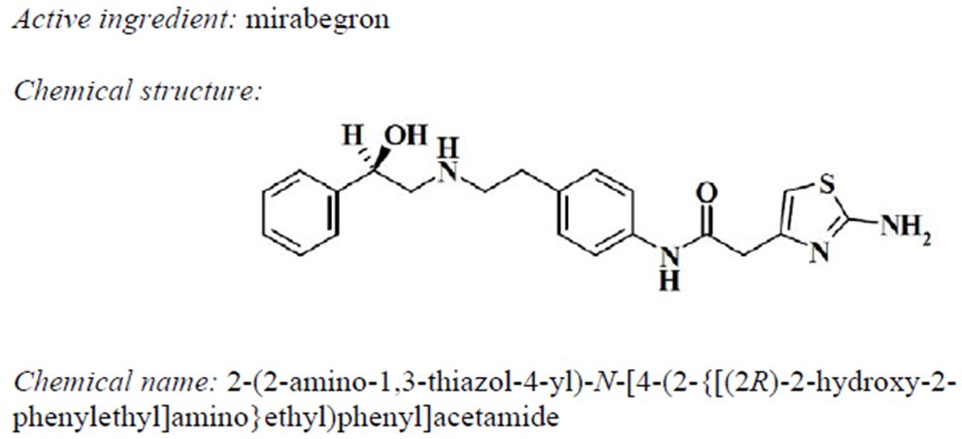

Clinical rationale
The urinary bladder has two main roles: the storage of urine produced by the kidneys, and the release of that stored urine during voluntary voiding at a convenient time. The neurophysiological control of these two opposing functions is complex. At the simplest level, voiding is triggered by a stretch reflex initiated in the bladder wall, leading to relaxation of the urinary sphincter and contraction of the main bladder muscle, the detrusor. In a normal toilet-trained subject, this reflex is inhibited by higher centres, so that the subject experiences a desire to void but can post-pone the void, often for prolonged periods. In a variety of conditions, including cerebral and spinal cord disease, bladder damage, or more subtle idiopathic disturbances, the balance between storage and voiding, and the central inhibition of the stretch reflex, can be disturbed. A common syndrome of bladder dysfunction is over-active bladder (OAB), in which subjects have the urge to void at relatively low bladder volumes, have difficulty postponing voiding, may be excessively aware of the need to void, or may lose urine involuntarily because of active detrusor contraction. A hallmark of this syndrome is urgency, in which patients experience a rapid escalation from initial awareness of bladder fullness to a strong desire to void, have difficulty postponing voiding, and may be incontinent if they do not get to a toilet in time.
The main two arms of the autonomic nervous system, the parasympathetic and sympathetic systems, exert opposing influences on bladder function. Contractions of the detrusor are enhanced by parasympathetic activity, mediated by muscarinic acetylcholine receptors, and traditional approaches to OAB have involved the use of antimuscarinic (anticholinergic) agents. Problems with such agents include lack of efficacy, constipation, dry eyes, dry mouth, and sedation. Many patients abandon antimuscarinic therapy because of these side effects, or because efficacy is inadequate. Others continue antimuscarinic agents but suffer continued symptoms of OAB. These symptoms may include urinary frequency, urgency, incontinence, social isolation and low self esteem. Many patients can only avoid incontinence by planning each trip around the location of toilets, or by frequent pre-emptive voiding.
Mirabegron is a new agent that works by stimulating a subclass of sympathetic receptors in the bladder, the beta-3 adrenergic receptors (beta-3 AR). Whereas stimulation of muscarinic receptors facilitates detrusor contraction, activation of beta-ARs in the bladder’s triangular base (the trigone) facilitates urine storage by flattening and lengthening the bladder base (Yamanishi et al, 2003). The dominant beta-AR subtype in the human detrusor muscle is beta 3-AR, and activation of beta 3-ARs has been shown to promote urine storage in the bladder (Kumar et al, 2003; Yamaguchi, 2002).
A range of animal studies have supported the idea that a beta-3 AR agonist might be useful in promoting urine storage. Using the beta 3-AR agonists FK175 and CL-316243, it has been shown that activation of beta 3-ARs promoted urine storage in rats by increasing bladder capacity (Fujimura et al, 1999; Takeda et al, 2000). Also, CL-316243 increased urinary bladder capacity in OAB models in rats (Woods et al, 2001; Takeda, Yamazaki, Igawa et al, 2002; Leon et al, 2008), leading some authors to propose use of beta 3-AR agonists as bladder relaxant drugs for treatment of OAB (Yamaguchi, 2002).
The sponsor reports that preclinical work with mirabegron showed it to be a selective beta 3-AR agonist, although the evidence for this is beyond the scope of this clinical evaluation report. Mirabegron reportedly showed selective agonistic activity and high affinity for human beta 3- as compared with beta 1- and beta 2-ARs, and it had little affinity for a wide panel of other receptors, ion channels, and transporters. It did not have any inhibitory effects on the activity of a panel of enzymes. Mirabegron increased cyclic adenosine 3', 5'-monophosphate (cAMP) concentrations in bladder tissues isolated from rats and it showed a potent relaxant effect in isolated rat and human bladder strips precontracted with carbachol. It also decreased the resting intravesical (intra-bladder) pressure in rats. It decreased the frequency of rhythmic bladder contractions in anaesthetised rats, without affecting the force of the contractions. In water-loaded conscious cynomolgus monkeys, it increased the volume voided per micturition and decreased the voiding frequency. In a cerebral infarction (stroke) model of OAB in rats, mirabegron increased the mean voided volume per micturition. In rats with partial urethral obstruction, it decreased the frequency of non-voiding contractions without affecting the voided volume per micturition, voiding pressure, or residual urine volume. Overall, this evidence suggests that mirabegron enhances urine storage function by stimulating beta 3-ARs in the bladder, without affecting voiding contractions.
OAB is a common and distressing condition, so the prospect of a new agent for relieving OAB symptoms is welcome. The main question raised by the proposed mechanism of action is whether the beta-3 receptors play a sufficiently potent role in modifying urine storage to allow a meaningful improvement of OAB symptoms with this approach, and whether stimulation of adrenergic receptors can be achieved without causing systemic adrenergic side effects, such as hypertension.

Guidance
The European Medicines Agency (EMA) for the evaluation of medicinal products has produced guidelines for the clinical investigation of products intended to treat urinary incontinence, which the Australian Therapeutic Goods Administration (TGA) has adopted*. Those guidelines suggest that the primary aim of incontinence treatment is to provide a subjective improvement, so subjective response should be a major clinical outcome measure. The guidelines argue that quantification of symptoms in terms of frequency of incontinence or micturition is worthwhile but cannot be used as a surrogate for subjective improvement. The sponsor’s pivotal studies partially conform to these general principles; the co-primary endpoints of all three pivotal studies were the same, and consisted of a quantification of urinary frequency and incontinence. Subjective endpoints were included, but were secondary or tertiary in importance. Because these subjective endpoints were positive in most cases, with mirabegron achieving statistically significant superiority over placebo, the sponsor’s initial ranking of these endpoints ranking is not critical.
In other respects, the sponsor’s submission conforms to suggestions in the EMA guidelines, such as the use of a parallel, placebo-controlled design, and pivotal study durations of at least 3 months.
According to the sponsor, “Regulatory interactions with the Competent Authorities in Europe have been held at regular intervals during the mirabegron development program. National Scientific Advice (NSA) meetings have been conducted with the Competent Authorities in The Netherlands (March 2010), Sweden (March 2010), and Spain (March 2010) for the OAB development program. The phase 3 protocols were shared with the Competent Authorities at NSA meetings with The Netherlands (Oct 2007) and Spain (Dec 2007) prior to conduct and the protocols were adapted accordingly.”
The protocols for primary phase 3 studies 178-CL-046 and 178-CL-047 were also submitted to the FDA, and the recommendations of the FDA were followed in producing the statistical analysis plans (SAPs). The sponsor also agreed to perform a pivotal phase 3 assessment of the 25mg dose in response to a suggestion from the FDA Division of Reproductive and Urologic Products. According to the sponsor “Agreement on the SAPs for Studies 178-CL-046 and 178-CL-047 was received from the FDA in May 2009.”

Contents of the clinical dossier

Scope of the clinical dossier
The clinical studies included in this submission are summarised below. They include 29 clinical pharmacology studies, 3 phase 2 OAB studies and 6 phase 3 OAB studies, three of which are considered pivotal. Three phase 2 studies for other indications (diabetes and bladder outlet obstruction) contributed safety data.
Table 3. Overview of the Clinical Development Program for Mirabegron*
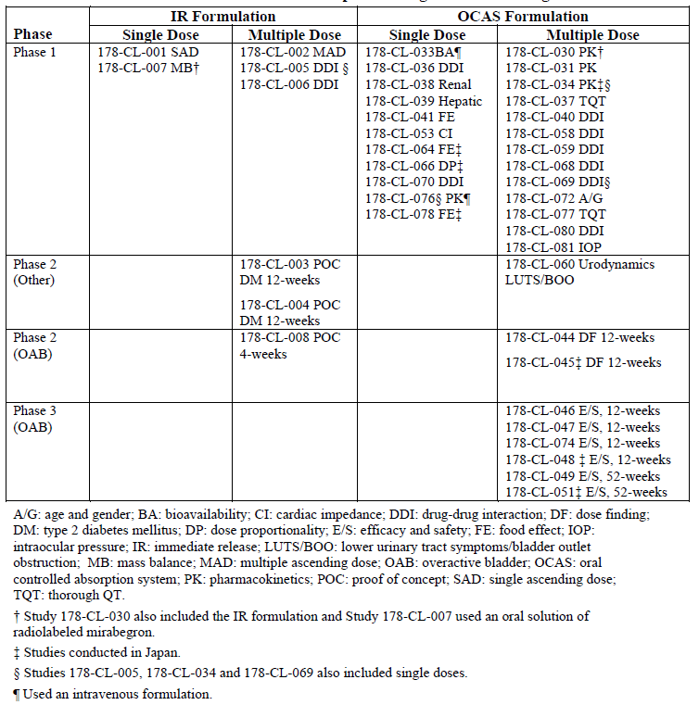
The contents of the submission are as follows:
Module 5
- 41 clinical studies, as above.
- Literature references
- Integrated Summary of Efficacy, Integrated Summary of Safety
Module 1
- Application letter, application form, draft Australian PI and CMI
Module 2
- Clinical Overview, Summary of Clinical Efficacy, Summary of Clinical Safety.

Paediatric data
The submission did not include paediatric data. According to the sponsor, “a Pediatric Investigation Plan (PIP) for mirabegron has been submitted to the EMA Pediatric Committee (PDCO), with a positive opinion communicated in August 2010; the measures of the agreed PIP were deferred until after submission of the MAA for the adult indication.”

Good clinical practice
All submitted studies included an assurance that they were conducted in keeping with current guidelines on Good Clinical Practice.

Pharmacokinetics

Studies providing pharmacokinetic data
The table below shows the studies relating to each pharmacokinetic topic.
Table 4. Overview of Mirabegron Phase 1 Studies.
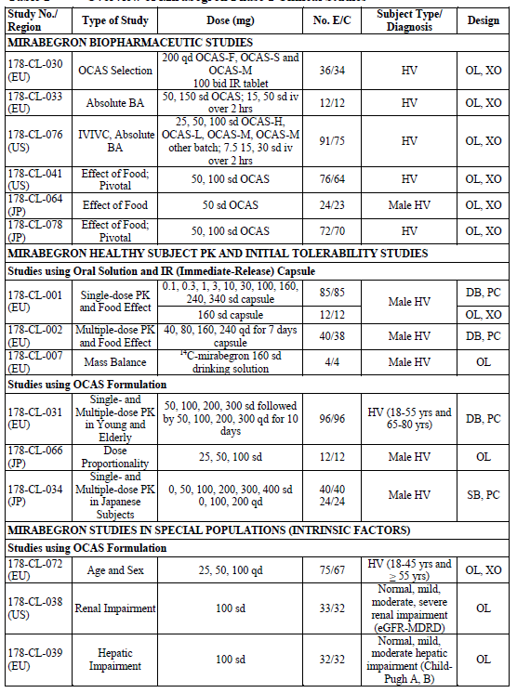
Table 4 continued. Overview of Mirabegron Phase 1 Studies.
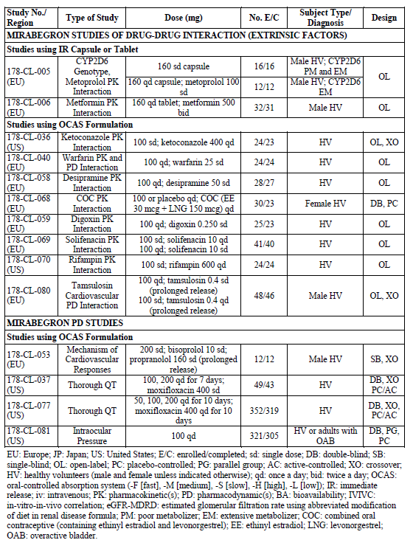
Table 5. Location of Clinical Pharmacology Synopses
[Table 5 is not included in this Extract from the Clinical Evaluation Report]

Summary of pharmacokinetics
The information in the following summary is derived from conventional pharmacokinetic studies.

Pharmacokinetics in healthy subjects

Absorption

Sites and mechanisms of absorption
No clinical studies were submitted that established the precise sites and mechanisms of absorption of mirabegron, but the speed and extent of absorption depends on the formulation, dose and presence of food in the stomach.
After administration of 160mg mirabegron as a drinking solution, peak concentrations were attained at ~ 1.0 hour (Study 178-CL-007). The immediate-release (IR) solid formulation of mirabegron was associated with a t_{max} of ~2.5 – 3.5 hours (Studies 178-CL-001 and 178-CL-002). After oral administration of the proposed OCAS-M formulation in healthy volunteers, mean peak plasma concentrations were reached between 3 and 4.3 hours (Studies 178-CL-031 and 178-CL-034).
Absorption also depends on the dose. Pre-clinical in vitro studies suggest that mirabegron is a substrate for the efflux transporter P-gp and for the influx organic cation transporters (OCT) OCT1, OCT2, and OCT3 (Studies 178-ME-031, 178-ME-132, 178-ME-092, not evaluated in this report). Clinical PK studies showed that higher doses are associated with a more-than-dose proportional exposure, which is likely to be due to saturation of efflux transporters in the intestine.
Mirabegron is also susceptible to a substantial food effect, as discussed below.

Bioavailability

Absolute bioavailability
Bioavailability depends on the dose administered, but at the proposed dose of 50mg, bioavailability of the OCAS-M formulation was estimated to be 35% in Study 178-CL-076, compared to 29% at 25mg and 45% at 100mg . Similar trends were seen in Studies 178-CL-066 and 178-CL-034, which also showed greater-than-dose-proportional exposure at increasing oral doses. The sponsor proposes that the increase in absolute bioavailability with increasing dose is probably due to saturation of efflux transport proteins (particularly P-glycoprotein, P-gp).
Bioavailability appeared to be higher in females compared with males (Study 178-CL-072). Across the doses tested, mean C_{max} and AUC_{tau} were approximately 44% and 38% higher, respectively, in females relative to males. Normalisation for weight reduced the gender difference but did not eliminate it: weight-normalized values for C_{max} and AUC_{tau} were approximately 23% and 18% higher, respectively, in females.

Bioavailability relative to an oral solution or micronised suspension
Direct comparisons of an oral solution of mirabegron and the proposed formulation at the same dose have not been performed. The mirabegron solution (160mg) used in the mass balance study (178-CL-007) had a bioavailability of at least 55% (based on the percentage of administered radioactivity recovered in urine, though an additional 11% of administered radioactivity was unaccounted for). This is higher than the bioavailability of OCAS_M formulation discussed above. The lower bioavailability for the OCAS-M formulation compared with the solution is possibly due to more efficient efflux (less saturation of transporters) and reduced absorption from more distal gut regions, which play a greater role with the OCAS-M formulation as a result of slower release of mirabegron.

Bioequivalence of clinical trial and market formulations
The OCAS-M tablets used for the pivotal phase 3 clinical studies were used also used for the majority of the phase 2 and clinical pharmacology studies. The proposed commercial formulations of mirabegron 25mg and 50mg are identical to the tablets used in phase 3, except that the commercial product will be debossed.
Some clinical pharmacology studies used an immediate release (IR) formulation instead of OCAS-M: 178-CL-005 (CYP2D6 genotype and metoprolol drug-interaction study), 178-CL-006 (a metformin interaction study), and multi-dose PK and food-effect studies, 178-CL-001 and 178-CL-002. As noted above, the mass-balance study (178-CL-007) used an oral solution of mirabegron, and is not directly comparable to the IR or OCAS-M formulations.
For the few clinical pharmacology studies that did not employ the OCAS-M formulation, it is reasonable to draw qualitative conclusions, but exposure with the IR formulation was not quantitatively equivalent to that expected with OCAS-M. The mean relative bioavailability for the OCAS-M tablet (200mg qd) compared to the IR tablet (100mg bid) was estimated to be 80% in Study 178-CL-030.
A complete listing of the Phase 1 clinical studies and the formulation used is contained in Table 4, above.

Bioequivalence of different dosage forms and strengths
The proposed commercial 25mg and 50mg tablets have identical compositions, and would not be expected to differ significantly in their bioavailability.

Bioequivalence to relevant registered products
Not applicable.

Influence of food
Mirabegron exhibits a decrease in plasma exposure with food. Co-administration of a mirabegron 50mg tablet with a high-fat meal reduced mirabegron C_{max} and AUC_{inf} by 45% and 17%, respectively. A low-fat meal had a more marked effect, decreasing mirabegron C_{max} and AUC_{inf} by 75% and 51%, respectively. Similar results were obtained with mirabegron 100mg. (See studies 178-CL-041, 178-CL-064, 178-CL-078, 178-CL-001, 178-CL-002).
The sponsor proposes that the mechanism behind the food effect is likely to be a combination of adsorption to meal constituents and competition for drug uptake and efflux from meal constituents.
Although the food effect is substantial, the safety and efficacy of the proposed 50mg dose was assessed in the pivotal studies without food restrictions; subjects took mirabegron variably with and without food. This suggests that problems related to variability in exposure from the food effect have already been accounted for in considering the efficacy and safety of mirabegron in those studies.
Population PK analysis of the phase 3 data suggests that mirabegron plasma exposure was similar in subjects who took within 30 minutes before or after food compared to those who did not. This suggests that the food effect might have been obscured by interpatient variability.
On the basis of pre-clinical studies (not evaluated in this report), it appears that alcohol is unlikely to accelerate the dissolution and release of mirabegron from the OCAS-M formulation. Adding 4% ethanol to the dissolution medium did not significantly modify the dissolution profiles for mirabegron OCAS-M tablets, but adding 40% ethanol delayed dissolution profiles.

Dose proportionality
Deviations from dose proportionality have been noted for oral preparations, as discussed above. When given orally, mirabegron exposure increases more than dose-proportionally with increasing dose, which is likely to reflect saturation of efflux mechanisms. The mechanism is not likely to be due to saturable first-pass metabolism, because mirabegron metabolites also demonstrated a more-than-dose-proportional increase in C_{max} and AUC_{tau} after multiple mirabegron doses (25 to 200mg qd), which was similar to the increases observed with the parent compound.
By contrast, no deviations from dose proportionality in mirabegron PK parameters were observed after single-dose intravenous administration of mirabegron.

Bioavailability during multiple-dosing
Multi-dose studies (178-CL-031, 178-CL-034, 178-CL-002) suggest that steady state plasma concentrations of mirabegron are achieved within 7 days of once daily dosing. Comparison between AUC_{tau} values following a single dose and at steady state indicated a 2-fold accumulation of mirabegron with once daily dosing.
At the proposed therapeutic dose of 50mg, no time-dependency in PK handling of mirabegron was observed. At higher doses (100mg and 200mg), a small increase (<20%) was observed in AUC_{tau} at steady state compared with single-dose AUC_{inf}, suggesting that mirabegron may exhibit time-dependent PK at supratherapeutic doses. This effect appears small compared to the food effect and intersubject variability, and is not likely to be clinically relevant.

Effect of administration timing
No studies specifically assessed the influence of timing of dose, apart from the noted food effect. There are no a priori reasons to suspect a major timing effect.

Distribution

Volume of distribution
Mirabegron has a large apparent volume of distribution at steady state (~1670 L), well in excess of body water, indicating extensive distribution and binding to tissue constituents. (Study 178-CL-033).

Plasma protein binding
Mirabegron is moderately bound (approximately 71%) to human plasma proteins, including albumin and alpha-1 acid glycoprotein. (178-CL-038).

Erythrocyte distribution
In vitro assessments showed that erythrocyte concentrations of 14C-mirabegron were approximately 2-fold higher than in plasma, indicating that mirabegron distributes to erythrocytes.

Tissue distribution
The large apparent volume of distribution (~1670 L) suggests that mirabegron is distributed to multiple tissues and binds extensively to tissue constituents, but no clinical studies explored the details of the tissue distribution.

Metabolism

Interconversion between enantiomers
Mirabegron has a chiral center, and it has been developed as the R-configured enantiomer.
The sponsor reports that, after oral administration of radiolabeled mirabegron in healthy subjects, there was no evidence of chiral inversion (Study 178-ME-041).

Sites of metabolism and mechanisms / enzyme systems involved
Mirabegron is cleared by multiple mechanisms: renal and possibly biliary excretion of unchanged drug, and hepatic metabolism of the drug by multiple drug-metabolizing enzymes, with no single predominating clearance pathway.
Following an initial more rapid distribution phase, the t_{½} of mirabegron is approximately 50 hours. Total body clearance (CL) of mirabegron from plasma is ~57 L/h. Blood clearance is estimated to be ~ 41 L/hr, which is about half the liver blood flow. The t_{½} is independent of dose, route of administration and formulation. The effective half-life including distribution effects is estimated to be ~ 19 hours (based on population PK analysis).

Non-renal clearance
Renal clearance (CLR) is independent of dose and averages approximately 13 L/h, which corresponds to nearly 25% of CL, implying that non-renal clearance accounts for ~75% of clearance. Following the administration of 160mg radiolabelled mirabegron to healthy volunteers (Study 178-CL-007), ~ 55% of the radioactivity was recovered in the urine and 34% in the faeces. Unchanged mirabegron accounted for 45% of the urinary radioactivity and the majority of the faecal radioactivity; the remainder had undergone hepatic metabolism to a variety of metabolites as shown below.

Metabolites identified in humans
The sponsor proposes the following metabolic pathways in humans.
Figure 2. Postulated Metabolic Pathways of Mirabegron in Humans
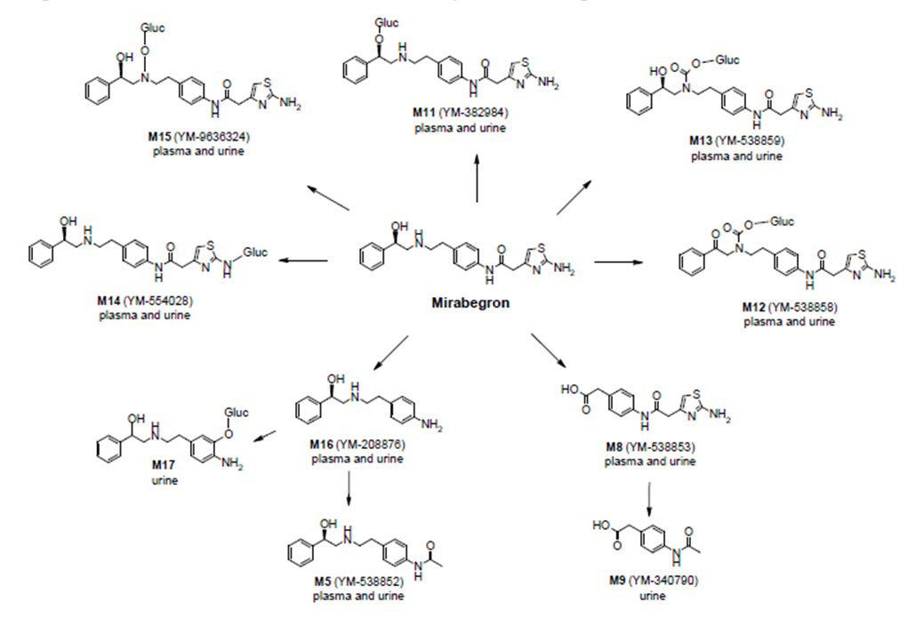
As shown in the figure above, mirabegron is metabolized via multiple pathways involving dealkylation, oxidation, glucuronidation, and amide hydrolysis. Metabolites recovered from urine suggest that butyrylcholinesterase is the most important matabolising enzyme, in addition to uridine diphosphate-glucuronosyltransferase (UGT), CYP3A4 and CYP2D6 enzymes and possibly alcohol dehydrogenase. In vitro studies suggested that CYP3A4 is the primary isoenzyme involved in hepatic oxidative metabolism of mirabegron, with a minor role of CYP2D6.
The metabolites designated M11 and M12 (see figure above) were considered to be the major metabolites. Both are phase 2 glucuronides representing 16% and 11% of total exposure in plasma.
None of the metabolites found in plasma appeared to be pharmacologically active. Agonist activities of metabolites on beta 3-AR were less than 1/400 of mirabegron activity, and activities on other beta ARs were negligible. No other affinities for a panel of biological targets were observed.

Pharmacokinetics of metabolites
Metabolite plasma concentration profiles were delayed by ~0.5 to 1.5 hours compared to mirabegron, with mean t_{max} values from ~ 3.6 and 6.3 hours. Metabolite-to-parent AUC ratios were essentially constant across multiple oral doses of 25 to 200mg qd, suggesting that the metabolism of mirabegron is not saturable over clinically relevant doses. For details, see Study 178-CL-007.

Consequences of genetic polymorphism
The sponsor assessed the PK of mirabegron in poor and extensive CYP2D6 metablizers in Study 178-CL-005. Genetic polymorphism for the CYP2D6 isozyme appeared to have no clinically relevant impact on mirabegron exposure. Following mirabegron 160mg administered as a single oral dose (IR formulation), the mean C_{max} and AUC_{inf} were 14% and 19% higher, respectively, in CYP2D6 poor metabolizers compared to extensive metabolizers.
In Study 178-CL-058, following multiple 50mg and 100mg doses of mirabegron OCAS, mean AUC_{tau} was 8% and 12% higher, respectively, in CYP2D6 poor metabolizers compared to extensive metabolizers, and mean C_{max} values were similar. The relatively minor effect of polymorphism is consistent with the multiple elimination pathways for mirabegron.

Excretion

Routes and mechanisms of excretion
Excretion of unchanged mirabegron and inactive mirabegron metabolites is predominantly renal. Following the administration of 160mg radiolabelled mirabegron to healthy volunteers (Study 178-CL-007), ~ 55% of the radioactivity was recovered in the urine and 34% in the faeces, which thus accounts for 89% of the administered dose. Of the radioactivity that was not recovered from stool, renal excretion accounts for at least 83% (55/(100-34)). It is unclear if some biliary excretion also occurs.

Mass balance studies
See Study 178-CL-007.

Renal clearance
Renal clearance (CLR) is independent of dose and averages approximately 13 L/h, which corresponds to nearly 25% of CL. The sponsor proposes that renal elimination of mirabegron is primarily through active tubular secretion along with glomerular filtration. The urinary excretion of unchanged mirabegron is dose-dependent and rages from ~6% after a daily dose of 25mg to ~9% after a daily dose of 50mg (Studies 178-CL-039, 178-CL-001, 178-CL-033 and other basic PK studies). In the mass balance study, following 160mg, unchanged mirabegron accounted for 45% of the radioactivity in urine, or 25% of the total radioactivity.

Intra- and inter-individual variability of pharmacokinetics
Mirabegron PK after oral administration shows substantial variability, with intersubject variability estimates (%CVs) for C_{max} and AUC_{inf} of ~40% to 52% and ~39% to 45%, respectively. The corresponding estimates for the intrasubject variability ranged from approximately 33% to 45% for C_{max} and 19% to 31% for AUC_{inf}.. Most of the variability appears to be related to absorption, as suggested by relatively low intersubject variability after intravenous administration: for IV mirabegron %CVs for C_{max} and AUC_{inf} were ~20% (Study 178-CL-076). Part of the variability in mirabegron exposure is related to body weight, and gender also plays a role even after normalising for weight (178-CL-072). A major source of intraindividual variability in clinical settings would be expected to come from the marked food effect.

Pharmacokinetics in the target population
The sponsor assessed the PK of mirabegron in subjects with OAB (in phase 1 Study 178-CL-081, and also the major phase 2 and 3 clinical efficacy studies), and found that mean AUC_{tau} estimates in patients with OAB were approximately 20% to 50% lower compared with fasted AUC_{tau} values in healthy volunteers.
This could reflect a food effect, because patients in the efficacy studies were not required to take mirabegron under fasting conditions. Also, PK estimates during efficacy studies were based on a relatively sparse sampling scheme, which could have missed the peak concentrations and thus underestimated the true exposure.
In general, patients with OAB are generally healthy, but are likely to be older than the healthy volunteers of the phase 1 program. As discussed below, age does not appear to have a major effect on the PK of mirabegron, so the PK characteristics of mirabegron are not expected to be significantly different in the target population. Even if exposure was lower in the target population, this would not pose clinically relevant concerns: safety would be greater at lower exposure, and any compromise in efficacy at lower exposure has already been accounted for in the pivotal study results.

Pharmacokinetics in other special populations
The sponsor performed a number of studies assessing the effects of a range of intrinsic factors on the PK of mirabegron, including age, gender, CYP2D6 genotype, renal and hepatic function. The results are displayed graphically below. For details, see the sections. Overall, the PK in these different populations was similar to that in healthy volunteers, but exposure was slightly higher in women, and moderately higher in the setting of hepatic or renal impairment. Dose adjustment is recommended in the presence of moderate hepatic impairment or severe renal impairment.
Figure 3. Effect of Intrinsic Factors on the Pharmacokinetics of Mirabegron
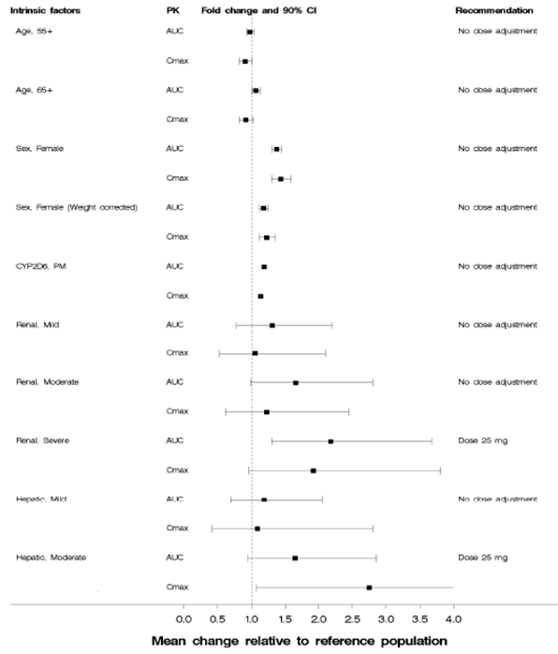

Pharmacokinetics in subjects with impaired hepatic function
The PK of mirabegron in volunteers with hepatic impairment were compared to those in healthy control volunteers matched for sex, age and body mass index (BMI) in Study 178-CL-034. Following mirabegron 100mg in volunteers with mild hepatic impairment (Child-Pugh Class A), mean C_{max} and AUC_{inf} were 9% and 19% higher, respectively, relative to healthy volunteers. In volunteers with moderate hepatic impairment (Child-Pugh Class B), mean C_{max} and AUC_{inf} values were 175% and 65% higher, respectively. A reduction of the dose to 25mg once daily in patients with moderate hepatic impairment is therefore recommended.
The magnitude of the increases in exposure with mild hepatic impairment are unlikely to be clinically relevant, and are small compared to intersubject variability with healthy volunteers, so no dose adjustment is recommended.
Mirabegron has not been studied at all in patients with severe hepatic impairment (Child-Pugh Class C) and should not be used in this patient population, even at a reduced dose. The Proposed Product Information sheet (PI) contains appropriate warnings against use in this population.

Pharmacokinetics in subjects with impaired renal function
In Study 178-CL-038, the PK of mirabegron in volunteers with renal impairment were compared to the PK in healthy volunteers matched for sex, age and weight.
Following mirabegron 100mg, in volunteers with mild renal impairment (estimated glomerular filtration rate [eGFR] 60 to 89 mL/min/1.73 m²), mean mirabegron C_{max} and AUC_{inf} were 6% and 31% higher, respectively, relative to volunteers with normal renal function. In volunteers with moderate renal impairment (eGFR 30 to 59 mL/min/1.73 m²), C_{max} and AUC_{inf} were 23% and 66% higher, respectively. In volunteers with severe renal impairment (eGFR 15 to 29 mL/min/1.73 m2), mean C_{max} and AUC_{inf} values were 92% and 118% higher, respectively.
On the basis of these results, the sponsor’s proposed Product Information sheet recommends a halving of the dose to 25mg once daily in patients with severe renal impairment, but no adjustment in patients with mild to moderate renal impairment. This appears reasonable, given that doses up to 100mg were assessed in pivotal phase 3 studies and had an acceptable safety profile.
Mirabegron has not been studied in patients with End Stage Renal Disease (eGFR < 15 mL/min/1.73 m² or patients requiring hemodialysis) and should not be used in this patient population. The PI warns against such use.

Pharmacokinetics according to age
The effects of age and gender on the PK of mirabegron were assessed in Study 178-CL-072. No statistically significant differences in C_{max} and AUC_{tau} were found in mirabegron between older volunteers (≥55 years) and younger volunteers (18-45 years). Similar results were obtained for the subpopulation aged ≥ 65 years.
Given that mirabegron clearance is affected by renal function, and that renal function declines with advancing age, it would be surprising if there were no PK differences between elderly subjects and younger subjects. A population PK analysis of phase 2 and 3 data confirmed that age increased mirabegron exposure, but the effect was minimal. AUC was estimated as 11% higher in a subject aged 90 years compared to a subject aged 60 years.
Overall, given that the changes in PK with age are minor, no dosage adjustment is recommended on the basis of age.

Pharmacokinetics related to genetic factors
There are no known genetic factors significant affecting the PK of mirabegron. Polymorphism for the CYP2D6 isozyme, as discussed previously (above), has a minimal effect on mirabegron exposure, which is not likely to be clinically significant.

Pharmacokinetics according to gender
In multiple PK studies, mirabegron C_{max} and AUC_{tau} were ~40% to 50% higher in females compared to males. The magnitude of the differences was lessened but not eliminated by weight-normalisation: weight-normalized values for C_{max} and AUC_{tau} were ~ 20% to 30% higher in females (See Study 178-CL-072).
The sponsor does not propose dose adjustment based on sex, and this seems reasonable. All the major studies contributing to the efficacy and safety evidence for mirabegron recruited both men and women with OAB, so the clinical effects of this variation in exposure have already been factored in to the efficacy and safety analysis. The increased exposure in women does not appear to compromise the safety of mirabegron, and the relatively reduced exposure in men does not appear to significantly compromise efficacy.

Pharmacokinetics according to race
Race did not influence any PK parameters in a population PK analysis of phase 2 and 3 data. Plasma exposure in healthy Japanese subjects was higher than in Western subjects, but the differences are largely accounted for by differences in body weight. Dose adjustment based on race is not necessary.

Pharmacokinetic interactions

Pharmacokinetic interactions demonstrated in human studies
The clinical pharmacology program suggested that mirabegron is susceptible to a variety of pharmacokinetic interactions, but each interaction has a relatively minor effect, which is not surprising considering the drug is cleared by multiple mechanisms (both hepatic and renal), with no single predominating clearance pathway.

Effect of co-administered drugs on mirabegron.
The interactions identified in the study program are displayed graphically below. The most substantial interaction was observed with ketoconazole (400mg qd), which is a potent CYP3A and P-gp inhibitor. Ketoconazole caused a 45% increase in the C_{max} and an 81% increase in the AUC_{inf} of mirabegron (100mg single dose). This is less than the increase in exposure that would be achieved if the dose were doubled (estimated to produce a 190% and 160% increase in C_{max} and AUC, respectively). Given that mirabegron was assessed in pivotal studies at 100mg daily (twice the proposed therapeutic dose), the increase in exposure with ketoconazole does not raise substantial clinical concerns.
Figure 4. Effect of Co-administered Drugs or Food on the Pharmacokinetics of Mirabegron
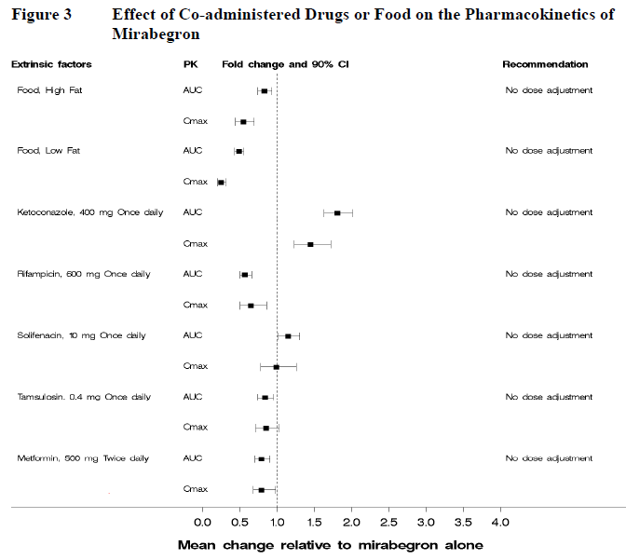
Other drug interactions were less substantial. Co-administration with rifampin (600mg qd), a potent CYP3A and P-gp inducer, resulted in a 35% decrease in C_{max} and a 44% decrease in AUC_{inf} of a single dose of mirabegron (Study 178-CL-070).
An interaction of mirabegron with an inhibitor of CYP2D6 was not expected, so the effect of a potent CYP2D6 inhibitor on mirabegron PK was not directly studied in human subjects. Subjects who were poor metabolizers of CYP2D6 substrates exhibited only slightly higher mirabegron plasma exposure compared with extensive metabolizers. Therefore, no dose adjustment of mirabegron is recommended for mirabegron when co-administered with CYP2D6 inhibitors or in patients who are CYP2D6 poor metabolisers. (The reverse interaction, of mirabegron on other CYP2D6 substrates, could be more significant as discussed below).
Mirabegron PK was not significantly affected by co-administration with metformin, solifenacin or tamsulosin. There was a minor pharmacodynamic (PD) interaction between tamsulosin and mirabegron, not expected to be clinically relevant.

Effect of mirabegron on co-administered drugs.
Drug interaction studies were performed with substrates for CYP2D6, CYP3A4 and P-gp, with other urological medications and with the narrow therapeutic index drug warfarin. Studies were also performed with metformin, which, like mirabegron, is a renally secreted organic cation.
The results of these studies are displayed graphically below.
Figure 5. Effect of Mirabegron on the Pharmacokinetics of Co-administered Drugs
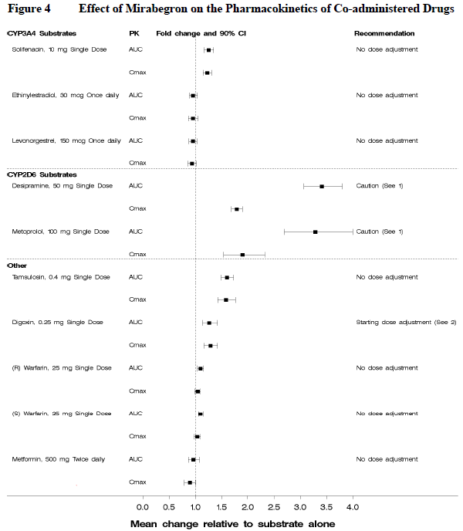
The inhibitory effects of mirabegron on CYP2D6 were sufficient to recommend caution when combining mirabegron with other CYP2D6 substrates if these substrates have a narrow therapeutic index. Multiple daily dosing with mirabegron 160mg (IR formulation) resulted in a 90% increase in C_{max} and a 229% increase in AUC_{inf} of a single 100mg dose of the CYP2D6 substrate metoprolol. Similarly, multiple daily dosing with mirabegron 100mg resulted in a 79% increase in C_{max} and a 241% increase in AUC_{inf} of a single 50mg dose of the CYP2D6 substrate desipramine.
By contrast, mirabegron (100mg qd) did not affect the PK of ethinyl estradiol and levonorgestrel (both CYP3A4 substrates) or solifenacin (a CYP3A4 substrate) to a clinically significant extent.
Mirabegron (100mg qd) did increase plasma exposure of the CYP2D6 and CYP3A4 substrate tamsulosin (0.4 mg sd) by approximately 60%, but the cardiovascular results did not suggest a clinically relevant pharmacodynamic interaction between tamsulosin and mirabegron (see Study 178-CL-080). The sponsor recommends no dose adjustment during co-administration of these two drugs, which seems appropriate.
No significant effects of mirabegron on the pharmacokinetics of warfarin (a substrate for CYP2C9) or on prothrombin time were observed when mirabegron (100mg qd) was co-administered with warfarin (25mg sd).
No significant changes in the PK of metformin (500mg bid) were observed when co-administered with a supratherapeutic dose of mirabegron (160mg IR qd).
Although mirabegron inhibits P-gp, the effect was weak. With multiple daily dosing of mirabegron 100mg, the C_{max} of the P-gp substrate digoxin (0.25mg sd) increased 29%, and the AUC_{last} increased 27%. Because digoxin has a narrow therapeutic index, patients commencing combination treatment with mirabegron and digoxin should start with the lowest dose for digoxin, and then titrate the dose according to digoxin levels. (Given the weak efficacy of mirabegron, ceasing it would be another reasonable option.)

Clinical implications of in vitro findings
On the basis of in vitro tests, mirabegron appears unlikely to inhibit the metabolism of co-administered drugs metabolised by: CYP1A2, CYP2B6, CYP2C8, CYP2C9, CYP2C19 and CYP2E1. Also, in vitro studies suggest that mirabegron does not affect the metabolism of glibenclamide (a CYP3A4 substrate) or tolbutamide (a CYP2C9 substrate), and mirabegron does not induce CYP1A2 or CYP3A. On the other hand, mirabegron did inhibit P-gp, OCT1- and OCT2-mediated drug transport at high concentrations.

Evaluator’s overall conclusions on pharmacokinetics
The pharmacokinetics of mirabegron have been well characterised. They are adequately described in the sponsor’s proposed Product information sheet. Important features are a pronounced food effect, with lower exposure when combined with food, a large volume of distribution, and moderate increases in exposure in the setting of renal or hepatic impairment. Several minor drug interactions were observed with mirabegron, but dose adjustment of mirabegron is generally not required. Drugs that are substrates for CYP2D6 may need dose adjustment when combined with mirabegron, and digoxin should be introduced slowly and titrated with the assistance of drug levels when combined with mirabegron.

Pharmacodynamics

Primary pharmacodynamic studies
No primary pharmacodynamic studies directly assessing bladder physiology in response to mirabegron were submitted.

Primary pharmacodynamic modelling
The sponsor submitted some PD population modelling, based on the major phase 2 and 3 efficacy studies (178-CL-044, 178-CL-046, 178-CL-047 and 178-CL-074), using a Poisson-Normal mixed effect model. This modelling attempted to create a dose response curve, despite very noisy underlying data. Such modelling does not provide new information beyond a direct assessment of the contributory studies, and inevitably imports a range of assumptions into the model, but the key conclusions of this analysis are shown below. The table below shows the placebo-subtracted changes in micturition frequency and volume voided expected from the oacross the dose range 25mg to 200mg. Similar information is displayed graphically in the subsequent pair of figures, where each curve represents an individual model run that attempts to capture the variability between patients. The underlying idealised model is shown in the final figure.
From 50mg upwards, the dose-response curve is largely flat, suggesting that the proposed dose of 50mg is an appropriate compromise between efficacy and safety – further dose increases could increase the risk of adverse events, but is unlikely to lead to substantially improved efficacy. The model predicts that 25mg produces 52% (29% to 70%) of the maximum effect, 50mg produces 85% (68% to 97%) of the maximum effect, and 100mg produces 98% (86% to 100%).
Table 6. Pharmacodynamic Model of Mirabegron Effect from 25mg to 200mg
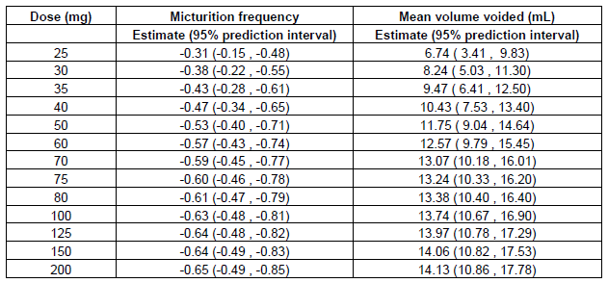
Figure 6. First 50 predicted dose-response relationships for micturition frequency (left) and mean volume voided (right)
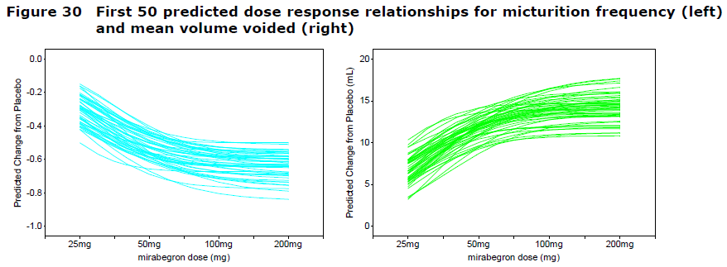
Figure 7. Idealised Dose-response Curve for Mirabegron.
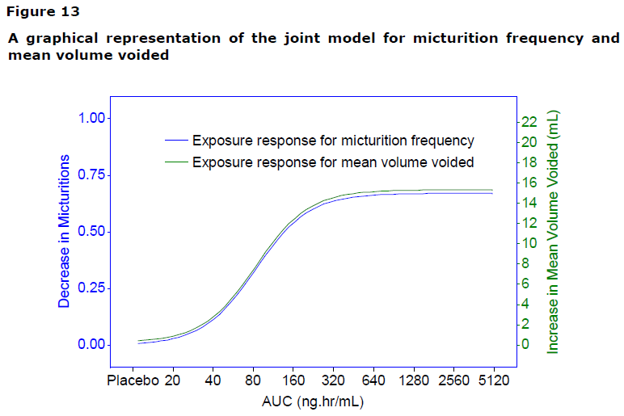

Secondary pharmacodynamic studies
The sponsor submitted three secondary pharmacodynamic studies related to potential tolerability issues with a systemic beta agonist. One of these assessed the cardiovascular response to mirabegron in the presence or absence of beta blockers, confirming that mirabegron exerts a minor cardiovascular effect that is partially blocked by beta-1-selective and non-selective beta antagonists. This result is consistent with a low degree of beta-1 agonist activity, and shows that selectivity for the beta-3 AR is only relative, but the clinical consequences of the minor beta-1 agonism are minimal. A similar result was obtained in the mirabegron monotherapy arm of the tamsulosin interaction study (178-CL-080).
Another study looked for changes in intraocular pressure with continued use, finding no evidence of this. Two studies assessed the potential QT effects of mirabegron [Thorough QT Studies 178-CL-037 and 178-CL-077], but these are summarised in the Safety section (see Section 8.4.5).
None of these studies had deficiencies that excluded their results from consideration.

Dosage selection for the pivotal studies
Dosage selection for the pivotal studies was largely based on the phase 2b study, Study 044, which assessed the following doses:
- mirabegron OCAS 25mg qd
- mirabegron OCAS 50mg qd
- mirabegron OCAS 100mg qd
- mirabegron OCAS 200mg qd
This study is described in detail in Section 7.2.2. Active treatment with mirabegron in this study was associated with a placebo-subtracted improvement in micturition frequency of 0.45, 0.64, 0.68, and 0.80 episodes per 24 hours in the 25mg, 50mg, 100mg and 200mg groups, respectively. There was a dose trend across the range 25mg to 200mg, suggesting that 200mg might be more effective than lower doses, but mild QT prolongation has been observed at this dose. The results in the 25mg group were not significantly different from placebo, suggesting that 25mg is likely to be an ineffective dose in most OAB patients. The proposed dose of 50mg showed a significant treatment effect, as did 100mg, but the difference between 50mg and 100mg was minor. The sponsor chose 50mg and 100mg for further evaluation, and assessed both of these doses in two pivotal studies (Study 046 and Study 047). The FDA suggested another assessment of the 25mg dose, so the third pivotal study (Study 074) assessed 25mg as well as 50mg (subsequently showing that 25mg achieved some, but nor all efficacy endpoints, and was generally inferior to the 50mg dose).
The population-PD modelling described above in Section 5.2 was performed after the pivotal studies were complete, but provides some retrospective justification of the doses chosen. The proposed 50mg dose appears to offer most of the efficacy available from mirabegron, while avoiding the increased risks expected from higher doses. It also provides a greater safety margin compared to the QT-prolonging dose of 200mg.

Clinical efficacy

Pivotal efficacy studies
The sponsor performed three pivotal efficacy studies, which shared most design features including entry criteria, endpoints and statistical methods. The studies differed in the doses assessed, however, and only one of them employed an active control. They are therefore best considered separately, though a pooled analysis of all three studies resembled the results obtained in each study individually (see Section 7.3).

Pivotal Study 046

Study design, objectives, locations and dates
Study 046 was a large (n=1987), randomised, parallel-group, international study comparing mirabegron 50mg (the proposed dose), mirabegron 100mg, tolterodine 4mg and placebo in the treatment of patients with OAB. It had a single-blind placebo run-in period of two weeks, followed by a randomised, double-blind, active and placebo-controlled main study period of 12 weeks.
Patients were randomly assigned to receive placebo, mirabegron 50mg, mirabegron 100mg or tolterodine 4mg once daily in the morning for 12 weeks.
The study was conducted in 27 countries in the EU (Austria, Belgium, Bulgaria, Czech Republic, Denmark, Finland, France, Germany, Greece, Hungary, Iceland, Ireland, Italy, Latvia, Lithuania, Netherlands, Poland, Romania, Slovakia, Spain, Sweden, and the United Kingdom) and non-EU countries (Australia, Belarus, Norway, Russian Federation, and Switzerland) and took place from 28 April 2008 to 24 March 2009.

Inclusion and exclusion criteria
The inclusion and exclusion criteria, as listed in the study protocol, are summarised below. In most cases, these were straightforward and aimed at recruiting patients with sufficiently symptomatic OAB, while reducing the risk of adverse events and avoiding confounding conditions. The main criterion for inclusion was OAB with 8 micturitions per day and at least one episode of urgency per day (on average) during the 3 day screening diary. Incontinence was not necessary for inclusion in the study. This meant that patients with fairly mild OAB were eligible, and that the study was not well designed for demonstrating improvements in continence. In evaluating the safety of mirabegron, it is also important to note that patients thought to be at high risk of urinary retention, or hypertension, were excluded.
Inclusion criteria at screening
- Patient ≥ 18 years of age, of either gender.
- Had symptoms of OAB (urinary frequency and urgency with or without incontinence) for ≥ 3 months.
- Able to give written informed consent.
- Willing and able to complete the micturition diary and questionnaires.
Inclusion criteria at baseline
- Frequency of micturition on average ≥ 8 times per 24-hour period during the 3-day micturition diary period.
- At least 3 episodes of urgency (grade 3 or 4) with or without incontinence during the 3-day micturition diary period.
Exclusion criteria at screening
- Breastfeeding, pregnant, or at significant risk of becoming pregnant.
- Clinically significant bladder outflow obstruction and thought to be at risk of urinary retention.
- Significant stress incontinence or mixed stress/urgency incontinence where stress was the predominant factor as determined by the investigator (confirmed by a cough provocation test).
- Indwelling catheter or practising intermittent self-catheterization.
- Diabetic neuropathy.
- Symptomatic UTI, interstitial cystitis, bladder stones, previous pelvic radiation or history of pelvic malignancy.
- Uncontrolled narrow angle glaucoma, urinary or gastric retention, severe ulcerative colitis, toxic megacolon, myasthenia gravis or any other medical condition that, in the opinion of the investigator, contraindicated the use of anticholinergics.
- Received nondrug bladder treatment including electro-stimulation therapy (bladder training programs or pelvic floor exercises were permitted if started more than 30 days prior to entry).
- Patient using medications intended to treat OAB or other prohibited medications (including anticholinergics, antispasmodics, CYP2D6 substrates with narrow therapeutic indices and other medications recommended not to be used with tolterodine, such as strong CYP3A4 inhibitors, antiarrhythmics).
- Patient had severe hypertension, which was defined as a sitting average systolic blood pressure (SBP) ≥ 180 mm Hg and/or average diastolic blood pressure (DBP) ≥ 110 mm Hg.
- Known or suspected hypersensitivity to tolterodine, other anticholinergics, mirabegron, other beta-AR agonists, or any of the other inactive ingredients.
- Any other clinically significant condition, which in the opinion of the investigator made the patient unsuitable.
- Patient had been treated with any investigational drug or device within 30 days (90 days in the UK) prior to screening.
- Patient professionally associated with the sponsor or study centre.
Exclusion criteria at baseline
- Patient had an average daily urine volume > 3000 mL recorded in the 3-day micturition diary.
- Clinically significant increases in laboratory values in screening blood samples (serum creatinine >150 umol/L, aspartate aminotransferase (AST) or alanine aminotransferase (ALT) >2 times the upper limit of normal range (ULN), or gamma glutamyl transferase (GGT) >3 times the ULN).
- Severe hypertension, defined as a sitting average SBP ≥ 180 mmHg or average DBP ≥ 110 mmHg.
- An abnormal ECG (at the investigator’s discretion).

Study treatments
Patients were randomised in equal proportions to receive placebo, mirabegron 50mg, mirabegron 100mg or tolterodine slow-release (SR) 4mg once daily in the morning, with or without food, for 12 weeks.
The dose of tolterodine SR selected for this study (4 mg) is the standard daily dose used in the EU, US and Australia for treatment of OAB.
Several concomitant medications were restricted during the study: these included alpha blockers, 5-alpha reductase inhibitors, CYP3A4 inducers and loop diuretics. Restricted medications were permitted provided the patient had not stopped, started or changed treatment within 30 days prior to entering the study.

Efficacy variables and outcomes

Co-primary Endpoints
The main efficacy variables were:
- Mean number of micturitions/24h based on a 3-day micturition diary
- Mean number of incontinence episodes/24h based on a 3-day micturition diary
The co-primary efficacy outcomes were:
- Change from baseline to end of treatment in mean number of micturitions/24h
- Change from baseline to end of treatment in mean number of incontinence episodes/24h
The study seemed poorly designed for assessment of the second co-primary endpoint, incontinence frequency, because it included subjects with a single episode per 3-day diary period. The number of incontinence episodes in three days is necessarily an integer, and because subjects with the lowest possible non-zero value were included, any improvement at all in such subjects was necessarily a 100% improvement, without any capacity for more accurate characterisation of their true underlying incontinence frequency.
Such sparse sampling of a discrete event makes accurate characterisation of any potential treatment effect very difficult, and runs the risk that regression-to-the-mean effects will be mistaken for efficacy. If two patients with a baseline incontinence frequency of one episode per week entered this study, but only one happened to have an episode during the three-day baseline diary period, only one would enter the incontinence subgroup. If their situations were reversed at the end of the study with respect to whether the diary caught the weekly episode of incontinence, without any actual change in incontinence frequency, the patient who had entered the incontinence subgroup would appear to have a 100% improvement while the other patient would not enter the analysis at all. This produces a potential bias towards an appearance of improvement even when the actual incontinence frequency across the population has not changed. Although such effects could also occur on the placebo group, it is not necessarily simple to disentangle this methodological bias from any potential treatment. (In fact, a responder analysis across the pivotal population showed a high proportion of 100% responders in the placebo group, as discussed in Section 7.3.

Secondary efficacy outcomes
Change from baseline in volume voided per micturition was considered a key secondary outcome. Note that, for any specified volume of urine production, the volume per micturition is inversely related to the number of micturition episodes, so this endpoint would not be expected to capture substantial new clinical information. The two co-primary efficacy variables were also assessed at Week 4, and results at this time point were considered key secondary efficacy outcomes.
Non-key secondary endpoints are listed below. (Subjective endpoints have been italicised.)
- Change from baseline in mean number of urgency incontinence episodes per 24h.
- Change from baseline in mean number of severe urgency episodes (grade 3 or 4) per 24h.
- Change from baseline in mean level of urgency.
- Change from baseline in symptom bother and health related quality of life scores as assessed by OAB-q questionnaire.
- Change from baseline in mean number of pads used per 24h.
- Change from baseline in scores as assessed by Work Productivity and Activity Impairment: Specific Health Problem (WPAI:SHP) questionnaire.
- Change from baseline in scores as assessed by European Quality of Life-5 Dimensions (EQ-5D) questionnaire.
- Change from baseline in Patient Perception of Bladder Condition (PPBC).
- Change from baseline in the Treatment Satisfaction Visual Analog Scale (TS-VAS).
- Change from baseline in the number of physician visits for the subject’s bladder condition (excluding study related visits).
- Change from baseline in mean number of nocturia episodes per 24h.
The first of these secondary endpoints is the change in frequency of urgency incontinence – which differs from the primary endpoint of all-cause incontinence because it excludes incontinence attributed by the patient to other causes, such as stress incontinence. Although mirabegron is proposed for treatment of urgency, and urgency incontinence is thus a major clinical target of treatment, it is appropriate to consider this a mere secondary endpoint. The attribution of the cause of incontinence is not necessarily reliable, and a treatment would not be useful if it merely shifted the attribution of the cause of incontinence without actually reducing the number of episodes.
The ‘mean level of urgency’ was calculated from subjective urgency assessments entered into the 3-day micturition diary. For each episode of voluntary or involuntary voiding, the patient rated the degree of associated urgency according to the following 5-point categorical scale (Patient Perception of Intensity of Urgency Scale, or PPIUS):
- 0. No urgency, I felt no need to empty my bladder, but did so for other reasons.
- 1. Mild urgency, I could postpone voiding as long as necessary, without fear of wetting myself.
- 2. Moderate urgency, I could postpone voiding for a short while, without fear of wetting myself.
- 3. Severe urgency, I could not postpone voiding, but had to rush to the toilet in order not to wet myself.
- 4. Urge incontinence, I leaked before arriving to the toilet.
Many of the secondary endpoints were subjective, and were based on patients completing questionnaires (OAB-q, WPAI:SHP, EQ-5D), selecting a value from a Likert scale (PPBC) or marking a line on a visual analog scale (TS-VAS). The inclusion of such measures is broadly appropriate. The EU Note for Guidance on studies of incontinence specifically recommends that at least one subjective endpoint be included to assess the overall impact of treatment. On the other hand, the large number of such endpoints in this study meant that no clear hypothesis was being assessed, and the multiplicity of endpoints leaves room to emphasize one subjective finding over another, leaving no clear way to interpret the clinical significance of the various results.
Specific OAB symptoms and QoL in relation to OAB were assessed by the OAB-q, as described by Coyne et al (2005); this questionnaire, also known as International Consultation on Incontinence Questionnaire for OAB (ICIQ-OAB) has been recommended by the International Consultation on Incontinence (Coyne and Matza, 2002, Coyne et al 2003, 2005). The questionnaire is reported to have good psychometric properties, and has shown to be valid and responsive in treatment trials (Sussman & Garely, 2002, Garely et al, 2007). It is a self-report questionnaire described by Coyne et al (2005) as follows:
“The OAB-q consists of an 8-item symptom bother scale and 25 HRQL items that form 4 subscales (coping, concern, sleep, and social interaction) and a total HRQL score. Patients rate each item on a 6-point Likert scale ranging from ‘none of the time’ to ‘all of the time’ for the HRQL items and ‘not at all’ to ‘a very great deal’ for the symptom bother items. Subscales are summed and transformed into scores ranging from 0 to 100; higher symptom bother scores indicate increasing symptom bother, higher HRQL scores indicate better HRQL.”
The ‘symptom bother’ subscale was treated as one secondary endpoint, and the HRQL component of the OAB-q as another. The OAB-q was administered at baseline and weeks 4, 8, and 12 (or the end of treatment).
The Patient Perception of Bladder Condition (PPBC) is a global assessment tool. Subjects are asked to rate their subjective impression of their current bladder condition using a 6-point Likert scale in which a score of 1 indicates “no problems at all” and a score of 6 indicates “many severe problems.” Negative changes therefore indicate improvements. The PPBC was assessed at baseline and at week 12 (or the end of treatment).
The Treatment Satisfaction-Visual Analog Scale (TS-VAS) is a simple visual analog scale (VAS) in which higher values indicate higher satisfaction. Subjects are asked to rate their satisfaction with the treatment of interest by placing a mark on a line that runs from 0 (“No, not at all”) to 10 (“Yes, completely”).
Validation of the PPBC and TS-VAS was not discussed in the clinical study report, but these are very simple assessment tools with a fairly straightforward interpretation. As with any subjective tool, they would be expected to be quite susceptible to a placebo effect, and so only placebo-subtracted differences have any meaning. The magnitude of a small shift on such scales is also difficult to put into clinical context; no means of calibrating the results was provided or discussed.
The WPAI:SHP and EQ-5D are more general quality of life assessment tools, intended to detect changes in the broader context of the patient’s life and the impact of their symptoms on their social, psychological and employment conditions. The EQ-5D has been used in many similar studies and is widely regarded as a valid and responsive tool (Walters et al, 2009); it is an international, standardised instrument, not specific to any disease, used for describing and evaluating health status in five dimensions: Mobility, Self-Care, Usual Activities, Pain/Discomfort and Anxiety/Depression. Each dimension has 3 response levels (e.g, no problems, some problems, unable to perform the activity). It also includes a visual analog scale (VAS) that elicits a self-rating of the subject’s overall health status.
The WPAI:SHP has been described and validated by Reilly et al (1993) as a tool for assessing the interference of health problems with work and productivity. It is a self-administered questionnaire with 6 questions referring to the patient’s experiences in the previous week. The 6 questions cover: employment status; hours absent from work due to a specific health problem; hours absent from work due to other reasons; hours actually worked; impact of the health problem on productivity while working; impact of the health problem on productivity while doing regular daily activities other than work. Overall, it was an appropriate tool for assessing the impact of OAB on productivity, but because it was one of many subjective measures used in the pivotal studies, it added little to the overall assessment.
Finally, the frequency of nocturia was also assessed. This endpoint is not suitable as a primary endpoint because psychological factors and patient expectations may affect the decision to void pre-emptively before bed or to defer voiding until after getting up. Nonetheless, it is an endpoint that can reflect important intrusions on quality of life, with nocturia causing sleep interruptions, and it was appropriate to include it.

Randomisation and blinding methods
Subjects were randomised if they were still eligible after a placebo run-in period. Randomisation to each treatment group was equal, with stratification by country, and was performed using a computer-generated randomization scheme prepared by Pierrel Research Europe.
Blinding was maintained by using a centralised randomisation procedure and placebo tablets that matched the appearance of active treatments, with the randomisation code only broken after the study was complete. The drug did not produce characteristic side effects that are likely to have led to unblinding, and the treatment effect was modest enough that subjects are unlikely to have guessed their treatment group.

Analysis populations
The sponsor defined four analysis populations: the Safety Analysis Set (SAF), the Full Analysis Set (FAS, almost equivalent to an intent-to-treat population), the Per Protocol Set (PPS) and the Pharmacokinetics Analysis Set (PKAS).
The primary efficacy analysis was based on the FAS, which included subjects who took at least one dose of double-blind study medication after randomisation and also provided data on micturitions at baseline and on at least one post baseline visit (without at least one post-baseline micturition frequency, these subjects could not be assessed).
Note that the sponsor assessed incontinence in a subgroup of the FAS, defined as those with at least one episode of incontinence in the baseline 3-day screening diary. This population is referred to in the tables as the FAS-incontinence or FAS-I population.
The SAF included all subjects who received at least one dose. The PPS excluded FAS subjects with major protocol violations. The PKAS included subjects with at least one quantifiable level of mirabegron.

Statistical methods
The sponsor described the statistical analysis of the primary efficacy variables in detail, and provided appropriate corrections for multiplicity of the mirabegron dose groups for the separate analyses of the two variables of micturition and incontinence, as described below. The sponsor also controlled the overall analysis for multiplicity between the variables at a type I error rate at the alpha = 0.05 level, using a stepwise parallel gate-keeping procedure. That is, analysis of lower-ranking variables only proceeded if significance was demonstrated for higher-ranking variables. Also, since 2 mirabegron groups were being compared with placebo, the Hochberg procedure was performed in this stepwise approach: if only 1 dose group proceeded to the next stage, then the comparison between mirabegron and placebo was assessed at the alpha = 0.025 level.
These corrections and the overall statistical approach were appropriate, but the incontinence analysis was flawed by the recruitment of subjects with minimal incontinence.
Primary endpoint: change in mean number of micturitions per 24h
Changes from baseline to end of treatment in the mean number of micturitions per 24h were analysed using ANCOVA including treatment and country as fixed factors and baseline frequency as a covariate. The sponsor stated the hypothesis for the comparison as follows:
H0: Mean number of micturitions per 24h at end of treatment is the same for placebo and mirabegron 50mg and the same for placebo and mirabegron 100mg.
H1: Mean number of micturitions per 24h at end of treatment is not the same for placebo and mirabegron 50mg or not the same for placebo and mirabegron 100mg.
Because two mirabegron dose groups were used, increasing the probability that one of them could do better than placebo, the sponsor used Dunnett’s procedure within the ANCOVA analysis to adjust for multiplicity, keeping the significance level at 5%.
Co-primary endpoint: change in mean number of incontinence episodes per 24h
Changes from baseline in the mean number of incontinence episodes per 24h were analysed by a stratified Wilcoxon rank-sum test with study centre as the stratification factor. Mirabegron 50mg and mirabegron 100mg were separately compared with placebo, and the Bonferroni-Holm procedure was applied to keep the overall two-sided significance level at the 5% level. The protocol specified that Hodges-Lehman estimates and CI’s would be provided for each of the comparisons vs placebo.
Note that only subjects with at least one incontinence episode recorded in the baseline diary were included in the analysis of mean number of incontinence episode per 24h.

Sample size
For analysis of micturition frequency, the sponsor estimated that a sample size of 362 evaluable patients per treatment group would provide about 90% power to detect a reduction of 0.7 in the mean number of micturitions per 24 hours over placebo in at least one dose group at a 2-sided significance level of 0.05. For this estimation, the standard deviation of the primary efficacy variable was assumed to be up to 2.7, based on Study 178-CL-044, where a SD of 2.5 was found with an upper 97.5% CI limit of 2.65. Both mirabegron doses were compared with placebo by means of the Dunnett’s test, which takes into account multiplicity.
For the analysis of incontinence, power calculations were based on the expected size of the subset of patents with incontinence in their baseline diary. From Study 178-CL-044, it was estimated that this would be ~65% of the study population (234 patients per group, if the target of 362 subjects was met for the other co-primary endpoint). The sponsor performed a power analysis with nQuery 6.0 for a Wilcoxon rank-sum test based on ordered categories of incontinence, and this revealed a power of 97% for a 2-sided significance level of 2.5%.
Allowing for 20% dropouts in the placebo run-in phase and for 15% of randomised subjects being non-evaluable, the target recruitment was 430 patients per treatment group. The study achieved its recruitment targets and also demonstrated statistical significance for its primary endpoints, indicating that it was adequately powered.

Participant flow
Patient disposition is summarised in the figure below. Discontinuations occurred in 8.9% to 11.5% of randomised subjects across the different treatment groups, which is acceptable for a study of this nature. The differences in withdrawal rates across the treatment groups were small and therefore it is unlikely that withdrawal bias contributed to the positive findings of this study.
Figure 8. Patient Disposition in Study 046
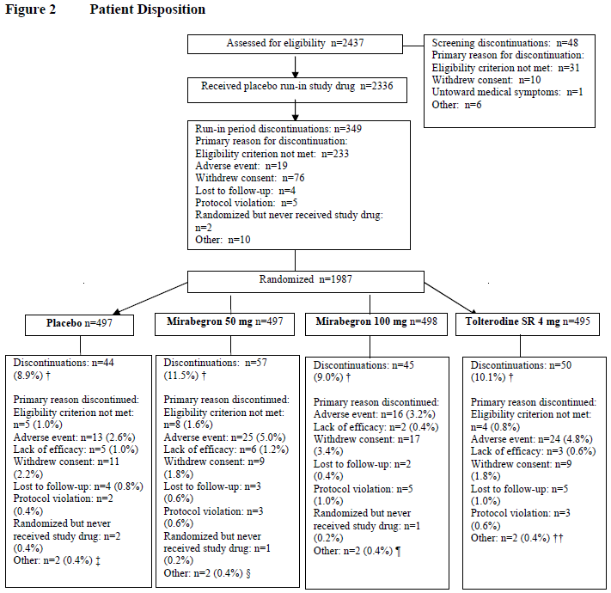

Major protocol violations/deviations
Protocol deviations are summarised in the table below. A range of deviations occurred, with the most common being failure to complete the micturition diary for the full study period. Overall, these deviations were similar across treatment groups and do not appear likely to have introduced any major biases into the study.
Table 7. Reasons for Exclusion from the Per Protocol Analysis Set, FAS, Study 046
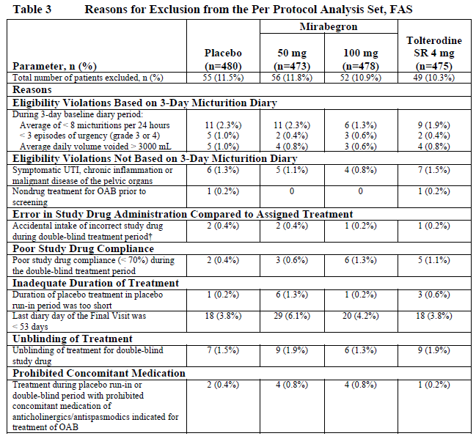

Baseline data
Baseline data in the full analysis set (FAS) is summarised in the tables below. In terms of demographics (Table 8), the groups were well-matched at baseline. They were moderately well-matched in terms of previous OAB history (Table 10), but the proportion of patients with prior OAB surgery was slightly higher in the mirabegron 50mg group than in other groups. This could indicate a slightly more refractory population in this group, and might be expected to make it more difficult to demonstrate the efficacy of mirabegron. The baseline micturition frequencies (Table 11) were well-matched. Overall, the minor differences at baseline are not likely to have compromised interpretation of the results.
Table 8. Summary of Patient Demographics and Baseline Characteristics, FAS, Study 046
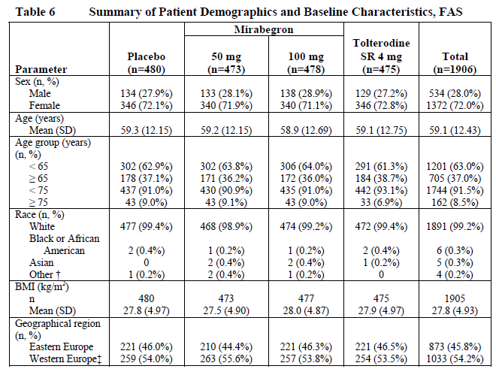
Table 9. Overactive Bladder History, FAS, Study 046
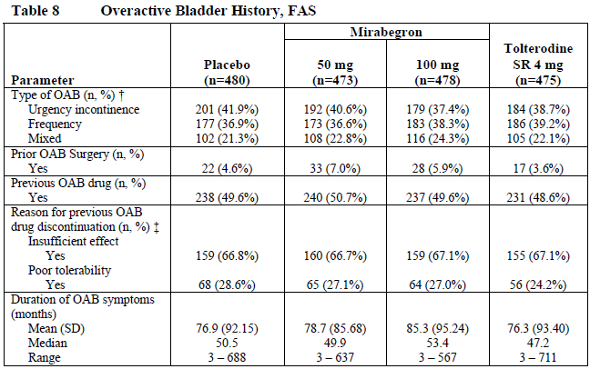
Table 10. Overactive Bladder-related Baseline Characteristics, FAS, Study 046
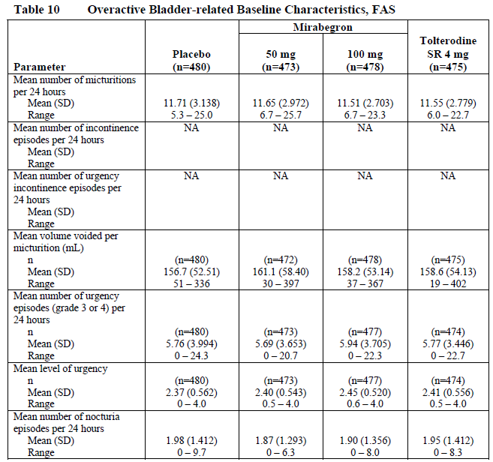

Results for the primary efficacy outcome
Results for the two co-primary endpoints and three key secondary endpoints are summarised in the table below. This study was positive for both of its co-primary endpoints, but the magnitude of the treatment effect was small.
A beneficial change from baseline (BL) to final visit (FV) in the mean number of micturitions was observed in all treatment groups, including the placebo group. In placebo recipients, the mean improvement in micturition frequency was 1.34 episodes per 24 hrs (95%CI for change was -1.55 to -1.12) from a baseline of 11.7 episodes per 24 hrs. This is likely to be due to a combination of the placebo effect and regression to the mean. A pronounced placebo response in urinary urgency studies has been noted by many investigators and is explicitly mentioned in the EU guide for analysis of such studies. Given that voluntary voiding can often be postponed, and that urgency is subjective, many patients may have deferred voiding in the expectation of a response to treatment, lowering their micturition frequency. Also, subjects with variable urgency are likely to have been recruited during periods of greater urgency and then regressed to their average level of urgency during the course of the study.
Compared to the placebo effect, the actual treatment effect was even smaller: the lower dose group (mirabegron 50mg) experienced a reduction of 0.6 micturition episodes per 24 hrs (based on the adjusted mean change) compared to placebo, and the higher dose group (mirabegron 100mg) experienced a reduction in micturition frequency of 0.44 episodes per 24hrs. Across both mirabegron groups, the treatment effect was about half an episode of micturition. That is, over the course of two days, when ~23 episodes of voiding would be expected, about one episode of voluntary voiding would be prevented by active treatment. This hardly seems clinically worthwhile, though it was statistically significant. (For p-values in all pivotal studies and for all major endpoints, see Section 7.3).
The change in micturition frequency with tolterodine was even more disappointing: the adjusted mean difference from placebo was 0.25 episodes per 24 hrs, or one episode of micturition prevented every four days, with a 95% CI including the possibility of zero difference from placebo.
Table 11. Results for Coprimary and Key Secondary Endpoints, Study 046
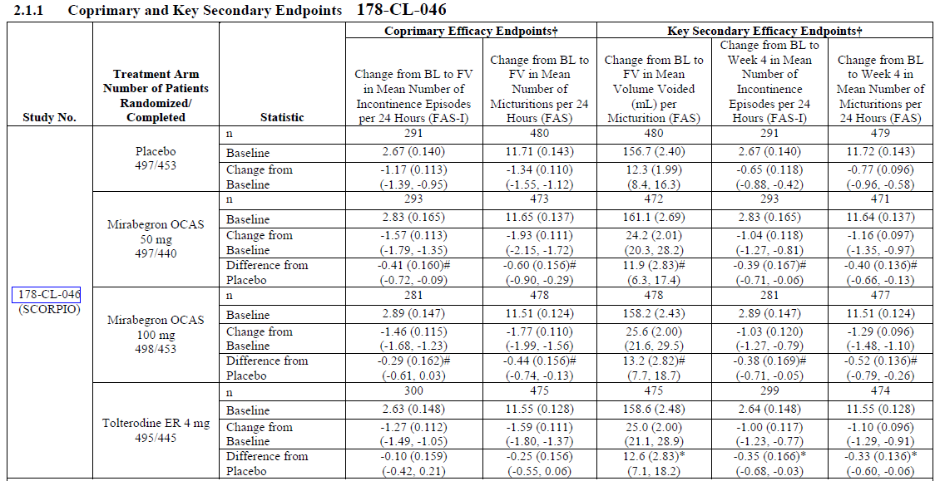
These results are displayed graphically below. Note that the sponsor’s method of displaying the results provides no reference to the baseline values, and the vertical axis has been scaled so that the modest improvements discussed above take up most of the vertical space. If the vertical axis showed actual micturition frequency (rather than change in frequency) and ranged from zero up to the baseline values of 11-12, the fall in frequency with treatment would have a shallow gradient rather than the steep fall displayed. As a percentage of baseline urinary frequency, the treatment effect was only 5% (0.60/11.65) and 4% (0.44/11.51) respectively.
Figure 9. Adjusted Mean Change in Micturition Frequency, Study 046
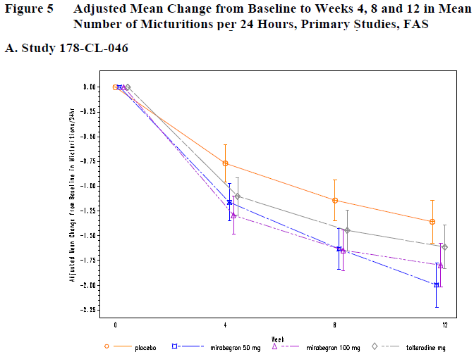
The other co-primary endpoint, incontinence frequency, was only assessed in the FAS-I subgroup, which included about 60% of subjects. The placebo effect for this endpoint was quite pronounced: from a baseline incontinence frequency of 2.67 episodes per 24 hrs, the placebo group experienced a mean reduction of 1.17 episodes (95%CI -1.39 to -0.95). This degree of improvement would be clinically worthwhile if sustained – it represents an approximate halving of baseline incontinence – but it has been achieved without active treatment and is likely to reflect psychological placebo effects and regression to the mean.
Compared to the placebo effect, the additional improvement in incontinence attributable to active treatment was modest. In the mirabegron 50mg dose group, the mean reduction in incontinence compared to placebo was 0.41 episodes. In the mirabegron 100mg dose group, the reduction was 0.29 episodes per 24 hours (about one episode prevented every three to four days). This is of marginal clinical value. For the mirabegron 50mg group, the treatment-effect of 0.41 episodes represents 14% of the baseline incontinence (0.41/2.83) and 26% of the observed improvement (0.41/1.57). For the mirabegron 100mg group, the treatment-effect of 0.29 episodes represents 10% of baseline incontinence (0.29/2.89) and 20% of the observed improvement (0.29/1.46).
These results are displayed in the table above, and represented graphically below. The y-axis has again been scaled so that the change takes up most of the vertical space.
Figure 10. Adjusted Mean Change in Incontinence Frequency, Study 046
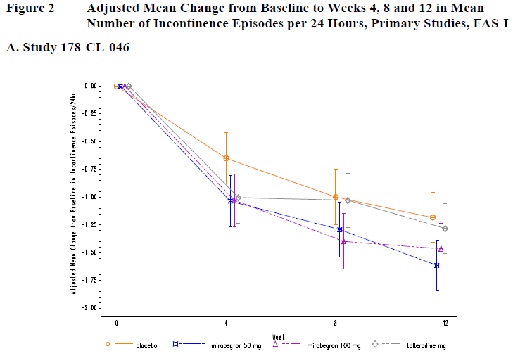

Results for other efficacy outcomes
Results for key secondary endpoints are included in the last three columns of the table above, reproduced below. The volume voided per micturition was ~160mL in all groups at baseline, and increased by a mean of 12.3 mL in the placebo group, 24.2 mL with mirabegron 50mg, 25.6 mL with mirabegron 100mg, and 25 mL with tolterodine. The mean differences from placebo were 12-13 mL across all active groups, with 95%CIs showing that these differences were significantly separated from the placebo results. The tolterodine results were similar to the mirabegron results. Despite achieving statistical significance, the clinical value of storing another 12 mL of urine between voids is marginal. The results are depicted graphically below; again the y-axis has been scaled according to the maximum change in volume, not the baseline volume.
Figure 11. Adjusted Mean Change in Volume Voided, Study 046
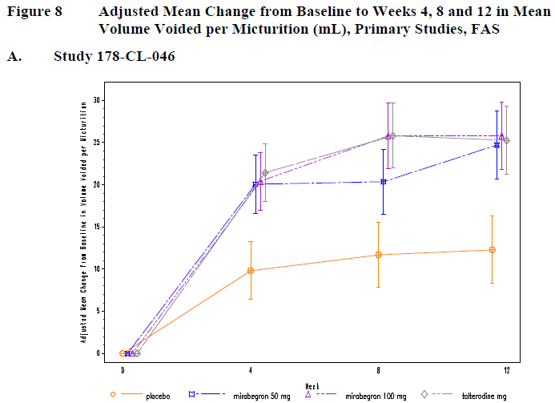
Changes for the key efficacy variables of incontinence and micturition frequency were also assessed at the non-primary endpoint of 4 weeks. Differences from placebo were broadly similar to the 12-week results, as is best appreciated from the figures above. The frequency of micturition and the frequency of incontinence both continued to improve across the 12 week study, a pattern that was also seen with the placebo group. There was no consistent pattern in the difference between active and placebo treatment in this regard. For micturition frequency, the difference from placebo was 0.40 episodes and 0.52 episodes at 4 weeks, compared to 0.6 and 0.44 at 12 weeks for the 50mg and 100mg dose groups, respectively.
Table 12. Results for Key Secondary Endpoints, Study 046
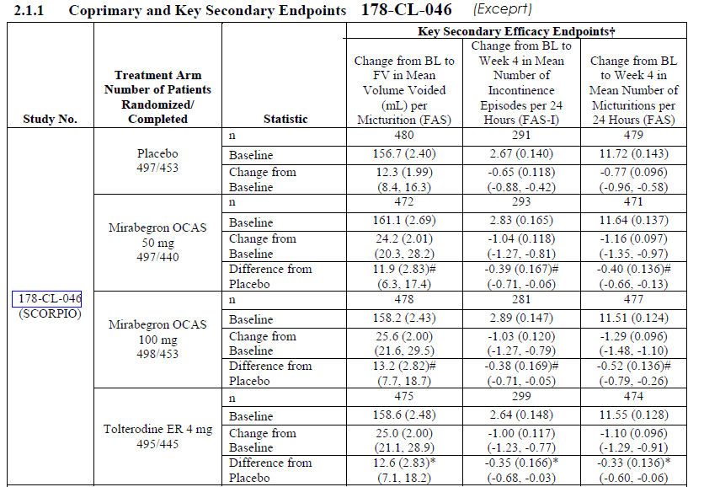
Results for non-key secondary endpoints are listed below. The mean ‘level of urgency’ (PPIUS) was ~2.4 at baseline across all groups (based on a 5-point rating scale). This is intermediate between the scale points designated “2. Moderate urgency, I could postpone voiding for a short while, without fear of wetting myself” and “3. Severe urgency, I could not postpone voiding, but had to rush to the toilet in order not to wet myself.” During the course of the 12-week study, placebo recipients improved by 0.22 of a grade, on average. Mirabegron recipients showed a slightly greater improvement: 0.31 in the 50mg group and 0.30 in the 100mg group, representing a placebo-subtracted difference of 0.09 and 0.08, respectively. The clinical value of a change this small is unclear. Tolterodine showed a similar mild treatment effect (mean 0.07 points better than placebo). The 95% CIs were consistent with a marginally significant treatment effect in all active groups, approaching zero (no effect) within 0.01 or 0.02 points.
The second column of results below shows the incidence of urgency incontinence at Final Visit (FV), which is a subset of the primary efficacy variable, total (all-cause) incontinence. For this endpoint, the improvements observed during the study and the differences relative to placebo were broadly similar to those observed for all-cause incontinence, but of lower magnitude: the placebo-subtracted treatment effect was 0.35 episodes for the mirabegron 50mg group and 0.22 for the 100mg group (compared to 0.41 and 0.29 for all-cause incontinence). For the 50mg group, the difference from placebo was statistically significant as reflected in the 95%CIs (-0.65 to -0.05 episodes); for the 100mg group, the 95% CI included zero effect (-0.53 to +0.09). Tolterodine showed a difference from placebo of only 0.07 episodes, which was not significant (95%CI -0.38 to 0.23).
The table also shows the incidence of episodes with higher grade urgency (Grade 3 or 4), which improved from baseline in all groups, including placebo. The 95%CIs for the difference from placebo showed a significant treatment effect for mirabegron 50mg, but not for mirabegron 100mg or tolterodine (see table below).
The number of episodes of nocturia was also assessed. At baseline, most subjects were voiding about twice per night. The number of episodes of nocturia improved in all groups, with greater increases seen with active treatment. The differences compared to placebo were clinically modest: 0.15 episodes for the mirabegron 50mg group and 0.09 for the 100mg group. The 95%CIs show that these differences narrowly achieved statistical significance. For tolterodine, the improvement in nocturia was similar to that seen with placebo and not statistically significant (see table below).
Table 13. Results for Non-key Secondary Endpoints, Study 046
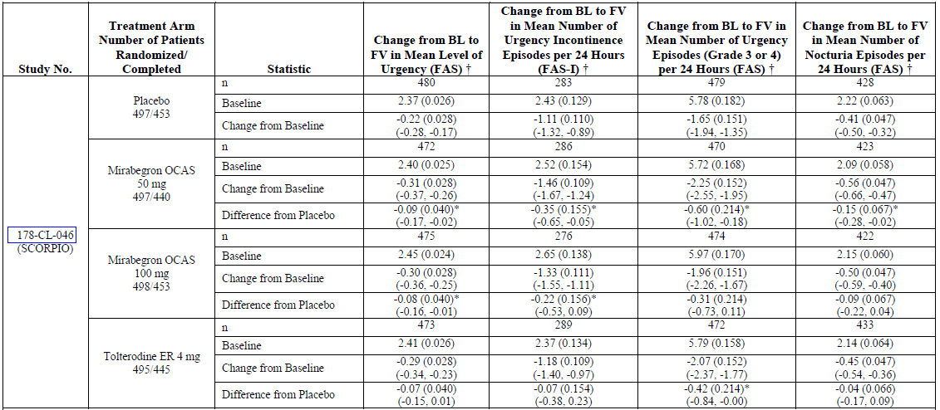
The mean number of incontinence pads used per 24 hours improved in all groups, including placebo. The changes in the active groups were slightly better than in the placebo group, but the placebo-subtracted differences were not significant at Week 12 or the Final Visit, and the 95%CIs included zero, as shown in the tables below.
Table 14. Change from Baseline in Mean Number of Pads Used Per 24 Hours, Study 046
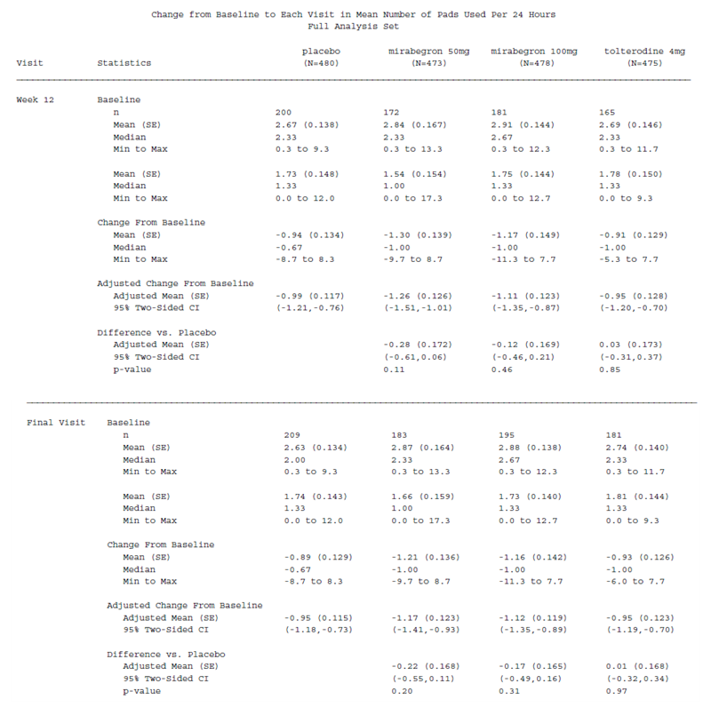
Results for subjective endpoints are listed below. On a visual analog scale (VAS), all treatment groups including placebo reported a favourable change in ‘Treatment Satisfaction’ and the differences were greater in the active groups, with the 95%CIs showing that these differences were significant (see the table below). The magnitude of the between-group differences was small, however: 0.66 for the mirabegron 50mg group, and 0.77 for the 100mg group, out of a 10-point scale. (Subjects indicated a rating of about 4 at baseline, so complete satisfaction with treatment would potentially produce a 6-point improvement.) Results in the tolterodine group were similar, with a placebo-subtracted improvement of 0.55.
Symptom bother was assessed from the symptom-bother subscale of the OAB-q, which potentially ranges from 0-100; at baseline the mean symptom bother was about 50 in all groups, and improved (decreased) in all groups during the course of the study. The mean placebo improvement was substantial (-14.9 points), and the additional improvement with active treatment was more modest (4.7 points in the mirabegron 50mg group, 5.0 points in the 100mg group). These differences were statistically significant, but it is difficult to know what such a difference means in clinical terms. (Ironically, the more quantitative primary endpoints such as improvement in incontinence frequency, actually give a clearer idea of how much the drug is likely to have reduced the ‘bother’ of symptoms, because we can at least imagine what it would be like to have one less episode of incontinence every 2-3 days.)
The other domains of the OAB-q were converted to a mean HRQL score, potentially ranging from 0-100. HQRL was rated as about 60 at baseline, and improved in all groups, with slightly greater improvement in the mirabegron groups compared to placebo. The 95%CIs excluded zero, but only by 0.2 points and 1.2 points in the 50mg and 100mg groups, respectively, a trivial difference in a 100 point scale.
The PPBC showed a similar pattern, with modest improvements in all groups, including the placebo group, and marginally significant superiority demonstrated for mirabegron 100mg. The mirabegron 50mg group was numerically superior to placebo but the 95%CI narrowly included zero.
For the subjective endpoints, tolterodine was significantly superior to placebo for some measures (TS-VAS, symptom-bother) but not others (HRQL, PPBC).
Table 15. Subjective Endpoints, Study 046
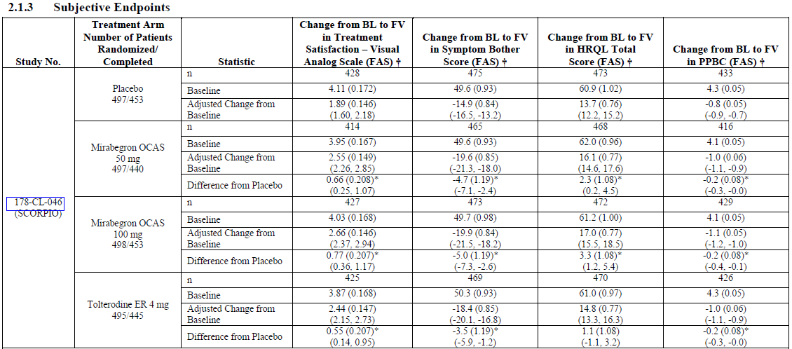
The table below summarises the major subjective endpoints (TS-VAS, Symptom Bother, HQRL) across all three pivotal studies, with p-values as well as 95%CIs. The study being discussed (Study 046) was broadly consistent with Study 047, which employed similar doses.
Table 16. Adjusted Mean Difference vs Placebo in Change from Baseline for TS-VAS, Symptom Bother Scale and Health-Related QOL Total Score, Studies 046, 047 and 074
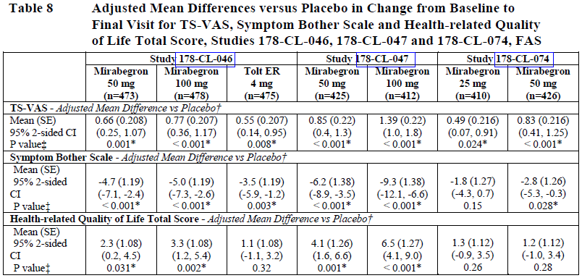

Subgroup analyses
Although the sponsor presented subgroup analyses for the co-primary endpoints, this analysis was relatively underpowered. A more meaningful subgroup analysis was performed on the pooled pivotal data, and this is presented in Section 7.3.

Per protocol analyses
The sponsor reassessed all major endpoints in the per protocol population. Overall, the results were very similar to the FAS analysis (data not shown), suggesting that protocol deviations did not distort the overall findings of the study.

Pivotal Study 047

Study design, objectives, locations and dates
This was a phase 3, randomised, parallel-group, placebo-controlled, double-blind, multinational study assessing the efficacy of placebo, mirabegron 50mg or mirabegron 100mg in female and male adults with symptoms of OAB (urinary frequency and urgency with or without incontinence) present for at least 3 months.
The study was conducted in 132 sites in the US (115 sites) and Canada (17 sites), from 28 March 2008 to 22 April 2009.

Inclusion and exclusion criteria
Inclusion and exclusion criteria for Study 047 were the same as for Study 046. The inclusion criteria are listed below. For exclusion criteria, see the corresponding section for Study 046.
Inclusion criteria at screening
- Patient ≥ 18 years of age, of either gender.
- Had symptoms of OAB (urinary frequency and urgency with or without incontinence) for ≥ 3 months.
- Able to give written informed consent.
- Willing and able to complete the micturition diary and questionnaires.
Inclusion criteria at baseline
- Frequency of micturition on average ≥ 8 times per 24-hour period during the 3-day micturition diary period.
- At least 3 episodes of urgency (grade 3 or 4) with or without incontinence during the 3-day micturition diary period.

Study treatments
As in Study 046, all subjects completed a single-blind placebo run-in period of 2 weeks. Eligible patients were then randomised to receive placebo, mirabegron 50mg or mirabegron 100mg orally once daily for 12 weeks. Unlike Study 046, there was no active control.

Efficacy variables and outcomes
The following bulleted lists of endpoints are repeated essentially verbatim from the main study report. Overall, these endpoints were very similar to Study 046 and were broadly appropriate.
The two co-primary endpoints were identical to Study 046. The number of additional secondary endpoints in Study 047 seemed somewhat excessive, with the same variables being reassessed at multiple time points. The secondary endpoints included several subjective assessments; the conduct and validity of these have already been discussed in the corresponding section for Study 046.
Co-primary Endpoints
- Change from baseline to end of treatment (Final Visit) in mean number of incontinence episodes per 24 hours based on a 3-day micturition diary
- Change from baseline to end of treatment (Final Visit) in mean number of micturitions per 24 hours based on a 3-day micturition diary
Key Secondary Endpoints
- Change from baseline to Final Visit in mean volume voided per micturition
- Change from baseline to week 4 in mean number of incontinence episodes per 24 hours based on a 3-day micturition diary
- Change from baseline to week 4 in mean number of micturitions per 24 hours based on a 3-day micturition diary
Additional Secondary Endpoints
Endpoints derived from the micturition diary:
- Change from baseline to week 8 and week 12 in mean number of incontinence episodes per 24 hours
- Change from baseline to week 8 and week 12 in mean number of micturitions per 24 hours
- Change from baseline to week 4, week 8 and week 12 in mean volume voided per micturition
- Change from baseline to week 4, week 8, week 12 and Final Visit in mean number of urgency incontinence episodes per 24 hours
- Change from baseline to week 4, week 8, week 12 and Final Visit in mean number of urgency episodes (grades 3 or 4) per 24 hours
- Change from baseline to week 4, week 8, week 12 and Final Visit in mean level of urgency
- Change from baseline to week 4, week 8, week 12 and Final Visit in mean number of nocturia episodes per 24 hours
- Change from baseline to week 4, week 8, week 12 and Final Visit in mean number of pads used per 24 hours
Additional secondary efficacy variables not derived from the 3-day diary:
- Change from baseline to week 4, week 8, week 12 and Final Visit in Symptom Bother and HRQL scores as assessed by the OAB-q questionnaire
- Change from baseline to week 12 and Final Visit in scores as assessed by the WPAI:SHP questionnaire
- Change from baseline to week 4, week 8, week 12 and Final Visit in scores as assessed by the EQ-5D questionnaire
- Change from baseline to week 4, week 8, week 12 and Final Visit in scores as assessed by the EQ-5D VAS questionnaire
- Change from baseline to week 12 and Final Visit in PPBC
- Change from baseline to week 12 and Final Visit in TS-VAS
- Change from baseline to week 4, week 8, week 12 and Final Visit in number of physician visits for patient’s bladder condition (excluding study-related visits)

Randomisation and blinding methods
Randomisation was performed equally to all treatment groups, including placebo, using a computerised randomisation scheme prepared by Pierrel Research Europe. Randomisation was stratified by centre.
The study employed a double-dummy blinding technique. Throughout the study, subjects received 2 study drug tablets (mirabegron 50mg or matching placebo, mirabegron 100mg or matching placebo).

Analysis populations
The analysis populations were as defined for Study 046: the Full Analysis Set (FAS), FAS-incontinence set (FAS-I), Per Protocol Set (PPS) and the Safety Analysis Set (SAF).

Statistical methods
This study used the same co-primary endpoints as Study 046, and analysed these with the same statistical methods (see Section 7.1.1.7). Overall, the statistical methodology was appropriate.

Sample size
Sample size considerations for Study 047 were as already described for Study 46. The study achieved its recruitment targets and demonstrated statistical significance for its primary endpoints, indicating an adequate sample size.

Participant flow
Patient disposition is summarised in the figure below. The proportion of patients discontinuing after randomisation was 12.2% to 15.2% across the three treatment groups, with about 4% withdrawing because of adverse events. This is reasonable for a study of this nature and duration. Withdrawals were higher in the placebo group, and there is no evidence that significant withdrawal bias contributed to the positive results of this study.
Figure 12. Patient Disposition, Study 047
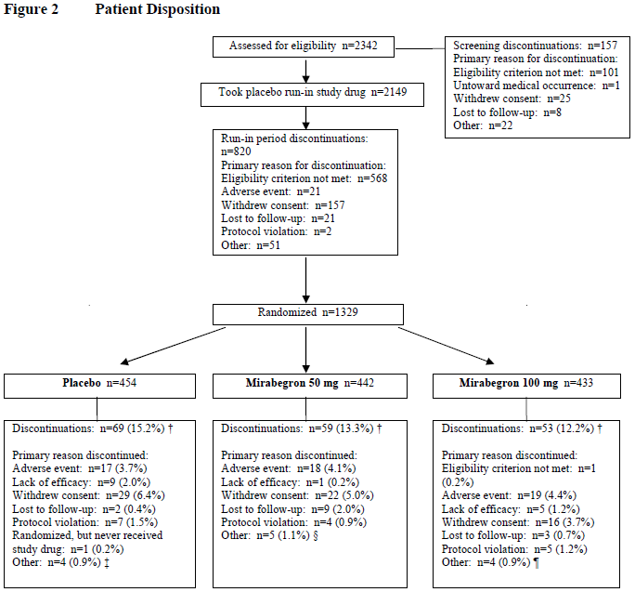

Major protocol violations/deviations
Significant protocol deviations are categorised in the table below. Major protocol violations included 4 patients who were randomised twice and received 2 double-blind treatment assignments from different centres. Sensitivity analyses excluding these 4 patients (8 subject numbers) did not produce different conclusions. Overall, the number of violations was acceptable for a complex study of this nature. The most common protocol violation was a failure to fill in the diary adequately, seen in 3.4 to 6.5% of subjects across the three treatment groups.
Table 17. Reasons for Exclusion from the Per Protocol Set, Study 047
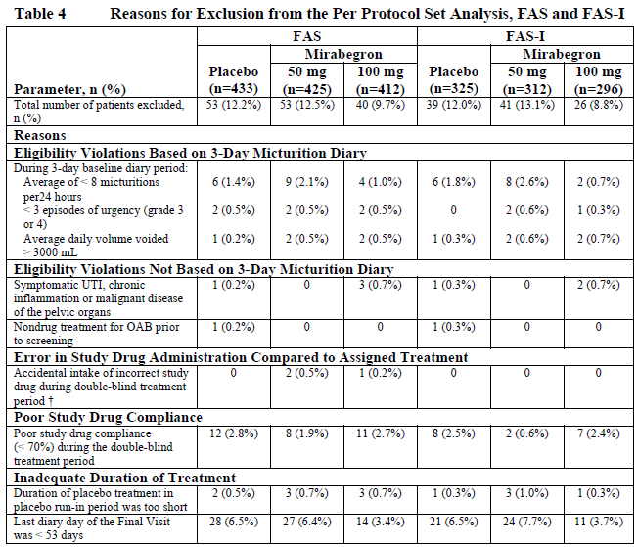

Baseline data
Baseline data in Study 047 is summarised in the tables below. Each group appeared reasonably well balanced in terms of demographics (Table 18), prior OAB history (Table 19) and characteristics of their OAB at the time of screening (Table 20).
Note that the FAS-I population included some patients who were designated as having ‘frequency’ rather than ‘urgency incontinence’ or ‘mixed incontinence’, and yet they had to have incontinence to enter the FAS-I population. This apparent contradiction arises from the fact that FAS-I was defined on the basis of the baseline micturition diary, whereas prior OAB history refers to the patients’ previous reported experience of OAB. The same discrepancy was seen in Study 074, and it suggests that patients under-reported their incontinence when describing their prior OAB experience. The same effect is observed in all treatment groups, and does not undermine the basic conclusions of the studies.
Table 18. Summary of Patient Demographics and Baseline Characteristics, Study 047
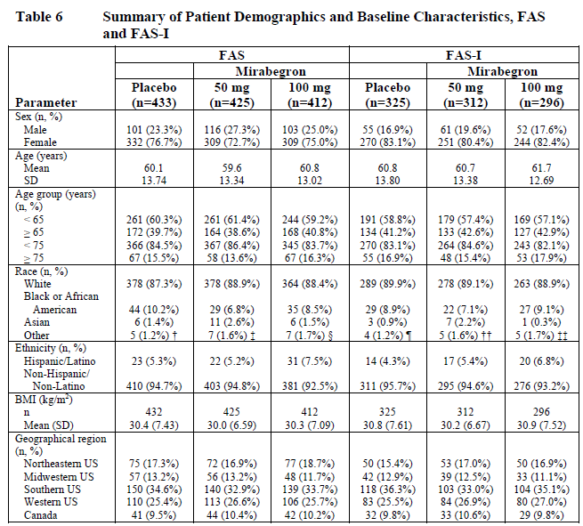
Table 19. Overactive Bladder History, Study 047
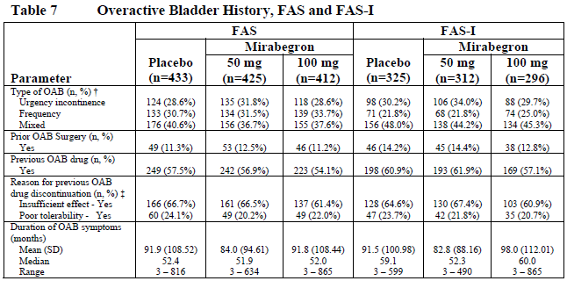
Table 20. Overactive Bladder-related Baseline Characteristics, Study 047
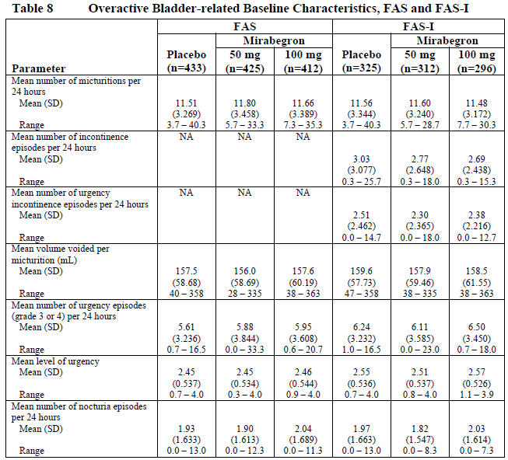

Results for the primary efficacy outcome
This study was positive for both of its co-primary endpoints. The major results for Study 047 are shown in the table below, including the two co-primary efficacy endpoints and key secondary endpoints. The results are broadly similar to those already discussed in Study 046, including the magnitude of the placebo response and the size of the placebo-subtracted treatment effect.
At baseline, subjects had a mean micturition frequency of about 12 episodes per 24 hours, and this was reduced during treatment in all groups. The placebo group showed a mean reduction of 1.05 episodes by the Final Visit. The mirabegron groups showed a significantly greater reduction, but the placebo subtracted difference was less than one voiding episode per day in both dose groups. For the 50mg dose, the placebo-subtracted treatment effect was 0.61 episodes per 24 hours (95%CI -0.98 to -0.24). For the 100mg dose, the treatment effect was 0.70 episodes per 24 hours (95%CI -1.07 to -0.33).
Table 21. Results for Coprimary and Key Secondary Endpoints, Study 047
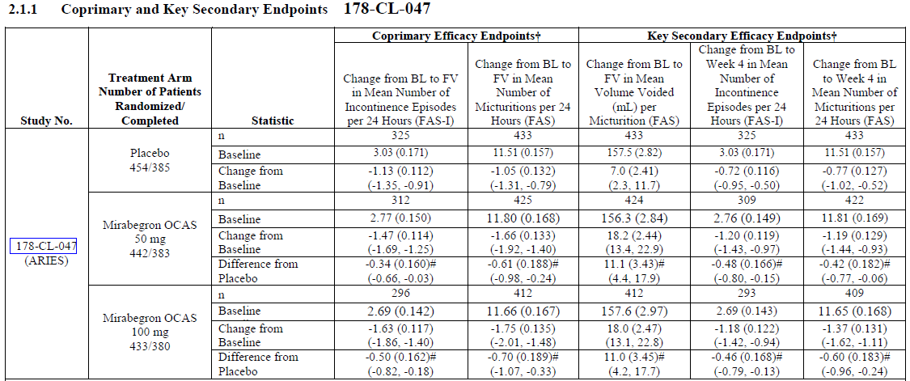
For the more distressing endpoint of incontinence, a statistically significant treatment effect was also demonstrated, but the magnitude of the benefit was small. In the placebo group, incontinence reduced during the study by a mean of 1.13 episodes per 24 hours, from a baseline mean of 3.03 episodes. On average, active treatment with mirabegron helped prevent an additional episode every two to three days: the placebo-subtracted treatment effect was 0.34 episodes per 24 hours in the 50mg group, with the 95%CI narrowly excluding zero (95%CI -0.66 to -0.03); the placebo-subtracted treatment effect was 0.50 episodes per 24 hours in the 100mg group (95%CI -0.82 to -0.18). Given the mean baseline frequency of 2.77 episodes in the 100mg group, this means that mirabegron 100mg would be expected to prevent about one episode of incontinence every two days in subjects expected to have ~8 episodes in that period. For some patients, this modest improvement could be considered worthwhile, but most would consider it disappointing.
The results for both co-primary endpoints are displayed graphically below. Note, again, that the vertical axes have been scaled in a way that gives no reference to the modest proportional changes from baseline.
Figure 13. Adjusted Mean Change in Incontinence Frequency, Study 047
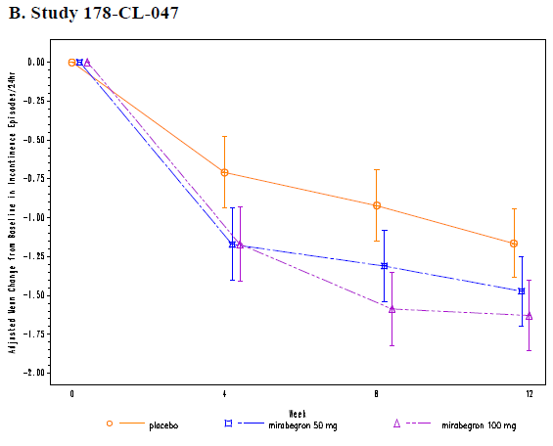
Figure 14. Adjusted Mean Change in Micturition Frequency, Study 047
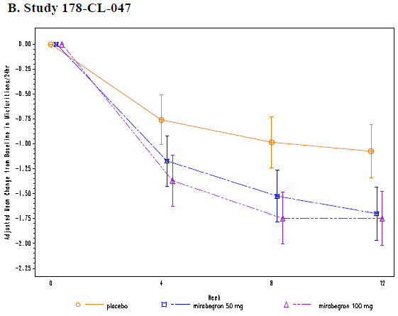

Results for other efficacy outcomes
Results for key secondary endpoints are shown in the table excerpt below. As in the previous study, active treatment was associated with an increase in voided volume by about 11 mL compared to placebo, which was statistically significant as shown by the 95%CIs, but of doubtful clinical value. The Week 4 results for the major variables of interest (micturition frequency and incontinence frequency) were similar to those observed at 12 weeks, in terms of the difference from placebo, and achieved statistical significance. For the 50mg group, the placebo-subtracted difference for micturition frequency was 0.42 at 4 weeks; the placebo-subtracted difference for incontinence was 0.48 at 4 weeks. For the 100mg group, the placebo-subtracted difference for micturition frequency was 0.60 at 4 weeks; the placebo-subtracted difference for incontinence was 0.46 at 4 weeks.
Table 22. Results for Key Secondary Endpoints, Study 047
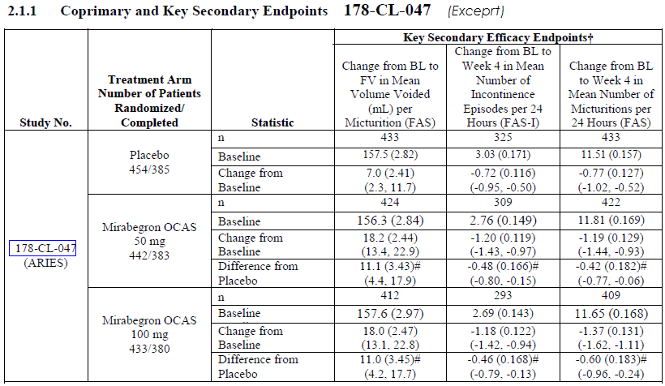
Figure 15. Adjusted Mean Change in Volume voided, Study 047
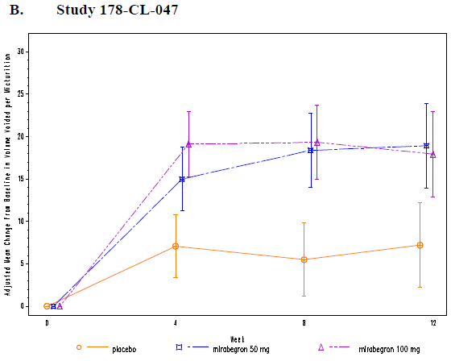
The other diary-derived secondary endpoints are displayed in the table below. All groups showed an improvement in the mean level of urgency, but the magnitude of the change was small: the placebo group showed a mean 0.08 reduction in the 5-point scale, and active treatment was associated with an additional reduction of about one eighth or one ninth of a scale point. The 95%CIs narrowly excluded zero. For the 50mg group, the placebo-subtracted change in urgency level was -0.11 (95%CI -0.18 to -0.04); for the 100mg group, the mean placebo-subtracted change was -0.13 (95%CI -0.20 to -0.05). The clinical value of this reduction is questionable.
The reduction in urgency incontinence was similar to the reduction in overall all-cause incontinence. The placebo group showed a mean reduction of 0.89 episodes per 24 hours, from a mean baseline of 2.56 episodes. The mirabegron 50mg group showed an additional placebo-subtracted reduction of 0.43 episodes (95%CI for change, -0.72 to -0.15); the 100mg group showed an additional reduction of 0.56 episodes (95%CI -0.85 to -0.28).
As shown in the table, there was also a significant reduction in the mean number of episodes of higher-grade (Grade 3-4) urgency episodes, with the placebo-subtracted differences suggesting that active treatment shifted a bit less than one episode of urgency per day into the lower urgency categories. (Note that this endpoint had been negative for the 100mg dose group in the previous pivotal study, 046). Nocturia was significantly reduced from a baseline of 2-3 episodes, but the placebo-subtracted difference was less than one fifth of an episode, meaning that less than one episode of nocturia would be prevented every five days by active treatment. This is of marginal clinical value, and was only marginally statistically significant – the 95%CIs closely approached zero, reaching -0.01 (one episode prevented every hundred days) in both dose groups.
Table 23. Results for Non-key Secondary Endpoints, Study 047
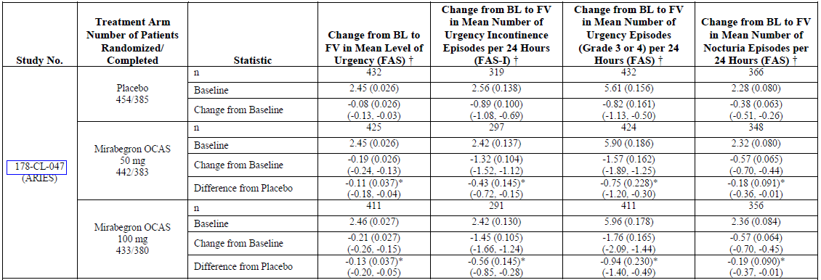
In subjects who used incontinence pads, there was a significant reduction with active treatment, as shown in the tables below, the placebo-subtracted difference was 0.41 pads per 24 hrs in the 50mg group and 0.46 in the 100mg group.
Table 24. Change from Baseline in Mean Number of Pads Used Per 24 Hours, Study 047
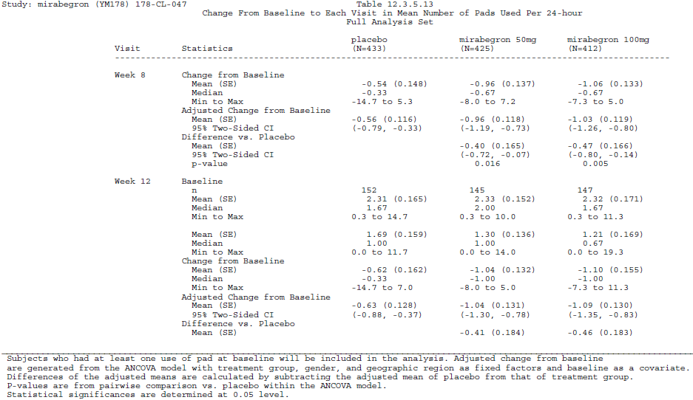
Subjective endpoints are displayed below. The adjusted change from baseline was consistent with improvement for all subjective endpoints and for all treatment groups (for symptom bother and for PPBC, negative changes indicate a lessening of symptoms). The placebo-subtracted differences were modest. For the TS-VAS, the placebo-subtracted difference amounted to 0.85 and 1.39 for the 50mg and 100mg groups, respectively, on a 10-point scale. For the symptom bother subscale of the OAB-q, the placebo-subtracted difference from baseline was -6.2 and -9.3, respectively, in a 100-point scale. For HRQL, the placebo-subtracted improvements were 4.1 and 6.5, respectively, on a 100-point scale. For PPBC, mean reductions of just 0.2 and 0.3 were observed, on a 6-point scale. For most of these endpoints, the 95%CIs for the difference from placebo excluded zero, except the 95%CI for the PPBC changes in the 50mg group, which narrowly included zero.
For all of these subjective endpoints, it is difficult to know what the mean changes signify, in terms of actual clinical benefit. Given the modest improvements in the quantifiable endpoints of micturition and incontinence frequency, it seems likely that the quality-of-life benefits were also modest, though it is reassuring that the overall changes were in the beneficial direction.
Table 25. Subjective Endpoints, Study 047
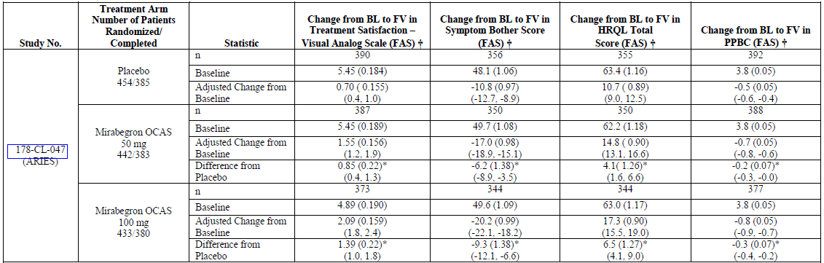

Subgroup analyses
Although the sponsor presented subgroup analyses for the co-primary endpoints, this analysis was relatively underpowered. A more meaningful subgroup analysis was performed on the pooled pivotal data, and this is presented in Section 7.4.

Pivotal Study 074

Study design, objectives, locations and dates
This was a phase 3, randomised, parallel-group, placebo-controlled, double-blind, multinational study conducted in female and male adults with symptoms of OAB (urinary frequency and urgency with or without incontinence) present for at least 3 months.
The study took place in multiple centres in Europe, Canada, and the United States from 28 April 2009 to 27 April 2010.

Inclusion and exclusion criteria
The inclusion criteria were the same as the other pivotal studies, as summarised below.
Inclusion criteria at screening
- Patient ≥ 18 years of age, of either gender.
- Had symptoms of OAB (urinary frequency and urgency with or without incontinence) for ≥ 3 months.
- Able to give written informed consent.
- Willing and able to complete the micturition diary and questionnaires.
Inclusion criteria at baseline
- Frequency of micturition on average ≥ 8 times per 24-hour period during the 3-day micturition diary period.
- At least 3 episodes of urgency (grade 3 or 4) with or without incontinence during the 3-day micturition diary period.
Exclusion criteria were essentially the same as those listed for study 046, and were aimed at excluding patients at high risk of adverse events and patients in whom the assessment of efficacy was likely to be compounded by other conditions or other treatments.

Study treatments
Study 074, like the other pivotal studies, used a single-blind placebo run-in period of 2 weeks. Following this, eligible patients were randomized in a 1:1:1 ratio to receive placebo, mirabegron 25mg or mirabegron 50mg orally daily for 12 weeks. Note that the proposed mirabegron dose of 50mg was the higher dose assessed in this study, but it was the lower dose of Studies 046 and 047, and that this study was the only pivotal study to assess a dose of 25mg.

Efficacy variables and outcomes
The study used the same two co-primary endpoints assessed in the other pivotal studies:
- Change from baseline to end of treatment (final visit) in mean number of incontinence episodes per 24 hours based on a 3-day micturition diary
- Change from baseline to end of treatment (final visit) in mean number of micturitions per 24 hours based on a 3-day micturition diary
Key secondary efficacy variables (based on the 3-day micturition diary) included:
- Change from baseline to end of treatment (final visit) in mean volume voided per micturition
- Change from baseline to week 4 in mean number of incontinence episodes per 24 hours
- Change from baseline to week 4 in mean number of micturitions per 24 hours
- Change from baseline to end of treatment (final visit) in mean level of urgency
- Change from baseline to end of treatment (final visit) in mean number of urgency incontinence episodes per 24 hours
- Change from baseline to end of treatment (final visit) in mean number of urgency episodes (grades 3 or 4) per 24 hours
Additional secondary efficacy variables derived from the 3-day micturition diary:
- Change from baseline to week 8 and week 12 in mean number of micturitions perv24 hours
- Change from baseline to week 8 and week 12 in mean number of incontinence episodes per 24 hours
- Change from baseline to week 4, week 8 and week 12 in mean volume voided per micturition
- Change from baseline to week 4, week 8 and week 12 in mean number of urgency incontinence episodes per 24 hours
- Change from baseline to week 4, week 8 and week 12 in mean number of urgency episodes (grades 3 or 4) per 24 hours
- Change from baseline to week 4, week 8 and week 12 in mean level of urgency
- Change from baseline to week 4, week 8 week 12, and final visit in mean number of nocturia episodes per 24 hours
- Change from baseline to week 4, week 8 week 12 and final visit in mean number of pads used per 24 hours
Subjective assessments included the following:
- Change from baseline to week 4, week 8, week 12 and final visit in Symptom Bother and HRQL scores as assessed by the OAB-q questionnaire
- Change from baseline to week 12 and final visit in WPAI:SHP scores
- Change from baseline to week 4, week 8, week 12 and final visit in EQ-5D scores
- Change from baseline to week 4, week 8, week 12 and final visit in EQ-5D VAS scores
- Change from baseline to week 12 and final visit in PPBC
- Change from baseline to week 12 and final visit in TS-VAS
- Change from baseline to week 4, week 8, week 12 and final visit in number of physician visits for patient’s bladder condition (excluding study-related visits)
- Change from baseline to week 12 and final visit on the Clinician Global Impression (CGI) scale (US only)
- Change from baseline to week 12 and final visit on the Patient Global Impression (PGI) scale (US only)
The last two scales (CGI and PGI) were not employed in the other pivotal studies. These were standard Likert scales similar to those used in many placebo-controlled drug studies, in which clinicians or patients assessed the change since baseline and recorded their impression in one of the following categories: ‘Very much improved’, ‘Much improved’, ‘Minimally improved’, ‘No change’, ‘Minimally worse’, ‘Much worse’, or ‘Very much worse’. (The PGI also included a second question in which subjects rated their current status instead of their change since baseline.) These endpoints were not included in the European submission and are considered of minor importance, given that several other scales, including the TS-VAS, assessed similar information.

Randomisation and blinding methods
Randomisation was performed equally between the three treatment groups, using the same computerised system as in the other pivotal studies. Randomisation was stratified by centre.
Blinding was maintained with a double-dummy technique. For unclear reasons, unblinding may have occurred at one centre, affecting one patient in each treatment group (see Section 7.1.3.10). This low level of unblinding is unlikely to have altered the results.

Analysis populations
The analysis populations were as described for Study 046, and included the FAS, FAS-I, PPS and SAF.

Statistical methods
This study used the same co-primary endpoints as Study 046, and analysed these with the same statistical methods (see Section 7.1.1.7). Overall, the statistical methodology was appropriate.

Sample size
Sample size considerations for Study 074 were essentially the same as those already described for Study 46. As with the other two pivotal studies, the study achieved its recruitment targets and demonstrated statistical significance for its primary endpoints, indicating an adequate sample size.

Participant flow
Patient disposition is summarised in the figure below. The discontinuation rate for randomised patients was 10.6% to 15.2% across the treatment groups, which is acceptable for a study of this nature. The discontinuation rate was slightly higher in the placebo group, and it does not appear likely that withdrawal bias contributed to the positive results of this study. Withdrawal due to AEs was seen in ~3-4% of subjects.
Figure 16. Patient Disposition, Study 074
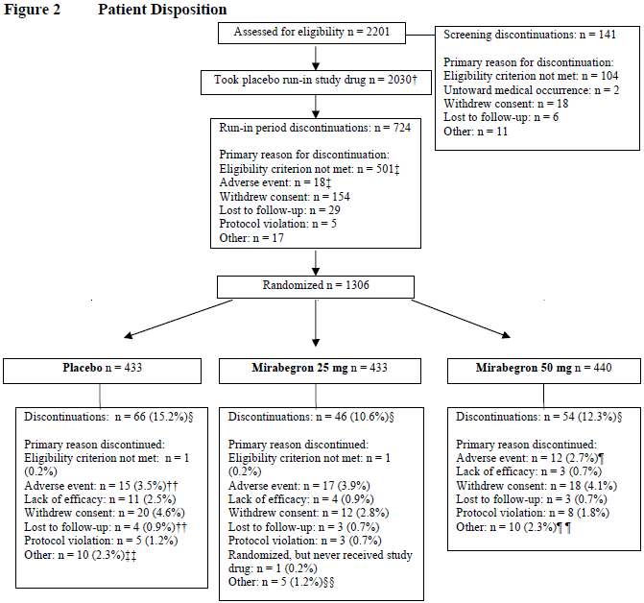

Major protocol violations/deviations
Major protocol deviations included enrolment of 9 patients who had previously enrolled in the same or similar studies, as well as some violations of entry criteria. The main protocol deviations are summarised below. The most common deviation was an incomplete micturition diary.
Table 26. Reasons for Exclusion from the Per Protocol Set, Study 074
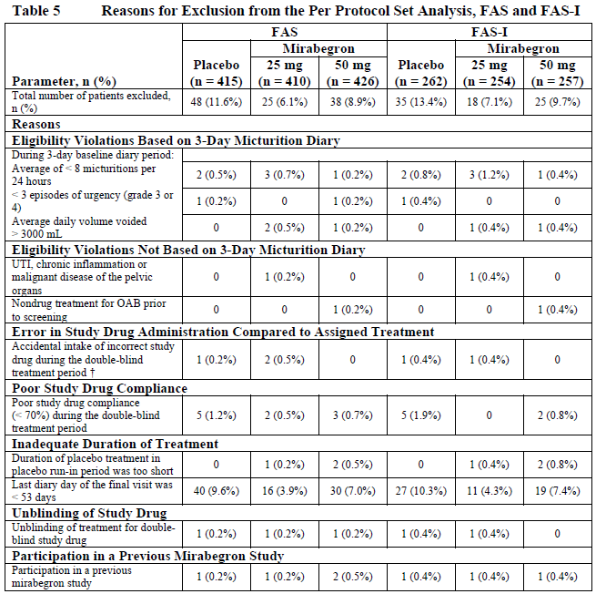

Baseline data
Baseline characteristics in the three treatment groups are summarised in the tables blow. Overall, the groups appeared well-matched in terms of demographics (Table 27), prior OAB history (Table 28) and OAB characteristics at screening (Table 29), with one exception: the proportion of patients with predominant urgency incontinence (as opposed to frequency without incontinence or mixed stress/urgency incontinence) was lower in the placebo group (28.2%) than the mirabegron 25mg group (38.0%) or mirabegron 50mg group (38.5%) of the FAS; similar differences were seen in the FAS-I population. The effects of this imbalance on the primary endpoints are difficult to predict. If the placebo group had less urge incontinence, then this might indicate milder urgency and a greater potential to reduce micturition frequency via non-pharmacological means, exaggerating the placebo effect, or it might indicate that there are less symptoms available for modification, lessening the placebo effect and enhancing the apparent treatment effect. It is unclear if the placebo response modifies mixed incontinence or stress incontinence to the same degree as urgency incontinence. Thus, the placebo response in this group might not be comparable to that in the active groups. Overall, this imbalance weakens the study slightly, but the same imbalance was not seen in the other pivotal studies, and the results across all three pivotal studies were similar, so it is unlikely to have had a major effect on the outcome.
Table 27. Patient Demographics and Baseline Characteristics, Study 074
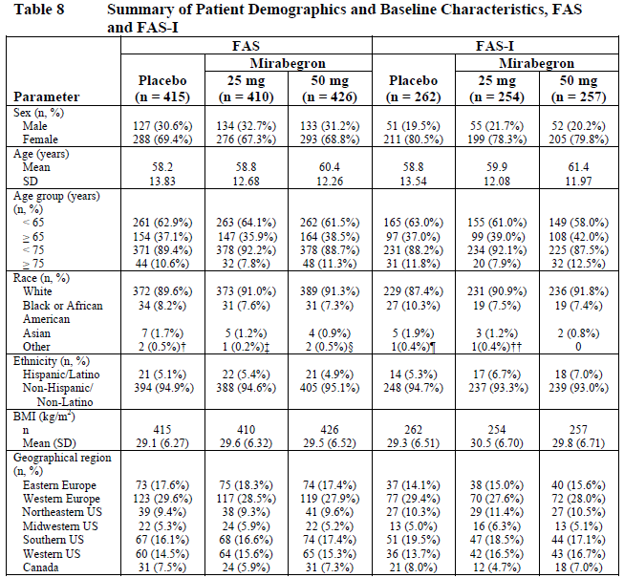
Table 28. Overactive Bladder History, Study 074
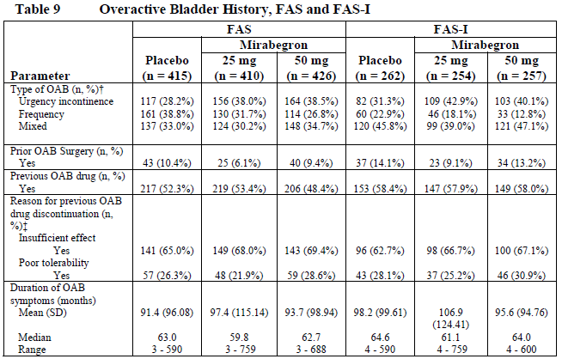
Table 29. Overactive Bladder-related Baseline Characteristics, Study 074
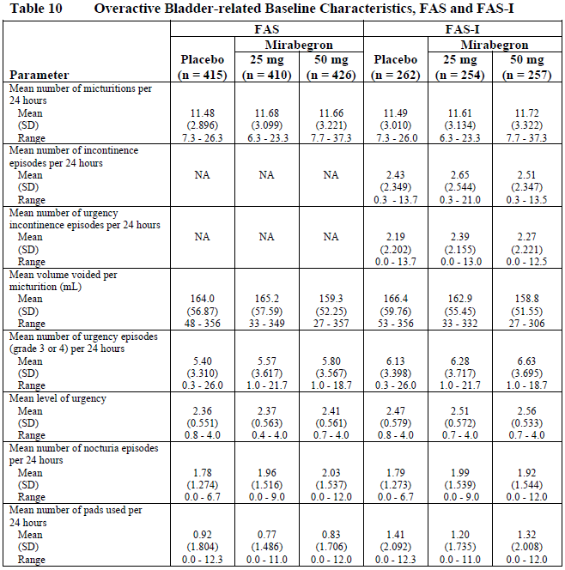

Results for the primary efficacy outcome
Results for the two co-primary endpoints and key secondary endpoints are shown in the table below. As in the other pivotal studies, the mean baseline micturition frequency was 11-12 episodes per day, with little difference between groups at baseline. All groups experienced a reduction in micturition frequency through the study, amounting to just over one episode in the placebo group (mean change -1.18 episodes per 24 hours). Active treatment with mirabegron 25mg was associated with a placebo-subtracted reduction of 0.47 episodes per 24 hours, which was statistically significant (95% CI for placebo-subtracted change -0.82 to -0.13). The 50mg dose was associated with a smaller but still significant placebo-subtracted reduction of 0.42 episodes (95%CI -0.76 to -0.08). This is similar to the previous studies, and implies that active treatment would be expected to prevent less than one episode of voiding every two days, over a time period when about 23 voids would be expected from the baseline values. This is of marginal clinical value.
For the more distressing symptom of incontinence, baseline frequency was similar to the other pivotal studies, with about two and half episodes of incontinence per day. In the placebo group, the baseline incontinence frequency was 2.43 episodes per 24 hours and this improved during the study period by 0.96 episodes. Active treatment with mirabegron 25mg was associated with a placebo-subtracted reduction of 0.40 episodes of incontinence per 24 hours, which was statistically significant (95%CI -0.74 to -0.06). The 50mg dose was associated with a similar placebo-subtracted reduction of 0.42 episodes (95%CI -0.76 to -0.08).*
Table 30. Results for Coprimary and Key Secondary Endpoints, Study 074
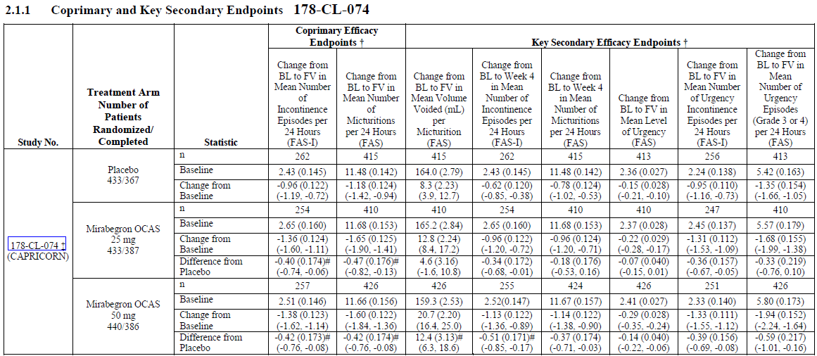
The results for the co-primary endpoints are displayed graphically below. As previously noted, the vertical scales of the graphs do not reflect the small proportional change from baseline.
Figure 17. Adjusted Change in Mean Incontinence Frequency, Study 074
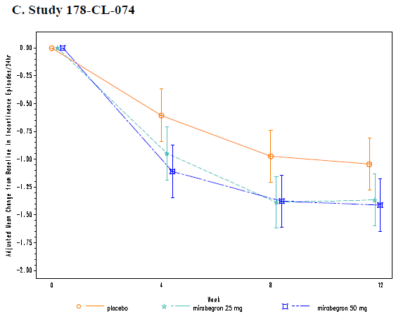
Figure 18. Adjusted Mean Change in Micturition Frequency, Study 074
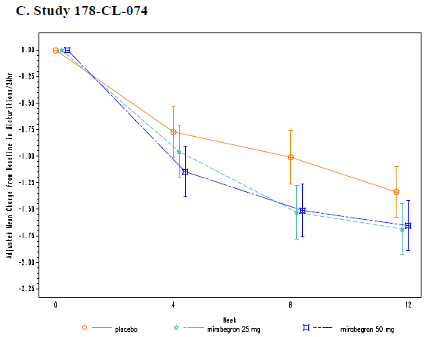

Results for other efficacy outcomes
The key secondary endpoints are shown in the table-excerpt below. For the 50mg dose, a significant difference was observed compared to placebo for all of the key secondary endpoints. For the 25mg dose, several endpoints had 95%CIs that crossed zero: significance was achieved for change in incontinence episodes at week 4 and change in urgency incontinence at final visit, but not for change in mean volume voided, change in micturition frequency at week 4, change in mean level of urgency, or change in frequency of Grade 3 or 4 urgency episodes.
Table 31. Key Secondary Endpoints, Study 074
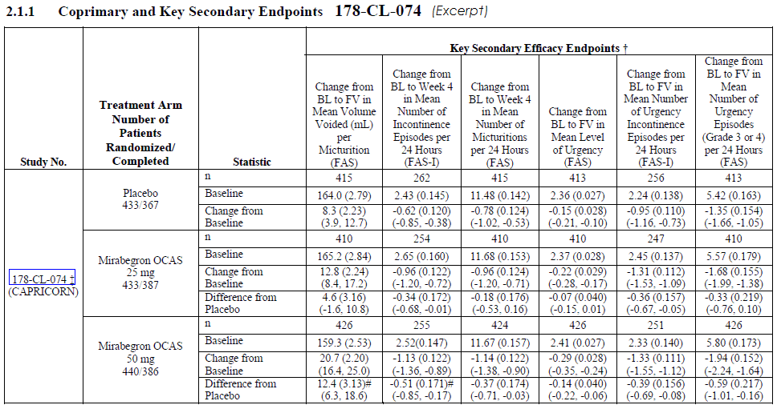
For the 50mg dose, the placebo-subtracted change in volume voided was about 12 mL, as in the other studies (mean change 12.4, 95%CI 6.3 to 18.6). The placebo-subtracted changes at week 4 in micturition frequency and incontinence frequency for the 50mg group were similar to those seen at week 12. The mean level of urgency (placebo-subtracted) was reduced with mirabegron 50mg, by 0.14 in a 5-point scale, which narrowly achieved statistical significance (95% -0.22 to -0.06), but is of questionable clinical utility. With 50mg, urgency incontinence was also reduced by 0.39 episodes per 24 hours (placebo-subtracted), which was statistically significant (95%CI for placebo-subtracted change, -0.69 to -0.08). Episodes of higher-grade urgency (Grade 3 or 4) showed a similar reduction, as shown in the table.
For the 25mg dose group, changes were generally smaller and, as already noted, did not always achieve statistical significance. For details see the table.
Figure 19. Adjusted Mean Change in Volume Voided, Study 074
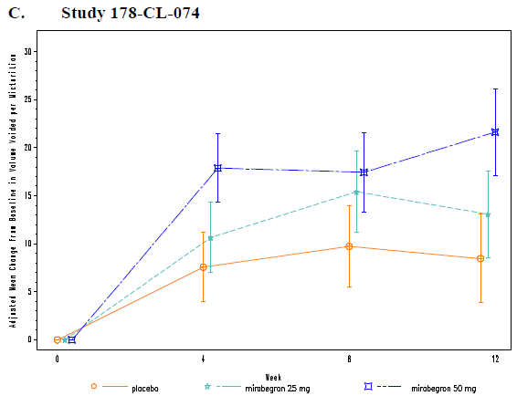
Nocturia was barely affected by active treatment, with very small mean placebo-subtracted changes (mean reductions of 0.01 and 0.04 episodes per 24 hours in the 25mg and 50mg dose groups, respectively), and this endpoint did not approach statistical significance.
Table 32. Change in Nocturia, Study 074
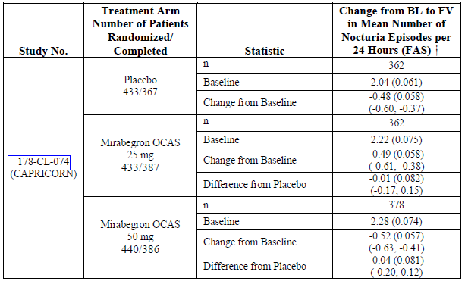
For the secondary endpoint of pad use, the results of this study were negative. In all groups, there was a reduction in the mean number of pads used per 24 hours from baseline to final visit. The difference from placebo was positive in the 25mg group (+0.16, more pad use) and negative in the 50mg group (-0.17, less pad use), with no statistical difference from placebo in either group. The table excerpt below shows the results for the Final Visit.
Table 33. Change from Baseline in Mean Number of Pads Used Per 24 Hours, Study 074
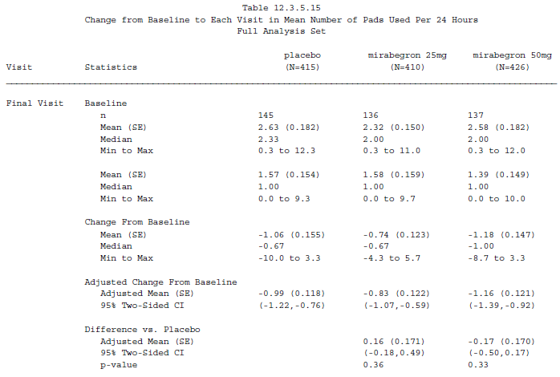
The subjective endpoints showed favourable changes in all groups including placebo, with minor numerical superiority seen with active treatment for most assessments (apart from the change in PPBC, which was the same in the placebo and mirabegron 50mg groups).
For the 25mg dose, statistical superiority over placebo was shown for the TS-VAS, but none of the other subjective endpoints in the table. For the 50mg dose, superiority was demonstrated for the TS-VAS and ‘symptom bother’ scores, but not the HRQL or PPBC. Even for measures in which a statistical effect was shown, the differences from placebo were of doubtful clinical value, with the TS-VAS showing a placebo-subtracted improvement of 0.49 for 25mg and 0.83 for 50mg, out of a 10-point scale, and the symptom bother score showing a placebo-subtracted reduction of 2.8 in a scale ranging to 100.
Table 34. Subjective Endpoints, Study 074
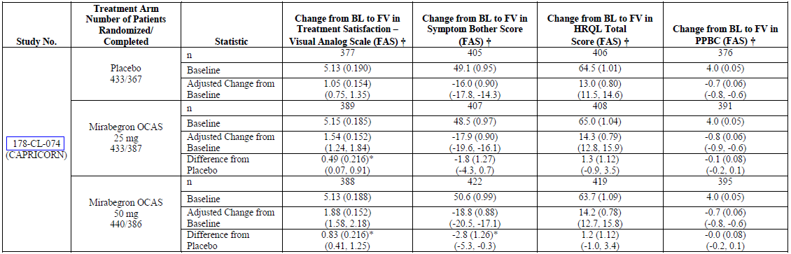

Subgroup analyses
Although the sponsor presented subgroup analyses for the co-primary endpoints, this analysis was relatively underpowered. A more meaningful subgroup analysis was performed on the pooled pivotal data, and this is presented in Section 7.3.

Supportive efficacy studies
In addition to the three pivotal phase 3 studies (Studies 046, 047 and 074), the sponsor performed a number of supportive studies, as follows:
- 1 supportive phase 3 study (178-CL-048),
- 2 supportive phase 2b studies (178-CL-045 and 178-CL-044),
- 1 phase 2a proof-of-concept study (178-CL-008),
- 1 phase 3 active-controlled long-term safety study (178-CL-049), and
- 1 phase 3 open label, long-term safety study (178-CL-051).

Supportive efficacy study 048

Design
Study 048 was a phase 3, a randomised, double-blind, placebo- and tolterodine-controlled, parallel-group, multi-centre study in which the efficacy of mirabegron was assessed in overactive bladder patients. The study consisted of a 2-week run-in period, a 12-week double-blind treatment period, and 2-week follow-up period.
Mirabegron was administered at the proposed dose of 50mg daily. Tolterodine was used at a standard dose of 4mg daily. Patients were randomised equally to mirabegron, tolterodine and placebo.
Entry criteria were generally similar to those in the pivotal studies, but patients were eligible if they had, on average, one episode of urgency per day in the baseline micturition diary; the requirement for Grade 3 or 4 urgency, which was an entry criteria for the pivotal studies, was not relevant to Study 048 because urgency was not graded in this study. Subjects were required to have at least one episode per day of episode of urge incontinence per day, however, so this population roughly corresponds to the FAS-I subgroup of the pivotal studies (rather than to the full pivotal population which included subjects without baseline incontinence).
From the study report, the entry criteria are listed as follows:
“Provisional enrolment
- Outpatient of either sex, at least 20 years of age at time of consent
- Continuous symptoms of overactive bladder for at least 24 weeks prior to start of the run-in period
- Capable of walking to toilet unaided and measuring urine volume by him-/herself.
- Has personally given written informed consent.
Formal enrolment (randomization)
Patients who satisfied inclusion criterion 3 above at provisional enrolment and all of the following criteria at formal enrolment progressed to the treatment period.
5. Averages at least 8 micturitions per 24 hours and satisfies at least one of the following conditions (confirmed from the 3-day diary entries for the run-in period).
- At least 1 urgency episode per 24 hours on average.
- At least 1 urge incontinence episode per 24 hours on average.”
Primary endpoint
The primary endpoint was the change from baseline to the final visit in mean number of micturitions per 24 hours (which therefore matched one of the co-primary endpoints of the pivotal studies).
Secondary endpoints
The frequency of incontinence, which was a primary endpoint in the pivotal studies, was only a secondary endpoint Study 048.
Other secondary endpoints were:
- the mean volume voided per micturition
- the mean number of urgency incontinence episodes per 24 hours
- the mean number of urgency episodes per 24 hours
- the mean number of nocturia episodes per 24 hours
- QOL as assessed by the King’s Health Questionnaire (KHQ)
The King’s Health Questionnaire (KHQ) was the main QOL instrument used in this study. It is a disease-specific health-related QOL questionnaire designed to measure QOL of patients with urinary incontinence; it has been shown to be reliable and responsive to treatment-induced changes in clinical trials (Reese et al, 2003). Development, validation and instructions for conducting the questionnaire were described by Kelleher et al (1997) and updated in 2004 (Kelleher 2004). It includes questions in several domains, as summarised below: Incontinence impact, Role limitations, Physical limitations, Social limitations, Personal relationships, Emotions, Sleep and energy, Severity measures, General health perceptions, and Symptom severity. Decreases in scores represent improvements.
Table 35. King’s Health Questionnaire
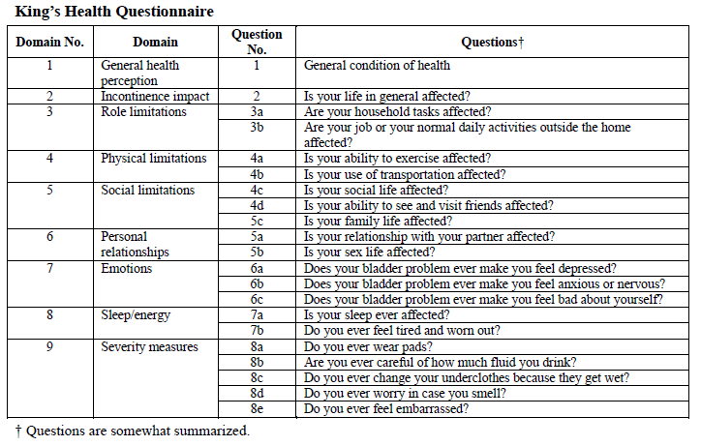

Statistics
For analysis of the primary variable, the sponsor used the two-sample t-test to compare mirabegron and placebo for the change in mean number of micturitions per 24 hours (from baseline to final assessment). A standard, two-sided significance level of 5% was used.
For secondary variables, the Wilcoxon rank sum test was used for studying superiority to placebo in change in the mean number of incontinence episodes and change in the mean number of urge incontinence episodes. To estimate the adjusted difference in change from baseline between the placebo group and the respective treatment groups, and the two-sided 95% confidence interval for that difference, an ANOVA was used with treatment group as a factor and baseline as a covariate.

Differences between Study 048 and the pivotal studies
This study was conducted in Japan and had several design differences compared to the multi-centre, international pivotal studies. In Study 048, urinary urgency was based on whether a patient reported urgency or not with an episode of micturition; the 5-point PPIUS was not utilized. There was only one primary endpoint, micturition frequency, whereas incontinence frequency was considered a secondary endpoint. The subjective endpoints were also different, and included the QOL domain scores on King’s Health Questionnaire (KHQ) instead of the OAB-q, which makes a comparison across studies difficult. The TS-VAS, which was considered a major secondary endpoint in the pivotal studies, was not used in this study. This study does not, therefore, conform to the EU note for Guidance on the performance of incontinence studies, because it did not include a global evaluation of the patient’s subjective assessment of the benefits of therapy. Because of all these differences, the study was considered by the sponsor to be merely supportive, but it has a broadly acceptable phase 3 design and the results have a similar importance to the pivotal studies.

Results

Baseline data
The groups were acceptably matched at baseline, as shown in the table below.
Table 36. Demographic and Baseline Characteristics, Study 048
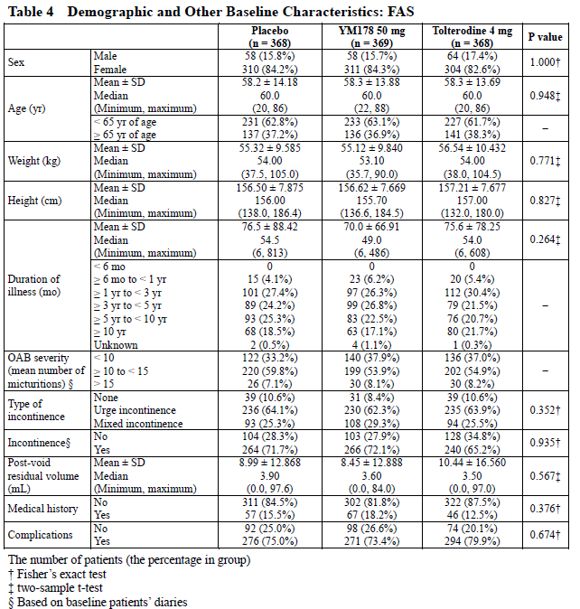

Primary endpoint
The baseline micturition frequency in Study 048 was about 11 episodes per 24 hours, which is very similar to the three pivotal studies, despite some differences in entry criteria. Placebo treatment was associated with a mean reduction of 0.86 micturition episodes from a baseline of 11.29 episodes. Active treatment with mirabegron 50mg was associated with a further reduction of 0.86 (placebo-subtracted), and this was statistically significant (95%CI for the difference from placebo, -1.16 to -0.57). Tolterodine, the active control, showed a somewhat less beneficial change, with a mean placebo-subtracted change in micturition frequency of -0.61 episodes per 24 hours (95%CI -0.90 to -0.32).
Note that the magnitude of the placebo-subtracted change in micturition was modest, less than one voiding episode per day, but this was a slightly greater reduction than that seen in the pivotal studies.
Table 37. Results for Primary and Major Secondary Endpoints, Study 048
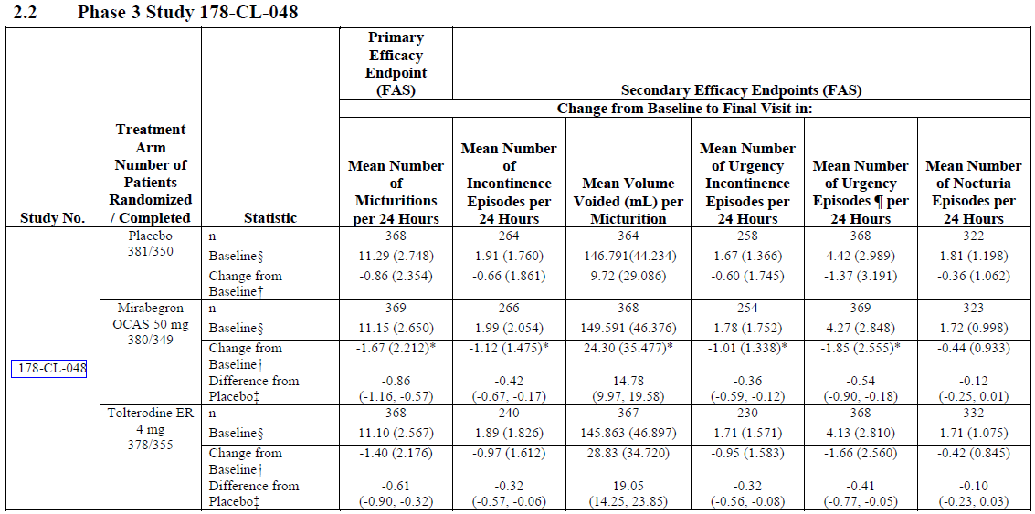

Secondary endpoints
Results for the main secondary endpoints are shown in the table above. The findings in the mirabegron group were significantly different from the placebo group for all of the major secondary endpoints except nocturia.
Incontinence was about two episodes per day at baseline (mean 1.89 to 1.99 across the treatment groups), and this was reduced by 0.66 episodes per day in the placebo group. Active treatment with mirabegron 50mg was associated with a further reduction of 0.42 episodes (95%CI for placebo-subtracted change, -0.67 to -0.17), a similar value to that shown across the three pivotal studies. Tolterodine was associated with a similar but slightly smaller treatment effect (placebo-subtracted change -0.32 episodes per 24 hours, 95%CI -0.57 to -0.06).
The mean volume of micturition was increased by mirabegron treatment by ~15 mL over and above the placebo effect (+14.78 mL, 95%CI 9.97 to 19.58). Tolterodine was associated with a slightly greater increase (+19.05 mL, 95%CI 14.25 to 23.85).
Urgency incontinence showed similar changes to all-cause incontinence, with a placebo-subtracted change of -0.36 episodes per 24 hours in the mirabegron group (95%CI-0.59 to -0.12), and -0.32 in the tolterodine group (95%CI -0.56 to -0.08).
Urgency episodes were reduced by 0.54 episodes in the mirabegron group (placebo-subtracted), equivalent to about one episode every two days. Nocturia was not significantly changed by mirabegron, and the magnitude of the mean reduction was of doubtful clinical value (0.12 episodes per 24 hours). Tolterodine results for these two endpoints were similar (see table).
Overall, the results are broadly consistent with the pivotal studies and increase the external validity of the pivotal studies. The magnitude of the benefits was small, however, with primary endpoint showing that micturition is changed, on average, by less than one void per day.
Subjective endpoints consisted of responses to the King’s Health Questionnaire. In most of the nine domains assessed, a significant and favourable difference was noted in the mirabegron group compared to placebo, as shown in the table below. Compared to placebo, the mirabegron group showed a statistically significant improvement in: domain 2 (incontinence impact), domain 3 (role limitations), domain 4 (physical limitations), domain 5 (social limitations), domain 7 (emotions), domain 8 (sleep/energy) and domain 9 (severity measures). As with most of the subjective endpoints described in this submission, it is difficult to assess what the observed differences actually mean in terms of clinical utility, but it is at least encouraging that the overall trends were favourable.
Table 38. Change from Baseline in QOL Scores
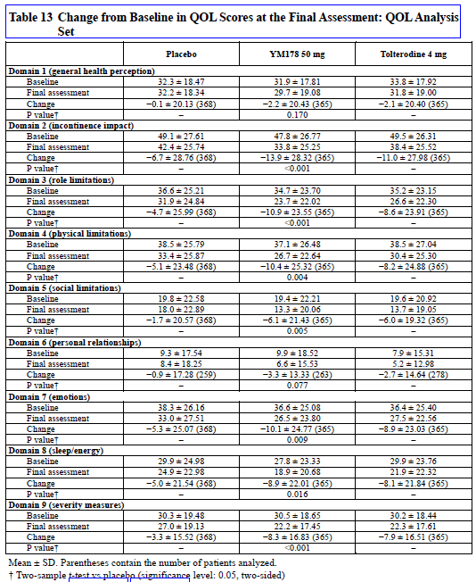

Supportive efficacy study 044

Design
Study 044 was a phase 2b study, designed to explore the dose-response relationship of mirabegron in the treatment of OAB. It was a multinational, multicentre, double-blind, randomised, parallel group, placebo- and tolterodine-controlled study with six treatment groups.
Like the pivotal studies, it employed a single-blind, 2-week placebo run-in period followed by a randomised, double-blind, placebo-controlled, 12-week treatment period.
At screening, patients received a micturition diary that was completed in the 3 days preceding Visit 2, and ambulatory blood pressure monitor to use for the 3-day diary period.
After the placebo run-in period, eligible patients were randomised to one of the following treatments:
- mirabegron OCAS 25mg qd
- mirabegron OCAS 50mg qd
- mirabegron OCAS 100mg qd
- mirabegron OCAS 200mg qd
- placebo
- tolterodine 4 mg qd.
In addition to micturition diaries, which were completed in the 3 days prior to each visit, patients measured vital signs (HR, SBP, DBP) 2 times per day in triplicate by means of ambulatory blood pressure monitoring, and symptom and Quality of Life Questionnaires were completed at baseline and approximately every two weeks thereafter. Post-void residual volume (the volume left in the bladder after voiding) was measured by ultra-sonography or bladder scan at baseline and the end of treatment.
The entry criteria were similar to the pivotal studies: men or women aged ≥ 18 years who had experienced symptoms of OAB (including urinary frequency, and urgency with or without urge incontinence) for at least 3 months prior to screening, who did not have major confounding illnesses or other treatments. To be eligible for randomisation, subjects had to experience frequency of micturition on average ≥ 8 times per 24-hour period during the 3-day micturition diary period, and at least 3 episodes of urgency with or without incontinence (grade 3 or 4), during the 3-day period.
The primary endpoint was the change from baseline to final visit in the mean micturition frequency (per 24 hours), based on the 3-day micturition diary.
Secondary efficacy variables as listed by the sponsor were:
- Change from baseline in mean volume voided per micturition
- Change from baseline in mean number of urgency episodes (grade 3 or 4) per 24 hours
- Change from baseline in level of urgency (using the same scale as in the pivotal studies, the Patient Perception of Intensity of Urgency Scale, or PPIUS).
- Change from baseline in mean number of urge incontinence episodes per 24 hours
- Change from baseline in mean number of incontinence episodes per 24 hours
- Change from baseline in mean number of nocturia episodes per 24 hours
- Change from baseline in symptom scores as assessed by International Consultation on Incontinence Questionnaire-Overactive Bladder (ICIQ-OAB)
- Change from baseline in quality of life scores as assessed by International Consultation on Incontinence Questionnaire-Overactive Bladder-Quality of Life (ICIQ-OABqol)
- Change from baseline in patient’s perception of treatment benefit.
In most cases, these endpoints were derived from the micturition diaries and were similar to those employed in the pivotal studies. The OAB questionnaire referred to in the study report as the ICIQ-OAB is the same one referred to in the pivotal study reports as the OAB-q, and this contributed to a symptom bother score and a QOL estimate, as in the pivotal studies. The change from baseline in the patient’s perception of treatment benefit was assessed with a 3-point scale, in contrast to the 10-point VAS used in the pivotal studies. This treatment assessment instrument had been used in a Phase 2a proof-of-concept study, and in one other published OAB study (Sussman D, Garely A., 2002), but it has not been formally validated. Given that it only had 3 points, it would seem to lack the resolution required to characterise treatment benefit with any detail or subtlety, but this is acceptable in a minor supportive study.

Statistics
Changes from baseline in the mean number of micturitions per 24 hours were subjected to an analysis of covariance (ANCOVA) model, including mirabegron dose as a fixed factor and the baseline number of micturitions per 24 hours as a covariate.
Overall, the design of this study was acceptable for a phase 2 dose-ranging study.

Results

Baseline data
The groups were reasonably matched at baseline in terms of demographics and disease characteristics (data not shown).

Efficacy endpoints
The main efficacy results for Study 044 are shown in the table excerpt below (results for other Phase 2 studies have been cut from the table and will be included separately). For the primary endpoint of mean micturition frequency, all treatment groups had 11-12 micturitions per 24 hours at baseline, and all groups showed an improvement during the course of the study. In the placebo group, mean micturition frequency improved by 1.43 episodes from 11.67 at baseline. Active treatment with mirabegron caused an additional (placebo-subtracted and adjusted) improvement of 0.45, 0.64, 0.68, and 0.80 episodes per 24 hours in the 25mg, 50mg, 100mg and 200mg groups, respectively. Note that there was a dose trend across the range 25mg to 200mg, but the difference between 50mg and 100mg was minor, and the mean unadjusted changes from baseline were similar across dose groups without a dose trend. The tolterodine group showed a change from baseline that was similar to the mirabegron groups and greater than the change in the placebo group, but the sponsor did not estimate the placebo-subtracted change in the tolterodine group, making a comparison between active treatments difficult.
The 95%CIs for the placebo-subtracted change did not include zero for the 50mg, 100mg and 300mg doses, but did include zero for the 25mg group, which was therefore not significantly different from placebo.
The magnitude of the benefit at 50mg and 100mg is broadly similar to the phase 3 studies, and amounts to less than one void prevented by active treatment each day. The treatment effect at 200mg was slightly better (0.80 episodes per 24 hours), but the 95%CIs for the placebo-subtracted change with the 200mg dose overlapped those of other doses.
Table 39. Results for Primary and Key Secondary Endpoints, Study 044
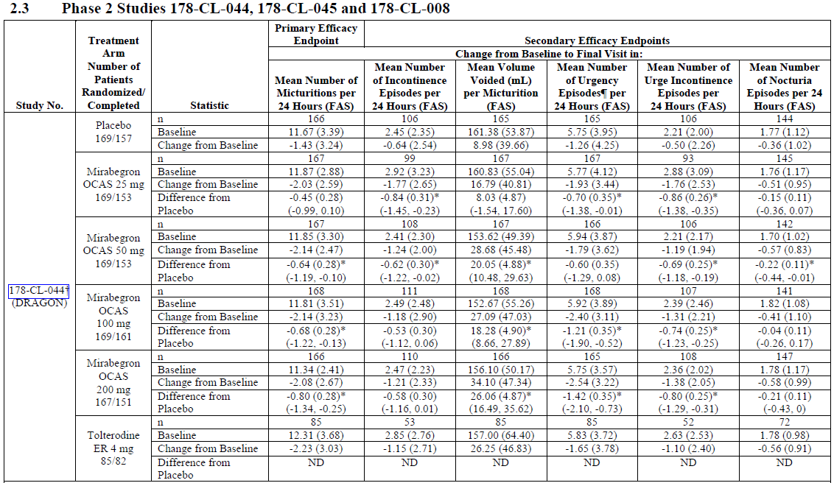
Other endpoints did not show statistically significant treatment effect across the doses. The mean number of incontinence episodes was significantly improved by the two lower dose groups, 25mg and 50mg, but not by the higher doses, 100mg and 200mg, based on the 95%CIs for the placebo-subtracted change from baseline. The placebo group showed an improvement of 0.64 incontinence episodes per 24 hours, from a baseline of 2.45, and active treatment was associated with an additional improvement of 0.84, 0.62, 0.53 and 0.58 episodes across the dose groups from lowest to highest, respectively. Although not significant, the magnitude of the placebo-subtracted changes observed at 100mg was consistent with the larger Phase 3 studies, where statistical significance was achieved. The results in the tolterodine group were similar to those seen with mirabegron.
The mean volume voided was increased with active treatment, and the difference was significant for the 50mg, 100mg and 200mg doses. The mean number of urgency episodes was improved with mirabegron treatment in all dose groups, and this was significant for the 25mg, 100mg and 200mg doses but not for the proposed dose of 50mg. The magnitude of the benefit at the proposed dose of 50mg was a reduction of 0.60 episodes or urgency (95%CI for placebo-subtracted change was -1.29 to +0.08), whereas for 100mg the estimated benefit was 1.21 episodes per 24 hours.
The frequency of urgency incontinence was reduced by a similar amount as the all-cause incontinence, and the placebo-subtracted change was significant for the 25mg, 50mg, 100mg and 200mg doses, as shown by the table above. For the proposed 50mg dose, an additional 0.69 episodes were prevented per 24 hours (95%CI -1.18 to -0.19).
Nocturia was significantly reduced with active treatment for the 50mg dose, but for none of the other doses. The statistical significance for the 50mg dose was marginal (placebo-subtracted change from baseline -0.22 episodes, 95%CI -0.44 to -0.1). The magnitude of the treatment effect (one episode of nocturia prevented every 5 days) was similar to other studies, and would be expected to be of minor clinical utility.
The results for subjective endpoints are shown in the tables below (YM178 = mirabegron). Although not adequately explained by the sponsor, the questions referred to in the table headings appear to correspond to the following categories:
- Questions 3a, 4a, 5a, 6a - Bladder Symptoms
- Questions 3b, 4b, 5b, 6b - Symptom Bother
- Questions 3-27 – Quality of Life
The actual questions of the OAB questionnaire are reproduced in an appendix to this report.
In general, there were significant benefits for active treatment over placebo in terms of Bladder Symptoms and Symptom Bother, with an apparent dose trend (the 25mg dose group did not achieve significance for Symptom Bother). The clinical meaning of the observed difference is, however, unclear. There was not a significant benefit for overall QOL, as assessed by questions 3 to 27 of the OAB-q. This information is therefore merely supportive of the more objective efficacy measures.
Table 40. ANCOVA Modelling Result for ICIQ-OAB, Study 044, Questions 3a, 4a, 5a, 6a
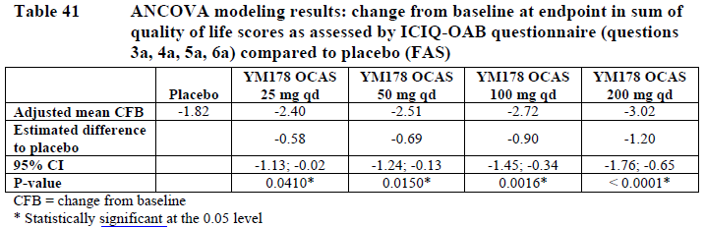
Table 41. ANCOVA Modelling Results for ICIQ-OAB, Study 044, Questions 3b, 4b, 5b, 6b
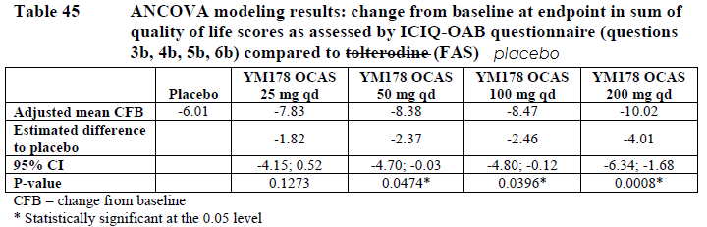
Table 42. ANCOVA Modelling Results for QOL, Study 044, Questions 3 to 27
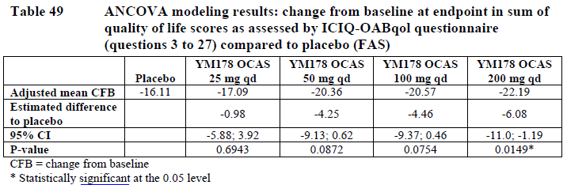
Finally, the results for the patent perception of benefit are shown below. This endpoint was listed in the study synopsis as one of the secondary endpoints, but not subsequently mentioned in the results section of the synopsis or the main study report. The excerpt below shows results for the last visit, Visit 6. About a third of placebo recipients (32.3%) thought their treatment had benefited them “very much”, and the results in the mirabegron 50mg group were slightly better than this (38.8%), implying that about 6.5% (38.8%-32.3%) of mirabegron recipients had an attributable improvement in the “very much” category. For the overall category of any improvement, the 50mg dose was associated with at least “a little” improvement in 81.7% of subjects, compared to 67.1% of placebo recipients. This result was not subjected to a statistical analysis, but appears to be of sufficient magnitude that a trial of mirabegron treatment would be considered clinically worthwhile. The problem is that, on the basis of these numbers, of all the patients reporting they were “very much” improved on mirabegron 50mg, only a small proportion (6.5/38.8, or 17% of the “very much” responders) are likely to have had an attributable response and there is no way of distinguishing these from the much larger number of subjects reporting a placebo response.
Table 43. Frequencies of Patients’ Perception of Treatment Benefit and Responders, Study 044
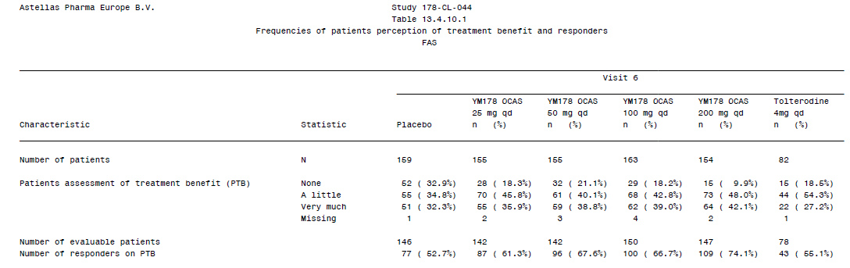

Supportive efficacy study 045

Design
This study was a randomised, placebo-controlled dose-ranging study assessing the efficacy of mirabegron in the treatment of OAB.
The entry criteria were broadly similar to the pivotal studies, but subjects had to have some urgency incontinence – not necessarily confirmed in the 3-day diary. The listed entry criteria were:
- Male or female outpatient aged between 20 and 80 years at the time of informed consent
- Symptoms of OAB for at least 24 weeks before initiation of the run-in period
- Capable of walking to the lavatory and measuring urine volume unassisted
- Written informed consent
- An average frequency of micturition of 8 or more times per 24 hours period and meeting at least one of the following diary conditions:
  - On average, at least one episode of urgency per 24 hours
  - On average, at least one episode of urge incontinence per 24 hours
The exclusion criteria were similar to the pivotal studies, but included a lack of urgency incontinence.
The study was performed from 11 September 2007 (first signed consent) to 3 April 2008 (last subject evaluation).
Subjects underwent a single-blind placebo run-in period, followed by a randomised, controlled double-blind treatment period of 12 weeks.
The randomised treatments were:
- placebo group: Two mirabegron placebo tablets/day
- mirabegron 25mg group: mirabegron (extended-release tablet) 25mg/day
- mirabegron 50mg group: mirabegron (extended-release tablet) 50mg/day
- mirabegron 100mg group: mirabegron (extended-release tablet) 100mg/day
The major endpoints were the same as described above for Study 044.
The primary efficacy endpoint was change in the mean number of micturitions per 24 hours from baseline to the end of study.
The secondary endpoints were:
- Change from baseline in mean number of urgency episodes per 24 hours
- Change from baseline in mean number of incontinence episodes per 24 hours
- Change from baseline in mean number of urge incontinence episodes per 24 hours
- Change from baseline in mean volume voided per micturition
- Change from baseline in mean number of nocturia episodes
- Change from baseline in the quality of life domain scores assessed by the King’s Health Questionnaire.

Statistics
The primary analysis of the main endpoint was conducted using a Williams’ multiple comparison between the placebo group and each mirabegron treatment group, using a one-sided significance level of 0.025. Sample size was chosen to provide adequate power to show superiority of mirabegron over placebo and to allow demonstration of the dose-response relationship; prospective sample sizes were assessed using the Williams’ multiple comparison method, using data from Study 044 to guide assumptions about potential treatment effect and standard deviations. The sponsor concluded that 165 cases were needed to show superiority of the mirabegron 100mg group over the placebo group with more than 80% power of detection at a significance level of 0.025. Allowing for possible dropouts, an enrolment target of ≥ 180 subjects was set for each group.

Results

Baseline data
The groups were acceptably matched at baseline in terms of demographics and disease characteristics (data not shown).

Efficacy endpoints
The results for the primary endpoint were consistent with other studies of mirabegron in OAB. At baseline, the micturition frequency was about 11-12 episodes per 24 hours, and during the treatment study period this fell by one to two episodes. In the placebo group, from a mean baseline of 11.17 episodes per 24 hours, subjects experienced a mean change of -1.18 episodes. In the active groups, additional (placebo-subtracted) changes were observed, ranging from 0.66 episodes in the 25mg group, to 0.74 in the 50mg group and 0.78 in the 100mg group. As shown in the table below, the 95%CIs for the placebo-subtracted changes did not include zero and were consistent with a statistically significant treatment effect (p<0.001 in all active groups by ANOVA). As in all of the other studies, the magnitude of the benefit amounted to less than one episode of voiding per day, and was therefore of modest clinical utility.
The primary endpoint showed a dose-response trend in the mean placebo-subtracted change, but there was a great deal of overlap in the 95%CIs, as shown in the table, and the differences between groups were relatively minor (just 0.12 of an episode difference in the placebo-subtracted treatment effect from the highest dose to the lowest).
Table 44. Results for Primary Endpoint and Key Secondary Endpoints, Study 045
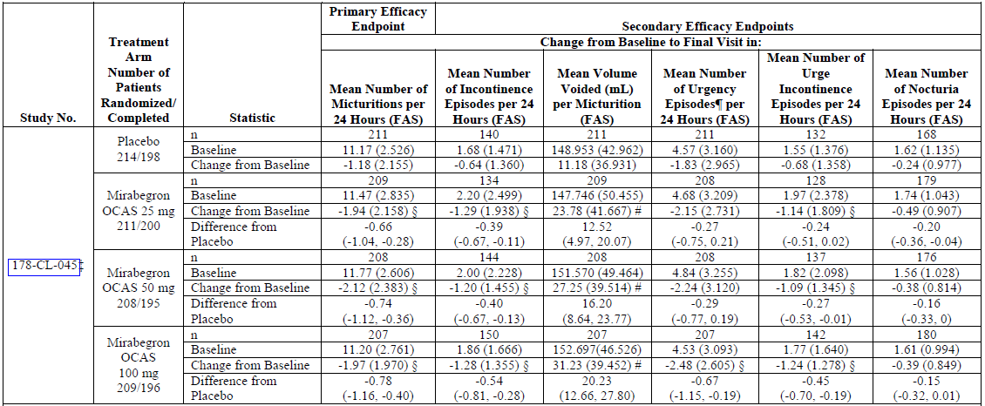
Additional endpoints are shown in the table, and were also consistent with the other efficacy studies. Incontinence, which is the most distressing symptom for OAB patients and the most important of the secondary endpoints, was significantly reduced with active treatment. Interpretation of this endpoint is difficult, however, because of a marked difference between groups at baseline. In the placebo group, incontinence was reduced by a mean of 0.64 episodes from a baseline of 1.68 episodes per 24 hours. In the mirabegron 25mg group, treatment was associated with a reduction of 1.29 episodes from a baseline of 2.20 episodes. The placebo-subtracted change was 0.39 episodes, but it is unclear if some of the between-group difference was due to the fact that a higher number of episodes were present at baseline, giving more chance for regression to the mean and the placebo effect to prevent episodes independently of any true treatment effect. In the 50mg group, the placebo-subtracted change was -0.40 episodes and in the 100mg group, -0.54 episodes, with confidence intervals showing a significant difference between active treatments and placebo but no significant difference between active groups. The dose trend showed a numerical increase across doses, but with small differences between the mean treatment effects.
As shown in the table, the mean volume voided per micturition was significantly higher in the active groups, but the actual volume difference was only 13-20 mL across the active groups, compared to placebo. Urgency episodes were reduced, relative to placebo, by 0.27, 0.29 and 0.67 episodes per 24 hours, in the 25mg, 50mg and 100mg dose groups, respectively, but only in the highest dose group did the 95%CI exclude zero difference. At the proposed dose of 50mg, the mean benefit was about one episode of urgency prevented every 3 to 4 days. Urgency incontinence was reduced by 0.24, 0.27 and 0.45 episodes per 24 hours, relative to placebo, with the 50mg and 100mg doses showing statistical separation from placebo. The 95%CI for 50mg dose included the possibility that only one episode of urgency incontinence was prevented every 100 days. Nocturia was not significantly reduced with 50mg or 100mg, but the 25mg dose group did show a significant reduction, relative to placebo. The magnitude of the mean benefit for nocturia was modest: placebo-subtracted changes were -0.20, -0.16 and -0.15 in the 25mg, 50mg and 100mg dose groups, respectively; note that this is the opposite of the expected dose trend.
The sponsor performed a number of additional analyses, including one which considered the proportion of subjects normalised for the main symptoms of urgency, incontinence and nocturia. For the proposed dose, 6% of subjects (20.2%-14.2%) had an attributable normalisation of urgency, 2.9% (45.8%-42.9%) had an attributable normalisation of incontinence, and 2.9% (14.8%-11.9%) had an attributable normalisation of nocturia. Treatment was therefore associated with a fairly low yield of good responses.
Table 45. Percentage of Subjects Whose Symptoms for Secondary Endpoints (other than QOL) Disappeared at End of Study 045
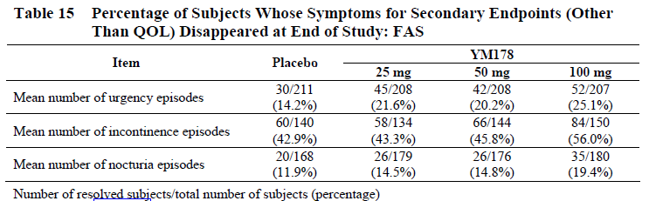
Assessments of quality of life showed that active treatment was associated with some significant benefits in some domains. For the proposed dose of 50mg, a significant reduction (improvement) in KHQ domain scores was observed for Incontinence Impact, Role Limitations, Physical Limitations, Emotions and Severity Measures.
Table 46. QOL Scores, Study 045
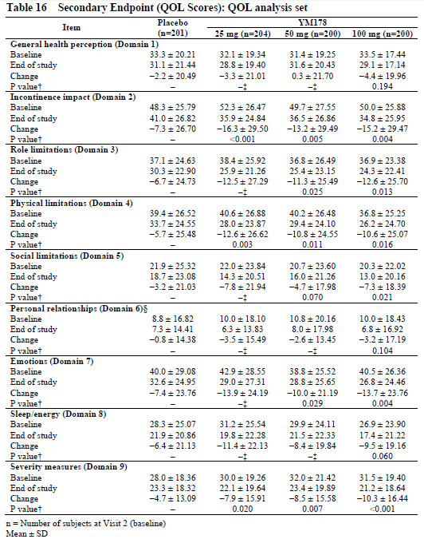

Supportive efficacy study 008

Design
Study 008 was a small randomised, double-blind, parallel group, proof-of-concept study of the efficacy of mirabegron in comparison with placebo and tolterodine in patients with symptomatic OAB. It only had 63-65 subjects per dose group, and therefore lacked the statistical power of most of the other supportive studies. It was also very short. A 2-week single-blind placebo run-in period was followed by a 4-week double-blind treatment period, and then a 2-week single-blind placebo follow-up period. The doses employed (100mg bid and 150mg bid) were also well in excess of the recommended dose of 50mg daily, being 4 and 6 times the recommended daily dose, respectively. For all of these reasons, it is only weakly supportive of the proposed usage of mirabegron.
The main entry criteria were similar to those in the pivotal studies: eligible subjects were of either gender, aged ≥ 18 years, with symptoms of OAB (urinary frequency and urgency with or without incontinence) for ≥ 3 months. Patients had to have a micturition frequency of ≥ 8 episodes per 24-hours on average during the 3-day diary period, and at least 3 episodes of urgency (grade 3 or 4), with or without incontinence, during the 3-day diary period.
Subjects were randomised to one of the following treatments, with sufficient placebo tablets provided to maintain the blind:
- Group I - mirabegron 100mg bid
- Group II - mirabegron 150mg bid
- Group III - tolterodine 4 mg od
- Group IV - placebo
The primary endpoint was the same as other supportive studies: change from baseline in mean number of micturitions per 24 hours.
Secondary efficacy endpoints were:
- Change from baseline in mean volume voided per micturition
- Change from baseline in mean number of incontinence episodes/24 hours
- Change from baseline in mean number of nocturia episodes/24 hours
- Change from baseline in mean number of urge incontinence episodes/24 hours
- Change from baseline in mean number of urgency episodes/24 hours
- Change from baseline in severity of urgency
- Change from baseline in patient perception of bladder condition
- Patient perception of treatment benefit
The two subjective endpoints were assessed with simple categorical scales. A 3-point scale was used for assessment of treatment benefit and a 6-point scale for the patients’ perception of their bladder condition.
For the patients’ assessment of treatment benefit, the question “Has the treatment been of any benefit to you?” had the three possible outcomes:
- No
- Yes, a little
- Yes, very much
For the patients’ perception of bladder condition, the stem “My bladder condition…” had the following six possible completions:
- Does not cause me any problems at all
- Causes me some very minor problems
- Causes me some minor problems
- Causes me (some) moderate problems
- Causes me severe problems
- Causes me many severe problems

Statistics
Changes in mean number of micturitions per 24 hours were analysed by ANCOVA, with treatment as a fixed factor, and centre as a random factor. Baseline micturition frequency was included in the model as covariate. Comparisons were tested with a two-sided significance level 0.05. Sample size was not based on statistical considerations as this was a proof-of-concept study.

Results

Baseline data
The groups were acceptably matched at baseline for a minor supportive study, apart from baseline incontinence frequency (see table below), which was greater in the 150mg BID group.

Efficacy endpoints
Results for the primary endpoint of micturition frequency were positive. The magnitude of the estimated placebo-subtracted treatment benefit was greater than in the pivotal studies, and was slightly more than one episode of micturition, from a baseline of 11 to 12 episodes per 24 hours. This could reflect the use of high total daily doses (4 or 6 times the proposed daily dose). For the 100mg bid dose, the placebo-subtracted change in micturition frequency was -1.02, and for 150mg bid it was -1.03, with 95%CIs excluding zero as shown in the table below. The active control, tolterodine, showed a lesser treatment effect that was not significantly different from placebo.
For the major secondary endpoint, incontinence frequency, the estimated treatment effect amounted to more than one episode of incontinence in the 100mg bid dose group, which is better than the results obtained in the larger pivotal studies, which used once daily dosing. The dose trend in Study 008, however, was the reverse of the expected trend and the higher dose group did not show a significant effect, which is likely to reflect the relatively low patient numbers in combination with a fairly modest treatment effect, so that the treatment effect was easily swamped by random variation. In the 100mg bid dose group, the reduction in incontinence was 1.16 episodes over and above the placebo effect (95%CI -1.93 to -0.38), from a baseline of 2.5 episodes per 24 hours. In the 150mg bid group, the placebo-subtracted reduction in incontinence was only 0.57 episodes (95%CI -1.34 to +0.20), from a baseline of 3.57 episodes per 24 hours.
Table 47. Results for Primary and Key Secondary Endpoints, Study 008
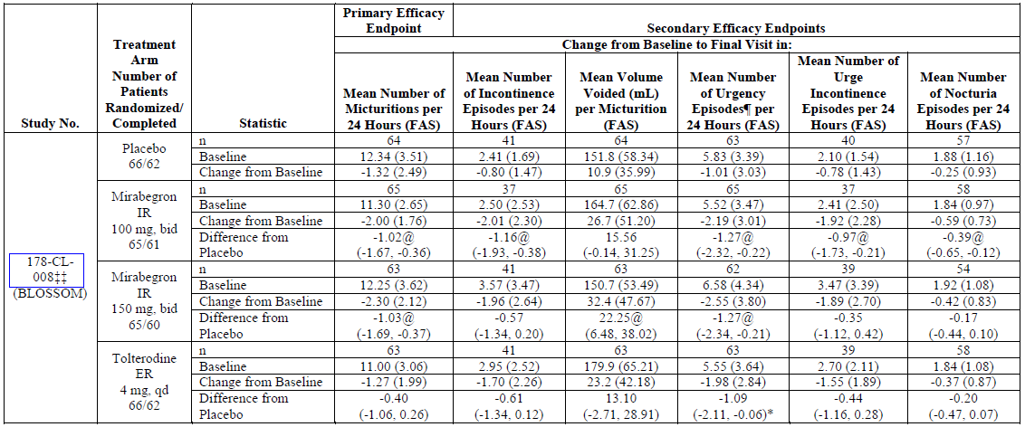
For the other diary-related endpoints, a significant benefit for mirabegron 100mg bid was shown for the mean number of urgency episodes, the mean number of urgency incontinence episodes, and the mean number of nocturia episodes, but not for the mean volume voided. For the 150mg bid dose, a significant benefit was shown for volume voided and mean number of urgency episodes, but not for mean number of urgency incontinence episodes or nocturia episodes, as determined from the 95%CIs which are shown in the table. The achievement of some endpoints but not others, with no consistent trend across doses, is likely to reflect the relative low patient numbers. In broad terms, the magnitudes of the observed mean changes for these secondary endpoints were consistent with the pivotal studies, where the majority of these endpoints were achieved.
The distributions of responses for the subjective endpoints, as assessed at the final visit, are shown in the tables below. Recipients of mirabegron were more likely to report that they had responded to treatment “very much”, compared to placebo recipients. Tolterodine recipients were even more likely to report that they had improved “very much”. In the sponsor’s report, neither the table reproduced below nor the accompanying text indicated clearly what definition of responder was being used in the final line of the table, but it appears to have been patients showing a positive shift in category.
Logistic regression of the proportion of responders showed that there was a statistically significant difference between mirabegron 100mg bid and placebo (p=0.0150), and between mirabegron 150mg bid and placebo (p=0.0038) for this endpoint. The difference between tolterodine 4mg od and placebo was also statistically significant (p=0.0001), but the difference between the tolterodine and mirabegron groups was not statistically significant.
Table 48. Patients’ Assessment of Treatment Benefit, Study 008
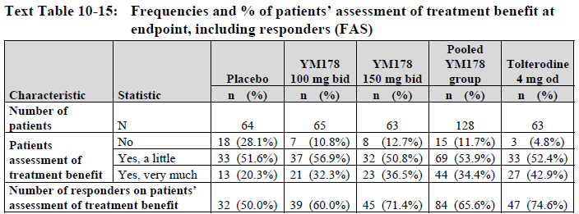
Table 49. Patient Perception of Bladder Condition, Study 008
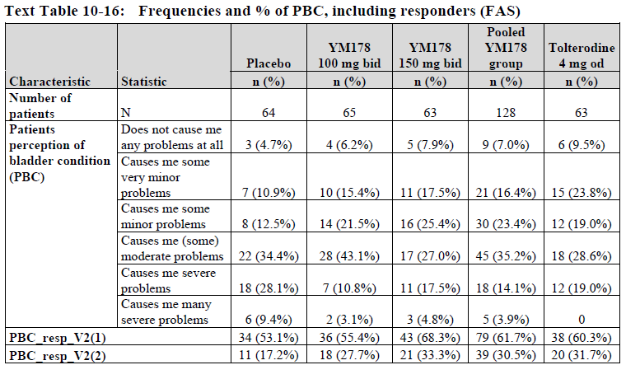
There was a corresponding in shift in responses for patient perception of bladder condition (PBC), with placebo recipients being more likely to report moderate or severe bladder problems, and mirabegron recipients more likely to report moderate or mild problems, as shown in the table above. Inspection of the proportions responding with an improvement (reduction) by one category (PBC_resp_V2(1)) and of those with a favourable shift of two categories (PBC_resp_V2(1)) suggested that active treatment was more likely to produce a favourable shift. Formal logistic regression of this endpoint showed that there was no statistically significant difference between mirabegron 100mg and placebo (p=0.0618). The mirabegron 150mg group was statistically significantly different from placebo (p=0.0135), however, and the difference between tolterodine and placebo was also statistically significant (p=0.0165). The difference between tolterodine and the mirabegron groups was not significant.
Overall, the results in this study are broadly consistent with the pivotal results, and add to external validity of the pivotal studies, but have limited applicability because of the doses used, the low patient numbers, and the short duration of treatment.

Long-term study 049

Design
Study 049 was a long-term safety study with no placebo group, though it did employ tolterodine as an active control. The assessment of efficacy was a secondary focus, and the study was not powered or designed to show superiority of mirabegron over the active control; it is therefore only weakly supportive of the efficacy of mirabegron.
Patients were eligible if they were adults of either gender with symptoms of OAB for ≥ 3 months and recorded an average frequency of micturition ≥ 8 times per 24-hour period during the 3-day micturition diary period, with at least 3 episodes of urgency (grade 3 or 4) with or without incontinence, during the 3-day diary period.
The study consisted of a single-blind placebo run-in period of 2 weeks, followed by a randomised double-blind, active-controlled treatment period of 12 months. Patients were randomly assigned with equal likelihood to receive mirabegron 50mg, mirabegron 100mg or tolterodine ER 4 mg once daily for 12 months. The randomised, double-blind, active-controlled, treatment period consisted of assessment visits at months 1, 3, 6, 9 and 12.
The sponsor listed a large number of efficacy endpoints, all of which were considered secondary.
- Change in mean number of micturitions per 24 hours
- Change in mean number of incontinence episodes per 24 hours
- Change in mean volume voided per micturition
- Change in mean number of urgency incontinence episodes per 24 hours
- Change in mean number of urgency episodes (grade 3 and/or 4) per 24 hours
- Change in mean level of urgency
- Change in the mean number of pads used per 24 hours
- Change in mean number of nocturia episodes per 24 hours
- Change in Symptom Bother and HRQL scores as assessed by the OAB-q
- Change from baseline to month 12 and Final Visit in PPBC
- Change from baseline to month 12 and Final Visit in the TS-VAS
- Change in scores as assessed by WPAI:SHP
- Change in scores as assessed by the EQ-5D questionnaire
- Change in the number of non-study physician visits for the patient's bladder condition
In addition, for the change from baseline in PPBC, an analysis was performed at month 12 and Final Visit based on the following improvement from baseline definitions:
- Improvement: ≥ 1 point improvement from baseline
- Major improvement: ≥ 2 point improvement from baseline
Unless stated otherwise, the endpoints were assessed as changes from baseline to months 3, 6, 9, 12 and Final Visit, sometimes with a month 1 assessment as shown in the tables.

Statistics
Results in each group were compared with ANCOVA.

Results

Baseline data
The groups were reasonably well-matched at baseline (data not shown).

Efficacy endpoints
As shown in the table below, favourable changes were observed in all three treatment groups, with reductions in incontinence frequency, micturition frequency, and mean volume voided from baseline to the final visit. It is unclear how much of the observed improvement was due to the placebo effect and regression to the mean, but the mean reductions in both incontinence (1.01 to 1.24 across the mirabegron dose groups) and micturition frequency (1.27 to 1.41 episodes) were broadly comparable to the changes seen in the placebo groups of the pivotal studies. For instance, in Study 046, the mean reduction in incontinence for placebo recipients was 1.17 episodes from a baseline incontinence frequency of 2.67 episodes per 24 hrs, and the mean improvement in micturition frequency was 1.34 episodes per 24 hrs from a baseline of 11.7 episodes per 24 hrs. Although a comparison across studies is inherently unreliable, the strong placebo response demonstrated in the pivotal studies suggests that a large proportion of the observed changes in the table below could have been due to factors other than the active pharmacological treatment.
Table 50. Results for Major Efficacy Endpoints, Study 049
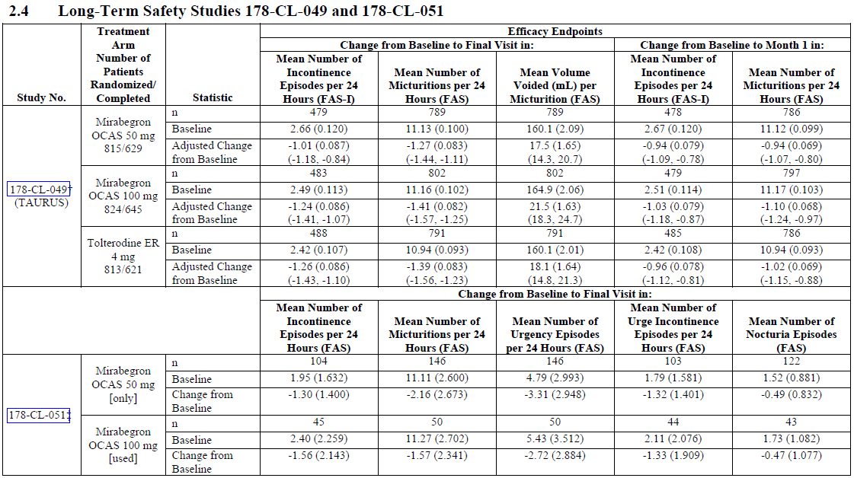
Results for some other endpoints are displayed in the tables below but note that the same difficulties of interpretation apply to these minor endpoints, and that most or all of the observed changes could be due to the placebo effect. For many diary-based endpoints, the sponsor did not produce convenient summary tables, so the data is not reproduced here. Consulting the long, unabridged tables in the appendix of the study report did not raise any significant new issues, but merely emphasized the difficulties of interpretation that arise without a placebo group.
The Treatment Satisfaction VAS showed that, on average, patients in all three groups had an improvement in satisfaction compared to baseline, with the greatest improvement seen in the tolterodine group. Similarly, all groups showed a mean decrease in Symptom Bother scores and a mean increase in QOL scores, but this could reflect the placebo effect or some degree of spontaneous improvement unrelated to active treatment.
Table 51. Change from Baseline in TS-VAS, Study 049
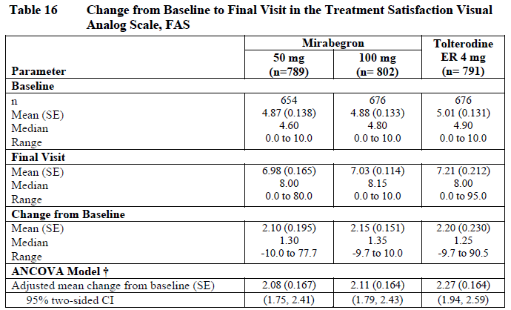
Table 52. Change from Baseline in Symptom Bother and QOL, Study 049
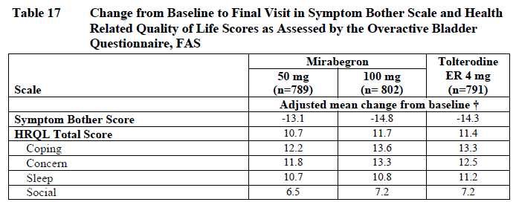
The best that can be said of the efficacy results in this study is that, if treatment was associated with any efficacy, there was no obvious waning of that efficacy with continued use. The graphs below show that the main efficacy variables were fairly stable after the first month. Unfortunately, this is of limited reassurance given that the improvements in micturition frequency and incontinence could be due to the placebo effect and regression to the mean. Without a placebo group, the results are essentially uninterpretable.
Figure 20. Adjusted Mean Change from Baseline in Incontinence Frequency, Study 049
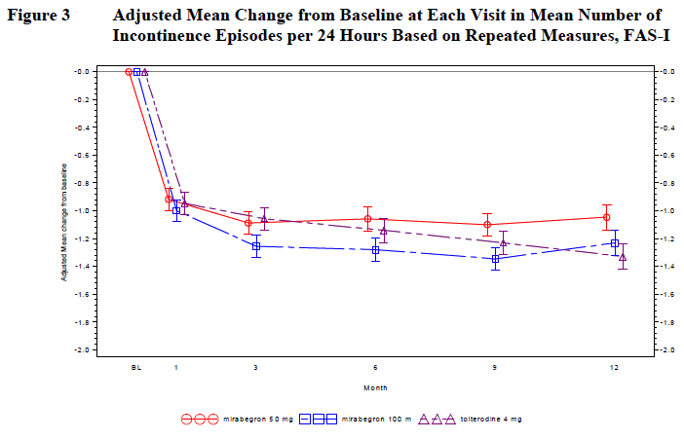
Figure 21. Adjusted Mean Change from Baseline in Micturition Frequency, Study 049
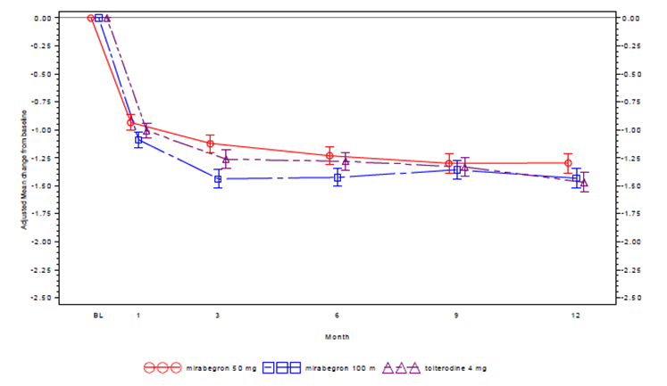

Long-term study 051

Design
Study 051 was another long-term safety study in OAB patients. It assessed two doses of mirabegron (50mg daily and 100mg daily), but it did not randomise between the dose groups, and it had no control group of non-mirabegron recipients. It is primarily useful for assessing safety and provides only very weak support for the claim of mirabegron efficacy.
The study consisted of a 1-week run-in period and a 52-week treatment period. After the 1-week run-in period, subjects who satisfied the inclusion criteria were enrolled for treatment. They all started with mirabegron 50mg, taken orally once daily. An optional increase in dose to 100mg daily was available at the week 8 visit, provided that 50mg was found to provide insufficient efficacy, the investigator concluded that the subject’s safety was not at risk, and the subject desired the increased dosage. When dose was increased to 100mg, this dose was generally maintained until treatment completion unless adverse events occurred.
Because subjects who had not responded to 50mg were the ones who escalated therapy to 100mg, the final dose groups were selected on their basis of treatment responsiveness, and it is impossible to compare the efficacy at the two doses. Furthermore, without a placebo group, it is impossible to determine what changes were due to the placebo effect and regression to the mean and what changes, if any, were due to active treatment.
To be eligible, patients had to be adults ≥ 20 years with OAB and average at least 8 micturitions per 24 hours in their 3-day baseline micturition diary, with at least 1 urgency episode per 24 hours on average, or at least 1 urge incontinence episode per 24 hours on average. Other entry criteria were similar to the pivotal studies.
The efficacy endpoints were as follows:
- Change from baseline in mean number of micturitions per 24 hours
- Change from baseline in mean number of urgency episodes per 24 hours
- Change from baseline in mean number of incontinence episodes per 24 hours
- Change from baseline in mean number of urge incontinence episodes per 24 hours
- Change from baseline in mean number of nocturia episodes
- Change from baseline in quality of life domain scores on King’s Health Questionnaire
None of these was considered primary, as the study’s main focus was long-term safety.

Statistics
Because this was an uncontrolled study, the results were primarily reported with descriptive statistics.

Results

Baseline data
The baseline demographics and disease characteristics were typical of an OAB population (data not shown).

Efficacy endpoints
The main efficacy results are shown in the table excerpt below (results for Study 049 have been removed). The table shows results for those who only received 50mg, versus those who used 100mg in addition to 50mg. For some endpoints, the changes were greater in the lower dose group, and for others the changes were greater in the higher dose group. Because the subjects were not randomly assigned to groups, it is not possible to draw any conclusions about the relative efficacy of the two different groups, and it is not known whether the changes listed in the table reflect efficacy, the placebo effect or regression to the mean. The changes from baseline appear broadly comparable to changes observed in the placebo groups of other studies, so the study does not provide evidence of a strong therapeutic effect.
Table 53. Results for Major Efficacy Endpoints, Study 050
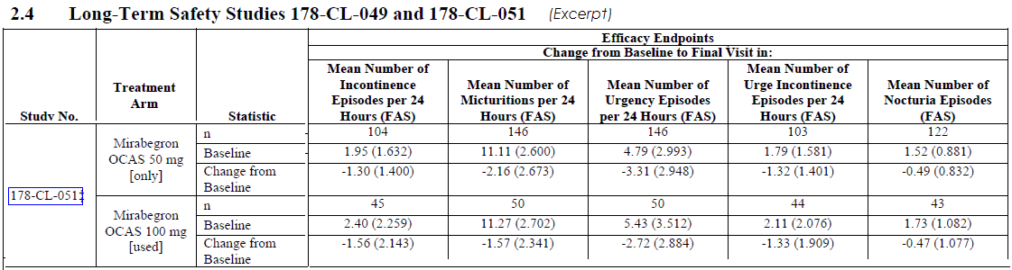
When viewed graphically, it is clear that the main efficacy variables, including mean number of micturitions (Figure 22) and mean number of incontinence episodes (Figure 23), showed substantial spread in terms of standard deviations, and did not convincingly depart from baseline.
Figure 22. Change from Baseline in Mean Number of Micturitions Per 24 Hours, Study 050
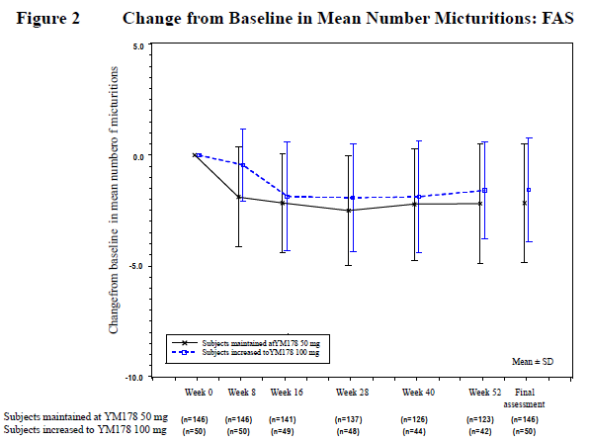
Figure 23. Change from Baseline in Mean Number of Incontinence Episodes Per 24 Hours, Study 050
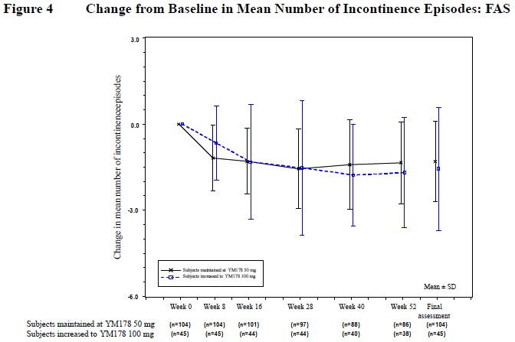
The KHQ results are shown below. Decreases (improvements) were observed in all domains, but without a placebo group it is impossible to know to what extent this is due to the placebo effect and regression to the mean.
Table 54. Change in QOL Scores, Study 050
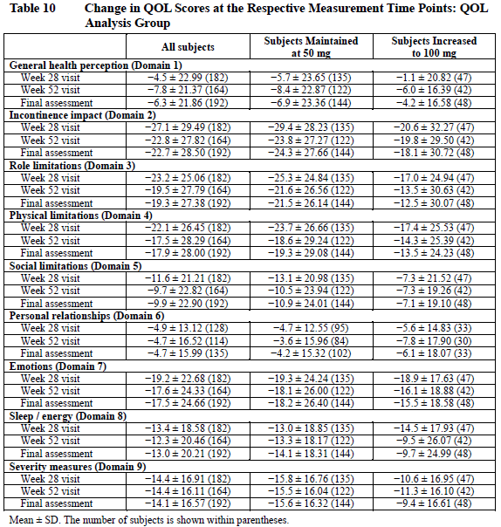
In conclusion, because it lacked a randomised, controlled design, this study provides almost no insight into the long term efficacy of mirabegron.

Analyses performed across trials
Because the three pivotal studies shared entry criteria and endpoints, they were suitable for a pooled analysis, which is reproduced below. Note that the studies were all slightly different in terms of the treatments being assessed, with Study 046 using a tolterodine control group as well assessing mirabegron 50mg and 100mg, Study 047 just assessing mirabegron 50mg and 100mg, and Study 074 assessing 50mg and 25mg, but not 100mg. The pooled results therefore involve all three studies, for the proposed 50mg dose, but only Studies 046 and 047 for the 100mg dose.
In general, the results for the proposed 50mg dose in the pooled analysis were consistent with the individual studies. The results in the 25mg group were derived from only one study, so the confidence intervals were broader. The magnitude of the effects at this dose also appeared inferior to the pooled 50mg results.
Table 55. Overview of Efficacy Results, Individual and Pooled Pivotal Studies
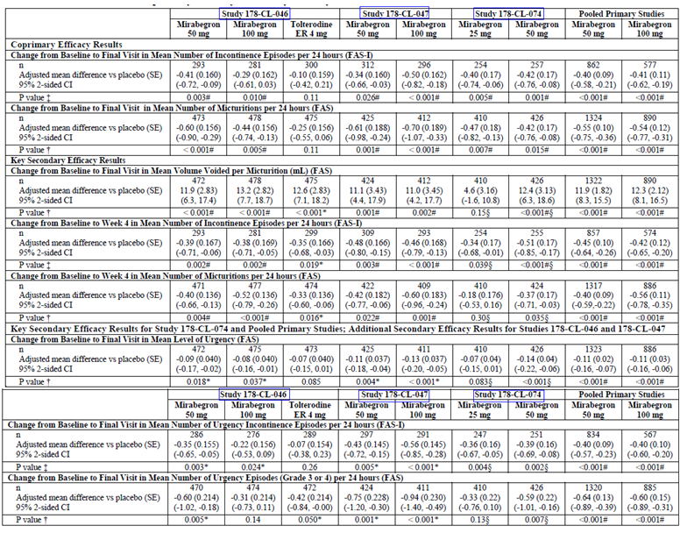
Pooled primary studies include 178-CL-046, 178-CL-047, and 178-CL-074. All randomized patients who took at least one dose of double-blind study drug and who had a micturition measurement in the baseline diary and at least one postbaseline visit diary with a micturition measurement (Full Analysis Set [FAS]). All randomized patients who took at least one dose of double-blind study drug and who had a micturition measurement and at least one incontinence episode in the baseline diary and at least one postbaseline visit diary with a micturition measurement (Full Analysis Set-Incontinence [FAS-I]). ER: extended release. For the pooled primary studies and Studies 178-CL-046, 178-CL-047 and 178-CL-074 individually, a stepwise parallel gate keeping procedure was performed to control the Type I error rate at the 0.05 significance level for the coprimary and key secondary efficacy endpoints. Since 2 mirabegron treatment groups were compared with placebo, the Hochberg procedure was used to adjust for multiplicity within each stage. Since the comparison between tolterodine and placebo was a secondary analysis in Study 178-CL-046, no adjustment for multiplicity was necessary. In the pooled primary studies, the adjusted mean difference versus placebo for change from baseline and corresponding 95% CI were generated from an ANCOVA model with treatment group, gender and study as fixed factors and baseline as a covariate. In Studies 178-CL-046, 178-CL-047, and 178-CL-074, the adjusted mean difference versus placebo for change from baseline and corresponding 95% CI were generated from an analysis of covariance (ANCOVA) model with treatment group, gender and geographical region as fixed factors and baseline as a covariate. Differences of the adjusted means were calculated by subtracting the adjusted mean of placebo from that of treatment groups.
† Nominal P values are from pairwise comparisons versus placebo within the ANCOVA model, a parametric analysis.
‡ Nominal P values are from pairwise comparison versus placebo within the stratified rank ANCOVA, a nonparametric analysis.
# Statistically significantly superior compared with placebo at the 0.05 level with multiplicity adjustment.
* Statistically significantly superior compared with placebo at the 0.05 level without multiplicity adjustment.
§ Study 178-CL-074 only: Since the mirabegron 25 mg group did not meet statistical significance with multiplicity adjustment for mean volume voided (P=0.15), subsequent key secondary efficacy endpoints for the mirabegron 25 mg group were excluded from further hypothesis testing as part of the gatekeeping procedure. Mean volume voided per micturition and subsequent key secondary efficacy endpoints for the mirabegron 50 mg group were evaluated at the 0.025 significance level. Since the mirabegron 50 mg group did not meet statistical significance with multiplicity adjustment for change from baseline to Week 4 in mean number of micturitions per 24 hours (P=0.035), subsequent key secondary efficacy endpoints for the mirabegron 50 mg group were excluded from further hypothesis testing as part of the gatekeeping procedure.
Figure 24. Change in Incontinence Episodes Per 24 Hours, Pivotal Studies
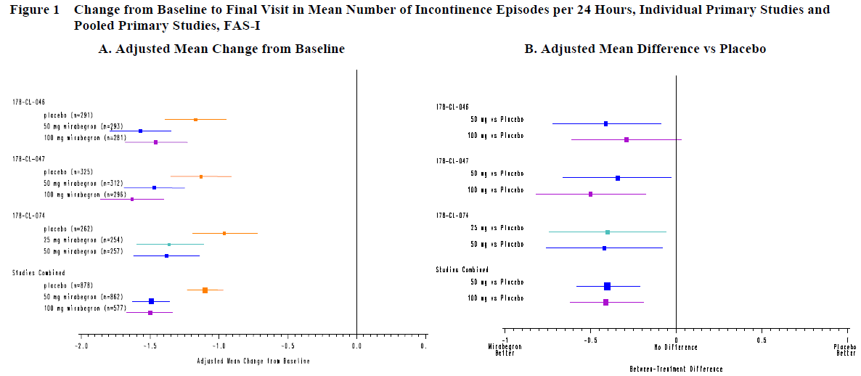
Figure 25. Change in Micturition Episodes Per 24 Hours, Pivotal Studies
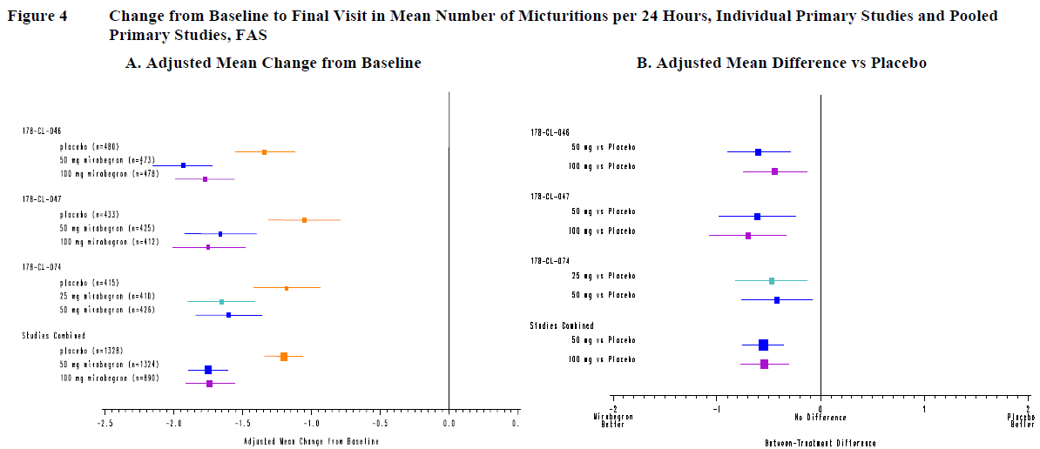
Figure 26. Change in Volume Voided per Micturition, Pivotal Studies
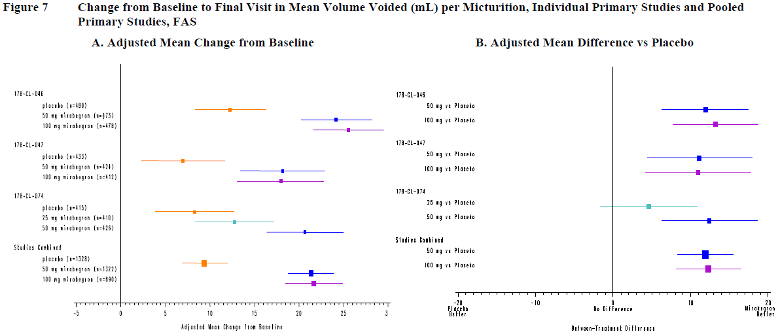
Figure 27. Adjusted Change in Mean Number Incontinence Episodes, Pooled Pivotal Studies
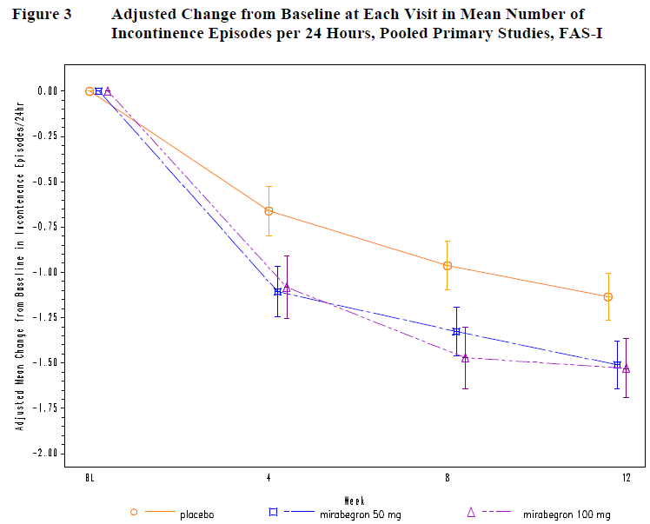
Figure 28. Adjusted Change in Mean Number of Micturition Episodes, Pooled Pivotal Studies
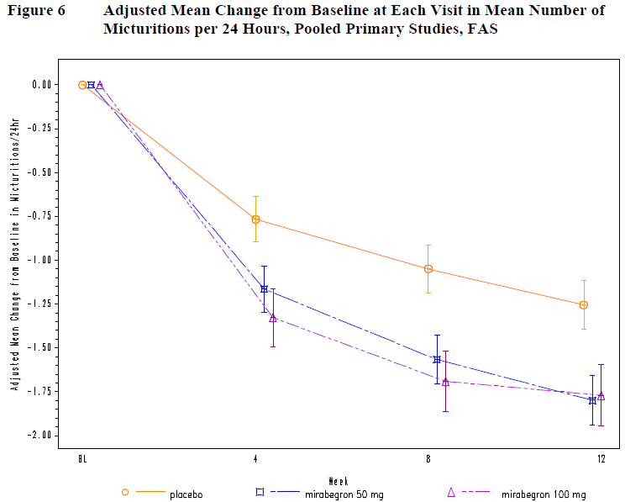
The sponsor presented responder analyses based on 1) the achievement of zero incontinence episodes at final visit, or 2) a reduction of at least 50% from baseline incontinence. These results are shown below. Note the very high responder rates in the placebo group, which reflects the inclusion of patients who only had one or very few episodes of incontinence at baseline. At the proposed dose, the attributable (placebo-subtracted) difference in responder rate for both definitions was modest, amounting to 6.3% for zero incontinence and 9.9% for ≥ 50% reduction. Although this difference in response rate was statistically significant, the data suggests that the majority of responders responded because of the placebo effect and regression to the mean. Without a clear method of identifying attributable responses, there is a substantial risk that clinicians will continue the drug in subjects who appear to have ‘responded’ but would have responded to placebo.
Table 56. Responder Analysis for Zero Incontinence Episodes at Final Visit, Pooled Pivotal Studies
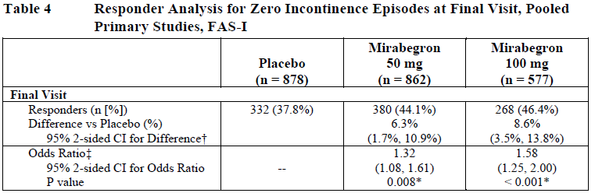
Table 57. Responder Analysis for ≥ 50% Reduction from Baseline in Incontinence Episodes at Final Visit, Pooled Pivotal Studies
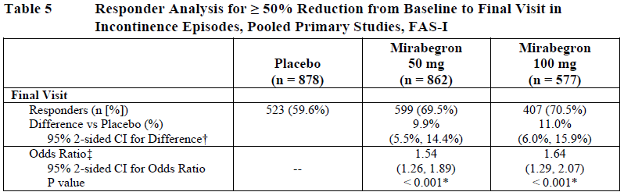
Finally, the sponsor performed a pooled analysis of the change in treatment satisfaction as measured by the TS-VAS. This was a minor endpoint, but relatively important in view of the European guidelines on the conduct of urological studies, which suggest that subjective endpoints should be major endpoints. It is therefore reassuring to observe that there was a statistically significant improvement in treatment satisfaction (p<0.01) at the proposed dose, in comparison to placebo.
Table 58. Adjusted Mean Difference from Baseline in TS-VAS, Pooled Pivotal Studies
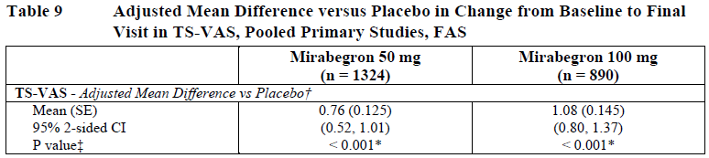
The higher statistical power of the pooled analysis allowed a number of subgroup analyses, which are shown below. There was no evidence that the efficacy of mirabegron was significantly different in subgroups defined by baseline demographics, OAB history or concomitant drug use.
Table 59. Change from Baseline to Final Visit for the Coprimary Efficacy Endpoints by Subpopulation, Demographics, Pooled Pivotal Studies
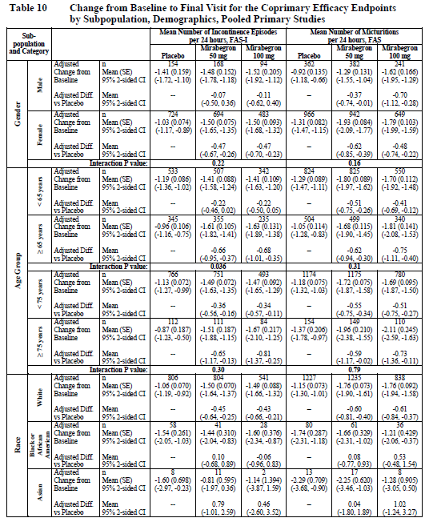
Table 59 continued. Change from Baseline to Final Visit for the Coprimary Efficacy Endpoints by Subpopulation, Demographics, Pooled Pivotal Studies
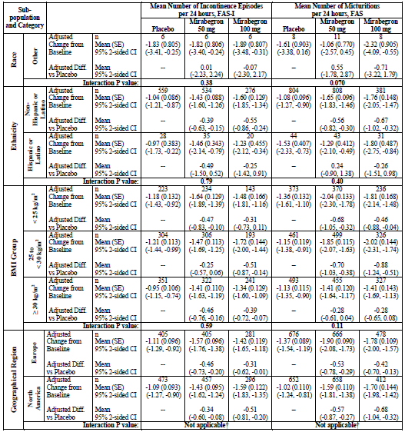
Table 60. Change from Baseline for the Coprimary Efficacy Endpoints by Subpopulation, Characteristics of OAB, Pooled Pivotal Studies
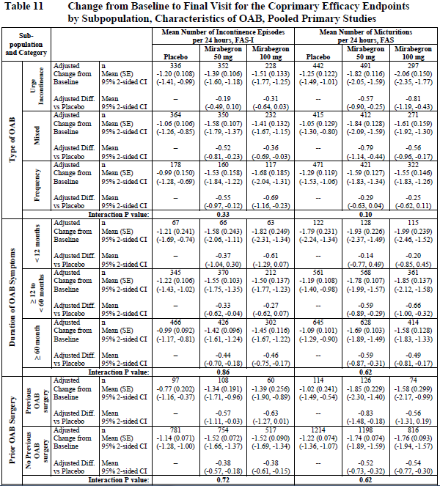
Table 60 continued. Change from Baseline for the Coprimary Efficacy Endpoints by Subpopulation, Characteristics of OAB, Pooled Pivotal Studies
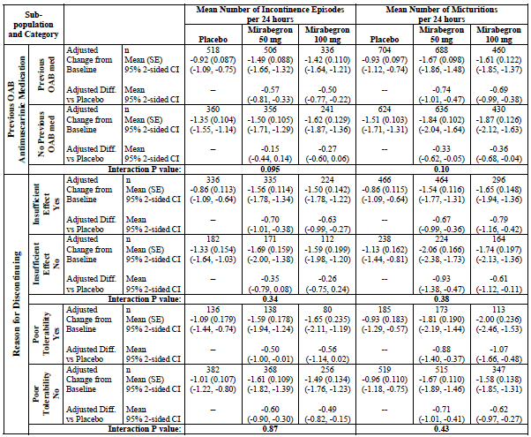
Table 61. Change from Baseline to Final Visit for the Coprimary Efficacy Endpoints by Subpopulation, Intrinsic/Extrinsic Factors, Pooled Pivotal Studies
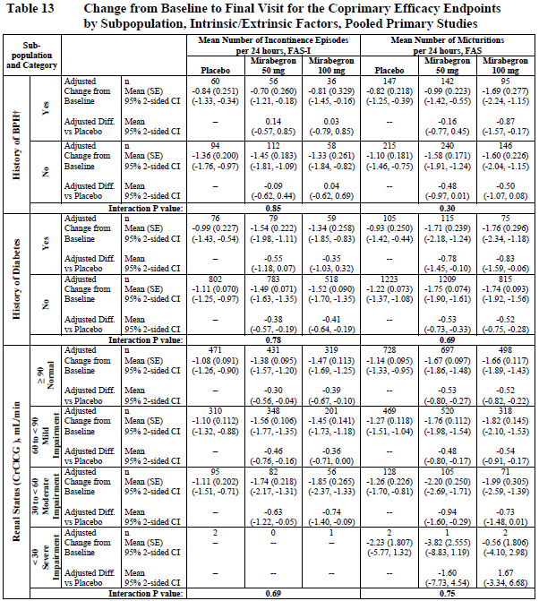
Table 61 continued. Change from Baseline to Final Visit for the Coprimary Efficacy Endpoints by Subpopulation, Intrinsic/Extrinsic Factors, Pooled Pivotal Studies
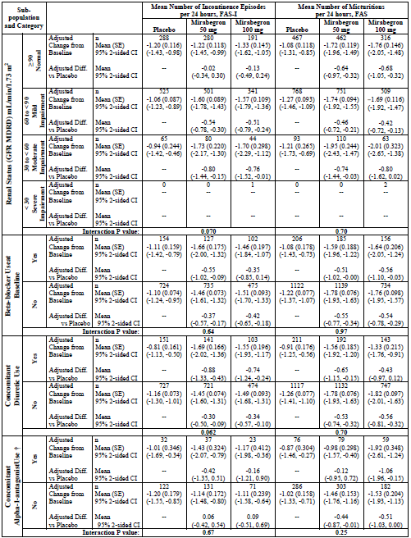

Evaluator’s conclusions on clinical efficacy
Overall, the submitted efficacy data shows that mirabegron has a minor beneficial effect on the symptoms OAB. The statistical evidence in support of the efficacy of mirabegron 50mg is robust and consistent: all three pivotal studies and the pooled analysis showed a statistically significant treatment effect for both of the co-primary endpoints, micturition frequency and incontinence frequency. Secondary endpoints were also achieved with statistical significance in most cases, including a number of subjective endpoints, such as the Treatment Satisfaction VAS.
There were no major methodological flaws compromising the statistical interpretation of the major endpoints, but there was a pronounced placebo response for both co-primary endpoints and most secondary endpoints. The placebo-subtracted treatment effect was relatively small compared to this placebo response.
The magnitude of the placebo-subtracted treatment effect was disappointing. In the pooled analysis of the pivotal studies, the number of voluntary micturitions avoided per 24 hours was 0.55 episodes for the proposed 50mg dose, and 0.54 for the 100mg dose, from a baseline of 11 to 12 episodes. This hardly seems worth pursuing. The mean number of incontinence episodes was reduced with mirabegron 50mg by 0.40 episodes, from a baseline of about two and a half episodes across the various treatment groups. The reduction with mirabegron 100mg was 0.41 episodes.
This modest quantitative improvement was associated with a statistically significant improvement in the subjective TS-VAS, which showed a placebo-subtracted improvement of 0.76 for mirabegron 50mg and 1.08 for mirabegron 100mg, in a scale ranging from 0 to 10 and baseline values of about 4. The improvement in the placebo group was 1.89, 0.7, 1.05 across the three studies. A fully effective drug would potentially produce a rating of 10 (complete satisfaction with treatment), giving an overall improvement of 6 points, and a placebo-subtracted improvement of 4-5 points.
Results in the 50mg and 100mg groups were generally similar to each other. The lower dose of 25mg was only assessed in one pivotal study, and although this dose achieved significance for many endpoints, it was inferior to 50mg and did not achieve all of its secondary endpoints.
The efficacy of mirabegron was broadly similar to that seen with the active control, tolterodine.
Thus, overall, mirabegron has modest efficacy, which some patients might find useful, and is comparable to another agent already used for OAB.

Clinical safety

Studies providing evaluable safety data
The studies listed below are the major source of evaluable safety data. The sponsor defined 5 different study populations, as indicated by the last 5 columns of the table below. The most important of these were the global phase 2/3 population and the 12-week (placebo-controlled) global phase 2/3 population; the contribution of each study to these populations is detailed in the subsequent table, on the following page. Patient disposition in the phase 2/3 population is listed in Table 64. Most subjects (85.6%) completed treatment with mirabegron, but some patients withdrew for a variety of reasons, as listed. Adverse events (AEs) caused withdrawals in 5% of the global phase 2/3 population.
Table 62. Overview of Phase 2/3 Study Populations
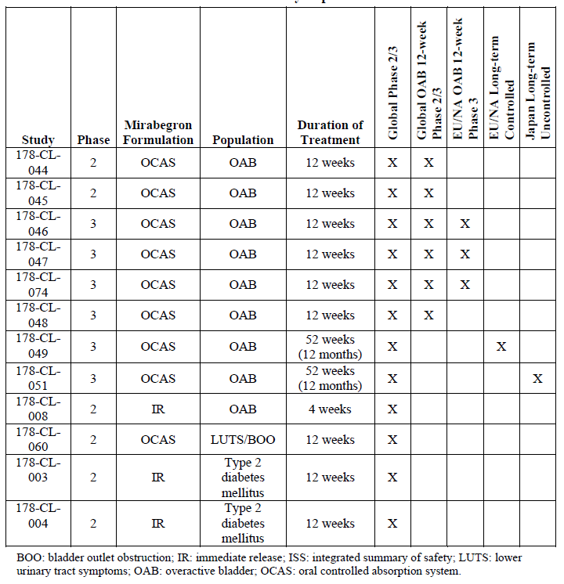
Table 63. Source and Number of Patients Treated in the Global Phase 2/3 Clinical Population
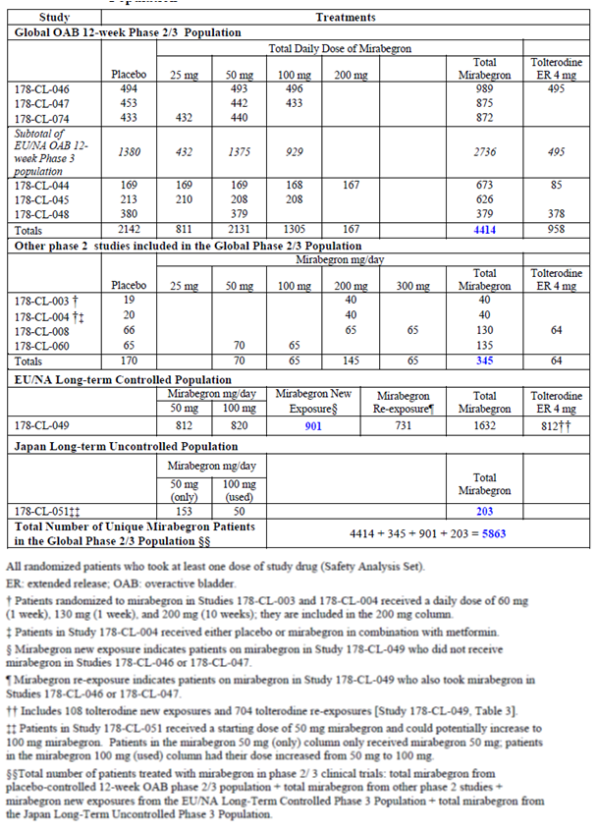
Table 64. Patient Disposition, Global Phase 2/3 Population
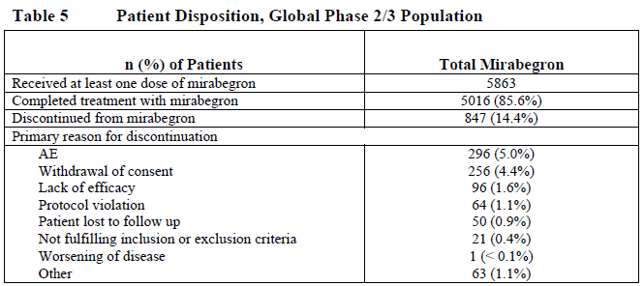
Pivotal efficacy studies
In the pivotal efficacy studies, the following safety data were collected:
- General adverse events (AEs) were assessed by interviewing patients at each visit and reviewing hospital records for unscheduled visits.
- AEs of particular interest, including urological events and cardiovascular events.
- Laboratory tests, including full blood counts, liver function tests and electrolytes, were performed at regular intervals and the results were compared with normal reference ranges.
Studies that assessed safety as a primary outcome
Long-term studies 049 and 051 assessed the safety and tolerability of mirabegron over 12 months, and efficacy was a secondary focus. The design of these studies has been described in Sections 7.2.5 and 7.2.6. These studies contributed data to the EU/NA long term population (Study 049) and to the Japanese long-term population (Study 051); the results in these long-term subgroups are included where relevant in the sections below.
Dose-response studies, non-pivotal efficacy and clinical pharmacology studies
The dose-response and non-pivotal efficacy studies provided safety data in the same way as in the pivotal studies, with adverse event monitoring and laboratory surveillance. A couple of clinical pharmacology studies were specifically designed to assess the effect of mirabegron on the QT interval (Thorough QT studies 178-CL-037 and 178-CL-077).

Patient exposure
Exposure to mirabegron has been fairly extensive, with 10,552 subjects exposed in the clinical study program: this includes 1800 healthy volunteers and 8752 patients. Most patients (8433) have had OAB; the remainder (319) consists of male patients with lower urinary tract symptoms/bladder outlet obstruction (LUTS/BOO) and some patients with type 2 diabetes mellitus.
Not all exposed subjects were in studies that contributed to the integrated safety data set. The safety data set is based on 29 phase 1 studies and 9 phase 2/3 studies in OAB, and 3 studies in other conditions (one study in patients with LUTS/BOO and two studies in patients with type 2 diabetes mellitus). Detailed safety data thus comes from 1462 volunteers in phase 1 studies and 5863 patients (5648 patients with OAB) in the phase 2/3 studies.
The immediate release (IR) formulation was used for most of the phase 1 studies; subsequent studies used the controlled-release (OCAS) formulation. The most relevant safety data comes from the global phase 2/3 studies in OAB, summarised below, which used the proposed formulation for the proposed indication. Exposure in this population is summarised below.
Table 65. Summary of Study Drug Exposure by Total Daily Dose, Global Phase 2/3 Population
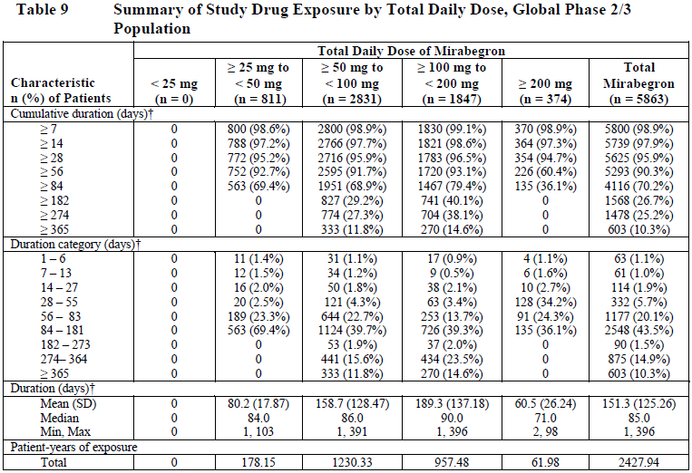
Table 66. Summary of Study Drug Exposure by Total Daily Dose, Global OAB 12-Week Phase 2/3 Population
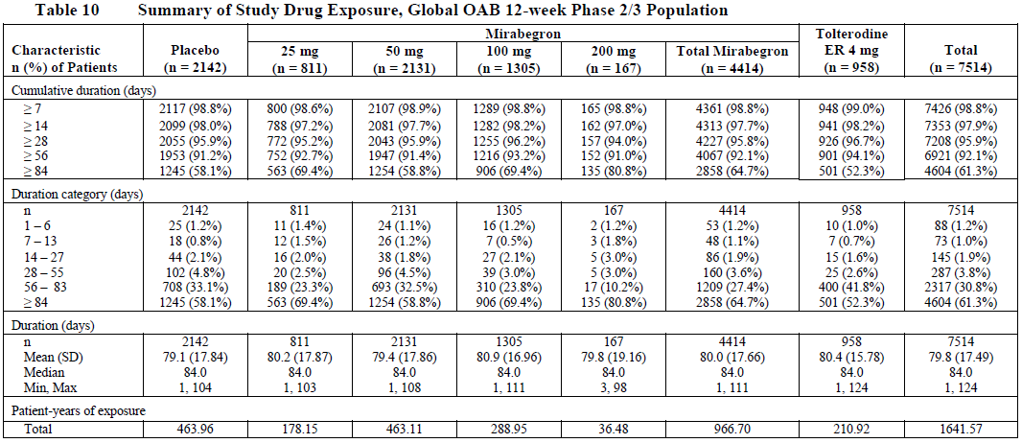
Table 67. Summary of Study Drug Exposure, EU/NA Long-term Controlled Population
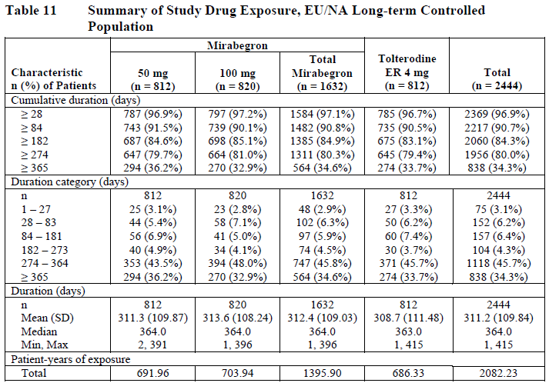
The demographic characteristics of the main safety population (the global phase 2/3 population) is summarised in the table below. About 36% of this population were ≥ 65 years old, and 9.8% were ≥ 75 years old, so that the population assessed broadly matches the population in which the drug is likely to be used. On the other hand, subjects with significant comorbidities were excluded from the major efficacy studies, so tolerability in a more realistic, less selective population would be expected to be worse than in this carefully monitored and selected trial population.
Table 68. Demographic and Baseline Characteristics, Global Phase 2/3 Population
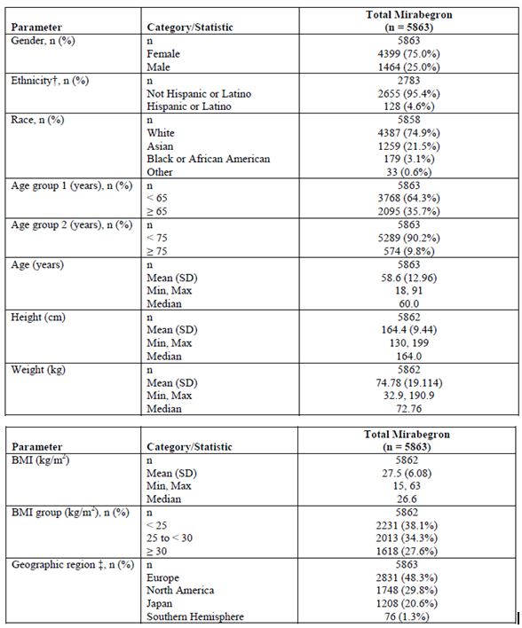

Adverse events

All adverse events (irrespective of relationship to study treatment)

Individual studies (Pivotal studies and major supporting studies)
The incidences of treatment-emergent adverse events (TEAEs) reported in the major studies are listed below for each study and each treatment group. These included any adverse events (AEs) which appeared during the study, as well as AEs that significantly worsened during the treatment phase.
Reviewing the TEAE column for each study shows that, in general, the incidence of TEAEs was comparable in the mirabegron and placebo groups, and was often slightly higher in the placebo group. The incidence of TEAEs varied widely from study to study, but this largely reflects different study durations, with the highest incidence of TEAEs reported in the long-term follow-up studies. In the pivotal studies, the incidence ranged from 40% to 50%, with no consistent difference between mirabegron dose groups or between mirabegron and placebo treatment. In pivotal Study 046, the incidence of TEAEs was slightly higher in the tolterodine group (46.7%) than the placebo group (43.3%) or the 50mg and 100mg mirabegron dose groups (42.8% and 40.1%, respectively). In pivotal Study 047, the mirabegron 100mg dose group had the lowest incidence of TEAEs (46.9%), followed by the placebo group (50.1%) and the mirabegron 50mg group (51.6%). In pivotal Study 074, the mirabegron 50mg group had the lowest incidence (47.3%), followed by the 25mg group (48.6%%) and the placebo group (50.1%). Overall, this suggests that mirabegron is well tolerated by most subjects. The incidence of specific AEs is considered in the subsequent section.
Table 69. Main Safety Results for Individual Studies
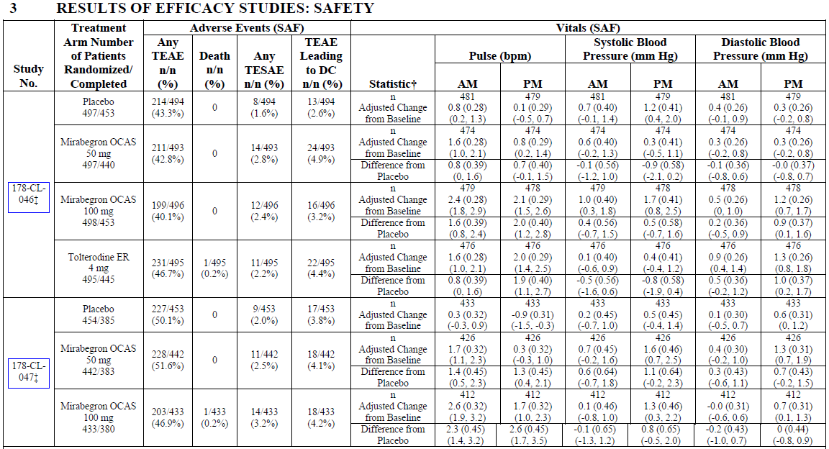
Table 69 continued. Main Safety Results for Individual Studies
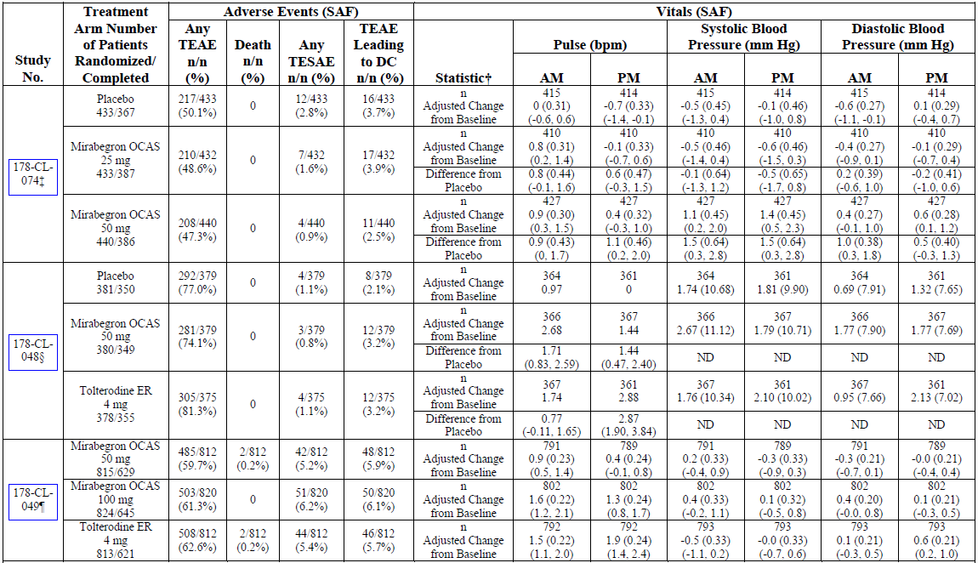
Table 69 continued. Main Safety Results for Individual Studies
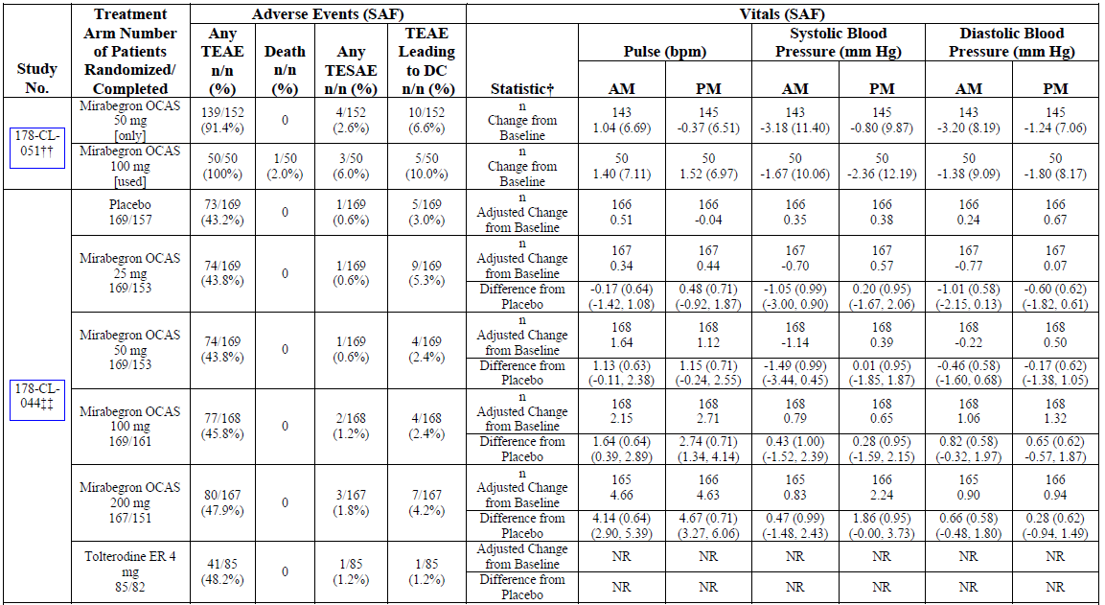
Table 69 continued. Main Safety Results for Individual Studies
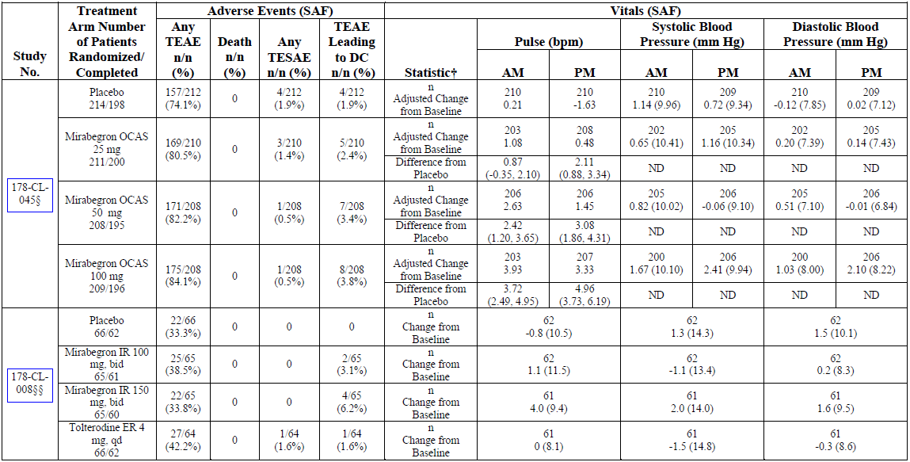

Pooled phase 2/3 studies
In the pooled 12-week phase 2/3 population (involving subjects followed for 12 weeks, but excluding subjects from the non-placebo-controlled long-term studies), the incidence of TEAEs in the total mirabegron population (53.4%) was similar to that in the placebo group (55.2%), and there was actually a trend to reduced incidence of TEAEs at higher mirabegron doses, as shown in the table below.
Table 70. SAE, TEAE and TEAE leading to Discontinuation of Study Drug, Global OAB 12-Week Phase 2/3 Population
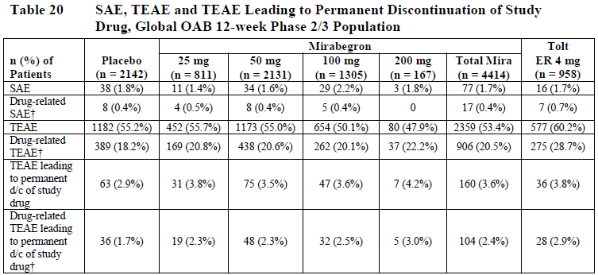
Considering specific AEs, the most common AEs reported in the mirabegron group were: nasopharyngitis, hypertension, increased blood glucose, headache, UTI, increased gamma GT, and abnormal urinary sediment, with incidences as shown in the table below.
Table 71. TEAE by Preferred Term (Reported by ≥ 3.0% in the Total Mirabegron group), Global Phase 2/3 Population
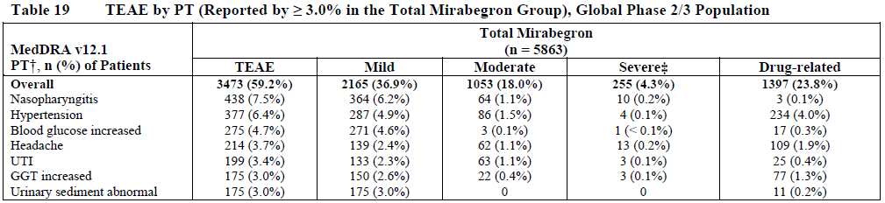
Many of these reflect the intercurrent illnesses present in any population studied for a prolonged period. When compared with the incidence of the same AEs in the placebo population, as shown in the table below, there was no substantial difference between active treatment and placebo. The overall incidence of each AE was similar with active treatment and placebo, as was the distribution amongst the mild, moderate and severe categories.
Table 72. TEAE by Preferred Term (Reported by ≥ 3.0% in the Total Mirabegron group), Global OAB 12-Week Phase 2/3 Population
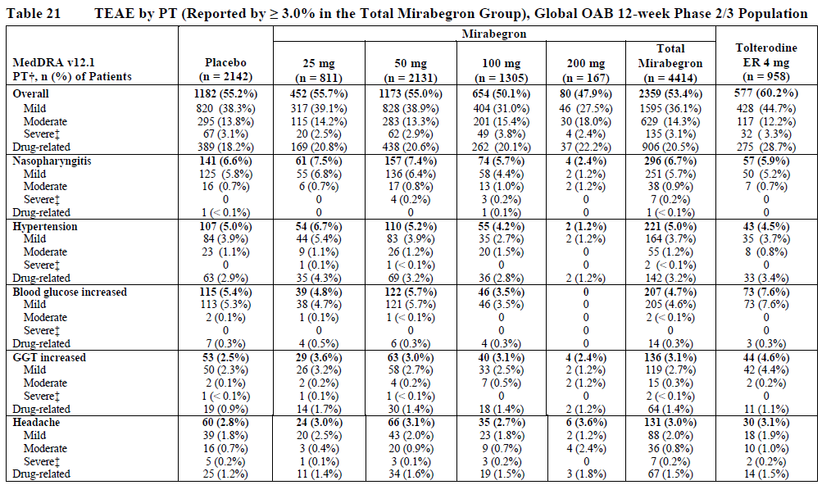
The sponsor also presented a summary of TEAEs in the long-term population from the European Union and North America (EU/NA) long-term population; note that this data is derived from studies that lacked a placebo control group, so interpretation is difficult.
Table 73. SAE, TEAE and TEAE leading to Discontinuation of Study Drug, EU/NA Long-term Controlled Population
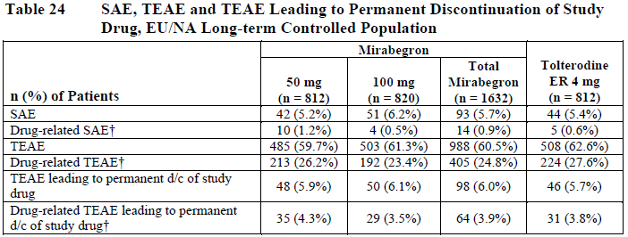
Table 74. TEAE by Preferred Term (Reported by ≥3.0% in the Total Mirabegron Group), EU/NA Long-term Controlled Population
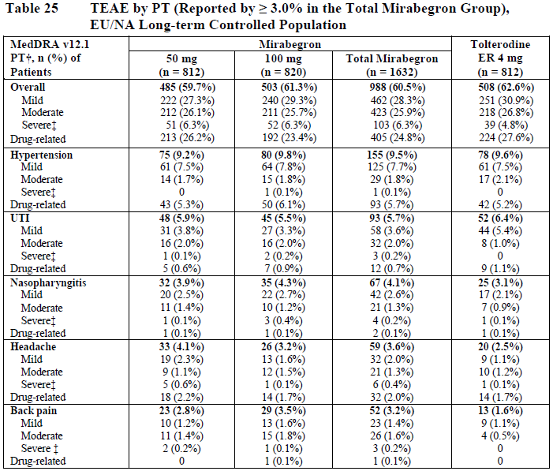

Treatment-related adverse events (adverse drug reactions)
As is typical for placebo-controlled studies, AEs reported in the phase 2/3 study program were classified according to whether the reporting investigator thought that study drug was likely to have played a significant causal role. The attribution of causation in such circumstances is inherently unreliable, and may merely reflect the investigators preconceived notions about the likely side effects of active treatment. Investigators may be particularly unlikely to attribute a causal role to the study drug when side effects are novel or unexpected.
The tables above include data about which AEs were considered ‘drug-related’ by the reporting investigator. Note that investigators often thought that AEs were drug related even when subjects were receiving placebo, and the overall incidence of drug-related AEs was similar in the active and placebo groups. The main table of interest in this regard is Table 70 above, which considers drug-related TEAEs in the global 12-week phase 2/3 population. About 1 in 5 subjects had a drug-related TEAE, with a slight excess in the active groups (20.5% overall in the pooled mirabegron population) compared to the placebo group (18.2%). As shown in the table, there was also a slight excess of discontinuations that were thought to be drug-related: this occurred in 2.4% of mirabegron recipients, compared to 1.7% of placebo recipients, an excess of 0.7% or 7 in 1000 patients.

Deaths and other serious adverse events
Deaths in the major study populations and in individual studies are listed in the tables below. In the global phase 2/3 population, one death occurred in a placebo recipient, and 5 in mirabegron recipients, but this difference reflects the unequal patient number assigned to active treatment vs placebo. When expressed in deaths per 1000 patient-years of exposure (PYE), the highest mortality in the global phase 2/3 population was seen with tolterodine (3.3 deaths per 1000 PYE), followed by placebo (2.0 deaths per 1000 PYE) and then mirabegron (1.9 deaths per 1000 PYE).
Table 75. Mortality by Treatment Group
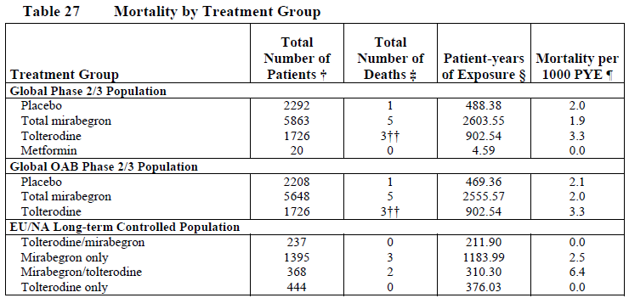
A review of the individual causes of death, as shown in the table below, shows no concerning trends, with multiple different causes appearing. In general, investigators did not feel that study drug had played a role in the deaths, but ‘possible’ causation was indicated for one case of pneumonia in a mirabegron 50mg recipient, one of suicide in a mirabegron 50mg recipient, and one of a ruptured cerebral aneurysm in a tolterodine recipient.
[Information redacted]: Table 76 below has been modified from the original to remove patient numbers and age.
Table 76. Listing of Deaths
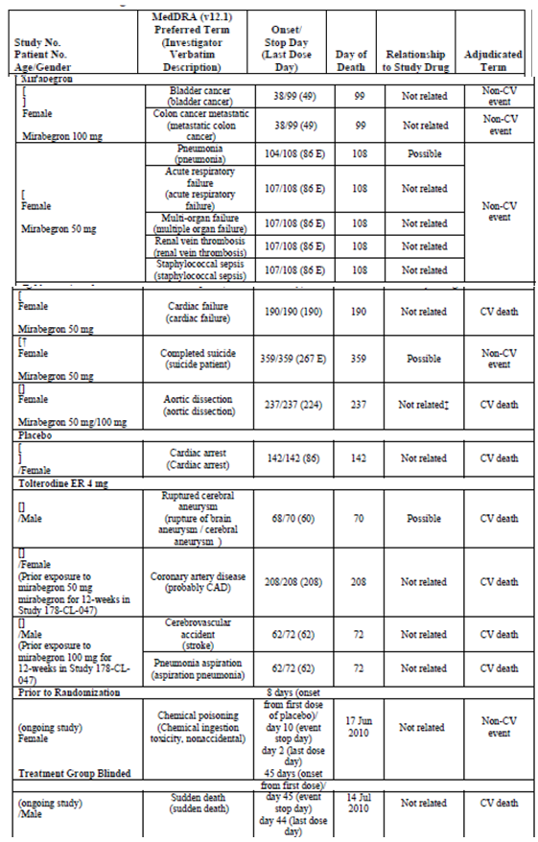
Relationship to study drug is assessed by investigator. CAD: coronary artery disease; CV: cardiovascular; E: estimated value; ER: extended release; SAP: Statistical Analysis Plan. † Last dose day for this patient was unknown. Based on the estimated last dose day (per SAP imputation rules), the death was non-treatment-emergent. ‡ Investigator’s causality determination: there was insufficient information at the time of the event because the subject was dead on arrival at the hospital, and the Sponsor concluded that the event (aortic dissection), which occurred during study treatment, was not completely unrelated to the study drug.
The incidence of serious AEs (SAEs) in the global 12-week phase 2/3 population were listed in Table 70 above. There was no notable overall difference between the incidence of SAEs in the placebo group (1.8%) versus the pooled mirabegron group (1.7%). At the proposed dose of 50mg, the incidence of SAEs was mildly lower (1.6%) than in the placebo group, and at 25mg the incidence was even lower (1.4%), whereas at 100mg the incidence was slightly higher (2.2%) than in the placebo group. Considering the subgroup of SAEs that were considered potentially ‘drug-related’, the incidence was similar across the placebo group (0.4%), the pooled mirabegron group (0.4%) and the individual dose groups (0.5%, 0.4%, 0.4% and 0% across the 25mg, 50mg, 100mg and 200mg dose groups, respectively).
The individual SAEs reported by two or more patients in the pooled mirabegron group of the 12-week phase 2/3 population are summarised below, under organ/system headings and individual AE designations. There was no overall pattern in the distribution of SAEs. Cardiac SAEs were reported in 10 mirabegron recipients (0.2%), which was a slightly lower proportion than that observed in the placebo group (0.3%). Neoplasms were observed in a slightly higher proportion of mirabegron recipients (0.2%) than placebo recipients (0.1%), but the comparison is based on few individual cases. Given the long lead time required to produce a tumour after exposure to a carcinogenic agent, it seems very unlikely that a 12-week study would be able to detect such a risk. In the long-term study, the incidence of neoplasms was 0.7%, and the most common neoplasms were breast, lung and prostate cancer, which occurred in two patients each. These are common cancers in the general aged population.
Table 77. SAE (Reported by ≥ 2 Patients in the Total Mirabegron Group), Global OAB 12-Week Phase 2/3 Population
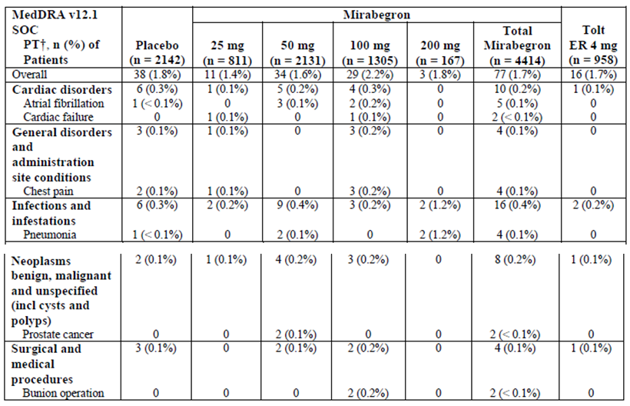
Table 78. SAE (Reported by ≥ 2 Patients in the Total Mirabegron Group), EU/NA Long-Term Controlled Population
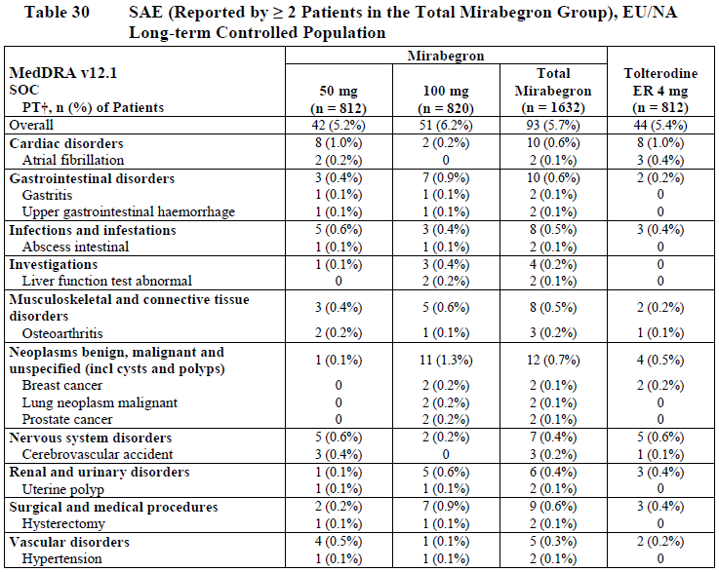

Discontinuation due to adverse events
Discontinuations due to adverse events were shown in Table 70, seen earlier. In the 12-week phase 2/3 population, there was a slight excess of discontinuations in the pooled mirabegron group (3.6%) than the placebo group (2.9%), amounting to 0.7% or 7 patients per 1000. When longer studies are included, as in Table 81 below, the incidence of discontinuations due to AEs was slightly higher (4.9% in the pooled mirabegron group). The types of AEs leading to discontinuation are shown in Table 79 (global phase 2/3 population) and Table 80 (12-week phase 2/3 population). As shown in Table 79, most individual types of AE leading to discontinuations occurred with an incidence ≤ 0.1%, with the exception of constipation (0.3%), nausea (0.2%), dizziness (0.2%), headache (0.3%) and hypertension (0.3%). The results in the 12-week phase 2/3 population (Table 80) were similar; the inclusion of a placebo comparator in this group shows that gastrointestinal intolerance, including nausea, was more common with placebo than with mirabegron.
Table 79. TEAE Leading to Permanent Discontinuation of Study Drug (Reported by ≥ 0.1% in the Total Mirabegron Group), Global Phase 2/3 Population
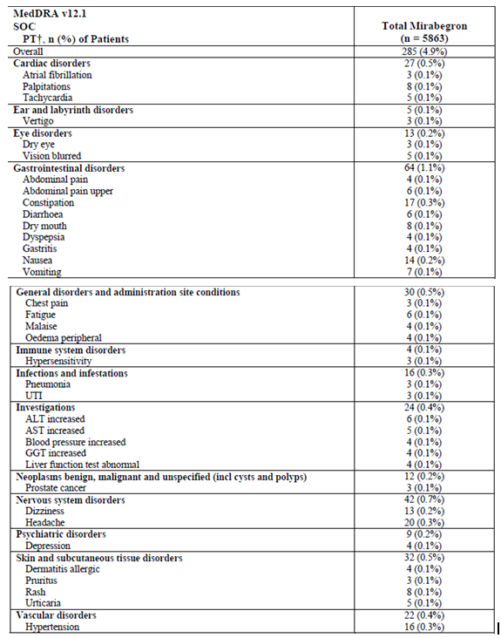
Table 80. TEAE Leading to Permanent Discontinuation of Study Drug (Reported by ≥0.1% in the Total Mirabegron Group), Global OAB 12-Week Phase 2/3 Population
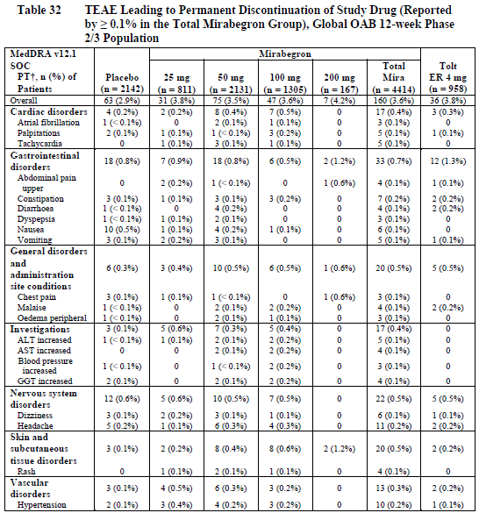
Table 81 lists discontinuations in the long-term EU/NA population for both mirabegron and tolterodine. Overall, discontinuations occurred with similar frequency in the total mirabegron group (6.0%) and the tolterodine group (5.7%). Of the more common types of AE leading to discontinuation, most occurred with similar frequency in the mirabegron and tolterodine groups, including headache and hypertension, but not dizziness, which was only seen in the mirabegron and placebo groups.
Table 81. TEAE Leading to Permanent Discontinuation of Study Drug (Reported by ≥ 2 Patients in the Total Mirabegron Group), EU/NA Long-Term Controlled Population
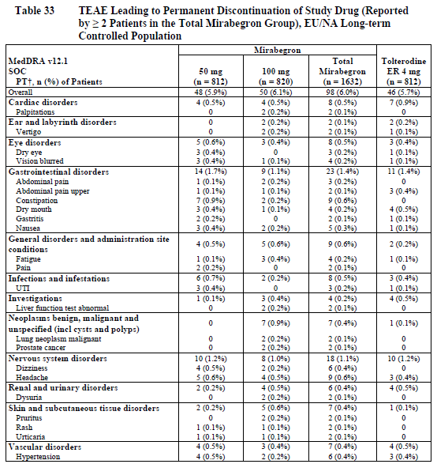

Adverse events of particular interest

Postural hypotension and falls
The incidence of postural hypotension and falls was infrequent with both active treatment and placebo, as shown in the table below.
Table 82. Syncope, Postural Hypotension and Falls TEAE, Global OAB 12-Week Phase 2/3 Population
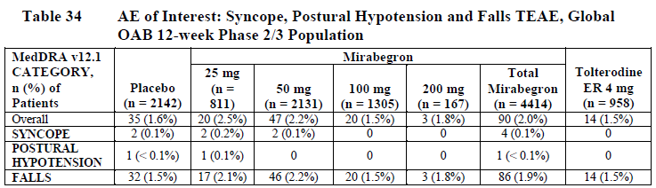
Table 83. Syncope, Postural Hypotension and Falls TEAE, EU/NA Long-Term Controlled Population
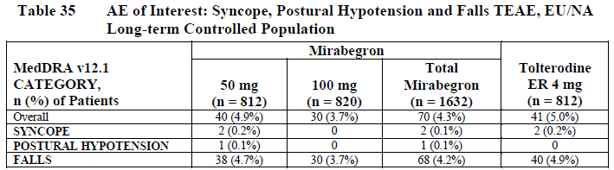

Urinary AEs
Urinary AEs, including urinary retention, occurred with a low incidence in all treatment groups, with no substantial differences between active treatment and placebo, as shown below.
Table 84. Urinary Tract Infection TEAE, Global OAB 12-Week Phase 2/3 Population
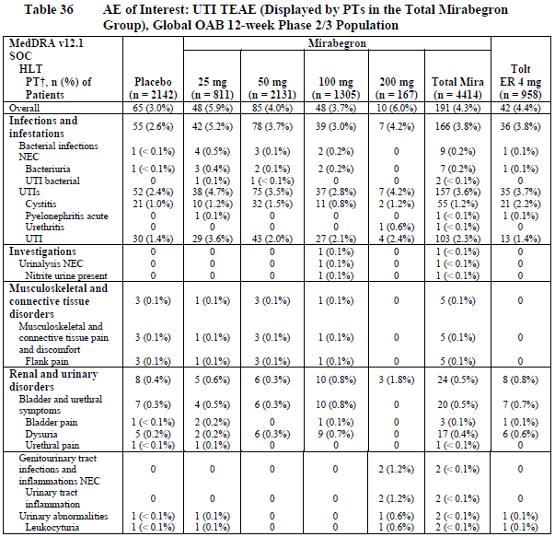
Table 85. Urinary Tract Infection TEAE, EU/NA Long-Term Controlled Population
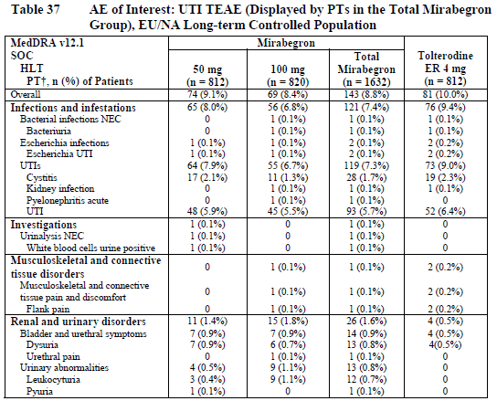
Table 86. Urinary Retention TEAE, Global OAB 12-Week Phase 2/3 Population
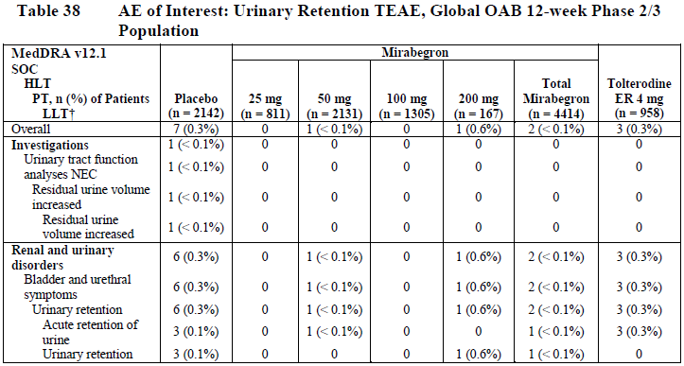
Table 87. Urinary Retention, EU/NA Long-Term Controlled Population
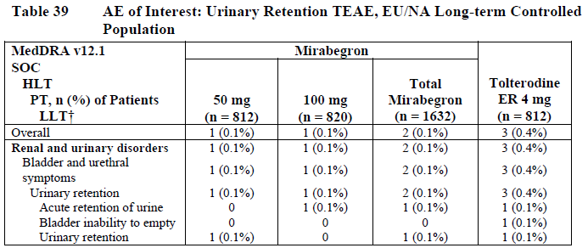
Table 88. Combined Summary of Urinary Retention, Based on TEAE and Post-Void Residual Volume Measured During Baseline and Postbaseline, Global OAB 12-Week Phase 2/3 Population
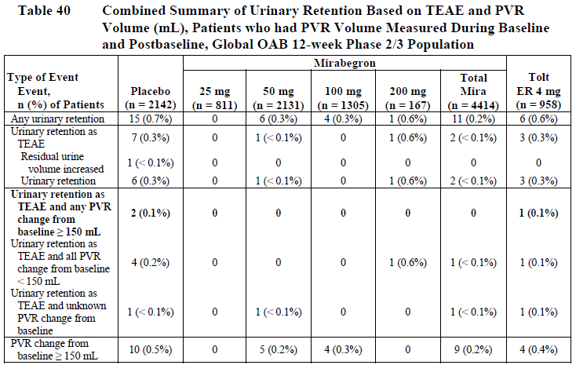
Table 89. Urolithiasis TEAE, Global OAB 12-Week Phase 2/3 Population
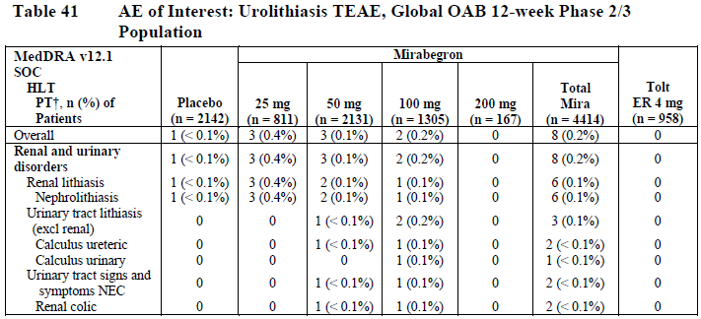
Table 90. Urolithiasis TEAE, EU/NA Long-Term Controlled Population
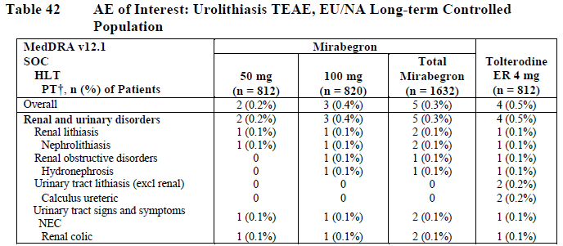

Laboratory tests

Liver function
Liver function tests in the phase 2/3 studies did not suggest that mirabegron is prone to causing hepatotoxicity. In mirabegron recipients, mean shifts from baseline in ALT, AST, and ALP were generally minor and similar to those observed in placebo recipients. Table 91 shows the mean shifts observed with each treatment in the pooled 12-week global OAB phase 2/3 population, and Table 92 shows the mean shifts in the long-term EU/NA population.
Table 91. Hepatic Laboratory Test Results, Global OAB 12-Week Phase 2/3 Population
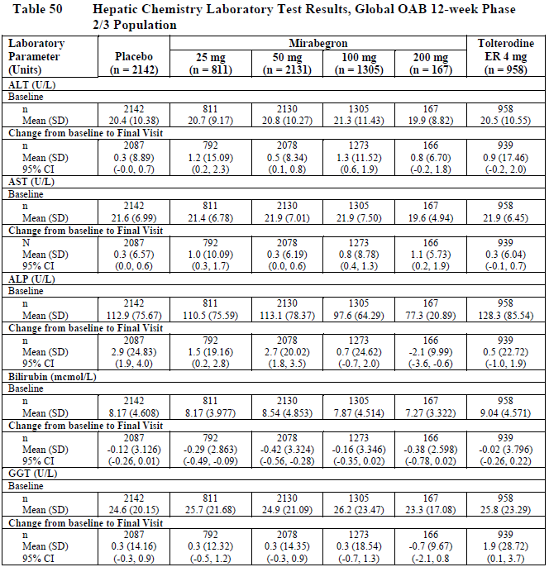
Table 92. Hepatic Laboratory Test Results, EU/NA Long-Term Controlled Population
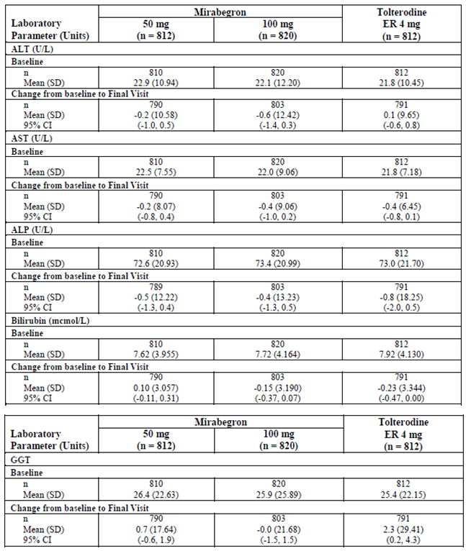
When considering the incidence of shifts to levels of concern, mirabegron appeared no more likely than placebo to be associated with levels at various multiples of the upper limit of normal (ULN), as shown in the table below. Hy’s law, which indicates a poor prognosis for drug-induced hepatic injury in the presence of ALT elevation>3xULN and serum bilirubin >2xULN, was not explicitly mentioned by name in the Integrated Summary of Safety, but the number of cases with this combination of abnormalities was assessed: in the global Phase 2/3 population, just one patient (1/5860, < 0.1%) receiving mirabegron experienced ALT and/or AST > 3 x ULN and total bilirubin > 2 x ULN and ALP < 2 x ULN on the same date. This patient had viral hepatitis as an alternative aetiology. One other mirabegron patent had concurrent ALT and bilirubin abnormalities satisfying this definition in the local laboratory, but not in the centralised laboratory. Given that similar elevations of ALT and bilirubin were also seen in the placebo group, there does not appear to be significantly increased risk of hepatic injury with active treatment.
Table 93. Potentially Clinically Significant Hepatic Laboratory Abnormalities, Global OAB 12-Week Phase 2/3 Population
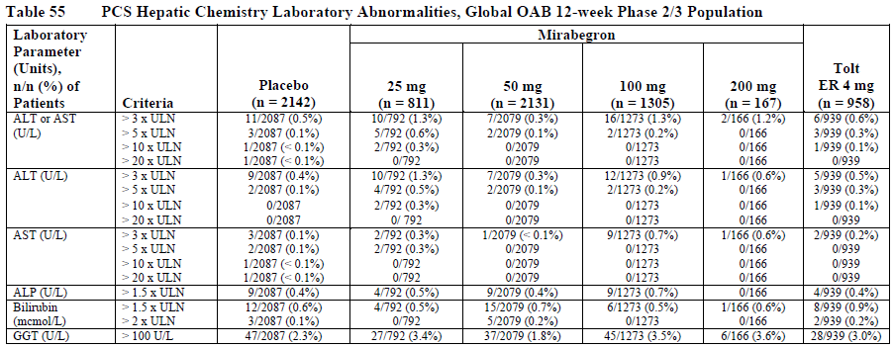
Table 94. Potentially Clinically Significant Hepatic Laboratory Abnormalities, EU/NA Long-Term Controlled Population
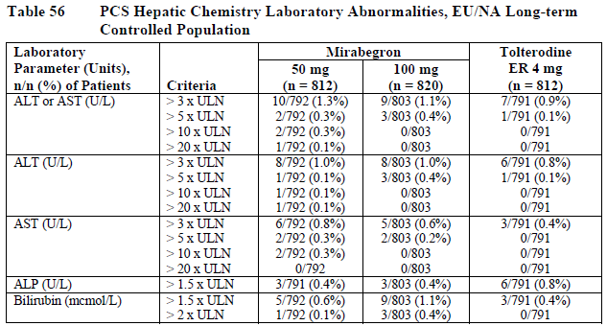
TEAEs related to the liver are summarised in the table below. Overall, in the 12-week phase 2/3 population, liver-related AEs occurred in 5.5% of mirabegron recipients, and 5.6% of placebo recipients, with no consistent dose trend observed across the mirabegron dose 25mg, 50mg and 100mg. In the tolterodine group, liver-related AEs were reported in 8.1% of recipients, which is a slightly higher incidence than seen with placebo or mirabegron.
Table 95. Hepatotoxicity TEAE, Global OAB 12-Week Phase 2/3 Population
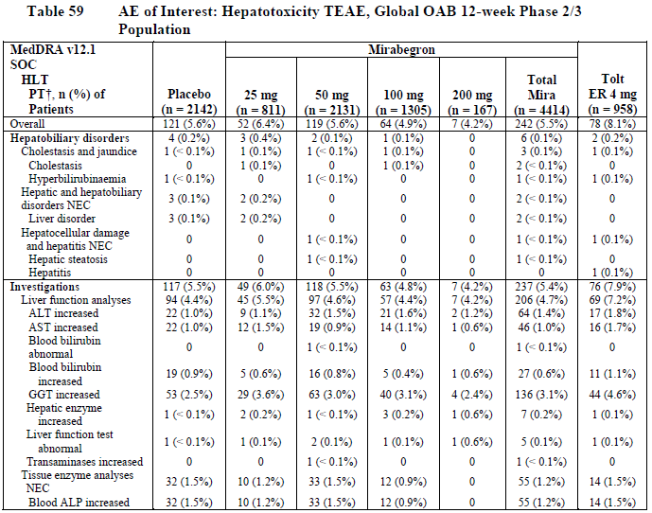
The long-term population lacked a placebo control group, making it more difficult to interpret the incidence of hepatic TEAEs in this population, but the results were generally reassuring. TEAEs potentially consistent with hepatotoxicity were reported in 3.3% of mirabegron recipients overall, compared to 2.7% of tolterodine recipients, as shown in the table below.
Table 96. Combined Summary of Hepatotoxicity Events Based on TEAE and Laboratory Data, EU/NA Long-Term Controlled Population
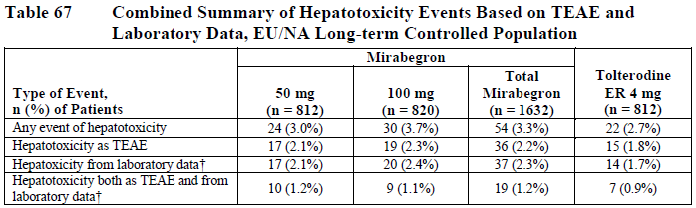

Kidney function
Mean changes from baseline in serum creatinine and urea (BUN) were generally minor in all treatment groups of the 12-week phase 2/3 study population, as shown in the table below. Results in the long-term EU/NA population were similar, with only minor changes observed that were similar in the mirabegron and tolterodine groups.
Table 97. Chemistry Laboratory Test Results, Global OAB 12-Week Phase 2/3 Population
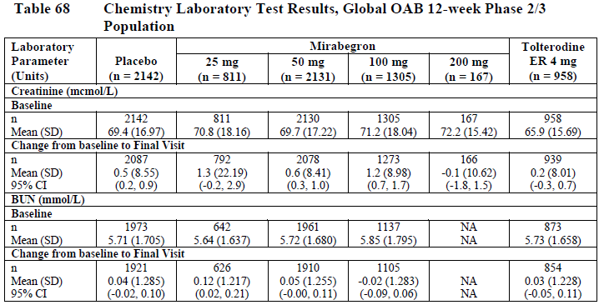
Table 98. Chemistry Laboratory Test Results, EU/NA Long-Term Controlled Population
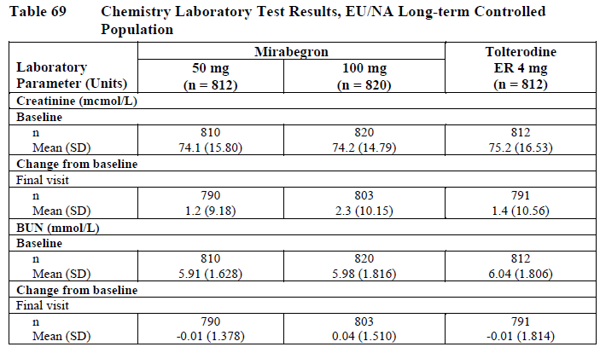
Mean changes in creatinine may not reflect the actual risk of renal toxicity, because concerning changes in a small proportion of patients are diluted by the overall group. To address this, the sponsor also assessed the number of patients in each group that exhibited a rise of at least 15% in serum creatinine (and more concerning rises of ≥ 30%, ≥ 50% ≥ 100%). As shown in the table below, about 10% of each group in the 12-week phase 2/3 population showed a creatinine rise of at least 15% at the final visit. The differences between groups were minor; the incidence of such a rise with proposed dose of mirabegron 50mg (10.1%) and placebo (10%) were almost identical. Considering other visits or other degrees of change did not show any substantial between-group differences. In the long-term population, rises of at least 15% at the final visit were slightly more common (12.4% of the mirabegron 25mg group, and 16.9% of the mirabegron 50mg group) but the incidence was similar in the tolterodine group (13.4%).
Table 99. Serum Creatinine: Patients with Increases of at Least 15% from Baseline, Global OAB 12-Week Phase 2/3 Population
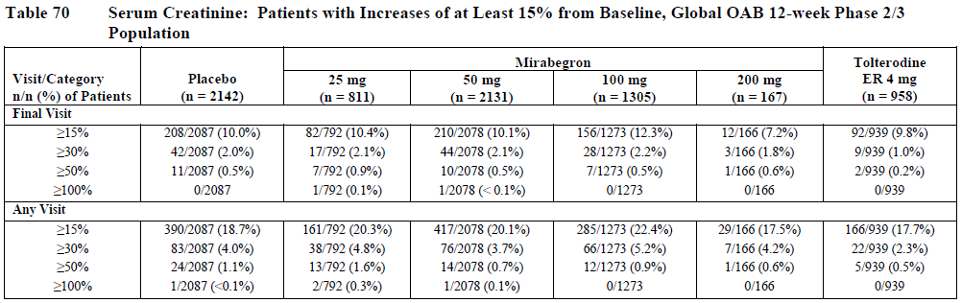
Table 100. Serum Creatinine: Patients with Increases of at Least 15% from Baseline, EU/NA Long-Term Controlled Population
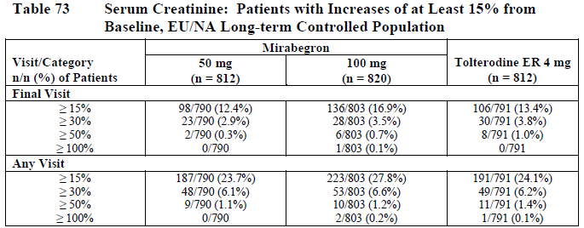

Other clinical chemistry
Laboratory results for other clinical chemistry tests in the 12-week phase 2/3 population are summarised in the table below. Shifts to concerning levels of sodium, potassium, chloride, calcium, urate, albumin and total protein were relatively rare, and occurred with similar frequency in the placebo and active groups. LDH levels >250 U/L were more common and appeared to show a dose trend in incidence, being slightly more common with increasing dose (placebo 4.0%, mirabegron 25mg 4.3%, mirabegron 50mg 5.5%, mirabegron 100mg 5.6%, mirabegron 200mg 6.0%). Changes were also observed in 4.6% of tolterodine recipients and, overall, these changes do not appear to be of clinical concern. The long-term population showed an incidence of LDH >250 U/L that was less than or equal to the placebo incidence in the 12-week studies, suggesting that there is no lasting effect on this laboratory parameter.
Table 101. Potentially Clinically Significant Abnormalities in Biochemistry, Global OAB 12-Week Phase 2/3 Population
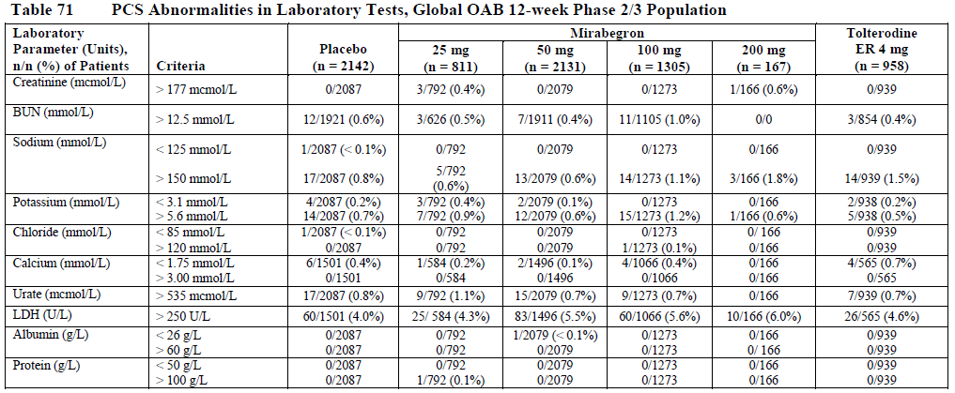
Table 102. Potentially Clinically Significant Abnormalities in Biochemistry, EU/NA Long-Term Controlled Population
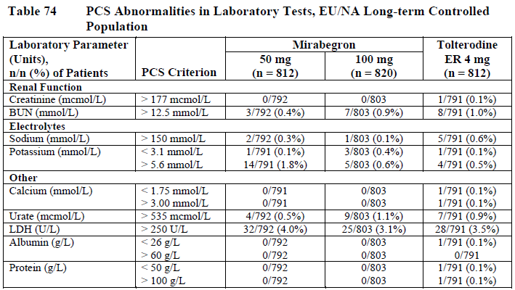

Haematology
The results of haematology monitoring are summarised in the tables below. Mean shifts in haematology parameters were relatively minor, and were generally similar between treatment groups in the 12-week phase 2/3 population, as shown in the Table below. Mean leukocyte counts shifted downwards with mirabegron therapy, and although the shifts were small in magnitude, there appeared to be a dose trend, with greater mean shifts in the 100mg and 200mg dose groups than the 25mg and 50mg dose groups. At the proposed 50mg dose, the mean shift was only -0.07 from a baseline value of 6.4 x 10⁹/L.
Table 103. Haematology Laboratory Test Results, Global OAB 12-Week Phase 2/3Population
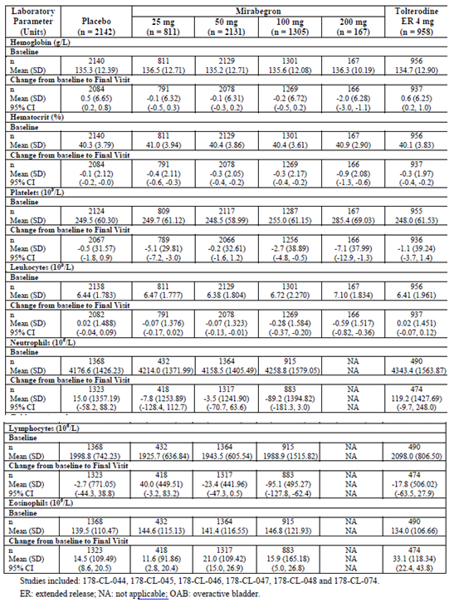
Table 104 lists the incidence of abnormal haematology results that were in potentially concerning ranges (too high or too low) in the 12-week phase 2/3 studies. Clinically significant changes in red cell and platelet indices were rare. Low leukocyte counts (<2.5 x 10^9/L) were observed in some mirabegron recipients (the incidence was 0.2% to 0.6% across the dose groups) and in tolterodine recipients (0.4%), but in relatively few placebo recipients (0.1%). These counts did not appear to be associated with clinical sequelae.
Table 104. Potentially Clinically Significant Haematology Abnormalities, Global OAB 12-Week Phase 2/3 Population
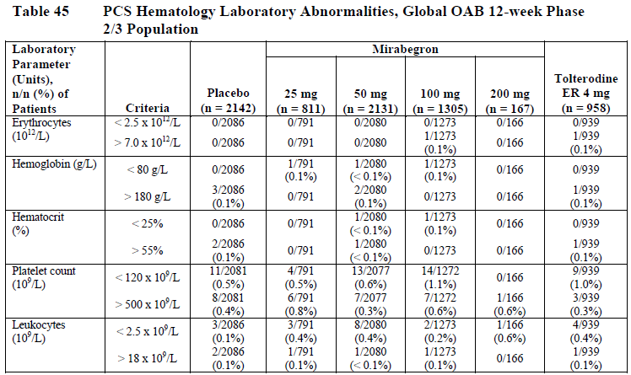
In the long-term EU/NA population, mean shifts in haematology parameters were minor and the magnitude and direction of shifts were similar in the two mirabegron dose groups (50mg and 100mg) and the tolterodine group.
Table 105. Haematology Test Results, EU/NA Long-Term Controlled Population
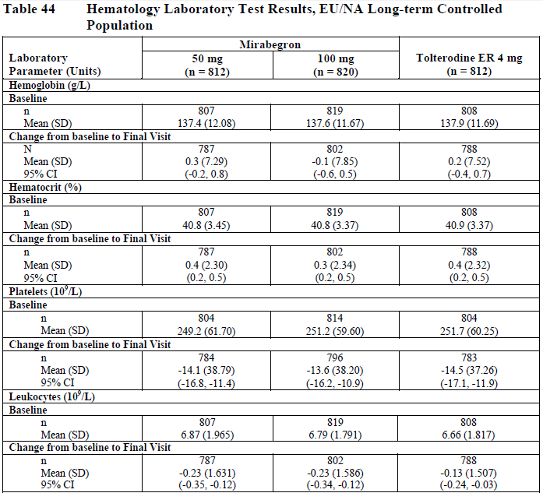
Table 105 continued. Haematology Test Results, EU/NA Long-Term Controlled Population
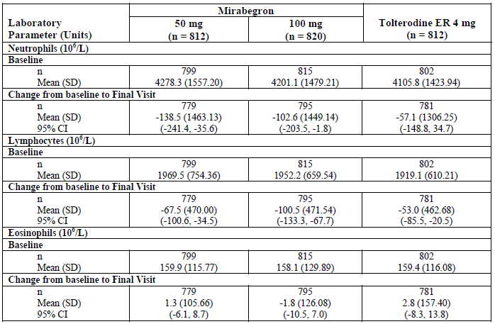
Table 106. Potentially Clinically Significant Haematology Abnormalities, EU/NA Long-Term Controlled Population
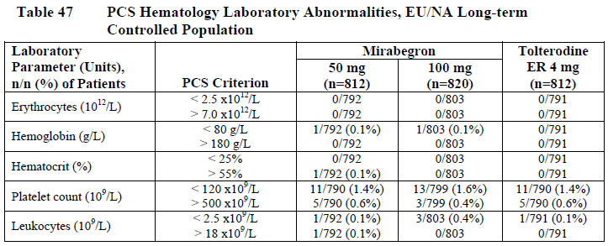

Electrocardiograph

Phase 2/3 efficacy studies
Regarding electrocardiograph (ECG) abnormalities observed in the 12-week phase 2/3 population. No consistent differences were observed between mirabegron and placebo.

Other studies
The sponsor performed two thorough QT studies. These studies suggested that supra-therapeutic doses of mirabegron may mildly prolong the QT interval, especially in women, who experience greater exposure than men for the same dose. The upper bounds of the 90%CI for the QT prolongation exceeded 10ms at a number of time points (depending on the dose, gender and study considered).

Vital signs
In the 12-week phase 2/3 studies, mirabegron at the proposed dose of 50mg once daily was associated with an increase in pulse rate of approximately 1 bpm (adjusted mean change from baseline pulse rate compared with placebo).
For blood pressure changes, the adjusted mean difference vs placebo was generally < 1mmHg, as shown in the figure below. For systolic blood pressure (SBP), the placebo-subtracted change from baseline SBP in the 12-week Phase 3 population for mirabegron 25, 50 and 100mg and tolterodine was -0.5, 0.6, 0.4 and -0.1 mm Hg for AM measurements, respectively, and -1.0, 0.5, 0.9 and 0.0 mm Hg for PM measurements, respectively. For diastolic blood pressure (DBP), the placebo-subtracted change from baseline for mirabegron 25, 50 and 100mg and tolterodine was -0.1, 0.4, 0.2 and 0.7 mm Hg for AM measurements, respectively, and -0.3, 0.4, 0.5 and 1.0 mm Hg for PM measurements, respectively.
Figure 29. Adjusted Mean Differences vs Placebo in Change from Baseline, SBP and DBP Measured by Patient Diary, ANCOVA Model, EU/NA OAB 12-Week Phase 3 Population
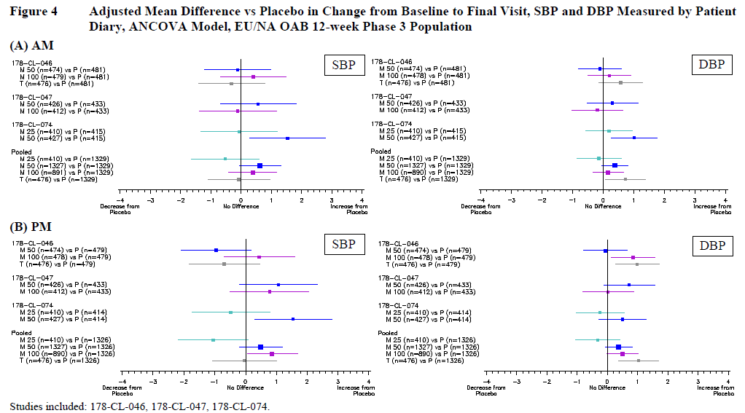
Adverse events associated with vital signs were relatively rare apart from hypertension, which was reasonably common in all treatment groups: it occurred in 5.0% of mirabegron recipients, 5.0% of placebo recipients, and 4.5% of tolterodine recipients, as shown in Table 72 earlier.

Post-marketing experience
According to the sponsor’s Summary of Clinical Safety, “There are no postmarketing data available for mirabegron at this time.”

Safety issues with the potential for major regulatory impact

Liver toxicity
As discussed in Section 8.4.1, there is no evidence in the current submission that mirabegron produces significant liver toxicity.

Haematological toxicity
As discussed in Section 8.4.4, mirabegron was associated with a minor reduction in mean leukocyte counts, but there was no evidence of clinically significant haematological toxicity.

Serious skin reactions and unwanted immunological events
Considering all AEs grouped under “Skin and subcutaneous tissue disorders”, there was a slight increase in skin reactions in the active groups compared to placebo, and this increased with increasing doses. The incidence of skin-related AEs leading to discontinuation in the 12-week phase 2/3 population was for each treatment group: placebo 0.1%, mirabegron 25mg 0.2%, mirabegron 50mg 0.4%, mirabegron 100mg 0.6%, mirabegron 200mg 1.2%, total mirabegron 0.5% and tolterodine 0.2%.
Over the whole clinical program, two events were suggestive of moderate skin reactions, reported as Stevens-Johnson syndrome and leukocytoclastic vasculitis. In one event, a 74-year-old woman treated with mirabegron 100mg developed urticaria, a rash and an elevated white cell count, which was reported as Stevens-Johnson syndrome by the treating clinican but the Expert Committee’s blinded review of the event classified it as urticaria and not as Stevens-Johnson syndrome. Mirabegron was ceased and she recovered without major sequelae. Subsequently, 72 days after stopping study drug, she developed urticaria again, which resolved without treatment, suggesting an underlying aetiology unrelated to mirabegron.
In another event, a 19-year-old woman treated with mirabegron 30mg IV and 100mg orally had a SAE reported by the investigator as probable drug hypersensitivity vasculitis. She developed symptoms 4 days after the oral dose, and she presented to the emergency room with a skin rash that was described as pruritic and painful. She was treated with methylprednisolone and diphenhydramine, making an uneventful recovery.
These two cases prompted a search for other potential hypersensitivity reactions, and one additional case of urticaria was identified. All cases were reviewed by an Expert Committee of hypersensitivity specialists. The main conclusions of the panel are listed in Appendix 2 of this report (copied from the sponsor’s Summary of Clinical Safety). It should be noted that some reactions were reported in placebo recipients, and differences between treatment groups were minor.
Overall, there appears to be a risk of serious skin reactions and hypersensitivity in some susceptible individuals, but the incidence is low, and patients recovered when study drug was ceased.

Cardiovascular safety
Treatment with mirabegron was associated with mild changes in mean pulse rate and blood pressure, as discussed in Section 8.4.6. Despite this, mirabegron treatment was not associated with an increased risk of clinically significant hypertension, as reflected in the incidence of ‘hypertension’ AEs in the 12-week phase 2/3 population, which was similar in the placebo and mirabegron groups (see Section 8.3.1).
The sponsor submitted a specific assessment of the cardiovascular risk of mirabegron which included a detailed review of all cardiovascular events. Hypertensive events identified in that report are summarised below, and do not suggest a clinically significant impact on the risk of hypertension.
Table 107. TEAE, SAE and TEAE Leading to Permanent Discontinuation of Study Drug for Hypertension, EU/NA OAB 12-Week Phase 3 Population.
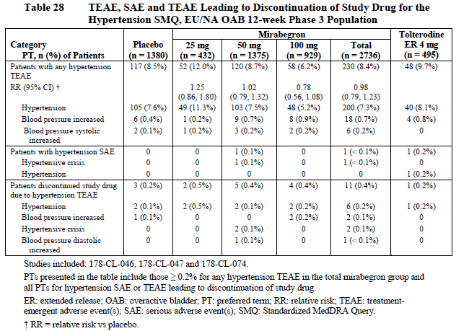
Postural hypotension and falls also occurred with a similar incidence in the mirabegron and placebo groups (see Section 8.3.5.1).
In the 12-week phase 2/3 population, SAEs listed under ‘Cardiac disorders’ occurred with similar incidence in the pooled mirabegron (0.2%) and placebo (0.3%) groups (see Section 8.3.3).
The sponsor performed two QT studies, which suggested that mirabegron may mildly prolong the QT interval, especially at higher doses and in women, who experience greater exposure than men for the same dose.
Despite the mildly concerning results in the QT studies, clinically relevant arrhythmias were not observed at a higher frequency with mirabegron. As shown in the table below, arrhythmias occurred with similar frequency in the mirabegron and placebo groups in the 12-week phase 2/3 population.
Table 108. TEAE, SAE and TEAE Leading to Permanent Discontinuation of Study Drug for Cardiac Arrhythmias, Global OAB 12-Week Phase 2/3 Population
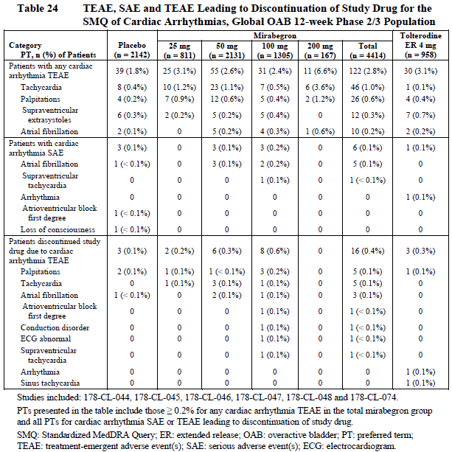
In the long-term EU/NA population, there was no placebo comparator, but the incidence of arrhythmias with mirabegron compared favourably with the incidence of arrhythmias observed with tolterodine treatment, as shown in the table below.
Table 109. TEAE, SAE and TEAE Leading to Permanent Discontinuation of Study Drug for Cardiac Arrhythmias, EU/NA Long-Term Controlled Population
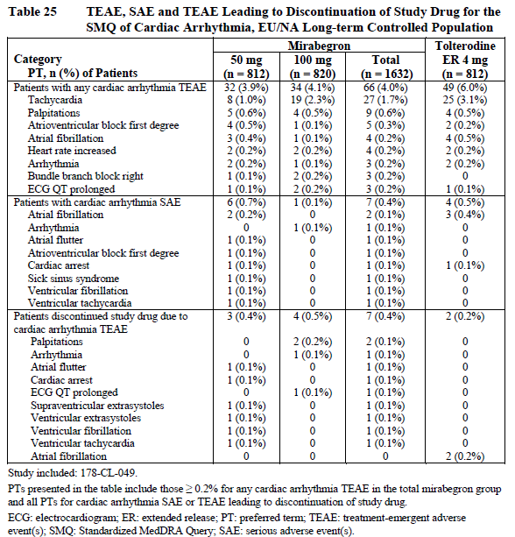
Overall, mirabegron appears to pose a minimal cardiovascular risk. Given the results of the QT studies, which showed mild QT prolongation at supra-therapeutic doses, mirabegron should be avoided in patients with long QT syndrome, and in combinations involving other QT-prolonging drugs.

Other safety issues

Safety in special populations
Exposure to mirabegron and its metabolites is higher in women than in men, and this was reflected in slightly greater changes in QT interval and pulse rate in females, as discussed in Section 8.4.5.2 and Section 8.4.6. AEs were also reported more frequently in women than in men, but this difference was noted in all treatment groups, including placebo, as shown in the tables below. Dose adjustment is therefore not recommended on the basis of gender.
Table 110. TEAE by Gender (Reported by ≥ 3.0% in the Total Mirabegron Group), Global OAB 12-Week Phase 2/3 Population
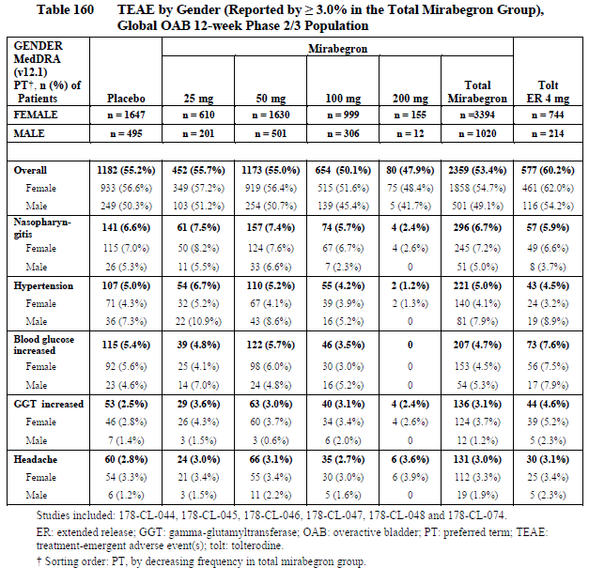
Table 111. TEAE by Gender (Reported by ≥ 3.0% in the Total Mirabegron Group), EU/NA Long-Term Controlled Population
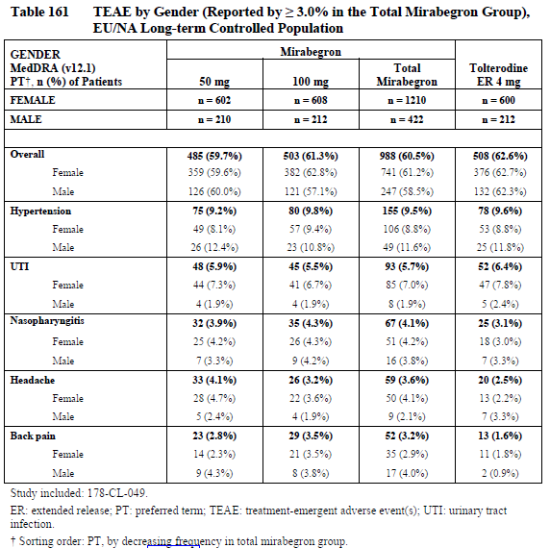
Older subjects (≥ 65 years) were slightly more likely to report AEs than younger subjects (<65 years), as shown in the table below. This difference was observed in the placebo group and the mirabegron group, however, with no overall evidence that the safety of mirabegron is significantly worse in older patients.
Table 112. TEAE by Age (Reported by ≥ 3.0% in the Total Mirabegron Group), Global OAB 12-Week Phase 2/3 Population
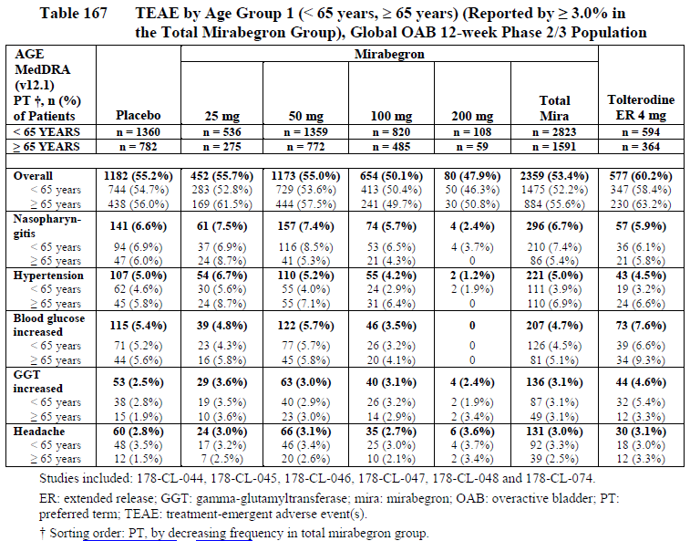
Table 113. TEAE by Age Group (Reported by ≥ 3.0% in the Total Mirabegron Group), EU/NA Long-Term Controlled Population
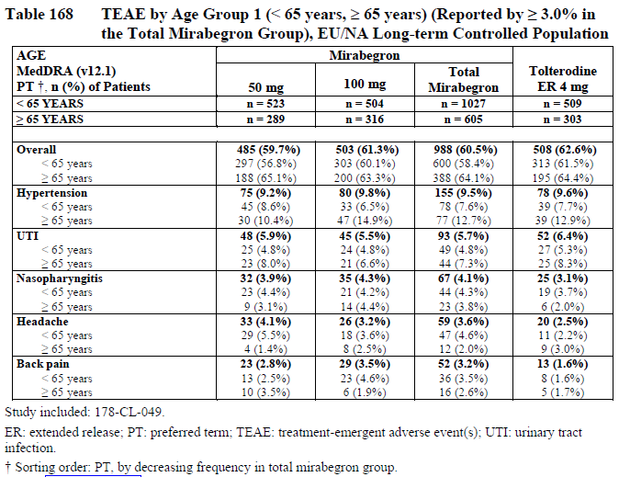
Subjects with significant comorbidities were excluded from the clinical program, so the safety of mirabegron in subjects with severe hypertension, cardiac disease or other major illnesses has not been tested. Given the mild QT-prolonging effects observed in the QT studies, it would be prudent to avoid mirabegron in subjects with a significant history of cardiac arrhythmia.
The PI recommends caution, as follows:
‘Consider observations from the QT study (see PHARMACOLOGY: Pharmacodynamic Effects: Effect on QT Interval) in clinical decisions to prescribe BETENIQ to patients with a known history of QT prolongation or patients who are taking medicinal products known to prolong QT interval.’
Subjects with moderate hepatic impairment or severe renal impairment should halve the dose of mirabegron to 25mg, as discussed in sections 4.2.4.1 and 4.2.4.2. At this reduced dose, such subjects would be expected to have similar exposure to subjects with normal hepatic or renal function. Subjects with severe hepatic impairment or End-Stage Renal Failure should avoid the drug completely; the proposed PI lists these conditions as ‘Precautions’, with the following comments:
‘[BETENIQ] has not been studied in patients with End Stage Renal Disease (eGFR <15 mL/min/1.73 m2 or patients requiring haemodialysis) and, therefore, it is not recommended for use in this patient population.’
‘[BETENIQ] has not been studied in patients with severe hepatic impairment (Child-Pugh Class C) and, therefore, it is not recommended for use in this patient population.’

Safety related to drug-drug interactions and other interactions
The sponsor performed a number of safety-related subgroup analyses based on concomitant or prior use of other medications, and no consistent patterns or concerning trends emerged. The results for one such analysis, an assessment of AEs by baseline use of alpha-1 antagonists, is shown below. The sponsor also assessed prior medications for treatment of OAB, and baseline use of beta-blockers, which did not significantly modify the incidence of AEs comparing active and placebo groups (data not shown).
Table 114. TEAE by Baseline Use of Alpha 1-AR Antagonists (Reported by ≥ 3.0% in the Total Mirabegron Group), EU/NA OAB 12-Week Phase 3 Population
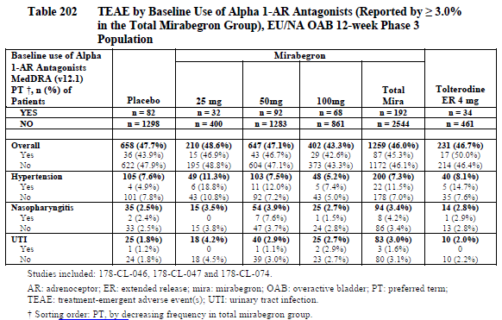
The clinical pharmacology program indicated that mirabegron may be involved in pharmacokinetic interactions with other medications, but the magnitude of the interactions was generally small (see Section 4.2.5). A mild pharmacodynamic interaction was observed with tamsulosin, as discussed above, but this is unlikely to be clinically relevant.
The QT studies showed that mirabegron is associated with a minor QT-prolonging effect. Although there was no evidence of a clinically significant risk of arrhythmias in the phase 2/3 study population, it would be prudent to avoid combining mirabegron with other QT-prolonging drugs.

Evaluator’s overall conclusions on clinical safety
The safety and tolerability of mirabegron was acceptable in the pooled phase 2/3 population, with an incidence of adverse events only slightly in excess of placebo, as summarised in Table 70, seen earlier. The distribution of individual AE types, including cardiovascular and urological AEs, did not raise specific concerns.
Potential safety issues with mirabegron arise from the mild QT-prolonging effect observed at the supratherapeutic dose of 200mg, a low incidence of skin reactions, and the possibility of drug interactions. Although mirabegron does not require dose adjustment when combined with other drugs, it may modify the pharmacokinetics of drugs metabolised CYP2D6, increasing their levels, which could be relevant for drugs with narrow therapeutic indices. Mirabegron also increases exposure to digoxin when the two are co-administered, so digoxin should be introduced at a low dose and titrated according to blood levels.
The systemic beta agonist effects of mirabegron are minimal, but minor increases in pulse rate and blood pressure have been observed. The incidence of clinically relevant hypertension was not increased with mirabegron. Falls, syncope and hypotension did not occur with increased incidence in mirabegron recipients.
The proposed PI contains appropriate warnings about these few safety issues.
Exposure to mirabegron is increased (approximately doubled) in the setting of severe renal impairment, as discussed in Section 4.2.4.2. The PI therefore recommends halving the dose to 25mg once daily in patients with severe renal impairment, but no adjustment in patients with mild to moderate renal impairment. Given that the proposed dose (50mg) is half the maximum dose tested in the pivotal studies (100mg), patients with severe renal impairment would experience an exposure that has been shown to have an acceptable safety profile. Similarly, a reduction of the dose to 25mg once daily in patients with moderate hepatic impairment is recommended in the PI, and would be expected to produce an exposure similar to that experienced by normal subjects receiving a standard dose.
Mirabegron has not been studied at all in patients with severe hepatic impairment (Child-Pugh Class C), nor in patients with End-Stage Renal Failure (ESRF). The Proposed Product Information sheet (PI) contains appropriate warnings against use in these two populations, under ‘Precautions’.

First round benefit-risk assessment

First round assessment of benefits
The benefits of mirabegron in the proposed usage are:
- A slightly lower micturition frequency (one less void every two days)
- A slightly lower rate of incontinence (~0.4 episodes prevented per day)
- Marginally improved quality of life

First round assessment of risks
The risks of mirabegron in the proposed usage are:
- A slight risk of QT prolongation in the event of accidental supratherapeuic exposure
- A slight risk of hypersensitivity reactions that would be expected to resolve with discontinuation
- Minor increases in blood pressure in susceptible subjects

First round assessment of benefit-risk balance
The benefit-risk balance of mirabegron, given the proposed usage, is favourable. It is expected that many patients will find the efficacy of mirabegron unacceptably low, but those who fail to show an adequate response could discontinue the drug, and a therapeutic trial of mirabegron is likely to be a worthwhile exercise in patients distressed by OAB symptoms.

First round recommendation regarding authorisation
Mirabegron should be approved for use in patients with overactive bladder.

Clinical questions

Efficacy
Could the sponsor please confirm that Study 074 produced identical placebo-subtracted differences and 95%CIs (-0.42; 95%CI -0.76 to -0.08) for the two coprimary endpoints in the 50mg group. (The results are plausible, but the co-incidence raises the possibility of a transcription error.)

Second round evaluation of clinical data submitted in response to questions
The sponsor has confirmed that the results as shown in Table 30 (in this report) are correct. The identical values of the placebo-subtracted differences and of the corresponding 95% confidence intervals, viz -0.42, 95% CI [-0.76, -0.08] for each of the two co-primary endpoints for the mirabegron 50mg dosage group in Study 074, happened by chance. In the s31 response the sponsor also included copies of the source tables from the Study Report [178-CL-074] to verify this fact. Also one can observe that the information in the two relevant cells of Table 30 is not identical in all respects, there being differences in the 3rd decimal place in the standard deviations of the point estimates (0.173 in one cell and 0.174 in the other).

Second round benefit-risk assessment
Assessment remains unchanged from that in section 9 of this report.

Second round recommendation regarding authorisation
As in section 10 of this report, it is recommended that mirabegron should be approved for use in patients with overactive bladder.

References
Coyne KS, Matza LS, Thompson CL. The responsiveness of the Overactive Bladder Questionnaire (OAB-q). Qual Life Res. 2005, 14(3):849-55. Wein AJ, Rovner ES. The overactive bladder: An overview for primary care health providers. Int J Fertil 1999;44:56-66.
Coyne K, Revicki D, Hunt T, Corey R, Stewart W, Bentkover J, Kurth H, Abrams P. Psychometric validation of an overactive bladder symptom and health-related quality of life questionnaire: The OAB-q. Qual.Life.Res 2003, 11:563-574.
Coyne K, Matza L. Validation of the perception of bladder condition in overactive bladder. Value Health 2002, 231.
Sussman D, Garely A. Treatment of overactive bladder with once-daily extended release of tolterodine and oxybutynin: the antimuscarinic clinical effectiveness trial (ACET). Current Medical Research and Opinion 2002, 18(4): 177-184.
Walters S.J. John Wiley & Sons; Chichester, UK: 2009. Quality of Life Outcomes in Clinical Trials and Health-Care Evaluation: a Practical Guide to Analysis and Interpretation.

Appendix 1. ICIQ-OAB and ICIQ-OAB qol Questionnaire

Overactive bladder
Many people experience urinary symptoms some of the time. We are trying to find out how many people experience urinary symptoms, and how much they bother them. We would be grateful if you could answer the following questions, thinking about how you have been, on average, over the PAST FOUR WEEKS.
1. Please write in your date of birth:
DAY MONTH YEAR
2. Are you (tick one): Female Male
3a. How often do you pass urine during the day?
hourly 3
every two hours 2
every three hours 1
every four hours or more 0
3b. How much does this bother you?
Please ring a number between 0 (not at all) and 10 (a great deal)
0 1 2 3 4 5 6 7 8 9 10
4a. During the night, how many times do you have to get up to urinate, on average?
none 0
one 1
two 2
three 3
four or more 4
4b. How much does this bother you?
Please ring a number between 0 (not at all) and 10 (a great deal)
0 1 2 3 4 5 6 7 8 9 10
5a. Do you have to rush to the toilet to urinate?
never 0
occasionally 1
sometimes 2
most of the time 3
all of the time 4
5b. How much does this bother you?
Please ring a number between 0 (not at all) and 10 (a great deal)
0 1 2 3 4 5 6 7 8 9 10
6a. Does urine leak before you can get to the toilet?
never 0
about once a week or less often 1
two or three times a week 2
about once a day 3
several times a day 4
all the time 5
6b. How much does this bother you?
Please ring a number between 0 (not at all) and 10 (a great deal)
0 1 2 3 4 5 6 7 8 9 10
Thank you very much for answering these questions.
Quality of life
For the following questions, please think about your overall urinary symptoms in the past four weeks and how these symptoms have affected your life. Please answer each question about how often you have felt this way to the best of your ability. Please tick the box that best answers each question.
1. Please write in your date of birth:
DAY MONTH YEAR
2. Are you (tick one): Female Male
DURING THE PAST FOUR WEEKS, HOW OFTEN HAVE YOUR BLADDER SYMPTOMS…
3. Made you carefully plan your journey?
4. Caused you to feel drowsy or sleepy during the day?
5. Caused you to plan “escape routes” to toilets in public places?
6. Caused you distress?
7. Frustrated you?
8. Made you feel like there is something wrong with you?
9. Interfered with your ability to get a good night’s rest?
10. Caused you to decrease your physical activities (exercising, sports, etc.)?
11. Prevented you from feeling rested upon waking in the morning?
12. Frustrated your family and friends?
13. Caused you anxiety or worry?
14. Caused you to stay home more often than you would prefer?
15. Caused you to adjust your travel plans so that you are always near a toilet?
16. Made you avoid activities away from toilets (i.e., walks, running, hiking)?
17. Made you frustrated or annoyed about the amount of time you spend in the toilet?
18. Awakened you during sleep?
19. Made you worry about odour or hygiene?
20. Made you uncomfortable while travelling with others because of needing to stop for a toilet?
21. Affected your relationships with family and friends?
22. Caused you to decrease participating in social gatherings, such as parties or visits with family or friends?
23. Caused you embarrassment?
24. Interfered with getting the amount of sleep you needed?
25. Caused you to have problems with your partner or spouse?
26. Caused you to plan activities more carefully?
27. Caused you to locate the closest toilet as soon as you arrive at a place you have never been?
For questions 3 to 27 one of the following answers can be given:
none of the time 1
a little of the time 2
some of the time 3
a good bit of the time 4
most of the time 5
all of the time 6
28. Overall, how much do your urinary symptoms interfere with your everyday life?
Please ring a number between 0 (not at all) and 10 (a great deal)
0 1 2 3 4 5 6 7 8 9 10
Thank you very much for answering these questions.

Appendix 2. Conclusions from the Expert Committee on Hypersensitivity
The following text is derived from the sponsor’s Integrated Summary of Safety:
Across all populations, the Expert Committee identified 2 plausible hypersensitivity reaction cases of immediate type. Both occurred in patients from Global 12-week Phase 2/3 Population (defined as the Global OAB 12-week Phase 2/3 Population with the addition of studies 178-CL-003, 178-CL-004 and 178-CL-049). The events occurred in 1/2292 (< 0.1%) placebo, 0/3012 mirabegron < 100mg-, 1/1667 (0.1%) mirabegron ≥ 100mg-treated patients and 0/1022 tolterodine-treated patients and included pruritus generalized in a mirabegron-treated patient and urticaria in a placebo-treated patient.
Across all populations, the Expert Committee identified 38 subjects who experienced plausible hypersensitivity reactions of nonimmediate type, including 33 subjects with hypersensitivity reactions assessed as primarily cutaneous and 6 subjects with hypersensitivity reactions assessed as primarily noncutaneous. One subject experienced 2 nonimmediate hypersensitivity reactions – one categorized as primarily cutaneous (urticaria) and the other categorized as primarily noncutaneous (leukopenia).
Across all populations, there were 32 mirabegron-treated subjects with plausible hypersensitivity reactions categorized as nonimmediate type, including 29 subjects with primarily cutaneous reactions and 4 subjects with primarily noncutaneous reactions (one mirabegron-treated subject experienced nonimmediate hypersensitivity reactions of both types).
Across all populations, the Expert Committee identified 5 patients who experienced plausible hypersensitivity reaction of undetermined type: 3 patients from Global 12-week Phase 2/3 Population (1/2292 [< 0.1%] placebo, 0/3012 for mirabegron < 100 mg, 2/1667 [0.1%] for mirabegron ≥ 100mg and 0/1022 for tolterodine patients) and 2 patients from EU/NA Long-term Controlled Population (0/812 mirabegron 50mg, 1/820 [0.1%] mirabegron 100mg and1/812 [0.1%] tolterodine patients) [Module 5.3.5.3 Hypersensitivity Research Report Tables 6.1.1.1 and 6.1.1.2]. None of these cases were identified as definite hypersensitivity reactions.
Overall, the available clinical data do not support an association of mirabegron exposure with immediate-type hypersensitivity reactions.
Hypersensitivity reactions of hemolytic anemia and thrombocytopenia (1 patient) and neutropenia (1 patient) occurred in mirabegron-treated patients, but there was not a consistent pattern to establish an association of mirabegron with nonimmediate, primarily noncutaneous hypersensitivity reactions.
Nonimmediate, primarily cutaneous hypersensitivity reactions of urticaria, leukocytoclastic vasculitis, rash, pruritus, purpura, and lip and eyelid edema, occurred in mirabegron-treated patients during the clinical development program including SAE of cutaneous vasculitis (1 patient) and urticaria (2 patients). An association of mirabegron, particularly at doses > 100mg, with nonimmediate, primarily cutaneous reactions cannot be ruled out.
These cutaneous reactions were generally reversible with discontinuation of mirabegron and symptomatic treatment as clinically indicated.

* “Note for Guidance on the Clinical Investigation of Medicinal Products for the Treatment of Urinary Incontinence.” CPMP, December 2002.
* All figures and tables contained in this evaluation report have been copied from the sponsor’s submission. Note: Tables 1 and 2 of the CER are not included in this Extract.
*For the 50mg dose, the mean placebo-subtracted value and 95% confidence interval were reported with identical figures for both co-primary endpoints. The sponsor should be asked to confirm that there has not been an editing error producing this coincidence.

