Date of CER: March 2013

AusPAR Attachment 2

Extract from the Clinical Evaluation Report for misoprostol
  - Proprietary Product Name: Misodel, Misopess
  - Sponsor: Ferring Pharmaceuticals Pty Ltd

About the Therapeutic Goods Administration (TGA)
- The Therapeutic Goods Administration (TGA) is part of the Australian Government Department of Health, and is responsible for regulating medicines and medical devices.
- The TGA administers the Therapeutic Goods Act 1989 (the Act), applying a risk management approach designed to ensure therapeutic goods supplied in Australia meet acceptable standards of quality, safety and efficacy (performance), when necessary.
- The work of the TGA is based on applying scientific and clinical expertise to decision-making, to ensure that the benefits to consumers outweigh any risks associated with the use of medicines and medical devices.
- The TGA relies on the public, healthcare professionals and industry to report problems with medicines or medical devices. TGA investigates reports received by it to determine any necessary regulatory action.
- To report a problem with a medicine or medical device, please see the information on the TGA website <http://www.tga.gov.au>.
About the Extract from the Clinical Evaluation Report
- This document provides a more detailed evaluation of the clinical findings, extracted from the Clinical Evaluation Report (CER) prepared by the TGA. This extract does not include sections from the CER regarding product documentation or post market activities.
- The words [Information redacted], where they appear in this document, indicate that confidential information has been deleted.
- For the most recent Product Information (PI), please refer to the TGA website <http://www.tga.gov.au/hp/information-medicines-pi.htm>.
Copyright
© Commonwealth of Australia 2014
This work is copyright. You may reproduce the whole or part of this work in unaltered form for your own personal use or, if you are part of an organisation, for internal use within your organisation, but only if you or your organisation do not use the reproduction for any commercial purpose and retain this copyright notice and all disclaimer notices as part of that reproduction. Apart from rights to use as permitted by the Copyright Act 1968 or allowed by this copyright notice, all other rights are reserved and you are not allowed to reproduce the whole or any part of this work in any way (electronic or otherwise) without first being given specific written permission from the Commonwealth to do so. Requests and inquiries concerning reproduction and rights are to be sent to the TGA Copyright Officer, Therapeutic Goods Administration, PO Box 100, Woden ACT 2606 or emailed to <tga.copyright@tga.gov.au>.

Contents
List of abbreviations 5
1. Introduction 6
2. Clinical rationale 7
3. Contents of the clinical dossier 7
3.1. Scope of the clinical dossier 7
3.2. Paediatric data 7
3.3. Good clinical practice 7
3.4. Justification for not providing appropriate biopharmaceutic studies 7
4. Pharmacokinetics 8
4.1. Studies providing pharmacokinetic data 8
4.2. Summary of pharmacokinetics 9
4.3. Evaluator’s overall conclusions on pharmacokinetics 10
5. Pharmacodynamics 10
5.1. Studies providing pharmacodynamic data 10
5.2. Summary of pharmacodynamics 10
5.3. Evaluator’s overall conclusions on pharmacodynamics 10
6. Dosage selection for the pivotal studies 11
7. Clinical efficacy 12
7.1. Pivotal efficacy study 12
7.2. Other efficacy studies 19
7.3. Evaluator’s conclusions on clinical efficacy 24
8. Clinical safety 25
8.1. Studies providing evaluable safety data 25
8.2. Pivotal studies that assessed safety as a primary outcome 25
8.3. Patient exposure 26
8.4. Adverse events 26
8.5. Laboratory tests 31
8.6. Post-marketing experience 32
8.7. Evaluator’s overall conclusions on clinical safety 33
9. First round benefit-risk assessment 33
9.1. First round assessment of benefits 33
9.2. First round assessment of risks 34
9.3. First round assessment of benefit-risk balance 34
10. First round recommendation regarding authorisation 34
11. Clinical questions 35
12. References 35
12.1. Other references 35

List of abbreviations
Abbreviation | Meaning
AE | Adverse event
CTG | Cardiotocograph
DVI | Dinoprostone vaginal insert
FHR | Foetal heart rate
ITT | Intention to treat
LLQ | Lower limit of quantitation
MBS | Modified Bishop score
Miso | Misoprostol
MTD | Maximum tolerated dose
MVI 200 | Misoprostol vaginal insert containing 200 mcg in the reservoir
PI | Product information
PP | Per protocol
SAE | Serious adverse event
SOC | System organ class

Introduction
Misoprostol is a synthetic analogue of prostaglandin E1.
The approved indication, from the approved PI for Cytotec oral tablets (Pfizer Australia), is:
Cytotec is indicated in the treatment of acute duodenal and gastric ulcers.
Cytotec is indicated in the prevention of stress-induced upper gastrointestinal mucosal bleeding and lesions in post-surgical patients in intensive care units.
Cytotec is indicated for the prevention of gastric ulceration in patients in whom NSAID therapy is essential and who have been assessed at high risk of gastric ulceration, or the complications of gastric ulceration.
The proposed indication for Misodel Vaginal Inserts was:
Misodel is indicated for induction of labour, from 36 weeks gestation, in women with an unfavourable cervix in whom induction is clinically indicated.
Misodel is a controlled release vaginal insert containing 200 micrograms (mcg) of misoprostol which is released at a mean rate of approximately 7 mcg/hour over a period of 24 hours.
The maximum recommended dose is one Misodel vaginal insert (200 mcg).
Remove Misodel
- at the onset of active labour
- if uterine contractions are prolonged or excessive
- if there is evidence of foetal compromise or
- if 24 hours have elapsed since insertion.
If Misodel falls out, do not replace it.
In case of subsequent administration of oxytocin, a waiting period of at least 30 minutes is recommended following the removal of the vaginal insert (see Interactions).
Misodel is supplied in an individual aluminium foil sachet, and must be stored in the freezer. No thawing is required prior to use.
There is a “tear mark” on one side of the foil sachet. Open the foil sachet along the tear mark across the top of the sachet. Do not use scissors or other sharp objects which may cut the retrieval system.
Place Misodel high in the posterior vaginal fornix. To ensure that Misodel remains in situ, it should be turned 90° so that it lies transversely in the posterior fornix of the vagina. Water-soluble lubricants may be used to aid insertion when necessary. After Misodel has been inserted, the withdrawal tape may be cut with scissors always ensuring there is sufficient tape outside the vagina to allow removal.
The patient is to remain in bed for 30 minutes after insertion, but may be ambulatory thereafter. Take care not to inadvertently remove Misodel during toileting and vaginal examinations.
Misodel is removed by gently pulling the tail of the retrieval system.
The vaginal insert should NEVER be removed from the retrieval system.
During insertion, Misodel will swell to 2-3 times its original size and be pliable. After removal, ensure that the entire product (insert and retrieval system) has been removed from the vagina.

Clinical rationale
This is implied by the following extract from the Clinical Overview:
‘There is therefore an unmet medical need for a product that combines the dose administration attributes of Cervidil/Propess, such as consistent dose reservoir, single vaginal administration, controlled release at a known rate, removal once exogenous drug is no longer required, and sustained release for up to 24 hours for those women who need that duration of exposure, with the enhanced uterine contractility effects of misoprostol and potential for shorter times to delivery.’

Contents of the clinical dossier

Scope of the clinical dossier
The submission contained the following clinical information:
- 2 clinical pharmacology studies, including 2 that provided pharmacokinetic data and none that provided pharmacodynamic data.
- 0 population pharmacokinetic analyses.
- 1 pivotal efficacy/safety studies.
- 3 dose-finding studies.
- 1 other efficacy/safety study.
- Literature references.

Paediatric data
The submission included paediatric safety data relating to neonates born to mothers treated with the drugs studied.

Good clinical practice
GCP compliance was asserted for all 7 studies for which detailed reports were included in the dossier.

Justification for not providing appropriate biopharmaceutic studies
The sponsor has provided a document with this title, focusing on the requirements of the Australian Regulatory Guidelines for Prescription Medicines (ARGPM) Appendix 15 which stipulate (at sections 3.4 and 3.8) that unless justification is provided, biopharmaceutic data should be provided:
- for a new dose form, demonstrating bioequivalence of the new dose form to the currently approved dose form(s); and
- for a new modified release formulation, in vitro and in vivo studies to establish the release and absorption characteristics of the new product.
The sponsor argues:
‘The ARGPM requires BEQ (bioequivalence) data on the new dose form to the currently approved dose forms. As there is no approved dose form for the intended indication and route of administration of misoprostol, and no accepted target pharmacokinetic parameters to reference, there is no relevant comparator for such a study. Whilst there is off label vaginal use of misoprostol oral tables (Cytotec), it would not be appropriate to conduct a BEQ study in such circumstances.’
If it can be established that the vaginal route of administration is associated with special advantages regarding efficacy or safety (including the hypothetical case where no other route of administration is feasible, for example because a local effect is important to its mode of action) in a particular indication for which other routes of administration have not been formally approved by the regulatory authority, then this evaluator sees no reason why the sponsor should be required to prove bioequivalence of the vaginal product to a product intended for another route of administration. In the evaluators opinion, however, the necessary basis for such an argument does not exist, in that special advantages of the vaginal route regarding efficacy or safety have not been established.
The sponsor takes the opportunity in the same Justification document to address the request from TGA in the Planning Letter dated 15 December 2012:
‘The application should justify the use of an overseas sourced referenced product (Cytotec), if applicable.’
The evaluator accepts the sponsor's argument on this point. The study in question (MISO-OBS-001) was not intended as a bioequivalence study, and the comparison with an oral dosage form was only for illustrative purposes.
Regarding the second of the 2 dot points at the beginning of this section, the sponsor argues mainly on quality grounds. The evaluator, however, makes the point that its statement ‘there is no immediate release comparator for a BEQ study and thus such a study is not appropriate’ appears to be based on a misunderstanding, as the second dot point does not mention bioequivalence.

Pharmacokinetics

Studies providing pharmacokinetic data
Table 1 shows the studies relating to each pharmacokinetic topic and the location of each study summary.
Table 1. Submitted pharmacokinetic studies.
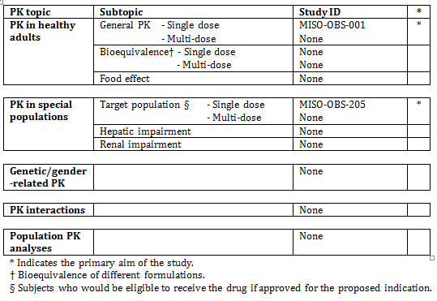
None of the pharmacokinetic studies had deficiencies that excluded their results from consideration.

Summary of pharmacokinetics
The information in the following summary is derived from conventional pharmacokinetic studies unless otherwise stated.

Pharmacokinetics in healthy subjects

Absorption

Sites and mechanisms of absorption
No data.

Bioavailability

Absolute bioavailability
No data.

Bioequivalence of different dosage forms and strengths
No data.

Dose proportionality
Study MISO-OBS-001 showed that the relationship between insert strength (mass of drug in reservoir) and absorption parameters was approximately linear in the range 100 to 400 mcg.

Distribution
No data.

Excretion
No data. Some information on half-life of plasma concentration after withdrawal of MVI is available from Study MISO-OBS-001.

Pharmacokinetics in the target population
A few data are available from Study MISO-OBS-205, on PK in women at term. However, interpretation is problematic because the duration of insertion of the MVI was short and variable.

Evaluator’s overall conclusions on pharmacokinetics
Study MISO-OBS-001 obtained some PK data relating to use of MVI 200 in non-pregnant women, but kinetics may well be significantly different in advanced pregnancy. Study MISO-OBS-205 studied MVI 200 at pregnancy term, but the results are difficult to interpret because duration of insertion of the product was variable and generally short, and actual amount of drug released while product was in situ was not measured.

PK studies comparing different routes of administration
The clinical study reports included in the dossier contained little detailed clinical information on this. Study MISO-OBS-001 presented some comparative data comparing plasma concentrations observed with MVIs and with a single 200 mcg Cytotec oral tablet, but this was not designed to demonstrate equivalence.
Some additional information is available from published articles, performed in women admitted for termination of pregnancy: Zieman et al (1997) studied plasma concentrations of misoprostol acid following administration of two 200 mcg Cytotec tablets, either orally or placed in the posterior vaginal fornix (10 patients in each treatment group). Tang et al (2002) studied the PK parameters following administration of two 200 mcg misoprostol tablets by 4 different routes of administration (sublingual, oral, vaginal, and vaginal with addition of water) in 40 women. Khan et al (2004) studied PK parameters following administration of two 200 mcg misoprostol tablets (orally, rectally or vaginally) in 27 women. Note that these studies did not use the vaginal product now proposed.

Pharmacodynamics

Studies providing pharmacodynamic data
None submitted.

Summary of pharmacodynamics
Not relevant.

Evaluator’s overall conclusions on pharmacodynamics
The proposed usage is unsupported by pharmacodynamic data. As the Pharmacology Written Summary states: ‘No nonclinical studies relating to the intended primary pharmacological action of the misoprostol vaginal insert have been conducted in vitro or in animals.’ The Clinical Overview states ‘In the MVI clinical programme, the pharmacodynamic response was assessed through clinical endpoints. Due to logistical issues and the attempt to disturb the woman’s labour course as little as possible, plasma samples obtained for PK analysis were obtained at scheduled time points during Miso-Obs-205 rather than at milestone time points such as onset of labour or the time at which an adverse event occurred; therefore the relationship between misoprostol acid plasma concentrations and pharmacological activity of MVI 200 is not known.’
In the evaluators opinion this is a deficiency in the program. The rationale for vaginal application is vague. Whether there is a significant local effect on the cervix or uterus is not known with certainty. A few literature references were provided, but no integrated discussion of these was included.
The literature reports studied both oral and vaginal misoprostol in connection with induction of labour (Alfirevic et al. 2010, Hofmeyr et al. 2010). However, it is not clear whether local effects within the pelvis, or differences in rate or extent of absorption following the different routes of administration, were responsible for differences in outcomes. Reports of some in vitro studies of interest were included in the list of Literature references submitted:
Bryman et al. (1982) studied effects of PGE2 on needle biopsy specimens of pregnant human cervix:
‘Spontaneous phasic activity appeared in 58% of the specimens studied, with a mean frequency of 3.0 contractions/min. The addition of PGE2 at concentrations of 0.1 pg/ mL to 1.0 ng/ mL strikingly inhibited contractile activity in all specimens. In most cases total inhibition occurred at 100 pg/ mL and above but in strips from a few patients peak inhibition was encountered at 1.0 pg/ mL. PGF2α at similar concentrations had no effect on contractile activity. 6-keto-PGF1α, the stable metabolite of PGI2, abolished the contractions at 10 to 100 ng/ mL but had no significant effect at lower concentrations.’
Senior et al. (1993) studied effects of various prostaglandins on myometrial biopsy specimens from women undergoing C-section:
‘Prostaglandin E2 (PGE2) produced a biphasic effect consisting of an initial excitation followed by a dose-related inhibition. The EP2/EP3-receptor agonists, rioprostil and misoprostol, produced similar effects to PGE2, however, the excitatory event of the misoprostol response was related to dose.’
Chiossi et al. (2012) studied effects of PGE1, PGE2 and oxytocin on myometrial biopsy specimens from women undergoing C-section:
‘Oxytocin and prostaglandins have different effects on myometrial contractility accounting for different mechanisms of action and side effects. The increased uterine contractility observed with PGE1 as compared with PGE2 can contribute to explain the higher success of vaginal delivery.’

Dosage selection for the pivotal studies
The sponsor explains that based on the Phase II studies, the decision was taken to compare MVI 100 and DVI in a Phase III study (MISO-OBS-004), which was designed to demonstrate superiority of MVI 100 over DVI in the time to vaginal delivery and non-inferiority in the rate of caesarean delivery. As the first objective was not achieved, and given ‘the unmet medical need to reduce the time to vaginal delivery compared to alternate methods of labour induction, further investigation of higher dose reservoirs was necessary. Therefore, a comparison of MVI 100 to MVI 150 and MVI 200 was conducted in MISO-OBS-204.’ Based on the results of this study, MVI 200 was chosen as the dose reservoir for the Phase III Study MISO-OBS-303.
Studies MISO-OBS-003, MISO-OBS-204 and MISO-OBS-004 each provide some information on the efficacy and safety at various doses.
In the evaluator’s opinion, the basis for choosing the 200 mcg dose reservoir is inadequate. However, the evaluator believes it is not possible to separate this aspect from the question of overall justification for the vaginal route of administration.

Clinical efficacy

Pivotal efficacy study

Study MISO-OBS-303

Study design, objectives, locations and dates
This was a Phase III, double-blind, randomised, multicentre study of subjects at or near term requiring cervical ripening and induction of labour.

Objectives

Co-Primary
The primary efficacy objective was to demonstrate that the time to vaginal delivery was shorter in subjects randomised to receive MVI 200 than for subjects randomised to receive DVI.
The primary safety objective was to demonstrate that the rate of Caesarean delivery was not greater for subjects randomised to receive MVI 200 than for subjects randomised to receive DVI.

Secondary
The secondary objectives were to compare MVI 200 to DVI for the following parameters:
- Time to any delivery (vaginal or Caesarean)
- Time to active labour
- Proportion of subjects with pre-delivery oxytocin
- Proportion of subjects with vaginal delivery within 12 hours
- Proportion of subjects with any delivery within 24 hours
- Proportion of subjects with any delivery within 12 hours
- Proportion of subjects with vaginal delivery within 24 hours
- Proportion of subjects with vaginal delivery
- Proportion of subjects with cervical ripening success at 12 hours

Locations
35 sites in the USA enrolled subjects in the study.

Dates
10 September 2010 to 15 March 2012.

Study treatments
Eligible subjects were randomised to receive either MVI 200 or DVI. Subjects were treated with one vaginal insert for up to 24 hours, one time only. The following batches of product were manufactured and released by the manufacturer for use in the study:
- MVI 200: MS10006
- DVI (Cervidil 10 mg): MA10K02/1.
The insert was to be kept in place for 24 hours unless events occurred that necessitated earlier removal:
- Onset of active labor;
- Intrapartum AE necessitating discontinuation of study drug, (specified in the protocol), for example:
  - Category III FHR pattern
  - Thick or fresh meconium, scalp pH <7.2, or other sign of foetal compromise
  - Uterine tachysystole with late decelerations, bradycardia, or prolonged decelerations
  - Category II FHR requiring tocolytic therapy
  - Category II FHR requiring intrapartum resuscitation (for example, amnioinfusion)
  - Category II FHR resulting in the decision to proceed to Caesarean delivery
  - Uterine tachysystole requiring tocolytic therapy
- Other intrapartum event requiring study drug discontinuation based on Investigator’s judgment

Non-study-related labour-inducing agents
Oxytocin use was not permitted within 7 days prior to study drug administration and while the study drug was in situ. Intravenous oxytocin was permitted, when required, 30 minutes following removal of the study drug, assuming no contraindications and no active labour. Earlier administration was permitted, for treatment of an emergency situation. Oxytocin dosing followed the American College of Obstetricians and Gynecologists guidelines, or individual institutional guidelines. A "low-dose" oxytocin regimen was recommended for induction or augmentation of labour, with a suggested starting dose of 1 mU/min increased by 1 to 4 mU/min every 30 minutes if an active labour pattern had not been established. The suggested maximum dose was 30 mU/min. Start and stop date(s), time(s), total dose and dose per minute of pre-delivery oxytocin were recorded. If oxytocin use was continuous through delivery, the stop time was recorded as the time of delivery. If pre-delivery oxytocin use was interrupted prior to delivery, the stop time was indicated and the new pre-delivery oxytocin was started; the pre-delivery oxytocin details were recorded if it was restarted.
Prostaglandin preparations and cervical-ripening agents were not permitted within 7 days prior to study drug administration and while the study drug was in situ. The use of these agents was permitted, when required, 1 hour following removal of the study drug if the Investigator determined that the subject required additional cervical ripening. The name, route, date of medication administered, and indication for use were recorded. Only products marketed for an obstetric indication were to be utilised, that is oxytocin, Cervidil or Prepidil. Cytotec is not approved for the indication of cervical ripening and induction of labour and was not to be used in subjects enrolled in this study prior to delivery.
Mechanical (non-pharmacological) cervical ripening methods were not permitted within 7 days prior to study drug administration and while the study drug was in situ. Mechanical means (for example intracervical Foley bulb use) were permitted immediately following removal of the study drug.

Efficacy variables and outcomes
Note: Both co-primary variables are included here for convenience. The "primary safety variable" could just have logically been regarded as a primary efficacy variable.
- The primary efficacy variable was the time from study drug administration to vaginal delivery of the neonate during the first hospitalisation.
- The primary safety variable was the rate of Caesarean delivery during the first hospitalisation.
Secondary efficacy endpoints are listed earlier.

Randomisation and blinding methods
Enrolment was stratified by site and by parity, to ensure that approximately 60% nulliparous subjects and 40% parous subjects were enrolled.

Randomisation
Randomisation codes were generated by Tipping Consulting LLC and provided to Controlled Therapeutics (Scotland) Ltd., which then allocated study drug assignment to each code. This information was provided to the designated packaging/ labelling vendor (Almac Clinical Services). Subsequent allocation to treatment group was random and based on the randomisation code. Two series of numbers were generated for each site, one for the nulliparous subset, and one for the parous subset. Once a subject was confirmed to be eligible to participate in the study, she was assigned by the investigator or designee to the next study drug subject number appropriate to her parity group. A copy of the randomisation code for each subject at the site was held in the Investigator Site File (or pharmacy). Each subject’s randomisation code was provided as a perforated, scratch-off card stored in a sealed plastic bag with tamper-evident tape along with the other code-break cards for all other subjects at the site. Each card contained a subject number and a scratch-off area that revealed the randomised treatment identification and treatment group assignment for that subject. The study drugs supplied were used in sequential order with the next qualifying subject at a site assigned the next available pre-printed study drug subject number within her cohort.

Blinding
The study was conducted in a double-blind manner. The MVI 200 and DVI study drug inserts and packaging were identical in appearance. It was the responsibility of each participating investigator to ensure that blinding at the site was maintained during the study. The randomisation list was kept strictly confidential, accessible only to authorised sponsor personnel and the designated packaging/ labelling vendor until unblinding. The randomisation codes were unblinded and made available for data analysis only when the study was completed, the database locked, and the statistical analysis plan finalised. During the study, the blind was permitted to be broken by designated sponsor personnel for expedited reporting purposes in the case of a “Suspected Unexpected Serious Adverse Reaction”.

Analysis populations
The 3 study populations defined by the sponsor prior to the commencement of the study are described below.

ITT population
The ITT population comprised all subjects who were administered study drug. The ITT population was used for efficacy analyses.

Safety population
The safety population included all subjects who were administered study drug and was the cohort of subjects considered in the safety analyses.
The CSR states: ‘Neonates were considered to have been exposed to the study drug in utero and therefore were included in the safety population.’ However, the meaning of this is unclear. AEs in the babies were recorded, but the number in the safety population did not include babies.

PP population
Subjects in the ITT population were excluded from the PP population if they exhibited any major protocol deviations, such as significant non-compliance, or any other serious unforeseen deviations that it was deemed could potentially invalidate the data and affect the conclusions of the trial. Subjects were not excluded from the PP population for minor protocol deviations. The rating of such protocol deviations as either “minor” or “major” was determined based on a review of the data conducted prior to unblinding of the study. The following hierarchical criteria were established, and subjects were excluded from the PP population based on the first deviation that occurred:
- Baseline MBS greater than 4 (or missing)
- Foetal malpresentation
- Pre-specified AE checkbox for foetal malpresentation
- Foetus was not vertex per manual review of other intrapartum AE verbatim terms
- Gestational age less than 36 weeks
- BMI greater than 50 kg/m² (or missing)
- Eligibility criteria not met (manual review of eligibility criteria free text)
Table 2. Numbers in the analysis populations.
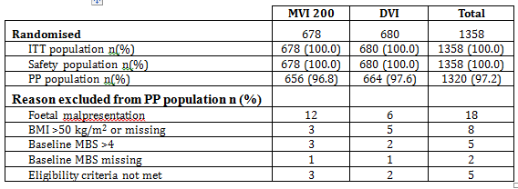

Sample size

Anticipated sample size
The MVI 200 group previously exhibited a median time to vaginal delivery of 1181 minutes in the MISO-OBS-204 study, and the DVI group exhibited a median time of 1650 minutes in the MISO-OBS-004 study. A sample size of 675 subjects per group provided 90% power to detect an improvement of greater than or equal to 320 minutes (20% improvement from DVI) in time to vaginal delivery between MVI 200 and DVI, assuming a median time to vaginal delivery of 1600 minutes for DVI and a 34% dropout (censoring) rate, based on a 5% two-sided test. The MVI 200 group had a rate of Caesarean delivery of 22.9% in the MISO-OBS-204 study, and the DVI group had a rate of 26.4% in the MISO-OBS-004 study. The estimated Caesarean delivery rates in both treatment arms were adjusted upward to match the recent increases in Caesarean delivery rates, with the current US national incidence now above 30%. This sample size (675 subjects in each group) provided a sufficient number of subjects to assess non-inferiority of MVI 200 with respect to rate of Caesarean delivery, based on an alpha level of 5% and 80% power for a two-sided approach using a 10% non-inferiority limit (relative to the DVI rate), assuming a 30% rate of Caesarean delivery in the DVI group compared to a 26% rate in the MVI 200 group. Thus, MISO-OBS-303 was designed to incorporate approximately 1350 subjects at or near term gestation requiring cervical ripening and induction of labour.

Actual sample size
The ITT comprised 1358 subjects: 678 MVI 200 subjects, and 680 DVI subjects.

Statistical methods

Co-primary endpoints
It is not clear from the Protocol how it was proposed to deal with the fact that co-primary endpoints were specified. (See Li 2009.) It is not correct simply to test multiple hypotheses using the same stipulated level of significance for each then regard any of the hypotheses which individually meet that test as having been proven at that level of significance. A Statistical Analysis Plan was included in the dossier. It did not discuss this point, but the statement ‘if the primary safety objective demonstrates that the rate of cesarean delivery is not greater for MVI 200 than for DVI, superiority of MVI over DVI will be assessed’ perhaps indicates that the endpoint to which it relates was to have a gatekeeper role in the overall analysis.
For the 2 individual primary endpoints, the Protocol states:
‘The analysis of the primary efficacy parameter, time to vaginal delivery, will be based on a time-to-event analysis using a log rank test. The primary efficacy parameter is the time from study drug administration to vaginal delivery of the neonate. Subjects who undergo a cesarean section delivery will be censored using the greatest interval between time and date of study drug administration to time and date of cesarean section delivery, independent of treatment assignment. Subjects who leave the hospital prior to delivering will be censored using the greatest interval between time and date of study drug administration to time and date of discharge from Labor & Delivery during this first hospital admission. Subjects who withdraw consent will be censored using the time consent was withdrawn. ...’
‘The analysis of the cesarean section delivery rates will be based on a between treatment-group difference. If the upper limit of the 95% confidence interval of the difference in event rates is less than the calculated non-inferiority margin (10% of the DVI rate), then MVI 200 will be considered non-inferior to DVI. Subjects who were discharged prior to delivery, withdraw early without having a cesarean section delivery, or become lost-to-follow-up, will be classified as not having the event.’

Secondary endpoints
The Statistical Analysis Plan provided:
‘The ITT population will be used for all secondary efficacy analyses. Of the secondary efficacy endpoints, the first three endpoints will be corrected for multiplicity to control the experiment-wise alpha level. If the primary analyses are significant, these three secondary endpoints will be analyzed in rank order, as presented below. The evaluation of superiority of MVI 200 over DVI for each of these endpoints will be assessed sequentially until the first non-significant treatment difference is found. If superiority of a prior endpoint cannot be established, the remaining endpoints will not be formally tested, but p-values will be presented for informational purposes only.
- Time to any delivery (vaginal or cesarean) during the first hospital admission;
- Time to active labor during the first hospital admission;
- Incidence of pre-delivery oxytocin during the first hospital admission;
The remaining secondary efficacy endpoints are considered lower priority and thus no multiplicity adjustment will be made."

Participant flow
All subjects were regarded as having completed the study.

Major protocol violations/deviations
Subjects with major deviations that could have affected either co-primary endpoint were excluded from the PP population.
Note that cessation of treatment resulting from loss of the study drug was not regarded as a protocol violation .

Baseline data
Table 3. Baseline data
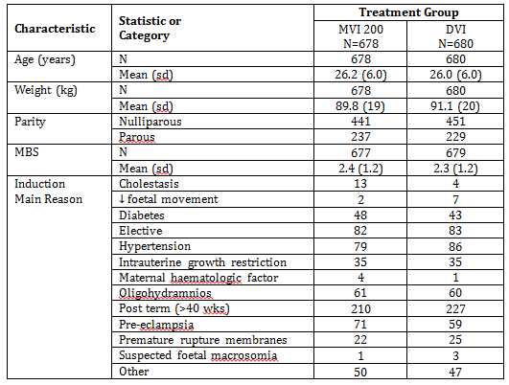

Results for the primary efficacy outcome
Analysis of the primary associated efficacy endpoint was based on a time-to-event analysis using a log-rank test in the ITT population. The survivor function for each treatment group was estimated using a product-limit (Kaplan-Meier) estimator. Subjects who underwent a Caesarean delivery during the first hospitalisation were censored using the greatest interval between time and date of study drug administration to time and date of Caesarean delivery, independent of treatment assignment. Subjects who, in their first hospitalisation, were discharged prior to delivery (that is, left the L&D unit of the hospital) or withdrew consent prior to delivery were censored using the longest time interval from study drug administration to L&D discharge (that is, the maximum interval for all subjects who, in their first hospitalisation, were discharged undelivered or withdrew consent without delivery), independent of treatment group. If the log-rank p value was less than 0.05, then MVI 200 would be considered superior to DVI with respect to time to vaginal delivery. The analysis of the primary efficacy endpoint was also performed on the PP population to assess the impact of major protocol deviations.
A supportive analysis was also conducted in the ITT population using a Cox proportional hazards model to compare the event time distribution functions between MVI 200 and DVI. Independent factors in the Cox proportional hazards regression model were treatment assignment and study centre. The interaction between treatment and study centre was investigated and was to be excluded from the model if p was greater than or equal to 0.10. If it was found to be significant, separate Cox proportional hazards regression analyses would be constructed for each of the study centres. The effects of the stratification parameter (parity) were assessed using a separate model incorporating the factors treatment assignment, study centre, and parity.
Time to vaginal delivery during first hospitalisation was statistically significantly shorter for MVI 200 subjects (median 1292.00 minutes) than for DVI subjects (median 1968.50 minutes) (p less than 0.001).
Median time to vaginal delivery during first hospitalisation was also statistically significantly shorter in MVI 200 subjects than in DVI subjects among the nulliparous subjects subset (p less than 0.001) and the parous subjects subset (p less than 0.001). In addition, median time to vaginal delivery was shorter in the MVI 200 group than in the DVI group regardless of race (White, African American, Hispanic), BMI (less than 25, 25 to less than 30, 30 to less than 35, greater than or equal to 35 kg/m²), age (less than 20, 20 to less than 25, 25 to less than 30, 30 to 35, greater than 35 years), or gestational age (less than 37, 37 to 40, greater than 40 weeks).

Results for other efficacy outcomes
As the primary efficacy endpoint was found to be significant (but see earlier discussion), the endpoints relating to the first three secondary efficacy variables were analysed in rank order. These three variables were time to any delivery (vaginal or Caesarean), time to active labour, and the proportion of subjects administered oxytocin pre-delivery. In accordance with the statistical design of the study, the evaluation of potential superiority of MVI 200 over DVI for each of these three secondary endpoints was to be conducted sequentially until the first non-significant treatment difference was found. Regarding the other secondary endpoints, see last quoted sentence above. This implies that while multiple statistical comparisons were conducted with regard to these variables, this fact was not appropriately incorporated into the derivation of the reported significance values. Thus these variables will not be considered in this report, as they have not been rigorously statistically assessed. Given their designation as "lower priority", it may have been more appropriate for the sponsor to list them as tertiary efficacy variables, rather than secondary.
Time to any delivery mode (vaginal or Caesarean) was significantly shorter in MVI 200 subjects (Kaplan-Meier median 1096.50 minutes) compared with DVI subjects (Kaplan-Meier median 1639.50 minutes) (p less than 0.001). Time to any delivery was also significantly shorter in MVI 200 subjects than in DVI subjects among both nulliparous subjects (p less than 0.001) and parous subjects (p less than 0.001). Active labour was defined as progressive cervical dilatation to 4 cm with any frequency of contractions, or, rhythmic, firm, adequate quality uterine contractions causing progressive cervical change occurring at a frequency of three or more in 10 minutes and lasting at least 45 seconds. Time to active labour was significantly shorter in MVI 200 subjects (median 726.50 minutes) than in DVI subjects (median 1116.50 minutes) (p less than 0.001). It was also significantly shorter in MVI 200 subjects compared with DVI subjects among nulliparous subjects (p less than 0.001), and parous subjects (p less than 0.001). In a supportive Kaplan-Meier analysis of time to active labour using censoring rules that applied actual times to events, results were similar to those of the primary analysis. In this supportive analysis, subjects who did not go into active labour during the first hospitalisation were censored at the time of delivery, and subjects who in their first hospitalisation were discharged from L&D or withdrew consent prior to delivery were censored at the time of L&D discharge. The percentages of subjects requiring pre-delivery oxytocin, pre-delivery oxytocin total dose, duration of pre-delivery oxytocin use, and maximum dose/ minute were all lower in the MVI 200 treatment group compared with the DVI treatment group (p less than 0.001 for each individual comparison, after controlling for multiple comparisons). Statistically significant treatment differences (p less than or equal to 0.001) were also evident when comparing the nulliparous subsets in each treatment group with each other, and when comparing the parous subsets in each treatment group with each other, for these oxytocin parameters.

Other efficacy studies

Study MISO-OBS-002
This was a Phase II, multi-centre, randomised, parallel group, double blind study in parous women at term (37 to 42 weeks gestation) for whom labour induction was indicated. The primary objective was to assess the efficacy of four dose reservoirs (25 mcg, 50 mcg, 100 mcg, 200 mcg) of intravaginal controlled release misoprostol administered for up to 24 hours. Efficacy was measured in terms of time from insert placement to vaginal delivery.
Following insertion, the delivery system was to remain in situ for up to 24 hours except in any of the following circumstances, when it was to be removed immediately:
- The onset of active labour.
- Evidence of maternal complications.
- Evidence of foetal distress.
- Oxytocin planned in the following 30 minutes.
- The woman was to undergo C-section.
At the end of the dosing period the delivery system was removed. If it fell out of the vagina spontaneously before the end of the dosing period or was removed for any reason, it was not replaced.
124 women were randomised; all completed. Demographic and other baseline date are tabulated below. Mean exposure was 14.2, 12.4, 10.5 and 8.8 hours, for the 25, 50, 100 and 200 mcg MVIs, respectively (excluding 4 patients in whom the time of removal of the MVI was not recorded).
Table 4. Demographic and other baseline data
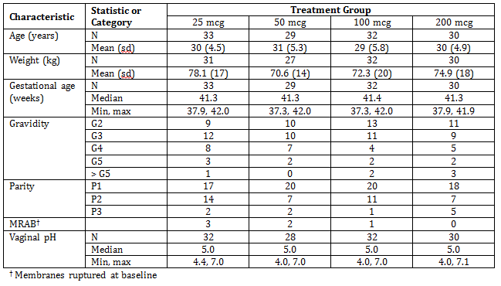
Table 5. Primary efficacy results are shown in the table below.
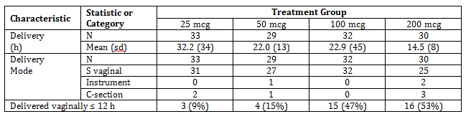
Comment: Convincing efficacy is shown by the MVI 100 and MVI 200 (using log rank and Wilcoxon tests).

Measurement of residual drug after removal of MVI
Available 100 mcg and 200 mcg inserts were sent for drug assay after removal, and results were presented in a separate report. Problems with refrigeration of specimens during transport and storage are thought to have invalidated some of the results.

Study MISO-OBS-204
This was a Phase II, randomised, double blind, dose ranging study to assess the efficacy and safety of up to 24 hours treatment with the MVI 100, MVI 150 or MVI 200. The primary objective was to compare the efficacy of MVI 100 and MVI 200 based on the proportion of vaginal deliveries within 24 hours in women requiring cervical ripening and induction of labour.
Subjects were stratified by parity and centre. During and following treatment, subjects were assessed for delivery mode, time to delivery and safety. Modified Bishop score was assessed at 6, 12, 18 and 24 hours after study drug insertion. The insert was removed before 24 hours when any of the following events occurred:
- Onset of active labour.
- Uterine hypertonus.
- Uterine tachysystole.
- Need for tocolysis.
- Evidence of foetal compromise.
- Uterine hyperstimulation syndrome.
- maternal or foetal AEs necessitating discontinuation of dosing.
374 subjects were randomised, of whom 373 completed, 1 being lost to follow-up within 24 hours of drug treatment. Demographic and other baseline data for the 373 are tabulated below.
Table 6. Demographic and baseline data
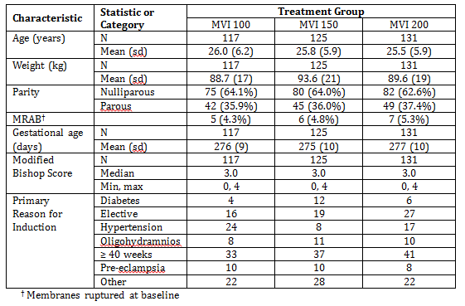
Table 7. Primary efficacy results
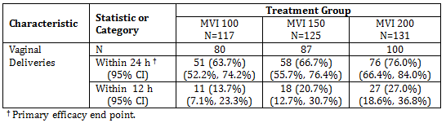
Comment: A trend is evident, but the comparison MVI 200 versus MVI 100 did not reach statistical significance.

Study MISO-OBS-003
This was a Phase II, multi-centre study conducted in two parts; Part A and Part B. Part A was an open-label dose escalation study in which cohorts of subjects were treated with ascending reservoir doses of the MVI from 25 to 300 mcg, or until the MTD had been reached. Subjects were to be entered in cohorts of up to six. Entry into a cohort was to be stopped and no further dose escalation undertaken when two subjects in that cohort experienced hyperstimulation syndrome. Part B was a randomised, controlled, double-blind study of the efficacy and safety of three dose reservoirs of the MVI. Based on the preliminary efficacy and safety profiles seen in Part A, the dose reservoirs used in Part B were 25, 100 and 200 mcg. The overall primary objective of Parts A & B combined was assessment of the relative efficacy of varying drug reservoir doses of the MVI measured by the time from start of treatment (insertion of the MVI) to vaginal delivery of the baby.
Main inclusion criteria: Pregnant women at term (37 to 42 weeks gestation); aged greater than or equal to 18 years; singleton pregnancy; cephalic presentation (normal lie); MBS less than or equal to 6; no prior deliveries; not in labour.
Following insertion, the vaginal insert was to remain in situ for up to 24 hours except in any of the following circumstances, when it was to be removed immediately:
- Onset of active labour.
- Uterine hyperstimulation syndrome.
- Non-reassuring foetal heart rate pattern.
- Other maternal or foetal adverse events which, in the opinion of the investigator necessitated discontinuation of dosing.
- Oxytocin to be administered within 30 minutes.
- C-section to be performed.
Part A: Subjects were entered into the 5 dose reservoir groups as follows: 25 mcg (6 subjects), 50 mcg (6 subjects), 100 mcg (6 subjects), 200 mcg (7 subjects), 300 mcg (6 subjects).
Part B: It had been planned to enrol 150 subjects, but the study was stopped before completion as it was believed that the preliminary results of Part A together with a similar study in parous women (MISO-OBS-002) had adequately elucidated the safety and efficacy profiles of the controlled release system, and enabled the appropriate dose to be selected for subsequent Phase III studies. 13 women were entered into Part B and 12 completed the study (one was lost to follow up).
In view of the small number enrolled in Part B, data from the two parts of the study are consolidated in this CER.
Table 8. Demographic and other baseline data
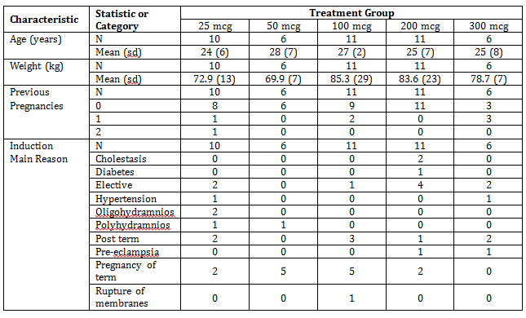
Table 9. Efficacy results
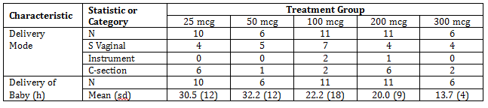
Comment: According to the Protocol, inclusion did not require that subjects have indications for induction of labour. Thus, the subjects studied here are not drawn from the population for whom the drug is intended for clinical use. Presumably, "Elective" under "Induction Main Reason" in the tabulation of baseline data means "for the purposes of the study". The meaning of "Pregnancy of term" as a reason for induction is unclear. I do not believe these efficacy data are of any relevance to a current assessment of the product.

Measurement of residual drug after removal of MVI
Available inserts were sent for drug assay after removal.

Study MISO-OBS-004
This was a Phase III randomised, double blind, multi-centre study whose primary efficacy objective was to demonstrate that the time to vaginal delivery in subjects treated with MVI 100 was significantly shorter than the time to vaginal delivery in subjects given Cervidil 10 mg. Nulliparous and parous women at or near term requiring induction of labour and cervical ripening were randomised to receive either MVI 50 or MVI 100 or Cervidil 10 mg, followed by oxytocin, if needed. The co-primary safety objective of the study was to demonstrate that the rate of C-section deliveries in subjects randomised to receive MVI 100 is non-inferior to the rate for subjects randomised to receive Cervidil.
Main inclusion criteria: Pregnant women at term (greater than or equal to 36 weeks gestation); aged greater than or equal to 18 years; singleton pregnancy; vertex presentation; MBS less than or equal to 4; parity less than or equal to 3; not in labour.
Following insertion, the vaginal insert was to remain in situ for 24 hours except in any of the following circumstances, when it was to be removed:
- Onset of active labour.
- Uterine hypertonus or tachysystole or hyperstimulation syndrome.
- Need for tocolytic drug identified.
- Evidence of foetal compromise.
- Other maternal or foetal adverse events which, in the opinion of the investigator necessitated discontinuation of dosing.
The ITT population comprised 428 randomised to MVI 100, 443 to MVI 50, and 436 to Cervidil 10 mg.

Evaluator’s conclusions on clinical efficacy
In terms of the chosen primary efficacy endpoint in the one pivotal study, efficacy of MVI 200 was superior to that of the comparator DVI. However, in the opinion of the evaluator:
- the route of administration has not been justified by an adequate program of PK and PD studies, and in any case appears to be unreliable, judging from the frequency with which the product falls out; and
- the optimum dosage has not been established.

Compliance with "One pivotal study" criteria
This is an application where the evidence of efficacy of the proposed treatment relies upon a single study (MISO-OBS-303). The relevant guideline (EMA 2001) stipulates:
‘In cases where the confirmatory evidence is provided by one pivotal study only, this study will have to be exceptionally compelling, and at the regulatory evaluation special attention will be paid to:
- The internal validity. There should be no indications of a potential bias.
- The external validity. The study population should be suitable for extrapolation to the population to be treated.
- Clinical relevance. The estimated size of treatment benefit must be large enough to be clinically valuable.
- The degree of statistical significance.
- Data quality.
- Internal consistency. Similar effects demonstrated in different pre-specified sub-populations. All important endpoints showing similar findings.
- Centre effects. None of the study centres should dominate the overall result, neither in terms of number of subjects nor in terms of magnitude of effect.
- The plausibility of the hypothesis tested.’
Most of these conditions appear to be met, but the evaluator believes the following are not met:
- ‘this study will have to be exceptionally compelling’; and
- ‘All important endpoints showing similar findings’.
Reasons:
- The evaluator has reservations about route of administration and dosage; and
- One of the co-primary objectives (which is closely related to efficacy) was not met.

Clinical safety

Studies providing evaluable safety data
The following studies provided evaluable safety data:

Pivotal efficacy study
In the pivotal efficacy study, the following safety data were collected:
- General AEs were assessed from insertion of study drug through to hospital discharge. Neonates were followed for AEs and concomitant medications from birth to hospital discharge and for hospital readmissions and visits to the emergency room for an additional 30 days.
- Routine CTG data were collected.

Pivotal studies that assessed safety as a primary outcome
Study MISO-OBS-303 (see section next above) was a pivotal study that assessed safety as a primary outcome. The study had as co-primary safety objective: to demonstrate that the rate of C-section deliveries in subjects randomised to receive MVI 200 is non-inferior to the rate for subjects randomised to receive Cervidil.

Dose-response and non-pivotal efficacy studies
The dose-response and non-pivotal efficacy studies provided safety data, as follows:
- Studies MISO-OBS-002, MISO-OBS-003 and MISO-OBS-204 provided data on AEs, including those ascertained by CTG monitoring.
- Study MISO-OBS-004 had as co-primary safety objective: to demonstrate that the rate of C-section deliveries in subjects randomised to receive MVI 100 is non-inferior to the rate for subjects randomised to receive Cervidil. The study also provided data on AEs, including those ascertained by CTG monitoring.

Other studies evaluable for safety only

Clinical pharmacology studies
Studies MISO-OBS-001 and MISO-OBS-205.

Pivotal studies that assessed safety as a primary outcome

Study MISO-OBS-303
See section 7.

Patient exposure
Table 10. Exposure to Misoprostol vaginally and comparators in clinical studies.
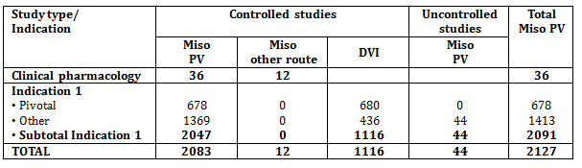

Adverse events
Note: When AEs are listed other than in a table, a comma separates AEs reported in the same patient, and a semicolon separates AEs reported in different patients.

All adverse events (irrespective of relationship to study treatment)

Pivotal study
Table 11. Study MISO-OBS-303. Number of subjects reporting AEs
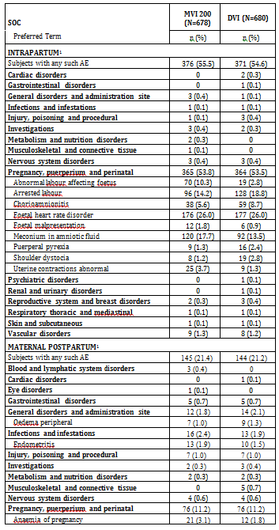
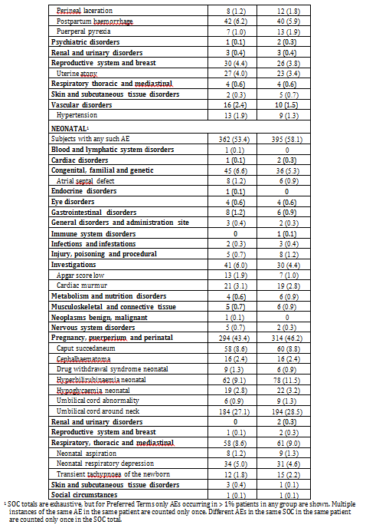

Other studies
Postpartum: 2 patients (1 increase in blood mg; 1 anxiety)

Treatment-related adverse events (adverse drug reactions)
Study MISO-OBS-205: Only 1 AE was classified as treatment-related.
Study MISO-OBS-204: Maternal postpartum: 2 in MVI 150 (postpartum hemorrhage; uterine atony) and 3 in MVI 200 (rash; postpartum hemorrhage; postpartum vaginal laceration). Neonatal: 2 in MVI 200 (subdural haematoma; neonatal disorder − poor adaptation to extrauterine life)
Study MISO-OBS-003: AEs classified as at least possibly related to study drug were as follows:
- 25 mcg dose: 1 (FHR disorder)
- 50 mcg dose: 2 (uterine hypertonus, uterine contractions abnormal NOS)
- 100 mcg dose: 0
- 200 mcg dose: 4 (nausea; 3 uterine contractions abnormal NOS)
- 300 mcg dose: 6 (uterine contractions abnormal NOS, nausea, vomiting; abnormal labour affecting foetus; abnormal labour affecting foetus, uterine contractions abnormal NOS)

Deaths and other serious adverse events

Pivotal study
No deaths.

Other studies
Study MISO-OBS-001: No deaths or SAEs.
Study MISO-OBS-205: No deaths. SAEs: intrapartum 3 out of 24 (1 uterine tachysystole with bradycardia; 2 foetal heart rate disorder); neonatal 3 out 24 (cryptorchism and hydrocoele; infantile apnoeic attack; neonatal respiratory distress syndrome).
Study MISO-OBS-002: No deaths.
Study MISO-OBS-204: No deaths.
Study MISO-OBS-003: No deaths. SAEs:
- 25 mcg dose: 6 (2 failed trial of labour; 3 FHR disorder NOS; arrested labour)
- 50 mcg dose: 3 (failed trial of labour; uterine hypertonus, uterine contractions abnormal NOS)
- 100 mcg dose: 3 (failed trial of labour; arrested labour, meconium aspiration)
- 200 mcg dose: 7 (3 failed trial of labour; 2 FHR disorder NOS; FHR disorder NOS, meconium aspiration)
- 300 mcg dose: 2 (2 abnormal labour affecting foetus)
Study MISO-OBS-004: No deaths.

Discontinuation due to adverse events
Note that in studies of the MVI in clinical use, discontinuation (that is, removal of the MVI) following an AE does not necessarily imply a suspicion that the drug may have caused the AE. For example, an AE leading to C-section may be considered entirely unrelated to the drug, yet the MVI would be removed. In the remainder of this section, status of all patients regarding retention of MVI (rather than only those patients reporting AEs) is summarised, where such information is considered informative.

Pivotal study
In Study MISO-OBS-303, the primary reason for study drug removal is given below.
Table 12. Primary reason for removal
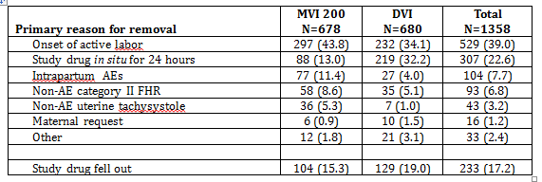

Other studies
Study MISO-OBS-001: None
Study MISO-OBS-205: None
Study MISO-OBS-002: The status of all patients regarding retention of MVI is summarised below.
Table 13. Patient retention status
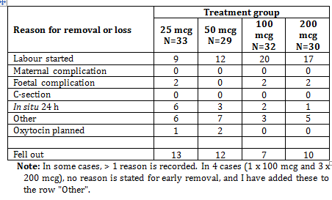
Table 14. Study MISO-OBS-204 primary reason for study drug removal
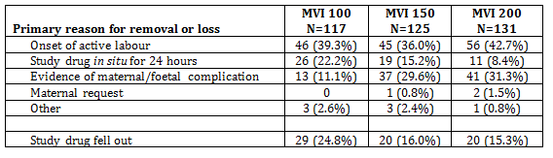
Table 15. Study MISO-OBS-003 primary reason for study drug removal
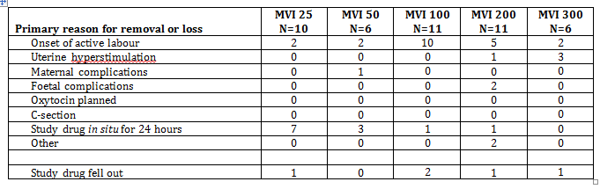
Table 16. Study MISO-OBS-004 primary reason for study drug removal
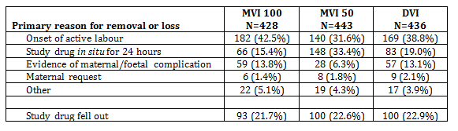

Laboratory tests

Clinical chemistry and haematology

Pivotal study
Study MISO-OBS-303: Routine laboratory tests were not done following treatment.

Other studies
Study MISO-OBS-001: Routine screening was done at the beginning and end of the study. Subject 1 had a high bilirubin value of 27.5 µmol/L (baseline value 11.9, normal range 1.0 to 22.5); Subject 2 had a neutrophil count of 1.3 (baseline value 1.6, normal range 1.7 to 7.5); Subject 8 had normal urine at entry and blood, epithelial cells and ketones present post study; and Subject 9 had normal urine (except for the presence of epithelial cells) at entry but blood, epithelial cells and ketones were present post study. Repeat tests were normal the following day for Subject 1, but remained abnormal for Subjects 2, 8 and 9.
In studies MISO-OBS-205, MISO-OBS-002, MISO-OBS-204, MISO-OBS-003 and MISO-OBS-004, routine laboratory tests were not done following treatment.

Other safety parameter: Rate of C-section

Pivotal study
Study MISO-OBS-303 had as co-primary safety objective: to demonstrate that the rate of C-section deliveries in subjects randomised to receive MVI 200 is non-inferior to the rate for subjects randomised to receive DVI (Cervidil). The rates of C-section during the index hospital admission are tabulated below.
Table 17. Rates of Caesarean section during the index hospital admission
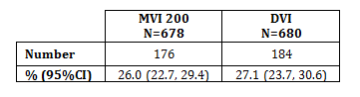
Using the protocol-specified non-inferiority margin of 10%, non-inferiority of MVI 200 compared with Cervidil was not demonstrated. In a subgroup analysis, the non-inferiority criterion was met for the nulliparous subgroup (comprising 441 subjects on MVI 200 and 451 on Cervidil).

Other studies
Study MISO-OBS-004 had as co-primary safety objective: to demonstrate that the rate of C-section deliveries in subjects randomised to receive MVI 100 is non-inferior to the rate for subjects randomised to receive Cervidil. The rates of C-section during the index hospital admission are tabulated below.
Table 18. Rates of Caesarean section during the index hospital admission
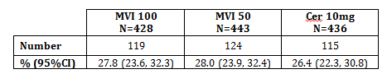
Using the protocol-specified non-inferiority margin of 15%, non-inferiority of MVI 100 compared with Cervidil was not demonstrated.
For the other studies in which any C-section occurred, the rates during the index hospital admission are tabulated below.
Table 19. Study MISO-OBS-002
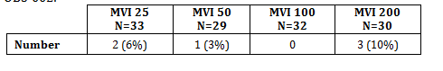
Table 20. Study MISO-OBS-204
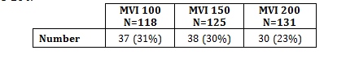
Table 21. Study MISO-OBS-003
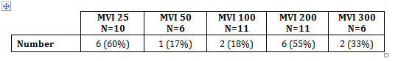

Post-marketing experience
None reported.

Evaluator’s overall conclusions on clinical safety
The main studies useful for assessment of safety were
- MISO-OBS-204 (comparing MVI 100, 150, 200);
- MISO-OBS-004 (comparing MVI 50, 100 with DVI); and
- MISO-OBS-303 (comparing MVI 200 with DVI).
Some relevant findings of these studies are tabulated below.
Table 22.
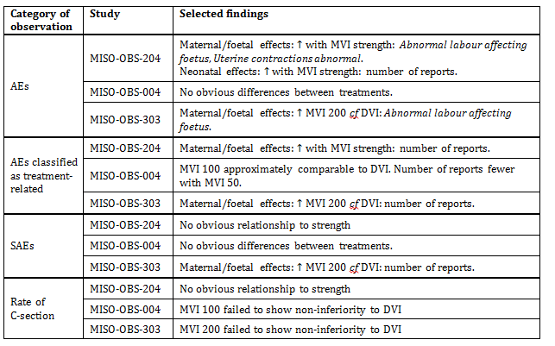

First round benefit-risk assessment

First round assessment of benefits
A question which must be considered is whether vaginal misoprostol has any advantage over the oral route. This was explicitly considered in Alfirevic and Weeks (2010), which stated:
‘The large variety of doses of both oral and vaginal misoprostol used in the direct comparisons make it very difficult to interpret these data. The only consistent finding is a reduction in low Apgar score at five minutes in those given oral misoprostol, but there is no corresponding reduction in special baby care unit admission. The cause of this improved outcome in those given oral misoprostol is not clear, but it may relate to the hyperstimulation rates which were generally lower in those given low-dose oral misoprostol. The relative acceptability of the oral and vaginal routes also need to be considered alongside this clinical data. Satisfaction was only considered in one study of 200 women, and in this study only two women (one in each group) expressed dissatisfaction. However, other clinical studies comparing oral and vaginal misoprostol have found increased satisfaction with the oral route.
In summary, there is some evidence that the oral route may result in improved clinical outcomes over the vaginal route. Given the likely greater acceptability for women using an oral route, it is the authors’ opinion that the oral route should be preferred over the vaginal route.’
It seems this question has not been resolved by clinical studies of efficacy and safety. Nor is definitive relevant information available from PK or PD studies, which could help to resolve the question of whether the outcomes resulting from different dosages and routes of administration depend only on the shape and magnitude of the plasma concentration versus time curve for misoprostol acid which is achieved by the regimen.
Thus, benefits can only be assessed in comparison to other products intended for vaginal administration. In the one pivotal study, efficacy of MVI 200 was superior to that of the comparator DVI. However, as already discussed this evaluator has reservations.

First round assessment of risks
As with the benefits, from the data submitted, risks can only be assessed in comparison to other products intended for vaginal administration. As pointed out, on the basis of the criterion rate of C-section, Studies MISO-OBS-004 and MISO-OBS-303 failed to demonstrate that MVI 100 and MVI 200, respectively, were non-inferior to DVI. In addition to this, several categories of adverse effects were observed in the main clinical studies to occur more frequently with MVI 200 than with comparators.
Overall, the evaluator thinks there are grounds for concern that the clinical safety of MVI 200 may be inferior to that of DVI.

First round assessment of benefit-risk balance
The benefit-risk balance of MVI 200, given the proposed usage, is unfavourable.

First round recommendation regarding authorisation
This evaluator recommends that registration should be refused.
The trials submitted were in the evaluator’s opinion insufficient in overall number of patients studied, too narrowly focused on a specific route of administration, and insufficiently supported by PK and PD data, to justify approval of the application. For a broader perspective on this area of therapeutics, the evaluator recommends 2 reports of the Cochrane Collaboration, from which extracts are copied below. The most recent of these (Hofmeyr et al. 2010) was included in the present dossier, in the list of literature references.
Alfirevic et al. (2010) expressed the opinion:
‘[Oral misoprostol] as an induction agent is effective at achieving vaginal delivery. It is more effective than placebo, as effective as vaginal misoprostol and results in fewer caesarean sections than vaginal dinoprostone…. If using [oral misoprostol], clinicians should use a dose of 20 to 25 mcg in solution. Given that safety is the primary concern, the oral regimens are recommended over vaginal regimens. This is especially important in situations where the risk of ascending infection is high and the lack of staff means that women cannot be intensely monitored.’
In the summary of a subsequent Cochrane review, Hofmeyr et al. (2010) stated:
‘Misoprostol is a hormone given by insertion through the vagina or rectum, or by mouth to ripen the cervix and bring on labour. The review of 121 trials found that larger doses of misoprostol are more effective than prostaglandin and that oxytocin is used in addition less often. However, misoprostol also increases hyperstimulation of the uterus. With smaller doses, the results are similar to other methods. The trials reviewed are too small to determine whether the risk of rupture of the uterus is increased. More research is needed into the safety and best dosages of misoprostol. Another Cochrane review has shown that the oral route of administration is preferable to the vaginal route.’

Clinical questions
None.

References
Studies presented in the dossier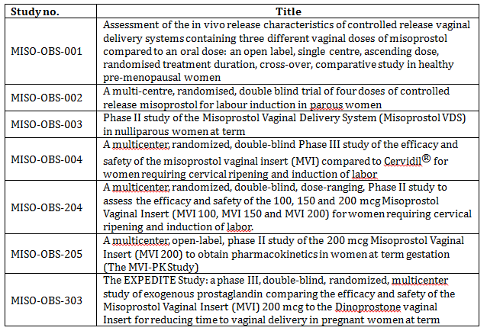

Other references
Alfirevic Z and Weeks A. Oral misoprostol for induction of labour (Review). 2010. Cochrane Database of Systematic Reviews, Issue 1. (First published as Art. No.: CD001338. DOI: 10.1002/14651858.CD001338.pub2.)
Bryman I et al. 1982. Extreme sensitivity of cervical musculature to prostaglandin E2 in early pregnancy. Lancet 2:1471.
Chiossi G et al. 2012. In vitro myometrial contractility profiles of different pharmacological agents used for induction of labor. Am J Perinatol. 1 February.
Note: Whether this document has ever been published is not clear.
European Medicines Agency (EMA). 1999. Note for Guidance on Modified Release Oral and Transdermal Dosage Forms: Section II (Pharmacokinetic and Clinical Evaluation). Document CPMP/EWP/280/96.
European Medicines Agency (EMA). 2001. Points to consider on application with 1. Meta-analyses; 2. One pivotal study. Document CPMP/EWP/2330/99.
Hofmeyr GJ et al. 2010. Vaginal misoprostol for cervical ripening and induction of labour. Cochrane Database of Systematic Reviews, Issue 10. Art. No.: CD000941. DOI: 10.1002/14651858.CD000941.pub2.
Khan R et al. 2004. Oral, rectal, and vaginal pharmacokinetics of misoprostol. Obstetrics and Gynaecology 103: 866-870.
Li QH. 2009. Evaluating co-primary endpoints collectively in clinical trials. Biometrical Journal 51: 137-145.
Senior J et al. 1999. In vitro characterization of prostanoid receptors on human myometrium at term pregnancy. Br J Pharmacol 108: 501-506.
Tang OS et al. 2002. Pharmacokinetics of different routes of administration of misoprostol. Human Reproduction 17: 332-336.
Zieman M et al. 1997. Absorption kinetics of misoprostol with oral or vaginal application. Obstetrics and Gynaecology 90: 88-92.
Therapeutic Goods Administration
PO Box 100 Woden ACT 2606 Australia
Email: info@tga.gov.au Phone: 1800 020 653 Fax: 02 6232 8605
http://www.tga.gov.au

The DVI value of 26.0 has been revised to 25.9 (5.9)
The 50 mcg group, delivered vaginally < = 12 hours has been revised to 4 (14%).
Post term 100mcg group has been revised and should be 4.
Delivery of baby (h) 200 mcg group has been revised to 19.8 (9).

