|  |
| --- |
| **May 2020** |

|  |
| --- |
| Australian Public Assessment Report for Neratinib (as maleate) |
| Proprietary Product Name: Nerlynx |
| Sponsor: Specialised Therapeutics PM Pty Ltd |

About the Therapeutic Goods Administration (TGA)

* The Therapeutic Goods Administration (TGA) is part of the Australian Government Department of Health and is responsible for regulating medicines and medical devices.
* The TGA administers the *Therapeutic Goods Act 1989* (the Act), applying a risk management approach designed to ensure therapeutic goods supplied in Australia meet acceptable standards of quality, safety and efficacy (performance) when necessary.
* The work of the TGA is based on applying scientific and clinical expertise to decision-making, to ensure that the benefits to consumers outweigh any risks associated with the use of medicines and medical devices.
* The TGA relies on the public, healthcare professionals and industry to report problems with medicines or medical devices. TGA investigates reports received by it to determine any necessary regulatory action.
* To report a problem with a medicine or medical device, please see the information on the TGA website <<https://www.tga.gov.au>>.

About AusPARs

* An Australian Public Assessment Report (AusPAR) provides information about the evaluation of a prescription medicine and the considerations that led the TGA to approve or not approve a prescription medicine submission.
* AusPARs are prepared and published by the TGA.
* An AusPAR is prepared for submissions that relate to new chemical entities, generic medicines, major variations and extensions of indications.
* An AusPAR is a static document; it provides information that relates to a submission at a particular point in time.
* A new AusPAR will be developed to reflect changes to indications and/or major variations to a prescription medicine subject to evaluation by the TGA.

Copyright

© Commonwealth of Australia 2020  
This work is copyright. You may reproduce the whole or part of this work in unaltered form for your own personal use or, if you are part of an organisation, for internal use within your organisation, but only if you or your organisation do not use the reproduction for any commercial purpose and retain this copyright notice and all disclaimer notices as part of that reproduction. Apart from rights to use as permitted by the *Copyright Act 1968* or allowed by this copyright notice, all other rights are reserved and you are not allowed to reproduce the whole or any part of this work in any way (electronic or otherwise) without first being given specific written permission from the Commonwealth to do so. Requests and inquiries concerning reproduction and rights are to be sent to the TGA Copyright Officer, Therapeutic Goods Administration, PO Box 100, Woden ACT 2606 or emailed to <[tga.copyright@tga.gov.au](mailto:tga.copyright@tga.gov.au)>.

Contents

Common abbreviations 4

I. Introduction to product submission 6

Submission details 6

Product background 7

Regulatory status 8

Product Information 9

II. Registration timeline 9

III. Submission overview and risk/benefit assessment 9

Quality 9

Nonclinical 10

Clinical 11

Risk management plan 20

Risk-benefit analysis 21

Outcome 22

Attachment 1. Product Information 23

## Common abbreviations

|  |  |
| --- | --- |
| Abbreviation | Meaning |
| ACM | Advisory Committee on Medicines |
| ADME | Absorption, distribution, metabolism, and excretion |
| ALT | Alanine transaminase |
| ARTG | Australian Register of Therapeutic Goods |
| ASA | Australian specific Annex |
| AST | Aspartate transaminase |
| BCRP | Breast cancer resistance protein |
| CEP17 | Chromosome enumeration probe 17 |
| CI | Confidence interval |
| CMI | Consumer Medicines Information |
| CYP3A4 | Cytochrome P450 3A4 |
| DLP | Data lock point |
| EGFR | Epidermal growth factor receptor |
| EMA | European Medicines Agency (European Union) |
| EU | European Union |
| EU-RMP | European Union-risk management plan |
| FDA | Food and Drug Administration (United States) |
| GI | Gastrointestinal |
| GVP | Good Pharmacovigilance Practice |
| HCP | Healthcare professional |
| HER1, HER2, HER3, HER4 | Human epidermal growth factor receptors 1, 2, 3 and 4 |
| HR | Hazard ratio |
| HRc | Hormone receptor |
| iDFS | Invasive disease-free survival |
| ITT | Intention to treat |
| IV | Intravenous |
| LVEF | Left ventricular ejection fraction |
| M3, M11 | Neratinib metabolites 3 and 11 |
| NCCN | National Comprehensive Cancer Network |
| ODAC | Oncologic Drugs Advisory Committee (Food and Drug Administration, United States) |
| PASS | Post-authorisation safety study |
| PBPK | Physiologically based pharmacokinetic |
| PD | Pharmacodynamic(s) |
| P-gp | P-glycoprotein |
| PI | Product Information |
| PK | Pharmacokinetic(s) |
| PSUR | Periodic safety update report |
| RMP | Risk management plan |
| TGA | Therapeutic Goods Administration |
| US(A) | United States (of America) |

## I. Introduction to product submission

### Submission details

|  |  |
| --- | --- |
| *Type of submission:* | New chemical entity |
| *Decision*: | Approved |
| *Date of decision:* | 14 March 2019 |
| *Date of entry onto ARTG:* | 15 March 2019 |
| *ARTG number:* | 301129 |
| *Black Triangle Scheme* | Yes  This product will remain in the scheme for 5 years, starting on the date the product is first supplied in Australia. |

|  |  |
| --- | --- |
| *Active ingredient:* | Neratinib (as maleate) |
| *Product name:* | Nerlynx |
| *Sponsor’s name and address:* | Specialised Therapeutics PM Pty Ltd  Level 2, 17 Cotham Road,  Kew, Victoria 3101 |
| *Dose form:* | Film coated tablet |
| *Strength:* | 40 mg |
| *Container:* | Bottle |
| *Pack size:* | 180 |
| *Approved therapeutic use:* | *Nerlynx is indicated for the extended adjuvant treatment of adult patients with early-stage HER2-overexpressed/amplified breast cancer, to follow adjuvant trastuzumab based therapy.* |
| *Route of administration:* | Oral |
| *Dosage:* | Nerlynx treatment should be initiated and supervised by a physician experienced in the administration of anti-cancer medicinal products.  The recommended dose of Nerlynx is 240 mg (6 x 40 mg tablets) taken orally once daily, continuously for one year. The tablets should be swallowed whole preferably with water and should not be crushed or dissolved, and should be taken with food, preferably in the morning. Patients should initiate treatment within 1 year after completion of trastuzumab therapy.  For further information, refer to the Product Information (PI). |

### Product background

This AusPAR describes the application by Specialised Therapeutics PM Pty Ltd (the sponsor) to register Nerlynx (neratinib as maleate) 40 mg film coated tablets for the following proposed indication:

*The extended adjuvant treatment of adult patients with early-stage HER2‑overexpressed/amplified breast cancer who have received prior adjuvant trastuzumab based therapy.*

Carcinoma of the breast is a malignancy arising from epithelial cells in the lobules or ducts of the mammary gland. According to Cancer Council Australia there were 16,614 women and 140 men diagnosed with breast cancer in Australia in 2014 and 2,939 women and 28 men died of the disease in 2015.[1]

Human epidermal growth factor receptor 2 (HER2; also referred to as ErbB2) is a cell surface receptor that is expressed in a variety of normal epithelial cell types. It is one of a family of four transmembrane receptors (the ErbB family) that activate a network of intracellular signalling pathways that affect various cell functions including cell proliferation and survival. The other members of the family are HER1 (also referred to as ErbB1 or epidermal growth factor receptor (EGFR)); HER3 (or ErbB3); and HER4 (or ErbB4). The intracellular domains of the HER1 (EGFR), HER2 and HER4 receptors have tyrosine kinase activity.[2] Ligand binding to the extracellular domains of HER1, HER3 or HER4 results in the formation of dimers between the four types of receptor and then activation of the tyrosine kinases. HER2 itself has no known ligand.

HER2-positivity (that is, overexpression of the HER2 receptor or amplification of the HER2 gene) is found in approximately 15 to 20% of breast cancers.[3] HER2-positive breast cancer is associated with reduced disease-free survival and overall survival compared to HER2‑negative disease.[4]

According to current consensus clinical practice guidelines;[5],[6],[7] standard adjuvant treatment for HER2-positive breast cancer should include:

* Cytotoxic chemotherapy. A number of chemotherapy regimens can be used such as:
  + doxorubicin plus cyclophosphamide followed by paclitaxel;
  + paclitaxel alone; or
  + docetaxel with carboplatin.

Cytotoxic chemotherapy is usually continued for 12 to 24 weeks.

* Trastuzumab; this agent is a monoclonal antibody directed against the extracellular domain of the HER2 receptor. In the adjuvant setting it is commenced after any anthracycline chemotherapy has been completed, and concurrently with non‑anthracycline chemotherapy. The standard duration of trastuzumab therapy in the adjuvant setting is 12 months.
* Endocrine therapy in those subjects who have hormone receptor positive disease (approximately 50% of subjects with HER2-positive disease).[8] Agents registered in Australia for adjuvant treatment of hormone receptor-positive breast cancer include tamoxifen, exemestane, anastrozole and letrozole. Adjuvant endocrine treatment may continue for up to 10 years.

Neratinib is a new chemical entity that binds to the intracellular tyrosine kinase domains of HER1 (EGFR), HER2 and HER4. The application described in this AusPAR sought approval of neratinib for use in the adjuvant treatment of HER-2 positive breast cancer.

The indication sought by the sponsor was for *extended* adjuvant treatment of HER2‑positive breast cancer. It was proposed that treatment commence after completion of trastuzumab therapy and continue for a period of 12 months. Therefore, specific anti‑HER2 therapy would be received for a total of 24 months.

The rationale provided by the sponsor included the following:

* Approximately 26% of subjects who receive adjuvant trastuzumab develop disease recurrence. One potential explanation in these subjects is the development of acquired resistance to trastuzumab, which may occur when the extracellular domain HER2 receptor can no longer be recognized by trastuzumab or because of co-activation of HER1 (EGFR) signalling.
* Neratinib binds to the intracellular tyrosine kinase domains of HER1 (EGFR), HER2 and HER4. Its mode of action is therefore different to trastuzumab, which targets the extracellular domain of HER2 only. Neratinib binding is also irreversible. These features may make neratinib effective even in the presence of trastuzumab resistance.

### Regulatory status

Nerlynx (neratinib as maleate) is considered a new chemical entity for Australian regulatory purposes.

At the time the TGA considered this application, a similar application had been approved in the United States of America (USA) and the European Union (EU) for the following indications.

USA (Food and Drug Administration (FDA)) approved indication (approved 17 July 2017):

*Nerlynx is indicated for the extended adjuvant treatment of adult patients with early stage HER2-overexpressed/amplified breast cancer, to follow adjuvant trastuzumab based therapy.*

EU (European Medicines Agency (EMA)) approved indication (approved September 2018):

*Nerlynx is indicated for the extended adjuvant treatment of adult patients with early-stage hormone receptor positive HER2-overexpressed/amplified breast cancer and who are less than one year from the completion of prior adjuvant trastuzumab based therapy.*

### Product Information

The Product Information (PI) approved with the submission which is described in this AusPAR can be found as Attachment 1. For the most recent PI, please refer to the TGA website at <<https://www.tga.gov.au/product-information-pi>>.

## II. Registration timeline

Table 1 captures the key steps and dates for this application and which are detailed and discussed in this AusPAR.

Table 1: Timeline for Submission PM-2018-00968-1-4

|  |  |
| --- | --- |
| Description | Date |
| Submission dossier accepted and first round evaluation commenced | 30 April 2018 |
| First round evaluation completed | 18 October 2018 |
| Sponsor provides responses on questions raised in first round evaluation | 15 November 2018 |
| Second round evaluation completed | 12 March 2019 |
| Delegate’s Overall benefit-risk assessment | 14 February 2019 |
| Sponsor’s pre-Advisory Committee response | Not applicable |
| Advisory Committee meeting | Not applicable |
| Registration decision (Outcome) | 14 March 2019 |
| Completion of administrative activities and registration on the ARTG | 15 March 2019 |
| Number of working days from submission dossier acceptance to registration decision* | 200 |

*Statutory timeframe for standard applications is 255 working days

## III. Submission overview and risk/benefit assessment

The submission was summarised in the following Delegate’s overview and recommendations.

### Quality

The sponsor has made a submission to register a new chemical entity, neratinib (as maleate) 40 mg film-coated tablets in bottles containing 180 tablets (equates to 30 day supply). The tablet contains 48.31 mg of neratinib maleate (Figure 1) stoichiometrically equivalent to 40.0 mg of neratinib free base.

Figure 1: Structure of neratinib (as maleate)

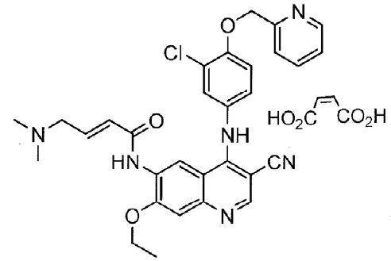

Neratinib is an oral, irreversible tyrosine kinase inhibitor of HER1, 2 and 4, blocking signal transduction that preferentially inhibits proliferation of cells expressing HER2 and EGFR. Other dual inhibitors (inhibit both HER2 and EGFR kinases) include lapatinib and afatinib. It is prepared synthetically and isolated as an anhydrate maleate salt.

The application and the supporting data relating to the composition, development, manufacture, quality control and stability of the product have been assessed and checked for compliance, as applicable, with Australian legislation and requirements for new medicines and in accordance with pharmacopoeial standards and the technical guidelines adopted by the TGA.

Registration is recommended with respect to chemistry, manufacturing and biopharmaceutic aspects.

### Nonclinical

The following conclusions and recommendations were summarised in the nonclinical evaluation:

* The pharmacology studies support the proposed indication and dose.
* The secondary pharmacodynamic and safety pharmacology studies raise no obvious concerns.
* While neratinib appears to have affinity for and retention in melanin-containing tissues, this does not appear to be associated with adverse toxicological effects.
* Pharmacokinetic drug interactions are possible with cytochrome P450 3A4 (CYP3A4) inhibitors/inducers and CYP3A4, P-glycoprotein (P-gp) or breast cancer resistance protein (BCRP) substrates.
* Effects on the skin and gastrointestinal (GI) tract may be seen in patients.
* The toxicity of the M11 metabolite has not been assessed (minor deficiency).[9]
* There are no genotoxic or carcinogenicity concerns with neratinib.
* Given the role of EGFR and HER2 in implantation and embryofetal development, neratinib should not be used during pregnancy.
* There are still outstanding concerns in regards to the proposed specifications for impurity 3638 (minor deficiency).
* The following studies should be submitted to the TGA in a subsequent submission:
  + The cardiovascular safety pharmacology study with M3
  + The 2 week repeat-dose toxicity study with M11, and
  + An *in vitro* clastogenicity study with the impurity 3638.
* The minor deficiencies identified above should not preclude registration if there are clear benefits to the patient group.

### Clinical

The clinical dossier consisted of the following studies:

* 14 clinical pharmacology studies in healthy volunteers;
* 17 Phase I/Phase II studies of neratinib in subjects with various malignancies. In these studies, neratinib was administered either as monotherapy or in combination with other antineoplastic agents. These studies provided data on clinical pharmacology, efficacy and safety;
* one pivotal Phase III randomised double blind trial with two parallel groups (pembrolizumab versus placebo) in subjects with resected early stage HER2-positive breast cancer, previously treated with trastuzumab. The study provided data on efficacy and safety;
* one study that examined safety (diarrhoea) as the sole primary endpoint;
* one population pharmacokinetic (pop PK) analysis; and
* one physiologically based pharmacokinetic (PBPK) analysis.

The clinical dossier also included literature references.

#### Pharmacology

In their overview, the Delegate referenced the European Medicines Agency (EMA)-approved Summary of Product Characteristics for Nerlynx, Section 5.2: Pharmacokinetic properties.[10]

##### Pharmacokinetics

The clinical evaluator concluded the following in regards to the pharmacokinetic (PK) data:

* The PK of neratinib have not been fully elucidated due to the lack of PK data following intravenous (IV) administration. Absolute bioavailability and actual clearance and volume of distribution have not been determined. According to the sponsor, an IV formulation could not be produced due to solubility issues.
* Metabolite profiles in urine and faeces have also not been determined. It is understood that another absorption, distribution, metabolism, and excretion (ADME) study in healthy subjects (Study PUMA-NER-0102) has been conducted and this may provide further data on this subject. The sponsor should be asked when data from this study are likely to be available.
* Otherwise, the program of clinical PK studies was fairly comprehensive. If the justification for not conducting an absolute bioavailability study is considered acceptable on pharmaceutical chemistry grounds, the PK data to support registration of neratinib are considered adequate.

##### Pharmacodynamics

The clinical evaluator concluded the following in regards to the pharmacodynamic (PD) data:

* Limited clinical data relating to PD were submitted. The studies were acceptable.

#### Efficacy

##### Study 3004 (ExteNET trial)

Evidence to support the proposed indication for neratinib is derived primarily from the ExteNET trial (Study 3004).

There were a total of six global protocol amendments over the course of the study under the supervision of three sponsors.

This study was a Phase III, randomised, double blind, placebo-controlled trial with two parallel groups (neratinib monotherapy versus placebo).

A study schema is shown in Figure 2. The study had three parts. Part A was from randomisation to 2 years post-randomisation, Part B was from 2 to 5 years post‑randomisation, and Part C covered longer-term follow-up for overall survival.

Figure 2: Design of Study 3004 (ExteNET trial)

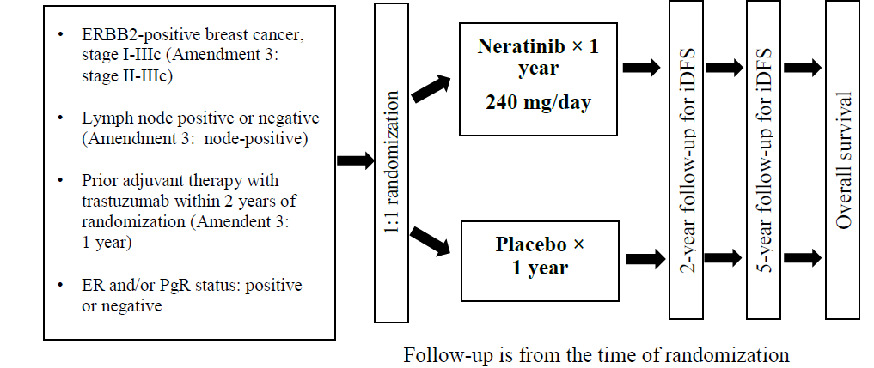

ER = oestrogen receptor, PgR = progesterone receptor.

###### Study population

Women with locally-confirmed invasive HER2-positive breast cancer Stage I to III (changed to Stage II to III in Amendment 3) without evidence of recurrence were eligible. Neo/adjuvant trastuzumab was completed up to 2 years (changed to 1 year in Amendment 3) before randomisation. Normal organ and left ventricular ejection fraction (LVEF) function was required and concurrent adjuvant endocrine therapy for hormone receptor (HRc)–positive disease was recommended. Antidiarrheal prophylaxis was not mandated per protocol, but treatment for diarrhoea was advised at its earliest occurrence.

###### Randomisation

Patients were randomly assigned (in a 1:1 ratio) to receive neratinib or matching placebo.

The randomisation sequence was generated with permuted blocks stratified by locally determined HRc status (HRc-positive (defined as either oestrogen or progesterone receptor positive or both) versus hormone receptor-negative (defined as oestrogen and progesterone receptor-negative)), nodal status (0, 1 to 3, or ≥ 4), and trastuzumab adjuvant regimen (sequentially versus concurrently with chemotherapy).

HER2 status was subsequently confirmed centrally (HER2 amplification defined as a ratio of HER2 to chromosome enumeration probe 17 (CEP17) of ≥ 2·2 using PathVysion HER2 DNA dual probe (Abbott Molecular, Des Plaines, IL, USA)).

The primary objective was to compare invasive disease-free survival (iDFS) in women with early-stage HER2-overexpressed/amplified breast cancer following trastuzumab in the adjuvant setting receiving neratinib, compared with that of women receiving placebo.

Patient flow is shown in Figure 3.

Figure 3: Patient flow in Study 3004 (ExteNET trial)

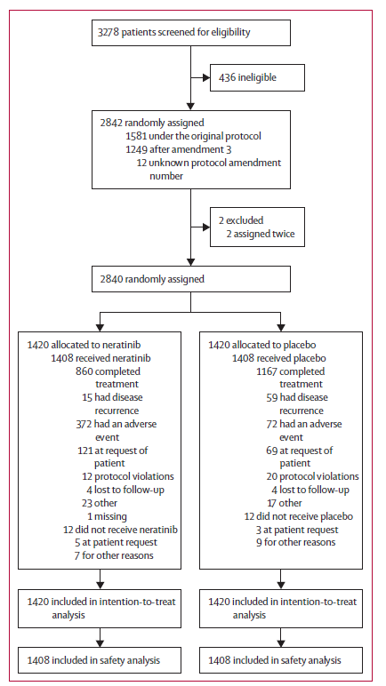

From Chan et al. (2016).[11]

Some baseline characteristics of patients in the ExteNET trial are shown inTable 2**.**

Table 2: Baseline characteristics in Study 3004 (ExteNET trial)

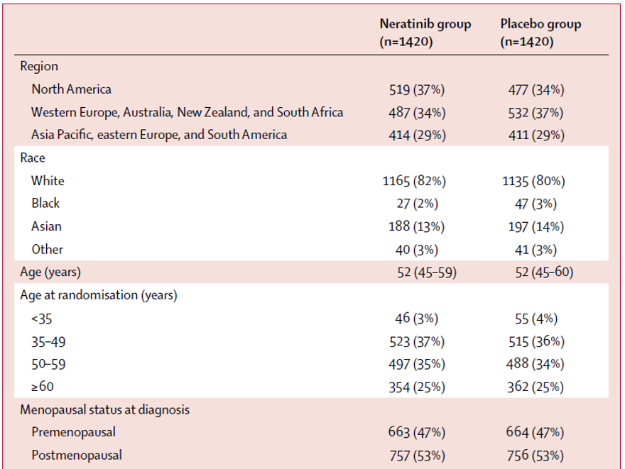

Extract from Chan et al. (2016).11

###### Results

The primary analysis of iDFS was conducted on the intention to treat (ITT) population and was based on all subjects who experienced an iDFS event within 2 years and 28 days after randomisation.

A total of 173 subjects experienced an event. Neratinib treatment was associated with a statistically significant reduction in the risk of experiencing an iDFS event (hazard ratio (HR) = 0.66; 95% confidence interval (CI): 0.49 to 0.90; 2-sided p value = 0.008);[12] see Figure 4.

At 24 months, the proportion of subjects who were alive and free of invasive disease was increased from 91.9% in the placebo arm to 94.2% in the neratinib arm, an absolute difference of 2.3%.

The most common form of disease recurrence was distant recurrence, in both arms of the study.

Figure 4: Kaplan-Meier plot of disease-free survival, Study 3004 (ExteNET trial), intention to treat population

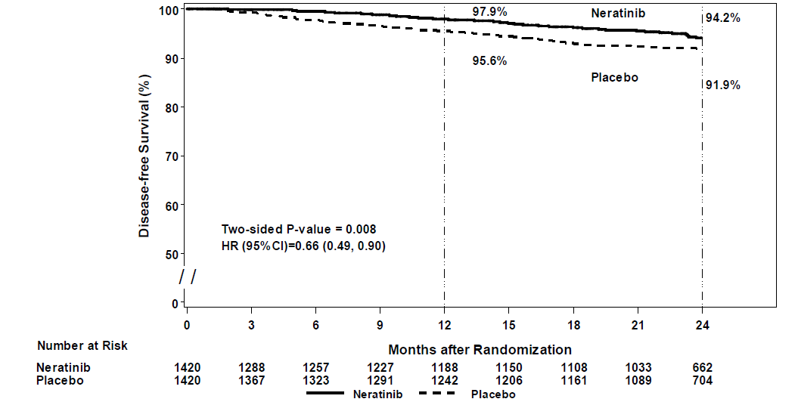

Sub-group analyses are shown in Figure 5.

Figure 5: Forest plot of disease-free survival in key subgroups, Study 3004 (ExteNET trial), intention to treat population

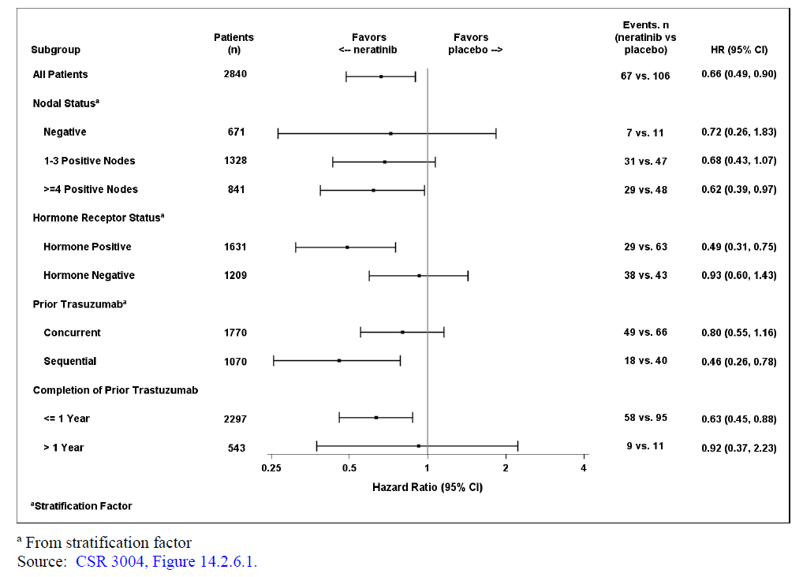

In HRc-positive women, neratinib reduced the 2 year risk of recurrence or death by 51% relative to placebo (HR 0.49; 95% CI, 0.31 to 0.75; p = 0.001), whereas 2 year iDFS rates were not different in HRc-negative women (HR 0.93; 95% CI, 0.60 to 1.43; p = 0.73) see Figure 6 and Figure 7.

Figure 6: Kaplan-Meier plot of disease-free survival in hormone receptor-positive patients, Study 3004 (ExteNET trial)

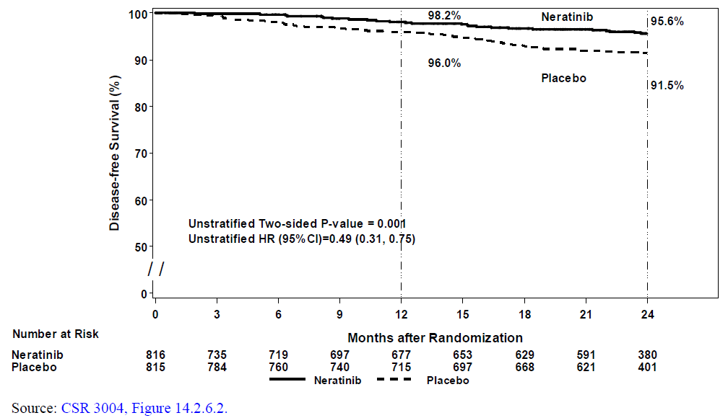

Figure 7: Kaplan-Meier plot of disease-free survival, hormone receptor-negative patients, Study 3004 (ExteNET trial)

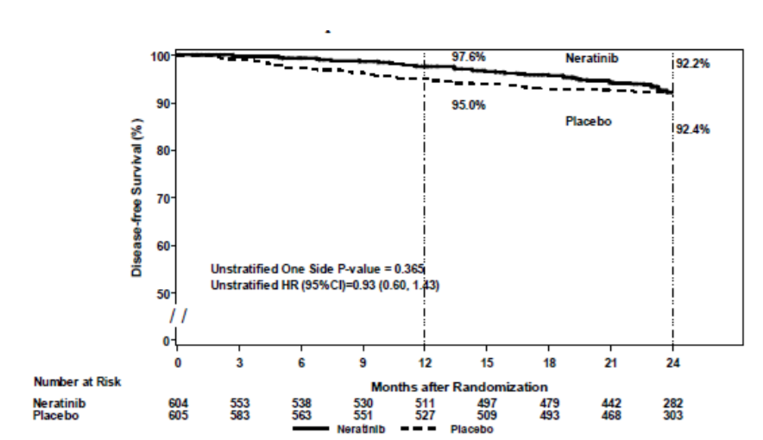

Published data on 5 year follow-up (Martin et al, 2017),[13] show durability of response and confirm sub-group analyses indicating greater benefit with neratinib in patients with hormone receptor-positive disease see Figure 8 and Figure 9 below.

Figure 8: Invasive disease-free survival in patients with hormone receptor-positive breast cancer, Study 3004 (ExteNET trial)

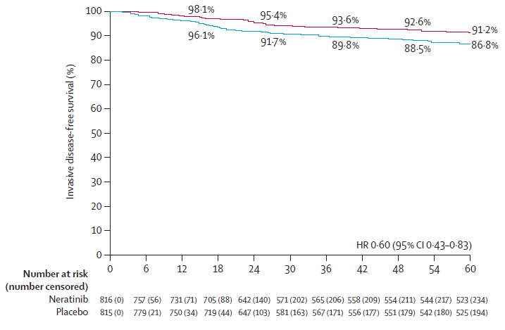

Red = neratinib, blue = placebo. From Martin et al. (2017).11

Figure 9: Invasive disease-free survival in patients with hormone receptor-negative breast cancer, Study 3004 (ExteNET trial)

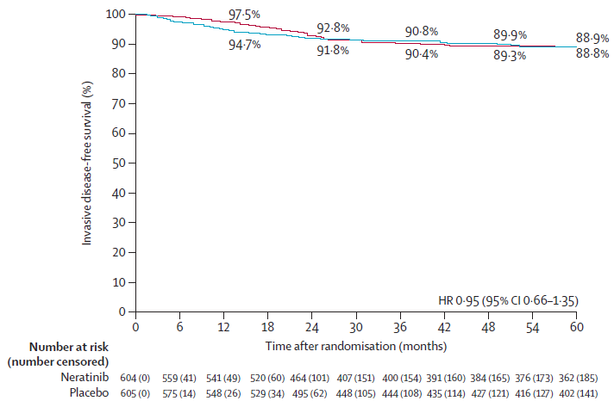

Red = neratinib, blue = placebo. From Martin et al. (2017).11

##### Efficacy summary

In the ITT population, at 24 months, the proportion of subjects who were alive and free of invasive disease was increased from 91.9% in the placebo arm to 94.2% in the neratinib arm, a relatively modest absolute difference of 2.3%.

The efficacy results in the ITT population are mostly driven by the efficacy in the HRc‑positive sub-group.

In HRc-positive women, neratinib reduced the 2 year risk of recurrence or death by 51% relative to placebo (HR 0.49; 95% CI, 0.31 to 0.75; p = 0.001), whereas 2 year iDFS rates were not different in HRc-negative women (HR 0.93; 95% CI, 0.60 to 1.43; p = 0.73).

From the EMA European Public Assessment Report (EPAR; page 161):[14]

‘At five years post baseline the iDFS estimates for HRc positive tumours were 85.7 versus 90.8 %, HR 0.58, p = 0.002; for HRc negative tumours: 87.6 versus 88.2 %, HR 0.89, p = 0.5.’

#### Safety

Treatment-emergent adverse events occurring in at least 10% of patients in the safety population are summarised in Table 3.

##### Diarrhoea

Diarrhoea was the most common treatment-emergent adverse event in the neratinib group. 458 (33%) patients had Grade 2 diarrhoea, 561 (40%) patients had Grade 3 diarrhoea, and one (< 1%) patient had Grade 4 diarrhoea see Table 3. In the placebo group, 94 (7%) patients had Grade 2 diarrhoea, 23 (2%) patients had Grade 3, and no patients had Grade 4 diarrhoea.

Diarrhoea led to neratinib dose reductions in 372 (26%) patients in the neratinib group and eight (1%) patients in the placebo group, hospital admission in 20 (1%) versus one (< 1%) patient, and drug discontinuation in 237 (17%) patients (discontinued after a median of 20 days versus three (< 1%) patients (discontinued after 241 days).

Table 3: Treatment-emergent adverse events occurring in at least 10% of patients in the safety population, Study 3004 (ExteNET trial)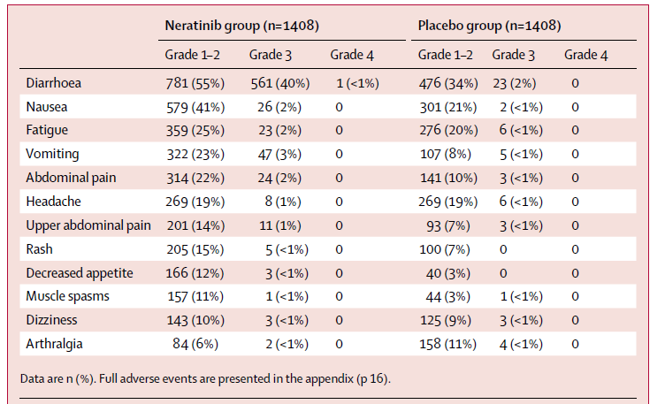

Extract from Chan et al. (2016).11

##### Hepatotoxicity

Hepatic-associated adverse reactions in the pivotal Phase III study, Study 3004 (ExteNET trial), were reported more frequently in the neratinib arm compared to the placebo arm (12.4% versus 6.6%), due primarily to alanine aminotransferase (ALT) increased (8.5% versus 3.2%), aspartate aminotransferase (AST) increased (7.4% versus 3.3%) and blood alkaline phosphatase increased (2.1% versus 1.1%).

Grade 3 adverse reactions were reported in 1.6% versus 0.5% and Grade 4 adverse reactions were reported in 0.2% versus 0.1%, neratinib and placebo treated patients, respectively. Grade 3 ALT increases were reported in 1.1% versus 0.2% and Grade 4 ALT increases were reported in 0.2% versus 0.0% of neratinib versus placebo treated patients. Grade 3 AST increases were reported in 0.5% versus 0.3% and Grade 4 AST increases were reported in 0.2% versus 0.0%, of neratinib versus placebo-treated patients. There was no Grade 3 or 4 adverse reactions of blood bilirubin increases.

##### Safety summary

In the application made to the TGA, the sponsor provided copies of multiple documents related to the FDA and EMA submissions. Arguments made by the sponsor in favour of concluding a favourable benefit-risk balance for neratinib included the following:

* The main safety concern is severe (Grade 3) diarrhoea. Episodes of Grade 3 diarrhoea generally occur early after the initiation of treatment, are short in duration and not recurrent.
* The diarrhoea is manageable for most patients with anti-diarrhoeal prophylaxis, supportive care, dose withholding, dose reduction, or discontinuation.
* Patients who can manage the diarrhoea in the initial 1 to 2 months will experience much less diarrhoea during the remaining months of therapy.
* Adverse reactions observed with neratinib are acute, predictable, manageable and reversible. The toxicities associated with neratinib do not cause major organ damage or long-lasting morbidities.

### Risk management plan

The sponsor has submitted European Union-risk management plan (EU-RMP) version 4.0 (dated 15 January 2018 data lock point (DLP) 22 September 2015) and Australian specific Annex (ASA) version 1.0 (dated March 2018) in support of this application. As required by the EMA Committee for Medicinal Products for Human Use (CHMP), the sponsor has transferred the EU-RMP according to the relevant guidance.[15] The sponsor has submitted the new EU-RMP version 0.9; dated 3 July 2018; DLP 22 September 2015 with ASA version 1.1; dated November 2018[16]. The sponsor has advised that the assignment of version number of the EU RMP is based on the new guidance rather than the sponsor’s internal version control.

The proposed summary of safety concerns and their associated risk monitoring and mitigation strategies are summarised below in Table 4.[17]

Table 4: Summary of safety concerns

|  |  |  |  |  |  |
| --- | --- | --- | --- | --- | --- |
| Summary of safety concerns | | Pharmacovigilance | | Risk Minimisation | |
| **Routine** | **Additional** | **Routine** | **Additional** |
| Important identified risks | Gastrointestinal toxicity (diarrhoea and stomatitis a) | ✓ | ✓1,2,3 | ✓ | ✓4,5 |
| Hepatotoxicity | ✓6 | – | ✓ | – |
| Important potential risks | Cardiotoxicity (LVEF decreased) | ✓ | – | ✓ | – |
| Pulmonary toxicity (interstitial lung disease) | ✓ | – | - | – |
| Reproductive and developmental toxicity | ✓ | – | ✓ | – |
| Missing information | – | – | – | – | – |

a: Includes mucosal inflammation, stomatitis, aphthous stomatitis, mouth ulceration, and oral mucosal blistering.1: Post-authorisation safety study (PASS). 2: Pharmacoepidemiology study. 3: Healthcare professional (HCP) and patient survey. 4: Patient education. 5: HCP education.6: Specific adverse reaction follow-up questionnaire.

Routine pharmacovigilance including specific adverse reaction follow-up questionnaire, has been proposed to monitor the safety concerns. Additional pharmacovigilance studies, including a PASS, pharmacoepidemiology studies, have been required by the EMA and the US FDA. A healthcare professional and patient survey has been required to evaluate the effectiveness of the additional risk minimisation in the EU. There is no objection to the proposed and required pharmacovigilance activities.

In its response to the second round risk management plan (RMP) evaluation report, the sponsor has agreed to implement patient and healthcare professional education in Australia. It is expected that the draft educational materials will be submitted to the TGA with an updated ASA following the Delegate’s overview.[18]

### Risk-benefit analysis

#### Delegate’s considerations

The FDA approved neratinib with a broader indication than the EMA, which restricted the indication to patients with early-stage hormone receptor positive / HER2‑overexpressed / amplified breast cancer.

Evidence to support the proposed indication for neratinib was primarily derived from the pivotal Phase III study, Study 3004 (ExteNET trial).

Study 3004 underwent multiple amendments, initially allowing enrolment of patients who were node negative, but later limiting enrolment to high-risk patients who were node‑positive.

Originally, patients within 2 years of trastuzumab therapy were eligible; later, enrolment was limited to 1 year. The planned study follow-up was reduced from 5 years to 2 years, changing the analysis from event-driven to time-driven. To restore the original design, the follow-up was extended to 5 years in a protocol amendment in 2014, and re-consent was obtained for 2117 (75%) of the 2840 original patients.

The efficacy in the ITT population is modest.

Published data on 5 year follow-up (Martin et al, 2017);13 show durability of response and confirm sub-group analyses indicating greater benefit with neratinib in patients with hormone receptor-positive disease.

Approximately 40% of patients in Study 3004 experienced Grade 3 diarrhoea.

Although prophylaxis with loperamide is now recommended and being evaluated in the PUMA-NEW-6201 trial (NCT02400476);[19] the tolerance in the general population is unknown.

The EMA concluded on balance of benefits and risks (page 163):14

‘The magnitude of benefit on iDFS in HER2+ HRc+ patients is statistically significant and clinically relevant and, therefore, outweighs the risks; primarily treatment-induced diarrhoea whose management is expected to be improved in light of the ongoing and planned studies.’

Some CHMP members expressed a divergent opinion.

In the US, the FDA’s Oncologic Drugs Advisory Committee (ODAC) members voted 12 to 4 to approve neratinib for a broader population;[20] which was subsequently adopted by the FDA.

#### Independent clinical advice

The Delegate sought and received independent clinical advice from Australian experts.

#### Proposed action

Following receipt of advice from Australian independent clinical experts, it is recommended to align the Australian indication for neratinib with the FDA approved indication.

The Delegate has no reason to say, at this time, that the application for Nerlynx (neratinib) should not be approved for the indication:

*Nerlynx as a single agent is indicated for the extended adjuvant treatment of adult patients with early-stage HER2-overexpressed/amplified breast cancer who have received prior adjuvant trastuzumab based therapy.*

#### Advisory Committee considerations[21]

The Delegate did not refer this application to the Advisory Committee on Medicines (ACM) for advice.

### Outcome

Based on a review of quality, safety and efficacy, TGA approved the registration of Nerlynx (neratinib as maleate) 40 mg film coated tablets, indicated for:

*Nerlynx is indicated for the extended adjuvant treatment of adult patients with early-stage HER2-overexpressed/amplified breast cancer, to follow adjuvant trastuzumab based therapy.*

#### Specific conditions of registration applying to these goods

* Nerlynx (neratinib) is to be included in the Black Triangle Scheme. The PI and Consumer Medicines Information (CMI) for Nerlynx must include the black triangle symbol and mandatory accompanying text for five years, which starts from the date that the sponsor notifies the TGA of supply of the product.
* Report the results of the PUMA-NER-0105 trial to the TGA and any subsequent evaluations by the EMA.
* The Nerlynx EU-RMP (version 0.9, dated 3 July 2018, DLP 22 September 2015), with ASA (version 1.1, dated November 2018),[22] included with submission PM-2018-00968-1-4, to be revised to the satisfaction of the TGA, will be implemented in Australia.

An obligatory component of risk management plans is routine pharmacovigilance. Routine pharmacovigilance includes the submission of periodic safety update reports (PSURs).

Reports are to be provided to the TGA within 90 calendar days of DLP until the period covered by such reports is not less than three years from the date of this approval letter.

The reports are to at least meet the requirements for PSURs as described in the European Medicines Agency’s Guideline on Good Pharmacovigilance Practices (GVP) Module VII-periodic safety update report (Rev 1), Part VII.B Structures and processes. Note that submission of a PSUR does not constitute an application to vary the registration.

## Attachment 1. Product Information

The PI for Nerlynx approved with the submission which is described in this AusPAR is at Attachment 1. For the most recent PI, please refer to the TGA website at <<https://www.tga.gov.au/product-information-pi>>.

|  |
| --- |
| Therapeutic Goods Administration |
| PO Box 100 Woden ACT 2606 Australia  Email: [info@tga.gov.au](mailto:info@tga.gov.au) Phone: 1800 020 653 Fax: 02 6232 8605  [**https://www.tga.gov.au**](https://www.tga.gov.au) |

1. Cancer Council Australia. About cancer. Breast cancer. 3 January 2018. Available from: https://www.cancer.org.au/about-cancer/types-of-cancer/breast-cancer/
2. Yarden, Y. and Sliwkowski, M. Untangling the ErbB signalling network. *Nat Rev Mol Cell Biol*. 2001; 2: 127-137.
3. Burstein, H.J. The Distinctive Nature of HER2-Positive Breast Cancers. *N Engl J Med*. 2005; 353: 1652-1654.
4. Slamon, D.J. et al. Human breast cancer: correlation of relapse and survival with amplification of the HER-2/neu oncogene. *Science*. 1987; 235: 177–182.
5. National Comprehensive Cancer Network (NCCN). NCCN Clinical Practice Guidelines in Oncology – Breast Cancer. Version I.2018. 20 March 2018.
6. Senkus, E. et al. Primary breast cancer: ESMO Clinical Practice Guidelines for diagnosis, treatment and follow-up. *Ann Oncol*. 2015; 26 Suppl 5: v8-30.
7. Denduluri, N. et al. Selection of Optimal Adjuvant Chemotherapy Regimens for Human Epidermal Growth Factor Receptor 2 (HER2) -Negative and Adjuvant Targeted Therapy for HER2-Positive Breast Cancers: An American Society of Clinical Oncology Guideline Adaptation of the Cancer Care Ontario Clinical Practice Guideline*. J Clin Oncol*. 2016; 34 (20): 2416-2427.
8. Schettini, F. et al. Hormone Receptor/Human Epidermal Growth Factor Receptor 2-positive breast cancer: Where we are now and where we are going. *Cancer Treat Rev*. 2016; 46: 20-26.
9. Sponsor clarification: to be addressed in a subsequent submission.
10. European Medicines Agency, Summary of Product Characteristics, Nerlynx (neratinib maleate) 40 mg film-coated tablets. Date of first authorisation: 31 August 2018.
11. Chan et al. (2016). Neratinib after trastuzumab-based adjuvant therapy in patients with HER2-positive breast cancer (ExteNET): a multicentre, randomised, double-blind, placebo-controlled, phase 3 trial. *Lancet Oncol*, 2016; 17: 367–377.
12. 1-sided p value = 0.004.
13. Martin, M. et al (2017). Neratinib after trastuzumab-based adjuvant therapy in HER2-positive breast cancer (ExteNET): 5-year analysis of a randomised, double-blind, placebo-controlled, phase 3 trial, *Lancet Oncol*, 2017; 18(12): 1688-1700.
14. European Medicines Agency, European Public Assessment Report (EPAR), Assessment report: Nerlynx, 13 July 2018. Accessed from the EMA website.
15. EMA, Guidance on the format of the risk management plan (RMP) in the EU – in integrated format, EMA/PRAC/613102/2015 Rev.2 accompanying GVP Module V Rev.2, 30 March 2017.
16. ASA, V1.2, April 2019 was submitted by the sponsor post-approval, as agreed between sponsor and the TGA as part of evaluation close-out sequence.
17. *Routine risk minimisation* activities may be limited to ensuring that suitable warnings are included in the product information or by careful use of labelling and packaging.

    *Routine pharmacovigilance* practices involve the following activities:

    All suspected adverse reactions that are reported to the personnel of the company are collected and collated in an accessible manner;

    Reporting to regulatory authorities;

    Continuous monitoring of the safety profiles of approved products including signal detection and updating of labelling;

    Submission of PSURs;

    Meeting other local regulatory agency requirements.
18. The draft HCP and patient materials were subsequently submitted to the TGA and considered acceptable from an RMP perspective.
19. ClinicalTrials.gov Identifier: NCT02400476. An Open-Label Study to Characterize the Incidence and Severity of Diarrhea in Patients With Early-Stage HER2+ Breast Cancer Treated With Neratinib and Loperamide. Accessed from the ClinicalTrials.gov website.
20. FDA, Center for Drug Evaluation and Research, Multi-Discipline Review/Summary, Clinical, Non-Clinical, application number: 208051Orig1s000, Nelynx (neratinib maleate). Available from the FDA website.
21. The ACM provides independent medical and scientific advice to the Minister for Health and the Therapeutic Goods Administration (TGA) on issues relating to the safety, quality and efficacy of medicines supplied in Australia including issues relating to pre-market and post-market functions for medicines.

    The Committee is established under Regulation 35 of the Therapeutic Goods Regulations 1990. Members are appointed by the Minister. The ACM was established in January 2017 replacing Advisory Committee on Prescription Medicines (ACPM) which was formed in January 2010. ACM encompass pre and post-market advice for medicines, following the consolidation of the previous functions of the Advisory Committee on Prescription Medicines (ACPM), the Advisory Committee on the Safety of Medicines (ACSOM) and the Advisory Committee on Non-Prescription Medicines (ACNM). Membership comprises of professionals with specific scientific, medical or clinical expertise, as well as appropriate consumer health issues relating to medicines.
22. ASA, V1.2, April 2019 was submitted by the sponsor post-approval, as agreed between sponsor and the TGA as part of evaluation close-out sequence.