|  |
| --- |
| **First Round CER report: 12 January 2015**  **Second Round CER report: 25 April 2015** |

|  |
| --- |
| AusPAR Attachment 2 |
| Extract from the Clinical Evaluation Report for Nintedanib esilate |
| Proprietary Product Name: Ofev and Vargatef |
| Sponsor: Boehringer Ingleheim Pty Ltd |

About the Therapeutic Goods Administration (TGA)

* The Therapeutic Goods Administration (TGA) is part of the Australian Government Department of Health, and is responsible for regulating medicines and medical devices.
* The TGA administers the *Therapeutic Goods Act 1989* (the Act), applying a risk management approach designed to ensure therapeutic goods supplied in Australia meet acceptable standards of quality, safety and efficacy (performance), when necessary.
* The work of the TGA is based on applying scientific and clinical expertise to decision-making, to ensure that the benefits to consumers outweigh any risks associated with the use of medicines and medical devices.
* The TGA relies on the public, healthcare professionals and industry to report problems with medicines or medical devices. TGA investigates reports received by it to determine any necessary regulatory action.
* To report a problem with a medicine or medical device, please see the information on the TGA website <<https://www.tga.gov.au>>.

About the Extract from the Clinical Evaluation Report

* This document provides a more detailed evaluation of the clinical findings, extracted from the Clinical Evaluation Report (CER) prepared by the TGA. This extract does not include sections from the CER regarding product documentation or post market activities.
* The words [Information redacted], where they appear in this document, indicate that confidential information has been deleted.
* For the most recent Product Information (PI), please refer to the TGA website <<https://www.tga.gov.au/product-information-pi>>.

Copyright

© Commonwealth of Australia 2015  
This work is copyright. You may reproduce the whole or part of this work in unaltered form for your own personal use or, if you are part of an organisation, for internal use within your organisation, but only if you or your organisation do not use the reproduction for any commercial purpose and retain this copyright notice and all disclaimer notices as part of that reproduction. Apart from rights to use as permitted by the *Copyright Act 1968* or allowed by this copyright notice, all other rights are reserved and you are not allowed to reproduce the whole or any part of this work in any way (electronic or otherwise) without first being given specific written permission from the Commonwealth to do so. Requests and inquiries concerning reproduction and rights are to be sent to the TGA Copyright Officer, Therapeutic Goods Administration, PO Box 100, Woden ACT 2606 or emailed to <[tga.copyright@tga.gov.au](mailto:tga.copyright@tga.gov.au)>.

Contents

1. List of abbreviations 5

2. Introduction 8

2.1. Submission type 8

2.2. Drug class and therapeutic indication 8

2.3. Dosage forms and strengths 8

2.4. Dosage and administration 8

3. Clinical rationale 8

3.1. NSCLC 8

3.2. IPF 9

4. Contents of the clinical dossier 9

4.1. Scope of the clinical dossier 9

4.2. Paediatric data 10

4.3. Good clinical practice 10

5. Pharmacokinetics 10

5.1. Studies providing pharmacokinetic data 10

5.2. Summary of pharmacokinetics 11

5.3. Evaluator’s overall conclusions on pharmacokinetics 19

6. Pharmacodynamics 19

6.1. Studies providing pharmacodynamic data 19

6.2. Summary of pharmacodynamics 20

6.3. Evaluator’s overall conclusions on pharmacodynamics 20

7. Dosage selection for the pivotal studies 20

7.1. Non-small cell lung cancer (NSCLC) 20

7.2. Idiopathic pulmonary fibrosis (IPF) 20

8. Clinical efficacy 20

8.1. Non-small cell lung cancer (NSCLC) 20

8.2. Idiopathic pulmonary fibrosis (IPF) 39

9. Clinical safety 54

9.1. NSCLC 54

9.2. IPF 64

9.3. Post-marketing experience 73

9.4. Safety issues with the potential for major regulatory impact 73

9.5. Other safety issues 74

9.6. Evaluator’s overall conclusions on clinical safety 74

10. First round benefit-risk assessment 75

10.1. First round assessment of benefits 75

10.2. First round assessment of risks 75

10.3. First round assessment of benefit-risk balance 76

11. First round recommendation regarding authorisation 76

12. Clinical questions 76

12.1. Pharmacokinetics 76

12.2. Safety 76

13. Second round evaluation of clinical data submitted in response to questions 76

13.1. Effect of hepatic impairment on PK of nintedanib 76

13.2. Drug-induced liver injury 77

14. Second round benefit-risk assessment 77

14.1. Second round assessment of benefits 77

14.2. Second round assessment of risks 77

14.3. Second round assessment of benefit-risk balance 78

15. Second round recommendation regarding authorisation 78

16. References 78

## List of abbreviations

| Abbreviation | Meaning |
| --- | --- |
| AE | Adverse Event |
| AEOSI | Adverse event of special interest |
| ALKP | Alkaline Phosphatase |
| ALT | Alanine Transaminase |
| aPTT | activated partial thromboplastin time |
| ARTG | Australian Register of Therapeutic Goods |
| AST | Aspartate Transaminase |
| AUC | Area under the curve |
| BD | Twice daily |
| BIL | Bilirubin |
| CASA | Cough and Sputum assessment |
| CI | Confidence interval |
| Cmax | Maximum concentration |
| CMI | Consumer Medicines Information |
| CL | Clearance |
| CR | Complete Response |
| CrCl | Creatinine clearance |
| CT | X-Ray Computed Tomography |
| CTCAE | Common terminology criteria for adverse events |
| CV | Coefficient of variation |
| DCE-MRI | Dynamic contrast-enhanced magnetic resonance imaging |
| DCR | Disease Control Rate |
| DILI | Drug-induced liver injury |
| DLT | Dose limiting toxicity |
| DoR | Duration of Response |
| ECG | Electrocardiograph |
| ECOG | Eastern Cooperative Oncology Group |
| eGFR | Estimated glomerular filtration rate |
| EMA | European Medicines Agency |
| EORTC | European Organisation for Research and Treatment of Cancer |
| FAS | Full analysis set |
| FDA | Food and Drug Administration |
| FVC | Forced vital capacity |
| GCP | Good Clinical Practice |
| HRCT | High Resolution CT scan |
| ICH | International Conference on Harmonisation |
| IgG | Immunoglobulin G |
| INR | International normalised ratio |
| IPF | Idiopathic Pulmonary Fibrosis |
| IV | Intravenous |
| L | Litre(s) |
| LDH | Lactate Dehydrogenase |
| LFTs | Liver function tests |
| MEDRA | Medical dictionary for regulatory activities |
| MRI | Magnetic Resonance Imaging |
| MTD | Maximum Tolerated Dose |
| NCI | National Cancer Institute |
| NSCLC | Non-Small Cell Lung Cancer |
| OD | Once daily |
| ORR | Overall response rate |
| OS | Overall Survival |
| PD | Pharmacodynamics |
| PDGFR | Platelet derived growth factor receptors |
| PFS | Progression free survival |
| PGI | Patient’s global impression |
| P-gp | P-glycoprotein |
| PI | Product Information |
| PK | Pharmacokinetics |
| PR | Partial Response |
| PRO | Patient reported outcomes |
| QoL | Quality of Life |
| RECIST | Response evaluation criteria in solid tumours |
| SAE | Serious Adverse Event |
| SD | Stable Disease |
| SGRQ | St George’s Respiratory Questionnaire |
| SOBQ | Shortness of Breath Questionnaire |
| TGA | Therapeutic Goods Administration |
| Tmax | Time of maximum concentration |
| TSH | Thyroid stimulating hormone |
| TTP | Time to Progression |
| UDP | Uridine diphosphate glucuronosyltransferase |
| VEGFR | Vascular endothelial growth factor receptor |
| Vss | Volume of distribution at steady state |

## Introduction

### Submission type

This is a full submission to register the product as a new chemical entity.

### Drug class and therapeutic indication

Nintedanib is a tyrosine kinase inhibitor (TKI). It blocks the kinase activity of a variety of receptors:

* The vascular endothelial growth factor receptors (VEGFR) -1, -2 and -3;
* The platelet derived growth factor receptors (PDGFR) α and β;
* The fibroblast growth factor receptors (FGFR) -1, -2 and -3;

It also blocks the activity of Flt-3, Lck, Lyn and Src kinases.

The submission seeks approval of the product for two indications:

*In combination with docetaxel, for the treatment of patients with locally advanced, metastatic or recurrent non-small cell lung cancer (NSCLC) of adenocarcinoma tumour histology after first line chemotherapy; and*

*The treatment of Idiopathic Pulmonary Fibrosis (IPF) and to slow disease progression.*

### Dosage forms and strengths

The submission proposes registration of nintedanib in the form of softgel capsules, in two strengths; 100 mg and 150 mg.

### Dosage and administration

In NSCLC, the proposed dosage regimen is 200 mg twice daily (BD), on Days 2 to 21 of a 21 day cycle. Docetaxel is to be administered on Day 1 of the 21 day cycle. It is proposed that nintedanib be continued as monotherapy if docetaxel is discontinued, and for as long as clinical benefit is observed or until unacceptable toxicity occurs.

In IPF the proposed dosage regimen is 150 mg BD continuously.

## Clinical rationale

### NSCLC

NSCLC accounts for approximately 60 to 65% of lung cancers and adenocarcinoma is the most common subtype of NSCLC. Standard first line therapy for most patients with advanced NSCLC is a platinum based doublet chemotherapy regimen. Bevacizumab is also registered in Australia for use in first line treatment in combination with platinum based chemotherapy. Current treatments available for second line use include docetaxel, pemetrexed and erlotinib.

For patients with activating mutations of EGFR, agents available for first line therapy, or for second line therapy following failure of chemotherapy, include gefitinib, erlotinib and afatinib. Crizotinib is registered for the treatment of ALK positive NSCLC.

The proposed use of nintedanib in NSCLC is based on its anti angiogenic effects mediated through inhibition of VEGF and PDGF receptors. Bevacizumab, which acts through inhibition of the VEGF pathway, has already been registered for use in NSCLC. Several other VEGFR inhibitors have been approved for use in other cancers (for example sorafenib, sunitinib, pazopanib).

### IPF

IPF is a specific form of chronic, progressive interstitial pneumonia of unknown cause. It generally occurs in older adults, is limited to the lungs and is associated with a histological/radiological appearance known as ‘usual interstitial pneumonia (UIP)’. It is a rare condition with a prevalence estimated at between 2 and 29 cases per 100,000 population. Translated to the Australian population, this would give an approximate prevalence of between 50 and 700 subjects. IPF is a fatal condition with a median survival of 2 to 3 years after diagnosis. Most patients experience a slow, gradual progression with death from respiratory failure (1).

There are currently no drugs registered in Australia that have been proven to be of benefit in the treatment of IPF. Drugs that have been used include corticosteroids, immunosuppressive agents, colchicine, acetylcysteine, interferon gamma 1b, bosentan and etanercept. The evidence to support the efficacy of any of these agents is weak and current clinical guidelines (1, 2) do not recommend their use. A new agent, pirfenidone, has in recent years been approved for the treatment of IPF in several foreign markets (including the USA, Europe and Canada). However, at the time of writing of this review it had not been registered in Australia.

According to the sponsor, preclinical data suggest a potential role of FGF and PDGF signalling in the pathogenesis of IPF. Hence, the clinical rationale is based on nintedanib’s ability to inhibit the receptors for these factors.

## Contents of the clinical dossier

### Scope of the clinical dossier

The submission contained the following clinical information:

* There were two separate clinical dossiers – one for NSCLC and one for IPF. Together they contained the following:
* 15 clinical pharmacology studies, that primarily provided pharmacokinetic data.
* 1 study in renal cell cancer patients that provided data on QT interval.
* 3 population pharmacokinetic analyses. Two of these were preliminary and were superseded by the third (U13-1588-01).
* 1 pivotal efficacy/safety study in NSCLC (Study 1199.0013).
* 2 supportive efficacy/safety studies in NSCLC (1199.0014 and 1199.0010).
* 2 pivotal efficacy/safety studies in IPF (1199.0032 and 1199.0034).
* 1 supportive efficacy/safety study in IPF (1199.0030).
* Literature references.

There were several studies included in the submission that were not relevant to the approval being sought. These were primarily early Phase studies in which nintedanib was tested in malignancies other than NSCLC and/or studies combining nintedanib with anticancer agents other than docetaxel. These studies have not been evaluated. They are listed in Table 1.

Table 1. Studies included in submission but not evaluated.

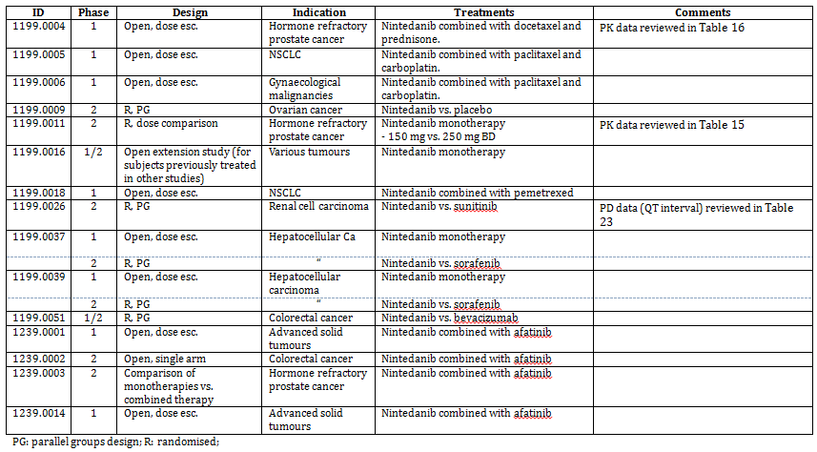

* There were two separate versions of the following: Clinical Overview, Summary of Biopharmaceutics, Summary of Clinical Pharmacology, Summary of Clinical Efficacy and Summary of Clinical Safety.

### Paediatric data

The submission did not include paediatric data. AS NSCLC and IPF are diseases of adults this is acceptable.

### Good clinical practice

The study reports included in the submission all contained assurances that the trials were carried out in compliance with the principles laid down in the Declaration of Helsinki, in accordance with the International Conference on Harmonisation (ICH) Harmonised Tripartite Guideline for Good Clinical Practice and in accordance with any other applicable regulatory requirements.

## Pharmacokinetics

### Studies providing pharmacokinetic data

Summaries of the pharmacokinetic studies were provided. Table 2 shows the studies relating to each pharmacokinetic topic.

Table 2. Submitted pharmacokinetic studies.

| PK topic | Subtopic | Study ID |
| --- | --- | --- |
| PK in healthy adults | Absolute bioavailability | 1199.0075 |
| Mass balance | 1199.0020 |
| Food effect | 1199.0017 |
| Bioequivalence† - Single dose | 1199.0021 |
| PK in special populations | Patients with advanced cancer |  |
| Single and Multi-dose | 1199.0001  1199.0002  1199.0003  1199.0019 (Japanese) |
| Patients with NSCLC | 1199.0010 |
| Patients with prostate cancer | 1199.0011 |
| Patients with IPF | 1199.0030 |
| PK interactions | with ketoconazole | 1199.0161 |
| with rifampicin | 1199.0162 |
| with docetaxel | 1199.0004 |
| Population PK analyses | Patients with advanced cancer | Report U11-1279-01 |
| Patients with NSCLC | Report U11-1259-01 |
| Patients with NSCLC or IPF | Report U13-1588-01 |

* Indicates the primary aim of the study. † Bioequivalence of different formulations.

None of the pharmacokinetic studies had deficiencies that excluded their results from consideration.

### Summary of pharmacokinetics

The information in the following summary is derived from conventional pharmacokinetic studies unless otherwise stated.

#### Pharmacokinetics in healthy subjects

##### Absorption

###### Sites and mechanisms of absorption

In vitro data indicated that nintedanib is a substrate for P-glycoprotein (P-gp) and this was supported by the results of interaction studies (see below). There were no clinical data on sites of absorption.

##### Bioavailability

###### Absolute bioavailability

Absolute bioavailability of nintedanib is low; 4.69%.

###### Bioavailability relative to an oral solution or micronized suspension

[information redacted]

###### Bioequivalence of clinical trial and market formulations

The formulation of the liquid suspension (which is enclosed in a soft gelatin capsule) has remained unchanged during the clinical development program. Therefore clinical bioequivalence studies comparing the clinical trial and market formulations have not been conducted.

###### Influence of food

Co-administration of nintedanib with a high fat, high caloric meal resulted in an increase in AUC of approximately 20% and an increase in Cmax of approximately 15% (Table 3). In the pivotal studies subjects were instructed to take nintedanib together with food.

Table 3. Geometric mean(and gCV%) pharmacokinetic parameters of BIBF 1120 BS after single administration of 150 mg BIBF 1120 capsule under fasted and fed conditions to healthy male volunteers.

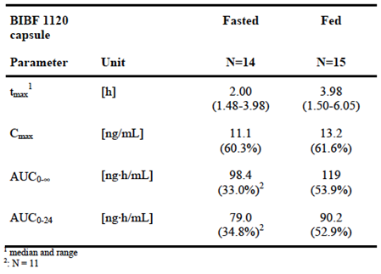

###### Dose proportionality

Following IV administration, Cmax and AUC0-∞ increased in an approximately dose proportional manner.

Table 4. Summary of geometric mean (gCV) pharmacokinetic parameters of BIBF 1120 after intravenous infusion (4 hours) of BIBF 1120 1 mg, 3 mg or 6 mg and after a single oral administration of BIBF 1120 100 mg capsule (N, geometric mean, gCV%).

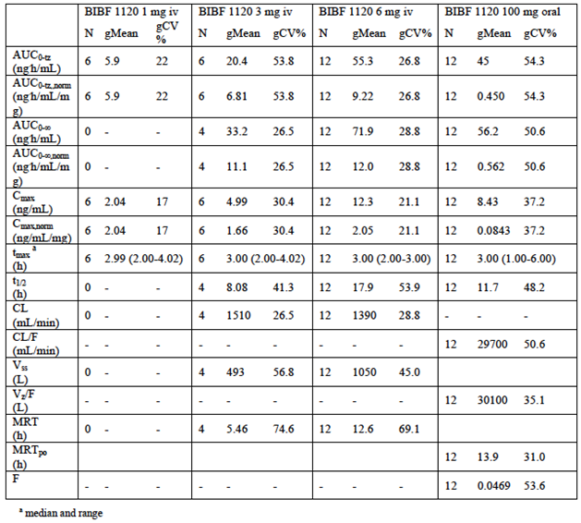

##### Distribution

###### Volume of distribution

Following IV administration of 6 mg of nintedanib, volume of distribution was estimated to be 1,050 litres, indicating extensive tissue distribution (see Table 4 above).

###### Plasma protein binding

An in vitro study (U03-1150) was reported to show that plasma protein binding of nintedanib was 97.8%, and that albumin was the major binding protein. Binding was independent of plasma concentration over the range 50 to 2000 ng/mL.

###### Erythrocyte distribution

An in vitro study (U03-1150) was reported to show that nintedanib is distributed preferentially in plasma with a blood to plasma ration of 0.869.

##### Metabolism

###### Sites of metabolism and mechanisms / enzyme systems involved

In vitro studies were reported to have shown that the major metabolic reaction was rapid hydrolytic cleavage by esterases resulting in the metabolite BIBF 1202. BIBF 1202 was subsequently glucuronidated by UGT enzymes, namely UGT 1A1, UGT 1A7, UGT 1A8, and UGT 1A10 to BIBF 1202 glucuronide.

###### Non-renal clearance

After IV administration of 6 mg of nintedanib only 1.39% of the administered dose was excreted as unchanged nintedanib in the urine over 48 hours, indicating that non-renal mechanisms are responsible for the clearance of nintedanib.

###### Metabolites identified in humans

As indicated above, the two main metabolites of nintedanib are BIBF 1202 and BIBF 1202 glucuronide.

Active metabolites

According to the sponsor’s Summary of Clinical Pharmacology, BIBF 1202 shows activity at some of the target receptors of nintedanib. However, it was not expected to contribute to the clinical effects of nintedanib in vivo due to the low permeability across biological membranes.

Other metabolites

According to the sponsor’s Summary of Clinical Pharmacology, BIBF 1202 glucuronide did not show in vitro activity at target receptors of nintedanib.

###### Pharmacokinetics of metabolites

In plasma, concentrations of the metabolite BIBF 1202 were comparable to those of nintedanib. Systemic exposure to BIBF 1202 glucuronide was significantly greater (see Figure 1 as an example). Half-life values for BIBF 1202 ranged from 4.55 to 5.08 hours. Values for BIBF 1202 glucuronide ranged from 30.3 to 34.8 hours.

Figure 1. Geometric mean plasma concentration-time profiles of BIBF 1120 BS, BIBF 1202 ZW and BIBF 1202-glucuronide after single oral administration of 150 mg BIBF 1120 as capsule (fast).

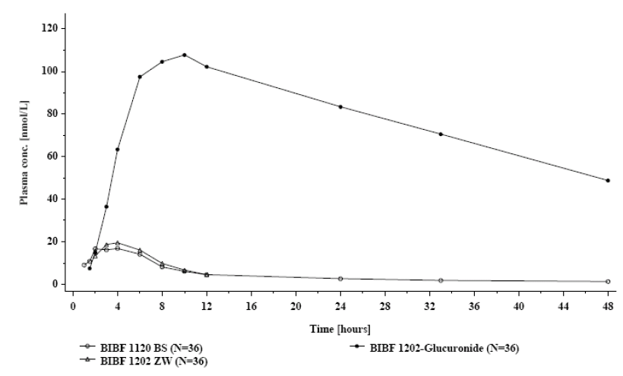

###### Total clearance and half-life

After IV administration of 6 mg of nintedanib total clearance was 1,390 mL/min and half-life was 17.9 hours (Table 4). After oral administration in healthy volunteers, half-life ranged from 11.7 to 23.4 hours.

##### Excretion

###### Routes and mechanisms of excretion

In a mass balance study using radiolabelled nintedanib, only 0.649% of the orally administered radioactivity was excreted in urine (up to 72 hours). A total of 93.4% of the orally administered radioactivity was excreted in faeces (up to 120 hours).

###### Renal clearance

Following IV administration of 6 mg, only 1.39% of the administered dose was excreted as unchanged nintedanib in the urine over 48 hours, indicating that renal mechanisms are not important for the clearance of nintedanib (Table 4).

#### Pharmacokinetics in the target population

The main population PK analysis indicated that there were no differences in PK between the NSCLC and IPF populations.

##### Absorption

In studies of patients with advanced cancer, maximum plasma concentrations of nintedanib generally occurred within 2 to 4 hours following administration.

###### Dose proportionality

In studies in advanced cancer patients, dose proportionality was not consistently demonstrated. However, in a population PK analysis of NSCLC and IPF subjects no significant deviation from linear kinetics could be detected.

###### Bioavailability during multiple-dosing

In studies in advanced cancer patients, multiple dosing with nintedanib resulted in modest accumulation, with accumulation ratios for AUC generally being less than 2.0. Based on trough concentrations, steady state was reached by 7 days of dosing.

##### Metabolism

###### Consequences of genetic polymorphism

In an analysis of three studies that collected data on polymorphism of UGT1A1, subjects who were homozygous for a mutation known as UGT1A1*28 had a modest increase in exposure to nintedanib (Table 5). However, in a population PK analysis UGT1A1 polymorphism was not a covariate that significantly affected the PK of nintedanib.

Table 5. Study 1199.0006. AUC and Cmax for the glucuronide metabolite in UGT1A1 genotypes.

**Evaluator’s comment** 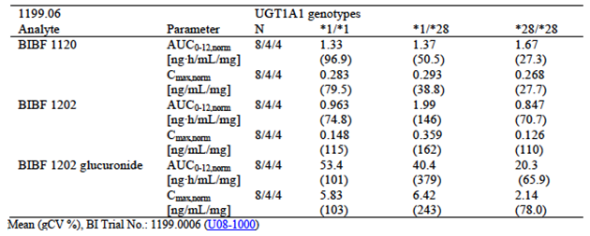

##### Intra- and inter-individual variability of pharmacokinetics

The sponsor assessed inter individual variability in the PK of nintedanib as being moderate to high, and intra individual variability as being low to moderate.

#### Pharmacokinetics in other special populations

##### Pharmacokinetics in subjects with impaired hepatic function

The submission did not include any specific studies examining the effect of hepatic impairment on the PK of nintedanib. There are three ongoing studies examining this issue (1199.0037, 1199.0039 and 1199.0120).

In the main population PK analysis, some included subjects had mild or moderate hepatic impairment.

* Mild impairment was defined as AST and ALT > ULN but < 10x ULN; with BIL > ULN but < 1.5x ULN.
* Moderate impairment was defined as: AST and ALT > ULN but < 10x ULN; with BIL > 1.5x ULN but < 3x ULN.

Only 1 subject (0.1%) had moderate impairment. 9.7% of subjects had mild impairment. A non-significant trend was observed for higher bioavailability and lower CL/F in subjects with mild or moderate hepatic impairment.

:

The draft PI states that treatment with nintedanib is not recommended in patients with moderate or severe hepatic impairment. Based on the available information this is an appropriate recommendation. The sponsor should be asked to provide an update on the ongoing studies examining the effect of hepatic impairment.

##### Pharmacokinetics in subjects with impaired renal function

Renal clearance was found to be a minor route of elimination. Therefore, no specific studies were conducted to examine the effect of renal impairment on the PK of nintedanib.

In the main population PK analysis, 44.7% of the observations were from subjects with mild renal impairment (creatinine clearance ≥ 60 to 90 mLs/min by the Cockcroft-Gault equation), 14.0% from subjects with moderate renal impairment (CrCl ≥ 30 to 60 mLs/min) and only 0.5% were from subjects with severe impairment (CrCl ≥ 15 to 30 mLs/min). Creatinine clearance as a covariate had no effect on the PK of nintedanib.

**Evaluator’s comment**:

The draft PI does not specifically recommend against use of nintedanib in subjects with severe renal impairment, even though there were very few observations from such patients. Although subjects with severe renal impairment can have disturbances of drug metabolism, this approach is considered acceptable.

##### Pharmacokinetics according to age

In the main population PK analysis (Figure 2), age was found to significantly affect the PK of nintedanib, with increasing age associated with increasing systemic exposure. However, the effects were modest and unlikely to be clinically significant.

Figure 2. Effect of age on the PK of nintedanib. Report U13-158801.

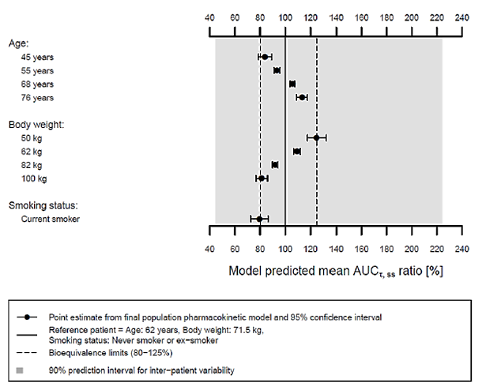

##### Pharmacokinetics related to ethnicity

In the main population PK analysis (Figure 3), Chinese, Taiwanese and Indian subjects had a 33% increase in systemic exposure.

Figure 3. Effect of ethnicity on the PK of nintedanib. Report U13-158801.

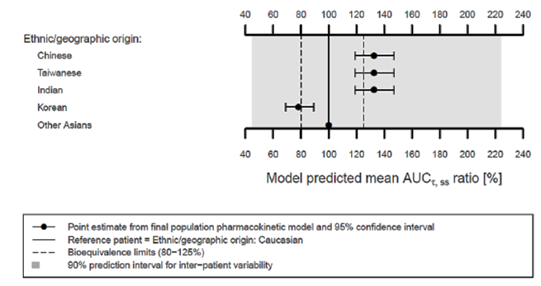

**Evaluator’s comment**:

Although the effects of age and ethnicity were not considered clinically significant in themselves, the sponsor has included a precautionary statement in the draft PI to the effect that a subject with a combination of these factors may be at increased risk of toxicity.

#### Pharmacokinetic interactions

##### Pharmacokinetic interactions demonstrated in human studies

In vitro studies indicated that nintedanib is a substrate for P-glycoprotein (P-gp). In human studies, co-administration with the P-gp inducer rifampicin resulted in a 50% decrease in the bioavailability of nintedanib. Co-administration with the P-gp inhibitor ketoconazole resulted in a 60 to 70% increase in the bioavailability of nintedanib.

In a study in patients with prostate cancer, nintedanib administration did not affect the PK of docetaxel, a substrate for CYP3A4, 5, 7.

In a PK study in Japanese subjects with IPF, co-administration of pirfenidone was associated with reduced nintedanib levels. Nintedanib did not appear to affect the PK of pirfenidone.

**Evaluator’s comment**:

Nintedanib solubility is pH dependant, with decreasing solubility with increasing pH. It is therefore possible that bioavailability may be reduced if co-administered with antacids, proton pump inhibitors etcetera. The sponsor provided a meta-analysis of early phase studies in oncology subjects that attempted to address this issue. However, the results were conflicting and a potential interaction has therefore not been excluded. It may be prudent to include a statement in the PI to the effect that use of such drugs should be avoided.

##### Clinical implications of in vitro findings

Preclinical studies were reported to demonstrate the following:

* Nintedanib did not inhibit the following CYP450 enzymes in human liver microsomes: 1A1, 1A2, 2A6, 2B6, 2C8, 2C9, 2C19, 2D6, 2E1, 3A4 o4 4A11 (Report U03-1386).
* BIBF 1202 did not inhibit the following CYP450 enzymes in human liver microsomes: 1A1, 1A2, 2A6, 2B6, 2C8, 2C9, 2C19, 2D6, 2E1, 3A4 o4 4A11 (Report U08-1256-02).
* BIBF 1202 glucuronide did not inhibit the following CYP450 enzymes in human liver microsomes: 1A1, 1A2, 2A6, 2B6, 2C8, 2C9, 2C19, 2D6, 2E1, 3A4 o4 4A11 (Report U09-1164-02).
* Nintedanib did not induce the following CYP450 enzymes in primary human hepatocytes: CYP1A2, 2B6, 2C8, 2C9, 2C19 and 3A4 (Report U09-1731-01).
* Nintedanib, at clinically relevant concentrations, did not inhibit glucuronidation by UGT1A1 in human liver microsomes (Report U06-1744).
* UGT1A1 was responsible for the glucuronidation of BIBF 1202 to BIBF 1202 glucuronide in human liver microsomes (Report U06-1667-03).
* In human liver microsomes, the major metabolic reaction was cleavage of nintedanib by esterases to form BIBF 1202. CYP450 dependant metabolism played a minor role and the major CYP450 enzyme involved was 3A4 (Report U03-1355-01).
* Nintedanib did not inhibit OATP1B1, OATP1B3, OATP2B1, OCT-1, OCT2, P-gp or BRCP mediated transport at clinically relevant concentrations (Report U05-3076-02).

These findings would suggest that nintedanib and its metabolites have a low potential to be associated with clinically significant interactions.

### Evaluator’s overall conclusions on pharmacokinetics

Overall, the PK data in the submission are considered adequate to support registration. Further information on the effect of hepatic impairment would be desirable. An interaction with drugs that elevate gastric pH has not been excluded and a PI statement along these lines should be considered.

## Pharmacodynamics

### Studies providing pharmacodynamic data

There were no dedicated clinical studies on pharmacodynamics (PD) submitted. Various studies examined PD endpoints and these are listed in Table 6.

Table 6. Submitted pharmacodynamic studies.

| PD Topic | Subtopic | Study ID |
| --- | --- | --- |
| Primary Pharmacology | Effect on vasculature in tumours | 1199.0001 1199.0003 |
| Effects on plasma VEGF/bFGF | 1199.0001 |
| Secondary Pharmacology | Effect on QT interval | 1199.0026 |

None of these studies had deficiencies that excluded their results from consideration.

### Summary of pharmacodynamics

The information in the following summary is derived from conventional pharmacodynamic studies in humans unless otherwise stated.

#### Pharmacodynamic effects

##### Primary pharmacodynamic effects

###### Vascular effects in tumours

Two studies used dynamic contrast enhanced magnetic resonance imaging (DCE-MRI) to assess changes in tumour vasculature. In both studies changes consistent with an anti-vascular effect (decreased vascular permeability and tumour blood flow) were observed after treatment with nintedanib.

###### Effects on plasma VEGF/bFGF

Only one study examined these markers, and no effect was demonstrated.

##### Secondary pharmacodynamic effects

Nintedanib treatment was not associated with QT prolongation.

### Evaluator’s overall conclusions on pharmacodynamics

Clinical data on PD effects were limited. The DCE-MRI data support the proposed mechanism of action.

## Dosage selection for the pivotal studies

### Non-small cell lung cancer (NSCLC)

In a Phase I study (1199.0004) the maximum tolerated dose of nintedanib, when given in combination with docetaxel was 250 mg BD. (However, laboratory results of patients treated at the MTD, including the extension cohort, revealed that 4 additional patients experienced transaminase increases of grade 3 or 4. The recommended dose of nintedanib in combination with docetaxel and prednisone was therefore considered to be 200 mg BD.

### Idiopathic pulmonary fibrosis (IPF)

In a Phase II study (1199.0030) a dose of 150 mg BD was found to produce beneficial effects on FVC. Lower doses did not show such beneficial effects. Higher doses have not been studied.

## Clinical efficacy

### Non-small cell lung cancer (NSCLC)

#### Pivotal efficacy study

##### Study 1199.0013 (‘LUME-Lung 1’)

###### Study design, objectives, locations and dates

This study was a randomised, double bind, placebo controlled trial with two parallel groups.

The primary objective was to evaluate whether nintedanib in combination with docetaxel is more effective than placebo in combination with docetaxel in patients with stage IIIB/IV or recurrent NSCLC after failure of first line chemotherapy. A secondary aim was to obtain safety information of patients treated with nintedanib in combination with docetaxel.

The trial was conducted in 211 centres in 27 countries; 162 in Europe (75.0% of randomised subjects), 42 in Asia (23.4%) and 7 in South Africa (1.6%). The study commenced in December 2008. Two study reports were provided:

* An initial report that provided results of the primary analysis of progression-free survival. The dates of data cut off for this report were 2 November 2010 for efficacy data and 20 April 2011 for safety data. The report was dated 19 September 2012.
* A follow-up report of the final overall survival analysis. The date of data cut off for this report was 15 February 2013. The report was dated 26 August 2013.

The study has been published (10).

###### Inclusion and exclusion criteria

Inclusion criteria for the study are listed in Table 7 and exclusion criteria in Table 8.

Table 7. Inclusion criteria for Study 1199.0013

|  |
| --- |
| Male or female patient aged 18 years or older |
| Histologically or cytologically confirmed, locally advanced and/or metastatic NSCLC of stage IIIB or IV ( according to American Joint Committee on Cancers (AJCC) or recurrent NSCLC (all histologies) |
| Relapse or failure of 1 first line prior chemotherapy (in the case of recurrent disease one additional prior regimen was allowed for adjuvant, neoadjuvant or neoadjuvant plus adjuvant therapy) |
| At least 1 target tumour lesion that had not been irradiated within the past 3 months and that could accurately be measured by magnetic resonance imaging (MRI) or CT in at least 1 dimension (longest diameter to be recorded) as ≥ 20 mm with conventional techniques or as ≥ 10 mm with spiral CT |
| Life expectancy of at least 3 months |
| ECOG PS of 0 or 1 |
| Patient had given written informed consent which must be consistent with international conference on harmonisation – good clinical practice (ICH-GCP) and local legislation. |

Table 8. Exclusion criteria for Study 1199.0013

|  |
| --- |
| More than 1 prior chemotherapy regimen for advanced and/or metastatic or recurrent NSCLC |
| More than 1 chemotherapy treatment regimen (either neoadjuvant or adjuvant or neoadjuvant plus adjuvant) prior to first-line chemotherapy of advanced and/or metastatic or recurrent NSCLC |
| Previous therapy with other VEGFR inhibitors (other than bevacizumab) or docetaxel for treatment of NSCLC |
| Persistence of clinically relevant therapy-related toxicities from previous chemotherapy and/or radiotherapy |
| Treatment with other investigational drugs or treatment in another clinical trial within the past 4 weeks before start of therapy or concomitantly with this trial |
| Chemo-, hormone-, radio- (except for brain and extremities) or immunotherapy or therapy with monoclonal antibodies or small tyrosine kinase inhibitors within the past 4 weeks prior to treatment with the trial drug that is the minimum time elapsed since the last anticancer therapy and the first administration of BIBF 1120 was to be 4 weeks.  This criterion was changed with Protocol Amendment 1 (dated 15 May 2009): the exception for radiotherapy of the brain was removed, and no radiotherapy of the brain was permitted within 4 weeks prior to the first administration of BIBF 1120. |
| Radiotherapy (except extremities and brain) within the past 3 months prior to baseline imaging |
| Active brain metastases (for example, stable for < 4 weeks, no adequate previous treatment with radiotherapy, symptomatic, requiring treatment with anti-convulsants; dexamethasone therapy was allowed if administered as stable dose for at least 1 month before randomisation) or leptomeningeal disease |
| Radiographic evidence of cavitary or necrotic tumours |
| Centrally located tumours with radiographic evidence (CT or MRI) of local invasion of major blood vessels |
| History of clinically significant haemoptysis within the past 3 months (more than 1 tea spoon of fresh blood per day) |
| Therapeutic anticoagulation (except low dose heparin and/or heparin flush as needed for maintenance of an indwelling intravenous device) or antiplatelet therapy (except for chronic low dose therapy with acetylsalicylic acid ≤ 325 mg per day) |
| History of major thrombotic or clinically relevant major bleeding event in the past 6 months |
| Known inherited predisposition to bleeding or thrombosis |
| Significant cardiovascular diseases (that is hypertension not controlled by medical therapy, unstable angina, history of myocardial infarction within the past 6 months, congestive heart failure > New York Heart Association (NYHA) class II, serious cardiac arrhythmia, pericardial effusion) |
| Serum creatinine > 1.5 times the upper limit of normal |
| Proteinuria CTCAE grade ≥ 2 |
| Total bilirubin > upper limit of normal (ULN) |
| Alanine aminotransferase (ALT) and/or Aspartate aminotransferase (AST) > 1.5 x ULN |
| Prothrombin time (PT) and/or partial thromboplastin time (PTT) > 50% deviation from normal limits |
| Absolute neutrophil count (ANC) < 1500/µL |
| Platelets < 100 000/µL |
| Haemoglobin < 9.0 g/dL |
| Significant weight loss (> 10%) within the past 6 weeks prior to treatment in the present trial |
| Current peripheral neuropathy ≥ CTCAE grade 2 except due to trauma |
| Pre-existing ascites and/or clinically significant pleural effusion |
| Major injuries and/or surgery within the past 10 days prior to randomisation with incomplete wound healing |
| Serious infections requiring systemic antibiotic (for example, antiviral, antimicrobial, antifungal) therapy |
| Decompensated diabetes mellitus or other contraindication to high dose corticosteroid therapy |
| Gastrointestinal disorders or abnormalities that could interfere with absorption of the trial drug |
| Active or chronic hepatitis C and/or B infection |
| Serious illness or concomitant non-oncological disease such as neurologic-, psychiatric-, infectious disease or active ulcers (gastrointestinal tract, skin) or laboratory abnormality that might have increased the risk associated with trial participation or trial drug administration and in the judgment of the investigator might have made the patient inappropriate for entry into the trial |
| Patients who were sexually active and unwilling to use a medically acceptable method of contraception (e.g. such as implants, injectables, combined oral contraceptives, some intrauterine devices or vasectomised partner for participating females, condoms for participating males) during the trial and for at least 12 months after end of active therapy |
| Pregnancy or breast feeding |
| Psychological, familial, sociological, or geographical factors potentially hampering compliance with the trial protocol and follow-up schedule |
| Patients unable to comply with the protocol |
| Active alcohol or drug abuse |
| Other malignancy within the past 3 years other than basal cell skin cancer, or carcinoma in situ of the cervix |
| Any contraindications for therapy with docetaxel |
| History of severe hypersensitivity reactions to docetaxel or other drugs formulated with polysorbate 80 (Tween 80) |
| Hypersensitivity to BIBF 1120 and/or the excipients of the trial drugs |
| Hypersensitivity to contrast media |

**Evaluators comment**:

Enrolment was restricted to subjects with stage IIIB or stage IV disease. Stage IIIB includes disease with lymph node involvement in the contralateral hilum or mediastinum, lymph node involvement of supraclavicular nodes or a tumour that has invaded the mediastinum, heart, great vessels, trachea, recurrent laryngeal nerve, oesophagus, vertebral body or carina or a separate tumour nodule(s) in a different ipsilateral lobe. Stage IV disease includes tumour nodule(s) in a contralateral lobe, tumour with pleural nodules, malignant pleural (or pericardial) effusion or distant metastases in extra-thoracic organs (11).

It is notable that subjects with bilirubin levels above the upper limit of normal (ULN) were excluded, as were subjects with AST or ALT > 1.5 x ULN. Several of the other exclusion criteria relate to known safety issues with other anti-angiogenic agents (bleeding, thrombosis, hypertension).

###### Study treatments

Subjects were randomised (1:1) to receive 21 day cycles of either:

* Docetaxel 75 mg/m2 IV on Day 1, combined with nintedanib 200 mg BD on Days 2 to 21
* Docetaxel 75 mg/m2 IV on Day 1, combined with placebo BD on Days 2 to 21.

Nintedanib was administered as 100 mg soft gel capsules (or 150 mg soft gel capsules in the event of dose reduction). The drug was to be administered after food.

Docetaxel was administered as a 1 hour infusion. Docetaxel injection concentrate was obtained from Aventis Pharma in the UK. Subjects received a 3 day course of oral corticosteroids for each docetaxel administration, commencing 1 day prior to the infusion. Prior to each infusion subjects had to meet the following re-treatment criteria: absolute neutrophil count > 1500/µL, platelets > 100,000/µL, bilirubin < ULN, AST and ALT ≤ 1.5x ULN, ALKP ≤ 2.5x ULN, no prior hypersensitivity reactions to docetaxel and peripheral neuropathy ≤ grade 2.

Treatment was continued until disease progression, provided that treatment was tolerated, withdrawal criteria had not been met and neither the patient nor the investigator had requested discontinuation. If subjects had to discontinue treatment with docetaxel (due to reasons other than disease progression) they were permitted to continue therapy with nintedanib/placebo as monotherapy, provided they had received at least four cycles of combination treatment. Subjects who had to discontinue treatment with nintedanib/placebo could continue to receive treatment with docetaxel monotherapy. There was no facility for placebo treated subjects to crossover to the nintedanib arm after disease progression.

Dose reductions for toxicity while on combination therapy are summarised in Table 9. Similar criteria were used for nintedanib dose reductions in patients continuing on nintedanib monotherapy. Two dose reductions were permitted for nintedanib (to 150 mg BD and then to 100 mg BD). One dose reduction was permitted for docetaxel (to 60 mg/m2).

Table 9. Study 1199.0013 Dose reductions for toxicity.

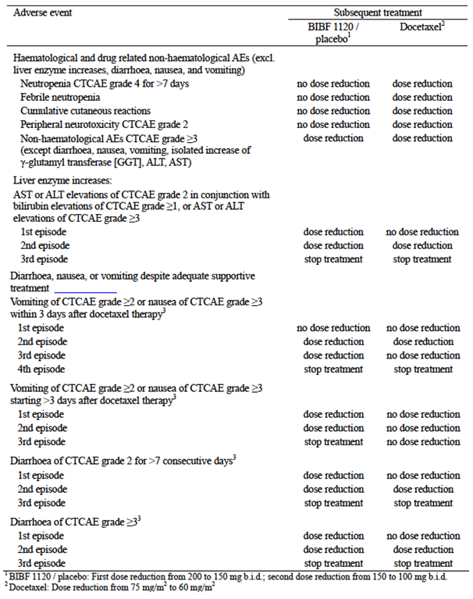

The only prohibited treatments were other chemotherapy, immunotherapy, hormone therapy or radiotherapy. Palliative radiotherapy was permitted for the treatment of bone lesions in the extremities.

**Evaluator’s comment**:

Docetaxel monotherapy is registered in Australia for the treatment of patients with locally advanced or metastatic non-small cell lung cancer, including those who have failed platinum based chemotherapy. The approved dosage regimen is 75 to 100 mg/m2 every 3 weeks. The choice of comparator is therefore acceptable.

###### Efficacy variables and outcomes

The main efficacy variables

The main efficacy variables were:

* Change in tumour size
* Survival
* Quality of life (QoL) measures.

The primary efficacy outcome was progression free survival (PFS), as assessed by a blinded central review panel. PFS was defined as the duration of time from date of randomisation to date of progression or death (whichever occurs earlier).

Other efficacy outcomes

Other efficacy outcomes included:

* Overall survival (OS), defined as the duration of time from date of randomisation to time of death (irrespective of cause).
* Objective tumour response; that is the proportion of subjects who achieved a partial response (PR) or complete response (CR). Responses had to be confirmed by imaging at least four weeks after first documented.
* Time to objective response, defined as the time from randomization to the date of first documented CR or PR.
* Duration of objective response, defined as the time from first documented CR or PR to the time of progression or death.
* Disease control rate (DCR); that is the proportion of patients who achieved PR, CR or stable disease (SD). A best response of SD could only be assigned if it occurred at least six weeks after randomisation. SD did not require a confirmatory scan.
* Duration of disease control, defined as the duration from date of randomization until progression or death (whichever occurs earlier), among patients with disease control.
* Tumour shrinkage. The two treatment groups were to be compared in terms of the maximum decrease in the sum of the longest diameters of all target lesions.
* Clinical improvement, defined as time to deterioration in body weight (that is a loss of > 10%) and time to deterioration in ECOG performance status (any increase in ECOG PS category).
* QoL as measured by the following instruments:
  + The EQ-5D health status self-assessment questionnaire.
  + The EORTC QLQ-C30 questionnaire and its lung cancer module EORTC QLQ-LC13.

Details of these instruments are summarised in Table 10. The study reports did not present any results for the ED-5Q. The only results presented for the EORTC QLQ-C30 and QLQ-LC13 were analyses of time to deterioration in cough, dyspnoea and pain.

Table 10. Study 1199.0013; Quality of life instruments.

| EuroQoL Five-Dimension (EQ-5D) | This is a generic measure of QoL. It consists of a questionnaire (index) and a visual analogue scale (VAS). The questionnaire has five ‘dimensions’ (mobility, self-care, usual activities, pain/discomfort and anxiety/depression). For each dimension, answers range from 1 to 3, depending on whether the subject perceives no problems (= 1), some problems (= 2), or significant problems (= 3) in that aspect of their health. The VAS asks the subject to rate his or her current health state from 0 (‘worst imaginable health state’) to 100 (‘best imaginable health state’). |
| --- | --- |
| European Organisation for Research and Treatment of Cancer Quality of Life Questionnaire Core 30 (EORTC QLQ-C30) | The EORTC QLQ-C30 is a cancer-specific 30-item questionnaire. It incorporates five functional domains - physical functioning (5 items), role functioning (2 items), emotional functioning (4 items), cognitive functioning (2 items) and social functioning (2 items). It also includes questions on a variety of symptoms - pain (2 items), fatigue (3 items), nausea and vomiting (2 items) and single items on insomnia, loss of appetite, constipation, diarrhoea, dyspnoea and financial difficulties. Each of these 28 items is scored on a scale of 1 (‘not at all’) to 4 (‘very much’). Two additional items ask about global health status and overall quality of life (GHS/QoL) and these are scored on a seven point scale from 1 (‘very poor’) to 7 (‘excellent’). Subjects are asked to assess functioning and symptoms over the preceding week.  Raw scores are transformed to obtain a score between 0 and 100 points. For the functional domains, a high score means a better level of functioning, whereas for the symptom scores a higher score means worse symptoms. For the GHS/QoL domain, higher scores mean better GHS/QoL. Minimally important differences (MIDs) have been categorised as ‘small’ if the mean change in scores is 5 to 10 points, ‘moderate’ if 10 to 20 points, and ‘large’ if > 20 points (1).  The EORTC QLQ-LC13 module comprises 13 questions. It incorporates one 3-item scale to assess dyspnoea, and a series of single items assessing pain, coughing, sore mouth, dysphagia, peripheral neuropathy, alopecia, and haemoptysis. Each of the 13 items is scored on a scale of 1 (‘not at all’) to 4 (‘very much’). |

(1) Osoba D, Rodrigues G, Myles J et al. Interpreting the significance of changes in health-related quality-of-life scores. *J Clin Oncol*; 1998; 16: 139-144.

For all efficacy measures, PR, CR, SD and progressive disease (PD) were defined according to a modified version of the Response Evaluation Criteria In Solid Tumours (RECIST) version 1.0 (12). A central, blinded review panel undertook assessment of response and disease progression. Two independent specialist radiologists reviewed all scans and a third radiologist acted as an adjudicator if required. An oncologist then assessed all available patient data. Investigator-assessed results for several of the above endpoints were also presented.

Baseline scans (CT or MRI) were to be obtained within 4 weeks of commencement of study treatment. Between 1 and 10 target lesions were identified for follow up. Scans were to be repeated every 6 weeks after the first administration of docetaxel. The same scan method used initially (CT or MRI) was used for follow up. Measurement of bodyweight, ECOG performance status and QoL was performed every 3 weeks (on Day 1 of each cycle). Subjects who discontinued treatment were followed up every 6 to 8 weeks for overall survival.

**Evaluator’s comment**:

The measures of efficacy were standard for oncology studies. According to the EMA guidelines adopted by the TGA (3, 5), PFS is an acceptable primary endpoint for Phase III studies in NSCLC.

###### Randomisation and blinding methods

Subjects were randomised 1:1 to treatment via a third party interactive voice (phone) or web-based response system. Randomisation was performed in blocks of four. All persons directly involved in the conduct and analysis of the trial had no access to the treatment allocation prior to unblinding for the primary analysis. Randomisation was stratified according to the following baseline factors: ECOG performance score (0 versus 1), squamous versus non squamous histology, presence or absence of brain metastases and previous bevacizumab therapy (yes or no).

Blinding was achieved through the use of placebo soft gel capsules that were matched to the nintedanib capsules.

###### Analysis populations

Four analysis populations were defined:

* The screened set (SS) included all patients who had given their informed consent.
* The randomised set (RS) included all randomised patients, whether patients had received study treatment or not. Patients were allocated to the treatment groups as randomised, regardless of the actual medication taken. Efficacy analyses were based on the RS.
* The treated set (TS) included all randomised patients who were documented to have taken at least 1 dose of study medication (that is docetaxel or nintedanib/placebo). Patients were allocated to the treatment groups according to the treatment actually received. The TS was used for safety analyses.
* The safety set (SFS) included all patients who were documented to have received at least 1 dose of investigational treatment (that is nintedanib or placebo).

###### Sample size

It was assumed that median PFS for docetaxel was 4 months and that combination with nintedanib would increase this by 28% to 32%. The trial was planned to achieve a statistical power of 90% for PFS and 80% for OS, and the null hypothesis (no difference between treatments) would be rejected if statistical significance was reached at the 2 sided 0.05 level. It was calculated that a total of 713 PFS events would be required to achieve 90% power for PFS. Assuming a median overall survival of 9 months for docetaxel monotherapy and an 18% increase in median survival with combination treatment, it was calculated that 1,151 deaths would be required to achieve a statistical power of 80% for OS. This number of deaths was expected to occur within 48 months if 1,300 patients were recruited at a rate of 45 to 60 per month. The planned sample size was therefore set at 1,300.

###### Statistical methods

For the primary endpoint of PFS, a stratified log rank test was used to test for the difference between nintedanib and placebo. Kaplan-Meier analyses were presented. A Cox proportional hazards model was used as a sensitivity analysis. Subgroup analyses were performed using the same statistical method as the primary analysis.

OS was to be analysed using the same methods used for PFS. The analyses conducted for OS were amended during the trial. This is discussed further below.

For objective response rate and DCR, logistic regression was used to compare rates between the two treatments. Duration of response/DCR and time to objective response were analysed using Kaplan-Meier estimates. Change in tumour size was analysed using analysis of variance (ANOVA). Time to deterioration of body weight and ECOG status were analysed using the same method as for PFS. For QoL measures, the time to deterioration in cough, dyspnoea and pain were analysed using the same method as for PFS.

###### Participant flow

A total of 1,773 subjects were screened and 1,314 subjects were randomised (655 to nintedanib and 659 to placebo). The most common reason for non-randomisation was that the subjects did not meet the inclusion or exclusion criteria (n = 362). Participant flow is summarised in Figure 4, analysis sets in Table 11 and patient disposition in Table 12. At the time of data cut-off (15 February 2013), only 11 subjects were still receiving study treatment.

Figure 4. Study 1199.0013: Participant flow.

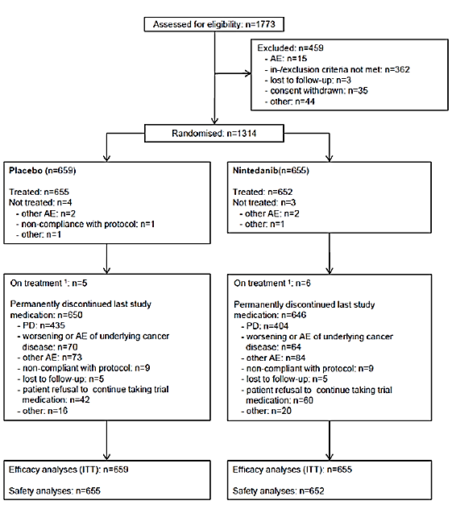

Table 11. Study 1199.0013 – Analysis sets.

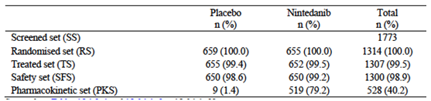

Table 12. Study 1199.0013. Patient disposition.

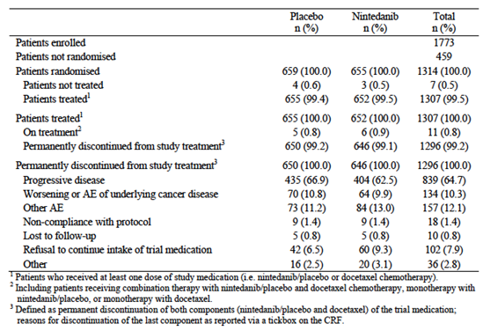

###### Major protocol violations/deviations

Important protocol violations were defined as those that could potentially impact on the efficacy assessments or the patients’ rights or safety.

**Evaluator’s comment**:

Important protocol violations were uncommon and were balanced between the two treatment arms. It is unlikely that they would have affected the outcomes of the study.

###### Baseline data

Baseline demographics were summarised. Some 31.5% of the population were aged ≥ 65 years and approximately 75% were current or ex- smokers. The two groups were well balanced with respect to demographic characteristics.

Stratification factors at baseline are summarised in Table 13 and other disease characteristics in Table 14. The two groups were well balanced with respect to these characteristics. The two groups were also well balanced with respect to prior 1st-line chemotherapy and other prior therapies.

Table 13. Study 1199.0013 - Stratification factors at baseline.

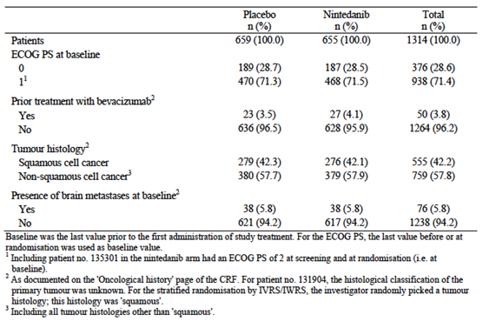

Table 14. Study 1199.0013 – Disease characteristics at baseline.

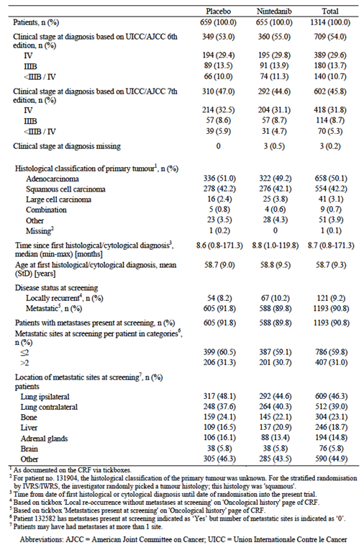

###### Results for the primary efficacy outcome

The primary analysis for PFS was scheduled to occur after 713 PFS events. Some 714 PFS events had occurred by 2 November 2010 and this was chosen as the date of data cut-off. At this stage only 1,134 subjects had been randomised (565 to nintedanib and 569 to placebo). Of these, 375 placebo subjects had experienced a PFS event (346 with disease progression and 29 died) compared to 339 nintedanib patients (291 with disease progression and 48 died). Results for the primary PFS analysis are shown in Table 15. Nintedanib treatment was associated with a statistically significant reduction in the risk of progression or death (hazard ratio [HR]: 0.79; 95%CI: 0.68 – 0.92; p=0.0019). Median PFS was prolonged from 2.7 months to 3.4 months.

Table 15. Study 1199.0013. Primary analysis of PFS (Primary endpoint).

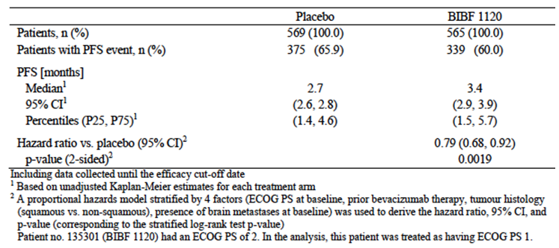

A sensitivity analysis was conducted with a Cox proportional hazards model, fitted with the four stratification factors as covariates. This also demonstrated a statistically significant benefit for nintedanib treatment (HR: 0.77; 95%CI: 0.67 – 0.89; p = 0.0005). Subgroup analyses showed a consistent benefit across all subgroups examined.

A follow up analysis for PFS was conducted at the time of the final OS analysis (date of data cut-off 15 February 2013). At this stage all 1,314 subjects had been randomised. Of these 538 placebo subjects had experienced a PFS event (497 with disease progression and 41 died) compared to 519 nintedanib patients (455 with disease progression and 64 died). Results for the primary PFS analysis are shown in Figure 5. Results were comparable to those obtained with the primary analysis (HR: 0.85; 95%CI: 0.75 – 0.96; p = 0.0070). Median PFS was prolonged from 2.7 months to 3.5 months.

Figure 5. Study 1199.0013 – Follow-up analysis of PFS.

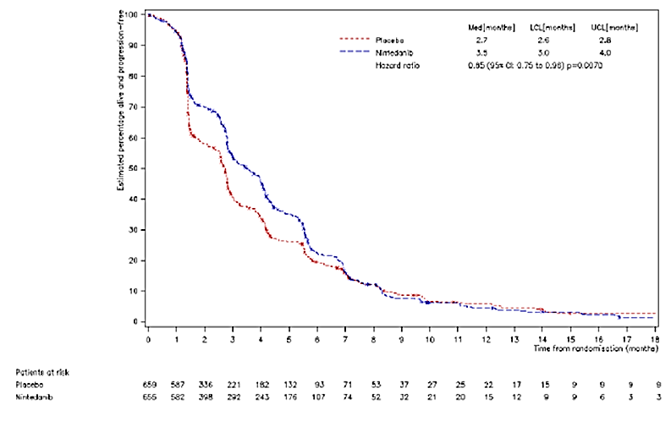

###### Results for other efficacy outcomes

For the secondary endpoints, results are presented from the final study report (date of data cut-off 15 February 2013).

Overall survival

Study 1199.0013 was conducted together with another study (1199.0014), which compared pemetrexed/nintedanib with pemetrexed/placebo in subjects with advanced/metastatic NSCLC after failure of 1st line chemotherapy. This study failed an interim analysis for futility, and was terminated because the primary efficacy objective was unlikely to be met. The sponsor performed exploratory analyses of both 1199.0013 and 199.0014 in an attempt to identify a subgroup of patients who would benefit from nintedanib treatment. These analyses suggested that, in subjects with non-squamous histology, who had a short period of time between start 1st line chemotherapy and enrolment into the nintedanib study, nintedanib produced a significant benefit compared to placebo. Furthermore, this effect was largely driven by subjects with adenocarcinoma histology.

To confirm this finding, a fixed sequence testing procedure was introduced for the analysis of OS in 1199.0013. Provided that both the primary and follow up analyses of PFS demonstrated a statistically significant benefit for nintedanib over placebo, OS would be tested in the following sequence:

* 1. In subjects with adenocarcinoma histology, with < 9 months since the start of 1st line chemotherapy
  2. In subjects with adenocarcinoma histology
  3. In all subjects.

Each of the 3 hypotheses could only be tested at the pre-specified alpha level if the previous null hypothesis in the testing sequence had been rejected. The amendment to the statistical analysis plan was implemented prior to locking of the database for OS.

Results for OS were:

* In subjects with adenocarcinoma histology and < 9 months since the start of 1st line chemotherapy, nintedanib treatment was associated with a statistically significant reduction in the risk of death (HR: 0.75; 95%CI: 0.60 – 0.92; p = 0.0073). Median survival was increased from 7.9 to 10.9 months.
* In subjects with adenocarcinoma histology, nintedanib treatment was associated with a statistically significant reduction in the risk of death (HR: 0.81; 95%CI: 0.69 – 0.99; p = 0.0359). Median survival was increased from 10.3 to 12.6 months (Table 16 and Figure 6).
* In all subjects, nintedanib treatment was not associated with a statistically significant reduction in the risk of death (HR: 0.94; 95%CI 0.83 – 1.05; p = 0.2720).

The use of anticancer therapies after participation in the trial was comparable in the two treatment arms.

Table 16. Study 1199.001; Overall survival (adenocarcinoma patients).

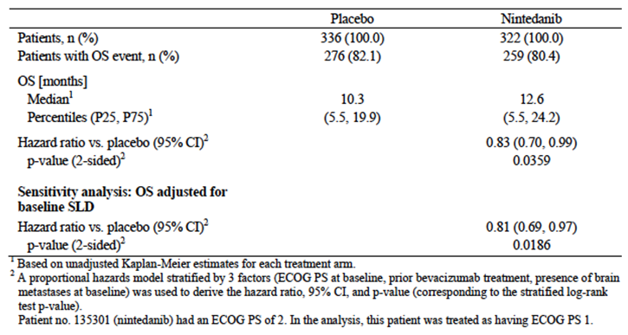

Figure 6. Study 1199.0013: Overall survival (adenocarcinoma patients).

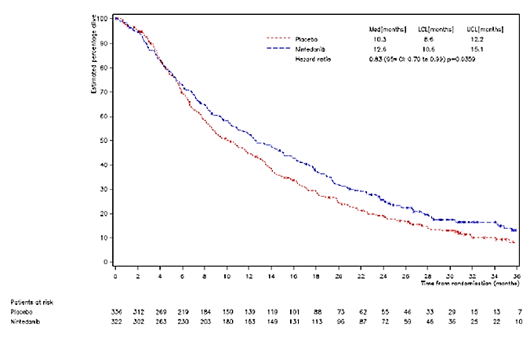

**Evaluator’s comment**:

The indication proposed by the sponsor restricts use of nintedanib to subjects with adenocarcinoma histology.

Subgroup analyses were presented for the three populations. Results for the adenocarcinoma population are shown in Figure 7. A beneficial effect of nintedanib was observed in most subgroups, as hazard ratios were < 1.

Figure 7. Study 1199.0013 – Subgroup analyses (adenocarcinoma population).

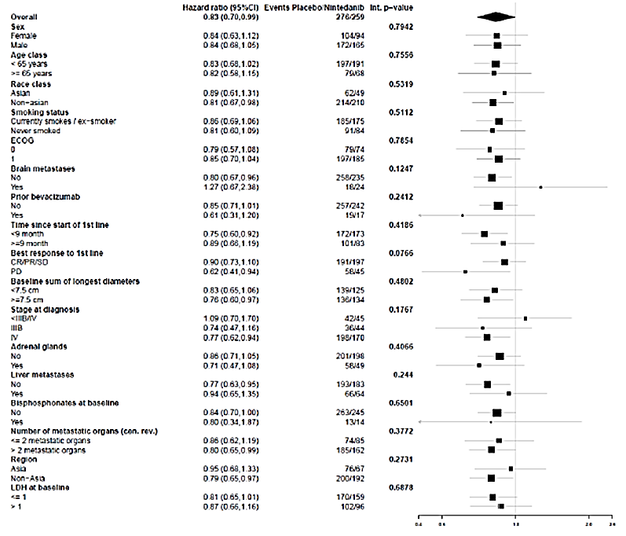

Investigator-assessed PFS

Assessment of PFS by the investigators gave comparable results to those obtained by central assessment (HR: 0.82; 95%CI: 0.73 – 0.93; p = 0.0012). Median PFS was prolonged from 3.0 months to 4.2 months.

Tumour response

There was no significant difference in objective response rate between treatments, either in the whole study population or the adenocarcinoma population. Duration of response and time to response were comparable in the two treatment arms.

Disease control

Disease control rate was superior with nintedanib, both in the whole study population (Table 17) or the adenocarcinoma population (Table 18). Duration of disease control was comparable in the two treatment arms.

Table 17. Study 1199.0013 - Disease control (All patients).

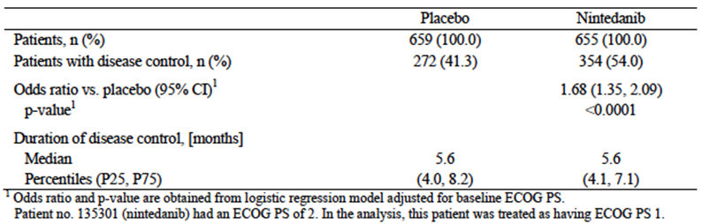

Table 18. Study 1199.0013 - Disease control (Adenocarcinoma patients).

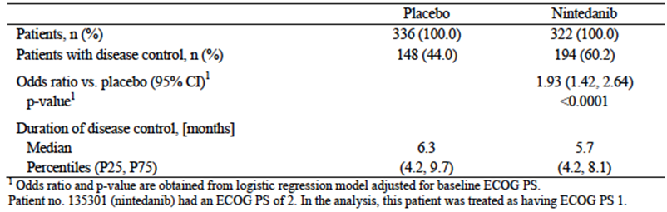

Change in tumour size

Reduction in tumour size was significantly greater with nintedanib, both in the whole study population (Table 19) or the adenocarcinoma population (Table 20).

Table 19. Study 1199.0013 – Change in tumour size (All patients).

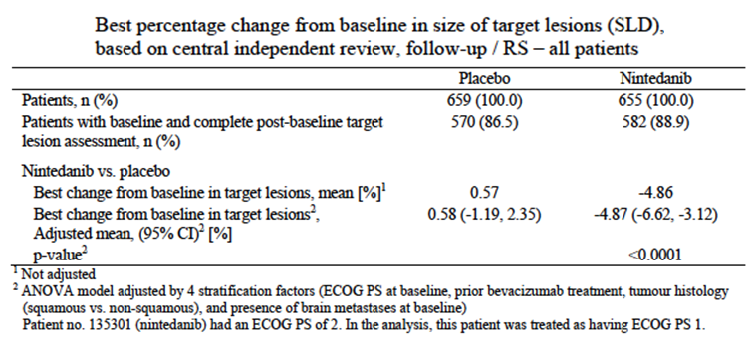

Table 20. Study 1199.0013 – Change in tumour size (Adenocarcinoma patients).

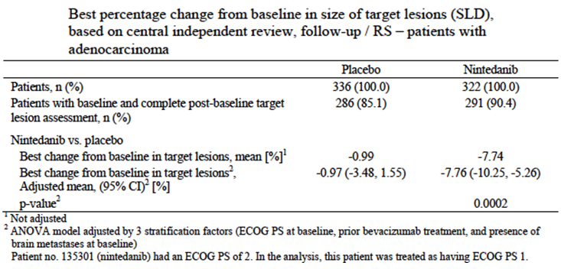

Clinical improvement

Among all patients, there were no significant differences detected in the time to deterioration of bodyweight and/or ECOG performance status.

QoL

The completion rate for QoL questionnaires was > 80% in both treatment arms. In the overall population, there were no differences between treatment arms in the time to deterioration of cough, dyspnoea or pain. Time to deterioration of diarrhoea was significantly shorter with nintedanib. Global health status was comparable in the two treatment arms. Similar observations were found for the adenocarcinoma population.

#### Other efficacy studies

##### Study 1199.0014 (‘LUME-Lung 2’)

This study was another Phase III, randomised, double blind, placebo controlled trial with two parallel groups. It enrolled subjects with stage IIIB or IV or recurrent NSCLC with non squamous histologies, after failure of 1st line chemotherapy. Subjects were randomised to receive pemetrexed in combination with nintedanib (200 mg BD) or pemetrexed in combination with placebo. The primary endpoint was PFS assessed by a central blinded panel, with OS as a secondary endpoint. It was planned to enrol 1,300 subjects (650 in each arm).

The study commenced in December 2008. The primary analysis of PFS was planned to occur after 713 PFS events. A pre-planned futility analysis based on investigator assessed PFS was conducted after 341 PFS events. This futility analysis suggested that the study was unlikely to meet its efficacy objective and the data monitoring committee recommended that the trial be stopped. Therefore the sponsor stopped recruitment in June 2011. By this stage, 713 patients had been randomised (353 to nintedanib and 360 to placebo). These patients could continue with treatment although all placebo use was ceased and subjects were not permitted to switch treatments. The subjects were followed for efficacy and safety and were analysed with a date of data cut-off of 9 July 2012.

94.3% of subjects who were randomised and treated had adenocarcinoma histology. By the time of data cut-off 239 subjects in the nintedanib arm and 259 subjects in the placebo arm had experienced a PFS event.

Results for PFS (as assessed centrally) were provided. Nintedanib treatment was associated with a statistically significant reduction in the risk of a PFS event (HR: 0.83; 95%CI: 0.70 – 0.99; p = 0.0435). Median PFS was increased from 3.6 to 4.4 months. Results for OS were provided. There was no significant difference between treatments.

A follow-up analysis with a date for data cut-off of 13 February 2013 showed similar results although the difference in PFS was no longer statistically significant.

**Evaluator’s comment:**

The sponsor is not seeking approval for nintedanib use in combination with pemetrexed. Despite recruitment having been stopped following the futility analysis, a statistically significant benefit in terms of PFS was still demonstrated. However, the benefit was small (prolongation of median PFS by 0.8 months). Due to the stopping of recruitment, the study would probably have had insufficient power to demonstrate an effect on overall survival.

##### Study 1199.0010

This was a Phase II, randomised, double blind trial comparing two dose levels of nintedanib (150 mg BD versus 250 mg BD) in subjects with previously treated stage IIIB or IV NSCLC. The PK data from this study were provided. In this study nintedanib was used as monotherapy. The primary endpoint was PFS.

73 subjects were enrolled and treated; 36 in the 250 mg arm and 37 in the 150 mg arm. Results for PFS were provided. There were no significant differences between the two treatments.

#### Analyses performed across trials (pooled analyses and meta-analyses)

Not applicable.

#### Evaluator’s conclusions on clinical efficacy for NSCLC

The pivotal study was well designed and conducted. It complied with the requirements of the EMA guidelines adopted by the TGA. The trial demonstrated that nintedanib has activity in the treatment of NSCLC as evidenced by statistically significant effects on such endpoints as disease control rate and tumour size.

The primary endpoint was PFS. Although a statistically significant result was obtained, the effect was of dubious clinical significance, as median PFS was only increased by 0.7 months (approximately 3 weeks). There was also no survival benefit in the overall population.

The application rests on the finding of an increase in overall survival (a secondary endpoint) in the subgroup of patients with adenocarcinoma. The analysis for survival in the adenocarcinoma subpopulation was defined prospectively, but after the results of the initial PFS analysis was known.

For a group with a median survival of only 10.3 months, an increase of 2.3 months would be important. The increase in survival is therefore considered to be clinically significant.

The application for the NSCLC indication is based on a single pivotal study. The TGA has adopted an EMA guideline (6) that addresses the situation where regulatory approval is being sought on the basis of a single pivotal study. This guideline states that the results of such a study need to be ‘exceptionally compelling’ and it sets out a number of ‘prerequisites’ for the study. One of the prerequisites is that ‘*Statistical significance considerably stronger than p < 0.05 is usually required.*’ The p-value obtained in the OS analysis in the adenocarcinoma population was 0.0359.

On balance, given the magnitude of the survival benefit, it is considered that the evidence for efficacy is adequate to support registration.

The study did not collect data on NSCLC tumour biomarkers such as EGFR mutation status or ALK positivity. The place of nintedanib in the therapy in the treatment of tumours with these characteristics is therefore unknown.

### Idiopathic pulmonary fibrosis (IPF)

The main evidence for efficacy comes from two Phase III, randomised, double blind and placebo controlled studies (1199.0032 and 1199.0034). These two studies had essentially an identical design and will therefore be reviewed together. Supportive evidence was provided by one Phase II dose ranging study (1199.0030).

#### Pivotal efficacy studies

#### Studies 1199.0032 (‘INPULSIS 1’) and 1199.0034 (‘INPULSIS 2’)

###### Study design, objectives, locations and dates

Each study was a randomised, double blind, placebo controlled trial with two parallel groups. They included a screening phase, a 52 week treatment phase and a 28 day follow-up phase. A study schema is shown in Figure 8.

Figure 8. Studies 1199.0032 and 1199.0034 – Study schema.

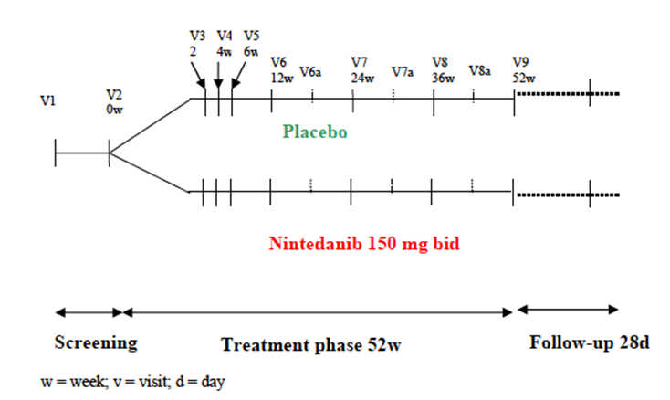

The overall objective was to investigate the efficacy and benefit/risk ratio for nintedanib 150 mg BD compared with placebo in the treatment of IPF. The primary objective was to assess the reduction in lung function decline, as measured by a change in the annual rate of decline in forced vital capacity (FVC).

Study 1199.0032 was conducted in 98 centres in 13 countries. Study 1199.0034 was conducted in 107 centres in 17 countries. Both studies were conducted between May 2011 and October 2013. The studies have been published (13).

###### Inclusion and exclusion criteria

Inclusion criteria are listed in Table 21 and exclusion criteria in Table 22.

Table 21. Studies 1199.0032 and 1199.0034 – Inclusion criteria.

| Patients were eligible for the trial if they met the following criteria |
| --- |
| Written informed consent consistent with ICH GCP and local laws signed prior to entry into the trial (and prior to any trial procedure, including shipment of HRCT/biopsy to reviewer) |
| Patient aged ≥ 40 years at Visit 1 |
| IPF diagnosed, based upon most recent American Thoracic Society (ATS)/European Respiratory Society (ERS)/Japanese Respiratory Society (JRS)/Latin American Thoracic society (ALAT) guidelines, within 5 years of Visit 2 |
| Chest HRCT performed within 12 months of Visit 1 |
| Combination of HRCT pattern, and if available surgical lung biopsy pattern, as assessed by central reviewers, consistent with diagnosis of IPF |
| DLCO (corrected for haemoglobin [Hb] [Visit 1]): 30% to 79% predicted of normal at Visit 2 |
| FVC ≥ 50% predicted of normal at Visit 2 |

HRCT = High resolution CT scan; DLCO = carbon monoxide diffusion capacity; FVC = Forced Vital Capacity

Table 22. Studies 1199.0032 and 1199.0034 – Exclusion criteria.

| Exclusion criteria |
| --- |
| Laboratory Parameters (Visit 1)  AST and ALT > 1.5 x upper limit of normal (ULN)  Bilirubin > 1.5 x ULN |
| Lung function (Visit 2)  Airway obstruction (pre-bronchodilator forced expiratory volume in 1 second [FEV1]/FVC < 0.7)  In the opinion of the Investigator, the patient was likely to have lung transplantation during the trial (however, being on the transplantation list was acceptable for participation) |
| Other diseases  Cardiac disease  Myocardial infarction within 6 months of Visit 2  Unstable angina within 1 month of Visit 2  Bleeding risk  Known genetic predisposition to bleeding  Patients who required fibrinolysis, full-dose therapeutic anticoagulation (e.g. vitamin K antagonists, dabigatran, heparin, hirudin etc), or high dose antiplatelet therapy. Prophylactic low dose heparin or heparin flush as needed for maintenance of an indwelling IV device (eg enoxaparin 4000 IU subcutaneous [sc] per day)., as well as use of antiplatelet therapy (e.g. acetyl salicylic acid up to 325 mg/d or clopidogrel at 75 mg/d, or equivalent doses of other antiplatelet therapy ) was not excluded  History of haemorrhagic central nervous system (CNS) event within 12 months of Visit 2  Any of the following within 3 months of Visit 2  Haemoptysis or haematuria  Active gastrointestinal bleeding or ulcers  Major injury or surgery  Coagulation parameters. International normalised ratio (INR) > 2, prolongation of prothrombin time and partial (plasma) thromboplastin time (sec) (PTT) by > 50% of institutional ULN at Visit 1  Thrombotic risk  Known inherited predisposition to thrombosis  History of thrombotic event (including stroke and transient ischemic attacks) within 12 months of Visit 2 |
| Known hypersensitivity to the trial medication or its components |
| Other disease that may have interfered with testing procedures or in the judgement of the Investigator may have interfered with trial participation or may have put the patient at risk when participating in the trial |
| Life expectancy for disease other than IPF < 2.5 years (Investigator assessment) |
| General exclusion criteria  Previous treatment with nintedanib (except short term treatment for up to 4 weeks)  Other investigational therapy (participation in a research trial) received within 8 weeks of Visit 1  N-acetylcysteine (NAC), prednisolone > 15 mg/day ore equivalent received within 2 weeks of Visit 1  Pirfenidone, azathioprine, cyclophosphamide, cyclosporine A received within 8 weeks of Visit 1  Major surgical procedures planned to occur during the trial  Pregnant women or women who are breast feeding or of child bearing potential and not using tow effective methods of birth control (one barrier and one highly effective non-barrier) for at least 1 month prior to enrolment (and 3 months after treatment end). Female patients were considered to be of childbearing potential unless surgically sterilised by hysterectomy or bilateral tubal ligation, or had been postmenopausal for at least 2 years. Highly effective methods of birth control included established use of oral, injected or implanted hormonal methods of contraception, placement of an intrauterine device (IUD) or intrauterine system (IUS). A barrier method of contraception included condom or occlusive cap with spermicidal (foam, gel, film, cream, suppository) or male sterilisation (with appropriate post vasectomy documentation of the absence of sperm in the ejaculate)  Sexually active males who would not commit to using condoms during the course of the trial (except if their partner was not of child bearing potential) and for 3 months after the end of treatment  Active alcohol or drug abuse  Patients who were not able to understand and follow trial procedures including completion of self-administered questionnaires without help. This criterion was included as part of global amendment 1.0. |

**Evaluator’s comment**:

Diagnosis of IPF had to conform to the criteria set out in a widely accepted international consensus guideline on the diagnosis and management of IPF (1). Diagnosis was confirmed by central reading of chest high resolution CT scan (HRCT) and surgical lung biopsy (if available). The study did not include subjects with more advance disease (for example FVC < 40[1]%).

###### Study treatments

Subjects were randomised (3:2) to receive either:

* Nintedanib 150 mg BD for 52 weeks; or
* Placebo for 52 weeks.

Nintedanib was administered as 150 mg soft gel capsules (or 100 mg soft gel capsules in the event of dose reduction). The drug was to be administered after food intake.

Dose interruptions or reductions for toxicity were permitted. A single dose reduction (to 100 mg BD) was allowed. If the reduced dose was not tolerated, the drug was to be permanently discontinued. If the reduced dose was well tolerated, re-escalation to 150 mg BD was permitted provided it occurred within 4 weeks.

The use of pirfenidone or any other experimental therapy for IPF was forbidden during the trial. If patients required fibrinolysis, full dose anticoagulant therapy or high dose antiplatelet therapy during the trial, nintedanib/placebo was to be stopped for 4 weeks prior to their use.

Azathioprine, cyclophosphamide, cyclosporin, N-acetylcysteine and prednisone or other corticosteroids (at a dose of > 15 mg/day or equivalent) were not permitted during the first 6 months of treatment. However these medications could be initiated at any time for the treatment of acute exacerbations, and after 6 months, in the event of disease progression (a ≥ 10% decrease in the absolute value of % predicted FVC or a ≥ 15% decrease in % predicted DLCO).

###### Efficacy variables and outcomes

The main efficacy variables were:

* Forced vital capacity (FVC)
* Patient reported outcomes (PROs)/quality of life (QoL) measures
* The occurrence of acute exacerbations of IPF
* Survival.

An acute exacerbation was defined as an episode of otherwise unexplained clinical features including all of the following:

* Unexplained worsening or development of dyspnoea within 30 days
* New diffuse pulmonary infiltrates on chest X-ray, and/or new HRCT parenchymal abnormalities with no pneumothorax or pleural effusion (new ground glass opacities) since the last visit
* Exclusion of infection as per routine clinical practice and microbiological studies
* Exclusion of alternative causes as per routine clinical practice, including the following: left heart failure, pulmonary embolism and identifiable cause of acute lung injury.

The primary efficacy outcome was the annual rate of decline in FVC (expressed in mL over 52 weeks).

The key secondary efficacy outcomes were:

* Change from baseline in the Saint George’s Respiratory Questionnaire (SGRQ) total score at 52 weeks (expressed in points)
* Time to first acute IPF exacerbation (as assessed by the investigator) over 52 weeks.

A large number of other secondary outcomes were analysed. These are listed in Table 23. There were five PRO/QoL instruments used in the studies. These are summarised in Table 24. The PRO/QoL instruments were to be completed in the following order: SGRQ, SOBQ, CASA-Q, PGI-C, EQ-5D.

Table 23. Studies 1199.0032 and 1199.0034 – Other secondary outcomes.

|  |
| --- |
| Other secondary outcomes |
| Further analysis on FVC   * Absolute and relative change from baseline in FVC (mL) and FVC% predicted over 52 weeks * Absolute categorical change of FVC% predicted over 52 weeks: decrease by > 5%, increase by > 5%, and change within ≤ 5% * Absolute categorical change of FVC% predicted over 52 weeks: decrease by > 10%, increase by > 10%, and change within ≤ 10% * Proportion of FVC responders using 5% threshold at 52 weeks, defined as patients with absolute decline in FVC% predicted no greater than 5% and with an FVC evaluation at 52 weeks * FVC responders using 10% threshold at 52 weeks, defined as patients with absolute decline in FVC% predicted no greater than 10% and with an FVC evaluation at 52 weeks |
| Patient reported outcomes (PRO’s)   * Proportion of SGRQ responders at 52 weeks (defined as absolute change from baseline at 52 weeks, in SGRQ total score ≤ - 4 points * Change from baseline in SGRQ domains at 52 weeks (points) * Change from baseline in IPF specific version of SGRQ (SGRQ-I)[r10-5500] total score (exploratory calculation from SGRQ data) at 52 weeks (points) * Change from baseline in Shortness of Breath Questionnaire (SOBQ) at 52 weeks * Change from baseline in cough impact and cough symptom of the Cough and Sputum Assessment Questionnaire (CASA-Q(CD)) score at 52 weeks * Proportion of Patient’s Global Impression of Change (PGI-C) responders at 52 weeks (defines as ‘Very much better’/’Much better’/’A little better’/’No change’ * Change from baseline in EuroQol 5 Dimensional Quality of Life Questionnaire (EQ-5D) health state up to 52 weeks |
| Acute exacerbations   * Risk of acute IPF exacerbation over 52 weeks |
| Survival analysis   * Time to death over 52 weeks * Time to death due to respiratory cause over 52 weeks (adjudicated) * Time to on-treatment death * Time to death or lung transplant over 52 weeks   + Time to death or lung transplant or qualifying for lung transplant over 52 weeks. As defined in the CTP, a patient was considered qualifying for transplant if he or she fulfilled the following criteria: FVC < 45% predicted or DLCO < 30% predicted or SpO2 < 88% at rest, at sea level (to be adapted for other heights) |
| Change from baseline in SpO2 (oxygen saturation, expressed in percent) at rest up over 52 weeks |
| Change from baseline in DLCO at rest over 52 weeks |

Table 24. Studies 1199.0032 and 1199.0034 – PRO/QoL instruments.

| PRO/QoL instruments |
| --- |
| St. George's Respiratory Questionnaire (SGRQ)  The SGRQ is a 50-item questionnaire split into three domains:  Symptoms (assessing the frequency and severity of respiratory symptoms)  Activity (assessing the effects of breathlessness on mobility and physical activity), and  Impact (assessing the psychosocial impact of the disease).  Scores are weighted such that every domain score and the total score range from 0 to 100 points, with higher scores indicating a poorer QoL. The minimum important clinical difference is considered to be 4 points. The SGRQ was originally developed for use in patients with chronic obstructive pulmonary disease (COPD) and asthma.  The pivotal studies also analysed an IPF-specific version of the SGRQ (the SGRQ-I). This instrument had the same 3 domains as the SGRQ but contained only 34 of the items. Analysis of the SGRQ-I was based on responses given to the SGRQ and did not require the administration of a separate questionnaire. |
| Shortness Of Breath Questionnaire (SOBQ)  The SOBQ is a 24 item dyspnoea questionnaire that asks respondents to rate themselves from 0 (‘Not at all’) to 5 (‘Maximally or unable to do because of breathlessness’) in two areas:  How short of breath they are while performing various activities (21 items); and  How much shortness of breath, fear of hurting themselves by overexerting and fear of shortness of breath limit them in their daily lives (3 items).  Scores range from 0 to 120, with higher scores indicating greater dyspnoea. The minimum important clinical difference is considered to be 5 points. |
| Cough And Sputum Assessment Questionnaire (CASA-Q)  The CASA-Q is a 20-item questionnaire that assesses the symptoms of cough and sputum across 4 domains: cough symptoms, sputum symptoms, cough impact and sputum impact. The four domains are scored from 0 to 100, with lower scores indicating higher symptom or impact levels. A minimally important clinical difference was not stated in the study documentation. In the pivotal studies only the cough domains were analysed with a questionnaire consisting of 11 items. |
| Patient’s Global Impression of Change (PGI-C)  Subjects were asked to: ‘*Check the one number that best describes how your respiratory condition is now, compared with how it was before you began taking medication in this study’*. Possible responses ranged from 1 (very much better) to 7 (very much worse). |
| EuroQoL 5-Dimension Quality of Life Questionnaire (EQ-5D)  The EQ-5D is a generic measure of QoL. It consists of a questionnaire (index) and a visual analogue scale (VAS). The questionnaire has five ‘dimensions’ (mobility, self-care, usual activities, pain/discomfort and anxiety/depression). For each dimension, the subject can choose one of three responses (for example, no problems, some problems, severe problems). The VAS asks the subject to rate his or her current health state from 0 (‘worst imaginable health state’) to 100 (‘best imaginable health state’). |

A flowchart showing the timing of investigations was provided. Standard spirometry devices were supplied to all study centres and spirometry performance was monitored centrally. Testing was conducted in triplicate with the best result selected.

###### Randomisation and blinding methods

Subjects were randomised (3:2) to nintedanib or placebo via an interactive voice (phone) or web based response system. Randomisation was performed in blocks of five and was not stratified. Blinding was achieved through the use of placebo soft gel capsules that were matched to the nintedanib capsules.

###### Analysis populations

The treated set (TS) included all randomised patients who were dispensed study medication and were documented to have taken at least 1 dose of investigational treatment. The TS was used for all analyses of Trials 1199.32 and 1199.34, and their pooled data. Patients were analysed based on the treatment to which they were randomised.

The randomised set (RS) consists of those patients who were randomised to a treatment group.

###### Sample size

The expected difference in FVC over 52 weeks between the nintedanib and placebo groups was 100 mL. Based on Phase II data, the expected standard deviation for FVC was 300 mL. It was assumed that 2% of subjects would not be evaluable. Using these assumptions, it was calculated that 485 subjects (194 placebo and 291 nintedanib) would be required to demonstrate a difference of 100 mL in FVC, with 90% power using a two group t-test with a 0.025 one sided significance level.

###### Statistical methods

The primary endpoint (annual rate of decline in FVC) was analysed using a random coefficient regression model. Decrease in FVC was assumed to be linear within each patient over 52 weeks. Gender, baseline age, and baseline height, which are predictors of FVC, were also included in the model as covariates. Various sensitivity analyses were performed.

The change from baseline in SGRQ total score over 52 weeks was analysed using a mixed model for repeated measures (MMRM). The model included treatment and visit as fixed effects, baseline SGRQ total score as a covariate, and treatment by visit and baseline SGRQ total score by visit as interaction terms.

For time to first acute IPF exacerbation, an estimate with a 2 sided 95% CI for the hazard ratio of nintedanib 150 mg BD over placebo was obtained using the Cox’s proportional hazards model, adjusted for gender, baseline height and baseline age. The 2-sided p-value from the log rank test was also provided. Kaplan-Meier estimates were derived to calculate the probability of an acute IPF exacerbation over time.

###### Participant flow

Across the two trials, 1,066 subjects were randomised, and 1,061 were treated; 638 with nintedanib and 423 with placebo. Approximately 84% of subjects completed the study. Patient disposition is summarised in Table 25.

Table 25. Studies 1199.0032 and 1199.0034 – Patient disposition.

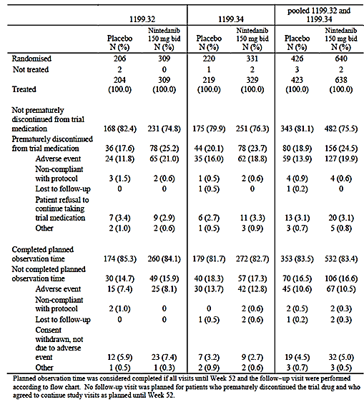

###### Major protocol violations/deviations

Important protocol violations for the pooled studies were provided. The number and type of violations were comparable across treatment arms.

###### Baseline data

Baseline demographic data are summarised in Table 26, baseline disease characteristics in Table 27 and baseline values for FVC and SGRQ were provided. Concomitant medical conditions at baseline and use of concomitant medications at baseline were comparable between arms. In the pooled population 8.9% of subjects in the nintedanib arm and 8.3% of subjects in the placebo arm were using oxygen at baseline. Systemic corticosteroid use was also comparable (21.3% versus 21.0%).

**Evaluator’s comment:**

There were no significant imbalances between treatment arms with respect to baseline characteristics. The male to female ratio was high (4:1) in both trials. Consistent with the known clinical features of IPF, mean age in the pooled population was 66.8 years, and the majority of patients were current or ex-smokers.

Table 26. Studies 1199.0032 and 1199.0034 – Baseline demographic characteristics.

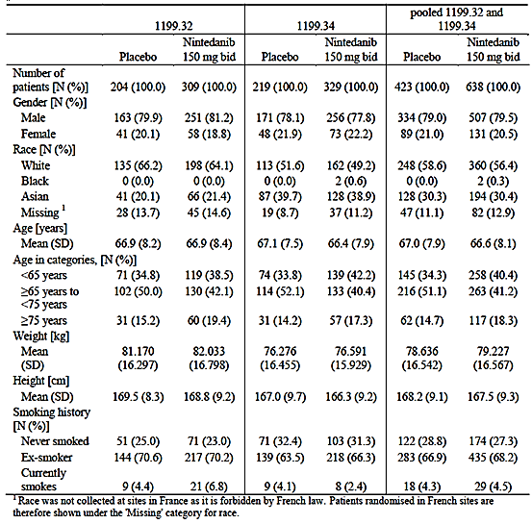

Table 27. Studies 1199.0032 and 1199.0034 – Baseline disease characteristics.

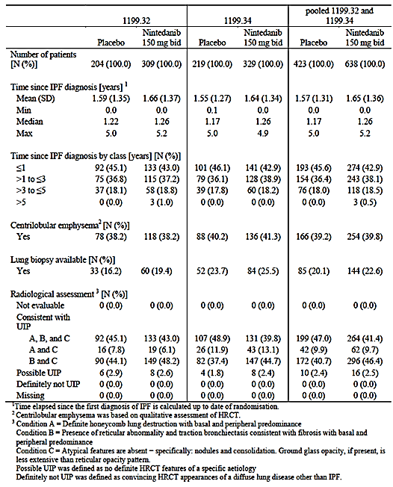

###### Results for the primary efficacy outcome

Results for the rate of decline in FVC are summarised in Table 28 and Figure 9. In both studies and in the pooled analysis, nintedanib treatment was associated with a significantly lower annual rate of decline in FVC.

* In 1199.32 the adjusted rate of change was -239.91 mLs/year with placebo and 114.65 mLs/year with nintedanib (difference 125.26 mLs/year; p < 0.0001)
* In 1199.34 the adjusted rate of change was -207.32 mLs/year with placebo and 113.59 mLs/year with nintedanib (difference 93.73 mLs/year; p = 0.0002).

Various sensitivity analyses were conducted. The results were consistent with the primary analysis for both studies.

Table 28. Studies 1199.0032 and 1199.0034 – Decline in FVC (Primary endpoint). Rate of decline in FVC (mL/yr) over 52 weeks, treated set.

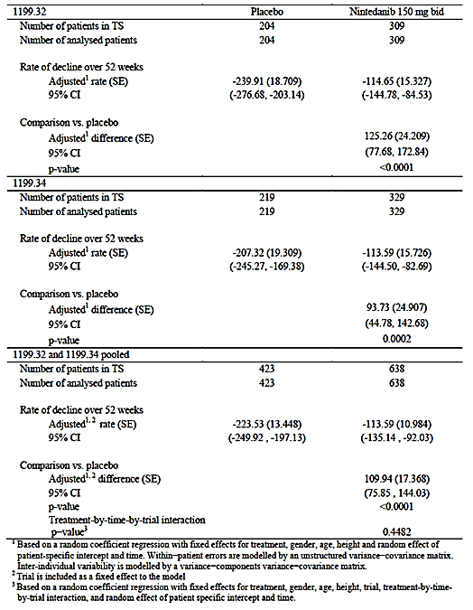

Figure 9. Studies 1199.0032 and 1199.0034 – Decline in FVC (pooled data).

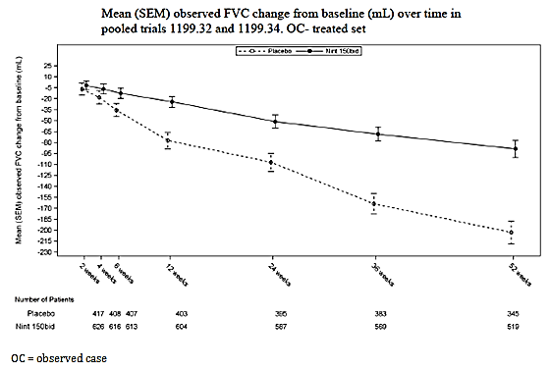

###### Results for key secondary efficacy outcomes

Change from baseline in SGRQ total score at 52 weeks

Results for this endpoint were provided. The two studies gave conflicting results, with a statistically significant benefit observed with nintedanib treatment in Study 1199.0034, and no significant difference between treatments in Study 1199.0032. When the data were pooled no significant difference between treatments was observed.

**Evaluator’s comment**:

In Study 1199.0034 the SGRQ total score increased in both groups, indicating deterioration in QoL. The increase was less marked in the nintedanib group (mean change 2.16 versus 5.34 points) and the difference was statistically significant. However the adjusted mean difference was only 2.69 points. The minimum clinically important difference on the SGRQ is 4 points. Hence the effect of nintedanib on SGRQ total score is unlikely to be clinically significant.

Time to first acute IPF exacerbation

The results for investigator diagnosed IPF exacerbations were again discordant across the two trials, with Study 1199.0034 demonstrating a significant benefit with nintedanib, and Study 1199.0032 showing no significant difference. When results of the two studies were pooled there was a lower incidence of exacerbations with nintedanib (4.9% versus 7.6%) but the difference was not statistically significant (p = 0.0823).

All cases of acute IPF exacerbations were reviewed by a central adjudication committee who were blinded to treatment allocation. This committee classified cases as ‘confirmed’, ‘suspected’ or ‘not an IPF exacerbation’. A pre-specified sensitivity analysis examined time to first IPF exacerbation for cases adjudicated as confirmed or suspected in the pooled population. This analysis demonstrated a significant benefit with nintedanib treatment (hazard ratio 0.32; 95% CI: 0.16 to 0.65; p = 0.0010).

###### Results for other secondary efficacy outcomes

Results for the other secondary analyses are summarised below.

Further analyses of FVC

In the pooled studies:

* Absolute change from baseline in FVC was significantly less in with nintedanib treatment (adjusted means: -94.46 mLs versus -205.01 mLs; adjusted mean difference 110.55 mLs; p< 0.0001).
* Absolute change from baseline in % predicted FVC was significantly less in with nintedanib treatment (adjusted means: -2.91% versus -6.08%; adjusted mean difference 3.17%; p< 0.0001).
* Relative change from baseline in FVC was significantly less in with nintedanib treatment (adjusted means: -3.62% versus -7.79%; adjusted mean difference 4.17%; p< 0.0001).
* Relative change from baseline in % predicted FVC was significantly less in with nintedanib treatment (adjusted means: -3.63% versus -7.78%; adjusted mean difference 4.15%; p< 0.0001).
* Analysis of the proportion of patients who achieved an ‘FVC response’ demonstrated a significant benefit for nintedanib over placebo (Table 29). A responder was a patient who did not experience a decline in % predicted FVC of 5% (or 10%) over the course of the trial. No other analyses of categorical change were presented.

**Evaluator’s comment**:

Declines in FVC of 5 to 10% may be predictive of an increased risk of mortality in IPF subjects (1).

Table 29. Studies 1199.0032 and 1199.0034 – FVC responder analyses.

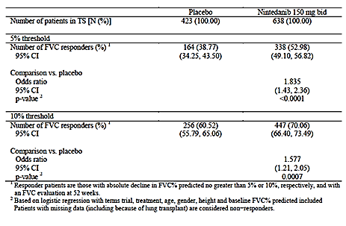

Patient reported outcomes/quality of life

Summary results for PRO/QoL endpoints were provided for Studies 1199.0032 and 1199.0034. Analyses of pooled data were not presented in the submission. In brief, there were no significant differences detected in Study 1199.0032. In Study 1199.0034 some statistically significant differences in favour of nintedanib were obtained for SGRQ domains (Activities and Impacts) and SGRQ-I. However mean differences were all < 4 points and therefore unlikely to be clinically significant. Nintedanib-treated patients were more likely to have an improvement in SGRQ total score of > 4 points (25.23% versus 16.89%; Odds ratio 1.665; 95%CI: 1.08 – 2.57; p = 0.0218).

In both studies nintedanib treatment was not associated with any beneficial effect on dyspnoea or cough.

**Evaluator’s comment**:

Considering the results of both studies, the overall conclusion is that nintedanib treatment had no clinically significant effect on quality of life or respiratory symptoms.

Risk of an acute IPF exacerbation over 52 weeks

The incidence rate of exacerbations was calculated as the number of patients with at least 1 acute IPF exacerbation divided by the total number of years at risk.

* In Study 1199.0032 there was no significant difference in risk (6.6 versus 5.6 per 100 patient-years for nintedanib and placebo respectively; p = 0.6793; risk ratio 1.17; 95%CI: 0.56 – 2.46);
* In Study 1199.0034 the risk was reduced with nintedanib (3.9 versus 10.2 per 100 patient-years; p = 0.0070; risk ratio 0.38; 95%CI: 0.19 – 0.77).

An analysis of pooled data was not presented.

Survival analyses

There were no significant differences on any of the survival endpoints either in the analyses of pooled data or the individual studies. Survival data were not mature with only 6.4% of subjects having died. Subjects are not being followed up long term for survival.

Absolute change from baseline in SpO2 and DLCO over 52 weeks

There were no significant differences between treatment groups in either study.

#### Other efficacy studies

##### Study 1199.0030 (‘TOMORROW’)

Study 1199.0030 was a randomised, double blind, placebo controlled Phase II trial with five treatment groups. The overall objective of the trial was to compare the efficacy and safety of 4 different dosing strategies compared with placebo. It was conducted at 92 centres in 25 countries between September 2007 and June 2010. The study has been published (14).

The trial enrolled subjects with IPF diagnosed according to ATS/ERS criteria. Inclusion and exclusion criteria were very similar to those used in the pivotal studies. Subjects were randomised to one of five treatments:

* Placebo;(n=85)
* Nintedanib 50 mg OD (n=86)
* Nintedanib 50 mg BD (n=86)
* Nintedanib 100 mg BD (n=86)
* Nintedanib 150 mg OD (n=85).

The trial used a dose escalation scheme. The first cohort was randomised to placebo or the lowest (50 mg OD) dose. The second cohort was randomised to placebo or the 50 mg OD or the 50 mg BD dose, etcetera. Treatment was continued for 52 weeks.

The primary endpoint was annual rate of decline in FVC compared to placebo. A large number of secondary endpoints were studied. A total of 428 subjects were randomised and treated. The five groups were well balanced with respect to baseline characteristics. Mean FVC for the whole population was 2.8 L and mean % predicted FVC was 81.3%.

Results for the primary endpoint were provided. Although the difference between placebo and the 150 mg BD group was not significant according to the primary analysis, it reached statistical significance (p = 0.0136) using a testing procedure that was pre-specified in the statistical analysis plan as a sensitivity analysis. Significant benefit with nintedanib 150 mg BD compared to placebo was also observed on a number of secondary endpoints including SGRQ total score and time to first IPF exacerbation. Results for the other dose groups were generally not statistically significant.

#### Analyses performed across trials (pooled analyses and meta-analyses)

Pooled analyses of efficacy data from the two pivotal studies have been presented above. There were no other pooled analyses in the submission.

#### Evaluator’s conclusions on clinical efficacy for IPF

The two pivotal studies were well designed and well conducted. They have demonstrated that nintedanib has activity in the treatment of IPF, with effects on FVC that were highly statistically significant compared to placebo. There was also inconsistent evidence that the drug may reduce the incidence of acute exacerbations of the disease. Overall there was no convincing evidence that nintedanib resulted in favourable effects on quality of life or patient symptoms such as dyspnoea and cough.

FVC is a surrogate endpoint for efficacy, as it does not measure effects that are of direct benefit to patients (for example improvement in symptoms, function or life expectancy). Appropriate endpoints for Phase III studies in IPF have been the subject of debate in the literature in recent years (15, 16) with some authors arguing that hard endpoints such as mortality should be used and others supporting the use of surrogate endpoints such as FVC. No consensus has been reached. There are no specific regulatory guidelines on the issue. However it is noted that overseas regulators (for example FDA and EMA) have approved pirfenidone and nintedanib based on studies that demonstrated a benefit on FVC.

The pivotal studies in this submission demonstrated that nintedanib significantly reduces the proportion of patients experiencing a 5% or 10% decline in FVC. A decline of 5 to 10% in FVC has been associated with an increased risk of death in the following 12 months (17).

IPF is a fatal condition and currently there are no therapies registered in Australia that have been shown to be effective. Overall it is considered that the evidence for efficacy of nintedanib in the treatment of IPF is sufficient to support registration. The pivotal studies did not include patients with more severe disease. Although there is no agreed scheme for classifying disease severity of IPF, the indication should be restricted to the population studied. This could be achieved by limiting the indication to ‘mild to moderate’ IPF with explanatory text in the Clinical Trials section of the PI.

## Clinical safety

### NSCLC

#### Studies providing evaluable safety data

In the Summary of Clinical Safety in Module 2 of the submission, the sponsor presented analyses of safety in various pooled populations. Four ‘safety analysis sets’ (SAFs) were defined:

* SAF-1 included data from the two Phase III randomised, double blind placebo controlled trials 1199.0013 and 1199.0014
* SAF-2 included data from patients treated with nintedanib monotherapy in Phase I/II trials
* SAF-3 included data from patients with cancer
* SAF-4 included data from studies in healthy volunteers.

The trials included in SAFs-1 to 3 were not mutually exclusive but overlapped. A summary of the studies included in these safety sets is shown in Table 30.

Table 30. NSCLC studies - Safety analysis sets.

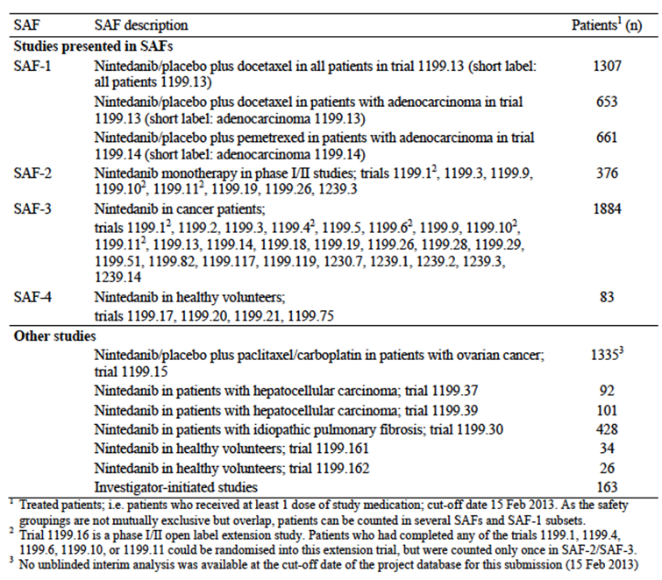

This review will focus on the results from the SAF-1 set. The two studies included in this analysis set were both large, randomised, double blind and placebo controlled trials and are likely to give the most reliable assessment of the safety profile of nintedanib. Within the SAF-1 set, the sponsor presented data for three populations:

* Adenocarcinoma patients in 1199.0013
* All patients in 1199.0013
* Adenocarcinoma patients in 1199.0014.

The two studies collected the following evaluable safety data:

##### Pivotal efficacy study (1199.0013)

In the pivotal efficacy study, the following safety data were collected:

* General adverse events (AEs) were assessed at each clinic visit. AEs were spontaneously reported by the patient. CTCAE criteria (version 3) were used to grade AEs. ‘On treatment’ AEs were defined as those that occurred between the first study drug administration until 28 days after the last administration.
* The following AEs of special interest (AESI) were analysed: possible side effects of nintedanib (nausea, vomiting, abdominal pain, fatigue, dehydration and renal failure, diarrhoea, liver toxicities), potential class effects of VEGF inhibitors, AEs associated with chemotherapy, AEs observed with competitor products, cardiac events, interstitial lung disease, photosensitivity and anaphylactic reactions.
* General physical examination was performed on Day 1 of each cycle.
* Vital signs (BP, pulse, temperature) were measured on Days 1, 8 and 15 of cycle 1 and on Days 1 and 8 of subsequent cycles.
* Laboratory tests, including the following, were collected on Days 1, 8 and 15 of cycle 1 and on Days 1 and 8 of subsequent cycles;
  + Haematology: haemoglobin, white blood cell (WBC) count, ANC, platelets;
  + Biochemistry: glucose, sodium, potassium, calcium, phosphorus, magnesium, creatinine, AST, ALT, ALKP, lactate dehydrogenase, bilirubin (if grade ≥ 1, direct and indirect bilirubin were also determined), urea, total protein, uric acid
  + Coagulation parameters: international normalised ratio (INR), activated partial thromboplastin time (aPTT)
  + Thyroid parameters: thyroid stimulating hormone (TSH), free triiodothyronine (fT3) and free thyroxine (fT4); these were collected on Day 1 of each odd numbered cycle only.
* Urinalysis (pH, glucose, erythrocytes, leukocytes, protein, nitrites) was performed on Day 1 of each cycle.
* ECGs were taken on Day 1 of each cycle.

#### Patient exposure

Exposure to nintedanib and placebo is summarised in Table 31. In total, 1,880 cancer subjects were exposed to nintedanib. Average duration of exposure was short (for example median = 3.38 months in 1199.0013). A total of 146 cancer subjects had received nintedanib for periods > 12 months. Dose intensity was generally > 90%.

Table 31. NSCLC studies – Exposure. Duration of nintedanib/placebo treatment in Phase III trials 1199.13 and 1199.14 (SAF-1) in nintedanib Phase I/II monotherapy trials (SAF-2) and in all patients with cancer treated with nintedanib.

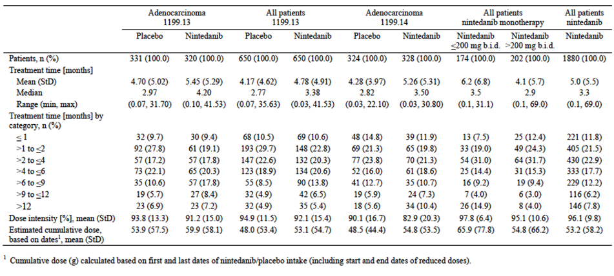

#### Adverse events

The overall safety profile of nintedanib in terms of AEs, SAEs etcetera is summarised in Table 32.

Table 32. NSCLC studies – Overall safety profile.

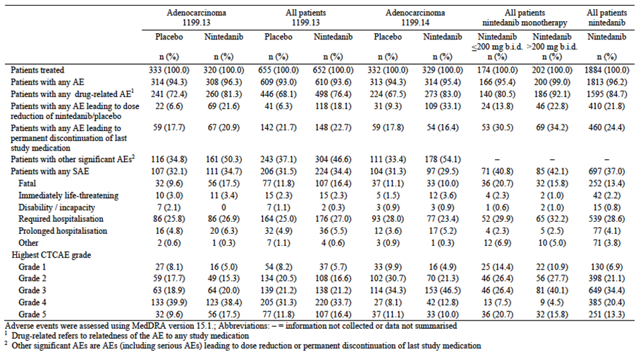

##### All adverse events (irrespective of relationship to study treatment)

The incidence of AEs was high and comparable in nintedanib and placebo groups (for example 93.6% with nintedanib and 93.0% with placebo in Study 1199.0013). Common AEs (that is those with an incidence > 10% in either treatment arm) are shown in Table 33 and Table 34.

**Evaluator’s comment**:

The two studies gave a consistent pattern of common toxicities, with nintedanib treatment being associated with increased incidences of gastrointestinal effects (notably diarrhoea, but also nausea, vomiting, decreased appetite and abdominal pain) and transaminase elevations.

Most of these toxicities were of Grade 1 or 2 in severity. There was a modest increase in the incidence of grade ≥ 3 toxicities with nintedanib (for example 71.3% versus 64.3% in 1199.0013).

Table 33. Study 1199.0013 (Adenocarcinoma patients) – Common AEs.

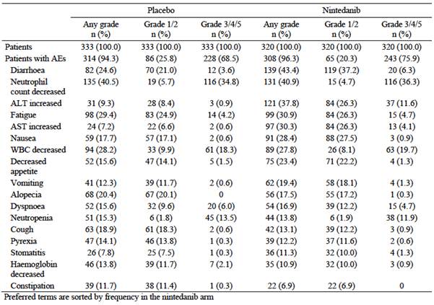

Table 34. Study 1199.0014 (Adenocarcinoma patients) – Common AEs.

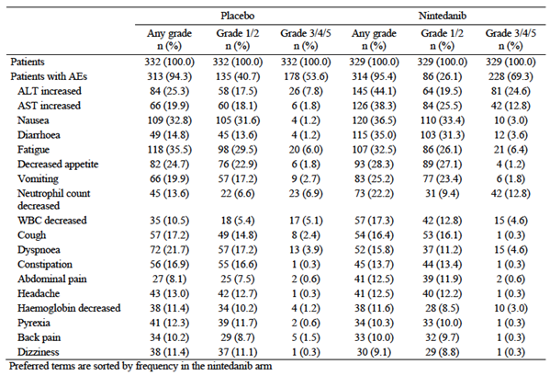

##### Treatment related adverse events (adverse drug reactions)

Drug related AEs included AEs due to docetaxel, nintedanib or placebo. The incidence of drug related AEs was higher in the nintedanib arms than in the placebo arms (for example 76.4% with nintedanib and 68.1% with placebo in Study 1199.0013). Common drug related AEs (that is those with an incidence ≥ 5% in either treatment arm) were provided and those for Study 1199.0013 for Adenocarcinoma patients are shown in Table 35.

Table 35 – Study 1199.0013 (Adenocarcinoma patients) – Drug-related AEs.

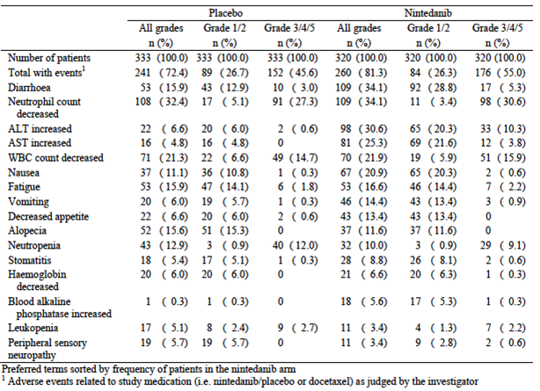

**Evaluator’s comment:**

The pattern of toxicity was consistent with that observed when all AEs were analysed.

##### Deaths and other serious adverse events

An SAE was defined as any AE which resulted in death, was immediately life threatening, resulted in persistent or significant disability/incapacity, required or prolonged patient hospitalisation, was a congenital anomaly/birth defect, or was deemed serious for any other reason representing a significant hazard.

###### Deaths

AEs leading to death were provided and those for Study 1199.0013 for Adenocarcinoma patients are shown in Table 36.

Table 36. Study 1199.0013 (Adenocarcinoma patients) – AEs leading to death.

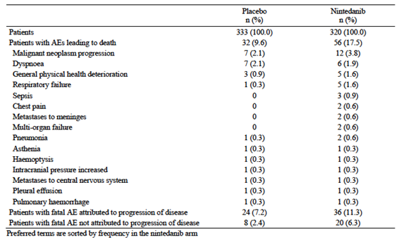

In 1199.0013, there was an increased incidence of fatal AEs with nintedanib (n=107 for nintedanib versus 77 for placebo). Most of these deaths were attributed to disease progression (n = 72 and 52 respectively). However, with the remaining deaths there remained an excess number with nintedanib (35 versus 25). Of these, the only fatal AEs that were notably increased in the nintedanib arm were sepsis/septic shock (7 versus 1 cases) and respiratory failure (4 versus 0 cases). None of the respiratory failure cases were considered drug related.

The 7 cases of fatal sepsis/septic shock in the nintedanib arm were associated with neutropenia in 4 cases. In the other 3 cases haematology results were not available. Most of the cases were considered related to drug treatment by the investigators.

In Study 1199.0014 (adenocarcinoma patients), there were more fatal AEs in the placebo arm (33 versus 38) as shown in Table 37. Again most were attributed to disease progression (18 and 26 respectively) with the number not attributed to disease progression being comparable (15 and 12 respectively). Of these there were no individual AE terms that were notably more common in the nintedanib arm.

Table 37. Study 1199.0014 (Adenocarcinoma patients) – AEs leading to death.

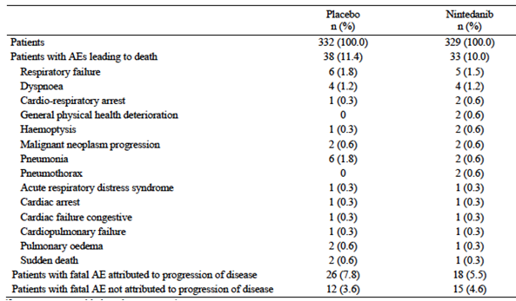

###### Serious AEs (SAEs)

Serious AEs (occurring with an incidence of > 1% in either treatment arm) were provided and those for Study 1199.0013 (Adenocarcinoma patients) are summarised in Table 38.

In both studies the overall incidence of SAEs was comparable in the two treatment arms. The incidences of individual AE terms were also comparable. Serious gastrointestinal and hepatic AEs were not prominent in the nintedanib treatment arms.

Table 38. Study 1199.0013 (Adenocarcinoma patients) – Serious AEs.

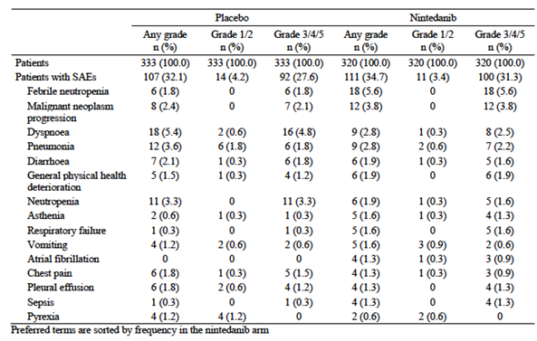

##### Discontinuation due to adverse events

AEs leading to discontinuation of last study drug (occurring with an incidence of > 1% in either treatment arm were provided. A summary for Study 1199.0013 (Adenocarcinoma patients) is shown in Table 39.

In both studies the overall incidence of AEs leading to discontinuation was comparable in the two treatment arms. Discontinuation due to ALT or AST elevation was notably more common in the nintedanib arms. In Study 1199.0013, discontinuation due to diarrhoea was more common with nintedanib.

Table 39. Study 1199.0013 (Adenocarcinoma patients) – AEs leading to discontinuation.

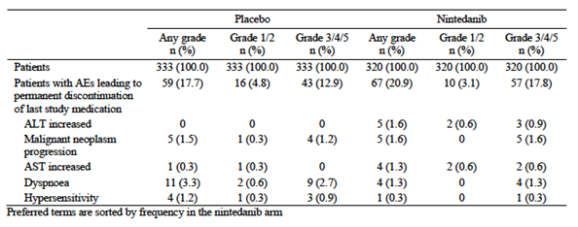

##### Adverse events of special interest (AESI)

AESI were analysed using collections of MEDRA preferred terms. Some were analysed using Standardised MedDRA Queries (SMQs) while others were based on newly created collections of terms. For example, the AESI of ‘fatigue’ was analysed based on several MedDRA terms (asthenia, decreased activity, fatigue, lethargy, etcetera.)

The various AESI analysed by the sponsor were summarised and provided. Notable findings included the following:

* Gastrointestinal toxicity (diarrhoea, nausea/vomiting, abdominal pain) and hepatotoxicity were clearly increased with nintedanib. MedDRA terms suggestive of hepatic failure were also more commonly reported with nintedanib.
* There appeared to be a slight excess of hypertension and venous thromboembolic events with nintedanib compared to placebo. There was no consistent increase in bleeding events, arterial thromboembolism or perforation events.
* Nintedanib treatment was associated with a small but consistent increase in the incidence of grade ≥ 3 neutropaenia and febrile neutropaenia, compared to placebo.
* Nintedanib treatment was associated with a small increase in the incidence of serious skin reactions, compared to placebo.

#### Laboratory tests

##### Liver function

In Study 1199.0013, abnormalities of LFTs were notably more common in the nintedanib arm (Table 40). Two subjects in the nintedanib arm potentially met the criteria for Hy’s Law (ALT and/or AST > 3 x ULN with total bilirubin ≥ 2 x ULN and ALKP < 2 x ULN). One subject had a documented bile duct stone and his LFTs recovered after treatment. Nintedanib treatment was not interrupted. Another subject met the criteria for AST, ALT and bilirubin but did not have a reading for ALKP. However, ALKP was elevated > 2xULN one week earlier. Hepatic metastases were suspected but not documented on scan.

Table 40. Study 1199.0013 (All patients) – LFT abnormalities.

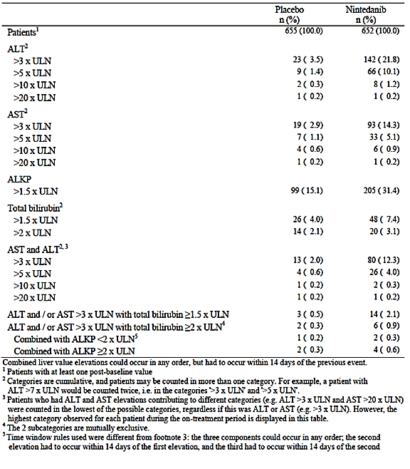

In Study 1199.0014, LFT abnormalities were again more common with nintedanib. There were 7 subjects in the nintedanib arm that potentially met the criteria for Hy’s Law. Of these, alternative explanations for the abnormalities could be found in 6. There was one case that could not be explained by alternative pathology.

##### Kidney function

In Study 1199.0013, elevations of serum creatinine occurred with equal frequency in the nintedanib and placebo arms (23.2% versus 23.9%). None of these were grade 3 or 4. In Study 1199.0014, elevations of serum creatinine occurred with comparable frequency in the nintedanib and placebo arms (21.2% versus 24.3%). There were no grade 3 or 4 elevations in the nintedanib arm.

##### Other clinical chemistry

Electrolyte abnormalities and hypoglycaemia occurred with comparable frequency in the nintedanib and placebo arms of both studies.

##### Haematology

In both studies decreases in neutrophils and white blood cells occurred more frequently with nintedanib. In 1199.0014, decreases in platelets also occurred more frequently in the nintedanib arm.

##### Coagulation parameters

Abnormalities of coagulation parameters (INR, aPTT) occurred with comparable frequency in the two treatment arms in both studies.

##### Thyroid function testing

Abnormalities on thyroid function testing (TSH, free T3, free T4) occurred with comparable frequency in the two treatment arms in both studies.

##### Urinalysis

Abnormalities on urine dipstick testing also occurred with comparable frequency in the nintedanib and placebo arms.

##### Electrocardiograph

Results of ECG testing were not reported.

##### Vital signs

In both studies, mild or moderate elevations in blood pressure occurred more frequently with nintedanib. Average values for pulse rate and temperature were comparable for the two treatment groups.

#### Other safety datasets

The pattern of toxicity observed in the SAF-2 and SAF-3 databases was consistent with that described above. No other cases meeting Hy’s law criteria for liver toxicity were identified.

### IPF

#### Studies providing evaluable safety data

Studies conducted in IPF patients are summarised in Figure 10 and Table 41. Including the open extension trials, approximately 1,350 unique subjects received nintedanib in the submitted studies. Review of safety data in this report will focus on the two pivotal Phase III studies, 1199.0032 and 1199.0034, and the Phase II Study 1199.0030 (150 mg BD dose group). These three studies were double blind, placebo controlled trials of 52 weeks duration.

Figure 10. Studies in IPF subjects.

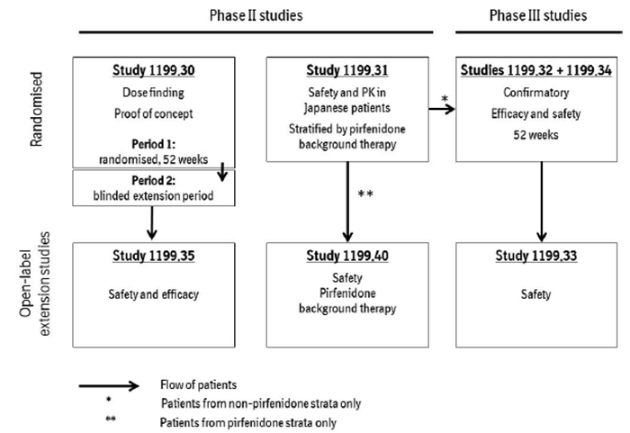

Table 41. Studies in IPF subjects.

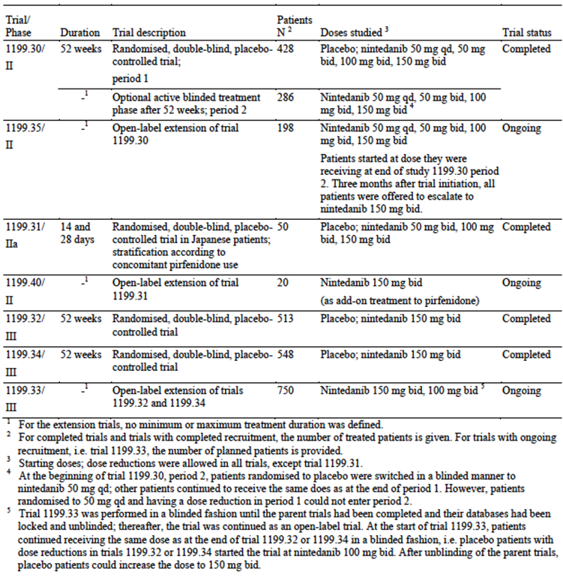

The following safety data were collected during the studies:

##### Pivotal efficacy studies

In the pivotal efficacy studies, the following safety data were collected:

* General adverse events (AEs) were assessed at each clinic visit. Intensity of AEs was graded as mild, moderate or severe.
* The following were designated as AEs of special interest (AESI): abdominal pain, anaphylactic reaction, bilirubin increase, bleeding, cardiac arrhythmias, cardiac failure, cutaneous serious skin reactions, gastrointestinal (GI) perforation, hypertension, hypothyroidism, liver enzyme elevation, liver-related investigation, major adverse cardiovascular event (MACE), osteonecrosis, photosensitivity and photodermatosis conditions, pneumonic infection, rash, renal failure and thromboembolic events (including arterial thromboembolism and venous thromboembolism).
* General physical examination, including measurement of vital signs, was performed at each visit.
* Laboratory tests, including the following, were collected at each visit:
  + Haematology: red blood cell count (RBC), haemoglobin, haematocrit, mean corpuscular volume (MCV), white blood cell count (WBC) and differential, and platelets.
  + Biochemistry: glucose, sodium, potassium, calcium, creatinine, AST, ALT, GGT, total protein, alkaline phosphatase, lactate dehydrogenase, bilirubin (total), uric acid, creatine kinase, brain natriuretic peptide, and thyroid stimulating hormone (TSH) (baseline and end of treatment visit only)
  + Coagulation parameters: international normalised ratio (INR), activated partial thromboplastin time (aPTT).
* Urinalysis (pH, glucose, erythrocytes, leukocytes, protein, nitrites) was performed at each visit.
* ECGs were only taken regularly during the trial for subjects in Japan.

##### Study 1199.0030

Safety monitoring was similar to that used in the pivotal studies.

#### Patient exposure

Extent of exposure in the pivotal studies was provided. Average duration of nintedanib exposure was 10.29 months and 129 subjects received the drug for over 12 months.

Extent of exposure in Study 1199.0030 was provided. Average duration of nintedanib exposure was 9.5 months.

#### Adverse events

An overall summary of adverse events for the pivotal studies is shown in Table 42 and for Study 1199.0030 in Table 43.

Table 42. Studies 1199.0032 and 1199.034 – Overall summary of AEs.

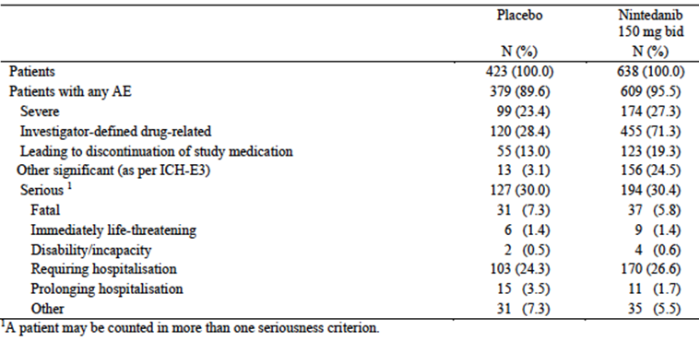

Table 43. Study 1199.0030 - Overall summary of AEs.

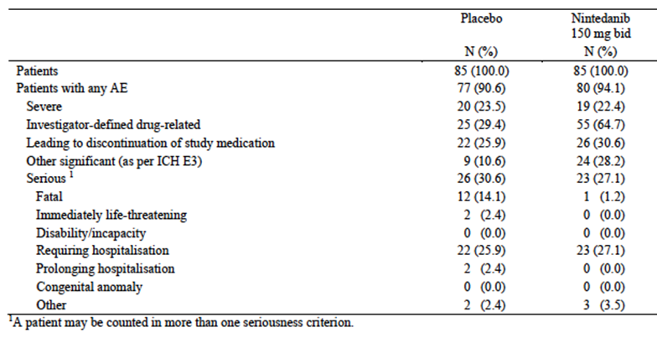

##### All adverse events (irrespective of relationship to study treatment)

###### Pivotal studies

In the pivotal studies nintedanib treatment was associated with a small increase in the overall incidence of AEs (95.5% versus 89.6%). Common AEs (incidence > 5%) were provided. Gastrointestinal toxicity (diarrhoea, nausea and vomiting, abdominal pain, decreased appetite) was far more common with nintedanib than with placebo. Abnormal investigations were also more common with nintedanib. The most common event under this heading was decrease in weight. However LFT abnormalities reported as AEs were also more common with nintedanib.

###### Study 1199.0030

In this study, treatment with nintedanib 150 mg BD also produced a small increase in the overall incidence of AEs compared with placebo (94.1% versus 90.6%). Common AEs (incidence > 10%) were provided. The pattern of AEs was similar to that observed in the pivotal studies.

##### Treatment-related adverse events (adverse drug reactions)

###### Pivotal studies

Drug related AEs were significantly more common with nintedanib than with placebo (71.3% versus 28.4%). Common drug related AEs (incidence > 2%) are shown in Table 44. Gastrointestinal toxicity and hepatotoxicity were again more common with nintedanib.

Table 44. Studies 1199.0032 and 1199.034 – Drug-related AEs (incidence > 2%).

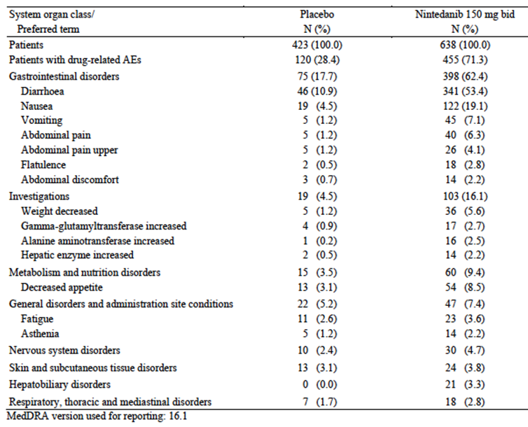

###### Study 1199.0030

Drug related AEs were again significantly more common with nintedanib than with placebo (64.7% versus 29.4%). Common drug related AEs (incidence > 5%) were provided. The pattern of toxicity was similar to that observed in the pivotal studies.

##### AEs leading to death

###### Pivotal studies

The incidence of fatal AEs was lower in the nintedanib arms compared with the placebo arms (5.8% versus 7.3%). None of the deaths in the nintedanib arms were considered drug related by the investigators. AEs with a fatal outcome that occurred in more than 1 subject were provided. There was an excess of subjects with fatal neoplasms with nintedanib (5 versus 0). Three of these patients died from lung neoplasms.

**Evaluator’s comment**:

The overall incidence of neoplasms was not higher in the nintedanib arms (3.6%) compared to the placebo arms (4.3%). The incidence of neoplasms reported as serious AEs was also not increased (2.8% versus 3.5%).

###### Study 1199.0030

The incidence of fatal AEs was decreased in the nintedanib 150 mg BD arm compared to placebo; 1.2% (n = 1) versus 14.1% (n = 12). The death in the nintedanib 150 mg group was due to adenocarcinoma of the lung. One of the deaths in the placebo group was due to NSCLC. None of the deaths were considered related to study treatment.

##### Other serious adverse events

###### Pivotal studies

The incidence of serious AEs was comparable in the two treatment arms (30.4% versus 30.0%). Serious AEs occurring in more than 1% of subjects are listed in Table 45. Serious gastrointestinal and hepatobiliary disorders were more common with nintedanib. There was also a slightly increased incidence of myocardial infarction (1.1% versus 0.5%).

Table 45. Studies 1199.0032 and 1199.034 – Serious AEs (incidence > 1%).

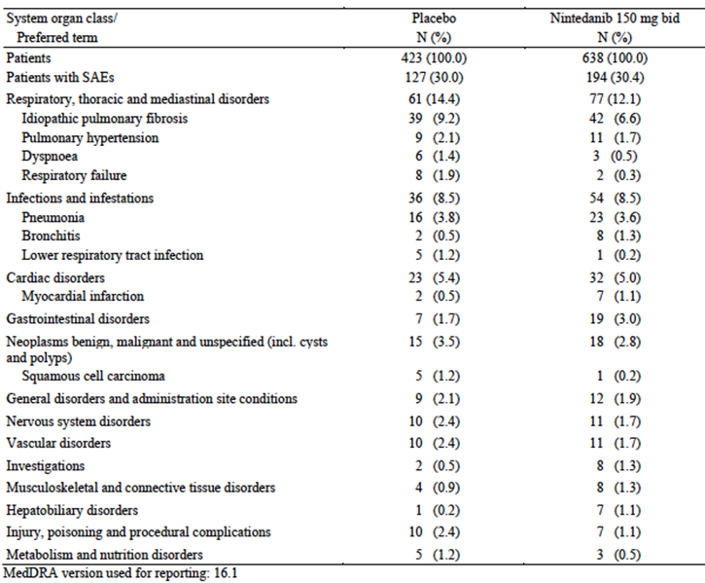

###### Study 1199.0030

Serious AEs were slightly less common in the nintedanib 150 mg BD arm than in the placebo arm (27.1% versus 30.6%). Serious AEs occurring in more than 2% of subjects were provided. Serious gastrointestinal AEs (mainly diarrhoea) were more frequent with nintedanib.

##### Discontinuation due to adverse events

###### Pivotal studies

Discontinuation due to an AE was more common with nintedanib than with placebo (19.3% versus 13.0%). Gastrointestinal events (diarrhoea, nausea) were more common with nintedanib as were hepatobiliary disorders and abnormal investigations (decreased weight and abnormal LFTs).

###### Study 1199.0030

Discontinuation due to an AE was again more common with nintedanib than with placebo (30.6% versus 25.9%). Gastrointestinal events (diarrhoea, nausea) were again more common with nintedanib as were abnormal investigations (decreased weight and abnormal LFTs).

##### Adverse events of special interest (AESI)

###### Pivotal studies

AESI are summarised in Table 46. Notable findings included the following:

* Abdominal pain and hepatotoxicity were clearly increased with nintedanib.
* There were two cases of GIT perforation with nintedanib and none with placebo. GIT perforation is a known AE for other agents that interrupt the VEGF pathway.
* There was an increased incidence of arterial thromboembolic events (ATEs) and major adverse cardiac events (MACE). For both categories, the excess of events was due to an increased incidence of myocardial infarction (Table 47).
* Bleeding events were more common with nintedanib (10.3% versus 7.8%). The most common AE terms were epistaxis and contusion. The incidence of serious bleeding events was comparable (1.3% versus 1.4%).
* Hypertension was more common with nintedanib.

Table 46. Studies 1199.0032 and 1199.034 –AEs of special interest.

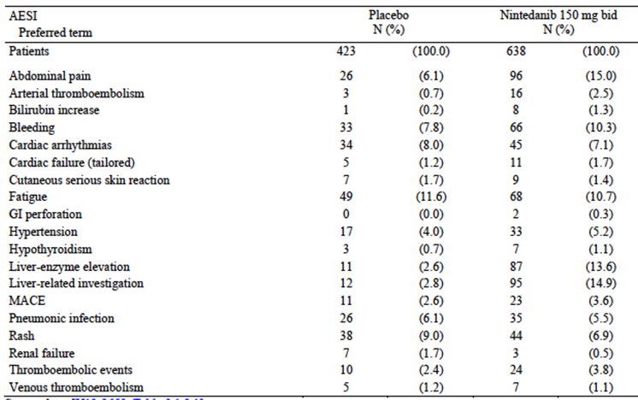

Table 47. Studies 1199.0032 and 1199.034 –ATEs and MACE.

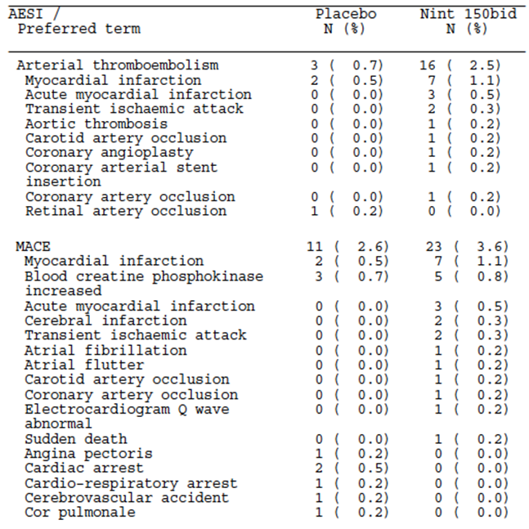

###### Study 1199.0030

There were no AESI specified for Study 1199.0030.

#### Laboratory tests

##### Liver function

###### Pivotal studies

LFT abnormalities occurred more frequently with nintedanib. There were no cases in the nintedanib arm that met the criteria for Hy’s law.

###### Study 1199.0030

Abnormal LFTs were more common with nintedanib 150 mg BD than with placebo. There were no cases in the nintedanib arm that met the criteria for Hy’s law.

##### Kidney function

###### Pivotal studies

Elevations of creatinine occurred more commonly in the placebo arm (2.2% nintedanib 150 mg BD versus 3.4% placebo).

###### Study 1199.0030

Elevations of creatinine occurred more commonly in the placebo arm (1.2% nintedanib 150 mg BD versus 9.5% placebo).

##### Other clinical chemistry

###### Pivotal studies

Abnormalities of other biochemistry variables occurred with comparable frequency in the treatment arms.

###### Study 1199.0030

Hypocalcaemia was more common with nintedanib (23.8% versus 8.3%). However hypocalcaemia was considered to be clinically significant in only 1 nintedanib treated subject. Abnormalities of sodium potassium occurred with comparable frequency.

##### Coagulation parameters

###### Pivotal studies

Prolongations of INR and aPTT occurred with comparable frequency in the study arms.

###### Study 1199.0030

Prolongations of INR and aPTT occurred more frequently in the nintedanib 150 mg BD arm compared with placebo. However, the incidence of clinically significant abnormalities was comparable in the two arms.

##### Haematology

###### Pivotal studies

Nintedanib treatment was associated with an increased incidence of elevated red blood cell mean corpuscular volume (MCV); 24.9% for nintedanib 150 mg BD versus 9.4% for placebo. There was no indication of an increased incidence of anaemia. Other haematology abnormalities occurred with comparable frequency or were more common with placebo treatment.

###### Study 1199.0030

Abnormal haematology values occurred with comparable frequency in the nintedanib 150 mg BD and placebo arms.

##### Thyroid function tests

###### Pivotal studies

Abnormalities of TSH (both increase and decrease) occurred with comparable frequency in the two treatment arms.

###### Study 1199.0030

The numbers of patients who had TSH values was too low (3 in the placebo group and 8 in the nintedanib 150 mg BD group) to allow a meaningful analysis.

##### Electrocardiograph

###### Pivotal studies

ECGs were only collected on subjects in Japan. The sponsor stated that based on these data there was no discernible effect of nintedanib on QT interval.

###### Study 1199.0030

An analysis of ECGs was not presented in the study report.

##### Vital signs

###### Pivotal studies

Differences in mean values for blood pressure and pulse rate were not significant. Marked increases in blood pressure occurred more frequently with nintedanib, as did marked decreases in pulse rate (Table 48). Average weight decreased more in the nintedanib groups compared to placebo (-3.1 kg versus -1.4 kg).

Table 48. Studies 1199.0032 and 1199.034 – Marked changes in vital signs.

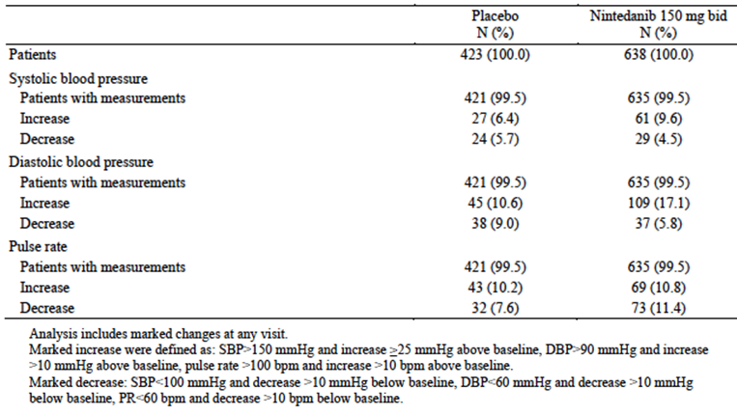

###### Study 1199.0030

Differences in mean values for blood pressure and pulse rate were not significant. Average weight decreased more in the nintedanib 150 mg BD group compared to placebo (-2.2 kg versus -0.7 kg).

#### Other safety datasets

The submission included data from three open extension trials. The studies were not placebo controlled. The pattern of toxicity observed in these studies was consistent with that described above.

### Post-marketing experience

No post-marketing experience data were included in the submission.

### Safety issues with the potential for major regulatory impact

#### Liver toxicity

As described above, hepatotoxicity is a common adverse event with nintedanib. The hepatotoxicity observed in the NSCLC and IPF studies was reversible. There was one case in a NSCLC patient that met the criteria for Hy’s law, which is predictive of a capacity for the drug to cause severe drug-induced liver injury (DILI). The relevant FDA guideline (18) contains the following text:

‘*Finding one Hy’s Law case in the clinical trial database is worrisome; finding two is considered highly predictive that the drug has the potential to cause severe DILI when given to a larger population.’*

Nintedanib may therefore be associated with a risk of severe DILI. Prior to a decision on registration it would be prudent to seek updated information from the sponsor on any further cases that met Hy’s law criteria, or cases of hepatic failure.

#### Haematological toxicity

When co-administered with docetaxel, nintedanib caused an increase in the incidence of neutropenia (see section 9.1.4.4). In the pivotal study there were 2 reports of pancytopenia in the nintedanib group and 1 in the placebo group. In the IPF studies the incidence of cytopaenias was not increased in the nintedanib arm and there were no reports of pancytopenia.

#### Serious skin reactions

In the NSCLC studies, nintedanib treatment was associated with a small increase in the incidence of serious skin reactions, compared to placebo. There were no reports of Stevens-Johnson syndrome (SJS) or toxic epidermal necrolysis (TEN). In the IPF studies, the incidence of serious skin reactions was comparable in the two arms. There were no reports of SJS or TEN.

#### Cardiovascular safety

In the NSCLC studies, nintedanib treatment was associated with a slight increase in the incidence of venous thromboembolic events. There was no consistent increase in the incidence of cardiac events. In the IPF studies there was an increased incidence of myocardial infarction with nintedanib. Otherwise there was no increase in cardiovascular events. In a study conducted in subjects with renal cell cancer, nintedanib did not have an effect on QT interval.

#### Unwanted immunological events

In the NSCLC studies there was no increase in the incidence of anaphylactic reactions with nintedanib. In the IPF studies there were no cases of serious immunological events such as anaphylaxis.

### Other safety issues

#### Safety in special populations

Among nintedanib treated subjects, females experienced higher rates of hepatotoxicity than males. Asian subjects also experienced higher rates of hepatotoxicity compared to non-Asian subjects. The incidence of SAEs increased with increasing age.

### Evaluator’s overall conclusions on clinical safety

In both the NSCLC and IPF populations the most common adverse effects associated with nintedanib were:

* Gastrointestinal (diarrhoea, nausea, vomiting, abdominal pain, decreased appetite, etcetera). These events were very common. However, compared to placebo there was only a small increase in the incidence of severe or life threatening gastrointestinal events.
* Hepatotoxicity. Abnormal LFTs were very common. The abnormalities were reversible and no cases of severe drug induced liver injury were observed in the submitted studies. However one patient developed LFT abnormalities that fulfilled the criteria for Hy’s law.

Hypertension also occurred more frequently with nintedanib treatment in both populations.

In the NSCLC population, where nintedanib was used in combination with chemotherapy, the following toxicities were also more common with nintedanib:

* Venous thromboembolic events
* Neutropenia, febrile neutropenia and fatal sepsis
* Serious skin reactions.

In the IPF population, the following toxicities were also more common with nintedanib:

* Arterial thromboembolic events, most commonly myocardial infarction
* Decreased weight
* Bleeding events
* GI perforation.

Many of these toxicities are consistent with those previously observed for drugs which interrupt the VEGF/VEGFR pathway.

In the pivotal study in NSCLC, nintedanib treatment resulted in only a small increase in the proportion of patients who experienced a serious AE (versus placebo) (34.4% versus 31.5%) or a grade ≥ 3 AE (71.3% versus 64.3%). There was an increase in the incidence of fatal AEs in the nintedanib arm (16.4% versus 11.8%). However most of these were related to disease progression and of the remainder, only an increased incidence of fatal sepsis (7 versus 1 cases) appeared related to nintedanib. The overall increase in toxicity produced by the addition of nintedanib to docetaxel is considered modest. The proportion of subjects who discontinued treatment due to AEs was only slightly increased in the nintedanib arm (22.7% versus 21.7%). This suggests that nintedanib toxicity is manageable with dose reductions and interruptions.

In the pivotal IPF studies, nintedanib treatment resulted in only a small increase in the overall incidence of adverse events (versus placebo) (95.5% versus 89.6%) with no increase in the incidence of serious AEs (30.4% versus 30.0%) and a small increase in the incidence of AEs classified as severe (27.3% versus 23.4%). There was no increase in the incidence of fatal AEs. The overall toxicity of the drug in IPF can therefore be considered to be modest. The proportion of subjects who had to discontinue treatment due to AES was modestly increased (19.3% versus 13.0%).

## First round benefit-risk assessment

### First round assessment of benefits

The benefits of nintedanib in the treatment of NSCLC with adenocarcinoma histology, in combination with docetaxel, are:

* A decreased risk of death with an increase in median survival of approximately 2.3 months, when compared to docetaxel monotherapy

The benefits of nintedanib in the treatment of IPF are:

* A delay in disease progression, manifested by improved FVC compared to placebo.

### First round assessment of risks

The risks of nintedanib in the treatment of NSCLC with adenocarcinoma histology, in combination with docetaxel, are:

* Gastrointestinal toxicity
* Hepatotoxicity
* Hypertension
* Venous thromboembolic events
* Neutropenia leading to febrile neutropenia and sepsis
* Serious skin reactions.

The risks of nintedanib in the treatment of IPF are:

* Gastrointestinal toxicity
* Hepatotoxicity
* Hypertension;
* Arterial thromboembolic events such as myocardial infarction
* Decreased weight
* Bleeding events
* GI perforation.

### First round assessment of benefit-risk balance

For the treatment of NSCLC with adenocarcinoma histology, in combination with docetaxel the benefits of nintedanib are clinically significant with an average prolongation of survival of approximately two months in a population of patients with an average survival of only 10 months. This benefit is considered to outweigh the modest additional toxicity that the drug causes. Therefore the benefit-risk balance of nintedanib in this setting is considered favourable.

For the treatment of mild to moderate IPF, the benefits of nintedanib are clinically significant, with a delay in the progression of a life threatening condition, for which there are currently no effective therapies available in Australia. This benefit is considered to outweigh the modest toxicity that the drug produces. The benefit-risk balance of nintedanib in this setting is therefore considered favourable.

## First round recommendation regarding authorisation

It is recommended that the application be approved for the following indications:

* *In combination with docetaxel, for the treatment of patients with locally advanced, metastatic or recurrent non-small cell lung cancer (NSCLC) of adenocarcinoma tumour histology after first line chemotherapy; and*
* *The treatment of mild to moderate Idiopathic Pulmonary Fibrosis (IPF).*

## Clinical questions

### Pharmacokinetics

Please provide a summary of any available data from the ongoing studies 1199.0037, 1199.0039 and 1199.0120 on the effect of hepatic impairment on the PK of nintedanib.

### Safety

The submitted studies identified one case that met the criteria for Hy’s law, which is predictive of severe drug induced liver injury. Please provide details of any further cases that have been identified, as well as any new cases of hepatic failure.

## Second round evaluation of clinical data submitted in response to questions

### Effect of hepatic impairment on PK of nintedanib

The sponsor indicated that PK data from the three identified studies are not yet available. The sponsor also identified another relevant study (1199.0200). This study is a single dose study in volunteers with hepatic impairment (Child Pugh A and B) who are otherwise healthy, and matched healthy controls. A summary report of these studies is expected to be available in July 2015.

### Drug-induced liver injury

#### Hy’s law cases

* For oncology subjects, the sponsor provided updated data from the previously submitted oncology studies together with data from an interim safety analysis of an ongoing study in ovarian cancer (Study 1199.0015). A total of approximately 2,800 subjects had been treated in these studies. One additional case was identified (subject [information redacted] in Study 1199.0015) that fulfilled the criteria for Hy’s law, without any other identifiable cause. The total number of such cases therefore is two.
* For IPF subjects, no cases fulfilling Hy’s law criteria were identified in an updated safety analysis of ongoing IPF studies. There have therefore been no cases reported among IPF subjects.

#### Hepatic failure

The sponsor searched its safety databases with a standardised MedDRA query (SMQ) entitled ‘hepatic failure, fibrosis and cirrhosis, and other liver damage related conditions, broad’. This SMQ includes several terms that do not necessarily indicate severe liver dysfunction (for example ‘hepatotoxicity’, ‘liver disorder’, ‘hepatocellular injury’ etcetera.). The sponsor presented a review of the cases retrieved. This demonstrated that none of the cases met stringent criteria for liver failure (increases in transaminases with hepatocellular jaundice and subsequent INR increase, hypoproteinaemia, encephalopathy, coma, death). In most cases the AEs were considered related to underlying malignancy. None were consistent with severe DILI induced by nintedanib.

## Second round benefit-risk assessment

### Second round assessment of benefits

No new clinical efficacy information was submitted in response to questions. Accordingly, the benefits of nintedanib are unchanged from those identified in the first round assessment of benefits.

### Second round assessment of risks

The sponsor identified one additional patient with LFT abnormalities meeting Hy’s Law criteria, without any identifiable cause (apart from nintedanib). A total of two such cases have been identified, both in subjects with advanced malignancy. It is therefore possible that nintedanib may be associated with severe DILI, although no such cases have been reported. The issue will need to be monitored closely in the post market setting.

After consideration of the responses to clinical questions, the risks of nintedanib in the proposed usage are essentially unchanged from those identified in the first round assessment of risks.

### Second round assessment of benefit-risk balance

Both advanced NSCLC and IPF are serious life-threatening conditions. Even if nintedanib were to be associated with rare cases of severe DILI, the overall benefit-risk balance of the drug is still considered favourable.

## Second round recommendation regarding authorisation

It is recommended that the application for registration be approved. The wording of the indication is discussed further below.

## References

1. Raghu G, Collard HR, Egan JJ et al. An official ATS/ERS/JRS/ALAT statement: idiopathic pulmonary fibrosis: evidence-based guidelines for diagnosis and management. Am J Respir Crit Care Med. 2011; 183(6): 788-824.
2. National Institute for Health and Care Excellence (NICE). The diagnosis and management of suspected idiopathic pulmonary fibrosis (clinical guideline 163). 2013;
3. European Medicines Agency. Guideline on the evaluation of anticancer medicinal products in man. EMA/CHMP/205/95/Rev.4 (2012).
4. European Medicines Agency. Appendix 1 to the guideline on the evaluation of anticancer medicinal products in man. Methodological consideration for using progression-free survival (PFS) or disease-free survival (DFS) in confirmatory trials. EMA/CHMP/27994/2008/Rev.1 (2012).
5. European Medicines Agency. Appendix 4 to the guideline on the evaluation of anticancer medicinal products in man. Condition Specific Guidance EMA/CHMP/703715/2012 (2012).
6. European Medicines Agency. Points to consider on application with 1. Meta-analyses; 2. One pivotal study. CPMP/EWP/2330/99 (2001).
7. European Medicines Agency. Note for Guidance on Clinical Evaluation of QT/QTc Interval Prolongation and Proarrhythmic Potential for Non-Antiarrhythmic Drugs (CHMP/ICH/2/04); 2005.
8. Food and Drug Administration. News Release. FDA Approves Ofev to treat idiopathic pulmonary fibrosis. October 15 2014.
9. European Medicines Agency. Summary of opinion (initial authorisation) – Vargatef (nintedanib). 25 September 2014.
10. Reck M, Kaiser R, Mellemgaard A et al. Docetaxel plus nintedanib versus docetaxel plus placebo in patients with previously treated non-small-cell lung cancer (LUME-Lung 1): a phase 3, double-blind, randomised controlled trial. Lancet Oncol 2014; 15: 143–55.
11. American Joint Committee on Cancer. Lung Cancer Staging. 7th edition. 2012.
12. Therasse P, Arbuck SG, Eisenhauer EA et al. New guidelines to evaluate the response to treatment in solid tumors. European Organization for Research and Treatment of Cancer, National Cancer Institute of the United States, National Cancer Institute of Canada. J Natl Cancer Inst. 2000; 92 (3): 205-16.
13. Richeldi L, du Bois RM, Raghu G et al. Efficacy and safety of nintedanib in idiopathic pulmonary fibrosis. N Engl J Med. 2014; 370(22): 2071-82.
14. Richeldi L, Costabel U, Selmen M et al. Efficacy of a Tyrosine Kinase Inhibitor in Idiopathic Pulmonary Fibrosis. N Engl J Med 2011; 365: 1079-87.
15. Raghu G, Collard HR, Anstrom KJ et al. Idiopathic pulmonary fibrosis: clinically meaningful primary endpoints in phase 3 clinical trials. Am J Respir Crit Care Med. 2012; 185 (10): 1044-8.
16. du Bois RM, Nathan SD, Richeldi L et al. Idiopathic Pulmonary Fibrosis - Lung Function Is a Clinically Meaningful Endpoint for Phase III Trials. Am J Respir Crit Care Med. 2012; 186 (8): 712–715.
17. du Bois RM, Weycker D, Albera C et al. Forced vital capacity in patients with idiopathic pulmonary fibrosis: test properties and minimal clinically important difference. Am J Respir Crit Care Med. 2011; 184 (12): 1382-9.
18. Food and Drug Administration. Guidance for Industry - Drug-Induced Liver Injury: Premarketing Clinical Evaluation (2009).

|  |
| --- |
| Therapeutic Goods Administration |
| PO Box 100 Woden ACT 2606 Australia  Email: [info@tga.gov.au](mailto:info@tga.gov.au) Phone: 1800 020 653 Fax: 02 6232 8605  [**https://www.tga.gov.au**](https://www.tga.gov.au) |

1. Erratum: 50%