PRODUCT INFORMATION

OPDIVO ®

**(nivolumab)**

**10mg per 1mL concentrate solution for infusion**

# WARNING: IMMUNE-RELATED ADVERSE REACTIONS WITH OPDIVO AND YERVOY (IPILIMUMAB) COMBINATION THERAPY.

More frequent and more serious immune-related adverse reactions are seen with OPDIVO and YERVOY combination therapy than with the use of OPDIVO or YERVOY monotherapy. Potentially life-threatening immune-related adverse reactions including pneumonitis, hepatitis, diarrhoea/colitis, skin adverse reactions, hypophysitis and thyroid dysfunction as well as immune related adverse reactions in other organ systems have been observed.

Physicians should consult the YERVOY product information prior to initiation of OPDIVO in combination with YERVOY.

It is recommended that the combination of OPDIVO and YERVOY should be administered and monitored under the supervision of physicians experienced with the use of immunotherapy in the treatment of unresectable or metastatic melanoma.

Early diagnosis and appropriate management are essential to minimise life-threatening complications (see PRECAUTIONS, ADVERSE EFFECTS and DOSAGE & ADMINISTRATION).

# NAME OF THE MEDICINE

OPDIVO ® (nivolumab): 10 mg/mL concentrate solution for infusion

Each 1 mL of concentrate contains 10 mg of nivolumab.

One 10 mL vial contains 40 mg of nivolumab in 4mL.

One 10 mL vial contains 100 mg of nivolumab in 10mL.

# DESCRIPTION

CAS: 946414-94-4. OPDIVO (nivolumab (rch)) is a fully human anti-PD-1 monoclonal antibody (IgG4) produced in mammalian (Chinese hamster ovary) cells by recombinant DNA technology.

Clear to opalescent, colorless to pale yellow liquid for intravenous infusion that may contain few light particles. The solution has a pH of approximately 6.0 and an osmolality of approximately 340 mOsm/kg.

Each 1 milliliter contains 10 mg of nivolumab and 0.1mmol sodium (or 2.50mg sodium).

Inactive ingredients are: sodium citrate, sodium chloride, mannitol (E421), pentetic acid (diethylenetriaminepentaacetic acid), polysorbate 80, sodium hydroxide (for pH‑adjustment), hydrochloric acid (for pH‑adjustment), water for injections.

# PHARMACOLOGY

## Mechanism of action

Nivolumab is a fully human immunoglobulin G4 (IgG4) monoclonal antibody (HuMAb) which binds to programmed death-1 (PD-1) receptor and blocks its interaction with the ligands PD‑L1 and PD‑L2. The PD-1 receptor is a negative regulator of T-cell activity. Engagement of PD-1 with PD-L1 and PD-L2, which are expressed in antigen presenting cells and may be expressed by tumours or other cells in the tumour microenvironment, results in inhibition of T-cell proliferation and cytokine secretion. Nivolumab potentiates T-cell responses, including anti-tumour responses, through blockade of PD1 binding to PD-L1 and PD-L2 ligands. In syngeneic mouse models, blocking PD‑1 activity resulted in decreased tumour growth.

Combined nivolumab (anti-PD-1) and ipilimumab (anti-CTLA-4) mediated inhibition results in enhanced T-cell function that is greater than the effects of either antibody alone, and results in improved anti-tumour responses in metastatic melanoma. In murine syngeneic tumour models, dual blockade of PD-1 and CTLA-4 resulted in synergistic anti-tumour activity.

## Cardiac Electrophysiology

The potential effect of nivolumab on QTc interval was evaluated in 146 patients at doses up to 10 mg/kg every three weeks. No changes in mean QT interval were detected in nivolumab-treated patients based on Fridericia correction method.

Ipilimumab did not have a clinically meaningful effect on the QTc interval at doses up to 10mg/kg. Thus, QT interval prolongation is not expected with the nivolumab and ipilimumab combination.

## Immunogenicity

As with all therapeutic proteins, there is a potential for an immunogenic response to nivolumab.

## Nivolumab Monotherapy:

In a pooled analysis of 1586 patients who were treated with nivolumab 3 mg/kg every 2 weeks and evaluable for the presence of anti‑product‑antibodies, 157 patients (9.9%) tested positive for treatment‑emergent anti‑product‑antibodies by an electrochemiluminescent (ECL) assay. Only 2 (0.1%) patients were persistent positive. Neutralising antibodies were detected in only 9 (0.6% of the total) of the positive anti‑product‑antibody patients. There was no evidence of altered pharmacokinetic profile, or toxicity profile associated with anti‑product‑antibody development. Neutralising antibodies were not associated with loss of efficacy.

## Nivolumab in Combination with Ipilimumab:

Of 394 patients who were treated with nivolumab in combination with ipilimumab and evaluable for the presence of anti-nivolumab antibodies, 149 patients (37.8%) tested positive for treatment‑emergent anti-nivolumab antibodies by an ECL assay. Neutralising antibodies were detected in 18 patients (4.6%). Of 391 patients who were treated with nivolumab in combination with ipilimumab and evaluable for the presence of anti-ipilimumab antibodies, 33 patients (8.4%) tested positive for treatment-emergent anti-ipilimumab antibodies by an ECL assay. One (0.3%) patient had neutralising antibody detected. There was no evidence of altered toxicity profile associated with anti-product antibody development. Neutralising antibodies were not associated with loss of efficacy.

# PHARMACOKINETICS

Nivolumab pharmacokinetics (PK) was assessed using a population PK approach for both single-agent nivolumab and nivolumab in combination with ipilimumab.

## Nivolumab Monotherapy

The pharmacokinetics (PK) of nivolumab is linear in the dose range of 0.1 to 10 mg/kg. The exposure to nivolumab increased dose proportionally over the dose range of 0.1 to 10 mg/kg administered every 2 weeks.

Based on a population PK analysis, using data predominantly from patients with melanoma, NSCLC and RCC, the geometric mean clearance (CL), terminal half-life, and average exposure at steady state at 3 mg/kg every 2 weeks of nivolumab were 9.5 mL/h, 26.7 days, and 75.3 μg/mL, respectively.

Steady-state concentrations of nivolumab were reached by 12 weeks when administered at 3 mg/kg every 2 weeks, and systemic accumulation was approximately 3-fold.

In patients with cHL, nivolumab clearance was lower resulting in a 15 day increase in the half-life and a 43% increase in exposure (as measured by median Cavgss). The lower nivolumab clearance was not considered clinically meaningful; there was a flat predicted exposure-response relationship.

Nivolumab CL increased with increasing body weight. Body weight normalised dosing produced approximately uniform steady‑state trough concentration over a wide range of body weights (34‑162 kg).

The metabolic pathway of nivolumab has not been characterised. As a fully human IgG4 monoclonal antibody, nivolumab is expected to be degraded into small peptides and amino acids via catabolic pathways in the same manner as endogenous IgG.

## Nivolumab in combination with ipilimumab

In the nivolumab and ipilimumab combination, nivolumab 1mg/kg had no effect on the clearance of ipilimumab, and ipilimumab 3mg/kg had a 24% increase in clearance of nivolumab based on a population PK analysis.

In the nivolumab and ipilimumab combination, the clearance of nivolumab increased by 42% in the presence of anti-nivolumab antibody based on a population PK analysis. There was no effect of anti-ipilimumab antibodies on the clearance of ipilimumab based on a population PK analysis.

## Special populations

A population PK analysis suggested no difference in CL of nivolumab based on age, gender, race, tumour size, and hepatic impairment. Although ECOG status, baseline glomerular filtration rate (GFR), body weight, and mild hepatic impairment had an effect on nivolumab CL, the effect was not clinically meaningful.

Patients with lower baseline serum albumin tended to have lower exposure to nivolumab. However, because of the flat exposure-response relationship between nivolumab exposure and overall survival, this effect is unlikely to be clinically meaningful and no dose adjustment is recommended for patients with lower serum albumin.

## Renal impairment

The effect of renal impairment on the CL of nivolumab was evaluated in patients with mild (GFR < 90 and ≥ 60 mL/min/1.73 m2; n = 379), moderate (GFR < 60 and ≥ 30 mL/min/1.73 m2; n = 179), or severe (GFR < 30 and ≥ 15 mL/min/1.73 m2; n = 2) renal impairment compared to patients with normal renal function (GFR ≥ 90 mL/min/1.73 m2; n = 342) in population PK analyses. No clinically important differences in the CL of nivolumab were found between patients with mild or moderate renal impairment and patients with normal renal function. There were insufficient data to determine the effect of severe renal impairment on the CL of nivolumab (see PRECAUTIONS and DOSAGE AND ADMINISTRATION).

## Hepatic impairment

The effect of hepatic impairment on the CL of nivolumab was evaluated in patients with mild hepatic impairment (total bilirubin 1.0 × to 1.5 × ULN or AST > ULN as defined using the National Cancer Institute criteria of hepatic dysfunction; n = 92) compared to patients with normal hepatic function (total bilirubin and AST ≤ ULN; n = 804) in the population PK analyses. No clinically important differences in the CL of nivolumab were found between patients with mild hepatic impairment and normal hepatic function. Nivolumab has not been studied in patients with moderate (total bilirubin > 1.5 × to 3 × ULN and any AST) or severe hepatic impairment (total bilirubin > 3 × ULN and any AST) (see PRECAUTIONS and DOSAGE AND ADMINISTRATION).

# CLINICAL TRIALS

The nivolumab clinical trial program are based on patients who received nivolumab 3 mg/kg monotherapy every two weeks in 10 clinical studies including: advanced melanoma (one Phase 1 study CA209003 and two Phase 3 studies, CA209037, CA209066), SQ NSCLC (Phase 1 study CA209003, Phase 2 study CA209063, Phase 3 study CA209017), NS NSCLC (one Phase 3 study CA209057), RCC (Phase 3 study CA209025) and cHL (one Phase 2 study CA209205 and one Phase 1 study CA209039).

The nivolumab clinical trial program also includes patients who received OPDIVO in combination with ipilimumab in three clinical studies in advanced melanoma (CA209067, CA209069, and CA209004-cohort 8).

# UNRESECTABLE OR METASTATIC MELANOMA

## OPDIVO MONOTHERAPY

**Study CA209066. A randomised phase 3 study comparing OPDIVO monotherapy to dacarbazine in subjects with previously untreated unresectable or metastatic melanoma.**

The safety and efficacy of nivolumab 3 mg/kg as monotherapy for the treatment of advanced (unresectable or metastatic) melanoma were evaluated in a phase 3, randomised, double-blind study (CA209066). The study included adult patients (18 years or older) with confirmed, treatment-naive, Stage III or IV BRAF wild-type melanoma and an ECOG performance-status score of 0 or 1. Patients with active autoimmune disease, ocular melanoma, or active brain or leptomeningeal metastases were excluded from the study.

A total of 418 patients were randomised to receive either nivolumab (n = 210) administered intravenously over 60 minutes at 3 mg/kg every 2 weeks or dacarbazine (n = 208) at 1000 mg/m2 every 3 weeks. Randomisation was stratified by tumour PD-L1 status and M stage (M0/M1a/M1b versus M1c). Treatment was continued as long as clinical benefit was observed or until treatment was no longer tolerated. Treatment after disease progression was permitted for patients who had a clinical benefit and did not have substantial adverse effects with the study drug, as determined by the investigator. Tumour assessments, according to the Response Evaluation Criteria in Solid Tumours (RECIST), version 1.1, were conducted 9 weeks after randomisation and continued every 6 weeks for the first year and then every 12 weeks thereafter. The primary efficacy outcome measure was overall survival (OS). Key secondary efficacy outcome measures were investigator-assessed progression free survival (PFS) and objective response rate (ORR).

Baseline characteristics were balanced between the two groups. The median age was 65 years (range: 18-87), 59% were men, and 99.5% were white. Most patients had ECOG performance score of 0 (64%) or 1 (34%). Sixty-one percent of patients had M1c stage disease at study entry. Seventy-four percent of patients had cutaneous melanoma, and 11% had mucosal melanoma; 35% of patients had PD-L1 positive melanoma (>5% tumour cell membrane expression). Sixteen percent of patients had received prior adjuvant therapy; the most common adjuvant treatment was interferon (9%). Four percent of patients had a history of brain metastasis, and 37% of patients had a baseline LDH level greater than ULN at study entry.

The observed OS (Figure 1, Table 1) benefit was consistently demonstrated across subgroups of patients including baseline ECOG performance status, M stage, history of brain metastases, and baseline LDH level. Survival benefit was observed regardless of whether PD‑L1 expression was above or below a PD‑L1 tumour membrane expression cut‑off of 5% or 10%.

Figure 1: Kaplan-Meier Curves of OS (CA209066)

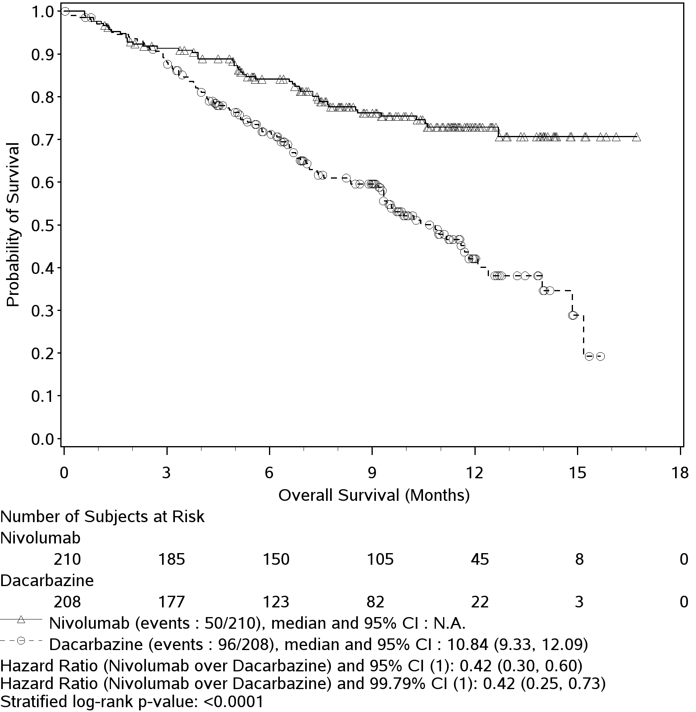

──∆─── Nivolumab (events: 50/210), median and 95% CI: N.A.  
- - -🔿- - - Dacarbazine (events: 96/208), median 10.84 months 95% CI: (9.33, 12.09)  
Table 1: Efficacy Results (CA209066)

|  | **nivolumab (n = 210)** | | **dacarbazine (n = 208)** | |
| --- | --- | --- | --- | --- |
| **Overall survival** | | | | |
| Events | 50 (23.8%) | | 96 (46.2%) | |
| Hazard ratio | 0.42 | | | |
| 99.79% CI | (0.25, 0.73) | | | |
| 95% CI | (0.30, 0.60) | | | |
| p-value | < 0.0001 | | | |
|  |  |  |  |  |
| Median (95% CI) | Not reached | | 10.8 (9.33, 12.09) | |
| Rate % (95% CI) |  |  |  |  |
| At 6 months | 84.1 (78.3, 88.5) | | 71.8 (64.9, 77.6) | |
| At 12 months | 72.9 (65.5, 78.9) | | 42.1 (33.0, 50.9) | |
| **Progression-free survival** |  |  |  |  |
| Events | 108 (51.4%) | | 163 (78.4%) | |
| Hazard ratio | 0.43 | | | |
| 95% CI | (0.34, 0.56) | | | |
| p-value | < 0.0001 | | | |
|  |  |  |  |  |
| Median (95% CI) | 5.1 (3.48, 10.81) | | 2.2 (2.10, 2.40) | |
| Rate % (95% CI) |  |  |  |  |
| At 6 months | 48.0 (40.8, 54.9) | | 18.5 (13.1, 24.6) | |
| At 12 months | 41.8 (34.0, 49.3) | | NA | |
|  |  |  |  |  |
| **Objective response** | 84 | (40.0%) | 29 | (13.9%) |
| (95% CI) | (33.3, 47.0) | | (9.5, 19.4) | |
| Odds ratio (95% CI) | 4.06 (2.52, 6.54) | | | |
| p-value | < 0.0001 | | | |
|  |  |  |  |  |
| Complete response (CR) | 16 | (7.6%) | 2 | (1.0%) |
| Partial response (PR) | 68 | (32.4%) | 27 | (13.0%) |
| Stable disease (SD) | 35 | (16.7%) | 46 | (22.1%) |
|  |  |  |  |  |
| **Median duration of response** | | | | |
| Months (range) | Not reached | (0+- 12.5+) | 6.0 | (1.1 - 10.0+) |
|  |  |  |  |  |
| **Median time to response** |  |  |  |  |
| Months (range) | 2.1 | (1.2 - 7.6) | 2.1 | (1.8-3.6) |

**Study CA209037. A randomised phase 3 study comparing OPDIVO monotherapy to chemotherapy in subjects with unresectable or metastatic melanoma following progression on anti-CTLA-4 therapy.**

The safety and efficacy of OPDIVO 3 mg/kg as monotherapy for the treatment of advanced (unresectable or metastatic) melanoma were evaluated in a phase 3, randomised, open-label study (CA209037). The study included adult patients who had progressed on or after ipilimumab and if BRAF V600 mutation positive had also progressed on or after BRAF kinase inhibitor therapy. Patients with active autoimmune disease, ocular melanoma, or a known history of prior ipilimumab-related high-grade (Grade 4 per CTCAE v4.0) adverse reactions except for resolved nausea, fatigue, infusion reactions, or endocrinopathies were excluded from the study.

A total of 405 patients were randomised to receive either nivolumab (n = 272) administered intravenously over 60 minutes at 3 mg/kg every 2 weeks or chemotherapy (n = 133) which consisted of the investigator’s choice of either dacarbazine (1000 mg/m2 every 3 weeks) or carboplatin (AUC 6 every 3 weeks) and paclitaxel (175 mg/m2 every 3 weeks). Randomisation was stratified by BRAF and tumour PD-L1 status and best response to prior ipilimumab.

The co-primary efficacy outcome measures were confirmed ORR in the first 120 patients treated with nivolumab, as measured by independent radiology review committee (IRRC) using RECIST 1.1, and comparison of OS of nivolumab to chemotherapy. Additional outcome measures included duration and timing of response.

The median age was 60 years (range: 23-88). Sixty-four percent of patients were men and 98% were white. ECOG performance scores were 0 for 61% of patients and 1 for 39% of patients. The majority (75%) of patients had M1c stage disease at study entry. Seventy-three percent of patients had cutaneous melanoma and 10% had mucosal melanoma. The number of prior systemic regimen received was 1 for 27% of patients, 2 for 51% of patients, and > 2 for 21% of patients. Twenty-two percent of patients had tumours that tested BRAF mutation positive and 50% of patients had tumours that were considered PD-L1 positive. Sixty-four percent of patients had no prior clinical benefit (CR/PR or SD) on ipilimumab. Baseline characteristics were balanced between groups except for the proportions of patients who had a history of brain metastasis (19% and 13% in the nivolumab group and chemotherapy group, respectively) and patients with LDH greater than ULN at baseline (51% and 35%, respectively).

At the time of this final ORR analysis, results from 120 nivolumab-treated patients and 47 chemotherapy-treated patients who had a minimum of 6 months of follow-up were analysed. Efficacy results are presented in Table 2.

Table 2 Best overall response, time, and duration of response (CA209037)

|  | | nivolumab (n=120) | chemotherapy (n=47) | |
| --- | --- | --- | --- | --- |
| **Confirmed Objective Response** (IRRC) | | 38 (31.7%) | 5 (10.6%) | |
| (95% CI) | | (23.5, 40.8) | (3.5, 23.1) | |
| Complete Response (CR) | | 4 (3.3%) | 0 | |
| Partial Response (PR) | | 34 (28.3%) | 5 (10.6%) | |
| Stable Disease (SD) | | 28 (23.3%) | 16 (34.0%) | |
| **Median Duration of Response** | |  |  |  |
| Months (range) | Not Reached | | 3.6 (Not available) | |
| **Median Time to Response** | |  |  |  |
| Months (range) | | 2.1 (1.6‑7.4) | 3.5 (2.1‑6.1) | |

Objective responses to nivolumab (according to the definition of the co-primary endpoint) were observed in patients with or without BRAF mutation-positive melanoma. Of the patients who received nivolumab, the ORR in the BRAF mutation-positive subgroup (n = 26) was 23% (95% CI: 9.0, 43.6), and 34% (95% CI: 24.6, 44.5) in patients whose tumours were BRAF wild-type (n = 94). Objective responses to nivolumab were observed regardless of whether patients had tumours that were designated PD-L1 negative or PD-L1 positive (tumour membrane expression cut off of 5% or 10%). However, the role of this biomarker (tumour PD-L1 expression) has not been fully elucidated.

The OS data were not mature at the time of the PFS analysis. There was no statistically significant difference between nivolumab and chemotherapy in the preliminary OS analysis that was not adjusted for the potentially confounding effects of subsequent therapy. It is of note that 42 (31.6%) patients in the chemotherapy arm subsequently received an anti-PD1 treatment.

PFS numerically favoured the nivolumab group vs. the chemotherapy group in all randomised patients, BRAF mutation positive patients, and BRAF wild-type patients (HRs 0.74 [95% CI: 0.57,

0.97], 0.98 [95% CI: 0.56, 1.70], and 0.63 [95% CI: 0.47, 0.85], respectively).

**Study MDX1106-03. Open-label phase 1 dose-escalation study**

The safety and tolerability of OPDIVO were investigated in a phase 1, open-label dose-escalation study in various tumour types, including malignant melanoma. Of the 306 patients enrolled in the study, 107 had melanoma and received OPDIVO at a dose of 0.1 mg/kg, 0.3 mg/kg, 1 mg/kg, 3 mg/kg, or 10 mg/kg for a maximum of 2 years. In this patient population, objective response was reported in 33 patients (31%) with a median duration of response of 22.9 months (95% CI: 17.0, NR). The median PFS was 3.7 months (95% CI: 1.9, 9.3). The median OS was 17.3 months (95% CI: 12.5, 36.7), and the estimated OS rates were 63% (95% CI: 53, 71) at 1 year, 48% (95% CI: 38, 57) at 2 years, and 41% (95% CI: 31, 51) at 3 years.

# OPDIVO IN COMBINATION WITH YERVOY (ipilimumab)

**Study CA209067 Randomised phase 3 study of nivolumab in combination with ipilimumab or nivolumab as monotherapy versus ipilimumab**

The safety and efficacy of nivolumab in combination with ipilimumab and nivolumab monotherapy for the treatment of advanced (unresectable or metastatic) melanoma were evaluated in a phase 3, randomised, double‑blind study (CA209067). The study included adult patients (18 years or older) with confirmed unresectable Stage III or Stage IV melanoma, regardless of PD-L1 expression. Patients were to have ECOG performance status score of 0 or 1. Patients who had not received prior systemic anticancer therapy for unresectable or metastatic melanoma were enrolled. Prior adjuvant or neoadjuvant therapy was allowed if it was completed at least 6 weeks prior to randomisation. Patients with active autoimmune disease, ocular/uveal melanoma, or active brain or leptomeningeal metastases were excluded from the study.

A total of 945 patients were randomised to receive nivolumab in combination with ipilimumab (n = 314), nivolumab as monotherapy (n = 316), or ipilimumab alone (n = 315). Patients in the combination arm received nivolumab 1 mg/kg over 60 minutes and ipilimumab 3 mg/kg over 90 minutes administered intravenously every 3 weeks for the first 4 doses, followed by nivolumab 3 mg/kg as monotherapy every 2 weeks. Patients in the nivolumab monotherapy arm received nivolumab 3 mg/kg every 2 weeks. Patients in the comparator arm received ipilimumab 3 mg/kg and nivolumab-matched placebo intravenously every 3 weeks for 4 doses followed by placebo every 2 weeks. Randomisation was stratified by PD-L1 expression (≥5% vs. <5% tumour cell membrane expression), BRAF status, and M stage per the American Joint Committee on Cancer (AJCC) staging system. Treatment was continued as long as clinical benefit was observed or until treatment was no longer tolerated. Tumour assessments were conducted 12 weeks after randomisation then every 6 weeks for the first year, and every 12 weeks thereafter. The co-primary outcome measures were PFS and OS. ORR and the duration of response were also assessed. This study evaluated whether PD-L1 expression was a predictive biomarker for the co-primary endpoints. The efficacy of nivolumab in combination with ipilimumab and nivolumab monotherapy was each compared with that of ipilimumab. In addition, the differences between the two OPDIVO‑containing groups were evaluated descriptively, but not included in formal hypothesis testing.

Baseline characteristics were balanced across the three treatment groups. The median age was 61 years (range: 18 to 90 years), 65% of patients were men, and 97% were white. ECOG performance status score was 0 (73%) or 1 (27%). The majority of the patients had AJCC Stage IV disease (93%); 58% had M1c disease at study entry. Twenty-two percent of patients had received prior adjuvant therapy. Thirty-two percent of patients had BRAF mutation-positive melanoma; 26.5% of patients had PD-L1 ≥5% tumour cell membrane expression. Four percent of patients had a history of brain metastasis, and 36% of patients had a baseline LDH level greater than ULN at study entry.

Median duration of follow up was approximately 12 months. Overall survival was not mature at time of this analysis. Efficacy results are shown in Table 3 and Figure 2.

Table 3: Efficacy results (CA209067)

|  | OPDIVO  (n=316) | OPDIVO + Ipilimumab  (n=314) | Ipilimumab  (n=315) |
| --- | --- | --- | --- |
| **Progression-free survival** |  |  |  |
| Events, n (%) | 174 (55%) | 151 (48%) | 234 (74%) |
| Hazard ratio (vs. ipilimumab)  (99.5% CI) | 0.57  (0.43, 0.76) | 0.42  (0.31, 0.57) |  |
| p-value | p<0.0001 | p<0.0001 |  |
| Hazard ratio (vs. nivolumab monotherapy)  (95% CI) |  | 0.74 (0.60, 0.92) |  |
| Median months  (95% CI) | 6.9 (4.3, 9.5) | 11.5 (8.9, 16.7) | 2.9 (2.8, 3.4) |
| Rate % (95% CI) |  |  |  |
| At 6 months | 52 (46,57) | 62 (52,67) | 29 (24, 34) |
| At 9 months | 45 (40, 51) | 56 (50, 61) | 21 (17, 26) |
| **Objective response** | 138 (44%) | 181 (58%) | 60 (19%) |
| (95% CI) | (38.1,49.3) | (52.0, 63.2) | (14.9, 23.8) |
| Odds ratio (vs ipilimumab) | 3.40 | 6.11 |  |
| (95% CI) | (2.02, 5.72) | (3.59, 10.38) |  |
| p-value | p<0.0001 | p<0.0001 |  |
| Complete response (CR) | 28 (9%) | 36 (11%) | 7 (2%) |
| Partial response (PR) | 110 (35%) | 145 (46%) | 53 (17%) |
| Stable disease (SD) | 34 (11%) | 41 (13%) | 69 (22%) |

Figure 2 Progression-free Survival: Unresectable or Metastatic Melanoma (Study CA209067)

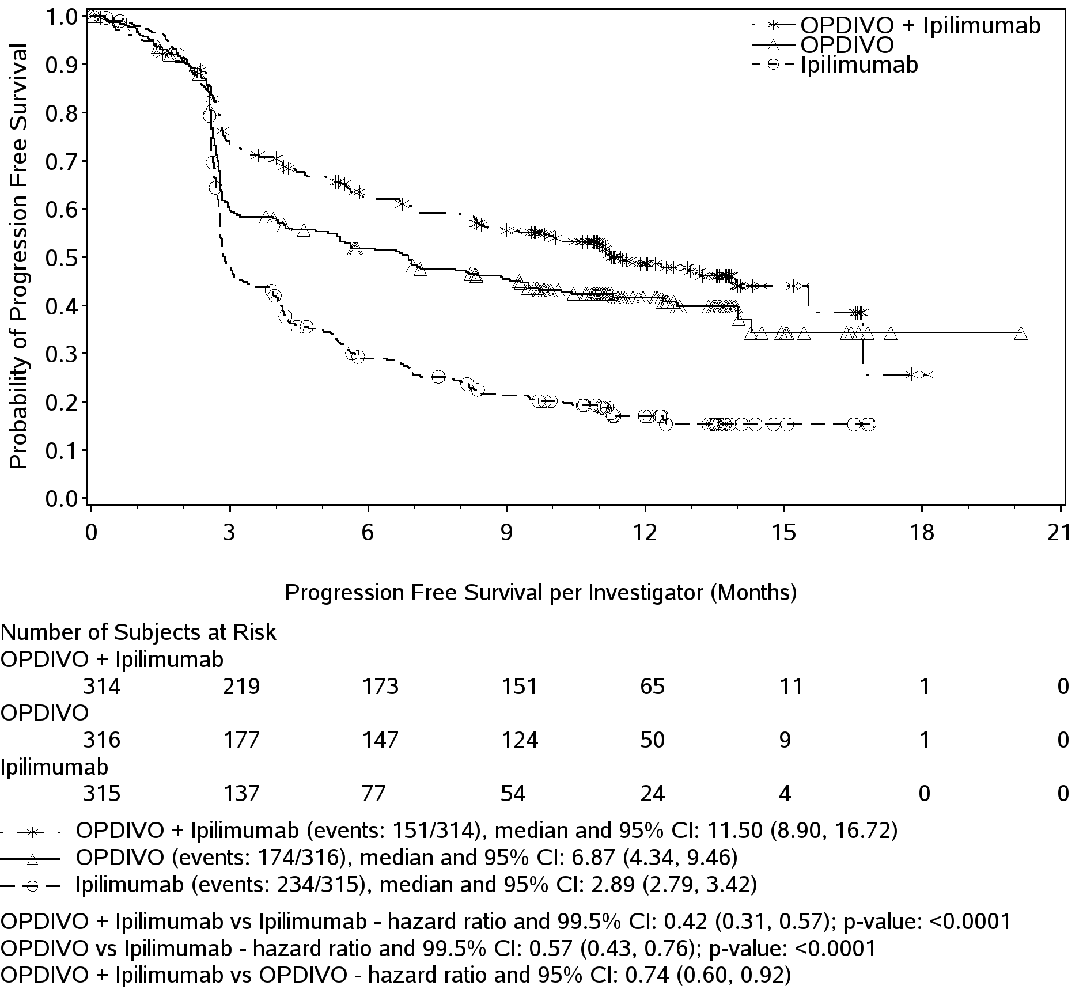

At the time of this analysis, 76% (138/181) of responding patients randomised to nivolumab in combination with ipilimumab and 78% (107/138) of responding patients randomised to nivolumab monotherapy had ongoing responses, which included 123 patients and 93 patients, respectively, with durable responses of 6 months or longer. Responses were observed within the first 3 months for 94 of the 181 patients with an objective response to nivolumab in combination with ipilimumab and 69 of the 138 patients with an objective response to nivolumab monotherapy. The observed PFS and ORR results for nivolumab in combination with ipilimumab and nivolumab monotherapy were consistently demonstrated across subgroups of patients including baseline ECOG performance status, BRAF status, M stage, age, history of brain metastases, and baseline LDH level.

Patients in the nivolumab in combination with ipilimumab and the nivolumab monotherapy arms had a median reduction in tumour volume of 52% and 35%, respectively, while patients in the ipilimumab arm had a median increase in tumour volume of 6%.

Among 120 patients who discontinued nivolumab in combination with ipilimumab due to adverse reaction, median PFS was 11.7 months (95% CI: 9.92, 16.72), and the ORR was 68% (81/120) with 15% (18/120) achieving a complete response.

## *Efficacy in Stage IV metastatic melanoma by M-stage status.*

The majority of the patients had AJCC Stage IV disease (93%, n=881); of these patients, 63% (n=559) had M1c disease and 37% (n=322) had M1a/M1b disease at study entry.

The combination of nivolumab and ipilimumab demonstrated longer PFS over nivolumab monotherapy in Stage IV patients (HR 0.75; 95% CI: 0.60, 0.94) and ipilimumab monotherapy (HR 0.43; 95% CI: 0.35, 0.54) (Table 4).

In addition, a higher objective response rate (ORR) was reported in Stage IV patients randomised to the combination (57.2%; 95% CI: 51.4, 62.9) than to nivolumab monotherapy (42.6%; 95% CI: 36.9, 48.5) and ipilimumab monotherapy (18.1%; 95% CI 13.9, 23.0) (Table 5).

Table 4: Stage IV Pre-defined Subgroup Analysis on Progression Free Survival across all treatment groups in Study CA209067.

|  |  | | **Nivolumab + Ipilimumab** | | **Nivolumab** | | **Ipilimumab** | | |
| --- | --- | --- | --- | --- | --- | --- | --- | --- | --- |
| **AJCC Stage at Study Entry** | **N** | | **N of Events (N of Patients)** | **mPFS (95% CI)** | **N of Events (N of Patients)** | **mPFS (95% CI)** | **N of Events (N of Patients)** | **mPFS**  **(95% CI)** | |
| Stage IV | 881 | | 143  (297) | 11.27  (8.51, 15.54) | 162 (291) | 6.87  (4.21, 9.46) | 217  (293) | 2.86  2.79, 3.48) | |
| M1c | | 559 | 100  (185) | 8.51  (5.52, 12.35) | 111  (185) | 5.39  (2.83, 8.87) | 142  (189) | 2.79  (2.73, 2.83) |

Table 5: Stage IV Pre-defined Subgroup Analysis on Objective Response Rate across all treatment groups in Study CA209067.

|  |  | | **Nivolumab + Ipilimumab** | | **Nivolumab** | | **Ipilimumab** | | |
| --- | --- | --- | --- | --- | --- | --- | --- | --- | --- |
| **AJCC Stage at Study Entry** | **N** | | **N of Response**  **(N of Patients)** | **ORR**  **(95% CI)** | **N of Response**  **(N of Patients)** | **ORR**  **(95% CI)** | **N of Response**  **(N of Patients)** | **ORR**  **(95% CI)** | |
| Stage IV | 881 | | 170 (297) | 57.2%  (51.4, 62.9) | 124 (291) | 42.6%  (36.9, 48.5) | 53 (293) | 18.1%  (13.9, 23.0) | |
| M1c | | 559 | 95 (185) | 51.4% (43.9, 58.8) | 72 (185) | 38.9% (31.9, 46.3) | 27 (189) | 14.3% (9.6, 20.1) |

The safety of the combination of nivolumab and ipilimumab in patients with M1c disease was consistent with that in all randomised patients.

## *Efficacy by elevated LDH.*

Three hundred forty-one patients (36%) had a baseline LDH level greater than ULN. In this population, the median PFS was 4.2 months (95% CI: 2.79, 9.26) in the nivolumab in combination with ipilimumab arm, 2.8 months (95% CI: 2.63, 4.04) in the nivolumab monotherapy arm and 2.63 months (95% CI: 2.60, 2.76) in the ipilimumab arm (Table 6).

The ORR was 44.7% (95% CI: 35.4, 54.3), 30.4% (95% CI: 22.0, 39.8) and 9.6% (95% CI: 4.9, 16.5) in the nivolumab in combination with ipilimumab, nivolumab monotherapy and ipilimumab monotherapy arms respectively (Table 7).

Table 6: Elevated LDH Pre-defined Subgroup Analysis on Progression Free Survival across all treatment groups in Study CA209067.

|  |  | **Nivolumab + Ipilimumab** | | **Nivolumab** | | **Ipilimumab** | |
| --- | --- | --- | --- | --- | --- | --- | --- |
| **LDH** | **N** | **N of Events (N of Patients)** | **mPFS**  **(95% CI)** | **N of Events (N of Patients)** | **mPFS**  **(95% CI)** | **N of Events (N of Patients)** | **mPFS**  **95% CI)** |
| >ULN | 341 | 69 (114) | 4.21 (2.79, 9.26) | 73 (112) | 2.79 (2.63, 4.04) | 93 (115) | 2.63 (2.60, 2.76) |

Table 7: Elevated LDH Pre-defined Subgroup Analysis on Objective Response Rate across all treatment groups in Study CA209067.

|  |  | **Nivolumab + Ipilimumab** | | **Nivolumab** | | **Ipilimumab** | |
| --- | --- | --- | --- | --- | --- | --- | --- |
| **LDH** | **N** | **N of Events (N of Patients)** | **ORR**  **(95% CI)** | **N of Events (N of Patients)** | **ORR**  **(95% CI)** | **N of Events (N of Patients)** | **ORR**  **(95% CI)** |
| >ULN | 341 | 51 (114) | 44.7% (35.4, 54.3) | 34 (112) | 30.4% (22.0, 39.8) | 11(115) | 9.6% (4.9, 16.5) |

*Efficacy by BRAF status*: BRAF [V600] mutation-positive and BRAF wild-type patients randomised to nivolumab in combination with ipilimumab had a median PFS of 11.73 months (95% CI 8.02, NA) and 11.24 months (95% CI: 8.34, NA), respectively, while those randomised to nivolumab monotherapy had a median PFS of 5.62 months (95% CI: 2.79, 9.46) and 7.89 months (95% CI: 4.86, 12.68), respectively. Regardless of the BRAF mutation status, median PFS of both nivolumab in combination with ipilimumab and nivolumab monotherapy was greater than with ipilimumab. ORR results by BRAF status are shown in Table 8.

Table 8 Objective Response by BRAF [V600]-Mutation Status (CA209067)

|  | BRAF [V600] Mutation-Positive | | | BRAF Wild-Type | |
| --- | --- | --- | --- | --- | --- |
| Treatment | Number of Responses/Patients | ORR%  [95% CI] | Number of Responses/Patients | | ORR%  [95% CI] |
| **OPDIVO + Ipilimumab** | 68/102 | 66.7  (56.6, 75.7) | 113/212 | | 53.3  (46.3, 60.2) |
| **OPDIVO** | 36/98 | 36.7  (27.2, 47.1) | 102/218 | | 46.8  (40.0, 53.6) |
| **Ipilimumab** | 22/100 | 22.0  (14.3, 31.4) | 38/215 | | 17.7 (12.8, 23.4) |

*Efficacy by PD-L1 tumour expression*: Baseline tumour tissue specimens were systematically collected prior to randomisation in order to conduct planned analyses of efficacy according to PD-L1 expression. Quantifiable tumour PD-L1 expression was measured in 89% (278/314) of patients randomised to nivolumab in combination with ipilimumab, 91% (288/316) of patients randomised to nivolumab monotherapy, and 88% (277/315) of patients randomised to ipilimumab alone. Among patients with quantifiable PD-L1 expression, the distribution of patients was balanced across the three treatment groups at each of the predefined tumour PD-L1 expression levels of ≥1% (56% in the nivolumab in combination with ipilimumab arm, 59% in the nivolumab monotherapy arm, and 59% in the ipilimumab arm) and ≥5% (24%, 28%, and 27%, separately). Tumour PD-L1 expression was determined using the PD-L1 IHC 28-8 pharmDx assay.

In patients with low or no tumour PD-L1 expression (based on the predefined expression level of <5%), nivolumab in combination with ipilimumab (HR 0.42, 95% CI: 0.32, 0.54) and nivolumab monotherapy (HR 0.59, 95% CI: 0.47, 0.75) demonstrated significant improvements in PFS compared with ipilimumab alone. Nivolumab in combination with ipilimumab demonstrated a greater improvement in PFS than nivolumab monotherapy. In patients with ≥5% tumour PD-L1 expression, a significant improvement in PFS relative to ipilimumab was also observed for both nivolumab in combination with ipilimumab (HR 0.39, 95% CI: 0.25, 0.62) and nivolumab monotherapy (HR 0.41, 95% CI: 0.26, 0.63). The improvement in PFS was similar between nivolumab in combination with ipilimumab and nivolumab monotherapy. Results are shown in Figures 3 and 4.

Figure 3 PFS: Patients with PD-L1 expression < 5% (CA209067)

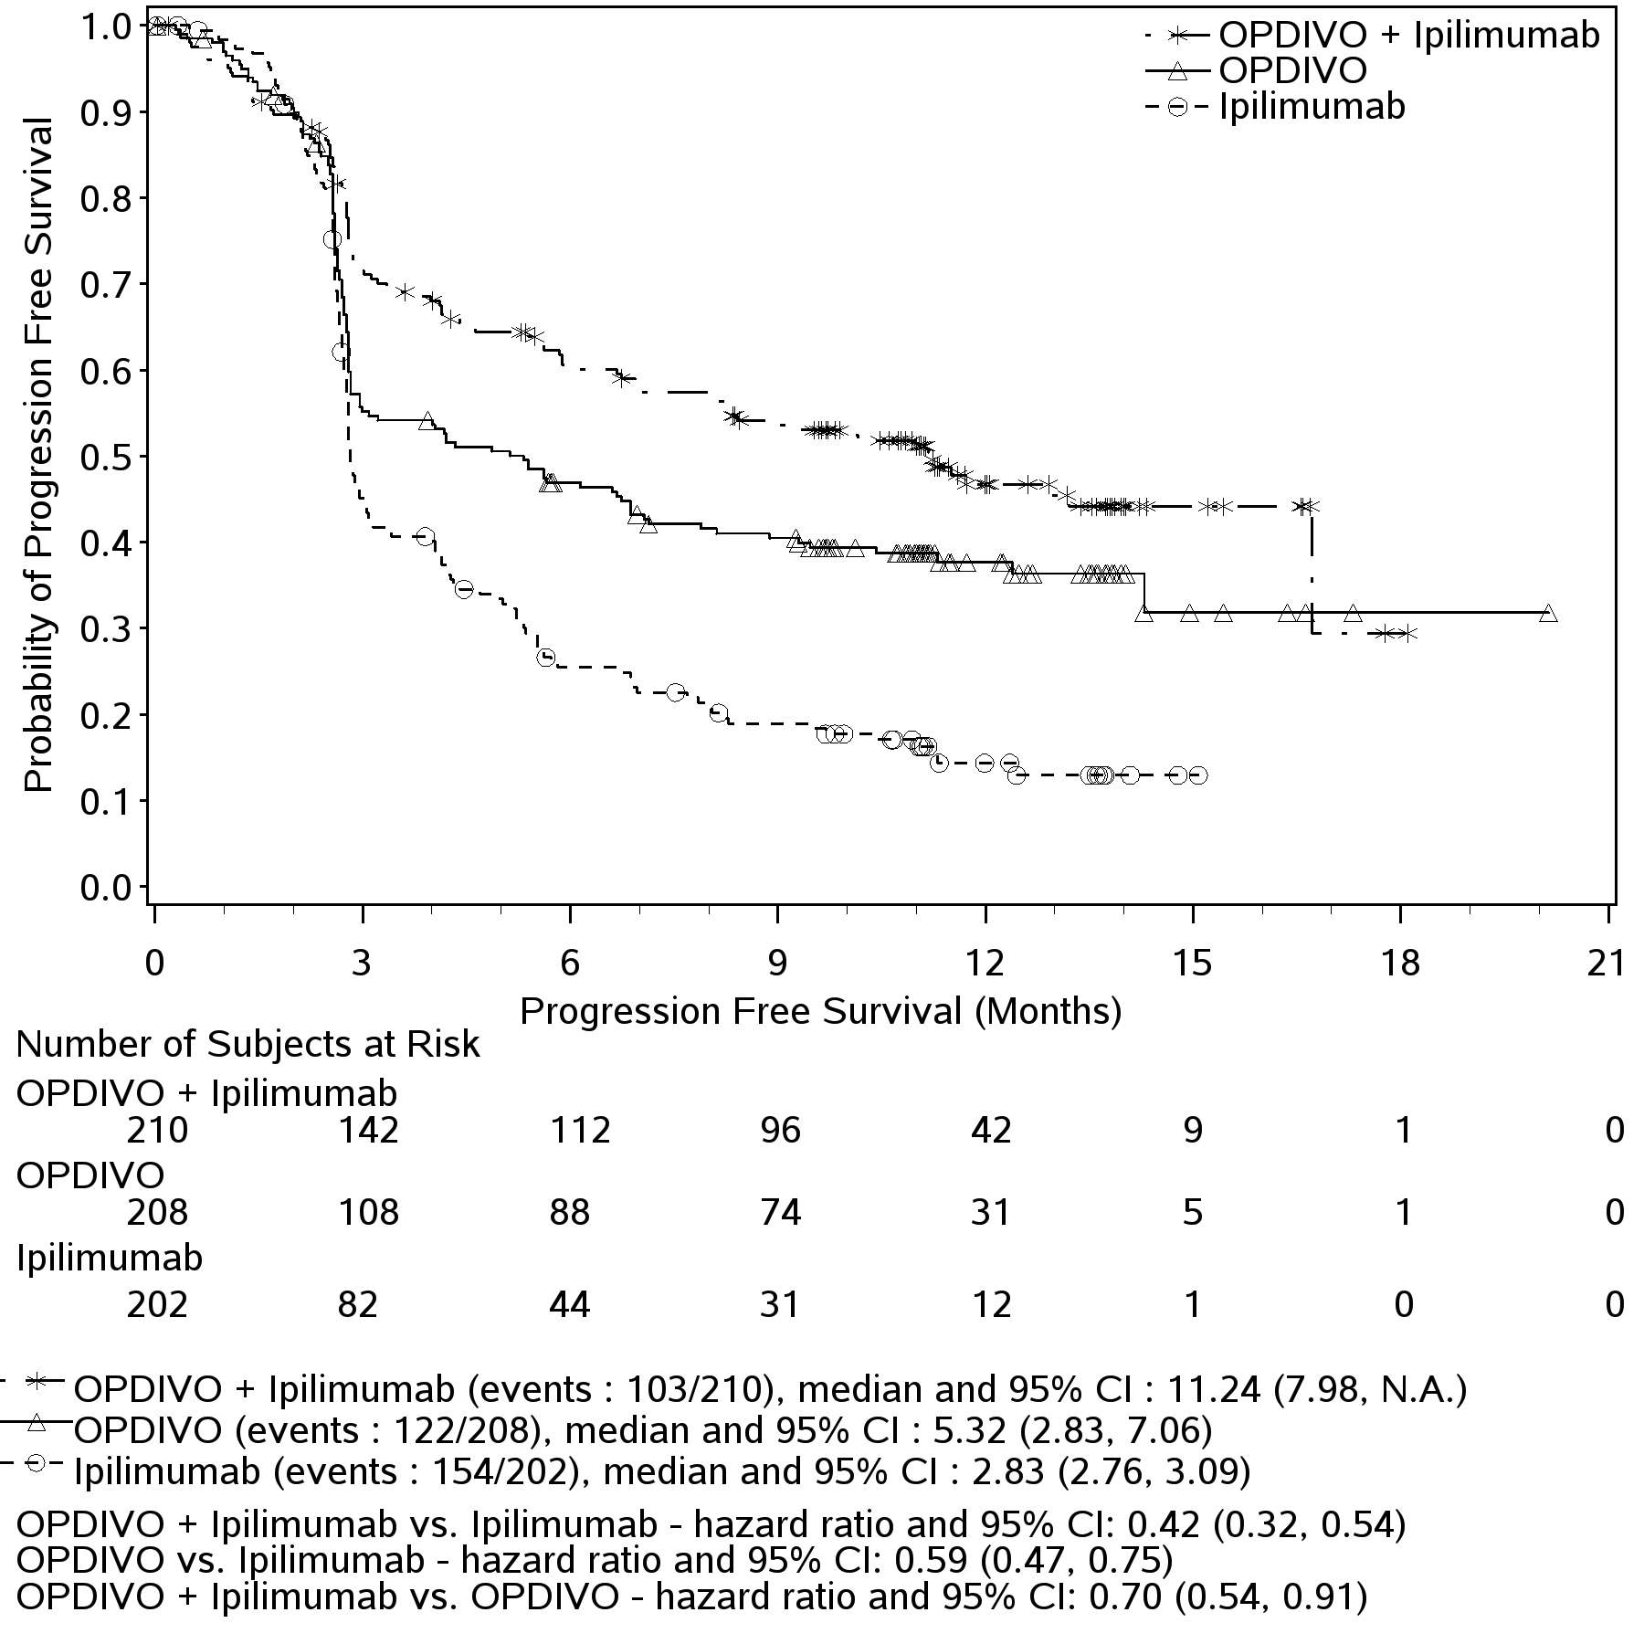

Figure 4 PFS: Patients with PD-L1 expression ≥ 5% (CA209067)

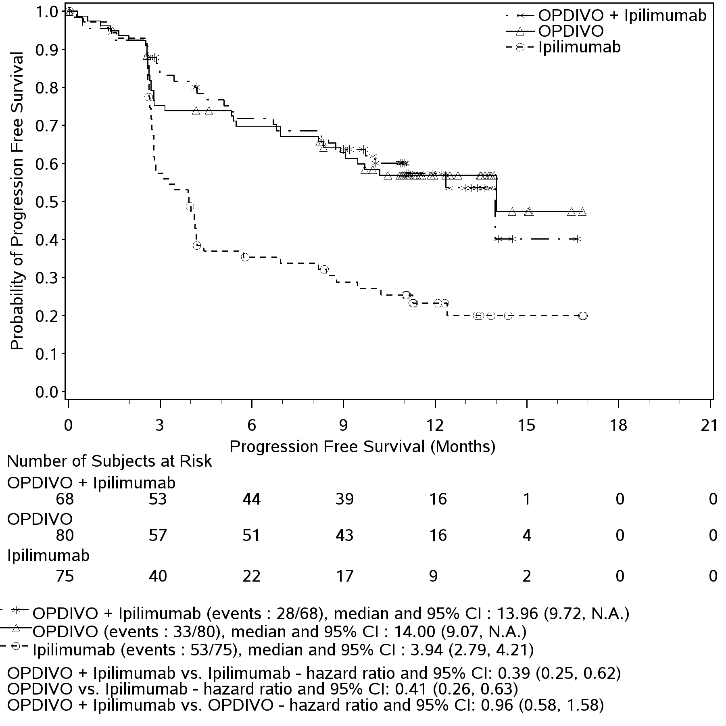

Table 9 shows the objective response rates in CA209067 based on PD-L1 expression level. Both nivolumab in combination with ipilimumab and nivolumab monotherapy demonstrated greater objective response rates than ipilimumab regardless of tumour PD-L1 expression levels of 1% or 5%. Nivolumab in combination with ipilimumab demonstrated greater objective response rates than nivolumab monotherapy regardless of tumour PD-L1 expression levels of 1% or 5%.

Table 9: Objective Response by PD-L1 Expression (CA209067)

|  | PD-L1 Expression Level | Number. of Patients | ORR | |
| --- | --- | --- | --- | --- |
| Treatment | % | [95% CI] |
| **OPDIVO +Ipilimumab** | ≥5% | 68 | 72% | (59.9, 82.3) |
| <5% | 210 | 55% | (47.8, 61.6) |
| ≥1% | 155 | 65% | (56.4, 72.0) |
| <1% | 123 | 52% | (42.8, 61.1) |
| **OPDIVO** | ≥5% | 80 | 58% | (45.9, 68.5) |
| <5% | 208 | 41% | (34.6, 48.4) |
| ≥1% | 171 | 54% | (46.6, 62.0) |
| <1% | 117 | 33% | (24.9, 42.6) |
| **Ipilimumab** | ≥5% | 75 | 21% | (12.7, 32.3) |
| <5% | 202 | 18% | (12.8, 23.8) |
| ≥1% | 164 | 19% | (13.2, 25.7) |
| <1% | 113 | 19% | (11.9, 27.0) |

As compared to the overall study population, no meaningful differences in safety were observed based on BRAF status or tumour PD-L1 expression level.

**Study CA209069. A randomised, phase 2 study of OPDIVO in combination with ipilimumab vs ipilimumab alone in subjects with previously untreated, unresectable or metastatic melanoma**

Study CA209069 was a randomised, Phase 2, double-blind study comparing the combination of nivolumab and ipilimumab with ipilimumab alone in 142 patients with advanced (unresectable or metastatic) melanoma with similar inclusion criteria to study CA209067 and the primary analysis in patients with BRAF wild-type melanoma (77% of patients). Investigator assessed ORR was 61% (95% CI: 48.9, 72.4) in the combination arm (n=72) versus 11% (95% CI: 3.0, 25.4) for the ipilimumab arm (n=37). The estimated 12 and 18 month OS rates were 79% (95% CI: 67, 87) and 73% (95% CI: 61, 82) respectively for the combination and 62% (95% CI: 44, 75) and 56% (95% CI: 39, 70) respectively for ipilimumab.

# SQUAMOUS NON SMALL CELL LUNG CANCER (SQ NSCLC)

**Study CA209017. An Open-label Randomised Phase 3 Trial of Nivolumab versus Docetaxel in Previously Treated Advanced or Metastatic Squamous Non-small Cell Lung Cancer (SQ NSCLC).**

The safety and efficacy of nivolumab 3 mg/kg as monotherapy for the treatment of advanced or metastatic squamous NSCLC were evaluated in a phase 3, randomised, open-label study (CA209017). The study included patients (18 years or older) who have experienced disease progression during or after one prior platinum doublet-based chemotherapy regimen. Patients were enrolled regardless of their PD-L1 status. Patients with active autoimmune disease, symptomatic interstitial lung disease, or untreated brain metastasis were excluded from the study. Patients with treated brain metastases were eligible if neurologically returned to baseline at least 2 weeks prior to enrolment, and either off corticosteroids, or on a stable or decreasing dose of <10 mg daily prednisone equivalents.

A total of 272 patients were randomised to receive either nivolumab 3 mg/kg (n = 135) administered intravenously over 60 minutes every 2 weeks or docetaxel (n = 137) 75 mg/m2 every 3 weeks. Treatment was continued as long as clinical benefit was observed or until treatment was no longer tolerated. Tumour assessments, according to the RECIST, version 1.1, were conducted 9 weeks after randomisation and continued every 6 weeks thereafter. The primary efficacy outcome measure was OS. Key secondary efficacy outcome measures were investigator-assessed ORR and PFS. In addition, symptom improvement and overall health status were assessed using the Lung Cancer Symptom Score (LCSS) average symptom burden index and the EQ-5D Visual Analogue Scale (EQ-VAS), respectively.

Baseline characteristics were generally balanced between the two groups. The median age was 63 years (range: 39-85) with 44% ≥65 years of age and 11% ≥75 years of age. The majority of patients were white (93%) and male (76%). Thirty-one percent had progressive disease reported as the best response to their most recent prior regimen and 45% received nivolumab within 3 months of completing their most recent prior regimen. Baseline ECOG performance status score was 0 (24%) or 1 (76%).

The observed OS benefit (Figure 5, Table 10) was consistently demonstrated across subgroups of patients. At the pre-defined PD-L1 tumour membrane expression cutoff levels of 1%, 5%, and 10%, similar survival was observed regardless of PD-L1 expression status.

Study CA209017 included a limited number of patients ≥ 75 years (11 in the nivolumab group and 18 in the docetaxel group). Nivolumab showed numerically less effect on OS (HR 1.85; 95% CI: 0.76, 4.51), PFS (HR 1.76; 95%-CI: 0.77, 4.05) and ORR (9.1% vs. 16.7%). Because of the small sample size, no definitive conclusions can be drawn from these data.

Figure 5: Kaplan-Meier curves of OS (CA209017)

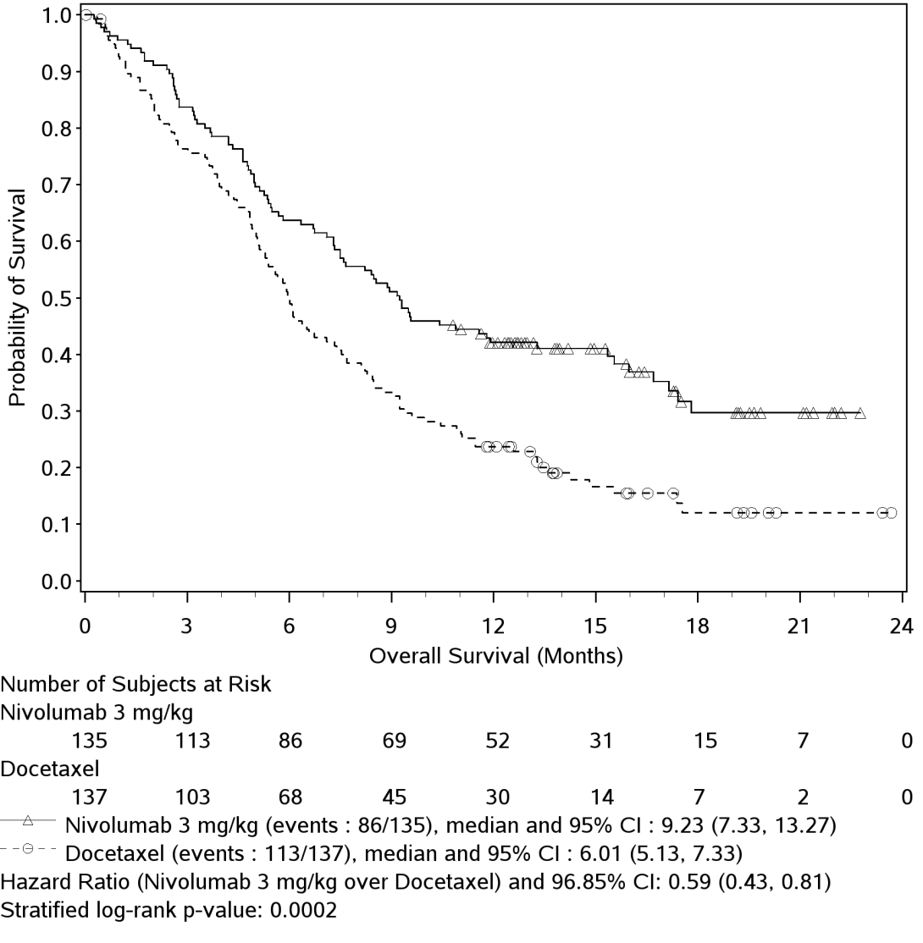

Table 10: Efficacy results (CA209017)

|  | **nivolumab (n = 135)** | | | **docetaxel (n = 137)** | | |
| --- | --- | --- | --- | --- | --- | --- |
| **Overall survival** |  |  | |  | |  |
| Events | 86 (63.7%) | | | 113 (82.5%) | | |
| Hazard ratio | 0.59 | | | | | |
| 96.85% CI | (0.43, 0.81) | | | | | |
| p-value | 0.0002 | | | | | |
|  |  |  | |  | |  |
| Median (95% CI) months | 9.23 (7.33, 13.27) | | | 6.01 (5.13, 7.33) | | |
| Rate % (95% CI) at 12 months | 42.1 (33.7, 50.3) | | | 23.7 (16.9, 31.1) | | |
|  |  |  | |  | |  |
| **Confirmed objective response** | 27 | (20.0%) | | 12 | | (8.8%) |
| (95% CI) | (13.6, 27.7) | | | (4.6, 14.8) | | |
| Odds ratio (95% CI) | 2.64 (1.27, 5.49) | | | | | |
| p-value | 0.0083 | | | | | |
|  |  |  | |  | |  |
| Complete response (CR) | 1 | (0.7%) | | 0 | |  |
| Partial response (PR) | 26 | (19.3%) | | 12 | | (8.8%) |
| Stable disease (SD) | 39 | (28.9%) | | 47 | | (34.3%) |
|  |  |  | |  | |  |
| **Median duration of response** |  | |  | |  | |
| Months (range) | Not reached | (2.9 - 20.5+) | | 8.4 | | (1.4+ - 15.2+) |
|  |  |  | |  | |  |
| **Median time to response** |  |  | |  | |  |
| Months (range) | 2.2 | (1.6 - 11.8) | | 2.1 | | (1.8 - 9.5) |
| **Progression-free survival** |  |  | |  | |  |
| Events | 105 (77.8%) | | | 122 (89.1%) | | |
| Hazard ratio | 0.62 | | | | | |
| 95% CI | (0.47, 0.81) | | | | | |
| p-value | < 0.0004 | | | | | |
|  |  |  | |  | |  |
| Median (95% CI) (months) | 3.48 (2.14, 4.86) | | | 2.83 (2.10, 3.52) | | |
| Rate % (95% CI) at 12 months | 20.8 (14.0, 28.4) | | | 6.4 (2.9, 11.8) | | |

The rate of disease-related symptom improvement, as measured by LCSS, was similar between the nivolumab group (18.5%) and the docetaxel group (21.2%). The average EQ-VAS increased over time for both treatment groups, indicating better overall health status for patients remaining on treatment.

**Study (CA209063). A Single-Arm Phase 2 Study of Nivolumab in Subjects with Advanced or Metastatic Squamous Cell Non-Small Cell Lung Cancer Who Have Received at Least Two Prior Systemic Regimens**

Study CA209063 was a single-arm, open-label study conducted in 117 patients with locally advanced or metastatic squamous NSCLC after two or more lines of therapy; otherwise similar inclusion criteria as study CA209017 were applied. Nivolumab 3 mg/kg showed an overall response rate of 14.5% (95% CI: 8.7,22.2%), a median OS of 8.21 months (95% CI: 6.05,10.9), and a median PFS of 1.87 months (95% CI 1.77,3.15). The PFS was measured by RECIST, version 1.1. The estimated 1-year survival rate was 41%.

# NON SQUAMOUS NON SMALL CELL LUNG CANCER (NSQ NSCLC)

**Study CA209057. An Open-label Randomised Phase 3 Trial of Nivolumab versus Docetaxel in Previously Treated Advanced or Metastatic Non Squamous Cell Non-small Cell Lung Cancer (NSQ NSCLC).**

The safety and efficacy of nivolumab 3 mg/kg as a single agent for the treatment of advanced or metastatic non-squamous NSCLC were evaluated in a phase 3, randomised, open-label study (CA209057). The study included patients (18 years or older) who have experienced disease progression during or after one prior platinum doublet-based chemotherapy regimen which may have included maintenance therapy and who had an ECOG performance status score of 0 or 1. An additional line of TKI therapy was allowed for patients with known EGFR mutation or ALK translocation. Patients were enrolled regardless of their PD-L1 status. Patients with active autoimmune disease, symptomatic interstitial lung disease, or untreated brain metastasis were excluded from the study. Patients with treated brain metastases were eligible if neurologically returned to baseline at least 2 weeks prior to enrolment, and either off corticosteroids, or on a stable or decreasing dose of <10 mg daily prednisone equivalents.

A total of 582 patients were randomised to receive either nivolumab 3 mg/kg administered intravenously over 60 minutes every 2 weeks (n = 292) or docetaxel 75 mg/m2 every 3 weeks (n = 290). Treatment was continued as long as clinical benefit was observed or until treatment was no longer tolerated. Tumour assessments, according to the RECIST version 1.1, were conducted 9 weeks after randomisation and continued every 6 weeks thereafter. The primary efficacy outcome measure was OS. Key secondary efficacy outcome measures were investigator-assessed ORR and PFS. In addition, symptom improvement and overall health status were assessed using the LCSS average symptom burden index and the EQ-5D Visual Analogue Scale (EQ-VAS), respectively.

The median age was 62 years (range: 21 to 85) with 34% ≥65 years of age and 7% ≥75 years of age. The majority of patients were white (92%) and male (55%). Baseline ECOG performance status was 0 (31%) or 1 (69%). Seventy-nine percent of patients were former/current smokers.

The Kaplan-Meier curves for OS are shown in Figure 6.

Figure 6: Kaplan-Meier curves of OS (CA209057)

Figure 6 is a line graph showing the Kaplan-Meier curves of OS (CA209057)

The trial demonstrated a statistically significant improvement in OS for patients randomised to nivolumab as compared with docetaxel at the prespecified interim analysis when 413 events were observed (93% of the planned number of events for final analysis). Efficacy results are shown in Table 11.

Table 11: Efficacy Results (CA209057)

|  |  |  |  |  |
| --- | --- | --- | --- | --- |
|  | | **nivolumab (n = 292)** | | **docetaxel (n = 290)** |
| **Prespecified interim analysis** | |  | |  |
| **Overall survival** | |  | |  |
| Events (%) | | 190 (65.1%) | | 223 (76.9%) |
| Hazard ratioa | | 0.73 | | |
| (95.92% CI) | | (0.59, 0.89) | | |
| p-valueb | | 0.0015 | | |
| Median (95% CI) months | | 12.19 (9.66, 14.98) | | 9.36 (8.05, 10.68) |
| Rate % (95% CI) at 12 months | | 50.5 (44.6, 56.1) | | 39.0 (33.3, 44.6) |
| **Confirmed objective response** | | 56 (19.2%) | 36 (12.4%) | |
| (95% CI) | | (14.8, 24.2) | | (8.8, 16.8) |
| Odds ratio (95% CI) | | 1.68 (1.07, 2.64) | | |
| p-value | | 0.0246 | | |
| Complete response (CR) | | 4 (1.4%) | 1 (0.3%) | |
| Partial response (PR) | | 52 (17.8%) | 35 (12.1%) | |
| Stable disease (SD) | | 74 (25.3%) | 122 (42.1%) | |
| **Median duration of response** | |  |  | |
| Months (range) | 17.15 (1.8, 22.6+) | | 5.55 (1.2+, 15.2+) | |
| **Median time to response** | |  |  | |
| Months (range) | | 2.10 (1.2, 8.6) | 2.61 (1.4, 6.3) | |
| **Progression-free survival** | |  |  | |
| Events | | 234 (80.1%) | 245 (84.5%) | |
| Hazard ratio | | 0.92 | | |
| 95% CI | | (0.77, 1.11) | | |
| p-value | | 0.3932 | | |
| Median (95% CI) months | | 2.33 (2.17, 3.32) | 4.21 (3.45, 4.86) | |
| Rate % (95% CI) at 12 months | | 18.5 (14.1, 23.4) | 8.1 (5.1, 12.0) | |

a Derived from a stratified proportional hazards model.

b P-value is derived from a log-rank test stratified by prior maintenance therapy and line of therapy; the corresponding O’Brien-Fleming efficacy boundary significance level is 0.0408.

The rate of disease-related symptom improvement, as measured by LCSS, was similar between the nivolumab group (17.8%) and the docetaxel group (19.7%). The average EQ-VAS increased over time for both treatment groups, indicating better overall health status for patients remaining on treatment.

# RENAL CELL CARCINOMA (RCC)

**Study CA209025. A Randomised, Open-label, Phase 3 Study of Nivolumab versus Everolimus in Subjects with Advanced or Metastatic Clear-Cell Renal Cell Carcinoma who have received Prior Anti-Angiogenic Therapy.**

The safety and efficacy of nivolumab 3 mg/kg as a single agent for the treatment of advanced RCC was evaluated in a Phase 3, randomised, open-label study (CA209025). The study included patients (18 years or older) who have experienced disease progression during or after 1 or 2 prior anti-angiogenic therapy regimens and no more than 3 total prior systemic treatment regimens. Patients had to have a Karnofsky Performance Score (KPS) ≥70%. All patients had clear cell histology component. This study included patients regardless of their PD-L1 status. Patients with any history of or concurrent brain metastases, prior treatment with an mammalian target of rapamycin (mTOR) inhibitor, active autoimmune disease, or medical conditions requiring systemic immunosuppression were excluded from the study.

A total of 821 patients were randomised to receive either nivolumab 3 mg/kg (n = 410) administered intravenously over 60 minutes every 2 weeks or everolimus (n = 411) 10 mg daily, administered orally. Treatment was continued as long as clinical benefit was observed or until treatment was no longer tolerated. The first tumour assessments were conducted 8 weeks after randomisation and continued every 8 weeks thereafter for the first year and then every 12 weeks until progression or treatment discontinuation, whichever occurred later. Tumour assessments were continued after treatment discontinuation in patients who discontinued treatment for reasons other than progression. Treatment beyond initial investigator-assessed RECIST 1.1-defined progression was permitted if the patient had a clinical benefit and was tolerating study drug as determined by the investigator. The primary efficacy outcome measure was OS. Secondary efficacy assessments included investigator-assessed ORR and PFS.

Baseline characteristics were generally balanced between the two groups. The median age was 62 years (range: 18-88) with 40% ≥65 years of age and 9% ≥75 years of age. The majority of patients were male (75%) and white (88%), all Memorial Sloan Kettering Cancer Center (MSKCC) risk groups were represented, and 34% and 66% of patients had a baseline KPS of 70 to 80% and 90 to 100%, respectively. The majority of patients (72%) were treated with one prior anti-angiogenic therapy The median duration of time from initial diagnosis to randomisation was 2.6 years in both the nivolumab and everolimus groups. The median duration of treatment was 5.5 months (range: 0- 29.6+ months) in nivolumab-treated patientsand was 3.7 months (range: 6 days-25.7+ months) in everolimus-treated patients.

Nivolumab was continued beyond progression in 44% of patients.

The Kaplan-Meier curves for OS are shown in Figure 7.

Figure 7: Kaplan-Meier curves of OS (CA209025)

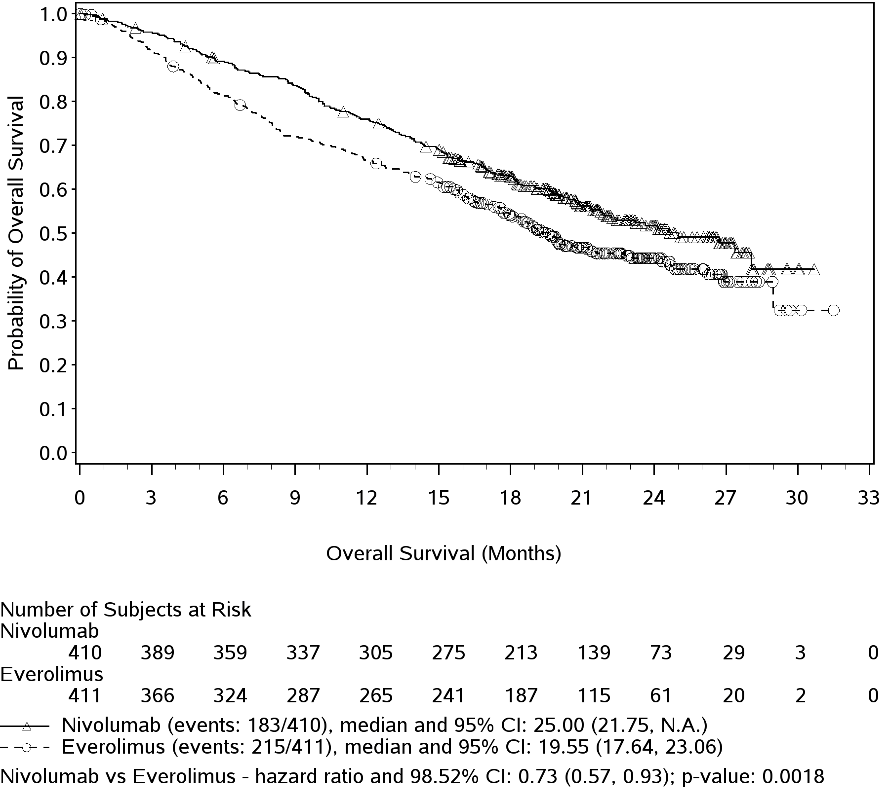

Overall Survival (Months)

Probability of Survival

Overall Survival (Months)

Number of Subjects at Risk

|  |  |  |  |  |  |  |  |  |  |  |  |
| --- | --- | --- | --- | --- | --- | --- | --- | --- | --- | --- | --- |
| Nivolumab | | | | | | | | | | | |
| 410 | 389 | 359 | 337 | 305 | 275 | 213 | 139 | 73 | 29 | 3 | 0 |
| Everolimus | | | | | | | | | | | |
| 411 | 366 | 324 | 287 | 265 | 241 | 187 | 115 | 61 | 20 | 2 | 0 |

" "Nivolumab 3 mg/kg (events: 183/410), median and 95% CI: 25.00 (21.75, N.A.)

" " Everolimus 10 mg (events: 215/411), median and 95% CI: 19.55 (17.64, 23.06)

The trial demonstrated a statistically significant improvement in OS for patients randomised to nivolumab as compared with everolimus at the prespecified interim analysis when 398 events were observed (70% of the planned number of events for final analysis) (Table 12 and Figure 7). OS benefit was observed regardless of PD-L1 expression level.

Efficacy results are shown in Table 12.

Table 12: Efficacy results (CA209025)

|  | **nivolumab (n = 410)** | | **everolimus (n = 411)** | |
| --- | --- | --- | --- | --- |
| **Overall survival** |  |  |  |  |
| Events | 183 (45) | | 215 (52) | |
| Hazard ratio | 0.73 | | | |
| 95% CI | (0.57, 0.93) | | | |
| p‑value | < 0.0018 | | | |
|  |  |  |  |  |
| Median (95% CI) months | 25.0 (21.7, NE) | | 19.6 (17.6, 23.1) | |
| Rate % (95% CI) |  |  |  |  |
| At 6 months | 89.2 (85.7, 91.8) | | 81.2 (77.0, 84.7) | |
| At 12 months | 76.0 (71.5, 79.9) | | 66.7 (61.8, 71.0)) | |
|  |  |  |  |  |
| **Objective response** | 103 | (25.1%) | 22 | (5.4%) |
| (95% CI) | (21.0, 29.6) | | (3.4, 8.0) | |
| Odds ratio (95% CI) | 5.98 (3.68, 9.72) | | | |
| p‑value | < 0.0001 | | | |
|  |  |  |  |  |
| Complete response (CR) | 4 | (1.0%) | 2 | (0.5%) |
| Partial response (PR) | 99 | (24.1%) | 20 | (4.9%) |
| Stable disease (SD) | 141 | (34.4%) | 227 | (55.2%) |
|  |  |  |  |  |
| **Median duration of response** |  | |  |  |
| Months (range) | 11.99 | (0.0-27.6+) | 11.99 | (0.0+-22.2+) |
|  |  |  |  |  |
| **Median time to response** |  |  |  |  |
| Months (range) | 3.5 | (1.4-24.8) | 3.7 | (1,5-11,2) |
| **Progression-free survival** |  | |  | |
| Events | 318 (77.6) | | 322 (78.3) | |
| Hazard ratio | 0.88 | | | |
| 95% CI | (0.75, 1.03) | | | |
| p‑value | 0.1135 | | | |
| Median (95% CI) months | 4.6 (3.71, 5.39) | | 4.4 (3.71, 5.52) | |
| Rate % (95% CI) |  | |  | |
| At 6 months | 39 (35, 44) | | 39 (33, 44) | |
| At 12 months | 23 (19, 27) | | 19 (15, 23) | |

“+” denotes a censored observation.

The median time to onset of objective response was 3.5 months (range: 1.4-24.8 months) after the start of nivolumab treatment. Forty-nine (47.6%) responders had ongoing responses with a duration ranging from 0.0-27.6+ months.

Overall survival could be accompanied by an improvement over time in disease related symptoms and non-disease specific quality of life (QoL) as assessed using valid and reliable scales in the Functional Assessment of Cancer Therapy-Kidney Symptom Index-Disease Related Symptoms (FKSI-DRS) and the EuroQoL EQ-5D. Apparently meaningful symptom improvement (MID=2 point change in FKSI-DRS score; p<0.001) and time to improvement (HR= 1.66 (1.33,2.08), p<0.001) were significantly better for patients on the nivolumab arm. While both arms of the study received active therapy, the QoL data should be interpreted in the context of the open-label study design and therefore cautiously taken.

# CLASSICAL HODGKIN LYMPHOMA

Two open-label studies evaluated the safety and efficacy of nivolumab 3 mg/kg as a single agent for the treatment of relapsed or refractory cHL following autologous stem cell transplantation (ASCT) and treatment with brentuximab vedotin.

Study CA209205 is an ongoing Phase 2, open-label, multi-cohort, single-arm study of nivolumab in cHL - Cohort B of this study included 80 patients who received nivolumab following ASCT and brentuximab vedotin treatment. Study CA209039 was an open-label, multicenter, dose escalation Phase 1 study that included 23 patients with cHL, 15 of whom received nivolumab following ASCT and brentuximab vedotin treatment and 5 of whom were ASCT naive.

Both studies included patients regardless of their tumour PD-L1 status and excluded patients with ECOG performance status of 2 or greater, autoimmune disease, hepatic transaminases more than 3 times ULN, creatinine clearance less than 40 mL/min, prior allogeneic haematopoietic stem cell transplant (HSCT), chest irradiation within 24 weeks or symptomatic interstitial lung disease.

In both studies, patients received 3 mg/kg of OPDIVO administered intravenously over 60 minutes every 2 weeks until disease progression or unacceptable toxicity (or maximal clinical benefit in CA209039). Dose reduction was not permitted. Tumour assessments were conducted 4 weeks (CA209039) or 9 weeks (CA209205) after the start of treatment and continued thereafter until disease progression or treatment discontinuation.

The primary efficacy outcome measure was Objective Response Rate (ORR). Additional efficacy measures included duration of response. The baseline and disease characteristics of the patients in each study were similar. In CA209205, the median age was 37 years with 3 subjects aged 65 years or older; 89% were white, 64% were male; 67.5% had Stage IV disease at study entry; the median number of prior systemic regimens was 4 (range 3 to 15); 89% had had a best response of CR or PR to regimen prior to ASCT. In CA209039, the median age was 35 years (range 20-54), 87% were white, the median number of prior systemic regimens was 5 (range 2 to 15).

Efficacy from both studies was evaluated by the same IRRC using the 2007 revised International Working Group criteria. Median duration of follow-up 15.4 months (range 1.9 to 18.5 months) in Study CA209205 and 21.9 months (range 11.2 to 27.6 months) in Study CA209039. Follow-up was ongoing at the time of data submission. Results are shown in Table 13.

Table 13: Efficacy results, per IRRC, in patients with relapsed/refractory classical Hodgkin lymphoma

| **Efficacy Parameter** | **CA209205**  **Cohort B**a  **(n = 80)** | **CA209039**  **ASCT-Bren failed group**  **(n = 15)** |
| --- | --- | --- |
| **Objective Response Rate;**(95% CI) | 54 (68%); (56, 78) | 9 (60%); (32, 84) |
| Complete Remission Rate; (95% CI) | 6 (8%); (3, 16) | 0 (0%); (0, 22) |
| Partial Remission Rate; (95% CI) | 48 (60%); (48, 71) | 9 (60%); (32, 84) |
| **Stable disease,** n (%) | 17 (21) | 5 (33) |
| **Median Duration of Response (months)**b  (95% CI)  Min, Max | 13.1  (8.7, N.A.)  0.0+, 14.2+ | 12.0  (1.8, N.A.)  1.8, 23.1+ |
| **Median Time to Response (months)**  Min, Max | 2.1  1.6, 11.1 | 0.8  0.7, 4.1 |

a Follow‑up was ongoing at the time of data submission

b Data unstable due to the limited DOR for Cohort B resulting from censoring.

N.A. = not available

PFS and OS were exploratory endpoints in these studies. The median PFS was 14.8 months (95% CI: 11.3, NA) and 12.7 months (95% CI: 5.91, NA) in CA209205 Cohort B and CA209039, respectively. The PFS rate at 12 months was 55% (95% CI 41, 66) and 69% (95% CI 37, 88) in CA209205 Cohort B and CA209039, respectively. At the time of database lock, OS data were immature and the median had not been reached in CA209205 Cohort B and CA209039. The OS rate at 12 months was 95% (95% CI 87, 98) and 93% (95% CI 61, 99) in CA209205 Cohort B and CA209039, respectively.

Objective response per IRRC with nivolumab was observed regardless of baseline tumour PD-L1 expression status.

B -symptoms were present in 25% (18/80) of the patients in CA209205 Cohort B at baseline. Nivolumab treatment resulted in rapid resolution of B-symptoms in 88.9% (16/18) of the patients, with a median time to resolution of 1.9 months.

Health related Quality of Life (QoL) was assessed in CA209205 using the patient reported EQ 5D VAS and EORTC-QLQ-C30 (overall health status). There was a high rate of completion up to Week 33 of treatment. During this time, mean EQ-5D VAS scores increased from baseline and EORTC QLQ-C30 scores remained stable.

Data from cHL patients 65 years of age or older are too limited to draw conclusions on this population.

# INDICATIONS

OPDIVO, as monotherapy is indicated for the treatment of patients with unresectable (Stage III) or metastatic (Stage IV) melanoma.

OPDIVO, in combination with YERVOY (ipilimumab) is indicated for the treatment of patients with metastatic (Stage IV) melanoma with M1c disease or elevated lactic dehydrogenase (LDH).

OPDIVO, as monotherapy is indicated for the treatment of locally advanced or metastatic squamous non-small cell lung cancer (NSCLC) with progression on or after prior chemotherapy.

OPDIVO, as monotherapy is indicated for the treatment of locally advanced or metastatic non squamous non-small cell lung cancer (NSCLC) with progression on or after prior chemotherapy. In patients with tumour EGFR or ALK genomic aberrations, OPDIVO should be used after progression on or after targeted therapy.

OPDIVO as monotherapy is indicated for the treatment of patients with advanced clear cell renal cell carcinoma after prior anti-angiogenic therapy in adults.

OPDIVO, as monotherapy is indicated for the treatment of adult patients with relapsed or refractory classical Hodgkin lymphoma (cHL) after autologous stem cell transplant and treatment with brentuximab vedotin. The approval of this indication is based on objective response rate. See CLINICAL TRIALS.

# CONTRAINDICATIONS

Hypersensitivity to the active substance or to any of the excipients.

# PRECAUTIONS

Early identification of adverse reactions and intervention are an important part of the safe use of OPDIVO with or without ipilimumab.

OPDIVO monotherapy is associated with immune‑related adverse reactions. In clinical trials, almost all immune-related adverse reactions have occurred at higher frequencies when OPDIVO was administered in combination with ipilimumab compared with OPDIVO as a monotherapy. Most immune-related adverse reactions improved or resolved with appropriate management, including initiation of corticosteroids and dose modifications.

Patients should be monitored continuously as an adverse reaction with OPDIVO monotherapy or OPDIVO in combination with ipilimumab may occur at any time during or after discontinuation of therapy.

Clinicians should consider immune-related adverse reactions for all unexplained illnesses. Adequate evaluation should be performed to confirm aetiology or exclude other causes.

Based on the severity of the adverse reaction, OPDIVO monotherapy or OPDIVO in combination with ipilimumab should be withheld (see DOSAGE AND ADMINISTRATION) and corticosteroids administered.

If immunosuppression with corticosteroids is used to treat an adverse reaction, a taper of at least one month duration should be initiated upon improvement. Rapid tapering may lead to worsening or recurrence of the adverse reaction.

Non-corticosteroid immunosuppressive therapy should be added if there is worsening or no improvement despite corticosteroid use.

OPDIVO monotherapy or OPDIVO in combination with ipilimumab should not be resumed while the patient is receiving immunosuppressive doses of corticosteroids or other immunosuppressive therapy.

Prophylactic antibiotics should be used to prevent opportunistic infections in patients receiving immunosuppressive therapy.

OPDIVO monotherapy or OPDIVO in combination with ipilimumab must be permanently discontinued for any severe immune related adverse reaction that recurs and for any life threatening immune related adverse reaction (see DOSAGE AND ADMINISTRATION).

## Immune‑related pneumonitis

Severe pneumonitis or interstitial lung disease, including fatal cases, has been observed with OPDIVO monotherapy or OPDIVO in combination with ipilimumab.

Patients should be monitored for signs and symptoms of pneumonitis such as radiographic changes (e.g., focal ground glass opacities, patchy filtrates), dyspnoea, and hypoxia. Infectious and disease-related aetiologies should be ruled out.

For Grade 3 or 4 pneumonitis, OPDIVO monotherapy or OPDIVO in combination with ipilimumab, must be permanently discontinued and corticosteroids should be initiated at a dose of 2 to 4 mg/kg/day methylprednisolone equivalents.

For Grade 2 (symptomatic) pneumonitis, OPDIVO monotherapy or OPDIVO in combination with ipilimumab, should be withheld and corticosteroids initiated at a dose of 1 mg/kg/day methylprednisolone equivalents. Upon improvement, OPDIVO monotherapy or OPDIVO in combination with ipilimumab, maybe resumed after corticosteroid taper. If worsening or no improvement occurs despite initiation of corticosteroids, corticosteroid dose should be increased to 2 to 4 mg/kg/day methylprednisolone equivalents and OPDIVO monotherapy or OPDIVO in combination with ipilimumab, must be permanently discontinued.

## Immune‑related colitis

Severe diarrhoea or colitis has been observed with OPDIVO monotherapy or OPDIVO in combination with ipilimumab. Patients should be monitored for diarrhoea and additional symptoms of colitis, such as abdominal pain and mucus or blood in stool. Infectious and disease-related aetiologies should be ruled out.

For Grade 4 diarrhoea or colitis, OPDIVO monotherapy or OPDIVO in combination with ipilimumab, must be permanently discontinued and corticosteroids should be initiated at a dose of 1 to 2 mg/kg/day methylprednisolone equivalents.

For Grade 3 diarrhoea or colitis observed with OPDIVO in combination with ipilimumab, permanently discontinue both agents and follow the management guideline for Grade 4 diarrhoea or colitis above.

OPDIVO monotherapy should be withheld for Grade 3 diarrhoea or colitis and corticosteroids initiated at a dose of 1 to 2 mg/kg/day methylprednisolone equivalents. Upon improvement, OPDIVO monotherapy may be resumed after corticosteroid taper. If worsening or no improvement occurs despite initiation of corticosteroids, OPDIVO monotherapy must be permanently discontinued.

For Grade 2 diarrhoea or colitis, OPDIVO monotherapy or OPDIVO in combination with ipilimumab, should be withheld. Persistent diarrhoea or colitis should be managed with corticosteroids at a dose of 0.5 to 1 mg/kg/day methylprednisolone equivalents. Upon improvement, OPDIVO monotherapy or OPDIVO in combination with ipilimumab, may be resumed after corticosteroid taper, if needed. If worsening or no improvement occurs despite initiation of corticosteroids, corticosteroid dose should be increased to 1 to 2 mg/kg/day methylprednisolone equivalents and OPDIVO monotherapy or OPDIVO in combination with ipilimumab, must be permanently discontinued.

Based on limited data from clinical trials on the management of corticosteroid‑refractory diarrhoea or colitis, administration of other systemic immunosuppressants (e.g., anti-TNF-α agents) can be considered.

## Immune‑related hepatitis

Severe hepatitis has been observed with OPDIVO monotherapy or OPDIVO in combination with ipilimumab. Infectious and disease‑related aetiologies should be ruled out.

Elevations in liver function tests may develop in the absence of clinical symptoms. Monitor patients for abnormal liver tests prior to and periodically during treatment as indicated based on clinical evaluation.

For Grade 3 or 4 transaminase or total bilirubin elevation, OPDIVO monotherapy or OPDIVO in combination with ipilimumab, must be permanently discontinued and corticosteroids should be initiated at a dose of 1 to 2 mg/kg/day methylprednisolone equivalents.

For Grade 2 transaminase or total bilirubin elevation, OPDIVO monotherapy or OPDIVO in combination with ipilimumab should be withheld. Persistent elevations in these laboratory values should be managed with corticosteroids at a dose of 0.5 to 1 mg/kg/day methylprednisolone equivalents. Upon improvement OPDIVO monotherapy or OPDIVO in combination with ipilimumab, may be resumed after corticosteroid taper, if needed.

If worsening or no improvement occurs despite initiation of corticosteroids, corticosteroid dose should be increased to 1 to 2 mg/kg/day methylprednisolone equivalents and OPDIVO monotherapy or OPDIVO in combination with ipilimumab must be permanently discontinued.

## Immune‑related nephritis and renal dysfunction

Severe nephritis and renal dysfunction have been observed with OPDIVO monotherapy or OPDIVO in combination with ipilimumab. Disease‑related aetiologies should be ruled out.

Creatinine elevations may develop in the absence of clinical symptoms. Monitor patients for elevated serum creatinine prior to and periodically during treatment as indicated based on clinical evaluation.

For Grade 4 serum creatinine elevation, OPDIVO monotherapy or OPDIVO in combination with ipilimumab must be permanently discontinued and corticosteroids should be initiated at a dose of 1 to 2 mg/kg/day methylprednisolone equivalents.

For Grade 2 or 3 serum creatinine elevation, OPDIVO monotherapy or OPDIVO in combination with ipilimumab, should be withheld and corticosteroids should be initiated at a dose of 0.5 to 1 mg/kg/day methylprednisolone equivalents. Upon improvement, OPDIVO monotherapy or OPDIVO in combination with ipilimumab, may be resumed after corticosteroid taper. If worsening or no improvement occurs despite initiation of corticosteroids, corticosteroid dose should be increased to 1 to 2 mg/kg/day methylprednisolone equivalents and OPDIVO monotherapy or OPDIVO in combination with ipilimumab, must be permanently discontinued.

## Immune‑related endocrinopathies

Severe endocrinopathies, including hypothyroidism, hyperthyroidism, adrenal insufficiency, hypophysitis, diabetes mellitus, and diabetes ketoacidosis have been observed with OPDIVO monotherapy or OPDIVO in combination with ipilimumab.

Patients should be monitored for clinical signs and symptoms of endocrinopathies and for changes in thyroid function (at the start of treatment, periodically during treatment, and as indicated based on clinical evaluation).

Patients may present with fatigue, headache, mental status changes, abdominal pain, unusual bowel habits, and hypotension, or nonspecific symptoms which may resemble other causes such as brain metastasis or underlying disease.

Unless an alternate aetiology has been identified, signs or symptoms of endocrinopathies should be considered immune-related.

For symptomatic hypothyroidism, OPDIVO monotherapy or OPDIVO in combination with ipilimumab, should be withheld, and thyroid hormone replacement should be initiated as needed. For symptomatic hyperthyroidism, OPDIVO monotherapy or OPDIVO in combination with ipilimumab, should be withheld and an antithyroid medicine should be initiated as needed. Corticosteroids at a dose of 1 to 2 mg/kg/day methylprednisolone equivalents should also be considered if acute inflammation of the thyroid is suspected. Upon improvement, OPDIVO monotherapy or OPDIVO in combination with ipilimumab, may be resumed after corticosteroid taper, if needed. Monitoring of thyroid function should continue to ensure appropriate hormone replacement is utilised. OPDIVO monotherapy or OPDIVO in combination with ipilimumab should be permanently discontinued for life-threatening (Grade 4) hypothyroidism or hyperthyroidism.

For symptomatic Grade 2 adrenal insufficiency, OPDIVO monotherapy or OPDIVO in combination with ipilimumab, should be withheld, and physiologic corticosteroid replacement should be initiated as needed. OPDIVO monotherapy or OPDIVO in combination with ipilimumab must be permanently discontinued for severe (Grade 3) or life-threatening (Grade 4) adrenal insufficiency. Monitoring of adrenal function and hormone levels should continue to ensure appropriate corticosteroid replacement is utilised.

For symptomatic Grade 2 or 3 hypophysitis, OPDIVO monotherapy or OPDIVO in combination with ipilimumab should be withheld, and hormone replacement should be initiated as needed. Corticosteroids at a dose of 1 to 2 mg/kg/day methylprednisolone equivalents should also be considered if acute inflammation of the pituitary gland is suspected. Upon improvement, OPDIVO monotherapy or OPDIVO in combination with ipilimumab may be resumed after corticosteroid taper, if needed. OPDIVO monotherapy or OPDIVO in combination with ipilimumab must be permanently discontinued for life-threatening (Grade 4) hypophysitis. Monitoring of pituitary function and hormone levels should continue to ensure appropriate hormone replacement is utilised.

For symptomatic diabetes, OPDIVO monotherapy or OPDIVO in combination with ipilimumab should be withheld, and insulin replacement should be initiated as needed. Monitoring of blood sugar should continue to ensure appropriate insulin replacement is utilised. OPDIVO monotherapy or OPDIVO in combination with ipilimumab should be permanently discontinued for life-threatening (Grade 4) diabetes.

## Immune-related skin adverse reactions

Patients should be monitored for rash. Severe rash has been observed with OPDIVO in combination with ipilimumab and less commonly with OPDIVO monotherapy. OPDIVO monotherapy or OPDIVO in combination with ipilimumab should be withheld for Grade 3 rash and permanently discontinued for Grade 4 rash. Severe rash should be managed with high-dose corticosteroids at a dose of 1 to 2 mg/kg/day methylprednisolone equivalents.

Rare cases of Stevens-Johnson syndrome (SJS) and toxic epidermal necrolysis (TEN), some with fatal outcome, have been observed. If symptoms or signs of SJS or TEN appear, nivolumab or nivolumab in combination with ipilimumab should be withheld and the patient referred for specialist assessment and treatment. If the patient has confirmed SJS or TEN, permanent discontinuation of nivolumab or nivolumab in combination with ipilimumab is recommended.

Caution should be used when considering the use of nivolumab in a patient who has previously experienced a severe or life-threatening skin adverse reaction on prior treatment with other immunostimulatory anticancer agents.

## Immune‑related neurological adverse reactions

The following adverse events have been observed across clinical trials of nivolumab or nivolumab in combination with ipilimumab: demyelination, autoimmune neuropathy (including facial and abducens nerve paresis), Guillain‑Barré syndrome, myasthenic syndrome/myasthenia gravis, and encephalitis.

Withhold OPDIVO in patients with new-onset moderate to severe neurologic signs or symptoms and evaluate to rule out infectious or other causes of moderate to serve neurologic deterioration. Evaluation may include, but not be limited to, consultation with a neurologist, brain MRI, and lumbar puncture.

While other aetiologies are being ruled out, administer corticosteroids at a dose of 1 to 2 mg/kg/day methylprednisolone equivalents for patients with immune-related neurological adverse reactions, followed by corticosteroid taper.

Permanently discontinue OPDIVO for immune-related encephalitis and myasthenic syndrome/myasthenia gravis.

## Complications of allogeneic Haematopoietic Stem Cell Transplant (HSCT) in classical Hodgkin Lymphoma

Preliminary results from the follow-up of patients undergoing allogeneic HSCT after previous exposure to nivolumab showed a higher than expected number of cases of acute graft-versus-host-disease (aGVHD) and transplant related mortality (TRM). Until further data become available, careful consideration to the potential benefits of HSCT and the possible increased risk of transplant related complications should be made case by case (see Select Adverse Reactions).

## Other immune‑related adverse reactions

Other clinically significant immune-related adverse reactions, including some with fatal outcome, have been observed across clinical trials of OPDIVO or OPDIVO in combination with ipilimumab investigating various doses across tumour types (see ADVERSE EFFECTS).

For suspected immune-related adverse reactions, adequate evaluation should be performed to confirm aetiology or exclude other causes. Based on the severity of the adverse reaction, OPDIVO monotherapy or OPDIVO in combination with ipilimumab, should be withheld and corticosteroids administered. Upon improvement, OPDIVO monotherapy or OPDIVO in combination with ipilimumab, maybe resumed after corticosteroid taper. OPDIVO monotherapy or OPDIVO in combination with ipilimumab, must be permanently discontinued for any severe immune-related adverse reaction that recurs and for any life-threatening immune-related adverse reaction.

Rare cases of myotoxicity (myositis, myocarditis, and rhabdomyolysis) have been reported with nivolumab or nivolumab in combination with ipilimumab. If a patient develops signs and symptoms of myotoxicity, close monitoring should be implemented, and the patient referred to a specialist for assessment and treatment without delay. Based on the severity of myotoxicity, nivolumab or nivolumab in combination with ipilimumab should be withheld or discontinued (see DOSING AND ADMINISTRATION), and appropriate treatment instituted.

## Infusion reaction

Severe infusion reactions have been reported in clinical trials of OPDIVO monotherapy or OPDIVO in combination with ipilimumab (see ADVERSE EFFECTS). In case of a severe or life-threatening infusion reaction, the OPDIVO monotherapy or OPDIVO in combination with ipilimumab infusion must be discontinued and appropriate medical therapy administered. Patients with mild or moderate infusion reaction may receive OPDIVO monotherapy or OPDIVO in combination with ipilimumab with close monitoring and use of premedication according to local treatment guidelines for prophylaxis of infusion reactions.

# OPDIVO IN COMBINATION WITH YERVOY (ipilimumab)

Review the full prescribing information for YERVOY (ipilimumab) prior to initiation of the OPDIVO in combination with YERVOY (ipilimumab). Both agents are associated with immune-related adverse reactions and may require immunosuppression. In clinical trials, immune-related adverse reactions described in the PRECAUTIONS section have occurred at higher frequencies when OPDIVO was administered in combination with YERVOY (ipilimumab) compared with OPDIVO as a monotherapy. Most immune-related adverse reactions (except for endocrinopathies) improved or resolved with appropriate management, including initiation of corticosteroids and treatment modifications.

Patients receiving OPDIVO in combination with YERVOY should be monitored for serum creatinine, thyroid function, and liver function prior to each dose during the combination phase.

# OPDIVO IN NSCLC

OPDIVO is not approved for combination with EGFR TKI use in NSCLC. Serious adverse events, including deaths (one case of pneumonitis and one case of toxic epidermal necrolysis), have been reported in a Phase II non- randomised trial of nivolumab in combination with an investigational 3rd generation TKI.

In patients transitioning from an EGFR TKI to OPDIVO monotherapy, a sufficient wash-out period should be observed to minimise the risk of adverse events occurring from the combination. Clinical judgement should be used to determine if any serious or clinically relevant adverse events occurring from an EGFR TKI are resolved prior to initiation of OPDIVO.

## Special populations

Patients with a baseline performance score ≥ 2, active brain metastases, or autoimmune disease, and patients who had been receiving systemic immunosuppressants prior to study entry were excluded. Specific populations excluded from clinical studies of nivolumab or nivolumab in combination with ipilimumab by tumour type are listed below.

***Melanoma*:** patients with ocular/uveal melanoma and a baseline performance score >2. In addition, CA209037 excluded patients who have had a Grade 4 adverse reaction that was related to anti‑CTLA‑4 therapy (except for resolved nausea, fatigue, infusion reaction or an endocrinopathy controlled by hormone replacement therapy).

***NSCLC*:** patients with symptomatic interstitial lung disease and a baseline performance >2 score.

***RCC*:** patients with a history of concurrent brain metastases.

***cHL****:* patients with symptomatic interstitial lung disease

In the absence of data, OPDIVO should be used with caution in these populations after careful consideration of the potential benefit-risk on an individual basis.

# RENAL IMPAIRMENT

The safety and efficacy of nivolumab have not been studied in patients with severe renal impairment. Based on the population pharmacokinetic (PK) results, no dose adjustment is required in patients with mild or moderate renal impairment (see PHARMACOKINETICS and DOSAGE AND ADMINISTRATION).

# HEPATIC IMPAIRMENT

The safety and efficacy of OPDIVO have not been studied in patients with moderate or severe hepatic impairment. Based on the population PK results, no dose adjustment is required in patients with mild hepatic impairment (see PHARMACOKINETICS and DOSAGE AND ADMINISTRATION).

OPDIVO must be administered with caution in patients with moderate (total bilirubin > 1.5 × to 3 × the upper limit of normal [ULN] and any AST elevation) or severe (total bilirubin > 3 × ULN and any AST elevation) hepatic impairment.

## Patients on controlled sodium diet

Each mL of this medicinal product contains 0.1 mmol (or 2.5 mg) sodium. To be taken into consideration when treating patients on a controlled sodium diet.

# EFFECTS ON FERTILITY

Studies to evaluate the effect of OPDIVO on fertility have not been performed. Thus, the effect of OPDIVO on male and female fertility is unknown.

# USE IN PREGNANCY (Category D)

OPDIVO is not recommended during pregnancy or in women of childbearing potential not using effective contraception, unless the clinical benefit outweighs the potential risk. Advise females of reproductive potential to use effective contraception during treatment with OPDIVO for at least 5 months following the last dose of OPDIVO.

There are no data on the use of OPDIVO in pregnant women. Human IgG4 is known to cross the placental barrier and OPDIVO is an IgG4; therefore OPDIVO has the potential to be transmitted from the mother to the developing fetus. It is not known whether nivolumab can cause fetal harm when administered to a pregnant woman.

The effects of OPDIVO on prenatal and postnatal development were evaluated in monkeys that received OPDIVO at 10 and 50 mg/kg twice weekly from the onset of organogenesis in the first trimester through delivery, at exposure levels 8 and 35 times, respectively, those observed at the clinical dose of 3 mg/kg of OPDIVO (based on AUC). There was a dose-dependent increase in fetal losses and increased neonatal mortality mainly in the 3rd trimester of pregnancy and after birth.

The remaining offspring of OPDIVO-treated females survived to scheduled termination, with no treatment-related clinical signs, alterations to normal development, organ-weight effects, or gross and microscopic pathology changes. Results for growth indices, as well as teratogenic, neurobehavioral, immunological and clinical pathology parameters throughout the 6-month postnatal period were comparable to the control group.

# USE IN LACTATION

It is not known whether OPDIVO is secreted in human breast milk. Because many drugs, including antibodies, can be secreted in human milk, a risk to newborns/infants cannot be excluded. Clinical judgement is required to determine whether to discontinue breast-feeding or to discontinue OPDIVO therapy, taking into account the benefit of breast-feeding for the child and the benefit of therapy for the mother.

# PAEDIATRIC USE

The safety and efficacy of OPDIVO in children below 18 years have not been established. The use of OPDIVO in children or adolescents is not recommended.

# GENOTOXICITY AND CARCINOGENICITY

Studies to evaluate the genotoxic and carcinogenic potential of OPDIVO have not been performed.

# DRUG INTERACTIONS

Pharmacokinetic interaction studies have not been conducted. Nivolumab is a human monoclonal antibody. As monoclonal antibodies are not metabolised by cytochrome P450 (CYP) enzymes or other drug metabolizing enzymes, inhibition or induction of these enzymes by co-administered medicinal products is not anticipated to affect the pharmacokinetics of nivolumab. Nivolumab is not expected to have an effect on CYP or other drug metabolizing enzymes in terms of inhibition or induction.

## Other forms of interaction

### Systemic immunosuppression

The use of systemic corticosteroids and other immunosuppressants at baseline, before starting nivolumab, should be avoided because of their potential interference with the pharmacodynamic activity. However, systemic corticosteroids and other immunosuppressants can be used after starting nivolumab to treat immune‑related adverse reactions. The use of systemic immunosuppression after starting nivolumab treatment does not appear to impair the efficacy of nivolumab.

# EFFECTS ON ABILITY TO DRIVE AND USE MACHINES

No studies on the effects on the ability to drive and use machines have been performed. Based on its pharmacodynamic properties, OPDIVO is unlikely to affect this ability. Because of potential adverse reactions such as fatigue (see ADVERSE EFFECTS), patients should be advised to use caution when driving or operating machinery until they are certain that OPDIVO does not adversely affect them.

# PATIENT COUNSELLING INFORMATION

Patients should be advised to report immediately any signs or symptoms suggestive of adverse reactions as described in PRECAUTIONS. The importance of reporting any worsening of symptoms or severity should be emphasised. Patients should be strongly advised not to treat any of these symptoms with over-the-counter medications without consultation with a health care provider.

## Patient Alert Card

All prescribers of OPDIVO must be familiar with the immune-related adverse reactions Management Guide. The prescriber must discuss the risks of OPDIVO therapy with the patient. Each patient must be provided with the OPDIVO patient alert card.

# ADVERSE EFFECTS

## Summary of the safety profile

### **Nivolumab Monotherapy**

Nivolumab is most commonly associated with immune-related adverse reactions. Most of these, including severe reactions, resolved following initiation of appropriate medical therapy or withdrawal of nivolumab (see “Description of selected adverse reactions” below).

In the pooled dataset of nivolumab 3 mg/kg as monotherapy across tumour types (Melanoma: CA209066, CA209037, CA209067 [monotherapy group only], SQ NSCLC: CA209017, CA209063, NS NSCLC: CA209057, RCC: CA209025 and cHL: CA209205, and CA209039), the most frequent adverse reactions (≥ 10%) were fatigue (32%), rash (18%), pruritus (13%), diarrhoea (13%) and nausea (13%). The majority of adverse reactions were mild to moderate (Grade 1 or 2).

### **Nivolumab in combination with ipilimumab**

In the pooled dataset of nivolumab in combination with ipilimumab in melanoma (CA209067 [combination group], CA209069, and CA209004-cohort 8), the most frequent adverse reactions (≥ 10%) were rash (51%), fatigue (43%), diarrhoea (42%), pruritus (35%), nausea (25%), pyrexia (19%), decreased appetite (15%), hypothyroidism (15%), vomiting (14%), colitis (14%), abdominal pain (13%), arthralgia (11%), and headache (11%). The majority of adverse reactions were mild to moderate (Grade 1 or 2).

Among the patients treated with nivolumab in combination with ipilimumab in CA209067, 151/313 (48%) had the first onset of Grade 3 or 4 adverse reactions during the initial combination phase. Among the 147 patients in this group who continued treatment in the single-agent phase, 37 (25%) experienced at least one Grade 3 or 4 adverse reaction during the single-agent phase.

## Tabulated summary of adverse reactions

Adverse reactions reported in the pooled dataset for patients treated with nivolumab monotherapy (n = 1991) and for patients treated with nivolumab in combination with ipilimumab (n = 448) are presented in Table 14. These reactions are presented by system organ class and by frequency. Frequencies are defined as: very common (≥ 1/10); common (≥ 1/100 to < 1/10); uncommon (≥ 1/1,000 to < 1/100); rare (≥ 1/10,000 to < 1/1,000); very rare (< 1/10,000). Within each frequency grouping, adverse reactions are presented in the order of decreasing seriousness.

Table 14: Adverse reactions in clinical trials

|  | **Nivolumab monotherapy (n=1991)** | **Nivolumab in combination with ipilimumab (n=448)** |
| --- | --- | --- |
| **Infections and infestations** | | |
| Common | upper respiratory tract infection | pneumonia, upper respiratory tract infection |
| Uncommon | pneumoniaa, bronchitis | bronchitis |
| **Neoplasms benign, malignant and unspecified (including cysts and polyps)** | | |
| Rare | histiocytic necrotising lymphadenitis (Kikuchi lymphadenitis) |  |
| **Blood and lymphatic system disorders** | | |
| Very common | neutropeniaa,b |  |
| Common |  | eosinophilia |
| Uncommon | eosinophilia |  |
| **Immune system disorders** | | |
| Common | infusion related reactionc, hypersensitivityc | infusion related reactionc, hypersensitivity |
| Uncommon | anaphylactic reactionc | sarcoidosis |
| **Endocrine disorders** | | |
| Very common |  | hypothyroidism |
| Common | hypothyroidism, hyperthyroidism, hyperglycaemiac | adrenal insufficiency, hypopituitarism, hypophysitis, hyperthyroidism, thyroiditis, hyperglycaemiac |
| Uncommon | adrenal insufficiency, hypopituitarism, hypophysitis, thyroiditis, diabetic ketoacidosis | diabetic ketoacidosisb, diabetes mellitusb |
| Rare | diabetes mellitus |  |
| **Metabolism and nutrition disorders** | | |
| Very common |  | decreased appetite |
| Common | decreased appetite | dehydration |
| Uncommon | dehydration, metabolic acidosis |  |
| **Hepatobiliary disorders** | | |
| Common |  | hepatitisb |
| Uncommon | Hepatitisc  cholestasis |  |
| **Nervous system disorders** | | |
| Very common |  | headache |
| Common | peripheral neuropathy, headache, dizziness | peripheral neuropathy, dizziness |
| Uncommon | Polyneuropathy, autoimmune neuropathy (including facial and abducens nerve paresis) | Guillain-Barré syndrome, polyneuropathy, neuritis, peroneal nerve palsy, autoimmune neuropathy (including facial and abducens nerve paresis), encephalitisb |
| Rare | Guillain-Barré syndrome, demyelination, myasthenic syndrome |  |
| **Eye disorders** | | |
| Common | dry eye | uveitis, blurred vision |
| Uncommon | Uveitis, blurred vision |  |
| **Cardiac disorders** | | |
| Common |  | tachycardia |
| Uncommon | tachycardia | arrhythmia (including ventricular arrhythmia)a, atrial fibrillation, myocarditisa,e |
| Rare | arrhythmia (including ventricular arrhythmia), myocarditis a,e, atrial fibrillation |  |
| **Vascular disorders** | | |
| Common | hypertension | hypertension |
| Uncommon | vasculitis |  |
| **Respiratory, thoracic and mediastinal disorders** | | |
| Common | pneumonitisa,c, dyspnoea, cough | pneumonitisa,c dyspnoea, cough |
| Uncommon | pleural effusion | pleural effusion |
| Rare | lung infiltration |  |
| **Gastrointestinal disorders** | | |
| Very common | diarrhoea, nausea | colitis, diarrhoea, vomiting, nausea, abdominal pain |
| Common | colitis, stomatitis, vomiting, abdominal pain, constipation, dry mouth | stomatitis, gastritis, constipation, dry mouth |
| Uncommon | Pancreatitis, gastritis | pancreatitis, intestinal perforation, duodenitis |
| Rare | duodenal ulcer |  |
| **Skin and subcutaneous tissue disorders** | | |
| Very common | Rashd, pruritus | rashd, pruritus |
| Common | vitiligo, dry skin, erythema, alopecia | vitiligo, dry skin, erythema, alopecia, urticaria |
| Uncommon | erythema multiforme, psoriasis, rosacea, urticaria | psoriasis |
| Rare | toxic epidermal necrolysisa,e  Stevens-Johnson syndromea,e | toxic epidermal necrolysisa,e  Stevens-Johnson syndromea,e |
| **Musculoskeletal and connective tissue disorders** | | |
| Very common |  | arthralgia |
| Common | musculoskeletal painf, arthralgia, arthritis | musculoskeletal paing |
| Uncommon | polymyalgia rheumatica | spondyloarthropathy, Sjogren’s syndrome, arthritis, myopathy, myositisa,e, rhabdomyolysisa,e |
| Rare | myopathy, myositisa,e, rhabdomyolysisa,e |  |
| **Renal and urinary disorders** | | |
| Common |  | renal failure a,c |
| Uncommon | tubulointerstitial nephritis, renal failurea,c | tubulointerstitial nephritis |
| **General disorders and administration site conditions** | | |
| Very common | fatigue | fatigue, pyrexia |
| Common | pyrexia, oedema (including peripheral oedema) | oedema (including peripheral oedema), pain |
| Uncommon | pain, chest pain | chest pain |
| **Investigationsb** | | |
| Common | weight decreased | weight decreased |

a Fatal cases have been reported in completed or ongoing clinical studies

b Frequencies of laboratory terms reflect the proportion of patients who experienced a worsening from baseline in laboratory measurements. See “Description of selected adverse reactions; laboratory abnormalities” below.

c Life-threatening cases have been reported in completed or ongoing clinical studies.

d Rash is a composite term which includes maculopapular rash, rash erythematous, rash pruritic, rash

follicular, rash macular, rash morbilliform, rash papular, rash pustular, rash papulosquamous, rash

vesicular, rash generalised, dermatitis, dermatitis acneiform, dermatitis allergic, dermatitis atopic,

dermatitis bullous, dermatitis exfoliative, dermatitis psoriasiform, and drug eruption.

e Reported in studies outside the pooled dataset. The frequency is based on the program-wide exposure.

f Musculoskeletal pain is a composite term which includes back pain, bone pain, musculoskeletal chest

pain, musculoskeletal discomfort, myalgia, neck pain, pain in extremity, and spinal pain.

Table 15: Laboratory abnormalities

|  | **Number (%) of Patients with Worsening Laboratory Test from Baseline** | | | | | |
| --- | --- | --- | --- | --- | --- | --- |
| **Test** | **Nivolumab monotherapy** | | | **Nivolumab in combination with ipilimumab** | | |
| Na | **Grades1-4** | **Grades3-4** | **Na** | **Grades1-4** | **Grades3-4** |
| An~~a~~emiab | 1942 | 682 (35.1) | 82 (4.42) | 424 | 209 (49.3) | 12 (2.8) |
| Thrombocytopenia | 1944 | 255 (13.1) | 12 (0.6) | 422 | 47 (11.1) | 5 (1.2) |
| Leukopenia | 1948 | 291 (14.9) | 18 (0.9) | 426 | 56 (13.1) | 2 (0.5) |
| Lymphopenia | 1932 | 783 (40.5) | 151 (7.8) | 421 | 160 (38.0) | 27 (6.4) |
| Neutropenia | 1935 | 227 (11.7) | 18 (0.9) | 423 | 58 (13.7) | 3 (0.7) |
| Increased alkaline phosphatase | 1928 | 470 (24.4) | 33 (1.7) | 418 | 155 (37.1) | 17 (4.1) |
| Increased AST | 1930 | 522 (27.0) | 52 (2.7) | 420 | 192 (45.7) | 50 (11.9) |
| Increased ALT | 1939 | 418 (21.6) | 45 (2.3) | 425 | 219 (51.5) | 62 (14.6) |
| Increased total bilirubin | 1936 | 166 (8.6) | 19 (1.0) | 422 | 49 (11.6) | 4 (0.9) |
| Increased creatinine | 1943 | 410 (21.1) | 13 (0.7) | 424 | 97 (22.9) | 10 (2.4) |
| Increased total amylase | 566 | 78 (13.8) | 11 (1.9) | 366 | 91 (24.9) | 31 (8.5) |
| Increased total lipase | 660 | 149 (22.6) | 49 (7.4) | 401 | 158 (39.4) | 73 (18.2) |
| Hypercalcaemia | 1851 | 194 (10.5) | 22 (1.2) | 320 | 22 (6.9) | 1 (0.3) |
| Hypocalcaemia | 1851 | 320 (17.3) | 12 (0.6) | 320 | 96 (30.0) | 4 (1.3) |
| Hyperkalaemia | 1887 | 357 (18.9) | 38 (2.0) | 335 | 45 (13.4) | 1 (0.3) |
| Hypokalaemia | 1887 | 197 (10.4) | 28 (1.5) | 335 | 60 (17.9) | 15 (4.5) |
| Hypermagnesaemia | 1655 | 75 (4.5) | 13 (0.8) | 309 | 9 (2.9) | 1 (0.3) |
| Hypomagnesaemia | 1655 | 236 (14.3) | 7 (0.5) | 309 | 43 (13.9) | 0 |
| Hypernatraemia | 1889 | 105 (5.6) | 2 (0.1) | 337 | 12 (3.6) | 1 (0.3) |
| Hyponatraemia | 1889 | 494 (26.2) | 99 (5.2) | 337 | 143 (42.4) | 31 (9.2) |

Toxicity scale: CTC Version 4.0.   
Includes laboratory results reported after the first dose and within 30 days of the last dose of study therapy. The frequencies are regardless of causality.

a The total number of patients who had both baseline and on-study laboratory measurements available.

b Per anemia criteria in CTC version 4.0, there is no Grade 4 for haemoglobin.

The safety of OPDIVO 3 mg/kg every 2 weeks as monotherapy was evaluated in 266 adult patients with cHL post high-dose chemotherapy and ASCT (243 patients in study CA209205 and 23 patients in CA209039). The median number of doses was higher in the cHL nivolumab monotherapy population compared with the pooled nivolumab monotherapy population across tumours (N=1991) (23 versus 10, respectively). The median duration of study therapy was longer in the cHL nivolumab monotherapy population compared with the pooled nivolumab monotherapy population across tumours (18.6 months versus 5.3 months, respectively). Some adverse reactions (all grades) were reported at a higher frequency in the cHL nivolumab monotherapy population compared with the pooled nivolumab monotherapy population across tumours: infusion related reaction (13.2%), lipase increased (7.1%), neutropenia (6.8%) and thrombocytopenia (6.4%). Grade 3 or 4 adverse reactions of lipase increased (3.8%) and neutropenia (3.8%) were also reported at a higher frequency in the cHL nivolumab monotherapy population. All other adverse reactions (all grades and Grade 3 or 4) were similar to the pooled nivolumab monotherapy population across tumours.

## Description of selected immune-related adverse reactions

### **OPDIVO monotherapy**

Data for the following immune‑related adverse reactions are based on patients who received nivolumab 3 mg/kg monotherapy in nine clinical studies in melanoma, NSCLC and RCC (CA209066, CA209037, CA209067, CA209017, CA209057, CA209063, CA209025, CA209205 and CA209039).

### **OPDIVO in combination with ipilimumab**

Data for the following immune‑related adverse reactions are based on patients who received OPDIVO in combination with ipilimumab in three clinical studies in melanoma (CA209067, CA209069, and CA209004-cohort 8).

The management guidelines for these adverse reactions are described in DOSAGE AND ADMINISTRATION.

Note: Time to resolution may include censored observations.

#### Immune‑related pneumonitis

##### OPDIVO monotherapy

In patients treated with nivolumab monotherapy, the incidence of pneumonitis, including interstitial lung disease and lung infiltration, was 3.1% (62/1991). The majority of cases were Grade 1 or 2 in severity reported in 0.7% (13/1991) and 1.7% (34/1991) of patients respectively. Grade 3 and 4 cases were reported in 0.7% (14/1991) and <0.1 (1/1991) of patients respectively. No Grade 5 cases were reported.

Median time to onset was 3.5 months (range: 0.4-19.6). Fourteen patients (0.7%), 13 with Grade 3 and 1 with Grade 4 required permanent discontinuation of nivolumab.

Forty-four patients received high-dose corticosteroids (at least 40 mg prednisone equivalents) at a median initial dose of 1.1 mg/kg (range: 0.5-17.6) for a median duration of 3.4 weeks (range: 0.1-13.1).

Resolution occurred in 50 patients (80.6%) with a median time to resolution of 5.3 weeks (range: 0.1-53.1).

##### OPDIVO in combination with ipilimumab

In patients treated with OPDIVO in combination with ipilimumab, the incidence of pneumonitis including interstitial lung disease, was 7.4% (33/448). Grade 2, Grade 3, and Grade 4 cases were reported in 4.5% (20/448), 1.1% (5/448), and 0.2% (1/448) of patients, respectively. One of the Grade 3 pneumonitis worsened over 11 days with a fatal outcome.

Median time to onset was 7.9 weeks (range: 3.0-29.1). Nine patients (2.0%) required permanent discontinuation of nivolumab in combination with ipilimumab.

Twenty-one patients received high-dose corticosteroids (at least 40 mg prednisone equivalents) at a median initial dose of 1.2 mg/kg (range: 0.4-5.0) for a median duration of 4.3 weeks (range: 0.7-51.1).

Resolution occurred in 29 patients (87.9%) with a median time to resolution of 6.1 weeks (range: 0.3-46.9).

#### Immune‑related colitis

##### OPDIVO monotherapy

In patients treated with nivolumab monotherapy, the incidence of diarrhoea, colitis or frequent bowel movements was 13.3% (264/1991). The majority of cases were Grade 1 or 2 in severity reported in 8.9% (178/1991) and 2.9% (58/1991) of patients respectively. Grade 3 cases were reported in 1.4% (28/1991) of patients. No Grade 4 or 5 cases were reported.

Median time to onset was 1.5 months (range: 0.0-20.9). Twelve patients (0.6%) with Grade 3 diarrhoea or colitis required permanent discontinuation of nivolumab.

Thirty-five patients received high-dose corticosteroids (at least 40 mg prednisone equivalents) at a median initial dose of 0.9 mg/kg (range: 0.4-4.7) for a median duration of 2.7 weeks (range: 0.4-40.3).

Resolution occurred in 233 patients (89.6%) with a median time to resolution of 1.9 weeks (range: 0.1-88.3).

##### OPDIVO in combination with ipilimumab

In patients treated with OPDIVO in combination with ipilimumab, the incidence of diarrhoea or colitis was 45.5% (204/448). Grade 2, Grade 3, and Grade 4 cases were reported in 13.2% (59/448), 15.4% (69/448), and 0.4% (2/448) of patients, respectively. No deaths due to diarrhoea or colitis were reported.

Median time to onset was 4.9 weeks (range:1 day-45.2 weeks). Seventy-one patients (15.8%) required permanent discontinuation of nivolumab in combination with ipilimumab.

Ninety-six patients received high-dose corticosteroids (at least 40 mg prednisone equivalents) at a median initial dose of 1.1 mg/kg (range: 0.3-12.5) for a median duration of 4.6 weeks (range: 0.1-50.7).

Resolution occurred in 184 patients (90.6%) with a median time to resolution of 3.0 weeks (range: 0.1-78.7).

#### Immune‑related hepatitis

##### OPDIVO monotherapy

In patients treated with nivolumab monotherapy, the incidence of liver function test abnormalities was 6.9% (137/1991). The majority of cases were Grade 1 or 2 in severity reported in 3.8% (75/1991) and 1.3% (25/1991) of patients respectively. Grade 3 and 4 cases were reported in 1.5% (30/1991) and 0.4% (7/1991) of patients, respectively.

No deaths due to liver function abnormalities were reported.

Median time to onset was 1.9 months (range: 0.0 - 18.7). Eighteen patients (0.9%), 14 with Grade 3 and 4 with Grade 4 liver function test abnormalities required permanent discontinuation of nivolumab.

Twenty-three patients received high-dose corticosteroids (at least 40 mg prednisone equivalents) at a median initial dose of 1.2 mg/kg (range: 0.4-4.7) for a median duration of 3.1 weeks (range: 0.4-8.9).

Resolution occurred in 102 patients (75%) with a median time to resolution of 5.4 weeks (range: 0.1-82.6).

##### OPDIVO in combination with ipilimumab

In patients treated with OPDIVO in combination with ipilimumab, the incidence of liver function test abnormalities was 27.9% (125/448). Grade 2, Grade 3, and Grade 4 cases were reported in 6.3% (28/448), 15.0% (67/448), and 1.8% (8/448) of patients, respectively. No deaths due to liver function abnormalities were reported.

Median time to onset was 6.1 weeks (range:1 day-47.8 weeks). Forty-one patients (9.2%) required permanent discontinuation of nivolumab in combination with ipilimumab.

Fifty-eight patients received high-dose corticosteroids (at least 40 mg prednisone equivalents) at a median initial dose of 1.2 mg/kg (range: 0.4-941.2) for a median duration of 3.8 weeks (range: 0.1-57.6).

Resolution occurred in 116 patients (92.8%) with a median time to resolution of 5.0 weeks (range: 0.1-53.1).

#### Immune‑related nephritis and renal dysfunction

##### OPDIVO monotherapy

In patients treated with nivolumab monotherapy, the incidence of nephritis and renal dysfunction was 3.0% (59/1991). The majority of cases were Grade 1 or 2 in severity reported in 1.7% (34/1991) and 0.8% (15/1991) of patients respectively. Grade 3 and 4 cases were reported in 0.5% (9/1991) and <0.1% (1/1991) of patients, respectively. No Grade 5 nephritis or renal dysfunction was reported in these studies.

Median time to onset was 2.3 months (range: 0.0-18.2). Two patients (0.1%), 1 with Grade 3 and 1 with Grade 4 nephritis or renal dysfunction required permanent discontinuation of nivolumab.

Fifteen patients received high-dose corticosteroids (at least 40 mg prednisone equivalents) at a median initial dose of 0.8 mg/kg (range: 0.5-2.1) for a median duration of 3 weeks (range: 0.1-67.0).

Resolution occurred in 35 patients (61.4%) with a median time to resolution of 11.1 weeks (range: 0.1-77.1).

##### OPDIVO in combination with ipilimumab

In patients treated with OPDIVO in combination with ipilimumab, the incidence of nephritis and renal dysfunction was 4.2% (19/448). Grade 2, Grade 3, and Grade 4 cases were reported in 1.1% (5/448), 0.9% (4/448), and 0.7% (3/448) of patients, respectively. No deaths due to nephritis or renal dysfunction were reported. Median time to onset was 11.1 weeks (range: 2.2-63.9). Four patients (0.9%) required permanent discontinuation of nivolumab in combination with ipilimumab.

Four patients received high-dose corticosteroids (at least 40 mg prednisone equivalents) at a median initial dose of 2.1 mg/kg (range: 1.2-6.6) for a median duration of 2.5 weeks (range: 0.1-4.1).

Resolution occurred in 17 patients (89.5%) with a median time to resolution of 1.9 weeks (range: 0.4- 42.6).

#### Immune‑related endocrinopathies

##### OPDIVO monotherapy

In patients treated with nivolumab monotherapy, the incidence of thyroid disorders was 8.7% (173/1991). The majority of cases were Grade 1 or 2 in severity reported in 3.6% (72/1991) and 5.0% (99/1991) of patients respectively. Grade 3 thyroid disorders were reported in 0.1% (2/1728) of patients. Hypophysitis (1 Grade 1; 1 Grade 2, and 3 Grade 3), adrenal insufficiency (1 Grade 1; 5 Grade 2; and 4 Grade 3), diabetes mellitus (1 Grade 2), and diabetic ketoacidosis (2 Grade 3) were reported. No Grade 4 or 5 endocrinopathies were reported.

Median time to onset of these endocrinopathies was 2.8 months (range: 0.4-14.0). Two patients (0.1%) with Grade 3 endocrinopathies required discontinuation of nivolumab.

Eleven patients received high dose corticosteroids (at least 40 mg prednisone equivalents) at a median initial dose of 0.8 mg/kg (range: 0.5-2.2) for a median duration of 1.6 weeks (range 0.1-4.9).

Resolution occurred in 74 patients (45%) with a median time to resolution of 66.6 weeks (0.4-96.1).

##### OPDIVO in combination with ipilimumab

In patients treated with OPDIVO in combination with ipilimumab, the incidence of thyroid disorders was 23.7% (106/448). Grade 2 and Grade 3 thyroid disorders were reported in 13.4% (60/448) and 1.6% (7/448) of patients, respectively. Grade 2 and Grade 3 hypophysitis occurred in 6.0% (27/448) and 1.8% (8/448) of patients, respectively. Grade 2 and Grade 3 adrenal insufficiency each occurred in 1.1% (5/448), and Grade 4 adrenal insufficiency occurred in 0.2% (1/448) of patients. Grade 1 and Grade 2 diabetes mellitus and Grade 4 diabetic ketoacidosis were each reported in 0.2% (1/448) of patients. No deaths due to endocrinopathy were reported.

Median time to onset of these endocrinopathies was 6.7 weeks (range: 1 day-43.9 weeks). Eleven patients (2.5%) required discontinuation of nivolumab in combination with ipilimumab.

Thirty-six patients received high dose corticosteroids (at least 40 mg prednisone equivalents) at an initial dose of 1.0 mg/kg (range: 0.4-9.3) for a median duration of 2.9 weeks (range: 0.1-12.7).

Resolution occurred in 59 patients (45.0%). Time to resolution ranged from 0.4 to 74.4 weeks.

#### Immune‑related skin adverse reactions

##### OPDIVO monotherapy

In patients treated with nivolumab monotherapy, the incidence of rash was 26.7% (532/1991). The majority of cases were Grade 1 in severity reported in 20.7% (412/1991) of patients. Grade 2 and Grade 3 cases were reported in 5.0% (100/1991) and 1.0% (20/1991) of patients, respectively. No Grade 4 or 5 cases were reported.

Median time to onset was 1.4 months (range: 0.0-17.2). Three patients (0.2%) with Grade 3 rash required permanent discontinuation of nivolumab.

Nineteen patients received high‑dose corticosteroids (at least 40 mg prednisone equivalents) at a median initial dose of 0.9 mg/kg (range: 0.4-2.8) for a median duration of 2.1 weeks (range: 0.1-38.7).

Resolution occurred in 326 patients (62.1%) with a median time to resolution of 16.1 weeks (0.1-113.7).

##### OPDIVO in combination with ipilimumab

In patients treated with OPDIVO in combination with ipilimumab, the incidence of rash was 63.4% (284/448). Grade 2 and Grade 3 cases were reported in 19.2% (86/448) and 7.4% (33/448) of patients, respectively. No Grade 4 or 5 cases were reported.

Median time to onset was 0.5 months (range: 0.0‑9.7). Three patients (0.7%) required permanent discontinuation of nivolumab in combination with ipilimumab.

Twenty patients received high‑dose corticosteroids (at least 40 mg prednisone equivalents) at a median initial dose of 0.9 mg/kg (range: 0.3-1.8) for a median duration of 1.6 weeks (range: 0.3-15.6).

Resolution occurred in 192 patients (67.6%) with a median time to resolution of 10.4 weeks (range: 0.1-74.0).

#### Infusion reactions

##### OPDIVO monotherapy

In patients treated with nivolumab monotherapy, the incidence of hypersensitivity/infusion reactions, including anaphylactic reaction, was 5.4% (108/1991), including 5 Grade 3 and 2 Grade 4 cases. No deaths due to infusion reactions were reported.

##### OPDIVO in combination with ipilimumab

In patients treated with OPDIVO in combination with ipilimumab, the incidence of hypersensitivity/infusion reactions was 3.8% (17/448); all were Grade 1 or 2 in severity. Grade 2 cases were reported in 2.2% (10/448) of patients. No Grade 3-5 cases were reported.

#### Immune‑related neurological adverse reactions

The following adverse events observed across clinical trials of nivolumab or nivolumab on combination with ipilimumab were reported in less than 1% of patients: demyelination, autoimmune neuropathy (including facial and abducens nerve paresis), Guillain‑Barré syndrome, myasthenic syndrome/myasthenia gravis, and encephalitis.

#### Complications of allogeneic HSCT in classical Hodgkin Lymphoma

In 40 evaluated patients from two cHL studies who underwent allogeneic HSCT after discontinuing nivolumab monotherapy, Grade 3 or 4 acute GVHD was reported in 7/40 patients (17.5%). Hyperacute GVHD, defined as acute GVHD occurring within 14 days after stem cell infusion, was reported in two patients (5%). A steroid-requiring febrile syndrome, without an identified infectious cause, was reported in six patients (15%) within the first 6 weeks post-transplantation, with five patients responding to steroids. Hepatic veno-occlusive disease occurred in one patient, who died of GVHD and multi-organ failure. Six of 40 patients (15%) died from complications of allogeneic HSCT after nivolumab. The 40 patients had a median follow-up from subsequent allogeneic HSCT of 2.9 months (range: 0-22 months).

#### Other Immune-related adverse reactions

Other clinically significant immune-related adverse reactions have been observed. Some of these have had fatal outcome. Across clinical trials of nivolumab or nivolumab in combination with ipilimumab investigating various doses and tumour types, the following immune-related adverse reactions were reported in less than 1% of patients: pancreatitis, uveitis, hypopituitarism,gastritis, sarcoidosis, duodenitis, myositis, myocarditis, and rhabdomyolysis.

# DOSAGE AND ADMINISTRATION

Treatment must be initiated and supervised by specialist physicians experienced in the treatment of cancer.

OPDIVO infusion must not be administered as an intravenous push or bolus injection.

Dose escalation or reduction is not recommended. Guidelines for permanent discontinuation or withholding of doses are described in Table 16. Detailed guidelines for the management of immune-related adverse reactions are described in PRECAUTIONS.

**OPDIVO MONOTHERAPY (Unresectable or metastatic melanoma, Squamous NSCLC, non squamous NSCLC, renal cell carcinoma and relapsed/refractory classical Hodgkin lymphoma)**

The recommended dose of OPDIVO as a monotherapy is 3 mg/kg administered intravenously over 60 minutes every 2 weeks. Treatment should be continued as long as clinical benefit is observed or until treatment is no longer tolerated by the patient.

**OPDIVO IN COMBINATION WITH YERVOY (ipilimumab) [Metastatic (Stage IV) melanoma with M1c disease or elevated LDH]**

**OPDIVO and YERVOY should be administered and monitored under the supervision of physicians experienced with the use of immunotherapy.**

Please review the full prescribing information for YERVOY (ipilimumab) prior to initiation of OPDIVO in combination with ipilimumab.

## Combination Phase:

In the initial combination phase, administer OPDIVO and YERVOY (ipilimumab) on the same day. Use separate infusion bags and filters for each infusion. Administer OPDIVO first followed by YERVOY (ipilimumab), after completion of the OPDIVO infusion.

The recommended dose of OPDIVO in the combination phase is 1mg/kg administered intravenously over 60 minutes every 3 weeks for the first 4 doses in combination with YERVOY (ipilimumab) 3mg/kg administered intravenously over 90 minutes. This should be followed by OPDIVO monotherapy therapy in the single-agent phase (see below).

## Single-agent Phase:

The recommended dose of OPDIVO in the single-agent phase is 3mg/kg as a monotherapy administered intravenously over 60 minutes every 2 weeks.

Treatment with OPDIVO, either as a monotherapy or in combination with ipilimumab, should be continued as long as clinical benefit is observed or until treatment is no longer tolerated by the patient.

# RECOMMENDED TREATMENT MODIFICATIONS FOR OPDIVO AS MONOTHERAPY AND OPDIVO IN COMBINATION WITH YERVOY (ipilimumab).

Dose escalation or reduction is not recommended. Dosing delay or discontinuation may be required based on individual safety and tolerability.

When OPDIVO is administered in combination with YERVOY (ipilimumab), if either agent is withheld, the other agent should also be withheld.

Table 16: Recommended Treatment Modifications for OPDIVO as monotherapy or OPDIVO in combination with YERVOY (ipilimumab)

| Immune‑related adverse reaction | Adverse Reactiona | Treatment Modification |
| --- | --- | --- |
| Immune‑related pneumonitis | Grade 2 pneumonitis | Withhold dose(s) until symptoms resolve, radiographic abnormalities improve, and management with corticosteroids is complete |
| Grade 3 or 4 pneumonitis | Permanently discontinue treatment |
| Immune‑ related colitis | Grade 2 diarrhoea or colitis | Withhold dose(s) until symptoms resolve and management with corticosteroids, if needed, is complete |
|  | Grade 3 diarrhoea or colitis OPDIVO monotherapy | Withhold dose(s) until symptoms resolve and management with corticosteroids is complete |
|  | Grade 3 diarrhoea or colitis  OPDIVO+ipilimumab | Permanently discontinue treatment |
|  | Grade 4 diarrhoea or colitis | Permanently discontinue treatment |
| Immune‑related hepatitis | Grade 2 elevation in aspartate aminotransferase (AST), alanine aminotransferase (ALT), or total bilirubin | Withhold dose(s) until laboratory values return to baseline and management with corticosteroids, if needed, is complete |
| Grade 3 or 4 elevation in AST, ALT, or total bilirubin | Permanently discontinue treatment |
| Immune‑related nephritis and renal dysfunction | Grade 2 or 3 creatinine elevation | Withhold dose(s) until creatinine returns to baseline and management with corticosteroids is complete |
|  | Grade 4 creatinine elevation | Permanently discontinue treatment |
| Immune‑related endocrinopathies | Symptomatic Grade 2 or 3 hypothyroidism, hyperthyroidism, hypophysitis  Grade 2 adrenal insufficiency  Grade 3 diabetes  Grade 4 hypothyroidism  Grade 4 hyperthyroidism  Grade 4 hypophysitis  Grade 3 or 4 adrenal insufficiency  Grade 4 diabetes | Withhold dose(s) until symptoms resolve and management with corticosteroids (if needed for symptoms of acute inflammation) is complete. OPDIVO should be continued in the presence of hormone replacement therapyb as long as no symptoms are present  Permanently discontinue treatment |
| Immune-related skin adverse reactions | Grade 3 rash  Suspected SJS/TEN  Grade 4 rash  Confirmed SJS/TEN | Withhold dose(s) until symptoms resolve and management with corticosteroids is complete  Withhold dose(s)  Permanently discontinue treatment |
| Immune-related neurological adverse reactions | New onset moderate or severe neurologic signs or symptoms  Immune-related encephalitis  Immune-related myasthenic syndrome/myasthenia gravis | Withhold dose(s) until symptoms resolve and management with corticosteroids is complete  Permanently discontinue treatment |
| Other immune-related adverse reactions | Other Grade 3 adverse reaction |  |
|  | First occurrence | Withhold dose(s) until symptoms resolve and management with corticosteroids is complete |
|  | Recurrence of same Grade 3 adverse reactions | Permanently discontinue |
|  | Grade 3 myotoxicity | Permanently discontinue |
|  | Life-threatening or Grade 4 adverse reaction | Permanently discontinue |
|  | Inability to reduce corticosteroid dose to 10 mg prednisone or equivalent per day |
|  | Persistent Grade 2 or 3 adverse reactions despite treatment modification |

a Note: Toxicity grades are in accordance with National Cancer Institute Common Terminology Criteria for Adverse Events Version 4.0 (NCI‑CTCAE v4).

b Recommendation for the use of hormone replacement therapy is provided in PRECAUTIONS.

# SPECIAL POPULATIONS

## Paediatric patients

The safety and efficacy of OPDIVO in children below 18 years of age have not been established. No data are available. OPDIVO should not be used in children below 18 years of age.

## Elderly patients

No overall differences in safety or efficacy were reported between elderly (≥ 65 years) and younger patients (< 65 years). No dose adjustment is required for elderly patients (≥ 65 years) (see section PHARMACOKINETICS).

## Patients with renal impairment

The safety and efficacy of OPDIVO have not been studied in patients with severe renal impairment. Based on the population pharmacokinetic (PK) results, no dose adjustment is required in patients with mild or moderate renal impairment (see section PHARMACOKINETICS). Data from patients with severe renal impairment are too limited to drawn conclusions from this population..

## Patients with hepatic impairment

The safety and efficacy of OPDIVO have not been studied in patients with moderate or severe hepatic impairment. Based on the population PK results, no dose adjustment is required in patients with mild hepatic impairment (see section PHARMACOKINETICS). Data from patients with moderate or severe hepatic impairment are too limited to draw conclusions on these populations. OPDIVO must be administered with caution in patients with moderate (total bilirubin > 1.5 × to 3 × the upper limit of normal [ULN] and any AST) or severe (total bilirubin > 3 × ULN and any AST) hepatic impairment.

# PREPARATION AND ADMINISTRATION INSTRUCTIONS

## Calculating the dose

The prescribed dose for the patient is given in mg/kg. Based on this prescribed dose, calculate the total dose to be given. More than one vial of OPDIVO concentrate may be needed to give the total dose for the patient.

* Each 4 mL vial of OPDIVO concentrate contains 40 mg of nivolumab; each 10 mL vial of OPDIVO contains 100 mg of nivolumab.
* The total nivolumab dose in mg = the patient’s weight in kg × the prescribed dose in mg/kg.
* The volume of OPDIVO concentrate to prepare the dose (mL) = the total dose in mg, divided by 10 (the OPDIVO concentrate strength is 10 mg/mL).

## Preparing the infusion

Preparation should be performed by trained personnel in accordance with good practices rules, especially with respect to asepsis.

OPDIVO can be used for intravenous administration either:

* without dilution, after transfer to an infusion container using an appropriate sterile syringe; or
* after diluting to concentrations as low as 1 mg/mL. The final infusion concentration should range between 1 and 10 mg/mL. OPDIVO concentrate may be diluted with either sodium chloride 9 mg/mL (0.9%) solution for injection or 50 mg/mL (5%) glucose solution for injection.

### **STEP 1**

* Inspect the OPDIVO concentrate for particulate matter or discoloration. Do not shake. OPDIVO concentrate is a clear to opalescent, colourless to pale yellow liquid that may contain a few light particles.
* Withdraw the required volume of OPDIVO concentrate using an appropriate sterile syringe.

### **STEP 2**

* Transfer the concentrate into a sterile, evacuated glass bottle or IV container (PVC, non-PVC or polyolefin).
* If applicable, dilute with the required volume of sodium chloride 9 mg/mL (0.9%) solution for injection or 50 mg/mL (5%) glucose solution for injection. For ease of preparation, the concentrate can also be transferred directly into a pre-filled bag containing the appropriate volume of sodium chloride 9 mg/mL (0.9%) solution for injection or 50 mg/mL (5%) glucose solution for injection.
* Gently mix the infusion by manual rotation. Do not shake.

# ADMINISTRATION

OPDIVO infusion must not be administered as an intravenous push or bolus injection.

Administer the OPDIVO infusion intravenously over a period of 60 minutes.

OPDIVO infusion should not be infused at the same time in the same intravenous line with other agents. Use a separate infusion line for the infusion.

When OPDIVO is administered in combination with YERVOY (ipilimumab), administer both therapeutics on the same day. Use separate infusion bags and filters for each infusion. Administer OPDIVO first followed by YERVOY (ipilimumab), no earlier than 30 minutes after completion of the OPDIVO infusion (see DOSAGE AND ADMINISTRATION).

Use an infusion set and an in-line, sterile, non-pyrogenic, low protein binding filter (pore size of 0.2 μm to 1.2 μm).

OPDIVO infusion is compatible with:

* PVC or non-PVC containers
* Polyolefin containers
* Glass bottles
* PVC infusion sets
* In-line filters with polyethersulfone membranes with pore sizes of 0.2 μm to 1.2 μm.

After administration of dose, flush the line with sodium chloride 9 mg/mL (0.9%) solution for injection or 50 mg/mL (5%) glucose solution for injection.

EACH VIAL OF OPDIVO® IS FOR SINGLE USE IN ONE PATIENT ONLY. DISCARD ANY RESIDUE.

# OVERDOSE

There is no information on overdosage with OPDIVO.

Inadvertent rapid administration (over 30 minutes instead of 60 minutes) without adverse consequences has been reported in a small number of patients in the clinical studies

In case of overdosage, patients must be closely monitored for signs or symptoms of adverse reactions, and appropriate symptomatic treatment instituted.

In the event of an overdose or poisoning contact the Poisons Information Centre on 131126.

# PRESENTATION

40 mg of nivolumab in 4 mL of concentrate solution for infusion is supplied in a 10 mL vial (Type I glass) with a stopper (coated butyl rubber) and an aluminium dark blue “flip off” seal. Pack of 1 vial containing 4 mL.

100 mg of nivolumab in 10 mL of concentrate solution for infusion is supplied in a 10mL vial (Type I glass) with a stopper (coated butyl rubber) and an aluminium grey “flip off” seal. Pack of 1 vial containing 10 mL.

# STORAGE AND STABILITY CONDITIONS:

Unopen vial: 24 months

After opening:

* To reduce microbiological hazard, once opened, the medicinal product should be infused immediately.
* After preparation of infusion: The administration of the OPDIVO infusion must be completed within 24 hours of preparation. If not used immediately, the solution may be stored under refrigeration conditions: 2°-8°C and protected from light for up to 24 hours (a maximum of 4 hours of the total 24 hours can be at room temperature 20°-25°C and room light – the maximum 4-hour period under room temperature and room light conditions should be inclusive of the product administration period).

This medicinal product does not contain any preservatives.

## Special precautions for storage

Store in a refrigerator (2°C to 8°C).

Do not freeze.

Store in the original package in order to protect from light.

# POISONS SCHEDULE: S4

# NAME AND ADDRESS OF THE SPONSOR:

Bristol-Myers Squibb Australia Pty Ltd

Level 2, 4 Nexus Court  
MULGRAVE VIC 3170.

# DATE OF INCLUSION IN THE ARTG

11 January 2016

# DATE OF MOST RECENT AMENDMENT

30 May 2017

OPDIVO® and YERVOY® are registered trademarks of Bristol-Myers Squibb