|  |
| --- |
| **First round evaluation: 11 June 2013**  **Second round evaluation: 2 December 2013** |

|  |
| --- |
| AusPAR Attachment 2 |
| Extract from the Clinical Evaluation Report for Normal Human Immunoglobulin |
| Proprietary Product Name: Hizentra |
| Sponsor: CSL Behring Limited |

About the Therapeutic Goods Administration (TGA)

* The Therapeutic Goods Administration (TGA) is part of the Australian Government Department of Health, and is responsible for regulating medicines and medical devices.
* The TGA administers the *Therapeutic Goods Act 1989* (the Act), applying a risk management approach designed to ensure therapeutic goods supplied in Australia meet acceptable standards of quality, safety and efficacy (performance), when necessary.
* The work of the TGA is based on applying scientific and clinical expertise to decision-making, to ensure that the benefits to consumers outweigh any risks associated with the use of medicines and medical devices.
* The TGA relies on the public, healthcare professionals and industry to report problems with medicines or medical devices. TGA investigates reports received by it to determine any necessary regulatory action.
* To report a problem with a medicine or medical device, please see the information on the TGA website <<http://www.tga.gov.au>>.

About the Extract from the Clinical Evaluation Report

* This document provides a more detailed evaluation of the clinical findings, extracted from the Clinical Evaluation Report (CER) prepared by the TGA. This extract does not include sections from the CER regarding product documentation or post market activities.
* The words [Information redacted], where they appear in this document, indicate that confidential information has been deleted.
* For the most recent Product Information (PI), please refer to the TGA website <<http://www.tga.gov.au/hp/information-medicines-pi.htm>>.

Copyright

© Commonwealth of Australia 2014  
This work is copyright. You may reproduce the whole or part of this work in unaltered form for your own personal use or, if you are part of an organisation, for internal use within your organisation, but only if you or your organisation do not use the reproduction for any commercial purpose and retain this copyright notice and all disclaimer notices as part of that reproduction. Apart from rights to use as permitted by the *Copyright Act 1968* or allowed by this copyright notice, all other rights are reserved and you are not allowed to reproduce the whole or any part of this work in any way (electronic or otherwise) without first being given specific written permission from the Commonwealth to do so. Requests and inquiries concerning reproduction and rights are to be sent to the TGA Copyright Officer, Therapeutic Goods Administration, PO Box 100, Woden ACT 2606 or emailed to <[tga.copyright@tga.gov.au](mailto:tga.copyright@tga.gov.au)>.

Contents

List of commonly used abbreviations 5

1. Clinical rationale 8

1.1. Primary Immunodeficiencies (PID) 8

2. Contents of the clinical dossier 9

2.1. Scope of the clinical dossier 9

2.2. Paediatric data 10

2.3. Good clinical practice 10

3. Pharmacokinetics 10

3.1. Studies providing pharmacokinetic data 10

3.2. Summary of pharmacokinetics 12

3.3. Pharmacokinetics in the target population 14

3.4. Pharmacokinetics in other special populations 15

3.5. Pharmacokinetic interactions 16

4. Evaluator’s overall conclusions on pharmacokinetics 16

5. Pharmacodynamics 17

5.1. Studies providing pharmacodynamic data 17

5.2. Summary of pharmacodynamics 17

5.3. Mechanism of action 17

5.4. Pharmacodynamic effects 17

5.5. Time course of pharmacodynamic effects 17

5.6. Relationship between drug concentration and pharmacodynamic effects 18

5.7. Genetic, gender and age-related differences in pharmacodynamic response 18

5.8. Pharmacodynamic interactions 18

5.9. Evaluator’s overall conclusions on pharmacodynamics 18

6. Dosage selection for the pivotal studies 18

7. Clinical efficacy 18

7.1. Pivotal efficacy study for use of Hizentra® as Ig replacement in PID 18

7.2. Pivotal efficacy study for use of Hizentra® as Ig replacement in PID 25

7.3. Pivotal efficacy study for use of Hizentra® as Ig replacement in PID 33

7.4. Other efficacy studies 37

7.5. Analyses performed across trials (pooled analyses and meta-analyses) 43

7.6. Evaluator’s conclusions on clinical efficacy for SC Hizentra® for immunoglobulin replacement 43

8. Clinical safety 45

8.1. Studies providing evaluable safety data 45

8.2. Pivotal studies that assessed safety as a primary outcome 46

8.3. Patient exposure 46

8.4. Adverse events 47

8.5. Laboratory tests 51

8.6. Postmarketing experience 54

8.7. Safety issues with the potential for major regulatory impact 55

8.8. Other safety issues 55

8.9. Safety related to drug-drug interactions and other interactions 56

8.10. Evaluator’s overall conclusions on clinical safety 56

9. First round benefit-risk assessment 57

9.1. First round assessment of benefits 57

9.2. First round assessment of risks 57

9.3. First round assessment of benefit-risk balance 57

10. First round recommendation regarding authorisation 57

11. Clinical questions 58

12. Additional corrected safety data 58

13. Second round evaluation of clinical data submitted in response to questions 59

13.1. Indications for use of Hizentra 59

13.2. Additional corrected safety data 61

14. Second round benefit-risk assessment 61

15. Second round recommendation regarding authorisation 61

16. References 62

## List of commonly used abbreviations

| Abbreviation | Meaning | Abbreviation | Meaning |
| --- | --- | --- | --- |
| ACA | Anti-complement activity | HAV | Hepatitis A virus |
| AE | Adverse event | HBV | Hepatitis B virus |
| ALP | Alkaline phosphatase | HCV | Hepatitis C virus |
| ALT | Alanine aminotransferase | HIV | Human immunodeficiency virus |
| AMS | Aseptic Meningitis Syndrome | HRQL | Health-Related Quality of Life |
| ARAG | Autosomal recessive agammaglobulinemia | ICH | International Conference on Harmonisation |
| AST | Aspartate aminotransferase | IgG | Immunoglobulin G |
| AUC | Area under the concentration-time curve | IgPro20 | HIZENTRA® |
| AUC24 | Area under the concentration-time curve from 0-24 h | IM | intramuscular |
| AUClast | Area under the concentration-time curve until last measured concentration | IMIG | Immunoglobulin for intramuscular application |
| AUCτ | Area under the concentration-time curve during 1 regular dosing interval | IMP | Investigational Medicinal Product |
| B19V | Parvovirus B19 | IRB | Institutional review board |
| BMI | Body Mass Index | ITT | Intent to treat |
| BP | Blood pressure | IV | Intravenous(lV) |
| bw | Body weight | IVIG | Immunoglobulin for intravenous application |
| CBP | childbearing potential | LDH | Lactate dehydrogenase |
| CIDP | Chronic Inflammatory Demyelinating Polyneuropathy | MA | Marketing Authorisation |
| CNS | Central Nervous System | MedDRA | Medical Dictionary for Regulatory Activities |
| CFR | Code of federal regulations | NBS | Nijmegen breakage syndrome |
| CI | Confidence interval | PAGID | Pan-American Group for Immunodeficiency |
| CIOMS | Council for International Organizations of Medical Sciences | PCR | Polymerase chain reaction |
| CJD | Creutzfeldt-Jakob Disease | PID | Primary Immunodeficiency Disease |
| CL | Confidence Limit | PK | Pharmacokinetics |
| Clast | Last measured concentration | PP | Per protocol |
| CLSI | Clinical and Laboratory Standards Institute | QD | Once daily |
| Cmax | Maximum concentration | RMP | Risk Management Plan |
| Cmin | Minimum concentration | sAUC | AUC standardized |
| CPK | Creatine phosphokinase | SBIs | Serious Bacterial Infections |
| CRF | Case report form | SC | subcutaneous |
| Ctrough | Trough level | SCIG | Immunoglobulin for subcutaneous use |
| CVID | common variable immunodeficiency | SD | Standard deviation |
| DAC | dose adjustment coefficient | SAE | Serious adverse event |
| DD | D-Dimer | SOC | System Organ Class |
| DMP | Data Management Plan | TAT | Thrombin-antithrombin fragments |
| DSUR | Development Safety Update Report. | TEE | Thromboembolic Events |
| DSV | Data study verification | TLR | Trough level ratio |
| ECG | Electrocardiogram | Tmax | Timepoint of maximum concentration |
| EAE | Experimental allergic encephalomyelitis | TNFα | Tumor necrosis factor-alpha |
| ELISA | Enzyme-linked immunosorbent assay | TSE | Transmissible Spongiform Encephalopathy |
| EMA | European Medicines Agency | ULN | Upper Limit of Normal |
| ESID | EuropeanSociety for Immunodeficiencies | US | United States |
| EU | European Union | URTI | upper respiratory tract infection |
| FDA | US Food and Drug Administration | UTI | urinary tract infection |
| F1+2 | Prothrombin fragments 1 and 2 | vCJD | variant Creutzfeldt-Jakob-Disease |
| GCP | Good Clinical Practice | WHO-DRL | World Health Organization Drug Reference List |
| GCSP | Global Clinical Safety & Pharmacovigilance | WI/WO | wash-in/wash-out |
| γ-GT | Gamma-glutamyltransferase | XLA | X-linked agammaglobulinemia |
| GMR | Geometric mean ratio |  |  |

## Clinical rationale

Human immunoglobulins are naturally occurring proteins; highly purified preparations have been marketed by various manufacturers, including CSL Behring, as medicinal products for many years with a well-established safety and tolerability record.

### Primary Immunodeficiencies (PID)

PIDs include a variety of disorders in which there is an intrinsic defect in the immune system that renders subjects more susceptible to infections. These infections may be fatal if left untreated. The disorders constitute a spectrum of more than 100 innate defects in the body’s immune system.[1] Common PIDs include disorders of humoral immunity (affecting B-cell differentiation or antibody production), T-cell defects and combined B- and T-cell defects, phagocytic disorders, and complement deficiencies.[2] Major features of these disorders include multiple infections despite aggressive treatment, infections with unusual or opportunistic organisms, failure to thrive or poor growth, and a positive family history. PIDs generally are considered to be relatively uncommon. The true population prevalence, however, is not well established. In the US, there may be as many as 500,000 cases, of which about 50,000 cases are diagnosed each year. Immunoglobulin replacement therapy is the standard treatment for subjects with PIDs. Providing passive immunity and maintaining consistent serum IgG levels decreases the frequency of the recurrent infections and results in significantly improved quality of life for these subjects. IVIG infusions are common practice; however, the incidence of severe systemic reactions and difficult venous access, particularly in children, has prompted the development of alternatives.

Home-based SC administration of IgG is the standard of care in Sweden and is increasingly used in subjects with PID in other European countries and in the USA.[3],[4],[5] With SCIG treatment, smaller doses of IgG are given more frequently than with IVIG. This results in more stable serum IgG concentrations, as indicated by lower peak concentrations and levels of IgG sustained throughout the treatment cycle.

In contrast, the large IV bolus doses result in rapidly attained high peak concentrations of serum IgG, followed by an initially rapid decline and a period of more gradual decline to baseline.[6],[7] Previous studies have shown that the side-effect profile of SC infusions of IgG is more favourable than IVIG.4,5 This may be due to the slower systemic absorption of SCIG and the more stable serum IgG concentrations achieved with the SC route.4,5 It is assumed that the lower peak serum IgG concentrations with SC treatment reduce systemic AEs such as headaches, chills, fevers, and fatigue, which are commonly associated with the higher peaks of serum IgG with bolus IV doses.4 The efficacy of SCIG treatment in subjects with immunodeficiency has been demonstrated by sustained IgG trough concentration level (Ctrough) values compared to previous IVIG at doses equal to the previous therapy4 and by reduced or similar infection frequencies compared to IVIG.[8],[9] With SCIG, reported rates of serious bacterial infections (SBIs) were as low as 0.04 infections/subject/year.[10],[11]

IgPro20 is a 20% IgG solution that has been developed by CSL Behring. IgPro20 is a chromatographically purified SCIG product with ≥ 98% purity. The high purity potentially benefits the protein stability.[12] L-proline is used as a stabiliser at a concentration of 250 mmol/L IgPro20 (=28.75 g/L). L-proline stabilises IgG in solution and proved to be superior to glycine. The combination of L-proline as an excipient and the moderately acidic pH of 4.8 minimises IgG aggregation and denaturation.[13] A second excipient is polysorbate 80 (P80), a surfactant widely used as an additive to approved drugs, including plasma-derived IVIG and SCIG products (for example Subgam, Gammaplex, Gammagard Liquid, Gammagard S/D 5%). When IgPro20 is administered at 400 mg/kg body weight (bw) IgG for a 60 kg patient, the maximum daily dose of P80 is 3.6 mg. More than 90% of the IgG in IgPro20 consists of monomers and dimers. IgPro20 contains no more than 50 μg/mL of immunoglobulin A. In practice, batch analyses showed a consistently lower immunoglobulin A content (mean: 8 µg/mL; range: 4 to 11 µg/mL).

## Contents of the clinical dossier

### Scope of the clinical dossier

The submission contained the following clinical information.

#### Clinical data

* 3 Phase III pivotal efficacy/safety studies;
  + **ZLB06_002C R** (Japan pivotal study) Phase III, prospective, open-label, multicenter, single arm study including a PK substudy;
  + **ZLB06_001CR** (European pivotal study) Phase III, prospective, open-label, multicenter, single-arm study including a PK substudy;
  + **ZLB04_009C R** (US pivotal study) Phase III, prospective, open-label, multicenter, single-arm study including a PK substudy;
  + 1 Phase I PK study - **ZLB04_008CR**, Phase I, prospective, randomized, 4-way cross-over, Assessment-blinded PK study with Comparator: IgPro16 (16 mL); Vivaglobin (15 mL);
  + 1 Phase I PK study - **ZLB06_003CR** of IV Hizentra® administered at SC dose in healthy volunteers;
* 3 other efficacy/safety studies that is, extension to the 3 pivotal Phase III studies above.
  + Japan follow-up study **ZLB07_001CR**; European extension study **ZLB07_002CR**; US extension study **IgPro20_3001**
* PSURs for three reporting periods since the International Birth Date of Hizentra® in March 2010 and *Integrated Summary of Efficacy*, *Integrated Summary of Safety*.

Of the 7 studies, 1 is a Phase I safety and tolerability study conducted in healthy volunteers (ZLB04-008CR). The remaining 6 studies are Phase III studies conducted in PID patients. Three of these studies are short-term efficacy and safety studies conducted in the EU (ZLB06-001CR), US (ZLB04-009CR) and Japan (ZLB06-002CR). Subsets of patients in each of these studies also contributed Pharmacokinetic (PK) data. Patients from these 3 studies were eligible to enter extension studies (the remaining 3 clinical studies in the submission), in which longer term safety and health-related quality of life was assessed – EU (ZLB07-002CR), US (IgPro20-3001) and Japan (ZLB07-001CR). In addition, the TGA requested that the sponsor included an additional study report of a trial conducted in 20 healthy volunteers that assessed the safety of unintended IV administration of the product at the SC dose used for IgG replacement therapy. This study (ZLB06-003CR) was included in EU submission but initially excluded from the Australian submission without explanation. This situation has now been rectified.

Hizentra® is [information redated] the only 20% formulation of SC Ig; the higher concentration means smaller volumes need to be infused; this may be preferable in some patients.

### Paediatric data

The submission included paediatric PK, efficacy and safety data.

### Good clinical practice

All studies conducted using good Clinical Practice Guidelines (CPMP); each study being approved by an appropriate Institutional review board (IRB); informed consent obtained from all trial participants or for paediatric patients an adult with the legal right to consent on their behalf.

## Pharmacokinetics

### Studies providing pharmacokinetic data

Table 1 shows the studies relating to each PK topic.

Table . Submitted pharmacokinetic studies.

|  |  |  |  |
| --- | --- | --- | --- |
| PK topic | Subtopic | Study ID | * |
| **PK in healthy adults** | General PK - Single dose | **ZLB04_008CR** |  |
| - Multi-dose | not applicable |  |
| Bioequivalence† -Single dose | not applicable |  |
| - Multi-dose |  |  |
| Food effect | not applicable |  |
| Other (**IV** Hizentra®) | **ZLB06-003CR** |  |
| **PK in special populations** | Target population (adults and children with PID) § - Single dose | not applicable |  |
| - Multi-dose | **ZLB06_002C R ZLB06_001CR ZLB04_009C R** |  |
| Hepatic and/or renal impairment | not applicable |  |
| Neonates/infants/children/ adolescents | **very limited** (in terms of nos.), paediatric data included in Phase III studies |  |
| Elderly | **very limited** (in terms of nos.), data included in Phase III studies |  |
| **Genetic / gender-related PK** | Males versus females | not applicable, Phase 1 PK study conducted only in Males; the PK substudies of the Pivotal efficacy studies enrolled males and females |  |

* Indicates the primary aim of the study. † Bioequivalence of different formulations. § Subjects who would be eligible to receive the drug if approved for the proposed indication.

None of the PK studies had deficiencies that excluded their results from consideration. Numbers were very small but this has to be put into context; PIDs are rare conditions and the recruitment into the main studies in which these PK substudies were embedded were small.

### Summary of pharmacokinetics

PK studies are complicated by both endogenous production of Ig and the inability to differentiate between endogenously produced IgG and Ig replacement in regards to serum measurement of IgG.

#### Physicochemical characteristics of the active substance

The following information is derived from the Sponsor’s summaries in Module 2. IgPro20 is prepared from large donor pools and all IgG subclasses found in normal serum are present in IgPro20. IgG functions (Fc and Fab mediated activities) are retained. Dimer and aggregate contents of IgPro20 correspond to the requirements of an IVIG. The sterile 20% IgG solution is formulated with 250 mmol/L of L-proline at pH 4.8. To improve the appearance of the final product, IgPro20 contains 20μg/mL polysorbate 80. IgPro20 has low sodium content (<10 mmol/L); osmolality is approximately380 mOsmol/kg; no preservative. The protein moiety of IgPro20 is highly purified IgG (≥ 98% purity); >90% of the IgG consists of monomers and dimers.

#### Pharmacokinetics in healthy subjects

##### Absorption

###### Sites and mechanisms of absorption

This is a parenterally administered agent.

##### Bioavailability

###### Absolute bioavailability

###### Bioavailability relative to an oral solution or micronised suspension

Not applicable.

###### Bioequivalence of clinical trial and market formulations

###### Bioequivalence of different dosage forms and strengths

Not applicable, only one strength of Hizentra® explored, dose varies according to IgG response in individuals for this passive immunotherapy.

###### Bioequivalence to relevant registered products

ThePhase I safety study in healthy volunteers (**ZLB04_008CR**)**.** Bioequivalence is almost impossible to assess in this setting because of i) endogenous production of Ig; ii) very small doses used. The non-discernible increase in serum Ig meant PK parameters could not be established. This study was primarily designed as a safety and tolerability study. Bioequivalence and bioavailability in PID patients was assessed in the US pivotal study **ZLB04_009CR**. As a part of this study, bioequivalence of IgPro 20 was approximately calculated against the IVIG product Privigen® (IgPro10). Bioavailability could not be assessed directly again because of the patients’ variable ability to generate endogenous IgG. However, based on serum IgG Ctrough measured in Part I of the PK substudy during IVIG, a mean dose adjustment coefficient (DAC) of 1.53 (range: 1.26 to 1.87) was calculated for SCIG treatment. The DAC was used for calculating the dose adjustments in the non-PK subjects of the US pivotal study. Thus, a comparable systemic exposure to IgG during SCIg treatment with IgPro20 relative to the previous exposure observed during IVIg treatment was achieved. On this basis, serum bioavailability of IgPro20 was approximately 65% (that is, [1 / 1.53] × 100%; range: 53% to 79%).

##### Influence of food

Not applicable this is a parenterally administered product.

##### Dose proportionality

Not applicable.

##### Bioavailability during multiple-dosing

See above.

##### Effect of administration timing

Not applicable.

#### Distribution

##### Volume of distribution

No details provided in this application, presumably as for endogenous immunoglobulin.

##### Plasma protein binding

No details provided in this application, presumably as for endogenous immunoglobulin.

##### Erythrocyte distribution

Not applicable.

##### Tissue distribution

No specific details provided in this Application, Hizentra® is effectively passive immunity of immunoglobulins extracted and concentrated from human plasma donations. The tissue distribution is presumably as per endogenous IgG produced by the individual.

##### Interconversion between enantiomers

Not applicable.

##### Sites of metabolism and mechanisms / enzyme systems involved

No details given in this application, but endogenous IgG is metabolised in the liver.

##### Non-renal clearance

No details given in this application.

##### Metabolites identified in humans

###### Active metabolites

No details given in this application, none would be expected as infused Ig will undergo the same physiological breakdown as endogenous Ig.

###### Other metabolites

Not applicable.

##### Pharmacokinetics of metabolites

Not applicable.

##### Consequences of genetic polymorphism

Not applicable.

#### Excretion

##### Routes and mechanisms of excretion

##### Mass balance studies

Not applicable.

##### Renal clearance

Not applicable.

#### Intra- and inter-individual variability of pharmacokinetics

Not assessed in this application. This would be hard to assess between individuals due to the different amounts of endogenous production of IgG and the consequent variable dosing to achieve “target” IgG in that individual.

### Pharmacokinetics in the target population

PK in the population target (children and adults with PID) was only assessed in PID patients already stable on IVIG (Japan and US pivotal studies) or IVIG or SCIG in the EU pivotal study. No data on PK was provided for PID patients starting SC Hizentra® as de novo Ig replacement. Patients in the Pivotal studies previously maintained on stable IVIG or SCIG acted as their own controls in regards to trough IgG levels prior to Hizentra® dosing.

Table 2a: Overview of the Human PK Studies Conducted with IgPro20

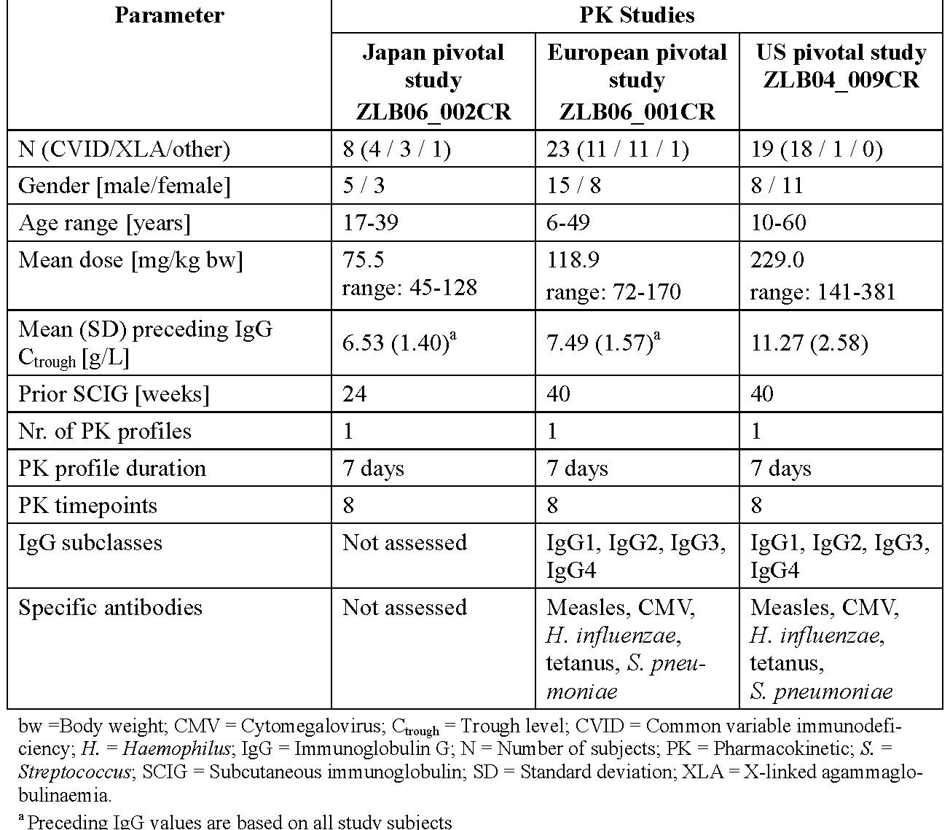

The mean of the individual median IgG Ctrough values during steady-state IgPro20 treatment was 7.15 g/L in the Japan pivotal study **ZLB06_002CR**. The corresponding values were 8.10 g/L in the EU Pivotal **ZLB06_001CR** and 12.53 g/L in the US pivotal study **ZLB04_009CR**, reflecting the higher mean dose given in these studies. The Ctrough values in **ZLB06_002CR and ZLB06_001CR** were comparable to values achieved at the recommended doses for other SCIG products licensed in the EU, according to their SPCs (Vivaglobin: 8 to 9 g/L; Subcuvia: 7.2 to 7.9 g/L; no data quoted for Subgam and Gammanorm). Ratios of the individual IgG subclasses contributing to total IgG at steady-state and measurement of specific IgGs were only evaluated in the European and US studies **ZLB06_001CR and ZLB04_009CR**. Measured values in these studies generally within the range of physiological IgG subclasses ratios reported in the literature (French; Shakib and Stanworth).

This indicates that IgPro20 treatment should provide protection against a range of different types of infection comparable to protection in healthy people. One possible exception was proportionally lower levels of Ig G4 (IgG4) in study **ZLB06_001CR** compared to somewhat higher than normal values in study **ZLB04_009CR.** However, IgG4 represents only a small fraction of the total IgG, its function is uncertain, and low IgG4 levels are not associated with immunodeficiency (Aalberse et al. 2009). In the EU and US pivotal studies, the serum concentrations of total serum IgG, IgG subclasses, and specific IgGs were stable throughout the dosing interval. The changes in serum concentrations of specific IgGs over time were low and generally comparable to changes in total serum IgG and IgG subclasses. This is confirmed by the fact that IgPro20 provides antibodies to a range of infection types (anti-measles, anti-cytomegalovirus, anti-Haemophilus influenzae type B, anti-tetanus, and anti-*Streptococcus pneumoniae*) (ACIP).

As expected, lower serum concentrations for IgG subclasses and specific IgGs were generally observed in **study ZLB06_001CR** than in study **ZLB04_009CR**, reflecting the lower total IgG levels in the former due to lower IgPro20 dosing.

Table 2b. Steady-state Pharmacokinetics of Serum IgG During IgPro20 Treatment, PPK Population (Studies ZLB06_002CR and ZLB06_001CR)

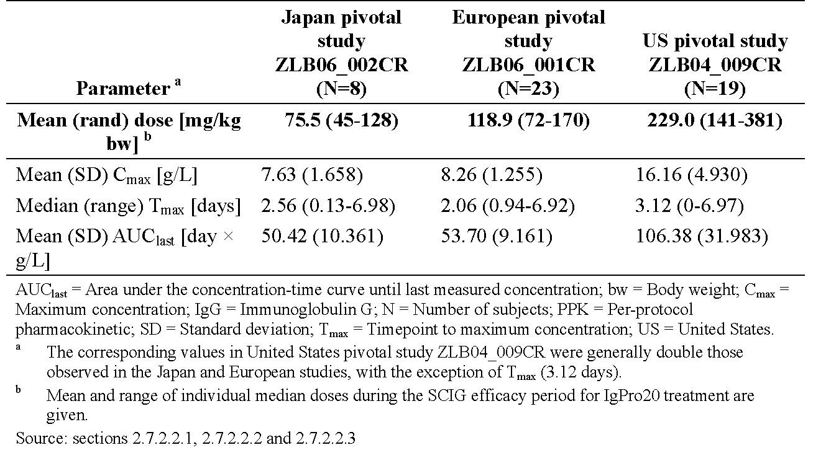

**L-proline:** Serum L-proline was rapidly eliminated from the circulation in the EU and US pivotal studies **ZLB06_001CR and ZLB04_009CR**. One day post IgPro20 at steady-state (Week 28 ± 1), serum L-proline concentration had returned to approximately pre-infusion levels, indicating rapid elimination and lack of accumulation. These observations confirmed the expected safety with respect to L-proline.

### Pharmacokinetics in other special populations

#### Pharmacokinetics in subjects with impaired hepatic function

Not assessed.

#### Pharmacokinetics in subjects with impaired renal function

Not assessed.

#### Pharmacokinetics according to age

Very limited data was available from the PK substudies of SC Hizentra® in children <16 years of age. However, these data suggest no differences in PK for age. No data was provided in children <2 years of age. Further data in regards to the efficacy endpoint of Serum IgG is demonstrated in the pivotal EU clinical study **ZLB06_001CR** which included 17 children (2 to <12 years) and 5 children (12 to <16 years of age). A sub-group analysis of the effect of age on serum IgG, was conducted for this study. The analysis demonstrated no paediatric specific dose requirements, beyond weight based dosing.

Moreover, 12 children participated in the PK substudy confirming that aside from weight based dosing, no dosing adjustments for age.

#### Pharmacokinetics related to genetic factors

Not applicable.

#### Pharmacokinetics {in other special population / according to other population characteristic}

### Pharmacokinetic interactions

#### Pharmacokinetic interactions demonstrated in human studies

Significant drug interactions are reported with human IgG and are not expected with IgPro20. L-proline (an excipient) is permanently present in the blood and has been used in high doses as component of solutions for parenteral nutrition. Drug-L-proline interactions have not been reported in the literature and, based on its metabolism are not expected at these doses.

#### Clinical implications of *in vitro* findings

Not applicable.

## Evaluator’s overall conclusions on pharmacokinetics

Very limited PK data is available from the pre-clinical setting as testing of human Ig in animal models is problematic due to its immunogenicity. Other challenges in PK studies of Ig relate to variable production of endogenous IgG in PID patients. The safety study in healthy volunteers (ZLB04_008CR) did not generate PK data because there was no discernible change in serum IgG. The assessment of the Ig PK during treatment with IgPro20 is based on the PK substudies of the 3 Phase III pivotal Studies ZLB06_002CR, ZLB06_001CR and ZLB04_009CR. PK data were obtained in 8 adults aged ≥16 to <65 years from the Japan pivotal study ZLB06_002CR; 23 (including 9 children 2 to <12 years of age and 3 adolescents 12 to <16 years of age) subjects in European pivotal Study ZLB06_001CR. There were differences in IgPro20 dosing in the Japan pivotal Study ZLB06_002CR, with mean value of the individual median doses of 75.5 mg/kg bw which was 63% of the value in the ZLB06_001CR (118.9 mg/kg bw) and 33% of the value in the US pivotal Study ZLB04_009CR (229.0 mg/kg bw). This difference in IgPro20 dose resulted in relatively lower maximum concentration (Cmax) and AUC values at steady-state. The Cmax for IgG in the European pivotal Study ZLB06_001CR was achieved at approximately 2 days after dosing with IgPro20. This is comparable to the result achieved in the Japan pivotal Study ZLB06_002CR with IgPro20 (approximately 2.5 days after dosing) and also to Vivaglobin, CSL Behring’s other SCIG product (2 days [Vivaglobin SPC]). Other SCIG products have described a longer time to maximum concentration (Tmax) that is, Subcuvia (4 days [Subcuvia SPC]); Subgam (3 to 4 days [Subgam SPC]) and Gammanorm (4 to 6 days [Gammanorm SPC]).

Dosing algorithms used to guide PID patients stable on IVIG switching to SC Hizentra® in the Pivotal Phase III studies, were based on the previous experience with Vivaglobin®.[14] The PK substudy of ZLB04_009CR confirmed that the doses of SCIG should be higher compared to the previously received IVIG doses to achieve matching systemic exposure. The TLR (IgG Ctrough value on steady-state SC IgPro20 treatment divided by the IgG Ctrough value during previous steady-state IVIG treatment) associated with comparable exposure in terms of matching areas under the concentration time-curves was determined to be 1.29 in Study ZLB04_009CR.

Despite the somewhat limited PK data for SC Hizentra®, the studies meet the requirement of the EMEA and the evaluator concurred with their opinion that there is sufficient PK data for this product. The evaluator noted the lack of any specific PK data in children under the age of 2 years of age.

## Pharmacodynamics

### Studies providing pharmacodynamic data

No PD studies have been performed with IgPro20.

### Summary of pharmacodynamics

Not applicable, see *Efficacy* for the findings of the Pivotal efficacy studies in regards to the serum IgG levels attained with SC Hizentra® in PID.

### Mechanism of action

Antibodies are bifunctional protein molecules; the variable domains are responsible for antigen binding; constant domains perform Fc-mediated effector functions that is, complement activation via the classical complement pathway, binding to different Fc-receptors on a variety of immune cells and thereby regulating IgG-synthesis and controlling biological half-life and catabolism. In order to assure the antigen binding function of IgPro20 titres of antibodies with specific antigen reactivity including antiviral, antibacterial and antitoxin antibodies were measured in the final product. They compare well with the titres found in IVIG products Privigen and Sandoglobulin. The functional integrity of the IgG molecule is demonstrated by the Fc-function test which measures effector function of Fc-part. Another assay applied measures activation of neutrophils by erythrocyte bound antibodies of IgPro20. These assays show functionality of Ig in IgPro20 is retained and compares to IVIG.

### Pharmacodynamic effects

#### Primary pharmacodynamic effects

The primary effect of infused human Ig is to provide passive immunity to Ig deficient recipients.

#### Secondary pharmacodynamic effects

The secondary and most important aspect of increasing circulating antibody levels is to protect the recipient from serious bacterial infections that would otherwise be potentially life threatening.

### Time course of pharmacodynamic effects

Several prior/published studies have shown that PK of IgG, differs between IV and SC administration. SC administration of IgG results in lower peak serum concentrations and higher serum Ctrough values of IgG compared to IVIG (Berger 2004; Ochs). In SC regimens, smaller doses are given more frequently that is, weekly compared to the large boluses of 3 or 4 Weekly IV infusions. Based experience with SCIG treatment using Vivaglobin, subjects switching from IVIG to SCIG treatment need to have their IgG dose increased to provide an equivalent systemic IgG exposure compared to their previous IVIG treatment.

### Relationship between drug concentration and pharmacodynamic effects

### Genetic, gender and age-related differences in pharmacodynamic response

Not applicable.

### Pharmacodynamic interactions

Not applicable.

### Evaluator’s overall conclusions on pharmacodynamics

No specific PD data was provided; see efficacy data as measured by steady-state serum IgG and clinical efficacy as measured by rates of SBIs and other infections.

## Dosage selection for the pivotal studies

Two algorithms depending on whether starting Ig de novo or transitioning to SC Hizentra. Numbers of injection sites per treatment depend on volume of the total dose individualised by weight and target serum IgG levels.

## Clinical efficacy

Details of the 3 pivotal efficacy are provided here.

### Pivotal efficacy study for use of Hizentra® as Ig replacement in PID

#### Phase III, prospective, open-label, multicenter, single arm study including a PK substudy: ZLB06_002C R (Japan pivotal study)

##### Study design, objectives, locations and dates

A Multicenter Study of Efficacy, Safety, Tolerability, and Pharmacokinetics of Immune Globulin Subcutaneous (Human) IgPro20 in Subjects with Primary Immunodeficiency (IgPro20 Japanese Pivotal Study). There was also a PK substudy conducted in 8 patients.Multicentre, conducted at 9 sites in Japan 2010-2011. Date of first enrolment: 06 September 2010; Date of last completed: 23 August 2011.

##### Inclusion and exclusion criteria

**Inclusion**1. Male/female ≤75years old; 2. PID (CVID, XLA, ARAG, NBS, hyper IgM syndrome, ataxia telangiectasia with hypo or agammaglobulinemia requiring IgG replacement with a diagnosis of; 3. Subjects who had received IVIG therapy at regular 3 or 4 Week intervals at a stable dose (variations of ±10% allowed) for at ≥3 doses prior to consenting; 4. consent by subject/parent.

**Inclusion criteria for the SC Ig period:** 1) IgG trough level ≥5 g/L at least once between screening or first IVIG infusion until thirdIVIG infusion; 2) IgG trough level ≥4 g/L between screening or first IVIG infusion until 3rd IVIG; 3) No development of SBIs during IVIG period. **Exclusion:** 1) Newly diagnosed PID;2) Ongoing SBIs at screening;3) Hx lymphoid malignancies; 4) Known hyperprolinemia; 5) Hypoalbuminaemia, protein-losing enteropathies, proteinuria; 6) Allergic or other severe reactions to Ig or blood products in the past 3 months or at time of screening; 7) Known haemophilia or thrombocytopaenia; 8) Female subjects of CBP not using/not willing to use, a medically reliable method of contraception for study duration; 9) Intention to become pregnant during course of the study or 10) Pregnant/nursing mother; 11) HIV-1/2,HBV, HCV+ve; 12) AST/ALT>2.5 times ULN; Creatinine >1.5 times ULN; 13) Participated in a study with other investigational product within3 months of screen; 14) Subjects with recent blood donation;15) Subjects who were employees at the investigational site, or relatives or spouse of the study Personnel; 16) Alcohol, drug, or medication abuse within the last year; 17) Treatment with steroids/other systemic immunosuppressants; 18) Re-entry of subjects previously participating in the current study; 19) Any condition likely to interfere with evaluation of the IMP;20) Known/suspected antibodies to the IMP, or to excipients; 21) recent X-rays suggesting infection.

##### Study treatments

IgPro20 administered as SC infusion using Coopdech Syringe Pumps (CSP-100), Daiken Medical Co., LTD (Japan); home-based after a training period. Target injections sites as per **Figure 1**, rotation of sites could occur weekly especially if local site reactions not resolved before next dosing.

**Selection of doses in the study:** Initial weekly dose of IgPro20 during the SCIG WI/WO period was the doseof the IVIG period divided by the treatment interval (Nos of Weeks). If the dose in the IVIGperiod was adjusted according to the procedure described, the average dose of IV 1, IV 2,and IV 3 was to be used. Dose adjustments if trough levels <5 g/L. If necessary, IgPro20 dose adjusted based on the IgG trough levels taken during the WI/WO period to produce IgG trough of ≥5 g/L. During SCIG WI/WO period if IgG trough level <5g/L, repeat a week later. Dose adjustments based on the control measurement could then be performed if medically indicated in amounts according to the investigator’s discretion. If IVIG dose was adjusted, the average dose of IV 1, IV 2, and IV 3 was used. No dose adjustments allowed once SCIG WI/WO period completed unless medically indicated.

Figure 1: Injection site locations ZLB06_002C R

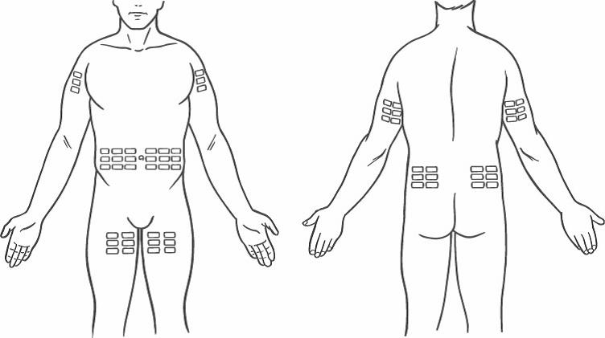

##### Efficacy variables and outcomes

The **main efficacy variable** was evaluation of sustained total serum IgG trough levels with IgPro20 compared to the preceding IVIG treatment period in the per-protocol set (PPS). Evaluation comprised a comparison of 3 trough levels measured at IV 1, IV 2, and IV 3 of the IVIG treatment period with 3 trough levels measured at steady-state of 3 SCIG infusions (at Weeks 16, 20, and 24). **The primary efficacy outcome** was indicated by a GMR of SC versus IV trough levels close to 1 would indicating comparable trough levels achieved with Weekly SC Hizentra® versus historically recorded trough levels of serum IgG when the patient was on IVIG.

###### Other efficacy outcomes included

1. **Protection against infections** that is,how the serum IgG levels achieved with weekly SC Hizentra® translated into protection against infection(s) as measured by: Number of infection episodes (serious and non-serious); Number of days out of work/school/kindergarten/day care or unable to perform normal daily activities due to infections, as assessed by the investigator from subject reporting in the diary; Number of days of hospitalisation due to infections, as assessed by the investigator from subject reporting in the diary; duration of antibiotics for infection prophylaxis and treatment.
2. **Safety as assessed by** numbers, rate, severity, and relatedness of any AEs per infusion and subject; Local tolerability of SC infusions; Vital sign changes before and after infusions at the study site; Changes in routine laboratory parameters (blood chemistry, haematology, urinalysis) as compared to baseline assessments (that is, at screening); Changes in viral safety markers.
3. **Quality of life** as assessed by Health-related quality of life (HRQL) questionnaires that is, to compare QoL when treated with SC Hizentra® versus HRQL at baseline after IVIG treatment. Baseline and follow-up questionnaires (Life Quality Index, LQI) and “Satisfaction of the current IgG replacement therapy” examining HRQL of subjects - completed by the subject/parent.
4. **Pharmacoeconomics (PhEc):** The PhEc assessments included Scale IV of the LQI, and the “Medical expenditures of IVIG and SCIG treatments” questionnaire.

##### Randomisation and blinding methods

This was a single arm, open-label study. No blinding was performed.

##### Analysis populations

The full analysis set (FAS) comprised all subjects treated with IgPro20 during the efficacy period; PPS comprised all subjects under study: who underwent regular IVIG therapy at 3- or 4-Week intervals in the last 6 doses, prior to SCIG treatment (for the first 3 doses variations of ± 10% were allowed; for the 3 subsequent doses dose adjustments allowed as defined above) and with at least one documented IgG trough level during IVIG treatment; treated with IgPro20 during the WI/WO period and for at least 4 Weeks in the efficacy period; received uniformly repeated doses of IgPro20 at weekly intervals during the efficacy period in case of weekly doses below 20 mL; with at least one documented total serum IgG trough level in the efficacy period (Week 16 to Week 24; in case of dosing variations exceeding 10%, all trough levels prior to the dosing change could be used); The “all treated” (AT) safety data set=all subjects treated with at least 1 IVIG or IgPro20 injection during any study period.

##### Sample size

Previous experience with IgPro20 showed that IgG trough levels increased by 17.7% with SC treatment, when SC doses administered at the same Weekly equivalent amount as a subject’s previous IVIG. Based on data from study **ZLB04_009CR** (**see later in this section**), the residual SD of the primary model has been estimated to be 8.4%. For a conservative estimate of the sample size, a residual SD of 10% was used. Primary objective was to provide the GMR of SC versus IV trough, along with a 2-sided 90% CI derived from the model. Comparable troughs would be indicated by a GMR close to 1. Assuming a residual SD of 0.1 for the log-transformed IgG troughs, this 90% CI was estimated to extend from 0.93 to 1.07 times the GMR if 15 subjects were evaluable for the primary analysis. In order to account for discontinuations/feasibility, **25 subjects** planned.

##### Statistical methods

The SAS software package (SAS Institute, Cary, NC, USA), version 9.2 or higher was used. Descriptive statistics included the following: continuous variables were summarized with Number of subjects, mean, SD, 0% (minimum), 25%, 50% (median), 75%, and 100% (maximum) quantiles; frequency distributions were given for categorical data. Non-compartmental AUC determinations at steady-state were performed with WinNonlin software, version 5.2 or higher.

**Demographic and background characteristics were summarised descriptively** to describe the different analysis sets (that is, FAS, PPS, PK, and AT). A separate listing was to be provided for the total set identifying screen failures; The primary efficacy analysis based on the PPS (SCIG efficacy period versus IVIG treatment period). Serum trough levels following a dose variation of >± 10% during the efficacy period were discarded in the respective treatment period (treated as missing). Missing values not replaced. Serum trough levels log-transformed, beforehand and mean values by treatment calculated. An analysis of variance model was fitted to the mean log IgG values to assess the treatment effect (SCIG versus IVIG), using subjects as fixed effect: **Mean log IgG = Treat + Subject**, where mean log IgG values were estimated as arithmetic means of log IgG trough levels by subject and treatment. From this model, the treatment effect estimate, along with the 90% CI, was obtained. After back exponentiation, these values represent the GMR, along with its 90% CI. Additionally, all trough IgG analysed descriptively by visit. Individual median IgG trough levels per study period were calculated and summarised descriptively: IVIG period (IV 1, IV 2, IV 3), WI/WO period (Week 4, 8, and 12), and the SCIG efficacy period (Week 16, 20, and 24). Analyses of **secondary efficacy variables** were based on the PPS and the FAS data set and were calculated for the IVIG run-in, SCIG WI/WO, and SCIG efficacy period. **The Number and rate of infections** (serious/non-serious) calculated for the IVIG run-in, SCIG WI/WO, and SCIG efficacy period. Infection rates were standardized to a 1-year period in the following way: **Annualised rate = 365 × observed episodes / total exposure days**. No imputation of values considered for subjects dropped before the regular study end. The annualised rate (λI) of SBIs estimated along with its upper 1-sided 99% (λIupper) CL:



with χ21-α,v representing the upper 1-α percentile of the Chi-Square distribution with ν degrees of freedom, y the total Number of a SBIs within the respective period, and t the sum of all study days over all subjects for the respective period.

Days out of work/school/kindergarten/daycare due to infections, Days of hospitalization due to infections - Number and proportion of subjects, descriptive statistics. **Health-related quality of life and PhEc analyses**: utilising health questionnaires and the LQI subscale IV and the PhEc questionnaires respectively were used. to compared and score change in HRQL from IVIG to SCIG treatment.

**Note**: Treatment satisfaction data in answers to questions Q2, Q5 and Q6 was reanalysed due to a translation error of instructions from the English original into Japanese, subjects scored these 3 specific questions under erroneous guidance. Instead of the original score range from 1 (extremely bad) to 7 (extremely good), the Japanese questionnaire requested answers on a reverse scale from 1 (extremely good) to 7 (extremely bad). To correct this error post hoc, the original answers to the above 3 questions were transformed. The following additional **post-hoc analyses** were performed for the primary endpoint “GMR of SC versus IV trough levels” to support the results: The primary endpoint (on the PPS) was additionally calculated for the FAS. **Safety analyses**: AEs were coded using MedDRA version 14.1. Analyses performed by primary system organ class (SOC) and preferred term (PT). Analyses of AEs were conducted in 2 ways: i) **Subject level:** The Number of subjects with an AE was related to the total Number of subjects treated (that is, incidences). Incidences were given in percent: (no. of subjects with AE / total no. of subjects) x 100 ii) **Infusion level:** The Number of AEs was related to the total Number of infusions (that is, rates). Rates were given as a ratio: number of events/number of infusions. Summaries on Nos, rate, severity, relatedness of any AEs per infusion and subject, assessment of local tolerability of SC infusions, vital sign, routine labs; viral safety markers.

##### Participant flow

Screening period, IVIG treatment period with 3 planned infusions every 3 or 4 Weeks, a 12 Week SCIG wash-in/wash-out period, and a 12 Week SCIG efficacy period followed by completion/Discontinuation visit. A viral safety follow-up visit was performed within 12 to 17 Weeks after last IgPro20 infusion. All SCIG infusions administered Weekly.

Figure 2: Study Design ZLB06_002C R

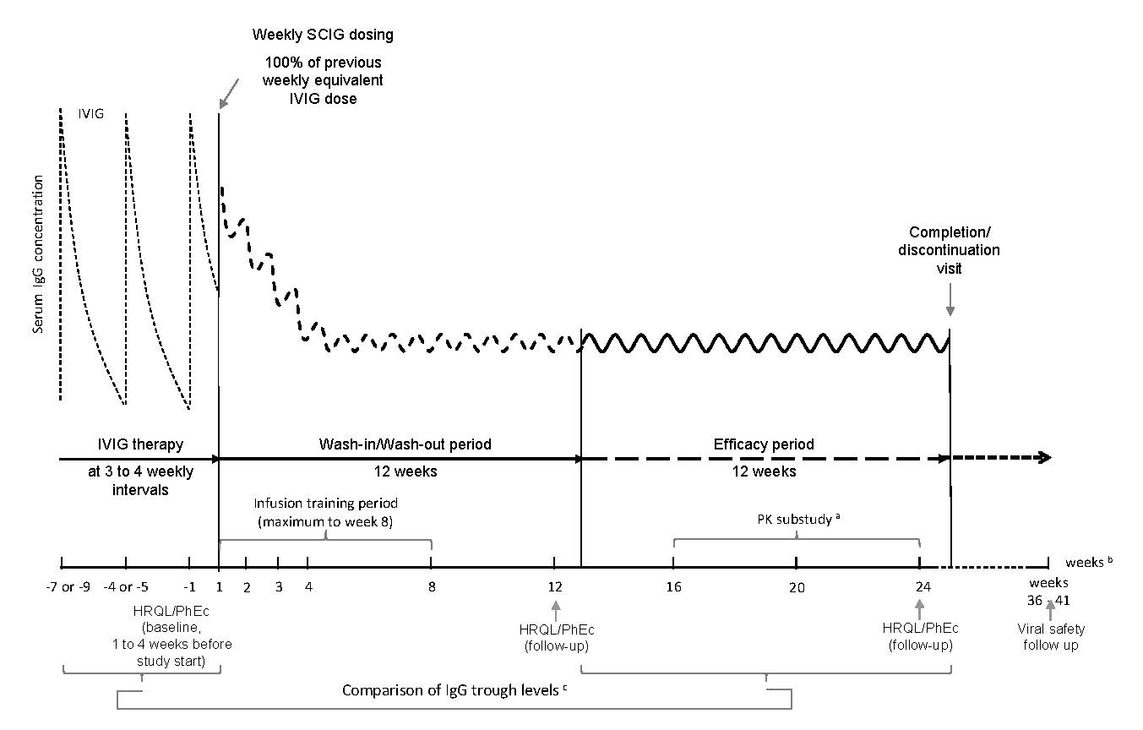

##### Major protocol violations/deviations

Figure 3: Disposition of patients in the Japan Pivotal study ZLB06_002CR

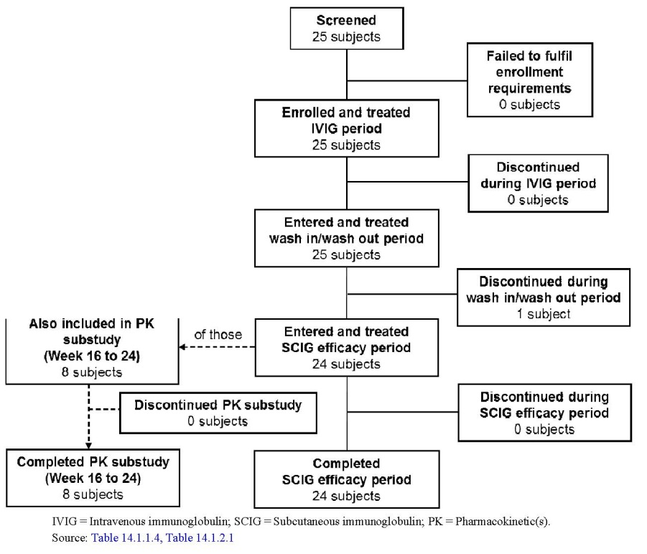

##### Baseline data

Table 3: baseline characteristics ZLB06_002CR

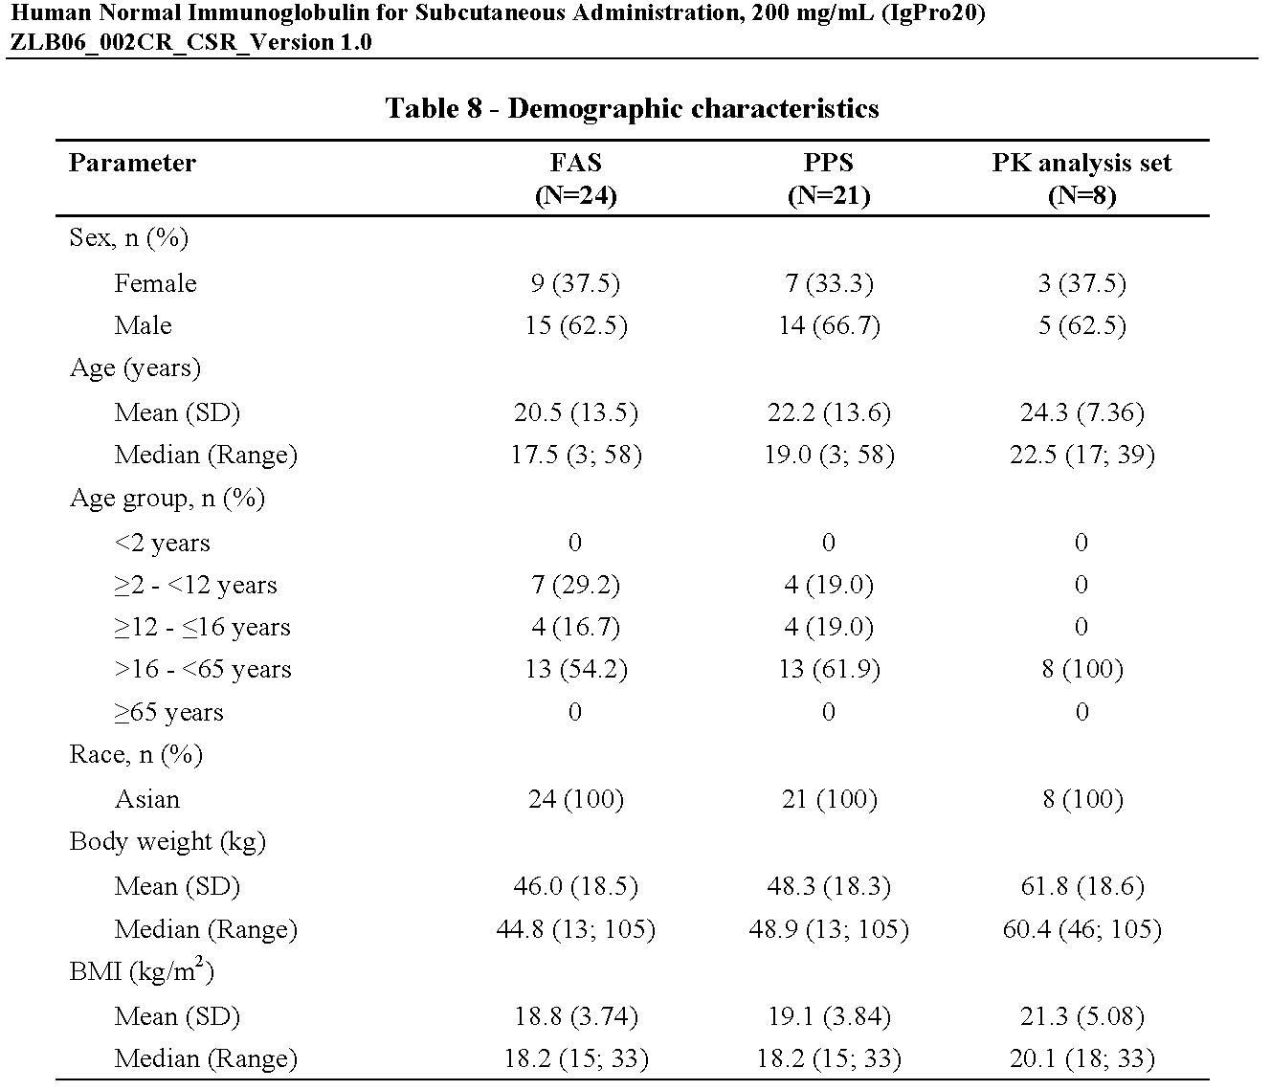

In the FAS, 8 subjects (33.3%) blood group A, 7 (29.2%) blood group O, 5 (20.8%) blood group B, and 4 subjects (16.7%) blood group AB; all subjects were rhesus positive . **Study drug exposure:** All 25 subjects in the IVIG run-in period received the intended 3 infusions. All 24 subjects in the FAS and all 21 in the PPS received the intended 12 infusions during the SCIG WI/WO period. The subject who discontinued the study during the WI/WO period and was not included in FAS and PPS received 8 of 12 infusions in that period and none during the SCIG efficacy period. During the SCIG efficacy period, all 24 subjects of the FAS and all 21 in the PPS received the intended 12 infusions. In the SCIG efficacy period, the proportion of infusions performed at home increased to approximately 74% in the FAS and PPS analysis sets.

##### Results for the primary efficacy outcome

Table 4: Primary analysis: GMR and 90% CI of IgG trough levels SCIG versus IVIG (PPS & FAS) in ZLB06_002CR

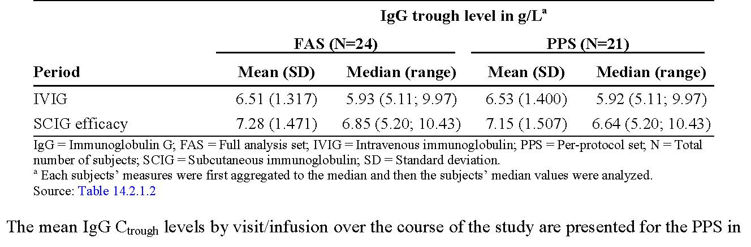

The primary efficacy analysis was the comparison of median individual IgG Ctrough levels of the IgPro20 efficacy period with those of the IVIG period in the PPS by GMR. The IgG Ctrough levels increased from 6.53 g/L in the IVIG period to 7.15 g/L in the SCIG efficacy period (**Table 4**). The GMR calculated was 1.09 (90% CI: 1.06 to 1.13), showing that the objective of achieving comparable IgG Ctrough levels was met (**Table 5**).

Figure 4: Serum IgG trough levels (mean ± SEM) over the course of the study (PPS) in ZLB06_002CR

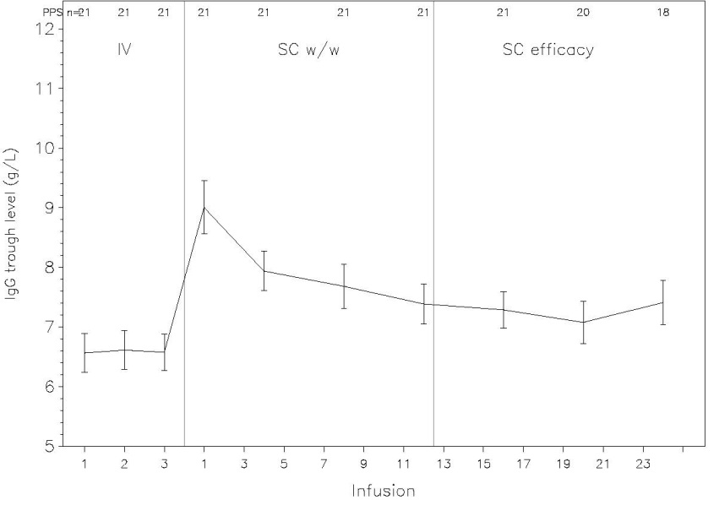

Table 5: Primary analysis: GMR and 90% CI of IgG trough levels SCIG versus IVIG (PPS & FAS) in ZLB06_002CR

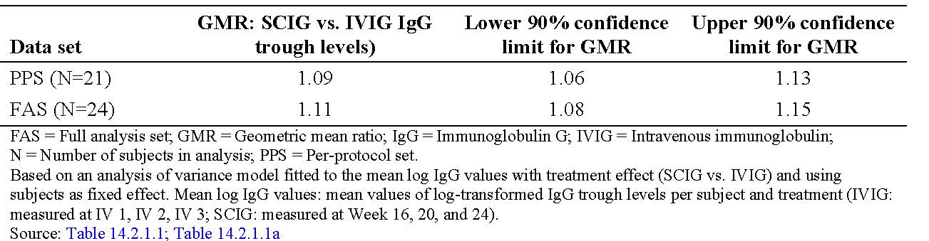

##### Results for other efficacy outcomes

Table 6: Summary of results for secondary efficacy endpoints (PPS) in ZLB06_002CR

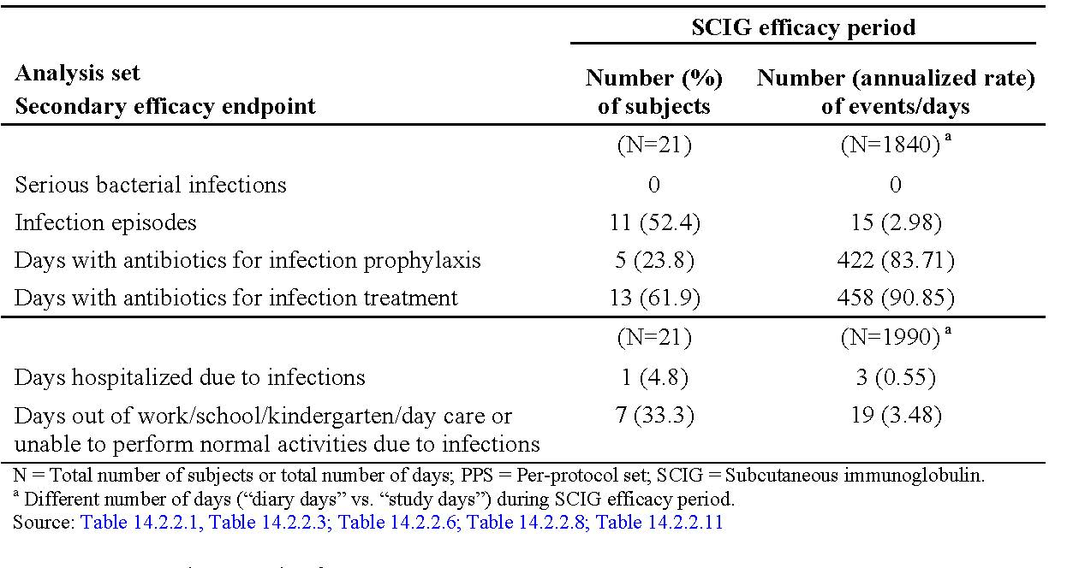

A total of 11 subjects (52.4%) in the PPS had ≥1 infection in the SCIG efficacy period. Based on the 1840 subject-days collected in the SCIG efficacy period, the total annualised rate of infections in the study was 2.98 infections/subject/year (upper 99% CL: 5.305 infections/subject/year). Most commonly: nasopharyngitis, URTI, and gastroenteritis. All other types of infection affected only 1 subject each and had an incidence of 1 event during the SCIG efficacy period. The “Satisfaction questionnaire” showed that during SCIG treatment >95% of the subjects were performing their therapy mainly at home. At Week 24, 14 subjects (58.3%) were able to perform the SCIG home infusion by themselves. The mean LQI total score increased from 53.7 at Week 1 (IVIG) to 71.5 at Week 24 during SCIG treatment with IgPro20. Improvements were found in all LQI subscales but were most pronounced for “costs”, “therapy setting”, and “treatment interference”.

### Pivotal efficacy study for use of Hizentra® as Ig replacement in PID

#### Phase III, prospective, open-label, multicenter, single-arm study including a PK substudy: ZLB06_001CR (European pivotal study)

##### Study design, objectives, locations and dates

A Multicentre Study of the Efficacy, Tolerability, Safety, and Pharmacokinetics of Immune Globulin Subcutaneous (Human) IgPro20 in Subjects with Primary Immunodeficiency. 15 sites in the EU enrolled patients between 28 September 2007-31 August 2009. Sites increased (Amendment 3) to increase enrolment.

##### Inclusion and exclusion criteria

Inclusions and Exclusions are aligned with those in Study ZLB06_002CR, with the following exceptions: **Inclusions:** 1) Male or female subjects >2 to ≤65 years of age (for sites in the UK: 16 to 65 years of age); 2) Subjects who had received IVIG therapy at regular 3- or 4-Week intervals, **or SCIG therapy** at regular Weekly intervals at a stable dose (variations of ± 10% were allowed) for at least 6 months prior to receiving IgPro20 (maintenance dose to reach a cumulative monthly dose of the order of 0.2 to 0.8 g/kg); 3) Subjects who had at least 3 documented IgG Ctrough values ≥ 5 g/L during 3 months on IVIG **or SCIG** replacement therapy immediately prior to receiving IgPro20; 2 of the 3 IgG Ctrough values could go back up to 6 months prior to receiving IgPro20, in case of stable dosing for at least 3 months prior to this assessment.

##### Study treatments

IgPro20 administered SC using Cane Crono PCA-50 or Super-PID infusion pumps (Cane S.R.L., Turin, Italy). After selection of appropriate injection sites (see **Figure 1**) ≥2 injection sites could be used simultaneously; maximum initial volume per injection site was 15 mL increasing to a maximum of 25 mL after fourth infusion. For subjects already receiving SCIG prior to this study, the infusion volume per injection site used in the previous treatment could be continued, but should not exceed a maximum of 25 mL. Total infusion flow rate not to exceed 25 mL/h during the WI/WO period (Infusions 1 to 12) and could then be increased up to 35 mL/h. When using bifurcated catheters, an infusion rate of 17.5 mL/h per injection site, that is, a pump setting of 35 mL/h, was allowed from outset. Treatment with IgPro20 was predominantly home-based. Infusions in Weeks 1, 2, 4, 8, 12, 16, and 28 performed at study site under medical supervision, thereafter at home. **Selection of Doses for the study:** I) **Subjects previously treated with IVIG,** the initial Weekly dose of IgPro20 during the wash in/wash-out period was one third (previous 3-Weekly schedule) or one fourth (previous 4-Weeklyschedule) of previous IVIG dose; 2) **For subjects already on SCIG therapy**, the initial Weekly dose of IgPro20 during the WI/WO period was the same dose as previously. Changes in wt of more than ± 5% required dose adjustment. If necessary, the Weekly dose of IgPro20 was adjusted during the WI/WO period to attain IgG Ctrough values of ≥5 g/L. Dose adjustments performed if medically indicated. If an IgG Ctrough value of < 5 g/L was measured at the scheduled assessments prior to Infusions 4, 8, or 12, repeat 1 Week later. If the IgG Ctrough value on repeat was still too low, dose adjustment permitted. However, except for adjustments due to changes in body wt, no further dose adjustments during the efficacy period unless medically indicated.

##### Efficacy variables and outcomes

The main efficacy variable was to descriptively compare IgG Ctrough values at 6 consecutive weeks at steady-state, that is, IgG levels prior to Infusions 12 to 17, with 3 IgG Ctrough values obtained from the subject’s previous treatment during the last 3 to 6 months prior to the study. Bloods were collected from all subjects within 6 hours prior to the next infusions with IgPro20 at the study site: Infusions 1, 4, and 8 in the WI/WO period; Infusions 12 to 17; Infusion 20 and every 4th infusion thereafter until Infusion 40. IgG m’ments performed by the central laboratory. Other efficacy outcomes:

* Rates of infections (including SBIs - criteria included in the protocol : Bacterial pneumonia; Bacteraemia/septicaemia; Osteomyelitis/septic arthritis; Bacterial meningitis; Visceral abscess;
* QoL using the Short Form-36 (SF-36) Health Survey (Ware) and Child Health Questionnaire-Parent Form 50 (CHQ-PF50) (Landgraf) for children <14 years (not available in Polish and Romanian); TSQM, version 1.4 (Atkinson); Questionnaire on the IgG Therapy; LQI (Daly) andhealth status rating scale (Gardulf 1993;Gardulf 1995);
* Safety.

##### Randomisation and blinding methods

This was a single arm, open-label study. No blinding was performed.

##### Analysis populations

Efficacy analyses were carried out on the **ITT (**all subjects treated with IgPro20 during the efficacy period (starting with Week 13)) population**.** In addition, analyses of IgG Ctrough values and SBIs were also performed on the **per-protocol efficacy (PPE) (**all subjects who completed the 28-Week efficacy period according to protocol) population. HRQL analyses were carried out on the Full-Analysis HRQL (Full HRQL) population.

The Full HRQL population comprised all enrolled subjects with a baseline and at least 1 follow-up HRQL assessment. Missing visits were not imputed, except that the “last observation carried forward” (LOCF) approach was used to analyse the end of study visit that was defined as the last observed post-baseline value for each subject. All safety analyses were carried out on the “all treated” (AT) population (safety data set) that comprised all subjects who were treated with IgPro20 during any study period. PK analyses were carried out on the per-protocol PK (PPK) population.

##### Sample size

It was initially planned to enrol approximately 36 subjects (including approximately 12 children) in approximately12 centres to achieve a total of 30 subjects (including at least 10 children) evaluable for efficacy, tolerability, and safety. Of these subjects, approximately 18 ≥6 years of age were to be enrolled in the PK substudy in order to gather PK data for at least 15 subjects. This sample size was consistent with recommendations of the CPMP guideline CPMP/BPWG/283/00, that PK data should be derived from ≥15 subjects, including 10 subjects with PID. To ensure sufficient data in children, the planned enrolment was changed **to 51 subjects** in Amendment 3. Due to slow recruitment, number of study sites and recruitment period were expanded.

##### Statistical methods

The study design took into consideration the European CPMP guideline “Note for guidance on the clinical investigation of human normal immunoglobulin for subcutaneous and intramuscular use”. The primary endpoint, that is, IgG Ctrough value, is an accepted and reliable standard parameter, measured in the central laboratory by a validated assay. Concentrations of IgG analysed by immunoturbimetry which is a standard method. Six consecutive steady-state IgPro20 IgG Ctrough values per subject, that is, IgG concentrations determined before Infusions 12 to 17, were compared descriptively with 3 Ctrough values obtained prior to the first IgPro20 infusion. For this purpose, the 6 consecutive steady-state IgPro20 Ctrough values per subject were aggregated to the subject’s median value and then median values across subjects were summarised using descriptive stats. The same procedure was used for the 3 most recent IgG Ctrough values ≥5 g/L obtained prior to first IgPro20 infusion. If there were at least 5 subjects with at least 1 dose adjustment in the WI/WO period, a robustness analysis was to be performed. The primary analysis as described above conducted using only data from subjects who did not have a dose adjustment. In a second analysis, all steady-state IgPro20 Ctrough values obtained in the efficacy period (that is, IgG concentrations determined before Infusions 12 to 17, 20, 24, 28, 32, 36, and 40) were used for calculation of the aggregated median values and the comparison with the IgG Ctrough values obtained prior to the first IgPro20 infusion. The comparison of Ctrough values before and during the study was performed via boxplots. In addition, all IgPro20 Ctrough values were analysed descriptively by visit. The course of IgG Ctrough values was presented graphically. The analyses described for the annualised rate of SBIs were also performed for the total Number of infection episodes and by preferred term. However, 2‑sided 95% confidence limits were calculated instead of the 1-sided upper 99% CL used for SBIs. No imputation was made for subjects who discontinued the study. Annual rates of infection were also analysed by month. In addition, incidences of infections (overall and by PT) were calculated as were nos. of infections treated with antibiotics was analysed. Annualised rates and incidences of infections were provided by route of antibiotic administration. **Quality of life scoring and analyses:** Each HRQL instrument scored according to the instructions provided by the authors. **Analyses of safety endpoints** based on AT population and extended to full study period, Day 1-completion visit. AEs coded using MedDRA. Analyses by primary SOC and PT. TEAEs included in the summarising analyses.

In addition, because this study allowed the inclusion of patients previously on SCIG, exploratory subgroup analyses conducted according to the following criteria: **Age class** (≥2 to <12 years, children; ≥12 to <16 years, adolescents; ≥16 to <65 years, adults); **Disease type** (CVID, XLA, or ARAG).

###### Previous replacement therapy (IVIG or SCIG)

Subgroup analyses performed for the primary efficacy endpoint based on ITT Population. Subgroup analyses for secondary efficacy endpoints performed only for nos. of infections and nos. of days out of work/school/kindergarten/day care or unable to perform normal activities due to infections based on ITT population. If <5 events in a respective category or <5 subjects in a subgroup, subgroup analysis could be omitted. In addition, incidences/rates of TEAEs analysed by these subgroups. Subgroup analyses by age, that is, <14 years of age versus adolescents/adults ≥14 years of age.

##### Participant flow

Figure 5. Study and PK substudy procedures in ZLB06_001CR

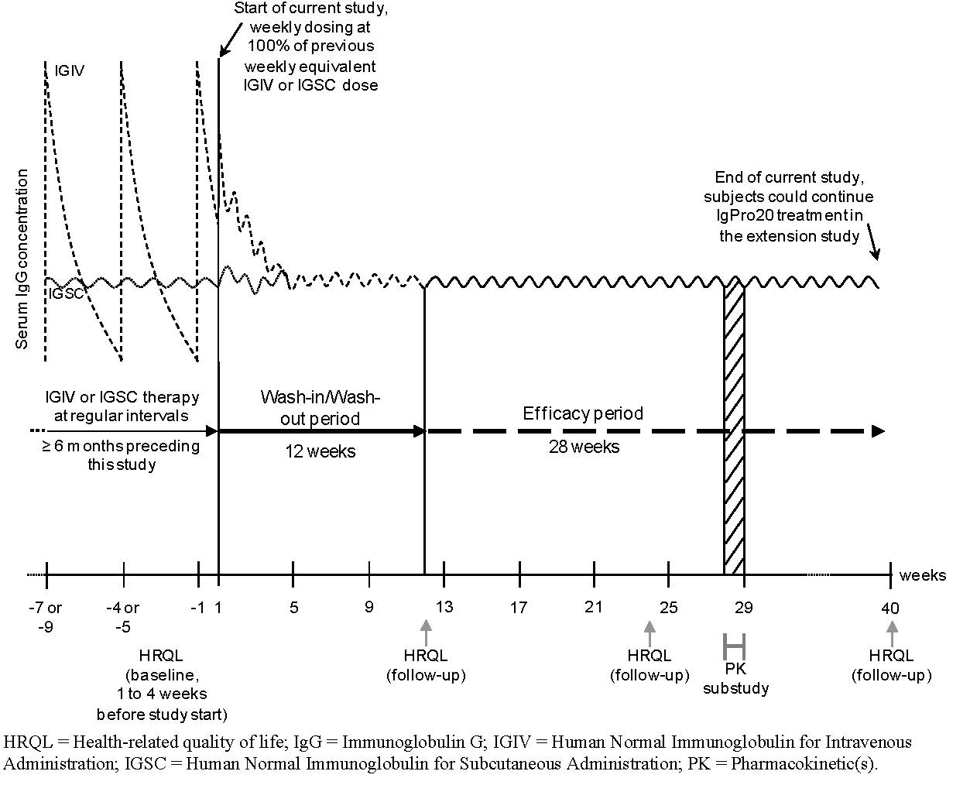

##### Major protocol violations/deviations

5 subjects (9.8%) in the AT population excluded from the ITT population because they were not treated during the efficacy period; 12 subjects (**26.1%)** in the ITT population had major protocol deviations and were therefore excluded from the PPE population. **See Figure 6**.In the ITT population, 28 subjects (60.9%) and 17 subjects (37.0%) had CVID and XLA respectively. In the AT population, 49.0% blood group A (19 subjects were Rh+), 25.5% blood group O (12 subjects were Rh+), 9.8% blood group B (all were Rh+), and 2.0%, Rh+ blood group AB. Blood group not determined for 13.7%.

Figure 6: Disposition of patients in the EU Pivotal study ZLB06_001CR

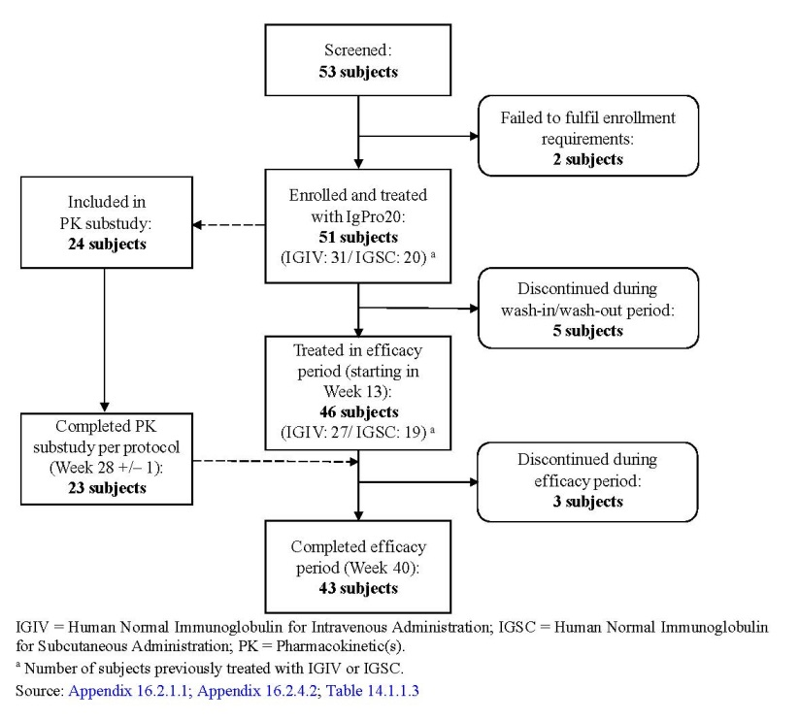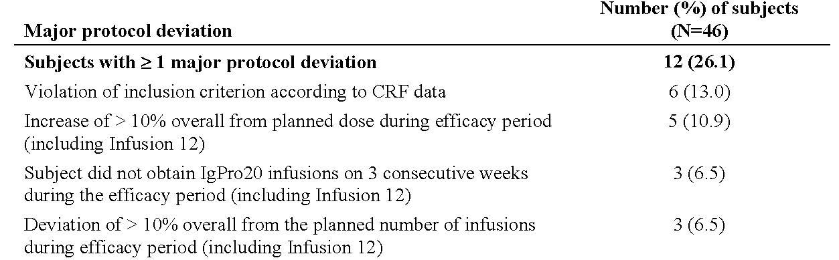

##### Baseline data

Table 7a: Baseline demographics in ZLB06_001CR

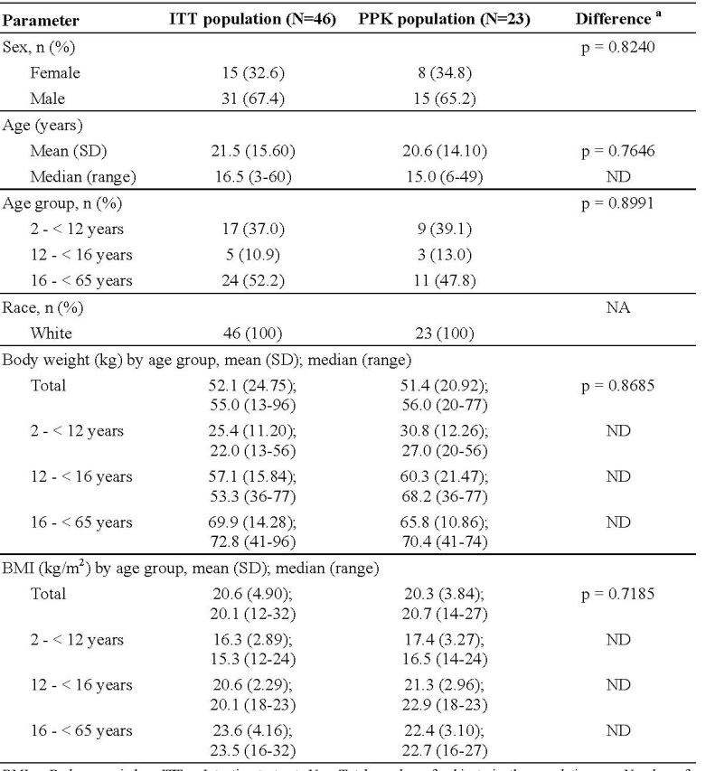

Table 7b: Baseline demographics in ZLB06_001CR

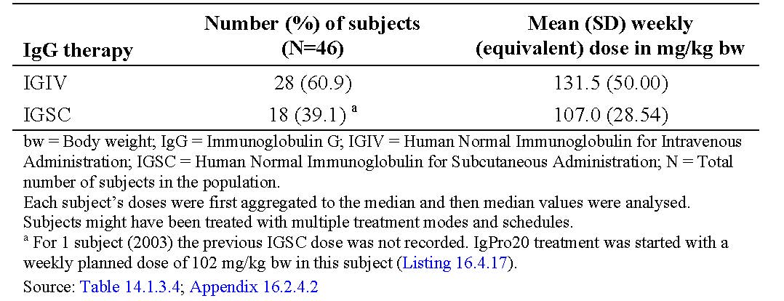

Table 7c: Mean Weekly (equivalent dose) at baseline in ZLB06_001CR



##### Results for the primary efficacy outcome

The AT population=51 subjects, ITT population =46 subjects, PPE population =34 subjects. All efficacy endpoints were evaluated in ITT population, except for an additional analysis of the primary efficacy endpoint in the PPE population and the secondary efficacy endpoint of SBIs in ITT and PPE populations. Subgroup analyses of efficacy endpoints were based on the ITT population. The PPK population that was used for PK evaluations comprised 23 subjects. All 46 subjects (100%) in the ITT population received the intended 12 infusions during the WI/WO period. During the efficacy period, 37 subjects (80.4%) received the intended 28 infusions, 1 subject (2.2%) received 27 infusions, and 3 subjects (6.5%) who discontinued during the efficacy period received 3, 7, and 24 infusions. 37 subjects (80.4%) received the planned 40 infusions. The median Number of injection sites per infusion during WI/WO period and during the efficacy period was 2 (range: 1-4). In the ITT population, mean IgG Ctrough values were generally stable during the efficacy period (**Figure 5**) with values between 7.99 and 8.25g/L**.** The mean of individual median IgG Ctrough values was 8.10 g/L at steady-state IgPro20 treatment (values were nearly equal when 6 consecutive IgG Ctrough values before Infusions 12 to 17 or all IgG Ctrough values during the efficacy period were considered). Compared to IgG Ctrough values for 3 infusions during the pre-study IVIG or SCIG treatment, the mean of individual median IgG Ctrough values **increased by 8.1%** (from 7.49 g/L with the prior IgG therapy to 8.10 g/L during Infusions 12 to 17). The same increase in IgG Ctrough values observed when considering Ctrough pre-Infusions 12 to 41 **(Table 8).**

Table 8: Median IgG trough levels before & during the study (ITT population) ZLB06_001CR

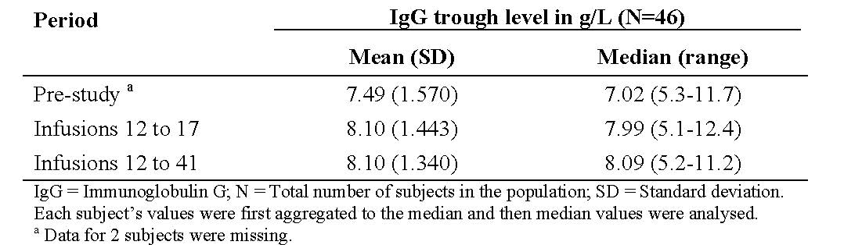

IgG Ctrough values <5 g/L were measured in 5 subjects; 3 with CVID and 2 with XLA. IgG Ctrough values <5 g/L occurred only before very few infusions, except subject 2103 with repeated IgG Ctrough values <5 g/L.

**Figure 7: Serum IgG trough levels by visit (ITT population)** **ZLB06_001CR**

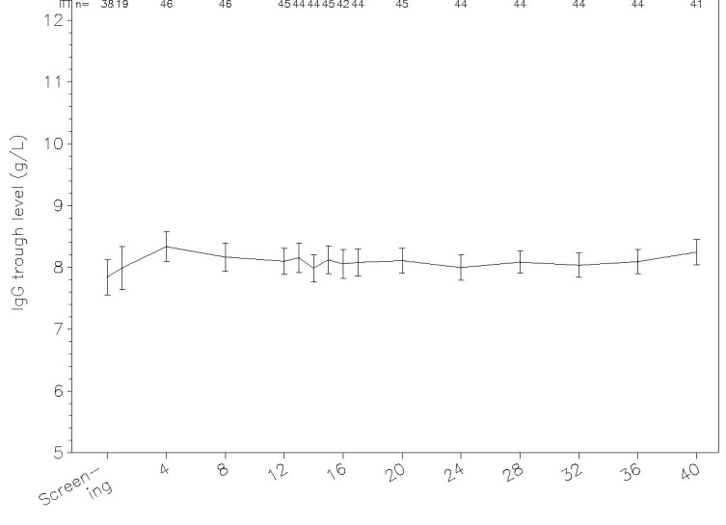

##### Results for other efficacy outcomes

No subjects in ITT or PPE populations had an SBI during the efficacy period. The annual rate of SBIs per subject was therefore **0**, with upper 99% CL of 0.192 for the ITT and 0.250 for the PPE population. However, 1 subject had an SBI (pneumonia) during the WI/WO period, resulting in an annual rate for the full evaluation period of 0.03 SBIs/subject/year (upper 99% CL: 0.192) for the ITT population and of 0.04 SBIs/subject/year (upper 99% CL: 0.253) for the PPE population. This subject (1505) had an underlying disease of pneumonia and IgG concentrations 6.43 and 9.86 g/L during the WI/WO period.

Table 9: Summary of results for secondary efficacy endpoints (ITT and PPE population) ZLB06_001CR

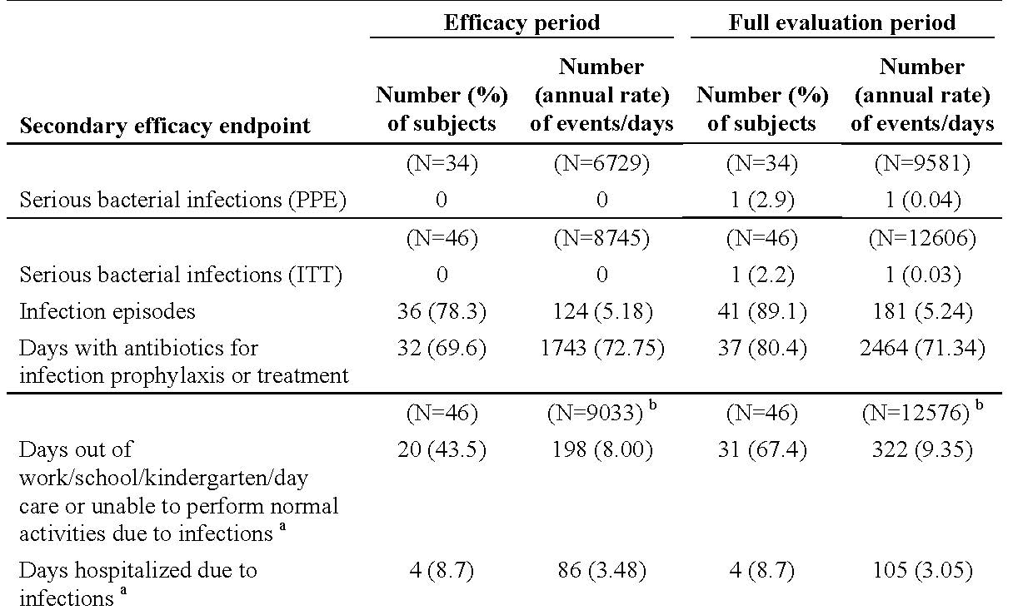

78.3% in the ITT population had at least 1 infection in the efficacy period (that is, during 8745 subject-days). Total annual rate of infections =5.18 infections/subject/year (95% CL: 4.305; 6.171). The most frequent being cough (16 events; rate of 0.67 infections/subject/year)>URTI and bronchitis (15 events each; rate of 0.63 infections/subject/year each) >nasopharyngitis (13 events; rate of 0.54 infections/subject/year), and sinusitis and productive cough (7 events; rate of 0.29 infections/subject/year each). All other infections incidence ≤4 events.

The highest incidence of subjects with a specific infection type was URTI (11 subjects [23.9%])>bronchitis (10 subjects [21.7%])>nasopharyngitis (9 subjects [19.6%]). **Effect of age on efficacy endpoints:** In the ITT population, 24 subjects (52.2%) were 16 to <65 years of age, 17 (37.0%) were 2 to <12 years of age, and 5 (10.9%) were 12 to <16 years of age. For all age classes, mean IgG Ctrough values were generally stable during the efficacy period; mean values 7.55-8.17g/L in subjects 2 to <12 years of age, 7.33-8.67 g/L in subjects 12 to <16 years of age, and 8.12-8.45g/L in subjects 16 to <65 years of age (**Table 10a**). Before the study start, mean of individual median IgG Ctrough values slightlylower in subjects 2 to <12 years of age (6.94 g/L) versus subjects 12 to <16 years ofage (7.99 g/L) and subjects 16 to <65 years of age (7.81 g/L). The mean of individual median IgG Ctrough values during IgPro20 treatment wasslightly lower in subjects 2 to <12 years of age. During Infusions 12 to 17, the mean IgGCtrough was 7.86 g/L in subjects 2 to <12 years of age, 7.91 g/L in subjects 12 to <16 years ofage, and 8.31 g/L in subjects 16 to <65 years old. The largest increase in IgG Ctrough values with IgPro20 treatment (Infusions 12 to 17) versus prior IgG therapy observed in subjects 2 to <12 years of age (increase of 13.3% in the mean of individual median Ctrough values), who had had the lowest mean IgG Ctrough value with their previous IgG therapy (**Table 10b**). In a robustness analysis of IgG Ctrough values by age class excluding all subjects who had dose adjustment during the WI/WO period, **no relevant difference was observed** versus analysis for the ITT population.

Table 10a: Median IgG trough levels before and during the study by age class (ITT population) ZLB06_001CR

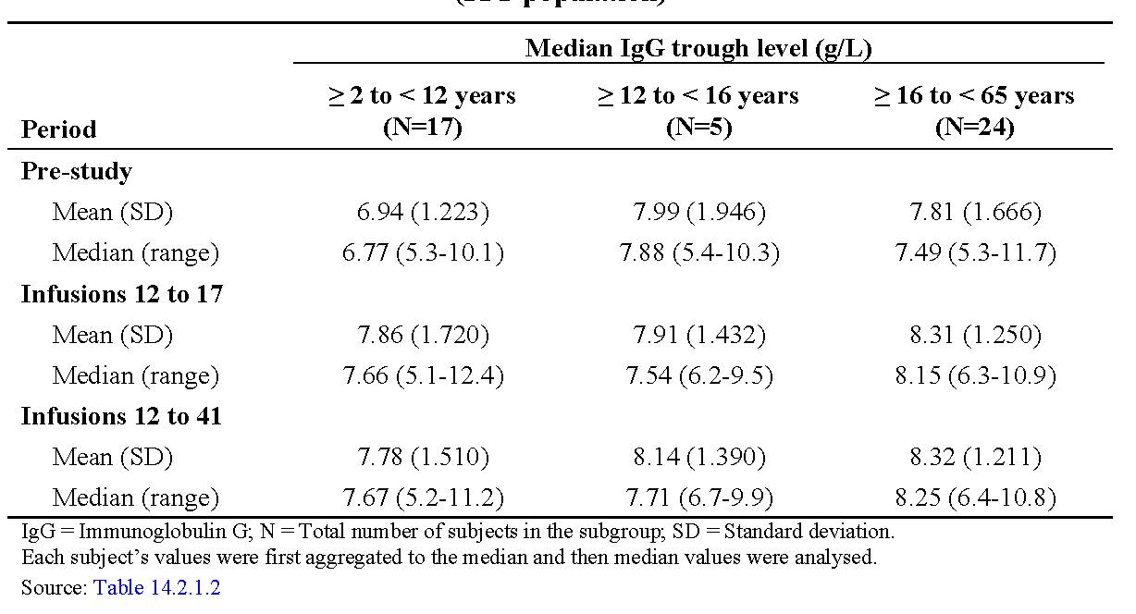

**Table 10b: Median IgG trough levels before and during the study by previous replacement therapy (ITT population) ZLB06_001CR**

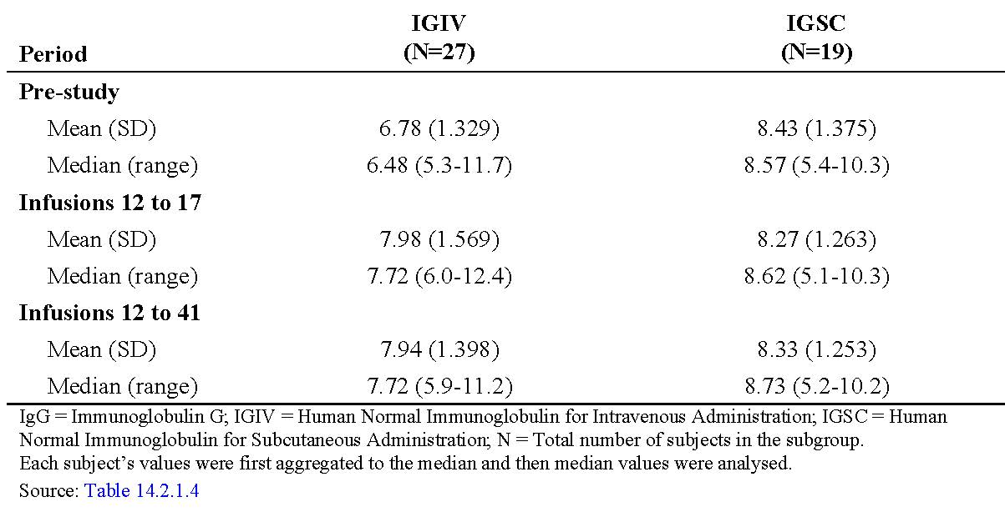

**Quality of Life:** Some aspects of HRQL and treatment satisfaction improved with SC IgPro20. Statistically significant improvements observed for TSQM domain convenience and total LQI.

### Pivotal efficacy study for use of Hizentra® as Ig replacement in PID

#### Pivotal efficacy studies) Phase III, prospective, open-label, multicenter, single-arm study including a PK substudy: ZLB04_009C R (US pivotal study)

##### Study design, objectives, locations and dates

A Phase III Open-label, Prospective, Multicentre Study of the Efficacy, Tolerability, Safety, and Pharmacokinetics of Immune Globulin Subcutaneous (Human), IgPro20 in Subjects with Primary Immunodeficiency. Multicentre, 12 sites in the USA enrolled patients into this study between 2006 and 2008. Date of first enrolment: 29November 2006; Date of last completed: 27 October 2008. The study design took into consideration the criteria in the FDA Draft Guidance “Safety, efficacy, and PK studies to support marketing of IVIG (human) as replacement therapy for primary humoral immunodeficiency” (November 2005) and the EMEA Guidance. At the request of the FDA, a new variable, trough level ratio (**TLR**) of serum IgG for SCIG versus IVIG (Privigen) at steady-state, was derived on the basis of PK data obtained in the current PK substudy. The TLR relates steady-state AUC and serum Ctrough during IVIG administration to steady-state AUC and Ctrough during SCIG administration. The purpose of this IgPro20-specific TLR was to provide a means by which serum Ctrough values in non-PK subjects could be used to assess whether these subjects had been adequately dosed with IgPro20 during the efficacy period. The individual comparisons of serum IgG levels and AUCs between IgPro20 treatment in the current study and during Privigen treatment in the preceding studies were conducted in the PK subset.

##### Inclusion and exclusion criteria

**Key inclusions:** 1) Male or female, 2-75 years of age with PID that is, CVID or XLA; 2) Previously received IVIG therapy at 3- or 4 Week intervals for ≥3 months prior to receiving IgPro20. Subjects switching from Privigen had to have at least 3 documented serum IgG Ctrough values of ≥5 g/L during the preceding 3 months of Privigen therapy. Subjects switching from another IVIG had to have ≥1 documented IgG Ctrough value of ≥ 5 g/L during the preceding 6 months of IVIG; 3) non pregnant using contraception. **Exclusions: see above under the Japan Pivotal study.**

##### Study treatments

IgPro20 was administered SC using Cane Crono PCA-50 infusion pumps (Cane S.R.L., Turin, Italy). Number of injection sites depended on the volume of total dose. The actual points of injection were changed with each Weekly administration. Treatment with IgPro20 was predominantly home-based performed by subject/parent after a training period at study site – see above. **Selection of doses in the study:** Initial Weekly dosing during the WI/WO period was **one fourth** (previous 4-Weekly schedule) or **one third** (previous 3-Weekly schedule) of the average dose ofthe previous 3 IVIG infusions x 1.30 (130%); weight based changes as per above.

##### Efficacy variables and outcomes

The main efficacy variables evaluated in this study was the annual rate of SBIs in patients receiving SC Hizentra® defined as: Bacterial pneumonia; Bacteraemia/septicaemia; Osteomyelitis / septic arthritis; Bacterial meningitis; Visceral abscess. Using FDA guidelines in regards to criteria used for definition of these SBIs (FDA). The primary efficacy outcome to evaluate whether the annual rate of serious bacterial infections (SBIs) per subject was <1. **Other efficacy outcomes: Infections related:** Rate of SBIs in the PPE and ITT populations; Number of infection episodes (serious /non-serious); Number of days out of work/school/kindergarten/day care or unable to perform normal daily activities due to infections; Number of hospitalisation days due to infections; Use of antibiotics for infection prophylaxis and treatment. **Ig level related:** Total serum IgG Ctrough. **Safety-related:** Rate, intensity, and relatedness of any AEs per subject and infusion;Assessment of local tolerability in terms of ISRs; Changes in clinical labs (chemistry, haematology, urinalysis);physical exam;vital signs; concomitant medications, viral safety markers.

##### Randomisation and blinding methods

This was a single arm, open-label study. No blinding was performed.

##### Analysis populations

Efficacy analyses carried out on **MITT** (all subjects treated with study drug during the efficacy period starting with Week13)) and **PPE** (all subjects completing 12-mth efficacy period) populations. All safety analyses carried out on the safety data set=ITT (all subjects treated with study drug during any study period) data set. Descriptive stats for continuous variables included Number of subjects, mean, SD, and the 0% (min), 25%, 50% (median), 75%, and 100% (max) quantiles. Frequency distributions for categorical data. Subgroup analyses (gender/age/ethnicity/PID type/dose/PK versus non-PK subject) performed for 1o and 2o efficacy endpoints based on PPE population.

##### Sample size

The sample size for this study is based on the following hypotheses: **H0: λI ≥ 1.0 versus Ha: λI < 1.0**. where λI represents the parameter of a Poisson distribution, that is, the Number of SBIs in the IgPro20 group per subject per year through the 12-month efficacy period. Under the assumption of a real rate of 0.5 SBIs per subject per year, 32 subjects have to complete the 12-mth efficacy period (alpha = 0.01, one-sided, power = 80%). 50 subjects planned. Steady-state AUC values from SC treatment versus those from previous weekly-equivalent IVIG (PK substudy). PK noninferiority of the average adjusted SC doses will be claimed, if the lower (one-sided) 95% CL for the geometric mean AUC ratio is 0.8 (that is, 80%) or more. For the purpose of this study, an intra-subject variability with CV=25% (s=0.25 for log-transformed AUCs) assumed. Further assuming that the expected geometric AUC-ratio of adjusted SC versus IV doses equals or exceeds 1, the power for a one-sided 95% CI of this ratio to exclude the non-inferiority limit of 0.8 will be 85%, if 18 evaluable subjects complete the PK substudy. To account for drop-outs/deviations, 20-25 subjects planned for the PK substudy.

##### Statistical methods

Primary efficacy endpoint defined as annual rate of clinically documented SBIs in the MITT population during the efficacy period (starting Week 13). The null hypothesis H0: λI ≥ 1.0 versus Ha: λI < 1.0, where λI represents the parameter of a Poisson distribution, that is, the Number of SBIs in the IgPro20 group per subject per year through the 12-month efficacy period, was tested by providing the upper 1-sided 99% confidence limit. Secondary efficacy endpoints and safety variables analysed descriptively. AEs analysed based on the safety data set. AEs coded using MedDRA. Analyses performed by primary SOC and PT. Analyses of TEAEs conducted at subject and infusion level – considered temporally associated if occurring from infusion start until 72 h after ending. Analyses split by occurrence 24, 48, 72 h after infusion end and infusion rate.

##### Participant flow

The study consisted of a 12-Week WI/WO period followed by a 12-month efficacy period, during which the efficacy, safety, tolerability of IgPro20 were evaluated. Within this, a 2-part PK substudy was conducted. Part I determined an appropriate dose adjustment for SCIG treatment with IgPro20 (vs. prior IVIG dose) to be used to attain individual target IgG trough levels during the efficacy period. Dose adjustment was based on IgG Ctrough values obtained during IgPro20 treatment at the end of the WI/WO period (Weeks 9 to 12) (the mean DACwas 1.53). Part II evaluated whether the adjusted dose of IgPro20 used during the efficacy period provided a non-inferior AUC for serum IgG versus the AUC measured in a preceding study during IVIG treatment with Privigen.

Figure 8.Schematic Overview of the ZLB04_009CR study and the embedded PK substudy

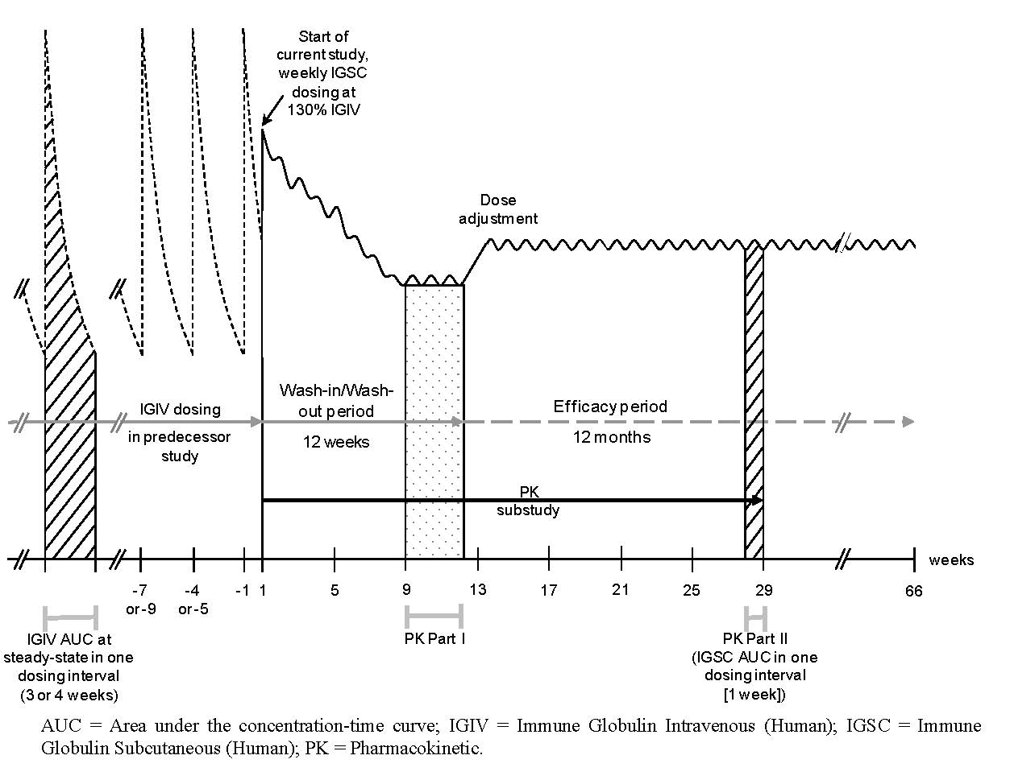

##### Major protocol violations/deviations

Patient disposition summarised in **Figure 9**. 22.4% in the ITT population excluded from the MITT population because they were not treated during the efficacy period. **34.2%** in the MITT population had major protocol deviations and were excluded from the PPE. Deviations: “deviation of >10% overall from the planned Number of infusions during efficacy period” (n=9), “deviation of >10% overall from planned adjusted dose during efficacy period” (n=2), and “subject did not obtain IgPro20 infusions on 3 consecutive Weeks during efficacy period” (n=2). **26.3%** excluded from the PPE population because of non-completion of the 12-mth efficacy period.

Figure 9: Disposition of patients in the USA Pivotal study ZLB04_009CR

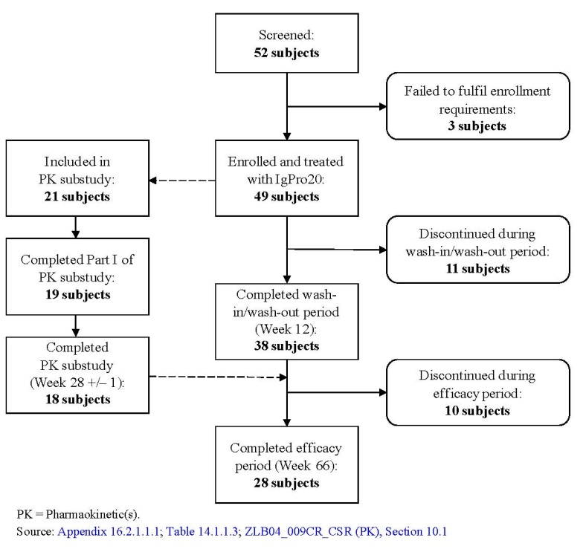

##### Baseline data

See **Table 11**. In the ITT population, 28 were blood gpO (26 Rh+), 14 blood gpA (10 Rh+), 4 subjects blood gpB (all Rh+). Blood gp not determined for 3. CVID was the PID in 36/38. All HIV-1&-2, HBV & HCV neg. All subjects in MITT population treated with IVIG during the last 3 months before enrolling with the majority (28 [73.7%]) treated with Privigen. During this time period, the mean of the Weekly equivalent median doses (with 3- or 4-Week dosing) of IVIG was 144.4 mg/kg bw.

Table 11: baseline demographics in ZLB04_009CR

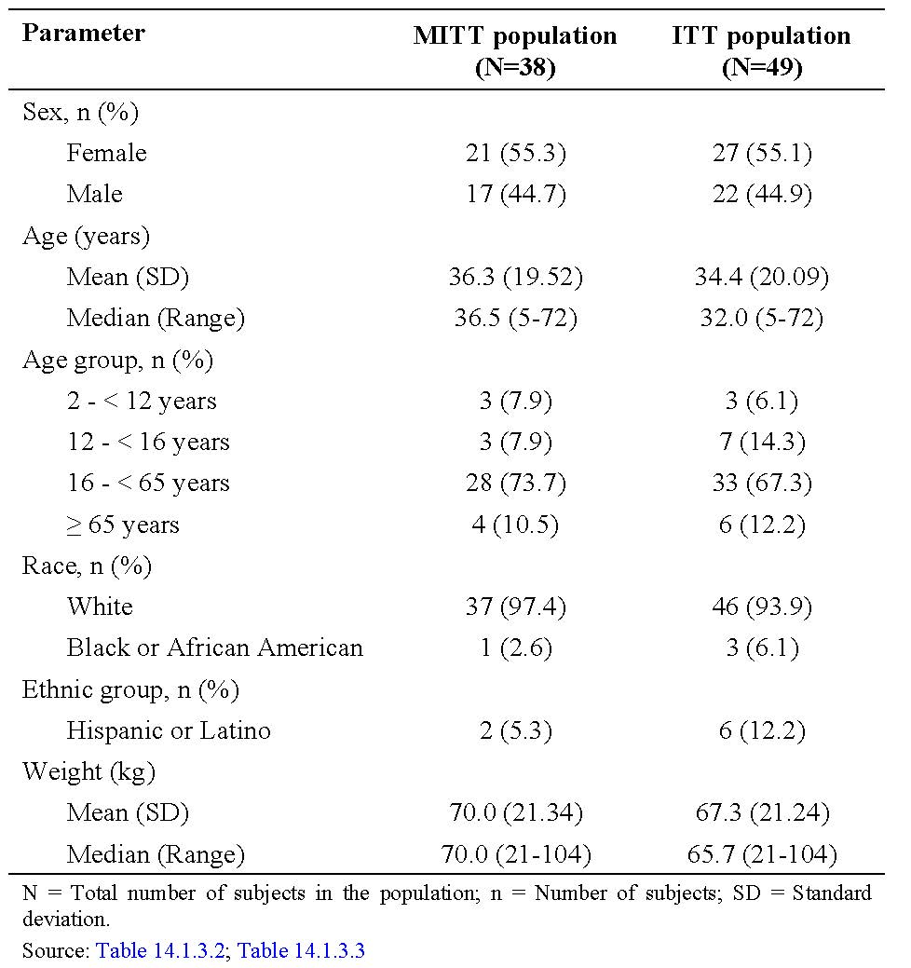

Mean of the individual median serum IgG Ctrough values during the last 3 months of IVIG treatment, before participating in the current study, was 10.09g/L in the MITT population. The mean serum IgG Ctrough with IVIG treatment immediately before start of IgPro20 in the current study was 16.1 g/L in subjects with a 3-Weekly dosing schedule and 13.6 g/L in subjects with a 4-Weekly dosing schedule. Note high values as measured close to a recent dose of IVIG dose. **Study drug exposure:** 2264 Weekly infusions of IgPro20 administered to 49 subjects; 77.6% received the maximum of 12 infusions during the WI/WO period, 46.9% received the maximum of 54 infusions during the efficacy period. The median treatment interval was 7 days throughout the study. The mean of individual Weekly doses was 181.5 mg/kg bw during the WI/WO period (range of median doses: 66 to 331 mg/kg bw) and 213.2 mg/kg bw during the efficacy period (range of median doses: 72 to 379 mg/kg bw). In the MITT population, a mean of 1.27x the previous IVIG dosewas administered during the WI/WO period that is, close to the intended dose of1.30x previous IVIG dose. On average a median dose of 1.49 times the previous IVIGdose was administered during the efficacy period, which was close to the intended adjustedIgPro20 dose of 1.53 times the previous IVIG dose, considering that approximately25% ofsubjects had dose adjustment only at Week 24 or later.

##### Results for the primary efficacy outcome

No subjects experienced an SBI in the MITT population. Therefore, the annual rate of SBIs per subject was zero (upper 99% confidence limit: 0.132) and the primary objective of the study was achieved because this rate was <1. All AEs with the potential to be an SBI were adjudicated on by the review committee, consisting of the Project Manager, the Medical Monitor and the Principal Investigator, this includes 5 AEs in 3 subjects which were suspected to be SBIs: 1) In [information redacted], **pneumonia** was **suspected twice** during hospitalisation for cellulitis and urinary tract infection and an AE of **bacteraemia** during hospitalisation for cellulitis was evaluated for consistency with the SBI criteria but was rejected, the patient was extensively investigated and even underwent bronchoscopy;2) In [information redacted], a staphylococcal infection during hospitalization for gastroenteritis was a suspected SBI of bacteraemia, but rejected after review as not meet the end-point criteria; 3).

In [information redacted], an AE of pneumonia was evaluated for consistency with the SBI criteria but did not meet end-point criteria.

##### Results for other efficacy outcomes

Table 12: Summary of results for other secondary efficacy endpoints (MITT population) ZLB04_009CR

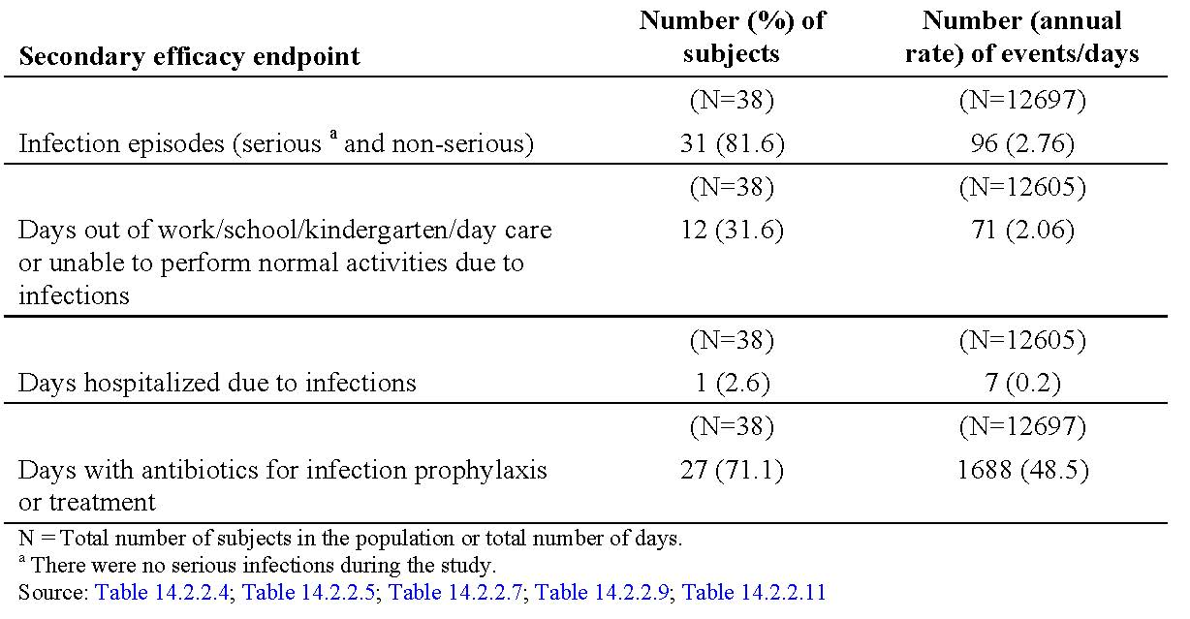

81.6% in the MITT population had a non-serious infection in the efficacy period (12697 subject days) equates to 2.76 infections/subject year (95% CL: 2.235; 3.370). The most frequent infection was sinusitis (39.5%), followed by nasopharyngitis (15.8%), bronchitis, viral infection, and URTI (10.5% each), UTI & otitis media (7.9% each); cystitis, otitis externa, conjunctivitis, gastroenteritis, influenza, staphylococcal infection (5.3% each). All other infections were each recorded in only 1 subject. Annual rates of specific infections ranged 0.03-0.40 infections/subject yr.

**Serum IgG levels: *See also the PK substudy results.*** Mean IgG Ctrough values were generally stable at Weeks 9 to 12 of the WI/WO period,and after dose adjustment during the efficacy period (Figure 6). For the MITT population, themean of the individual median IgG Ctrough values was 12.56 g/L (SD: 2.92 g/L) during the WI/WO period and 12.53 g/L (SD: 3.21 g/L) during the efficacy period. Compared to the last 3 months of IVIG treatment before the start of IgPro20 treatment in the current study the mean IgG Ctrough increased by 2.44 g/L (24.2%) with IgPro20 treatment during the efficacy period. None of the subjects had an IgG Ctrough value <5 g/L during IgPro20 treatment in this study. Except for 3 subjects with implausible negative IgG concentration, response to doseincrease after dose adjustment, the remaining subjects showed a tendency towards increases in IgG responses with increases in IgPro20 dose.

### Other efficacy studies

#### Japan follow-up study ZLB07_001CR

A Multicenter Follow-Up Study of Long-Term Safety, Tolerability, and Efficacy of Immune Globulin Subcutaneous (Human) IgPro20 in Subjects with Primary Immunodeficiency (IgPro20 Japanese Follow-Up Study). Conducted at 9 sites in Japan, 25Apr11-09Feb12. **Aim**: to assess long-term safety, tolerability and efficacy of IgPro20, as well as HRQL and PhEc aspects, in subjects with PID electing to continue with IgPro20previously in the Japan pivotal study **ZLB06_002CR**. Duration=24 Weeks.

**Primary safety objective:** rate, severity, and relatedness of newly developing or worsening AEs per infusion during the treatment period of the follow-up study. **Secondary objectives**: maintenance of consistent IgG serum levels; assessment of the rate of clinically documented SBIs, nos. of infection episodes, the Number of days out of work/school/kindergarten/day care or unable to perform normal daily activities due to infections, nos. of days hospitalized due to infections, use of antibiotics for prophylaxis and treatment.

**Results: Patient population:** 23 subjects enrolled and were treated with IgPro20 in this follow-up study. One subject was screened for the follow-up study and received treatment at baseline but was discontinued afterwards ([information redacted] did not continue the follow-up study due to IgG trough levels <5 g/L at Week 20 and Week 24 [completion visit] of the pivotal study, which constituted an exclusion criterion in the pivotal study).

The AT analysis set and FAS were identical consisting of 23 subjects; a total of 4 FAS subjects were excluded from the PPS (3 subjects because of increase of >10% from the planned dose; 1 subject because of use of prohibited medication/undocumented total serum IgG values).

**Investigational medicinal product administration**: The mean SD of the individual IgPro20 doses/Week was 92.76 (35.69) mg/kg bw for the FAS and 97.56 (35.81) mg/kg bw for the PPS, range 26.7 to 177.8 mg/kg bw for both data sets. Doses were relatively stable, reflecting the steady state period. The difference between the mean doses at baseline to the end of study was within 5%.

**Primary analysis**: The assessment of the individual subjects’ rate of newly developed or worsened AEs on infusion level, is summarized in **Table 13.** In the AT analysis set, the median of the individual subjects’ rate of AEs per infusion was 0.17. The median rate of AEs assessed as mild was 0.13. One subject reported a moderate AE; 1 subject reported a severe AE. The median rate of AEs assessed by the investigator as possibly related was 0. Median rate of AEs assessed by the investigator as not related was 0.13, range of 0 to 0.75. See also the Safety below**.**

Table 13: AEs in ZLB07_001CR follow-up study

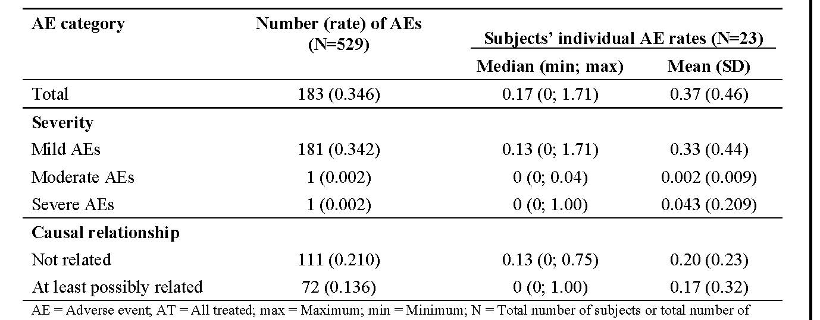

**Secondary Analysis: Serum IgG levels:** Based on the PPS* and FAS*. See **Figure 10**. The median IgG troughs were comparable in the pivotal study with the follow-up study in the PPS*.

Figure 10: Serum IgG trough levels (median) across 2 consecutive studies, from IV period of pivotal study ZLB06_002CR to completion visit of ZLB07_001CR (PPS*)

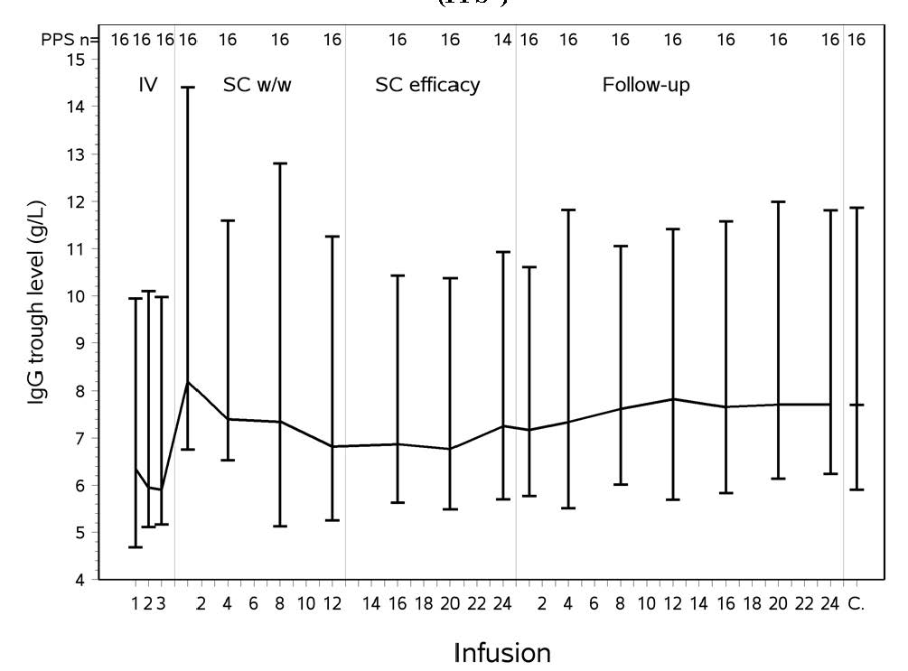

Table 14: Summary of results for secondary efficacy endpoints (FAS) follow-up study ZLB07_001CR

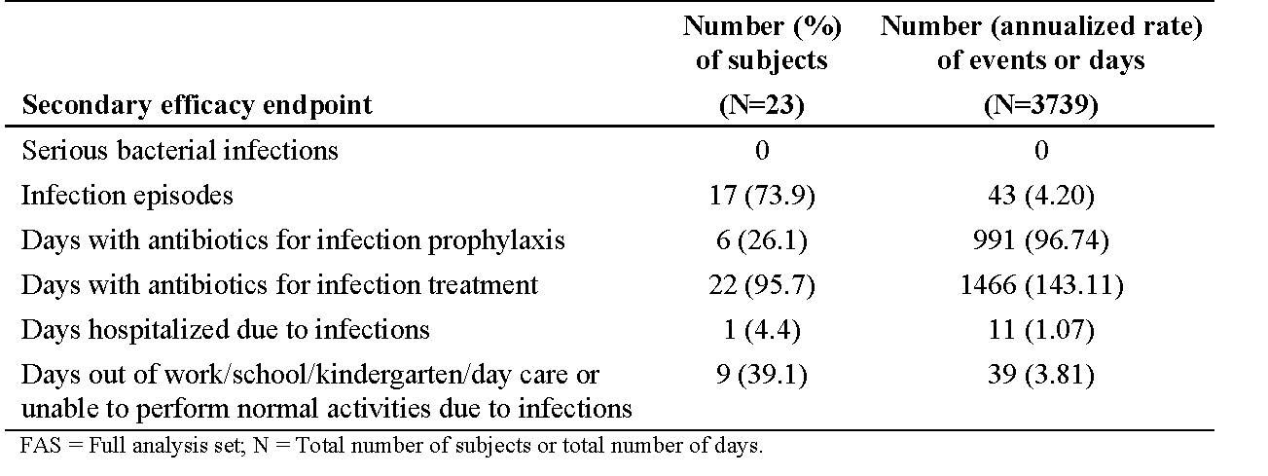

Infection-related secondary endpoints shown in **Table 14.** The mean (SD) scores of all LQI parameters were high and stable for all parameters at all assessment timepoints (Weeks 1, 12, and 24). Stability of HRQL in LQI is further confirmed by small effect size changes in all 4 LQI scales as well as in the total score between Week 1 and Week 24. **Overall conclusion,** safety, efficacy and HRQL results from this follow-up study consistent with findings in **ZLB06_002;** study drugsafe, efficacious and well tolerated when given for a longer period.

#### European extension study ZLB07_002CR

A Multicenter Extension Study of the Efficacy, Tolerability, and Safety of Immune Globulin Subcutaneous (Human) IgPro20 in Subjects with Primary Immunodeficiency (IgPro20 EU Extension Study). Conducted at the 13 sites in the EU that between 13 August 2008 and 21 December 2011.

The overall objective was to continue assessing the efficacy, tolerability, and safety of IgPro20 in subjects with PID who elected to continue the treatment they received previously under Protocol.

ZLB06_001CR. Additionally, long-term health-related quality of life (HRQL) was assessed. The efficacy objectives included maintenance of total serum IgG trough levels (Ctrough) consistent with the main study **ZLB06_001CR** over 36 months (UK sites only) or <42 months (all other sites).

Other efficacy endpoints included: the rate of clinically documented serious SBIs; nos. of infection episodes, the Number of days out of work/school/kindergarten/day care or unable to perform normal daily activities due to infections, the Number of days of hospitalisation due to infections, and the use of antibiotics for infection prophylaxis and treatment.

**Methodology:** Phase III extension study of **ZLB06_001CR**. Planned Weekly dose of IgPro20 in this study was the same as the subject’s last dose prior to roll-over. Subjects visited the study site for assessments every 6 months.

**Efficacy variables**: Descriptive comparison of serum IgG levels at Visits 1, 3, 5, 7, 9, 11, 13, and 15; **Rate of clinically documented SBIs, Number** of infection episodes, Number of days out of work/school/kindergarten/day care or unable to perform normal activities due to infections, Number of days of hospitalization due to infections, and use of antibiotics for infection prophylaxis and treatment;.

**HRQL**: The influence of long-term SCIG treatment on HRQL in subjects with PID who switched from the pivotal study ZLB06_001CR to the extension study ZLB07_002CR was assessed using validated HRQL questionnaires. Questionnaires were completed at Visits 3, 5, 7, 9, 11, 13 and 15 and examined both generic and treatment-specific subject status.

**Safety and tolerability**: Rate, severity, and relatedness to study drug of any AEs per infusion and per subject; changes in vital signs, routine laboratory parameters versus baseline.

**Results: Planned enrolment:** approximately46 subjects: Actual enrolment/AT population: 40 subjects ITT population: 40 subjects (12 F: 28 M); Full HRQL population 37 subjects.

**Demographics:** Mean age 21.6 years (4 to 52 years). 15 subjects (37.5%) aged 2 to <12 years, 19 subjects (47.5%) were <16 years of age.

**Investigational medicinal product administration**: In the AT population, mean of the individual median Weekly IgPro20 doses administered during the study (117.9 mg/kg bw was comparable to the mean of the individual median Weekly equivalent IVIG or SCIG doses administered in **ZLB06_001CR** (120 mg/kg bw).

**Efficacy results (ITT population): Serum IgG levels:** In the AT population, mean IgG trough values were measured every 6 months for 36 months and in 4 subjects up to 42 months.

Trough levels stable within a range of 7.5 to 8.5 g/L, with a mean (SD) median value of 7.97 (1.17) g/L, and a median of 8.12 g/L ranging from5.8 g/L to 11.1 g/L **(Table 15).** Minor fluctuations in median IgG trough levels were observed over the 36-month period completed by most subjects. Stable median IgG trough levels were maintained within a narrow range throughout the treatment periods of the pivotal study **ZLB06_001CR** and the extension study, constituting a combined observation period for the majority of ITT subjects of 3 years.

Table 15: Median IgG trough levels before and during the study (AT population) ZLB07_002CR extension

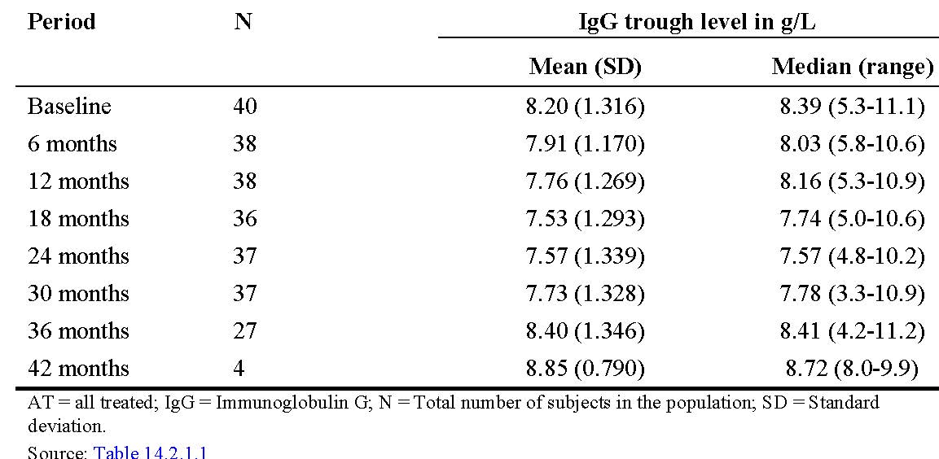

**Infections:** Five SBIs (all bacterial pneumonia) in 5 subjects reported during the extension study (annualised rate: 0.0478 SBIs/subject/year; upper 1-sided 99% CL: 0.1252). 95% had at least 1 infection during the study period (38208 subject days) (rate: 3.334 infections/subject/year; 95% CL: 2.993; 3.703). The most common infections were bronchitis (51 events; rate: 0.487 infections/subject/year), URTI (49 events; rate: 0.468 infections/subject/year), sinusitis (31 events; rate: 0.296 infections/subject/year), cough (26 events; 0.248 infections/subject/year), and nasopharyngitis (19 events; 0.182 infections/subject/year).

Table 16: Summary of results for other efficacy endpoints (AT population) ZLB07_002CR extension

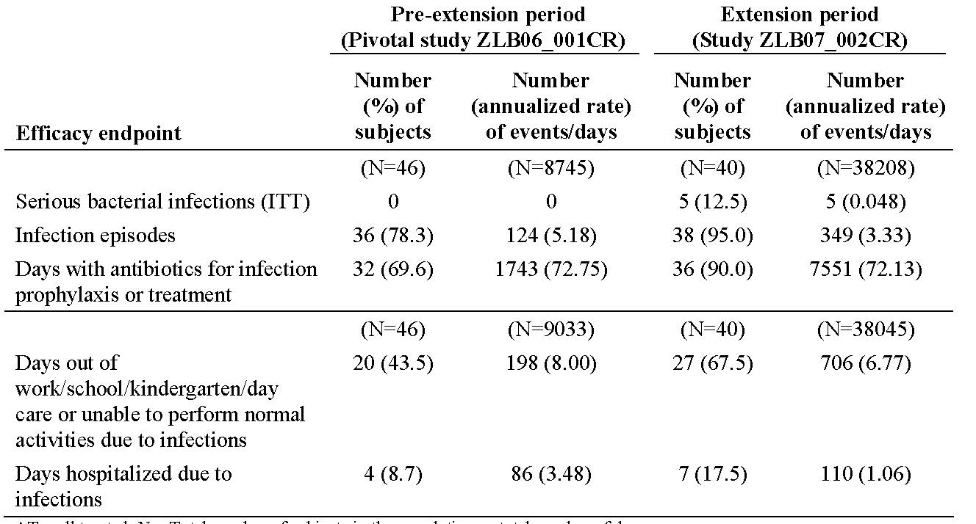

**HRQL results (Full HRQL population):** HRQL scores from each instrument stable through Month 36.

**Safety results:** Evaluated in all 40 subjects. 5405 Weekly infusions of IgPro20 administered. 97.5% had at least 1 AE, and 20.0% had ≥1 AE considered by the investigator to be at least possibly related to study drug. No causally related AE preferred term was reported for more than 1 subject during the study. 506 AEs (rate: 0.0936 AE/infusion) of which 14 AEs were considered at least possibly related to study drug (rate: 0.0026 AE/infusion).

SAEs were reported by 35.0% subjects; none were considered related to the study drug. **One subject with CVID died from an AE of pneumonia [information redacted].**

**Overall conclusion:** Long-term therapy with Weekly IgPro20 is efficacious and safe long term.

#### US extension study IgPro20_3001

A Multicenter Extension Study of the Efficacy, Tolerability, and Safety of Immune Globulin Subcutaneous (Human) IgPro20 in Subjects with Primary Immunodeficiency (IgPro20 US Extension Study - IgPro20_3001). Conducted at 4 sites in the US that between 04 June 2008-16 June 2010. This study was designed to provide long-term data on efficacy, tolerability, and safety of IgPro20 through an ≤120-Week treatment and observation period in **ZLB04_009CR** subjects. In addition, longitudinal data on HRQL, treatment satisfaction, and utility over the study period was collected to assess maintenance and sustainability of long-term therapy effects. The efficacy objectives included the annual rate of serious SBIs in the ITT and PPE populations, nos. of infection episodes, nos. of days out of work/school/kindergarten/day care or unable to perform normal daily activities due to infections, nos. of days of hospitalisation due to infections, use of antibiotics for prophylaxis/ treatment; total serum IgG Ctrough. Safety included assessment of local tolerability and AEs.

**Methodology:** This was a prospective, multicenter, open-label, single-arm, Phase III extension study to provideadditional long-term data for IgPro20 for subjects in ZLB04_009CR. Adequate dosing during the study was monitored based on the TLR, steady-state trough level [Ctrough] value SC replacement therapy divided by the last Ctrough value during stable intravenous replacement therapy. Study visits every 12-Week intervals for efficacy and safety evaluations. **Descriptive statistics** for continuous variables generally included Number of subjects, mean, standard deviation (SD), and the 0% (minimum), 25%, 50% (median), 75%, and 100% (maximum) quantiles. Frequency distributions given for categorical data.

**Analysis population:**Efficacy analyses were carried out on the **ITT** (all subjects with the disease under study, treated with studymedication during any study period) and **PPE (**all subjects who completed at least 48 Weeks of the efficacy period that started with the first IgPro20 dose in this study populations).The 12-month rate of SBIs was estimated along with the 1-sided 99% upper confidence limit in the ITTand PPE populations. Analyses of all other efficacy endpoints based on ITT population.

**Study drug:** IgPro20 SC infusion Weekly **or twice Weekly**, depending on the investigator’s medical judgment and subject’s preference. Initial Weekly dose was the same as last dose during **ZLB04_009CR**. Dose adjustments if TLR for IgG differed from the threshold value of 1.29 (calculated from results of **ZLB04_009CR** PK by >15% (that is, was below 1.10 or above 1.50). **Results: Planned enrolment:** approximately20; Actual enrolment: 21; ITT population: 21; PPE population: 18Discontinued: 5.

**Demographics:** Mean age 42.4 years; 15 F: 6 M. 9.5% (n=2) were <16 years old. **Investigational medicinal product administration**: Median duration 87 Weeks (11-104 Weeks). All subjects except for 1 on Weekly infusions. Median Number of infusions= 87.

**Efficacy results (ITT population): SBIs:** Two subjects had bacterial pneumonia, equates to annual rate of SBIs per subject year of 0.06 (upper 99% CL: 0.257). The total rate of infection was 2.38 per subject year (95% CI: 1.883; 2.973). The most frequent infections (rate of ≥0.15 per subject year) were sinusitis, bronchitis, URTI, and nasopharyngitis. See **Table 17** for other efficacy endpoints.

Table 17: Summary of other efficacy endpoints in IgPro20_3001

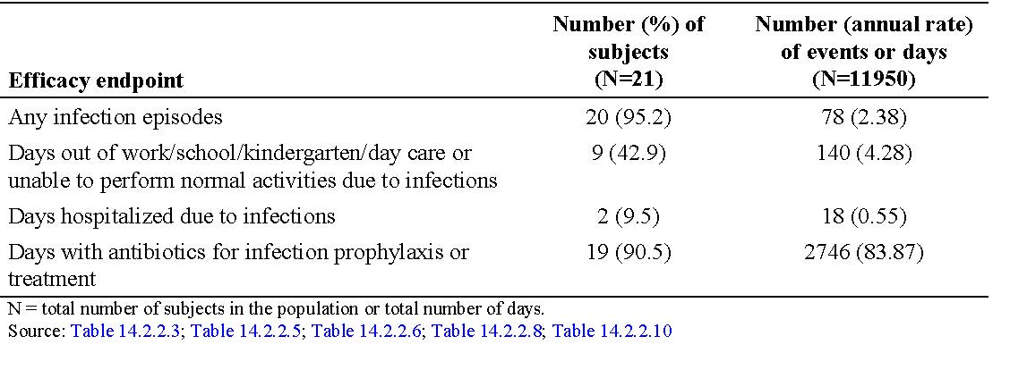

**Serum IgG:** Mean IgG Ctrough values were generally stable throughout the study (11.71-12.76 g/L); the mean of individual median IgG Ctrough values was 11.98 g/L and hence comparable to the mean of individual median IgG Ctrough values during the last 3 months in the preceding study **ZLB04_009CR** before the Screening Visit for rollover (12.20 g/L; none of the subjects had an IgG Ctrough value <5 g/L during IgPro20 treatment in this study.

**Quality of Life:** The evaluation of HRQL, treatment satisfaction, and utility showed a trend towards maintenance of HRQL and high treatment satisfaction throughout the study. **Safety:** See below. All subjects had ≥1 AE. Local reactions were the most frequent AEs experienced by all; rate of local reactions per infusion was 0.500. Excluding local reactions, overall AE rate per infusion was 0.161. The next most frequent AEs after local reaction were sinusitis and nasopharyngitis (66.7% and 33.3% of subjects, respectively). Most AEs (98.5%) were mild or moderate. Subgroup analyses of AEs revealed no clinically relevant or consistent trends according to gender or total body infusion rate. No deaths. Five unrelated SAE in 4 subjects. According to the subjects’ assessments of local tolerability (within 24 hours after infusion), approximately45% of subjects experienced ISRs after each infusion. Almost all ISRs (99.3%) assessed as “very slight” or “slight” in intensity. No safety concerns regarding clinical lab parameters.

**Conclusion**: Confirms efficacy and safety during long-term.

### Analyses performed across trials (pooled analyses and meta-analyses)

Not done.

### Evaluator’s conclusions on clinical efficacy for SC Hizentra® for immunoglobulin replacement

The Applicant has submitted a comprehensive suite of data in support of their drug SC Hizentra®.

All the registration studies were performed in children and adults with primary immunodeficiency, using diagnostic criteria defined by the Pan-American Group for Immunodeficiency and the European Society for Immunodeficiencies. The study populations recruited in the European, Japan, and US Phase III studies reflect many of the typical demographic characteristics of subjects receiving IgG substitution therapy for PID via the IV route, with one caveat, no very young children (2 years or less) were enrolled. Moreover, none of the studies included patients with secondary immunoglobulin deficiency syndromes. All the studies included a single arm switch to Weekly SC Hizentra® as Ig replacement in patients already stable on IVIG (US and Japan pivotal Studies, ZLB04_009CR and ZLB-06_002CR respectively) or IVIG or SCIG (EU pivotal ZLB06_001CR) . The study design meant patients functioned as their own controls in regards to the IgG trough levels prior to switching to SC Hizentra®. The EU pivotal and extension studies (data for >3 years) and combined Japan studies, assessed the sustained IgG Ctrough values as the primary efficacy endpoint, and the protective effect against infections as a secondary endpoint. IgG trough in this setting is really a surrogate marker of efficacy, in so much as achieving the IgG target level known to be protective against SBIs. In contrast, the US pivotal and extension studies, in which patients received substantially higher doses of SC Hizentra®, the hierarchy of endpoints differed with the primary efficacy endpoint a clinical one that is, annual rate of SBI that is, bacterial pneumonia; bacteraemia/septicaemia; osteomyelitis/septic arthritis; bacterial meningitis; visceral abscess. FDA guidelines were used to define the criteria for confirmed SBIs. The EU and Japan studies also explored the effects of IgPro20 treatment on quality of life and in Japan, pharmacoeconomics.

There were a number of design differences across the 3 pivotal studies that is, In the Japan pivotal study, the primary analysis was made using the PPS by descriptive comparison using 3 IgG Ctrough values from the 3 IVIG infusions (baseline) with 3 consecutive Ctrough values during steady-state IgPro20 treatment (that is, Week 16, 20, and 24) expressed as a GMR of SC:IV. In the European pivotal study, the ITT population was used for a descriptive comparison of 3 Ctrough values obtained during the subjects’ previous Ig treatment in the 3 to 6 months prior to the study (baseline) to 6 consecutive Ctrough values measured during steady-state IgPro20 treatment (that is, before Infusions 12 to 17).

In the US pivotal study, the MITT population was used for a descriptive comparison of the individual median IgG trough level values. See Table 18. Importantly, the primary objective of these studies to sustain (>3 years in the EU extension) serum total IgG trough levels at least at the level prior to IgPro20 use was achieved and at levels considered clinically effective that is, protective against SBI; these data further inform on the efficacy of this form of passive immunity.

The US pivotal Study ZLB04_009CR demonstrated an annual rate of SBIs of 0 (and corresponding upper bound of 1-sided 99% CI <1) following >1year of IgPro20 treatment. SBIs were secondary endpoints in the EU and Japan pivotal & rollover studies, there were low rates of SBIs in both studies.

Only 1 subject had an SBI during the WI/WO period in the European pivotal study, resulting in an annual rate of 0.03 SBIs/subject/year (upper 1-sided 99% CL: 0.192). In the European extension Study ZLB07_002CR, a total of 5 SBIs all bacterial pneumonia in 5 subjects were reported. The annualised rate of SBIs was 0.0478, with an upper 1-sided 99% CL of 0.1252. Additional evidence from the US extension study IgPro20_3001 confirmed sustained efficacy (2 SBIs, upper 1-sided 99% CL for the SBI rate: 0.257 SBIs per subject per year for the ITT population) over a median treatment period of 87 Weeks. Table 19. Infections – any – were high in all 3 studies that is, In the combined Japan Studies ZLB06_002CR and ZLB07_001CR, reported in 83.3% (annualised rate: 3.83 infections per subject/year), 78% of subjects in the European pivotal Study ZLB06_001CR (annualised rate: 5.18 infections/subject/year) and 95% during the EU extension Study ZLB07_002CR (annualised rate: 3.33 infections/subject/ year). In the US pivotal Study ZLB04_009CR, 81.6% of subjects had any infection (annualised rate: 2.76 infections/subject/year) and in the US extension IgPro20_3001, 95.2% had any infection (annualised rate: 2.38 infections/subject/year). Commonest were respiratory that is, URTI, nasopharyngitis, sinusitis, bronchitis and cough. Last, no clinically relevant differences in efficacy of SC Hizentra® in paediatric subjects found; no paediatric specific dosing to achieve target serum IgG concentrations aside from standard weight based dosing.

Table 18: Summary of IgG Doses and Serum IgG Trough Levels Before and During IgPro20 SCIG Treatment, Primary Analysis Populations (Studies ZLB06_002CR, ZLB06_001CR and ZLB04_009CR)

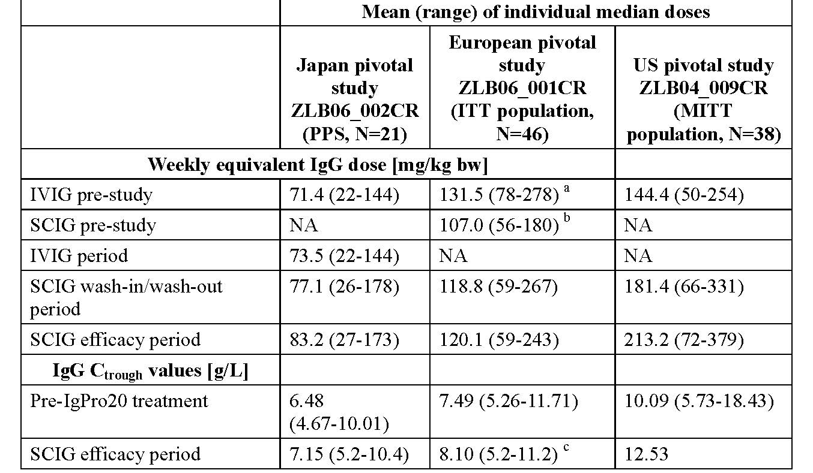

Table 19: Summary of Secondary Efficacy Results, ITT Population (Studies ZLB06_002CR, ZLB07_001CR and ZLB06_001CR)

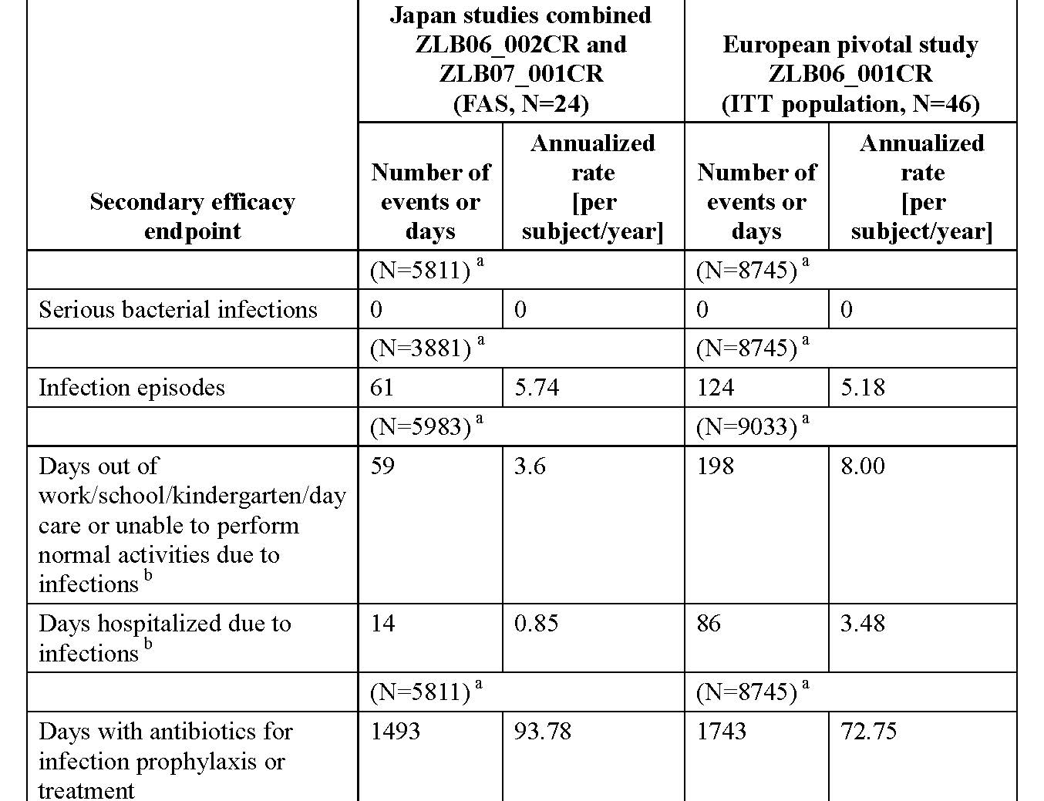

In keeping with common medical practice, these results suggest that IgPro20 could be an effective treatment in other immunodeficiencies of a secondary aetiology.

## Clinical safety

### Studies providing evaluable safety data

The following studies provided evaluable safety data: 6 Phase III studies in PID (that is, 3 pivotal studies in Japan, Europe, US and their respective extension studies). Safety data from ZLB04_008CR in healthy male volunteers and SAE reporting from the ongoing Phase III study IgPro20_3006 provide further support of the overall safety of IgPro20. In addition, safety data derived from postmarketing data via spontaneous AE reports.

#### Pivotal efficacy studies

In the pivotal efficacy studies, the following safety data were collected: **General AEs** assessed at each visit (observed by investigator and/or reported by patient) with a focus on the relatedness between infusion rate and intensity of AEs (local ISR and systemic); **AEs of particular interest**, including **ISRs**, were assessed by Investigator directed questioning and examination, patient diary cards (also captured nos. of days out of work/school/ kindergarten/day care or unable to perform normal activities due to infections, Number of days of hospitalization due to **infections**, patient report of specific symptoms and signs and quality of life). ISRs reported either as individual AEs of local reaction at any time or via specific assessments of local tolerability according to predefined schedules. As local reaction is not a MedDRA preferred term, any AE that belonged to 1 of 34 preferred terms related to the site of injection was grouped into a separate term called “**local reaction**” and the incidence of this was evaluated. **Laboratory tests,** including: blood **chemistry** tests (liver function, renal function, amylase), **haematology** (FBC and differential, Direct Coombs test, markers of haemolysis; coagulation), **viral markers** (HIV-1 and 2, HAV, HBV, HCV, Parvovirus B19 – antibody/PCR tests) performed at regular time points except not in the EU pivotal and extension (**ZLB06_001CR and ZLB07_002CR**), urinalysis.

#### Pivotal studies that assessed safety as a primary outcome

No pivotal studies that assessed safety as a primary outcome.

#### Dose-response and non-pivotal efficacy studies

As the dose of SC Hizentra® is titrated according to IgG response no classic “dose-response” studies were conducted. Suffice to say that the maximum individual Weekly doses administered in the EU and US studies were higher than in the Japan pivotal **ZLB06_002CR**.

The maximum individual Weekly dose administered in any of the Phase III studies was 406 mg/kg bw (administered on 2 separate Weeks in the EU extension **ZLB07_002CR**). No safety concerns were identified with these maximum IgPro20 doses administered. The EU extension **ZLB07_002CR** and the US extension **IgPro20_3001** provided long-term exposure; no safety concerns identified with the long-term use of IgPro20 for treatment duration of up to 3.2 years.

#### Other studies evaluable for safety only

Not applicable.

### Pivotal studies that assessed safety as a primary outcome

ZLB04_008CR was a Phase I Safety and tolerability study in health volunteers.

### Patient exposure

In these 7 studies, IgPro20 was administered to **153 subjects**, including **125** **PID** **subjects** in the 6 Phase III studies (of whom 23 participated in **both** Japan studies [including 11 subjects ≤16 years old], 40 participated in **both** European studies [including 19 subjects ≤16 years old], and 21 participated in **both** US studies [including 2 subjects <16 years old]) with a total of 12348 infusions. There were no comparators in the pivotal studies, all were single arm.

Table 20: Summary of Exposure to IgPro20 in Completed Clinical Studies (Safety Population)

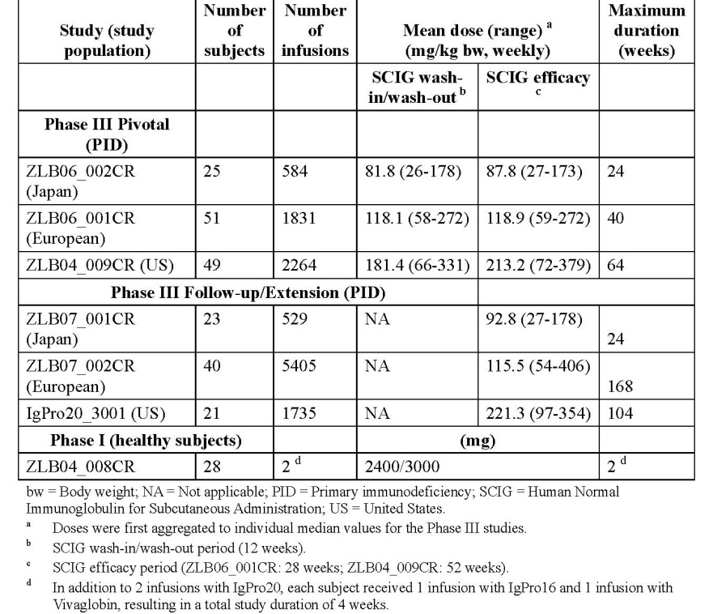

### Adverse events

#### All adverse events (irrespective of relationship to study treatment)

##### Pivotal studies

These are summarised below.

**Table 21: Summary of AEs in the AT Population (Studies ZLB06_002CR/ZLB07_001CR, ZLB06_001CR, and ZLB04_009CR) *Source 2.7.4***

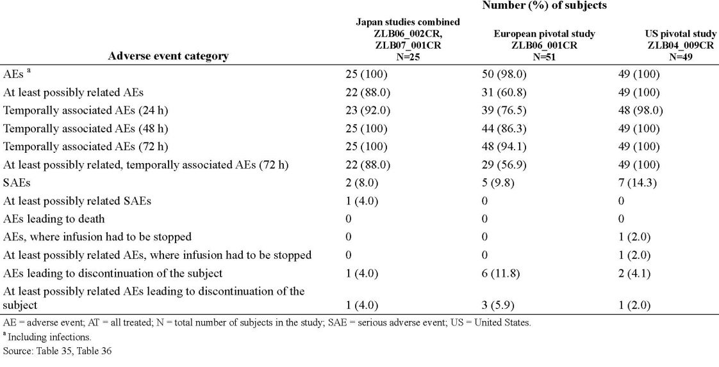

**In the combined Japan studies**, local reactions were the most common AE during the SCIG periods (21 subjects [84.0%], causally related for all subjects). All other AEs each occurred in ≤7 subjects (≤28%). The only causally related AEs experienced by more than 1 subject were local reactions. The rate per infusion of the most common AE, local reaction, was 0.207 overall and 0.205 for causally related AEs. After local reaction and excluding infections, the AE with the next highest rate was arthropod bite (rate of 0.018 overall and 0 for causally related AEs). The rates of all other AEs were each ≤0.008. Excluding the local reactions, the rate of AEs per infusion was 0.183 in the SCIG period of the Japan pivotal Study **ZLB06_002CR**. Except for 1 severe AE (**SAE of encephalitis**), all other AEs in the combined Japan studies were mild or moderate in intensity. Only 4 subjects (16%) experienced 6 AEs (rate per infusion of 0.005) of moderate intensity (influenza, bacterial infection, proteinuria, haematuria, and alopecia during the Japan pivotal study and encephalitis during the Japan follow-up study, which was a possibly related, SAE. In the European pivotal Study **ZLB06_001CR**, the incidence of subjects with AEs was highest in the SOC of infections and infestations (42 subjects [82.4%]), followed by the SOC of general disorders and administration site conditions (34 subjects [66.7%]).

In the European extension **ZLB07_002**, the incidence of subjects with AEs was highest in the SOC infections and infestations (38 [95.0%]) subjects. Further SOCs affected in at least 30% of subjects were respiratory, thoracic and mediastinal disorders (18 subjects, 45.0%), gastrointestinal disorders (15 subjects, 37.5%), and general disorders and administration site conditions (12 subjects, 30.0%). In the US pivotal **ZLB04_009CR**, the incidence of subjects with AEs was highest in the SOC of general disorders and administration site conditions (49 subjects [100%]), followed by the SOC of infections and infestations (35 subjects [71.4%]). In the US extension **IgPro20_3001** the incidence of subjects with AEs was highest in SOCs of infections and infestations (21 subjects [100%]), followed by the SOC of general disorders and administration site conditions (19 subjects [90.5%]). AEs of local reaction were experienced at least once by 25 subjects (49.0%) in the European pivotal study **ZLB06_001CR** and by all 49 subjects (100%) in the US pivotal study **ZLB04_009CR.** Local reactions that were at least possibly related to study drug were experienced at least once in all of these subjects.

Specific AEs summarised in **Table 22.** As local reaction is not a MedDRA preferred term, any AE that belonged to 1 of 34 PTs related to the site of injection was grouped into a separate term of “local reaction”.

Table 22: Subjects with AEs Excluding Infections (Experienced by ≥4 Subjects in Any Study) by Decreasing Frequency in the European Pivotal Study, AT Population (Studies ZLB06_002CR/ZLB07_001CR, ZLB06_001CR, and ZLB04_009CR) *Source 2.7.4*

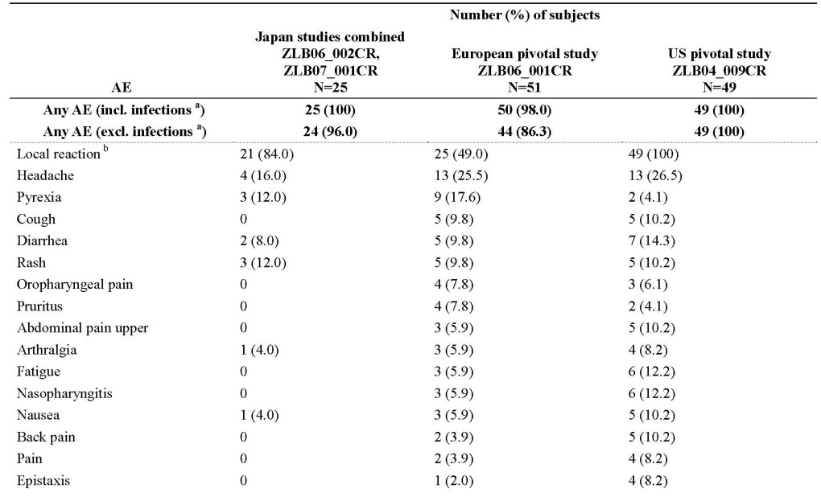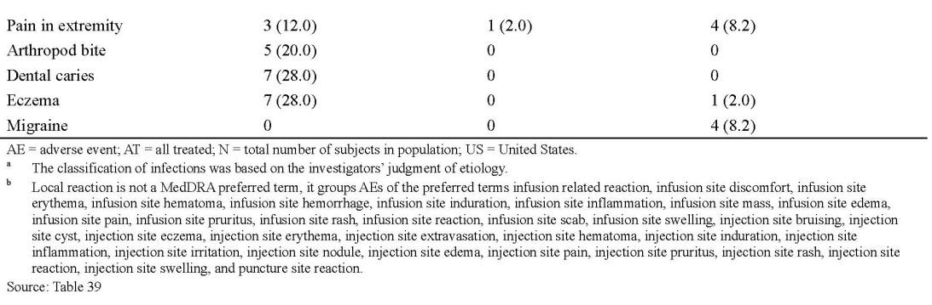

In the European extension **ZLB07_002**, local reactions were experienced by 6 subjects [15%]) In the US extension study IgPro20_3001, local reactions were experienced by 19 subjects (90.5%), all of whom experienced at least 1 event considered at least possibly related to study drug.

The rate per infusion of local reaction, the most common AE in both the European and US pivotal studies **(ZLB06_001CR and ZLB04_009CR),** was 0.060 overall and 0.058 for causally related AEs in the European pivotal study **ZLB06_001CR**, and 0.592 overall and 0.591 for causally related AEs in the US pivotal study **ZLB04_009CR**. In the European extension study, local reactions were experienced with a rate of 0.001 overall and were all causally related). In the US extension study, local reaction had the highest event rate (0.500 for both overall and causally related). Excluding the local reactions, the rate of AEs per infusion was 0.228 in the European pivotal study **ZLB06_001CR**, 0.181 in the US pivotal study **ZLB04_009CR**, and 0.161 in the US extension study IgPro20_3001.

The next most common AE excluding infections in both the European and US pivotal studies (**ZLB06_001CR and ZLB04_009CR**) was headache (**ZLB06_001CR**: 13 subjects [25.5%], causally related in 6 subjects [11.8%]; **ZLB04_009CR**: 13 subjects [26.5%], causally related in 12 subjects [24.5%]). In the European pivotal study **ZLB06_001CR**, local reaction and headache were followed by pyrexia (9 subjects [17.6%], causally related in 1 subject [2.0%]) and cough, diarrhoea and rash (5 subjects [9.8%] each, causally related in 2 subjects [3.9%] for rash). In the US pivotal **ZLB04_009CR**, local reaction and headache were followed by diarrhoea (7 subjects [14.3%], causally related in 2 subjects [4.1%]) and fatigue and nasopharyngitis (6 subjects [12.2%] each, causally related in 3 subjects [6.1%] for fatigue and 1 subject [2.0%] for nasopharyngitis).

All other AEs each occurred in ≤4 subjects (≤ 7.8%) in the European pivotal **ZLB06_001CR** and in ≤5 subjects (≤ 10.2%) in the US pivotal **ZLB04_009CR**. In the European extension **ZLB07_002CR**, apart from local reactions and excluding infections, the next most common AE was cough (27.5% of subjects, none causally related); all other AEs were reported by ≤4 subjects (10%). In the US extension **IgPro20_3001**, the next most common AEs after local reaction and excluding infections were fatigue (5 subjects [23.8%], causally related in 2 subjects [9.5%]), oropharyngeal pain (5 subjects [23.8%], causally related in 1 subject [4.8%]), and arthralgia (5 subjects [23.8%], causally related in 1 subject [4.8%]); all other AEs occurred in ≤4 subjects (≤ 19.0%). Most AEs were mild or moderate. The only AEs of **severe intensity** were:

* European pivotal **ZLB06_001CR**: chest pain, injection site pruritus, appendicitis, bronchitis, pneumonia, C-reactive protein increased, and cough (1 subject [2.0%] each).
* In the European extension **ZLB07_002**, only 7 (17.5%) subjects had AEs of severe intensity and the only severe AE reported more than once was pneumonia bacterial (3 subjects [7.5%]).
* In the US pivotal **ZLB04_009CR**, the only AEs of severe intensity were headache (4 subjects [8.2%]), ISR (3 subjects [6.1%]), chest pain (2 subjects [4.1%]) and small intestinal obstruction, toothache, chronic hepatitis, gastroenteritis, post procedural infection, musculoskeletal stiffness, papillary thyroid cancer, migraine, and asthma (1 subject [2.0%] each).
* In the US extension **IgPro20_3001**, the only AEs of severe intensity were headache, abdominal pain upper, haematochezia, fatigue, thyroid cancer, abdominal pain, diarrhoea, orchitis, arthralgia, pain in extremity, and depression (1 subject [4.8%] each).

##### Other studies

**ZLB04_008CR** (Healthy subjects).

#### Treatment-related adverse events (adverse drug reactions)

##### Pivotal studies

These are summarised in tabular form.

**Table 23: Subjects with Causally Related Adverse Events Excluding Infections (Experienced by ≥ 4 Subjects in Any Study) by Decreasing Frequency, AT Population (Studies ZLB06_002CR/ZLB07_001CR, ZLB06_001CR, and ZLB04_009CR) *Source 2.7.4***

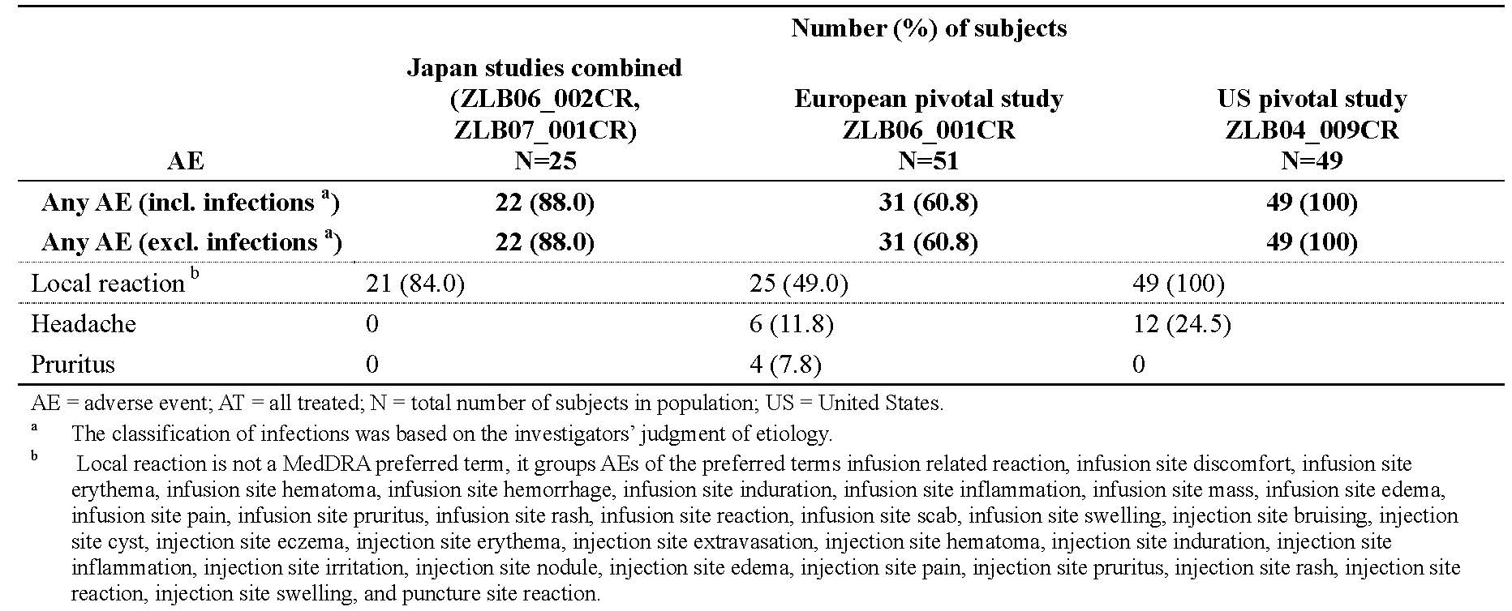

As expected, in terms of temporal relationship to Hizentra® receipt, local site reactions were most commonly reported in the pivotal studies.

#### AEs of special interest

1. ***Anaphylaxis:*** no episodes reported in any of the studies included in this Application;
2. ***Aseptic Meningitis syndrome (AMS):*** In the ongoing Japan extension, as of the cut-off date of the 31 January 2013, 1 SAE has been reported: aseptic meningitis experienced by a [information redacted] female who was hospitalised because of pyrexia, vomiting and nuchal rigidity developed on the day of IgPro20 infusion. Treatment with IgPro20 was not discontinued and the subject recovered. The causal relationship between the event and study product was reported as unknown. The investigator considered the relationship to be highly **unlikely** considering the clinical course of the event; the symptoms were matched to viral meningitis. [information redacted] was immediately administered high dose IVIG. The subject was discontinued from the study due to the SAE. The subject recovered after 253 days. The investigator considered the causal relationship with IgPro20 could not be excluded, because aseptic meningitis has been reported with Ig use. However, viral infection could provide a plausible alternative explanation. In the ongoing Japan extension study, an SAE of aseptic meningitis was experienced by a [information redacted] female.
3. ***Embolic and thrombotic events:*** reported in the setting of Ig replacement therapy. No episodes reported in the pivotal studies of Hizentra®.

#### Deaths and other serious adverse events

##### Pivotal studies

There was **1 death** in the IgPro20clinical studies reported in the European extension.

**ZLB07_002CR**: **Subject** [information redacted] female with CVID) died due to pneumonia, not considered related to study drug. The subject had a medical history of recurrent severe pneumonia prior to study and on the pivotal study and its extension study. The subject completed the pivotal study **ZLB06_002CR**. However, 10 days after Infusion 5 in the extension phase, the subject was again hospitalized due to an acute exacerbation of chronic pneumonia. [information redacted] condition deteriorated despite major medical intervention and continuous Ig, and [information redacted] died from respiratory failure.

**SAE:** A total of 45 SAEs occurred in 26 subjects (subjects experiencing AEs in the pivotal as well as in the respective follow-up/extension study were counted only once. 42 of these events occurred during the SCIG treatment (that is, were treatment emergent), while 3 occurred prior to treatment (that is, were non-treatment-emergent).

* All but 1 of the SAEs (encephalitis in the Japan follow-up study ZLB07_001CR) were considered by the investigators to be unrelated to study drug;
* 20 SAEs were severe in intensity, 20 were moderate and 5 were mild;
* No action with respect to study drug was taken, except for 3 SAEs that led to discontinuation: 1 subject with thyroid cancer from the US extension study **IgPro20_3001** to enable the subject focus on a specific cancer therapy, 1 subject due to death by bacterial pneumonia in **ZLB07_002CR**, and 1 subject because of a possibly related encephalitis in the Japan follow-up study **ZLB07_001CR**;
* All SAEs resolved without sequelae, except for the 1 death, 4 events where the subject recovered with sequelae and 7 events that were ongoing at the final assessment.

##### Other studies

Not applicable.

#### Discontinuation due to adverse events

##### Pivotal studies

In the combined Japan studies **ZLB06_002CR and ZLB07_001CR**, 1 subject discontinued from the study due to an AE during the follow-up study. [information redacted] had a possibly related SAE of encephalitis during the follow-up study. Six subjects had 14 AEs that led to discontinuation from the European pivotal **ZLB06_001CR** (myalgia, pyrexia, nausea, chest pain, increased C-reactive protein, injection site pain, injection site pruritus, pulmonary tuberculosis, ISR [2 events], fatigue, feeling cold, hypersensitivity, and anaemia).

The AEs of injection site pain, injection site pruritus, ISR [2 events], fatigue, feeling cold, and hypersensitivity were considered at least possibly related to the study drug. Except for the AEs of pulmonary tuberculosis and anaemia that were ongoing at final assessment, all AEs leading to discontinuation resolved without sequelae within 1 to 22 days. In the European extension **ZLB07_002CR**, apart from the SAE resulting in death in [information redacted], there were no other AEs leading to study discontinuation. Two subjects had AEs that led to discontinuation from the US pivotal **ZLB04_009CR** (ISR and myositis [post-treatment AE]). In addition, 1 subject with liver cirrhosis had an AE of chronic hepatitis classified as leading to discontinuation, although the reason for this subject’s discontinuation was violation of exclusion criterion “AST and ALT >2.5 times the ULN” at screening. Including the post-treatment AE of myositis, 2 of the 3 AEs classified as leading to discontinuation were considered at least possibly related to the study drug (ISR and myositis). Two of the AEs were ongoing at final assessment (myositis and chronic hepatitis). One subject was discontinued from the US extension **IgPro20_3001** due to an unrelated ongoing SAE of thyroid cancer.

##### Other studies

There were no AEs leading to discontinuation from the Phase I study ZLB04_008CR.

### Laboratory tests

#### Liver function

##### Pivotal studies

ALT, AST, albumin and ALP measured at regular time points and in extension phases. Mean and median values and ranges for serum chemistry parameters did not show any clinically relevant changes in any of the 6 Phase III studies or the Phase 1 study **ZLB04_008CR** in healthy volunteers.

#### Kidney function

##### Pivotal studies

Urea, creatinine measured at regular time points and in extension phases. Mean and median values and ranges for serum chemistry parameters did not show any clinically relevant changes in any of the 6 Phase III studies or the Phase 1 study ZLB04_008CR in healthy volunteers.

#### Other clinical chemistry

##### Pivotal studies

Amylase measured in the US and EU pivotal studies. No changes of concern. Creatine Phosphokinase mildly elevated in the US pivotal study. No changes of concern.

#### Haematology

##### Pivotal studies

Full blood count and differential measured at regular time points and in extension phases. Mean and median values and ranges for haematology parameters did not show any clinically relevant changes over time in any of the 6 Phase III studies.

#### Direct Coombs Test, Blood type including Rhesus status; haemolysis

##### Pivotal studies

A potential concern with IgG products is that they can contain blood group antibodies that may act as haemolysins and induce in vivo coating of red blood cells with IgG, which causes a positive direct antiglobulin reaction and, rarely, haemolysis (Copelan; Daw; Thomas; Wilson).

However, haemolysis is not known to be associated with the administration of SCIG products in general. Direct Coombs test and markers of haemolysis (LDH and reticulocytes; haptoglobin only measured in Extension study **ZLB07_002CR**) measured at regular time points and their extension phases. No thromboembolic events (TEE) or cases of haemolysis were reported in the combined Japan studies. No AEs of haemolysis in the European pivotal, the US pivotal or the US extension studies. In the European extension study, there was 1 possible event of haemolysis in a subject who had a positive direct Coombs’ test at screening, throughout the study and with a history of haemolytic anaemia reported as ongoing at study entry. Haemoglobin values remained stable during the study (145 to 157 g/L), except for Visit 11, where Hb dropped to 137 g/L, haptoglobin decreased to 0.25 g/L, and LDH increased to 487 U/L. In addition, 3 subjects had a positive Coombs’ test at selected visits, but were negative at completion visit. Three subjects had positive Direct Coombs’ test results at baseline that were assessed as not clinically significant. Of the 45 subjects who had negative Direct Coombs’ test results at baseline in the US pivotal **ZLB04_009CR**, 7 subjects converted to positive at some time during the study. During the end of study haemolysis testing, Direct Coombs’ tests were positive in 2 subjects who had negative Direct Coombs’ tests at baseline. However, they were not accompanied by a decrease ≥2 g/dL in Hb. In addition, 5 subjects in the US pivotal **ZLB04_009CR** converted to positive Direct Coombs’ tests at other time points during the study. In all cases the changes were assessed by the investigator as not clinically significant. None of these 5 subjects had decreases in Hb ≥2 g/dL. In the US extension **IgPro20_3001**, no subjects met the criteria for Coomb’s positive haemolysis . Two subjects converted from a negative Direct Coombs’ test at baseline to a positive Direct Coombs’ test, and 3 subjects with a missing Direct Coombs’ test at baseline had positive Direct Coombs’ test at some time during the study. In addition, 1 subject had a positive Direct Coombs’ test at baseline and after Infusion 1, and negative Direct Coombs’ test subsequently; 1 subject had a positive direct antiglobulin test at baseline and also at subsequent measurements. None of the positive Direct Coombs’ tests were assessed by the investigator as clinically significant. None of the subjects with positive Direct Coombs’ tests had a decrease in Hb of ≥ 2 g/dL.

#### L-Proline-related AE

##### Pivotal studies

IgPro20 contains the excipient L-proline (250 mmol/L) that proved to stabilize IgPro20 at room temperature throughout the shelf-life. It has a long history of safe administration as a medicinal product to humans, including elderly patients at doses higher than those administered with IgPro20. During product development, the safety of L-proline administered by the SC and IV route was specifically investigated in nonclinical and clinical studies, which consistently revealed no safety signals of concern. IgPro20 should be contraindicated in patients with the rare condition of hyperprolinaemia. There were no safety concerns associated with the administration of L-proline in the clinical studies with IgPro20. L-proline concentrations were not measured in the Japan Phase III studies, but were measured in the European and US Phase III pivotal studies. In both studies, pre-infusion serum concentrations of L-proline were within the NR(120 to 450 µmol/L) in almost all subjects tested. Measured levels generally concurred with the expected physiological range (Druml). One day after infusion of IgPro20 at steady-state, the serum L-proline concentration had returned to approximately the same level as before the infusion, indicating rapid elimination of L-proline and a lack of accumulation. The amount of L-proline given did not exceed 58 mg/kg bw in the US pivotal **ZLB04_009CR**, in which substantially (>2 times) higher doses compared to the Japan pivotal **ZLB06_002CR** were administered. Thus the amounts of L-proline administered in clinical studies with IgPro20 were considerably lower (more than 70 fold) than the highest doses that were tested in nonclinical studies (up to 4350 mg/kg bw) and were defined as no-observed-adverse effect levels.

#### Urinalysis

##### Pivotal studies

Measured at regular timepoints in the pivotal studies and their extension phases; no changes.

#### Electrocardiograph

##### Pivotal studies

Not performed.

##### Other studies

**ZLB04_008CR**: no significant changes in 12-lead ECG in healthy volunteers during the 4 different Ig infusions.

#### Vital signs

##### Pivotal studies

Vital signs measurements in the Phase III studies included BP, heart rate, and body temperature. No consistent or clinically relevant changes in vital signs were reported. Mean changes from pre-infusion were small for all parameters at all visits.

##### Other studies

In the Phase I safety study ZLB04_008CR in healthy subjects, there were no safety concerns regarding vital signs or physical examination.

#### Viral markers

**Pathogen safety:** IgPro20 is made from human plasma that may potentially contain infectious agents for example, viruses and, theoretically, CJD agent and vCJD that can cause various diseases. The risk that products manufactured from plasmacould transmit an infectious agent has been reduced as far as possible by the methods described in *Product development and regulatory background***.**

##### Pivotal studies

Although they do not provide specific evidence as such, further support for the viral safety of IgPro20 was obtained from assessments of viral markers during the conduct of clinical studies **ZLB06_002CR, ZLB07_001CR, ZLB04_009CR, IgPro20_3001, and ZLB04_008CR** which revealed no evidence that administration of IgPro20 was associated with infections. In agreement with EMA guidance EMEA/CPMP/BPWG/283/00, viral safety was not assessed in the European pivotal or extension studies (**ZLB06_001CR and ZLB07_002CR**). In the Japan studies (**ZLB06_002CR and ZLB07_001CR**) and the US pivotal and extension (**ZLB04_009CR and IgPro20_3001**), no cases of infection due to HIV-1, HIV-2, hepatitis A, B, or C virus, or parvovirus B19 were observed. In the US extension **IgPro20_3001**, not all viral marker tests were completed for all subjects. Viral markers for HAV, HBV, HCV, HIV-1/-2 or parvovirus B19 were not detected in any subject with an available measurement before Infusion 1 (HAV: 15 subjects; HIV-1: 18 subjects; HBV, HCV, HIV-1/-2, and parvovirus B19: 20 subjects). However, at the completion visit, 1 subject [information redacted] tested positive for **parvovirus B19** (by PCR) and 1 subject [information redacted] tested positive for **HBV** (by PCR, <29 IU/mL). Both subjects had been tested negative at baseline; the positive findings at the completion visit were assessed as not clinically significant by the investigator and were not reported as AEs. According to correspondence with the site, both subjects had a post-study follow-up examination in June 2011. During the follow-up for [information redacted] physical examination was normal and hepatitis B history was negative; the subject’s HBV surface antigen, HBV surface antibody, HBV core IgM antibody, and **HBV PCR tests were negative**, and liver enzymes were normal. [information redacted] had a normal physical examination with no medical problems apart from her thyroid cancer. Both her antibody tests and PCR for parvovirus B19 were negative.

##### Other studies

In the Phase I safety study ZLB04_008CR in healthy subjects, no safety concerns re viral safety.

### Postmarketing experience

* Cumulatively since 04 March 2010 up to and including October 2012, 9,443,086 grams were sold worldwide, corresponding to an estimated exposure of 18,160 patient years. The International Birth Date of Hizentra® is 04 March 2010 when the product was initially granted a license in the USA. Provided in this application were Periodic Safety Update Reports (PSUR) for the periods detailed below. The estimated standard dose of Hizentra® is 10 g (for an average patient of 70 kg bodyweight in the indication primary immunodeficiency). [information redacted].
* **Report nos 1** PSUR 04 March 2010 to 14 October 2011: [information redacted], corresponding to 234,243 standard doses; 4405years of patient exposure. This PSUR presents a total of 509 initial spontaneous case reports from worldwide sources, one report from a clinical trial and 180 follow-up reports received from the US prior to DLP of this PSUR are included. 480 initial cases were medically confirmed, 95 thereof report serious events. One case reporting a fatal outcome was received during the current interval. 30 initial consumer reports were received. All spontaneous reports came from the US market exclusively. During the reporting period, a clinical study (European extension study) was newly analysed, and 3 papers were published[15],[16] on Hizentra® US and European pivotal trials.
* **Report nos 2** PSUR 15 October 2011 to 14 April 2012: [information redacted] 4041years of patient exposure. This PSUR presents a total of 425 initial spontaneous case reports from worldwide sources and one report from a clinical trial. 147 follow-up reports received during the current interval of this PSUR are included. 399 initial cases were medically confirmed, 103 thereof report serious events. Four cases reporting a fatal outcome were received during the current interval. 26 initial consumer reports were received. There was no safety related action taken by either regulatory authorities or the MAH during the reporting period. No changes have been made to the Reference Product Information for safety reasons.
* **Report nos 3** PSUR Period 15 April 2012 to 14 October 2012 [information redacted] 5430 years of patient exposure. This PSUR presents 436 new medically confirmed case reports from worldwide sources. Of these, 71 were classified as serious and 365 as non-serious. For 1 medically confirmed case a fatal outcome was reported. In addition, 56 non-medically confirmed consumer reports were registered, including 14 serious reports.

As of January 2013 A few cases of IG class effects such as anaphylactic reactions, Aseptic Meningitis Syndrome (**AMS**), and TEE were reported, and the reporting rates of these events were considered as rare or well within the background rate in the general population. The Hizentra® Company Core Data Sheet, dated 02/2012, was valid at the beginning of reporting period numbers 3 and has been used as the Reference Safety Information for PSUR nos 3. **CHANGES PLANNED**: An update of the CCSI and afterwards of national labelling is currently in progress concerning **inclusion** of **TEE and AMS.**

### Safety issues with the potential for major regulatory impact

#### Liver toxicity

None.

#### Haematological toxicity

None.

#### Serious skin reactions

None.

#### Cardiovascular safety

None.

#### Unwanted immunological events

None revealed.

### Other safety issues

#### Safety in special populations

Several subgroup analyses were performed with the caveat that these were a) exploratory in all studies, b) were mostly performed for selected AE categories, and c) subgroup definitions of IgPro20 infusion rate/volume were different between the studies due to differences in study design. In addition, the number of subjects in some subgroups was too small to perform the planned subgroup analyses at all or to draw any meaningful conclusions. Included were the following intrinsic factors: age, gender, underlying disease, ethnicity; **Extrinsic factors:** prior replacement therapy, Infusion Rate/Dose Volume, Treatment Setting (Home Versus Investigational Site). Pregnant women, breastfeeding mothers, and women planning pregnancy were not included in the studies on IgPro20, and no cases of pregnancy were reported in these studies. Clinical experience with IG’s suggests no harmful effects on the course of the pregnancy or on the foetus are to be expected. In addition, there are reports in the literature of SC administration of Ig replacement therapy for PID in pregnant women with good efficacy and safety. Gardulf et al. reported the use of SCIG infusions during 11 pregnancies in 9 women (Gardulf et al. 2001). Weekly SC infusions were administered at a dose of 100 mg/kg bw throughout pregnancy. No systemic AEs were recorded during more than 400 infusions; no pronounced local tissue reactions were noted. The 9 women gave birth to 11 healthy children after uneventful gestations; none of the infants required additional IgG after delivery. In addition, in a pregnant woman with a previous anaphylactic reaction to IVIG, the IVIG was successfully replaced by SCIG (Berger et al. 1982).

After administration of IVIG products, IgGs are excreted into the milk and may contribute to the transfer of protective antibodies to the neonate (Privigen SPC). As the route of administration is irrelevant for the passive transfer of antibodies once they are in the circulation and due to the similar pathophysiology of IVIG and SCIG products, this transfer is also expected to apply to IgPro20.

No genotoxicity studies have been performed with Hizentra®. L-proline is not genotoxic in any of the testing performed (see above).

### Safety related to drug-drug interactions and other interactions

No formal drug-IgPro20 interaction studies were conducted and “interaction” data in regards to the administration of live attenuated vaccines in the PI is extrapolated from data derived from the registration of other immunoglobulin replacement products.

### Evaluator’s overall conclusions on clinical safety

SC Hizentra® has been trialled in relatively few adults and children but PID is a relatively rare disease and the studies included in this application were conducted appropriately and in accordance with European Medicines Agency (EMA) and FDA guidelines. The drug is well tolerated and as expected, across the clinical studies, the most common AEs reported were local reactions at the injection site. These reactions **are expected** with SC infusions of relatively large volumes and most were mild in intensity and of short duration. Excluding infections, all other AEs apart from local reactions occurred in ≤7 subjects (≤ 28%) in the combined Japan studies, and <13 subjects in any of the European and US studies. Although a slightly higher proportion of subjects in the European and US studies (ZLB06_001CR, ZLB04_009CR, and IgPro20_3001) than in the Japan studies reported AEs excluding infections and local reactions, the overall rate of AEs per infusion **was lower than the rate reported for IVIG**.

Although most subjects had local site reactions they were almost exclusively mild, short lived, not requiring special treatment and incidence decreased over time. There were few severe events and most were reported in only a single subject in any study.

No subject discontinued study participation because of AEs other than the subject who died in the European extension study. There was 1 death (due to pneumonia, unrelated to study drug in the European extension Sstudy ZLB07_002CR). Across the 7 studies included in this dossier, 45 SAEs occurred in 26 subjects and 42 of these events were treatment-emergent, while 3 occurred prior to treatment. All but 1 of the SAEs (encephalitis in the Japan follow-up ZLB07_001CR) were considered by the investigators unrelated to study drug. Importantly, although numbers were relatively small and no child under 2 was enrolled in any pivotal studies, there was no evidence for an increased rate of AEs in paediatric subjects (2 to< 12 years) compared to adults. There was no evidence that more AEs were associated with higher starting infusion rate of >25 mL/h. Moreover, in Study IgPro20_3001, no AEs of severe intensity were experienced when using infusion rates of >50 to 70 mL/h. Rates of temporally related AEs per infusion were similar across the infusion rates used in this study, suggesting no additional risks with infusions of IgPro20 at high total body infusion rates of up to 70 mL/h. No evidence that systemic AEs of IVIG class effects such as haemolysis, renal dysfunction/failure, thromboembolic events, aseptic meningitis syndrome, transfusion-related acute lung injury and so on occurred during IgPro20 treatment in any of the studies that were included in this summary. Postmarketing surveillance data have not revealed an increased risk of these class effects. There were no safety concerns regarding clinical laboratory parameters, vital signs, physical exam or viral safety. In summary, weekly SC Hizentra® appears safe for PID Ig replacement in adult and paediatric (aged 2 or more) subjects.

## First round benefit-risk assessment

### First round assessment of benefits

The benefits of SC Hizentra® in the proposed usage are:

* Efficacious as IgG replacement for PID as measured by serum IgG using dosing algorithms as suggested following a switch from either IVIG of SCIG (different formulation);
* Clinically effective in regards to rates of SBI;
* Safe even at relatively high infusion rates;
* Predictable side effects, predominantly, as expected, short lived ISRs;
* The development programme for the drug either during registration studies (albeit small) and postmarketing surveillance did not reveal any new AEs of concern for this class of agent, of which several are already registered in Australia and World wide;
* Smaller volumes for infusion may be advantageous for some patients.

### First round assessment of risks

The risks of SC Hizentra®in the proposed usage are:

* No data is supplied in patients with secondary immunodeficiencies requiring Ig replacement, the three pivotal studies were conducted exclusively in PID patients;
* No data is supplied in patients with PID starting de novo Ig replacement with SC Hizentra®;
* No data is provided in children aged less than 2 years of age;
* As the transmission of cCJD is unknown, there is an unquantifiable risk of transmission through receipt of blood products including Ig;
* It is not possible to screen all blood products for all infections because some infections potentially transmissible through blood have not yet been identified. The production of Ig from donated plasma, whilst rigorous with several steps that minimise transmission of infectious agents, may not exclude all current (for example, vCJD) or future pathogens.

### First round assessment of benefit-risk balance

The benefit-risk balance of SC Hizentra®, given the proposed usage, is favourable.

## First round recommendation regarding authorisation

The data presented in this application from trials and their extension phases conducted in the EU, US and Japan demonstrate the efficacy, measured by serum IgG levels and protection against SBIs and safety, with an expected side effect profile in line with the Class of agents to which it belongs. Moreover, there was improved Quality of Life when this SC formulation was used compared to the IVIG. The evaluator recommends SC Hizentra for authorisation for use in PID. Despite the fact that no data was presented for the use of this drug in the setting of secondary immunoglobulin deficiency states, the evaluator had no reason to believe that efficacy and safety of the drug will be anything other equal to that demonstrated in the PID setting. However, the evaluator had concerns that there is no data in children under the age of 2, and for this reason, the evaluator recommended SC Hizentra be approved for replacement immunoglobulin therapy in children (aged 2 years or older) and adults with Primary Immunodeficiency Disease such as SCID, common variable immunodeficiency, congenital agammaglobulinaemia and hypogammaglobulinaemia and IgG subclass deficiencies with recurrent infections.

## Clinical questions

Nil.

## Additional corrected safety data

In August 2013, the sponsor provided additional safety data from the Japan Phase III study ZLB06_002CR and its associated extension Study ZLB07_001CR. Subsequent to completion of their CSRs, inspection of 1 of the study sites by the Japanese regulatory agency identified that data on 2 AEs were not included. These were both local reactions of injection site pain which were mild in intensity and resolved without sequelae in 0.9 and 2.6 hours, respectively.

Data are provided showing how these affect the AE analyses as follows:

Module 2.5 – Clinical Summary - Erratum (1 page)

Module 2.7.3 – Summary of Clinical Efficacy – Erratum (1 page)

Module 2.7.4 – Summary of Clinical Safety – Erratum (6 pages)

Module 5, 5.3.5.2-4 - Clinical Study Report for ZLB06_ 002CR – Erratum (5 pages)

These data showed that the additional AEs did not affect the number of subjects experiencing any AE, and did not have a relevant effect on the rate of AEs per infusion. Examples of the revised data are presented below.

|  |  |  |
| --- | --- | --- |
| **Variable** | **CSR Data** | **Correct Data** |
| Number and rate per infusion of any AE including infections | 450 (0.404) | 452 (0.406) |
| Number and rate per infusion of any causally related AE including infections | 245 (0.220) | 247 (0.222) |
| Number and rate per infusion of local reactions | 230 (0.207) | 232 (0.208) |
| Number and rate per infusion of any causally related and temporally associated local reactions | 223 (0.200) | 225 (0.202) |

**Note:** extracted from Hizentra_2.7.4_ Summary_of_Clinical_Safety_Erratum

It is indicated that an external consultant was commissioned by the sponsor to conduct an independent verification of the study data at this study site followed by a review meeting with the Principal Investigator on 08 May 2013.

From these activities, the sponsor concluded that this was a site-specific issue and that there were no other relevant discrepancies between the ZLB06_002CR study source documents and the submission dossier that would have an impact on the efficacy and safety conclusions of the study. The sponsor also concluded that the 2 new local reactions did not have a relevant effect on the rate of AEs per infusion or the overall safety statements or risk-benefit assessment of the IgPro20 therapy in immune deficiency patients.

**Evaluator comment:** These data were reviewed by a second evaluator and not by the evaluator who undertook the evaluation presented in sections 1-10 of this report. It is noted that there were 9 sites in this study. The sponsor’s conclusion is accepted. However it is considered that the sponsor should provide the following information on:

* The independent consultant engaged to undertake the data study verification (DSV) and,
* How the data from the other 8 sites were verified as accurate.

## Second round evaluation of clinical data submitted in response to questions

### Indications for use of Hizentra

The proposed indications for use of Hizentra do not include an age restraint. The First round evaluator stated that “... The evaluator recommended SC Hizentra be approved for replacement immunoglobulin therapy in children (aged 2 years of older) and adults with Primary Immunodeficiency Disease such as SCID, common variable immunodeficiency, congenital agammaglobulinaemia andhypogammaglobulinaemia and IgG subclass deficiencies with recurrent infections.”

The Sponsor Responseis presented below.

CSL Behring believes that Hizentra should not be restricted to children < 2 years for the following reasons:

#### 1 Subcutaneous Immunoglobulin (SCIG) use does not demonstrate age specific dosing requirements

During the clinical evaluation of Hizentra, there were no differences seen in Hizentra PK parameters between children (<12 years old), adolescents (12 to <16), and adults (16 and older).

This suggests that there are no age specific efficacy or safety requirements when using immunoglobulins subcutaneously. Furthermore, no special dosing requirements or precautions were needed for any of these age groups which is another indicator that there are no specific dosing requirements across age groups. These findings indicate that Hizentra use in infants less than two would demonstrate similar efficacy and safety findings when using the stated dose per body weight.

#### Global use of Hizentra within paediatric populations

Hizentra is registered in numerous countries around the world and has celebrated many successful clinical applications in the paediatric population. There are a number of published literature investigating the use of Hizentra and SCIG in children under the age of two. In one example by Gallagher J (2012), Hizentra was found to be a safe and effective treatment for infants 4 months and 14 months of age. Global marketing experience on the reporting of Adverse Event’s within children (≤ 12 years old) indicate that the nature and frequency of Adverse Event’s (AE) reported are in line with the expected range of possible adverse reactions to Hizentra3, indicating no specific AE issues in children.

#### Inconsistency with subcutaneous immunoglobulins indications approved in

##### Australia

CSL Behring notes the age restriction in children is inconsistent with approved indications for commercially available normal subcutaneous immunoglobulins currently approved in Australia:

##### Gammanorm

Gammanorm is indicated for:

*“Replacement therapy in adults and children with primary immunodeficiency syndromes such as:*

* *congenital agammaglobulinaemia and hypogammaglobulinaemia*
* *common variable immunodeficiency*
* *severe combined immunodeficiencies*
* *IgG subclass deficiencies with recurrent infections*

*Replacement therapy in myeloma or chronic lymphatic leukaemia with severe secondary hypogammaglobulinaemia and recurrent infections.”*

According to the Product Information for Gammanorm the clinical program included children from the age of 1.5 years however the approved indication does not include an age restriction for children.

##### Kiovig

KIOVIG administered subcutaneously is indicated for:

*“(1) Replacement therapy indications*

* *Primary immunodeficiency disorders (PID).”*

According to the Product Information for Gammanorm the clinical program for subcutaneous use of Kiovig included children from the age of 2 years however the approved indication does not include an age restriction for children.

CSL Behring would like to further note that although Kiovig is indicated for use in children, the Product Information highlights the limited efficacy and safety data within the paediatric age group in the ‘*Precautions’, ‘Paediatric use’*. The proposed Hizentra Product Information is consistent with these products.

#### Suitability of subcutaneous administration in the infant population

Subcutaneous use of immunoglobulins, especially in infants, is more practical, convenient and offers a real alternative treatment modality for those with poor venous access. Therefore, immune deficiency patients of the youngest age group (that is, less than 2 years old) would benefit the most from a SCIG such as Hizentra.

Second round clinical evaluator comment

The response in relation to global use of Hizentra within the paediatric population references an article by Gallagher et al as support for its use in children < 2 years of age. It is indicated that this is noted in the PSUR covering the period 14 April 2011 to 15 October 2012 provided in module 5.3.6 of the submission. It is actually noted in PSUR covering 15 October 2011 to 14 April 2012. A copy of the reference was not provided in the submission.

In the comparison with the indications in the PI for SC immunoglobulins already approved in Australia, for Kiovig it is stated that “According to the Product Information for Gammanorm the clinical program for subcutaneous use of Kiovig included children from the age of 2 years, however the approved indication does not include an age restriction for children.” This statement corresponds to the Kiovig PI and reference to Gammanorm appears to be a typographical error.

As indicated in the First round evaluation, the age limitation to patients > 2 years is included in the US label. However, it is not included in the EU Summary of Product Characteristics (SPC) dated August 2013 accessed via the e-Medicines Compendium. Also, review of European Public Assessment Reports (2011 and 2012) reveals that the clinical data package reviewed for EU marketing authorisation was the same as that provided to the TGA. The sponsor’s rationale for not limiting the age in the indication for use is accepted.

### Additional corrected safety data

These (see above) related to 1 site in the Japan Phase III study ZLB06_002CR and its extension ZLB07_001CR which was conducted across 9 sites. The sponsor was asked to provide information on 2 issues as follows.

#### **Information requested**

The independent consultant engaged to undertake the DSV.

##### ***Sponsor response***

The Study Monitor performed the SDV in accordance with the monitoring plan and a recent review conducted by CSL Behring indicated that this was sufficiently carried out. The two unreported AEs were identified as a SDV oversight, mainly attributed to the additional transcription process applied by the Monitor at this site to accommodate the set-up in the data verification and review discussion with the Principal Investigator. This extra data transcription step was unique to the site at the National Defense Medical College, and was not followed at other sites. Following the PMDA (Japanese regulatory authority) post inspection inquiries and using a risk based assessment, CSL Behring commissioned an external consultant to lead an independent SDV activity relevant to the study data at the National Defense Medical College. This was performed on 22, 23 and 25 April 2013 and was followed by a review meeting with the PI on 08 May 2013. From these activities CSL Behring concludes that there were no other relevant discrepancies between the ZLB06_002CR study source documents and the submission dossier that would have an impact on the efficacy and safety conclusions of the study. CSL Behring concluded that monitoring at the individual study site had been appropriately conducted in compliance with the Monitoring Plan of the Contract Research Organization.

#### **Information requested**

How the data from the other 8 sites were verified as accurate.

##### Sponsor response

At the 8 other sites in which the trial was carried out, 100% SDV of Case Report Form entries against subject’s source medical records was performed by an accredited Contract Research Organization. This SDV was carried out according to Standard Operating Procedures.

##### Second round clinical evaluator comment

The sponsor’s response does not provide any information on the independent consultant appointed to undertake the DSV. Notwithstanding this, the responses to both questions are accepted.

## Second round benefit-risk assessment

As presented previously in this evaluation report, based on the efficacy and safety data provided in the submission, it is concluded that the benefits of treatment with Hizentra outweigh its risks. The response to the question regarding its indications for use does not change this assessment.

## Second round recommendation regarding authorisation

It is recommended that Hizentra is approved for inclusion in the ARTG as follows:

“*Hizentra® is indicated in adults and children for replacement therapy in:*

* *Primary Immunodeficiency Disease (PID) and*
* *Symptomatic hypogammaglobulinaemia secondary to underlying disease or treatment.”*

## References

Aalberse R.C., Stapel S.O., Schuurman J., Rispens T. (2009). Immunoglobulin G4: an odd antibody. Clinical and Experimental Allergy, 39, 469-477.

ACIP (Advisory Committee on Immunization Practices): Measles, Mumps, and Rubella - Vaccine use and strategies for elimination of measles, rubella, and congenital rubella syndrome and control of mumps - Recommendations of the Advisory Committee on Immunization Practices (ACIP). MMWR Recommendations and Reports [serial online] 1998 May;47(RR-8):[63 screens]. (http://www.cdc.gov/MMWR/preview/MMWRhtml/00053391.htm, accessed in July 2012).

Atkinson MJ, Sinha A, Hass SL, et al. Validation of general measure of treatment satisfaction, the treatment satisfaction questionnaire for medication (TSQM), using a national panel study of chronic disease. Health and Quality of Life Outcomes 2(12), 1-13, 2004.

Berger M, Cupps TR, Fauci AS.High-dose immunoglobulin replacement therapy by slow subcutaneous infusion during pregnancy. [JAMA.](http://www.ncbi.nlm.nih.gov/pubmed/?term=berger+1982+fauci) 1982 May 28;247(20):2824-5.

Berger M. (2008a). Subcutaneous administration of IgG. Immunology and Allergy Clinics of North America, 28, 779-802.

Berger M. (2004). Subcutaneous immunoglobulin replacement in primary immunodeficiencies. Clinical Immunology, 112, 1-7.

Berger M., Pinciaro P.J., Flebogamma 5% Investigators. (2004a). Safety, efficacy, and pharmacokinetics of Flebogamma 5% (Immune Globulin Intravenous [Human]) for replacement therapy in primary immunodeficiency diseases. Journal of Clinical Immunology, 24, 389-396.

Bonilla F.A. (2008). Pharmacokinetics of immunoglobulin administered via intravenous or subcutaneous routes. Immunology and Allergy Clinics of North America, 28, 803-819.

Borte M., Quinti I., Soresina A., Fernández-Cruz E., et al. (2011). Efficacy and safety of subcutaneous Vivaglobin® replacement therapy in previously untreated patients with primary immunodeficiency: a prospective, multicenter study. J Clin Immunol, 31, 952-961.

Busse J., Hoffmann F., Schlieben S., Strotmann G., et al. (2005). Subcutaneous immunoglobulin substitution in primary B-cell defects. Review of the literature and some experiences with 17 patients over a period of 6 yrs. Intern Praxis, 45, 185-194.

Chapel H.M., Spickett G.P., Ericson D., Engl W., et al. (2000). The comparison of the efficacy and safety of intravenous versus subcutaneous immunoglobulin replacement therapy. Journal of Clinical Immunology, 20, 94-100.

Cooper M.A., Pommering T.L., Korányi K. (2003). Primary immunodeficiencies. American Family Physician, 68, 2001-2008.

Copelan E.A., Strohm P.L., Kennedy M.S., Tutschka P.J. (1986). Haemolysis following intravenous immune globulin therapy. Transfusion, 26, 410-412.

CPMP. Guideline for Good Clinical Practice (CPMP/ICH/135/95).

Cramer M., Frei R., Sebald A., Mazzoletti P., et al. (2009). Stability over 36 months of a new liquid 10% polyclonal immunoglobulin product (IgPro10, Privigen©) stabilized with Lproline. Vox Sanguinis, 96, 219-225.

Daly P, Evans JH, Kobayashi RH, et al. Home-based immunoglobulin infusion therapy: quality of life and patient health perceptions. Annals of Allergy 67(5), 504-510, 1991.

Daw Z., Padmore R., Neurath D., Cober N., et al. (2008). Hemolytic transfusion reactions after administration of intravenous immune (gamma) globulin: a case series analysis. Transfusion, 48, 1598-1601.

European Medicines Agency. (July 2002). Core SPC for human normal immunoglobulin for subcutaneous and intramuscular use.

EMEA/CPMP/BPWG/282/00.(http://www.emea.europa.eu/pdfs/human/bpwg/028200en.pdf, accessed in January 2010) European Medicines Agency. (July 2002). Note for guidance on the clinical investigation of human normal immunoglobulin for subcutaneous and intramuscular use.

EMEA/CPMP/BPWG/283/00. (http://www.emea.europa.eu/pdfs/human/bpwg/028300en.pdf, accessed in January 2010)

FDA. Food and Drug Administration. (June 2008). Guidance for Industry. Safety, efficacy, and pharmacokinetic studies to support marketing of immune globulin intravenous (human) as replacement therapy for primary humoral immunodeficiency. Food and Drug Administration, Center for Biologics Evaluation and Research. (http://www.fda.gov/downloads/BiologicsBloodVaccines/GuidanceComplianceRegulatoryInformation/Guidances/Blood/ucm078526.pdf, accessed July 2012)

French M. (1986). Serum IgG subclasses in normal adults. Monograph Allergy, 19, 100-107.

Fujii R (1997). Clinical trials of new antibiotics in children in Japan. Acta Paediatrica Japonica, 39, 98-104.

Gammanorm, Human normal immunoglobulin. (2006). Summary of Product Characteristics (SPC). Octapharma.

Gardulf A., Andersen V., Björkander J., Ericson D., et al. (1995). Subcutaneous immunoglobulin replacement in patients with primary antibody deficiencies: safety and costs. Lancet, 345, 365-369.

Gardulf A., Andersson E., Lindqvist M., Hansen S., et al. (2001). Rapid subcutaneous IgG replacement therapy at home for pregnant immunodeficient women. Journal of Clinical Immunology, 21, 150-154.

Gardulf A, Björvell H, Andersen V, et al. Lifelong treatment with gammaglobulin for primary antibody deficiencies: the patients’ experiences of subcutaneous self-infusions and home therapy. Journal of Advanced Nursing 21, 917-927, 1995.

Gardulf A, Björvell H, Gustafson R, et al. The life situations of patients with primary antibody deficiency untreated or treated with subcutaneous gammaglobulin infusions. Clin Exp Immunol 92(2), 200-204, 1993.

Gardulf A., Nicolay U., Asensio O., Bernatowska E., et al. (2006). Rapid subcutaneous IgG replacement therapy is effective and safe in children and adults with primary immunodeficiencies - A prospective, multi-national study. Journal of Clinical Immunology, 26, 177-185.

Gaspar J., Gerritsen B., Jones A. (1998). Immunoglobulin replacement treatment by rapid subcutaneous infusion. Archives of Disease in Childhood, 79, 48-51.

Jolles S, Bernatowska E, de Gracia J, et al. (2011) Efficacy and safety of Hizentra® in patients with primary immunodeficiency after a dose-equivalent switch from intravenous or subcutaneous replacement therapy. Clinical Immunology 141, 90-102.

Landgraf JM, Abetz L, Ware JE. The CHQ User’s Manual. Second Edition. Boston, MA: The Health Institute, New England, Medical Center, 1999.

Notarangelo L., Casanova J.L., Fischer A., Puck J., et al. (2004). Primary immunodeficiency diseases: an update. Journal of Allergy and Clinical Immunology, 114, 677-687.

Ochs H.D., Gupta S., Kiessling P., Nicolay U., et al. (2006). Safety and efficacy of selfadministered subcutaneous immunoglobulin in patients with primary immunodeficiency diseases. Journal of Clinical Immunology, 26, 265-273.

Ochs H.D., Pinciaro P.J., Octagam Study Group. (2004). Octagam 5%, an intravenous IgG product, is efficacious and well tolerated in subjects with primary immunodeficiency diseases. Journal of Clinical Immunology, 24, 309-314.

Privigen, Human normal immunoglobulin. (2012). Summary of Product Characteristics (SPC). CSL Behring.

Radinsky S., Bonagura V.R. (2003). Subcutaneous immunoglobulin infusion as an alternative to intravenous immunoglobulin. Journal of Allergy and Clinical Immunology, 112, 630-633.

Shakib F., Stanworth D.R. (1980). Human IgG subclasses in health and disease; a review (Parts I and II). La Ricerca in Clinica e in Laboratorio, 10, 463-479; 10, 561-580.

Subcuvia, Human Normal Immunoglobulin. (2010). Summary of Product Characteristics (SPC). Baxter Healthcare.

Subgam, Human normal immunoglobulin solution 160 g/L. (2008). Summary of Product Characteristics (SPC). Bio Products Laboratory.

Thomas M.J., Misbah S.A., Chapel H.M., Jones M., et al. (1993). Haemolysis after high-dose intravenous Ig. Blood, 82, 3789.

Vivaglobin, Human normal immunoglobulin (subcutaneous). (2011). Summary of Product Characteristics (SPC). CSL Behring.

Wang W. (1999). Instability, stabilization, and formulation of liquid protein pharmaceuticals. International Journal of Pharmaceutics, 185, 129-188.

Ware J. SF-36 Health Survey - Manual and Interpretation Guide. Boston: The Health Institute, New England Medical Center, 1993;

Weiler C.R. (2004). Immunoglobulin therapy: history, indications, and routes of administration. International Journal of Dermatology, 43, 163-166.

Wilson J.R., Bhoopalam N., Fisher M. (1997). Hemolytic anemia associated with intravenous immunoglobulin. Muscle & Nerve, 20, 1142-1145. www.health.gov.au/internet/immunise/publishing.nsf/Content/handbook10

|  |
| --- |
| Therapeutic Goods Administration |
| PO Box 100 Woden ACT 2606 Australia  Email: [info@tga.gov.au](mailto:info@tga.gov.au) Phone: 1800 020 653 Fax: 02 6232 8605  [**http://www.tga.gov.au**](http://www.tga.gov.au) |

1. Notarangelo L., Casanova J.L., Fischer A., Puck J., et al. (2004). Primary immunodeficiency diseases: an update. Journal of Allergy and Clinical Immunology, 114, 677-687
2. Cooper M.A., Pommering T.L., Korányi K. (2003). Primary immunodeficiencies. American Family Physician, 68, 2001-2008.
3. Berger M. (2004). Subcutaneous immunoglobulin replacement in primary immunodeficiencies. Clinical Immunology, 112, 1-7.
4. Berger M. (2008a). Subcutaneous administration of IgG. Immunology and Allergy Clinics of North America, 28, 779-802
5. Weiler C.R. (2004). Immunoglobulin therapy: history, indications, and routes of administration. International Journal of Dermatology, 43, 163-166
6. Bonilla F.A. (2008). Pharmacokinetics of immunoglobulin administered via intravenous or subcutaneous routes. Immunology and Allergy Clinics of North America, 28, 803-819.
7. Berger M., Pinciaro P.J., Flebogamma 5% Investigators. (2004a). Safety, efficacy, and pharmacokinetics of Flebogamma 5% (Immune Globulin Intravenous [Human]) for replacement therapy in primary immunodeficiency diseases. Journal of Clinical Immunology, 24, 389-396.
8. Busse J., Hoffmann F., Schlieben S., Strotmann G., et al. (2005). Subcutaneous immunoglobulin substitution in primary B-cell defects. Review of the literature and some experiences with 17 patients over a period of 6 yrs. Intern Praxis, 45, 185-194.
9. Radinsky S., Bonagura V.R. (2003). Subcutaneous immunoglobulin infusion as an alternative to intravenous immunoglobulin. Journal of Allergy and Clinical Immunology, 112, 630-633.
10. Gardulf A., Nicolay U., Asensio O., Bernatowska E., et al. (2006). Rapid subcutaneous IgG replacement therapy is effective and safe in children and adults with primary immunodeficiencies - A prospective, multi-national study. Journal of Clinical Immunology, 26, 177-185.
11. Ochs H.D., Gupta S., Kiessling P., Nicolay U., et al. (2006). Safety and efficacy of selfadministered subcutaneous immunoglobulin in patients with primary immunodeficiency diseases. Journal of Clinical Immunology, 26, 265-273.

    Ochs H.D., Pinciaro P.J., Octagam Study Group. (2004). Octagam 5%, an intravenous IgG product, is efficacious and well tolerated in subjects with primary immunodeficiency diseases. Journal of Clinical Immunology, 24, 309-314.
12. Wang W. (1999). Instability, stabilization, and formulation of liquid protein pharmaceuticals. International Journal of Pharmaceutics, 185, 129-188.
13. Cramer M., Frei R., Sebald A., Mazzoletti P., et al. (2009). Stability over 36 months of a new liquid 10% polyclonal immunoglobulin product (IgPro10, Privigen©) stabilized with Lproline. Vox Sanguinis, 96, 219-225.
14. Ochs H.D., Gupta S., Kiessling P., Nicolay U., et al. (2006). Safety and efficacy of selfadministered subcutaneous immunoglobulin in patients with primary immunodeficiency diseases. Journal of Clinical Immunology, 26, 265-273.

    Ochs H.D., Pinciaro P.J., Octagam Study Group. (2004). Octagam 5%, an intravenous IgG product, is efficacious and well tolerated in subjects with primary immunodeficiency diseases. Journal of Clinical Immunology, 24, 309-314.
15. Borte M., Quinti I., Soresina A., Fernández-Cruz E., et al. (2011). Efficacy and safety of subcutaneous Vivaglobin® replacement therapy in previously untreated patients with primary immunodeficiency: a prospective, multicenter study. J Clin Immunol, 31, 952-961.
16. Jolles S, Bernatowska E, de Gracia J, et al. (2011) Efficacy and safety of Hizentra® in patients with primary immunodeficiency after a dose-equivalent switch from intravenous or subcutaneous replacement therapy. Clinical Immunology 141, 90-102.