|  |
| --- |
| **May 2012** |

|  |
| --- |
| Australian Public Assessment Report for Normal Immunoglobulin (human) |
| Proprietary Product Name: Evogam |
| Sponsor: CSL Ltd |

About the Therapeutic Goods Administration (TGA)

* The Therapeutic Goods Administration (TGA) is part of the Australian Government Department of Health, and is responsible for regulating medicines and medical devices.
* The TGA administers the *Therapeutic Goods Act 1989* (the Act), applying a risk management approach designed to ensure therapeutic goods supplied in Australia meet acceptable standards of quality, safety and efficacy (performance), when necessary.
* The work of the TGA is based on applying scientific and clinical expertise to decision-making, to ensure that the benefits to consumers outweigh any risks associated with the use of medicines and medical devices.
* The TGA relies on the public, healthcare professionals and industry to report problems with medicines or medical devices. TGA investigates reports received by it to determine any necessary regulatory action.
* To report a problem with a medicine or medical device, please see the information on the TGA website <<http://www.tga.gov.au>>.

About AusPARs

* An Australian Public Assessment Record (AusPAR) provides information about the evaluation of a prescription medicine and the considerations that led the TGA to approve or not approve a prescription medicine submission.
* AusPARs are prepared and published by the TGA.
* An AusPAR is prepared for submissions that relate to new chemical entities, generic medicines, major variations, and extensions of indications.
* An AusPAR is a static document, in that it will provide information that relates to a submission at a particular point in time.
* A new AusPAR will be developed to reflect changes to indications and/or major variations to a prescription medicine subject to evaluation by the TGA.

Copyright

© Commonwealth of Australia 2012  
This work is copyright. You may reproduce the whole or part of this work in unaltered form for your own personal use or, if you are part of an organisation, for internal use within your organisation, but only if you or your organisation do not use the reproduction for any commercial purpose and retain this copyright notice and all disclaimer notices as part of that reproduction. Apart from rights to use as permitted by the *Copyright Act 1968* or allowed by this copyright notice, all other rights are reserved and you are not allowed to reproduce the whole or any part of this work in any way (electronic or otherwise) without first being given specific written permission from the Commonwealth to do so. Requests and inquiries concerning reproduction and rights are to be sent to the TGA Copyright Officer, Therapeutic Goods Administration, PO Box 100, Woden ACT 2606 or emailed to <[tga.copyright@tga.gov.au](mailto:tga.copyright@tga.gov.au)>.

Contents

I. Introduction to product submission 4

Submission details 4

Product background 4

Regulatory status 5

Product Information 5

II. Quality findings 5

Drug substance (active ingredient) 5

Drug product 6

Biopharmaceutics 6

Quality summary and conclusions 6

III. Nonclinical findings 7

Introduction 7

Pharmacokinetics 9

Toxicology 9

Nonclinical summary and conclusions 10

IV. Clinical findings 10

Introduction 10

List of questions 45

Clinical summary and conclusions 45

V. Pharmacovigilance findings 45

Risk management plan 45

VI. Overall conclusion and risk/benefit assessment 48

Quality 49

Nonclinical 49

Clinical 49

Risk management plan 52

Risk-benefit analysis 53

Outcome 56

Attachment 1. Product Information 57

## I. Introduction to product submission

### Submission details

|  |  |  |
| --- | --- | --- |
| *Type of submission:* | Major variations including New Strength/New Route of Administration/Change in Manufacture and Tradename | |
| *Decision*: | Approved | |
| *Date of decision:* | 24 January 2012 | |
| *Active ingredient:* | Normal (Human) Immunoglobulin |
| *Product name:* | Evogam |
| *Sponsor’s name and address:* | CSL Ltd, 189-209 Camp Rd Broadmeadows VIC 3047 |
| *Dose form:* | Solution for Injection |
| *Strengths:* | 16% solution (16g/100mL) in 5, 10 and 20 mL |
| *Container:* | Glass vials |
| *Pack sizes:* | 5, 10 and 20 mL vials |
| *Approved therapeutic use:* | Evogam is indicated in adults and children for replacement therapy in:   * Primary Immunodeficiency Disease (PID) and * Symptomatic hypogammaglobulinaemia secondary to underlying disease or treatment. |
| *Route of administration:* | Subcutaneous injection |
| *Dosage:* | The dose and dosage interval must be individualised for each patient based on their measured IgG trough levels and ongoing clinical response. The proposed dose for Evogamis 0.05 – 0.15 g/kg body weight weekly (corresponding to a total monthly dose of Evogam in the range of 0.2 – 0.6 g/kg body weight). |
| *ARTG numbers:* | 173315 [0.8 g / 5 mL], 173323 [1.6 g/10 mL], 173324 [3.2 g /20 mL] |

### Product background

This AusPAR describes the application to register Evogam. The higher concentration SCIg Evogam is intended for ‘replacement’ indications in immunodeficiency states whereas the IVIg Intragam 10 NF is approved for both ‘replacement’ and ‘immune modulation’ indications.

The current Australian submission contains multiple changes but the major changes are:

* Revision of the tradename from Evogam NF to Evogam.
* New strength size: from 6 % weight/volume (w/v) to 16 % w/v protein.
* Replacement of the excipient maltose with glycine resulting in a new formulation.
* Administration by SC route instead of IV route.
* Addition of nanofiltration step for pathogen clearance.
* Removal of low pH incubation step.

CSL Limited has another registered 10% IVIg product (Privigen) which is a different formulation and it is currently not supplied in Australia.

The relevant European Union (EU) guideline adopted in Australia dealing with SCIg can be accessed from the TGA website.[1]

### Regulatory status

Evogam is not registered overseas. An application has been submitted to Medsafe (in October 2010) to register Evogam in New Zealand.

Other 16% SCIg products approved in the European Union (EU) and the USA are not identical to Evogam, nor manufactured to the same process or at the same manufacturing site.

### Product Information

The approved Product Information (PI) current at the time this AusPAR was prepared can be found as Attachment 1.

## II. Quality findings

### Drug substance (active ingredient)

Evogam is manufactured from large pools of human plasma (Australian voluntary donors; non-renumerated) by chromatographic fractionation and distributed by the Australian Red Cross Blood Service (ARCBS).

Evogam is a solution containing purified plasma protein (IgG), with the drug substance and the drug product only differing by the addition of glycine during the manufacture of the drug product. All steps relating to the manufacture of the drug substance have been approved by the TGA for Intragam P previously. However, the drug substance is still subject to evaluation of the quality and suitability of the plasma used for the manufacture of Evogam prepared by CSL.

### Drug product

Evogam is a sterile, preservative free solution containing 16 % weight/volume (w/v) human protein (at least 98 % IgG), 2.25 % glycine and Water for Injections. The solution has a pH of 6.6 with isotonicity achieved by the addition of glycine. The sponsor stated that it complies with the British and European Pharmacopiea (BP and Ph Eur, respectively) monographs for ‘Normal Immunoglobulin (Human) for Intravenous Use’. The finished product is to be supplied in clear neutral Type I glass vials of capacity 10 and 20 ml.

#### Manufacture

The manufacturing process for Evogam only varies from Intragam P after diafiltration of Pasteurised Bulk IgG by the introduction of the following changes:

* Viral filtration (nanofiltration)
* removal of low pH incubation step
* Concentration of Active to 16 % w/v protein
* Change to formulation with glycine as excipient

The product was terminally sterilised by filtration. The development of Evogam is based on a trend towards SC administration of high concentration IgG solutions. Sufficient information was provided to demonstrate that the manufacturing process is sufficiently controlled.

#### Specifications

Appropriate validation data have been submitted in support of the test procedures of the proposed specifications, which control identity, potency, purity, dose delivery and other physical, chemical and microbiological properties relevant to the clinical use of the product.

#### Stability

Stability data have been generated under stressed and real time conditions to characterise the stability profile of the product. The proposed shelf life is 24 months at 2 - 8°C and then 2 weeks below 25°C.

### Biopharmaceutics

The sponsor, CSL, provided a satisfactory justification for why a separate bioequivalence study was not conducted despite the proposed change to the route of administration from IV to SC.

### Quality summary and conclusions

All deficiencies and other issues identified during the evaluation of the manufacturer and quality control aspects have now been satisfactorily resolved. Several issues that were raised by TGA’s Pharmaceutical Subcommittee (PSC) in relation to CSL’s submission for Intragam 10 NF were addressed in the Evogam application, including sterility concerns.

Only one validation is outstanding and this issue has been listed as an additional Condition of Registration.

The only issue of note to the Delegate is that CSL were asked to address the safety concerns relating to non endotoxin pyrogenicity of their product. This issue was raised due to TGA’s recent adoption of the EU guideline on the replacement of rabbit pyrogen testing.[2] All monographs for plasma derived products state that the test for pyrogens should be performed, unless where the test for bacterial endotoxins can be justified. Most of CSL’s plasma derived products now solely use the test for bacterial endotoxins as a surrogate for the test for pyrogens and they were not required to justify this change because the test for bacterial endotoxins is considered generally superior to the test for pyrogens. However, the new guidance document clearly articulates the potential for additional pyrogens, other than endotoxin, to potentially contaminate plasma-derived products.

Most of the plasma proteins that have potential pyrogenicity were directly measured in the Evogam product and found to be sufficiently low. However, CSL were unsuccessful in measuring the levels of pro inflammatory cytokines in the finished product. Instead CSL provided a risk assessment to investigate if the current manufacturing process satisfactorily mitigates any perceived risk from cytokines contaminating the final product. The risk assessment was deemed satisfactory.

## III. Nonclinical findings

### Introduction

The sponsor stated that the dose and dosage interval must be individualised for each patient based on their measured IgG trough levels and ongoing clinical response. The proposed dose for Evogam is 50-150 mg/kg body weight weekly (corresponding to a total monthly dose of Evogam in the range of 200-600 mg/kg body weight). This monthly dose is the same as the registered product Intragam P. The maximum weekly dose of 150 mg IgG/kg contains 33.75 mg/kg glycine.

CSL has other Ig products registered in Australia (Intragam P, normal (human) by IV injection and Zoster Immunoglobulin VF by IM injection) incorporating a virus nanofiltration step as part of their manufacturing process. The inclusion of the additional virus filtration step to the manufacturing process is not expected to increase the impurity profile or result in the generation of novel antigens.

CSL submitted a Good Laboratory Practice (GLP) compliant acute toxicity and local tolerance study (SC) in rats using Evogam. Evogam was administered SC at 400 mg/kg (or 2.5 mL/kg) of the antibody to 4 rats/sex in the local tolerance study and at 600 mg/kg (or 3.75 mL/kg) to 3 rats/sex in the acute toxicity study (4 fold the maximum IgG dose on a mg/kg basis). There were no effects on body weight gain or local or systemic adverse signs (including erythema or oedema) noted during the observation period. No evidence of local irritation was observed at histological examination after administration of 400 mg/kg IgG. A limitation of the study was the small animal group size (3-4 rats/sex/group).

The proposed formulation contains 2.25% (w/v) glycine (= 22.5 mg/mL). At the maximum (weekly) SC dose of Ig (150 mg/kg, in 0.9 mL/kg), the adult human dose of glycine is 21.1 mg/kg or 780 mg/m2 (37 times 21.1). In the acute toxicity study, the dose of glycine was 84.4 mg/kg and no adverse effects were noted in the vehicle control group. The animal: human glycine exposure ratios are shown in Table 1. The dose of glycine in rats was 506 mg/m2 (6 times 84.4), which is only 0.6 fold the acute clinical exposure at the maximum dose proposed (on an mg/m2 basis). The glycine dose proposed is higher than that from the registered IM normal immunoglobulin-VF product (13.5 mg glycine/kg at 0.6 mL/kg). However, in an acute toxicity study previously submitted to the TGA, no adverse effects were observed in control rats given glycine 750 mg/kg IV alone. This represented a dose of glycine of 4500 mg/m2 in rats, which is more than 5 fold the acute clinical systemic exposure at the maximum dose proposed SC for Evogam on a mg/m2 basis. Overall, the use of glycine in Evogam presents minimal systemic risk relative to its use in other currently registered products. In the rat local tolerance study, the dose of glycine was 56 mg/kg. The absence of local irritation in rats at a SC glycine dose approximately 2.5 fold the proposed clinical dose (56 mg/kg compared to. 22.5 mg/kg) suggests that the proposed SC route is unlikely to cause significant local reactions in humans.

Table 1. Animal:human glycine exposure ratios.

|  |  |  |  |
| --- | --- | --- | --- |
| Animal/human glycine exposure ratios in nonclinical studies | | | |
| Study type (no.) | Treatment | Glycine exposure multiple | |
| mg/kg | mg/m2 |
| Rat single-dose toxicity SC (510196) | IgG 600 mg/kg, glycine 84.4 mg/kg (506 mg/m2) | 4 | 0.6 |
| Rat local tolerance SC (510196) | IgG 400 mg/kg, glycine 56.3 mg/kg (338 mg/m2) | 2.7 | 0.4 |
| Rat embryofetal development IV (AA30034) | Glycine 945 mg/kg/day (7 h/day) on GD 6-17 (5670 mg/m2) | 45 | 7.3 |
| Rat acute toxicity IV (Inveresk 660254; 2006-4-9004) | Glycine 750 mg/kg (4500 mg/m2) | 35 | 5.8 |
| Human maximum proposed dose | IgG 150 mg/kg, glycine 21.1 mg/kg (780 mg/m2) | --- | --- |

Overall, since immunoglobulin is a normal constituent of human plasma and since the Evogam formulation is identical to the currently registered Normal Immunoglobulin-VF (a CSL product for intramuscular administration), an acute toxicity and local tolerance study with exposures to the test material up to 4 fold the single clinical exposure was considered acceptable. In combination with previously submitted material, the data indicated that Evogam is unlikely to present a systemic or local tolerance risk.

The lack of pharmacological, pharmacokinetic, repeated dose toxicity, carcinogenicity, genotoxicity and reproductive toxicity studies was justified by the sponsor on several grounds:

* the active ingredient is a naturally occurring plasma protein intended for replacement therapy;
* it has known pharmacological properties (human pharmacokinetic data are also available for various IV IgG products);
* it is in current clinical use; and
* repeated dosing in laboratory animal species would result in the induction of antibodies against this human protein, making interpretation of the results difficult.

There were no nonclinical studies in young animals to support the use of Evogam in paediatric patients. However, CSL’s Normal Immunoglobulin-VF for IM use, which is identical to Evogam, has been approved for IM use in children as young as 6 months of age, although the IM dose (0.2 mL/kg) is lower than the proposed SC dose of approximately 1 mL/kg. The approval of use in paediatric patients would have to rely on clinical experience with Evogam and other normal immunoglobulin products, particularly Normal Immunoglobulin-VF. The proposed indications make no mention of paediatric patients or disorders.

### Pharmacokinetics

No nonclinical pharmacokinetic studies were submitted for the new strength formulation. The absorption, distribution, metabolism (protein degradation) and excretion pathways for immunoglobulins are well described in the literature and no further studies were considered necessary. The plasma half-life in animals is usually considerably shorter than in humans (hours-days compared to circa 4 weeks), and such studies are therefore of limited value.

The pharmacokinetic profile of IgG is different when given via IV and SC routes of administration. SC doses are smaller and are given more frequently than the single IV infusion doses given once a month. SC administration eliminates rapid large swings in serum IgG concentration as there is a slow or gradual absorption following SC injection. Bioavailability is likely to be lower by the SC route but no animal bioavailability data were provided. The sponsor considered steady state IgG trough levels (Cmin) as a surrogate of efficacy.

### Toxicology

#### Reproductive toxicity

The sponsor has previously provided an embryofetal development study in rats and a developmental toxicity study (2 phases) in young rats with glycine (and L-proline) alone to the TGA.

In the rat embryofetal development study, preimplantation loss was greater in females treated with glycine 945 mg/kg/day compared tocontrols, largely due to two females that each had a significant loss (>70%). In addition, enlarged ventricular chambers were noted at a slightly higher incidence in fetuses from glycine (at 945 mg/kg/day and 1447 mg/kg/day L-proline) treated groups. The incidence of this vascular change was greater than both the concurrent control and the historical control range from the sponsor’s laboratory, but the distribution of the finding did not indicate a relation to treatment.

In young rats treated over postnatal days (PND) 9-23, 5 days of daily treatment with glycine 1000 mg/kg twice a day (*bid)* SC did not cause clinical signs of neurotoxicity. There was also no affect on the acquisition of reference memory or working memory as assessed in the Morris water maze task, 1 month post-treatment on PND 54-57. Bodyweight gain and the general health of the treated animals appeared to be normal.

The EU Note for guidance [3] not yet adopted in Australia states that *“Clinical experience with immunoglobulins suggest that no harmful effects on the course of the pregnancy, or on the foetus and the neonate are to be expected”*. It is therefore acceptable that no reproductive or developmental toxicity studies have been undertaken with Evogam.

### Nonclinical summary and conclusions

* The nonclinical data consisted of an acute toxicity and local tolerance study (SC) conducted in rats with Evogam with 84.4 and 56.3 mg/kg glycine, respectively. The study achieved maximum single dose exposure margins of up to 4 fold for IgG and glycine, with no adverse findings. However, it should be noted that animal numbers were low (3-4 rats/sex/group).
* The sponsor provided adequate justification for the limitednonclinical studies with the proposed formulation in terms of existing clinical data. Glycine is used as an excipient in several other of CSL’s marketed IM IgG products[4] with the same specification and at the same concentration. Animal studies are limited by immune reactions against the human IgG and dose volume constraints.
* The viral inactivation step was considered unlikely to be of toxicological concern.
* There is no nonclinical data to support the use of the proposed product in paediatric patients. However, in a study provided in support of another CSL product, young rats were treated on postnatal days 9-23. Five days of daily treatment with glycine (1000 mg/kg *bid* SC) or 3 days of intermittent dose escalating treatment (1000-1300 mg/kg *bid* SC) did not cause signs of acute neurotoxicity or affect the acquisition of reference or working memory, assessed 1 month post-treatment. A rat embryofetal development study at a glycine IV dose of 945 mg/kg/day on GD 6-17 showed no adverse effects.

The nonclinical data raise no objections to the registration of Evogam solution for the proposed indications. However, in view of the limited nonclinical studies, demonstration of safety and efficacy will depend mainly on clinical data.

## IV. Clinical findings

### Introduction

The application contains data from a clinical trial CSLCT-SCIG- 05-23 (hereafter Study 05-23) with Evogam in patients with primary immune deficiency disease, to support the immunoglobulin replacement indications currently approved for Intragam P. Limited data from extension Study CSLCT-SCIG- 07-42 (hereafter Study 07-42) are also supplied. The sponsor writes in support of the indications other than primary immune deficiency disease:

*“Primary immune deficiency disorders were studied in both clinical trials however Evogam NF is also indicated as (a) replacement therapy in myeloma and chronic lymphocytic leukaemia with severe secondary hypogammaglobulinaemia and recurrent infections and (b) congenital and acquired immune deficiency syndrome with recurrent infections. These indications are specified in the CPMP guidelines.[5]*

*“Because of the compromised immune system in these patients, the common clinical problem is increased susceptibility to opportunistic (bacterial) infections, the situation being in full analogy to primary immunodeficiency, but clinically rather less severe. Chapel HM et al[6] concluded that IVIg can be given safely to selected patients with multiple myeloma in a stable phase.*

*Although these indications were not directly studied, it is not considered that there would be a safety concern with the use of SCIg in these patient populations due to the similar disease profile with PID and the known experience with IVIg.”*

The two submitted trials were stated to have been conducted in accordance with the standards of Good Clinical Practice as defined by the International Conference on Harmonisation, the principles outlined in the Declaration of Helsinki and all applicable federal and local regulations.

#### Study 05-23

##### Design

A Phase III, single arm, open label, multicentre study undertaken in Australia and New Zealand, to assess the efficacy, tolerability, safety and pharmacokinetics of subcutaneous administration of Evogam (Evogam® NF) in patients with primary immunodeficiency (PID).

##### Objectives

###### Primary objectives

Following the SC administration of Evogam:

* To evaluate the occurrence of serious bacterial infections (SBIs) per patient per year
* To demonstrate the achievement of acceptable steady state trough immunoglobulin G (IgG) concentrations

###### Secondary objectives

* To assess the pharmacokinetics
* To assess the safety and tolerability
* To assess the health and treatment related quality of life questionnaires (in this study, collectively referred to as HRQoLs)
* To evaluate the occurrence of non serious bacterial and viral infections

##### Criteria for evaluation

###### Primary criteria

* Serious bacterial infections were defined according to the FDA’s Guidance for Industry criteria and included: bacterial pneumonia; bacteraemia and septicaemia; osteomyelitis/septic arthritis; bacterial meningitis; and visceral abscess. Data for the analysis were to be collected for six months, Visits 6 to 12, defined in the statistical analysis plan as the Efficacy Period.
* Comparison of monthly steady state trough IgG concentrations following weekly SC administration of Evogam (Visits 7 to 12) with the steady state trough IgG concentrations obtained by the patient during their previous IgG treatment.

###### Secondary criteria

* IgG PK variables following Evogam infusion, including the following parameters: terminal half-life (t½); maximum serum concentration (Cmax); time to reach maximum serum concentration (tmax); minimum serum concentration (Cmin); and the area under the curve over a dosing interval at steady state (AUC(0-t)ss).
* Total number and rate of infection episodes: serious and non serious bacterial and viral infections. This data was collected between Visits 2 and 12.
* Total number of days and days per year with IV and/or oral antibiotic usage.
* Total number of days and days per year out of work / school/kindergarten/day care.
* Total number of days and days per year of hospitalisation for infections.
* Assessment of local tolerability (infusion site reactions).
* Rate, severity and relatedness of adverse events.
* Concomitant medications.
* Assessment of changes in a patient’s HRQoL questionnaire from baseline.

##### Methodology

Following enrolment, patients who had previously been treated with IVIg received one administration of their previous IgG treatment at Visit 0 then two weeks later were administered SC Evogam at Visit 1. Patients previously treated with SCIg had one administration of their previous treatment at Visit 0 and were 1 week later administered Evogam at Visit 1.

There was a 12 week Wash out/Wash in Period. Patients continued to receive Evogam at weekly intervals for the remainder of the study, receiving a total of 36 infusions. For the first 1 to 4 weeks (Visits 1 to 4), self administration was supervised and blood samples were collected for measurement of weekly trough serum IgG concentrations. The period of treatment following the Wash out/Wash in Period was the 24-week Efficacy Period. (Figure 1 below).

Monthly trough concentrations were assessed and the incidence of serious bacterial infections was monitored during the entire 36 weeks of treatment. Blood samples for PK assessment were collected from a subset of at least 20 patients aged 18 years and older. Safety and quality of life was assessed for all patients during the length of their participation in the study.

Figure . Study 05-23 design

Figure 1. Study 05-23 design

###### Inclusion criteria

Patients who fulfilled the following criteria were eligible for inclusion into the study:

* Males or females ≥ 3 years of age and at least 13 kg at enrolment.
* Patients with primary immunodeficiency receiving immunoglobulin replacement therapy with a diagnosis of X-linked agammaglobulinaemia (XLA) or common variable immunodeficiency (CVID) with severe hypogammaglobulinaemia.
* Patients who had received a consistent dose of Intragam P at 3, 4, 5 or 6 weekly intervals within the range of 0.2 to 0.6 g/kg body weight for at least 6 months prior to the Screening Visit.(After Protocol Amendment 1, this was changed to: Patients who had received a consistent dose of IVIg at 3, 4, 5 or 6weekly intervals, or SCIg weekly or biweekly, within the monthly dose range of 0.2 to 0.6 g/kg body weight for at least 6 months prior to the Screening Visit.)
* Patients had to have maintained IgG trough serum concentration of ≥ 5 g/L during the 6 months before Visit 0 with at least two trough concentrations documented during this period. (After Protocol Amendment 1, this was changed to include: Trough concentrations for patients switching from previous SCIg products had to be taken after a 6 day period of no treatment.)
* Patients and/or their legally acceptable representative/guardian who had given written informed consent to participate in the study and who understood the nature of the study and were willing to comply with all protocol requirements.

###### Exclusion criteria

Patients who fulfilled any of the following criteria were not eligible for inclusion into the study:

* Patients newly diagnosed with primary immunodeficiency within 6 months of the Screening.
* Patients with known or suspected severe hypersensitivity or previous evidence of severe side effects to immunoglobulin therapy or other blood products.
* Patients with known selective IgA deficiency or antibodies to IgA. Patients receiving immunosuppressive treatment other than topical and/or inhaled steroids and low dose oral steroids.
* Females who were pregnant, breast feeding or planning a pregnancy during the course of the study. Females of child-bearing potential had to have a negative pregnancy test at Screening.
* Patients with protein losing enteropathies, and kidney diseases with substantial proteinuria.
* Patients with malignancies of lymphoid cells such as chronic lymphocytic leukaemia, non Hodgkin’s lymphoma and immunodeficiency with thymoma.
* Patients who had, within 30 days prior to the study Screening Visit, participated in a clinical study or used an investigational compound.
* Patients with any of the following abnormal lab results:
  + serum creatinine > 1.5 x upper limit of normal,
  + serum alanine aminotransferase (ALT) and aspartate aminotransferase (AST) > 2.5 x upper limit of normal,
  + albumin < 25 g/L.
* Patients who were suffering from an acute or chronic medical condition other than primary immunodeficiency, which may, in the opinion of the study investigators affect the conduct of the study.

###### Removal from therapy

The study investigators could cease study treatment and withdraw the patient, or the patient could withdraw from the study, at any time. If a patient was withdrawn from the study, every attempt was made to ensure the patient attended the clinic for a complete Exit Visit.

###### Study therapy

Patients switched from their normal dosing regimen of IVIg or SCIg infusions to weekly SC infusions of Evogam at Visit 1 and received weekly Evogam infusions for the duration of the study giving a total of 36 subcutaneous infusions. An individual patient’s dose was based on their previous IVIg / SCIg dose, which had to be in the range of 0.2 to 0.6 g/kg body weight.

Patients used Graseby MS syringe driver infusion pumps and standard infusion sets and tubing supplied by CSL. Appropriate infusion sites included the abdomen, thighs, upper arms and/or lateral hip.

No protocol-specified premedication for infusion related events was required before the Evogam infusion but was permitted as medically indicated or based on normal hospital procedures. Local anaesthetics could be applied before the infusion if a patient found the pricking of the needle uncomfortable. All medications were to be recorded as concomitant medications.

As a precaution, in the rare case of a severe systemic reaction, patients were provided with an adrenaline EpiPen auto injector at Visit 0 and were shown how to use it. EpiPen Junior was provided for children with a weight of 13 to 20 kg.

Patients were not to take concomitant treatment for primary immunodeficiency and this included any of the following:

* other immunoglobulins including anti-D preparations;
* IV steroids;
* immunosuppressant medications or blood products.

###### Reference therapy

Previous IgG treatment during the 6 months prior to the start of the study.

###### Protocol amendments

The first patient was enrolled on 10 April 2007. There was one Protocol Amendment dated 23 November 2007 issued for the following reasons:

* To expand the protocol inclusion criteria and study design to allow the inclusion of patients currently treated with other IVIg (as opposed to only Intragam P) or SCIg preparations into the study. Patients switching from other IVIg or from SCIg preparations were included in the analyses and trough IgG concentrations were stratified according to the previous route of treatment administration.
* Administrative changes.
* Changes in the conduct of the study that did not warrant a change to the protocol were as follows:
* Further haemolysis testing was only performed at Visits 0 and 9 if clinically indicated. This was not specified in the protocol.
* Because of the inability to recruit at least 10 paediatric patients (those aged 3 to 12 years), the study was terminated once the successful enrolment of the required number of adult patients had been reached.

###### Statistical analysis plan

A statistical analysis plan was written before database lock and before any analysis was performed and it was dated 10 August 2009. No interim analysis or data monitoring was planned. Sample size calculation was based on European Medicines Agency (EMA) and FDA guidelines. Table 2 below summarises power in relation to sample size and infection rate.

Table 2. Study 05-23 Sample Size, Significance and Power for Serious Bacterial Infection Rates

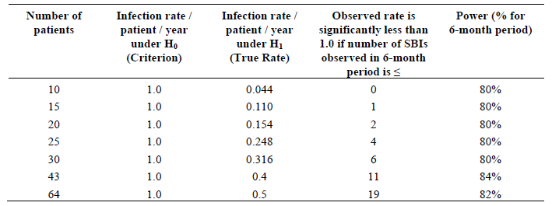

The statistical modelling was to account for the length of time the patient remained in the study during the relevant period. For patients completing all the required study visits, the length of time was calculated from the date of first visit for the period and the date of Visit 12 + 1 day. For patients terminating early from the study, the length of time was calculated from the date of first visit for the period and the date of the visit prior to their Exit Visit + 1 day. The length of time the patient remained in the study was calculated in days and then converted into years by dividing by 365.25.

###### Primary analysis

The primary analysis tested whether the observed serious bacterial infection rate was less than 1.0 per patient year using a one sided test, with α = 0.01 level and assuming that the rate followed a Poisson distribution.

The IgG trough concentrations were summarised for each scheduled visit by previous route of treatment administration and overall. Linear and log-linear plots of geometric mean serum concentration time profiles were calculated. A repeated measures analysis was used to calculate patients’ difference in trough concentrations between treatments and their average trough concentrations across both treatments along with 95% confidence intervals. The comparability of the treatments, Evogam versus previous Ig treatment was to be assessed by examining the confidence interval for the within patient difference in trough concentrations. The data was to be log transformed prior to analysis to approximate normality. Alternatively, nonparametric or distribution free methods were to be used if transformation was inadequate.

###### Handling of missing data

If patients dropped out of the study before Visit 12, with the exception of HRQoL questionnaires, there was to be no imputation of missing data. For the HRQoL questionnaires (SF-36[7] and CHQ-PF50[8]), a last observation carried forward approach was taken at Month 12, replacing missing data with the last available data, which provides a complete set of results for all domains recorded after Visit 0. A domain was treated as missing if more than 50 percent of the items were missing. If less than 50 percent of the items are missing, the score was taken to be the average of the non missing items.

###### Analysis populations

*Per Protocol Population* included all patients who completed the study without any major protocol violations or deviations and who have attended all their required study visits. After database lock however, a decision was made to include patients who entered the study without fulfilling the eligibility criteria on the proviso they had been granted a waiver.

*Intent to Treat (ITT) Population* included all patients who received at least one partial or complete dose of Evogam and who had sufficient valid samples to evaluate the IgG trough concentrations for Evogam and the previous Ig treatments.

*Formal PK Population* included all patients who participated in the PK evaluation who reached steady state and who had sufficient valid samples for evaluation.

*Safety Population* included all patients who have received at least one partial or complete dose of Evogam.

###### Trough IgG level measurements

Trough serum IgG concentrations were analysed from three baseline samples (one recorded in the 6 months before study entry and closest in time to the Screening Period, one during the Screening Period and one at Visit 0) and from samples collected during the Evogam Efficacy Period (Visits 7 to 12). The blood samples collected for trough IgG concentrations were analysed by the local laboratory at each study site.

###### Pharmacokinetic measurement

The PK endpoints measured in this study were total IgG and IgG subclass variables. Patients aged at least 18 years, consenting to participate in the PK evaluation had extra blood samples collected at Visit 9 (Week 24) and at additional time points up to 7 days later.

##### Results 1

###### Number of patients

Planned: Approximately 40 patients (minimum 30 evaluable patients), including 10 paediatric patients aged 3 to 12 years and 20 adult patients at least 18 years of age. These sample sizes were chosen using both the Committee for Proprietary Medicinal Products (CPMP) and FDA guidelines.

Enrolled: 35 patients, including 5 paediatric patients

###### Patient disposition

Thirty-five patients completed the Screening Period and entered the study (Figure 2). Of these, 33 patients completed the Wash out/Wash in Period and entered the Efficacy Period. A total of 30 patients completed the study. Of the five patients who did not complete, four patients withdrew consent and one patient failed to meet Inclusion Criterion 2 and was withdrawn from the study with a major protocol violation 15 days after receiving the first dose of Evogam.

Figure 2. Study 05-23. Patient disposition

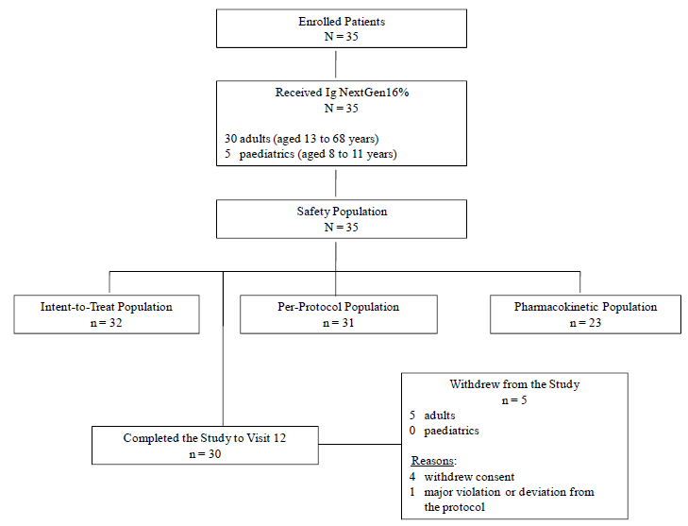

###### Major protocol deviations

A total of thirteen (37.1%) patients were reported to have major protocol deviations. One patient was prescribed, dispensed and administered Evogam that was labelled for a separate study. Twelve patients did not fulfill at least one of the inclusion/exclusion criteria. Of the 12 patients with failed eligibility criteria, 10 patients had been granted protocol waivers by the Medical Monitor. The two patients without waivers continued in the study although one was later withdrawn because of the protocol violation 15 days after receiving the first dose of Evogam.

###### Study population numbers

Study populations are summarised below in Table 3.

Table 3. Summary of Analysis Populations, All Enrolled Patients

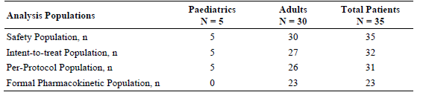

###### Baseline characteristics

The majority of patients were White (94.3%) and 57.1% were female. The mean age of adult patients was 43.99 years. The mean age of the paediatric patients was 9.72 years. Thirty three (94.3%) were classified with primary immunodeficiency type Common variance immunodeficiency (Table 4). Thirty-four (97.1%) had prior IVIg treatment and one had prior SC treatment. Baseline dosages are summarised in 5.

Table 4. Study 05-23 Demographics and Baseline Information, All Enrolled Patients

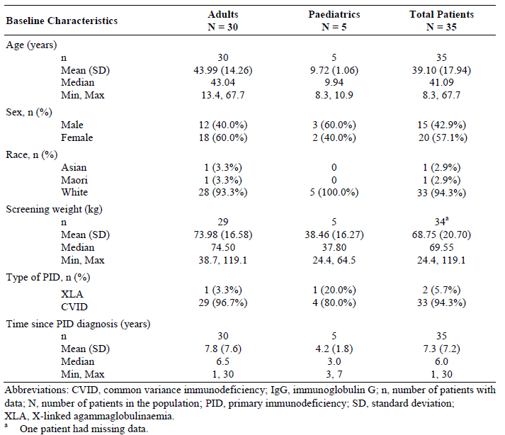

Table 5. Study 05-23 Baseline Information, All Enrolled Patients

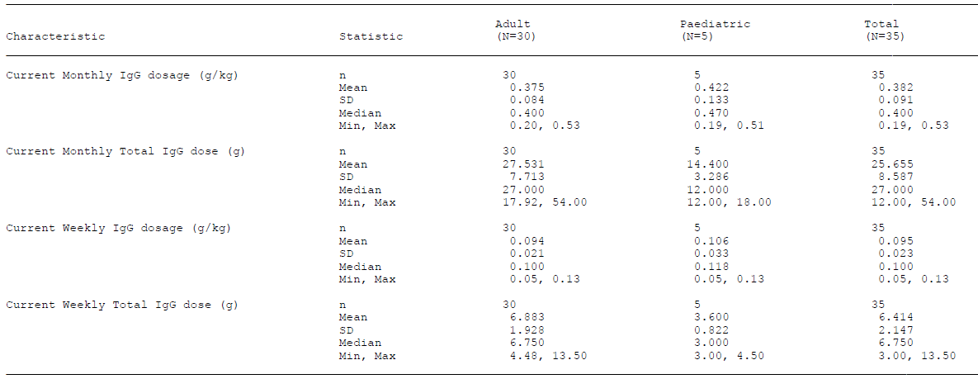Table 5. Study 05-23 Baseline Information, All Enrolled Patients

###### Previous infections

Seven adult patients were diagnosed with nine infections in the 12 months before the study:

* Two infections (pneumonia with sepsis, and endocarditis) probably met the FDA criteria for serious bacterial infection;
* Three infections (sinus infection, urinary tract infection and root canal dental procedure) were unlikely to have met the criteria
* Four infections (two chest infections, pneumonia and bacterial pneumonia) may have met the criteria but there was not enough information available to be certain.

##### Results 2

The extent of exposure is summarised in Table 6.

Table 6. Study 05-23 Extent of Exposure, Safety Population

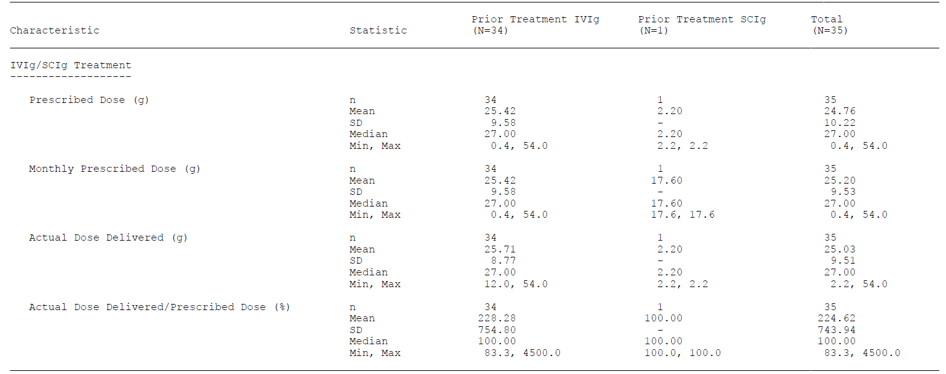Table 6. Study 05-23 Extent of Exposure, Safety Population

###### Serious bacterial infections

* For the Efficacy Period, the 12 month serious bacterial infection rate was 0 for both the Per Protocol (PP) and Intent to Treat (ITT) Populations with 99% upper confidence limits of 0.36 and 0.33, respectively
* For the Treatment Period, the 12 month serious bacterial infection rate was also 0 for both Populations with 99% upper confidence limits of 0.24 and 0.22, respectively.

These findings were in accordance with the FDA guidance that substantial evidence of efficacy is provided by statistical demonstration per person year of less than 1.0 with upper one sided 99% confidence limit also less than 1.0. (Table 7 below)

Table 7. Study 05-23. Rate of Serious Bacterial Infections

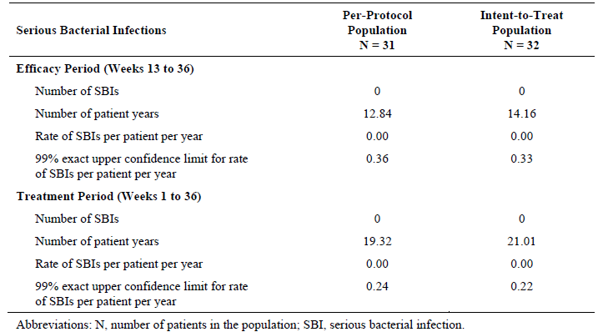

###### Trough serum IgG concentrations

Mean trough serum IgG concentration time profiles suggested that the IgG concentrations were at steady state from Visit 6 (Week 13) onwards. No patient had trough IgG concentration of less than 5g/L at any time during the study. Higher steady state serum trough IgG concentrations were observed after treatment with Evogam than after previous IgG treatment (see Figure 3 and Table 8).

* For the PP population the baseline mean trough IgG concentration was 8.30 g/L. During the Efficacy Period the mean trough concentration was 9.11 g/L. The difference was statistically significant (p = 0.0021).
* For the ITT Population, the baseline mean trough IgG concentration was 8.27 g/L. For the Efficacy Period, the mean trough concentration was 8.94 g/L. The difference was statistically significant (p = 0.0063).

The ranges were as follows:

* During the Efficacy Period, mean trough IgG concentrations ranged from 9.262 to 9.692 g/L for the PP population and 9.088 to 9.518 g/L for the ITT population. Individual trough IgG concentrations ranged from 6.40 to 13.30 g/L for both populations.
* During the previous IgG treatment period, mean trough IgG concentrations ranged from 8.349 to 8.936 g/L for the PP population and 8.218 to 8.867 g/L for the ITT population. Individual trough IgG concentrations ranged from 5.37 to 15.60 g/L and 5.80 to 15.60 g/L, respectively.

Figure 3. Box Plot of Trough Serum IgG Concentrations over Time (Linear Scale), Per-Protocol Population

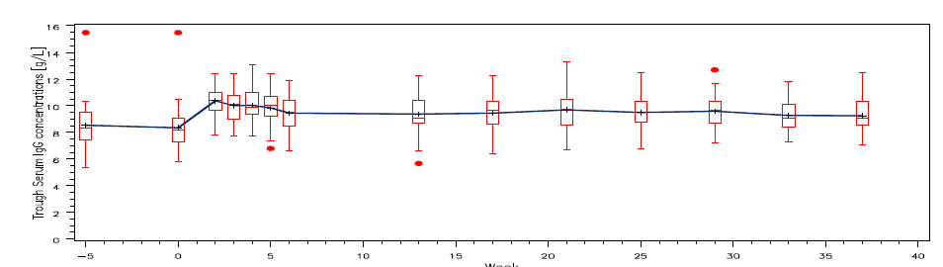Figure 3. Box Plot of Trough Serum IgG Concentrations over Time (Linear Scale), Per-Protocol Population

Table 8. Study 05-23 Comparison of Trough Serum IgG Concentrations

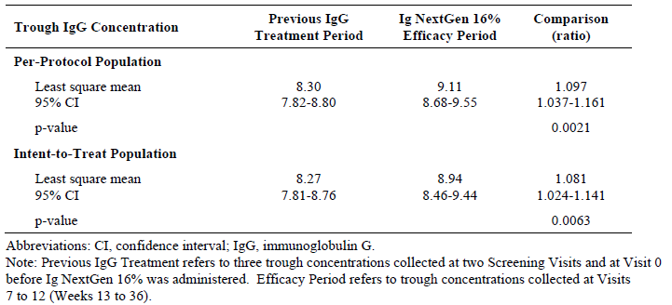

###### Secondary endpoints

*Infection episodes/ antibiotic use/ days off/ hospitalisation.* The results calculated for these secondary endpoints are summarised in Table 9 below.

Table 9. Study 05-23. Secondary endpoints

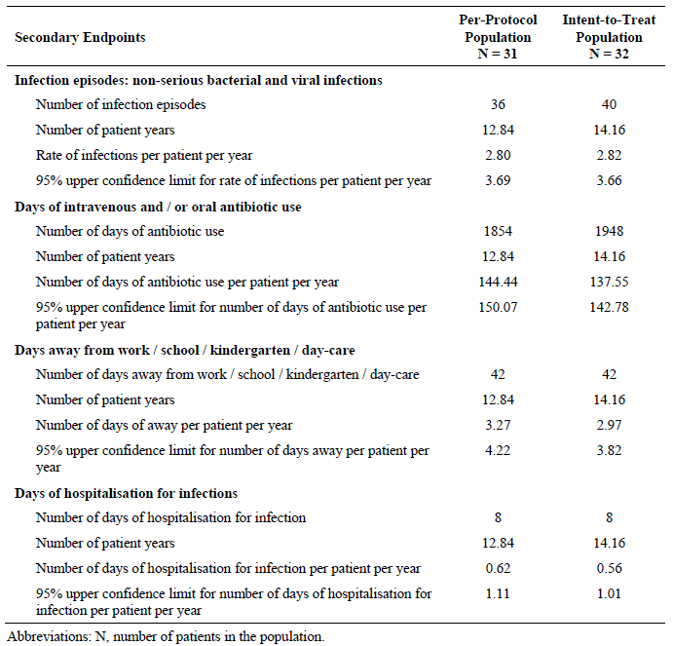

###### Pharmacokinetics

The geometric serum IgG concentrations at the beginning and end of the dosing interval were in close agreement, with similar values observed in mean Cmax (8.87 g/L: range: 6.7 to 11.1 g/L) and mean Cmin (8.32 g/L; range: 6.0 to 10.6 g/L), confirming that patients had achieved steady state with respect to serum IgG concentrations. On average, the Cmax occurred at 0.35 days (8.49 hours). The mean AUC(0-t)ss and clearance (CL/F) were also consistent with patients at steady state IgG concentration. The estimated terminal t1/2 for IgG ranged from 13.65 to 164.87 days. The PK profiles of the IgG subclasses were also characterised and were mostly consistent with values for IgG following absorption. The serum IgG concentration over time profiles displayed the characteristic peak concentration at the end of the IgG infusion and declined with a geometric mean terminal half-life of approximately 54 days. (Tables 10 and 11 and Figure 4).

Table 10. Study 05-23. Serum IgG Pharmacokinetic Variables per Treatment, Pharmacokinetic Population

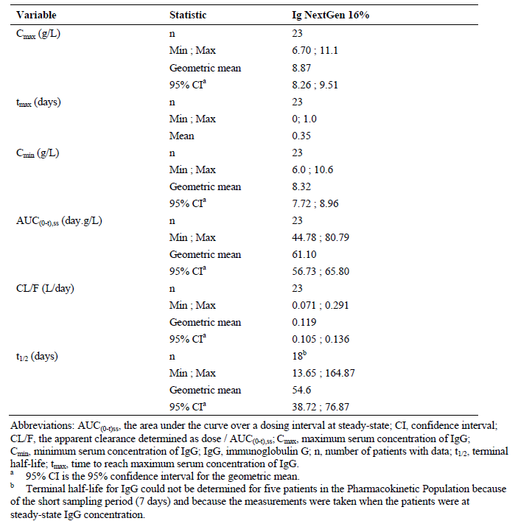

Figure 4. Study 05-23 Mean Serum IgG Subclass Concentrations Pharmacokinetic Population (N = 23)

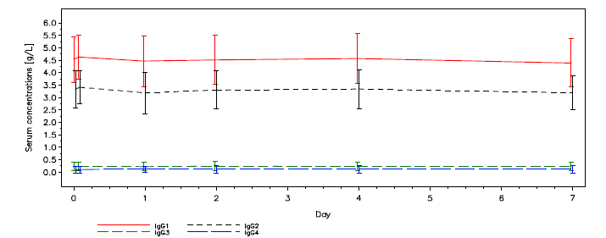Figure 4. Study 05-23 Mean Serum IgG Subclass Concentrations Pharmacokinetic Population (N = 23)

Table 1. Study05-23. Serum IgG Subclasses Pharmacokinetic Variables, Pharmacokinetic Population

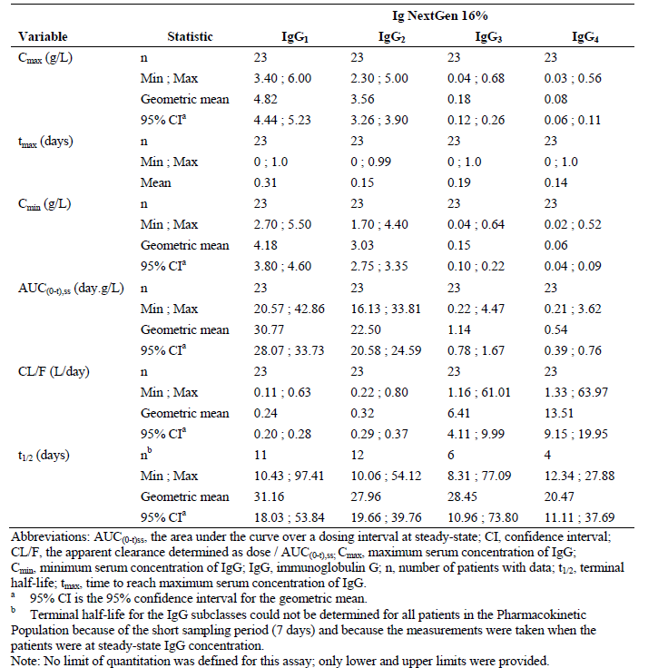

##### Quality of life

For the quality of life analysis, a total of 27 adult patients (aged at least 17 years) completed health-related (SF-36v2) and treatment related (LQI[9]) questionnaires at Visit 0 (while patients were still on their previous IgG treatment) and at Visit 6 and/or Visit 12 (during the Evogam Treatment Period). Twenty-five adult patients completed the Treatment Comparison Questionnaire at Visit 6 as compared to 24 patients at Visit 12.

Based on the SF-36v2 questionnaire, patients had a similar quality of life on both previous IgG treatment and Evogam; the repeated measures analysis showed no significant difference between previous IgG treatment and treatment with Evogam (Table 12). Results of the LQI are shown in Table 13.

Table 12. SF-36v2™ Questionnaire: Observed Values at Visits 0, 6 and 12, Safety Population

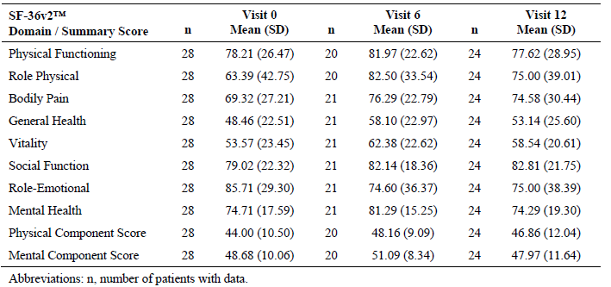

Table 13. Life Quality Index Questionnaire: Observed Values at Visits 0, 6 and 12, Safety Population

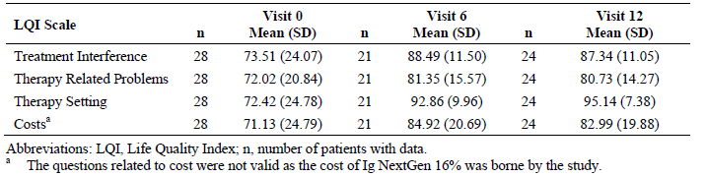

For quality of life analyses, a total of 7 paediatric patients aged between 8 and 16 completed the CHQ-PF50™ questionnaire at least once during the study. However, only three completed questionnaires at all three time points making any assessment of results unreliable.

It was stated that after switching from their previous IgG treatment to Evogam, the majority of patients reported that they preferred home based SCIg treatment.

##### Safety results

Thirty-five patients were administered 1,111 infusions of Evogam and the mean number of infusions during the Treatment Period was 31.74. Based on infusions conducted at the study site, the total mean dose of Evogam was 73.23 g and the mean weekly dose of Evogam was 6.83 g.

###### Treatment emergent adverse events

Treatment emergent adverse events and events considered at least possibly related to study treatment are summarised in Tables 14 and 15 below.

Table 14. Study 05-23 Treatment-emergent Adverse Events Reported by > 10% of Total Patients, Safety Population

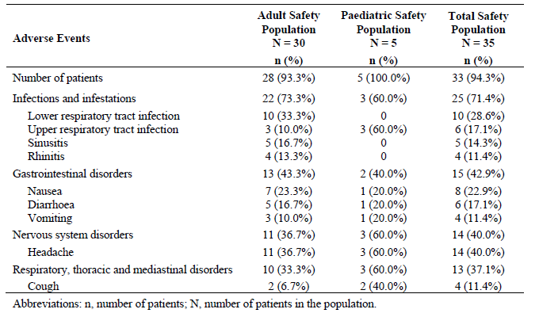

Table 15. Study 05-23. Number of Patients Experiencing a Treatment-Emergent Adverse Event Possibly, Probably or Definitely Related Safety Population. Table continued across two pages.

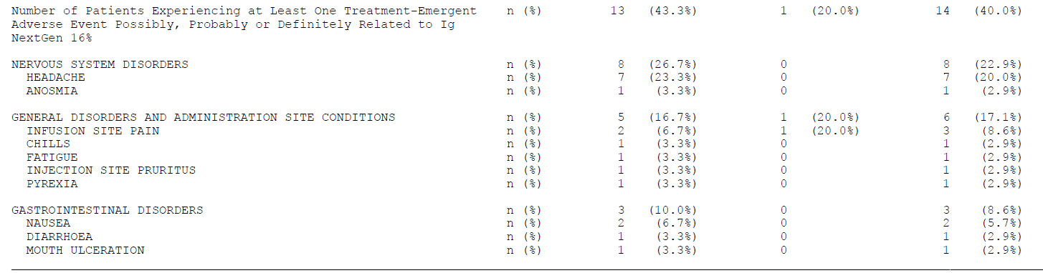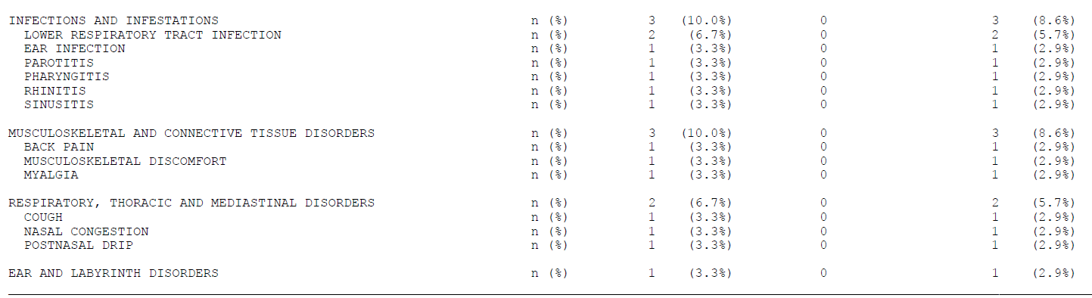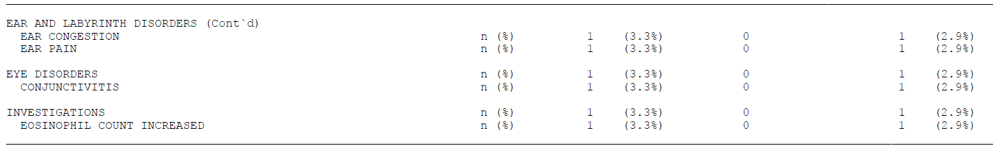

There were no deaths reported and no patient withdrew from the study due to a treatment emergent adverse event. A total of five (14.3%) patients reported six serious adverse events. None were considered by the study investigators to be related to Evogam.

Overall, 33 of the 35 patients (94.3%) reported an adverse event, regardless of causality. Sixty percent of patients reported an adverse event with a maximum intensity of either mild or moderate and 34.3% of patients reported an event with maximum intensity of severe.

Thirteen (43.3%) adult patients and one (20.0%) paediatric patient reported adverse events that were considered possibly, probably or definitely related to Evogam. Headache was the most frequently reported.

Solicited symptoms were to be recorded as adverse events if they resulted in a cessation of Evogam infusion; required concomitant medication; or in the opinion of the study investigators, had an impact on the general condition of the patient.

Solicited tolerability symptoms at the infusion site occurred in almost all patients (pain, itching and/or local heat [82.9% of patients]); erythema [91.4% of patients]; and induration [97.1% of patients]). The reported incidence of symptoms decreased over the length of the study. A small number of tolerability symptoms were reported as treatment emergent adverse events (two adult patients and one paediatric patient with infusion site pain and one adult patient with injection site pruritus). In addition, one adult patient reported injection site haematoma.

Unsolicited adverse events were reported by 93.3% of adult patients. The most frequently reported of these were headache (36.7% of adult patients), lower respiratory tract infection (33.3% of adult patients) and nausea (23.3% of adult patients). Overall, 36.7% of adult patients had at least one treatment emergent adverse event with a maximum intensity of severe and 56.6% of adult patients reported events with a maximum intensity of either moderate or mild.

Unsolicited treatment emergent adverse events considered to be possibly, probably or definitely related to Evogam were reported by 43.3% of adult patients. Headache was the most frequently related event (23.3% of patients; median duration 2 days). Two patients had three treatment related adverse events with a maximum intensity of severe;

* One patient experienced pyrexia and chills lasting 4 days following Infusion 2.
* Another patient reported sinusitis before Infusion 26, requiring an increase in the dose of Evogam. The dose was not subsequently increased.

###### Pharmacological class effects

Risks which are known to the pharmacological class of polyvalent (normal) human IgG products have been characterised through the use of IVIg include: headache, hypersensitivity and anaphylactic reactions, thromboembolic events, haemolysis and aseptic meningitis syndrome. Incidence of such events is summarised below in Table 16.

Table 16. Adverse events considered pharmacological class effects

|  |  |
| --- | --- |
| Risk | Incidence and severity |
| Headache | Eleven adults and three children (37.8%) experienced at least one headache. All were mild or moderate in severity except for one child who reported severe headache lasting 4 days. One adult patient experienced 18 episodes of headache; each occurring on the day of each infusion. |
| Hypersensitivity | No anaphylactic reactions were observed during either of the studies. |
| Thromboembolic event | One adult patient (2.7%) experienced a non-serious (unspecified) embolism, which was moderate in severity and resolved the same day without intervention, considered by the Investigator to be unlikely related to Evogam. There were no other reports of thromboembolism in the studies. |
| Haemolysis | There were no reports of haemolysis with Evogam during either of the studies. |
| Aseptic meningitis syndrome | There were no reports of Aseptic Meningitis Syndrome with Evogam during the pivotal study. |

###### Laboratory findings

Two patients were considered to have clinically significant changes in haematology results. (Table 17 below). Six patients were considered to have clinically significant biochemistry results. (Table 18) With respect to ALT and AST, one patient was reported as having a treatment emergent adverse event albeit considered unrelated to treatment. The event was said to have resolved after an unspecified change in medication.

Table 17. Study 05-23. Clinically Significant Haematology Values after Baseline

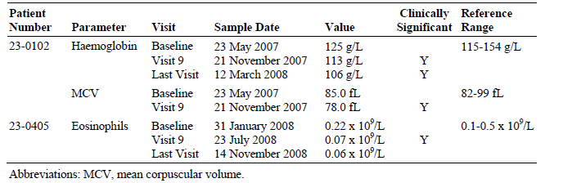

Table 18. Study 05-23. Clinically Significant Biochemistry Values after Baseline

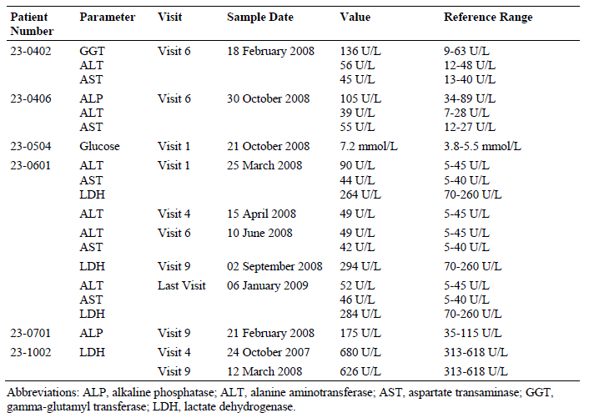

#### Study 07-42

The study was a continuation of Study 05-23 with allowance for enrolment of new patients. Enrolment of a total of 50 patients was planned. At the time of writing of the submission report, the study included 37 patients, two of whom were newly enrolled paediatric patients. The current Australian submission reported only the outcome for the 2 new paediatric patients.

The results for the two patients are summarised below; demographics in Table 19 and trough serum IgG concentrations in Table 20. The length of follow up is inferred from the times shown in Table 20, a total of 9 months for one of the patients and 12 months for the other, with Efficacy periods of 3 and 6 months, respectively.

Table 19. Study 07-42. Demographics and Baseline Information

|  |  |  |
| --- | --- | --- |
| Baseline Characteristics | Patient 1 | Patient 2 |
| Age (years) | 5.9 | 11.0 |
| Sex | Male | Male |
| Race | White | White |
| Screening weight (kg) | 20.2 | 30.8 |
| Type of PID | Ataxia Telangiectasia Specific Antibody Deficiency | Hyper IgE Syndrome |
| Year of PID diagnosis | 2004 | 2003 |

Table 20. Study 07-42. Trough Serum IgG Concentrations, interim analysis

|  |  |  |  |  |  |
| --- | --- | --- | --- | --- | --- |
| Phase | Wash in/wash out Period | | Efficacy Period | | |
| Visit | 0 | 3 Month | 6 Month | 9 Month | 12 Month |
| **Patient1 IgG trough concentration (g/L)** | 6.8 | 10.4 | 11.8 | 10.6 |  |
| **Patient2 IgG trough concentration (g/L)** | 13.3 |  | 13.4 | 12.6 | 14.2 |

The conclusion drawn by CSL regarding efficacy is that the interim analysis of data from two paediatric patients showed that trough serum IgG concentrations were maintained by weekly doses.

#### Paediatric Patients. Combined Studies 05-23 and 07-42

In Study 05-23, a total of 5 children under the age of 12 years were enrolled. A 13 year old paediatric patient from this trial was considered by the TGA to be eligible for analysis in the paediatric population. An additional two children were enrolled into the 07-42 trial. Results for a total of eight paediatric patients were separately summarised in the sponsor’s current Australian submission. These patients comprised the Paediatric population for the Efficacy Period.

Six (75%) patients were male and two (25%) were female and all were White (100%). The mean age was 9.85 (median 10.20, range: 5.9 to13.4) years and the mean weight was 35.25 (median 34.40, range: 20.2 to 64.5) kg. Demographic and baseline data are summarised in Table 21 below.

Table 21. Combined paediatric demographics and baseline information, paediatric population.

|  |  |
| --- | --- |
| Baseline Characteristics | Paediatric population N=8 |
| Age (years) n Mean (SD) Median Min, Max | 8 9.85 (2.22) 10.20 5.9, 13.4 |
| Sex, n (%) Male Female | 6 (75.0%) 2 (25.0%) |
| Race, n (%) White | 8 (100.0%) |
| Screening weight (kg) n Mean (SD) Median Min, Max | 8 35.25 (13.98) 34.40 20.2, 64.5 |
| Type of PID, n (%) XLA CVID Other* | 8 1 5 2 |

Abbreviations: CVID, common variance immunodeficiency; IgG, immunoglobulin G; n, number of patients with data; N, number of patients in the population; PID, primary immunodeficiency; SD, standard deviation; XLA, X‑linked agammaglobulinaemia.

* Other includes ataxia telangiectasia specific antibody deficiency and Hyper IgE Syndrome.

#### Trough serum IgG concentrations

A comparison was made of trough serum IgG concentrations collected at baseline (at three time points: Visit 0, Screening Period and pre-screening for Study 05-23 participants and one time point: Visit 0 for Study 07-42 participants) and Week 17 to 39 for the paediatric population (Visit 7 to Visit 12 for participants of Study 05-23 and Month 6 and Month 9 for Study 07-42 participants). No difference in mean trough IgG concentrations was observed after treatment with Evogam compared with the previous IgG treatment (Table 22).

Table 2 Comparison of Trough Serum IgG Concentrations, paediatric population (n=8)

|  |  |  |  |
| --- | --- | --- | --- |
| Trough IgG Concentration | Previous IgG Treatment | Evogam | Comparison (ratio) |
| Least square mean 95% CI | 9.22 8.36-10.16 | 9.44 9.16-9.72 | 1.024 0.926-1.132 |
| p-value |  |  | 0.631 |

Abbreviations: CI, confidence interval; IgG, immunoglobulin G.

Note: Previous IgG Treatment refers to Screening Visits and Visit 0 and Evogam refers to trough concentrations collected at Weeks 17 to 39.

#### Literature evaluation

To supplement the paediatric data obtained in Studies 05-23 and 07-42, CSL included a literature component. The literature search was reviewed by the TGA and found to be comprehensive. The CSL search was widened for safety at the request of the TGA. Details of the search strategy were included in the Australian submission. Eleven reports were identified as potentially relevant. Of these 11 reports, 6 were open label prospective observational trials, of which four were evaluated. Two of these are summarised below[10]. Two studies were not summarised as there was no record of Good Clinical Practice[11] . Of the remaining reports, two were retrospective and three were case series. These reports were not evaluated here.

##### Gardulf 2004

Gardulf A *et al*. (2004). Children and adults with primary antibody deficiencies gain quality of life by subcutaneous IgG self infusions at home. *J Allergy Clin Immunol* 114 (4): 936-42.

###### Objectives

The aims of the study were to describe self reported Health related Quality of Life (HRQOL) and Treatment Satisfaction (TS) in children and adults with Primary antibody deficiency and to determine whether the introduction of SCIg replacement therapy as self infusions at home would improve these functions.

###### Inclusion criteria

* Primary immunodeficiency patients aged between 2 and 75 years.
* IVIg or SCIg replacement therapy for at least 6 months, stable serum IgG trough levels ≥ 5 g/L before enrolment.
* No other major chronic diseases.
* Ability and willingness to answer questionnaires.

###### Enrolment

17 Children < 14 years were enrolled.

Participants answered the questionnaires at baseline and after 6 and 10 months.

Not all participants answered all questionnaires. However, the reason was stated to be not attributed to the health of the patients.

###### Treatment regimen

IgG was given as weekly SC infusions. With a liquid pasteurised polyvalent human Evogam preparation (Germany). Weekly doses ranged between 50 and 150 mg/kg/body weight.

All participants were trained and supervised once per week at the local hospital for 4 to 6 training sessions and had to show practical skill, knowledge, and confidence in the SCIg administration route before being transferred to self infusions at home. The parents gave the infusions to their children or supervised the treatment. The participants visited their clinic every fourth week for medical and nursing follow ups and to verify that the infusion technique was correct.

Fifteen of the 17 enrolled children were evaluable. The age range was 3 to 13 years. All were male. All evaluable patients were previously treated with IVIgG.

###### Questionnaires

The CHQ-PF50 12 was used for the children and answered by the parents. It focused on the physical and psychosocial functioning and well being of the child and family and aggregated to 15 concepts in total. For this study, the one standalone global item ‘‘change in health’’ was not used because it has a one year recall period. Higher scores indicate a better HRQOL.

The Life Quality Index (LQI) consists of 15 statements, each rated on a 7 point Likert response scale[12]. A maximum summary score of 105 indicated the highest possible satisfaction with factors such as independence, therapy convenience, social/school/work activities, and health and travel costs. In addition to the LQI, two preference items were used: ‘‘Which IgG therapy do you prefer?’’ (IVIg, SCIg, or no preference) and ‘‘Where do you prefer to receive your IgG therapy?’’ (In the hospital/in the doctor’s office, at home, or no preference).

###### Statistical analysis

The primary analysis included the 15 children who were fully compliant with the study protocol.

The non responder rate to single items was in total 0.43%. To handle missing data, two methods were used. If less than 50% of the responses within a single scale were missing for a respondent, item imputation was performed by mean value substitution as described in the scoring manuals. Otherwise, values were predicted by using an explicit regression model that included the previously observed scores on the scale for the individual as well as important covariates (age, country, route of previous IgG treatment and the number of SCIg infusions).

Data were analysed with a repeated measures model that assumes correlated assessments over time and normally distributed response variables. The 6 and 10 month assessments were compared with the patients’ baselines in the two groups, children and adults.

###### Good clinical practice

Local ethics committees approved the study. Written informed consent was obtained.

###### Results

Significant improvements were found for six of the CHQPF50 subscales at 10 months compared with baseline. Between 47% and 87% of the 15 children showed an improvement of at least 5 points with regard to these scales. Four of these significant improvements were already seen after 6 months. After the introduction of the SCIg home therapy regimen, the parents reported improved school and social functioning for their child (subscale role/social emotional, behavioural) and improved overall health (global health). They also reported that the child now was as healthy as other children and that the child had a better resistance against infections (general health perceptions). Moreover, the parents had greater expectations for a healthier life of the child in the future (general health perceptions).

For the children, the total mean summary LQI score significantly improved from 73.4 ± 13.4 at baseline to 94.9 ± 8.7 at 10 months (p = 0 .0001).

All children and their parents reported that they preferred the SCIg self infusions at home.

###### Author’s comments

From this study, it was not possible to say whether the reported improvements in the children’s health were primarily related to the use of the SCIg therapy itself, the switch to home therapy or to a combination of both.

Another benefit from the home therapy regimen itself was the reduced number of visits to the hospital and a decreased risk for the children to acquire infections. This may contribute to the reported improved health of the children and may also reduce the parents’ anxiety that their child may become infected. Indeed, in this study it was found that the introduction of the SCIg home therapy made the parents feel less worried or concerned regarding their child’s physical health and emotional well being (subscale parental impact–emotional).

The parents also reported that the introduction of the home therapy resulted in less limitation in personal time for their own needs (parental impact–time). Moreover, the home therapy regimen positively influenced the entire family situation, for example, there were fewer restrictions and interruptions in the usual family activities (family activities). Home therapy has been considered especially important in paediatric immunodeficiency care because it saves the families the trips to the hospital and families have reported that they prefer the shorter, more frequent infusions at home to the more disruptive and lengthy visits to a hospital every third to fourth week as required by IVIg infusions.

The LQI showed that home therapy resulted in greater independence, with less disruption of daily activities; less effect on school, work, and social activities; freedom to travel; better therapy convenience; comfort; treatment flexibility; and pleasantness of treatment atmosphere. The concept of feeling able to control a treatment is important for the patient because a sense of active participation leads to greater compliance and improved medical outcome.

###### Evaluator comments

The study is rated a Jadad score[13] of zero and Level IV of the NHMRC Evidence Hierarchy[14].

##### Gardulf 2006. Pivotal study

Gardulf A *et al.* (2006). Rapid Subcutaneous IgG Replacement Therapy is Effective and Safe in Children and Adults with Primary Immunodeficiencies – A Prospective, Multi-National Study. *Journal of Clin Immunol.* 26(2): 177-185.

A multicentre, prospective, longitudinal, trial with each participant as his/her own control. Pivotal study for European registration approval. Supported by ZLB Behring.

###### Objective

To evaluate efficacy and safety of SCIg replacement therapy.

###### Inclusion criteria

Primary immunodeficiency patients aged 2 to 75 years.

Prior IVIg of SCIg replacement for at least 6 months with stable serum IgG trough levels > 5 g/L

*Exclusion criteria*

* Anaphylactoid reaction to any IgG preparation
* Severe chronic diseased
* Infection with hepatitis A, B or C or Human immunodeficiency virus (HIV)

###### Good clinical practice

Local Ethics Committees approval and written informed consent were obtained. The study was stated to be performed in conformance with the European CPMP guidelines adopted in Australia for IV and SC/IM use of immunoglobulin[15].

###### Participants

Sixty patients at 12 study sites in 6 European countries were enrolled: sixteen were children (2 to 11 years old) and forty-four were adults.

Eight participants prematurely discontinued (1 child and 7 adults). Of the adult patients, two discontinuations were due to protocol violation, two withdrew consent and one was lost to follow up. One patient withdrew after the first infusion due to suspected severe adverse reaction (pallor, sweating and hypotension) and one adult was withdrawn due to moderate local tissue reactions.

An 11 year old boy was excluded after the eleventh infusion as his serum IgG trough levels did not increase to a sufficient level. A suspected protein losing enteropathy was considered the reason and IVIg also failed to raise IgG level above 5 g/L.

Demographic characteristics are summarised in Table 23 below.

Table 23. Demographic and Medical data

Table 23. Demographic and Medical data

###### Study treatment

Liquid, ready-to-use, pasteurised, polyvalent, human 16% IgG preparation (Vivaglobin, ZLB Behring Marburg, Germany) was administered. The product was free of sugars and preservatives and stabilised by glycine at pH 7.0. The manufacturing process included two virus inactivation steps; precipitation by ethanol in the presence of fatty alcohols and pasteurisation. The previous monthly IVIg dose was divided by four to calculate the weekly dose of SCIg. No premedication was used.

The first 15 weeks were considered a wash out period. Weeks 16 – 43 were considered the Efficacy phase for serum IgG levels and infections.

###### Analyses

Serum IgG trough levels and infections were reported for the Efficacy phase for 52 patients who completed all infusions.

Non inferiority of serum IgG trough levels obtained during the SCIg Efficacy period to the serum IgG trough levels obtained on Day 1 was tested separately for adults and children using a one sided t test for dependent samples. A maximum deterioration of 0.5 g/L during the SCIg therapy was considered to be clinically acceptable.

###### Results

Children: The mean IgG level increased from 7.8 to 9.2 (p < 0.001).

Adults: The mean IgG level increased from 8.6 to 8.9 g/L (p < 0.001).

Respiratory tract infections were reported at an annualised rate of 0.5 lower respiratory episodes per patient and 3.6 upper respiratory tract infection episodes per patient. Some 90% of all respiratory tract infections were classified as mild. One adult developed pneumonia one day before his last infusion. One 7 year old boy suffered salmonella enteritis and was hospitalised. Six children missed days of school, with absences ranging from 1 to 9 days.

###### Related adverse events

Sixty patients received a total of 2297 infusions. Systemic adverse events considered related to study drug were reported for 12 adults and 1 child in relation to 28 infusions (1%). The reactions were fever ≥ 38ºC (17/28), generalised skin reaction (2/28), dizziness, malaise and chills (one each), wheezing, pallor, sweating and hypotension (NB not all were accounted for).

Local reactions occurred on 28% (641/2297) occasions and 98% of these were reported as mild. Local reactions were mainly reported during the first two months of therapy.

Liver function tests pre and post study were normal and all viral tests were negative.

###### Author’s comments

Reduced exposure to premedication, in particular corticosteroids, is beneficial for all patients but particularly for children. The author states that it is of great importance to inform patients and parents that local tissue reactions are normal and will occur in most cases but that these will decrease with time.

###### Evaluator’s comments

The findings of this study examining Vivaglobin ZLB Behring appear to be in keeping with the results for Evogam. The stated reduced exposure to premedication was not supported by data.

#### Summary and discussion

CSL has submitted the results of Study 05-23, an open label, multicentre observational study assessing SC infusion of Evogam, with the primary objective of evaluating the occurrence of serious bacterial infections and assessing steady state trough concentrations. Safety, tolerability, PK and quality of life assessments were secondary objectives. In total, 35 patients were enrolled in Study 05-23, including 5 children aged between 8 and 11 years old and one child aged 13.4 year. Reports of two paediatric patients newly enrolled in the follow up Study 07-42 were also included in the Australian submission. Thus, eight results for eight paediatric patients were included.

Serious bacterial infections and the statistical approach to assessing them were defined according to the FDA Guidance for Industry[16]. Study05-23 was also done in accordance with the EU Guideline adopted in Australia14 which recommends a minimum enrolment of 30 patients and efficacy follow up period of 3 to 6 months. This guideline also recommends inclusion of at least10 paediatric patients and this requirement was not met in this study. In view of this, CSL submitted supportive paediatric literature.

All but one of the participants in Study 05-23 had been stabilised on IVIg prior to enrolment; one patient was stable on SCIg. The SC weekly dose was based on the previously required monthly dose which was in the range 0.2 – 0.6 g/kg/month. Patients treated according to protocol received a total of 36 infusions. There was no protocol specified pre medication. There was a wash in/wash out period of 12 weeks followed by an Efficacy period of 24 weeks.

##### Primary objectives

There were no serious infections reported for the PP and ITT populations. The 99% upper CI for the annualised rate was 0.24 for the PP population and 0.22 for the ITT population satisfying the FDA criteria of a 99% upper CI < 1.0.

The data on serious infection incidence was reported over a six month period rather than a one year period. As the sponsor’s clinical expert pointed out, this may not have allowed for seasonal variation in infection rates. A similar result was obtained for the whole treatment period; however, this also was also less than a complete year and could have been influenced by the preceding treatment. Data analysed in terms of patient years, when all of the data has been collected for each individual for a maximum of six months, is to be interpreted with a degree of caution.

The objectives of Study 07-42 differed from those of the pivotal Study 05-23. Monitoring of IgG trough levels was a secondary objective and reporting the incidence of severe bacterial infections was not specified as either a primary or secondary objective. The number of serious bacterial infections suffered by the two paediatric patients enrolled in Study 07-42 could not be established.

Mean trough serum IgG concentrations were a little higher during the Efficacy period than during the previous Ig Treatment period; for the PP population ranges of 9.262 g/L to 9.692 g/L versus 8.349 to 8.936 g/L, respectively, were reported. The differences were statistically significant. The clinical significance of the difference is hard to assess.

Pharmacokinetics, evaluated as a secondary analysis, showed a serum IgG concentration over time profile with the characteristic peak concentration at the end of the IgG infusion followed by a decline, with a geometric mean t1/2 of approximately 54 days.

The trough serum IgG concentrations would have depended on the dose regimen and calculation of dose was left to individual treating doctors. It was not possible to compare baseline and treatment period doses in terms of g/kg (as presented for baseline for both adults and children). In addition, when comparing baseline and study exposures, it was noted that the baseline exposures are documented separately for adults and children whereas the study treatment values for the two groups were combined. As the exposure for children was lower than for adults, an increase in the exposure may not be obvious when the two are combined.

##### Secondary objectives

The repeated measures analysis of the LQI questionnaire showed improvement in scores over the course of the study. Not all patients were included in the results for Visits 6 and 12. The method of analysing the quality of life data, with imputed missing results and the lack of accounting for multiplicity and the unblinded nature of the study, made the assessment of these findings difficult.

Solicited symptoms were documented as an adverse event only if an event resulted in a cessation of Evogam infusion, required concomitant medication, or if in the opinion of the study investigator it had an impact on the general condition of the patient. It is considered that this may underestimate the problems that SC infusions may present to the patient. If this was a vaccine being considered, all solicited local symptoms by their very nature would be considered product related adverse events.

The number of patients with classification of headache, nausea, diarrhoea and fever and muscle aches and pains considered unrelated is questioned. For instance one patient reported severe nausea and vomiting on the day of Infusion 3. The events were considered unrelated. One child reportedly suffered severe diarrhoea, severe headache and elevated temperature on the day of infusion. These events were not considered even possibly related. The reasoning as to why such events were considered unequivocally unrelated was questioned by the clinical evaluator.

With regard to reporting of events consistent with pharmacological class effects, it was noted that the incidences for headache and aseptic meningitis are reported only for the pivotal study, whereas the incidences of hypersensitivity, thromboembolic events, and haemolysis are qualified in either of the studies. This being so, it appears that incidences of adverse events have been analysed for the follow up study and it would be of interest to know the incidence of headache and aseptic meningitis reported in Study 07-42. The incidence of serious infection in Study 07-42 would also be of great interest.

The findings reported by CSL were largely in keeping with the results reported in the literature included with the current Australian submission.

#### CSL’s benefit risk assessment

##### Benefits

Human immunoglobulin preparations have long been successfully used as replacement therapy in patients with immunodeficiencies. There is a recognised need for alternative delivery options for IgG replacement therapy compared to IVIg such as high concentration IgG solutions delivered via the SCIg route. There are many potential benefits afforded by these high concentration SCIg formulations. These benefits include:

* Reduced costs for healthcare systems and families;
* Favourable cost effectiveness in pharmacoeconomic evaluations;
* Adverse events (AEs; systemic and local) are predominantly mild to moderate in nature (and particularly suitable for patients with previous adverse reactions to IVIg);
* Improved safety and tolerability with the absence of infusional adverse events;
* Reduced need for pre medication (including corticosteroids);
* Lack of requirement for venous access, and therefore for many patients, a reduction in the need for implantable venous access ports;
* Stable, more physiological pharmacokinetics, with the loss of “wear off” symptoms experienced by some IVIg patients prior to the next infusion;
* Improved patient acceptability and quality of life measures, including a reduction in school and work absences (also easy for children, adults and elderly patients to learn and handle);
* Reduced reliance on hospital or infusion centre resources, with the potential for independent self administration at home;

##### Risks

* The risks associated with SCIg administration are not significant and are predominantly associated with the need for the patient to be trained to self administer the product in the home setting.
* Local reactions at the site of infusion were observed during Studies 05-23 and 07-42 in both adults and children. However, all were mild to moderate in nature, reduced in intensity with time and eventually resolved. Infusion site reactions are a well known risk with SC infusion of any product and so this risk is not specific to Evogam.

##### CSL’s benefits/risks conclusion

Intragam P, the parent IVIg product to Evogam SCIg has been used successfully in the market place for many years. Evogam is an additional product in CSL's range of human immunoglobulin products and is Australia's first human IgG product designed for SC use that is fractionated from non remunerated Australian donors.

The data presented for Evogam from Studies 05-23 and 07-42 are in accordance with the requirements of relevant guidelinesfor a modified product,and demonstrate that all primary and secondary objectives for both studies were met. The clinical trials demonstrate that:

* Evogam is efficacious: No serious bacterial infections were reported. Both adults and children treated with Evogam at weekly doses between 0.05 – 0.15 g /kg showed serum IgG trough levels which are comparable or higher than previous IVIg/SCIg treatment. The serum IgG trough levels were also comparable to other SCIg products.
* The HRQoL scores showed that the majority of patients treated with Evogam preferred this SCIg therapy at home compared to their previous treatment. Patients also had similar health related quality of life results between the two therapies.
* Infusion site reactions were well tolerated with only a small number reported as treatment emergent AEs (TEAEs).
* None of the laboratory or vital sign abnormalities described represent a safety risk to the patient population studied, or to patients in the post marketing environment.
* Eight (21.6%) patients included in the studies were between 5 and 13 years of age and 29 (78.4%) were aged 14 years and over. No differences were seen between the adult and paediatric populations studied with regard to Cmin, number and type of adverse events or tolerability of the infusion procedure.
* Evogam has an acceptable safety and tolerability profile for both adult and paediatric patients with PID.

Overall CSL considers the Benefit/Risk ratio is favourable for Evogam for both adults and children.

#### Evaluator comment

While there is substantial agreement with the points raised by the sponsor, some items were considered contentious.

With respect to costs to healthcare systems and families and cost effectiveness in pharmacoeconomic evaluations, both statements may be true, but evidence was not submitted for evaluation. In words taken from the sponsor in the Australian submission:

“In this study, the question of cost was not relevant because the costs were borne by the study, not the patient.”

It is considered unproven that the investigational product is particularly suitable for patients with previous adverse reactions to IVIg as such patients were excluded from the study.

With regard to the assertion that all AEs (systemic and local) were predominantly mild to moderate in nature, approximately one third of patients (34%) in Study 05-23 were reported to have a treatment emergent adverse event with maximum intensity of severe.

With regard to the claim of “absence of infusional adverse events” local reactions are considered by the evaluator to be infusion related unless proven otherwise.

With respect to the assertion that there was a reduced need for pre medication (including corticosteroids); The protocol stated that pre medication was not required but was permitted as medically indicated or based on normal hospital procedures. Data on the number of patients requiring or given premedication could not be found.

“Wear off” symptoms were not addressed in the submitted study. Though this statement may be true, there was no direct evidence supplied.

The assertion is made that all local reactions at the site of infusion were mild to moderate in intensity. The clinical evaluator has been able to determine that three adults and one child reported severe pain and that one adult and one child reported severe induration.

With respect to the reduced reporting of local reactions over time, the decrease in reporting may not have reflected decreased incidence. Patients may have become resigned to the occurrence of local reactions over time. In the literature reports of Gardulf et al 2006, such events occurring later in the course of treatment were reported more commonly by hospital staff than by patients at home.[17]

#### Evaluator’s benefit risk assessment

##### Benefits

* The underlying conditions have the potential for considerable morbidity and mortality.
* Demonstrated efficacy in preventing occurrence of serious bacterial infections in patients with PID.
* Mean trough serum IgG concentration time profiles reported for SC infusions were comparable to those of IV infusions.
* Stable, more physiological PK.
* Lack of requirement for venous access.
* Reduced reliance on hospital or infusion centre resources, with the potential for independent self administration at home which in turn has potential to reduce exposure to hospital acquired infection.

##### Risks

* As with all blood products, there is a theoretical risk of transmission of infection.
* The adverse event profile is likely to have some features in common with that of IV infusion, such as a potential for hypersensitivity reactions. The small numbers included in the study precluded detection of all but very common adverse events.
* Under non study conditions, there is the potential that unsupervised patients at home may become less compliant with treatment and unsupervised patients may become less careful with handling of equipment and product.

##### Balance

The Benefit/Risk ratio is considered favourable for Evogam for both adults and children.

### List of questions

During 2010, the TGA began to change the way applications were evaluated. As part of this change, after an initial evaluation, a List of Questions to the sponsor is generated.

Evaluator Question:

An explanation is requested as to why many of the adverse events commonly considered related to human immunoglobulin administration were not considered at least possibly related to treatment in Study 05-23.

### Clinical summary and conclusions

Registration is recommended with the following condition:

* Provision of the results of Study 07-42.

## V. Pharmacovigilance findings

### Risk management plan

A Risk Management Plan (version 1.00) was submitted and evaluated by the Office of Product Review (OPR) at TGA. A summary of the Ongoing Safety Concerns as specified by the sponsor has been tabulated below in Table 24.

Table 24. Ongoing Safety Concerns

|  |  |
| --- | --- |
| Important identified risks | * Infusion site reactions * Headache |
| Important potential risks | * Hypersensitivity and anaphylactic reactions * Thromboembolic events (TEE) * Haemolysis * Aseptic meningitis syndrome (AMS) * Lack of efficacy and/or non-compliance |
| Important missing information | * Limited patient clinical trial exposure |

##### OPR evaluator comment

The sponsor anticipates that the risk of known class effects of IgG’s (TEE, haemolysis and AMS) is very low or unlikely given the lower doses and infusion rates used with the SC compared to IV treatment. These risks have been included as *Important potential risks*. As the small numbers from clinical trial exposure precluded detection of rare adverse events, it is recommended that the Sponsor includes other class effects (risk of transmission of infective agents, transfusion-related acute lung injury [TRALI] and renal dysfunction) as *Important potential risks*. The sponsor should provide adequate justification if they do not believe the addition of these safety concerns is warranted.

Gamunex has not been studied in patients with serum creatinine > 1.5 x upper limit of normal, in pregnant or lactating women or in children under 5. Therefore it is recommended that the Ongoing Safety Concerns are updated with the following *Important missing information*:

* Experience in patients with renal impairment.
* Experience in paediatric patients.
* Experience in pregnancy/lactation.

The sponsor should provide adequate justification if they do not believe the addition of these safety concerns is warranted.

#### Pharmacovigilance plan

Routine Pharmacovigilance[18] was proposed for most Safety Concerns. With respect to *Important missing information*; *Limited patient clinical trial exposure*, additional activities included provision of interim and final clinical study reports 2 years after study start and on completion of the extension study CSLCT-SCIG-07-42.

##### OPR evaluator’s comments

* The Sponsor proposes additional 12 and 24 month reviews of available safety data for AMS and lack of efficacy/non-compliance. However, this would be expected as part of the routine evaluation, together with that of the other ongoing safety concerns, presented in the PSUR.
* The extension study CSLCT-SCIG-07-42 has not been assessed as it commenced in the pre-market phase. The evaluation of safety related data from interim and final study reports for CSLCT-SCIG-07-42 should be provided to the TGA’s Office of Product Review in the PSUR.
* The recommendations for the inclusion of additional safety concerns to the RMP have been outlined above. Unless the Sponsor provides adequate justification why not to include these in the RMP, an acceptable PhV action plan for each safety concerns should be provided. Milestones for evaluating and reporting on the safety concerns should be included.
* In the context of the increasing concern regarding TEE’s and IgG products, including those for subcutaneous administration, additional PhV activities are recommended for this safety concern. As TEE’s are rare events and a similar application has not been made in the USA or the EU where access to large claims databases might permit extra postmarket monitoring of this risk, it was recommended that an additional pharmacovigilance activity be implemented for TEE’s. For example, an active surveillance program could occur at selected sentinel sites where patients are most likely to have Evogam®NF prescribed, as an inpatient or for home administration, and have specialist follow up.

#### Risk minimisation activities

The sponsor concluded that routine risk minimisation[19] is sufficient for the Ongoing Safety Concerns.

##### OPR evaluator comment

The recommendations for the inclusion of additional safety concerns to the RMP have been outlined above. Unless the Sponsor provides adequate justification not to include these in the RMP, an acceptable evaluation of the need for risk minimisation activities for each safety concerns should be provided.

#### Summary of recommendations

The following is a summary of specific recommendations to the Delegate regarding the Evogam, RMP Version 1.0.

##### Ongoing safety concerns

The sponsor anticipates that the risk of known class effects of IgGs (thromboembolic events (TEE), haemolysis and astragalus membranaceus saponins (AMS)) is very low or unlikely given the lower doses and infusion rates used with the SC compared to IV treatment. These risks have been included as *Important potential risks*. As the small numbers from clinical trial exposure precluded detection of rare adverse events, it is recommended that the Sponsor includes other class effects (risk of transmission of infective agents, transfusion-related acute lung injury [TRALI] and renal dysfunction) as *Important potential risks*.

Evogam has not been studied in patients with serum creatinine > 1.5 x upper limit of normal, in pregnant or lactating women or in children under 5. Therefore it is recommended that the Ongoing Safety Concerns are updated with the following *Important missing information*:

* Experience in patients with renal impairment.
* Experience in paediatric patients.
* Experience in pregnancy/lactation.

##### Pharmacovigilance (PhV) plan.

An acceptable PhV action plan for each of the recommended additional safety concerns outlined above should be provided. Milestones for evaluating and reporting on the safety concerns should be included.

An evaluation of safety related data from interim and final study reports for the continuation study CSLCT-SCIG-07-42 should be provided to the TGA in the Product Safety Update Report (PSUR).

An additional pharmacovigilance activity is recommended for TEE’s. For example, an active surveillance program could occur at selected sentinel sites where patients are most likely to have Evogam prescribed and receive specialist follow up.

##### Conclusions regarding the need for risk minimisation activities

For the additional Ongoing Safety Concerns recommended, the sponsor should provide an evaluation of the need for risk minimisation activities.

##### Potential for medication errors

The sponsor proposes training material to supplement the PI and Consumer Medicine Information (CMI) on the correct administration of Evogam. This material should be provided for review and acceptance by the TGA. Furthermore, the sponsor should identify the target population and distribution method. It is also recommended that the sponsor outline any measures they propose to use to evaluate the effectiveness of the training material and whether there will be consumer involvement to assess the user friendliness of the material.

##### Risk minimisation

No routine risk minimisation is planned for the following *Important potential risks*: AMS, TEE and haemolysis. It is recommended that the PI include advice regarding these and other class effects. Similar recommendations have been made by the clinical evaluator.

In the context of the increasing concern regarding TEE’s and IgG products, including those for SC administration, the sponsor is requested to clarify what testing methods have been undertaken, if any, to identify specific pro coagulant proteins such as coagulation Factor XIa in the product and whether ongoing monitoring procedures are planned.

Given the risks associated with self administering parenteral medication the following are recommended:

The PI should contain a statement in the *Dosage and Administration* section to the effect that SC infusion for home treatment should be initiated by a physician experienced in the guidance of patients for home treatment.

There should be an educational program in place for health care professionals most likely to prescribe Evogam to ensure that patients are adequately trained on SC infusion for home treatment.

The CMI preparation and administration instructions be supplemented with diagrammatic aids to enhance understanding and reduce the risk of medication errors.

The CMI be included in the package.

The patient should have accessibility to a sharps container and be educated on the safe and appropriate disposal of needles, left over medication and biological waste.

The PI should also communicate the step wise approach for the preparation and administration of Evogam as outlined in the draft CMI.

In conclusion, if the application is approved, it was recommended that the conditions of registration include the full implementation of the Risk Management Plan Version 1.0, with the agreed amendments and the submission of an updated RMP within 90 days of registration approval.

CSL submitted an updated Risk Management Plan (version 2.00) on 21 October 2011 addressing the points raised by the evaluators.

## VI. Overall conclusion and risk/benefit assessment

The submission was summarised in the following Delegate’s overview and recommendations:

### Quality

Evogam is a sterile, preservative free, fully-dissolved, ready to use solution for administration by subcutaneous route containing human immunoglobulins (16g/100 mL) purified from pooled plasma of voluntary blood donors within Australia.

The immunoglobulin is principally IgG (at least 98%) with distribution of IgG subclasses similar to physiological ranges. The drug product is stated to contain only trace amounts of IgA, typically < 0.002mg/mL. This was consistent with the 0.78-2.03 µg/mL values measured in the clinical batches.

However, the latest Ph. Eur monograph for Human Normal Immunoglobulins requires the maximum content of IgA to be stated on the label. The sponsor has committed to test IgA levels at batch release. An amended maximum IgA limit of 0.025 mg/mL (consistent with Intragam 10 NF and Intragam P) has been proposed. An additional condition of registration has been proposed requiring the sponsor to validate the test method for Evogam and provide report to the TGA prior to any release of the product.

The formulation changes involve replacing maltose (10g/100mL) in Intragam P to glycine (2.25g/100mL) in Evogam. This switch also occurred with Intragam 10 NF manufacture. The pH of the 16% Evogam solution is 6.6 compared to 4.25 for both Intragam P (6%) and Intragam 10 NF (10%) solutions.

In Evogam manufacture, the pathogen clearance steps are pasteurisation and nanofiltration compared to pasteurisation and low pH incubation in Intragam P. Intragam 10 NF undergoes all three steps.

The proposed shelf life is 2 years at 2 to 8 °C and 2 weeks if not refrigerated below 25°C. An additional recommendation requires the sponsor to notify the TGA of any out of specification results or trends from the ongoing Stability S396 trial as they become known, and supply the final results on completion of the study.

Overall, the product quality issues have been satisfactorily resolved including endotoxin testing, justification for not performing rabbit pyrogen test and the limited cytokine testing supported by risk assessment of potential for contamination by proinflammatory cytokines. Sterility, viral safety and TSE safety were also considered satisfactory.

The approval will also be subject to the standard batch release conditions, including the type of batch release data to be provided to the TGA. The currency of GMP clearance will be reconfirmed prior to finalisation of the application.

### Nonclinical

Limited nonclinical data were provided in support of the application. No objections were raised by the nonclinical evaluator, who thus noted the consequential reliance on human clinical data.

### Clinical

The clinical evaluation report (CER) is an exhaustive review of the submitted clinical data and should be consulted for details. A summary is presented below.

#### Study 05-23

##### Efficacy

This study was a single arm study in patients with PID who were stabilised on ongoing IVIg or SCIg (one patient) treatment.

All were switched to once weekly SC administration of Evogam (called NextGen 16% during development). The doses were individualised based on preceding monthly IVIg (or SCIg) dose and had to be within the 0.2 to 0.6 g/kg body weight range. The baseline plasma IgG levels on stable IgG therapy in the preceding 6 months were used as reference for comparison of PK data.

The initial 12 weeks following switching to Evogam were considered wash in/out period. The subsequent 24 weeks of weekly Evogam treatment were considered the Efficacy Period. The term Treatment Period is used for Weeks 1-36.

The serum trough levels of IgG and the incidence of bacterial infections was monitored during entire Treatment Period.

A total of 35 patients (including 5 paediatric patients ages 8-11 years) were enrolled. The mean age in adults was 44±14 years and this included one 13 years old patient. The mean time since diagnosis was nearly 7.8±7.6 years. The mean age in paediatric patients was 9.7±1.06 years. The mean time since diagnosis was 4.2±1.8 years in this population. A total of 33/35 patients reached the Efficacy Period and 30 subjects completed the study.

Incidence of serious bacterial infection (SBI) was the primary efficacy measure. No SBIs were reported in the Efficacy Period (Weeks 13 to 36) or Treatment Period (Weeks 1 to 36). A total of 32 patients were included in the ITT population and 31 patients in PP population amounting to 14.16 patient years (PY) exposure in ITT and 12.84 PY in PP sets in Efficacy Period. The PY exposures based on Treatment Period were 21.01 PY and 19.32 PY in the ITT and PP sets, respectively.

The 99% exact upper confidence limits for rate of SBI ranged from 0.22 to 0.35 per patient per year in various analyses of above groups and were thus below the predefined limit of no more than 1 occurrence per patient per year in all instances.

Annualised Secondary Efficacy outcomes, based on PP population (N = 31), were reported as described in Table 25 below.

Table 25. Secondary Efficacy Outcomes (PP population).

|  |  |  |
| --- | --- | --- |
| Secondary efficacy outcomes | Incidence/patient/year | 95% upper confidence limit |
| Non-serious bacterial and viral infections | 2.80 | 3.69 |
| Days of intravenous and/or oral antibiotic use | 144.44 | 150.07 |
| Days away from  work/school/kindergarten/day-care | 3.27 | 4.22 |
| Days of hospitalisation for infections | 0.62 | 1.11 |

Quality of Life assessments were also made.

##### Pharmacokinetics

The steady state IgG levels were maintained throughout the Efficacy period (Week 13 onwards) as shown in Figure 5 below.

Figure 5. Box Plot of Trough Serum IgG Concentrations over Time (Linear Scale). PP Population.

Figure 5. Box Plot of Trough Serum IgG Concentrations over Time (Linear Scale). PP Population.

The mean steady state serum trough levels during the Efficacy Period were higher than the baseline mean steady state serum trough levels when stabilised on the prior IVIg/SCIg therapy as shown in Table 26 below:

Table 26. Comparison of Trough Serum IgG Concentrations.



No individual trough levels less than 5g/L were reported at anytime during the study.

##### Safety

The mean number of infusions per patient during the Treatment Period was 31.74. The total mean total dose was 73.23 g and the mean weekly dose was 6.83 g. A total of 33/35 (94%) patients reported at least one AE. Location reactions were common. Headache was the most common treatment related adverse drug reaction (ADR). Five (14%) patients reported six serious AEs. One patient experienced pyrexia and chills lasting for 4 days following the second infusion.

The known IgG class effects were as reported as in Table 27 below.

Table 27. IgG class effects.

|  |  |
| --- | --- |
| Headache | 11 adults and 3 children experienced at least one episode of headache.  One child experienced severe headache lasting 4 days.  One adult experienced 18 episodes of headache; each occurring on the day of each infusion. |
| Hypersensitivity | No event reported |
| Thromboembolic event (TEE) | One adult reported having experienced an unspecified embolism, which resolved the same day without intervention. |
| Haemolysis | No events reported |
| Aseptic meningitis syndrome | No events reported |

Study 07-42 is a continuation of Study 05-23 with an allowance for new recruitment of patients. The overall count of 50 patients is anticipated in this study. At the time of reporting, two new paediatric patients had been enrolled and received treatment.

Please note that five paediatric patients (age 8-11 years) were included in Study 05-23 which also included one 13 years old in the adult group. Thus the available total paediatric exposure consists of 8 patients with a mean age of 9.85±2.2 years. The clinical outcomes were not reported. However, the PK profile was considered to be satisfactory as shown in Table 28 below.

Table 28. Comparison of Trough Serum IgG Concentrations. Paediatric population(n=8)

|  |  |  |  |
| --- | --- | --- | --- |
| Trough IgG Concentration | Previous IgG Treatment | Evogam | Comparison (ratio) |
| Least square mean | 9.22 | 9.44 | 1.024 |
| 95% CI | 8.36-10.16 | 9.16-9.72 | 0.926-1.132 |
| P value |  |  | 0.631 |

The sponsor also submitted two published reports were reviewed by the clinical evaluator in the CER. These provide further experience of SCIg (not Evogam) in 33 children and 44 adult PID patients.

### Risk management plan

The OPR at TGA recommends full implementation of RMP version 1.0 with amendments agreed during the evaluation including enhanced follow up of thromboembolic events. The RMP evaluation also includes the following observation:

The sponsor states that initial results from CSL’s NAPTT testing of Intragam P and Evogam have shown that Factor XIa (FXIa) mediated clot promoting activity is absent after the final purification step that occurs prior to pasteurisation. The sponsor proposes to confirm the absence of FXIa mediated clot promoting activity by NAPTT in the final product of validation batches. They do not envisage introducing routine batch release testing once the capability of the process to minimise FXIa co purification with immunoglobulins has been established. There is no objection to the sponsor’s proposal, however the capability of the biochemical and manufacturing steps to minimise the risk of pro coagulant activity prior to marketing of Evogam have not been evaluated as part of the RMP.

The confirmation of this could not be ascertained from the quality evaluations. The sponsor is therefore requested to please provide comment and confirmation in its pre-Advisory Committee on Prescription Medicines (ACPM) response.

### Risk-benefit analysis

#### Delegate considerations

The proposed quality changes to the parent IVIg product 6% Intragam P involve change in excipient from 10% maltose to 2.25% glycine, pH from 4.24 to 6.6 and introduction of nanofiltration with loss of low pH incubation. Some of the issues were common and have been considered in relation to the recently registered Intragam 10 NF (a 10% IVIg product). All issues regarding product quality and manufacture have been either resolved or justified satisfactorily and appropriate conditions of registration have been proposed for outstanding issues as outlined above.

The intended clinical usage changes with respect to Evogam include weekly SC administration for ‘replacement’ therapy in immunodeficiency states. The cumulative weekly SC dose is equivalent to the monthly IV dose divided into equal quarters.

The EU guideline for SCIg14 adopted in Australia recommends that at least 30 patients, including 10 children, be followed 6 months to demonstrate clinical efficacy and 15 patients are needed for clinical pharmacokinetics. The requirement was not nominally fulfilled in Study 05-23 which included 6 paediatric patients. Two more were subsequently recruited in the ongoing extension Study 07-42. Additional experience in exposure of children to other SCIg products was provided from published reports.

The weekly SC dosing in Study 05-23 was individualised with respect to the preceding IVIg/SCIg doses on which patients had been stable. The clinical efficacy and adequate serum IgG steady state levels were satisfactorily demonstrated and were consistent with the accepted standards for these products in view of limited data based on low numbers.

As is usual in these studies, the annualised incidence of infections based on 6 months observed data may not reflect the yearly true incidence due to seasonal variation.

The adverse effect profile was consistent with the known profile of these products. The available limited safety data are not expected to uncover rare or even less common unexpected adverse trend related to this product in its premarket stage. No cases of aseptic meningitis or (confirmed) thromboembolism were reported.

The proposed dosage is consistent with that used in Study 05-23 and is not inconsistent with that approved for Gammanorm.

The SCIg product provides advantages and disadvantages compared to the IVIg. These have been covered in the accompanying evaluations and include more physiological plasma profile but need for more frequent dosing and expected less potential for adverse outcomes such as thromboembolic events.

#### Issues for advice

In view of its subcutaneous administration and the fact that it is effectively an application for registration of a new biological product, it is hence brought to the ACPM for consideration.

In addition to any matter which the ACPM may wish to comment, the Committee was asked to provide guidance about the proposed indication and whether usage in children needs to be specifically endorsed in the therapeutic indication.

The Committee was also asked to provide comments about the proposed dosage and instructions for dosing.

#### Delegate’s proposed action

Pending advice from the ACPM, the Delegate was of the view that Evogam should be approved for supply based on the evaluation of data provided in the current Australian submission. The product is meant for SC administration. The sponsor’s proposed indications and dosing recommendations were supported.

The sponsor, in response to the CER and RMP evaluations, has indicated that results of the ongoing Study 07-42 will be provided in a subsequent PSUR. It is recommended that the results should be used to update the clinical trials section of the PI as soon as the clinical study report becomes available.

The approval will be subject to recommendations and conditions proposed in all the evaluations included above.

Advice from the ACPM was requested.

#### Response from Sponsor

##### 1. Regarding the quality evaluation

The description of the product, indications, formulation, manufacture, pathogen safety and proposed shelf life is accurately captured in the Delegate’s Overview.

The requirements of the Ph Eur relating to IgA have been agreed with the TGA. The maximum content will be included on the carton, IgA will be tested at batch release (to the agreed limit) and the test method will be validated and the report provided to TGA prior to release of the product.

As agreed, any out of specification results or trends from the ongoing stability study (S396) will be reported; and the final stability report will be provided to TGA.

CSL agrees with the Delegate’s overall assessment that the product quality issues have been satisfactorily resolved for Evogam.

##### 2. Regarding the risk management plan

As noted in response to the RMP evaluation report, it was proposed that NAPTT testing would be conducted in the finished product of validation batches to confirm the absence of FXIa mediated clot promoting activity.

Following the recent concerns regarding thromboembolic events (TEE) and immunoglobulin products there has been considerable interest in the impact of manufacturing processes on the partitioning and inactivation of activated clotting factors particularly Factor XIa (FXIa). Testing has now been completed for three batches of Evogam, all three batches had non detectable levels (<0.01 μg/mL) of FXIa like activity. This indicates that the manufacturing process used by CSL Biotherapies appears to be effective in removing or inactivating FXIa activity.

CSL Biotherapies intends to establish appropriate activity assays, such as the NAPTT, activated partial thromboplastin time (APTT), Thrombin Generation Assay (TGA) and Factor XI enzyme linked immunosorbent assay (ELISA), to be used in the characterisation of immunoglobulin products and validation of manufacturing processes. In particular, the sponsor will include evaluations of FXIa and other procoagulant activity in applications for manufacturing process changes. Investigations will be undertaken as part of process development, so that a good understanding of the impact of specific parameter changes on FXIa removal can be obtained. Absence of FXIa mediated clot promoting activity will also be confirmed in the final product of validation batches. It is not envisaged that it will be necessary to introduce routine batch release testing as we are confident the capability of the process to minimise FXIa co-purification with immunoglobulins can been demonstrated.

##### 3. Regarding issues for advice

As noted by the Delegate, the SC formulation provides advantages and disadvantages compared to IV immunoglobulin. The improvements in physiological plasma profile and expected reduction in potential for adverse outcomes such as TEEs will outweigh the disadvantage of more frequent dosing for many patients. Although the 10 children recommended in the EU guideline for SC immunoglobulin were not achieved, the clinical Studies 05-23 and 07-42 provide data in eight paediatric patients which support the indication in children. CSL therefore propose that the therapeutic indication should include children to ensure that prescribers can readily identify Evogam as a suitable product for paediatric use. It is noted that Gammanorm included data in eight paediatric patients.

CSL welcomed the clinical Evaluator’s finding of a favourable Benefit/Risk ratio for both adults and children for Evogam. The advantages offered through SC immunoglobulin should be equally available to paediatric patients.

##### 4. Regarding delegate's proposed action

The Delegate’s proposed actions, supporting approval of Evogam were welcomed by the sponsor.

CSL confirmed that the results of the clinical Study 07-42 will be provided in the appropriate PSUR (once the study is complete), and that in addition the Clinical Trials section of the PI will be updated as soon as the clinical study report are available.

#### Advisory Committee Considerations

The ACPM, having considered the evaluations and the Delegate’s overview, as well as the sponsor’s response to these documents, agreed with the Delegate’s proposal.

In expressing its view that this submission for Normal (Human) Immunoglobulin (Evogam) solution 16% solution (16 g/100 mL) was suitable to be considered for approval, the ACPM agreed with the Delegate that the evidence of safety and efficacy supported a positive risk benefit profile in the indications sought. The ACPM considered the following matters:

The Committee noted that the evidence provided of viral safety in the steps included in manufacture were adequate.

The Committee noted that there were clearly insufficient numbers in the paediatric range in the trial to conform to the current EMA guidelines14. However, there were significant safety data with the currently registered product and the individualised nature of this treatment would allow extrapolation to this group.

The replacement indications were all supported. However, *myeloma and chronic lymphocytic leukaemia with severe secondary hypogammaglobulinaemia and recurrent infections* could be more accurately stated as *“symptomatic hypogammaglobulinaemia secondary to underlying disease or treatment”*. The Committee considered the term “congenital” inaccurate and the terminology “congenital or acquired immune deficiency syndrome” confusing and suggested “symptomatic paediatric HIV infection” as a possible alternative. However, IVIG is no longer used in paediatric HIV infection and this indication is of historical interest only. The ACPM was of the view that it would be advantageous for the statement of indications to conform to the current therapeutic criteria and in any case that the product class should all have a similar statement of indications.

Given the number of Normal (Human) Immunoglobulin products available on the Australian market the Committee agreed strongly with the Delegate that the strength of the product be included in the product name to help prevent any confusion in dispensing.

### Outcome

Based on a review of quality, safety and efficacy, TGA approved the registration of the above mentioned three Evogam products containing normal immunoglobulin (human) 16% w/v (16 g in 100 mL) regarding:

1. new strengths : 0.8 g/5 mL, 1.6 g/10 mL and 3.2 g/20 mL (16% w/v)
2. a new route of administration: subcutaneous use only, and
3. changes to the manufacturing process.

The approved indicationsfor the Evogam products are:

*Evogam is indicated in adults and children for replacement therapy in:*

* *Primary Immunodeficiency Disease (PID) and*
* *Symptomatic hypogammaglobulinaemia secondary to underlying disease or treatment.*

#### Specific conditions applying to these therapeutic goods:

1. The implementation in Australia of the Evogam Risk Management Plan (RMP) Version 2.0 (21 October 2011), with the agreed commitments.
2. Initial Release Condition:

CSL must validate test method for Evogam and provide a copy of the report to the TGA prior to release of any Evogam finished product.

1. Ongoing Batch Release Conditions:

It is a condition of registration that the first five batches of Evogam are not released for sale until: (1) samples of each batch have been tested and approved by Office of Laboratories and Scientific Services (OLSS), and (2) the manufacturer’s release data have been evaluated and approved by OLSS. These batch release conditions will be reviewed and may be modified on the basis of actual batch quality and consistency. These conditions remain in place until you are notified officially in writing of any change.

Three vials of each batch should be provided for testing by the Therapeutic Goods Administration Laboratories together with any necessary standards, impurities and active pharmaceutical ingredients (together with their Certificates of Analysis) for method development and validation.

Samples and data should be forwarded to the OLSS, before release of each batch and with sufficient lead time to allow for testing. Data for batch release should include:

* 1. Results of release tests for the drug product.
  2. Bioassay results for all determinations together with fiducial limits for individual assays. Assays rejected as invalid should be provided together with the signature of the responsible authorising officer and reason for rejection.
  3. Certificate of Analysis of the active ingredient and final product.

1. Plasma Master File (PMF)

The provision of annual updates for the PMF is required as per format outlined in the guideline EMEA/CPMP/BWP/3794/03 “Note for Guidance on the Scientific Data Requirements for a Plasma Master File (PMF)”.

1. Certified Product Details (CPD)

Certified Product Details should be provided as described in the *Australian Regulatory Guidelines for Prescription Medicines* (Appendix 7).

1. The sponsor is required to notify the TGA of any out of specification results or trends from the ongoing stability study (Trial No. S396) as they become known, and supply the final results upon completion of the study.

## Attachment 1. Product Information

The Product Information approved at the time this AusPAR was published is at Attachment 1. For the most recent Product Information please refer to the TGA website at <<http://www.tga.gov.au/hp/information-medicines-pi.htm>>.

|  |
| --- |
| Therapeutic Goods Administration |
| PO Box 100 Woden ACT 2606 Australia  Email: [info@tga.gov.au](mailto:info@tga.gov.au) Phone: 1800 020 653 Fax: 02 6232 8605  [**http://www.tga.gov.au**](http://www.tga.gov.au) |

1. <http://www.tga.gov.au/pdf/euguide/bpwg028300en.pdf>.
2. EMEA/CHMP/BWP/452081/2007. Guideline on the replacement of rabbit pyrogen testing by an alternative test for plasma derived medicinal products. <http://www.ema.europa.eu/docs/en_GB/document_library/Scientific_guideline/2009/09/WC500003599.pdf>
3. CPMP/BPWG/859/95 rev.2 Core SPC for human Normal Immunoglobulin for Intravenous Administration (IVIg). <http://www.ema.europa.eu/docs/en_GB/document_library/Scientific_guideline/2010/01/WC500067337.pdf>
4. Hepatitis B Immunoglobulin-VF (AUST R 61213, 61214)

   Normal Immunoglobulin-VF (AUST R 61215, 61216)

   Rh(D) Immunoglobulin-VF (AUST R 61217, 76643)

   Tetanus Immunoglobulin (for IM use)-VF (AUST R 61218)

   Zoster Immunoglobulin-VF (AUST R 61219)
5. Committee for Proprietary Medicinal Products (CPMP), Note for guidance on the Clinical Investigations of Human Normal Immunoglobulin for Subcutaneous and Intramuscular Use (CPMP/BPWG/283/00, 25 July 2002)
6. Chapel HM, et al. The comparison of the Efficacy and Safety of Intravenous versus Subcutaneous Immunoglobulin Replacement Therapy. J of Clin Immunol 2000; 20(2): 94
7. The SF-36 is a multi-purpose, short-form health survey with only 36 questions. It yields an 8-scale profile of functional health and well-being scores as well as psychometrically-based physical and mental health summary measures and a preference-based health utility index. It measures eight domains of health: physical functioning, role limitations due to physical health, bodily pain, general health perceptions, vitality, social functioning, role limitations due to emotional problems, and mental health. It yields scale scores for each of these eight health domains, and two summary measures of physical and mental health. It is a generic measure, as opposed to one that targets a specific age, disease, or treatment group. The SF-36 is available for two recall periods: standard (4-week recall) and acute (1-week recall).
8. The Child Health Questionnaire™ (CHQ) Parent Form 50 Questions (PF50) gauges paediatric, health related quality of lifefrom the parent's perspective focusing on physical and psychosocial functioning and well being of the child and family.
9. The Life Quality Index (LQI) comprised four scales: treatment interference (I), therapy related problems (II), therapy setting (III), treatment costs (IV).
10. Also evaluated: Fasth A, Nystrom J. (2007). Safety and efficacy of subcutaneous human immunoglobulin in children with primary immunodeficiency. *Acta Paediatrika* 96: 1474 – 1478 and

    Ochs HD *et al.* (2006). Safety and Efficacy of Self-Administered Subcutaneous Immunoglobulin in Patients with Primary Immunodeficiency Diseases. *J of Clin Immunol* 26 (3): 265 – 273.
11. Gaspar J, et al. (1998). Immunoglobulin replacement treatment by rapid subcutaneous infusion. *Archives of Disease in Childhood* 79: 48 – 51. No information on good clinical practice. Pac M, Bernatowska E. (2005). Polish experience with immunoglobulin replacement treatment by subcutaneous infusion. *Centr Eur J Immunol* 30 (3 – 4): 78 – 82. No information on good clinical practice.
12. A Likert scale is a [psychometric](http://en.wikipedia.org/wiki/Psychometrics) scale commonly involved in research that employs [questionnaires](http://en.wikipedia.org/wiki/Questionnaire). It is the most widely used approach to scaling responses in survey research (such as Strongly agree or Disagree).
13. The Jadad scale, sometimes known as Jadad scoring or the Oxford quality scoring system, is a procedure to independently assess the methodological quality of a [clinical trial](http://en.wikipedia.org/wiki/Clinical_trial).
14. Designation of National Health and Medical Research Council (NHMRC) Evidence Hierarchy for Interventions*.

    I Evidence obtained from a systematic review of all relevant randomised controlled trials

    II Evidence obtained from at least one properly designed randomised controlled trial

    III-1 Evidence obtained from well designed pseudo randomised controlled trials (alternate allocation or some other method)

    III-2 Evidence obtained from comparative studies (including systematic reviews of such studies) with concurrent controls and allocation not

    randomised, cohort studies, case control studies or interrupted time series with a control group

    III-3 Evidence obtained from comparative studies with historical control, two or more single arm studies or interrupted time series without a parallel

    control group

    IV Evidence obtained from case series, either post-test or pre-test/post-test

    * The complete NHMRC evidence hierarchy table can be viewed at: <www.nhmrc.gov.au/guidelines/developers.htm>
15. Note for Guidance on the clinical investigation of normal human immunoglobulins for subcutaneous and intramuscular use. CPMP/BPWG/283/00. <http://www.tga.gov.au/pdf/euguide/bpwg028300en.pdf> and

    Note for Guidance on the Clinical Investigation of Human Normal Immunoglobulin for Intravenous Administration (IVIg). CPMP/BPWG/388/95. <http://www.tga.gov.au/pdf/euguide/bwp038895en.pdf>
16. Guidance for Industry Safety, Efficacy, and Pharmacokinetic Studies to Support Marketing of Immune Globulin Intravenous (Human) as Replacement Therapy for Primary Humoral Immunodeficiency. <http://www.fda.gov/downloads/BiologicsBloodVaccines/GuidanceComplianceRegulatoryInformation/Guidances/Blood/ucm078526.pdf>
17. Gardulf A *et al.* (2006). Rapid Subcutaneous IgG Replacement Therapy is Effective and Safe in Children and Adults with Primary Immunodeficiencies – A prospective, Multi-National Study. *J of Clin Immunol* 26(2): 177 - 185
18. *Routine pharmacovigilance* practices involve the following activities:

    All suspected adverse reactions that are reported to the personnel of the company are collected and collated in an accessible manner;

    Reporting to regulatory authorities;

    Continuous monitoring of the safety profiles of approved products including signal detection and updating of labeling;

    Submission of PSURs;

    Meeting other local regulatory agency requirements.
19. *Routine risk minimisation* activities may be limited to ensuring that suitable warnings are included in the product information or by careful use of labelling and packaging.