|  |
| --- |
| **August 2014** |

|  |
| --- |
| Australian Public Assessment Report for obinutuzumab |
| Proprietary Product Name: Gazyva |
| Sponsor: Roche Products Pty Ltd |

About the Therapeutic Goods Administration (TGA)

* The Therapeutic Goods Administration (TGA) is part of the Australian Government Department of Health and is responsible for regulating medicines and medical devices.
* The TGA administers the *Therapeutic Goods Act 1989* (the Act), applying a risk management approach designed to ensure therapeutic goods supplied in Australia meet acceptable standards of quality, safety and efficacy (performance), when necessary.
* The work of the TGA is based on applying scientific and clinical expertise to decision-making, to ensure that the benefits to consumers outweigh any risks associated with the use of medicines and medical devices.
* The TGA relies on the public, healthcare professionals and industry to report problems with medicines or medical devices. TGA investigates reports received by it to determine any necessary regulatory action.
* To report a problem with a medicine or medical device, please see the information on the TGA website <<http://www.tga.gov.au>>.

About AusPARs

* An Australian Public Assessment Record (AusPAR) provides information about the evaluation of a prescription medicine and the considerations that led the TGA to approve or not approve a prescription medicine submission.
* AusPARs are prepared and published by the TGA.
* An AusPAR is prepared for submissions that relate to new chemical entities, generic medicines, major variations, and extensions of indications.
* An AusPAR is a static document, in that it will provide information that relates to a submission at a particular point in time.
* A new AusPAR will be developed to reflect changes to indications and/or major variations to a prescription medicine subject to evaluation by the TGA.

Copyright

© Commonwealth of Australia 2014  
This work is copyright. You may reproduce the whole or part of this work in unaltered form for your own personal use or, if you are part of an organisation, for internal use within your organisation, but only if you or your organisation do not use the reproduction for any commercial purpose and retain this copyright notice and all disclaimer notices as part of that reproduction. Apart from rights to use as permitted by the *Copyright Act 1968* or allowed by this copyright notice, all other rights are reserved and you are not allowed to reproduce the whole or any part of this work in any way (electronic or otherwise) without first being given specific written permission from the Commonwealth to do so. Requests and inquiries concerning reproduction and rights are to be sent to the TGA Copyright Officer, Therapeutic Goods Administration, PO Box 100, Woden ACT 2606 or emailed to <[tga.copyright@tga.gov.au](mailto:tga.copyright@tga.gov.au)>.

Contents

List of abbreviations 5

I. Introduction to product submission 8

Submission details 8

Product background 8

Regulatory status 9

Product Information 9

II. Quality findings 10

Drug substance (Active ingredient) 10

Drug product 11

Biopharmaceutics 12

Quality summary and conclusions 12

III. Nonclinical findings 12

Introduction 12

Pharmacology 12

Pharmacokinetics 16

Toxicology 17

Nonclinical summary and conclusions 19

IV. Clinical findings 21

Introduction 21

Pharmacokinetics / pharmacodynamics 23

Dosage selection for the pivotal studies 24

Efficacy 25

Safety 26

First round benefit-risk assessment 27

First round recommendation regarding authorisation 28

Clinical questions 29

Second round benefit-risk assessment 29

Second round recommendation regarding authorisation 30

V. Pharmacovigilance findings 30

Risk management plan 30

VI. Overall conclusion and risk/benefit assessment 35

Quality 35

Nonclinical 35

Clinical 35

Risk management plan 46

Risk-benefit analysis 47

Outcome 56

Attachment 1. Product Information 56

Attachment 2. Extract from the Clinical Evaluation Report 56

**List of abbreviations**

|  |  |
| --- | --- |
| Abbreviation | Meaning |
| ADA | anti drug antibody |
| AE | adverse event |
| ADCC | antibody dependent cell mediated cytotoxicity |
| ADCP | antibody dependent cellular phagocytosis |
| ASA | Australian Specific Annex |
| AUC | area under the plasma concentration-time curve |
| Ctrough | trough plasma drug concentration (measured concentration at the end of a dosing interval at steady state [taken directly before next administration]) |
| CDC | complement dependent cytotoxicity |
| CHO | Chinese hamster ovary |
| CIRS | cumulative illness rating scale |
| CL | total body clearance of the drug from plasma |
| CLinf | steady state clearance |
| CLT | initial time dependent clearance |
| Clb | chlorambucil |
| CLL | chronic lymphocytic leukaemia |
| Cmax | maximum plasma drug concentration |
| CNS | central nervous system |
| CR | complete remission |
| CTCAE | Common Terminology Criteria for Adverse Events |
| DLBCL | diffuse large B cell lymphoma |
| ECG | electrocardiogram |
| EFS | event free survival |
| ELISA | enzyme linked immunosorbent assay |
| GCB | germinal centre B |
| GClb | obinutuzumab (Gazyva) in combination with chlorambucil (Clb) |
| GI | gastrointestinal |
| HAHA | human anti human antibodies |
| HCCF | harvested cell culture fluid |
| HR | hazard ratio |
| IRC | independent review committee |
| IRR | infusion related reaction |
| IV | intravenous |
| KD | dissociation constant |
| kdes | decay co-efficient of time dependent clearance |
| MCB | master cell bank |
| MRD | minimal residual disease |
| NCI | National Cancer Institute |
| NHL | Non Hodgkin lymphoma |
| OB | obinutuzumab |
| OS | overall survival |
| PD | pharmacodynamic(s) |
| PFS | progression free survival |
| PI | Product Information |
| PK | pharmacokinetic(s) |
| PML | progressive multifocal leukoencephalopathy |
| PR | partial remission |
| Q | inter compartmental clearance |
| RClb | rituximab in combination with chlorambucil (Clb) |
| RMP | Risk Management Plan |
| SAP | safety analysis population |
| SC | subcutaneous |
| t1/2 | elimination half life |
| TGI | tumour growth inhibition |
| TLS | tumour lysis syndrome |
| V1 | central volume of distribution |
| V2 | peripheral volume of distribution |
| Vss | volume of distribution at steady state |
| WCB | working cell bank |

## I. Introduction to product submission

### Submission details

|  |  |
| --- | --- |
| *Type of submission:* | New biological entity |
| *Decision*: | Approved |
| *Date of decision:* | 7 May 2014 |

|  |  |
| --- | --- |
| *Active ingredient:* | Obinutuzumab |
| *Product name:* | Gazyva |
| *Sponsor’s name and address:* | Roche Products Pty Ltd  4-10 Inman Road  PO Box 255  Dee Why NSW 2099 |
| *Dose form:* | Concentrate solution for infusion |
| *Strength:* | 1000 mg |
| *Container:* | Vial |
| *Pack size:* | 1 vial |
| *Approved therapeutic use:* | Gazyva in combination with chlorambucil is indicated for the treatment of patients with previously untreated chronic lymphocytic leukaemia (CLL). |
| *Route(s) of administration:* | Intravenous (IV) infusion |
| *Dosage:* | 1000 mg administered on Day 1-2, Day 8 and Day 15 of the first 28 day treatment cycle followed by 1000 mg administered on Day 1 only for each subsequent treatment cycle (Cycles 2 to 6). |
| *ARTG number (s):* | 210562 |

### Product background

This AusPAR describes the application by Roche Products Pty Ltd to register obinutuzumab (trade name Gazyva). The proposed indication is Gazyva in combination with chlorambucil (Clb) (Gazyva + Clb = GClb) for the treatment of patients with previously untreated chronic lymphocytic leukaemia (CLL).

Obinutuzumab (OB) is a novel humanised type II glyco-engineered monoclonal antibody directed against the CD20 antigen which is found on most malignant and benign cells of B cell origin. OB was derived by humanisation of the parental B-Ly1 mouse antibody and subsequent glyco-engineering leading to the following characteristics: high affinity binding to the CD20 antigen; low complement dependent cytotoxicity activity; high direct cell death induction; high antibody dependent cellular cytotoxicity and antibody dependent cellular phagocytosis. *In vitro* data indicates that compared to existing CD20 antibodies OB demonstrates enhanced ability to induce direct cell death in the immune effector cell activation translating into superior B cell depletion and anti tumour efficacy. OB is being developed for the treatment of various haematological malignancies including CLL and Non Hodgkin lymphoma (NHL).

OB is to be supplied in a single dose vial containing 40 ml of preservative free concentrate solution for infusion. Each vial contains 1000 mg of OB (25 mg/ml). OB is to be administered as an IV infusion with appropriate prophylaxis for infusion related reactions (IRRs). Isotonic 0.9% sodium chloride solution should be used as the infusion vehicle. Planned dosage is for Cycle 1, 1000 mg administered on Days 1 and 2, Day 8 and Day 15 of the first 28 day treatment followed by 1000 mg administered on Day 1 only for each subsequent cycle of 28 days.

### Regulatory status

The international regulatory status for Gazyva at the time of the Australian submission on 7 June 2013 to the TGA is shown in Table 1.

Table 1: International regulatory status for Gazyva (obinutuzumab) at the time of Australian submission.

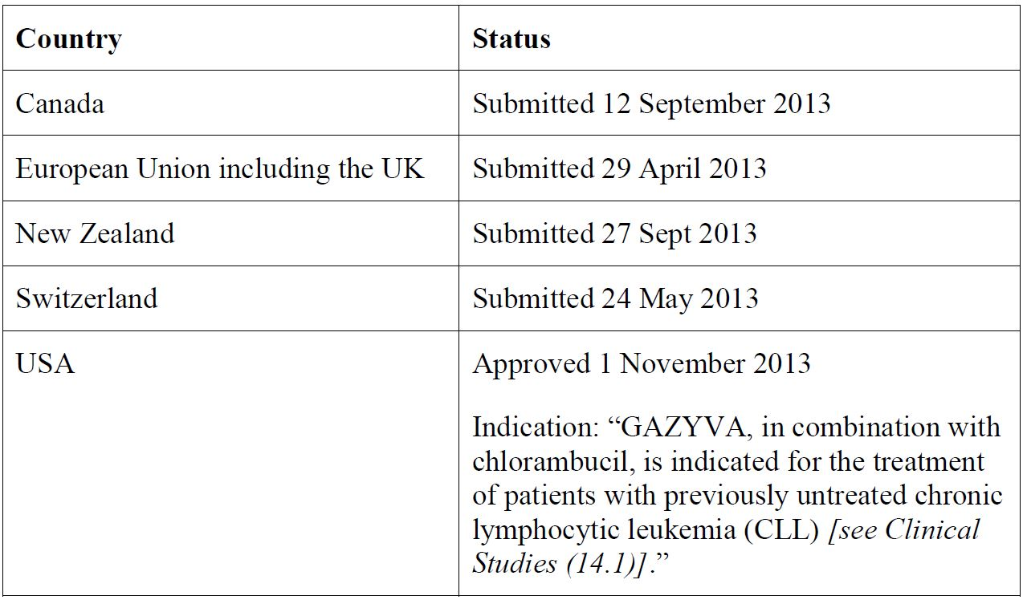

### Product Information

The approved Product Information (PI) current at the time this AusPAR was prepared can be found as Attachment 1. For the most recent PI please refer to the TGA website at <<http://www.tga.gov.au/hp/information-medicines-pi.htm>>.

## II. Quality findings

### Drug substance (Active ingredient)

#### Structure

The drug substance has the following structure as shown in Figures 1 and 2.

Figure 1: Amino acid sequence of the light chains of obinutuzumab.

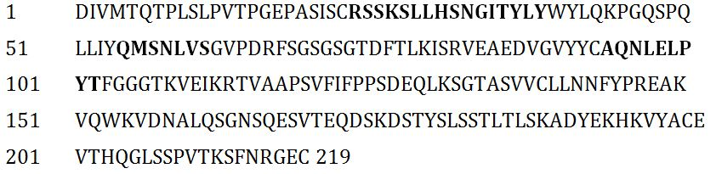

The calculated molecular mass of the light chain is 23,943 Da (cysteine residues are in the reduced form). Complementarity-determining regions are shown in **bold**.

Figure 2: Amino acid sequence of the heavy chains of obinutuzumab.

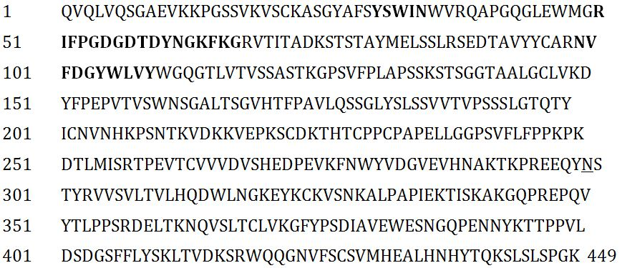

The calculated molecular mass of the heavy chain without carbohydrate, with N-terminal glutamine and with C-terminal lysine residue is 49,234 Da (cysteine residues are in the reduced form).

Complementarity-determining regions are shown in **bold**.

The glycosylation site at Asn299 is shown as N.

#### Manufacture

OB is manufactured in a bioreactor using a suspension adapted Chinese hamster ovary (CHO) cell line. The source of the cells is a vial of the working cell bank (WCB), which is thawed and cultivated in shake flasks.

Each cell culture harvest is purified separately.

##### Overview

OB is produced in a fed batch process using the WCB as starting material, which is derived from the master cell bank (MCB). The antibody is secreted into the cell culture medium.

For the production of OB, a vial of the WCB is thawed. The cells are then cultivated in shake flasks and bioreactors with increasing volumes.

The production culture is harvested using centrifugation and filtered prior to purification of OB.

The OB purification process consists of a series of chromatography, viral inactivation, filtration, and ultrafiltration/diafiltration steps. The Drug Substance solution is filtered into stainless steel freezing containers.

Cell banking processes are satisfactory.

All viral/prion safety issues have been addressed, including use of animal-derived excipients, supplements in the fermentation process and in cell banking.

#### Physical and chemical properties

OB is based on a human IgG1 (κ) framework. The recombinant antibody consists of two heavy chains and two light chains with inter and intra chain disulfide bonds that are typical of IgG1 antibodies. The CH2 domain of each heavy chain has a single conserved glycosylation site at Asn299 predominantly with biantennary complex and hybrid type N-glycans with reduced levels of core fucosylation. The calculated molecular mass of intact OB is 146 kDa (peptide chains only, with heavy chain C-terminal lysine residue, with heavy chain N-terminal glutamines).

The characterisation of OB assesses the physicochemical, biological and immunochemical characteristics of OB and is divided into two major subsections:

* Physicochemical characteristics which provide a detailed assessment of five OB registration batches including molecular size distribution, charge heterogeneity, molecular structure, and oligosaccharide analysis.
* Biological and immunochemical characteristics, which include assessments of OB’s ability to bind CD20, bind Fc receptors, and induce effector functions.

### Drug product

OB is provided as a sterile, colourless to slightly brownish, preservative free liquid solution in 50 mL single dose vials. The concentrate is diluted in 0.9% (w/v) sodium chloride solution prior to administration.

#### Manufacture

The manufacture of OB drug product consists of three major steps:

1. Thawing of drug substance, filtration and filling;
2. Stoppering/capping;
3. Labelling and packaging.

#### Stability

Stability data have been generated under accelerated and real time conditions to characterise the stability profile of the product. Photostability data indicate that the product is not photostable.

The proposed shelf life is 3 years when stored at 2°C-8°C.

In use stability data have also been submitted. The proposed shelf life and storage conditions for the diluted product are 24 h when stored at 2°C-8°C, followed by 24 h not above 30°C, followed by the administration duration of maximum 24 h.

The proposed maximum overall allowable temperature excursions during activities such as secondary packaging, labelling, transport and handling are 7 days at 25°C and 7 days at 30°C and 22 days at -20°C (including two freeze/thaw cycles).

### Biopharmaceutics

Biopharmaceutic data are not required for this product as it is a monoclonal antibody and is given by IV infusion.

### Quality summary and conclusions

The evaluator recommends that Gazyva obinutuzumab (rch) 1000 mg/40 mL concentrate solution for infusion should be approved.

## III. Nonclinical findings

### Introduction

The sponsor has applied to register the new biological entity, OB, for the treatment of patients with previously untreated CLL. The recommended dosage of Gazyva is 1000 mg administered on Day 1-2 (100 mg Day 1, 900 mg Day 2), Day 8 (1000 mg) and Day 15 (1000 mg) of the first 28 day treatment cycle, followed by 1000 mg administered on Day 1 only for each subsequent 28 day treatment cycle (Cycles 2 to 6). Infusion rates vary starting at 25 mg/h for initial (day 1) treatment, then 50 mg/h on Day 2 with incremental increases of 50 mg/h every 30 minutes to a maximum rate of 400 mg/h. On Days 8, 15 and 1 (new/second cycle), the initial rate started at 100 mg/h increasing at 100 mg/h every 30 minutes to a maximum of 400 mg/h. The duration of treatment was six treatment cycles, each of 28 day duration.

Nonclinical data included studies in the areas of pharmacology, pharmacokinetics (PK), repeat-dose toxicity and reproductive toxicity (embryofoetal). Nonclinical studies were limited by the pharmacology of OB (seen with similar drug from this class) that does not bind to rodent or canine CD20 homologues. The toxicity program was conducted using cynomolgus monkeys (high degree of CD20 homology with humans), with pivotal studies conducted according to expected standards (GLP). The dossier was generally in accordance with the EU guidance on nonclinical safety evaluation of biotechnology-derived pharmaceuticals.[1]

The pharmacology data submitted in this application consisted of over 100 references, which covered an amount of specific and general information on OB and related substances. It was determined that the use of the sponsor expert report covering the pharmacology literature was valid since its pharmacological activity was well known and this approach would assist in the timely completion of the report.

### Pharmacology

#### Primary pharmacology

CLL is characterised by the progressive accumulation of leukemic cells in the peripheral blood, bone marrow and lymphoid tissue that morphologically appear as small, mature looking lymphocytes with dense nuclei lacking discernible nucleoli. The disease has a characteristic immunophenotype characterised by coexpression of CD5 (T cell antigen) and the B cell surface antigens CD19, CD20 and CD23, and low levels of surface immunoglobulin, CD20 and CD79b compared to normal B cells (Clinical Overview).

OB is a humanised glycoengineered Type II CD20 monoclonal antibody of the IgG1 isotype. It was derived by humanisation of the parental B-Ly1 mouse antibody and is characterised by a glycoengineered Fc-part (resulting in higher FcγRIIIa and FcγRIIIb affinity) to enhance its antibody dependent cell mediated cytotoxicity (ADCC) activity.

The CD20 antigen is a transmembrane antigen that is expressed on the surface of malignant and non-malignant pre and mature B lymphocytes, but not on haematopoietic stem cells, pro B cells, normal plasma cells, or other normal tissues. CD20 is believed to exist predominantly as a tetramer on the cell surface and is usually not to shed or internalised upon antibody binding making it an attractive target for cancer immunotherapy.

Classification of CD20 antibodies as Type I (rituximab, ofatumumab, veltuzumab and ocrelizumab) or Type II (OB and tositumomab) CD20 antibodies is based on binding and their primary mechanism for killing of CD20 positive B cells. Type I and Type II CD20 antibodies differ in their ability to induce CD20 translocation (Type I does, Type II does not) into large lipid rafts within the plasma membrane upon binding, which enhances the recruitment and activation of complement. The complement dependent cytotoxicity (CDC) activity of Type I CD20 antibodies is enhanced when compared to Type II CD20 antibodies. Type I and Type II CD20 antibodies also differ in their capacity to bind to B cells, with B cells binding twice as many Type I CD20 antibody molecules than Type II CD20 antibody molecules; clinical relevance or biological significance of this difference is unclear. However, Type II antibodies are more potent than Type I antibodies in inducing homotypic aggregation and direct cell death. The ADCC and antibody dependent cellular phagocytosis (ADCP) activity of CD20 antibodies is mediated by the interaction of their Fc regions with FcγRIIIa and not impacted by the Type I or Type II character of the antibody.

Nonclinical *in vitro* studies, using a variety of assays, were conducted to characterise OB activity and compare it to other monoclonal antibodies (for example, rituximab). OB bound with high affinity and selectivity to CD20 protein expressed on malignant and non-malignant B cells. The binding affinity (KD value) of OB for human CD20 cells was estimated to be ~4.0 nM, with rituximab found to have a similar KD value of ~4.5 nM. As stated above, activity of CD20 antibodies is mediated by the interaction of their Fc regions with FcγRIIIa and data from a binding study comparing OB and rituximab found KD values for OB of 55 nM (low affinity site) and 270 nM (high affinity site) compared to rituximab values of 660 nM (low affinity site) and 2 µM (high affinity site). Binding to FcγRIIb (inhibitory human receptor) was not affected by glycoengineering.

*In vitro* studies with OB identified the effectiveness of the glycoengineered Fc part to enhance its ADCC activity. *In vitro* data on ADCC activity from a series of assays showed OB more potent (5 to 100 fold) than rituximab, with the increased potency linked to the enhanced affinity of OB binding to FcγRIIIa. However, *in vivo* studies in xenograft tumour models in SCID mice showed no difference in tumour growth inhibition between OB and non glycoengineered wild type OB.

*In vitro* studies on the influence of OB on macrophage/monocyte ADCC/ADCP activity included an analysis of the effect of non glycoengineered OB (wild type) on macrophage (M1 and M2c) binding in the presence of competing immunoglobulins (REDIMUNE). Glycoengineered OB was more effective at binding to M1/M2c in the presence of immunoglobulins, but both forms of OB had similar binding profile in the absence of immunoglobulins; glycoengineering influenced the extent of binding. The phagocytic activity of macrophages (M2c>M1) was enhanced with the use of glycoengineered over wild type OB in the presence of immunoglobulins; this effect could be associated with the enhanced release of nitric oxide induced by glycoengineered over wild type OB.

Cell binding experiments with OB and rituximab at CD20 epitopes found a degree of overlap, with OB shifting towards the C-terminus of CD20 and rituximab orientated more towards the core of the CD20 epitope. These differences in orientation contribute to the Type I or Type II character of OB and rituximab, and may explain the differences in nonclinical and clinical behaviour of OB and rituximab.

Cytotoxicity mechanisms for OB and related monoclonal antibodies were examined using a range of approaches. Examination of CDC activity of OB and rituximab in NHL cell lines (different CD20 expression levels, 105 to >106 receptors/cell) revealed substantially lower (102 to 104 fold) CDC activity in cultures exposed to OB when compared to rituximab; OB was capable of mediating CDC activity at saturating concentrations in the µg/mL range. Work with OB and rituximab in Z138 and SU-DHL-4 cell lines on CDC activity supported these outcomes.

Induction of direct cell death by CD20 antibodies in NHL cell lines (*in vitro*) related to mechanism/s involving apoptosis and non-apoptotic cell death, but the exact weighting of these mechanisms is uncertain. Studies with OB and rituximab showed OB was consistently better than rituximab at inducing early and late stage cell death in a range of cell lines (NHL cells: diffuse large B cell lymphoma [DLBCL] cells, germinal centre B [GCB] cell like, Raji cells, WIL2S cells, Z138 M CL cells). *Ex vivo* studies with malignant B cells (derived from blood samples from NHL patients) found induction of cell death more prominent in OB incubated samples than rituximab treated samples.

The use of the cynomolgus monkey as the appropriate species for OB was based on a number of considerations:

* OB does not recognise rodent CD20 due to differences in epitope sequences.
* Human and cynomolgus monkey CD20 have similar (97%) sequence homology and complete (100%) identity in the binding epitope for OB.
* OB has comparable binding affinity to CD20 on B cell lines in both humans and cynomolgus monkeys, although CD20 expression on cynomolgus monkey B cells was greater (2-3 times) than on human B cells.
* Analysis of FcγRIIIa receptor region (sequencing/alignment) showed >90% homology between humans and cynomolgus monkeys.
* OB has similar binding affinity to human and cynomolgus monkey neonatal Fc receptor.
* Glycoengineered OB binding to FcγRIIIa receptor induced comparable effects in humans and cynomolgus monkeys, for example, ADCC activity of NK cells.
* OB recognition of Type II epitope is conserved in B cells from cynomolgus monkeys.
* OB induced B cell depletion in cynomolgus monkeys, mirrored that seen in humans.

Based on these considerations the cynomolgus monkey is considered an appropriate species for testing.

Nonclinical *in vivo* studies were conducted in xenograft models of NHL in severe combined immunodeficient mice and hCD16 transgenic mice that express the human high affinity FcγRIIIa receptor on NK cells. B cell depletion was studied in fully immunocompetent human CD20 transgenic mice and cynomolgus monkeys. OB (at 30-60 mg/kg once weekly, corresponding to trough levels of ~200-500 μg/mL, compared to the clinical mean trough plasma drug concentration (Ctrough) of 250 μg/mL in CLL patients) mediated statistically significant and dose dependent, anti tumoural efficacy in several NHL subcutaneous and disseminated xenograft models. In most studies, OB was found to be more efficacious than rituximab at the same doses. The *in vivo* mechanism of action of OB in xenograft models has not been fully understood.

A study examining OB, a non-glycoengineered wild type version of OB, rituximab, and ofatumumab compared weekly dosing of 30 mg/kg (q7d × 3, IV) in the SC SU-DHL-4 model in hCD16 transgenic SCID mice. All antibody treated groups mediated a significant anti tumoural effect, with OB and the non-glycoengineered wild type version of OB mediating the best anti tumoural efficacy with tumour growth inhibition (TGI) > 110% at Day 49. At termination of the study (Day 80) almost all animals treated with OB and the non-glycoengineered wild type version of OB showed a complete remission without tumour re-growth. These data indicate that the efficacy in the SU-DHL-4 model is not impacted by glycoengineering. In contrast, only 5 of 9 animals treated with rituximab and 4 of 9 animals treated with ofatumumab were tumour free at study termination. These data established OB as more efficacious when compared to the two Type I CD20 antibodies rituximab and ofatumumab.

Specific pharmacological studies examining the effects of OB (10 or 30 mg/kg) and rituximab (10 mg/kg) on B cell counts in cynomolgus monkeys (dosed twice IV, 7 days apart) found peripheral blood B cells were reduced by over 95% with both OB and rituximab at all timepoints evaluated after Day 2; OB was more effective at depleting B cells from the lymph nodes of cynomolgus monkeys compared to rituximab and B cells took longer to return to pre dose levels in animals dosed with OB. Exposure levels at 10 mg/kg were comparable between OB and rituximab. Anti drug antibodies (ADA) were detected in animals at the lower (10 mg/kg) dose of both OB (1/3) and rituximab (1/2), but not at the higher dose (30 mg/kg) of OB.

An examination (all at 30 mg/kg, 2 doses IV) of B cell effects of either OB, non-glycoengineered wild type OB or rituximab showed OB, as well as non-glycoengineered wild type OB, have a greater ability (intensity and duration) for depleting B cells from both blood and lymph nodes of cynomolgus monkeys compared to rituximab. It was suggested that the difference in effectiveness of OB and non-glycoengineered wild type OB over ritixumab was likely due to their Type II character. Exposure profiles for OB and non-glycoengineered wild type OB showed no differences, while lower observed exposure of rituximab may be ADA formation related (leads to accelerated clearance). The clearance of rituximab through ADA formation may influence the activity of rituximab and be the cause of lower activity. Quantitative levels of binding affinity to effector receptors for both rituximab and OB could also affect efficacy.

Analysis of the immune (humoral) competency of B cell depletion (by OB or rituximab) in cynomolgus monkeys found vehicle control and rituximab administration had little impact on both the de novo and measles/rubella memory recall antibody responses, while OB attenuated the de novo response, but spared protective memory recall responses to measles/rubella. Blocking of de novo humoral antibody responses could be attributed to the increased extent of endogenous B cell depletion (by OB) and/or the augmented capacity of OB to reduce activated, CD20 expressing B cells.

OB induced depletion of B cells has also been shown in repeat dose toxicity studies in cynomolgus monkeys, with partial/full recovery to pre treatment levels dependent on the recovery period.

#### Secondary pharmacodynamics and safety pharmacology

No specific secondary and safety pharmacology studies were presented. Adverse effects secondary to the primary pharmacological effect of depletion of B cells, such as opportunistic infections and immune complex mediated glomerulonephritis and hypersensitivity reactions, were observed in repeat dose toxicity studies in monkeys. However, these types of effects in an animal species by a humanised antibody may not be predicative of the same effects in humans.

Repeat dose toxicity studies in monkeys showed no clinical signs indicative of central nervous system (CNS) effects. Blood pressure was unaffected and electrocardiogram (ECG) recordings showed no abnormalities. There was no evidence of renal and respiratory abnormalities.

Examination of cross reactivity of OB binding in cynomolgus monkey tissues found predictable binding to lymphocytes/lymphoid tissues in a number of organs, and unpredicted binding to endothelium (membrane/cytoplasm) of tissues. Examination of cross reactivity of OB binding in normal human tissues (cryosections) identified resident lymphocytes in lymphoid tissues as the primary sites, which was broadly similar to the binding profile for OB in cynomolgus monkeys. A range of tissues were predictable targets of OB binding, but unanticipated binding occurred at membrane/cytoplasm of liver, salivary glands and lung. Toxicity studies did not reveal any specific adverse effects in organs/tissues identified as having unanticipated binding, although direct binding of OB to endothelium as the cause of arteritis cannot be excluded.

*In vitro* assays with human whole blood showed that OB (24h exposure) induced release of cytokines (IL-6, IL-8 and TNF-α) over a clinically relevant concentration range of 0.1-100 µg/mL, while an initial assay at higher concentrations (up to 200 µg/mL) of OB with a shorter exposure (incubation) period of 2 h had limited effect. This suggests the length of infusion period could influence the potential for initial infusion related cytokine release and its related adverse effects. OB was compared with alemtuzumab (humanised anti CD52 IgG1, positive comparator), cetuximab (anti epidermal growth factor receptor [EGFR], negative comparator) and TGN1412 like (superagonistic anti CD28 monoclonal antibody, an assay control) for their ability to stimulate release of cytokines from human whole blood. Alemtuzumab and TGN1412 like monoclonal antibody also induced release of cytokines with the positive comparator alemtuzumab inducing higher cytokine release levels when compare to OB in a majority of blood samples (8/10); these elevated levels were within the same order of magnitude. The likelihood of infusion related reactions could be considered as high, which is a valid reason for premedication with a corticosteroid.

### Pharmacokinetics

PK of OB were studied in the cynomolgus monkey, which was the animal species used in toxicity studies.

As a monoclonal antibody, the PK profile of OB in monkeys is characteristic of a large molecular protein, with a small volume of distribution (Vss 59-63 mL/kg, slightly greater than the plasma volume), slow clearance (CL) (0.245-0.275 mL/h/kg) and long elimination half life (t1/2) (172-194 h) at an IV dose of 1 or 10 mg/kg. The clearance in monkeys was faster than in humans (0.085 L/day, equivalent to 0.05 ml/kg/h), and the elimination was faster than in humans (t1/2 730 h).

There were no dedicated studies examining tissue distribution of OB, which is acceptable for a monoclonal antibody. The small volume of distribution indicated limited tissue penetration, with OB likely to remain within the circulation.

In repeat dose studies in cynomolgus monkeys, systemic exposures were generally dose proportional and increased by 2-3 fold after repeated dosing for 13 to 26 weeks. There was no gender difference.

The PK profile in mice at 1 mg/kg was similar to the profile in monkeys, with Vss 89mL/kg, CL 0.66 mL/h/kg and elimination t1/2 125 h. A 10 fold increase in dose to 10 mg/kg in mice resulted in a slower clearance (CL 0.28 mL/h/kg, t1/2 288 h) with only a minimal increase in Vss (107 mL/kg).

There were no studies examining the metabolism and excretion of OB, but as a protein OB is expected to be degraded to small peptides and individual amino acids.

ADAs were detected in monkeys following repeated dosing at rates of ~15%. ADAs caused a reduction (dose related) in the plasma concentration of OB and consequently an increase in B cells with reducing levels of OB.

#### PK drug interactions

No nonclinical drug-drug PK interaction studies have been performed. This is acceptable for a monoclonal antibody.

### Toxicology

#### Repeat dose toxicity

All toxicity studies were performed in cynomolgus monkeys as OB binds human and cynomolgus monkey CD20 but not rodent CD20.

No single dose toxicity studies were performed with OB. Findings in repeat dose toxicity studies were consistent with the pharmacological activities of OB, that is, depletion of B lymphocytes, and other findings secondary to B cell depletion.

OB treatment resulted in complete and rapid B cell depletion in peripheral blood of cynomolgus monkeys after a single dose of >1 mg/kg. B cell recovery started when serum concentrations fell under a concentration ~0.02 μg/mL. In addition, there was also potent B cell depletion in lymphoid tissues, for example, spleen and lymph node, manifested as disappearance of germinal centres in the follicles of mesenteric and mandibular lymph nodes and spleen corresponding with complete B cell depletion in these organs in all dosed groups.

There was no clear target organ of toxicity, with changes seen in organs (such as glomerulonephritis, arteritis/periarteritis, mononuclear infiltrates in multiple organs in the 6 month study) considered secondary to immunogenic hypersensitivity reactions, although arteritis could be partially due to binding of OB to endothelium. Opportunistic infections were also seen, which would likely be associated with depressed immune function as a result of depletion of CD20 B cells.

##### Relative exposure

Exposure ratios have been calculated based on human values (area under the plasma concentration-time curve [AUC] 10113 μg.d/mL and maximum plasma drug concentration (Cmax) 510.6 μg/mL, conditional predictions from Study 21004) in the Population PK and PK-PD Analysis Report. The exposure based on AUC achieved in the monkey IV studies was up to 8 times the clinical exposure (Table 2).

Table 2: Relative exposure in repeat-dose toxicity studies in cynomolgus monkeys.

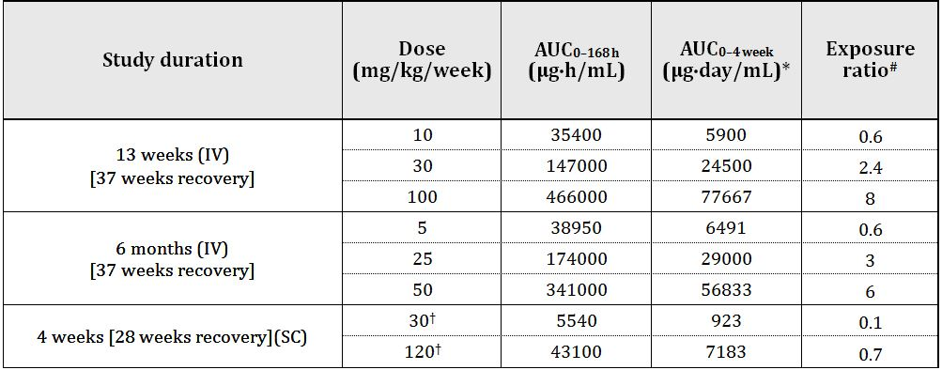

* AUC0-4 weeks = AUC0-168h x 4/24. # Ratio = animal:human plasma AUC0-4 weeks. Human AUC0-4 weeks = 10113 µg∙day/mL at the clinical dose of 1000 mg every 28 days. † mg/animal/week (~5 and 20 mg/kg/day).

#### Genotoxicity and carcinogenicity

No genotoxicity or carcinogenicity studies have been performed with obitnutuzumab. This is acceptable for a monocloncal antibody, which does not possess stimulatory activities.

#### Reproductive toxicity

There was only one reproductive toxicity (embryofoetal and pre/postnatal development) study submitted. The absence of a fertility study was addressed in part by findings from the 6 month toxicity study, which showed no evidence of treatment related adverse effects on reproductive tissues/organs and female reproductive hormonal profile.

The embryofoetal development study with OB administered from gestation Day 20 to parturition found no evidence of embryofoetal toxicity or teratogenicity despite foetuses clearly being exposed to OB with infant blood samples taken post partum (Day 28) showing Cmax values up to 241 µg/m; infant blood samples showed declining OB levels to around 0.2 µg/mL by post partum day 168. Exposures achieved in mothers were 4-5 times the clinical exposure in CLL patients based on Cmax or AUC.

##### Relative exposure

Relative exposure is shown in Table 3.

Table 3: Relative exposure.

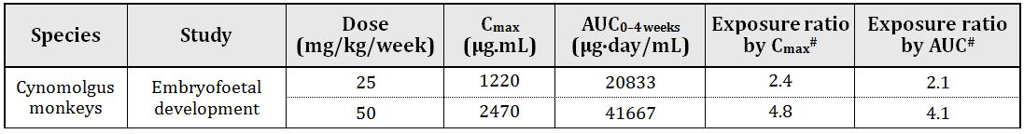

# Based on human Cmax 510.6 μg/mL and AUC0-4 weeks, 10113 µg∙day/mL in CLL patients.

Concentrations of OB were very low in mother’s milk at mean values of up to 0.2 µg/mL at 50 mg/kg on Day 28 post partum, with mother milk/infant serum ratios around 0.001, suggesting *in utero* exposure. ADAs were detected in adults and infants, but the presence of ADA did not appear to reduce systemic exposure and/or induce hypersensitivity reactions.

Exposure to OB during gestation resulted in depletion of B lymphocytes in mothers and infants, which was reversible with B lymphocyte counts returning to almost normal levels in infants by 112 days (25 mg/kg) or 168 days (50 mg/kg) postpartum. This was similar to, but faster than, recoveries in adult monkeys observed in repeat dose studies. Signs of opportunistic infection were evident in mothers and infants and consistent with findings from repeat dose toxicity studies. Neurobehaviour and skeletal development of infants were unaffected. T cell dependent antibody response was normal at around 6 months of age.

The limited data set for reproductive toxicity of OB could be considered acceptable since other drugs in the same class lack specific reproductive toxicity (not teratogenic). The only observed adverse finding in the reproductive study was reversible depletion of B lymphocytes in mothers and infants. Also, the target population for the proposed indication of CLL has a median age of 65-70 years of age.

##### Pregnancy classification

The sponsor has proposed Pregnancy Category C,[2] which is considered appropriate given the pharmacological effects on B lymphocytes.

#### Local tolerance

There was no evidence of local tissue damage at the injection site caused by the IV infusion/injection of OB in cynomolgus monkeys. OB did not cause haemolysis, precipitation or turbidity of human whole blood *in vitro*.

#### Paediatric use

OB is not proposed for paediatric use and no specific studies in juvenile animals were submitted.

### Nonclinical summary and conclusions

#### Summary

* The sponsor has provided adequate studies on the pharmacology and PK, as well as toxicity studies including repeat-dose toxicity, reproductive toxicity and immunotoxicity, according to relevant guidelines.
* OB is a humanised glycoengineered Type II CD20 monoclonal antibody of the IgG1 isotype. OB binds to CD20 membrane protein on B-cells with high selectivity and affinity at nanomolar concentrations. OB induced cell death was linked to ADCC and ADCP. *In vivo*, OB demonstrated the capacity to induce tumour remission and increase median and overall survival (OS) in NHL xenograft models. OB induced significant B cell depletion in peripheral blood and lymphoid tissue (spleen and lymph nodes) in cynomolgus monkeys and humanised CD20 transgenic mice.
* Specific secondary and safety pharmacology studies were not provided in this submission. Related findings from toxicity and *in vitro* assays included opportunistic infections, cytokine release, immune complex mediate effects and binding to endothelium of multiple tissues (in addition to lymphocytes). Infusion related reactions as a result of cytokine release could occur in patients.
* PK data was primarily generated in cynomolgus monkeys (single/repeat dose studies). As a monoclonal antibody, the PK profile of OB in monkeys is characteristic of a large molecular protein, with a small volume of distribution, slow clearance, and long half life. The clearance in monkeys was faster than in humans. Dosing monkeys with OB via the subcutaneous (SC) route resulted in a bioavailability of ~50%. Repeat dose IV OB produced dose proportional increases over the dose range tested, showing slight drug accumulation without any apparent gender differences. Depletion of CD20 B cells was seen at all doses of OB tested, with kinetic modelling predicting B cell recovery when OB blood levels were <0.02 µg/mL.
* There was no single dose toxicity study included in this application.
* Repeat dose toxicity studies were conducted in cynomolgus monkeys in compliance with GLP, with durations of up to 26 weeks (plus recovery) using the IV route (clinical route). A repeat dose toxicity study of 4 weeks duration using the SC route was also conducted in cynomolgus monkeys. There was clear evidence of CD20 cell depletion in all studies, which showed reversibility during the recovery period. ADAs were detected in the repeat dose toxicity studies. There was also evidence of systemic inflammation consistent with immune related hypersensitivity reactions, and opportunistic infections as a result of depressed immune function. There were no clear target organs, with changes to kidneys (glomerulonephritis) and arteries (arteritis/periarteritis) secondary to immune complex mediated hypersensitivity, although arteritis could be partially attributable to OB binding to endothelium (as observed in *in vitro* tissue binding assays). Exposures achieved in the pivotal monkey studies at the highest doses exceeded the clinical exposure levels (by up to 8 fold).
* There were no genotoxicity or carcinogenicity studies included in this application. This is not considered a deficiency.
* Data addressing reproductive toxicity examined only embryofoetal and pre/postnatal development. The limited reproductive toxicity assessment was compensated by findings from repeat dose toxicity studies, which showed no effects on reproductive organs. Findings in infants were limited to B cell depletion and secondary opportunistic infections or immune related hypersensitivity reactions. OB crossed the blood/placental barrier, with measurable amounts found in infants; very low levels of OB were found in breast milk. ADAs were detected in both adult and infant animals at similar frequencies (~15%), which is at a rate similar to non pregnant monkeys from repeat dose toxicity studies. Exposures in pregnant monkeys were 4-5 times the clinical exposure based on Cmax and AUC.

#### Conclusions

* According to EU guidelines the data presented is consistent with that required for a drug of this class with the exception for reproductive toxicity data, which only examined embryofoetal and pre/postnatal development.
* Nonclinical primary pharmacology studies demonstrated the efficacy (B cell depletion) and support the use of OB for the proposed indication.
* OB stimulates cytokine release from human blood in vitro over a clinically relevant concentration range, which could have safety implications (infusion related reactions) in patients.
* There was no clear target organ of toxicity, with changes seen in organs (for example, glomerulonephritis, arteritis/periarteritis) considered secondary to immunogenic hypersensitivity reactions although arteritis could be partially due to OB binding to endothelium.
* Embryofoetal and pre/postnatal development was unaffected except for the expected pharmacological effects. The limited reproductive toxicity assessment was compensated by repeat dose toxicity studies, which showed no effects on reproductive organs.
* There are no objections on nonclinical grounds to the registration of OB for the proposed indication.

## IV. Clinical findings

A summary of the clinical findings is presented in this section. Further details of these clinical findings can be found in Attachment 2.

### Introduction

#### Clinical rationale

CLL is a condition commonly affecting the elderly who frequently have associated co-morbidities which limit the nature of chemotherapy which can be administered to these patients. Clb has been a mainstay of treatment for these patients for many years being able to maintain disease control for prolonged periods of time but ultimately the disease remains incurable. More recent approaches to treatment including agents such as fludarabine and rituximab and other monoclonal antibodies have proven efficacious in combination associated with significantly higher incidence of adverse effects in the elderly patients. Accordingly, OB has been under development as a proposed alternative monoclonal antibody with potential for improved efficacy and acceptable safety.

#### Contents of the clinical dossier at submission

A total of five studies are presented including the pivotal Study B021004, and Phase I/II Studies B021000, B020999, B021003 and J021900. Full clinical reports and tabular summaries are provided with these studies. It is to be noted that only the pivotal study contains data of direct pertinence to the proposed indications. The remaining four studies effectively provide data with regards to PK and safety. There were a total of 38 patients with CLL who received OB monotherapy in the Phase I Study B021003 and Phase I/II Study B020999. These will be reviewed in the Clinical Efficacy section. Overview of the clinical studies provided in relation to both PK/PD data as well as safety and efficacy data is indicated in Tables 4 and 5.

Table 4: Clinical studies contributing safety and efficacy data supporting the application for registration of OB in CLL.

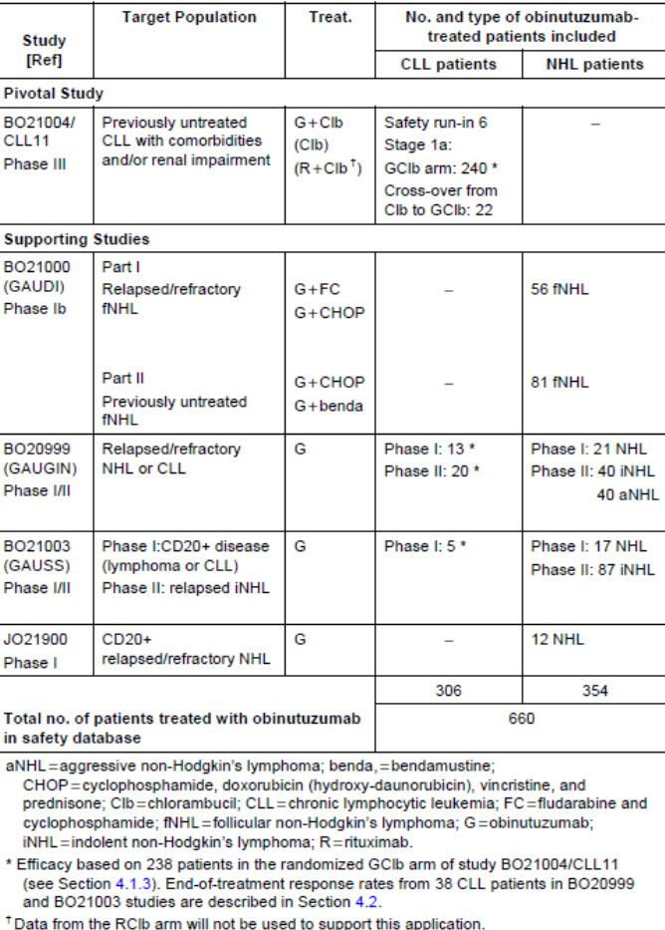

Table 5: Overview of OB studies providing PK/PD data.

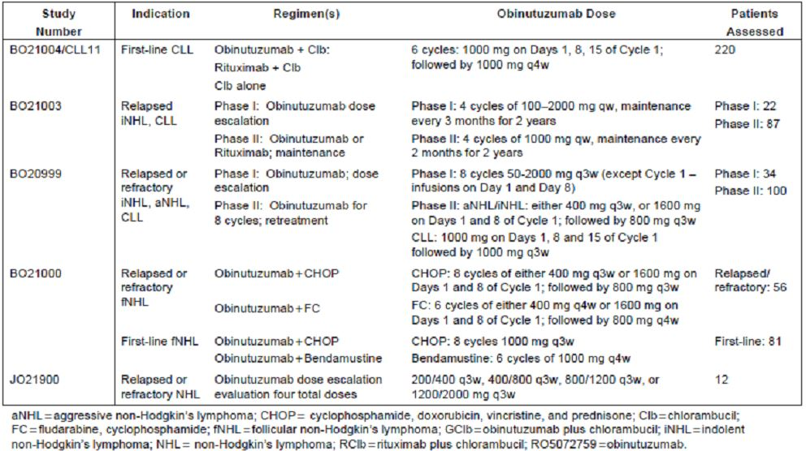

#### Paediatric data

Not applicable.

#### Good clinical practice

All aspects of good clinical practice were observed in the studies presented.

### Pharmacokinetics / pharmacodynamics

#### Studies providing data

PK and PD data for this submission is provided from the five studies indicated in Table 5 that included PK, PD, and immunogenicity data. The studies involve the administration of OB to patients with NHL as well as CLL. It is noted that three of the studies involve monotherapy with OB but Study B021000 was a combination Phase II study involving the administration of concomitant chemotherapy. Data from four of the clinical studies, namely Studies B020999, B021003, B021000 and B021004, were combined in a population PK analysis and modelling. This provided the most comprehensive analysis of relevant PK and PD data for OB and will be the focus of this evaluation. It is to be noted that the serum sampling scheme for each of these studies is sufficient to enable the development of a population PK model as well as enabling a non compartmental analysis. This included data from both patients with NHL and CLL, OB monotherapy, and OB in combination with chemotherapy in order to conduct a population PK co-variate analysis to identify the main sources of OB PK variability. It was not considered appropriate to include the 12 patients from the Japanese study for the PK analysis since efficacy from this data was not used in the original submission and the safety data was not pooled from other studies.

A two compartment population PK model with time dependent clearance describe OB concentration. Estimates were made from the following structural parameters: steady state clearance (CLinf), initial time dependent clearance (CLT), decay co-efficient of time dependent clearance (kdes), central volume of distribution (V1) inter compartmental clearance (Q), and peripheral volume of distribution (V2). In the co-variate analysis the following co-variates were tested: weight, gender, age, normalised creatinine clearance, tumour size. Additionally body surface area, body mass index, baseline B cell and lymphocyte count and presence of human anti human antibodies (HAHAs) in Study B021004/CLL 11 were checked for influence on PK parameters by the diagnostic plots.

Graphical analysis of the exposure/efficacy relationship was undertaken with the PK exposure derived from the population PK analysis. Similarly, graphical analysis of the exposure/safety relationship in the pivotal study was undertaken with PK exposure derived from the population PK analysis exploring neutrophil and B cell count time course with neutropenia and B cell count anticipated to be direct consequence of the mechanism of action.

To assess immunogenicity, serum samples obtained during the treatment phase and follow up periods for the four included studies were analysed and assessed for HAHAs. Initially, a first generation HAHA assay was utilised for the three Studies B020999, B021000 and B021003. However, this proved to be extremely sensitive, although only one patient from these studies proved to have developed positive antibodies. A second generation ELISA with improved drug tolerance was developed and used for analysis of the pivotal study.

A sophisticated method of PK analysis was utilised to maximise the information to be obtained from the PK and PD data. This involved a population PK modelling analysis by pooling the serum OB concentration data from all four of the studies. Concentration/time course of OB was accurately described by a two-compartment PK model with time-dependent clearance and with the steady state PK parameters typical for monoclonal antibodies.

#### Evaluator’s conclusions

The PK of OB in CLL patients is best described by a two-compartment model with two clearance pathways: a time varying clearance pathway, and a linear clearance pathway. The time varying clearance pathway is predominant at the start of treatment is consistent with target mediated disposition where there is an abundance of target (CD20/+) cells at the start of treatment. As the target is saturated by the addition of OB, the target mediated disposition decreases; this is reflected by a decrease in the time-dependent clearance pathway. Consequently, this determines a principal aim of dosing is to saturate targets as quickly as possible. Accordingly, high doses of OB such as 1000 mg are required to minimise the impact of target mediated disposition.

### Dosage selection for the pivotal studies

Data from two clinical Studies B020999 and B021003 in NHL, CLL and DLBCL patients were used in conjunction with a PK model of OB to define the recommended dose used in the pivotal study. As discussed above, the PK of OB can be described using a two-compartment PK model. In addition, population PK analysis is undertaken in all serum OB data from the two clinical studies indicated above, in conjunction with data from Studies B021000 and pivotal Study B021004.

As discussed earlier, patients with a high initial tumour burden and high numbers of CD20+ tumour cells clear the drug from plasma at a higher rate in comparison to patients with a lower initial tumour burden. This is because the OB binds to the CD20+ tumour cells and is effectively removed from plasma. Once the majority of CD20+ cells are bound to OB, there is a significantly reduced impact of target mediated disposition on PK. Consequently, the underlying rationale in selecting an appropriate OB dosing schedule is to saturate the target as early and as quickly as possible in the majority of patients to minimise a target mediated disposition and to maintain this saturation over the complete treatment period while minimising AEs. With respect to the PK model, this means reducing the impact of the time varying clearance component as quickly as possible to ensure an adequate dose is delivered regardless of tumour burden.

Reviewing the PK data from Studies B020999 and B021003, a total dose of 3000 mg of OB in Cycle 1 administered 1000 mg on Days 1, 8 and 15 were considered suitable, followed by 1000 mg on Cycle 2 onwards, both to maximise the potential to saturate the target for all patients regardless of tumour burden and to achieve consistent and high plasma concentrations. The observation of infusion related reactions to the first OB infusion resulted in adjustments to the Cycle 1 Day 1 dose to be actually administered over two days with 100 mg on Day 1 and 900 mg on Day 2. Accordingly, the recommended dose of OB for treatment in CLL patients is 1000 mg on Cycles 1, Days 1, 8 and 15 and Cycles 2-6 Day 1, with the first dose being administered over the first two days at 100 mg on Day 1 and 900 mg on Day 2.

### Efficacy

#### Studies providing efficacy data

The principal data to support the efficacy of OB in combination with Clb in previously untreated CLL patients are provided from the pivotal study, a Phase III trial B021004-CLL 11. This study was designed to include two stages:

|  |  |
| --- | --- |
| Stage 1a | A comparison of OB (Gazyva) plus chlorambucil (GClb) versus chlorambucil (Clb) alone in the treatment of previously untreated CLL |
| Stage 1b | A comparison of rituximab plus chlorambucil (RClb) versus chlorambucil (Clb) alone in the treatment of previously untreated CLL |
| Stage 2 | A comparison of RClb versus GClb in the treatment of previously untreated CLL |

The results from this Stage 1a analysis of the pivotal study form the principal focus for this submission. It is to be noted that Stage 2 of the study was ongoing without data being made available at the time of the initial submission.

Limited end of treatment response data available from a total of 38 patients with CLL received OB monotherapy in the Phase I Study B021003 and the Phase I/II Study B020999. Overall, there were no complete remissions (CRs) but in Study B020999, 8/13 patients (62%) participated in the Phase I part, and 3/20 patients (15%) participating in the Phase II part had a partial remission (PR) at the end of treatment as indicated in Table 6.

Table 6: Summary of end-of-treatment response in patients with relapsed/refractory CLL receiving OB monotherapy (Phase I/II results).

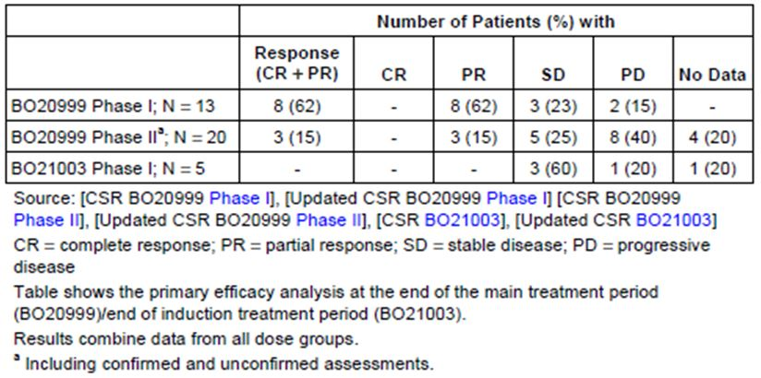

#### Evaluator’s conclusions on efficacy

##### Study B021004

These data have shown that the combination of OB with Clb (that is, GClb) results in a significant improvement in progression free survival (PFS) with a stratified HR of 0.14 and a median PFS of 23 months for the GClb arm compared to 10.9 months in the Clb arm. These data were confirmed by independent review committee (IRC) assessment. Similarly, results of secondary efficacy endpoints generally favoured the GClb combination at a significant level. The only area outstanding relates to OS.

It is recognised that more aggressive therapies for CLL commonly result in improved PFS but less frequently for OS. OS data from this study will be of interest, although it is recognised that a proportion of patients on Clb initially also crossed over to the GClb and are likely to have also received other anti leukaemic therapy throughout the remainder of their illness. This will tend to have a masking effect on determination of potential differences in OS, but at the same time may well point to a suitable more conservative approach of long term management of elderly patients with CLL.

##### Study B020999

These data are difficult to assess based on the differences in patient population as well as the OB regimens comparing single agent OB to combination with Clb as well as a significant proportion of the patients in the supportive studies with CLL had recurrent or relapsed disease. The only conclusions to be drawn is that there is evidenced of a degree of efficacy for OB alone from the small data in the supportive studies.

### Safety

#### Studies providing safety data

Safety data provided in this submission principally is derived from the pivotal study B021004-CLL 11, specifically the Stage Ia component. Also providing supportive safety data were three studies in patients with CLL or NHL: B020999, B021003, and B021000.

Safety data for the pivotal study is presented separately, while safety data for the monotherapy Studies B020999 and B021003 are combined, and safety data for the chemotherapy combination NHL Study B021000 is presented separately. The data from these four studies involved a total of 648 patients exposed to OB.

The safety analysis population (SAP) for each study included all patients who received at least one dose of study drug. Patient demographic data and baseline disease characteristics for the pivotal study were analysed for the intent to treat population to ensure consistency.

It is to be noted that the patients involved in the pivotal trial all were previously untreated for CLL, whereas those patients in Studies B020999 and B021003 were relapsed and refractory patients with either CLL or NHL. This included a total of 38 patients with relapsed refractory CLL. There were a total of 205 relapsed or refractory NHL patients in these two studies. In Study B021000, 56 patients with relapsed refractory follicular lymphoma received either OB and CHOP or fludarabine and cyclophosphamide, and 81 patients with previously untreated follicular lymphoma received OB plus bendamustine. Safety data from these two patient populations were combined.

Safety was assessed through collection of AEs, clinical examinations including vital signs, ECG, and physical exam, and laboratory test results including haematology coagulation, biochemistry, creatinine clearance, urine analysis, and HAHAs.

Table 7 summarises the duration of reporting of AEs and serious AEs for the pivotal study. Rating of AEs was according to National Cancer Institute (NCI) criteria. A similar process was utilised for collection and assessment of safety data from the supporting studies.

Table 7: Duration and reporting of AEs for the pivotal study (BO21004).

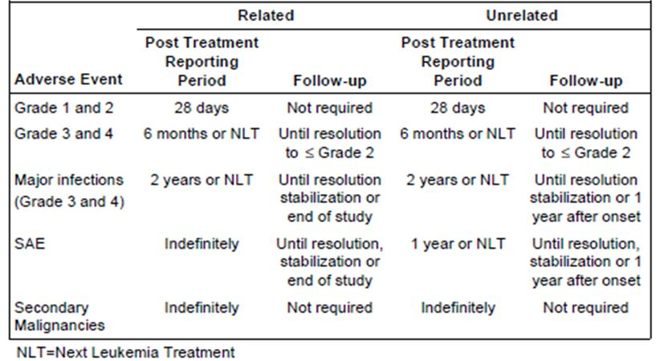

#### Patient exposure

The clinical cut off date was July 2012 and database lock was October 2012; 648 patients in pivotal and supporting studies had received at least one infusion of OB. The mean cumulative dose of OB was similar in all studies and populations. The median number of infusions was 8 in the pivotal study, 9 in Studies B020999 and B021003, and 10 in Study B021000.

#### Post marketing data

At the time of submission of the dossier in Australia there was no post marketing data available.

#### Evaluator’s conclusions on safety

The incidence and severity of adverse effects in the pivotal study was clearly greater in the OB combination arm with particular relationship to infusion related reactions. There was a very high incidence of this initially; however, this was ameliorated to some extent with appropriate prophylaxis and alteration in the initial dosing for the first cycle. Overall, it would appear that the tolerance for OB in older patients with associated co-morbidity is acceptable providing appropriate care is taken in relation to infusion related reactions.

### First round benefit-risk assessment

#### First round assessment of benefits

The pivotal Study B021004 is a well conducted but moderate sized multinational randomised trial that has demonstrated significant improvement in PFS for the combination of GClb compared to Clb alone in previously untreated CLL patients with co-existing medical conditions and/or renal impairment. The risk of disease progression or death was reduced by 86% when OB was combined with Clb and the Kaplan-Meier estimated median for investigator assessed PFS was 10.9 months in the Clb arm compared to 23 months in the GClb arm. IRC assessment corroborated this. Sensitivity and sub-group analyses as well as secondary efficacy parameters all support the benefit for GClb. However, at this time OS data is immature and showed no apparent differences between the two arms of study.

It is important to note that for elderly patients with co-morbidities, standard therapy is Clb. Treatment goals are disease control and minimisation of symptoms. Other studies involving more aggressive therapies have demonstrated improvements in PFS without ultimate improvements in OS. It is not unreasonable to anticipate that this may well be the case for GClb in this patient population as those patients receiving Clb are likely to go on to various other treatments maintaining disease control comparable to that achieved with GClb.

Despite the improvement of PFS by meaningful addition of OB to Clb and the complete eradication of disease as determined by minimal residual disease (MRD) negative status achieved in 20% of patients, this just might be indicative of very prolonged disease free survival for these patents.

#### First round assessment of risks

In the pivotal study there was a greater proportion of patients in the GClb who experienced AEs being Clb 78% versus GClb 93%, Common Terminology Criteria for Adverse Events (CTCAE) grade III-V AEs Clb 47% versus GClb 69%, and serious AEs Clb 32% versus GClb 37%. This is particularly related to the high incidence of infusion related reactions, most particularly during Cycle 1 of therapy. Subsequent introduction of prophylactic corticosteroids adjusting dose schedule for 100 mg on Day 1 and 900 mg on Day 2 for Cycle 1 resulted in a reduction in the incidence of these adverse effects.

Neutropenia was also of higher incidence for patients receiving GClb compared to Clb with grade III/IV AEs of neutropenia in 38% of patients on the combination compared to 18% on Clb. However, it is of some interest that none of these proved fatal as there is no apparent increase in incidence of infections in the GClb arm. Similarly, tumour lysis syndrome (TLS) was more frequent among patients receiving the combination at 4% versus Clb alone at 1% but with appropriate prophylaxis and high hydration this syndrome is likely to be minimised.

It was also noted in older patients adverse effects were more frequent but this was essentially similar for the two arms of study with the exception of those discussed above.

Overall, the safety data for OB in combination with Clb clearly indicates a greater likelihood for adverse effects requiring appropriate prophylaxis and management as compared to Clb. In view of the advanced age of the majority of patients with CLL receiving this therapy and relatively simple treatment with Clb as a single agent, there is a need for caution in easily recommending OB for all patients with previously untreated CLL particularly in the elderly and those with co-morbidities.

#### First round assessment of benefit-risk balance

As stated above, there are some difficulties in accepting a clear cut benefit over risk balance for the combination of OB with Clb as determined by the result of the pivotal trial. There will be considerable interest in comparing the results for the stage II component of this study presently underway, namely GClb versus RClb as the patients receiving OB in the GClb arm will be receiving relevant prophylaxis and altered schedule for Day 1 of therapy. Further comparison of the adverse effects for OB versus rituximab in this setting will give further clarity to the potential role of OB for the proposed indication.

### First round recommendation regarding authorisation

The data available certainly indicates that the addition of OB to Clb in patients with CLL who have increased risk factors was associated with a significant improvement in PFS and a proportion that will have very prolonged improvement in PFS as they become MRD negative. Nevertheless, the adverse effect profile even with relevant prophylaxis is still somewhat greater for the combination compared to Clb alone and is not likely to translate into improved survival. As the combination of RClb is becoming increasingly common as a treatment for this patient population, results of the direct comparison of GClb to RClb is very pertinent. Accordingly, this reviewer is reluctant to recommend approval for OB for its proposed indication of Gazyva in combination with Clb for the treatment of patients with previously untreated CLL until the data from the randomised trial of GClb versus RClb (Stage 2) is available and more prolonged follow up of patients in the Phase IA of the pivotal study is available to perhaps better assess potential differences in survival.

### Clinical questions

Details of clinical questions and sponsor responses are included in the Extract from the Clinical Evaluation Report in Appendix 2.

### Second round benefit-risk assessment

#### Second round assessment of benefits

After consideration of the responses to clinical questions, the benefits of Gazyva in the proposed usage are:

* In patients with previously untreated CLL, with a cumulative illness rating scale (CIRS) score >6 or creatinine clearance <70 mL/min, or both, a significant improvement in PFS and OS is shown with the combination of Gazyva and Clb as compared with Clb alone.
* In patients with previously untreated CLL, with a CIRS score >6 or creatinine clearance <70 mL/min, or both, a significant improvement in PFS is shown with the combination of Gazyva and Clb as compared to the combination of rituximab and Clb. Data regarding OS is immature for these treatment groups.

#### Second round assessment of risks

After consideration of the responses to clinical questions, the risks of Gazyva in the proposed usage are:

* Progressive multifocal leukoencephalopathy (PML) and hepatitis B reactivation have occurred following Gazyva therapy, which warrant a black box warning;
* AEs occurred more commonly in the GClb arm than the Clb or RClb arms, most frequently infusion related reactions;
* TLS has been seen in subjects with a high tumour burden;
* Serious new, or reactivated, bacterial viral or fungal infections may occur during, and following cessation of, Gazyva treatment;
* Persistent, severe, neutropaenia or neutropaenia occurring during, and following cessation of, Gazyva therapy;
* Severe grades of thrombocytopaenia;
* Worsening of pre-existing cardiac conditions, which may be fatal;
* Hypersensitivity and anaphylaxis to Gazyva, or Chinese hamster ovary (CHO) proteins;
* The risk of AEs is increased with advancing age and worse renal function;
* The premedication regimen to prevent infusion related reactions does not reduce the proportion of subjects that experience grades 3 or 4 events.

#### Second round assessment of benefit-risk balance

The benefit-risk balance of Gazyva, given the proposed usage, is favourable.

### Second round recommendation regarding authorisation

Following the sponsor’s responses, the recommendation is to approve authorisation.

## V. Pharmacovigilance findings

### Risk management plan

#### Contents

The sponsor submitted a Risk Management Plan (EU-RMP Version: 1.0 [Data lock point 2 July 2012] with an Australian Specific Annex (ASA) v1.0 [June 2013])which was reviewed by the TGA’s Office of Product Review (OPR).

The sponsor proposes routine pharmacovigilance activities to monitor all specified safety concerns. Additional pharmacovigilance is proposed for certain risks. Routine risk minimisation activities are proposed for all safety concerns except the risks of Prolonged B cell depletion, Immunogenicity, Second malignancies, Gastrointestinal (GI) perforation, and Immune mediated glomerulonephritis.

#### Ongoing safety concerns

The sponsor provided a summary of ongoing safety concerns which are shown at Table 8.

Table 8: Ongoing safety concerns for Gazyva.

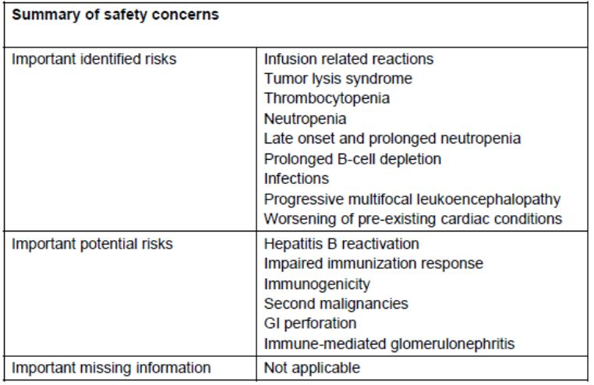

#### Reconciliation of issues outlined in the RMP report

Reconciliation of issues outlined in the RMP report is as follows.

##### Recommendation #1 in RMP evaluation report

Safety considerations may be raised by the nonclinical and clinical evaluators through the consolidated Section 31 request and/or the nonclinical and clinical evaluation reports, respectively. It is important to ensure that the information provided in response to these includes a consideration of the relevance for the RMP, and any specific information needed to address this issue in the RMP. For any safety considerations so raised, the Delegate should provide information that is relevant and necessary to address the issue in the RMP.

##### Sponsor response

The sponsor acknowledges the need to consider, in the context of the RMP, the relevance of any safety considerations raised by clinical and nonclinical evaluators.

Within the sponsor’s responses to the 20 RMP recommendations, the sponsor includes various commitments to amend the RMP when it is next updated and update the draft Australian PI.

##### OPR evaluator’s comment

This is acceptable.

##### Recommendation #2 in RMP evaluation report

It is recommended that the sponsor provides Australian specific information about the epidemiology of the target disease, and any other information required to evaluate the Australian specific context of this submission.

##### Sponsor response

According to the latest Australian Institute of Health and Welfare statistics (ICD-10 code C91.1),[3] there were 1,062 cases of CLL in Australia during 2009. For 2012, this number rose to an estimated 1,230 cases. Mean age of diagnosis is about 70 years. There were 309 deaths from CLL in Australia during 2007. For 2010, this number had risen to an estimated 354 deaths. Mean age of death is 79 years. Currently on average, women are living for about 5.5 years longer than men.

The sponsor will include epidemiology information for CLL in the next version of the ASA submitted to the TGA.

##### OPR evaluator’s comment

This is acceptable.

##### Recommendation #3 in RMP evaluation report

It is recommended that the following will be added to the list of potential safety concerns:

* Potential for interactions
* Potential off-label use
* Potential for paediatric off-label use
* Hepatobiliary events
* Patients with renal impairment

##### Sponsor response

**The potential for interactions, use in renally impaired patients** and **the hepatic effects** of Gazyva have been adequately investigated during clinical development in CLL patients. The sponsor has reviewed the clinical trial data which suggest that there is no safety concern regarding possible hepatoxicity of Gazyva to date. Similarly, data from clinical trials do not indicate any potential safety concerns for interactions or use in renally impaired patients.

Based on this, the sponsor believes that this information does not need to be added to the list of potential safety concerns (missing information). The sponsor acknowledges **the potential for off-label use** of Gazyva, which is addressed in the designated off-label use section of the RMP. The sponsor believes that this is the appropriate section to address off-label use as no specific safety concerns related to off label use of Gazyva have been identified.

Although no major safety concerns are expected given the vulnerability of the paediatric population, information regarding **off-label use in paediatric patients** will be added to the RMP. **In addition, use in children will be added as a safety concern.**

##### OPR evaluator’s comment

This is acceptable.

##### Recommendation #4 in RMP evaluation report

The sponsor makes the following statement in regards to the pharmacovigilance plan for the ongoing safety concern of “Late onset and prolonged neutropenia”: “Routine pharmacovigilance including further investigations in clinical trials” (EU RMP v1 Section 16.III.1). However, the sponsor does not specify to which studies they are referring. It is recommended that the sponsor clarify exactly what studies they are referring to, the study titles, milestones and submit protocols for any planned studies to the TGA review.

***Sponsor response***

The incidence and reversibility (time to recovery) of late onset and prolonged neutropenia will be evaluated during routine pharmacovigilance including further investigation in clinical trials (RMP 1.0, Section 16.III.1 “Safety Concerns And Overview Of Planned Pharmacovigilance Actions”). An overview of all on-going and planned studies in the Post authorisation Pharmacovigilance Development Plan, including milestones, is provided.

**The sponsor agrees to update the text on late onset and prolonged neutropenia in Section 16.III.1 of the RMP to include the relevant clinical trial numbers (B021004 [Stage 2], GAO4779g, GA04768g, BO21005 and BO21223) under “proposed routine and additional PhV activities”. Part III.5.1 (Section 18.1), Part VI.1.2 and Part VI.2.5 will also be updated accordingly.**

##### OPR evaluator’s comment

This is acceptable.

##### Recommendation #5 in RMP evaluation report

It is recommended that the sponsor considers performing post authorization safety studies to address important missing information.

##### Sponsor response

The previously submitted OB RMP (Version 1.0) identifies no missing information from the clinical trial program which could constitute an important risk to the target population: CLL patients. As mentioned in the response to question 3, during clinical development in CLL patients the sponsor has adequately investigated the potential for interactions, use in renally impaired patients and the hepatic effects of OB and believes that this information does not need to be added to the list of potential safety concerns (missing information).

Although the sponsor does not propose to include the potential for interactions, use in renally impaired patients and the hepatic effects of OB as important missing information given that these are adequately characterised during development, **the sponsor will add the following as important missing information:**

* **Use during pregnancy and lactation**
* **Use in paediatric population**

#### Use during pregnancy and lactation

No study is planned in pregnant and breast feeding women for ethical reasons. Studies in monkeys have not identified any particular risks for pregnant mothers, although infants were born with low levels of B cells. Although pregnancy is an exclusion criteria, in case of an inadvertent pregnancy, all data collected from clinical studies and post marketing setting will be analysed thoroughly for safety information.

#### Use in paediatric population

The sponsor has an agreed Paediatric Investigation Plan (PIP; EMA Decision P/0046/2013) and has planned to explore the efficacy and safety of OB in comparison to rituximab as part of a multi agent chemotherapy regimen in children (6 months to < 18 years) with newly diagnosed mature B cell lymphoma, Burkitt or Burkitt-like lymphoma/leukaemia.

This paediatric study will commence once adult data in patients with DLBCL have shown a positive benefit/risk balance and paediatric data on rituximab support the design of the study and the targeted population. Final paediatric data on OB are expected in June 2024.

In addition, the safety profile of OB in CLL and NHL patients will be continuously evaluated within the extensive clinical development program. Of the Roche sponsored clinical trials that are currently ongoing (Roche Investigator’s Brochure OB, Eighth Version, September 2013), 6 trials (BO21004, AO4779g, GAO4768g, BO21005, BO21223, MO28543) will provide additional safety data to assess the safety profile of OB. An overview of on-going studies in the post authorisation pharmacovigilance development plan is provided in the previously submitted version of the RMP (version 1.0) and is outlined in the response to question 4. Further, in the current signal detection plan for OB, the sponsor performs a thorough monthly review and assessment of listings with serious AEs occurring in patients with renal impairment exposed to OB. This is part of the routine pharmacovigilance activities. With regards to the assessment of an association between the exposure to OB and the occurrence of rare events, given the current exposed population, common events occurring in association with OB should already be identified. The detection of rare events occurring in association with OB may require exposure of a larger patient population than the one that has been exposed in the current clinical trial program thus far. Based on the 2300 exposed patients, there is a 90% probability of detecting at least 1 event whose underlying probability is 0.1% in the population. Any rare event that occurs in ≥0.3% has a probability of more than 99.9% to have been observed already. Based on the on-going extensive clinical program and data assessed to date, the Sponsor believes that additional post marketing studies are not required at this stage.

##### OPR evaluator’s comment

This is acceptable. However, it is recommended that details on the Paediatric Investigation Plan (PIP; EMA Decision P/0046/2013) are provided to TGA.

##### Recommendation #6 in RMP evaluation report

It is recommended that guided questionnaire regarding hepatitis B is developed and submitted to TGA for review.

##### Sponsor response

**The sponsor agrees with the recommendation to develop a guided questionnaire for hepatitis B. A draft will be submitted to TGA by the end of February 2014.**

##### OPR evaluator’s comment

This is acceptable.

##### Recommendation #7 in RMP evaluation report

The studies referenced in the pharmacovigilance plan will generate safety data that will simply support the known safety profile of the medicine, while others will generate data that will provoke applications to amend the Australian registration details. To this end, it is suggested that the sponsor should provide an attachment to the ASA setting out all the forthcoming studies and the anticipated dates for their submission in Australia.

##### Sponsor response

The sponsor acknowledges this recommendation. **Following assessment of the data generated from studies referenced in the pharmacovigilance plan, the Gazyva company Core Data Sheet and Australian PI will be revised accordingly**.

##### OPR evaluator’s comment

This is acceptable.

##### Recommendation #8 in RMP evaluation report

B cell depletion is the expected therapeutic outcome with OB and it is mentioned in the OB Australian PI. However, the risk minimisation activity for this risk is not mentioned in the RMP. The sponsor is recommended to update the risk minimization activity in the RMP.

##### Sponsor response

**The sponsor agrees to update the OB RMP to include “Prolonged B cell depletion” as a routine risk minimisation activity in the next version of the RMP**. The Australian PI already includes this information. No additional risk minimisation activities related to B cell depletion are proposed.

##### OPR evaluator’s comment

This is acceptable.

##### Recommendation #9 in RMP evaluation report

It is recommended that the sponsor addresses the risk minimisation activity for the potential risk of GI perforation in the RMP.

##### Sponsor response

GI perforation is a known risk in patients with NHL treated with anti cancer therapies including anti CD20 antibodies. The infiltration of the GI tract in patients with CLL is rarer compared to NHL and therefore the risk of GI perforation is very low (as described in the current MabThera RMP). A potential hypothetical mechanism is based on the necrosis of the tumour in successfully treated patients with lymphomatous involvement of the GI tract.

GI perforation has been reported in rituximab treated patients with CLL and NHL (as noted in the approved MabThera RMP v2.0). A systematic review by the sponsor of published observational data in patients with CLL did not identify any studies providing information on the background incidence or prevalence of GI perforations.

To date, there have been no cases of GI perforation in CLL patients treated with OB. In Study BO21004, GI perforation was reported in 2 patients treated with rituximab. However, these events have been captured owing to the very conservative methodology using the Standard MedDRA Query (SMQ) GI perforation. One case was a non serious case of perianal abscess (grade 2) which was assessed as unrelated to rituximab and resolved with antibiotic treatment. The second case was reported as an exacerbation of simple rectal trans sphincteral fistula. The event was reported as serious (leading to hospitalisation), unrelated to rituximab and resolved. GI perforation remains a potential and unconfirmed risk in patients with CLL treated with OB. Given the absence of safety reports and an unclear mechanism in patients with CLL, this risk has not been confirmed. Therefore, the sponsor proposes to assess the risk of GI perforation and will implement routine pharmacovigilance activities and prospectively collect data to assess the nature, incidence, severity and outcome of this potential risk. Currently, in the absence of any case of GI perforation in CLL patients treated with OB, the sponsor proposes not to include a routine risk minimisation activity for GI perforation in the proposed Gazyva PI.

##### OPR evaluator’s comment

This is acceptable.

## VI. Overall conclusion and risk/benefit assessment

The submission was summarised in the following Delegate’s overview and recommendations:

### Quality

The evaluator had no objections to the registration of OB, but has recommended that Batch Release Testing by the Office of Laboratory and Scientific Services at the TGA should be a Condition of Registration. **The Delegate is in agreement with this proposal.**

### Nonclinical

There were no nonclinical (toxicological) objections to registration of OB for the proposed indication.

### Clinical

#### Overview of data

Five studies were included in the dossier: four Phase I/II studies of PK and one Phase III pivotal study of PFS efficacy assessed by the investigators (Table 9).

Table 9: Clinical studies included in the dossier.

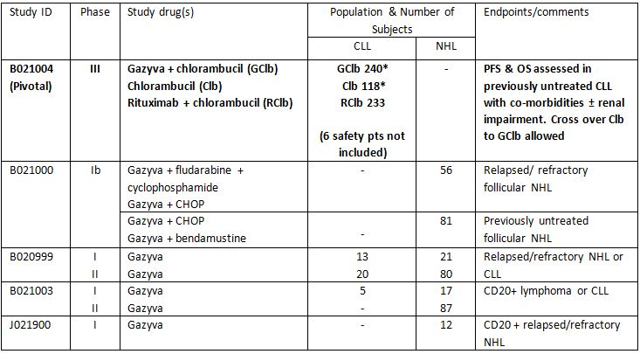

* 2 subjects in each arm did not receive the study treatment (1 protocol violation and 3 withdrawals of consent)

##### PK

A population PK model was obtained from four studies of OB use as a single agent, in combination with other chemotherapy, in subjects with CLL and NHL.

A two-compartment model with one linear and one time-dependent clearance component is described, which is consistent with other monoclonal antibody preparations. The initial clearance estimate was 2.85 times higher than that at steady state, supporting the need to minimise the time varying clearance component using the proposed treatment regimen.

###### ADME

**Absorption:** As a formulation for intravenous infusion, it is presumed to be 100% bioavailable.

**Distribution:** From the two-compartment population PK model, the following parameters were estimated as shown in Table 10.

Table 10: Distribution parameters.

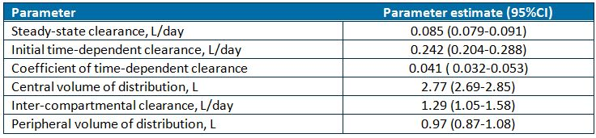

###### Metabolism

In PK modelling:

* There was no influence of baseline B cell count on PK
* PK of OB was independent of age and renal function
* The PK profile of the nine patients in the pivotal study that developed HAHAs was similar to the PK of the other patients during treatment.

Differences in PK parameter results for gender, body weight, and tumour type were deemed to be not clinically relevant for dosing in CLL patients.

**Excretion:** Given the large molecular weight of OB (150 kDa), it is not expected to be eliminated through renal excretion.

###### Special populations

**Renal impairment:** No formal testing of the effect of renal impairment was performed. An assessment of the effect of reduced creatinine clearance (70 mL/min to 30mL/min) in the population PK model demonstrated no effect of this degree of renal impairment on OB PK.

**Hepatic impairment:** No formal testing of the effect of hepatic impairment was conducted.

**Drug-drug interactions:** No formal drug-drug interaction studies were performed.

##### Efficacy: pivotal Study B021004

This was Phase III open label, multicentre, three arm, randomised trial in previously untreated CLL patients.

This study was divided into two stages with the objective of demonstrating a benefit of the addition to Gazyva to existing therapeutic options for patients unable to receive fludarabine based regimens due to a significant co-morbidity burden and/or impaired renal function:

|  |  |
| --- | --- |
| Stage 1a | A comparison of Gazyva plus chlorambucil (GClb) versus chlorambucil (Clb) alone |
| Stage 1b | A comparison of rituximab plus chlorambucil (RClb) versus chlorambucil (Clb) alone |
| Stage 2 | A comparison of RClb versus GClb |

Clinical efficacy data for the proposed indication was only obtained from the pivotal study, which randomised subjects in a 2:2:1 ratio to: GClb, RClb and Clb alone, respectively.

The primary outcome of Stage 1a and 2 was PFS. Secondary efficacy responses assessed were: end of treatment response, molecular response (minimum residual disease negative incidence), OS, and event free survival (EFS). Efficacy assessments were according to NCI/International Workshop on CLL guidelines. In patients achieving a CR or cytopaenic CR, a bone marrow aspirate and biopsy was obtained.

###### Patient population

Subjects were included if they had CD20+ B cell CLL which was previously untreated (according to NCI criteria), with CIRS score >6 (Table 11) and/or creatinine clearance <70 ml/minute. Subjects were excluded if: they had previous CLL therapy, CIRS of 4 in an individual organ, creatinine clearance <30 ml/min, liver function of CTCAE grade 3 or above or positive hepatitis B serology (notably due to a risk of reactivation in studies of the alternate anti CD20 therapy rituximab).

Table 11: Modified Cumulative Illness Rating Scale (CIRS).

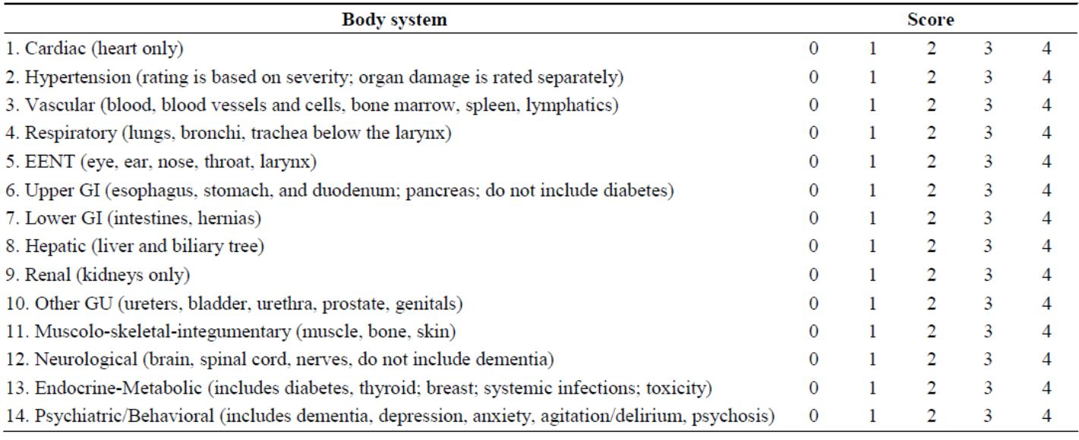

The distribution of CIRS and creatinine clearance for patients <65 years of age was balanced between study arms in Stage 1a (CIRS score reported is additional to the component score for CLL itself) (Table 12).

Table 12: Distribution of CIRS and creatinine clearance.

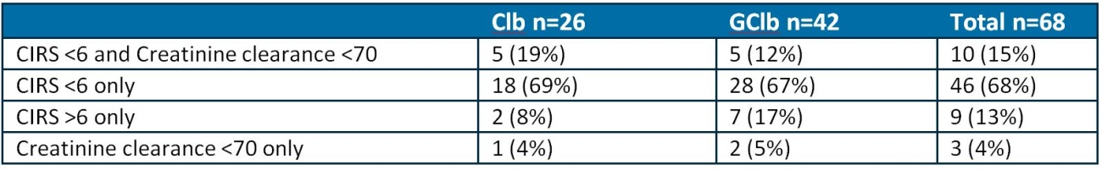

###### Dosage selection

Results of the population PK study demonstrated the need for multiple Gazyva dosing in the first 28 day cycle with one dose in subsequent cycles to overcome the effect of the time dependent portion of clearance.

All subjects were followed up at 28 days after last dose of study drug and three monthly thereafter until 3 years from last treatment.

A total of 22 subjects in the Clb arm crossed over to the Gazyva + Clb arm following disease progression occurring during, or within 6 months of ceasing, Clb treatment.

###### Primary efficacy results for Stage 1a

The primary efficacy outcome was met for this stage.

For the Stage 1a analysis, a data cut-off date of 11 July 2012 was used. By this date, the required number of PFS events for the Stage 1a analysis had been achieved and 250 randomised patients had been observed for at least 12 months and the enrolment of the Clb arm was complete.

###### Primary efficacy results for Stage 2

The primary efficacy outcome was met for this stage.

At the data cut-off of 9 May 2013, 300 PFS events had occurred and the Data and Safety Monitoring Board (DSMB) recommended to un-blind the study at the primary end-point for this stage had been met.

The observation time was similar for each treatment arm 18.6 months (IQR 12.8, 25.6) for RClb and 18.8 months (IQR 12.8, 26.0) for GClb. Disease progression leading to study withdrawal occurred more commonly in the RClb arm: 94 patients (28%) as compared the GClb arm (43 patients [13%]). A greater proportion of patients in the GClb arm required dose delays for 4 to 7 days (RClb: 20% and GClb: 28%), 8 to 14 days (RClb: 16% and GClb: 18%) and more than 14 days (RClb: 8% and GClb: 12%). Additionally, a greater proportion of patients in the GClb arm required slowing, or interruption of the first infusion (15% and 49%, respectively) as compared to those in the RClb arm (5% and 22%, respectively). Beyond Cycle 3, dose modifications were uncommon in both treatment arms (≤2%) (Table 13 and Figures 3-4).

Table 13: Primary outcome - PFS.

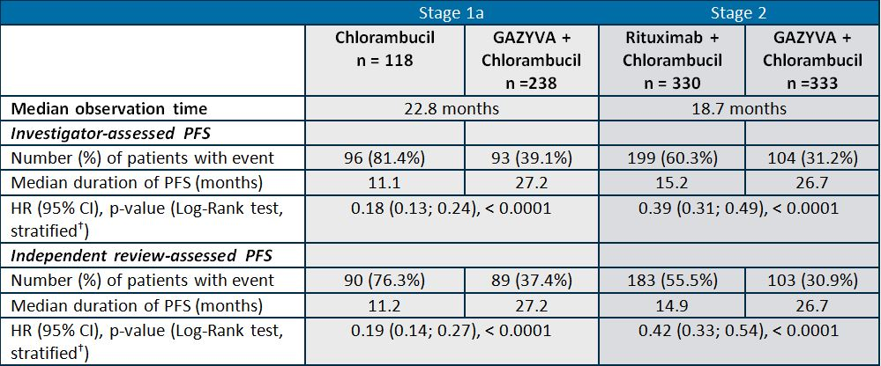

† stratified by Binet stage at baseline

Figure 3: Stage 1a - Kaplan Meier plot of PFS (IRC assessment) cut-off 9 May 2013.

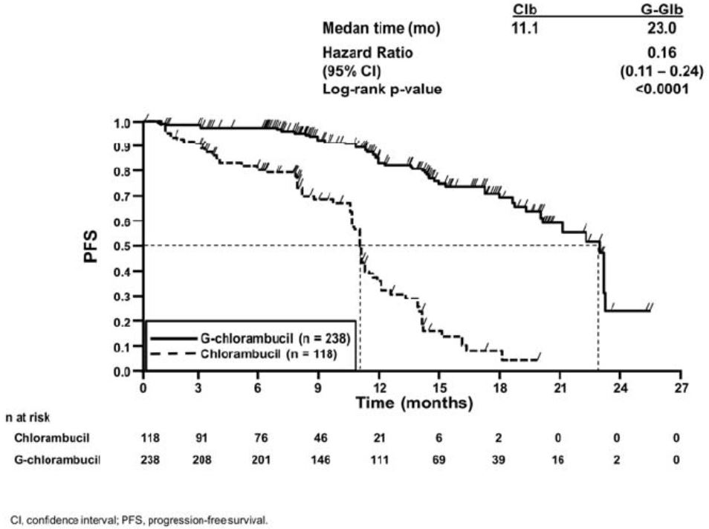

Figure 4: Stage 2 - Kaplan Meier plot of PFS (IRC assessment) cut-off 9 May 2013.

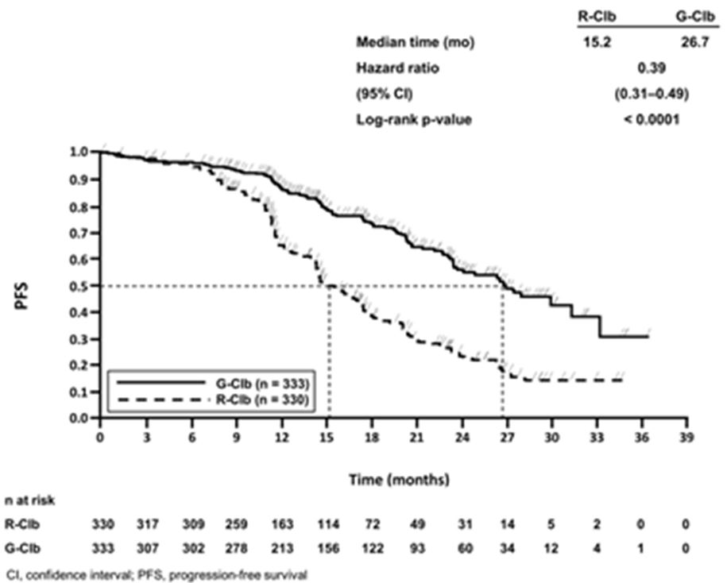

###### Secondary efficacy outcomes

Overall survival

OS at the data cut-off date 9 May 2013 is shown in Table 14.

Table 14: OS at the data cut-off date 9 May 2013.

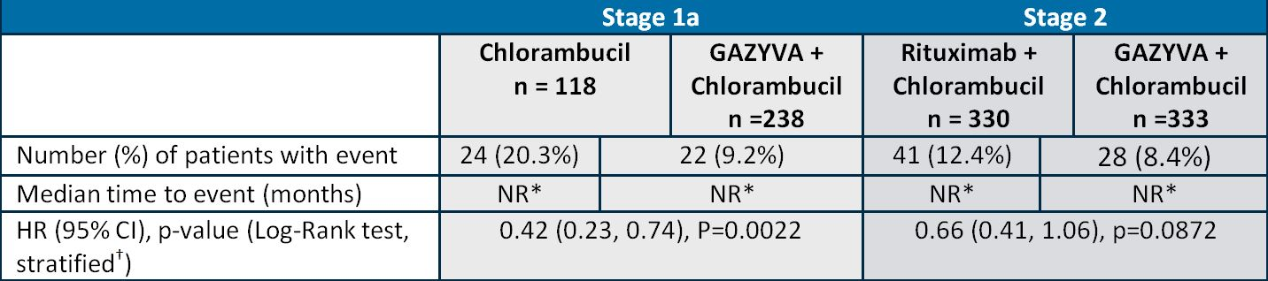

*NR – Not reached, † stratified by Binet stage at baseline

In both Stage 1a and 2, the number of deaths was not sufficient to calculate the median survival estimate.

###### EFS – Stage 1a

In the Clb arm, 103 patients (87.3%) had experienced an EFS event (PD, death or start of new anti leukemic treatment) compared with 104/238 patients (43.7%) in the GClb arm. The investigator assessed risk of an EFS event was significantly lower in the GClb arm compared with the Clb arm HR: 0.19 (95% CI: 0.14, 0.25) p value < 0.0001, log-rank test. The median EFS was 26.1 months in the GClb arm compared with 10.8 months in the Clb arm.

###### Duration of response – Stage 1a

Duration of response was assessed in patients who had a response (nPR, PR, CRi, CR) at any time from 56 days after end of treatment onwards, and included 36/118 patients in the Clb arm and 165/238 patients in the GClb arm (stratified HR 0.10 [95% CI: 0.05, 0.20]). The median DOR was longer in the GClb arm (15.2 months) compared with the Clb arm (3.5 months) (Table 15).

Table 15: Stage 2 end-of-treatment response.

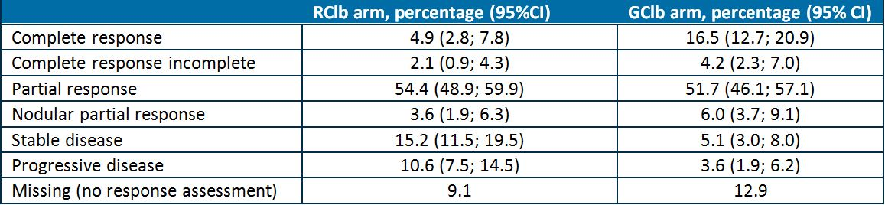

###### Molecular remission at the end of treatment

MRD status was considered negative if result was less than 1 CLL cell in 10,000 leukocytes (MRD value < 0.0001) based on the method of allele specific polymerase chain reaction (ASO-PCR). Of evaluable patients, a greater proportion of GClb subjects achieved MRD negativity as compared the RClb arm, whereas none in the Clb arm achieved MRD negative status (Table 16).

Table 16: Proportion of subjects achieving MRD negativity or positivity.

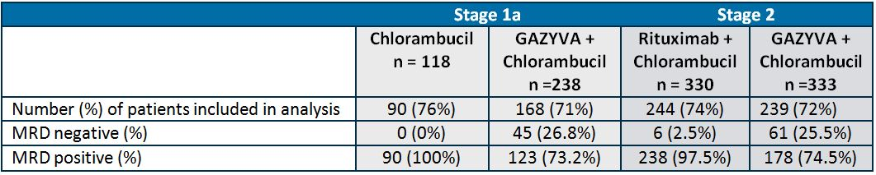

##### Efficacy: supportive Studies BO20999 and BO21003

Efficacy data from these two studies was not included in the Summary of Clinical Efficacy since they only enrolled patients with relapsed/refractory CLL or NHL. Furthermore, each study employed a different treatment regimen to BO21004.

##### Safety

###### Safety in studies of patients with CLL

Safety data was reported for any subject that had at least one dose of Gazyva in any of the clinical trials described in the overview of data, that is, not just those patients treated with Gazyva for the proposed indication.

Safety data was reported for a total of 648 subjects across four trials (Table 17).

Table 17: Safety data - number of subjects.

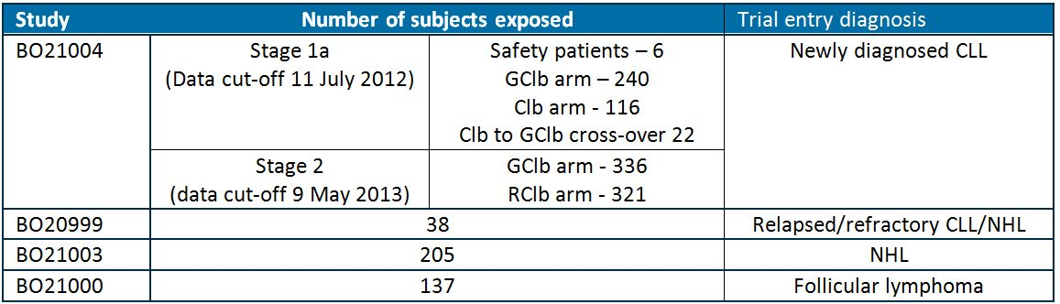

###### Exposure

Exposure to OB was similar in the studies: the median number of infusions was 8 in the pivotal study, 9 in Studies BO20999 and BO21003, and 10 in BO21000. Cumulative median doses were also of a similar magnitude in each of the studies.

###### General safety overview

The Stage 1a analysis demonstrated a higher proportion experiencing AEs in the GClb arm with the excess predominately due to infusion related reactions. The incidence of death and fatal AEs was lower in the GClb arm (9% and 5%, respectively) as compared the Clb arm (21% and 9%, respectively) (Table 18).

Table 18: Patients experiencing AEs - Stage 1a analysis.

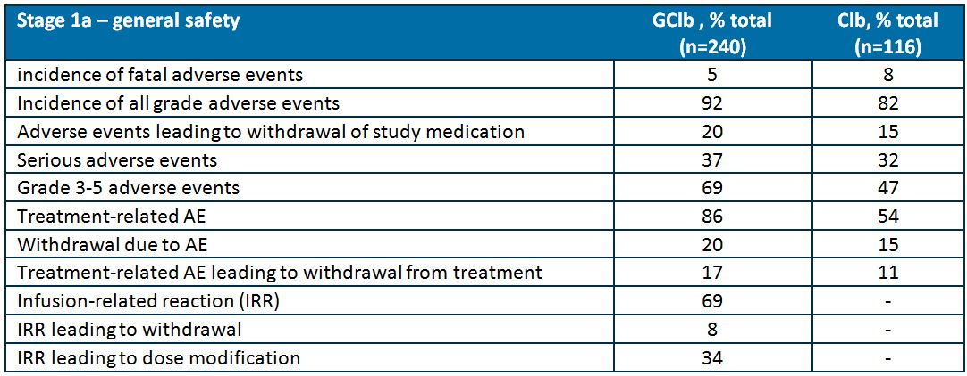

The Stage 2 analysis demonstrated a higher proportion of the GClb arm experiencing: all grade AEs, grade 3-5 AEs, serious AEs and AEs leading to withdrawal from study medication. The proportion of deaths was smaller in the GClb arm (8%) versus RClb (12%) (Table 19).

Table 19: Patients experiencing AEs - Stage 2 analysis.

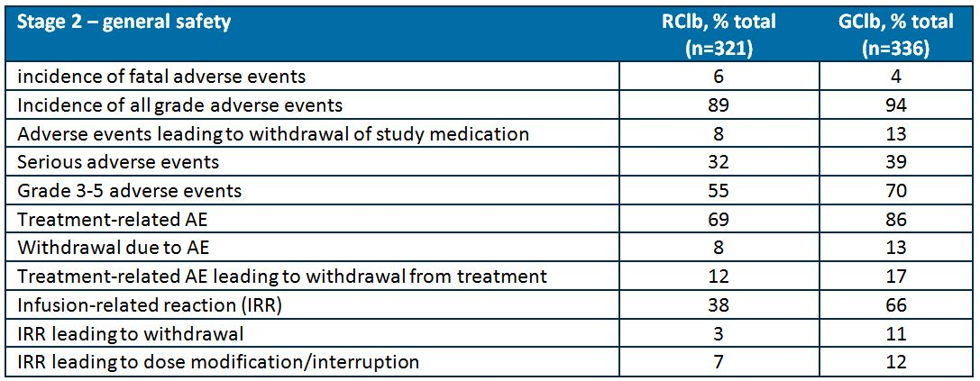

###### Deaths

In Stage 1a, 24/116 patients (21%) in the Clb arm and 22/241 patients (9%) in the GClb arm had died until the data cut off of 9 May 2013. AEs leading to death in the GClb arm all occurred in <1% of the safety population per category, as compared to the Clb arm where 5% were due to infections and infestations and 2% due to nervous system disorders (cerebrovascular accident).

In Stage 2, 6% (20/321) of RClb arm died and 4% (15/336) of the GClb arm died as a result of AEs. The breakdown of AEs leading to death was similar between the RClb and GClb arms.

###### AEs of special interest

Infusion related reactions

Measures to mitigate the risk of IRR were implemented during the course of the pivotal trial. Study protocol amendment G (December 2011) recommended the first 1000 mg dose was split: as per the proposed dosage regimen and premedication was mandated prior to each dose. These measures reduced the incidence of IRR; the sponsor has provided supportive evidence in their Round 2 responses demonstrating that the complete abolition of IRR is implausible given the mode of action of Gazyva (Table 20).

Table 20: IRR incidence.

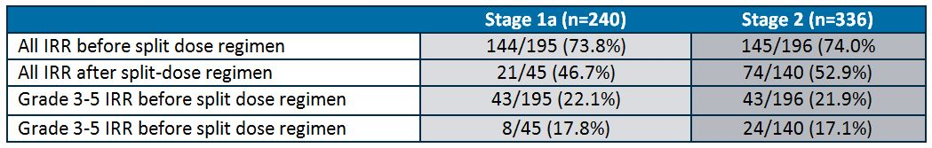

No grade 5 IRRs were reported at any time and no fatal IRRs occurred. Symptoms of infusion related reactions most commonly occurring were: chills/pyrexia, hypotension (advice to withhold anti hypertensive medication on the morning of Gazyva administration is in the PI), nausea and vomiting, dyspnoea, rash and pruritus, headache, tachycardia and myalgia.

The incidence of IRR was similar between subjects pre medicated with prednisolone, methylprednisolone or dexamethasone.

###### Risk of second malignancy within 6 months of Gazyva therapy

The overall observed incidence of second malignancies was not greater than that expected.

In Stage 1a, 3/30 crossover patients experienced second malignancies: in situ squamous cell carcinoma of skin, lung neoplasm and seborrhoiec keratosis.

In Stage 2, squamous cell carcinoma was the most commonly reported malignancy in 3 and 5 individuals in the RClb and GClb arms, respectively.

###### Cardiac disorders

In Stage 1a, tachycardia was the most commonly reported AE, with a higher incidence in the GClb arm, predominately with infusion related reactions.

In Stage 2, infusion related reaction associated tachycardia was more common in the GClb arm (7% versus 3% in RClb arm). Cardiac failure and atrial fibrillation each occurred in 1% of subjects. Fatal cardiac events occurred in five patients in the RClb arm (one arrhythmia, one heart failure and three ‘cardiac arrest’) and two patients in the GClb arm (myocardial infarction; both considered unrelated to Gazyva).

###### Immune system

One subject in the GClb arm in each of the stages 1a and 2 experienced an anaphylactic reaction.

Immunoglobulin depletion diagnosed at the 28 day follow up visit was similar in the GClb and CLb arms. The median time to immunoglobulin recovery was 392 days, 379 days and 589 days for IgA, IgG and IgM, respectively, for the GClb arm in Stage 1a.

###### TLS

In Stage 1a, 1 subject in the Clb arm and 10 in the GClb arm experienced TLS; in Stage 2, 14 subjects (4.2%) in the GClb arm and zero in the RClb arm experienced the event.

###### Neutropaenia

In Stage 1a, neutropaenia was more common in the GClb arm (45%) than the Clb arm (21%). However, the grade of neutropaenia was higher in the Clb arm with an associated higher proportion of patients discontinuing treatment.

In Stage 2, neutropaenia not resolving after 28 days of last study drug occurred in 4% RClb arm and 2% of GClb arm, with an associated higher incidence of infection in the RClb treated group (Table 21).

Table 21: Neutropaenia rates.

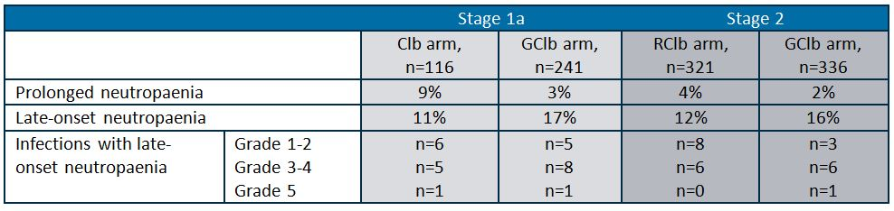

###### Richter’s transformation

No subjects initially treated with GClb underwent disease transformation; however, 1 patient in the Clb arm who crossed over to GClb and 4 in the RClb arm did undergo transformation. This low incidence does not indicate an additional risk from Gazya use.

###### Thrombocytopaenia

AEs of thrombocytopaenia were observed more commonly following Gazyva exposure in both stages of the pivotal trial.

Table 22: Thrombocytopaenia rates.

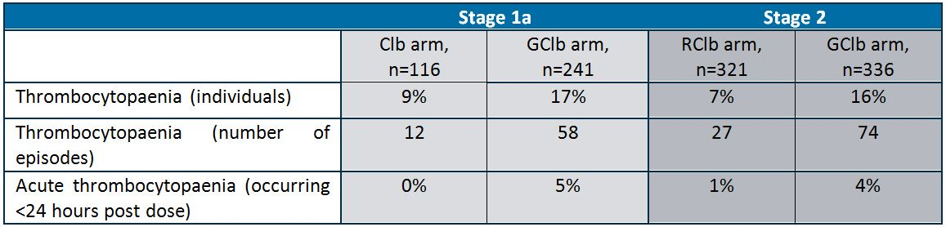

The sponsor wrote a “Dear Healthcare Provider” letter on 3 February 2014 regarding a higher incidence of thrombocytopaenia and haemorrhage during the first cycle of Gazyva therapy. This letter outlined 3 deaths during RClb treatment, 2 deaths during Clb treatment, and 4 deaths during GClb treatment. All 4 deaths during GClb treatment occurred during the first cycle, whereas none occurred in the first cycle of either of the other treatments. Additional advice regarding concomitant anti platelet therapy and platelet count monitoring has been included in the PI in the Round 2 responses.

###### B cell depletion

A small subset of patients was assessed by immunophenotyping. At the end of Stage 1a treatment, 2/20 patients (9%) in the Clb arm and 40/44 (91%) patients in the GClb arm had B cell depletion. Re-assessment between 6 and 9 months post end of treatment demonstrated all 40 patients in the GClb arm remained B cell deplete, as opposed to none in the Clb arm.

###### Common AEs: by body system

Anaemia

The incidence of anaemia was the similar in each in each of the three treatment arms (10-12%).

###### General disorders

Pyrexia was more common in the GClb arm (10% versus 7%).

###### Development of HAHAs

Four patients had positive HAHA results from serum provided prior to the Cycle 1 (first) infusion. Subsequently, samples from these patients did not test positive for HAHA and can thus be considered false positive test results; the assay has been calibrated to accept a small number of false positives.

HAHA positive cases were seen at 6, 9, 12 months after end of treatment. At 12 months follow-up, 7/64 patients (11%) randomised to the GClb arm tested positive for HAHAs; one of those patients tested positive at follow-up Months 6 and 9 and another patient tested positive at follow-up Month 9, and for both patients the positivity increased over time. The sponsor states that:

*[T]here is currently no evidence to suggest that the patients with positive HAHA experienced any relevant AEs and neither PK parameters nor clinical response were notably affected.*

Two of the six patients who participated in the safety run-in phase tested positive for HAHAs; one at follow-up Months 9 and 12, and the other at follow-up Month 12.

###### Hepatitis B reactivation and PML

There were no reported cases of HBV reactivation or PML in either Stage 1a or 2. The sponsor reports that of 2409 patients treated, only one case of PML has been seen in association with OB therapy. There have been no cases of fatal HBV reactivation.

###### Bowel perforation

There were no reported cases of bowel perforation in either Stage 1a or 2. A risk of intestinal perforation at sites of intestinal CLL deposits remains a possibility, but has not observed in the pivotal trial. This issue was of specific concern to the RMP evaluator.

###### Nervous system

Headache, dizziness and paraesthesia were the commonest events reported, with similar incidence in the GClb and RClb arms (each occurring in <10% of subjects).

###### Vascular

In Stage 2, the commonest events in the GClb arm were: hypertension (3%) and hypotension (1%).

###### Renal

In Stage 1a and 2, there were few patients that shifted their graded severity of creatinine upwards.

###### Hepatobiliary

The baseline incidence of hepatobiliary disorders in study entrants was high, ranging 14-16%. Hepatobiliary disorders occurred in ~1% of subjects in the treatment arms of stages 1a and 2, most frequently cholecystitis, cholelithiasis and cholestasis. Transient elevation of liver enzymes reflecting hepatic cellular injury, lasting 2 day to 1 month following first Gazyva administration was observed in 3% of patients.

###### Respiratory, thoracic and mediastinal

Cough, dyspnoea and epistaxis were the most common disorders in this category (each occurring in <10% of subjects).

###### Infections and infestations

The overall incidence of infections was balanced between treatment arms in both Stage 1a and 2. Serious infections occurred more commonly in Clb patients (15%) than GClb (12%); in Stage 2 similar percentages of patients experienced bronchitis, pneumonia and urinary tract infections (each <5% of the total in the treatment arm).

###### Safety from supporting studies

Disease progression accounted for the majority of deaths in the supporting studies. In the monotherapy NHL trial, of the 50 deaths (24%), 5 were as a result of AEs. The most common AEs in all studies were IRRs, with patients experiencing grade ≥3 AEs mainly occurring due to neutropaenia (Table 23).

Table 23: Summary of AEs.

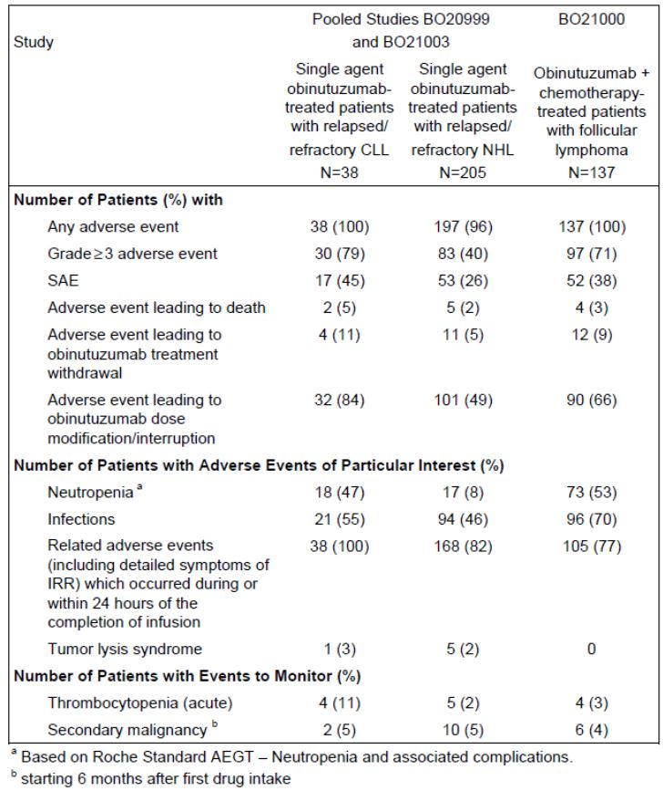

### Risk management plan

The RMP proposed by the sponsor was considered generally acceptable by the TGA’s OPR. A number of changes to the product information recommended by the evaluator have been accepted by the sponsor.

The sponsor has provided a guided questionnaire for clinicians for hepatitis B reactivation as per the request in the Section 31 response, which is to be evaluated by the OPR.

The RMP evaluator recommended the Delegate address the risk of intestinal perforation. As discussed above, from the current data provided in the dossier the reported risk following Gazyva is not worse than the background risk.

A black box warning pertaining to the risk of hepatitis B reactivation and PML is recommended by the Delegate.

The currently observed risk of second malignancies following Gazyva is not worse than expected, but requires ongoing pharmacovigilance monitoring.

### Risk-benefit analysis

#### Delegate’s considerations

##### Efficacy

The addition of OB to Clb in subjects with previously untreated CLL, with poor functional status and/or renal impairment, provides a clinically meaningful improvement in PFS and OS (median OS has not yet been met).

In subjects with previously untreated CLL, with poor functional status and/or renal impairment, GClb versus RClb demonstrates improved PFS with the former combination.

##### Safety

This overview precedes the Advisory Committee on the Safety of Medicines (ACSOM) meeting of 7 March 2014 where Gazyva was discussed.

A risk of hepatitis B reactivation and PML exists with Gazyva exposure; the Delegate considers these risks require a black box warning on the PI.

The overall incidence of AEs for GClb treated patients was higher than those receiving RClb or Clb alone, predominately due to infusion related reactions, neutropaenia and thrombocytopaenia.

There is a risk of fatal thrombocytopaenia/haemorrhage during the first cycle of Gazyva treatment.

The pre-medication and dose splitting regimens reduced the incidence of infusion related reactions, but are unlikely to abolish their occurrence completely.

No increase in the background risk of intestinal perforation at sites of CLL infiltration was seen with Gazyva therapy.

An increased risk of second malignancy following Gazyva therapy was not observed, but requires ongoing surveillance.

TLS occurs more commonly with the GClb combination than with RClb or Clb alone.

In patients shown to develop immunoglobulin depletion as a result of Gazyva therapy, the median duration of recovery was in the order of one year.

##### Indication as initially proposed by sponsor in this submission

*Gazyva, in combination with chlorambucil, is indicated for the treatment of patients with previously untreated chronic lymphocytic leukaemia.*

##### Overall risk-benefit

The combination of OB and Clb (that is, GClb) resulted in a clinically meaningful and statistically significant improvement in PFS in CLL, which is currently characterised by eventual relapse and long term treatment failure, as compared to Clb alone and the RClb combination. The higher incidence of AEs in patients treated with Gazyva and Clb compared to Clb and RClb was predominately due to infusion related reactions, which the sponsor concedes are unable to be completely abolished using a pre medication regimen (Round 2 responses to questions). The risk of thrombocytopaenia/haemorrhages in the first cycle, and risk of second malignancy following Gazyva therapy require ongoing monitoring.

**The overall risk-benefit favours the combination of OB and chlorambucil (that is, GClb) in the proposed indication.**

#### Request for ACPM advice

The Advisory Committee on Prescription Medicines (ACPM) was requested to provide advice on the following specific issues:

1. *Does the risk-benefit balance favour OB use in the proposed indication?*
2. *What is the opinion of the Committee regarding extending the use of Gazyva in combination with Clb to patients with CLL that are not poorly functioning or with normal creatinine clearance?*
3. *What is the opinion of the Committee regarding the premedication and dose splitting regimens proposed?*
4. *What is the opinion of the Committee regarding specific warnings for: hepatitis B reactivation, PML, and thrombocytopaenia and fatal haemorrhagic events during the first cycle?*

The committee was requested to provide advice on any other issues that it thinks may be relevant to a decision on whether or not to approve this application.

#### Clinical evaluator’s recommendation

The Delegate proposes to approve the application for the indication proposed by the sponsor.

#### Response from sponsor

##### Comment on the Delegate’s proposed action

The sponsor concurs with the Delegate’s recommendation to approve Gazyva (obinutuzumab) 1000 mg/40 mL concentrate solution for infusion vial for the indication:

*Gazyva in combination with Clb is indicated for the treatment of patients with previously untreated chronic lymphocytic leukaemia (CLL).*

##### Sponsor comment on issues raised in the Delegate’s overview and advice sought of the ACPM

1. *Does the risk-benefit balance favour obinutuzumab use in the proposed indication?*

The sponsor considers the benefit/risk profile of the GClb combination to be positive in the proposed indication. The efficacy data gained from pivotal Study BO21004 confirms the superiority of GClb treatment to the other study arms, with an acceptable safety profile.

CLL represents a serious, life threatening disease with medical need for improved treatment. The results obtained with GClb showed superiority over Clb for the first time in a randomised Phase III setting. This is an important advance in clinical benefit for this group of patients who otherwise have limited alternative treatment options. The results are not only statistically significant and clinically relevant, but they also represent a “real world” setting since the median age of patients enrolled in BO21004 is very similar to the median age of patients diagnosed with CLL.

BO21004 was an open label, multicentre, three arm randomised, Phase III study comparing the efficacy and safety of GClb, RClb, and Clb alone in co-morbid patients with previously untreated CLL. The study was divided into two stages:

|  |  |
| --- | --- |
| Stage 1a | A comparison of Gazyva plus chlorambucil (GClb) versus chlorambucil (Clb) alone |
| Stage 1b | A comparison of rituximab plus chlorambucil (RClb) versus chlorambucil (Clb) alone |
| Stage 2 | A comparison of RClb versus GClb |

The results from Stage 1a of BO21004 demonstrated that treatment with GClb compared with Clb resulted in a clinically meaningful improvement in PFS (primary endpoint; stratified HR = 0.18, 95% CI [0.13; 0.24], log-rank test p <0.0001, median PFS 26.7 months GClb arm versus 11.1 months Clb arm; updated analysis) and all time-to-event parameters. A statistically significant benefit in favour of GClb was also observed in OS (stratified HR = 0.41, 95% CI [0.23; 0.74], log-rank test p = 0.0022 [unadjusted for multiplicity], updated analysis).

The results from Stage 2 of BO21004 demonstrated that treatment with GClb resulted in a clinically meaningful and statistically significant improvement in the primary endpoint compared to RClb (PFS, stratified HR = 0.39, 95% CI [0.31; 0.49], log-rank test p-value <0.0001, median PFS 26.7 months GClb arm versus 15.2 months RClb arm). The results were consistent for investigator and IRC assessed PFS and across the pre-specified subgroups for investigator assessed PFS. Sensitivity analyses of the PFS outcome supported the primary analysis. Statistically significant improvements were observed in all of the secondary efficacy endpoints apart from OS for which the data are not yet mature.

Efficacy data from supporting Phase I/II studies demonstrated Gazyva activity as a single agent or in combination with chemotherapy in patients with CLL, including patients who have been heavily pre-treated.

The overall safety profile of Gazyva based on data from Stage 2 of BO21004 is consistent in nature, severity and incidence with that observed in Stage 1a. The safety profile, with respect to type of AEs, was generally comparable between the RClb and GClb arms. There was a lower incidence of deaths (all cause) and grade 5 (fatal) AEs in the GClb arm compared with the RClb arm. There was a higher incidence with GClb compared with RClb for all Grade AEs, AEs leading to withdrawal of any study medication, SAEs, and grade ≥ 3 AEs. These differences were mainly driven by IRRs and to a lesser extent neutropenia and thrombocytopenia.

The higher incidence of IRRs in the GClb arm could be due to the more potent cytotoxic effect of OB on CD20 positive B cells and related cytokine release. CD19 positive lymphocytes (that is, lymphocytes of B cell lineage) were found to be more profoundly and rapidly depleted by OB than by rituximab. The rapid and profound depletion of B cells in Cycle 1 may explain the pattern of IRRs seen with OB. Overall, in the GClb arm, IRRs were generally manageable and the majority of events were grade 1 or 2 in severity. There were no fatal IRRs reported in either study arm.

Neutropenia is considered an expected effect of therapy with Gazyva based on previous clinical observations with rituximab and new understanding of the interactions between CD20 targeted monoclonal antibodies and polymorphonuclear neutrophils.[4] The higher incidence of neutropenia reported in the GClb arm may reflect the higher binding affinity of OB to CD16B expressed on neutrophils. Despite the more profound effect of OB on neutrophils and the more profound and prolonged depletion of B cells with GClb compared with RClb, there were no imbalances in the incidence of infections, serious infections and withdrawals due to infections between the treatment arms. Fatal infections, which account for up to 50% of deaths in patients with CLL,[5] occurred at a low incidence in BO21004. This favourable outcome may be partly attributed to the risk minimisation strategies implemented in the study protocol (prophylaxis with granocyte-colony stimulating factor [G-CSF] and anti infectives) but it could also reflect the superior efficacy afforded by the GClb regimen since patients in remission are less prone to infections. There were no cases of PML or hepatitis B virus reactivation among GClb treated patients. Reactivation of HBV was reported for two patients in the RClb arm.

Thrombocytopenia (all grade and grade 3 or 4) was more frequent with GClb compared with RClb, mainly due to a higher rate of events in Cycle 1. However, the incidence of haemorrhagic events was balanced between the study arms and grade 5 events occurred in a similar number of patients in each arm (3 RClb versus 4 GClb). All 4 deaths in the GClb arm occurred during Cycle 1 whereas deaths in the RClb arm all occurred late (after treatment completion). Review of deaths in the GClb arm did not show a clear relationship between thrombocytopenia and haemorrhages since, in the majority of cases, there were other confounding factors. In view of the early deaths due to haemorrhage observed in the GClb arm, the sponsor has proposed appropriate advice for the PI and issued a “Dear Healthcare Provider” letter to clinical trial investigators. Clinical trial guidance documents have also been updated to ensure prescribers and investigators are advised of the risk of fatal haemorrhagic events in Cycle 1 and implement the risk minimisation measures. The sponsor considers the safety profile of Gazyva to be acceptable and the AEs to be clinically manageable. The foremost safety risks associated with Gazyva therapy for the proposed indication are IRRs and haematologic toxicities (mainly neutropenia and thrombocytopenia) particularly during the first cycle, both of which occurred in BO21004 at a higher frequency and severity in the GClb arm compared with the RClb arm.

In conclusion, the benefit/risk profile of GClb over Clb and RClb is strongly positive in patients with previously untreated CLL. The magnitude of clinical benefit, achieved when Gazyva was combined with Clb was large and clinically meaningful, and occurred in the context of acceptable tolerability and in patients with few treatment options.

1. *What is the opinion of the Committee regarding extending the use of Gazyva in combination with Clb to patients with CLL that are not poorly functioning or with normal creatinine clearance?*

The majority of patients with CLL are elderly. According to the latest data from the Australian Institute of Health and Welfare, during 2012 there were 1,230 cases of CLL (ICD10 C91.1) in Australia, and 354 deaths from CLL during 2010. For patients with CLL, mean age at diagnosis is about 70 years and mean age of death is 79 years. Currently on average, women are living for about 5.5 years longer than men.[6] Similar data is available from the US where from 2005-2009, the median age at diagnosis was 72 years, and that almost 70% of CLL patients were 65 years or older, and over 40% were older than 75 years.[7]

Elderly patients frequently have concurrent medical conditions and/or physiological declines in organ function.[8] Major co-morbidities have been described in 46% of patients with newly diagnosed CLL.[9] CLL patients with multiple coexisting medical conditions have been reported to have inferior outcomes compared to CLL patients without coexisting medical conditions.[10]

At present, CLL remains incurable using standard treatment approaches. Therefore, the aim of therapy is to control disease, improve symptoms, and prolong survival, while minimising toxicity with regimens which are well tolerated and acceptable to patients who are predominantly older than 65 years of age. Treatment is usually associated with a high rate of initial response, followed inevitably by relapse. Subsequent treatments can induce remissions but at a progressively lower rate with responses of shorter duration.

Since patients with CLL are typically elderly at diagnosis and frequently have other co-existing medical conditions and/or impaired organ function, the choice of first-line therapy for individual patients must take these factors into consideration, as well as disease-specific prognostic factors, such as the presence or absence of high risk genetic abnormalities (for example, 17p or 11q chromosomal deletions). The US National Comprehensive Cancer Network (NCCN) Guidelines[11] recommend treatments based on the presence of comorbidities (for example, CIRS score), age, fitness and cytogenetics. NCCN first line treatment recommendations are summarised in Table 24; the Guidelines were recently updated (January 2014) to include OB. It recommends GClb as a first line treatment option for all patients with CLL.

Table 24: NCCN Guidelines for First-line Treatment of CLL.

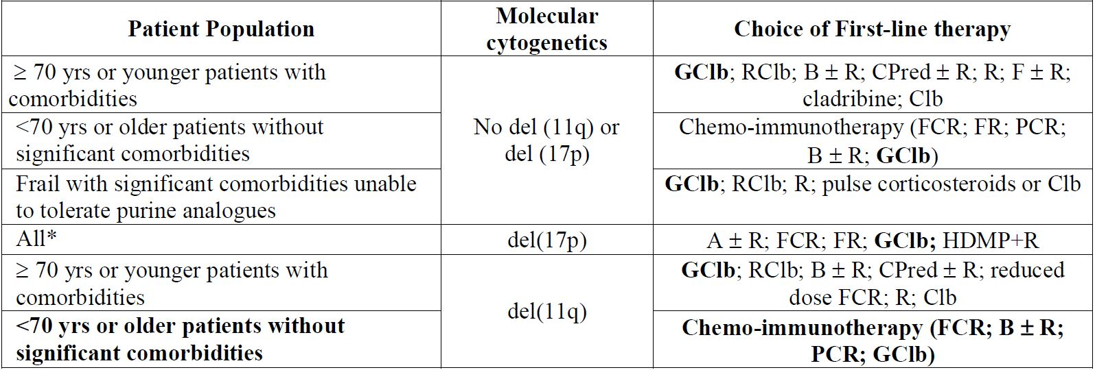

A alemtuzumab; B bendamustine; Clb chlorambucil; C cyclophosphamide; F fludarabine; G obinutuzumab; HDMP high-dose methylprednisolone; P pentostatin; Pred prednisone; R rituximab.

*Note: regimens are listed in the order of preference except for the del(17p) subgroup where the regimens are in alphabetical order

It should be highlighted that GClb is listed as a treatment option for patients with unfavourable cytogentics (del(17p)) and for younger patients or those without comorbidities, as well as the treatment of choice in older patients and younger patients with comorbidities.

The update to the NCCN guidelines allows patients and physicians to make a decision together on individual treatment options on a case by case basis. Alternative therapies for this patient population include fludarabine, pentostatin and bendamustine which are all associated with known toxicity. There is no reason to believe that patients without comorbidities (CIRS <6) or renal impairment (CrCl >70mL/min) would behave differently in terms of efficacy outcomes compared to that observed in the patient population studied. In fact the safety profile with GClb could be expected to be more favourable than in the comorbid patient population since patients without comorbidities or renal impairment can be considered to be more able to tolerate toxicity.

Of note, historically trials in CLL have been conducted in younger, fitter patients representing only a subgroup of the overall CLL patient population (~30%) and not reflective of a typical newly diagnosed CLL patient. For this reason many of the treatment guidelines and medication labels were restricted to this fitter patient population to protect the typical CLL patient who would be at risk of toxicity.

There is no cure for CLL and irrespective of first line treatment patients eventually relapse and die from their disease. A comparative study versus immunotherapy such as FCR (fludarabine + cyclophosphamide + rituximab) would require a study very long in duration to demonstrate a PFS improvement in addition to the improvement anticipated from current treatments. This would delay the availability of a novel treatment option for patients.

There is no evidence that patients without co-morbidities or renal impairment will benefit differently to those with comorbidities and the safety profile in patients without comorbidities or renal function is expected to be better than those with comorbidities. The proposed indication does not preclude the use of second line therapies and allows physicians and patients the choice of a new treatment option for a disease with an unmet medical need.

1. *What is the opinion of the Committee regarding the premedication and dose splitting regimens proposed?*

IRRs were the most frequently reported AEs in BO21004. The risk of IRRs was mostly limited to the first infusion. The incidence and severity of infusion related symptoms decreased substantially after the first 1000 mg was infused, with most patients having no IRRs during subsequent administrations and no grade ≥ 3 IRR reported beyond the first infusion.

The mechanism by which IRRs are triggered appears to be related to the release of cytokines/chemokines and/or other mediators from B cells targeted by OB. IRRs are a class effect of anti tumour antibodies that use antibody dependent cellular cytotoxicity as a mode of action. Cytokine release can occur as a consequence of the antibody-antigen interaction between OB and the CD20 antigen on B lymphocytes, resulting in Fc receptor crosslinking of FcγRIII on immune effector cells such as NK cells and macrophages/monocytes and subsequent cytokine release from these cells. Compared to conventional IgG1 antibodies, FcγRIII affinity of OB is enhanced due to glycoengineering resulting in improved efficacy and a higher potential for cytokine release. This could explain the higher incidence of cytokine related infusion reactions with Gazyva compared to other anti CD20 antibodies.

Pre-medication with IV corticosteroids, antipyretics and antihistamines and split dose over 2 days was recommended in study BO21004 to minimise the risk of IRRs.

The effectiveness of pre-medication in mitigating the risk of cytokine release and thus the risk of IRRs has been investigated *in vitro* studies. A study conducted with human whole blood revealed that cytokine release can be significantly reduced by administration of corticosteroids.[12] Acknowledging the predictivity of *in vitro* whole blood assays to assess the risk for cytokine release in man leads to the assumption that pre-treatment with corticosteroids may also be effective to reduce cytokine release following Gazyva administration.

The split dose over 2 days for the first dose approach along with other measures (mandatory premedication with glucocorticoids, omission of antihypertensive medication on the day of first infusion, slow infusion) helped to decrease the incidence of all grade IRRs on Cycle 1 Day 1, however with a limited impact on grade 3-4 IRRs. As these risk minimisation measures were implemented in parallel, it is not possible to assess the effectiveness of the split dose infusion to minimise IRRs in isolation.

Approximately 60% of patients were able to have the first infusion without interruption and rate modification.[13] Thus, it is recommended that if no modifications/interruptions of the infusion are required during the first 4 h, the complete dose may be administered within the same day, provided that the infusion takes place under appropriate conditions and medical supervision is available throughout the infusion.

As the majority of first IRRs (~70% of all Grade and Grade 3-4 events) start within the first 2 h, the same slow initial infusion rate of 25 mg/h (4 h infusion for the first 100 mg) is recommended for all patients. A slow infusion rate (25 mg/h) may attenuate the incidence and/or severity of symptoms due to cytokine release by allowing clearance of these cytokines and so allow physicians and nursing staff to detect the start of an IRR earlier and to react faster to the developing signs and symptoms.

Given the mechanism of action of Gazyva, with a contribution of cytokine release of IL-6, IL-8 and IL-10 to the occurrence of IRRs, the sponsor considers that the risk minimisation measures listed below and included in the Gazyva PI to be appropriate:

* Premedication with IV corticosteroids, antipyretics and antihistamines may reduce the symptoms caused by cytokine release syndrome.
* A very slow initial infusion may attenuate the incidence and/or severity of symptoms due to cytokine release by allowing clearance of these cytokines.
* Patients who tolerate the first 100 mg without any IRR are allowed to continue the remaining 900 mg on the same day provided that appropriate time, conditions and medical supervision are available throughout the infusion. If there are any modifications to the infusion rate or interruptions during the first 100 mg, the second bag must be administered the following day. Split dosing may attenuate the incidence and/or severity of symptoms due to cytokine release by allowing a progressive lytic action of OB on tumoural CD20 lymphocytes.

1. *What is the opinion of the Committee regarding specific warnings for: hepatitis B reactivation, PML, thrombocytopaenia, and fatal haemorrhagic events during the first cycle?*

The sponsor acknowledges the Delegate’s recommendation for boxed warnings regarding the risks of PML and hepatitis B reactivation. The sponsor provides the following comment on these recommendations, as well as the proposed Precaution for thrombocytopenia and fatal haemorrhagic events.

The sponsor accepts the recommendation for a PML boxed warning and a proposed boxed warning has been included in the PI. Given the typical clinical course of PML and its outcome, the inclusion of a boxed warning for the risk of PML is warranted.

With regard to a boxed warning for the risk of hepatitis B reactivation, the sponsor consider the detailed risk minimisation measures described in the proposed Precaution to be appropriate to address this risk, and that a boxed warning is not currently warranted. Up to March 2014, there have been no cases of fatal HBV reactivation among subjects exposed to Gazyva. Further, up to 2 July 2013, 2 patients among an estimated 94 hepatitis B core antibody positive patients exposed to Gazyva in clinical studies have experienced hepatitis B reactivation as defined by an occurrence of HBV DNA >1000 IU/mL at least once after exposure to Gazyva. Both these patients who experienced HBV reactivation had benign clinical courses with no signs or symptoms of hepatitis or any liver function test abnormalities.

The sponsor will continue to assess the emerging data regarding HBV reactivation to further characterise this risk and will communicate diligently any relevant information to all prescribers and investigators. At this request of the TGA, the sponsor will implement a guided questionnaire to collect information to allow continued assessment of the clinical course and profile of HBV reactivation in Gazyva treated patients. Assessment of the guided questionnaire by TGA was an ongoing process at the time of this response.

For thrombocytopenia and the risk of fatal haemorrhagic events during the first infusion cycle, the Precaution proposed for the PI provides the following advice for prescribers:

* That patients should be closely monitored for thrombocytopenia, especially during the first infusion cycle;
* That regular lab tests should be performed and that dose delays should be considered in the case of severe or life threatening thrombocytopenia;
* That platelet transfusion should be at the discretion of the treating physician; and
* Use of all concomitant therapies, which could possibly worsen thrombocytopenia related events such as platelet inhibitors and anticoagulents, should also be taken into consideration, especially during the first cycle.

The sponsor considers these risk minimisation measures to be appropriate and will inform the prescriber and protect the patient. Additionally, the sponsor has implemented appropriate risk minimisation measures in all relevant ongoing Gazyva clinical trials (updated Informed Consent Form, protocol amendments and publication of a “Dear Healthcare Provider” letter). The sponsor will continue to assess the emerging data to further characterise the nature, severity and frequency of all haemorrhagic events and will communicate diligently any relevant information to all prescribers and investigators.

#### Advisory committee considerations

The ACPM, taking into account the submitted evidence of efficacy, safety and quality, agreed with the delegate and considered Gazyva solution for injection containing 25 mg/ml of OB to have an overall positive benefit-risk profile for the indication:

*Gazyva, in combination with chlorambucil, is indicated for the treatment of patients with previously untreated chronic lymphocytic leukaemia*

##### Proposed conditions of registration

The ACPM agreed with the Delegate on the proposed conditions of registration.

##### Proposed Product Information (PI)/Consumer Medicine Information (CMI) amendments:

The ACPM agreed with the delegate to the proposed amendments to the PI and CMI and specifically advised on the inclusion of the following:

* Cross reference in the PRECAUTIONS section on TLS to the section on Worsening Pre-existing Cardiac Conditions as high fluid loads are part of TLS management or prevention and this needs to be considered. It may further exacerbate congestive cardiac failure.

##### Specific advice:

The ACPM advised the following in response to the specific Delegate’s questions on this submission:

1. *Does the benefit-risk balance favour obinutuzumab use in the proposed indication?*

The benefit-risk balance favours the proposed indication although data regarding OS are not mature and CLL is a disease where, due to age of onset, death from another cause can occur. The data suggesting improvement in PFS, eradication of minimal residual disease, treatment response, and EFS are compelling. There is no evidence of adverse effect on quality of life measures from patient reports. IRRs appear mostly manageable after first infusion.

1. *What is the opinion of the Committee regarding extending the use of Gazyva in combination with Clb to patients with CLL that are not poorly functioning or with normal creatinine clearance?*

The ACPM agreed with the sponsor that this is an obvious next step. These patients are often eligible for more intensive therapy on the basis of performance status and ultimately the treatment decision would remain with the clinicians. Off-label use with other agents may provoke unanticipated consequences. However, the indication proposed is for **untreated** patients in combination with Clb.

1. *What is the opinion of the Committee regarding the premedication and dose splitting regimens proposed?*

The ACPM advised that the use of pre-medications for the management of IRRs is relatively standard. The dose splitting regimen used in the pivotal trial reduced IRRs significantly; but not those of a more severe nature (grade 3-4).

1. *What is the opinion of the Committee regarding specific warnings for: hepatitis B reactivation, PML, thrombocytopaenia, and fatal haemorrhagic events during the first cycle?*

A specific black box warning on the risk PML is appropriate, although there were no cases in the pivotal trial. The ACPM noted the sponsor has agreed. Practicing haematologists and oncologists are keenly aware of the risk of hepatitis B reactivation with many forms of anti-cancer treatment. A suitable statement could be included in the PRECAUTIONS.

The risk of early onset thrombocytopenia needs to be made very obvious to health care providers and patients. Although thrombocytopaenia is well managed by haematologists who will be prescribing this medication, the early onset is unusual. The “Dear Healthcare Provider” letter recommended by ACSOM was endorsed.

The ACPM advised that the implementation by the sponsor of the recommendations outlined above to the satisfaction of the TGA, in addition to the evidence of efficacy and safety provided would support the safe and effective use of this product.

### Outcome

Based on a review of quality, safety and efficacy, TGA approved the registration of Gazyva obinutuzumab (rch) 1000 mg/40 mL concentrate solution for infusion vial for the indication:

*Gazyva in combination with chlorambucil is indicated for the treatment of patients with previously untreated chronic lymphocytic leukaemia (CLL).*

#### Specific conditions of registration applying to these goods

* Implementation in Australia of the Gazyva (obinutuzumab) EU-RMP version: 1.0, dated March 2013 with an ASA version: 1.0 dated June 2013 (to be revised as agreed in the sponsor's correspondence of 6 January 2014) and with the addition of a “Dear Healthcare Provider” letter, to be issued within 3 months of registration as agreed with the Delegate, and any future updates as agreed with the TGA’s OPR.

## Attachment 1. Product Information

The PI approved for Gazyva at the time this AusPAR was published is at Attachment 1. For the most recent PI, please refer to the TGA website at <<http://www.tga.gov.au/hp/information-medicines-pi.htm>>.

## Attachment 2. Extract from the Clinical Evaluation Report

|  |
| --- |
| Therapeutic Goods Administration |
| PO Box 100 Woden ACT 2606 Australia  Email: [info@tga.gov.au](mailto:info@tga.gov.au) Phone: 1800 020 653 Fax: 02 6232 8605  [**http://www.tga.gov.au**](http://www.tga.gov.au) |

1. European Medicines Agency, “ICH guideline S6 (R1) – preclinical safety evaluation of biotechnology-derived pharmaceuticals (EMA/CHMP/ICH/731268/1998)”, June 2011.
2. Pregnancy Category C: Drugs which, owing to their pharmacological effects, have caused or may be suspected of causing, harmful effects on the human foetus or neonate without causing malformations. These effects may be reversible. Accompanying texts should be consulted for further details.
3. Australian Institute of Health and Welfare, Australian Cancer Incidence and Mortality (ACIM) book for Chronic Lymphocytic Leukaemia (ICD-10 code C91.1), Canberra, 2014.
4. Golay J, et al. (2013) Glycoengineered CD20 antibody obinutuzumab activates neutrophils and mediates phagocytosis through CD16B more efficiently than rituximab. *Blood* 122: 3482-3491.
5. Nosari A. (2012) Infectious complications in chronic lymphocytic leukemia. *Mediterr J Hematol Infect Dis.* 4: e2012070.
6. Australian Institute of Health and Welfare, Australian Cancer Incidence and Mortality (ACIM) book for Chronic Lymphocytic Leukaemia (ICD-10 code C91.1), Canberra, 2014; Cancer in Australia: An Overview (2012) Cancer series number 74 Australian Institute of Health and Welfare, Canberra AIHW cat no. CAN 70.
7. Howlader N, et al. 2012 SEER Cancer Statistics Review 1975-2009 (Vintage 2009 Populations): Introduction pp. 1-6.
8. Yancik R. (1997) Epidemiology of cancer in the elderly. Current status and projections for the future. *Rays* 22(1 Suppl): 3-9.
9. Thurmes P, et al. (2008) Comorbid conditions and survival in unselected, newly diagnosed patients with chronic lymphocytic leukemia. *Leuk Lymphoma* 49: 49-56.
10. Goede V, et al. (2005) Distribution and impact of comorbidity in chronic lymphocytic leukaemia: metaanalysis of two phase III trials of the German CLL Study Group (GCLLSG). *Leuk Lymphoma* 46(suppl 1): S105; Cramer P, et al. (2006) Impact of Different Chemotherapy Regimen in Comorbid Patients with Advanced Chronic Lymphocytic Leukaemia: Metaanalysis of Two Phase III Trials of the German CLL Study Group. Abstract #2840. ASH Annual Meeting Abstracts Part 1, Vol 108, Issue 11.
11. NCCN NHL Guidelines version 1.2014.
12. Report # 1053430. Effect of Immunosuppressants on Cytokine Release in a 24-hour Human Whole Blood Assay. 20 December 2013.
13. Drug Safety Report # 1058847. Infusion Related Reactions - Risk minimisation measures. 17 January 2014.