First round CER: May 2017
Second round CER: June 2017

AusPAR Attachment 2

Extract from the Clinical Evaluation Report for Obinutuzumab
  - Proprietary Product Name: Gazyva
  - Sponsor: Roche Products Pty Ltd

About the Therapeutic Goods Administration (TGA)
- The Therapeutic Goods Administration (TGA) is part of the Australian Government Department of Health, and is responsible for regulating medicines and medical devices.
- The TGA administers the Therapeutic Goods Act 1989 (the Act), applying a risk management approach designed to ensure therapeutic goods supplied in Australia meet acceptable standards of quality, safety and efficacy (performance), when necessary.
- The work of the TGA is based on applying scientific and clinical expertise to decision-making, to ensure that the benefits to consumers outweigh any risks associated with the use of medicines and medical devices.
- The TGA relies on the public, healthcare professionals and industry to report problems with medicines or medical devices. TGA investigates reports received by it to determine any necessary regulatory action.
- To report a problem with a medicine or medical device, please see the information on the TGA website <https://www.tga.gov.au>.
About the Extract from the Clinical Evaluation Report
- This document provides a more detailed evaluation of the clinical findings, extracted from the Clinical Evaluation Report (CER) prepared by the TGA. This extract does not include sections from the CER regarding product documentation or post market activities.
- The words (Information redacted), where they appear in this document, indicate that confidential information has been deleted.
- For the most recent Product Information (PI), please refer to the TGA website <https://www.tga.gov.au/product-information-pi>.
Copyright
© Commonwealth of Australia 2018
This work is copyright. You may reproduce the whole or part of this work in unaltered form for your own personal use or, if you are part of an organisation, for internal use within your organisation, but only if you or your organisation do not use the reproduction for any commercial purpose and retain this copyright notice and all disclaimer notices as part of that reproduction. Apart from rights to use as permitted by the Copyright Act 1968 or allowed by this copyright notice, all other rights are reserved and you are not allowed to reproduce the whole or any part of this work in any way (electronic or otherwise) without first being given specific written permission from the Commonwealth to do so. Requests and inquiries concerning reproduction and rights are to be sent to the TGA Copyright Officer, Therapeutic Goods Administration, PO Box 100, Woden ACT 2606 or emailed to <tga.copyright@tga.gov.au>.

Contents
List of abbreviations 5
1. Introduction 9
1.1. Drug class and therapeutic indication 9
1.2. Dosage forms and strengths 9
1.3. Dosage and administration 9
2. Clinical rationale 9
2.1. Background 9
2.2. Guidance 13
3. Contents of the clinical dossier 14
3.1. Scope of the clinical dossier 14
3.3. Paediatric data 14
3.4. Good clinical practice 14
3.5. Evaluator’s commentary on the clinical dossier 15
4. Pharmacokinetics 15
4.1. Studies providing pharmacokinetic information 15
4.3. Evaluator’s overall conclusions on pharmacokinetics 17
5. Pharmacodynamics 17
5.1. Study BO21223: B cell depletion and B cell recovery 17
6. Dosage selection for the pivotal studies 18
7. Clinical efficacy 18
7.1. Studies providing evaluable efficacy data 18
7.2. Pivotal or main efficacy studies 18
7.3. Other efficacy studies 31
7.4. Evaluator’s conclusions on clinical efficacy 32
8. Clinical safety 33
8.1. Studies providing evaluable safety data 33
8.2. Studies that assessed safety as the sole primary outcome 34
8.3. Patient exposure (Study BO21223) 35
8.4. Adverse events (Study BO21223) 37
8.5. Evaluation of issues with possible regulatory impact 53
8.6. Other safety issues 55
8.7. Post marketing experience 57
8.8. Evaluator’s overall conclusions on clinical safety 57
9. First round benefit-risk assessment 60
9.1. First round assessment of benefits 60
9.2. First round assessment of risks 60
9.3. First round assessment of benefit-risk balance 61
10. First round recommendation regarding authorisation 61
11. Clinical questions 61
11.1. Clinical questions 61
12. Second round evaluation of clinical data submitted in response to questions 62
13. Second round benefit-risk assessment 62
14. Second round recommendation regarding authorisation 63
15. References 63

List of abbreviations
Abbreviation | Meaning
ADCC | Antibody dependent cellular cytotoxicity
ADCP | Antibody dependent cellular phagocytosis
ADL | Activities of daily living
AE | Adverse event
AEGT | Adverse event group term
AEPI | Adverse event of particular interest
AESI | Adverse event of special interest
ALT | Alanine aminotransferase
aPTT | Activated partial thromboplastin time
AST | Aspartate aminotransferase
CDC | Complement dependent cytotoxicity
CHOP | Cyclophosphamide, doxorubicin, vincristine, and prednisolone
CLL | Chronic lymphocytic leukaemia
CMH | Cochran-Mantel-Haenszel
CO | Clinical overview
CR | Complete response
CSR | Clinical study report
CT | Computed tomography
CVP | Cyclophosphamide, vincristine, and prednisolone
DFS | Disease free survival
DLBCL | Diffuse large B cell lymphoma
DOR | Duration of response
DRESS | Drug reaction with eosinophilia and systemic symptoms
EC | Ethics committee
ECOG | European cooperative oncology group
EFS | Event-free survival
enMZL | Extranodal MZL
EOI | End of induction
EOM | End of maintenance
ESMO | European Society for Medical Oncology
EuroQol | European Quality of Life
FACT-Lym | Functional Assessment of Cancer Therapy-Lymphoma
FDG-PET | 18F-fluorodeoxyglucose positron emission tomography
FL | Follicular lymphoma
FLIPI2 | Follicular lymphoma international prognostic index 2
G-chemo | Obinutuzumab plus chemotherapy
GCP | Good clinical practice
G-CSF | Granulocyte colony stimulating factor
G-maintenance | Obinutuzumab maintenance
HAHA | Human anti–human antibodies
HBcAb | Hepatitis B core antibody
HBsAb | Hepatitis B surface antibody
HBsAb | Hepatitis B surface antibody
HBsAg | Hepatitis B surface antigen
HBV | Hepatitis B virus
HCV | Hepatitis C virus
HR | Hazard ratio
HRQoL | Health-related quality of life
HTLV-1 | Human T-lymphotropic 1 virus
IADL | Instrumental activities of daily living
ICF | Informed consent form
IDMC | Independent data monitoring committee
IHC | Immunohistochemistry
INR | International normalised ratio
IPI | International prognostic index
IRB | Institutional review board
IRC | Independent review committee
ITT | Intention-to-treat
IVRS | Interactive voice response system
IxRS | The Interactive Voice/Web Response System used in Study BO21223
LAA | Last antibody administered
mAb | Monoclonal antibody
MRD | Minimum residual disease
MRI | Magnetic resonance imaging
MTX | Methotrexate
MZL | Marginal zone lymphoma
NALT | New anti-lymphoma treatment
NCCN | National comprehensive cancer network
NHL | Non-Hodgkin lymphoma
nMZL | Non-splenic marginal zone lymphoma
OR | Overall response
ORR | Overall response rate
OS | Overall survival
PBRER | Periodic benefit risk evaluation report
PD | Protocol deviation
PFS | Progression-free survival
PK | Pharmacokinetic
PML | Progressive multifocal leukoencephalopathy
PR | Partial response
PRO | Patient-reported outcomes
PT | Prothrombin time
PTT | Partial thromboplastin time
R-chemo | Rituximab plus chemotherapy
R-maintenance | Rituximab maintenance
SAE | Serious adverse event
SAP | Statistical analysis plan
SCE | Summary of clinical efficacy
SCP | Summary of clinical pharmacology
SCS | Summary of clinical safety
SD | Stable disease
SLL | Small lymphocytic lymphoma
SMQ | Standardized MedDRA query
sMZL | Splenic marginal zone lymphoma
TTNLT | Time to next anti-lymphoma treatment
ULN | Upper limit of normal
WM | Waldenström’s macroglobulinaemia

Introduction
This is an application for Gazyva (obinutuzumab) to extend the indications and to add changes to the PI to include updates from the previously evaluated Study GAO4753g (GADOLIN).

Drug class and therapeutic indication
Obinutuzumab is a novel, humanised, Type II glycoengineered monoclonal antibody (mAb) directed against the CD20 antigen found on the surface of most malignant and benign cells of B cell origin. Glycoengineering of this Type II mAb has generated a mAb with a high affinity for binding immune effector cells. Compared to existing CD20 antibodies, obinutuzumab demonstrates an enhanced ability to induce direct cell death and immune effector cell activation, translating into superior B cell depletion and anti-tumour efficacy.
The approved indications are:
‘Gazyva in combination with chlorambucil is indicated for the treatment of patients with previously untreated chronic lymphocytic leukaemia (CLL).
Gazyva in combination with bendamustine, followed by Gazyva maintenance, is indicated for the treatment of patients with follicular lymphoma (FL) who did not respond to, or who progressed during or up to 6 months after treatment with rituximab or a rituximab-containing regimen’.
The proposed additional indication is:
‘Gazyva in combination with chemotherapy followed by Gazyva maintenance is indicated for the treatment of patients with previously untreated follicular lymphoma’.
Comment: The main purpose of this submission is to move the use of obinutuzumab in combination with chemotherapy forward from the second line setting to first line therapy in follicular lymphoma patients.

Dosage forms and strengths
Gazyva is supplied in a single-dose vial containing 40 mL of preservative-free concentrate solution for infusion. Each vial contains 1000 mg of obinutuzumab (25 mg/mL).
No new dosage forms or strengths are proposed.

Dosage and administration
The dosage and administration is essentially unchanged.

Clinical rationale

Background

Information on the condition being treated
Follicular lymphoma (FL) is the second most common type of non-Hodgkin lymphoma (NHL). It is the most common of the indolent NHLs defined as those lymphomas in which survival of the untreated patient is measured in years.
In the United States as a whole, FL accounts for approximately 35% of NHLs and has an estimated incidence of 3.18 cases per 100,000 people. The estimated incidence in Europe is 2.18 cases per 100,000 persons per year. The incidence is stable over time, but varies by ethnicity, with the incidence in Whites being more than twice that in Black and Asian populations. There is no strong sex predilection. The incidence increases with age; FL most frequently presents in middle aged individuals and the elderly, with a median age at diagnosis of 65 years. Rarely, FL arises in children or adolescents.
The course of FL is quite variable. Some patients have waxing and waning disease for 5 years or more without therapy. Others with more disseminated disease and rapid tumour growth require treatment because massive nodal or organ enlargement leads to pain, lymphatic obstruction, or organ obstruction. The 2 best measures of outcome at the time of diagnosis are the follicular lymphoma international prognostic index (FLIPI) and tumour grade. Response to prior therapies can predict outcome with subsequent therapies. As an example, a patient relapsing 5 years after initial treatment with single agent rituximab has a better prognosis than a patient relapsing within 2 years of receiving multiagent chemotherapy (for example, R-CHOP).
Prognostic features that aid in the decision to initiate therapy have been proposed by the Groupe d’Etude des Lymphomes Folliculaires (GELF) and the British National Lymphoma Investigation (BNLI).
A subset of cases (2% to 3% per year) will undergo histologic transformation to a more aggressive lymphoma. Patients with histologic transformation generally have a worse prognosis and require more aggressive therapy.
FL is graded in Grade 1, 2, 3a and 3b based upon the number of centroblasts/high power field.
The minor differences in clinical behaviour and response to treatment have not supported a different treatment approach toward Grade 1 versus Grade 2 FL. Thus, although the grading system remains in place, for clinical decision making, Grade 1 and 2 FL should be approached similarly and considered to be clinically indolent lymphomas. Although controversial, differences in molecular genetics as well as clinical behaviour suggest that FL Grade 3a may be an indolent disease and 3b a more aggressive one. (Excerpts from Freedman and Aster, 2016).
Comment: The study supporting this application has been performed in subjects with Grade 1 to 3a follicular lymphoma and advanced stage disease (Stage II bulky, III, and IV).

Current treatment options
Treatment of FL depends upon the stage of disease at presentation. Patients with localised (Stage I) disease are candidates for radiation therapy, which is curative in a percentage of patients. In contrast, the treatment of advanced (Stage III/IV) disease is not curative and focuses largely on symptom control with chemoimmunotherapy with or without radiation therapy. Even so, patients with advanced stage FL generally have an excellent prognosis.
The management of patients with Stage II FL is more variable, with some clinicians offering treatment similar to that used for Stage I disease and others offering treatment similar to that used for advanced stage disease (Freedman and Aster, 2016).
Patients with newly diagnosed, advanced stage Grade 1 to 2 or Grade 3a FL can be managed using the proposed algorithm as shown in Figure 1, below. Patients with FL Grade 3b are generally managed according to the principles for diffuse large B cell lymphoma.
Figure 1. Approach to the patient with newly diagnosed FL
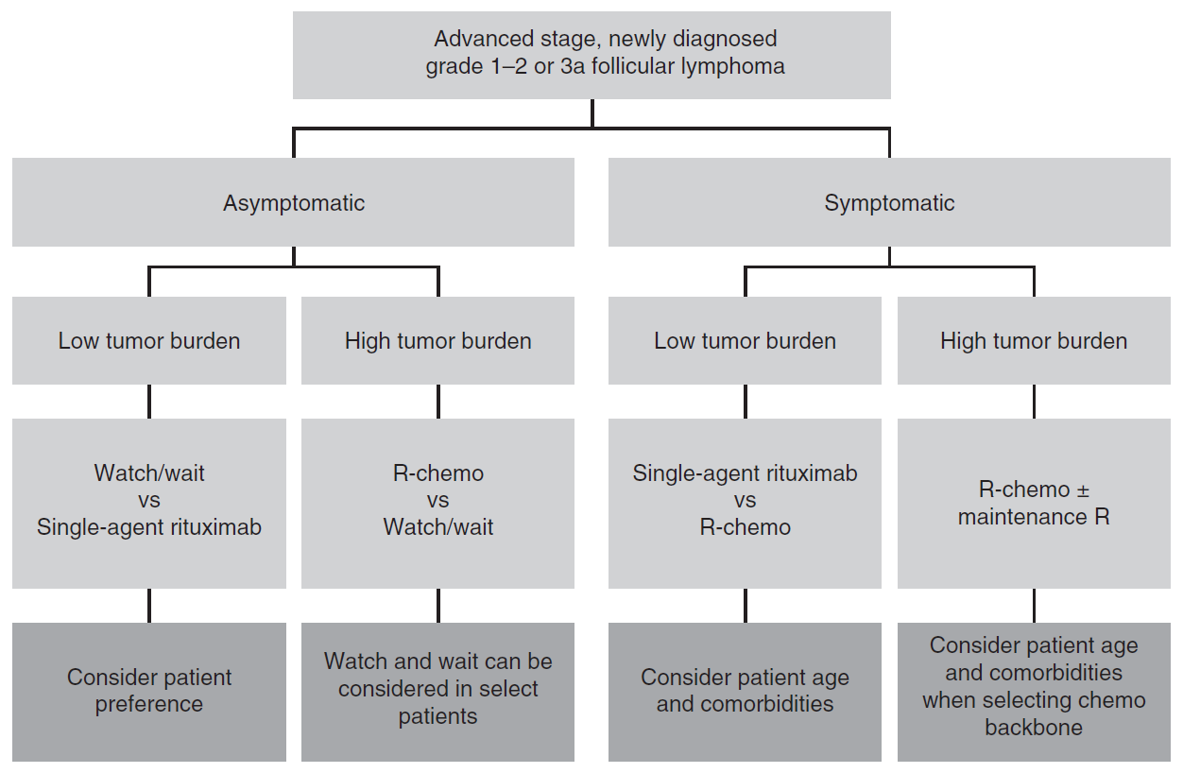
R-chemo consists of rituximab, the first CD20 antibody registered for B cell malignancies, and various chemotherapy regimens, see Table 1.
In the ESMO guidelines, no clear preference is expressed for R-bendamustine versus R-CHOP, although both are preferred to R-CVP (Dreyling et al. 2014; shown in Figure 2, below). According to US NCCN guidelines (v2.2016 (and v1.2017,)), R-benda is now the preferred first line treatment regimen for patients with FL requiring systemic treatment, followed by R-CHOP and then R-CVP.
Figure 2. ESMO guidelines, Follicular lymphoma treatment algorithm
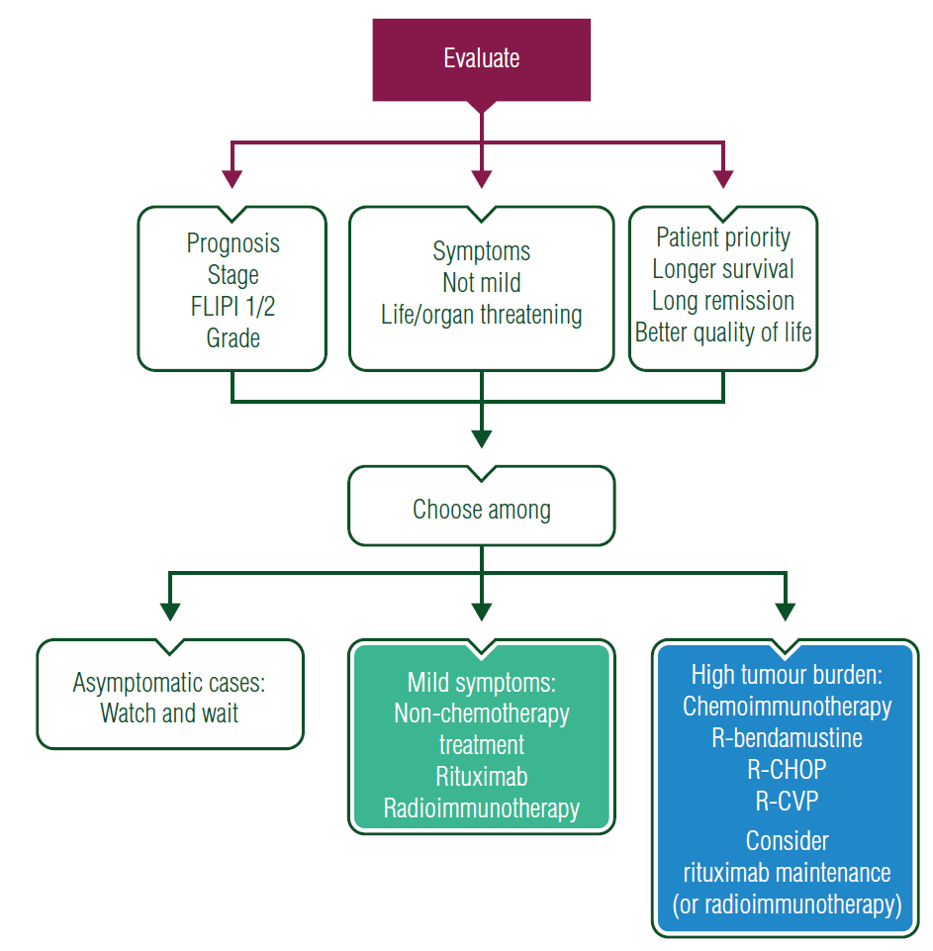
From Dreyling et al, 2014.

Table 1. Efficacy in key randomised Phase III studies of rituximab based induction treatment for patients with previously untreated advanced follicular lymphoma
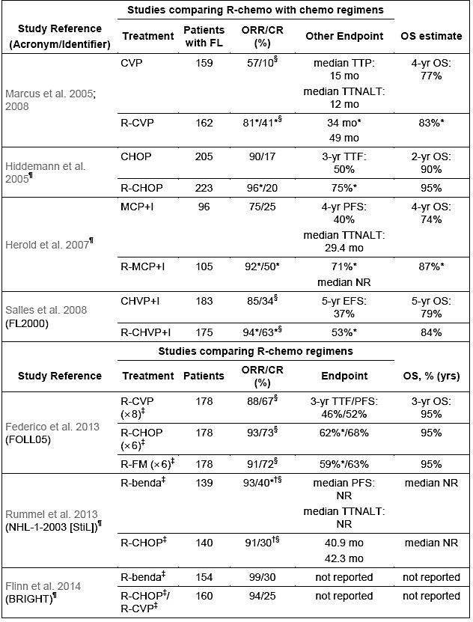
CHOP: cyclophosphamide, doxorubicin, vincristine and prednisone; CHVP: cyclophosphamide, doxorubicin, etoposide and prednisone; CR: complete response; CVP: cyclophosphamide, vincristine and prednisone; EFS: event-free survival; I: interferon; MCP: mitoxantrone, chlorambucil and prednisone; NR: not reached; ORR: overall response rate; OS: overall survival; PFS: progression-free survival; R: rituximab; TTF: time to treatment failure; TTNALT: time to new anti-lymphoma treatment; TTP: time to progression. † Response rates only shown in the publication for patients with iNHL and MCL enrolled in study. All other results shown for the StiL and BRIGHT studies, which enrolled patients with FL and other iNHL histologies, are for the subgroup of patients with FL. ‡ without use of rituximab maintenance therapy. § Unconfirmed complete response (CRu) included in CR rate for these studies (NHL-1-2003/STiL study used WHO response criteria – classification of CRu uncertain). ¶ studies enrolling FL grades 1 and 2 only. * Significant difference versus comparator reported in referenced publication (p < 0.05).

Clinical rationale
As in other mature B cell lymphomas, FL is characterised by the expression of a surface membrane antigen, CD20. CD20 is an attractive target for anti-lymphoma therapies being B cell specific, highly and stably expressed, exhibiting a low rate of internalisation, and not being present on hematopoietic stem cells. The concept of targeting CD20 as an effective anti-lymphoma strategy has been unequivocally established by clinical data for the anti-CD20 mAb rituximab, which has revolutionised the treatment of FL, as well as a range of other B cell malignancies and non-malignant disorders. Accumulating clinical data demonstrate clearly that combining rituximab with chemotherapy improves patients’ outcomes compared to chemotherapy or rituximab alone (see Table 1, above). The advantage of CD20 over other therapeutic targets, as outlined above, has led to the continued development of improved anti-CD20 mAbs as anti-lymphoma therapies. Obinutuzumab, a glycoengineered type II anti-CD20 mAb, binds the CD20 antigen in a different orientation to type I mAbs such has rituximab. Compared with rituximab, obinutuzumab possesses the following properties in vitro:
Properties due to type II binding mode:
- Higher induction of direct cell killing (via a non-apoptotic pathway)
- Lower degree of internalisation, following binding to CD20 (type II binding mode prevents interaction with FcγRIIb which promotes CD20 internalisation)
- Lower complement-dependent cytotoxicity (CDC) (type II binding mode prevents clustering of bound CD20 to lipid rafts).
Properties due to Fc-glycoengineering:
- Higher affinity binding to high and low affinity human FcγRIIIa expressed on effector cells (NK cells and macrophages)
- Higher antibody dependent cell mediated cytotoxicity (ADCC) and antibody dependent cellular cytotoxicity (ADCP) towards bound CD20 expressing target cells.
These in vitro properties translated into superior anti-lymphoma activity for obinutuzumab when compared directly to rituximab in a number of preclinical NHL xenograft models, including a model of FL involving subcutaneous inoculation of the human RL cell line. In addition, the antitumour effects of obinutuzumab in combination with chemotherapeutic agents were superior to the antitumour effects of rituximab when used in combination with these agents.

Formulation
There is no new biopharmaceutical information beyond that which was submitted in the initial license application for the CLL indication. No changes to the Summary of Biopharmaceutics and Analytical Methods have been made.

Guidance
No pre-submission advice was sought by the sponsor.
In the Dossier, the sponsor states ‘The submission is consistent with the lodged pre-submission planning form (PPF) and the subsequent planning letter’.
In the US the FDA agreed overall with the adequacy of the Study BO21223 trial design, the proposed treatment population and dosing regimen in both arms.
For the EMA, overall the feedback provided by the Committee for Medicinal Products for Human Use (CHMP)/Scientific Advice Working Party (SAWP) in October 2010 was in agreement with the sponsor’s proposed design of Study BO21223 with respect to target patient population, primary endpoint of investigator assessed PFS in FL patients (with a requirement to demonstrate positive independent review committee (IRC) assessed PFS for registration), clinical relevance of the targeted treatment effect, proposed dose and regimen of G-chemo and R-chemo (including induction and maintenance phases and choice of chemotherapies), and safety monitoring.

Contents of the clinical dossier

Scope of the clinical dossier
  - Scope of the clinical dossier
According to the sponsor:
The purpose of the current application is to support registration for the use of obinutuzumab in combination with standard of care chemotherapy, followed by obinutuzumab maintenance/monotherapy, for the treatment of patients with previously untreated FL.
- Reports of bioanalytical and analytical methods for human studies: 2 amended, previously presented reports. Amendments related to storage at -80○C.
- Population PK Study Report: Report 1072889; Population PK Analysis, Graphical Analysis and Exposure-Safety and Exposure-Efficacy Relationships, and Exposure Analysis of progression-free survival for obinutuzumab in patients with follicular lymphoma or marginal zone lymphoma (Study BO21223/GALLIUM) (data cut off date: 31 January, 2016).
- Study reports of controlled clinical studies pertinent to the claimed indication: Study BO21223 (GALLIUM) primary Clinical Study Report (Pivotal study data cut off date 31 January 2016).
- Study reports of uncontrolled clinical studies: Study BO21000 (GAUDI) Final CSR: Supportive efficacy and safety data are provided from Part 2 of the Phase Ib Study BO21000 in which additional cohorts of patients (n = 81) with previously untreated FL were treated with G-chemo.
- Other Study Reports: Update Clinical Study Report GA04753g (GADOLIN)
- Literature references
- A Clinical Overview, Summary of Clinical Pharmacology, Summary of Clinical Efficacy, Summary of Clinical Safety, literature references, and synopses of individual Studies.

Paediatric data
No paediatric data was provided.
The sponsor states that there is an agreed Paediatric Investigation Plan (PIP) in Europe.
The FDA has granted a waiver from having to submit a Paediatric Assessment in all subtypes of iNHL.

Good clinical practice
The sponsor states that for each individual study report supplied in this dosser, the study was conducted in accordance with the principles of GCP.

Evaluator’s commentary on the clinical dossier
The pivotal Study BO21223 is relevant and has the appropriate comparator; another CD20 monoclonal antibody.
The submission has the following problems, that added substantially to the time spent evaluating the application:
- The CSR of Study BO21223 was divided into Part A to H with no heading for each part and no proper heading for the majority of tables making it difficult to find tables of interest unless you had the link from the CSR.
- The references to the changes made to the Product information were unspecific usually just referring to the CSR of Study BO21223 as a whole (approximately 120,000 pages) or generally to a summary.
- Most tables looked like compiled raw data and as such were not well presented/easily readable.
- The evaluation of safety was primarily made in the FL population with the argument that this was the population for which the indication is sought, but the overall population (adding approximately 100 MZL patients to each arm containing approximately 600 FL patients) is the safety population in the Product Information. This added a lot of time spent finding the relevant overall population data in the 120,000 page CSR.

Pharmacokinetics

Studies providing pharmacokinetic information
Study BO21223 (GALLIUM) included PK sampling (approximately 23 samples per obinutuzumab treated patient) from a planned sample of 460 patients with FL or MZL who received obinutuzumab.
The analyses were performed, according to the PopPK Report 1072889:
- To update a previously developed population model (Report No. 1065581) that describes pharmacokinetics of obinutuzumab following intravenous administration in patients with CD20+ B cells malignancies
- To re-estimate population PK parameters of the model
- To determine post hoc estimates for derived PK parameters (steady state AUCτ, C_{max}, C_{trough}, terminal half-life and effective half-life)
- To re-estimate the inter-individual variability of model parameters in the patient population
- To re-estimate the residual variability of the dependent variable (obinutuzumab concentration) in the patient population
- To confirm and re-estimate the effects of previously identified covariate factors that influence disposition of obinutuzumab, and to estimate the effects of new covariates
- To determine whether the presence of anti-drug antibodies (ADAs) affects the pharmacokinetics of obinutuzumab following intravenous administration in patients with CD20+ B cells malignancies
- To perform model based simulations of clinically relevant dosing regimens.
The obinutuzumab PK data from Study BO21223 were added to the population PK dataset and the population PK model was updated. The presence of ADAs was also analysed in all patients receiving obinutuzumab.
The relationships between obinutuzumab exposure and safety and efficacy have also been explored graphically.
The data and results of the current population PK, exposure-efficacy and exposure-safety analyses in this summary are consistent with the findings presented in both the initial license application in CLL and the subsequent application for relapsed/refractory FL. The concentration time course of obinutuzumab is accurately described by a 2 compartment PK model with both time independent and time dependent clearance components, and with steady state PK parameters typical for an IgG like mAb.
  - Population pharmacokinetics
Data from 6 studies used in the prior analysis (16,301 concentrations from 961 patients from Studies GAO4753g, GAO4915g, BO20999, BO21000, BO21003, and BO21004/CLL11) were combined with data from Study BO21223 (7550 concentrations from 493 patients). Of the 1454 patients in the analysis, 343 (23.6%) had CLL, 961 (66.1%) had iNHL (including 814 with FL and 119 with MZL), 130 (8.9%) had with DLBCL, and 20 (1.4%) were diagnosed with MCL. Study BO21223 contributed data for 492 patients with iNHL: 408 patients with FL and 84 patients with MZL (a further patient in this study had CLL). Of these patients, 275 received bendamustine, 147 received CHOP, and 71 received CVP, as concomitant chemotherapy during the induction period. All patients with FL and MZL in Study BO21223 were previously untreated, while the majority of patients with FL or MZL from other studies who contributed to the PK analysis were previously treated.

PopPK Report 1072889
Study BO21223 (GALLIUM) included PK sampling (approximately 23 samples per obinutuzumab treated patient) from a planned sample of 460 patients with FL or MZL who received obinutuzumab. The obinutuzumab PK data from Study BO21223 were added to the population PK dataset and the population PK model was updated. Below are the conclusions from this update:
- The current population PK model of obinutuzumab (with the inclusion of data from Study BO21223) was consistent with a previously developed model in patients with CLL, FL, other iNHL subtypes, DLBCL, and MCL. The model confirmed the influence of previously identified covariates (body weight, sex, tumour size and serum albumin at Baseline, disease types (CLL, FL/DLBCL, MCL), iNHL subtypes (SLL), and concomitant chemotherapies (CHOP/CVP, bendamustine, FC)). The PK model also better quantified the influence of a MZL diagnosis, compared to FL, with a slightly higher time dependent clearance and a similar linear clearance. Doxorubicin (administered as part of CHOP regimen) had no influence on obinutuzumab PK.
- As is typical for mAbs, obinutuzumab exposure is lower in patients with high body weight (following Q3W regimen, mean AUCτ and C_{trough} at Cycle 8 of induction and Cycle 4 of maintenance is 31% to 39% higher for WT < 60 kg and 28% to 37% lower for WT > 90 kg compared to patients weighing 60 to 90 kg), and is also lower in male patients (31% to 43% lower in male FL patients compared to females). As most of the targeted agents, obinutuzumab exposure depends on tumour burden and therefore decreases in patients with high tumour size at Baseline (following Q3W regimen in FL patients, mean AUCτ and C_{trough} at Cycle 8 of induction and Cycle 4 of maintenance is 5% to 7% higher for BSIZ < 2777 mm² and 1% to 2% lower for BSIZ > 8998 mm², compared to BSIZ of 2777 to 8998 mm²).
- The analysis of obinutuzumab exposure-safety relationships in FL and MZL patients from Study BO21223 demonstrated absence of relationships between exposure and safety parameters.
- There was no apparent relationship between obinutuzumab exposure and efficacy parameters for patients with FL receiving bendamustine in Study BO21223.
- The analysis of obinutuzumab exposure-efficacy relationships for patients with FL receiving CHOP or CVP in Study BO21223 suggested that an increase in exposure might lead to an improvement in efficacy parameters mainly in patients with high body weight and patients with high tumour size at Baseline. However, these exploratory subgroup analyses should be interpreted with caution regarding causality and need to be confirmed by other data sources. As new data are collected they are being analysed to explore the impact of covariates and prognostic indicators on patient outcomes. This includes investigations into whether there are patient subpopulations that would benefit from dose adjustment.
- There was no apparent relationship between obinutuzumab exposure and efficacy parameters for patients with MZL in Study BO21223.

Evaluator’s overall conclusions on pharmacokinetics
The current population PK model (with the data from Phase III Study BO21223) is consistent with the previously evaluated model and subsequently there is no change to the Product Information.

Pharmacodynamics

Study BO21223: B cell depletion and B cell recovery
B cell depletion was defined as a CD19⁺ cell count of < 0.07 x 10⁹/L occurring after at least one dose of study drug has been administered. Time to depletion was defined as the number of days between the first intake of study drug and the date of the first depletion.
B cell recovery was defined as a CD19⁺ cell count of ≥ 0.07 x 10⁹/L, for a patient with a previous CD19⁺ cell count indicating B cell depletion (CD19⁺ measurement < 0.07 x 10⁹/L). B cell recovery was considered possible only after the patient had completed study treatment. The time to B cell recovery was defined as the time from B cell depletion until B cell recovery.
Almost all patients who had a B cell result reported showed B cell depletion at the last antibody administration (LAA)
Overall, 445 patients (74.5% of the safety population; 452 patients had a B cell result reported) in the R-chemo arm had B cell depletion at the LAA. 454 patients (76.3% of the safety population; 457 patients had a B cell result reported) in the G-chemo arm had B cell depletion at the LAA.
A robust analysis of recovery cannot be performed due to the low number of patients who had been followed for a sufficient duration as of the time of data cut off. However at the time of the clinical data cut off, ≤ 10% of the patients reporting B cell depletion during treatment in each treatment arm had recovered.
Within 6 to 12 months of follow-up after LAA, of 190 patients in the R-chemo arm with B cell assessment done 24 patients had recovered (one patient with PD and 23 patients without PD), and of 190 patients in the G-chemo arm with B cell assessment done three patients had recovered (all without PD).
Comment: The numbers are small but B cell recovery was clearly slower in the G-chemo arm.

Dosage selection for the pivotal studies
The obinutuzumab dosage for previously untreated follicular lymphoma is identical to the approved dosage in relapsed/refractory follicular lymphoma (induction and maintenance).

Clinical efficacy

Studies providing evaluable efficacy data

Study BO21223 (GALLIUM)
This was a multicentre, Phase III, open label, randomised study in previously untreated patients with advanced indolent non-Hodgkin’s lymphoma evaluating the benefit of obinutuzumab plus chemotherapy (G-chemo) compared with rituximab plus chemotherapy (R-chemo) followed by obinutuzumab or rituximab maintenance therapy in responders.
This is the pivotal study to support the proposed new indication for obinutuzumab (in previously untreated FL).

Study BO21000 (GAUDI)
This was an open label, multicentre, randomised, Phase Ib study to investigate the safety and efficacy of obinutuzumab given in combination with CHOP, FC or bendamustine chemotherapy in patients with CD20+ B cell follicular non-Hodgkin’s lymphoma.
Part 2, which is the one included in the Dossier, is part of this Phase Ib study in which a cohort of patients (n = 81) with previously untreated FL were treated with G-chemo. The primary objective was the safety of obinutuzumab in combination with CHOP or bendamustine.

Pivotal or main efficacy studies

Study BO21223 (GALLIUM)

Study design, objectives, locations and dates
Study BO21223 (GALLIUM) is a Phase III, open label, multicentre, randomised study to investigate the efficacy and safety of G-chemo followed by G-maintenance therapy for responders (CR or PR), compared to R-chemo followed by R-maintenance therapy for responders, in patients with previously untreated advanced iNHL, as shown below in Figure 3. The overall population consisted primarily of patients with previously untreated FL (1202/1401, 85.8%), of which 601 patients were randomised to the R-chemo arm, and 601 patients were randomised to the G-chemo arm.
Comment: 14% of the overall study population consisted of MZL patients but the primary objective of Study BO21223 was investigator evaluated PFS for the FL population and that is also the population for which the extended indication is sought.
Figure 3. Study BO21223 design
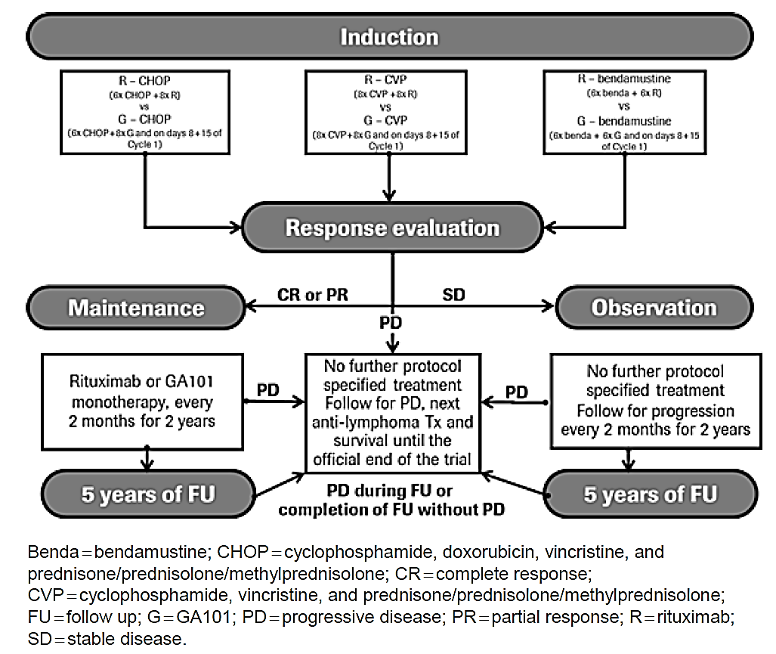
The primary objective of the study was:
- To evaluate the efficacy of obinutuzumab plus chemotherapy (G-chemo) followed by obinutuzumab maintenance (G-maintenance) therapy compared with rituximab plus chemotherapy (R-chemo) followed by rituximab maintenance (R-maintenance) therapy in patients with previously untreated advanced FL, as measured by investigator-assessed PFS.
The secondary objectives of the study were:
- To evaluate and compare Independent Review Committee (IRC) assessed PFS between the 2 arms. In the US, IRC assessed PFS will be the basis of regulatory decisions.
- To evaluate and compare overall response (OR) and complete response (CR) after the end of induction treatment, as assessed by the investigator, between the 2 arms, with and without ¹⁸F-fluorodeoxyglucose positron emission tomography (FDG-PET).
- To evaluate and compare OR and CR after the end of induction treatment, as assessed by the IRC, between the 2 arms, with and without FDG-PET.
- To evaluate and compare overall survival (OS), event-free survival (EFS), disease free survival (DFS), duration of response (DOR), and time to next anti-lymphoma treatment (TTNLT) between the 2 arms. EFS, DFS, and DOR are based on investigator assessment.
- To evaluate and compare the safety profiles between the 2 arms during induction and maintenance.
- To assess patient-reported outcomes (PROs) in both arms.
Patients were recruited from 177 investigational sites in 18 countries and the highest recruiting countries were United Kingdom (293 patients), Germany (237 patients), Canada (138 patients), Australia (136 patients), and Japan (129 patients).
Prior to the initiation of the study, each site chose one of three chemotherapy regimens (CHOP, CVP, or bendamustine) that was considered to be the standard of care for follicular lymphoma; all patients with follicular lymphoma at that site received the chosen chemotherapy regimen for the duration of the study (a site could switch to another regimen if new scientific data became available and after sponsor approval). For non-follicular NHL, the investigator had the option of choosing one of the three chemotherapy regimens (CHOP, CVP, or bendamustine) for each patient. All patients were then randomised to rituximab plus chemotherapy or obinutuzumab plus chemotherapy.
Important dates included:
- First patient enrolled: 6 July 2011
- Last patient enrolled: 5 June 2014
- Data cut off: 31 January 2016

Inclusion and exclusion criteria
Below are the key criteria.

Key inclusion criteria
- Histologically documented, CD20 positive, indolent B cell NHL consisting of one of the following: follicular lymphoma (Grades 1 to 3a), splenic MZL, nodal MZL, or extranodal MZL
- Stage III or IV disease or Stage II bulky disease (bulky disease is defined as a tumour diameter of ≥ 7 cm)
- At least one bi-dimensionally measurable lesion (> 2 cm in its largest dimension by CT scan or MRI).

Key exclusion criteria
- For patients with FL: prior treatment for NHL by chemotherapy, immunotherapy, or radiotherapy
- Regular treatment with corticosteroids during the 4 weeks prior to the start of Cycle 1, unless administered for indications other than NHL at a dose equivalent to ≤ 30 mg/day prednisone
- For patients who will be receiving CHOP: LVEF < 50% by MUGA scan or echocardiogram.

Study treatments

Rituximab
In the R-chemo arm, 6 to 8 doses of rituximab at 375 mg/m² were administered by IV infusion with the accompanying chemotherapy regimen during induction.
- R-CHOP: Rituximab was administered on Day 1 of Cycles 1 to 8 (21 day cycles). CHOP was administered on Day 1, with prednisone/prednisolone/methylprednisolone also administered on Days 2 to 5, of Cycles 1 to 6.
- R-CVP: Rituximab was administered on Day 1 of Cycles 1 to 8 (21 day cycles). CVP was administered on Day 1, with prednisone/prednisolone/methylprednisolone also administered on Days 2 to 5, of Cycles 1 to 8.
- R-bendamustine: Rituximab was administered on Day 1 of Cycles 1 to 6 (28 day cycles). Bendamustine was administered on Days 1 and 2 of Cycles 1 to 6, with prednisone/prednisolone/methylprednisolone also administered on Day 1 of Cycle 1.
Patients randomised to receive R-chemo who achieved a CR or PR at the end of induction therapy continued to receive R-maintenance at 375 mg/m² every 2 months until disease progression, or for 2 years (see Figure 3, above) whichever came first.

Obinutuzumab
In the G-chemo arm, eight to ten doses of obinutuzumab at 1000 mg were administered by IV infusion with the accompanying chemotherapy regimen during induction.
- G-CHOP: Obinutuzumab was administered on Days 1, 8, and 15 of Cycle 1 and on Day 1 of Cycles 2 to 8 (21 day cycles). CHOP was administered on Day 1, with prednisone/prednisolone/methylprednisolone also administered on Days 2 to 5 of Cycles 1 to 6.
- G-CVP: Obinutuzumab was administered on Days 1, 8, and 15 of Cycle 1 and on Day 1 of Cycles 2 to 8 (21 day cycles). CVP was administered on Day 1, with prednisone/prednisolone/methylprednisolone also administered on Days 2 to 5 of Cycles 1 to 8.
- G-bendamustine: Obinutuzumab was administered on Days 1, 8, and 15 of Cycle 1 and on Day 1 of Cycles 2 to 6 (28 day cycles). Bendamustine was administered on Days 1 and 2 of Cycles 1 to 6, with prednisone/prednisolone/methylprednisolone administered on Day 1 of Cycle 1.
Patients randomised to receive G-chemo who achieved a CR or PR at the end of induction therapy continued to receive G-maintenance at 1000 mg every 2 months until disease progression, or for 2 years whichever came first (see Figure 3, above).
The dose of obinutuzumab (induction and maintenance) is unchanged from the currently recommended dose in previously treated FL.

Efficacy variables and outcomes
The primary efficacy outcome/endpoint was PFS as assessed by the investigator according to a modified version of the Revised Response Criteria for Malignant Lymphoma (Cheson et al., 2007). The key ‘modification’ made to the 2007 criteria was to allow response assessments to be made using CT scans only (without PET). PFS is defined as the time from randomisation to the first occurrence of progression, relapse, or death from any cause, where symptomatic deterioration and disease transformation are counted as a progression throughout. PFS for patients without disease progression, relapse, or death will be censored at the time of the last tumour assessment or, if no tumour assessments were performed after the baseline visit, on the date of randomisation.
Important secondary efficacy outcomes included overall response (OR) and complete response (CR) after the end of induction treatment, as assessed by the investigator and IRC, between the 2 arms with and without FDG-PET. Furthermore, to assess overall survival (OS), event-free survival (EFS), disease-free survival (DFS), duration of response (DOR), and time to next anti-lymphoma treatment (TTNLT) between the 2 arms. EFS, DFS, and DOR are based on investigator assessment.

Schedule of assessments
Patients were assessed for response and progression once during induction therapy and at EOI. Patients who received maintenance therapy or entered observation were followed clinically every 2 months for 2 years (with CT scans every 4 months for the first year and then every 6 months for the second year) or until disease progression or patient discontinuation from the study, whichever occurred first.
In addition, bone marrow trephines were mandatory at screening for all patients with FL and, if positive at screening, for those with a CR at EOI. Bone marrow aspirates were also required at screening and subsequently in patients achieving a CR or PR for evaluation of minimal residual disease.
¹⁸F fluorodeoxyglucose PET scans were performed at screening and at induction completion/end of treatment (EOT) visit (only if screening PET was positive) in sites with access to a PET scanner. INV and IRC assessed response with and without PET data were evaluated in the study but, since PET scans were not available for all patients, results without inclusion of PET were the basis for the main efficacy endpoints in the study.

Tumour and response evaluation
- All measurable disease must be documented at Baseline and re-assessed within 14 days prior to each subsequent study visit. Response assessments will be performed by the investigator, based on physical examinations, CT/MRI scans, haematology, laboratory results, and bone marrow examinations, through use of Revised Response Criteria for Malignant Lymphoma (Cheson et al. 2007). Response evaluation by the investigator shall be done with and without FDG-PET results or the PET portion of a combined PET-CT in the eCRF.
- CT scans (with contrast) should include chest, abdomen, and pelvis scans; CT scans of the neck should be included if clinically indicated (that is, if evidence of disease on physical examination) and must be followed throughout the trial if there is disease involvement at Baseline. MRIs of the chest, abdomen, and pelvis with a non-contrast CT scan of the chest may be used in patients for whom CT scans with contrast are contraindicated (that is, patients with contrast allergy or impaired renal clearance). If MRI is used at screening, then MRI should be used throughout the study (same method during the entire study). In addition, the CT portion of a combined FDG-PET/CT scan may be used only if performed with contrast and collected with resolution sufficient to allow accurate and consistent comparison of target lesion measurements with subsequent CT scans. Any time the investigator suspects disease progression, a full tumour assessment must be performed, including a CT scan (limited to areas of prior involvement if required by local authorities).
  - In the first 170 patients with follicular lymphoma, an FDG-PET is mandatory where a PET scanner is available. This may require specific approval in some countries. In such instances, FDG-PET becomes mandatory only after necessary approvals have been obtained.
- PET scans are to be performed at screening and at induction completion/end of treatment visit (only if screening PET was positive) within 6 to 8 weeks after Day 1 of the last cycle, within 4 to 8 weeks (in case of early termination due to adverse event), or within 2 to 8 weeks after last dose (in case of early termination due to clinical disease progression).
- In the overall study population, FDG-PET remains optional upon investigator’s discretion.
- If the screening PET scan is negative, subsequent FDG-PET scans need not be performed. Any time the investigator suspects disease progression on the basis of PET scan results, a full tumour assessment must be performed, including a CT scan (or MRI scan if CT scan is contraindicated), limited to areas of prior involvement (if required by local authorities to limit scans). FDG-PET standardised uptake values will be collected.
- FDG-PET scan results will be incorporated in an exploratory analysis in a separate response assessment based on physical examinations, relevant clinical information, CT or MRI scans, and bone marrow examinations by the investigator and the IRC.
- Bone marrow examinations should include a biopsy for morphology, an aspirate for local haematology (optional, if part of standard of care at site), and an aspirate for BCL2/IgH (= MRD) determination. Bone marrow examinations are required at screening for staging purposes in all patients (CR definition requires clearing of a previously infiltrated bone marrow) and in all patients with follicular lymphoma also for determination of BCL2/IgH (MRD) baseline levels.
- If there was bone marrow infiltration at screening, then a subsequent bone marrow biopsy (trephine) at the induction completion visit is required for clinical response evaluation for all patients who may have achieved a CR. In patients with a PR and continued bone marrow involvement, a subsequent bone marrow examination may be required to confirm a CR at a later time point. An additional bone marrow aspirate may be done if that is standard of care at the site.
- If bone marrow involvement was diagnosed by morphology at screening, a subsequent bone marrow aspirate for BCL2/IgH (MRD) is required at the induction completion/end of treatment visit for all patients with follicular lymphoma who achieve a CR or PR (all responders). If bone marrow was free of lymphoma by morphology at screening, a subsequent bone marrow aspirate for BCL2/IgH (MRD) at the induction completion/end of treatment visit is optional but strongly recommended in responders (CR + PR). This recommendation is based on the observation that, at screening, bone marrow involvement is detectable on the level of minimal residual disease in the large majority of patients even if it appears to be negative by morphology.
- Any additional (unscheduled) bone marrow examinations performed during the study will be at the discretion of the investigator.

Patient-reported outcomes
The PRO questionnaires (FACT-Lym and EQ-5D) should be self-administered at the investigational site. Study personnel should review all questionnaires for completeness before the patient leaves the investigational site. It is important that the questionnaires be administered before any other study procedure is performed during that study visit.

Required exploratory biomarkers
These included:
- Fcγ receptor polymorphisms (only in fully eligible patients)
- Tumour tissue sample at time of progression/transformation
- A tumour sample will be collected at time of progression from patients who undergo such a biopsy as part of the standard of care at their institution for central pathology review. A biopsy at the time of progression is not mandatory.
- Bone marrow aspirate for BCL2/IgH (MRD) analysis at screening (follicular lymphoma patients only) and at induction completion/early termination (only responders (CR and PR) in whom bone marrow involvement was diagnosed by morphology at screening).
- For each required bone marrow examination, a bone marrow aspirate is required for the analysis of clonal BCL2/IgH rearrangement (as a potential marker of tumour burden).
- Peripheral blood sample for BCL2/IgH (MRD) analysis in all patients with follicular lymphoma at screening, before Cycle 4 Day 1 bendamustine) or Cycle 5 Day 1 (CHOP/CVP), at induction completion/end of treatment, maintenance or observation Months 4, 8, 12, 18, at maintenance or observation completion/end of treatment visit, and during follow up at Months 30, 36, 42, 48, 60, and 72.

Randomisation and blinding methods
Patients were randomised in a 1:1 fashion through an interactive voice response system (IVRS) to the R-chemo arm or the G-chemo arm. Randomisation occurred separately for the patients with FL and MZL. Randomisation was stratified for the following factors:
- Chemotherapy regimen (CHOP, CVP, or bendamustine)
- FLIPI (for FL: low, intermediate, or high)/IPI (for MZL: low/low-intermediate or high-intermediate/high) group (see the protocol for further details)
- Geographic region (Western Europe, Eastern Europe, South and Central America, North America, other).
This was an open-label study; however, the IRC was blinded to treatment assignment throughout. Clinical scientists from the MAH’s study team reviewed eCRF data for ambiguous, contradictory and/or potentially erroneous data entry as part of routine data cleaning. For these activities, they were not blinded to treatment allocation on an individual patient basis. However, no aggregated efficacy or safety analyses by treatment arm were conducted by the sponsor using unblinded data before the IDMC released the data following the interim analysis.

Analysis populations
The primary efficacy analysis population is the intent-to-treat follicular lymphoma population (FL ITT, 1202 patients, 601 in each arm), defined as all randomised patients with follicular histology. Efficacy analyses were conducted according to the intent to treat (ITT) principle, where patients were grouped according to their randomised treatment arm regardless of what treatments were actually received.
All primary and secondary efficacy analyses were performed on the FL ITT.
The safety analysis population included all patients who received any amount of study drug (obinutuzumab, rituximab, or chemotherapy (CHOP, CVP, or bendamustine)), and patients were analysed according to the treatment received (that is, a patient who received obinutuzumab at least once for any reason was analysed under the G-chemo treatment arm; if only chemotherapy and/or rituximab was received, the patient was analysed under the R-chemo treatment arm).
The ‘PET evaluable’ subset contains all patients who have an answer of ‘Yes’ to question ‘Were there any PET-avid lesions representing lymphoma?’ on PET scan eCRF at Baseline. 12 patients had at least one PET scan although they did not have ethics committee approval to do so. Therefore, these patients were omitted from the PET evaluable subset and are not part of any PET analysis.
      - Sample size
Planned: 1200 patients with FL and 200 patients with marginal zone lymphoma (MZL).
Enrolled and included in primary analysis: 1401 patients of which 1202 patients had FL.

Determination of sample size
The primary analysis of the study tested the equality of PFS distributions in the R-chemo and G-chemo arms the following null hypothesis with use of a 2 sided stratified log rank test at an overall 5% significance level:
- Equality of PFS distributions in the G-chemo and R-chemo arms in the FL population by investigator assessment:
  - H₀: PFS_{G-chemo} = PFS_{R-chemo} versus H₁: S_{G-chemo} ≠ S_{R-chemo}
- In the FL subset, estimates of the number of events required to demonstrate efficacy with respect to PFS were made on the basis of the following assumptions:
  - 2 sided log-rank test at the 0.05 level of significance.
  - Powered for the follicular lymphoma population.
  - Eighty percent power to detect a hazard ratio for obinutuzumab combined chemotherapy versus rituximab combined chemotherapy of 0.74, corresponding to an improvement in 3 year PFS from 70.7% to 77.4% or in median PFS from 6 to 8.1 years (35%). Estimates of median PFS are not likely to be reached in either study arm.
  - Exponential distribution of PFS.
  - An annual dropout rate of 2.5%.
Performance of interim analyses on PFS: one futility analysis when approximately 30% of the total (investigator assessed) PFS events had occurred (second Interim (futility), and one efficacy analysis (third Interim (efficacy); see Table 2, below) when approximately 67% of the total (investigator assessed) PFS events had occurred. Efficacy and (non-binding) futility boundaries were calculated using the Lan-DeMets approximation to the O’Brien-Fleming boundary shape.
In addition, a futility analysis on the basis of CR rates at the end of induction (first Interim (futility); see Table 2, below), as determined by CT (or MRI, but not PET), will be performed on the first 170 randomised follicular lymphoma patients.
With the above assumptions, 370 PFS events are required to achieve 80% power for the primary analysis.
Table 2. Study BO21223 Timing of analyses: primary efficacy and futility
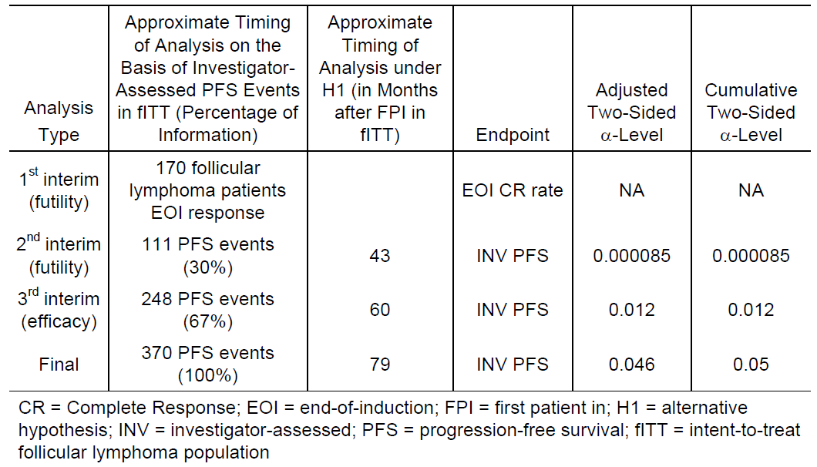

Statistical methods
The primary analysis of the study will test the equality of PFS distributions in the obinutuzumab plus chemotherapy (G-Chemo) and rituximab plus chemotherapy (R-Chemo) arms, as follows:
- H₀: PFS_{G-chemo} = PFS_{R-chemo} versus H₁: S_{G-chemo} ≠ S_{R-chemo}
Treatment comparison will be made using a 2 sided stratified log-rank test (0.05 significance level) stratified by chemotherapy regimen (CHOP, CVP, or bendamustine) and FLIPI risk group (low, intermediate, or high). Kaplan-Meier methodology will be used to estimate PFS distribution for each treatment arm. The Kaplan-Meier curve will provide a visual description of the differences across treatment arms. Estimates of the treatment effect will be expressed as hazard ratios through use of a stratified Cox proportional hazards analysis, including 95% confidence limits.
Median PFS is not expected to be reached in this study; hence, the 3 year and 4 year rates will be used to describe PFS in addition to the hazard ratio.
The following sensitivity analyses for PFS will also be performed:
- An unstratified log-rank test will be performed.
- A re-randomisation test of the primary endpoint will be performed to assess the sensitivity of the stratified log-rank test to the dynamic randomisation procedure.
- The impact of loss to follow up will be assessed by a worst case analysis that assigns event outcomes to patients who were lost prior to disease progression in the obinutuzumab arm at the next scheduled disease assessment date and censored outcomes to patients in the rituximab arm at the last disease assessment date.
- PFS analyses will be performed with censoring at the initiation of non−protocol specified anti-lymphoma therapy to assess potential confounding of the treatment effect estimates by subsequent therapy.
- PFS analyses will be performed with censoring of patients who died more than 6 months after their last tumour assessment and showed no sign of progression (that is, at the last available tumour assessment).
- A multivariate sensitivity analysis of PFS will be performed using Cox proportional hazards regression to assess the treatment effect after adjustment for potential prognostic factors.

Participant flow
A total of 1606 patients were screened for entry into this study. There were 205 screen failures, mainly due to not meeting the inclusion/exclusion criteria. Screen failure data is not recorded in the clinical database.
A total of 1401 patients were randomised in the study (699 patients to the R-chemo arm and 702 patients to the G-chemo arm). The first patient was randomised on 6 July 2011 and the last patient on 5 February, 2014.
A total of 1202 follicular lymphoma patients were randomised in the study (601 patients to the R-chemo arm and 601 patients to the G-chemo arm).
Of the 1202 patients randomised, 1192 received at least one dose of study medication. Ten patients withdrew from the study after randomisation but prior to receiving study treatment. Reasons for not being treated included: withdrawal by subject (5 patients), protocol violation (3 patients), physician decision (1 patient) and adverse event (1 patient).
In total, 1108/1202 patients (92.2%) completed induction treatment. There were 84 withdrawals from the study during the induction phase (see also Section 4.2). The percentage of withdrawals during induction was 7.8% (47/601 patients) in the R-chemo arm and 6.2% in the G-chemo arm (37/601 patients). At the time of the clinical cut off, 551/601 (91.7%) and 557/601 (92.7%) patients in R-chemo and G-chemo arms, respectively, had completed the induction phase.
Overall, 1066/1202 patients (88.7%) received at least one dose of rituximab or obinutuzumab in the maintenance phase (527/601 patients (87.7%) in the R-chemo arm and 539/601 patients (89.7%) in the G-chemo arm). Only patients with CR or PR at the end of induction were to enter the maintenance phase. However, 3 patients in each arm who had stable disease and 1 patient in each arm who had progressive disease at the end of induction entered the maintenance phase. At the time of the clinical cut off, 341/601 (56.7%) and 361/601 (60.1%) patients in R-chemo and G-chemo arms, respectively, had completed the maintenance phase. A further 114/1202 patients (9.5%) were still on study in the maintenance phase, and 250/1202 patients (20.8%) had discontinued from the study during the maintenance phase in the follicular lymphoma population (see also Section 4.2 above).

Analysis sets
- The FL ITT population was the primary population for efficacy analyses (N = 1202; R-chemo: 601 versus G-chemo: 601Error! Reference source not found.).
The safety populations (relevant to this application; MZL as a separate entity is not presented here) on which the safety analyses are based are as follows:
- FL safety population (N = 1192; R-chemo: 597 versus G-chemo: 595). Of 1202 randomised patients with FL, 10 patients (4 patients in the R-chemo arm and six patients in the G-chemo arm) did not receive any amount of study drug (obinutuzumab, rituximab, or chemotherapy (CHOP, CVP, or bendamustine)) as induction treatment and therefore, per protocol and definition, were excluded from the FL safety population. One patient with FL randomised to the R-chemo arm received one dose of obinutuzumab in error (1000 mg obinutuzumab on Day 1, Cycle 5) and for the purposes of the safety analyses presented in Section 8 (below), is included in the G-chemo arm.
- Overall safety population (indolent NHL population, N = 1390; R-chemo: 692 (FL: 597, MZL: 93; other: 2) versus G-chemo: 698 (FL: 595; MZL: 101; other: 2)).
The third interim analysis (efficacy) was planned after 67% of the events had occurred (that is, approximately 248 events (see Table 2, above)) and all patients had been enrolled and followed for an estimated minimum of 11 months. The clinical cut off date for the third interim analysis was 31 January 2016. This analysis is now referred to as the primary analysis. The IDMC reviewed the data on 20 May 2016 and recommended that the study be fully analysed at this time, as the primary endpoint had been met.
Comment: The IDMC stopped the trial for efficacy but also had comments and a request to the sponsor (see Figure 4, below).
Figure 4. IDMC recommendation 20 May 2016
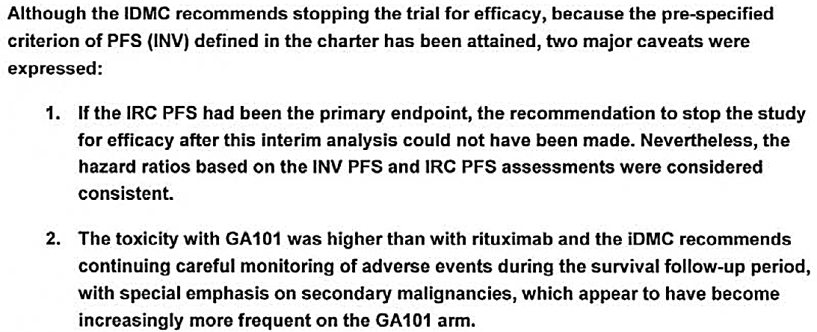
Question 1: Participant flow: There is a discrepancy related to the date of the last enrolled patient between the front page of the clinical study report and Section 4.1.1 in the CSR; 5 June 2014 versus 5 February 2014. What is the correct date?

Major protocol violations/deviations
Overall, 828/1401 patients (59.1%) had at least one protocol deviation.
Comment: Protocol deviations were equally distributed between the 2 arms.

Baseline data
At randomisation, patients were stratified by FLIPI (low, intermediate and high), chemotherapy regimen (CHOP, CVP, bendamustine) and geographic region (Eastern Europe, Western Europe, North America, Asia, Other).
There were no imbalances in stratification factors between the 2 arms based on the eCRF derived data, as shown in Table 3, below.

Table 3. Study BO21223 Stratification factors (FL population)
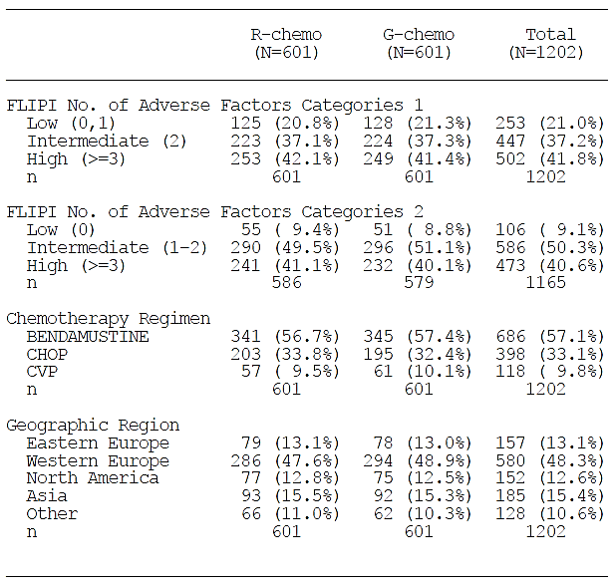
In the FL population, the treatment arms were in general balanced with respect to demographic factors. The median age of patients was 59.0 years (range: 23 to 88 years). The majority of patients (68.7%) were less than 65 years of age. The G-chemo arm had proportionally more patients 60 to 69 years old than the R-chemo arm (34.3% versus 28.6%, respectively).
The 2 treatment arms were well balanced with respect to baseline disease characteristics. The overall median time from first diagnosis to randomisation was 1.5 months (range: 0.0 to 168.1 months). The majority of patients had an ECOG performance status of 0 to 1 (96.8%). Overall, 56.5% of patients had Ann Arbor Stage IV disease at study entry. The greatest proportion of patients comprised intermediate and high risk FLIPI (37.2% and 41.8% respectively) and FLIPI-2 groups (50.3% and 40.6%, respectively). Nearly half (43.8%) of patients had a nodal or extra-nodal mass over 7 cm in diameter. There was extra-nodal involvement in 65.6% of patients. Overall, 42.3% of patients had 6 indicator lesions at Baseline, and 8.9% of patients had liver palpable at Baseline.
Comment: There was approximately the same number of patients who were ≥ 65 years of age in the 2 arms (187 and 189).
Baseline data were equal between the 2 study groups in FL. Patients with an ECOG = 0 or 1 and a median age at diagnosis of 59 years of age are not representative of the FL population, though.

Results for the primary efficacy outcome
A statistically significant and clinically meaningful improvement in the primary endpoint of PFS in the FL population as assessed by Investigator was demonstrated. This occurred at a protocol specified interim analysis of efficacy after 245/370 (66%) of events required for the final analysis had occurred as shown below in Table 4. Treatment with G-chemo resulted in a clinically meaningful and statistically significant reduction by 34% in the risk of an Investigator assessed PFS event (disease progression/relapse or death) compared with R-chemo (stratified HR 0.66 (95% CI: 0.51, 0.85); p-value = 0.0012, stratified log-rank test). The p-value of the investigator assessed PFS was smaller than the pre-specified interim boundary significance level of 0.012.
The Kaplan–Meier estimated median PFS times were not reached for either arm. On the basis of Kaplan–Meier estimates, 73.3% (95% CI: 68.8, 77.2) of patients in the R-chemo arm and 80.0% (95% CI: 75.9, 83.6) of patients in the G-chemo arm were progression free at 3 years (see Table 4, below). Kaplan-Meier estimates are not considered to be reliable beyond the time point when too few patients are at risk (that is, at least 20% according to Pocock et al. 2002). After 3 years, 160 patients (26.6%) in the R-chemo arm, and 168 patients (28.0%) in the G-chemo were at risk of a PFS event, as shown below in Figure 5.

Table 4. Study BO21223 overview of efficacy: PFS (INV assessed endpoints)
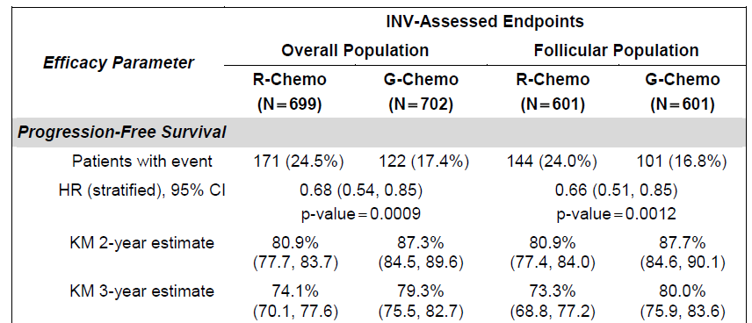
Figure 5. Study BO21223 Kaplan-Meier plot of PFS by investigator assessment (FL ITT population)
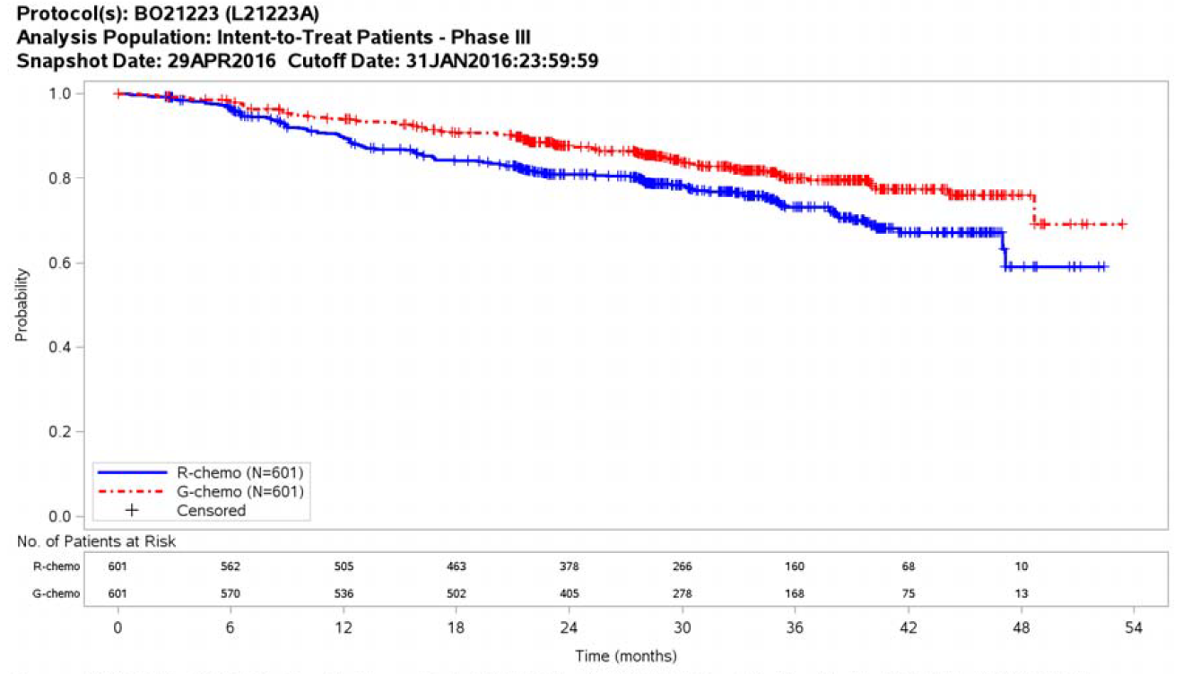

Results for secondary efficacy outcomes

PFS as assessed by IRC (FL ITT population)
At the time of the analysis, 218/1202 patients (18.1%) had experienced disease progression according to the IRC’s assessment, or death (see Table 5, below). More patients in the R-chemo arm experienced a PFS event than in the G-chemo arm (125 patients versus 93 patients, 20.8% versus 15.5%). Disease progression was recorded for 106 patients in the R-chemo arm and 69 patients in the G-chemo arm (17.6% versus 11.5%). There were 19 deaths in the R-chemo arm and 24 deaths in the G-chemo arm before IRC assessed progression.
Table 5. Study BO21223 overview of efficacy: PFS (IRC assessed endpoints)
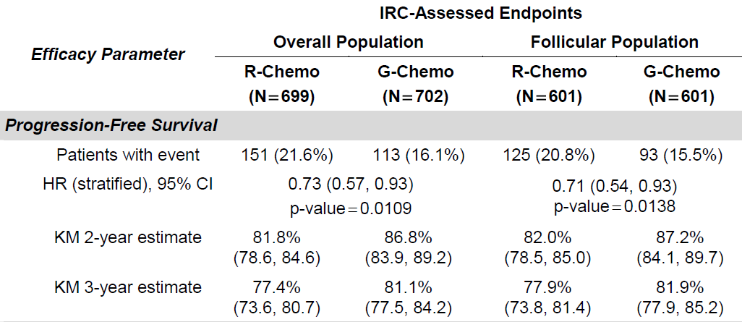
Question 2: Study BO21223 CSR; There are more deaths but fewer events in the IRS assessed data compared to the investigator assessed data. The cut-off date for the study is the same. What is the explanation for the disparity in death numbers?
The secondary (investigator assessed) endpoints were tested following a fixed sequence procedure in the following hierarchical order: PFS in the overall population without PET, CR rate at EOI without PET in FL and in overall population, OS in FL and in overall population, and ORR at EOI without PET in FL and overall population (see Table 6, below). The remaining secondary endpoints (including EFS, TTNLT, and DFS) were not adjusted for multiple testing. Based on this fixed sequence, only the first parameter (PFS in the overall population) is considered statistically significant since the next parameter in the sequence (CR rate without PET at the EOI in the FL population) did not meet the predefined statistical requirements.

Table 6. Study BO21223 fixed sequence testing procedure (INV assessment)
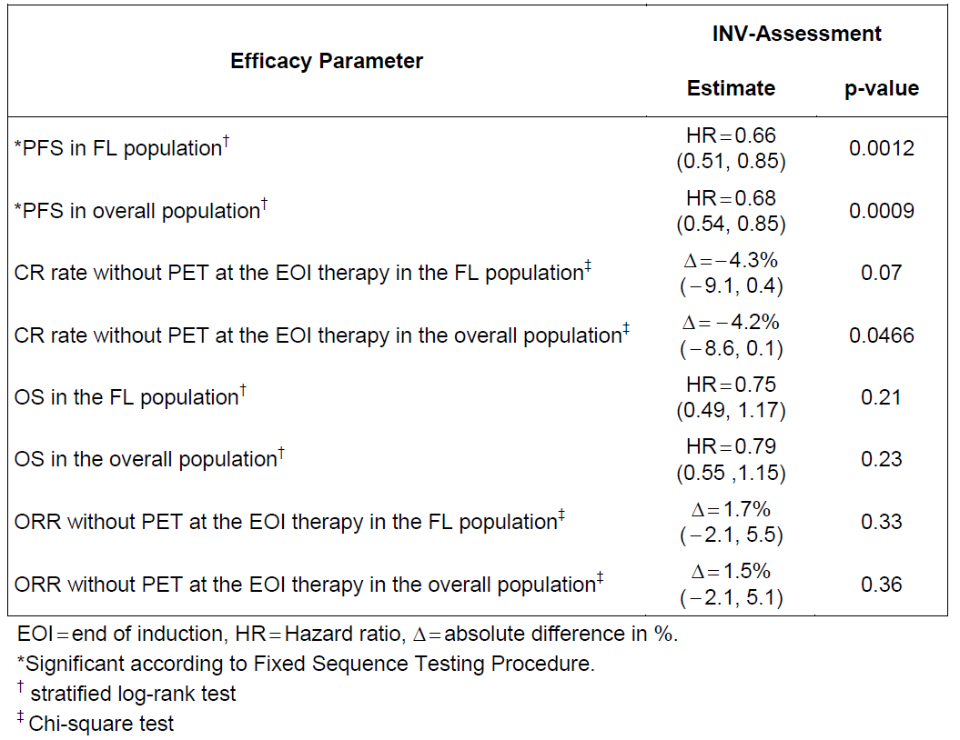
Analysis of overall survival (OS) and other secondary time to event efficacy analyses (event free survival (EFS), disease free survival (DFS), duration of response (DOR), and time to new anti-lymphoma treatment (TTNLT), (see also study design, above); sensitivity analyses, and subgroup analyses did not meet the predefined statistical requirements.
Specifically, for overall survival, at the clinical cut-off date (31 January, 2016), a total of 81 randomised patients had died: 46/601 patients (7.7%) in the R-chemo arm and 35/601 patients (5.8%) in the G-chemo arm, and less than 20% of patients had been followed for survival for more than 4 years, hence the data can be considered still immature at this time (stratified HR 0.75 (95% CI: 0.49, 1.17), stratified log-rank p = 0.21). The most frequent cause of death was adverse event in the G-chemo arm (3.9% versus 3.4% in the R-chemo arm), and progressive disease in the R-chemo arm (3.7% versus 2.0% in the G-chemo arm). Further information on deaths is provided in the safety section.

Patient-reported outcomes in (FL ITT Population)
There were no notable differences between the treatment arms in any of the FACT-Lym questionnaire subscales or EQ-5D-3L scales over time during the induction and maintenance treatment periods, and follow-up, as evidenced by modest (< 5%) between arm differences in the mean changes from baseline scores in FACT-Lym subscales, TOI and Total score, and EQ-5D-3L Utility scales.
Although patient scores did not exceed the levels for clinically meaningful change on the 4 scales of the FACT-G (PWB, SWB, EWB, FWB) on the FACT-Lym in either arm, both arms reported clinically meaningful improvement on the FACT-Lym LYMS (≥ 3 points), TOI (≥ 6 points) and Total scores (≥ 7 points) by the Month 2 maintenance visit. These improvements were continued at the Month 12 maintenance and maintenance completion visits, as well as the Month 36 follow up visit.

Evaluator commentary
The primary endpoint of investigator assessed PFS was statistically significantly superior in the G-chemo arm compared to the R-chemo arm (see Table 4, above). Approximately 60% had completed the full treatment (induction and maintenance). The secondary endpoints did not meet the predefined statistical requirements. Whether a longer PFS for G-chemo translates into superior overall survival in the long run is still uncertain and this has to be followed closely through regular updates from the sponsor to the TGA.
It is also worthwhile noticing the results for the MZL population, although this was not part of the primary objective, with no difference between R-chemo and G-chemo for nodal and splenic MZL, though acknowledging that the numbers are small.

Other efficacy studies

Study BO21000 (GAUDI)
This application includes the final CSR for Study BO21000 which contains additional data collected from the maintenance period (during which patients received single agent obinutuzumab), and from the post-treatment follow up period, as shown below in Table 7. The sponsor previously filed 2 primary CSRs for Study BO21000 (Report No. 1036396, January 2012, including patients with relapsed/refractory FL; and Report No. 1050659, November 2012, including previously untreated patients with FL). A full data set from the induction period was reported in the primary CSR (Report No. 1050659).
In Study BO21000, the number of scheduled obinutuzumab doses was lower than in Study BO21223 since only 2 doses of obinutuzumab were scheduled in Cycle 1 (on Days 1 and 8 in Study BO21000 versus Day 1, 8, and 15 in Study BO21223), fewer treatment cycles were scheduled during induction (4 or 6 for G-benda and 6 or 8 for G-CHOP in Study BO21000 versus 6 for G-benda and 8 for G-CHOP or G-CVP in BO21223), and because of less frequent maintenance dosing (every 3 months for a total of 8 maintenance doses in BO21000 versus every 2 months for a total of 12 maintenance doses in BO21223). The number of planned chemotherapy cycles was also lower in BO21000 than in BO21223, see Table 7, below.
The end of the study was defined as the time point when the last patient had completed 2 years of follow up after receiving the last dose of maintenance therapy (for Study BO21000, last patient last visit (LPLV) occurred on 4 November 2015).

Table 7. Summary of Study BO21000 (GAUDI)
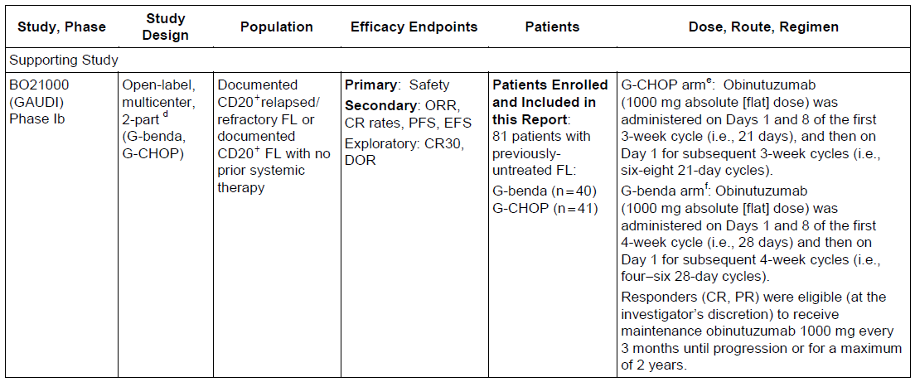
Patients with Ann Arbor Stage I to IV were included as opposed to the pivotal Study BO21223, where only Ann Arbor Stage III to IV and bulky stage II were included.

Evaluator commentary: other efficacy studies
Study BO21000 has not been included in the main evaluation of efficacy and safety as the pivotal Study BO21223 was a Phase III study with a relevant comparator in which 700 patients received G-chemo compared to 81 patients in part 2 of the Phase Ib Study BO21000.

Evaluator’s conclusions on clinical efficacy
The pivotal Study BO21223 (GALLIUM) is a Phase III, open label, multicentre, randomised study to investigate the efficacy and safety of G-chemo followed by G-maintenance therapy for responders (CR or PR), compared to R-chemo followed by R-maintenance therapy for responders, in patients with previously-untreated advanced iNHL (see Figure 3, above). The overall population consisted primarily of patients with previously-untreated FL (1202/1401, 85.8%), of which 601 patients were randomised to the R-chemo arm, and 601 patients were randomised to the G-chemo arm.
The primary endpoint of investigator assessed PFS in the FL population was statistically significantly superior for the G-chemo arm compared to the R-chemo arm, see Table 4, above. Approximately 60% had completed the full treatment (induction and maintenance). The secondary endpoint of investigator assessed PFS in the overall population was also statistically significantly superior. The other secondary endpoints did not meet the predefined statistical requirements.
In the end, long overall survival is the current goal of treatment of follicular lymphoma (as opposed to cure). The data are immature and regular updates on this trial are crucial to evaluate if obinutuzumab-chemo in the long run is superior to rituximab-chemo.
The follicular lymphoma study population is not totally representative of the ‘average’ FL patient: The median age in the study was 59.0 years and ECOG performance score was 0-1 (for app. 97%). No patients with a CrCL < 40 mL/min were included (CrCL < 40 mL/min was a study exclusion criterion). The median age at diagnosis ‘in real life’ is approximately 65 years, and as this is mainly a disease of the elderly the ECOG performance score will often exceed 1 and patients will have comorbidities including compromised renal function. This may all affect the efficacy and certainly the safety (see Section 8 of this report, below), and thus ultimately the benefit/risk ratio.
The study is in compliance with the TGA adopted EMA ‘Guideline on the evaluation of anticancer medicinal products in man (EMA/CHMP/205/95/Rev.4)’.

Clinical safety

Studies providing evaluable safety data

Pivotal studies that assessed safety as the sole primary outcome
No pivotal studies assessed safety as the sole primary outcome.

Pivotal and/or main efficacy studies
Study BO21223 (GALLIUM) is a Phase III, open label, multicentre, randomised study to investigate the efficacy and safety of G-chemo followed by G-maintenance therapy for responders (CR or PR), compared to R-chemo followed by R-maintenance therapy for responders, in patients with previously-untreated advanced iNHL (see Figure 3, above). The overall safety population included 1390 patients in total (1192 patients with FL and 194 patients with MZL), 692 patients in the R-chemo arm and 698 patients in the G-chemo arm. See Section 7.2.1 for further details.
In the SCS, the sponsor has chosen to focus mainly on the FL population, which comprises 86% of the total study population, as this population is the one that the indication G-chemo followed by G-maintenance in first line is sought for. In the CSR both the FL populations are described in much more detail than the overall population. In the updated PI the safety population described for previously untreated iNHL is the entire cohort in Study BO21223, which is why this is the group evaluated in the following safety sections to the extent that the data are available.
The safety outcome measures described in the protocol include:
- Incidence, nature, and severity of adverse events (including serious adverse events) compared between the 2 treatment arms.
- Deaths.
- Changes in vital signs, physical findings, and clinical laboratory results.
- Protocol-defined events of special interest/non-serious expedited adverse events:
  - Tumour lysis syndrome
  - Serious IRR
  - Serious neutropaenia
  - Serious infections
  - Hepatitis B reactivation.

Other studies

Other efficacy studies
Not applicable.

Studies with evaluable safety data: dose finding and pharmacology
Not applicable.

Studies evaluable for safety only
Not applicable.

Studies that assessed safety as the sole primary outcome
The primary objective of the Phase Ib Study BO21000 (GAUDI), which included 81 first line FL patients, was the safety of obinutuzumab (G) in combination with CHOP or bendamustine in this group of patients. This study has not been evaluated in detail as it was a small Phase I study compared to the large Phase III Study BO21223, comprising 1390 patients of which 698 received obinutuzumab and chemotherapy. There was no comparator in Study BO21000 whereas Study BO21223 has another CD20 antibody (rituximab) as comparator. The results from this study are not included in the product information.
An overview of adverse events in Study BO21000 compared to the FL population of Study BO21223 compiled by the sponsor can be found in Table 8, below.

Table 8. Overview of adverse events in previously untreated patients with FL (safety population) pivotal Study BO21223 and supporting Study BO21000 (entire study period)
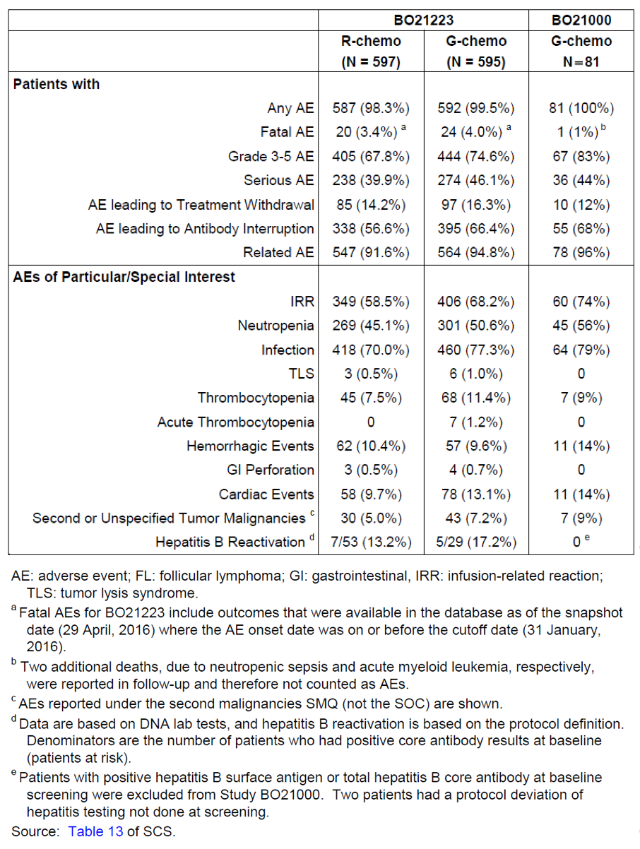

Patient exposure (Study BO21223)

Overall safety population
Indolent NHL population, N = 1390; R-chemo: 692 (FL: 597, MZL: 93; other: 2) versus G-chemo: 698 (FL: 595; MZL: 101; other: 2).
The demographics for the FL population have been described in the efficacy section. The FL population comprised of about 86% of the overall safety population. The main differences between the FL and MZL patients are the mean age of 59.0 versus 63.0 and number of patients ≥ 65 years of age (31.3% versus 44.6%), which are likely to have an impact on the safety results.

Induction phase
At least 90% of the planned cumulative dose of antibody was administered in 99.4% of the R-chemo arm and in 99.0% in the G-chemo arm.
In Table 9 shown below, the extent of exposure to individual components of chemotherapy during induction by treatment arms is summarised.

Maintenance phase
609 patients in the R-chemo arm and 624 patients in the G-chemo arm received maintenance treatment. In the R-chemo arm 99.0% received ≥ 90% of the cumulative maintenance dose compared to 99.8% of patients in the G-chemo arm.

FL safety population
N = 1192; R-chemo: 597 versus G-chemo: 595. Of 1202 randomised patients with FL, 10 patients (4 patients in the R-chemo arm and 6 patients in the G-chemo arm) did not receive any amount of study drug (obinutuzumab, rituximab, or chemotherapy (CHOP, CVP, or bendamustine)) as induction treatment and therefore, per protocol and definition, were excluded from the FL safety population. One patient with FL randomised to the R-chemo arm received one dose of obinutuzumab in error (1000 mg obinutuzumab on Day 1, Cycle 5) and for the purposes of the safety analyses presented in the CSR, is included in the G-chemo arm.

Induction phase
At least 90% of the planned cumulative dose of antibody was administered in 99.5% of the R-chemo arm and in 99.7% in the G-chemo arm.
In Table 10, shown below, the extent of exposure to individual components of chemotherapy during induction by treatment arms is summarised.

Maintenance phase
526 patients in the R-chemo arm and 540 patients in the G-chemo arm received maintenance treatment. At the time of the clinical cut-off date, 114 patients with FL were still ongoing with maintenance treatment. In the R-chemo arm 99.2% received ≥ 90% of the cumulative maintenance dose compared to 99.8% of patients in the G-chemo arm.

Table 9. Study BO21223 summary of extent of exposure to chemotherapy during induction in patients with iNHL (Overall safety population)
 | R-chemo (n = 692) |  | G-chemo (n = 698)
Chemotherapy | Median treatment duration, weeks (range) | Dose intensity¹ ≥ 90% | Median treatment duration, weeks (range) | Dose intensity¹ ≥ 90%
Bendamustine | 24.29  (3.9, 30.0) | 89.6 | 24.29  (3.9, 31.9) | 87.7
Cyclophosphamide | 19.29  (2.6, 28.3) | 95.8 | 20.14  (3.1, 32.3) | 89.7
Doxorubicin | 19.14  (4.1, 27.1) | 95.5 | 19.86  (3.1, 27.1) | 89.4
Prednisone | 19.86  (1.3, 28.9) | 93.8 | 20.86  (3.1, 32.9) | 94.7
Vincristine | 19.29  (2.6, 28.1) | 83.0 | 20.14  (3.1, 32.3) | 79.7
1) Defined as total cumulative dose actually received/total planned dose x 100%.

Table 10. Study BO21223 summary of extent of exposure to chemotherapy during induction in patients with follicular lymphoma (FL safety population)
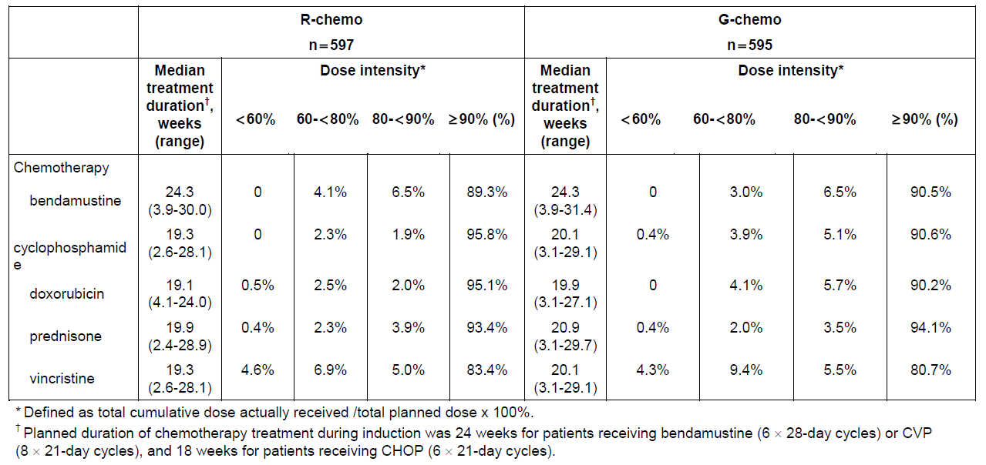
More patients in the G-chemo arm (overall safety population) had antibody dose delays (R-chemo: 41.2% and G-chemo: 55.0%). During the induction phase, a greater proportion of patients in the G-chemo arm had a dose modification of any study medication component (that is, rituximab/obinutuzumab or any chemotherapy component) compared to the R-chemo arm (R-chemo: 40.2% and G-chemo: 47.7%).

Adverse events (Study BO21223)
In the SCS the following is stated: ‘The safety data presented in this SCS are focused on the FL safety population (FL patients who received any amount of study therapy, […] because the indication being sought is for patients with FL.’ In the updated PI the safety population described for previously untreated iNHL is the entire cohort in Study BO21223, which is why this is the group evaluated in the following safety sections as far as the data is available.

All adverse events (irrespective of relationship to study treatment)
An overview of types of adverse events is presented in Table 11 for the FL and overall safety population and by treatment phase in the FL population in Table 12, both below.

Table 11. Study BO21223 overview of adverse events (FL and overall safety population)
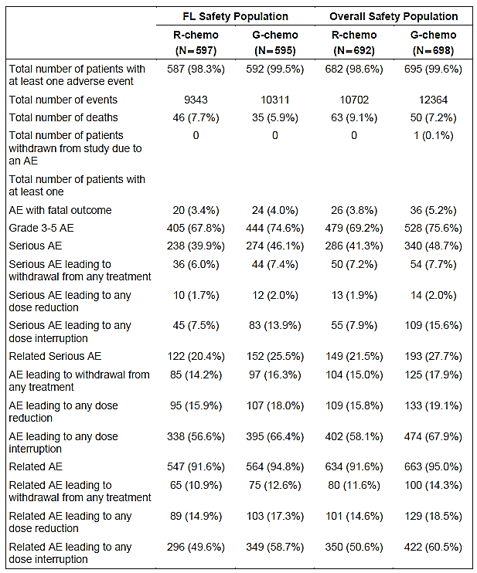
Question 3: CSR; Table 1: The proportion of AEs (all categories) in the MZL population was higher than in the FL population. Can the sponsor suggest any explanations for this? (See Table 11 above).

Table 12. Study BO21223 overview of AEs by treatment phase (FL safety population)
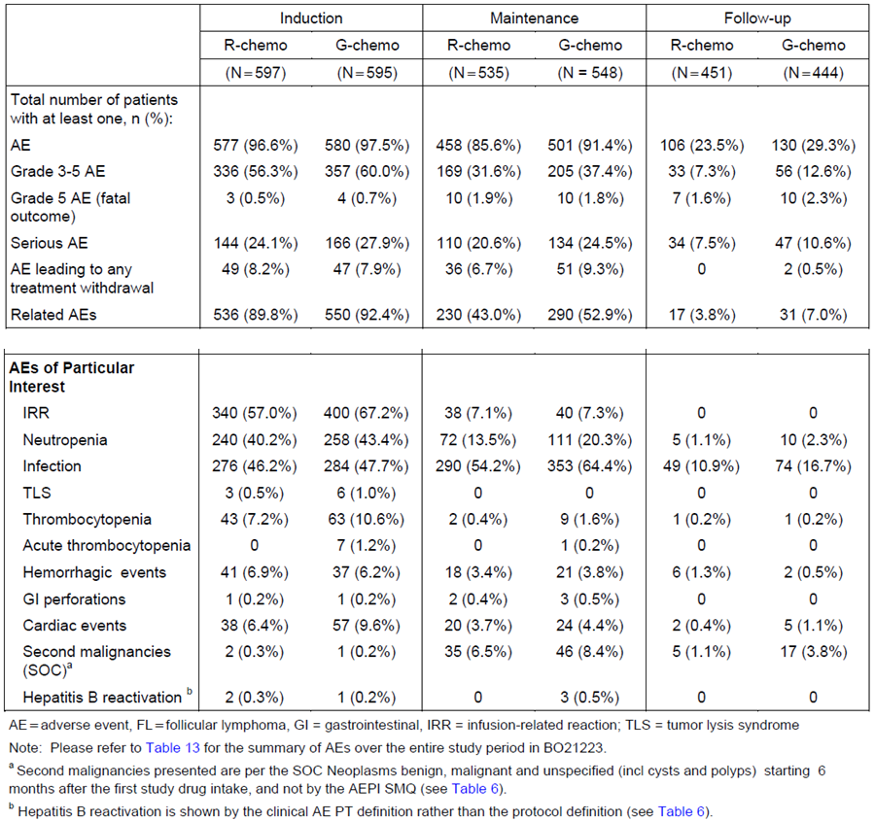
The overall incidence of AEs over the entire study period was similar in the 2 treatment arms (678/692 patients (98.0%) with at least one AE in the R-chemo arm compared with 695/698 patients (99.6%) in the G-chemo arm) and a total of 10698 AEs in the R-chemo arm and 12364 AEs in the G-chemo arm (overall safety population).
The incidence of Grade 3 to 5 AEs during the entire treatment period was higher in the G-chemo arm than in the R-chemo arm (479/692 patients (69.2%) and 528/698 patients (75.6%), respectively).
An overview of AEs of all grades and Grades 3 to 5 by SOC and Preferred Term (in descending order of frequency) is presented in Tables 13 and 14, respectively.

Table 13. Adverse events of all grades and Grade 3 to 5 by SOC (overall safety population)
 | Affected SOCs, AE of all grades |  | Affected SOCs, AE Grades 3 to 5
 | R-chemo | G-chemo | R-chemo | G-chemo
Population (n) | 692 | 698 | 692 | 698
Total number of events | 10698 | 12364 | 1525 | 1865
GI Disorders | 73.4% | 79.4% | 8.5% | 8.3%
Infections and Infestations | 69.5%# | 78.1%# | 15.9% | 21.6%
General Disorders and Admin. Site Conditions | 68.6% | 75.5% | 5.8% | 7.3%
Injury, Poisoning and Procedural Complications | 55.1% | 65.6% | 6.5% | 8.9%
Blood and Lymphatic System Disorders | 52.5% | 58.3% | 42.2% | 50.7%
Respiratory, Thoracic and Mediastinal Disorders | 52.0% | 56.4% | 5.6% | 9.3%

Table 14. Adverse events of all grades and Grade 3 to 5 (overall safety population)
 | AE of all grades |  | AE Grades 3 to 5
 | R-chemo | G-chemo | R-chemo | G-chemo
Population (n) | 692 | 698 | 692 | 698
Total number of events | 10698 | 12364 | 1525 | 1865
Infusion related reactions | 49.0% | 61.0% | 4.8% | 6.9%
Nausea | 45.2% | 47.3% | 1.6% | 1.3%
Neutropaenia | 43.1% | 48.1% | 37.9% | 44.0%
Fatigue | 35.7% | 37.1% | 0.9% | 1.1%
Constipation | 29.6% | 34.4% | 0.4% | 0.4%
Thrombocytopaenia | 7.2%* | 12.5% | 2.7% | 6.6%
Percentages are based on the n in the column heading.
Adverse events (all grades) reported with a difference of at least 2% between the treatment arms, but excluding IRRs reflects the most frequently related AEs described above, which are all in favour of R-chemo.
Comment: It is important for the clinician to see the differences in safety between the 2 anti-CD20 antibodies, as there may be individual patient related concerns to take into account when choosing which antibody to use. It is therefore essential that this information is provided in the PI.
Question 4: CSR: Looking at the tabulated overview of AEs by phase in the overall safety population, the AEs of particular interest such as Infection, Neutropaenia and Thrombocytopaenia do not differ substantially from the AEs observed in the FL population (see Table 12, above), except for the numbers and percentages for Neutropaenia in the follow up phase, where there is 1 (2.5%) in the R-chemo arm and 13 (2.5%) in the G-chemo arm as opposed to 5 (in a smaller part of the population) and 10 correspondingly in the FL population presented in Table 12. Please explain this discrepancy in numbers for neutropaenia in the follow-up phase in the R-chemo arm.

All adverse events by chemotherapy group (FL safety population)
According to the sponsor the trial was not designed to compare induction regimens. Still there is an overview of adverse events by chemotherapy subgroups in the CSR.
Listed below are the adverse events occurring with ≥ 2% difference in the 2 treatment arms. The corresponding overall incidences for the entire R-chemo and G-chemo FL population are written in brackets:
R-Bendamustine (N = 338) versus G-Bendamustine (N = 338):
- Overall incidence of AEs: 97.6% (98.3%) in the R-bendamustine group versus 99.7% (99.5%) in the G-bendamustine group.
- Serious AEs: 45.9% (39.9%) in the R-bendamustine group versus 50.6% (46.1%) in the G-bendamustine group.
- Grade 3 to 5 AEs: 66.3% (67.8%) in the R-bendamustine group versus 68.3% (74.6%) in the G-bendamustine group.
- Infections: 72.8% (70.0%) in the R-bendamustine group versus 80.5% (77.3%) in the G-bendamustine group.
R-CHOP (N = 203) versus G-CHOP (N = 193):
- Serious AEs: 31.5% (39.9%) in the R-CHOP group versus 38.3% (46.1%) in the G-CHOP group.
- Grade 3-5 AEs: 74.4% (67.8%) in the R-CHOP group versus 88.1% (74.6%) in the G-CHOP group.
- Infections: 66.0% (70.0%) in the R-CHOP group versus 73.6% (77.3%) in the G-CHOP group.
R-CVP (N = 56) versus G-CVP (N = 61):
- Serious AEs: 33.9% (39.9%) in the R-CVP group versus 42.6% (46.1%) in the G-CVP group.
- Grade 3 to 5 AEs: 53.6% (67.8%) in the R-CVP group versus 65.6% (74.6%) in the G-CVP group.
- Infections: 67.9% (70.0%) in the R-CVP group versus 73.8% (77.3%) in the G-CVP group.
- The numbers of deaths (for any reason; including progressive disease): 8.9% (7.7%) in the R-CVP group versus 3.3% (5.9%) in the G-CVP group.
Comment: G-bendamustine seems to be the driver for the higher SAEs and infections in the G-chemo arm whereas G-CHOP drives the high incidence of Grade 3 to 5 AEs.
The corresponding data for the overall safety population cannot be found in the Dossier, which could be justified by the small number of patients in each chemotherapy arm (around 30).

Treatment related adverse events (adverse drug reactions)
Related AEs were observed in 634/692 patients (91.6%) in the R-chemo arm and 663/698 patients (95.0%) in the G-chemo arm in the overall safety population. Related AEs were most frequently reported in the following SOCs (percentages expressed as R-chemo versus G-chemo):
- Gastrointestinal Disorders (60.7% versus 63.6%)
- General Disorders and Administration Site Conditions (51.3% versus 61.5%)
- Injury, Poisoning and Procedural Complications (49.0% versus 61.2%)
- Blood and Lymphatic System Disorders (48.3% versus 54.0%).
This is in line with the data for the FL population, [from a table] in the CSR
Comment: The safety data presented above favour R-chemo versus G-chemo.

Deaths and other serious adverse events

Deaths
There were more deaths in the R-chemo versus the G-chemo arm, as shown in Table 15, below. The deaths in the G-chemo arm were mainly due to an adverse event, whereas in the R-chemo arm they were almost equally due to progressive disease or an AE.
In the MZL population, 18.3% in the R chemo arm and 14.9% in the G chemo arm died during the study for any reason. The most common cause of death in the R-chemo arm was progressive disease (R-chemo arm: 7.5% and G-chemo arm: 1.0%). Adverse event was the most common cause of death in the G chemo arm (R chemo arm: 6.5%; G chemo arm: 11.9%).

Table 15. Summary of deaths (overall safety population)
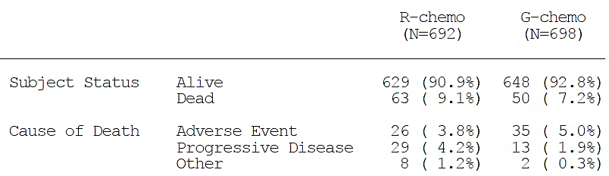
G-chemo AE deaths: There were 16 deaths (2.3%) in the SOC Infections and Infestations compared to 4 (0.6%) in the R-chemo arm, which is the main difference between the 2 arms for deaths.

SAEs
From the CSR:
A total of 286/692 patients (41.3%) in the R-chemo arm experienced 554 SAEs and 340/698 patients (48.7%) in the G-chemo arm experienced 797 SAEs.
The most frequently affected SOCs (overall incidence of SAEs in each SOC ≥ 5% in the G-chemo arm) are listed (percentages expressed as R-chemo versus G-chemo):
- Infections and Infestations (15.0% versus 20.8%; total number of events 143 versus 217)
- Blood and Lymphatic System Disorders (8.7% versus 9.6%; total number of events 87 versus 100)
- Gastrointestinal Disorders (4.6% versus 7.6%; total number of events 47 versus 74)
- Injury, Poisoning and Procedural Complications (4.2% versus 7.6%), the difference driven mainly by the higher incidence of serious IRRs in the G-chemo arm (2.6% versus 5.2%; total number of events 33 versus 64)
- General Disorders and Administration Site Conditions (6.5% versus 7.3%; total number of events 48 versus 61)
- Respiratory, Thoracic and Mediastinal Disorders (5.6% versus 6.4%; total number of events 42 versus 56)
- Neoplasms Benign, Malignant and Unspecified (including Cysts and Polyps) (3.8% versus 6.0%; total number of events 28 versus 49)
- Cardiac Disorders (2.0% versus 5.9%; total number of events 15 versus 46).
The corresponding information for the FL population (from the CSR):
A total of 238/597 patients (39.9%) in the R-chemo arm experienced 450 SAEs and 274/595 patients (46.1%) in the G-chemo arm experienced 590 SAEs.
The most frequently affected SOCs (overall incidence of SAEs in each SOC ≥5% in the G-chemo arm) are listed (percentages expressed as R-chemo versus G-chemo):
- Infections and Infestations (14.4% versus 18.2%)
- Blood and Lymphatic System Disorders (7.9% versus 9.4%)
- Gastrointestinal Disorders (4.7% versus 7.2%)
- Injury, Poisoning and Procedural Complications (3.5% versus 6.9%), the difference driven mainly by the higher incidence of serious IRRs in the G-chemo arm (1.8% versus 4.5 %)
- Neoplasms Benign, Malignant and Unspecified (including Cysts and Polyps) (3.5% versus 6.4%)
- Respiratory, Thoracic and Mediastinal Disorders (5.0% versus 5.5%)
- General Disorders and Administration Site Conditions (5.7% versus 5.0%).
Comment: There are more SAEs in the G-chemo arm compared to the R-chemo arm in both the overall and FL safety population. There are generally more SAEs in the overall safety population (the population in the PI) than in the FL population, which is not unexpected, as the median age of the FL population is 59.0 years and 63.0 years for the MZL population. The percentage of patients who are ≥ 65 years of age is 31.3% in the FL population and 44.6% in the MZL population, and although the MZL population only constitute 14% of the overall safety population this apparently has an impact on the overall safety data together with other factors. As the average age at diagnosis for FL patients is 65 years, the lower average age (and good performance status) in this study does not reflect the FL population as a whole, and these data demonstrate that this has to be taken into account when choosing which anti-CD20 antibody to use in addition to considering efficacy.

Discontinuations due to adverse events
The treatment arms were balanced (≤ 1% difference) with respect to AEs within all the SOCs that led to withdrawal of study medication and were mainly in the same SOCs as the SAEs.
AEs with an overall incidence of ≥ 1% in the G-chemo that led to withdrawal (R-chemo versus G-chemo) (the corresponding percentages for the FL population are written in italics):
- Infections and Infestations (22/692 patients (3.2%) (3.2%) versus 36/698 patients (5.2%) (4.7%)), most frequently pneumonia (0.6% versus 1.3%) (0.5% versus 1.5%)
- Blood and Lymphatic System Disorders (21/692 patients (3.0%) (2.3%) versus 24/698 patients (3.4%) (2.9%)), most frequently neutropaenia (2.2% versus 2.7%) (2.0% versus 2.2%)
- Nervous System Disorders (24/692 patients (3.5%) (3.7%) versus 21/698 patients (3.0%) (3.0%)), most frequently peripheral sensory neuropathy (1.2% versus 1.0%) (1.3% versus 1.0%)
- Neoplasms Benign, Malignant and Unspecified (11/692 patients (1.6%) versus 17/698 patients (2.4%)) (1.3% versus 2.5%)
- Respiratory, Thoracic and Mediastinal Disorders (10/692 patients (1.4%) versus 10/698 patients (1.4%)) (ND)
- Gastrointestinal Disorders (8/692 patients (1.2%) versus 8/698 patients (1.1%)) (1.2% versus 1.0%)
- Injury, Poisoning and Procedural Complications (4/692 patients (0.6%) versus 7/698 patients (1.0%)), most frequently IRRs (0.4% versus 1.0%) (0.3% versus 0.7%).
Comment: From the CSR (FL population; and overall population): ‘A patient listing of AEs that led to withdrawal from any study medication is available.’ When opening the links, a list of patients who withdrew from the study is presented but no corresponding AEs.
Question 5: A patient listing of AEs that led to withdrawal from any study medication in Study BO21223, as indicated on 2 pages in the CSR cannot be found. Can the sponsor provide these lists?

Dose modification due to adverse events
For the FL population the following information is presented:
Modifications to any study medication were most frequently (≥ 10% in either treatment arm) due to AEs in the following SOCs (R-chemo versus G-chemo):
- Injury, Poisoning and Procedural Complications (32.2% versus 38.5%), mainly due to IRRs which occurred at a higher frequency in the G-chemo arm (31.0% versus 38.5%)
- Blood and Lymphatic System Disorder (22.8% versus 34.8%), mainly neutropaenia (19.1% versus 28.6%)
- Respiratory, Thoracic and Mediastinal Disorders (15.7% versus 16.1%), mainly dyspnea (4.4% versus 6.2%)
- General Disorders and Administration Site Conditions (13.6% versus 22.2%); mainly chills (4.2% versus 10.9%) and pyrexia (3.0% versus 7.2%)
- Infections and Infestations (12.1% versus 16.0%); no infection or infestation had a notably higher frequency in the G-chemo arm
- Skin and Subcutaneous Tissue Disorders (12.6% versus 9.9%), mainly rash (5.0% versus 2.2%) and pruritus (3.4% versus 2.5%) (both more frequent in the R-chemo arm)
- Nervous System Disorders (9.2% versus 12.9%), mainly peripheral sensory neuropathy (1.8% versus 3.4%)
- Gastrointestinal Disorders (8.7% versus 12.8%), mainly nausea (3.4% versus 5.9%) and vomiting (1.5% versus 3.5%).
Modifications to the rate of infusion/infusion delays of antibody (FL population) were more frequent in the G-chemo arm (389/595 patients (65.4%)) compared to the R-chemo arm (329/597 patients (55.1%)). The main drivers for the difference between the treatment arms were the higher frequency of IRRs, neutropaenia and infections/infestations in the G-chemo arm.
Chemotherapy dose modifications due to AEs (FL population) were more frequent in the G-chemo arm (37.5%) compared to the R-chemo arm (32.0%). According to the CSR no individual AEs were the main drivers for the difference in incidence between treatment arms.
Question 6: For a section of the CSR: The evaluator was unable to locate the information regarding dose modifications due to adverse events for the overall safety population (only for the FL population). What are the corresponding data for the overall safety population?

Adverse events of particular and special interest
Adverse events of particular interest (AEPIs) included all events of special interest (AESI; numbers or percentages given in italics) and additionally, all events for which a separate analysis has been performed; see Table 16 (shown below) for an overview. AEPIs were defined prior to the primary analysis based on the mode of action of obinutuzumab and the need to gather further safety information.

Table 16. AEs of particular interest and AEs of special interest
Adverse Event of Particular Interest | Definition
Infusion Related Reactions (IRRs) | IRRs are defined as AEs that are deemed related to any study treatment (not specific to obinutuzumab) by the investigator, which occurred during infusion or within 24 hours from the end of infusion.  Note: IRRs encompass AEs reported as the MedDRA PT ‘Infusion related reaction’ (within the System Organ Class ‘Injury, Poisoning and Procedural Complications’) together with reported signs and symptoms of IRRs.  In addition to the above IRR definition, antibody related IRRs and investigator assessed IRR will be investigated for exploratory assessment of IRR. The following definition will be used for exploratory purposes only:  Antibody related IRRs defined as obinutuzumab/rituximab treatment-related AEs that occurred during or within 24 hours from end of infusion,  Investigator assessed IRRs defined as All AEs ticked as ‘AE qualifies as part of an Infusion Related Reaction’.  Chemotherapy related IRRs are defined as any chemotherapy treatment related AEs that occurred during or within 24 hours from the end of infusion.
Neutropaenic Events | Defined according to the sponsor’s standard AEGT ‘*Neutropaenia and associated complications’, and based on reported AEs rather than laboratory values.
Prolonged Neutropaenia¹ | Initial ANC < 1.0 x 109/L following LAA² and ANC < 1.0 x 109/L at last previous visit before LAA.
Late-onset Neutropaenia¹ | Initial ANC < 1.0 x 109/L following LAA³ and ANC within normal range (NR) (≥ 1.0 x 109/L) at last previous visit before LAA.
All Infections | Defined as all PTs included in the system organ class (SOC) of ‘Infections and infestations’.
All TLS events | Defined by the PT ‘tumour lysis syndrome’, from the SOC ‘Metabolism and Nutrition Disorders’.
Thrombocytopaenia | Defined using standardized MedDRA query (SMQ) ‘Haematopoietic Thrombocytopaenia narrow’ (20000031n).
Acute Thrombocytopaenia | Defined as thrombocytopaenia (using SMQ ‘Haematopoietic thrombocytopaenia narrow’ (20000031n)) occurring during or within 24 hours post infusion.
GI Perforation | Defined using SMQ ‘Gastrointestinal perforation’ (20000107 narrow).
Cardiac Events | Defined under the SOC ‘Cardiac disorders’.
Second Malignancy | Defined by any PT under the SOC ‘Neoplasms benign, malignant and unspecified (incl. cysts and polyps)’ starting 6 months after the first study drug intake.
Hepatitis B reactivation | If either one of the followings is met:  A Hepatitis B reactivation AE, that is, all AEs that have the response to the question ‘The AE is non-serious and qualifies for expedited reporting to the sponsor per protocol due to the following criteria:’ selected as ‘Hepatitis B reactivation’ on the AE eCRF page.  An elevation of HBV DNA post baseline (HBV DNA ≥ 100 IU/mL), using central laboratory results. HBV DNA positive is considered HBV-DNA ≥ 100 IU/mL in the reporting of Hepatitis B reactivation.
Adverse Event of Special Interest (AESI)
IRRs (serious) | Serious AEs related to study treatment (not specific to obinutuzumab) which occurred during infusion or within 24 hours from the end of infusion.
Neutropaenic Events (serious) | Serious AEs in the sponsor’s AEGT ‘*Neutropaenia and associated complications’.
Infections (serious) | Serious AEs in the SOC ‘Infections and infestations’.
TLS (all grades and irrespective of seriousness) | Defined by the PT ‘Tumour Lysis Syndrome’, from the SOC ‘Metabolism and Nutrition Disorders’.
AE = adverse event; IRR = infusion related reaction; NR = normal range; SMQ = Standardized MedDRA Query; SOC = System Organ Class; TLS = tumour lysis syndrome. 1) For patients who have had at least one dose of antibody and reached last antibody administration (LAA). Patients with no neutrophil assessment during the time interval will be excluded from this analysis. Patients will be censored at point of NALT; 2) LAA Interval: LAA + 24 days, LAA + 41 days; 3) LAA Interval: LAA + 24 days, LAA + 200 days. The data in this section is compiled from the CSR.
Comment: The dossier primarily details these events in the FL population with the general argument (for the entire safety section) that this is the population for which the indication is sought although the PI includes the entire safety population. Less detail is supplied for the overall safety population apart from a 4 page overview for the IRRs with links to tables in the dossier.

Infusion related reactions (IRRs)
IRRs were more frequent in the G-chemo arm compared to the R-chemo arm, as show in Table 17 below.

Table 17. Summary of AEs and SAEs IRRs (FL safety population and overall safety population)
 | R-chemo (N = 597) (N = 692) | G-chemo (N = 595) (N = 698)
No. of patients with at least 1 AE | 349 (58.5%), 401 (57.9%) | 406 (68.2%), 486 (69.6%)
No. of patients with serious AE | 14 (2.3%), 23 (3.3%) | 33 (5.5%), 43 (6.2%)
Total number of AEs:  Grade 1:  Grade 2:  Grade 3:  Grade 4: | 1540, 1833  867, 1004  595, 725  75, 98  3, 6 | 2023, 2483  1105, 1328  765, 973  124, 147  29, 35
No. of serious AEs | 31, 49 | 82, 111
The main difference between arms was driven by the IRRs occurring in Cycle 1, Day 1.
The incidence of IRRs in Cycle 2 decreased dramatically in the G-chemo arm, and continued to decrease in subsequent cycles. The incidence of IRRs in Cycles 2 to 5 in the R-chemo arm decreased from Cycle 2 onwards and continued to decrease with each cycle. In Cycle 2 and 3 the incidence of IRRs was higher in the R-chemo arm than the G-chemo arm, and from Cycle 4 onwards (during induction and maintenance) the incidence was comparable in the 2 arms.
In high risk (FL) patients (high tumour burden and/or high peripheral lymphocyte count) the antibody infusion could be split over 2 days. 14/15 patients (93.3%) in the R-chemo arm and 39/43 patients (90.7%) in the G-chemo arm receiving a split dose experienced an infusion related AE, compared to 335/582 patients (57.6%) and 367/552 patients (66.5%), respectively.
For the definition of IRR, see Table 16 above.
Comment: There were more IRRs in the overall population compared to the follicular population. Elderly patients have more co-morbidities, for instance cardiovascular problems, which could be an issue in relation to IRRs and subsequently the choice of anti-CD20 antibody.
There is a 450 page listing of all patients and their IRRs in the CSR but the evaluator cannot find any list of the various IRR preferred terms by incidence (for instance nausea, vomiting, pyrexia, chills, flushing, chest pain, hypertension, hypotension, rash, and pruritus). The most frequently reported IRR related symptoms (≥ 5%) are listed in the annotated PI with reference to Study BO21223 CSR, so the data supporting that list has to be presented for the overall safety population.

Neutropaenic events (overall safety population)
The incidence of neutropaenia AEs in the FL population (defined using the sponsor’s standard AEGT ‘Neutropaenia and associated complications’) was higher in the G-chemo arm (301/595 patients (50.6%)) than in the R-chemo arm (269/597 patients (45.1%)).
The summarised data for the overall safety population, listed in the CSR and the corresponding summarised data for the FL population (in italics), listed in the CSR are as follows (percentages shown for R-chemo followed by G-chemo arm):
- Incidence higher in G-chemo arm (44.9% versus 50.4%) (45.1% versus 50.6%)
- Grade 3 to 5 more frequent in G-chemo arm (39.7% versus 46.1%) (39.5% versus 45.9%)
- One Grade 5 neutropaenia AE in the R-chemo arm (MZL population)
- Serious neutropaenia AEs comparable (7.9% versus 8.9%) (7.4% versus 8.4%)
- Patients with treatment withdrawn due to AE comparable (5.5% versus 6.3%) (5.2% versus 5.0%)
- Prolonged neutropaenia occurred in 0.8% (0.6%) of patients in the R-chemo arm and 0.9% (0.9%) of patients in the G-chemo arm (based on laboratory ANC assessment).
- Late onset neutropaenia occurred in 4.1% (4.1%) of patients in the R-chemo arm and 3.9% (3.8%) of patients in the G-chemo arm (based on laboratory ANC assessment).
Comment: There were generally more AEs related to neutropaenia in the G-chemo arm compared to the R-chemo, which again can have implications for the choice of therapy depending on individual patient characteristics such as comorbidity and age and also renal function, as patients with renal impairment (CrCL < 50 mL/min) are more at risk of neutropaenia, according to the PI.
      - All infections (overall safety population)
The data for the overall safety population is presented below, but as the dossier has more details for the FL safety population, these are also presented (in italics). Percentages shown for R-chemo followed by G-chemo arm:
- Incidence higher in G-chemo arm (69.5% versus 78.1%) (70.0% versus 77.3%)
- Grade 3 to 5 more frequent in G-chemo arm (15.9% versus 21.8%)* (15.6% versus 20.0%)
- Incidence of Grade 3 to 5 was lower among G-chemo patients who received G-CSF prophylaxis (17.2%) (15.5%) compared to those who did not (23.6%) (21.8%)
- Grade 5 infections more frequent in G-chemo arm (0.6% versus 2.3%) and for the FL population 2/597 (0.3%) and 10/595 (1.6%) patients, respectively.
- Serious infection AEs more frequent in G-chemo arm (15.0% versus 20.8%) (14.4% versus 18.2%)
- Patients with treatment withdrawn due to AE comparable (4.6% versus 6.6%) (4.5% versus 6.1%)
- No cases of progressive multifocal leukoencephalopathy (PML) were reported in either treatment arm.
- Opportunistic infections in the FL safety population (sponsor’s standard AEGT Opportunistic infections):
  - 3 patients in the R-chemo arm
  - 9 patients in the G-chemo arm.
No Grade 4 or 5 opportunistic infections AEs were reported. One of the 3 AEs in the R-chemo arm, and 6 of the 12 AEs in the G-chemo arm were Grade 3 AEs.
Comment: Data for the overall safety population cannot be found in the dossier.
*Prophylactic G-CSF reduced the Grade 3 to 5 infections (see Table 18, below).

Table 18. AE for infections related to the use of G-CSF (overall safety population)
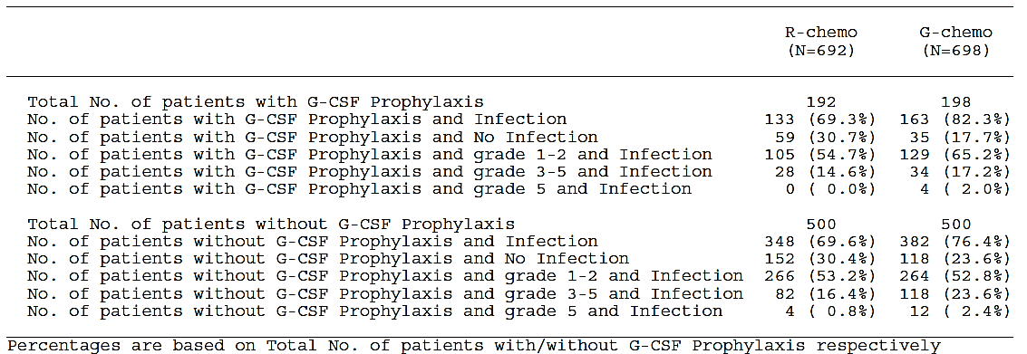
Comment: The difference between the R-chemo and G-chemo arm for Grade 3 to 5 infections is even higher when patients receiving G-CSF are excluded (16.4% versus 23.6%).

All TLS events (overall safety population)
Data for the FL safety population are presented in italics. Percentages shown for R-chemo followed by G-chemo arm:
- Incidence of TLS AEs comparable (0.4% versus 0.9%) (0.5% versus 1.0%)
- All classed as Grade 3 or 4
- No fatal TLS AEs
- Serious TLS 0.1% versus 0.4% (0.2% versus 0.5%)
- No TLS AEs led to treatment withdrawal.

Thrombocytopaenia (overall safety population)
Data for the FL safety population are presented in italics. Percentages shown for R-chemo followed by G-chemo arm:
- Incidence higher in G-chemo arm (7.2% versus 12.5%) (7.5 versus 11.4%)
- No Grade 5 thrombocytopaenia AEs
- Grade 3-4 more frequent in G-chemo arm (2.7% versus 6.6%) (2.7% versus 6.1%)
- Serious thrombocytopaenia 0.3% versus 0.7% (0.2% versus 0.7%)
- Patients with treatment withdrawn due to AE comparable (2.0% versus 2.3%) (2.2% versus 2.9%).
Information about abnormal laboratory results is given in Section 8.5.4, below.

Acute thrombocytopaenia (overall safety population)
Acute thrombocytopaenia was defined as ‘thrombocytopaenia occurring during or within 24 hours after the infusion’. Data for the FL safety population are presented in italics. Percentages shown for R-chemo followed by G-chemo arm (when the numbers are small the number of patients is presented):
- Incidence higher in G-chemo arm (0.1% versus 1.1%) (0/597 (0%) versus 7/595 (1.2%))
- No Grade 5 acute thrombocytopaenia AEs
- Grade 3 or 4 events more frequent in G-chemo arm 1/692 and 7/698 (0.1% versus 7/0.9%) (0 versus 8 patients)
- Serious thrombocytopaenia 1/692 and 4/698 (0.1% versus 0.3%) (0 versus 2 patients)
- No patients had treatment withdrawn due to AE.

Haemorrhagic events (overall safety population)
According to the CSR, haemorrhagic events were defined by any MedDRA preferred term from the following SMQs (all of them narrow): ‘Haemorrhagic cerebrovascular conditions’ (20000064), ‘Haemorrhage laboratory terms’ (20000040) and ‘Haemorrhage excluding laboratory terms’ (20000039)). The events were similar in the 2 treatment arms:
Data for the FL safety population are presented in italics. Percentages shown for R-chemo followed by G-chemo arm:
- Similar incidence in the 2 treatment arms (10.4% R-chemo versus 10.0% G-chemo) (10.4% versus 9.6%)
- Majority of haemorrhagic events were Grade 1 or 2, and there were 2 Grade 5 AEs in each arm
- Similar incidence of serious haemorrhagic events (1.0% R-chemo versus 1.1% G-chemo) (1.0% versus 1.1%)
- One patient in the R-chemo arm was withdrawn from treatment due to haemorrhagic AE
- The incidence of haemorrhagic events was greater in the G-chemo arm during Cycle 1 (1.3% in the R-chemo arm versus 2.4% in the G-chemo arm), but comparable for all other cycles
- The 5 most frequently observed haemorrhagic events were epistaxis (2.2% versus 1.9%) (2.3% versus 1.8 %), contusion (1.7% versus 1.9%) (1.8% versus 2.0%), haematuria (0.7% versus 0.9%) (0.5% versus 0.8%), haematoma (0.7% versus 0.6%) (0.7% versus 0.3%), and conjunctival haemorrhage (1.3% versus 0.0%) (1.3% versus 0.0%).
- The types of haemorrhagic events were comparable (< 1% difference between the 2 treatment arms), except for conjunctival haemorrhage which was more frequently observed in the R-chemo arm (1.3% versus 0.0% in the G-chemo arm).

GI perforation (overall safety population)
Data for the FL safety population are presented in italics. Percentages shown for R-chemo followed by G-chemo arm:
- Incidence of GI perforation AEs comparable (0.4% versus 0.6%) (0.5% versus 0.7%)
- No Grade 5 GI perforation AEs
- Grade 3 or 4 more frequent in G-chemo arm (0/0.0% versus 3/0.4%) (0 versus 3 patients)
- Serious GI perforation AEs 0/0.0% versus 3/0.4% (0 versus 3 patients)
- No patients had treatment withdrawn due to AE.

Cardiac events (overall safety population)
Data for the FL safety population are presented in italics. Percentages shown for R-chemo followed by G-chemo arm:
- Greater incidence in G-chemo arm (9.7% versus 14.6%) (9.7% versus 13.1%)
- Higher incidence in G-chemo arm due to higher incidence of tachycardia (1.6% versus 3.0%) (1.2 versus 2.7%), atrial fibrillation (1.4% versus 2.4%) (1.3% versus 2.7%), sinus tachycardia (0.4% versus 1.3%) (0.5% versus 1.3%), bradycardia (0.3% versus 0.9%), sinus bradycardia (0.0% versus 1.0%) (0% versus 1.2%), arrhythmia (0.0% versus 0.7%), and acute myocardial infarction (0.0% versus 0.6%) (0% versus 0.7%)
- The incidence was still higher in G-chemo arm when IRRs were excluded (7.8% versus 11.2%) (8.2% versus 9.6%)
- 2 fatal cardiac AEs in the R-chemo arm (cardiac arrest and myocardial infarction), and 3 in the G-chemo arm (2 cases of cardiogenic shock, and one cardiac failure).
- Greater incidence of serious cardiac AEs in the G-chemo arm (2.0% versus 5.9%) (12/597 (2.0%) versus 26/595 (4.4%)).
Comment: Generally it looks like there are more cardiac AEs in the G-chemo arm in the overall population than in the FL population while it was approximately the same for the R-chemo arm (see overall AEs and SAEs). The average age of the MZL population was 63.0 and for the FL population 59.0. More patients proportionally had bendamustine in the MZL arm. The sponsor has previously argued that there were more patients with stage IV disease in the MZL arm compared to the FL arm, but this is the nature of at least the splenic and nodal MZL, which constitute about 2/3 of the MZL population. The MZL population only constitute 14% of the overall safety population and still it affects the safety data making the evaluator worry that age plays a large part in the higher incidence of AEs in the G-chemo arm in the overall safety population.
Question 7: The sponsor is asked to comment on possible reasons for the higher incidence of cardiac AEs in the MZL population (and as such the overall safety population, which is the safety population in the PI) compared to the FL population.

Second malignancies (overall safety population)
Data for the FL safety population are presented in italics. Percentages shown for R-chemo followed by G-chemo arm:
- Greater incidence of SOC defined second malignancies in G-chemo arm (7.5% versus 10.3%) (42/597 (7.0%) versus 62/595 (10.4%))
- SMQ-defined second malignancies were also more frequent in the G-chemo arm (5.5% versus 7.2%) (5.0% versus 7.2%).
From the CSR, regarding the follicular lymphoma population:
There were 11 fatal second malignancies reported; 5 in the R-chemo arm (neuroendocrine carcinoma of the skin, gastric cancer, colon cancer, malignant melanoma, and lung adenocarcinoma), and 6 in the G-chemo arm (non-small cell lung cancer (2 AEs), hepatic neoplasm, prostate cancer, myelodysplastic syndrome, and acute lymphocytic leukaemia).
Comment: There is no obvious difference between the R- and G-chemo arms with regards to malignancies. This was a concern raised by the IDMC when the study was stopped in the third interim assessment, see Figure 4, above.

Hepatitis B reactivation (FL safety population)
7 patients of 53 HepB core Ab⁺ patients (13.2%) in the R-chemo arm and 5 of 29 HepB core Ab+ patients (17.2%) in the G-chemo arm had reactivation according to the definition in Table 14. HBV DNA ≥ 100 IU/mL occurred in 3 patients in each arm. 5 AEs of HBV reactivation were reported: 2 in the R-chemo arm and 3 in the G-chemo arm. One new case of hepatitis B reactivation in the R-chemo arm was reported as Grade 3 hepatitis viral.

Evaluation of issues with possible regulatory impact

Liver function and liver toxicity
The following information regarding liver related laboratory abnormalities for the FL population is taken from the CSR.

Table 19. Liver related chemistry laboratory parameters (FL population)
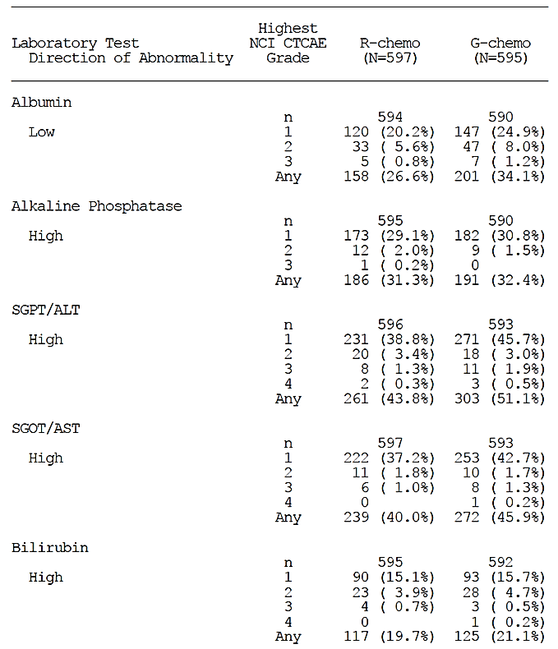
Comment: There is no data for the overall safety population (although there may be data in the 105,000 pages of data listings that does not have a proper ToC and is subdivided without any proper headings). There does not seem to be any difference between the R-chemo and G-chemo arms.
For Hepatitis B reactivation see Section 8.4.6.11 (above).

Renal function and renal toxicity
The 2 arms were comparable with relation to change in kidney parameters. There were more patients in the G-chemo arm with high potassium and an AE for hypokalaemia in the overall safety population; for the FL population the numbers for hypokalaemia were almost identical; 6.4% versus 3.7% for R-chemo). There were also more patients with high uric acid in this arm; 29.2% versus 23.0% for R-chemo.
The incidence of AEs by creatinine clearance is summarised below in Table 20.
In both treatment groups, the incidence of deaths, deaths due to AEs, Grade 3 to 5 AEs, SAEs, and AE leading to withdrawal from treatment was higher in patients with a creatinine clearance < 50 mL/min compared with patients with creatinine clearance ≥ 50 mL/min (see Table 20, below).
Deaths, deaths due to AEs, Grade 3 to 5 AEs, SAEs, and AE leading to withdrawal from treatment were more frequent in patients in the G-chemo arm in patients with a creatinine clearance < 50 mL/min (see Table 20). 4 patients with CrCL < 50 mL/min died due to an AE; 2 in the R-chemo arm and 2 in the G-chemo arm.

Table 20. Adverse events by creatinine clearance < 50 mL/min and ≥ 50 mL/min (FL safety population)
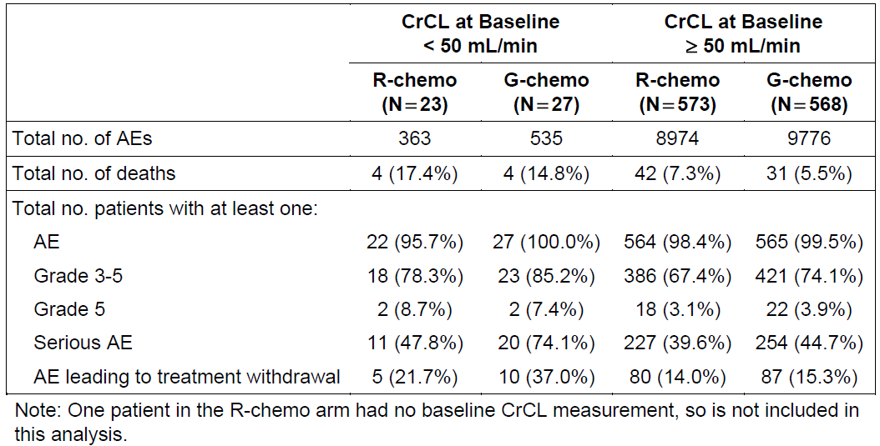
Comment: There were more SAEs in the G-chemo arm in patients with a CrCL < 50 mL/min compared to the corresponding R-chemo arm. The average age at diagnosis for Australian patients with FL is 60 to 65 years of age (57.9 years at commencement of therapy in this study). With increasing age CrCL declines. It is therefore very important to stress the higher AEs with declining kidney function especially neutropaenia and infections (as noted in the PI under ‘Precautions’).

Other clinical chemistry
Grade 3 and 4 high uric acid level in the FL population was seen more frequently in the G-chemo arm (percentages shown for R-chemo followed by G-chemo arm): 125 (21.3%) and 10 (1.7%) versus 154 (26.3%) and 17 (2.9%), respectively.

Haematology and haematological toxicity
The main differences in haematological laboratory parameters in the FL population were seen for neutrophils and platelets, as shown below in Table 21, in particular a higher incidence of Grade 4 neutropaenia in the G-chemo arm (36.65 versus 29.5%).

Table 21: Neutrophils and platelets in the FL safety population
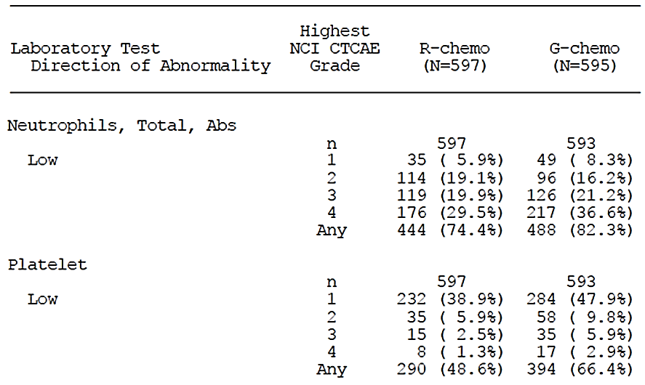
Neutropaenia is an AEPI and AESI and for further information and discussion see Section 8.4.6.2, above.

Electrocardiograph findings and cardiovascular safety
According to the CSR, regarding the FL population:
ECGs were performed at screening and at end of induction, or early withdrawal. Individual 12-Lead ECG data are provided. Clinically important ECG abnormalities had to be reported as AEs or SAEs:
- One patient in each treatment arm had ECG QT prolonged
- One patient in the R-chemo arm had ECG ST segment elevation
- One patient in the R-chemo arm had ECG T wave inversion.
Cardiac events are an AEPI and are discussed in Section 8.4.6.9, above.

Vital signs and clinical examination findings (FL safety population)
According to the clinical study report no clinically relevant trends were apparent in either treatment arm in blood pressure, pulse rate, or temperature throughout the treatment period.

Immunogenicity and immunological events
No patients in the G-chemo arm had a detectable positive HAHA result for anti-obinutuzumab antibodies after Cycle 1, Day 1.

Serious skin reactions
Frequents AEs for the PT Skin disorders are presented in Table 22 (FL safety population).
No Grade 3 to 5 adverse events with an incidence > 2% or an SAE with an incidence > 1% were observed in the SOC Skin and Subcutaneous Tissue Disorders for the entire safety population. There is no mention of Stevens Johnson syndrome, DRESS or toxic epidermal necrolysis.

Table 22. Adverse events with an incidence rate of at least 10% in either treatment arm in Study BO21223 (FL safety population)
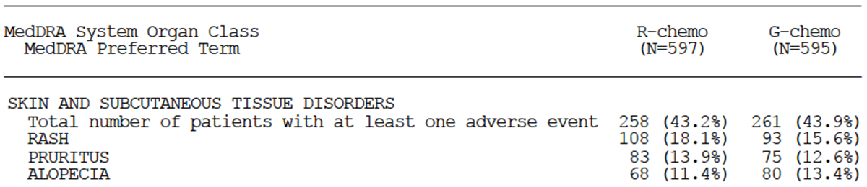
Comment: There does not seem to be any major differences between R- and G-chemo for the SOC Skin disorders.

Other safety issues

Safety in special populations

Age and sex
The adverse events by age group and sex in the overall safety population are depicted in Table 23, below.

Table 23. Adverse events by age group and sex (overall safety population)
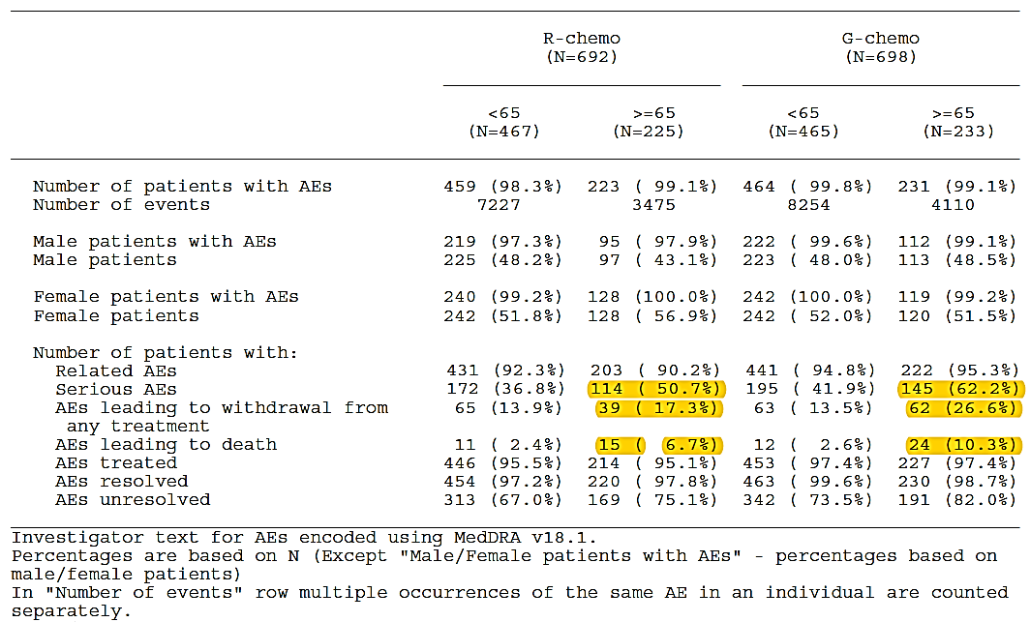
For the FL safety population the sponsor states:
The incidence of AEs was similar in the 2 age groups in both treatment arms, including related AEs (using a cut-off of 5% to indicate a difference). However, in both treatment arms, the incidence of SAEs was higher in patients ≥ 65 years old than in younger patients, as was the incidence of AEs leading to death and the incidence of AEs leading to withdrawal from any treatment (see Table 24 below).
The incidence of AEs, deaths, fatal AEs, Grade 3 to 5 AEs, and serious AEs was similar (using a cut-off of 5% to indicate a difference between arms) for both males and for females.
Table 24. Adverse events by age group and sex (FL safety population)
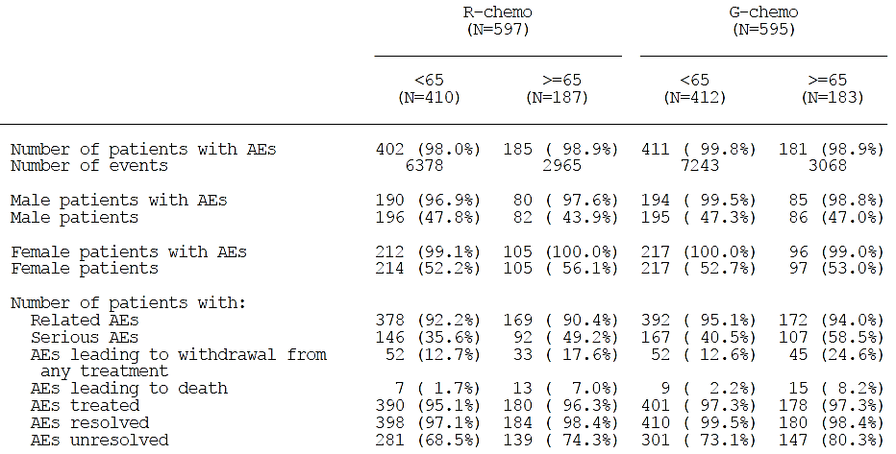
Comment: For the above sponsor mentioned SAEs in patients who were ≥ 65 years of age, the incidence was demonstrably higher in the G-chemo arm compared to the R-chemo arm especially in the overall safety population; see highlighted text in Table 23, above. This has to be taken into account when choosing a CD20 antibody-chemo regimen for a person ≥ 65 years of age. This has to be made clear in the PI with relevant differences specified.

Pregnancies (FL safety population)
4 pregnancies were reported in Study BO21223.
2 pregnancies were reported in study patients: One in the G-chemo arm which led to a therapeutic termination of pregnancy and one in the R-chemo arm which resulted in a spontaneous abortion.
There were 2 pregnancies in the partner of a male patient: One in the G-chemo arm which led to a therapeutic termination of pregnancy and one in the R-chemo arm with a healthy baby delivered at term.

Safety related to drug-drug interactions and other interactions
From the SCS:
No formal drug-drug interaction studies have been conducted with obinutuzumab as such interactions are not expected with this mAb. A comparison of serum pharmacokinetic parameters from studies of obinutuzumab monotherapy with pharmacokinetic parameters from studies of obinutuzumab in combination with chemotherapy (Study BO21000) suggests that concomitant chemotherapy has minimal impact on the pharmacokinetics of obinutuzumab. Co-administration with obinutuzumab was investigated in exploratory analyses in Studies GAO4753g (GADOLIN, a study to investigate the efficacy and safety of bendamustine compared with G-benda in patients with rituximab-refractory iNHL) and Study GAO4915g (GATHER, a study of G-CHOP in patients with previously untreated advanced DLBCL). Obinutuzumab had no apparent effect on the pharmacokinetics of bendamustine, or the individual components of CHOP.

Post marketing experience
According to the sponsor, 13841 mainly CLL and iNHL patients have received obinutuzumab worldwide. Overall no new safety signal was identified in Study BO21223 compared with the data presented in the latest periodic benefit-risk evaluation report.

Evaluator’s overall conclusions on clinical safety
Study BO21000 (GAUDI) included 81 first line FL patients and explored the safety of obinutuzumab (G) in combination with CHOP or bendamustine. This study has not been evaluated in detail as it was a small Phase I study compared to the large Phase III Study BO21223 (GALLIUM) comprising 1390 patients of which 698 received obinutuzumab and chemotherapy (bendamustine, CHOP, or CVP). There was no comparator in Study BO21000 whereas Study BO21223 has another CD20 antibody (rituximab) as comparator. The results from Study BO21000 are not included in the product information, and in the following the results from Study BO21223 are summarised. For an overview of the study design see Figure 3, above.
The demographics for the FL population have been described in the efficacy section; about 80% were White and 47% male. The FL population comprise about 86% of the overall safety population. The demographics for the remaining 14% mainly MZL patients were listed in the CSR. About 93% were White and 50% male. The main differences between the FL and MZL patients are the mean age of 57.9 versus 61.9 and the number of patients ≥ 65 years of age (31.3% versus 44.6%), which are likely to have an impact on the safety results even though the proportion of MZL patients is small.

Exposure (overall safety population)
Induction phase: At least 90% of the planned cumulative dose of antibody was administered in 99.4% of the R-chemo arm and in 99.0% in the G-chemo arm.
Maintenance phase: (for patients in CR or PR after induction): 603 patients in the R-chemo arm and 623 patients in the G-chemo arm received maintenance treatment. In the R-chemo arm 99.0% received ≥ 90% of the cumulative maintenance dose compared to 99.8% of patients in the G-chemo arm.

Adverse events
There were more adverse events in the G-chemo arm compared to the R-chemo arm in both the FL and overall safety population in particular Grade 3 to 5 AEs, SAE, related SAEs and related AEs leading to any dose interruption. There were more AEs with a fatal outcome in the G-chemo arm but more deaths in the R-chemo arm.
Adverse events (all grades) reported with a difference of at least 2% between the treatment arms, but excluding IRRs reflects the most frequently related AEs which are all in favour of R-chemo.
There are more SAEs in the G-chemo arm compared to the R-chemo arm in both the overall and FL safety population (see section 8.4.3.2, above). There are generally more SAEs in the overall safety population (the population in the PI) than in the FL population, which is not unexpected, as the median age of the FL population is 59.0 years and 63.0 years for the MZL population. The percentage of patients who are ≥ 65 years of age is 31.3% in the FL population and 44.6% in the MZL population, and although the MZL population only constitute 14% of the overall safety population this apparently has an impact on the overall safety data together with other factors. As the average age at diagnosis for FL patients is 65 years, the lower average age (and good performance status) in this study does not reflect the FL population as a whole, and these data demonstrate that this has to be taken into account when choosing which anti-CD20 antibody to use in addition to considering efficacy. See also comments in Section 7.4, above.
AEs leading to withdrawal were slightly higher in the G-chemo arm in both the FL and overall safety population.

Adverse events of particular or special interest
There were more IRRs in the overall population compared to the follicular population. Elderly patients have more co-morbidities, for instance cardiovascular problems, which could be an issue in relation to IRRs and subsequently the choice of anti-CD20 antibody (see also Section 8.4.6.1).
Higher age (see Section 8.6.1.1) and renal impairment (see Table 20) were risk factors for SAEs.
There were more AEs and SAEs in the MZL population in the G-chemo arm. Off label use in MZL and other indolent NHL may, especially in the elderly, affect the benefit/risk ratio negatively.
Statements from the sponsor’s Clinical Overview regarding safety compared to data from Study BO21223 are presented in Table 26, below. One problem with the safety section of the Clinical Overview is that it deals with the FL population, not the overall safety population, which is the population included (as it should be) in the PI.

Table 26. Clinical overview statements compared to data from the CSR Study BO21223
Section topic in Clinical Overview | Clinical Overview statement | Data from Study BO21223
Overall adverse events experience  FL population versus overall population | Safety data from the overall population of patients was generally consistent with that of the FL population. | There were more adverse events in overall population than in the FL population.
Deaths  Deaths due to Adverse Event | Deaths from causes other than progression (non-PD) were reported in a similar proportion of patients in each arm: 24 (4.0%) in the R-chemo arm and 23 (3.9%) in the G-chemo arm. These deaths were mainly due to Grade 5 AEs (20 (3.4%) versus 23 (3.9%)). | In the SCS referred to there is a reference to Table 16 in the SCS. Here there are 24 (not 23) patient deaths in the G-chemo arm. For the overall population deaths due to AEs in the R-chemo versus G-chemo arm are 26 and 35.
Safety by treatment phase:  AE during the maintenance phase | Overall safety in the maintenance phase, was comparable between the R-chemo and G-chemo arms (n = 535 (R-chemo) versus 548 (G-chemo) in the safety evaluable FL population). | All types of AEs were higher in the G-chemo arm during the maintenance phase.
Intrinsic factors  AEs in patients ≥ 65 years of age | The overall incidence of fatal AEs, SAEs, and AEs leading to withdrawal of any treatment, was higher in patients ≥ 65 years old (n = 183 receiving G-chemo) than in younger patients (n = 412). Safety in patients ≥ 75 years (n = 37) was comparable to that described for patients ≥ 65 years. | Yes, there were more AEs in patients who were ≥ 65 year old, and the incidence of SAEs was clearly higher in the G-chemo arm compared to the R-chemo arm especially in the overall safety population.
Safety by renal function | In both G-chemo and R-chemo treatment arms of Study BO21223, the incidence of fatal AEs, SAEs, and AE leading to withdrawal of treatment was higher in patients with moderate renal impairment (creatinine clearance (CrCL < 50 mL/min) compared with patients with normal or mildly impaired renal function (CrCL ≥ 50 mL/min). | There were more SAEs in the G-chemo arm in patients with a CrCL < 50 mL/min compared to the corresponding R-chemo arm (see Table 20).

First round benefit-risk assessment

First round assessment of benefits
Indication
Benefits | Strengths and Uncertainties
Study BO21223 demonstrated that treatment with G-chemo resulted in a clinically meaningful and statistically significant reduction by 34% in the risk of an investigator assessed PFS event (disease progression/relapse or death) compared with R-chemo (stratified HR 0.66 (95% CI: 0.51, 0.85); p-value = 0.0012, stratified log-rank test). The p-value of the investigator assessed PFS was smaller than the pre-specified interim boundary significance level of 0.012. | Large Phase III trial with a relevant comparator.  It is too early to evaluate overall survival. This is the most important objective long term, and it is uncertain whether improved PFS translates into improved OS.  Not all the secondary met the predefined hierarchal statistical requirements.

First round assessment of risks
Risks | Strengths and uncertainties
Compared to R-chemo G-chemo poses a higher risk of:  IRRs  SAEs  Neutropaenia  Infections  Death due to AEs  which is even higher in patients ≥ 65 years of age. | The average age of the FL population in Study BO21223 is 57.9 years and 61.9 years in the MZL population and the ECOG performance score was 0 or 1. Patients with a CrCL ≤ 40 mL/min were excluded. This is not representative of the average FL population and makes it necessary to be cautious in the elderly, in patients with many comorbidities and/or high ECOG performance score, and in patients with reduced CrCL.

First round assessment of benefit-risk balance
- In the investigated FL population the benefits outweighs the risk when evaluating PFS. It is unknown, but likely, that this will lead to longer overall survival in this population.
- The benefit may not outweigh the risk in elderly patients, in patients with reduced renal function, and in patients with an ECOG performance score ≥ 2. This group of patients comprises a substantial part of the follicular lymphoma patient population. To approve the indication there has to be clear warnings in the Product Information regarding the adverse events in this group of patients and regular updates on PFS and OS submitted to the TGA.
- MZL patients had more adverse events and there is a risk that obinutuzumab may be used outside the approved label and thus skew the benefit/risk negatively in these patients, which stresses the importance of the warnings described in Section 9.2, above).

First round recommendation regarding authorisation
Approval of ‘Gazyva in combination with chemotherapy followed by Gazyva maintenance is indicated for the treatment of patients with previously untreated follicular lymphoma’ is recommended provided that the product information and CMI clearly display the various adverse events seen to a higher extent in the G-chemo arm compared to the R-chemo arm and also clearly state the higher incidence of all adverse events in patients > 65 years of age and patients with reduced renal function. The fact that the patients in the pivotal study had an ECOG performance score of 0 or 1 also has to be clearly visible.
The sponsor should present a Product Information document complying with these conditions for evaluation.

Clinical questions

Clinical questions

Pharmacokinetics
Not applicable.

Pharmacodynamics
Not applicable.

Efficacy
- Participant flow: There is a discrepancy related to the date of the last enrolled patient between the front page of the clinical study report and section 4.1.1 in the CSR; 5 June 2014 versus 5 February 2014. What is the correct date?
- Tables from the CSR: There are more deaths but fewer events in the IRS assessed data compared to the investigator assessed data [as per 2 tables in the CSR]. The cut-off date for the study is the same. What is the explanation for the disparity in death numbers?

Safety
- CSR; the proportion of AEs (all categories) in the MZL population was higher than in the FL population. Can the sponsor suggest any explanations for this?
- CSR; Looking at the tabulated overview of AEs by phase in the overall safety population, the AEs of particular interest such as Infection, Neutropaenia and Thrombocytopaenia do not differ substantially from the AEs observed in the FL population, except for the numbers and percentages for Neutropaenia in the follow-up phase, where there is 1 (2.5%) in the R-chemo arm and 13 (2.5%) in the G-chemo arm as opposed to 5 (in a smaller part of the population) and 10 correspondingly in the FL population. Please explain this discrepancy in numbers for neutropaenia in the follow-up phase in the R-chemo arm.
- A patient listing of AEs that led to withdrawal from any study medication in Study BO21223, as indicated in the CSR cannot be found. Can the sponsor provide these lists?
- Question 6: CSR: The evaluator is unable to locate the information regarding dose modifications due to adverse events for the overall safety population (only for the FL population). What are the corresponding data for the overall safety population?
- The sponsor is asked to comment on possible reasons for the higher incidence of cardiac AEs in the MZL population (and as such the overall safety population, which is the safety population in the PI) compared to the FL population.

Second round evaluation of clinical data submitted in response to questions
The sponsor provided a response to the extensive questions of the first round evaluator and also submitted a new report in relation to Study BO21223. This is irregular in that no new data is to be submitted in the evaluation process unless asked for by the relevant evaluator or Delegate, or previously agreed up front prior to the original submission of the application. This report (11,298 pages) is titled, ‘Assessment of Delayed-Entry Adverse Event Records and Update of Safety Results Reported at the Primary Analysis in Study BO21223 (GALLIUM). Beyond trying to interrogate the report to verify the edits to the PI in terms of adverse events, this report was not evaluated by this Delegate as it was not possible.
With respect to Questions 1 to 7 of the sponsor’s response to the questions raised in the first round evaluation, the Delegate has reviewed the responses provided and, based upon the crux of this evaluation, that is, the moving of the treatment of follicular lymphoma from second line to first line, the responses appear to have addressed the evaluator’s questions and are considered satisfactory.
The remaining questions relate directly to amendments requested in the PI document. These have universally been agreed to by the sponsor and are reflected in a new draft, annotated PI document. The questions are dealt with individually below:

Second round benefit-risk assessment
The substance of the questions asked in the first round and their answers has not changed the overall positive risk/benefit of the product. The first round evaluator was concerned that the higher rates of certain ADRs noted with the G-chemo arm was made explicit in the PI and this has been done by compliance with the requests made to amend the PI document. In addition, the adverse event rate differences in general terms (SAEs, AEs leading to death or withdrawal) in the elderly versus the rest of the study population has been made clear. On this basis, the concerns of the first round evaluator have been met.

Second round recommendation regarding authorisation
The product may be authorised for marketing (noting with the slightly changed indication statement).

References
Cheson B et al. Revised Response Criteria for Malignant Lymphoma. J Clin Oncol 2007; 25: 579-586.
Federico M et al. R-CVP versus R-CHOP versus R-FM for the initial treatment of patients with advanced-stage follicular lymphoma: results of the FOLL05 trial conducted by the Fondazione Italiana Linfomi. J Clin Oncol 2013; 31: 1506-1513.
Flinn I et al. Randomized trial of bendamustine-rituximab or R-CHOP/R-CVP in first-line treatment of indolent NHL or MCL: the BRIGHT study. Blood 2014; 123: 2944-2952.
Freedman A, Aster J. Clinical manifestations, pathologic features, diagnosis, and prognosis of follicular lymphoma. UpToDate. Literature review current through: January 2017. Updated: September 21, 2016.
Herold M et al. Rituximab added to first-line mitoxantrone, chlorambucil, and prednisolone chemotherapy followed by interferon maintenance prolongs survival in patients with advanced follicular lymphoma: an East German Study Group Hematology and Oncology Study. J Clin Oncol 2007; 25: 1986-1992.
Hiddemann W et al. Frontline therapy with rituximab added to the combination of cyclophosphamide, doxorubicin, vincristine, and prednisone (CHOP) significantly improves the outcome for patients with advanced-stage follicular lymphoma compared with therapy with CHOP alone: results of a prospective randomised study of the German Low-Grade Lymphoma Study Group. Blood 2005; 106: 3725-3732.
Kahl B, Yang D. Follicular lymphoma: evolving therapeutic strategies. Blood 2016; 127, 2055-2063.
Marcus R et al. CVP chemotherapy plus rituximab compared with CVP as first-line treatment for advanced follicular lymphoma. Blood 2005; 105: 1417-1423.
Marcus R et al. Phase III study of R-CVP compared with cyclophosphamide, vincristine, and prednisone alone in patients with previously untreated advanced follicular lymphoma. J Clin Oncol 2008; 26: 4579-4586.
Pocock J et al. Survival plots of time-to-event outcomes in clinical trials: good practice and pitfalls. Lancet 2002; 359: 1686–1689.
Rummel M et al. Bendamustine plus rituximab versus CHOP plus rituximab as first-line treatment for patients with indolent and mantlecell lymphomas: an open-label, multicentre, randomised, phase 3 non-inferiority trial. Lancet 2013; 381:1203-1210.
Salles G et al. Rituximab combined with chemotherapy and interferon in follicular lymphoma patients: results of the GELA-GOELAMS FL2000 study. Blood 2008; 112: 4824-4831.
Westfall P, Krishen A. Optimally weighted, fixed sequence and gatekeeper multiple testing procedures. J Stat Plan Inference 2001; 99: 25–40.

Therapeutic Goods Administration
PO Box 100 Woden ACT 2606 Australia
Email: info@tga.gov.au Phone: 1800 020 653 Fax: 02 6232 8605
https://www.tga.gov.au

Australia, Belgium, Canada, China, Czech Republic, Finland, France, Germany, Hungary, Israel, Italy, Japan, Russia, Spain, Sweden, Taiwan, United Kingdom, and USA.
In both treatment groups, the incidence of deaths, deaths due to AEs, Grade 3- 5 AEs, SAEs, and AE leading to withdrawal from treatment was higher in patients with a creatinine clearance <50 mL/min compared with patients with creatinine clearance >50 mL/min

