|  |
| --- |
| **May 2018** |

|  |
| --- |
| Australian Public Assessment Report for Obinutuzumab |
| Proprietary Product Name: Gazyva |
| Sponsor: Roche Products Pty Ltd |

About the Therapeutic Goods Administration (TGA)

* The Therapeutic Goods Administration (TGA) is part of the Australian Government Department of Health and is responsible for regulating medicines and medical devices.
* The TGA administers the *Therapeutic Goods Act 1989* (the Act), applying a risk management approach designed to ensure therapeutic goods supplied in Australia meet acceptable standards of quality, safety and efficacy (performance) when necessary.
* The work of the TGA is based on applying scientific and clinical expertise to decision-making, to ensure that the benefits to consumers outweigh any risks associated with the use of medicines and medical devices.
* The TGA relies on the public, healthcare professionals and industry to report problems with medicines or medical devices. TGA investigates reports received by it to determine any necessary regulatory action.
* To report a problem with a medicine or medical device, please see the information on the TGA website <<https://www.tga.gov.au>>.

About AusPARs

* An Australian Public Assessment Report (AusPAR) provides information about the evaluation of a prescription medicine and the considerations that led the TGA to approve or not approve a prescription medicine submission.
* AusPARs are prepared and published by the TGA.
* An AusPAR is prepared for submissions that relate to new chemical entities, generic medicines, major variations and extensions of indications.
* An AusPAR is a static document; it provides information that relates to a submission at a particular point in time.
* A new AusPAR will be developed to reflect changes to indications and/or major variations to a prescription medicine subject to evaluation by the TGA.

Copyright

© Commonwealth of Australia 2018  
This work is copyright. You may reproduce the whole or part of this work in unaltered form for your own personal use or, if you are part of an organisation, for internal use within your organisation, but only if you or your organisation do not use the reproduction for any commercial purpose and retain this copyright notice and all disclaimer notices as part of that reproduction. Apart from rights to use as permitted by the *Copyright Act 1968* or allowed by this copyright notice, all other rights are reserved and you are not allowed to reproduce the whole or any part of this work in any way (electronic or otherwise) without first being given specific written permission from the Commonwealth to do so. Requests and inquiries concerning reproduction and rights are to be sent to the TGA Copyright Officer, Therapeutic Goods Administration, PO Box 100, Woden ACT 2606 or emailed to <[tga.copyright@tga.gov.au](mailto:tga.copyright@tga.gov.au)>.

Contents

Common abbreviations 4

I. Introduction to product submission 7

Submission details 7

Product background 7

Regulatory status 9

Product Information 10

II. Registration timeline 10

III. Quality findings 11

IV. Nonclinical findings 11

V. Clinical findings 11

Introduction 11

Pharmacokinetics 15

Pharmacodynamics 15

Dosage selection for the pivotal studies 15

Efficacy 15

Safety 16

First round benefit-risk assessment 20

First round recommendation regarding authorisation 22

Second round evaluation of clinical data submitted in response to questions 22

Second round benefit-risk assessment 22

VI. Pharmacovigilance findings 22

Risk management plan 22

VIII. Overall conclusion and risk/benefit assessment 24

Quality 24

Nonclinical 24

Clinical 24

Risk management plan 34

Risk-benefit analysis 35

Outcome 42

Attachment 1. Product Information 43

Attachment 2. Extract from the Clinical Evaluation Report 43

## Common abbreviations

|  |  |
| --- | --- |
| Abbreviation | Meaning |
| ACM | Advisory Committee on Medicines |
| ADCC | Antibody dependent cell mediated cytotoxicity |
| ADCP | Antibody dependent cellular cytotoxicity |
| ADR | Adverse drug reaction |
| AE | Adverse event |
| AEGT | Adverse event group term |
| ANC | Absolute neutrophil count |
| ARTG | Australian Register of Therapeutic Goods |
| ASA | Australian specific annex |
| CDC | Complement dependent cytotoxicity |
| CHMP | Committee for Medicinal Products for Human Use |
| CHOP | Cyclophosphamide, doxorubicin, vincristine and prednisolone |
| CMI | Consumer medicines information |
| CR | Complete response |
| CrCL | Creatinine clearance |
| CSR | Clinical study report |
| CT | Computed tomography (scan) |
| CVP | Cyclophosphamide, vincristine and prednisolone |
| DFS | Disease free survival |
| DLBCL | Diffuse large B cell lymphoma |
| DLP | Data lock point |
| DOR | Duration of response |
| ECOG | Eastern Cooperative Oncology Group |
| EFS | Event free survival |
| EMA | European Medicines Agency |
| FC | Fludarabine + cyclophosphamide |
| FDA | Food and Drug Administration |
| FL | Follicular lymphoma |
| G-chemo | Obinutuzumab (Gazyva) plus chemotherapy |
| GA101 | Obinutuzumab (drug development name) |
| GELF | Groupe d’Etude des Lymphomes Folliculaires |
| HBV | Hepatitis B virus |
| HCP | Healthcare Professional |
| HepB core Ab+ | Hepatitis B core antibody positive |
| HR | Hazard ratio |
| IDMC | Independent Data Monitoring Committee |
| IRC | Independent review committee |
| IRR | Infusion related reaction |
| LAA | Last antibody administration |
| mAb | Monoclonal antibody |
| MCL | Mantle cell lymphoma |
| MRD | Minimal residual disease |
| MRI | Magnetic resonance imaging |
| MZL | Marginal zone lymphoma |
| NCCN | National Comprehensive Cancer Network (US) |
| NHL | Non-Hodgkin’s lymphoma |
| NK | Natural killer |
| OS | Overall survival |
| PBRER | Periodic benefit-risk evaluation report |
| PET | Positron emission tomography |
| PFS | Progression free survival |
| PI | Product Information |
| PIP | Paediatric Investigation Plan |
| PK | Pharmacokinetic |
| PopPK | Population Pharmacokinetics |
| PR | Partial response |
| PRO | Patient reported outcomes |
| R-chemo | Rituximab plus chemotherapy |
| RMP | Risk management plan |
| RO5072759 | Obinutuzumab (drug development name) |
| SAE | Serious adverse event |
| SAP | Statistical analysis plan |
| SAWP | Scientific Advice Working Party |
| SMQ | Standardised MedDRA Query |
| SOC | System Organ Class |
| TLS | Tumour lysis syndrome |
| TTNLT | Time to next anti-lymphoma treatment |
| US | United States |

## I. Introduction to product submission

### Submission details

|  |  |
| --- | --- |
| *Type of submission:* | Extension of indications |
| *Decision*: | Approved |
| *Date of decision:* | 16 November 2017 |
| *Date of entry onto ARTG* | 5 December 2017 |
| *Active ingredient:* | Obinutuzumab |
| *Product name:* | Gazyva |
| *Sponsor’s name and address:* | Roche Products Pty Ltd PO Box 255, Dee Why, NSW, 2099 |
| *Dose form:* | Injection, concentrated |
| *Strength:* | 1000 mg obinutuzumab/40 mL concentrate solution |
| *Container:* | Type I glass vial |
| *Pack size:* | 1 vial per pack |
| *Approved therapeutic use:* | *‘Gazyva in combination with chemotherapy followed by Gazyva maintenance is indicated for* *the treatment of patients with previously untreated advanced follicular lymphoma’.* |
| *Route of administration:* | Intravenous infusion |
| *Dosage:* | Details of dosage and administration are given in the Product Information (Attachment 1). |
| *ARTG number (s):* | 210562 |

### Product background

This AusPAR describes the application by the sponsor to extend the indications of Gazyva obinutuzumab 40 mL concentrated solution single dose vials, each containing 1000 mg of obinutuzumab (25 mg/mL) for intravenous infusion, with the following indication:

*‘Gazyva in combination with chemotherapy followed by Gazyva maintenance is indicated for the treatment of patients with previously untreated follicular lymphoma’.*

At the time this application was considered, Gazyva had been previous approved for the following indications:

*‘Gazyva in combination with chlorambucil is indicated for the treatment of patients with previously untreated chronic lymphocytic leukaemia (CLL).*

*Gazyva in combination with bendamustine, followed by Gazyva maintenance, is indicated for the treatment of patients with follicular lymphoma (FL) who did not respond to, or who progressed during or up to 6 months after treatment with rituximab or a rituximab-containing regimen’.*

If approved, the drug is to become first line in follicular lymphoma, with ‘chemotherapy’ as combination treatment rather than the second line indication that remains, with bendamustine as the specific combination drug.

#### Follicular lymphoma

Follicular lymphoma (FL) is the second most common category of non-Hodgkin’s lymphoma (NHL) and the most common of the indolent forms of non-Hodgkin’s lymphoma, where patient survival is measured in years. It accounts for approximately 35% of NHL in the United States (US) with an incidence of 3.18 per 100,000 people. This is somewhat lower in Europe. Incidence increases with age and is twice as common in Caucasian people versus Black and Asian populations.

Treatment depends upon the stage of disease at presentation. Those with localised (Stage I) disease are candidates for radiation therapy, which is curative in a proportion of these patients. Others, with Stage III/IV disease, are treated for symptom control. Management for Stage II disease can vary from that offered to Stage I sufferers to that given those with more advanced disease.[1]

An approach to patient treatment is provided in the following Figure 1.

Figure 1. Typical treatment pathways for Grade 1 to 2 or 3a follicular lymphoma

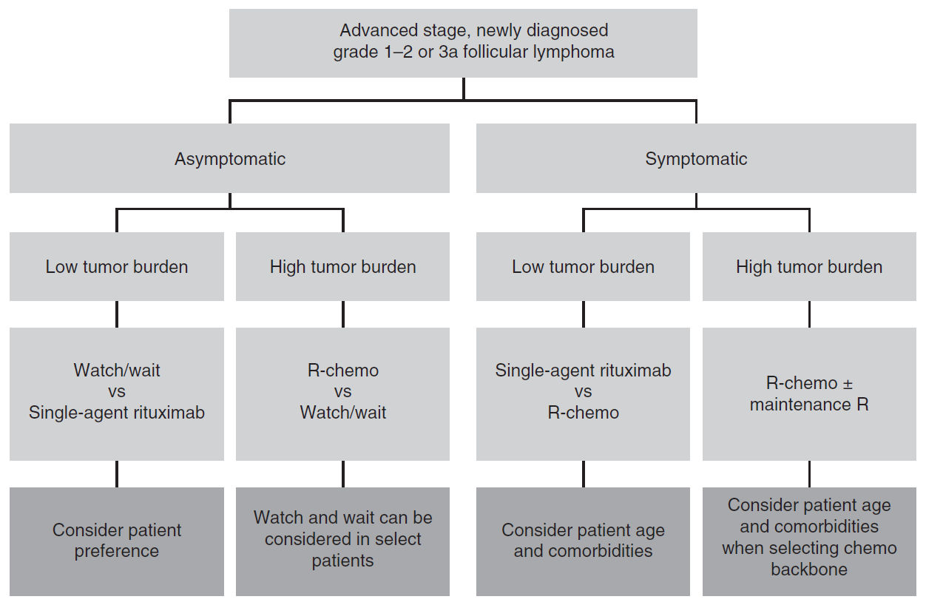

Figure adapted from Kahl and Yang, 2016.[2]

In the above figure and throughout this document, R-chemo denotes rituximab plus chemotherapy, with obinutuzumab (Gazyva) plus chemotherapy treatment denoted by G-chemo. Of relevance to this submission, rituximab’s approved indications in Australia include CD20+ Stage III/IV follicular B cell NHL, as well as relapsed or refractory CD20+ follicular B cell NHL. No combination chemotherapy is specifically cited in the indication, hence all are possible.[3] This submission seeks to include obinutuzumab as a first line treatment option for previously untreated follicular lymphoma (no stage of disease cited) in combination with ‘chemotherapy’. This expands the use from rituximab non-responders currently approved to be treated with obinutuzumab in combination with bendamustine.

There are 3 potential ‘chemotherapy’ regimens that can be used with rituximab in the literature, namely bendamustine, CHOP (cyclophosphamide, doxorubicin, vincristine and prednisolone) and CVP (cyclophosphamide, vincristine and prednisolone). As described by the clinical evaluator, US National Comprehensive Cancer Network (NCCN) guidelines favour R-benda as the best first line therapy followed by R-CHOP and then R-CVP.

#### Obinutuzumab

Obinutuzumab is a novel, humanised, type II glycoengineered monoclonal antibody (mAb) directed against the CD20 antigen found on the surface of most malignant and benign cells of B cell origin. Glycoengineering of this type II mAb has generated a mAb with a high affinity for binding immune effector cells (as per the sponsor’s cover letter dated 24 October 2016).

Properties conferred upon obinutuzumab as a result are claimed to be:

* Properties due to type II binding mode:
  + Higher induction of direct cell killing (via a non-apoptotic pathway).
  + Lower degree of internalisation, following binding to CD20 (type II binding mode prevents interaction with FcγRIIb which promotes CD20 internalisation).
  + Lower complement dependent cytotoxicity (CDC) (type II binding mode prevents clustering of bound CD20 to lipid rafts).
* Properties due to Fc-glycoengineering:
  + Higher affinity binding to high and low affinity human FcγRIIIa expressed on effector cells (for example, natural killer (NK) cells and macrophages).
  + Higher antibody dependent cell mediated cytotoxicity (ADCC) and antibody dependent cellular cytotoxicity (ADCP) towards bound CD20 expressing target cells.

These in vitro properties are claimed to translate into superior anti-lymphoma activity when compared with rituximab.

### Regulatory status

The product received initial registration on the Australian Register of Therapeutic Goods (ARTG) on 15 May 2014. As noted earlier in this document, the drug is already approved for second line treatment of FL, in combination with bendamustine.

At the time the TGA considered this application similar applications for registration have been approved or were under evaluation as shown in Table 1, below.

Table 1. Overseas regulatory and submission status

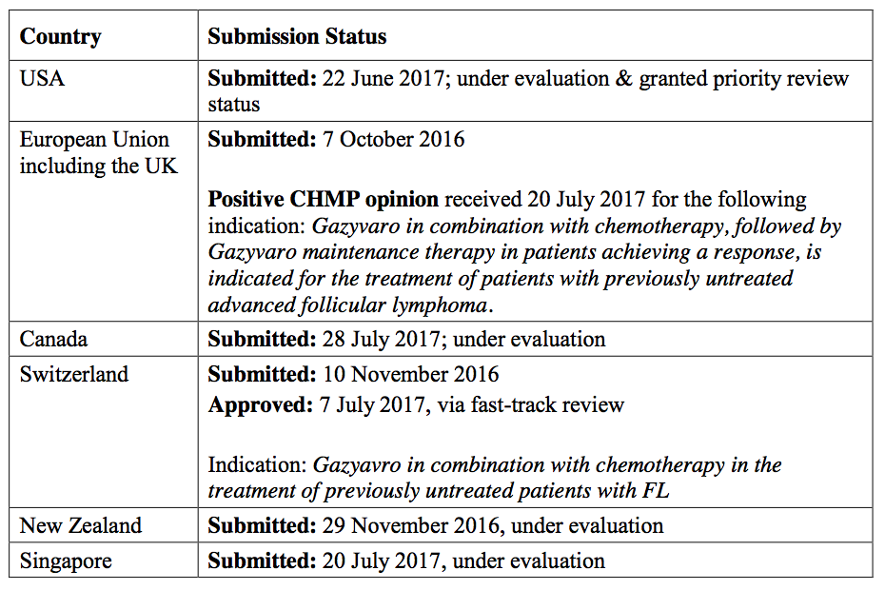

### Product Information

The Product Information (PI) approved with the submission which is described in this AusPAR can be found as Attachment 1. For the most recent PI, please refer to the TGA website at <<https://www.tga.gov.au/product-information-pi>>.

## II. Registration timeline

Table 2. Registration timeline for Submission PM-2016-03149-1-4

|  |  |
| --- | --- |
| Description | Date |
| Submission dossier accepted and 1st round evaluation commenced | 30 November 2016 |
| First round evaluation completed | 16 May 2017 |
| Sponsor provides responses on questions raised in First round evaluation | 16 June 2017 |
| Second round evaluation completed | 7 July 2017 |
| Request for Advisory Committee advice and/or Delegate’s Overview | 6 September 2017 |
| Sponsor’s response to Delegate’s Overview | 19 September 2017 |
| Advisory Committee meeting | 6 October 2017 |
| Registration decision | 16 November 2017 |
| Entry onto ARTG | 5 December 2017 |
| Number of TGA working days from commencement of evaluation to registration decision1 | 219 days |

1) Statutory timeframe: 255 working days.

## III. Quality findings

There was no requirement for a quality evaluation in a submission of this type.

## IV. Nonclinical findings

There was no requirement for a nonclinical evaluation in a submission of this type.

## V. Clinical findings

A summary of the clinical findings is presented in this section. Further details of these clinical findings can be found in Attachment 2.

### Introduction

#### Clinical rationale

As in other mature B cell lymphomas, FL is characterised by the expression of a surface membrane antigen, CD20. CD20 is an attractive target for anti-lymphoma therapies being B cell-specific, highly and stably expressed, exhibiting a low rate of internalisation, and not being present on hematopoietic stem cells. The concept of targeting CD20 as an effective anti-lymphoma strategy has been unequivocally established by clinical data for the anti‑CD20 mAb rituximab, which has revolutionised the treatment of FL, as well as a range of other B cell malignancies and non-malignant disorders. Accumulating clinical data demonstrate clearly that combining rituximab with chemotherapy improves patients’ outcomes compared to chemotherapy or rituximab alone (see Table 3, below). The advantage of CD20 over other therapeutic targets, as outlined above, has led to the continued development of improved anti-CD20 mAbs as anti-lymphoma therapies. Obinutuzumab, a glycoengineered type II anti-CD20 mAb, binds the CD20 antigen in a different orientation to type I mAbs such has rituximab. Compared with rituximab, obinutuzumab possesses the following properties in vitro:

* Properties due to type II binding mode:
  + Higher induction of direct cell killing (via a non-apoptotic pathway).
  + Lower degree of internalisation, following binding to CD20 (type II binding mode prevents interaction with FcγRIIb which promotes CD20 internalisation).
  + Lower CDC (type II binding mode prevents clustering of bound CD20 to lipid rafts).
* Properties due to Fc-glycoengineering:
  + Higher affinity binding to high and low affinity human FcγRIIIa expressed on effector cells (for example, NK cells and macrophages).
  + Higher ADCC and ADCP towards bound CD20 expressing target cells.

The in vitro properties of obinutuzumab compared with rituximab, as listed in the product background above, translated into superior anti-lymphoma activity for obinutuzumab when compared directly to rituximab in a number of preclinical NHL xenograft models, including a model of FL involving subcutaneous inoculation of the human RL cell line.[4] In addition, the anti-tumour effects of obinutuzumab in combination with chemotherapeutic agents were superior to the anti-tumour effects of rituximab when used in combination with these agents.

Table 3. Efficacy in key randomised Phase III studies of rituximab based induction treatment for patients with previously untreated advanced follicular lymphoma

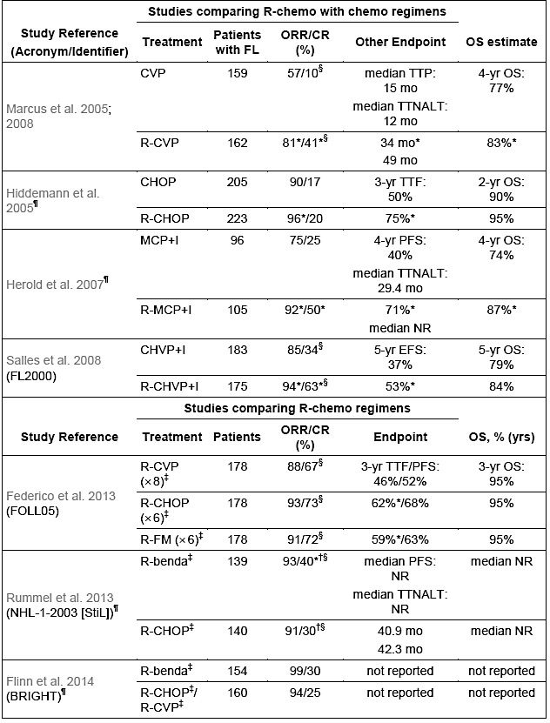

CHOP: cyclophosphamide, doxorubicin, vincristine and prednisone; CHVP: cyclophosphamide, doxorubicin, etoposide and prednisone; CR: complete response; CVP: cyclophosphamide, vincristine and prednisone; EFS: event-free survival; I: interferon; MCP: mitoxantrone, chlorambucil and prednisone; NR: not reached; ORR: overall response rate; OS: overall survival; PFS: progression-free survival; R: rituximab; TTF: time to treatment failure; TTNALT: time to new anti-lymphoma treatment; TTP: time to progression. † Response rates only shown in the publication for patients with iNHL and MCL enrolled in study. All other results shown for the StiL and BRIGHT studies, which enrolled patients with FL and other iNHL histologies, are for the subgroup of patients with FL. ‡ without use of rituximab maintenance therapy. § Unconfirmed complete response (CRu) included in CR rate for these studies (NHL-1-2003/STiL study used WHO response criteria, classification of CRu uncertain). ¶ studies enrolling FL grades 1 and 2 only. * Significant difference versus comparator reported in referenced publication (p < 0.05).

#### Guidance

In the US, the Food and Drug Administration (FDA) agreed overall with the adequacy of the Study BO21223 trial design, the proposed treatment population and dosing regimen in both arms.

For the European Medicines Agency (EMA) overall the feedback provided by the Committee for Medicinal Products for Human Use (CHMP)/Scientific Advice Working Party (SAWP) was in agreement with the sponsor’s proposed design of Study BO21223 with respect to target patient population, primary endpoint of investigator assessed progression free survival (PFS) in FL patients (with a requirement to demonstrate positive IRC assessed PFS for registration), clinical relevance of the targeted treatment effect, proposed dose and regimen of G-chemo and R-chemo (including induction and maintenance phases and choice of chemotherapies), and safety monitoring.

#### Contents of the clinical dossier

According to the sponsor:

The purpose of the current application is to support registration for the use of obinutuzumab in combination with standard of care chemotherapy, followed by obinutuzumab maintenance/monotherapy, for the treatment of patients with previously untreated FL.

* Reports of bioanalytical and analytical methods for human studies: 2 amended, previously presented reports. Amendments related to storage at -80○C.
* Population pharmacokinetic (PopPK) study Report: Report 1072889; PopPK analysis, graphical analysis and exposure-safety and exposure-efficacy relationships, and exposure analysis of progression free survival for obinutuzumab in patients with FL or marginal zone lymphoma (MZL) (Study BO21223/GALLIUM) (data cut-off date: 31 January 2016).
* Study reports of controlled clinical studies pertinent to the claimed indication: Study BO21223 (GALLIUM) primary clinical study report (CSR) (Pivotal study data cut-off date: 31 January 2016).
* Study reports of uncontrolled clinical studies: Study BO21000 (GAUDI) final CSR: Supportive efficacy and safety data are provided from Part 2 of the Phase Ib Study BO21000 in which additional cohorts of patients (n = 81) with previously untreated FL were treated with G-chemo.
* Other study reports: Updated CSR for Study GA04753g (GADOLIN).
* Literature references.
* A clinical overview, summary of clinical pharmacology, summary of clinical efficacy, summary of clinical safety, literature references and synopses of the 2 individual studies.

#### Paediatric data

No paediatric data was provided.

The sponsor states that there is an agreed paediatric investigation plan (PIP) in Europe.

The FDA has granted a waiver from having to submit a Paediatric Assessment in all subtypes of indolent NHL.

#### Good clinical practice

The sponsor states for each individual study report supplied in this dosser that: This study was conducted in accordance with the principles of Good Clinical Practice.

### Pharmacokinetics

#### Studies providing pharmacokinetic data

Study BO21223 (GALLIUM) included pharmacokinetic (PK) sampling (approximately 23 samples per obinutuzumab treated patient) from a planned sample of 460 patients with FL or MZL who received obinutuzumab.

The obinutuzumab PK data from Study BO21223 were added to the popPK dataset and the popPK model was updated.

#### Evaluator’s conclusions on pharmacokinetics

The current PopPK model (with the data from Phase III Study BO21223) is consistent with the previously evaluated model and subsequently there is no change to the PI.

### Pharmacodynamics

#### Studies providing pharmacodynamic data

Study BO21223 provided pharmacodynamic data.

#### Evaluator’s conclusions on pharmacodynamics

The numbers are small but B cell recovery was clearly slower in the G-chemo arm.

### Dosage selection for the pivotal studies

The obinutuzumab dosage for previously untreated follicular lymphoma is identical to the approved dosage in relapsed/refractory FL (induction and maintenance).

### Efficacy

#### Studies providing efficacy data

##### Study BO21223 (GALLIUM)

This was a multicentre, Phase III, open label, randomised study in previously untreated patients with advanced indolent non-Hodgkin’s lymphoma evaluating the benefit of obinutuzumab plus chemotherapy (G-chemo) compared with rituximab plus chemotherapy (R-chemo) followed by obinutuzumab or rituximab maintenance therapy in responders.

This is the pivotal study to support the proposed new indication for obinutuzumab (in previously untreated FL).

**Study BO21000 (GAUDI)**

This was an open label, multicentre, randomised, Phase Ib study to investigate the safety and efficacy of obinutuzumab given in combination with CHOP, fludarabine + cyclophosphamide (FC), or bendamustine chemotherapy in patients with CD20+ B cell follicular non-Hodgkin’s lymphoma.

Part 2, which is the one included in the sponsor’s submission, is part of this Phase Ib study in which a cohort of patients (n = 81) with previously untreated FL were treated with G‑chemo. The primary objective was the safety of obinutuzumab in combination with CHOP or bendamustine.

#### Evaluator’s conclusions on efficacy

The pivotal Study BO21223 (GALLIUM) is a Phase III, open label, multicentre, randomised study to investigate the efficacy and safety of G-chemo followed by G-maintenance therapy for responders (complete response (CR) or partial response (PR)), compared to R-chemo followed by R-maintenance therapy for responders, in patients with previously untreated advanced indolent NHL. The overall population consisted primarily of patients with previously untreated FL (1202/1401, 85.8%), of which 601 patients were randomised to the R-chemo arm, and 601 patients were randomised to the G-chemo arm.

The primary endpoint of investigator assessed PFS in the FL population was statistically significantly superior for the G-chemo arm compared to the R-chemo arm. Approximately 60% had completed the full treatment (induction and maintenance). The secondary endpoint of investigator assessed PFS in the overall population was also statistically significantly superior. The other secondary endpoints did not meet the predefined statistical requirements.

In the end, long term overall survival (OS) is the current goal of treatment of FL (as opposed to cure). The data are immature and regular updates on this trial are crucial to evaluate if obinutuzumab chemo in the long run is superior to rituximab chemo.

The FL study population is not totally representative of the ‘average’ FL patient: The median age in the study was 59.0 years and the Eastern Cooperative Oncology Group (ECOG) performance score was 0 to 1 (for approximately 97%). No patients with a creatinine clearance (CrCL) < 40 mL/min were included (CrCL < 40 mL/min was a study exclusion criterion). The median age at diagnosis ‘in real life’ is approximately 65 years, and as this is mainly a disease of the elderly the ECOG performance score will often exceed 1 and patients will have comorbidities including compromised renal function. This may all affect the efficacy and certainly the safety (see the following section of this report), and thus ultimately the benefit/risk ratio.

The study is in compliance with the TGA adopted EMA ‘Guideline on the evaluation of anticancer medicinal products in man (EMA/CHMP/205/95/Rev.4)’.

### Safety

#### Studies providing safety data

The pivotal Phase III Study BO21223 (GALLIUM) provided safety data.

The Phase Ib Study BO21000 (GAUDI) included 81 first line FL patients; the primary objective was the safety of obinutuzumab (G) in combination with CHOP or bendamustine in this group of patients. This study has not been evaluated in detail as it was a small Phase I study compared to the large Phase III Study BO21223, comprising 1390 patients of which 698 received obinutuzumab and chemotherapy. There was no comparator in Study BO21000 whereas Study BO21223 has another CD20 antibody (rituximab) as comparator. The results from this study are not included in the PI.

#### Patient exposure

##### Induction phase

The overall safety population (indolent NHL population) comprised of 1390 subjects; those treated with R-chemo: 692 (FL: 597, MZL: 93; other: 2) versus G-chemo: 698 (FL: 595; MZL: 101; other: 2).

The FL safety population comprised was of 1192 subjects; those treated with R‑chemo: 597 versus G-chemo: 595.

Table 4, shown below, summarises the extent of exposure in the induction phase along with exposure to chemotherapy in the overall safety population. Table 5 gives a similar summary limited to the FL safety population.

Table 4. Study BO21223 summary of extent of exposure to chemotherapy during induction in patients with indolent NHL (Overall safety population)

|  |  |  |  |  |
| --- | --- | --- | --- | --- |
|  | R-chemo (n = 692) | | G-chemo (n = 698) | |
| Chemotherapy | Median treatment duration, weeks (range) | Dose intensity1  ≥ 90% | Median treatment duration, weeks (range) | Dose intensity1 ≥ 90% |
| Bendamustine | 24.29  (3.9, 30.0) | 89.6 | 24.29  (3.9, 31.9) | 87.7 |
| Cyclophosphamide | 19.29  (2.6, 28.3) | 95.8 | 20.14  (3.1, 32.3) | 89.7 |
| Doxorubicin | 19.14  (4.1, 27.1) | 95.5 | 19.86  (3.1, 27.1) | 89.4 |
| Prednisone | 19.86  (1.3, 28.9) | 93.8 | 20.86  (3.1, 32.9) | 94.7 |
| Vincristine | 19.29  (2.6, 28.1) | 83.0 | 20.14  (3.1, 32.3) | 79.7 |

1) Defined as total cumulative dose actually received/total planned dose x 100%.

Table 5. Study BO21223 summary of extent of exposure to chemotherapy during induction in patients with follicular lymphoma (FL safety population)

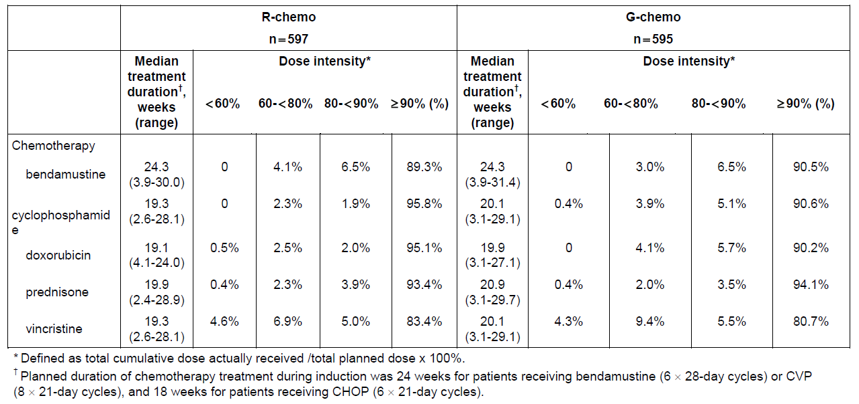

##### Maintenance phase

For the overall population, 609 patients in the R-chemo arm and 624 patients in the G‑chemo arm received maintenance treatment. In the R-chemo arm 99.0% received ≥ 90% of the cumulative maintenance dose compared to 99.8% of patients in the G-chemo arm.

For the FL safety population, 526 patients in the R-chemo arm and 540 patients in the G‑chemo arm received maintenance treatment. At the time of the clinical cut off date, 114 patients with FL were still ongoing with maintenance treatment. In the R-chemo arm 99.2% received ≥ 90% of the cumulative maintenance dose compared to 99.8% of patients in the G-chemo arm.

#### Safety issues with the potential for major regulatory impact

##### Renal function and toxicity

The 2 arms were comparable with relation to change in kidney parameters. There were more patients in the G-chemo arm with high potassium and an adverse event (AE) for hypokalaemia in the overall safety population; for the FL population the numbers for hypokalaemia were almost identical; 6.4% versus 3.7% for R-chemo. There were also more patients with high uric acid in this arm; 29.2% versus 23.0% for R-chemo.

In both treatment groups, the incidence of deaths, deaths due to AEs, Grade 3 to 5 AEs, serious adverse events (SAE), and AEs leading to withdrawal from treatment was higher in patients with a CrCL < 50 mL/min compared with patients with CrCL ≥ 50 mL/min.

Deaths, deaths due to AEs, Grade 3 to 5 AEs, SAEs, and AEs leading to withdrawal from treatment were more frequent in patients in the G-chemo arm in patients with a CrCL < 50 mL/min. 4 patients with CrCL < 50 mL/min died due to an AE; 2 in the R-chemo arm and 2 in the G-chemo arm.

There were more SAEs in the G-chemo arm in patients with a CrCL < 50 mL/min compared to the corresponding R-chemo arm. The average age at diagnosis for Australian patients with FL is 60 to 65 years of age (57.9 years at commencement of therapy in this study). With increasing age CrCL declines. It is therefore very important to stress the higher AEs with declining kidney function especially neutropaenia and infections (as noted in the PI under ‘Precautions’).

##### Safety in older patients

The incidence of AEs was similar in the 2 age groups (< 65 years, and ≥ 65 years) in both treatment arms, including related AEs (using a cut off of 5% to indicate a difference). However, in both treatment arms, the incidence of SAEs was higher in patients ≥ 65 years old than in younger patients, as was the incidence of AEs leading to death and the incidence of AEs leading to withdrawal from any treatment.

The incidence of AEs, deaths, fatal AEs, Grade 3 to 5 AEs, and SAEs was similar (using a cut off of 5% to indicate a difference between arms) for both males and for females.

The incidence of SAEs in patients who were ≥ 65 years of age was demonstrably higher in the G-chemo arm compared to the R-chemo arm especially in the overall safety population. This has to be taken into account when choosing a CD20 antibody chemo regimen for a person ≥ 65 years of age. This has to be made clear in the PI with relevant differences specified.

#### Postmarketing data

According to the sponsor, 13,841 mainly chronic lymphocytic leukaemia and indolent NHL patients have received obinutuzumab worldwide. Overall no new safety signal was identified in Study BO21223 compared with the data presented in the latest periodic benefit-risk evaluation report (PBRER).

#### Evaluator’s conclusions on safety

Study BO21000 (GAUDI) included 81 first line FL patients and explored the safety of obinutuzumab (G) in combination with CHOP or bendamustine. This study has not been evaluated in detail as it was a small Phase I study compared to the large Phase III Study BO21223 (GALLIUM) comprising 1390 patients of which 698 received obinutuzumab and chemotherapy (bendamustine, CHOP, or CVP). There was no comparator in Study BO21000, whereas Study BO21223 has another CD20 antibody (rituximab) as comparator. The results from Study BO21000 are not included in the product information, and in the following the results from Study BO21223 are summarised. For an overview of the study design see Figure 3, above.

The demographics for the FL population have been described in the efficacy section; about 80% were White and 47% male. The FL population comprise about 86% of the overall safety population. The demographics for the remaining 14% were mainly MZL patients. About 93% were White and 50% male. The main differences between the FL and MZL patients are the mean age of 57.9 versus 61.9 and the number of patients ≥ 65 years of age (31.3% versus 44.6%), which are likely to have an impact on the safety results even though the proportion of MZL patients is small.

##### Exposure (overall safety population)

*Induction phase*: At least 90% of the planned cumulative dose of antibody was administered in 99.4% of the R-chemo arm and in 99.0% in the G-chemo arm.

*Maintenance phase:* (for patients in CR or PR after induction): 603 patients in the R-chemo arm and 623 patients in the G-chemo arm received maintenance treatment. In the R‑chemo arm 99.0% received ≥ 90% of the cumulative maintenance dose compared to 99.8% of patients in the G-chemo arm.

##### Adverse events

There were more adverse events in the G-chemo arm compared to the R-chemo arm in both the FL and overall safety population in particular Grade 3 to 5 AEs, SAEs, treatment related SAEs and treatment related AEs leading to any dose interruption. There were more AEs with a fatal outcome in the G-chemo arm but more deaths in the R-chemo arm.

AEs (all grades) reported with a difference of at least 2% between the treatment arms, but excluding infusion related reactions (IRR) reflects the most frequently related AEs which are all in favour of R-chemo.

There are more SAEs in the G-chemo arm compared to the R-chemo arm in both the overall and FL safety population. There are generally more SAEs in the overall safety population (the population in the PI) than in the FL population, which is not unexpected, as the median age of the FL population is 59.0 years and 63.0 years for the MZL population. The percentage of patients who was ≥ 65 years of age is 31.3% in the FL population and 44.6% in the MZL population, and although the MZL population only constitute 14% of the overall safety population this apparently has an impact on the overall safety data together with other factors. As the average age at diagnosis for FL patients is 65 years, the lower average age (and good performance status) in this study does not reflect the FL population as a whole, and these data demonstrate that this has to be taken into account when choosing which anti-CD20 antibody to use in addition to considering efficacy.

AEs leading to withdrawal were slightly higher in the G-chemo arm in both the FL and overall safety population

###### Adverse events of particular or special interest

There were more IRRs in the overall population compared to the follicular population. Elderly patients have more co-morbidities, for instance cardiovascular problems, which could be an issue in relation to IRRs and subsequently the choice of anti-CD20 antibody.

Higher age and renal impairment were risk factors for SAEs.

There were more AEs and SAEs in the MZL population in the G-chemo arm. Off label use in MZL and other indolent NHL may, especially in the elderly, affect the benefit/risk ratio negatively.

For a further comparison of statements from the sponsor’s clinical overview regarding safety compared to data from Study BO21223, and tables and figures supporting the evaluators conclusions, please see Attachment 2.

### First round benefit-risk assessment

#### First round assessment of benefits

Table 6, shown below, summarises the clinical evaluator’s assessment of benefits at the first round.

Table 6. First round assessment of benefits

|  |  |
| --- | --- |
| Indication | |
| Benefits | Strengths and Uncertainties |
| Study BO21223 demonstrated that treatment with G-chemo resulted in a clinically meaningful and statistically significant reduction by 34% in the risk of an investigator assessed PFS event (disease progression/relapse or death) compared with R-chemo (stratified hazard ratio (HR) 0.66 (95% CI: 0.51, 0.85); p-value = 0.0012, stratified log-rank test). The p-value of the investigator assessed PFS was smaller than the prespecified interim boundary significance level of 0.012 [see Attachment 2 for supporting tables]. | Large Phase III trial with a relevant comparator.  It is too early to evaluate overall survival. This is the most important objective long term, and it is uncertain whether improved PFS translates into improved OS.  Not all the secondary endpoints met the predefined hierarchical statistical requirements. |

#### First round assessment of risks

Table 7, shown below, summarises the clinical evaluator’s assessment of risks at the first round.

Table7. First round assessment of risks

|  |  |
| --- | --- |
| Risks | Strengths and uncertainties |
| Compared to R-chemo G-chemo poses a higher risk of:  IRRs  SAEs  Neutropaenia  Infections  Death due to AEs  which is even higher in patients ≥ 65 years of age.[5] | The average age of the FL population in Study BO21223 is 57.9 years and 61.9 years in the MZL population and the ECOG performance score was 0 or 1. Patients with a CrCL ≤ 40 mL/min were excluded. This is not representative of the average FL population and makes it necessary to be cautious in the elderly, in patients with many co-morbidities and/or high ECOG performance score, and in patients with reduced CrCL. |

#### First round assessment of benefit-risk balance

1. In the investigated FL population the benefit outweighs the risk when evaluating PFS. It is unknown, but likely, that this will lead to longer OS in this population.
2. The benefit may not outweigh the risk in elderly patients, in patients with reduced renal function, and in patients with an ECOG performance score ≥ 2. This group of patients comprises a substantial part of the follicular lymphoma patient population. To approve the indication there has to be clear warnings in the PI regarding the adverse events in this group of patients and regular updates on PFS and OS submitted to the TGA.
3. MZL patients had more adverse events and there is a risk that obinutuzumab may be used outside the approved label and thus skew the benefit/risk negatively in these patients, which stresses the importance of the warnings.

### First round recommendation regarding authorisation

Approval of ‘*Gazyva in combination with chemotherapy followed by Gazyva maintenance is indicated for the treatment of patients with previously untreated follicular lymphoma’* is recommendedprovided that the PI and consumer medicines information (CMI) clearly display the various adverse events seen to a higher extent in the G-chemo arm compared to the R-chemo arm and also clearly state the higher incidence of all adverse events in patients > 65 years of age and patients with reduced renal function. The fact that the patients in the pivotal study had an ECOG performance score of 0 or 1 also has to be clearly visible.

The sponsor should present a PI document complying with these conditions for evaluation.

### Second round evaluation of clinical data submitted in response to questions

For details of the evaluator’s questions, the sponsor’s responses and the evaluation of these responses please see Attachment 2.

### Second round benefit-risk assessment

The substance of the questions asked in the first round and their answers has not changed the overall positive risk/benefit of the product. The first round evaluator was concerned that the higher rates of certain adverse drug reactions (ADR) noted with the G-chemo arm was made explicit in the PI and this has been done by compliance with the requests made to amend the PI document. In addition, the adverse event rate differences in general terms (SAEs, AEs leading to death or withdrawal) in the elderly versus the rest of the study population has been made clear. On this basis, the concerns of the first round evaluator have been met.

## VI. Pharmacovigilance findings

### Risk management plan

* In support of the extended indications for this application (extension of indications to include the first line treatment of FL), the sponsor has submitted EU-RMP version 3.0 (dated 13 September 2016; data lock point (DLP) 5 September 2016) and Australian Specific Annex (ASA) version 4.0 (dated October 2016). In its post-first round evaluation response, the sponsor submitted ASA version 4.1, dated June 2017 to support the extension of indications.
* The most recently evaluated EU-RMP was version 2.0 (dated 20 May 2016; DLP 4 August 2015) and ASA version 3.1 (dated August 2016)), which were submitted with application PM-2015-03578-1-4 (extension of indications to include indolent NHL (FL, second line treatment)).
* The proposed Summary of Safety Concerns and their associated risk monitoring and mitigation strategies are summarised below (Table 8).

Table 8. Summary of ongoing safety concerns

R=routine and A=additional

|  |  |  |  |  |  |
| --- | --- | --- | --- | --- | --- |
| Summary of safety concerns | | Pharmacovigilance | | Risk Minimisation | |
| R | A | R | A |
| **Important identified risks** | Infusion related reactions | ✓ | ✓ | ✓ | – |
| Tumour lysis syndrome | ✓ |  | ✓ | – |
| Thrombocytopaenia | ✓ | ✓ | ✓ | – |
| Neutropaenia | ✓ | – | ✓ | – |
| Late onset and prolonged neutropaenia | ✓ | ✓ | ✓ | – |
| Prolonged B cell depletion | ✓ | ✓ | ✓ | – |
| Infections | ✓ | – | ✓ | – |
| Hepatitis B reactivation | ✓ | – | ✓ | – |
| Progressive multifocal leukoencephalopathy | ✓ |  | ✓ | – |
| Worsening of pre-existing cardiac conditions | ✓ | – | ✓ | – |
| GI perforation | ✓ | – | ✓ | – |
| **Important potential risks** | Impaired immunisation response | ✓ | – | ✓ | – |
| Immunogenicity | ✓ | ✓ | ✓ | – |
| Second malignancies | ✓ | – | ✓ | – |
| Immune mediated glomerulonephritis | ✓ | ✓ | – | – |
| **Missing information** | Use in children | ✓ | – | ✓ | – |
| Use in pregnancy and lactation | ✓ | – | ✓ | – |

Note: For pharmacovigilance and risk minimisation activities, R = routine; A = additional.

* Additional pharmacovigilance activities (ongoing clinical trials) have been proposed for the following safety concerns:
  + Infusion-related reactions;
  + Thrombocytopaenia;
  + Late onset and prolonged neutropenia;
  + Prolonged B cell depletion,
  + Immunogenicity;
  + Immune-mediated glomerulonephritis
* There are no additional risk minimisation activities.

#### New and outstanding recommendations in the Second round RMP evaluation

There are no outstanding recommendations from the second round evaluation.

#### Wording for conditions of registration

Any changes to which the sponsor has agreed should be included in a revised RMP and ASA. However, irrespective of whether or not they are included in the currently available version of the RMP document, the agreed changes become part of the risk management system.

The suggested wording is:

Implement EU-RMP (version 3.0, dated 13 September 2016, data lock point 5 September 2016) with Australian Specific Annex (version 4.1, dated June 2017) and any future updates as a condition of registration.

## VIII. Overall conclusion and risk/benefit assessment

The submission was summarised in the following Delegate’s overview and recommendations:

### Quality

There was no requirement for a quality evaluation in a submission of this type.

### Nonclinical

There was no requirement for a nonclinical evaluation in a submission of this type.

### Clinical

The data relate almost exclusively to Study BO21223.

#### Pharmacology

##### Pharmacokinetics

Study BO21223 provided approximately 23 PK samples per patient (7550 in total), from a planned sample of 460 patients who received obinutuzumab. These data were added to a popPK dataset and thus the dataset updated. The previous dataset was based upon 6 studies where 16,301 data points were gathered from 961 patients. Of the new combined total (n = 1454 patients), 814 had FL. The resulting dataset did not deviate from conclusions previously reached, specifically:

* The model confirmed the influence of previously identified covariates (body weight, sex, tumour size and serum albumin at Baseline, disease types (CLL, FL/diffuse large B cell lymphoma (DLBCL), mantle cell lymphoma (MCL)), indolent NHL subtypes (SLL), and concomitant chemotherapies (CHOP/CVP, bendamustine, FC)).
* The analysis of obinutuzumab exposure-safety relationships in FL and MZL patients from Study BO21223 demonstrated absence of relationships between exposure and safety parameters.
* There was no apparent relationship between obinutuzumab exposure and efficacy parameters for patients with FL receiving bendamustine in Study BO21223.
* The analysis of obinutuzumab exposure-efficacy relationships for patients with FL receiving CHOP or CVP in Study BO21223 suggested that an increase in exposure might lead to an improvement in efficacy parameters mainly in patients with high body weight and patients with high tumour size at Baseline. However, these exploratory subgroup analyses should be interpreted with caution regarding causality.
* There was no apparent relationship between obinutuzumab exposure and efficacy parameters for patients with MZL in Study BO21223.

##### Pharmacodynamics

###### Study BO21223 B cell depletion and B cell recovery

B cell depletion was defined as a CD19+ cell count of < 0.07 x 109/L occurring after at least one dose of study drug has been administered. Time to depletion was defined as the number of days between the first intake of study drug and the date of the first depletion.

B cell recovery was defined as a CD19+ cell count of ≥ 0.07 x 109/L, for a patient with a previous CD19+ cell count indicating B cell depletion (CD19+ measurement < 0.07 x 109/L). B cell recovery was considered possible only after the patient had completed study treatment. The time to B cell recovery was defined as the time from B cell depletion until B cell recovery.

* Almost all patients who had a B cell result reported showed B cell depletion at the last antibody administration (LAA).
* Overall, 445 patients (74.5% of the safety population; 452 patients had a B cell result reported) in the R-chemo arm had B cell depletion at the LAA. 454 patients (76.3% of the safety population; 457 patients had a B cell result reported) in the G-chemo arm had B cell depletion at the LAA.
* A robust analysis of recovery cannot be performed due to the low number of patients who had been followed for a sufficient duration as of the time of data cut off. However at the time of the clinical data cut off, ≤ 10% of the patients reporting B cell depletion during treatment in each treatment arm had recovered.
* Within 6 to 12 months of follow up after LAA, of 190 patients in the R-chemo arm with B cell assessment done 24 patients had recovered (one patient with pharmacodynamics and 23 patients without), and of 190 patients in the G-chemo arm with B cell assessment done, 3 patients had recovered (all without pharmacodynamics).

#### Efficacy

##### Study BO21223

Study BO21223 consisted primarily of patients with previously untreated FL, the patient subset of interest to this submission. 85% of patients (1202/1401) had FL and were randomised equally to the R-chemo arm or ‘G-chemo’ arm (obinutuzumab) to give 2 cohorts of n = 601. The overall study design is given as follows in Figure 4.

Figure 4. Overall design of Study BO21223

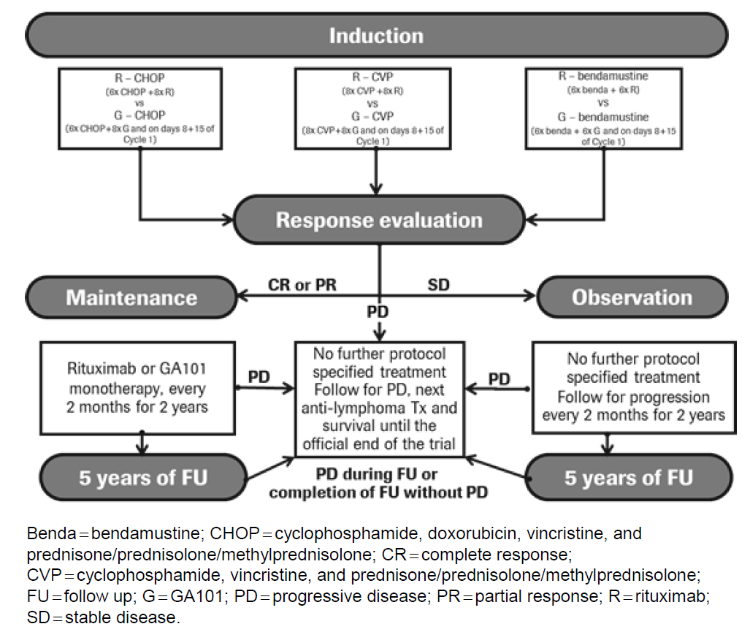

The primary outcome variable was investigator assessed PFS. The FDA required IRC assessed PFS. Secondary objectives included:

* IRC investigated PFS.
* OR and CR rates at end of induction treatment, as assessed by investigator and IRC.
* OS, event free survival (EFS), disease free survival (DFS) and duration of response (DOR) between cohorts as well as time to next anti-lymphoma treatment (TTNLT).
* Patient reported outcomes (PROs): FACT-lym and EQ-5D.

###### Key inclusion criteria

* Histologically documented, CD20+, indolent B cell NHL consisting of one of the following: follicular lymphoma (Grades 1 to 3a), splenic MZL, nodal MZL, or extranodal MZL.
* Stage III or IV disease or Stage II bulky disease (bulky disease is defined as a tumour diameter of ≥ 7 cm).
* At least one bi-dimensionally measurable lesion (> 2 cm in its largest dimension by computed tomography (CT) scan or magnetic resonance imaging (MRI)).

###### Key exclusion criteria

* For patients with FL: prior treatment for NHL by chemotherapy, immunotherapy, or radiotherapy.
* Regular treatment with corticosteroids during the 4 weeks prior to the start of Cycle 1, unless administered for indications other than NHL at a dose equivalent to ≤ 30 mg/day prednisone.
* For patients who will be receiving CHOP: LVEF (Left Ventricular Ejection Fraction) < 50% by multigated acquisition (MUGA) scan or echocardiogram.

###### Dosing schedule

In the R-chemo arm, 6 to 8 doses of rituximab at 375 mg/m2 were administered by IV infusion with the accompanying chemotherapy regimen during induction.

* R-CHOP: Rituximab was administered on Day 1 of Cycles 1 to 8 (21 day cycles). CHOP was administered on Day 1, with prednisone/prednisolone/methylprednisolone also administered on Days 2 to 5, of Cycles 1 to 6.
* R-CVP: Rituximab was administered on Day 1 of Cycles 1 to 8 (21 day cycles). CVP was administered on Day 1, with prednisone/prednisolone/methylprednisolone also administered on Days 2 to 5, of Cycles 1 to 8.
* R-bendamustine: Rituximab was administered on Day 1 of Cycles 1 to 6 (28 day cycles). Bendamustine was administered on Days 1 and 2 of Cycles 1 to 6, with prednisone/prednisolone/methylprednisolone also administered on Day 1 of Cycle 1.

Patients randomised to receive R-chemo who achieved a CR or PR at the end of induction therapy continued to receive R-maintenance at 375 mg/m2 every 2 months until disease progression, or for 2 years, whichever came first.

In the G-chemo arm, 8 to 10 doses of obinutuzumab at 1000 mg were administered by IV infusion with the accompanying chemotherapy regimen during induction.

* G-CHOP: Obinutuzumab was administered on Days 1, 8, and 15 of Cycle 1 and on Day 1 of Cycles 2 to 8 (21 day cycles). CHOP was administered on Day 1, with prednisone/prednisolone/methylprednisolone also administered on Days 2 to 5 of Cycles 1 to 6.
* G-CVP: Obinutuzumab was administered on Days 1, 8, and 15 of Cycle 1 and on Day 1 of Cycles 2 to 8 (21 day cycles). CVP was administered on Day 1, with prednisone/prednisolone/methylprednisolone also administered on Days 2 to 5 of Cycles 1 to 8.
* G-bendamustine: Obinutuzumab was administered on Days 1, 8, and 15 of Cycle 1 and on Day 1 of Cycles 2 to 6 (28 day cycles). Bendamustine was administered on Days 1 and 2 of Cycles 1 to 6, with prednisone/prednisolone/methylprednisolone administered on Day 1 of Cycle 1.

Patients randomized to receive G-chemo who achieved a CR or PR at the end of induction therapy continued to receive G-maintenanceat 1000 mg every 2 months until disease progression, or for 2 years, whichever came first.

The dose of obinutuzumab (induction and maintenance) is unchanged from the currently recommended dose in previously treated FL.

In the FL subset, estimates of the number of events required to demonstrate efficacy with respect to PFS were made on the basis of the following assumptions:

* 2 sided log-rank test at the 0.05 level of significance.
* Powered for the FL population.
* 80% power to detect a HR for obinutuzumab combined chemotherapy versus rituximab combined chemotherapy of 0.74, corresponding to an improvement in 3 year PFS from 70.7% to 77.4% or in median PFS from 6 to 8.1 years (35%). Estimates of median PFS are not likely to be reached in either study arm.
* Exponential distribution of PFS.
* An annual dropout rate of 2.5%.

Performance of interim analyses on PFS: one futility analysis when approximately 30% of the total (investigator assessed) PFS events had occurred (second Interim (futility), and one efficacy analysis (third Interim (efficacy)) when approximately 67% of the total investigator assessed) PFS events had occurred. This analysis is now referred to as the primary analysis. The Independent Data Monitoring Committee (IDMC) reviewed the data on 20 May 2016 and recommended that the study be fully analysed at this time, as the primary endpoint had been met.

Two points were noted by the IDMC, first, that if the endpoint were IRC assessed PFS, the recommendation to cease the study for efficacy could not have been made at this point, although trends in comparison to investigator assessed PFS were considered consistent, and secondly, that toxicity is higher with obinutuzumab than rituximab and careful examination of adverse events in the follow-up period is warranted, specifically with respect to secondary malignancies.

###### Efficacy results

A statistically significant and clinically meaningful improvement in the primary endpoint of PFS in the FL population as assessed by Investigator was demonstrated. This occurred at a protocol-specified interim analysis of efficacy after 245/370 (66%) of events required for the final analysis had occurred. Treatment with G-chemo resulted in a clinically meaningful and statistically significant reduction by 34% in the risk of an investigator assessed PFS event (disease progression/relapse or death) compared with R-chemo (stratified HR 0.66 (95% CI: 0.51, 0.85); p-value = 0.0012, stratified log-rank test). The p-value of the investigator assessed PFS was smaller than the prespecified interim boundary significance level of 0.012.

Table 9. Results for the investigator assessed endpoints

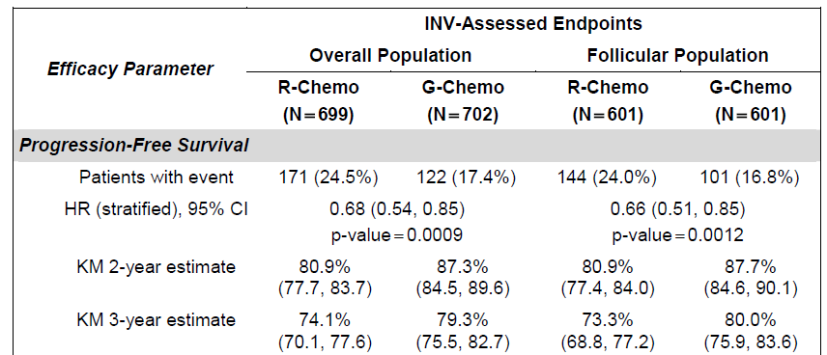

The relevant Kaplan-Meier plot of PFS by investigator assessment is as follows in Figure 5.

Figure 5. Kaplan-Meier plot of PFS by investigator assessment

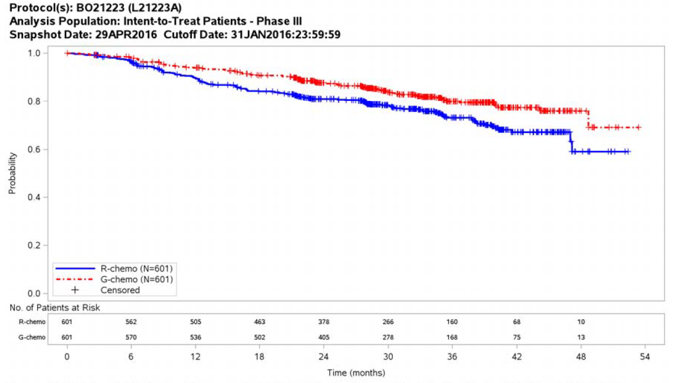

###### Other efficacy outcomes of interest

This Delegate selectively presents the following outcomes. Table 10, shown below, gives the results for the IRC assessed PFS.

Table 10. IRC assessed PFS

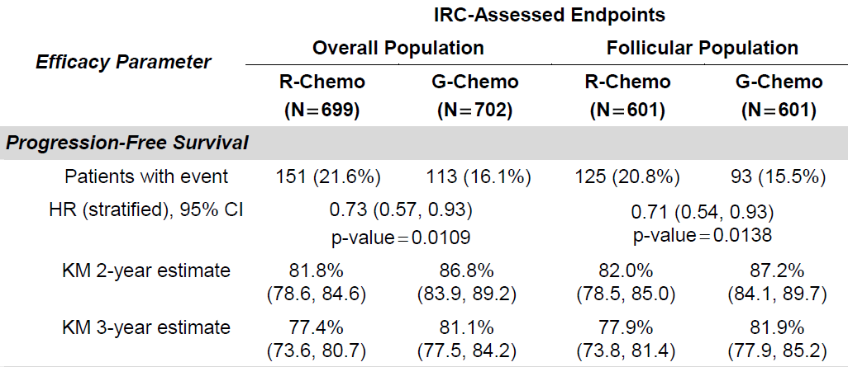

Only the first parameter (PFS in the overall population) is considered statistically significant since the next parameter in the fixed sequence analysis (CR rate without positron emission tomography (PET) for the indication in the FL population) did not meet the predefined statistical requirements.

A number of other secondary outcome variables are summarised in Table 11, based upon investigator assessment.

Table 11. Summary of other secondary outcome variables

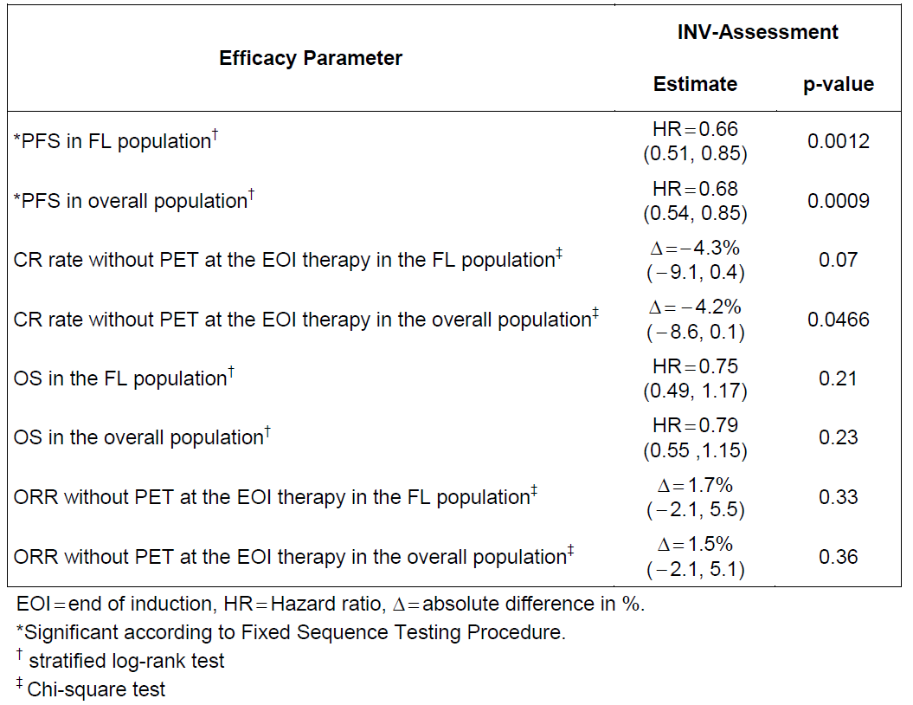

Specifically, for overall survival in the FL population, at the clinical cut off date (31 January 2016), a total of 81 randomised patients had died: 46/601 patients (7.7%) in the R-chemo arm and 35/601 patients (5.8%) in the G-chemo arm, and less than 20% of patients had been followed for survival for more than 4 years, hence the data can be considered still immature at this time (stratified HR 0.75 (95% CI: 0.49, 1.17), stratified log-rank p = 0.21). The most frequent cause of death was adverse event in the G-chemo arm (3.9% versus 3.4% in the R-chemo arm), and progressive disease in the R-chemo arm (3.7% versus 2.0% in the G-chemo arm). AEs in the obinutuzumab cohort will be discussed in more detail shortly.

In terms of patient reported outcomes, there were no clinically meaningful differences identified between treatment cohorts in the two questionnaires used during the specific periods of the study, or indeed overall. However, clinically meaningful improvements were noted and sustained in both treatment cohorts for the FACT-lym scores from the Month 2 maintenance visit to Month 36.

Given the early termination of the study for efficacy, overall survival needs to be closely observed as the data from this study matures.

#### Safety

The overall safety population of Study BO21223 comprised 1390 patients in total, with 1192 of those having a diagnosis of previously untreated FL. The evaluator has focussed on the entire safety population when considering AEs, not simply those from the FL cohort, although these patients do make up 86% of the total study population.

The safety outcome measures described in the protocol include:

* Incidence, nature, and severity of AEs (including SAEs) compared between the 2 treatment arms.
* Deaths.
* Changes in vital signs, physical findings, and clinical laboratory results.
* Protocol defined events of special interest/non-serious expedited AEs:
  + Tumour lysis syndrome
  + Serious IRR
  + Serious neutropaenia
  + Serious infections
  + Hepatitis B reactivation.

In the induction phase of the study, 90% or more of the planned dosing of antibodies occurred in over 99% of patients in both treatment cohorts. This was the same for the maintenance phase of the study. Hence essentially all subjects received sizeable dosing of their respective monoclonal antibody treatments. A broad summary of AEs is provided below in Table 12.

Table 12. Summary of adverse events (FL safety population and overall safety population)

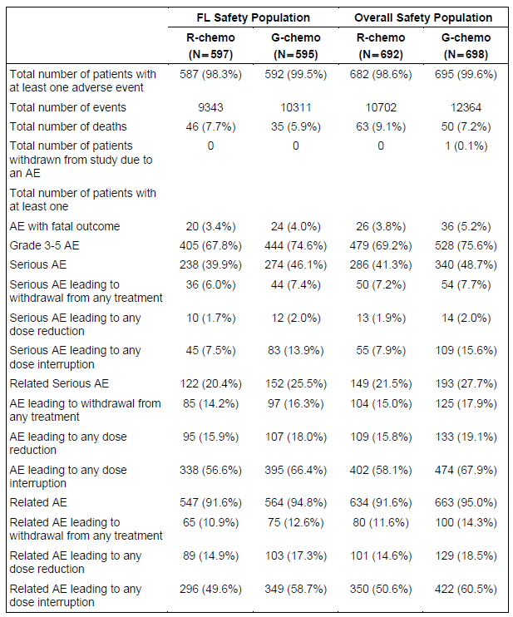

One can see that the trend is certainly of obinutuzumab having a greater rate of AEs in all the categories presented above. One could confidently say that the toxicity profile is less benign than it appears to be for rituximab. Hence, as a general conclusion, efficacy benefits must be weighed against this increase in toxicity, particularly when considering whether the drug should be used first line, in situations where rituximab is a treatment option, rather than currently, where progression or failure to respond to rituximab has occurred.

If one compares chemo regimens, where only the use of rituximab or obinutuzumab is the differing factors, for the FL population, the AE profile is as follows:

* R-Bendamustine (N = 338) versus G-Bendamustine (N = 338):
  + Overall incidence of AEs: 97.6% (98.3%) in the R-bendamustine group versus 99.7% (99.5%) in the G-bendamustine group.
  + SAEs: 45.9% (39.9%) in the R-bendamustine group versus 50.6% (46.1%) in the G-bendamustine group.
  + Grade 3 to 5 AEs: 66.3% (67.8%) in the R-bendamustine group versus 68.3% (74.6%) in the G-bendamustine group.
  + Infections: 72.8% (70.0%) in the R-bendamustine group versus 80.5% (77.3%) in the G-bendamustine group.
* R-CHOP (N = 203) versus G-CHOP (N = 193):
  + SAEs: 31.5% (39.9%) in the R-CHOP group versus 38.3% (46.1%) in the G-CHOP group.
  + Grade 3 to 5 AEs: 74.4% (67.8%) in the R-CHOP group versus 88.1% (74.6%) in the G-CHOP group.
  + Infections: 66.0% (70.0%) in the R-CHOP group versus 73.6% (77.3%) in the G-CHOP group.
* R-CVP (N = 56) versus G-CVP (N = 61):
  + SAEs: 33.9% (39.9%) in the R-CVP group versus 42.6% (46.1%) in the G-CVP group.
  + Grade 3 to 5 AEs: 53.6% (67.8%) in the R-CVP group versus 65.6% (74.6%) in the G-CVP group.
  + Infections: 67.9% (70.0%) in the R-CVP group versus 73.8% (77.3%) in the G-CVP group.

Regardless of chemotherapy co-administered, SAEs, Grade 3 to 5 AEs and infections all occur at higher rates in those given obinutuzumab.

In the overall treatment population, ADRs most frequently reported were as follows (for R-chemo versus G-chemo):

* Gastrointestinal Disorders (60.7% versus 63.6%)
* General Disorders and Administration Site Conditions (51.3% versus 61.5%)
* Injury, Poisoning and Procedural Complications (49.0% versus 61.2%)
* Blood and Lymphatic System Disorders (48.3% versus 54.0%).

Again, suggesting a more toxic safety profile for obinutuzumab.

There were, however, more deaths in the R-chemo arm, mainly due to progressive disease or an AE, whereas for obinutuzumab they were essentially due to AEs. For the overall safety population, there were 63 deaths for R-chemo and 50 for G-chemo. However progressive disease accounted for 29 versus 13 while AEs were 26 versus 35 for R-chemo versus G-chemo, respectively.

SAEs favoured rituximab in the overall safety population (41.3% versus 48.7%), and those with at or greater than a 5% discrepancy between groups all favoured rituximab:

* Infections and Infestations (15.0% versus 20.8%; total number of events 143 versus 217)
* Blood and Lymphatic System Disorders (8.7% versus 9.6%; total number of events 87 versus 100)
* Gastrointestinal Disorders (4.6% versus 7.6%; total number of events 47 versus 74)
* Injury, Poisoning and Procedural Complications (4.2% versus 7.6%), the difference driven mainly by the higher incidence of serious IRRs in the G-chemo arm (2.6% versus 5.2%; total number of events 33 versus 64)
* General Disorders and Administration Site Conditions (6.5% versus 7.3%; total number of events 48 versus 61)
* Respiratory, Thoracic and Mediastinal Disorders (5.6% versus 6.4%; total number of events 42 versus 56)
* Neoplasms Benign, Malignant and Unspecified (including Cysts and Polyps) (3.8% versus 6.0%; total number of events 28 versus 49)
* Cardiac Disorders (2.0% versus 5.9%; total number of events 15 versus 46).

It is noted by the evaluator that there are generally more SAEs in the overall study population than the FL population, and this is ascribed to there being proportionally more patients over 65 years in the MZL population. Hence age might be a factor when deciding upon appropriate first line treatment.

Treatment discontinuations as a result of AEs (FL population) were similar between the 2 treatment groups. Treatment modifications, however, were more frequent for G-chemo than R-chemo (65.4% versus 55.1%).

In terms of AEs of particular interest, these included IRRs; serious neutropaenia; tumour lysis syndrome; serious infection, and hepatitis B reactivation.

For IRRs, these were more frequent in the G-chemo group in the overall safety population (486 versus 401), and similarly for SAEs (111 versus 49). The evaluator notes this difference was mainly due to Day 1, Cycle 1, and by Cycle 4, IRRs were comparable between treatment groups.

Neutropaenia (FL):

* For serious neutropaenia, AEs were comparable.
* Patients with treatment withdrawn due to AE comparable (5.5% versus 6.3%, overall population) (5.2% versus 5.0%, FL population)
* Prolonged neutropenia occurred in 0.8% (0.6%) of patients in the R-chemo arm and 0.9% (0.9%) of patients in the G-chemo arm (based on laboratory absolute neutrophil count (ANC) assessment).
* Late onset neutropenia occurred in 4.1% (4.1%) of patients in the R-chemo arm and 3.9% (3.8%) of patients in the G-chemo arm (based on laboratory ANC assessment).

Infections (FL):

* Serious infections had higher rates in the G-chemo arm as compared to R-chemo arm for the FL populations SAEs more frequent in G-chemo arm (15.0% versus 20.8%) (14.4% versus 18.2%)
* Patients with treatment withdrawn due to AE comparable (4.6% versus 6.6%) (4.5% versus 6.1%)
* No cases of progressive multifocal leukoencephalopathy were reported in either treatment arm.
* Opportunistic infections in the FL safety population (sponsor’s standard adverse event group term (AEGT) Opportunistic infections):
  + 3 patients in the R-chemo arm
  + 9 patients in the G-chemo arm

No Grade 4 or 5 opportunistic infections AEs were reported. One of the 3 AEs in the R‑chemo arm, and 6 of the 12 AEs in the G-chemo arm were Grade 3 AEs.

Tumour lysis syndrome (TLS) events for the FL population were broadly comparable:

* Percentages shown for R-chemo followed by G-chemo arm:
  + Incidence of TLS AEs comparable (0.4% versus 0.9%) (0.5% versus 1.0%)
  + All classed as Grade 3 or 4
  + No fatal TLS AEs
  + Serious TLS 0.1% versus 0.4% (0.2% versus 0.5%)
  + No TLS AEs led to treatment withdrawal

Lastly, for hepatitis B reactivation, 7 of 53 hepatitis B core antibody positive (HepB core Ab+) patients (13.2%) in the R-chemo arm and 5 of 29 HepB core Ab+ patients (17.2%) in the G-chemo arm had reactivation according to the study definition. Hepatitis B virus (HBV) DNA ≥ 100 IU/mL occurred in 3 patients in each arm. 5 AEs of HBV reactivation were reported: 2 in the R-chemo arm and 3 in the G-chemo arm.

Finally, of particular mention given the IDMC’s comments at the cessation of efficacy evaluation, there was a greater incidence of secondary malignancies in the G-chemo arm:

* Greater incidence of SOC (System Organ Class) defined second malignancies in G-chemo arm (7.5% versus 10.3%) (42/597 (7.0%) versus 62/595 (10.4%))
* SMQ (Standardised MedDRA Query) defined second malignancies were also more frequent in the G-chemo arm (5.5% versus 7.2%) (5.0% versus 7.2%)

There were 11 fatal second malignancies reported; 5 in the R-chemo arm (neuroendocrine carcinoma of the skin, gastric cancer, colon cancer, malignant melanoma, and lung adenocarcinoma), and 6 in the G-chemo arm (non-small cell lung cancer (2 AEs), hepatic neoplasm, prostate cancer, myelodysplastic syndrome, and acute lymphocytic leukaemia).

It is clear from these and other data in the clinical evaluation report that the safety profile of obinutuzumab is, on balance, worse than that of rituximab. Rates of AE in every general category (see Table 12, above) suggest a more toxic profile. Of those AEs of particular interest, the data are either equivocal or favour rituximab. While secondary malignancies don’t differ in terms of substantial percentages, the absolute numbers, as defined by SOC, are 42 versus 62 for R-chemo and G-chemo, respectively.

### Risk management plan

There are no outstanding issues for the proposed risk management plan. The sponsor proposed the following additional pharmacovigilance activities in addition to the plan already in place for the currently approved indication:

* Additional pharmacovigilance activities (ongoing clinical trials) have been proposed for the following safety concerns:
  + Infusion-related reactions;
  + Thrombocytopaenia;
  + Late onset and prolonged neutropaenia;
  + Prolonged B cell depletion,
  + Immunogenicity;
  + Immune mediated glomerulonephritis

There are no additional risk minimisation activities.

Table 6 above, extracted from the second round RMP evaluation summarises the safety issues of concern.

One can note here that the issue of renal impairment as well as FL being more typified by an older population were raised separately by the clinical evaluator as cautionary elements to the analysis of the outcomes of Trial BO21223. In fact, the G-chemo arm had proportionally more patients from 60 to 69 years (34.3% versus 28.6%), but the mean age in the G-chemo arm was 59.0 years. This Delegate is satisfied a significant number of patients in both treatment arms were elderly.

### Risk-benefit analysis

#### Delegate’s considerations

Study BO21223 shows a statistically significant superior result for obinutuzumab chemo compared to rituximab chemo in terms of PFS in previously untreated patients with follicular lymphoma. OS was not statistically significantly different between treatment cohorts and this result is explained in part by the immaturity of the data and the early termination for efficacy recommended by the IDMC. This can be reassessed as data mature.

The clinical evaluator notes that the study population with FL is not what they would typically consider as representing those patients with FL, given they were selected with an ECOG score of 0 to 1, mean age was 57.9 years, and no patient with a CrCL below 40 mL/min was included. Patients often are over 65 and have multiple co-morbidities. This is something to consider when weighing up risk/benefit for this drug when considering use as first line therapy.

It is clear in the opinion of this Delegate that the safety data arising from Study BO21223 show a more toxic profile for obinutuzumab in comparison to rituximab when used first line along with combination chemotherapy for the treatment of FL. This may indeed be an issue for the treatment of elderly patients as the clinical evaluator asserts. In light of this more toxic profile, one can try and consider any other objective data that indicate a positive risk-benefit outcome. It is clear that, based upon the statistical analysis model devised for the trial, PFS in both the FL and overall study population showed a statistically significant difference with the use of obinutuzumab compared with rituximab. However, no other efficacy endpoints demonstrated statistical significance at data cut off. One can say that there is a potential trend based upon HRs that OS may prove to be prolonged when more data are available, but this is speculation at this point. There was certainly no particular difference between treatment groups noted for patient-centric outcome variables, accepting that both cohorts experienced a benefit in these over time.

So, it would appear that we have a clear benefit in terms of PFS, weighed against a worse toxicity profile, all else being equal. The crude measure of study deaths provides a limited benefit to obinutuzumab in the view of this Delegate, as despite a more toxic safety profile, study deaths were greater in the rituximab cohort (46 versus 35 in FL study population, 63 versus 50 in overall study population). Morbidity is more difficult to compare, and certainly rates of SAEs, Grade 3 to 5 AEs and AEs leading to withdrawal from treatment all favoured rituximab. In spite of all this, patients seem to have comparable views about their own status, and PFS is extended in the obinutuzumab treatment cohort.

In summary, this Delegate is minded to allow the use of this drug as first line therapy for follicular lymphoma, but before making such a decision would be grateful for the views of the committee on the points listed in the request for Advisory Committee on Medicines (ACM) advice, shown below.

#### Proposed action

The Delegate had no reason to say, at this time, that the application for (the product) should not be approved for registration.

#### Request for ACM advice

The committee is requested to provide advice on the following specific issues:

1. What is the opinion of the committee with respect to approving the indication for first line treatment of FL, based principally on the demonstration of benefit to PFS?
2. What is the opinion of the committee with regard to the safety profile demonstrated by this drug, bearing in mind an approval would obviously allow its use prior to any use and failure of a rituximab-based treatment? Is a positive risk-benefit made out for this potential treatment population by the data submitted in the opinion of the committee?
3. What is the committee’s view on whether the submitted clinical trial adequately represents the first line treatment population of FL sufferers?

The committee is (also) requested to provide advice on any other issues that it thinks may be relevant to a decision on whether or not to approve this application.

#### Response from sponsor

Despite progress in the treatment of FL in recent years, patients with advanced disease remain incurable with current immunochemotherapy regimens; relapse is inevitable for many patients, and many patients still die from progressive disease or immune dysfunction associated with the disease. There is therefore a significant unmet medical need for new and more effective treatments for patients with advanced FL. A key goal of treatment of FL is to maximise the length of time that a patient is in remission following treatment and to reduce the rate of transformation. As the first remission is usually the longest, maximising the benefit gained from the first treatment is paramount. Compared to the current standard of care rituximab + chemotherapy (R-chemo), obinutuzumab + chemotherapy (G-chemo) offers a markedly prolonged duration of remission, as demonstrated by the primary endpoint of investigator assessed PFS (HR 0.66 (95% CI: 0.51, 0.85); p = 0.0012) observed in pivotal Study BO21223. In addition, results of other secondary time to event endpoints, EFS, TTNALT, DFS and DoR were also consistent with the primary efficacy endpoint. The magnitude of the clinical benefit observed over R-chemo, combined with an acceptable safety profile support the use of G-chemo as an important new treatment option for patients with previously untreated advanced FL.

##### Sponsor’s response to question 1

*‘What is the opinion of the committee with respect to approving the indication for first line treatment of FL, based principally on the demonstration of benefit to PFS?’*

PFS was the primary endpoint in Study BO21223. PFS is a well-accepted and clinically relevant endpoint according to the Guideline on the evaluation of anticancer medicinal products in man (EMA/CHMP/205/95/Rev.4). The Guideline has been adopted by the TGA.

From a clinical perspective, PFS is considered a reliable endpoint in this indolent lymphoma setting, where most patients will have options for salvage therapy during subsequent lines of therapy, rendering OS not very reliable in predicting treatment benefit for patients. Additionally, waiting for an OS benefit to occur in a malignant, yet indolent disease such as FL may take too long to allow patients to receive an efficacious new treatment within an acceptable timeframe. Historical data shows a median OS of about 8 to 10 years, which could well be longer now with new treatment strategies.

The sponsor considers the results of Study BO21223 to be clear and robust. Based on an IDMC recommendation the study was fully analysed after an interim analysis had shown that the prespecified boundary for the protocol specified primary endpoint of investigator assessed PFS in the FL population had been crossed. At this time, the G-chemo regimen produced a statistically significant and clinically meaningful improvement in investigator assessed PFS when compared with R-chemo, a treatment regimen considered the current standard of care for patients with previously untreated FL. IRC assessed PFS was consistent with the investigator-assessed PFS result.

These results have since been confirmed in an updated analysis after 6.6 months of additional median follow-up and when 72% of patients had been followed up for at least 36 months. Investigator assessed-PFS (HR 0.68 (95% CI: 0.54, 0.87; p = 0.0016; stratified log-rank)) and IRC assessed PFS (HR 0.72 (95% CI: 0.56, 0.93); p = 0.0118) were highly consistent with the primary analysis, providing further confidence that the data are meaningful and reliable. A summary of efficacy outcomes in patients with FL for the primary and the updated analyses in the intent to treat FL population is provided [not included here].

Although median durations for PFS have not been reached in Study BO21223, assuming exponentially distributed PFS survival curves and stable HRs over time, the observed HRs would translate into 52% and 38% longer median investigator and IRC assessed PFS, respectively, in the G-chemo arm compared to the R-chemo arm. In assuming a median PFS of 6 years in the R-chemo arm (approximated from 6 year follow-up of the PRIMA study;[6] the observed HRs for investigator and IRC assessed PFS in Study BO21223 would translate to an estimated improvement in median PFS of 3.1 and 2.3 years, respectively (that is, to 9.1 and 8.3 years in total). Such an improvement in PFS is considered clinically meaningful as it represents the additional time that patients may be spared the symptoms of disease progression and the toxicity of subsequent therapies. Progression or relapse, which is almost inevitable for patients with FL, is furthermore accompanied by increasing resistance to treatment following each relapse and the risk of bone marrow exhaustion after repeated lines of therapy.

The sponsor considers that the PFS results from Study BO21223 are sufficiently mature and are not likely to change appreciably with longer follow up, based on the magnitude of treatment effect observed with G-chemo over R-chemo, the consistency between the results of the primary and the updated analyses, the stability of HR estimates, and the maintenance over time of early PFS benefit with long term follow up in several large randomised FL studies.[7],[8],[9],[10]

Results of secondary time to event endpoints including EFS, TTNALT, DFS, and DoR were highly consistent with the PFS results and supportive of clinical benefit for G-chemo compared with R-chemo. Other secondary endpoints such as CR rates by PET and exploratory endpoints such as minimal residual disease (MRD) rates provide further support for the effects seen on PFS. Results of analyses of end of induction PET and MRD data from Study BO21223 suggest that although there was no clinically relevant difference in clinical response rates (PR/CR and CR rates) between the two treatment arms, G-chemo induced deeper responses than R-chemo. Among the 696 MRD evaluable patients the MRD response was numerically higher in the G-chemo arm (92.0%) compared to the R-chemo arm (84.9%). These findings are consistent with the higher proportion converting to CR during maintenance and the improved duration of response (CR or PR) and PFS in the G‑chemo arm.

The G-chemo regimen was also accompanied by fewer deaths overall than the R-chemo regimen. At the time of the clinical cut off for the updated analysis, 95 randomised patients with FL had died (7.9% of the FL ITT population; 14 more deaths than in the primary analysis). More deaths occurred in the R-chemo arm (52/601 patients (8.7%)) compared to the G-chemo arm (43/601 patients (7.2%)). The stratified HR for OS in the updated analysis was 0.82 (95% CI: 0.54, 1.22; stratified log-rank test p = 0.32) and was consistent with the results of the primary analysis (0.75 (95% CI: 0.49, 1.17); stratified log-rank test p = 0.21), the effect estimate remaining in favour of the G-chemo arm.

These benefits of the G-chemo regimen were observed in the context of toxicities known to be associated with Gazyva (in addition to those commonly observed with chemotherapy). Notably, the increased toxicity observed with G-chemo did not impair patient quality of life.

Overall, the sponsor considers the benefit-risk balance of the G-chemo regimen to be positive. The observed PFS benefit is clear, robust and clinically meaningful, and was accompanied by fewer deaths and improvements in secondary and exploratory efficacy endpoints. The magnitude of clinical benefit combined with an acceptable safety profile of G-chemo support this regimen as an important new treatment option for patients with previously untreated advanced FL, representing an improvement over the R-chemo regimen, the standard of care for treatment of this disease. As the first remission is usually the longest, maximising the benefit gained from the first treatment is paramount. There is therefore a strong rationale for introducing new therapeutic agents that can improve outcomes in patients with previously untreated FL, by preventing or delaying relapse and the need for new lines of anti-lymphoma therapy, and/or prolonging the quality and duration of remission.

##### Sponsor’s response to question 2

*‘What is the opinion of the committee with regard to the safety profile demonstrated by this drug, bearing in mind an approval would obviously allow its use prior to any use and failure of a rituximab-based treatment? Is a positive risk-benefit made out for this potential treatment population by the data submitted in the opinion of the committee?’*

The observed safety profile needs to be assessed in light of the observed efficacy of the regimen; the G-chemo regimen evaluated in Study BO21223 demonstrated a statistically significant and clinically meaningful improvement in PFS when compared head to head with R-chemo, a treatment regimen considered the current standard of care for patients with previously untreated FL. G-chemo was accompanied by fewer deaths overall than with R-chemo. G-chemo was also associated with high quality and durable responses, and a reduction of patient-reported lymphoma related symptoms.

In Study BO21223, the G-chemo treatment regimen was well tolerated in patients with FL and high rates of treatment completion in both induction and maintenance phases were observed. The frequency of treatment withdrawal and dose reductions due to AEs was similar to that seen with R-chemo.

The safety profile of G-chemo was broadly comparable with that of R-chemo with the exception of a higher incidence of Grade 3 to 5 AEs and SAEs. The incidence of fatal AEs was the same in the 2 treatment arms. Most of the common AEs were Grade 1 to 2 in severity, and were known to be associated with Gazyva and/or chemotherapy. The following adverse events of particular/special interest (all Grades and Grade 3 to 5) were observed more frequently in the G-chemo arm: IRRs, neutropaenia, thrombocytopaenia, infections, cardiac events and second malignancies and reflect the known safety profile of Gazyva. A notable finding was that Grade 3 to 5 infections, fatal infections and serious infections were more frequent in patients receiving bendamustine chemotherapy than CHOP/CVP (regardless of treatment arm). The sponsor has updated the PI with this new finding.

Although the incidence of Grade 3 to 5 AEs and SAEs were higher in the G-chemo arm compared to the R-chemo arm, these higher incidences were driven by known events (neutropaenia, febrile neutropaenia, thrombocytopaenia, and IRRs). These are well known events, which were well managed in the study. In addition, the current PI provides clear advice and guidance for treating and managing these events, should they occur.

Overall, G-chemo induction followed by Gazyva maintenance in patients with previously untreated FL was associated with a tolerable and manageable safety profile and there were no unexpected safety signals. No new important risks were identified and the safety data from Study BO21223 were consistent with the known safety profile for Gazyva. Consequently, no further mitigation strategies are considered to be necessary beyond the proposed amendments made to the PI and ongoing routine pharmacovigilance. The sponsor will continue to monitor all identified and potential risks, and missing information as described in the RMP.

The G-chemo regimen evaluated in Study BO21223 demonstrated a statistically significant and clinically meaningful improvement in PFS when compared head to head with R‑chemo, a treatment regimen considered the current standard of care for patients with previously untreated FL. G-chemo was accompanied by fewer deaths overall than with R‑chemo. G-chemo was also associated with high quality and durable responses, and a reduction of patient reported lymphoma related symptoms. As a result, the sponsor considers the overall benefit-risk balance to be positive and supports the use of G-chemo as a treatment for previously untreated advanced FL.

##### Sponsor’s response to question 3

*‘What is the committee’s view on whether the submitted clinical trial adequately represents the first line treatment population of FL sufferers?’*

Study BO21223 enrolled a broad population of patients with FL and marginal zone lymphoma. A total of 1401 patients with indolent NHL were enrolled in Study BO21223, of whom 1202 patients with previously untreated FL were randomised to the R-chemo (601 patients) and G-chemo arms (601 patients). This population, the FL intent to treat population, was the primary population on which the efficacy analyses for Study BO21223 are based. Inclusion criteria required all patients to fulfil the Groupe d’Etude des Lymphomes Folliculaires (GELF) criteria) (see Table 13, below).[11],[12] These are the generally accepted criteria for initiation of systemic treatment in FL (NCCN, ESMO guidelines). Patients were also required to have a good performance status (ECOG performance score ≥ 2) and adequate organ function to ensure they were likely to be able to tolerate immunochemotherapy.

Table 13. Groupe d’Etude des Lymphomes Folliculaires (GELF criteria) for initiation of systemic treatment

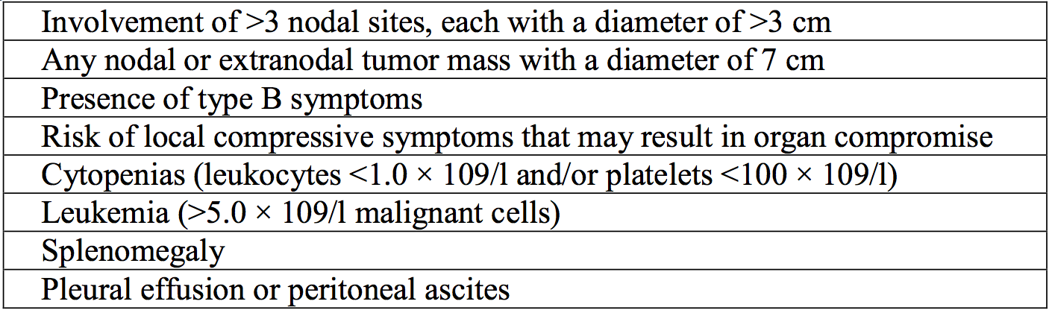

The median age of patients in the FL ITT population was 59 years (range: 23 to 88 years) which is close to the median age that patients are diagnosed with FL (around 61 years).[13] Almost a third (31.3%) of the patients was > 65 years and 16.9% were > 70 years. Slightly more patients were female (53.2%), consistent with published data.13,[14] The majority of patients were White (80.5%) reflecting the predominant enrolment at investigator sites in Europe (61.3% of patients); the remainder were from locations in Asia (15.4%), North America (12.6%) and other regions including Australia (10.6%).

The majority of patients randomised had advanced disease, that is, Ann Arbor Stage III to IV disease (91.4%; with over half with Stage IV, 56.5%). Most patients were in intermediate and high risk FLIPI (37.3% and 41.8% respectively) and FLIPI-2 groups (50.1% and 40.8%. respectively), consistent with published data for similar patient populations.[15],[16] Almost half of the patients (43.8%) had bulky disease (nodal or extranodal mass > 7 cm in diameter). Baseline characteristics for the intent to treat population are presented in Table 14, below.

Table 14. Study BO21224 Baseline characteristics

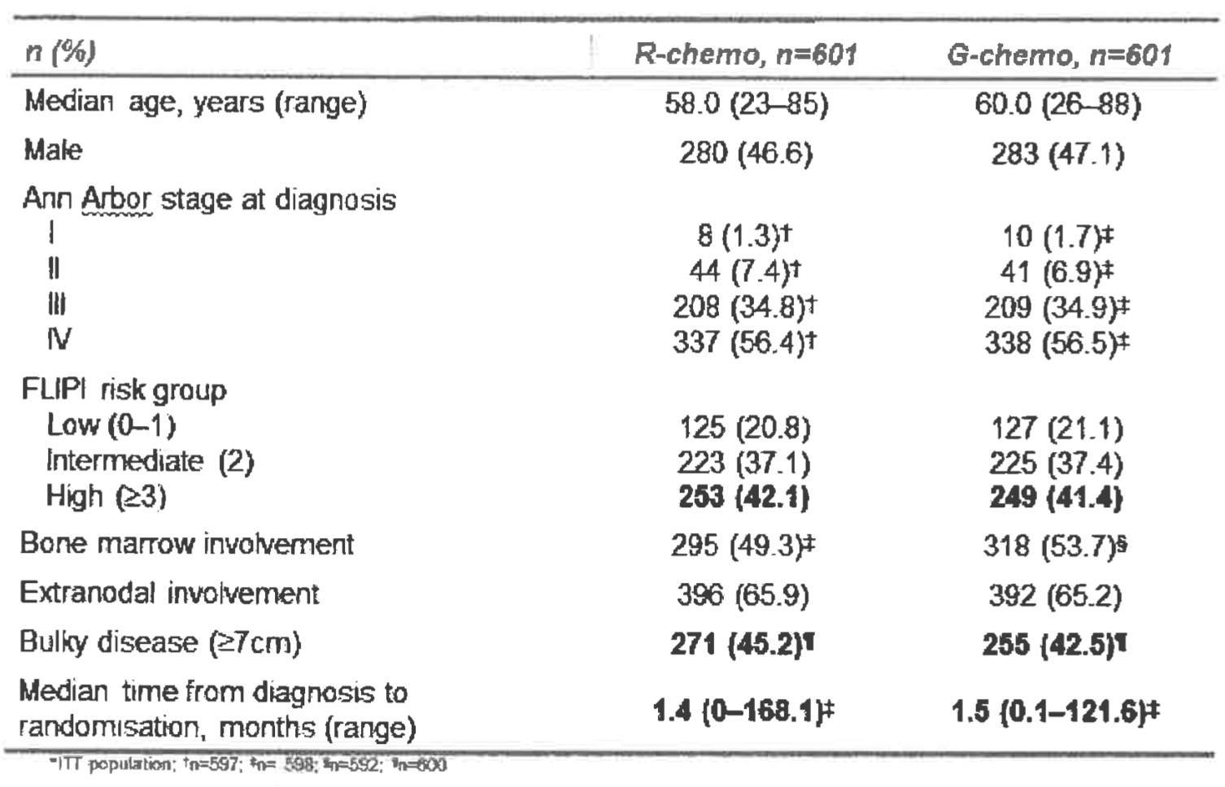

Given the proportions and baseline characteristics of the enrolled FL study population, the sponsor considers Study BO21223 to be an appropriate representation of the FL population requiring systemic treatment.

#### Advisory Committee Considerations

The Advisory Committee on Medicines (ACM) taking into account the submitted evidence agreed with the Delegate and considered Gazyva concentrated solution for infusion containing 1000 mg/40 mL of obinutuzumab to have an overall positive benefit risk profile for the proposed indication:

*‘Gazyva in combination with chemotherapy followed by Gazyva maintenance is indicated for the treatment of patients with previously untreated follicular lymphoma’.*

In making this recommendation the ACM noted the evidence regarding the use of obinutuzumab in the proposed indication and differences in the study and target populations.

##### Specific advice

The ACM advised the following in response to the Delegate’s specific questions on the submission:

*What is the opinion of the committee with respect to approving the indication for first line treatment of FL, based principally on the demonstration of benefit to PFS?*

The ACM advised that studies providing evidence of OS benefits are not commonly undertaken for treatments in the field of haematology and that PFS is commonly used as a surrogate, as it is considered biologically plausible. The committee noted that rituximab based treatment protocols are considered first line in the management of FL and that approval of this submission to extend the indications of Gazyva would result in making obinutuzumab a first line therapy in the treatment of follicular lymphoma. Approval was recommended by the committee based on the evidence provided in the Study BO21223, which showed that obinutuzumab has greater PFS benefits compared to rituximab after 2 to 3 years.

*What is the opinion of the committee with regard to the safety profile demonstrated by this drug, bearing in mind an approval would obviously allow its use prior to any use and failure of a rituximab-based treatment? Is a positive risk-benefit made out for this potential treatment population by the data submitted in the opinion of the committee?*

The ACM noted that obinutuzumab has demonstrated a higher incidence of toxicity than rituximab across all grades of toxicity, including febrile neutropaenia and secondary malignancy. The committee considered that it is still appropriate to approve this submission and that the higher risk of toxicity can be managed by information in the product information document, specialist clinical decision making and patient consent.

*What is the committee’s view on whether the submitted clinical trial adequately represents the first line treatment population of FL sufferers?*

The ACM considered that the study population is different to the target population. Differences in the study population include:

* Lower median age: the median age in the study was 59 compared to a median age of 60 to 65 in the Australian target population. Elderly patients are more susceptible to adverse effects.
* Limited comorbidity.
* Normal renal function.

*The committee was also requested to provide advice on any other issues that it thinks may be relevant to a decision on whether or not to approve this application.*

The ACM advised that implementation by the sponsor of the recommendations outlined above to the satisfaction of the TGA, in addition to the evidence of efficacy and safety provided would support the safe and effective use of this product.

### Outcome

Based on a review of quality, safety and efficacy, the TGA approved the registration of Gazyva obinutuzumab 40 mL concentrated solution single dose vials for intravenous infusion, indicated for the new indication:

*‘Gazyva in combination with chemotherapy followed by Gazyva maintenance is indicated for* *the treatment of patients with previously untreated advanced follicular lymphoma’.*

#### Specific conditions of registration applying to these goods

* Implement EU-RMP (version 3.0, dated 13 September 2016, data lock point 5 September 2016) with Australian Specific Annex (version 4.1, dated June 2017) and any future updates as a condition of registration.

## Attachment 1. Product Information

The PI for Gazyva approved with the submission which is described in this AusPAR is at Attachment 1. For the most recent PI, please refer to the TGA website at <<https://www.tga.gov.au/product-information-pi>>.

## Attachment 2. Extract from the Clinical Evaluation Report

|  |
| --- |
| Therapeutic Goods Administration |
| PO Box 100 Woden ACT 2606 Australia  Email: [info@tga.gov.au](mailto:info@tga.gov.au) Phone: 1800 020 653 Fax: 02 6232 8605  [**https://www.tga.gov.au**](https://www.tga.gov.au) |

1. Freedman A, and Aster J. Clinical manifestations, pathologic features, diagnosis, and prognosis of follicular lymphoma. UpToDate. Literature review current through: January 2017. Updated: September 21, 2016.
2. Kahl B, and Yang D. Follicular lymphoma: evolving therapeutic strategies. Blood 2016; 127, 2055-2063.
3. Australian Register of Therapeutic Goods (ARTG), searched 17 July 2017.
4. The RL cell line is a human, non-Hodgkin's lymphoma B cell line originated in 1983.
5. In both treatment groups, the incidence of deaths, deaths due to AEs, Grade 3 to 5 AEs, SAEs, and AE leading to withdrawal from treatment was higher in patients with a creatinine clearance < 50 mL/min compared with patients with creatinine clearance > 50 mL/min.
6. Salles G, et al. (2011). Rituximab maintenance for 2 years in patients with high tumour burden follicular lymphoma responding to rituximab plus chemotherapy (PRIMA): a Phase 3, randomised controlled trial. Lancet.377:42-51
7. Salles G, et al. (2011). Rituximab maintenance for 2 years in patients with high tumour burden follicular lymphoma responding to rituximab plus chemotherapy (PRIMA): a phase 3, randomised controlled trial. Lancet 377:42-51.
8. Salles G, et al. (2013). Obinutuzumab (GA101) in patients with relapsed/refractory indolent non-Hodgkin lymphoma: results from the phase II GAUGUIN study. J Clin Oncol 31:2920-2926.
9. Barta S, et al (2016). Randomized Phase 3 Study in Low-Grade Lymphoma Comparing Maintenance Anti-CD20 Antibody With Observation After Induction Therapy: A Trial of the ECOG-ACRIN Cancer Research Group (E1496). Cancer 2016: 1-9.
10. Hochster H, et al. (2009). Maintenance Rituximab After Cyclophosphamide, Vincristine, and Prednisone Prolongs Progression-Free Survival in Advanced Indolent Lymphoma: Results of the Randomized Phase III ECOG1496 Study. J Clin Oncol 27:1607-1614.
11. Solal-Celigny P, et al., (1998) Doxorubicin-Containing Regimen With or Without Interferon Alfa-2b for Advanced Follicular Lymphomas: Final Analysis of Survival and Toxicity in the Groupe d'Etude des Lymphomes Folliculaires 86 Trial. J Clin Oncol 16:2332-2338.
12. Brice P, et al., (1997). Comparison in Low-Tumor-Burden Follicular Lymphomas Between an Initial No-Treatment Policy, Prednimustine, or Interferon Alfa: A Randomized Study From the Groupe D'Etude des Lymphomes Folliculaires. J Clin Oncol 15:1110- 1117.
13. Nabhan C, et al., (2015). Disease characteristics, treatment patterns, prognosis, outcomes and lymphoma-related mortality in elderly follicular lymphoma in the United States. Br J Haematol. 2015 July ; 170(1): 85–95.
14. Nabhan C, et al., (2016). Disease, treatment, and outcome differences between men and women with follicular lymphoma in the United States. Am. J. Hematol. 00:000–000, 2016.
15. Federico M, et al., (2009). Follicular Lymphoma International Prognostic Index 2: A New Prognostic Index for Follicular Lymphoma Developed by the International Follicular Lymphoma Prognostic Factor Project, Clin Oncol 27:4555-4562.
16. Buske C, et al., for the German Low Grade Lymphoma Study Group (GLSG). The Follicular Lymphoma International Prognostic Index (FLIPI) separates high-risk from intermediate- or low-risk patients with advanced-stage follicular lymphoma treated front-line with rituximab and the combination of cyclophosphamide, doxorubicin, vincristine, and prednisone (R-CHOP) with respect to treatment outcome. Blood, 1 September 2006 Volume 108, Number 5.