|  |
| --- |
| **August 2019** |

|  |
| --- |
| Australian Public Assessment Report for Osimertinib mesilate |
| Proprietary Product Name: Tagrisso |
| Sponsor: AstraZeneca Pty Ltd |

About the Therapeutic Goods Administration (TGA)

* The Therapeutic Goods Administration (TGA) is part of the Australian Government Department of Health and is responsible for regulating medicines and medical devices.
* The TGA administers the *Therapeutic Goods Act 1989* (the Act), applying a risk management approach designed to ensure therapeutic goods supplied in Australia meet acceptable standards of quality, safety and efficacy (performance) when necessary.
* The work of the TGA is based on applying scientific and clinical expertise to decision-making, to ensure that the benefits to consumers outweigh any risks associated with the use of medicines and medical devices.
* The TGA relies on the public, healthcare professionals and industry to report problems with medicines or medical devices. TGA investigates reports received by it to determine any necessary regulatory action.
* To report a problem with a medicine or medical device, please see the information on the TGA website <<https://www.tga.gov.au>>.

About AusPARs

* An Australian Public Assessment Report (AusPAR) provides information about the evaluation of a prescription medicine and the considerations that led the TGA to approve or not approve a prescription medicine submission.
* AusPARs are prepared and published by the TGA.
* An AusPAR is prepared for submissions that relate to new chemical entities, generic medicines, major variations and extensions of indications.
* An AusPAR is a static document; it provides information that relates to a submission at a particular point in time.
* A new AusPAR will be developed to reflect changes to indications and/or major variations to a prescription medicine subject to evaluation by the TGA.

Copyright

© Commonwealth of Australia 2019  
This work is copyright. You may reproduce the whole or part of this work in unaltered form for your own personal use or, if you are part of an organisation, for internal use within your organisation, but only if you or your organisation do not use the reproduction for any commercial purpose and retain this copyright notice and all disclaimer notices as part of that reproduction. Apart from rights to use as permitted by the *Copyright Act 1968* or allowed by this copyright notice, all other rights are reserved and you are not allowed to reproduce the whole or any part of this work in any way (electronic or otherwise) without first being given specific written permission from the Commonwealth to do so. Requests and inquiries concerning reproduction and rights are to be sent to the TGA Copyright Officer, Therapeutic Goods Administration, PO Box 100, Woden ACT 2606 or emailed to <[tga.copyright@tga.gov.au](mailto:tga.copyright@tga.gov.au)>.

Contents

Common abbreviations 4

I. Introduction to product submission 8

Submission details 8

Product background 8

Regulatory status 10

Product Information 11

II. Registration time line 12

III. Quality findings 12

IV. Nonclinical findings 12

V. Clinical findings 12

Introduction 12

Pharmacokinetics 15

Pharmacodynamics 18

Dosage selection for the pivotal studies 18

Efficacy 18

Safety 20

First round benefit-risk assessment 29

First round recommendation regarding authorisation 30

Second round evaluation 30

Clinical questions 30

VI. Pharmacovigilance findings 39

Risk management plan 39

VII. Overall conclusion and risk/benefit assessment 41

Quality 41

Nonclinical 41

Clinical 41

Risk management plan 57

Risk-benefit analysis 58

Outcome 59

Attachment 1. Product Information 60

## Common abbreviations

|  |  |
| --- | --- |
| Abbreviation | Meaning |
| AE | Adverse event |
| AESI | Adverse event of special interest |
| ALK | Anaplastic lymphoma kinase |
| ARTG | Australian Register of Therapeutic Goods |
| ASA | Australian Specific Annex |
| AST | Aspartate aminotransferase |
| AZ5104, AZ7550 | Metabolites of AZD9291 |
| AUC | Area under the curve |
| AUC,ss | Area under the curve at steady state |
| BICR | Blinded independent central review |
| cEFR | CNS evaluable-for-response analysis set |
| cFAS | CNS full analysis set |
| CI | Confidence interval |
| CLIA | Clinical Laboratory Improvement Amendments |
| CNS | Central nervous system |
| CNS MTS | Subgroup of patients in the full analysis set with a CNS metastases status of Yes or No at baseline |
| CR | Complete response |
| CSR | Clinical study report |
| CTCAE v4.03 | Common Terminology Criteria for Adverse Events version 4.0 |
| ctDNA | Circulating tumour DNA |
| CTSQ-16 | Cancer Therapy Satisfaction Questionnaire 16 items |
| CYP | Cytochrome P450 |
| DCO | Data cut-off |
| DCR | Disease control rate |
| dECG | Digital electrocardiogram |
| DLP | Data lock point |
| DNA | Deoxyribonucleic acid |
| DoR | Duration of response |
| EGFR | Epidermal growth factor receptor |
| EGFRm | Epidermal growth factor receptor-tyrosine kinase inhibitor sensitising mutation, including exon 19 deletions and point mutations in exon 21 (L858R, L861Q) and exon 18 (G719X) |
| EGFR-TKI | Epidermal growth factor receptor-tyrosine kinase inhibitor |
| EMA | European Medicines Agency |
| EORTC QLQ-C30 | European Organisation for Research and Treatment of Cancer Quality of Life Questionnaire - Core 30 items |
| EU | European Union |
| Ex19del | Exon 19 deletion, an in-frame deletion occurring within exon 19, which encodes part of the kinase domain |
| FAS | Full analysis set |
| FDA | Food and Drug Administration (United States) |
| GCP | Good Clinical Practice |
| GLP | Good Laboratory Practice |
| GMP | Good Manufacturing Practice |
| HER2 | Human epidermal growth factor receptor 2 |
| HIV | Human immunodeficiency virus |
| HR | Hazard ratio |
| ICH | International Conference on Harmonisation |
| ILD | Interstitial lung disease |
| KM | Kaplan-Meier |
| L858R | Activating mutation in the EGFR gene with substitution of a leucine with an arginine at position 858 in exon 21 |
| LLN | Lower limit of normal |
| LVEF | Left ventricular ejection fraction |
| MedDRA | Medical Dictionary for Regulatory Activities |
| MET | Mesenchymal-epithelial transition factor |
| NSCLC | Non-small cell lung cancer |
| ORR | Objective response rate |
| OS | Overall survival |
| PD | Progressive disease |
| PD1 | Programmed cell death protein 1 |
| PD-L1 | Programmed cell death ligand 1 |
| PI | Product Information |
| PFS | Progression-free survival |
| PFS2 | Second progression-free survival, that is, time from randomisation to second progression on subsequent treatment |
| PK | Pharmacokinetic(s) |
| PopPK | Population pharmacokinetics |
| PRO | Patient-reported outcome |
| PRO-CTCAE | Patient-reported outcome version of the CTCAE |
| PT | Preferred term (MedDRA) |
| RUO | Research yse only |
| QoL | Quality of life |
| QTcF | QT interval corrected for heart rate using Fridericia's formula |
| RECIST v1.1 | Response Evaluation Criteria in Solid Tumors version 1.1 |
| ROS1 | Proto-oncogene tyrosine-protein kinase 1 |
| SAE | Serious adverse event |
| SAP | Statistical analysis plan |
| SoC | Standard of care |
| SOC | System organ class (MedDRA) |
| T790M | EGFR mutation resulting in substitution of threonine with methionine at amino acid position 790 in exon 20 of EGFR |
| TDT | Time from randomisation to discontinuation of treatment or death |
| TFST | Time to first subsequent therapy |
| TKI | Tyrosine kinase inhibitor |
| UK | United Kingdom |
| ULN | Upper limit of normal |
| US(A) | United States (of America) |
| WHO | World Health Organization |

## I. Introduction to product submission

### Submission details

|  |  |
| --- | --- |
| *Type of submission:* | Extension of indications |
| *Decision*: | Approved |
| *Date of decision:* | 3 July 2018 |
| *Date of entry onto ARTG:* | 5 July 2018 |
| *ARTG numbers:* | 255492 and 255493 |
| *Black Triangle Scheme* | No |
| *Active ingredient:* | Osimertinib mesilate |
| *Product name:* | Tagrisso |
| *Sponsor’s name and address:* | AstraZeneca Pty Ltd  PO BOX 131,  North Ryde NSW 1670 |
| *Dose form:* | Tablet |
| *Strengths:* | 40 mg and 80 mg |
| *Container:* | Blister pack |
| *Pack size:* | 30 |
| *Approved therapeutic use:* | *Tagrisso is indicated for the first-line treatment of patients with locally advanced or metastatic non-small cell lung cancer (NSCLC) whose tumours have activating epidermal growth factor receptor (EGFR) mutations.* |
| *Route of administration:* | Oral |
| *Dosage:* | For instructions on dosage please see the Product Information |

### Product background

This AusPAR describes the application by AstraZeneca Pty Ltd (the sponsor) for an extension of indications (with Priority Review designation, effective 24 November 2017) for Tagrisso osimertinib (as osimertinib mesilate).

Tagrisso has approval for the first-line treatment of patients with locally advanced or metastatic non-small cell lung cancer (NSCLC) whose tumours have epidermal growth factor receptor (EGFR) exon 19 deletions or exon 21 (L858R[1]) substitution mutations.

The approved indication is under evaluation as part of another submission currently under evaluation to determine whether the confirmatory data supports removal of the second sentence:

*Tagrisso is indicated for the treatment of patients with locally advanced or metastatic EGFR T790M[2] mutation-positive non-small cell lung cancer.*

*This indication is approved on the basis of tumour response rate and duration of response (see CLINICAL TRIALS).*

A confirmatory study assessing improvement in progression free survival and disease-related symptoms is ongoing.

Advanced non-small-cell lung cancer (NSCLC) is incurable, and treatment intent is palliative, aiming to improve symptom control, progression-free and/or overall survival, while not compromising quality of life. Initial systemic management is determined by disease stage, patient performance status/comorbidities and the presence of key biomarkers including driver mutations in the epidermal growth factor receptor (EGFR), anaplastic lymphoma kinase (ALK) c-ros oncogene 1 (ROS1) and proto-oncogene B-Raf oncogene homolog B (BRAF) genes. For those with an identified molecular target, initial systemic treatment is a targeted therapy prior to immunotherapy or chemotherapy. Targeted therapy may be combined with other treatment modalities, such as surgery and radiation therapy.

Sensitising EGFR mutations are identified in approximately 40% of Chinese patients and 15% of Caucasian patients with NSCLC, most commonly as a deletion of exon 19 (Del19) or substitution in L858R in exon 21. Rarer mutations may also respond to treatment with EGFR tyrosine kinase inhibitor (TKI) but sensitivity varies. Currently approved first-line therapies in Australia for patients with newly detected advanced EGFR-positive NSCLC include erlotinib, gefinitib and afatinib. However, disease progression occurs after a median of 10 months of treatment, most commonly due to T790M mutations which were identified in 50 to 60% of patients progressing on first generation EGFR TKIs. T790M is occasionally detected de novo, and has been associated with a poorer prognosis than that acquired after treatment. Mesenchymal-epithelial transition factor (MET) oncogene amplification is also associated with progression on EGFR TKIs, and is seen more frequently with osimertinib compared to other TKIs. Central nervous system (CNS) disease (both at presentation and at progression) is common in EGFR-mutated NSCLC. There are some data to support CNS activity of erlotinib, gefitinib and afatinib, but prospective data on CNS efficacy with currently approved first-line EGFR TKIs are limited, largely due to clinical trial exclusion criteria.

Osimertinib is a third generation irreversible EGFR TKI which targets T790M in addition to Del19 and L858R. In addition to its broader specificity for EGFR mutations, the sponsor postulates osimertinib may provide an additional clinical benefit over the other EGFR TKIs where pharmacological properties of those agents may have limited CNS penetration and thus limited efficacy.

There is unmet need for more effective first-line therapies of patients with EGFR-sensitising mutations, and on the basis of the promising top line results from the FLAURA trial, this application has been granted priority review status.

#### Current first-line treatment options for EGFR-positive NSCLC

##### EGFR TKIs

###### First generation

Erlotinib (Tarceva) (only the NSCLC indications included here):

*Tarceva is indicated for the first-line treatment of patients with advanced (Stage IIIB) or metastatic (Stage IV) non-small cell lung cancer (NSCLC) with activating EGFR mutations.*

*Tarceva is indicated for maintenance therapy in patients with locally advanced or metastatic non-small cell lung cancer (NSCLC) with activating EGFR mutations who have not progressed on first-line chemotherapy.*

*Tarceva is also indicated for the treatment of patients with locally advanced or metastatic non-small cell lung cancer after failure of prior chemotherapy.*

Gefitinib:

*Treatment of patients with locally advanced or metastatic Non Small Cell Lung Cancer (NSCLC) whose tumours express activating mutations of the EGFR tyrosine kinase.*

###### Second-generation

Afatinib (Giotrif):

*Giotrif is indicated as monotherapy for the treatment of patients with advanced or metastatic non-squamous non-small cell carcinoma of the lung, either as first line therapy or after failure of cytotoxic chemotherapy. Tumours must have Epidermal Growth Factor Receptor (EGFR) exon 19 deletions or L858R substitution mutations.*

This second-generation EGFR TKI has activity against the T790M mutation, responsible for the emergence of resistance in approximately 50% of cases no longer responding to first-line EGFR TKIs. However, its lack of specificity results in significant off-target wild type EGFR (wtEGFR) activity resulting in high rates of cutaneous and gastrointestinal toxicity, limiting its tolerability.

##### Platinum doublet chemotherapy

Although approved for use for the first-line treatment of NSCLC, and previously the standard of care, this has been superseded by TKIs, which are more efficacious and better tolerated.

### Regulatory status

#### Australian regulatory status

Osimertinib was first included in the Australian Register of Therapeutic Goods (ARTG) on 3 August 2016 for the currently approved indication:

*Tagrisso is indicated for the treatment of patients with locally advanced or metastatic EGFR T790M mutation-positive non-small cell lung cancer.*

*This indication is approved on the basis of tumour response rate and duration of response (see CLINICAL TRIALS). A confirmatory study assessing improvement in progression free survival and disease-related symptoms is ongoing.*

The registration was based on promising single arm study data showing high response rates in those with disease progression on earlier generation EGFR TKIs with documented T790M mutations. An application to provide confirmatory data to support this early data has been submitted to the TGA separately and is currently under (non-priority) evaluation.

On 24 November 2017, the TGA granted this application for osimertinib a Priority Review Designation.[3]

The table below summarises the international regulatory status of Tagrisso (United States (US) Food and Drug Administration (FDA) and the European Medicines Agency (EMA) in the European Union EU).

Table 1: Overseas regulatory status of submission

|  |  |  |
| --- | --- | --- |
| Regulator | US FDA | EMA |
| Submitted | 24 October 2017 | 26 October 2017 |
| Approved | 18 April 2018 | Positive CHMP opinion 26 April 2018 |
| Current indications (equivalent to those proposed in this submission) | Tagrisso is a kinase inhibitor indicated for:   * the first-line treatment of patients with metastatic NSCLC whose tumors have epidermal growth factor receptor (EGFR) exon 19 deletions or exon 21 L858R mutations, as detected by an FDA-approved test. * the treatment of patients with metastatic EGFR T790M mutation-positive NSCLC, as detected by an FDA-approved test, whose disease has progressed on or after EGFR TKI therapy. | ‘Tagrisso as monotherapy is indicated for:   * the first-line treatment of adult patients with locally advanced or metastatic non-small cell lung cancer (NSCLC) with activating epidermal growth factor receptor (EGFR) mutations.   the treatment of adult patients with locally advanced or metastatic EGFR T790M mutation-positive NSCLC.’ |

### Product Information

The Product Information (PI) approved with the submission which is described in this AusPAR can be found as Attachment 1. For the most recent PI, please refer to the TGA website at <<https://www.tga.gov.au/product-information-pi>>.

## II. Registration time line

The following table captures the key steps and dates for this application and which are detailed and discussed in this AusPAR.

Table 2: Timeline for Submission PM-2017-04579-1-4

|  |  |
| --- | --- |
| Description | Date |
| Positive Designation (Orphan or Provisional if applicable) | 24 November 2017 |
| Submission dossier accepted and first round evaluation commenced | 10 January 2018 |
| Evaluation completed | 4 April 2018 |
| Delegate’s Overall benefit-risk assessment |  |
| Sponsor’s pre-Advisory Committee response | N/A |
| Registration decision (Outcome) | 3 Jul 2018 |
| Completion of administrative activities and registration on ARTG | 5 July 2018 |
| Number of working days from submission dossier acceptance to registration decision* | 119 |

## III. Quality findings

There was no requirement for a quality evaluation in a submission of this type.

## IV. Nonclinical findings

There was no requirement for a nonclinical evaluation in a submission of this type.

## V. Clinical findings

A summary of the clinical findings is presented in this section.

### Introduction

#### Clinical rationale

Advanced non-small-cell lung cancer (NSCLC) is essentially an incurable condition, and treatment intent is palliative, aiming to improve symptom control, progression-free and/or overall survival, while not compromising quality of life. The initial systemic management of advanced NSCLC is determined by the stage of the disease, the presence of key biomarkers including driver mutations, and the patient’s performance status and comorbidities. To date, a number of driver mutations or rearrangements have been identified in NSCLC, including in the epidermal growth factor receptor (EGFR), ALK, ROS1 and BRAF. It is noted from the PI for the recent TGA approval of pembrolizumab for the first-line treatment of patients with metastatic NSCLC patients with tumour programmed cell death-ligand 1 (PD-L1) expression levels > 50%, that patients with EGFR or ALK genomic tumour aberrations were excluded. Therefore, for those with an identified molecular target, the initial systemic treatment is a targeted therapy prior to treatment with either immunotherapy or chemotherapy. This targeted therapy may be used together with other treatment modalities, such as surgery and radiation therapy.

Sensitising EGFR mutations are identified in approximately 38.4% of Chinese patients and 15% of Caucasian patients with NSCLC;[4] mostly commonly as a deletion of exon 19 or substitution in L858R in exon 21; other mutations have been identified and may also respond to treatment with EGFR TKIs to a lesser extent. Standard practice in patients with newly detected advanced EGFR-positive NSCLC is to commence an EGFR tyrosine kinase inhibitor (TKI) as initial systemic therapy and currently approved first-line therapies in Australia include erlotinib, gefinitib and afatinib. However, the emergence of resistance to these agents is well documented and disease progression occurs after a median of 10 months of treatment, most commonly due to T790M mutations which were identified in 50 to 60% of those experiencing disease progression on first generation EGFR TKIs.[5],[6],[7],[8],[9] While the T790M mutation usually emerges under treatment pressure from first generation EGFR TKIs, it is occasionally detected de novo, and has been associated with a poorer prognosis than that acquired after treatment.[10] Other mechanisms of resistance or underpinning disease progression on EGFR-TKIs;[11] include amplification of the MET oncogene;5,[12] with an increased rate compared with other TKIs of this reported in patients receiving osimertinib;8 possibly due to the predominance of T790M mutations with those other agents, and transformation to small cell lung cancer. CNS disease at presentation and subsequent relapse or progression are common in EGFR-mutated NSCLC, but prospective data on the efficacy in treating or preventing CNS disease progression with currently approved first-line EGFR TKIs are somewhat limited. This is in part due to the either the exclusion from clinical trials of patients with CNS involvement or restriction to those with stable or asymptomatic brain metastases.

There are some data to support CNS penetration and activity of erlotinib, gefitinib[13] and clinical activity of afatinib,[14] whether osimertinib proves superior to erlotinib or gefitinib in treating or preventing CNS relapse or progression in this relative sanctuary site, may be addressed in the study presented. CNS response and progression rates were an exploratory endpoint in the pivotal trial in this dossier.

Osimertinib is a third generation irreversible EGFR TKI which also targets the T790M mutation in addition to those sensitising EGFR mutations targeted by earlier generation TKIs. In addition to its broader coverage of activating and resistance-related EGFR mutations, the sponsor postulates osimertinib may provide an additional clinical benefit over the other EGFR TKIs where pharmacological properties of those agents may have limited CNS penetration and thus limited efficacy. As stated above, data are included and will be evaluated from the pivotal study to determine whether there is sufficient evidence to support this assertion in the Delegate’s Clinical Overview (see relevant section, below). On the basis of promising early single arm study data showing high response rates in those with disease progression on earlier generation EGFR TKIs, osimertinib was approved for the treatment of such patients with documented T790M mutations. An application to provide confirmatory data to support this early data has been submitted to the TGA separately, and this application seeks to register osimertinib as first line treatment on the basis of the randomised Phase III study (FLAURA trial) comparing the outcome of treatment with osimertinib with erlotinib or gefitinib. This study offers the opportunity of comparing efficacy, including relative CNS activity, as well as safety profiles of these agents.

There is unmet need for more effective first-line therapies of patients with EGFR‑sensitising mutations, and on the basis of the promising top line results from this trial, this application has been granted priority review status. Note is made of the release subsequent to the priority review status of a peer-reviewed publication.[15]

#### Evaluator’s commentary on the background information

No issues or concerns were identified and there is clear unmet need for more effective agents for the first line treatment of NSCLC harbouring EGFR-sensitising genomic aberrations. In particular, there is need for a more selective and therefore, more tolerable treatment for the T790M mutation which accounts for approximately half of the mutations known to confer resistance to the first-generation EGFR TKIs.

#### Contents of the clinical dossier

The dossier included:

* A full study report for Study D5160C00007 (FLAURA trial) and supporting documents: A Phase III, double-blind, randomised study to assess the efficacy and safety of AZD9291 versus a standard of care epidermal growth factor receptor-tyrosine kinase inhibitor as first-line treatment in patients with epidermal growth factor receptor mutation-positive, locally-advanced or metastatic non-small-cell lung cancer (data cut-off: 12 June 2017).
* Integrated safety tables presented in a document without supportive text were provided and were evaluated in full as per the Statement of Requirements.
* A document, was reviewed but the search strategy and literature provided not fully evaluated as this constituted a literature-based approach in support of the proposed usage.
* Updated reports for exposure-response modelling and simulation for the following have been provided in this submission, based on the population pharmacokinetic (PK) analyses, noting that different populations have been used to inform each. As per the Statement of Requirements, top line summaries were provided for the following:
  + Population PK Modelling and Simulation Report for osimertinib (date 22 September 2017)
  + Exposure and RECIST-based efficacy measures;[16] based on Study D5160C00001 (AURA trial) and Study D5160C00007 (FLAURA trial).
  + Exposure-response analyses relating the occurrence of interstitial lung disease, rash, and diarrhoea to osimertinib exposure based on Study D5160C00001 (AURA trial), Study D5160C00002 (AURA2 trial), Study D5160C00003 (AURA3 trial), and Study D5160C00007 (FLAURA trial).
  + Changes in left ventricular ejection fraction and osimertinib exposure based on Study D5160C00001 (AURA trial), Study D5160C00002 (AURA2 trial), Study D5160C00003 (AURA3 trial), and Study D5160C00007 (FLAURA trial).

#### Evaluator’s commentary on the clinical dossier

The dossier contained a very comprehensive study report with extensive analyses of the efficacy and safety endpoints. An Integrated Safety Summary document with extensive tables was included, as well as a summary of key safety events provided in the Summary of Clinical Safety across the development program. In order to integrate and facilitate comparison, the adverse event rates have been included from the Integrated Safety Dataset tables rather than the Summary of Clinical Safety.

#### Paediatric data

No data provided which is acceptable.

#### Good clinical practice

The Phase III FLAURA trial study report states:

*‘This study was performed in accordance with the ethical principles that have their origin in the Declaration of Helsinki and that are consistent with International Conference on Harmonisation (ICH)/Good Clinical Practice (GCP), applicable regulatory requirements, and the AstraZeneca policy on Bioethics.’*

### Pharmacokinetics

#### Studies providing pharmacokinetic data

The FLAURA trial (Study D5160C00007) provided pharmacokinetic (PK) data in support of this submission.

A top-line summary is provided for the Population PK reports updating the model and simulation, and for the reports on efficacy-response for RECIST criteria, and exposure-response for events of left ventricular ejection fraction (LVEF), and for events of interstitial lung disease (ILD), rash and diarrhoea.

##### Conclusions from the FLAURA trial and sponsor’s proposed PI changes

1. The PI states, ‘The geometric mean exposure of both AZ5104 and AZ7550, based on AUC, was approximately 10% each of the exposure of osimertinib at steady-state’, which is reasonably similar to the findings here.
2. The establishment of Cycle 3 Day 1 as when steady-state was achieved reflects the limitations of the sample collection times and appropriately, and it is appropriate this information is not included in the PI.
3. No new insights into the PK of osimertinib or its metabolites appear to have been gained.

##### Conclusions on the population PK model

The outcomes and conclusions from this modelling reflect the limitations of the model which is built around and relies upon the assumption that steady state exposure is the key determinant of safety. Therefore, based on the model if parameters do not affect the steady state level of osimertinib or its metabolite, these are deemed not to be affected by the dosing strategy, which therefore should be maintained. However, this model does not adequately capture and model the ethnicity-specific differences in the adverse event rates for Japanese patients. No dose-related information on the actions and outcomes taken are available as ILD required discontinuation per protocol, and insufficient information is provided to assess whether dose reduction led to improvements in left ventricular function. Thus, for these very critical toxicities which were increased in Japanese patients throughout the development program, the model is currently inadequate and the accuracy of the population PK-derived generalisations regarding exposure relationships and ethnicity remain uncertain. Further investigation within this group is required to understand the mechanism and it may be possible to develop appropriate modelling to determine whether exposure (noted to be slightly higher in Japanese patients) is relevant, and dose modification may be required or beneficial in these patients. However, for issues arising in smaller specific populations such as individual ethnic groups, any recommendations should be based on an established mechanism of action, and supported by clinical actions and observations, rather than generalisations from a population PK model.

Thus, the evaluator does not support the PI statement that ‘no clinically significant relationships were identified between predicted steady state exposure (area under the curve at steady state (AUC,ss)) and ethnicity’ on the grounds that this has not been adequately investigated.

##### Conclusions on modelling and simulation analysis report for osimertinib to explore the relationship between exposure and RECIST-based efficacy measures in first-line patients (dated 29 September 2017)

The analysis might provide some reassurance that the selected starting dose is adequate and that those requiring a dose reduction, especially if the adverse event is associated with higher exposure levels, would not appear to have a predicted decrease in efficacy. The high exposure observed in those in the upper quartile is in part driven by those 30 patients who received 160 mg osimertinib in the Phase I study as well as those with low body weight and the anticipated diminished clearance. The clinical utility of this modelling is however, limited by its inability to account for dose interruptions (given the highest rate of adverse events was experienced in the AURA trial first line extension population receiving 80 mg daily (30 patients) and potential confounding baseline prognostic factors affecting efficacy outcomes. Appropriately, no information is included in the PI and the maintained superiority of osimertinib over standard of care (SoC) for all quartiles of exposure demonstrates that there is no predictive role in exposure analyses to identify patients for treatment with the SoC rather than osimertinib.

Figure 1: Population PK efficacy-response analysis; Kaplan-Meier representation of progression-free survival (PFS) stratified by quartiles of osimertinib AUCss and SoC

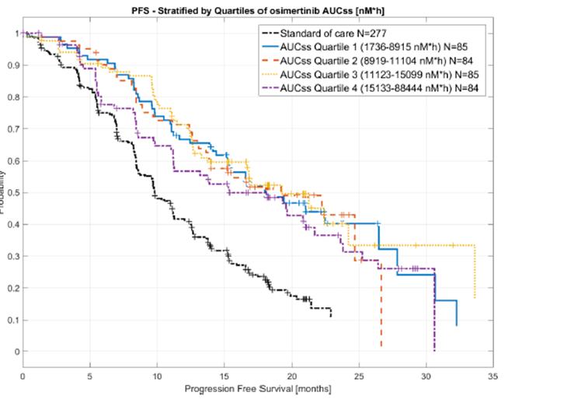

Progression-free survival (PFS) is stratified by quartiles of osimertinib area under the curve at steady state (AUC,ss) and standard of care (SoC)

##### Conclusions on exposure-response analyses relating the occurrence of interstitial lung disease, rash, and diarrhoea to osimertinib exposure

Assumptions within the modelling were that ‘the relationship between exposure (AUC,ss) and the response (logit of the probability of ILD) is linear.’ The sponsor’s modelling of the potential for ILD/pneumonitis to be related to exposure is noted, but given that all clinical trials to date and the PI specify discontinuation, rather than dose reduction, there are no clinical data to support any reduction in that risk with dose reduction to translate these findings into a recommendation with clinical relevance. There does not appear to be a satisfactory explanation for the observed increased incidence in Japanese patients. As previously stated, the model does not include other potential factors contributing to this risk and therefore is constrained by the assumptions that define it.

The conclusions with respect to the incidence of diarrhoea in the osimertinib arm mirror those of direct observation from the data randomised presented in the clinical study report (CSR). No new insights are provided from this analysis.

##### Conclusions on modelling and simulation analysis report to explore the relationship between changes in left ventricular ejection fraction and osimertinib exposure (dated 27 September 2017)

It is noted that the previous conclusions were that exposure to osimertinib did not explain the incidence and/or risk of LVEF events. Once again, the assumption was, ‘The relationship between exposure (AUCss) and the logit[17] of the event probability is linear.’ Therefore, in this study where there were only 8 LVEF events from the FLAURA trial as defined by a decline of ≥ 10% from baseline to an absolute value of < 50%, it would have been unlikely that prior conclusions would change. The evaluator is in agreement that the current data and modelling do not support a correlation between AUC,ss and LVEF events. Appropriately, there is no information included in the PI from this report.

### Pharmacodynamics

No new pharmacodynamic data were submitted.

### Dosage selection for the pivotal studies

No changes to the previously registered starting dose are proposed.

### Efficacy

#### Studies providing efficacy data

Study D5160c00007 (also known as the FLAURA trial) is a Phase III, double-blind, randomised study to assess the efficacy and safety of AZD9291 versus a standard of care epidermal growth factor receptor-tyrosine kinase inhibitor as first-line treatment in patients with epidermal growth factor receptor mutation-positive, locally-advanced or metastatic non-small-cell lung cancer.

#### Evaluator’s conclusions on efficacy

Treatment with osimertinib as first-line therapy in patients with NSCLC who were selected on the basis of tumour tissue samples with either or both of the two most common EGFR mutations (Exon19del or L858R), improved progression-free survival by 8.7 months compared with either of the two first generation EGFR TKIs, gefitinib or erlotinib. The median progression-free survival (PFS) was 18.9 months (95% confidence interval (CI): 15.2, 21.4) in the osimertinib arm versus 10.2 months (95% CI: 9.6, 11.1) in the SoC arm by Investigator assessment (primary endpoint). This was supported by the blinded independent central review (BICR) assessment which, although the median PFS was slightly lower in both arms, had a similar magnitude of difference: 17.7 months (95% CI: 15.1, 21.4) in the osimertinib arm versus 9.7 months (95% CI: 8.5, 11.0) in the SoC arm, indicating an 8 month improvement in median PFS for patients on osimertinib versus those on SoC.

The median duration of response was longer with osimertinib treatment which is consistent with its additional activity against the T790M mutation, which accounts for the majority of emergent resistance to other EGFR TKI inhibitors. Extensive analyses of other efficacy endpoints were presented, including for overall survival, but the overall survival (OS) data are too immature and no statistically significant difference was detectable. Overall response rates were high in both arms, and numerically were slightly higher in the osimertinib arm without reaching statistical significance. Similar marginal differences not reaching statistical significance were observed for disease control rate, depth of response. Consistent with the improved median PFS, the use of osimertinib delayed the time to a second treatment. Data for second subsequent therapies, median PFS2;[18] were limited by the small numbers as well as the cross over that was permitted from the SoC arm. The second therapies were markedly different between the arms, making it too difficult to interpret endpoints such as the duration of second treatment and median PFS2. However, it does appear from the data available that first-line use of osimertinib is preferable to sequential use of a first generation TKI followed by osimertinib to treat emergent T790M mutations.

An updated analysis once the OS data are mature will be performed, but extensive crossover among patients in the SoC arm to osimertinib, and the wide use of agents known to influence OS by both arms, may limit the demonstration of a survival benefit.

##### CNS efficacy

From the extensive exploratory data presented and multiple analyses by both BICR and investigator, it is apparent that all 3 TKIs have an effect on CNS disease. Only limited conclusions about the relative efficacy between osimertinib and the two first line EGFR TKIs can be drawn due to the absence of mandated baseline and subsequent central imaging to accurately capture all patients with brain metastases at baseline and subsequent response rates and duration. This limitation in study design, as well as the predefined statistical hierarchy requiring a statistically significant OS difference, prevents a statistically significant and satisfactory demonstration and comparison of CNS efficacy between the arms. Demonstration of a TKI treatment effect requires evaluable measurable disease in sufficient numbers of patients within the randomised structure of the clinical trial. However, results for the CNS full analysis set (cFAS) dataset, which is already a small subset of the study population, are confounded by prior treatments for a substantial proportion of patients (nearly one quarter in each arm had received prior brain radiotherapy, all within the previous 6 months), and a possibly significant number of patients did not have their CNS disease detected at all. Baseline demographic data were presented on the cFAS BICR analysis set (but not for those with measurable disease (CNS evaluable-for-response analysis set (Cefr)) and this indicates loss of randomisation with imbalances in the stratification factors (Asian patients, mutation status), as well as other key prognostic factors such as World Health Organization (WHO) status. The number of patients with evaluable disease represents too few of the study population to draw any firm conclusions and the findings should be considered potentially promising and hypothesis-generating. As these are not conclusive results, they should not be included in the PI. Note is also made of an apparent disparity in the study report description of exclusion criteria duration of time off steroids and those stated in the PI. However, no changes to the text are proposed, as the evaluator does not consider this sufficiently well demonstrated for inclusion in the PI.

The sponsor’s summary captures the uncertainty, ‘The CNS analysis showed that, in patients with at least 1 CNS lesion at Baseline (measurable or non-measurable; cFAS) as determined by CNS BICR, there was a nominally statistically significant and clinically meaningful improvement in CNS PFS for patients on osimertinib compared to patients on SoC (hazard ratio (HR): 0.48 (95% CI: 0.26, 0.86); p-value = 0.014). The CNS objective response rate (ORR) was numerically higher in the cFAS and cEFR subsets for patients on osimertinib compared to patients on SoC. For cEFR patients, the median CNS duration of response (DoR) was longer in the SoC arm, with a possible impact of the very low number of patients contributing to the analysis.’

In any case, the significantly improved median PFS and duration of response with osimertinib will result in it being promoted to the treatment of choice for those with newly diagnosed advanced EGFR-positive NSCLC, for all patients with EGFRm[19] NSCLC.

##### Selection of patients for treatment with osimertinib

No companion diagnostic or individual test is nominated in the PI, as a number of tests were used to enroll patients in the FLAURA trial. Exploratory data were presented comparing the results of EGFR mutation detection by central analysis of tissue using an earlier version of the cobas EGFR Test (which the evaluator understands to be the same for tissue analysis as the subsequent version (v2)), compared with retrospective plasma testing using the cobas EGFR Plasma Test v2. As with previous reports in other studies using other plasma assays for EGFR mutation detection, a lower positive predictive agreement was recorded with a higher rate of false negative tests with the plasma testing underscoring the need to check any such negative results with tissue testing wherever possible.

From the proportion of patients in the full analysis set (FAS) who tested circulating tumour DNA (ctDNA) positive, it appears that there is a similar magnitude of benefit as determined by the HR, and a slightly smaller median PFS that appears unlikely to be significantly different from the overall population, but no formal comparative analysis was provided. However, there is no information available from this trial on the safety and efficacy for those whose plasma ctDNA assay was positive but negative by EGFR tissue assay. This study only provides limited support for the clinical utility of the plasma ctDNA test for the proposed first line usage of osimertinib. It is not established whether the results from the full analysis set are representative of those that would be obtained with the plasma ctDNA used in a de novo setting, with no enrichment for a positive EGFRm status by prior local assessment, as occurred in this study. It is likely that given the convenience, less invasive nature and the speed with which the sample can be obtained, the DNA extracted and the test performed compared with tissue testing which requires a biopsy and slower process of DNA extraction, it could become the initial preferred test. At this time, it is recommended that it only be used where tissue is not available and cannot be safely or readily obtained.

The sensitivity of the cobas EGFR Test v2 to detect L858R mutations (by either the tissue or the plasma DNA extraction method) compared with some of the tests used at local sites is somewhat uncertain. It is noted that of the six patients negative by cobas EGFR tissue testing, that five of these harboured L858R mutations as detected by local site testing, and three of those patients experienced very significant clinical benefit. This finding may be a chance observation or reflect a lower sensitivity with this test.

The limitations of the data surrounding the plasma ctDNA need to be communicated clearly in the PI and it is recommended that this assay be evaluated as a companion diagnostic for the proposed usage.

### Safety

#### Studies providing safety data

The safety data were presented in the study report for the first line FLAURA trial as well as an Integrated Summary of Safety (ISS) stated to have the objective evaluate the clinical safety and tolerability of AZD9291 when given orally as an 80 mg dose with locally advanced or metastatic non-small cell lung cancer (NSCLC) using the largest relevant patient population of incorporating the following studies from the clinical development program.

#### Patient exposure

##### Study D5160C00007/FLAURA trial (Phase III)

All safety analyses were conducted on the safety analysis set, which included all 556 randomised patients who all received at least 1 dose of study treatment. At the time of the 12 June 2017 data cut off 1 (DCO1), 141 (50.5%) patients were still on treatment in the osimertinib arm and 64 (23.1%) were still on treatment in the SoC arm.

The total duration of exposure (that is, treatment duration) ranged from 0.1 month to 27.4 months in the osimertinib arm (median: 16.2 months), and from 0.0 month to 26.2 months in the SoC arm (median: 11.5 months). Patients on osimertinib had a longer exposure to study drug (349.9 treatment-years versus 271.9 treatment-years for the SoC arm). The actual duration of exposure (total treatment time excluding the dosing interruptions) was longer in the osimertinib arm than in the SoC arm, consistent with the delayed time to disease progression. To account for the longer exposure to study drug in the osimertinib arm than in the SoC arm (349.9 treatment-years versus 271.9 treatment-years, respectively), the event rate of adverse events (AEs) per 100 patient-years was used.

Table 2: FLAURA trial Duration of exposure as at DCO1

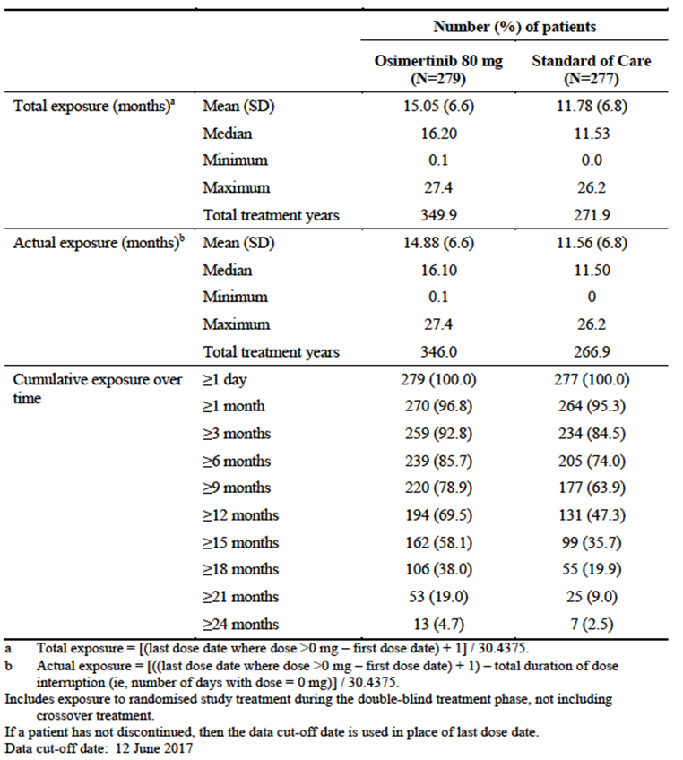

Minor overdoses (including of the placebo) were recorded with no adverse events related to these.

The SCS states, ‘A total of 48 patients crossed over to osimertinib treatment within the study after confirmed objective disease progression on SoC and a T790M positive test result based on tissue or plasma, as allowed by protocol, with a new baseline determined at the start of osimertinib treatment.’

##### Dose interruptions or modifications

Table 3: FLAURA trial; Treatment interruptions and dose reductions (safety analysis set)

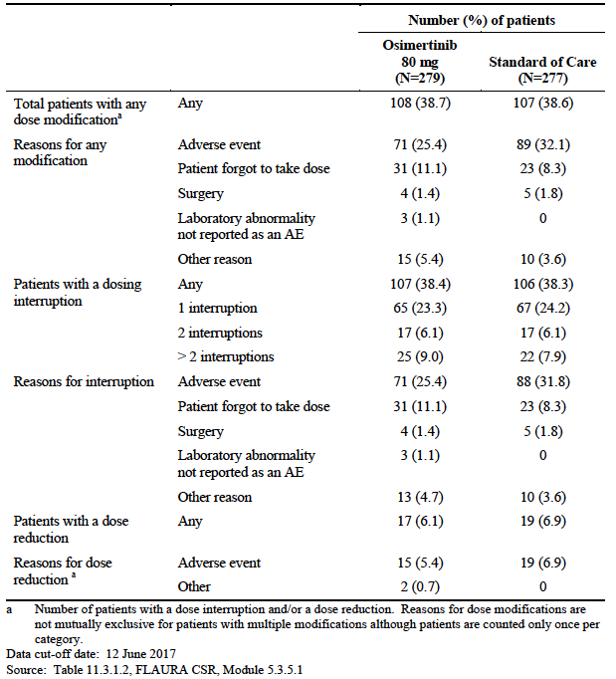

The proportions of patients in each arm requiring at least one or more dose interruptions were similar, as were the rates of dose modification; while there were slightly higher rates in the SoC arm categorised as due to an adverse event, the higher rates of category of ‘Other reason’ and ‘Laboratory abnormalities not reported as an AE’ (although obviously of sufficient concern to the clinician or patient to lead to dose modification) in the osimertinib arm led to almost identical overall rates.

Overall, the majority of patients requiring a treatment interruption did so only once, with a median time off treatment was not clinically significant at 4 days in the osimertinib arm versus 7 days in the SoC arm.

With an additional 4.2 months of median treatment duration in the osimertinib arm, this represents a slightly improved tolerability profile over the standard of care.

##### Integrated Summary of Safety (ISS)

Across the pooled studies, 1142 patients were treated with AZD9291 at an 80 mg dose as either first-line or second-line or greater therapy. 309 treatment-naïve patients received AZD9291 80 mg as first-line therapy for NSCLC, and 833 patients were treated in a second-line or greater setting with the same 80 mg dose of AZD9291. The table below shows the number of patients receiving this dose in each of the pooled studies, and by each line of therapy.

The sponsor states in the ISS statistical analysis plan (SAP), ‘Across the pooled safety database for this submission (N = 1141), that if an event exists in 1% of the population, there would be at least a 95% chance of observing at least one such event across the pooled studies. This is considered sufficient number of patients to adequately characterise the safety profile.’

Table 4: Integrated Summary of Safety dataset; Number of patients by line of treatment receiving 80 mg osimertinib in pooled studies

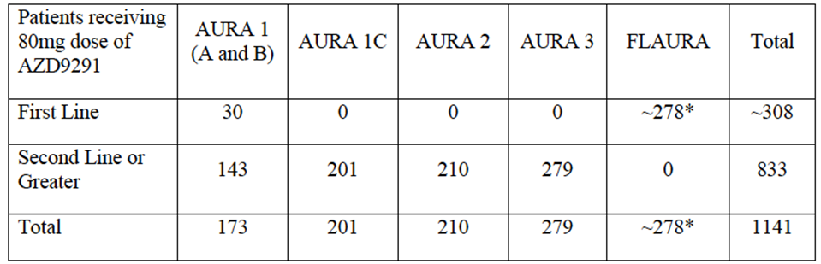

Exact number unknown at time of SAP finalisation as FLAURA is still blinded

In the AURA1A and AURAB trials, 18 and 155 patients respectively, received an 80 mg dose of AZD9291, totalling 173 patients. Of those, 30 received AZD9291 as first-line therapy. 279 patients in the FLAURA trial received osimertinib.

Table 5: Duration of exposure (ISS safety analysis set)

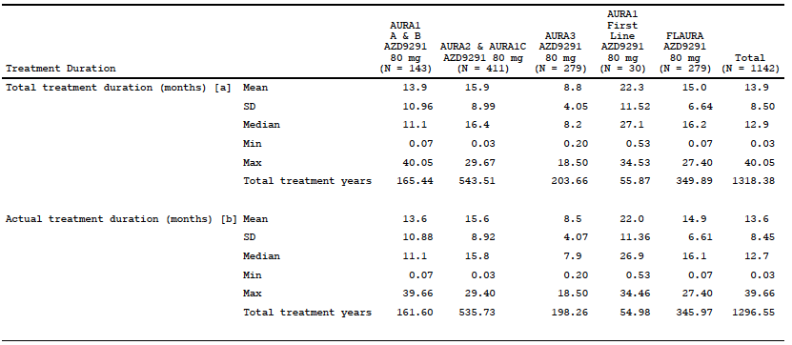 The median duration of treatment in the ISS was 12.9 months with a range of 0.03 to 40.05 months. 5.8% of 1142 patients in the ISS had received treatment for longer than 24 months.

#### Safety in special populations

##### Ethnicity

Data were presented comparing adverse events in Asian compared with White patients due to the small number of other ethnic or racial groups

The evaluator does not agree with the sponsor’s statement that the ‘overall incidence of AEs was similar across White and Asian patients’. Adverse events in all categories except serious adverse events (SAE) and deaths were higher in patients of Asian ethnicity. In particular, Asian patients were more likely to experience adverse events including severe adverse events, and to discontinue treatment as a result of adverse event and have that event attributed to treatment. These findings suggest that the PI should include a warning under Special Populations, given Australia has a relatively large Asian population and that EGFR-mutated NSCLC is more common in that population.

The evaluator considers that the warnings about potential increased toxicity in Japanese patients is adequate in the respective Precautions, but that this may be further informed by the Japanese pharmacovigilance study that is underway. Consideration could be given to the TGA making submission of this a condition of registration.

Table 6: FLAURA trial; Adverse events by race among patients in the osimertinib arm (safety analysis set)

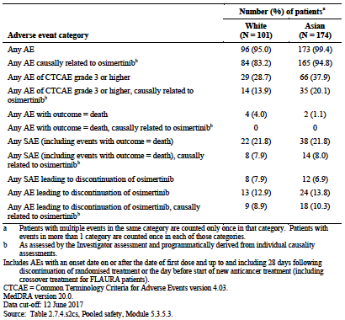

##### Elderly

The data in the table indicate very clearly that elderly patients had a much higher rate of adverse events with increasing age, and were more likely to discontinue due treatment- related adverse events than younger patients. The PI includes this information, combined with the AURA3 trial data (which has not been evaluated in this report) and this is sufficiently representative of the FLAURA trial. No new issues were identified for the elderly, and the PI statements apply to the findings in the FLAURA trial.

Table 7: FLAURA trial; Adverse events by age group at Baseline among patients in the osimertinib arm (safety analysis set)

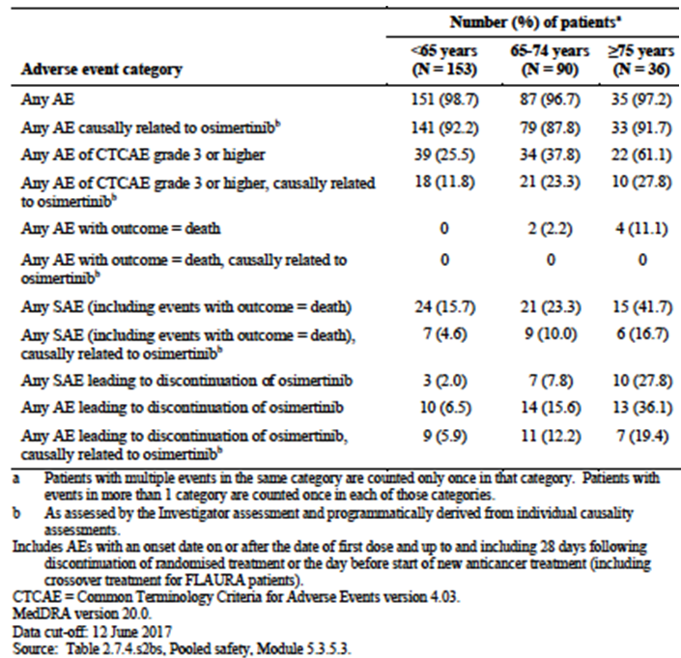

##### Renal impairment

Study exclusion criteria mandated that patients with creatinine > 1.5 times upper limit of normal (ULN) concurrent with creatinine clearance < 50 mL/min were not enrolled. The sponsor suggests in the SCS, that the increase in AEs with worse baseline renal function may reflect the effect of comorbidities, rather than renal function per se.

This may be the case, but it is noted that there is a dedicated study underway investigating osimertinib in patients with normal or with severe renal failure and consideration could be given to making submission of this a condition of registration as soon as the CSR is available, given the higher rate observed among those with a degree of impairment.

Table 8: FLAURA trial; Adverse events by baseline renal function among patients in the osimertinib arm (safety analysis set)

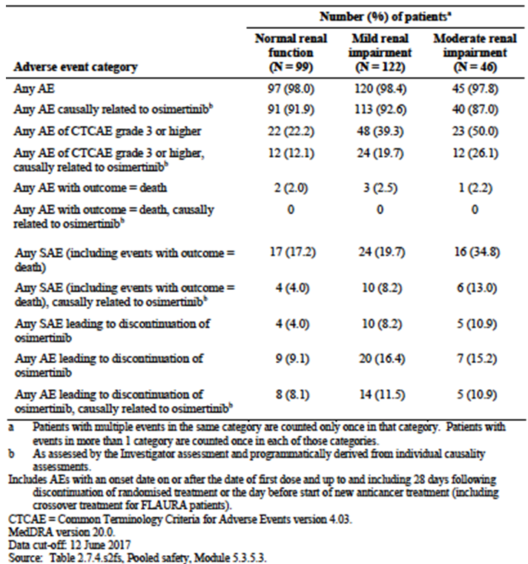

##### Hepatic impairment

Only 40 out of 273 patients in the osimertinib arm had moderate hepatic impairment due to exclusion criteria, with the remainder having normal hepatic function. A higher proportion or patients with baseline impairment experienced adverse events and the sponsor has indicated that a clinical study (Study D5160C00008) to evaluate the impact of hepatic impairment (mild and moderate hepatic impairment) on osimertinib exposure is currently being finalised.

Given the few patients with impairment, no conclusions can be drawn and it is noted the sponsor has indicated a commitment to submit the CSR for this study (note, the evaluator recommends this be required).

No clear pattern in AEs emerged for those with an Eastern Cooperative Oncology Group (ECOG) score of1 versus 0, or based on smoking status at Baseline.

##### Safety related to drug-drug interactions and other interactions

No new data.

#### Post marketing data

The SCS states, ‘Post-marketing data have been summarised in the latest periodic benefit-risk evaluation report (PBRER), which included data from 13 November 2016 to 12 May 2017. In this PBRER, the total cumulative post-marketing exposure to osimertinib for all doses and all countries as of 12 May 2017 was 7295.5 patient-years.’ As this will have been submitted to the TGA, and is likely to have been evaluated separately, it has not been re-evaluated in this report.

#### Evaluator’s conclusions on safety

Overall, osimertinib has an acceptable safety profile which compared with the two first generation EGFR TKIs, erlotinib and gefitinib, the comparators in this study. The proportion of dose modifications (dose interruptions or reductions) were almost identical overall, with similar rates in both arms for the individual reasons but the median duration of treatment was 4.5 months longer in the osimertinib arm, suggesting an improved tolerability overall with osimertinib. To date, osimertinib studies including the recently submitted AURA3 trial have either had chemotherapy as the comparator arm or been single arm studies. This new randomised, double blind, placebo-controlled study is the first comparing osimertinib with other EGFR TKIs as the standard of care.

##### New signals

Newly defined safety signals for osimertinib include a higher rate of haematological toxicity compared with the two EGFR TKIs which included reports of lowered counts of neutrophils, leucocytes, lymphocytes and white blood cell counts by various terms as well as much higher rates of thrombocytopaenia. There does not appear to be an absolute increase in risk of infection compared with the control arm and dose interruptions, reductions and discontinuations were uncommon. However, there was an imbalance in the number of deaths in patients with concurrent neutropaenia and infection (4 in the osimertinib arm compared with none in the SoC), which may be coincidence due to the much higher rates of neutropenia or reflect a causal effect. The grade of neutropaenia was not presented, and this has been requested as this may add some clarity. However, the absolute numbers of infections in either arm were high and appear to confirm the findings of a recent meta-analysis by Wang et al (2017);[20] in EGFR TKIs (other than osimertinib) of a relatively high rate of infections related to treatment, most of which were not serious or fatal. In the pivotal study, these include a preponderance of skin and mucosal infections, which would not normally be seen in lung cancer patients necessarily, and a causal link with mild immune suppression from osimertinib-related suppression of white cell counts cannot be excluded. Thrombocytopaenia was also observed, infrequently high grade, but associated with occasional severe bleeding episodes and there has been one death in an earlier phase trial.

Keratitis or corneal disorders, which appears to be a class effect of EGFR TKIs, were noted in the FLAURA trial and during the development program, and there is a new precaution in the PI regarding this. However, this should also warn against the risk of contact lens usage as long as there are any signs or symptoms, given this is an independent risk factor for corneal rupture.

Another new signal was pyrexia, which occurred much more often in the osimertinib arm. Apart from the immediate discomfort, this is likely to result in extensive investigations to exclude infections which also occur very commonly with this condition, and may be further increased when treated with EGFR TKIs, including osimertinib. Together with the new signal of neutropenia and infections, this trio of adverse events may lead to significant investigations and uncertainty about management, especially among those healthcare professionals unfamiliar with this disease and this new therapy to whom patients will present. The current inclusion in the Adverse Events section of the PI provides no contextualisation of the risk of a severe event, and given 73% of patients in the osimertinib arm experienced infections concurrently with neutropenia, and 10% experienced AEs of pyrexia, there should be information to guide clinicians as to the optimal management of such events. Clarification is being sought regarding the signal of concurrent neutropenia and SAEs or AEs leading to death in the osimertinib arm. This is discussed further in the section below on communication.

Stomatitis and other inflammatory conditions were much more common and were more severe in patients receiving osimertinib, but seldom required intervention. As an adverse event familiar to oncologists, these should be manageable.

##### Other known effects

The known EGFR TKI-related adverse events of ILD/pneumonitis occurred at higher rates in the osimertinib arm, although the strategy of immediately withholding osimertinib on suspicion, and discontinuing permanently on confirmation of the diagnosis may have reduced the seriousness and improved the manageability of this severe adverse event, which had resulted in 5 deaths earlier in the osimertinib development program. No deaths were observed in this study in the osimertinib arm, but otherwise the distribution across the grades was otherwise similar to the development program. ILD/pneumonitis again occurred at a much higher frequency in Japanese patients with the reasons for this still unclear. The population PK analyses do not provide convincing evidence of a relationship with increased exposure.

Japanese patients were also over-represented among patients experiencing adverse events of LV function decline, defined as a decrease of ≥10% to absolute value 50%, or a ≥ 15% decrease to an absolute value ≥50%. This AE occurred at higher rates in the osimertinib arm (13.6% compared with 8.7% in the standard of care arm during the course of the study regardless of baseline status) and appears to be a treatment-related effect of osimertinib. One event of new onset of cardiac failure (Grade 2) occurred in the osimertinib arm. However, the PI asserts that there is no clear link with treatment; the evaluator does not agree, and events that were comparable with the degree of LV dysfunction observed with human epidermal growth factor receptor 2 (HER2) directed therapies where this is an established treatment-related toxicity.

QT prolongation occurred at higher rates in the osimertinib arm. Rate of QTcF[21] prolongation> 500 ms were uncommon but increases > 60ms from baseline in 5% of patients were observed but the latter is not reported in the PI. Given this was one of leading causes of dose interruption, reduction and discontinuation in a population who were only eligible if they had no risk factors and not permitted to take any medications prior to and during the clinical trial that might lead to QT prolongation, the PI should advise of this and it would not be unreasonable for all patients to be recommended to have a baseline EGC prior to commencing.

Adverse events related to skin effects, while very common in both treatment arms, were more severe with the standard of care. Imbalances in the adverse events were mostly due to the higher rate of dermatitis acneiform with the standard of care, while erythematous rashes were more common with osimertinib. Events requiring dose modification and discontinuation were not common in the osimertinib arm, indicating an improved profile with respect to this adverse event.

Both adverse events of hepatotoxicity and laboratory abnormalities were much more common and much more severe with the standard of care, with three cases meeting Hy’s law compared with in the osimertinib arm.

##### Monitoring

The communication of these common AEs and their management is a somewhat difficult issue, given that under the strict monitoring of the clinical trial conditions, most were manageable. It is likely that with the high frequency of infections, fever and other adverse events, as well as the reduced intensity of treatment visits with these oral agents compared with patients receiving chemotherapy, that patients will present to a range of healthcare professionals including general practitioners and emergency department staff who are unfamiliar with newer therapeutic agents and how best to manage these events. The PI currently includes the high rates of adverse events such as infections and neutropaenia, but without contextualisation of the risks of each individually and concomitantly, which appear to be low for most patients (noting the outstanding issue regarding deaths from infections with concurrent neutropaenia) – which is very different from most experience and training about neutropaenia, and may lead to inappropriate treatment interruption. The constellation of fever, neutropenia and infection have to date, been considered an oncology emergency and healthcare providers not familiar with these TKI-related events of neutropaenia, infection (including medical oncologists not familiar with the unique toxicity of haematological toxicity with osimertinib) may overcall or undercall the event with either posing a risk of inappropriate discontinuation or failure to withhold dosing as needed. It is recommended that the PI include a section in the Precaution contextualising these very frequent adverse events and making clear recommendations about management. No data were available for the outcomes in patients treated with colony-stimulating factors, although it is noted that some oral preparations were used that are not approved in Australia and only approved for animal use in Europe.

In conclusion, most of the adverse events were manageable and reflect an acceptable safety profile for osimertinib for the proposed usage.

### First round benefit-risk assessment

#### First round assessment of benefit-risk balance

The improvement in investigator-assessed median progression-free survival in patients treated with osimertinib compared with the standard of care comparator arm of gefitinib or erlotinib, is compelling and consistent with the broader coverage of EGFR mutations, including T790M, the most commonly found as a cause of first generation EGFR TKI resistance. This benefit was seen across all subgroups, with 95% confidence intervals around the HR < 1 for all except a small subgroup where confirmation of EGFR mutation status was missing. As expected in a population selected on the presence of either or both of the sensitising EGFR mutations, exon 19 deletion and L858R substitution, overall response rates were high in both arms, with a numerically but not statistically significantly higher response rate in the osimertinib arm. Consistent with the improvement in median progression-free survival, this broader coverage led to statistically and clinically significant improvements in duration of response and longer time to second therapies in this arm.

The decreased occurrence of adverse events such as hepatotoxicity and severe skin reactions with osimertinib represents an improvement in the safety profile over the standard of care. However, osimertinib is associated with a higher risk of ILD/pneumonitis and QT prolongation was again observed in this very highly selected population, manageable under the stringent clinical trial-mandated close monitoring and avoidance of additional risk factors such as concomitant medications. Mostly low-grade haematological toxicities (including neutropaenia) and pyrexia were increased in the osimertinib arm which, together with the high rate of infections may be a source of confusion to the potentially wide range of healthcare professionals to whom these patients will present, particularly out of hours. One of the benefits of oral anticancer therapies is the reduced need for hospital visits such as for treatment administration. Therefore, these patients will have less contact with specialised treating teams, and a greater reliance on community healthcare providers for management of day-to-day issues. This is particularly relevant for patients in remote regions in Australia.

Following the responses from the sponsor, there is one remaining outstanding question regarding the severity/grade of the concurrent neutropenia and infections reported as serious adverse events and adverse events leading to death (see Section: Clinical questions, below); this does not affect the risk-benefit, which is still favourable, but is more an issue of understanding if there is a strong safety signal and any additional risk mitigation activities required.

### First round recommendation regarding authorisation

It is recommended that the sponsor’s proposed indication be approved, subject to the issues relating to the PI being addressed to the satisfaction of the TGA.

### Second round evaluation

There was no second round evaluation as this application was a ‘Priority’ type. The evaluator discussed the clinical questions and issues that were raised with the sponsor, as follows in the next section of this AusPAR.

### Clinical questions

#### Outstanding issues following the sponsor’s response to the TGA’s request for further information response

It is difficult to determine whether the imbalances in the rates of neutropaenia and leukopaenia in patients in the osimertinib arm with SAEs and AEs leading to death of infection reflect a causative role in these AEs or not. Both events occurred at much higher frequencies in the osimertinib arm, making it likely they would appear more frequently if assessed with another AE. A causative role cannot be excluded, particularly in the absence of the requested grading of leukopaenia and neutropaenia.

#### Efficacy

##### Question 1

***Given its usage in this study as a screening IVD for patient selection, the cobas EGFR Mutation plasma Test v2 and the tissue test referred to as ‘cobas EGFR Mutation Test (Roche)’ in the CSR, both fulfil the criteria to be considered a companion diagnostic. Note is made of the FDA approval of ‘cobas EGFR Mutation Test v2’ as a test for both plasma and tissue testing. The sponsor is requested to clarify:***

* 1. ***if the FDA-approved cobas EGFR Mutation Test v2 was used for both the central tissue and for the plasma ctDNA screening in the FLAURA study or if there were two different tests used (and the exact name of these including any version number); and***
  2. ***whether the test(s) used to select patients for the FLAURA Study are included in the ARTG as Class 3 IVD(s). If not included, is there an application lodged with the TGA given this/these tests defined the population in the pivotal trial?***

###### Sponsor’s response (Question 1a)

*Explanatory note on cobas EGFR mutation test kit naming:*

It is important to note that prior to the development of the cobas EGFR Mutation Test v2 kit there were 2 different cobas EGFR Mutation Test kits commercially available. On release of the cobas EGFR Mutation Test v2, these two cobas EGFR Mutation Test are now referred to as cobas EGFR Mutation Test v1, purely to differentiate from the new cobas EGFR Mutation Test v2 kit. The cobas EGFR Mutation Test v1 was only validated for use in formalin fixed paraffin embedded tissue samples whereas the cobas EGFR Mutation Test v2 is validated for use on both tissue and plasma samples.

The CE-In-vitro Diagnostic (IVD) marked cobas EGFR Mutation Test (v1) (Roche Molecular Systems) was marketed outside the USA; reporting on Exon 19 Deletions, L858R, G719X, S768I and T790M mutations.

The PMA-approved cobas EGFR Mutation Test (v1) (Roche Molecular Systems) was marketed within the USA; reporting only on Exon 19 Deletions and L858R EGFR mutations

The CE-IVD marked cobas EGFR Mutation Test was not commercially available in the USA at the time of central tissue screening to support Study D5160C00007 (FLAURA trial). Roche Molecular Systems made this kit available as a ‘research use only’ (RUO)-labelled kit. The CE-IVD marked and RUO labelled kits were equivalent in terms of the kit configuration, test procedure and the type of EGFR mutations reported.

*Central tissue testing within Study D5160C00007 (FLAURA trial):*

The cobas EGFR Mutation Test v2 was not commercially available in any territory when Study D5160C00007 (FLAURA trial) central testing of tissue samples started on 16 December 2014. The commercially available CE-IVD marked, or RUO-marked, cobas EGFR Mutation Test (cobas EGFR Mutation Test v1) was used for prospective testing of all screened patients, to maintain consistency in the cobas EGFR Mutation Test kit version utilised across the screening period.

Central tissue EGFR testing within the Study D5160C00007 (FLAURA trial) was performed in four (4) laboratories globally. Three (3) of the 4 testing laboratories used the CE-IVD marked cobas EGFR Mutation Test:

* Testing for patients screened within the Asia (excluding Chinese patients) and Australia region were performed at Peter MacCallum Cancer Center located in Melbourne, Australia.
* Testing for patients screened in mainland China were performed at the LabCorp laboratory in Beijing, China.
* Testing for patients screened in Europe were performed at the LabCorp laboratory located in Mechelen, Belgium.
* The fourth testing laboratory used the RUO-labelled cobas EGFR Mutation Test:
* Testing for patients screened within the USA and Canada were performed at the LabCorp CMBP Laboratory located in Research Triangle Park, USA.

*Central EGFR plasma testing within Study D5160C00007 (the FLAURA trial):*

Assessment of EGFR mutations in plasma samples collected during the screening window was performed, retrospectively, by Roche Molecular Systems in a single central laboratorylocated in the USA after the completion of enrolment, but prior to primary analysis, of Study D5160C00007 (FLAURA trial). This testing was performed using the cobas EGFR Mutation Test v2, which had been validated for use on plasma samples, to determine EGFR mutations in circulating tumour DNA, and released in the market prior to the testing.

Within Australia, there is no single established reference standard for EGFR mutation testing. The EGFR mutation status for Tagrisso, as proposed under the Dosage and Admin section of the PI, is assessed via ‘a validated test’ that does not restrict EGFR mutation status determination to cobas EGFR Mutation Test v1 or cobas EGFR Mutation Test v2.

###### Sponsor’s response (question 1b)

The cobas EGFR Mutation Test v1 (CE-IVD marked cobas EGFR Mutation Test), used to screen patients for tissue mutations during enrolment for Study D5160C00007 (FLAURA) was included on the Australian Register of Therapeutic Goods (ARTG) from the 3 February 2012.

The cobas EGFR Mutation Test v2, used to determine plasma mutation status, retrospectively, was included on the ARTG from 3rd February 2016. Both tests were registered in the ARTG as Class 3 IVD (AUST R:194319) with the cobas EGFR Mutation Test v2 superseding the previously registered cobas EGFR Mutation Test v1.

##### Question 2

***The sponsor is requested to provide the mutation status (that is which mutation was detected locally) and the efficacy outcomes for the 6 patients for whom the central cobas EGFR Mutation Test on tumour tissue did not confirm the presence of a mutation.***

###### Sponsor’s response to question 2

Amongst the 217 patients, who were randomised based on a local EGFR mutation positive test result in Study D5160C00007 (FLAURA trial) and had a valid central cobasEGFR mutation test result, 6 patients had a ‘no mutation detected’ central EGFR mutation test result.

Of the 6 patients, 3 had progression events and 3 did not have progression events at data cut off for Study D5160C00007 (FLAURA trial), on 12 June 2017.

Three different methods were used for local tests, the best objective response ranged from progressive disease (PD) to complete response (CR), and 3 patients had short PFS, with the remaining 3 patients showing a relatively long PFS (days from randomisation to censoring). Despite the central cobas EGFR Mutation Test and all local tests specified utilised DNA-based test methodology, the limit of detection and analytical specificity amongst them vary. Moreover, heterogeneity within tumours, among tumour sites and within tumour tissue samples may provide an explanation for the test discrepancy.

The overall positive percent agreement between the local tests and cobas EGFR Mutation Test was very high (97.24% (95% CI: 94.08, 98.98), excluding invalid test results) and the discordant cases were very rare in Study D5160C00007 (FLAURA trial).

##### Question 3

***The non-Asian patients appear to fare better with treatment with osimertinib than non- Asian patients and this is an unexpected finding, especially as response rates to EGFR TKIs have been reported as higher in female, Asian never smokers (Ha et al, 2015;******[22]) who appear to be the cohort predominantly recruited in this study – the Sponsor is requested to discuss potential reasons for this. Given these results are based on investigator assessments of PFS, a confirmatory Forest plot for the all same PFS subgroups is requested using the BICR PFS data.***

###### Sponsor’s response

The sponsor acknowledges that non-Asian patients appear to fare better with osimertinib than non-Asian patients in the FLAURA trial, but notes that the HR for Asian patients in this study demonstrates a large superior PFS benefit over SoC. There are currently no known potential reasons for the apparent difference in PFS between Asians and non-Asians.

The sponsor further concurs with the conclusion from the referenced article that in the 198 never-smoker Asian female patients with NSCLC, mutated EGFR was found to be the most commonly observed oncogenic driver. This conclusion from Ha et al.19 aligns with other reports showing that EGFR sensitizing mutations, which confer response to EGFR TKIs;[23],[24] are more commonly found in never-smokers, patients with the adenocarcinoma histological subtype, and in women.[25],[26] Together, these observations explain why in previous studies in unselected NSCLC populations only a small proportion of patients responded to EGFR TKs and the responders were predominately female and of Asian origin.[27],[28]

However, as the FLAURA trial was conducted in patients with centrally confirmed EGFR sensitising mutations, the observations by Ha et al. do not offer an explanation for the difference in HR. In fact, the FLAURA trial population are in line with EGFRm positive patients, with 63% of patients being female and 64% non-smokers. In studies with EGFRm positive patients, the observations are not conclusive: some studies showed no significant difference in PFS between ethnicities or gender (LUXLung-3 trial)[29] (LUXLung7 trial),[30] another did show some differences with longer mPFS for female and Asian subjects (ARCHER trial).[31]

In the FLAURA trial subgroup analysis for Asians versus non-Asians, the HRs imply that non‑Asians receive more benefit from osimertinib treatment than Asians (Asians: 0.55 (95% CI: 0.42, 0.72) versus 0.34 (95% CI: 0.23, 0.48) for Non-Asian patients). However, one should acknowledge that despite a lower HR in non-Asians, Asian have a much better outcome with osimertinib compared to SoC with a 95% CI of the HR that did not include ‘1’. In addition the 95% confidence intervals overlap. Furthermore, the overall statistical assumptions for the total population was a HR of 0.71; therefore, osimertinib performed better in the Asian subgroup with a HR of 0.55 than was assumed for the overall population. Assessment of any possible confounding factors, such as PK, or other known predictive factors such as mutation subtype, disease burden, or performance status, were conducted but did not show an imbalance that could further explain the observations. A global interaction test did not provide evidence of any treatment-by-covariate interaction for the covariates of ethnicity, gender, age, mutation status, duration prior EGFR-TKI, CNS metastases, and smoking history (2-sided p value = 0.317).

The requested forest plot based on BICR data (see below) is consistent with the analysis based on the investigator assessed data showing a benefit for both the Asian and non-Asian subgroups with osimertinib over SoC. The HRs by BICR for the subgroups are also consistent with the HR by investigator-assessed PFS with the HR values closer than in the investigator assessment and the confidence interval showing a larger overlap (Asians: 0.54 (95% CI: 0.36, 0.57) versus 0.37 (95% CI: 0.26, 0.53) for Non-Asian patients).

The improvement in PFS based on investigator assessment was seen consistently across predefined subgroups of interest with data. All point estimate PFS HRs with non-missing data (or available) were < 0.60.

The improvement in PFS based on BICR assessment was seen consistently across predefined subgroups of interest with data. All point estimate PFS HRs with non-missing data (or available) were < 0.60.

The conclusion from the FLAURA trial remains that osimertinib 80 mg once-daily offers a large statistically significant clinically meaningful PFS improvement for patients compared to SoC. The superiority of osimertinib over SoC was maintained consistently across the randomisation stratification factors and all predefined subgroups with available data for statistical analysis, indicating that osimertinib is an effective treatment option for patients regardless of the demographic or disease characteristics.

##### Question 4

***The sponsor is requested to provide the median PFS for each arm for the subgroups in the FLAURA trial defined EGFRm-positive, EGFRm-negative or for whom data was missing, as determined by the plasma ctDNA testing.***

Sponsor’s response

For median PFS and PFS analysis of the subgroups determined by ctDNA testing. The relevant subgroup is shown in the table below.

Table 9: Subgroup analysis of progression-free survival (full analysis set)

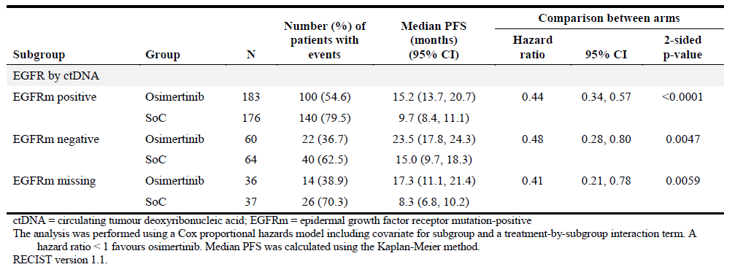

#### Pharmacokinetics

##### Question 5

***The visual predictive checks for the final model refer to Day 22 sampling from the FLAURA trial, which is presumably Day 1, Cycle 2. However, it is stated in the PK section of the FLAURA trial report reporting the secondary endpoint data, that samples were collected at Cycle 1 and thereafter, every second cycle up to and including, Cycle 13, and that steady-state was achieved by Cycle 3. Thus it would appear that no samples were collected on Day 22 as depicted in the VPC for the first line population for osimertinib or its metabolite, AZ5104 to provide these data. The sponsor is requested to confirm whether Day 22 samples were obtained, and if not, state what sampling timepoint was used and discuss the impact of the use of sampling different time points for comparisons between the datasets for the different studies and any conclusions drawn and proposed PI changes.***

###### *Sponsor’s response*

The population PK analysis of osimertinib included PK data from the FLAURA study, AURA Phase I, AURA extension, AURA2 and AURA3 studies, all of which were used to understand the population PK of osimertinib and AZ5104. In FLAURA study, PK samples were collected at Cycle 1 Day 1, Cycle 3 Day 1, Cycle 5 Day 1 and every other cycle till Cycle 13 Day 1 and in AURA phase I study, patients in first line cohort (n=30 at 80 mg and n=30 at 160 mg dose) had PK samples collected at Cycle 2 Day 1 (Day 22).

Data from first line patients in AURA Phase I provided full concentration time course PK profile at Cycle 2 Day 1 (Day 22) which were included in the VPC plots in the population PK analysis and were reported. Based on this analysis, steady state of osimertinib and its metabolite AZ5104 was achieved by Day 22 (Cycle 2 Day 1) onwards in first line patients as well. The VPCs also contain observations obtained under steady-state conditions after Day 22 to confirm that steady state is maintained after Day 22 of continuous dosing of osimertinib. Hence, pooling of data from all studies with different sampling times does not impact the evaluation of model adequateness and provides appropriate description of the pharmacokinetics of osimertinib and AZ5104. Thus, no changes are required in the proposed Australian PI of Tagrisso

##### Question 6

***From the Summary of Clinical Safety summarises the proportion of patients in the osimertinib arm of the FLAURA trial with an AE leading to dose reduction as 3.9% and an AE leading to treatment discontinuation as 9.7% and from the Integrated Safety dataset did not provide a figure for dose reductions in the FLAURA trial. However, the population PK report Discussion section states, ‘Out of 279 patients in FLAURA trial , 28 had dose reductions’ which is 10%, and not in agreement with either of these tables. The sponsor is requested to explain the source of these different figures.***

###### *Sponsor’s response*

In the population PK analysis, an initial check of the data indicated that there are 28 patients who had a change in their doses following the previous dose, during the FLAURA study. This was programmatically evaluated as dose changes at any time during the study following another dose. Of these 28 patients, there were 17 patients who had dose reductions in the study, of which 11 (3.9%) patients had dose reduction due to AEs (consistent with the summary of clinical safety) 9.1, FLAURA CSR Module 5.3.5.1). There are 11 additional patients in the popPK nonmem dataset who were noted to have dose changes who are not discussed in the CSR:

* 4 patients were identified with short term dose changes that were not recorded as dose modifications:
  + 3 patients accidentally took two doses on single days and returning back to the original dose the next day (That is, increased to 160 mg for just one day and then returned to the starting dose of 80 mg);
  + 1 patient accidentally took 40 mg for one day and returned to 80 mg the subsequent day.
* 7 patients were identified with dose changes that were not recorded due to subsequent discontinuations:
  + 4 patients who had dose reduction and subsequent discontinuation due to progressive disease;
  + 2 patients who had dose reduction and subsequent discontinuation due to AE;
  + 1 patient who had dose reduction and subsequent discontinuation due to death.

Please note, as mentioned in FLAURA CSR, when discussing dose modifications in the exposure section, each action taken for an AE is taken into account (That is, all actions taken are considered); whereas within the AE datasets, only the last action taken for an AE is recorded and summarised. Hence, there are discrepancies between numbers of patients with dose reductions between the exposure analysis and the AE analysis. For example, 3 of the 7 patients mentioned above were recorded as dose reductions due to AEs in the adverse event listings; however, they were not recorded as dose reductions in the compliance listing.

Overall, the analysis in the population PK report is an initial check of the dosing data while the information provided in the ISS and FLAURA CSR are an accurate reflection of the dose reductions.

#### Safety

##### Question 7

***There is a significant increase in what appear likely to be predominantly bacterial infections in patients receiving osimertinib who experienced concurrent neutropaenia and also leukopaenia. The sponsor is requested to provide: CTCAE grading for these events of infection that occurred concurrently, in one table each, for low neutrophil, leucocyte, lymphocyte or white blood cell counts (using all MedDRA preferred terms (PTs) that would capture such events) by Grade 1 or2, 3 or4 and 5. In particular, The sponsor is requested to identify whether there were any episodes of neutropaenic sepsis.***

###### *Sponsor’s response*

* Patients who experienced adverse events in the Infections and Infestations System Organ Class (SOC) occurring concomitantly with neutrophil counts below the lower limit of normal by SOC and preferred term by maximum reported CTCAE grade.
* Patients who experienced adverse events in the Infections and Infestations SOC occurring concomitantly with leucocyte counts below the lower limit of normal by SOC and preferred term by maximum reported CTCAE grade.
* Patients who experienced adverse events in the Infections and Infestations SOC occurring concomitantly with lymphocyte counts below the lower limit of normal by SOC and preferred term by maximum reported CTCAE grade.

No events of neutropenic sepsis were reported.

##### Question 8

***Given the increased rates and severity of neutropaenia and leukopaenia observed in the osimertinib arm, The sponsor is requested to present the neutrophil counts and leukocyte counts (including a grading by CTCAE) for all SAEs and all deaths from infection in both arms. In particular, The sponsor is requested to identify and include with this response, the narratives for any patients who meet the criteria for neutropaenic sepsis.***

###### *Sponsor’s response*

Patients who experienced serious adverse events or adverse events resulting in death in the Infections and Infestations SOC occurring concomitantly with neutrophil counts below the lower limit of normal by SOC and preferred term by maximum reported CTCAE grade.

Patients who experienced serious adverse events or adverse events resulting in death in the Infections and Infestations SOC occurring concomitantly with leukocyte counts below the lower limit of normal by SOC and preferred term by maximum reported CTCAE grade.

Serious adverse events or adverse events resulting in death in the Infections and Infestations SOC occurring concomitantly with lymphocyte counts below the lower limit of normal by SOC and preferred term by maximum reported CTCAE grade.

No events of neutropenic sepsis were reported.

##### Question 9

***There was a high rate of serious infections in patients who crossed over to osimertinib treatment per protocol and the sponsor is requested to present the neutrophil, leucocyte, lymphocyte or white blood cell counts in those experiencing Grade 3, 5 events and SAEs of infection after crossing over.***

Sponsor’s response

* There were no patients who crossed over to osimertinib treatment and experienced a CTCAE Grade 3, 4 or 5 adverse event or SAE from the infections and infestations SOC concurrently with either a neutrophil count below the lower limit of normal (LLN) or a leukocyte count below the LLN.
* Some patients experienced adverse events with CTCAE Grade 3 or higher, or serious adverse events, in the infections and infestations SOC occurring concomitantly with lymphocyte counts below the lower limit of normal by SOC and preferred term by maximum reported CTCAE grade.
* There were a total of 6 subjects who experienced an SAE within the infections and infestations SOC after crossing over to treatment with osimertinib. Patient listings for neutrophils, leucocytes and lymphocyte counts have been provided for all patients who experienced an SAE after crossing over.

##### Question 10

***The sponsor is requested to state whether the observed haematological abnormalities resolve following interruption and/or discontinuation of osimertinib.***

Sponsor’s response

Haematological abnormalities leading to dose interruptions and/or dose discontinuations of osimertinib are described. Twelve patients reported a total of 21 events of haematological abnormalities for which the drug was interrupted or withdrawn.

The most common adverse events (AEs) reported in this category were:

* neutropaenia (3 events)
* neutrophil count decrease (9 events)
* leukopaenia (2 events)
* white blood cell count decreased (1 event)
* lymphopaenia (1 event)
* lymphocyte count decrease (3 events)
* platelet count decrease (2 events)

Most AEs were not serious (20 events). One serious AE of CTCAE Grade 3 platelet count decreased was reported. The AE resolved in 15 days without drug intervention and was considered to be possibly related to treatment by the Investigator. Of the 21 reported AEs, 15 were CTCAE Grade 3 and 6 were CTCAE Grade 2; 17 resolved, 3 did not resolve and 1 was resolving at the time of the data cut-off. Of the AEs that had resolved, the duration ranged from 6 to 71 days (median 10 days). Fifteen haematological AEs did not require treatment administration, while treatment was administered for 6 AEs. The investigator considered the AE to be possibly related to study treatment in 16 of the 21 events.

##### Question 11

***Events of pyrexia were substantially increased in the osimertinib arm and The sponsor is requested to provide the proportion of these events with each of any of the following: concomitant low neutrophil, leucocyte, lymphocyte and white blood cell counts (using all terms that would capture such events), and the proportion where the event was accompanied by evidence of infection. The sponsor is specifically requested to present any information on any cases that could be neutropaenic fever (noting this was not a PT for the adverse event of special interest (AESI)), neutropaenic infection or neutropaenic sepsis.***

###### *Sponsor’s response*

No events of neutropaenic fever, neutropaenic infection or neutropaenic sepsis were reported. Subjects who experienced an event of pyrexia concurrently with either neutrophils, leucocytes, or lymphocytes below the lower limit of normal plus a concurrent event from the infections and infestations SOC have been identified and summarized below.

*Neutrophils:* One patient [Patient information redacted] experienced an event from the Infections and Infestations MedDRA[32] SOC (PT: Paronychia, CTCAE Grade 1) concurrently with pyrexia and neutrophil count below LLN. Paronychia began on 8 February 2016 and was reported as ongoing. The patient had 2 episodes of pyrexia (both CTCAE Grade 1), 1 June 2016 to 2 June 2016 and 22 June 2016 to 24 June 2016.

*Leukocytes:* Three patients [Patient information redacted] experienced an event from the Infections and Infestations MedDRA SOC (all reported PT: Paronychia, CTCAE Grade 1) concurrently with pyrexia and leukocyte count below LLN. Patient [Patient information redacted] experienced two episodes of pyrexia with concurrent paronychia, while the other two patients experienced one episode each. Of these three patients, two recovered from the event of paronychia and in the remaining patient paronychia was ongoing.

*Lymphocytes:* Nine patients experienced ten events of pyrexia, of which nine were reported as CTCAE Grade 1 and one was reported as CTCAE Grade 3. There were eleven events from the Infections and Infestations MedDRA SOC (PTs included: Paronychia (n=6 events), Bronchitis (n=1), Hordeolum (n=1), Pneumonia (n=1), Urethritis (n=1) and Urinary Tract Infection (UTI) (n=1)) reported concurrently with pyrexia and lymphocyte count below LLN. Seven patients experienced one event each whilst two patients experienced two events each. Five events had an outcome of recovered and six events were reported as ongoing at the time of data cut off (four paronychia, one hordeolum and one UTI). Ten of the eleven events were CTCAE Grade 1 or 2. The one remaining event (PT: Urethritis) was reported as CTCAE Grade 3 and the patient [Patient information redacted] recovered.

## VI. Pharmacovigilance findings

### Risk management plan

#### Summary of RMP evaluation[33]

The most recently evaluated Risk Management Plans (RMP) were [EU-RMP version 4.0](docubridge://open/Id=Fceae8039c18c4f9fba28ce130fb9227c&NodeId=Nc7e88008fae345aa9d3f80021ea21f55&Page=0) (8 February 2016; data lock point (DLP) 1 May 2015) and Australian Specific Annex [ASA version 2](docubridge://open/Id=Fceae8039c18c4f9fba28ce130fb9227c&NodeId=Na1c17c96215c4a6dbbbb616a237a3473&Page=0) (10 April 2016). In support of the extended indications, the sponsor has submitted [EU-RMP version 8.0](docubridge://open/Id=F19094fc3462143ffb4452cdda8cce6d8&NodeId=Nc368930f893b40e795f532c42848f61d&Page=0) (18 October 2017; DLP 12 June 2017) and [ASA version 4](docubridge://open/Id=F19094fc3462143ffb4452cdda8cce6d8&NodeId=N33a49686ac24462a8084553c3a9784b2&Page=0) (20 November 2017).

As the TGA has previously evaluated RMPs for this product, the focus of this evaluation is on the differences between the RMP versions that could have an impact on the safety profile, and any new safety related information relevant to this submission.

The proposed Summary of Safety Concerns and their associated risk monitoring and mitigation strategies are summarised below:

Table 10: Summary of safety concerns

|  |  |  |  |  |  |
| --- | --- | --- | --- | --- | --- |
| Summary of safety concerns | | Pharmacovigilance | | Risk Minimisation | |
| Routine (R) | Additional (A) | R | A |
| Important identified risks | Interstitial lung disease (ILD) | ✓ | ✓ | ✓ | – |
| Important potential risks | Cardiac failure | ✓ | – | ✓ | – |
| Missing information | Use in patients with moderate or severe hepatic impairment | ✓ | ✓ | ✓ | – |
| Use in patients with severe renal impairment | ✓ | ✓ | ✓ | – |
| Potential for drug-drug interactions between osimertinib and non-CYP3A4 mediated Pregnane X receptor (PXR) substrates | ✓ | ✓ | ✓ | – |
| Potential for P-glycoprotein inhibition | ✓ | ✓ | ✓ | – |

* The summary of safety concerns following consideration of the sponsor’s response to recommendations is acceptable in relation to the nature of the indication treated.
* The sponsor is undertaking routine pharmacovigilance activities for all safety concerns, and additional pharmacovigilance activities for all important identified risks and areas of missing information. This is acceptable given the nature of these concerns.
* The sponsor has proposed no additional risk minimisation activities, which is acceptable given the nature of the safety concerns.

#### Recommendations

The rolling questions made in the RMP evaluation were sent as recommendations 1 to 6 to the sponsor on 22 March 2018. The sponsor’s response was received and considered.

All RMP recommendations to the sponsor have been satisfactorily addressed.

#### Wording for conditions of registration

Any changes to which the sponsor has agreed should be included in a revised RMP and ASA. However, irrespective of whether or not they are included in the currently available version of the RMP document, the agreed changes become part of the risk management system.

The suggested wording is:

The Tagrisso EU-Risk Management Plan (RMP) (version 8.0, dated 10 October 2017, data lock point 12 June 2017), with Australian Specific Annex (version 4, dated 20 November 2017), included with submission PM-2017-04579-1-4, and any subsequent revisions, as agreed with the TGA will be implemented in Australia.

The following wording is recommended for the PSUR requirement:

An obligatory component of risk management plans is routine pharmacovigilance. Routine pharmacovigilance includes the submission of Periodic Safety Update Reports (PSURs).

Reports are to be provided in line with the current published list of EU reference dates and frequency of submission of PSURs until the period covered by such reports is not less than three years from the date of this approval letter.

The reports are to at least meet the requirements for PSURs as described in the European Medicines Agency’s Guideline on good pharmacovigilance practices(GVP) Module VII-Periodic Safety Update Report (Rev 1), Part VII.B Structures and processes. Note that submission of a PSUR does not constitute an application to vary the registration. Each report must have been prepared within ninety calendar days of the data lock point for that report.

## VII. Overall conclusion and risk/benefit assessment

The submission was summarised in the following Delegate’s overview and recommendations.

### Quality

There was no requirement for a quality evaluation in a submission of this type.

### Nonclinical

There was no requirement for a nonclinical evaluation in a submission of this type.

### Clinical

#### Pharmacokinetics

The PK data generated from the FLAURA trial were incorporated into an updated population PK model as described in the following section.

#### Population pharmacokinetic data

A popPK model for osimertinib was previously evaluated by TGA as part of the submission to register osimertinib as a new entity. The model included data from healthy volunteers and NSCLC patients treated with osimertinib as second or later line therapy in Phase I (AURA), Phase II (AURA2) and Phase III (AURA3) trials. An updated model was updated which includes data from FLAURA trial patients (treated first line with osimertinib).

Findings of the sponsor in updating the popPK model to include FLAURA trial data were:

* A linear 1-compartmental disposition model for both osimertinib and AZ5104, with first order oral absorption of osimertinib into the central compartment and the formation of AZ5104 from osimertinib described the considered data in an adequate manner.
* In the final popPK model, the typical values of CL/F, CLM/F, V/F, and VM/F are 14.3 L/hour (1.4%), 31.3 L/hour (2%), 918 L (3.3%), and 143 L (4.2%), respectively. Values in parentheses are the corresponding relative standard errors in percentages.
* The typical half-life of osimertinib was predicted with a median of 44.4 hours (95% confidence interval: (41.2, 47.7) hours).
* Pharmacokinetics of osimertinib and its metabolite AZ5104 was, in general, similar between patients treated with osimertinib in first line (FLAURA trial), second line (AURA3 trial) and ≥ third line.
* No clinically significant covariates effects were identified.

The clinical evaluator noted that safety signals in Japanese patients for ILD and decline in ejection fraction could not be explained by the popPK model, as ethnicity had a negligible effect on PK parameters.

The FDA label currently contains the following text regarding PK in special populations:

‘No clinically significant differences in the pharmacokinetics of osimertinib were observed based on age, sex, ethnicity, body weight, baseline albumin, line of therapy, smoking status, mild (CLcr 60 to 89 mL/min), moderate (CLcr 30 to 59 mL/min, as estimated by C-G), or severe (CLcr 15 to 29 mL/min) renal impairment, or mild (total bilirubin ≤ ULN and aspartate aminotransferase (AST) > ULN or total bilirubin between 1 to 1.5 times ULN and any AST) or moderate (total bilirubin between 1.5 to 3 times ULN and any AST) hepatic impairment. The pharmacokinetics of osimertinib in patients with end-stage renal disease (CLcr < 15 mL/min) or with severe hepatic impairment (total bilirubin between 3 to 10 times ULN and any AST) are unknown.’

#### Pharmacodynamics (PD)

Three popPK modelling reports looking at exposure-efficacy or exposure-safety analyses were submitted. The corresponding conclusion of the clinical evaluator is notated below each:

##### Exposure and RECIST-based efficacy measures (included data from AURA and FLAURA trials)

*Sponsor conclusions:*

‘This analysis suggests that within the limited exposure (AUCss) range investigated in this analysis, increasing exposure (AUC,ss) of osimertinib is not associated with increased efficacy with respect to PFS, BRS, DoR, and BPCT.

Model-based analysis indicated that the observed lower median PFS in patients in the highest exposure quartile could not be clearly defined as it may be a result of multiple factors that could have contributed to these small PFS difference, rather than related to exposure of osimertinib.’

*Evaluator assessment:*

The evaluator commented that those requiring a dose reduction would not appear to have a predicted decrease in efficacy. The clinical utility of this modelling is limited by its inability to account for dose interruptions and potential confounding baseline prognostic factors affecting efficacy outcomes. There is no predictive role in exposure analyses to identify patients for treatment with the SoC rather than osimertinib.

##### Exposure-response analyses for interstitial lung disease, rash, and diarrhoea (included data from AURA, AURA2, AURA3 and FLAURA trials)

*Sponsor conclusions:*

‘The model-based analysis of ILD and ILD-like events suggested a potential relationship between osimertinib treatment and the incidence of ILD and ILD-like events. However, this relationship was not statistically significant (according to the pre-defined criterion; p < 0.001). The probability of a patient experiencing ILD or an ILD-like event may increase with increasing osimertinib exposure (and dose). At a similar exposure (AUCss), Japanese patients are predicted to have a higher probability of experiencing ILD and ILD-like events compared to other ethnic populations.

The incidence and severity of rash and diarrhoea AEs appear to increase with increasing osimertinib systemic exposure, and was higher at 160 mg osimertinib compared to the 80 mg dose.

The incidence and severity of rash is lower and diarrhoea was similar in the osimertinib 80 mg treated patients compared to EGFR-TKI SoC treated patients.’

###### Evaluator assessment:

Assumptions within the modelling were that ‘The relationship between exposure (AUCss) and the response (logit of the probability of ILD) is linear.’ There are no clinical data to support any reduction in that risk with dose reduction to translate these findings into a recommendation with clinical relevance. There does not appear to be a satisfactory explanation for the observed increased incidence in Japanese patients. As previously stated, the model does not include other potential factors contributing to this risk and therefore is constrained by the assumptions that define it.

The conclusions with respect to the incidence of diarrhoea in the osimertinib arm mirror those of direct observation from the data randomised presented in the CSR. No new insights are provided from this analysis.

##### Exposure-response analysis for changes in left ventricular ejection fraction (included data from AURA, AURA2, AURA3 and FLAURA trial)

*Sponsor conclusions:*

Based on the available data and the small number of patients with LVEF events, a relationship between osimertinib exposure and LVEF events could not be established.

*Evaluator assessment:*

The current data and modelling do not support a correlation between AUCss and LVEF events.

#### Efficacy

##### Pivotal Study D5160C00007/FLAURA trial

###### Title

A Phase III, double-blind, randomised study to assess the efficacy and safety of AZD9291 versus a standard of care epidermal growth factor receptor-tyrosine kinase inhibitor as first-line treatment in patients with epidermal growth factor receptor mutation-positive, locally-advanced or metastatic non-small-cell lung cancer.

###### Locations

Patients were enrolled in 132 study centres across 29 countries: Australia (7 centres), Belgium (2), Brazil (1), Canada (5), China (4), Czech Republic (1), France (6), Germany (6), Hungary (3), Israel (3), Italy (7), Japan (18), Malaysia (3), Philippines (2), Poland (5), Portugal (4), Romania (1), Russian Federation (3), South Korea (7), Spain (8), Sweden (1), Switzerland (3), Taiwan (5), Thailand (6), Turkey (1), Ukraine (3), United Kingdom (UK, 4), United States of America (USA, 11), and Vietnam (2).

An additional 17 centres in China enrolled patients in a separate China extension cohort.

###### Dates

Table 11: Study dates

|  |  |
| --- | --- |
| Study event | Date |
| First patient randomised: | 19 February 2015 |
| First patient's first dose: | 19 February 2015 |
| Last patient's first dose: | 11 March 2016 |
| Data cut-off date for primary analysis (DCO1): | 12 June 2017 |
| Clinical study report (CSR) dated | 20 September 2017 |

###### Design

This was a Phase III, randomised, double-blind study assessing efficacy and safety of osimertinib 80 mg orally (PO) daily versus a standard of care (Soc) EGFR-TKI (gefitinib 250 mg PO daily or erlotinib 150 mg PO daily) in patients with locally advanced or metastatic EGFRm NSCLC eligible for first-line therapy with an EGFR-TKI who were treatment-naïve for their advanced EGFRm NSCLC.

Figure 2: Figure study design flowchart

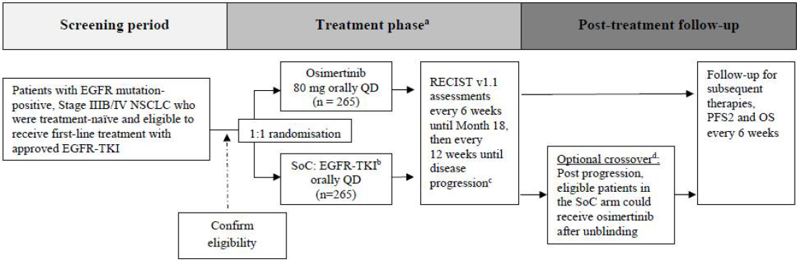

###### Sample size

Approximately 530 patients (265 per treatment arm).

###### Randomisation

Patients were randomised 1:1 to osimertinib or SoC. Randomisation was stratified by mutation status (Ex19del;[34] or L858R) and ethnicity (Asian versus Non-Asian).

###### Inclusion criteria (abbreviated)

* Non-reproductive, non-breastfeeding, consenting, compliant adults (age 18+ except 20+ in Japan), with WHO Performance status S 0 or 1 and life expectancy ≥ 12 weeks
* Stage IIIB/IV NSCLC with predominant adenocarcinoma histology if mixed, not amenable to curative surgery or radiotherapy , suitable measurable target lesion
* Not yet treated for their stage IIIB/IV disease and eligible for comparator;
  + prior adjuvant/neo-adjuvant was permitted.
* EGFRm: at least one of Del19 or L858R according to either central cobas EGFR Mutation Test (Roche Molecular Systems) or using a validated local test
  + Validated local test:
    - performed in a Clinical Laboratory Improvement Amendments (CLIA)-certified lab (for US sites); or
    - in an accredited lab (outside of the US)
  + Sufficient tissue was required at enrolment for central (cobas) testing for a sensitivity analysis comparing local with central results.

###### Exclusion criteria (abbreviated)

* Staff of the sponsor
* Prior or concurrent treatments including:
  + any of the following:
    - an EGFR-TKI;
    - investigational compound unless ceased within 5 half lives of study drug; or
    - potent inducers of CYP3A4 unless ceased 1 week prior to study drug Concurrent alternative anti-cancer treatment.
  + Within 4 weeks of first dose of study drug:
    - major surgery excluding placement of vascular access; or
    - radiotherapy to more than 30% of bone marrow or with a wide field.
* Other malignancy within 2 years.
* Toxicities from prior therapy unresolved below CTCAE Grade 1;
  + except alopecia or Grade 2 prior-chemotherapy induced neuropathy.
* Symptomatic CNS disease unless neurologically stable for 2 weeks after definitive therapy completed and steroids ceased.
* Severe or uncontrolled systemic disease including active hepatitis or human immunodeficiency virus (HIV).
* Gastrointestinal (GI):
  + refractory nausea and vomiting;
  + factors precluding adequate absorption (disease, resection, inability to swallow).
* Cardiac:
  + QTcF prolongation:
    - rhythm, conduction or morphology abnormalities;
    - risk factors for QT prolongation including concomitant medications.
* Hypersensitivity to ingredients or others in-class.

###### Interventions

* Osimertinib arm:
  + 80 mg osimertinib PO daily plus comparator-matching placebo.
* SoC arm, either:
  + gefitinib 250 mg PO daily plus osimertinib-matching placebo; or
  + erlotinib 150 mg PO daily plus osimertinib-matching placebo.

Study sites were required to select either gefitinib or erlotinib as the sole comparator prior to site initiation, except for the US where all sites used erlotinib (the most commonly used EGFR-TKI for first-line EGFRm NSCLC in the US at the time of study start, in 2014).

###### Dose modification, crossover, treatment beyond progression

* Patients could continue to receive their randomised treatment beyond RECIST v1.1;[35] defined progression if the investigator judged the patient was continuing to show clinical benefit on treatment.
* Continuation of randomised treatment was not allowed if patient had been unblinded.
* After investigator-assessed objective disease progression based on RECIST v1.1, patients randomised to the SoC arm had the option to crossover to treatment with open-label osimertinib provided the following criteria were met:
  + progression confirmed by BICR of imaging;
  + no subsequent therapy received after discontinuation of randomised treatment; and
  + T790M-positive status confirmed (centrally or locally).

###### Endpoints

Table 12 gives the endpoints of the FLAURA trial.

Table 12: Endpoints

|  |  |
| --- | --- |
| Endpoint type | Endpoint description |
| Primary | Progression-free survival (PFS) based on Investigator assessment according to RECIST v1.1  Sensitivity analysis by blinded independent central review (BICR) of imaging data |
| Secondary | PFS subgroups: EGFRm type: that is Del19 versus L858RDetectable EGFRm by circulating tumour DNA (ctDNA) testing  Overall response rate (ORR), duration of response (DoR), disease control rate (DCR), and depth of response (absolute change in tumour size)  Overall survival (OS)  PFS, ORR and DOR in subgroups based on presence or absence of CNS metastases at study entry (CNS MTS)  PK  Patient reported outcomes (PRO): EORTC QLQ-C30 questionnaire (general cancer symptoms and functioning);[36] EORTC QLQ-LC13 questionnaire (lung cancer symptoms); and CTSQ-16 questionnaire (patient satisfaction with therapy).[37]  Safety:  AEs (graded using CTCAE v4.03);[38] laboratory data (clinical chemistry, haematology, urinalysis); vital signs, physical examination, body weight, WHO performance status; dECG; LVEF and ophthalmologic assessment. |
| Exploratory | Health resource use  Patient-reported AEs (PRO-CTCAE)[39]  Time to discontinuation of randomised treatment or death (TDT) PFS with subsequent therapy (PFS2)  Time to first subsequent therapy (TFST) |

###### Data collection

* Tumour measurements:
  + Every 6 weeks (± 1 week) from randomisation for first 18 months.
  + Every 12 weeks thereafter including post-progression.
* Following Investigator-assessed objective disease progression according to RECIST v1.1, irrespective of whether patients had discontinued treatment, patients were to be followed for survival every 6 weeks, with collection of data on subsequent therapies, any response or progression, patient-reported outcomes (PRO), and survival status. After discontinuation of randomised treatment, AEs and concomitant medication data were to be collected for a further 28 days, and patients were to be treated in accordance with the regional SoC. Survival data for patients randomised prior to the end of global recruitment were to be collected up to the time of the final OS analysis.

###### Statistical analysis plan

Primary efficacy analysis was planned at approximately 359 PFS events in the intended 530 patients.

###### Analysis populations

Table 13: Primary efficacy analysis populations

|  |  |  |  |
| --- | --- | --- | --- |
|  | Osimertinib arm (n=279) | SoC arm (n=277) | Total (n=556) |
| Full analysis set (FAS) | 279 | 277 | 556 |
| Safety analysis set | 279 | 277 | 556 |
| Centrally-confirmed EGFRm | 255 | 245 | 500 |
| EGFR negative by central test | 3 | 3 | 6 |
| Inadequate sample for central test | 17 | 24 | 41 |
| Invalid sample for central test | 4 | 5 | 9 |
| CNS FAS (cFAS) - baseline CNS lesion by BICR | 61 | 67 | 128 |
| CNS evaluable-for-response (cEFR) analysis set – measurable baseline CNS lesion by BICR | 22 | 19 | 41 |
| CNS MTS analysis set – CNS status ‘YES’ at baseline per investigator | 53 | 63 | 116 |

###### Disposition

Figure3: Disposition flowchart

Disposition flowchart



Table 14: Baseline characteristics (demographics and disease)

|  |  |  |  |
| --- | --- | --- | --- |
| Demographic characteristic | Osimertinib  (N=279) | SoC  (N=277) | Total  (N=556) |
| Age (years) |  |  |  |
| Mean | 62.7 | 63.3 | 63 |
| Standard deviation | 10.7 | 10.9 | 10.79 |
| Median | 64 | 64 | 64 |
| Min | 26 | 35 | 26 |
| Max | 85 | 93 | 93 |
| Age group (years), n (%) |  |  |  |
| <50 | 32 (11.5) | 37 (13.4) | 69 (12.4) |
| ≥50-<65 | 121 (43.4) | 108 (39.0) | 229 (41.2) |
| ≥65-<75 | 90 (32.3) | 89 (32.1) | 179 (32.2) |
| ≥75 | 36 (12.9) | 43 (15.5) | 79 (14.2) |
| Sex n (%) |  |  |  |
| Male | 101 (36.2) | 105 (37.9) | 206 (37.1) |
| Female | 178 (63.8) | 172 (62.1) | 350 (62.9) |
| Race n (%) |  |  |  |
| Asian | 174 (62.4) | 173 (62.5) | 347 (62.4) |
| Black or African American | 2 (0.7) | 2 (0.7) | 4 (0.7) |
| White | 101 (36.2) | 100 (36.1) | 201 (36.2) |
| American Indian or Alaska Native | 1 (0.4) | 1 (0.4) | 2 (0.4) |
| Missing | 1 (0.4) | 1 (0.4) | 2 (0.4) |
| Ethnic group n (%) |  |  |  |
| Asian (other than Chinese and Japanese) | 77 (27.6) | 94 (33.9) | 171 (30.8) |
| Chinese | 32 (11.5) | 24 (8.7) | 56 (10.1) |
| Japanese | 65 (23.3) | 55 (19.9) | 120 (21.6) |
| Other | 103 (36.9) | 104 (37.5) | 207 (37.2) |
| Missing | 2 (0.7) | 0 | 2 (0.4) |
| Smoking status |  |  |  |
| Never | 182 (65.2) | 175 (63.2) | 357 (64.2) |
| Current | 8 (2.9) | 9 (3.2) | 17 (3.1) |
| Former | 89 (31.9) | 93 (33.6) | 182 (32.7) |

Table 15: Baseline disease characteristics

|  |  |  |  |
| --- | --- | --- | --- |
| Disease characteristic | Osimertinib  (N=279) | SoC  (N=277) | Total  (N=556) |
| *World Health Organization Performance Status* |  |  |  |
| 0 (normal activity) | 112 (40.1) | 116 (41.9) | 228 (41.0) |
| 1 (restricted activity) | 167 (59.9) | 160 (57.8) | 327 (58.8) |
| Missing | 0 | 1 (0.4) | 1 (0.2) |
| *Overall disease classification* |  |  |  |
| Metastatic a | 264 (94.6) | 262 (94.6) | 526 (94.6) |
| Locally advanced b | 14 (5.0) | 15 (5.4) | 29 (5.2) |
| Missing | 1 (0.4) | 0 | 1 (0.2) |
| *Time from diagnosis/recurrence to randomisation (months)* |  |  |  |
| n | 278 | 276 | 554 |
| Mean | 1.9 | 1.8 | 1.9 |
| Standard deviation | 5.57 | 3.24 | 4.56 |
| Median | 1.2 | 1.2 | 1.2 |
| Min | 0 | 0 | 0 |
| Max | 82 | 37 | 82 |
| CNS metastases c | 53 (19.0) | 63 (22.7) | 116 (20.9) |
| No CNS metastases c | 226 (81.0) | 214 (77.3) | 440 (79.1) |
| Extra-thoracic visceral metastases | 94 (33.7) | 103 (37.2) | 197 (35.4) |
| Liver metastases | 41 (14.7) | 37 (13.4) | 78 (14.0) |
| Bone & locomotor metastases | 97 (34.8) | 102 (36.8) | 199 (35.8) |
| No extra-thoracic visceral metastases | 185 (66.3) | 174 (62.8) | 359 (64.6) |
| Baseline tumour size (mm) d |  |  |  |
| n | 278 | 277 | 555 |
| Mean | 55.3 | 56.7 | 56 |
| Standard deviation | 34.65 | 33.55 | 34.08 |
| Median | 47.5 | 50 | 48 |
| Min | 10 | 10 | 10 |
| Max | 207 | 176 | 207 |
| *Baseline tumour size category (mm) d, n (%)* |  |  |  |
| <40 | 111 (39.8) | 104 (37.5) | 215 (38.7) |
| 40 - <80 | 102 (36.6) | 107 (38.6) | 209 (37.6) |
| 80 – <120 | 52 (18.6) | 49 (17.7) | 101 (18.2) |
| ≥120 | 13 (4.7) | 17 (6.1) | 30 (5.4) |
| Missing | 1 (0.4) | 0 | 1 (0.2) |
| EGFR mutations by cobas central test e |  |  |  |
| EGFR exon 19 deletion | 158 (56.6) | 155 (56.0) | 313 (56.3) |
| EGFR exon 21 L858R | 97 (34.8) | 90 (32.5) | 187 (33.6) |
| EGFRm not detected | 3 (1.1) | 3 (1.1) | 6 (1.1) |
| Invalid test | 4 (1.4) | 5 (1.8) | 9 (1.6) |
| No sample or inadequate sample | 17 (6.1) | 24 (8.7) | 41 (7.4) |
| *EGFR mutations as used for randomisation strata*(f) | | | |
| EGFR exon 21 L858R | 104 (37.3) | 103 (37.2) | 207 (37.2) |
| EGFR exon 19 deletion | 175 (62.7) | 174 (62.8) | 349 (62.8) |

a. Metastatic disease - Patient had any metastatic site of disease. b. Locally advanced - Patient had only locally advanced sites of disease. c. This is a programmatically derived composite endpoint with a list of contributing data sources. d. Longest diameter at baseline. e. A patient could have more than one mutation. f. EGFR mutations based on the test (local or central) used to determine randomisation strata (Ex19del or L858R).

###### Efficacy results

Main efficacy findings as at the primary efficacy analysis data cut-off date (DCO1) of 12 June 2017 are outlined below.

Table 16: Main efficacy findings as at the primary efficacy analysis data cut-off date (DCO1) of 12 June 2017

|  |  |  |
| --- | --- | --- |
| Efficacy finding | Osimertinib (n=279) | SoC (n=277) |
| Median PFS (months) (95%CI) per investigator | 18.9 (15.2, 21.4) | 10.2 (9.6, 11.1) |
| Median PFS (months) (95%CI) per BICR | 17.7 (15.1, 21.4) | 9.7 (8.5, 11.0) |
| Deaths (n) (%) at DCO1 - 25.4% maturity | 58 (20.8) | 83 (30.0) |
| 18 months Kaplan-Meier (KM) estimate of OS (%) (95% CI) | 82.8 (77.7, 86.8) | 70.9 (64.8, 76.1) |
| ORR (%) (95% CI) per Investigator | 79.9 (74.7, 84.5) | 75.8 (70.3, 80.7) |
| ORR (%) per BICR | 78.1 | 70.4 |
| DOR (months) (95% CI) by KM estimate per Investigator | 17.2 (13.8, 22.0) | 8.5 (7.3, 9.8) |
| DOR (months) (95% CI) by KM estimate per BICR | 24.9 (18.8, 31.0) | 12.5 (10.5, 14.5) |

At DCO1, PFS hazard ratio (HR) by BICR was 0.45 (95% CI: 0.36, 0.57; p <0.0001). Sensitivity analysis of PFS, ORR and DOR by BICR was in keeping with Investigator findings in terms of comparison between arms. Ascertainment, evaluation time and attrition bias analyses based on the primary outcome indicate these biases were not significant.

As demonstrated in the forest plot below, the PFS HR favoured osimertinib over SoC in all predefined subgroups with n≥20 (notably including CNS MTS) except for patients without a valid central EGFRm test, in which the confidence interval crossed 1. No T790M subgroup testing was performed as it was only identified in 5 patients in this first line cohort.

The interim OS analysis showed a HR of 0.63 (99.85% CI: 0.37, 01.08), p=0.0068, but did not reach the interim analysis requirement for formal statistical significance (p<0.0015, using O’Brien-Fleming methodology, and adjusted CI as above). Minimum follow-up for OS at DCO1 was 15 months. An updated OS will be available once data mature, but extensive crossover, and variability in subsequent therapies may prevent the demonstration of a survival benefit.

DOR median was doubled in the osimertinib arm compared to SoC, with clear separation of confidence intervals.

Figure 4: Progression free survival hazard ratios and 95% confidence intervals

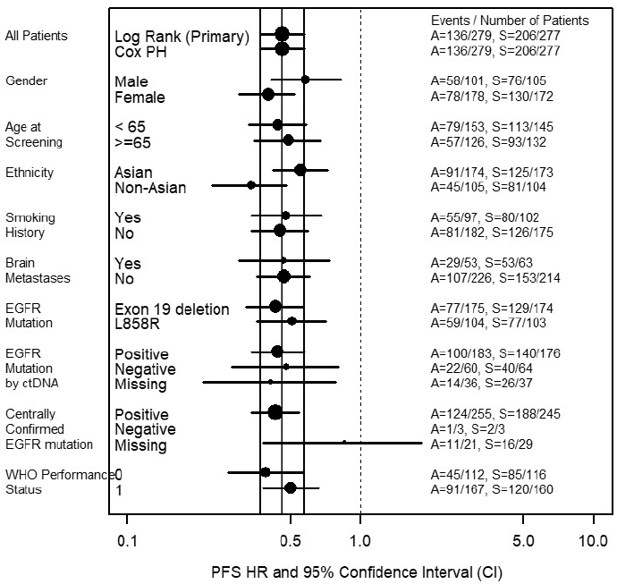 Note: A=osimertinib, S=SoC

In PRO testing, compared to a reference group of unselected patients with NSCLC (N = 1262), both treatment arms reported clinically relevant (that is, at least 10 percentage point (pp) difference) lower scores for dyspnoea and clinically relevant higher scores for role functioning. Differences between arms were not demonstrated.

ORR, DCR, time to response, depth of response and proportion of patients continuing randomised (blinded) treatment post-progression were not shown to be different between arms.

Time to first subsequent therapy (TFST) was longer in the osimertinib arm (consistent with the primary efficacy outcome). Interpretation of exploratory outcomes was limited by missing/incomplete data, crossover and marked differences in second therapies between arms.

CNS outcomes nominally suggested improved CNS PFS with osimertinib, but this remain exploratory as they are subsequent to OS (which didn’t reach formal statistical significance at DCO1) in the hierarchical statistical testing strategy. These results may be interpretable in future analyses but are not considered appropriate for inclusion in the PI at this time. Inclusion of CNS ORR and DOR in the PI is acceptable but should be much more succinct and limited than the current Australian PI draft, comparable to that in the US label.

The clinical evaluation also highlighted that the FLAURA trial provides very limited support for the clinical utility of the plasma ctDNA test for the proposed first line usage of osimertinib, recommending that ctDNA testing should only be used where tissue is not available and cannot be safely or readily obtained. This is reinforced by a March 2018 ASCO guideline update on lung cancer molecular testing which states: ‘There is currently insufficient evidence to support the use of circulating tumour cell molecular analysis for the diagnosis of primary lung adenocarcinoma, the identification of EGFR or other mutations, or the identification of EGFR T790M mutations at the time of EGFR TKI resistance.’

Modification of the PI to reflect this recommendation should be undertaken. Again, the US label provides an appropriate template.

#### Safety

Safety data was presented in the study report for the FLAURA trial, as well as an Integrated Safety Summary (ISS) containing data amalgamated from AURA, AURA extension, AURA2, AURA3 and FLAURA trials. Patients excluded from the safety summary were those who were randomised to the comparator arm but received osimertinib (both AURA3 and FLAURA trials), such as those who cross over to osimertinib post-progression.

As the safety profile of osimertinib has already been established in earlier trials, the important outcomes of this submission are the comparative safety profile between SoC and osimertinib arms, and any new safety signals.

The rate of dose modifications (interruptions or reductions) was very similar between arms.

Haematological toxicity was higher with osimertinib, including lowered counts of neutrophils, leucocytes, lymphocytes and white blood cell counts by various preferred terms as well as much higher rates of thrombocytopenia compared to the SoC arm. Neutropaenia was predominantly Grade 1 or 2, and a single reported Grade 3 case was not associated with any infection.

Keratitis appears to be a class effect of EGFR-TKIs and was seen with osimertinib in the FLAURA trial. A new precaution regarding keratitis is noted in the proposed osimertinib PI but the additional statement around contact lens use needs rewording.

Stomatitis and other inflammatory conditions were much more common and were more severe in patients receiving osimertinib, but seldom required intervention. As an adverse event familiar to oncologists, these should be manageable.

ILD/pneumonitis and QT are known risks with osimertinib and occurred with similar low frequencies in both arms. This is reflected in the adverse events section of the PI. ILD was reported at a higher rate in Japanese patients, but The sponsor provided the following explanation for this in their post-clinical evaluation response:

‘Local amendments in Japan in all osimertinib trials have included substantially increased monitoring and detection of ILD, which may account for an increased level of detection; the events observed have been mostly Grade 1-2, with many of them asymptomatic; and a risk factor analysis has not identified any specific risk factor that would warrant labelling to that effect.

The protocols in Japan specified:

ILD Markers (KL-6, SP-D) and β-D-glucan: ILD Markers (KL-6, SP-D) and β-D-glucan will be measured at pre-dose on Cycle 1 Day 1. These markers will be measured at next visit as baseline if patients started study treatment in ongoing studies. KL-6 will be monitored every 6 weeks relative to first dose until discontinuation.’

The clinical evaluator was also concerned that left ventricular (LV) function decline was seen at a higher frequency in Japanese patients. The sponsor’s post-evaluation response contains an analysis of adverse events in patients according to Asian race subgroup by comparison to the White subgroup and there is quite large variation (> 10% difference incidence) in a number of preferred terms: electrocardiogram QT prolonged, white blood cell count decreased, paronychia, stomatitis and dermatitis acneiform were all reported at least 10% more frequently in Asian patients than White, whilst pain in extremity, cough, fatigue, dyspnoea, nausea, vomiting, thrombocytopaenia and asthenia were reported at least 10% more frequently in White patients than in Asian patients. No particular pattern of events was seen in this or in the analysis of Grade 3 or higher AEs, or those leading to discontinuation or dose modification. Given the variation in PTs across the race groups and the lack of a race effect on PK, it is likely that such differences in event reporting are not true safety signals but chance variation (within what are subgroups of the order of n=100-150) or cultural reporting biases.

The trial population excluded patients at risk of QT prolongation, and it was one of the leading causes of dose interruption, reduction and discontinuation in this highly selected population. The sponsor’s post-evaluation response regarding QT prolongation is noted. However, some revisions to the current PI precautions titled ‘QT Interval Prolongation’ will be discussed with the sponsor by the Delegate. The Precaution currently titled ‘Changes in cardiac contractility’ will also be discussed. In the ‘selected adverse events’ section, the discussion of LVEF incidence should include a note that in the FLAURA trial, LV function decline was seen at a higher rate in the osimertinib arm versus SoC (13.6% versus 8.7%).

Adverse events that were related to skin effects and hepatotoxicity were more severe in the SoC arm.

##### Question for sponsor

Referring to neutropaenia, infections and fever with the use of osimertinib, the clinical evaluator made the following conclusions:

‘Mostly low-grade haematological toxicities (including neutropaenia) and pyrexia were increased in the osimertinib arm which, together with the high rate of infections may be a source of confusion to the potentially wide range of healthcare professionals to whom these patients will present, particularly out of hours. One of the benefits of oral anticancer therapies is the reduced need for hospital visits such as for treatment administration. Therefore, these patients will have less contact with specialised treating teams, and a greater reliance on community healthcare providers for management of day-to-day issues. This is particularly relevant for patients in remote regions in Australia.

It is likely that with the high frequency of infections, fever and other adverse events, as well as the reduced intensity of treatment visits with these oral agents compared with patients receiving chemotherapy, that patients will present to a range of healthcare professionals including general practitioners and emergency department staff who are unfamiliar with newer therapeutic agents and how best to manage these events. The PI currently includes the high rates of adverse events such as infections and neutropenia, but without contextualisation of the risks of each individually and concomitantly, which appear to be low for most patients (noting the outstanding issue regarding deaths from infections with concurrent neutropaenia) – which is very different from most experience and training about neutropaenia, and may lead to inappropriate treatment interruption. The constellation of fever, neutropenia and infection have to date, been considered an oncology emergency and healthcare providers not familiar with these TKI-related events of neutropenia, infection (including medical oncologists not familiar with the unique toxicity of haematological toxicity with osimertinib) may overcall or undercall the event with either posing a risk of inappropriate discontinuation or failure to withhold dosing as needed. It is recommended that the PI include a section in the Precaution contextualising these very frequent adverse events and making clear recommendations about management.’

Could the sponsor please discuss the evaluator’s suggestion and propose appropriate PI text?

### Risk management plan

#### Recommended condition of registration

All RMP issues have been addressed to the satisfaction of the RMP evaluator.

The wording suggested by the RMP evaluator for the RMP condition of registration is:

The Tagrisso EU-Risk Management Plan (RMP) (version 8.0, dated 10 October 2017, data lock point 12 June 2017), with Australian Specific Annex (version 4, dated 20 November 2017), included with submission PM-2017-04579-1-4, and any subsequent revisions, as agreed with the TGA will be implemented in Australia.

The following wording is recommended for the PSUR requirement:

An obligatory component of risk management plans is routine pharmacovigilance. Routine pharmacovigilance includes the submission of Periodic Safety Update Reports (PSURs).

Reports are to be provided in line with the current published list of EU reference dates and frequency of submission of PSURs until the period covered by such reports is not less than three years from the date of this approval letter.

The reports are to at least meet the requirements for PSURs as described in the European Medicines Agency’s Guideline on good pharmacovigilance practices (GVP) Module VII-Periodic Safety Update Report (Rev 1), Part VII.B Structures and processes. Note that submission of a PSUR does not constitute an application to vary the registration. Each report must have been prepared within ninety calendar days of the data lock point for that report.

### Risk-benefit analysis

#### Delegate’s considerations

Table 16: Benefit-risk summary

| **Benefits and associated uncertainties** | Based on the FLAURA trial, a randomised, double-blind study (n=556), an oral dose of 80 mg of osimertinib daily in the first-line treatment of patients with locally advanced or metastatic NSCLC that tested positive to L858R or Del19 mutation, compared to standard-of-care therapy with erlotinib or gefitinib, resulted in:  An increase in PFS of 8.7 months, HR 0.46 (0.37, 0.57), p<0.0001 (stratified by ethnicity (Asian versus non-Asian) and mutation status (Ex19del versus L858R))  An increase in DOR of 8.7 months  The benefit was seen regardless of demographics or baseline disease characteristics, including presence of CNS disease. An overall survival benefit has not yet been conclusively demonstrated. |
| --- | --- |
| **Harms and associated uncertainties** | The safety profile of osimertinib is well-characterised. Based on the data available, no new safety concerns were identified.  The exclusion criteria of the clinical trials limit the meaning of the clinical trial safety profile in some respects (such as with regard to QT prolongation). |
| **Balance** | Osimertinib in this first-line indication is more effective and has a different safety profile to erlotinib and gefitinib, with less risk of skin and hepatotoxicity adverse events, but with increased rates of low grade haematological toxicity and cardiomyopathy. The risks would be outweighed by the benefits for most patients in the proposed indication. |

##### Outstanding issues

Changes to the PI text were discussed between the Delegate and the sponsor.

#### Proposed indications

The TGA has requested further information following their ongoing review of the data. The European Medicine Agency’s (EMA) reasoning for requesting an indication that does not specify the two common EGFRm should be elucidated prior to approval.

##### Question for sponsor

Can the sponsor please provide information regarding discussions held with the EMA, and reasoning provided by the EMA for requesting this less specific indication wording?

#### Advisory Committee Considerations[40]

The Delegate did not refer this application to the Advisory Committee on Prescription Medicines (ACM) for advice however, a Delegate Overview was still prepared and the sponsor provided with a right of reply in the usual specified time period.

#### Response from sponsor

The modification to the proposed indication statement relating to first line use of osimertinib, was put forward to the sponsor as part of the European Committee for Medicinal Products for Human Use (CHMP) Meeting and positive opinion output and is now approved in the EU following the European Commission positive decision on 7 June 2018.

It was the CHMP opinion that although only patients with Ex19del or L858R mutations were included in the FLAURA trial, the available preclinical data and limited clinical data support broad indication regardless of the type of activating EGFR mutations. This is in line with precedent set by existing EU approved EGFR-TKI therapies available.

CHMP disclosed within the European Public Assessment Report (EPAR) that:

* A broadening of the indication to mutations other than Ex19del or L858R has been considered.
* Available evidence, including early preclinical data with mutant cell lines shows activity of osimertinib, against the rare EGFR mutations G719S, L861Q, and the exon 19 insertion mutations. Publications have also reported activity in exon 20 mutations. Clinical data with osimertinib in other mutations are limited, although ongoing clinical trials could provide additional information in the future. It is not expected that osimertinib would have a lower efficacy in other mutations. Alternatives authorised in the treatment of EGFR activating mutations do not have a restricted use based on specific EGFR mutations despite very little or no clinical data in rare mutations.

Based on the above, the CHMP considered that the use of Tagrisso should not be restricted to Ex19del or L858R mutations. It is expected that the EPAR will be updated following Commission Decision for this variation and will be published on the EMA website.

#### Advisory Committee Considerations[41]

The Delegate did not refer this application to the Advisory Committee on Medicines (ACM) for advice however, a Delegate Overview was still prepared and the sponsor provided with a right of reply in the usual specified time period.

### Outcome

Based on a review of quality, safety and efficacy, TGA approved the registration of Tagrisso containing osimertinib for the new indication:

*Tagrisso is indicated for:*

*the first-line treatment of patients with locally advanced or metastatic non-small cell lung cancer (NSCLC) whose tumours have activating epidermal growth factor receptor (EGFR) mutations.*

The full indications are now:

*Tagrisso is indicated for:*

*the first-line treatment of patients with locally advanced or metastatic non-small cell lung cancer (NSCLC) whose tumours have activating epidermal growth factor receptor (EGFR) mutations.*

*the treatment of patients with locally advanced or metastatic EGFR T790M mutation-positive NSCLC.’*

#### Specific conditions of registration applying to these goods

* The TGA EU-Risk Management Plan (RMP) (version 8.0, dated 10 October 2017, data lock point 12 June 2017), with Australian Specific Annex (version 4, dated 20 November 2017), included with submission PM-2017-04579-1-4, and any subsequent revisions, as agreed with the TGA will be implemented in Australia.

## Attachment 1. Product Information

The PI for Tagrisso approved with the submission which is described in this AusPAR is at Attachment 1. For the most recent PI, please refer to the TGA website at <<https://www.tga.gov.au/product-information-pi>>.

|  |
| --- |
| Therapeutic Goods Administration |
| PO Box 100 Woden ACT 2606 Australia  Email: [info@tga.gov.au](mailto:info@tga.gov.au) Phone: 1800 020 653 Fax: 02 6232 8605  [**https://www.tga.gov.au**](https://www.tga.gov.au) |

1. L858R = Activating mutation in the EGFR gene with substitution of a leucine with an arginine at position 858 in exon 21.
2. T790M = EGFR mutation resulting in substitution of threonine with methionine at amino acid position 790 in exon 20 of EGFR
3. https://www.tga.gov.au/priority-review-pathway-prescription-medicines
4. Zhang YL, et al. The prevalence of EGFR mutation in patients with non-small cell lung cancer: a systematic review and meta-analysis. *Oncotarget*. 2016; 7: 78985–78993
5. Kosaka T, et al. Analysis of epidermal growth factor receptor gene mutation in patients with non-small cell lung cancer and acquired resistance to gefitinib. *Clin Cancer Res*. 2006; 12: 5764
6. Balak MN, et al., Novel D761Y and common secondary T790M mutations in epidermal growth factor receptor-mutant lung adenocarcinomas with acquired resistance to kinase inhibitors. [*Clin Cancer Res*.](https://www.ncbi.nlm.nih.gov/pubmed/17085664) 2006;12: 6494-6501
7. Kobayashi S, et al EGFR mutation and resistance of non-small-cell lung cancer to gefitinib. *N Engl J Med*. 2005; 352: 786.
8. Pao W, Miller VA, Politi KA, Acquired resistance of lung adenocarcinomas to gefitinib or erlotinib is associated with a second mutation in the EGFR kinase domain. PLoS Med. 2005;2(3):e73. Epub 2005 Feb 22
9. Yu HA, et al. Analysis of tumor specimens at the time of acquired resistance to EGFR-TKI therapy in 155 patients with EGFR-mutant lung cancers. *Clin Cancer Res*. 2013;19: 2240-2247
10. Liu, Y., et al. Meta-analysis of the impact of de novo and acquired EGFR T790M mutations on the prognosis of patients with non-small cell lung cancer receiving EGFR-TKIs. *Onco Targets Ther*. 2017; 10: 2267-2279
11. EGFR-TKI = Epidermal growth factor receptor-tyrosine kinase inhibitor
12. Piotrowska Z, et al, MET amplification (amp) as a resistance mechanism to osimertinib *J Clin Oncol*. 2017;35S(15):ASCO Abstract#9020
13. Heon, S., et al. Development of central nervous system metastases in patients with advanced non-small cell lung cancer and somatic EGFR mutations treated with gefitinib or erlotinib. *Clin Cancer Res*. 2010; 16: 5873–5882.
14. Schuler, M, et al. First-line afatinib versus chemotherapy in patients with non-small cell lung cancer and common epidermal growth factor receptor gene mutations and brain metastases. *J Thoracic Oncol* 2016; 11: 380-390
15. Soria JC, et al; FLAURA Investigators. *N Engl J Med*. 2018;378: 113-125.
16. RECIST; Response evaluation criteria in solid tumours
17. Logit is the logit function or the log-odds is the logarithm of the odds p/(1 − p) where p is probability. It is a type of function that creates a map of probability value.
18. PFS2 = Second progression-free survival, that is, time from randomisation to second progression on subsequent treatment
19. EGFRm = Epidermal growth factor receptor-tyrosine kinase inhibitor sensitising mutation, including exon 19 deletions and point mutations in exon 21 (L858R, L861Q) and exon 18 (G719X)
20. Wang Y et al.; Incidence and risk of infections associated with EGFR-TKIs in advanced non-small-cell lung cancer: a systematic review and meta-analysis of randomized controlled trials. Oncotarget. 2017 Apr 25;8(17):29406-29415
21. QTcF = QT interval corrected for heart rate using Fridericia's formula
22. Ha SY, et al. Lung cancer in never-smoker Asian females is driven by oncogenic mutations, most often involving EGFR. *Oncotarget*. 2015; 6: 5465-5474
23. Lynch TJ, et al. Activating mutations in the epidermal growth factor receptor underlying responsiveness of non-small-cell lung cancer to gefitinib. *N Engl J Med.* 2004;350:2129–2139
24. Paez JG et al. EGFR mutations in lung cancer: correlation with clinical response to gefitinib therapy. *Science* 2004; 304: 1497–1500
25. Marchetti A, et al. EGFR mutations in non–small cell lung cancer: analysis of a large series of cases and development of a rapid and sensitive method for diagnostic screening with potential implications on pharmacologic treatment. *J Clin Oncol*. 2005; 23: 857-865
26. Zhang YL, et al. The prevalence of EGFR mutation in patients with non-small cell lung cancer: a systematic review and meta- analysis*. Oncotarget*. 2016; 7: 78985-78993
27. Kris, M. G., et al. Efficacy of gefitinib, an inhibitor of the epidermal growth factor receptor tyrosine kinase, in symptomatic patients with non–small cell lung cancer: a randomized trial*. JAMA*. 2003; 290: 2149-2158
28. Fukuoka M, et al.. Multi- institutional randomized phase II trial of gefitinib for previously treated patients with advanced non–small-cell lung cancer*. J Clin Oncol.* 2003;21:2237-46
29. Sequist LV, et al. Phase III study of afatinib or cisplatin plus pemetrexed in patients with metastatic lung adenocarcinoma with EGFR mutations*. J Clin Oncol.* 2013; 31 :3327-3334.
30. Park K, et al. Afatinib versus gefitinib as first-line treatment of patients with EGFR mutation-positive non-small-cell lung cancer (LUX-Lung 7): a phase 2B, open-label, randomised controlled trial. *Lancet Oncol.* 2016; 17: 577-589.
31. Wu YL, et al. Dacomitinib versus gefitinib as first-line treatment for patients with EGFR-mutation-positive non-small-cell lung cancer (ARCHER 1050): a randomised, open-label, phase 3 trial. *Lancet Oncol*. 2017. ISSN 1470-2045, https://doi.org/10.1016/S1470-2045(17)30608-3
32. MedDRA = Medical Dictionary for Regulatory Activities
33. *Routine risk minimisation* activities may be limited to ensuring that suitable warnings are included in the product information or by careful use of labelling and packaging.

    *Routine pharmacovigilance* practices involve the following activities:

    All suspected adverse reactions that are reported to the personnel of the company are collected and collated in an accessible manner;

    Reporting to regulatory authorities;

    Continuous monitoring of the safety profiles of approved products including signal detection and updating of labeling;

    Submission of PSURs;

    Meeting other local regulatory agency requirements.
34. Ex19del = Exon 19 deletion, an in-frame deletion occurring within exon 19, which encodes part of the kinase domain
35. RECIST v1.1 = Response Evaluation Criteria in Solid Tumors version 1.1
36. EORTC QLQ-C30 = European Organisation for Research and Treatment of Cancer Quality of Life Questionnaire - Core 30 items
37. CTSQ-16 = Cancer Therapy Satisfaction Questionnaire 16 items
38. CTCAE v4.03 = Common Terminology Criteria for Adverse Events version 4.0
39. PRO-CTCAE = Patient-reported outcome version of the CTCAE
40.
41. The ACM provides independent medical and scientific advice to the Minister for Health and the Therapeutic Goods Administration (TGA) on issues relating to the safety, quality and efficacy of medicines supplied in Australia including issues relating to pre-market and post-market functions for medicines.

    The Committee is established under Regulation 35 of the Therapeutic Goods Regulations 1990. Members are appointed by the Minister. The ACM was established in January 2017 replacing Advisory Committee on Prescription Medicines (ACPM) which was formed in January 2010. ACM encompass pre and post-market advice for medicines, following the consolidation of the previous functions of the Advisory Committee on Prescription Medicines (ACPM), the Advisory Committee on the Safety of Medicines (ACSOM) and the Advisory Committee on Non-Prescription Medicines (ACNM). Membership comprises of professionals with specific scientific, medical or clinical expertise, as well as appropriate consumer health issues relating to medicines.