INVEGA TRINZA™

PRODUCT INFORMATION

# name of the MEDICINE

Paliperidone palmitate

The chemical name is (±)-3-[2-[4-(6-fluoro-1,2-benzisoxazol-3-yl)-1-piperidinyl]ethyl]-6,7,8,9-tetrahydro-2-methyl-4-oxo-4*H*-pyrido[1,2-*a*]pyrimidin-9-yl hexadecanoate.



CAS: 199739-10-1 C39H57FN4O4 MW=664.89

# DESCRIPTION

The active ingredient, paliperidone palmitate, is a psychotropic agent belonging to the chemical class of benzisoxazole derivatives. INVEGA TRINZA contains a racemic mixture of (+)- and (-)- paliperidone palmitate. Paliperidone palmitate is very slightly soluble in ethanol and methanol, practically insoluble in water, polyethylene glycol 400 and propylene glycol, and slightly soluble in ethyl acetate.

INVEGA TRINZA is available as a white to off-white sterile modified release aqueous suspension for intramuscular injection in dose strengths of 175 mg, 263 mg, 350 mg and 525 mg paliperidone (as 273 mg, 410 mg, 546 mg and 819 mg paliperidone palmitate, respectively). The inactive ingredients are citric acid monohydrate, macrogol 4000, polysorbate 20, sodium phosphate – monobasic monohydrate, sodium hydroxide, water for injections.

INVEGA TRINZA is provided in a pre-filled syringe (cyclic-olefin-copolymer) with a plunger stopper and tip cap (bromobutyl rubber). The kit contains 2 safety needles (a 1 ½‑inch 22 gauge safety needle and a 1-inch 22 gauge safety needle).

# Pharmacology

## Mechanism of Action

## Paliperidone palmitate is hydrolysed to paliperidone (see Pharmacokinetics). Paliperidone is the major active metabolite of risperidone. The mechanism of action of paliperidone, as with other drugs having efficacy in schizophrenia, is unknown, but it has been proposed that the drug's therapeutic activity in schizophrenia is mediated through a combination of central dopamine Type 2 (D2) and serotonin Type 2 (5HT2A) receptor antagonism.

## Pharmacodynamics

Paliperidone is a centrally active dopamine Type 2 (D2) receptor antagonist and a serotonin Type 2 (5HT2A) receptor antagonist. Paliperidone is also active as an antagonist at α1 and α2 adrenergic receptors and H1 histaminergic receptors, which may explain some of the other effects of the drug. Paliperidone has no affinity for cholinergic muscarinic or β1- and β2-adrenergic receptors. The pharmacological activity of the (+)- and (-)- paliperidone enantiomers is qualitatively and quantitatively similar *in vitro.*

## Pharmacokinetics

### Absorption and Distribution:

Due to its extremely low water solubility, the 3-month formulation of paliperidone palmitate dissolves slowly after intramuscular injection before being hydrolysed to paliperidone and absorbed into the systemic circulation.

The data presented in this paragraph are based on a population pharmacokinetic analysis. Following a single intramuscular dose of INVEGA TRINZA, the plasma concentrations of paliperidone gradually rise to reach maximum plasma concentrations at a median Tmax of 30-33 days. Following intramuscular injection of INVEGA TRINZA at doses of 175-525 mg in the deltoid muscle, on average, an 11-12% higher Cmax was observed compared with injection in the gluteal muscle. The release profile and dosing regimen of INVEGA TRINZA results in sustained therapeutic concentrations. The total exposure (AUC) of paliperidone following INVEGA TRINZA administration was dose-proportional over a 175-525 mg dose range, and approximately dose-proportional for Cmax. The median steady-state peak:trough ratio for a INVEGA TRINZA dose was 1.6 to 1.7 following gluteal and deltoid administration. Following administration of INVEGA TRINZA, the apparent volume of distribution of paliperidone is 1960 L.

In the single dose study of 75 to 525mg 1 subject on 525mg clearly had a rapid absorption event with a Cmax on Day 2 of 416ng/mL (median for subjects on that dose was 57.9 ng/mL) with no adverse events.

The plasma protein binding of racemic paliperidone is 74%. Following administration of INVEGA TRINZA, the (+) and (-) enantiomers of paliperidone interconvert, reaching an AUC (+) to (-) ratio of approximately 1.7-1.8.

### Metabolism and Elimination:

In a study with oral immediate-release 14C-paliperidone, one week following administration of a single oral dose of 1 mg immediate-release 14C‑paliperidone, 59% of the dose was excreted unchanged into urine, indicating that paliperidone is not extensively metabolized in the liver. Approximately 80% of the administered radioactivity was recovered in urine and 11% in the feces. Four metabolic pathways have been identified *in vivo*, none of which accounted for more than 10% of the dose: dealkylation, hydroxylation, dehydrogenation, and benzisoxazole scission. Although *in vitro* studies suggested a role for CYP2D6 and CYP3A4 in the metabolism of paliperidone, there is no evidence *in vivo* that these isozymes play a significant role in the metabolism of paliperidone. Population pharmacokinetics analyses indicated no discernible difference on the apparent clearance of paliperidone after administration of oral paliperidone between extensive metabolizers and poor metabolizers of CYP2D6 substrates. *In vitro* studies in human liver microsomes showed that paliperidone does not substantially inhibit the metabolism of medicines metabolized by cytochrome P450 isozymes, including CYP1A2, CYP2A6, CYP2C8/9/10, CYP2D6, CYP2E1, CYP3A4, and CYP3A5.

*In vitro* studies have shown that paliperidone is a P-gp substrate and a weak inhibitor of P-gp at high concentrations. No *in vivo* data are available and the clinical relevance is unknown.

Based on population pharmacokinetic analysis, the median apparent half-life of paliperidone following INVEGA TRINZA administration over the dose range of 175-525 mg ranged from 84-95 days following deltoid injections and 118-139 days following gluteal injections.

### Long-acting 3-month paliperidone palmitate injection versus other paliperidone formulations

The concentration of paliperidone remaining in the circulation 18 months after dosing of 525 mg INVEGA TRINZA is stopped is estimated to be 3% (following deltoid injection) or 7% (following gluteal injection) of the average steady‐state levels.

INVEGA TRINZA is designed to deliver paliperidone over a 3-month period, while 1-month paliperidone palmitate injection is administered on a monthly basis. Simulations show that INVEGA TRINZA, when administered at doses that are 3.5‑fold higher than the corresponding dose of 1-month paliperidone palmitate injection, produces paliperidone exposures similar to those obtained with corresponding monthly doses of 1-month paliperidone palmitate injection and corresponding once daily doses of paliperidone extended-release tablets; and that exposure range for INVEGA TRINZA is encompassed within the exposure range for the approved dose strengths of paliperidone extended-release tablets.

The between‐subject variability for paliperidone pharmacokinetics following delivery from INVEGA TRINZA is similar to the variability for paliperidone extended‐release tablets. Because of the difference in median pharmacokinetic profiles among the three paliperidone formulations, caution should be exercised when making a direct comparison of their pharmacokinetic behaviour in a given patient.

### Special Populations

**Renal Impairment:**

INVEGA TRINZA has not been systematically studied in patients with renal impairment. The disposition of a single oral dose of a paliperidone 3 mg extended-release tablet was studied in subjects with varying degrees of renal function. Elimination of paliperidone decreased with decreasing estimated creatinine clearance. Total clearance of paliperidone was reduced in subjects with impaired renal function by 32% on average in mild (CrCl = 50 to < 80 mL/min), 64% in moderate (CrCl = 30 to < 50 mL/min), and 71% in severe (CrCl = 10 to < 30 mL/min) renal impairment, corresponding to an average increase in exposure (AUCinf) of 1.5, 2.6, and 4.8 fold, respectively, compared to healthy subjects. Based on a limited number of observations with INVEGA TRINZA in subjects with mild renal impairment and pharmacokinetic simulations, the initiation and maintenance dose of 1-month paliperidone palmitate injection should be reduced in patients with mild renal impairment. Subjects can be transitioned over to INVEGA TRINZA using the corresponding 3.5-multiple dose for mild renal impaired subjects. No additional dose reduction upon starting INVEGA TRINZA is necessary (see**DOSAGE AND ADMINISTRATION**).

INVEGA TRINZA is not recommended for patients with moderate or severe renal impairment (see **DOSAGE AND ADMINISTRATION**.

**Hepatic Impairment:**

INVEGA TRINZA has not been studied in patients with hepatic impairment. Based on a study with oral paliperidone in subjects with moderate hepatic impairment (Child-Pugh Class B), no dose adjustment is required in patients with mild or moderate hepatic impairment (see **DOSAGE AND ADMINISTRATION**). In the study with oral paliperidone in subjects with moderate hepatic impairment (Child-Pugh class B), the plasma concentrations of free paliperidone were similar to those of healthy subjects, although total paliperidone exposure decreased because of a decrease in protein binding. Paliperidone has not been studied in patients with severe hepatic impairment.

**Elderly *(65 years of age and older)*:**

No dosage adjustment is recommended based on age alone. However, dose adjustment may be required because of age-related decreases in creatinine clearance (see**DOSAGE AND ADMINISTRATION**).

**Race:**

No dosage adjustment is recommended based on race. In the PopPK analysis of INVEGA TRINZA no influence of race on pharmacokinetics was shown.

**Gender:**

No dosage adjustment is recommended based on gender, although slower absorption was observed in females in a population pharmacokinetic analysis.

**Smoking:**

No dosage adjustment is recommended based on smoking status. Based on *in vitro* studies utilising human liver enzymes, paliperidone is not a substrate for CYP1A2; smoking should, therefore, not have an effect on the pharmacokinetics of paliperidone.

#### **Body Mass Index (BMI)/Body Weight**

No dose adjustment is needed based on BMI. Lower Cmax was observed in overweight and obese subjects. At apparent steady-state with INVEGA TRINZA, the trough concentrations were similar among normal, overweight, and obese subjects.

## CLINICAL TRIALS

The efficacy of INVEGA TRINZA for the treatment of schizophrenia in subjects who have been adequately treated for at least 4 months with the 1-month paliperidone palmitate injectable product was evaluated in a long-term double-blind, placebo-controlled relapse prevention randomised withdrawal study and in a long-term double-blind, active-controlled noninferiority study.

#### ***Relapse prevention / randomised withdrawal study***

Adult subjects who met DSM-IV-TR criteria for schizophrenia could enter the study with acute symptoms (if previously treated with oral antipsychotics) or be clinically stable (if treated with long-acting injectable antipsychotics [LAI]). All subjects who previously received oral antipsychotics received the paliperidone palmitate 1-month initiation regimen (deltoid injections of 150 mg and 100 mg one week apart), while those subjects switching from LAI medication were treated with the 1-month paliperidone palmitate injectable product in place of the next scheduled injection. Specifically:

* For subjects entering the study who were already being treated with the 1-month paliperidone palmitate injectable product, their dosing remained unchanged.
* Subjects entering the study who were being treated with 25 mg, 37.5 mg, or 50 mg of RISPERDAL CONSTA® (risperidone long-acting injection) were switched to 50-100mg of the 1-month paliperidone palmitate administered in the deltoid muscle.
* Subjects entering the study who were being treated with any other LAI product were switched to 150mg initially then 50-150mg of the 1-month paliperidone palmitate administered in the deltoid muscle.

This study consisted of the following three treatment periods:

* A 17-week flexible-dose open-label period with the 1-month paliperidone palmitate (first part of a 29-week open-label stabilisation phase). A total of 506 subjects entered this phase of the study. Dosing of the 1-month paliperidone palmitate was individualised based on symptom response, tolerability, and previous medication history. Specifically, the dose could be adjusted at the week 5 and 9 injections and the injection site could be deltoid or gluteal. The week 13 dose had to be the same as the week 9 dose. Subjects had to be clinically stable at the end of this period before receiving INVEGA TRINZA at the week 17 visit. Clinical stability was defined as achieving a PANSS total score <70 at week 17.
* A 12-week open-label treatment period with INVEGA TRINZA (second part of a 29-week open-label stabilisation phase). A total of 379 subjects received a single-dose of INVEGA TRINZA which was a 3.5 multiple of the last dose of the 1-month paliperidone palmitate. Subjects had to remain clinically stable before entry into the next period (double-blind). Clinical stability was defined as achieving a PANSS total score <70 and scores of <=4 for PANSS items P1, P2, P3, P6, P7, G8, and G14 at the end of this 12-week period (week 29 of the study).
* A variable length double-blind treatment period. In this period, 305 stabilised subjects were randomised 1:1 to continue treatment with INVEGA TRINZA or placebo until relapse, early withdrawal, or the end of study. Subjects were randomised to the same dose of INVEGA TRINZA they received during the open-label phase (i.e., 273 mg, 410 mg, 546 mg, or 819 mg [175, 263, 350 or 525mg]) or to placebo administered every 12 weeks. The numbers (%) of subjects entering double-blind on each of the dose levels were 6 (4%) for 175 mg, 15 (9%) for 263 mg, 78 (49%) for 350 mg, and 61 (38%) for 525 mg.

The primary efficacy variable was time to first relapse. Relapse was pre-defined as emergence of one or more of the following: psychiatric hospitalisation, ≥ 25% increase (if the baseline score was > 40) or a 10-point increase (if the baseline score was ≤ 40) in total PANSS score on two consecutive assessments, deliberate self-injury, violent behavior, suicidal/homicidal ideation, or a score of ≥ 5 (if the maximum baseline score was ≤ 3) or ≥ 6 (if the maximum baseline score was 4) on two consecutive assessments of the individual PANSS items P1 (Delusions), P2 (Conceptual disorganization), P3 (Hallucinatory behavior), P6 (Suspiciousness/persecution), P7 (Hostility), or G8 (Uncooperativeness).

A pre-planned interim analysis showed a statistically significantly (p-value <0.001) longer time to relapse in subjects treated with INVEGA TRINZA compared to placebo, and the study was stopped early. The hazard ratio for relapse (placebo/INVEGA TRINZA) was 3.45 (95% CI: 1.73, 6.88) indicating a 71% decrease in relapse risk with INVEGA TRINZA. The most common reason for relapse observed across both treatment groups was increase in the PANSS total score value, followed by psychiatric hospitalisation.

The mean (SD) duration of exposure during the double-blind phase was 150 (79) days in the placebo group and 175 (90) days in the INVEGA TRINZA group. Twenty-three percent (23%) of subjects in the placebo group and 7.4% of subjects in the INVEGA TRINZA group experienced a relapse event. The hazard ratio for relapse (placebo/INVEGA TRINZA) was 3.45 (95% CI: 1.73, 6.88) indicating a 71% decrease in relapse risk with INVEGA TRINZA. A Kaplan-Meier plot of time to relapse by treatment group is shown in Figure 1. The median time to relapse (the time at which the cumulative survival function equals 0.5, or 50%) for subjects in the placebo group was 274 days.

An examination of population subgroups did not reveal any clinically significant differences in responsiveness on the basis of gender, age, or race.

**Figure 1**: Kaplan-Meier Plot of Time to Relapsea – Interim Analysis



***Non‐inferiority study***

This study was a randomised, double‐blind, parallel group, multicentre non‐inferiority study to determine if the efficacy of INVEGA TRINZA was non‐inferior to the efficacy of the 1-month paliperidone palmitate injectable product for the treatment of adults with schizophrenia.

The primary efficacy endpoint was the percentage of subjects (per protocol analysis) who had not relapsed at the end of the 48‐week Double‐blind Phase. This was determined based on the Kaplan‐Meier 48‐week cumulative estimate of survival (i.e., percentage of subjects remaining relapse free). The predefined noninferiority margin was 15%.

Eligible subjects were adult men and women who had a DSM‑IV‑TR diagnosis of schizophrenia for at least 1 year before screening. Subjects were required to have a PANSS total score between 70 and 120 at screening and to have worsening symptoms, in the opinion of the investigator. All subjects must have had a valid reason to discontinue current antipsychotic therapy (including insufficient efficacy with current therapy, safety or tolerability issues, or subject preference for injectable medications). Subjects may not have received a long-acting injectable (LAI) antipsychotic within 4 weeks before screening.

Relapse was defined as one or more of the following (identical to the relapse criteria used in the placebo-controlled relapse prevention/randomised withdrawal study described above): psychiatric hospitalisation, ≥ 25% increase (if the baseline score was > 40) or a 10-point increase (if the baseline score was ≤ 40) in total PANSS score on two consecutive assessments, deliberate self-injury, violent behavior, suicidal/homicidal ideation, or a score of ≥ 5 (if the maximum baseline score was ≤ 3) or ≥ 6 (if the maximum baseline score was 4) on two consecutive assessments of the individual PANSS items P1 (Delusions), P2 (Conceptual disorganization), P3 (Hallucinatory behavior), P6 (Suspiciousness/persecution), P7 (Hostility), or G8 (Uncooperativeness).

A total of 1,429  subjects with worsening of symptoms (baseline mean PANSS total score: 85.7) were enrolled into the open‑label phase and treated with the 1‑month paliperidone palmitate injectable product for 17 weeks. The dose could be adjusted (i.e., 50 mg, 75 mg, 100 mg, or 150 mg) at the week 5 and 9 injections and the injection site could be deltoid or gluteal. For subjects that met randomisation criteria at weeks 14 and 17, 1,016 were randomised in a 1:1 ratio to continue on monthly injections of the 1‑month paliperidone palmitate injectable product or to switch to INVEGA TRINZA with a 3.5 multiple of the week 9 and 13 dose of the 1‑month paliperidone palmitate injectable product for 48 weeks. Subjects received INVEGA TRINZA once every 3 months and received placebo‑injectable medication for the other months to maintain the blind.

The primary efficacy endpoint of the study was the percentage of subjects who had not relapsed at the end of the 48‑week double‑blind phase based on the Kaplan‑Meier 48‑week estimate (INVEGA TRINZA: 91.2%, 1‑month paliperidone palmitate injectable product: 90.0%). The difference (95% CI) between the treatment groups was 1.2% (‑2.7%, 5.1%), meeting the pre‑specified non‑inferiority criterion based on a margin of ‑15%. Thus, the INVEGA TRINZA treatment group was non‑inferior to the 1‑month paliperidone palmitate injectable product.

**Figure 2**: Kaplan‑Meier plot of time to relapse comparing INVEGA TRINZA and 1‑month paliperidone palmitate injectable product

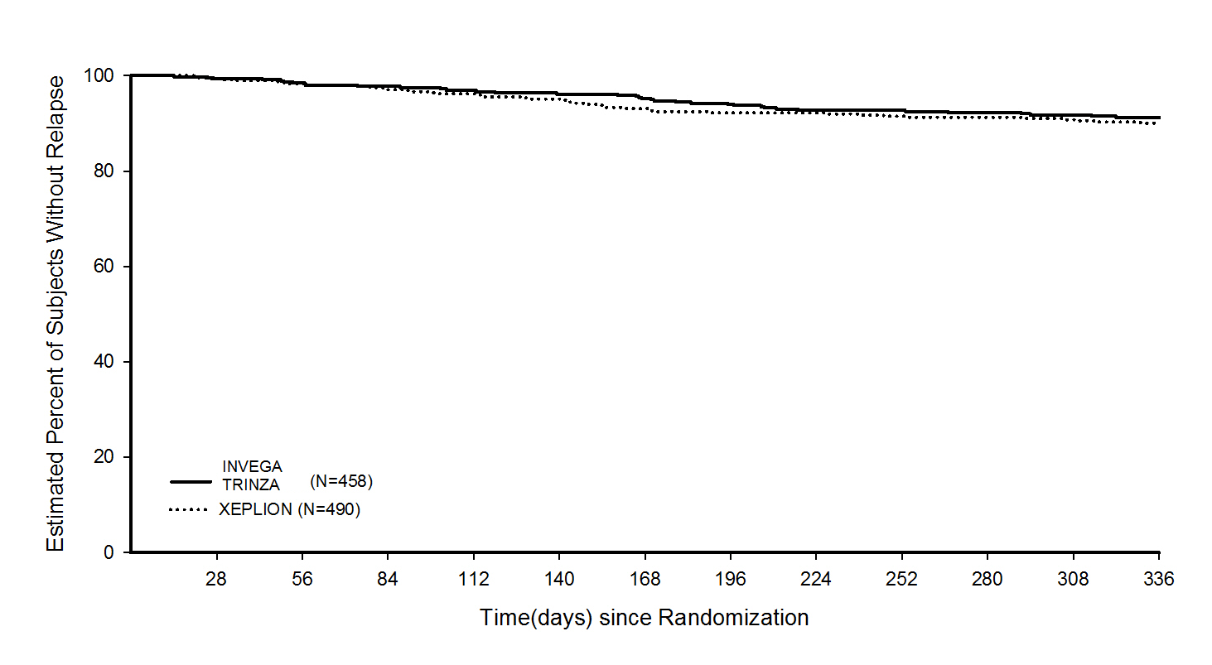

The efficacy results were consistent across population subgroups (gender, age, and race) in both studies.

# INDICATIONS

INVEGA TRINZA, a 3-month injection, is indicated for the maintenance treatment of schizophrenia in adult patients who have been adequately treated with the 1-month paliperidone palmitate injectable product for at least four months.

# CONTRAINDICATIONS

INVEGA TRINZA is contraindicated in patients with a known hypersensitivity to paliperidone or to any of the components in the formulation. Since paliperdone is an active metabolite of risperidone, INVEGA TRINZA is contraindicated in patients with a known hypersensitivity to risperidone.

# PRECAUTIONS

### Use in elderly

This drug is known to be substantially excreted by the kidney and clearance is decreased in patients with renal impairment (see**PHARMACOLOGY** – Special Populations), who should be given reduced doses. Because elderly patients are more likely to have decreased renal function, care should be taken in dose selection, and it may be useful to monitor renal function *(*see**DOSAGE AND ADMINISTRATION)**

### Use in elderly patients with dementia

#### **Overall mortality**

Elderly patients with dementia treated with atypical antipsychotic drugs, an increased risk of mortality compared to placebo. INVEGA TRINZA (paliperidone palmitate) is not approved for the treatment of dementia-related psychosis.

#### **Cerebrovascular adverse events including Stroke, in Elderly Patients with Dementia-Related Psychosis**

In placebo-controlled trials in elderly patients with dementia treated with some atypical antipsychotic drugs, including risperidone, aripiprazole, and olanzapine, there was a higher incidence of cerebrovascular adverse events (cerebrovascular accidents and transient ischemic attacks) including fatalities, compared to placebo. Oral paliperidone and INVEGA TRINZA were not marketed at the time these studies were performed and are not approved for the treatment of patients with dementia-related psychosis.

### Neuroleptic Malignant Syndrome

A potentially fatal symptom complex sometimes referred to as Neuroleptic Malignant Syndrome (NMS) has been reported in association with antipsychotic drugs, including paliperidone. Clinical manifestations of NMS are hyperpyrexia, muscle rigidity, altered mental status, and evidence of autonomic instability (irregular pulse or blood pressure, tachycardia, diaphoresis, and cardiac dysrhythmia). Additional signs may include elevated creatine phosphokinase, myoglobinuria (rhabdomyolysis), and acute renal failure.

The diagnostic evaluation of patients with this syndrome is complicated. In arriving at a diagnosis, it is important to identify cases in which the clinical presentation includes both serious medical illness (e.g., pneumonia, systemic infection, etc.) and untreated or inadequately treated extrapyramidal signs and symptoms (EPS). Other important considerations in the differential diagnosis include central anticholinergic toxicity, heat stroke, drug fever, and primary central nervous system pathology.

The management of NMS should include: (1) immediate discontinuation of antipsychotic drugs and other drugs not essential to concurrent therapy; (2) intensive symptomatic treatment and medical monitoring; and (3) treatment of any concomitant serious medical problems for which specific treatments are available. There is no general agreement about specific pharmacological treatment regimens for uncomplicated NMS. Consideration should be given to the long-acting nature of INVEGA TRINZA.

If a patient appears to require antipsychotic drug treatment after recovery from NMS, reintroduction of drug therapy should be closely monitored, since recurrences of NMS have been reported.

If NMS has occurred with any paliperidone product, INVEGA TRINZA should not be used.

### Tardive dyskinesia

A syndrome of potentially irreversible, involuntary, dyskinetic movements may develop in patients treated with antipsychotic drugs. Although the prevalence of the syndrome appears to be highest among the elderly, especially elderly women, it is impossible to predict which patients will develop the syndrome. Whether antipsychotic drug products differ in their potential to cause tardive dyskinesia is unknown.

The risk of developing tardive dyskinesia and the likelihood that it will become irreversible appear to increase as the duration of treatment and the total cumulative dose of antipsychotic drugs administered to the patient increase, but the syndrome can develop after relatively brief treatment periods at low doses, although this is uncommon.

There is no known treatment for established tardive dyskinesia, although the syndrome may remit, partially or completely, if antipsychotic treatment is withdrawn. Antipsychotic treatment itself may suppress (or partially suppress) the signs and symptoms of the syndrome and may thus mask the underlying process. The effect of symptomatic suppression on the long-term course of the syndrome is unknown.

Given these considerations, INVEGA TRINZA should be prescribed in a manner that is most likely to minimize the occurrence of tardive dyskinesia. Chronic antipsychotic treatment should generally be reserved for patients who suffer from a chronic illness that is known to respond to antipsychotic drugs. In patients who do require chronic treatment, the smallest dose and the shortest duration of treatment producing a satisfactory clinical response should be sought. The need for continued treatment should be reassessed periodically.

If signs and symptoms of tardive dyskinesia appear in a patient treated with INVEGA TRINZA, drug discontinuation should be considered. Consideration should be given to the long-acting nature of INVEGA TRINZA. However, some patients may require treatment with INVEGA TRINZA despite the presence of the syndrome.

### QT prolongation

Paliperidone causes a modest increase in the corrected QT (QTc) interval. The use of paliperidone should be avoided in combination with other drugs that are known to prolong QTc including Class 1A (e.g., quinidine, procainamide) or Class III (e.g., amiodarone, sotalol) antiarrhythmic medications, antipsychotic medications (e.g., chlorpromazine, thioridazine), antibiotics (e.g., gatifloxacin, moxifloxacin), or any other class of medications known to prolong the QTc interval. Paliperidone should also be avoided in patients with congenital long QT syndrome and in patients with a history of cardiac arrhythmias.

Certain circumstances may increase the risk of the occurrence of torsade de pointes and/or sudden death in association with the use of drugs that prolong the QTc interval, including (1) bradycardia; (2) hypokalaemia or hypomagnesaemia; (3) concomitant use of other drugs that prolong the QTc interval; and (4) presence of congenital prolongation of the QT interval.

The effects of paliperidone on the QT interval were evaluated in a double-blind, active-controlled (moxifloxacin 400 mg single dose), multicentre QT study with oral paliperidone in adults with schizophrenia and schizoaffective disorder and in three placebo- and active-controlled 6-week, fixed-dose efficacy trials in adults with schizophrenia.

In the Thorough QT study (n = 141), the 8 mg dose of immediate-release oral paliperidone (n=50) showed a mean placebo-subtracted increase from baseline in QTcLD (QT interval corrected for heart rate using the population specified linear derived method) of 12.3 msec (90% CI: 8.9; 15.6) on day 8 at 1.5 hours post-dose. The mean steady-state peak plasma concentration for this 8 mg dose of paliperidone immediate release (Cmax ss = 113 ng/mL) was approximately 2-fold the PopPK predicted concentration with the maximum recommended 525 mg dose of INVEGA TRINZA administered in the deltoid muscle (predicted median Cmax ss = 56 ng/mL). In this same study, a 4 mg dose of the immediate-release oral formulation of paliperidone, for which Cmax ss = 35 ng/mL, showed an increased placebo-subtracted QTcLD of 6.8 msec (90% CI: 3.6; 10.1) on day 2 at 1.5 hours post-dose.

In the four fixed-dose efficacy studies of the 1-month paliperidone palmitate injectable product, no subject had a change in QTcLD exceeding 60 msec and no subject had a QTcLD value of > 500 msec at any time point. In the long-term recurrence prevention study, no subject had a QTcLD change > 60 msec, and one subject had a QTcLD value of 507 msec (Bazett’s QT corrected interval [QTcB] value of 483 msec); this latter subject also had a heart rate of 45 beats per minute.

In the long-term relapse prevention trial of INVEGA TRINZA in subjects with schizophrenia, an increase in QTcLD exceeding 60 msec was observed in 1 subject (< 1%) in the open-label phase, no subject had an increase in QTcLD exceeding 60 msec after treatment with INVEGA TRINZA in the double-blind phase, and no subject had a QTcLD value of > 480 msec at any point in the study.

In the long term non-inferiority study 1 subject each in the INVEGA TRINZA and 1-month paliperidone palmitate groups had a change in the QTcLD value of >60msec during the DB Phase relative to the average predose value. In the INVEGA TRINZA subject, the absolute QTcLD value at the time of the increase was < 480msec, and all QTc interval values were normal at the next study visit.

If clinically significant QT prolongation has occurred with any paliperidone product, INVEGA TRINZA should not be used.

### Hypersensitivity reactions

Although tolerability with oral paliperidone or risperidone should be established prior to initiating treatment with INVEGA TRINZA, very rare cases of anaphylactic reactions have been reported during Postmarketing experience in patients who have previously tolerated oral risperidone or oral paliperidone (see **DOSAGE AND ADMINISTRATION** and **ADVERSE EFFECTS**).

If hypersensitivity reactions occur, discontinue use of INVEGA TRINZA; initiate general supportive measures as clinically appropriate and monitor the patient until signs and symptoms resolve. (See **CONTRAINDICATIONS** and **ADVERSE EFFECTS**).

### Orthostatic hypotension and Syncope

Paliperidone may induce orthostatic hypotension in some patients based on its alpha-adrenergic blocking activity.

In the non-inferiority study, 2 subjects (0.4%) in the INVEGA TRINZA group and 7 subjects (1.4%) in the 1-month paliperidone palmitate group reported adverse events related to orthostatic hypotension (dizziness postural, orthostatic hypotension). In the long term relapse study, 1 subject (0.3%) on INVEGA TRINZA during the Maintenance phase experienced treatment-emergent adverse event related of orthostatic hypotension and during the Double-blind Phase, 1 subject in the placebo group (0.7%) experienced a treatment-emergent adverse event related to orthostatic hypotension (dizziness postural). No adverse events of syncope were observed following treatment with INVEGA TRINZA in either study.

INVEGA TRINZA should be used with caution in patients with known cardiovascular disease (e.g., heart failure, myocardial infarction or ischemia, conduction abnormalities), cerebrovascular disease, or conditions that predispose the patient to hypotension (e.g., dehydration, hypovolemia, and treatment with antihypertensive medications).

**Use in Patients with Concomitant Illness**

Clinical experience with INVEGA TRINZA in patients with certain concomitant illnesses islimited.

Patients with Parkinson’s Disease or Dementia with Lewy Bodies are reported to have anincreased sensitivity to antipsychotic medication. Manifestations of this increased sensitivityinclude confusion, obtundation, postural instability with frequent falls, extrapyramidal symptoms, and clinical features consistent with the neuroleptic malignant syndrome.

INVEGA TRINZA has not been evaluated or used to any appreciable extent in patients with a recent history of myocardial infarction or unstable heart disease. Patients with these diagnoses were excluded from premarketing clinical trials. Because of the risk of orthostatic hypotension with INVEGA TRINZA, caution should be observed in patients with known cardiovascular disease (see **PRECAUTIONS – Orthostatic Hypotension and Syncope**).

### Seizures

As with other antipsychotic drugs, INVEGA TRINZA should be used cautiously in patients with a history of seizures or other conditions that potentially lower the seizure threshold.

**Dysphagia**

Esophageal dysmotility and aspiration have been associated with antipsychotic drug use. Aspiration pneumonia is a common cause of morbidity and mortality in patients with advanced Alzheimer’s dementia. INVEGA TRINZA and other antipsychotic drugs should be used cautiously in patients at risk for aspiration pneumonia.

**Suicide**

The possibility of suicide attempt is inherent in psychotic illnesses, and close supervision of high-risk patients should accompany drug therapy.

**Thrombotic Thrombocytopenic Purpura (TTP)**

No cases of TTP were observed during clinical studies with oral paliperidone, the 1-month paliperidone palmitate injectable product, or INVEGA TRINZA. Although cases of TTP have been reported in association with risperidone administration, the relationship to risperidone therapy is unknown.

**Hyperprolactinemia**

Like other drugs that antagonize dopamine D2 receptors, paliperidone elevates prolactin levels and the elevation persists during chronic administration (see **ADVERSE EFFECTS** – Events of particular interest to the class– *Laboratory tests: serum prolactin*). Paliperidone has a prolactin-elevating effect similar to that seen with risperidone, a drug that is associated with higher levels of prolactin than other antipsychotic drugs.

Hyperprolactinemia, regardless of aetiology, may suppress hypothalamic GnRH, resulting in reduced pituitary gonadotropin secretion. This, in turn, may inhibit reproductive function by impairing gonadal steroidogenesis in both female and male patients. Galactorrhea, amenorrhea, gynecomastia, and impotence have been reported in patients receiving prolactin-elevating compounds. Long-standing hyperprolactinemia when associated with hypogonadism may lead to decreased bone density in both female and male subjects.

Tissue culture experiments indicate that approximately one-third of human breast cancers are prolactin dependent *in vitro*, a factor of potential importance if the prescription of these drugs is considered in a patient with previously detected breast cancer. An increase in the incidence of pituitary gland, mammary gland, and pancreatic islet cell neoplasia (mammary adenocarcinomas, pituitary and pancreatic adenomas) was observed in the risperidone carcinogenicity studies conducted in mice and rats (see **PRECAUTIONS** – Carcinogenicity). Neither clinical studies nor epidemiologic studies conducted to date have shown an association between chronic administration of this class of drugs and tumorigenesis in humans, but the available evidence is too limited to be conclusive.

### Leukopenia, neutropenia, and agranulocytosis

Events of leukopenia, neutropenia, and agranulocytosis have been reported with antipsychotic agents, including paliperidone. Agranulocytosis has been reported very rarely (< 1/10,000 patients) during postmarketing surveillance.

Possible risk factors for leukopenia/neutropenia include pre-existing low white blood cell count (WBC) and history of drug-induced leukopenia/neutropenia. Patients with a history of a clinically significant low white blood cell count (WBC) or a drug-induced leukopenia/neutropenia should be monitored during the first few months of therapy and discontinuation of INVEGA TRINZA should be considered at the first sign of a clinically significant decline in WBC in the absence of other causative factors.

Patients with clinically significant neutropenia should be carefully monitored for fever or other symptoms or signs of infection and treated promptly if such symptoms or signs occur. Patients with severe neutropenia (absolute neutrophil count < 1000/mm3 ) should discontinue INVEGA TRINZA and have their WBC followed until recovery.Consideration should be given to the long-acting nature of INVEGA TRINZA. If clinically significant drug‐induced leukopenia/neutropenia has occurred with any paliperidone product, INVEGA TRINZA should not be used.

### Potential for Cognitive and Motor Impairment Somnolence, sedation, and dizziness were reported as adverse reactions in subjects treated with INVEGA TRINZA (see ADVERSE EFFECTS). Antipsychotics, including INVEGA TRINZA, have the potential to impair judgment, thinking, or motor skills. Patients should be cautioned about performing activities requiring mental alertness, such as operating hazardous machinery or operating a motor vehicle, until they are reasonably certain that paliperidone therapy does not adversely affect them.

### Venous thromboembolism

Cases of venous thromboembolism (VTE) have been reported with antipsychotic drugs. Since patients treated with antipsychotics often present with acquired risk factors for VTE, all possible risk factors for VTE should be identified before and during treatment with INVEGA TRINZA and preventive measures undertaken.

### Parkinson’s disease and dementia with Lewy bodies

Patients with Parkinson’s Disease or Dementia with Lewy Bodies (DLB) since both groups may be at increased risk of Neuroleptic Malignant Syndrome as well as having an increased sensitivity to antipsychotic medications. Manifestation of this increased sensitivity can include confusion, obtundation, postural instability with frequent falls, in addition to extrapyramidal symptoms.

## Extrapyramidal symptoms

As with other antipsychotics, EPS including akathisia have been reported (see ADVERSE EFFECTS). The presentation of akathisia may be variable and comprises subjective complaints of restlessness and an overwhelming urge to move and either distress or motor phenomena such as pacing, swinging of the legs while seated, rocking from foot to foot, or both. Particular attention should be paid to the monitoring for such symptoms and signs as, left untreated, akathisia is associated with poor compliance and an increased risk of relapse.

### Priapism

Drugs with alpha-adrenergic blocking effects have been reported to induce priapism. Priapism has been reported with paliperidone during postmarketing surveillance (see **ADVERSE EFFECTS**). Severe priapism may require surgical intervention.

### Body temperature regulation

Disruption of the body’s ability to reduce core body temperature has been attributed to antipsychotic agents. Appropriate care is advised when prescribing INVEGA TRINZA to patients who will be experiencing conditions which may contribute to an elevation in core body temperature, e.g., exercising strenuously, exposure to extreme heat, receiving concomitant medication with anticholinergic activity, or being subject to dehydration.

### Antiemetic effect

An antiemetic effect was observed in preclinical studies with paliperidone. This effect, if it occurs in humans, may mask the signs and symptoms of overdosage with certain drugs or of conditions such as intestinal obstruction, Reye’s syndrome, and brain tumor.

### Administration

Care must be taken to avoid inadvertent injection of INVEGA TRINZA into a blood vessel.

### Intraoperative floppy iris syndrome

Intraoperative floppy iris syndrome (IFIS) has been observed during cataract surgery in patients treated with medicines with alpha1a-adrenergic antagonist effect, such as INVEGA TRINZA (see **ADVERSE EFFECTS**).

IFIS may increase the risk of eye complications during and after the operation. Current or past use of medicines with alpha1a-adrenergic antagonist effect should be made known to the ophthalmic surgeon in advance of surgery. The potential benefit of stopping alpha1 blocking therapy prior to cataract surgery has not been established and must be weighed against the risk of stopping the antipsychotic therapy.

## Hyperglycemia and Diabetes Mellitus

Hyperglycaemia, in some cases extreme and associated with ketoacidosis or hyperosmolar coma or death, has been reported in patients treated with all atypical antipsychotics. These cases were, for the most part, seen in post-marketing clinical use and epidemiologic studies, not in clinical trials, and there have been few reports of hyperglycaemia or diabetes in trial subjects treated with INVEGA TRINZA. Assessment of the relationship between atypical antipsychotic use and glucose abnormalities is complicated by the possibility of an increased background risk of diabetes mellitus in patients with schizophrenia and the increasing incidence of diabetes mellitus in the general population. Given these confounders, the relationship between atypical antipsychotic use and hyperglycaemia-related adverse events is not completely understood. However, epidemiological studies suggest an increased risk of treatment-emergent hyperglycaemia-related adverse events in patients treated with the atypical antipsychotics. Because INVEGA TRINZA was not marketed at the time these studies were performed, it is not known if INVEGA TRINZA is associated with this increased risk.

Patients with an established diagnosis of diabetes mellitus who are started on atypical antipsychotics should be monitored regularly for worsening of glucose control. Patients with risk factors for diabetes mellitus (e.g., obesity, family history of diabetes) who are starting treatment with atypical antipsychotics should undergo fasting blood glucose testing at the beginning of treatment and periodically during treatment. Any patient treated with atypical antipsychotics should be monitored for symptoms of hyperglycaemia including polydipsia, polyuria, polyphagia, and weakness. Patients who develop symptoms of hyperglycaemia during treatment with atypical antipsychotics should undergo fasting blood glucose testing. In some cases, hyperglycaemia has resolved when the atypical antipsychotic was discontinued; however, some patients required continuation of anti-diabetic treatment despite discontinuation of the suspect drug.

## Weight Gain

Weight gain has been observed with INVEGA TRINZA and other atypical antipsychotics. Clinical monitoring of weight is recommended.

In the double-blind placebo-controlled phase of the long-term relapse prevention trial, abnormal increases of ≥ 7% in body weight from double-blind baseline to double-blind end point were reported for 15 subjects (10%) in the INVEGA TRINZA group and 1 subject (1%) in the placebo group. Conversely, abnormal decreases in body weight (≥ 7%) from double-blind baseline to double-blind end point were reported for 2 subjects (1%) in the INVEGA TRINZA group and 12 subjects (8%) in the placebo group. The mean changes in body weight from double-blind baseline to double-blind end point were +0.94 kg and ‑1.28 kg for the INVEGA TRINZA and placebo groups, respectively.

In the non-inferiority study, 15% of subjects in the INVEGA TRINZA group and 16% of subjects in the 1-month paliperidone palmitate treatment group had an increase in body weight of ≥ 7% from double-blind baseline to double-blind end point.

**Use in patients with renal impairment**

INVEGA TRINZA has not been systematically studied in patients with renal impairment (see **PHARMACOLOGY** – Special Populations). A reduced dose is recommended in patients with mild renal impairment; INVEGA TRINZA is not recommended in patients with moderate or severe renal impairment (see **DOSAGE AND ADMINISTRATION**).

## Use in patients with hepatic impairment

INVEGA TRINZAhas not been studied in patients with hepatic impairment. Based on a study with oral paliperidone, no dose adjustment is required in patients with mild or moderate hepatic impairment. Paliperidone has not been studied in patients with severe hepatic impairment.

## Paediatric Use

In a 7-week oral toxicity study in juvenile rats with paliperidone at doses of 0.16, 0.63, and 2.5 mg/kg/day, no effects on growth, sexual maturation or reproductive performance were observed. Doses up to 2.5 mg/kg/day did not affect neurobehavioral development, except for an impairment of learning and memory in females treated at 2.5 mg/kg/day, which was not observed after discontinuation of treatment. Respective exposures (plasma AUC) at these doses were 0.1, 0.4, and 1.3 times exposure in adolescents at the maximal recommended dose (12 mg/day).

A 39-day oral toxicity study with risperidone (which is extensively converted to paliperidone) in juvenile rats noted increased pup mortality, a delay in physical development and, in a small proportion of animals, impairment of auditory startle, at exposures (plasma AUC) less than that at the maximum recommended paediatric risperidone dose (6 mg/day).

The clinical relevance of these findings for adolescents is uncertain, given the relative immaturity of the rat pups upon commencement of treatment.

A 40-week oral toxicity study with risperidone (which is extensively converted to paliperidone) in juvenile dogs noted delayed sexual maturation, probably secondary to hormonal changes. Long bone growth was slightly reduced at exposures (plasma AUC) of 3 fold and greater than those at the maximum dose in children and adolescents (6 mg/day); exposure at the no-effect dose was similar to human exposure.

## Effects on fertility

Fertility studies of paliperidone palmitate have not been performed.

Mating and fertility of male and female rats was not affected at oral paliperidone doses up to 2.5 mg/kg/day (twice the maximum recommended oral clinical dose based on body surface area (mg/m2)). The 2.5 mg/kg/day dose produced slight maternal toxicity, increased pre-implantation loss and slightly reduced the number of live embryos; the no-effect dose was 0.63 mg/kg/day.

In rat fertility studies with risperidone, which is extensively converted to paliperidone in rats and humans, mating (but not fertility) was impaired at doses 0.2 to 5 times the maximum human dose on a mg/m2 basis, by an effect on females. In repeat dose toxicity studies in beagle dogs, risperidone at doses of 1 to 17 times the maximum human dose on a mg/m2 basis was associated with adverse effects on the male reproductive system (inhibited ejaculation, incomplete spermatogenesis, reduced sperm motility and concentration, reduced gonadal and prostatic weight, prostatic immaturity, decreased serum testosterone). Serum testosterone and sperm parameters partially recovered but remained decreased after treatment was discontinued. No-effect doses were not determined in either rat or dog.

## Use in pregnancy – Category C

## The safety of intramuscularly-injected paliperidone palmitate or orally-dosed paliperidone during human pregnancy has not been established. No teratogenicity was observed following a single intramuscular treatment of pregnant rats with paliperidone palmitate in early gestation. The highest dose (160 mg/kg) was maternotoxic and resulted in paliperidone exposure 4-fold the maximal anticipated clinical exposure based on plasma AUC. No teratogenic effect was noted in rats and rabbits following oral administration of paliperidone during the period of organogenesis at respective exposures up to 28- and 17-fold the maximal anticipated clinical exposure, based on plasma AUC. Maternotoxic doses in rabbits were associated with increased fetal mortality. Studies with risperidone also found no teratogenic effects in rats and rabbits following oral administration of risperidone during the period of organogenesis at doses up to nine times the human dose on a mg/m2 basis.

Neonates exposed to antipsychotic drugs (including paliperidone) during the third trimester of pregnancy are at risk for extrapyramidal and/or withdrawal symptoms that may vary in severity following delivery. These symptoms in the neonates may include agitation, hypertonia, hypotonia, tremor, somnolence, respiratory distress, or feeding disorder. Since paliperidone has been detected in plasma up to 18 months after a single-dose administration of INVEGA TRINZA, consideration should be given to the long-acting nature of INVEGA TRINZA as maternal exposure to INVEGA TRINZA before or during pregnancy may lead to adverse reactions in the newborn child. Monitor neonates for extrapyramidal and/or withdrawal symptoms and manage symptoms appropriately. Some neonates recover within hours or days without specific treatment; others may require prolonged hospitalisation.

INVEGA TRINZA should only be used during pregnancy if the benefits outweigh the risks. The effect of INVEGA TRINZA on labor and delivery in humans is unknown.

## Use in lactation

In animal studies with paliperidone and in human studies with risperidone, paliperidone was excreted in the milk. Therefore, women receiving INVEGA TRINZA should not breast-feed infants. Consideration should be given to the long-acting nature of INVEGA TRINZA as nursing infants may be at risk even from INVEGA TRINZA administration long before nursing.

Oral administration of paliperidone to rats from early gestation to lactation was associated with adverse effects in pups (clinical signs, reduced body weight gain and survival, impaired righting reflex) during lactation at doses similar to the maximal recommended clinical dose on a mg/m2 basis; the no-effect dose was less than the clinical dose. In risperidone studies in rats, oral administration of risperidone during late gestation and lactation was associated with increased pup deaths during early lactation at doses 0.2 to 5 times the maximum human dose on a mg/m2 basis (a no-effect dose was not determined) and with reduced pup weight gain at doses fivefold or greater than the maximal recommended human dose on a mg/m2 basis. There were also increases in stillborn rat pups at an oral risperidone dose 2.5 to 5 times the maximum human dose on a mg/m2 basis. It is not known whether these effects of risperidone and paliperidone resulted from a direct effect on the fetuses and pups and/or an effect on the dams.

## Alcohol

Given the primary CNS effects of paliperidone, patients should be advised to avoid alcohol while taking this medicine.

## Carcinogenicity

No carcinogenicity studies have been conducted with the 3-month paliperidone palmitate extended-release injection. The carcinogenic potential of the 1-month intramuscular paliperidone palmitate injection was assessed in a long-term study in rats. There was an increase in mammary gland adenocarcinomas in female rats at 10, 30 and 60 mg/kg/month, associated with respective exposures (plasma AUC) of 0.4, 1.6 and 3 times clinical exposure at the maximum recommended 150 mg dose of the 1-month paliperidone palmitate injectable product. A no-effect dose was not established. Male rats showed an increase in total mammary gland tumours at 30 and 60 mg/kg/month, associated with respective exposures (plasma AUC) of 1 and 2 times clinical exposure. These rat doses of 10, 30 and 60 mg/kg/month are 0.5, 1.5 and 3 times the maximal recommended clinical dose of INVEGA TRINZA (525 mg/3 months), on a mg/m2 basis. A carcinogenicity study in mice has not been conducted with paliperidone palmitate.

## Carcinogenicity studies of risperidone, which is extensively converted to paliperidone in rats, mice and humans, were conducted in Swiss albino mice and Wistar rats. Risperidone was administered in the diet at daily doses of 0.63, 2.5, and 10 mg/kg for 18 months to mice and for 25 months to rats, equivalent to 0.3, 1.3 and 5 times (mice) and 0.6, 2.5 and 10 times (rats) the maximum human dose on a mg/m2 basis. There were statistically significant increases in pituitary gland adenomas in female mice and endocrine pancreas adenomas in male rats at the two highest dose levels, and in mammary gland adenocarcinomas at all dose levels in female mice and female rats and at the highest dose in male rats. An increase in mammary, pituitary, and endocrine pancreas neoplasms has been found in rodents after chronic administration of other antipsychotic drugs and is considered to be mediated by prolonged dopamine D2-receptor antagonism and hyperprolactinemia. The relevance of these tumour findings in rodents in terms of human risk is unknown (see PRECAUTIONS – Hyperprolactinemia).

## Genotoxicity

## Paliperidone palmitate was not genotoxic in *in vitro* tests for bacterial reverse gene mutation and forward mutation in mammalian cells (mouse lymphoma). Paliperidone was also not genotoxic in these tests, or in an *in vivo* test for clastogenicity (rat micronucleus assay).

## INTERACTIONS WITH OTHER MEDICINES

Caution is advised when prescribing INVEGA TRINZA with drugs known to prolong the QT interval.

Since paliperidone palmitate is hydrolysed to paliperidone (see **Pharmacokinetics**), results from studies with oral paliperidone should be taken into consideration when assessing drug-drug interaction potential.

### Concomitant use of INVEGA TRINZA with risperidone or with oral paliperidone

Since paliperidone is the major active metabolite of risperidone, the co-administration of INVEGA TRINZA with oral risperidone or paliperidone is likely to result in an increase in the paliperidone concentration, within the bloodstream. Caution should be exercised when INVEGA TRINZA is coadministered with risperidone or with oral paliperidone for extended periods of time. Safety data involving concomitant use of INVEGA TRINZA with other antispychotics is limited.

#### Potential for INVEGA TRINZA to Affect Other Drugs:

Paliperidone is not expected to cause clinically important pharmacokinetic interactions with drugs that are metabolised by cytochrome P-450 isozymes. *In vitro* studies in human liver microsomes showed that paliperidone does not substantially inhibit the metabolism of drugs metabolised by cytochrome P450 isozymes, including CYP1A2, CYP2A6, CYP2C8/9/10, CYP2D6, CYP2E1, CYP3A4, and CYP3A5. Therefore, paliperidone is not expected to inhibit clearance of drugs that are metabolised by these metabolic pathways in a clinically relevant manner. Paliperidone is also not expected to have enzyme inducing properties.

Paliperidone is a weak inhibitor of P-glycoprotein (P-gp) at high concentrations. No *in vivo* data are available and the clinical relevance is unknown.

Given the primary CNS effects of paliperidone (see **ADVERSE EFFECTS**), INVEGA TRINZA should be used with caution in combination with other centrally acting drugs and alcohol. Paliperidone may antagonize the effect of levodopa and other dopamine agonists.

Because of its potential for inducing orthostatic hypotension (see **PRECAUTIONS**: Orthostatic hypotension), an additive effect may be observed when INVEGA TRINZA is administered with other therapeutic agents that have this potential.

Co-administration of oral paliperidone extended-release tablets at steady-state (12 mg once daily) with divalproex sodium extended-release tablets (500 mg to 2000 mg once daily) did not affect the steady-state pharmacokinetics of valproate.

Pharmacokinetic interaction between INVEGA TRINZA and lithium is unlikely.

#### Potential for Other Drugs to Affect INVEGA TRINZA:

Paliperidone is not a substrate of CYP1A2, CYP2A6, CYP2C9, and CYP2C19, so that an interaction with inhibitors or inducers of these isozymes is unlikely. While *in vitro* studies indicate that CYP2D6 and CYP3A4 may be minimally involved in paliperidone metabolism, *in vivo* studies do not show decreased elimination by these isozymes and they contribute to only a small fraction of total body clearance. *In vitro* studies have shown that paliperidone is a P-gp substrate.

Paliperidone is metabolised to a limited extent by CYP2D6 (see **PHARMACOLOGY** – Pharmacokinetics). In an interaction study in healthy subjects in which a single 3 mg dose of oral paliperidone modified release was administered concomitantly with 20 mg per day of paroxetine (a potent CYP2D6 inhibitor), paliperidone exposures were on average 16% (90% CI: 4, 30) higher in CYP2D6 extensive metabolisers. Higher doses of paroxetine have not been studied. The clinical relevance is unknown.

Co-administration of oral paliperidone extended release once daily with carbamazepine 200 mg twice daily caused a decrease of approximately 37% in the mean steady-state Cmax and AUC of paliperidone. This decrease is caused, to a substantial degree, by a 35% increase in renal clearance of paliperidone. A minor decrease in the amount of drug excreted unchanged in the urine suggests that there was little effect on the CYP metabolism or bioavailability of paliperidone during carbamazepine co-administration. On initiation of carbamazepine, the dose of INVEGA TRINZA should be re-evaluated and increased if necessary. Conversely, on discontinuation of carbamazepine, the dose of INVEGA TRINZA should be re-evaluated and decreased if necessary. Consideration should be given to the long-acting nature of INVEGA TRINZA.

Paliperidone, a cation under physiological pH, is primarily excreted unchanged by the kidneys, approximately half via filtration and half via active secretion. Concomitant administration of trimethoprim, a drug known to inhibit active renal cation drug transport, did not influence the pharmacokinetics of paliperidone.

Co-administration of a single dose of an oral paliperidone extended-release tablet 12 mg with divalproex sodium extended-release tablets (two 500 mg tablets once daily) resulted in an increase of approximately 50% in the Cmax and AUC of paliperidone. Although this interaction has not been studied with INVEGA TRINZA a clinically significant interaction would not be expected between divalproex sodium extended-release tablets and INVEGA TRINZA intramuscular injection. This interaction has not been studied with INVEGA TRINZA.

Pharmacokinetic interaction between lithium and INVEGA TRINZA is unlikely.

## Effect on ability to drive or operate machinery

As INVEGA TRINZA has the potential to impair judgment, thinking, or motor skills, patients should be cautioned about operating hazardous machinery, including automobiles, until they are reasonably certain that INVEGA TRINZA therapy does not affect them adversely (see **PRECAUTIONS** – Potential for Cognitive and Motor Impairment).

# ADVERSE EFFECTS

Adverse events during exposure to study treatment were obtained by general inquiry and recorded by clinical investigators using their own terminology. Consequently, to provide a meaningful estimate of the proportion of individuals experiencing adverse events, events were grouped in standardised categories using MedDRA terminology.

Throughout this section, adverse reactions are reported. Adverse reactions are adverse events that were considered to be reasonably associated with the use of paliperidone palmitate based on the comprehensive assessment of the available adverse event information. A causal relationship with paliperidone palmitate cannot be reliably established in individual cases. Further, because clinical trials are conducted under widely varying conditions, adverse reaction rates observed in the clinical trials of a drug cannot be directly compared to rates in the clinical trials of another drug and may not reflect the rates observed in clinical practice.

## Clinical Trial Data

The data described in this section include data from two clinical trials. One was a long-term relapse-prevention/randomised withdrawal trial, in which 379 subjects with schizophrenia during the open-label phase received a single injection of INVEGA TRINZA and 160 subjects were subsequently randomised to receive at least one further dose of INVEGA TRINZA and 145 subjects received placebo during the double-blind placebo-controlled phase. The mean (Standard Deviation [SD]) duration of exposure during the double-blind phase was 150 (79) days in the placebo group and 175 (90) days in the INVEGA TRINZA group.

The second trial was a long-term double-blind, active-controlled noninferiority study, in which 1429 subjects were enrolled into the open-label phase and treated with the 1 month paliperidone palmitate injectable product. Subjects who met the randomisation criteria were randomised in a 1:1 ratio to continue on monthly injections of the 1-month paliperidone palmitate injectable product (n=512) or to switch to INVEGA TRINZA (n=504) for 48 weeks.

There also was a Phase 1 study, in which 308 subjects with schizophrenia or schizoaffective disorder received a single injection of INVEGA TRINZA concomitantly with other oral antipsychotics.

The majority of adverse reactions were mild to moderate in severity.

Adverse events reported in the long-term relapse-prevention trial are shown in Table 1 and 2

|  |  |  |  |
| --- | --- | --- | --- |
|  |  |  |  |

Table  1: Treatment-Emergent Adverse Events in at Least 2% of Subjects in Either Treatment Group by MedDRA System Organ Class and Preferred Term During the Double-blind Phase (Study PSY-3012)

|  |  |  |
| --- | --- | --- |
|  | Placebo | INVEGA TRINZA |
| **Body System Or Organ Class** | (N=145) | (N=160) |
| Dictionary-Derived Term | n (%) | n (%) |
| **Total no. subjects with adverse events** | 84 (57.9) | 99 (61.9) |
|  |  |  |
| **Psychiatric disorders** | 46 (31.7) | 30 (18.8) |
| Anxiety | 16 (11.0) | 13 ( 8.1) |
| Insomnia | 17 (11.7) | 11 ( 6.9) |
| Agitation | 3 ( 2.1) | 2 ( 1.3) |
| Schizophrenia | 15 (10.3) | 2 ( 1.3) |
| Suicidal ideation | 3 ( 2.1) | 0 |
|  |  |  |
| **Infections and infestations** | 16 (11.0) | 28 (17.5) |
| Nasopharyngitis | 2 ( 1.4) | 9 ( 5.6) |
| Upper respiratory tract infection | 3 ( 2.1) | 6 ( 3.8) |
| Urinary tract infection | 2 ( 1.4) | 5 ( 3.1) |
| Influenza | 3 ( 2.1) | 3 ( 1.9) |
|  |  |  |
| **Investigations** | 25 (17.2) | 27 (16.9) |
| Weight increased | 5 ( 3.4) | 14 ( 8.8) |
| Blood glucose increased | 3 ( 2.1) | 3 ( 1.9) |
| Weight decreased | 11 ( 7.6) | 2 ( 1.3) |
|  |  |  |
| **Nervous system disorders** | 10 ( 6.9) | 25 (15.6) |
| Headache | 6 ( 4.1) | 14 ( 8.8) |
| Akathisia | 1 ( 0.7) | 7 ( 4.4) |
|  |  |  |
| **General disorders and administration site conditions** | 6 ( 4.1) | 11 ( 6.9) |
| Irritability | 3 ( 2.1) | 1 ( 0.6) |
|  |  |  |
| **Respiratory, thoracic and mediastinal disorders** | 5 ( 3.4) | 6 ( 3.8) |
| Cough | 3 ( 2.1) | 5 ( 3.1) |
|  |  |  |
| **Metabolism and nutrition disorders** | 8 ( 5.5) | 5 ( 3.1) |
| Decreased appetite | 3 ( 2.1) | 1 ( 0.6) |
| Hyperglycaemia | 4 ( 2.8) | 0 |
| Note: Incidence is based on the number of subjects experiencing at least one adverse event, not the number of events.  Note: A subject in the INVEGA TRINZA group had a TEAE of influenza (nonserious) during the Double-blind Phase that was not entered in the database before database lock and thus could not be included in the summary table. | | |
| Adverse events are coded using MedDRA version 16.0 | | |
| tsfae03b\_corr.rtf generated by tsfae03b\_corr.sas, 05MAR2015 10:14 | | |

Table  2: Treatment-Emergent Adverse Events in at Least 2% of Subjects in Either Treatment Group by MedDRA System Organ Class and Preferred Term During the Double-blind Phase (Study PSY-3011)

|  |  |  |  |
| --- | --- | --- | --- |
|  | | INVEGA TRINZA | 1-month paliperidone palmitate injectable product |
| **Body System Or Organ Class** | | (N=504) | (N=512) |
| Dictionary-Derived Term | | n (%) | n (%) |
| **Total no. subjects with adverse events** | | 342 (67.9) | 340 (66.4) |  |
|  | |  |  |  |
| **Investigations** | | 143 (28.4) | 152 (29.7) |  |
| Weight increased | | 105 (20.8) | 109 (21.3) |  |
| Weight decreased | | 14 ( 2.8) | 14 ( 2.7) |  |
|  | |  |  |  |
| **Psychiatric disorders** | | 89 (17.7) | 85 (16.6) |  |
| Anxiety | | 27 ( 5.4) | 24 ( 4.7) |  |
| Schizophrenia | | 18 ( 3.6) | 14 ( 2.7) |  |
| Insomnia | | 16 ( 3.2) | 24 ( 4.7) |  |
| Depression | | 11 ( 2.2) | 6 ( 1.2) |  |
|  | |  |  |  |
| **Infections and infestations** | | 82 (16.3) | 81 (15.8) |  |
| Nasopharyngitis | | 36 ( 7.1) | 33 ( 6.4) |  |
|  | |  |  |  |
| **Nervous system disorders** | | 66 (13.1) | 67 (13.1) |  |
| Akathisia | | 20 ( 4.0) | 14 ( 2.7) |  |
| Headache | | 18 ( 3.6) | 26 ( 5.1) |  |
|  | |  |  |  |
| **General disorders and administration site conditions** | | 51 (10.1) | 35 ( 6.8) |  |
| Injection site induration | | 14 ( 2.8) | 6 ( 1.2) |  |
| Injection site pain | | 12 ( 2.4) | 14 ( 2.7) |  |
| Fatigue | | 10 ( 2.0) | 5 ( 1.0) |  |
|  | |  |  |  |
| **Gastrointestinal disorders** | | 49 ( 9.7) | 40 ( 7.8) |  |
| Diarrhoea | | 10 ( 2.0) | 6 ( 1.2) |  |
|  | |  |  |  |
| **Metabolism and nutrition disorders** | | 22 ( 4.4) | 22 ( 4.3) |  |
| Hyperglycaemia | | 4 ( 0.8) | 10 ( 2.0) |  |
|  | |  |  |  |
| **Vascular disorders** | | 18 ( 3.6) | 12 ( 2.3) |  |
| Hypertension | | 12 ( 2.4) | 7 ( 1.4) |  |
| Note: Incidence is based on the number of subjects experiencing at least one adverse event, not the number of events. | | | |
| Adverse events are coded using MedDRA version 17.1 | | | |
| tsfae31b.rtf generated by tsfae31b.sas, 10MAR2015 13:18 | | | |
|  | | | | |
|  | | | | |

**Pain Assessment and Local Injection Site Reaction**

In the long-term relapse prevention trial of INVEGA TRINZA in subjects with schizophrenia, the mean intensity of pain reported by subjects using a visual analog scale (0 = no pain to 100 = unbearable pain) was 16.0 for the single INVEGA TRINZA injection during the Open-label Maintenance Phase. The mean intensity of pain for INVEGA TRINZA injections was 15.8 at double-blind baseline and 15.1 at double-blind endpoint. Blinded investigators’ evaluation of the injection site for induration, redness and swelling was performed over time during the Double-blind Phase. The level of redness was generally similar between the Placebo and INVEGA TRINZA groups (ie, redness being absent in 100% and ≥98% of subjects, respectively) over time. The occurrence of swelling was similar between the Placebo and INVEGA TRINZA groups (absent in ≥99% in each group) over time. Induration was absent during the entire Double-blind Phase for both groups.

In the long term non-inferiority study, the mean intensity of pain reported by subjects ranged from14.0 to 19.5 in subjects who received INVEGA TRINZA injections, and 14.9 to 18.4 in subjects who received 1-month paliperidone palmitate injections during the Double-blind Phase. Blinded investigators’ evaluation of the injection site for induration, redness and swelling was performed over time during the Double-blind Phase. Induration, redness, and swelling were observed in ≤5% of subjects in both treatment groups and were mostly mild in nature. The level of induration, redness and swelling was generally similar between the INVEGA TRINZA and 1-month paliperidone palmitate groups over time.

**Other Adverse Reactions Observed During the Clinical Trial Evaluation of Paliperidone and/or Risperidone**

Paliperidone palmitate is hydrolysed to paliperidone. Paliperidone is the active metabolite of risperidone, therefore, the adverse reaction profiles of these compounds (including both the oral and injectable formulations) are relevant to one another. This subsection includes additional adverse reactions reported with paliperidone and/or risperidone in clinical trials. Table 3 lists adverse reactions that were reported with paliperidone and/or risperidone by frequency category estimated from subjects who received at least one injection of INVEGA TRINZA in two long-term, double-blind clinical trials. The following terms and frequencies are applied: very common (≥ 1/10), common (≥ 1/100 to < 1/10), uncommon (≥ 1/1,000 to < 1/100), rare (≥ 1/10,000 to < 1/1,000), very rare (< 1/10,000), and not known (cannot be estimated from the available data).

**Table 3: Adverse Reactions Reported with Paliperidone and/or Risperidone, Reported in Subjects**

**who Received at Least One Injection of INVEGA TRINZA in two Long-term, Double-blind Clinical Trials (Not already Listed in Table 1, Table 2, or the Postmarketing Data section)**

|  | **Frequencya** | | | |
| --- | --- | --- | --- | --- |
| **System Organ Class** | **Common** | **Uncommon** | **Not Knownb** | |
| **Infections and infestations** |  | Pneumonia, Bronchitis, Respiratory tract infection, Sinusitis, Cystitis, Tonsillitis, Onychomycosis, Cellulitis Acarodermatitis | Ear infection, Eye infection, Subcutaneous abscess | |
| **Blood and lymphatic system disorders** |  | Neutropenia, White blood cell count decreased, Anemia | Eosinophil count increased | |
| **Immune system disorders** |  | Hypersensitivity | Anaphylactic reaction | |
| **Endocrine disorders** |  | Glucose urine present, Hyperprolactinemia |  | |
| **Metabolism and nutrition disorders** |  | Hyperinsulinemia, Increased appetite, Blood triglycerides increased, Blood cholesterol increased | Polydipsia Anorexia | |
| **Psychiatric disorders** |  | Sleep disorder, Blunted affect, Nightmare | Confusional state, Libido decreased, Anorgasmia, Nervousness | |
| **Nervous system disorders** | Parkinsonismc, Sedation/somnolence, Tremor | Tardive dyskinesia, Dystonia, Dizziness postural, Disturbance in attention, Dizziness, Dyskinesia, Hypoesthesia | Neuroleptic malignant syndrome, Cerebral ischemia, Unresponsive to stimuli, Loss of consciousness, Depressed level of consciousness, Diabetic coma, Convulsion, Syncope, Psychomotor hyperactivity, Balance disorder, Coordination abnormal, Dysarthria, Head titubation, Paresthesia | |
| **Eye disorders** |  | Vision blurred, Lacrimation increased | Glaucoma, Eye movement disorder, Eye rolling, Photophobia, Conjunctivitis, Dry eye, Ocular hyperemia | |
| **Ear and labyrinth disorders** |  | Vertigo, Tinnitus | Ear pain | |
| **Cardiac disorders** | Tachycardiac | Atrioventricular block, Conduction disorder, Electrocardiogram QT prolonged, Bradycardia, Electrocardiogram abnormal, Palpitations | Postural orthostatic tachycardia syndrome, Sinus arrhythmia | |
| **Vascular disorders** |  | Hypotension, Orthostatic hypotension | Pulmonary embolism, Ischemia, Flushing | |
| **Respiratory, thoracic and mediastinal disorders** |  | Dyspnea, Pharyngolaryngeal pain, Epistaxis, Nasal congestion | Hyperventilation, Pneumonia aspiration, Pulmonary congestion, Respiratory tract congestion, Rales, Wheezing, Dysphonia | |
| **Gastrointestinal disorders** | Nausea | Abdominal pain, Abdominal discomfort, Vomiting, Constipation, Gastroenteritis, Dysphagia, Dyspepsia, Dry mouth, Toothache, Flatulence | Intestinal obstruction, Swollen tongue, Fecal incontinence, Fecaloma, Cheilitis | |
| **Hepatobiliary disorders** | Transaminases increased | Gamma-glutamyltransferase increased, Hepatic enzyme increased |  | |
| **Skin and subcutaneous tissue disorders** |  | Pruritus, Rash, Eczema | Drug eruption, Urticaria, Hyperkeratosis Dry skin, Erythema, Skin discoloration, Acne, Seborrheic dermatitis, Dandruff | |
| **Musculoskeletal and connective tissue disorders** | Musculoskeletal pain, Back pain | Joint stiffness, Muscular weakness, Arthralgia | Rhabdomyolysis, Blood creatine phosphokinase increased, Muscle spasms, Posture abnormal, Joint swelling, Neck pain | |
| **Renal and urinary disorders** |  | Dysuria | Urinary incontinence, Pollakiuria | |
| **Reproductive system and breast disorders** | Amenorrhea, Menstrual disorderc | Erectile dysfunction, Ejaculation disorder, Gynecomastia, Galactorrhea, Sexual dysfunction, Breast pain, Breast discomfort | Breast engorgement, Breast enlargement, Vaginal discharge | |
| **General disorders and administration site conditions** |  | Face edema, Edemac, Pyrexia, Body temperature increased, Chest pain, Chest discomfort, Asthenia, Malaise | Body temperature decreased, Chills, Gait abnormal, Thirst, Drug withdrawal syndrome, Induration | |
| **Injury, poisoning and procedural complications** |  | Fall |  | |
| a No adverse reactions fell within the category of ‘*very common’*, ‘*rare’*, or ‘*very rare’.*  b *‘Not known’* adverse reactions include adverse reactions reported with paliperidone and/or risperidone in other clinical trials but not reported by INVEGA TRINZA-treated subjects during the double-blind studies.  c **Menstrual disorder includes**: menstrual delayed and menstrual irregular; **Edema includes:** edema peripheral; **Parkinsonism includes:** bradykinesia, cogwheel rigidity, drooling, extrapyramidal disorder, hypokinesia, muscle rigidity, muscle tightness, musculoskeletal stiffness, Parkinsonian gait, salivary hypersecretion; **Tachycardia includes:** sinus tachycardia | | | |

### Postmarketing data

In addition to the adverse reactions reported during clinical studies and listed above, the following adverse reactions have been reported during postmarketing experience with paliperidone and/or risperidone (Table4). In each table, the frequencies are provided according to the following convention:

Very common ≥ 1/10

Common ≥ 1/100 and < 1/10

Uncommon ≥ 1/ 1000 and < 1/100

Rare ≥ 1/10000 and < 1/1000

Very rare < 1/10000, including isolated reports.

|  |  |
| --- | --- |
| In Table 4, adverse reactions are presented by frequency category based on spontaneous reporting rates ,  **Table 4.** **Adverse Reactions Identified During Postmarketing Experience with Paliperidone and/or Risperidone by Frequency Category Estimated from Spontaneous Reporting Rates with Paliperidone** | |
| **Blood and lymphatic system disorders** | |
| *Very rare* | Agranulocytosis, Thrombocytopenia |
| **Endocrine disorders** | |
| *Not known* | Inappropriate antidiuretic hormone secretion |
| **Metabolism and nutrition disorders** | |
| *Very rare* | Diabetes mellitus, Diabetic ketoacidosis, Hypoglycemia |
| *Not known* | Water intoxication |
| **Psychiatric disorders** | |
| *Very rare* | Mania |
| **Nervous system disorders** | |
| *Very rare* | Dysgeusia |
| **Eye disorders** | |
| *Not known* | Floppy iris syndrome (intraoperative) |
| **Cardiac disorders** | |
| *Very rare* | Atrial fibrillation |
| **Vascular disorder** | |
| *Very rare* | Venous thrombosis, Pulmonary embolism |
| **Respiratory, thoracic and mediastinal disorders** | |
| *Very rare* | Sleep apnea syndrome |
| **Gastrointestinal disorders** | |
| *Very rare* | Pancreatitis |
| *Very rare* | Ileus |
| **Hepatobiliary disorders** | |
| *Not known* | Jaundice |
| **Skin and subcutaneous tissue disorders** | |
| *Rare* | Angioedema |
| *Very rare* | Alopecia |
| **Renal and urinary disorders** | |
| *Very rare* | Urinary retention |
| **Pregnancy, puerperium and perinatal conditions** | |
| *Very rare* | Drug withdrawal syndrome neonatal |
| **Reproductive system and breast disorders** | |
| *Very rare* | Priapism |
| **General disorders and administration site conditions** | |
| *Very rare* | Hypothermia, Injection site abscess, Injection site cellulitis, Injection site hematoma |
| *Not known* | Injection site cyst, Injection site necrosis, Injection site ulcer |

Very rarely, cases of anaphylactic reaction after administration of the 1-month paliperidone palmitate injectable product have been reported during postmarketing experience in patients who have previously tolerated oral risperidone or oral paliperidone.

# DOSAGE AND ADMINISTRATION

## INVEGA TRINZA is to be used only after the 1‑month paliperidone palmitate injectable product has been established as adequate treatment for at least four months. In order to establish a consistent maintenance dose, it is recommended that the last two doses of the 1-month injection be the same dosage strength before starting INVEGA TRINZA.

Initiate INVEGA TRINZA at the time when the next 1-month paliperidone palmitate dose was to be scheduled with a INVEGA TRINZA dose based on the previous 1-month injection dose as shown in Table 5. INVEGA TRINZA may be administered up to 7 days before or after the monthly time point of the next scheduled paliperidone palmitate 1-month dose.

**Table 5. Conversion From the Last Paliperidone Palmitate 1-Month Injectable Product Dose To the Paliperidone Palmitate 3-Month Injectable Product**

**(INVEGA TRINZA) Dose Using 3.5 as a Multiplier**

|  |  |  |
| --- | --- | --- |
| **If the last**  **1-month paliperidone palmitate injection dose is:** |  | **Initiate INVEGA TRINZA at the following dose:** |
| 50 mg | 🡪 | 175 mg |
| 75 mg | 🡪 | 263 mg |
| 100 mg | 🡪 | 350 mg |
| 150 mg | 🡪 | 525 mg |

Conversion from the 25 mg 1-month paliperidone

palmitate injectable product was not studied.

Following the initial INVEGA TRINZA dose, INVEGA TRINZA should be administered every 3 months. If needed, dose adjustment can be made every 3 months in increments within the range of 175 mg to 525 mg based on individual patient tolerability and/or efficacy. Due to the long-acting nature of INVEGA TRINZA, the patient’s response to an adjusted dose may not be apparent for several months (see **Pharmacokinetics**).

## Switching from Other Antipsychotics

INVEGA TRINZA is to be used only after the patient has been adequately treated with the 1‑month paliperidone palmitate injectable product for at least 4 months (see **INDICATIONS** and **DOSAGE AND ADMINISTRATION**).

If INVEGA TRINZA is discontinued, its prolonged-release characteristics must be considered. As recommended with other antipsychotic medications, the need for continuing existing extrapyramidal symptoms (EPS) medication should be re‑evaluated periodically.

**Switching from INVEGA TRINZA to the 1-Month Paliperidone Palmitate Injectable Product**

For switching from INVEGA TRINZA to the 1-month paliperidone palmitate injectable product, the 1-month paliperidone palmitate injectable product should be administered at the time the next INVEGA TRINZA dose was to be administered using the equivalent 3.5-fold lower dose as shown in Table 6. The 1-month paliperidone palmitate injectable product should then continue dosed at monthly intervals.

**Table 6. Conversion From the Last Paliperidone Palmitate 3-Month Injectable Product (INVEGA TRINZA) Dose To the Paliperidone Palmitate 1-Month Injectable Product Dose Using 3.5 as a Multiplier**

|  |  |  |
| --- | --- | --- |
| **If the last**  **INVEGA TRINZA dose is:** |  | **Administer 1-Month Paliperidone Palmitate at the following dose:** |
| 175 mg | 🡪 | 50 mg |
| 263 mg | 🡪 | 75 mg |
| 350 mg | 🡪 | 100 mg |
| 525 mg | 🡪 | 150 mg |

The initiation dosing as described in the prescribing information for the 1-month paliperidone palmitate injectable product is not required.

### Switching from INVEGA TRINZA to Oral Paliperidone Extended-Release Tablets

For switching from INVEGA TRINZA to oral paliperidone extended-release tablets, the daily dosing of the paliperidone extended-release tablets should be started 3 months after the last INVEGA TRINZA dose and transitioned over the next several months following the last INVEGA TRINZA dose as described in Table 7. Table 7 provides dose conversion regimens to allow patients previously stabilised on different doses of INVEGA TRINZA to attain similar paliperidone exposure with once daily paliperidone extended-release tablets.

**Table 7. INVEGA TRINZA doses and once-daily paliperidone extended-release conversion regimens needed to attain similar paliperidone exposures**

|  |  |  |  |
| --- | --- | --- | --- |
|  | **Weeks since last INVEGA TRINZA dose** | | |
|  | **≥ 3 months to**  **≤ 18 weeks** | **> 18 weeks to**  **≤ 24 weeks** | **> 24 weeks** |
| **Last INVEGA TRINZA Dose** | **Doses of oral paliperidone extended-release tablets** | | |
| 175 mg | 3 mg | 3 mg | 3 mg |
| 263 mg | 3 mg | 3 mg | 6 mg |
| 350 mg | 3 mg | 6 mg | 9 mg |
| 525 mg | 6 mg | 9 mg | 12 mg |

## Dosage in Special Populations

### Renal Impairment

INVEGA TRINZA has not been systematically studied in patients with renal impairment (see **Pharmacokinetics**). For patients with mild renal impairment (creatinine clearance ≥ 50 to < 80 mL/min), dose adjustment is done when initiating treatment with the 1-month paliperidone palmitate injectable product; no dose adjustment of INVEGA TRINZA is required. Transition to INVEGA TRINZA is with a dose in a 3.5 to 1 ratio to the previous stabilized 1-month paliperidone palmitate injectable product as described in Dosage above. The maximum recommended dose of INVEGA TRINZA in patients with mild renal impairment is 350 mg.

INVEGA TRINZA is not recommended in patients with moderate or severe renal impairment (creatinine clearance < 50 mL/min).

### Hepatic Impairment

INVEGA TRINZA has not been studied in patients with hepatic impairment. Based on a study with oral paliperidone, no dose adjustment is required in patients with mild or moderate hepatic impairment. Paliperidone has not been studied in patients with severe hepatic impairment. (see **PHARMACOLOGY –** Pharmacokinetics).

#### Paediatric Use

Safety and effectiveness of INVEGA TRINZA in patients < 18 years of age have not been studied. Use in these patients is not recommended.

#### Use in the Elderly

In general, recommended dosing of INVEGA TRINZA for elderly patients with normal renal function is the same as for younger adult patients with normal renal function. As elderly patients may have reduced renal function, see Renal impairment below for dosing recommendations in patients with renal impairment.

#### Other populations

No dose adjustment for INVEGA TRINZA is recommended based on gender, race, or smoking status. (For pregnant women and nursing mothers, see **Use in Pregnancy**)

## Missed Doses

Dosing Window. Missing doses of INVEGA TRINZA should be avoided. However, on exceptional occasions, patients may be given the injection up to 2 weeks before or after the 3-month time point.

Missed Dose > 3½ Months up to 4 Months

If more than 3½ months (up to 4 months) have elapsed since the last injection of INVEGA TRINZA, the previously administered INVEGA TRINZA dose should be administered as soon as possible, then continue with the 3-month injections following this dose.

Missed Dose > 4 Months up to 9 Months

If more than 4 months (up to 9 months) have elapsed since the last injection of INVEGA TRINZA, do NOT administer the next dose of INVEGA TRINZA. Instead, use the re-initiation regimen shown in Table 8.

**Table 8. Re-initiation regimen after missing >4 months up to 9 months of INVEGA TRINZA**

|  |  |  |  |
| --- | --- | --- | --- |
| **Last INVEGA TRINZA 3‑Month Injectable**  **Product Dose** | **Administer Paliperidone Palmitate**  **1-Month Injectable Product,**  **two doses one week apart**  **(into deltoid muscle)** | | **Then administer**  **INVEGA TRINZA 3‑Month Injectable**  **Product Dose**  **(into deltoida or**  **gluteal muscle)** |
|  | **Day 1 🡪** | **Day 8 🡪** | **1 month after Day 8** |
| 175 mg | 50 mg 🡪 | 50 mg 🡪 | 175 mg |
| 263 mg | 75 mg 🡪 | 75 mg 🡪 | 263 mg |
| 350 mg | 100 mg 🡪 | 100 mg 🡪 | 350 mg |
| 525 mg | 100 mg 🡪 | 100 mg 🡪 | 525 mg |

a See Instructions for Use for deltoid injection needle selection based on body weight.

Missed Dose > 9 Months

If more than 9 months have elapsed since the last injection of INVEGA TRINZA, re-initiate treatment with the 1-month paliperidone palmitate injectable product as described in the prescribing information for that product. INVEGA TRINZA can then be resumed after the patient has been adequately treated with the 1-month paliperidone palmitate injectable product for at least 4 months.

## Administration Instructions

Parenteral drug products should be inspected visually for foreign matter and discoloration prior to administration. Within 5 minutes prior to administration of INVEGA TRINZA to the patient, it is important to shake the syringe vigorously for at least 15 seconds to ensure a homogeneous suspension (see **Instructions for Use**).

INVEGA TRINZA is intended for intramuscular use only. Do not administer intravascularly or subcutaneously. Avoid inadvertent injection into a blood vessel. Each injection must be administered only by a health care professional. Administer the dose in a single injection; do not administer the dose in divided injections. Inject slowly, deep into the deltoid or gluteal muscle. Product is for single use in one patient only. Discard any residue.

INVEGA TRINZA must be administered using only the thin wall needles that are provided in the INVEGA TRINZA pack. Needles from the 1-month paliperidone palmitate injectable product pack or other commercially-available needles are not to be used when administering INVEGA TRINZA.

## The recommended needle size for administration of INVEGA TRINZA into the deltoid muscle is determined by the patient’s weight. For those ≥ 90 kg (≥ 200 lbs), the 1½-inch, 22 gauge thin wall needle is recommended. For those < 90 kg (< 200 lbs), the 1-inch, 22 gauge thin wall needle is recommended. Administer into the center of the deltoid muscle. Deltoid injections should be alternated between the two deltoid muscles.

The recommended needle size for administration of INVEGA TRINZA into the gluteal muscle regardless of body weight is the 1½-inch, 22 gauge thin wall needle. Administer into the upper-outer quadrant of the gluteal muscle. Gluteal injections should be alternated between the two gluteal muscles.

Since paliperidone is the active metabolite of risperidone, caution should be exercised when INVEGA TRINZA is coadministered with risperidone or with oral paliperidone for extended periods of time. Safety data involving concomitant use of INVEGA TRINZA with other antispychotics is limited.

Incomplete Administration. To avoid an incomplete administration of INVEGA TRINZA, ensure that the prefilled syringe is shaken vigorously for at least 15 seconds within 5 minutes prior to administration to ensure a homogeneous suspension (see **Instructions for Use**). However, in the event of an incompletely administered dose, do not re-inject the dose remaining in the syringe and do not administer another dose. Closely monitor and treat the patient appropriately until the next scheduled 3-month injection of INVEGA TRINZA.

## Instructions for Use

****

Administer every 3 months

Shake syringe vigorously for at least 15 seconds



**For intramuscular injection only. Do not** administer by any other route.

**Important**

INVEGA TRINZA should be administered by a healthcare professional as a single injection. **Do not** divide dose into multiple injections.

INVEGA TRINZA is intended for intramuscular use only. Inject slowly, deep into the muscle taking care to avoid injection into a blood vessel.

**Read complete instructions prior to use.**

### Dosing

This medication should be administered **once every 3 months**.

### Preparation

Peel off tab label from the syringe and place in patient record.

INVEGA TRINZA requires longer and more vigorous shaking than INVEGA SUSTENNA (1-month paliperidone palmitate modified-release injectable suspension). Shake the syringe vigorously, with the syringe tip pointing up, for **at least 15 seconds within 5 minutes prior to administration** (see Step 2).

### Thin Wall Safety Needle Selection

Thin wall safety needles are designed to be used with INVEGA TRINZA. Therefore, it is important to **only use the needles provided in the INVEGA TRINZA kit**.

### Dose pack contents

**Prefilled Thin Wall**

**Syringe Safety Needles**

**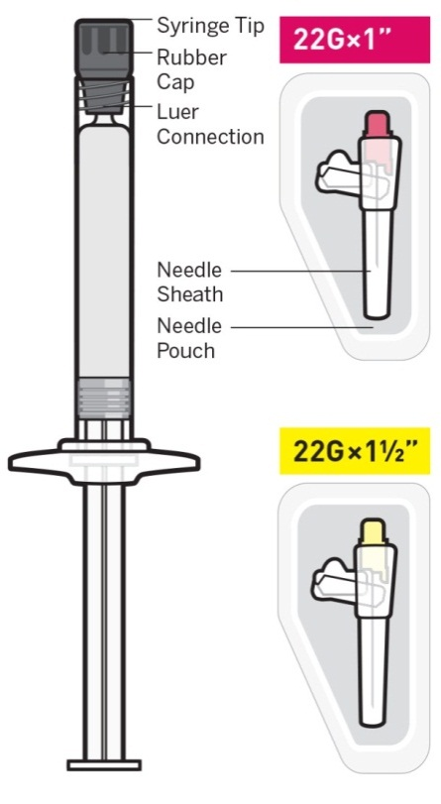**

**Select needle**

**1**

**Needle selection is determined by injection area and patient weight.**

|  |  |
| --- | --- |
| If administering a **Deltoid** injection    If patient weighs:  **Less than 90 kg**  pink hub  **needleSize_pink**  **90 kg or more**  yellow hub  **needleSize_yellow** | If administering a **Gluteal** injection    **Regardless of patient weight**  yellow hub  **needleSize_yellow** |

Immediately discard the unused needle in an approved sharps container. Do not save for future use.



**Prepare for injection**

**2**

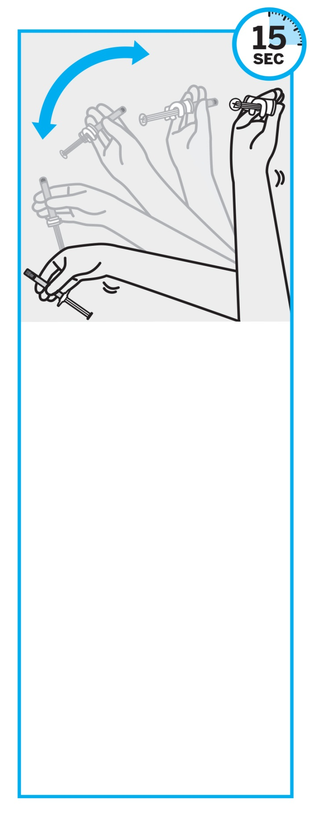

Proceed to the next step immediately after shaking. **If more than 5 minutes pass before injection, shake vigorously, with the syringe tip pointing up, again** for at least 15 seconds to re‑suspend the medication.

**SHAKE vigorously   
for at least 15 seconds**

**With the syringe tip pointing up,** SHAKE VIGOROUSLY with a **loose wrist** for at least 15 seconds to ensure a homogeneous suspension.

**NOTE:** This medication requires longer and more vigorous shaking than the 1‑month paliperidone palmitate modified‑release injectable suspension.



### Check suspension

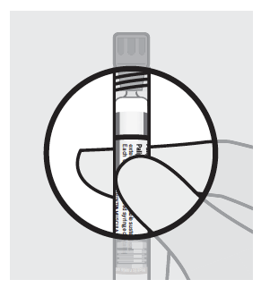

After shaking the syringe for at least 15 seconds, check the liquid in the viewing window.

The suspension should appear uniform and milky white in colour.

It is also normal to see small air bubbles.

### Open needle pouch and remove cap

**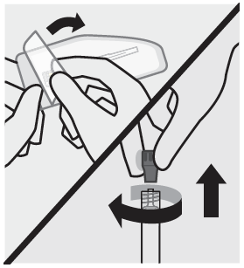**

First, open needle pouch by peeling the cover back half way. Place on a clean surface.

Then, holding the syringe upright, twist and pull the rubber cap to remove.

### Grasp needle pouch

**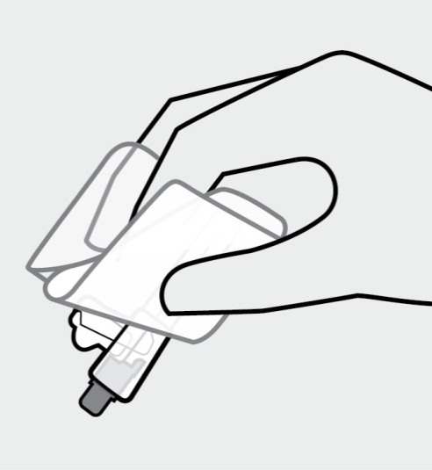**

Fold back needle cover and plastic tray. Then, firmly grasp the needle sheath through the pouch, as shown.

### Attach needle

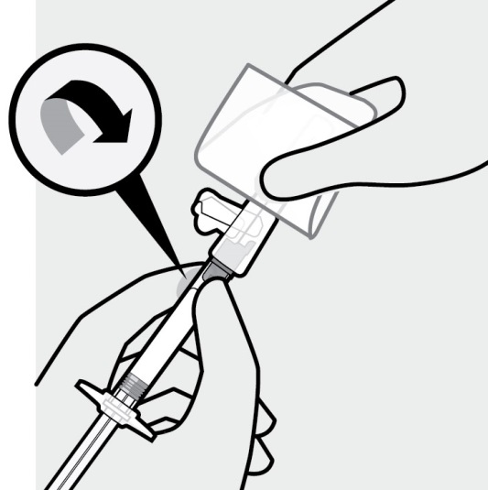

With your other hand, hold the syringe by the luer connection and attach it to the safety needle with a gentle clockwise twisting motion.

**Do not** remove the pouch until the syringe and needle are securely attached.

### Remove needle sheath

**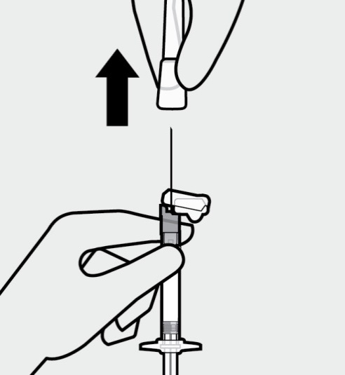**

Pull the needle sheath away from the needle in a straight motion.

**Do not** twist the sheath, as this may loosen the needle from the syringe.

### Remove air bubbles

**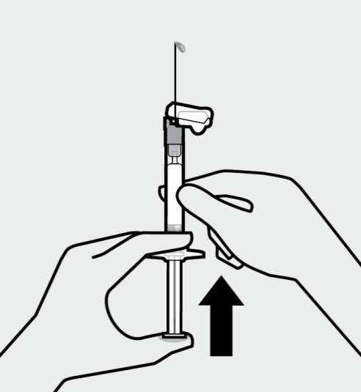**

Hold the syringe upright and tap gently to make any air bubbles rise to the top.

Remove air by pressing the plunger rod upward carefully until a drop of liquid comes out of the needle tip.

**Inject**

**3**

### Inject dose

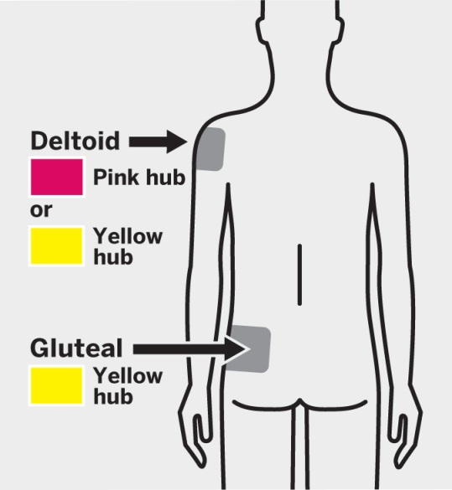

**Slowly inject the entire contents of the syringe** intramuscularly, deep into the selected deltoid or gluteal muscle.

**Do not administer by any other route.**

**After injection**

**4**

### Secure needle

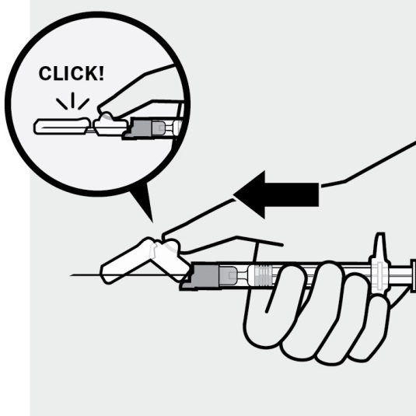

After the injection is complete, use your thumb or a flat surface to secure the needle in the safety device. The needle is secure when a “click” sound is heard.

### Dispose properly

**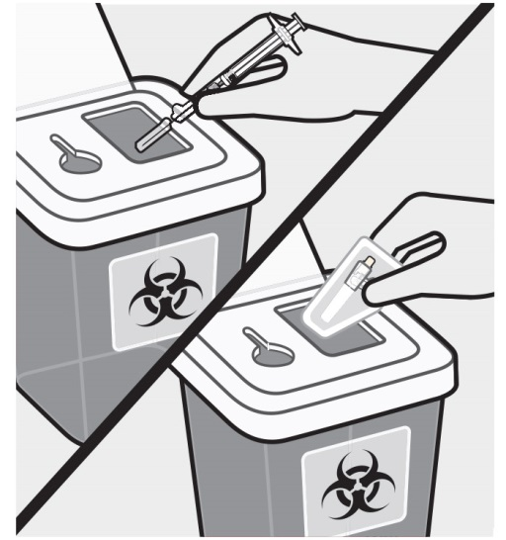**

Dispose of the syringe and unused needle in an approved sharps container.

GDS:Pharma:INVEGA SUSTENNA:Design:WordDoc_IFU_regulatory:images141028:exclamationMark_141028.jpg

Thin wall safety needles are designed specifically for use with INVEGA TRINZA. Unused needle   
should be discarded and not saved   
for future use.

**OVERDOSAGE**

Because INVEGA TRINZA is to be administered by health care professionals, the potential for overdosage by patients is low.

While experience with paliperidone overdose is limited, among the few cases of overdose reported in premarketing trials with oral paliperidone, the highest estimated ingestion was 405 mg.

Observed signs and symptoms included extrapyramidal symptoms and gait unsteadiness. Other potential signs and symptoms include those resulting from an exaggeration of paliperidone’s known pharmacological effects, i.e., drowsiness and sedation, tachycardia and hypotension, and QT prolongation. Torsade de pointes and ventricular fibrillation have been reported in a patient in the setting of overdose with oral paliperidone.

Paliperidone is the major active metabolite of risperidone. Overdose experience reported with risperidone can be found in the OVERDOSAGE section of the risperidone Product Information.

The possibility of multiple drug involvement should be considered.

## Management of Overdosage

Consideration should be given to the extended-release nature of INVEGA TRINZA and the long apparent half-life of paliperidone when assessing treatment needs and recovery. There is no specific antidote to paliperidone. General supportive measures should be employed. Establish and maintain a clear airway and ensure adequate oxygenation and ventilation. Cardiovascular monitoring should commence immediately and should include continuous electrocardiographic monitoring for possible arrhythmias.

If antiarrhythmic therapy is administered, disopyramide, procainamide, and quinidine carry a theoretical hazard of additive QT-prolonging effects when administered in patients with an acute overdose of paliperidone. Similarly the alpha-blocking properties of bretylium might be additive to those of paliperidone, resulting in problematic hypotension.

Hypotension and circulatory collapse should be treated with appropriate measures such as intravenous fluid and/or sympathomimetic agents (epinephrine [adrenaline] and dopamine should not be used, since beta stimulation may worsen hypotension in the setting of paliperidone-induced alpha blockade).

In case of severe extrapyramidal symptoms, anticholinergic agents should be administered. Close supervision and monitoring should continue until the patient recovers.

# PRESENTATION AND STORAGE CONDITIONS

INVEGA TRINZA contains a syringe (cyclic-olefin-copolymer) prefilled with either 175 mg (0.875 mL), 263 mg (1.315 mL), 350 mg (1.75 mL), or 525 mg (2.625 mL) paliperidone (as 273 mg, 410 mg, 546 mg, or 819 mg paliperidone palmitate) suspension with a plunger stopper and tip cap (bromobutyl rubber), a backstop, and 2 types of commercially available needles: a thin walled 22G, 1½‑inch safety needle and a thin walled 22G, 1-inch safety needle.

INVEGA TRINZA should not be mixed with any other product or diluent and is intended for intramuscular administration directly from the syringe in which it is packaged.

Store at or below 25oC.

NAME AND ADDRESS OF THE sponsor

Janssen-Cilag Pty Ltd

1-5 Khartoum Road, Macquarie Park, NSW, 2113, AUSTRALIA

NZ Office:

Auckland, NEW ZEALAND

POISON SCHEDULE OF THE MEDICINE

S4 - Prescription Only Medicine

**DATE OF FIRST INCLUSION IN THE ARTG**

23 September 2016