|  |
| --- |
| **Date of CER: May 2013** |

|  |
| --- |
| AusPAR Attachment 2 |
| Extract from the Clinical Evaluation Report for palonosetron hydrochloride |
| Proprietary Product Name: Aloxi |
| Sponsor: Specialised Therapeutics Australia Pty Ltd |

About the Therapeutic Goods Administration (TGA)

* The Therapeutic Goods Administration (TGA) is part of the Australian Government Department of Health, and is responsible for regulating medicines and medical devices.
* The TGA administers the *Therapeutic Goods Act 1989* (the Act), applying a risk management approach designed to ensure therapeutic goods supplied in Australia meet acceptable standards of quality, safety and efficacy (performance), when necessary.
* The work of the TGA is based on applying scientific and clinical expertise to decision-making, to ensure that the benefits to consumers outweigh any risks associated with the use of medicines and medical devices.
* The TGA relies on the public, healthcare professionals and industry to report problems with medicines or medical devices. TGA investigates reports received by it to determine any necessary regulatory action.
* To report a problem with a medicine or medical device, please see the information on the TGA website <<http://www.tga.gov.au>>.

About the Extract from the Clinical Evaluation Report

* This document provides a more detailed evaluation of the clinical findings, extracted from the Clinical Evaluation Report (CER) prepared by the TGA. This extract does not include sections from the CER regarding product documentation or post market activities.
* The words [Information redacted] indicate confidential information has been deleted.
* For the most recent Product Information (PI), please refer to the TGA website <<http://www.tga.gov.au/hp/information-medicines-pi.htm>>.

Copyright

© Commonwealth of Australia 2013  
This work is copyright. You may reproduce the whole or part of this work in unaltered form for your own personal use or, if you are part of an organisation, for internal use within your organisation, but only if you or your organisation do not use the reproduction for any commercial purpose and retain this copyright notice and all disclaimer notices as part of that reproduction. Apart from rights to use as permitted by the *Copyright Act 1968* or allowed by this copyright notice, all other rights are reserved and you are not allowed to reproduce the whole or any part of this work in any way (electronic or otherwise) without first being given specific written permission from the Commonwealth to do so. Requests and inquiries concerning reproduction and rights are to be sent to the TGA Copyright Officer, Therapeutic Goods Administration, PO Box 100, Woden ACT 2606 or emailed to <[tga.copyright@tga.gov.au](mailto:tga.copyright@tga.gov.au)>.

Contents

List of abbreviations 4

1. Clinical rationale 6

2. Contents of the clinical dossier 7

3. Pharmacokinetics 9

3.1. PALO-02-12 study 9

3.2. PALO-04-09 study 11

3.3. Comparison of results across the two pharmacokinetic studies 13

3.4. Summary of pharmacokinetics 13

4. Pharmacodynamics 15

5. Clinical efficacy 15

5.1. Publications of controlled studies incl. abstracts (multiple dosing of palonosetron 0.25 mg IV for the prophylaxis of CINV) 15

5.2. Uncontrolled studies 27

5.3. Guidelines on antiemesis 35

5.4. Conclusions regarding efficacy 44

6. Clinical safety 47

6.1. Patient exposure (registration studies) 47

6.2. Safety data 48

6.3. Safety comparisons 51

6.4. Safety in special groups and populations 52

6.5. Deaths and serious adverse events (registration studies) 52

6.6. Laboratory abnormalities and physical examination (registration studies) 52

6.7. Post-marketing experience 54

6.8. Conclusions regarding safety 54

7. First round recommendation regarding authorisation 55

7.1. Clinical summary and conclusions 57

7.2. Recommendation 58

8. Clinical questions 58

## List of abbreviations

| **Abbreviation** | **Meaning** |
| --- | --- |
| ASCT | Autologous haematopoietic stem cell transplantation |
| AUC | Area under the plasma concentration-time curve |
| AUCt1-t2 | Area under the plasma concentration-time curve within time span t1 to t2 |
| BEP | Bleomycin + etoposide + cisplatin |
| Cmax | Maximum plasma drug concentration |
| CINV | Chemotherapy induced nausea and vomiting |
| CCSI | Company Core Safety Information |
| CP | Complete protection |
| CR | Complete response |
| CT | Chemotherapy |
| EP | Etoposide + cisplatin |
| FLIE | Functional Living Index - Emesis |
| HD | High-dose |
| HDT | High-dose chemotherapy |
| HEC | Highly emetogenic chemotherapy |
| HSCT | Haematopoietic stem cell transplantation |
| IL-2 | Interleukin-2 |
| LBS | Literature based submission |
| MASCC | Multinational Association for Supportive Care in Cancer |
| MM | Multiple myeloma |
| MEC | Moderately emetogenic chemotherapy |
| NCCN | National Comprehensive Cancer Network |
| PONV | Postoperative nausea and vomiting |
| t½ | Elimination half life |
| Tmax | Time to reach maximum plasma concentration following drug administration |
| 5-HT3 RA | 5-HT3-receptor antagonist |

## Clinical rationale

Multiple-day moderately and highly emetogenic CT regimens are often used for the treatment of cancer. Patients continue to rank CINV among the most distressing experiences of cancer treatment.

Vomiting results from stimulation of a multistep reflex pathway controlled by the brain. The principal neuroreceptors involved in the emetic response are the serotonin and dopamine receptors.

Other neuroreceptors involved in emesis include acetylcholine, corticosteroid, histamine, cannabinoid, opiate, and neurokinin-1 (NK-1) receptors, which are located in the vomiting and vestibular centres of the brain.

When used at a certain concentration, each antiemetic agent predominantly blocks one receptor type. A final common pathway for emesis has yet to be identified. Therefore, no single agent can be expected to provide complete protection from the various emetic phases of chemotherapy.

With the use of effective antiemetic regimens, patients receiving emetogenic chemotherapy often experience more nausea than vomiting. Vomiting and nausea are related; however, they may occur via different mechanisms. Delayed nausea is more common than acute nausea, it is often more severe, and tends to be resistant to treatment.

With single-day chemotherapy, distinct phases of CINV have been identified: an acute phase, usually beginning immediately after CT administration and resolving within about 24 h and a delayed phase, usually defined as starting 24 or more hours after CT and lasting for up to 120 h or more depending on the CT regimen used.

In multiple-day emetogenic regimens, the overlap of acute and delayed CINV confounds antiemetic prophylaxis. In previous clinical trials with short-acting 5-HT3 receptor antagonists with or without dexamethasone, patients receiving multiple day cisplatin experienced the highest incidence of nausea and vomiting on Days 3 through 5 when the interaction of acute and delayed CINV is at its height.[1]

Following repeated chemotherapy cycles, patients may also experience anticipatory nausea and vomiting.

Serotonin (5-HT) is especially implicated in CINV since this neurotransmitter is released from the damaged enterochromaffin cells, lining the small intestinal mucosa. The subsequent activation of the 5-HT3 receptors on vagal afferents is transmitted to the vomiting centre in the brainstem and leads to emesis.

Several factors may contribute to the onset of nausea and vomiting, including the type of chemotherapy regimen, the use of antibiotics and analgesics, as well as concomitant mucositis.

General strategies for the management of CINV often involve the use of various antiemetics, but 5-HT receptor antagonists are the mainstay of therapy.

Palonosetron, a potent, second generation, highly selective, 5-HT3 receptor antagonist with a strong binding affinity for this receptor, has labelled indications for the management of nausea and vomiting associated with cancer therapy.

Palonosetron exists as a single stereoisomer and is structurally unrelated to other 5-HT3 receptor antagonists. It has extended plasma half-life of ~40 hours, which is significantly longer than that of other agents in its class (4-8 hours).

One of the assumptions for sponsor-led studies were as follows:

“The potential risk for both acute and delayed nausea and vomiting in patients receiving multiple-day emetogenic chemotherapy regimens, such as 3- to 5-day cisplatin-based therapy, is well known. It would appear that palonosetron could be particularly useful for those patients in which emetogenic risk lasts for several days.”[2]

## Contents of the clinical dossier

The sponsor submitted a LBS to update the PI of Aloxi (palonosetron 250 µg/5 mL) solution for injection in relation to altering the dosage regimen (allowing multiple dosing).

The sponsor informed TGA that this submission presents published data from controlled and uncontrolled clinical studies to update the Pl of Aloxi in the followings sections:

* ‘Dosage and Administrations’ section: to permit multiple dosing of palonosetron 0.25 mg IV for the prevention of CINV. The current PI states that repeated dosing is not permitted.
* ‘Precautions General’ section: additional statement that palonosetron use should only occur in association with chemotherapy.
* ‘Pharmacokinetics’ section: text related to some pharmacokinetic aspects of multiple dosing of palonosetron, based on two sponsor led studies.
* ‘Clinical Trials’ section: a brief summary of three randomised controlled trials (RCTs) submitted as published papers involving multiple administrations of palonosetron and intended to support the alternate dose schedule for palonosetron.

The proposed changes to the PI are associated with one amendment to the current Consumer Medicine Information (CMI).

The presented search strategy for this LBS has been approved by the TGA Library.

The dossier includes two pharmacokinetic studies and fourteen efficacy/safety studies presented as published papers.

The international sponsor for palonosetron, Helsinn Healthcare SA, has performed two clinical studies with repeated (< 7 days) palonosetron dosing with the aim of removing the warning on multiple dosing from the European SmPC; this variation was approved in the EU on 29 January 2009. Data supporting this variation included the two sponsor led studies:

* Phase I, double blind, randomised, placebo controlled trial to determine the pharmacokinetics and safety of multiple IV dosing of palonosetron in healthy subjects (n = 16); PALO-02-12 study.
* Phase II, open label trial to assess the safety and efficacy of Aloxi, administered as multiple doses, in patients (n = 41) receiving consecutive daily doses of cisplatin therapy for testicular cancer; PALO-04-09 study.

These two studies involved palonosetron 0.25 mg administered IV on 3 consecutive days in the PK PALO-02-12 study, and on 3 alternate days in the PALO-04-09 study.

The two studies were included as full study reports in an earlier submission and were already evaluated by the TGA. The studies have subsequently been published by Hunt and colleagues[3] (PALO-02-12) and Einhorn and colleagues[4] (PALO-04-09), and these publications are submitted in current LBS as key supporting evidence for the multiple dose regimen proposed.

An earlier application to the TGA that sought approval for removal of the single dose restriction for Aloxi was rejected by the TGA on the basis of inadequate clinical efficacy and safety data of the proposed multiple dosing regimen. That application to amend the ‘Dosage and Administration’ section of the PI to allow for repeated dosing of palonosetron was based on the EU dossier.

The current submission differs from the previous one in that it includes results of a literature search for supportive clinical studies. In this re-submission, the complete study reports for these studies are not included as the publications for each study provide sufficient information for the LBS.

Since the completion of the two sponsor initiated studies listed above, there have been many published reports of clinical studies involving multiple dose regimens for palonosetron for the prevention of CINV. These publications have been retrieved via a comprehensive literature search strategy which has been approved by the TGA librarian.

*Comments: The proposed efficacy statement for ‘Clinical Trials’ section is based on data from 246 patients from three published randomised controlled trials; out of these, 63 patients in two clinical trials received the proposed alternative day dosing of palonosetron of 0.25 mg administered IV in association with multi day chemotherapy.*

*In a study of acute myeloid leukemia (AML) or myelodysplastic syndromes (MDS), a total of 143 patients were treated: 48 patients received the proposed alternate day dosing of palonosetron, 48 received different palonosetron dosing regimen, and 47 received an active comparator (ondansetron).*

*In a study of metastatic melanoma (MM), a total of 30 patients were treated: 15 patients received the proposed alternate day dosing of palonosetron, and 15 received a different palonosetron dosing regimen.*

*In a study of MM, a total of 73 patients were treated: 25 patients received 3 consecutive days of palonosetron, and 48 received shorter palonosetron dosing regimes.*

*Apart from the two sponsor led studies, and the three randomised controlled trials listed above, the rest of the submitted data, including the clinical guidelines, could be regarded as the background reading material.*

## Pharmacokinetics

### PALO-02-12 study[5]

Title: “Phase I, Double-Blind, Randomised, Placebo-Controlled Study to Determine the Pharmacokinetics and Safety of Multiple Dose Administration of Palonosetron in Healthy Subjects.”

Single-centre (US), double blind, randomised controlled trial including placebo, in a parallel group design involving healthy volunteers (n = 16) given single doses of palonosetron on 3 consecutive days.

#### Interventions

Palonosetron 0.25 mg IV once daily for 3 consecutive days (n = 12), or placebo (n = 4); both infused over 10 seconds.

Demographics: Males (8), and females (8), with mean age of 26.8 years (range: 18-43). The study population was 75% White, and 25% Hispanic. Overall, demographic data were similar for subjects in the palonosetron and placebo treatment groups.

#### Results

PK parameters were consistent with previously performed single dose studies. Daily dosing of palonosetron produced a predictable PK profile, with increasing AUC and Cmax on Day 3 compared to Day 1, consistent with the long elimination half-life of the drug (Table 1).

Table 1: Summary PK of palonosetron after IV bolus administration to healthy subjects (Hunt et al.).

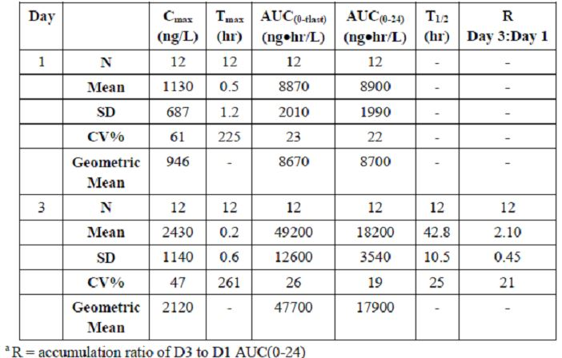

Plasma drug concentrations declined in a biphasic manner, with a rapid initial distribution phase followed by a slower elimination phase. Palonosetron was measurable in the plasma 168 hours after the 3rd administration (Figure 1).

Figure 1: Mean plasma palonosetron and metabolite M9 concentration-time profiles after IV bolus administration (Hunt et al.).

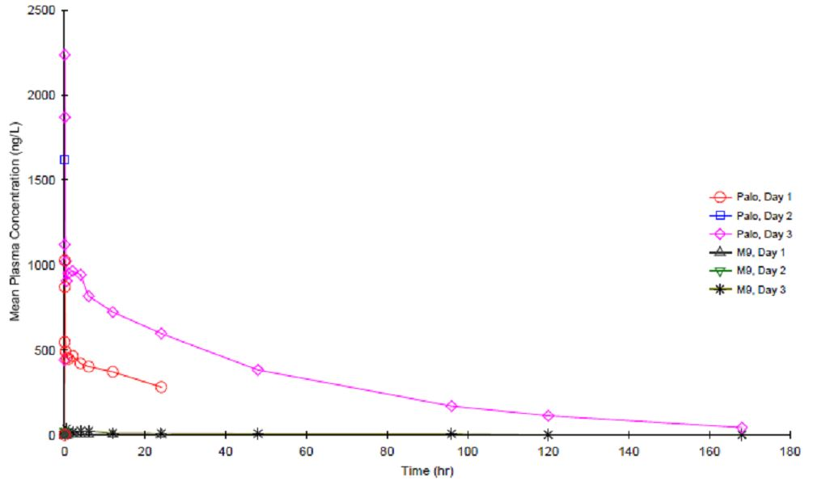

A 2.1-fold accumulation of drug in plasma occurred after 3 daily administrations (accumulation ratio Day 3/Day 1 AUC0-24h values), which is consistent with the long plasma elimination t½ and linear PKs.

On Days 1 and 3, the observed mean Cmax values were 1130 and 2430 ng/L, respectively with CV of 61% and 47%.

The observed median Tmax value was 3 minutes after IV bolus administration of palonosetron on both Day 1 and Day 3. In the majority of subjects, Tmax was observed within 6 minutes after dosing.

However, in 2 subjects on Day 1 Tmax occurred at 2 hours and 4 hours after dosing, and on Day 3 in 1 subject, Tmax was observed at 2 hours after dosing.

Mean AUC0-24h values were 8900 and 18200 ng•hr/L on Day 1 and Day 3, with a CV of 22% and 19%, respectively.

Mean terminal phase plasma elimination t½ determined after dosing on Day 3 was 42.8 hours with a CV of 25%.

The intersubject variability of both AUC values and t½ values was low.

There were minor differences in some PK parameters between men and women. The mean plasma concentration of palonosetron in female subjects was consistently higher than in men. This was most likely a result of female subjects receiving higher doses than men did, based on body weight.

Comparison of daily exposure (AUC0-24h) on Day 3 to Day 1 revealed mean accumulation ratios for men and women of 2.21 and 1.98, respectively, which were not statistically different (p = 0.385).

Because palonosetron has been well tolerated at doses from 3-30 times higher than those administered in this study, these slight between-gender PK differences were not expected to be clinically meaningful.

Metabolite M9 (N-oxide metabolite) levels were low and near the limit of quantification, therefore no PK analysis could be performed.

(The metabolite M9 has been shown to possess <1 % of the 5-HT3 antagonist activity of palonosetron in isolated guinea pig ileum model. Therefore, coupled with low systemic exposure, the contribution of metabolite M9 to the clinical activity of palonosetron may not be relevant.)

*Comments: “After 3 consecutive daily doses of 0.25mg, the maximum observed plasma concentration remained lower than the Cmax observed previously in healthy subjects or cancer patients after a single IV 0.75-mg bolus dose of palonosetron, a dose proven in large, well-controlled phase III clinical trials to be effective, safe, and well-tolerated.”*

#### Summary

Daily dosing of palonosetron produced a predictable PK profile, with increasing AUC and Cmax on Day 3 compared to Day 1, consistent with the long elimination t½ of the drug.

With increasing total drug exposure, there was no increase in the incidence of treatment-related AEs at Day 3 compared to Day 1. PK results in this study were consistent with previously performed single dose studies.

#### Conclusions

This was the first study to assess the safety and PKs of consecutive multiple-day dosing of palonosetron.

*Comments: “The 2.1-fold accumulation of palonosetron in plasma following 3 daily doses was predictable based on elimination half-life of approximately 40 hours, and the maximum plasma concentration remained below the maximum plasma concentration previously observed after a single, well- tolerated 0.75 mg intravenous bolus dose of palonosetron.”*

*“Palonosetron administered as an IV bolus of 0.25 mg, daily for 3 days, was safe and well tolerated in these healthy subjects. Upon repeated dosing, accumulation of palonosetron in plasma was predictable based on its long plasma elimination half-life of approximately 40 hours. This study therefore supports the use of 3 repeated days of dosing of palonosetron in subjects requiring antiemetic treatment during multiday chemotherapy regimens.”*

*“As a unique 5-HT3 receptor antagonist with extended activity, palonosetron could be particularly useful for patients receiving chemotherapy with emetogenic risk lasting for 4 days or longer; however, safety and efficacy of repeated dosing with palonosetron within a 7-day interval has yet to be evaluated.*

*The results of this study support future investigation into the safety and efficacy of repeated palonosetron dosing in patients with cancer who require preventative antiemetic therapy during multiple-day chemotherapy.”*

### PALO-04-09 study[6]

Title: “A Phase II Study to Assess the Safety and Efficacy of Aloxi (Palonosetron HCL) for the Prevention of Nausea and Vomiting in Patients Receiving Consecutive Daily Doses of Cisplatin Therapy for Testicular Cancer.”

Multicentre (US), open label study evaluating the safety and efficacy of palonosetron + dexamethasone in patients (n = 41) receiving highly emetogenic multiple-day cisplatin-based chemotherapy for germ cell tumors. In a subset of patients (n = 11) the PKs and the ECG effects were evaluated.

#### Interventions

Palonosetron 0.25 mg IV (30-second infusion), as a single dose, 30 min before chemotherapy, on Days 1, 3 and 5 in patients receiving 20 mg/m2 cisplatin on Days 1-5.

Dexamethasone (O/IV) was administered according to a predefined schedule: Days 1 & 2: 20 mg once a day; Days 6 & 7: 8 mg BD (bis in die; twice daily); and Day 8: 4 mg BD.

The cisplatin component is commonly given on 5 sequential days in a 3-week cycle. All patients received a chemotherapy regimen consisting of bleomycin, etoposide and cisplatin (BEP), except 1 patient who received etoposide and cisplatin (EP) therapy. Table 7 - 2, Part B; (Cisplatin regimens acceptable for the trial.

Demographics: Men with testicular cancer. The mean age was 33.3 years (range: 16 - 55); 39 were White; and 2 identified as Others. The majority (n = 35) were chemotherapy-naïve.

Monitoring: Safety and efficacy were assessed over nine 24-hour periods starting with the initiation of chemotherapy on Day 1 and ending on Day 10. ECG testing (Days 1 and 5), and PK sampling (Days 1, 3 and 5), were performed in a subset of 11 patients.

#### Results

With repeated dosing of palonosetron, mean Cmax increased from 1920 ng/L on Day 1 to 2580 ng/L on Day 5.

On Days 1, 3 and 5, the observed mean Cmax values were 1920, 2500, and 2580 ng/L, respectively, with CV between 57 % and 84 %.

Similarly, AUC0-t increased from 1270 ng•h/L to 1680 ng•h/L, resulted in a 1.42-fold accumulation (ratio of Day 5/Day 1 AUC0-t). This is consistent with the extended (~40 hr) plasma elimination t½ of palonosetron (Table 2 and Figure 2).

Table 2: Summary of PK of palonosetron on Days 1, 3 and 5 after 0.25 mg IV bolus administration in cancer patients (Einhorn et al.).

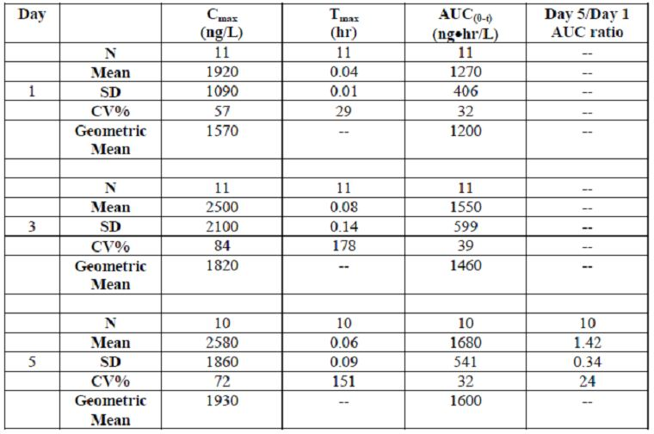

Figure 2: Days 1, 3 and 5 mean plasma palonosetron concentrations after IV bolus administrations of 0.25 mg dose to cancer patients (Einhorn et al.).

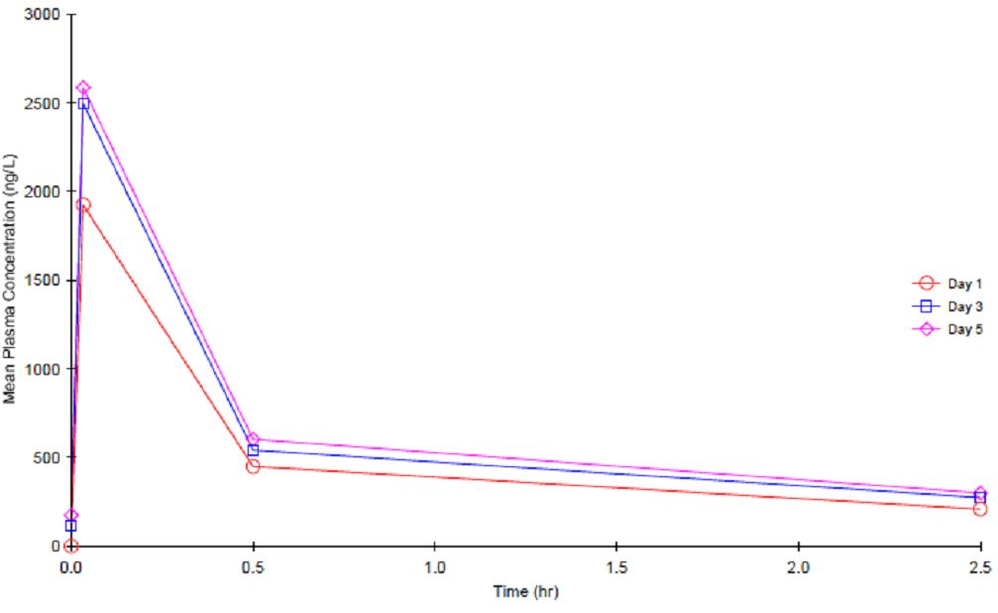

The observed mean Tmax values were 0.04, 0.08, and 0.06 hr after Days 1, 3 and 5 of IV bolus administration of palonosetron, respectively.

Mean AUC0-t values were 1270, 1550, and 1680 ng•hr/L on Days 1, 3 and 5, respectively, with CV between 32% and 39%.

Comparison of AUC0-t over the same sampling interval of 0-2.5 hr on Day 5/Day 1 resulted in mean accumulation ratio of 1.42; consistent with the long t½ of palonosetron observed in previous PK studies in healthy subjects and cancer patients.

Metabolite M9 concentrations were low and near lower limit of quantitation, therefore no PK analysis could be performed.

#### Summary

PK results of palonosetron in this study were similar to values determined in previous studies in patients and healthy subjects.

### Comparison of results across the two pharmacokinetic studies

In PALO-04-09 study, on Day 5 after the 3rd dose of palonosetron (with doses of 0.25 mg IV given on Days 1, 3 and 5), the mean Cmax of 2580 ng/L in the chemotherapy patients, was similar to the mean Cmax of 2430 ng/L observed for healthy subjects on Day 3 after 3 consecutive 0.25 mg daily IV doses (PALO-02-12). The evaluated PK profile was also similar.

These PK studies form the basis of the proposed text to the PK section of Aloxi PI:

*Comments: “Following intravenous administration of palonosetron 0.25 mg once every other day for 3 doses in 11 testicular cancer patients, the mean (± SD) increase in plasma concentration from Day 1 to Day 5 was 42 ± 34 %. After intravenous administration of palonosetron 0.25 mg once daily for 3 days in 12 healthy subjects, the mean (± SD) increase in plasma palonosetron concentration from Day 1 to Day 3 was 110 ± 45 %.”*

### Summary of pharmacokinetics

The following conclusions were presented by the sponsor based on these two studies:

* In the study by Hunt and colleagues[7] involving healthy subjects, Aloxi 0.25 mg IV bolus over 10 seconds daily for 3 consecutive days resulted in a 2.1 fold accumulation (ratio of Day 3/Day 1 AUC0-24h [area under the plasma concentration-time curve within time span t1 to t2]).
* Similarly, in the study by Einhorn and colleagues[8] involving cancer patients, Aloxi 0.25 mg IV bolus over 30 seconds on Days 1, 3, and 5 resulted in a 1.42 fold accumulation (ratio of Day 5/Day 1 AUC0-t). This is consistent with the plasma elimination half life of palonosetron (~40 h; see SmPC).
* Based on these two studies, AUC after daily IV doses of 0.25 mg over 3 days is expected to be similar to the AUC resulting from a single 0.75 mg dose. These pharmacokinetic data, therefore, support the proposal to use repeated daily dosing of Aloxi.

*Comments (additional information):*

*The earlier submission to address the same issue of palonosetron multiple dosing regimens included the pharmacokinetic simulation study (PR-PALO-02-17).*

*The following were the comments of the clinical evaluator at that time:*

*Data were obtained from three studies; the 2 compartment model was used. The simulations calculated the plasma concentrations for several dosing regimens over a time interval of up to 216 h.*

*The following simulations were performed:*

* + - Single dose of 0.75 mg IV
    - 3 daily doses of 0.25 mg/day
    - 8 daily doses of 0.25 mg/day (to represent steady state).

*The AUC0-∞ for the three daily doses was similar to that for the single dose of 0.75 mg. The model simulated no significant increase in the Cmax of palonosetron after the third daily dose.*

*The simulations did not predict the range of plasma concentrations that might be expected in a population of patients. The simulations used parameters estimated from mean values and did not simulate for the expected range of values. Hence, there is no way of knowing what proportion of the population might experience an AUC and/or Cmax well in excess of the mean.*

*“The PK data were obtained for palonosetron 0.25 mg on Days on Days 1, 2, 3 from a volunteer population and on Days 1, 3, 5 from a population of subjects with testicular cancer. These data did not indicate significant accumulation of palonosetron after Day 3.”*

*The simulations were rudimentary in that only mean plasma concentrations were simulated. The modelling did not use all the available data to develop the model and did not model the variability in plasma concentrations over time.”*

*“The modelling and simulations did not attempt to determine an optimal dosing strategy for multiple doses in a one week period.”*

## Pharmacodynamics

No new pharmacodynamics data was submitted.

## Clinical efficacy

### Publications of controlled studies incl. abstracts (multiple dosing of palonosetron 0.25 mg IV for the prophylaxis of CINV)

The sponsor included 9 controlled studies on multiple dosing of palonosetron for the prophylaxis of CINV.

Background: “More than 90 % of patients receiving highly emetogenic chemotherapy will have episodes of vomiting. However, only about 30 % of these patients will vomit if they receive prophylactic (preventive) antiemetic regimens before treatment with highly emetogenic chemotherapy. Although vomiting can often be prevented or substantially decreased by using prophylactic antiemetic regimens, nausea is much harder to control.”

“For multi-drug regimens, antiemetic therapy should be selected based on the drug with the highest emetic risk.”

“The need for repeat dosing with palonosetron, either daily or less frequently, in the setting of multiday chemotherapy is not yet known.”[9]

#### Comparative randomised controlled trials

The 3 RCT discussed in this section form the basis for the proposed reference to the Clinical Trials section of the PI.

These studies evaluated the efficacy of multiple dosing regimens of palonosetron 0.25 mg IV in association with multiday chemotherapy for the treatment of AML or MDS (n = 143),[10] metastatic melanoma (n = 30),[11] or MM patients treated with high dose melphalan pre-SCT conditioning (n = 73).[12]

##### Noor et al.

Noor and colleagues[13] published a Phase II, single centre, RCT comparing 2 schedules of palonosetron in treatment-naïve patients (n = 30) with metastatic melanoma undergoing 1st cycle of CT.

Title: “Comparison of two dosing schedules of palonosetron for the prevention of nausea and vomiting due to interleukin-2-based biochemotherapy.”

The primary goal was to evaluate the efficacy of 2 different dosing schedules of palonosetron for CINV prophylaxis; the study was not powered for possible quantitative differences in efficacy between the dosing schedules.

###### Intervention

Palonosetron 0.25 mg IV, 30 min prior to biochemotherapy, on either Days 1 and 4 (Schedule 1); n = 15 or Days 1, 3, and 5 (Schedule 2); n = 15.

All patients received dacarbazine on Day 1; cisplatin, vinblastine and interleukin-2 on Days 1 - 4; and IFNα-2b on Days 1 - 5. Dexamethasone was not administered in this study.

(Corticosteroids for the prevention of CINV are contraindicated in patients receiving immunotherapy, as they cause lysis of LAK cells produced in response to IL-2.)

Demographics: 30 patients, median age 53 years (range: 18 - 65), including 60 % of males. The 2 treatment groups were similar in terms of age, sex, PS, and stage of the disease. There were significantly more patients with liver metastasis in Group 1 (9 vs. 4; p = 0.041).

###### Results

A consistent trend of a better control of both nausea and vomiting favouring Schedule 2 was observed during the first 7 days, and throughout the cycle.

For the first 7 days of treatment, more episodes of nausea were reported for Schedule 1 than Schedule 2, although the difference was not statistically significant (p = 0.16).

A similar trend, favouring Schedule 2, was observed comparing the number of episodes of emesis during the first 7 days (p = 0.20), the number of antiemetic rescue doses required (p = 0.30), and the number of episodes of nausea and emesis during the first 21 days.

Significantly more patients experienced nausea on any day during the first 7 days on Schedule 1 (mean number of episodes 8.1 ± 1.5), than on Schedule 2 (mean number of episodes 5.6 ± 2.3; p = 0.028).

The impact on daily function as measured by the Functional Living Index-Emesis was similar between the 2 groups. The interference with appetite, sleep, physical activity, social life, and enjoyment of life was reported in 53 % vs. 64 % patients, in Schedule 1 and 2, respectively; p = 0.71.

The authors concluded that the alternate day dosing of palonosetron was more effective in controlling CINV in this patient population. Both dosing schedules were well tolerated, but no AE data were reported in this publication.

“Even though there were more patients with liver metastasis in the group treated with palonosetron on Days 1 and 4, this may not be the reason why this dose schedule was less effective than the more frequent dosing of palonosetron, because the proportion of patients with advanced liver involvement was not statistically different.”

“These results must be interpreted with caution since the study was not designed or powered to show statistical differences.”

*Comments: Underpowered study. Note, the impact on daily function was numerically worse in Schedule 2. Number of patients exposed to alternate days dosing of palonosetron in this study = 15.*

##### Giralt et al.

Giralt and colleagues[14] reported the efficacy and safety of 3 palonosetron regimens for emesis prevention over 7 days in multiple myeloma (MM) patients receiving melphalan (100 mg/m2) and haematopoietic stem cell transplantation (HSCT).

Title: “Three palonosetron regimens to prevent CINV in myeloma patients receiving multiple-day high-dose melphalan and hematopoetic stem cell transplantation.”

Prospective, randomised, controlled, DB pilot study designed to evaluate the efficacy and safety of single- and multiple-day dosing schedules of palonosetron, and to identify the optimal emesis prevention regimen in MM patients, who were undergoing melphalan conditioning for 2 days (Days -2 and -1) with autologous HSCT (Day 0).

Demographics: MM patients (n = 73), aged ≥ 18 years. The majority of patients were male (64 %), Caucasian (75 %), ranging in age from 32 - 72 years; < ⅓ were chemotherapy-naïve.

###### Intervention

Patients received 1-day (n = 24); 2-days (n = 24); or 3-days (n = 25) IV palonosetron 0.25 mg; 30 minutes before melphalan (Days -2 and -1), and HSCT (Days -2 to 0).

Thus, palonosetron was given on Day -2 (cohort 1), Days -2 and -1 (cohort 2), and Days -2, -1, and 0 (cohort 3). Infusions of saline were given as placebo in cohorts receiving 1 and 2 days of palonosetron.

All patients received dexamethasone (20 mg IV Days -2 and -1) immediately before, or after study drug/placebo.

Primary efficacy endpoint was the complete protection (CP) rate defined as proportion of patients with no emetic episodes during the cumulative 7-day period (Days -2 to Day +4). Daily diaries recorded emesis, rescue medication, nausea duration, and AEs.

###### Results

> 40 % of patients in each of the palonosetron treatment groups had CP from emesis thought the entire 7-day study period. For the primary end point, the 1-, 2-, and 3-day palonosetron dosing cohorts were not statistically different from each other (p = 0.43).

A 7-day CP (no emesis) occurred in 41.7 % (95 % CI: 22.1 % - 63.4 %), 41.7 % (95 % CI: 22.1 % - 63.4 %) and 44.0 % (95 % CI: 24.2 % - 65.1%) of patients receiving 1, 2 or 3 days of palonosetron, respectively (p = 0.43).

Over the 7-day course of the study, CR (emesis-free without rescue medication) occurred in 8.3 %, 20.8 % and 20.0 %; (p = 0.14).

During the 2 days of chemotherapy, most patients reported little to no interference with daily functioning due to nausea/emesis as reflected in the Osoba questionnaire. During the 5 days post HSCT, little or no functional impact was reported by the majority of patients receiving 2 or 3 doses of palonosetron (70.8 % and 56.0 % respectively), as compared with 41.7 % of patients in the 1-day palonosetron group.

Exploratory analysis of the primary endpoint: “In this study, because of the sample size no definite conclusions can be made over the benefit of multiple-day administrations of palonosetron. No increasing trend in efficacy was noted in the primary end point of overall CP rate with multiple days of palonosetron (P = 0.43).”

“However, on the day of HSCT (Day 0), 92 % of the patients who received three doses of palonosetron were emesis free compared with 66.7 % and 79.2 % of those who had received one and two doses of palonosetron, respectively (P = 0.015). Secondary measures of the effects of palonosetron also showed trends that favoured multiple days of dosing.”

“Although the rates of complete remission compare favourably with previous studies of antiemetic prophylaxis in patient populations receiving multiple-day high-dose chemotherapy before HSCT, the majority of patients either had emesis or required rescue medications.”

Even multiple doses of palonosetron resulted in only 20% of patients being emesis free without rescue medication, suggesting that further improvement will require development of more effective combination antiemetic therapy.

The authors concluded that palonosetron + dexamethasone was safe and effective in preventing emesis in MM patients receiving melphalan and HSCT.

“This pilot study with limited number of patients suggests that multiple doses of palonosetron could be more effective than a single dose in making patients emesis-free without the need for rescue medication.”

“Additional studies to determine the optimal regimen of palonosetron and dexamethasone with or without other agents are warranted.”

*Comments: Underpowered study. In an exploratory analysis of the primary endpoint no increasing trend in efficacy was noted for multiple administrations of palonosetron. No definite conclusions could be made from this study. Number of patients exposed to proposed alternate days dosing of palonosetron = 0.*

##### Mattiuzzi et al.

Mattiuzzi and colleagues[15] compared 2 schedules of palonosetron vs. ondansetron for the prophylaxis of CINV in patients (n = 143) with AML receiving high-dose (HD) cytarabine.

Title: “Daily palonosetron is superior to ondansetron in the prevention of delayed chemotherapy-induced nausea and vomiting in patients with Acute Myelogenous Leukemia.”

Prospective, randomised, 3-arm trial comparing 2 schedules of palonosetron vs. ondansetron in the treatment of CINV.

Demographics: Adults (>18 years old) with AML or high-risk MDS undergoing induction chemotherapy or 1st salvage regimen with HD (> 1.5 g/m2 up to 5 days) cytarabine-containing regimens (including but not limited to cytarabine + idarubicin and cytarabine + fludarabine).

###### Intervention

* Ondansetron, 8 mg IV, followed by 24 mg continuous infusion 30 minutes before HD cytarabine until 12 hours after the HD cytarabine infusion ended (n = 47),
* Palonosetron, 0.25 mg IV 30 minutes before chemotherapy, daily from Day 1 up to 5 days of HD cytarabine (n = 48), depending on duration of cytarabine treatment,
* Palonosetron 0.25 mg IV 30 minutes before HD cytarabine on Days 1, 3, and 5 (n = 48).
* All patients received methylprednisolone 40 mg IV bolus before each cytarabine infusion.

The treatment groups were similar with respect to baseline characteristics and with respect to the type of chemotherapy administered.

A total of 143 patients were evaluable for efficacy: 47 patients in the ondansetron arm, and 48 patients in each palonosetron arm; 7 patients were excluded from the analysis.

The primary endpoint was the CR defined as no emesis episodes and no use of rescue medication during the study period (7 days).

###### Results

Although more patients in the palonosetron arms than in the ondansetron arm achieved a CR, this difference was not statistically significant.

Similarly, fewer patients in the palonosetron arms than in the ondansetron arm had treatment failure (1st need for rescue medication or 1st emesis), but the difference was not statistically significant.

Patients in the palonosetron arms achieved higher CR rates (no emetic episodes + no rescue medication), but the difference was not statistically significant (ondansetron, 21 %; palonosetron on Days 1-5, 31 %; palonosetron on Days 1, 3, and 5, 35 %; p = 0.32).

Similar to the nausea results, fewer patient in the palonosetron arms than in the ondansetron arm reported emesis. The daily assessments of emesis did not show significant differences between study arms in the number of patients without emesis.

Although all 3 antiemetic regimens tested offered effective protection against nausea during the first 24 hours, the proportion of patients free of nausea during Days 2-5 was markedly lower in all 3 arms, and the severity of nausea was higher.

On Day 1, >77 % of patients in each arm was free of nausea; however, on Days 2-5, the proportion of patients without nausea declined similarly in all 3 groups.

On Days 6 and 7, significantly more patients receiving palonosetron on Days 1-5 than those receiving ondansetron were free of nausea (p = 0.001 and p = 0.0247, respectively).

Patients recorded the impact of CINV on daily activities in a diary during the study period; no differences were found among the 3 groups, except on Day 6, when significantly more patients who received palonosetron on Days 1-5 reported a minimal effect of CINV on their activities.

The authors commented that the overall response rates in this study with palonosetron (31 % and 35 %) were lower than in other studies published, and also lower than response rates with other types of cancer. Patients with AML have unique characteristics specific to the treatment of leukaemia that might affect the incidence of CINV and the efficacy of the antiemetic therapy.

###### Conclusions

The daily assessments of emesis did not show significant differences between the study arms. Patients receiving palonosetron on Days 1-5 had significantly less severe nausea and experienced significantly less impact of CINV on daily activities on Days 6 and 7.

“Our findings indicate that although 5-HT3 serotonin receptor antagonists have high efficacy against CINV during the first 24 hours of chemotherapy, this protection is less effective on Days 2 to 5, because >40 % of patients develop nausea during that period. It will be important to investigate whether combinations of different classes of antiemetics will result in better protection during these days.”

*Comments: This study of patients with haematological malignancies (n = 143) and high dose CT did not convincingly demonstrate the advantage of multiple dosing of palonosetron over other 5-HT3 receptor antagonist.*

*CR (primary endpoint) did not show the statistical advantage for 2 different schedules of multiple day administration of palonosetron over ondansetron. Number of patients exposed to alternate days dosing of palonosetron in this study = 48.*

##### Overall comments on the submitted RCTs

None of the 3 RCTs intended to back up the proposed multiple/alternate day dosing of palonosetron convincingly demonstrated the benefits of this regimen, or in fact the benefits of multiple day dosing of palonosetron.

Some trends indicating possible benefits of repeating the doses of palonosetron were described in the published papers, however, the trials were generally underpowered.

Only 2 studies investigated the proposed alternate day dosing regimen of palonosetron. Number of patients exposed to alternate days administration of palonosetron in these studies = 63.

In a letter to the TGA dated 12 October 2012, the sponsor outlined the proposed changes to the PI of Aloxi, including a text for the Clinical Trials section that describes “a brief summary of 3 RCTs involving alternate dose schedules for palonosetron”. This is clearly incorrect, as only 2 of these RCT investigated this dosage regimen.

#### Retrospective comparative studies (ondansetron cohort), and studies with historical control

##### Feinberg et al.

The retrospective comparative study published by Feinberg and colleagues[16] analysed the risk of uncontrolled CINV among lung cancer patients receiving multi-day chemotherapy and ondansetron- or palonosetron-initiated prophylactic antiemetic regimens in a community oncology setting.

Title: “Impact of initiating antiemetic prophylaxis with palonosetron versus ondansetron on risk of uncontrolled chemotherapy-induced nausea and vomiting in patients with lung cancer receiving multi-day chemotherapy.”

This was a retrospective analysis of electronic medical records data from 1 April 2006 - 31 August 2009. The population was derived from Georgia Cancer Specialist (US); the database was used to identify lung cancer patients who received multi-day cisplatin or carboplatin regimens with ondansetron or palonosetron on Day 1.

Uncontrolled CINV events were identified through codes (nausea/vomiting, dehydration), rescue medications, nausea/vomiting hospitalizations, and/or antiemetic therapy after last chemotherapy cycle (off-protocol, non-prophylactic use of antiemetics).

Risk for uncontrolled CINV, up to 7 days after last chemotherapy administration, was analysed at cycle level using logistic regression with regressors of gender, age, number of chemotherapy administration days, Charlson comorbidity index, cancer type, multicancer diagnoses, and chemotherapy regimen. Palonosetron and ondansetron cohorts were identified at any time point during the study period.

###### Intervention

* Palonosetron on Day 1 + every-other-day dosing through to the last day of chemotherapy in that cycle (Palonosetron cohort).
* Ondansetron on Day 1 + ondansetron daily during the chemotherapy period and a single palonosetron dose on the last day (Ondansetron cohort).

E.g., in the palonosetron cohort, palonosetron was to be given on Days 1 and 3 during 3-day chemotherapy, or on Days 1, 3, and 5 during 5-day chemotherapy; whereas the ondansetron cohort was to receive ondansetron on chemotherapy Days 1 and 2 and palonosetron on Day 3 (3-day chemotherapy) or ondansetron on Days 1-4 and palonosetron on Day 5 (5-day chemotherapy).

Duration of treatment: up to 5 days depending on chemotherapy regimen.

Demographics: 209 palonosetron and 153 ondansetron patients (702 and 515 cycles, respectively) met the inclusion criteria. Palonosetron patients were significantly older (mean 67.9 vs. 63.9 years; p < 0.0001), with no significant difference in gender, baseline comorbidity score, or multicancer diagnosis.

There was a predominance of 3-day regimens, accounting for 90.3 % and 92.0 % of cycles in palonosetron and ondansetron cohorts, respectively. The most frequently received platinum agent was carboplatin in the palonosetron cohort (89 % of platinum cycles) and cisplatin in the ondansetron cohort (79 % of platinum cycles); a statistically significant difference in platinum type received (p < 0.0001).

Platinum agents are among the most emetogenic agents, with carboplatin designated as moderately emetogenic chemo-therapy (MEC) and cisplatin as highly emetogenic chemotherapy (HEC).

In the palonosetron cohort, 87.2 % of the chemotherapy cycles included the per-practice every-other-day palonosetron schedule, although 72.9 % of cycles were given with palonosetron only on Day 1. Accounting for the cycles that did not receive palonosetron according to the per-practice schedule, ~13 % of cycles included either ondansetron or aprepitant along with palonosetron.

In the ondansetron cohort, 83.3 % of the chemotherapy cycles were given with the per-protocol daily ondansetron and last-day palonosetron schedule. Variation of the per-practice schedule occurred during 12.8 % of the chemotherapy cycles, with ondansetron given on the last day instead of palonosetron in 8.2 % of cycles.

The primary outcome was the rate of uncontrolled CINV events, measured from 1st chemotherapy agent administration of the cycle (start date) through 7 days after the last chemotherapy agent administration (end date).

###### Results

Overall, there were 273 uncontrolled CINV events during 702 platinum cycles in the palonosetron cohort; and 455 events during 515 cycles in the ondansetron cohort (unadjusted incidences of 38.9 % with palonosetron vs. 88.4 % with ondansetron; p < 0.0001).

Benefits of initiating cycles with palonosetron vs. ondansetron were seen in the overall analysis population (63 % lower risk) as well as in subgroups based on specific platinum exposure (cisplatin 91 % lower risk) and carboplatin (54 % lower risk).

Palonosetron cycles had 63 % lower risk for uncontrolled CINV events vs. ondansetron cycles (OR 0.37; 95 % CI: 0.25 - 0.54; p < 0.0001).

Consistent with the overall analysis, sub-analyses by platinum type demonstrated significantly lower risks of uncontrolled CINV during cisplatin and carboplatin cycles in the palonosetron cohort; 91% reduction during cisplatin cycles (OR 0.09; 95 % CI: 0.04 - 0.25; p < 0.0001) and 54% reduction during carboplatin cycles (OR 0.46; 95 % CI: 0.30 - 0.70; p = 0.0003).

*Comments: The imbalance between cohorts with respect to platinum type was a key limiting factor, resulting in an imbalance in emetogenicity between the cohorts; however, it is reassuring that the subgroup analyses focused on cisplatin and carboplatin (conducted to address this issue) showed similar results to those in the overall population.*

*There was also a 2-year imbalance with a statistical difference in age, with palonosetron recipients being significantly older. Any impact of this difference in age on the primary outcome would be expected to have favoured the palonosetron cohort, considering that younger age is regarded as a risk factor for developing CINV.*

*At the same time, the relative small numerical between-cohort difference in age would be of questionable clinical relevance for impacting the occurrence of uncontrolled CINV, supported by the consistency in findings between the overall population and platinum-based subsets (for which the differences in age were not statistically significant).*

*Conclusions: “In this retrospective analysis of lung cancer patients, multi-day chemotherapy cycles administered with palonosetron on day 1 were associated with a significantly lower risk for uncontrolled CINV events vs. ondansetron-initiated chemotherapy cycles.”*

##### Musso et al.

Musso and colleagues[17] reported on the efficacy of single dose of palonosetron combined with dexamethasone on prevention of acute and delayed CINV in patients receiving multiple days chemotherapy, and the efficacy of a 2nd dose of palonosetron in treating breakthrough emesis.

Title: “Palonosetron (Aloxi) and dexamethasone for the prevention of acute and delayed nausea and vomiting in patients receiving multiple-day chemotherapy.”

Prospective observational study from the Haematologic Oncology Unit and the Department of Oncology at “La Maddalena” Hospital in Palermo; patients suffering from haematologic malignancies and receiving multiple-day CT from June 2006 - August 2007 were consecutively included in the study.

The control was a historical population with similar demographic and clinical characteristics, pathologies, and chemotherapeutic regimens, consecutively enrolled from June 2005 - May 2006 and treated with ondansetron + dexamethasone.

A total of 91 consecutive patients were included in the study: 46 patients in the palonosetron group (P), and 45 in the ondansetron group (O).

###### Intervention

Single dose of palonosetron (0.25 mg IV) on the 1st day of chemotherapy + dexamethasone (8 mg IV) 15 min before starting chemotherapy (palonosetron cohort).

Dexamethasone (8 mg IV; 4 mg BD) was administered every day during the entire period of chemotherapy (except for DHAP); “short and low-dose dexamethasone.”

For breakthrough emesis, a 2nd dose of palonosetron was administered after 72 h following the 1st administration; palonosetron was also permitted for breakthrough emesis within 5 days after the end of chemotherapy.

The control group had single-dose ondansetron on the 1st day of chemotherapy + dexamethasone (as above) throughout the entire period of chemotherapy and metoclopramide for breakthrough emesis.

Duration of treatment: up to 3 days.

Demographics: The most frequent diagnoses were non-Hodgkin’s lymphoma (50 % P, 48 % O), AML (30 % P, 28 % O), and Hodgkin’s disease (18 % P, 24 % O). In both groups, the majority of patients was treated with DHAP (24 % P, 24 % O), followed by ICE (22 % P, 18 % O), HD-AraC (17 % P, 18 % O), and FluCy (17 % P, 13 % O).

The primary endpoint was the complete control (CINV Grade 0: no emesis, no nausea, and no rescue therapy) during the period of chemotherapy and within 5 days after the end of chemotherapy, over the entire chemotherapy cycles.

A total of 180 and 173 chemotherapy cycles were administered in the palonosetron and ondansetron groups, respectively.

###### Results

Nausea and vomiting were absent in 80 % of patients of the palonosetron group and 60 % of the control group, during the overall period of observation; p < 0.05.

“This significant result is also in light of our stringent criteria for complete control of CINV, which was extended to the entire chemotherapeutic cycles.”

As breakthrough therapy, the 2nd dose of palonosetron rescued 67 % of patients (p = 0.04) who experienced at least 1 episode of CINV. In the ondansetron group, only 22 % of patients achieved CINV-0 when treated with metoclopramide as rescue therapy.

In both groups, the incidence of CINV and the need for breakthrough antiemetic therapy were higher for those patients in which the duration of chemotherapy lasted ≥ 3 days.

No SAEs related to the antiemetic treatment was recorded in either treatment group.

The authors concluded that the results appear encouraging in terms of complete prophylaxis of CINV and treatment of breakthrough emesis in the setting of multiple-day chemotherapy.

Conclusions: “The present results appear to be encouraging in terms of complete prophylaxis of CINV and treatment of breakthrough emesis in the setting of multiple-day chemotherapy.”

*Evaluator’s comments: The study investigated single doses of palonosetron vs. ondansetron in addition to prophylactic dexamethasone for both groups. The study was not designed to investigate prophylactic multiple days dosing of palonosetron.*

*Additionally, palonosetron was evaluated in the context of breakthrough emesis; this represents a different scenario from the proposed administration of the drug. Administration of palonosetron doses not associated with chemotherapy administration was also allowed.*

#### Abstracts/Conference Proceedings

Background: “The inclusion of study results from published abstracts/conference proceedings in this submission is appropriate as these reflect emerging clinical practice and are likely to be published in full in the near future, further strengthening the basis of evidence for Guidelines’ recommendations.”

“While the published abstracts do not provide complete data for the study, the results do support the efficacy and safety of multiple dosing of palonosetron for the prophylaxis of CINV demonstrated by the controlled studies discussed previously.”

The studies are also intended to demonstrate that the multiple dosing schedule of palonosetron is widely used in other countries.

Published abstracts indicate that clinical studies have been conducted to compare:

* 2 dose schedules of palonosetron

Day 1 vs. Days 1, 3 (Marcacci et al.[18])

Day -2 or -1 and Days -7, -5 and -3 vs. daily ondansetron depending on the chemotherapy regimen duration (Tendas et al.[19])

* Palonosetron administered on alternate days for entire chemotherapy regimen in combination with aprepitant (López-Jiménez et al.[20])
* Palonosetron dosed on alternate days for entire chemotherapy regimen - retrospective comparison with ondansetron cohort (Mirabile et al.[21]).

##### Marcacci et al.

Marcacci and colleagues[22] prospectively evaluated the efficacy of 2 dose schedules of palonosetron IV in 60 patients undergoing HDT and ASCT.

Abstract entitled: “Single vs double dose palonosetron for the prevention of acute and delayed nausea and vomiting in patients undergoing high dose chemotherapy and autologous stem cell transplantation.”

The study included 60 patients (M/F = 32/28), median age 45 years (range: 16 - 64), with diagnoses of lymphoma (n = 29), MM (n = 24), sarcoma (n = 5), acute leukaemia (n = 1), and breast cancer (n =1).

Acute (24 hours) and delayed (120 hours) CINV episodes were rated by the visual analogic scale while CINV impact on daily activities was self-assessed by patients, through the Functional Living Index-Emesis (FLIE) tool.

###### Intervention

The 1st cohort (n = 30) received single 0.25 mg IV palonosetron before starting HDT and the 2nd cohort (n = 30) received the same dose followed by a 2nd dose 0.25mg IV dose 48 hours after HDT.

Palonosetron was given in conjunction with 8 mg dexamethasone in both groups, and the distribution of conditioning regimens was similar in each cohort.

###### Results

No significant differences between the 2 groups (“single vs. double PALO”) emerged as to acute CINV evaluation (MAT) since 98 % of patients achieved CR (no emesis, no need for rescue therapy) with only 17 patients (28 %) experiencing moderate nausea.

Double-dose PALO displayed a trend for a better control of delayed nausea; 53 % vs. 77 % of patients (p = 0.0581). In addition, double PALO dosing had a highly significant impact on nausea-related modifications of daily activities. FLIE nausea score had a median value of 55.26 in patients receiving 2 doses of PALO vs. 40.92 for patients treated with the single PALO dosing (p = 0.0009).

Conclusion: “Our results indicate that double dose PALO achieves an optimal control of acute/-delayed CINV and significantly reduces the detrimental impact of nausea on daily activities in patients undergoing HDT.”

Or, in the words of sponsor: “The results indicated that the 2 dose schedule for palonosetron (Day 1 and 3) achieved optimal control of acute/delayed CINV and significantly reduced (p = 0.0009) the detrimental impact of nausea on daily activities (using the Functional Living Index-Emesis (FLIE) in patients undergoing HDT).”

*Comments: Unevaluable abstract. The summary does not comment specifically on the incidence of delayed vomiting/CINV.*

##### Tendas et al.

Tendas and colleagues[23] conducted a single centre (Rome), randomised open study comparing the efficacy of palonosetron and ondansetron for CINV prophylaxis in the setting of HSCT.

Abstract entitled: “Palonosetron versus ondansetron as prophylaxis of chemotherapy-induced nausea and vomiting: a single centre experience.”

A total of 54 patients were randomised (treatment/control ratio 1: 2); 38 in O-arm and 16 in P-arm. Median age was 52 years (range: 20-66); 32 male and 22 female. The diagnosis were MM (n = 26), lymphoma (n = 20), acute leukaemia (n = 6), or other (n = 2).

###### Intervention

CINV prophylaxis with steroids plus:

* Ondansetron (O-arm): 8 mg IV BD, Days -2,-1, 0 or -1, 0, for high or intermediate dose melphalan conditioning, respectively; 4 mg IV BD, Days -7,-6,-5,-4,-3,-2 for multiple days conditioning)
* Palonosetron (P-arm): 0.25 mg IV once a day, Day -2 or -1, for high or intermediate dose melphalan conditioning, respectively; 0.25 mg IV Days -7,-5,-3 for multiple day conditioning).

Acute nausea or vomiting onset were defined as occurrence of at least 1 episode of > Grade 0 nausea or vomiting, during administration of conditioning regimen to HSCT; delayed nausea or vomiting as occurrence in the interval from HSCT (Day 0) to Day +5.

Nausea and vomiting were assessed daily, from the start of conditioning regimen to Day +20 or discharge and symptoms severity was measured accordingly to CTC NCI 3.0 scale.

###### Results

Acute vomiting occurred in 42 % (16/38) and 6 % (1/16) of patients in O-arm vs. P-arm, respectively (p = 0.01); delayed vomiting in 50 % (19/38) and 69 % (11/16) of patients in O-arm vs. P-arm, respectively (p = NS).

Acute nausea occurred in 82 % (31/38) and 56 % (9/16) of patients in O-arm and P-arm, respectively (p = 0.05); delayed nausea occurred in 71 % (27/38) and 88 % (14/16) of patients in O-arm and P-arm, respectively (p = NS).

Conclusions: “Our study suggests an advantage of Palonosetron vs Ondansetron on acute CINV prophylaxis. Larger studies are needed to better define the optimal CINV management in patients undergoing high dose chemotherapy and HSCT.”

*Evaluator’s comment: Note the higher numerical incidence of delayed nausea/vomiting for the palonosetron cohort (combined 2 and 3 day dosing), in this small study.*

##### López-Jiménez et al.

López-Jiménez and colleagues[24] investigated whether palonosetron (0.25 mg IV every 48 h) administered in combination with aprepitant[25] (125 mg on Day 1 followed by 80 mg each of the remaining days) during the conditioning period (5-6 days) improved control of CINV compared with daily granisetron (3 mg IV) in a prospective, multicentre, randomised, stratified (conditioning regimen), DB study.

Abstract entitled: “Palonosetron + aprepitant versus granisetron for prevention of nausea and vomiting in patients receiving high dose conditioning chemotherapy regimens prior to stem cell transplantation (HSCT).”

A total of 60 patients were included in the study (n = 31 palonosetron + aprepitant; n = 29 granisetron); 53% were being treated for NHL, 27% for E. Hodgkin’s and 12% for AML. There were no between-group differences in variables that could potentially influence emesis (sex, previous chemotherapy or CINV, and regular intake of alcohol).

The primary efficacy endpoint was CR (defined as no emesis and no use of rescue medication).

###### Results

Palonosetron + aprepitant significantly reduced the proportion of patients with emesis during the acute, delayed and overall periods and showed a trend toward a reduction in percent of patients with significant nausea during the delayed period.

Significantly more patients in the palonosetron + aprepitant group vs. the granisetron group had a CR during the acute (0 - 24 h) 92.3 % vs. 67.9 %, p < 0.05; delayed (24 - 120 h) 61.5 % vs. 28.6 %, p < 0.05; and overall (0 - 120 h) 61.5 % vs. 28.6 %, p < 0.05; periods.

There were no significant differences between the groups in AEs or in the times of graft infection/severe infections.

Conclusion:The combination of palonosetron + aprepitant was well tolerated with superior protection from nausea and vomiting compared with granisetron in patients receiving multiday highly emetogenic conditioning chemotherapy regimens prior to HSCT.

*Evaluator’s comment: This study compared one 5-HT3-receptor antagonist (palonosetron) combined with another potent antiemetic (aprepitant) vs. another 5-HT3-receptor antagonist (control). The exposure to aprepitant in one arm confounds the interpretation of efficacy.*

*The study did not include “routine” dexamethasone in its antiemetic schedule.*

##### Mirabile et al.

Mirabile and colleagues[26] from Istituto Nazionale dei Tumori, Milano studied the efficacy of palonosetron + dexamethasone in prospective patients undergoing HDCT.

Abstract entitled: “Palonosetron and dexamethasone in prevention of chemotherapy-induced nausea and vomiting (CINV) in patients undergoing high dose chemotherapy (HDCT).”

###### Intervention

Palonosetron 0.25 mg every other day + dexamethasone 8 mg BD; for the entire HDT.

Primary endpoint was CR (no vomiting and no use of rescue medication), evaluated during the overall phase (0-120 h after chemotherapy).

The results were retrospectively compared to similar patients treated with ondansetron 8 mg BD + the same dexamethasone dosage.

A total of 98 patients undergoing HDCT were treated with palonosetron; the diagnoses were NHL (64.3 %), HL (10.2 %) or MM (6.1 %).

Results compared to the retrospective data for ondansetron showed CR of 85.7 % for palonosetron vs. 57.9 % for ondansetron (p = 0.00001); and emesis-free outcome in 88.8 % of palonosetron patients vs. 67.4 % for ondansetron (p = 0.0003).

Conclusions: “Our results indicate that PALO every other day plus dexamethasone achieves a high control of CINV in patients undergoing HDT.”

*Evaluator’s overall comments: None of the publications are evaluable (abstracts), hence they can only be considered as background reading material for the regulatory purpose.*

### Uncontrolled studies

The sponsor submitted 5 uncontrolled efficacy studies; out of these 3 were submitted as abstracts.

The paper by Einhorn et al.[27] is the sponsor-led efficacy and safety study, re-submitted as the “key supporting evidence”. The study was evaluated previously by the TGA.

##### Einhorn et al.

Einhorn and colleagues[28] (PALO-04-09 study) evaluated the safety and antiemetic efficacy of alternate days dosing of palonosetron given with dexamethasone in patients (n = 41) receiving highly emetogenic multiple-day cisplatin-based chemotherapy for testicular cancer.

Title: “Palonosetron plus dexamethasone for prevention of chemotherapy-induced nausea and vomiting in patients receiving multiple-day cisplatin chemotherapy for germ cell cancer.”

Background: “Previous studies have shown that a wide range of doses (from 0.3 to 90 μg/kg) of palonosetron were safe and well tolerated in healthy volunteers and cancer patients. Moreover, Hunt et al.[29] have demonstrated that dosing of 0.25 mg IV palonosetron on three consecutive days in healthy subjects was safe and well tolerated, with a predictable accumulation ratio of 2:1 based on the elimination half-life.

Given the high receptor binding affinity and prolonged half-life of palonosetron, we hypothesised that alternate day dosing (Days 1, 3, and 5), combined with a standard dexamethasone regimen, during multiple-day cisplatin-based CT would be safe and would effectively mitigate acute and delayed CINV.”

Phase 2, multi-centre, open-label study designed to assess the safety and efficacy of palonosetron 0.25 mg IV, given every 2nd day on Days 1, 3, and 5 to patients with testicular cancer who were receiving daily cisplatin, 20 mg/m2, on Days 1-5.

###### Intervention

Palonosetron as a 30-second IV infusion 30 minutes before the start of chemotherapy on Days 1, 3, and 5. Patients also received dexamethasone IV/O, as follows: 20 mg/day on Days 1 and 2; 8 mg BD on Days 6 and 7; and 4 mg BD on Day 8.

On Day 4, neither palonosetron nor dexamethasone was given; on Day 5, palonosetron alone was administered.

A total of 41 male patients with testicular cancer were enrolled and treated; 39 completed the study. All 41 patients were included in the ITT and safety cohorts.

Efficacy evaluated as emetic episodes, intensity and duration of nausea (4 point Likert scale), and the use of rescue medication, collected in the patients’ diaries, and assessed in 24-h intervals for 9 days; cumulative results for the 5 days of CT administration (study treatment period: 0-120 hours); follow-up period (>120-216 hours); and the entire study duration (0-216 hours).

CR was defined as no emetic episodes and no use of rescue medications for the defined period. The impact of nausea on patient functioning was assessed using the Osoba nausea questionnaire.

(Nausea data collection in this trial was designed to be more rigorous and frequent than in previous trials reported in literature.)

###### Results

With multiple-day administration of palonosetron, ~½ of the ITT population of this study had no emetic episodes during CT (Days 1-5), or throughout the entire study period (Days 1-9). Overall, ~⅓ of patients in the study had a complete response to therapy.

Importantly, although the majority of the ITT population reported some nausea during at least one interval in the study, >⅔ reported little or no functional impact on activities of daily living due to nausea.

* For the ITT cohort, half of patients (51.2 %) had no emetic episodes for the 0-120 hour study period; and most of patients (82.9 %) had no emetic episodes during the >120-216 hour study period.

Even on Days 4 and 5, when a complex overlap of acute and delayed cisplatin-induced emesis was most likely present, 68% and 71% of patients, respectively, reported no emetic episodes.

During the time interval 0-24 hours a large proportion of patients (>80 %) reported no emetic episodes, and no use of rescue medications. Consistently a similar pattern of complete response rate was shown. During this period, >50 % of patients had no nausea (Table 3).

Table 3: Summary of efficacy results from repeated administration of palonosetron (Einhorn et al.).

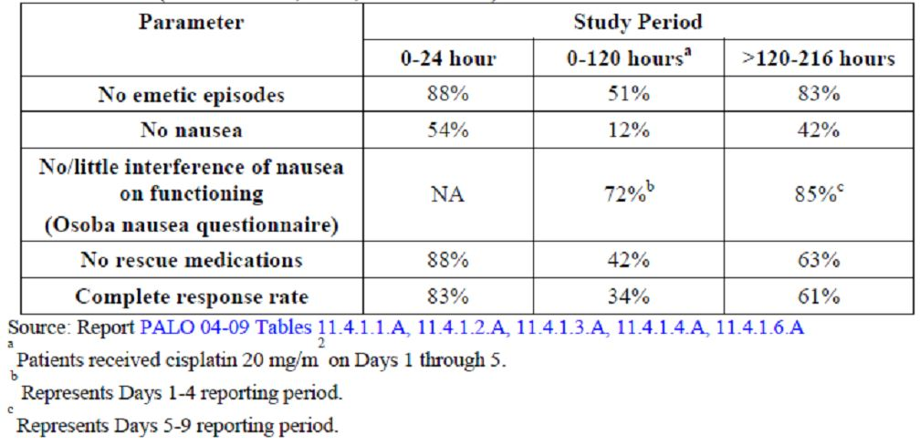

* “However, during the first five days only five (12.2 %) subjects had no nausea and no rescue medications.”

Palonosetron + dexamethasone also prevented severe nausea for most patients, with 59 % or more patients reporting no, or, at maximum, mild nausea at any time on each study day.

Most patients experienced at least 1 episode of nausea during the 216-h study period; the highest incidence, greatest intensity, and longest duration of nausea were reported on Days 3-5. Even so, on any given study day, the majority of patients reported having no or mild nausea.

Most patients reported that nausea had no significant effect on daily functioning on Days 1-4 (72%), and Days 5-9 (85 %) (Figure 3).

Figure 3: The proportion of patients reporting no or little interference with functioning attributable to nausea (Osoba nausea module) (Einhorn et al.).

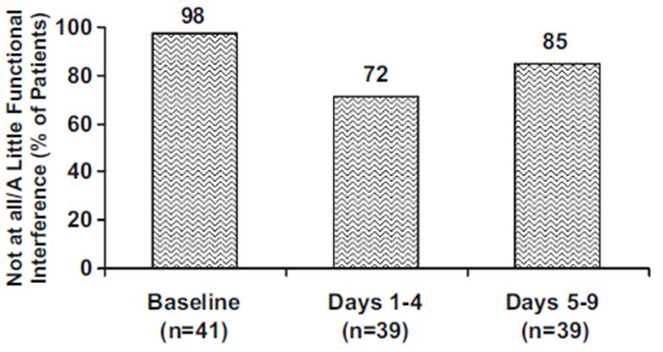

For the entire 216-h study period, patients reported having no nausea for a median of 200 h (equivalent to 8.3/9 of study days) and having mild nausea for a median of 11 hours.

During the 0-120-hour study period, ⅓ of ITT patients (34.1%) reported either no or mild nausea, with 41.5 % and 24.4 % reporting at least 1 episode of either moderate or severe nausea, respectively.

During the >120-216-hour study period, ¾ of patients (75.6 %) reported either no or mild nausea, with 14.6 % and 9.8 % reporting either moderate or severe nausea, respectively.

The median duration of nausea of any intensity was 16 hours over the entire 216-hour study period.

Patients reported minimal interference of nausea on functioning, suggesting that nausea episodes were not significantly debilitating enough to interfere with patients’ social, physical or other functioning.

* “Fourteen (34.1 %) subjects were recorded as having complete response during the 5 days of treatment.”

More than 60 % of patients required no rescue medication on any study day except Day 4 (46 % required no rescue medication). Overall, rescue medication was used on a median of 1 day during the 9-day study.

More than ⅓ of the study population used no rescue medications for the entire 216-hour study period.

The majority of patients had not undergone prior chemotherapy treatment. Because of the small number of non-naïve patients, no analysis of their response vs. that for the chemotherapy-naïve patients was conducted.

The authors concluded that the administration of palonosetron 0.25 mg IV ~30 minutes prior to chemotherapy on Days 1, 3, and 5, along with a regimen of dexamethasone, was effective, safe, and well tolerated for the prevention of CINV in patients receiving daily emetogenic chemotherapy.

“This palonosetron antiemetic regimen was effective in preventing both emesis and significant nausea throughout a 9-day study period in the majority of patients. Importantly, interference with patient functioning attributable to nausea was minimal during both intervals assessed in this study.”

There was no evidence of cumulative toxicity or increase in severity of events as a result of systemic accumulation of palonosetron when palonosetron was given multiple times per week.

Based on this study, the sponsor postulated that the proposed dosing regimen of palonosetron is effective in the prevention of CINV in a difficult-to-treat population. Efficacy results were similar to other antiemetic regimens reported in the literature and widely used in cancer patient population undergoing highly emetogenic chemotherapy.

*Evaluator’s comments: This was an open label, sponsor-led study without a control group investigating multiple days dosing of palonosetron; with such a design it is difficult to be confident in relation to efficacy data.*

*This study, together with its PK component, serves also as the primary source of recommending the alternate days dosing regimen of palonosetron.*

*Overall, the efficacy outcomes were not overly impressive, but probably in line with what one can expect, for highly emetogenic CT, from a combination of a 5-HT3 receptor antagonist + dexamethasone (“gold standard” antiemetic combination at that time).*

*In relation to the effect of palonosetron + dexamethasone on delayed CINV, the evaluator acknowledges, the results that: ”Even on Days 4 and 5, when a complex overlap of acute and delayed cisplatin-induced emesis was most likely present, 68% and 71% of patients, respectively, reported no emetic episodes.” The impact on mitigating the nausea was less clear in this study.*

##### Assanelli et al.

Assanelli and colleagues[30] reported on a prospective single centre study of palonosetron efficacy in patients with haematological malignancies receiving multiple-day and/or HDT regimens and/or myeloablative conditioning treosulfan-based regimens for allogenic bone marrow transplantation.

Abstract entitled: “Palonosetron (Aloxi): A single-centre experience in the prevention of emesis in patients affected by haematological malignancies.”

###### Intervention

100 consecutive patients received “double IV administration of palonosetron 0.25 mg over 30 seconds”, ~30 minutes before the administration of chemotherapy on Day 1 and Day 4 of each cycle + dexamethasone IV 4 mg BD.

No dosage adjustment has been performed in elderly patients (>65 years) and in patients with renal or hepatic impairment.

The diagnoses included various haematological malignancies: AML (65), acute lymphoblastic leukaemia (11), non-Hodgkin’s and Hodgkin’s lymphomas (12 and 4), MM (4), chronic myeloid and lymphocytic leukaemia (1 and 1), and severe aplastic anaemia (2).

A total of 51 patients received allogenic myeloablative conditioning treatment with a treosulfan-based regimen; 12 patients received autologous bone marrow transplantation after a myeloablative regimen with HD-melphalan ± mitoxantrone; 24 patients received HD-aracytin ± HD-methotrexate; and 13 patients received multiple-day standard-dose treatments, as induction or consolidation therapies for acute leukaemias.

Major endpoints included CR defined as the proportion of patients with no nausea and/or emesis and no rescue medication during acute phase (<24 hours after initial dose of CT) and delayed phase (>24 hours but <120 hours after initial dose of CT).

###### Results

During the acute phase, almost all patients (93%) achieved a CR (no emesis, no need for rescue therapy) with only 7 patients (7%) experiencing nausea, followed by 1-5 episodes of emesis, treated with rescue medication, i.e. other 5-HT3 RAs or metoclopramide as needed.

During the delayed phase, 13 patients (13%) suffered nausea, with up to 4 episodes of emesis, with a CR rate of 87 %.

A total of 32 emetic events were registered during the whole observation time (0-120 hours), corresponding to an overall RR of 68%.

Conclusions: “Our experience with the combination of Aloxi (double injection) plus corticosteroid seems to be an effective therapy in the prevention of both acute and delayed CINV confirming also its rational use in an allogenic setting for patients affected by haematological malignancies.”

*Evaluator’s comments: An abstract - non-evaluable (single page document with the headings: 14th Congress of the European Hematology Association, 4-7 June 2009).*

*The study also employed different from the approved dose of palonosetron (2 x 0.25 mg) given on Day 1 and repeated on Day 4.*

##### Musso et al.

Study by Musso and colleagues[31] evaluated the efficacy of palonosetron + dexamethasone in prevention of CINV in patients receiving HDT with auto-SCT, and the efficacy of a 2nd dose of palonosetron in treating breakthrough emesis.

Title: “Palonosetron and dexamethasone for prevention of nausea and vomiting in patients receiving high-dose chemotherapy with auto-SCT.”

Open, uncontrolled, Phase III study conducted in 134 consecutive patients with haematological malignancies. Study participants were predominantly male (60%); with median age 53 years (range: 15-77). The most frequent diagnoses included MM (39%); and NHL (37%); Hodgkin’s disease (10%); and AML (14%).

###### Intervention

Palonosetron on Day 1 of conditioning + dexamethasone (8 mg IV). Dexamethasone (4 mg IV BD every 2nd day) was administered throughout the entire period of conditioning.

For breakthrough emesis, a 2nd dose of palonosetron was given 72 h after the 1st dose.

Duration of treatment: up to 2 doses of palonosetron (0, +72 hrs) if rescue medication required.

The occurrence of breakthrough emesis before 72 h was considered as treatment failure, and patients could receive any antiemetic drug.

The primary end point was CR (no emesis, no rescue therapy) during the conditioning regimen and within 5 days after the end of the conditioning. Secondary end points included CP (no emesis, no significant nausea, and no rescue therapy).

###### Results

CR was reported in 48 (36 %) patients, and among these, 35 (26 %) patients had CP from CINV. Additionally, ½ of patients re-treated with palonosetron for breakthrough emesis, were successfully rescued.

Considering the individual conditioning regimens, CR and CP were observed in 74% and 53%, 58% and 42%, 38% and 24%, and 24% and 18% of patients treated with idarubicin + dexamethasone, melphalan 140 mg/m2, BEAM/FEAM + melphalan 200 mg/m2, respectively.

Breakthrough emesis occurred in 64% (86) of patients. In 28 patients, vomiting episodes occurred 48 h after the 1st dose of palonosetron. The 51 (38%) patients who experienced breakthrough emesis 72 h after the 1st doses were retreated with palonosetron as rescue therapy and 25 (50%) were successfully rescued.

Comments: “The incidence of the overall complete response (36%) and complete protection (26%) was lower than that observed in the multiple-day CT setting, although palonosetron had a similar efficacy (50%) in rescuing patients with breakthrough emesis. Moreover, the subgroup analysis showed differences in efficacy among the different conditioning regimens”

In auto-SCT, several factors may contribute to the onset of nausea and vomiting, including the type of conditioning regimen and use of antibiotics or analgesics, as well as concomitant mucositis, and the fact that no patient is CT-naive. This could partially explain the reduced efficacy of antiemetic prophylaxis in the HD-CT setting.

Conclusions: “Treatment with palonosetron plus dexamethasone seems to be encouraging in terms of prophylaxis of CINV and treatment of breakthrough emesis in the setting of HD-CT.”

*Evaluator’s comments: Similarly to the other paper by the same author7 the study did not deal with the prophylactic multiple dosing of palonosetron, but evaluated the efficacy of a single dose of palonosetron (+ dexamethasone regimen) in patients receiving HDT, and attempted to address the issue of rescue therapy i.e. antiemetic given on demand.*

*“The general principle of breakthrough treatment is to add one agent from a different drug class PRN to the current regimen” (NCCN Guidelines 2012). This is on the background of the optimal prophylactic dosing regimen employed.*

##### Patriarca et al.

Patriarca and colleagues[32] prospectively evaluated 3-drug combination antiemetic therapy of palonosetron + dexamethasone + aprepitant for the prevention of nausea and vomiting in patients (n = 21) undergoing HDT before HSCT.

Abstract entitled: “Effectiveness of a three-drug regimen of dexamethasone, palonosetron and aprepitant for the prevention of acute and delayed nausea and vomiting caused by high-dose therapy before haematopoietic stem cell transplantation.”

###### Intervention

Aprepitant orally 125 mg on Day 1 of chemotherapy and 80 mg on Days 1 and 2 post-chemotherapy + palonosetron 0.25 mg IV Day 1 ± Day 4 ± Day 6 of chemotherapy (according to the duration of chemotherapy) + dexamethasone 8 mg IV each day of chemotherapy and Day 1 and 2 post-chemotherapy.

Acute (during chemotherapy) and delayed (3 days post-chemotherapy) nausea and vomiting were evaluated daily.

The study included 21patients with a median age of 54 years (range: 23 - 70). Overall, 81 days in the acute period and 54 days in the delayed period were examined.

Conditioning regimens were busulphan-cyclophosphamide for acute leukaemia patients (n = 6), melphalan 200 mg/m2 for MM (n = 9), BEAM (carmustine, cytosine arabinoside, etoposide, melphalan) for lymphomas (n = 6).

###### Results

Absence of vomiting was presented on 66/81 (81 %) **days** in the acute period and in 36/54 (67 %) **days** in the delayed period.

Absence of nausea was achieved on 44/81 (54 %) days in the acute period and 23/54 (43 %) days post-chemotherapy. Rescue therapy was administered on 12/81 (15 %) days in the acute period and 9/54 (17 %) days in the delayed period.

No limitation of feeding and daily activity was presented on 44/81 (54 %) and 46/81 (57 %) days in acute period, respectively; and on 18/54 (33 %) and 22/54 (41 %) days post-chemotherapy.

The authors concluded that the 3-drug antiemetic regimen of aprepitant + palonosetron + dexamethasone was feasible and effective for the protection against both acute and delayed nausea and vomiting due to HDT.

*Comment: An un-evaluable abstract. This small study used unconventional endpoints; the days of chemotherapy with/without symptoms; that are rather meaningless for the evaluator.*

##### Deauna-Limayo et al.

Deauna-Limayo and colleagues[33] evaluated emetic responses to prophylactic multi-day doses of palonosetron + aprepitant + low dose dexamethasone in patients undergoing ASCT for MM and relapsed lymphoma.

Abstract entitled: “Aprepitant combined with Palonosetron, Lorazepam and low doses Dexamethasone in Prevention of Emesis among Patients with Multiple Myeloma and Lymphoma Undergoing High Dose Therapy and Autologous Hematopoietic Stem Cell Transplant: A Pilot Study.”

A total of 20 patients were enrolled (October 2007 - January 2010), of which 18 were considered evaluable; 9 MM and 9 lymphoma (Hodgkin and NHL). There were 11 males and 9 females with median age of 55 years (range: 35-66).

###### Intervention

Standard doses of aprepitant 125/80/80 mg were administered on Days -3, -2, -1 for MM group, and Days -7, -6, -5 for lymphoma group.

Low dose dexamethasone 4 mg IV + multi-day doses of palonosetron 0.25 mg IV were given on Days -3, -2, -1, and on Days -7 through -3 for the MM and lymphoma groups, respectively. In both groups, palonosetron was repeated on Day +3.

Acute CINV was defined as nausea and/or vomiting within 24 hours of chemotherapy. Delayed CINV was defined as nausea and/or vomiting after 24 and up to 72 hours after chemotherapy. Extended CINV was defined as nausea and/or vomiting after 72 hours of chemotherapy.

Emetic responses were defined as follows: Complete Control (CC) no emetic episode in 24 hours, no rescue medications and NVS of ≤ 2.5; Complete Emetic Response (CR) 0 emetic episode, no rescue; Major Emetic Response (MR) 1-2 episodes; Minor Emetic Response (MR) 3-5 episodes; Failure >5 episodes.

###### Results

Acute CINV: Responses were achieved in all patients: CC 2/9 (22%) and MR 7/9 (78%) in MM patients and CC 2/9 (22%), CR 2 (22%) and MR 5/9 (56%) in lymphoma patients (Table 4).

Table 4: Efficacy results from Deauna-Limayo at al.

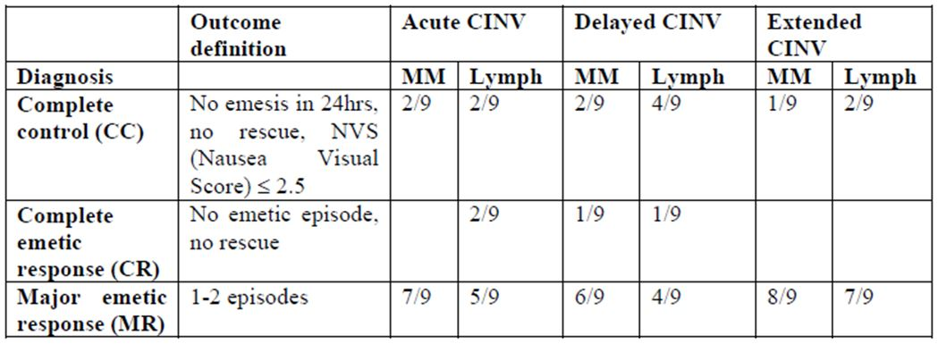

Delayed CINV: Responses were achieved in all patients: CC 2/9 (22 %), CR 1 (11 %) and MR 6/9 (67 %) in MM patients and CC 4/9 (44 %), CR 1 (11 %) and MR 4/9 (44 %) in lymphoma patients.

Extended CINV: Responses were achieved in all patients: CC 1/9 (11%) and MR 8/9 (89%) in MM patients and CC 2/9 (22%) and MR 7/9 (78%) in lymphoma patients.

Conclusions: “The combination of aprepitant, multi-day palonosetron, and low dose dexamethasone appear to be well tolerated and effective in achieving at least a major emetic response, in 100 % of patients with MM and lymphoma undergoing HDT and ASCT.

These encouraging results should warrant further evaluation in a larger population of ASCT patients.”

*Comment: Un-evaluable data. With the use if acronyms in this abstract it is not possible to distinguish between major and minor emetic response; both abbreviated to MR.*

### Guidelines on antiemesis

The sponsor referred to 3 antiemetic guideline sets: MASCC/ESMO (2011),[34] NCCN (2012),[35] and ASCO (2011)[36] guidelines.

#### Multi-day chemotherapy MASCC/ESMO guidelines (updated April 2011 on www.mascc.org; Roila et al.)

The sponsor provided the following summary of the Multinational Association of Supportive Care in Cancer (MASCC) and European Society of Medical Oncology (ESMO) Guidelines, in relation to issues raised in current submission:

MASCC guidelines for patients receiving repeated dosing of highly emetogenic chemotherapy were updated in April 2011. (Tables listing the emetogenic potential of single various antineoplastic agents have been widely published.)

A significant population in this review included patients receiving a 5-day course of cisplatin for testicular cancer. While the first days of this regimen resulted in patients having vomiting and nausea, the worst occurrence is seen on Days 4 and 5 as well as on Days 6, 7 and 8.

Whether this reflects delayed vomiting and nausea from the 1st day of the regimen which is historically the most severe day; delayed onset following the last day of chemotherapy; or, if there are multiple mechanisms involved, is not clear.

The MASCC guidelines recommend:

* Patients receiving multi-day cisplatin should receive a 5-HT3 RA + dexamethasone for acute, and dexamethasone for delayed nausea and vomiting.
* A 5-HT3 RA should be dosed Days 1-5 except for palonosetron that should be dosed on Days 1, 3 and 5 only.

*Evaluator’s comments: Prevention of nausea and vomiting induced by multiple-day cisplatin chemotherapy: The comments are outlined in paper by Roila et al.[37], and are based on 2009 Perugia ESMO-MASC Consensus Conference.*

*“Only a few small studies have been carried out with this type of chemotherapy schedule.”*

*“Using a combination of a 5-HT3 receptor antagonist plus dexamethasone, patients receiving consecutive 5 days of cisplatin for testicular cancer will have little or no nausea or vomiting during the first 3 days of chemotherapy. The worst nausea is seen on Day 4 and Day 5 as well as on Days 6, 7 and 8. Whether this all reflects delayed nausea from Days 1 and 2 is unknown.*

*Strategies for delayed nausea and vomiting for multiple-day cisplatin courses should be utilised similarly to single-day high-dose cisplatin.”*

* + *“Patients receiving multiple-day cisplatin should receive a 5-HT3 receptor antagonist plus dexa-methasone for acute nausea and vomiting and dexamethasone for delayed nausea and vomiting.” [MASC Level of Confidence: High, Level of Consensus: High]; [ESMO Level of Evidence: II, Grade of Recommendation: A]*

*“The optimal dose of the 5-HT3 receptor antagonist as well as of dexamethasone remains to be identified.”*

*“The possible role of the NK1 receptor antagonists in this setting remains undefined.”*

* + *The above position of the expert committee has been upheld by the MASC 2011 update (“Guideline for patients receiving multiple-day cisplatin”), with the following comments:*

*“No guideline was felt to be appropriate for rescue antiemesis or high-dose (i.e. transplant) chemotherapy. 5-HT3 receptor antagonists should be dosed Day 1 - 5, except for palonosetron that should be dosed on Days 1, 3 and 5 only.”*

*With respect to palonosetron use for the prevention of acute nausea and vomiting in the setting of cisplatin-containing chemotherapy, the following comments have been made:*

*The authors of the paper referred to 2 studies that have compared palonosetron with ondansetron and granisetron and discussed their shortcomings. These studies included single doses of palonosetron, but comments are interesting as they provide some background information.*

*“These studies do not address the issue of whether palonosetron is superior to other 5-HT3 receptor antagonists when an NK1 receptor antagonist is used as recommended by guidelines.*

*Therefore, it is concluded that more studies are necessary to determine whether palonosetron should be recommended as the 5-HT3 receptor antagonist of choice in prevention of cisplatin-induced acute nausea and vomiting. These studies should include a NK1 receptor antagonist.”*

*With respect to delayed nausea and vomiting in the setting of cisplatin- containing chemotherapy, the following comments are worth noting:*

*Overall comment on highly emetogenic chemotherapy: “A number of predictive factors have been identified for the development of delayed nausea and vomiting. By far the most important is the presence or absence of acute nausea and vomiting.”*

*“Therefore, the panel recommended that given the dependence of delayed emesis and nausea on acute antiemetic outcome, optimal acute antiemetic prophylaxis should be employed.”*

* + *Of note are the updated recommendations on prevention of acute and delayed nausea and vomiting following chemotherapy of high emetic risk (single IV agents).*

*In context of the delayed emesis the following has been said (MASC update, April 2011):*

* + *“In patients receiving cisplatin treated with a combination of aprepitant (or fosaprepitant), a 5-HT3 receptor antagonist and dexamethasone to prevent acute nausea and vomiting, the combination of dexamethasone and aprepitant is suggested to prevent delayed emesis, on the basis of its superiority to dexamethasone alone.” [MASC Level of Confidence: High, Level of Consensus: Moderate High]*
  + *Haematological malignancies: “There are still very few data on the effective use of modern antiemetics for patients treated with high-dose chemotherapy with stem cell support. Most reports involve phase II studies of a 5-HT3 receptor antagonist alone or combined with dexamethasone. A major difficulty in evaluating patients in this setting is the multi-factorial nature of the nausea and vomiting.”[38]*

*“In summary, complete protection from nausea and vomiting is currently achieved in a minority of patients receiving high dose chemotherapy and stem cell transplantation. The use of a 5-HT3 receptor antagonist with dexamethasone represents the current standard of care. Randomised studies evaluating the efficacy of aprepitant added to standard therapy are necessary.”[39]*

#### Multi-day chemotherapy NCCN Guidelines Version 1.2012 (www.nccn.org)

The sponsor provided the following summary of the National Comprehensive Cancer Network (NCCN) Guidelines (2012),[40] that at are intended to support the multiple days dosing of palonosetron:

The NCCN Guidelines state:

* A 5-HT3 RA should be administered prior to the 1st dose of chemotherapy (palonosetron preferred).
* A unique dose of palonosetron may be used before a 3 days of chemotherapy regimen. Multiple doses of palonosetron is likely to be safe while in term of efficacy the need of repeat dosing of palonosetron either daily or less frequently in the setting of multiple day chemotherapy is not yet known.

*Evaluator’s comments: NCCN Guidelines: “Managing Multiday Emetogenic Chemotherapy Regimens”*

*“Patients receiving multiday chemotherapy are at risk for both acute and delayed nausea/vomiting based upon the emetogenic potential of the individual chemotherapy agents and their sequence. It is therefore difficult to recommend a specific antiemetic regimen for each day, especially since acute and delayed emesis may overlap after the initial day of chemotherapy until the last day of chemo-therapy.*

*After chemotherapy administration concludes, the period of risk for delayed emesis also depends on the specific regimen and the emetogenic potential of the last chemotherapy agent administered in the regimen. For multi-drug regimens, antiemetic therapy should be selected based on the drug with the highest emetic risk.”*

*As a general principle the NCCN panel recommendations are as follows:*

* + *A 5-HT3 receptor antagonist should be administered prior to the first dose of moderately or highly emetogenic chemotherapy.*
  + *Dexamethasone should be administered once daily (either orally or IV) for moderately or highly emetogenic chemotherapy, and for 2-3 days after chemotherapy for regimens that are likely to cause significant delayed emesis.*
  + *The potential role of NK-1 antagonists in the antiemetic management of multiday chemotherapy regimens remains to be defined.*

*Aprepitant may be used for multiday chemotherapy regimens likely to be highly emetogenic and associated with significant risk for delayed nausea and emesis (Cat 1 evidence for single-day chemotherapy regimens only.)*

* + *“For antiemetic prophylaxis of multiday emetogenic chemotherapy regimens (e.g., cisplatin-containing regimens), the combination of a 5-HT3 antagonist with dexamethasone remains the standard treatment.”*

*The use of 5-HT3 antagonist is further discussed:*

* + *Palonosetron IV may be used before the start of a 3-day chemotherapy regimen instead of multiple daily doses of oral or IV 5-HT3 receptor antagonists.*
  + *Repeat dosing of palonosetron (0.25 mg IV) is likely to be safe, based on the dose ranging Phase II trial (where up to 30-times the FDA approved dose (90 µg/kg) was administered) and the 3 Phase III trials using palonosetron as a single fixed dose (0.75 mg IV).*
  + *Compared to the approved dose of palonosetron of 0.25 mg IV, these higher doses were not associated with significantly different AEs.*
  + *In terms of efficacy, the need for repeat dosing with palonosetron, either daily or less frequently, in the setting of multiday chemotherapy is not yet known.*

*A total of 3 references were cited to back up this statement:*

* + *Reference to study by Einhorn et al.[41]: In one study, patients receiving highly emetogenic multiday cisplatin-based chemotherapy for testicular cancer (n = 41) received multiday dosing of palonosetron (0.25 mg IV on Days 1, 3, and 5) and dexamethasone, which prevented nausea and emesis in most patients on Days 1-5 (51%) and on Days 6-9 (83%); the most common AEs were mild headache and constipation.*
  + *Reference to study by Giralt at al.[42] of palonosetron (given for 1, 2. or 3 days) + dexamethasone; noting that during the 7-day emesis prevention period, about 40 - 45 % of patients had no emesis.*

*In this study, however, even among the patients who received either 2 or 3 days of palonosetron, only 20 % had a complete response (i.e., emesis free without rescue medication).*

* + *Reference to study by Musso at al.[43] that found that a palonosetron/dexamethasone regimen appeared to be more effective for multiday chemotherapy than ondansetron/dexamethasone regimen; the 2nd dose of palonosetron for breakthrough emesis was effective in 67 % of patients who experienced nausea or vomiting.*
  + *“Further studies are needed to define whether a need exists for repeated dosing of palonosetron in the setting of multiday chemotherapy.”*
  + *As sponsor rightly noted, the NCCN Guidelines version 2012 had the word “preferred” added to palonosetron 0.25 mg IV on Day 1 for high-risk chemotherapy and “preferred” on Day 1 only for moderate emetic risk IV chemotherapy (change from 2011 version).*

*The issue of this specific wording in relation to palonosetron warrants brief discussion, as it was emphasised by the sponsor. This wording (palonosetron preferred) is not repeated in the context of multiple day chemotherapy. The following points have been raised by the expert committee of the NCCN Guidelines:*

* + *Several large, multicentre, double-blind, randomised phase III trials have demonstrated the superiority of palonosetron compared with other 5-HT3 antagonists in preventing emesis associated with both moderate and high emetic risk chemotherapy regimens, particularly for delayed emesis.*

*In these studies, the primary efficacy end point was CR, defined as having no emesis and no rescue treatments.*

* + *IV palonosetron is FDA approved as a single dose on Day 1 for the prevention of acute and delayed nausea and vomiting associated with moderately and highly emetogenic chemotherapy.*

*(This is not strictly correct, as for the highly emetogenic chemotherapy the FDA label of Aloxi does not carry the indication for the prevention of delayed nausea and vomiting.)*

*It is the “preferred” 5-HT3 antagonist for the prevention of acute and delayed emesis associated with high emetic risk IV chemotherapy and is also recommended (Category 1) for emesis prevention when using moderate emetic risk IV chemotherapy.*

*It should be noted that the recommendation for palonosetron as the “preferred 5-HT3 antagonist” for antiemetic prophylaxis in the setting of high emetic risk chemotherapy is based upon data from randomised studies with the 2-drug combination of palonosetron and dexamethasone.*

*Palonosetron IV was superior to other 5-HT3 antagonists for preventing delayed nausea. Repeat dosing of palonosetron in the days after chemotherapy (i.e., days 2 or 3) is likely to be safe.*

*However, in the setting of multiple day (i.e., multiday) chemotherapy, need for repeat dosing with palonosetron is not yet known.*

* + *“The superiority of palonosetron over other available 5-HT3 antagonists in preventing acute and delayed nausea and vomiting in the setting of high emetogenic chemotherapy was demonstrated in a recent meta-analysis of randomised controlled trials.*

*Therefore, the NCCN Guidelines Panel recommends palonosetron as the preferred 5-HT3 antagonists for high emetic risk chemotherapy.*

*As previously noted, the recommendation for palonosetron as the preferred 5-HT3 antagonist for antiemetic prophylaxis in this setting is based upon data from randomised studies (discussed earlier) with the 2-drug combination of palonosetron and dexamethasone.”*

*Similar conclusions based on the most recent meta-analysis (2011) of RCTs comparing palonosetron with other available 5-HT3 antagonists have been drawn in the setting of moderately emetogenic chemotherapy.*

*NCCN Guidelines: Acute and Delayed Emesis Prevention - High and Moderate Emetic Risk IV Chemotherapy refer to Figures 4 and 5.*

*As a general principle the guidelines recommend in this scenario the 5-HT3 antagonist + steroid ± neurokinin 1 antagonist (+ for high risk) ± lorazepam ± H2 blocker.*

*“The risk of nausea/vomiting for persons receiving chemotherapy of high and moderate emetic risk lasts for at least 3 days for high and 2 days for moderate after the last dose of chemotherapy. Patients need to be protected throughout the full period of risk.”*

Figure 4: NCCN Guidelines 2012 (antiemesis).

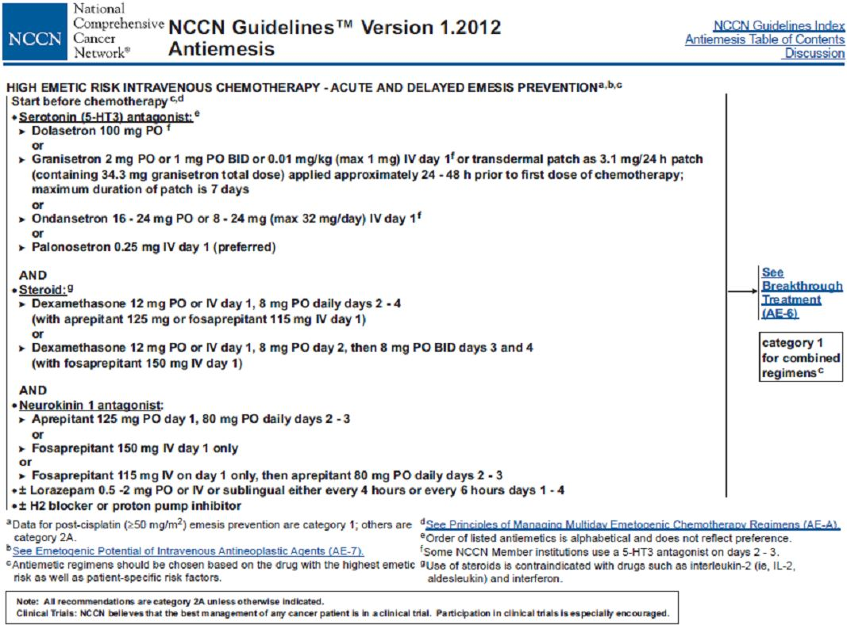

Figure 5: NCCN Guidelines 2012 (antiemesis).

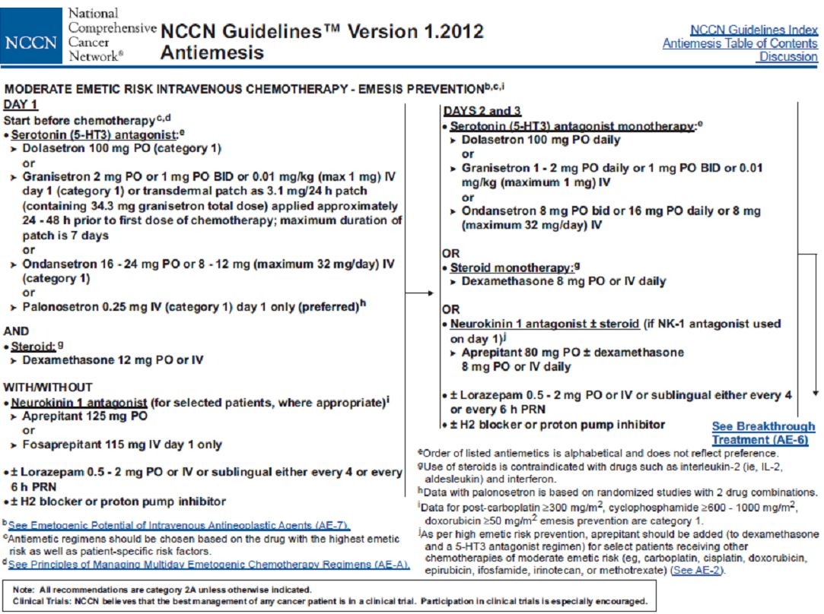

#### Multi-day chemotherapy ASCO Guidelines (www.asco.org)[44]

The sponsor provided the following comments regarding the American Society of Clinical Oncology (ASCO) Guidelines (published 2011) in relation to multiple days dosing of palonosetron:

The ASCO guidelines state in reference to prevention of nausea and vomiting for patients receiving multiday chemotherapy as follows:

* Antiemetics appropriate for the emetogenic risk class of the chemotherapy to be administered for each day of the chemotherapy and for 2 days after, if appropriate.
* Patients receiving 5-day cisplatin regimens should be treated with a 5-HT3 antagonist in combination with dexamethasone and aprepitant (Table 5: Overall principles; and Table 6: Summary of recommendations - multiday chemotherapy).

Table 5: ASCO Guidelines 2010 (Antiemesis).

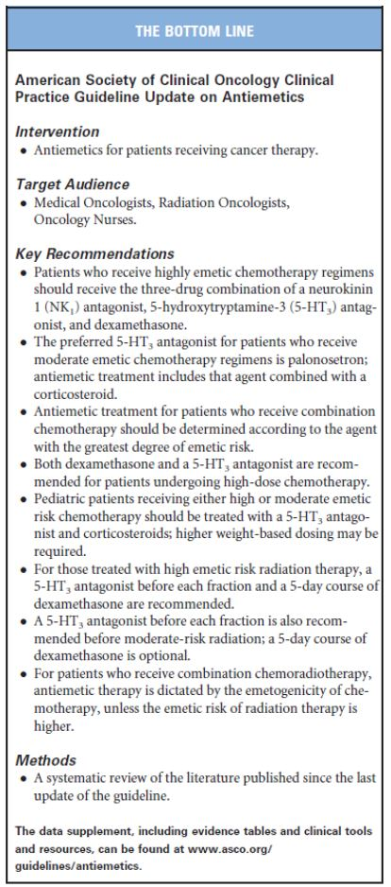

Table 6: ASCO Guidelines 2010 (Antiemesis).

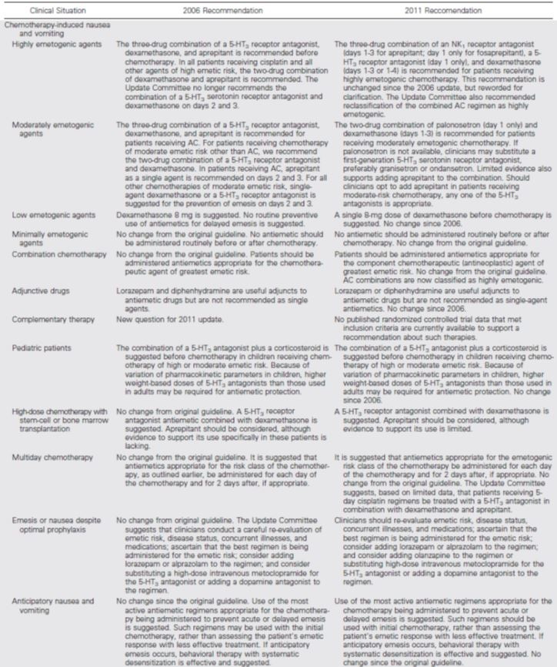

*Evaluator’s comments: The guidelines itself do not refer specifically to multiple days dosing of palonosetron.*

*Multiday chemotherapy: “It is suggested that antiemetics appropriate for the emetogenic risk class of the chemotherapy be administered for each day of the chemotherapy and for 2 days after, if appropriate. No change from the original guideline. The Update Committee suggests, based on limited data, that patients receiving 5-day cisplatin regimens be treated with a 5-HT3 antagonist in combination with dexamethasone and aprepitant.”*

*No specific reference to palonosetron in this setting, only granisetron transdermal patch mentioned as an option for patients who receive high-risk, multiday chemotherapy.*

* + *In the setting of high-dose chemotherapy with stem-cell or bone marrow transplantation repeated dosing of palonosetron is mentioned in the literature review, but not in the recommendations.*

*Recommendations: A 5-HT3 receptor antagonist combined with dexamethasone is recommended. Aprepitant should be considered, although evidence to support its use is limited.*

*Literature update: “One report detailed superior emetic control with palonosetron. Data suggest that 2 days of palonosetron therapy will decrease the likelihood of CINV.” (Giralt at al.[45])*

* + *Although not of direct relevance to multiple palonosetron applications, the issue of preference of palonosetron over other 5-HT3 antagonists, in the setting of moderately emetogenic therapy is worth mentioning:*

*“The preference for palonosetron is an extrapolation from the Saito et al.;[46] when an NK1 receptor antagonist is not used in the setting of cisplatin and AC chemotherapy, the combination of palonosetron and dexamethasone is superior to granisetron and dexamethasone.*

*By inference, with non-AC moderately emetogenic chemotherapy, palonosetron and dexamethasone are also likely to be superior to a first-generation 5-HT3 receptor antagonist and dexamethasone.”*

#### Other literature references

##### SEOM Clinical Guidelines

A paper outlining the Spanish Society of Medical Oncology (SEOM) Guidelines[47] has been submitted.

*Evaluator’s comments: The guidelines deal mainly with antiemetic strategies for one-day chemotherapy regimens.*

*The antiemetic prophylaxis for chemotherapy “beyond a day” indicates “palonosetron day 1 (single dose) for the duration of its effect”. The guidelines do not contain any reference in relation to multiple dosing of palonosetron.*

##### Review paper by Schwartzberg at al.

Schwartzberg and colleagues[48] reviewed the role of second-generation 5-HT3 receptor antagonists in managing chemotherapy-induced nausea and vomiting in hematological malignancies.

Compared with solid tumour patients, those with haematological malignancies are at particular risk of CINV because of their young age, exposure to highly-emetogenic induction, consolidation and salvage regimens, the high-dose conditioning regimens used before stem cell transplantation, and the heavy psychological burden of such treatments.

A further feature of the haematologic setting is that several front-line chemotherapy regimens most salvage programs, platinum-based rescue regimens for lymphoma, and all pre-transplant conditioning regimens are delivered on multiple days.

* In contrast to solid tumours, there are no internationally agreed guidelines for the prevention and treatment of CINV in haematological malignancies. The MASC/ESMO/ASCO committees were unable to arrive at any formal recommendations.

The authors reviewed the available literature producing “Recommendations on the dosing of palonosetron in various haematological malignancies” (Table 7).

Table 7: Recommendations on the dosing of palonosetron in various haematological malignancies (Schwartzberg et al.).

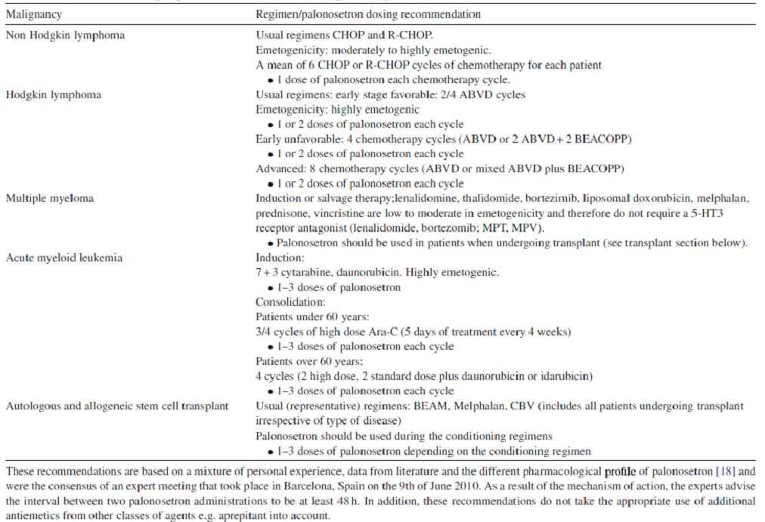

The recommendations refer to palonosetron being used as “1 dose”, “1 or 2 doses”, or “1 - 3 doses” each chemotherapy cycle, depending on the specific treatment employed.

“These recommendations are based on a mixture of personal experience, data from literature and the different pharmacological profile of palonosetron and were the consensus of an expert meeting that took place in Barcelona, Spain on the 9th of June 2010.”

The authors acknowledge that it would be helpful to undertake further studies of palonosetron with regard to optimum dosing schedule, and its possible use in combination with other anti-emetics, notably NK-1 inhibitor.

### Conclusions regarding efficacy

The sponsor provided the following comments in relation to current LBS and the evidence provided supporting multiple days dosing regimen of palonosetron:

* While not all studies with multiple dose per cycle of palonosetron have been RCTs, thus reducing the level of evidence, all of the study results have been in the same direction, i.e. in favour of multiple dosing, thus strengthening the argument in favour of the proposed multiple dose regimen.
* Given the US and European acceptance of multi-dose per chemotherapy cycle palonosetron, it will not be possible to do any more large RCTs in this area, so that there is no expectation of a major change in the published literature.
* From the literature included in this review, and supported by the MASCC/ESMO guidelines, it is clear that palonosetron given on alternate days during multi-day chemotherapy dosing is more effective than when given just once, particularly for the later days of chemotherapy-induced nausea/vomiting. It is also more effective than other “setrons”.
* The key clinical evidence in this submission is provided by the 3 recent major RCTs (Noor et al.,[49] Giralt et al.[50] and Mattiuzzi et al.[51]) supported by the findings of the uncontrolled study by Einhorn et al. 20072.
* The repeated palonosetron regimen used by Einhorn et al.[52] was effective in preventing emesis and moderate-to-severe nausea throughout the 216-hour study period for the majority of cancer patients who received cisplatin-based chemotherapy for 5 consecutive days. Efficacy results were similar to other antiemetic regimens reported in the literature and widely used in cancer patient population undergoing highly emetogenic chemotherapy.
* The following were the conclusions from the uncontrolled, sponsor-led PALO-04-09 study:

“In terms of efficacy, with multiple-day administration of palonosetron, approximately half of the ITT population of this study had no emetic episodes during CT (Days 1-5) or throughout the entire study period (Days 1-9). Overall, about one third of patients in the study had a complete response to therapy.

Importantly, although the majority of the ITT population reported some nausea during at least one interval in the study, more than two thirds reported little or no functional impact on activities of daily living due to nausea.”[53]

* A significant number of patients is included in the mixture of studies presented in this submission (RCTs, retrospective comparisons, uncontrolled studies), using the standard dose of palonosetron (0.25 mg IV) approved in Australia, and all results are in the same direction i.e. in favour of multiple dosing, thus strengthening the argument in favour of the proposed regimen.
* This comprehensive group of studies is fully applicable to the Australian patient population in terms of patient demographics (age, sex), oncology diagnoses, and the chemotherapy regimens employed.
* Both MASCC/ESMO and NCCN guidelines support this, and these are based on the published literature.
* Comprehensive reviews of all the available literature are also supportive (Schwartzberg et al.[54] and Feinberg et al.[55]) and there is no conflicting literature to dilute it.
* Feinberg et al.[56] extended the RCT findings to a retrospective community-based analysis of patients receiving multi-day platinum based chemotherapy regimens for lung cancer and found that palonosetron-initiated cycles were associated with a significantly lower risk of uncontrolled CINV compared with ondansetron initiated cycles i.e. the findings of the RCTs are supported by clinical experience in the community.
* Costs of allowing alternate day dosing will be contained by the requirement that palonosetron only be given on a day when chemotherapy is being given and by the reduction in healthcare costs associated with fewer unplanned visits to clinic and fewer unplanned admissions for management of chemotherapy-induced nausea/vomiting.
* Furthermore, as previously mentioned, it will not be possible to do a large, prospective RCT in this area given the European and US approvals are already in place.

#### Comments on efficacy

Overall, the available efficacy data to back up the multiple days of administration of palonosetron IV for prevention of CINV are inconclusive.

None of the three randomised controlled trials, submitted as published papers and intended to back up the proposed alternate day dosing of palonosetron, convincingly demonstrated the benefits of this regimen, or in fact the benefits of multiple day dosing of palonosetron.

In fact, only two of these randomised controlled trials investigated the alternate day dosing of palonosetron (Mattiuzzi et al.[57] and Noor at al.[58]). This amounts to a total of 63 patients exposed to alternate days of administration of palonosetron in these two studies.

The sponsor led PALO-04-09 study published by Einhorn et al.[59] was an open label uncontrolled study that cannot be strictly accounted as an adequate efficacy study design. It investigated an alternate days dosing regimen in 41 patients with testicular cancer.

In this study, regarded as key study for this submission, half of the patients (51.2%) had no emetic episodes for the 1-5 days study period, 12.2% of patients had no nausea and no rescue medications during the first 5 days, and 34.1 % of patients were recorded as having complete response during the 5 days of treatment.

On Days 4 and 5, when a complex overlap of acute and delayed cisplatin induced emesis was most likely present, 68% and 71% of patients, respectively, reported no emetic episodes.

Overall, efficacy outcomes from this trial were not overly impressive, but probably in line with what one can expect from a combination of a 5-HT3 receptor antagonist + dexamethasone in this setting.

The rest of the efficacy data represented a mixture of studies in a heterogeneous patient’s population with a variety of dosing schedules of palonosetron, and provided equally equivocal results.

Overall, some trends indicating possible benefits of repeating the doses of palonosetron were described in the published studies, however, often the studies were underpowered, or not evaluable.

The submitted guidelines representing the opinions of the learned cancer societies are cautiously supportive of the repetitive dosing of palonosetron, in specific circumstances.

There is an obvious scarcity of good quality data.

#### Conclusion

Based on the sponsor led PALO-04-09 study, the submitted three randomised controlled trials, the rest of published papers involving alternate days dosing of palonosetron, and on the basis of extrapolation from indirect evidence involving different dosing schedules of palonosetron, the evaluator believes that there is likely some benefit in repeating the dosing of palonosetron for up to 3 doses/cycle.

These data are, however, not sufficiently robust to be included in the ‘Clinical Trials’ section of the Aloxi PI.

## Clinical safety

The summary of safety relates primarily to the 2 Helsinn studies (PALO-02-12 and PALO-04-09) as these registration studies provided the most detailed safety monitoring in association with repeated doses of palonosetron.

The published studies included in the current submission, as support for the clinical efficacy of the multi-dosing schedule palonosetron, generally do not provide details of safety monitoring or methods of collection of AE reports. However, the published reports do include a summary of AEs reported during an individual study.

### Patient exposure (registration studies)

Overall, 12 healthy volunteers and 41 cancer patients were exposed to palonosetron during the clinical studies PALO-02-12 and PALO-04-09.

Subjects received a single dose of palonosetron 0.25 mg/day and a total cumulative exposure to 0.75 mg of the drug over 3 days; in study PALO-02-12 the dose was received on 3 consecutive days; in study PALO-04-09 the dose was received on Days 1, 3 and 5 of cisplatin treatment.

In PALO-02-12 study 4 subjects received placebo. All subjects who received at least 1 dose of study medication and had at least 1 post-dose safety assessment were included in the safety analysis for each study.

### Safety data

#### AEs (registration studies)

In both sponsor-led studies the AEs were reported including both serious and non-serious AEs, pre-dose AEs and AEs occurring between dosing and 14 days post-dose (SAEs up to 30 days post-dose).

##### PALO-02-12 (Hunt et al.)[60]

Phase I PK study involving healthy volunteers that assessed safety throughout the study by monitoring of AEs and evaluation of vital signs, physical examinations, clinical laboratory assessments, and 12-lead ECGs. All 16 enrolled subjects were evaluable for safety.

###### Safety outcome

There were no new safety concerns due to repeat dosing of palonosetron daily for 3 days in healthy subjects. There was no increase in the incidence of TEAEs at Day 3 compared to Day 1.

A total of 6/12 subjects in the palonosetron group reported 11 AEs. Only one AE (mild pruritus) was considered possibly related to palonosetron. In the placebo group, 2/4 subjects reported 2 AEs (Table 8).

Table 8: Summary of all treatment emergent AEs in Study PALO-02-12 (Hunt et al.).

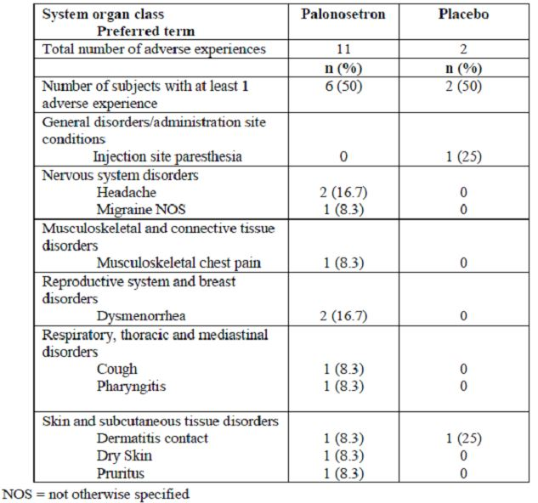

##### PALO-04-09 (Einhorn et al.)[61]

Phase II, open label study in patients with testicular cancer that assessed safety by a review of all AEs and vital signs. Safety and efficacy were assessed over nine 24-hour periods starting with the initiation of chemotherapy (Day 1) and ending on Day 10. ECG testing (Days 1 and 5) was performed on a subset of 11 patients (Table 9).

Table 9: Overview of treatment emergent AEs in Study PALO-04-09 (Einhorn et al.).

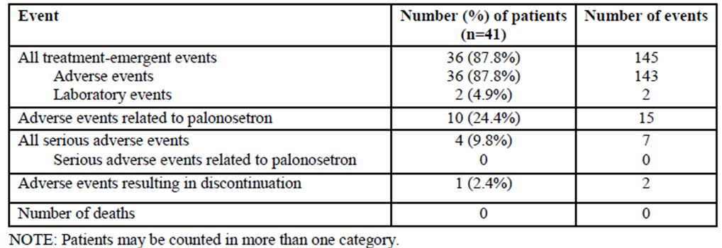

A total of 3 ECG tests/session/patient recorded 20 minutes before (baseline) and 20 minutes after palonosetron was given. For patients participating in both PK and ECG assessments, laboratory samples were taken on Day 5 prior to chemotherapy for UEC assessment.

###### Withdrawals

39 patients completed the study; and 2 withdrawals; 1 patient due to non-palonosetron related SAEs (fluid overload secondary to over-hydration and asymptomatic sinus bradycardia previously known); 1 patient withdrawn on Day 4 due to nausea and vomiting (palonosetron given on Days 1 and 3).

###### Safety outcomes

The incidence of TEAEs in this study was consistent with AEs reported by patients receiving chemotherapy, as reported in the approved dosing regimen for IV palonosetron. There was no inference of any increase in either incidence or intensity of these AEs following repeated dosing regimen of palonosetron.

Overall, 36 (87.8%) patients reported a total of 145 TEAEs. However, only 15 of these AEs, in 10 (24.4%) patients, were considered to be related to treatment (Table 10).

Table 10: Patients with palonosetron related AEs in Study PALO-04-09 (Safety set).

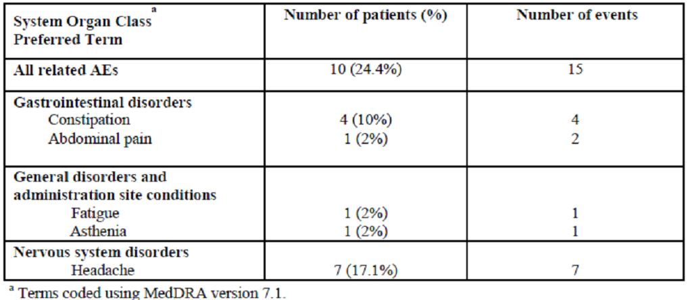

As expected for palonosetron and the 5-HT3-receptor antagonists, the most frequently reported AEs related to palonosetron consisted of headache (7 patients) and constipation (4 patients).

The majority of AEs were reported from the GI disorders and General Disorders and Administrative site conditions SOC (61% and 58.5%, respectively). Other frequently reported were Nervous System disorders (24.4%) and Psychiatric disorders (24.4%).

The most frequently reported AEs were fatigue (43.9%), dyspepsia (26%), headache (17.1%), constipation (17.1%) and nausea (17.1%).

AEs considered possibly or probably related to palonosetron, as determined by the investigator, were headache (7 patients), constipation (4 patients) and in 1 patient each; fatigue, asthenia, and abdominal pain (1 patient reported 2 AEs of abdominal pain).

All TEAEs were mild in severity, except for 1 moderate AE each of; headache, constipation and abdominal pain.

When analysed by study-day, palonosetron-related AEs did not increase in intensity or frequency over the study period. There did not appear to be any cumulative AEs related to palonosetron.

###### Conclusions

The administration of palonosetron on Days 1, 3, and 5, along with a regimen of dexamethasone, was effective, safe, and well tolerated for the prevention of CINV in patients receiving daily emetogenic chemotherapy.

There was no evidence of cumulative toxicity or increase in severity of AEs as a result of systemic accumulation of palonosetron when palonosetron was given multiple times per week. ECG data were acquired over several days of therapy and suggest no evidence of a cumulative effect of palonosetron on cardiac ventricular repolarisation in this trial.

This multiple-day antiemetic regimen was safe, with headache and constipation the most common TEAEs; mostly mild.

Neither AEs nor ECG changes appeared to increase in frequency, duration, or intensity over time despite a 1.42-fold systemic accumulation of palonosetron with repeated doses.

Likewise, there was no indication of any cardiac effects. The incidence of TEAEs in this study was consistent with those reported in previous trials and in clinical practice.

ECG monitoring during the administration of palonosetron revealed no significant arrhythmias. No clinically significant changes in ECG intervals or pattern were recorded. In this small sample, no patients developed prolongation of QT or QTc.

##### Summary of AEs in registration studies

Overall, there were no new safety findings reported during the PALO-04-09 and PALO-02-12 studies. No patient or subject experienced a palonosetron-related SAE or withdrew from the either study due to a palonosetron-related AE.

#### Published studies

The safety data from published studies is presented in Table 11.

Table 11: Listing of AEs reported in published studies related to multiple dosing of 0.25 mg IV palonosetron for the prophylaxis of CINV.

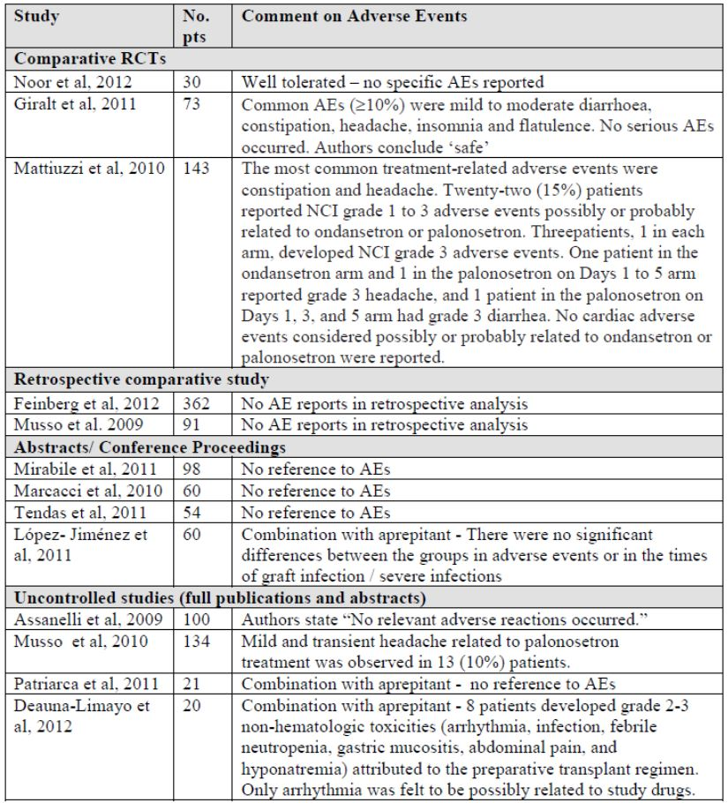

### Safety comparisons

The sponsor provided the following additional safety information:

The safety profile from the registration studies by Hunt et al. and Einhorn et al. is consistent with data in previous safety CINV studies which were included in the original Aloxi registration dossier, i.e. studies 2330, PALO-99-03, PALO-99-04 and PALO-99-05.

In these studies, a total of 633 patients received a single IV palonosetron dose of 0.75 mg, x3 the current authorised single dose of 0.25 mg. No safety issues were identified with the 0.75 mg dose in these studies.

In study 2330, 77 patients received single palonosetron doses >0.75 mg, with 50 patients receiving a dose of 90 μg/kg (~6 mg, ~24 times the 0.25 mg dose), with safety profiles not significantly different than those of the 0.25 mg dose.

### Safety in special groups and populations

No data from special groups or populations were included in the submission.

Of note, the PALO-04-09 study of testicular cancer patients was conducted, as consistent with the diagnosis, in a relatively young male population (mean age 33.3 years, range: 16-55).

The sponsor, however, provided the following overall comments:

Oncological patients with minimal, moderate or severe renal or hepatic impairment are not excluded from treatment with chemotherapy agents, which are known for potential renal and hepatic toxicity, or to be dependent for their metabolism from the organ function.

In this setting of patients supportive care antiemetic treatments with 5-HT3 receptor antagonists do not represent a particular concern for the clinician, due to their favourable safety profile. These safety data support consecutive daily dosing of Aloxi within a 7-day period.

### Deaths and serious adverse events (registration studies)

#### • PALO-02-12 (Hunt et al.)[62]

No SAEs were reported in this study, and no subjects died.

#### • PALO-04-09 (Einhorn et al.)[63]

A total of 7 SAEs in 4 patients (9.8 %) were reported during treatment; none of which were considered to be related to palonosetron. There were no deaths.

### Laboratory abnormalities and physical examination (registration studies)

##### Laboratory testing

###### PALO-02-12 (Hunt et al.)[64]

No subjects had abnormal laboratory results that were considered to be AEs, and no clinically significant changes in laboratory values occurred from screening to the end of the study.

###### PALO-04-09 (Einhorn et al.)[65]

In the study only 11 patients enrolled at 1 site that participated in the ECG and PK assessment had also blood chemistries on Day 5 for UEC.

The safety data reports 2 patients that had 1 laboratory haematological AE each (severely decreased WCC, decreased platelet count) reported as AEs; neither AE was considered related to palonosetron.

##### ECG

###### PALO-02-12 (Hunt et al.)[66]

No clinically significant abnormalities of QT and QTc intervals were observed in any subject prior to drug administration, and no notable change in Bazett-corrected or Fridericia-corrected QT intervals were observed after drug administration on Day 1 and Day 3.

###### PALO-04-09 (Einhorn et al.)[67]

The ECG data was analysed for a subset of 11 patients and tracings were read by a single cardiologist; 1 patient did not complete Day 1 ECG due to technical difficulties, but completed Day 5.

ECG conclusions: ECG monitoring during the administration of palonosetron revealed no significant arrhythmias. No clinically significant changes in ECG intervals or pattern were recorded; no patients developed prolongation of QT or QTc. Data were acquired over several days of therapy and suggest no evidence of a cumulative effect of palonosetron on cardiac ventricular repolarisation.

All patients were in normal sinus rhythm. A total of 10 patients displayed normal AV conduction (PR intervals <200 msec); 1 patient had a minor 1st degree AV block (PR interval 210 msec at baseline). There were no clinically significant changes in PR interval during treatment.

A total of 10 patients displayed normal intraventricular conduction (QRS <110 msec). One patient had a minor intraventricular conduction delay (QRS 115 msec) at baseline. There were no clinically significant changes in QRS duration with treatment.

A total of 10 patients had a normal uncorrected QT interval at baseline (<450 msec). No patient had a corrected QT, either by the Fredericia or Bazett correction method >450 msec at any time. No patient had a change in QT or QTc (either correction method) >30 msec.

Only one patient had an uncorrected QT >450 msec on treatment. No ventricular arrhythmias were recorded in any of the patients. No clinically significant abnormalities of conduction were seen. There were no abnormalities attributable to ischemia or infarction in any patient, neither significant changes of U waves and T waves were recorded during the course of the study.

In summary, ECG monitoring during the administration of palonosetron revealed no significant arrhythmias. No clinically significant changes in ECG intervals or pattern were recorded. In this small sample, no patients developed prolongation of QT or QTc.

Data were acquired over several days of therapy and suggest no evidence of a cumulative effect of palonosetron on cardiac ventricular repolarisation in this trial.

##### Physical examination

###### PALO-02-12 (Hunt et al.)[68]

No clinically significant changes were observed for any vital signs and physical examination between screening and post-dosing evaluation.

### Post-marketing experience

The most recent PSUR for palonosetron was submitted to the TGA on 14 March 2012 (reporting period: 25 July 2011 - 24 January 2012).

Safety data are available from marketing of the product in the US since 15 September 2003 and in Europe since the 10 May 2005.

6-monthly PSURs have been submitted to TGA since 1st registration of palonosetron and evaluation of the safety findings has not led to any update in the AEs section of the PI which lists the following AEs from CINV studies.

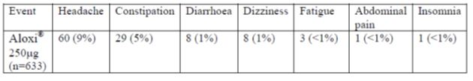

### Conclusions regarding safety

The sponsor provided the following safety conclusions:

The safety profile from the 2 company-sponsored studies that were evaluated as part of the prior application (submission 2010-01993-3-4); study PALO-02-12 (published by Hunt et al.[69]), and study PALO-04-09 (published by Einhorn et al.[70]) revealed no new safety concerns.

As both these studies represent registration studies conducted by the sponsor, they provide the most comprehensive safety data in terms of multiple dosing of palonosetron.

Although Study PALO-04-09 was an uncontrolled study in terms of efficacy outcomes, it provided the evaluable data in 41 patients receiving 5-day cisplatin therapy for testicular cancer, to support the key data from published randomised controlled studies of multiple dose palonosetron in other malignancies.

The safety conclusions from the sponsor-led efficacy and safety PALO-04-09 trial in testicular cancer patients were as follows:

*“Multiple-day dosing of palonosetron resulted in a 1.42-fold accumulation seen in the day 5 to day 1 AUC0-t ratio, consistent with the approximately 40-h plasma elimination half-life of palonosetron.*

*However, there was no evidence of cumulative toxicity or any increase in the number or intensity of adverse events as a result of systemic accumulation of palonosetron when the drug was given three times over 5 days.*

*There was no evidence of cardiac effects, and there were no new safety findings in this trial, which is consistent with findings from the three pivotal phase 3 trials that included 192 patients with pre-existing cardiac impairment and over 300 patients at least 65 years of age in which one third of patients received palonosetron 0.75 mg (three times the approved dose).*

*Overall, the incidence of treatment-related events was similar to that seen in other trials and in clinical practice.”[71]*

The available data from published literature related to controlled and uncontrolled studies of repeat dosing of palonosetron for the prophylaxis of CINV did not identify any new safety concerns and support the favourable safety profile of the compound.

There does not appear to be any appreciable change in the nature, frequency or intensity of AEs associated with repeat dose palonosetron. Collectively, the PK, efficacy and safety data corroborate the conclusion that repeated dosing of palonosetron is safe, effective and well tolerated.

#### Evaluator’s comments on safety

The submitted data does not raise any specific safety concerns for the evaluator.

The previous clinical evaluator dealing with an earlier submission relating to multiple dosing of palonosetron expressed the following concerns: “There were insufficient numbers of subjects exposed to multiple dosing within one week period in clinical trials to support Variation 1 in the absence of adequate PK data.”

The clinical evaluator believes that the inclusion of the published papers in current submission has mitigated this concern to some extent, bearing in mind that the safety data available from the published studies is usually scanty.

## First round recommendation regarding authorisation

The purpose of this LBS submission is the removal of single dose restriction for Aloxi injections to allow multiple days dosing of palonosetron within a chemotherapy cycle. An alternate day dosing of palonosetron has been proposed by the sponsor.

The published data in this submission consists of controlled and uncontrolled clinical studies of palonosetron for the prevention of CINV.

The above claim is supported by two sponsor-led studies, couple of RCT, as well as some international guidelines published by the Cancer Societies.

“The comparative studies provide evidence of efficacy and safety of palonosetron in a multiple dosing regimen to support the removal of the current restriction in the Aloxi PI.

In addition, the controlled, comparative studies are supported by several non-comparative studies, that use multiple or alternate-day dosing regimens based on the duration of the chemotherapy regimen.”

* The two sponsor-led studies include the PALO-02-12 study, a PK study investigating 3 consecutive days of IV doses of palonosetron in healthy volunteers; and the PALO-04-09 study, an open-label Phase 2 study in testicular cancer patients receiving palonosetron IV on alternate days before cisplatin therapy administered over 5 days. The PALO-04-09 study included also a small PK sub-study.

These two company-sponsored trials were evaluated as part of the prior application. The published version of the studies were re-submitted; study PALO-02-12 (published by Hunt et al.[72]), and study PALO-04-09 (published by Einhorn et al.[73]).

An earlier application to the TGA that sought approval for removal of the single dose restriction for Aloxi, was rejected by the TGA on the basis of inadequate clinical efficacy and safety data of the proposed multiple dosing regimen.

The current LBS included also published papers related to multiple dosing of palonosetron.

* Overall, the available efficacy data that back up the multiple days of administration of palonosetron IV for prevention of CINV are inconclusive. There are some trends detectable that indicate possible benefits of repeating the doses of palonosetron, as described in the published studies; however, often the studies are underpowered, or not evaluable..
* The submitted guidelines representing the opinions of the learned cancer societies are cautiously supportive of the repetitive dosing of palonosetron, in specific circumstances.

*“These studies are supported by recent international Clinical Guidelines related to the prevention of CINV published by NCCN, ASCO and MASCC/ESMO.”*

*“International clinical guidelines which refer to the use of palonosetron on an alternate dosing regimen according to the duration of the specific chemotherapy regimen are largely based on the published clinical studies presented in this literature-based submission. “*

*“The guidelines developed by MASCC, considered to be the premier anti-emetic guidelines, support the use of alternate daily palonosetron during multiday chemotherapy, which would not happen were this not considered to be safe.”*

* There is an obvious scarcity of good quality data.
* Sponsor indicated that it is unlikely that more sponsor-led clinical trials will be conducted in this area.

*“Given the US and European acceptance of multi-dose per chemotherapy cycle palonosetron, it will not be possible to do any more large RCTs in this area, so that there is no expectation of a major change in the published literature.”*

* The outcomes from the two sponsor-led PK studies relevant to multiple dosing of palonosetron are as follows:

*“In the study by Hunt et al. involving healthy subjects, Aloxi 0.25 mg IV bolus over 10 seconds daily for 3 consecutive days resulted in a 2.1-fold accumulation (ratio of Day 3/Day 1 AUC0-24).*

*Similarly, in the study by Einhorn et al. involving cancer patients, Aloxi 0.25 mg IV bolus over 30 seconds on Days 1, 3, and 5 resulted in a 1.42-fold accumulation (ratio of Day 5/Day 1 AUC0-t). This is consistent with the plasma elimination half-life of palonosetron (~40 hr; see SmPC).*

*Based on these two studies, AUC after daily IV doses of 0.25 mg over 3 days is expected to be similar to the AUC resulting from a single 0.75 mg dose. These PK data, therefore, support the proposal to use repeated daily dosing of Aloxi.”*

* The long half life of palonosetron is always a concern, but in view of the available published literature documenting clinical use of the product in repeated-dose manner, this appears to be a more a theoretical consideration. Ongoing surveillance is needed in this area.
* The sponsor provided the following additional safety arguments:

PALO-02-12 and PALO-04-09 studies represent registration studies conducted by the sponsor; they provide the most comprehensive safety data in terms of multiple dosing of palonosetron.

Palonosetron is a well-known second generation 5-HT3 receptor antagonist with an established clinical efficacy and safety profile in the prevention of chemotherapy induced nausea and vomiting

As a class, 5-HT3-receptor antagonists are generally well tolerated. These agents have similar safety profiles and few significant AEs associated with use.

Headache, diarrhoea, constipation and alterations in ECG intervals are known AEs of 5-HT3 receptor antagonists. Extensive scientific literature is available to support the existence and mechanisms of these untoward effects. From a qualitative standpoint these AEs do not constitute a special safety concern for palonosetron.

The comprehensive literature included in this review demonstrates that the proposed doses used in alternate daily palonosetron regimens would not pose any extra safety concern for patients. This is supported by the lack of any increase in safety issues since European and US approval of multi-day dosing.

* The sponsor provided also the following comments:

The proposed variation to permit multiple dosing of palonosetron in association with multiday chemotherapy regimens is in agreement with the CCSI for palonosetron and the current approved EU SmPC and US Data Sheet for palonosetron, none of which contains the single dosing restriction.

Approval of a multiple dosing regimen for palonosetron would bring Australian clinical practice into line with international clinical practice for the prevention of CINV.

Many chemotherapy regimens involve consecutive daily or repeated doses of emetogenic chemotherapy within a 7-day period. Current clinical practice recommends administration of a 5-HT3 RA prior to each dose of chemotherapy, including the consecutive-day regimens of cisplatin.

Currently in Australia, palonosetron cannot be used in these chemotherapy regimens, thereby excluding its use in patients who could otherwise benefit from them. The sponsor believes that the proposed application to revise the dosing section of the Australian PI for Aloxi will allow local clinical practice for the prevention of CINV to be in line with worldwide clinical usage of palonosetron.

### Clinical summary and conclusions

Following review of the submitted data, the evaluator believes, that there are no evident safety concerns compelling to uphold the previously present single dose restriction on palonosetron injection, within 7 days of the first dose.

This will bring the Australian PI of Aloxi in line with the other international labels, namely the EU SmPC of Aloxi, the FDA label, and the Product Monograph for Canada, none of which carry the single dose restrictions.

Of note, none of the Aloxi international labels clearly recommend repeated dosing of palonosetron, but neither explicitly prohibits one from doing so.

The evaluator rejected the proposed text to the ‘Clinical Trials’ section and the ‘Dosing and Administration’ section based on insufficient clinical data. The proposed text to the Pharmacology section of the PI is acceptable.

It transpires that the optimal dosing regimen for repeated doses of palonosetron is yet to be defined.

The evaluator recommended additional text for ‘Dosage and Administration’ section advising that there is limited safety data on repeating dosing of palonosetron, particularly beyond 3 doses. The text is similar to one already present for Aloxi Product Monograph in Canada.

### Recommendation

The evaluator recommends the approval of this submission by Specialised Therapeutics Australia Pty Ltd to update the PI for Aloxi (palonosetron hydrochloride) injections in relation to removal of single dose restriction, conditional upon the sponsor addressing the recommendations as outlined in the clinical evaluation report.

## Clinical questions

None.

1. Hunt TL, et al. (2005) Evaluation of safety and pharmacokinetics of consecutive multiple-day dosing of palonosetron in healthy subjects. *J Clin Pharmacol.* 45: 589-596.
2. Hunt TL, et al. (2005) Evaluation of safety and pharmacokinetics of consecutive multiple-day dosing of palonosetron in healthy subjects. *J Clin Pharmacol.* 45: 589-596.
3. Hunt TL, et al. (2005) Evaluation of safety and pharmacokinetics of consecutive multiple-day dosing of palonosetron in healthy subjects. *J Clin Pharmacol.* 45: 589-596.
4. Einhorn LH, et al. (2007) Palonosetron plus dexamethasone for prevention of chemotherapy-induced nausea and vomiting in patients receiving multiple-day cisplatin chemotherapy for germ cell cancer. *Support Care Cancer* 15: 1293-1300.
5. Hunt TL, et al. (2005) Evaluation of safety and pharmacokinetics of consecutive multiple-day dosing of palonosetron in healthy subjects. *J Clin Pharmacol.* 45: 589-596.
6. Einhorn LH, et al. (2007) Palonosetron plus dexamethasone for prevention of chemotherapy-induced nausea and vomiting in patients receiving multiple-day cisplatin chemotherapy for germ cell cancer. *Support Care Cancer* 15: 1293-1300.
7. Hunt TL, et al. (2005) Evaluation of safety and pharmacokinetics of consecutive multiple-day dosing of palonosetron in healthy subjects. *J Clin Pharmacol.* 45: 589-596.
8. Einhorn LH, et al. (2007) Palonosetron plus dexamethasone for prevention of chemotherapy-induced nausea and vomiting in patients receiving multiple-day cisplatin chemotherapy for germ cell cancer. *Support Care Cancer* 15: 1293-1300.
9. National Comprehensive Cancer Network Guidelines, 2012 <www.nccn.org/professionals/ physician_gls/f_guidelines.asp>.
10. Giralt SA, et al. (2011) Three palonosetron regimens to prevent CINV in myeloma patients receiving multiple-day high-dose melphalan and hematopoietic stem cell transplantation. *Ann Oncol.* 22: 939-946.
11. Noor R, et al. (2012) Comparison of two dosing schedules of palonosetron for the prevention of nausea and vomiting due to interleukin-2-based biochemotherapy. *Support Care Cancer* 20: 2583-2588.
12. Mattiuzzi GN, et al. (2010) Daily palonosetron is superior to ondansetron in the prevention of delayed chemotherapy-induced nausea and vomiting in patients with acute myelogenous leukemia. *Cancer* 116: 5659-5666.
13. Noor R, et al. (2012) Comparison of two dosing schedules of palonosetron for the prevention of nausea and vomiting due to interleukin-2-based biochemotherapy. *Support Care Cancer* 20: 2583-2588.
14. Giralt SA, et al. (2011) Three palonosetron regimens to prevent CINV in myeloma patients receiving multiple-day high-dose melphalan and hematopoietic stem cell transplantation. *Ann Oncol.* 22: 939-946.
15. Mattiuzzi GN, et al. (2010) Daily palonosetron is superior to ondansetron in the prevention of delayed chemotherapy-induced nausea and vomiting in patients with acute myelogenous leukemia. *Cancer* 116: 5659-5666.
16. Feinberg B, et al. (2012) Impact of initiating antiemetic prophylaxis with palonosetron versus ondansetron on risk of uncontrolled chemotherapy-induced nausea and vomiting in patients with lung cancer receiving multi-day chemotherapy. *Support Care Cancer* 20: 615-623.
17. Musso M, et al. (2009) Palonosetron (Aloxi) and dexamethasone for the prevention of acute and delayed nausea and vomiting in patients receiving multiple-day chemotherapy. *Support Care Cancer* 17: 205-209.
18. Marcacci G, et al. (2010) Single vs double dose palonosetron for the prevention of acute and delayed nausea and vomiting in patients undergoing high dose chemotherapy and autologous stem cell transplantation. *Biology of Blood and Marrow Transplantation* 16: S259.
19. Tendas A, et al. (2011) Palonosetron versus ondansetron as prophylaxis of chemotherapy-induced nausea and vomiting: a single-centre experience. *BM Transplant* 46: S174.
20. López-Jiménez J, et al. (2011) Palonosetron + aprepitant versus granisetron for prevention of nausea and vomiting in patients receiving high dose conditioning chemotherapy regimens prior to stem cell transplantation (HSCT) *Haematologica* 96: S185.
21. Mirabile A, et al. (2011) Palonosetron and dexamethasone in prevention of chemotherapy-induced nausea and vomiting (CINV) in patients undergoing high dose chemotherapy (HDCT) *Support Care Cancer* 19: S214.
22. Marcacci G, et al. (2010) Single vs double dose palonosetron for the prevention of acute and delayed nausea and vomiting in patients undergoing high dose chemotherapy and autologous stem cell transplantation. *Biology of Blood and Marrow Transplantation* 16: S259.
23. Tendas A, et al. (2011) Palonosetron versus ondansetron as prophylaxis of chemotherapy-induced nausea and vomiting: a single-centre experience. *BM Transplant* 46: S174.
24. López-Jiménez J, et al. (2011) Palonosetron + aprepitant versus granisetron for prevention of nausea and vomiting in patients receiving high dose conditioning chemotherapy regimens prior to stem cell transplantation (HSCT) *Haematologica* 96: S185.
25. Aprepitant represents a new class of oral anti-emetic which targets the neurokinin receptor antagonist (NK-1). It is effective for both acute and delayed onset emesis.
26. Mirabile A, et al. (2011) Palonosetron and dexamethasone in prevention of chemotherapy-induced nausea and vomiting (CINV) in patients undergoing high dose chemotherapy (HDCT) *Support Care Cancer* 19: S214.
27. Einhorn LH, et al. (2007) Palonosetron plus dexamethasone for prevention of chemotherapy-induced nausea and vomiting in patients receiving multiple-day cisplatin chemotherapy for germ cell cancer. *Support Care Cancer* 15: 1293-1300.
28. Einhorn LH, et al. (2007) Palonosetron plus dexamethasone for prevention of chemotherapy-induced nausea and vomiting in patients receiving multiple-day cisplatin chemotherapy for germ cell cancer. *Support Care Cancer* 15: 1293-1300.
29. Hunt TL, et al. (2005) Evaluation of safety and pharmacokinetics of consecutive multiple-day dosing of palonosetron in healthy subjects. *J Clin Pharmacol.* 45: 589-596.
30. Assanelli AA, et al. (2009) Palonosetron (Aloxi): A single-center experience in the prevention of emesis in patients affected by haematological malignancies. *Haematologica* 94: S187.
31. Musso M, et al. (2009) Palonosetron (Aloxi) and dexamethasone for the prevention of acute and delayed nausea and vomiting in patients receiving multiple-day chemotherapy. *Support Care Cancer* 17: 205-209.
32. Patriarca F, et al. (2011) Effectiveness of a three-drug regimen of dexamethasone, palonosetron and aprepitant for the prevention of acute and delayed nausea and vomiting caused by high-dose therapy before haematopoietic stem cell transplantation. *Bone Marrow Transplant* 46: S187.
33. Deauna-Limayo D, et al. (2010) Aprepitant combined with palonosetron, lorazepam and low doses dexamethasone in prevention of emesis among patients with multiple myeloma and lymphoma undergoing high dose therapy and autologous hematopoietic stem cell transplant: a pilot study. *Blood (ASH Annual Meeting Abstracts)* 116: 1335.
34. www.mascc.org/assets/documents/MASCC_Guidelines_English_2011.pdf
35. www.nccn.org/professionals/ physician_gls/f_guidelines.asp
36. Basch E, et al. (2011) Antiemetics: American Society of Clinical Oncology clinical practice guideline update. *J Clin Oncol.* 29: 4189-4198.
37. Roila F, et al. (2010) Guideline update for MASCC and ESMO in the prevention of chemotherapy- and radiotherapy-induced nausea and vomiting: results of the Perugia consensus conference.” *Ann Oncol.* S5: 232-243.
38. Roila F, et al. (2010) Guideline update for MASCC and ESMO in the prevention of chemotherapy- and radiotherapy-induced nausea and vomiting: results of the Perugia consensus conference.” *Ann Oncol.* S5: 232-243.
39. Roila F, et al. (2010) Guideline update for MASCC and ESMO in the prevention of chemotherapy- and radiotherapy-induced nausea and vomiting: results of the Perugia consensus conference.” *Ann Oncol.* S5: 232-243.
40. www.nccn.org/professionals/ physician_gls/f_guidelines.asp
41. Einhorn LH, et al. (2007) Palonosetron plus dexamethasone for prevention of chemotherapy-induced nausea and vomiting in patients receiving multiple-day cisplatin chemotherapy for germ cell cancer. *Support Care Cancer* 15: 1293-1300.
42. Giralt SA, et al. (2011) Three palonosetron regimens to prevent CINV in myeloma patients receiving multiple-day high-dose melphalan and hematopoietic stem cell transplantation. *Ann Oncol.* 22: 939-946.
43. Musso M, et al. (2009) Palonosetron (Aloxi) and dexamethasone for the prevention of acute and delayed nausea and vomiting in patients receiving multiple-day chemotherapy. *Support Care Cancer* 17: 205-209.
44. Basch E, et al. (2011) Antiemetics: American Society of Clinical Oncology clinical practice guideline update. *J Clin Oncol.* 29: 4189-4198.
45. Giralt SA, et al. (2011) Three palonosetron regimens to prevent CINV in myeloma patients receiving multiple-day high-dose melphalan and hematopoietic stem cell transplantation. *Ann Oncol.* 22: 939-946.
46. Saito M, et al. (2009) Palonosetron plus dexamethasone versus granisetron plus dexamethasone for prevention of nausea and vomiting during chemotherapy: a double-blind, double-dummy, randomised, comparative phase III trial. *Lancet Oncol.* 10: 115-124.
47. Gomez JG, et al. (2010) The role of second-generation 5-HT3 receptor antagonists in managing chemotherapy-induced nausea and vomiting in haematological malignancies. *Clin Transl Oncol.* 12: 770-774.
48. Schwartzberg LS, et al. (2012) The role of second-generation 5-HT3 receptor antagonists in managing chemotherapy-induced nausea and vomiting in hematological malignancies. *Crit Rev Oncol Hematol.* 83: 59-70.
49. Noor R, et al. (2012) Comparison of two dosing schedules of palonosetron for the prevention of nausea and vomiting due to interleukin-2-based biochemotherapy. *Support Care Cancer* 20: 2583-2588.
50. Giralt SA, et al. (2011) Three palonosetron regimens to prevent CINV in myeloma patients receiving multiple-day high-dose melphalan and hematopoietic stem cell transplantation. *Ann Oncol.* 22: 939-946.
51. Mattiuzzi GN, et al. (2010) Daily palonosetron is superior to ondansetron in the prevention of delayed chemotherapy-induced nausea and vomiting in patients with acute myelogenous leukemia. *Cancer* 116: 5659-5666.
52. Einhorn LH, et al. (2007) Palonosetron plus dexamethasone for prevention of chemotherapy-induced nausea and vomiting in patients receiving multiple-day cisplatin chemotherapy for germ cell cancer. *Support Care Cancer* 15: 1293-1300.
53. Einhorn LH, et al. (2007) Palonosetron plus dexamethasone for prevention of chemotherapy-induced nausea and vomiting in patients receiving multiple-day cisplatin chemotherapy for germ cell cancer. *Support Care Cancer* 15: 1293-1300.
54. Schwartzberg LS, et al. (2012) The role of second-generation 5-HT3 receptor antagonists in managing chemotherapy-induced nausea and vomiting in hematological malignancies. *Crit Rev Oncol Hematol.* 83: 59-70.
55. Feinberg B, et al. (2012) Impact of initiating antiemetic prophylaxis with palonosetron versus ondansetron on risk of uncontrolled chemotherapy-induced nausea and vomiting in patients with lung cancer receiving multi-day chemotherapy. *Support Care Cancer* 20: 615-623.
56. Feinberg B, et al. (2012) Impact of initiating antiemetic prophylaxis with palonosetron versus ondansetron on risk of uncontrolled chemotherapy-induced nausea and vomiting in patients with lung cancer receiving multi-day chemotherapy. *Support Care Cancer* 20: 615-623.
57. Mattiuzzi GN, et al. (2010) Daily palonosetron is superior to ondansetron in the prevention of delayed chemotherapy-induced nausea and vomiting in patients with acute myelogenous leukemia. *Cancer* 116: 5659-5666.
58. Noor R, et al. (2012) Comparison of two dosing schedules of palonosetron for the prevention of nausea and vomiting due to interleukin-2-based biochemotherapy. *Support Care Cancer* 20: 2583-2588.
59. Einhorn LH, et al. (2007) Palonosetron plus dexamethasone for prevention of chemotherapy-induced nausea and vomiting in patients receiving multiple-day cisplatin chemotherapy for germ cell cancer. *Support Care Cancer* 15: 1293-1300.
60. Hunt TL, et al. (2005) Evaluation of safety and pharmacokinetics of consecutive multiple-day dosing of palonosetron in healthy subjects. *J Clin Pharmacol.* 45: 589-596.
61. Einhorn LH, et al. (2007) Palonosetron plus dexamethasone for prevention of chemotherapy-induced nausea and vomiting in patients receiving multiple-day cisplatin chemotherapy for germ cell cancer. *Support Care Cancer* 15: 1293-1300.
62. Hunt TL, et al. (2005) Evaluation of safety and pharmacokinetics of consecutive multiple-day dosing of palonosetron in healthy subjects. *J Clin Pharmacol.* 45: 589-596.
63. Einhorn LH, et al. (2007) Palonosetron plus dexamethasone for prevention of chemotherapy-induced nausea and vomiting in patients receiving multiple-day cisplatin chemotherapy for germ cell cancer. *Support Care Cancer* 15: 1293-1300.
64. Hunt TL, et al. (2005) Evaluation of safety and pharmacokinetics of consecutive multiple-day dosing of palonosetron in healthy subjects. *J Clin Pharmacol.* 45: 589-596.
65. Einhorn LH, et al. (2007) Palonosetron plus dexamethasone for prevention of chemotherapy-induced nausea and vomiting in patients receiving multiple-day cisplatin chemotherapy for germ cell cancer. *Support Care Cancer* 15: 1293-1300.
66. Hunt TL, et al. (2005) Evaluation of safety and pharmacokinetics of consecutive multiple-day dosing of palonosetron in healthy subjects. *J Clin Pharmacol.* 45: 589-596.
67. Einhorn LH, et al. (2007) Palonosetron plus dexamethasone for prevention of chemotherapy-induced nausea and vomiting in patients receiving multiple-day cisplatin chemotherapy for germ cell cancer. *Support Care Cancer* 15: 1293-1300.
68. Hunt TL, et al. (2005) Evaluation of safety and pharmacokinetics of consecutive multiple-day dosing of palonosetron in healthy subjects. *J Clin Pharmacol.* 45: 589-596.
69. Hunt TL, et al. (2005) Evaluation of safety and pharmacokinetics of consecutive multiple-day dosing of palonosetron in healthy subjects. *J Clin Pharmacol.* 45: 589-596.
70. Einhorn LH, et al. (2007) Palonosetron plus dexamethasone for prevention of chemotherapy-induced nausea and vomiting in patients receiving multiple-day cisplatin chemotherapy for germ cell cancer. *Support Care Cancer* 15: 1293-1300.
71. Einhorn LH, et al. (2007) Palonosetron plus dexamethasone for prevention of chemotherapy-induced nausea and vomiting in patients receiving multiple-day cisplatin chemotherapy for germ cell cancer. *Support Care Cancer* 15: 1293-1300.
72. Hunt TL, et al. (2005) Evaluation of safety and pharmacokinetics of consecutive multiple-day dosing of palonosetron in healthy subjects. *J Clin Pharmacol.* 45: 589-596.
73. Einhorn LH, et al. (2007) Palonosetron plus dexamethasone for prevention of chemotherapy-induced nausea and vomiting in patients receiving multiple-day cisplatin chemotherapy for germ cell cancer. *Support Care Cancer* 15: 1293-1300.