First round report 13 November 2014
Second round report 9 April 2015

AusPAR Attachment 2

Extract from the Clinical Evaluation Report for: Paritaprevir / Ritonavir / Ombitasvir and Dasabuvir (as Sodium Salt)
  - Proprietary Product Name: Viekira Pak
  - Sponsor: Abbvie Pty Ltd

About the Therapeutic Goods Administration (TGA)
- The Therapeutic Goods Administration (TGA) is part of the Australian Government Department of Health, and is responsible for regulating medicines and medical devices.
- The TGA administers the Therapeutic Goods Act 1989 (the Act), applying a risk management approach designed to ensure therapeutic goods supplied in Australia meet acceptable standards of quality, safety and efficacy (performance), when necessary.
- The work of the TGA is based on applying scientific and clinical expertise to decision-making, to ensure that the benefits to consumers outweigh any risks associated with the use of medicines and medical devices.
- The TGA relies on the public, healthcare professionals and industry to report problems with medicines or medical devices. TGA investigates reports received by it to determine any necessary regulatory action.
- To report a problem with a medicine or medical device, please see the information on the TGA website <https://www.tga.gov.au> .
About the Extract from the Clinical Evaluation Report
- This document provides a more detailed evaluation of the clinical findings, extracted from the Clinical Evaluation Report (CER) prepared by the TGA. This extract does not include sections from the CER regarding product documentation or post market activities.
- The words [Information redacted], where they appear in this document, indicate that confidential information has been deleted.
- For the most recent Product Information (PI), please refer to the TGA website <https://www.tga.gov.au/product-information-pi> .
Copyright
© Commonwealth of Australia 2017
This work is copyright. You may reproduce the whole or part of this work in unaltered form for your own personal use or, if you are part of an organisation, for internal use within your organisation, but only if you or your organisation do not use the reproduction for any commercial purpose and retain this copyright notice and all disclaimer notices as part of that reproduction. Apart from rights to use as permitted by the Copyright Act 1968 or allowed by this copyright notice, all other rights are reserved and you are not allowed to reproduce the whole or any part of this work in any way (electronic or otherwise) without first being given specific written permission from the Commonwealth to do so. Requests and inquiries concerning reproduction and rights are to be sent to the TGA Copyright Officer, Therapeutic Goods Administration, PO Box 100, Woden ACT 2606 or emailed to <tga.copyright@tga.gov.au> .

Contents
List of abbreviations 5
1. Introduction 11
2. Clinical rationale 11
2.1. Formulation 13
3. Contents of the clinical dossier 14
3.1. Scope of the clinical dossier 14
3.2. Paediatric data 14
3.3. Good clinical practice 14
4. Pharmacokinetics 14
4.1. Pharmacokinetics in healthy subjects 17
4.2. Pharmacokinetics in the target population 29
4.3. Pharmacokinetic interactions 32
4.4. PPK studies 38
4.5. Evaluator’s overall conclusions on pharmacokinetics 46
5. Pharmacodynamics 53
5.1. Studies providing pharmacodynamic data 53
5.2. Summary of pharmacodynamics 53
5.3. Evaluator’s overall conclusions on pharmacodynamics 57
5.4. Questions regarding PD studies 58
6. Dosage selection for the pivotal studies 58
7. Clinical efficacy 61
7.1. Pivotal efficacy studies 62
7.2. Other efficacy studies 88
7.3. Analyses performed across trials 97
7.4. Evaluator’s conclusions on clinical efficacy 101
8. Clinical safety 102
8.1. Studies providing evaluable safety data 102
8.2. Pivotal studies that assessed safety as a primary outcome 103
8.3. Patient exposure 103
8.4. Adverse events 103
8.5. Laboratory tests 109
8.6. Integrated Summary of Safety 118
8.7. Post-marketing experience 123
8.8. Safety issues with the potential for major regulatory impact 123
8.9. Other safety issues 125
8.10. Evaluator’s overall conclusions on clinical safety 126
9. First round benefit-risk assessment 127
9.1. First round assessment of benefits 127
9.2. First round assessment of risks 127
9.3. First round assessment of benefit-risk balance 128
10. First round recommendation regarding authorisation 129
11. Clinical questions 129
11.1. Pharmacokinetics 129
11.2. Pharmacodynamics 130
11.3. Efficacy 131
11.4. Safety 131
12. Second round evaluation of clinical data submitted in response to questions 131
12.1. Pharmacokinetics 131
12.2. Pharmacodynamics 142
12.3. Efficacy 144
12.4. Safety 145
13. Second round benefit-risk assessment 146
13.1. Second round assessment of benefits 146
13.2. Second round assessment of risks 147
13.3. Second round assessment of benefit-risk balance 147
14. Second round recommendation regarding authorisation 147
15. References 147

List of abbreviations
Abbreviation | Meaning
Ab | antibody
ABT-267 | ombitasvir
ABT-333 | dasabuvir
ABT-450 | paritaprevir (also previously named veruprevir)
ADME | absorption, distribution, metabolism and excretion
AE | adverse event
ALT | alanine aminotransferase
AST | aspartate aminotransferase
AUC | area under the concentration-time curve
AUC_{inf} | AUC extrapolated to time infinity
AUC_{last} | AUC from the time of dosing to the last quantifiable concentration
BA | bioavailability
BD | twice daily
BMI | body mass index
BSA | body surface area
BW | body weight
C12 | plasma concentration 12 hours after dosing
C24 | plasma concentration 24 hours after dosing
CBZE | carbamazepine-10,11-epoxide
cf | compared with
CI | confidence interval
CL/F | apparent clearance
C_{max} | maximum plasma concentration
C_{max,ss} | maximum plasma concentration at steady state
COC | combined oral contraceptive
CrCL | creatinine clearance
CsA | cyclosporine
CTCAE | Common Terminology Criteria for Adverse Events
CV | coefficient of variation
CYP | cytochrome P450
Cτ,ss | trough plasma concentration
DAA | direct-acting antiviral agent
DB | double blind
DDI | drug-drug interaction
DMC | Data Monitoring Committee
DNA | deoxyribonucleic acid
Ε | residual variability (epsilon)
ECG | electrocardiogram
EE | ethinyl estradiol
EOTR | end-of-treatment response
eRVR | extended rapid virologic response
EVR | early virologic response; partial = HCV RNA decrease of > 2 log₁₀ IU/mL at Study Week 12, complete = HCV RNA < 25 IU/mL at Study Week 12
F | bioavailability
FBLV | fibrosis
FDC | fixed dose combination
FIH | first in human
fu | unbound fraction
GCP | Good Clinical Practice
GT1a | genotype 1a
GT1b | genotype 1b
h | hour/s
Η | inter-individual random effect (eta)
HBsAg | hepatitis B surface antigen
HBV | hepatitis B virus
HCV | hepatitis C virus
HGC | hard gelatin capsule
HIV | human immunodeficiency virus
HME | hot melt extrusion
HRT | hormonal replacement therapy
ICH | International Conference on Harmonisation
IEC | Independent Ethics Committee
IgG | immunoglobulin G
IgM | immunoglobulin M
IIV | inter-individual variability
IL28B | interleukin 28B
IP-10 | interferon gamma-induced protein 10
IR | immediate release
IRT | interactive Response Technology
ITT | intent-to-treat
IU | international units
KTZ | ketoconazole
LCB | lower bound of the 95% confidence interval
LC-MS/MS | liquid chromatography method with tandem mass spectrometric detection
LLN | lower limit of normal
LLOD | lower limit of detection
LLOQ | lower limit of quantitation
LPV | lopinavir
MAD | multiple-ascending dose
MedDRA | Medical Dictionary for Regulatory Activities
mRNA | messenger RNA
N | number
NA | not applicable
NET | norethindrone
NG | norgestrel
NGM | norgestimate
NGNM | norelgestromin
NS | non-structural
NS3 | non-structural protein 3
NS3/NS4A | NS protein 3/NS protein 4A
NS4A | non-structural protein 4A
NS5A | non-structural protein 5A
NS5B | non-structural protein 5B
OAT | organic anion transporters
OATP | organic anion transporting polypeptide
OATP1B1 | organic ion transporting polypeptide
OL | open label
PCS | potentially clinically significant
PD | pharmacodynamics
pegIFN | pegylated interferon
pegIFN/RBV | pegylated interferon plus ribavirin
P-gp | P-glycoprotein
PK | pharmacokinetics
pKa | acid dissolution constant
POP | progestin only pill
PT | post-treatment
PVF | primary virologic failure
QD | once daily
QT | time between the start of the Q wave and the end of the T wave
r | ritonavir
RBV | ribavirin
RNA | ribonucleic acid
RSE | relative standard error
RUV | residual unexplained variability
RVR | rapid virologic response, HCV RNA level < 25 IU/mL at Study Week 4
RVR | rapid virologic response
SAD | single-ascending dose
SAE | serious adverse event
SALLE | salting-out assisted liquid/liquid extraction
SD | standard deviation
SDD | spray dried dispersion
SGC | soft gel capsule
SNP | single nucleotide polymorphism
SOC | System Organ Class
SVR | sustained virologic response
SVR₁₂ | sustained virologic response 12 weeks post dosing
SVR₂₄ | sustained virologic response 24 weeks post dosing
SVR₄ | sustained virologic response 4 weeks post dosing
TEAE | Treatment emergent adverse event
UCB | upper bound of the 95% confidence interval
ULN | upper limit of normal
VAS | visual analogue scale
Vc/F | apparent volume of central compartment
Vd/F | volume of distribution
Vp/F | apparent volume of peripheral compartment
Vss/F | apparent steady state volume of distribution
WBC | white blood cell
WT | body weight

Introduction
This is a submission to register a direct acting antiviral combination agent containing paritaprevir/ombitasvir/dasabuvir (3-DAA) combination regimen containing: A co-formulated tablet comprised of paritaprevir (code name: ABT-450), ritonavir and ombitasvir (code name: ABT-267), and a tablet comprised of dasabuvir (code name: ABT-333).
Ombitasvir is a novel NS5A inhibitor, with inhibitory concentrations in the picomolar range against genotypes 1a and 1b subgenomic replicon systems.
Paritaprevir is a NS3 protease inhibitor of HCV genotype 1; ombitasvir is a NS5A inhibitor with activity against genotype 1a and 1b; and ritonavir is a potent CYP3A inhibitor used to increase paritaprevir exposure, which is susceptible to first pass metabolism.
Dasabuvir is a non-nucleoside NS5B polymerase inhibitor of HCV genotypes 1a and 1b.
The proposed indication is:
for the treatment of genotype 1 chronic hepatitis C infection, including patients with cirrhosis.
Duration of therapy and addition of ribavirin are dependent on patient population.
Viekira Pak is a fixed dose combination tablet containing paritaprevir75 mg, ritonavir 50 mg and ombitasvir 12.5 mg, co-packaged with dasabuvir 250 mg tablets.
Viekira Pak RBV is paritaprevir/ritonavir/ombitasvir FDC tablets co-packaged with dasabuvir tablets and separate ribavirin 200 mg tablets (submission PM-2014-01438-1-2).

Clinical rationale
It is estimated that 130 to 210 million people worldwide are infected with HCV with 2 to 4 million new infections annually. Approximately 300,000 Australians were infected with HCV in 2011. Acute infections become chronic in 70% to 90% of cases and this leads commonly to cirrhosis, chronic liver failure, hepatocellular carcinoma, liver transplantation and death. After 20 years of infection, 20 to 30% of patients will have progressed to cirrhosis, 5 to 10% will have developed end stage liver disease, and 4 to 8% will have died of liver related causes. HCV has six genotypes (GT) and multiple subtypes with genotypes 1 to 3 distributed worldwide. Genotypes 1a and 1b account for 60% of global HCV infections. In Australia, the most common genotypes are 1a and 1b (54% prevalence) and 3a (37% prevalence). GT4 is most prevalent in North Africa and the Middle East but it is spreading to Europe and the rest of the world through immigration and IV drug use. Until recently, the standard of care treatment for chronic HCV infection for all genotypes was the combination of pegylated interferon (pegIFN) and ribavirin (RBV) for 48 weeks. The response to this treatment varies according to HCV genotype and host IL28B genotypic subtypes (CC, CT, and TT). Patients with the IL28b CC genotype are able to mount stronger immune responses to the HCV virus and spontaneous viral clearance rates and responsiveness to antiviral therapy are enhanced. In patients with GT1 infection, sustained viral response rates (SVR) following pegIFN/RBV therapy are only 45% in treatment naïve patients and significantly lower in prior relapsers and non-responders. Moreover, the side effect profile of pegIFN/RBV is unfavourable with a high incidence of lethargy, fatigue, depression and anaemia.
The NS3/4A protease inhibitors boceprevir, telaprevir, sofosbuvir and simeprevir used singly in combination with pegIFN/RBV have improved SVR rates in treatment naïve and treatment experienced patients, and shortened treatment duration to 24 weeks in many patients (Table 1). However, these combinations are associated with increased rates and severity of AEs, including rash in addition to the common side effects of pegIFN/RBV. Simeprevir is well tolerated and has the advantage of once daily dosing. However, telaprevir and boceprevir both require TID therapy.

Table 1: Sustained virologic response rates 24 weeks after stopping treatment in subjects with HCV GT1
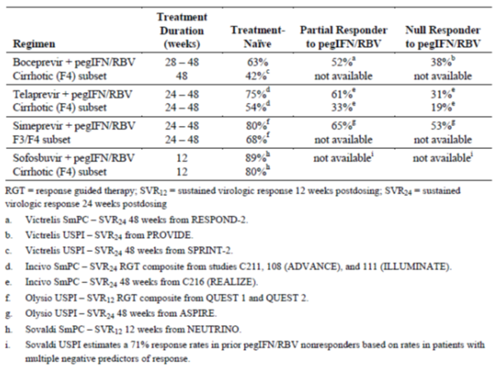
The three direct acting antiviral agents (DAAs) in Viekira Pak have different mechanisms of action, they all have potent activity against HCV genotype 1, and they have non-overlapping viral resistance profiles. They also appear to have non-overlapping toxicity with RBV. Current EMA guidelines are based on 24 to 48 weeks of therapy with one or more DAAs in combination with pegIFN/RBV. However, the guidelines recognise the rapidly developing therapeutic area and the potential value of combination DAA therapy. Paritaprevir (ABT-450), ombitasvir (ABT-267) and dasabuvir (ABT-333) are potent DAAs but resistance develops to each agent when used as monotherapy. It is proposed that the combination of the three direct acting antiviral agents (3-DAA) used in Viekira Pak will obviate the need for concomitant pegIFN/RBV therapy, increase SVR rates compared with approximately 75% for 1-DAA + pegIFN/RBV combination therapy in treatment naïve patients, shorten treatment duration from 24 to 12 weeks, and improve safety and tolerability.

Formulation

Formulation
As the current application is for a co-formulated tablet containing ABT-450, ritonavir and ABT-267 and an additional tablet containing ABT-333 the discussion of formulation development will examine the development of the novel active components individually prior to a discussion of the various co-formulations used throughout the development cycle.

ABT-450 (paritaprevir) + ritonavir
During the clinical development program, four different ABT-450 formulations were used [information redacted].
[Information redacted]an amorphous solid dispersion was developed for Phase II studies to provide a solubility enabling formulation of ABT-450 while also allowing dose flexibility and easier combination into a solid oral dosage form with ritonavir in subsequent Phase III studies. The Phase II formulation (SDD) was manufactured at [information redacted].
Throughout the clinical development program only one study examined the PKs of ABT-450 following its administration in the absence of the other active compounds. This was the first-in-human (FIH) study (Study M10-749), which examined three single doses (300 mg, 600 mg and 900 mg) of ABT-450 HGC in healthy individuals. For the remaining Phase I and Phase II studies, ABT-450 (the HGC and/or SDD formulations) was co-administered with ritonavir or co-formulated with ritonavir (ABT-450/r), which acts as a pharmacokinetic enhancer, that is it increases the bioavailability and t½ of ABT-450 allowing for once daily (QD) dosing of ABT-450 at lower doses.

ABT-267 (ombitasvir)
For human trials [information redacted] an HME based amorphous solid dispersion of ombitasvir commenced during Phase I clinical testing and was utilised for clinical testing from Phase II onwards in conjunction with the other amorphous solid dispersion tablet formulation strengths.
A coated ABT-267 HME tablet formulation was also developed and this formulation was evaluated in the interferon-free DAA combination Phase II studies. This coated HME tablet displayed comparable bioavailability to the uncoated ABT-267 HME tablet.

ABT-450 (paritaprevir) / ritonavir /ABT-267 (ombitasvir)
The proposed to be marketed formulation of ABT-450/r/ABT-267 75 mg/50 mg/12.5 mg is co-formulated as a coated immediate release tablet. The coating is a non-functional film coating which does not affect the dissolution profiles of ABT-267, ABT-450 or ritonavir. The coated tablet was evaluated in Phase III studies, which form the basis for the safety and efficacy data included in this submission, and in food effect studies.
An uncoated ABT-450/r/ABT-267 co-formulated tablet was also manufactured and although it had a similar dissolution profile to the coated formulation, it was only evaluated in a relative bioavailability study where it was compared to the SDD tablet (Phase IIb formulation).
Three different strengths of the uncoated ABT-450/r/ABT-267 co-formulated tablet were developed (50/50/12.5 mg, 75/50/12.5 mg and 100/50/12.5 mg) and evaluated in the Phase I studies (the 50/50/12.5 mg in Japanese and Chinese subjects in Study M13-505).

ABT-333
Initially, a capsule formulation was developed as an immediate release product utilising [information redacted] gelatin capsules (5 and 50 mg), which was used in Phase I and early Phase II studies. Although the product was stable, it was not optimised with respect to manufacturability, bioavailability, or patient preference.
A 400mg tablet formulation was developed for Phase II clinical studies. Two ABT-333 formulations, [information redacted] were developed and compared to the reference Phase II ABT-333 (without [information redacted]) 400 mg tablet (Study M12-995).The bioavailability of this 250 mg ABT-333 optimised tablet (coated) relative to the Phase II 400 mg ABT-333 tablet was evaluated in Study M13-331.The compositions of ABT-333 250 mg to be marketed tablet and the Phase III ABT-333 250 mg optimised tablet are identical; however, the manufacturing site was changed. To determine whether the change in manufacturing site affected the drugs characteristics, a bioequivalence study (Study M14-196) was conducted to compare the ABT-333 250 mg to be marketed tablet to the Phase III tablet. The tablets were found to be bioequivalent.

Contents of the clinical dossier

Scope of the clinical dossier
The submission contained the following clinical information:
- Sixty one clinical pharmacology studies, including 59 that provided PK data and 5 that provided pharmacodynamic data.
- Two population PK analyses.
- Six pivotal efficacy/safety studies: M11-646 (Sapphire-I), M13-098 (Sapphire-II), M13-389 (PEARL-II), M13-961 (PEARL-III), M14-002 (PEARL-IV), M13-099 (TURQUOISE II).
- Multiple Phase I and II studies used to justify the selected regimen, dose and treatment duration.
- Five other efficacy/safety studies: M12-114, M13-386, M12-746, M12-998, M14-103. Also included in the submission is the preliminary report of a long-term follow-up study (M13-102) of all patients who have received 3-DAA in a Phase II or III study. This will assess the long-term durability of virologic response and the persistence rates of resistant variants.
- Two additional efficacy/safety studies not directly related to the proposed indication: M11-652 in patients with GT1a or 1b infection given 3-DAA +/- RBV for 8, 12 or 24 weeks; and M13-393 in patients with GT4 infection treated with a 2DAA combination.
- Pooled efficacy and safety analyses, Integrated Summary of Efficacy (ISE), Integrated Summary of Safety (ISS).
The submission also contained a Clinical Overview, Summary of Clinical Efficacy, Summary of Clinical Safety and literature references.

Paediatric data
The submission did not include paediatric data.

Good clinical practice
All studies were conducted according to the principles of GCP.

Pharmacokinetics
Summaries of the PK studies were provided. Table 2 below shows the studies relating to each PK topic.

Table 2: Submitted pharmacokinetic studies
PK topic | Subtopic | Study ID | *
PK in healthy adults | Absorption | M11-389 | Effect of food on the BA of ABT-450/r/ABT-267 co-formulated tablet
PK in healthy adults | Absorption | M14-196 | PKs of ABT-333 commercial and clinical Phase III formulations
PK in healthy adults | Absolute BA | M11-030 | Absolute BA of ABT-333
PK in healthy adults | BA | M12-995 | BA of two test tablet formulations of ABT-333
PK in healthy adults | BA | M10-749 | Single-ascending dose of ABT-450 alone and interaction with ritonavir
PK in healthy adults | BA | M10-797 | BA of SDD and HGC formulations of ABT-450
PK in healthy adults | BA | M11-388 | BE between test ABT-450/r tablet co-formulation and free combination
PK in healthy adults | BA | M12-683 | BA of different dosage strengths of ABT-450 and ritonavir co-formulated cf free combination
PK in healthy adults | BA | M12-115 | BA of HME and SDD formulations of ABT-267
PK in healthy adults | BA | M12-647 | Comparison of coated and uncoated ABT-267 HME tablets
PK in healthy adults | BA | M13-391 | BA of different dosage strengths of ABT-450, ritonavir and ABT-267 co-formulated tablets with free combination
PK in healthy adults | BA | M13-331 | Comparison of optimised and Phase II tablet formulations of ABT-333
PK in healthy adults | BA | M13-387 | Comparison of candidate tablets of ABT-267 relative to the reference ABT-267 tablet
PK in healthy adults | BA | M14-356 | BE between commercial formulations of US and Australian ribavirin tablets
PK in healthy adults | Food Effect | M10-923 | Effect of food on ABT-450/r
PK in healthy adults | Food Effect | M12-116 | Antiviral activity and food effect of single and multiple doses of ABT-267
PK in healthy adults | Food Effect | M13-300 | Effect of food on ABT-333 optimised tablets
PK in healthy adults | Ascending Single dose | M12-351 | Comparison of 3 single doses of ABT-450 SDD Formulation
PK in healthy adults | Ascending Single dose | M11-032 | Single ascending doses of ABT-333
PK in healthy adults | Multi-dose | M10-861 | Multiple-ascending doses of ABT-450
PK in healthy adults | Multi-dose | M10-687 | Multi-dose PKs of ABT-333
PK in healthy adults | Multi-dose | M12-187 | Multi-dose PKs of ABT-267 and ABT-450/r
PK in healthy adults | Multi-dose | M11-603 | PKs of multi-dose ABT-333 plus ABT-450/r
PK in healthy adults | ADME | M10-798 | ADME of [¹⁴C] ABT-450/r
PK in healthy adults | ADME | M12-186 | ADME of [¹⁴C]ABT-267
PK in special populations | Target population  HCV Genotype 1 infected subjects | M10-351 | Antiviral activity, and PKs of single and multiple doses (2 Days) of ABT-333
PK in special populations | Target population  HCV Genotype 1 infected subjects | M11-602 | PKs, and anti-viral activity of multi-dose ABT-450/r, ABT-333, or ABT-072 each administered alone
PK in special populations | Hepatic impairment | M12-215 | PKs of a single dose of co-administered ABT-267, ABT-333, and ABT-450/r
PK in special populations | Renal impairment | M12-193 | PKs of a single dose of co-administered ABT-267, ABT-333, and ABT-450/r
PK in special populations | Other special populations | M12-221 | PKs of multi-dose of ABT-267 and ABT-450/r with or without ABT-333 in Han Chinese, Japanese, and Caucasians
PK in special populations | Other special populations | M12-688 | PKs of a single dose of ABT-450/r in Han Chinese, Japanese and Caucasians
PK in special populations | Other special populations | M12-181 | PKs of ABT-267 in Han Chinese, Japanese, and Caucasians
PK in special populations | Other special populations | M13-505 | PKs of the co-formulated ABT-450/r/ABT-267 in Han Chinese and Japanese
PK in special populations | Other special populations | M11-384 | PKs of ABT-450/r in Japanese males
PK in special populations | Other special populations | M11-385 | PKs of ABT-450/r in Han Chinese
DDIs | Atazanavir | M13-394 | DDIs between ABT-450/r with ABT-267 + ABT-333 and atazanavir
DDIs | Ketoconazole | M12-189 | DDIs between ABT-450/r with ABT-267 + ABT-333 and ketoconazole
DDIs | Gemfibrozil | M12-196 | DDIs between ABT-450/r + ABT-333 and gemfibrozil
DDIs | Warfarin | M12-198 | DDIs between ABT-450/r with ABT-267 + ABT-333 and warfarin
DDIs | Omeprazole | M12-199 | DDIs between ABT-450/r with ABT-267 + ABT-333 and omeprazole
DDIs | Carbamazepine | M14-027 | DDIs between ABT-450/r with ABT-267 + ABT-333 and carbamazepine
DDIs | Digoxin | M12-201 | DDIs between ABT-450/r with ABT-267 + ABT-333 and digoxin
DDIs | Rosuvastatin or pravastatin | M12-200 | DDIs between ABT-450/r with ABT-267 + ABT-333 and rosuvastatin or pravastatin
DDIs | LPV/r | M13-492 | DDIs between ABT-450/r with ABT-267 + ABT-333 and LPV/r
DDIs | LPV/r | M14-031 | DDIs between ABT-450/r with ABT-267 + ABT-333 and LPV/r
DDIs | Darunavir | M13.506 | DDIs between ABT-450/r with ABT-267 + ABT-333 and darunavir
DDIs | Darunavir | M12-202 | DDIs between ABT-450/r with ABT-267 + ABT-333 and darunavir
DDIs | Emtricitabine + tenofovir | M13-783 | DDIs between ABT-450/r with ABT-267 + ABT-333 and emtricitabine + tenofovir
DDIs | Atripla | M13-104 | DDIs between ABT-450/r with ABT-267 + ABT-333 and Atripla
DDIs | Rilpivirine | M13-782 | DDIs between ABT-450/r with ABT-267 + ABT-333 and rilpivirine
DDIs | Raltegravir | M13-392 | DDIs between ABT-450/r with ABT-267 + ABT-333 and raltegravir
DDIs | CsA | M13-103 | DDIs between ABT-450/r with ABT-267 + ABT-333 and cyclosporine (CsA)
DDIs | Tacrolimus | M13-491 | DDIs between ABT-450/r with ABT-267 + ABT-333 and tacrolimus
 | Methadone | M12-997 | DDIs between ABT-450/r with ABT-267 + ABT-333 and methadone
 | Buprenorphine, norbuprenorphine and naloxone | M13-100 | DDIs between ABT-450/r with ABT-267 + ABT-333 and buprenorphine, norbuprenorphine and naloxone
 | Ethinyl estradiol + norgestimate, norethindrone, or ethinyl estradiol + norethindrone | M12-205 | DDIs between ABT-450/r with ABT-267 + ABT-333 and ethinyl estradiol + norgestimate, norethindrone, or ethinyl estradiol + norethindrone
 | Escitalopram or duloxetine | M12-204 | DDIs between ABT-450/r with ABT-267 + ABT-333 and escitalopram or duloxetine
 | Alprazolam or zolpidem | M14-324 | DDIs between ABT-450/r with ABT-267 + ABT-333 and alprazolam or zolpidem
 | Furosemide or amlodipine | M14-325 | DDIs between ABT-450/r with ABT-267 + ABT-333 and furosemide or amlodipine
PPK | Healthy subjects | R&D/13/690 | PPKs of ABT-333 in healthy subjects
PPK | Target population | RD 13-1098 PPK | PPK of 3 DAAs + ritonavir and ribavirin in Phase I and 2b studies
PPK | Target population | RD 14-0047 PPK | PPK of 3 DAAs + ritonavir and ribavirin in Phase III studies
* Indicates the primary aim of the study. † Bioequivalence of different formulations. BA – bioavailability § Subjects who would be eligible to receive the drug if approved for the proposed indication.
None of the PK studies had deficiencies that excluded their results from consideration.
The information in the following summary is derived from conventional PK studies unless otherwise stated.
Note: Due to the number of studies included in this evaluation and the number of drug combinations examined, discussion of the studies in this section has primarily centred on the proposed dose as identified in the proposed product information (PI) document that is two paritaprevir/ritonavir/ombitasvir (ABT-450/r/ABT-267) 75/50/12.5 mg tablets once daily (in the morning) and one dasabuvir (ABT-333) 250 mg tablet twice daily (morning and evening).

Pharmacokinetics in healthy subjects

Bio analytical methods

ABT-450/r
Plasma levels of ABT-450/r were in general determined using validated LC/MS/MS methods. The LLOQ for ABT-450 was approximately 0.5 ng/mL and for ritonavir was approximately 4.9 ng/mL using a 100 µL plasma sample.

ABT-267
Plasma concentrations of ABT-267 were determined using validated LC/MS/MS methods. The LLOQ for ABT-267 was approximately 0.13 ng/mL using a 50 µL plasma sample. Urine samples were analysed using the same general method and the LLOQ value was established at 1.77 ng/mL.

ABT-333
Plasma concentrations of ABT-333 and the M1 metabolite were determined using a validated LC/MS/MS method. The LLOQ for ABT-333 was established at approximately 1.0 ng/mL and for the M1 metabolite was approximately 2.0 ng/mL using a 45 µL plasma sample.

Absorption

Sites and mechanisms of absorption

ABT-450/r/ABT-267
Following administration of the recommended oral dose (150 mg/100 mg/25 mg) of the to be marketed, co-formulated, coated ABT-450/r/ABT-267 75 mg/50 mg/12.5 mg tablets to 19 healthy subjects under non-fasting conditions after a moderate-fat breakfast (Study M11-389) the C_{max}, T_{max}, t½ and AUC_{inf} values for ABT-450 were 1580 ng/mL, 4.9 h, 5.2 h and 7,660 ng.h/mL, respectively. For ritonavir these values were: 1,510 ng/mL; 4.4 h; 4.4 h and 9,210 ng.h/mL, respectively, and for ABT-267 were: 127 ng/mL, 5.2 h, 29.0 h and 1,670 ng.h/mL.

ABT-333
Following administration of the recommended oral dose (250 mg) of the to be marketed ABT-333 250 mg tablet to 30 healthy subjects under non-fasting conditions after a moderate-fat breakfast (Study M14-196) the C_{max}, T_{max}, t½ and AUC_{inf} values for ABT-333 were 699 ng/mL, 3.47 h, 7.07 h and 6050 ng.h/mL, respectively.

Bioavailability

Absolute bioavailability

ABT-450 and ABT-267
Studies to determine the absolute bioavailability of ABT-450 and ABT-267 have not been conducted. Therefore, the sponsor has requested that the TGA waive the requirement for absolute bioavailability data, as per CHMP Guidance CPMP/EWP/QWP/1401/98, for both DAAs in the Justification for Not Providing Appropriate Biopharmaceutic Studies. The sponsor argues that the PKs and DDIs of ABT-450 and ABT-267 have been extensively characterised in the evaluation materials and as Phase I and Phase II formulations were adequate to achieve therapeutic and supratherapeutic exposures, absolute bioavailability studies were not needed to aid formulation or clinical development. Therefore, they believe that absolute bioavailability studies are unlikely to produce any additional valuable information.
Comment: In general, the evaluator believes that bioavailability studies are a necessary requirement for any new chemical entity to allow a full understanding of the PKs of the drug, especially considering the novelty of the compounds in question. There is no question that the PK development program has been extensive for both ABT-450 and ABT-267; however, it is therefore somewhat surprising, due to the scope of the studies included in this submission, that bioavailability studies have not been conducted. In spite of this, due to this extensive PK evaluation and given that no significant adverse safety issues have been identified in the Phase III trials; in this case the evaluator believes that the waiver is appropriate.

ABT-333
The absolute bioavailability of ABT-333 400 mg tablets in healthy subjects was examined in Study M11-030. The study identified that the absolute bioavailability of a 400 mg oral tablet dose of ABT-333 compared to an intravenous microdose of approximately 85 µg of ¹⁴C-ABT-333 was 46%.
Comment: Given that the relative bioavailability of the optimised 400 mg tablet of ABT-333 was approximately 53% higher (Study M12-995) than the tablet formulation used in Study M11-030, the predicted bioavailability of the optimised formulation of ABT-333 is approximately 70% (that is 46 x 1.53).

Bioavailability relative to an oral solution or micronised suspension
Not applicable.

Bioequivalence of clinical trial and market formulations

ABT-450/r
Through-out the clinical development program only the FIH study examined the PKs of ABT-450 following its administration in the absence of the other active compounds or ritonavir (Study M10-749). More importantly, this study identified that co-administration of ABT-450 HGC with ritonavir resulted in a large increase in ABT-450 exposure. For instance, the mean C_{max} and AUC for 300 mg ABT-450 co-administered with 100 mg ritonavir increased by approximately 28 and 48 fold, respectively, as compared with 300 mg ABT-450 alone and the mean t½ of 300 mg ABT-450 increased from 3 to 5 h (Figure 1). Following on from this work, all of the ensuing trials examined ABT-450 co-administered or co-formulated with ritonavir.
Figure 1: Mean + SD ABT-450 plasma concentration time profiles following single doses of 300 mg ABT-450 without ritonavir and with 100 mg ritonavir
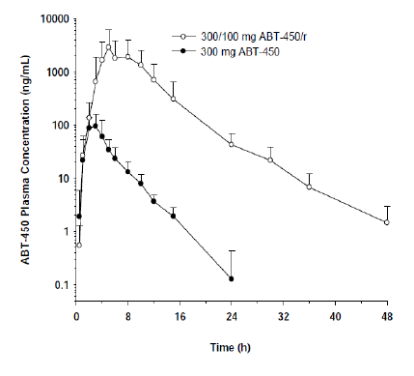

Study M10-797
Study M10-797 examined the bioequivalence of two test SDD tablet formulations (formulation 1 and 2) of ABT-450 50 mg relative to the reference ABT-450 50 mg HGC formulation following co-administration with ritonavir. In addition, it examined the relative bioavailability of a 200 mg HGC capsule and a 200 mg tablet of SDD formulation 2 under non-fasting conditions when co-administered with a 100 mg ritonavir capsule. The results indicated that the 200 mg ABT-450 SDD tablet had a lower bioavailability (55% and 49% lower C_{max} and AUC_{inf},) than the 200 mg ABT-450 HGC capsule. By contrast, the PKs of ritonavir were affected to the same extent by both capsule and tablet formulations of ABT-450.
Comment: Although the PKs of the two SDD formulations were similar, SDD Formulation 2 was chosen for further development as it displayed lower variability in regards to the PKs of both ABT-450 and ritonavir.
Two further studies compared the PKs of co-formulations of ABT-450/r with ABT-450 capsules or tablets when co-administered with ritonavir. The first of these, Study M11-388 examined different doses of ABT-450 (150 mg versus 100 mg) for the co-formulation of ABT-450/r and free combination of ABT-450 and ritonavir; therefore, making the relative bioavailability results difficult to interpret. The second study, M12-683, assessed the bioavailability of four different dosage strengths of ABT-450 administered with ritonavir (ABT-450/r) co-formulated tablets compared to the ABT-450 SDD tablet formulation co-administered with ritonavir 100 mg capsule. Following administration of the co-formulated ABT-450/r 150 mg/100 mg (that is the proposed recommended dose) the C_{max} and AUC_{inf} of ABT-450 were 1.53 fold and 1.35 fold higher than following administration of 150 mg of the ABT-450 SDD tablet co-administered with the 100 mg ritonavir capsule. By contrast, although the C_{max} of ritonavir was slightly higher following administration of the co-formulation (1.22 fold), in regard to ritonavir AUC_{inf}, the two formulations were bioequivalent.

ABT-267

Study M12-115
Study M12-115 assessed the relative bioavailability of an uncoated HME 25 mg tablet formulation of ABT-267 relative to the ABT-267 SDD 25 mg tablet used in the initial Phase I trials. For the uncoated HME tablet the C_{max} and AUC_{inf} were 1.9 fold and 1.75 fold higher, respectively, than for the SDD tablet. The more bioavailable uncoated HME formulation was therefore utilised for clinical testing from Phase II onwards in conjunction with the 1.5 mg and 5 mg SDD tablet dose strengths.
Later in the development program a coated HME tablet was developed and Study M12-647 assessed the relative bioavailability of the coated HME 25 mg tablet of ABT-267 compared to the uncoated ABT-267 25 mg HME tablet. This study identified that both formulations were bioequivalent with the 90% CI interval for the point estimates of the log transformed C_{max} and AUC_{inf} falling between the BE interval of 80 to 125%.

ABT-450/r/ABT-267
Following on from these initial studies a co-formulated tablet containing ABT-450, ritonavir and ABT-267 was developed. Study M13-391 examined the bioavailability of different dosage strengths of ABT-450, ritonavir and ABT-267 co-formulated tablets with reference to the free combination of ABT-450 SDD tablet administered with ritonavir and ABT-267 HME and with reference to the ABT-450 and ritonavir co-formulated tablets administered with ABT-267 HME. This study identified that at the proposed daily dose of 150 mg/100 mg/25 mg the C_{max} and AUC_{inf} values for ABT-450 for the co-formulated tablets containing ABT-450/r/ABT-250 were similar to the values obtained from the ABT-450/r co-formulated tablets. By contrast, the ABT-450 C_{max} and AUC_{inf} of the triple co-formulation were 1.93 fold and 1.63 fold higher than the corresponding values obtained for the free combination. Ritonavir exposure following administration of the co-formulated ABT 450/r/ABT-267 was similar to ritonavir exposure following dosing with the free combination and bioequivalent to the co-formulated ABT-450/r co-administered with ABT-267 HME tablet. ABT-267 exposure following administration of the co-formulated ABT 450/r/ABT-267 tablet was bioequivalent to the ABT-267 HME tablet (co-administered with ABT-450 SDD tablets plus ritonavir capsule) and similar to ABT-267 exposure following dosing with the ABT-267 HME tablet co-administered with co-formulated ABT-450/r tablets.

ABT-333
Study M12-995 assessed the relative bioavailability of two test tablet formulations of ABT-333, optimised 400 mg and 300 mg formulations, compared to the reference tablet formulation of ABT-333 400 mg used in the Phase IIb trials. This study identified that both optimised formulations were more bioavailable than the Phase IIb formulation. For instance the C_{max} and AUC_{inf} of ABT-333 following administration of the optimised 400 mg formulation was 1.48 fold and 1.53 fold higher than the values obtained with the Phase IIb formulation.
Given that the bioavailability of the optimised formulation of ABT-333 was higher than that of the Phase IIb formulation, an optimised 250 mg ABT-333 tablet was then developed with the intention that it would be used in the Phase III studies. Study M13-331 assessed the relative bioavailability of the 250 mg ABT-333 optimised formulation compared to the 400 mg ABT-333 Phase IIb formulation. The results indicate that the C_{max} and AUC_{inf} values for ABT-333 were bioequivalent following administration of the 250 mg optimised tablet and the 400 mg formulation.
Study M14-196 examined the relative bioavailability of a 250 mg dose of the commercial formulation ABT-333 with reference to the ABT-333 clinical Phase III formulation. This study identified that both formulations were bioequivalent.
Comment: The following study is relevant to Viekira Pak-RBV application only.
Study M14-356 examined the bioequivalence between Ribasphere ribavirin tablets (Test) sold in the US relative and Copegus ribavirin tablets (Reference) sold in Australia under fed conditions. The two formulations were bioequivalent as the 90% confidence intervals for C_{max}, AUCt and AUC_{inf} ratios of central values fell within the bioequivalence range (0.80 to 1.25).

Bioequivalence of different dosage forms and strengths
Only a single dosage form and strength is proposed for the to be marketed co-formulated ABT-450/r/ABT-267 (75 mg/50 mg/12.5 mg) and ABT-333 250 mg tablets and the PKs of these formulations are described in the preceding section.
Comment: It should be noted that additional ABT-267 candidate tablets were examined in Study M13-387, but as these were not used in succeeding studies the results will not be discussed in this evaluation report.

Bioequivalence to relevant registered products
Not applicable.

Influence of food

ABT-450/r
Study M11-388 assessed the effect of food on the bioavailability of ABT-450/r co-formulation Following administration of ABT-450/r 150 mg/100 mg under non-fasting conditions the C_{max} and AUC_{inf} of ABT-450 were increased 3.05 to and 2.39 fold, respectively, compared to when the co-formulation was administered under fasting conditions. For the ritonavir component the C_{max} and AUC_{inf} were increased by 1.60 and 1.34 fold, respectively, when the co-formulation was administered with food. By contrast, when a 200 mg/100 mg dose of ABT-450/r was evaluated (Study M10-923), the effect of food on increase in ABT-450 exposure was significantly diminished and the C_{max} and AUC_{inf} of ritonavir were decreased by 30% and 14%, respectively, compared to fasted conditions.

ABT-267
One objective of Study M12-116 was to determine the effect of a moderate fat breakfast on the PKs of 25 mg ABT-267 SDD. The results indicated that the C_{max} and AUC_{inf} of ABT-267 were 1.93 and 1.62 fold higher, respectively, following a moderate fat breakfast than under fasting conditions.

ABT-450/r/ABT-267
Study M11-389 examined the effect of food on the PKs of the co-formulated ABT-450/r/ABT-267 tablet. Following administration of the proposed daily dose, a moderate fat breakfast increased the C_{max} and AUC_{inf} of ABT-450 by 4.67 and 3.11 fold, respectively, compared to when the co-formulation was administered under fasting conditions. The C_{max} and AUC_{inf} of ritonavir was increased by 1.63 and 1.49 fold, respectively, following administration with a moderate fat breakfast and the C_{max} and AUC_{inf} of ABT-267 increased by 2.27 and 1.82 fold, respectively.

ABT-333
Study M13-300 assessed the effect of food on the PKs of ABT-333 following administration of 250 mg dose of the optimised Phase III tablet formulation. The results indicate that a moderate fat breakfast increased the C_{max} and AUC_{inf} of ABT-333 by 1.53 and 1.3 fold compared to when ABT-333 was administered under fasted conditions. By contrast, in Study M10-351 food appeared to have little to no effect on the C_{max} and AUC_{inf} of ABT-333 following administration of the initial IR capsule formulation of ABT-333.
Comment: ABT-333 formulation appears to alter the effects of food on the bioavailability of ABT-333. Can the sponsor please comment?

Dose proportionality

ABT-450/r
Following single doses of 300 mg, 600 mg and 900 mg of ABT-450 HGC the dose normalised C_{max} and AUC_{inf} values for ABT-450 increased and were statistically significantly different (p ≤ 0.021) over the dose range investigated. These results indicate that the increase in ABT-450 exposure with dose was greater than dose proportional. When ABT-450 was co-administered with ritonavir the PKs of ABT-450 were nonlinear and increased supra-proportionally with dose. For instance, a 2.7 fold increase in dose from 75 mg to 200 mg increased ABT-450 AUC by 30 fold.
Two further studies, M10-861 and M12-351, added additional support for the finding that dose related increases in ABT-450 exposure were greater than dose proportional.

ABT-267
Sub-study 1 of Study M12-116 examined the single ascending dose PKs of ABT-267 at doses of 1.5 mg to 200 mg SDD tablets and 200 mg and 350 mg for the HME tablet formulation. For the SDD tablets between doses of 1.5 mg to 50 mg the dose normalised C_{max} and AUC_{inf} increased with dose indicating that at these doses the PKs of ABT-267 were non-linear and increased greater than dose proportionally. By contrast, for the 100 mg and 200 mg SDD formulation and the 200 mg and 300 mg HME tablets it appeared that the PKs were dose linear.

ABT-333
Study M10-351 examined the PKs after administration of QD doses of 10 to 2000 mg of the capsule formulation of ABT-333. Dose normalised C_{max} and AUC_{inf} appeared to decrease with dose with doses up to 200 mg ABT-333. Initially at higher doses (400 to 1200 mg) dose normalised ABT-333 exposure remained relatively stable before decreasing with dose at doses of greater than 1200 mg. A second study, M10-687, also identified similar dose normalised C_{max} and AUC₁₂ values between the dose range of 200 to 1000 mg, but in this case following BD doses of ABT-333 capsules. For the tablet formulation, the dose normalised PKs at higher doses appeared to differ to those of the capsule. Study M11-032, which examined the PKs of ABT-333 following administration of QD doses of 1200 mg and 1600 mg ABT-333 tablets, identified that the dose normalised C_{max} and AUC were very similar between doses. Suggesting, in contrast to the capsule formulation, that there were linear PKs in regard to ABT-333 exposure at high doses of the tablet formulation.
Comment: The dose/exposure pattern of ABT-333 during Study M10-351 appears to be a little unusual. Can the sponsor please explain this behaviour in regards to dose normalised C_{max} and AUC for ABT-333 in Study M10-351 and why the results for the 1200 and 1600 mg doses are not consistent across the two studies?

Bioavailability during multiple-dosing

ABT-450/r
Following 14 days QD dosing with ABT-450/r 200/100 mg or 300/100 mg, Study M10-861, ABT-450 exhibited non-linear PKs with greater than dose proportional increases in ABT-450 exposure. ABT-450 C_{max} and AUCt were approximately 2.3 fold and 1.68 fold higher, respectively, following 14 days dosing with 200/100 mg QD than following a single dose. By contrast for the 300/100 mg QD dose, ABT-450 accumulation was less pronounced with C_{max} and AUCt increasing by only 1.12 fold and 1.05 fold, respectively, following 14 days of administration. The ABT-450 t½ following multiple QD dosing ranged between 4.5 and 5.7 h. C_{trough} concentrations of ABT-450 increased up to Day 7, before gradually decreasing and stabilising between Day 9 and 12 possibly indicating that some inhibition occurs in the initial days followed by induction of metabolism and/or transporters. When ABT-450/r 250 (250 mg SDD/100 mg SGC) were co-administered over a 14 day period (Study M12-187) the accumulation ratios for ABT-450 C_{max} and AUC₂₄ were 3.81 and 2.60, respectively.
Comment: Can the sponsor please provide an explanation as to why accumulation of ABT-450 exposure was far less pronounced for the 300 mg ABT-450 dose compared to the 250 mg and 200 mg doses?

ABT-267
Following 10 days QD dosing with 25 mg ABT-267 (Study M12-116) the C_{max} and AUC₀₋₂₄ values of ABT-267 increased approximately 1.49 fold and 1.56 fold, respectively, compared to administration of a single dose. The T_{max} values were similar on both Days 1 and 10 and the t½ for the 25 mg QD dose was 28.1 h on Day 10. ABT-267 C_{trough} values initially increased up to Day 5 and subsequently stabilised. These findings were similar to the results of Study M12-187, which identified accumulation ratios of 1.09 and 1.26 for ABT-267 C_{max} and AUC₀₋₂₄, respectively, following 25 mg QD dosing with ABT-267 SDD for 7 days.
Comment: It would appear that accumulation ratios increase with the length of dosing for ABT-267.

ABT-450/r/ABT-267
Following 21 days dosing with 25 mg ABT-267 SDD and 14 days with co-administered ABT-450/r 250 mg SDD/100 mg SGC (starting on Day 8), Study M12-187, the accumulation ratios for ABT-450 C_{max} and AUC₂₄ were 3.81 and 2.60. For ritonavir over this period the accumulation ratios for C_{max} and AUC₂₄ were 2.29 and 1.67, respectively. Over the 14 day period during which all three drugs were administered (that is Day 8 to 21), the accumulation ratios for ABT-267 C_{max} and AUC₂₄ were 0.83 and 0.91, respectively.

ABT-333
Study M10-687 also examined the PKs of ABT-333 following 10 days of BD dosing with 200 to 1000 mg of ABT-333 capsules. As in the single dose studies the dose normalised C_{max} and AUC₁₂ values of ABT-333 were similar for all doses following 10 days of treatment. In addition, on Day 10 the dose normalised C_{max}, AUC₁₂ and C_{trough} values for ABT-333 were not statistically significantly (p > 0.375) different; furthermore the T_{max} values (p > 0.190) across the dose range were not examined. The accumulation ratios comparing the AUC₁₂ following 10 days and a single dose of ABT-333 ranged from 0.95 to 1.65.

ABT-450/r/ABT-333
Following 17 days treatment with 100 mg ABT-333 BD and 14 days treatment with ABT-450/r 200/100 mg QD (starting on Day 4) (Study M11-603) the C_{max}/dose of ABT-450 increased from 6.69 ng/mL/mg on Day 4 to 15.7 ng/mL/mg on Day 17 and the AUC₁₂/dose of ABT-450 increased from 28.1 ng.h/mL/mg to 71.9 ng.h/mL/mg. Similar increases in the dose adjusted C_{max} and AUC of ABT-450 were identified following 14 days treatment with 400 mg ABT-333 BD co-administered with ABT-450/r 200/100 mg QD. Ritonavir C_{max}/dose and AUC₁₂/dose also increased following multiple doses of 200 mg ABT-333 and ABT-450/r. By contrast for ABT-333, the C_{max}/dose decreased from 2.15 ng/mL on Day 4 to 1.57ng/mL on Day 17 and the AUC₁₂/dose decreased from 13.9 ng.h/mL to 11.0 ng.h/mL. Similar decreases in dose adjusted C_{max} and AUC were also identified following 14 days treatment with 400 mg ABT-333 BD co-administered with ABT-450/r 200/100 mg QD.

ABT-450/r/ABT-267/ABT-333
A summary of the central values of C_{max}, AUC and plasma concentrations at 12 h or 24 h after drug administration (C12 and C24, respectively), following multiple doses of the proposed dose of Viekira Pak, based on the results of 5 PK studies conducted in healthy subjects (M12-199, M12-202, M12-204, M14-324 and M14-325), are shown in Table 3.

Table 3: Summary of central value data from 5 PK studies, which examined the PKs of the proposed dose of Viekira Pak in healthy subjects
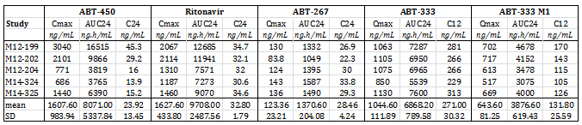

Effect of administration timing

ABT-450/r
Study M10-861 examined both BD and QD dosing of ABT-450/r. When dosed QD, a 50% increase in ABT-450 dose from 200 mg to 300 mg increased mean C_{max} and mean AUC by 5 to 6 fold. Increasing the BD dose of ABT-450 from 50 to 100 mg, increased the C_{max} and AUC by 4 to 5 fold.
Comment: The increase seen in ABT-450/r exposure that occurs following BD compared to QD dosing is not relevant to the current submission as the proposed dose of ABT-450/r is 150/100 mg once daily.

ABT-333
Study M10-687 investigated the mean plasma concentration time profiles following the morning and evening administrations of a range of ABT-333 doses (200 mg to 1000 mg) given BD for 10 days. Although, no formal statistical analyses were undertaken, the results indicated that the C_{max} values following the morning dose were higher than the values following the evening dose.

Distribution
Comment: No studies contained in the clinical dossier materials have specifically examined the ADME of ABT-333.

Volume of distribution

ABT-450/r/ABT-267
Following the administration of two ABT-450/r/ABT-267 (75/50/12.5 mg) co-formulated tablets (total dose of 150/100/25 mg) with a moderate fat breakfast the volume of distribution (Vd/F) values for ABT-450, ritonavir and ABT-267 were 400 L, 97.3 L and 717 L, respectively.

ABT-333
The Vd/F of ABT-333 following a 250 mg dose of the optimised, to be marketed, tablet formulation was 517 L.

Plasma protein binding

ABT-450
ABT-450 partitioned preferentially into the plasma compartment with a blood-to-plasma concentration ratio averaging 0.68 in humans (R&D/14/0039). In addition, protein binding was independent of the 0.1 to 10 µM concentrations investigated.

Ritonavir
Like ABT-450, ritonavir partitioned preferentially into the plasma compartment with a blood-to-plasma concentration ratio of 0.60 in humans (R&D/14/0039). Protein binding of ritonavir was independent of the 0.01 to 30 µg/mL concentrations tested.

ABT-267
The blood-to-plasma concentration ratio of ABT-267 is approximately 0.49 in humans, indicating that ABT-267 is preferentially distributed in the plasma compartment of human whole blood. ABT-267 is approximately 99.9% bound to human plasma proteins over a concentration range of 0.1 to 10 µM (0.09 to 9 µg/mL) (R&D/14/0038).

ABT-333
ABT-333 is > 99.9% bound to human plasma proteins over a concentration range of 0.1 to 10 µM (0.05 to 5 µg/mL) (R&D/14/0040). The blood-to-plasma concentration ratio is approximately 0.7 in humans.

Erythrocyte distribution
See section 4.2.2.3.2 above.

Tissue distribution
See section 4.2.2.3.2 above.

Metabolism

Interconversion between enantiomers
Not applicable.

Sites of metabolism and mechanisms / enzyme systems involved

ABT-450
The in vitro metabolism of ABT-450 was investigated in Study R&D/08/1579 using recombinant human CYP enzymes. The primary enzyme identified for the metabolism of ABT-450 was CYP3A4 and CYP3A5 was identified as having a minor role in this process. As a result of this ABT-450 is co-administered with the CYP3A inhibitor ritonavir to boost the exposure to ABT-450 following oral administration.

Ritonavir
In vitro study R&D/95/116 identified that ritonavir primarily undergoes bio-transformation to three major metabolites, M1, m² and M11 via the CYP3A-subfamily of enzymes with a minor contribution from CYP2D6.

ABT-267
In vitro study R&D/10/171 identified that ABT-267 is metabolised to a low extent and at a very slow rate by CYP3A4/5 and CYP2C8.

ABT-333
In vitro study R&D/07/1141, identified that ABT-333 is primarily metabolised by CYP2C8 (60% in vitro) and to a lesser extent by CYP3A (30% in vitro), with minor contribution of other CYPs (approximately 10% in vitro).

Non-renal clearance
Please see Section 4.2.2.5.1 of this report.

Metabolites identified in humans

ABT-450
Study M10-798, which examined the metabolism of ABT-450 following co-administration of a single oral dose of [¹⁴C]ABT-450 (200 mg) with 100 mg ritonavir in 4 healthy male subjects, identified 5 ABT-450 metabolites in human plasma (Table 4.). The breakdown of total drug related material based on AUCt in plasma was that 88.9% represented unchanged ABT-450, 7.8% m², 3.2% m²9 and there were trace levels of M3, M13 and M6. A summary of the proposed biotransformation pathway from Study R&D/08/1579 was provided.

Table 4: Identification of ABT-450 metabolites
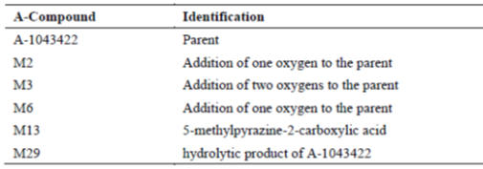

Ritonavir
Following oral administration of [¹⁴C] ritonavir 600 mg in five healthy males the primary, and only, metabolite identified in plasma was m² and that there was a mean 30 fold excess of parent drug over metabolite in systemic circulation between 2 and 12 h after oral dosing (Study R&D/95/959). The proposed biotransformation pathway from R&D/95/116 was provided.

ABT-267
In man, following a single oral dose of [¹⁴C]ABT-267 25 mg under non-fasting conditions (Study M12-186) the primary ABT-267 metabolites in plasma, based on AUCt, were m²9 (which represented 31.2% of the drug related material in plasma), M36 (21.4%), m²3 (15%) and M37 (13.9%) (Table 5). By contrast, the parent drug ABT-267 represented only 8.85% of the administered dose in plasma. A number of other metabolites were also identified (M5, m²5, m²6 and M34) but each of these represented less than 5% of the administered dose. The proposed metabolic pathway for ABT-267 was provided.

Table 5: The PK parameters of ABT-267 and its metabolites based on the radioactivity assay
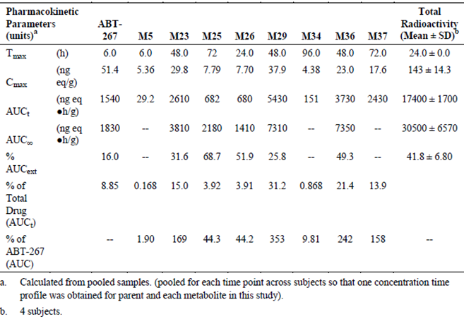

ABT-333
Following administration of a single 400 mg oral dose of [¹⁴C] ABT-333 in four healthy males (Study R&D/12/843) seven metabolites were identified in plasma including ABT-333 M1, m², M3, M4, M5, M6 and trace levels of metabolite M11. Unchanged parent was the most prominent component in plasma representing 58.1% of total plasma radioactivity followed by M1 (21.4% of total plasma radioactivity), while the other six were minor metabolites, each accounting for less than 10% of total radioactivity in plasma. The proposed metabolic pathway of ABT-was provided.

Active metabolites

ABT-333
The M1 metabolite of ABT-333 is an active metabolite with similar in vitro antiviral activity to ABT-333.

Other metabolites

ABT-267
None of the major metabolites of ABT-267(that is m²3, m²9, M36 and M37) have been shown to have in vitro anti-HCV activity.

Pharmacokinetics of metabolites
Following a single oral dose of the proposed commercial formulation of ABT-333 250 mg under non-fasting conditions (Study M14-196), the C_{max}, T_{max}, t½ and AUC_{inf} values for the active M1 metabolite of ABT-333 were 244 ng/mL, 4 h, 6.4 h and 2120 ng.h/mL, respectively.

Consequences of genetic polymorphism
R&D/14/0052 represented a pharmacogenetic analysis that examined whether known and novel single nucleotide polymorphisms (SNP)s within Phase I, Phase II and drug transporters, including UGT1A1 and SLCO1B1, effected ABT-450 exposure. In addition, genetic analysis of SNPs within CYP2C8 was performed for ABT-333. No significant genetic associations were identified that consistently associated with exposures of ABT-450 or ABT-333. Finally, co-exposure of escitalopram and duloxetine with ABT-450, ABT-267 and ABT-333 did not result in changes in exposures of any of the compounds based on CYP2D6 metaboliser status.

Excretion

Routes and mechanisms of excretion

ABT-450
Following co-administration of 200 mg [¹⁴C] ABT-450 and 100 mg ritonavir (Study M10-798), 96.5% of the radioactive dose was recovered in the faeces (representing 88% of radioactive dose) and urine (8.8%) within approximately 8 days. Unchanged parent drug (that is ABT-450) accounted for only 1.1% and 0.05% of the total radioactivity in faeces and urine, respectively, with the major components being m²9 in faeces, which accounted for 59.9% of radioactive dose, and M13 in urine, which accounted for 8.6% of dose.

Ritonavir
Following administration of 600 mg liquid oral dose of [¹⁴C] ritonavir, 97.6% of radioactive dose was recovered in the urine and faeces of humans within approximately 6 days (R&D/95/810). Faecal excretion was the major route of elimination, accounting for 86.4% of the dose, whereas, urinary excretion accounted for 11.3% of the dose.

ABT-267
Following a 25 mg oral dose of [¹⁴C] ABT-267 under non-fasting conditions (Study M12-186) approximately 90.3% of the radioactive dose was recovered in faeces and a further 0.6% was recovered in urine within 8 days. Unchanged parent drug accounted for 87.8% of total radioactivity recovered in faeces and although a number of metabolites were detected in the faeces, including m², M3, M5, M6, and M9, each represented less than 1% of administered dose.

ABT-333
Two hundred forty hours following a single oral dose of 400 mg [¹⁴C]-ABT-333 in four male subjects, 94.4% of administered radioactivity was recovered in faeces and a further 2.20% was recovered in urine (R7D/12/843). Unchanged parent drug accounted for 26% and 0.03% in faeces and urine, respectively. ABT-333-M1 was the most abundant metabolite in faeces representing 31.5% of administered dose.

Mass balance studies
Please see Section 4.2.2.5.1 of this report.

Renal clearance
Please see Section 4.2.2.5.1 of this report.

Intra- and inter-individual variability of pharmacokinetics

ABT-450/r/ABT-267 co-formulation
Following the proposed dose of the to be marketed formulation of ABT-450/r/ABT-267 under non-fasted conditions (that is following a moderate fat breakfast) the total variability’s in C_{max} and AUC_{inf} values expressed as percent coefficient of variation (CV) for ABT-450 were high (> 100%), indicating inter-subject variability in regards to ABT-450 exposure was high. For, ritonavir variability in ritonavir exposure was relatively lower but still around approximately 50% whereas, variability in ABT-267 exposure was lower again at 28%.

ABT-333
For the proposed commercial formulation of ABT-333 250 mg the %CV values for ABT-333 C_{max} and AUC_{inf} were 44% and 46%, respectively.

Pharmacokinetics in the target population

ABT-450/r
Study M11-602 examined the PKs of ABT-450/r following co-administration of single doses of ABT-450 HGC 50 to 200 mg with 100 mg ritonavir SGC and following three days of dosing in naïve HCV genotype 1 infected subjects. Following a single dose of ABT-450/r 200 mg/100 mg the geometric mean C_{max} and AUC₂₄ values for ABT-450 were 1753 ng/mL and 10478 ng.h/mL respectively and for ritonavir were 917 ng/mL and 7104 ng.h/mL respectively. Over the dose range examined ABT-450 demonstrated greater than dose proportional increases following single doses. ABT-450 exposures were 80% to 310% higher on Day 3 compared to Day 1.

ABT-267
Sub-study 4 of Study M12-116 examined the PKs ABT-267 following multiple oral doses of 5 to 50 mg ABT-267 SDD under non-fasting conditions in HCV genotype 1 infected treatment naïve adult subjects. After a single dose of ABT-267 25 mg the C_{max} and AUC₂₄ values for ABT-267 were 35.9 ng/mL and 337 ng.h/mL respectively and following 3 days of QD dosing were 24.8 ng/mL and 319 ng.h/mL respectively indicating there was no accumulation in ABT-267 over this period. Over the dose range mentioned, following single doses there were greater than dose proportional increases in ABT-267 exposure in this population.

ABT-333
Two studies examined the PKs of ABT-333 in treatment naïve HCV genotype 1 infected subjects under non-fasting conditions. Study M11-602 examined the PKs of ABT-333 following 400 and 800 mg BD dosing for 3 days in this population. ABT-333 exposures on Day 1 and Day 3 were similar suggesting that there was little to no accumulation following BD doses. Dose normalised C_{max} and AUC₁₂ values following a single dose indicated that there was a slightly greater than dose proportional increase in ABT-333 exposure, whereas on Day 3, exposures increased in a slightly less than dose proportional manner with increasing ABT-333 doses. In the second study, Sub-study 2 of Study M10-351 examined the PKs following 100 and 600 QD and BD dosing of ABT-333 for two days. Unfortunately only a small number of subjects were examined in each group (n = 2 to 4) making interpretation of the data difficult.

Intra- and inter-individual variability of PK in target population
Two PPK studies examined the PKs of ABT-450, ritonavir, ABT-267 and ABT-333 in subjects infected with genotype 1 strain HCV. The first of these studies, RD 13-1098 PPK, used data from Phase Ib and Phase II clinical trials to generate the PPK model, whereas, the second study, RD 14-0047 PPK utilised patient data from six Phase III trials and one Phase II trial.

ABT-450
The final Phase II PPK model generated in Study RD 13-1098 PPK predicted that the inter-subject variability in ABT-450 clearance (CL/F) and volume of the central compartment (Vc/F) was very high with CV values of 166% and 265%, respectively. The residual unexplained variability (RUV) for ABT-450 was also high (100%). By comparison in Study RD14-0047PPK, the final ABT-450 PPK model indicated that the inter-subject variability in ABT-450 CL/F was 150%.

Ritonavir
The final PPK model for ritonavir (Study RD 13-1098 PPK) indicated that the inter-subject variability values for CL/F and VcF, after accounting for the significant covariate of race, were 85% and 210%, respectively and the RUV was 71%. By comparison in Study RD14-0047PPK, the final ritonavir PPK model indicated that the inter-subject variability in ritonavir CL/F was 112%.

ABT-267
The final PPK model for ABT-267 (Study RD 13-1098 PPK) indicated that the inter-subject variability values, after accounting for the covariates (age, weight and gender), for CL/F, Vc/F and volume of the peripheral compartment (Vp/F) were 30%, 59% and 59%, respectively, and the RUV was 37%. By comparison in Study RD14-0047PPK, the final ABT-267 PPK model indicated that the inter-subject variability in ABT-267 CL/F was 39%.

ABT-333
The final PPK model for ABT-333 (Study RD 13-1098 PPK), indicated that, after accounting for the gender covariate, the inter-subject variability values on CL/F and Vc/F were 62% and 73%, respectively, and the RUV was 55%. By comparison in Study RD14-0047PPK, the final ABT-333 PPK model indicated that the inter-subject variability in ABT-333 CL/F was 55%.

Pharmacokinetics in other special populations

Pharmacokinetics in subjects with impaired hepatic function
Study M12-215 assessed the PKs of the active constituents following a single dose of 25 mg ABT-267, 400 mg ABT-333, and ABT-450/r 200/100 mg under non-fasting conditions in subjects with normal hepatic function and in subjects with mild stable chronic to severe stable chronic hepatic impairment. In subjects with mild hepatic impairment compared to healthy subjects, the AUC_{inf} values for the active drugs were approximately ± 35% different with the greatest changes seen in the exposures of ABT-450 and ritonavir, which were 29% and 34% lower in the hepatically impaired subjects. In subjects with moderate hepatic impairment the AUC_{inf} values for ritonavir, ABT-267, ABT-333 and ABT-333 M1 were 30%, 30%, 16% and 57% lower, respectively, in the impaired subjects than in the healthy subjects. By contrast, exposure to ABT-450 increased by approximately 62% in subjects with moderate hepatic impairment. In subjects with severe hepatic impairment, the AUC_{inf} values for ABT-450, ritonavir, ABT-333 and ABT-M1 were increased by 10.5 fold, 1.13 fold, 4.25 fold and 1.77 fold, respectively, compared to healthy subjects, whereas, the AUC_{inf} of ABT-267 decreased by 54%. The unbound fraction (% fu) of DAAs and ritonavir were up to approximately 30% different in subjects with hepatic impairment and healthy control subjects, except for ABT-333 % unbound fraction (fu), which was approximately 50% lower in subjects with mild and moderate hepatic impairment compared to healthy control subjects and ABT-267 % fu in subjects with severe hepatic impairment, which was approximately 2.24 fold higher than in healthy control subjects.

Pharmacokinetics in subjects with impaired renal function
Study M12-193 examined the PKs of 2 DAA (ABT-450/r + ABT-267) and 3-DAA (ABT-450/r + ABT-267 + ABT-333) combinations administered as a single dose under non-fasting conditions in subjects with normal renal function and subjects with mild, moderate and severe renal impairment. Following administration of two ABT-450/r 75/50 mg tablets and one 25 mg ABT-267 tablet under non-fasting conditions the ABT-450 C_{max} values were 11% to 22% lower, whereas, the AUC_{inf} values were 11% to 25% higher in the subjects with renal impairment compared to healthy controls. For ritonavir, C_{max} values were 28% to 71% higher and AUC_{inf} values were 40% to 108% higher in impaired than in normal subjects. By contrast for ABT-267, C_{max} and AUC_{inf} values were similar in the impaired and healthy subjects (± 18%).
Following administration of the 3-DAA regimen with ritonavir, the AUC_{inf} of ABT-450 increased by 1.19 to 1.45 fold in subjects with mild to severe renal impairment compared to healthy subjects. Ritonavir AUC_{inf} increased by 1.42 to 2.14 fold in subjects with renal impairment compared to healthy subjects. The AUC_{inf} of ABT-333 also increased in subjects with renal impairment, for instance in subjects with mild impairment AUC_{inf} was increased by 1.21 fold and with severe impairment by 1.50 fold. In contrast, ABT-267 exposure was relatively unaffected by renal impairment.

Pharmacokinetics according to age
No trials specifically examined the effect of age on the PKs of the 3 DAAs or ritonavir. However, both of the PPK studies, RD 13-1098 PPK and RD 14-0047 PPK, which examined the PKs of the drugs in the target population, included age as a potential covariate. In Study RD 13-1098 PPK, age was only identified as a significant covariate for ABT-267 clearance in the final ABT-267 PPK model and it was shown that a patient, who was 10 years younger or older than the population mean age (that is 48 years old) would have < 12% change in ABT-267 exposure. By contrast in Study RD 14-0047 PPK, age was found to be a significant covariate of both CL/F and Vc/F in the final PPK models generated for ABT-450 and ABT-333 and in Vp/F for ABT-267. However, overall the effect of age was relatively small with a ≤ 20% change in exposures with a change of ± 10 years from 54 years of age.

Pharmacokinetics related to genetic factors

Gender
No studies specifically examined the effect of gender on the PKs of the 3 DAAs and ritonavir. Therefore, the effect of gender has only been addressed in the two PPK studies, RD 13-1098 PPK and RD 14-0047 PPK. Study RD 13-1098 PPK identified gender as a significant covariate for clearance for ABT-450, ABT-267 and ABT-333 but not ritonavir and for ABT-267 Vp/F. In this study the effect of gender on exposure to the drugs ranged from 15% to 30% with females having lower clearance than male subjects. Study RD 14-0047 PPK also identified gender as a significant covariant of CL/F for ABT-450, ABT-267 and ABT-333. In addition and in contrast to the preceding study, gender was identified as a significant covariate for ritonavir clearance. In this study the effects of gender were more significant for both ABT-450 and ABT-267 with females having 100% and 55% higher exposure, respectively, than male patients.

Ethnicity
A number of studies, including M12-221, M12-688, M12-181, M13-505, M11-384 and M11-385 compared the PKs of ABT-450/r, ABT-267 and ABT-333 in subjects with different ethnic backgrounds. The most relevant of these to the current discussion involved Arm 3 of Study M12-221, which examined the PKs following co-administration of ABT-267 25 mg QD HME, ABT-450/r 150/100 mg QD, and ABT-333 400 mg BD for 21 days to Han Chinese, Japanese and Caucasian subjects. On Study Day 21, the results indicated that in comparison to Caucasian subjects, the AUC₂₄ values for ABT-267 in Chinese and Japanese subjects were 1.18 and 1.30 fold higher, respectively. For ABT-450, the AUC₂₄ values were 2.47 and 2.91 fold higher in Chinese and Japanese subjects, respectively. For ritonavir, the AUC₂₄ values were 1.24 and 1.06 fold higher in Chinese and Japanese subjects, respectively. For ABT-333, the AUC₂₄ values were 1.11 and 1.29 fold higher in Chinese and Japanese subjects, respectively and for ABT-333 M1 were 1.35 and 1.50 fold higher, respectively.
In addition, Study RD 13-1098 PPK identified that HCV genotype 1 infected subjects of Hispanic/Latino ethnicity had 15% higher ABT-450 C_{max},_{ss} and 43% lower ABT-450 C_{τ,ss} and approximately 58% to 156% higher ritonavir exposures than non-Hispanic/Latino patients.

Pharmacokinetics in other special populations

Weight
Both PPK studies identified that the patients weight can affect the PKs of the 3DAAs and ritonavir. For instance in Study RD13-1098, weight was a significant covariate of ABT-267 CL/F with a 10 kg increase or decrease in body weight from 79 kg (reference body weight in ABT-267 model) resulting in < 12% change in ABT-267 exposure. In Study RD14-0047 PPK, weight was shown to be a significant determinant of: ABT-267 CL/F and Vc/F, with a 10 kg increase or decrease in weight from 76 kg (median weight in the Phase III studies) resulting in < 10% change in ABT-267 exposures; and ABT-333 CL/F and Vp/F, with a 10 kg increase or decrease in weight from median resulting in < 10% change in ABT-333 exposure.

Other factors
Study RD14-0047 PPK identified a number of additional significant covariates that influenced the PKs of ABT-450, ABT-333 and ritonavir. These included: cirrhosis on the CL/F of ABT-450, whereby cirrhotic subjects would have approximately 120 to 140% higher ABT-450 exposures than non-cirrhotic subjects; cirrhosis and renal function (based on CrCL) on ABT-333 CL/F, whereby subjects with mild renal impairment would have approximately 10% higher ABT-333 exposures than healthy subjects and cirrhotic subjects would have approximately 30 to 40% higher ABT-333 C_{max},_{ss} and AUC₂₄,ss values than non-cirrhotic subjects; and renal function and HCV genotype on CL/F of ritonavir, whereby subjects with mild renal impairment would have approximately 15% higher ritonavir exposures than healthy subjects and subjects with genotype 1a would have approximately 35% higher ritonavir AUC₂₄,_{ss,} than those with genotype 1b.

Pharmacokinetic interactions

Pharmacokinetic interactions demonstrated in human studies

Interactions between DAAs and ritonavir contained in the proposed formulations

Effect of ritonavir on ABT-450 exposure
Study M10-749 clearly demonstrated the rationale for the co-administration of the CYP3A4 inhibitor, ritonavir, with ABT-450. Compared to when 300 mg ABT-450 was administered alone, co-administration with 100 mg ritonavir resulted in significant increases in ABT-450 C_{max}, which increased from 121 ng/mL to 3,397 ng/mL, and AUC_{inf} , which increased from 391 to 18,534 ng.h/mL.

Effect of ABT-450/r on ABT-267 exposure
Compared to when 25 mg ABT-450 was administered alone for 7 days, co-administration with a single dose of ABT-450/r 250/100 mg increased the C_{max} and AUC₂₄ of ABT-267 by 1.59 and 1.62 fold, respectively. These finding were confirmed in healthy Caucasians in Study M12-221 as following co-administration of ABT-450/r 250/100 mg with 25 mg ABT-267 the C_{max} and AUC_{inf} of ABT-267 increased by 1.65 to and 1.62 fold, respectively.

Effect of ABT-267 on ABT-450/r exposure
Compared to when ABT-450/r 250/100 mg was administered alone for 14 days, co-administration with a single dose of 25 mg ABT-267 had little effect on C_{max} and AUC₂₄ of ABT-450, which increased by 1.09 and 1.06 fold, respectively. Similar small increases in ABT-450 C_{max} and AUC₂₄ were identified in Caucasian subjects in Study M12-221.
For ritonavir, single dose co-administration with 25 mg ABT-267following 14 days administration of ABT-450/r 250/100 mg had little to no effect on the C_{max} and AUC of ritonavir.

Effect of ABT-333 on ABT-450/r
Co-administration of 100 mg ABT-333 BD with ABT-450/r 200/100 mg increased the ABT-450 C_{max} from 2,520 to 3,140 ng/mL and ABT-450 AUC₂₄ from 9,890 to 14,400 ng.h/mL compared to when ABT-450/r was administered alone. Ritonavir exposure was also increased in the presence of ABT-333 with the AUC₂₄ of ritonavir increasing from 7,140 to 8,160 ng.h/mL.

Effect of ABT-450/r on ABT-333
Following co-administration of 100 mg ABT-333 BD with ABT-450/r 200/100 mg QD the C_{max} and AUC₁₂ values for ABT-333 was similar to when ABT-333 was administered alone.

Effect of ABT-333 on ABT-450/r + ABT-267
Following co-administration of ABT-450/r 150/100 mg QD + ABT-267 25 mg QD with ABT-333 400 mg BD for 14 days, ABT-450 exposure more than doubled with the C_{max} of ABT-450 increasing from 1,530 to 3,330 ng/mL ABT-450 AUC₂₄ from 9,030 to 19,000 ng.h/mL compared to when ABT-450/r + ABT-267 were co-administered in the absence of ABT-333. The effects of ABT-333 on ritonavir and ABT-267 exposure were smaller with ritonavir AUC₂₄ increasing from 10,100 to 13,700 ng.h/mL and ABT-267 AUC₂₄ from 1,210 to 1,540 ng.h/mL.
Following a single dose of ABT-450/r/ABT-267 150/100/25 mg co-administered with ABT-333 250 mg the AUC_{inf} of ABT-450 increased from 6,066 to 8,616 ng.h/mL, ritonavir AUC_{inf} increased marginally from 9,443 to 9,533 ng.h/mL and ABT-267 AUC_{inf} increased from 1,695 to 2,011 ng.h/mL when compared to administration of ABT-450/r/ABT-267.

Mechanism-based drug-drug interaction studies
Study M12-189 evaluated the effect of ketoconazole 400 mg QD, an inhibitor of both CYP3A4 and P-gp, on the PKs of a single dose ABT-450/r/ABT-267 150/100/25 mg and 250 mg ABT-333. Co-administration with ketoconazole increased the AUC_{inf} of ABT-450, ritonavir and ABT-333 by 1.98, 1.57 and 1.42 fold respectively, whereas it had little to no effect on AUC_{inf} values for ABT-267 or ABT-333 M1. In the presence of the 3 DAAs + ritonavir, the AUC₂₄ of ketoconazole was increased by 2.17 fold.
Study M13-394 examined the PK interaction between steady state ABT-450/r 150/100 mg QD + ABT-267 25 mg QD in the morning + ABT-333 400 mg BD and steady state atazanavir 300 mg QD. Atazanavir is metabolised by CYP3A4 and CYP3A5 and it is an inhibitor and inducer of P-gp as well as a potent inhibitor of CYP3A in vitro. In addition, atazanavir inhibits OATP1B1/1B3. The presence of steady state atazanavir increased the AUC₂₄ of ABT-450 by 1.94 fold, whereas, it decreased the AUC₂₄ of ABT-267, ABT-333 and ABT-333 M1 by 17%, 18% and 11%, respectively. By contrast, steady state levels of the 3 DAAs + ritonavir had no effect on the PKs of atazanavir.
Study M12-196 evaluated the effect of the CYP2C8 inhibitor, gemfibrozil 600 mg, on the PKs of the two-DAA combination of 400 mg ABT-333 and ABT-450/r 150/100 mg when co-administered in healthy subjects. The results indicate that co-administration with gemfibrozil resulted in an 11.25 fold increase in ABT-333 AUC₀₋₇₂, a 4.6 fold decrease in ABT-333 M1 AUC₀₋₇₂, a 1.38 fold increase in ABT-450 AUC_{inf}, whereas, it had little to no effect on ritonavir AUC_{inf}.
Study M12-198 investigated the PK interaction between a single dose of 5 mg warfarin + 10 mg Vitamin K1 and ABT-450/r 150/100 mg + 25 mg ABT-267 with or without ABT-333 400 mg BD in healthy subjects at steady state. Metabolism of R-warfarin occurs mainly via CYP3A4 with involvement of CYP1A1, CYP1A2, CYP2C8, CYP2C9, CYP2C18 and CYP2C19, whereas, S-warfarin is primarily metabolised by CYP2C9. Warfarin + Vitamin K1 had little to no effect on the C_{max} and AUC of ABT-450, ritonavir, ABT-267, ABT-333 and ABT-333 M1. Nor did the 3 DAA combination + ritonavir affect the PKs of R- or S-warfarin.
Comment: Given the metabolic profile of R-warfarin, it is a little surprising that the PKs of R-warfarin were not affected by the presence of the 3 DAAs + ritonavir, considering that ritonavir is a potent inhibitor of CYP3A4. This possibly suggests that the PK interaction study should have instead examined steady state levels of warfarin. Can the sponsor please comment on whether a different result would be expected if this was the case?
Study M12-199 examined the effect of steady state ABT-450/r/ABT-267 150/100/25 mg with and without 250 mg ABT-333 BD on the PKs of a single 40 mg dose of the proton pump inhibitor and CYP2C19 substrate omeprazole in healthy subjects. Omeprazole had little to no effect on the PKs of ABT-450, ritonavir, ABT-267, ABT-33 or ABT-333 M1. Co-administration of a single dose of omeprazole with ABT-450/r/ABT-267 + ABT-333 resulted in 38% and 39% decrease in omeprazole C_{max} and AUC_{inf}, respectively, compared to omeprazole was administered alone.
Study M14-027 examined the PK interaction between steady state levels of the anticonvulsant carbamazepine, following 200 mg BD dosing, and a single dose of ABT-450/r/ABT-267 150/100/25 mg + ABT-333 250 mg. Exposure to ABT-450, ritonavir, ABT-267, ABT-333 and ABT-333 M1 were all significantly decreased when the 3DAAs were administered with the CYP3A inducer and substrate carbamazepine with AUC_{inf} values decreasing by approximately 3.4 , 7.9, 1.5, 3.3 and 1.6 fold, respectively. By contrast, carbamazepine PKs were relatively unaffected by the presence of the 3DAAs + ritonavir, whereas, the C_{max} and AUC₁₂ of its metabolite CBZE were decreased by 16 and 25%, respectively.
Comment: Due to the inhibition of CYP3A4 induced by ritonavir should we not expect to see an increase in carbamazepine exposure in the presence of the 3 DAAs + ritonavir.
Study M12-201 examined the PK interaction between a single dose of the P-gp substrate digoxin 0.5 mg and steady state levels of ABT-450/r/ABT-267 150/100/25 mg QD + ABT-333 400 mg BD. Results indicated that digoxin had no effect on steady state exposure of ABT-450/r/ABT-267 or ABT-333, nor did co-administration of the 3DAAs + ritonavir affect the PKs of digoxin).
Study M12-200 examined the PK interaction between steady state levels of the OATP1B1/B3 substrates rosuvastatin 5 mg and pravastatin 10 mg and steady state levels of ABT-450/r/ABT-267 150/100/25 mg QD + ABT-333 400 mg BD. Co-administration with pravastatin induced a small increase in ABT-450 AUC₂₄ (approximately 13%) but did not affect the PKs of ritonavir, ABT-267 or ABT-333. By contrast, pravastatin AUC₂₄was increased by 1.82 fold when co-administered with the 3DAAs. Rosuvastatin co-administration increased ABT-450 AUC₂₄ by 1.52 fold, but like pravastatin it did not affect the AUC₂₄ values of ritonavir, ABT-267 or ABT-333. Rosuvastatin AUC₂₄ increased by 2.59 fold when administered with the DAAs.

Interactions with other anti-viral drugs
Two studies examined the DDIs between lopinavir (LPV) + ritonavir and the triple combination of DAAs + ritonavir in healthy subjects. The first of these, Study M13-492 examined the PK interaction between steady state levels of LPV/r 400/100 mg and steady state levels of ABT-450/r/ABT-267 150/100/25 mg QD + ABT-333 400 mg BD. Co-administration of LPV/r increased the AUC₂₄ values for ABT-450, ritonavir and ABT-267 by 2.17-, 2.05 and 1.17 fold, respectively, whereas, it had little to no effect on the AUC₁₂ of ABT-333 or ABT-333 M1. Co-administration of the 3DAAs + ritonavir with LPV/r did not affect the AUC₁₂ of LPV/r. The second study (M14-013) examined the interaction between LPV/r 800/200 mg QD and 150/100/25 mg QD + ABT-333 400 mg BD. In this study LPV/r increased the AUC₂₄ of ABT-450, and ritonavir by 1.87- and 2.62 fold, respectively, and decreased the AUC₁₂ of ABT-333 and ABT-333 M1 by 46% and 38%, whereas, it did not affect the subject’s exposure to ABT-267. As in the previous study, the 3DAAs + ritonavir did not affect LPV exposure.
Comment: It is not surprising that ritonavir exposure increases with LPV/r as you are doubling and then tripling the daily dose of ritonavir in the two studies, respectively. Due to the increased levels of ritonavir it is difficult to ascertain whether the increase in ABT-450 exposure occurs as a result of LPV or increased inhibition of CYP3A4.
Study M13-506 examined the DDIs between darunavir 800 mg QD and ABT-450/r/ABT-267 150/100/25 mg QD + ABT-333 400 mg BD. The presence of steady state darunavir induce a small increase ABT-450 AUC₂₄ (1.29 fold), whereas for ritonavir, ABT-267, ABT-333 and ABT-333 M1, small decreases in AUC were identified with decreases ranging from 6% to 17%. Compared to steady state levels of following administration of darunavir + ritonavir the three DAAs decreased darunavir AUC₂₄ by 25%.
A second study, M12-202, examined the DDIs between steady state darunavir 800 mg + ritonavir 100 mg QD (administered in the evening) and ABT-450/r/ABT-267 150/100/25 mg QD (administered in the morning) + ABT-333 400 mg BD under non-fasted conditions. Surprisingly, given that the additional dose of ritonavir would be expected to result in increased ABT-450 exposure, when darunavir/r were co-administered with the 3DAAs + ritonavir the AUC₂₄ of ABT-450 decreased, in contrast to the preceding study by approximately 19.
Comment: It seems counter intuitive that on the one hand ritonavir increases ABT-450 exposure (see Tables 6 and 7) but in Study M12-202 the additional dose of ritonavir decreases ABT-450, can the sponsor please provide an explanation concerning the differences seen in ABT-450 PKs between Studies M13-506 and M12-202 described above.

Table 6: Study M10-749 the mean pharmacokinetic parameters of ritonavir after administration of ABT-450/r in sub-study 2
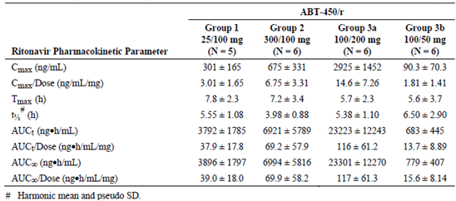

Table 7: Study M10-749
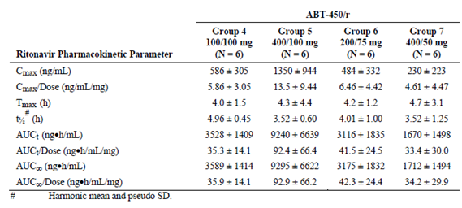
Study M13-783 examined the PK interaction between steady state levels of emtricitabine 200 mg QD + tenofovir disoproxil fumarate 300 mg QD and ABT-450/r/ABT-267 150/100/25 mg QD + ABT-333 400 mg BD. Tenofovir undergoes active renal secretion via organic anion transporters (OAT1, OAT3). Co-administration of emtricitabine/tenofovir with the 3 DAAs + ritonavir resulted in small decreases in the AUCs of ABT-450, ABT-333 and ABT-333 (16%, 15% and 10%, respectively), whereas the exposure to ABT-267 and ritonavir were unaffected. The 3 DAAs + ritonavir did not affect the steady state PKs of emtricitabine or tenofovir.
Study M13-104 examined the PK interaction between steady state levels of efavirenz/emtricitabine/tenofovir disoproxil fumarate (Atripla) 600/200/300 mg QD and ABT-450/r/ABT-267 150/100/25 mg QD + ABT-333 400 mg BD. Subjects who initiated dosing with Atripla followed by combination dosing with Atripla and DAAs experienced a greater number of AEs, treatment discontinuations and elevations in transaminases (ALT and AST), which lead to study termination.
Comment: Atripla should not be administered with the 3 DAAs + ritonavir.
Study M13-782 examined the DDIs between steady state rilpivirine 25 mg QD (administered in the evening) and ABT-450/r/ABT-267 150/100/25 mg QD + ABT-333 400 mg BD under non-fasting conditions. Co-administration of rilpivirine with the 3 DAAs + ritonavir resulted in a small increase in ABT-450 AUC₂₄ (1.19 fold), whereas the exposure to ritonavir, ABT-267 and ABT-333 were not affected by the presence of rilpivirine. By contrast, rilpivirine AUC₂₄ increased 2.5 fold in the presence of the 3 DAAs + ritonavir.
Comment: The increase in rilpivirine exposure is not surprising given that it is primarily metabolised by CYP3A enzymes; however, there is evidence to suggest that doses of 75 mg rilpivirine may elongate QT. Although ECGs were monitored in the present study and no clinically abnormal changes were detected, there is still a possibility that the increase in rilpivirine exposure following co-administration with ABT-450/r/ABT-267 + ABT-333 may increase the risk of QT elongation.
Study M13-392 examined the DDIs between the UGT1A1 substrate raltegravir 400 mg BD and ABT-450/r/ABT-267 150/100/25 mg QD + ABT-333 400 mg BD. The C_{max} and AUC₁₂ of raltegravir were increased by 2.33 and 2.34 fold, respectively, when it was co-administered with the 3 DAAs + ritonavir.
Comment: As raltegravir is eliminated mainly by metabolism via a UGT1A1 mediated glucuronidation pathway, this dramatic increase in exposure in the presence of the 3 DAAs + ritonavir is unexpected and suggests that one component of the mix is a strong UGT1A1 inhibitor. The raltegravir PI indicates that no toxicity has been seen with raltegravir at doses of up to 1800 mg/day; however, the side effect profile of the drug may be substantially increased if administered with the 3 DAAs + ritonavir.
The effect of raltegravir on the PKs of ABT-450/r/ABT-267/ABT-333 were not examined in this study.

Interactions with commonly co-administered immune suppressants
Study M13-103 examined the PK interaction between a single 30 mg dose of the CYP3A substrate cyclosporine (CsA) and ABT-450/r/ABT-267 150/100/25 mg QD + ABT-333 400 mg BD. Cyclosporine co-administration increased the AUC₂₄ of ABT-450 by 1.72 fold and decreased the AUC₁₂ of ABT-333 by 1.43 fold, whereas, it had no effect on the AUC of ritonavir, ABT-267 or ABT-333 M1. Steady state levels of the 3 DAAs + ritonavir increased the AUC_{inf}/dose of CsA by 5.82 fold.
Study M13-491 examined the PK interaction between a single 2 mg dose of CYP3A4 and CYP3A5 substrate tacrolimus and ABT-450/r/ABT-267 150/100/25 mg QD + ABT-333 400 mg BD. Tacrolimus co-administration resulted in a 1.51 and 1.15 fold decrease in the AUC₂₄ of ABT-450 and ritonavir, respectively, whereas, it had little to no effect on the PKs of ABT-267 and ABT-333. Co-administration of the 3 DAAs + ritonavir, increased the AUC_{inf} of tacrolimus by 57.1 fold.

Interactions with commonly co-administered opioid substitutions
Arm 3 of Study M12-997 examined the PK interaction between steady state levels of methadone QD and steady state ABT-450/r/ABT-267 150/100/25 mg QD + ABT-333 400 mg BD. The steady state C_{max}/dose and AUC₂₄/dose of both R- and S-methadone were not affected by steady state levels of the 3 DAAs + ritonavir.
Arm 2 of Study M13-100 evaluated the effect of steady state levels of ABT-450/r/ABT-267 150/100/25 mg QD + ABT-333 400 mg BD on the PKs of stable buprenorphine/naloxone maintenance therapy. Steady state levels of the 3 DAAs + ritonavir increased the AUC₂₄/dose of buprenorphine and its active metabolite norbuprenorphine by 2.07 and 1.84 fold, respectively and the AUCt/dose of naloxone was increased by 1.28 fold.
Comment: Neither of these studies examined the effect of opioid like substances on the PKs of the 3 DAAs + ritonavir. This is of concern as the PPK study, RD14-0047 PPK, identified concomitant opioid use as a significant covariant of ABT-450 clearance.

Interaction with commonly co-administered drugs
Study M12-205 evaluated the effect of ABT-450/r/ABT-267 150/100/25 mg QD and ABT-333 250 mg BD on the PKs of a combined oral contraceptive (COC) containing ethinyl estradiol (EE) + norgestimate (NGM) at steady state in healthy premenopausal female. In addition, this study examined the effect of the 3 DAAs + ritonavir on the PKs of a progestin only pill (POP) containing norethindrone (NET) at steady state. In the presence of the COC, the AUC values for ABT-450, ritonavir, ABT-333 and ABT-333 M1 were 34%, 29%, 52% and 46% lower, respectively. Although in the presence of the triple DAA + ritonavir the AUC of EE was not affected, the AUC₂₄ values for NGMN and NG were increased by 2.60 and 2.54 fold. By comparison, NET had little to no effect on the PKs of the 3 DAAs or ritonavir nor did the triple DAA combination + ritonavir affect the exposure to NET.
Comment: It is not clear why the sponsor has combined data from Arms 1 and 2 in which 3 DAAs and 2 DAAs have been co-administered respectively, as Studies M13-394 and M12-189 indicate that co-administration of ABT-333 with ABT-450/r/ABT-267 significantly affects the PKs of ABT-450, ritonavir and ABT-267. Can the sponsor please provide replacement Tables 4.57.1 and 4.57.2 in which the two data sets for Arm 1 and 2 have been separated?
Study M12-204 evaluated the effect of steady state ABT-450/r/ABT-267 150/100/25 mg QD and ABT-333 250 mg BD on the PKs of a single dose of the anti-depressants escitalopram 10 mg or duloxetine 60 mg. Escitalopram had little no effect on the PKs of the 3 DAAs and ritonavir. Steady state levels of the 3 DAAs resulted in a small decrease (13%) in the single dose AUC_{inf} of escitalopram, whereas, the AUC_{inf} of the active metabolite, S-desmethylcitalopram, increased by 1.36 fold. A single dose of duloxetine induced a small decrease (17%) in the AUC₂₄ of ABT-450, whereas, it had little to no effect on the PKs of ritonavir, ABT-267 or ABT-333. In the presence of steady state levels of the 3 DAAs the AUC_{inf} of duloxetine was decreased by 25%.
Comment: It would have been more clinically relevant if this study was conducted with steady state levels of the anti-depressants, especially considering that CYP3A4 is a major contributor to the metabolism of escitalopram.
Study M14-324 evaluated the effect of steady state ABT-450/r/ABT-267 150/100/25 mg QD and ABT-333 250 mg BD on the PKs of a single dose of the anti-anxiolytic alprazolam 0.5 mg or the sedative zolpidem tartrate 5 mg. The steady state PKs of the 3 DAAs and ritonavir were not affected by a single dose of alprazolam, whereas, the AUC_{inf} of alprazolam was increased by 1.34 fold when administered with the anti-viral drugs. Single dose co-administration of zolpidem decreased the steady state AUC₂₄ of ABT-450 by 32% and of ABT-333 M1 by 17%, whereas, it did not affect the PKs of ritonavir, ABT-267 or ABT-333. The effect of steady state levels of the 3 DAAs on zolpidem PKs was not clinically significant.
Comment: It would have been more clinically relevant if this study was conducted with steady state levels or at least following multiple daily doses of alprazolam.
Study M14-325 evaluated the effect of steady state ABT-450/r/ABT-267 150/100/25 mg QD and ABT-333 250 mg BD on the PKs of a single dose of the diuretic furosemide 20 mg or the calcium channel blocker amlodipine 5 mg. A single dose of furosemide had little no effect on the steady state PKs of the 3 DAAs + ritonavir, nor did the 3 DAAs affect the PKs of furosemide. By contrast, amlodipine decreased steady state the AUC₂₄ of ABT-450 by 22%, whereas, it had no effect on ritonavir, ABT-267 or ABT-333 PKs. The AUC_{inf} of amlodipine was increased by 2.57 fold by steady state levels of the 3 DAAs.

Other interactions
The two PPK studies, RD13-1098 and RD14-0047 PPK, identified two additional covariates that were important for determining ABT-450 CL/F, which were use of CYP2C8 inhibitors and concomitant anti-diabetic use.

Clinical implications of in vitro findings
None of the in vitro studies contained in the clinical section of the evaluation materials examined the metabolic pathways of the 3 DAAs or ritonavir.

PPK studies
Two PPK studies, RD 13-1098 PPK and RD 14-0047 PPK examined the population PKs of ABT-450, ritonavir, ABT-267 and ABT-333 in subjects infected with genotype 1 strain of HCV.

RD 13-1098 PPK
The first of these studies, RD 13-1098 PPK, characterised the PKs of the 3 DAAs + ritonavir using data generated from in Phase Ib and Phase II clinical trials.

ABT-450
The final PPK model for ABT-450 was a one compartment model with first order absorption and elimination. Gender and co-medication with CYP2C8 inhibitors significantly effected ABT-450 CL/F, whereas, ethnicity had a significant effect on Vc/F. Based on the results, the population mean ABT-450 CL/F for a male Hispanic/Latino HCV genotype 1 infected subject, who was not taking medication that was a CYP 2C8 inhibitor, was 3,770 L/day and the Vc/F for a HCV genotype 1 infected subject was 638 L.

Ritonavir
For ritonavir, the final PPK model was a one compartment model with first order absorption and elimination. None of the tested covariates were significant on CL/F and only ethnicity had significant effect on ritonavir Vc/F. Based on the results, the population mean ritonavir CL/F for a HCV genotype 1 infected subject was 378 L/day and the Vc/F for a Hispanic/Latino HCV genotype 1 infected subject was 46.1 L.

ABT-267
For ABT-260, the final PPK model was a two compartment model with first order absorption and elimination. Age, gender and body weight (WT) had significant effects on ABT-267 CL/F, whereas, gender had a significant effect on the volume parameters (Vc/F and Vp/F). Based on the results, the population mean ABT-267 CL/F for a 79 kg and 48 year old male HCV genotype 1 infected subject was 579 L/day and the Vc/F and Vp/F for a male HCV genotype 1 infected subject were 164 and 345 L, respectively.

ABT-333
For ABT-333, the final PPK model was a one compartment model with first order absorption and elimination. Only gender significantly affected ABT-333 CL/F, whereas, none of the tested covariates were significant on Vc/F. Based on the results, the population mean ABT-333 CL/F for a male HCV genotype 1 infected subject was 1,690 L/day and the Vc/F for a HCV genotype 1 infected subject was 417 L.

RD 14-0047 PPK
The PPK models reported in Study RD 14-0047 PPK were generated from data from six Phase III and one Phase II clinical trials.

ABT-450
The final PPK model for ABT-450 was a one compartment model with first order absorption and elimination, a lag time in absorption, additive residual error model, inter-individual variability on CL/F and evidence of cirrhosis, gender, age, opioid use, anti-diabetic use were significant covariates on CL/F, whereas, body weight and age were covariates on Vc/F. The population mean ABT-450 CL/F for HCV genotype 1 infected subjects (at the model's reference covariate values, that is, female, 54 years, without cirrhosis, without opioid and anti-diabetic co-medication use) was 1,580 L/day (Table 8) and the Vc/F (at the model's reference covariate values, that is, 76 kg and 54 years) was 16.7 L, respectively.

Table 8: Study RD14-0047. Parameter estimates and variability for ABT-450 PKs: final model (ABT-450 final population PK model)
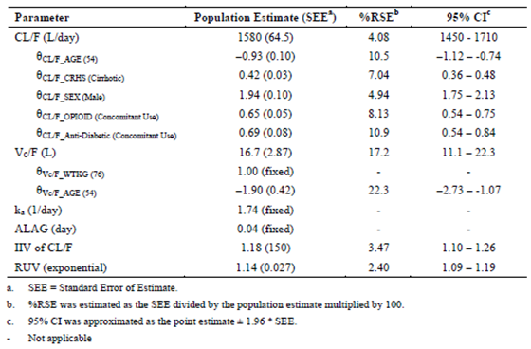

Ritonavir
For ritonavir, the final PPK model was a one compartment model with first order absorption and elimination. Significant covariates on CL/F were creatine clearance (CrCL), gender and HCV genotype. The population mean ritonavir CL/F for HCV genotype 1 infected subjects (at the model's reference covariate values (that is, female, genotype 1a with CrCL of 104 mL/min) was 439 L/day and the Vc/F was 21.5 L (Table 9).

Table 9: Study RD14-0047 Parameter estimates and variability for ritonavir PKs: final model (ritonavir final population PK model)
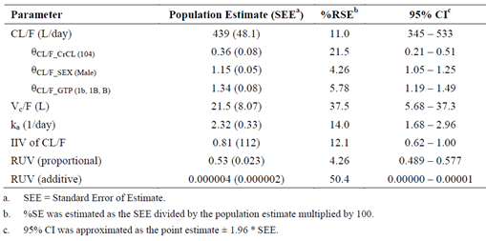

ABT-267
For ABT-267, the final PPK model was a one compartment model with first order absorption and elimination. The significant covariates on CL/F were gender, age, body weight and cirrhosis, and on Vc/F were age and gender. The population mean ABT-267 CL/F for HCV genotype 1 infected subjects (at the model's reference covariate values, that is, 76 kg, female, 54 years, without cirrhosis and no co-medication use) was 453 L/day and the Vc/F (at the model's reference covariate values, that is, 76 kg, 54 year old subject) was 50.1 L (Table 10).

Table 10: Study RD14-0047 Parameter estimates and variability for ABT-267 PKs: final model (ABT-267 final population PK model)
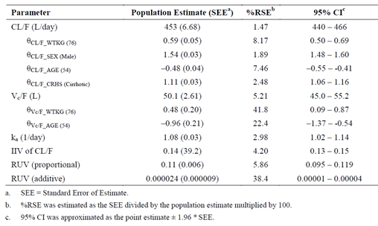

ABT-333
For ABT-333, the final PPK model was a two compartment model with first order absorption and elimination. The significant covariates on CL/F were cirrhosis, gender, creatine clearance and body weight and on volume (Vc/F and Vp/F) were age and body weight. The population-mean ABT-333 CL/F for HCV genotype 1 infected subjects (at the reference values of 76 kg, female, CrCL of 104 mL/min without cirrhosis) was 1,150 L/day and the Vc/F and Vp/F (at the model's reference values of 54 year old and 76 kg) were 1,100 and 286 L, respectively (Table 11).

Table 11: Study RD14-0047 Parameter estimates and variability for ABT-333 PKs: final model (ABT-333 final population PK model)
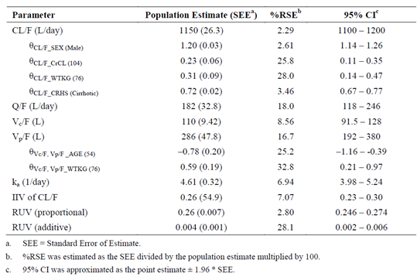
Comment: Although not identified in the materials to be evaluated, a third PPK analysis was contained in the submitted package. Report R&D/13/690 examined PKs of ABT-333 in data generated from healthy subjects in Study 12-680. In this study, the final PPK model for ABT-333 was identified as a two compartment linear model incorporating an absorption lag time, inter-individual variance on clearance, central volume, and lag time, covariance between clearance/central volume, and a proportional residual error model. Body weight was identified as a significant covariate on CL/F. The population-mean ABT-333 CL/F for healthy subjects was 20.9 L/h and the Vc/F was 54.2 L (Table 12).

Table 12: Study M12-680
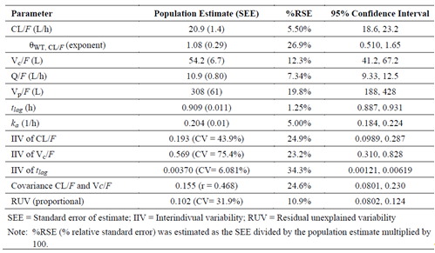

Additional report on the reliability of the two PPK studies.
Two PPK studies, RD 13-1098 PPK and RD 14-0047 PPK examined the population PKs of ABT-450, ABT-267 and ABT-333 in subjects infected with the genotype 1 strain of HCV.
In both studies the modelling of the data predicted that the final PPK model for ABT-450 was a one compartment model with first order absorption and elimination and that gender was a significant covariate of CL/F. By contrast, the PPK analysis from Study RD 13-1098 PPK predicted that the final model for ABT-267 was a two compartment model with first order absorption and elimination and the final model for ABT-333 was a one compartment model with first order absorption and elimination, whereas, results of Study RD 14-0047 PPK indicated that the final model for ABT-267 was a one compartment model and for ABT-333 was a two compartment model.
Given that PPK analysis undertaken in the two PPK studies generated different final PPK models for the ABT-267 and ABT-333 data sets, we must examine which of the two models for each drug is the preferred or more reliable PPK model. The evaluator believes that in this case, this can be done by examining the data sets used to generate the PPK models for ABT-267 and ABT-333 and the PK profiles for each drug.
To this end, the data-set used to generate the PPK models in Study RD 13-1098 PPK included Phase I and Phase II studies in which the patients received a range of doses and different formulations of ABT-450, ABT-267 and ABT-33. By contrast, Study RD 14-0047 PPK included data from Phase II and Phase III studies in which the patients received the recommended dose of the co-formulated ABT-450/r/ABT-267 150/100/25 mg tablets QD + ABT-333 250 mg tablets BD.
In Study RD 13-1098 PPK, although the data-set for ABT-450 included data from studies in which a range of ABT-450 doses and formulations were administered, the apparent lack of dose linearity in ABT-450 exposure (that is, greater than dose proportional) following both single and multiple doses and the differences in bioavailability of the various formulations was taken into account during the PPK modelling by the inclusion of the following equation (as shown in Figure 2).
Figure 2: Additional equation used in PPK modelling
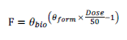
Where F is the population mean ABT-450 bioavailability and θ_{bio} represents the fold increase in ABT-450 bioavailability of SDD tablet for each 50 mg increment in dose relative to bioavailability of 50 mg ABT-450 SDD tablet. θ_{form} is the factor that accounts for the bioavailability of ABT-450 released from HGC formulation. θ_{form} is equal to one if the formulation is SDD tablet.
This was not the case for the ABT-267 and ABT-333 data sets in Study RD 13-1098 PPK and no attempt was made to adjust for non-dose linear PKs.
In Study RD 13-1098 PPK the data used to generate the PPK model for ABT-267 PKs were collected from a total of 601 subjects who had been enrolled in either one Phase Ib study (M12-116), 3 Phase IIa studies (M12-114, M12-998 and M13-386) or one Phase IIb study (M11-652). For ABT-333, data was collected from 560 subjects who had been enrolled in either one Phase Ib study (M10-351), 4 Phase IIa studies (M10-380, M11-602, M12-746 and M13-386) or one Phase IIb study (M11-652).
In these studies, administered ABT-267 doses ranged from 1.5 mg to 200 mg QD and ABT-33 doses ranged from 100 to 1200 mg. It is not entirely clear, from the Data Analysis Plan in Study RD 13-1098 PPK, exactly how the data for the different doses were normalised prior to the commencement of modelling studies. However, the analysis plan does state the following in the sponsor’s report in regard to dose normalisation:
“Obtained individual post hoc steady state exposures (area under the plasma concentration curve during 24 hour dosing interval at steady state [AUC_{24,ss}]) from base models (without any covariates) for ABT-450, ABT-267, ABT-333, ritonavir, and ribavirin.
Dose normalised the post hoc AUC_{24,ss} values to typical daily doses of DAAs (25 mg for ABT-267; 800 mg for ABT-333; 100 mg for ritonavir; 1,200 mg for ribavirin) except for ABT-450. In case of ABT-450, only the post hoc AUC_{24,ss} values representing 150 mg dose and SDD tablets were considered based on prior knowledge of dose and formulation dependent nonlinear bioavailability. Majority (363 out of 676 subjects) of the ABT-450 pharmacokinetic data for pharmacokinetic modelling represent 150 mg dose and SDD tablet formulation.
Calculated geometric means of post hoc AUC_{24,ss} values for each group that represents a drug class or category. Geometric means were also calculated for control groups: co-medications that represent no drug class (excluding other drug class) and co-medication that represent no inhibitor/inducer of metabolic enzyme(s) or transporter(s).
Calculated geometric mean ratios of post hoc AUC_{24,ss} between each drug class and the control group. Similarly, the ratios of post hoc AUC_{24,ss} were calculated between each drug category and the control group.”
If this truly is the dose normalisation strategy implemented in regards to different doses of ABT-267 and ABT-333 then the PPK modelling assumes that the exposure to ABT-267 or ABT-333 is dose linear and the PK evidence we have indicates that this may in fact not be the case.
Following single ascending doses of ABT-267 1.5 mg to 200 mg SDD tablets and 200 mg and 350 mg HME tablets, sub-study 1 of Study M12-116 indicated that for the SDD tablets between doses of 1.5 mg to 50 mg the dose normalised C_{max} and AUC_{inf} increased with dose indicating that at these dose the PKs of ABT-267 were non-linear and increased greater than dose proportionally (Figure 3). By contrast, for the 100 mg and 200 mg SDD formulation and the 200 mg and 300 mg HME tablets it appeared that the PKs were dose linear. Following multiple doses of ABT-267, Study M12-116 indicated that between 5 and 25 mg SDD QD increases in C_{max}/dose and AUC/dose were greater than dose proportional and then decreased at 100 mg SDD QD. Whereas, at 200 mg HME QD the C_{max}/dose and AUC/dose increased to a level above that obtained for 25 mg dose. These findings suggest that across the entire dose range examined ABT-267 exposure is not dose linear.
Figure 3: Study M12-116 Mean + SD dose normalised ABT-267 C_{max} and AUC_{inf} values plotted versus ABT-267 dose in healthy subjects (sub study 1)
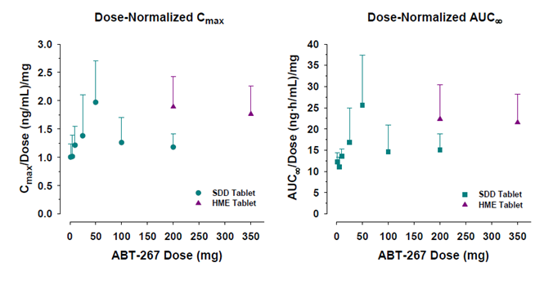
Following single doses of ABT-333 (Study M10-351) dose normalised C_{max} and AUC_{inf} appeared to decrease with dose at doses up to 200 mg ABT-333. Following multiple BD doses of 200 to 1,000 mg of ABT-333 capsules (Study M10-687), although dose-normalised C_{max}, AUC₁₂ and C_{trough} values for ABT-333 were similar and not statistically significantly different (p > 0.375), the evaluator fells that we should not assume that the PKs of ABT-333 are dose linear at steady state as they were associated with relatively high SDs. For example, the mean ± SD C_{trough} value following 10 days of dosing with 1000 mg ABT-333 was 695.2 ± 417.9. In itself, this high degree of variability would have made it difficult to establish any significant changes from dose linearity. In fact, dose normalised C_{max}, AUC₁₂ and C_{trough} increased between doses of 200 and 400 mg by approximately 1.1, 1.3 and 1.17 fold, respectively. These PK parameters were relatively stable or decreased slightly between 400 and 600 mg and between 600 and 1,000 mg C_{max}/dose and AUC₁₂/dose increased by approximately 1.27 and 1.15 fold and C_{trough}/dose decreased by 1.28 fold. Therefore for doses of ABT-333 between 200 and 1,000 mg BD, the tests of significance indicate that ABT-333 PKs are dose linear, whereas, comparison of the means suggest that this may not be the case and to properly determine whether ABT-333 exposure was dose linear following multiple doses, testing in a larger cohort of patients would have been desirable as this would have helped determine whether the high variation in PK values seen in this study were real or artifactual. In addition, adding further weight to the possibility that ABT-333 PKs are not dose linear, Study M10-351 indicates that following 100 mg and 600 mg BD doses of ABT-333 the dose normalised C_{max}, AUC₁₂ and C_{trough} values decreased by 1.23, 1.29 and 1.20 fold, respectively.

Conclusion
The PPK evaluator believes that based on the available evidence there is some uncertainty in the assumption that ABT-267 and ABT-333 exposure is dose linear, particularly in the case of ABT-267. Therefore, if we assume that ABT-267 and ABT-333 PKs were dose normalised in a linear fashion in Study RD 13-1098 PPK this may help explain why the two PPK studies identified different PPK models for ABT-267 and ABT-333 and possibly indicates that the ABT-267 and ABT-333 models generated in Study RD 13-1098 should be ignored. Therefore, it is the evaluator’s opinion that RD 14-0047 PPK provides the preferred and more reliable final PPK models for ABT-267 and ABT-333.

Evaluator’s overall conclusions on pharmacokinetics

Absorption
- Following a single oral dose (150 mg/100 mg/25 mg) of the to be marketed co-formulation of ABT-450/r/ABT-267 under non-fasting conditions the C_{max}, T_{max}, t½ and AUC_{inf} values for ABT-450 were 1,580 ng/mL, 4.9 h, 5.2 h and 7,660 ng.h/mL, respectively. For ritonavir these values were: 1,510 ng/mL; 4.4 h; 4.4 h and 9,210 ng.h/mL, respectively, and for ABT-267 were: 127 ng/mL, 5.2 h, 29.0 h and 1,670 ng.h/mL. Following a single oral dose of the to be marketed ABT-333 250 mg tablet under non-fasting conditions the C_{max}, T_{max}, t½ and AUC_{inf} values for ABT-333 were 699 ng/mL, 3.47 h, 7.07 h and 6,050 ng.h/mL, respectively.
- The absolute bioavailability of ABT-450 and ABT-267 has not been determined.
- The absolute bioavailability of a 400 mg oral tablet dose of ABT-333 compared to an intravenous microdose of approximately 85 µg of ¹⁴C-ABT-333 was 46%.
- Only a single dosage form and strength is proposed for the to be marketed co-formulated ABT-450/r/ABT-267 (75 mg/50 mg/12.5 mg) and ABT-333 250 mg tablets.
- A number of different formulations of the active drugs were used during the clinical trial program.
- In the presence of 100 mg ritonavir, the Phase II SDD tablet formulation of ABT-450 had a lower bioavailability (55% and 49% lower C_{max} and AUC_{inf}, respectively) than the 200 mg ABT-450 HGC capsule used in early Phase I clinical trials.
- Following administration of the co-formulated ABT-450/r 150 mg/100 mg (that is the proposed recommended dose) the C_{max} and AUC_{inf} of ABT-450 were 1.53 fold and 1.35 fold higher than following administration of 150 mg of the ABT-450 SDD tablet co-administered with the 100 mg ritonavir capsule.
- The C_{max} and AUC_{inf} values for the uncoated ABT-267 HME tablet, which was used in Phase II studies onwards, were 1.9 fold and 1.75 fold higher, respectively, relative to the ABT-267 SDD tablet used in the initial Phase I trials.
- Later in the development program a coated ABT-267 HME tablet was developed, which was bioequivalent with the uncoated HME tablet.
- Following administration of a triple co-formulated tablet containing ABT-450/r/ABT-267 the C_{max} and AUC_{inf} of ABT-450 were 1.93 fold and 1.63 fold higher than the corresponding values obtained for the free combination. By contrast, ritonavir exposure following administration of the triple co-formulated tablet was similar to ritonavir exposure following dosing with the free combination and ABT-267 exposures were bioequivalent.
- The commercial tablet formulation of ABT-333 was bioequivalent with the formulation used in the Phase III clinical trials.
- Following administration of the proposed daily dose of the co-formulated ABT-450/r/ABT-267 tablet, a moderate-fat breakfast increased the C_{max} and AUC_{inf} of ABT-450 by 4.67 and 3.11 fold, respectively, compared to when the co-formulation was administered under fasted conditions. The C_{max} and AUC_{inf} values for of ritonavir were increased by 1.63 and 1.49 fold, respectively, and the C_{max} and AUC_{inf} of ABT-267 increased by 2.27 and 1.82 fold, respectively.
- Following administration of a 250 mg dose of the optimised Phase III tablet formulation a moderate fat breakfast increased the C_{max} and AUC_{inf} of ABT-333 by 1.53 and 1.3 fold compared to when ABT-333 was administered under fasted conditions.
- Following co-administration of single doses of ABT-450 with ritonavir the PKs of ABT-450 were nonlinear and increased supra proportionally with dose. Following 14 days QD dosing with ABT-450/r 200/100 mg, ABT-450 C_{max} and AUCt were approximately 2.3 fold and 1.68 fold higher, respectively, following 14 days dosing with 200/100 mg QD than following a single dose.
- For the ABT-267 SDD tablets between doses of 1.5 mg to 50 mg, the dose normalised C_{max} and AUC_{inf} increased with dose indicating that at these dose the PKs of ABT-267 were non-linear and increased greater than dose proportionally. By contrast, at higher doses the PKs were dose linear. Following 10 days QD dosing with 25 mg ABT-267 the C_{max} and AUC₀₋₂₄ values of ABT-267 increased approximately 1.49 fold and 1.56 fold, respectively, compared to administration of a single dose.
- Following 21 days dosing with 25 mg ABT-267 SDD and 14 days with co-administered ABT-450/r 250 mg SDD/100 mg SGC (starting on Day 8), the accumulation ratios for ABT-450 C_{max} and AUC₂₄ were 3.81 and 2.60, respectively. The accumulation ratios for ritonavir over this period the accumulation ratios for C_{max} and AUC₂₄ were 2.29 and 1.67, respectively, and for ABT-267 were 0.83 and 0.91, respectively.
- The dose normalised C_{max} and AUC of ABT-333 tablets were very similar at doses of 1,200 and 1,600 mg. By contrast for the capsule formulation of ABT-333, dose normalised C_{max} and AUC_{inf} appeared to decrease with dose for doses up to 200 mg and for doses greater than 1,200 mg. The accumulation ratios comparing the AUC₁₂ following 10 days and a single dose of ABT-333 ranged from 0.95 to 1.65.
- Following 21 days of dosing with ABT-450/r (250 mg SDD/100 mg SGC) QD + ABT-267 HME 200 mg QD + ABT-333 400 mg tablet BD, the accumulation ratios for ABT-450 C_{max} and AUC₂₄ were 2.32 and 1.89, respectively; for ritonavir they were 1.64 and 1.82, respectively; for ABT-267 they were 0.90 and 1.12; and for ABT-333 were 0.905 and 0.974.
- When dosed QD, a 50% increase in ABT-450 dose from 200 mg to 300 mg increased mean C_{max} and mean AUC by 5 to 6 fold. Increasing the BD dose from ABT-450 50 to 100 mg increased the C_{max} and AUC by 4 to 5 fold.
- Following BD dosing with ABT-333 the C_{max} values following the morning dose were higher than the values following the evening dose.

Distribution
- Following the administration of two ABT-450/r/ABT-267 (75/50/12.5 mg) co-formulated tablets (total dose of 150/100/25 mg) with a moderate-fat breakfast, the Vd/F values for ABT-450, ritonavir and ABT-267 were 400 L, 97.3 L and 717 L, respectively.
- The Vd/F of ABT-333 following a 250 mg dose of the optimised, to be marketed, tablet formulation was 517 L.
- ABT-450, ritonavir, ABT-267 and ABT-333 partitioned preferentially into the plasma compartment with blood to plasma concentration ratios of 0.68, 0.60, 0.49 and 0.7 in humans.

Metabolism
- ABT-450, ritonavir, ABT-267 and ABT-333 are primarily metabolised in vitro by: CYP3A4; CYP3A; CYP3A4/5 and CYP2C8; and CYP2C8, respectively.
- Five inactive ABT-450 metabolites have been identified in human plasma and the breakdown of total drug related material based on AUC_{t} was that 88.9% represented unchanged ABT-450, 7.8% m², 3.2% m²9 and there were trace levels of M3, M13 and M6.
- Only a single ritonavir metabolite, m², was identified in plasma and there was a mean 30 fold excess of parent drug over metabolite in systemic circulation between 2 and 12 h after oral dosing.
- The primary ABT-267 metabolites in plasma, based on AUC_{t}, were m²9 (which represented 31.2% of the drug related material in plasma), M36 (21.4%), m²3 (15%) and M37 (13.9%). By contrast, the parent drug ABT-267 represented only 8.85% of the administered dose in plasma. A number of other metabolites were also identified (M5, m²5, m²6 and M34) but each of these represented less than 5% of the administered dose. None of the ABT-267 metabolites had in vitro anti-viral activity.
- Seven ABT-333 metabolites were identified in plasma including ABT-333 M1, m², M3, M4, M5, M6 and trace levels of metabolite M11. Unchanged parent was the most prominent component in plasma representing 58.1% of total plasma radioactivity followed by the active metabolite M1 (21.4% of total plasma radioactivity), which has similar in vitro antiviral activity to ABT-333. Following a single oral dose of the proposed commercial formulation of ABT-333 250 mg under non-fasting conditions, the C_{max}, T_{max}, t½ and AUC_{inf} values for the active M1 metabolite of ABT-333 were 244 ng/mL, 4 h, 6.4 h and 2,120 ng.h/mL, respectively.
- A pharmacogenetic analysis indicated that there were no significant genetic abnormalities that were consistently associated with exposures of ABT-450 or ABT-333.

Excretion
- Following administration of [¹⁴C] ABT-450/r 200/100 mg, 96.5% of the radioactive dose of ABT-450 was recovered in the faeces (representing 88% of radioactive dose) and urine (8.8%) within approximately 8 days. Unchanged parent drug accounted for only 1.1% and 0.05% of the total radioactivity in faeces and urine, respectively, with the major components being m²9 in faeces, which accounted for 59.9% of radioactive dose, and M13 in urine, which accounted for 8.6%.
- Following administration of 600 mg dose of [¹⁴C] ritonavir, 97.6% of radioactive dose was recovered in the urine and faeces of humans within approximately 6 days. Faecal excretion was the major route of elimination, accounting for 86.4% of the dose, whereas, urinary excretion accounted for 11.3%.
- Following a 25 mg oral dose of [¹⁴C] ABT-267 under non-fasting conditions approximately 90.3% of the radioactive dose was recovered in faeces and a further 0.6% was recovered in urine within 8 days. Unchanged drug accounted for 87.8% of total radioactivity recovered in faeces and although a number of metabolites were detected in the faeces, including m², M3, M5, M6, and M9, each represented less than 1% of administered dose.
- Two hundred forty hours following a single oral dose of 400 mg [¹⁴C] ABT-333, 94.4% of administered radioactivity was recovered in faeces and a further 2.20% was recovered in urine. Unchanged drug accounted for 26% and 0.03% in faeces and urine, respectively. ABT-333-M1 was the most abundant metabolite in faeces representing 31.5% of administered dose.

Inter-subject variability
Following the proposed dose of the to be marketed formulation of ABT-450/r/ABT-267 under non-fasted conditions inter-subject variability on C_{max} and AUC_{inf} values for ABT-450, ritonavir and ABT-267were > 100%, approximately 50% and 28%, respectively. For the proposed commercial formulation of ABT-333, 250 mg the %CV values for ABT-333 C_{max} and AUC_{inf} were 44% and 46%, respectively.

Pharmacokinetics in the target population
- Following a single dose of ABT-450/r 200 mg/100 mg in naïve HCV genotype 1 infected subjects the mean C_{max} and AUC₂₄ values for ABT-450 were 1,753 ng/mL and 10,478 ng.h/mL, respectively, and for ritonavir were 917 ng/mL and 7,104 ng.h/mL, respectively. Over the dose range examined ABT-450 demonstrated greater than dose proportional increases following single doses. ABT-450 exposures were 80% to 310% higher on Day 3 compared to Day 1.
- Following multiple oral doses of 5 to 50 mg ABT-267 SDD under non-fasting conditions in HCV genotype 1 infected treatment naïve subjects the C_{max} and AUC₂₄ values for a 25 mg dose of ABT-267 were 35.9 ng/mL and 337 ng.h/mL, respectively and following 3 days of QD dosing were 24.8 ng/mL and 319 ng.h/mL, respectively. Following single doses there were greater than dose proportional increases in ABT-267 exposure in this population.
- Following 400 and 800 mg BD dosing for 3 days, dose normalised C_{max} and AUC₁₂ values following a single dose indicated that there was a slightly greater than dose proportional increase in ABT-333 exposure, whereas on Day 3, exposures increased in a slightly less than dose proportional manner with increasing ABT-333 doses.

Inter-subject variability of PK in target population based on PPK modelling
- Inter-subject variability in ABT-450 CL/F and Vc/F was 166% and 265%, respectively and the RUV was 100%.
- Inter-subject variability values for ritonavir CL/F and VcF were 85% and 210%, respectively and the RUV was 71%.
- Inter-subject variability values for ABT-267 CL/F, Vc/F and Vp/F were 30%, 59% and 59%, respectively, and the RUV was 37%.
- Inter-subject variability values on ABT-333 CL/F and Vc/F were 62% and 73%, respectively, and the RUV was 55%.

Pharmacokinetics in subjects with impaired hepatic function
Following a single dose of 25 mg ABT-267, 400 mg ABT-333, and ABT-450/r 200/100 mg under non-fasting conditions: mild hepatic impairment induced a ± 35% difference in AUC_{inf} for each of the active drugs; moderate hepatic impairment decreased the AUC_{inf} values for ritonavir, ABT-267, ABT-333 and ABT-333 M1 by 30%, 30%, 16% and 57%, respectively, whereas, exposure to ABT-450 increased by approximately 62%; severe hepatic impairment increased the AUC_{inf} values for ABT-450, ritonavir, ABT-333 and ABT-M1 by 10.5 fold, 1.13 fold, 4.25 fold and 1.77 fold, respectively, whereas, the AUC_{inf} of ABT-267 decreased by 54%. The % fu of DAAs and ritonavir were up to approximately 30% different in subjects with hepatic impairment and healthy control subjects, except for ABT-333 % fu, which was approximately 50% lower in subjects with mild and moderate hepatic impairment compared to healthy control subjects and ABT-267 % fu in subjects with severe hepatic impairment, which was approximately 2.24 fold higher than in healthy control subjects.

Pharmacokinetics in subjects with impaired renal function
Following administration of the 3-DAA regimen with ritonavir, the AUC_{inf} of ABT-450 increased by 1.19 to 1.45 fold in subjects with mild to severe renal impairment compared to healthy subjects, ritonavir AUC_{inf} increased by 1.42 to 2.14 fold; and ABT-333 AUC_{inf} increased by 1.21 fold to 1.50 fold. In contrast, ABT-267 exposure was relatively unaffected by renal impairment.

Ethnicity
Following co-administration of ABT-267 25 mg QD HME, ABT-450/r 150/100 mg QD, and ABT-333 400 mg BD for 21 days to Han Chinese, Japanese and Caucasian subjects, compared to Caucasians the AUC₂₄ values for ABT-267 in Chinese and Japanese subjects were 1.18 and 1.30 fold higher, respectively. For ABT-450, the AUC₂₄ values were 2.47 and 2.91 fold higher in Chinese and Japanese subjects, respectively. For ritonavir, the AUC₂₄ values were 1.24 and 1.06 fold higher in Chinese and Japanese subjects, respectively. For ABT-333, the AUC₂₄ values were 1.11 and 1.29 fold higher in Chinese and Japanese subjects, respectively and for ABT-333 M1 were 1.35 to and 1.50 fold higher, respectively.

Effect of ritonavir on ABT-450 exposure
Compared to when 300 mg ABT-450 was administered alone, co-administration with 100 mg ritonavir resulted in significant increases in ABT-450 C_{max}, which increased from 121 ng/mL to 3,397 ng/mL and AUC_{inf}, which increased from 391 to 18,534 ng.h/mL.

Effect of ABT-450/r on ABT-267 exposure
Compared to when 25 mg ABT-450 was administered alone for 7 days co-administration with a single dose of ABT-450/r 250/100 mg increased the C_{max} and AUC₂₄ of ABT-267 by 1.59 and 1.62 fold, respectively.

Effect of ABT-267 on ABT-450/r exposure
Compared to when ABT-450/r 250/100 mg was administered alone for 14 days, co-administration with a single dose of 25 mg ABT-267 had little to no effect on C_{max} and AUC₂₄ of ABT-450 or ritonavir.

Effect of ABT-333 on ABT-450/r
Co-administration of 100 mg ABT-333 BD with ABT-450/r 200/100 mg increased the ABT-450 C_{max} from 2,520 to 3,140 ng/mL and ABT-450 AUC₂₄ from 9,890 to 14,400 ng.h/mL. Ritonavir exposure was also increased in the presence of ABT-333 with the AUC₂₄ of ritonavir increasing from 7,140 to 8,160 ng.h/mL.

Effect of ABT-450/r on ABT-333
Following co-administration of 100 mg ABT-333 BD with ABT-450/r 200/100 mg QD the C_{max} and AUC₁₂ values for ABT-333 was similar to when ABT-333 administered alone.

Effect of ABT-333 on ABT-450/r + ABT-267
Following co-administration of ABT-450/r 150/100 mg QD + ABT-267 25 mg QD with ABT-333 400 mg BD for 14 days, ABT-450 exposure more than doubled. By contrast, the effect of ABT-333 on ritonavir and ABT-267 exposure was smaller with ritonavir AUC₂₄ increasing from 10,100 to 13,700 ng.h/mL and ABT-267 AUC₂₄ from 1,210 to 1,540 ng.h/mL.

DDIs having a large effect on PKs (≥ ± 50%)
- ABT-450 AUC values were increased by the co-administration of ketoconazole, rosuvastatin, LPV/r, CsA or atazanavir by 1.98, 1.52, 2.17, 1.72 and 1.94 fold, respectively and decreased by tacrolimus and carbamazepine, by 1.51 and 3.4 fold, respectively.
- Ritonavir AUC was increased by the presence of ketoconazole or LPV/r by 1.57 and 2.05 fold, respectively, whereas, carbamazepine decreased the AUC by 7.9 fold.
- ABT-267 AUC was decreased by 1.5 fold following co-administration with carbamazepine.
- ABT-333 AUC was increased by the presence of gemfibrozil by 11.25 fold and decreased by carbamazepine or COC by 3.3 and 2.08 fold, respectively.
- ABT-333 M1 AUC was decreased by the co-administration of gemfibrozil or carbamazepine by 4.6 and 1.6 fold, respectively.
- In the presence of the 3 DAAs + ritonavir the AUC values for pravastatin, rosuvastatin, rilpivirine, raltegravir, CsA, tacrolimus, buprenorphine, norbuprenorphine, NGMN, NG and amlodipine by 1.82, 2.59, 2.5, 2.34, 5.82, 57.1, 2.07, 1.84, 2.60, 2.54 and 2.57 fold, respectively.
- Co-administration of Atripla with the 3 DAAs + ritonavir resulted in high number AEs therefore the 2 combination therapies should not be co-administered.

DDIs having an intermediate effect on the PKs (< ± 50%)
Co-administration of ketoconazole, gemfibrozil, pravastatin, darunavir or rilpivirine increased the AUC of ABT-450 by 1.42, 1.38, 1.13, 1.29 and 1.19 fold, respectively, whereas, emtricitabine/tenofovir, COC, duloxetine, zolpidem or amlodipine decreased the AUC of ABT-450 by 16%, 34%, 17%, 32% and 22%, respectively.
Co-administration of tacrolimus or COC decreased the AUC of ritonavir by 13% and 29%, respectively.
LPV/r increased the steady state ABT-267 AUC₂₄ by 1.17 fold, whereas, atazanavir or darunavir decreased the AUC by 17% and 14%, respectively.
Co-administration of emtricitabine/tenofovir, atazanavir, darunavir or CsA decreased the AUC of ABT-333 by 15%, 18%, 6% and 30%, respectively.
Co-administration of emtricitabine/tenofovir, atazanavir, darunavir, COC or zolpidem decreased the AUC of ABT-333 M1 by 10%, 11%, 17%, 46% and 17%, respectively.
Co-administration of ABT-450/r/ABT-267 + ABT-333 decreased the AUC of omeprazole, darunavir, escitalopram and duloxetine by 39%, 25%, 13% and 25% and increased the AUC of naloxone, S-desmethylcitalopram and alprazolam by 1.28, 1.36, 1.34 fold.

DDIs having little to no effect on PKs
- Co-administration of warfarin + Vitamin K1, digoxin, omeprazole, NET, alprazolam, escitalopram or furosemide had little no effect on the PKs of the 3 DAAs + ritonavir.
- Co-administration of emtricitabine/tenofovir did not affect the exposure to ABT-267 or ritonavir.
- Co-administration of ketoconazole or tacrolimus had little to no effect on the PKs of ABT-267 or ABT-333.
- Co-administration of pravastatin, rilpivirine, duloxetine, zolpidem and amlodipine had no effect on the PKs of ritonavir, ABT-267 or ABT-333 PKs.
- Gemfibrozil had little to no effect on ritonavir AUC_{inf}.
- Co-administration of the 3 DAAs + ritonavir had little to no effect on the PKs of atazanavir, R- or S-warfarin, carbamazepine, digoxin, emtricitabine, tenofovir, R- and S-methadone, EE, NET, zolpidem or furosemide.
- Two studies examined the PPK of ABT-450/r/ABT-267 + ABT-333 in HCV genotype 1 infected subjects. In both studies ABT-450 and ritonavir data was best fit to a one compartment model with first order absorption and elimination. By contrast, one study predicted that ABT-267 and ABT-333 data was best described by a one compartment model, whereas, the other study identified a 2 compartment model for these drugs.
- Covariates that were consistent across both two studies were: gender on ABT-450 and ABT-333 CL/F and ABT-267 Vd; and age, gender and body weight on ABT-267 CL/F.

Limitations of PK studies
- No studies examined the PKs of the 3 DAAs in pregnant or breast feeding women or children (< 18 years of age).
- Studies to determine the absolute bioavailability of ABT-450 and ABT-267 have not been conducted.
- No studies contained in the clinical section of the evaluation materials have specifically examined the ADME of ABT-333.
- The effect of raltegravir on the PKs of ABT-450/r/ABT-267/ABT-333 was not examined.
- No studies examined the effect of opioid like substances on the PKs of the 3 DAAs + ritonavir. This is of concern as the PPK study, RD14-0047 PPK, identified concomitant opioid use as a significant covariant of ABT-450 clearance.
- It would have been more clinically relevant if the DDIs between ABT-450/r/ABT-267 + ABT-333 and escitalopram or duloxetine had been examined on steady state levels of the anti-depressants rather than single doses as in Study M12-204, especially considering that CYP3A4 is a major contributor to the metabolism of escitalopram.
- Study M14-324 would have been more clinically relevant if it was conducted with steady state levels or at least following multiple daily doses of alprazolam.
- There are a number of inconsistencies between the PPK models defined for ABT-267 and ABT-333 in the two PPK studies.

Questions regarding the PK studies
- In studies M13-300 and M10-351 ABT-333 formulation appears to alter the effects of food on the bioavailability of ABT-333. Can the sponsor please comment?
- The dose/exposure pattern of ABT-333 during Study M10-351 appears to be a little unusual. Can the sponsor please explain this behaviour in regards to dose normalised C_{max} and AUC for ABT-333 in Study M10-351 and why the results for the 1,200 and 1,600 mg doses are not consistent across the two studies?
- Regarding Study M10-861 can the sponsor please provide an explanation as to why accumulation of ABT-450 exposure was far less pronounced for the 300 mg ABT-450 dose compared to the 250 mg and 200 mg doses?
- Given the metabolic profile of R-warfarin, it is a little surprising that the PKs of R-warfarin were not affected by the presence of the 3 DAAs + ritonavir (Study 12-198), considering that ritonavir is a potent inhibitor of CYP3A4. This possibly suggests that the PK interaction study should have instead examined steady state levels of warfarin. Can the sponsor please comment on whether a different result would be expected if this was the case?
- In Study M14-027, due to the inhibition of CYP3A4 induced by ritonavir should we not expect to see an increase in carbamazepine exposure in the presence of the 3 DAAs + ritonavir.
- It seems counter intuitive that on the one hand ritonavir increases ABT-450 exposure but in Study M12-202 the additional dose of ritonavir decreases ABT-450, can the sponsor please provide an explanation concerning the differences seen in ABT-450 PKs between Studies M13-506 and M12-202 described above.
- It is not clear why the sponsor has combined data from Arms 1 and 2 in which 3 DAAs and 2 DAAs have been co-administered respectively, as Studies M13-394 and M12-189 indicate that co-administration of ABT-333 with ABT-450/r/ABT-267 significantly affects the PKs of ABT-450, ritonavir and ABT-267. Can the sponsor please provide replacement Tables 4.57.1 and 4.57.2 in which the two data sets for Arm 1 and 2 have been separated?
- Given the results of RD14-0047 PPK indicate that concomitant opioid use may significantly affect ABT-450 clearance, can the sponsor please justify why the effects of co-administration of opioid-like substances, in Studies M12-997 and M13-100, on the PKs of Viekira Pak were not examined?
- Given that for anti-depressants to be clinically effective they must attain steady state, why has Study 12-204 only examined the interaction between Viekira Pak and single doses of the anti-depressants, especially considering that CYP3A4 is a major contributor to the metabolism of escitalopram?
- As the US PI for Xanax states that alprazolam should be administered multiple times daily and for at least 3 to 4 days for maximum effect why has Study M14-324 only examined the interaction with Viekira Pak following a single dose of alprazolam? This is of particular importance given that potent CYP3A4 inhibitors can increase alprazolam plasma concentrations by up to 4 fold.

Pharmacodynamics

Studies providing pharmacodynamic data
Summaries of the pharmacodynamic studies were provided. Table 13 shows the studies relating to each pharmacodynamic topic.

Table 13: Submitted pharmacodynamic studies
PD Topic | Subtopic | Study ID | Primary aim of the study
Secondary Pharmacology | Effect on QT | M12-990 | QT effects of therapeutic and supratherapeutic doses
Secondary Pharmacology | Effect on QT | M12-680 | QT effects of therapeutic and supratherapeutic doses
None of the pharmacodynamic studies had deficiencies that excluded their results from consideration.

Summary of pharmacodynamics
The information in the following summary is derived from conventional pharmacodynamic studies in humans unless otherwise stated.

Mechanism of action
ABT-450 is a potent non-structural (NS) protein 3/NS protein 4A (NS3/NS4A) protease inhibitor of HCV. NS3/NS4A is necessary for the proteolytic cleavage of the HCV encoded polyprotein (into mature forms of the NS3, NS4A, NS4B, NS5A, and NS5B proteins) and is essential for viral replication. ABT-267 is a NS protein 5A (NS5A) inhibitor, which is essential for viral replication; and ABT-333 is a non-nucleoside NS protein 5B (NS5B) polymerase inhibitor. Ritonavir is a potent CYP3A4 inhibitor, which increases ABT-450 bioavailability and allow for QD dosing. Ritonavir does not have activity against HCV.

Pharmacodynamic effects

Primary pharmacodynamic effects
In vitro studies

ABT-450
Study R&D/08/1559 identified that ABT-450 was a potent inhibitor of the enzymatic activity of genotype 1a and 1b HCV NS3 proteases with IC50 values of 0.043 and 0.054 nM, for each genotype, respectively, whereas, ABT-450 was a relatively less potent inhibitor of NS3 proteases from genotypes 2 and 3 with IC50 values ranging from 2.3 to 20.5 nM. By contrast, ABT-450 exhibited no detectable inhibitory activity against endogenous human proteases, with IC50 values of > 200,000 nM. HCV replicon cell culture assays indicated that ABT-450 was also a potent inhibitor of both genotype 1a and 1b replication with EC50 values of 0.94 and 0.32 nM, respectively. These findings were consistent with the results of a second in vitro study, R&D/13/1064. Two further studies, R&D/13/352 and R&D/14/0224, identified that the most common variants detected in NS3 that conferred resistance to ABT-450 were R155K, A156T, D168A/V/Y, V36M+R155K, and Y56H+D168V in GT 1a; and R155K, D168K and D168V in GT 1b. Study R&D/13/637 indicated that ABT-450 had no antiviral activity against either HIV-1 or HBV in vitro.

ABT-267
Study R&D/10/430 identified that ABT-267 was a potent inhibitor of genotype 1 HCV replication in sub-genomic HCV replicon cell culture assays with EC50 values ranging from 5.0 to 14 pM. Studies R&D/13/352 and R&D/14/0224 indicated that the most common variants observed in NS5A either in vitro or in clinical studies that conferred resistance to ABT-267 were m²8T, m²8V, Q30R, Y93C, and Y93H in GT 1a; and Y93H in GT 1b. Study R&D/13/637 also indicated that ABT-267 had no antiviral activity against either HIV-1 or HBV in vitro.

ABT-333
Study R&D/08/212 identified that ABT-333 was a potent inhibitor of HCV polymerases from genotype 1a and 1b strains, with IC50 values from 2.2 to 10.7 nM for a panel of seven genotype 1 polymerases. It was also a relatively weak inhibitor of HCV polymerases from genotypes 2 to 4, with IC50 values from 900 nM to greater than 20,000 nM. By contrast, ABT-333 exhibited no significant inhibitory activity against endogenous human/mammalian polymerases, with IC50 values of 76,000 to > 100,000 nM, leading to a selectivity factor of at least 18,000 fold. Studies R&D/13/352 and R&D/14/0224 indicated that the most common variants detected in NS5B either in vitro or in clinical studies that conferred resistance to ABT-333 were C316Y, M414T, Y448H, G554S, and S556G in GT 1a; and C316Y, M414T, Y448H, and S556G in GT 1b. Similar to both, ABT-450 and ABT-267, ABT-333 demonstrated no in vitro antiviral activity against either HIV-1 or HBV (R&D/13/637). Study R&D/14/0224 indicated that ABT-267 and ABT-333 displayed additive to synergistic interactions, which support the potential for use of ABT-267 and ABT-333 in combination in clinical studies.

Antiviral activity in humans
Three PK studies examined the antiviral activity of the DAAs in Viekira Pak. The first of these Sub-study 4 of Study M12-116 examined the antiviral activity following 3 days of oral doses of 5 to 200 mg ABT-267 QD in treatment naïve HCV genotype 1 infected adults. The results indicated that the decrease from baseline HCV RNA levels was statistically significantly greater following ABT-267 administration than following placebo. The greatest mean maximum decrease in HCV levels was observed with 25 mg ABT-267 (–3.33 log₁₀ IU/mL). In addition, 4 h following the initial dose of ABT-267 the mean decline in log₁₀ HCV RNA viral load from baseline was statistically significantly greater than following placebo administration for all of the ABT-267 dose regimens examined. However, the decrease in log₁₀ HCV RNA levels was not dose dependent.
Sub-study 2 of Study M10-351 examined the antiviral activity of single and multiple doses (2 Days) of ABT-333 in HCV Genotype 1 infected adults. Six hours following the first dose of 100 mg QD, 100 mg BD, 600 mg QD or 600 mg BD ABT-333, all dose groups displayed decreased levels of HCV RNA and greater decreases through 12 hours after the first dose. Dose dependent decreases in LS mean maximum change from baseline in log₁₀ HCV RNA levels were observed for the two 100 mg groups and the 600 mg BD group but not for the 600 mg QD group.
Study M11-602 assessed the antiviral activity following 3 days dosing with either, ABT-450/r, ABT-333, or ABT-072 followed by 81 days of treatment with pegIFN and RBV under non-fasting conditions in HCV genotype 1 infected adults. HCV RNA levels were monitored for a further 48 weeks post DAA treatment. The mean maximum decrease from baseline in log₁₀ HCV RNA levels in subjects who received ABT-450/r monotherapy (n = 24) was 4.03 log₁₀ IU/mL and for ABT-333 monotherapy (n = 16) was 1.02 log₁₀ IU/mL. By comparison, for subjects who received placebo (n = 11) the maximum decrease was 0.36 log₁₀ IU/mL HCV RNA (Table 14). For all 3 ABT-450/r dose groups, the mean maximum HCV RNA decreases were statistically significantly different from placebo for subjects with either HCV subtype 1a or 1b. By contrast, ABT-333 was shown to be relatively more potent in subjects with HCV genotype 1b infection than 1a. With regard to IL28B genotype, no differences were seen in treatment response among subjects with C/C, C/T, or T/T genotype. Twenty one of 24 subjects who received ABT-450/r, 8 of 16 subjects who received ABT-333 and 1 of 11 subjects who received placebo achieved rapid virologic response (RVR). In addition, 23 of 24 subjects who received ABT-450/r, 16 of 16 subjects who received ABT-333 and 4 of 11 of subjects who received placebo achieved partial early virologic response (EVR). Whereas, 22 of 24 subjects receiving ABT-450/r, 12 of 16 subjects who received ABT-333 and 2 of 11 of subjects who received placebo achieved complete EVR by Study Week 12. Finally, 20 of 24 subjects who received ABT-450/r, 10 of 16 subjects who received ABT-333, and 1 of 11 of subjects who received placebo achieved sustained virological response for 24 weeks.

Table 14: Study M11-602. Maximum change from baseline during monotherapy in viral load (log10 IU/mL)
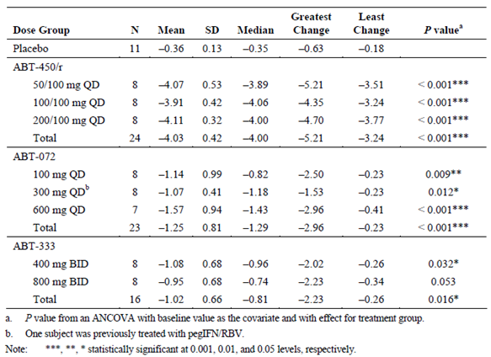

Secondary pharmacodynamic effects
Two studies, M12-990 and M12-680 examined the effects of therapeutic and supratherapeutic doses on QT in healthy subjects; however, the first study did not include a positive control (such as moxifloxacin); therefore, the following discussion will focus on Study M12-680. In Study M12-680, subjects were administered either a single dose of placebo, ABT-267 25 mg + ABT-450 200 mg + ritonavir 150 mg + ABT-333 250 mg (therapeutic dose), ABT-267 50 mg + ABT-450 350 mg + ritonavir 150 mg + ABT-333 500 mg (supratherapeutic dose) or moxifloxacin 400 mg. None of the subjects experienced a change from baseline in QTcF interval of greater than 60 msec and only 1 subject had change from baseline QTcF value that was greater than 30, which occurred following dosing with moxifloxacin. All other subjects had QTcF interval increases from baseline of ≤ 30 msec. The number of subjects with the with PR interval > 200 msec and QRS interval > 100 msec was similar between active and placebo regimens. The results also indicate that neither the therapeutic or supratherapeutic doses of ABT-450/r/ABT-267 + ABT-333 meet the ICH guidelines for QT prolongation as compared to placebo the peak QTcF effect following a therapeutic dose was 3.6 msec with an upper 95% confidence bound of 5.4 msec and the peak QTcF effect following a supratherapeutic dose was 5.9 msec, with the upper confidence bound of 7.7 msec.

Time course of pharmacodynamic effects
Studies M12-116 and M10-351 indicate that in subjects with HCV genotype 1, the effects of ABT-267 and ABT-333 on baseline HCV RNA levels occur rapidly and statistically significant decreases are seen by 4 h and 6 h, respectively, after drug administration.

Relationship between drug concentration and pharmacodynamic effects
Following doses of 5 to 200 mg ABT-267 in treatment naïve HCV genotype 1 infected adults (Study M12-116) the antiviral effects of ABT-267 were not dose-dependent and the greatest mean maximum decrease in HCV levels was observed with a dose of 25 mg. By contrast, following 100 mg QD, 100 mg BD and 600 mg BD, but not 600 mg QD, doses of ABT-333 (Study M10-351) the antiviral effects of ABT-333 were dose dependent. Study M11-602 indicated that the antiviral effect of the drugs was not dose dependent following 50/100 mg, 100/100 mg and 200/100 mg doses of ABT-450/r.

Genetic, gender and age related differences in pharmacodynamic response
No studies examined the gender and age related differences in pharmacodynamic response. The effect of genetic variations that confer resistance to the 3 DAAs is discussed in the section entitled Primary pharmacodynamic effects of this report.

Pharmacodynamic interactions
No studies examined PD interactions.

Evaluator’s overall conclusions on pharmacodynamics

Mechanism of action
ABT-450 is a potent NS3/NS4A protease inhibitor, ABT-267 is a NS5A inhibitor and ABT-333 is a NS5B polymerase inhibitor. Ritonavir is a potent CYP3A4 inhibitor.

Primary PD effects

ABT-450
In vitro studies indicate that ABT-450 potently inhibits the enzymatic activity of genotype 1a and 1b HCV NS3 proteases and genotype 1a and 1b replication. By contrast, ABT-450 is relatively less potent at inhibiting NS3 proteases from genotypes 2 and 3 and had no detectable inhibitory activity against endogenous human proteases or anti-viral activity for HBV or HIV-1. The most common variants detected in NS3 that conferred resistance to ABT-450 were R155K, A156T, D168A/V/Y, V36M+R155K, and Y56H+D168V in GT 1a; and R155K, D168K and D168V in GT 1b.

ABT-267
ABT-267 is a potent inhibitor of genotype 1 HCV replication in sub genomic HCV replicon cell culture assays, whereas, it has no in vitro antiviral activity against either HIV-1 or HBV. The most common variants observed in NS5A that conferred resistance to ABT-267 were m²8T, m²8V, Q30R, Y93C, and Y93H in GT 1a; and Y93H in GT 1b.

ABT-333
ABT-333 is a potent inhibitor of HCV polymerases from genotype 1a and 1b strains. It was also a relatively weak inhibitor of HCV polymerases from genotypes 2 to 4. By contrast, ABT-333 exhibited no significant inhibitory activity for endogenous human/mammalian polymerases or antiviral activity for either HIV-1 or HBV. The most common variants detected in NS5B that conferred resistance to ABT-333 were C316Y, M414T, Y448H, G554S, and S556G in GT 1a; and C316Y, M414T, Y448H, and S556G in GT 1b.

Antiviral activity in humans
- Four hours following dosing with ABT-267, the mean decline in log₁₀ HCV RNA viral load from baseline was statistically significantly greater than following placebo administration.
- Six hours following dosing with ABT-333, all dose groups displayed decreased levels of HCV RNA and greater decreases through 12 hours after the first dose.
- Following multiple doses of ABT-450/r, the mean maximum decrease from baseline in log₁₀ HCV RNA levels was 4.03 log₁₀ IU/mLand for ABT-333 was 1.02 log₁₀ IU/mL. For subjects who received placebo the maximum decrease was 0.36 log₁₀ IU/mL HCV RNA.

Secondary pharmacodynamic effects
Therapeutic and supratherapeutic doses of ABT-450/r/ABT-267 + ABT-333 did not prolong QT interval.

Time course of pharmacodynamic effects
The effects of ABT-267 and ABT-333 on baseline HCV RNA levels occur rapidly and statistically significant decreases are seen by 4 hours and 6 hours, respectively, after drug administration.

Relationship between drug concentration and pharmacodynamic effects
The antiviral effects of ABT-450 and ABT-267 were not dose dependent.
Following 100 mg QD, 100 mg BD and 600 mg BD, but not 600 mg QD, doses of ABT-333 the antiviral effects of ABT-333 were dose dependent.

Limitations of PD studies
- No studies examined the gender and age related differences in pharmacodynamic response.
- No studies examined PD interactions.

Questions regarding PD studies
Regarding Study M10-351, can the sponsor please provide an explanation as to why the 100 mg QD, 100 mg BD and 600 mg BD doses of ABT-333 have dose dependent anti-viral effects, whereas, the 600 mg QD dose does not?

Dosage selection for the pivotal studies
Selection of the combination regimen, dosage and treatment duration was based on multiple Phase I and Phase II studies listed in Table 15.

Table 15: Studies used for regimen, dose and duration recommendation
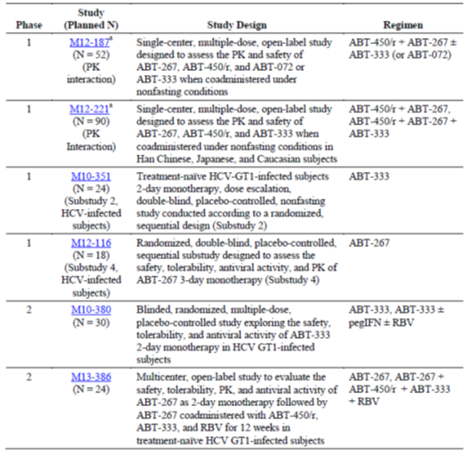

Table 15 (continued): Studies used for regimen, dose and duration recommendation
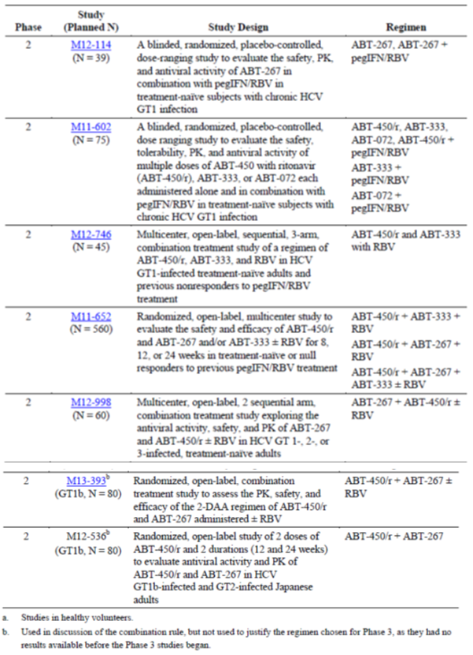
As stated in the Dose Duration report (R&D/14/0150), the doses for each of the 3 DAAs that were to be used in the Phase III studies were determined by the examination of a combination of factors. These included comparisons of: viral load decline for different doses following monotherapy; virologic failure rates when the different doses were combined with peg-IFN plus RBV; virologic failure rates when the different doses were combined with other DAAs in the absence of interferon; and the resistance profile following monotherapy and IFN-free DAA combination regimens with the different doses. In addition, the safety profiles for the 3 DAAs when combined with peg-IFN plus RBV and IFN-free DAA combination regimens were examined, as were the exposure-response relationships correlating exposures of ABT-450, ABT-267 and ABT-333 to viral load and lab safety parameters. Finally, the PK interactions in healthy subjects between the 3 DAAs and commonly prescribed and potentially co-administered medications were also taken into account. A summary of the principle drug characteristics that were used to determine the doses for each of the 3 DAAs in Phase III are shown in Figure 4.
Figure 4: Summary of DAA doses selected for Phase III and to be marketed regimen with rationale for selection
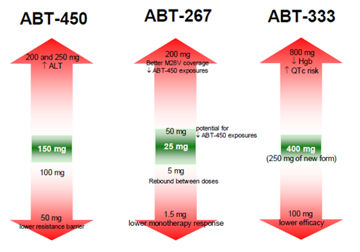
Comment: Conventional dose ranging studies are not feasible in chronic HCV infection because of the dangers of viral resistance in patients who receive potentially suboptimal treatment. This is particularly relevant with a novel 3-DAA combination. The dosage and regimen selected for the Phase III studies was appropriate after consideration of a large body of in vitro and in vivo pre-clinical and Phase I and II data. For the Phase II and III studies, the optimal treatment duration was assumed to be 12 weeks but SVR rates were compared in different patient groups during treatment periods of 8, 12 and 24 weeks.

Clinical efficacy
The treatment of genotype 1 chronic hepatitis C infection, including patients with cirrhosis.

Pivotal efficacy studies

Study M11-646 (SAPPHIRE-I)

Study design, objectives, locations and dates
This was a Phase III, multicentre, randomised, double blind, placebo controlled safety and efficacy study of ABT-450/r/ABT-267 and ABT-333 co-administered with ribavirin (3-DAA + RBV) in treatment naïve non-cirrhotic adults with genotype 1 (GT1) chronic HCV infection. It was conducted at 79 centres in 13 countries (Australia, Austria, Canada, France, Germany, Hungary, Italy, New Zealand, Spain, Sweden, Switzerland, the UK, and the US). It commenced in November 2012 and last patient last visit occurred in November 2013 for the primary analysis. The primary efficacy objective was to show the non-inferiority in SVR₁₂ rates after 12 weeks of treatment with 3-DAA + RBV, compared with the historical SVR rate for telaprevir plus pegIFN/RBV. Approximately 600 patients were randomised to one of two arms in a 3:1 ratio to receive 3-DAA + RBV for 12 weeks (Arm A), or placebo 3-DAA + RBV for 12 weeks followed by 3-DAA + RBV for 12 weeks (Arm B). In the double blind treatment period, randomisation was stratified according to HCV subtype (1a and non-1a) and IL28B genotype (CC and non CC). The study schematic is shown below in Figure 5. The duration of the study was 72 weeks consisting of a double blind treatment period, an open label treatment period (for patients randomised to placebo) and a post dosing period. All patients who received active study drugs were followed for 48 weeks post treatment to monitor safety, HCV RNA, and the emergence and/or persistence of resistant viral variants.
Figure 5: Study schematic of study M11-646
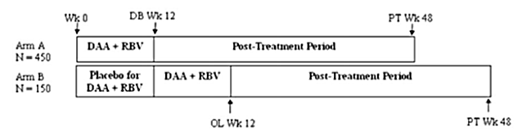
DAA = direct acting antiviral agent; DB = double blind; OL = open label; PT = post treatments; RBV = ribavirin; Wk = week
Screened patients who met the eligibility criteria entered the 12 week double blind treatment period. At the Week 12 visit, the study drug assignment was un-blinded and patients randomised to placebo entered the open label treatment period consisting of 12 weeks of active therapy. Following completion or discontinuation of active therapy, all patients entered the 48 week post-treatment follow-up period. Patients who discontinued active treatment prematurely were un-blinded and entered the post-treatment follow-up period for monitoring of virologic failure and resistance.

Inclusion and exclusion criteria
The key inclusion criteria were: adult male or female patients aged 18 to 70 years; appropriate contraceptive precautions, not including hormonal contraceptives; no previous HCV antiviral therapy; BMI ≥ 18 to < 38 kg/m²; chronic HCV infection based on antibody or liver biopsy criteria; HCV genotype 1 infection; liver biopsy, FibroTest or FibroScan results within the previous 24 months demonstrating the absence of cirrhosis; and plasma HCV RNA > 10,000 IU/mL. The key exclusion criteria were: history of any severe drug sensitivity; use of herbal supplements; history of drug or alcohol abuse; antibody evidence of HBV or HIV infection; co-infection with other HCV genotypes; the use of protocol defined concomitant medications; use of strong inhibitors or inducers CYP3A or CYP2C8; clinically significant concomitant illnesses including epilepsy, uncontrolled diabetes and malignancy; any past or present evidence of cirrhosis; any liver disease other than HCV; ALT or AST > 5 x ULN; creatinine clearance < 60 mL/min; albumin < ULN; haemoglobin, platelets or WBC < ULN; and clinically significant ECG abnormalities.

Study treatments
ABT-450/r/ABT-267 150 mg/100 mg/25 mg was administered QD, and ABT-333 250 mg + RBV was administered BD. RBV dosing was based on body weight, either 1,000 mg or 1,200 mg, divided BD as per local label (typically < 75 kg or ≥ 75 kg). The DAAs, placebo DAAs and open label RBV were dispensed as tablets. Each dose of double blind RBV or matching placebo was dispensed as capsules. All study drugs were to be taken with food at the same time every day. The study drugs were provided in weekly kits and a tablet count was performed at each visit. Non-compliance was defined as < 80% usage of the prescribed active medications at each visit.

Efficacy variables and outcomes
The main efficacy variables were:
- Plasma HCV RNA levels
- HCV resistance testing.
The primary efficacy variable was the rate of SVR₁₂ in patients with genotype 1 infection.
The primary efficacy outcomes were non-inferiority of the 3-DAA + RBV treatment group compared with the historical SVR rate for telaprevir/pegIFN/RBV in treatment naïve patients, and superiority of the 3-DAA + RBV treatment group if non-inferiority was demonstrated.
Other efficacy outcomes included:
- ALT normalisation rates, active versus placebo groups
- SVR₁₂ rates in genotype 1a patients compared with telaprevir/pegIFN/RBV
- SVR₁₂ rates in genotype 1b patients compared with telaprevir/pegIFN/RBV
- the percentage of patients with on treatment virologic failure
- the percentage of patients with post treatment virologic relapse.
The historical telaprevir response rates are based on data from the Incivek US PI. The SVR₁₂ rates in the two Phase III studies ADVANCE and ILLUMINATE in treatment naïve, non-cirrhotic patients with genotype 1 infection are shown in Table 16.
Note: See List of Abbreviations for definitions of viral response parameters.

Table 16: Study M11-646
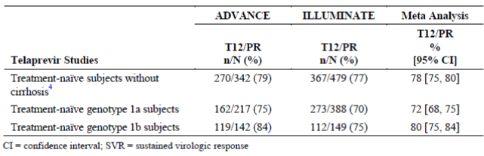

Randomisation and blinding methods
Randomisation was performed at the baseline (Day 1) visit using IRT according to a computer generated schedule. The investigators and patients were blind to the treatment schedule and tablet or capsule study treatments were provided with matching placebos. During the active treatment period, virologic results were reviewed and virologic failure criteria were applied by an un-blinded independent reviewer. Certain safety results (including haemoglobin, haematocrit and ALT) were also blinded.

Analysis populations
All randomised patients who received at least one dose of study medication were included in the ITT population and used in the efficacy and safety analyses. All patients who received at least one dose of active, open label study drug during the open label (OL) treatment period were included in the OL population.

Sample size
The estimated SVR rates for telaprevir + pegIFN/RBV therapy in treatment-naive, non-cirrhotic patients with HCV GT1 infection were derived from the ADVANCE and ILLUMINATE studies. A fixed effect meta-analysis was used to estimate SVR₁₂ rates and 95% CIs (Table 16). To demonstrate non-inferiority compared with the historical telaprevir control rate, the lower bound (LCB) of the 95% CI for the rate of SVR₁₂ in Group A had to exceed the upper bound (UCB) for the control rate minus 10.5 percentage points (that is 70%). Assuming that 92% of patients in the 3-DAA + RBV treatment group would achieve SVR₁₂, a sample size of 450 patients had > 90% power to demonstrate non-inferiority with a 2 sided 95% lower confidence bound > 70%; and > 90% power to demonstrate superiority with a 2 sided 95% LCB > 80%. No adjustment for dropouts was applicable because patients without evaluable virologic data at Week 12 were counted as SVR₁₂ failures.
Comment: It is unclear how the non-inferiority margin of 10.5% was selected.

Statistical methods
The primary analysis was performed on patients who were initially randomised to active drug and all had completed the PT Week 12 visit or prematurely discontinued the study; and placebo patients when they had completed 12 weeks of active treatment in the OL treatment period or prematurely discontinued. A final end of study analysis was performed at PT Week 48. Demographic, efficacy and safety analyses were performed on the ITT population. SAS was used for all analyses. All statistical tests and all CIs were 2 sided with α = 0.05. Descriptive statistics were provided for continuous variables and counts and percentages for discrete variables. P values for differences between treatment groups for categorical variables were calculated using the χ² test. P values for differences between groups for continuous variables were calculated using 1 way ANOVA. Multiplicity was controlled across the primary and secondary endpoints using a fixed sequential testing procedure. No data were imputed for the efficacy analyses except for the HCV RNA endpoints. If there was no HCV RNA value at a defined visit, the closest values before and after the visit were noted. A flanking imputation method, including a backward imputation approach, was then used in the analysis. For patients with undetectable or unquantifiable HCV RNA levels at both the preceding and succeeding visits, the missing value was also considered undetectable or unquantifiable.

Participant flow
The disposition of patients is shown in Table 17, below. A total of 636 patients were randomised, 631 patients were treated, and 621 patients completed the DB treatment period. At the time of the primary analysis, a total of 616 patients were ongoing in the post-treatment period.

Table 17: Study M11-646: Disposition of patients
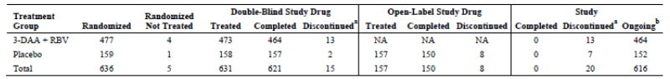
DAA = direct acting antiviral agent; NA = not applicable PT = post treatments; RBV = ribavirin; ª Includes subjects who were randomised but never dosed. ^{b}. Ongoing in PT period.
The reasons for study drug discontinuation were provided. During the double blind period, 10 (1.6%) patients discontinued study treatment, most commonly due to AEs, non-compliance and withdrawal of consent.

Major protocol violations/deviations
Individual patient data are provided in the CSR but the percentage of patients with deviations, major protocol deviations, and deviations leading to exclusion from the primary analysis are not tabulated. However, because the ITT population was used, no patients were excluded from the primary analysis due to protocol deviations.

Baseline data
The patient demographics were provided. The majority of patients were White (90.6%) and male (54.5%) with a mean age of 49.9 years. With the exception of minor gender differences, the active and placebo treatment groups were generally balanced. Baseline disease characteristics were provided. Overall, 67.7% of patients were infected with HCV GT1a and 32.3% with GT1b. A total of 30.7% of patients had IL28B genotype CC, 53.2% had IL28B genotype CT, and 16.0% had IL28B genotype TT. The mean baseline HCV RNA level was 6.42 (range 3.58 to 7.60) log₁₀ IU/mL. There were no meaningful differences between the two treatment groups.

Results for the primary efficacy outcome
Sustained virologic response at 12 weeks post dosing ( SVR₁₂) was achieved by 96.2% patients (95% CI: 94.5%, 97.9%) (Table 18). Both primary endpoints were achieved, namely non-inferiority and superiority compared with historical telaprevir-based therapy (> 70% LCB non-inferiority threshold, and > 80% LCB superiority threshold). All patients achieved viral suppression. On treatment virologic failure was experienced by one patient (0.2%), one patient (0.2%) experienced viral rebound, and seven (1.5%) patients relapsed by post-treatment Week 12. The remaining reasons for non-response were missing data or premature study discontinuation. Compliance was ≥ 95% in the patients who had on-treatment virologic failure or relapse. SVR₁₂ rates and 95% CIs were comparable in the randomisation strata based on HCV genotype and IL28B status (Table 19), and in sub-groups defined by gender, age, race, geographic region, BMI, baseline HCV RNA, baseline IP-10, and fibrosis stage.

Table 18: Study M11-646 Virologic response (SVR₁₂) for the 3-DAA + RBV treatment group (intent to treat population)
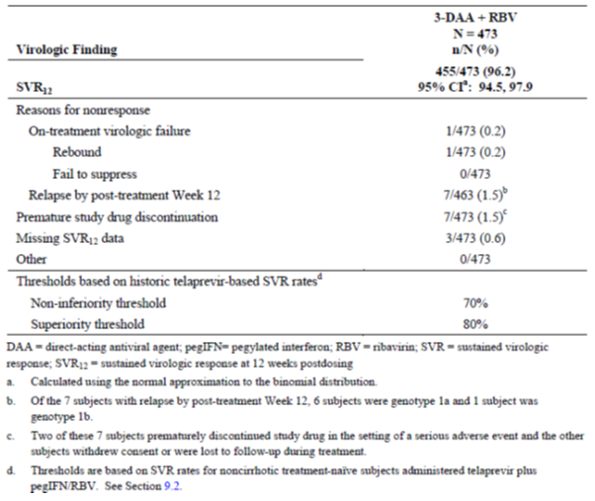

Table 19: Study M11-646 Virologic response (SVR₁₂) for the 3-DAA + RBV treatment group by randomisation strata (intent to treat population)
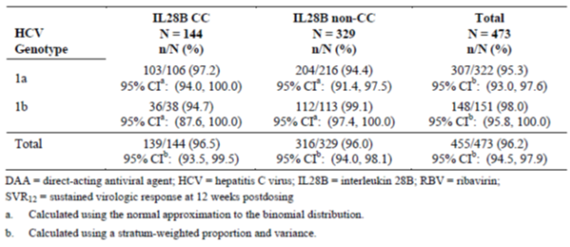

Results for other efficacy outcomes
The most important secondary endpoints were also met. A significantly greater proportion of patients randomised to 3-DAA + RBV achieved normalisation of ALT (97.0%) compared with patients randomised to placebo (15.8%). For both HCV GT1a and GT1b sub-groups, the LCBs for SVR₁₂ were above the pre-specified thresholds (75% and 84%, respectively), demonstrating superiority to the historical telaprevir-based rate (Table 20).

Table 20: Study M11-646 Virologic response (SVR₁₂) for the 3-DAA + RBV treatment group by HCV genotype (intent to treat population)
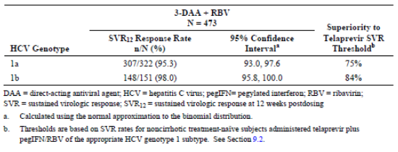
Comment: The rate of SVR₁₂ in treatment naïve, non-cirrhotic adult patients given 3-DAA + RBV was clearly non-inferior and superior to the historical rate for telaprevir + pegIFN/RBV in the corresponding patient population. SVR₁₂ was achieved in 96.2% of patients with a 95% CI: 94.5%, 97.9%. Response rates in the GT1a and GT1b sub-groups were 93.0% and 95.8%, respectively, with no meaningful differences in the IL28B CC and non CC genotypic sub-groups. Almost all patients normalised ALT values after 12 weeks treatment. Virologic failure, mostly post-treatment relapse, occurred in only 1.7% of patients. There were no meaningful differences in patient sub-groups defined by gender, age, race, geographic region, BMI, baseline HCV RNA, baseline IP-10, and fibrosis stage.
The patient populations and sub-populations, virologic endpoints and treatment periods were based on the EU guidelines and other treatment norms. The study design and methodology was appropriate and the 3:1 randomisation process minimised exposure to placebo. Ideally an active control group of 1-DAA + pegIFN/RBV should have been included as current standard of care. The sponsor justifies its exclusion on the grounds of difficulties of double-dummy blinding of injectable medications, the difficulties of blinding the well-known side effects of pegIFN/RBV and the currently approved DAAs, and the ethics of prolonged treatment with poorly tolerated combination therapies. The sponsor also notes that there are extensive clinical trial data of the telaprevir + pegIFN/RBV combination with large published Phase III trials in the same populations of HCV patients based on demographics, disease characteristics and response to previous treatment. The data used by the sponsor in the statistical analyses can be assumed to be robust as they are drawn from the approved Incivek US PI. This overall approach is justified but the very high efficacy rates achieved with the 3-DAA + RBV combination make the discussion largely redundant.
The very high SVR₁₂ rates in GT1a and GT1b, non-cirrhotic, treatment naïve patients justify the 3-DAA + RBV treatment regimen given for a 12 week period.

Study M13-098 (SAPPHIRE-II)

Study design, objectives, locations and dates
This was a Phase III, multicentre, randomised, double blind, placebo controlled safety and efficacy study of ABT-450/r/ABT-267 and ABT-333 co-administered with ribavirin in pegIFN/RBV treatment experienced non-cirrhotic adults with GT1 chronic HCV infection. It was conducted at 76 centres in 15 countries (Australia, Canada, Czech Republic, Denmark, France, Germany, Ireland, Italy, Mexico, the Netherlands, Portugal, Russia, Spain, the UK, and the USA/Puerto Rico). It commenced in November 2012 and last patient last visit occurred in November 2013 for the primary analysis. The primary efficacy objective was to compare the percentage of patients who achieved SVR₁₂ after 12 weeks of treatment with 3-DAA + RBV with the historical SVR rate of telaprevir plus pegIFN/RBV. Approximately 400 patients were randomised to one of two arms in a 3:1 ratio to receive 3-DAA + RBV for 12 weeks (Arm A), or placebo 3-DAA + RBV for 12 weeks followed by 3-DAA + RBV for 12 weeks (Arm B). In the double blind treatment period, randomisation was stratified according to HCV subtype (GT1a or non-1 a), and by the type of response to previous pegIFN/RBV treatment (null responder, partial responder, or relapser). The study schematic is shown below in Figure 6. The duration of the study was 72 weeks consisting of a double blind treatment period, an open label treatment period (for patients randomised to placebo) and a post dosing period (for all patients who received active study drugs). All patients who received active study drugs were followed for 48 weeks post-treatment to monitor safety, HCV RNA, and the emergence and/or persistence of resistant viral variants.
Figure 6: Study M13-098. Study schematic
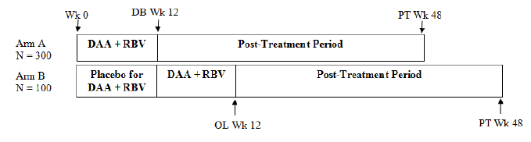

Inclusion and exclusion criteria
The key inclusion criteria were: adult male or female patients aged 18 to 70 years; appropriate contraceptive precautions, not including hormonal contraceptives; no previous HCV DAA therapy; BMI ≥ 18 to < 38 kg/m²; chronic HCV infection based on antibody or liver biopsy criteria; HCV genotype 1 infection; liver biopsy, FibroTest or FibroScan results within the previous 24 months demonstrating the absence of cirrhosis; and plasma HCV RNA > 10,000 IU/mL; and a documented history of the type of response to previous pegIFN/RBV treatment (null responder, partial responder, or relapser). The key exclusion criteria were: history of any severe drug sensitivity; use of herbal supplements; history of drug or alcohol abuse; antibody evidence of HBV or HIV infection; co-infection with other HCV genotypes; the use of protocol defined concomitant medications; use of strong inhibitors or inducers CYP3A or CYP2C8; clinically significant concomitant illnesses including epilepsy, uncontrolled diabetes and malignancy; any past or present evidence of cirrhosis; any liver disease other than HCV; ALT or AST > 5 x ULN; creatinine clearance < 60 mL/min; albumin < ULN; haemoglobin, platelets or WBC < ULN; and clinically significant ECG abnormalities.

Study treatments
ABT-450/r/ABT-267 150 mg/100 mg/25 mg was administered QD and ABT-333 250 mg + RBV was administered BD. RBV dosing was based on body weight, either 1,000 mg or 1,200 mg divided BD as per local label (typically < 75 kg or ≥ 75 kg). The DAAs, placebo DAAs and open label RBV were dispensed as tablets. Each dose of double blind RBV or matching placebo was dispensed as capsules. All study drugs were to be taken with food at the same time every day. The study drugs were provided in weekly kits and a tablet count was performed at each visit. Non-compliance was defined as < 80% usage of the prescribed active medications at each visit.

Efficacy variables and outcomes
The main efficacy variables were:
- Plasma HCV RNA levels
- HCV resistance testing.
The primary efficacy variable was the rate of SVR₁₂.
The primary efficacy outcomes were non-inferiority of the 3-DAA + RBV treatment group compared with the historical SVR rate for telaprevir/pegIFN/RBV, and superiority of the 3-DAA + RBV treatment group if non-inferiority was demonstrated.
Other efficacy outcomes included:
- ALT normalisation rates, active versus placebo groups
- SVR₁₂ rates in genotype 1a patients compared with telaprevir/pegIFN/RBV
- SVR₁₂ rates in genotype 1b patients compared with telaprevir/pegIFN/RBV
- the percentage of patients with on-treatment virologic failure
- the percentage of patients with post-treatment virologic relapse.
The historical telaprevir response rates are based on data from the Incivek US PI. The SVR₁₂ rates in the Phase III study REALIZE in treatment experienced, non-cirrhotic patients with genotype 1 infection are shown below in Table 21.

Table 21: Study M13-098 Estimated SVR rates for telaprevir based therapy in treatment experienced, without cirrhosis
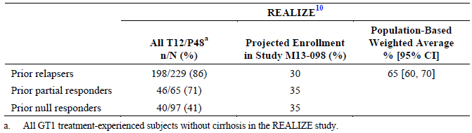

Randomisation and blinding methods
Randomisation was performed at the baseline (Day 1) visit using IRT according to a computer-generated schedule. The investigators and patients were blind to the treatment schedule and tablet or capsule study treatments were provided with matching placebos. During the active treatment period, virologic results were reviewed and virologic failure criteria were applied by an un-blinded independent reviewer. Certain safety results (including haemoglobin, haematocrit and ALT) were also blinded.

Analysis populations
All randomised patients who received at least one dose of study medication were included in the ITT population and used in the efficacy and safety analyses. All patients who received at least one dose of active, open label study drug during the open label treatment period were included in the OL population.

Sample size
The estimated SVR rates for telaprevir + pegIFN/RBV therapy in treatment experienced, non-cirrhotic patients with HCV GT1 infection were derived from the REALIZE study, with adjustments made to account for the exclusion of cirrhotic patients in M13-098. SVR rates were also adjusted for the historical type of treatment response (relapsers, partial responders, and null responders) (Table 21, above). A population based weighted average CI of the corresponding SVR rate was calculated to reflect the expected population to be enrolled in M13-098 [95% CI: 65% (60%, 70%)]. Assuming that 85% of patients in the 3-DAA + RBV treatment group would achieve SVR₁₂, a sample size of 300 patients had > 90% power to demonstrate non-inferiority with a 2 sided 95% LCB > 60%; and > 90% power to demonstrate superiority with a 2 sided 95% LCB > 70%. No adjustment for dropouts was applicable because patients without evaluable virologic data at Week 12 were counted as SVR₁₂ failures.

Statistical methods
The primary analysis was performed on patients who were initially randomised to active drug and all had completed the post-treatment Week 12 visit or prematurely discontinued the study; and placebo patients when they had completed 12 weeks of active treatment in the OL treatment period or prematurely discontinued. A final end of study analysis was performed at PT Week 48. Demographic, efficacy and safety analyses were performed on the ITT population. SAS was used for all analyses. All statistical tests and all CIs were 2 sided with α 0.05. Descriptive statistics were provided for continuous variables and counts and percentages for discrete variables. P values for differences between treatment groups for categorical variables were calculated using the χ² test. P values for differences between groups for continuous variables were calculated using 1 way ANOVA. Multiplicity was controlled across the primary and secondary endpoints using a fixed sequential testing procedure. No data were imputed for the efficacy analyses except for the HCV RNA endpoints. If there was no HCV RNA value at a defined visit, the closest values before and after the visit were noted. A flanking imputation method, including a backward imputation approach, was then used in the analysis. For patients with undetectable or unquantifiable HCV RNA levels at both the preceding and succeeding visits, the missing value was also considered undetectable or unquantifiable.

Participant flow
The disposition of patients is shown in Table 22. A total of 395 patients were randomised, 394 patients were treated, and 388 patients completed the double blind treatment period. At the time of the primary analysis, a total of 387 patients were ongoing in the post-treatment period.

Table 22: Study M13-098: Patient disposition
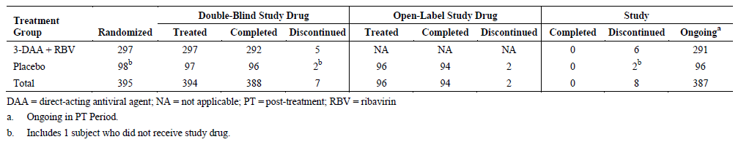
The reasons for study drug discontinuation were provided. During the double blind period, 6 (1.5%) patients discontinued study treatment, most commonly due to AEs in three patients in the active treatment group. No patients experienced virologic failure.

Major protocol violations/deviations
Individual patient data are provided in the CSR but the percentage of patients with deviations, major protocol deviations, and deviations leading to exclusion from the primary analysis are not tabulated. However, because the ITT population was used so no patients were excluded from the primary analysis due to protocol deviations.

Baseline data
The majority of patients were White (90.1%) and male (57.6%) with a mean age of 52.5 years. The baseline demographics in the two groups were similar although the placebo group was approximately 4 years older than the active treatment group. There were no meaningful differences in baseline disease characteristics. Overall, 58.4% and 41.4% of patients had HCV GT1a and GT1b infection, respectively. The majority of patients (68.5%) had IL28B genotype CT, 21.1% had genotype TT and 10.4% had genotype CC. The mean baseline HCV RNA level was 6.55 (range 4.61 to 7.70) log₁₀ IU/mL.

Results for the primary efficacy outcome
As shown in Table 23, SVR₁₂ was achieved by 96.3% of patients (95% CI: 94.1%, 98.4%). Both primary endpoints were met as the 60% non-inferiority and 70% superiority LCB thresholds were achieved. There were no cases of on treatment virologic failure; 2.4% of patients had virologic relapse by post treatment Week 12; and 1.3% discontinued drug treatment prematurely. SVR₁₂ rates and 95% CIs were comparable in the randomisation strata based on previous pegIFN/RBV treatment failure (null responders, partial responders, and relapsers) (Table 24,), and in sub-groups defined by HCV genotype, IL28B genotype, gender, age, race, geographic region, BMI, baseline HCV RNA, baseline IP-10, and fibrosis stage.

Table 23: Study M13-098 virologic response (SVR₁₂) for the 3-DAA + RBV treatment group (intent to treat population)
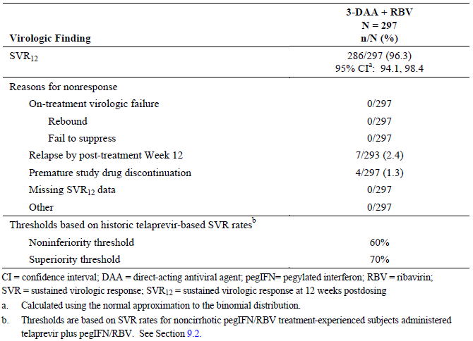

Table 24: Study M13-098. Virologic Response (SVR12) for the 3-DAA + RBV treatment group by randomization strata (Intent-to-Treat population)
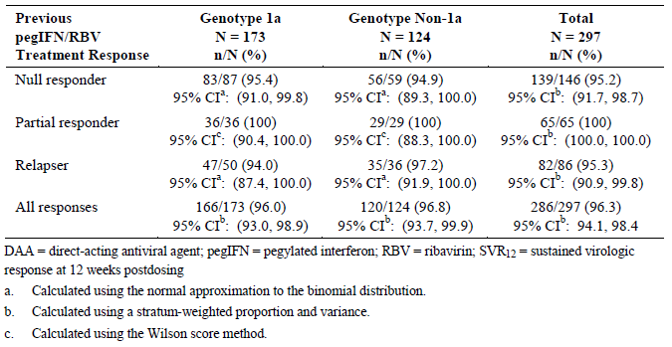

Results for other efficacy outcomes
The main secondary endpoints were also met. A significantly greater proportion of patients randomised to 3-DAA + RBV achieved normalisation of ALT (96.9%) compared with patients randomised to placebo (12.8%). For both HCV GT1a and GT1b sub-groups, the LCBs for SVR₁₂ were above the pre-specified thresholds (65% and 77%, respectively), demonstrating superiority to the historical telaprevir-based rate.
Comment: This study design was identical to study M11-646 except that the population consisted of treatment experienced patients (see previous comments). The patient population was restricted to patients who had failed to achieve viral clearance following pegIFN/RBV and the prior use of any other antiviral agents, including DAAs, was excluded. The rate of SVR₁₂ in these non-cirrhotic adult patients given 3-DAA + RBV was clearly non-inferior and superior to the historical rate for telaprevir + pegIFN/RBV in the comparable patient groups (based on the telaprevir REALIZE study). SVR₁₂ was achieved in 96.3% of patients with a 95% CI: 94.1%, 98.4%. Response rates in the GT1a and GT1b sub-groups were 96.0% and 96.7%, respectively. Response rates in the IL28B CC and non-CC genotypic sub-groups were also high, 91.2% and 97.0%, respectively. Almost all patients normalised ALT values after 12 weeks treatment. Virologic failure occurred in only 2.4% of patients, all with post-treatment relapse. Similar SVR₁₂ rates were observed in prior null responders, partial responders and relapsers: 95.2%, 100% and 95.3%, respectively. There were no meaningful differences in patient sub-groups defined by gender, age, race, geographic region, BMI, baseline HCV RNA, baseline IP-10, and fibrosis stage.
When combined with study M11-646, the data demonstrate impressively high viral clearance rates following 3-DAA + RBV given for 12 weeks in all patients with HCV GT1 infection (1a and 1b), whether treatment naïve or treatment experienced.

Study M13-389 (PEARL-II)

Study design, objectives, locations and dates
This was a Phase III, multicentre, open label safety and efficacy study of ABT-450/r/ABT-267 and ABT-333 with and without ribavirin in pegIFN/RBV treatment experienced non-cirrhotic adults with GT1b chronic HCV infection. It was conducted at 43 centres in 10 countries (Austria, Belgium, Italy, the Netherlands, Portugal, Sweden, Switzerland, Turkey, and the US/Puerto Rico). It commenced in August 2012 and last patient last visit occurred in January 2014 for the primary analysis. The primary efficacy objective was to demonstrate non-inferiority in SVR₁₂ rates in both arms after 12 weeks of treatment with 3-DAA with and without RBV compared with the historical SVR rate of telaprevir plus pegIFN/RBV. Approximately 210 patients were to be randomised in a 1:1 ratio to receive either, 3-DAA + RBV (Arm 1) or 3-DAA without RBV (Arm 2). Randomisation was stratified according to the type of response to previous pegIFN/RBV treatment (null responder, partial responder or relapser). The study schematic is shown below in Figure 7. The duration of the study was 60 weeks consisting of a 12 week treatment period, and a post dosing observation period of up to 48 weeks to monitor safety, HCV RNA, and the emergence and/or persistence of resistant viral variants.
Note: The original protocol included patients with GT1a and GT1b infection but this was amended to allow recruitment of only GT1b-infected patients. This amendment was made after two patients with GT1a infection had been randomised.
Figure 7: Study M13-389 study schematic
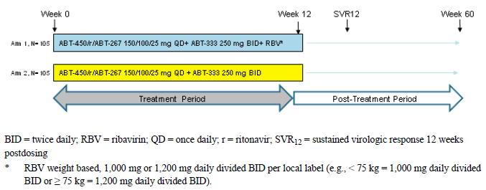

Inclusion and exclusion criteria
The key inclusion criteria were: adult male or female patients aged 18 to 70 years; appropriate contraceptive precautions, not including hormonal contraceptives; no previous HCV antiviral therapy; BMI ≥ 18 to < 38 kg/m²; chronic HCV infection based on antibody or liver biopsy criteria; HCV genotype 1b infection; liver biopsy, FibroTest or FibroScan results within the previous 24 months demonstrating the absence of cirrhosis; and plasma HCV RNA > 10,000 IU/mL; and a documented history of the type of response to previous pegIFN/RBV treatment (null responder, partial responder, or relapser). The key exclusion criteria were: history of any severe drug sensitivity; use of herbal supplements; history of drug or alcohol abuse; antibody evidence of HBV or HIV infection; co-infection with HCV genotypes other than 1b; the use of protocol defined concomitant medications; use of strong inhibitors or inducers CYP3A or CYP2C8; clinically significant concomitant illnesses including epilepsy, uncontrolled diabetes and malignancy; any past or present evidence of cirrhosis; any liver disease other than HCV; ALT or AST > 5 x ULN; creatinine clearance < 60 mL/min; albumin < LLN; haemoglobin < LLN, platelets < 120,000 cells/mm³; and clinically significant ECG abnormalities.

Study treatments
All treatments were open label. At the beginning of the study, patients received study drugs as separate tablets for 12 weeks. However, co-formulated tablets, with and without RBV were used latterly following a protocol amendment. ABT-450/r/ABT-267 150 mg/100 mg/25 mg was administered QD, and ABT-333 250 mg was administered BD. RBV dosing was based on body weight, either 1,000 mg or 1,200 mg (as 200 mg tablets) divided BD as per local label (typically < 75 kg or ≥ 75 kg). All study drugs were to be taken with food at the same time every day. The study drugs were dispensed every 4 weeks and a tablet count was performed at each visit. Non-compliance was defined as < 80% usage of the prescribed active medications at each visit.

Efficacy variables and outcomes
The main efficacy variables were:
- Plasma HCV RNA levels
- HCV resistance testing.
The primary efficacy variable was the rate of SVR₁₂.
The primary efficacy endpoint were non-inferiority of Arm 2 and Arm 1 compared with the historical SVR rate for telaprevir/pegIFN/RBV (LCB > 64% for both comparisons). Other efficacy endpoints included:
- The percentage of patients with a decrease in haemoglobin to below the LLN at the end of treatment.
- Superiority of SVR₁₂ rates in Arm 1 and Arm 2 compared with the historical rate for telaprevir/pegIFN/RBV (LCB > 75% for both comparisons)
- Non-inferiority of Arm 2 compared with Arm 1 using a 10.5% SVR₁₂ margin
- the percentage of patients with on-treatment virologic failure
- the percentage of patients with post-treatment virologic relapse.
The historical telaprevir response rates are based on data from the Incivek US PI. The SVR₁₂ rates in the Phase III study REALIZE in treatment experienced, non-cirrhotic patients with genotype 1b infection are shown in Table 25.

Table 25: Study M13-389. Estimated SVR rates for telaprevir plus pegIFN/RBV therapy in treatment experienced non-cirrhotic subjects with HCV sub genotype 1b
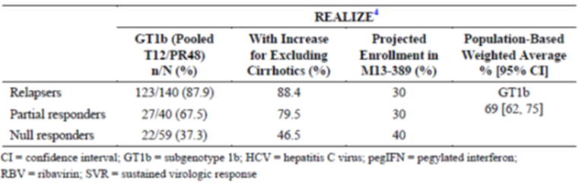

Randomisation and blinding methods
The study was open label. Randomisation was conducted using a computer generated schedule accessed via IRT.

Analysis populations
All randomised patients who received at least one dose of study medication were included in the ITT population and used in the safety analyses. Efficacy analyses were performed on the ITT GT1b efficacy subset (n = 179), and patients with GT1a infection or not administered with the ABT-450/r/ABT-267 co-formulated drug were not included.

Sample size
The estimated SVR rates for telaprevir + pegIFN/RBV therapy in treatment experienced, non-cirrhotic patients with HCV GT1b infection were derived from the REALIZE study, with adjustments made to account for the exclusion of cirrhotic patients. SVR rates were also adjusted for the historical type of treatment response (relapsers, partial responders, and null responders) (Table 25). A population based weighted average CI of the corresponding SVR rate was calculated to reflect the expected population to be enrolled in M13-389 [95% CI: 69% (62%, 75%)]. Assuming that 82% of patients in Arm 2 would achieve SVR₁₂, a sample size of approximately 210 patients randomised 1:1 had > 90% power to demonstrate non-inferiority with a 2 sided 95% LCB > 64%.

Statistical methods
SAS was used for all analyses. Summary statistics for each visit and for change from baseline were provided. The simple percentage of patients in each group who achieved SVR₁₂ was calculated and the 95% CI calculated using normal approximation to the binomial distribution. Pairwise comparisons of the two arms for the percentage of patients with SVR, RVR or EOTR were performed using logistic regression models. Comparisons of continuous variables were made using 1 way ANOVA at p ≤ 0.05, and comparisons of categorical variables were made using the χ² test. Multiplicity was controlled across the primary and secondary endpoints using a fixed sequential testing procedure. No data were imputed for the efficacy analyses except for the HCV RNA endpoints. If there was no HCV RNA value at a defined visit, the closest values before and after the visit were noted. A flanking imputation method, including a backward imputation approach, was then used in the analysis. For patients with undetectable or unquantifiable HCV RNA levels at both the preceding and succeeding visits, the missing value was also considered undetectable or unquantifiable. The time to viral suppression and time to relapse were shown using Kaplan-Meier curves.

Participant flow
A total of 324 patients were screened, 187 patients were enrolled, 186 patients received at least one dose of study treatment, and a total of 184 patients completed study drug. At the time of the primary analysis, three patients had completed the study and 182 patients were ongoing. Two patients discontinued study drug due to AEs, both in the 3-DAA + RBV treatment group. Additional details were provided.

Major protocol violations/deviations
Individual patient data are provided in the CSR but the percentage of patients with deviations, major protocol deviations, and deviations leading to exclusion from the primary analysis are not tabulated. However, because the GT1b efficacy subset population was used so no patients were excluded from the primary analysis due to protocol deviations.

Baseline data
In the safety population, the majority of patients were White (91.4%) and male (54.8%) with a mean age of 54.2 years. The baseline demographics in the two groups were similar although the 3-DAA group was approximately 5 kg heavier than the 3-DAA + RBV treatment group. There were no meaningful differences in baseline disease characteristics. Overall, 1.6% and 97.8% of patients had HCV genotype 1a and 1b infection, respectively. The majority of patients (67.7%) had IL28B genotype CT, 23.1% had genotype TT and 9.1% had genotype CC. The mean baseline HCV RNA level was 6.52 (range 4.69 to 7.52) log₁₀ IU/mL. Based on previous pegIFN/RBV therapy, the study population comprised 34.9% null responders, 28.5% partial responders, and 36.6% relapsers.

Results for the primary efficacy outcome
SVR₁₂ was achieved by 96.6% of patients (95% CI: 92.8%, 100%) in the 3-DAA + RBV group, and by 100% of patients (95% CI: 95.9%, 100%) in the 3-DAA group. Both primary endpoints were met as the 64% non-inferiority LCB thresholds were achieved in both groups. There were no cases of on-treatment virologic failure, and no cases of virologic relapse by post-treatment Week 12. Two patients (2.3%) discontinued treatment prematurely, and one patient had missing SVR₁₂ data. SVR₁₂ rates and 95% CIs were comparable in the randomisation strata based on previous pegIFN/RBV treatment failure (null responders, partial responders, and relapsers), and in sub-groups defined by HCV genotype, IL28B genotype, gender, age, race, geographic region, BMI, baseline HCV RNA, baseline IP-10, and fibrosis stage.

Results for other efficacy endpoints
The LCB was > 75% in both treatment groups, confirming superiority to the historical telaprevir + pegIFN/RBV SVR₁₂ rates. There was a 3.4% (95% CI: -0.4, 7.2) benefit in SVR₁₂ rates in favour of the 3-DAA group compared with the 3-DAA + RBV group. The LCB was above -10.5% indicating that the 3-DAA group was non-inferior to the 3-DAA + RBV group. Anaemia with a decrease in haemoglobin to below the LLN was reported in 42% of the 3-DAA + RBV group compared with 5.5% in the 3-DAA group (p < 0.001).
Comment: The M11-646 and M13-098 studies demonstrated SVR₁₂ rates > 95% following 3-DAA + RBV for 12 weeks in treatment naïve and treatment experienced patients with HCV GT1b infection. This open label study compared 3-DAA with and without RBV in treatment experienced patients. SVR₁₂ was achieved by 96.6% of patients in the 3-DAA + RBV group, and by 100% of patients in the 3-DAA without RBV group. Both regimens were superior to the historical rate for telaprevir + pegIFN/RBV. While efficacy rates were high in both groups, anaemia was as expected much more common in the 3-DAA + RBV (42.0%) group compared with the 3-DAA group (5.5%). No patients in either group experienced on-treatment virologic failure or post-treatment relapse. The RBV treatment was not placebo controlled. This does not invalidate the conclusions of the study but the sponsor should provide a justification for the open label design (see Clinical Questions).
Efficacy rates in patients given 3-DAA +/- RBV were comparable. The results justify the recommendation for the use of 3-DAA without RBV for 12 weeks in non-cirrhotic, treatment experienced patients with GT1b infection.

Study M13-961 (PEARL-III)

Study design, objectives, locations and dates
This was a Phase III, randomised, multicentre, double blind, placebo controlled, safety and efficacy study of ABT-450/r/ABT-267 and ABT-333 with and without ribavirin in treatment naive non-cirrhotic adults with GT1b chronic HCV infection. It was conducted at 50 centres in 11 countries (Austria, Belgium, Hungary, Israel, Italy, Poland, Portugal, Romania, Russia, Spain, and the US). It commenced in December 2012 and last patient last visit occurred in December 2013 for the primary analysis. The primary efficacy objective was to demonstrate non-inferiority in SVR₁₂ rates in both arms after 12 weeks of treatment with 3-DAA with and without RBV compared with the historical SVR rate of telaprevir plus pegIFN/RBV.
Approximately 400 patients were to be randomised in a 1:1 ratio to receive either, 3-DAA + RBV (Arm A) or 3-DAA without RBV (Arm B). Randomisation was stratified according to the IL28B genotype. The study schematic is shown below in Figure 8. The duration of the study was 60 weeks consisting of a 12 week treatment period, and a post dosing observation period of up to 48 weeks to monitor safety, HCV RNA, and the emergence and/or persistence of resistant viral variants.
Figure 8: Study M13-961 study schematic
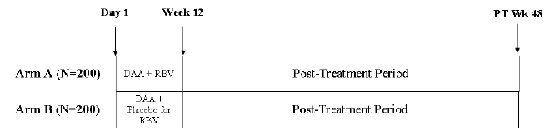

Inclusion and exclusion criteria
The key inclusion criteria were: adult male or female patients aged 18 to 70 years; appropriate contraceptive precautions, not including hormonal contraceptives; no previous HCV antiviral therapy; BMI ≥ 18 to < 38 kg/m²; chronic HCV infection based on antibody or liver biopsy criteria; HCV genotype 1b infection; liver biopsy, FibroTest or FibroScan results within the previous 24 months demonstrating the absence of cirrhosis; and plasma HCV RNA > 10,000 IU/mL. The key exclusion criteria were: history of any severe drug sensitivity; use of herbal supplements; history of drug or alcohol abuse; antibody evidence of HBV or HIV infection; co-infection with HCV genotypes other than 1b; the use of protocol defined concomitant medications; use of strong inhibitors or inducers CYP3A or CYP2C8; clinically significant concomitant illnesses including epilepsy, uncontrolled diabetes and malignancy; any past or present evidence of cirrhosis; any liver disease other than HCV; ALT or AST > 5 x ULN; creatinine clearance < 60 mL/min; albumin < ULN; haemoglobin, platelets or WBC < ULN; and clinically significant ECG abnormalities.

Study treatments
ABT-450/r/ABT-267 150 mg/100 mg/25 mg was administered as tablets QD, and ABT-333 250 mg was administered as tablets BD. RBV dosing was based on body weight, either 1,000 mg or 1,200 mg (as 200 mg tablets) divided BD as per local label (typically < 75 kg or ≥ 75 kg). All study drugs were to be taken with food at the same time every day. The study drugs were dispensed every 4 weeks and a tablet count was performed at each visit. Non-compliance was defined as < 80% usage of the prescribed active medications during treatment.

Efficacy variables and outcomes
The main efficacy variables were:
- Plasma HCV RNA levels
- HCV resistance testing.
The primary efficacy variable was the rate of SVR₁₂.
The primary efficacy outcomes were non-inferiority of Arm A and Arm B compared with the historical SVR rate for telaprevir/pegIFN/RBV (LCB > 73% for both comparisons). Other efficacy outcomes included:
- The percentage of patients with a decrease in haemoglobin below the LLN at the end of treatment in Arm A compared with Arm B
- Superiority of SVR₁₂ rates in Arm A and Arm B compared with the historical rate for telaprevir/pegIFN/RBV (LCB > 84% for both comparisons)
- Non-inferiority of Arm B compared with Arm A using a 10.5% SVR₁₂ margin
- the percentage of patients with on-treatment virologic failure
- the percentage of patients with post-treatment virologic relapse.
The historical telaprevir response rates are based on data from the Incivek US PI. The SVR₁₂ rates in the two Phase III studies ADVANCE and ILLUMINATE in treatment naïve, non-cirrhotic patients with genotype 1b infection are shown in Table 26.also below

Table 26: Study M13-961 Estimated SVR rates for Telaprevir plus pegIFN and RBV therapy in treatment-naïve, non-cirrhotic HCV sub genotype 1b-Infected subjects
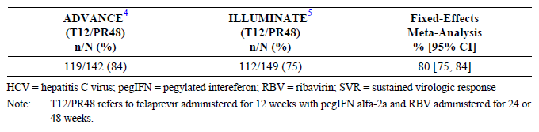

Randomisation and blinding methods
Randomisation was conducted using a computer generated schedule accessed via IRT. 3-DAA was provided as open label tablets while RBV and RBV placebos were provided as matching capsules.

Analysis populations
All randomised patients who received at least one dose of study medication were included in the ITT population and used in the efficacy and safety analyses (n = 419).

Sample size
Historical SVR₁₂ rates in treatment naïve patients without cirrhosis were obtained from the ADVANCE and ILLUMINATE studies of telaprevir-based therapy. A fixed-effect meta-analysis was used to estimate SVR₁₂ rates and 95% CIs (Table 26). The superiority of either treatment compared with telaprevir + pegIFN/RBV required the LCB to exceed 84%. Based on the data from the ILLUMINATE study, a margin of 10.5% with a LCB in excess of 73% was required to demonstrate non-inferiority.

Statistical methods
SAS was used for all analyses. Descriptive statistics were employed and all statistical tests and CIs were 2 sided with α = 0.05. Continuous variables were analysed using 1 way ANOVA and categorical variables were analysed using a χ² test. Multiplicity was controlled across the primary and secondary endpoints using a fixed sequential testing procedure. No data were imputed for the efficacy analyses except for the HCV RNA endpoints. If there was no HCV RNA value at a defined visit, the closest values before and after the visit were noted. A flanking imputation method, including a backward imputation approach, was then used in the analysis. For patients with undetectable or unquantifiable HCV RNA levels at both the preceding and succeeding visits, the missing value was also considered undetectable or unquantifiable.

Participant flow
A total of 629 patients were screened, 419 were randomised, all of whom received at least one dose of study treatment, and a total of 417 patients completed study drug treatment. At the time of the primary analysis, nine patients had completed the study and 409 patients were ongoing. One patient in each treatment group discontinued study drug due to withdrawal of consent. Additional details were provided.

Major protocol violations/deviations
Individual patient data are provided in the CSR but the percentage of patients with deviations, major protocol deviations, and deviations leading to exclusion from the primary analysis are not provided. However, because the ITT population was used so no patients were excluded from the primary analysis due to protocol deviations.

Baseline data
The baseline demographics were similar in both treatment groups. Overall, the majority of patients were White (94.3%) and female (54.2%) with a mean age of 48.8 years. Mean body weight was 74.4 kg. There were no meaningful differences in baseline disease characteristics. All patients had HCV GT1b infection. The majority of patients (61.8%) had IL28B genotype CT, 17.2% had genotype TT and 21.0% had genotype CC. The mean baseline HCV RNA level was 6.31 (range 1.40 to 7.65) log₁₀ IU/mL.

Results for the primary efficacy outcome
SVR₁₂ was achieved by 99.5% of patients (95% CI: 98.6%, 100%) in the 3-DAA + RBV group, and by 99.0% of patients (95% CI: 97.7%, 100%) in the 3-DAA group. Both primary endpoints were met as the 73% non-inferiority LCB thresholds were achieved in both groups. There were no cases of on-treatment virologic failure in the 3-DAA group. In the 3-DAA + RBV group, one patient (0.5%) experienced virologic failure but there were no cases of virologic relapse in either arm. Two patients (1%) had missing SVR₁₂ data but no patients discontinued drug treatment prematurely. SVR₁₂ rates and 95% CIs were comparable in the randomisation strata based on IL28B genotype (CC versus non-CC), and in sub-groups defined by gender, age, race, geographic region, BMI, baseline HCV RNA, baseline IP-10, and fibrosis stage.

Results for other efficacy outcomes
The LCB was > 84% in both treatment groups, confirming superiority to the historical telaprevir + pegIFN/RBV SVR rates. There was a 0.5% (95% CI: -2.1, 1.1) benefit in SVR₁₂ rates in favour of the 3-DAA + RBV group compared with the 3-DAA group. The LCB was above -10.5% indicating that the 3-DAA group was non-inferior to the 3-DAA + RBV group. Anaemia with a decrease in haemoglobin below the LLN was reported in 51.2% of the 3-DAA + RBV group compared with 3.4% in the 3-DAA group (p < 0.001).
Comment: The study design and objectives were similar to study M13-389 with the exception that the population of HCV GT1b-infected patients was treatment naïve, and the RBV treatment was given double blind. SVR₁₂ was achieved by 99.5% of the 3-DAA + RBV group and by 99.0% of the 3-DAA group. The groups were non-inferior to each other and superior to the historical control rate for telaprevir + pegIFN/RBV therapy. Virologic failure occurred in only one patient (in the 3-DAA + RBV group). Although efficacy rates were similar in both treatment groups, anaemia was reported in 51.2% of the 3-DAA + RBV group compared with only 3.4% in the 3-DAA group. Studies M13-389 and M13-961 failed to demonstrate any efficacy benefit with the addition of RBV to 3-DAA given for 12 weeks in treatment naïve or treatment experienced patients with HCV GT1b infection. Overall, the data support the use of 3-DAA without RBV for all non-cirrhotic patient groups with GT1b infection.

Study M14-002 (PEARL-IV)

Study design, objectives, locations and dates
This was a Phase III, randomised, multicentre, double blind, placebo controlled, safety and efficacy study of ABT-450/r/ABT-267 and ABT-333 with and without ribavirin in treatment naive non-cirrhotic adults with GT1a chronic HCV infection. It was conducted at 53 centres in Canada, UK and the US. It commenced in March 2013 and last patient last visit occurred in December 2013 for the primary analysis. The primary efficacy objective was to demonstrate non-inferiority in SVR₁₂ rates in both arms after 12 weeks of treatment with 3-DAA with and without RBV compared with the historical SVR rate of telaprevir plus pegIFN/RBV. Approximately 300 patients were to be randomised in a 1:2 ratio to receive 3-DAA + RBV (Arm A) or 3-DAA without RBV (Arm B). Randomisation was stratified according to the IL28B genotype. The study schematic is shown below in Figure 9. The duration of the study was 60 weeks consisting of a 12 week treatment period, and a post dosing observation period of up to 48 weeks to monitor safety, HCV RNA, and the emergence and/or persistence of resistant viral variants.
Figure 9: Study M14-002 study schematic
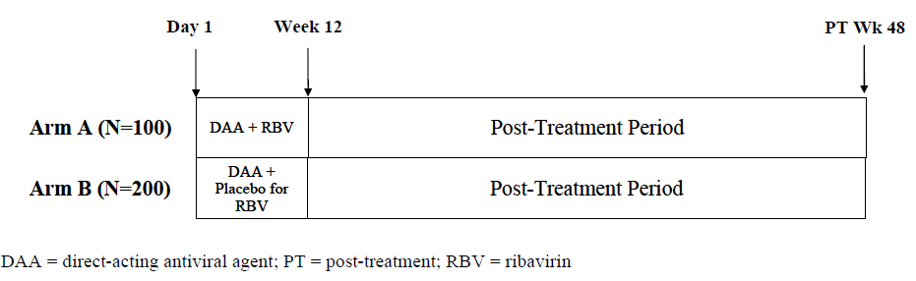

Inclusion and exclusion criteria
The key inclusion criteria were: adult male or female patients aged 18 to 70 years; appropriate contraceptive precautions not including hormonal contraceptives; no previous HCV antiviral therapy; BMI ≥ 18 to < 38 kg/m²; chronic HCV infection based on antibody or liver biopsy criteria; HCV genotype 1b infection; liver biopsy, FibroTest or FibroScan results within the previous 24 months demonstrating the absence of cirrhosis; and plasma HCV RNA > 10,000 IU/mL. The key exclusion criteria were: history of any severe drug sensitivity; use of herbal supplements; history of drug or alcohol abuse; antibody evidence of HBV or HIV infection; co-infection with HCV genotypes other than 1a; the use of protocol defined concomitant medications; use of strong inhibitors or inducers CYP3A or CYP2C8; clinically significant concomitant illnesses including epilepsy, uncontrolled diabetes and malignancy; any past or present evidence of cirrhosis; any liver disease other than HCV; ALT or AST > 5 x ULN; creatinine clearance < 60 mL/min; albumin < ULN; haemoglobin, platelets or WBC < ULN; and clinically significant ECG abnormalities.

Study treatments
ABT-450/r/ABT-267 75 mg/50 mg/12.5 mg was administered as two tablets QD, and ABT-333 250 mg was administered as tablets BD. RBV dosing was based on body weight, either 1,000 mg or 1,200 mg (as 200 mg tablets) divided BD as per local label (typically < 75 kg or ≥ 75 kg). All study drugs were to be taken with food at the same time every day. The study drugs were dispensed every 4 weeks and a tablet count was performed at each visit. Non-compliance was defined as < 80% usage of the prescribed active medications and 99% to 100% of patients were compliant in both treatment groups during treatment.

Efficacy variables and outcomes
The main efficacy variables were:
- Plasma HCV RNA levels
- HCV resistance testing.
The primary efficacy variable was SVR₁₂.
The primary efficacy outcomes were non-inferiority of Arm A and Arm B compared with the historical SVR rate for telaprevir + pegIFN/RBV (LCB > 65% for both comparisons). Other efficacy outcomes included:
- The percentage of patients with a decrease in haemoglobin below the LLN at the end of treatment in Arm A versus Arm B.
- Superiority of SVR₁₂ rates in Arm A and Arm B compared with the historical rate for telaprevir/pegIFN/RBV (LCB > 75% for both comparisons)
- Non-inferiority of Arm B compared with Arm A using a 10.5% SVR₁₂ margin
- the percentage of patients with on-treatment virologic failure
- the percentage of patients with post-treatment virologic relapse.
The historical telaprevir response rates are based on data from the Incivek US PI. The SVR₁₂ rates in the Phase III studies ADVANCE and ILLUMINATE in treatment naive, non-cirrhotic patients with genotype 1a infection are shown below in Table 27.

Table 27: Estimated SVR Rates for Telaprevir plus pegIFN and RBV therapy in treatment-naïve, non-cirrhotic subjects with HCV sub genotype 1a
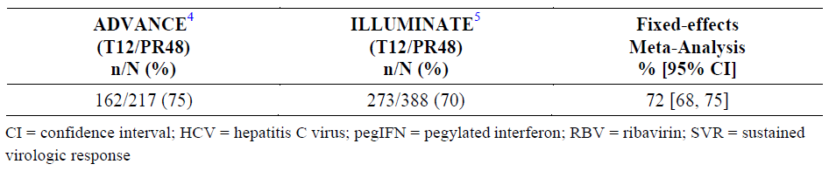

Randomisation and blinding methods
Randomisation was conducted using a computer generated schedule accessed via IRT. 3-DAA was provided as open label tablets while RBV and RBV placebos were provided as matching capsules.

Analysis populations
All randomised patients who received at least one dose of study medication were included in the ITT population and used in the efficacy and safety analyses (n = 305).

Sample size
Historical SVR₁₂ rates in treatment naïve patients without cirrhosis with HCV GT1a infection were obtained from the ADVANCE and ILLUMINATE studies of telaprevir-based therapy. A fixed-effect meta-analysis was used to estimate SVR₁₂ rates and 95% CIs (Table 27). The superiority of either treatment compared with telaprevir + pegIFN/RBV required the LCB to exceed 75%. Based on data from the ILLUMINATE study, a margin of 10.5% with a LCB in excess of 65% was required to demonstrate non-inferiority.

Statistical methods
SAS was used for all analyses. Descriptive statistics were employed and all statistical tests and CIs were 2 sided with α = 0.05. Continuous variables were analysed using 1 way ANOVA and categorical variables were analysed using a χ² test. Multiplicity was controlled across the primary and secondary endpoints using a fixed sequential testing procedure. No data were imputed for the efficacy analyses except for the HCV RNA endpoints. If there was no HCV RNA value at a defined visit, the closest values before and after the visit were noted. A flanking imputation method, including a backward imputation approach, was then used in the analysis. For patients with undetectable or unquantifiable HCV RNA levels at both the preceding and succeeding visits, the missing value was also considered undetectable or unquantifiable.

Participant flow
A total of 436 patients were screened, 305 patients received at least one dose of study treatment, and a total of 294 patients completed study drug treatment. At the time of the primary analysis, no patients had completed the study and 298 patients were ongoing. No patients discontinued study drug in the 3-DAA + RBV group but eleven patients (5.4%) discontinued in the 3-DAA group. Of these patients six (2.9%) discontinued because of virologic failure.

Major protocol violations/deviations
Individual patient data are provided in the CSR but the percentage of patients with deviations, major protocol deviations, and deviations leading to exclusion from the primary analysis are not provided. However, because the ITT population was used so no patients were excluded from the primary analysis due to protocol deviations.

Baseline data
The baseline demographics were similar in both treatment groups. Overall, the majority of patients were White (84.3%) and male (65.2%) with a mean age of 51.5 years. Mean body weight was 79.4 kg. There were no meaningful differences in baseline disease characteristics. All but one patient (99.7%) had HCV genotype 1a infection. The majority of patients (53.4%) had IL28B genotype CT, 15.7% had genotype TT and 30.8% had genotype CC. The mean baseline HCV RNA level was 6.57 (range 3.92 to 7.62) log₁₀ IU/mL.

Results for the primary efficacy outcome
SVR₁₂ was achieved by 97.0% of patients (95% CI: 93.7%, 100%) in the 3-DAA + RBV group, and by 90.2% of patients (95% CI: 86.2%, 94.3%) in the 3-DAA group. Both primary endpoints were met as the 65% non-inferiority LCB thresholds were achieved in both groups. All patients achieved virologic suppression but on-treatment virologic failure occurred in 1 (1.0%) patient in the 3-DAA + RBV group, and six (2.9%) patients in the 3-DAA group. In the 3-DAA + RBV group, one patient (1.0%) experienced virologic relapse by post-treatment Week 12 compared with 10 (5.2%) patients in the 3-DAA group. One patient (1%) in each group had missing SVR₁₂ data. In the 3-DAA + RBV group, SVR₁₂ rates and 95% CIs were comparable in the randomisation strata based on IL28B genotype (CC versus non-CC), and in sub-groups defined by gender, age, race, geographic region, BMI, baseline HCV RNA, and fibrosis stage.

Results for other efficacy outcomes
The LCB was > 75% in both treatment groups, confirming superiority to the historical telaprevir + pegIFN/RBV SVR₁₂ rates. There was a 6.8% (95% CI: -12.0%, 1.5%) benefit in SVR₁₂ rates in favour of the 3-DAA + RBV group compared with the 3-DAA group (Table 28). The LCB was below -10.5%, indicating that non-inferiority of the 3-DAA group compared with the 3-DAA + RBV group was not confirmed. Anaemia with a decrease in haemoglobin below the LLN was reported in 42.0% of the 3-DAA + RBV group compared with 3.9% in the 3-DAA group (p < 0.001).

Table 28: Study M14-002. Non inferiority analysis comparing 3-DAA treatment to 3-DAA + RBV treatment for virologic response (SVR₁₂) (Intent to treat population)
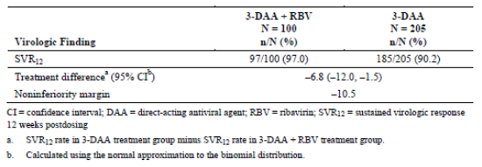
Comment: This study compared the efficacy of 3-DAA with and without RBV in patients with HCV GT1a infection. SVR₁₂ rates were 97.0% in the 3-DAA + RBV group and 90.2% in the 3-DAA group. Both treatments were superior to the historical control rate for telaprevir plus pegIFN/RBV therapy. Although the SVR rate was > 90% in the 3-DAA group, it was not shown to be non-inferior to the 3-DAA + RBV group. Virologic failure occurred in 2.0% of the 3-DAA + RBV compared with 7.8% in the 3-DAA group. Anaemia was reported in 42.0% of patients in the 3-DAA + RBV group and 3.9% in the 3-DAA group.
Overall, the study results confirm high efficacy rates in HCV GT1a infected patients, matching the rates observed in patients with GT1b infection. SVR₁₂ rates were higher with the addition of RBV to the treatment regimen. However, the impressively high SVR₁₂ rates in the 3-DAA group (> 90%), justify the use of 3-DAA alone in patients with GT1a infection who are intolerant to RBV.

Study M13-099 (TURQUOISE-II)

Study design, objectives, locations and dates
This was a Phase III, randomised, multicentre, open label safety and efficacy study of ABT-450/r/ABT-267 + ABT-333 with ribavirin in treatment-naive and pegIFN/RBV treatment experienced adults with genotype 1a and 1b chronic HCV infection and compensated cirrhosis. It was conducted at 78 centres in Canada, Belgium, France, Germany, Italy, Spain, the UK and the US/Puerto Rico). It commenced in October 2012 and last patient last visit occurred in January 2014 for the primary analysis dated 1 April 2014. The primary efficacy objective was to compare SVR₁₂ rates after 12 or 24 weeks of treatment with 3-DAA + RBV with the historical SVR rate for telaprevir plus pegIFN/RBV.
Approximately 380 patients were to be randomised. Randomisation of the first 200 patients was in a 3:5 ratio to the 12 and 24 week arms. The remaining patients were randomised in a 3:1 ratio to the same respective arms (a placebo arm was not included to minimise prolonged exposure to placebo in this vulnerable patient group). Randomisation was stratified according to previous pegIFN/RBV therapy (treatment experienced) or no previous therapy (treatment-naive). The treatment experienced patients were stratified according to non-response to previous pegIFN/RBV treatment (null responder, partial responder, or relapser) and IL28B genotype. The treatment naïve patients were stratified by HCV genotype (1a or 1b). The study schematic is shown below in Figure 10. The duration of the treatment period was either 12 or 24 weeks, followed by a 48 week post-treatment period to monitor safety, HCV RNA, and the emergence and/or persistence of resistant viral variants. A final follow-up visit was conducted at Week 72.
Figure 10: Study schematic Study M13-099
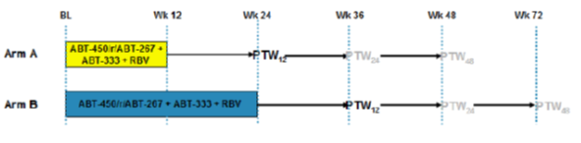

Inclusion and exclusion criteria
The key inclusion criteria were: adult male or female patients aged 18 to 70 years; appropriate contraceptive precautions, not including hormonal contraception; no previous HCV antiviral therapy; BMI ≥ 18 to < 38 kg/m²; chronic HCV infection based on antibody or liver biopsy criteria; HCV genotype 1 infection; liver biopsy, or FibroScan evidence of cirrhosis; compensated cirrhosis defined as Childs-Pugh score ≤ 6; absence of HCC based on negative ultrasound, CT or MRI; plasma HCV RNA > 10,000 IU/mL; and either no previous therapy or a documented history of the type of response to previous pegIFN/RBV treatment (null responder, partial responder, or relapser). The key exclusion criteria were: history of any severe drug sensitivity; use of herbal supplements; history of drug or alcohol abuse; antibody evidence of HBV or HIV infection; co-infection with HCV genotypes other than genotype 1; the use of protocol defined concomitant medications; use of strong inhibitors or inducers CYP3A or CYP2C8; clinically significant concomitant illnesses including epilepsy, uncontrolled diabetes and malignancy; any past or present evidence of cirrhosis; any liver disease other than HCV; ALT or AST > 5 x ULN; creatinine clearance < 60 mL/min; albumin < ULN; haemoglobin, platelets or WBC < ULN; and clinically significant ECG abnormalities.

Study treatments
All treatments were open label. 75 mg/50 mg/12.5 mg was administered as 2 tablets QD, and 250 mg was administered as 1 tablet BD. RBV dosing was based on body weight, either 1,000 mg or 1,200 mg (as 200 mg tablets) divided BD as per local label (typically < 75 kg or ≥ 75 kg). All study drugs were to be taken with food at the same time every day. The study drugs were dispensed every 4 weeks and a tablet count was performed at each visit. Non-compliance was defined as < 80% usage of the prescribed active medications and 99% to 100% of patients were compliant in both treatment groups at each visit.

Efficacy variables and outcomes
The main efficacy variables were:
- Plasma HCV RNA levels
- HCV resistance testing.
The primary efficacy variable was the rate of SVR₁₂.
The primary efficacy outcome was the percentage of patients with SVR₁₂ in each treatment arm.
Other efficacy outcomes included:
- The percentage of patients with SVR₁₂ in the 24 week arm compared with the 12 week arm, both compared with historical telaprevir + pegIFN/RBV rates.
- the percentage of patients with on-treatment virologic failure
- the percentage of patients with post-treatment virologic relapse.
The historical telaprevir response rates are based on data from the Incivek US PI. The SVR₁₂ rates in the Phase III studies ADVANCE, ILLUMINATE and REALIZE in treatment naïve and treatment experienced, cirrhotic patients with genotype 1a and 1b infection are shown in Tables 29 and 30.

Table 29: Study M13-099 SVR rates for Telapravir plus pegIFN and RBV in treatment naive subjects
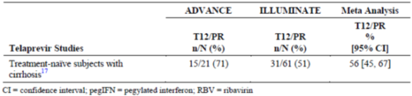

Table 30: Study M13-099 Estimated SVR rates for telaprevir plus pegIFN and RBV in cirrhotic subjects
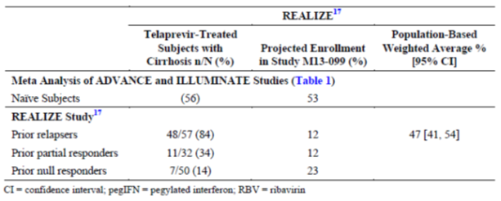

Randomisation and blinding methods
The study was open label. Randomisation was conducted using a computer generated schedule accessed via IRT.

Analysis populations
All randomised patients who received at least one dose of study medication were included in the ITT population and used in the efficacy and safety analyses (n = 380).

Sample size
Assuming that 68% of patients in each arm would achieve SVR₁₂, a sample size of 380 patients had 90% power to demonstrate non-inferiority to the historical SVR rate for telaprevir + pegIFN/RBV therapy with a 2 sided 97.5% LCB > 43%, and 90% power to demonstrate superiority with a 2 sided 97.5% LCB > 54%. A sample size of 380 patients had 80% to detect a difference of approximately 13% assuming underlying SVR₁₂ rates of 68% and 81% in the 12 week and 24 week arms, respectively.

Statistical methods
SAS was used for all analyses. Descriptive statistics were employed. The percentage of patients achieving SVR₁₂ in each arm and 2 sided 95% CIs were calculated using the normal approximation of the binomial distribution. Comparisons of mean changes between treatment arms were made using ANCOVA. Continuous variables were analysed using 1 way ANOVA and categorical variables were analysed using a χ² test. Multiplicity was controlled across the primary and secondary endpoints using a fixed sequential testing procedure. No data were imputed for the efficacy analyses except for the HCV RNA endpoints. If there was no HCV RNA value at a defined visit, the closest values before and after the visit were noted. A flanking imputation method, including a backward imputation approach, was then used in the analysis. For patients with undetectable or unquantifiable HCV RNA levels at both the preceding and succeeding visits, the missing value was also considered undetectable or unquantifiable. Kaplan-Meier curves were constructed to plot changes in HCV RNA levels over time.

Participant flow
A total of 671 patients were screened, 381 patients were randomised, 380 patients received at least one dose of study treatment, and a total of 367 patients completed study drug treatment. At the time of the primary analysis, no patients had completed the study and 370 patients were ongoing. In the 12 week treatment group, five patients discontinued study drug compared with nine patients in the 24 week treatment group. The most common reason for discontinuation was AEs and only three patients (0.8%) discontinued because of virologic failure (all in the 24 week group).

Major protocol violations/deviations
Individual patient data are provided in the CSR but the percentage of patients with deviations, major protocol deviations, and deviations leading to exclusion from the primary analysis are not provided. However, because the ITT population was used so no patients were excluded from the primary analysis due to protocol deviations.

Baseline data
The baseline demographics were similar in both treatment groups. Overall, the majority of patients were White (94.7%) and male (70.3%) with a mean age of 56.8 years. Mean body weight was 82.4 kg. There were no meaningful differences in baseline disease characteristics. All patients had HCV genotype 1a (68.7%) or 1b (31.3%) infection. The majority of patients (62.4%) had IL28B genotype CT, 19.5% had genotype TT and 18.2% had genotype CC. The mean baseline HCV RNA level was 6.47 (range 3.93 to 7.68) log₁₀ IU/mL. Overall, 42.1% of patients were treatment naïve and 57.9% were treatment experienced (mostly null responders). The majority of patients had a Child-Pugh score of 5 to 6.

Results for the primary efficacy outcome
As shown in Table 31, SVR₁₂ was achieved by 91.8% of patients (97.5% CI: 87.6%, 96.1%) in the 12 week treatment group, and by 95.9% of patients (97.5% CI: 92.6%, 99.3%) in the 24 week group. Both primary endpoints were met as the 43% non-inferiority LCB thresholds were achieved in both groups. All patients achieved virologic suppression but on-treatment virologic failure occurred in 1 (0.5%) patient in the 12 week group and 3 (1.7%) patients in the 24 week group. In the 12 week group, 12 patients (5.9%) experienced virologic relapse by post-treatment Week 12 compared with one (0.6%) patient in the 24 week group. No patients had missing SVR₁₂ data. SVR₁₂ rates by randomisation strata are shown in Table 32. In both treatment groups, the SVR₁₂ rates were higher in patients with GT1b infection compared with GT1a infection (98.5% versus 88.6% in the 12 week group, 100% versus 94.2% in the 24 week group). There were no meaningful differences in SVR₁₂ rates between treatment naïve and treatment experienced patients with the exception of prior null responders with GT1a infection in the 12 week arm ( SVR₁₂ 80.0% ). In prior null responders, the SVR₁₂ rate was higher in the 24 week group than in the 12 week group (95.2% versus 86.7%, respectively).

Table 31: Study M13-099 Virologic response (SVR12) by arm (intent to treat population)
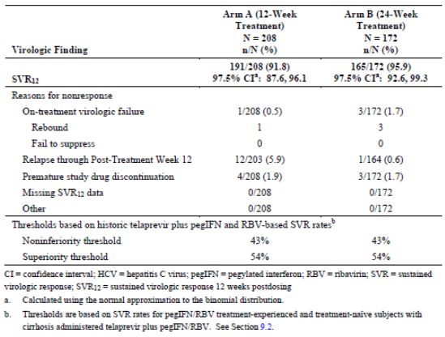

Table 32: study M13-099 virologic response (SVR12) by randomisation strata and arm (intent to treat population)
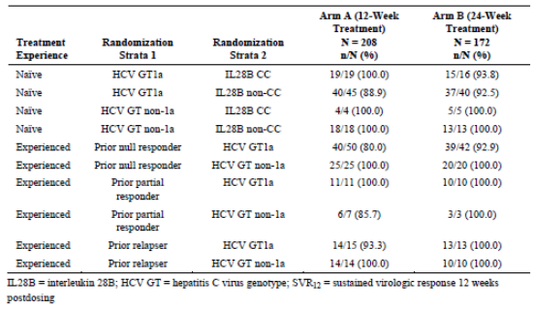

Results for other efficacy outcomes
The LCB was > 54% in both treatment groups, confirming superiority to the historical telaprevir + pegIFN/RBV SVR₁₂ rates. There was a 4.18% (95% CI: 9.79, 1.42) benefit in SVR₁₂ rates in favour of the 24 week group compared with the 12 week group but the difference was not statistically significant (p = 0.089). Statistical comparisons of the rates of virologic failure and post-treatment relapse are shown in Table 33. Based on 95% CIs, post-treatment virologic relapse occurred more frequently in the 12 week group (5.9%) compared with the 24 week group (0.6%).

Table 33: Study M13-099 On treatment virologic failure and post treatment relapse₁₂ by arm (intent to treat population)
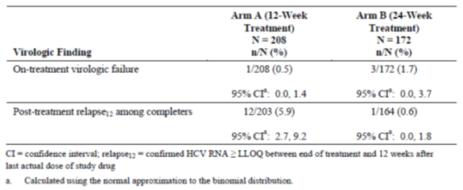
Comment: This study compared the efficacy of 3-DAA + RBV in patients with HCV GT1 infection and compensated cirrhosis. The study design was open label to avoid exposing vulnerable patients to the risk of decompensated liver disease during placebo treatment. In addition, enrolment in PegIFN containing regimens was considered not to be feasible due to the increasing availability of treatment regimens free of pegIFN. SVR is more difficult to achieve in cirrhotic patients compared with those without cirrhosis so a 24 week treatment arm was tested in the study. In addition, the longer treatment period allowed comparison with 24 week telaprevir + pegIFN/RBV therapy in the same patient group. SVR₁₂ rates were 91.8% in the 3-DAA + RBV 12 week group, and 95.9% in the 24 week group, and both treatments were superior to the historical control rate for telaprevir + pegIFN/RBV therapy. SVR rates were higher in patients with GT1b infection compared with those with GT1a infection after 12 and 24 weeks treatment. Virologic failure occurred in 8.2% of patients in the 12 week arm compared with 4.1% in the 24 week arm, due mostly to post-treatment relapse (5.9% and 0.6%, respectively).
Overall, the study results confirm high efficacy rates in HCV GT1a and GT1b-infected patients with compensated cirrhosis. There were no meaningful differences between the 12 and 24 week treatment periods. The exception was treatment experienced patients with GT1a infection given 3-DAA + RBV for 12 weeks in particular prior null responders who had an SVR₁₂ rate of ‘only’ 80%. SVR₁₂ rates were comparable in both treatment groups irrespective of IL28B status. The study results justify the treatment recommendation of 3-DAA + RBV for 24 weeks in prior null responders with GT1a infection.

Other efficacy studies

Study M11-652
This was a randomised, open label, multicentre, Phase II study comparing SVR₂₄ rates in treatment naïve and prior null responder patients with HCV genotype 1 infection. The study was conducted at 92 sites in 9 countries between October 2011 and September 2013. There were 14 treatment groups. Patients were randomised to receive ABT-450/r/ABT-267 and/or ABT-333 with and without RBV given for 8, 12, or 24 weeks. The primary objective was to compare the percentage of patients achieving SVR₂₄ following 8 and 12 weeks treatment with 3-DAA + RBV. The secondary objectives included comparisons of treatment with 3-DAA +/- RBV and 2-DAA +/- RBV for periods of 8, 12 or 24 weeks. Patients were male or female aged between 18 and 70 years. Approximately 560 patients were planned, and 571 patients received at least one dose of study medication. The study schematic is shown in Figure 11. Most patients were White (83.5%) and male (55.0%) with a mean age of 50.3 years and mean weight 79.6 kg. Overall, 66.2% of patients had HCV genotype 1a infection and 33.3% had genotype 1b infection. Overall, the mean baseline HCV RNA was 6.55 (4.65 to 7.52) log₁₀ IU/mL.
Figure 11: Study Schematic Study M11-652
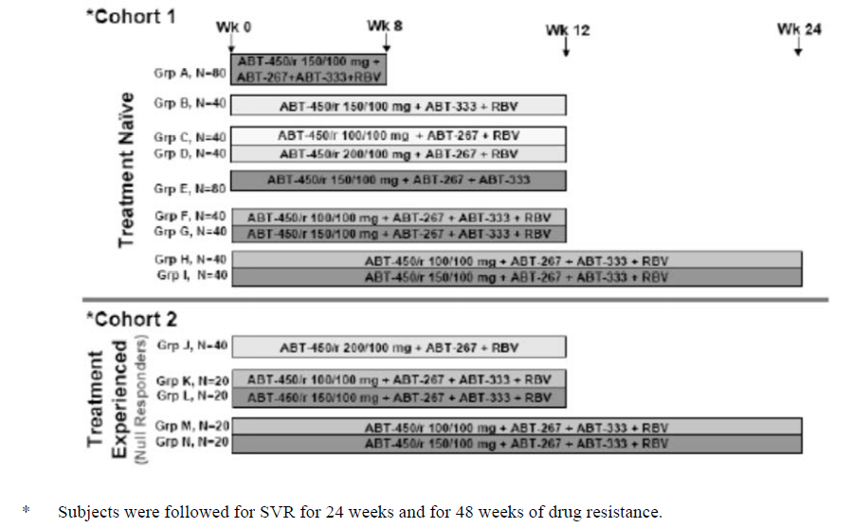

Results
SVR₂₄ rates ranged from 82.9% to 100% across all treatment groups. For the primary analysis, the SVR₂₄ rate after 8 weeks of treatment with 3-DAAs + RBV was 87.5%, compared with 95.0% in the group given 3-DAAs + RBV for 12 weeks. The 7.3% difference in favour of the 12 week group was not statistically significant (p = 0.238). Overall, SVR₂₄ was achieved in 89.7% of treatment naïve patients, and 92.5% of prior non-responders. In treatment naïve and null responder patients, there were no meaningful differences between the 12 and 24 week treatment groups. In patients given 3-DAAs + RBV for 8 weeks, 10/80 patients (12.5%) had viral relapse compared with 1/79 (1.3%) in the group given the same treatment for 12 weeks.
Comment: This exploratory study was not powered to demonstrate statistically significant between the different treatment regimens and treatment durations. However, treatment with 3-DAA + RBV for 12 weeks was associated with numerically higher SVR rates and lower virologic relapse rates compared with treatment for 8 weeks. No additional benefit was observed when treatment was extended to 24 weeks. The study supports an optimal dosing period of 12 weeks for patients with HCV GT1 infection.

Study M13-393 (PEARL-I)
This was an open label, randomised, efficacy and safety study of the 2-DAA combination treatment (ABT-450/r administered with ABT-267 with and without RBV) in adults with chronic HCV infection. The results presented are an interim analysis of the on-going study. The interim study report is not dated but the study has completed the planned enrolment of 316 patients at 47 sites in the US and Europe. The study objectives were to compare SVR₁₂ rates in treatment naïve and treatment experienced patients with HCV GT4 infection, and in patients with and without cirrhosis with HCV GT1b infection. The study schematic is shown below in Figure 12.
Figure 12: Study M13-393 schematic
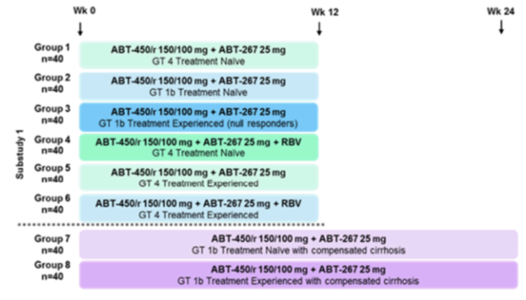
Based on a protocol specified interim review of the on-treatment results from the treatment naïve Groups 1 and 4 that indicated higher SVR rates among patients receiving the 2-DAA regimen with RBV, only Group 6 was opened for enrolment in treatment experienced HCV GT4 infected patients.
In the treatment period, non-cirrhotic patients with HCV GT4 infection received 12 weeks of the 2-DAA regimen with or without RBV. Non-cirrhotic patients with HCV GT1b infection received 2-DAA for 12 weeks, and compensated cirrhotic patients with HCV GT1b infection received 2-DAA for 24 weeks. The main purpose of the interim analysis was to assess SVR₁₂ rates in patients with GT4 infection (Groups 1 and 4). All Group 6 patients have completed 12 weeks treatment and are in the post-treatment follow-up period. Their results in Group 6 (treatment experienced patients with GT4 infection) were not available at the time of the preliminary analysis. In patients with HCV GT4 infection, the majority of patients were White and male with non-CC IL28B genotypes. The most common GT4 sub-types were 4a and 4d.

Results
In Group 1 (2-DAA without RBV), 90.9% of patients achieved SVR₁₂. Three patients had virologic failure; one had on-treatment failure and two had post-treatment relapse. In Group 4 (2-DAA with RBV), 100% of patients achieved SVR₁₂. In Group 6, unconfirmed preliminary results indicate that all patients had undetectable HVC RNA levels at the end of treatment.
Comment: ABT-333 has no potent in vitro activity against HCV GT4 so it was not included in the treatment regimen in this exploratory study. These preliminary results show that 2-DAA for 12 weeks is effective in treatment naïve patients with HCV GT4 infection (SVR₁₂ rate 90.9%). In the group with added RBV, 100% of patients achieved SVR₁₂ with similar efficacy in treatment experienced patients. The results justify further studies in patients with HCV GT4 infection.

Study M12-114
This was a Phase II, double blind, randomised, placebo controlled, dose ranging, efficacy and safety study of ABT-267 in combination with pegIFN α-2a and RBV in treatment naïve patients with chronic HCV GT1 infection. It was conducted at nine centres in the US and Puerto Rico between March 2011 and February 2013. The primary objective of the study was to compare the percentages of patients who achieved RVR response after 4 weeks treatment with three different doses of ABT-267 in combination with pegIFN/RBV with patients given pegIFN/RBV alone (ABT-267 placebo) for 12 weeks. Important secondary objectives included the percentage of patients who achieved SVR₁₂ and exposure-time-response relationships. The study schematic is shown in Figure 13. Patients who completed the first 12 week treatment period continued treatment with pegIFN/RBV and ABT-267 or placebo for a further 36 weeks, and a post-treatment observation period for a maximum total of 72 weeks. Patients were randomised to receive one of three doses of ABT-267 (5 mg QD, 50 mg QD or 200 mg QD). Each treatment group was planned to contain 10 patients given ABT-267 + pegIFN/RBV, and three patients given placebo for ABT-267 + pegIFN/RBV. A total of 37 patients were randomised and all received at least one dose of study drug. The majority of patients were White and male, most were infected with HCV GT1a, and most were of non-CC IL28B genotype.
Figure 13: Study M12-114 Schematic
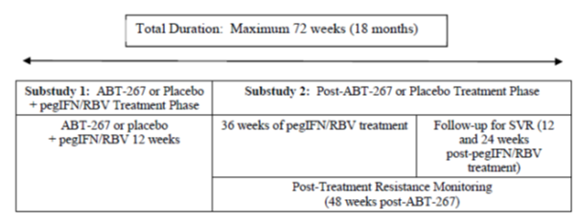

Results
The primary efficacy endpoint was the percentage of patients with RVR at Week 4 (Table 34). The percentage of patients with HCV RNA < LLOD was 22.2% in the placebo group, and 33.3%, 55.6% and 70.0% in the ABT-267 5 mg, 50 mg and 200 mg, respectively (p = 0.030 for the 200 mg group compared with placebo). The majority of patients achieved the primary endpoint in each demographic sub-group. SVR₁₂ was achieved by 33.3% of patients in the placebo group compared with 66.7%, 66.7% and 60% in the ABT-267 5 mg, 50 mg and 200 mg groups, respectively. SVR₂₄ rates were achieved by 22.2% of the placebo group compared with 55.6%, 44.4% and 50% in the respective groups. The median time to viral suppression was 84.0 days in the placebo group compared with 27.0, 16.0 and 21.5 days in the respective groups (p = 0.011 for the combined active groups versus placebo).

Table 34: Percentage of subjects with HCV RNA < LLOD at Week 4 (ITT population) Study M12-114
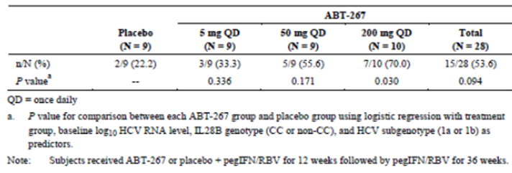
Comment: The percentage of patients achieving RVR at Week 4 was higher in each ABT-267 + pegIFN/RBV treatment group although the study numbers were small and statistical significance versus placebo was shown only for the 200 mg group (p = 0.030). The time to viral suppression was shorter by at least 50 days in all the ABT-267 groups (p = 0.011). The study confirmed the antiviral activity of ABT-267 and supported further study in the 50 mg to 200 mg QD dosage range.

Study M13-386
This was a Phase II, open label, multiple ascending dose study of the antiviral activity of ABT-267 in treatment naïve patients with HCV GT1 infection. It was conducted at four sites in the US between February 2012 and June 2013. The primary objective of the study was to assess the antiviral activity of multiple ascending doses of ABT-267 administered as two days monotherapy followed by combination therapy with ABT-267, ABT-450/r, ABT-333, and RBV for 12 weeks. The study schematic is shown in Figure 14. Patients were to receive doses of ABT-267 from 1.5 mg up to 50 mg on dosing Days 1 and 2. There was no control arm but the antiviral activity of ABT-267 was compared to placebo patients in study M12-116. The dosage arms were studied sequentially and after review of the preliminary data (based on a priori protocol criteria), it was decided not to continue with Arms 3 and 4. A total of 12 patients received study drug (6 patients each in Arms 1 and 2) but two patients (one in each group) discontinued. The majority of patients were White and female, most were infected with HCV GT1a, and most were of non-CC IL28B genotype.
Figure 14: Study M13-386 study schematic
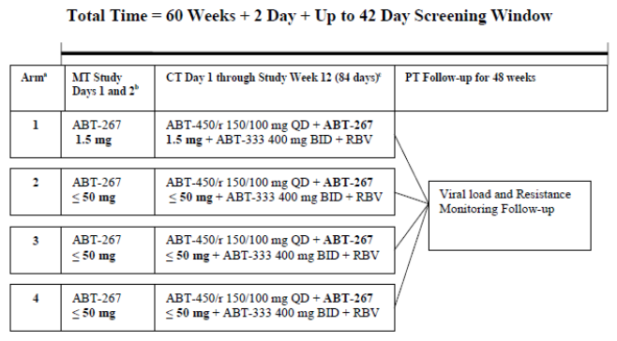

Results
The primary efficacy endpoint was the decrease from baseline in HCV RNA during the ABT-267 2 day dosing period. Following dosing with ABT-267 1.5 mg QD monotherapy, the maximal change from baseline in HCV RNA was -1.6 log₁₀ IU/mL compared with -3.1 log₁₀ IU/mL in the ABT-267 25mg QD group (p = 0.035). The percentage of patients achieving SVR₁₂ was 83.3% in each group.
Comment: The study was designed to assess the lower dosage limit of the antiviral activity of ABT-267. The results showed that the 25 mg dose was effective and that the 1.5 mg was ineffective. When the results were assessed in conjunction with M12-116 (in which doses from 5 mg to 200 mg were studied) it was decided that no further useful information could be gathered from further dose escalation. Overall, the data supported an optimal dose of ABT-267 25 mg QD for the Phase III program.

Study M12-746
This was a Phase II, open label, 3 arm, pilot study to evaluate the antiviral activity of two doses of ABT-450/r given in combination with ABT-333 and RBV in treatment naïve and treatment experienced (pegIFN/RBV) non-responder patients with HCV GT1 infection. It was conducted at 11 sites in the US between February 2011 and October 2012. The primary objective was to assess the antiviral activity of ABT-450/r/ABT-333 + RBV given for 12 weeks. The study schematic is shown in Figure 15. In combination with ABT-333 + RBV, treatment naïve patients were given either ABT-450/r 250/100 mg QD (Arm 1) or ABT-450/r 150/100 mg QD (Arm 2), and treatment experienced patients were given ABT-450/r 150/100 mg QD (Arm 3). Antiviral activity was monitored for the 12 week treatment period and SVR₁₂ and SVR₂₄ rates were calculated during the post-treatment phase of up to 48 weeks. A total of 50 patients were randomised and received at least one dose of study medication (Arm1 = 19, Arm 2 = 14, Arm 3 = 17). The majority of patients were White and male with a mean age of 52.4 years. Most patients were infected with HCV GT1a, and most were of non-CC IL28B genotype.
Figure 15: Study M12-746 study schematic
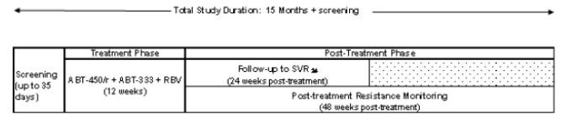

Results
HCV RNA < LLOD from Week 4 to Week 12 was achieved by 89.5%, 78.6%, and 58.8% of patients in Arms 1, 2, and 3, respectively (Table 35). SVR₁₂ was achieved by 94.7%, 92.9%, and 47.1% of patients, respectively, and SVR₂₄ was achieved by 94.7%, 85.7%, and 47.1% of patients, respectively. Virologic failure occurred in 5.3%, 0%, and 41.2% of patients, respectively.

Table 35: Study M12-746 Number and percentage of subjects with HCVRNA < LLOD from Week 4 through Week 12 (ITT population)
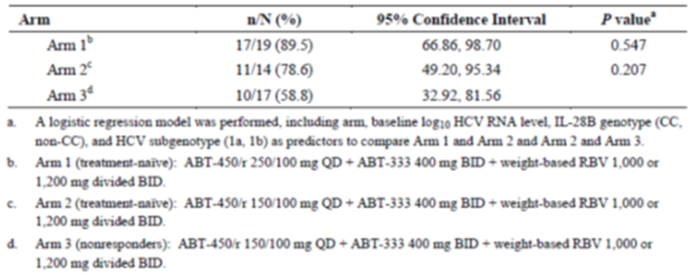
Comment: In treatment naïve patients, both doses of ABT-450/r were effective but antiviral activity was superior in patients given the 250/100 mg dose. ABT-450/r 150/100 mg was ineffective in prior non-responder patients. The lack of difference in viral suppression during treatment Arms 1 and 2 supported the use of the lower 150 mg dose in the Phase III program.

Study M12-998
This was a Phase II, open label, sequential arm, multicentre study of up to two doses of ABT-450/r (between 100 mg or 200 mg) given in combination with ABT-267 with and without RBV in treatment naïve patients with HCV GT1, GT2 or GT3 infection. It was conducted at 15 sites in the US between September 2011 and May 2013. The primary objective was to assess the antiviral activity of ABT-450/r /ABT-267 + RBV given for 12 weeks. The post-treatment period of 48 weeks was designed to evaluate SVR₁₂ and SVR₂₄ rates and the development of virologic failure. The study schematic is shown in Figure 16. After review of the emerging data, it was decided to study only the ABT-450/r 200/100 mg dose. Arm 1 and 2 were enrolled sequentially and each arm contained three cohorts according to HCV genotype (1, 2, or 3). Patients in Arm 1 received ABT-450/r 200/100 mg QD in combination with ABT-267 25 mg QD with RBV for12 weeks, while patients in Arm 2 received the same regimen without RBV. A total of 61 patients received at least one dose of study medication (Arm 1 = 30, Arm 2 = 31), and at least 10 patients were enrolled in each genotype cohort. The majority of patients were White and male with a mean age of approximately 47 years. In the overall population, HCV GT3a was present in 34.4% of the population, HCV GT1a and 2b 26.2% each, and 1b and 2a 6.6% each. IL28B genotype CC was present in 26.2% of the overall population.
Figure 16: Study M12-998 study schematic
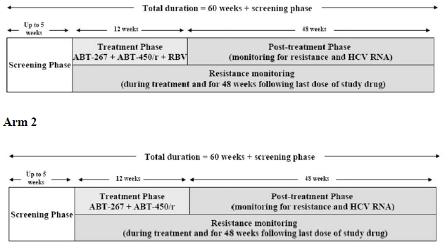

Results
The percentage of patients with HCV RNA levels <LLOQ from Week 4 to Week 12 are shown in Table 36. eRVR was achieved by 86.7% (95% CI: 69.28, 96.24) of patients in Arm 1 (with RBV), and by 61.3% (95% CI: 42.19, 78.15, p = 0.037) of patients in Arm 2 (without RBV). In each treatment arm, the response rates were highest in patients infected with GT1 and GT2 and least in those with GT3 infection. SVR₁₂ and SVR₂₄ rates mirrored the eRVR rates. SVR₁₂ was achieved by 76.7% of patients in Arm 1 and 41.9% of patients in Arm 2 with the least response noted in patients with GT3 infection. SVR₂₄ was achieved by 73.3% of patients in Arm 1 compared with 41.9% in Arm 2. In Arm 1, virologic stopping criteria were met by 0%, 10.0% and 30.0% of patients with GT1, GT2 and GT3 infection, respectively. In Arm 2, virologic failure occurred in 10.0%, 10.0% and 72.7% of patients, respectively.

Table 36: Study M12-998 Number and percentage of subjects with HCV RNA < LLOQ from week 4 through Week 12 (eRVR) (ITT population)
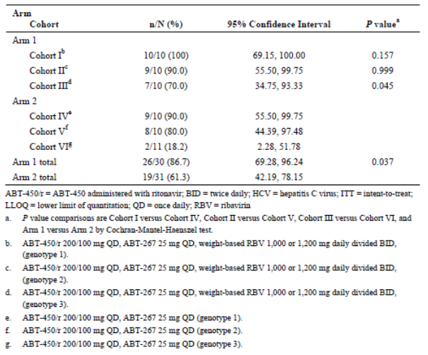
Comment: This exploratory study demonstrated the efficacy of 12 weeks treatment with ABT-267 + ABT450/r with or without RBV in patients infected with HCV GT1, GT2 and GT3. Virologic response was least in the GT3 group but they were still comparable to response rates achieved with pegIFN/RBV. The data supported further clinical testing in all three genotypes and their sub-types.

Study M14-103
This was a Phase II, open label, single arm study of ABT-450/r/ABT-267 and ABT-333 with RBV in adult patients with HCV GT1 infection receiving methadone or buprenorphine. It was conducted at 8 sites in the US between April 2013 and December 2013. The primary objective was to assess efficacy and safety during 12 weeks treatment in patients taking stable opioid replacement therapy. The 12 week treatment period was followed by a 48 week post-treatment period to monitor HCV RNA levels and emerging viral failure. The primary analysis was performed when all patients had completed post-treatment Week 12. A total of 38 patients received at least one dose of study drug. The majority were White and male with a mean age of 48 years. Most patients had GT1a infection and 68.4% had non-CC IL28B genotype. All patients were on stable opioid replacement therapy (50% methadone, 50% buprenorphine with or without naloxone).

Results
SVR₁₂ was achieved by 97.4% of patients (95% CI: 92.3%, 100.0%). One patient discontinued prematurely due to AEs and no patient had virologic failure.
Comment: IV drug abuse is common in patients with HCV infection. The study is sufficient to show that opioid replacement therapy does not influence SVR₁₂ rates following 3-DAA + RBV therapy.

Study M13-102
This is an interim report of an on-going Phase III study with a cut-off date of December 2013. It offers long-term monitoring for up to 3 years in any patient who received any DAA at any dose level in the Phase II and Phase III trial program. The main objectives of the study are to monitor the persistence of specific HCV amino acid variants; and to monitor the durability of virologic response in patients who achieved SVR₁₂. Patient visits occur at Months 3 and 6, and at 6 monthly intervals thereafter. At the cut-off date, 176 patients had been enrolled and no patients had completed the study. Most of the patients (79%) were recruited from Study M11-652.

Results
Of the 176 patients enrolled in M13-102, 96.6% achieved SVR₁₂ in the prior study. Of these patients, 43.2% have completed 84 weeks of post-treatment follow-up and 1.1% have completed 120 weeks. The median duration of follow-up is 553.5 days. None of the patients has experienced viral relapse or re-infection. To date, there are too few samples available for meaningful analysis of persistence of resistant variants. Only four patients experienced on-treatment virologic failure in the previous study, or post-treatment relapse before enrolment in M13-102.

Analyses performed across trials
Meta-analyses were performed on the following analysis populations:

Placebo controlled analysis set
Overall, the SVR₁₂ rate for the 3-DAA + RBV population with GT1 infection (M11-646 and M13-098, n = 770) was 96.2% (95% CI: 94.9%, 97.6%), with comparable efficacy in subgroups defined by HCV genotype subtype and prior treatment response (Table 37). Virological non-response was experienced by 3.8% (95% CI: 2.4%, 5.1%) of patients (Table 38). All patients achieved virologic suppression in the on-treatment period. Subsequent virologic failure was associated most commonly with Week12 post-treatment relapse (1.9%) or premature drug discontinuation (1.4%).

Table 37: SVR₁₂ rate for 3-DAA + RBV group by prior treatment experience and HCV sub genotype (ITT population placebo controlled analysis set)
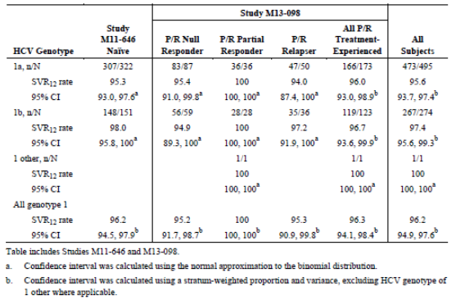

Table 38: reasons for virologic non-response (SVR₁₂) for the 3-DAA + RBV treatment group (ITT population. Placebo controlled analysis set)
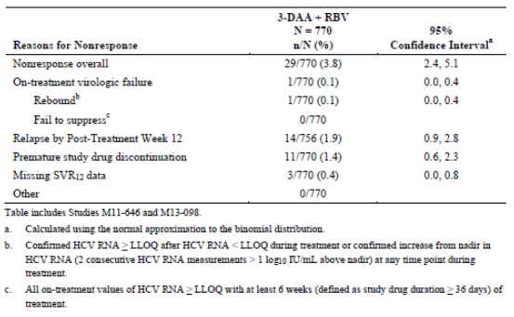

Regimen-controlled analysis set

3-DAA + RBV group
Overall, the SVR₁₂ rate for the 3-DAA + RBV population (n = 398) with GT1 infection (treatment naïve and treatment experienced in studies M13-961, M14-002 and M13-389) was 98.2% (95% CI: 97.0%, 99.5%), with comparable efficacy in subgroups defined by HCV genotype subtype and prior treatment response (Table 39). SVR₁₂ rates were 93.5%, 96.0% and 100% in prior null responders, partial responders and relapsers, respectively. All patients achieved virologic suppression in the on-treatment period but rebound occurred in 0.1% of patients and post-treatment virologic relapse was experienced by 1.9% of patients.

Table 39: SVR₁₂ rate for 3-DAA + RBV group by prior treatment experience and HCV sub genotype (ITT population, regimen controlled analysis set)
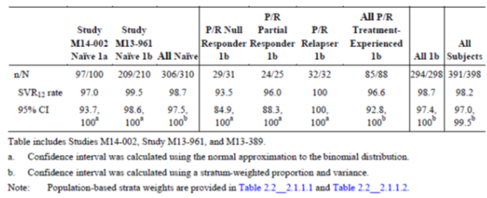

3-DAA group
Overall, the SVR₁₂ rate for the 3-DAA population (n = 505) was 95.6% (95% CI: 93.9%, 97.4%), with comparable efficacy in subgroups defined by prior treatment response (Table 40). However, SVR₁₂ rates were significantly lower in treatment naïve patients with GT1a infection compared with the GT1b group [90.2% (95% CI: 86.1%, 94.3%) versus 99.0% (95% CI: 97.7%, 100%), respectively. All patients achieved virologic suppression in the on-treatment period but rebound occurred in 1.2% of patients, and post-treatment virologic relapse was experienced by 2.0% of patients.

Table 40: SVR₁₂ rate for the 3-DAA group by prior treatment experience and HCV sub genotype ITT population, regimen controlled analysis set)
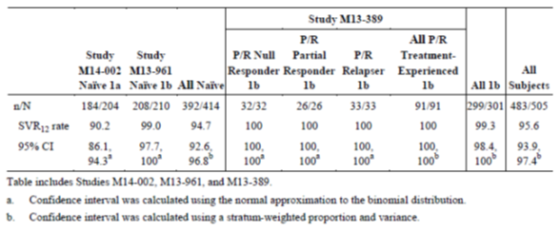

Comparison with individual study arms with historical telaprevir + pegIFN/RBV SVR₁₂ rates
SVR₁₂ rates from the placebo controlled studies in treatment naïve and treatment experienced non-cirrhotic patients (M11-646 and M13-098) are summarised in Figure 17. Three studies (M13-389, M113-961 and M14-002) in non-cirrhotic patients with HCV GT1 infection compared treatment with, 3-DAA + RBV or 3-DAA (Figure 18). A summary plot of all the pivotal studies compared with historical telaprevir + pegIFN/RBV rates is shown in Figure 19. In every 3-DAA + RBV or 3-DAA study group, efficacy rates were markedly higher than the corresponding groups treated with telaprevir + pegIFN/RBV.
Figure 17: Forest Plot of SVR₁₂ rates for 3-DAA + RBV group compared to historic telaprevir thresholds (ITT population, placebo-controlled analysis set)
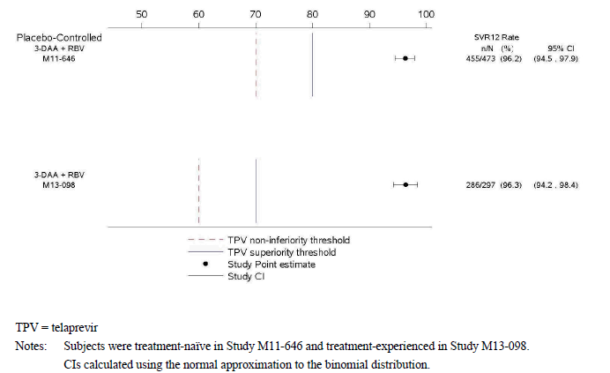
Figure 18: Forest Plot of SVR₁₂ rates for 3-DAA + RBV and 3-DAA groups compared to historic telaprevir threshold (ITT population, regimen-controlled analysis set)
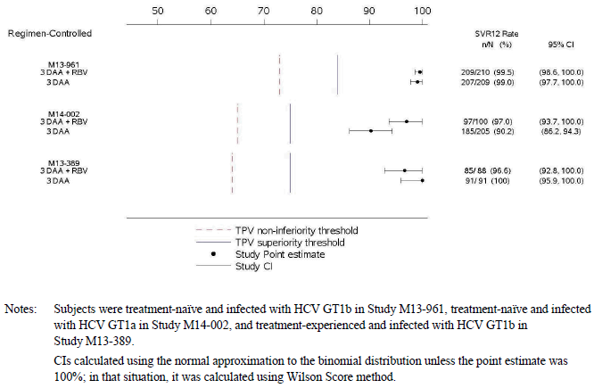
Figure 19: Forest Plot of SVR₁₂ rates for 3-DAA + RBV and 3-DAA groups compared to historic telaprevir thresholds (ITT population, historic telaprevir-controlled analysis set)
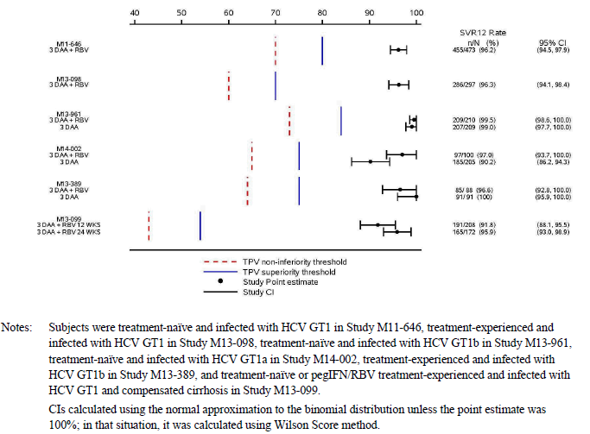

Persistence of efficacy
In the combined Phase II and III studies, 660 patients had SVR₁₂ and SVR₂₄ data available. With the exception of one patient, SVR₁₂ predicted SVR₂₄ with an overall accuracy of ≥ 99.8% for the 3-DAA + RBV and 3-DAA groups.

Evaluator’s conclusions on clinical efficacy
Evaluator’s conclusions on clinical efficacy for the proposed indication of “the treatment of genotype 1 chronic hepatitis C infection, including patients with cirrhosis”.
The study program was based on current US and EU guidelines for the treatment of chronic HCV infection, and scientific advice on study design and methodology was sought from the FDA and EMA. All studies were conducted according to the principles of GCP and patient numbers were adequate in the overall population and most subgroups. The eligibility criteria were appropriate with adequate representation of the most important patient groups defined by HCV genotype sub-type, prior treatment experience and the presence or absence of cirrhosis. Patients with significant hepatic and renal impairment were excluded, and also patients with co-infection with HIV. However, PK studies in these patient subgroups have been conducted leading to clear dosage recommendations and precautions in the PI. There were adequate numbers of males and females but few elderly patients were studied. In addition, the great majority of patients were White and efficacy in other racial groups, particularly Asians, needs further study. The potential influence of IL28B genotype sub-types was addressed in all the pivotal studies and no interactions were demonstrated.
The primary efficacy endpoint for all studies was SVR₁₂ rates in patients with chronic HCV GT1 infection. Within this population, important subgroups with known differing response rates to telaprevir + pegIFN/RBV were identified and analysed. These subgroups include patients with GT1a and GT1b infection, cirrhotic and non-cirrhotic patients, treatment naïve and treatment experienced patients, and other subgroups defined by IL28B status, gender, race, age, BMI, baseline fibrosis score, baseline HCV RNA level and baseline IP-10. SVR₁₂ rates for the 3-DAA + RBV combination in non-cirrhotic, treatment naïve and treatment experienced patients with GT1a and GT1b infection were compared with placebo in two pivotal Phase III studies. In the 770 patients who received active treatment during the 12 week double blind treatment period, the overall SVR₁₂ rate was 96.2% (95% CI: 94.9%, 97.6%), and the rates were comparable in all subgroups including genotype subtype and prior treatment experience. The SVR₁₂ rate was markedly superior to historical rates achieved by comparable patient groups treated with telaprevir + pegIFN/RBV. On-treatment virologic failure and post-treatment relapse occurred in only 2% of patients, and SVR₁₂ almost completely predicted SVR₂₄ rates. In the double blind studies, there was prompt normalisation of abnormal baseline LFTs in most patients given active treatment. These studies confirmed the value of 3-DAA + RBV given for 12 weeks in all non-cirrhotic patient groups with HCV GT1 infection.
The 3-DAA + RBV and 3-DAA 12 week treatment regimens were compared in non-cirrhotic, treatment naïve and treatment experienced patients with GT1a and GT1b infection in another three pivotal Phase III studies of similar design. In these studies, 398 and 505 patients were treated with 3-DAA + RBV and 3-DAA, respectively. In these studies, SVR₁₂ rates of 90.2% to 100% were achieved across all patient groups, all markedly superior to historical rates with telaprevir + pegIFN/RBV. Only in treatment naïve GT1a patients treated with 3-DAA were SVR₁₂ rates lower than in other groups (90.2%). Only in this sub-group was an additional benefit obtained with the addition of RBV to the treatment regimen. However, an SVR₁₂ rate of > 90% is still exceptional and 3-DAA is a valid treatment option for patients intolerant of RBV. The 3-DAA + RBV 12 week regimen was assessed in a single study in compensated cirrhotic patients with GT1 infection. SVR is more difficult to achieve in cirrhotic patients so the 3-DAA regimen was not assessed, and the 3-DAA + RBV regimen was given for 24 weeks in cirrhotic prior null responders. Outstanding SVR₁₂ rates were achieved in cirrhotic patients with GT1b infection (99% overall), and in patients with GT1a infection (91% overall).
ABT-333 has insufficient potency against HCV GT4 so a 2-DAA +/- RBV regimen was tested in this group of patients. An interim analysis of an on-going, open label, exploratory study with small patient numbers to date has demonstrated SVR₁₂ rates of 100% and 90.9% in the 3-DAA + RBV and 3-DAA groups respectively. The data do not merit an indication for use in patients with GT4 infection but they are strongly encouraging and warrant further studies.

Clinical safety

Studies providing evaluable safety data

Pivotal efficacy studies
In the pivotal efficacy studies, the following safety data were collected:
- General adverse events (AEs) were assessed, documented and reported in accordance with ICH GCP and classified according to MedDRA criteria.
- AEs of particular interest included LFT abnormalities, skin rash and anaemia. Hepatic safety was assessed by an independent specialist liver panel.
- Laboratory tests, including chemistry, haematology, urinalysis, HCV RNA and IL28B genotyping were performed by Covance Central Laboratory Services at Indianapolis, Geneva and Singapore.

Pivotal studies that assessed safety as a primary outcome
- No studies presented.

Dose-response and non-pivotal efficacy studies
- The dose-response and non-pivotal efficacy studies provided safety data, assessed and categorised using the same methodology as the pivotal studies.

Other studies evaluable for safety only
- No studies submitted.

Pivotal studies that assessed safety as a primary outcome
No studies submitted.

Patient exposure
The majority of patients were male (57.3%) with a mean age of 51.6 years. A total of 214 (8.1%) patients were aged ≥ 65 years. The large majority of patients was White (90.5%) and 6.2% were Hispanic or Latino. A total of 2,632 patients with HCV GT1 infection were exposed to the 3-DAA combination, with or without RBV, for up to 24 weeks. A total of 380 patients had compensated cirrhosis. In the All Treated Analysis Set, the median exposure in each treatment group was 84 days with > 95% of patients exposed for more than 60 days of treatment. A total of 2,044 patients were exposed to 3-DAA + RBV for 511.4 patient-years (PY), and 588 patients were exposed to 3-DAA for 134.4 PY. Exposure in the All Treated Analysis Set was 586.2 PY in Whites, 41.8 PY in Hispanics or Latinos, 41.7 PY in Blacks, and 10.7 PY in Asians. Exposure in patients with compensated cirrhosis was 124.94 PY.
Comment: Further studies in Asian populations are in progress.
However, following co-administration of ABT-267 25 mg QD HME, ABT-450/r 150/100 mg QD, and ABT-333 400 mg BD for 21 days to healthy Han Chinese, Japanese and Caucasian subjects, Study M12-221 indicated that relative to the values in Caucasians, the ABT-450 AUC₂₄ values were 2.47 and 2.91 fold higher in Han Chinese and Japanese subjects, respectively, and the ABT-333 M1 AUC values were 1.35 and 1.50 fold higher in Han Chinese and Japanese subjects, respectively. For the other components of Viekira Pak changes in AUC were less than 1.3 fold between the 3 groups.
In addition, Study RD 13-1098 PPK identified that the ritonavir Cτ,ss in HCV genotype 1 infected subjects of Hispanic/Latino ethnicity was approximately 156% higher than in non-Hispanic/Latino patients.

Adverse events

All adverse events (irrespective of relationship to study treatment)

Pivotal studies

Study M11-646
An overview of Treatment emergent AEs during the double blind period was provided. AEs were reported in 87.5% of the 3-DAA + RBV group compared with 73.4% in the placebo group (P < 0.05). Treatment emergent AEs reported by ≥ 5% of patients in either treatment group during the double blind treatment period: The most common AEs (≥ 10%) in the active group were fatigue, headache, nausea, pruritus, insomnia, diarrhoea, asthenia, and rash. The most common AEs in the placebo group were fatigue, headache, and nausea. The differences between active treatment and placebo groups were statistically significant (p < 0.05) for anaemia, diarrhoea, nausea, asthenia, insomnia, dyspnoea, dry skin, and pruritus. The pattern of AEs reported during the open label period was similar to that of the double blind period with a high incidence (≥ 10%) of fatigue, asthenia, cough, headache, nausea, diarrhoea, and insomnia.

Study M13-098
An overview of Treatment emergent AEs during the double blind period was provided. AEs were reported in 91.2% of the 3-DAA + RBV group compared with 82.5% in the placebo group (p < 0.05). Treatment emergent AEs reported by ≥ 5% of patients in either treatment group during the double blind treatment period were provided. The most common AEs (≥ 10%) in the active group were headache, fatigue, nausea, asthenia, insomnia, pruritus, diarrhoea, dyspnoea, and cough. The most common AEs in the placebo group were headache, fatigue, nausea, diarrhoea, asthenia, myalgia, and dyspnoea. The differences between active treatment and placebo groups were statistically significant (p < 0.05) for anaemia, constipation, vomiting, and pruritus. The pattern of AEs reported during the open label period was similar to that of the double blind period with a high incidence (≥ 10%) of fatigue, headache, nausea, insomnia, dyspnoea, and pruritus).

Study M13-389
An overview of Treatment emergent AEs were provided. AEs were reported in 79.1% of the 3-DAA + RBV group compared with 77.9% in the 3-DAA group. AEs reported by ≥ 5% of patients in either treatment group during the open label treatment period were provided. The most common AEs (≥ 10%) in the 3-DAA + RBV group were fatigue, headache, nausea, insomnia, pruritus, diarrhoea, asthenia, and anaemia. The most common AEs in the 3-DAA group were fatigue, headache, and diarrhoea. AEs occurring more commonly in the 3-DAA + RBV were statistically significant (p < 0.05) for fatigue, nausea, insomnia, anaemia, increased bilirubin, and rash.

Study M13-961
An overview of Treatment emergent AEs were provided. AEs were reported in 80.0% in the 3-DAA + RBV group compared with 67.0% in the 3-DAA group (p < 0.05). AEs reported by ≥ 5% of patients in either treatment group during the double blind treatment period were provided. The most common AEs (≥ 10%) in the 3-DAA + RBV group were nausea, headache, fatigue, pruritus, and asthenia. The most common AEs in the 3-DAA group were headache and fatigue. AEs occurring more commonly in the 3-DAA + RBV group were statistically significant (p < 0.05) for nausea, insomnia, cough, anaemia and pruritus.

Study M14-002
An overview of Treatment emergent AEs during the double blind period was provided. AEs were reported in 92.0% of the 3-DAA + RBV group compared with 82.4% in the 3-DAA group (p < 0.05). Treatment emergent AEs reported by ≥ 5% of patients in either treatment group were provided. The most common AEs (≥ 10%) in the 3-DAA + RBV group were fatigue, headache, nausea, insomnia, diarrhoea, and pruritus. The most common AEs in the 3-DAA group were fatigue, headache, diarrhoea, and nausea. AEs occurring more commonly in the 3-DAA + RBV were statistically significant (p < 0.05) for insomnia, arthralgia, exertional dyspnoea, increased bilirubin, dry skin, and anaemia.

Study M13-099
An overview of Treatment emergent AEs during the 3-DAA + RBV 12 week and 24 Week periods was provided. AEs were reported in 91.8% during the 12 week period compared with 90.7% in the 24 Week group. Treatment emergent AEs reported by ≥ 5% of patients in either arm were provided. In the 24 Week group, the most common AEs (≥ 10%) were irritability and dyspnoea, fatigue, headache, pruritus, nausea, insomnia, diarrhoea, asthenia, cough, and rash. AEs occurring more commonly (p ≤ 0.05) in the 24 Week arm compared with the 12 week arm were fatigue, dyspnoea, URTI, back pain, and memory impairment.
Comment: Although it is not appropriate to compare the frequency of AEs across studies, the only AE occurring more commonly in the 3-DAA groups than in the placebo groups of studies M11-646 and M13-098 was pruritus.

Other studies

M11-652
AEs were reported in 83.8% to 96.3% of patients given 3-DAA + RBV, most commonly fatigue and headache.

M13-393
To date, AEs have been reported in 77.3% and 87.9% of the 2-DAA and 2-DAA + RBV groups, respectively, most commonly pruritus, headache and asthenia in the 2-DAA group, and insomnia, headache, asthenia, nausea and fatigue in the 2-DAA + RBV group.

M12-114
All patients received pegIFN/RBV in addition to ABT-267 5mg, 50 mg or 200 mg, or placebo. A total of 92.9% of patients reported AEs.

M13-386
Six patients in each treatment group received 3-DAA with either 1.5 mg or 25 mg doses of ABT-267. AEs were reported in 50% and 83.3%, most commonly increased bilirubin, diarrhoea, fatigue, headache, rash and decreased haemoglobin.

M12-746
Patients were treated with ABT-450/r and ABT-333 + RBV with ABT-450 given in doses of either 150 mg or 250 mg. AEs were reported in 76.5% to 92.9% of patients, most commonly, fatigue, headache, dizziness, insomnia, nausea, pruritus and rash.

M12-998
Patients were treated with 2-DAA (ABT-450/r and ABT-267) +/- RBV which included an ABT-450 dose of 200 mg. AEs were reported in 86.7% to 90.3% of patients, most commonly nausea, diarrhoea, arthralgia, fatigue and headache.

M14-103
AEs were reported in 92.1% of patients, most commonly nausea, fatigue, headache, insomnia and rash. Anaemia was reported in 10.5% of patients. There were no AEs suggestive of increased opiate effect or withdrawal.
Comment: Patient numbers in the supportive studies were low and a variety of different dosage treatment regimens were tested in different patient groups. However, the overall frequency and pattern of AEs was comparable to the pivotal studies.

Treatment related adverse events (adverse drug reactions)

Pivotal studies

Study M11-646
In the double blind period, AEs related to DAA treatment were experienced by 71.9% and 51.9% of the active and placebo groups, respectively. AEs considered related to RBV were experienced by 74.4% and 50.0% of the respective groups.

Study M13-098
In the double blind period, AEs related to DAA treatment were experienced by 75.4% and 64.9% of the active and placebo groups, respectively. AEs considered related to RBV were experienced by 76.4% and 62.9% of the respective groups.

Study M13-389
In this open label study, AEs related to 3-DAA treatment (as judged by the investigator) were experienced by 64.8% of patients in the 3-DAA + RBV group, compared with 51.6% in the 3-DAA group. AEs related to RBV treatment were experienced by 71.4% of patients in the 3-DAA + RBV group compared with 0% in the 3-DAA group (p < 0.0001).

Study M13-961
AEs considered related to 3-DAA treatment were experienced by 53.8% of the 3-DAA + RBV group compared with 45.9% of the 3-DAA group. AEs considered related to RBV treatment were experienced by 56.2% of the 3-DAA + RBV group compared with 43.1% of the 3-DAA group.

Study M14-002
AEs considered related to 3-DAA were reported in 76.0% of the 3-DAA + RBV group compared with 63.9% of the 3-DAA group. AEs considered related to RBV were reported in 78.0% and 64.4% of the respective groups.

Study M13-099
AEs considered related to 3-DAA were reported in 72.1% of the 12 week arm compared with 75.6% of the 24 Week arm. AEs considered related to RBV were reported in 75.5% and 81.4% of the respective groups.
Comment: The pattern of ADRs was comparable to the pattern of AEs. They largely reflect the known AE profile of RBV.

Other studies

M11-652
ADRs possibly related to DAA were reported in 64.6% to 85.0% of patients.

M13-393
ADRs possibly related to DAA were reported in 40.0% to 67.3% of patients.

M12-114
ADRs possibly related to ABT-267/placebo were reported in 57.1% of patients, more commonly in the placebo group than any ABT-267 dose group.

M13-386
ADRs possibly related to DAA were reported in 50.0% to 66.7% of patients.

M12-746
ADRs possibly related to DAA were reported in 52.9% to 78.9% of patients.

M12-998
ADRs possibly related to DAA were reported in 58.1% to 63.3% of patients.

M14-103
ADRs possibly related to DAA were reported by 76.3% of patients.
Comment: The pattern of ADRs was comparable to that of the pivotal studies.

Deaths and other serious adverse events

Pivotal studies

Study M11-646
One death due to lung carcinoma occurred in a patient in the active treatment group. It was considered unrelated to treatment. SAEs in the double blind period were reported in 2.1% and 0.0% of the active and placebo treatment groups, respectively. Two SAEs were considered drug related, a case of pneumonia and an acute allergic reaction immediately following the first dose of study medication.

Study M13-098
No deaths were reported. SAEs were reported in 2.0% and 1.0% of the active and placebo treatment groups, respectively. Two SAEs were considered drug related, a cerebrovascular accident and a case of renal failure related to RBV. Both events resolved within 7 days of drug discontinuation.

Study M13-389
No deaths were reported. SAEs were reported in 2.2% of the 3-DAA + RBV group and 2.1% of the 3-DAA group. No events were considered drug related.

Study M13-961
No deaths were reported. SAEs were reported in 1.9% of both treatment groups. No events were considered drug related.

Study M14-002
No deaths were reported. SAEs were reported in 3% of the 3-DAA + RBV group compared with 0.5% in the 3-DAA group. No events were considered drug related.

Study M13-099
There was one death (0.5%) in the 12 week arm but none in the 24 Week arm. The death occurred in a patient with severe lactic acidosis associated with metformin use, and it was not considered to be related to study drug.
Comment: The frequency of SAEs was low in all patient groups. Few SAEs and no deaths were attributed to 3-DAA by the investigators. Patients with significant co-morbidities in the largely middle aged population were excluded. Tolerability in real world patients may prove to be less but the safety profile of 3-DAA in the Phase III studies was strongly encouraging.

Other studies

M11-652
SAEs were reported in 1.5% to 2.5% of patients and there were no deaths during the on-treatment period.

M13-393
To date, there has been one unrelated SAE and no deaths.

M12-114
There were no SAEs or deaths.

M13-386
There were two unrelated SAEs and no deaths.

M12-746
No SAEs or deaths were reported.

M12-998
There were two unrelated SAEs. There was one unrelated death (due to arteriosclerotic cardiovascular disease) which occurred in the post-treatment period.

M14-103
There were two SAEs and no deaths. Both SAEs were considered unrelated.
Comment: The low frequency of SAEs supported the pivotal study data.

Discontinuation due to adverse events

Pivotal studies

Study M11-646
AEs leading to study drug discontinuation were experienced by 0.6% of patients in the active and placebo groups. AEs leading to RBV dose modification were experienced by 5.5% of the active treatment group.

Study M13-098
AEs leading to study drug discontinuation were experienced by 1.0% and 0.0% of patients in the active and placebo groups, respectively. AEs leading to RBV dose modification were experienced by 6.4% of the active treatment group.

Study M13-389
AEs leading to discontinuation of study drug were experienced by 2.2% of the 3-DAA + RBV group compared with 0% in the 3-DAA group.

Study M13-961
There were no AEs leading to discontinuation of study drug in either treatment arm.

Study M14-002
AEs leading to discontinuation of study drug were reported by 1.0% of the 3-DAA group compared with none in the 3-DAA + RBV group.

Study M13-099
AEs leading to discontinuation of study drug were reported by 1.9% of the 12 week arm compared with 2.3% of the 24 Week arm.
Comment: Discontinuations due to AEs were notably infrequent and largely attributable to RBV.

Other studies

M11-652
AEs leading to discontinuation of study drug were experienced by 1.5% to 3.8% of patients.

M13-393
There were no AEs leading to discontinuation of study drug.

M12-114
There were no AEs leading to discontinuation of study drug.

M13-386
One patient experienced an AE leading to discontinuation of study drug.

M12-746
One patient experienced an AE leading to discontinuation of study drug.

M12-998
One patient experienced an AE leading to discontinuation of study drug but the AE was considered unrelated to treatment.

M14-103
One patient experienced an AE leading to discontinuation of study drug but the AE was considered unrelated to treatment.
Comment: The low number of discontinuations mirrors the pivotal studies.

Laboratory tests

Liver function

Pivotal studies
All significant Treatment emergent LFT changes from baseline were assessed by an independent expert liver panel to identify drug induced liver injury (DILI). The sources of the liver safety review dated 28 March 2014 were data from the two Sapphire studies (M11-646, M13-098), the three Pearl studies (M13-389, M13-961, and M14-002), the Turquoise II study (M13-099) and the M14-103 study. In addition, several cases of interest from other studies involving treatment with ABT-450/r were reviewed. Subjects in the above studies who experienced a documented post-baseline serum ALT exceeding 5 x ULN, or experienced a post baseline elevation in serum ALT exceeding 3 x ULN and total serum bilirubin exceeding 2 x ULN (not necessarily concurrent) were referred to the hepatologists for adjudication. The hepatologists were blinded to treatment assignment, and they independently performed and submitted written assessments. HCV viral loads were not provided to the reviewers a priori, but if the reviewers believed that the HCV viral load would be required to obtain consensus causality assessment, HCV viral load could be requested from AbbVie. The reviewers used the causality assessment scale adopted by the Drug-Induced Liver Injury Network [Seven categories ranging from Definite (> 95% likelihood) to Unrelated and Unassessable].

Study M11-646
Mean LFT changes from baseline to the end of the double blind treatment period were provided. In the active treatment group, there were highly significant decreases in ALT, AST and GGT levels (p ≤ 0.001) which were sustained at the end of the at PT Week 4. In the double blind treatment period, there were modest but statistically significant increases in total bilirubin and alkaline phosphatase which reversed post-treatment. In the active treatment group, 11.7% of patients had a ≥ 2 x ULN increase in total bilirubin. There were no meaningful mean changes in any LFT parameter in the placebo group. During the double blind treatment period, ALT increases of CTCAE Grade 3 or higher occurred in 0.9% and 4.4% of the active and placebo groups, respectively.

Study M13-098
Mean LFT changes from baseline to the end of the double blind treatment period were provided. In the active treatment group, there were decreases in ALT, AST and GGT levels which were sustained at the end of the Week 4 post-treatment period. In the double blind treatment period, there were minor but statistically significant increases in total bilirubin and alkaline phosphatase which reversed post-treatment. There were no meaningful mean changes in any LFT parameter in the placebo group. During the double blind treatment period, ALT increases of CTCAE Grade 3 or higher occurred in 1.7% and 3.1% of the active and placebo groups, respectively.

Study M13-389
Mean LFT changes from baseline to the end of the open label treatment period were provided. In the 3-DAA + RBV and 3-DAA groups, there were decreases in ALT, AST and GGT levels which were sustained at the end of the Week 4 post-treatment period. There were no meaningful differences between the two treatment groups. In the 3-DAA + RBV treatment period, there were minor but statistically significant increases in total bilirubin and alkaline phosphatase which reversed post-treatment. During the treatment period, there were no ALT increases of CTCAE Grade 3 or higher in either group.

Study M13-961
Mean LFT changes from baseline to the end of the double blind treatment period were provided. In the 3-DAA + RBV and 3-DAA groups, there were decreases in ALT, AST and GGT levels which were sustained at the end of the Week 4 post-treatment period. There were no meaningful differences between the two treatment groups. In the 3-DAA + RBV treatment period, there were minor but statistically significant increases in total bilirubin and alkaline phosphatase which reversed post-treatment. During the treatment period, 1.0% of the 3-DAA + RBV group had an ALT increase of CTCAE Grade 3 or higher compared with none in the 3-DAA group.

Study M14-002
Mean LFT changes from baseline to the end of the double blind treatment period were provided. In the 3-DAA + RBV and 3-DAA groups, there were decreases in ALT, AST and GGT levels which were sustained at the end of the Week 4 post-treatment period. There were no meaningful differences between the two treatment groups. In the 3-DAA + RBV treatment period, there was a minor but statistically significant increase in total bilirubin which reversed post-treatment. During the treatment period, one patient (1.0%) in of the 3-DAA + RBV group, and one patient (0.5%) in the 3-DAA group) had ALT increases of CTCAE Grade 3 or higher compared with none in the 3-DAA group.

Study M13-099
Mean LFT changes from baseline to the end of the 12 week and 24 week treatment periods were provided. In the 12 week and 24 week, there were decreases in ALT, AST and GGT levels which were sustained at the end of the Week 4 post-treatment period. There were no meaningful differences between the two treatment groups. There was a minor increase in total bilirubin which reversed post-treatment. During the treatment period, six patients (2.9%) in the 12 week arm had ALT increases of CTCAE Grade 3 or higher compared with no patients in the 24 week arm.
Comment: There was a prompt improvement in all liver function parameters in the majority of patients. The frequency of Grade 3 or 4 liver related events was low and no specific events meeting Hy’s Law criteria for DILI were recorded. Overall, there was no evidence to suggest liver toxicity related to 3-DAA.

Other studies

M11-652
In all treatment groups, there were highly significant and sustained decreases in ALT, AST and GGT levels. The decrease in ALT level ranged from -42.4 U/L to -60.8 U/L. Grade 3 ALT level increases were experienced by 0% to 3.8% of patients but there were no Grade 4 increases and no cases met Hy’s Law criteria.

M13-393
Mean LFT changes from baseline have not been reported in the interim analysis. However, there has been only one Grade 3 ALT increase and no Grade 4 increases.

M12-114
At the end of treatment, no patients had experienced an increase in ALT from baseline. There were no ALT increases ≥ Grade 3 during the treatment period.

M13-386
There were no LFT increases ≥ Grade 3 during the treatment period.

M12-746
One patient had a Grade 3 ALT increase which led to study drug discontinuation on Day 17. It was considered possibly related to DAA but it did not meet Hy’s Law criteria.

M12-998
Mean ALT decreased from baseline by -28.0 U/L to -77.4 U/L. The changes were not statistically significant as patient numbers were small. There were two Grade 3+ ALT increases but neither met Hy’s Law criteria.

M14-103
Mean ALT values decreased by -39.9 U/L from baseline. No patient experienced a ≥ Grade 2 LFT increase.
Comment: The pattern of LFT response in the supportive studies was comparable to that observed in the pivotal studies.

Kidney function

Pivotal studies
Patients with significant renal impairment at screening were excluded. There were no meaningful trends or mean changes from baseline in any measure of renal function in any of the pivotal studies.

Study M11-646
One patient (0.2%) in the 3-DAA + RBV group experienced a significantly low CrCl (< 50 mL/min) during the double blind treatment period (not confirmed on re-testing, compared with two patients (1.3%) in the placebo group.

Study M13-098
Two patients (0.7%) in the 3-DAA + RBV group experienced a significantly low CrCl during the double blind treatment period compared with no patients in the placebo group.

Study M13-389
Two patients (2.1%) in the 3-DAA group experienced a significant reduction in creatinine clearance during the treatment period compared with no patients in the 3-DAA + RBV group.

Study M13-961
Three patients (1.4%) in the 3-DAA + RBV group experienced a significantly low CrCl during the treatment period compared with no patients in the 3-DAA group.

Study M14-002
One patient (1.0%) in the 3-DAA + RBV group experienced a significantly low CrCl compared with two patients (1.0%) in the 3-DAA group.

Study M13-099
Three patients (1.4%) in the 12 week treatment arm experienced a significantly low CrCl compared with three patients (1.7%) in the 24 week treatment arm.

Other studies
There were no meaningful trends or mean changes in renal function during the treatment period in any of the supportive studies.

M11-652
There were no meaningful trends or mean changes in renal function during the treatment period. Clinically significant low CrCl (< 50 mL/min) were recorded in 0% to 2.5% of patients.

M13-393
There were no significant low CrCl (< 50 mL/min) in the 3-DAA or 3-DAA groups.

M12-114
One patient in the ABT-267 5 mg group experienced a significant low CrCl.

M13-386
Two patients experienced a significant reduction in eGFR.

M12-746
Two patients experienced a CrCl > 50 mL/min in Arm 1 (ABT-450 250mg dose) compared to none in Arms 2 and 3 (ABT-450 150mg dose).

M12-998
One patient (1.0%) in the 2-DAA + RBV group experienced a significant low CrCl (< 50 mL/min) compared with two patients (1.0%) in the 3-DAA group.

M14-103
One patient (1.0%) in the 3-DAA + RBV group experienced a CrCl < 50 mL/min.

Other clinical chemistry

Pivotal studies
With the exception of elevations in total bilirubin, there were no meaningful trends or mean changes from baseline in any clinical chemistry parameter in any of the pivotal studies.

Study M11-646
The number and percentage of patients with potentially clinically significant changes in any clinical chemistry parameter were provided. With the exception of total bilirubin (11.7% 3-DAA + RBV, 0% placebo), the incidence of significant abnormalities was small and similar in the active and treatment groups.

Study M13-098
The number and percentage of patients with potentially clinically significant changes in any clinical chemistry parameter were provided. With the exception of total bilirubin (11.5% 3-DAA + RBV, 0% placebo), the incidence of significant abnormalities was small and similar in the active and treatment groups.

Study M13-389
The number and percentage of patients with potentially clinically significant changes in any clinical chemistry parameter were provided. With the exception of raised total bilirubin (15.4% 3-DAA + RBV, 1.1% 3-DAA) the incidence of significant abnormalities was small and comparable between the groups.

Study M13-961
The number and percentage of patients with potentially clinically significant changes in any clinical chemistry parameter were provided. With the exception of raised total bilirubin in (11.9% 3-DAA + RBV, 1.4% 3-DAA) the incidence of significant abnormalities was small and comparable between the groups.

Study M14-002
The number and percentage of patients with potentially clinically significant changes in any clinical chemistry parameter were provided. With the exception of raised total bilirubin (8.0% 3-DAA + RBV, 2.4% 3-DAA group), the incidence of significant abnormalities was small and comparable between the groups.

Study M13-099
The number and percentage of patients with potentially clinically significant changes in any clinical chemistry parameter were provided. With the exception of raised total bilirubin (27.9% 12 week arm, 21.5% 24 week arm), the incidence of significant abnormalities was small and comparable between the groups.
Comment: Hyperbilirubinaemia due to drug-induced haemolysis is a well-described event associated with RBV.

Other studies
With the exception of elevations in total bilirubin, there were no meaningful trends or mean changes from baseline in any clinical chemistry parameter in any of the supportive studies.

M11-652
Potentially clinically significant changes in any parameter occurred in 0% to 3.8% of patients.

M13-393
Potentially clinically significant changes in any parameter occurred in 0% to 2.4% of patients. A 60 year old woman receiving ABT-450/r, ABT 267, and ribavirin experienced a marked elevation in her serum aminotransferases levels at week 6 of treatment which resolved despite continuing treatment with the study drugs. She experienced a transient rise in serum unconjugated bilirubin very early in treatment as expected, but she also experienced a secondary rise in serum total bilirubin which preceded the spike in aminotransferase levels but continued to rise during resolution of the aminotransferases. At this time, the conjugated bilirubin concentration exceeded that of the unconjugated bilirubin. This was described as a confusing case and since the bilirubin rise preceded the onset of ALT elevations, the consensus of the hepatologists was that it should not be considered a Hy’s Law Case.

M12-114
Potentially clinically significant changes in any parameter occurred in 0% to 5.4% of patients.

M13-386
Potentially clinically significant changes in any parameter occurred in five patients, most commonly an increase in total bilirubin.

M12-746
Potentially clinically significant changes in any parameter occurred in nine patients, most commonly increased total bilirubin.

M12-998
There were only isolated potentially clinically significant changes in any parameter. The most common change was increased total bilirubin which occurred in 3.2% to 30% in each cohort. Subject 3183 was a 22 year old woman who was receiving treatment with ABT 450/r, ABT 267 and ribavirin and experienced the typical early and transient rise in the unconjugated serum bilirubin level. At about week 10 of treatment, she was noted to have a marked but transient elevation in serum ALT and AST, which was temporarily linked to insertion and subsequent removal of a cervical ring (NuvaRing) that delivers oestrogens. Of note is that the serum bilirubin value rose again as the elevations in serum aminotransferase values were resolving, but this time the majority of the total bilirubin was conjugated. Serum alkaline phosphatase did not rise significantly during the event. This event may have just failed to achieve the bilirubin criteria for a Hy’s Law Case as the peak serum bilirubin is 1.9 x ULN according to ULN listed for the laboratory). The known effect of the drugs on bilirubin transport may have contributed to the bilirubin rise observed. It is of note that study drugs were continued through the full 12 week course when the serum aminotransferases had fallen to within normal limits and the serum bilirubin was near normal.

M14-103
There were only isolated potentially clinically significant changes in any parameter. The exception was increased total bilirubin which occurred 10.5% of patients.
Comment: As in the pivotal studies, there were frequent elevations in total bilirubin in patients who received RBV.

Haematology

Pivotal studies

Study M11-646
Clinically significant haematological abnormalities occurred in ≤ 0.6% of patients in the 3-DAA + RBV and placebo groups during the double blind and open label treatment periods. During the double blind treatment period, mean haemoglobin in the 3-DAA + RBV group fell from 147.6 g/L at baseline to 124.3 g/L, compared with 145.9 g/L to 142.6 g/L in the placebo group (treatment difference 20.0 g/L, p < 0.001).

Study M13-098
Clinically significant haematological abnormalities occurred in ≤ 1% of patients in the 3-DAA + RBV and ≤ 2% in the placebo group during the double blind and open label treatment periods. During the double blind treatment period, mean haemoglobin in the 3-DAA + RBV group fell from 148.8 g/L at baseline to 123.6 g/L, compared with 148.9 g/L to 146.2 g/L in the placebo group (treatment difference 22.5 g/L, p < 0.001).

Study M13-389
No clinically significant haematological abnormalities occurred in the 3-DAA + RBV or 3-DAA groups during the treatment period. During the treatment period, mean haemoglobin in the 3-DAA + RBV group fell from 145.7 g/L at baseline to 124.1 g/L, compared with 147.1 g/L to 142.7 g/L in the 3-DAA group (treatment difference 17.2 g/L, p < 0.001).

Study M13-961
Clinically significant haematological abnormalities occurred in ≤ 1.0% of patients in the 3-DAA + RBV and 3-DAA groups during the treatment period. During the treatment period, mean haemoglobin in the 3-DAA + RBV group fell from 143.7 g/L at baseline to 120.8 g/L , compared with 142.4 g/L to 136.7 g/L in the 3-DAA group (treatment difference 17.2 g/L, p < 0.001).

Study M14-002
Clinically significant haematological abnormalities occurred in ≤1.0% of patients in the 3-DAA+RBV and 3-DAA groups during the treatment period. During the treatment period, mean haemoglobin in the 3-DAA + RBV group fell from 147.2 g/L at baseline to 126.4 g/L compared with 147.5 g/L to 142.1 g/L in the 3-DAA group (treatment difference 15.4 g/L, p < 0.001).

Study M13-099
Clinically significant haematological abnormalities occurred in ≤ 1.4% of patients in the 12 week treatment arm ≤ 1.7% in the 24 week arm. During the treatment periods, there were comparable falls in mean haemoglobin in each group (25.5 g/L and 24.2 g/L, respectively. Reversible neutropaenia (< 1 x 10⁹/L) was observed in 0.5% of the 12 week arm and 1.7% of the 24 week arm.
Comment: The only notable Treatment emergent haematological event was anaemia related to RBV therapy. Reversible neutropaenia was observed in a low percentage of patients but the frequency was comparable to that observed in the general population. There were no meaningful changes in other haematological parameters, and overall there was no evidence of haematological toxicity related to 3-DAA.

Other studies
With the exception of haemoglobin, there were no meaningful trends or mean changes from baseline in any haematological parameter in the supportive studies.

M11-652
There was a mean decrease from baseline in haemoglobin of 19.7 g/L to 27.5 g/L in patients given RBV, compared with 6.5 g/L in patients not given RBV. No more than one patient in each treatment group experienced a Grade 3 reduction in neutrophil count with no Grade 4 reductions.

M13-393
There were two potentially clinically significant haematological changes, one case each of anaemia and neutropenia, both in the 2-DAA + RBV group. Both cases resolved during the treatment period.

M12-114
Most patients experienced reductions in haemoglobin in keeping with RBV treatment. A total of 10 patients had potentially significant haematological changes, most commonly neutropaenia observed in eight patients in the ABT-267 groups.

M13-386
There were no Grade 3 or 4 changes in haemoglobin or neutrophil counts, and no abnormalities of potential clinical significance.

M12-746
Most patients experienced a reduction in haemoglobin in keeping with RBV treatment (mean changes of -16.5 to -23.5 g/L). No changes in any parameter were clinically significant.

M12-998
There were mean haemoglobin reductions of -20.9 g/L in the RBV groups compared with -7.2g/L in the groups who did not receive RBV. No patients had clinically significant haematological abnormalities.

M14-103
Two patients had clinically significant anaemia but no other significant haematological abnormalities were observed during the treatment period.
Comment: The frequency and pattern of haematological events were similar to those observed in the pivotal studies.

Electrocardiograph

Pivotal studies
No patients had clinically significant ECG changes during the double blind treatment period of studies M11-646 and M13-098, nor during the treatment periods of studies M13-389 and M13-961. In study M14-002, one patient with a history of hypertension had a possible septal infarct after one day of 3-DAA treatment. It was considered possibly related to therapy by the investigator. In study M13-099, one patient in the 12 week group developed transient first degree AV block on Day 1 of the post-treatment period. It was considered possibly related to treatment.

Other studies
In M11-652, three patients had Treatment emergent clinically significant ECG changes, each mild and considered not related. No clinically significant ECG changes were reported in any of the other supportive studies. ECGs have not been reported in the interim analysis of M13-393.

Vital signs

Pivotal studies
There were no meaningful changes from baseline or trends for vital signs during treatment with 3-DAA +/- RBV in any of the pivotal studies. There were statistically significant changes in SBP, DBP and HR in various studies but the changes were small in magnitude and not clinically significant. Treatment emergent AEs related to vital signs were reported in ≥ 5.0% of patients only in study M13-389. In this study, 5.5% and 2.1% of patients reported palpitations in the 3-DAA + RBV and 3-DAA groups, respectively; and hypertension was reported in 5.5% and 4.2% of patients, respectively. In study M11-646, an SAE of sinus tachycardia was reported in one patient in the 3-DAA group. In study M13-098, there was an SAE of bradycardia in the 3-DAA+RBV group, considered unrelated to treatment, and an SAE of atrial fibrillation in the placebo group. No SAEs related to vital signs were reported in studies M13-389, M13-961, M14-002. In study M13-099, no SAEs or AEs leading to discontinuation were reported.

Other studies
In the supportive studies, mean changes from baseline in vital signs were minor and no trends were observed. AEs and changes of potential clinical significance were reported infrequently, most commonly related to SBP or DBP. No SAEs related to vital signs were reported. Changes in vital signs have not been reported in the interim analysis of M13-393.

Skin rash
No AEs of rash meeting MedDRA severe cutaneous reaction criteria were reported in the pivotal studies. The most common treatment related skin AEs (≥ 2.0% in any treatment arm) were pruritus and rash.

Pivotal studies

Study M11-646
AEs related to rash were reported in 29.0% of patients in the 3-DAA + RBV group compared with 11.4% in the placebo group during the double blind treatment period. The most common events were pruritus (16.9% versus 3.8%) and rash (10.8% versus 5.7%). Most events were considered mild and possibly related to 3-DAA + RBV therapy. There were no SAEs and no drug interruptions or discontinuations.

Study M13-098
AEs related to rash were reported in 29.0% of patients in the 3-DAA + RBV group compared with 22.7% in the placebo group during the double blind treatment period. The most common events were pruritus (13.8% versus 5.2%), rash (8.8% versus 6.2%), pruritus generalised (3.7% versus 5.2%), erythema (0.3% versus 3.1%), and mouth ulceration (0.7% versus 2.1%). Most events were considered mild and possibly related to 3-DAA + RBV therapy. There were no SAEs and no drug interruptions or discontinuations.

Study M13-389
AEs related to rash were reported in 24.2% of patients in the 3-DAA + RBV group compared with 13.7% in the 3-DAA group during the treatment period. The most common events were pruritus (14.3% versus 8.4%) and rash (8.8% versus 1.1%). Most events were considered mild and possibly related to 3-DAA + RBV therapy. There were no SAEs and no drug interruptions or discontinuations.

Study M13-961
AEs related to rash were reported in 17.1% of patients in the 3-DAA + RBV group compared with 10.5% in the 3-DAA group during the treatment period. The most common events were pruritus (11.9% versus 5.3%) and rash (5.7% versus 3.8%). Most events were considered mild and possibly related to 3-DAA + RBV therapy. There were no SAEs and no drug interruptions or discontinuations.

Study M14-002
AEs related to rash were reported in 26.0% of patients in the 3-DAA + RBV group compared with 17.1% in the 3-DAA group during the treatment period. The most common events were pruritus (10.0% versus 5.9%) and rash (5.0% versus 4.9%). Most events were considered mild and possibly related to 3-DAA + RBV therapy. There were no SAEs and no drug interruptions or discontinuations.

Study M13-099
AEs related to rash were reported in 37.0% of patients in the 12 week treatment group compared with 43.6% in the 24 week group. The most common events were pruritus (18.3% versus 19.2%) and rash (11.1% versus 14.5%), pruritus generalised (4.8% versus 7.0%), and rash papular (1.4% versus 2.9%). Most events were considered mild and possibly related to 3-DAA + RBV therapy. There were no SAEs and no drug interruptions or discontinuations.
Comment: In contrast to the telaprevir + pegIFN/RBV combination, there was a notable lack of severe or serious rash related events in the pivotal studies. Most events were reversible and mild in severity. Pruritus was observed more frequently in the 3-DAA group compared with placebo although the groups were not compared in the same studies.

Other studies

M11-652
Rash-related events were reported in 26.3% of treatment naïve patients and 30.1% of prior null responders. The most common events were rash and pruritus. All events were considered mild and possibly related to DAA or RBV. There were no SAEs.

M13-393
The most common rash-related events in the 2-DAA group were rash (2.4%) and pruritus (6.3%), and rash (3.3%) and pruritus (6.6%) in the 2-DAA + RBV group.

M12-114
The most common rash-related events were rash (21.4%) and pruritus (10.7%) in the patients who received RBV and ABT-267/placebo. Most events were mild and there were no SAEs.

M13-386
Three patients experienced rash-related AEs, all considered mild.

M12-746
Rash-related AEs were reported in 14.3% to 26.3% of patients; most were mild and none were severe.

M12-998
Five (16.7%) patients in Arm 1 (with RBV) and 1 (3.2%) patient in Arm 2 (without RBV) experienced rash-related AEs.

M14-103
Rash-related AEs were reported in 18.4% of patients, most commonly rash (15.8%) and pruritus (2.6%). All except one event was considered mild and none were severe.
Comment: The pattern of rash related events was comparable to the pivotal studies.

Integrated summary of safety
An integrated summary of safety was performed on the studies listed in Table 41. For studies testing the 3-DAA +/- RBV combination, there was a Placebo controlled Set which pooled data from the Phase III studies (M11-646 and M13-098), and a Regimen-Controlled Set which pooled the Phase III studies (M13-389, M13-961 and M14-002). In addition, there was an All Treated Set comprising the six pivotal Phase III studies and the Phase II studies M11-652 and M14-103. A further 17 studies were pooled in the Phase I Set.

Table 41: Integrated Summary of Safety analysis sets
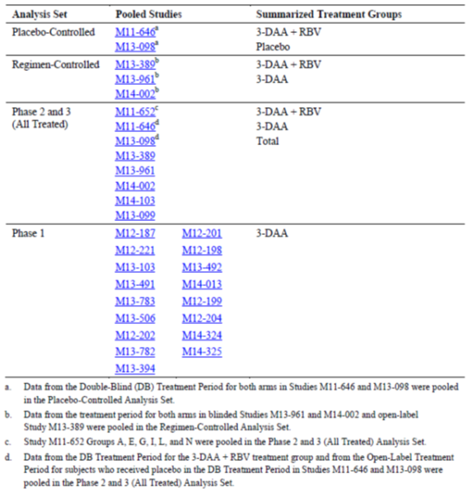

Placebo controlled analysis set
Median study drug exposure was 84 days in the 3-DAA + RBV and placebo groups, with total exposures of 176.0 and 58.6 patient/years, respectively. An overview of Treatment emergent AEs is shown in Table 42. All AE categories were reported more commonly in the 3-DAA+RBV group compared with the placebo group. Most AEs were of mild to moderate intensity. Grade 3 or 4 AEs were reported in 3.9% and 0.8% of the respective groups, and SAEs were reported in 2.1% and 0.4% of patients, respectively. AEs reported with a risk difference of ≥ 5.0% in incidence were pruritus (15.7% versus 4.3%), fatigue (34.2% versus 26.3%), nausea (22.3% versus 14.9%), asthenia (13.5% versus 6.7%), insomnia (14.0% versus 7.5%), and anaemia (5.3% versus 0%).

Table 42: Integrated summary of safety. Overview of treatment emergent adverse events (placebo controlled analysis set)
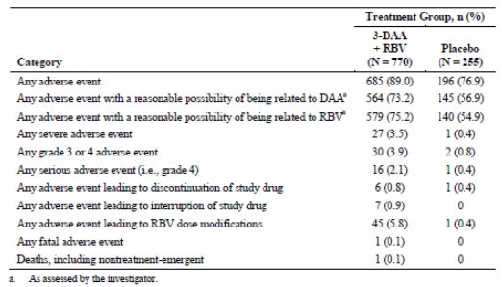

Regimen-controlled analysis set
Median study drug exposure was 84 days in the 3-DAA + RBV and 3-DAA groups, with total exposures of 92.1 and 116.6 patient/years, respectively. An overview of Treatment emergent AEs is shown in Table 43. With the exception of severe adverse events (1.0% versus 1.2%), all AE categories were reported more commonly in the 3-DAA + RBV group compared with the 3-DAA group. Most AEs were of mild to moderate intensity. Grade 3 or 4 AEs were reported in 3.0% and 2.0% of the respective groups, and SAEs were reported in 2.2% and 1.4% of patients, respectively. AEs reported with a risk difference of ≥ 5.0% in incidence were nausea (15.7% versus 8.4%), anaemia (7.5% versus 0.2%), insomnia (12.2% versus 5.1%), pruritus (12.0% versus 6.1%), and asthenia (9.0% versus 3.9%).

Table 43: Integrated summary of safety. Overview of treatment emergent adverse events (regimen controlled analysis set)
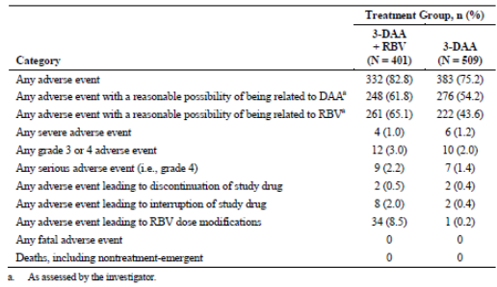

All treated analysis set
Median study drug exposure was 84 days in the 3-DAA + RBV and 3-DAA groups, with total exposures of 511.4 and 134.4 patient/years, respectively. An overview of Treatment emergent AEs is shown in Table 44. All AE categories were reported more commonly in the 3-DAA+RBV group compared with the 3-DAA group. Most AEs were of mild to moderate intensity. Grade 3 or 4 AEs were reported in 4.5% and 2.6% of the respective groups, and SAEs were reported in 2.7% and 1.5% of patients, respectively. AEs reported in ≥ 5.0% in either group are shown in Table 45. The most commonly reported events were fatigue (32.3% versus 25.7%), headache (28.9% versus 24.5%), nausea (19.7% versus 9.2%), insomnia (14.4% versus 5.4%), pruritus (14.3% versus 5.8%), diarrhoea (12.3% versus 12.1%), and asthenia (11.5% versus 4.3%). In the overall Phase II and Phase III analysis population (n = 2,632), there were two deaths in the 3-DAA + RBV group, and one death in the 3-DAA group.

Table 44: Overview of treatment emergent adverse events (all treated analysis set)
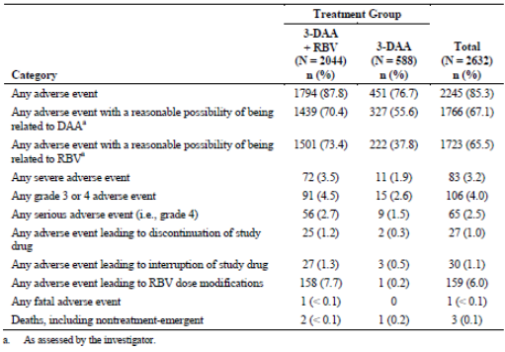

Table 45: Treatment emergent adverse events reported for ≥ 5.0% of all subjects (all treated analysis set)
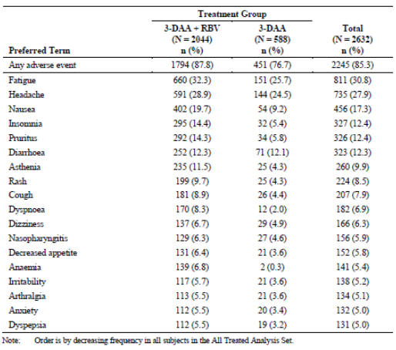

Phase I analysis set
In the 17 Phase I studies, 275 healthy subjects received multiple doses of the 3-DAA regimen at the proposed dose or higher. AEs were reported in 34.9% of subjects with one SAE. AEs leading to withdrawal of study drug occurred in five (1.8%) subjects.

Placebo controlled and regimen controlled analysis sets
A pooled summary of ADRs is shown in Table 46. The most frequent ADRs were pruritus, fatigue, nausea, asthenia, insomnia and anaemia. In the Placebo controlled Analysis Set, each ADR occurred more frequently in the 3-DAA + RBV group compared with placebo with an overall risk difference of 12.1%. In the Regimen-Controlled Analysis Set, each ADR occurred more frequently in the 3-DAA + RBV group compared with the 3-DAA group with an overall risk difference of 7.5%. SAEs were reported in 2.5% of patients and AEs leading to study drug discontinuation occurred in 1% of patients. None of the three deaths was considered related to drug treatment. The frequency of ADRs was comparable in the 3-DAA and placebo groups with the exception of pruritus (6.1% versus 4.3%).

Table 46: Adverse drug reactions (placebo controlled and regimen controlled analysis sets)
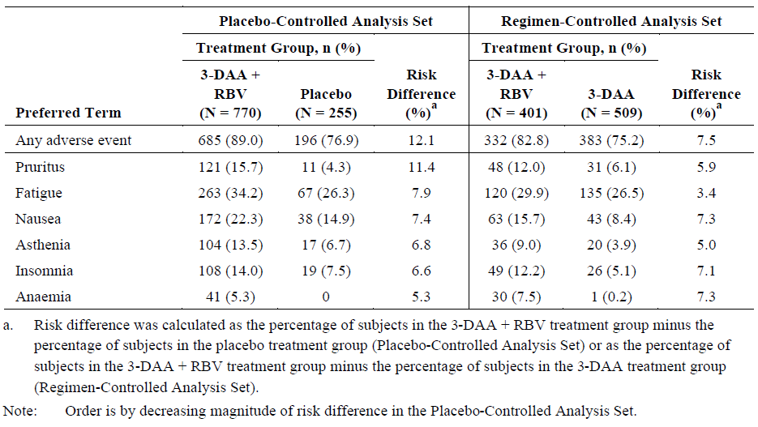
Comment: The pooled analyses confirm the good safety profile of the 3-DAA combination and no significant safety signals have been detected. With the possible exception of pruritus, adverse reactions can be attributed largely to RBV. These adverse reactions are now well understood and can be managed in most cases. However, high SVR₁₂ rates with 3-DAA can be achieved even in patients intolerant of RBV.

Post-marketing experience
Not applicable. This is a new drug application.

Safety issues with the potential for major regulatory impact

Liver toxicity
No major issues were identified with the exception of a potential interaction between 3-DAA and oestrogen containing medications. In the 3-DAA + RBV groups in the Placebo controlled Analysis Set, there was a decrease in ALT of 36.8 U/L to 49.3 U/L over the 12 week treatment period (Figure 20). Similar changes were observed in the Regimen-Controlled Set. In the all treated analysis set, ALT elevations of at least Grade 2, or at least Grade 3 were observed in 2.2% and 1.0% of patients, respectively, mostly in the 3-DAA + RBV group. Six patients (0.2%) experienced Grade 4 LFT elevations during treatment. A total of 20 patients had elevated ALT and bilirubin values with the potential for DILI during the treatment period. However, the liver panel (who were blind to the treatment assignment) adjudicated that none met the criteria for Hy’s Law.
Figure 20: Mean change form baseline in ALT (U/L) (placebo controlled analysis set)
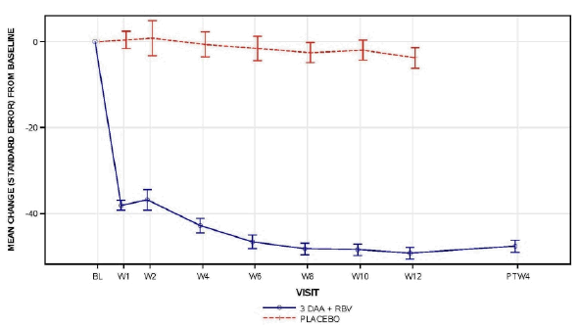
Comment: Assessment of potential liver toxicity is confounded by the haemolytic anaemia and hyperbilirubinaemia associated with RBV.
Hormonal contraceptives in female patients were excluded in the submitted clinical studies. However, in an expanded Phase II and III data set, Treatment emergent, reversible ALT elevations were experienced commonly in the 103 patients taking oestrogen containing medications. In this group, ALT elevations of at least Grade 2 or at least Grade 3 were experienced by 8.7% and 4.9% of patients, respectively, compared with respective rates of 2.0% and 0.8% in the 2,771 patients who were not receiving oestrogen containing medications. A definitive mechanism for this interaction has not yet been determined.
A summary of the opinion of the Independent Liver Panel is given verbatim below:
“Elevations in serum ALT and AST values are associated with the 3 DAA treatment regimen, with the majority occurring within the first two weeks of treatment. These have resolved with continued treatment (adaptation) and monitoring was not pertinent to management of this risk, with the possible exception of the two patients who were receiving oestrogens. (Analysis of risk factors had revealed that patients receiving oestrogens have a statistically significant increase in risk of developing treatment emergent elevations in serum ALT exceeding 5 X ULN. The incidence in women not receiving estrogens is 0.8% (21 out of 2,515) versus 4.5% (5 out of 111) among women receiving oestrogens. An increased risk of ALT elevations attributed to oestrogens was supported by a Phase I drug interactions study. The mechanism underlying this effect is not known but is currently under investigation. There have been two instances of liver injury accompanied by signs of liver dysfunction associated with the ABT450/r and ABT 267 regimen and the possibility of progressive liver injury in patients receiving the three drug regimen cannot be excluded at this time. Due to the rarity and transient nature of these events, routine liver chemistry monitoring is not indicated for all patients receiving the 3 DAA regimen, but this is a reasonable recommendation for patients who must continue oestrogen treatment. Patients and physicians should be made aware of the liver chemistry abnormalities that have been rarely observed in patients treated in the clinical trials and patients should be advised to seek medical attention should they experience symptoms consistent with liver injury.”

Haematological toxicity
The known association of RBV with anaemia was confirmed but no issues related to 3-DAA were identified.

Serious skin reactions
No issues were identified. In the Placebo controlled Analysis Set, rash-related AEs were reported in 29.0% of the 3-DAA + RBV group compared with 15.7% in the placebo group. However, in the Regimen Controlled Analysis Set, rash-related AEs were reported in 13.8% of 3-DAA patients, comparable to the placebo group suggesting that rash-related AEs were related largely to RBV. No patients had a rash-related SAE, and there were no discontinuations or study drug interruptions due to rash-related AEs. There were no cases of Stevens-Johnson syndrome, toxic epidermal necrolysis or other potentially life threatening dermatological syndromes.

Cardiovascular safety
No issues identified.

Unwanted immunological events
No issues were identified.

Other safety issues

Safety in special populations
No issues were identified.

Safety related to drug-drug interactions and other interactions
The sponsor has provided an extensive examination of the possible drug-drug interactions for Viekira Pak in healthy subjects. Studies have examined the interaction of the 3 DAAs with: inhibitors of CYP2C8, CYP3A4 and P-gp; other drugs that are substrates for CYP1A1, CYP1A2, CYP2C8, CYP2C9, CYP2C18, CYP2C19, CYP3A4, CYP3A5, P-gp and OATP1B1/B3; and an inducer of CYP3A. In addition, the interaction between the 3 DAAs and: other anti-viral drugs; commonly co-administered immune suppressants; commonly co-administered opioid substitutions; and commonly co-administered drugs; have also been examined.
As identified in the dose selection section of this report there is evidence to suggest that co-administration of drugs that increase the proposed level of ABT-450 exposure by 1.5 fold or greater may result in elevations in ALT and drugs that induce a 2 fold increase ABT-333 exposure may decrease Hgb and increase the risk to QTc elongation; whereas, drugs that induce a large increase in ABT-267 exposure (approximately 8 fold) may result in reduced ABT-450 exposure. By contrast, co-administered drugs that lower the levels of exposure to the 3 DAAs may result in increased resistance and lower efficacy for HCV1.
The principle DDIs in regards to safety were therefore the interactions between: ABT-450 and ketoconazole, rosuvastatin, LPV/r, CsA or atazanavir, which resulted in ABT-450 AUC increases of 1.98, 1.52, 2.17, 1.72 and 1.94 fold, respectively, and with carbamazepine, which induced a 3.4 fold decrease in ABT-450 AUC; and the interactions between ABT-333 and gemfibrozil, which increased ABT-333 AUC by 11.25 fold, and carbamazepine or COC which decreased ABT-333 AUC by 3.3 and 2.08 fold, respectively. Finally, co-administration of Atripla with the 3DAAs + ritonavir resulted in a large number of AEs, indicating that the 2 combination therapies should not be co-administered.

Evaluator’s overall conclusions on clinical safety
The rationale for the development of this novel combination product is sound as viral resistance to the individual components is inevitable. However, assessment of safety and tolerability raises some unique issues as it is a fixed dose combination of three new chemical entities. Safety related to the individual components relies heavily on pre-clinical data, and limited data from Phase I and II studies in healthy subjects and patients. It also relies on the premise that the safety of the individual components can be assumed if the combination is shown to be safe. This assumption can be validly made based on the data presented.
The safety of the 3-DAA combination has been assessed in treatment naïve and treatment experienced patients with HCV GT1a and GT1b infection, with and without compensated cirrhosis. The safety of the 3-DAA + RBV combination was compared with placebo in the two pivotal studies, M11-646 and M13-098. The frequency of AEs was significantly higher in the active group compared with placebo although the pattern of AEs was comparable with the known AE profile of RBV. The safety of the 3-DAA + RBV and 3-DAA combinations was compared in three pivotal studies, M13-389, M13-961 and M14-002. All AE categories were reported more frequently in the 3-DAA + RBV group compared with the 3-DAA group. Although the data were generated from different studies, the frequency of AEs in the 3-DAA and the placebo groups were comparable. In all studies, most AEs were of mild to moderate intensity. The frequency of Grade 3 or 4 ADRs and SAEs was low and none of the three deaths was considered to be drug related. Study drug compliance was high and discontinuations due to AEs occurred in only 1% of patients, confirming the tolerability of the combinations.
In the placebo controlled studies, the most common ADRs were pruritus, fatigue, nausea, asthenia, insomnia and anaemia, all of which occurred more commonly in the 3-DAA + RBV group. In the regimen controlled studies, the same ADRs also occurred more commonly in the 3-DAA + RBV group compared with the 3-DAA group. However, ADRs in the placebo group (of the placebo controlled studies) were each reported more frequently than in the 3-DAA group (of the regimen controlled studies). The only exception was pruritus which was reported in 4.3% and 6.1% of the respective groups. With the benefit of hindsight, it is regrettable that there are no direct comparisons of 3-DAA and placebo in a Phase III study. Safety and tolerability were comparable in all patient sub-groups. Only 8% of patients were aged > 65 years but the frequency of ADRs was similar to the younger population. Most patients were Caucasian and further studies in Asian populations are required. An exploratory study of 2-DAA + RBV in patients with GT4 infection was also well tolerated and the data add weight to the overall safety profile of the 3-DAA combination.
AEs of special interest based on approved HCV therapies including pegIFN/RBV and DAAs were also assessed. In the placebo controlled and regimen controlled studies, anaemia AEs were reported in 5.3% to 7.5% of the 3-DAA + RBV groups, compared with only one patient in the 3-DAA group and no patients in the placebo group. The results suggest that anaemia (and hyperbilirubinaemia) related to the 3-DAA + RBV combination can be attributed exclusively to the haemolytic anaemia associated with RBV. There was a prompt improvement in LFTs in all active treatment groups indicating a reduction in liver inflammation due to suppression of viral replication. There were transient marked elevations in ALT in approximately 1% of patients, most often during the first two weeks of treatment. However, there were no associated bilirubin elevations and the abnormalities were self-limiting. With the exception of pruritus, the frequency of skin AEs in the active treatment groups was comparable to placebo. Most rashes were mild or moderate in severity and there were no cases of the serious reactions seen with DAAs such as telaprevir. No studies have directly compared the safety profiles of the 3-DAA with pegIFN/RBV or other DAAs. However, the overall safety profile of 3-DAA with or without RBV is clearly superior to any other approved pegIFN/RBV or DAA + pegIFN/RBV combination therapy.

First round benefit-risk assessment

First round assessment of benefits
The benefits of Viekira Pak and Viekira Pak-RBV in the proposed usage are:
- In patients with HCV GT1 infection given the recommended dosage schedules (3-DAA with or without RBV for 12 weeks or 24 weeks), SVR₁₂ was achieved by 97% of non-cirrhotic patients with HCV GT1 infection, and 95% of patients with cirrhosis.
- The 3-DAA combination alone is a viable and effective therapeutic option in patients intolerant of RBV.
- SVR₁₂ rates in all patient groups were notably higher with 3-DAA than with other approved combinations.
- Shorter treatment duration than other approved regimens (12 or 24 weeks versus 24 or 48 weeks).
- Very low rates of on-treatment virologic failure (0.5%) and post-treatment relapse (1.6%).
- Almost 100% post-treatment durability of response.
- Comparable efficacy in other sub-groups defined by IL28B status, gender, race, age, BMI, baseline fibrosis score, baseline HCV RNA level and baseline IP-10.
- Fixed dose regimens.
- Also the limited data from study M13-393 suggest efficacy as a 2-DAA combination in patients with HCV GT4 infection.
- Rapid normalisation of liver function tests in most patients (97% 3-DAA + RBV, 15.8% placebo).
- Good safety profile with most AEs attributable to co-administered RBV. Pruritus (mostly mild) was the only potential specific safety signal detected.
- Well tolerated, contributing to good compliance (> 98%) and low discontinuation rates (0.3%).

First round assessment of risks
The risks of Viekira Pak and Viekira Pak -RBV in the proposed usage are:
- As yet unidentified ADRs.
- Potential interaction with oestrogen contraceptives (ALT elevation).
- As yet unidentified drug-drug interactions.
- ADRs associated with co-administered RBV.
- No data available in patients with decompensated liver disease or patients with moderate to severe renal impairment.
- Limited data in racial groups other than White.
- Emergence of resistant viral variants.
- No data in patients co-infected with HIV or HBV.
- No data available in liver transplant patients.

First round assessment of benefit-risk balance
The benefit-risk balance of Viekira Pak and Viekira Pak -RBV given the proposed usage, is highly favourable. The benefits of both products are summarised in relation to the tabulated indications in the proposed PIs shown below. In all patient subgroups, efficacy rates are outstanding and notably better than telaprevir-based therapy in the same subgroups. Viekira Pak is well tolerated. The risks associated with Viekira Pak relate largely to potential risks which have not been identified in the clinical trial program. The same risks apply to Viekira Pak-RBV with the addition of the well described toxicity associated with RBV.
Viekira Pak:
Viekira Pak is indicated for both treatment naïve and treatment experienced patients with HCV genotype 1b infection without cirrhosis. SVR rates of > 95% can be anticipated without the addition of RBV.
In treatment naïve patients with genotype 1a infection without cirrhosis, SVR rates were 97.0% in patients given Viekira Pak -RBV and 90.2% in patients given Viekira Pak. The addition of RBV confers additional benefit but outstanding SVR rates can still be achieved in patients who are intolerant of RBV.
The data do not support the use of Viekira Pak for any GT subgroup other than 1b. It should not be recommended if the genotype 1 subtype is unknown, or for patients with mixed infections. Viekira Pak has not been tested in patients with cirrhosis.
Viekira Pak-RBV:
Viekira Pak-RBV is indicated for treatment experienced patients with genotype 1a infection without cirrhosis. SVR was achieved by 93% of treatment naïve patients and > 95% of treatment experienced patients. As noted above, SVR rates > 90% may still be achieved with Viekira Pak in GT1 patients intolerant of RBV.
Viekira Pak-RBV is also indicated in patients with compensated cirrhosis and genotype 1 infection. SVR rates > 90% were achieved with higher rates in patients with GT1b infection compared with GT1a infection. There was a marginal benefit in in patients given 24 weeks rather than 12 weeks of therapy with SVR rates > 95%. However, there was a notable benefit in prior null responders given 24 weeks therapy compared with those given a 12 week regimen (95.2% versus 86.7%).

Table 47: Summary of treatment options
Patient Population | Treatment | Duration | Ribavirin Dosage
Genotype 1b, without cirrhosis | Viekira Pak | 12 weeks
Genotype 1a, without cirrhosis | Viekira Pak-RBV* | 12 weeks | < 75kg = 1000mg  ≥ 75kg = 1200mg  Ribavirin is to be taken in two doses, morning and evening
Genotype 1 with cirrhosis | Viekira Pak-RBV* | 12 weeks† | < 75kg = 1000mg  ≥ 75kg = 1200mg  Ribavirin is to be taken in two doses, morning and evening
*Viekira Pak without ribavirin can be considered as a therapeutic option for treatment naïve patients with genotype 1a infection without cirrhosis. Treatment decision should be guided by an assessment of the potential benefits and risks for the individual patient. †24 weeks of Viekira Pak –RBV is recommended for patients with genotype 1a-infection with cirrhosis who have had a previous null response to pegIFN and ribavirin. Viekira Pak -RBV ribavirin is recommended in patients with an unknown genotype 1 subtype or with mixed genotype 1 infection.

First round recommendation regarding authorisation
Approval is recommended for the proposed indication of ‘the treatment of genotype 1 chronic hepatitis C infection, including patients with cirrhosis’. However, the approval is subject to incorporation of suggested changes to proposed PI and CMI and adequate response to clinical questions.

Clinical questions

Pharmacokinetics

Pharmacokinetics question 1
In studies M13-300 and M10-351, ABT-333 formulation appears to alter the effects of food on the bioavailability of ABT-333. Can the sponsor please comment?

Pharmacokinetics question 2
The dose/exposure pattern of ABT-333 during Study M10-351 appears to be a little unusual. Can the sponsor please explain this behaviour in regards to dose normalised C_{max} and AUC for ABT-333 in Study M10-351 and why the results for the 1200 and 1600 mg doses are not consistent across the two studies?

Pharmacokinetics question 3
Regarding Study M10-861 can the sponsor please provide an explanation as to why accumulation of ABT-450 exposure was far less pronounced for the 300 mg ABT-450 dose compared to the 250 mg and 200 mg doses?

Pharmacokinetics question 4
Given the metabolic profile of R-warfarin, it is a little surprising that the PKs of R-warfarin were not affected by the presence of the 3 DAAs + ritonavir (Study M12-198), considering that ritonavir is a potent inhibitor of CYP3A4. This possibly suggests that the PK interaction study should have instead examined steady state levels of warfarin. Can the sponsor please comment on whether a different result would be expected if this was the case?

Pharmacokinetics question 5
In Study M14-027, due to the inhibition of CYP3A4 induced by ritonavir should we not expect to see an increase in carbamazepine exposure in the presence of the 3 DAAs + ritonavir?

Pharmacokinetics question 6
It seems counter-intuitive that on the one hand ritonavir increases ABT-450 exposure (see Tables 6 and 7 see Section 4 above)) but in Study M12-202 the additional dose of ritonavir decreases ABT-450, can the sponsor please provide an explanation concerning the differences seen in ABT-450 PKs between Studies M13-506 and M12-202 described above?

Pharmacokinetics question 7
It is not clear why the sponsor has combined data from Arms 1 and 2 in which 3 DAAs and 2 DAAs have been co-administered respectively, as Studies M13-394 and M12-189 indicate that co-administration of ABT-333 with ABT-450/r/ABT-267 significantly affects the PKs of ABT-450, ritonavir and ABT-267. Can the sponsor please provide replacement Tables 4.57.1 and 4.57.2 in which the two data sets for Arm 1 and 2 have been separated?

Pharmacokinetics question 8
Given the results of RD14-0047 PPK indicate that concomitant opioid use may significantly affect ABT-450 clearance, can the sponsor please justify why the effects of co-administration of opioid-like substances, in Studies M12-997 and M13-100, on the PKs of Viekira Pak were not examined?

Pharmacokinetics question 9
Given that for anti-depressants to be clinically effective they must attain steady state, why has Study M12-204 only examined the interaction between Viekira Pak and single doses of the anti-depressants, especially considering that CYP3A4 is a major contributor to the metabolism of escitalopram?

Pharmacokinetics question 10
As the US PI for Xanax states that alprazolam should be administered multiple times daily and for at least 3 to 4 days for maximum effect why has Study M14-324 only examined the interaction with Viekira Pak following a single dose of alprazolam? This is of particular importance given that potent CYP3A4 inhibitors can increase alprazolam plasma concentrations by up to 4 fold.

Pharmacodynamics

Pharmacodynamics question 1
Regarding Study M10-351, can the sponsor please provide an explanation as to why the 100 mg QD, 100 mg BD and 600 mg BD doses of ABT-333 have dose-dependent anti-viral effects, whereas, the 600 mg QD dose does not?

Efficacy

Efficacy question 1
Individual patient data and the percentages of some important protocol deviations are provided in the CSRs. However, it is unclear what percentages of patients had major deviations, how many had deviations leading to exclusion from the analyses of the primary endpoints, and on what basis these decisions were made. Please provide these data for each of the pivotal studies.

Efficacy question 2
The body of the M13-961 CSR Section 9.4.1 (Treatments) contains the following statement:
Subjects received ABT-450/r/ABT-267 at 75 mg/50 mg/ 12.5 mg QD, ABT-333 250 mg BD, and either placebo for RBV or weight based RBV 1,000 or 1,200 mg divided BD for 12 weeks. All study drugs were taken orally with food.
In addition, the body of the M14-002 CSR Section 9.4.1 (Treatments) contains the following statement:
Subjects received ABT-450/r/ABT-267 at 75 mg/50 mg/ 12.5 mg QD
In each case the evaluator has assumed that ABT-450/r/ABT-267 was actually given as two tablets of the stated dose QD and not one tablet either QD or BD. Please confirm.

Efficacy question 3
Studies M13-389 and M13-961 both assessed 3-DAA with and without RBV. The RBV component in M13-961 was double blinded but M13-389 was conducted open label. Please provide a rationale for this difference in study design.

Efficacy question 4
In the pivotal studies, a non-inferiority margin of 10.5% was selected. Please provide a rationale for this choice.

Safety

Safety question 1
Was there a rationale for not including a 3-DAA arm in addition to the 3-DAA + RBV arms in the placebo controlled studies?

Second round evaluation of clinical data submitted in response to questions
In this section the TGA question is followed by summary of sponsor’s response to the query and then the evaluator’s comments on the sponsor’s response.

Pharmacokinetics

Pharmacokinetics question 1
In studies M13-300 and M10-351, ABT-333 formulation appears to alter the effects of food on the bioavailability of ABT-333. Can the sponsor please comment?
Sponsor’s response:
Food had minimal effect on the bioavailability of ABT-333 in Study M10-351, but increased the exposure of ABT-333 by approximately 20 to 50% in Study M13-330. These differences are likely due to the differences in dose in the 2 studies.
Study M10-351 evaluated the effect of the ABT-333 capsule formulation at the 100 mg dose, while Study M13-330 evaluated the effect of a tablet formulation at the 250 mg dose. ABT-333 has a distribution coefficient (n-octanol/pH 7.4) of 4.3 and the free acid is practically insoluble in 0.1 N HCl, pH 1 and slightly soluble in water. Intake of food results in an increase in pH and release of bile salts; thus, food can increase the solubility of lipophilic compounds and lead to an increase in bioavailability. The lack of food effect at the 100 mg dose of the capsule formulation is probably due to the use of the lower 100 mg dose. The increase in pH and improved solubility probably has a minimal or low impact on ABT-333 at the lower 100 mg dose compared to the higher 250 mg dose. As a result, the improvement in bioavailability with food was greater in Study M13-330 compared to Study M10-351.
Evaluation of response:
This response to this question does not affect the outcome regarding approval for registration of Viekira Pak. However, the evaluator believes that without comparative dissolution profiles for the capsule and tablet forms of ABT-333 it is impossible to discount drug formulation as the cause for the difference in food effect seen in Studies M13-300 and M10-351.

Pharmacokinetics question 2
The dose/exposure pattern of ABT-333 during Study M10-351 appears to be a little unusual. Can the sponsor please explain this behaviour in regards to dose normalised C_{max} and AUC for ABT-333 in Study M10-351 and why the results for the 1200 and 1600 mg doses are not consistent across the two studies?
Sponsor’s response
Study M10-351 used the 5 and 50 mg ABT-333 capsule while Study M11-032 used the 400 mg ABT-333 tablet. The capsule and tablet formulations were bioequivalent at the 400 mg dose.
In Study M10-351, the 50 mg capsule with doses greater than 1200 mg had lower bioavailability compared to doses ≤ 1200 mg. This is likely due to solubility limited dissolution of ABT-333 from the formulation at higher doses. The 400 mg tablet formulation also showed lower bioavailability at the 1200 and 1600 mg dose compared to the 400 mg dose, though dose proportional increase in exposures was observed when escalating from 1200 to 1600 mg dose.
The reason for the lower bioavailability of ABT-333 at the 1200 and 1600 mg dose is not completely clear but could be due to study to study variability. Dose normalised C_{max} and AUC values for Studies M10-351 and M11-032 are shown in Table 48 below along with dose normalised values from another study (Study M11-023) conducted in Japanese subjects.

Table 48: Dose normalised C_{max} and AUC Values for ABT-333 across studies
Study (Formulation) | Dose (mg) | Dose Normalised C_{max} (ng/mL/mg) | Dose Normalised AUC (ng•h/mL/mg)
M10-351 (50 mg capsule) | 200 | 1.94 | 15.2
M10-351 (50 mg capsule) | 400 | 3.23 | 24.6
M10-351 (50 mg capsule) | 1200 | 2.54 | 20.0
M11-032 (50 mg capsule) | 400 | 2.42 | 17.4
M11-032 (400 mg tablet) | 400 | 2.37 | 16.3
M11-032 (400 mg tablet) | 1200 | 1.48 | 10.6
M11-032 (400 mg tablet) | 1600 | 1.39 | 10.4
M11-023 (400 mg tablet) | 400 | 2.45 | 15.9
M11-023 (400 mg tablet) | 1200 | 1.97 | 12.6
M11-023 (400 mg tablet) | 1600 | 2.45 | 18.4
As shown in Table 48, in Study M10-351, the dose normalised exposures at the 200 mg dose was lower than that from the 400 or 1200 mg dose but similar to the 400 mg dose in Study M11-032. Similarly, the 400 mg tablet in Study M11-023 showed lower exposures for the 1200 mg dose, consistent with the lower exposure in Study M11-032, but higher exposures for the 1600 mg dose consistent with the higher exposures in Study M10-351. Thus, the differences in exposures between Studies M10-351 and M11-032 are likely due to variability across studies.
Evaluation of response:
As for the preceding question the response to this question does not affect the outcome regarding approval for registration of Viekira Pak. However, the evaluator is not entirely satisfied with the applicant’s response. In particular, PPK studies indicate, as is stated in the updated proposed PI, that ABT-333 exposure is higher in Asian than non-Asian subjects and therefore the differences in ABT-333 exposure identified following tablet doses of 400 to 1600 mg in Studies M11-032 (conducted in a predominantly white population) and M11-023 (Japanese population) are in part due to differences in ethnicity and cannot be solely attributed to differences in variability across studies.

Pharmacokinetics question 3
Regarding Study M10-861 can the sponsor please provide an explanation as to why accumulation of ABT-450 exposure was far less pronounced for the 300 mg ABT-450 dose compared to the 250 mg and 200 mg doses?
Sponsor’s response
The accumulation ratios in the evaluation report were calculated using arithmetic means. The ratio for the 200 and 300 mg dose of ABT-450 using the geometric means are shown in Table 49.

Table 49: ABT-450 Accumulation Ratios for Study M10-861
ABT-450/r Dose |  | Day 1 | Day 14 | Ratio
200/100 mg | C_{max} | 566 (n = 6) | 698 (n = 4) | 1.23
 | AUC | 3579 (n = 6) | 4484 (n = 4) | 1.25
300/100 mg | C_{max} | 4873 (n = 8) | 6852 (n = 7) | 1.41
 | AUC | 26531 (n = 8) | 36072 (n = 7) | 1.36
The accumulation ratio of ABT-450 is comparable at the 200 mg and 300 mg doses.
The evaluation report also compared the ratios to Study M12-187 where higher ratios were observed for the 250 mg dose of ABT-450 (C_{max} ratio = 3.81 and AUC = 2.60). However, another arm in the study that also dosed the 250 mg ABT-450 dose had accumulation ratios comparable to that from Study M10-861 (Table 50).

Table 50: ABT-450 Accumulation Ratio for Study M12-187
ABT-450/r Dose |  | Day 1 | Day 14 | Ratio
250/100 mg (Arm 1)  (n = 7) | C_{max} | 794 | 3025 | 3.81
250/100 mg (Arm 1)  (n = 7) | AUC | 5102 | 13244 | 2.60
250/100 mg (Arm 3)  (n = 7) | C_{max} | 1609 | 2346 | 1.46
250/100 mg (Arm 3)  (n = 7) | AUC | 7428 | 9370 | 1.26
Thus, the accumulation ratio of ABT-450 at the 300 mg dose is consistent with the accumulation ratio at the 200 mg dose in Study M10-861 as well accumulation ratio of ABT-450 from Arm 3 of Study M12-187. The reason for the differences in accumulation ratio between the 2 arms of Study M12-187 is not completely clear but could be due to the high variability in ABT-450 pharmacokinetics and the small sample sizes of these comparisons (N = 4 to 7).
Evaluation of response:
The evaluator is satisfied with the sponsor’s response.

Pharmacokinetics question 4
Given the metabolic profile of R-warfarin, it is a little surprising that the PKs of R-warfarin were not affected by the presence of the 3 DAAs + ritonavir (Study M12-198), considering that ritonavir is a potent inhibitor of CYP3A4. This possibly suggests that the PK interaction study should have instead examined steady state levels of warfarin. Please comment on whether a different result would be expected if this was the case?
Sponsor’s response
The study design is considered to be appropriate. In the study, warfarin was the victim or substrate and the DAA regimen was the perpetrator. Dosing the perpetrator to steady state is hence important to fully characterise the interaction. To do this, the DAA regimen was dosed to steady state prior to addition of warfarin. This ensures that CYP3A and CYP2C9 inhibition by the DAA regimen has reached steady state which enables the evaluation of the maximum effect of the DAA regimen on single dose warfarin pharmacokinetics. Dosing warfarin to steady state is expected to provide similar results. The magnitude of inhibition (ratio of warfarin exposures when co-administered with DAAs over warfarin exposure when administered alone) by the DAA regimen is expected to remain the same regardless of whether warfarin was dosed to steady state or as a single dose.
Additionally, please note that study with 400 mg BD ritonavir resulted in minimal changes in warfarin levels (9% increase in AUC and 9% decrease in C_{max} of S-warfarin (Norvir USPI)) indicating that the role of CYP3A in warfarin metabolism is not very relevant from the drug interaction perspective. This is another reason why it is the recommended probe substrate to evaluate CYP2C9 interactions.
Evaluation of response:
The evaluator accepts that the study design was appropriate. However, the question was specifically in regard to R-warfarin, which is primarily metabolised by CYP3A4 and in the presence of steady state ritonavir, a strong inhibitor of CYP3A4, the exposure to R-warfarin should be decreased.

Pharmacokinetics question 5
In Study M14-027, due to the inhibition of CYP3A4 induced by ritonavir should we not expect to see an increase in carbamazepine exposure in the presence of the 3 DAAs + ritonavir4?
Sponsor’s response
Carbamazepine is a strong CYP3A inducer which could result in a decrease in exposures of CYP3A substrates. While ritonavir is a CYP3A inhibitor, it is also a CYP3A substrate. In Study M14-027, a 3 week dose administration of carbamazepine resulted in an approximately 90% decrease in ritonavir AUC, indicating strong CYP3A induction by carbamazepine. Due to these very low levels of ritonavir, even though carbamazepine is a CYP3A substrate, minimal inhibition of carbamazepine metabolism was observed (17% increase in AUC).
Evaluation of response:
The evaluator is satisfied with the sponsor’s response.

Pharmacokinetics question 6
It seems counter intuitive that on the one hand ritonavir increases ABT-450 exposure (see Tables 6 and 7) but in Study M12-202 the additional dose of ritonavir decreases ABT-450, can the sponsor please provide an explanation concerning the differences seen in ABT-450 PKs between Studies M13-506 and M12-202 described above?
Sponsor’s response
AbbVie agrees with the evaluator's assessment that the effect of increasing ritonavir dose from 100 to 200 mg is not consistent between Studies M10-749 and M12-202. In Study M10-749, increasing RTV dose from 100 to 200 mg increased ABT-450 exposures. In Study M12-202, the ABT-450 C_{max} and AUC values decreased. This effect cannot be explained by the effect of ritonavir on ABT-450. The effect is more likely due to the effect of darunavir on ABT-450.
In Study M13-506, similar results were observed when darunavir was administered with 200 mg ritonavir (100 mg BD). ABT-450 C_{max} and AUC values decreased by 30% and 40%, respectively. A decrease in ABT-450 exposures was also observed at the 100 mg ritonavir dose when darunavir was administered with the 2-DAA combination of ABT-450/r + ABT-333. In contrast exclusion of ABT-333, as with the ABT-450/r + ABT-267 regimen results in increase of ABT-450 exposures.

Table 51: Effect of Darunavir/Ritonavir Regimen on ABT-450 AUC Values
Study | DAA Regimen | Darunavir/Ritonavir Regimen | Effect on ABT-450 AUC in Presence of Darunavir
M13-506 | ABT-450/r + ABT-267 | 800 mg QD | ↑ 94%
 | ABT-450/r + ABT-267+ ABT-333 | 800 mg QD | ↑ 29%
 | ABT-450/r + ABT-333 | 800 mg QD | ↓ 35%
 | ABT-450/r + ABT-267 + ABT-333 | 600 mg BD DRV with 100 mg RTV | ↓ 40%
M12-202 | ABT-450/r + ABT-267 + ABT-333 | 800/100 mg QD | ↓ 19%
In general, when co-administered with darunavir, regimens that include ABT-333 and higher ritonavir doses decrease ABT-450 exposures (or limit increase in ABT-450 exposures). Since ritonavir as well as ABT-333 increases ABT-450 exposures, this interaction is counterintuitive. One explanation could be that darunavir inhibits (but to a lesser degree) the same uptake or efflux transporters that ABT-333 and ritonavir also inhibit. In this case the mechanism could be similar to that of partial agonists that bind to and activate a given receptor, but have only partial efficacy at the receptor relative to a full agonist.
Evaluation of response:
The evaluator is satisfied with the sponsor’s response.

Pharmacokinetics question 7
It is not clear why you have combined data from Arms 1 and 2 in which 3 DAAs and 2 DAAs have been co-administered respectively, as Studies M13-394 and M12-189 indicate that co-administration of ABT-333 with ABT-450/r/ABT-267 significantly affects the PKs of ABT-450, ritonavir and ABT-267. Please provide replacement Tables 4.57.1 and 4.57.2 in which the two data sets for Arm 1 and 2 have been separated?
Sponsor’s response
In Study M13-394 and Study M12-189, the data for 3-DAAs and 2-DAAs have not been combined. The synopsis for these 2 studies has a single table that shows data from both the 2-DAA and 3-DAA arms, but the data are presented in different rows. The body text of the clinical study reports have the data separated by Arm, as well as by analyte, in separate tables.
Tables separating the 2- and 3-DAA arms are presented below.

Table 52: Study M12-189: Arm 1 (3-DAA Arm)
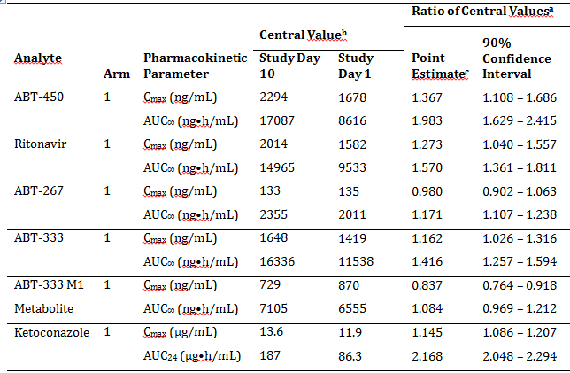
a Study Day 10:Study Day 1. b Antilogarithm of the least squares means for logarithms. c Antilogarithm of the difference (test minus reference) of the least squares means for logarithms.

Table 53: Study M12-189: Arm 2 (2-DAA Arm)
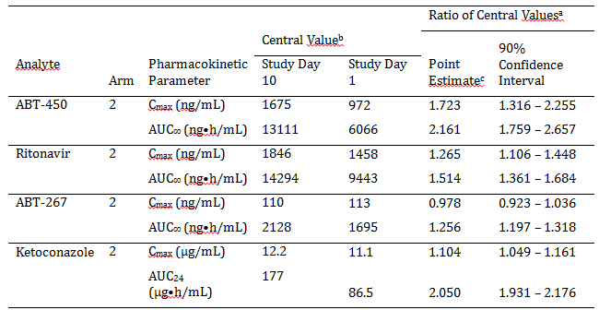
a. Study Day 10:Study Day 1. b. Antilogarithm of the least squares means for logarithms. c. Antilogarithm of the difference (test minus reference) of the least squares means for logarithms.

Table 54: Study M13-394: Arm 1 (3-DAA Arm: Atazanavir administered in the morning without Ritonavir)
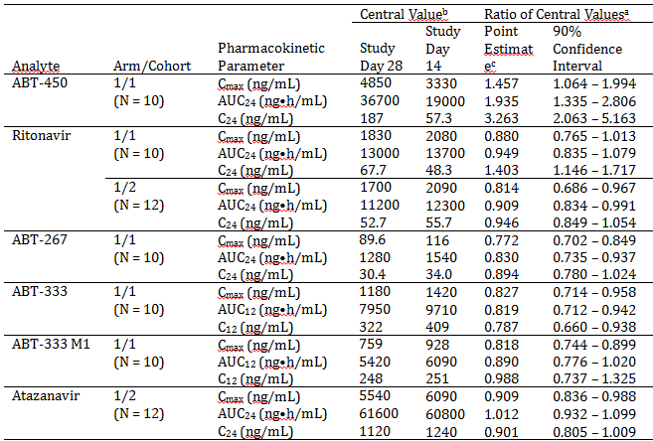
a. Study Day 28: Study Day 14. b Antilogarithm of the least squares means for logarithms. c Antilogarithm of the difference (test minus reference) of the least squares means for logarithms.

Table 55: Study M13-394: Arm 2 (2-DAA Arm: Atazanavir administered in the morning without Ritonavir)
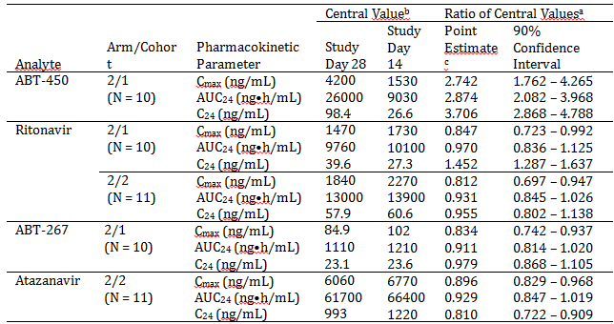
a. Study Day 28: Study Day 14. b. Antilogarithm of the least squares means for logarithms. c. Antilogarithm of the difference (test minus reference) of the least squares means for logarithms.

Table 56: Study M13-394: Arm 3 (3-DAA Arm: Atazanavir administered in the evening with Ritonavir)
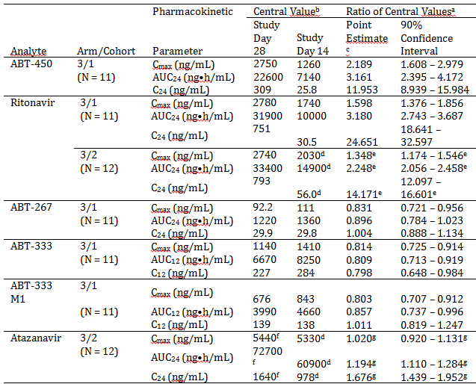
a. Study Day 28: Study Day 14. b.Antilogarithm of the least squares means for logarithms. c. Antilogarithm of the difference (test minus reference) of the least squares means for logarithms. d. Study Day 13. e. Study Day 28: Study Day 13. f. Study Day 27.
Evaluation of response:
This question did not relate to the two studies mentioned by the sponsor; however, the evaluator concedes in its present format this is not entirely clear in Section 12.2.1 of the CER. This question specifically relates to Study M12-205 (please see Section 4.2.5.1.6 entitled “Interaction with commonly co-administered drugs” of the evaluation report), which examined the interaction between oral contraceptives and the active compounds. In this study the data for the 2- and 3-DAA regimens are combined in Tables 4.57.1 etcetera. The reference to Studies M13-394 and M12-189 in the question related to why this should not be done. In context with the initial statement of the question in Section 4 of the CER this would have been clear; however, in Section 12 of the CER the question should have read as follows: “In Study M12-205, it is not clear why the sponsor has combined data from Arms 1 and 2 in which 3 DAAs and 2 DAAs have been co-administered respectively (please see notes to Table 4.57.1, of the CER), as Studies M13-394 and M12-189 indicate that co-administration of ABT-333 with ABT-450/r/ABT-267 significantly affects the PKs of ABT-450, ritonavir and ABT-267. Can the sponsor please provide replacement Tables 4.57.1 and 4.57.2 in which the two data sets for Arm 1 and 2 have been separated?”

Pharmacokinetics question 8
Given the results of RD14-0047 PPK indicate that concomitant opioid use may significantly affect ABT-450 clearance, please justify why the effects of co-administration of opioid-like substances, in Studies M12-997 and M13-100, on the PKs of Viekira Pak were not examined?
Sponsor’s response:
Studies M12-997 and M13-100 evaluated the pharmacokinetics of all the components of Viekira Pak. The effect of methadone and buprenorphine/naloxone on the components of Viekira Pak was evaluated using cross study comparison.
Unlike other drug interaction studies where the DAAs were given with and without the interacting drug, the methadone (Study M12-997) and the buprenorphine/naloxone (Study M13-100) studies were conducted in subjects on stable methadone or buprenorphine/naloxone therapy. As a result, comparison of DAA exposures with and without methadone or buprenorphine/naloxone in these studies was not possible.
Cross study comparisons were hence conducted to evaluate the effect of methadone and buprenorphine/naloxone on Viekira Pak. Results of these comparisons is presented in the Studies M13-100 and M12-997 Clinical Study Reports.
Dasabuvir, ombitasvir and ritonavir exposures in Studies M12-997 and M13-100 were comparable to historic data. Table 57 compares the exposures of paritaprevir in the methadone and buprenorphine/naloxone DDI studies that used the Phase III (and to be marketed formulation) ombitasvir/paritaprevir/ritonavir co-formulated tablet to all the studies with the ombitasvir/paritaprevir/ritonavir co-formulated tablet (includes studies that were not available for inclusion in the reports for Studies M12-997 or M13-100) in the Phase I program. Paritaprevir exposures when dosed with methadone or buprenorphine/naloxone were within the range of exposures of the ombitasvir/paritaprevir/ritonavir co-formulated tablet. These data suggest that subjects on methadone or buprenorphine/naloxone do not have lower paritaprevir exposures.

Table 57: Paritaprevir exposures from the Ombitasvir/Paritaprevir/Ritonavir co-formulated tablet for the 3-DAA regimen in Study M12-997 or M13-100 and historic data
Study ª | Geometric Mean Paritaprevir C_{max} (ng/mL) | Geometric Mean Paritaprevir AUC (ng•h/mL)
M12-997 (Methadone DDI study) | 1123 | 4002
M13-100 (Buprenorphine/naloxone DDI study) | 1299 | 5236
Historic data from 8 study arms:  M14-324 Part 1  M12-204 Part 1  M12-204 Part 2  M14-325 Part 1  M12-202  M14-325 Part 2  M14-324 Part 2  M12-199 | 686  771  914  1442  2101  2097  2295  3040 | 3765  3819  4484  6391  9866  9373  9240  16515
ª. All study reports were provided in the submission.
In addition intensive plasma sampling was conducted at steady state to characterise the pharmacokinetic profile of the DAAs in HCV infected subjects who were receiving methadone or buprenorphine (with or without naloxone) (Study M14-103). The study enrolled and dosed 38 subjects: 19 subjects on methadone and 19 subjects on buprenorphine ± naloxone. In the subset of subjects with intensive pharmacokinetic sampling, dasabuvir, ombitasvir and ritonavir exposures were comparable to historic data in healthy subjects. Paritaprevir pharmacokinetic parameters from the subset of subjects with intensive sampling in Study M14-103 are shown in Table 58. Paritaprevir exposures are comparable to slightly higher than in other Phase I studies using the same formulation.

Table 58: Geometric Means of Pharmacokinetic Parameters of Paritaprevir for HCV GT1-Infected Subjects in Study M14-103 and Cross-Study Comparison and Comparison to Phase I Studies
 | Study M14-103 (Methadone)  N = 10 | Study M14-103 (Buprenorphine ± naloxone) N = 12 | Geometric Mean from 8 Phase I Studies with the Phase III Formulationa
C_{max} (ng/mL) | 1,755 | 1,090 | 686 to 3,040
AUC₂₄ (ng.hr/mL) | 19,389 | 10,766 | 3765 to 16,515
a. Studies M12-199, M12-202, M12-204 Part 1, M12-204 Part 2, M14-324 Part 1, M14-324 Part 2, M14-325 Part 1, M14-325 Part 2. All study reports were provided in the submission.
Thus based on the above, subjects on methadone or buprenorphine/naloxone therapy are expected to have similar DAA exposures to subjects who are not on methadone or buprenorphine/naloxone therapy.
Evaluation of response:
The evaluator is satisfied with the sponsor’s response.

Pharmacokinetics question 9
Given that for anti-depressants to be clinically effective they must attain steady state, why has Study M12-204 only examined the interaction between Viekira Pak and single doses of the anti-depressants, especially considering that CYP3A4 is a major contributor to the metabolism of escitalopram?
Sponsor’s response:
The study design is considered to be appropriate. As indicated by the evaluator, escitalopram is a CYP3A substrate and the primary objective of the evaluation was to evaluate the effect of Viekira Pak on the pharmacokinetics of escitalopram that is, the DAA regimen is the perpetrator and needs to be dosed to steady state to determine the maximal interaction at steady state. In the study, Viekira Pak was dosed to steady state prior to addition of escitalopram. This ensures that CYP3A inhibition by Viekira Pak has reached steady state which enables the evaluation of the maximum effect of the DAA regimen on single dose pharmacokinetics of escitalopram. Dosing escitalopram to steady state is not expected to provide different results. The magnitude of inhibition (ratio of escitalopram exposure with Viekira Pak DAAs over escitalopram exposure by itself) by the Viekira Pak regimen is expected to remain the same if escitalopram was dosed to steady state as opposed to as a single dose. The same rationale applies to duloxetine, another antidepressant evaluated in Study M12-204.
Evaluation of response:
The evaluator accepts that the study design was satisfactory.

Pharmacokinetics question 10
As the US PI for Xanax states that alprazolam should be administered multiple times daily and for at least 3 -4 days for maximum effect why has Study M14-324 only examined the interaction with Viekira Pak following a single dose of alprazolam? This is of particular importance given that potent CYP3A4 inhibitors can increase alprazolam plasma concentrations by up to 4 fold.
Sponsor’s response:
Similar to the rationale presented in response to question 9 for antidepressants, the study design is considered appropriate to evaluate the effect of Viekira Pak (perpetrator) on alprazolam (substrate or victim). Viekira Pak that contains ritonavir, the CYP3A inhibitor, was dosed to steady state to provide maximal inhibition/induction of CYP3A. Hence the effect of Viekira Pak on alprazolam is not expected to change if alprazolam was dosed to steady state as opposed to single dose. Also please note that higher ritonavir dose (500 mg every 12 hours for 10 days) did not increase alprazolam exposures (12% decrease in alprazolam AUC) (Norvir USPI). Thus the potential for ritonavir to inhibit alprazolam appears to be minimal and dosing alprazolam to steady state is unlikely to impact this potential.
Evaluation of response:
The evaluator accepts that the study design was satisfactory.

Pharmacodynamics

Pharmacodynamics question 1
Regarding Study M10-351, please provide an explanation as to why the 100 mg QD, 100 mg BD and 600 mg BD doses of ABT-333 have dose dependent anti-viral effects, whereas, the 600 mg QD dose does not?
Sponsor’s response
The antiviral effect for the 600 mg QD is consistent with the exposures observed for the 600 mg dose. Figure 21 shows the maximum change in viral load versus AUC values in the study.
Figure 21: Viral load decline versus. AUC₂₄ values at 100 mg QD, 100 mg BD and 600 mg QD doses in Study M10-351
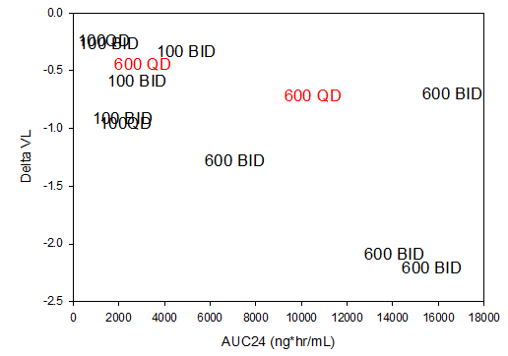
As shown in the figure, one of the 2 subjects on the 600 mg QD dose had an AUC₂₄ value of 3086 ng.hr/mL, which is much lower than the AUC₂₄ value of 10518 ng.hr/mL in the second subject and consequently had a lower viral load decline. Figure 22 compares the viral load decline and exposure for the 100 mg BD and the 600 mg QD doses to further clarify that the response of the 600 mg dose was consistent with the exposures at this dose in the study.
Figure 22: Viral load decline versus. AUC₂₄ values at 100 mg BD and 600 mg QD dose in Study M10-351
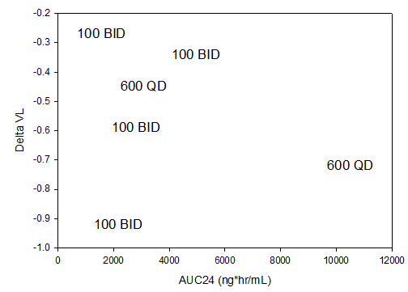
In conclusion, the 600 mg QD dose group had only 2 subjects and the exposure in one of the 2 subjects was very low resulting lack of discernible dose response relationship at this dose group.
Evaluation of response:
The sponsor’s response was satisfactory.

Efficacy

Efficacy question 1
Individual patient data and the percentages of some important protocol deviations are provided in the CSRs. However, it is unclear what percentages of patients had major deviations, how many had deviations leading to exclusion from the analyses of the primary endpoints, and on what basis these decisions were made. Please provide these data for each of the pivotal studies.
Sponsor’s response:
The statistical plans for each study states that all efficacy and safety analysis were done in the ITT population which is the preferred analysis population for the primary endpoints according to the FDA Draft Guidance for Industry Chronic Hepatitis C Virus Infection: developing DAA Drugs for Treatment (October 2013) p 22. Due to the use of the ITT population (defined as all randomised subjects who receive at least one dose of study drug) for all analyses, deviations were not classified (as major, minor, leading to exclusion of subject from per protocol analysis, etc.); hence, no subject who received at least one dose of study drug was excluded from the ITT analysis.
Evaluation of response:
The sponsor’s response is acceptable.

Efficacy question 2
The body of the M13-961 CSR Section 9.4.1 (Treatments) contains the following statement:
Subjects received ABT-450/r/ABT-267 at 75 mg/50 mg/ 12.5 mg QD, ABT-333 250 mg BD, and either placebo for RBV or weight based RBV 1,000 or 1,200 mg divided BD for 12 weeks. All study drugs were taken orally with food.
In addition, the body of the M14-002 CSR Section 9.4.1 (Treatments) contains the following statement:
Subjects received ABT-450/r/ABT-267 at 75 mg/50 mg/ 12.5 mg QD
In each case the evaluator has assumed that ABT-450/r/ABT-267 was actually given as two tablets of the stated dose QD and not one tablet either QD or BD. Please confirm.
Sponsor’s response:
The evaluator's assumption is correct. Each ABT-450/r/ABT-267 tablet contained 75 mg of ABT-450, 50 mg of ritonavir and 12.5 mg of ABT-267. ABT-450/r/ABT-267 was given as two tablets once daily which corresponded to a 150 mg ABT-450, 100 mg ritonavir and 25 mg ABT-267 dose QD.
Evaluation of response:
The sponsor’s response is acceptable.

Efficacy question 3
Studies M13-389 and M13-961 both assessed 3-DAA with and without RBV. The RBV component in M13-961 was double blinded but M13-389 was conducted open label. Please provide a rationale for this difference in study design.
Sponsor’s response:
Study M13-389 was an ongoing Phase II study at the time when, in response to regulatory agency feedback, it was converted to a Phase III study using the same co-formulated drug as for the other Phase III studies. The study was being conducted without blinding and conversion to a blinded study (including creation of blinded RBV/placebo) would have significantly delayed the Phase III program. The open label nature of the study design did not unduly affect the efficacy comparisons because the primary and secondary efficacy endpoints are based on laboratory measurements. Data from other blinded studies, including Study M14-002 conducted in treatment naïve GT1a-infected subjects and Study M13-961 conducted in treatment naïve GT1b-infected subjects, are available to assess the impact of RBV on the overall adverse event profile of the regimen.
The sponsor states that the overall adverse event profile 3D + RBV and 3D in Study M13-389 is similar to the profiles in the double blind (to RBV) Studies M14-002 and M13-961.
Evaluation of response:
The sponsor’s response is acceptable.

Efficacy question 4
In the pivotal studies, a non-inferiority margin of 10.5% was selected. Please provide a rationale for this choice.
Sponsor’s response
One of the primary objectives of the pivotal studies was to demonstrate non-inferiority compared to the historical telaprevir rate. To demonstrate non-inferiority to the historic telaprevir rate, the lower bound (LCB) of the 95% CI for the rate of SVR₁₂ in 3-DAA regimen with RBV had to exceed the upper bound (UCB) for the control rate minus 10.5 percentage points (non-inferiority margin).
This margin was chosen based on the most recent non-inferiority ILLUMINATE study for telaprevir (Sherman et al, 2011). In the ILLUMINATE study, a non-inferiority margin of –10.5% was used for the comparison of 24 weeks versus 48 weeks of pegIFN/RBV treatment among subjects achieving eRVR during 12 weeks of telaprevir/pegIFN/RBV treatment. Since the SVR rates anticipated in pivotal studies would be similar to the SVR rates observed in subjects achieving eRVR in the ILLUMINATE study (≥ 90%), a –10.5% margin was being proposed and was expected to provide an appropriate balance of maintenance of efficacy versus the potential benefits of the interferon free 3-DAA regimen with RBV.
Evaluation of response:
The sponsor’s response is acceptable

Safety

Safety question 1
Was there a rationale for not including a 3-DAA arm in addition to the 3-DAA + RBV arms in the placebo controlled studies?
Sponsor’s response:
The results of the Phase II study, M11-652 (Aviator), informed the strategy for the Phase III program. Having identified the treatment regimen (3-DAA, dosage and duration) with which to proceed, further exploration of the safety and efficacy of the chosen 3-DAA regimen with RBV versus without RBV was warranted.
Studies M13-389, M13-961 and M14-002 were also designed to provide a robust assessment of safety and efficacy, and included a determination of whether the regimen without RBV had non-inferior efficacy to the regimen containing RBV in select patient populations. Thus, in Studies M13-961, M13-389 and M14-002, experimental arms of 3-DAA administered with and without RBV provided a robust assessment of the impact of RBV on the safety and efficacy profile of the 3-DAA combination in treatment naïve subjects with GT1b infection, treatment experienced subjects with GT1b infection, and treatment naïve subjects with GT1a infection, respectively.
The placebo controlled studies, Studies M11-646 and M13-098, were designed to provide a robust assessment of the safety and efficacy of the chosen 3-DAA regimen with RBV in a broad genotype 1, non-cirrhotic population. Hence, the placebo controlled Studies M11-646 and M13-098, which included treatment naïve and treatment experienced subjects with GT1a infection did not include 3-DAA arms (without RBV).
Evaluation of response:
The rationale for not including a 3-DAA arm in the placebo controlled studies M11-646 and M13-098 was an ethical decision to avoid under-treating vulnerable patient groups. This decision was based on results observed in the Phase II open label study M11-652 in treatment naïve and prior null responder patients with HCV genotype 1 infection.
This exploratory Phase II study was not powered to demonstrate statistical significance between the different treatment regimens and treatment durations. However, treatment with 3-DAA + RBV for 12 weeks was associated with numerically higher SVR rates and lower virologic relapse rates compared with treatment for 8 weeks. No additional benefit was observed when treatment was extended to 24 weeks. The study supports an optimal dosing period of 12 weeks for patients with HCV GT1 infection.
The open label studies M13-961, M13-389 and M14-002 had experimental arms of 3-DAA administered with and without RBV which provided some information on the impact of RBV on the safety and efficacy profile of the 3-DAA combination in treatment naïve subjects with GT1b infection, treatment experienced subjects with GT1b infection, and treatment naïve subjects with GT1a infection, respectively.
Overall, the sponsor’s response is acceptable.

Second round benefit-risk assessment

Second round assessment of benefits
After consideration of the responses to clinical questions, the benefits of Viekira Pak and Viekira Pak -RBV in the proposed usage are unchanged from those identified in the first round assessment of benefits.

Second round assessment of risks
After consideration of the responses to clinical questions, the benefits of Viekira Pak and Viekira Pak -RBV in the proposed usage are unchanged from those identified in the first round assessment of risks.

Second round assessment of benefit-risk balance
The benefit-risk balance of Viekira Pak and Viekira Pak -RBV given the proposed usage, is favourable.

Second round recommendation regarding authorisation
Approval is recommended for the proposed indication of
‘the treatment of genotype 1 chronic hepatitis C infection, including patients with cirrhosis’.
However, the approval is subject to incorporation of suggested changes to proposed PI.

References
Sherman KE, Flamm SL, Afdhal NH, et al. Response-guided telaprevir combination treatment for hepatitis C virus infection. N Engl J Med. 2011;365(11):1014-1024.

Therapeutic Goods Administration
PO Box 100 Woden ACT 2606 Australia
Email: info@tga.gov.au Phone: 1800 020 653 Fax: 02 6232 8605
https://www.tga.gov.au

Paritaprevir (ABT-450) was initially known as veruprevir. The name changed during the time of the submission.
http://www.drugs.com/pro/warfarin.html
http://www.ncbi.nlm.nih.gov/pubmed/11020127
http://www.ema.europa.eu/docs/en_GB/document_library/EPAR_-_Public_assessment_report/human/002264/WC500118872.pdf
Clarification The predicted absolute bioavailability of the commercial optimized 250 mg formulation of ABT-333 is 71%.
http://www.ncbi.nlm.nih.gov/pubmed/11020127
HCV RNA level < 25 IU/mL at Study Week 4.
For partial EVR criteria to be satisfied the patient’s HCV RNA had to decrease > 2 log₁₀ IU/mL by Study Week 12, whereas for complete EVR the patient’s HCV RNA had to be < 25 IU/mL by Study Week 12.
Clarification of omission: should include “for ABT-267 was -3.33 log₁₀ IU/mL”
http://www.ncbi.nlm.nih.gov/pubmed/11020127

