PRODUCT INFORMATION

VELTASSATM

POWDER FOR SUSPENSION

# NAME OF THE MEDICINE

Patiromer sorbitex calcium

Chemical structure of patiromer sorbitex calcium

CAS: 1415477-49-4

Empirical formula: C613H765F114O399Ca57

# DESCRIPTION

Patiromer sorbitex calcium is a crosslinked polymer of calcium, hydrolyzed divinylbenzene-Me 2-fluoro-2-propenoate-1,7-octadiene polymer sorbitol complexes. The molecular weight of a 100 micrometre patiromer sorbitex calcium bead, calculated using an experimentally derived value for density and the theoretical calculated value for volume, is estimated to be 5.6 × 1017 g/mol.

Veltassa powder for suspension is an off-white to light-brown powder, with occasional white particles. Each sachet contains 8.4 g, 16.8 g or 25.2 g of patiromer (as sorbitex calcium). Each sachet also contains Xanthan gum.

# PHARMACOLOGY

## Pharmacology

### Mechanism of Action

Patiromer sorbitex calcium is a non-absorbed, cation exchange polymer that contains a calcium-sorbitol complex as a counterion.

Patiromer sorbitex calcium increases faecal potassium excretion through binding of potassium in the lumen of the gastrointestinal tract. Binding of potassium reduces the concentration of free potassium in the gastrointestinal lumen, resulting in a reduction of serum potassium levels.

### Pharmacodynamic Effects

Patiromer has been shown to bind potassium *in vitro* and *in vivo* in experimental animal models.

In a Phase 1 study in healthy adult subjects (6 to 8 subjects per group), patiromer (2.52 g to 50.4 g per day) administered three times a day for 8 days caused a dose-dependent increase in faecal potassium excretion compared with placebo. A corresponding dose-dependent decrease in urinary potassium excretion with no change in serum potassium were also observed. Compared to placebo, patiromer doses of 25.2 and 50.4 g per day significantly decreased mean daily urinary potassium excretion. Daily urinary calcium excretion increased from baseline by 73 mg/day at the 25.2 g dose of patiromer.

In a Phase 1, open-label, multiple-dose crossover study in 12 healthy subjects, 25.2 g of patiromer per day was administered orally as a once daily, twice daily or thrice daily regimen for 6 days in a randomly assigned order. A significant increase in mean daily faecal potassium excretion and concomitant decrease in mean daily urinary potassium excretion were observed during the treatment periods for all three dosing regimens. The mean increase in faecal potassium excretion ranged from 1283 to 1550 mg/day, and the mean decrease in urinary potassium excretion ranged from 1438 to 1534 mg/day across the three dosing regimens. No significant differences were observed among the dosing regimens with respect to mean daily faecal potassium and urinary potassium excretion. This was true for the overall comparison among the three dosing regimens, as well as for the pairwise comparisons. Daily urinary calcium excretion increased from baseline by 53 mg/day, 66 mg/day and 73 mg/day for once daily, twice daily and thrice daily regimens, respectively.

In an open-label, uncontrolled study, 25 patients with hyperkalaemia (mean baseline serum potassium of 5.9 mEq/L) and chronic kidney disease were given a controlled potassium diet for 3 days, followed by 16.8 g patiromer daily (as two divided doses) for 2 days while the controlled diet was continued. A statistically significant reduction in serum potassium (-0.2 mEq/L) was observed at 7 hours after the first dose. Serum potassium levels continued to decline during the 48-hour treatment period (-0.8 mEq/L at 48 hours after the first dose). Potassium levels remained stable for 24 hours after the last dose, then rose during the 4-day observation period following discontinuation of patiromer sorbitex calcium.

**Figure 1: Onset of Action – Mean (95% CI) Serum Potassium (mEq/L) Over Time**

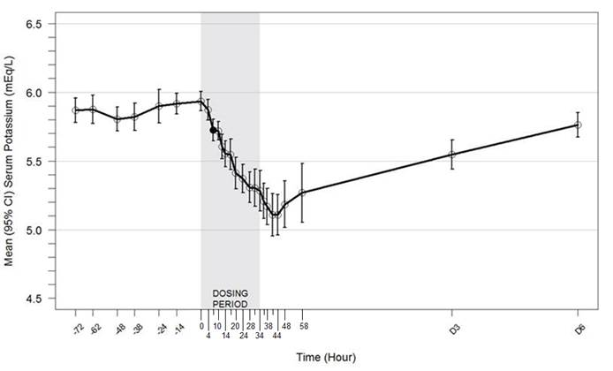

**\* Filled circle indicates the hour when the first statistically significant reduction was identified. A mean reduction of 0.8 mEq/L was observed at 48 hours (p < 0.001).**

**Notes: Hours -72 to 0 = Potassium controlled diet Run-in Period; Hours 0 to 58 = Inpatient Treatment Period with Veltassa 16.8 g daily as divided doses; Hour 58 to Day 6 = Outpatient Follow-Up Period**

## Pharmacokinetics

Veltassa works by binding potassium in the gastrointestinal tract and thus the serum drug concentration is not relevant for its efficacy. Due to the insolubility and non-absorptive characteristics of Veltassa, many classical pharmacokinetic studies cannot be carried out.

In radiolabelled ADME studies in rats and dogs, patiromer was not systemically absorbed and was excreted in the faeces. Quantitative whole-body autoradiography analysis in rats demonstrated that radioactivity was limited to the gastrointestinal tract, with no detectable level of radioactivity in any other tissues or organs.

# CLINICAL TRIALS

The safety and efficacy of patiromer sorbitex calcium were demonstrated in a two-part, single-blind randomised withdrawal study that evaluated patiromer sorbitex calcium in hyperkalaemic patients with CKD on stable doses of at least one renin angiotensin aldosterone system (RAAS) inhibitor (i.e., angiotensin-converting enzyme inhibitor [ACEI], angiotensin II receptor blocker [ARB], or aldosterone antagonist [AA]).

In Part A, 243 patients were treated with Veltassa for 4 weeks. Patients with a baseline serum potassium of 5.1 mEq/L to < 5.5 mEq/L received a starting Veltassa dose of 8.4 g patiromer per day (as a divided dose) and patients with a baseline serum potassium of 5.5 mEq/L to < 6.5 mEq/L received a starting Veltassa dose of 16.8 g patiromer per day (as a divided dose). The dose of Veltassa was titrated, as needed, based on the serum potassium level, assessed starting on Day 3 and then at weekly visits (Weeks 1, 2 and 3) to the end of the 4-week treatment period, with the aim of maintaining serum potassium in the target range (3.8 mEq/L to < 5.1 mEq/L). The mean daily doses of patiromer were 13 g and 21 g in patients with serum potassium of 5.1 to < 5.5 mEq/L and 5.5 to < 6.5 mEq/L, respectively.

The mean age of patients was 64 years, 58% of patients were men, and 98% were Caucasian. Approximately 97% of patients had hypertension, 57% had type 2 diabetes, and 42% had heart failure.

Mean serum potassium levels were 5.58 mEq/L at baseline and the mean (SE) change in serum potassium from Part A Baseline to Part A Week 4 was -1.01 (0.031) mEq/L (see Figure 2); this mean reduction in serum potassium was statistically significant (p < 0.001). For the Part A secondary outcome, 76% (95% CI: 70%, 81%) of patients had a serum potassium in the target range of 3.8 mEq/L to < 5.1 mEq/L at Part A Week 4.

**Figure 2: Estimated Mean (95% CI) of Central Serum Potassium (mEq/L) Over Time**

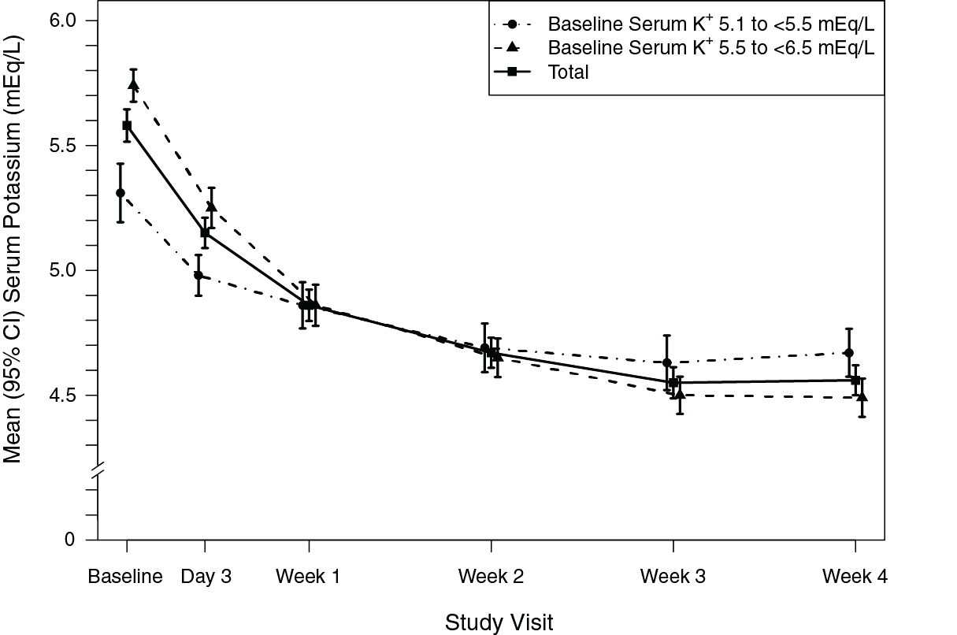

**In Part B, 107 patients with a Part A baseline serum potassium of 5.5 mEq/L to < 6.5 mEq/L and whose serum potassium was in the target range (3.8 mEq/L to < 5.1 mEq/L) at Part A Week 4 and still receiving RAAS inhibitor medication were randomized to continue Veltassa or to receive placebo for 8 weeks to evaluate the effect of withdrawing Veltassa on serum potassium. In patients randomized to Veltassa, the mean daily dose was 21 g at the start of Part B and during Part B.**

**The Part B primary endpoint was the change in serum potassium from Part B baseline to the earliest visit at which the patient’s serum potassium was first outside of the range of 3.8 to < 5.5 mEq/L or to Part B Week 4 if the patient’s serum potassium remained in the range. In Part B, serum potassium rose by 0.72 mEq/L in patients on placebo relative to no change in patients who remained on Veltassa (p < 0.001).**

**More placebo patients (91% [95% CI: 83%, 99%]) developed a serum potassium ≥ 5.1 mEq/L at any time during Part B than Veltassa patients (43% [95% CI: 30%, 56%]), p < 0.001. More placebo patients (60% [95% CI: 47%, 74%]) developed a serum potassium ≥ 5.5 mEq/L at any time during Part B than Veltassa patients (15% [95% CI: 6%, 24%]), p < 0.001.**

**Fifty-two percent (52%) of subjects receiving placebo discontinued RAAS inhibitor medication because of recurrent hyperkalaemia compared with 5% of subjects treated with Veltassa.**

**The effect of treatment with Veltassa for up to 52 weeks was evaluated in an open-label study of 304 hyperkalaemic patients with CKD and type 2 diabetes mellitus on stable doses of a RAAS inhibitor. Decreases in serum potassium with Veltassa treatment were maintained over 1 year of chronic treatment with a low incidence of hypokalaemia and the majority of subjects reaching and maintaining target serum potassium levels. In patients with a baseline serum potassium of > 5.0 to 5.5 mEq/L who received an initial dose of 8.4 g patiromer per day (as a divided dose), the mean daily dose was 14 g; in those with a baseline serum potassium of > 5.5 to < 6.0 mEq/L who received an initial dose of 16.8 g patiromer per day (as a divided dose), the mean daily dose was 20 g during the entire study.**

**After stopping Veltassa, significant increases in least squares mean serum potassium levels were seen by day 3 post-treatment. Patients remained on all RAAS inhibitors for 28 days after discontinuation of Veltassa treatment, during which time the increase in serum potassium remained statistically significant.**

**Figure 3: Mean (95% CI) Serum Potassium Over Time**

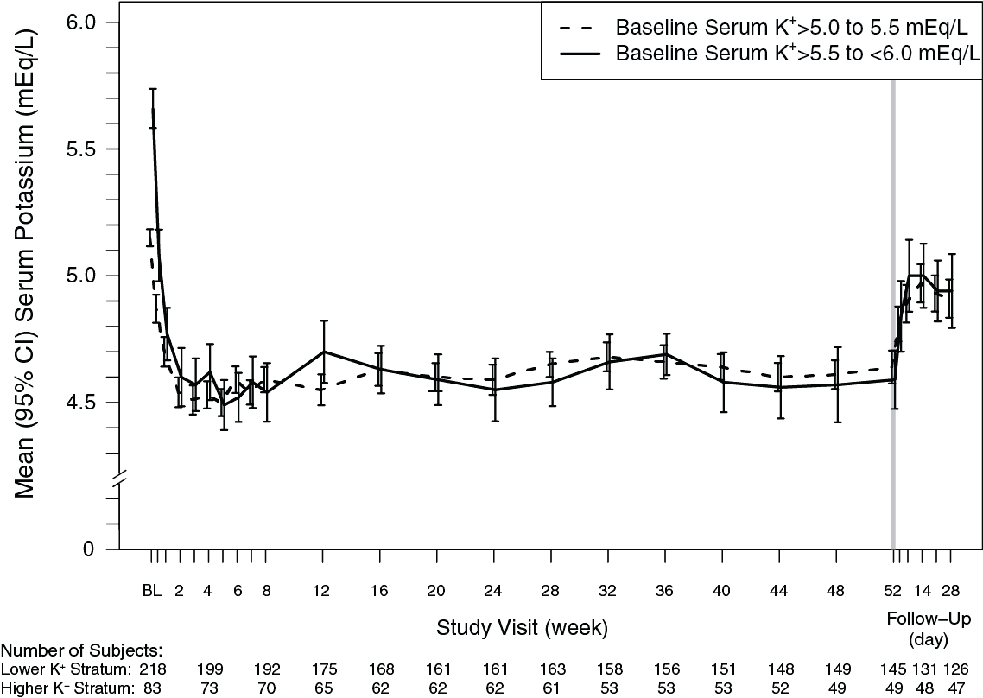

# INDICATIONS

Veltassa is indicated for the treatment of hyperkalaemia in adults.

# CONTRAINDICATIONS

The use of Veltassa is contraindicated in cases of hypersensitivity to patiromer sorbitex calcium or any of its excipients.

# PRECAUTIONS

Reversible causes of hyperkalaemia should be excluded and therapy initiated only if the serum potassium remains elevated and uncontrolled with dietary modification.

Treatment needs to be closely supervised or monitored.

There have been no clinical studies related to the use of Veltassa for duration of greater than 1 year. There have been no clinical studies that have examined the impact of Veltassa on patient mortality.

## Veltassa should not replace emergency treatment of hyperkalaemia

The onset of action of Veltassa occurs 4‑7 hours after administration. Veltassa could be used in conjunction with other measures to stabilise the myocardium but is not recommended as the sole treatment of patients with hyperkalaemia and ECG changes.

## Use in severe renal impairment

There is no data on the administration of Veltassa to patients on peritoneal dialysis. Veltassa reduced serum potassium in the 6 patients on haemodialysis included in the drug development program. There is no data on the use with phosphate binders.

## Monitoring

Serum potassium should be monitored when clinically indicated, including after changes are made to medicinal products that affect the serum potassium concentration (e.g. RAAS inhibitors or diuretics) and after the Veltassa dose is titrated.

Serum magnesium should be monitored for at least 1 month after initiation of patiromer treatment (see also “Low magnesium”).

Serum calcium should be monitored in patients at risk of hypercalcaemia (see also “Information about calcium”).

## Low Magnesium

In clinical studies, serum magnesium values < 1.4 mg/dL occurred in 9% of patients treated with patiromer sorbitex calcium, with no patient developing a serum magnesium level < 1.0 mg/dL. Mean decreases in serum magnesium occurred early during patiromer sorbitex calcium use and were 0.17 mg/dL or less throughout treatment. Monitor serum magnesium for at least 1 month after initiation of patiromer sorbitex calcium treatment; continue monitoring if serum magnesium levels decrease. Consider magnesium supplementation in patients who develop low serum magnesium levels on patiromer sorbitex calcium.

## Information about calcium

Veltassa contains calcium as part of the counterion complex. Calcium is partially released some of which may be absorbed (see PHARMACOLOGY). The benefits and risks of administering this medicinal product should be carefully evaluated in patients at risk of hypercalcaemia. Monitoring serum calcium is recommended in patients at risk for hypercalcemia.

## Gastrointestinal Disorders

Patients with a history of bowel obstruction or major gastrointestinal surgery, severe gastrointestinal disorders, or swallowing disorders were not included in the clinical studies. Gastrointestinal ischaemia, necrosis and/or intestinal perforation have been reported with other potassium binders. Patients should be monitored carefully such that the benefits and risks of administering Veltassa can be evaluated before and during treatment.

## Discontinuing Veltassa

Veltassa binds potassium. On cessation of this medication, potassium levels will return to pre-treatment levels, reflecting the combined effect of the patient’s other medications (e.g. RAAS inhibitors), dietary intake and medical conditions (e.g. CKD). Patients should be instructed not to discontinue therapy without consulting their physicians. In clinical studies, serum potassium increased as early as 2 days after the last patiromer sorbitex calcium dose.

## Effects on fertility

There are no data on the effect of Veltassa on fertility in humans.

Male and female fertility were unaffected in rats at oral doses of patiromer up to 5 g/kg/day, 10 times higher than the maximum recommended human dose on a g/kg basis (assuming 50 kg patient body weight).

## Use in Pregnancy (Category B1)

There are no data from the use of patiromer in pregnant women. Patiromer is not absorbed systemically following oral administration and maternal use is not expected to result in fetal risk.

No adverse effects on embryofetal development were observed in rats and rabbits receiving oral doses of patiromer of up to 6 and 3 g/kg/day, respectively (12 and 6 times, respectively, the maximum recommended human dose on a g/kg basis).

## Use in Lactation

There are no data from the use of patiromer in breastfeeding women. No effects on the breastfed newborn/infant are anticipated since the systemic exposure of the breast-feeding woman to patiromer is negligible.

## Paediatric Use

There is no data on the safety and efficacy of Veltassa in children aged under 18 years.

## Use in the Elderly

Of the total number of subjects exposed to Veltassa in clinical studies, 398 (59.8%) were aged 65 and over, while 132 (19.8%) were aged 75 and over. No special dose and administration guidelines were applied to seniors in these studies.

## Genotoxicity

Patiromer was not genotoxic in the bacterial reverse mutation test (Ames assay), *in vitro* chromosomal aberration assay (Chinese Hamster Ovary cells) or rat micronucleus test.

## Carcinogenicity

Carcinogenicity studies with patiromer sorbitex calcium have not been performed.

# INTERACTIONS WITH OTHER MEDICINES

Patiromer sorbitex calcium has the potential to bind some oral co-administered drugs, which could decrease their gastrointestinal absorption and result in a loss of efficacy when taken close to the time Veltassa is administered.

**As precautionary measure, and based on the data summarised below, administration of Veltassa should therefore be separated by at least 3 hours from other oral medicinal products.**

Concomitant administration of Veltassa showed reduced bioavailability of ciprofloxacin, levothyroxine and metformin. However, there was no interaction when Veltassa and these medicinal products were taken 3 hours apart.

*In vitro* studies have shown potential interaction of Veltassa with quinidine and thiamine.

Concomitant administration of Veltassa did however not affect the bioavailability as measured by the area under the curve (AUC) of amlodipine, cinacalcet, clopidogrel, furosemide, lithium, metoprolol, trimethoprim, verapamil and warfarin.

*In vitro* studies have shown no potential interaction of Veltassa with the following active substances: allopurinol, amoxicillin, apixaban, acetylsalicylic acid, atorvastatin, cephalexin, digoxin, glipizide, lisinopril, phenytoin, riboflavin, rivaroxaban, spironolactone and valsartan.

Physicians should consider monitoring medicines with a narrow therapeutic index when starting Veltassa.

# ADVERSE EFFECTS

The current safety profile of patiromer sorbitex calcium is based on a total of 666 patients from clinical trials, 547 patients with hyperkalaemia from treatment studies and 119 patients at risk of hyperkalaemia from prevention studies.

The majority of the adverse events reported from trials were gastrointestinal disorders, with the most frequently reported adverse events being constipation, diarrhoea, abdominal pain, flatulence, nausea, vomiting, and hypomagnesaemia. Gastrointestinal disorder events were generally mild to moderate in nature, did not appear to be dose related, generally resolved spontaneously or with treatment, and none were reported as serious.

**Table 1: Tabulated list of adverse events**

|  |  |  |
| --- | --- | --- |
| System Organ Class | Common  (>1/100 to <1/10) | Uncommon  (>1/1,000 to <1/100) |
| Metabolism and nutrition disorders | Hypomagnesaemia |  |
| Gastrointestinal disorders | Constipation  Diarrhoea  Abdominal pain  Flatulence | Nausea  Vomiting |

Laboratory Abnormalities

Approximately 4.7% of patients in clinical trials developed hypokalaemia with a serum potassium value < 3.5mEq/L

# DOSAGE AND ADMINISTRATION

The recommended starting dose of Veltassa is at least 8.4 g patiromer (as sorbitex calcium) once daily. The prepared Veltassa suspension should be taken with food and preferably at the same time of the day.

Adjust the daily dose of Veltassa based on the serum potassium level and the desired target range. The daily dose may be increased at 1-week or longer intervals by increments of 8.4 g, or decreased by 8.4 g, as necessary to reach the desired target range, up to a maximum dose of 25.2 g daily. If serum potassium falls below the desired range, the dose should be reduced or discontinued.

If a Veltassa dose is missed, the missed dose should be taken as soon as possible on the same day. The missed dose should not be taken with the next dose.

Upon discontinuation of Veltassa, serum potassium levels may rise, especially if RAAS inhibitor treatment is continued (see PRECAUTIONS). Therefore, patients should consult their doctor before discontinuing this medication.

Veltassa should be taken at least 3 hours before or after other oral medications (see INTERACTIONS WITH OTHER MEDICINES).

Serum potassium should be monitored when clinically indicated, including after changes are made to medicinal products that affect the serum potassium concentration (e.g. RAAS inhibitors or diuretics) and after the Veltassa dose is titrated (see Monitoring, PRECAUTIONS).

Serum magnesium should be monitored for at least 1 month after initiation of patiromer treatment (see Monitoring, PRECAUTIONS).

Serum calcium should be monitored in patients at risk of hypercalcaemia (see Monitoring, PRECAUTIONS).

Method of administration

For oral administration, Veltassa should be mixed with water and stirred to a uniform consistency, according to the following steps:

Measure 80 ml of water. Pour half of the water into a glass, then add Veltassa and stir. Add the remaining half of the water and stir thoroughly. The powder will not dissolve and the mixture will look cloudy. Add more water to the mixture as needed for desired consistency.

Drink the mixture immediately. If powder remains in the glass after drinking, add more water, stir and drink immediately. Repeat as needed to ensure the entire dose is administered.

Apple juice or cranberry juice can be used instead of water as liquid to prepare the mixture. Other liquids containing high amounts of potassium should be avoided.

Take prepared Veltassa suspension with food. Veltassa should not be heated (e.g., microwaved) or added to heated foods or liquids. Veltassa should not be taken in its dry form.

# OVERDOSAGE

For information on the management of overdose, contact the Poison Information Centre on 13 11 25 (Australia).

Doses of Veltassa in excess of 50.4 g patiromer per day have not been tested. Since excessive doses of Veltassa may result in hypokalaemia, serum potassium levels should be monitored. If it is determined that medical intervention is required, appropriate measures to restore serum potassium may be considered.

# PRESENTATION AND STORAGE CONDITIONS

## Presentation

Veltassa is a powder for suspension available in 8.4 g, 16.8 g and 25.2 g single dose aluminium foil laminated sachets. The powder is an off-white to light-brown powder, with occasional white particles.

Veltassa is available as a pack size of 30 sachets.

Not all strengths may be marketed.

## Storage Conditions

Store at 2 to 8°C. (Refrigerate. Do not freeze.)

Veltassa can be stored below 25°C for up to 6 months.

Do not use Veltassa past the expiry date printed on the sachet.

Protect from heat.

# NAME AND ADDRESS OF THE SPONSOR

Vifor Pharma Pty Ltd

Level 8, 80 Dorcas Street

Southbank, Melbourne, VIC, 3006

Australia

# POISON SCHEDULE OF THE MEDICINE

Schedule 4 – Prescription Only Medicine

# DATE OF FIRST INCLUSION IN THE AUSTRALIAN REGISTER OF THERAPEUTIC GOODS (THE ARTG):

12 December 2017

# DATE OF MOST RECENT AMENDMENT:

Not applicable