|  |
| --- |
| **March 2019** |

|  |
| --- |
| Australian Public Assessment Report for Pegfilgrastim |
| Proprietary Product Name: Fulphila |
| Sponsor: Alphapharm Pty Ltd |

About the Therapeutic Goods Administration (TGA)

* The Therapeutic Goods Administration (TGA) is part of the Australian Government Department of Health and is responsible for regulating medicines and medical devices.
* The TGA administers the *Therapeutic Goods Act 1989* (the Act), applying a risk management approach designed to ensure therapeutic goods supplied in Australia meet acceptable standards of quality, safety and efficacy (performance) when necessary.
* The work of the TGA is based on applying scientific and clinical expertise to decision-making, to ensure that the benefits to consumers outweigh any risks associated with the use of medicines and medical devices.
* The TGA relies on the public, healthcare professionals and industry to report problems with medicines or medical devices. TGA investigates reports received by it to determine any necessary regulatory action.
* To report a problem with a medicine or medical device, please see the information on the TGA website < <https://www.tga.gov.au>> .

About AusPARs

* An Australian Public Assessment Report (AusPAR) provides information about the evaluation of a prescription medicine and the considerations that led the TGA to approve or not approve a prescription medicine submission.
* AusPARs are prepared and published by the TGA.
* An AusPAR is prepared for submissions that relate to new chemical entities, generic medicines, major variations and extensions of indications.
* An AusPAR is a static document; it provides information that relates to a submission at a particular point in time.
* A new AusPAR will be developed to reflect changes to indications and/or major variations to a prescription medicine subject to evaluation by the TGA.

Copyright

© Commonwealth of Australia 2019  
This work is copyright. You may reproduce the whole or part of this work in unaltered form for your own personal use or, if you are part of an organisation, for internal use within your organisation, but only if you or your organisation do not use the reproduction for any commercial purpose and retain this copyright notice and all disclaimer notices as part of that reproduction. Apart from rights to use as permitted by the *Copyright Act 1968* or allowed by this copyright notice, all other rights are reserved and you are not allowed to reproduce the whole or any part of this work in any way (electronic or otherwise) without first being given specific written permission from the Commonwealth to do so. Requests and inquiries concerning reproduction and rights are to be sent to the TGA Copyright Officer, Therapeutic Goods Administration, PO Box 100, Woden ACT 2606 or emailed to < [tga.copyright@tga.gov.au](mailto:tga.copyright@tga.gov.au)> .

Contents

Common abbreviations 5

I. Introduction to product submission 7

Submission details 7

Product background 8

Regulatory status 8

Product Information 9

II. Registration time line 9

III. Quality findings 10

Introduction 10

Drug substance (active ingredient) 10

Drug product 10

Biopharmaceutics 11

Biosimilarity 11

Quality summary and conclusions 12

IV. Nonclinical findings 13

Introduction 13

Pharmacology 14

Pharmacokinetics 14

Toxicology 14

Nonclinical summary and conclusions 15

V. Clinical findings 16

Introduction 16

Pharmacokinetics 19

Pharmacodynamics 22

Dosage selection for the pivotal studies 22

Efficacy 22

Safety 23

First round benefit-risk assessment 26

First round recommendation regarding authorisation 29

Clinical questions and second round evaluation 29

Second round benefit-risk assessment 43

VI. Pharmacovigilance findings 46

Risk management plan 46

VII. Overall conclusion and risk/benefit assessment 48

Background 48

Quality 51

Nonclinical 52

Clinical 52

Risk management plan 62

Risk-benefit analysis 63

Outcome 77

Attachment 1. Product Information 77

## Common abbreviations

|  |  |
| --- | --- |
| Abbreviation | Meaning |
| ADA | Anti-drug antibodies |
| AE | Adverse event |
| ANC | Absolute neutrophil count |
| ANOVA | Analysis of variance |
| AUEC | Area under effect-time curve |
| AUC | Area under the curve |
| AUC0-t | Area under the curve from time zero to t |
| AUC0-∞ | Area under the curve extrapolated to infinity |
| BPI | Brief pain inventory |
| CD34+ | Haematopoietic progenitor cell antigen |
| CI | Confidence interval |
| Cmax | Maximum concentration |
| CSR | Clinical study report |
| CTCAE | Common terminology criteria for adverse events |
| CV | Coefficient of variation |
| DSN | Duration of severe neutropenia |
| ED50 | 50% efficacious dose |
| EMA | European Medicines Agency |
| Emax | Maximum response |
| ESMO | European Society for Medical Oncology |
| EU | European Union |
| FDA | Food and Drug Administration |
| FN | Febrile neutropenia |
| G-CSF | Granulocyte colony stimulating factor |
| GLM | General linear model |
| ICH | International Conference on Harmonisation of Technical Requirements for Registration of Pharmaceuticals for Human Use |
| ITT | Intent-to-treat |
| LS | Least squares |
| MHRA | Medicines and Healthcare Products Regulatory Agency (UK) |
| MYL-1401H | Alternative name for Fulphila |
| n | Number of patients in the sample |
| NAb | Neutralizing antibodies |
| NCCN | National Comprehensive Cancer Network |
| PD | Pharmacodynamic(s) |
| PEG | Polyethylene glycol |
| PK | Pharmacokinetic(s) |
| PP | Per-protocol (population) |
| PT | Preferred term |
| RMP | Risk Management Plan |
| SAP | Statistical analysis plan |
| SC | Subcutaneous |
| SD | Standard deviation |
| t½ | Apparent terminal elimination half-life |
| TAC | Docetaxel, doxorubicin, and cyclophosphamide chemotherapy regimen |
| TEAE | Treatment-emergent adverse event |
| Tmax | Time to maximum concentration |
| US | United States (of America) |

## I. Introduction to product submission

### Submission details

|  |  |
| --- | --- |
| *Type of submission:* | Similar biological medicinal product |
| *Decision*: | Approved |
| *Date of decision:* | 6 August 2018 |
| *Date of entry onto ARTG:* | 17 August 2018 |
| *ARTG number:* | 282830 |
| *Black Triangle Scheme* | No |
| *Active ingredient:* | Pegfilgrastim |
| *Product name:* | Fulphila |
| *Sponsor’s name and address:* | Alphapharm Pty Ltd  PO Box R1462  Royal Exchange NSW 1225 |
| *Dose form:* | Solution for injection |
| *Strength:* | 6 mg / 0.6 mL |
| *Container:* | Pre filled syringe |
| *Pack size:* | 1 |
| *Approved therapeutic use:* | *Fulphila is indicated for the treatment of cancer patients following chemotherapy, to decrease the duration of severe neutropenia and so reduce the incidence of infections, as manifested by febrile neutropenia.* |
| *Route of administration:* | Subcutaneous |
| *Dosage:* | A single subcutaneous (SC) injection of 6 mg administered once per chemotherapy cycle. Fulphila should be administered approximately 24 hours after the administration of cytotoxic chemotherapy |

### Product background

This AusPAR describes the application by the sponsor to register Fulphila pegfilgrastim as a biosimilar version of the innovator, Neulasta. The proposed indications are identical to those for the innovator product:

*Indicated for the treatment of cancer patients following chemotherapy, to decrease the duration of severe neutropenia and so reduce the incidence of infection, as manifested by febrile neutropenia.*

Neulasta pegfilgrastim is composed of filgrastim (recombinant methionyl human granulocyte colony stimulating factor (G-CSF)) with a 20,000 dalton polyethylene glycol (PEG) molecule covalently bound to the N-terminal methionine residue. Filgrastim is a 175 amino acid protein manufactured by recombinant DNA technology produced by Escherichia coli (E coli) bacteria into which has been inserted the human G-CSF gene. Filgrastim is unglycosylated and contains an N-terminal methionine necessary for expression in E coli. Neulasta has a total molecular weight of 39,000 daltons.

Pegfilgrastim is a modified colony stimulating factor that regulates the neutrophil lineage. It stimulates the production of neutrophil precursors, and the differentiation and release of mature neutrophils from the bone marrow. Pegfilgrastim binds to the G-CSF receptor and has the same principal effect as endogenous G-CSF, with the polyethylene glycol moiety providing a longer half-life.

### Regulatory status

Fulphila received initial registration on the Australian Register of Therapeutic Goods (ARTG) on 17 August 2018.

The innovator product Neulasta was first registered in September 2002.

At the time the TGA considered this application,[1] similar applications were under consideration in (country date) as shown in Table 1.

Table 1: International regulatory status

|  |  |  |
| --- | --- | --- |
| Country / region | Date of submission/status | Indications |
| European Union (centralised procedure) | Submission of 26 May 2016 withdrawn  Submitted 3 November 2017; Under evaluation | Reduction in the duration of neutropenia and the incidence of febrile neutropenia in adult patients treated with cytotoxic chemotherapy for malignancy (with the exception of chronic myeloid leukaemia and myelodysplastic syndromes) |
| Canada | 30 November 2016  Under evaluation | Fulphila (pegfilgrastim) is indicated to decrease the incidence of infection, as manifested by febrile neutropenia, in patients with non-myeloid malignancies receiving myelosuppressive antineoplastic drugs. |
| United States of America | Submitted 9 December 2016  (Approved 4 June 2018) | Fulphila is indicated to decrease the incidence of infection, as manifested by febrile neutropenia, in patients with non-myeloid malignancies receiving myelosuppressive anticancer drugs associated with a clinically significant incidence of febrile neutropenia. |

### Product Information

The Product Information (PI) approved with the submission which is described in this AusPAR can be found as Attachment 1. For the most recent PI, please refer to the TGA website at < <https://www.tga.gov.au/product-information-pi>> .

## II. Registration time line

Table 2 captures the key steps and dates for this application and which are detailed and discussed in this AusPAR.

Table 2: Timeline for submission PM-2016-03834-1-4

|  |  |
| --- | --- |
| Description | Date |
| Submission dossier accepted and first round evaluation commenced | 3 January 2017 |
| First round evaluation completed | 5 June 2017 |
| Sponsor provides responses on questions raised in first round evaluation | 31 July 2017 |
| Second round evaluation completed | 13 September 2017 |
| Delegate’s Overall benefit-risk assessment and request for Advisory Committee advice | 29 September 2017 |
| Sponsor’s pre-Advisory Committee response | 13 November 2017 |
| Advisory Committee meeting | 30 November to 1 December 2017 |
| Registration decision (Outcome) | 6 August 2018 |
| Completion of administrative activities and registration on ARTG | 17 August 2018 |
| Number of working days from submission dossier acceptance to registration decision* | 237 |

*Statutory timeframe for standard applications is 255 working days

Evaluations included under Quality findings and Nonclinical findings incorporate both the first and second round evaluations.

## III. Quality findings

### Introduction

The active ingredient of Fulphila is recombinant G-CSF (filgrastim) with subsequent PEGylation, with an average molecular weight (MW) of 20kDa. The active ingredient is synthesised using culture in *Escherichia coli*.

### Drug substance (active ingredient)

#### Structure

The amino acid sequence was confirmed and appropriate conformational studies were completed.

#### Physical and chemical properties

Most of the characteristics of filgrastim were shown to be compliant. The PEGylation of filgrastim is crucial in determining the circulatory half-life of the drug product. The same PEGylating agent is used for Fulphila and Neulasta however, analysis showed (a) a higher molecular mass, (b) higher levels of aggregates and (c) a lower level of dimers or diPEGylated filgrastim in Fulphila. Further analysis confirmed the difference in molecular mass was due to the PEGylation. The difference in molecular mass is unlikely to discernibly affect the potency or half-life but is hereby noted. As aggregates (at much higher levels) have been associated with immunogenicity, the higher level of aggregates is also noted.

Overall, supplied data are satisfactory.

### Drug product

#### Brief description of formulation

The formulation is different to that of the reference product. Fulphila is formulated at pH4.0 and it also contains the following inactive ingredients, sorbitol, polysorbate 20, acetate (as acetic acid), sodium, as sodium hydroxide) and water for injection. The differences noted were in the quantities of the buffering agent and sodium. The batch analyses show it complying with the same pH specification as Neulasta. Thus, this does not appear to be a problem but is noted for future reference during batch release testing.

#### Manufacture/manufacturer(s)/GMP status

Flow charts of the manufacturing processes were provided and the manufacturers and their Good Manufacturing Practice (GMP) status were provided.

All manufacturing steps are validated. The processes have been shown to be adequately controlled.

Non-compliances for one site for aseptic filling of injectables have been raised by other regulatory agencies. The matter is still under review and unlikely to be resolved soon.[2]

#### Specifications

In general, the specifications are adequate and all analytical procedures are validated. There are no other issues pertaining to specifications.

#### Stability

Stability data have been generated under stressed and real time conditions to characterise the stability profile of the product. As the product is not completely photostable, it should carry the warning ‘Protect from light’.

The data support a shelf life of 2 years when stored at 5°C ± 3°C.

No in-use stability data or excursion studies were submitted. As such cold chain at 5°C ± 3°C must be maintained during shipping and use.

Stability studies have been conducted in accordance with relevant International Conference on Harmonisation (ICH) guidelines.[3]

Degradation takes place largely by aggregation.

There are no issues pertaining to stability of drug substance and drug product.

##### Recommended shelf life

24 months at 2 to 8°C. Refrigerate, do not freeze. Protect from light. No temperature excursions during shipping.

### Biopharmaceutics

Biopharmaceutic data are not required for this product as there is only one route of administration.

### Biosimilarity

The active substance of Fulphila (pegfilgrastim) has been developed as a biosimilar to that of the currently registered reference product, Neulasta (pegfilgrastim), ARTG R 166387.

During the development of Fulphila, European Union (EU) and US sourced Neulasta was used as the main reference product to demonstrate biosimilarity in terms of quality and non-clinical comparability exercise. An additional bridging comparability study was performed between the EU and US sourced Neulasta and Australian and New Zealand sourced Neulasta to present EU and US sourced Neulasta as representative of the Australian registered product.

Extensive characterisation studies involving comparison of primary, secondary and tertiary structures, physicochemical properties and biological activities showed that Fulphila and EU and US sourced Neulasta are generally similar. However, several differences have been noted as highlighted below:

* The formulation of Fulphila is different to that of the reference product. The differences noted were in the quantities of the buffering agent and sodium. These differences are likely to have an effect on the pH, though the buffering capacity would be greater in Fulphila. The batch analyses show it complying with the same pH specification as Neulasta.
* Fulphila has a slightly greater intact molecular mass due to the PEG moiety. The difference is unlikely to discernibly affect the potency or half-life.
* Fulphila has a higher level of aggregates than Neulasta. The level increases during storage at 2 to 8°C. This may impact immunogenicity. It is suggested that the clinical delegate re-checks comparative clinical data for differences in antibody formation.
* Fulphila has slightly higher levels of Des-PEG-G-CSF and deamidated Gln108. This is not likely to have any significant effect on potency or half-life.
* Fulphila has greater overall purity and lower levels of dimers and diPEGylated G-CSF.
* Fulphila appears slightly more photosensitive than Neulasta. The labelling and PI/CMI all include the warning ‘Protect from light’. This should be sufficient.

Overall then, the sponsor has demonstrated that Fulphila is comparable to Neulasta in terms of structure, species, function and degradation profile (that is physicochemically and biologically).

#### Sterility, container safety, endotoxin and infectious disease evaluations

There are no objections to the registration of this product from sterility; endotoxin and viral safety related aspects.

Overall, sufficient evidence has been provided to demonstrate that the risks related to the manufacturing quality of Fulphila have been controlled to an acceptable level.

#### Labelling, packaging and documentation

With respect to quality matters, the Product Information (PI), Consumer Medicine Information (CMI) and labels as detailed are acceptable.

### Quality summary and conclusions

#### Summary of issues

1. At the time the quality summary and conclusion was written there were some manufacturing sites for which GMP clearances had not been issued.[4]
2. Fulphila has a higher level of aggregates than the reference Neulasta. The level increases during storage at 2 to 8°C. This may impact immunogenicity. It is suggested that the clinical delegate re-checks comparative clinical data for differences in antibody formation.
3. The formulation of Fulphila is different to that of the reference product. The differences noted were in the quantities of the buffering agent and sodium. These differences are likely to have an effect on the pH, though the buffering capacity would be greater in Fulphila. The batch analyses show it complying with the same pH specification as Neulasta. Thus, this does not appear to be a problem but is noted for future reference during batch release testing.
4. The specifications for charge variants and aggregates appeared to be too broad. The sponsor proposed acceptably tight specifications but did not modify the specification tables. It was highlighted that it is preferable to set rigorous release specifications and use values including stability trends as end-of-shelf-life specifications.[5]
5. After the request for information, unsolicited data was provided relating to the Working Cell Bank and temperature excursions during shipping. These data were not evaluated and should be submitted as Category 3 applications under section 9D of the Act. Until such time as this is done any new WCB will require approval and the product should be shipped maintaining cold chain at 2 to 8°C.
6. The pathogen safety evaluator noted that the sponsor made a commitment to provide a mycoplasma testing report of the MCB and WCB to TGA, this commitment is noted.

##### Proposed conditions of registration (for clinical delegate)

1. Batch release testing and compliance with Certified Product Details (CPD)
   1. It is a condition of registration that all batches of Fulphila (pegfilgrastim) imported into Australia must comply with the product details and specifications approved during evaluation and detailed in the Certified Product Details (CPD).
   2. It is a condition of registration that each batch of Fulphila (pegfilgrastim) imported into Australia is not released for sale until samples and/or the manufacturer’s release data have been assessed and endorsed for release by the TGA Laboratories Branch.
   3. The Certified Product Details (CPD), as described in Guidance 7: Certified Product Details of the Australian Regulatory Guidelines for Prescription Medicines (ARGPM) [<http://www.tga.gov.au/industry/pm-argpm-guidance-7.htm>], in PDF format, for the above products should be provided upon registration of these therapeutic goods. In addition, an updated CPD should be provided when changes to finished product specifications and test methods are approved in a Category 3 application or notified through a self-assessable change.

#### Recommendation

There are no objections on quality grounds to the approval of Fulphila (pegfilgrastim) solution for injection 6 mg/0.6 mL prefilled syringe.

## IV. Nonclinical findings

### Introduction

Alphapharm Pty Ltd has applied to register pegfilgrastim (Fulphila), as a biosimilar to Neulasta (pegfilgrastim, Amgen Inc.). Pegfilgrastim binds to the human G-CSF receptor and has the same principal effect as endogenous G-CSF, with the polyethylene glycol moiety providing a longer half-life. The amino acid sequence of Fulphila is identical to that of Neulasta.

The scope of the submitted nonclinical dossier was in accordance with the relevant guidelines;[6],[7] containing comparative *in vivo* pharmacology and toxicity studies including toxicokinetics. Comparative *in vitro* comparability studies were submitted in the quality module and are evaluated by the quality evaluator.

The EU and US sourced Neulasta were used as comparators in the nonclinical studies submitted in the nonclinical module. The Australian-sourced Neulasta was not used, and no data was provided in the nonclinical module to verify the comparability of the various sources of Neulasta. Provided adequate comparability of Fulphila and the EU/US sourced Neulasta, as well as the comparability of Fulphila and the Australia sourced Neulasta are demonstrated in the quality module, the submitted nonclinical dossier is considered adequate.

### Pharmacology

Pegfilgrastim is a modified colony stimulating factor that regulates the neutrophil lineage. It stimulates the production of neutrophil precursors, and the differentiation and release of mature neutrophils. Pegfilgrastim binds to G-CSF receptor and has the same principal effect as endogenous G-CSF, with the polyethylene glycol moiety providing a longer half-life. The pharmacological activity of Fulphila and the EU and US Neulasta forms of pegfilgrastim were compared in *in vitro* assays (evaluated by the quality evaluator) and in one rat study *in vivo*.

The sponsor has submitted one primary pharmacology study comparing *in vivo* pharmacodynamics of Fulphila, EU and US Neulasta in a chemically induced (cyclophosphamide induced) neutropenic rat model, using single subcutaneous (SC) doses of 100 to 3000 µg/kg. Animals administered Fulphila, EU or US Neulasta at (300 to 3000 µg/kg) showed dose related leucocyte and absolute neutrophil count (ANC) responses. The 50% efficacious dose (ED50) (assuming 100% response at the highest dose 3000 µg/kg) for both responses were comparable between the three formulations. The maximum response (Emax), area under effect-time curve (AUEC) and effective AUEC (AUEC of treated group; AUEC of untreated control group) of leukocytes and ANC were also comparable between the treatment groups. There were no significant differences in other haematological parameters including lymphocytes, monocytes, erythrocytes (and associated parameters) and platelets.

The rat primary pharmacology study demonstrated comparability of Fulphila with the EU and US Neulasta.

### Pharmacokinetics

No specific pharmacokinetic comparability studies were performed in animal species. In the 4 week repeat dose toxicity study, toxicokinetic parameters on Day 1 and 22 in animals administered Fulphila showed dose proportional increases in mean maximal concentration (Cmax), exposures (area under the curve(AUC)), and half-lives (t½), which were comparable to the parameters for EU Neulasta.

### Toxicology

One comparative GLP-compliant repeat-dose toxicity study of 4 weeks duration in rats was conducted. The toxicity profile of Fulphila in rats was compared with that of EU Neulasta. The duration of the study and the choice of species are considered acceptable. The clinical route and clinical dosing regimen (once weekly) were used.

Administration of Fulphila or EU Neulasta in rats had no significant effects on body weight and food consumption. Both Fulphila and EU Neulasta increased serum alkaline phosphatase levels and blood leukocytes and ANC in a dose proportional manner. Minor effects due to exaggerated pharmacology caused by administration of Fulphila were observed, such as decreased red blood cell count, haemoglobin content, haematocrit value, platelet numbers and increased spleen weight and size, were comparable to the results observed for EU Neulasta. Microscopic findings (also pharmacological or secondary to pharmacological effects) included increased granulopoiesis in the bone marrow (femur and sternum) and increased haemotopoiesis in the spleen and liver. There were no obvious qualitative or quantitative differences in these microscopic findings between Fulphila and EU Neulasta treated rats. Thus, toxicological profiles of Fulphila and EU Neulasta were comparable.

Minimal local reactions were observed at the injection site, with similar frequency and severity for Fulphila and Neulasta. Anti-drug antibodies were not assessed, but animal studies do not generally predict immunogenicity of humanised antibodies in humans. Toxicokinetic data showed exposure to the active drug substance during the 4 week dosing period, indicating filgrastim was not neutralised by anti-drug antibodies.

The doses chosen for Fulphila for a comparative analysis with EU Neulasta are acceptable, resulting in exposures (AUC) covering and exceeding the clinical exposure in patients receiving 6 mg injection of Fulphila once per chemotherapy cycle (Table 3).

Table 3: Relative exposure in the repeat-dose toxicity study

|  |  |  |  |  |  |
| --- | --- | --- | --- | --- | --- |
| Species | Study duration [Study no.] | Compound | Dose (mg/kg/day SC) | AUC0–24 h^ (ng∙h/ mL) | Exposure ratio# |
| Rat (SD) | 4 weeks [Study: TOX-071-001] | Fulphila (Day 22) | 0.15 | 3215 | 4 |
| 0.65 | 25,900 | 31 |
| 1.50 | 115,800 | 140 |
| Human | Steady state [Study: CSR -1001] | Fulphila | 6 mg | 827 | – |

# = animal: human plasma AUC0–24 h; ^ = data are for the sexes combined CSR = clinical study report MYL‑1401H: Alternative name for Fulphila

#### Comments on the nonclinical safety specification of the Risk Management Plan

Results and conclusions drawn from the nonclinical program for Fulphila detailed in the sponsor’s draft Risk Management Plan (RMP) are in general concordance with those of the nonclinical evaluator.

### Nonclinical summary and conclusions

* No data were provided in nonclinical module to verify the comparability of the EU sourced and Australia sourced Neulasta. *In vitro* pharmacological activity (for example receptor binding) and comparability data between Fulphila and US/EU Neulasta and bridging studies comparing Fulphila and Australia/New Zealand Neulasta are provided in the quality module and are assessed by the quality evaluator. If comparability is demonstrated by quality data, no further nonclinical studies comparing Fulphila and Australia sourced Neulasta would be necessary.
* No significant differences between Fulphila and Neulasta were observed in the comparative pharmacology study and the 4 week repeat dose toxicity study. Pharmacology, toxicity findings and toxicokinetic parameters were comparable between the Fulphila and the reference product (EU Neulasta).
* There are no nonclinical objections to the approval of Fulphila provided quality data showed comparability between Fulphila and US/EU/Australia Neulasta.
* The draft Product Information is acceptable from a nonclinical perspective.

## V. Clinical findings

A summary of the clinical findings is presented in this section.

### Introduction

#### Clinical rationale

Cytotoxic chemotherapeutic agents act non-selectively on cells with high replication rates, causing myelosuppression as an adverse side effect. The consequent drop in neutrophil count is accompanied by the risk of severe infections, which used to be the major dose limiting factor of systemic chemotherapy. Chemotherapy induced neutropenia can be prevented or ameliorated by the use of filgrastim or pegfilgrastim.

Pegfilgrastim is a modified colony stimulating factor that regulates the neutrophil lineage. It stimulates the production of neutrophil precursors, and the differentiation and release of mature neutrophils. Pegfilgrastim binds to the G-CSF receptor and has the same principal effect as endogenous G-CSF, with the polyethylene glycol moiety providing a longer half-life.

The proposed clinical use of Fulphila (MYL-1401H; an alternative name for Fulphila) is an indication approved for the reference product, Neulasta; that is, for the treatment of cancer patients following chemotherapy, to decrease the duration of severe neutropenia and to reduce the incidence of infection, as manifested by febrile neutropenia.

Neutropenic sepsis is not only dose limiting, but may also be fatal. The benefit of the longer acting form of G-CSF is only one injection is required per cycle, compared with 4 consecutive daily treatments required with recombinant non-pegylated G-CSF, registered and available in Australia. Neulasta, the reference product and currently the only registered pegylated G-CSF product in Australia, offers greater ease and convenience to the patient, and an increased likelihood of compliance; while not considered by the TGA for the purposes of this evaluation it is considerably more costly than the shorter acting versions of G-CSF.

##### Current treatment options in Australia

The risk of neutropenic fever and sepsis may be reduced by the addition of G-CSF, and a reduction in the dose or intensity of the chemotherapy regimen may be avoided.

Currently, there are four products listed on the ARTG as registered in Australia using the term filgrastim (non-pegylated); Neupogen, Nivestim, Tevagrastim, and Zarzio although it is not clear if all of these are supplied.

In addition to the reference product, Neulasta (approved 18 May 2010), another pegylated form of filgrastim, lipefilgrastim (Lonquex) was approved by the TGA on 12 November 2015.

##### Excipients

The composition of MYL-1401H injection is identical to that of the reference product, Neulasta. MYL-1401H is a clear, colorless, preservative-free solution for injection (0.6 mL) containing 6 mg of pegfilgrastim (10 mg/ mL); with excipients D-sorbitol, polysorbate 20, acetate (buffer), sodium (buffer), and water for injection. MYL-1401H is supplied in a single dose syringe with an UltraSafe Plus Passive Needle Guard.

#### Guidance

* Biosimilar guidance from the TGA website
* Biosimilar PI wording approach within PMAB as of December 2016
* European Medicines Agency (EMA) Guideline; Guidance on similar medicinal products containing recombinant granulocyte-colony stimulating factor
* EMA Guideline; Guideline on Clinical Trials with haematopoietic growth factors for the prophylaxis of infection following myelosuppressive or myeloablative therapy
* EMA Guideline; Guideline on similar biological medicinal products containing biotechnology-derived proteins as active substance - non-clinical and clinical issues
* FDA Guidance for Industry ‘Immunogenicity assessment for therapeutic protein products’
* ‘EP2006, a proposed biosimilar to Neupogen’ FDA Briefing Document, Oncology Drugs Advisory Committee Meeting, January 7, 2015

The following references were also cited by the evaluator

* Crawford, J et al., ‘Chemotherapy-induced neutropenia: risks, consequences, and new directions for its management’ *Cancer* 2004;100:228-237.
* Garay, RP et al., ‘Antibodies against polyethylene glycol in healthy subjects and in patients treated with PEG-conjugated agents.*’ Expert Opin Drug Deliv*, 2012; 9: 1319-1323.
* Schellekens, H et al., ‘The immunogenicity of polyethylene glycol: facts and fiction.’ *Pharm Res*. 2013; 30: 1729-1734.
* Shankar, G et al., ‘Recommendations for the validation of immunoassays used for detection of host antibodies against biotechnology products.’ *Journal of Pharmaceutic and Biomedical Analysis* 2008; 48: 1267-1281.
* Slamon, D et al., ‘Adjuvant trastuzumab in HER2-positive breast cancer.’ *N Engl J Med*. 2011; 365: 1273–1283.

#### Scope of the clinical dossier

The TGA website states that: ‘For a biosimilar to be registered in Australia, the reference medicine must be a biological medicine that has been registered in Australia based on full quality, safety and efficacy data ('the Australian reference medicine').’[8]

As the key clinical studies use overseas sourced Neulasta:

* The reference medicine must be approved for general marketing by a regulatory authority with similar scientific and regulatory standards as the TGA (for example, the EMA or US FDA).
* A bridging study must be provided to demonstrate that the comparability studies are relevant to the Australian reference medicine (this bridging study may be abridged or omitted if you include evidence that the medicine is manufactured in a single site for global distribution).

The sponsor has not stated the reference Neulasta product for Australia, including from where the reference product registered in Australia is sourced or manufactured. The sponsor is requested to provide this information.

Limited data have been provided comparing Neulasta stated to be sourced in Australia and New Zealand with MYL-1401H but there is no inclusion of either the EU Neulasta or US Neulasta products.

The European Medicines Evaluation Agency (EMEA) Guideline;[9] which states in part: ‘If certain clinical and in vivo non-clinical studies of the development programme are performed with the non-EEA authorised comparator, the applicant should provide adequate data or information to scientifically justify the relevance of these comparative data and establish an acceptable bridge to the EEA authorised reference product. As a scientific matter, the type of bridging data needed will always include data from analytical studies (for example, structural and functional data) that compare all three products (the proposed biosimilar, the EEA authorised reference product and the non EEA authorised comparator), and may also include data from clinical pharmacokinetic (PK) and/or pharmacodynamic (PD) bridging studies for all three products. The overall acceptability of such an approach and the type of bridging data needed, will be a case-by-case/product type decision, and is recommended to be discussed upfront with the Regulatory Authorities. However, the final determination of the adequacy of the scientific justification and bridge will only be made during the assessment of the application.’

#### Contents of the clinical dossier

The clinical evidence included in support of the application comes from the 3 studies listed below. It is noted that the Clinical Study Protocol for Study 1001 included mention of ‘A pilot study (Myl-Per-0001/MYB262EC-122621), sponsored by Mylan, was performed to evaluate the inter and intra subject variability in pharmacokinetics (PK) and pharmacodynamics (PD) of Neulasta in healthy volunteers’.

* Study MYL-1401H-1001: a single centre, randomised, double blind, 3 period, 3 treatment, 3 way crossover pharmacokinetic (PK) and pharmacodynamic (PD) comparability study between MYL-1401H and the reference product Neulasta designed to collect comprehensive comparability data between MYL-1401H and Neulasta (EU Neulasta and US Neulasta) in healthy volunteers.
* Study MYL-1401H-1002: a single centre, randomised, open label, 2 dose, parallel immunogenicity and safety study comparing immunogenicity and safety between 2 SC injections of MYL-1401H and Neulasta (US licensed Neulasta) 6 mg SC injection in healthy volunteers.
* Study MYL-1401H-3001: a multicentre, randomised, double blind, therapeutic-equivalence study to compare the efficacy, safety, and immunogenicity of MYL-1401H and Neulasta (EU licensed Neulasta) in adult patients with Stage II/III invasive breast cancer in the adjuvant/neoadjuvant setting who were receiving TAC chemotherapy.[10]

#### Paediatric data

None provided.

It is noted that the broad Neulasta indication includes paediatric patients, and that the product information includes paediatric data. The sponsor is requested to provide a justification for not examining the effects of MYL-1401H in this special population.

#### Good clinical practice

The sponsor states that Good Clinical Practice and Declaration of Helsinki have been adhered to, and that all studies were performed in compliance with the principles of Good Clinical Practice, including the archiving of essential documents. This report was written in compliance with the ICH guidelines.

#### Evaluator’s commentary on the clinical dossier

The studies include the use of ‘US Neulasta’ and ‘EU Neulasta’ but no details of which Neulasta is considered the reference in Australia are presented, or the source of that product. This is important as there were issues with PK values falling outside the reference range for similarity between the two Neulasta products and MYL-1401H. The immunogenicity study was carried out using the US Neulasta as a comparator and not the EU Neulasta.

The sponsor has been requested to provide a justification for not assessing the safety and efficacy in a paediatric population, given the current reference product is approved across all age groups.

The presentation of the data and the discussion of the immunogenicity, the primary objective, in Study 1002 are presented in two addenda separately from the main clinical study report (CSR), and the reports finalised after that main CSR was finalised.

Numerous nonclinical study documents have been included in the clinical module for both Studies 1001 and 1002.

### Pharmacokinetics

#### Studies providing pharmacokinetic data

##### Study MYL-1401H-1001

Phase I Study MYL-1401H-1001 a single centre, randomised, double blind, 3 period, 3 treatment, 3 way crossover pharmacokinetic (PK) and pharmacodynamic (PD) comparability study between MYL-1401H and the reference product Neulasta designed to collect comprehensive comparability data between MYL-1401H and Neulasta (EU Neulasta and US Neulasta) in healthy volunteers.

###### Objectives

Primary:

* To compare the PD of a single subcutaneous (SC) injection (2 mg) of MYL-1401H and a single SC injection (2 mg) of EU and US Neulasta in healthy volunteers
* To compare the PK of a single SC injection (2 mg) of MYL-1401H and a single SC injection (2 mg) of EU and US Neulasta in healthy volunteers.

Secondary:

* To evaluate the safety and tolerability of MYL-1401H and EU and US Neulasta after a single 2 mg SC injection in healthy volunteers.

Figure 1: Study schema for Study MYL-1401H-1001 (Study 1001)

Figure 1: Study schema MYL-1401H-1001
3 weeks screening and enrollment 
1st period 4 weeks after treatment with either MYL-1041H,US Neulasta or EU Neulasta thenw weeks waSHOUT THEN CROSS OVER TREATMENT TO  ONE OF THE OTHER TWO  products then 4 weeks obsevation and washout and then again another crossover to the other drug not yet used and 4 weeks observation and washout

Note is made that the excipients include sorbitol, which may potentially affect patients with hereditary fructose intolerance, hence the exclusion criterion for those with ‘fructose intolerance’. The evaluator notes that for a range of other G-CSF products registered (for example Nivestim, Neupogen), the EMA’s SmPCs and Medsafe PI include statements about either not administering this to or cautioning use in those with hereditary fructose intolerance, respectively. This study was conducted in Europe. However, only the PI for Lonquex (lipefilgrastim product approved in Australia) contains such a warning:

‘Excipients with known effect:

This medicinal product contains 30 mg sorbitol per pre-filled syringe. Patients with rare hereditary problems of fructose intolerance should not use this medicinal product.’

A similar warning is included in the PIs for irinotecan.

Given this was considered to be of sufficient relevance or concern to thesponsor to be an exclusion criterion, the sponsor is requested to provide a justification for why this should not be included in the PI and CMI for this product if registered. The evaluator does not consider the inclusion of such a statement in the PI represents a genuine difference between the products, and considers this preferable.

###### Results for the primary efficacy outcome

*PK primary endpoint:* After administration of a single SC injection of 2 mg pegfilgrastim (MYL-1401H, EU Neulasta or US Neulasta), PEG-G-CSF appeared in serum within 2 to 4 hours post dose. PEG-G-CSF concentrations were first observed at 6 hours after dosing in 2 patients receiving EU Neulasta.

Maximum mean concentrations were reached approximately 12 hours post dose. The shape of the serum concentration-time profiles of PEG-G-CSF was most similar between MYL-1401H and US Neulasta, whereas the mean PEG-G-CSF concentrations appeared to be slightly lower for EU Neulasta compared to the other 2 treatments.

Mean PEG-G-CSF concentrations could be determined in serum up to 144 hours post dose for all 3 treatments but were below the lower level of quantification prior to the next dose.

Summary descriptive data for MYL1401H (that is, PK data from all patients irrespective of whether it was the first, second or third dose) were provided which demonstrate substantial variability between measurements for individual subjects, and only 204 patients in total. The sponsor notes that there is considerable inter individual variability between the primary PK parameters, citing the geometric mean and a coefficient of variation (CV)% of 70% as presented in Table 4. However, the range for Cmax is nearly 130 fold (1.6 to 204), and 32 fold for AUC0-t;[11] and the differences between the median and the mean indicate that the bell-shaped curve is skewed to the right and the data are not normally distributed. No log transformation of the data and no demonstration of overcoming the non-normal distribution were presented in the CSR, prior to the analysis of variance (ANOVA) calculations as presented in Table 4.

The sponsor has stated that PK data excluded or missing would be explained. The evaluator located a table of all missing data (‘Listing 16.2.3-1 Overview of analysis sets’) for all patients and all analysis sets but an integrated presentation for each population for the relevant parameter (for example, PK dataset by treatment received) is required, identifying and summarising for just the patients relevant to the analysis here.

Table 4: Summary of PK parameters for PEG-G-CSF in serum (geometric mean (CV%)) (Study MYL-1401H-1001)

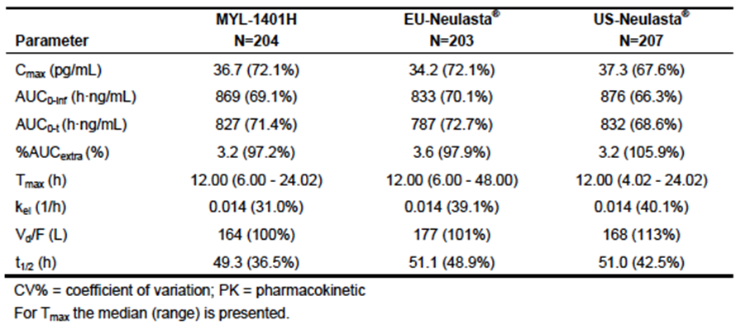

#### Evaluator’s conclusions on pharmacokinetics

The study presented used a single dose, 3 way crossover design to provide data in support of the similarity between the EU and US Neulasta products and the proposed biosimilar product MYL-1401H. Differences in PK, and to a lesser extent, PD emerged and there was substantial inter-individual variability. Key issues requiring clarification[12] are:

1. The source of the reference product for Neulasta in Australia and comparability with the reference products used here has not been described.
2. The apparent replacement of subjects who did not complete the study.
3. Blinding of the study to local site participants.
4. Explanation of how the general linear model (GLM) ANOVA managed the significant variability in the PK and PD measurements.
5. Whether there has been any characterisation of a dose-response relationship and the PK and PD endpoints explored for MYL-1401H, particularly given the increase in exposure with anti-drug antibodies (ADAs).

The sponsor’s responses to the clinical questions relating to these issues are awaited. The safety data are summarised in the Clinical Safety section below. Given these were healthy subjects administered only 1/3 of the proposed usage, a brief summary of the safety data are included in the Clinical Safety section, with an emphasis on the identification of any new safety signals.

### Pharmacodynamics

#### Studies providing pharmacodynamic data

These were discussed within the evaluation of the individual study reports due to the different populations, and doses used.

### Dosage selection for the pivotal studies

Not applicable.

### Efficacy

#### Studies providing efficacy data

Efficacy data for the proposed usage are reliant upon a single Phase III study, Study MYL‑1401H-3001.

Study MYL-1401H-3001 was stated to be a multicentre, randomised, double blind, parallel group study with 2 treatment groups designed to evaluate the efficacy and safety of MYL‑1401H versus EU Neulasta (reference product) in patients with newly diagnosed Stage II/III breast cancer receiving up to 6 cycles of adjuvant or neoadjuvant TAC chemotherapy (docetaxel, cyclophosphamide, doxorubicin). The aim of this study is to demonstrate similarity between MYL-1401H and EU Neulasta.

#### Evaluator’s conclusions on efficacy

The EMA Guidelines indicate that the main emphasis for demonstrating similarity with the reference product should come from Cycle 1 prevention of neutropenia. In Cycle 1 and overall in the study, patients receiving MYL-1401H experienced a higher rate of Grade 3/4 neutropenia, and a higher rate of severe neutropenia. More patients receiving MYL-1401H developed febrile neutropenia during the course of the study (7 patients; 5.5% versus 1 patient, 1.5%) and while there were no ‘documented’ events of neutropenic sepsis, appropriate information regarding investigations and outcomes of infection is lacking in the narratives provided. Events of neutropenic fever and sepsis in the MYL-1401H arm maybe underestimated with one patient receiving intravenous corticosteroids (and documented use of other corticosteroids in other patients likely to mask a fever) and the use of oral antibiotics in another neutropenic patient.

The median nadir, and median time to recovery (defined as ≥ Grade 1 neutropenia) were longer in the MYL-1401H arm. The sponsor has presented a statistical analysis of the duration of severe neutropenia to demonstrate there is no apparent statistically significant difference between the two groups. In the Clinical Overview, the sponsor appears to concede that the prespecified margin of + 1 day to demonstrate similarity for this analysis may be too lenient and that +/- 0.5 days may be more appropriate. A sensitivity analysis using the +/- 0.5 day margin has been requested.

Dose delays and dose reductions occurred more commonly in the MYL-1401H arm than the EU Neulasta arm. In addition to hospitalisation and the immediate risks associated with events of febrile neutropenia and potentially neutropenic sepsis, the ensuing dose reductions and loss of treatment intensity potentially compromise efficacy of the chemotherapy.

Thus, results from other secondary endpoints do not support demonstration of similarity in the most relevant clinical outcomes for these patients, particularly when these are considered over the course of the clinical trial: rates of neutropenia, febrile neutropenia, and resulting delays and dose reductions were all increased in those patients receiving MYL-1401H.

This study had some methodological issues, with unblinding of local site staff, as well as quality issues regarding information collection and reporting relating to the episodes of febrile neutropenia, a key endpoint and adverse event in the context of the trial aims.

### Safety

#### Studies providing safety data

##### Study MYL-1401H-3001

The clinical study protocol specifies the following safety assessments:

* Incidence, nature, and severity of adverse events (AEs) including adverse drug reactions (ADRs)
* Incidence, severity, and distribution of bone pain by brief pain inventory (BPI) form (Short Form) in Cycle 1 and Cycle 2 only
* Incidence, severity, and distribution of infections
* Injection site tolerance
* Incidence, titre, and neutralizing capacity of antibodies against MYL-1401H and Neulasta (Cycle 2 through Cycle 6) as per the statistical analysis plan (SAP).

The CSR states, ‘Version 3.0 of the SAP (dated 25 September 2015) included information on additional immunogenicity assessments to be performed in anticipation of a protocol change. However, due to operational reasons, the protocol change was not initiated and consequently, the additional immunogenicity assessments were not performed. Only baseline immunogenicity assessments were performed.’ The impact of this is uncertain but it is noted that the time points for reporting ADAs differs from those in Study 1002 and this limits comparability between the two studies.

#### Patient exposure

127 patients with breast cancer received at least one 6 mg dose of MYL-1401H, 67 received EU Neulasta. 120 patients (94.5%) in the MYL-1401H group and 66 patients (98.5%) in the EU Neulasta group received all 6 doses.

#### Evaluator’s conclusions on safety from Study MYL-1401H-3001

Treatment-emergent adverse events (TEAEs) were similar in number and distribution across the arms. Taking into account, the high background rate most likely to be attributable to the chemotherapy, the main events considered treatment related appeared to be consistent with the known side effect profile of GSCF products. Musculoskeletal TEAEs were common and a comparison of bone pain; a very significantly morbid AE for patients receiving G-CSF appeared similar between the arms.

Discontinuations were higher in the MYL-1401H arm (4 due to TEAEs of erysipelas; an SAE requiring hospitalisation and antibiotics, venous thrombosis, deranged LFTs and pneumonitis compared with one in the Neulasta arm who discontinued treatment due to Grade 3 elevation in ALT. Additional information has been requested to evaluate this further.

6 out of 7 episodes of febrile neutropenia were reported as SAEs.

Evaluation of clinical laboratory results and vital signs requires integration and could not be evaluated in its present form.

Anti-drug antibodies (ADA) were assessed and reported as low, with no neutralising antibodies detected in the MYL-1401H arm but a number of questions have arisen during the evaluation. As well as a different population and different Neulasta product being used, the difference in the time points for sampling compared with Study 1002 make comparisons of findings difficult. In addition, while baseline antibodies were detected using the screening methods, these were no longer detected after receiving chemotherapy. In addition, a planned change to the protocol investigating ADAs was not implemented and the reasons for the planned change have not been presented.

Local injection site reactions were not commonly reported for either PEG-G-CSF.

The sponsor has also been requested to confirm that all safety data has been submitted for evaluation with this dossier as the Clinical Overview suggested data from Study 3001 had not been presented.

##### Study MYL-1401H-1001

Study MYL-1401H-1001 was a 3 way cross over design trial of MYL-1401H, US Neulasta and EU Neulasta which provides limited safety data from a single cycle of exposure of a subtherapeutic dose (2 mg) in healthy volunteers. Safety data has been reviewed for signals only. Although nominated as belonging to particular group (as per the PEG-G-CSF first administered) when discussed, subjects who completed the study would have received all 3 PEG-G-CSF products. Thus, this study does not discriminate between the individual products and AEs attributable to each.

170 healthy male and 46 healthy female subjects had a total of 3 doses of PEG-G-CSF, each a single dose of 2 mg subcutaneous MYL-1401H, EU or US Neulasta. All subjects were enrolled in 1 site in the Netherlands and were randomly assigned to 1 of 6 treatment sequences as previously described.

TEAEs were of a similar frequency and grade across the groups. The most common treatment related adverse events by preferred term were back pain (81%), headache (63%), extremity pain (36%) and nasopharyngitis (22%). Most treatment related adverse events were Grade 1; MYL-1401H n = 158 out of 207 (76%), EU Neulasta n = 172 out of 208 (83%) and US Neulasta n = 166 out of 207 (80%).

###### Immunogenicity

This study used a subtherapeutic 2 mg dose in a crossover manner with limited sampling time points for assessing immunogenicity. Nonetheless, immunogenicity data were collected. 4 subjects were noted to be ADA positive with at least one time point with an ADA titre that was greater than 30. One subject had an increase in ADA titre (1006) coincide with a decrease in pharmacodynamics response in Period 2 but the ADA titres subsequently dropped.

7% of samples were confirmed ADA positive at baseline (16 of 216). Of these 9 (4%) were in the MYL-1401H group, 4 (2%) in the EU Neulasta and 3 (1%) in the US. All of these titres were under 30 with no increase in ADA titres post therapy. 17 (8%) developed ADA after the first drug dose. 5 were in the MYL-1401H group, 5 in the EU Neulasta and 7 in the US Neulasta. This was thought to be treatment induced but noted to be similar across all three drugs.

The differing time points, for measuring the ADAs are noted. In Study 3001, the time point was at the end of the 21 day cycle of treatment in Cycles 2, 4, and 6.

##### Study MYL-1401H-1002

Study MYL-1401H-1002; a safety study that assessed safety as the sole primary outcome.

This was a single centre, randomised, open label, 2 dose, parallel trial to evaluate immunogenicity, pharmacodynamics (PD), safety, and tolerability of the test product, MYL-1401H, compared with the reference product, US licensed Neulasta (pegfilgrastim), in 50 healthy subjects.

The target population is those with cancer and therefore, immunogenicity in that population is the relevant outcome. The use of just 2 doses 4 weeks apart does not reflect the proposed usage, where G-CSF is used to support continued treatment for many cycles of chemotherapy, often given at 2 to 3 week intervals. Thus, while perhaps testing immunogenicity in an otherwise healthy population with an intact immune system might be more sensitive, the duration of therapy is inadequate to determine and inform whether repeat exposure results in a change in immunogenicity and potentially, safety and efficacy, over time.

###### Evaluator’s conclusions

This small study was designed to provide descriptive statistics for safety largely centred on immunogenicity. This is the only study using therapeutic doses in adult healthy volunteers, and supplements what was learnt in Study 1001. Quality issues in the design limit how well this has been demonstrated. The trial design does not fully address some elements of the guidance documents from the EMA and FDA for the testing of immunogenicity. In particular, the times selected for measuring the antibody response and ANC (the key efficacy outcome for this product) are not ideal and would be unlikely to detect a negative effect of any antibodies on efficacy. The measurement of the antibodies in this study should ideally have been blinded but this would appear unlikely with the study design.

The use of healthy volunteers might have provided some benefits in detecting antibodies in those without any concomitant medications, but 2 cycles are perhaps not enough to demonstrate the safety and immunogenicity of a longer usage anticipated with chemotherapy. The chemotherapy regimens used to treat solid tumours have a limited effect on humoral immunity and thus antibody detection would still have been possible in patients undergoing chemotherapy. The choice of VAS and injection site reactions as the main way of testing local reactions would have been unaffected but there would have been background AEs from chemotherapy that would make other more subtle AEs difficult to detect.

Sources of bias within the study include the open label design, with only one principle investigator and one study centre (the same as for Study 1001), and no apparent blinding of the samples for antibody analysis. Concealment of allocation and blinding of samples are not discussed. Reporting, attributions of adverse events and relationship to study drug are all at the discretion and judgment of the sole principle investigator and collated in the CSR without apparent review. Concerns that recruitment of reserve patients to act as ‘replacements’ would result in potential selection bias were addressed in the response to questions; although there was provision for their inclusion, no such patients were required.

The validity of the assays used needs to be evaluated and accepted by the TGA. There appeared to be quite substantial discordance, particularly between the screening ADA detection and subsequent antibody assays and reasons for this are not discussed. Between the two PEG-G-CSF products, differences in positivity of ADA over time indicate some immunogenic differences. The CSR addendum data provided for the detection of ADA between the two arms consistently showed greater numbers of patients with ADA detected in the MYL-1401H arm at every time point except one. Antibody persisted in twice as many patients in the MYL-1401H arm as the Neulasta arm. And the rates of local injection site reactions, albeit very mild, were increased in frequency and duration of symptoms consistently in the investigational product arm. This may be linked to the higher ADA formation rate but this was not discussed. No paediatric studies have been presented but this increase in injection site pain may be an issue for children (encompassed in the indication for the reference product) and adults with a needle phobia, especially as it is common to be required to self-administer at home the day after inpatient chemotherapy.

It is also noted that in Study 1001, the PK of Cmax and exposure were different in those with ADA detected, such that those measurements were no longer within the predefined boundaries of 0.8 to 1.25 required to demonstrate similarity. This key issue has not been explored in this study satisfactorily, especially given it was designed to explore the impact of immunogenicity. Study 1002 may have been designed and conducted prior to knowledge of the outcomes of Study 1001.

Two patients, one in each arm, had neutralising antibodies (Nab) detected, but both were withdrawn due to AEs after the first treatment and the effect on efficacy of neutralising antibodies (Nabs) remains unknown. One patient in the MYL-1401H arm had a substantial decrease in response as measured by ANC in the second treatment period despite similar concentration measurements between the periods, and this remains unexplained. In the remainder of the study population the magnitude of response was consistent, that is, intra-individual variability was small, making this one case all the more uncertain. The sample size and treatment duration limit the ability to understand this further, but such apparent decrease of ANC response as a surrogate marker of efficacy is of concern.

In this safety study, no new safety signals emerged, but the small size of the population would render this very unlikely. Attribution of the AEs to study drug cannot be evaluated, as the information is not provided other than as a summary of the events attributed by the principle investigator. The study was not designed to permit a comparison of the AEs and the choice of measurement of some endpoints such as the clinical assessment of the spleen rendered that endpoint of no value.

### First round benefit-risk assessment

#### First round assessment of benefits

No significant differences between MYL-1401H compared with EU Neulasta or US Neulasta have been identified. No formal statement about the source of the Neulasta supplied in Australia was included to determine if the current studies are sufficient to meet the TGA’s requirements to establish biosimilarity.[13]

#### First round assessment of risks

In Study 3001, compared with those receiving EU Neulasta, patients receiving MYL-1401H experienced:

* higher rates of Grade 3 and 4 neutropenia during Cycle 1, and overall;
* higher rates of severe (Grade 4) neutropenia during Cycle 2, and overall;
* lower median neutrophil counts at the ANC nadir;
* a slower median recovery time to ANC ≥ 1.5 x 109/L;
* more dose reductions and delays in treatment due to events related to febrile neutropenia (FN) and neutropenia;
* increased events of febrile neutropenia during Cycle 1 (5 events versus 1 event) and during the study period of 6 cycles (7 events versus 1 event).

##### Antibody formation

Antibody formation was noted in both Study 1001, and in Study 1002 specifically designed to investigate immunogenicity. In the latter, ADAs occurred more frequently and were more persistent than for US Neulasta. Neutralising antibodies were noted at baseline in the MYL-1401H arm and one patient in the US Neulasta arm developed neutralizing antibodies but both were withdrawn due to AEs and the effect of repeat dosing on safety and efficacy remains unknown. In Study 1002, there was a decline in ANC response in a patient receiving MYL-1401H that requires an explanation.

##### Injection site reactions

In healthy volunteers, there was an increase in the frequency, degree and duration of injection site reactions with MYL-1401H compared with EU and US Neulasta in Study 1001, and with US Neulasta in Study 1002. This was reported as significant for 1 patient in Study 1001, and overall appeared to be mild in Study 1002. Although not noted in Study 3001, the patient population in this last study was different and for children or those with a needle phobia, who are likely to be required to self-administer (or have a caregiver administer) the day after chemotherapy, this difference may be important.

##### Uncertainties

1. The source of Neulasta for Australia was not presented and therefore the reference product for establishing biosimilarity in Australia has not been identified and the suitability of the study designs and products used discussed.
2. The evaluator cannot establish if the absence of ‘documented infection’ during episodes of febrile neutropenia is due to be an issue of information capture rather than absence of infection as the narratives provided for 6 out of 7 patients with febrile neutropenia state that information about investigations undertaken to determine whether there was an infection or the outcomes of those investigations was not available. A narrative for the seventh patient presented as having febrile neutropenia has been requested, as this could not be located.
3. There has been no characterisation presented of the dose relationship of pharmacokinetic factors such as Cmax, AUC and pharmacodynamics endpoints such as ANC. Note is made that such a study has been submitted for G-CSF biosimilars. (FDA briefing document for Oncology Drug Advisory Committee).
4. The presence of ADA was associated with PK parameters of AUC0-infinity and Cmax no longer falling within the prespecified range for biosimilarity with the EU Neulasta. While potentially a chance finding, the impact of this on the safety and efficacy of MYL-1401H cannot be evaluated in the absence of data demonstrating comparability of safety and efficacy over a wide range of doses and exposures with the appropriate reference product.
5. No comparison in a dedicated immunogenicity study was undertaken with EU Neulasta. The importance of this in part depends on the reference product established for Australia. Differences between the apparent immunogenicity of US Neulasta and MYL-1401H were noted at the end of Study 1002.
6. Higher rates of ADA formation were reported in Study 1002 (the dedicated immunogenicity study) in patients receiving MYL-1401H compared with US Neulasta. There was a higher number of ADAs at the end of the study still present at follow-up, but the long-term effect is not known.
7. The effects of repeat dosing on safety and efficacy for the neutralising antibodies that developed against the US Neulasta product and were pre-existing to MYL‑1401H were not investigated due to withdrawal of the healthy volunteers prior to the second scheduled dose. Thus the effect remains unknown of the antibodies, as well as the effect of repeat dosing on titres of such antibodies.
8. Low levels of anti-drug antibodies were reported in Study 3001 but the sampling times were different and a planned change to the protocol was not implemented. It is not clear if data from all sampling times have been presented and there are questions asked pertaining to the apparent disappearance of the background antibodies at the first time point measurement presented after commencing chemotherapy (end of Cycle 2).
9. No justification was included for not including a paediatric study. The tolerability of this product remains unknown in this population, in addition to the safety and efficacy.

#### First round assessment of benefit-risk balance

Results from the Phase III randomised trial in patients receiving chemotherapy for the treatment of Stage II or III breast cancer indicate a relative lack of efficacy in the MYL‑1401H arm with higher rates of Grade 3 and 4 neutropenia, and in particular higher rates of severe (Grade 4) neutroapenia and a slower time to recovery of the absolute neutrophil count. The statistical analysis of the duration of severe neutropenia was reported to show no statistically significant difference between MYL-1401H and EU Neulasta. However, the clinical significance of the observed differences in severity, and slower recovery time is compelling: there was a higher rate of febrile neutropenia and inadequate documentation regarding infection in these patients and use of antibiotics during another neutropenic episode precludes satisfactory exclusion of neutropenic sepsis, a life-threatening infection and consequence of severe neutropenia. Dose delays and reductions were more common with MYL-1401H treatment compared with EU Neulasta as a result of the neutropenia and febrile neutropenia.

Taken together, these differences in severe neutropenia indicate a higher risk of development of neutropenic fever and likelihood of neutropenic sepsis, with its immediate risk of harm, requirement for hospitalisation and also the risk of delays and dose reductions on longer-term efficacy of the chemotherapy regimen.

The pharmacokinetics and pharmacodynamics of MYL-1401H have not been fully or adequately characterised over a range of doses, and in the presence of anti-drug antibodies, the PK parameters were no longer in the pre-specified range of similarity for EU Neulasta.

There is considerable uncertainty as to whether MYL-1401H has similar efficacy to EU Neulasta, and it appeared to have a slightly worse tolerability profile in healthy volunteers.

### First round recommendation regarding authorisation

The indication for Neulasta in Australia, and proposed for MYL-1401H is:

‘*for the treatment of cancer patients following chemotherapy, to decrease the duration of severe neutropenia and so reduce the incidence of infections, as manifested by febrile neutropenia*.’

The observed increased rates of severe neutropenia, the lower median ANC at nadir, and increased rates of febrile neutropenia and possibly neutropenic sepsis (exclusion of neutropenic sepsis has not been adequately addressed at this time) with MYL-1401H do not support registration for this indication. Underpinning the use of PEG-G-CSF and implicit in this indication is the ability to maintain dose levels and intensity, particularly important in the curative, adjuvant and neoadjuvant settings; more treatment delays and dose reductions attributable to neutropenia and febrile neutropenia occurred when MYL‑1401H was used compared with EU Neulasta.

There are numerous clinical questions that arose during the course of the evaluation but the clinical evaluator does not consider that the responses to these will address the concerns raised by the higher rates of severe neutropenia, febrile neutropenia and dose reductions and delays observed in the single Phase III trial presented. Inadequate PK and PD characterisation over a range of doses also adds to these concerns, together with uncertainties regarding the immunogenicity and tolerability of this product when variously compared with EU or US Neulasta.

No source of the Neulasta used in Australia has been provided or site of manufacture, and the studies submitted for assessment of physico-chemical properties only examine MYL‑1401H and products sourced in Australia or New Zealand; they do not include any comparisons between the EU Neulasta and US Neulasta. Whether there has been adequate bridging between the products in the studies and the Neulasta available in Australia has not been demonstrated.

Authorisation of MYL-1401H is not recommended based on the studies and data presented.

### Clinical questions and second round evaluation

The clinical questions raised are presented in bold italicised text and the evaluation of the sponsor’s response is presented below each question.

1. ***The source and manufacturing site for the reference Neulasta product currently supplied in Australia has not been identified by the sponsor. Please provide this information and a justification for use of the EU Neulasta as a reference product for two of the three studies and also the use of US Neulasta for the third study. This information was not included in the minutes from the presubmission meeting.***[14]

*Sponsor’s response:*

[Information redacted]

*Evaluator comment:*

This requires acceptance of the similarity between the EU Neulasta and Australian Neulasta, which has not been directly compared in the bridging studies.

1. ***Please provide a justification as to why no paediatric study has been presented.***

*Sponsor’s response:*

[Information redacted]

*Evaluator comment:*

The sponsor is reliant upon extrapolation from the PK studies conducted in healthy volunteers and adult breast cancer patients, to support approval in the paediatric population. Given the concerns and uncertainties about the effects of ADAs potentially increasing MYL-1401H PK parameters beyond the 0.8 to 1.25 similarity range, and absence of any studies of PK parameters over a range of doses, together with the increased rate of febrile neutropenia observed in the breast cancer patients, extrapolation to the paediatric population is not supported.

1. ***The sponsor is requested to clarify any differences between the datasets provided to the TGA and the US FDA, and include an explanation for any differences.***

*Sponsor’s response:*

[Information redacted]

*Evaluator comment:*

The sponsor is thanked for the clarification.

1. ***Note is made that there were 3 German study sites planned but only listed in none appeared to enrol patients (1 screen failure noted as the only patient). Poland is included in the list of Ethics Boards to which this application was submitted, and 3 sites appear to have opened but not recruited. The sponsor is requested to explain the lack of enrolment. The only sites are from Eastern Europe and the sponsor is requested to explain why no US sites or Western European sites participated as planned. In particular, was there an issue with the product (safety or efficacy or quality) or protocol or other issue that precluded this trial being opened in those other countries?***

*Sponsor’s response:*

[Information redacted]

*Evaluator comment:*

The explanation is satisfactory.

1. ***The sponsor states the batch number for each product in the table above with reference to the Appendix 16.1.1 as the source document. The hyperlink links to the Protocol and Protocol amendments which contain no information about the product and batches when searching using the term ‘batch’.product from specific batches. Furthermore, Module 5 contains a pdf listing of the subjects receiving test drug/investigational and the batch numbers do not match those specified as being used in the table above (for either Neulasta MYL-1410H). The sponsor is requested to explain this discrepancy and summarise the number of batches for each product actually used.***

*Sponsor’s response:*

[Information redacted]

*Evaluator comment:*

It is noted that the MYL-1401H has a production date of October 2014 and yet a much earlier ‘re-test’ date compared with the stated expiry date for the Neulasta product (18 months versus 3 years). The biological medicines evaluator may wish to comment on the requirement for an apparently much earlier ‘re-test’ and whether this reflects concerns about stability or other quality issues for MYL-1401H.

Two different batches of Neulasta were used, and one batch of MYL-1401H in Study 3001.

1. ***The sponsor is requested to state whether all health care professionals were blinded to treatment allocation and whether indistinguishable products (apart from appropriate de-identification coding) were provided by the sponsor to each study site. IT is noted that the pharmacists preparing and those administering the respective study drugs were not blinded in the Phase III study, despite that study being described as double blind.***

*Sponsor’s response:*

[Information redacted]

*Evaluator comments:*

The explanation clarifies that the risk of unblinding of local health care professionals is small, and that the analyses were carried out by a central laboratory for PK and PD assessments.

1. ***The sponsor is requested to comment on why there was a limitation in the Inclusion Criteria about extent of smoking in terms of any implications for smokers using this product if it is registered. The sponsor is also requested to comment on compliance with the requirement to abstain from for a period and limit smoking.***

*Sponsor’s response:*

[Information redacted]

*Evaluator comment:*

The response and explanation are satisfactory.

1. ***The sponsor is requested to explain the use of replacement patients in Studies 1001 and 1002, given the design incorporated sufficient patients to allow of dropouts and discontinuations. This would appear to be a significant potential source of bias, especially in an open label study (for example Study 1002).***

*Sponsor’s response:*

[Information redacted]

*Evaluator comment:*

Given there were no replacements, there is no issue of selection bias.

1. ***There is quite striking inter-individual variability in terms of both the Cmax and the time to maximum concentration (Tmax) (see Figure 2). These data were presented as a series of graphs for each individual or by descriptive data for individuals. The sponsor is requested to present the PK results for each PEG-G-CSF product in a table, including the median with interquartile ranges, mean with standard deviation of the PK results for each PEG-G-CSF product to allow comparison between the results. It would also be useful to include measures of intra- and inter-individual variability.***

Figure 2: Sample of individual PEG-GCSF serum concentration-time profiles (linear and semi-logarithmic)

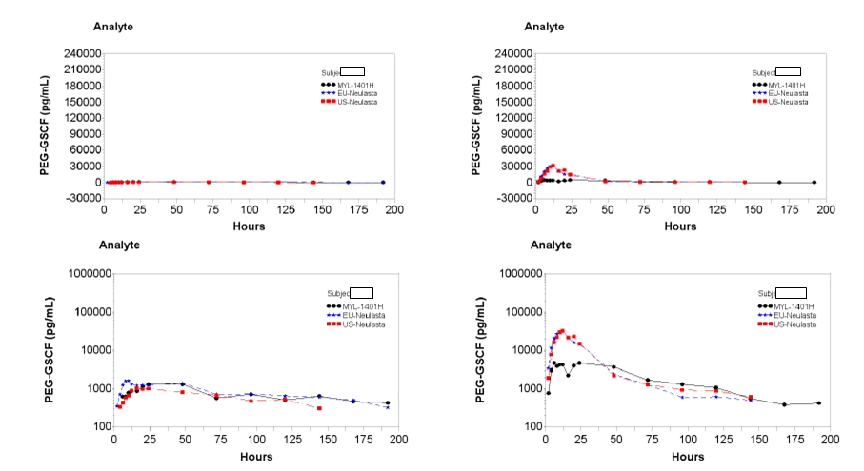

*Sponsor’s response:*

[Information redacted]

*Evaluator comment:*

The mean and median values for exposure were similar across the 3 products but the minimum and maximum values for exposure were higher in the MYL1401H arm than for either the EU Neulasta (approximately + 74 % for the minimum value and + 8.3% for the maximum value) or US Neulasta (approximately 2 fold for the minimum exposure and + 28.1% for the maximum value).

This suggests some marked intra-individual PK characteristics across the 3 products, with exposure substantially higher for some individuals when receiving MYL-1401H compared with EU or US Neulasta. Given this was only a 2 mg dose being administered, and the proposed dose is 6 mg, and there is no dose ranging study included in the dossier, there is uncertainty as to whether there is a linear dose-exposure relationship and whether similarity of PK parameters would be demonstrated at the proposed dose is uncertain. Note is also made of the effect of anti-drug antibodies on the Cmax and AUC0-∞[15] which led to values that exceeded the upper bounds of the proposed confidence intervals compared with EU Neulasta (see Table 5). The reason for this is unclear and the clinical relevance of this is uncertain, but may pose a safety risk and limit the extrapolation to special populations such as children.

Table 5: Summary of statistical analysis for the primary PEG-GCSF PK parameters by ADA status PK analysis set (source Addendum to CSR)

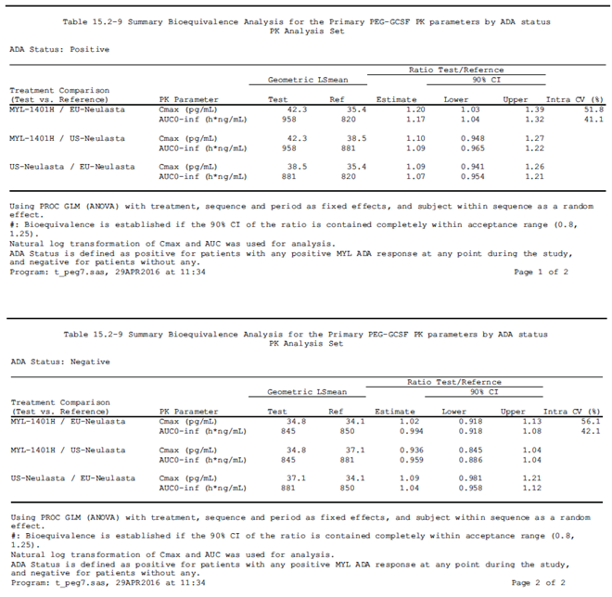

The intra and inter individual variability is quite substantial for each product as can be seen in the table below.

The inter subject and intra subject coefficient of variability (CV%) are model dependent, with the following table shows the variability by individual models per treatment pair and the variability using single model with all 3 treatments respectively.

Table 6: PK parameter analyses Study MYL1401H-1001 (Source: response to question 9)

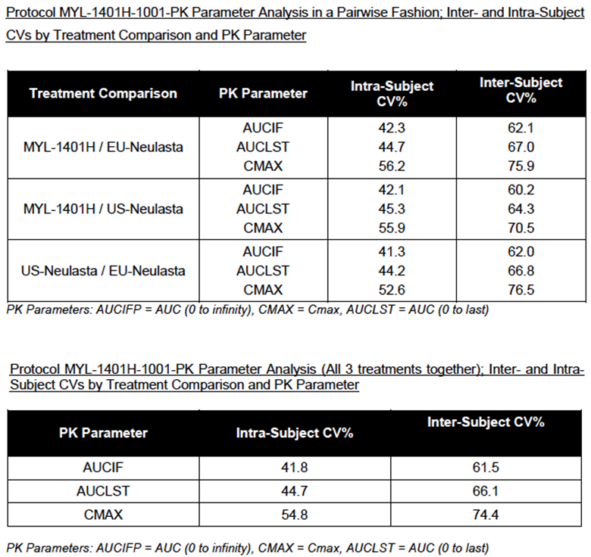

1. ***For Study 1001, the sponsor is requested to state what validation of the assays was undertaken that were used in this additional study given it was designed and included late therefore not in the protocol.***

*Sponsor’s response:*

[Information redacted]

*Evaluator comment:*

It is recommended that the TGA seek the advice of an expert to evaluate these reports to determine the validity of the assays used for ADA and NAb testing.

1. ***In Study 1001, the most informative time period for testing, given the crossover design, is prior to the second test dose when all patients have received just the one type of PEG-G-CSF. It is unclear why the patients with Nab in the treatment emergent ADA population have been subtracted and it appears that the total figure should be the number of patients with NAbs detected at any time less those who entered the study with them that is. a total of 6 patients. The sponsor is requested to comment as this affects the summary reporting data discussed in this document and also presented in the table in the main text.***

*Sponsor’s response:*

[Information redacted]

*Evaluator comment:*

The sponsor is thanked for the clarification.

1. ***In Study 1001, for those who developed antibodies, there is no discussion at to whether this was associated with any local or systemic reactions with ADA or if there was a correlation with loss of efficacy in terms of smaller increases in neutrophil counts with NAbs and the sponsor is requested to comment.***

*Sponsor’s response:*

[Information redacted]

*Evaluator comment:*

The antibodies detected in Subject [information redacted] appear to have affected exposure and the PD response. Note is also made of the reported changes in PK parameters associated with ADAs in Table 5 of the evaluation report, with apparently increased exposure with ADAs for Cmax and AUC0-∞, although the small numbers are noted. Thus, there appears to be a potential to affect both exposure and efficacy with ADAs although this did not occur commonly and was not associated with adverse reactions such as infusion reactions or hypersensitivity.

1. ***The comparison between Tmax for MYL1401H and EU Neulasta showed no difference; the sponsor is requested to clarify how the ‘test minus reference’ estimate is zero when there is a 2 fold difference between the measured median Tmax for EU Neulasta and US Neulasta.***

*Sponsor’s response:*

[Information redacted]

*Evaluator comment:*

This response and explanation are accepted.

1. ***Thrombocytosis AEs were noted to be reported more commonly in Study 3001, and the sponsor is requested to present the median and range of platelet measurements for each arm for Study 1001 after the first treatment in order to isolate the effect of MYL-1401H.***

*Sponsor’s response:*

[Information redacted]

*Evaluator comment:*

There does not appear to be a clinically relevant change in platelet counts with MYL-1401H compared with EU Neulasta in Study 3001, or in comparison with EU and US Neulasta in Study 1001 (noting the smaller dose used in Study 1001).

1. ***Study 1002. This was an open label study and no detail is provided by the Study Protocol regarding blinded analysis of the samples. The sponsor is requested to clarify whether samples were blinded, given the sole investigator was not.***

*Sponsor’s response:*

[Information redacted]

*Evaluator comment:*

The sponsor has indicated that the laboratory was blinded to allocation when undertaking the antibody assays.

The following are stated to be the objectives of the trial as taken from the CSR:

Objectives:

* Primary: To descriptively compare immunogenicity between two SC injections of MYL‑1401H and US Neulasta
* Secondary: To evaluate the safety and tolerability of MYL-1401H and US Neulasta after two injections (6 mg) in healthy volunteers

The secondary objectives are assessed clinically and in this trial, there was just a single investigator who would be at risk of being influenced by the knowledge of which treatment patients received. It should have been relatively easy to have site health care professionals blinded to treatment allocation, and failure to do this is a significant deficiency in the study design and conduct. These issues are potentially compounded by there just being a single investigator at a single site. The sponsor’s response and rationale are not accepted, and the evaluator considers this should have been a blinded study.

1. ***It is noted in FDA ODAC Brief for a G-CSF biosimilar, that ADA false positive rates should be approximately 5% to minimise the false negative rate. Discordant ADA results were prominent in Study 1002, particularly between the screening result and subsequent ADA assays (see Subjects [information redacted] Table 7). Not all detected antibodies cross-reacted with the other PEG-G-CSF tested but these results were variable over time for example Subject [information redacted] (see below) from the MYL-1401H group (Listing of ADA assays 16.2.5.4). This requires confirmation of the reliability of the screening assay with presentation of the false positive rate for the assay used at screening as determined by subsequent determination of ADA to MYL-1401H and Neulasta antibodies using more specific tests. Validation of those tests is also required.***

Table 7: Listing of ADA, PEG-GSCF concentration and ANC - Subject [information redacted]

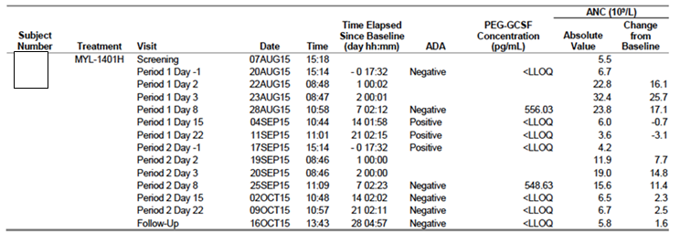

*Sponsor’s response:*

[Information redacted]

*Evaluator comment:*

The sponsor’s response indicates the assays and approach employed for screening and confirming the presence of anti-drug antibodies against MYL-1401H and Neulasta in the MYL-1401H-1002 study samples were adequate. The explanation regarding the reasons for discordance between ADAs to Neulasta and MYL-1401H is accepted, as it indicates that this occurred where the signal levels for detection of the ADA at screening were low, and the inhibitory activity close to the confirmatory cut-point.

1. ***From Study 3001, the sponsor is requested to provide the narrative for the patient given Solumedrol for thrombocytopenia and whether this event was thought to have any relation to the study drug. This therapy would also be likely to mask development of a fever as well as increase circulating neutrophil counts. The routine use of dexamethasone for 3 days, starting the day prior to and finishing the day after chemotherapy was allowed and should be given to all to reduce the risk of an allergic reaction to docetaxel; and are often continued for 2-3 days beyond this for a moderately emetogenic chemotherapy regimen, such as this. Dexamethasone has a long half-life and therefore its pharmacodynamic effects would last for some time following discontinuation. In light of this protocol deviation requiring the patient to be withdrawn from the study, the sponsor is requested to comment on:***
   1. ***a potential effect of this on the immunogenicity of the administered PEG-G-CSF and generalizability therefore to less emetogenic regimens or those without taxanes.***
   2. ***The usage of the following corticosteroids (Table 8 (Source Table 11.3, CSR)), other than dexamethasone which was permitted, and why these too, were not regarded as major protocol deviations. The higher usage in the MYL-1401H arm would favour a reduction in development of fever and raise blood ANC results in that arm – both endpoints in the study (Clinical Question)***

Table 8: Source Table 11.3, CSR

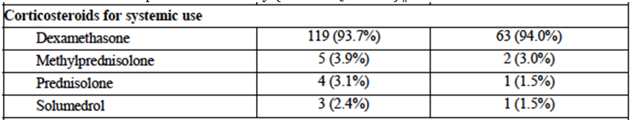

*Sponsor’s response:*

Part a [Information redacted]

*Evaluator comment:*

There are difficulties in determining immunogenicity in the cancer populations. However, the relatively infrequent assessment for immunogenicity once per cycle just prior to the next dose, when samples were otherwise being taken for haematology assessments at earlier time points in each cycle means the data available are limited for the key Phase III study. This would not have been an imposition on patients as samples were already being taken, and such timing would not have detected many healthy subjects in Study 1002 who were identified as ADA-positive at different times after treatment (see Table 7 and Table 9).

Table 9: Listing of ADA antibodies (ADA) Assays - Safety population, Subjects [information redacted] (Source 16.2.5.4)

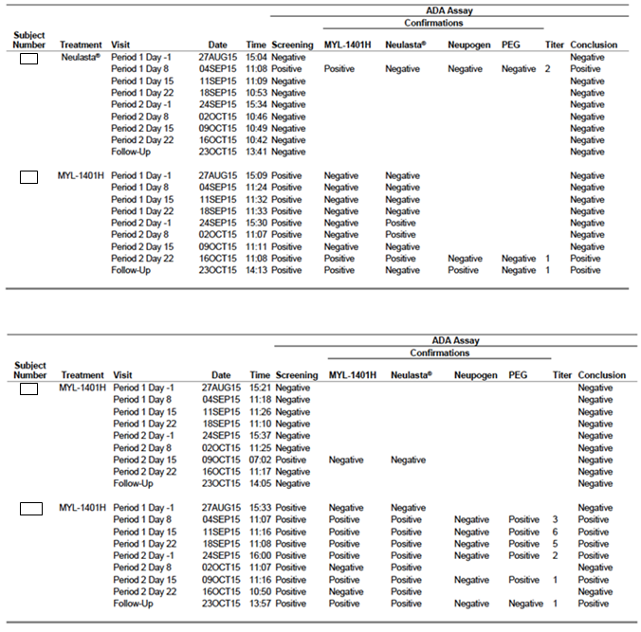

*Sponsor’s response:*

Part b. [Information redacted]

*Evaluator comment:*

This response is accepted.

1. ***The sponsor is requested to provide a sensitivity analysis removing those patients identified above as having protocol deviations that might affect ANC, and also another analysis, removing all patients for whom there was documented used of any corticosteroid usage other than dexamethasone during Cycle 1. (Clinical Question)***

*Sponsor’s response:*

Part 1. [Information redacted]

*Evaluator comment:*

With clarification of the nature of the protocol deviation, the evaluator agrees this patient should not be censored from the PP population.

*Sponsor’s response:*

Part 2. [Information redacted]

*Evaluator comment:*

The antibiotics received will not affect the ANC directly, but will reduce the chance substantially of an event of infection which would be anticipated to reduce the ANC further, and also of febrile neutropenia, which was measured as a key secondary endpoint variable (and forms the basis of the description of benefit in the proposed indication). Exclusion of this single patient from analyses involving the primary endpoint will not detect an effect of this protocol deviation on the primary efficacy analyses endpoint.

*Sponsor’s response:*

Part 3. [Information redacted]

*Evaluator comment:*

The half-life of methylprednisolone is stated to be 12 to 36 hours in the Solumedrol PI, which is not substantially different from that of dexamethasone. Therefore, there would be no anticipated difference in effect on ANC due to these treatments compared with the standard premedication regimen, unless repeat doses were administered; the only patient where this appeared to have occurred was appropriately censored from the PP population. Thus, any minor differences in the primary efficacy analyses when these patients, too, were censored from analyses of the primary endpoint are unlikely to be attributable to the use of these corticosteroids.

The results for the primary endpoint were given below in Table 10.

Table 10: Duration of severe neutropaenia in cycle 1 of Study MYL-1401H-3001. Primary efficacy analysis and sensitivity analysis I and II

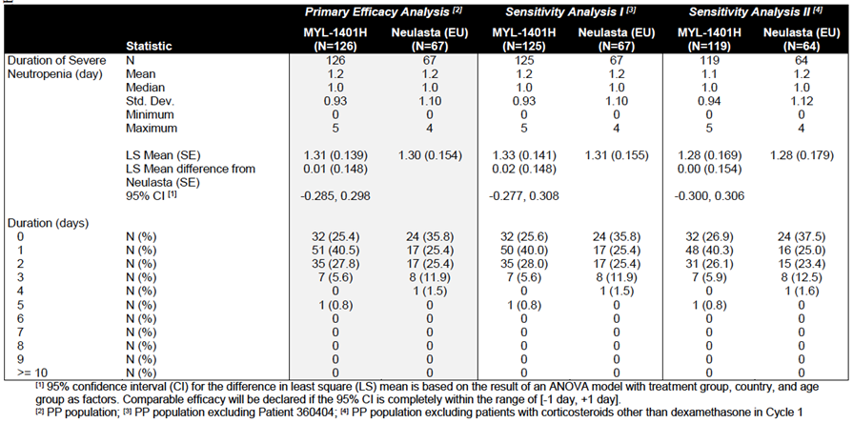

1. ***The sponsor is requested to present a demonstration of the whether the data are normally distributed or any log transformation required prior to conducting the primary endpoint efficacy analysis.***

*Sponsor’s response:*

[Information redacted]

*Evaluator comment:*

The TGA is recommended to seek the advice of an expert biostatistician to evaluate this response and the statistical approach adopted.

1. ***The sponsor is requested to provide a sensitivity analysis for the primary endpoint, duration of severe neutropenia, of the 95% confidence interval (CI) for difference in least squares (LS) Mean DSN of MYL-1401H and EU Neulasta using a range of +/- 0.5 days.***

*Sponsor’s response:*

[Information redacted]

*Evaluator comments:*

The sponsor has presented the LS mean DSN of MYL-1401H and EU Neulasta, indicating these fell within the range of -0.5/+0.5 day when considered by treatment group only, and also when sensitivity analyses were performed using ANCOVA with treatment group, country and age group as factors, and baseline ANC as a covariate.

It is noted that this analysis was undertaken for Cycle 1 which is consistent with the approach recommended in the EMA Guidelines. However, the clinically relevant endpoint is the number of events of febrile neutropenia which may herald severe infection which is the life-threatening consequence of severe neutropenia and which require emergency treatment and hospitalisation, and often reductions in dose for the remaining cycles of treatment and a loss of treatment intensity. The DSN is the numerical assessment of the laboratory parameter, but the rate of febrile neutropenia and its consequences are the more clinically relevant parameter and forms the basis of the therapeutic claim in the indication.

It is recommended that the TGA seek the advice of an expert biostatistician to evaluate these data which appear to indicate a similar duration of severe neutropenia at Cycle 1.

1. ***The Statistical Analysis Plan stipulates that FN figures will be presented descriptively. The sponsor states that the chi-square test result suggests that the absolute difference was likely due to chance given the small sample size. An alternative possibility is that there is a true difference in FN rates between the two treatment arms, given the higher proportion of Grade 4 neutropenia and slower recovery time in the MYL-1401H group, but that the sample size was too small to detect this true difference. The sponsor is asked to present statistical testing for a significant difference in FN rates during Cycle 1 through 6 on the original febrile neutropenia figures (before elimination based on meeting European Society for Medical Oncology (ESMO) definition took place).***

*Sponsor’s response:*

[Information redacted]

*Evaluator comment:*

The numbers are too small to establish whether there is a statistically significant difference in the rate of episodes of FN.

*Sponsor’s response (continued):*

[Information redacted]

*Evaluator comment:*

As discussed in the body of the report, that there were no ‘documented infections nor sepsis events’ appears to reflect an issue with adequate documentation, and it is not certain that these patients had no events of concurrent neutropenic sepsis. It is unclear what is meant by ‘rescue therapy’ as additional G-CSF administered during the event of FN is known to have no clinical benefit in shortening the duration of neutropenia, or reducing the severity. Therefore, this is not accepted as a means of assessing and downgrading the apparent severity of the event.

*Sponsor’s response (continued):*

[Information redacted]

*Evaluator comments:*

It is not clear how many patients had a second episode of severe neutropenia after the initial episode in Study 3001. Patients receiving chemotherapy in the adjuvant or neoadjuvant setting who have an episode of febrile neutropenia, usually have a dose reduction therefore, it would be expected that there should not be second episodes.

Issues of cross-study comparisons make the discussion of these rates from other studies difficult to interpret, and limits the relevance to the presentation and discussion of the data from Study 3001.

*Sponsor’s response (continued):*

[Information redacted]

*Evaluator comment:*

The study was not designed or powered to demonstrate safety endpoints and therefore cannot address any such imbalances when encountered. However, secondary clinically relevant endpoints should be supportive of the primary efficacy findings, and the difference in rates of FN persists when allowing for the unequal randomisation. FN would have been much more difficult to characterise in subsequent cycles, as it was not required for blood tests to be taken if a patient developed a fever. Given the increased rate in Cycle 1, and additional events in subsequent cycles when none occurred in the reference product arm raises some difficulties in supporting registration for the proposed indication:

*‘Fulphila is indicated for the treatment of cancer patients following chemotherapy, to decrease the duration of severe neutropenia and so reduce the incidence of infections, as manifested by febrile neutropenia.’*

The evaluator notes that TEAEs by SOC and preferred term (PT) across all cycles in the safety population that ‘Infections and Infestations’ were reported in similar proportions of patients for the MYL-1401H arm (8.7%) compared with the EU Neulasta arm (7.5%).

1. ***The sponsor is requested to state whether the administration of empiric antibiotic therapy to the patient receiving MYL-1401H while neutropenic was during Cycle 1.***

*Sponsor’s response:*

[Information redacted]

*Evaluator comment:*

Protocol deviations have prevented the exact nature and severity of these events being captured for both cycles of treatment. It is possible this patient had 2 episodes of severe neutropenia but due to no sample being taken this cannot be confirmed in Cycle 2, and also experienced an episode consistent with FN during the second cycle. The inclusion as FN is appropriate but the severity remains unclear. A previously stated, exclusion of this patient’s outcomes from the primary efficacy analysis of duration of severe neutropenia will not be affected as the ANC was established. Infection would, however, be expected to lower the ANC more and for a greater period of time so use of antibiotics may have limited the severity of assessment for this outcome.

1. ***The sponsor is requested to present the narrative including ANC for the patient in the MYL-1401H arm [Information redacted] who had the SAE of erysipelas requiring hospitalisation for antibiotic therapy – please include the ANC at diagnosis and during treatment.***

*Sponsor’s response:*

[Information redacted]

*Evaluator comment:*

Although not neutropenic at the documented start of the infection, the intervening neutrophil count may have declined but has not been reported. The sponsor has only presented the scheduled ANC values (as presented in Listing 16.2.6.1.1), and those for the other two days when hospitalized should have been available. This limited reporting style for severe infections means the severity of the event (for example classification as febrile neutropenia) cannot be adequately assessed. It is difficult when there is an event of severe infection requiring hospitalization and intravenous antibiotics during chemotherapy; to exclude this as not being treatment related (chemotherapy).

Of note, the following were noted to occur and are likely to lead to an underestimate of the severity of neutropenia and/or a decreased reporting rate for events of FN:

Absence of requirement for reporting, or data collection on febrile episodes as a secondary efficacy endpoint;

The infrequent collection of blood tests from Cycle 2 onwards, including not taking a sample during any such reported febrile events to establish if the patient was also neutropenic;

Collection on Days 8, 11 for Cycle 2 onwards when the nadir would appear to be Day 7 for most patients during Cycle 1 (Listing 16.2.6.1.1) and likely to occur earlier with the cumulative effect of bone marrow toxicity with increasing numbers of cycles of treatment.

1. ***For Cycle 6, ANC data were missing for 15% of patients and the sponsor is requested to present the percentage of missing ANC data in each arm for all patients for all cycles.***

*Sponsor’s response:*

[Information redacted]

*Evaluator comment:*

The evaluator does not consider that imputation for missing values is appropriate for this key PD endpoint, where the dynamic nature is critical to demonstrate efficacy of the study drug. That said, only those occurring within Cycle 1 will affect the primary efficacy analysis, and a review of Listing 16.2.6.1.1 indicates that the patient [information redacted] receiving MYL-1401H in Cycle 1 already had an SAE reported of FN with documented Grade 4 neutropenia the day before, and persisting beyond, the time point of this missing value; Patient [information redacted] receiving Neulasta, is beyond the relevant time point and had recovered from the Grade 4 neutropenia experienced earlier in the cycle.

As previously stated, the measurements taken in Cycles 2 to 8 appear to have been collected after and missed the likely nadir and therefore these missing samples and imputations are less likely to have a significant effect on the results.

1. ***The sponsor is requested to provide the following details for the patients discontinuing chemotherapy in the MYL-1401H arm. In particular, the sponsor is asked to clarify:***
   1. ***If the episode of thrombosis occurred in the MYL-1401H group due to thrombocytosis. The narrative provided does not state this.***
   2. ***As pegfilgrastim can also rarely cause pneumonitis/ARDS - the sponsor is asked to provide more details of the case of pneumonitis and how it was deemed to be chemotherapy-related. The narrative cites docetaxel but no mention is made of a potential causative role for MYL-1401H***
   3. ***If the diarrhoea occurred in the context of neutropenia, in which case neutropenic colitis is a possibility. The narrative does not state the neutrophil count at the time of the patient’s admission.***

*Sponsor’s response:*

Part a. [Information redacted]

*Evaluator comment:*

This is accepted by the evaluator.

*Sponsor’s response:*

*Part b.* [Information redacted]

*Evaluator comment:*

The evaluator is in agreement with the sponsor’s response and conclusions.

*Sponsor’s response:*

Part c. [Information redacted]

*Evaluator comment:*

The patient was not re-challenged with chemotherapy or study drug due to the onset of pneumonitis described above.

1. ***In Module 2, the sponsor states that Cycle 1 safety data has been provided for Study 3001 but data up to Cycle 6 will become available during review of this dossier. The data presented appeared to include safety data from all cycles and the sponsor is asked to confirm whether these safety data are complete. If not, please provide any additional safety data for evaluation (please note – submission of additional efficacy data is not accepted, outside of that specifically requested in the clinical questions).***

*Sponsor’s response:*

[Information redacted]

*Evaluator comment:*

The sponsor is thanked for the clarification.

### Second round benefit-risk assessment

#### Second round conclusions

##### Efficacy

The EMA Guidelines indicate that the main emphasis for demonstrating similarity with the reference product should come from Cycle 1 prevention of neutropenia. In Cycle 1 and overall in the study, patients receiving MYL-1401H experienced a higher rate of Grade 3/4 neutropenia, and a higher rate of severe neutropenia. More patients receiving MYL-1401H developed febrile neutropenia during the course of the study (7 patients; 5.5% versus 1 patient, 1.5%) and while there were no ‘documented’ events of neutropenic sepsis, appropriate information regarding investigations and outcomes of infection is lacking in the narratives provided. Events of neutropenic fever and sepsis in the MYL-1401H arm maybe underestimated with one patient receiving intravenous corticosteroids (and documented use of other corticosteroids in other patients likely to mask a fever) and the use of oral antibiotics in another neutropenic patient.

The study design where samples in Cycles 2-6 were taken after the most common nadir demonstrated during Cycle 1 (Day 7), together with the secondary endpoints not including collection of data regarding febrile events is likely to underestimate the number of significant laboratory and clinical events occurring beyond Cycle 1.

The median nadir, and median time to recovery (defined as ≥ Grade 1 neutropenia) were longer in the MYL-1401H arm. The sponsor has presented a statistical analysis of the duration of severe neutropenia to demonstrate there is no apparent statistically significant difference between the two groups to explain these findings. In the Clinical Overview, the sponsor appears to concede that the prespecified margin of + 1 day to demonstrate similarity for this analysis may be too lenient and that +/- 0.5 days may be more appropriate. A sensitivity analysis using the +/- 0.5-day margin was requested and does not demonstrate a significant difference between the arms with this more stringent requirement.

Dose delays and dose reductions occurred more commonly in the MYL-1401H arm than the EU Neulasta arm. In addition to hospitalisation and the immediate risks associated with events of febrile neutropenia and potentially neutropenic sepsis, the ensuing dose reductions and loss of treatment intensity potentially compromise efficacy of the chemotherapy.

Thus, results from other secondary endpoints do not support demonstration of similarity in the most relevant clinical outcomes for these patients, particularly when these are considered over the course of the clinical trial: rates of neutropenia, febrile neutropenia, and resulting delays and dose reductions were all increased in those patients receiving MYL-1401H.

Study 3001 had some methodological issues, with unblinding of local site staff, as well as quality issues regarding information collection and reporting relating to the episodes of febrile neutropenia and measurements of ANC, a key endpoint and adverse event in the context of the trial aims.

##### Safety

The assessment of safety in the Phase III study was confounded by the co-administration of chemotherapy with a high likelihood that any new signals would be masked, and none were detected. The initial studies in healthy volunteers used smaller doses and were not designed provide data to support a comparison of the safety profile in these patients.

There was the same sole investigator for Study 1001 and Study 1002, and for the latter where safety was the primary purpose of the study, the investigator was not blinded to treatment allocation; both being the solitary site and aware of the treatment allocation are considered significant weaknesses in the design and conduct of this study. This increases the risk of bias for the immunogenicity variables that were determined clinically, such as local infusion reaction and severity. For one patient, a pain score was revised at a visit some 6 weeks later, which is not considered appropriate. The study was designed to determine if the rates of ADA formation were higher in the MYL-1401H arm, but given sample size, lacks the power required for comparative assessment of clinical outcomes arising from any differences.

The timing of the testing for ADA and Nab was suboptimal for detecting a potential negative effect on ANC in Study 1002 that is. the time of maximal rate of increase in the ANC. Of most clinical relevance would be a matched sample for Days 2 and 3 when any blunting of the PD response would be most evident compared with Day 8 data presented, when the count is falling anyway and an impact cannot be attributed. It is noted that this issue is addressed in the FDA Guidance for Industry ‘Immunogenicity assessment for therapeutic protein products’ (p 7): ‘Repeat sampling should generally occur over periods of sufficient duration to determine whether these responses are persistent, neutralizing, and associated with clinical sequelae.’ It is noted that antibodies to endogenous G-CSF are rare.

Local infusion reactions did not appear increased in the breast cancer population, but were more common in the healthy population in Study 1001 and 1002, who might well be more sensitive for establishing this. This may affect patients who are needle phobic or paediatric patients.

The sponsor did not respond to the clinical evaluator’s concerns about the presentation of several sections of the safety data, which were not deemed evaluable in the way in which they were presented. No comment can be made regarding the safety for these parameters.

The PI and CMI do not communicate the risk of this product to patients with deficiencies in sorbitol metabolism, and the sponsor has not responded to this point from the Round 1 evaluation.

##### Outstanding issues

1. The sponsor did not address the limitations in the way in which the safety data were presented in Study 3001 as outlined) despite it being stated for each section and also as a summary statement in the ‘evaluator’s conclusions on clinical safety’ that this information could not be evaluated in its present form. Thus, the evaluator cannot make any conclusions about safety for these parameters.
2. Although the detection of ADAs was not common, the presence of ADAs affected the demonstration of PK similarity between MYL-1401H and Neulasta in Study 1001. The presence of antidrug antibodies was associated with PK parameters of AUC0-∞ and Cmax no longer falling within the prespecified range for biosimilarity with the EU Neulasta.
3. The impact of this apparent increase in exposure and Cmax on the safety and efficacy of MYL-1401H cannot be evaluated in the absence of data demonstrating comparability of safety and efficacy over a wide range of doses and exposures with the appropriate reference product. Thus, there is no evidence that potentially exceeding the proposed 6 mg dose is safe for any population, and in particular, this limits extrapolation to paediatric patients. Note is made that such a study was presented in a dossier submitted to the FDA for a G-CSF product (FDA briefing document for Oncology Drug Advisory Committee).
4. The effects of repeat dosing on safety and efficacy for the neutralising antibodies that developed against the US Neulasta product and were pre-existing to MYL-1401H were not investigated due to withdrawal of the affected healthy volunteers prior to the second scheduled dose. Thus the effect remains unknown of the antibodies, as well as the effect of repeat dosing on titres of such antibodies.
5. The sponsor is reliant upon extrapolation from the PK studies conducted in healthy volunteers and adult breast cancer patients, to support approval in the paediatric population. Given the concerns and uncertainties about the effects of ADAs potentially increasing MYL-1401H PK parameters beyond the 0.8 to 1.25 similarity range, and absence of any studies of PK parameters over a range of doses, together with the increased rate of febrile neutropenia observed in the breast cancer patients, extrapolation to the paediatric population is not supported.
6. The study design where samples in Cycles 2 to 6 were taken after the most common nadir demonstrated during Cycle 1 (Day 7), together with the secondary endpoints not including collection of data regarding febrile events is likely to underestimate the number of significant laboratory and clinical events occurring beyond Cycle 1.
7. The sponsor has not discussed or made any amendment to the annotated PI submitted with the response regarding the issue of hereditary fructose intolerance in the PI as presented in the Round 1 evaluation. The CMI was not presented and therefore, it cannot be evaluated to determine whether there is any intention to inform patients of a potential risk. It is noted that such individuals will be used to seeking out such information, which should be made readily available.

#### Second round recommendation regarding authorisation

Authorisation is not recommended.

## VI. Pharmacovigilance findings

### Risk management plan

#### Summary of RMP evaluation[16]

* Alphapharm Pty Limited has submitted EU RMP version 1.0 (dated 18 May 2016; data lock point (DLP) 18 May 2016) and Australian Specific Annex (ASA) version 1.0 (no date specified) in support of this application. At the second round, the sponsor submitted an updated EU RMP version 2.0 (dated 18 April 2017; DLP 18 April 2017) and ASA version 2.0 (28 August 2017).
* The proposed Summary of Safety Concerns and their associated risk monitoring and mitigation strategies are summarised in Table 11.

Table 11: Summary of safety concerns

|  |  |  |  |  |  |
| --- | --- | --- | --- | --- | --- |
| Summary of safety concerns | | Pharmacovigilance | | Risk Minimisation | |
| Routine | Additional | Routine | Additional |
| **Important identified risks** | Severe splenomegaly/splenic rupture | ✓ | – | ✓ | – |
| Cutaneous vasculitis | ✓ | – | ✓ | – |
| Sweet’s syndrome | ✓ | – | ✓ | – |
| Anaphylactic reaction | ✓ | – | ✓ | – |
| Capillary leak syndrome | ✓ | – | ✓ | – |
| Serious pulmonary adverse events (including interstitial pneumonia and acute respiratory distress syndrome) | ✓ | – | ✓ | – |
| Sickle cell crisis in patients with sickle cell disease | ✓ | – | ✓ | – |
| Musculoskeletal pain-related symptoms | ✓ | – | ✓ | – |
| Leucocytosis | ✓ | – | ✓ | – |
| Thrombocytopenia | ✓ | – | ✓ | – |
| **Important potential risks** | Acute myelogenous leukaemia/myelodysplastic syndrome | ✓ | – | ✓ | – |
| Cytokine release syndrome | ✓ | – | ✓ | – |
| Medication errors including overdose | ✓ | – | ✓ | – |
| Drug interactions with lithium | ✓ | – | ✓ | – |
| Off-label use | ✓ | – | ✓ | – |
| Immunogenicity (incidence and clinical implications of anti-G-CSF antibodies) | ✓ | – | ✓ | – |
| Extramedullary haematopoiesis | ✓ | – | ✓ | – |
| **Missing information** | Use in paediatric patients | ✓ | – | ✓ | – |
| Risks during pregnancy and breastfeeding | ✓ | – | ✓ | – |

* The sponsor has proposed only routine pharmacovigilance and risk minimisation for all safety concerns and missing information. Given the clinical use history of the innovator pegfilgrastim, Neulasta, this is acceptable from a RMP perspective.

#### New and outstanding recommendations from second round evaluation

There is one new recommendation made in the post-second round evaluation. This can be addressed when the next ASA is provided, as the changes are considered to be minor document changes.

*New recommendation*: The sponsor is recommended to collect Australian specific patient information for all case reports that are followed up. This should include the Aboriginal and Torres Strait Islander identity status of the patient which should be recorded as one of the following options: ‘Aboriginal’, ‘Aboriginal and Torres Strait Islander’, ‘Torres Strait Islander’, ‘Neither’ or ‘Unknown’.

#### Proposed wording for conditions of registration

Any changes to which the sponsor has agreed should be included in a revised RMP and ASA. However, irrespective of whether or not they are included in the currently available version of the RMP document, the agreed changes become part of the risk management system.

The suggested wording is:

Implement EU RMP (version 2.0, date 18 April 2017, data lock point 18 April 2017) with Australian Specific Annex (version 2.0, date 28 August 2017) and any future updates as a condition of registration.

## VII. Overall conclusion and risk/benefit assessment

The submission was summarised in the following Delegate’s overview and recommendations:

### Background

This is a submission to register Fulphila pegfilgrastim as a biosimilar medicine to the reference product Neulasta. Fulphila is also referred to by the synonym MYL-1401H.

#### Strengths / dose form

Fulphila is presented as 6 mg / 0.6 mL solution in pre-filled glass syringe for subcutaneous injection and these align with the reference product’s strengths and dose forms.

#### Indications (proposed)

These are identical to those of the innovator Neulasta, as follows:

*Fulphila is indicated for the treatment of cancer patients following chemotherapy, to decrease the duration of severe neutropenia and so reduce the incidence of infections, as manifested by febrile neutropenia.*

#### Dosage (proposed)

These are identical to those of the innovator, Neulasta, as follows:

The recommended dosage of Fulphila is a single SC injection of 6 mg administered once per chemotherapy cycle. Fulphila should be administered approximately 24 hours after the administration of cytotoxic chemotherapy. In clinical studies, Fulphila has been safely administered 14 days before chemotherapy (see Precautions).

#### Regulation

##### Australia

###### Regulatory guidelines

The TGA has adopted various EU Guidelines relating to biosimilars.[17]

A guideline for G-CSF-containing biosimilars has been adopted, some time ago.[18]

In addition, there is overarching TGA guidance.[19]

This includes information about the reference medicine, some of which is copied below:

If you are using for your comparability studies a reference medicine that has not been registered in Australia, the following requirements must be met:

* The reference medicine must be approved for general marketing by a regulatory authority with similar scientific and regulatory standards as the TGA (for example EMA or US FDA).
* A bridging study must be provided to demonstrate that the comparability studies are relevant to the Australian reference medicine (this bridging study may be abridged or omitted if you include evidence that the medicine is manufactured in a single site for global distribution).

As many biological medicines are made in multiple manufacturing sites, to ensure the breath of the reference medicine is represented in the comparability studies, it may be advantageous for you to choose to use batches of reference medicine from more than one jurisdiction (for example both the EU and the USA) in your comparability study.

The TGA has also adopted:

* The EU Guideline on the evaluation of anticancer medicinal products in man, EMA/CHMP/205/95/Rev.4 (and relevant appendices).
* The EU Guideline on Clinical Trials with Haematopoietic Growth Factors for the Prophylaxis of Infection Following Myelosuppressive or Myeloablative Therapy (EMEA/CPMP/555/95 Rev.1).

Guidelines are not binding but variation from their recommendations may suggest a need for close examination of particular quality, efficacy and / or safety issues.

Several key concepts about the TGA’s biosimilar framework are mentioned below.

A step-wise approach is used to establish comparability (sufficient to leverage off the innovator’s pivotal studies, without replicating them). Extent and nature of the non-clinical and clinical programme depends on the level of evidence obtained in the previous step(s).

In clinical studies, the aim is not to repeat the innovator’s study programme, but in each therapeutic area (or each area sharing a mechanism of action for the product) to find a sufficiently sensitive study design and patient population in order to show comparability of effect (or, confidently exclude clinical inferiority).

A comparative PK study is a typical first step; a therapeutic equivalence study is a next step.

There are currently three (3) pegfilgrastim products on the ARTG:

* RISTEMPA Pegfilgrastim (rbe) 6 mg / 0.6 mL Injection syringe with automatic needle guard Amgen Australia Pty Ltd
* Neulasta Pegfilgrastim (rbe) 6 mg / 0.6 mL Injection syringe with automatic needle guard Amgen Australia Pty Ltd
* Neulasta Pegfilgrastim (rbe) 6 mg / 0.6 mL Injection syringe with stelmi needle shield Amgen Australia Pty Ltd

A closely related product is called lipegfilgrastim:

* Lonquex Lipegfilgrastim (rbe) 6 mg / 0.6 mL Solution for injection prefilled syringe Teva

Lipegfilgrastim is a covalent conjugate of r-metHuG-CSF and a PEG moiety. There is a specific comment in the Lonquex PI: ‘potency of this medicinal product should not be compared to the potency of another pegylated or non-pegylated protein of the same therapeutic class.’

##### Overseas status

(As at 26 September 2017) No biosimilars of pegfilgrastim have been approved in the USA or Europe to date, and there have been multiple complete response letters and withdrawals. The regulatory status of Fulphila is of most importance (FDA complete response letter; withdrawn in Europe). Other pegfilgrastims are mentioned below for context.

##### US FDA (checked 26 September 2017)

The Fulphila dossier received by the TGA noted that a submission to the FDA was planned for December 2016 (and that there was no difference in the datasets in the Dossiers provided to TGA and FDA).

The FDA has not approved various other pegfilgrastim biosimilar applications:

* Coherus Bioscience’s product CHS-1701 (FDA issued a complete response letter in 2017, asking for re-analysis of some data and for more manufacturing information).
* Sandoz (FDA issued a complete response letter in 2016; the sponsor withdrew in Europe too, with differences in exposure [PK] a factor; the sponsor has said it plans to initiate an additional study).
* Apotex (2014; the sponsor may still be pursuing approval).

##### EU EMA (checked 27 September 2017)

A search for ‘pegfilgrastim’ on the EMA website reveals the following products that have ever been authorised:

* Lonquex (lipegfilgrastim – not a biosimilar version of pegfilgrastim)
* Neulasta
* Neupopeg (withdrawn in 2008 for commercial reasons)
* Ristempa, stated to be the same medicine as Neulasta

The following applications have been withdrawn prior to a decision:

* Fulphila (withdrawn 3 August 2017).

The application was withdrawn after the CHMP had evaluated the initial documentation provided by the company and formulated a list of questions. The CHMP was assessing the company’s response to the questions at the time of withdrawal.

Based on the review of the data, at the time of the withdrawal, the CHMP had some concerns and was of the provisional opinion that Fulphila could not have been approved to reduce neutropenia in patients taking cancer treatments.

One of the CHMP’s main concerns was the lack of a certificate of Good Manufacturing Practice (GMP) for the manufacturing site of the product. Other concerns related to the description of the manufacturing process, the control of impurities in the active substance and the sterilisation of the final product.

Therefore, at the time of the withdrawal, the CHMP was of the opinion that the quality of Fulphila had not been demonstrated.

In its letter notifying the Agency of the withdrawal of the application, the company stated that it was withdrawing the application because a GMP certificate for the manufacturing site of Fulphila could not be obtained in the time available.

* Zioxtenzo (18 January 2017; Sandoz)

Based on the review of the data, at the time of the withdrawal, the CHMP had two main concerns and was of the provisional opinion that Zioxtenzo could not have been approved as a biosimilar of Neulasta.

One concern was that study results were not able to show that the concentrations of pegfilgrastim in blood were the same after taking Zioxtenzo and Neulasta. The other concern was the lack of a certificate of Good Manufacturing Practice (GMP) for the medicine’s manufacturing site. An inspection of the site will therefore be needed before the medicine can be approved.

At the time of the withdrawal, the company had not demonstrated that Zioxtenzo is highly similar to Neulasta and an inspection to confirm that it was being manufactured according to GMP standards had not yet taken place.

* Efgratin / Cavoley (16 November 2016; Gedeon Richter)

Based on the review of the data and the company’s response to the CHMP list of questions, at the time of the withdrawal, the CHMP had some concerns and was of the provisional opinion that Efgratin could not have been approved for reducing neutropenia. The CHMP was concerned that study results had not shown that Efgratin was handled by the body in the same way as the reference medicine Neulasta.

Therefore, at the time of the withdrawal, the CHMP was of the opinion that the company had not demonstrated that Efgratin is highly similar to Neulasta.

### Quality

The quality product summary was considered, as were aspects of the primary quality evaluation.

GMP clearance has not been obtained (at the time of writing the Delegate’s overview).

#### Physicochemical comparability

The quality primary evaluation, discusses similarity of physicochemical attributes. It was considered that Fulphila is purer (that is, has a lower level of dimers and dipegylated G‑CSF) but has a higher level of aggregates – which at much higher levels have been associated with immunogenicity.

The quality evaluator notes regarding PEGylation:

The same PEGylating agent is used for Fulphila and Neulasta, however analysis showed (a) a higher molecular mass, (b) higher levels of aggregates and (c) a lower level of dimers or diPEGylated filgrastim in Fulphila Further analysis confirmed the difference in molecular mass was due to the PEGylation. The difference in molecular mass is unlikely to discernibly affect the potency or half-life but is hereby noted.

The main physicochemical comparability exercise was between MYL-1401H, EU Neulasta and US Neulasta.

##### Bridging data

The key clinical studies used overseas-sourced Neulasta.

The clinical evaluator noted that the application relies on bridging studies to show sufficient similarity between Fulphila and the Australian reference product. The evaluator notes that EU Neulasta and Australian Neulasta have not been directly compared in bridging studies.

Discussion is within the primary quality evaluation. The evaluator concludes (with italic emphasis added):

The data submitted show that the Australian and New Zealand-sourced Neulasta was similar to three batches of MYL1401H used in the biosimilarity *study and that by inference was similar to the Neulasta sourced from the USA and EU.*

Similarity of Australian Neulasta to US Neulasta and EU Neulasta (important to confirm the relevance of the reference Neulasta products in nonclinical and clinical studies) is via indirect comparison, or ‘inference’ as described above, that is:

* direct comparison of MYL-1401H and EU/US Neulasta and
* direct comparison of MYL-1401H and Australian Neulasta;

allowing indirect comparison of EU/US Neulasta and AUS Neulasta. The quality evaluator considered this acceptable; this view is provisionally accepted.

Note; bridging between EU Neulasta/ US Neulasta and Australian Neulasta was considered insufficient by the clinical evaluator.

##### Recommended condition/s of registration for quality issues

Standard conditions (Batch release testing and compliance with Certified Product Details (CPD) are recommended.

### Nonclinical

There were no objections to registration. The nonclinical evaluator reported that: pharmacology, toxicity findings and toxicokinetic parameters were comparable between the Fulphila and the reference product (EU Neulasta).

No data were provided in the nonclinical module to verify the comparability of the EU sourced and Australia sourced Neulasta

### Clinical

#### Overview of clinical data

The scope of the clinical dossier is described from the clinical evaluation report, as follows:

* Study MYL-1401H-1001: a single centre, randomised, double blind, 3 period, 3 treatment, 3 way crossover pharmacokinetic (PK) and pharmacodynamic (PD) comparability study between MYL-1401H and the reference product Neulasta designed to collect comprehensive comparability data between MYL-1401H and Neulasta (EU Neulasta and US Neulasta) in healthy volunteers.
* Study MYL-1401H-1002: a single centre randomised, open label, 2-dose, parallel immunogenicity and safety study comparing immunogenicity and safety between 2 SC injections of MYL-1401H and Neulasta (US-licensed Neulasta ) 6 mg SC injection in healthy volunteers.
* Study MYL-1401H-3001: a multicentre, randomised, double blind, therapeutic equivalence study to compare the efficacy, safety, and immunogenicity of MYL-1401H and Neulasta (EU licensed Neulasta) in adult patients with Stage II / III invasive breast cancer in the adjuvant / neoadjuvant setting who were receiving TAC chemotherapy.

##### Formulation

This is discussed in the clinical evaluation report. The sponsor has stated:

The composition of MYL-1401H injection is identical to that of the reference product, Neulasta. MYL-1401H is a clear, colourless, preservative free solution for injection (0.6 mL) containing 6 mg of pegfilgrastim (10 mg/ mL); with excipients D-sorbitol, polysorbate 20, acetate (buffer), sodium (buffer), and water for injection. MYL-1401H is supplied in a single dose syringe with an UltraSafe Plus Passive Needle Guard.

The quality evaluator notes quantitative differences in excipients in the quality evaluation and summary.

#### Pharmacokinetics

PK is described in the clinical evaluation report in detail; key aspects are noted here.

Study MYL-1401H-1001 was in healthy volunteers, used a 2 mg SC dose, compared MYL‑1401H, EU Neulasta and US Neulasta (in a randomised 3 period, 3 treatment, 3 way crossover design), and examined PK and PD endpoints.

The evaluator noted that no data were presented justifying the 2 mg dose as being in the log-linear part of the dose response curve. Also, no evidence of a linear relationship between dose and PK was presented.

There was high inter-subject variability for PK outcomes (Table 12). PK outcomes are summarised in Table 4 (above) and Table 13 (below) and show formal bioequivalence between MYL-1401H and the Neulastas, based on the 0.8 to 1.25 acceptance range.

Table 12: Summary of individual values and descriptive statistics of MYL1401H PK parameters and PK analysis set

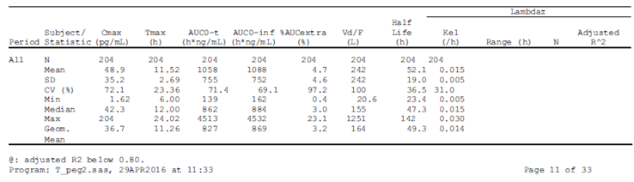

Table 13: Summary of statistical analysis of primary PK parameters for PEG-GCSF in serum

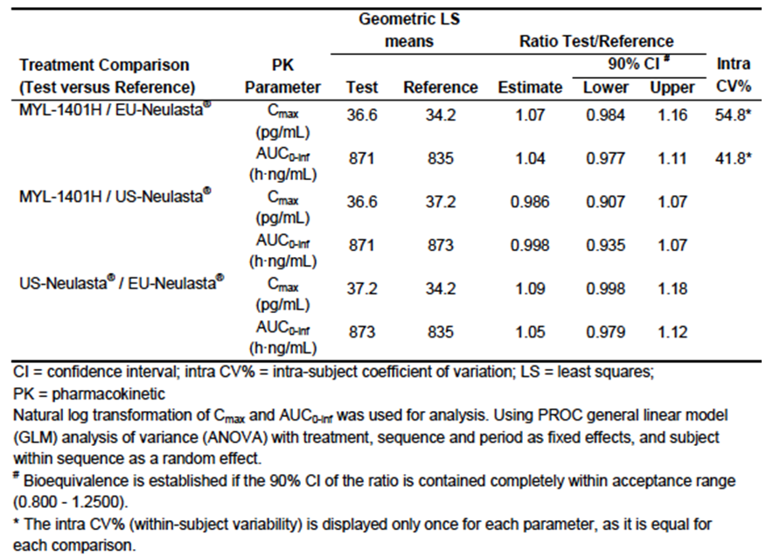

#### Pharmacodynamics

In Study MYL-1401H-1001, the primary PD endpoint was the AUC above baseline for absolute neutrophil count. The predefined similarity interval was 0.85 to 1.18, and PD similarity was declared on this basis (see Table 14). Outcomes based on CD34+ve;[20] cell count were also similar. PD analyses by ADA status revealed no particular differences (that is. there was no alignment with PK outcomes in this regard; see discussion of immunogenicity below).

In Study MYL-1401H-1002, PD outcomes were studied to a limited extent. The clinical evaluator concluded that US Neulasta exerts a more rapid, potent and sustained effect in increasing ANC. Mean change from baseline at Day 8 was higher for Neulasta in Period 1 (7.9 versus 10.4 x 109/L) and Period 2 (9.8 versus 15.0 x 109/L), although differences were less apparent at earlier and later time-points in each period.

Table 14: Summary of similarity analysis for the primary PD parameters for ANC

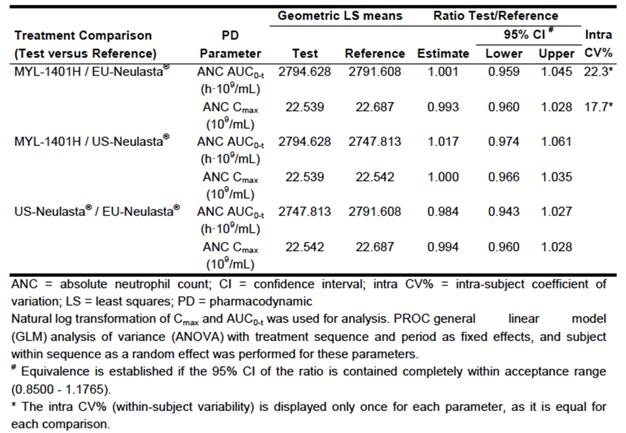

#### Immunogenicity

In Study MYL-1401H-1001, anti-drug antibodies were analysed. There was no large difference in post-dose anti-drug antibodies (ADAs) (Table 15).

* In subjects with ADAs, a post-hoc analysis found higher Cmax and higher AUC for MYL-1401H than for EU Neulasta (upper bound of 90% CI, 1.39 and 1.32 respectively); see Table 5 (above). Discussion in the sponsor’s response is acknowledged.

Neutralising antibodies were discussed; these were rare (1 to 3 per arm, post-first or pre-second treatment, or 1 to 2 per arm if baseline positive subjects were excluded).

In one subject, there was a correlation between high ADA levels and low exposure; in this subject very high levels of ADAs appeared to be triggered by exposure to MYL-1401H, and ADAs appeared to affect exposure to US Neulasta.

Table 15: Summary of treatment-induced anti-drug antibody samples (ITT population) Study 1001

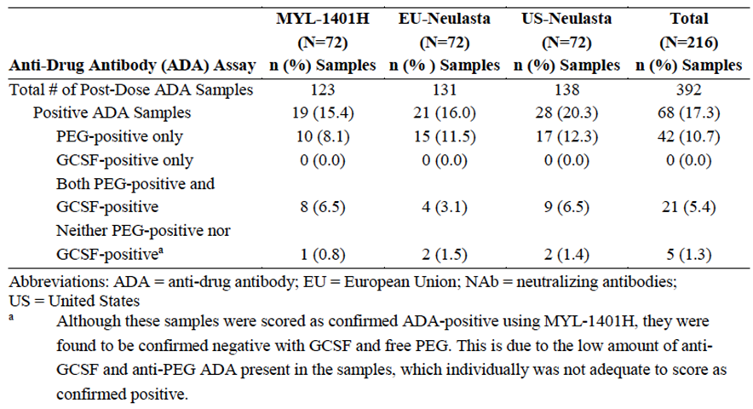

##### Study MYL-1401H-1002

Study MYL-1401H-1002 was a study in healthy volunteers, was described in the clinical evaluation report. Anti-drug antibodies were analysed. The clinical evaluator noted higher rates of ADAs in the MYL-1401H group than the Neulasta group:

*Although the absolute numbers of subjects with antibodies detected were reported as the same (8/25 in each arm), these were detected more frequently during the course of the study at all but one time point in the MYL-1401H arm.*

The evaluator also writes that it is a possibility that the increase in local reactions with MYL-1401H may be related to the increased frequency of ADAs in that arm.

In one MYL-1401H subject there was a possible link between ADAs and decreased efficacy.

##### Study MYL-1401H-3001

In Study MYL-1401H-3001, immunogenicity data were also obtained. No neutralising antibodies were detected; there were no dramatic differences in ADAs either. The evaluator noted various methodological issues (for example ADAs in 15 to 17% across arms at screening, with the rate falling precipitously thereafter for no clear reason, but coinciding with the start of chemotherapy). Overall, it is not clear that the sponsor’s approach to detection of immunogenicity in this study was sensitive enough to detect any true differences, were they to exist.

##### Integrated analysis of immunogenicity

The integrated analysis of immunogenicity presented in the sponsor’s response is noted; the sponsor’s note of caution about pooling of data is also noted. Some key tables are presented below (Tables 16 and 17).

Table 16: Integrated summary of all immunogenicity results by sample (N (%) of samples)(MYL-1401H-1001, MYL-1401H-1002 and MYL-1401H-3001: ITT population)

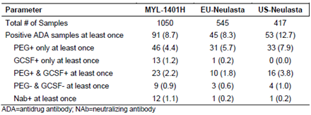

Table 17: Integrated summary of all immunogenicity results by subject (N (%) of subjects) (MYL-1401H-1001, MYL-1401H-1002 and MYL-1401H-3001: ITT population)

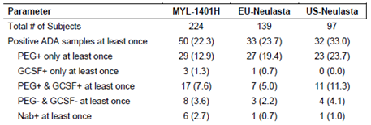

From these tables, there is no concern about dissimilarity for ADAs. Dissimilarity for neutralising antibodies (Nabs) has not been excluded. Excluding subjects with baseline ADA positivity, two MYL-1401H subjects, developed Nabs, and no subjects given Neulasta developed Nabs; but this does not constitute a definite difference, only a signal that a difference has not been excluded.

#### Efficacy

##### Study MYL-1401H-3001

Study MYL-1401H-3001 was described in the clinical evaluation report. It compared therapeutic equivalence of MYL-1401H versus EU Neulasta, in patients with newly diagnosed Stage II-III breast cancer receiving up to 6 cycles of adjuvant or neoadjuvant TAC. A 6 mg SC dose was used, and given on Day 2 of each cycle (at least 24 hours after TAC given on Day 1 of every 3 week cycle). Drug was given by unblinded clinic personnel.

###### Primary endpoint

Duration of severe neutropenia (DSN) in cycle 1 (that is, days with ANC < 0.5 x 109/L) was the primary endpoint.

* The 95% CI for the LS mean difference in Cycle 1 DSN needed to be within ± 1 day to conclude similarity. The sponsor writes that a margin of 0.5 days may have been appropriate; the clinical evaluator criticises the sponsor’s approach to this issue. Discussion of sample size also touches on the basis for a 1 day margin. However, the actual 95% CI around the LS mean difference was well within even the 0.5 day margin.

LS mean DSN was 1.3 days in each arm, and the LS mean difference was 0.01 (95% CI ‑0.285 to 0.298) (Table 18). In a subgroup analysis (neoadjuvant chemotherapy), DSN was shorter for the MYL-1401H group; this was ascribed to multiplicity of testing by the clinical evaluator. Analysis according to ADA status was not well addressed, in the clinical evaluator’s opinion.

Table 18: Study 3001 Duration of severe neutropenia (days with ANC < 0.5 x 109/L) in Cycle 1 (Per protocol population)

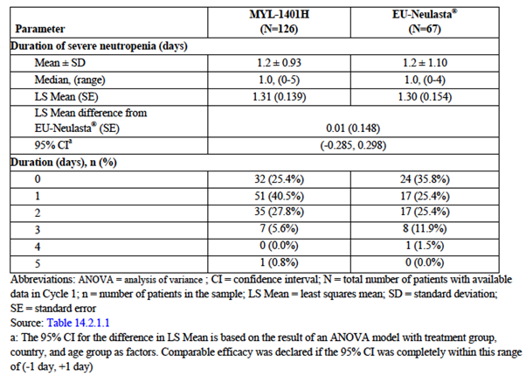

###### Secondary endpoints

In analysis of secondary endpoints, there were several indicators that neutropenia was deeper in the MYL-1401H arm (for example, Table 19, frequency of Grade 4 neutropenia). The evaluator writes:

*‘these results indicate a relative lack of efficacy in the MYL-1401H arm with higher rates of neutropenia, greater severity of that neutropenia and not surprisingly, a slower time to recovery. Taken together, these differences would be likely to result in an increased risk of development of an infection, with its immediate risk of harm and also the risk of delays and dose reductions on longer term efficacy of the regimen.’*

Table 19: Study 3001 Frequency, depth and time of neutropenia in Cycle 1; Per Protocol population

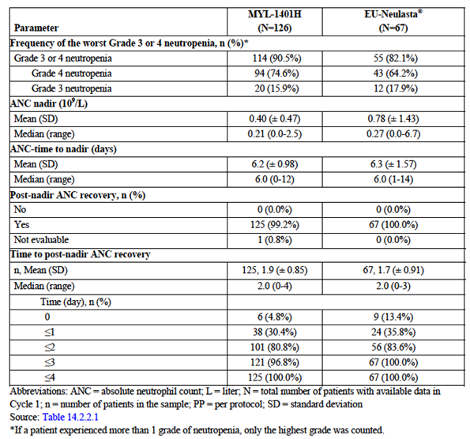

This is further discussed. In particular, the evaluator considers that sampling for ANC in Cycles 2 to 6 was after the predicted ANC nadir.

Febrile neutropenia (FN) was discussed. There was an imbalance, with 5.5% of MYL‑1401H patients reporting FN, versus 1.5% in the Neulasta arm. This was not a statistically significant difference. Three out of 8 patients had FN meeting ESMO criteria but 4/8 had inadequate data to allow assessment in this regard.

The evaluator discussed chemotherapy dose reduction / omission / delay related to neutropenia, FN or documented infection is discussed. There was an imbalance in the need for such dose adjustment (3.9% for MYL-1401H, 1.5% for EU Neulasta).

The evaluator summarises efficacy findings, and notes that similarity of therapeutic efficacy is not supported by various important secondary endpoints. The sponsor’s general view about this is that:

*The slight imbalance in the incidence of neutropenia and febrile neutropenia between treatment arms could be due to unequal randomisation or a chance effect.*

The evaluator recommended against extrapolation to a paediatric population. This is not ‘extrapolation of indications’; the question is more around generalisability of ‘comparability’ outcomes beyond the specific patient group studied in Study MYL-1401H-3001, within the same broad indication. The sponsor’s response is noted.

#### Extrapolation of indications

No extrapolation of indications is required; Neulasta has only the one indication. (Filgrastim’s on the other hand, have multiple indications.)

#### Switching

No switching studies were provided. Pegfilgrastim is not indicated for ongoing use, so switching studies are less relevant than for some other biosimilars. (In the case of filgrastim, use for severe chronic neutropenia requires ongoing use.)

#### Safety

Safety is detailed, with emphasis on Study MYL-1401H-3001. Reported AEs include many events expected from chemotherapy.

3.1% of MYL-1401H patients and 1.5% of EU Neulasta patients experienced Grade 3 bone pain, but there were no discontinuations as a result. The clinical evaluator was satisfied there was broad similarity across arms for bone pain.

The evaluator noted an imbalance in thrombocytosis (6.3% versus 0% respectively), though the sponsor noted that actual laboratory values; as opposed to AE reports, were comparable across arms.

There was an imbalance in serious AEs, mainly due to an imbalance in reporting of febrile neutropenia. An SAE in the MYL-1401H arm was erysipelas. Other notable AEs in the MYL‑1401H arm included thrombosis (n = 1), pneumonitis (n = 1), deranged LFTs (n = 1) and influenza (n = 1). In the sponsor’s response to the Round 2 report, (Table 20 notes two cases of pneumonitis in the MYL-1401H arm (1.6%), versus none in the EU Neulasta arm.

Table 20 Summary to MYL-1401H-3001 CSR Table 14.3.2.6; other significant treatment emergent adverse events by primary System Organ Class and Preferred Term across all cycles

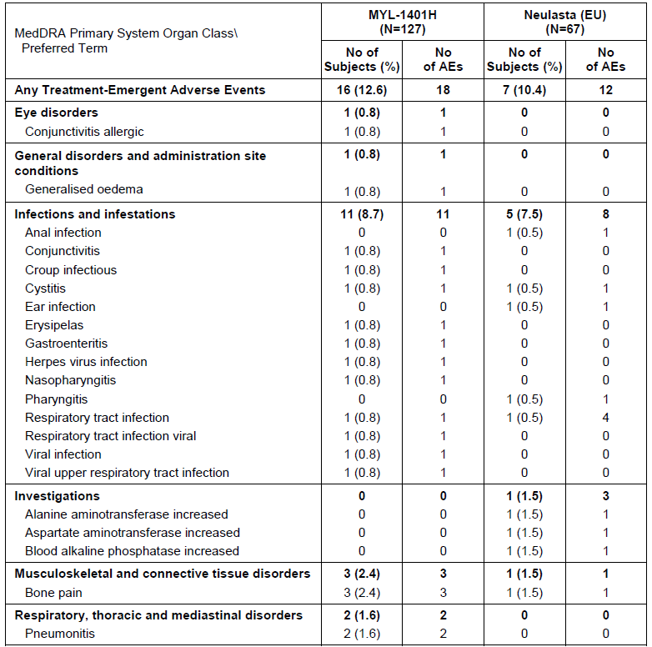

The evaluator noted the poor presentation of details of other significant AEs in the Dossier.

Within laboratory evaluation, it was noted that an increase in neutrophils was seen in 2.4% of MYL-1401H patients and 6% of EU Neulasta patients. These data were not presented in a format allowing comprehensive evaluation.

In Study MYL-1401H-3001 (as opposed to the studies in healthy volunteers) there was no clear difference in the rate of injection site reactions.

Safety data from healthy volunteer studies were noted.

In Study MYL-1401H-1001, no other safety signals were noted, except for a minor imbalance in injection site reactions, with more reports for MYL-1401H.

Study MYL-1401H-1002 was described. It was a randomised, 2 dose study of MYL-1401H versus US Neulasta, evaluating immunogenicity, PD, safety and tolerability, in healthy subjects. The clinical evaluator notes:

*The target population is those with cancer and therefore, immunogenicity in that population is the relevant outcome. The use of just 2 doses 4 weeks apart does not reflect the proposed usage, where G-CSF is used to support continued treatment for many cycles of chemotherapy, often given at 2 to 3 week intervals. Thus, while perhaps testing immunogenicity in an otherwise healthy population with an intact immune system might be more sensitive, the duration of therapy is inadequate to determine and inform whether repeat exposure results in a change in immunogenicity and potentially, safety and efficacy, over time.*

For a randomised study, there was a considerable difference in median age across arms (29 versus 45 years).

No differences in safety outcomes were revealed in Study MYL-1401H-1002, but the clinical evaluator noted that the study design allowed for bias (for example open label, single centre).

Regarding tolerability, more patients reported pain at the injection site in the MYL-1401H arm than in the US Neulasta arm, but events were described as very mild in severity by the clinical evaluator.

##### Integrated analysis of injection site reactions

An integrated analysis of injection site reactions across 3 studies, presented in the sponsor’s response after the evaluation phase, is noted. Incidence per injection is shown, although it is more typical to present frequencies of AEs per patient group. Pooling is problematic because of subject heterogeneity (healthy volunteer versus cancer patient) and because of dose heterogeneity (2 mg versus 6 mg) across studies.

#### Clinical evaluator’s recommendation

The clinical evaluator recommended the product not be approved at the first round and again at the second round.

The second round clinical evaluation report included a list of ‘outstanding issues’. The sponsor responded to these issues. This response was received after the TGA’s evaluation phase and so not seen by the clinical evaluator. The response has been considered in preparation of this Overview, and cited where relevant.

### Risk management plan

There were no objections to registration. The sponsor’s response to the second round RMP recommendations is noted.

#### Recommended condition/s of registration

Implement EU RMP (version 2.0, date 18 April 2017, data lock point 18 April 2017) with Australian Specific Annex (version 2.0, date 28 August 2017) and any future updates.

### Risk-benefit analysis

#### Delegate’s considerations

##### Summary of Issues

###### Manufacturing and quality control

All GMP clearances have not yet been given.[21]Fulphila cannot be approved without satisfactory evidence of GMP.

Some physico-chemical attributes were different for MYL-1401H and Neulasta, but differences were not large in absolute terms (for example MYL-1401H has more aggregates, but the level of aggregates is still low for MYL-1401H).

The quality evaluator considered that there was sufficient bridging between the Neulasta on the ARTG (‘AUS Neulasta’), EU Neulasta and US Neulasta, to accept the relevance of EU and US Neulasta in nonclinical and clinical studies. Bridging was, however, indirect.

###### Clinical

The sponsor established PK similarity in a cross over study of 2 mg pegfilgrastim in healthy volunteers (Study MYL-1401H-1001). In the same study, similarity of PD endpoints was demonstrated. In a separate study of 6 mg pegfilgrastim (Study MYL‑1401H-1002), also in healthy volunteers, similarity of PD outcomes was less convincing.

Comparability of MYL-1401H and Neulasta with regard to immunogenicity was not well established, mainly because:

* in Study MYL-1401H-1002, there was a difference in the frequency of ADAs, with more in the MYL-1401H arm;
* across studies, dissimilarity for the frequency of neutralising antibodies (NAbs) has not been robustly excluded;
* Module 3 data indicated minor differences in the level of aggregates, with more in the MYL-1401H product (albeit at levels lower than those associated with a heightened risk of immunogenicity)

However, there was no strong evidence that clinically relevant immunogenicity differed across pegfilgrastim versions.

In the therapeutic equivalence Study MYL-1401H-3001, the guideline endorsed primary endpoint of ‘duration of severe neutropenia at Cycle 1’ was highly similar across arms. However, the frequency of important secondary endpoints including Grade 4 neutropenia, febrile neutropenia, and chemotherapy dose adjustment due to neutropenia differed across arms, with more such occurrences in patients who received MYL-1401H. The sponsor attributed this imbalance essentially to chance; but it is also possible the imbalance reflects a real difference in characteristics of the pegfilgrastims. Certainly, this possibility has not been ruled out with rigour. It is not in keeping with PK or PD outcomes seen in Study MYL-1401H-1001.

Regarding the discord between primary and secondary endpoints, the clinical evaluator notes:

The DSN is the numerical assessment of the laboratory parameter, but the rate of febrile neutropenia and its consequences are the more clinically relevant parameter and forms the basis of the therapeutic claim in the indication.

Separately, the evaluator recommended against extrapolation to children. This is not ‘extrapolation of indications’; the question is more around generalisability of ‘comparability’ outcomes beyond the specific patient group studied in Study MYL‑1401H‑3001, within the same broad indication.

###### Totality of data

Only minor differences in physico-chemical attributes were noted in the quality dataset, in the comparison of Fulphila (MYL-1401H) and Neulasta. No substantial differences were noted in nonclinical comparisons. No substantial differences were noted in PK comparison in one clinical study, at 2 mg in healthy volunteers.

Pharmacodynamic outcomes and therapeutic efficacy outcomes overlap somewhat in this field, so emphasis is placed on therapeutic efficacy outcomes. In the pivotal Study MYL‑1401H-3001, there was close similarity based on the primary efficacy endpoint (DSN at Cycle 1). There was evidence of dissimilarity based on important secondary endpoints, such as frequency of febrile neutropenia. The sponsor’s view is that imbalances in secondary endpoints were due to the play of chance, but there is no strong justification for this point of view. A more rigorous approach would be to provide a separate study of similar design, showing no increase in risk of febrile neutropenia (etcetera) with MYL-1401H.

#### Question for sponsor

In pre-submission information supplied by the sponsor, the comparability assessment was framed as a physico-chemical comparison of 3 batches of MYL-1401H, 3 batches of Australian Neulasta, 1 batch of US Neulasta and 1 batch of EU Neulasta. Did the planned comparability assessment that was outlined in the Pre-submission Briefing Package eventuate?

#### Proposed action

At the Pre-ACM stage, the Delegate was not in a position to support approval of the application.

#### Request for ACM advice

The committee is requested to provide advice on the following specific issues:

1. Does the ACM consider there is a relevant difference in the immunogenicity of Fulphila and Neulasta?
2. Does the ACM consider that imbalances in some secondary endpoints in the therapeutic equivalence study MYL-1401H-3001 are clinically relevant?
3. What weight should be given to primary versus secondary endpoints in Study MYL‑1401H-3001?
4. Overall, does the ACM consider that there is sufficient evidence of biosimilarity between Fulphila and Neulasta?
5. Other things being equal, does the ACM support extrapolation to the paediatric population?

The committee is also requested to provide advice on any other issues that it thinks may be relevant to a decision on whether or not to approve this application.

In answering these questions, it is important that the ACM takes into account the sponsor’s response to the Delegate’s Overview, that is, the ‘Pre-ACM Response’.

#### Response from sponsor

1. ***Does the ACM consider there is a relevant difference in the immunogenicity of Fulphila and Neulasta?***

[Information redacted]. In summary, the sponsor has conducted a comprehensive assessment of immunogenicity in NHV and patients including assessment of immune response against PEG and G-CSF domains using sensitive and specific assay. Overall treatment induced ADA and NAb incidence was similar across treatment groups and any minor differences were not clinically relevant. There was no evidence of loss of efficacy or severe treatment-induced immune-related adverse events in ADA or NAb positive subjects. The immunogenicity data is also comparable with reported data from Neulasta and the filgrastim products that have a long, established history of low potential for immunogenicity (Neupogen/Neulasta SmPC and US prescribing information).

1. ***Does the ACM consider that imbalances in some secondary endpoints in the therapeutic equivalence study MYL-1401H-3001 are clinically relevant?***
2. ***What weight should be given to primary versus secondary endpoints in study MYL-1401H-3001?***

*Sponsor’s response for Questions 2 and 3:*

It has been widely recommended by global regulators that for development of filgrastim and pegfilgrastim biosimilars, given that there are very sensitive and specific PD biomarkers (absolute neutrophil count and CD34) available, demonstrating PD equivalence in healthy volunteers at a dose on the steep part of dose response curve is an absolute requirement. Regulators have indicated that this approach is much more sensitive to detect subtle differences between biosimilars versus conducting confirmatory efficacy and safety study in oncology setting using typical efficacy endpoints like duration of severe neutropenia (DSN). The sponsor followed this advice and demonstrated robust PK-PD bioequivalence in the most sensitive and homogenous population (healthy volunteers) at 2 mg dose in Study MYL-1401H-1001 against both EU and US sourced Neulasta.

[Information redacted]

The sponsor respectfully contends that Study MYL-1401H-3001, whose main objective was to assess safety and was conducted based on specific MHRA recommendation, demonstrated no clinically meaningful differences in safety, efficacy and immunogenicity between MYL-1401H and Neulasta. Although there were small differences in secondary efficacy endpoints, this study was not powered to detect these changes. Given the objective of this study, the unequal randomisation and limited sample size, the isolated differences noted were possibly attributed to chance. Furthermore, the data for MYL‑1401H in patients is consistent with extensive literature available for the reference product and it appears the incidence of FN was unusually low in the reference arm. As indicated earlier, in biosimilar development for this product, the regulatory standard is to detect subtle changes in efficacy using sensitive PD biomarkers like ANC and CD34 in a homogenous population. MYL-1401H showed robust PK and PD equivalence in this sensitive assay system. If indeed there was a difference in the efficacy between the products, it would have been detected in the PK-PD study supporting the contention of a chance finding.

1. ***Overall, does the ACM consider that there is sufficient evidence of biosimilarity between Fulphila and Neulasta?***

Overall biosimilarity has been demonstrated between MYL-1401H and Neulasta based on the totality of the evidence that is. quality, non-clinical and clinical data as per the EMA and FDA guideline. This includes comparison of MYL-1401H and Neulasta with respect to structure, function, animal toxicity, human pharmacokinetics (PK) and pharmacodynamics (PD), clinical immunogenicity, and clinical safety and effectiveness.

An extensive exercise has been conducted to demonstrate the analytical and functional similarity of MYL-1401H with EU Neulasta and US Neulasta. This includes comprehensive analyses of the proposed biosimilar and reference medicinal product using sensitive and orthogonal methods using state-of the art analytical techniques. Extensive characterisation of MYL-1401H batches along with Neulasta for all physico-chemical as well as biological attributes exhibits comparable results for the primary, secondary and higher order structure, post-translational modifications and associated charged isoforms, purity, and functionality of the molecule. Highly similar analytical functional characteristics between MYL-1401H and Neulasta has been demonstrated.

The consistency of the manufacturing process in delivering adequate process performance and suitable product quality was confirmed by in-process manufacturing data, lot release data and extensive characterisation. All process parameters (operational and performance) were found to be within the acceptance limits set during process validation study; demonstrating consistency of the manufacturing process. Similar results were obtained from the in vitro and in vivo pharmacodynamic studies, and the repeat dose study in rats, designed to compare the biological activity, pharmacology, and toxicity profiles of MYL-1401H and Neulasta.

The MYL-1401H clinical development program included 3 clinical studies that were designed to confirm the similarity established at the analytical/biological and nonclinical level, address the potential for immunogenicity, and demonstrate no clinically meaningful differences between MYL-1401H and EU approved Neulasta:

* 1. As per EMA guidance and FDA feedback, biomarkers (absolute neutrophil count [ANC] and hematopoietic progenitor cell antigen, CD34+) can strongly and sensitively predict efficacy of G-CSF class of compounds. The Study MYL-1401H-1001 demonstrated PK-PD Bioequivalence in the homogenous and sensitive population of normal healthy volunteers. A dose of 2 mg was used as it is on the steep part of the dose response curve and was considered sensitive dose to assess any potential differences between MYL-1401H and Neulasta.
  2. Study MYL-1401H-1002 showed low immunogenic potential similar to that of Neulasta after repeated administration of a therapeutic dose (6 mg) in a sensitive population without any confounding illness or immunosuppressive medication.
  3. Study MYL-1401H-3001 in breast cancer patients was primarily conducted based on MHRA recommendations to assess safety of the 6 mg dose in target population and showed no clinically meaningful difference in safety and efficacy and immunogenicity between MYL-1401H and Neulasta. This study was not powered for demonstrating similarity for secondary efficacy endpoints.

Overall, MYL-1401H was found to be bioequivalent to Neulasta. The clinical data confirm the high similarity established at the physiochemical/biological and nonclinical levels and demonstrate no clinically meaningful differences between MYL-1401H and Neulasta to complete the totality of evidence in support of biosimilarity.

1. ***Other things being equal, does the ACM support extrapolation to the paediatric population?***

The sponsor intends to extrapolate the efficacy findings in adults to children based on the completed Neulasta clinical studies and comparison data between MYL-1401H and Neulasta derived from the sponsor’s completed analytical, nonclinical, and clinical studies to confirm biosimilarity. The sponsor does not intend to perform any additional paediatric clinical studies assuming biosimilarity with the Pegfilgrastim reference product is demonstrated. In addition, the below points support the biosimilarity in the paediatric population:

* 1. Similar mechanism of action of pegfilgrastim in adults and paediatric population.[22]
  2. The safety and effectiveness of Neulasta have been studied in paediatric patients and is approved in paediatric population. No overall differences in safety were identified between adult and paediatric patients based on post marketing surveillance and review of the scientific literature.4,[23]
  3. The PK of the MYL-1401H was not studied in the paediatric population. However, the pharmacokinetics of Neulasta was studied in both adult and paediatric patient population which show comparable PK profiles. The pharmacokinetics of reference pegfilgrastim was studied in 379 adult patients with cancer. The PK was nonlinear and clearance decreased with increases in dose. Neutrophil receptor binding is an important component of the clearance of pegfilgrastim, and serum clearance is directly related to the number of neutrophils. In addition to numbers of neutrophils, body weight appeared to be a factor. Patients with higher body weights experienced higher systemic exposure to pegfilgrastim after receiving a dose normalized for body weight. A large variability in the pharmacokinetics of pegfilgrastim was observed. The half-life of Neulasta ranged from 15 to 80 hours after subcutaneous injection. Considering the similarity in physicochemical, nonclinical, clinical characteristics and as PK-PD equivalence of MYL-1401H is demonstrated with Neulasta at 2 mg in the Study MYL1401H-1001, a similar PK/PD profile would be expected for MYL-1401H across all the approved indications with similar mechanism of action at approved doses. MYL-1401H is also expected to behave similarly in paediatric patients.

##### Delegate’s question for sponsor

***In pre-submission information supplied by the sponsor, the comparability assessment was framed as a physico-chemical comparison of 3 batches of MYL-1401H, 3 batches of AUS Neulasta, 1 batch of US Neulasta and 1 batch of EU Neulasta. Did the planned comparability assessment that was outlined in the Pre-submission Briefing Package eventuate?***

The sponsor originally proposed a comparability plan that comprised of side by side analysis of 3 lots of AUS Neulasta and 1 lot each of US and EU Neulasta against 3 lots of MYL-1401H. However, based on the discussion with the TGA during the pre-submission meeting, it was concluded that performing the side by side analysis of one AUS Neulasta lot and three MYL-1401H lots side by side would be considered sufficient provided that an adequate level of similarity could be demonstrated. Based on this, we performed an analysis of 3 lots of MYL-1401H and 2 lots of AUS Neulasta side by side using internal reference standard QC/Q3/LC-028-04. The same internal reference standard has been previously used as reference for similarity assessment of MYL-1401H lots with EU Neulasta and US Neulasta. The sponsor believes that the two independent studies are adequately bridged by way of usage of the common internal reference standard lot. Based on the results of the analyses conducted, the Australian Neulasta lots and MYL-1401H lots were similar to internal reference standard lot in all physicochemical attributes. In the case of the functional assays, the activities of all samples were tested against the internal reference standard and have been found to be highly similar’.

#### Advisory Committee Considerations[24]

The Advisory Committee on Medicines (ACM), having considered the evaluations and the Delegate’s overview, as well as the sponsor’s response to these documents, advised the following:

Taking into account the submitted evidence of efficacy, safety and quality, the ACM considered Fulphila prefilled syringe for subcutaneous injection containing 6 mg/0.6 mL of pegfilgrastim to have an overall negative benefit-risk profile for the proposed indication:

*Fulphila is indicated for the treatment of cancer patients following chemotherapy, to decrease the duration of severe neutropenia and so reduce the incidence of infections, as manifested by febrile neutropenia.*

These proposed indications are identical to those of the innovator, Neulasta.

The ACM concluded that the evidence provided in the sponsor’s submission did not satisfactorily establish the quality, safety and efficacy of Fulphila prefilled syringe for subcutaneous injection containing 6 mg/0.6 mL of pegfilgrastim.

In making this recommendation, the ACM noted:

* significant manufacturing issues and the failed GMP certification in the EU and the US.[25]
* problems with the trial population selected, and the attempt to draw clinical conclusions about biosimilarity from populations that are not the most sensitive for detecting clinically relevant differences between products.

##### Proposed conditions of registration

The ACM agreed with the Delegate on the proposed conditions of registration.

##### Specific advice

The ACM advised the following in response to the Delegate’s specific questions on the submission:

1. ***Does the ACM consider there is a relevant difference in the immunogenicity of Fulphila and Neulasta?***

The ACM considered that there was no evidence to suggest the biosimilar is more immunogenic than the innovator. However, because clinical trials were not conducted in the most appropriate population, any immunogenicity differences could not be identified.

1. ***Does the ACM consider that imbalances in some secondary endpoints in the therapeutic equivalence Study MYL-1401H-3001 are clinically relevant?***

The ACM did not consider that imbalances in secondary endpoints were clinically relevant because PK and PD data, which looked at days of neutropenia and days to recovery, were similar.

1. ***What weight should be given to primary versus secondary endpoints in Study MYL-1401H- 3001?***

The ACM noted that FDA did not require secondary endpoints to be examined, and that the study was not sufficiently powered to address those differences.

1. ***Overall, does the ACM consider that there is sufficient evidence of biosimilarity between Fulphila and Neulasta?***

The ACM considered that there was sufficient evidence of biosimilarity between Fulphila and Neulasta in the population studied; however, it was considered that the populations studied were not necessarily the most sensitive for the detection of clinically relevant differences.

1. ***Other things being equal, does the ACM support extrapolation to the paediatric population?***

Despite no biochemical, PD, PK or clinical safety/effectiveness studies having been conducted in children, the ACM noted the extensive experience with the innovator product, and hence advised that if Fulphila was accepted as showing biosimilarity on the basis of PK and PD data, then the ACM supported the extrapolation to the paediatric population.

#### Post-ACM response from sponsor

On 20 December 2017, the sponsor, company representatives and the Delegate conducted a meeting to discuss the ACM recommendations.

The sponsor provided a written post ACM response to the Delegate on 8 January 2018 which is provided below:

The sponsor appreciates the ACM’s concurrence that imbalances in secondary endpoints in the Phase III study were not clinically relevant, that the study in patients was not powered to evaluate differences in secondary endpoints and that it supported extrapolation to paediatric population assuming biosimilarity was shown based on PK/PD data. The sponsor also appreciates the ACM concurrence that there is sufficient evidence of biosimilarity between Fulphila (MYL-1401H) and Neulasta and there is no evidence to suggest that Fulphila is more immunogenic than Neulasta in the population that was studied. However, the ACM raised some concerns with regards to the choice of population in clinical studies and whether it was sensitive enough to *detect clinically relevant differences*. The sponsor contends that clinical studies were conducted in the most sensitive and appropriate population to detect differences in PK, PD, efficacy, safety and immunogenicity between Fulphila and Neulasta and the ‘totality of evidence’ supports biosimilarity. As such, we would like to provide the following justification points to support this position:

##### Totality of evidence

The overall biosimilarity of MYL-1401H to the reference product (Neulasta) has been demonstrated based on the totality of the evidence that is. quality, non-clinical and clinical data as per the EMA and FDA guideline. This includes comparison of MYL-1401H and Neulasta with respect to structure, function, animal toxicity, human pharmacokinetics (PK) and pharmacodynamics (PD), clinical immunogenicity, and clinical safety and effectiveness.

The analytical, functional similarity and non-clinical data were provided.

###### Fulphila clinical development program

The clinical program included three clinical studies that were designed to confirm the similarity established at the analytical/biological and nonclinical level, address the potential for immunogenicity, and demonstrate no clinically meaningful differences between MYL-1401H and EU Neulasta.

1. Study MYL-1401H-1001; Rationale for choosing healthy volunteer population and 2 mg dose

It has been widely recommended by global regulators that for development of filgrastim and pegfilgrastim biosimilars, given that there are very sensitive and specific PD biomarkers (absolute neutrophil count and CD34) available, demonstrating PD equivalence in healthy volunteers at a dose on the steep part of dose response curve is an absolute requirement.[26]

A PK/PD study in healthy subjects is considered to be more sensitive in evaluating the product similarity because it is likely to produce less variability in PK and/or PD compared with a study in patients with potential confounding factors such as underlying and/or concomitant disease and concomitant medications.[27]

For filgrastim products, regulators have indicated that this approach is much more sensitive to detect subtle differences versus conducting confirmatory efficacy study in oncology setting using typical efficacy endpoints like duration of severe neutropenia (DSN). The sponsor followed this advice and demonstrated robust PK-PD bioequivalence in the most sensitive and homogenous population (healthy volunteers) at 2 mg dose in Study MYL-1401H-1001 against both EU and US sourced Neulasta.

As shown in Figure 3, the 2 mg dose (or weight adjusted equivalent) is very close to the EC50, and is on the steep part of the dose-response curve and was considered the most sensitive dose to assess any potential differences between MYL-1401H and Neulasta. [28], [29] The therapeutic dose of 6 mg lies on the plateau phase of the concentration effect curve (close to EC90), so this does not represent the ideal condition recommended in the relevant guidelines, to detect potential PK/PD differences between products.[30]

Figure 3: Concentration-effect relationship of pegfilgrastim based on a simple Emax model. EC50 and EC90 = pegfilgrastim concentrations that produce 50% and 90%, respectively, of the maximal effect (Emax). (Yang et al 2011)

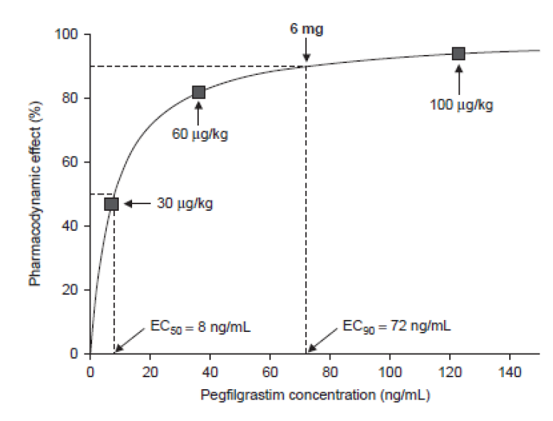

1. Study MYL-1401H-1002 - Rationale for choosing healthy volunteer population to assess immunogenicity

Immunogenicity data with 2 mg dose from Study MYL-1001 had its limitation as it was sub-therapeutic. To address immunogenicity, a specific study was designed based on feedback from FDA in the most sensitive population at the approved dose of 6 mg. Healthy volunteers are considered as sensitive and homogenous population to detect subtle differences in immunogenicity, as these subjects are not on background immunosuppressants or have concomitant disease which can affect immune response.

The 6 mg dose is therapeutic dose and is the appropriate and sensitive dose to assess impact on immunogenicity. Two period study (with 2 dose) was designed so that impact of repeat dosing on immunogenicity could be evaluated at early and late time-point. Highly sensitive and specific assay developed to assess baseline values and any post baseline subtle changes. The assay was not only specific for the entire molecule (pegfilgrastim) but also evaluated the PEG and G-CSF domain. The study showed that treatment induced ADA incidence was similar between the treatment groups. The ADA had no effect on PD (ANC). There were no treatment-induced NAb positive subjects. [Information redacted] (Table 21).

Table 21: Proportion of patients with PEG antibody, G-CSF antibody, and NAb response to MYL-1401H, EU Pegfilgrastim, or US-Pegfilgrastim in 3 clinical studies at any time post dose. (excludes subjects that are ADA and NAb positive at baseline)

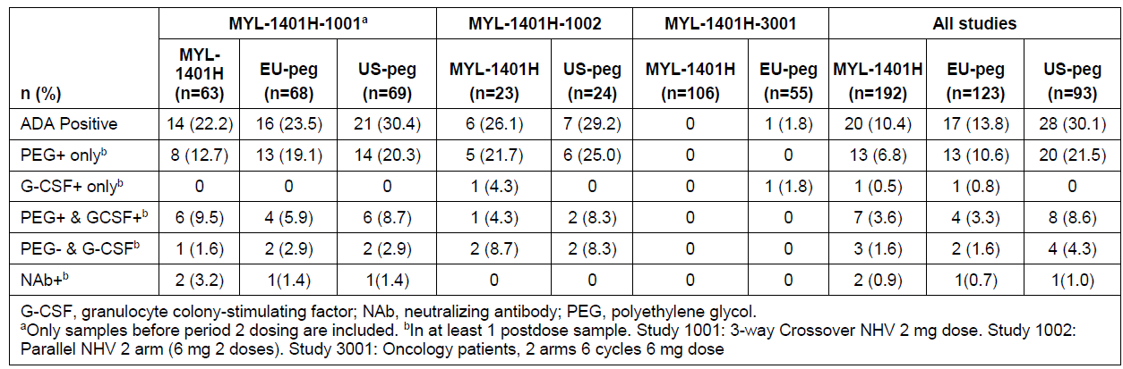

1. Study MYL-1401H-3001-Rationale for choice of primary breast cancer population.

This study was primarily conducted based on MHRA recommendations to assess safety of the 6 mg dose in target population and showed no clinically meaningful difference in safety and efficacy and immunogenicity between MYL-1401H and Neulasta. FDA has explicitly indicated that an efficacy and safety study in oncology setting is not required for this product. However, given that the sponsor was pursuing a global development program, it received feedback from MHRA that a study in patients was required to assess safety with the 6 mg dose but was not required for efficacy assessment. EMA Guideline41 states that the recommended clinical model for the demonstration of comparability of the test and the reference medicinal product is the prophylaxis of severe neutropenia after cytotoxic chemotherapy in a homogenous patient group (for example tumour type, previous and planned chemotherapy as well as disease stage). This model requires a chemotherapy regimen that is known to induce a severe neutropenia in patients. The sponsor must justify the comparability delta for the primary efficacy variable, the duration of severe neutropenia (ANC below 0.5 x 109/L). The incidence of febrile neutropenia, infections and the cumulative r-G-CSF dose are secondary variables. The main emphasis is on the first chemotherapy cycle. However, it should also be noted that this guideline is more than a decade old and there has been a lot of discussion between industry and regulators with regards to minimizing patient based studies for biosimilars like EPO, G-CSF and insulins, where robust PD endpoints are available. This approach is reflected in the feedback the sponsor received from regulators and is also consistent with the AUSPAR for filgrastim biosimilar products.

The Study MYL-1401H-3001 was designed in the context of MHRA feedback and EMA guideline and was primarily conducted to compare safety of MYL-1401H and Neulasta in breast cancer patients receiving chemotherapy but efficacy was also collected. The primary invasive breast cancer patients are a relatively young and healthy homogenous population with just local tumour and received a cytotoxic chemotherapy combination (TAC) and are considered as sensitive population to detect any meaningful differences in safety or efficacy. The choice of primary breast cancer patients versus metastatic cancer population also allows for comparison of biosimilarity without interference of potentially compounding factors in a metastatic breast cancer patient population (for example possible interference in assessment of bone pain through presence of bone metastases). Docetaxel / Doxorubicin / Cyclophosphamide (TAC) regimen requires prophylactic G-CSF treatment, according to the National Comprehensive Cancer Network (NCCN) guidelines,[31] as it is expected to induce severe neutropenia in ≥ 20% patients. It was mentioned that there was discussion during ACM meeting, that paediatric patients may have higher frequency of neutropenia and might be a more sensitive population. In this context, we would like to indicate that conducting study in paediatric population for a biosimilar at this stage of development is operationally challenging and may also not be ethically acceptable by many IRBs. The basic tenet of biosimilar development is to build on robust analytical characterisation followed by PK, PD, safety and immunogenicity assessment. If similarity is demonstrated then extrapolation to paediatric population is acceptable.

From a study design and sample size calculation perspective, Mylan had to use efficacy in the form of DSN as the primary endpoint for this study. As this was primarily to satisfy EU requirements, EU sourced Neulasta was used. Furthermore, since safety was the key objective, a 2:1 randomisation ratio for MYL-1401H versus EU Neulasta was chosen with the goal to ensure that at least 100 patients received MYL-1401H for 6 cycles. This was the general expectation of MHRA with regards to the sample size to assess safety. This study MYL-1401H-3001 was not designed or powered to re-establish efficacy of the active substance or identify a new, rare safety signal, as this is a biosimilar development program.

The primary endpoint was met with 95% CI (-0.285, 0.298) for the difference in LS Mean DSN of MYL-1401H and EU Neulasta was found to be well within the pre-specified equivalence range of [-1 day, +1 day]. The safety data were comparable between Fulphila and Neulasta. Mylan respectfully contends that Study MYL-1401H-3001, whose main objective was to assess safety and was conducted based on specific MHRA recommendation, demonstrated no clinically meaningful differences in safety, efficacy and immunogenicity between MYL-1401H and Neulasta. Although there were small differences in secondary efficacy endpoints, this study was not powered to detect these changes. Given the objective of this study, the unequal randomisation and limited sample size, the isolated differences noted were possibly attributed to chance. ACM concurred with our justification that the study was not powered to detect differences in secondary endpoints and that imbalances in secondary endpoints were not clinically relevant.

As indicated earlier, in biosimilar development for this product, the regulatory standard is to detect subtle changes in efficacy using sensitive PD biomarkers like ANC and CD34 in a homogenous population. MYL-1401H showed robust PK and PD equivalence in this sensitive assay system. The study population is similar to other studies conducted with biosimilar G-CSF in patients.

###### Overall immunogenicity data across the 3 clinical studies

The overall immunogenicity assessment included evaluation of early and late immune response, response after multiple dosing in healthy volunteers as well as in breast cancer patients on chemotherapy, and response after low and therapeutic doses of Fulphila and Neulasta.

As there is no standard approach to presenting immunogenicity data, multiple analyses have been conducted. The data include both subject-level and sample-level analyses, and includes all samples analysed, pre-dose and post dose. These analyses showed that there was no clinically significant difference between test and reference. Integrated summaries of comparative and pooled analyses of ADA and NAb data for the 3 clinical studies were provided along with response to questions during milestone 5 and are provided in the Annexure 1 of this response. For all analyses, only Period 1 data from Study MYL‑1401H‑1001 was considered.

Annexe 1 (provided) provides comprehensive immunogenicity information across the 3 clinical studies:

* Total number of ADA samples across studies
* Total number of subjects across studies
* Total number of samples and subjects across studies
* Sample-level data from subjects who were ADA-positive at any time across studies
* Subject-level data from subjects who were ADA-positive at any time across studies
* Sample-level data from subjects who were ADA-positive pre-dose across studies
* Subject-level data from subjects who were ADA-positive pre-dose across studies
* Sample-level data from subjects who were ADA-positive post dose across studies
* Subject-level data from subjects who were ADA-positive post dose across studies
* Post-dose sample-level data from subjects who were ADA-negative at baseline
* Post-dose subject-level data from subjects who were ADA-negative at baseline
* Post-dose sample-level data from subjects who were NAb-negative at baseline
* Post-dose subject-level data from subjects who were NAb-negative at baseline.

However, as pre-existing antibodies were present, the sponsor considers that treatment induced immunogenicity as most clinically relevant and a true reflection of drug effect than the overall incidence of immunogenicity, which could be impacted by potential imbalances in the pre-existing antibodies across studies. Thus, the treatment-induced ADA across 3 clinical studies were evaluated by analysing:

* Post dose ADA results excluding ADA positive subjects at baseline (prior to dosing)
* Post dose NAb results excluding NAb positive subjects at baseline (prior to dosing).

The proportions of subjects with treatment induced ADA were similar among the Fulphila, EU and US-pegfilgrastim (Neulasta) groups in the 2 studies in healthy volunteers. In the MYL-1401H-3001 study in breast cancer patients, the rates of ADA were 0% in the MYL-1401H group and 1.8% in the EU pegfilgrastim group. Most (86.0%) of the subjects with ADA had antibodies that recognised the PEG domain, which may be attributable to exposure to PEG related compounds in the environment as well as the highly sensitive nature of the assay, which can detect very low levels of antibodies. This might also be the reason for a higher ADA positivity prior to dosing. Given the extremely sensitive assay that was developed, it was critical not just to evaluate number of subjects or samples that were positive prior to and after dosing but also to evaluate the titre response. In this context, it should be noted that across three studies, the treatment induced increases in titres for majority of subjects who were positive at baseline did not suggest amplified immune response post treatment. Similarly, where treatment induced positivity was seen, the titres were very low and there was no impact on safety and efficacy associated with these increases.

Of the subjects who were NAb negative at baseline, the incidence of treatment-induced NAb positive was similar across all groups (0.7 to 1.0%). Of the 2 NAb positive subjects in the MYL-1401H group, 1 was positive for PEG only and the other for both PEG and G-CSF. Both had very low titres of ADA (8 to 10 ng/ mL). The NAb positive subject in the EU pegfilgrastim group was positive for both PEG and G-CSF and the subject in the US-pegfilgrastim group was positive for PEG domain only. The ANC profiles over time for all subjects with treatment induced NAb were similar to the mean ANC across each group, indicating no loss of efficacy.

In summary, the sponsor has conducted a comprehensive assessment of immunogenicity in NHV (which is the most sensitive population) and breast cancer patients on chemotherapy, including assessment of immune response against PEG and G-CSF domains using sensitive and specific assay. Overall treatment induced ADA and NAb incidence was similar across treatment groups and any minor differences were not clinically relevant. There was no evidence of loss of efficacy or severe treatment-induced immune-related adverse events in ADA or NAb positive subjects and in majority of the cases the titres were very low with no implication in immune response seen after single or repeated dosing. The immunogenicity data is also comparable with reported data from Neulasta and the filgrastim products that have a long, established history of low potential for immunogenicity (Neupogen/Neulasta SmPC and US prescribing information).

###### Regulatory guidance and population studied in ‘filgrastim’ products listed in AusPAR

The sponsor’s global clinical development program for Fulphila was guided by prevailing biosimilar guidelines from:

* European Medicines Agency (EMA)
* US Food and Drug Administration (US FDA)
* Interactions and agreement with the MHRA (UK) and US FDA (documentation was provided).

The sponsor conducted extensive discussions with FDA and EMA regarding the overall clinical development plan (adequacy of study design including study population) and regulatory expectation to support biosimilarity. Regulatory guidelines and feedback from EMA and FDA was to use stepwise approach and use totality of evidence to demonstrate biosimilarity. Extensive structural, analytical and functional characterisation of Fulphila and Neulasta reference product, serves as the foundation to establish biosimilarity. The role of clinical studies is to confirm the biosimilarity established at analytical and functional characterisation. In this context, the population studied in Fulphila clinical studies (healthy volunteers and breast cancer patients) are considered most sensitive and appropriate to detect any subtle clinically relevant differences. Similar concurrence was achieved during pre-submission meetings with BGTD, Health Canada and TGA and no concerns were raised with the population studied in clinical studies.

In addition, the Fulphila clinical studies and the population studied are also comparable to those conducted by other companies for filgrastim biosimilar products approved in Australia. Table 22 lists the studies that were conducted for pegfilgrastim in comparison to the studies conducted by other sponsors for the biosimilar ‘filgrastim’ products, as taken from their relevant AusPAR.

Table 22: Population studied in ‘filgrastim’ products listed in AusPAR compared to Fulphila Studies

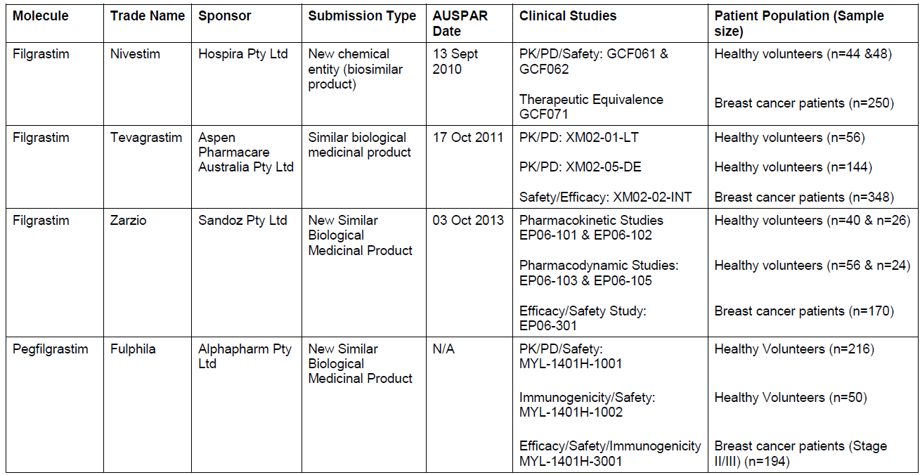

###### Conclusion

* Three clinical studies conducted in the most sensitive population confirm the similarity established at the analytical/biological and nonclinical level. Each study had a very specific objective and was conducted based on extensive feedback from global regulators and no concerns were raised regarding the choice of population and dose.
* The clinical study MYL-1401H-1001 demonstrated PK-PD bioequivalence in the homogenous and sensitive population of normal healthy volunteers at the sensitive 2 mg dose (For details refer to - MHRA Meeting Minutes and EMA Rapporteur Meeting Minutes (provided)).
* The study MYL-1401H-1002 demonstrated there was low immunogenic potential similar to that of Neulasta after repeated administration of a therapeutic dose in a sensitive population without any confounding illness or immunosuppressive medication (FDA Meeting Minutes (provided)).
* Similarly, in supportive study MYL-1401H-3001, with safety as the key objective in the sensitive and relatively homogenous MBC patients, there were no clinically meaningful differences in efficacy, safety and immunogenicity between Fulphila and EU approved Neulasta (For details see EMA Rapporteur Meeting Minutes (provided)).
* Finally, the overall clinical development plan and choice of study population is consistent with other filgrastim products approved by TGA. In addition, the Complete Response Letter (Complete Response Letter - Oct 2016 (provided)) issued by US FDA didn’t have any issues/comments on the three clinical studies presented in the BLA.
* Based on the collective information provided, it can be determined that most sensitive population was selected to detect any clinically meaningful differences and based on the evidence, it can be concluded that Fulphila is biosimilar to Neulasta.

##### Manufacturing issues and GMP certification

Aside from the ACM’s concerns relating to the sensitivity of the trial patient population, they also noted the significant manufacturing issues and failed GMP certification in EU and US.

In response to this statement, the sponsor would like to highlight that its manufacturing site(s) has made significant progress in the execution of the agreed upon corrective actions from the EU and US health authority audits. It is confirmed that all corrective actions identified during the GMP inspections of the facility have been completed. An update of all these corrective actions along with their execution status and summary is provided (in this response). [Information redacted]

#### Delegate’s review of post ACM response from sponsor (29 January 2018)

The Delegate thanked the sponsor for providing the meeting Minutes and the response to the ACM recommendation regarding Fulphila (Submission PM-2016-03834-1-4).

The Delegate has considered the ACM view and your response, and concluded that there is sufficient evidence to accept biosimilarity of Fulphila with Neulasta, with the caveat that PI and GMP issues need to be resolved.

The Delegate noted that your pre-ACM response PI did not appear to address PI concerns raised in the Delegate’s Overview. In the Clinical Trials section, it is essential that the description of Study 3001 references not only the primary efficacy endpoint but also key secondary endpoints that have been the subject of close scrutiny (that is. incidence of febrile neutropenia and extent of chemotherapy dose reduction / omission / delay related to neutropenia, FN or documented infection). This is because the PI must be an accurate reflection of the basis of approval, and any approval has been based, in no small part on close consideration of these study outcomes. It would also be reasonable to state in the PI that the study was not powered to detect differences in these secondary outcomes.

Please note that approval can only occur with agreement about the PI document and also with GMP clearance.

### Outcome

Based on a review of quality, safety and efficacy, TGA approved the registration of Fulphila Pegfilgrastim 6 mg /0.6 mL pre-filled syringe for injection, indicated for:

*Fulphila is indicated for the treatment of cancer patients following chemotherapy, to decrease the duration of severe neutropenia and so reduce the incidence of infections, as manifested by febrile neutropenia.*

#### Specific conditions of registration applying to these goods[32]

The pegfilgrastim (Fulphila) EU Risk Management Plan (EU RMP), version 2.0, date 18 April 2017, data lock point 18 April 2017) with Australian Specific Annex (version 3.0, date 16 October 2017) included with submission PM-2016-03834-1-4, and any subsequent revisions, as agreed with the TGA will be implemented in Australia.

## Attachment 1. Product Information

The PI for Fulphila approved with the submission which is described in this AusPAR is at Attachment 1. For the most recent PI, please refer to the TGA website at < <https://www.tga.gov.au/product-information-pi>> .

|  |
| --- |
| Therapeutic Goods Administration |
| PO Box 100 Woden ACT 2606 Australia  Email: [info@tga.gov.au](mailto:info@tga.gov.au) Phone: 1800 020 653 Fax: 02 6232 8605  [**https://www.tga.gov.au**](https://www.tga.gov.au) |

1. The information in Table 1 is what was provided to the TGA at the time the submission was considered by the Australian Committee on Medicines (ACM).
2. The GMP issues were resolved prior to registration.
3. International Conference on Harmonisation of Technical Requirements for Registration of Pharmaceuticals for Human Use
4. All GMP issues were resolved prior to registration.
5. This issue was resolved to the satisfaction of the quality evaluator prior to registration.
6. EMEA/CHMP/BMWP/42832/2005 Rev 1 – Guideline on similar biological medicinal products containing biotechnology-derived proteins as active substance: Non-clinical and clinical issues
7. EMEA/CHMP/BMP/31329/2005 –Guidance on similar medicinal products containing recombinant granulocyte-colony stimulating factor
8. <https://www.tga.gov.au/publication/evaluation-biosimilars>
9. CHMP/437/04 Rev 1 Guideline on similar biological medicinal products
10. TAC chemotherapy; docetaxel, doxorubicin, and cyclophosphamide chemotherapy regimen
11. AUC0-t: area under the curve from time zero to t
12. Key issues were resolved during the course of this elevation.
13. Clarification: this is the clinical evaluator’s conclusion at the end of the first round at which stage this issue was outstanding. The ACM was satisfied that biosimilarity had been satisfactorily demonstrated after the round two evaluation and Delegate’s overview.
14.
15.
16. *Routine risk minimisation* activities may be limited to ensuring that suitable warnings are included in the product information or by careful use of labelling and packaging.

    *Routine pharmacovigilance* practices involve the following activities:

    All suspected adverse reactions that are reported to the personnel of the company are collected and collated in an accessible manner;

    Reporting to regulatory authorities;

    Continuous monitoring of the safety profiles of approved products including signal detection and updating of labeling;

    Submission of PSURs;

    Meeting other local regulatory agency requirements.
17. https://www.tga.gov.au/multidisciplinary-guidelines
18. Annex to Guideline on Similar Biological Medicinal Products Containing Biotechnology-derived Proteins as Active Substance: Non-clinical and Clinical Issues; Guidance on Similar Medicinal Products Containing Recombinant Granulocyte-Colony Stimulating Factor (effective, September 2006)
19. https://www.tga.gov.au/publication/evaluation-biosimilars
20. CD34+: haematopoietic progenitor cell antigen
21. Clarification: At the time the Delegates overview was written the GMP issues were not resolved. A satisfactory resolution of these issues occurred and the product received registration.
22. Hann I, Viscoli C, Paesmans M, Gaya H, Glauser M, and the International Antimicrobial Therapy Cooperative Group (IATCG) of the European Organisation for Research and Treatment of Cancer (EORTC). A comparison of outcome from Febrile Neutropenic episodes in children compared with adults: results from four EORT studies. *Br J Haematol.* 1997; 99: 580-588.
23. Johnston E, et al. Randomized, dose escalation study of SD/01 compared with daily filgrastim in patients receiving chemotherapy. *J Clin Oncol*. 2000; 18:2522–2528.
24. The ACM provides independent medical and scientific advice to the Minister for Health and the Therapeutic Goods Administration (TGA) on issues relating to the safety, quality and efficacy of medicines supplied in Australia including issues relating to pre-market and post-market functions for medicines.

    The Committee is established under Regulation 35 of the Therapeutic Goods Regulations 1990. Members are appointed by the Minister. The ACM was established in January 2017 replacing Advisory Committee on Prescription Medicines (ACPM) which was formed in January 2010. ACM encompass pre and post-market advice for medicines, following the consolidation of the previous functions of the Advisory Committee on Prescription Medicines (ACPM), the Advisory Committee on the Safety of Medicines (ACSOM) and the Advisory Committee on Non-Prescription Medicines (ACNM). Membership comprises of professionals with specific scientific, medical or clinical expertise, as well as appropriate consumer health issues relating to medicines.
25. Clarification: at the time the ACM considered this submission the GMP issues were not resolved. Prior to registration these issues were resolved.
26. EMEA/CHMP/BMWP/31329/2005, FDA-2015 Scientific Considerations in Demonstrating Biosimilarity to a Reference Product
27. FDA 2016 - Clinical Pharmacology Data to Support a Demonstration of Biosimilarity to a Reference Product
28. Molineux G. et al A new form of Filgrastim with sustained duration in vivo and enhanced ability to mobilize PBPC in both mice and humans. *Exp. Hematology* 27(1999) 1724-1734
29. Yang B-B and Kido A 2011 , Pharmacokinetics and Pharmacodynamics of Pegfilgrastim *Clinical Pharmacokinet* 2011; 50: 295-306
30. EMEA/CHMP/BMWP/31329/2005, adopted by TGA Effective 29 September 2006
31. NCCN Clinical Practice Guidelines in Oncology (Breast Cancer); v3.2013
32. Subsequent to approval an additional condition of registration was applied regarding batch release testing and compliance with Certified Product Details (CPD).