|  |
| --- |
| **November 2021** |

|  |
| --- |
| Australian Public Assessment Report for pegvaliase |
| Proprietary Product Name: Palynziq |
| Sponsor: BioMarin Pharmaceutical Australia Pty Ltd |

About the Therapeutic Goods Administration (TGA)

* The Therapeutic Goods Administration (TGA) is part of the Australian Government Department of Health and is responsible for regulating medicines and medical devices.
* The TGA administers the *Therapeutic Goods Act 1989* (the Act), applying a risk management approach designed to ensure therapeutic goods supplied in Australia meet acceptable standards of quality, safety and efficacy (performance) when necessary.
* The work of the TGA is based on applying scientific and clinical expertise to decision-making, to ensure that the benefits to consumers outweigh any risks associated with the use of medicines and medical devices.
* The TGA relies on the public, healthcare professionals and industry to report problems with medicines or medical devices. TGA investigates reports received by it to determine any necessary regulatory action.
* To report a problem with a medicine or medical device, please see the information on the TGA website <<https://www.tga.gov.au>>.

About AusPARs

* An Australian Public Assessment Report (AusPAR) provides information about the evaluation of a prescription medicine and the considerations that led the TGA to approve or not approve a prescription medicine submission.
* AusPARs are prepared and published by the TGA.
* An AusPAR is prepared for submissions that relate to new chemical entities, generic medicines, major variations and extensions of indications.
* An AusPAR is a static document; it provides information that relates to a submission at a particular point in time.
* A new AusPAR will be developed to reflect changes to indications and/or major variations to a prescription medicine subject to evaluation by the TGA.

Copyright

© Commonwealth of Australia 2021  
This work is copyright. You may reproduce the whole or part of this work in unaltered form for your own personal use or, if you are part of an organisation, for internal use within your organisation, but only if you or your organisation do not use the reproduction for any commercial purpose and retain this copyright notice and all disclaimer notices as part of that reproduction. Apart from rights to use as permitted by the *Copyright Act 1968* or allowed by this copyright notice, all other rights are reserved and you are not allowed to reproduce the whole or any part of this work in any way (electronic or otherwise) without first being given specific written permission from the Commonwealth to do so. Requests and inquiries concerning reproduction and rights are to be sent to the TGA Copyright Officer, Therapeutic Goods Administration, PO Box 100, Woden ACT 2606 or emailed to <[tga.copyright@tga.gov.au](mailto:tga.copyright@tga.gov.au)>.

Contents

List of abbreviations 4

I. Introduction to product submission 6

Submission details 6

Product background 7

Regulatory status 8

Product Information 9

II. Registration timeline 10

III. Submission overview and risk/benefit assessment 11

Quality 11

Nonclinical 12

Clinical 13

Risk management plan 21

Risk-benefit analysis 23

Outcome 33

Attachment 1. Product Information 33

## List of abbreviations

|  |  |
| --- | --- |
| Abbreviation | Meaning |
| ACM | Advisory Committee on Medicines |
| ADHD | Attention deficit hyperactivity disorder |
| AE | Adverse event(s) |
| ARTG | Australian Register of Therapeutic Goods |
| ASA | Australian specific annex |
| CMI | Consumer Medicines Information |
| CPD | Certified Product Details |
| DLP | Data lock point |
| EMA | European Medicines Agency (European Union) |
| EU | European Union |
| FDA | Food and Drug Administration (United States of America) |
| GVP | Good Pharmacovigilance Practices |
| IgE | Immunoglobulin E |
| IgG | Immunoglobulin G |
| IgM | Immunoglobulin M |
| LLOQ | Lower limit of quantification |
| MIO | 4-methylideneimidazole-5-one |
| NHS | N-hydroxylsuccinimide |
| PAL | Phenylalanine ammonia lyase |
| PBAC | Pharmaceutical Benefits Advisory Committee |
| PBRER | Periodic benefit risk evaluation report |
| PD | Pharmacodynamic(s) |
| PDCO | Paediatric Committee |
| PEGylated | Polyethylene glycol bound |
| PKU | Phenylketonuria |
| POMS | Profile of mood states |
| PSUR | Periodic safety update report |
| rAvPAL | Recombinant phenylalanine ammonia lyase derived from the cyanobacterium Anabaena variabilis |
| RMP | Risk management plan |
| RS | Rating scale |
| SAE | Serious adverse event |
| US(A) | United States (of America) |

## I. Introduction to product submission

### Submission details

|  |  |
| --- | --- |
| *Type of submission:* | New biological entity |
| *Product name:* | Palynziq |
| *Active ingredient:* | Pegvaliase |
| *Decision*: | Approved |
| *Date of decision:* | 6 July 2021 |
| *Date of entry onto ARTG:* | 14 July 2021 |
| *ARTG number:* | 341752, 341753 and 341754 |
| *Black Triangle Scheme:[1]* | Yes  This product will remain in the scheme for 5 years, starting on the date the product is first supplied in Australia. |
| *Sponsor’s name and address:* | BioMarin Pharmaceutical Australia Pty Ltd  119 Willoughby Road  Crows Nest, NSW 2065 |
| *Dose form:* | Solution for injection |
| *Strengths:* | 2.5 mg/0.5 mL, 10 mg/0.5 mL, 20 mg/mL |
| *Container:* | Pre-filled syringe |
| *Pack sizes:* | One (single) pre-filled syringe pack (applicable to all strengths) and a pack of 10 pre-filled syringes (only applicable to 20 mg/mL syringes) |
| *Approved therapeutic use:* | *Palynziq is indicated for the treatment of patients with phenylketonuria (PKU) aged 16 years and older who have inadequate blood phenylalanine control despite prior management with available treatment options.* |
| *Route of administration:* | Subcutaneous |
| *Dosage:* | Treatment with Palynziq should be directed by physicians experienced in the management of phenylketonuria and in the context of a multidisciplinary team, including dieticians.  Dosage is based on blood phenylalanine level of the patient.  For further information regarding dosage, refer to the Product Information. |
| *Pregnancy category:* | D  Drugs which have caused, are suspected to have caused or may be expected to cause, an increased incidence of human fetal malformations or irreversible damage. These drugs may also have adverse pharmacological effects. Accompanying texts should be consulted for further details.  The use of any medicine during pregnancy requires careful consideration of both risks and benefits by the treating health professional. This must not be used as the sole basis of decision making in the use of medicines during pregnancy. The TGA does not provide advice on the use of medicines in pregnancy for specific cases. More information is available from obstetric drug information services in your State or Territory. |

### Product background

This AusPAR describes the application by BioMarin Pharmaceutical Australia Pty Ltd (the sponsor) to register Palynziq (pegvaliase) 2.5 mg/0.5 mL, 10 mg/0.5 mL, and 20 mg/mL, solution for injection for the following proposed indication:

*Palynziq is indicated for the treatment of patients with phenylketonuria (PKU) aged 16 years and older who have inadequate blood phenylalanine control (blood phenylalanine levels greater than 600 micromol/L) despite prior management with available treatment options.*

Phenylketonuria (PKU) is an inherited, autosomal recessive disease characterised by a deficiency in the liver enzyme, phenylalanine hydroxylase. Phenylalanine hydroxylase catalyses the conversion of the amino acid phenylalanine to tyrosine. The enzymatic activity is facilitated by tetrahydrobiopterin. Phenylalanine hydroxylase deficiency results in abnormally elevated concentrations of phenylalanine, which is toxic to the brain. Phenylketonuria can be controlled by the reduction of blood phenylalanine levels. Generally this is achieved by diet. The recommended target phenylalanine level in the European Union (EU) guideline for the treatment of PKU is 120 to 600 μmol/L for both children over 12 years and adults.[2],[3]

Elevated phenylalanine concentration has toxic effects, including on neurological development in utero, and development and function in infants and children with PKU. High blood phenylalanine is associated with cognitive and neuropsychiatric problems in adults, although there are large individual variations in how the control of phenylalanine levels relates to clinical outcome.

Most adults with PKU do not adhere to the dietary phenylalanine restriction. Approximately 79% of adolescents and 78% of adults with PKU have blood phenylalanine levels above the recommended target range. Uncontrolled blood phenylalanine levels in adulthood are associated with executive dysfunction and a variety of behavioural and psychiatric problems.

Phenylketonuria is diagnosed on newborn screening. Treatment consists of dietary protein restriction to reduce the intake of phenylalanine, together with supplementary protein from phenylalanine free amino acid nutritional products, described generally as medical nutritional treatment.

The proprietary product Kuvan;[4] (active ingredient: sapropterin dihydrochloride) is listed on the Australian Register of Therapeutic Goods (ARTG) for ‘*the treatment of hyperphenylalaninemia in sapropterin responsive adult and paediatric patients with PKU or tetrahydrobiopterin deficiency*’. Approximately 50% of patients will be responders (based on a 30% reduction in phenylalanine). This medicine is not associated with the high rates of hypersensitivity seen with Palyzniq (pegvaliase). Kuvan (sapropterin dihydrochloride) is available on the Pharmaceutical Benefits Scheme.[5]

The clinical rationale for the use of pegvaliase is as an enzyme substitute for native phenylalanine hydroxylase. Pegvaliase acts in blood to reduce levels of circulating phenylalanine. Palynziq (pegvaliase) is administered by subcutaneous injection. The dosing regimen commences with low dose induction, for desensitisation, followed by titration to an effective maintenance dose (up to 60 mg/day in the EU, as needed depending on blood phenylalanine levels, patient tolerance, and dietary protein intake).

Serum phenylalanine level has been previously accepted as a surrogate variable for treatment of PKU.

Pegvaliase acts independently of tetrahydrobiopterin, so all PKU patients requiring treatment are potentially treatable with pegvaliase.

This application was submitted through the TGA’s Comparable Overseas Regulator approach B (COR-B) process,[6] using evaluation reports from European Medicines Agency (EMA). The full dossier was also submitted to the TGA.

### Regulatory status

This product is considered a new biological entity for Australian regulatory purposes.

At the time the TGA considered this application, similar applications had been approved in the EU (on 3 May 2019) and the United States of America (USA) (on 24 May 2018). A similar application was under consideration in Canada (submitted on 31 March 2021).

Table : International regulatory status

|  |  |  |  |
| --- | --- | --- | --- |
| Region | Submission date | Status | Approved indications |
| European Union | 5 March 2018 | Approved on 3 May 2019 | *Palynziq is indicated for the treatment of patients with phenylketonuria (PKU) aged 16 years and older who have inadequate blood phenylalanine control (blood phenylalanine levels greater than 600 micromol/l) despite prior management with available treatment options.*  (Approved orphan indication: treatment of hyperphenylalaninemia) |
| United States of America | 30 June 2017 | Approved on 24 May 2018 | *Palynziq is a phenylalanine-metabolizing enzyme indicated to reduce blood phenylalanine concentrations in adult patients with phenylketonuria who have uncontrolled blood phenylalanine concentrations greater than 600 micromol/L on existing management.*  (Approved orphan indication: treatment of hyperphenylalaninemia) |
| Canada | 31 March 2021 | Under consideration | Under consideration |

### Product Information

The Product Information (PI) approved with the submission which is described in this AusPAR can be found as Attachment 1. For the most recent PI, please refer to the TGA website at <<https://www.tga.gov.au/product-information-pi>>.

## II. Registration timeline

The following table captures the key steps and dates for this application and which are detailed and discussed in this AusPAR.

Table 2: Timeline for Submission PM-2020-04119-1-3

|  |  |
| --- | --- |
| Description | Date |
| Designation (Orphan);[7] | 15 April 2020 |
| Submission dossier accepted and first round evaluation commenced | 30 September 2020 |
| First round evaluation completed | 12 February 2021 |
| Sponsor provides responses on questions raised in first round evaluation | 12 March 2021 |
| Second round evaluation completed | 12 April 2021 |
| Delegate’s Overall benefit-risk assessment and request for Advisory Committee advice | 3 May 2021 |
| Sponsor’s pre-Advisory Committee response | 17 May 2021 |
| Advisory Committee meeting | 3 and 4 June 2021 |
| Registration decision (Outcome) | 6 July 2021 |
| Completion of administrative activities and registration on the ARTG | 14 July 2021 |
| Number of working days from submission dossier acceptance to registration decision* | 166 |

* The COR-B process has a 175 working day evaluation and decision timeframe.

## III. Submission overview and risk/benefit assessment

The submission was summarised in the following Delegate’s overview and recommendations.

This section is a TGA summary of wording used in TGA’s evaluation report, which discussed numerous aspects of overseas evaluation reports and included some information that was commercial-in-confidence.

The following guideline was referred to by the Delegate as being relevant to this submission:

* European Medicines Agency (EMA), Committee for medicinal products for human use (CHMP) ICH Guideline S6 (R1) - Preclinical Safety Evaluation of Biotechnology-Derived Pharmaceuticals, EMA/CHMP/ICH/731268/1998, June 2011.

### Quality

Palynziq (pegvaliase) is PEGylated recombinant phenylalanine ammonia lyase derived from the *cyanobacterium Anabaena* *variabilis* (rAvPAL) which is expressed in *Escherichia coli*. The quaternary structure of rAvPAL is shown in Figure 1.

Figure : Quaternary structure of rAvPAL homotetramer

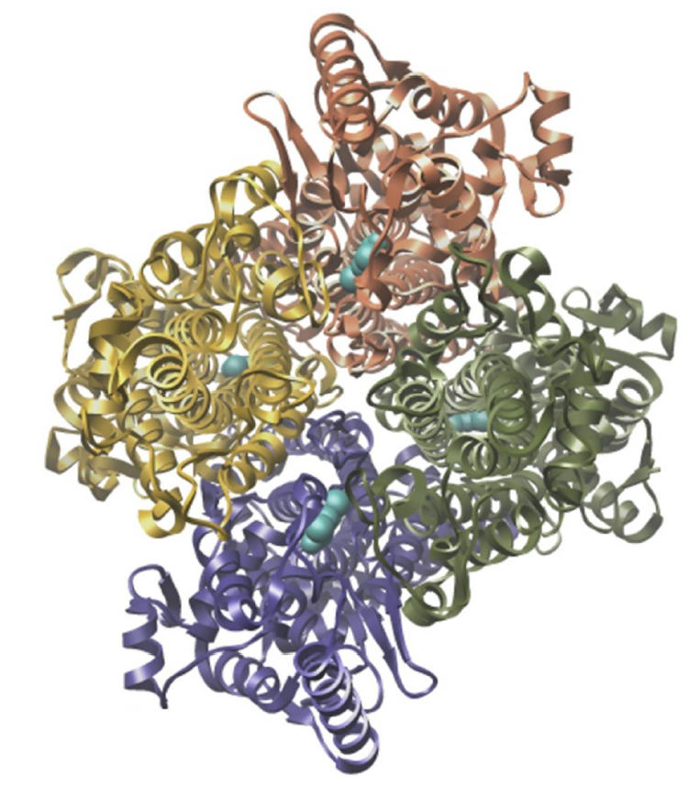

Recombinant phenylalanine ammonia lyase (rAvPAL) spontaneously forms a homotetramer, which is essential for enzyme activity. The individual polypeptide chains are represented by different colours, and the 4-methylideneimidazole–5–one (MIO) groups in the active sites are shown in cyan blue.

The rAvPAL protein is a homotetramer containing 567 amino acid residues and has a molecular weight of 62 kDa per monomer. It contains 72 lysine groups, of which 48 have some level of surface exposure for the lysine ε-amino group by which PEG is linked. The total molecular weight of pegvaliase is approximately 1000 kDa. The enzyme activity is attributed to the electrophilic prosthetic 4-methylideneimidazole-5-one (MIO) group.

During manufacture, the rAvPAL protein is purified and subsequently polyethylene glycol bound (PEGylated) with 20 kDa linear n-hydroxylsuccinimide (NHS) methoxyPEG, forming the active substance, pegvaliase (rAvPAL-PEG). Other ingredients include trometamol, trometamol hydrochloride, sodium chloride, trans-cinnamic acid and water for injections.

The proposed shelf life is 2 year (24 months) when stored at between 2°C and 8°C (that is, to be refrigerated). Do not freeze. The quality evaluator recommended to include temperature excursion during shipping if necessary. Palynziq may be stored in its sealed tray outside the refrigerator (below 25°C) for a single period up to 30 days with protection from sources of heat. After removal from the refrigerator, the product must not be returned to the refrigerator.

There were no outstanding quality issues.

### Nonclinical

The submitted nonclinical dossier was largely in accordance with the relevant TGA adopted guideline;[8]. The overall quality of the nonclinical dossier was satisfactory. However, the twice weekly dosing regimen utilised in all repeat dose toxicity studies was different to that of the daily maximum recommended human dose regimen and exposures were low. This is considered a limitation of the nonclinical dossier as the toxicity profile of pegvaliase may not have been fully presented.

No *in vitro* pharmacology studies were submitted. *In vivo* pharmacology studies in the PKU mouse model (BTBRPahenu2) demonstrated dose related reductions in plasma phenylalanine, accompanied by improvements in weight gain, neuropathology, and pup weaning capabilities (attenuation of maternal PKU syndrome). The *in vivo* studies also demonstrated reduced immune response against the protein portion of pegvaliase due to PEGylation.

No secondary pharmacology studies were submitted. Safety pharmacology studies assessed effects on the cardiovascular, respiratory, and central nervous systems. No adverse effects were noted in central nervous system (rat), cardiovascular (monkey) or respiratory (rat) function studies.

Overall, the pharmacokinetic profile in rats and monkeys was comparable to humans. Pegvaliase absorption was generally slow following subcutaneous dosing. Similarly, half‑life values were long. Tissue distribution of drug related material is expected to be limited, with no or limited penetration into brain tissue.

Pegvaliase showed a moderate order of toxicity in rats and monkeys following subcutaneous administration.

Repeat dose toxicity studies by subcutaneous administration were conducted in rats (up to 6 months) and monkeys (up to 9 months). The main findings were injection site reactions (both species), cellular vacuolation in multiple tissues (rats; associated with clearance of PEG) and arteritis (monkeys; associated with immune complex formation). Hypophenylalaninaemia in monkeys, arising from the exaggerated pharmacological effect of pegvaliase, also contributed to general toxicity findings such as, reduced body weight and food consumption, and anorexia.

Male fertility was unaffected in rats treated with pegvaliase. In females there was reduced corpora lutea, implantations and litter size (without an effect on the incidence of preimplantation loss). Reduced fetal weights and an increased incidence of variations and/or malformations were seen in embryofetal development studies (rats and rabbits). Lower birth weight and delayed postnatal development were seen in pups of rats treated with pegvaliase during pregnancy and lactation. All of these adverse reproductive and developmental effects occurred in the context of maternotoxicity and low plasma phenylalanine levels due to exaggerated pharmacology and may not be a direct drug-related effect. Pregnancy Category D;[9] was recommended.

A nonclinical mechanistic study to confirm a role of hypophenylalaninaemia in the observed teratogenicity in rabbits was requested by the United States Food and Drug Administration (FDA). However, there were problems achieving hypophenylalaninaemia in rabbits with dietary restriction, and the study was aborted.

### Clinical

The clinical dossier consisted of the following studies:

* One single dose Phase I study (Study PAL-001)
* Three multi-dose Phase II studies (Studies PAL-002, PAL-004, and 165-205)
* One Phase II long term open label extension study (Study PAL-003)
* Two Phase III studies (Studies 165-301 and 165-302) and a Study 165-302 sub-study (Study 165-303).

The primary efficacy/pharmacodynamic (PD) variable in clinical studies was blood levels of phenylalanine.

Pegvaliase is cleared by immune mediated mechanisms. The half-life varied greatly between individuals from 14 to 132 hours.

An induction/titration/maintenance dosing regimen was used in the Phase II/III studies, in order to manage the immune mediated response to pegvaliase that affects clearance, exposure, and adverse event (AE) profile. Immunogenicity necessitated an initial induction phase using fixed low weekly dose of pegvaliase for desensitisation to the protein, followed by individualised titration of the dose of daily pegvaliase subcutaneous injection to achieve phenylalanine target levels, balanced against tolerability, and a maintenance dose phase for long term.

#### Immunogenicity

Pegvaliase immunogenicity was monitored by a panel of semi-quantitative immunoassays to detect antibodies to total drug and immunoglobulin M (IgM) and immunoglobulin G (IgG) antibodies to the enzyme and PEGylated component of the drug. In addition, neutralising antibodies to capable of inhibiting enzymatic activity of phenylalanine ammonia lyase (PAL) enzyme and immunoglobulin E (IgE) antibodies were measured.

Figure : Study 165-301 Antibody titres over time in log scale plot (all patients)

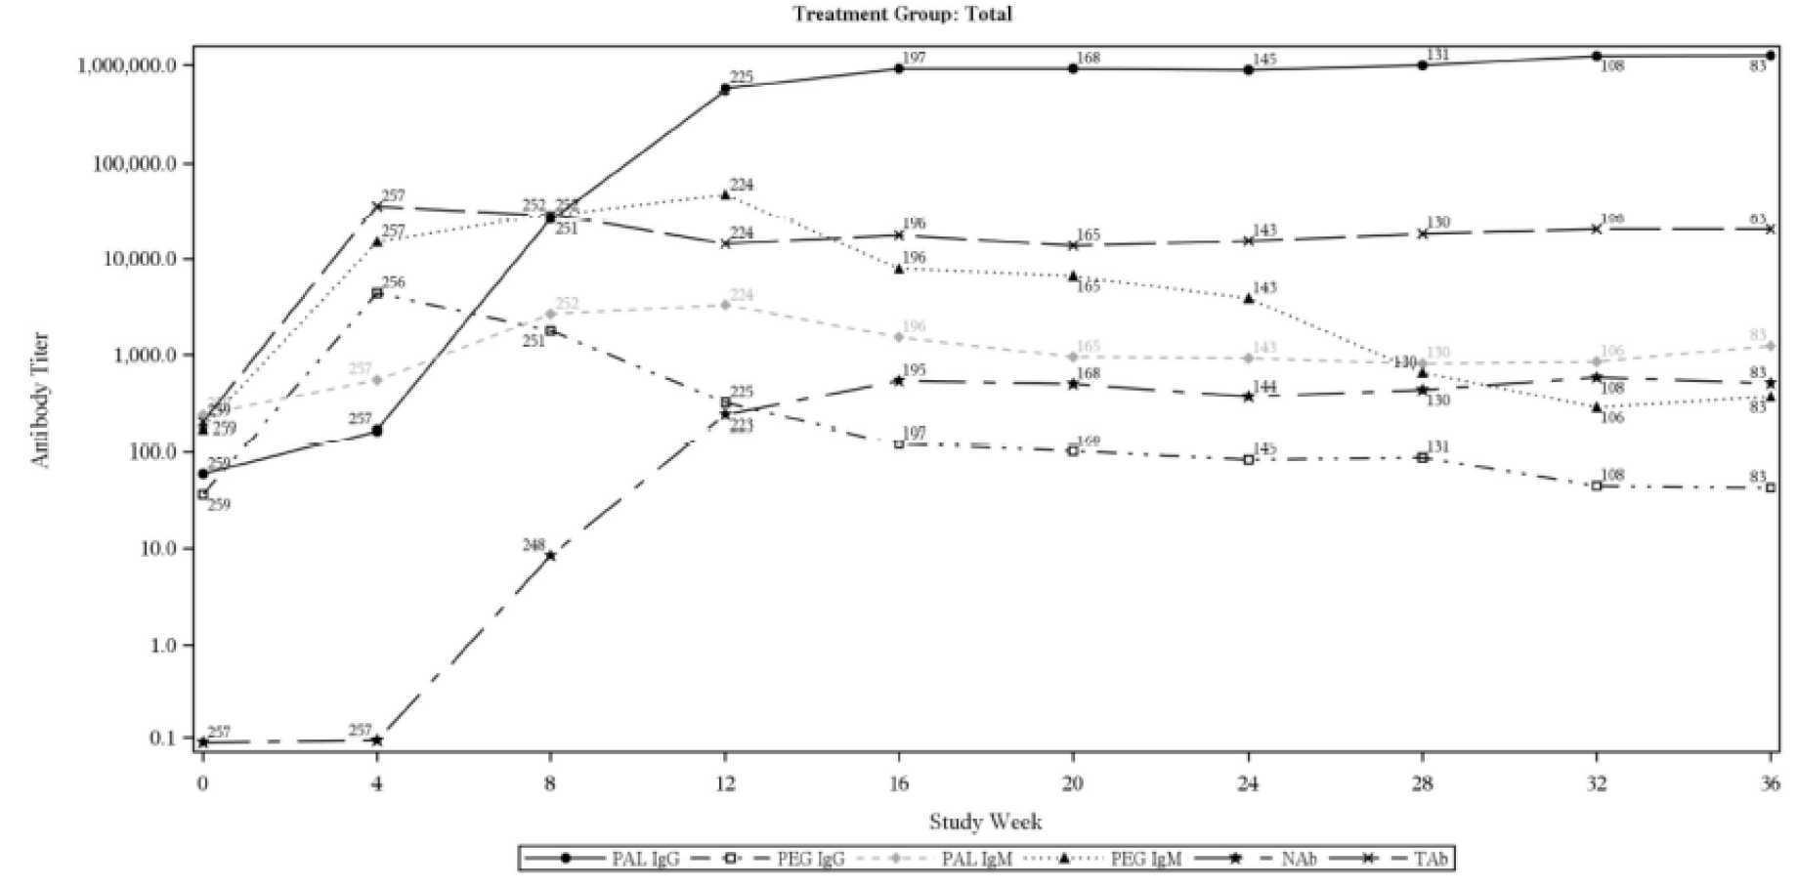

PAL = phenylalanine; IgG = immunoglobulin G; PEG = polyethylene glycol; IgM = immunoglobulin M; Nab = neutralising antibody; TAb = total antibody.

Antibody titre is the mean titre for each antibody type at each timepoint.

Following a single dose subcutaneous injection, pegvaliase is slowly absorbed and reaches maximum concentration in plasma around 4 to 5 days after administration. With the 2.5 mg weekly starting dose, the pegvaliase plasma concentration was very low or below the lower limit of quantification (LLOQ) after Week 1 to 2 due to the role of immune mediated clearance. The total antibody level reaches a maximum at Week 4, after this the pegvaliase concentration rises. Steady state can be reached 4 to 24 weeks after the starting dose.

Rising antibody titres are associated with a decreased effect on serum phenylalanine.

Figure : Study 165-302 Change in blood phenylalanine concentration and mean neutralising antibody titre (all patients)

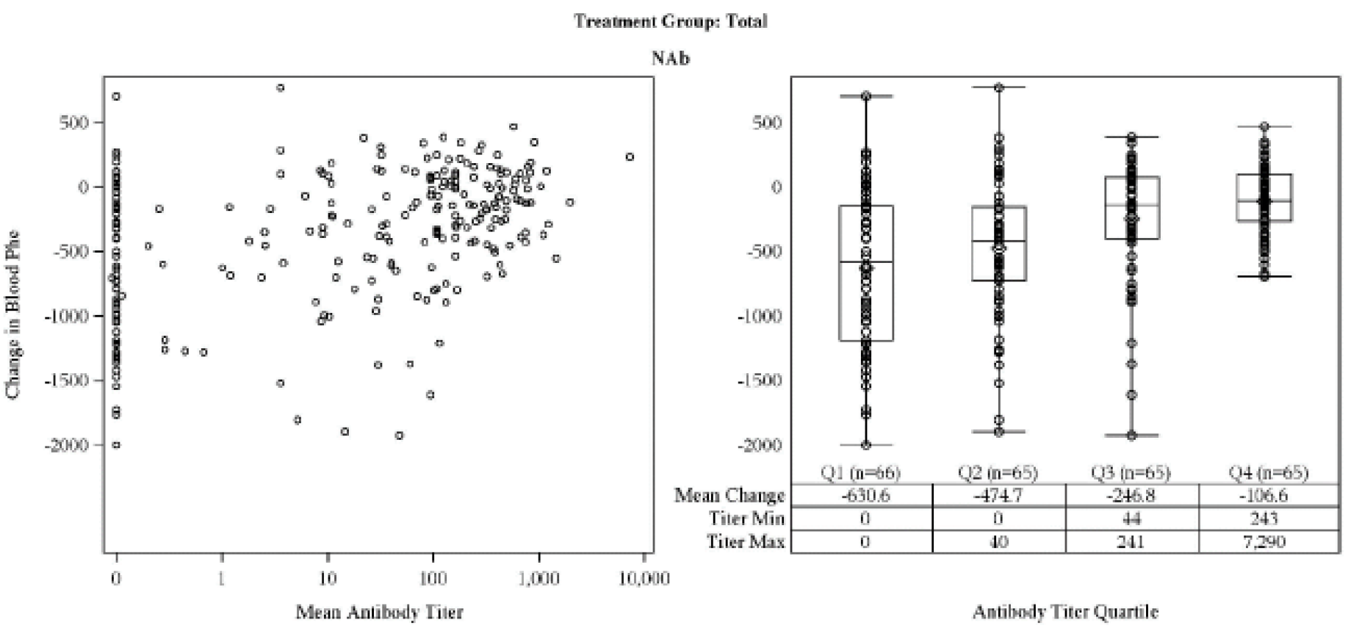

Nab = neutralising antibody; n = sample size; Q1 = the first quarter; Q2 = the second quarter; Q3 = the third quarter; Q4 = the fourth quarter.

Change in blood phenylalanine concentration was from Baseline to end of study for each patient. Each dot represents one patient.

In the right panel, patients were divided into quartiles based on their mean Nab titre. The horizontal lines from top to bottom represent the maximum value.

#### Efficacy

Study 165-301, was a 36 week safety, tolerability and efficacy study. Patients with PKU whom were naïve to pegvaliase (n = 261) were randomised using an Induction (4 weeks fixed dose 2.5 mg/week)/titration (30 weeks)/maintenance (2 weeks) dosing schedule to compare final fixed doses of pegvaliase 20 mg/day and 40 mg/day. Significant numbers of patients in the Phase III trials had been previously treated with sapropterin (196/261, 75%, in Study 165-301) and dependent on medical nutritional treatment as a protein source (57% in Study 165-301). Of those previously treated with sapropterin, 144 were considered non responders and 52 were regarded saproterin responders. Both doses resulted in a reduction in phenylalanine concentration. The dose effect was not linear.

Study 165-302 was a four part, Phase III, randomised, double blind, placebo controlled, four arm, discontinuation study to evaluate the efficacy and safety of subcutaneous injections of pegvaliase self administered by adults with PKU (n = 215). All patients had previously been treated with pegvaliase. Patients were required to have the neurocognitive and linguistic capacity to comprehend and understand the profile of mood states (POMS) depression scale observer rater scale, in addition participants were required to have a competent person over 18 years who could observe them after injections for at least one hour.

Figure : Study 165-302 A schematic diagram of the study design

Study 165-302 A schematic diagram of the study design

Study 165-302 is a Phase III, randomised, double-blind, placebo-controlled study to evaluate the efficacy and safety of pegvaliase.

Up to 250 subjects were screened initially. The study was conducted in 4 parts.

At Part 1 the subjects have gone through phenylalanine assessment. They were divided into two groups: 20 mg/day and 40 mg/day groups. 

Both groups were randomised to 2:1 ratio.

Subjects from Part 1 who have mean ≥ 20% reduction in blood phenylalanine proceed to Part 2, which compares placebo groups to groups taking pegvaliase 20 mg/day or 40 mg/day.

Subjects who completed Part 2 were proceeded to Part 3 for PK/PD study. 

Subjects who were not eligible for participation in Part 1 and 2 subjected or subjects who completed Part 3B enter Part 4, which they received pegvaliase for up to 60 mg/day.


Phe = phenylalanine.

Description: Study 165-302 is a Phase III, randomised, double-blind, placebo-controlled study to evaluate the efficacy and safety of pegvaliase.

Up to 250 subjects were screened initially. The study was conducted in 4 parts.

At Part 1 the subjects have gone through phenylalanine assessment. They were divided into two groups: 20 mg/day and 40 mg/day groups.

Both groups were randomised to 2:1 ratio.

Subjects from Part 1 who have mean ≥ 20% reduction in blood phenylalanine proceed to Part 2, which compares placebo groups to groups taking pegvaliase 20 mg/day or 40 mg/day.

Subjects who completed Part 2 were proceeded to Part 3 for PK/PD study.

Subjects who were not eligible for participation in Part 1 and 2 subjected or subjects who completed Part 3B enter Part 4, which they received pegvaliase for up to 60 mg/day.

Study 165-302 was conducted in 4 parts. Part 2 provided the most important efficacy outcomes:

The primary efficacy endpoint was to evaluate blood phenylephrine concentrations in patients previously treated with pegvaliase.

The secondary efficacy endpoints were mood and inattention symptoms measured by changes in neurocognitive and neuropsychiatric symptom scores, changes in attention deficit hyperactivity disorder (ADHD)-rating scale (RS) (investigator rated inattention score), change in PKU specific POMS (self rated).

##### Outcomes

There was a statistically significant change in serum phenylalanine concentration in the 20 mg and 40 mg groups (Table 2).

Table : Study 165-302 Mixed-model repeated measures of change from Baseline in blood phenylalanine concentration (μmol/L) at Week 8 of Part 2 for poolability (modified intent-to-treat;[10] population)

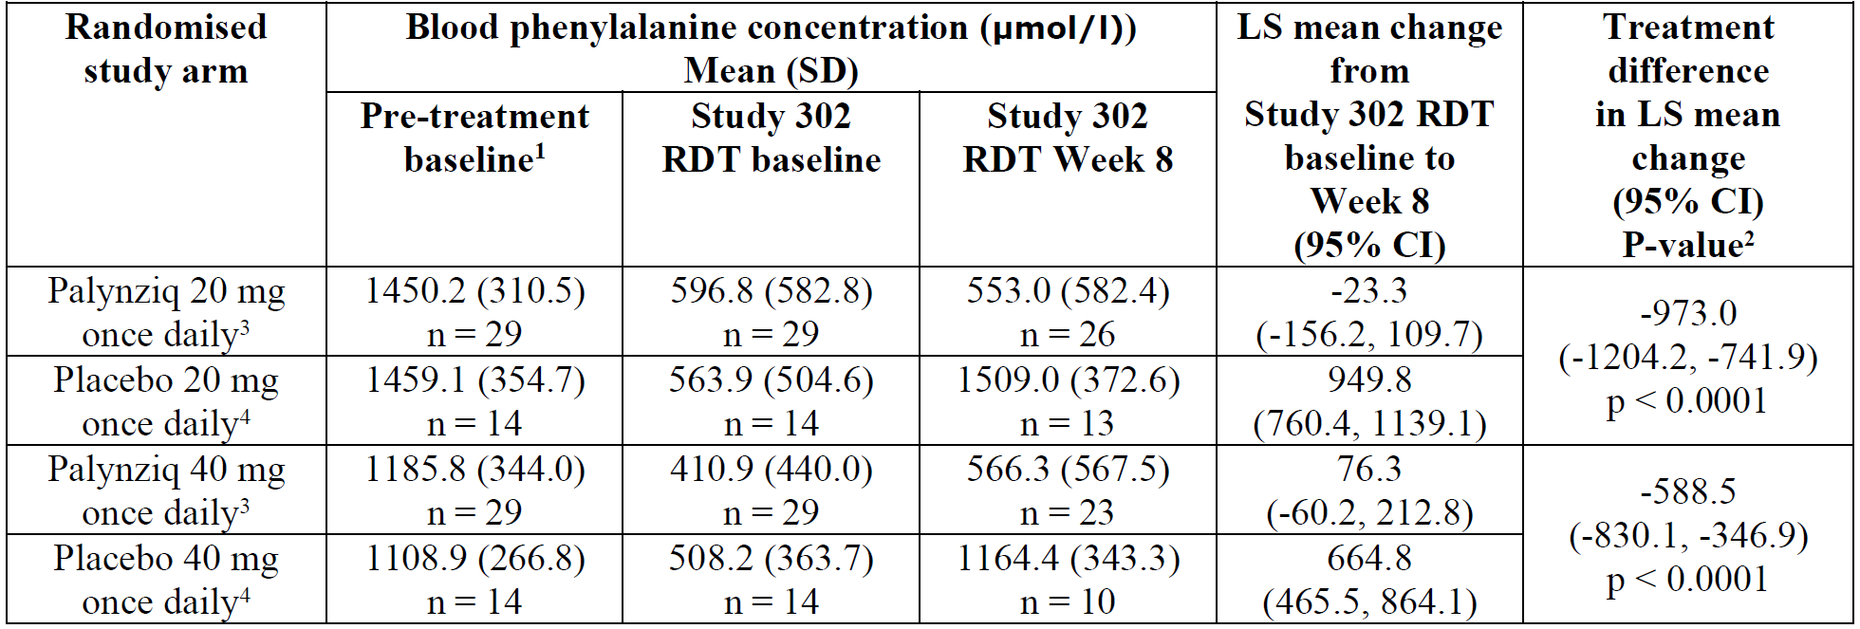

LS = least squares; RDT = randomised discontinuation trial; CI = confidence interval; n = sample size.

1: Blood phenylalanine level prior to initiating treatment with Palynziq

2: Based on the mixed model repeated measures method, with treatment arm, visit, and treatment arm-by-visit interaction (the time profile of blood phenylalanine changes is assessed separately for each treatment arm) as factors adjusting for baseline blood phenylalanine concentration.

3: Nine patients were excluded from the Week 8 analysis from the Palynziq treatment arms (20 mg/day or 40 mg/day): 4 patients did not complete the RDT due to adverse events (1 patient discontinued treatment and 3 patients transitioned to the long term extension period) and the remaining 5 patients who did not complete phenylalanine assessment within the window for Week 8 (Day 43 to 56).

4: Five patients were excluded from the Week 8 analysis from the placebo arms (20 mg/day or 40 mg/day): 1 patient did not complete the RDT due to adverse event transitioned to the long term extension period and the remaining 4 patients who did not complete phenylalanine assessment within the window for Week 8 (Day 43 to 56).

Table 3 shows the changes in symptoms scores for the psychological scales. Based on published literature, a 5.2 difference in ADHD-RS is considered the minimal important clinical difference. There was no clinically significant change in symptom score in 8 weeks in Part 2.

Table : Study 165-302 Mixed-model repeated measures of change from Baseline in neurocognitive and neuropsychiatric symptom scores at Week 8 of Part 2 (modified intent-to-treat;10 population)

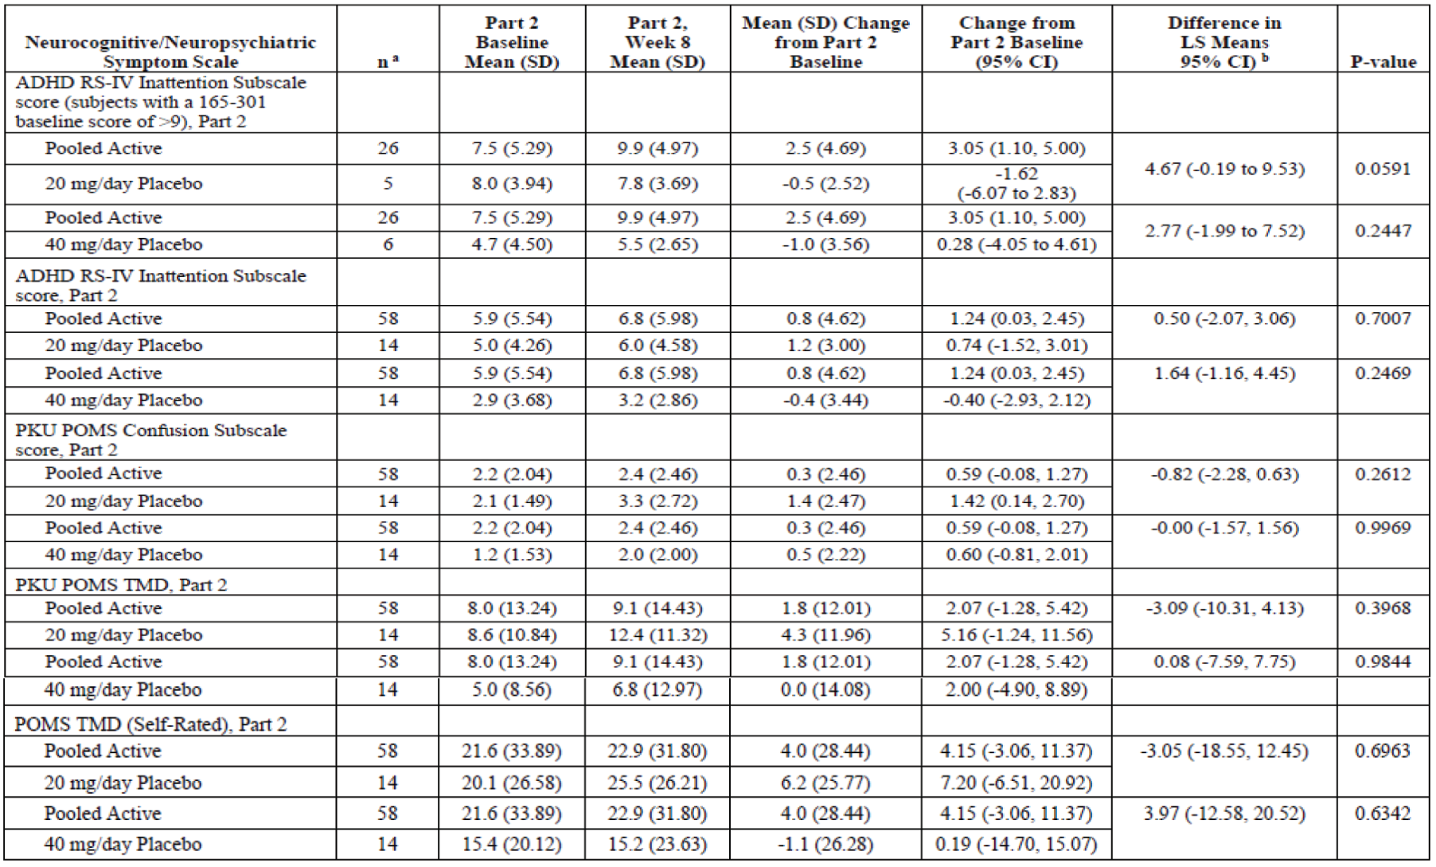

SD = standard deviation; CI = confidence interval; LS = least squares; ADHD = attention deficit hyperactivity disorder; RS = rating scale; IV = investigator rated; 165-301 = Study 165-301; PKU = phenylketonuria; POMS = profile of mood states; TMD = total mood disturbance.

Possible scores for the ADHD RS-IV Inattention and hyperactivity/impulsivity subscales range from 0 to 27, with higher scores indicative of more severe symptoms.

Possible scores for the POMS TMD range from -32 to 200, scores for the PKU POMS TMD range from -12 to 58, and scores for the PKU POMS Confusion Subscale range from 0 to 11, with higher scores indicative of more severe symptoms.

All Part 2 Week 8 (Day 56) assessments related to the secondary endpoints were performed one or within one week prior to the target day, otherwise they were considered missing values for the analyses of the secondary endpoints and the appropriated missing value imputation method(s) were applied.

a Some subjects did not have Part 2 neurocognitive and neuropsychiatric assessments data collected (Section 8.2. The ADHD RS-IV inattention subscale, PKU POMS, and POMS tools were not performed in Study 165-301 until a protocol amendment; only subjects who had baseline assessments were included. Subjects who were included in the modified intent-to-treat population from a Phase II study were not included because neurocognitive and neuropsychiatric tools were not administered in the Phase II studies.

b Negative values indicate a decline in symptom score (towards improvement); positive values indicate an increase in symptom score (towards decline).

Part 4 demonstrated long term efficacy. Figure 5 shows steady decrease in serum phenylalanine until Week 153. Patients who did not have a 20% reduction in phenylalanine level from a 20 mg or 40 mg dose in Study 165-301 were able to enter Part 4 and receive a 60 mg dose. There was a reduction in phenylalanine level in most of these patients.

Figure : Study 165-302 Mean plot of change from Baseline in blood phenylalanine concentration during Part 4 (all subjects)

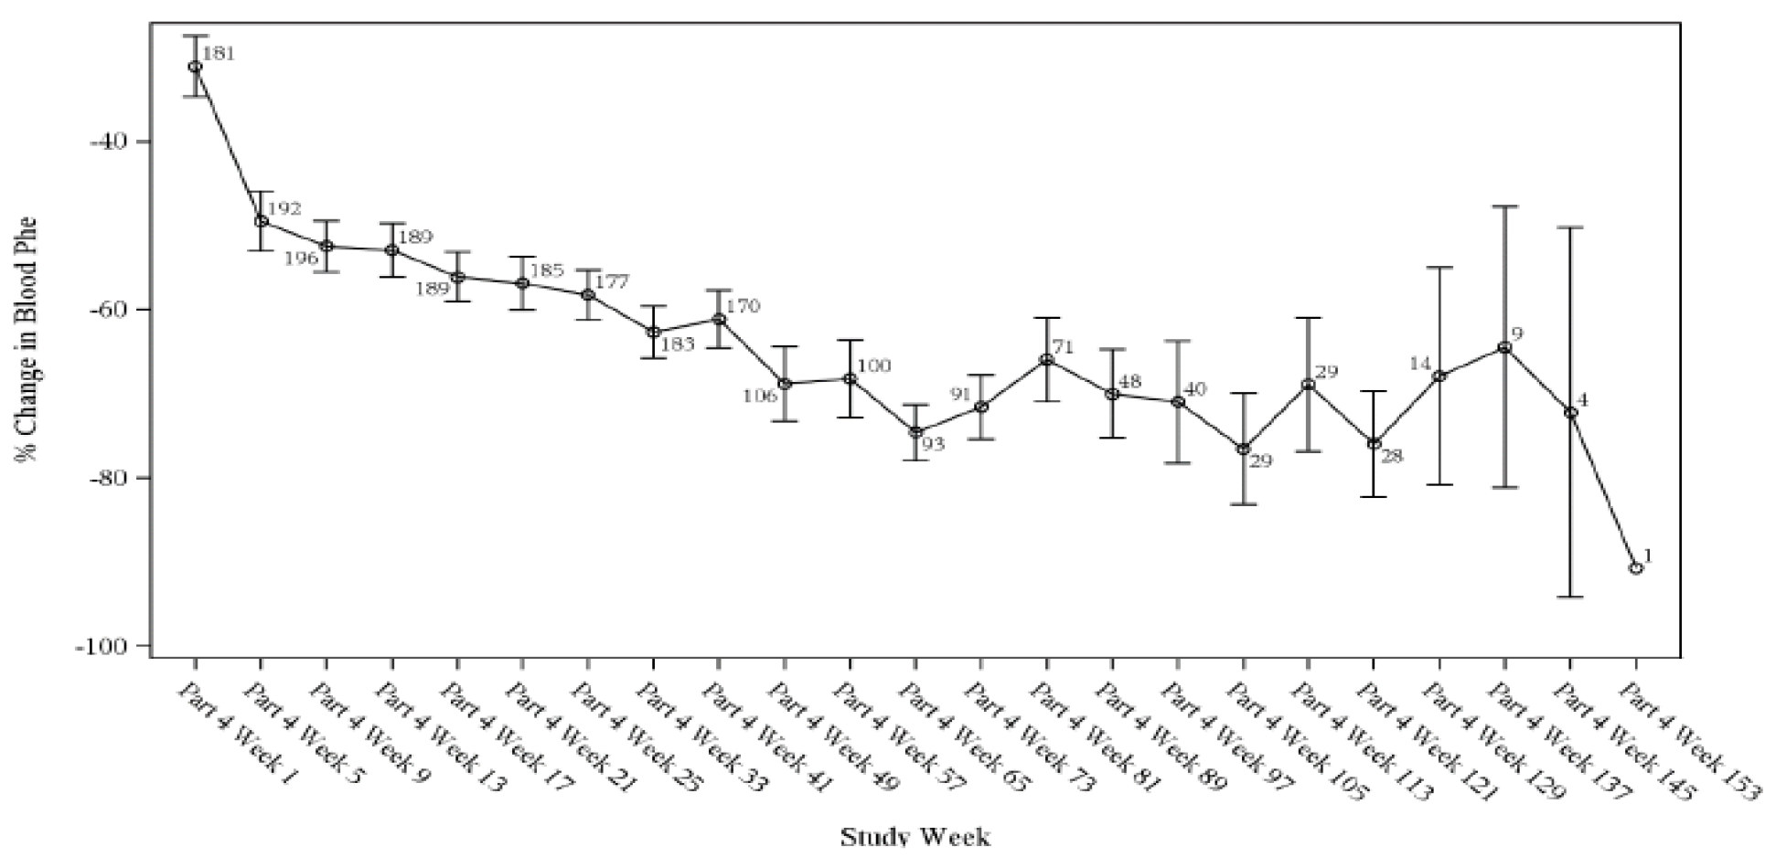

Phe = phenylalanine.

The variability in sample size is attributed to the variability of subjects with available data at each time point (subjects who did not perform an assessment within the protocol defined visit window, terminated from the study early, or have missing data were not included as of the cut-off for this clinical study report). Subjects who did not have Week 1 data but had data for subsequent Part 4 time points were included. Part 4 results are based on data as of the data cut-off for this clinical study report and are primarily discussed for subjects with data up through Week 41 of Part 4. These data and data at subsequent time points reflect a smaller and variable sample size due to the limited number of subjects with data at time points after Week 41 as of the data cut-off.

After 18 months of treatment, there was a clinically significant change in ADHD-RS. These changes were of greater magnitude in those who were more symptomatic at Baseline (Figure 6).

Figure : Study 165-302 Mean plot of attention deficit hyperactivity disorder rating scale investigator rated inattention subscale scores and change from Baseline during Part 4 (all subjects)

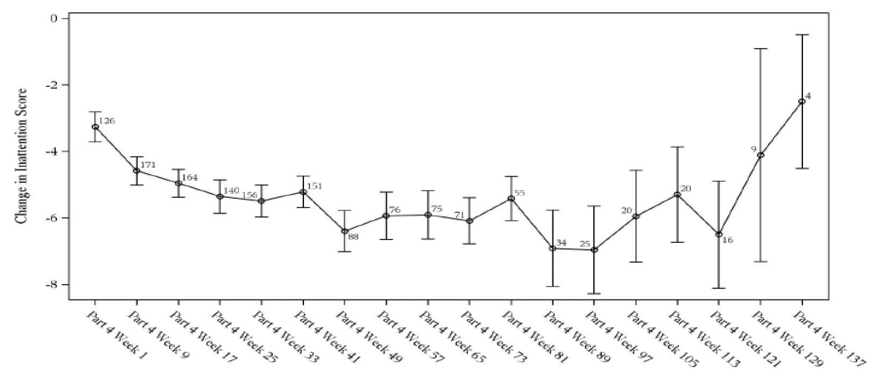

Table 4: describes efficacy in subpopulations based on previous treatments. There was a significant response to treatment regardless of previous therapy with diet or sapropterin.

Table : Study 165-302 Change from baseline phenylalanine in the different populations following 12 months of treatment

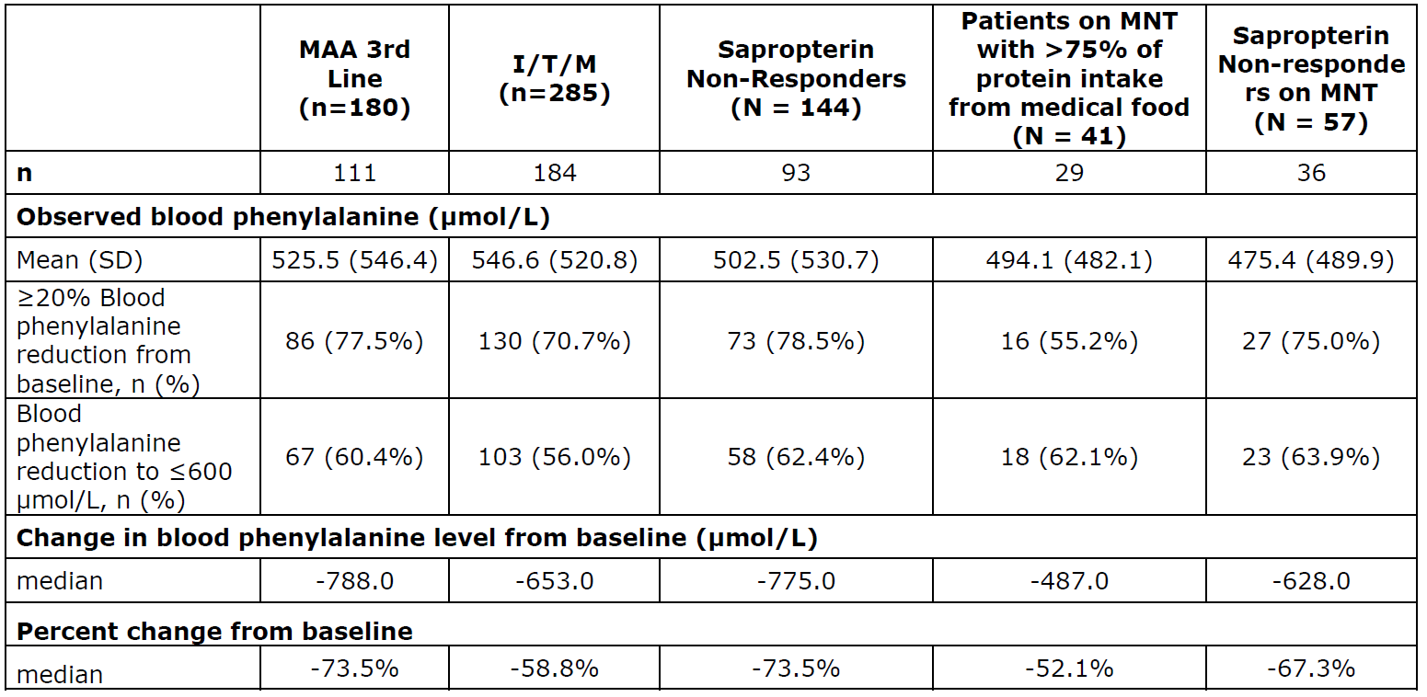

n = sample size; I/T/M = induction, titration, and maintenance population; N = population size; MNT = medical nutrition therapy; SD = standard deviation.

#### Safety

Adverse events were very common (Table 5). The most common AEs affecting > 50% of those treated included injection site reactions (93.3%), hypersensitivity (74.7%), decreased blood complement C3 or C4, arthralgia (84.6%) and headache (54.7%). Very high rates of hypersensitivity reactions and AEs were observed (n = 213 (74.7%). Most acute hypersensitivity reactions occurred in the first year.

Table : Study 165-302 Adverse events assessed by the investigator as related to study drug in > 10% of the patients per treatment phase (induction, titration, and maintenance population)

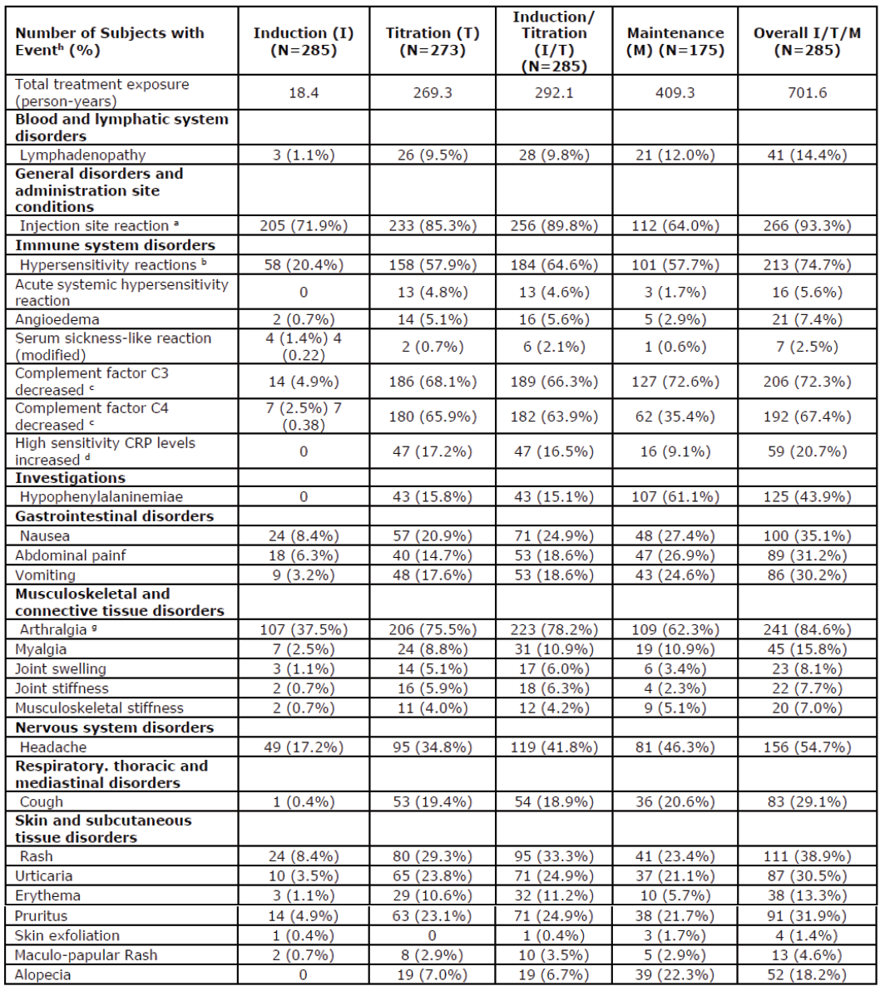

I = induction; T = titration; M = maintenance; N = population size; CRP = C-reactive protein.

a Reflect all terms reported under the Medical Dictionary for Regulatory Activities (MedDRA);[11] high level term injection site reactions

b Hypersensitivity reaction were identified using hypersensitivity modified narrow Standardised MedDRA Queries (SMQ);[12] with acute systemic hypersensitivity reaction (National Institute of Allergy and Infectious Disease (NIAID)/Food Allergy and Anaphylaxis Network (FAAN) episodes as adjudicated by external expert). Injection site rash and injection site urticaria were excluded from the hypersensitivity narrow SMQ.

c Complement factor C3/C4 decrease is defined as changing from normal or high complement baseline value to low post baseline value

d Reflects high sensitivity C-reactive protein (hsCRP) levels above upper limit of normal (> 0.287 mg/dL) over a 6 month period. hsCRP was measured in a total of (N = 261) subjects

e Hypophenylalaninaemia event is defined as the period with at least 2 consecutive blood phenylalanine concentrations <30 µmol/L.

f Abdominal pain reflects the following preferred terms: abdominal pain, abdominal pain upper and abdominal discomfort.

g Arthralgia reflects the following preferred terms: arthralgia, back pain, musculoskeletal pain, pain in extremity and neck pain.

h the number of patients in each treatment phase do not add up to the totality of patients in the I/T/M as patients could have adverse events reported in each phase.

There were 91 serious adverse events (SAE) in 64 of 285 subjects in the induction, titration, and maintenance population. The most common SAEs were anaphylaxis (14 subjects) and hypersensitivity (9 subjects). Almost all of these were resolved. There were 18 SAEs that resulted in study drug or study discontinuation, most of these were related to hypersensitivity.

Hypersensitivity reactions were mild in 18.2%, moderate in 62.5%. They were most frequent during the first 6 months of treatment. There were 16 patients who experience 25 acute systemic hypersensitivity events.

There was an association between anti-drug antibody levels and AEs.

A total of 125 patients met the definition of hypophenyalaninaemia (at least 2 consecutive blood phenylalanine levels < 30 µmol/L), despite monthly monitoring.

### Risk management plan

The sponsor has submitted EU-risk management plan (RMP) version 1.0 (dated 25 March 2019; data lock point (DLP) 5 February 2018) and Australian specific annex (ASA) version 0.1 (dated 11 August 2020) in support of this application.

In its response to questions raised by TGA, the sponsor has submitted EU-RMP version 3.0 (dated 6 October 2020; DLP 17 April 2019) and ASA version 0.2 (dated 5 March 2021) in support of this application.

The summary of safety concerns and their associated risk monitoring and mitigation strategies are summarised in Table 6.[13]

Table : Summary of safety concerns

|  |  |  |  |  |  |
| --- | --- | --- | --- | --- | --- |
| Summary of safety concerns | | Pharmacovigilance | | Risk Minimisation | |
| **Routine** | **Additional** | **Routine** | **Additional** |
| Important identified risks | Acute systemic hypersensitivity reaction | ✓ | ✓* | ✓ | ✓** |
| Angioedema | ✓ | ✓* | ✓ | ✓** |
| Serum sickness | ✓ | ✓* | ✓ | – |
| Hypophenylalaninaemia | ✓ | ✓*† | ✓ | – |
| Persistent arthralgia (≥ 6 months) | ✓ | ✓* | ✓ | – |
| Severe injection site reactions | ✓ | ✓* | ✓ | – |
| Important potential risks | Complications of immune complex formation resulting in end-organ damage | ✓ | ✓*† | – | – |
| Foetal developmental toxicity | ✓ | ✓‡ | ✓ | – |
| Unpredictable immune-mediated response with off-label use in patients < 16 years | ✓ | ✓§ | ✓ | – |
| Acute systemic hypersensitivity reactions in patients taking other concurrent injectables containing PEG | ✓ | ✓§ | ✓ | – |
| Missing information | Long term safety and tolerability | ✓ | ✓* | – | – |
| Use in elderly (> 65 years) | ✓ | ✓§ | ✓ | – |
| Use in patients with pre-existing renal impairment | ✓ | ✓§ | ✓ | – |
| Use in patients with pre-existing hepatic impairment | ✓ | ✓§ | ✓ | – |
| Use in breastfeeding women | ✓ | ✓ǁ | ✓ | – |

*Additional pharmacovigilance Study PAL-003; Study 165-302; Study 165-501

† Also additional pharmacovigilance Study 165-503

‡ Additional pharmacovigilance Studies 165-504; BMN165-18-080; Study - fetal development study in rabbits

§ Additional pharmacovigilance Study 165-501

ǁ Additional pharmacovigilance Study 165-504

** Additional risk minimisation includes educational material for health care professionals, patients and trained observers and a patient alert card

* The summary of safety concerns are acceptable and are consistent with known toxicities of pegvaliase.
* Routine pharmacovigilance activities which include follow-up questionnaires for reports associated with acute systemic hypersensitivity reaction and serum sickness as well as renal AEs have been proposed. Additional pharmacovigilance activities include the studies listed under Table 6. No Australian patients will be enrolled, however, it is likely that the results will be applicable to the Australian cohort.
* Routine and additional risk minimisation activities have been proposed. The additional activities include educational material, for health care professionals, patients and trained observers as well as a patient alert card. These educational materials will need to be assessed by the TGA prior to marketing.

### Risk-benefit analysis

#### Delegate’s considerations

##### Dosing

The dosing proposed is not the same as that used in the clinical studies. It is identical to the dosing recommendations in the EU. The maximum dose approved by the FDA is 60 mg/day.

The sponsor has given adequate rationale for the induction, titration and maintenance phases based on the results of the clinical studies. Monthly blood phenylalanine levels are recommended.

An increase in dose based upon lack of responsiveness is justified. In the clinical trials, lack of responsiveness was associated with increasing neutralising antibodies, however this could be overcome by further dose increases.

The Delegate suggests the sponsor include more information about when to change from 20 mg to 40 mg or 40 mg to 60 mg; and more detailed advice about what to do if the phenylalanine level is below target or dropping.

##### Efficacy

The clinical development plan included a number of studies evaluating different dosing regimens. Some controlled, some not. There was a clear statistically significant reduction of blood phenylalanine concentrations with Palynziq. This was not entirely dose dependent, greater reduction in phenylalanine was observed in those with less antibodies.

The were no clinically significant reduction is behavioural and psychological scales after 8 weeks of treatment. However, statistically significant reductions were observed after treatment in the longer term study.

Phenylalanine is a widely used biomarker to measure the control of PKU. Elevated phenylalanine is directly toxic to cells in the brain, inhibits protein synthesis, affects myelination of proteins, and leads to arrest or delayed development of dendrites and synapses in the cortex. The sponsor has provided a number of articles that describe the correlation with high phenylalanine and abnormal neurological outcomes, but only a few Bilder et al. (2016);[14] and Gassio et al. (2003);[15] that describe how in adults a reduction in phenylalanine leads to better behavioural or psychological outcomes.

##### Safety

Local injection site reactions were common.

This medicine is highly immunogenic. Hypersensitivity reactions were very common, most of these were mild to moderate. Anaphylaxis or acute hypersensitivity occurred in around 20%.

The hypersensitivity reactions have been shown to be Type III rather than Type I hypersensitivity reactions.[16] There were no identified clinical predictors of hypersensitivity reactions.

The risk mitigation strategy proposed was included as a protocol amendment to the clinical studies in May 2014. This included premedication with a histamine-1, histamine-2 antagonist and nonsteroidal anti-inflammatory drugs; having a trained observed present at the time of injections; training in the recognition and treatment of hypersensitivity; use of an EpiPen (adrenaline (epinephrine) autoinjector); and an extension of the initiation and titration phase from 14 weeks to 26 weeks. The sponsor states there was high compliance with pre-medication, and very few patients were unable to have a support person. The benefits of the risk mitigation strategies are described below. From the data provided it is not able to determine which component(s) of the strategy were most beneficial.

Table : Study 165-301 Event rate of adverse events of interest before and after risk mitigation strategy implementation on 9 May 2014 analysis population (safety population, N =261)

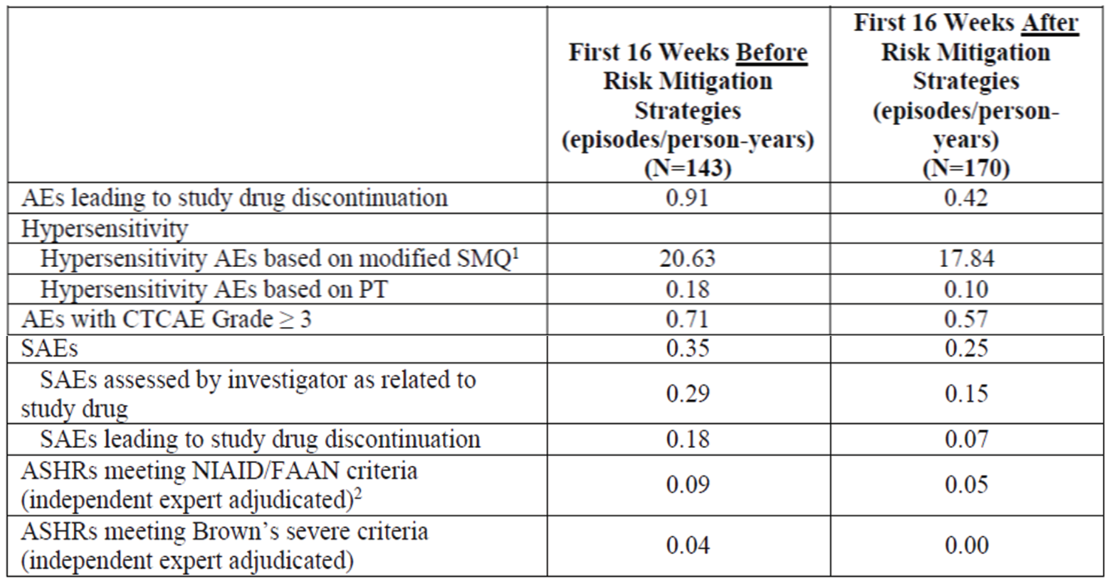

N = population size; AE = adverse event; SMQ = Standardised MedDRA Queries; PT = Preferred Term; CTCAE = common terminology criteria for adverse events; SAE = serious adverse event; NIAID = National Institute of Allergy and Infectious Disease; FAAN = Food Allergy and Anaphylaxis Network; ASHR = acute systemic hypersensitivity reactions.

1: Includes additional Preferred Terms such as arthralgia, arthritis, eye inflammation, eye irradiation, eye pain, joint stiffness, joint swelling, pyrexia, vision blurred and polyarthritis.

2: Data cut-off 5 February 2018.

There was a high rate of hypophenylalaninaemia despite monthly monitoring of phenylalanine. In my opinion, the current recommendation around the management of low phenylalanine levels in the PI could be improved, in particular how much the dietary protein intake should be changed, and how long between changes in diet or dose before further adjustments are made.

##### Use in pregnancy

Optimal control of serum phenylalanine is important during pregnancy. Both hyperphenyalaninaemia and hypophenylaninaemia should be avoided.

The nonclinical evaluator has recommended pregnancy category D;9.

Pregnancy category D refers to medicines which have caused, are suspected to have caused or may be expected to cause, an increased incidence of human fetal malformations or irreversible damage. These drugs may also have adverse pharmacological effects.

It is recommended that medicines in pregnancy category D not be used during pregnancy, however the medicine is not contraindicated during pregnancy.

Palyzniq is a large molecule which does not cross the placenta. It is likely that the AEs in the pups in the animal studies were related to low serum phenylanine levels in the mothers.

In addition, the evaluator was concerned about the potential risk of anaphylaxis during pregnancy.

Advice from Advisory Committee on Medicines (ACM) will be requested in relation to the use of Palynziq in pregnancy. In particular, how to best balance the potential risks of hyperphenylalaninaemia with hypophenylalaninaemia.

##### Risk management plan

The sponsor has included the EU-RMP and an ASA for use of this product in Australia. There are a number of post market studies evaluating safety of this product.

To mitigate the safety concerns, the sponsor has proposed a health professional information sheet, patient information sheet and patient alert card. The Delegate has no concerns about the content of these documents. However, given the importance of patient selection, education and ongoing follow in using this product, there needs to be more consideration given to who can prescribe this medicine.

The Delegate proposes this medicine be restricted to use by experience by physicians with management of metabolic disorders, ideally in a multidisciplinary clinic with a dietician.

The Delegate also recommend consideration be given to a boxed warning to highlight the risk of hypersensitivity similar the one included in the US PI.

##### ***Indication***

The sponsor’s proposed indication is:

*Palynziq is indicated for the treatment of patients with phenylketonuria (PKU) aged 16 years and older who have inadequate blood phenylalanine control (blood phenylalanine levels greater than 600 micromol/L) despite prior management with available treatment options*

The Delegate acknowledges the reported poor control of phenylalanine levels in adolescents and adults with PKU. The Delegate also appreciates the difficulties in adhering to long term dietary restrictions. Although this medicine offers advantages in improving phenylalanine levels, there is a high rate of hypersensitivity and anaphylaxis. The Delegate proposes the indication be amended to incorporate a statement around the importance of compliance with dietary modifications prior to initiation of treatment.

The Delegate would appreciate the opinion of the ACM in relation to whether the indication should be restricted to:

* Those adhering to nutritional advice
* Unresponsive to or unable to tolerate sapropterin.

#### Proposed action

Overall, the dossier submitted supports the registration of Palynziq. Advice of the ACM is requested around how this medicine should be used in Australia in the context of the small change in clinically relevant efficacy endpoints and high rates of serious AEs. The advice of the committee is also requested around how the potential risks associated with this medicine should be mitigated.

While a decision is yet to be made, at this stage the Delegate is inclined to approve the registration of the product.

If registration was approved, the Delegate would propose the following additional conditions of registration, to what is already included in the PI and RMP:

* A boxed warning describing the risk of anaphylaxis.

##### Proposed risk management plan conditions of registration

The Palynziq EU-RMP (version 3.0, dated 6 October 2020, DLP 17 April 2019), with ASA (version 0.2, dated 5 March 2021), included with Submission PM-2020-04119-1-3, and any subsequent revisions, as agreed with the TGA will be implemented in Australia.

An obligatory component of risk management plans is routine pharmacovigilance. Routine pharmacovigilance includes the submission of periodic safety update reports (PSURs).

Reports are to be provided in line with the current published list of EU reference dates and frequency of submission of PSURs until the period covered by such reports is not less than three years from the date of this approval letter.

The reports are to at least meet the requirements for PSURs as described in the European Medicines Agency’s Guideline on Good Pharmacovigilance Practices (GVP) Module VII-Periodic safety update report (Rev 1), Part VII.B Structures and processes. Note that submission of a PSUR does not constitute an application to vary the registration.

As Palynziq is a new biological entity it should be included in the Black Triangle Scheme as a condition of registration. The following wording is recommended for the condition of registration:

* Palynziq (pegvaliase) is to be included in the Black Triangle Scheme. The PI and Consumer Medicines Information (CMI) for Palynziq must include the black triangle symbol and mandatory accompanying text for five years, which starts from the date that the sponsor notifies the TGA of supply of the product.

##### ***Proposed quality conditions of registration***

All batches of Palynziq (pegvaliase) supplied in Australia must comply with the product details and specifications approved during evaluation and detailed in the Certified Product Details (CPD).

When requested by the TGA, the Sponsor should be prepared to provide product samples, specified reference materials and documentary evidence to enable the TGA to conduct laboratory testing on the product. Outcomes of laboratory testing are published biannually in the TGA database of laboratory testing results http://www.tga.gov.au/ws-labs-index and periodically in testing reports on the TGA website.

#### Questions for the sponsor

The sponsor provided the following response to questions from the Delegate.

1. ***What data is available about the long term risks of exposure to polyethylene glycol?***

Polyethylene glycol [PEG] distribution, metabolism and excretion has been well described in the literature. Polyethylene glycol is primarily eliminated by renal filtration. Long term nonclinical and clinical studies have been conducted with PEGylated proteins and enzymes with no PEG related toxicities. This is supported by the nonclinical studies with pegvaliase and the clinical program safety database which has not demonstrated any adverse effects related to PEG.

Polyethylene glycol has a simple repetitive structure, is chemically inert, and has minimal associated toxicity.[17] In numerous nonclinical development programs, vacuoles have been observed in animal studies with no associated adverse effects or organ dysfunction attributed to PEG. Preclinical evaluation of approved FDA and EMA PEGylated biopharmaceuticals (Adagen, Oncaspar, Peg-Intron, Pegasys, Neulasta, Somavert, Macugen, Mircera, Cimzia, Krystexxa, Omontys, Plegridy, Refixia, Ristempa and Lonquex) included comprehensive toxicology studies with the PEG conjugate and partly with the PEG alone. PEG sizes in these studies ranged from 25 to 230 kDa. Adverse effects seen in some of the toxicology studies of up to 52 weeks in duration are mostly related to the active part of the drug molecule (and not to the PEG) and are generally considered to be exaggerated pharmacological effects. No toxicity unique to PEGylation has been reported. Cellular vacuolation was reported for 6 of these 15 approved biopharmaceuticals and in 10 of the 17 products currently in nonclinical or early clinical development.[18] In 2 of the products, Refixia;[19] and Krystexxa, an immunohistochemical analysis was performed to assess PEG containing vacuoles. Both of these reported PEG containing vacuoles in various tissues with the PEG being eliminated in a time and dose proportional manner, with some vacuolation persisting after up to 12 weeks after cessation of treatment.

In the studies mentioned above, vacuolation appeared primarily in reticuloendothelial cells (that is, macrophages). Importantly, vacuolation, which does occur mainly in phagocytes, has not been linked with changes in organ function in these toxicology studies. Polyethylene glycol and PEG containing biopharmaceuticals may cause vacuolation of certain cell types after repeated treatment with high parenteral doses in animals. Based on the absence of tissue damage or any other signs of toxicity, vacuolated cells observed in some animal studies are considered to be a non-adverse consequence of an adaptive PEG removal process. Following high exposure to PEGylated biopharmaceuticals in animals, vacuolated macrophages are observed in several tissues, including the liver, kidney, bladder and choroid plexus. These findings were considered to reflect normal physiological processing of exogenous material by scavenger phagocytic cells, producing no apparent effect on cell function or cell viability.

Pegvaliase is expected to be cleared primarily by proteolytic degradation and uptake by the immune system. In clinical trials of pegvaliase, anti-drug antibodies and circulating immune complexes have been observed in PKU patients receiving pegvaliase treatment and these are associated with increased drug clearance. In the literature, it has been shown that the circulating immune complexes uptake through the reticular endothelial system via macrophages can result in a significant increase in drug clearance.[20],[21] Following the cellular uptake, the protein part of pegvaliase is expected to be catabolized into amino acids, and the PEG molecule will be separated from the active drug component. Regardless of the clearance mechanism, after protein cleavage the fate of the PEG molecule is expected to be similar to that for unconjugated PEG, which is predominantly excreted via urine and faeces.

As vacuoles were a known effect of PEGylated proteins and enzymes, an important component of the toxicology evaluation of pegvaliase was assessment and characterisation of potential tissue vacuolation. Vacuoles were observed in the chronic rat studies for pegvaliase in multiple organs (liver, kidney, lymph nodes, adrenal gland, and spleen and testes) with no associated adverse functional or pathological effects. In these studies, partial reversibility of cytoplasmic vacuolation was observed in all of these tissues after a recovery period with the exception of the kidney, where vacuolation was relatively unchanged. As the kidney is the primary clearance mechanism of PEG, this persistence of vacuolation may be attributed to gradual reduction of PEG in other organs that is being cleared through the kidney over time and is part of the normal physiological process for excretion of PEG.

Since 1990, 15 PEGylated biopharmaceuticals have been approved for human use, including for indications requiring chronic, daily administration such as Somavert.18 Although PEG related vacuolation has been reported in nonclinical studies of approximate 50% of approved PEGylated therapies, to the sponsor’s knowledge there is no indication of PEG related adverse effects in clinical studies or post-marketing surveillance associated with these products. Within the pegvaliase clinical program (355 subjects treated for a mean (standard deviation) duration of 37.3 (26.5) months including 56 subjects with > 5 years exposure), review of relevant organ systems (that is, tissues where vacuolation occurred in nonclinical pegvaliase studies), including renal, hepatic, and adrenal laboratory monitoring, has not identified any significant adverse clinical effects to date. Thus, the potential clinical risk associated with PEG exposure has not been demonstrated. Nevertheless, this potential clinical risk is being monitored and the planned observational safety studies (Studies 165-501 and 165-503) will further characterise this risk if patients develop clinical symptoms indicative of PEG exposure/accumulation.

Further information to support the long term safety of PEG are provided by the sponsor.[22]

1. ***Is the sponsor planning to apply for Pharmaceutical Benefits Advisory Committee (PBAC)[23] subsidy?***

The sponsor plans to apply for PBAC subsidy upon TGA approval of Palynziq.

1. ***When will further data in relation to use in children be available?***

The sponsor is in discussions with US FDA and EU Paediatric Committee (PDCO) on the design of the paediatric study for Palynziq with the aim to generate data in adolescents 12 year of age and above.

1. ***Has off-label use in children in been reported in Europe and United States of America?***

Off-label use in children has been reported in both Europe and the US. Treatment of patients < 18 years of age is considered off-label use in the US per the Palynziq US Prescribing Information. There were 39 patients < 18 years of age receiving doses of Palynziq post authorization as of 1 December 2020. These include 20 (17 year of age), 13 (16 years of age), 5 (15 years of age) and one (14 years of age) patients at the time of first dose (data retrieved from the US Risk Evaluation and Mitigation Strategy).

Treatment of patients < 16 years of age is considered off label use in the EU as per the Summary of product characteristics. Data regarding the use of Palynziq in this population are not always available as a result of patient privacy laws in the EU. Data are available from the Named Patient Program in Germany, where none of the 45 patients enrolled, as of 20 February 2021, are under 16 years of age.

The following is a summary of spontaneous or solicited reports received from commercial use. It should be noted that in periodic reports (periodic benefit risk evaluation report (PBRER)/PSUR) the sponsor’s focus has been on patients < 16 years of age as unpredictable immune reactions in this population is an important potential risk listed in the Palynziq EU-RMP (Version 3.0, October 2020) and global pharmacovigilance plan, that is, it is a risk that warrants further characterisation.

Cumulatively, up to 23 November 2020, the sponsor has received 67 adverse reaction reports (in 31 patients) involving a patient who was reported (either by age or extrapolated from the reported date of birth) as being under 18 years of age. Four of these reports concerned a patient aged 14 years; in one report the patient was aged 15 years; 34 reports (in 12 patients) concerned a patient aged 16 years; and in 28 reports (in 20 patients) the patient was aged 17 years. These 67 reports include 186 adverse reactions (including events of off-label use where appropriate, that is, for patients under the age of 18 years received from US sources or under the age of 16 years from the EU).

The most commonly reported adverse reactions (71/186; 38%) were related to an injection site reaction (for example, injection site: rash, pruritis, pain, or swelling).

There are 3 reports of an anaphylactic reaction, all reported as serious. One of these 3 reports concerned a 17 year old male patient in Germany. The other two reports occurred in a 17 and 16 year old respectively and both were US reports where the use was off-label. Where reported (2/3 reports) the anaphylactic reaction episode was resolved or recovered; or recovering or resolving. In the third report the outcome was not reported. These reactions are expected, and the nature and severity of these events was consistent with similar reactions seen in adults.

The other reported adverse reaction terms include: abdominal discomfort, abdominal pain, abdominal pain upper, alopecia, arthralgia, axillary pain, chest discomfort, chest pain, chills, disturbance in attention, dizziness, dysphagia, dysphonia, ear discomfort, erythema, fatigue, headache, hypersensitivity, hypoaesthesia, loss of personal independence in daily activities; muscle tightness, myalgia, nausea, pain, pain in extremity, palpitations, panic attack, paraesthesia, peripheral swelling, presyncope, pruritus, pyrexia, rash, swelling face, tachycardia, throat tightness, tongue eruption, toothache, urticaria, visual impairment and vomiting.

We have not received any reports that indicate an unpredictable immune response, either in terms of the nature of the AE or of the severity, concerning a patient < 16 years of age.

Overall, as characterised from commercial experience to date, the safety profile in patients aged less than 18 years is consistent with the safety profile seen in adult patients.

#### Advisory Committee considerations[24]

The Advisory Committee on Medicines (ACM), having considered the evaluations and the Delegate’s overview, as well as the sponsor’s response to these documents, advised the following.

##### Specific advice to the Delegate

1. ***Are the changes in serum phenylalanine levels observed in the clinical studies clinically significant for an adult with phenylketonuria?***

The ACM agreed that the changes in serum phenylalanine levels observed in the clinical studies are clinically significant for an adult with PKU, advising that reducing phenylalanine levels to < 400 µM/L is best for cognitive function and psychological effects, but even reducing levels to < 600 µM/L produces noticeably better outcomes than levels remaining at > 1000 µM/L.

In providing this advice, the ACM referenced the Australian PKU treatment consensus guidelines, which recommend reducing blood phenylalanine levels to below 360 μM/L, with the clarifier that in patients over 12 years of age, an informed decision to accept phenylalanine levels above 360 μM/L may be appropriate in some cases.[25]

1. ***Are the behavioural and psychological manifestations of phenylketonuria reversible in adulthood with improvements in serum phenylalanine concentrations?***

The ACM advised that in the real world setting, behavioural and psychological manifestations of PKU are substantially reversible in adulthood with improvements in serum phenylalanine concentrations.

1. ***Please comment on the clinical significance of the change in the scores for attention deficit hyperactivity disorder and behaviour scores.***

The ACM were of the view that the ADHD scales used in the clinical studies were appropriate, and there appears to be a dose response between change from Baseline in phenylalanine blood levels and change from Baseline in ADHD scores. However, the ACM were of the opinion that, based on the material presented, the results were marginal, advising that a clinically significant reduction in inattention score is -5.2 and noting that many of the confidence intervals cross this threshold. The ACM also noted that there was a high attrition rate during Part 4 of Study 165-302, particularly at the 36 month time point.

1. ***In adulthood, do all patients with phenylketonuria see a specialist metabolic physician?***

The ACM advised that all adult patients in Australia that are undergoing active management of their PKU are seeing a specialist metabolic physician.

1. ***Please comment on the practicality of the proposed risk mitigation strategies?***

The ACM advised that prescription of Palynziq should be restricted to metabolic physicians practicing in centres of excellence (multi-disciplinary clinics in tertiary hospitals with access to a dietitian), as these physicians have expertise in both PKU management and recombinant protein therapies, and are best placed to mitigate the risks of Palynziq treatment. The ACM discussed the practicalities of managing therapy for remote and rural patients, and advised that this can present some challenges, however, regular blood spot testing for such patients is standard of care.

The ACM emphasised that intensified phenylalanine monitoring is not optional and that the proposed recommendation for once monthly blood monitoring, as per the draft PI, is not sufficient. The ACM advised that measurement of phenylalanine levels should occur at least weekly during the induction and titration stages, in line with standard practice for significant treatment changes. The ACM commented that standard pregnancy/pre‑pregnancy management, as outlined in the Medical Research Council guidelines;[26] is phenylalanine measurement 2 times per a week, and advised that this monitoring schedule should also apply to relevant individuals on Palynziq treatment, with maternal phenylalanine levels to be strictly controlled between 120 and 250 µM/L before and during pregnancy.25,26

The ACM supported the inclusion of a Black box warning describing the risk of anaphylaxis.

The ACM was of the view that the risk of anaphylaxis and treatment related effects (for example, hypersensitivity) could be moved higher in the PI and CMI, to be more prominent for treating physicians and patients.

The ACM discussed that Palynziq may also increase hypersensitivity to other polyethylene glycol–bound (PEGylated) injectable medicinal products, which is noted in the draft PI. The ACM advised that the warning in the PI should be strengthened to say that other PEGylated injections should be avoided, and Depo-Provera;[27] and the Pfizer COVID-19 vaccine;[28] could be listed specifically as these are likely to be the most common PEGylated injections patients might use.

The ACM commented that there is no long term data on the impacts of PEG. Noting the challenges with surrogate marker and testing modalities for the impacts of PEG, the ACM advised that it would be beneficial for the sponsor to conduct a surveillance program for PEG effects.

1. ***Please comment on the proposed Pregnancy Category D.***

The ACM discussed the adverse reproductive and developmental effects of Palynziq from the nonclinical studies, although they noted that these findings occurred in the presence of maternal toxicity. The ACM also discussed that the human pregnancy data with pegvaliase is extremely limited. The ACM considered a case report of Palynziq use during pregnancy with no fetal anatomic anomalies associated with maternal PKU syndrome.[29] While they found this case study to be somewhat reassuring, the ACM recognised the need for caution in extrapolating findings in a single case report to a larger patient population.

Based on the current lack of human data, the ACM advised that Pregnancy Category D is considered appropriate, commenting that it is important to weigh up the risks/benefits of treatment versus non-treatment, consistent with the definition of Pregnancy Category D;9. The greatest risk in pregnancy is hypophenylalaninaemia.

The ACM were of the view that in the future, as data from the established surveillance program becomes available, confidence may increase regarding Palynziq treatment during pregnancy. The ACM noted that fetal toxicity is included in the risk management plan as an important potential risk and will be further characterised by a peri-/postnatal development study in rats and a fetal development study in rabbits.

1. ***Do the potential benefits of treatment in improving serum phenylalanine outweigh the potential risks of hypersensitivity and anaphylaxis.***

The ACM advised that based on the efficacy and safety data provided, Palynziq has a positive risk benefit profile. The ACM favourably viewed the finding that the Palynziq treated group in Study 165-302 were able to consume a near normal mean protein amount of 49 g per day, noting that Kuvan rarely permits normal diet, and some protein restriction and protein supplement is usually required in addition to tetrahydrobiopterin therapy.

However, the ACM commented that whether the potential benefits of treatment in improving serum phenylalanine outweigh the potential risks of hypersensitivity and anaphylaxis at an individual level will depend on the patient, and should be an individual decision made in consultation with the treating physician.

1. ***What place would Palynziq have in the clinical management of phenylketonuria in Australia? Do you consider there to be a need for patients to demonstrate compliance with dietary changes prior to using this, or could this be used despite not adhering to recommended protein restriction? Should patients be given a trial of Kuvan (sapropterin) prior to commencing Palynziq (pegvaliase)?***

The ACM advised that Palynziq should be a third line treatment for those who have failed standard treatment, including sapropterin, if relevant.

The ACM advised that the indication should not be restricted to those adhering to nutritional advice or who are unresponsive to, or unable to tolerate, sapropterin.

1. ***Please comment on the wording of the indication***

The ACM supported the following wording of the indication:

*Palynziq is indicated for the treatment of patients with phenylketonuria (PKU) aged 16 years and older who have inadequate blood phenylalanine control despite prior management with available treatment options.*

The ACM advised that this proposed indication gives flexibility to the treating physician. The ACM expressed concern that limiting the indication to patients with a blood phenylalanine levels of 600 µM/L or higher could disadvantage access to some patients who are compliant in managing their PKU. The ACM emphasised the importance of patients on Palynziq treatment undergoing careful monitoring due to the common occurrence of AEs. Taking this into consideration, the ACM were of the view that patients who are compliant with their diet and supplements, and thus potentially have lower blood phenylalanine levels, are also likely to be more engaged with Palynziq therapy monitoring, thus should not be inadvertently excluded from the proposed indication.

##### Conclusion

The ACM considered this product to have an overall positive benefit-risk profile for the indication:

*Palynziq is indicated for the treatment of patients with phenylketonuria (PKU) aged 16 years and older who have inadequate blood phenylalanine control despite prior management with available treatment options.*

### Outcome

Based on a review of quality, safety and efficacy, the TGA approved the registration of Palynziq (pegvaliase) 2.5 mg/0.5 mL, 10 mg/0.5 mL, 20 mg/mL, solution for injection, pre‑filled syringe, indicated for:

*Palynziq is indicated for the treatment of patients with phenylketonuria (PKU) aged 16 years and older who have inadequate blood phenylalanine control despite prior management with available treatment options.*

#### Specific conditions of registration applying to these goods

* Palynziq (pegvaliase) is to be included in the Black Triangle Scheme. The PI and CMI for Palynziq must include the black triangle symbol and mandatory accompanying text for five years, which starts from the date that the sponsor notifies the TGA of supply of the product.
* The Palynziq EU-RMP, version 3.0, dated 6 October 2020, DLP 17 April 2019), with ASA (version 0.2, dated 5 March 2021) included with Submission PM-2020-04119-1-3, and any subsequent revisions, as agreed with the TGA will be implemented in Australia.

An obligatory component of risk management plans is routine pharmacovigilance. Routine pharmacovigilance includes the submission of PSURs.

Reports are to be provided in line with the current published list of EU reference dates and frequency of submission of PSURs until the period covered by such reports is not less than three years from the date of the approval letter.

The reports are to at least meet the requirements for PSURs as described in the European Medicines Agency’s Guideline on Good Pharmacovigilance Practices (GVP) Module VII-Periodic safety update report (Rev 1), Part VII.B Structures and processes. Note that submission of a PSUR does not constitute an application to vary the registration.

* For all injectable products the PI must be included with the product as a package insert.

## Attachment 1. Product Information

The PI for Palynziq approved with the submission which is described in this AusPAR is at Attachment 1. For the most recent PI, please refer to the TGA website at <<https://www.tga.gov.au/product-information-pi>>.

|  |
| --- |
| Therapeutic Goods Administration |
| PO Box 100 Woden ACT 2606 Australia  Email: [info@tga.gov.au](mailto:info@tga.gov.au) Phone: 1800 020 653 Fax: 02 6232 8605  [**https://www.tga.gov.au**](https://www.tga.gov.au) |

1. The **Black Triangle Scheme** provides a simple means for practitioners and patients to identify certain types of new prescription medicines, including those being used in new ways and to encourage the reporting of adverse events associated with their use. The Black Triangle does not denote that there are known safety problems, just that the TGA is encouraging adverse event reporting to help us build up the full picture of a medicine's safety profile.
2. Van Spronsen, F. J. et al. Key European Guidelines for The Diagnosis and Management of Patients with Phenylketonuria, *Lancet Diabetes Endocrinol*, 2017; 5(9): 743-756.
3. van Wegberg, A. M. J The Complete European Guidelines on Phenylketonuria: Diagnosis and Treatment, *Orphanet J Rare Dis*, 2017; 12: 162.
4. Kuvan was first registered on the ARTG on 13 December 2018 (ARTG number: 297728 and 297734).
5. Department of Health, the Pharmaceutical Benefit Scheme, Sapropterin. Available at: <https://www.pbs.gov.au/medicine/item/10086W-10087X-11676M-11691H-11970B-11971C-11973E-11983Q>
6. The TGA makes use of assessments from **comparable overseas regulators (CORs)**, where possible, in the evaluation of prescription medicines. Under the COR-B approach, the TGA regulatory decision will be mostly based on a critical review of the COR assessment reports. The COR-B process has a 175 working day evaluation and decision timeframe, allowing for TGA evaluation of certain data, in addition to the label, Product Information (PI) and Risk Management Plan (RMP).

   The amount and type of additional data requiring evaluation will determine whether the application is best processed under the COR-B approach or as a Category 1 application.

   Examples of additional data that may be considered under the COR-B process include updated stability data, validation data for an additional manufacturing site and updates to pivotal studies that support the proposed indication.
7. **'Orphan drugs**' are often developed to treat small and very specific patient populations who suffer from rare diseases and conditions. In order to facilitate orphan drug access to the Australian marketplace and help offset orphan drug development costs the TGA waives application and evaluation fees for prescription medicine registration applications if a related orphan designation is in force. A medicine may be eligible for orphan drug designation if all orphan criteria set by the TGA are met. The orphan designation application precedes the registration application and the designation is specific to the sponsor, orphan indication for which designation was granted and dosage form of the medicine.
8. European Medicines Agency (EMA), Committee for medicinal products for human use (CHMP) ICH Guideline S6 (R1) - Preclinical Safety Evaluation of Biotechnology-Derived Pharmaceuticals, EMA/CHMP/ICH/731268/1998, June 2011.
9. **Pregnancy Category D:** Drugs which have caused, are suspected to have caused or may be expected to cause, an increased incidence of human fetal malformations or irreversible damage. These drugs may also have adverse pharmacological effects. Accompanying texts should be consulted for further details.
10. The randomised clinical trials analysed by the **intention-to-treat (ITT)** approach provide unbiased comparisons among the treatment groups. In the ITT population, none of the subjects are excluded, regardless of treatment compliance or attrition due to dropout or crossover, and the subjects are analysed according to the randomisation scheme. A **modified intention-to-treat analysis (mITT)** may sometimes be conducted excluding subjects post-randomisation.
11. The **Medical Dictionary for Regulatory Activities (MedDRA)** is a single standardised international medical terminology, developped as a project of the International Council for Harmonisation of Technical Requirements for Pharmaceuticals for Human Use (ICH) which can be used for regulatory communication and evaluation of data pertaining to medicinal products for human use. As a result, MedDRA is designed for use in the registration, documentation and safety monitoring of medicinal products through all phases of the development cycle (that is, from clinical trials to post-marketing surveillance). Furthermore, MedDRA supports ICH electronic communication within the ICH’s Electronic Common Technical Document (eCTD) and the E2B Individual Case Safety Report.
12. **Standardised MedDRA Queries (SMQs)** are groupings of terms from one or more MedDRA System Organ Classes (SOCs) that relate to a defined medical condition or area of interest. They are intended to aid in case identification.
13. *Routine risk minimisation* activities may be limited to ensuring that suitable warnings are included in the product information or by careful use of labelling and packaging.

    *Routine pharmacovigilance* practices involve the following activities:

    All suspected adverse reactions that are reported to the personnel of the company are collected and collated in an accessible manner;

    Reporting to regulatory authorities;

    Continuous monitoring of the safety profiles of approved products including signal detection and updating of labelling;

    Submission of PSURs;

    Meeting other local regulatory agency requirements.
14. Bilder, D. A. Systematic Review and Meta-Analysis of Neuropsychiatric Symptoms and Executive Functioning in Adults With Phenylketonuria, *Dev Neuropsychol*, 2016; 41(4): 245–260.
15. Gassio, R. et al. Do Adult Patients With Phenylketonuria Improve Their Quality of Life After Introduction/Resumption of A Phenylalanine-Restricted Diet?, *Acta Paediatr*, 2003; 92(12): 1474-1478.
16. Type I hypersensitivity (immediate hypersensitivity) is an allergic reaction provoked by re-exposure to an allergen (antigen). Type III hypersensitivity involves the accumulation of immune complexes (antigen-antibody complexes) that have not been adequately cleared by innate immune cells, giving rise to an inflammatory response.
17. Schellekens, H. et al. The Immunogenicity of Polyethylene Glycol: Facts and Fiction, *Pharm Res.*, 2013; 30(7): 1729-1734.
18. Ivens, I. A. et al. PEGylated Biopharmaceuticals: Current Experience and Considerations for Nonclinical Development, *Toxicol Pathol*, 2015; 43, 959-983.
19. Refixia was first registered on the ARTG on 4 September 2019 (ARTG number: 308424, 308425 and 308426).
20. Caliceti, P. and Francesco, M. V. Pharmacokinetic and Biodistribution Properties of Poly (Ethylene Glycol)–Protein Conjugates, *Adv Drug Deliv Rev*, 2003; 55 (10): 1261-1277.
21. Cheng, T. L. et al. Efficient Clearance of Poly (Ethylene Glycol)-Modified Immunoenzyme with Anti-PEG Monoclonal Antibody for Prodrug Cancer Therapy, *Bioconjug Chem*, 2000; 11(2): 258-266.
22. Inclusion of these information is beyond the scope of the AusPAR.
23. The Pharmaceutical Benefits Advisory Committee (PBAC) helps decide whether and, if so, how medicines should be subsidised in Australia. It considers submissions in this context. These submissions are of two types: to seek listing of a medicine on the Pharmaceutical Benefits Scheme (PBS); or to change the circumstances through which a medicine is already listed.
24. The ACM provides independent medical and scientific advice to the Minister for Health and the TGA on issues relating to the safety, quality and efficacy of medicines supplied in Australia including issues relating to pre market and post-market functions for medicines. Further information can be found here: <https://www.tga.gov.au/committee/advisory-committee-medicines-acm>.
25. Inwood, A. C. et al. Australasian Consensus Guidelines for the Management of Phenylketonuria (PKU) Throughout the Lifespan. For the Australasian Society of Inborn Errors of Metabolism (ASIEM). Available at: <https://www.hgsa.org.au/documents/item/8664>.
26. Recommendations on The Dietary Management of Phenylketonuria. Report of Medical Research Council Working Party on Phenylketonuria, *Arch Dis Child*, 1993; 68(3): 426-427.
27. Depo-Provera was first registered on the ARTG on 2 August 1991 (ARTG number: 12300).
28. Comirnaty was first registered on the ARTG on 25 January 2021 (ARTG number: 346290).
29. Boyer, M. et al. Continuation of Pegvaliase Treatment During Pregnancy: A Case Report, *Mol Genet Metab Rep,* 2021; 26: 100713.