|  |
| --- |
| **12 December 2016** |

|  |
| --- |
| AusPAR Attachment 3 |
| Extract from the Clinical Evaluation Report for Pembrolizumab |
| Proprietary Product Name: Keytruda |
| Sponsor: Merck Sharp and Dohme Australia Pty Ltd |

About the Therapeutic Goods Administration (TGA)

* The Therapeutic Goods Administration (TGA) is part of the Australian Government Department of Health, and is responsible for regulating medicines and medical devices.
* The TGA administers the *Therapeutic Goods Act 1989* (the Act), applying a risk management approach designed to ensure therapeutic goods supplied in Australia meet acceptable standards of quality, safety and efficacy (performance), when necessary.
* The work of the TGA is based on applying scientific and clinical expertise to decision-making, to ensure that the benefits to consumers outweigh any risks associated with the use of medicines and medical devices.
* The TGA relies on the public, healthcare professionals and industry to report problems with medicines or medical devices. TGA investigates reports received by it to determine any necessary regulatory action.
* To report a problem with a medicine or medical device, please see the information on the TGA website < <https://www.tga.gov.au>>.

About the Extract from the Clinical Evaluation Report

* This document provides a more detailed evaluation of the clinical findings, extracted from the Clinical Evaluation Report (CER) prepared by the TGA. This extract does not include sections from the CER regarding product documentation or post market activities.
* The words [Information redacted], where they appear in this document, indicate that confidential information has been deleted.
* For the most recent Product Information (PI), please refer to the TGA website < <https://www.tga.gov.au/product-information-pi>>.

Copyright

© Commonwealth of Australia 2018  
This work is copyright. You may reproduce the whole or part of this work in unaltered form for your own personal use or, if you are part of an organisation, for internal use within your organisation, but only if you or your organisation do not use the reproduction for any commercial purpose and retain this copyright notice and all disclaimer notices as part of that reproduction. Apart from rights to use as permitted by the *Copyright Act 1968* or allowed by this copyright notice, all other rights are reserved and you are not allowed to reproduce the whole or any part of this work in any way (electronic or otherwise) without first being given specific written permission from the Commonwealth to do so. Requests and inquiries concerning reproduction and rights are to be sent to the TGA Copyright Officer, Therapeutic Goods Administration, PO Box 100, Woden ACT 2606 or emailed to < [tga.copyright@tga.gov.au](mailto:tga.copyright@tga.gov.au)> .

Contents

List of abbreviations 5

1. Introduction 8

1.1. Drug class and therapeutic indication 8

1.2. Dosage forms and strengths 8

1.3. Dosage and administration 8

2. Clinical rationale 8

2.1. Information on the condition being treated 8

2.2. Current treatment options 10

2.3. Clinical rationale 11

2.4. Related submissions 11

3. Contents of the clinical dossier 11

3.1. Scope of the clinical dossier 11

3.2. Paediatric data 12

3.3. Good clinical practice 12

3.4. Evaluator’s commentary on the clinical dossier 12

4. Pharmacokinetics 12

4.1. Synopses of pharmacokinetic studies 13

4.2. Evaluator’s overall conclusions on pharmacokinetics 17

5. Pharmacodynamics 17

6. Dosage selection for the pivotal studies 17

7. Clinical efficacy 18

7.1. Studies providing evaluable efficacy data 18

7.2. Pivotal efficacy study 18

7.3. Evaluator’s conclusions on clinical efficacy 37

8. Clinical safety 37

8.1. Studies providing evaluable safety data 37

8.2. Patient exposure 37

8.3. Adverse events 38

8.4. Evaluation of issues with possible regulatory impact 47

8.5. Other safety issues 54

8.6. Post marketing experience 55

8.7. Evaluator’s overall conclusions on clinical safety 56

9. First round benefit-risk assessment 56

9.1. First round assessment of benefits 56

9.2. First round assessment of risks 57

9.3. First round assessment of benefit-risk balance 57

10. First round recommendation regarding authorisation 58

11. Clinical questions 58

11.1. Clinical questions 58

12. Second round evaluation of clinical data submitted in response to questions 58

13. References 58

## List of abbreviations

|  |  |
| --- | --- |
| Abbreviation | Meaning |
| AE | Adverse event |
| AEOSI | Adverse event of special interest |
| ALK | Anaplastic lymphoma kinase |
| AlkP | Alkaline phosphatase |
| ALT | Alanine transaminase |
| APTT | Activated partial thromboplastin time |
| AST | Aspartate transaminase |
| AUC | Area under the curve |
| BICR | Blinded Independent Central Radiologist |
| CI | Confidence interval |
| Cmax | Maximum concentration |
| CMI | Consumer Medicines Information |
| CR | Complete response |
| CT | X-Ray Computed Tomography |
| CTCAE | Common Terminology Criteria for Adverse Events |
| DILI | Drug induced liver injury |
| ECG | Electrocardiograph |
| ECOG | Eastern Cooperative Oncology Group |
| EGFR | Epidermal growth factor receptor |
| EMA | European Medicines Agency |
| EORTC | European Organisation for Research and Treatment of Cancer |
| FAS | Full analysis set |
| FDA | Food and Drug Administration |
| GCP | Good Clinical Practice |
| INR | International normalised ratio |
| ITT | Intention to treat |
| IV | Intravenous |
| L | Litre(s) |
| LFTs | Liver function tests |
| MedDRA | Medical Dictionary for Regulatory Activities |
| MRI | Magnetic resonance imaging |
| NCI | National Cancer Institute |
| NSCLC | Non-small cell lung cancer |
| ORR | Objective response rate |
| OS | Overall survival |
| PD | Pharmacodynamics |
| PD-1 | A receptor on T cells |
| PD-L1 | A ligand for PD-1 |
| PFS | Progression free survival |
| PI | Product Information |
| PK | Pharmacokinetics |
| PR | Partial response |
| PRO | Patient reported outcomes |
| Q3W/Q2W | Every 3 weeks/every 2 weeks |
| QoL | Quality of life |
| RECIST | Response Evaluation Criteria In Solid Tumours |
| SAE | Serious adverse event |
| SD | Stable disease |
| TGA | Therapeutic Goods Administration |
| TSH | Thyroid stimulating hormone |
| ULN | Upper limit of normal |

## Introduction

This is an abbreviated application to extend the approved indications of the product. The new indication is associated with a novel dosage regimen.

### Drug class and therapeutic indication

Pembrolizumab is a monoclonal antibody, which targets the programmed cell death-1 (PD-1) receptor on activated T lymphocytes. At the time of writing, the only approved indication for the product was:

*‘... as monotherapy for the treatment of unresectable or metastatic melanoma in adults.’*

The proposed new indication that is the subject of this submission is:

*‘Keytruda is indicated for the treatment of patients with previously untreated metastatic non-small cell lung carcinoma (NSCLC) whose tumours express PD-L1 as determined by a validated test and do not harbour a sensitizing EGFR mutation or ALK translocation [see CLINICAL TRIALS].’*

### Dosage forms and strengths

Two presentations of pembrolizumab are currently registered:

* A vial containing 50 mg powder for injection. The powder is reconstituted with sterile water for injection (2.3 mL) and then added to normal saline or 5% dextrose prior to intravenous (IV) infusion.
* A vial containing a concentrated solution of 100 mg in 4 mL. This solution is added to normal saline or 5% dextrose prior to IV infusion.

No new dosage forms are proposed with the current submission.

### Dosage and administration

The proposed dose for the first line treatment of NSCLC is 200 mg every 3 weeks, administered as an IV infusion over 30 minutes.

The currently approved regimen for melanoma is 2 mg/kg IV every 3 weeks.

## Clinical rationale

### Information on the condition being treated

Non-small cell lung carcinoma (NSCLC) is an umbrella clinical term that includes primary cancers, other than small cell lung cancer (SCLC), arising from the epithelial tissues of the lung.(1) NSCLC accounts for over 83% of all lung cancer cases.(2) The current classification system for lung cancers, promulgated by the World Health Organization in 2015, identifies multiple histological subtypes of NSCLC.(3) The most common are adenocarcinoma (40% of lung cancers), squamous cell carcinoma (25%) and large cell carcinoma (10%).(1)

Common symptoms of NSCLC include cough, haemoptysis, dyspnoea, weight loss, malaise, hoarseness and chest pain.(1,2) The median age at diagnosis is approximately 70 years.(4) Extent of disease in lung cancer is usually staged according to the American Joint Committee on Cancer (AJCC) system. The current AJCC staging system is summarised in Figure 1.[1] Most patients with NSCLC have metastatic disease at the time of diagnosis.(5) Prognosis is poor for subjects with advanced disease with a 5 year survival of approximately 5% for Stage IIIB disease and 1% for Stage IV disease.(6) Favourable prognostic factors include early stage disease at diagnosis, good performance status, absence of significant weight loss and female gender.(2)

According to Cancer Council Australia, there were 10,926 new cases of lung cancer in Australia in 2012.(7) Assuming that 15% of these were cases of SCLC, the annual incidence of NSCLC was 9,287 cases.

Figure 1: AJCC staging system for lung cancer

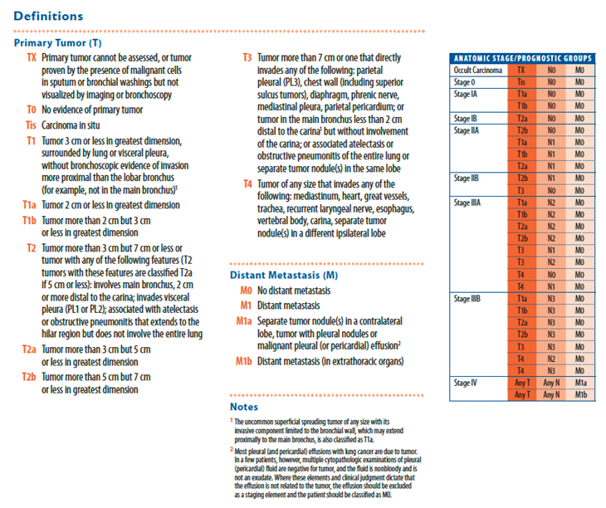

Figure 1 (continued): AJCC staging system for lung cancer

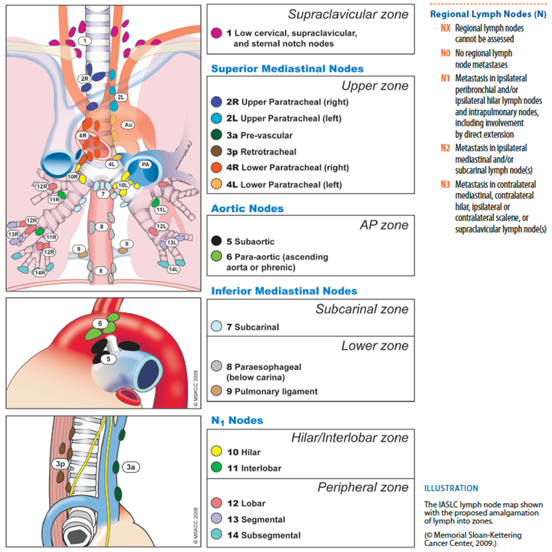

### Current treatment options

Standard first line therapy for most patients with metastatic NSCLC is cytotoxic chemotherapy with a platinum based doublet combination. Platinum agents used in Australia for first line therapy are cisplatin and carboplatin,(8) although these drugs are not specifically registered for use in NSCLC. Other agents used in combination with platinum therapy include docetaxel, paclitaxel, albumin bound paclitaxel, pemetrexed (in subjects with non-squamous histology), vinorelbine, gemcitabine and etoposide.(2,4,8) Treatment with platinum based therapy is usually continued for 4 to 6 cycles.(2,4) In elderly patients or those with poor performance status, single agent chemotherapy may be used for first line treatment.(2, 4)

The anti-angiogenic agent bevacizumab has been registered in Australia for the first line treatment of non-squamous forms of NSCLC, in combination with carboplatin and paclitaxel.

In subjects with tumours that have activating mutations of the epidermal growth factor receptor (EGFR), recommended first line treatment is with an EGFR tyrosine kinase inhibitor (gefitinib, erlotinib or afatinib).(2,4) Such mutations occur in approximately 15% of subjects with NSCLC.(9) For tumours with translocation of the anaplastic lymphoma kinase (ALK) gene, recommended first line therapy is with crizotinib, an inhibitor of the ALK receptor tyrosine kinase.(2, 4) ALK rearrangements are present in approximately 3 to 5% of subjects with NSCLC.(5) Crizotinib is also recommended for the first line treatment of tumours with translocation of the ROS1 gene.(2) ROS1 translocation is present in approximately 1 to 2% of subjects with NSCLC.(5)

### Clinical rationale

Pembrolizumab is a monoclonal antibody that inhibits the PD-1 receptor (also known as CD279), which is expressed on activated T lymphocytes. Stimulation of the PD-1 receptor results in an inhibitory effect on T cell function. The normal function of the PD-1 receptor is to limit or ‘check’ overstimulation of immune responses. There are 2 known normal ligands for PD-1: PD-L1 (also known as CD274 or B7-H1) and PD-L2 (also known as CD273 or B7-DC). The PD-L1 ligand is expressed on antigen-presenting cells (APCs) and a wide range of non‑haematopoietic cells, whereas PD-L2 is expressed on dendritic cells and macrophages.(10)

PD-L1 is often highly expressed in many human cancer types, including NSCLC. (5, 11) Tumour expression of PD-L1 may result in inhibition of T cell mediated anti-tumour effects via the PD‑1 receptor. The clinical rationale for PD-1 receptor blockade with pembrolizumab is to remove such inhibition.

**Comment:** The rationale for use of pembrolizumab in NSCLC is acceptable and is supported by the recent TGA approval of another PD-1 receptor blocker (nivolumab) for the second line treatment of NSCLC. (12)

### Related submissions

* The initial submission to register pembrolizumab for the treatment of melanoma (Submission PM‑2014‑01928-1-4) was approved by the TGA on 15 April 2015.
* At the time of writing, a separate submission to extend the indications of pembrolizumab to include the second line treatment of NSCLC was under evaluation (Submission PM‑2015‑04712‑1-4).
* A submission to register another monoclonal antibody against the PD-1 receptor (nivolumab) for the second line treatment of NSCLC was approved by the TGA on 7 January 2016.(12)
* According to the covering letter for the current submission another application is currently under evaluation to extend the approved indications of pembrolizumab to include the treatment of squamous cell carcinoma of the head and neck (Submission PM‑2016‑01163‑1‑4).[2]

## Contents of the clinical dossier

### Scope of the clinical dossier

The submission contained the following clinical information:

* A clinical study report for a single pivotal Phase III randomised controlled trial (Study 024);
* 1 pooled analysis (from 3 pembrolizumab studies) of the relationship between systemic exposure to pembrolizumab and efficacy in the first line treatment of NSCLC;
* 1 pooled analysis (from 5 pembrolizumab studies) of the relationship between systemic exposure to pembrolizumab and the occurrence of immune related adverse events, in NSCLC and melanoma patients;
* 1 analysis of immunogenicity data from several pembrolizumab studies;
* Literature references.

The submission also included a Clinical Overview, Summary of Clinical Efficacy and Summary of Clinical Safety.

### Paediatric data

There were no paediatric data in the submission.

**Comment:** As NSCLC is a disease of adults, the absence of paediatric data is acceptable.

### Good clinical practice

The report for Study 024 included the following assurance:

‘This trial was conducted in substantial conformance with GCP requirements and applicable country and/or local statutes and regulations regarding ethical committee review, informed consent, and the protection of human subjects participating in biomedical research.’

### Evaluator’s commentary on the clinical dossier

The clinical dossier was acceptable.

## Pharmacokinetics

No new pharmacokinetic studies were included in the submission. In the pivotal clinical study (Study 024) sparse PK sampling was performed in subjects in the pembrolizumab arm. Pre-dose (trough) samples were collected at Cycles 1, 2, 4 and 8 and every 8 cycles thereafter while the subject was receiving pembrolizumab. All trough samples were to be drawn within the 24 hours before the infusion. Post-dose samples were collected during Cycle 1 only; one sample within 30 minutes after end of infusion, and one sample between 72 and 168 hours post infusion.

These PK data were incorporated into a previously developed population PK model (see Section 4.1.1). Simulations conducted with the model suggested that the pembrolizumab PK in NSCLC are similar to PK in melanoma.

The population PK model was used to examine any potential relationships between systemic pembrolizumab exposure and efficacy in subjects receiving the drug as first line therapy for NSCLC (see Section 4.1.2, below). This analysis indicated that there is a flat relationship between systemic exposure and efficacy, such that efficacy did not increase with increasing pembrolizumab concentrations. The model was also used to examine any potential relationships between systemic pembrolizumab exposure and the incidence of immune-related adverse effects (see Section 4.1.3, below). This analysis also demonstrated a flat curve. However, duration of treatment was associated with an increased incidence of such AEs.

### Synopses of pharmacokinetic studies

#### Population PK analysis

This was an extension of the population pharmacokinetic model for pembrolizumab (MK 3475) to first line NSCLC patients from Protocol 024

##### Objectives

The objectives were to:

* Assess the appropriateness of the existing Pop PK model to characterise concentration data from first line NSCLC patients from Protocol 024.
* Generate exposure predictions for patients in Protocol 024 to support exposure response analyses.

##### Methodology

The sponsor had previously developed a population PK model based on data derived from three studies: Study P001; A Phase I study with multiple cohorts that enrolled subjects with melanoma and NSCLC, and Studies P002 and P006; two Phase III studies in subjects with melanoma. These studies have previously been evaluated by the TGA. The model was based on data from a total of 2,188 subjects and was a 2 compartment model with linear clearance and allometric scaling of PK parameters based on bodyweight.

For the current analysis, additional data were incorporated from Study P010 (a Phase III study in the second line treatment of NSCLC) and Study P024 (the pivotal Phase III study in the current submission). A total of 16,800 pembrolizumab concentrations from a total of 2,993 subjects were included in the analysis. This included 614 concentrations from 152 subjects in Study P024. The previous population PK model was used to re-estimate the PK parameters for the complete updated dataset.

In all the studies, serum concentrations of pembrolizumab were measured using a validated electrochemical luminescence (ECL) based immunoassay. The lower limit of quantitation was 10 ng/mL.

##### Results

Line of NSCLC (first line versus second line) was assessed as a covariate, and was found not to have a clinically significant effect on PK parameters. Similarly, cancer type (NSCLC versus melanoma) did not have a clinically significant effect on PK parameters. The final model chosen was found to adequately describe the observed plasma concentrations in both NSCLC and melanoma subjects.

Parameter estimates obtained with the final model were 0.229 L/day for total clearance, 3.52 L for central volume and 3.96 L for peripheral volume. Similar values had been obtained with the previous model.

PK parameters predicted by the model are summarised below in Tables 1 and 2.

Table 1: Comparisons of descriptive statistics of individual PK parameters (CL, Vc) and derived parameters (t½, Vdss, time to steady state) between first line NSCLC, second line NSCLC and melanoma patients

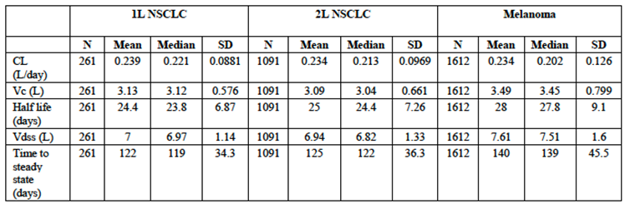

Table 2: Median (90% prediction interval) exposure parameters of pembrolizumab at steady state regimens of 2 mg/kg Q3W, 200 mg Q3W, 10 mg/kg Q3W and 10 mg/kg Q2W

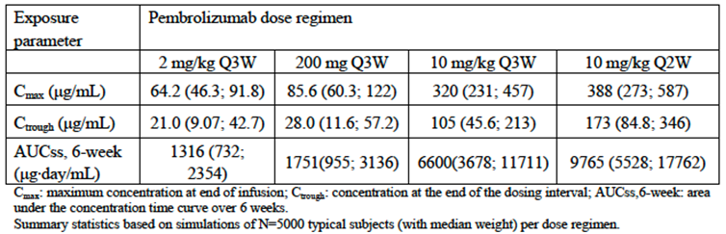

**Comment:** The study design, conduct and analysis were satisfactory. The population PK model indicates that the PK of pembrolizumab in first line NSCLC is likely to be similar to that observed in melanoma. As expected, for a typical subject, the 200 mg/Q3W regimen results in increased systemic exposure compared to the currently approved 2mg/kg/Q3W regimen.

#### Report 04FFM3

Exploration of the relationship between pembrolizumab (MK-3475) exposure and efficacy in patients receiving MK-3475 as first line therapy for non-small-cell lung carcinoma (NSCLC) in Studies P001, P010 and P024.

##### Objectives

The primary objective of the study was to assess the relationship between exposure to pembrolizumab in serum (that is AUC over 6 weeks at steady state; AUCss-6weeks) and the anti‑tumour response measured as the sum of the longest dimensions (SLD) of the tumour lesions in first-line NSCLC.

##### Methodology

The analysis was performed on pooled data from 263 subjects who received pembrolizumab as first-line therapy for NSCLC in three studies:

* Study 001 (Phase I, using doses of 2 mg/kg Q3W, 10 mg/kg Q3W or 10 mg/kg Q2W; n = 94);
* Study 010 (Phase III, using doses of 2 mg/kg or 10 mg/kg Q3W; n = 15);
* Study 024 (Phase III, using a flat dose of 200 mg Q3W; n = 154).

Of these 263 subjects, 131 had tumour size measurements (by CT or MRI) at both baseline and at 28 ± 2 weeks. The efficacy parameter studied was change in tumour size, recorded as the sum of longest dimensions of target lesions, using RECIST 1.1 criteria. The pharmacokinetic parameter studied was AUC over 6 weeks at steady state, derived from the population PK model described above.

Simple graphical analysis was conducted to explore the relationship between AUC and change in tumour size.

##### Results

The following graph (Figure 2) shows the relationship between AUC and percentage change in tumour size for subjects with tumours that have PD-L1 expression in > 1% of cells (n = 122). A flat exposure response curve was observed. Similar flat curves were observed for subjects with PD-L1 expression in ≥ 50% of cells and those with 1 to 49% expression. Graphs of AUC quintiles versus median percentage change in tumour size gave similar results.

Figure 2: Percent change in tumour size versus exposure in PD-L1 TPS > 1%

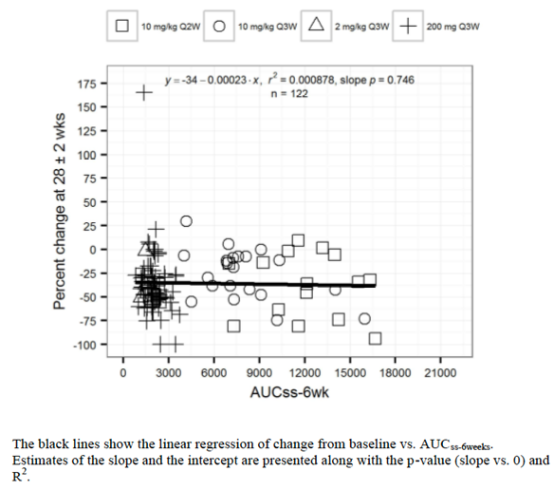

**Comment:** The study design, conduct and analysis were satisfactory.

#### Report 04FFLZ

Exposure adverse event analysis of pembrolizumab (MK-3475) in a pooled dataset of patients with advanced melanoma and NSCLC from Studies P001, P002, P006, P010 and P024.

##### Objectives

The stated objectives of the analysis were:

* Primary: To further characterise the exposure response relationship for pembrolizumab for relevant adverse events in a pooled dataset across melanoma and NSCLC indications;
* Secondary: To estimate the impact of other predictors on the occurrence of the adverse events of interest.

##### Methodology

The analysis was performed on pooled data from 2,884 subjects who received pembrolizumab in five studies:

* Study 001 (Phase I, melanoma and NSCLC, using doses of 2 mg/kg Q3W, 10 mg/kg Q3W or 10 mg/kg Q2W; n = 1191);
* Study 002 (Phase II, melanoma, using doses of 2 mg/kg Q3W or 10 mg/kg Q3W; n = 340);
* Study 006 (Phase III, melanoma, using doses of 10 mg/kg Q3W or 10 mg/kg Q 2W; n = 548);
* Study 010 (Phase III, NSCLC, using doses of 2 mg/kg or 10 mg/kg Q3W; n = 653);
* Study 024 (Phase III, NSCLC, using a flat dose of 200 mg Q3W; n = 152).

The pharmacokinetic parameter studied was AUC over 6 weeks at steady state (AUCss-6weeks), derived from the population PK model described above. The AEs analysed were AEs of special interest (AEOSI) a broad category of potentially immune related adverse events. The relationship between AUCss-6weeks and AEOSI was investigated by means of non-linear mixed effects modeling/logistic regression analysis. The following covariates were investigated for effects on the relationship: duration of treatment, dosing regimen, randomisation status, indication, baseline tumour size, ECOG performance status, body weight, sex, EGFR status and PD-L1 status.

##### Results

Various base models were investigated. A model with an intercept and a linear relationship between AEOSI incidence and AUCss-6weeks was found to best describe the observed data. Of the covariates tested, duration of treatment was found to have a significant effect on the intercept of the model, indicating that patients with longer treatment duration have a higher probability of experiencing an AEOSI. None of the other covariates, including dosage regimen, were found to have a significant effect. Treatment duration was therefore included as a covariate in the final model.

The final model was evaluated using visual predictive checks and was found to adequately predict the observed data.

Simulations were then performed with the model. The probability of experiencing an AEOSI as a function of AUC is illustrated below in Figure 3. Subjects with longer duration of treatment had a higher probability of experiencing an AEOSI. However, for a given duration of treatment, AEOSI incidence was not related to increase in AUC.

Figure 3: Probability of AEOSI versus exposure with 90% CI

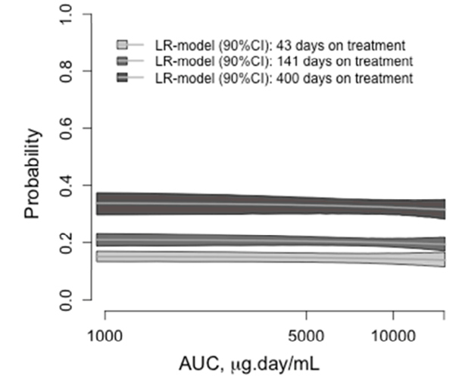

**Comment:** The study design, conduct and analysis were satisfactory.

### Evaluator’s overall conclusions on pharmacokinetics

Pembrolizumab PK parameters in subjects with previously untreated NSCLC are similar to those previously observed in melanoma subjects.

## Pharmacodynamics

No new pharmacodynamic data were included in the submission.

## Dosage selection for the pivotal studies

A dose of 2 mg/kg IV every 3 weeks had previously been established as safe and effective in advanced melanoma. In NSCLC patients in the Phase I KEYNOTE-001 trial, a dose of 2 mg/kg every 3 weeks produced a comparable response rate to that achieved with 10 mg /kg IV every 3 weeks. In a population PK model, tumour load and tumour type were not found to have a significant effect on pembrolizumab PK and the sponsor assumed that the dynamics of PD-1 target engagement would not vary significantly with tumour type. It was therefore anticipated that a dose of 2 mg/kg IV every 3 weeks would be safe and effective in NSCLC subjects.

A flat dose regimen (200 mg Q3W for all subjects) was chosen for Study 024 based on the following considerations:

* Simulations performed with the population PK model of pembrolizumab showed that the fixed dose regimen of 200 mg Q3W would provide systemic exposures that were consistent with those obtained with the 2 mg/kg Q3W dose;
* A fixed dose regimen simplified dosing for health professionals and reduced the potential for dosing errors;
* A fixed dosing scheme also reduced complexity in the logistical chain at treatment facilities and reduced wastage.

## Clinical efficacy

### Studies providing evaluable efficacy data

Clinical data to support the proposed new indication come from a single Phase III trial; Study 024, also known as the KEYNOTE-024 trial).

### Pivotal efficacy study

#### Study 024

##### Study design, objectives, locations and dates

The study was a randomised, open label, Phase III trial with 2 parallel groups (pembrolizumab versus platinum based chemotherapy). A study schema is shown below in Figure 4.

Figure 4: Study 024; Study schema

Figure 4: Study 024; Study schema
Subjects were randomised (1:1) to receive either pembrolizumab or platinum based chemotherapy.
Pembrolizumab was administered at a dose of 200 mg IV over 30 minutes on day 1 of a 21 day cycle (Q3W). It was continued until progressive disease or unacceptable toxicity occurred or until a total of 35 doses had been received.
Subjects randomised to platinum based chemotherapy received one of the following regimens:
• Pemetrexed 500 mg/m2 Q3W and carboplatin area under the curve (AUC) 5 to 6 mg/mL/min Q3W for 4 to 6 cycles, followed by optional maintenance pemetrexed 500 mg/m2 Q3W (this arm was permitted for non-squamous histologies only);
• Pemetrexed 500 mg/m2 Q3W and cisplatin 75 mg/m2 Q3W for 4 to 6 cycles, followed by optional maintenance pemetrexed 500 mg/m2 Q3W (this arm was permitted for non-squamous histologies only).
• Gemcitabine 1250 mg/m2 on Days 1 and 8 and cisplatin 75 mg/m2 on Day 1 of a 21 day cycle for 4 to 6 cycles.
• Gemcitabine 1250 mg/m2 on Days 1 and 8 and carboplatin AUC 5 to 6 mg/mL/min on Day 1 of a 21 day cycle for 4 to 6 cycles.
• Paclitaxel 200 mg/m2 Q3W and carboplatin AUC 5 to 6 mg/mL/min Q3W for 4 to 6 cycles followed by optional maintenance pemetrexed (pemetrexed maintenance was permitted for non-squamous histologies only).


###### Primary objective

The primary objective of the study was to compare progression free survival (PFS) in subjects with strongly PD-L1 positive, metastatic NSCLC treated with first line pembrolizumab or standard of care (SOC) chemotherapies.

###### Secondary objectives

Secondary objectives were to:

* Evaluate the safety and tolerability profile of first line pembrolizumab in subjects with strongly PD-L1 positive, metastatic NSCLC;
* Evaluate overall survival (OS) in subjects with strongly PD-L1 positive, metastatic NSCLC treated with first line pembrolizumab or SOC chemotherapies;
* Evaluate objective response rate (ORR) in subjects with strongly PD-L1 positive, metastatic NSCLC treated with first line pembrolizumab or SOC chemotherapies.

The study was conducted in 149 centres in 16 countries; Australia (6 centres), Austria (2), Belgium (4), Canada (4), France (6), Germany (6), Hungary (8), Ireland (4), Israel (6), Italy (12), Japan (23), the Netherlands (3), New Zealand (1), Spain (9), the United Kingdom (9) and the US (46).

The study commenced in September 2014 and the cut-off date for inclusion of data in the study report was 9 May 2016. The study report itself was dated 11 July 2016. The study has been published.(17)

##### Inclusion and exclusion criteria

###### Inclusion criteria

Subjects were required to meet the following inclusion criteria:

1. Had histologically or cytologically confirmed diagnosis of NSCLC, Stage IV, did not have an EGFR sensitising (activating) mutation or ALK translocation, and had not received prior systemic chemotherapy treatment for their metastatic NSCLC.
2. Had measurable disease based on RECIST 1.1 as determined by the study site.
3. Were ≥ 18 years of age on day of signing informed consent.
4. Had a life expectancy of at least 3 months.
5. Had a performance status of 0 or 1 on the ECOG Performance Status.
6. Had adequate organ function as indicated by the following laboratory values (see Table 3, below).

Table 3: Laboratory test parameter levels for inclusion criteria Study 024

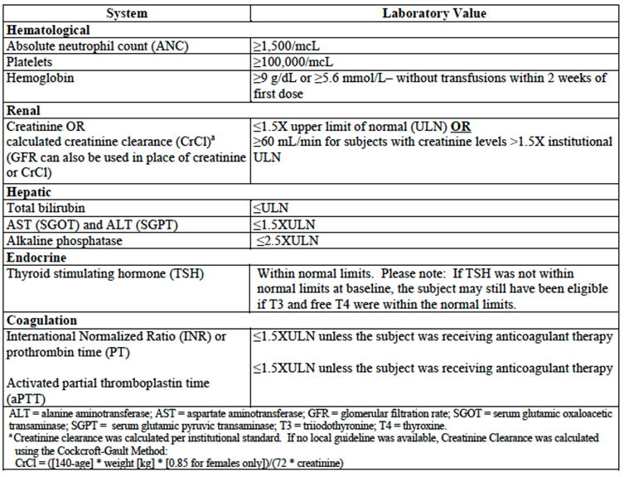

1. Had no history of prior malignancy, with the exception of basal cell carcinoma of the skin, superficial bladder cancer, squamous cell carcinoma of the skin, in situ cervical cancer, or had undergone potentially curative therapy with no evidence of that disease recurrence for 5 years since initiation of that therapy.
2. Had provided a formalin fixed tumour tissue sample from a biopsy of a tumour lesion either at the time of or after the diagnosis of metastatic disease had been made and from a site not previously irradiated to assess for PD-L1 status. Biopsies obtained PRIOR to the administration of any systemic therapy administered for the treatment of a subject’s tumour (such as neoadjuvant/adjuvant therapy) were not permitted for analysis. The tissue sample must have been received by the central vendor prior to randomisation. Fine needle aspirates, endobronchial ultrasound (EBUS), or cell blocks were not acceptable. Needle or excisional biopsies, or resected tissue was required.
3. Had tumour that did not harbor an EGFR sensitising (activating) mutation or ALK translocation. The EGFR sensitising mutations were those mutations that were amenable to treatment with tyrosine kinase inhibitors (TKIs) including erlotinib, gefitinib, or afatanib. Investigators must have been able to produce the source documentation of the EGFR mutation and ALK translocation status in all subjects with non-squamous histologies and for subjects in whom testing was clinically recommended. If either an EGFR sensitising mutation or ALK translocation was detected, additional information regarding the mutation status of the other molecule was not required. If unable to test for these molecular changes, formalin fixed paraffin embedded tumour tissue of any age could have been submitted to a central laboratory designated by the Sponsor for such testing. Subjects with non-squamous histologies were not randomised until the EGFR mutation status and/or ALK translocation status was available in source documentation at the site. For subjects enrolled who were known to have a tumour of predominantly squamous histology, molecular testing for EGFR and ALK translocation was not required.
4. PD-L1 strong tumour as determined by IHC at a central laboratory.
5. Female subjects must have had a negative urine or serum pregnancy test at screening (within 72 hours of first dose of study medication) if of childbearing potential or be of non child bearing potential. If the urine test was strong or could not be confirmed as negative, a serum pregnancy test was required. The serum pregnancy test must have been negative for the subject to be eligible. Non childbearing potential was defined as (by other than medical reasons):
   1. ≥ 45 years of age and had not had menses for greater than 1 year;
   2. Amenorrhoeic for < 2 years without a hysterectomy and oophorectomy and a follicle stimulating hormone (FSH) value in the postmenopausal range upon pre-trial (screening) evaluation;
   3. Whose status was post hysterectomy, oophorectomy or tubal ligation. Documented hysterectomy or oophorectomy must have been confirmed with medical records of the actual procedure or confirmed by an ultrasound. Tubal ligation must have been confirmed with medical records of the actual procedure otherwise the subject must have been willing to use 2 adequate barrier methods throughout the study, starting with the screening visit through 120 days after the last dose of study therapy and up to 180 days after last dose of chemotherapeutic agents.
6. If of childbearing potential, female subjects must have been willing to use 2 adequate barrier methods throughout the study, starting with the screening visit through 120 days after the last dose of study therapy and up to 180 days after last dose of chemotherapeutic agents.
7. Male subjects with a female partner(s) of child bearing potential must have agreed to use 2 adequate barrier methods throughout the trial starting with the screening visit through 120 days after the last dose of pembrolizumab was received. Such methods of contraception, or abstinence from heterosexual activity, were required from the screening visit (Visit 1) through 180 days after the last dose of chemotherapy. Males with pregnant partners must have agreed to use a condom; no additional method of contraception was required for the pregnant partner.
8. Subject had voluntarily agreed to participate by giving written informed consent/assent for the trial.

###### Exclusion criteria

A subject was not eligible for enrolment if he or she met the following exclusion criteria:

1. Had an EGFR sensitising mutation and/or an ALK translocation.
2. Had received systemic therapy for the treatment of their Stage IV NSCLC. Completion of treatment with chemotherapy and/or radiation as part of neoadjuvant/adjuvant therapy was allowed as long as therapy was completed at least 6 months prior to the diagnosis of metastatic disease.
3. Was currently participating and receiving study therapy or had participated in a study of an investigational agent and received study therapy or used an investigation device within 4 weeks of the first dose of treatment.
4. Tumour specimen was not evaluable for PD-L1 expression by the central laboratory. If an additional tumour specimen was submitted AND evaluable for PD-L1 expression, the subject was eligible to participate if PD-L1 expression was assessed as ‘strong’ by the central laboratory.
5. Was receiving systemic steroid therapy < 3 days prior to the first dose of trial treatment or receiving any other form of immunosuppressive medication (corticosteroid use on study for management of events of clinical interest (ECIs), as pre-medication for the control chemotherapies, and/or a premedication for IV contrast allergies/reactions were allowed). Subjects who were receiving daily steroid replacement therapy served as an exception to this rule. Daily prednisone at doses of 5 to 7.5 mg was an example of replacement therapy. Equivalent hydrocortisone doses were also permitted if administered as a replacement therapy.
6. Was expected to require any other form of systemic or localised antineoplastic therapy while on trial (including maintenance therapy with another agent for NSCLC, radiation therapy, and/or surgical resection).
7. Had received prior systemic cytotoxic chemotherapy, biological therapy, or major surgery within 3 weeks of the first dose of trial treatment; received thoracic radiation therapy of > 30 Gy within 6 months of the first dose of trial treatment.
8. Had received prior therapy with an anti-PD-1, anti-PD-L1, anti-PD-L2, anti-CD137, or anti-cytotoxic T lymphocyte associated antigen-4 (CTLA-4) antibody (including ipilimumab or any other antibody or drug specifically targeting T cell co-stimulation or checkpoint pathways).
9. Had untreated central nervous system (CNS) metastases and/or carcinomatous meningitis identified either on the baseline brain imaging obtained during the screening period OR identified prior to signing the ICF. Subjects whose brain metastases had been treated may have participated provided they showed radiographic stability (defined as 2 brain images, both of which were obtained after treatment to the brain metastases. These imaging scans should have been both obtained at least 4 weeks apart and showed no evidence of intracranial progression). In addition, any neurologic symptoms that developed either as a result of the brain metastases or their treatment must have returned to baseline or resolved. Any steroids administered as part of this therapy must have been completed at least 3 days prior to study medication.
10. Active autoimmune disease that had required systemic treatment in past 2 years (that is, with use of disease modifying agents, corticosteroids or immunosuppressive drugs). Replacement therapy (that is, thyroxine, insulin, or physiologic corticosteroid replacement therapy for adrenal or pituitary insufficiency, etcetera) was not considered a form of systemic treatment.
11. Had an allogeneic tissue/solid organ transplant.
12. Had interstitial lung disease (ILD) OR had a history of pneumonitis that has required oral or IV steroids.
13. Had received or would have received a live vaccine within 30 days prior to the first administration of study medication. Seasonal flu vaccines that did not contain a live virus were permitted.
14. Had an active infection requiring IV systemic therapy.
15. Had known history of human immunodeficiency virus (HIV) (HIV 1/2 antibodies).
16. Had known active hepatitis B, hepatitis C, or tuberculosis. Active hepatitis B was defined as a known positive hepatitis B surface antigen (HBsAg) result. Active hepatitis C was defined by a known positive hepatitis C antibody (Hep C Ab) result and known quantitative hepatitis C virus (HCV) RNA results greater than the lower limits of detection of the assay.
17. Had a history or current evidence of any condition, therapy, or laboratory abnormality that might confound the results of the trial, interfere with the subject’s participation for the full duration of the trial, or was not in the best interest of the subject to participate, in the opinion of the treating Investigator.
18. Had known psychiatric or substance abuse disorders that would interfere with cooperation with the requirements of the trial.
19. Was, at the time of signing informed consent, a regular user (including ‘recreational use’) of any illicit drugs or had a recent history (within the last year) of substance abuse (including alcohol).
20. Was pregnant or breastfeeding, or expecting to conceive or father children within the projected duration of the trial, starting with the screening visit (Visit 1) through 120 days after the last dose of pembrolizumab or 180 days after the last dose of SOC chemotherapy.
21. Was or has had an immediate family member (spouse or children) who was investigational site or sponsor staff directly involved with this trial, unless prospective IRB approval (by chair or designee) was given allowing exception to this criterion for a specific subject.

**Comment:** Enrolment was restricted to subjects with tumours that had high levels of PD-L1 expression (‘PD-L1 strong’ tumours; inclusion criterion 10 above). Strength of PD‑L1 expression was determined by assessing the percentage of neoplastic cells in the tumour that stained for membranous PD-L1 using an immunohistochemistry (IHC) assay (Dako PD-L1 IHC 22C3 pharmDx kit). The percentage of cells was called the Tumour Proportion Score (TPS). To qualify for enrolment, subjects were required to have a TPS of ≥ 50%. The cut off of 50% was based on an analysis of subjects in the Phase 1 KEYNOTE-001 trial which demonstrated that this level of PD-L1 expression was associated with improved efficacy.(18) To be evaluable, a sample was required to contain at least 100 tumour cells. The assay was performed centrally by pathologists.

##### Study treatments

Subjects were randomised (1:1) to receive either pembrolizumab or platinum based chemotherapy.

Pembrolizumab was administered at a dose of 200 mg IV over 30 minutes on day 1 of a 21 day cycle (Q3W). It was continued until progressive disease or unacceptable toxicity occurred or until a total of 35 doses had been received.

Subjects randomised to platinum based chemotherapy received one of the following regimens:

* Pemetrexed 500 mg/m2 Q3W and carboplatin area under the curve (AUC) 5 to 6 mg/mL/min Q3W for 4 to 6 cycles, followed by optional maintenance pemetrexed 500 mg/m2 Q3W (this arm was permitted for non-squamous histologies only);
* Pemetrexed 500 mg/m2 Q3W and cisplatin 75 mg/m2 Q3W for 4 to 6 cycles, followed by optional maintenance pemetrexed 500 mg/m2 Q3W (this arm was permitted for non-squamous histologies only).
* Gemcitabine 1250 mg/m2 on Days 1 and 8 and cisplatin 75 mg/m2 on Day 1 of a 21 day cycle for 4 to 6 cycles.
* Gemcitabine 1250 mg/m2 on Days 1 and 8 and carboplatin AUC 5 to 6 mg/mL/min on Day 1 of a 21 day cycle for 4 to 6 cycles.
* Paclitaxel 200 mg/m2 Q3W and carboplatin AUC 5 to 6 mg/mL/min Q3W for 4 to 6 cycles followed by optional maintenance pemetrexed (pemetrexed maintenance was permitted for non-squamous histologies only).

A chemotherapy regimen was selected for each patient prior to randomisation. The cytotoxic agents were sourced commercially. Although pemetrexed maintenance was optional, it was strongly recommended. When used, it was continued until progressive disease or unacceptable toxicity occurred.

Subjects in the chemotherapy arm who developed disease progression could crossover to pembrolizumab treatment, provided that any chemotherapy adverse events had resolved, they had adequate organ function, were not unstable due to brain metastases and had an ECOG Performance Status of 0 or 1.

Medicines for supportive care were permitted during the trial. Treatments that were prohibited were: other immunotherapies and chemotherapies, other investigational agents, surgery (for symptom management or tumour control), radiation therapy (for tumour control), live vaccines, glucocorticoids (except as described in exclusion criterion 5) and commencement of treatment with bisphosphonates or RANKL inhibitors.

##### Efficacy variables and outcomes

The main efficacy variables studied in the trial were:

* Change in tumour size;
* Survival;
* Patient reported outcomes / changes in quality of life.

###### Primary efficacy endpoint

The primary efficacy endpoint was progression free survival (PFS) defined as the time from randomisation to documented progressive disease or death due to any cause, whichever occurs first.

###### Secondary efficacy endpoints

Secondary efficacy endpoints were:

* Overall survival (OS) defined as the time from randomisation to death from any cause;
* Objective response rate (ORR).

Progressive disease and objective responses were assessed using the Response Evaluation Criteria for Solid Tumours Version 1.1 (RECIST 1.1). Assessment of imaging was conducted by an independent central panel of radiologists who were blinded to treatment allocation.

###### Exploratory endpoints

There were also a large number of exploratory endpoints. Most of these were not reported in the submitted study report. Results for the following were reported:

* Time to response;
* Duration of response;
* Patient reported outcomes (PROs), as assessed by the following quality of life instruments:
  + The EORTC QLQ-C30, which is a validated cancer specific 30 item questionnaire. It incorporates 5 functional scales (physical, role, cognitive, emotional and social) covered by 16 questions, 3 symptom scales (fatigue, pain and nausea/vomiting) covered by 6 questions, 6 single question items (constipation, diarrhoea, sleep, dyspnoea, appetite and financial) and 2 questions addressing global quality of life. All scales and single item measures range in score from 0 to 100. A high score on a functional scale represents a high level of functioning. A high score on global quality of life represents a high quality of life. A high score on the symptom scale or item represents a high level of symptomatic problems. A minimal clinically important difference is considered to be 5 to 10 points on the 100 point scale.
  + The EORTC QLQ-LC 13, which is a lung cancer specific questionnaire used as a supplement to the EORTCQLQ-C30. It contains 13 items. It incorporates one 3 item scale to assess dyspnoea, and a series of single items assessing pain, coughing, sore mouth, dysphagia, peripheral neuropathy, alopecia, and haemoptysis. As for the QLQ-C30, high scores on functioning scales indicate good functioning; high scores on the symptom scales indicate worse symptoms.

A third quality of life instrument (the EQ-5D-3L) was also administered. This is a generic measure of QoL and was intended to provide data for use in economic models and analyses on health utilities. The results of this questionnaire are not reviewed in this report.

The trial had the following phases:

* A screening phase that consisted of the screening visit;
* A treatment phase during which subjects were reviewed every 3 weeks;
* An end of treatment phase which consisted of a discontinuation visit (at the time study drug is discontinued for any reason) and a safety follow up visit (at approximately 30 days after the last dose of study treatment);
* An observation phase for subjects who had discontinued treatment for reasons other than progressive disease. These subjects were reviewed every 3 weeks until progressive disease was documented, or new antineoplastic therapy was commenced;
* A follow up phase (for subjects in the pembrolizumab arm only). This phase was for subjects who completed 35 cycles of pembrolizumab and had not developed progressive disease. They were followed up at 3 monthly intervals.
* A survival follow up phase during which subjects were contacted by telephone every 2 months to assess survival status.

Tumour imaging was performed every 9 weeks from the time of randomisation, using CT scanning (the preferred modality) or MRI. The same modality was used for an individual subject throughout the study. If progressive disease was documented, a confirmatory scan was required at least 4 weeks later.

QoL instruments were administered at every cycle for the first 3 cycles, every third cycle thereafter during the treatment phase, at the treatment discontinuation and 30 day safety follow up visits, and every 9 weeks during the observation phase until progressive disease occurred.

##### Randomisation and blinding methods

Subjects were randomised centrally 1:1 to pembrolizumab or chemotherapy using an interactive voice response system/integrated web response system (IVRS/IWRS). Subjects were stratified by ECOG Performance Scale (0 versus 1), histology (squamous versus non-squamous), and geographic region of the enrolling site (East Asia versus non-East Asia) prior to randomisation.

The study was an open label trial. However, disease progression and objective response events were determined by a central panel of independent radiologists who were blinded to treatment allocation.

##### Analysis populations

The following analysis populations were defined in the statistical analysis plan:

* The intent to treat (ITT) population included all randomised subjects. The ITT population was used for analyses of efficacy endpoints, with subjects analysed according to the treatment to which they were randomised;
* The All Subjects as Treated (ASaT) population included all randomised subjects who received at least one dose of study treatment. Subjects were analysed according to the treatment they actually received. This population was used for safety analyses.
* The patient reported outcomes full analysis set (PRO-FAS) consisted of all randomised subjects who received at least one dose of study medication and completed at least one PRO instrument. This population was used for analyses of PRO data.

##### Sample size

It was assumed that median PFS in the chemotherapy arm would be 5.5 months and that pembrolizumab treatment would result in a hazard ratio for PFS events of 0.55. An interim analysis of ORR was planned and this was to be conducted at an alpha level of 0.5%. Analysis of the primary endpoint of PFS was planned at a later date and was to be conducted at an alpha level of 2.0%. The overall type 1 error rate was therefore 2.5% (one-sided). It was calculated that with a total of 175 PFS events, the study would have a power of 97%. In order to achieve a total of 175 PFS events, it was planned to randomise a total of 300 subjects. This calculation assumed a 14 month enrolment period with at least 6 months of PFS follow up and a dropout rate of 10%.

##### Statistical methods

PFS curves for each treatment were to be estimated using Kaplan-Meier analysis. Differences between treatment arms were tested using the stratified log-rank test. A stratified Cox proportional hazard model was to be used to assess the hazard ratio. The same methods were used for the analysis of OS.

The stratified Miettinen and Nurminen’s method was used for comparison of ORR between the two treatment groups.

The interim analysis of ORR was planned to occur after the first 191 subjects had completed at least 6 months of follow up. The PFS analysis was to be conducted after 175 PFS events had occurred. Two analyses of OS were planned. An initial interim analysis was to occur at the time of the PFS analysis. At this time point it was anticipated that there would have been approximately 110 deaths. A final OS analysis was planned after a total of 170 deaths had occurred. Overall survival would only be tested if the PFS result was significant.

##### Participant flow

A total of 1,934 subjects were screened for the study. Only 305 subjects were randomised. No discussion of the reason for screening failure was included in the study report. However, according to a table in the report, 1729 tumour samples were assessed for PD-L1 expression. Of these, only 500 (29%) had a PD-L1 expression of ≥ 50%. 646 (37%) had a PD-L1 expression of 1 to 49%, and 507 (29%) had a PD-L1 expression of < 1%. For the remainder, the sample was not evaluable or no data were available.

Of the 305 subjects randomised, 154 were randomised to pembrolizumab and 151 to chemotherapy. Subject disposition is summarised in Table 4 below. In the pembrolizumab arm, 48.1% of subjects were still receiving study medication, compared to 10.0% in the chemotherapy arm. 29.9% of pembrolizumab subjects had discontinued treatment due to progressive disease, compared to 42.0% of chemotherapy subjects. No pembrolizumab subjects had completed the planned 24 months of treatment. 66 of 151 subjects (43.7%) in the chemotherapy arm had crossed over to receive pembrolizumab.

Table 4: Study 024; Subject disposition

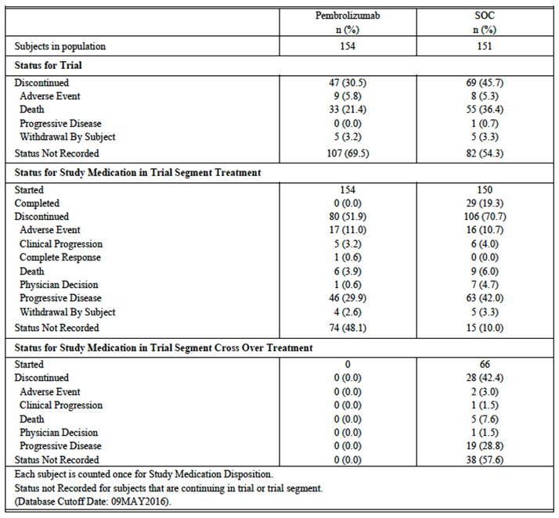

Analysis populations are summarised in Table 5. The PRO FAS population consisted of 299 subjects (151 in the pembrolizumab arm and 148 in the chemotherapy arm).

Table 5: Study 024; analysis populations

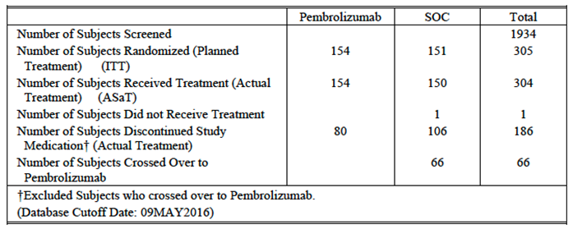

##### Major protocol violations/deviations

A major protocol deviation was defined as: *‘... any protocol deviation which may significantly/adversely impact the completeness, accuracy, and/or reliability of the trial data or that may significantly/adversely affect a subject's rights, safety, or well-being’*. There were a total of 285 major deviations reported as of 6 June 2016. The study report included a listing of these deviations but did not provide any analysis of them. The listing did not indicate the treatment arm in which each deviation occurred and hence it was not possible to determine if there was any imbalance between treatments.

##### Baseline data

Baseline demographic and disease characteristics were provided. Subjects were predominantly male, white and former smokers. Median age was approximately 65 years. Adenocarcinoma was the most common histological type of NSCLC (69.5% of subjects). Most baseline characteristics were reasonably well balanced across the two treatment arms. However, the proportion of subjects who had never smoked was higher in the chemotherapy arm (12.6% versus 3.2%)

For subjects randomised to the chemotherapy arm, the actual chemotherapy regimens used are summarised in Table 6.

Table 6: Study 024; Chemotherapy arm; regimens used

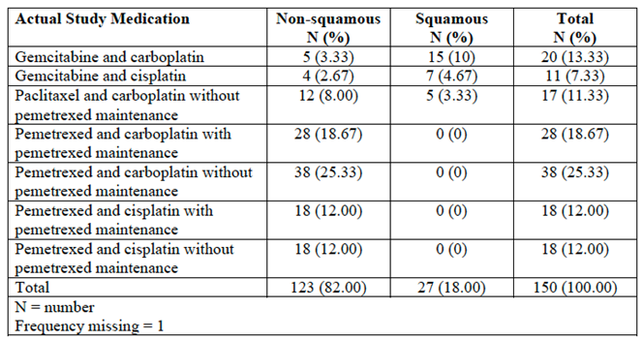

##### Results for the primary efficacy outcome

At the time of the planned analysis of PFS, median duration of follow up was 11 months (range 6.3 to 19.7 months).

Results for PFS are summarised in Table 7 and Figure 5. Pembrolizumab treatment was associated with a significant reduction in the risk of a PFS event (hazard ratio = 0.50; 95% CI: 0.37 to 0.68; p < 0.001). The predefined p-value for achieving statistical significance was p < 0.02. Median PFS was prolonged by approximately 4.3 months (10.3 versus 6.0 months). The proportion of subjects alive and progression free at 6 months was increased from 50.3% to 62.1%.

Table 7: Study 024; Progression-free survival results (analysis of progression free survival based on BICR assessment per RECIST 1.1 (Primary Censoring Rule) (ITT population)

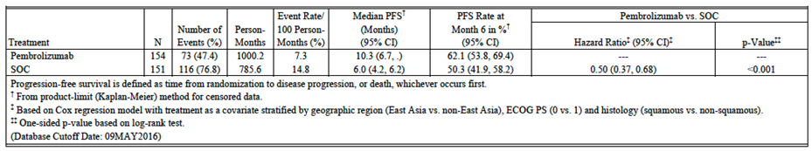

Figure 5: Study 024; Progression free survival results

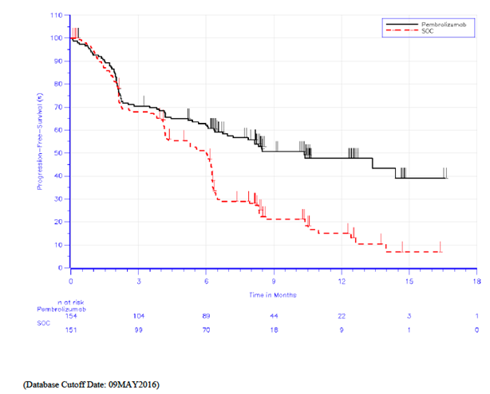

For the primary analysis, the date of disease progression was taken as the day on which progression was first objectively documented (according to RECIST 1.1 criteria). The sponsor presented the results of one sensitivity analysis. In this analysis, subjects who had documented PD or death, but who had missed 2 or more prior disease assessments, were censored at their last disease assessment prior to the missed assessments. The results of this sensitivity analysis were consistent with the primary analysis (hazard ratio = 0.52; 95% CI: 0.38 to 0.69; p < 0.001).

Results of subgroup analyses are presented below in Figure 6. Superiority of pembrolizumab over chemotherapy was consistent across all subgroups tested, with hazard ratios being < 1.0.

Figure 6: Study 024: Subgroup analyses of PFS [Forest plot of PFS hazard ratio by subgroup factor BICR assessment (primary censoring rule)

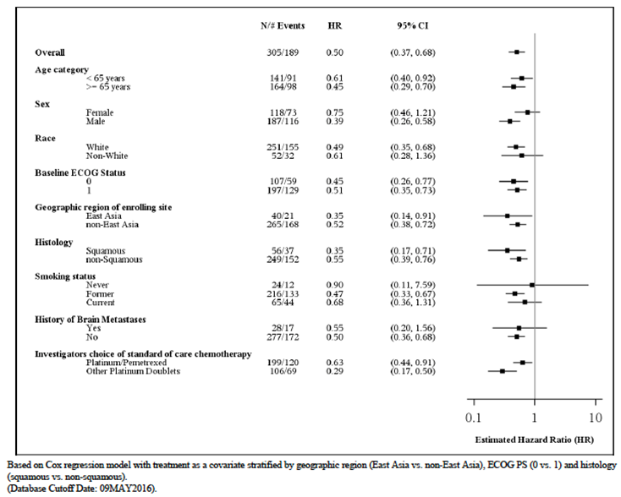

##### Results for other efficacy outcomes

###### Overall survival

Results for the first interim analysis of OS are presented in Figure 7.

Figure 7: Study 024; Overall survival results

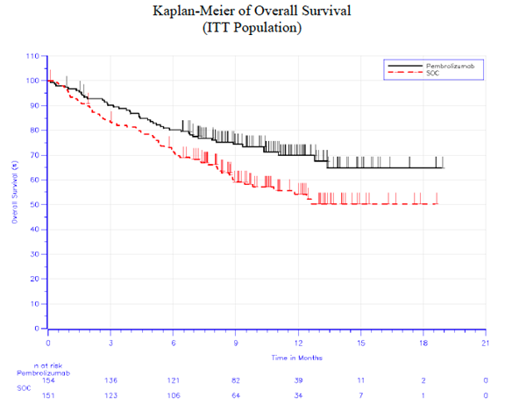

Only 108 of the 305 subjects (35.4%) had died. Despite the relative immaturity of the survival data, pembrolizumab treatment was associated with a significant reduction in the risk of death (hazard ratio = 0.60; 95%CI: 0.41 to 0.89; p = 0.005). The predefined p-value for achieving statistical significance was p < 0.0118. Median survival was not reached in either group, after a median follow up of 11 months. The proportion of subjects alive at 6 months was increased from 72.4% to 80.2%, and the proportion of subjects alive at 12 months was increased from 54.2% to 69.9%.

The survival benefit was achieved despite 66 of 151 subjects randomised to chemotherapy (43.7%) having crossed over to pembrolizumab. The study report did not provide details of subsequent therapy received by subjects in the pembrolizumab arm who developed disease progression.

Results of subgroup analyses are presented in Figure 8. Superiority of pembrolizumab over chemotherapy was consistent across most subgroups tested, with hazard ratios being < 1.0. Pembrolizumab appeared to be associated with reduced efficacy compared to chemotherapy in the subgroup of patients who had never smoked (HR = 1.69; 95% CI: 0.19 to 15.25). However, there were only 24 subjects in this group with only 7 deaths. Due to the small population and wide 95% CI, no reliable conclusions can be drawn regarding this subgroup.

Figure 8: Study 024; Subgroup analyses of OS (Forest plot of OS hazard ratio by subgroup factor)

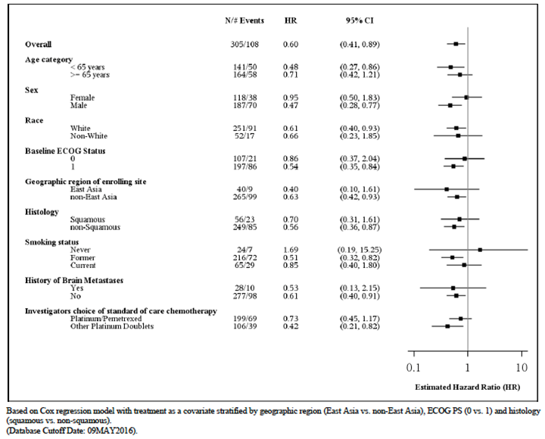

Following the above analyses of PFS and OS, the independent data monitoring committee for the study recommended that the trial be stopped and that patients receiving chemotherapy be offered access to pembrolizumab.

###### Objective Response Rate (ORR)

Results for the first interim analysis of ORR (done after the first 191 subjects had completed at least 6 months of follow up) were not presented in the study report. However, it was stated that there was no significant difference between the treatment arms.

ORR’s at the time of the PFS analysis are summarised in Table 8. ORR was 44.8% (95%CI: 36.8 to 53.0) in the pembrolizumab arm compared with 27.8% (95%CI: 20.8 to 35.7) in the chemotherapy arm. ORR was not to be formally tested for statistical significance at the time of the PFS analysis. However, the difference in ORR was found to be nominally significant when tested (p = 0.0011).

Table 8: Study 024; Overall response rate results

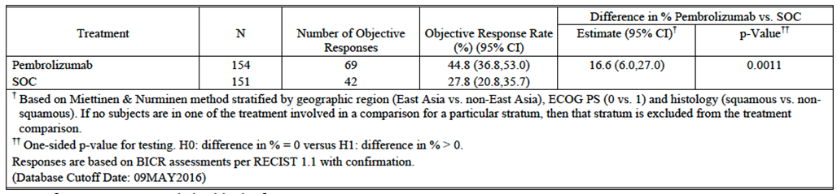

The best observed responses are summarised in Table 9. Most objective responses were partial responses in both arms. However, complete responses were observed in 3.9% of subjects in the pembrolizumab arm compared with 0.7% of subjects in the chemotherapy arm.

Table 9: Study 024; Summary of best overall response based on BICR assessment RECIST 1.1 with confirmation (ITT population)

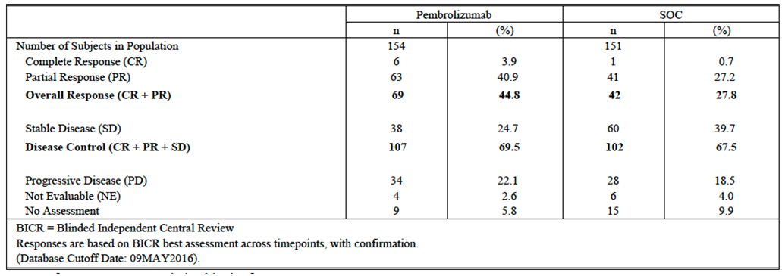

###### Time to response

Median time to response was 2.2 months (range 1.4 to 8.2) in the pembrolizumab arm, compared with 2.2 months (range 1.8 to 12.2) in the chemotherapy arm.

###### Duration of response

The median duration of response in the chemotherapy arm was 6.3 months (range 2.1 + to 12.6 + months, where ‘+’ indicates that the response was ongoing at the time of data cut off). The median duration of response in the pembrolizumab arm had not been reached. The range of response duration was 1.9 + to 14.5 + months.

###### Patient reported outcomes

Compliance rates for the QoL questionnaires were acceptable. For the EORTC QLQ-C30, at Baseline, compliance was 96.0% in the pembrolizumab arm and 92.6% in the chemotherapy arm. At Week 15, the rates were 84.5% and 78.6% respectively. Compliance rates were similar for the EORTC QLQ-LC 13.

* For the EORTC-QLQ-C30, the parameter tested was the change from Baseline to Week 15 in the global quality of life scale. Week 15 was chosen to *‘... minimise loss of data due to death or disease progression while allowing comparisons in scores while subjects in both arms were still on treatment’*. Results are summarised in Table 10. Scores at Baseline were comparable in the two treatment groups. There was a small improvement in global quality of life in the pembrolizumab arm at Week 15 (least squares (LS) mean change of +6.94 points) and a small deterioration in the chemotherapy arm (LS mean change of -0.88). No formal hypothesis testing was planned; however the difference between the treatment arms was nominally significant.

Table 10: Study 024; EORTC-QLQ-C30 results; global quality of life scale (analysis of change from Baseline in EORTC QLQ-C30 global health status/QoL at Week 15 (FAS population)

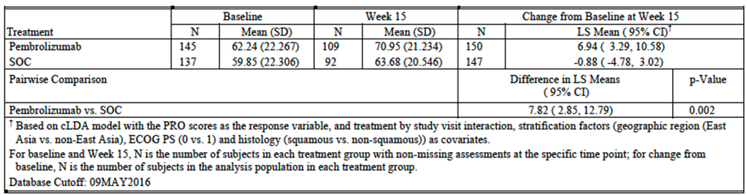

* For the EORTC QLQ-LC 13, the parameter tested was a composite of data derived from questions relating to chest pain (1 question), dyspnoea (3 questions) and cough (1 question). The endpoint was defined as the time to the first onset of a 10-point or greater score deterioration from Baseline in any one of these 3 symptoms, confirmed by a second adjacent 10-point or greater score deterioration from Baseline. Results are summarised in Table 11. Pembrolizumab treatment was associated with a prolongation of the time to deterioration in symptoms. No formal hypothesis testing was planned; however the difference between the treatment arms was nominally significant when tested.

Table 11: Study 024; EORTC-QLQ-LC13 results: Time to deterioration in symptoms (time to true deterioration for cough (LC13-Q1) chest pain (LC13-Q10) and dyspnoea (LC13-Q3-5) (FAS population)

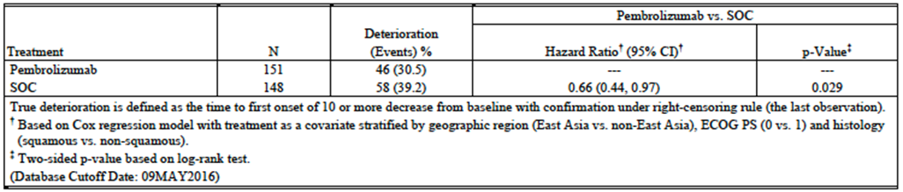

##### Evaluator commentary

Study 024 was well designed and well executed. The design of the study complied with the requirements of the relevant EMA guidelines adopted by the TGA.(13,14,15)

The comparators used in the study (platinum based doublet chemotherapy regimens) were appropriate, as these are standard therapy for the first line treatment of metastatic NSCLC.(2, 4) In Australia, bevacizumab is registered for use in combination with a platinum doublet (carboplatin/paclitaxel) for the first line treatment of metastatic non-squamous NSCLC. In the Phase III trial which supported this registration,(20)the addition of bevacizumab was associated with an increase in median OS of approximately 2 months. It could be argued that bevacizumab/carboplatin/paclitaxel should have been used as a comparator in subjects with non-squamous tumours. The report for Study 024 stated that bevacizumab containing regimens were not included among the chemotherapy options in Study 024 due to: *‘... a significant adverse toxicity profile as well as multiple exclusion criteria limiting the number of subjects eligible for treatment’*. It is noted that in Study 024, pembrolizumab treatment was associated with an increase in median PFS of approximately 4.3 months, which compares favourably with the bevacizumab data (increase in median PFS of 1.7 months). Furthermore, in Australia, bevacizumab is not subsidised under the Pharmaceutical Benefits Scheme for use in NSCLC, and is therefore probably not widely used.

The study demonstrated a statistically significant benefit for pembrolizumab over chemotherapy on both PFS and OS. The benefits are also clinically significant, with a prolongation of median PFS by approximately 4.3 months, and an increase in the proportion of subjects alive at 12 months from 54.2% to 69.9%. The study also demonstrated that pembrolizumab is associated with small improvements in QoL when compared to chemotherapy.

The application proposes a novel dosage regimen for pembrolizumab (that is a flat dose of 200 mg Q3W for all subjects). The currently approved dosage regimen for melanoma is weight-adjusted (2 mg/kg Q3W). A potential concern for the flat dosage regimen might be that efficacy is reduced in subjects with high bodyweight (that is > 100 kg). There appear to have been very few patients in Study 024 with a bodyweight > 100 kg and subgroup analyses of efficacy endpoints according to bodyweight were not presented in the study report. However, a pooled exposure response analysis included in the submission (reviewed in Section 4.1.2) did include a graphical analysis of percentage change in tumour size according to baseline bodyweight. Results are shown below in Figure 9. In Study 024, with the flat dosage regimen, there appeared to be a suggestion that efficacy was greater in low body weight subjects. However, the pooled analysis as a whole suggested there was a flat exposure response curve (see Section 4.1.2, above).

Figure 9: Percent change in tumour size versus weight (pooled analysis of NSCLC studies)

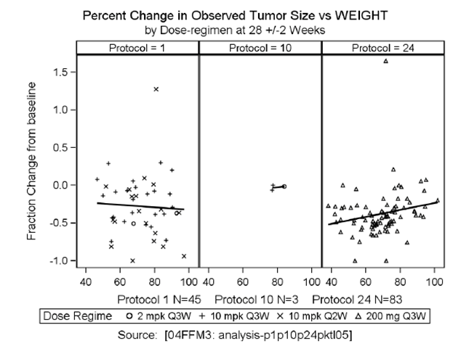

Efficacy issues raised by the data are as follows:

1. Enrolment in the study was restricted to subjects with tumours having high levels of PD-L1 expression (that is expression in ≥ 50% of neoplastic cells). The proposed indication appears to include subjects with any degree of tumour PD-L1 expression. Lower levels of PD-L1 expression have been associated with reduced efficacy of pembrolizumab in NSCLC (lower response rates).(18) There is therefore a concern that the efficacy of pembrolizumab in subjects with PD-L1 expression in < 50% of tumour cells may be lower than that of platinum based chemotherapy.

A study that compared another anti-PD-1 monoclonal antibody (nivolumab) against platinum based doublet chemotherapy in the first line treatment of metastatic NSCLC failed to demonstrate a PFS benefit.(21) The primary endpoint of the study was PFS in subjects with tumours with PD-L1 expression in ≥ 5% of tumour cells. It is possible that failure to demonstrate an efficacy benefit may have been due to the low level of PD-L1 expression in tumours studied.

In addition, the sponsor is conducting another Phase III trial of pembrolizumab versus platinum based chemotherapy in the first line treatment of NSCLC (KEYNOTE-042). It is understood that this trial is recruiting subjects with tumours that have any level of PD-L1 expression. It would be prudent to await the results of this study before considering approval in subjects whose tumours have PD-L1 expression in < 50% of tumour cells.

1. The draft PI submitted with the application recommends that pembrolizumab be continued until disease progression occurs. In Study 024, if disease progression had not occurred, subjects were to discontinue pembrolizumab treatment after a total of 35 doses (that is after 105 weeks or approximately 24 months). At the time of data cut off for the study report, no subjects had been treated for this long, and hence no data are available regarding the effects of treatment withdrawal after 35 doses. The sponsor should be asked for any updated efficacy data from the study relating to withdrawal of pembrolizumab after 35 doses.

In the absence of any data to suggest that withdrawal of pembrolizumab after 24 months is associated with disease relapse or progression, it would be appropriate to restrict pembrolizumab treatment duration to 35 doses, as proposed in Study 024.

1. The study excluded subjects with poor performance status (ECOG PS ≥ 2) and those with significant organ dysfunction. The efficacy findings of the study cannot be extrapolated to these patient groups.

The submission for the new indication is based on a single pivotal study and the TGA has adopted an EMA guideline that deals with this situation.(16) This guideline sets out certain ‘prerequisites’ that must be met for approval of such a submission. These are:

* 1. The study must have internal validity, with no indications of potential bias;
  2. The study must have external validity, with the population studied being suitable to allow extrapolation of data to the population to be treated;
  3. The size of the efficacy benefit must be large enough to be considered clinically valuable;
  4. The degree of statistical significance should be ‘considerably stronger’ than p < 0.05, and confidence intervals should be narrow.
  5. The data should be of acceptable quality;
  6. There should be internal consistency, with similar effects in sub-populations and important endpoints showing similar findings;
  7. Results should not differ notably between study centres;
  8. The hypothesis being tested should be plausible.

Overall it is considered that these prerequisites have been met. Although the submission relied on a single study in the first line NSCLC setting, a separate study (KEYNOTE-010) has demonstrated efficacy of pembrolizumab in the second-line setting.(22)

### Evaluator’s conclusions on clinical efficacy

The efficacy data to support the new indication are adequate. However, due to lack of relevant efficacy data it is recommended that the indication be restricted to subjects with tumours that have high levels of PD-L1 expression (that is expression in ≥ 50% of neoplastic cells). In addition, treatment should be restricted to a maximum of 35 cycles until further long term efficacy data are available.

## Clinical safety

### Studies providing evaluable safety data

#### Pivotal study

Full safety data were available from the pivotal trial, Study 024. Safety monitoring included the following:

* Information on adverse events (AEs) was collected at each study visit. AEs were graded according to the NCI CTCAE, Version 4 and were evaluated for seriousness, causality, and action taken with regards to trial treatment. AE terms were standardised using the Medical Dictionary for Regulatory Activities (MedDRA) Version 19.0.

The sponsor pre-identified a list of specific AE terms as adverse events of special interest (AEOSI). These AE terms covered events that were consistent with an immune phenomenon, such as pneumonitis, colitis, hypophysitis etcetera. These events were also referred to as immune related AEs (irAEs) or events of clinical interest (ECI).

* Physical examination, including measurement of vital signs (temperature, pulse, respiratory rate, weight and blood pressure) was performed at each study visit.
* Laboratory testing (complete blood count with differential and a comprehensive chemistry panel) was performed at randomisation, at each clinic visit during the treatment phase, at the discontinuation visit and at the 30 day safety follow up visit.
* Thyroid function testing (T3, free T4 and TSH) was performed at every second Cycle during the treatment phase and at the discontinuation visit and at the 30 day safety follow up visit.
* Blood samples for detection of anti-pembrolizumab antibodies were collected pre-dose at Cycles 1, 2, 4, 8 and every 8 cycles thereafter while the subject was receiving pembrolizumab. Once the subject discontinued taking pembrolizumab additional samples were obtained at 1, 3 and 6 months after the last dose of study medication.
* Urinalysis was performed every 12 weeks during the treatment phase, at the discontinuation visit and at the 30 day safety follow up visit.

#### Other data

The sponsor included the following additional safety data in the submission:

* A pooled analysis of immunogenicity data from seven pembrolizumab studies. This analysis is reviewed in Section 8.4.8.
* One periodic safety update, which is reviewed in Section 8.6.

### Patient exposure

Extent of exposure in is summarised in Table 12. The median duration of exposure in the pembrolizumab arm was 214 days (7.0 months), compared to 106 days (3.5 months) in the chemotherapy arm. In the pembrolizumab arm, 87 subjects received at least 6 months of treatment and 23 subjects had received at least 12 months of treatment. No subject had received the full planned 24 months of treatment.

Table 12: Study 024 extent of exposure

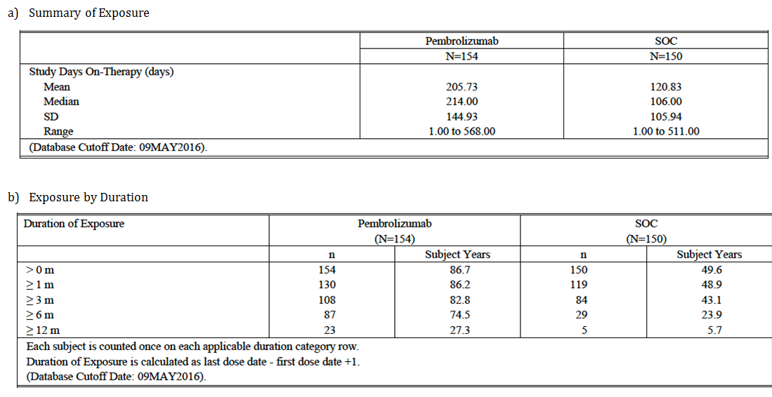

### Adverse events

AEs were monitored from the first dose to 30 days after the last dose of study drug. Serious AEs (SAEs) and AEOSI were monitored from the first dose to 90 days after the last dose of study drug (or 30 days if the subject commenced on new anticancer therapy). An overall summary of AEs, SAEs etcetera is shown below in Table 13.

Table 13: Study 024; Overall summary of AEs

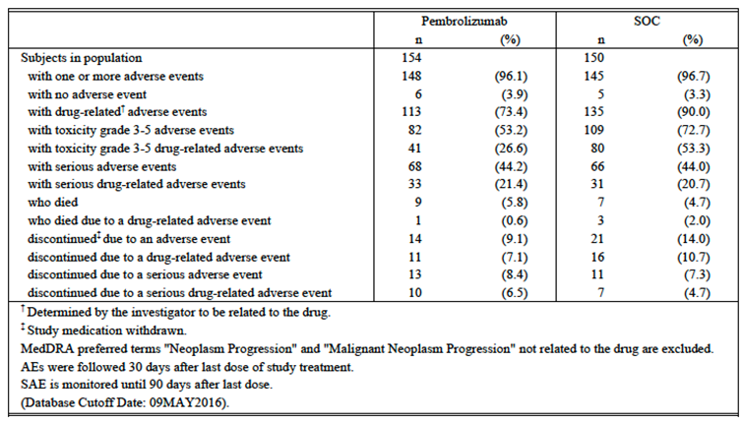

#### All adverse events (irrespective of relationship to study treatment)

The overall incidence of AEs was 96.1% in the pembrolizumab arm and 96.7% in the chemotherapy arm. Common AEs (those occurring in ≥ 2% of the study population as a whole) are listed in Table 14, shown below.

AEs typically associated with conventional chemotherapy (nausea, vomiting, myelosuppression etcetera) were more frequent in the chemotherapy arm. AEs that were notably more frequent in the pembrolizumab arm included:

* Certain respiratory events such as pneumonitis (5.2% versus 0.7%), dyspnoea (22.1% versus 16.0%), cough (16.9% versus 14.0%), haemoptysis (7.1% versus 3.3%) and chronic obstructive pulmonary disease (5.2% versus 0.7%);
* Skin AEs such as pruritus (14.9% versus 3.3%), rash (14.3% versus 4.0%), dry skin (8.4% versus 0.7%) and maculopapular rash (3.9% versus 0.7%);
* Abnormal LFTs including ALT increased (11.0% versus 7.3%), AST increased (8.4% versus 4.7%) and alkaline phosphatase increased (6.5% versus 2.7%);
* Thyroid AEs - hypothyroidism (9.1% versus 1.3%), hyperthyroidism (7.8% versus 1.3%) and TSH increased (3.9% versus 0.0%);
* Certain musculoskeletal events such as arthralgia (15.6% versus 10.0%), myalgia (5.2% versus 0.7%) and muscle spasms (5.2% versus 1.3%);
* Pyrexia (15.6% versus 9.3%).

Table 14: Study 024; common AEs (incidence ≥ 2% overall)

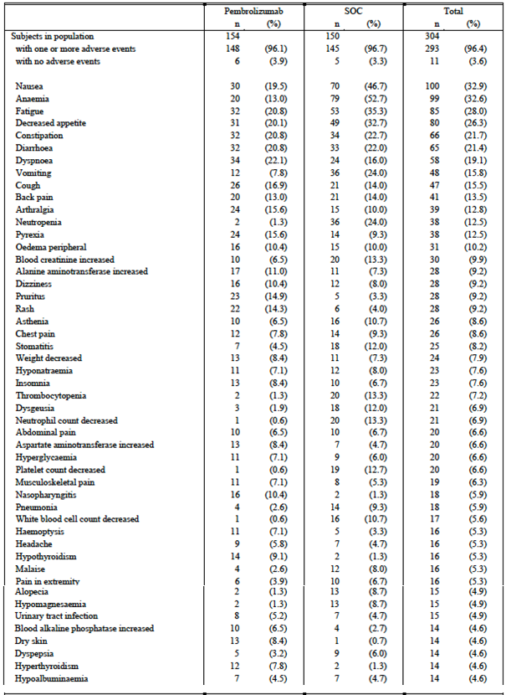

Table 14 (continued): Study 024; common AEs (incidence ≥ 2% overall)

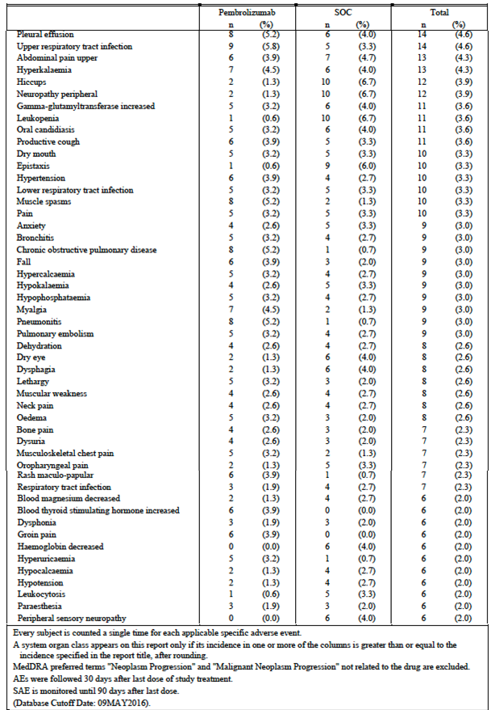

The overall incidence of Grade 3 to 5 AEs was 53.2% in the pembrolizumab arm and 72.7% in the chemotherapy arm. Grade 3 to 5 AEs occurring at least 1% of subjects in either arm are listed in Table 15. The pattern of events was similar to that observed for all AEs. However, the following Grade 3 to 5 AEs were more common with pembrolizumab:

* Diarrhoea (3.9% versus 2.0%) and colitis (1.3% versus 0.0%);
* Hyperglycaemia (2.6% versus 0.7%) and diabetes mellitus (1.3% versus 0.0%).

Table 15: Study 024; Grade 3 to 5 AEs (incidence ≥ 1% in either arm)

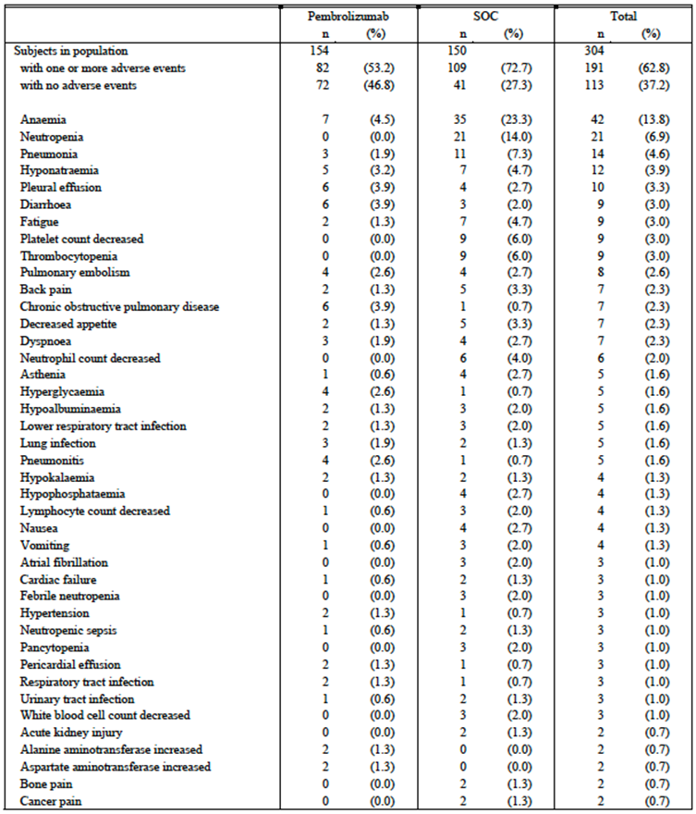

Table 15 (continued): Study 024; Grade 3 to 5 AEs (incidence ≥ 1% in either arm)

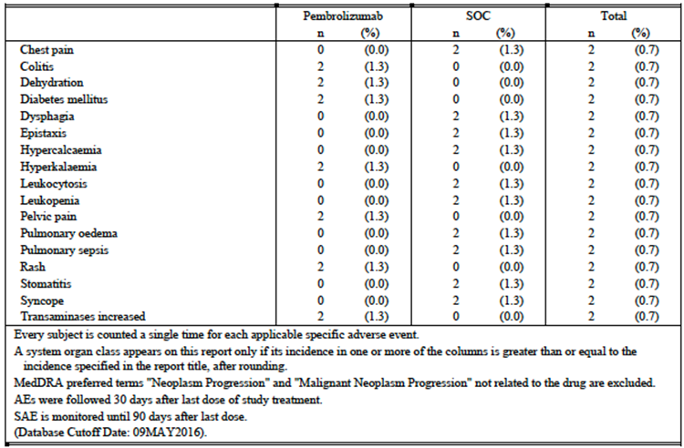

#### Treatment-related adverse events (adverse drug reactions)

The overall incidence of drug related AEs was 73.4% in the pembrolizumab arm and 90.0% in the chemotherapy arm. The pattern of drug related AEs was very similar to that described for all AEs above.

The overall incidence of drug related Grade 3 to 5 AEs was 26.6% in the pembrolizumab arm and 53.3% in the chemotherapy arm. The pattern of drug-related Grade 3 to 5 AEs was again very similar to that described above for all AEs.

#### Deaths and other serious adverse events

##### Serious AEs

A serious adverse event was defined as any adverse event that:

* Results in death;
* Is life threatening;
* Results in persistent or significant disability/incapacity;
* Results in or prolongs an existing inpatient hospitalisation;
* Is a congenital anomaly/birth defect;
* Is a new cancer (that is not a condition of the study);
* Is associated with an overdose;
* Is another important medical event.

The overall incidence of SAEs was similar in the 2 treatment arms; 44.2% in the pembrolizumab arm and 44.0% in the chemotherapy arm. SAEs occurring in at least 1% of subjects in either arm are listed in Table 16.

SAEs that were more common in the pembrolizumab arm included the following:

* Respiratory events such as pneumonitis (4.5% versus 0.7%), pleural effusion (3.2% versus 2.0%), haemoptysis (1.3% versus 0.0%) and chronic obstructive pulmonary disease (2.6% versus 0.7%);
* Colitis (1.3% versus 0.0%) and diarrhoea (1.9% versus 0.7%);
* Hyperglycaemia (1.9% versus 0.0%) and diabetes mellitus 1.3% versus 0.0%);
* ALT increased (1.3% versus 0%);
* Hyponatraemia (2.6% versus 0%).

The incidence of SAEs that were assessed as being drug related was also similar in the 2 arms; 21.4% in the pembrolizumab arm and 20.7% in the chemotherapy arm.

Table 16: Study 024; Serious AEs (incidence ≥ 1% in either arm)

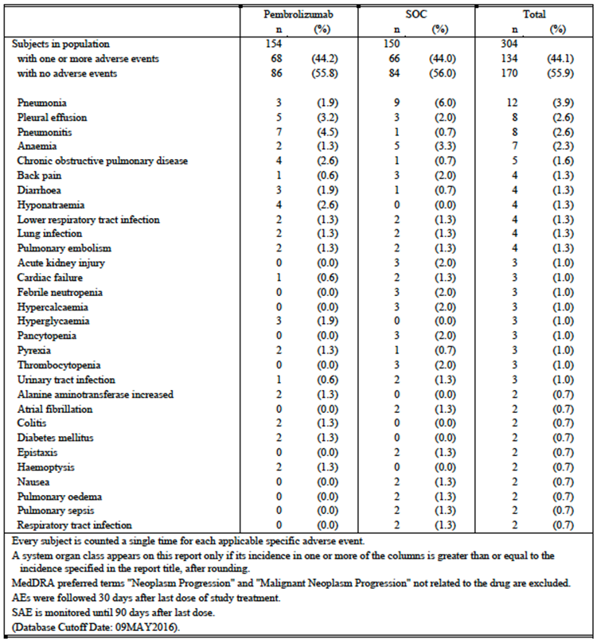

##### Deaths

There were a total of 16 AEs resulting in death (not including disease progression events); 9 (5.8%) in the pembrolizumab arm and 7 (4.7%) in the chemotherapy arm. These events are listed in Table 17. There was no apparent imbalance between the treatment arms in terms of the type of AEs.

Table 17: Study 024; AEs resulting in death

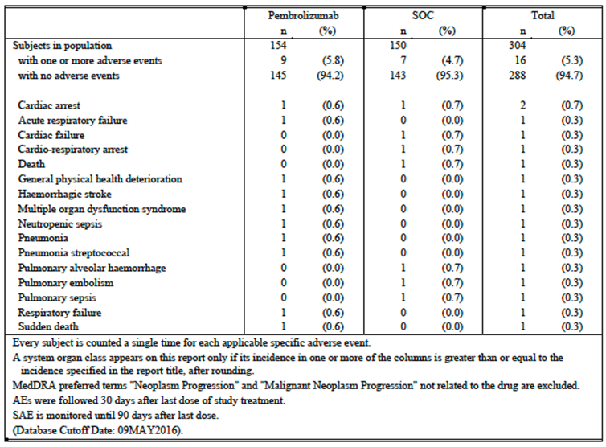

Four of these AEs were assessed as being related to study treatment; 1 (0.6%) in the pembrolizumab arm and 3 (2.0%) in the chemotherapy arm.

The fatal events that were assessed as related in the chemotherapy arm were: a death of unknown cause one week after the first dose of chemotherapy (n = 1), pulmonary alveolar haemorrhage (n = 1) and pulmonary sepsis (n = 1).

#### Discontinuations due to adverse events

The overall incidence of AEs resulting in discontinuation of study drug was 9.1% in the pembrolizumab arm and 14.0% in the chemotherapy arm. The only events resulting in discontinuation that occurred in more than 1 subject in the pembrolizumab arm were:

Pneumonitis; 6 subjects (3.9%) versus no subjects in the chemotherapy arm;

Abnormal LFTs; 2 subjects (1.3%) versus no subjects in the chemotherapy arm.

#### Adverse events of special interest

AEOSI were events that were suspected of being immune related AEs. These occurred more frequently in the pembrolizumab arm, with an incidence of 29.2% compared with 4.7% in the chemotherapy arm. AEOSI are listed in Table 18.

The most common AEOSI observed in the pembrolizumab arm were hypothyroidism (n = 14), hyperthyroidism (n = 12), pneumonitis (n = 8) and infusion reactions (n = 7).

Grade 3 to 5 AEOSI occurred in 9.7% of pembrolizumab treated subjects and serious AEOSI in 10.4%. AEOSI leading to discontinuation of pembrolizumab occurred in 3.9% of subjects. There were no AEOSI that led to death.

Table 18: Study 024; AEs of special interest

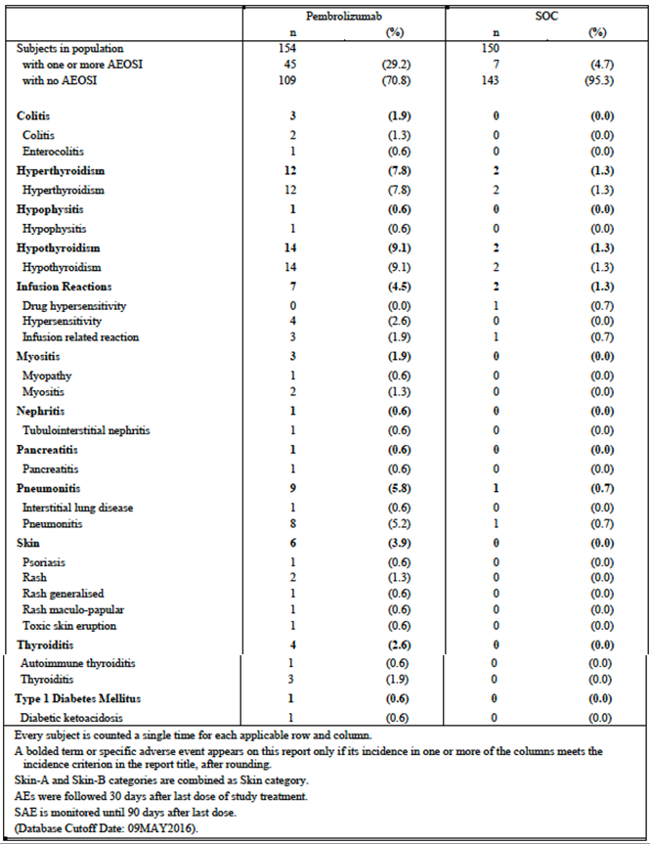

### Evaluation of issues with possible regulatory impact

#### Liver function and liver toxicity

Immune mediated hepatitis is listed in the current PI as an adverse effect of pembrolizumab.

The incidence of LFT abnormalities in Study 024 is summarised below in Table 19. The overall incidence of abnormalities was generally comparable in the two treatment arms. However, Grade 3 or 4 transaminase elevations occurred more frequently in the pembrolizumab arm. The protocol for the study indicated that cases of abnormal LFTs meeting Hy’s law criteria would be monitored as events of clinical interest. However, no discussion of such cases was included in the study report. The sponsor should be asked to provide details of any such cases.

Table 19: Study 024; Liver function test abnormalities

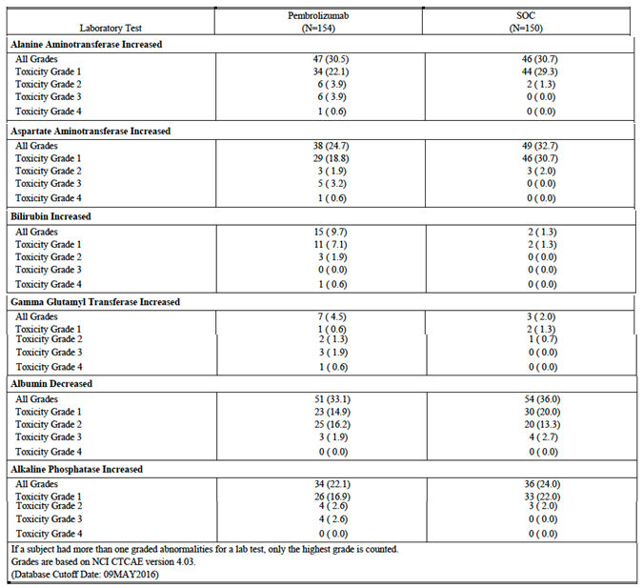

#### Renal function and renal toxicity

Immune mediated nephritis is listed in the current PI as an adverse effect of pembrolizumab.

In Study 024, abnormalities in serum creatinine occurred more frequently in the chemotherapy arm (see Table 20, below).

Table 20: Study 024; Serum creatinine abnormalities

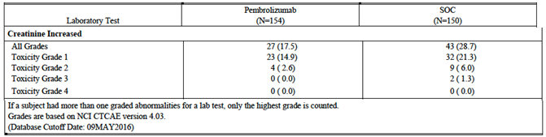

#### Other clinical chemistry

Other biochemical abnormalities occurring in Study 024 are listed in Table 21. The incidence of such abnormalities was generally similar in the two treatment arms.

Abnormal amylase/lipase was slightly more common in the pembrolizumab arm. There was 1 AE of pancreatitis in the pembrolizumab arm. Immune mediated pancreatitis is listed in the current PI as an adverse effect of pembrolizumab.

Table 21: Study 024; Abnormalities of other biochemistry tests

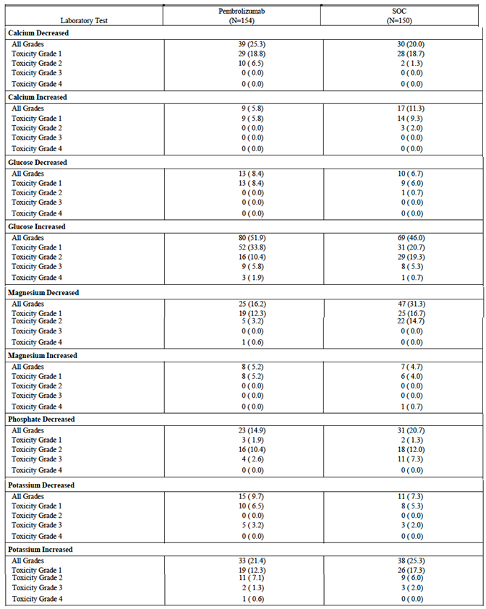

Table 21 (continued): Study 024; Abnormalities of other biochemistry tests

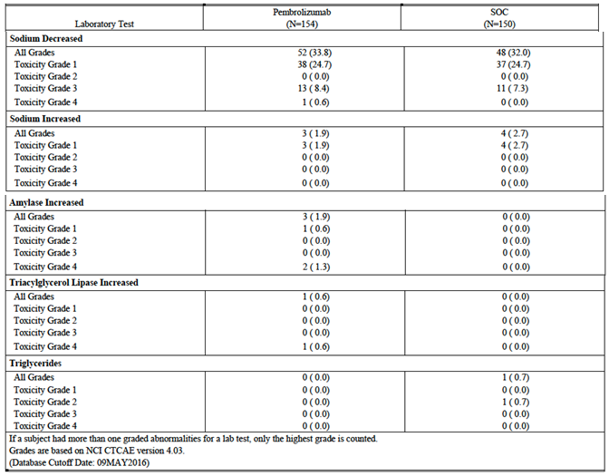

#### Haematology and haematological toxicity

Haematological laboratory abnormalities that occurred in Study 024 are summarised in Table 22. Cytopaenias were much more frequent in the chemotherapy arm. Other abnormalities occurred with a similar frequency in the two arms.

Table 22: Study 024; Haematological laboratory test abnormalities

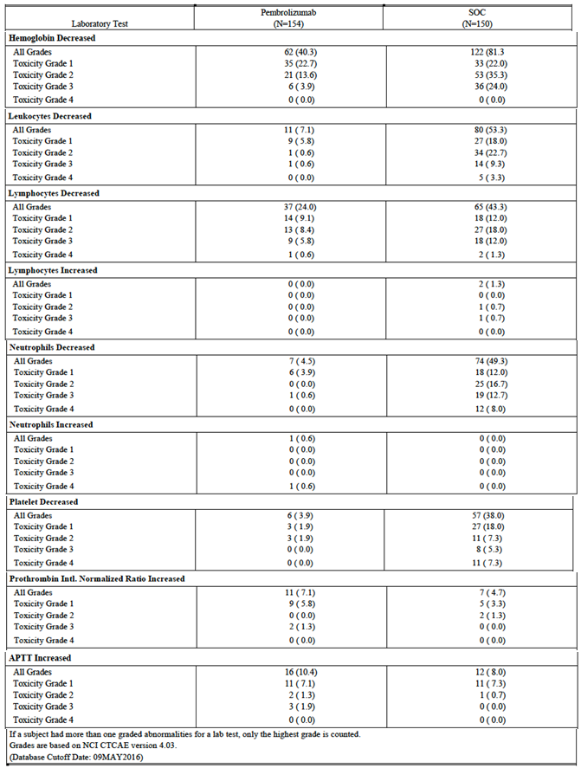

#### Other laboratory tests

Analyses of thyroid function testing and urinalysis performed in Study 024 were not presented in the study report.

#### Electrocardiograph findings and cardiovascular safety

ECGs were not routinely monitored during Study 024.

#### Vital signs and clinical examination findings

No analyses of vital signs etcetera were included in the study report.

#### Immunogenicity and immunological events

Immune-mediated AEs were common with pembrolizumab in Study 024. These have been reviewed in Section 8.3.5.

In Study 024, treatment emergent anti-pembrolizumab antibodies developed in 6 of 140 evaluable subjects (4.3%). These subjects did not develop any AEs of an allergic nature or any alterations in pembrolizumab PK.

The submission also included a pooled analysis of immunogenicity data from seven studies. This analysis is summarised below in Section 8.4.8.1.

##### Pembrolizumab (MK-3475) immunogenicity analysis NSCLC (Report 04FFCJ)

###### Methodology

The analysis was based on pooled immunogenicity data obtained from pembrolizumab treated subjects from 7 studies: Study 001 (melanoma and NSCLC), Studies 002 and 006 (melanoma) Studies 010 and 024 (NSCLC) and Studies 012 and 055 (head and neck squamous cell carcinoma (HNSCC)). A total of 2873 subjects were included in the assessment (1535 melanoma subjects, 1237 NSCLC subjects and 101 HNSCC subjects).

Samples were assayed for the presence of anti-drug antibodies (ADA) using a validated electrochemiluminescence (ECL) immunoassay. Samples underwent an initial screening test and those that tested positive underwent a confirmatory test. Those that tested positive on the confirmatory test were tested for antibody titre, and were also to be tested for the presence of neutralising antibodies (nAb) based on the ability of the antibodies to block binding of pembrolizumab to PD-1. Those samples which tested positive to the nAb assay were to undergo a further confirmatory test for nAb (protein G depletion). The nAb assessment results were not available for most samples because the nAb assays was not finalised at the time of reporting.

Pembrolizumab could interfere with the antibody assays at concentrations above the assay’s drug tolerance level (DTL). The DTL was either 25 µg/mL or 124 µg/mL depending on which of two laboratories performed the assay. Subjects were categorised into one of 3 groups:

* Negative: all pre-treatment and post dose samples negative in the confirmatory assay for antibodies against pembrolizumab and the concentration of pembrolizumab in the last post dose sample below the DTL.
* Inconclusive: all pre-treatment and post dose samples negative in the confirmatory assay for antibodies against pembrolizumab and the concentration of pembrolizumab in the last post dose sample above the drug tolerance level.
* Positive: at least one pre-treatment or post dose sample positive in the confirmatory assay for antibodies against pembrolizumab.

Subjects who tested positive were further categorised as follows:

* Treatment emergent positive:
  + Pre-treatment sample negative and at least one post dose sample positive in the confirmatory assay for antibodies against pembrolizumab (treatment induced positive).
  + Pre-treatment and post dose sample positive in the confirmatory assay for antibodies against pembrolizumab with an increase in titre (> 2 fold of baseline) (treatment boosted positive).
* Non-treatment emergent positive:
  + Pre-treatment sample positive and post dose sample negative in the confirmatory assay for antibodies against pembrolizumab.
  + Pre-treatment and post dose sample positive in the confirmatory assay for antibodies against pembrolizumab with a post dose titre < 2 fold of baseline.

###### Results

Of the 2873 subjects, results for 1584 (55.1%) were categorised as inconclusive, leaving 1289 (44.9%) as evaluable subjects. Results for the immunogenicity testing are summarised in Table 23.

Table 23: Results for immunogenicity testing. Report 04FFCJ

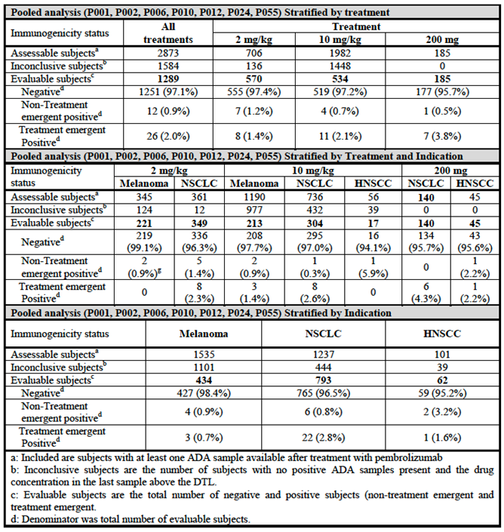

The overall incidence of treatment-emergent ADA was 2.0% (26/1289 evaluable subjects). In study 024, the overall incidence was 4.3% (6/140 evaluable subjects) and for NSCLC patients overall, the incidence was 2.8% (22/793 subjects).

The development of treatment emergent ADA was not associated with any significant alterations in pembrolizumab PK. Figure 10 shows pembrolizumab concentrations in the 6 subjects who developed treatment emergent ADA in Study 024, compared with other subjects in the same study. PK findings were similar for subjects who developed treatment-emergent ADA in other studies.

Figure 10: Study 024; Pembrolizumab exposure for NSCLC subjects treated with 200 mg Q3W

Figure 10: Study 024; Pembrolizumab exposure for NSCLC subjects treated with 200 mg Q3W


None of the 26 subjects who developed treatment-emergent ADA had allergic type events such as hypersensitivity events (for example anaphylaxis, urticaria, angioedema) or injection site reactions. The report stated that *‘no clinically significant impact on efficacy (that is tumour size change) was established’* although details of this analysis were not provided.

**Comments:** The study design, conduct and analysis were satisfactory.

#### Serious skin reactions

Immune mediated severe skin reactions are listed in the current PI as adverse effects of pembrolizumab.

There were two serious skin AEs in the pembrolizumab arm of Study 024; lichenoid keratosis (1) and rash (1). There was 1 serious AE of skin infection in the chemotherapy arm.

### Other safety issues

#### Safety in special populations

In the Summary of Clinical Safety, the sponsor presented analyses of the incidence of AEs, SAEs, etcetera in Study 024 by age, gender and ECOG performance status at Baseline.

The incidence of SAEs and discontinuations due to AEs increased with increasing age in both the pembrolizumab and chemotherapy arms. Discontinuation due to AE was more common in females than males in the pembrolizumab arm (14.5% versus 5.4%). There were no notable differences in AE incidence between subjects with ECOG PS 1 or 2.

An analysis of the incidence of AEOSI in Study 024 by bodyweight was presented in the submission and results are shown in Figure 11. The flat dosage regimen used in Study 024 did not result in a higher incidence of AEOSI in subjects with low bodyweight.

Figure 11: Study 024; Incidence of AEOSI by bodyweight

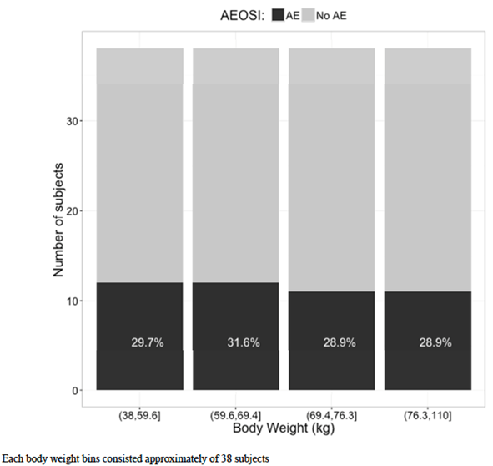

### Post marketing experience

The submission included one periodic safety update report (PSUR) that reviewed adverse event reports received by the sponsor over a 6 month period between 4 September 2015 and 3 March 2016. During this period, approximately 12,985 patients were exposed to marketed pembrolizumab. Cumulatively, there were approximately 22,494 patients who had been exposed to marketed pembrolizumab.

During the reporting period, there were no actions taken by regulators against the product on safety grounds.

Immune-mediated myasthenia gravis was identified as a potential safety issue based on published reports of cases occurring in subjects treated with nivolumab and ipilimumab. A review of the sponsor’s safety database for pembrolizumab identified 7 spontaneous reports that could have represented cases of myasthenia gravis. However, in all 7 cases the details provided were insufficient to allow a meaningful assessment. The sponsor considered that these may have been cases of immune-mediated myositis/myopathy which is an adverse reaction listed in the current PI. Another 4 potential cases were identified from clinical trials. However, there were confounding factors or inconsistencies with each of these 4 cases. The sponsor accepted myasthenia gravis as a potential safety risk for inclusion in the risk management program. However, a change to the prescribing information was not considered appropriate.

The sponsor also conducted an assessment of safety data related to reports of encephalitis and encephalopathy temporally associated with the administration of pembrolizumab. A total of 19 cases were identified (17 from clinical trials and 2 spontaneous reports). In most of these cases, a more plausible explanation for the event was present (e.g. brain metastases, hepatic encephalopathy, alcohol abuse etcetera). Three cases had insufficient detail for an adequate assessment to be made. The sponsor concluded that there was insufficient evidence to support a causal relationship with pembrolizumab.

No other new safety issues were identified.

### Evaluator’s overall conclusions on clinical safety

The data from Study 024 indicate that pembrolizumab has a more favourable overall safety profile than platinum doublet chemotherapy in the first line treatment of metastatic NSCLC. The incidence of AEs and serious AEs was comparable in the two treatment groups even though the duration of treatment in the pembrolizumab arm was approximately double that in the chemotherapy arm. Pembrolizumab treatment was associated with a lower incidence of Grade 3 to 5 AEs (53.2% versus 72.7%), discontinuations due to AEs (9.1% versus 14.0%) and drug related AEs leading to death (0.6% versus 2.0%).

The pattern of toxicity observed with pembrolizumab was consistent with that previously documented for the drug. The most common adverse events were consistent with immune-mediated toxicities such as pneumonitis, colitis, thyroid dysfunction, skin disorders, hepatitis etcetera No new toxicities were identified.

Anti-pembrolizumab antibodies developed in 4.3% of subjects in Study 024. However, these antibodies were not associated with any effects on the pharmacokinetics of the drug or with any safety concerns.

Given that metastatic NSCLC is a life-threatening condition with a poor prognosis, the safety profile of pembrolizumab is considered acceptable.

## First round benefit-risk assessment

### First round assessment of benefits

Table 24 (shown below) gives a summary of the assessment of benefits at the first round.

Table 24: First round assessment of benefits

| **Indication: First line treatment of metastatic NSCLC** | |
| --- | --- |
| **Benefits** | **Strengths and Uncertainties** |
| Compared with platinum doublet chemotherapy, pembrolizumab treatment was associated with:   * A significant reduction in the risk of a PFS event (hazard ratio = 0.50; 95% CI: 0.37 to 0.68; p < 0.001). Median PFS was prolonged by approximately 4.3 months (10.3 versus 6.0 months). The proportion of subjects alive and progression free at 6 months was increased from 50.3% to 62.1%; * A significant reduction in the risk of death (hazard ratio = 0.60; 95%CI: 0.41 to 0.89; p = 0.005). Median survival was not reached in either group, after a median follow up of 11 months. The proportion of subjects alive at 6 months was increased from 72.4% to 80.2%, and the proportion of subjects alive at 12 months was increased from 54.2% to 69.9%. * An increase in the ORR from 27.8% (95% CI: 20.8 to 35.7) in the chemotherapy arm to 44.8% (95% CI: 36.8 to 53.0) in the pembrolizumab arm. * An improvement in overall quality of life and a prolongation of the time to a deterioration in symptoms (dyspnoea, cough, chest pain). * An improved overall safety profile compared to the current standard therapy of platinum based chemotherapy, with a reduced incidence of Grade 3 to 5 AEs, discontinuations due to AEs and drug related fatal AES. | *Strengths:*   * The study was well-designed and executed. The trial design complied with various EMA guidelines adopted by the TGA. * The improvements in PFS and OS were both statistically and clinically significant. * The observed benefits in PFS/OS were consistent across various subgroups of patients.   *Uncertainties:*   * The study excluded subjects with ECOG PS > 1 and subjects those with significant organ dysfunction. Benefits in these subjects has not been established. * The improvements in quality of life/symptom measures were small and of borderline clinical significance. * Benefits have not been demonstrated in subjects who have tumours with PD-L1 expression in < 50% of neoplastic cells. * The optimal duration of treatment with pembrolizumab has not been defined. |

### First round assessment of risks

Table 25, shown below, gives a summary of the assessment of risks at the first round.

Table 25: First round assessment of risks

| **Risks** | **Strengths and Uncertainties** |
| --- | --- |
| * Immune mediated adverse drug reactions such as pneumonitis, colitis, thyroid dysfunction, skin disorders, hepatitis etcetera * Anti-pembrolizumab antibodies develop in 4.3% of first line NSCLC subjects. | *Strengths:*   * No new toxicities were identified in the proposed new patient population. * Anti-pembrolizumab antibodies were not associated with any effects on the pharmacokinetics of the drug or with any safety concerns.   *Uncertainties:*   * The study excluded subjects with ECOG PS > 1 and subjects those with significant organ dysfunction. Safety in these subjects has not been established. |

### First round assessment of benefit-risk balance

Platinum based chemotherapy, as the current standard of treatment in the first line treatment of metastatic NSCLC, is considered to have a favourable risk-benefit balance. Pembrolizumab has improved efficacy and an improved overall safety profile compared with platinum based chemotherapy. It can therefore be concluded that risk-benefit balance of pembrolizumab for the first line treatment of NSCLC is favourable.

## First round recommendation regarding authorisation

It is recommended that pembrolizumab be approved for the first line treatment of NSCLC. However, it is recommended that the indication should be revised as follows:

*‘Keytruda is indicated for the treatment of patients with previously untreated metastatic non-small cell lung carcinoma (NSCLC) whose tumours express PD-L1 in ≥ 50% of neoplastic cells as determined by a validated test and do not harbour a sensitizing EGFR mutation or ALK translocation [see CLINICAL TRIALS].’*

It is also recommended that the duration of pembrolizumab treatment be restricted to 24 months.

## Clinical questions

### Clinical questions

#### Efficacy

1. In Study 024, pembrolizumab treated subjects who had not developed disease progression were to discontinue the drug after a total of 35 treatments. At the time of data cut off for the study report, no subjects had completed 35 treatments. Please provide a summary of any available updated efficacy data on subjects who have now completed 35 treatments, in particular whether withdrawal of treatment was associated with the onset of progressive disease or disease relapse.

#### Safety

1. Grade 3 or 4 elevations of AST and ALT occurred more commonly in the pembrolizumab arm of the study. Section 7.2.3.2 of the study protocol indicated that LFT abnormalities that met Hy’s law criteria would be considered as Events of Clinical Interest (ECI). Please advise whether any cases meeting Hy’s law criteria were observed in the study, and if so, please provide details.

## Second round evaluation of clinical data submitted in response to questions

The evaluation of the response to issues raised has been covered by the Delegate in their review of the submission.

## References

1. National Cancer Institute. Non-Small Cell Lung Cancer Treatment (PDQ)–Health Professional Version. 2016. Available from: https://www.cancer.gov/types/lung/hp/non-small-cell-lung-treatment-pdq (accessed December 2016).
2. National Comprehensive Care Network (NCCN) Clinical Practice Guidelines in Oncology. Non-Small Cell Lung Cancer. Version 2.2017. 2016. Available from: https://www.nccn.org/professionals/physician_gls/f_guidelines.asp#site (accessed December 2016)
3. Travis WD, Brambilla E, Nicholson AG et al. The 2015 World Health Organization Classification of Lung Tumors - Impact of Genetic, Clinical and Radiologic Advances Since the 2004 Classification. J Thorac Oncol. 2015; 10: 1243–1260
4. Novello S, Barlesi F, Califano R et al. Metastatic non-small-cell lung cancer: ESMO Clinical Practice Guidelines for diagnosis, treatment and follow up. Annals of Oncology. 2016; 27 (Supplement 5): v1–v27.
5. Hirsch FR, Suda K, Jacinta Wiens J and Bunn PA. New and emerging targeted treatments in advanced non-small-cell lung cancer. *Lancet* 2016; 388: 1012–24.
6. American Cancer Society. Lung Cancer (Non-Small Cell). 2016. Available from: http://www.cancer.org/cancer/lungcancer-non-smallcell/detailedguide/non-small-cell-lung-cancer-survival-rates (Accessed December 2016)
7. Cancer Council Australia. Types of cancer – lung cancer. 2016. Available from: http://www.cancer.org.au/about-cancer/types-of-cancer/lung-cancer.html (Accessed December 2016)
8. Cancer Institute NSW. eviQ Cancer Treatments Online. Respiratory (lung) homepage. Chemotherapy protocols. 2016. Available from: https://www.eviq.org.au/ (Accessed December 2016)
9. Johnson BE. Divide and Conquer to Treat Lung Cancer. N Engl J Med 2016; 375:1892-1893.
10. Boussiotis VA. Molecular and Biochemical Aspects of the PD-1 Checkpoint Pathway. N Engl J Med 2016; 375:1767-78.
11. Chen DS, Irving BA and Hodi FS. Molecular Pathways: Next-Generation Immunotherapy— Inhibiting Programmed Death-Ligand 1 and Programmed Death-1. Clin Cancer Res. 2012; 18 (24): 6580-6587.
12. Therapeutic Goods Administration. Australian Public Assessment Report for nivolumab. August 2016. Available from: https://www.tga.gov.au/auspar/auspar-nivolumab. (Accessed December 2016)
13. European Medicines Agency. Guideline on the evaluation of anticancer medicinal products in man. EMA/CHMP/205/95/Rev.4; (2012).
14. European Medicines Agency. Appendix 1 to the guideline on the evaluation of anticancer medicinal products in man. Methodological consideration for using progression free survival (PFS) or disease-free survival (DFS) in confirmatory trials. EMA/CHMP/27994/2008/Rev.1; (2012).
15. European Medicines Agency. Appendix 4 to the guideline on the evaluation of anticancer medicinal products in man. Condition Specific Guidance. EMA/CHMP/703715/2012; (2013).
16. European Medicines Agency. Points to consider on application with 1. Meta-analyses; 2. One pivotal study; CPMP/EWP/2330/99 (2001).
17. Reck M, Rodríguez‑Abreu D, Robinson AG et al. Pembrolizumab versus Chemotherapy for PD-L1–Positive Non–Small-Cell Lung Cancer. N Engl J Med 2016; 375: 1823-33.
18. Garon EB, Rizvi NA, Hui R et al. Pembrolizumab for the Treatment of Non–Small-Cell Lung Cancer. N Engl J Med. 2015; 372: 2018-28.
19. Eisenhauer EA, Therasse P, Bogaerts J et al. New response evaluation criteria in solid tumours: revised RECIST guideline (version 1.1). Eur J Cancer. 2009; 45 (2): 228-47.
20. Sandler A, Gray R, Perry MC et al. Paclitaxel–Carboplatin Alone or with Bevacizumab for Non–Small-Cell Lung Cancer. N Engl J Med 2006; 355: 2542-50.
21. Socinski M, Creelan B, Horn L et al. CheckMate 026: A Phase III trial of nivolumab vs investigator's choice (IC) of platinum based doublet chemotherapy (PT-DC) as first line therapy for stage iv/ recurrent programmed death ligand 1 (PD-L1) −positive NSCLC. Annals of Oncology 2016; 27 (Suppl 6): vi552–vi587.
22. Herbst RS, Baas P, Kim DW et al.Pembrolizumab versus docetaxel for previously treated, PD-L1-positive, advanced non-small-cell lung cancer (KEYNOTE-010): a randomised controlled trial.

|  |
| --- |
| Therapeutic Goods Administration |
| PO Box 100 Woden ACT 2606 Australia  Email: [info@tga.gov.au](mailto:info@tga.gov.au) Phone: 1800 020 653 Fax: 02 6232 8605  [**https://www.tga.gov.au**](https://www.tga.gov.au) |

1. Available at https://cancerstaging.org/references-tools/quickreferences/Documents/LungMedium.pdf (accessed January 2018)
2. Submission PM-2016-01163-1-4 was approved on 20 March 2017