First round 12 August 2016
Second round 8 November 2016

AusPAR Attachment 2

Extract from the Clinical Evaluation Report for Pembrolizumab
  - Proprietary Product Name: Keytruda
  - Sponsor: Merck Sharp and Dohme Australia Pty Ltd

About the Therapeutic Goods Administration (TGA)
- The Therapeutic Goods Administration (TGA) is part of the Australian Government Department of Health, and is responsible for regulating medicines and medical devices.
- The TGA administers the Therapeutic Goods Act 1989 (the Act), applying a risk management approach designed to ensure therapeutic goods supplied in Australia meet acceptable standards of quality, safety and efficacy (performance), when necessary.
- The work of the TGA is based on applying scientific and clinical expertise to decision-making, to ensure that the benefits to consumers outweigh any risks associated with the use of medicines and medical devices.
- The TGA relies on the public, healthcare professionals and industry to report problems with medicines or medical devices. TGA investigates reports received by it to determine any necessary regulatory action.
- To report a problem with a medicine or medical device, please see the information on the TGA website < https://www.tga.gov.au >.
About the Extract from the Clinical Evaluation Report
- This document provides a more detailed evaluation of the clinical findings, extracted from the Clinical Evaluation Report (CER) prepared by the TGA. This extract does not include sections from the CER regarding product documentation or post market activities.
- The words [Information redacted], where they appear in this document, indicate that confidential information has been deleted.
- For the most recent Product Information (PI), please refer to the TGA website < https://www.tga.gov.au/product-information-pi >.
Copyright
© Commonwealth of Australia 2018
This work is copyright. You may reproduce the whole or part of this work in unaltered form for your own personal use or, if you are part of an organisation, for internal use within your organisation, but only if you or your organisation do not use the reproduction for any commercial purpose and retain this copyright notice and all disclaimer notices as part of that reproduction. Apart from rights to use as permitted by the Copyright Act 1968 or allowed by this copyright notice, all other rights are reserved and you are not allowed to reproduce the whole or any part of this work in any way (electronic or otherwise) without first being given specific written permission from the Commonwealth to do so. Requests and inquiries concerning reproduction and rights are to be sent to the TGA Copyright Officer, Therapeutic Goods Administration, PO Box 100, Woden ACT 2606 or emailed to < tga.copyright@tga.gov.au > .

Contents
List of abbreviations 5
1. Introduction 7
1.1. Dosage forms and strengths 7
1.2. Dosage and administration 7
2. Clinical rationale 8
3. Contents of the clinical dossier 8
3.1. Scope of the clinical dossier 8
3.2. Paediatric data 9
3.3. Good clinical practice 9
4. Pharmacokinetics 9
4.1. Studies providing pharmacokinetic data 9
4.2. Summary of pharmacokinetics 9
4.3. Population pharmacokinetics 11
4.4. Evaluator’s overall conclusions on pharmacokinetics 11
5. Pharmacodynamics 11
6. Dosage selection for the pivotal studies 11
7. Clinical efficacy 11
7.1. Pivotal efficacy studies 11
7.2. Analyses performed across trials (pooled analyses and meta-analyses) 36
7.3. Evaluator’s conclusions on clinical efficacy of pembrolizumab for the treatment of non-small cell lung cancer 38
8. Clinical safety 39
8.1. Studies providing evaluable safety data 39
8.2. Pivotal studies that assessed safety as a primary outcome 42
8.3. Patient exposure 42
8.4. Adverse events 42
8.5. Post-marketing experience 45
8.6. Safety issues with the potential for major regulatory impact 47
8.7. Other safety issues 51
8.8. Evaluator’s overall conclusions on clinical safety 52
9. First round benefit-risk assessment 53
9.1. First round assessment of benefits 53
9.2. First round assessment of risks 53
9.3. First round assessment of benefit-risk balance 54
10. First round recommendation regarding authorisation 54
11. Clinical questions 55
11.1. General questions 55
11.2. Pharmacokinetics 55
11.3. Efficacy 55
11.4. Safety 55
12. Second round evaluation of clinical data submitted in response to questions 56
12.1. General questions 56
12.2. Pharmacokinetics 67
12.3. Efficacy 67
12.4. Safety 78
13. Second round benefit-risk assessment 78
13.1. Second round assessment of benefits 78
13.2. Second round assessment of risks 78
13.3. Second round assessment of benefit-risk balance 79
14. Second round recommendation regarding authorisation 79
15. References 79

List of abbreviations
Abbreviation | Meaning
ADA | anti-drug antibodies
AE | adverse event
AEOSI | adverse event of special interest
APaT | All patients as treated
AUC_{ss} | Area under the time-concentration curve at steady state
ALK | Anaplastic lymphoma receptor tyrosine kinase
C_{max} | Maximal concentration
C_{trough} | Trough concentration
CSR | Clinical study report
CTCAE | Common terminology criteria for adverse events
CV | Coefficient of variation
ECOG | Eastern Cooperative Oncology Group
EGFR | endothelium growth factor receptor
EORTC | European Organization for Research and Treatment of Cancer
HRQoL | Health-related quality of life
IRC | Independent review committee
IV | intravenous
NSCLC | non-small cell lung carcinoma
ORR | overall response rate
OS | overall survival
PD-1 | Programmed cell death 1
PD | Progression of disease
PD-L1 | Programmed cell death 1 ligand 1
PD-L2 | Programmed Cell death 1 ligand 2
PFS | progression free survival
PI | Product information
PK | pharmacokinetic
PRO | patient-reported outcomes
Q2W | every two weeks
Q3W | every three weeks
RECIST | Response Criteria in Solid Tumours
SAE | serious adverse event
SD | standard deviation
TGA | Therapeutic Goods Administration
TKI | tyrosine kinase inhibitor
TPS | tumour proportion score

Introduction
This is a submission to extend the current indications.
The approved indication is:
‘Keytruda (pembrolizumab) is indicated as monotherapy for the treatment of unresectable or metastatic melanoma in adults.’
The proposed additional indication is:
‘Keytruda is indicated for the treatment of patients with advanced non-small cell lung carcinoma (NSCLC) whose tumours express PD-L1 and who have received platinum containing chemotherapy. Patients with EGFR or ALK genomic tumour aberrations should also have received approved therapy for these aberrations prior to receiving Keytruda [see CLINICAL TRIALS].’
Comment: The proposed indication states ‘advanced non-small cell lung cancer’ as opposed to that currently approved by the FDA which states ‘metastatic non-small cell lung cancer’.
The current FDA approved use of pembrolizumab in patients with NSCLC is restricted to patients with a > 50% expression of PD-L1 on tumour cells. The proposed indication in Australia ‘whose tumours express PD-L1…’ requires a cut-off of PD-L1 expression at the nominal value of 1%.
It is noted that the proposed indication does not contain the FDA’s requirement for patients to be evaluated for treatment eligibility using an approved test. This information is, however, documented in the PI in the ‘Dosage and Administration’ section:
‘Patient Selection
Non-Small Cell Lung Carcinoma
Patients should be selected for treatment of advanced NSCLC with Keytruda based on the presence of positive (tumour proportion score ≥ 1%) PD-L1 expression [see CLINICAL TRIALS].
Determination of PD-L1 expression for the treatment of advanced NSCLC should be performed using a validated test by laboratories.’
Keytruda, pembrolizumab (previously known as MK-3475 or SCH 900475) is a highly selective humanised monoclonal antibody (mAb) that binds to human programmed cell death 1 (PD-1) and blocks the interaction between the PD-1 pathway receptor and its ligands, programmed cell death 1 ligand 1 (PD-L1) and programmed cell death 1 ligand 2 (PD-L2).

Dosage forms and strengths
The following dosage forms and strengths are currently registered:
- Keytruda is presented as a 50 mg powder for solution for infusion (ARTG 226597).
- No new dosage forms or strengths are proposed.

Dosage and administration
As per the PI, the proposed dosing regimen for both melanoma and NSCLC is:
‘The recommended dose of Keytruda is 2 mg/kg administered intravenously over 30 minutes every 3 weeks. Patients should be treated with Keytruda until disease progression or unacceptable toxicity.’
Comment: Of note, at the pre-submission meeting, the sponsor had discussed submitting a flat-dosing schedule for patients with NSCLC and melanoma. This proposal has not eventuated.

Clinical rationale
Traditional treatment of non-small cell lung cancer (NSCLC) employed regimens of chemotherapy and/or radiotherapy depending upon the patient characteristics and tumour staging.
Programmed death receptor 1 (PD-1) is expressed by T cells, natural killer cells and some B cells, its action being to active T cells in peripheral tissues. PD-1 has two ligands, programmed death ligand-1 and -2, These ligands are major histocompatibility complex cell surface proteins, and have been identified as molecular target expressed on a number of types of tumours, including NSCLC. Pembrolizumab binds to PD-1, thereby blocking the PD-1: PD-L1 interaction.
The expression of PD-L1 is ‘variable and dynamic’, and in practical terms is thus a continuous variable.^{[1]} Furthermore, within tumours, PD-L1 expression, as assessed by more than one assay, is heterogeneous.^{[2]}
The FDA has approved the use of pembrolizumab, registered under provisional licencing arrangements, pending review of this dossier of the confirmatory study, for patients with NSCLC whose tumours express PD-L1 > 50% of the cells examined, when assessed using an FDA approved assay.
The TGA is currently evaluating the companion diagnostic test proposed for use with pembrolizumab in NSCLC. The current submission proposes an extension of the use of pembrolizumab beyond that approved by the FDA, in that, patients with PD-L1 expression of > 1% of the cells examined are captured by the indication. Given the diagnostic test assay measures PD-L1 expression, this is a proxy for the PD-1 target of pembrolizumab.
Previous studies have demonstrated a variation in the efficacy of PD-L1 inhibition depending upon the level of expression of PD-L1.^{[3,4]}

Contents of the clinical dossier

Scope of the clinical dossier
The submission contained the following clinical information:
- A pivotal full CSR for Study 3745-P010V01 (Keynote-010 trial); A Phase II/III randomised trial of two doses of Pembrolizumab versus Docetaxel in previously treated subjects with non-small cell lung cancer (NSCLC).
- Interim CSR for Study 3475-P001V04 (Keynote-001 trial); Phase I Study of Single agent MK-3475 in patients with progressive locally advanced or metastatic carcinoma, melanoma, and non-small cell lung cancer.
- A full CSR for Study 3475-006; A multicentre, randomised, controlled, three arm, Phase III study to evaluate the safety and efficacy of two dosing schedules of MK-3475 compared to ipilimumab in patients with advanced melanoma.
- Integrated summaries of efficacy and safety (combining data from patients with NSCLC and melanoma from the KEYNOTE-001,-002 and -006 and -010 trials).
- Population pharmacokinetic analyses.
- Pooled pembrolizumab (MK-3475) immunogenicity analysis in melanoma and non-small cell lung cancer patients from Protocol 001, 002, 006 and 010.
- Periodic Safety update Report (PSUR) for the period 4 September 2014 to 3 September 2015
- The sponsor’s Clinical Overview, Summary of Clinical Efficacy, Summary of Clinical Safety, synopses of individual studies and literature references.

Paediatric data
The submission did not include paediatric data.

Good clinical practice
Each of the clinical study reports states that Good Clinical Practice guidance was adhered to.

Pharmacokinetics

Studies providing pharmacokinetic data
Study P001V04 was a multi-part study:
- Part A used a traditional 3 + 3 design for dose escalation.
- Parts B and D enrolled patients with melanoma and have been evaluated previously.
In Part C, patients with previously treated NSCLC were enrolled to receive 10 mg/kg every 3 weeks (Q3W) to assess the tolerability, safety, and anti-tumour activity of pembrolizumab. Subjects with previously untreated NSCLC in Cohort F-1 and Cohort F-2 (subjects with prior systemic therapy) whose tumours express PD-L1 were enrolled at 10 mg/kg every 2 weeks (Q2W) or 10 mg/kg Q3W to characterise the tolerability, safety, and anti-tumour activity of pembrolizumab in NSCLC.
A small cohort of previously treated subjects with NSCLC who had received at least 2 lines of systemic therapy and whose tumours did not express PD-L1 were enrolled and treated at a dose of 10 mg/kg Q2W in Cohort F-2.
In Cohort F-3, previously treated subjects with NSCLC whose tumours expressed PD-L1 were enrolled at 2 mg/kg Q3W to better characterise the efficacy, safety, and anti-tumour activity of pembrolizumab in NSCLC.

Summary of pharmacokinetics
The information in the following summary is derived from conventional pharmacokinetic studies unless otherwise stated.

Distribution

Pre-dose and post-dose concentration
The Keynote-001 trial reported mean pre-dose minimum serum concentration (C_{trough}) and post-dose maximum serum concentration, following multiple doses of: 2 mg/kg Q3W, 10 mg/kg Q3W or 10 mg/kg Q2W in patients with NSCLC.
Consistent with the difference in administered dose of 2 mg/kg Q3W and 10 mg/kg Q3W, dose proportionality was observed with an approximately 5-fold difference in mean C_{trough} concentration Figure 1. The geometric mean C_{trough} concentration at Week 16 was higher for the 10 mg/kg Q2W patients (131 μg/mL) as compared to 10 mg/kg Q3W (205 μg/mL).
Figure 1: Arithmetic Mean (SE) pre-dose concentration-time profile of pembrolizumab following multiple IV administrations of 2 or 10 mg/kg pembrolizumab every 2 or 3 weeks to subjects with NSCLC in Study P001 (Log-Linear Scale)
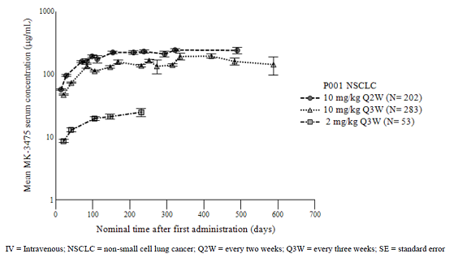
Comment: The ‘Pharmacokinetic Result Summary’ for this study states:
‘Pembrolizumab has low to moderate PK variability [inter-subject coefficient of variation (CV) of 25 to 63%]’
It is not clear as to the variability of which pharmacokinetic measure this statement refers; see clinical questions.

Metabolism

Clearance
Pembrolizumab clearance is via intrinsic catabolic mechanisms and is dependent upon body weight.
Among patients with NSCLC, there was no impact on clearance by the variables: age, gender, race, renal impairment or hepatic impairment.
Consequently, there are no dosing regimen amendments proposed according to any of these variables. It is noted that the sponsor did not proceed with a proposed change from body weight dependent dosing to flat dosing for this submission.

Population pharmacokinetics
The population PK model developed for the registration dossier and updated for the studies in NSCLC is discussed in the efficacy section.

Evaluator’s overall conclusions on pharmacokinetics
Pharmacokinetic data from Keynote-001, and the updated population pharmacokinetic model, demonstrate no substantial changes to the understanding of the pharmacokinetics of pembrolizumab from that described in the initial registration dossier.
There is no demonstrated effect of mild or moderate renal impairment or mild hepatic impairment on the pharmacokinetics of pembrolizumab, and thus no dose modifications are required for such patients.
There is no data regarding the PK in patients with severe renal impairment or moderate or severe hepatic impairment.
There are updates to the product information PK values of volume of distribution (and CV), plasma terminal half-life (and CV), time to steady state, C_{min}, for the dosing regimen of 2 mg/kg Q3W across indications. These updates are considered satisfactory.

Pharmacodynamics
No separate studies of pharmacodynamics were presented for evaluation.

Dosage selection for the pivotal studies
Data from Study P001V04 informed the dose selection of pembrolizumab for Study P010V01; a Phase II/III study of either 2 mg/kg Q3W or 10 mg/kg Q3W pembrolizumab versus docetaxel 75 mg/m² Q3W. These studies are discussed in Sections 7 and 8 (below).

Clinical efficacy
Studies in NSCLC.

Pivotal efficacy studies

Study P010V01 (Keynote-010 trial)

Study design, objectives, locations and dates
This was an open label Phase II/III trial of intravenous (IV) pembrolizumab at two dosing schedules (2 mg/kg and 10 mg/kg) versus docetaxel in subjects with NSCLC with PD-L1 positive tumours who had experienced disease progression after platinum containing systemic therapy. This is shown in Figure 2, below
Figure 2: Keynote-010 schematic design
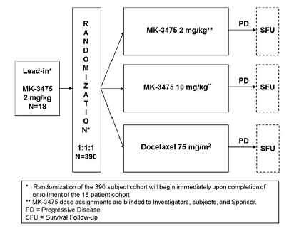
The objectives of the study were to:
- Compare the OS of previously treated subjects with NSCLC in the strongly positive (TPS > 50%) PD-L1 stratum treated with pembrolizumab to docetaxel.
Hypothesis: Pembrolizumab prolongs OS in previously treated subjects with NSCLC in the TPS ≥ 50% stratum compared to docetaxel.
- Compare PFS per RECIST 1.1 by independent radiologists’ review of previously treated subjects with NSCLC in the TPS ≥ 50% stratum treated with pembrolizumab to docetaxel.
Hypothesis: Pembrolizumab prolongs PFS per RECIST 1.1 by independent radiologists’ review in previously treated subjects with NSCLC in the TPS ≥ 50% stratum compared to docetaxel.
- Objective: To evaluate OS of previously treated subjects with NSCLC whose tumours express PD-L1 and are treated with pembrolizumab compared to docetaxel.
Hypothesis: Pembrolizumab prolongs OS in previously treated subjects with NSCLC whose tumours express PD-L1 compared to docetaxel.
- Objective: To evaluate PFS per RECIST 1.1 by independent radiologists’ review of previously treated subjects with NSCLC whose tumours express PD-L1 and are treated with pembrolizumab compared to docetaxel.
Hypothesis: Pembrolizumab prolongs PFS per RECIST 1.1 by independent radiologists’ review in previously treated subjects with NSCLC whose tumours express PD-L1 compared to docetaxel.
- Objective: Evaluate safety and tolerability profile of pembrolizumab in previously treated subjects with NSCLC in the TPS ≥ 50% stratum and the overall positive TPS ≥ 1% population.
The study was considered to have met its primary objective if at least one pembrolizumab arm was superior to docetaxel either in PFS or in OS at an interim analysis or the final analysis in the overall population whose tumours express PD-L1 (TPS ≥ 1%) or the TPS ≥ 50% stratum.
Secondary objectives were:
- To evaluate ORR per RECIST 1.1 by independent radiologists’ review in previously treated subjects with NSCLC in the TPS ≥ 50% stratum and in overall study population whose tumours express PD-L1 (TPS ≥ 1%) treated with pembrolizumab compared to docetaxel.
- To evaluate response duration per RECIST 1.1 by independent radiologists’ review in previously treated subjects with NSCLC in the TPS ≥ 50% stratum and in overall study population treated with pembrolizumab compared to docetaxel.
Exploratory objectives were:
- To evaluate PFS per immune related response criteria (irRC) by Investigators’ review of previously treated subjects with NSCLC in the TPS ≥ 50% stratum and in overall study population whose tumours express PD-L1 (TPS ≥ 1%) treated with pembrolizumab compared to docetaxel.
- To evaluate ORR per irRC by Investigators’ review in previously treated subjects with NSCLC in the TPS ≥ 50% stratum and in overall study population (TPS ≥ 1%) treated with pembrolizumab compared to docetaxel.
- To evaluate response duration per irRC by Investigators’ review in previously treated subjects with NSCLC in the TPS ≥ 50% stratum and in overall study population whose tumours express PD-L1 (TPS ≥ 1%) treated with pembrolizumab compared to docetaxel.
- To evaluate the influence of age of tumour specimen (archival versus new) submitted for PD-L1 analysis on the primary endpoints PFS and OS.
- To evaluate tumour volumetric changes of previously treated subjects with NSCLC in the TPS ≥ 50% stratum treated with pembrolizumab compared to docetaxel.
- To explore the correlation of tumour volumetric changes with OS in previously treated subjects with NSCLC in the TPS ≥ 50% stratum with pembrolizumab compared to docetaxel.
- To evaluate changes in health-related quality-of-life (HRQoL) assessments from baseline in previously treated subjects with NSCLC in the TPS ≥ 50% stratum and the TPS ≥ 1% population treated with pembrolizumab compared to docetaxel using the electronic European Organization for Research and Treatment of Cancer Quality of Life Questionnaire Core 30 items (eEORTC QLQ-C30) and eEORTC QLQ Lung Cancer 13 items (eEORTC QLQ-LC13).
- To characterise utilities in previously treated subjects with NSCLC in the TPS ≥ 50% stratum and the TPS ≥ 1% population treated with pembrolizumab compared to docetaxel using the electronic European Quality of Life 5 Dimensions (eEQ-5D).
- Characterise healthcare resource utilization in previously treated subjects with NSCLC in the TPS ≥ 50% stratum treated with pembrolizumab compared to docetaxel.
The study was conducted in 198 trial centres in 24 countries.
The first subject was enrolled in the study on 28 August 2013 and the last subject was enrolled on 27 February 2015. The planned duration of study was 28 months. The data cut-off date for the final analyses in this report was 30 September 2015.

Inclusion and exclusion criteria
A complete list of inclusion and exclusion criteria [are not reproduced here, but summarised below].
Patients were eligible for trial entry if they had NSCLC which expressed PD-L1 and had experienced disease progression following platinum containing systemic therapy.

Inclusion criteria
Key inclusion criteria were:
- Be willing and able to provide written informed consent.
- Be ≥ 18 years of age on day of signing informed consent.
- Have a life expectancy of at least 3 months.
- Have a histologically or cytologically confirmed diagnosis of NSCLC and have at least one measurable lesion as defined by RECIST 1.1. The target lesion(s) should also have bi-dimensional measurability for irRC evaluation on study.
- Have experienced investigator determined radiographic progression per RECIST 1.1 of NSCLC after treatment with at least two cycles of a platinum containing doublet for stage IIIB/IV or recurrent disease.
- Subjects with an EGFR sensitising mutation must also be able to demonstrate progression of disease on the EGFR TKI (either erlotinib, gefitinib, or afatinib) in a similar manner to that above for the platinum containing doublet.
- Subjects with an ALK translocation must also be able to demonstrate progression of disease on crizotinib in a similar manner to that above for the platinum containing doublet.
- Have a performance status of 0 or 1 on the ECOG Performance Scale.
- Have adequate organ function as indicated in Table 1.

Table 1: Parameters used for assessment of organ function
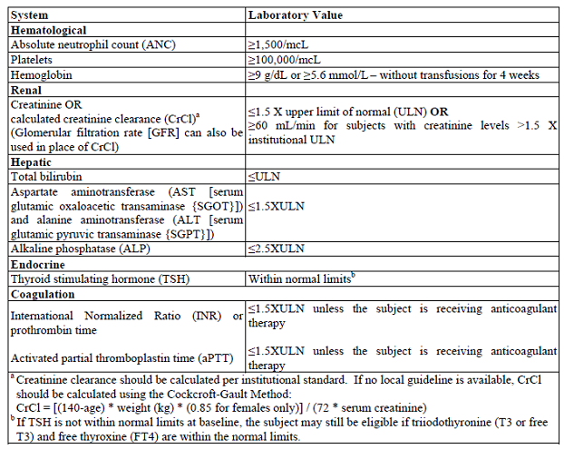
- Have provided tissue for PD-L1 biomarker analysis from a newly obtained formalin fixed tumour tissue from a recent biopsy of a tumour lesion not previously irradiated; no systemic antineoplastic therapy may be administered between the PD-L1 biopsy and initiating study medication.
- Have a PD-L1 positive (either strongly [TPS > 50%] or weakly [TPS = 1-49%]) tumour as determined by IHC at a central laboratory. If a subject’s initial tumour specimen is not classified as PD-L1 positive by the central laboratory, a newly obtained specimen (different from the sample previously submitted) may be submitted for testing. If the newer specimen is classified as PD-L1 positive by the central laboratory, the subject meets this eligibility criterion.

Exclusion criteria
Key exclusion criteria were:
The subject must be excluded from participating in the trial if the subject:
- Has received prior therapy with docetaxel for NSCLC.
- Is currently participating or has participated in a study of an investigational agent or using an investigational device within 30 days of the first dose of trial treatment. The 30 day window should be applied to the last dose of an antineoplastic investigational agent or last use of an investigational device with antineoplastic intent.
- Is receiving systemic steroid therapy within three days prior to the first dose of trial treatment or receiving any other form of immunosuppressive medication (corticosteroid use on study for management of events of clinical interest (ECIs) or as a pre-medication for docetaxel is allowed).
- Is expected to require any other form of systemic or localised antineoplastic therapy while on trial (including maintenance therapy with another agent for NSCLC or radiation therapy).
- Has received prior systemic cytotoxic chemotherapy, antineoplastic biological therapy (for example, cetuximab), major surgery within 3 weeks of the first dose of trial treatment; received thoracic radiation therapy of > 30 Gy within 6 months of the first dose of trial treatment; received prior TKI therapy or completed palliative radiotherapy within 7 days of the first dose of trial treatment.
- Has received prior therapy with an anti-PD-1, anti-PD-L1, anti-PD-L2, anti-CD137, or anti-CTLA-4 antibody (including ipilimumab or any other antibody or drug specifically targeting T-cell co-stimulation or checkpoint pathways). Has participated in another pembrolizumab clinical trial.
- Has a known history of prior malignancy except if the subject has undergone potentially curative therapy with no evidence of that disease recurrence for 5 years since initiation of that therapy.
- Note: The time requirement for no evidence of disease for 5 years does not apply to the NSCLC tumour for which a subject is enrolled in this trial. The time requirement also does not apply to subjects who underwent successful definitive resection of basal cell carcinoma of the skin, superficial bladder cancer, squamous cell carcinoma of the skin, or in situ cervical cancer.

Ascertainment of biomarker status
Tumour histological material was used to assess PD-L1, EGFR and ALK status prior to randomisation. Until the implementation of protocol amendment 8, archival material could be used for this determination.
Protocol amendment 8 required the use of ‘newly obtained’ formalin-fixed tissue from a recent biopsy of a tumour lesion not previously irradiated. Patients were precluded from receiving any anti-neoplastic treatment between the biopsy to determine PD-L1 status and commencement of allocated study therapy.
The sponsor states that exceptions to the requirement for a fresh biopsy could be given if it was deemed ‘medically inappropriate’ for this to occur.
Comment: The definition of ‘newly obtained’ is uncertain. The duration between tissue sample harvest and ability to no longer accurately determine PD-L1 status is not described. See clinical questions.

Study treatments
Trial treatment was administered on Day 1 of each cycle.
Pembrolizumab was administered as a 30 minute IV infusion every 3 weeks (Q3W) at either 2 mg/kg or 10 mg/kg.
Docetaxel at 75 mg/kg was administered as an IV infusion over 1 hour Q3W, following pre-medication with either oral or IV steroid as per the approved PI.
The sponsor states that the study design permitted the option to drop one of the two doses of pembrolizumab based upon the first interim analysis.

Efficacy variables and outcomes
The primary efficacy outcomes were overall survival and progression free survival.
Secondary outcomes were overall response rate and response duration.
ORR and response duration were assessed based on independent radiologists’ review per RECIST 1.1. All analyses were performed in the TPS ≥ 50% stratum and in the TPS ≥ 1% population.
Patient reported outcomes were assessed using the tools eEORTC QLQ-C30, eEORTC QLQ-LC13 and eEQ-5D
A health economic assessment was completed after the patient had completed all other questionnaires. The trial flow chart schedule of patient assessments was provided.

Randomisation and blinding methods
Owing to the difference in duration of infusion between docetaxel and pembrolizumab, and need for pre-medication with docetaxel, the study was open label.
Subjects were randomised via a central interactive voice response system or Interactive Voice and Web Response System in a 1:1:1 ratio into one of three treatment arms; pembrolizumab 10 mg/kg Q3W, pembrolizumab 2 mg/kg Q3W or docetaxel 75 mg/m² Q3W.
For patients randomised, the degree of PD-L1 expression was double blinded.

Analysis populations
The ITT population was used for the analysis of the primary efficacy end-points. The primary efficacy analysis was performed using this population for those with a TPS ≥ 50% and a TPS ≥ 1%.
A supportive analysis was performed using the full analysis set, which included subjects who experienced disease progression after platinum based cytotoxic chemotherapy and/or an appropriate TKI for a sensitising EGFR mutation or ALK gene rearrangement, had PD-L1 expression with a TPS ≥ 1% and received at least one dose of study medication.
The safety analysis in patients with NSCLC was performed in all randomised subjects who received at least one dose of study treatment. Subjects who took incorrect trial treatment for the entire treatment period were included in the treatment group corresponding to the trial treatment actually received.
The primary safety analysis was based on the APaT population in the TPS ≥ 50% stratum. The pooled safety data from both the TPS ≥ 50% stratum and TPS = 1 to 49% PD-L1 strata were summarised in the secondary safety analysis.

Sample size
The sample size for subjects with TPS ≥ 50% was targeted to be approximately 460, and the overall sample size was projected to be approximately 920 subjects.
Comment: The sample size was solely calculated based on the estimated event rate in the TPS ≥ 50% stratum.

Statistical methods
The sponsor states ‘The study was event driven (that is, number of subjects and follow-up time were subject to change, but the number of events was not) and would be complete after approximately
200 deaths had been observed across the three arms in the TPS ≥ 50% stratum (approximately 140 deaths between one pembrolizumab arm and the docetaxel arm under the alternative hypothesis). With 140 deaths between one pembrolizumab arm and the docetaxel arm, the study had over 81% power to detect a 0.55 hazard ratio at the final analysis, where 0.825% alpha was allocated to the two pembrolizumab versus docetaxel comparisons using Hochberg procedure.’

Multiplicity strategy
The multiplicity strategy specified in this study applied to the TPS ≥ 50% stratum and the TPS ≥ 1% population for the testing of primary hypotheses. The Hochberg step up procedure was to be used for multiple comparisons on an efficacy endpoint if both pembrolizumab arms continued to study completion. The type I error rates were all one sided.
The overall type I error was strongly controlled at 2.5% (one-sided) with 0.35% allocated to the PFS and 2.15% allocated to the OS hypotheses. PFS was to be tested in the TPS ≥ 50% stratum at 0.25% at IA2 (primary analysis of PFS) and at 0.1% at the final analysis for long term PFS effect. At each analysis, if both pembrolizumab arms demonstrated superior PFS in the TPS ≥ 50% stratum, the corresponding alpha was to be rolled into OS testing at the final analysis.
Overall survival was to be tested in the TPS ≥ 50% stratum at 0.5% at IA2, and at ≥ 0.825% at the final analysis. At IA2, only if both pembrolizumab arms demonstrated superior OS in the TPS ≥ 50% stratum, would OS in the TPS ≥ 1% population have been sequentially tested at the same alpha level. At the final analysis, OS in the TPS ≥ 50% stratum and the TPS ≥ 1% population will be tested simultaneously, with available alpha split evenly between the two tests.
Since the above alpha allocation strategy did not depend on the number of events, it would remain valid if the actual number of events at an interim analysis or final analysis differed from the planned number of events. Based on emerging external data, this testing strategy on PD-L1 could be modified to improve the efficiency of the design before unblinding the biomarker data. If that happened, a protocol amendment would have been issued to document the change, which was not expected to impact the conduct of the trial.
The schematic for the Hochberg procedure is shown below in Figure 3.
Figure 3: Multiplicity strategy; Hochberg procedure
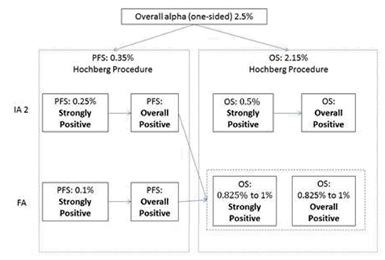
Two interim analyses were planned prior to the final analysis as shown below in Table 2.

Table 2: Planned interim analyses
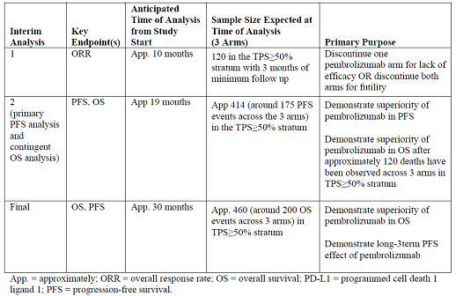

Participant flow
The study populations with a TPS ≥ 50% are shown below in Table 3.

Table 3: Study populations with a TPS ≥ 50%
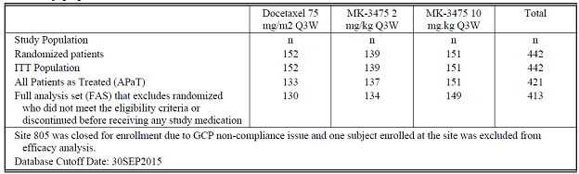
The study populations with TPS ≥ 1% are shown below in Table 4.

Table 4: Study populations with a TPS ≥ 1%
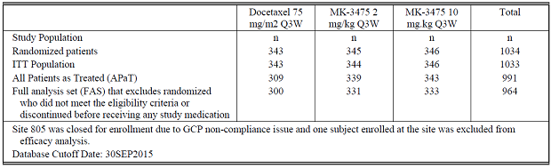

Major protocol deviations
The total number of protocol deviations was 829; the majority were considered by the sponsor to have had no impact on the trial conduct or outcomes. These were not reported in the dossier.
The following 61 events were considered protocol deviations that could have ‘significantly/adversely impact the completeness, accuracy, and/or reliability of the trial data or that could significantly/adversely affect a subject's rights, safety, or wellbeing’.
Efficacy Assessment: 21 events;
- Missing baseline radiographic image(s): 21.
Entry Criteria: 15 events;
- Did not have radiological progression from receiving at least 2 cycles of platinum containing doublet for stage IIIB/IV disease: 6;
- Did not have disease progression from appropriate TKIs for EGFR and/or ALK mutation status: 1;
- No assessment of EGFR/ALK mutation status: 6;
- Radiotherapy to the chest within 6 months of first dose: 1;
- Signed consent > 1 year after platinum containing doublet therapy for stage IIIA disease: 1.
Informed Consent Form: 5 events;
- Delayed signing original informed consent by approximately 1 month (FBR consent was signed at Screening instead): 2;
- Incomplete signature on original informed consent: 1;
- Original consent form used was either not approved or administered by inappropriate staff: 2.
Prohibited Medications: 20 events;
- Bisphosphonate/denosumab use during the study prior to radiographic progression: 17;
- Strong CYP3A4 inhibitor use in docetaxel arm: 2;
- Radiotherapy during the study prior to radiographic progression: 1.
Comment: The proportion of events in the denominator of the trial population (n = 1,034) ranged 0.1 to 2.0%. Although the greatest proportion was for the absence of baseline imaging, it is unlikely that this adverse finding would have substantially affected the final trial results.

Baseline data
Baseline data was presented for those patients with a TPS ≥ 50% and the pooled population with TPS ≥ 1%.
Comment: Baseline data was not provided for those patients with TPS 1 to 49%.
Information for the TPS ≥ 1% patients is shown below in Table 5.

Table 5: ITT population (TPS ≥ 1%) characteristics
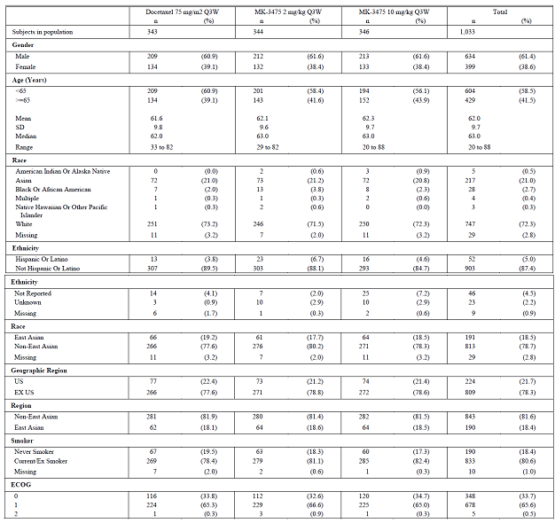

Table 5 (continued): ITT population (TPS ≥ 1%) characteristics
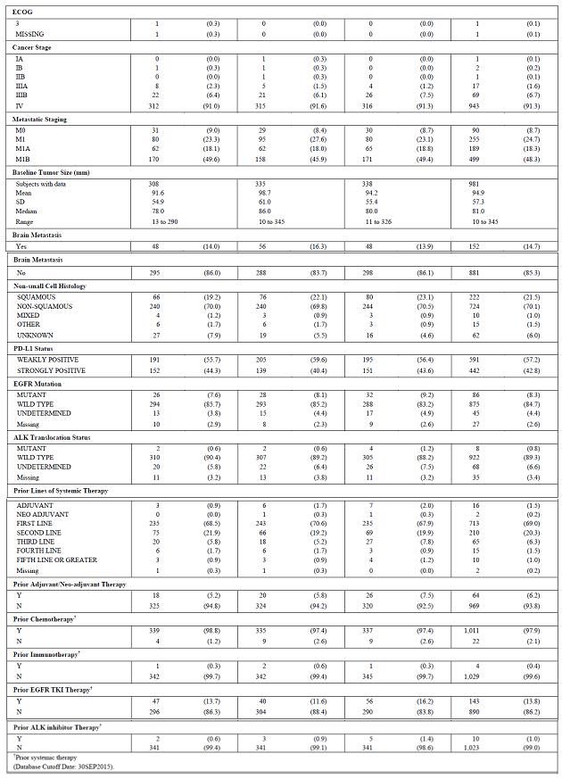
Comment: Not shown in the table above, but documented in the integrated summary of efficacy, of the 1,034 patients enrolled in KEYNOTE-010, only 578 (55.95%) patients provided a new tumour sample for PD-L1 analysis. that is 455 (44.05%) had their PD-L1 status assessed using an archived sample. The ability of an archived sample to accurately demonstrate PD-L1 status is not reported; see clinical questions (below).

Results for the primary efficacy outcomes

Overall survival (OS)

Overall positive population (TPS > 1%)
For patients receiving pembrolizumab 2 mg/kg (n = 344) as compared to docetaxel 75 mg/m² (n = 343), the hazard ratio of OS was 0.71 (95% CI 0.58, 0.88).
The estimate of median duration of OS was 8.5 months (95% CI 7.5, 9.8) for patients receiving docetaxel as compared to 10.4 months (95% CI 9.4, 11.9) for receiving pembrolizumab 2 mg/kg.

TPS ≥ 50% stratum OS analysis
The primary efficacy analysis for overall survival, demonstrated superiority of both of the pembrolizumab arms over docetaxel.
The HR for OS was 0.54 (95% CI: 0.38, 0.77) with a one sided p value of 0.00024 in the pembrolizumab 2 mg/kg Q3W arm versus the docetaxel arm. The HR for OS was 0.50 (95% CI: 0.36, 0.70) with a one sided p value of 0.00002 in the pembrolizumab 10 mg/kg Q3W arm versus the docetaxel arm.
The median duration of OS for pembrolizumab 2 mg/kg was 14.9 (95% CI 10.4, NE) months and for pembrolizumab 10 mg/kg was 17.3 (95% CI 11.8, NE) months, compared to 8.2 (95% CI 6.4, 10.7) months for the docetaxel arm.
This is graphically represented below in Figure 4.
Figure 4: Kaplan-Meier estimates of overall survival in subjects with TPS ≥ 50%, ITT population
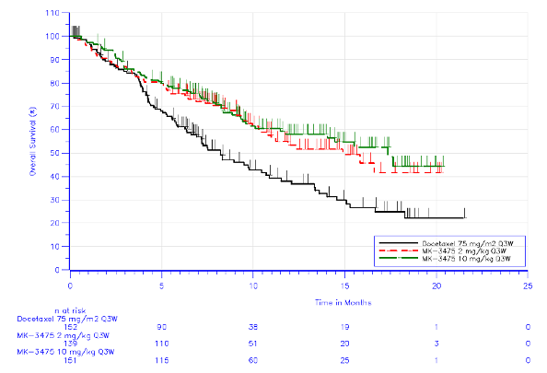
The OS rate at 6, 9 and 12 months demonstrates both pembrolizumab arms were higher in both pembrolizumab treatment arms as compared to the docetaxel arm; see Table 6, below.

Table 6: OS rate at 6, 9 and 12 months, ITT population
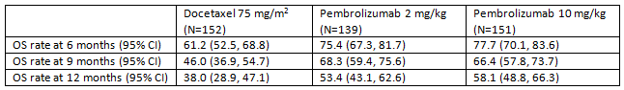
An exploratory analysis of pooled pembrolizumab data for OS according to patient characteristics demonstrated no substantial differences for any sub-groups, including tumour histology as shown below in in Figure 5.
Figure 5: Forest plot of OS hazard ratio by subgroup factors pembrolizumab treatment groups pooled versus docetaxel patients with TPS ≥ 50%
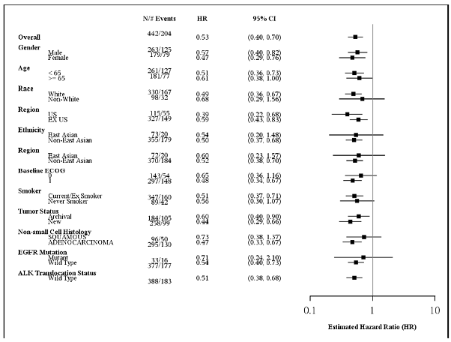
Comment: In this analysis, the independent effect of pembrolizumab 2 mg/kg Q3W cannot be separated from that of pembrolizumab 10 mg/kg Q3W in patients with TPS ≥ 50%. See clinical questions.

TPS ≥ 1% stratum; OS analysis
The OS HR for pembrolizumab 2 mg/kg versus docetaxel was 0.71 (95% CI: 0.58, 0.88) with a p value of 0.00076. The OS HR for pembrolizumab 10 mg/kg versus docetaxel was 0.61 (95% CI: 0.49, 0.75) with a p value < 0.00001.
The median OS for pembrolizumab was 10.4 months and 12.7 months for the 2 mg and 10 mg groups, respectively, compared to 8.5 months for the docetaxel arm.
The median OS for pembrolizumab was 10.4 months and 12.7 months for the 2 mg and 10 mg groups, respectively, which represent clinically meaningful improvements compared to 8.5 months for docetaxel.
This is graphically represented below in Figure 6.
Figure 6: Kaplan-Meier estimates of overall survival ITT population with TPS ≥ 1%
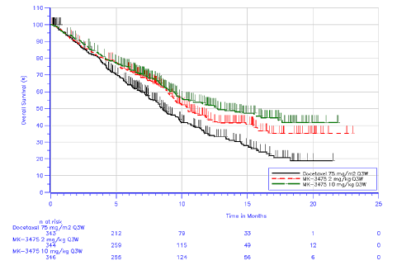
An exploratory analysis comparing the OS estimates of the two pembrolizumab arms showed HR = 1.17 (95% CI 0.94, 1.45), p = 0.16.
The OS rate at 6, 9 and 12 months demonstrates both pembrolizumab arms were higher in both pembrolizumab arms as compared to the docetaxel arm.

Table 7: OS rate at 6, 9 and 12 months, ITT population
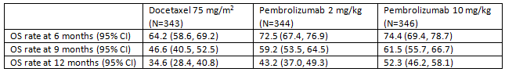

TPS ≥ 1% to < 50% stratum (sponsor termed ‘weakly positive’) OS analysis
The sponsor states in the CSR ‘In the 1% ≤ TPS < 50% stratum of the ITT population; both pembrolizumab doses were superior to docetaxel with regard to OS by individual arms (HR 0.79, 95% CI: 0.61, 1.04 for pembrolizumab 2 mg/kg and HR 0.71, 95% CI: 0.53, 0.94 for pembrolizumab 10 mg/kg).’
The median OS for pembrolizumab was 9.4 months and 10.8 months for the 2 mg and 10 mg groups, respectively, which represents clinically meaningful improvement compared to 8.6 months for docetaxel.

Progression-free survival (PFS)

Overall positive (TPS ≥ 1%) population
The hazard ratio for PFS comparing patients receiving pembrolizumab 2 mg/kg Q3W and docetaxel 75mg/m² was 0.88 (95% CI 0.73, 1.04), p = 0.007.
The estimate of median duration of PFS was 4.0 months (95% CI 3.1, 4.2) for the docetaxel arm as compared to 3.9 months (95% Ci 3.1, 4.1) for the pembrolizumab 2 mg/kg Q3W arm
Comment: Despite an apparent improvement in hazard of overall survival there is no improvement in progression free survival for this population.

TPS ≥ 50% stratum PFS analysis
A total of 304 PFS events were reported at the time of data cut-off. The HR for PFS was 0.58 (95% CI: 0.43, 0.77) with a one sided p value of 0.00009 in the pembrolizumab 2 mg/kg Q3W arm versus the docetaxel arm. The HR for PFS was 0.59 (95% CI: 0.45, 0.78) with a one sided p value of 0.00007 in the pembrolizumab 10 mg/kg Q3W arm versus the docetaxel arm. There was no difference between the 2 pembrolizumab arms; HR was 1.00 (95% CI: 0.74, 1.35).
The median duration of PFS was 5.2 (95% CI 4.0, 6.5) and 5.2 (4.1, 8.1) months respectively for the 2 m/kg and 10 mg/kg pembrolizumab arms as compared to 4.1 (95% CI 3.6, 4.3) months for the docetaxel arm.
Figure 7: Kaplan-Meier of progression free survival based on IRC assessment per RECIST 1.1; subjects with TPS ≥ 50%, ITT population
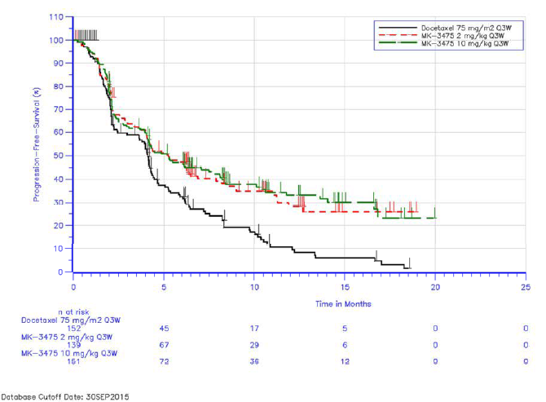
Comment: The sponsor has not provided an analysis of PFS according to subgroup factors comparing the pembrolizumab 2 mg/kg Q3W and docetaxel regimens. See clinical questions.

TPS ≥ 1% stratum PFS analysis
The HR for PFS (IRC assessment) was 0.88 (95% CI: 0.73, 1.04) with a one sided p value of 0.06758 for the pembrolizumab 2 mg/kg Q3W arm versus the docetaxel arm. The HR for PFS was 0.79 (95% CI: 0.66, 0.94) with a one sided p value of 0.00462 for the pembrolizumab 10 mg/kg Q3W arm versus the docetaxel arm. Neither of these analyses reached statistical significance at the 0.001 level as determined by the protocol.
Figure 8: Kaplan-Meier of progression free survival based on IRC assessment per RECIST 1.1 ITT population (TPS ≥ 1%)
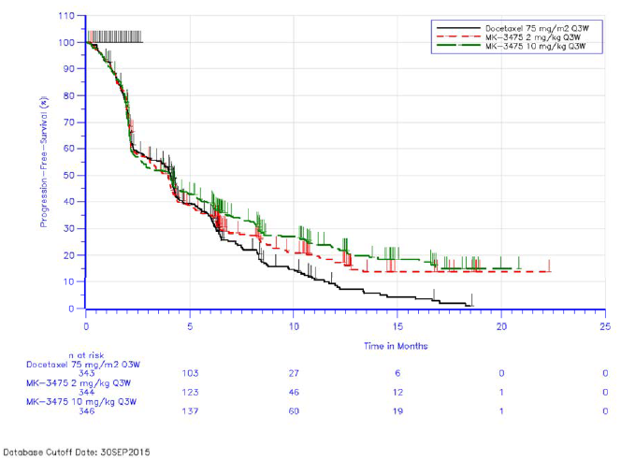

TPS ≥ 1% to < 50% stratum PFS analysis
The IRC assessment of disease progression in this stratum demonstrated no difference between either of the two pembrolizumab arms and the docetaxel arm.
For the pembrolizumab 2 mg/kg Q3W arm, the HR was 1.07 (95% CI: 0.85, 1.34) and for the pembrolizumab 10 mg/kg Q3W arm, the HR was 0.99 (95% CI: 0.78, 1.25) as compared to docetaxel. For the pooled pembrolizumab comparison, the HR was 1.04 (95% CI: 0.85, 1.27).
The duration of median PFS was not different between the three treatment groups, as shown in Table 8, below. However, the median estimate of PFS in the patients receiving the proposed dose of pembrolizumab is 0.8 months worse than for those receiving docetaxel.

Table 8: Analysis of progression free survival based on IRC assessment per RECIST 1.1 subjects with 1% ≤ TPS < 50%, ITT population
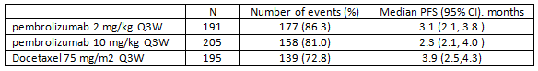
Comment: The sponsor has not satisfactorily demonstrated superiority of the 2 mg/kg pembrolizumab Q3W arm over that for docetaxel 75 mg/m² Q3W for the population with TPS ≥ 1% to < 50%. The sample size calculation for this study was solely determined by the TPS ≥ 50% population, thus the analyses including patients with TPS < 50% are exploratory and non-confirmatory.
The 95% confidence interval for the exploratory comparison of the two pembrolizumab arms with PD-L1 status of TPS ≥ 1% to < 50% crossed the line of unity and are therefore not different.
The method of presenting the comparative analyses results in contradictory conclusions depending upon the cut-off used to define the denominator. For example; for a patient with TPS = 25%, the TPS ≥ 1% analyses demonstrated superiority over docetaxel for OS and PFS whereas the TPS ≥ 1 to < 49% analyses for neither OS nor PFS demonstrates a difference to docetaxel.
The difference in median duration of OS between pembrolizumab 2 mg/kg and docetaxel 75 mg/m² was 0.8 months, favouring pembrolizumab; the difference in median PFS was 0.8 months, favouring docetaxel.

Results for other efficacy outcomes

Overall response rate; TPS ≥ 50% stratum

Table 9: Responses based on IRC assessment RECIST 1.1 subjects with TPS ≥ 50%, ITT population
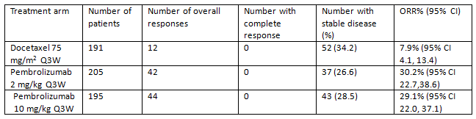
The ORR difference was 23.3% for pembrolizumab 2 mg/kg Q3W versus docetaxel and 22.2% for pembrolizumab 10 mg/kg Q3W versus docetaxel and the one sided p value of the difference was < 0.00001 for both pembrolizumab arms versus docetaxel.

Overall response rate; TPS ≥ 1% stratum

Table 10: Responses based on IRC assessment RECIST 1.1 subjects with TPS ≥ 1%, ITT population
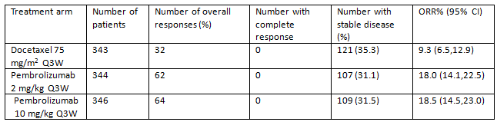
Pembrolizumab produced an ORR of 18.0% and 18.5% in the 2 mg/kg Q3W and 10 mg/kg Q3W arms, respectively, compared to 9.3% in the docetaxel arm. The confirmed ORR difference was 8.7% for pembrolizumab 2 mg/kg Q3W versus docetaxel and 9.1% for pembrolizumab 10 mg/kg Q3W versus docetaxel. The one-sided p value of the difference was 0.00045 and 0.00024 for the pembrolizumab 2 mg/kg and 10 mg/kg arms, respectively, versus docetaxel.

Overall response rate; TPS ≥ 1% to < 50%
The IRC assessed ORR in this stratum is shown in Table 11, below.

Table 11: Overall response based on IRC assessment RECIST 1.1subjects with TPS ≥ 1% to < 50%, ITT population
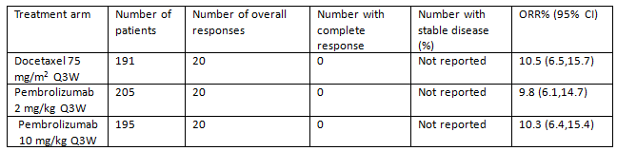

Disease progression
The risk of disease progression among the TPS ≥ 1 to < 50% pembrolizumab 2 mg/kg cohort was approximately double for those with a TPS ≥ 50%. The risk of disease progression was higher for both pembrolizumab arms as compared to docetaxel among the TPS ≥ 1 to < 50% patients; see Table 12, below.

Table 12: Incidence of disease progression, ITT population
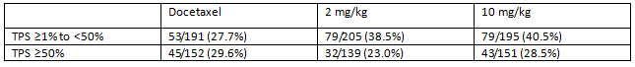
The analyses of overall survival and progression free survival according to patient demographic and disease factors were exploratory. The sponsor amalgamated the two pembrolizumab treatment arms for the purpose of this analysis. This is considered unsatisfactory, and does not enable the evaluator to establish if there are any discordant sub-groups. (See clinical questions)

Patient reported outcome analyses
The statistical analysis plan pre-specified exploratory PRO endpoints based on a quality of life related FAS population following the ITT principle and ICH E9 guidelines. The PRO FAS population consisted of all randomised subjects who received at least one dose of study medication and completed at least on PRO assessment.
Patient reported outcomes have been presented for the TPS ≥ 50% stratum and TPS ≥ 1% population, no data was presented for the TPS ≥ 1 to < 50% stratum.
Compliance with PRO assessments was increasingly poor over time for those expected to complete them. Beyond Week 12, more than 20% of the docetaxel arm did not complete their expected assessment; see Table 13, below.

Table 13: Compliance with patient reported outcomes; per protocol population
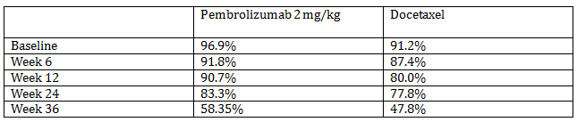
This magnitude of loss to follow-up renders the outcomes of the patient reported outcomes beyond Week 12 subject to substantial bias, and are therefore are not supportive of registration.
Among the TPS ≥ 1% stratum, the compliance with PRO assessments (per protocol) was 96.1% versus 93.2% in the pembrolizumab 2 mg/kg arm and docetaxel arms respectively. Thereafter, at 6 weeks, compliance was 91.6% versus 88.0% respectively; at 12 weeks was 88.1% versus 88.5% respectively; at Week 24 was 84.4% versus 74.8% respectively and at Week 36 was 64.2% versus 41.2%.
As for the TPS ≥ 50% stratum, the magnitude of loss to follow up for this population is substantial beyond 12 weeks and precludes support for registration.

Supportive Study P001V04 (Keynote-001)

Study design, objectives, locations and dates
This was a multicentre, open label, Phase I study of pembrolizumab monotherapy in patients with locally advanced or metastatic carcinoma, melanoma and non-small cell lung cancer.
The study was initiated on 14 April 2011, with cut-off of 23 February 2015. The CSR is dated 25 November 2015.
The trial enrolled subjects at 47 centres, of which 44 sites allocated subjects with NSCLC to study treatment. Eighteen trial centres were in the US, five were in France, five were in Italy, three were in Korea, three were in Spain, three were in United Kingdom, two were in Canada, two were in Norway, two were in Taiwan, and one was in Australia.
The trial investigated multiple expansion cohorts. Those pertinent to this submission are:
- Part C allocated 41 subjects with NSCLC who had experienced disease progression after two systemic anti-tumour regimens.
- Part F allocated patients with NSCLC to three additional cohorts:
  - F-1; was introduced with protocol Amendment 06. The first eleven subjects allocated and treated were required to be treatment naïve, have a diagnosis of non-squamous NSCLC and have tumours that expressed PD-L1 by the Prototype Assay (PA). These subjects were randomised (1:1) between 2 mg/kg Q3W and 10 mg/kg Q3W. The 92 subjects allocated under Amendment 07 and greater were further required to have Stage IV NSCLC and were randomised (1:1) to 10 mg/kg Q3W or every 2 weeks (Q2W). Ninety of these subjects were treated. Subjects were not permitted to have a sensitising EGFR mutation or ALK gene rearrangement starting with Amendment 07. Subjects were allowed prior exposure to adjuvant/neoadjuvant therapy if at least one year had passed between finishing the treatment and the recurrence.
  - F-2; The first 33 subjects allocated and treated in Cohort F-2 (Amendment 06) were required to have experienced disease progression after two prior systemic therapies for non-squamous NSCLC and the new pre-treatment tumour biopsy needed to demonstrate PD-L1 expression by the PA. They were treated at 10 mg/kg Q3W. Cohort F-2 (Amendment 07 and greater) allocated 285 subjects with locally advanced or metastatic NSCLC (all histologies) whose tumours expressed PD-L1 by the PA and had experienced progression of disease after at least one prior systemic antineoplastic regimen, at least one of which was a platinum containing doublet. If a sensitising EGFR mutation or ALK gene rearrangement was present, progression of disease after initiating the appropriate tyrosine kinase inhibitor was required. These subjects were randomised (3:2) between pembrolizumab 10 mg/kg Q3W or Q2W. Two hundred eighty subjects were treated. The last F-2 cohort (Amendment 07 and greater) included 43 subjects (allocated and treated) with locally advanced or metastatic NSCLC (all histologies) whose tumours did not express PD-L1 by the PA and had experienced progression of disease after at least two prior systemic antineoplastic regimens, at least one of which was a platinum containing doublet. These subjects were dosed at 10 mg/kg Q2W.
  - F-3; protocol amendment 09 allocated and treated 55 subjects with locally advanced or metastatic NSCLC whose tumours expressed PD-L1 by the PA and had experienced progression of disease after at least one prior systemic antineoplastic regimen, at least one of which was a platinum containing doublet. Subjects in Cohort F-3 were dosed at 2 mg/kg Q3W.
Of note, at the request of the FDA, a proposed part of the study (Part E) designed to characterise pembrolizumab in combination with chemotherapy in patients with NSCLC was removed.
The study design for the NSCLC cohorts are shown below in Figure 9.
Figure 9: Study P001, NSCLC expansion cohorts
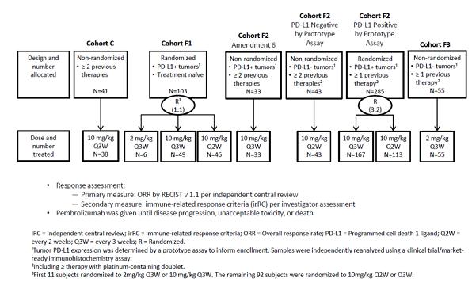
Protocol amendment 7 was implemented to define the biomarker training set and biomarker validation set. Using the Dako clinical trial assay (the proposed companion diagnostic to accompany this submission), the cut off points predicting response to pembrolizumab would be established in the training set, and then confirmed in the validation set. The primary analysis assessed the overall objective response rate (RECIST 1.1) in the subject population with PD-L1 expressing lesions with a TPS ≥ 50%.

Inclusion and exclusion criteria
The relevant population of this study pertaining to this submission were patients with NSCLC had to have histologically or cytologically confirmed NSCLC with progressive (within 1 year) locally advanced or metastatic disease.
Patients had to have newly obtained tumour biopsies within 60 days prior to commencement of treatment with pembrolizumab.
For part F, patients had to have histologically or cytologically confirmed NSCLC, which was amendable to biopsy.

Study treatments
See description of expansion cohorts above. Study treatment continued until disease progression, unacceptable toxicity or decision by the investigator to cease in the best interests of the patient. Imaging assessments were performed at baseline and, for parts C and F, every 9 (± 1) weeks from initiation of pembrolizumab.

Efficacy variables and outcomes
The imaging criteria for parts C and F were tumour response as determined by investigator assessment using immune related Response Criteria (irRC). Retrospective independent central review occurred, using RECIST 1.1 and irRC criteria. If a CR, PR or PD was observed, repeat imaging was repeated at least 4 weeks from the last scan.
Primary objective of the study pertinent to this dossier was:
- To evaluate the ORR per RECIST 1.1 of pembrolizumab in subjects with NSCLC with at least one prior systemic therapy whose tumours express a high level of PD-L1 (> 50%).
Hypothesis: Single agent pembrolizumab will show a clinically meaningful ORR per RECIST 1.1 in subjects with NSCLC with at least one prior systemic therapy whose tumours express a high level of PD-L1.
Secondary objectives of the study pertinent to this submission were:
- To characterise the PK profile of single agent pembrolizumab.
- To investigate the relationship between candidate efficacy biomarkers and anti-tumour activity of pembrolizumab:
- To evaluate the correlation between PD-L1 expression levels and anti-tumour activity of pembrolizumab in subjects with melanoma, excluding IPI-refractory subjects as stated in the primary objectives, and separately, non-small cell lung cancer.
- To investigate other biomarkers (for example, tumour infiltrating lymphocytes (TILs), PD-L2, PD-1; ribonucleic acid (RNA) signature profiles) that may correlate with tumour responses.
- To evaluate differences in tumour tissue characteristics in biopsies taken during or post-treatment with pembrolizumab versus baseline.
(Data pertaining to melanoma patients were not presented in the current dossier)
- To evaluate response duration, PFS and OS of melanoma subjects who are treated with pembrolizumab.
- To evaluate response duration, PFS and OS of NSCLC subjects who are treated with pembrolizumab.

Randomisation and blinding methods
The study was open label.
Cohort C was not randomised; all patients received pembrolizumab 10 mg/kg Q3W.
Cohort F1 (PD-L1 positive) was randomised 1:1 to pembrolizumab 2 mg/kg Q3W or 10 mg/kg (Q2W or Q3W).
Cohort F2 (PD-L1 positive) was randomised 3:2 to pembrolizumab 10 mg/kg Q3W and Q2W respectively.
Cohort F3 (PD-L1 negative) was not randomised; all patients received pembrolizumab 2 mg/kg Q3W

Analysis populations
The previously treated primary efficacy population (the randomised portion of cohort F2) comprised 61 patients randomised to pembrolizumab 10 mg/kg or 2 mg/kg with:
- progression of advanced/metastatic disease after initiating platinum based cytotoxic chemotherapy;
- progression of disease after initiation of the relevant TKI for a sensitising EFGR;
- mutation or ALK gene rearrangement, if present;
- tumour sample within the stability window for the CRA; and
- a TPS ≥ 50% for the baseline biopsy.
Among the total 560 patients with NSCLC allocated to study treatment with pembrolizumab, 61 were dosed using the proposed regimen of 2 mg/kg Q3W, of which only five were PD-L1 positive.

Sample size
No formal sample size was used. Part A of the study was a traditional 3 + 3 design for dose escalation.

Major protocol violations/deviations
The sponsor has listed all recorded major deviations; none are considered by the evaluator to have substantially affected the reported trial outcomes.

Baseline data
The baseline demographic and disease characteristics are shown below in Table 14.

Table 14: Baseline patient characteristics
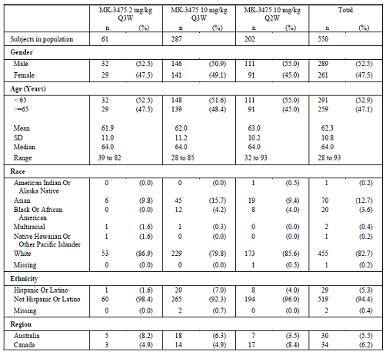

Table 14 (continued): Baseline patient characteristics
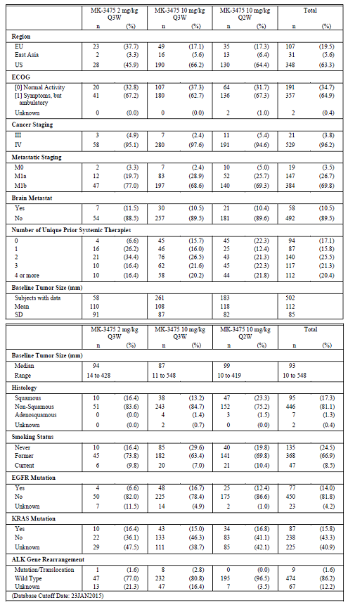

Results for the primary efficacy outcome
The ORR among 61 patients in the randomised primary efficacy population (Biomarker validation set) who had received prior treatment for NSCLC, receiving pembrolizumab 10 mg/kg Q3W or Q2W,and with a TPS ≥ 50% was 42.6% (95% CI: 30.0, 55.9). One patient who received pembrolizumab 10 mg/kg Q3W achieved a complete response; the best responses among the other 60 patients were partial responses.
Among the patients in the validation population with a TPS of 1 to 49% (n = 81), the ORR was 14.8% (95% CI: 7.9, 24.4).
For the treatment-naïve primary efficacy population with TPS ≥ 50% randomised to pembrolizumab 10 mg/kg Q3W or Q2W from Cohort F-1, the ORR was 52.9% (95% CI: 27.8, 77.0).
The response rate of the subjects in the Treatment-Naïve Validation Population with a TPS = 1 to 49% (PD-L1 weak) on baseline tumour was 19.4% (95% CI: 7.5, 37.5).
Comment: As for Keynote-010, there is evidence of a substantial difference in effect size for PD-L1 positive patients when dichotomised at a TPS level of 50% for both the previously treated and treatment-naïve populations, which necessitates they be reported separately.

Results for other efficacy outcomes
For previously treated patients in cohort F3 receiving pembrolizumab 2 mg/kg, the median follow-up time was 7.7 months (range 6.4 to 9.7 months).
The ORR for this cohort has been described over time; see Table 15, below.

Table 15: Summary of best overall response rate over time based on IRC assessment per RECIST 1.1. Previously treated 2 mg/kg Q3W by PD-L1 status
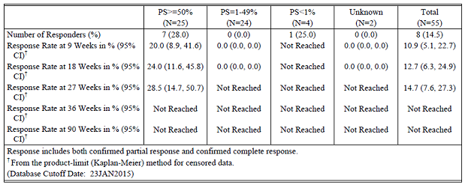
A further analysis of best overall response, based upon IRC assessment, demonstrated a stratum effect when PD-L1 status was dichotomised at multiple points; see Table 16, below. The crude overall response rate for each stratum increases with increasing PD-L1 expression.

Table 16: Summary of best overall response based on IRC assessment per RECIST 1.1 with confirmation. Total combined efficacy population by PS category (full analysis set by IRC with evaluable PD-L1 expression)
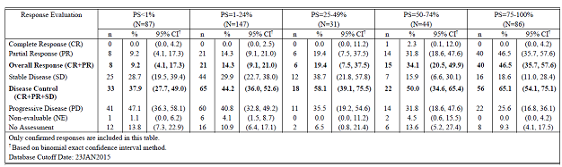
Among the previously treated NSCLC patients in Keynote-001, the IRC assessment of best overall response per RECIST is shown in Table 17. This table demonstrates that the ORR for patients with PS ≥ 50% was approximately three fold higher than that for those with a PS of 1 to 49%.

Table 17: Summary of best overall response based on IRC assessment per RECIST 1.1 with confirmation total previously-treated efficacy population by PD-L1 (irrespective of stability window) (all subjects as treated)
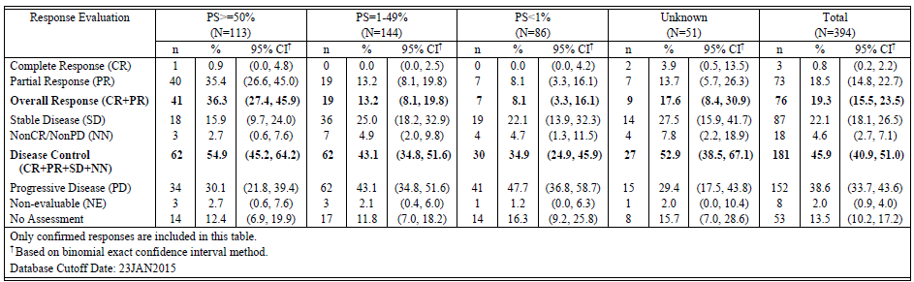
The best overall response according to treatment dose and degree of PD-L1 expression in the previously treated population is shown in Table 18.

Table 18: Summary of best overall response based on IRC assessment per RECIST 1.1 by PD-L1 and dose. Total previously treated population
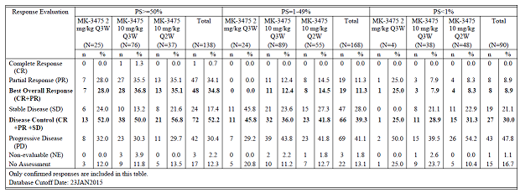
Comment: Consistent with previously shown data above for the recipients of pembrolizumab 2 mg/kg, there is a clearly demonstrated stratum effect on ORR based upon the degree of PD-L1 expression among all previously treated patients receiving the proposed, and two rejected, dose regimens of pembrolizumab. The overall response rate for patients receiving 2 mg/kg was lower than for those receiving either regimen of 10 mg/kg in the two PD-L1 positive strata dichotomised at 50%.

Analyses performed across trials (pooled analyses and meta-analyses)
A population pharmacokinetic analysis was performed for this submission, based upon a model compiled for the dossier for initial registration.
The Population PK analysis described in the CSR for Keynote-001 describes the inclusion 1,077 patients with melanoma, (94.6% total), 16 patients with NSCLC (4.0% total) and 16 patients with other cancer types (1.4% total).
The previously described 2 compartment model with linear clearance was used for the analysis of patients with NSCLC. The continuous covariates evaluated for the model were: age, weight, eGFR, ALP, ALT, AST, serum albumin, serum bilirubin, baseline tumour burden and IgG concentration.
The categorical covariates evaluated for the model were: gender, race, co-administered glucocorticoid, baseline ECOG status (0 or 1), geographic location, PD-L1 status (positive or negative), EGFR receptor mutation, ALK receptor mutation and smoking status.
A comparison of the estimates of C_{max}, C_{trough} and AUC_{ss} in patients with melanoma and NSCLC are shown in Table 19, which are reflected in amendments to the pharmacology section of the PI.

Table 19: The comparison of median (90% prediction interval) exposure parameters of pembrolizumab at steady state regimens of 2 mg/kg Q3W, 10 mg/kg Q3W and 10 mg/kg Q2W between melanoma and NSCLC patients
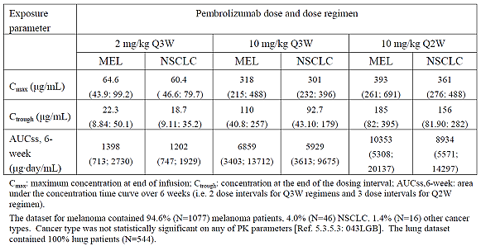
The model, including patients from Keynote-001, included the term for PD-L1 positivity/negativity. It is not described if the model was tested using PD-L1 positivity dichotomised at 50%.
Data were available from 544 patients with NSCLC as broken down in Table 20, below.

Table 20: Number of subjects and observations, by dose and dosing regimen, in the analysis set
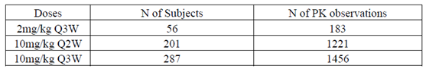
The majority of patients included in the population PK model had normal renal and hepatic function; see Table 21, below.

Table 21: Description of number of patients with degrees of renal or hepatic impairment contributing to the population PK model data
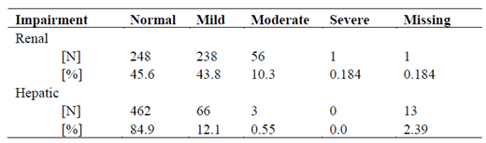
Comment: Appropriate advice is included in the PI regarding dosing in patients with varying degrees of renal or hepatic impairment based upon the available patient population described above.
The sponsor states as a conclusion:
‘No clinically relevant effect on exposure was found for either patient age or geographical location.
Statistically significant effects of gender were found on clearance, and central and peripheral volume, but overall these effects were not sufficient to warrant amendments to dosing.
- Mild or moderate renal impairment determined by estimated glomerular filtration rate (eGFR) did not have an impact on pembrolizumab exposure
- Mild or moderate hepatic impairment did not have not have a clinically relevant impact on exposure, although small, but statistically significant effects of albumin and bilirubin, but not AST, on clearance were identified
- Overall, no clinically important effects of disease characteristics were identified in the model. Statistically significant effects were identified for baseline tumour burden and ECOG, but not tumour type, but these effects were small and lacked clinical relevance
- No relationship was observed between prolonged use of systemic corticosteroids and pembrolizumab exposure.
- Consistent with the previously developed original Pop PK Analysis, body weight-based dosing was found to provide adequate control over exposure variation.’
Comment: The evaluator concurs with the opinion of the sponsor in regard to the conclusions from the population PK modelling.

Evaluator’s conclusions on clinical efficacy of pembrolizumab for the treatment of non-small cell lung cancer
The efficacy outcomes for patients with a TPS ≥ 1% presented in Keynote-010 do not satisfactorily represent the observed differences in efficacy for patients dichotomised above, and below, a TPS score of 50%. For an individual patient, it has to be considered whether their potential outcome would be best represented by the population stratified at a TPS above and below 50%, or by the amalgamated population with a TPS ≥ 1%. Owing to the substantial differences between them, and in order for clinicians to satisfactorily obtain informed consent form individual patients, the evaluator considers the outcomes to be best represented by the populations dichotomised at a TPS of 50%.
The conclusions on clinical efficacy of pembrolizumab from Keynote-010 (supported by a similar approach to Keynote-001) are thus described according to the 2 strata of TPS ≥ 50% and TPS ≥ 1 to < 50%.

Has evidence of efficacy benefit in patients with a TPS ≥ 50% treated with pembrolizumab at the proposed dose of 2 mg/kg Q3W been satisfactorily demonstrated?
From the pivotal study, Keynote-010, the sponsor has satisfactorily demonstrated superior efficacy of pembrolizumab 2 mg/kg Q3W over docetaxel 75 mg/m² Q3W in patients with a TPS ≥ 50%. Evidence of benefit has been observed across multiple efficacy measures:
- The difference in duration of median overall survival was 6.7 months, which is clinically significant. The OS hazard ratio was statistically significant 0.54 (95% CI: 0.38, 0.77) with a one-sided p value of 0.00024.
An exploratory analysis of overall survival according to patient characteristics did not demonstrate any sub-groups that might not be expected to obtain an efficacy benefit. In particular, there was not a substantial difference between tumour histologies.
- The difference in duration of median progression free survival was 1.1 months, with an estimate of HR for PFS of 0.58 (95% CI: 0.43, 0.77) with a one-sided p value of 0.00009.
- The overall response rate was higher for patients treated with pembrolizumab 2mg/kg as compared to docetaxel. However it is noted that no patients in any treatment group achieved a best overall response of complete response.
- For this patient population, the number needed to treat in order to achieve one additional event of partial response is 5.
- The risk of disease progression was lower for patients who received pembrolizumab.
- The median duration of response was not reached in the pembrolizumab arm.

Has evidence of efficacy benefit in patients with a TPS ≥ 1 to < 50% treated with pembrolizumab at the proposed dose of 2 mg/kg Q3W been satisfactorily demonstrated?
From the pivotal study, Keynote-010, the sponsor has not satisfactorily demonstrated superior efficacy of pembrolizumab 2 mg/kg Q3W over docetaxel 75 mg/m² Q3W in patients with a TPS ≥ 1 to < 50%.
Evidence of a lack of superiority over docetaxel has been observed across multiple efficacy measures, which is preclusive to registering pembrolizumab for the proposed use:
- The difference in median duration of overall survival was 0.8 months favouring pembrolizumab. The hazard ratio for overall survival was 0.79 (95% CI: 0.61, 1.04), p = 0.04.
- The difference in duration of median progression free survival was 1.3 months favouring docetaxel, with a hazard ratio of 1.07 (95% CI 0.85, 1.34), p = 0.718.
- The difference in overall response rate was not statistically significantly different between the pembrolizumab and docetaxel arms = 0.6 (95% CI -5.4, 6.8), p = 0.84 within this stratum. The ORR for patients in this stratum was substantially lower (9.8 (95% CI 6.1, 14.7)) as compared to the TPS ≥ 50% stratum = 30.2% (95% CI22.7, 38.6)).
- For this patient population, the number needed to treat to achieve one additional event of partial response is 140.
- The reported risk of disease progression was higher for pembrolizumab-exposed patients (79/205 (38.5%)) compared to those that received docetaxel (53/191 (27.7%)).
- Results of patient reported outcomes for this stratum have not been presented in the dossier for evaluation.
The effect-size of pembrolizumab is dependent upon the reported TPS cut-off percentage. In presenting the data according to a TPS ≥ 1%, the large effect size of pembrolizumab efficacy in those with a TPS ≥ 50% masks the effect size for those with a TPS ≥ 1% to < 50%, yielding an apparent benefit for the latter group. There is evidence of inferiority of pembrolizumab compared to docetaxel for patients with a TPS ≥ 1% to < 50%, with insubstantial difference in median duration of overall survival, worse median duration of PFS, substantially lower ORR and a higher number needed to treat as compared to the stratum of TPS ≥ 50%.
No patients, receiving either dose of pembrolizumab, obtained a complete response in either Keynote-010 or Keynote-001.
There is clearly demonstrated effect modification between the strata of patients dichotomised at a TPS value of 50% among patients receiving pembrolizumab 2 mg/kg Q3W. The magnitude of the difference in effect size, as seen across numerous efficacy endpoints, necessitates that the strata are reported separately to satisfactorily enable clinicians to gain informed consent for treatment from their patients.
In Keynote-001, there is a clear effect on overall response rate of degree of PD-L1 expression, based upon overall response rate, when degree of PD-L1 expression was expressed as quartiles.

Clinical safety

Studies providing evaluable safety data
The following studies provided evaluable safety data:

Pivotal efficacy Study P010v1 (Keynote-010)
The safety population for this study was the ‘All Patients as Treated’ (APaT); all randomised subjects who received at least one dose of treatment
Safety data from this study was presented for the two groups of patients with PD-L1 dichotomised at the 50% level and for all patients combined. Furthermore, safety data for patients receiving pembrolizumab was presented as a single pool of those having received pembrolizumab and also per dose regimen (2 mg/kg Q3W and 10 mg/kg Q3W).
Given that the sponsor is proposing to register the regimen of 2 mg/kg Q3W, the safety evaluation will predominately focus on this dose of pembrolizumab in patients with NSCLC, as compared to the docetaxel arm.
The first patient was enrolled on 28 August 2013 and last subject on 27 February 2015. The safety analysis data cut off was 30 September 2015.
Patients were assessed throughout the study period and up to 30 days following last dose of study treatment or before initiation of a new antineoplastic therapy.
The analysis strategy for reporting specific adverse events in this study is shown below in Table 22. The tier 1 end-points were those pre-specified by the sponsor as being of most clinical interest.

Table 22: Analysis strategy for safety parameters
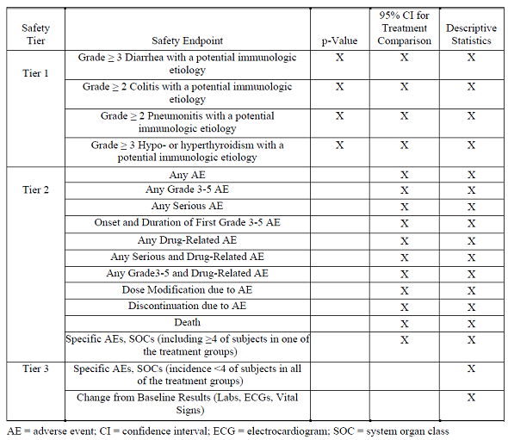
In the pivotal efficacy studies, the following safety data were collected:
- General adverse events (AEs) were assessed using CTCAE Version 4.0. The sponsor states ‘Characterisation of toxicities included seriousness, causality, toxicity grading, and action taken with regard to trial treatment. Safety endpoints included all types of AEs, in addition to laboratory safety assessments, ECOG performance scale status, and vital signs.’
- An updated list of AEs of special interest, initially compiled for the registration dossier in patients with melanoma, was used in this study; see Table 23, below.

Table 23: Adverse events of special interest preferred terms (version 9)
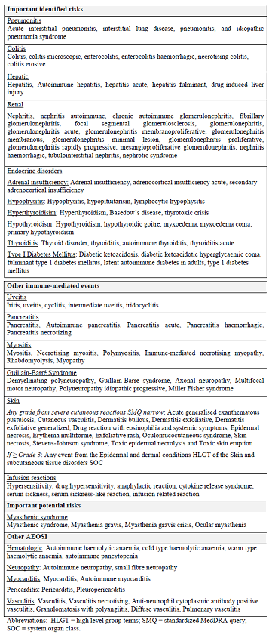
- Laboratory tests, including Vital signs, weight, physical examinations, ECOG performance status, pulmonary function tests, electrocardiogram (ECG), and laboratory safety tests (for example, urinalysis, complete blood count [CBC], prothrombin time/aPTT, serum chemistries, auto-antibodies, thyroid function) were obtained.

Pivotal studies that assessed safety as a primary outcome
No pivotal studies assessed safety as a primary outcome.

Patient exposure
Among patients in Keynote-010, the exposure, according to study treatment and degree of PD-L1 expression is shown in Tables 24 to 26, below.

Table 24: Keynote-010 patients with PD-L1 ≥ 50%
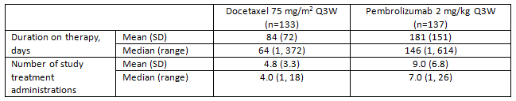

Table 25: Keynote-010 patients with PD-L1 > 1% to < 50%
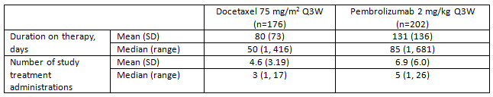

Table 26: Supportive study Keynote-001 summary of drug exposure all subjects with NSCLC by dose (All Subjects as Treated)
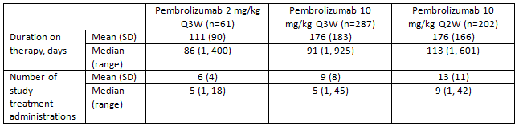

Adverse events

All adverse events (irrespective of relationship to study treatment)

Pivotal study
The proportion of patients with one or more adverse events, according to study treatment and degree of PD-L1 expression is shown below in Tables 27 and 28 for Keynote-010 and -001 respectively.

Table 27: Proportion of patients with adverse events; Keynote-010

Table 28: Proportion of patients who experienced one or more adverse events; Keynote-001
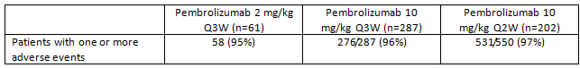
Comment: The proportion of patients with adverse events was similar between patient groups in Keynote-010 and between participants in Keynote-001 and Keynote-010.

Treatment related adverse events (adverse drug reactions)

Pivotal study
Investigator assessed treatment related adverse events are shown below in Table 29.

Table 29: Number of patients with an investigator assigned drug related adverse event
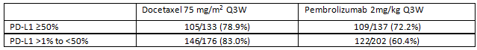
Comment: The incidence of investigator assigned treatment related adverse events was lowest among patients with TPS > 1% to < 50% receiving pembrolizumab. There was no independent assessment of these events.

Deaths and other serious adverse events

Pivotal study
Events of death in Keynote-010 were reported as patients ‘who died’ and patients ‘who died due to a drug related adverse event’; Table 30.

Table 30: Number of patients who died, and died due to study drug related events
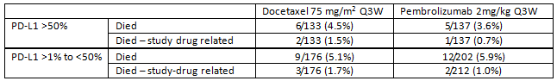
There were 3 deaths in each pembrolizumab arm reported by the investigator as possibly related to pembrolizumab:
- [Information redacted] (pneumonia), [Information redacted] (pneumonitis), and [Information redacted] (pneumonitis) in the 2 mg/kg Q3W arm; and
- [Information redacted] (myocardial infarction), [Information redacted] (pneumonia), and [Information redacted] (pneumonitis) in the 10 mg/kg Q3W arm.
Five deaths, reported as possibly drug related, occurred in the docetaxel arm.
The pattern of serious adverse events (Grades 3 to 5) was dissimilar between pembrolizumab and docetaxel exposed patients. There was no substantial difference in the proportion of events reported for patients receiving 2mg/kg or 10mg/kg pembrolizumab, however, the rate was lower for those with PD-L1 > 1% to < 50% expression; see Table 31, below.

Table 31: Number of patients with serious (Grades 3 to 5) adverse events, Keynote-010
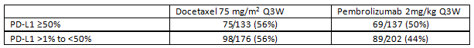
The most frequent SAEs for the patients receiving docetaxel were neutropenia (13.6%), neutrophil count decreased (6.5%), fatigue (5.5%), febrile neutropenia (5.5%), and pneumonia (5.5%).
The most commonly occurring SAEs for patients receiving pembrolizumab 2 mg/kg Q3W were pneumonia (4.1%), dyspnoea (3.8%), and fatigue (3.5%).

Supportive study
Among the patients with NSCLC in Keynote-001, there was a similar incidence of grade 3-5 adverse events for the three treatment regimens, which were consistent with the incidence in Keynote-010.
The incidence of one or more adverse event was 43%, 45% and 46% for the 2mg/kg Q3W, 10 mg/kg Q3W and 10 mg/kg Q2W arms respectively.

Discontinuation due to adverse events

Pivotal study
For the patients in Keynote-010, there were generally fewer patients who discontinued among those receiving pembrolizumab as compared to docetaxel. Discontinuations were generally lower among the patients receiving pembrolizumab with a TPS > 1% to < 50%; see Table 32, below.

Table 32: Proportion of discontinuations in Keynote-010 by study treatment and PD-L1 status
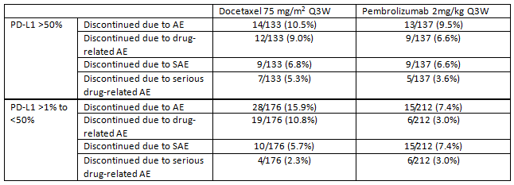

Blood and lymphatic disorders

Pivotal studies

Keynote-010 patients with PD-L1 > 50%
The incidence of haematology adverse events was lower among patients exposed to pembrolizumab 2mg/kg; 26/137 (26%) as compared to 47/133 (35%) in those receiving docetaxel, notably due to differences in events of anaemia, neutropaenia, leucopoenia and thrombocytopaenia.

Keynote-010 patients with PD-L1 > 1% to < 50%
The incidence of events under this AE category were less common among those receiving pembrolizumab 2 mg/kg Q3W than among those with a TPS > 50%. In total 27/202 (13.4%) of patients experienced one or more AE; for patients receiving docetaxel, 67/176 (38.1%) experienced at least one AE.

Electrocardiograph
A formal QTc study was not performed. The sponsor reports that prolongations of QTcF have not been reported from any of the clinical studies to date.
The absence of reported QT effects is in contrast with the observed effects on cardiac rhythm and rate, and events of myocarditis as reported in Section 8.6.

Hypophysitis

Pivotal studies
Among all patients treated in Keynote-010, 2 events of hypophysitis were reported; one occurring in each of the two pembrolizumab arms.

Other studies
In total, 17 events of hypophysitis have been reported among the 2,799 patients (0.6%) included in the integrated safety summary.

Post-marketing experience
The following descriptions of adverse events arise from post-marketing case reports presented in the dossier and from the Integrated Analysis of safety, which amalgamates all patients from the melanoma and NSCLC Studies PN001, PN002, PN006 and PN010, and Periodic Safety Update Report covering the period 4 September 2014 to 3 September 2015 was presented.

Peripheral neuropathy
Events of peripheral neuropathy are described using the multiple terms: axonal neuropathy, neuropathy peripheral, peripheral motor neuropathy, peripheral sensory neuropathy, radial nerve palsy and sensory loss. In total 115 events were reported among 2,799 patients (4.1%).

Myasthenic syndrome/myasthenia gravis
The sponsor provided CIOMS reports for 8 patients receiving pembrolizumab who developed myasthenic syndrome/myasthenia gravis symptoms. Of the 8 reports, one was assigned ‘related’, 2 were ‘possibly related’ and 4 did not attribute causality. Of the 4 reports without attribution, one patient’s symptoms occurred following the first pembrolizumab dose and one patient’s symptoms occurred after the second dose.
One of the reports attributed the events to concomitant use with ipilimumab.
Comment: In the absence of any evidence to the contrary, the evaluator considers those four patients without causation assignment to be related to pembrolizumab. The sponsor has stated in the Integrated Analysis of safety, that ‘Due to the analysis of AEOSI, myasthenic syndrome was re-categorised as a potential risk’. This statement now appears inaccurate, as there are confirmed cases of myasthenic syndrome/myasthenia gravis that have been observed and reported.
The evaluator notes the FDA approved label for the PD-L1 inhibitor atezolizumab contains a specific warning and dose modification instructions to permanently cease this drug in the event of symptoms of myasthenia. (http://www.accessdata.fda.gov/drugsatfda_docs/label/2016/761034s000lbl.pdf accessed August 2016)
Myasthenic symptoms were reported in a patient receiving the combination of ipilimumab and nivolumab (Muscle and Nerve, volume 52 issue 2 page; 307-308).
Given the potential for a PD-L1 class effect in the development of myasthenic syndrome/myasthenia gravis, the PI for pembrolizumab should be amended to include a warning and instructions to permanently discontinue pembrolizumab treatment in such patients.

Myocarditis/pericarditis/pericardial effusion/pericardial tamponade
The sponsor presented line listing reports for 9 events, including fatal events, within these AE categories, 7 of which were assigned ‘related’ to pembrolizumab. Two patients were reported to have events of myocarditis, one of which was categorised as ‘related’ to pembrolizumab.
In the Integrated Analysis of Safety, there are listed events of: ‘pericardial effusion’ 27/2799 (1.0%), ‘Cardiac tamponade’ 6/2799 (0.2%), ‘Pericarditis’ 2/2799 (0.1%)
Comment: This information regarding these reported AEs is contrary to the statement in the integrated summary of safety, page 781, ‘No cases of myocarditis or neuropathy, outside of Guillian-Barré syndrome, have been observed.’
It is plausible that the events of myocarditis/pericarditis/pericardial effusion/pericardial tamponade share a common aetiology and clinical presentation and the therefore the risk should be adequately reported in the PI.

Cardiac rhythm abnormalities
From the Integrated Analysis of Safety, events of cardiac rhythm disturbance are summarised below in Table 33.

Table 33: Subjects with cardiac rhythm or conduction adverse events from Studies PN001, PN002, PN006 and PN010; subjects treated with MK-3475 (APaT population)
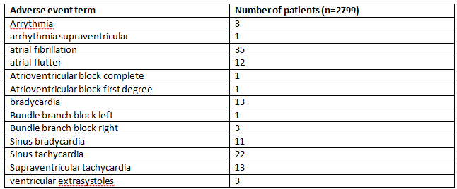
Comment: It is unclear from the reporting method whether these events occurred only in one patient each (that is the combined incidence was 119/2799 (4.3%), or whether one patient may have experienced more than one adverse event, yielding a lower combined incidence.
The sponsor is requested to confirm the reporting method, and present the risk of cardiac rhythm/conduction disturbance, based on the denominator of patients in the Integrated Analysis of Safety.

Gastrointestinal adverse events
Among this class of AEs, constipation affected 17.8%, diarrhoea 22.3% and nausea 24.5% of all patients.
Comment: These risks of the events of constipation are not currently reported in the PI, but should be. In the PI, the incidence of diarrhoea (12%) and nausea (11%) are much lower than that reported in the post-marketing report. This discrepancy should be explained by the sponsor.

Perforation of hollow viscus
In total, 17 events of perforation of a hollow viscus were reported in the PSUR. At least one was identified by the evaluator as having a fatal outcome. The events were reported for: oesophageal perforation, duodenal perforation, gastric perforation, gastrointestinal perforation, intestinal perforation, small intestinal perforation, large intestinal perforation and vaginal perforation.
In addition one event of large bowel perforation in association with diverticular disease was reported.
Comment: Given the diverse nature of the sites of these events, but cumulative incidence, the risks of visceral perforation should be reported in the PI.

General conditions
Among the 2799 amalgamated subjects, fatigue was reported in 37.3% and asthenia in 12.9%.
Comment: As for other adverse events, the incidence of fatigue is higher than presented in the Product Information. Asthenia is not reported in the PI.

Safety issues with the potential for major regulatory impact

Pre-specified adverse events
The sponsor pre-specified events of diarrhoea, colitis, pneumonitis and thyroid dysfunction as being of most clinical interest.

Diarrhoea
Overall, for diarrhoea, the incidence among the docetaxel arm was 80/309 (25.9%) as compared to 53/339 (15.6%) for the pembrolizumab 2 mg/kg arm.

Colitis/ischaemic colitis
This was reported in one patient in each of the docetaxel and pembrolizumab 2 mg/kg arms in those with TPS > 50%.
For those patients with TPS > 1 to < 50%, there were three events in the pembrolizumab 2 mg/kg arm as compared none in the docetaxel arm.
Of note, for patients with a TPS > 50%, there was a higher incidence of constipation among patients receiving pembrolizumab 2 mg/kg 24/137 (17.5%) as compared to docetaxel 16/133 (12.0%).
Events of pneumonitis in the TPS > 1 to < 50% population occurred in 8 patients (4.0%) exposed to pembrolizumab 2mg/kg and 3 patients (1.7%) exposed to docetaxel. Of the 8 pembrolizumab-associated episodes, 4 were Grade 3 to 5.

Thyroid disorders
For patients with TPS > 50%, there was a higher incidence of thyroid disorders among the pembrolizumab 2mg/kg arm (19/137 (13.9%), predominately events of hypothyroidism (14 patients) and thyroiditis (2 patients), as compared to the docetaxel arm (5/133 (3.8%).
Among patients with TPS > 1% to < 50%, there were 6/202 (3.0%) patients who experienced hyperthyroidism in association with pembrolizumab 2 mg/kg, whereas none occurred in those receiving docetaxel. There were 14/202 patients (6.9%) in the pembrolizumab 2mg/kg arm who experienced hypothyroidism as compared to none in the docetaxel arm.

Pneumonitis
For patients with TPS > 50%, there was an increased incidence of respiratory, thoracic and mediastinal disorders in the pembrolizumab 2 mg/kg arm (75/137 (54.7%) as compared to docetaxel (64/133 (48.1%), with 8 patients (5.8%) experiencing pneumonitis in association with pembrolizumab and 2 patients (1.5%) with docetaxel.

Liver toxicity
In Keynote-010 patients with TPS > 50%, 4 events of hepatotoxicity were reported in each of the 2 pembrolizumab arms; 2.9% and 2.6% of the 2mg/kg Q3W and 10mg/kg Q3W arms respectively. No events were reported for patients receiving docetaxel.

Serious skin reactions
No events of toxic epidermal necrolysis or Stevens Johnson syndrome were reported in Keynote-010, or in the summary of safety.

Cardiovascular safety
Keynote-010 patients with PD-L1 > 50%:
- There was a similar incidence of cardiac disorders in the docetaxel arm (8/133 (6.0%) versus 9/137 (6.6%) for the pembrolizumab 2 mg/kg arm.
Keynote-010 patients with PD-L1 > 1% to < 50%:
- Eighteen events of cardiac disorder (8.9%) occurred in the pembrolizumab 2 mg/kg arm as compared to 10 in the docetaxel arm (5.7%).
The reported risk of cardiac rhythm or conduction disturbance has been discussed above.

Unwanted immunological events
The development of anti-drug antibodies (ADAs) was assessed in patients participating in Keynote-001 parts C and F. Anti-drug antibody samples were collected from 420 patients, of which, 290 were included in the analysis. The majority of assessed patients were not evaluable owing to the concentration of pembrolizumab being above that tolerated for the ADA test. Overall 16 patients were evaluable; 5 having received pembrolizumab 2 mg/kg and 11 having received 10 mg/kg; none of these 16 patients were reported to have developed anti-pembrolizumab antibodies.
An additional pooled analysis of 11,886 samples among 2,910 patients from Protocols 001, 02, 006 and 010 was presented for evaluation. Of these patients, 559 subjects from Study P001 and 704 subjects from Study P010 were evaluable.
Detection of anti-pembrolizumab antibodies was impaired in patients with pre-dose pembrolizumab concentration above a defined tolerance level for the assay. Accordingly, patients could be categorised into 3 groups:
- Negative: all pre-treatment and post-dose samples negative in the confirmatory assay for antibodies against pembrolizumab and the concentration of pembrolizumab in the last post-dose sample below the drug tolerance level.
- Inconclusive: all pre-treatment and post-dose samples negative in the confirmatory assay for antibodies against pembrolizumab and the concentration of pembrolizumab in the last post-dose sample above the drug tolerance level.
- Positive: at least one pre-treatment or post-dose sample positive in the confirmatory assay for antibodies against pembrolizumab.
A further categorisation was made for patients identified as positive for anti-pembrolizumab antibodies:
- Treatment emergent positive:
  - Pre-treatment sample negative and at least one post-dose sample positive in the confirmatory assay for antibodies against pembrolizumab (treatment induced positive).
  - Pre-treatment and post-dose sample positive in the confirmatory assay for antibodies against pembrolizumab with an increase in titre (> 2 fold of baseline) (treatment-boosted positive).
- Non-treatment emergent positive:
  - Pre-treatment sample positive and post-dose sample negative in the confirmatory assay for antibodies against pembrolizumab.
  - Pre-treatment and post-dose sample positive in the confirmatory assay for antibodies against pembrolizumab with a post-dose titre < 2 fold of baseline.
For anti-pembrolizumab antibody positive subjects (based on the confirmatory assay), the immunogenicity response was further characterised for antibody titre and neutralising capacity. In addition, for treatment emergent positive subjects, the impact of antibodies against pembrolizumab on drug exposure was assessed.
Of the 2910 patients, 2632 had paired pre- and post-treatment samples for analysis. The observed incidence of treatment emergent ADA in evaluable subjects based on the pooled analysis of melanoma and NSCLC subjects was 1.7% (19 out of 1087), based on 19 subjects (3 melanoma and 16 NSCLC) with confirmed treatment emergent positive status, relative to all evaluable subjects including 19 with treatment emergent positive, 10 with non-treatment emergent positive and 1058 with negative immunogenicity status.
As shown in Table 34 (below), the incidence of ADA was higher for patients with NSCLC than in melanoma. The incidence of ADA was higher for patients receiving 2 mg/kg as compared to 10 mg/kg in Keynote-010.

Table 34: Summary of immunogenicity results (pooled analysis of Studies P001, P002, P006 and P010)
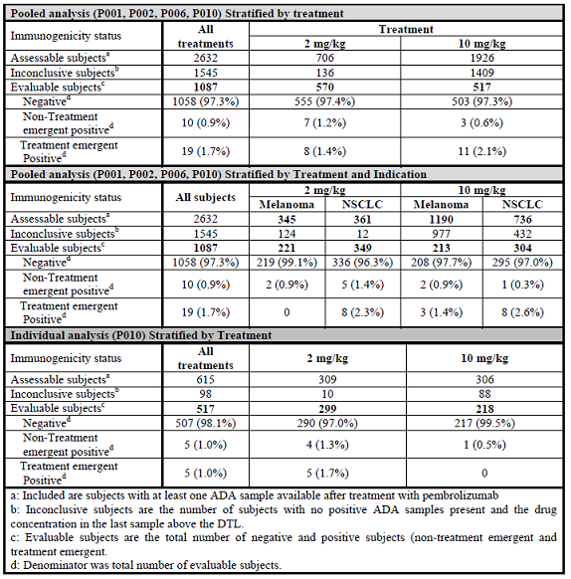
There was no adverse effect of the presence of treatment emergent neutralising antibodies on exposure for the 19 patients identified, nor was an effect observed for the 10 patients identified with non-treatment emergent antibody formation. Figures 10 and 11 (see below) show the patients with NSCLC treated with pembrolizumab 2 mg/kg Q3W and 10 mg/kg Q3W respectively.
Figure 10: Pembrolizumab exposure for NSCLC subjects treated with 2 mg/kg Q3W (P010)
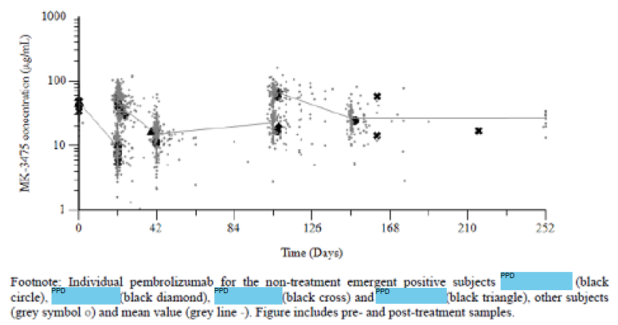
Figure 11: Pembrolizumab exposure for NSCLC subjects treated with 10 mg/kg Q3W (P010)
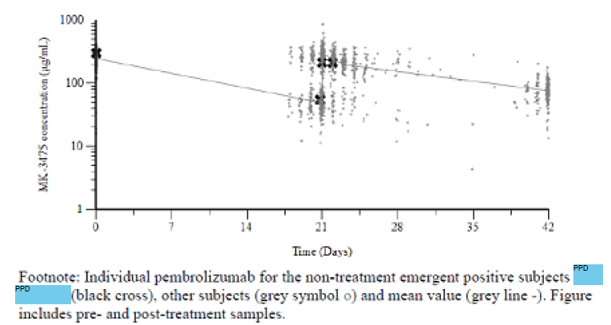
The sponsor stated that none of the 19 subjects with treatment emergent ADA formation ‘has any adverse events associated with neutralising antibodies, such as hypersensitivity events (for example anaphylaxis, urticaria, and angioedema) or injection site reactions. No clinical impact of efficacy could be assessed’.

Other safety issues

Safety related to drug-drug interactions and other interactions
No drug-drug interactions have been formally assessed.

Infusion reactions
Among patients in Keynote-010, the incidence of infusion reactions was commoner in docetaxel exposed patients than the pooled populations of those receiving pembrolizumab; (see Tables 35 and 36, below).

Table 35: Subjects with AEs by maximum toxicity grade (incidence > 0% in one or more treatment groups) AEOSI; infusion reactions MK-3475 treatment groups pooled subjects with TPS ≥ 50%, APaT population
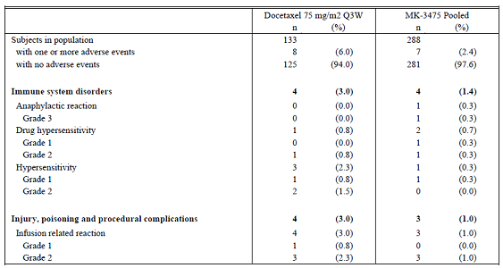

Table 36: Subjects with AEs by maximum toxicity grade (Incidence > 0% in one or more treatment groups) AEOSI; infusion reactions MK-3475 treatment groups pooled subjects with 1% ≤ TPS < 50%, APaT population
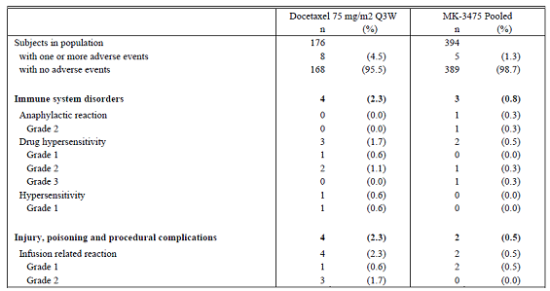

Evaluator’s overall conclusions on clinical safety
Fewer patients discontinued study drug therapy among those receiving pembrolizumab, irrespective of TPS status.
The crude incidence of adverse events was similar between patients receiving docetaxel and pembrolizumab 2 mg/kg. Investigator assessed treatment emergent adverse events showed the incidence to be lower for patients receiving pembrolizumab, and among these, was lower in those with TPS > 1 to < 50%.
The proportion of patients who died related, and not related to study drug, were comparable between patients receiving docetaxel and pembrolizumab.
The incidence of Grades 3 to 5 adverse events was lower among patients receiving pembrolizumab; the lowest proportion occurring in the patients with TPS > 1 to < 50%.
The overall incidence of adverse effects, and events leading to study treatment discontinuation were generally lower in those patients receiving pembrolizumab as compared to docetaxel.
The reporting method of many adverse events does not lend itself to the satisfactory assessment of risk of some adverse events that may have multiple associated terms used to describe the same event. Such events include: alteration of cardiac rhythm, myocarditis/pericarditis, perforation of hollow viscera and peripheral neuropathies. The pattern of immune mediated adverse reactions as described in the product information is not comprehensive and requires expansion to comprehensively report the risks.
Identification of anti-pembrolizumab antibodies is complicated by the presence of free drug, and may be under reported as a consequence. However, among those patients who could be satisfactorily assessed, the incidence of anti-pembrolizumab antibodies was low.
In contrast to the efficacy analysis, overall the pattern of adverse effect so pembrolizumab was not substantially different between patients with a tumour proportion score dichotomised at 50%.

First round benefit-risk assessment

First round assessment of benefits
The benefits of pembrolizumab in the proposed usage are:
- There is clear evidence of a stratum effect for efficacy among patients with NSCLC exposed to pembrolizumab whose TPS was dichotomised at 50%. For patients with TPS > 50%, there is an efficacy benefit from pembrolizumab, as second line therapy, when expressed as hazard ratio of overall survival, duration of progression free survival.
- Although no patients with TPS ≥ 50% were reported to have achieved a complete response to pembrolizumab therapy, the number needed to treat in order to obtain one additional event of partial response is 5 among this group.
- The incidence of Grades 3 or 5 adverse events and Investigator assessed treatment related adverse events is lower for patients with TPS ≥ 50% receiving pembrolizumab.

First round assessment of risks
The risks of pembrolizumab in the proposed usage are:
- The PD-L1 test characteristics have not been satisfactorily demonstrated for PD-L1 expression at a cut-off of 1%, the cut off mandated by proxy, in the sponsors proposed indication.
- The duration between the time of histology sample acquisition and ability of the PD-L1 assay to accurately determine PD-L1 status has not been described. This lack of information is particularly pertinent for patients who have an EGFR or ALK mutation who will receive at least one line of therapy appropriate therapy prior to being considered for treatment with pembrolizumab. Such patients may require a second tissue sample to determine their PD-L1 status at the time of initiation of pembrolizumab.
- Patients with TPS > 1 to < 50% do not have comparable efficacy as compared to those with a TPS ≥ 50%. There is evidence that the efficacy of pembrolizumab is not consistently superior, indeed potentially inferior, to docetaxel for patients with this degree of PD-L1 expression, as second-line therapy. The median duration of overall survival was 0.8 months longer in patients receiving pembrolizumab, which is an inadequate duration for registration purposes. The median duration of progression free survival was 1.3 months longer for patients receiving docetaxel among patients with TPS > 1 to < 50%. In the event that the Delegate agrees to register pembrolizumab for patients with this degree of PD-L1 expression, the provision of this information in the product information would be critical for clinicians to satisfactorily formulate a decision to initiate pembrolizumab therapy and obtain informed consent.
- No patients with NSCLC were reported to have achieved a complete response from treatment with pembrolizumab.
- From the evidence presented in the dossier, for patients with TPS > 1 to < 50%, the number needed to treat with pembrolizumab, as compared to docetaxel, in order to obtain one additional event of partial response is 140.
- The use of pembrolizumab in patients whose PD-L1 status cannot be determined cannot be recommended on the current evidence
- The risks and benefits of use of pembrolizumab as first line therapy cannot be established from the inclusion of 6treatment naïve patients studied in Keynote-001
- Additional immune related risks, above those already described in the PI, occurring from pembrolizumab exposure include events of myocarditis, pericarditis, pericardial effusion, myasthenic syndrome/myasthenia gravis, cardiac rate and rhythm disturbance and perforation of hollow viscera.

First round assessment of benefit-risk balance
The benefit-risk balance of pembrolizumab 2 mg/kg Q3W for second line treatment of patients with NSCLC with tumour expression of PD-L1 ≥ 50% is favourable.
The benefit-risk balance of pembrolizumab 2 mg/kg Q3W for second-line treatment of patients with NSCLC, with tumour expression of PD-L1 ≥ 1% is unfavourable owing to the failure to satisfactorily demonstrate an efficacy benefit, over docetaxel, among these patients.
The benefit-risk balance of pembrolizumab 2 mg/kg Q3W as second line therapy in patients with NSCLC without EGFR or ALK mutation, whose PD-L1 status cannot be determined, is negative.

First round recommendation regarding authorisation
The evaluator recommends to the Delegate that pembrolizumab 2 mg/kg Q3W in patients with NSCLC without ERGF or ALK positive mutation, in patients with tumour expression of PD-L1 ≥ 50% is authorised for registration.

Clinical questions

General questions
- The sponsor is kindly requested to provide the wording of the proposed indication sought in the EU, Canada, Singapore and Switzerland, and the registration status in each jurisdiction.
- The sponsor is kindly requested to provide details of the wording for the mandated companion diagnostic test to accompany pembrolizumab use in the product information provided to the EU, Canada, Singapore and Switzerland.
- The sponsor is requested to provide the test characteristics (sensitivity, specificity, positive predictive value and negative predictive value) when assessed in patients with NSCLC at:
- a cut-off of TPS 50%; and
- TPS 1%.

Pharmacokinetics
- The CSR for Keynote-001, states ‘Pembrolizumab has low to moderate PK variability (inter-subject coefficient of variation (CV) of 25 to 63%)’. The sponsor is kindly requested to state which PK measurement(s) this statement refers to.

Efficacy
- In order to inform clinicians to determine if repeated tumour histology acquisition is required, the sponsor is kindly requested to present data regarding the duration of time between tissue sample collection and ability to accurately determine PD-L1 status in patients with NSCLC.
- The sponsor is kindly requested to present the proportion of each treatment arm in Keynote-010 that achieved confirmed stable disease, based on the IRC assessment RECIST 1.1 criteria.
- In order to assess the effect of pembrolizumab regimen proposed for registration, the sponsor is kindly requested to present the Forest plot analyses of (i) OS and (ii) PFS by subgroup factors, using the IRC assessment of only the pembrolizumab 2 mg/kg arm in comparison with the docetaxel arm, for each of the TPS ≥ 50% and TPS ≥ 1 to < 50% ITT populations.
- The sponsor is kindly requested to present the sensitivity, specificity, positive predictive value, negative predictive value and receiver operator characteristic curve and associated Youden index for the PD-L1 test using a cut-off of 1% in the population of patients who received docetaxel and pembrolizumab 2 mg/kg Q3W in Keynote-010.

Safety
- The sponsor is kindly requested to explain the discrepancy between the reported incidences of (i) fatigue, (ii) nausea) and (iii) diarrhoea between the integrated summary of safety and the product information, as the latter documents a lower incidence for each category of adverse event.

Second round evaluation of clinical data submitted in response to questions

General questions

Question 1
‘The sponsor is kindly requested to provide the wording of the proposed indication sought in the EU, Canada, Singapore and Switzerland, and the registration status in each jurisdiction’.

Sponsor’s response
The requested information is summarised in Table 37, below. Corresponding information for New Zealand and USA is also included.

Table 37: Wording of the proposed indications sought in EU, Canada, Singapore and Switzerland
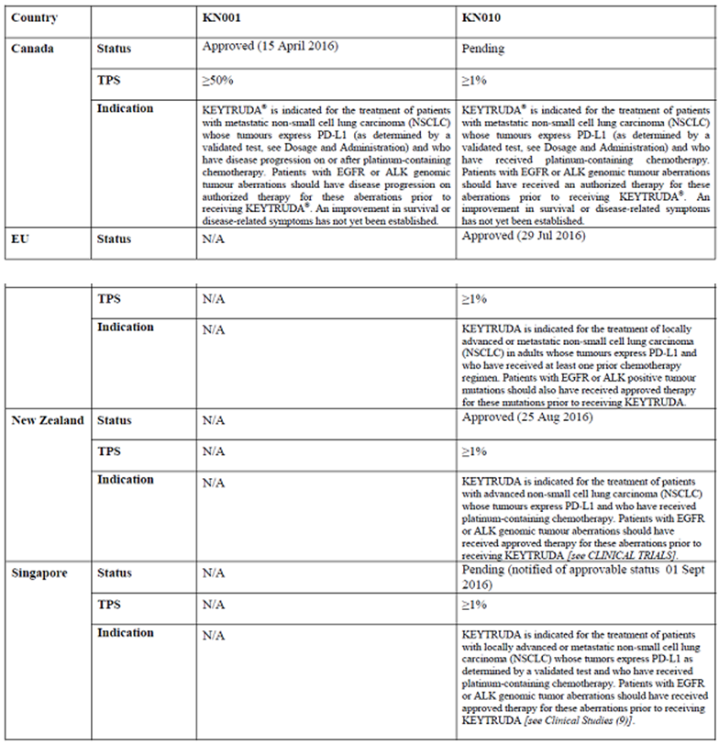

Table 37 (continued): Wording of the proposed indications sought in EU, Canada, Singapore and Switzerland
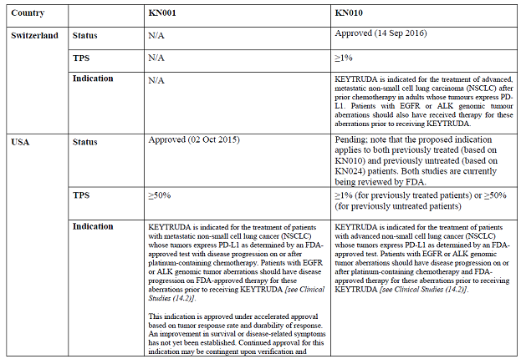

Evaluator’s comment
The wording of the indication in each jurisdiction is noted.

Question 2
The sponsor is kindly requested to provide details of the wording for the mandated companion diagnostic test to accompany pembrolizumab use in the product information provided to the EU, Canada, Singapore and Switzerland.

Sponsor’s response
The requested information is summarised in Table 38 below. Corresponding information for New Zealand and USA is also included.

Table 38: The wording for the mandated companion test in EU, Canada, Singapore and Switzerland
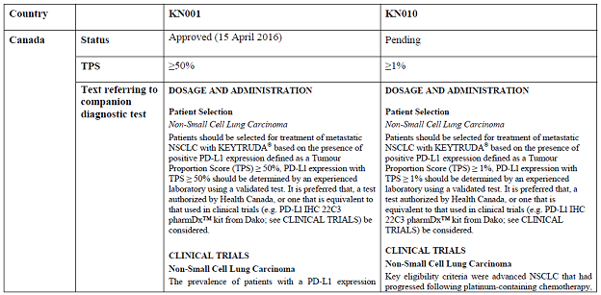

Table 38 (continued): The wording for the mandated companion test in EU, Canada, Singapore and Switzerland
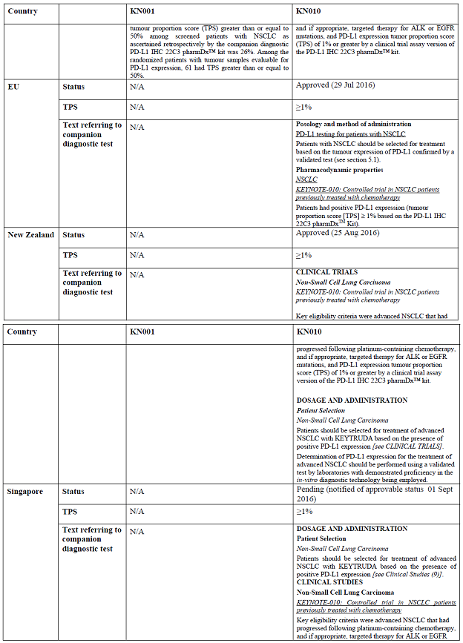

Table 38 (continued): The wording for the mandated companion test in EU, Canada, Singapore and Switzerland
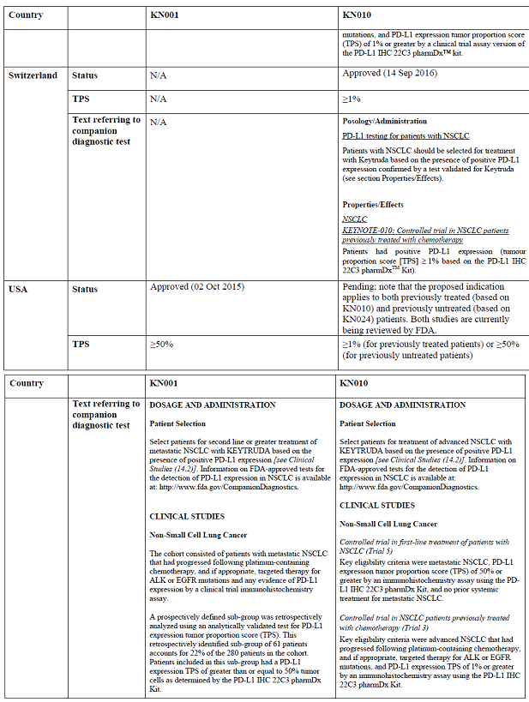

Evaluator’s comment
The wording associated with the companion test in each jurisdiction is noted.

Question 3
‘The sponsor is requested to provide the test characteristics (sensitivity, specificity, positive predictive value and negative predictive value) when assessed in patients with NSCLC at (i) a cut-off of TPS 50% and (ii) TPS 1%’.

Sponsor’s response
One of the eligibility criteria in KN010 was that subjects needed to have a PD-L1 positive (TPS ≥ 1%) specimen to be considered for randomisation. Subjects with PD-L1 negative (TPS < 1%) specimens were not eligible to participate in the study. As a result, it is not possible to determine the clinical sensitivity, clinical specificity and negative predictive value of the PD-L1 IHC 22C3 pharmDx kit from data from Study KN010. For each of these measures, an assessment of pembrolizumab outcomes in PD-L1 negative specimens is also needed which is unavailable due to the eligibility criterion for the study as briefly described above. Positive predictive value (PPV) of the test can be obtained from the study data and is in fact the objective response rate (ORR). The following tables (Tables 39, 40, 41 and 42) include the PPV of the test at the TPS ≥ 50% and TPS ≥ 1% cut-offs for both the clinical trial assay (CTA) version of the PD-L1 IHC 22C3 pharmDx kit used in the study to screen patients and the PD-L1 IHC 22C3 pharmDx kit market ready assay (MRA). Data with the MRA was obtained through a bridging study by retesting KN010 CTA screened samples with the MRA.

Table 39: Analysis of overall response based on IRC Assessment RECIST 1.1 subjects with CTA TPS ≥ 50% ITT population
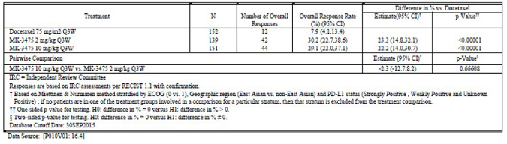

Table 40: Analysis of overall response based on IRC Assessment RECIST 1.1 subjects with CTA TPS ≥ 1% ITT population
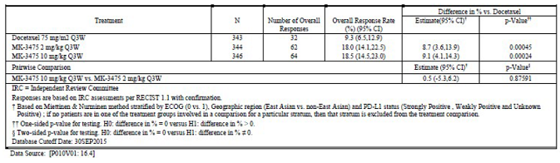

Table 41: Analysis of overall response based on IRC Assessment RECIST 1.1 subjects with MRA TPS ≥ 50%, WSW, ITT population
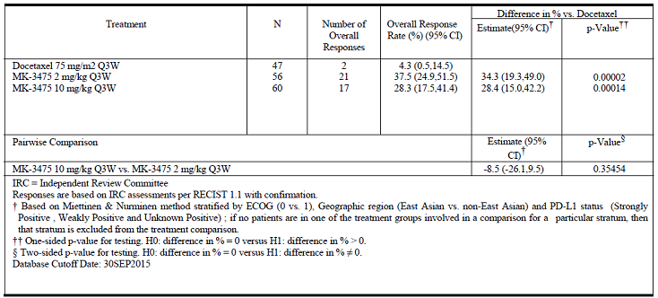

Table 42: Analysis of overall response based on IRC Assessment RECIST 1.1 subjects with MRA TPS ≥ 1% ITT population
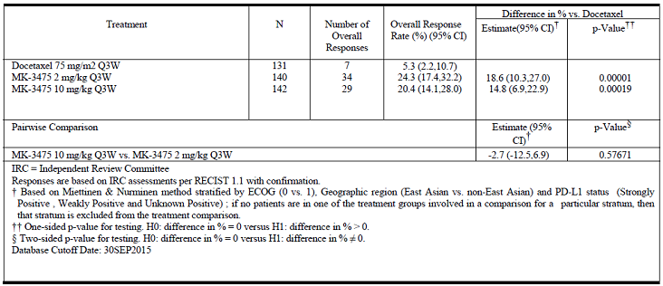
In addition, analytical sensitivity and analytical specificity for the PD-L1 IHC 22C3 pharmDx assay were assessed and are included below. This information was submitted to TGA by Dako on 11 March 2016 as part of the PD-L1 IHC 22C3 pharmDx assay IVD submission.

Analytical sensitivity
The objective of this test was to demonstrate that the PD-L1 IHC 22C3 pharmDx assay detects the target substance (PD-L1 protein) in a range of PD-L1-expressing FFPE human NSCLC tissue specimens.
NSCLC specimens were selected according to the criteria below and were stained according to the IHC staining procedure. One pair of sections from each specimen was tested with the Primary Antibody to PD-L1 and Negative Control Reagent.
127 unique cases of NSCLC were selected; the specimens represented a full range of PD-L1 expression, all specimens were chosen at random and were not pre-selected based on distribution. The 127 unique cases of NSCLC specimens included primary tumours and metastases, both Stage III and Stage IV disease specimens. All specimens were represented by whole tissue sections.
Any non-specific staining noted was ≤ 0.5. All NCR slides exhibited ≤ 0.5 background staining and therefore met acceptance criteria. Assessment of PD-L1 expression in the full specimen set (127 cases of NSCLC) demonstrated staining across a range of 0 to 100% positive tumour cells, and 0-3 staining intensity.
PD-L1 protein expression was detected across the range of 0 to 100% of tumour cells in NSCLC specimens, with the positivity rates, according to selected cut-off, shown in Table 43.

Table 43: Summary of rate of PD-L1 positive expression
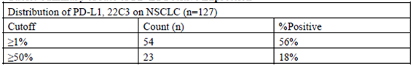

Analytical specificity
Analytical specificity was evaluated through panels of normal and neoplastic tissues. This testing is done independent of the cut off. Normal tissues: Table 44 summarises immunoreactivity on the recommended panel of normal tissues. Plasma membrane staining was observed on immune cells and cells of epithelial origin. Cytoplasmic staining was noted in some cell types but was not recorded as positive staining. All tissues were formalin fixed and paraffin embedded and stained with PD-L1 IHC 22C3 pharmDx according to the instructions in this package insert. There were no unexpected results observed in cell types or tissue types tested. The observed staining was consistent with the reported literature for PD-L1 IHC expression in normal tissues.

Table 44: Summary of PD-L1 IHC 22C3 pharmDx normal tissue reactivity
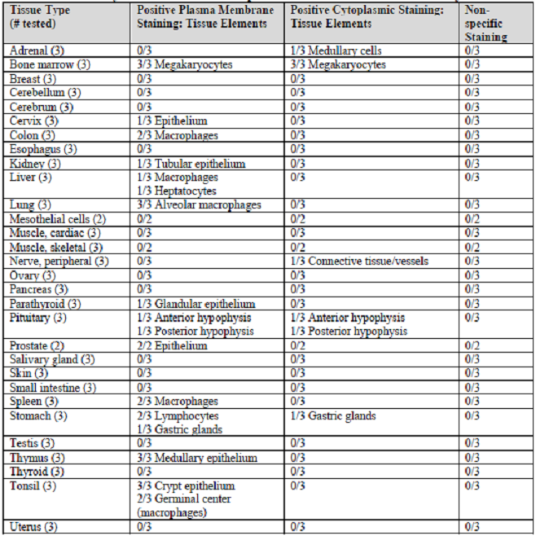
Neoplastic tissues: Table 45 summarises immunoreactivity on a panel of neoplastic tissues.
- Plasma membrane staining was observed on immune cells and cells of epithelial origin.
- Cytoplasmic staining was noted in some cell types but was not recorded as positive staining.
All tissues were formalin fixed and paraffin embedded and stained with PD-L1 IHC 22C3 pharmDx according to the instructions in this package insert. There were no unexpected results observed in the tumour specimens tested. The observed staining was consistent with the reported literature for PD-L1 IHC expression in neoplastic tissues.

Table 45: Summary of PD-L1 IHC 22C3 pharmDx neoplastic tissue reactivity
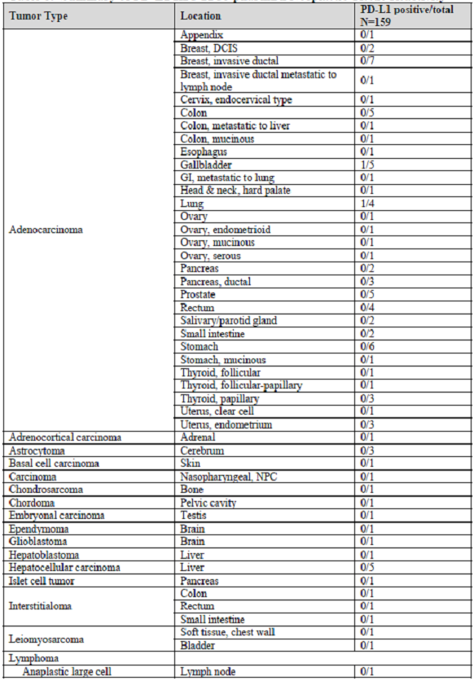

Table 45 (continued): Summary of PD-L1 IHC 22C3 pharmDx neoplastic tissue reactivity
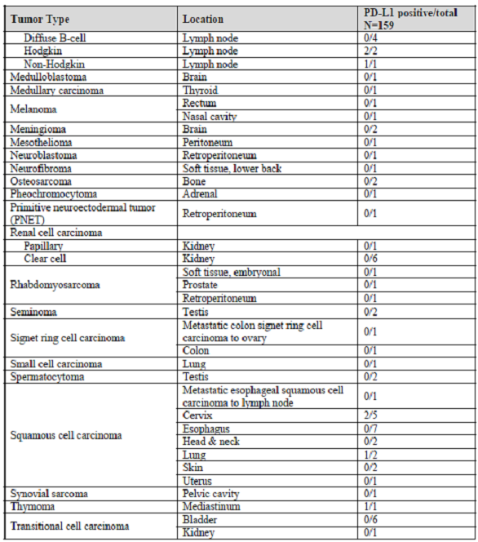

Evaluator’s comment
Owing to a lack of PD-L1 negative patients having been assessed, the diagnostic test characteristics have not been satisfactorily demonstrated. This has potential implications for patients who are falsely negative, who would be erroneously precluded from treatment with pembrolizumab.

Pharmacokinetics

Question 1
‘The CSR for Keynote-001 states: ‘Pembrolizumab has low to moderate PK variability (inter-subject coefficient of variation (CV) of 25 to 63%)’. The sponsor is kindly requested to state which PK measurement(s) this statement refers to’.

Sponsor’s response
Mean pre-dose minimum serum concentration (C_{trough}) and post-dose maximum serum concentration (C_{max}) levels are summarised in a table Study KN001 CSR [not reproduced here], illustrating a range in %CV between 25 and 63% across dose and collection time point. These analyses, conducted and reported within the CSR, largely reflect descriptive summaries of concentration data on an earlier protocol-specific dataset. Subsequently, an integrated population PK analysis pooling data from KEYNOTE-001, -002, and -006 has been performed, which provides a more robust estimate of inter-subject variability. Please consult the most recent integrated population PK report titled ‘Update to Population Pharmacokinetic Analysis of Exposure to Pembrolizumab (MK-3475) Using a Pooled Protocol 001, 002 and 006 Dataset’ (report footer: 04DDV3; dated May 2016) submitted to the TGA on 03 August 2016, as part of the Keytruda PK model update in support of this extension of indication application for previously treated NSCLC patients (Submission PM-2015-04712-1-4).

Evaluator’s comment
The source of the statement is noted. As described, there was no substantial change to the established popPK model with the addition of the data from Protocol 010.

Efficacy

Question 1
‘In order to inform clinicians to determine if repeated tumour histology acquisition is required, the sponsor is kindly requested to present data regarding the duration of time between tissue sample collection and ability to accurately determine PD-L1 status in patients with NSCLC’.

Sponsor’s response
Study KN010 required all enrolled subjects to provide a tumour sample for evaluation of PD-L1 status. Initially investigators were allowed to submit either a new sample or an archival sample, but either needed to have been formalin-fixed and paraffin embedded (FFPE). After randomization of 441 subjects, with the implementation of the 50% cut point with Amendment 08, subjects were asked to provide a new tumour sample, unless medically inappropriate, because most submitted tumour samples were archival. The definition of an archival tumour sample was a tumour sample from a subject who had received therapy for his cancer in between the tumour sample acquisition and testing for PD-L1. The median time between sample collection and PD-L1 assessment for the entire trial was 250 days (range, 3 to 2510) for archival samples and 11 days (range, 1 to 371) for new samples. With the implementation of Amendment 08, an exploratory objective was added to compare the impact of age of the tumour specimens (archival or new) on the primary efficacy outcomes of PFS and OS.
The OS and PFS hazard ratios relative to the age of the tumour samples are summarised in Table 46. Data from the 2 mg/kg and 10 mg/kg pembrolizumab arms were pooled for subgroup analyses to increase sample size and increase the interpretability of the results, because there were no significant differences in the efficacy results between the two arms.
The OS HR and the corresponding 95% CI in various subgroups by each of the pembrolizumab treatment arms versus docetaxel were analysed using a stratified Cox proportional hazard model. The OS hazard ratios for archival and new tumour samples demonstrated superiority of pembrolizumab versus docetaxel and were similar with overlapping confidence intervals for the TPS ≥ 50% stratum. Similarly, the OS hazard ratios for archival and new tumour samples demonstrated superiority of pembrolizumab versus docetaxel and were similar with overlapping confidence intervals for the overall study population (TPS ≥ 1%). Likewise, the PFS hazard ratios for archival and new tumour samples demonstrated superiority of pembrolizumab versus docetaxel and were similar with overlapping confidence intervals for the TPS ≥ 50% stratum. The PFS hazard ratios for archival and new tumour samples were similar with overlapping confidence intervals, but did not demonstrate the superiority of pembrolizumab relative to docetaxel for the overall population (TPS ≥ 1%). The results of these analyses were shown in Figures 11-15, 11-16, 11-17, and 11-18 of the CSR for KN010. These figures have been reproduced below as Figure 12, Figure 13, Figure 14, and Figure 15. Nevertheless, subjects received an improvement in OS when treated with pembrolizumab whether the PD-L1 testing was performed with a new tumour specimen or an archival one.

Table 46: Impact of age of tumour specimen on OS and PFS
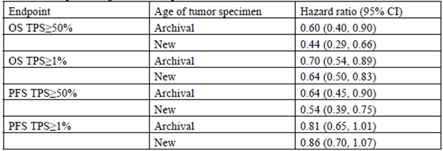
Regarding technical aspects of the PD-L1 assay, per the instructions of use provided by the PD-L1 IHC 22C3 pharmDx manufacturer (Dako), FFPE tissue blocks which are 5 years or older may result in a loss of PD-L1 immunoreactivity. Once cut from the FFPE tissue block, cut tissue sections maintain PD-L1 antigen stability for up to 6 months. After that time period, PD-L1 staining may be affected due to epitope instability.
Figure 12: Forest plot of OS hazard ratio by subgroup factors, pembrolizumab pooled versus docetaxel TPS ≥ 50%, ITT
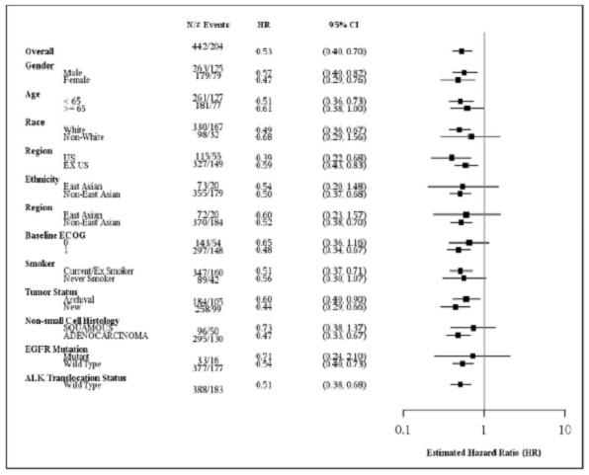
Figure 13: Forest plot of OS hazard ratio by subgroup factors, pembrolizumab pooled versus docetaxel TPS ≥ 1%, ITT
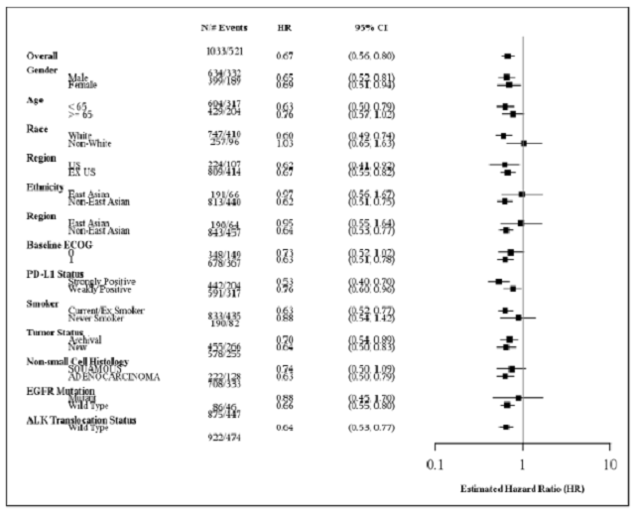
Figure 14: Forest plot of PFS hazard ratio by subgroup factors, IRC assessment (RECIST 1.1) pembrolizumab pooled versus docetaxel TPS ≥ 50%, ITT
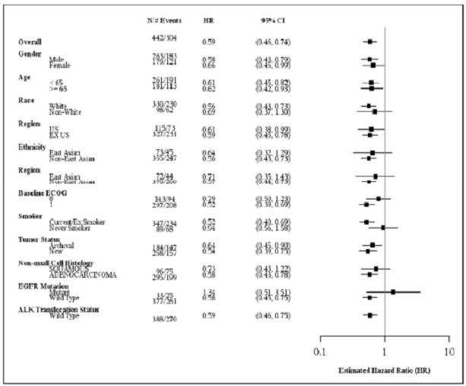
Figure 15: Forest plot of PFS hazard ratio by subgroup factors, IRC assessment (RECIST 1.1) pembrolizumab pooled versus docetaxel TPS ≥ 1%, ITT
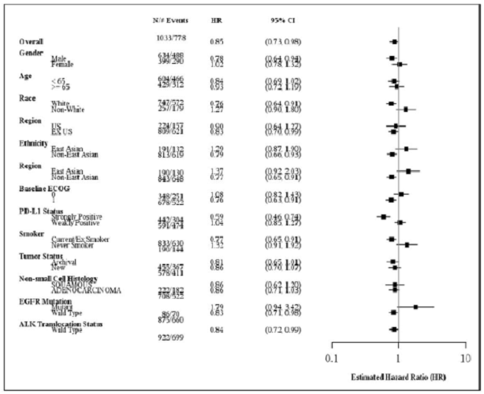

Evaluator’s comment
Among the patients studied, there was no apparent reduction in the point estimate of hazard ratio of OS, or PFS, according to the age of the tumour specimen, though this was not formally tested for difference.

Question 2
‘The sponsor is kindly requested to present the proportion of each treatment arm in Keynote-010 that achieved confirmed stable disease, based on the IRC assessment RECIST 1.1 criteria’.

Sponsor’s response
These data are not available as the best overall response tables in the clinical study report were generated from assessments made by the independent imaging vendor accounting for confirmed or unconfirmed responses. Assessments of confirmed response accompanied by stable disease and progressive disease have not been tabulated by the vendor. The sponsor reported in the best overall response table the data provided by the vendor.

Evaluator’s comment
Despite the overall survival estimates being in favour of pembrolizumab, it is still of relevance to clinicians to be able to include an estimate of categorised response when obtaining informed consent for treatment as not all patients achieved the same degree of benefit from pembrolizumab therapy.

Question 3
‘In order to assess the effect of pembrolizumab regimen proposed for registration, the sponsor is kindly requested to present the Forest plot analyses of (i) OS and (ii) PFS by sub-group factors, using the IRC assessment of only the pembrolizumab 2 mg/kg arm in comparison with the docetaxel arm, for each of the TPS ≥ 50% and TPS ≥ 1 to < 50% ITT populations’.

Sponsor’s response
The sponsor would like to direct the evaluator’s attention to CSR for Study P010V01, ‘Subgroup Analyses of Overall Survival Figure for the Forest plot of OS Hazard Ratio by subgroup factors for MK-3475 2 mg/kg Q3W versus Docetaxel for Subjects with TPS ≥ 50%, ITT Population’ and Figure for the Forest plot of OS Hazard Ratio by Subgroup Factors for MK3475 2 mg/kg Q3W versus docetaxel for subjects with 1% ≤ TPS< 50%, ITT Population’. These have been reproduced below as Figure 16 and Figure 17, respectively.
The pembrolizumab Study P010V01 CSR Strongly Positive (TPS ≥ 50% Stratum) and Weakly Positive (1% ≤ TPS < 50% Stratum) contain the requested Forest plot analyses for PFS. These have been reproduced below as Figure 18 and Figure 19, respectively. While these figures are available, please keep in mind that Study KN010 was powered to demonstrate efficacy in the TPS ≥ 50% and the TPS ≥ 1%. All primary endpoints are based on the stratum and the overall population. Analysis of the TPS = 1 to 49% stratum is exploratory and post-hoc. Furthermore, these subgroup analyses were performed on the pooled doses of pembrolizumab (2 mg/kg and 10 mg/kg) to increase sample size and the interpretability of the results, because there were no significant differences in the efficacy results between the 2 arms.
Figure 16: Forest plot of OS hazard ratio by subgroup factors, pembrolizumab 2 mg/kg Q3W versus docetaxel TPS ≥ 50%, ITT
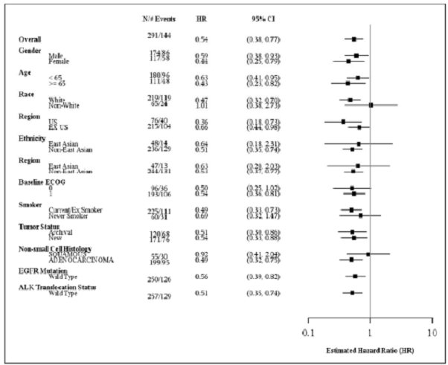
Figure 17: Forest plot of OS hazard ratio by subgroup factors, pembrolizumab 2 mg/kg Q3W versus docetaxel TPS ≥ 1 to 49%, ITT
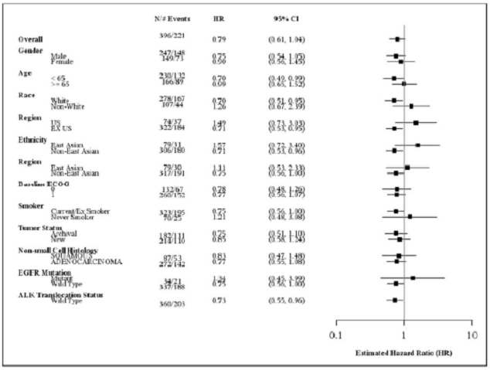
Figure 18: Forest plot of PFS hazard ratio by subgroup factors, IRC assessment (RECIST 1.1) pembrolizumab 2 mg/kg Q3W versus docetaxel TPS ≥ 50%, ITT
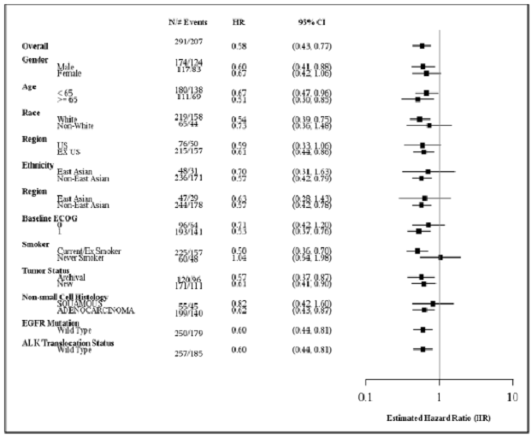
Figure 19: Forest plot of PFS hazard ratio by subgroup factors, IRC assessment (RECIST 1.1) pembrolizumab 2 mg/kg Q3W versus docetaxel TPS 1 to 49%, ITT
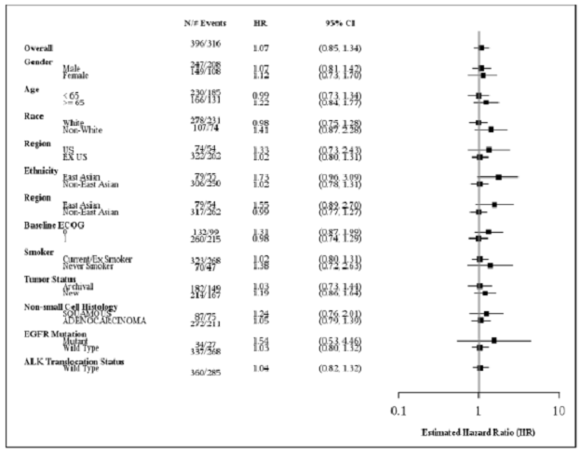

Evaluator’s comment
The post-hoc, therefore exploratory, nature of the TPS 1 to49% assessments is noted. Further data is needed to determine if the overall survival benefit is associated with a longer duration of pre or post progression survival. While the estimate of hazard ratio of OS favours pembrolizumab therapy, as noted previously, the currently available data estimates the improvement in median duration of OS of 0.8 months for those with TPS 1 to 49%.
The outcomes for patients with a TPS 1 to 49% remains of clinical importance to the oncology community as the composition of patient screened for enrolment in Keynote-001, -010 and -024 was presented at an ESMO poster presentation by Aggarwal et al; for all patients, those treatment naïve and those previously treated. Overall, approximately one third of patients appear to have been recruited into these studies having TPS 1 to 49%, as such they do not represent a small patient sub-group and their outcomes remain highly relevant, and potentially influential on the overall trial results.

Question 4
‘The sponsor is kindly requested to present the sensitivity, specificity, positive predictive value, negative predictive value and receiver operator characteristic curve & associated Youden index for the PD-L1 test using a cut-off of 1% in the population of patients who received docetaxel and pembrolizumab 2 mg/kg Q3W in Keynote-010’.

Sponsor’s response
A response to this question has already been provided as per the TGA’s 2 September 2016 email clarification to the sponsor’s request.
‘TGA clarification; the sponsor has answered this question. Given the absence of PD-L1 negative patients, the test characteristics cannot be satisfactorily determined for a PD-L1 cut off of 1% using this study population.’

Safety

Question 1
‘The sponsor is kindly requested to explain the discrepancy between the reported incidences of (i) fatigue, (ii) nausea) and (iii) diarrhoea between the integrated summary of safety and the product information, as the latter documents a lower incidence for each category of adverse event’.

Sponsor response
Incidences of fatigue, nausea and diarrhoea reported in the clinical trials experience subsection of the ‘Adverse effects’ section of the PI are based on events reported as treatment related by the investigator in a pooled dataset containing 2,799 patients from KEYNOTE-001, KEYNOTE-002, KEYNOTE-006, and KEYNOTE-010.
Treatment related adverse events for this dataset are displayed in a table of the Integrated Summary of Safety [not included here]. Incidences of these terms cited in the evaluator’s report are based on all events regardless of causality.

Evaluator’s comment
The difference in incidence of each AE owing to treatment relatedness is noted.

Second round benefit-risk assessment

Second round assessment of benefits
After consideration of the responses to clinical questions, the benefits of pembrolizumab in the proposed usage are:
- Among patients with TPS > 1%, the OS HR for pembrolizumab 2 mg/kg versus docetaxel was 0.71 (95% CI: 0.58, 0.88) with a p value of 0.00076.
- The median OS for pembrolizumab 2 mg/kg was 10.4 months compared to 8.5 months for the docetaxel exposed patients.
- Among the patients studied, there was no apparent difference in estimates of efficacy according to the age of the specimen used to determine PD-L1 status.
The outcomes of patients with TPS 1 to 49% remain clinically important for the purposes of obtaining informed consent and enabling an assessment of likely treatment effect. The exploratory differential effect observed between patients with TPS 1 to 49% and TPS ≥ 50% described in the round one report is unchanged.

Second round assessment of risks
After consideration of the responses to clinical questions, the risks of pembrolizumab in the proposed usage are:
- The PD-L1 test characteristics have not been satisfactorily demonstrated for PD-L1 expression at a cut-off of 1%, the cut-off mandated by proxy, in the sponsors proposed indication.
- Patients with TPS > 1 to < 50% do not have comparable efficacy as compared to those with a TPS ≥ 50%. There is evidence that the efficacy of pembrolizumab is not consistently superior, indeed potentially inferior, to docetaxel for patients with this degree of PD-L1 expression, as second-line therapy. The median duration of overall survival was 0.8 months longer in patients receiving pembrolizumab, which is an inadequate duration for registration purposes. The median duration of progression free survival was 1.3 months longer for patients receiving docetaxel among patients with TPS > 1 to < 50%. In the event that the Delegate agrees to register pembrolizumab for patients with this degree of PD-L1 expression, the provision of this information in the product information would be critical for clinicians to satisfactorily formulate a decision to initiate pembrolizumab therapy and obtain informed consent.
- No patients with NSCLC were reported to have achieved a complete response from treatment with pembrolizumab.
- From the evidence presented in the dossier, for patients with TPS > 1 to < 50%, the number needed to treat with pembrolizumab, as compared to docetaxel, in order to obtain one additional event of partial response is 140.
In addition, given the risk of myasthenia gravis and peripheral neuropathy and the potential presenting symptoms should be included in the PI and CMI (each described in the FDA approved label).

Second round assessment of benefit-risk balance
The benefit-risk balance of pembrolizumab, given the proposed usage, is favourable.

Second round recommendation regarding authorisation
It is recommended to the Delegate that pembrolizumab be approved for the indication:
‘Keytruda is indicated for the treatment of patients with advanced non-small cell lung carcinoma (NSCLC) whose tumours express PD-L1 and who have received platinum containing chemotherapy. Patients with EGFR or ALK genomic tumour aberrations should also have received approved therapy for these aberrations prior to receiving Keytruda’.

References
1 Kerr, K & Nicolson, M. Non-small cell lung cancer, PD-L1, and the pathologist. Archives of Pathology and Laboratory Medicine. 140, March 2016, pp 249-254
2 McLaughlin, J et al. Quantitative assessment of the heterogeneity of PD-L1 expression in non-small cell lung cancer. JAMA oncology 2016; 2(1):46-54
3 Kerr K, Tsao M, Nicholson A, et al. Programmed Death-Ligand 1 immunohistochemistry in lung cancer: in what state is this art? J Thorac Oncol. 2015;10(7):985–989.
4 Herbst R, Soria J, Kowanetz M, et al. Predictive correlates of response to the anti-PD-L1 antibody MPDL3280A in cancer patients. Nature. 2014; 515(7528):563–567.

Therapeutic Goods Administration
PO Box 100 Woden ACT 2606 Australia
Email: info@tga.gov.au Phone: 1800 020 653 Fax: 02 6232 8605
https://www.tga.gov.au

Aggarwal C et al 2016 1060P - Prevalence of PD-L1 expression in patients with non-small cell lung cancer screened for enrollment in KEYNOTE-001, -010, and -024 Annals of Oncology 2016; 27 :359-378

