May 2018

Australian Public Assessment Report for Pembrolizumab (rch)
  - Proprietary Product Name: Keytruda
  - Sponsor: Merck Sharp & Dohme Australia Pty Ltd

About the Therapeutic Goods Administration (TGA)
- The Therapeutic Goods Administration (TGA) is part of the Australian Government Department of Health and is responsible for regulating medicines and medical devices.
- The TGA administers the Therapeutic Goods Act 1989 (the Act), applying a risk management approach designed to ensure therapeutic goods supplied in Australia meet acceptable standards of quality, safety and efficacy (performance) when necessary.
- The work of the TGA is based on applying scientific and clinical expertise to decision-making, to ensure that the benefits to consumers outweigh any risks associated with the use of medicines and medical devices.
- The TGA relies on the public, healthcare professionals and industry to report problems with medicines or medical devices. TGA investigates reports received by it to determine any necessary regulatory action.
- To report a problem with a medicine or medical device, please see the information on the TGA website <https://www.tga.gov.au>.
About AusPARs
- An Australian Public Assessment Report (AusPAR) provides information about the evaluation of a prescription medicine and the considerations that led the TGA to approve or not approve a prescription medicine submission.
- AusPARs are prepared and published by the TGA.
- An AusPAR is prepared for submissions that relate to new chemical entities, generic medicines, major variations and extensions of indications.
- An AusPAR is a static document; it provides information that relates to a submission at a particular point in time.
- A new AusPAR will be developed to reflect changes to indications and/or major variations to a prescription medicine subject to evaluation by the TGA.
Copyright
© Commonwealth of Australia 2018
This work is copyright. You may reproduce the whole or part of this work in unaltered form for your own personal use or, if you are part of an organisation, for internal use within your organisation, but only if you or your organisation do not use the reproduction for any commercial purpose and retain this copyright notice and all disclaimer notices as part of that reproduction. Apart from rights to use as permitted by the Copyright Act 1968 or allowed by this copyright notice, all other rights are reserved and you are not allowed to reproduce the whole or any part of this work in any way (electronic or otherwise) without first being given specific written permission from the Commonwealth to do so. Requests and inquiries concerning reproduction and rights are to be sent to the TGA Copyright Officer, Therapeutic Goods Administration, PO Box 100, Woden ACT 2606 or emailed to <tga.copyright@tga.gov.au>.

Contents
Common abbreviations 5
I. Introduction to product submission 8
Submission details 8
Product background 9
Regulatory status 10
Product Information 11
II. Submission timeline 12
III. Quality findings 13
Introduction 13
IV. Nonclinical findings 13
Va. Clinical findings for Submission PM-2015-04712-1-4 13
Introduction 13
Pharmacokinetics 15
Pharmacodynamics 15
Dosage selection for the pivotal studies 16
Efficacy 16
Safety 18
Second Round Benefit-Risk Assessment 21
Second round recommendation regarding authorisation 22
Vb. Clinical findings for Submission PM-2016-02325-1-4 22
Introduction 22
Pharmacokinetics 25
Pharmacodynamics 25
Dosage selection for the pivotal studies 25
Efficacy 26
Safety 26
First Round Benefit-Risk Assessment 29
First Round Recommendation Regarding Authorisation 31
Clinical Questions 31
VI. Pharmacovigilance findings 31
Risk management plan 31
Summary 31
VII. Overall conclusion and risk/benefit assessment 34
Background 34
Quality 35
Nonclinical 35
Clinical evaluation for Submission PM-2015-04712-1-4 38
Clinical evaluation for Submission PM-2016-02325-1-4 44
Risk management plan 53
Risk-benefit analysis 53
Outcome 72
Attachment 1. Product Information 72
Attachment 2. Extract from the Clinical Evaluation Report (submission PM 2015-04712-1-4) 73
Attachment 3. Extract from the Clinical Evaluation Report (submission PM-2016-02325-1-4) 73

Common abbreviations
Abbreviation | Meaning
ACM | Advisory Committee for Medicines
ADAs | Anti-drug antibodies
AE | Adverse Event
AEOSI | Adverse event of special interest
ALK | Anaplastic Lymphoma Kinase
ALT | Alanine Transaminase
APaT | All patients as treated
APCs | Antigen presenting cells
aPTT | Activated partial thromboplastin time
ASA | Australian Specific Annex (of the RMP)
ASaT | All subjects as treated
AST | Aspartate Transaminase
AUC | Area under the curve
BICR | Blinded Independent Central Radiologist
CI | Confidence interval
C_{min} | Minimum plasma concentration
CMI | Consumer Medicines Information
COPD | Chronic obstructive pulmonary disease
CTA | Clinical Trial Assay (for PD-L1)
CTCAE | Common terminology criteria for adverse events
CV | Coefficient of variation
DoR | Duration of response
ECI | Events of clinical interest
ECOG | Eastern Cooperative Oncology Group
EGFR | Epidermal Growth Factor Receptor
EMA | European Medicines Agency
EORTC | European Organisation for Research and Treatment of Cancer
FDA | Food and Drug Administration
GCP | Good Clinical Practice
HNSCC | Head and neck squamous cell carcinoma
HR | Hazard ratio
IASLC | International Association for the Study of Lung Cancer
IFU | Instructions for use
irAEs | Immune related AEs
ITT | Intention to Treat
IV | Intravenous
KN-001 | KEYNOTE-001 trial; also referred to as Study 3475-P001V04
KN-010 | KEYNOTE-010 trial; also referred to as Study 3745-P010V01
KN-024 | KEYNOTE-024 trial; also known as Study 024
LFTs | Liver function tests
MAH | Market authorisation holder
MedDRA | Medical dictionary for regulatory activities
MK-3475 | Pembrolizumab (Keytruda)
NCI | National Cancer Institute
NCI CTCAE | NCI common terminology criteria for adverse events
NSCLC | Non-small cell lung cancer
NSQ | Non-squamous
ORR | Objective Response Rate or Overall Response Rate
OS | Overall Survival
PBS | Pharmaceutical Benefits Scheme (Australia)
PD-1 | Programmed death receptor-1
PD-L1 | Programmed death ligand-1 also known as CD274 or B7-H1
PD-L2 | Programmed death ligand-2 also known as CD273 or B7-DC
PFS | Progression free survival
PI | Product Information
PK | Pharmacokinetics
PRO | Patient reported outcomes
PSUR | Periodic safety update report
Q2W | Every 2 weeks
Q3W | Every 3 weeks
RECIST | Response evaluation criteria in solid tumours
RMP | Risk Management Plan
SAE | Serious Adverse Event
SCLC | Small cell lung cancer
SQ | Squamous
TGA | Therapeutic Goods Administration
TPS | Tumour proportion score
TSH | Thyroid stimulating hormone
WHO | World Health Organisation

I. Introduction to product submission

Submission details
Type of submission: | Major variation (both submissions were for new indications)
Decision: | Approved
Date of decision: | 3 March 3017
Date of entry onto ARTG | 6 March 2017 (PM-2015-04712-1-4) and  7 March 2017 (PM -2016-02325-1-4)
Active ingredient: | Pembrolizumab (rch)
Product name: | Keytruda
Sponsor’s name and address: | Merck Sharp & Dohme Australia Pty Ltd  North Ryde Post Business Centre  Locked Bag 2234  North Ryde NSW 1670
Dose forms: | Powder for injection and concentrated injection
Strengths: | 100 mg/4 mL, and 50 mg (powder)
Container: | Vial
Pack size: | 1 vial
Approved therapeutic use: | Keytruda is indicated for the first-line treatment of patients with metastatic non-small cell lung carcinoma (NSCLC) whose tumours express PD-L1 with a ≥ 50% tumour proportion score (TPS) as determined by a validated test, with no EGFR or ALK genomic tumour aberrations.  Keytruda is indicated for the treatment of patients with advanced NSCLC whose tumours express PD-L1 with a ≥ 1% TPS as determined by a validated test and who have received platinum containing chemotherapy. Patients with EGFR or ALK genomic tumour aberrations should have received prior therapy for these aberrations prior to receiving Keytruda.
Route of administration: | Intravenous
Dosage: | Dosage for previously treated NSCLC is 2 mg/kg once every three weeks. Dosing in previously untreated NSCLC is 200 mg once every three weeks. Determination of positive PD-L1 expression is a prerequisite. For further details please see the Product Information (PI)
ARTG numbers: | 226597, 263932

Product background
This AusPAR describes the applications by Merck Sharp and Dohme Australia Pty Ltd (the sponsor) to register Keytruda for the following indications:
Submission PM-2015-04712-1-4:
Keytruda is indicated for the treatment of patients with advanced non-small cell lung carcinoma (NSCLC) whose tumours express PD-L1 and who have received platinum containing chemotherapy. Patients with EGFR or ALK genomic tumour aberrations should also have received approved therapy for these aberrations prior to receiving Keytruda [see CLINICAL TRIALS].
Submission PM-2016-02325-1-4:
Keytruda is indicated for the treatment of patients with previously untreated metastatic non-small cell lung carcinoma (NSCLC) whose tumours express PD-L1 as determined by a validated test and do not harbour a sensitizing EGFR mutation or ALK translocation [see CLINICAL TRIALS].
The sponsor initially submitted the application for the second line treatment for non-small cell lung carcinoma (NSCLC) (Submission PM-2015-04712-1-4) and then the subsequent submission for first line treatment for NSCLC (Submission PM-2016-02325-1-4). The submissions were jointly reviewed by the Delegate and the Advisory Committee for Medicines (ACM). This AusPAR presents the assessment and review of both submissions and the associated clinical evaluations are presented as Attachment 2 (Submission PM-2015-04721-1-4) and Attachment 3 (Submission PM-2015-02325-1-4).
Non-small cell lung cancer accounts for approximately 81% of lung cancer and is histologically classified into the following cell types: squamous cell carcinoma (25%); adenocarcinoma (47%); large cell carcinoma (6%); and other (22%). Choice of therapy for advanced disease depends upon histology and also the extent of disease (number and site of metastases), presence of symptoms, the presence of oncogenic drivers (for example epidermal growth factor receptor (EGFR), anaplastic lymphoma kinase (ALK), and ROS1) and the patients’ overall condition and co-morbidities.
Programmed death receptor-1 (PD-1) is an immune checkpoint receptor that limits the activity of T lymphocytes in peripheral tissues. The PD-1 pathway is an immune control checkpoint that may be engaged by tumour cells to inhibit active T cell immune surveillance. Pembrolizumab is a monoclonal antibody against PD-1; which exerts dual ligand blockade of the PD-1 pathway, including PD-L1 and PD-L2, on antigen presenting or tumour cells. By inhibiting the PD-1 receptor from binding to its ligands pembrolizumab reactivates tumour specific cytotoxic T lymphocytes in the tumour microenvironment and reactivates anti-tumour immunity. Pembrolizumab thus functions as a ‘checkpoint inhibitor’; releasing the brakes on anti-tumour immunity (while also predisposing to autoimmune toxicity).
NSCLC is an area of unmet need with few effective treatment options. Nivolumab (also an anti-PD-1 monoclonal antibody) is approved as a second line agent in advanced NSCLC with no requirement with respect to PD-L1 expression on tumour specimens. In these submissions the sponsor requests approval of pembrolizumab in NSCLC subjects whose tumours express PD-L1 (with strong expression required in first line treatment of NSCLC, and ‘any’ positive staining required in second line treatment NSCLC).
Determination of PD-L1 expression is performed histologically and is rated using a tumour proportion score (TPS) based on the percentage of viable tumour cells showing partial or complete membrane staining. A TPS score ≥ 50% is defined as strongly positive PD-L1 expression.

Regulatory status
The product received initial registration on the Australian Register of Therapeutic Goods (ARTG) on16 April 2015 (powder for injection) and 8 March 2016 (concentrate for injection) and at the time of consideration for this submission the approved indications were:
Keytruda (pembrolizumab) is indicated as monotherapy for the treatment of unresectable or metastatic melanoma in adults.
At the time the TGA considered this application, a similar application had been approved was under consideration in the countries as described in Table 1.
Table 1: International regulatory history
Regulatory authority | Second line NSCLC | First line NSCLC
Food and Drug Administration (FDA) | Approved 24 October 2016  Indication: Keytruda is indicated for the treatment of patients with metastatic NSCLC whose tumors express PD-L1 (TPS ≥ 1%) as determined by an FDA-approved test, with disease progression on or after platinum containing chemotherapy. Patients with EGFR or ALK genomic tumor aberrations should have disease progression on FDA-approved therapy for these aberrations prior to receiving Keytruda [see Clinical Studies (14.2)]. | Approved 24 October 2016  Indication: Keytruda is indicated for the first-line treatment of patients with metastatic non-small cell lung cancer (NSCLC) whose tumors have high PD-L1 expression [Tumor Proportion Score (TPS) ≥ 50%)] as determined by an FDA-approved test, with no EGFR or ALK genomic tumor aberrations [see Clinical Studies (14.2)].
European Medicines Agency (EMA) | Approved 29 July 2016  Indication: Keytruda is indicated for the treatment of locally advanced or metastatic non-small cell lung carcinoma (NSCLC) in adults whose tumours express PDL1 and who have received at least one prior chemotherapy regimen. Patients with EGFR or ALK positive tumour mutations should also have received approved therapy for these mutations prior to receiving Keytruda. | Pending (recommended for approval by CHMP)
Health Canada | Pending | Pending
Medsafe (New Zealand) | Approved 25 August 2016  Indication: Keytruda is indicated for the treatment of patients with advanced non-small cell lung carcinoma (NSCLC) whose tumours express PD-L1 and who have received platinum containing chemotherapy. Patients with EGFR or ALK genomic tumour aberrations should have received approved | Pending
Swissmedic | Approved 13 September 2016  Indication: Keytruda is indicated for the treatment of advanced, metastatic non-small cell lung carcinoma (NSCLC) after prior chemotherapy in adults whose tumours express PD-L1. Patients with EGFR or ALK genomic tumour aberrations should also have received therapy for these aberrations prior to receiving Keytruda. | Pending
Health Sciences Authority (Singapore) | Approved 30 September 2016  Indication: Keytruda is indicated for the treatment of patients with locally advanced or metastatic non-small cell lung carcinoma (NSCLC) whose tumors express PD-L1 as determined by a validated test and who have received platinum containing chemotherapy. Patients with EGFR or ALK genomic tumor aberrations should have received approved therapy for these aberrations prior to receiving Keytruda. | Pending

Product Information
The Product Information (PI) approved with the submission which is described in this AusPAR can be found as Attachment 1. For the most recent PI, please refer to the TGA website at <https://www.tga.gov.au/product-information-pi>.

II. Submission timeline

Table 2: Registration timeline for Submission PM-2015-04712-1-4
Description | Date
Submission dossier accepted and first round evaluation commenced | 1 April2016
First round evaluation completed | 30 August 2016
Sponsor provides responses on questions raised in first round evaluation | 29 September 2016
Second round evaluation completed | 17 November 2016
Delegate’s overview/Request for Advisory Committee advice | 3 January 2017
Sponsor’s response to the Delegate’s overview | 16 January 2017
Advisory Committee meeting | 2 and 3 February 2017
Registration decision | 3 March 2017
Entry onto ARTG | 6 March 2017
Number of TGA working days from commencement of evaluation to registration decision* | 212
* Statutory timeframe for standard applications: 255 working days

Table 3: Registration timeline for Submission PM-2016-02325-1-4
Description | Date
Submission dossier accepted and first round evaluation commenced | 30 September 2016
First round evaluation completed | 16 December 2016
Sponsor provides responses on questions raised in first round evaluation | NA – expedited review response provided in response to Delegate’s overview
Second round evaluation completed | NA – expedited review
Delegate’s overview/Request for Advisory Committee advice | 3 January 2017
Sponsor’s response to the Delegate’s overview | 16 January 2017
Advisory Committee meeting | 2 and 3 February 2017
Registration decision | 3 March 2017
Entry onto ARTG | 7 March 2017
Number of TGA working days from commencement of evaluation to registration decision* | 106
* Statutory timeframe for standard applications: 255 working days

III. Quality findings

Introduction
There was no requirement for a quality evaluation in a submission of this type.

IV. Nonclinical findings
There was no requirement for a nonclinical evaluation in a submission of this type.

Va. Clinical findings for Submission PM-2015-04712-1-4
A summary of the clinical findings is presented in this section. Further details of these clinical findings can be found in Attachment 2, the extract of the clinical evaluation report for submission PM-2015-04712-1-4.

Introduction

Clinical rationale
Historically, treatment of NSCLC employed regimens of chemotherapy and/or radiotherapy depending upon the patient characteristics and tumour staging.
Programmed death receptor 1 (PD-1) is expressed by T cells, natural killer cells and some B cells, its action being to active T cells in peripheral tissues. PD-1 has two ligands, programmed death ligand-1(PD-L1) and programmed death ligand-2 (PD-L2) These ligands are major histocompatibility complex cell surface proteins, and have been identified as molecular target expressed on a number of types of tumours, including NSCLC. Pembrolizumab binds to PD-1, thereby blocking the PD-1: PD-L1 interaction.
The expression of PD-L1 is ‘variable and dynamic’, and in practical terms is thus a continuous variable. Furthermore, within tumours, PD-L1 expression, as assessed by more than one assay, is heterogeneous.
The FDA had approved (at the time of this report) the use of pembrolizumab, registered under accelerated licencing arrangements, pending review of this dossier of the confirmatory study, for previously treated patients with NSCLC whose tumours express PD-L1 in > 50% of the cells examined, when assessed using an FDA approved assay.
The TGA is currently evaluating the companion diagnostic test proposed for use with pembrolizumab in NSCLC. The current submission proposes an extension of the use of pembrolizumab beyond that approved by the FDA, in that, patients with PD-L1 expression in > 1% of the cells examined are captured by the indication. Given the diagnostic test assay measures PD-L1 expression, this is a proxy for the PD-1 target of pembrolizumab.
Previous studies have demonstrated a variation in the efficacy of PD-L1 inhibition depending upon the level of expression of PD-L1.,

Guidance
The following EMA guidelines which have been adopted by the TGA, are considered relevant to the current submission:
- Guideline on the evaluation of anticancer medicinal products;
- Appendix 1 to the guideline on the evaluation of anticancer medicinal products in man. (Methodological consideration for using progression free survival or disease free survival in confirmatory trials);
- Appendix 4 to the guideline on the evaluation of anticancer medicinal products in man. (Condition Specific Guidance);
- Points to consider on application with 1. Meta-analyses; 2. One pivotal study.
Compliance with these guidelines will be assessed where relevant.

Contents of the clinical dossier
The submission contained the following clinical information:
- A pivotal full CSR for Study 3745-P010V01 (KEYNOTE-010); a Phase II/III randomised trial of two doses of pembrolizumab versus docetaxel in previously treated subjects with non-small cell lung cancer (NSCLC).
- Interim CSR for Study 3475-P001V04 (KEYNOTE-001); a Phase I study of single agent MK-3475 (Keytruda) in patients with progressive locally advanced or metastatic carcinoma, melanoma, and NSCLC.
- A full CSR for Study 3475-006; A multicentre, randomised, controlled, three arm, Phase III study to evaluate the safety and efficacy of two dosing schedules of MK-3475 compared to ipilimumab in patients with advanced melanoma.
- Integrated summaries of efficacy and safety (combining data from patients with NSCLC and melanoma from the KEYNOTE-001, KEYNOTE-002 and KEYNOTE-006 and KEYNOTE-010 clinical trials).
- Population pharmacokinetic analyses.
- Pooled pembrolizumab (MK-3475) immunogenicity analysis in melanoma and NSCLC patients from Protocols 001, 002, 006 and 010.
- Periodic Safety Update Report (PSUR) for the period 4 September 2014 to 3 September 2015.
- The sponsor’s Clinical Overview, Summary of Clinical Efficacy, Summary of Clinical Safety, synopses of individual studies and literature references.

Paediatric data
The submission did not include paediatric data.

Good clinical practice
Each of the clinical study reports states that Good Clinical Practice guidance was adhered to.

Pharmacokinetics

Studies providing pharmacokinetic data

KEYNOTE-001 (also referred to as Study P001V04)
A Phase I study of single agent MK-3475 (pembrolizumab) in patients with progressive locally advanced or metastatic carcinoma, melanoma, and NSCLC. For the full details please see Attachment 2.

Evaluator’s conclusions on pharmacokinetics
Pharmacokinetic data from KEYNOTE-001, and the updated population pharmacokinetics model, demonstrate no substantial changes to the understanding of the pharmacokinetics of pembrolizumab from that described in the initial registration dossier.
There is no demonstrated effect of mild or moderate renal impairment or mild hepatic impairment on the pharmacokinetics of pembrolizumab, and thus no dose modifications are required for such patients.
There is no data regarding the pharmacokinetics in patients with severe renal impairment or moderate or severe hepatic impairment.
There are updates to the product information pharmacokinetic values of volume of distribution (and coefficient of variation (CV)), plasma terminal half-life (and CV), time to steady state, minimum plasma concentration (C_{min}), for the dosing regimen of 2 mg/kg every 3 weeks (Q3W) across indications. These updates are considered satisfactory.

Pharmacodynamics

Studies providing pharmacodynamic data
No separate studies of pharmacodynamics were presented for evaluation.

Dosage selection for the pivotal studies
Data from the KEYNOTE-001 trial informed the dose selection of pembrolizumab for Study KEYNOTE-010 (also referred to as Study P010V01); a Phase II/III study of either 2 mg/kg Q3W or 10 mg/kg Q3W Pembrolizumab versus Docetaxel 75 mg/m² Q3W.

Efficacy

Studies providing efficacy data

Pivotal study; KEYNOTE-010
This was an open label Phase II/III trial of intravenous (IV) pembrolizumab at two dosing schedules (2 mg/kg and 10 mg/kg) versus docetaxel in subjects with NSCLC with PD-L1 positive tumours who had experienced disease progression after platinum containing systemic therapy.

Supportive study KEYNOTE-001
This was a multicentre, open label, Phase I study of pembrolizumab monotherapy in patients with locally advanced or metastatic carcinoma, melanoma and non-small cell lung cancer.

Analyses performed across trials (pooled analyses and meta-analyses)
A population pharmacokinetic analysis was performed for this submission, based upon a model compiled for the dossier for initial registration.
For the full details of the evaluation please see Attachment 2.

Evaluator’s conclusions on efficacy

Conclusions on clinical efficacy of pembrolizumab for the treatment of non-small cell lung cancer.
The efficacy outcomes for patients with a tumour proportion score (TPS) ≥ 1% presented in KEYNOTE-010 do not satisfactorily represent the observed differences in efficacy for patients dichotomised above, and below, a TPS score of 50%. For an individual patient, it has to be considered whether their potential outcome would be best represented by the population stratified at a TPS above and below 50%, or by the amalgamated population with a TPS ≥ 1%. Owing to the substantial differences between them, and in order for clinicians to satisfactorily obtain informed consent from individual patients, the evaluator considers the outcomes to be best represented by the populations dichotomised at a TPS of 50%.
The conclusions on clinical efficacy of pembrolizumab from KEYNOTE-010 (supported by a similar approach to KEYNOTE-001) are thus described according to the two strata of TPS ≥ 50% and TPS ≥ 1 to < 50%.

Has evidence of efficacy benefit in patients with a TPS ≥ 50% treated with pembrolizumab at the proposed dose of 2 mg/kg Q3W been satisfactorily demonstrated?
From the pivotal Study KEYNOTE-010, the sponsor has satisfactorily demonstrated superior efficacy of pembrolizumab 2 mg/kg Q3W over docetaxel 75 mg/m² Q3W in patients with a TPS ≥ 50%. Evidence of benefit has been observed across multiple efficacy measures:
- The difference in duration of median overall survival (OS) was 6.7 months, which is clinically significant. The OS hazard ratio (HR) was statistically significant 0.54 (95% confidence interval (CI): 0.38, 0.77) with a one sided p-value of 0.00024.
- An exploratory analysis of overall survival according to patient characteristics did not demonstrate any subgroups that might not be expected to obtain an efficacy benefit. In particular, there was not a substantial difference between NSCLC tumour histologies.
- The difference in duration of median progression free survival (PFS) was 1.1 months, with an estimate of HR for PFS of 0.58 (95% CI: 0.43, 0.77) with a one sided p-value of 0.00009.
- The overall response rate was higher for patients treated with pembrolizumab 2 mg/kg as compared to docetaxel. However, it is noted that no patients in any treatment group achieved a best overall response of complete response.
- For this patient population, the number needed to treat in order to achieve one additional event of partial response is 5.
- The risk of disease progression was lower for patients who received pembrolizumab.
- The median duration of response (DoR) was not reached in the pembrolizumab arm.

Has evidence of efficacy benefit in patients with a TPS ≥ 1 to < 50% treated with pembrolizumab at the proposed dose of 2 mg/kg Q3W been satisfactorily demonstrated?
From the pivotal Study, KEYNOTE-010, the sponsor has not satisfactorily demonstrated superior efficacy of pembrolizumab 2 mg/kg Q3W over docetaxel 75 mg/m² Q3W in patients with a TPS ≥ 1 to < 50%.
Evidence of a lack of superiority over docetaxel has been observed across multiple efficacy measures, which is preclusive to registering pembrolizumab for the proposed use:
- The difference in median duration of OS was 0.8 months favouring pembrolizumab. The HR for overall survival was 0.79 (95% CI: 0.61, 1.04), p = 0.04.
- The difference in duration of median progression free survival was 1.3 months favouring docetaxel, with a HR of 1.07 (95% CI 0.85, 1.34), p = 0.718.
- The difference in overall response rate (ORR) was not statistically significantly different between the pembrolizumab and docetaxel arms = 0.6 (95% CI -5.4, 6.8), p = 0.84 within this stratum. The ORR for patients in this stratum was substantially lower (9.8 (95% CI 6.1, 14.7)) as compared to the TPS ≥ 50% stratum (30.2 (95% CI 22.7, 38.6)).
- For this patient population, the number needed to treat to achieve one additional event of partial response is 140.
- The reported risk of disease progression was higher for pembrolizumab exposed patients (79/205 (38.5%)) compared to those that received docetaxel (53/191 (27.7%)).
- Results of patient reported outcomes for this stratum have not been presented in the dossier for evaluation.
The effect size of pembrolizumab is dependent upon the reported TPS cut off percentage. In presenting the data according to a TPS ≥ 1%, the large effect size of pembrolizumab efficacy in those with a TPS ≥ 50% masks the effect size for those with a TPS ≥ 1% to < 50%, yielding an apparent benefit for the latter group. There is evidence of inferiority of pembrolizumab compared to docetaxel for patients with a TPS ≥ 1% to < 50%, with insubstantial difference in median duration of overall survival (OS), worse median duration of PFS, substantially lower ORR and a higher number needed to treat as compared to the stratum of TPS ≥ 50%.
No patients, receiving either dose of pembrolizumab, obtained a complete response in either the KEYNOTE-010 or KEYNOTE-001 trials.
There is clearly demonstrated effect modification between the strata of patients dichotomised at a TPS value of 50% among patients receiving pembrolizumab 2 mg/kg Q3W. The magnitude of the difference in effect size, as seen across numerous efficacy endpoints, necessitates that the strata are reported separately to satisfactorily enable clinicians to gain informed consent for treatment from their patients.
In KEYNOTE-001, there is a clear effect on overall response rate of degree of PD-L1 expression, based upon overall response rate, when the degree of PD-L1 expression was expressed as quartiles.

Safety

Studies providing safety data
The pivotal efficacy KEYNOTE-010 trial provided safety data. See the description above for details.

Patient exposure
Among patients in KEYNOTE-010, the exposure, according to study treatment and degree of PD-L1 expression is shown below in Tables 4 and 5. Exposure in the supportive KEYNOTE 001 trial is shown in Table 6.

Table 4: KEYNOTE-010 trial patients with PD-L1 ≥ 50%
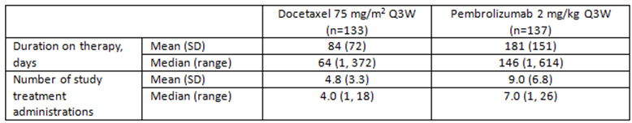

Table 5: KEYNOTE-010 trial patients with PD-L1 > 1% to < 50%
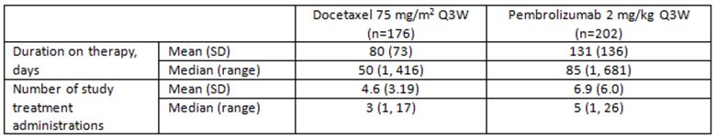

Table 6: Supportive KEYNOTE-001 trial summary of drug exposure all subjects with NSCLC by dose (All subjects as treated)
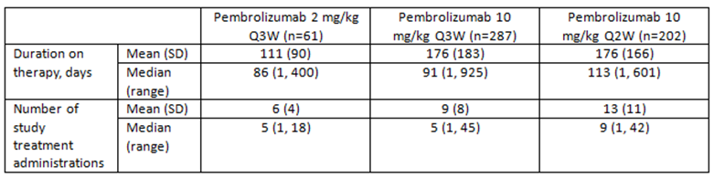

Safety issues with the potential for major regulatory impact

Pre-specified adverse events
The sponsor pre-specified events of diarrhoea, colitis, pneumonitis and thyroid dysfunction as being of most clinical interest.

Diarrhoea
Overall, for diarrhoea, the incidence among the docetaxel arm was 80 out of 309 (25.9%) as compared to 53 out of 339 (15.6%) for the pembrolizumab 2 mg/kg arm.

Colitis/ischaemic colitis
This was reported in one patient in each of the docetaxel and pembrolizumab 2 mg/kg arms in those with TPS ≥ 50%.
For those patients with TPS > 1 to < 50%, there were three events in the pembrolizumab 2 mg/kg arm as compared none in the docetaxel arm.
Of note, for patients with a TPS ≥ 50%, there was a higher incidence of constipation among patients receiving pembrolizumab 2 mg/kg 24 out of 137 (17.5%) as compared to docetaxel 16 out of 133 (12.0%).

Thyroid disorders
For patients with TPS ≥ 50%, there was a higher incidence of thyroid disorders among the pembrolizumab 2mg/kg arm (19 out of 137 (13.9%), predominately events of hypothyroidism (14 patients) and thyroiditis (2 patients), as compared to the docetaxel arm (5 out of 133 (3.8%)).
Among patients with TPS > 1% to < 50%, there were 6 out of 202 (3.0%) patients who experienced hyperthyroidism in association with pembrolizumab 2 mg/kg, whereas none occurred in those receiving docetaxel. There were 14 out of 202 patients (6.9%) in the pembrolizumab 2mg/kg arm who experienced hypothyroidism as compared to none in the docetaxel arm.

Pneumonitis
For patients with TPS ≥ 50 %, there was an increased incidence of respiratory, thoracic and mediastinal disorders in the pembrolizumab 2 mg/kg arm (75 out of 137 (54.7%)) as compared to docetaxel (64 out of 133 (48.1%)), with 8 patients (5.8%) experiencing pneumonitis in association with pembrolizumab and 2 patients (1.5%) with docetaxel.
Events of pneumonitis in the TPS > 1 to < 50% population occurred in 8 patients (4.0%) exposed to pembrolizumab 2 mg/kg and 3 patients (1.7%) exposed to docetaxel. Of the 8 pembrolizumab associated episodes, four were Grade 3 to 5.

Liver toxicity
In KEYNOTE-010 trial patients with TPS ≥ 50%, four events of hepatotoxicity were reported in each of the two pembrolizumab arms; 2.9% and 2.6% of the 2 mg/kg Q3W and 10 mg/kg Q3W arms respectively. No events were reported for patients receiving docetaxel.

Serious skin reactions
No events of toxic epidermal necrolysis or Stevens Johnson syndrome were reported in the KEYNOTE-010 trial, or in the summary of safety.

Cardiovascular safety

KEYNOTE-010 patients with PD-L1 ≥ 50%
There was a similar incidence of cardiac disorders in the docetaxel arm (8 out of 133 (6.0%)) versus the pembrolizumab 2 mg/kg arm (9 out of 137 (6.6%)).

KEYNOTE-010 patients with PD-L1 > 1% to < 50%
Eighteen events of cardiac disorder (8.9%) occurred in the pembrolizumab 2 mg/kg arm as compared to 10 in the docetaxel arm (5.7%).
The reported risk of cardiac rhythm or conduction disturbance has been discussed (please see Attachment 2).

Unwanted immunological events
The development of anti-drug antibodies (ADAs) was assessed in patients participating in KEYNOTE-001 trial parts C and F.
The majority of assessed patients were not evaluable owing to the concentration of pembrolizumab being above that tolerated for the ADA test. Overall 16 patients were evaluable; 5 having received pembrolizumab 2 mg/kg and eleven having received 10 mg/kg; none of these 16 patients were reported to have developed anti-pembrolizumab antibodies. For further detail see Attachment 2.

Evaluator’s conclusions on safety
Fewer patients discontinued study drug therapy among those receiving pembrolizumab, irrespective of TPS status.
The crude incidence of adverse events was similar between patients receiving docetaxel and pembrolizumab 2 mg/kg. Investigator assessed treatment emergent adverse events showed the incidence to be lower for patients receiving pembrolizumab, and among these, was lower in those with TPS > 1 to < 50%.
The proportion of patients who died related to, and not related to study drug, were comparable between patients receiving docetaxel and pembrolizumab.
The incidence of Grade 3 to 5 adverse events was lower among patients receiving pembrolizumab; the lowest proportion occurring in the patients with TPS > 1 to < 50%.
The overall incidence of adverse effects, and events leading to study treatment discontinuation were generally lower in those patients receiving pembrolizumab as compared to docetaxel.
The reporting method of many adverse events does not lend itself to the satisfactory assessment of risk of some adverse events that may have multiple associated terms used to describe the same event. Such events include: alteration of cardiac rhythm, myocarditis/pericarditis, perforation of hollow viscera and peripheral neuropathies. The pattern of immune mediated adverse reactions as described in the product information is not comprehensive and requires expansion to comprehensively report the risks.
Identification of anti-pembrolizumab antibodies is complicated by the presence of free drug, and may be under reported as a consequence. However, among those patients who could be satisfactorily assessed, the incidence of anti-pembrolizumab antibodies was low.
In contrast to the efficacy analysis, overall the pattern of adverse effect so pembrolizumab was not substantially different between patients with a tumour proportion score dichotomised at 50%.
For the first round benefit-risk assessment, first round recommendation regarding authorisation, clinical questions and second round evaluation of clinical data submitted in response to questions, please see Attachment 2.

Second round benefit-risk assessment

Second round assessment of benefits
After consideration of the responses to clinical questions, the benefits of pembrolizumab in the proposed usage are:
- Among patients with TPS > 1%, the OS HR for pembrolizumab 2 mg/kg versus docetaxel was 0.71 (95% CI: 0.58, 0.88) with a p-value of 0.00076.
- The median OS for pembrolizumab 2 mg/kg was 10.4 months compared to 8.5 months for the docetaxel exposed patients.
- Among the patients studied, there was no apparent difference in estimates of efficacy according to the age of the specimen used to determine PD-L1 status.
The outcomes of patients with TPS 1 to 49% remain clinically important for the purposes of obtaining informed consent and enabling an assessment of likely treatment effect. The exploratory differential effect observed between patients with TPS 1 to 49% and TPS ≥ 50% described in the First round report is unchanged.

Second round assessment of risks
After consideration of the responses to clinical questions, the risks of pembrolizumab in the proposed usage are:
- The PD-L1 test characteristics have not been satisfactorily demonstrated for PD-L1 expression at a cut-off of 1%, the cut off mandated by proxy, in the sponsors proposed indication.
- Patients with TPS > 1 to < 50% do not have comparable efficacy as compared to those with a TPS ≥ 50%. There is evidence that the efficacy of pembrolizumab is not consistently superior, indeed potentially inferior, to docetaxel for patients with this degree of PD-L1 expression, as second line therapy. The median duration of OS was 0.8 months longer in patients receiving pembrolizumab, which is an inadequate duration for registration purposes. The median duration of progression free survival was 1.3 months longer for patients receiving docetaxel among patients with TPS > 1 to < 50%. In the event that the Delegate agrees to register pembrolizumab for patients with this degree of PD-L1 expression, the provision of this information in the product information would be critical for clinicians to satisfactorily formulate a decision to initiate pembrolizumab therapy and obtain informed consent.
- No patients with NSCLC were reported to have achieved a complete response from treatment with pembrolizumab.
- From the evidence presented in the dossier, for patients with TPS > 1 to < 50%, the number needed to treat with pembrolizumab, as compared to docetaxel, in order to obtain one additional event of partial response is 140.
In addition, given the risk of myasthenia gravis and peripheral neuropathy and the potential presenting symptoms should be included in the PI and Consumer Medicines Information (CMI) (each described in the FDA approved label).

Second round assessment of benefit-risk balance
The benefit-risk balance of pembrolizumab, given the proposed usage, is favourable.

Second round recommendation regarding authorisation
It is recommended to the Delegate that pembrolizumab be approved for the indication:
Keytruda is indicated for the treatment of patients with advanced non-small cell lung carcinoma (NSCLC) whose tumours express PD-L1 and who have received platinum containing chemotherapy. Patients with EGFR or ALK genomic tumour aberrations should also have received approved therapy for these aberrations prior to receiving Keytruda.

Vb. Clinical findings for Submission PM-2016-02325-1-4
A summary of the clinical findings for Submission PM-2016-02325-1-4 (first line use of pembrolizumab) is presented in this section. Further details of these clinical findings can be found in Attachment 3, the extract of the clinical evaluation report for Submission PM-2016-02325-1-4.

Introduction
Pembrolizumab is a monoclonal antibody, which targets the PD-1 receptor on activated T lymphocytes. At the time of writing, the only approved indication for the product was:
‘... as monotherapy for the treatment of unresectable or metastatic melanoma in adults’.
The proposed new indication that is the subject of this submission is:
‘Keytruda is indicated for the treatment of patients with previously untreated metastatic non-small cell lung carcinoma (NSCLC) whose tumours express PD-L1 as determined by a validated test and do not harbour a sensitizing EGFR mutation or ALK translocation [see CLINICAL TRIALS]’.
The proposed dose for the first line treatment of NSCLC is 200 mg Q3W, administered as an IV infusion over 30 minutes.
The currently approved regimen for melanoma is 2 mg/kg IV Q3W.

Clinical rationale
Non-small cell lung carcinoma (NSCLC) includes primary cancers arising from the epithelial tissues of the lung such as adenocarcinoma and squamous cell carcinoma, and excluding small cell lung cancer.
Standard first line therapy for most patients with metastatic NSCLC is cytotoxic chemotherapy with a platinum based doublet combination. Platinum agents used in Australia for first line therapy are cisplatin and carboplatin; although these drugs are not specifically registered for use in NSCLC. Other agents used in combination with platinum therapy include docetaxel, paclitaxel, albumin bound paclitaxel, pemetrexed (in subjects with non-squamous histology), vinorelbine, gemcitabine and etoposide. ,, Treatment with platinum based therapy is usually continued for 4 to 6 cycles.^{12,13} In elderly patients or those with poor performance status, single agent chemotherapy may be used for first line treatment.^{12,13}
The anti-angiogenic agent bevacizumab has been registered in Australia for the first line treatment of non-squamous forms of NSCLC, in combination with carboplatin and paclitaxel.
In subjects with tumours that have activating mutations of the epidermal growth factor receptor (EGFR), recommended first line treatment is with an EGFR tyrosine kinase inhibitor (such as gefitinib, erlotinib or afatinib).^{12,13} Such mutations occur in approximately 15% of subjects with NSCLC. For tumours with translocation of the anaplastic lymphoma kinase (ALK) gene, recommended first line therapy is with crizotinib, an inhibitor of the ALK receptor tyrosine kinase.^{12, 13} ALK rearrangements are present in approximately 3 to 5% of subjects with NSCLC. Crizotinib is also recommended for the first line treatment of tumours with translocation of the ROS1 gene.¹² The ROS1 translocation is present in approximately 1 to 2% of subjects with NSCLC.¹⁶
Pembrolizumab is a monoclonal antibody that inhibits the PD-1 receptor (also known as CD279), which is expressed on activated T lymphocytes. Stimulation of the PD-1 receptor results in an inhibitory effect on T cell function. The normal function of the PD-1 receptor is to limit or ‘check’ overstimulation of immune responses. There are two known normal ligands for PD-1: PD-L1 (also known as CD274 or B7-H1) and PD-L2 (also known as CD273 or B7-DC). The PD-L1 ligand is expressed on antigen presenting cells (APCs) and a wide range of non-haematopoietic cells, whereas PD-L2 is expressed on dendritic cells and macrophages.
PD-L1 is often highly expressed in many human cancer types, including NSCLC.¹⁶ Tumour expression of PD-L1 may result in inhibition of T cell mediated anti-tumour effects via the PD-1 receptor. The clinical rationale for PD-1 receptor blockade with pembrolizumab is to remove such inhibition.
Comment: The rationale for use of pembrolizumab in NSCLC is acceptable and is supported by the recent TGA approval of another PD-1 receptor blocker (nivolumab) for the second line treatment of NSCLC.

Related submissions
The initial submission to register pembrolizumab for the treatment of melanoma (PM-2014-01928-1-4) was approved by the TGA on 15 April 2015.
At the time of writing, a separate submission (PM-2015-04712-1-4) to extend the indications of pembrolizumab to include the second line treatment of NSCLC was under evaluation.
A submission to register another monoclonal antibody against the PD-1 receptor (nivolumab) for the second line treatment of NSCLC was approved by the TGA on 7 January 2016.¹⁹
According to the covering letter for the current submission another application (Submission PM-2016-01163-1-4) is currently under evaluation to extend the approved indications of pembrolizumab to include the treatment of squamous cell carcinoma of the head and neck.

Contents of the clinical dossier
The submission contained the following clinical information:
- A clinical study report for a single pivotal Phase III randomised controlled trial, the KEYNOTE-024 trial (also known as Study 024);
- 1 pooled analysis (from 3 pembrolizumab studies) of the relationship between systemic exposure to pembrolizumab and efficacy in the first line treatment of NSCLC;
- 1 pooled analysis (from 5 pembrolizumab studies) of the relationship between systemic exposure to pembrolizumab and the occurrence of immune related adverse events, in NSCLC and melanoma patients;
- 1 analysis of immunogenicity data from several pembrolizumab studies;
- Literature references.
The submission also included a Clinical Overview, Summary of Clinical Efficacy and Summary of Clinical Safety.

Paediatric data
There were no paediatric data in the submission.
Comment: As NSCLC is a disease of adults, the absence of paediatric data is acceptable.

Good clinical practice
The study report for the KEYNOTE-024 trial included the following assurance:
‘This trial was conducted in substantial conformance with Good Clinical Practice (GCP) requirements and applicable country and/or local statutes and regulations regarding ethical committee review, informed consent, and the protection of human subjects participating in biomedical research.’

Pharmacokinetics
No new pharmacokinetic studies were included in the submission. In the pivotal clinical study KEYNOTE-024 sparse pharmacokinetic (PK) sampling was performed in subjects in the pembrolizumab arm. Pre-dose (trough) samples were collected at Cycles 1, 2, 4 and 8 and every 8 cycles thereafter while the subject was receiving pembrolizumab. All trough samples were to be drawn within the 24 hours before the infusion. Post-dose samples were collected during Cycle 1 only; one sample within 30 minutes after end of infusion, and one sample between 72 and 168 hours post infusion.
These PK data were incorporated into a previously developed population PK model (see Attachment 3, Section 4.1.1). Simulations conducted with the model suggested that the pembrolizumab pharmacokinetics in NSCLC are similar to the pharmacokinetics in melanoma.
For further details please see Attachment 3.

Evaluator’s conclusions on pharmacokinetics
Pembrolizumab pharmacokinetic parameters in subjects with previously untreated NSCLC are similar to those previously observed in melanoma subjects.

Pharmacodynamics
No new pharmacodynamic data were included in the submission.

Dosage selection for the pivotal studies
A dose of 2 mg/kg IV Q3W had previously been established as safe and effective in advanced melanoma. In NSCLC patients in the Phase I Study KEYNOTE-001, a dose of 2 mg/kg Q3W produced a comparable response rate to that achieved with 10 mg /kg IV Q3W. In a population pharmacokinetics model, tumour load and tumour type were not found to have a significant effect on pembrolizumab pharmacokinetics and the sponsor assumed that the dynamics of PD-1 target engagement would not vary significantly with tumour type. It was therefore anticipated that a dose of 2 mg/kg IV Q3W would be safe and effective in NSCLC subjects.
A flat dose regimen (200 mg Q3W for all subjects) was chosen for Study KEYNOTE-024 based on the following considerations:
- Simulations performed with the population pharmacokinetics model of pembrolizumab showed that the fixed dose regimen of 200 mg Q3W would provide systemic exposures that were consistent with those obtained with the 2 mg/kg Q3W dose;
- A fixed dose regimen simplified dosing for health professionals and reduced the potential for dosing errors;
- A fixed dosing scheme also reduced complexity in the logistical chain at treatment facilities and reduced wastage.

Efficacy

Studies providing efficacy data
Clinical data to support the proposed new indication come from a single Phase III trial; Study KEYNOTE-024 (also known as Study 024 and the KEYNOTE-024 trial).
For the full details of the evaluation of the efficacy data please see Attachment 3.

Evaluator’s conclusions on efficacy
The efficacy data to support the new indication are adequate. However, due to lack of relevant efficacy data it is recommended that the indication be restricted to subjects with tumours that have high levels of PD-L1 expression (that is, expression in ≥ 50% of neoplastic cells). In addition, treatment should be restricted to a maximum of 35 cycles until further long term efficacy data are available.

Safety

Studies providing safety data

Pivotal KEYNOTE-024 trial
Full safety data were available from the pivotal trial, Study KEYNOTE-024. Safety monitoring included the following:
- Information on adverse events (AEs) was collected at each study visit. Adverse events were graded according to the National Cancer Institute common terminology criteria for adverse events (NCI CTCAE), Version 4 and were evaluated for seriousness, causality, and action taken with regards to trial treatment. AE terms were standardised using the Medical Dictionary for Regulatory Activities (MedDRA) Version 19.0.
The sponsor pre-identified a list of specific AE terms as adverse events of special interest (AEOSI). These AE terms covered events that were consistent with an immune phenomenon, such as pneumonitis, colitis, hypophysitis etcetera. These events were also referred to as immune related adverse events (irAEs) or events of clinical interest (ECI).
- Physical examination, including measurement of vital signs (temperature, pulse, respiratory rate, weight and blood pressure) was performed at each study visit.
- Laboratory testing (complete blood count with differential and a comprehensive chemistry panel) was performed at randomisation, at each clinic visit during the treatment phase, at the discontinuation visit and at the 30 day safety follow up visit.
- Thyroid function testing (T3, free T4 and thyroid stimulating hormone (TSH)) was performed at every second Cycle during the treatment phase and at the discontinuation visit and at the 30 day safety follow-up visit.
- Blood samples for detection of anti-pembrolizumab antibodies were collected pre-dose at Cycles 1, 2, 4, 8 and every 8 cycles thereafter while the subject was receiving pembrolizumab. Once the subject discontinued taking pembrolizumab additional samples were obtained at 1, 3 and 6 months after the last dose of study medication.
- Urinalysis was performed every 12 weeks during the treatment phase, at the discontinuation visit and at the 30 day safety follow up visit.

Other data
The sponsor included the following additional safety data in the submission:
- A pooled analysis of immunogenicity data from 7 pembrolizumab studies.
- One periodic safety update report (PSUR).

Patient exposure
Extent of exposure in is summarised below in Table 7. The median duration of exposure in the pembrolizumab arm was 214 days (7.0 months), compared to 106 days (3.5 months) in the chemotherapy arm. In the pembrolizumab arm, 87 subjects received at least 6 months of treatment and 23 subjects had received at least 12 months of treatment. No subject had received the full planned 24 months of treatment.

Table 7: KEYNOTE-024 trial, extent of exposure
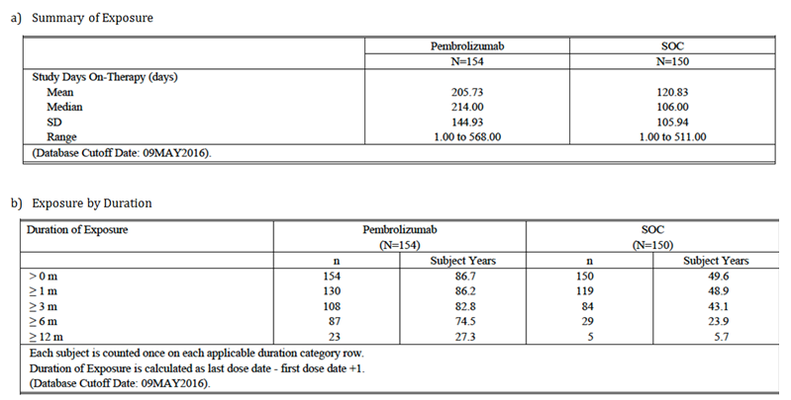

Safety issues with the potential for major regulatory impact

Liver function and liver toxicity
Immune mediated hepatitis is listed in the current PI as an adverse effect of pembrolizumab.
The incidence of liver function test (LFT) abnormalities in the KEYNOTE-024 trial is summarised in Table 19 of Attachment 3. The overall incidence of abnormalities was generally comparable in the two treatment arms. However, Grade 3 or 4 transaminase elevations occurred more frequently in the pembrolizumab arm. The protocol for the study indicated that cases of abnormal LFTs meeting Hy’s law criteria would be monitored as events of clinical interest. However, no discussion of such cases was included in the study report.

Renal function and renal toxicity
Immune mediated nephritis is listed in the current PI as an adverse effect of pembrolizumab.
In the KEYNOTE-024 trial, abnormalities in serum creatinine occurred more frequently in the chemotherapy arm (see Table 20, Attachment 3).

Other clinical chemistry
Other biochemical abnormalities occurring in the KEYNOTE-024 trial are listed in Table 21 of Attachment 3. The incidence of such abnormalities was generally similar in the two treatment arms.
Abnormal amylase/lipase was slightly more common in the pembrolizumab arm. There was 1 adverse event of pancreatitis in the pembrolizumab arm. Immune mediated pancreatitis is listed in the current PI as an adverse effect of pembrolizumab.

Haematology and haematological toxicity
Haematological laboratory abnormalities that occurred in the KEYNOTE-024 trial are summarised in Table 22, Attachment 3. Cytopaenias were much more frequent in the chemotherapy arm. Other abnormalities occurred with a similar frequency in the two arms.

Immunogenicity and immunological events
Immune mediated adverse events were common with pembrolizumab in the KEYNOTE-024 trial.
In the KEYNOTE-024 trial , treatment emergent anti-pembrolizumab antibodies developed in 6 of 140 evaluable subjects (4.3%). These subjects did not develop any adverse events of an allergic nature or any alterations in pembrolizumab pharmacokinetics.
The submission also included a pooled analysis of immunogenicity data from seven studies. This analysis is summarised in Section 8.4.8.1 of Attachment 3.

Post-marketing data
The submission included one PSUR that reviewed adverse event reports received by the sponsor over a 6 month period between 4 September 2015 and 3 March 2016. During this period, approximately 12,985 patients were exposed to marketed pembrolizumab. Cumulatively, there were approximately 22,494 patients who had been exposed to marketed pembrolizumab.
During the reporting period, there were no actions taken by regulators against the product on safety grounds.
Immune mediated myasthenia gravis was identified as a potential safety issue based on published reports of cases occurring in subjects treated with nivolumab and ipilimumab. A review of the sponsor’s safety database for pembrolizumab identified 7 spontaneous reports that could have represented cases of myasthenia gravis. However, in all 7 cases the details provided were insufficient to allow a meaningful assessment. The sponsor considered that these may have been cases of immune mediated myositis/myopathy which is an adverse reaction listed in the current PI. Another 4 potential cases were identified from clinical trials. However, there were confounding factors or inconsistencies with each of these four cases. The sponsor accepted myasthenia gravis as a potential safety risk for inclusion in the risk management program. However, a change to the prescribing information was not considered appropriate.
The sponsor also conducted an assessment of safety data related to reports of encephalitis and encephalopathy temporally associated with the administration of pembrolizumab. A total of 19 cases were identified (17 from clinical trials and 2 spontaneous reports). In most of these cases, a more plausible explanation for the event was present (for example, brain metastases, hepatic encephalopathy, alcohol abuse etcetera). Three cases had insufficient detail for an adequate assessment to be made. The sponsor concluded that there was insufficient evidence to support a causal relationship with pembrolizumab.
No other new safety issues were identified.

Evaluator’s conclusions on safety
The data from the KEYNOTE-024 trial indicate that pembrolizumab has a more favourable overall safety profile than platinum doublet chemotherapy in the first line treatment of metastatic NSCLC. The incidence of AEs and serious adverse events was comparable in the two treatment groups even though the duration of treatment in the pembrolizumab arm was approximately double that in the chemotherapy arm. Pembrolizumab treatment was associated with a lower incidence of Grade 3 to 5 AEs (53.2% versus 72.7%), discontinuations due to AEs (9.1% versus 14.0%) and drug related AEs leading to death (0.6% versus 2.0%).
The pattern of toxicity observed with pembrolizumab was consistent with that previously documented for the drug. The most common adverse events were consistent with immune mediated toxicities such as pneumonitis, colitis, thyroid dysfunction, skin disorders, hepatitis and so on. No new toxicities were identified.
Anti-pembrolizumab antibodies developed in 4.3% of subjects in the KEYNOTE-024 trial. However, these antibodies were not associated with any effects on the pharmacokinetics of the drug or with any safety concerns.
Given that metastatic NSCLC is a life-threatening condition with a poor prognosis, the safety profile of pembrolizumab is considered acceptable.

First round benefit-risk assessment

First round assessment of benefits
Table 8 (shown below) summarises the clinical evaluators assessment of benefits at the First round.

Table 8: First round assessment of benefits
Indication: First line treatment of metastatic NSCLC
Benefits | Strengths and Uncertainties
Compared with platinum doublet chemotherapy, pembrolizumab treatment was associated with:  - A significant reduction in the risk of a PFS event (hazard ratio = 0.50; 95%CI: 0.37 to 0.68; p < 0.001). Median PFS was prolonged by approximately 4.3 months (10.3 versus 6.0 months). The proportion of subjects alive and progression free at 6 months was increased from 50.3% to 62.1%;A significant reduction in the risk of death (hazard ratio = 0.60; 95%CI: 0.41 to 0.89; p = 0.005). Median survival was not reached in either group, after a median follow up of 11 months. The proportion of subjects alive at 6 months was increased from 72.4% to 80.2%, and the proportion of subjects alive at 12 months was increased from 54.2% to 69.9%.  - An increase in the ORR from 27.8% (95% CI: 20.8 to 35.7) in the chemotherapy arm to 44.8% (95% CI: 36.8 to 53.0) in the pembrolizumab arm.  - An improvement in overall quality of life and a prolongation of the time to a deterioration in symptoms (dyspnoea, cough, chest pain).  - An improved overall safety profile compared to the current standard therapy of platinum based chemotherapy, with a reduced incidence of Grade 3 to 5 AEs, discontinuations due to adverse events and drug related fatal adverse events. | Strengths:  The study was well designed and executed. The trial design complied with various EMA guidelines adopted by the TGA.  The improvements in PFS and OS were both statistically and clinically significant.  The observed benefits in PFS/OS were consistent across various subgroups of patients.  Uncertainties:  - The study excluded subjects with an ECOG PS > 1 and subjects those with significant organ dysfunction. Benefits in these subjects has not been established.  - The improvements in quality of life/symptom measures were small and of borderline clinical significance.  - Benefits have not been demonstrated in subjects who have tumours with PD-L1 expression in < 50% of neoplastic cells.  - The optimal duration of treatment with pembrolizumab has not been defined.

First round assessment of risks
Table 9 (shown below) summarises the clinical evaluators assessment of risks at the First round.

Table 9: First round assessment of risks
Risks | Strengths and Uncertainties
- Immune mediated adverse drug reactions such as pneumonitis, colitis, thyroid dysfunction, skin disorders, hepatitis etcetera  - Anti-pembrolizumab antibodies develop in 4.3% of first line NSCLC subjects. | Strengths:  - No new toxicities were identified in the proposed new patient population.  - Anti-pembrolizumab antibodies were not associated with any effects on the pharmacokinetics of the drug or with any safety concerns.  Uncertainties:  - The study excluded subjects with ECOG PS > 1 and subjects those with significant organ dysfunction. Safety in these subjects has not been established.

First round assessment of benefit-risk balance
Platinum based chemotherapy, as the current standard of treatment in the first line treatment of metastatic NSCLC, is considered to have a favourable risk-benefit balance. Pembrolizumab has improved efficacy and an improved overall safety profile compared with platinum based chemotherapy. It can therefore be concluded that risk-benefit balance of pembrolizumab for the first line treatment of NSCLC is favourable.

First round recommendation regarding authorisation
It is recommended that pembrolizumab be approved for the first line treatment of NSCLC. However, it is recommended that the indication should be revised as follows:
‘Keytruda is indicated for the treatment of patients with previously untreated metastatic non-small cell lung carcinoma (NSCLC) whose tumours express PD-L1 in ≥ 50% of neoplastic cells as determined by a validated test and do not harbour a sensitizing EGFR mutation or ALK translocation [see CLINICAL TRIALS].’
It is also recommended that the duration of pembrolizumab treatment be restricted to 24 months.

Clinical questions
For the clinical questions please see Attachment 3. As this submission was an expedited review there was no Second round clinical evaluation, the issues raised and the second round evaluation of the clinical data submitted in responses to the questions have been addressed by the Delegate in the overview of the two submissions (see Overall conclusion and risk/benefit assessment).

VI. Pharmacovigilance findings

Risk management plan
Note at the time the submissions were considered the Risk Management Plan (RMP) evaluation for Submission PM-2016-02325-1-4 (the use of Keytruda as first line treatment for NSCLC) took into account the RMP submitted for the earlier Submission PM-2015-04712-1-4). Therefore the report provided in this AusPAR will be that written for the later Submission PM-2016-02325-1-4.
The sponsor submitted a RMP version 10.0; dated 20 September 2016; DLP 27 June 2016 and Australian Specific Annex (ASA) Round 1 version 6.0; dated 17 January 2017 which was reviewed by the RMP evaluator.

Summary
- The sponsor has applied to extend the indications of pembrolizumab (Keytruda) to include ‘first-line treatment of patients with metastatic non-small cell lung carcinoma (NSCLC) whose tumours express PD-L1 with a ≥ 50 % tumour proportion score (TPS) as determined by a validated test, with no EGFR mutation or ALK genomic tumour aberrations’, (first line NSCLC) proposing a new fixed dosage of 200 mg Q3W administered intravenously over 30 minutes.
- This evaluation considers the most recent RMP for Keytruda submitted to the TGA by the sponsor: Core-RMP version 10.0 (dated 20 September 2016; DLP 27 June 2016) and ASA v6.0 (dated 17 January 2017). The most recent available EU RMP version 3.3 (dated 22 June 2016, DLP 30 September 2015) has been referred to where appropriate.
- The proposed Summary of Safety Concerns and their associated risk monitoring and mitigation strategies are summarised below in Table 10.
Table 10: Summary of safety concerns
Summary of safety concerns (ASA version 6.0) |  | Pharmacovigilanc |  | Risk Minimisation
 |  | Routine | Additional | Routine | Additional
Important identified risks | Immune mediated pneumonitis |  | ¹ |  | ²
Important identified risks | Immune mediated colitis |  | ¹ |  | ²
Important identified risks | Immune mediated hepatitis |  | ¹ |  | ²
Important identified risks | Immune mediated nephritis |  | ¹ |  | ²
Important identified risks | Immune mediated endocrinopathies:  - Hypophysitis (including hypopituitarism and secondary adrenal insufficiency)  - Thyroid disorder (hypothyroidism, hyperthyroidism, thyroiditis)  - Type 1 diabetes mellitus |  | ¹ |  | ²
Important identified risks | Other immune mediated adverse reactions:  - Uveitis  - Myositis  - Guillane-barre syndrome  - Pancreatitis  - Severe skin reactions |  | ¹ |  | ²
Important identified risks | Infusion-related reactions |  | ¹ |  | ²
Important potential risks | Immune mediated adverse events  - Myasthenic syndrome  - For haematological malignancies: increased risk of severe complications of allogenic stem cell transplantation in patients who have previously received pembrolizumab³ |  | ¹ |  | –
Important potential risks | Immunogenicity |  | – |  | –
Missing information | Safety in patients with moderate or severe hepatic impairment |  | – |  | –
Missing information | Safety in patients with severe renal impairment |  | – |  | –
Missing information | Safety in patients with active systemic autoimmune disease |  | – |  | –
Missing information | Safety in patients with HIV or Hepatitis B or Hepatitis C |  | – |  | –
Missing information | Safety in paediatric patients |  | ¹ |  | -
Missing information | Reproductive and lactation data |  |  |  | -
Missing information | Long term safety data |  | ¹ |  | -
Missing information | Safety in various ethnic groups |  | ¹ |  | -
Missing information | Potential pharmacodynamic interaction with systemic immunosuppressants |  | - |  | -
1) Described in the core RMP; 2) Described in the ASA as an Australian-specific activity; 3) this safety concern has been added to version 10 of the Core RMP, which includes additional indications that are currently under evaluation. This safety concern is not relevant to the currently approved indication, or the NSCLC indication being sought in the current application.
- Three (3) changes to the safety concerns are recommended [see Outstanding Recommendations (1 and 2) and Recommendation 2 below].
- The additional pharmacovigilance activities, as described in the Core RMP, involve the monitoring and analysis of safety data from the ongoing trials (both from trials studying the approved indications and from exploratory efficacy trials)
- Additional risk minimisation activities are currently being conducted for Keytruda, and will continue for the proposed indication. These materials are appended to the ASA and include:
  - Patient alert cards
  - Patient educational materials
  - Health Care Provider (HCP) educational materials.

New recommendations (Round 1: PM-2016-02325-1-4)
These recommendations should be addressed by the sponsor in the response.

Recommendation 1
The sponsor should update the immunogenicity and gastrointestinal perforation data in the ASA.

Recommendation 2
The sponsor should include encephalitis as an important potential risk in the summary of safety concerns within ‘Immune-mediated adverse events’ or provide acceptable justification for its omission.

Recommendation 3
The sponsor should provide access to the Keytruda health care professional (HCP) and patient websites/ online risk minimisation materials for review.

Unresolved recommendations in the concurrent RMP evaluations
These recommendations are listed here for completeness:

Recommendations in the concurrent Submission PM-2015-04712-1-4 (second line treatment for NSCLC)
The following changes to the safety concerns were recommended in the evaluation of the related Submission PM-2015-04712-1-4 (extension of indications to previously treated advanced (second line) NSCLC), and are considered unresolved and outstanding. These recommendations and the sponsor’s previous responses will be reconciled with consideration of the advice received from Advisory Committee for Medicines (ACM).

Outstanding recommendation 1
‘Other Immune-mediated adverse event: myasthenic syndrome’ should be considered as an important identified risk in the summary of safety concerns in the ASA.

Outstanding recommendation 2
‘Other Immune-mediated adverse events: myocarditis’ should be included in the summary of safety concerns in the ASA as an important identified risk.

Recommendations in the concurrent Submission PM-2016-01163-1-4 (second line treatment for head and neck squamous cell carcinoma (HNSCC))
The following changes were recommended in the evaluation of the related Submission PM-2016-01163-1-4 (extension of indications to include second line treatment of HNSCC):

Recommendation 1
The Consumer Medicine Information (CMI) should be revised as recommended (in the evaluation of Submission PM-2016-01163-1-4 (second line HNSCC)) with respect to:
- ‘What Keytruda is used for’ to make the note more readable; and
- appropriate wording for the signs and symptoms of pancreatitis.

Outstanding commitment from previous evaluations
The sponsor has committed to revising the education materials prior to the launch of the indication.

VII. Overall conclusion and risk/benefit assessment
The submission was summarised in the following Delegate’s overview and recommendations.
The Delegate’s overview encompasses two submissions; there are therefore two Clinical Evaluation Reports. CER-1L refers to the report for Submission PM-2016-02325-1-4 (First line NSCLC (see Attachment 3)); and CER-2L refers to the report for Submission PM-2015-04712-1-4 (Second line NSCLC (see Attachment 2)).

Background
Pembrolizumab is a monoclonal antibody against PD-1, and functions as a ‘checkpoint inhibitor’; releasing the brakes on anti-tumour immunity (while also predisposing to autoimmune toxicity). It is approved for use in unresectable or metastatic melanoma in Australia, and for that and other uses in the USA (including those uses proposed in the submissions under review here).
Non-small cell lung cancer (NSCLC) is an area of unmet need, although nivolumab (also an anti-PD-1 monoclonal antibody (mAb)) is approved as a second line agent in advanced NSCLC. Nivolumab is approved in ‘all comers’ with respect to PD-L1 expression on tumour specimens, while in the submissions under review here, the sponsor requests approval of pembrolizumab in NSCLC subjects whose tumours express PD-L1 (with strong expression required in first line NSCLC, and ‘any’ positive staining required in second line NSCLC).

Quality
There was no requirement for a quality evaluation in a submission of this type.

Nonclinical
There was no requirement for a nonclinical evaluation in a submission of this type.

Non-small cell lung cancer (NSCLC)
The two major types of lung cancer are small cell lung cancer and non-small cell lung cancer (NSCLC; approximately 81% of lung cancers). 6% of lung cancer originates from other cell types. The WHO/IASLC histological classification of NSCLC is:
- Squamous cell carcinoma (20% of lung cancers; approximately 25% of NSCLC)
- Adenocarcinoma (38% of lung cancers; approximately 47% of NSCLC)
- Large cell carcinoma (5% of lung cancers; approximately 6% of NSCLC)
- Other (18% of lung cancers; approximately 22% of NSCLC)
Choice of initial therapy for advanced disease depends on histology and also:
- extent of disease (for example number and site of metastases);
- presence of symptoms related to a specific metastatic site;
- presence of driver mutations (for example EGFR; ALK; ROS1); and
- the patient’s overall condition and co-morbidities
Influences on choice of subsequent therapy for advanced disease are similar. One other factor is the choice of prior treatment (that is, the need for a non cross resistant approach).
Treatment of advanced NSCLC aims to prolong survival and maintain quality of life, while minimising side effects of treatment. Almost all patients with advanced NSCLC eventually develop progressive disease.
Treatment of advanced NSCLC involves surgery, radiotherapy and/or chemotherapy. In local guidelines (Cancer Council Australia), each stage (I to IV) of NSCLC is divided into ‘operable’ and ‘non-operable’. Surgery may not be possible due to comorbidity, poor lung function, tumour location or patient choice.

Recent therapeutic advances
Nivolumab (Opdivo) (another anti-PD-1 monoclonal antibody) is approved for use in second line NSCLC patients as follows:
‘Opdivo, as monotherapy is indicated for the treatment of locally advanced or metastatic squamous non-small cell lung cancer (NSCLC) with progression on or after prior chemotherapy.
Opdivo, as monotherapy is indicated for the treatment of locally advanced or metastatic non squamous non-small cell lung cancer (NSCLC) with progression on or after prior chemotherapy. In patients with tumour EGFR or ALK genomic aberrations, Opdivo should be used after progression on or after targeted therapy.’
Based on the nivolumab PI/AusPAR, the following randomised control trials supported these approvals:
Table 11: Nivolumab randomised clinical trials
 | Study | Outcomes (nivolumab versus docetaxel)
Squamous NSCLC | CA209017  Nivolumab versus docetaxel in previously treated SQ NSCLC (one prior platinum doublet based regimen) | OS HR 0.59 (95% CI 0.43, 0.81), median 9.2 versus 6.0 months; similar survival regardless of PD-L1 status using 1%, 5%, 10% cut offs  PFS HR 0.62 (95% CI 0.47, 0.81), median 3.5 versus 2.8 months  ORR 20% versus 8.8%
Non-squamous NSCLC | CA209057  Nivolumab versus docetaxel in previously treated non-squamous (NSQ) NSCLC  (one prior regimen, with additional TKI therapy for known EGFR or ALK aberrations) | OS HR 0.73 (95% CI 0.59, 0.89), median 12.2 versus 9.4 months.  OS HR was 0.59 in PD-L1 positive (1% cut off), and 0.90 for PD-L1 negative. The difference was more pronounced with a 10% cut off (OS HRs 0.40 and 1.00 respectively).  PFS HR 0.92 (95% CI 0.77, 1.11), median 2.3 versus 4.2 months.  ORR 19.2% versus 12.4%.
A key study for nivolumab in first line NSCLC, CheckMate 026, did not indicate benefit over standard of care. In 423 patients with ≥ 5% PD-L1 tumour expression, the PFS HR was 1.15 and the OS HR was 1.02, relative to platinum based doublet therapy.
Hellmann et al., (2016) have published results of Phase I Study CheckMate 012, where nivolumab + ipilimumab was tested in 77 Stage IIIB to IV, chemotherapy naïve NSCLC patients. Confirmed ORRs were 38 to 47% in all comers across two dose regimens: 57% in PD-L1 positive subjects and 12 to 35% in PD-L1 negative subjects. This use is not approved.
Targeted therapies have emerged against tumours with specific driver mutations. For example, ALK positive disease can be treated with crizotinib and ceritinib; EGFR positive disease can be treated with gefitinib, afatinib, erlotinib and/or osimertinib.

Pembrolizumab
Pembrolizumab was approved for use in unresectable or metastatic melanoma by the TGA in April 2015, and has Pharmaceutical Benefits Scheme (PBS) listing for unresectable Stage III or Stage IV melanoma.
Pembrolizumab has a large clinical development programme, and there are multiple active applications currently, including Submissions PM-2015-4712-1-4 and PM-2016-2325-1-4 and:
- Submission PM-2016-01163-1-4 (SCC of the head and neck, (HNSCC)) (approved 20 March 2017)
- Submission PM-2016-02736-1-4 (classical Hodgkin’s Lymphoma)(approved 1 September 2017)
- Submission PM-2016-03169-1-4 (flat dosing in melanoma) (approved 14 November 2017)
- Submission PM-2016-03924-1-4 (flat dosing in NSCLC) (approved 9 January 2018)
- Submission PM-2016-04328-1-4 (urothelial carcinoma) (approved 9 January 2018)

Regulatory guidelines
The TGA has adopted the EU Guideline on evaluation of anticancer medicinal products, EMA/CHMP/205/95/Rev.4 (and relevant appendices). Some other EU guidelines are TGA adopted and relevant, for example ‘Points to consider on application with 1) meta-analysis; 2) single pivotal study’ (CPMP/EWP/2330/99). Guidelines are not legally binding, but variations from their recommendations may suggest the need for scrutiny of particular quality, efficacy and/or safety issues.

Regulation; overseas status

USA; FDA (checked 2 December 2016)
Pembrolizumab has the following indications:
Keytruda is a programmed death receptor-1 (PD-1)-blocking antibody indicated for the treatment of:
‘Patients with unresectable or metastatic melanoma. (1.1)
Patients with metastatic NSCLC whose tumours have high PD-L1 expression [(Tumor Proportion Score (TPS) ≥ 50%)] as determined by an FDA-approved test, with no EGFR or ALK genomic tumour aberrations, and no prior systemic chemotherapy treatment for metastatic NSCLC. (1.2)
Patients with metastatic NSCLC whose tumours express PD-L1 (TPS ≥ 1%) as determined by an FDA-approved test, with disease progression on or after platinum containing chemotherapy. Patients with EGFR or ALK genomic tumour aberrations should have disease progression on FDA-approved therapy for these aberrations prior to receiving Keytruda. (1.2)
Patients with recurrent or metastatic HNSCC with disease progression on or after platinum containing chemotherapy. This indication is approved under accelerated approval based on tumor response rate and durability of response. Continued approval for this indication may be contingent upon verification and description of clinical benefit in the confirmatory trials. (1.3)’.
For second line NSCLC, accelerated approval was granted on 2 October 2015 supported by the KEYNOTE-001 trial. Conversion to full approval was granted on 24 October 2016 supported by the KEYNOTE-010 trial.
Approval for first line NSCLC was given on 24 October 2016 supported by the KEYNOTE-024 trial. Final results of the KEYNOTE-024 trial are to be submitted by June 2018.(ref: post-marketing commitment 3127-1).
Also, final results of the KEYNOTE-042 trial are to be submitted by December 2018. The KEYNOTE-042 trial is described as: ‘A randomised, open label, Phase III Study of overall survival comparing pembrolizumab (MK-3475) versus platinum based chemotherapy in treatment naïve subjects with PD-L1 positive advanced or metastatic non-small cell lung cancer’. This implies that patients with PD-L1 positive (not just strongly positive) tumours are being studied; and that patients with advanced NSCLC not just metastatic (that is not just Stage IV disease) may be under study.

EU; EMA (checked 2 December 2016)
Pembrolizumab is approved for the following uses:
‘Keytruda as monotherapy is indicated for the treatment of advanced (unresectable or metastatic) melanoma in adults.
Keytruda is indicated for the treatment of locally advanced or metastatic non-small cell lung carcinoma (NSCLC) in adults whose tumours express PD-L1 and who have received at least one prior chemotherapy regimen. Patients with EGFR or ALK positive tumour mutations should also have received approved therapy for these mutations prior to receiving Keytruda.’

Clinical evaluation for Submission PM-2015-04712-1-4
Data included in the dossier are listed in Attachment 2, pages 8 and 9. The dossier included the pivotal KEYNOTE-010 trial and the supportive KEYNOTE-001 trial. A population pharmacokinetics analysis was updated to included studies in NSCLC.

Clinical evaluator’s recommendation
It is recommended to the Delegate that pembrolizumab be approved for the indication:
‘Keytruda is indicated for the treatment of patients with advanced non-small cell lung carcinoma (NSCLC) whose tumours express PD-L1 and who have received platinum containing chemotherapy. Patients with EGFR or ALK genomic tumour aberrations should also have received approved therapy for these aberrations prior to receiving Keytruda’.

Pharmacology
Information in the dossier did not substantially change the understanding of the pharmacokinetics for pembrolizumab CER^{2L} (see Attachment 2, pages 11 and 39).

Efficacy

The KEYNOTE-010 trial
This pivotal trial is described and evaluated in Attachment 2; Section 7. The data cut off used in the CSR was 30 September 2015.
Assessed were 1034 patients with NSCLC with PD-L1 positive tumours who had experienced disease progression after platinum containing systemic therapy were randomised into one of three groups, and given treatment every three weeks (Q3W):
- pembrolizumab 2 mg/kg (n = 345)
- pembrolizumab 10 mg/kg (n = 346)
- docetaxel 75 mg/m² (n = 343).
PD-L1 positivity (using the Clinical Trial Assay, (CTA)) was classed as:
- strongly positive (TPS ≥ 50%); or
- weakly positive (TPS 1 to 49%).
The 1034 patients included 442 (42.8%) with strongly positive tumours (see Attachment 2; pages 18 and 19 (Section 7.1.1.1.9)).
The co-primary efficacy endpoints were OS and PFS. Implicit in the plan to address multiplicity of testing (see Attachment 2, page 18, Figure 3) was the primacy of the PD-L1 ‘strongly positive’ group. ORR and duration of response (DoR) were secondary endpoints. Patient reported outcomes (PROs) were studied, but compliance with reporting was an issue (see Attachment 2, pages 29 and 30).
Attachment 2 Table 5 sets out baseline characteristics: 18% were never smokers; 91% had metastatic disease; 15% had brain metastases; 21.5% had squamous histology and 70% non-squamous histology; 8.3% had EGFR mutant tumours (14% had prior EGFR TKI therapy); 0.8% had ALK translocated tumours (1.0% had prior ALK inhibitor therapy); 69% had prior first line systemic therapy and 20% had prior 2L systemic therapy.

Efficacy outcomes
In the ‘strongly positive’ subgroup:
  - Overall survival was superior for pembrolizumab, with HR relative to docetaxel being 0.54 (95% CI 0.38 to 0.77) for 2 mg/kg Q3W and 0.50 (95% CI 0.36 to 0.70) for 10 mg/kg Q3W. Median OS was 8.2 months for docetaxel, 14.9 months for 2 mg/kg Q3W and 17.3 months for 10 mg/kg Q3W. A Kaplan-Meier curve is presented (see Attachment 2, Figure 4).
- There was a similar HR (0.58 for the 2 mg/kg Q3W arm versus docetaxel) when PFS was studied (see Attachment 2, Figure 7); the median PFS was 4.1 months for docetaxel, 5.2 months for both pembrolizumab arms.
- There was a large difference in ORR favouring pembrolizumab arms over docetaxel (approximately 30% versus 8% (see Attachment 2, Table 9)), and disease progression rate was in the same range across arms (23 to 30%). Duration of response (DoR) was clearly better in pembrolizumab arms (median DoR not reached) than in the docetaxel arm (median DoR 8.1 months according to the IRC assessment using RECIST 1.1).
All studied subgroups showed OS benefit for pembrolizumab over docetaxel (the two pembrolizumab arms were pooled). There was little difference for ‘current/ex-smoker versus never smoker’. For squamous histology the HR for OS was 0.73; for adenocarcinoma the HR for OS was 0.47. For EGFR mutant, the HR for OS was 0.71, and for EGFR wild type (WT), the HR for OS was 0.54 (see Attachment 2, Section 7.1.1.12, where confidence intervals are also shown).
In a further analysis (see Attachment 2, Figure 5) in the TPS ≥ 50% subgroup, an effect of histology was more apparent for OS (squamous histology, HR 0.92; adenocarcinoma, HR 0.49). In this analysis, the pembrolizumab arms were not pooled, that is, HRs reflect the comparison between docetaxel and pembrolizumab 2 mg/kg Q3W (in the Intention to Treat (ITT) cohort). However, no effect of histology was seen in the TPS 1 to 49% group (see Figure 1, below).
Figure 1. Forest plot of OS HR by subgroup factors, pembrolizumab 2 mg/kg Q3W versus docetaxel TPS = 1 - 49% ITT
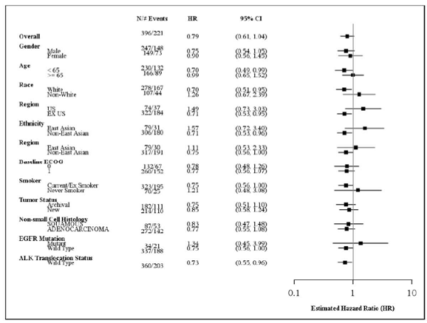
In the ‘weakly positive’ subgroup (see Attachment 2, page 25):
- The HR for OS relative to docetaxel was 0.79 (95% CI 0.61 to 1.04) for 2 mg/kg Q3W and 0.71 (95% CI 0.53 to 0.94) for 10 mg/kg Q3W. Median OS was 8.6 months for docetaxel, 9.4 months for 2 mg/kg Q3W and 10.8 months for 10 mg/kg Q3W.
- There was no advantage in HR versus docetaxel when PFS was studied; for 2 mg/kg Q3W, the HR was 1.07 (95% CI 0.85 to 1.34), and for 10 mg/kg Q3W, the HR was 0.99 (95% CI 0.78 to 1.25); median PFS was 3.9 months (docetaxel), 3.1 months (2 mg/kg Q3W) and 2.3 months (10 mg/kg Q3W).
- There was no difference in ORR across arms (all approximately 10%). Duration of response was better in the two pembrolizumab arms than for docetaxel (median 45 to 46 weeks, versus 26 weeks, based on IRC assessment using RECIST 1.1).
- Proportion of patients with progressive disease as the best objective response was 28% for docetaxel (similar to the rate in the strongly PD-L1 positive subgroup) versus 39 to 41% for pembrolizumab arms. Outcomes in the KEYNOTE-001 trial were similar to these outcomes in pembrolizumab arms. The PFS Kaplan-Meier curve (see Attachment 2, Figure 8) does not indicate acceleration in progression (versus docetaxel).

The KEYNOTE-001 trial
This supportive study investigated multiple cohorts, as described from Attachment 2, Section 7.1.2. In brief (refer also to Attachment 2, Figure 9):
- Part C studied 41 NSCLC patients who had disease progression after two lines of systemic therapy;
- Part F-1 studied 103 non-squamous NSCLC patients previously untreated for systemic disease and with PD-L1 positive tumours;
- Part F-2 studied 361 NSCLC patients who had disease progression after at least one line of systemic therapy (mostly with PD-L1 positive tumours);
- Part F-3 studied NSCLC patients who had disease progression after at least one line of systemic therapy and with PD-L1 positive tumours.
Patients received pembrolizumab 10 mg/kg Q3W, 2 mg/kg Q3W or 10 mg/kg Q2W; in some cohorts there was randomisation to different dose regimens.
The main objective was to assess ORR in patients with ≥ 1 prior systemic therapy and with strongly positive PD-L1 tumour expression. ORR outcomes were broadly similar to those in the KEYNOTE-010 trial, in that patients with strongly positive tumours had a much better response rate than those with weakly positive tumours. Table 12 (shown below) is instructive.
Table 12: Summary of best overall response based on IRC assessment per RECIST 1.1 with confirmation. Total combined efficacy population by PS category (full analysis set by IRC with evaluable PD-L1 expression)
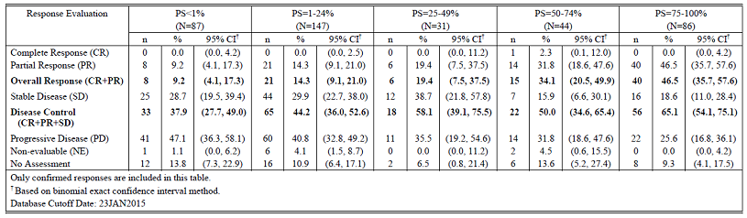
There was a weak suggestion that in patients with lower levels of tumour PD-L1 expression, higher dosing produced slightly better ORRs (see Attachment 2, Table 18). There was no suggestion of this in the KEYNOTE-010 trial, based on ORRs (see Attachment 2, Table 11).
There was also a trend towards a higher proportion of patients with progressive disease as the best objective response with decreasing expression of PD-L1 (see Table 12, above) with outcomes consistent with those in the KEYNOTE-010 trial, that is, disease progression was seen in the KEYNOTE-001 trial in 26 to 32% of subjects with ≥ 50% tumour expression of PD-L1, but 36 to 41% of those with 1 to 49% expression.

Safety
Exposure to pembrolizumab is described in Attachment 2, Section 8.3. In the KEYNOTE-010 trial, the median duration of treatment was much higher for pembrolizumab than for docetaxel.

The KEYNOTE-010 trial
A summary of adverse events by broad category for all patients in the all patients as treated (APaT) population, that is, all randomised subjects who received at least one dose of drug (that is, not subgrouped by PD-L1 status) is shown in Table 13, below (copied from the CSR). Note, only 309 out of 343 docetaxel subjects were in the APaT population, suggesting some patients withdrew early in this open label trial.
Table 13: KEYNOTE-010 trial; Summary of adverse events by broad category
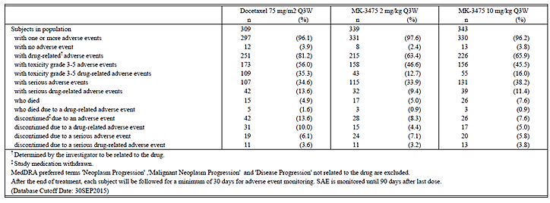
A summary of the more common adverse events (copied from the KEYNOTE-010 trial CSR) is shown below in Table 14.
Table 14. KEYNOTE-010 trial; Adverse events (incidence ≥ 10% in one or more treatment groups), APaT population (TPS ≥ 1%)
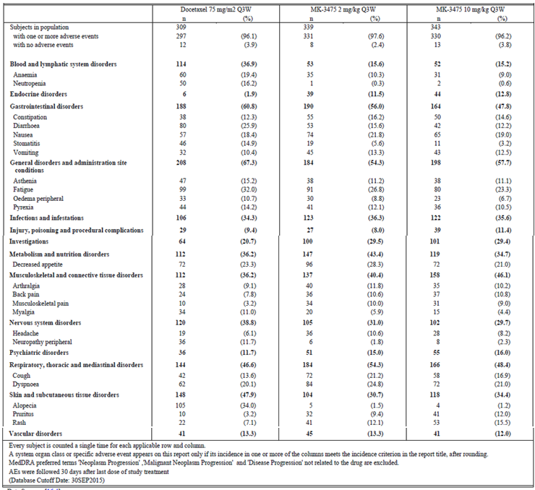
The two approaches (docetaxel versus pembrolizumab) have distinct safety profiles, consistent with the known safety profile of each drug. Incidences noted below should be interpreted in the context of a quite different duration of exposure for each arm. For simplicity, the 10 mg/kg pembrolizumab arm is not reported below. Many adverse events are from a table of the CSR and not included in Table 14 above.
- Pneumonitis was reported in 4.4% (pembrolizumab) versus 1.3% (docetaxel). The adverse event of dyspnoea was not clearly imbalanced, but there were more reports of cough in the pembrolizumab arm (21.2% versus 13.6%). Chronic obstructive pulmonary disease (COPD) was also imbalanced (2.7% versus 0.6%).
- Colitis (including ischaemic colitis) was reported in 1.2% (pembrolizumab) versus 0.3% (docetaxel), but diarrhoea was reported in 15.6% versus 25.9% respectively.
- Transaminitis (elevated aspartate transaminase (AST) or alanine transaminase (ALT)) was more common with pembrolizumab (5.0 to 7.1%) than docetaxel (1.3%). There were adverse events of autoimmune hepatitis, hepatic failure, hepatocellular injury and hepatotoxicity in pembrolizumab arms, but not in the docetaxel arm.
- Increased creatinine was more common with pembrolizumab (5.3% versus 1.3%). Acute kidney injury (1.5% versus 0.6%) and renal failure (0.9% versus 0%) were also imbalanced.
- Hypothyroidism (8.3% versus 0.3%) and hyperthyroidism (3.5% versus 1.0%) were reported more commonly with pembrolizumab.
- Adrenal insufficiency was reported in 0.6% (pembrolizumab) versus 0% (docetaxel).
- Hypopituitarism (or the term hypothalamo-pituitary disorder) was reported in three patients receiving pembrolizumab across both arms, and in no docetaxel patients.
- Imbalances in myalgia (5.9% pembrolizumab versus 11% docetaxel) and musculoskeletal pain (3.2% versus 10%) trended in different directions.
- Pancreatitis (including acute pancreatitis) was reported in 0.9% versus 0%.
- Rash, including maculopapular rash (14.2% versus 7.1%) and pruritus (9.4% versus 3.2%) were commoner with pembrolizumab but the adverse event of dry skin was not (2.9% versus 2.6%). There were no reports of serious skin reactions.
- Anaemia/neutropaenia/febrile neutropaenia, fatigue/asthenia/malaise, dysgeusia, alopecia, stomatitis, increased lacrimation and peripheral neuropathy were reported more commonly with docetaxel.
- Pyrexia was not increased with pembrolizumab versus docetaxel. Overall frequency of infection was similar across arms.
- Haemoptysis was reported in 6 to 7% across arms.
- Hyponatraemia was more common in the pembrolizumab arm (3.8% versus 1.0%).
- Decreased weight was more common in the pembrolizumab arm (8.0% versus 2.9%).
Question for sponsor: With reference to the KEYNOTE-010 trial, please explain the imbalance across arms in the AEs of ‘hyponatraemia’ and ‘decreased weight’.
Modestly lower frequencies of some categories of adverse event (for example serious adverse events) were observed in the 1 to 49% PD-L1 expression subgroup of the pembrolizumab 2 mg/kg Q3W arm (Attachment 2, Table 31) than the > 50% PD-L1 expression subgroup; although the 1 to 49% PD-L1 expression subgroup had overall less exposure to study drug than the ≥ 50% PD-L1 expression subgroup (exposure is described in Attachment 2, Section 8.3).
The sponsor provided an integrated summary of safety, including 2,799 patients in melanoma and NSCLC Studies PN001, PN002, PN006 and PN010 (see Attachment 2, Section 8.5).
The evaluator noted some areas where the PI could be improved but overall the pattern of toxicity for pembrolizumab was in keeping with its known safety profile.

Immunogenicity
Data concerning immunogenicity are described in Attachment 2 (Section 8.6.5); 19 out of 1,087 subjects had treatment emergent ADAs and 16 out of 19 subjects had NSCLC, that is, ADAs appear more common in NSCLC than melanoma patients. However, no functional effects of these ADAs were seen. Analysis was hamstrung by pembrolizumab interference with the antibody assays, meaning results were inconclusive for many subjects (see Attachment 2 Table 34).

Clinical evaluation for Submission PM-2016-02325-1-4
For the presentation of the clinical evaluation for the first line treatment of NSCLC, Submission PM-2016-02325-1-4, please see Attachment 3.

Clinical evaluator’s recommendation
The clinical evaluator recommended approval of a modified indication:
‘Keytruda is indicated for the treatment of patients with previously untreated metastatic non-small cell lung carcinoma (NSCLC) whose tumours express PD-L1 in ≥ 50% of neoplastic cells as determined by a validated test and do not harbor a sensitizing EGFR mutation or ALK translocation [see CLINICAL TRIALS].’
See Attachment 3; Section 7.2.1.2.

Pharmacology
Pharmacokinetic issues are noted on Attachment 3; Section 4. There was sparse pharmacokinetic sampling in the pivotal KEYNOTE-024 trial; data were added to a previously developed population pharmacokinetics model. Simulation suggested the pharmacokinetics in NSCLC are similar to the pharmacokinetics in melanoma.
The rationale for using a fixed 200 mg Q3W dose in the KEYNOTE-024 trial is noted in Attachment 3, Section 6. A 200 mg flat dose will increase systemic exposure relative to 2 mg/kg dosing, for the majority of subjects (see Table 15, below); on the other hand, dosing with 10 mg/kg Q3W and Q2W regimens has been studied with no signal of a major increase in toxicity, and the KEYNOTE-024 trial used 200 mg flat dosing, with no suggestion of increased toxicity.

Table 15: Median (90% prediction interval) exposure parameters of pembrolizumab at steady state of regimens of 2 mg/kg Q3W, 200 mg Q3W, 10 mg/kg Q3W and 10 mg/kg Q2W
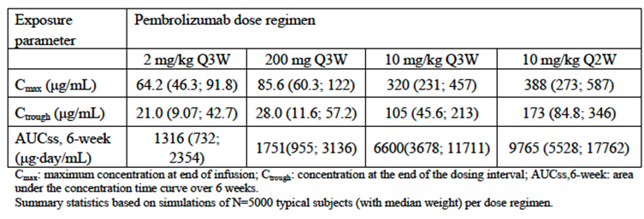

Efficacy

The KEYNOTE-024 trial
This is evaluated in Attachment 3, Section 7.
A CSR dated 11 July 2016 was considered which used a database lock of 3 June 2016. The study was stopped at that date per external Data Monitoring Committee’s recommendation ‘based on the totality of data’.
The study assessed 305 subjects with previously untreated, Stage IV, PD-L1 strong (TPS ≥ 50%) NSCLC were randomised 1:1 to pembrolizumab (200 mg Q3W) or standard of care (SOC) platinum based chemotherapy. Five SOC approaches were allowed:
- Pemetrexed 500 mg/m² Q3W and carboplatin area under the curve (AUC) 5 to 6 mg/mL/min Q3W on Day 1 for 4 to 6 cycles followed by optional pemetrexed 500 mg/m² Q3W (this arm was permitted for non-squamous histologies only):
  - 66 Non-squamous (NSQ) subjects treated with pemetrexed and carboplatin; 28 of these 66 subjects also received pemetrexed maintenance.
- Pemetrexed 500 mg/m² Q3W and cisplatin 75 mg/m² Q3W on Day 1 for 4 to 6 cycles followed by optional pemetrexed 500 mg/m² Q3W (this arm was permitted for non-squamous histologies only):
  - 36 NSQ subjects treated with pemetrexed and cisplatin; 18 of these 36 subjects also received pemetrexed maintenance.
- Gemcitabine 1250 mg/m² at Days 1 and 8 and cisplatin 75 mg/m² Q3W on Day 1 for 4 to 6 cycles:
  - 4 NSQ subjects treated.
  - 7 squamous (SQ) subjects treated.
- Gemcitabine 1,250 mg/m² at Days 1 and 8 and carboplatin AUC 5 to 6 mg/mL/min Q3W on Day 1 for 4 to 6 cycles:
  - 5 NSQ subjects treated.
  - 15 SQ subjects treated.
- Paclitaxel 200 mg/m² Q3W and carboplatin AUC 5 to 6 mg/mL/min Q3W on Day 1 for 4 to 6 cycles followed by optional pemetrexed maintenance (pemetrexed maintenance was permitted for non-squamous histologies only):
  - 12 NSQ subjects treated with paclitaxel and carboplatin, none of these 12 subjects received pemetrexed maintenance.
  - 5 SQ subjects treated.
Subjects were not allowed to have tumours with EGFR or ALK aberrations. Randomisation was stratified by Eastern Cooperative Oncology Group (ECOG) score (0 versus 1), histology (SQ versus NSQ) and geographic region (East Asian versus other). Control arm subjects with progressive disease were allowed to cross over. Pembrolizumab was continued until progressive disease or unacceptable toxicity or until a total of 35 doses had been received.
Inclusion and exclusion criteria are detailed in Attachment 3, Section 7.2.1.2. Only patients with Stage IV disease were included and only patients who had not received systemic chemotherapy for their metastatic disease. The biopsy to assess PD-L1 was taken at the time of (or after) diagnosis of metastatic disease, from a non-irradiated site. If patients had untreated CNS metastases, they were excluded; but patients with treated and stable/asymptomatic lesions could enrol.
Interim analysis 2 (IA2) was carried out after 189 PFS events were observed by the blinded independent central radiologist (BICR) review and 108 OS events had occurred. These numbers were reached approximately 20 months after study start.
The primary objective was to compare PFS per RECIST 1.1 as assessed by BICR review.
In the study 61.3% of subjects were male; 82.3% were White; 86.9% were non-East Asian. 82% had Stage IV, non-squamous NSCLC; < 3% had prior neo-adjuvant or adjuvant chemotherapy. 65% had ECOG PS of 1 at Baseline. More ‘never smokers’ were randomised to the SOC arm (12.6%) than the pembrolizumab arm (3.2%). More subjects with baseline brain metastases were randomised to the pembrolizumab arm (11.7%) than the SOC arm (6.6%).
1,934 patients were screened to arrive at the 305 patients who were then randomised, the major reason for screen failure was not having tumours expressing PD-L1 ≥ 50% (see Table 16 of PD-L1 distribution in screened subjects, below). The sponsor has been asked to provide a breakdown of reasons for screen failure.

Table 16: KEYNOTE-024 trial; PD-L1 distribution in screened subjects
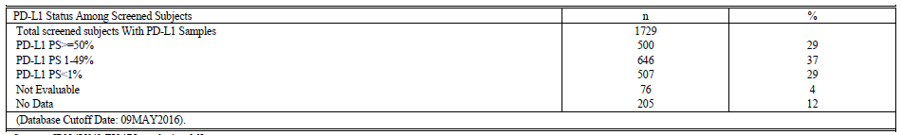
Thus only 29% of subjects had tumours strongly expressing PD-L1; and of the 29%, only approximately 60% of that subset adhered to other inclusion / exclusion criteria.
Question for sponsor: (Refer to Attachment 3, Section 7.2.1.10) Please comment on the distribution of major protocol deviations across arms, and whether any imbalances could have biased study outcomes.

Efficacy outcomes
The HR for PFS was 0.50 (95% CI 0.37 to 0.68) favouring pembrolizumab, with a median PFS of 10.3 months versus 6.0 months. The PFS curve is shown below in Figure 2.
Figure 2: Kaplan-Meier of PFS based on BICR assessment per RECIST 1.1 (Primary censoring rule; ITT Population)
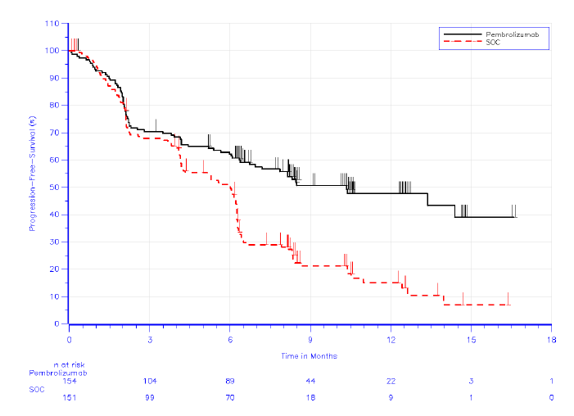
In subgroup analysis, all analysed subgroups benefited from pembrolizumab relative to SOC. The PFS benefit was more pronounced in males (HR 0.39) than females (HR 0.75); there was a similar pattern in subgroup analysis of OS (these trends were not seen in the KEYNOTE-010 trial). For patients with squamous histology, the PFS HR was 0.35. There was some variation according to which SOC was used: the HR for PFS was 0.63 in the ‘platinum/pemetrexed’ subset, versus HR 0.29 in the ‘other platinum doublets’ subset (a trend seen in the OS analysis as well).
The HR for OS was 0.60 (95% CI 0.41 to 0.89) favouring pembrolizumab, with median OS not reached in either arm. Altogether 108 out of 305 subjects had died. The OS curve is shown in Figure 3, below.
Figure 3: KEYNOTE-024 trial; Kaplan-Meier of OS (ITT Population)
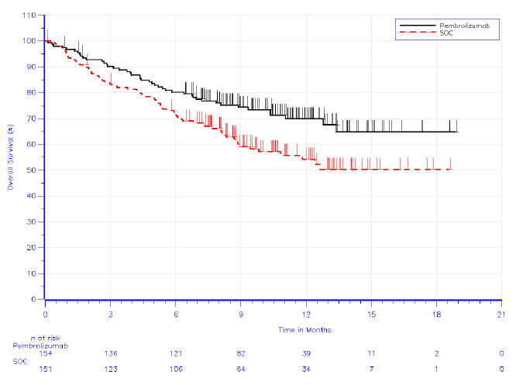
In the SOC arm, 44% of patients in the ITT population had crossed over to pembrolizumab. Subgroup analysis of OS is presented in Attachment 3, Figure 8.
ORR for pembrolizumab was 44.8%, 27.8% for SOC. Median time to response was 2.2 months in each arm. Median DoR was not reached for pembrolizumab and was 6.3 months for SOC; the survival curve for DoR is shown in Figure 4, below.
Figure 4: KEYNOTE-024 trial; Summary of DoR for Subjects with objective response based on BICR assessment (ITT Population)
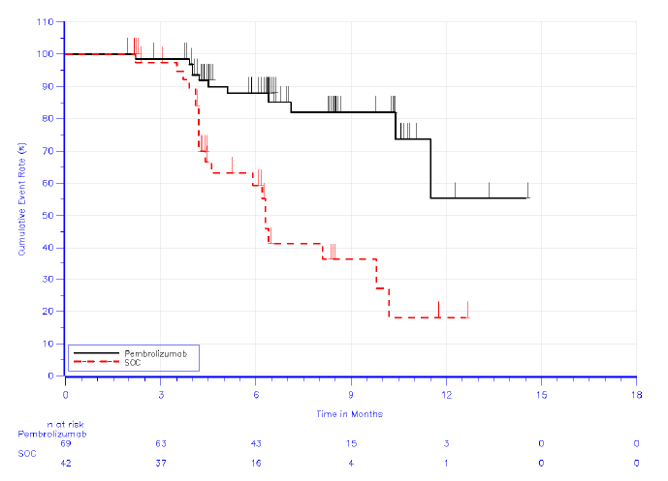
4% (pembrolizumab) versus 1% (SOC) had a complete response. The proportion of patients with progressive disease as the best objective response was reported in 22.1% (pembrolizumab) versus 18.5% (SOC).
There was a suggestion of improved health related quality of life with pembrolizumab relative to SOC. Compliance at Week 15 was 84.5% (pembrolizumab) versus 78.6% (SOC), considered acceptable by the clinical evaluator. The difference in Least Squares mean ‘change from Baseline at Week 15’ in the EORTC QLQ-C30 global health status measure was 7.8 (95% CI 2.8 to 12.8); reported values of minimally important differences range from 5 to 10. In the specific areas of time to deterioration in cough/chest pain/dyspnoea, there was a consistent suggestion that pembrolizumab prolonged the time to deterioration (see Attachment 3, pages 33 and 34). Overall, the evaluator described improvements in quality of life/symptom measures as of borderline clinical significance (see Attachment 3, Section 9.1).
There was no strong signal that efficacy was impaired in very heavy subjects (although few subjects weighing > 100 kg enrolled into the KEYNOTE-024 trial).

Exposure-response analysis
The clinical evaluator also considered a pooled analysis of the relationship between systemic exposure to pembrolizumab and efficacy in NSCLC (see Attachment 3, Section 4.1.2).

Safety

The KEYNOTE-024 trial
Mean duration of exposure was 206 days for pembrolizumab, 121 days for SOC (see Attachment 3, Section 8.2). Some 23 out of 154 patients in the pembrolizumab arm were exposed for > 12 months; versus 5 out of 150 in the SOC arm (SOC protocols only sometimes used maintenance pemetrexed). No subject in the pembrolizumab arm had received 35 doses/24 months of treatment.
Drug related adverse events were reported in 73.4% (pembrolizumab) versus 90% (SOC), and Grade 3 to 5 drug related adverse events in 26.6% versus 53.3%. Serious adverse events were reported in 44% across arms (Attachment 3, Table 16) and serious related adverse events in 21% across arms. Deaths due to drug related adverse events were reported in 0.6% versus 2.0%. Discontinuations due to AEs were reported in 9.1% versus 14%.
More common adverse events are shown below in Table 17 (a longer list is provided in Attachment 3, Table 14). The two approaches have distinct safety profiles, consistent with the known safety profile of each approach, as reported in Attachment 3, Section 8.3.1. The incidences below should be interpreted in the context of a quite different duration of exposure for each arm.

Table 17: KEYNOTE-024 trial; More common AEs
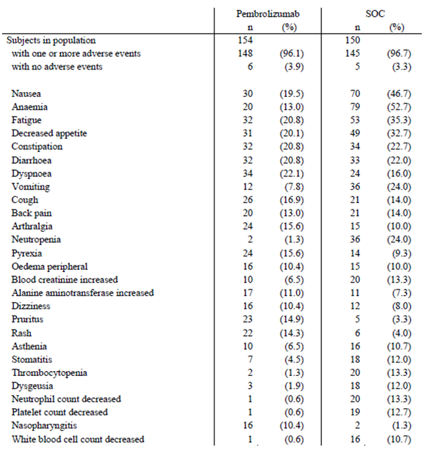
- Pneumonitis (including interstitial lung disease) was reported in 5.8% (pembrolizumab) versus 0.7% (SOC) and there was a similar imbalance for the adverse event of COPD. This was also seen in the KEYNOTE-010 trial. Dyspnoea was modestly imbalanced (22.1% versus 16%).
Question for sponsor: Is pembrolizumab known to exacerbate COPD? Could reports of COPD be misdiagnosed cases of pneumonitis?
- Colitis (including enterocolitis) was reported in 1.9% (pembrolizumab) versus 0% (SOC), while diarrhoea was reported in 20.8% versus 22% respectively.
- Transaminitis was more common with pembrolizumab (8.4 to 11%) than SOC (4.7 to 7.3%); see Attachment 3; Table 19. The sponsor has been asked to detail cases meeting Hy’s Law criteria (that is, suggestive of drug induced liver injury; see Attachment 3, Section 8.4.1).
- Blood creatinine increased was more common with platinum based doublet therapy (6.5% versus 13.3%) and there were very few reports of renal failure or nephritis.
- Hypothyroidism (9.1% versus 1.3%), TSH increased (3.9% versus 0%) hyperthyroidism (7.8% versus 1.3%) and thyroiditis (2.6% versus 0%) were more common with pembrolizumab. There was a report of hypophysitis and two reports of diabetes mellitus for pembrolizumab. There were no reports of adrenal insufficiency.
- There was an imbalance in adverse events such as myalgia (4.5% pembrolizumab versus 1.3% SOC), muscle spasms (5.2% versus 1.3%), musculoskeletal pain (7.1% versus 5.3%) and arthralgia (15.6% versus 10%).
- There was one report of pancreatitis in the pembrolizumab arm.
- Rash (14.3% versus 4%), pruritus (14.9% versus 3.3%) and dry skin (8.4% versus 0.7%) were all commoner with pembrolizumab.
- Nasopharyngitis was seen in 10.4% (pembrolizumab) versus 1.3% (SOC).
- Anaemia/thrombocytopaenia/neutropaenia, nausea/vomiting/dysgeusia, fatigue/asthenia/malaise, pneumonia, alopecia, stomatitis and peripheral neuropathy were commoner with SOC.
- Haemoptysis was more common with pembrolizumab (7.1% versus 3.3%), although this was not the case in the KEYNOTE-010 trial versus docetaxel.
Question for sponsor: More patients on pembrolizumab than on SOC had Grade 2 or 3 activated partial thromboplastin time (aPTT) increases. Did these patients have existing co-morbidities or concomitant treatments to explain these increases? Has this effect been seen in other studies of pembrolizumab?
The most frequent serious, pembrolizumab related AEs included pneumonitis (4.5%), diarrhoea (1.9%)/colitis (1.3%), diabetes mellitus (1.3%), ALT increased (1.3%) and lower respiratory tract infection (1.3%).
Immune mediated adverse events were common with pembrolizumab; 29.2% reported ≥ 1 adverse event of special interest (AEOSI) (see Attachment 3, Section 8.3.5): hypothyroidism (9.1%), hyperthyroidism (7.8%), pneumonitis (5.8%), infusion reactions (4.5%), skin reactions (3.9%), thyroiditis (2.6%), colitis (1.9%), myositis (1.9%), hypophysitis (0.6%), nephritis (0.6%), pancreatitis (0.6%) and T1DM (0.6%). In 7 patients, hyperthyroidism preceded hypothyroidism. There were no fatal AEOSIs.
The flat dose regimen did not lead to a higher incidence of AEOSIs in subjects with low bodyweight (see Attachment 3, Section 8.5.1).
The clinical evaluator considered that overall, pembrolizumab has a more favourable safety profile than platinum doublet chemotherapy in this setting (see Attachment 3, Section 8.7).

Exposure-response analysis
The clinical evaluator also considered a pooled analysis of the relationship between systemic exposure to pembrolizumab and the occurrence of immune mediated adverse events, from Attachment 3, Section 4.1.3. A flat exposure response relationship was described.

Immunogenicity
The evaluator considered an analysis of immunogenicity across pembrolizumab studies (from Attachment 3, Section 8.4.8.1). In Submission PM-2015-04712-1-4 (second line treatment for NSCLC) a pooled analysis of Studies P001, 002, 006 and 010 was reviewed; in this Submission PM-2016-02325-1-4 (first line treatment of NSCLC) a pooled analysis of those studies and Studies P012, 024 and 055 was reviewed. Conclusions were similar, though a higher incidence of ADAs was seen in the KEYNOTE-024 trial (see Attachment 3, Table 23), again supporting the notion of higher rates in NSCLC.

Risk management plan
The RMP evaluator for Submission PM-2015-04712-1-4 considered a number of issues unresolved. In summary, the evaluator recommended:
- Inclusion of ‘immune-mediated neurological adverse events’ as an ‘important identified risk’ in the ASA to the EU-RMP.
- Inclusion of ‘immune mediated adverse cardiac reactions’ as an ‘important potential risk’.
- Proposal of a more robust system to demonstrate appropriate distribution of educational materials.
The RMP evaluator also considers that ‘the PI should be revised to include statements on the risk of myasthenic syndrome and myocarditis’.
The sponsor’s response to this Second round report, dated 30 November 2016, is acknowledged.

Recommended conditions of registration (Submission PM-2015-04712-1-4)
The Core-RMP version 10.0 (dated 20 September 2016; data lock point 27 June 2016) with ASA version 5.0 (dated 26 September 2016) to be revised to the satisfaction of the TGA, must be implemented (see outstanding issues above).
Regarding the RMP attached to Submission PM-2016-02325-1-4, it is noted that the initial dossier for this submission included ASA version 4.0 and Core-RMP version 9.0, that is, has been superseded by the above versions. Further consultation with the RMP Evaluation area was required prior to a final decision regarding the first line NSCLC submission.

Risk-benefit analysis

Efficacy; standard of care in first line treatment of NSCLC
Bevacizumab (added to carboplatin and paclitaxel) is an option in frontline treatment of NSCLC (see Attachment 3, Section 7.2.1.2). The evaluator notes that bevacizumab is not PBS subsidised and may not be widely used in this setting. EviQ does not list a chemotherapy protocol for NSCLC involving bevacizumab, supporting the view that this use is not established. Choice of comparator in the KEYNOTE-024 trial is reasonable. The magnitude of benefit offered by the use of pembrolizumab over standard of care in the KEYNOTE-024 trial was large.

Efficacy; continuation of therapy
This issue is discussed in Attachment 3, Section 7.3. The clinical evaluator points out that no data are available regarding the effects of treatment withdrawal after 35 doses. The sponsor has been asked for further information in this regard. The Delegate’s general view is that it would be reasonable to recommend continuing use until there is some assurance that stopping after 35 doses does not provoke relapse in responders, or progression in those with stable disease. Note; the same approach was laid out in the protocol for the KEYNOTE-010 trial (that is, subjects on pembrolizumab were considered ‘completed’ when they had received 2 years of uninterrupted treatment); no subjects had reached that milestone at the data cut-off, and the clinical evaluator of the KEYNOTE-010 trial did not consider this a reason to discontinue at 2 years. For melanoma, the PI recommends treatment until disease progression or unacceptable toxicity.

Efficacy; patients with TPS 1 to 49% tumour PD-L1 expression, second line treatment of NSCLC
The evaluator notes a negligible rise in median OS (0.8 months) for pembrolizumab versus docetaxel in this group, and a fall in median PFS (1.3 months). The sponsor argues that:
‘The hazard ratio is a better assessment tool of efficacy than focusing on the median which is a point estimate because the hazard ratio provides a comparison at multiple time points all along the Kaplan-Meier curves.’
In the second line treatment of NSCLC, the benefit-risk balance is much more clear cut in subjects with TPS (percentage of viable tumour cells showing partial or complete membrane staining) ≥ 50%, that is, strongly positive PD-L1 expression. Efficacy relative to docetaxel (an acceptable standard of care) is less convincing in subjects with TPS 1 to 49%; it could loosely be described as ‘unlikely to be worse than docetaxel’, but there is no non-inferiority study. There are some promising aspects of the efficacy data for pembrolizumab in this group with weaker PD-L1 expression: a trend towards better overall survival; and better DoR in the minority (approximately 10%) who respond. This, in conjunction with excellent efficacy at higher levels of tumour PD-L1 expression, efficacy of nivolumab in second line NSCLC, and the distinct toxicity profile of pembrolizumab versus docetaxel, gives some assurance of a positive benefit-risk balance for Keytruda in the TPS 1 to 49% subgroup; although an imbalance in disease progression rates is noted.
The sponsor also states, in regard to presentation of data in the PI about this group:
‘The market authorisation holder (MAH) believes in presenting data corresponding to the study’s design in a product label, and not focusing on exploratory analyses’.

Biomarker assay
One clinical evaluator raised concerns about diagnostic test characteristics of the assay for PD-L1 expression (see Attachment 2; Section 12, Question 3).
Correspondence dated 15 November 2016 from the sponsor is acknowledged. The DAKO PD-L1 IHC 22C3 pharmDx instructions for use (IFU) were provided for review. The DAKO assay is specific for NSCLC tissue, and allows assessment for positivity at the TPS ≥ 1% threshold. The clinical performance of the assay was assessed using patients from the KEYNOTE-010 trial. For inclusion in the KEYNOTE-010 trial, tumour PD-L1 positivity based on a Clinical Trial Assay (CTA) was required. The DAKO assay IFU notes the following as shown below in Table 18.

Table 18: DAKO assay instruction for use notes
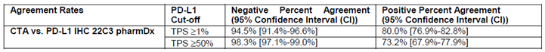
The DAKO assay IFU reworks outcomes from the KEYNOTE-010 trial (see Table 19, below). The re-worked outcomes of the KEYNOTE-010 trial based on the subset of n = 529 patients whose tumour tissue was retrospectively tested with the DAKO assay were more favourable than outcomes based on the complete dataset (n = 1034) and the Clinical Trial Assay (CTA). Of note, only 413 specimens (of the 529 declared positive by the CTA) were declared to be positive using the DAKO assay. Also, 163 out of 413 specimens had TPS ≥ 50% (that is, 39.5%, versus 42.8% across the n = 1,034 patients in the KEYNOTE-010 trial using the CTA); however, based on results in the above table, it seems only 73.2% of strongly positive CTA specimens were strongly DAKO positive.

Table 19: DAKO PD-L1 IHC 22C3pharmDx IFU; Response to Keytruda in previously treated NSCLC patients; overall clinical study and PD-L1 IHC 22C3 pharmDx positive patients; PD-L1 TPS ≥ 1% and TPS ≥ 50%
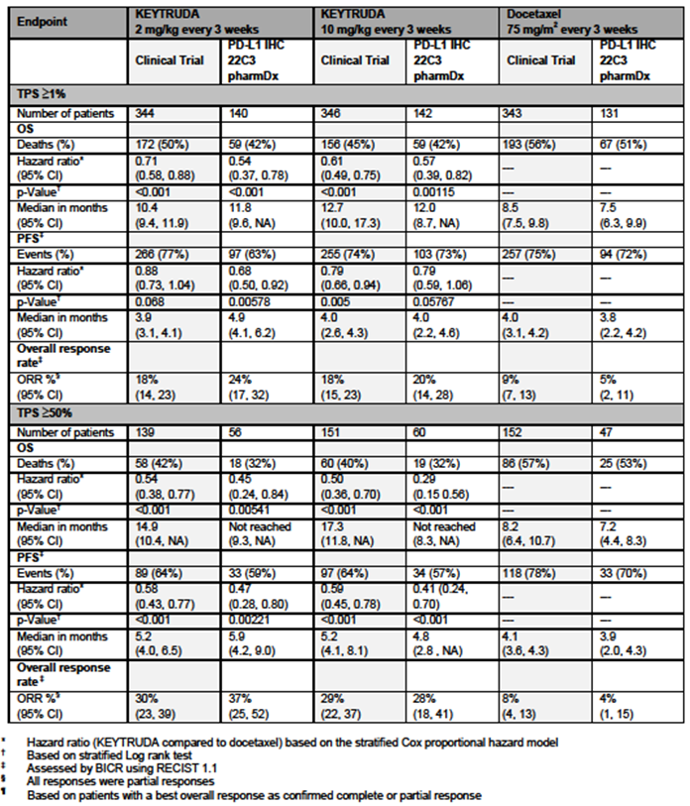
These better results might be due to the DAKO assay truly excluding false positives that occurred with the CTA, or due to the DAKO assay falsely excluding true positives (but at lower levels of PD-L1 staining). Each scenario might lead to better outcomes, assuming better efficacy of pembrolizumab against tumours with more PD-L1 expression.
The moderately better outcomes might also be because the subset (529 out of 1034) was not representative of the full dataset (for example ORRs in the docetaxel arm were slightly worse in the DAKO subset, and this should not really be influenced by PD-L1 positivity; but other outcomes gave conflicting signals; see Table 19 above).
Access is to the DAKO assay not the CTA, and results seem better for patients judged to have PD-L1 positive NSCLC according to the DAKO assay. It is possible an even smaller fraction of NSCLC patients will be deemed ‘positive’ for tumour PD-L1 expression, using this assay (compared to the situation in the KEYNOTE-010 trial). The clinical evaluator notes that if the DAKO assay produces false negative results, some patients (for example with true but low levels of tumour staining) may be denied a potentially beneficial treatment.
On the other hand, the DAKO assay may produce false positive outcomes, in which case patients may be treated without benefit. The extent to which false positives may occur is not known. Further, clinical outcomes in patients with DAKO positive, CTA negative tumours are not calculable. ‘Robustness’ analyses were conducted but these do not negate the basic concern that in theKEYNOTE-010 trial, patients were excluded if CTA staining was negative. The DAKO assay IFU states:
‘Additional robustness analyses were conducted to consider the potential impact of missing data arising from patients with a positive PDL1 IHC 22C3 pharmDx test result, but who may have been negative by the CTA. Patients with such test results are part of the intended use/ intent to diagnose (ITD)/ population of the PD-L1 IHC 22C3 pharmDx; however, they were excluded from the clinical trial due to negative results upon CTA screening. To account for these missing data, a sensitivity analysis was conducted to understand the plausible range for the hazard ratio (HR) estimated based on the PD-L1 IHC 22C3 pharmDx in the TPS ≥ 1% and TPS ≥ 50% subpopulations under an ITD framework to verify the consistency with the observed HR based on enrolment with the CTA. The HR sensitivity analysis results showed that the HR estimates are robust to any assumed attenuation of the treatment effect under the ITD framework’.
Question for sponsor: It is acknowledged the DAKO PD-L1 IHC 22C3 pharmDx assay has a different sponsor. However, does the sponsor know whether, in the bridging study, archived tissue declared PD-L1 negative by the CTA was retrospectively tested using the DAKO assay? If this testing was done, is it possible to calculate measures of diagnostic accuracy relative to the CTA? In particular, is there an estimate of the DAKO assay’s rate of ‘false’ positivity relative to the CTA? While clinical outcomes in the DAKO positive, CTA negative group may not be calculable, it is still important to gauge the potential size of this group.
In the KEYNOTE-024 trial, it appears the DAKO PD-L1 IHC 22C3pharmDx kit was used (see Attachment 3, Section 7.2.1.2).
Question for sponsor: Was the PD-L1 IHC assay in the KEYNOTE-024 trial the same as the DAKO kit registered for use in Australia? If not, has there been a bridging study analogous to the one conducted for the KEYNOTE-010 trial?

Overall risk-benefit, and indication
In the first line setting, the benefit-risk balance is clear in subjects with TPS ≥ 50%, with much improved survival, the suggestion of improved quality of life, and a distinct and on balance superior toxicity profile relative to standard of care.
The Delegate agrees with the clinical evaluator that it would be hasty to extrapolate use to first line NSCLC patients with weaker tumour PD-L1 expression. Efficacy of pembrolizumab is known to vary with PD-L1 tumour expression; the nivolumab trial Study CheckMate 026 in previously untreated patients failed to show benefit against platinum based doublet therapy; and there is a trial underway of pembrolizumab exploring benefit in patients with weakly positive tumours (Study KN042). The sponsor has already modified its proposed indication.
The benefit-risk balance is also considered positive for the second line indication, but the ACM’s advice has been requested about benefit-risk balance in the ‘weakly positive’ subgroup (TPS 1 to 49%; see above).
In the first line NSCLC setting, the sponsor proposes use in metastatic disease (not advanced disease); in the KEYNOTE-024 trial, only patients with Stage IV disease were included. In the second line NSCLC setting, the sponsor proposes use in advanced disease; in the KEYNOTE-010 trial, 91% had metastatic disease. The sponsor’s approach appears reasonable, although approval in the US is for metastatic disease only.
For second line use, the sponsor’s wording (‘who have received platinum containing chemotherapy’) is looser than the wording in the US PI (‘with disease progression on or after platinum containing chemotherapy’) and might open up use to patients who have not received a reasonable course of platinum containing chemotherapy, or to patients with stable disease (or even responders) after platinum containing chemotherapy.
For second line use, the proposed indication notes:
‘patients with EGFR or ALK genomic tumour aberrations should also have received approved therapy for these aberrations prior to receiving Keytruda [see CLINICAL TRIALS].’
The relevant inclusion criteria in the pivotal KEYNOTE-010 trial were:
- Subjects with an EGFR sensitizing mutation must also be able to demonstrate progression of disease on the EGFR TKI (either; erlotinib, gefitinib, or afatinib) in a similar manner to that above for the platinum containing doublet.
- Subjects with an ALK translocation must also be able to demonstrate progression of disease on crizotinib in a similar manner to that above for the platinum containing doublet.
The proposed wording might be interpreted as requiring, for ALK mutant tumours, use of crizotinib and then ceritinib (for example); and for EGFR mutant tumours, use of a first line targeted therapy then, potentially, osimertinib if resistance occurs due to development of a T790M mutation. Sequential use of targeted therapies may not have been the norm in the KEYNOTE-010 trial.
In the Summary of Clinical Efficacy for the second line NSCLC submission, Table 2.7.3-nsclc: 27 suggests (reproduced here as Table 20):
- response was attained in EGFR mutant disease in patients with TPS ≥ 1% in 11.9% (5 out of 42); and
- response was attained in ALK mutant disease in patients with TPS ≥ 1% in 0% (0 out of 7).

Table 20: Summary of Best Overall Response (BOR) based on IRC assessment per RECIST 1.1 with confirmation by subgroups total previously-treated efficacy population by PD-L1 (irrespective of stability window) (All subjects as treated)
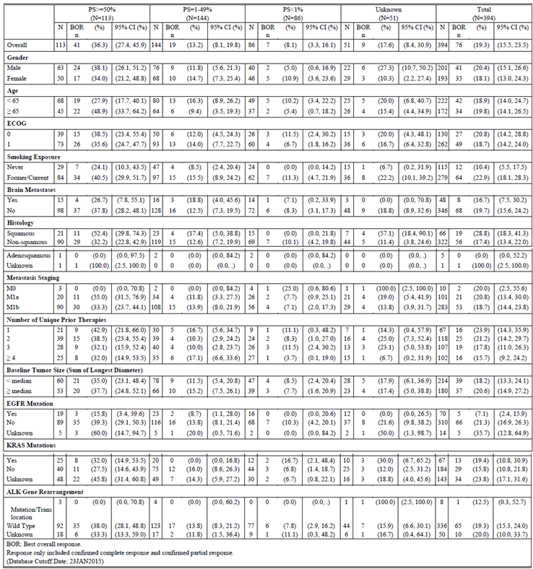
Question for the sponsor: Please comment on PFS and OS outcomes in patients in the KEYNOTE-010 and KEYNOTE-001 trials with TPS ≥ 1% with (a) EGFR sensitizing mutations, and (b) ALK translocations.

Questions for sponsor
- With reference to the KEYNOTE-010 trial, please explain the imbalance across arms in the adverse events of ‘hyponatraemia’ and ‘decreased weight’.
- With reference to Submission PM-2016-02325-1-4 (refer to Attachment 3, Section 7.2.1.10), please comment on the distribution of major protocol deviations across arms, and whether any imbalances could have biased study outcomes.
- Is pembrolizumab known to exacerbate COPD? Could reports of COPD be misdiagnosed cases of pneumonitis?
- With reference to the KEYNOTE-024 trial, more patients on pembrolizumab than on SOC had Grade 2 or 3 aPTT increases. Did these patients have existing co-morbidities or concomitant treatments to explain these increases? Has this effect been seen in other studies of pembrolizumab?
- Was the PD-L1 IHC assay in the KEYNOTE-024 trial the same as the DAKO kit registered for use in Australia? If not, has there been a bridging study analogous to the one conducted for the KEYNOTE-010 trial?
- Please comment on PFS and OS outcomes in patients in the KEYNOTE-010 and KEYNOTE-001 trials with TPS ≥ 1% with (a) EGFR sensitising mutations, and (b) ALK translocations.
In recent correspondence, the sponsor was also asked to provide a breakdown of reasons for screening failure in the KEYNOTE-024 trial.
The sponsor was also requested to respond (in their response to request for ACM advice) to questions asked by the clinical evaluator for Submission PM-2016-02325-1-4.

Delegate’s considerations
In second line NSCLC, benefit-risk balance is much more clear-cut in subjects with TPS (percentage of viable tumour cells showing partial or complete membrane staining) ≥ 50%, that is, strongly positive PD-L1 expression. Efficacy relative to docetaxel (an acceptable standard of care) is less convincing in subjects with TPS 1 to 49%; it could loosely be described as ‘unlikely to be worse than docetaxel’, but there is no non-inferiority study. There are some promising aspects of the efficacy data for pembrolizumab in this group with weaker PD-L1 expression: a trend towards better overall survival; and better DoR in the minority (approximately 10%) who respond. This, in conjunction with excellent efficacy at higher levels of tumour PD-L1 expression, efficacy of nivolumab in second line NSCLC, and the distinct toxicity profile of pembrolizumab versus docetaxel, gives some assurance of a positive benefit-risk balance for Keytruda in the TPS 1 to 49% subgroup; although an imbalance in disease progression rates is noted.
In the first line setting, the benefit-risk balance is also clear-cut in subjects with a TPS ≥ 50%, with much improved survival, and the suggestion of improved quality of life, with a distinct and on balance superior toxicity profile relative to standard of care.

Proposed action
The Delegate’s preliminary view is that the submissions are approvable, subject to agreement about an acceptable PI document and advice from ACM.
Please also note that the sponsor was asked additional questions (see ‘Questions for sponsor’ above).

Request for ACM advice
The committee was requested to provide advice on the following specific issues:
- The clinical evaluator for Submission PM-2016-02325-1-4 (first line treatment of NSCLC) suggests that the PI recommend a maximum duration of therapy of 35 treatments (24 months) for first line treatment of NSCLC. No subjects in the KEYNOTE-024 trial reached 24 months in the analysis provided. There are no data to inform the decision to stop at 24 months. What should the PI recommend in this regard?
- Does the ACM consider that the benefit-risk balance is positive in patients with NSCLC who have received platinum containing chemotherapy and whose tumours are weakly positive for PD-L1? Is there any concern regarding the imbalance in disease progression rates in this group, seen in the KEYNOTE-010 trial?
- The clinical evaluator and Delegate agree that the PI should present efficacy outcomes for second line treatment of NSCLC patients with PD-L1 expression of 1 to 49% and ≥ 50% separately. The sponsor argues that, in keeping with the study design, data should be presented for second line treated NSCLC patients with PD-L1 expression ≥ 1% (that is, including both TPS 1 to 49% and TPS ≥ 50%) and ≥ 50% separately. What is the preferable approach for clinicians and consumers to communication of efficacy outcomes in the PI?
- Are there any concerns about the generalisability of outcomes from the KEYNOTE-010 trial to the real world situation, given real world use of a different assay?
- Does the ACM consider that NSCLC indications should be limited to metastatic disease?
- Does the ACM consider that the second line indication should require patients to have progressed on or after platinum containing chemotherapy?
- Given the apparently low ORRs in second line patients with EGFR sensitising mutations or ALK translocation, is the sponsor’s proposed indication wording (‘patients with EGFR or ALK genomic tumour aberrations should also have received approved therapy for these aberrations prior to receiving Keytruda [see CLINICAL TRIALS]’) acceptable?
- Is there sufficient evidence of causality to support a Precaution for myasthenic syndrome, and to include myasthenic syndrome as an important identified risk in the RMP?
- Is there sufficient evidence of causality to support a Precaution for myocarditis, and to include myocarditis as an important identified risk in the RMP?
The committee is also requested to provide advice on any other issues that it thinks may be relevant to a decision on whether or not to approve this application.

Response from sponsor

Response from sponsor to Delegate’s questions for sponsor
- With reference to the KEYNOTE-010 trial, please explain the imbalance across arms in the adverse events of ‘hyponatraemia’ and ‘decreased weight’.
Mechanistically, hyponatremia is expected to occur with pembrolizumab only in the context of immune mediated endocrine abnormalities, such as adrenal insufficiency or hypophysitis. The events of hyponatraemia occurred more frequently than the reported incidence of adrenal insufficiency (0.6% for pembrolizumab 2 mg/kg and 0.9% for pembrolizumab 10 mg/kg) or hypophysitis (0.3% pembrolizumab 2 mg/kg and 10 mg/kg each) in the KEYNOTE-010 trial. In the KEYNOTE-010 trial, hyponatraemia was observed more frequently in the pembrolizumab arms (docetaxel 1.0%, pembrolizumab 2 mg/kg 3.8%, pembrolizumab 10 mg/kg 4.1%; (see Table 21, below)). However, patients treated with pembrolizumab had approximately double the exposure as those treated with docetaxel, and the exposure-adjusted incidence of hyponatraemia reflected this as seen in Table 22 (also below, 0.4 events/100 person-months docetaxel, 0.7 events/100 person months pembrolizumab 2 mg/kg, and 1.0 events/100 person months pembrolizumab 10 mg/kg). Importantly, while more cases of hyponatraemia were reported in the KEYNOTE-010 trial on the pembrolizumab arms than the docetaxel arm, the frequency was similar between pembrolizumab and chemotherapy in the KEYNOTE-024 trial. Hyponatraemia in the KEYNOTE-024 trial occurred in 7.1% of the pembrolizumab arm and 8.0% of the platinum doublet control arm. In the NSCLC portion of the KEYNOTE-001 trial, the frequency of hyponatraemia was 5.6%. Therefore, the sponsor considers the imbalance across the arms of the KEYNOTE-010 trial regarding the incidence of hyponatraemia to be due to random variation and differences in exposure, and not related to pembrolizumab.
In the KEYNOTE-010 trial, weight decreased was observed more frequently in the pembrolizumab arms (docetaxel 2.9%, pembrolizumab 2 mg/kg 8.0%, pembrolizumab 10 mg/kg 9.0%; see Table 21). A decreased appetite could account for this observation, although when looking at an exposure adjusted analysis, the docetaxel arm, which had a shorter exposure than the pembrolizumab arms to the assigned treatment, had a higher incidence of decreased appetite, but a lower incidence of weight decreased, and the pembrolizumab arms had a longer exposure to pembrolizumab but a lower incidence of decreased appetite and a higher incidence of weight decreased (see Table 22, below). However, the incidence of weight decreased was always less than decreased appetite.
In contrast, in the KEYNOTE-024 trial, weight decreased was similar between the 2 arms (8.4% pembrolizumab, 7.3% in the platinum doublet chemotherapy). Similar to the KEYNOTE-010 trial, in the KEYNOTE-024 trial decreased appetite was greater in the control arm (32.7%) than the pembrolizumab arm (20.1%). Therefore, the sponsor considers the imbalance across the arms of the KEYNOTE-010 trial regarding the incidence of weight decrease to be to random variation and not related to pembrolizumab.

Table 21: Select adverse events and adverse events of special interest by maximum toxicity grade; KEYNOTE-010 trial, APaT (TPS ≥ 1%)
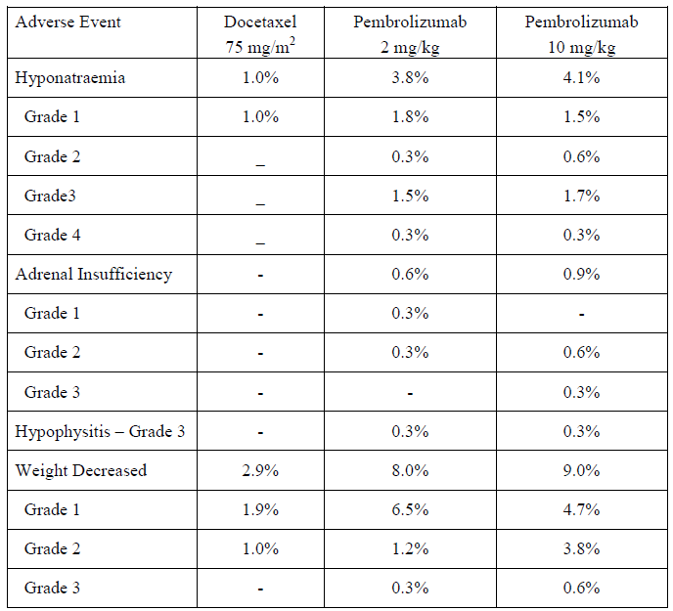

Table 22: Selected exposure-adjusted adverse events (including multiple occurrences of events) subjects from the KEYNOTE-010 trial (All subjects as treated population)
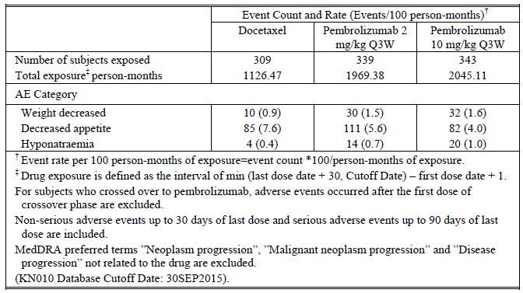
- With reference to Submission PM-2016-02325-1-4 (refer to Attachment 3, Section 7.2.1.10) please comment on the distribution of major protocol deviations across arms, and whether any imbalances could have biased study outcomes.
The market authorisation holder (MAH) refers the reviewers (to an appendix of the CSR [not reproduced] which includes a detailed listing of major protocol deviations for each subject. A table [not reproduced] in the CSR lists the few clinically important deviations, however no subjects were excluded from the efficacy analyses. In addition, Table 23 below, provides an overview of the major protocol deviations for the KEYNOTE-024 trial by deviation category and the number and percentage that occurred by arm.

Table 23: KEYNOTE-024; Overview of major protocol deviations
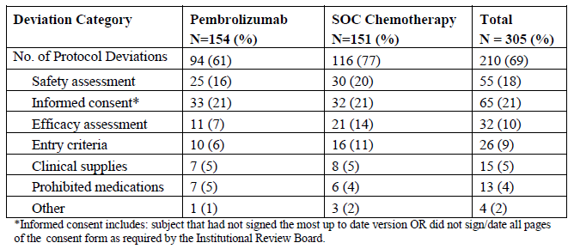
- Is pembrolizumab known to exacerbate COPD? Could reports of COPD be misdiagnosed cases of pneumonitis?
Pembrolizumab is not known to exacerbate COPD. There is not a mechanistic reason by which pembrolizumab should exacerbate COPD. Chronic bronchitis and emphysema are two conditions that also represent subtypes of chronic obstructive pulmonary disease (COPD). In the KEYNOTE-010 trial the rates of COPD were 2.7% for pembrolizumab 2 mg/kg, 1.7% for pembrolizumab 10 mg/kg, and 0.6% for docetaxel; rates of chronic bronchitis were 0.0% for pembrolizumab 2 mg/kg, 0.3% for pembrolizumab 10 mg/kg, and 0.3% for docetaxel; and rates of emphysema were 0.0% across both pembrolizumab and docetaxel arms. In KEYNOTE-024 the rate of COPD in the pembrolizumab arm was 5.7% and the control arm was 0.7%; chronic bronchitis was 0.0% in both arms; and emphysema was 0.0% in both arms. Pre-existing COPD, including chronic bronchitis or emphysema, in subjects randomised to pembrolizumab in the KEYNOTE-010 trial was 16.5% and in the KEYNOTE-024 trial was 29.9%. Pre-existing COPD amongst the subjects in the control arms of these studies was 19% for KEYNOTE-010 and 29% for the KEYNOTE-024 trial, comparable to the pembrolizumab arms in the respective studies. Seemungal et al. noted in The International Journal of COPD on the 27 May 2009; that patients with COPD may expect 0.5 to 3.5 exacerbations per year. Of those with a medical history of COPD and treated with pembrolizumab, 9% of them from KEYNOTE-010 and 17% of them from the KEYNOTE-024 trial developed an adverse event of COPD. Of those with a medical history of COPD and treated with chemotherapy, 5% of them from KEYNOTE-010 and 2% of them from the KEYNOTE-024 trial developed an adverse event of COPD. The rate of an adverse event of COPD developing in subjects with a medical history of COPD who are receiving pembrolizumab in KEYNOTE-010 is likely due to chance and not indicative of a causal relationship of exacerbation by pembrolizumab. While the percentage of subjects from the KEYNOTE-024 trial may seem high, it is because of the small number of subjects. Note that the incidence of COPD in the control arm may seem lower because corticosteroids are administered regularly as premedication every 3 weeks for receipt of the treatment, whereas for the pembrolizumab corticosteroids were avoided, except to manage toxicity. Corticosteroids are often used to treat COPD exacerbations. The rates of COPD amongst those with a prior history of COPD when exposed to pembrolizumab seemed consistent with that exposed to chemotherapy, especially considering the frequency of COPD exacerbations in an individual subject based on natural history of the disease.
The seeming increased incidence of COPD amongst subjects exposed to pembrolizumab may also be contributed to by the duration of exposure to pembrolizumab relative to control. Despite a near doubling of the exposure to pembrolizumab compared to docetaxel, the exposure adjusted incidence of COPD was double or less in the KEYNOTE-010 trial (docetaxel 0.3 events/100 person months, pembrolizumab 2 mg/kg 0.6 events/100 person months, pembrolizumab 10 mg/kg, 0.4 events/100 person months), suggesting that pembrolizumab exposure may not be a risk factor for COPD. Despite a near 1.5 x exposure to pembrolizumab compared to docetaxel, the exposure adjusted incidence of COPD was triple in the KEYNOTE-010 trial (docetaxel 0.3 events/100 person months, pembrolizumab 0.9 events/100 person months), but the numbers of subjects in each arm of KEYNOTE-024 and the incidence of COPD are small. The clinical trial program does not present convincing evidence that pembrolizumab exacerbates COPD.
Review of the serious adverse events of COPD from the KEYNOTE-010 and KEYNOTE-024 trials did not identify potential confusion with pneumonitis. No subject in KEYNOTE-024 and only one subject in the KEYNOTE-010 trial experienced an adverse event of COPD and pneumonitis, further underscoring the difference between these two adverse events. It is unlikely that a COPD exacerbation would be misdiagnosed as pneumonitis as the use of diagnostic imaging in the normal course of care would show non-specific or minimal radiographic changes in the patient with a COPD exacerbation, while ground glass opacities are key findings when diagnosing pneumonitis. When patients who present with symptoms of COPD or pneumonitis, as long as imaging is performed, physicians should be able to distinguish between the diagnoses.
- With reference to the KEYNOTE-024 trial, more patients on pembrolizumab than on SOC had Grade 2 or 3 aPTT increases. Did these patients have existing co-morbidities or concomitant treatments to explain these increases? Has this effect been seen in other studies of pembrolizumab?
In the KEYNOTE-024 trial, 3 subjects randomised to pembrolizumab experienced Grade 2 or 3 aPTT elevations while receiving pembrolizumab therapy:
- Subject [information redacted] had a single episode of aPTT elevation occurring on Cycle 12. The subject did not experience any clinical sequelae nor had any medical history or medications that could have caused this transient increase. No action was taken with pembrolizumab for this episode.
- Subject [information redacted], similarly, experienced a single episode of aPTT elevation occurring on Cycle 8. The subject did not experience any clinical sequelae nor had any medical history or medications that could have caused this transient increase. No action was taken with pembrolizumab for this episode.
- Subject [information redacted] had prolonged elevations of their aPTT due to initiation of anticoagulation therapy for their known pulmonary embolism. The subject did not experience any clinical sequelae as a result of this aPTT increase.
In the KEYNOTE-024 trial, one subject randomised to SOC experience a Grade 2 or 3 aPTT elevation.
In the KEYNOTE-010 trial , only one subject randomised to pembrolizumab experienced a Grade 2 or 3 aPTT elevation while on therapy. No subjects randomised to SOC experienced the same.
The above data indicate that the PTT elevations observed in the KEYNOTE-024 trial are likely not clinically meaningful nor attributable to pembrolizumab.
Additional question: It is acknowledged the DAKO PD-L1 IHC 22C3pharmDx assay has a different sponsor. However, does the sponsor know whether, in the bridging study, archived tissue declared PD-L1 negative by the CTA was retrospectively tested using the DAKO assay? If this testing was done, is it possible to calculate measures of diagnostic accuracy relative to the CTA? In particular, is there an estimate of the DAKO assay’s rate of ‘false’ positivity relative to the CTA? While clinical outcomes in the DAKO+ve CTA-ve group may not be calculable, it is still important to gauge the potential size of this group.
The bridging study was conducted in a manner that attempted to get the PDL1 IHC 22C3pharmDx testing conducted on all screened patients and the agreement estimates reported in the table cited in the Delegate’s overview (see Table 18 above) are in this population. As such, Clinical Trial Assay (CTA) PD-L1 negative samples were retested with the PDL1 IHC 22C3pharmDx. Of the 311 samples that were CTA PD-L1 negative (TPS < 1%), 17 were determined to be PDL1 IHC 22C3 PD-L1 positive (TPS ≥ 1%). 294 specimens were PD-L1 negative (TPS < 1%) by both the CTA and the PDL1 IHC 22C3pharmDx. The negative percent agreement was 94.5% between the two assay versions. Reliable estimates of false positivity are not possible since there is no true gold standard test to compare the PDL1 IHC 22C3pharmDx results to.
- Was the PD-L1 IHC assay in the KEYNOTE-024 trial the same as the DAKO kit registered for use in Australia? If not, has there been a bridging study analogous to the one conducted for the KEYNOTE-010 trial?
Yes [these were the same].
- Please comment on PFS and OS outcomes in patients in the KEYNOTE-010 and KEYNOTE-001 trials with TPS ≥ 1% with (a) EGFR sensitising mutations, and (b) ALK translocations.
EGFR: The sponsor does not know which EGFR mutations were sensitising among those subjects in the KEYNOTE-010 trial who had an EGFR mutation. However, the data among subjects with an EGFR mutation in the KEYNOTE-010 trial for OS among subjects whose tumours at Baseline had a TPS ≥ 1% include a HR of 0.88 (95% CI 0.45, 1.70) with 46 events among 86 subjects. PFS amongst the same patient population in the KEYNOTE-010 trial had a HR of 1.79 (95% CI 0.94, 3.42) with 70 events among 86 subjects. Data from both arms of pembrolizumab have been pooled because of the small subpopulations that result and there is not a treatment difference based on dose of pembrolizumab. The primary study result amongst all subjects whose tumours had a TPS ≥ 1% at Baseline was a HR for OS of 0.71 (95% CI 0.58, 0.88; p-value 0.00076) for pembrolizumab 2 mg/kg versus docetaxel 75 mg/m². The OS hazard ratio was 0.61 (95% CI 0.49, 0.75; p-value < 0.00001) for pembrolizumab 10 mg/kg versus docetaxel 75 mg/m². The primary study result amongst all subjects whose tumours had a TPS ≥ 1% at Baseline was a hazard ratio for PFS of 0.88 (95% CI 0.73, 1.04; p-value 0.06758) for pembrolizumab 2 mg/kg versus docetaxel 75 mg/m². The PFS hazard ratio was 0.79 (95% CI 0.66, 0.94; p-value 0.00462) for pembrolizumab 10 mg/kg versus docetaxel 75 mg/m². The primary study results demonstrated superior OS and PFS for pembrolizumab versus docetaxel relative to those subjects with an EGFR mutation.
ALK: Because only 8 subjects had an ALK gene rearrangement in the KEYNOTE-010 trial, conclusions will be difficult to draw. The outcome for PFS and OS are presented in Table 24, below.

Table 24: KEYNOTE-010 trial; PFS and OS
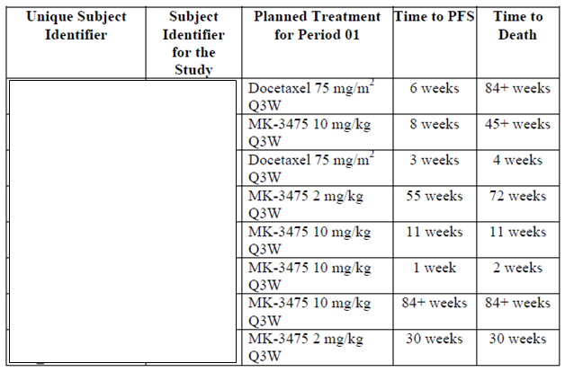
Additional question: In recent correspondence, the sponsor has also been asked to provide a breakdown of reasons for screening failure in the KEYNOTE-024 trial.
In total, 1,629 subjects were not randomised to the KEYNOTE-024 trial, of which 1,628 did not meet the inclusion or exclusion criteria outlined below. Please note that while 108 subjects have more than one criteria entered, the subject is counted only once in the overall total.
Inclusion Criteria:
- Have a PD-L1 strong tumour as determined by IHC at a central laboratory. (n = 1,084).
- Tumour harboured an EGFR sensitising mutation and/or ALK translocation (n = 139).
- Have provided a formalin fixed tumour tissue sample from a biopsy of a tumour lesion either at the time of or after the diagnosis of metastatic disease has been made AND from a site not previously irradiated to assess for PD-L1 status. Biopsies obtained PRIOR to the administration of any systemic therapy administered for the treatment of a subject’s tumour (such as neoadjuvant/adjuvant therapy) will not permitted for analysis. The tissue sample must be received by the central vendor prior to randomisation. Fine needle aspirates, Endobronchial Ultrasound (EBUS) or cell blocks are not acceptable. Needle or excisional biopsies, or resected tissue is required (n = 163).
- Have a histologically or cytologically confirmed diagnosis of NSCLC, is Stage IV, does not have an EGFR sensitising (activating) mutation or ALK translocation, and has not received prior systemic chemotherapy treatment for their metastatic NSCLC (n = 80).
- Have a performance status of 0 or 1 on the Eastern Cooperative Oncology Group (ECOG) Performance Status (n = 54).
- Subject withdrew consent for participation in the trial (n = 31).
- Have a life expectancy of at least 3 months (n = 16).
- Subject has no history of prior malignancy, with the exception of basal cell carcinoma of the skin, superficial bladder cancer, squamous cell carcinoma of the skin, in situ cervical cancer, or has undergone potentially curative therapy with no evidence of that disease recurrence for 5 years since initiation of that therapy (n = 10).
- Have measurable disease based on RECIST 1.1 as determined by the site (n = 3).
Exclusion Criteria:
- Has untreated central nervous system (CNS) metastases and/or carcinomatous meningitis identified either on the baseline brain imaging obtained during the screening period OR identified prior to signing the ICF. Subjects whose brain metastases have been treated may participate provided they show radiographic stability (defined as 2 brain images, both of which are obtained after treatment to the brain metastases. In addition, any neurologic symptoms that developed either as a result of the brain metastases or their treatment must have returned to baseline or resolved. Any steroids administered as part of this therapy must be completed at least three days prior to study medication (n = 73).
- Has a history or current evidence of any condition, therapy, or laboratory abnormality that might confound the results of the trial, interfere with the subject’s participation for the full duration of the trial, or is not in the best interest of the subject to participate, in the opinion of the treating Investigator. (n = 17).
- Active autoimmune disease that has required systemic treatment in past 2 years (that is, with use of disease modifying agents, corticosteroids or immunosuppressive drugs). Replacement therapy (that is, thyroxine, insulin, or physiologic corticosteroid replacement therapy for adrenal or pituitary insufficiency, etc.) is not considered a form of systemic treatment (n = 13).
- Is receiving systemic steroid therapy > 3 days prior to the first dose of trial treatment or receiving any other form of immunosuppressive medication (corticosteroid use on study for management of ECIs is allowed or as a pre-medication for the control chemotherapies is allowed). Subjects who are receiving daily steroid replacement therapy serve as an exception to this rule. Daily prednisone at doses of 5 to 7.5 mg is an example of replacement therapy. Equivalent hydrocortisone doses are also permitted if administered as a replacement therapy (n = 7).
- Is expected to require any other form of systemic or localised antineoplastic therapy while on trial (including maintenance therapy with another agent for NSCLC, radiation therapy, and/or surgical resection) (n = 8).
- Has received systemic therapy for the treatment of their Stage IV NSCLC. Completion of treatment with chemotherapy and/or radiation as part of neoadjuvant/adjuvant therapy is allowed as long as therapy was completed at least 6 months prior to the diagnosis of metastatic disease (n = 4).
- Has known active Hepatitis B, Hepatitis C or tuberculosis. Active Hepatitis B is defined as a known positive HBsAg result. Active Hepatitis C is defined by a known positive Hep C Ab result and known quantitative HCV RNA results greater than the lower limits of detection of the assay (n = 4).
- Has received prior therapy with an anti-PD-1, anti-PD-L1, anti-PD-L2, anti-CD137, or anti-cytotoxic T lymphocyte associated antigen-4 (CTLA-4) antibody (including ipilimumab or any other antibody or drug specifically targeting T cell co-stimulation or checkpoint pathways) (n = 4).
- Has received prior systemic cytotoxic chemotherapy, biological therapy, OR major surgery within 3 weeks of the first dose of trial treatment; received thoracic radiation therapy of > 30 Gy within 6 months of the first dose of trial treatment.(n = 3).
- Is currently participating or has participated in a study of an investigational agent or using an investigational device within 30 days of the first dose of trial treatment (n = 1).
- Has had an allogeneic tissue/solid organ transplant (n = 1).
- Has received or will receive a live vaccine within 30 days prior to the first administration of study medication (n = 1).
- Has interstitial lung disease (ILD) or has had a history of pneumonitis that has required oral or IV steroids (n = 2).
- Has known history of Human Immunodeficiency Virus (HIV) (HIV 1/2 antibodies).
- Has known psychiatric or substance abuse disorders that would interfere with cooperation with the requirements of the trial (n = 1).
- Is, at the time of signing informed consent, a regular user (including recreational use) of any illicit drugs or had a recent history (within the last year) of substance abuse (including alcohol) (n = 1).

Response from sponsor to Delegate’s questions for ACM
- The clinical evaluator for Submission PM-2016-02325-1-4 (first line treatment of NSCLC) suggests that the PI recommend a maximum duration of therapy of 35 treatments (24 months) for first line NSCLC. No subjects in the KEYNOTE-024 trial reached 24 months in the analysis provided. There are no data to inform the decision to stop at 24 months. What should the PI recommend in this regard?
Consistent with the design of, the sponsor concurs that the duration of treatment be limited to 35 treatments (24 months). Please refer to the sponsor’s proposed wording in the draft PI.
- Does the ACM consider that the benefit-risk balance is positive in patients with NSCLC who have received platinum containing chemotherapy and whose tumours are weakly positive for PD-L1? Is there any concern regarding the imbalance in disease progression rates in this group, seen in the KEYNOTE-010 trial?
The sponsor appreciates the Delegate’s position in the overview and would like to again refer to the previous responses (consolidated response and the KEYNOTE-010 trial CER Second round response) as the sponsor’s position has not changed. The final analysis of the data in the KEYNOTE-010 trial demonstrated clinically meaningful and statistically significant improvement in OS for both the TPS ≥ 50% stratum and the overall population (TPS ≥ 1%). While the study met its primary endpoint for OS, the study was not designed to demonstrate superiority of pembrolizumab in the TPS = 1 - 49% stratum. These analyses were not prespecified in the protocol. Nevertheless, data for the comparison of pembrolizumab 2 mg/kg versus docetaxel 75 mg/m² and pembrolizumab 10 mg/kg versus docetaxel 75 mg/m² in that stratum were HR 0.79, 95% CI: 0.61, 1.04 and HR 0.71, 95% CI: 0.53, 0.94, respectively. Because there is not a dose dependency for efficacy in the doses tested in KEYNOTE-010, the pembrolizumab arms may be pooled and a HR of 0.76, 95% CI: 0.60, 0.96 was observed in the TPS = 1 - 49% stratum. There is an intrinsic survival benefit to patients whose tumours express PD-L1 with a TPS of 1 to 49% and are treated with pembrolizumab. This benefit of overall survival outweighs the lack of benefit in progression free survival relative to docetaxel for the larger group of patients whose tumours have a TPS of 1% or greater. As the safety profile of pembrolizumab was consistent across all PD-L1 strata, and it is less toxic than docetaxel, pembrolizumab provides patients with a positive benefit-risk balance when the tumour’s baseline PD-L1 expression is a TPS ≥ 1%.
- The clinical evaluator and Delegate agree that the PI should present efficacy outcomes for second line NSCLC patients with PD-L1 expression 1 to 49% and ≥ 50% separately. The sponsor argues that, in keeping with the study design, data should be presented for second line NSCLC patients with PD-L1 expression ≥ 1% (that is, including both TPS 1 to 49% and TPS ≥ 50%) and ≥ 50% separately. What is the preferable approach for clinicians and consumers to communication of efficacy outcomes in the PI?
Pembrolizumab demonstrated a statistically significant and clinically meaningful improvement in OS in the KEYNOTE-010 trial for subjects in the TPS ≥ 50% stratum and the overall population (TPS ≥ 1%). Post-hoc subgroup analysis revealed that OS was also improved in the TPS = 1 to 49% stratum with a HR of 0.76 (95% CI 0.60, 0.96). These data have been publically presented at the American Society of Clinical Oncology in Chicago, Illinois, USA, in June of 2016 by E Garon, et al., The HR is a better assessment of a longitudinal comparison because every point along the Kaplan-Meier curve is considered, as opposed to looking only at the median or a landmark time point, which will look only at one point along the curves. The sponsor has focused the discussion on the protocol specified analyses as these were the primary and secondary analyses for the KEYNOTE-010 trial, but provided data on post-hoc exploratory analyses for the TGA’s interest. Pembrolizumab’s treatment effect is not being driven solely by high expressers of PD-L1, but pembrolizumab provides a survival benefit to all patients whose tumours express PD-L1.
The United States FDA, European Medicine Agency, Japanese PMDA Medsafe, Swissmedic, and Singapore’s Health Sciences Authority have all accepted that pembrolizumab provides superior clinical benefit to patients, whose tumours have a PD-L1 TPS ≥ 1%, who have developed disease progression after platinum based chemotherapy relative to single agent docetaxel, based on these data from the KEYNOTE-010 trial, and have approved pembrolizumab for the treatment of these patients since the application to the TGA was first submitted. Foreign product information was provided in this submission for comparison of approved labelling that consistently presents study data according to the prespecified patient populations of TPS ≥ 50% and TPS ≥ 1%.
- Are there any concerns about the generalisability of outcomes from the KEYNOTE-010 trial to the real world situation, given real world use of a different assay?
The clinical trial assay (CTA) as well as the commercial ready PD-L1 IHC 22C3pharmDx assay are both Dako (IVD manufacturer) assays, with the CTA being an earlier version of the PD-L1 IHC 22C3pharmDx. Both versions use the 22C3 primary antibody. The differences between the CTA and PD-L1 IHC 22C3 pharmDx are minor, with the only changes being the site of primary antibody and mouse linker production. The PD-L1 IHC 22C3 pharmDx is approved in the US and in Japan as a companion diagnostic to pembrolizumab and the same KEYNOTE-010 trial data as included in this submission were used as the as the basis for those approvals.
- Does the ACM consider that NSCLC indications should be limited to metastatic disease?
The sponsor concurs with the Delegate’s position in the overview and would like to reiterate that the KEYNOTE-010 trial did include patients (8.3%) with Stage III (advanced) disease.
- Does the ACM consider that the second line indication should require patients to have progressed on or after platinum containing chemotherapy?
[The sponsor did not respond to this issue].
- Given the apparently low ORRs in second line patients with EGFR sensitizing mutations or ALK translocation, is the sponsor’s proposed indication wording (‘patients with EGFR or ALK genomic tumour aberrations should also have received approved therapy for these aberrations prior to receiving Keytruda [see CLINICAL TRIALS]’) acceptable?
The KEYNOTE-010 trial was designed to test whether pembrolizumab monotherapy provided superior PFS and OS to docetaxel for subjects with previously treated NSCLC whose tumours expressed PD-L1 at a TPS ≥ 1%. All patients were required to have had standard of care for their NSCLC prior to participating in this trial for second line therapy and beyond. All subjects received platinum containing doublet, the standard first line therapy for patients at that time. Additionally, those subjects with an EGFR sensitising mutation or ALK gene rearrangement were required to have also received the appropriate tyrosine kinase inhibitor. These eligibility criteria for the study form the basis for our proposed indication statement, and have informed the indication statements for the major markets where pembrolizumab is approved for PD-L1 positive NSCLC that has progressed following prior therapy, including those subjects whose tumours harbor an EGFR sensitising mutation or an ALK gene rearrangement. Furthermore, the OS HR for subjects with an EGFR mutation was 0.88, still demonstrating benefit of pembrolizumab over docetaxel in the KEYNOTE-010 trial. Although the data in subjects with an ALK gene rearrangement are limited from KEYNOTE-010, several subjects treated with pembrolizumab had survival that surpassed the expected 9 month median. Therefore, it is appropriate to label pembrolizumab in previously treated patients to include those with EGFR sensitising mutations and ALK gene rearrangements.
- Is there sufficient evidence of causality to support a Precaution for myasthenic syndrome, and to include myasthenic syndrome as an important identified risk in the RMP?
Please refer to the previous responses (consolidated response and RMP report Second round response) as the sponsor’s position has not changed. Myasthenic syndrome is currently an important potential risk in the Core-RMP for pembrolizumab and the sponsor maintains that there is insufficient evidence to consider it an important identified risk at this time. The sponsor will continue to monitor cases of myasthenic syndrome for any changes in the characterisation of the risk.
- Is there sufficient evidence of causality to support a Precaution for myocarditis, and to include myocarditis as an important identified risk in the RMP?
As part of ongoing safety surveillance, the sponsor has reviewed updated data since the previous response (consolidated response and RMP report second round response) regarding myocarditis and pembrolizumab. The sponsor has concluded that there is now sufficient evidence of a causal association between myocarditis and pembrolizumab therapy warranting the addition of myocarditis to the Warnings and Precautions section of the Company core datasheet (CCDS) and the addition to the Core-RMP as an important identified risk.

Advisory Committee Considerations
The Advisory Committee on Medicines (ACM), having considered the evaluations and the Delegate’s overview, as well as the sponsor’s response to these documents, advised the following:
The ACM, taking into account the submitted evidence of efficacy, safety and quality, considered Keytruda concentrated injection containing 25 mg/1 mL and 50 mg powder for injection of pembrolizumab to have an overall positive benefit–risk profile for the indication.
Submission PM-2016-02325-1-4 (first line treatment of NSCLC):
‘Keytruda is indicated for the first-line treatment of patients with metastatic non-small cell lung carcinoma (NSCLC) whose tumours express PD-L1 with a ≥ 50% tumour proportion score (TPS) as determined by a validated test, with no EGFR or ALK genomic tumour aberrations.’
Submission PM-2015-04712-1-4 (second line treatment of NSCLC):
‘Keytruda is indicated for the treatment of patients with advanced NSCLC whose tumours express PD-L1 with a ≥ 1% TPS as determined by a validated test and who have received platinum containing chemotherapy. Patients with EGFR or ALK genomic tumour aberrations should have received prior therapy for these aberrations prior to receiving Keytruda.’

Proposed Product Information (PI)/Consumer Medicine Information (CMI) amendments
The ACM agreed with the Delegate to the proposed amendments to the Product Information (PI) and Consumer Medicine Information (CMI) and specifically advised on the inclusion of the following:
- statements in the PRECAUTIONS section of the PI and relevant sections of the CMI that myocarditis and myasthenic syndrome were possible adverse effects.
- presentation of efficacy outcomes in Study KEYNOTE-010 subgroup analysis by PD-L1 status using ‘PD-L1 TPS 50%+’ and ‘PD-L1 TPS 1 - 49%’ subgroups.

Specific advice
The ACM advised the following in response to the delegate’s specific questions on this submission:
- The clinical evaluator for Submission PM-2016-02325-1-4 (first line treatment of NSCLC) suggests that the PI recommend a maximum duration of therapy of 35 treatments (24 months) for first line NSCLC. No subjects in KEYNOTE-024 reached 24 months in the analysis provided. There are no data to inform the decision to stop at 24 months. What should the PI recommend in this regard?
The ACM advised that there was no valid scientific reason to define a cut off duration (such as cumulative toxicity) with a small percentage of patients continuing to derive prolonged benefits. The ACM has noted that the FDA and EU have not specified limits for pembrolizumab in NSCLC.
- Does the ACM consider that the benefit-risk balance is positive in patients with NSCLC who have received platinum containing chemotherapy and whose tumours are weakly positive for PD-L1? Is there any concern regarding the imbalance in disease progression rates in this group, seen in KEYNOTE-010?
The ACM advised that the benefit-risk balance in Study KEYNOTE-010 is marginally better with respect to overall survival (OS) and had favourable toxicity equating to an overall net benefit. The ACM noted that in Study KEYNOTE-010 over duration of overall response is more favourable for pembrolizumab as compared to docetaxel, regardless of PD–L1 expression.
- The clinical evaluator and Delegate agree that the PI should present efficacy outcomes for second line NSCLC patients with PD-L1 expression 1 to 49% and ≥ 50% separately. The sponsor argues that, in keeping with the study design, data should be presented for second line treated NSCLC patients with PD-L1 expression ≥ 1% (that is, including both TPS 1 to 49% and TPS ≥ 50%) and ≥ 50% separately. What is the preferable approach for clinicians and consumers to communication of efficacy outcomes in the PI?
The ACM advised that the efficacy outcomes should be communicated based on PD–L1 status 1 to 49% and > 50% in the second line setting. The relevant graphs should be added to the trail report in the PI.
- Are there any concerns about the generalisability of outcomes from KEYNOTE-010 to the real-world situation, given real-world use of a different assay?
The ACM noted that the FDA approval for PD–L1 testing includes DA-L1 IHC 22C3 pharmDx and VENTANA PD-L1 (SP142). The ACM advised that pathologist accreditation is more important for reliability of result and this should be emphasised.
- Does the ACM consider that NSCLC indications should be limited to metastatic disease?
The ACM advised that the indication should be in keeping with the clinical evidence (Study KEYNOTE-024 was limited to metastatic disease and in Study KEYNOTE-010, 91% had metastatic disease).
- Does the ACM consider that the second line indication should require patients to have progressed on or after platinum containing chemotherapy?
The ACM advised that platinum based chemotherapy remains standard of care for all patients with Stage IV NSCLC and hence appropriate for second line indications. The ACM noted that it was important to apply inclusion criteria used in second line trials in patient selection for treatment, including efficacious treatment and selection of fitter/younger patients.
- Given the apparently low ORRs in second line patients with EGFR sensitising mutations or ALK translocation, is the sponsor’s proposed indication wording (‘patients with EGFR or ALK genomic tumour aberrations should also have received approved therapy for these aberrations prior to receiving Keytruda [see CLINICAL TRIALS]’) acceptable?
The ACM supported the proposed indication statement, while acknowledging the level of evidence in this setting was more limited. However, the ACM advised that the statement could usefully be generalised to other actionable mutations such as ALK on the basis of genetic heterogeneity, also as second line.
- Is there sufficient evidence of causality to support a Precaution for myasthenic syndrome, and to include myasthenic syndrome as an important identified risk in the RMP?
The ACM advised that even though the data are inconclusive, there are sufficient data to establish that pembrolizumab can cause myasthenic syndrome as an adverse effect and that the PI should reflect this as a precaution.
- Is there sufficient evidence of causality to support a Precaution for myocarditis, and to include myocarditis as an important identified risk in the RMP?
The ACM advised that even though the data are inconclusive there are sufficient data to suggest that pembrolizumab can cause myocarditis syndrome and that the PI should reflect this as a PRECAUTION. The ACM noted that the sponsor had already agreed to inclusion of this adverse effect in the PI.
The ACM advised that implementation by the sponsor of the recommendations outlined above to the satisfaction of the TGA, in addition to the evidence of efficacy and safety provided would support the safe and effective of this product.

Outcome
Based on a review of quality, safety and efficacy, TGA approved the registration of Keytruda pembrolizumab (rch) 100 mg/4 mL concentrated injection vial and 50 mg powder for injection vial, indicated for:
Keytruda is indicated for the first-line treatment of patients with metastatic non-small cell lung carcinoma (NSCLC) whose tumours express PD-L1 with a ≥ 50% tumour proportion score (TPS) as determined by a validated test, with no EGFR or ALK genomic tumour aberrations.
Keytruda is indicated for the treatment of patients with advanced NSCLC whose tumours express PD-L1 with a ≥ 1% TPS as determined by a validated test and who have received platinum containing chemotherapy. Patients with EGFR or ALK genomic tumour aberrations should have received prior therapy for these aberrations prior to receiving Keytruda.

Specific conditions of registration applying to these goods
The Keytruda pembrolizumab (rch) EU Risk Management Plan (RMP) version 10.0 dated 20 September 2016, included with submissions: (PM-2015-04712-1-4 and PM-2016-02325-1-4), revised as specified by the Australian Specific Annex (ASA) version 6.0 dated 17 January 2017, and any subsequent revisions as agreed with the TGA, will be implemented in Australia.

Attachment 1. Product Information
The PI for Keytruda approved with the submission which is described in this AusPAR is at Attachment 1. For the most recent PI, please refer to the TGA website at <https://www.tga.gov.au/product-information-pi>.

Attachment 2. Extract from the Clinical Evaluation Report (submission PM 2015-04712-1-4)

Attachment 3. Extract from the Clinical Evaluation Report (submission PM-2016-02325-1-4)

Therapeutic Goods Administration
PO Box 100 Woden ACT 2606 Australia
Email: info@tga.gov.au Phone: 1800 020 653 Fax: 02 6232 8605
https://www.tga.gov.au

ROS1 is a receptor tyrosine kinase encoded by the gene ROS1.
Kerr, K and Nicolson, M. Non-small cell lung cancer, PD-L1, and the pathologist. Archives of Pathology and Laboratory Medicine. 2016; 140: 249-254
McLaughlin, J et al. Quantitative assessment of the heterogeneity of PD-L1 expression in non-small cell lung cancer. JAMA oncology 2016; 2: 46-54
Kerr K, et al. Programmed Death-Ligand 1 immunohistochemistry in lung cancer: in what state is this art? J Thorac Oncol. 2015; 10: 985–989.
Herbst R, et al. Predictive correlates of response to the anti-PD-L1 antibody MPDL3280A in cancer patients. Nature. 2014; 515: 563–567.
European Medicines Agency. Guideline on the evaluation of anticancer medicinal products in man. EMA/CHMP/205/95/Rev.4; (2012).
European Medicines Agency. Appendix 1 to the guideline on the evaluation of anticancer medicinal products in man. Methodological consideration for using progression-free survival (PFS) or disease-free survival (DFS) in confirmatory trials. EMA/CHMP/27994/2008/Rev.1; (2012).
European Medicines Agency. Appendix 4 to the guideline on the evaluation of anticancer medicinal products in man. Condition Specific Guidance. EMA/CHMP/703715/2012; (2013).
European Medicines Agency. Points to consider on application with 1. Meta-analyses; 2. One pivotal study; CPMP/EWP/2330/99 (2001).
National Cancer Institute. Non-Small Cell Lung Cancer Treatment (PDQ)–Health Professional Version. 2016. Available from: https://www.cancer.gov/types/lung/hp/non-small-cell-lung-treatment-pdq (accessed December 2016)
Cancer Institute NSW. eviQ Cancer Treatments Online. Respiratory (lung) homepage. Chemotherapy protocols. 2016. Available from: https://www.eviq.org.au/ (Accessed December 2016)
National Comprehensive Care Network (NCCN) Clinical Practice Guidelines in Oncology. Non-Small Cell Lung Cancer. Version 2.2017. 2016. Available from: https://www.nccn.org/professionals/physician_gls/f_guidelines.asp#site (accessed December 2016)
Novello S, et al. Metastatic non-small-cell lung cancer: ESMO Clinical Practice Guidelines for diagnosis, treatment and follow-up. Annals of Oncology. 2016; 27 (Supplement 5): v1–v27
Cancer Institute NSW. eviQ Cancer Treatments Online. Respiratory (lung) homepage. Chemotherapy protocols. 2016. Available from: https://www.eviq.org.au/ (Accessed December 2016)
Johnson B. Divide and Conquer to Treat Lung Cancer. N Engl J Med 2016; 375:1892-1893
Hirsch F et al. New and emerging targeted treatments in advanced non-small-cell lung cancer. Lancet 2016; 388: 1012–24.
Boussiotis V. Molecular and Biochemical Aspects of the PD-1 Checkpoint Pathway. N Engl J Med 2016; 375:1767-78
Chen DS, et al. Molecular Pathways: Next-Generation Immunotherapy - Inhibiting Programmed Death-Ligand 1 and Programmed Death-1. Clin Cancer Res. 2012; 18: 6580-6587
Therapeutic Goods Administration. Australian Public Assessment Report for nivolumab. August 2016. Available from: https://www.tga.gov.au/auspar/auspar-nivolumab. (Accessed December 2016)
PM-2016-01163-1-4 was approved on 20 March 2017.
ECOG PS = Eastern Cooperative Oncology Group Performance Score
Routine pharmacovigilance practices involve the following activities: - All suspected adverse reactions that are reported to the personnel of the company are collected and collated in an accessible manner; - Reporting to regulatory authorities; - Continuous monitoring of the safety profiles of approved products including signal detection and updating of labeling; - Submission of PSURs; - Meeting other local regulatory agency requirements.
Routine risk minimisation activities may be limited to ensuring that suitable warnings are included in the product information or by careful use of labelling and packaging.
WHO = World Health Organization; IASLC = International Association for the Study of Lung Cancer
http://www.esmo.org/Conferences/ESMO-2016-Congress/Press-Media/Greater-Patient-Selection-May-be-Needed-for-First-Line-Nivolumab-to-Improve-Progression-free-Survival-in-Advanced-Lung-Cancer
Hellmann M D et al CheckMate 012: Safety and efficacy of first-line (1L) nivolumab (nivo; N) and ipilimumab (ipi; I) in advanced (adv) NSCLC. J of Clinical Oncology 2016; 34; 3001-3001.
FDA post-marketing commitment 3127-1.
FDA post-marketing commitment 3127-2.
RECIST: Response evaluation criteria in solid tumours
Q2W: every 2 weeks; Q3W: every 3 weeks
EORTC QLQ-C30: European Organization for Research and Treatment of Cancer Quality of Life Questionnaire Core 30 items
EviQ; cancer treatment protocols online
Seemungal, T et al (2009). Exacerbation rate, health status and mortality in COPD – a review of potential interventions. International journal of chronic obstructive pulmonary disease.2009; 4:203-223.
Note: the CTA is also a Dako assay and is an earlier version of the commercial ready PDL1 IHC 22C3pharmDx. Both versions use the 22C3 primary antibody. The differences between the CTA and PDL1 IHC 22C3pharmDx are minor, with the only changes being the site of primary antibody and mouse linker production.
Garon EB, et al 2016. Pembrolizumab vs docetaxel for previously treated advanced NSCLC with a PD-L1 tumor proportion score (TPS) 1%-49%: Results from KEYNOTE-010. J Clin Oncol. 2016;34(15 (Suppl)):9024
Herbst R, et al. Pembrolizumab versus docetaxel for previously treated, PD-L1-positive, advanced non-small cell lung cancer (KEYNOTE-010): a randomised controlled trial. Lancet. 2016; 387:1540-1550

